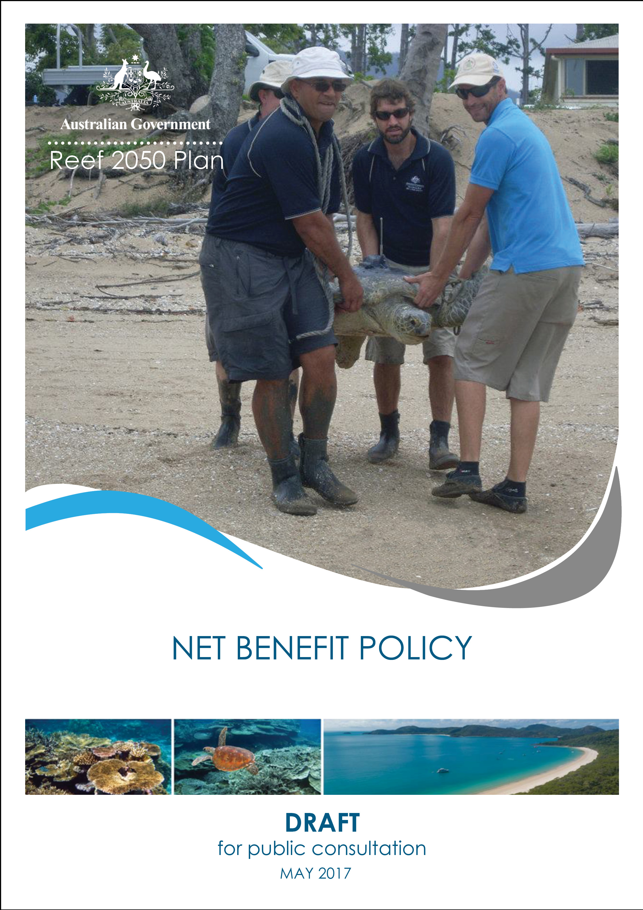

© Commonwealth of Australia 2017
Published by the Great Barrier Reef Marine Park Authority
ISBN 9780995373198

The Net Benefit Policy: Draft for public consultation is licensed by the Commonwealth of Australia for use under a Creative Commons By Attribution 4.0 International licence with the exception of the Coat of Arms of the Commonwealth of Australia, the logo of the Great Barrier Reef Marine Park Authority, any other material protected by a trademark, content supplied by third parties and any photographs. For licence conditions see: http://creativecommons.org/licences/by/4.0


A cataloguing record for this publication is available from the National Library of Australia

This publication should be cited as:
Great Barrier Reef Marine Park Authority 2017, Net Benefit Policy: Draft for public consultation, GBRMPA, Townsville.
Comments and questions regarding this document are welcome and should be addressed to:
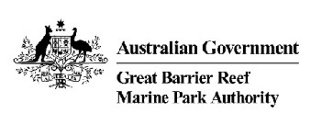
Great Barrier Reef Marine Park Authority
2–68 Flinders Street
(PO Box 1379)
Townsville QLD 4810, Australia

Phone: (07) 4750 0700
Fax: (07) 4772 6093
Email: info@gbrmpa.gov.au
www.gbrmpa.gov.au

Contents
Purpose 4
Target audience 4
Context 4
Foundational policy statements 9
Net benefit policy statements 11
Process 13
Implementation 15
Review and evaluation 15
Related legislation / policy 15
Definitions 16
Further information 20
Attachment 1: Examples of decision-making and actions to deliver net benefits at different scales 21
Attachment 2: Drivers of change, pressures and impacts on the Great Barrier Reef 23
Attachment 3: Risks to Great Barrier Reef values as reported in the Great Barrier Reef Outlook Report 26
Attachment 4: Condition and trend of Great Barrier Reef values 28

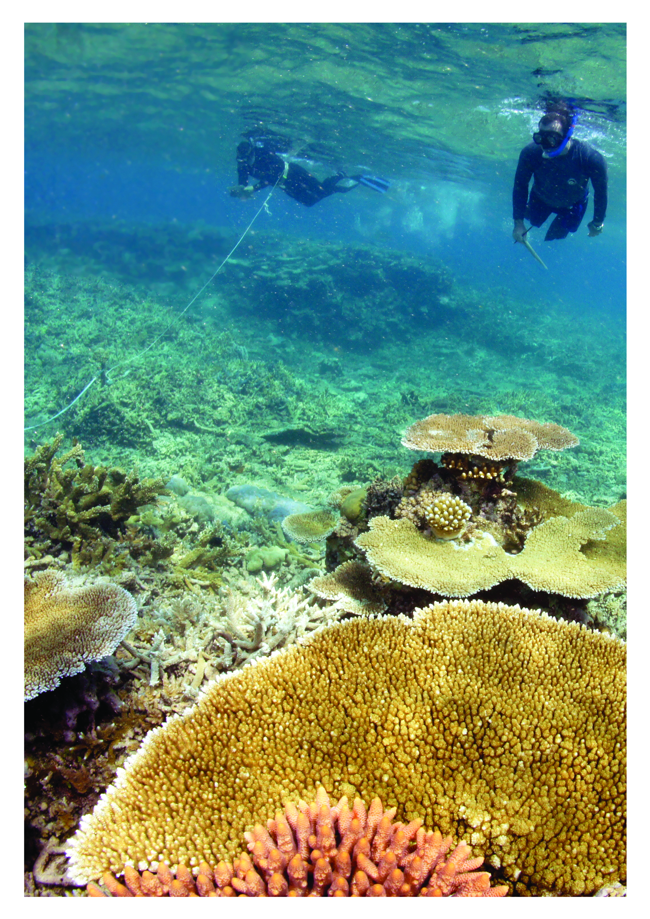

Purpose
To provide guidance on designing or implementing programs, plans and actions to improve the condition and trend of values and achieve an overall net benefit to the Great Barrier Reef.
Net benefit is defined as a net improvement in the condition and/or trend of Great Barrier Reef values, or those actions which result in the net improvement.

Target audience
The target audience for this policy is government, Traditional Owners, industry and the community involved in delivering programs, plans, policies and on-ground actions that influence the condition of the Great Barrier Reef.
Government agencies and authorities should apply this policy when:
  - revising or preparing relevant agreements, policies, plans, strategies and programs
  - making a decision likely to interact with Great Barrier Reef values
Others – such as industry, businesses, conservationists, infrastructure providers and developers – are encouraged to consider this policy when developing proposals, guidance material, programs or plans.
Researchers and the community can also use this policy to better understand priorities for the Great Barrier Reef, and focus areas for improvement and measurement.
Cultural and social change can be created by engaging community leaders to improve community knowledge, influence community attitudes, and promote the community’s role and responsibility for locally, regionally and globally improving the health of the Great Barrier Reef.
Community attitudes can directly affect decisions that are made about the Great Barrier Reef’s health by governments, communities, industry and others.
Opportunities to apply this influence include:
  - using networks and partnerships to build understanding of the social, economic and environmental factors influencing the health of the Great Barrier Reef
  - showcasing activities that reduce pressures on the Great Barrier Reef
  - showcasing activities that improve the resilience of the Great Barrier Reef

Context
Existing management measures have not been sufficient to reverse the decline in the health of the Great Barrier Reef. A more targeted approach to improving resilience and restoring the health of the Great Barrier Reef is required.
Avoiding and mitigating impacts will remain the primary focus of management efforts, however, these are not sufficient on their own to deliver a net improvement in the condition of Great Barrier Reef values.
Opportunities to foster net benefit environmental outcomes are best provided through a diverse range of approaches, working with all stakeholders involved with the Reef, and at local, regional, national and international scales.
Protecting the Great Barrier Reef is a key priority for the Australian and Queensland governments. The Reef 2050 Plan is the overarching strategy for protecting the Great Barrier Reef. The Plan is pivotal to bringing together actions and coordinating strategies across government, Traditional Owners, industry, researchers and the community to protect the Reef and provide for ecologically sustainable use.

Delivering net benefits to the Great Barrier Reef is one of the key principles of decision-making under the Reef 2050 Plan.
The 2014 Outlook Report identified the four main pressures on the Great Barrier Reef as:
  - climate change (global scale)
  - coastal land use change (Great Barrier Reef catchment scale)
  - poor water quality from land-based run-off (Great Barrier Reef catchment scale)
  - some remaining impacts of fishing (Great Barrier Reef Region – marine park scale).
These pressures and impacts do not operate in isolation but overlap and interact with each other, and their accumulation over time and space is diminishing the resilience of the Reef’s ecosystem and its ability to recover from disturbance.
Pressures can originate at the local, marine park, catchment and global scales, and require integration of decision-making at all space and time scales to manage their impacts on the Great Barrier Reef.
The impact is not just on the Great Barrier Reef ecosystem, but also impacts on the cultural values of Traditional Owners; economic values to the tourism and fishing industries which rely on a healthy Reef; social values for communities along the coast for whom the Reef is part of their daily life; together with the broader Australian and international community who consider it to be an irreplaceable icon – belonging to the global community.
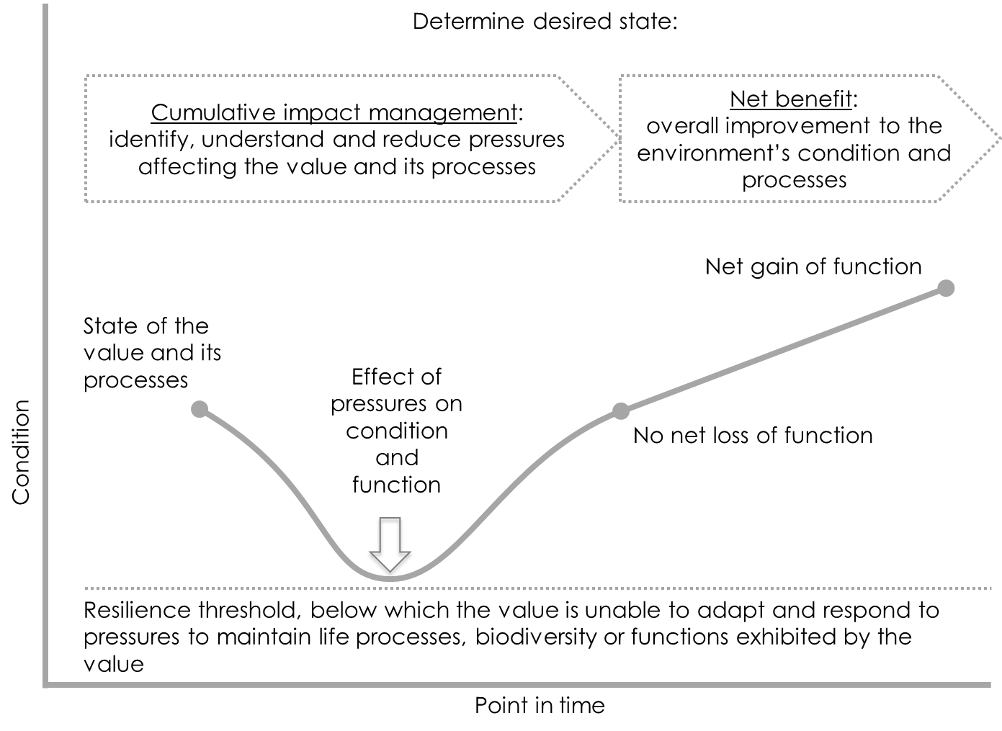Improving management of cumulative impacts, reducing pressures, and delivering solutions which result in an improvement in the condition of values, is critical to the future health and resilience of the Great Barrier Reef:

This requires a coordinated effort across a broad range of management approaches, and the delivery of actions at global, Reef and catchment-wide, regional and local scales (Attachment 1).

The following case studies demonstrate how net benefit policy can be implemented through voluntary on-ground actions:

Case study 1: Reducing Crown-of-Thorns Starfish Outbreaks

The crown-of-thorns starfish (Acanthaster planci) is native to coral reefs in the Indo-Pacific region. On healthy coral reefs, the coral-eating starfish plays an important role, feeding on the fastest growing corals, allowing slower growing coral species to form colonies.
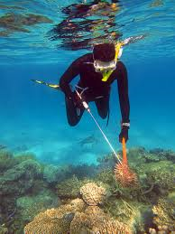However, when the density of crown-of-thorns starfish increases to outbreak levels - where the starfish consumes coral tissue faster than the corals can grow - a decline in coral cover is likely to occur.
The impacts of outbreaks of crown-of-thorns starfish compound the damage to corals caused by tropical storms, and the increasing impact of coral bleaching, coral disease outbreaks and floods. Of these major causes of coral death, mitigating crown-of-thorns starfish outbreaks is an immediate and viable management strategy to counter the Reef-wide decline in coral cover.
The Australian Government and the Great Barrier Reef Marine Park Authority work in partnership with the Queensland Parks and Wildlife Service, research organisations and tourism operators to reduce the incidence and severity of crown-of-thorns outbreaks.
These actions deliver a net benefit to the health and resilience of coral reefs and the diversity of values they support.

Case study 2: Raine Island Recovery Project
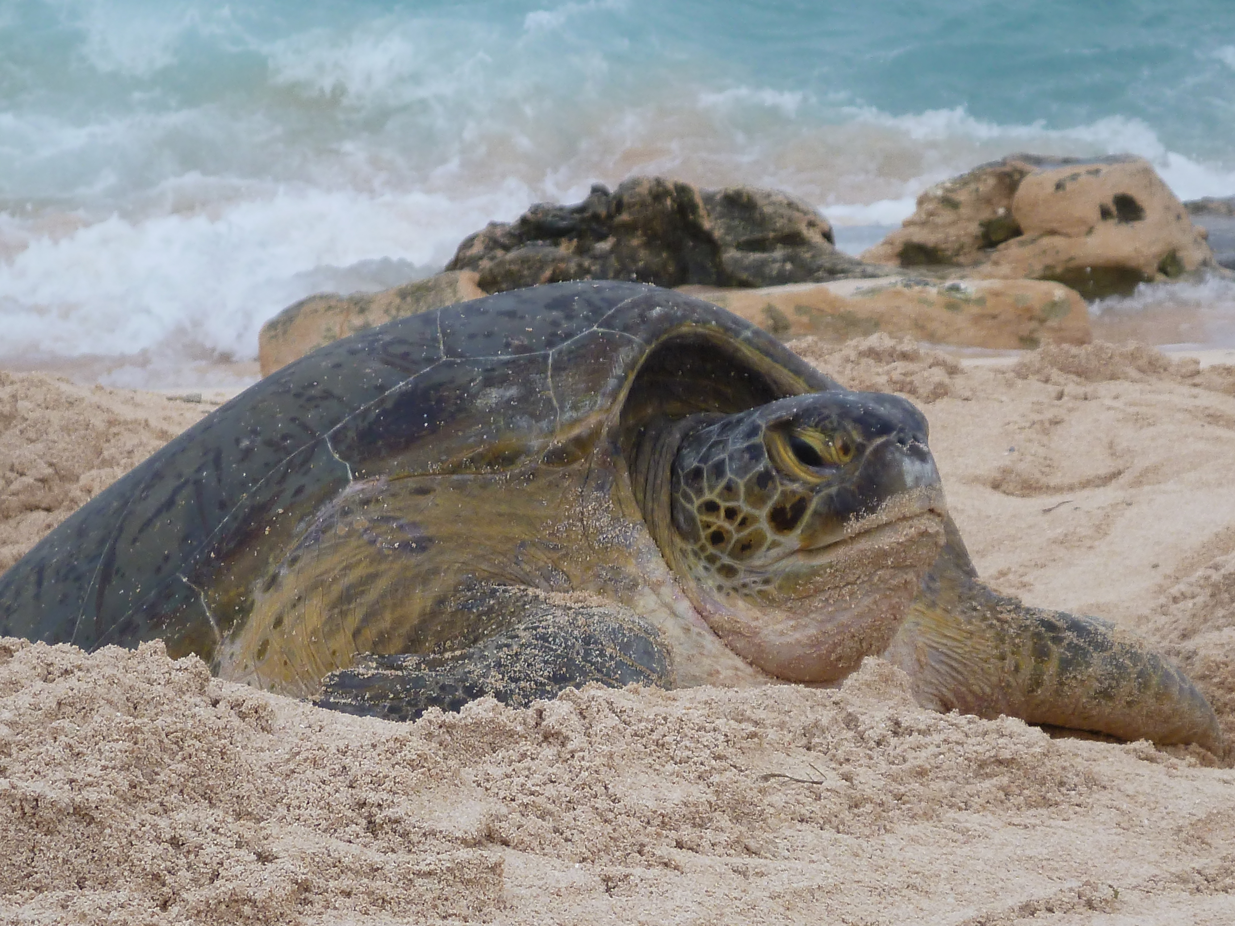
Raine Island, on the remote northern tip of the Great Barrier Reef, is the breeding ground for one of the world’s largest populations of green turtles. As many as 100,000 female green turtles migrate thousands of kilometres to lay their eggs here in a peak breeding season. The island is also an important seabird rookery and supports a diverse range of marine life. However, its role as a turtle sanctuary is in danger of collapse.
Rising sea levels and changes in the island’s landscape have caused tidal inundation destroying newly laid eggs and increasing adult mortality from falls and entrapment in rocky cliffs.
The Queensland Government, Great Barrier Reef Foundation, Great Barrier Reef Marine Park Authority, BHP Billiton and Traditional Owners are collaborating on a five-year project and voluntarily funding $7.95M (beyond all regulatory obligation) to protect and restore Raine Island’s critical habitat, including beach engineering, turtle tagging, monitoring and modelling. This project delivers a net benefit to the future viability of key marine species, such as green turtles and seabirds.

Case study 3: Monitoring Ocean Acidification Through Future Reef 2.0

Climate change is a significant threat to the Great Barrier Reef. As the ocean absorbs greater amounts of carbon dioxide from the atmosphere, ocean acidity increases. Ocean acidification has the potential to reduce coral growth and weaken reef structures, threatening the diverse marine life that makes up reef ecosystems.
To protect the Great Barrier Reef, a better understanding is needed on ocean chemistry and how that is changing. The Commonwealth Scientific and Industrial Research Organisation (CSIRO) in collaboration with Rio Tinto and the Great Barrier Reef Foundation are undertaking a three-year project and voluntarily funding $1M (beyond all regulatory obligation) to take water samples along the length of the Great Barrier Reef using Rio Tinto’s vessels. This research is the first of its kind to provide large-scale assessment of ocean acidification in the region.
Bridging the gap in the science is critical for government and stakeholders who want to maintain the diversity and function of coral reefs, and who need to develop and implement innovative management approaches in order to do this. This project works towards delivering a net benefit to the health and resilience of coral reefs and broader marine environment.

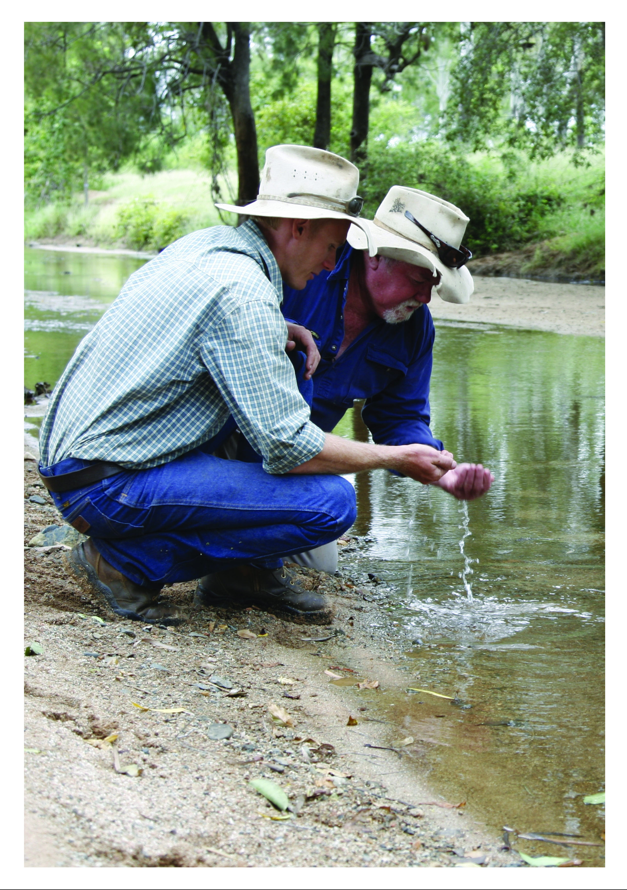

Foundational policy statements
These foundational policy statements also apply to the draft Cumulative Impact Management Policy.
Maximising avoidance of impacts - the highest priority is to avoid impacts. Measures to avoid impacts should be documented and consider prudent and feasible alternatives, including the alternative of not carrying out the proposed action. Measures to mitigate impacts to reduce the likely significance of any residual effects should be clearly documented as part of the avoid–mitigate–offset hierarchy.
Focusing on outcomes - adopting an outcomes-based approach was a key recommendation of the Great Barrier Reef Region Strategic Assessment, and underpins the Reef 2050 Plan’s delivery. The condition and trend of the Great Barrier Reef’s values are reported every five years in the Outlook Report and provide an assessment of ‘very good’, ‘good’, ‘poor’ or ‘very poor’ for each of the values. Desired outcomes for the Great Barrier Reef seek to restore the condition of values assessed as ‘poor’ or ‘very poor’, and to maintain and enhance where condition is assessed as ‘good’ or ‘very good’. This is set out below (Table 1).
Current condition | Desired outcome
Very good | The condition is maintained
Good | The condition is maintained and enhanced
Poor | The condition is restored to good
Very poor | The condition is restored to good
Trend in condition | Desired outcome
Improving | The trend is maintained
Stable | The trend is maintained and improved
Deteriorating | The decline is halted and reversed
Table 1: Desired outcomes for Great Barrier Reef values
Decisions should align with the desired outcomes (Table 1) for the condition and trend of Great Barrier Reef values, including its outstanding universal value. Management options should be compared with appropriate standards and guidelines, including desired outcomes for the state of the Great Barrier Reef’s values, to inform the acceptability of the proposed action. This includes considering the principles of ecologically sustainable use.
Taking a systems perspective - healthy and resilient ecosystems are fundamental to protect Great Barrier Reef values, and the community and economic benefits they support. The Driver, Pressure, State, Impact, Response (DPSIR) framework (Figure 2) should be used to understand links between drivers of, activities in and pressures on the state of the environment, and the impacts on the benefits it provides. Adopting a systems perspective focused on affected Great Barrier Reef values provides a strong basis to design and deliver net benefits, reduce cumulative impacts, maintain the integrity of the Great Barrier Reef World Heritage Area and provide adequate offsets. Decisions should clearly:
  - specify the space and time scales in which the drivers, pressures and impacts affect Great Barrier Reef values, including its outstanding universal value
  - specify the space and time scales, including relevant animal and plant life-history traits, at which affected values operate
  - identify cause and effect relationships between drivers, pressures and impacts on the environment’s constituent parts
  - consider connections between land and sea, and within the marine environment.
Using the best available information - the best available information from the most appropriate sources should be used. This includes historical information, monitoring data, Traditional Owner and stakeholder knowledge, observation, modelling, forecasts, expert judgement, peer-reviewed literature and science. Information should specify possible limitations of data and modelling; divergence in expert judgement, or uncertainty, availability, quality, quantity and ongoing relevance of information.
Understanding and managing risk - risk-management processes should be integrated into decision-making and demonstrate consistency with the Australian/New Zealand/International Standard, AS/NZS ISO 31000:2009 Risk management – Principles and guidelines. When identifying and analysing risks, the following factors should be considered:
- time lags which may exist between cause and effect  - diversity, complexity and connectivity between environmental components and processes, including cumulative or synergistic effects  - effects that are prone to change if the context changes  - lack of reliable data |  |  | - possibility of human error  - natural variation, where the likelihood of an outcome may depend on a variety of factors and the vulnerability of components of a system under study  - uncertainties likely to have a material impact on decision-making.
The Outlook Report should be used as a guide to the types and level of risks to the Great Barrier Reef from drivers, pressures and activities (refer Attachments 2 and 3).
Assessing vulnerability and resilience - the vulnerability and resilience of the overall ecosystem and its values (Figure 1) should be assessed. Consider whether exposure of a value or process to impacts – including the interaction of effects between impacts and past, present and reasonably foreseeable future pressures – is material, by assessing:  - the sensitivity of the value:  - the life histories/processes that are impacted  - the dependency on impacted resources  - the current condition and trend  - health thresholds  - risk and uncertainty around assumptions  - the adaptive capacity of the value:  - rate of recovery between disturbances, based on current condition  - rate of change and reorganising of a system to a desirable functioning state  - risk and uncertainty around assumptions.  Vulnerability and resilience should be considered when assessing the level of risk, identifying strategies for building resilience, assessing the urgency of action, evaluating the efficacy and cost-effectiveness of options, and for engaging and empowering stakeholders in adaptation processes. |  | Figure 1: Illustrating system vulnerability and resilience (Marshall, Tobin, Marshall, Gooch and Hobday, 2013).
Monitoring and review - the Reef 2050 Integrated Monitoring and Reporting Program is establishing standard protocols for collecting, storing, accessing and reporting information. Monitoring and reporting should be consistent with these protocols and appropriate to the nature and level of risk. Reporting should not only focus on implementation of actions but achievements towards outcomes. Monitoring and review should be systematically integrated into decisions and implementation concerned with net benefits, offsetting and cumulative impact assessment and management. It is then possible to detect change, maintain currency and evaluate the effectiveness of management interventions.
Adaptively manage - the results of targeted research, modelling and monitoring should be used to evaluate the performance of actions and drive continuous improvement.  Actions may need to be modified in response to new information, emerging issues or changing circumstances.  The Reef 2050 Plan and the Reef 2050 Integrated Monitoring and Reporting Program provide an adaptive management framework to assess progress towards outcomes and targets, and reduce impacts, using the Driver Pressure State Impact Response framework. | 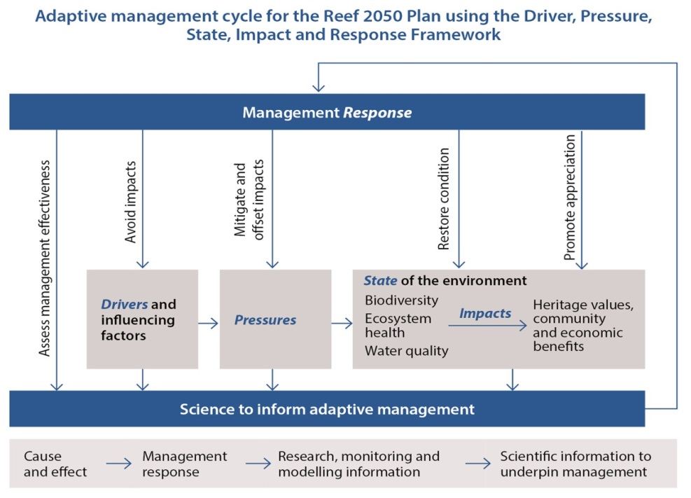  Figure 2: Reef 2050 Plan adaptive management framework.
Ensuring transparent governance - implementation should be supported by effective and transparent governance measures focused on ensuring specified outcomes are delivered to maintain Great Barrier Reef values. Clear governance arrangements are required to promote alignment, maximise efficient use of resources and reduce duplication of effort. Methods of communicating information and consulting with relevant stakeholders should facilitate accurate and understandable exchanges of information, while considering relevant information security requirements (such as privacy and confidentiality). Accountability for achieving outcomes will occur through the Reef 2050 Integrated Monitoring and Reporting Program, the Outlook Report and review of the Reef 2050 Plan. Where relevant, regulatory compliance and enforcement programs may contribute to transparent and accountable governance by aligning and supporting the Reef 2050 Integrated Monitoring and Reporting Program.

Net benefit policy statements
The Reef 2050 Plan details primary principles to consider in all programs, plans, decisions and on-ground actions (hereafter referred to as programs) that affect the Great Barrier Reef, and there are additional specific principles to consider when implementing this net benefit policy. The primary principles are:
  - maintain and enhance outstanding universal value in every action
  - base decisions on the best available science
  - deliver a net benefit to the ecosystem
  - adopt a partnership approach to management.
Practical approaches for addressing these principles are contained in the Reef 2050 Policy Guideline for Decision Makers.
Identifying the Great Barrier Reef values that are relevant to the decision or action
To ensure programs effectively deliver an improvement in the condition of the Great Barrier Reef, identify the Great Barrier Reef values that will benefit from the decision.
Given the scale and complexity of the Great Barrier Reef and its diversity and interconnectedness, values presented in Attachment 4 (Tables A4.2 and A4.3) provide a basis for delivering an overall net benefit to the Great Barrier Reef’s outstanding universal value and the seven matters of national environmental significance.
Considering the scale required to deliver the desired positive outcome
Net benefits should be delivered at a scale relevant to the desired outcome (Table 1) and consider:
  - the pressures and impacts affecting the values or processes (Attachment 2)
  - the strategic, tactical and operational decisions and actions required to restore the values or processes (Attachment 1)
  - partner and stakeholder collaboration to strengthen and facilitate enduring outcomes.
Aiming for a positive change or trend in condition of values
Programs that positively affect the Great Barrier Reef’s values contribute to net benefit outcomes, regardless of whether they occur within or outside the Great Barrier Reef, including internationally.
To achieve an overall net improvement in Great Barrier Reef values, consider improvement options that range from local to global actions.
Seeking to understand pressures and impacts affecting values
Net benefits should consider the range of pressures and impacts affecting values or processes relevant to the program (Attachment 2), as this may influence the management approach adopted, and the design and timing of net benefit actions.
Considering strategic and innovative approaches
The benefit from actions to improve the condition and trend of the Great Barrier Reef values is maximised when aligned with strategic approaches (Attachment 1) that are aimed at improving the condition of Great Barrier Reef values (Attachment 4 - Table A4.2 and A4.3).
Strategic approaches should consider a variety of options for programs and implementation to manage uncertainty, address risk and facilitate learning and adaptive management. New and novel approaches that target restoration or deliver improvements are more able to be considered if actions are supported by strategies designed to manage the risk created by uncertainty.
Strategic approaches that facilitate coordination and collaboration with industry, government or community groups with a special interest in an area, and that deliver multiple outcomes for environmental values, should be encouraged.
Using coordinated and collaborative approaches to improve effectiveness of programs
Wherever possible, net benefits should:
  - Adopt coordinated and collaborative approaches to align efforts and share information between stakeholders (such as industry and science organisations)
  - Support community groups with a special interest in an area to identify the condition and trend of locally significant values, and establish locally relevant baselines and desired outcomes for values, consistent with Table 1
  - Integrate and support targeted efforts to facilitate efficient and effective delivery of agreed decisions at the most relevant scale, helping maximise net benefits across multiple actions.
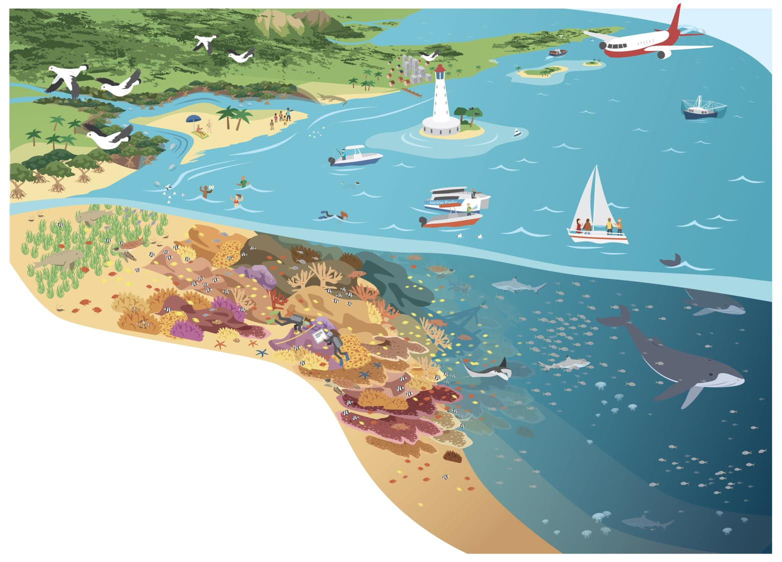

Process
Opportunities to foster net environmental benefit outcomes are best provided through a diverse range of approaches, working with all stakeholders across the Reef, and at local, regional, national and international scales. This includes through:
  - planning mechanisms (e.g. Plans of Management and Site Management Arrangements)
  - stewardship initiatives (e.g. Reef Guardians program)
  - partnerships (e.g. Reef Plan)
  - funding programs (e.g. Reef Program).

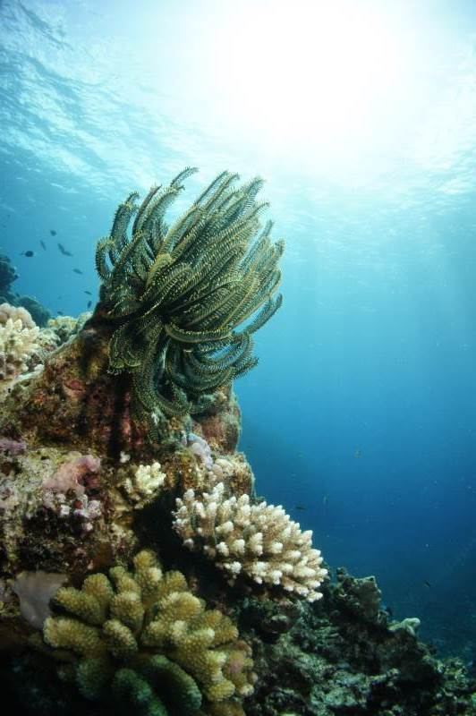

Identify impacts affecting the relevant Great Barrier Reef values. Use Attachment 2 as a checklist to identify impacts that may affect the delivery of a net benefit. Use the Driver Pressure State Impact Response framework.
3
1
Consider existing strategies that can be used to inform assessments of condition, cumulative impacts and risk; provide access to relevant data and information; and assist in negotiating approvals and permissions to facilitate on-ground actions.
Identify the relevant Great Barrier Reef values, and desired outcomes. Refer to Table 1 and Attachment 4. These tables are derived from the Great Barrier Reef Region Strategic Assessment and updated by the Great Barrier Reef Outlook Report. Consider connectivity and relationships between values relevant to your decision.
Steps in applying this policy
Consider the scale required to contribute effectively to improving the condition and trend of the value or process. Is the management decision-making at the operational, tactical or strategic level? Refer to Attachment 1 to work through the most appropriate level for decision-making and implementation.
6
Monitor, evaluate, report and implement adaptive management to achieve desire outcomes. Identify monitoring and reporting required –– to evaluate the effectiveness of actions. Identify consistencies with the Reef 2050 Integrated Monitoring and Reporting Program. To enhance effectiveness and drive continuous improvement, adapt actions in response to learning, new information, emerging issues and changing circumstances.
For on-ground implementation, consider how a coordinated approach can help with sharing of information and targeting delivery of actions.
For program managers, consider how a collaborative approach can help extend (area of effectiveness; successful uptake; reduced lag times etc.) the delivery of improvement actions.
5
Apply the most appropriate management tools and actions to maximise improvement in condition and trend of relevant values.
For research providers, consider what novel research can be implemented to actively demonstrate a positive change in Great Barrier Reef values.
For program managers, consider the opportunities for identifying and implementing pilot programs to test innovative restoration actions.
Consider the most appropriate approach to implementation, and how strategic and innovative approaches can help improve the effectiveness of achieving positive outcomes.
4
2

Implementation
Implementation will be staged, recognising the need to develop specific guidance for relevant agencies and sectors.

Review and evaluation
The effectiveness of this policy will be reviewed and evaluated in line with the assessment of the Reef’s values through the five yearly Outlook Report. Effective implementation of a net benefit approach should translate to an improvement in the condition and/or trend of Reef values.

Related legislation / policy
Australian Government, including:
  - Environment Protection and Biodiversity Conservation Act 1999 (EPBC Act)
  - Great Barrier Reef Marine Park Act 1975 (GBRMP Act)
Queensland Government, including:
  - Environmental Offsets Act 2014
  - Environmental Protection Act 1994
  - Fisheries Act 1994
  - Marine Parks Act 2004
  - Nature Conservation Act 1992
  - Planning Act 2016
  - Sustainable Planning Act 2009
  - State Development and Public Works Organisation Act 1971
  - Sustainable Ports Development Act 2015
  - Vegetation Management Act 1999
This policy is to be read in conjunction with the Reef 2050 Policy Guideline for Decision Makers which illustrates a wide range of actions designed to manage drivers and pressures on the Reef. Where legislation allows, decision-makers should consider opportunities to provide net benefits to the Great Barrier Reef within these and other relevant decision–making processes.
This policy has been developed in parallel with the Reef 2050 Plan Cumulative Impact Management Policy.

Definitions
Action
Actions and activities are used to describe projects and project parts under the EPBC Act and GBRMP Act. For this policy actions are used, assuming activities comprise action, or a subset of an action. Also includes development proposals and/or planning actions.
Adaptive capacity
The ability for a component of the environment to adapt to impacts to maintain or improve its condition. Includes the environmental component’s ability to recover, reorganise or build capacity to learn and adapt in between events.
Adaptive management
A systematic process for continually improving management practices through learning from the outcomes of previous management. It includes a monitoring, evaluation, reporting and improvement cycle.
Avoid-mitigate-offset hierarchy
Is used to guide assessment of actions and inform decision-making. The highest priority is given to avoiding impacts on the environment. Avoidance measures must consider prudent and feasible alternatives to a proposed action. Potential impacts that cannot be avoided must be minimised. Mitigation measures must consider direct, indirect and cumulative impacts, and account for the likely spatial and temporal scales of impacts across the duration of the proposed activity. Offsets compensate for the residual adverse impacts of an action on the environment.
Baseline condition
A description of existing conditions to provide a starting point (e.g. pre-project condition of biodiversity) against which comparisons can be made (e.g. post-impact condition of biodiversity), allowing the change to be quantified. Baseline conditions for the Marine Park are measured from its World Heritage Declaration in 1981.
Biodiversity elements
Biodiversity is the variety of life on Earth. It includes all living things and the way they interact with each other and their environment. The Region’s biodiversity values which underpin matters of national environmental significance include:
- Great Barrier Reef habitats
- terrestrial habitats that support the Great Barrier Reef
- species
Community benefit
The interconnectedness of people and their environment as reflected in the definition of ‘environment’ under the EPBC Act and GBRMP Act and as defined in this document.
Consequential impacts
Are a form of ‘indirect’ impact resulting from further actions (including actions by third parties) that are made possible or are facilitated by implementation of the activity. For example, a port expansion may result in an increase in shipping activity which may bring with it a suite of consequential impacts (e.g. anchoring impacts, displacement of uses).
Cumulative impacts
Cumulative impacts are defined as the interaction of effects between one or more impacts and past, present, and reasonably foreseeable future pressures.
Cumulative impact assessment
Takes into account direct, indirect and consequential impacts and the incremental and compounding effects of these impacts over time, including past, present and reasonably foreseeable future pressures.
Decision
Decisions are not limited to regulatory decision-making. Decisions include developing, revising or implementing relevant agreements, policies, plans, strategies and programs; implementing legislation as part of the Great Barrier Reef planning and assessment processes; prioritising and undertaking on-ground actions.
Drivers
An overarching cause that can drive change in the environment. It can affect the environment indirectly by changing the way people undertake activities that affect the environment (indirect drivers) or by directing changing conditions in the environment itself (direct drivers). Examples include climate change, economic growth and population growth.
Ecologically sustainable use
The principles of ecologically sustainable use are defined in section 3AA of the GBRMP Act as:
- decision-making processes should effectively integrate both long-term and short-term environmental, economic, social and equitable considerations
- the precautionary principle
- the principle of inter-generational equity—that the present generation should ensure that the health, diversity and productivity of the environment is maintained or enhanced for the benefit of future generations
- the conservation of biodiversity and ecological integrity should be a fundamental consideration in decision-making
- improved valuation, pricing and incentive mechanisms should be promoted
Effect
Is a deviation from the expected (positive or negative).
Environment
Includes ecosystems and their constituent parts, including people and communities; natural and physical resources; the qualities and characteristics of locations, places and areas; heritage values of places; and the social, economic and cultural aspects of the above. (EPBC Act and GBRMP Act).
Event
A change in situation; something happening or not happening (when it was expected); an incident or occurrence that exposes a value to a hazard.
Exposure
The magnitude, frequency and duration of an environmental component’s contact with a hazard.
Great Barrier Reef
Refers to the Great Barrier Reef World Heritage Area, Great Barrier Reef Marine Park and Great Barrier Reef Region areas relevant to the decision-making or action.
Hazard
A source of potential harm; a situation, action or behaviour that may negatively impact on an environmental component, whether intentionally or unintentionally.
Heritage values
The Region’s heritage values, which underpin matters of national environmental significance, are grouped into five broad categories:
- Indigenous heritage values: the heritage values of a place that are of significance to Aboriginal and Torres Strait Islander persons in accordance with their practices, observances, customs, traditions, beliefs or history
- other heritage values: a place’s natural and cultural environment having aesthetic, historic, scientific or social significance, or other significance, for current and future generations of Australians
- world heritage values: the natural heritage and cultural heritage of a property that is internationally recognised as being of outstanding universal value
- national heritage values: the values of a place that are of national significance as recognised through placement on the National Heritage List
- Commonwealth heritage values: the values of a place that are specified in its placement on the Commonwealth Heritage List.
Integrity
Relates to ‘wholeness and intactness’ of the World Heritage property and how it conveys the values it holds. Integrity can also relate to the size of the property (sufficient size to continue to represent the values) and to any threats affecting the property.
Impact
The result or effect that happens when an environmental component is exposed to a hazard; may be positive or negative.
Matters of national environmental significance
Those matters as defined in the Environment Protection and Biodiversity Conservation Act.
Net benefit
A decision or action which results in a net improvement to the condition and/or trend of a Great Barrier Reef environmental value or process as described in Attachment 4 – Tables A4.2 and A4.3.
Outstanding universal value
Cultural and/or natural significance which is so exceptional as to transcend national boundaries and to be of common importance for present and future generations of all humanity. Outstanding universal value is distributed throughout the entire Great Barrier Reef World Heritage Area. The relationship between outstanding universal value and Great Barrier Reef values is described in Attachment 4.
Pressure (Threats)
An activity or group of activities that cause an impact on a value.
Program
Includes programs, plans, decisions and on-ground actions.
Reference condition
Assessment of the reference condition and trend of Great Barrier Reef values (taking into account past and present effects) is described in Attachment 4 and values are benchmarked and graded every five years through the Outlook Report.
Reference scenario
What is likely to have occurred in the absence of management response. The reference scenario is based on the current condition and trend, taking into account reasonably foreseeable future pressures. Grading statements for condition are described in Attachment 4 – Table A4.1.
Resilience
The ability of an environmental component to cope with change or exposure and remain in a desirable functioning state. It includes the ability to absorb impacts and continue functioning, and recover, reorganise or build capacity to learn and adapt in between events.
Risk
Defined by the Australia/New Zealand Standard for Risk Management (AS/NZS 31000:2009 ) as “effect of uncertainty on objectives.” For this policy/guideline, risk relates to uncertainty as to whether the objectives of the policy can be achieved i.e. achieving desired states for Great Barrier Reef values.
Sensitivity
The degree to which a component of the environment is responsive to a specific impact.
Severity
How serious a consequence would be if it occurred; the degree of degradation that would occur to the value if that consequence occurred.
Values
Refers to values and processes as described in Attachment 4. Foremost, healthy and resilient ecosystems are fundamental to the protection of biodiversity and heritage values and the community benefits they support.
Vulnerability
The susceptibility of environmental components to degradation from impacts. Vulnerability is a function of the environmental component’s exposure, sensitivity and adaptive capacity.
Zone of influence
The area or spatial extent in which an activity or pressure has the potential to impact a component of the environment. The ‘zone of influence’ is used to describe the scale of effect at which impacts (such as from an action, project, plan or program) are occurring and the scope of response available to manage impacts. The zone of influence includes the assessment of the boundaries to biological and life processes needed to encompass the spatial and temporal extent of impacts that influence the condition of environmental values, ecosystem processes and socio-ecological systems throughout the period during which impacts of the decision will occur. The zone of influence can be described in three parts:
- zone of ecological influence - the area or spatial extent in which an activity or pressure directly impacts a component of the environment
- zone of system influence - the area or spatial extent in which an activity or pressure has an indirect or consequential impact on a component of the environment, recognising the boundaries to biological and life processes extend beyond the direct impact of the activity
- zone of management influence – which includes the scope of response encompassing direct and indirect impacts and other past, present pressures and threats affecting values and processes.

Further information
Director – Reef 2050
Great Barrier Reef Marine Park Authority
2 - 68 Flinders Street
PO Box 1379
Townsville Qld 4810
Australia

Phone + 61 7 4750 0700
Fax + 61 7 4772 6093
email reef2050plan@gbrmpa.gov.au

www.gbrmpa.gov.au

Document control information
Approved by: | Enter position title. | Approved date: | Click for date.
Last reviewed: | New
Next review:
Created: | May-2017
Document custodian: | Director- Reef 2050, Great Barrier Reef Marine Park Authority
Replaces: | New

Attachment 1: Examples of decision-making and actions to deliver net benefits at different scales
Scale of decision-making and implementation | Consider . . . | Existing examples to facilitate the delivery of net benefits
Strategic | Values / desired outcomes  - Refer to Attachment 4 for relevant values.  - Incorporate desired outcomes for values (refer Table 1)  Cumulative impact / risk assessment  - Management response is guided by assessment of cumulative effects on values (refer Attachment 4)  - Consider vulnerability and resilience  Positive change to values  - Identify the likely positive outcome for condition and trend of values and environmental processes (refer to ‘Steps in applying this policy’)  Scale  - Consider management options that can be applied at different landscape scales relevant to the values and the drivers, pressures, state, impact and response framework for linkages between drivers, pressures and impacts on values (Figure 2)  Strategic, innovative, coordinated and collaborative  - Consider options that can help extend the delivery of improvement actions and assist sharing of information and targeting delivery actions | Reef 2050 Plan  Great Barrier Reef Strategic Assessment Program Report
Tactical  Making plans / developing policies and guidelines | Values / desired outcomes  - Plans, guidelines and policies consider the values and environmental processes (refer Attachment 4) and desired outcomes in Table 1  Cumulative impact / risk assessment  - Risk assessment considers cumulative impacts, vulnerability and resilience  - Options to avoid, mitigate and offset impacts considered  Positive change to values  - Identify the likely positive outcome for condition and trend of values and environmental processes (refer to ‘Steps in applying this policy’)  Scale  - Does the scope account for the scale of the relevant values and pressures and impacts affecting them (are approvals required, risk assessed and feasible, supported by research)  - Plan for actions that recognise linkages across bio-cultural, land and seascape boundaries to encompass zone of influence  Strategic and innovative  - Provide management options and approaches for delivering net benefit outcomes  - Response developed to most effectively respond to drivers, pressures, state and impacts on values, and guide operational response to improve condition and trend (Attachment 4 and Figure 2)  - Allow for innovative approaches to delivering improvement in condition and trend.  Coordinated and collaborative  - Include opportunities for collaborative approaches to achieving desired outcomes (Table 1) | Developing plans of management and land use plans  Traditional Use of Marine Resources Agreement  Developing Strategic Offset Corridors  Direct Benefit Management Plans  Strategic investment opportunities  Water Quality Improvement Plans
Operational  Making decisions / undertaking actions | Values / desired outcomes  - Relevant to values and environmental processes (refer Attachment 4) and desired outcomes in Table 1  - Identify condition and trend of locally significant values; consider locally relevant health baselines and desired outcomes for values (consistent with Attachment 4 and Table 1).  Cumulative impact / risk assessment  - Risk assessment conducted, contextualised by cumulative impact assessment  - Options to avoid, mitigate and offset impacts considered  Positive change to values  - Actions contribute to achieving the desired outcomes for values (refer Attachment 4, Table 1).  Scale  - Implementation is at a scale to effectively improve the condition and trend of relevant Great Barrier Reef values  Strategic and innovative  - Implementation is consistent / integrated with strategic and tactical response  Coordinated and collaborative  - Contributes to and supports collaborative on-ground efforts | Activities through the Joint Field Management Program  Reef Guardian Stewardship Program  Ecotourism certification  Partnerships with the tourism industry for control of crown- of-thorns starfish  Making development assessment decisions

Attachment 2: Drivers of change, pressures and impacts on the Great Barrier Reef
Drivers are overarching causes that can drive change in the environment (State of the Environment, 2011; Strategic Assessment Report, 2014) and have also been referred to as underlying causes of change in the environment (Outlook Report, 2014). For the purposes of this policy and the Reef Integrated Monitoring and Reporting Program, it is proposed to adopt six drivers of change for the Great Barrier Reef system:
- Climate change
- Population growth
- Economic growth
- Technological developments
- Societal attitudes
- Governance systems
Pressures and impacts are mechanisms that exert a change force (either positive or negative) on a value. Put another way, pressures and impacts are the change mechanisms (e.g. processes or activities) that result from drivers. For the purposes of this policy, pressures are defined consistent with the Outlook Report ‘threats’ (2014) and the Strategic Assessment Report ‘impacts’ (2014).
Table A2.1 – Pressures and impacts, their definition and associated source
Pressures and impacts | Definitions
Acid sulphate soils | Exposure and subsequent oxidation of potential acid sulphate soils.
Altered ocean currents | Altered ocean currents due to climate change or anomalies related to the El Niño-Southern Oscillation, and altered coastal water movement at a local scale.
Artificial light | Artificial lighting including from resorts, industrial infrastructure, mainland beaches and coastlines, vessels and ships.
Atmospheric pollution | Pollution of the atmosphere related to domestic, industrial and business activities in both the Region and adjacent areas. The contribution of gases such as carbon dioxide to climate change is not included as this is encompassed under threats such as sea temperature increase and ocean acidification.
Artificial barriers to flow | Artificial barriers to riverine and estuarine flow including breakwalls, weirs, dams, gates, ponded pastures, and weeds causing changes to hydrology, groundwater and ecological connectivity.
Coastal reclamation | Coastal land reclamation, including for ports and groynes.
Cyclone activity | Cyclone activity.
Damage to reef structure | Physical damage to reef benthos (reef structure) through actions such as snorkelling, diving, anchoring and fishing, but not vessel grounding.
Damage to seafloor | Physical damage to non-reef benthos (seafloor) through actions such as trawling and anchoring, but not vessel grounding.
Disposal and resuspension of dredge material | Sea dumping of dredge material including smothering, loss and modification of seabed habitats and resuspension.
Dredging | Dredging of the seafloor.
Exotic species and diseases | Introduction of exotic species and diseases from aquaculture operations, hull fouling, ballast release, imported bait and release of aquarium specimens to the Region, plus the introduction of weeds and feral animals to islands.
Extraction – discarded catch | Immediate or post-release effects (such as death, injury, reduced reproductive success) on discarded species as a result of interactions with fishing gear. Does not include species of conservation concern.
Extraction — fishing in spawning aggregations | Retained take (extraction) of fish from unidentified or unprotected spawning aggregations.
Extraction – herbivores | Retained take (extraction) of herbivores (e.g. some fish, molluscs, dugongs, green turtles) through commercial and non-commercial uses.
Extraction – incidental catch of species of conservation concern | Immediate or post-release effects (such as death, injury, reduced reproductive success) of interactions of species of conservation concern with fishing gear.
Extraction — lower order predators | Retained take (extraction) of lower order predators (e.g. coral trout and snapper) through commercial, recreational and traditional fishing.
Extraction — lower trophic orders | Retained take (extraction) of lower trophic orders (e.g. scallops, sea cucumbers and prawns) through commercial, recreational and traditional fishing.
Extraction — top order predators | Retained take (extraction) of top order predators (e.g. sharks) through commercial, recreational and traditional fishing and the Queensland Shark Control Program.
Grounding large vessel | Grounding of large vessels (>50m) including physical damage and the dislodging of antifoulants.
Grounding small vessel | Grounding of small vessels (<50m) including physical damage and the dislodging of antifoulants.
Illegal activities — other | Illegal activities such as entering a protected or restricted area, illegal release of industrial discharge, shipping outside of designated shipping areas.
Illegal fishing and poaching | Illegal fishing, collecting and poaching (foreign or domestic) including of species of conservation concern.
Incompatible uses | Activities undertaken within the Region that disturb or exclude other users, such as recreational use in areas important for cultural activities.
Increased freshwater inflow | Increased freshwater inflow from prolonged or heavy rainfall including flood events, and from changes to catchment ecosystems; resulting in reduced salinity.
Marine debris | Manufactured material discarded, disposed of or abandoned in the marine and coastal environment (including discarded fishing gear and plastics).
Modifying supporting terrestrial habitats | Clearing or modifying supporting terrestrial habitats such as wetlands, saltmarshes, mangroves and sand dunes — this also includes trampling and damage from recreational vehicle use.
Noise pollution | Noise from human activities, both below and above water.
Nutrients from catchment run-off | Nutrients entering the Region in run-off from the catchment.
Ocean acidification | Increasing acidity of the Region’s waters.
Outbreak or bloom of other species | Outbreak of naturally occurring or native species, excluding crown-of-thorns starfish.
Outbreak of crown-of-thorns starfish | Outbreak of crown-of-thorns starfish (i.e. when the density exceeds about 30 starfish per hectare).
Outbreak of disease | Outbreak of disease, both naturally occurring and introduced.
Pesticides from catchment run-off | Pesticides (including herbicides, insecticides, fungicides) entering the Region in run-off from the catchment.
Rising sea level | Rising sea level.
Sea temperature increase | Increasing sea temperature.
Sediments from catchment run-off | Sediments entering the Region in run-off from the catchment.
Spill — large chemical | Chemical spill that triggers a national or regional response or is more than 10 tonnes.
Spill — large oil | Oil spill that triggers a national or regional response or is more than 10 tonnes.
Spill — small chemical and oil | Chemical or oil spill that does not trigger a national or regional response and is less than 10 tonnes
Urban and industrial discharge | Point and diffuse-source land-based discharge of pollutants from urban and industrial land use and mining, including polluted water, sewage, wastewater and stormwater.
Vessel strike on wildlife | Death or injury to wildlife as a result of being struck by a vessel of any type or size.
Waste discharge from a vessel | Waste discharged from a vessel into the marine environment.
Wildlife disturbance | Disturbance to wildlife including from snorkelling, diving, fish feeding, walking on islands and beaches, and the presence of boats; not including noise pollution.
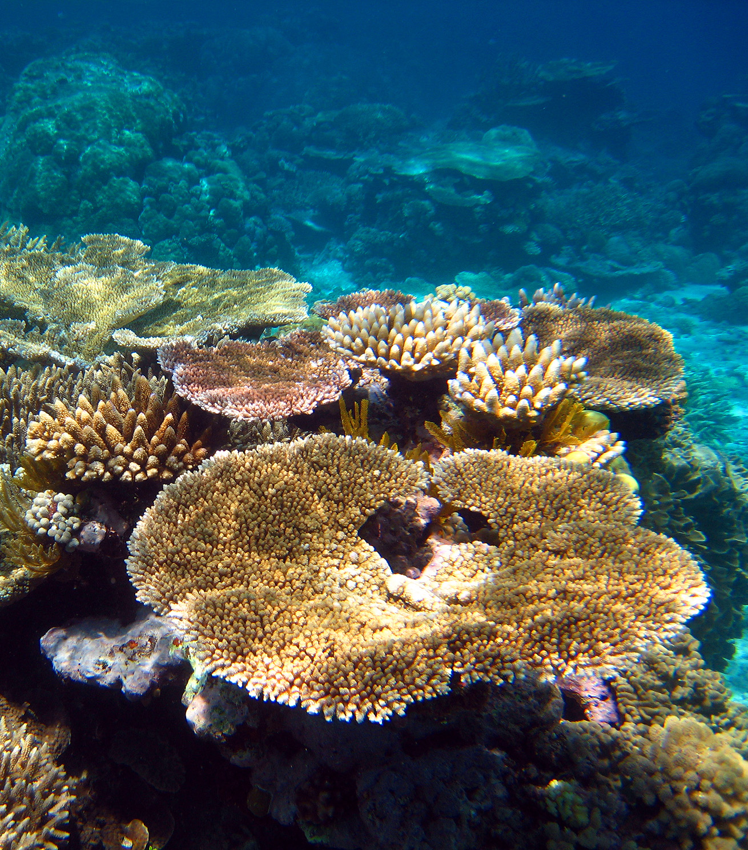

Attachment 3: Risks to Great Barrier Reef values as reported in the Great Barrier Reef Outlook Report
The Great Barrier Reef Outlook Report provides a full description of threats and risks. The Outlook Report has a standard set of criteria to allow the comparison of different types of threats within the one risk assessment, based on the likelihood and consequence of each threat. The likelihood and consequence of each predicted threat are ranked on five-point scales, as described below.

Figure A3.1 - Likelihood scale
Likelihood | Expected frequency of a given threat
Almost certain | Expected to occur more or less continuously throughout a year
Likely | Not expected to be continuous but expected to occur one or more times a year
Possible | Not expected to occur annually but expected to occur within a 10-year period
Unlikely | Not expected to occur in a 10-year period but expected to occur in a 100-year period
Rare | Not expected to occur within the next 100 years
Figure A3.2 - Consequence scale
Based on current management
Consequence | Ecosystem |  | Heritage
Consequence | Broad scale | Local scale | Heritage
Catastrophic | Impact is clearly affecting, or would clearly affect, the nature of the ecosystem over a wide area. Recovery periods greater than 20 years likely |  | Impact is or has the potential to destroy a class or collection of heritage places on a large scale; or is clearly affecting, or would clearly affect, a range of heritage values over a wide area.
Major | Impact is, or would be, significant as a wider scale. Recovery periods of 10 to 20 years likely. | Impact is, or would be, extremely serious and possibly irreversible to a sensitive population or community.  Condition of an affected part of the ecosystem possibly irretrievably compromised. | Impact is, or would be, adversely affect the heritage values of a number of places; destroy individual heritage places of great significance; or significantly affect the heritage values over a wide area.
Moderate | Impact is, or would be, present at a wider scale, affecting some components of the ecosystem. Recovery periods of five to 10 years likely. | Impact is, or would be, serious and possibly irreversible over a small area. Recovery periods of 10 to 20 years likely. | Impact is, or would, affect individual heritage places or values of significance; or affect to some extent the heritage values at a wider scale.
Minor | Impact is, or would be, not discernible at a wider scale.  Impact would not impair the overall condition of the ecosystem, or a sensitive population or community, over a wider level. | Impact is, or would be, significant to a sensitive population or community at a local level. Recovery periods of five to 10 years likely. | Impact is, or would, affect heritage places or values of local significance, but not at a wider scale. Impact would not impair the overall condition of the heritage values.
Insignificant | No impact; or if impact is, or would be, present then only to the extent that it has no discernible effect on the overall condition of the ecosystem. | No impact; or if impact is, or would be, present then only to the extent that it has no discernible effect on the overall condition of the ecosystem. | No impact; or if impact is, or would be, present then only to the extent that it has no discernible effect on the heritage values; or positive impacts.

Figure A3.3 - Risk matrix legend
Likelihood and consequence are combined to determine risk level, in accordance with the Australian Standard for Risk Assessment (AS/NZS ISO 31000:2009).

 |  | LIKELIHOOD
 |  | Rare | Unlikely | Possible | Likely | Almost certain
CONSEQUENCE | Catastrophic
CONSEQUENCE | Major
CONSEQUENCE | Moderate
CONSEQUENCE | Minor
CONSEQUENCE | Insignificant

Risk
 | Low |  | Medium |  | High |  | Very high

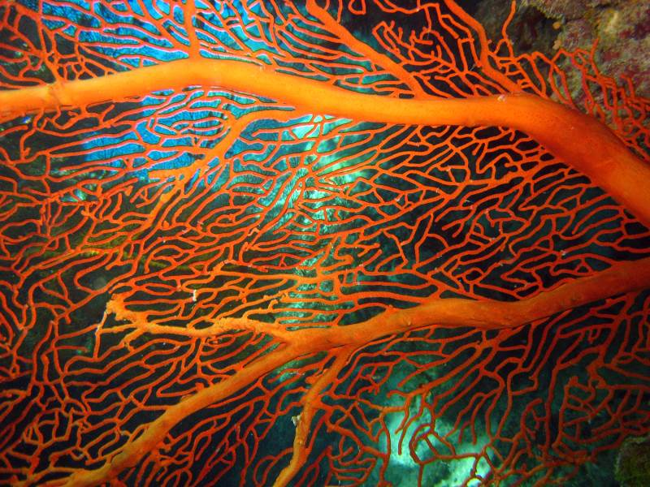

Attachment 4: Condition and trend of Great Barrier Reef values
Relationship between values and processes and ‘outstanding universal value’
A property is considered to be of ‘outstanding universal value’ if it meets one or more of 10 world heritage criteria and is inscribed on the World Heritage List. To be deemed to be of outstanding universal value ‘a property must also meet the conditions of integrity and/or authenticity and must have an adequate protection and management system to ensure its safeguarding’. Effective future protection of the Great Barrier Reef’s outstanding universal value, together with the seven matters of national environmental significance, relies on the integration of management measures and a systems approach to the protection of values and processes.
Given the scale and complexity of the Great Barrier Reef and its diversity and interconnectedness, key values and processes are combined into one comprehensive set as a basis for assessment of outstanding universal value and the seven matters of national environmental significance. The key values and processes presented in the following tables are based on those identified in the description of each matter in Sections 4.2 to 4.9 of the Great Barrier Reef Region Strategic Assessment Report.
Great Barrier Reef Outlook report condition and trend assessment approach (adapted from page 9 of the Great Barrier Reef Outlook Report 2014)
A set of assessment criteria is used to analyse available evidence. For example, the assessment of biodiversity uses two assessment criteria — habitats to support species and populations of species or groups of species. Within each assessment criterion there are multiple assessment components. A series of statements is then used to standardise the allocation of grades for all components examined in an assessment, as well as the overall grade for the criterion.
Grading statements (refer to Table A4.1)
The grade allocated is a ‘grade of best fit’, based on a qualitative assessment of the available evidence for the Region. It is not a comparison of the Region in relation to other tropical ecosystems around the world. The statements developed for assessing most heritage values are based on those used in the Australian State of the Environment Report and Strategic Assessment draft report. Those for the assessment of world and national heritage values are adapted from a grading system developed by the International Union for Conservation of Nature to assess the outstanding universal value of natural world heritage sites. One aspect considered in grading the condition of heritage values is the degree to which those values have been recorded and identified. This recognises the important role an understanding of heritage plays in its protection.
Trend and confidence
The approach to grading is refined by including an indication of trend and confidence, similar to the Australian State of the Environment Report and the Strategic Assessment report. There are four categories for trend: improved, stable, deteriorated and no consistent trend. The category of ‘no consistent trend’ is applied to a component when the available information is too variable to establish a trend, for example where there is strong variation across broad areas or across species within a group. The terms ‘improved’ and ‘deteriorated’ are replaced with ‘increased’ and ‘decreased’ in assessments of benefits, impacts, threats and risks. Similar to the Australian State of the Environment Report and the Strategic Assessment report, the level of confidence in each assessment of grade and trend is rated. The categories used are:
  - adequate high quality evidence and high level of consensus
  - limited evidence or limited consensus
  - inferred, very limited evidence.
For components where the confidence level is ‘inferred, very limited evidence’, the assessment is based on knowledge from managing agencies, Traditional Owners, topic experts and informed stakeholders (expert elicitation).

Evidence used
The evidence used in the Great Barrier Reef Outlook Report is derived from existing research and information sources. It is drawn from the best available published science based on:
  - relevance to the required assessments
  - duration of study
  - extent of area studied
  - reliability (such as consistency of results across different sources, peer review and rigour of study).

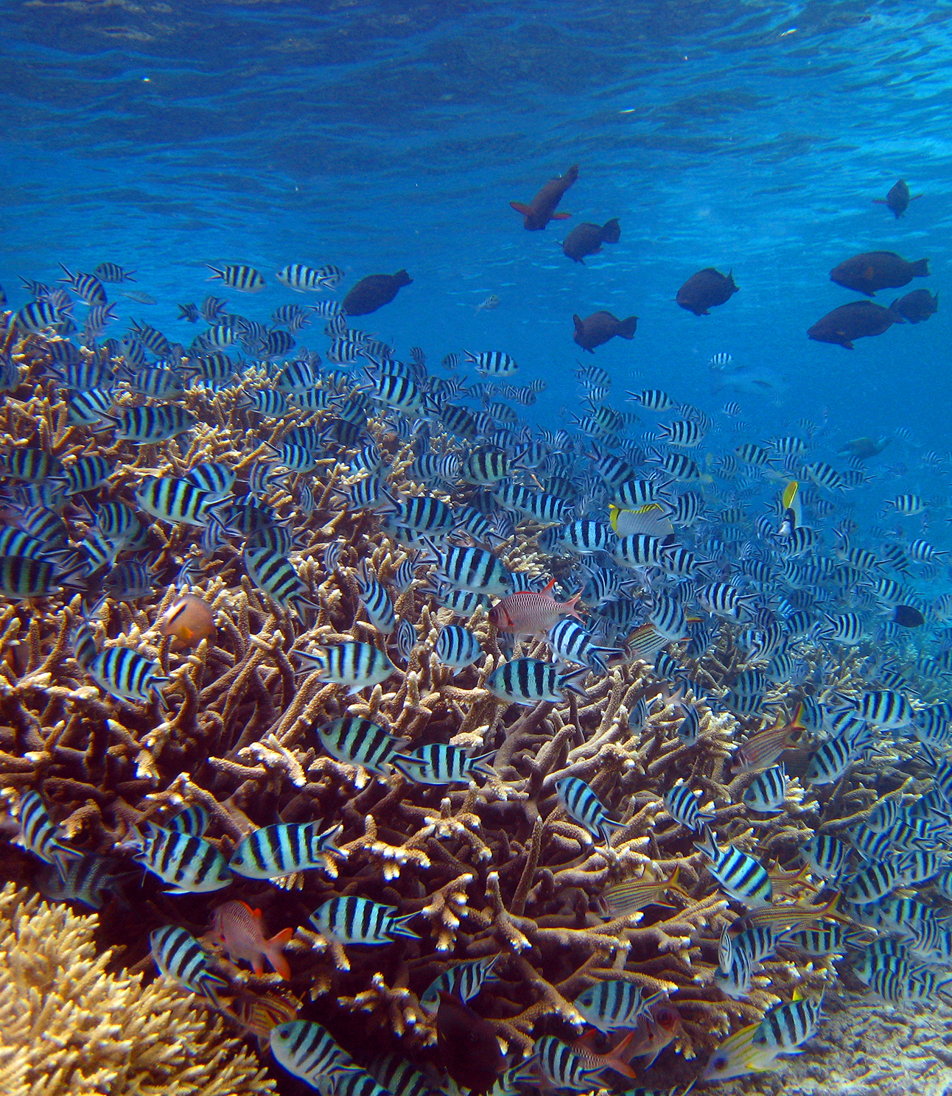

Table A4.1 - Condition of values grading statements
Functional group of values | Condition grading statement
Functional group of values | Very good | Good | Poor | Very poor
Habitat to support species | All major habitats are essentially structurally and functionally intact and able to support all dependent species. | There is some habitat loss, degradation or alteration in some small areas, leading to minimal degradation but no persistent, substantial effects on populations of dependant species. | Habitat loss, degradation or alteration has occurred in a number of areas leading to persistent substantial effects on populations of dependent species. | There is widespread habitat loss, degradation or alteration leading to persistent, substantial effects on many populations of dependent species.
Populations of species and groups of species | Only a few, if any, species populations have deteriorated as a result of human activities or declining environmental conditions. | Populations of some species (but no species groups) have deteriorated significantly as a result of human activities or declining environmental conditions. | Populations of many species or some species groups have deteriorated significantly as a result of human activities or declining environmental conditions. | Populations of a large number of species have deteriorated significantly.
Physical, chemical and ecological processes | There are no significant changes in processes as a result of human activities. | There are some significant changes in processes as a result of human activities in some areas, but these are not to the extent that they are significantly affecting ecosystem function. | There are substantial changes in processes as a result of human activities, and these are significantly affecting ecosystem functions in some areas. | There are substantial changes in processes across a wide area as a result of human activities, and ecosystem functions are seriously affected in much of the area.
Outbreak of disease, introduced species and pest species | No records of diseases above expected natural levels; no introduced species recorded; pests populations within naturally expected levels. | Diseases occasionally above expected natural levels but recovery prompt; any occurrences or introduced species successfully addressed; pests sometimes present above natural levels with limited effects on ecosystem function. | Unnaturally high levels of disease regularly recorded in some areas; occurrences of introduced species require significant intervention; pests outbreaks in some areas affecting ecosystem function more than expected under natural conditions. | Unnaturally high levels of disease often recorded in many areas; uncontrollable outbreaks of introduced pests; opportunistic pests seriously affecting ecosystem function in many areas.
Indigenous, historic, social, aesthetic, scientific, Commonwealth and Natural heritage values | Heritage values have been systematically and comprehensively identified and included in relevant inventories or reserves. Known heritage values are well maintained and retain a high degree of integrity. | Heritage values have been mostly identified and included in relevant inventories or reserves. Known heritage values are generally maintained and retain much of their integrity. | Heritage values have not been systematically identified. Known heritage values are degrading and generally lack integrity. | Heritage values have not been identified. Known heritage values are degraded and lack integrity.
World and national heritage values | All elements necessary to maintain the outstanding universal value are essentially intact, and their overall condition is stable or improving. Available evidence indicates only minor, if any, disturbance to this element of outstanding universal value. | Some loss or alteration of the elements necessary to maintain the outstanding universal value has occurred, but their overall condition is not causing persistent or substantial effects on this element of outstanding universal value. | Loss or alteration of the elements necessary to maintain outstanding universal value has occurred, which is leading to a significant reduction in this element of the outstanding universal value. | Loss or alteration of most elements necessary to maintain the outstanding universal value has occurred, causing a major loss of the outstanding universal value.
Economic and social benefits of use | Use of the Region provides significant economic and social benefit, in ways that sustain the fundamental value of the natural resource. The Region is strongly recognised, valued and enjoyed by catchment residents, the nation and the world community. | Use of the Region provides valuable economic and social benefit. The Region is valued by catchment residents, the nation and the world community. | There are few and declining economic and social benefits derived from the use of the Region. Many do not recognise the value of the Region and do not enjoy their visit to the Region. | Use of the Region contributes little or no economic and social benefit. The Region holds little value for catchment residents, the nation or the world community.

Table A4.2 - Key values and attributes of matters of national environmental significance
The following table outlines key values and attributes for the Great Barrier Reef. These values and attributes underpin Reef-related Matters of National Environmental Significance. For the World Heritage Area, values are based the Statement of Outstanding Universal Value.

 | World heritage properties |  |  |  |  |  |  |  | Listed migratory and  threatened species
Key values and attributes | Criterion i (now viii) | Criterion ii (now ix) | Criterion iii (now vii) | Criterion iv (now x) | Integrity | Great Barrier Reef Marine Park | National heritage places | Commonwealth marine areas | Marine turtles | Estuarine crocodiles | Whales | Dolphins | Dugongs | Sharks and rays | Seabirds | Shorebirds | Wetlands of international importance
Biodiversity — Great Barrier Reef habitats
Islands
Beaches and coastlines
Mangrove forests
Seagrass meadows
Coral reefs (<30 m)
Deeper reefs (>30 m)
Lagoon floor
Shoals
Halimeda banks
Continental slope
Open waters
Biodiversity — terrestrial habitats that support the Great Barrier Reef
Saltmarshes
Freshwater wetlands
Forested floodplain
Heath and shrublands
Grass and sedgelands
Woodlands
Forests
Rainforests
Connecting water bodies
Biodiversity — species
Mangroves
Seagrasses
Macroalgae
Benthic microalgae
Corals
Other invertebrates
Plankton and microbes
Bony fish
Sharks and rays
Sea snakes
Marine turtles
Estuarine crocodiles
Seabirds
Shorebirds
Whales
Dolphins
Dugongs
Geomorphological features
Coral reefs
Islands and shorelines
Channels and canyons
River deltas
Halimeda banks
Seagrass meadows
Aboriginal and Torres Strait Islander heritage
Cultural practices, observances, customs and lore
Sacred sites, sites of particular significance, places important for cultural tradition
Stories, songlines, totems and languages
Indigenous structures, technology, tools and archaeology
Historic heritage
Places of historic significance — historic shipwrecks
Places of historic significance — World War II features and sites
Places of historic significance — lightstations
Places of historic significance — other
Places of scientific significance (research stations, expedition sites)
Places of social significance — iconic sites
Community benefits of the environment
Income
Employment
Understanding
Appreciation
Enjoyment
Access to Reef resources
Personal connection
Health benefits
Aesthetics

Table A4.3 Key environmental processes relevant to matters of national environmental significance
For the World Heritage Area, connections are based on the Statement of Outstanding Universal Value. For listed species, processes that have a major supporting role in maintaining the species are shown (for example, the role that beaches play in the nesting of listed marine turtles). For wetlands of international importance, the connections shown are those discussed in the Ramsar Convention information sheet.

 | World heritage properties |  |  |  |  |  |  |  | Listed migratory and  threatened species
Key environmental processes | Criterion i (now viii) | Criterion ii (now ix) | Criterion iii (now vii) | Criterion iv (now x) | Integrity | Great Barrier Reef Marine Park | National heritage places | Commonwealth marine areas | Marine turtles | Estuarine crocodiles | Whales | Dolphins | Dugongs | Sharks and rays | Seabirds | Shorebirds | Wetlands of international importance
Waves, currents and tides
Cyclones
Wind
Sedimentation
Sea level
Sea temperature
Light
Nutrient cycling
Ocean acidity
Freshwater inflow and salinity
Microbial processes
Particle feeding
Primary production
Herbivory
Predation
Symbiosis
Competition
Connectivity
Recruitment
Reef building



