Great Barrier Reef Marine Park Authority
GREAT BARRIER REEF
Outlook Report 2014
IN BRIEF
The Great Barrier Reef Outlook Report 2014 — In Brief is licensed by the Commonwealth of Australia for use under a Creative Commons By Attribution 3.0 licence with the exception of the Coat of Arms of the Commonwealth of Australia, the logo of the Great Barrier Reef Marine Park Authority, any other material protected by a trademark, content supplied by third parties and any photographs. For licence conditions see: http://creativecommons.org/licences/by/3.0/au

The Great Barrier Reef Marine Park Authority asserts the right to be attributed as author of the original material in the following manner:

© Commonwealth of Australia (Great Barrier Reef Marine Park Authority) 2014

The Great Barrier Reef Marine Park Authority has made all reasonable efforts to identify content supplied by third parties using the following format ‘© [name of third party]’ or ‘Source: [name of third party]’. Permission may need to be obtained from third parties to re-use their material.
Requests and enquiries concerning reproduction and rights should be addressed to Communications, Great Barrier Reef Marine Park Authority, PO Box 1379, Townsville Queensland 4810.
Data from the Queensland Department of Agriculture, Fisheries and Forestry was accessed under a Creative Commons By Attribution 3.0 licence.
Disclaimer
While reasonable efforts have been made to ensure that the contents of this publication are factually correct, GBRMPA does not make any representation or give any warranty regarding the accuracy, completeness, currency or suitability for any particular purpose of the source material contained in this publication. Readers should consult the source material referred to and, where necessary, seek appropriate advice about the suitability of the publication for their needs. To the extent permitted by law GBRMPA shall not be liable for any loss, damage, cost or expense that may be occasioned directly or indirectly through the use of or reliance on the contents of this publication.
National Library of Australia Cataloguing-in-Publication entry
Great Barrier Reef outlook report 2014 : in brief / Great Barrier Reef Marine Park Authority.
ISBN 9781922126528
Includes bibliographical references.
Marine resources--Queensland--Great Barrier Reef.
Conservation of natural resources--Queensland--Great Barrier Reef.
Marine parks and reserves--Queensland--Great Barrier Reef--Management.
Environmental management--Queensland--Great Barrier Reef.
Great Barrier Reef (Qld.)
Great Barrier Reef Marine Park Authority.
551.42409943
This publication should be cited as:
Great Barrier Reef Marine Park Authority 2014, Great Barrier Reef outlook report 2014: in brief, GBRMPA, Townsville.
This publication should be cited as:
Great Barrier Reef Marine Park Authority 2014, Great Barrier Reef outlook report 2014: in brief, GBRMPA, Townsville.
Design and layout: Vetta Productions. Graphs: Hastings. Infographic: Agency. Cover photograph © Chris Jones.
Chapter design photographs © Chris Jones — chapters 2, 3, 4, 8, 9, 10; © Matt Curnock — chapter 5; © Queensland Parks and Wildlife Service — chapter 7.
Printed using environmentally responsible print techniques and purchased carbon neutral paper stock.
Further information is available from:
Great Barrier Reef Marine Park Authority
2-68 Flinders Street East (PO Box 1379)
Townsville Queensland 4810
Telephone +617 4750 0700
Fax +617 4772 6093
Website www.gbrmpa.gov.au
This Report contains photos of Aboriginal and Torres Strait Islanders. Readers of this report should be aware that, in some Aboriginal and Torres Strait Islander communities, seeing images of deceased persons in photographs may cause sadness or distress and, in some cases, offend against strongly held cultural prohibitions.
None of the report is intended to have the effect of extinguishing native title.

Preface
The Great Barrier Reef is one of the world’s most diverse marine ecosystems — it’s a rich mosaic of plants, animals, habitats and heritage values that is universally recognised as an amazing natural treasure.
In addition to its outstanding universal value as a world heritage area, the Reef is vitally important to communities and industries that depend on a healthy reef for recreation and their livelihoods.
The Great Barrier Reef Outlook Report 2014 is the second in the series. Following the first report in 2009, it provides an overview of the current condition, use, factors influencing the condition, management effectiveness, resilience, risks to its future and likely outlook.
For the first time, the report specifically considers the Region’s heritage values, including Indigenous heritage, historic heritage and the area’s world heritage values. This assessment is new and responds to both revised requirements of the Great Barrier Reef Marine Park Act 1975 and a World Heritage Committee request for an explicit assessment of the world heritage area’s outstanding universal value.
While positive actions have occurred since 2009, the report finds the greatest risks to the Reef are still climate change, land-based run-off, coastal development, some remaining impacts of fishing and illegal fishing and poaching.
This Great Barrier Reef Outlook Report 2014 — In Brief presents a summary of these key findings in a format the mirrors the key topics and chapters in the report.
The complete report, including a complete set of references, and other supporting material are available online at www.gbrmpa.gov.au.
signed
Russell Reichelt
Chairman and Chief Executive Officer
Great Barrier Reef Marine Park Authority
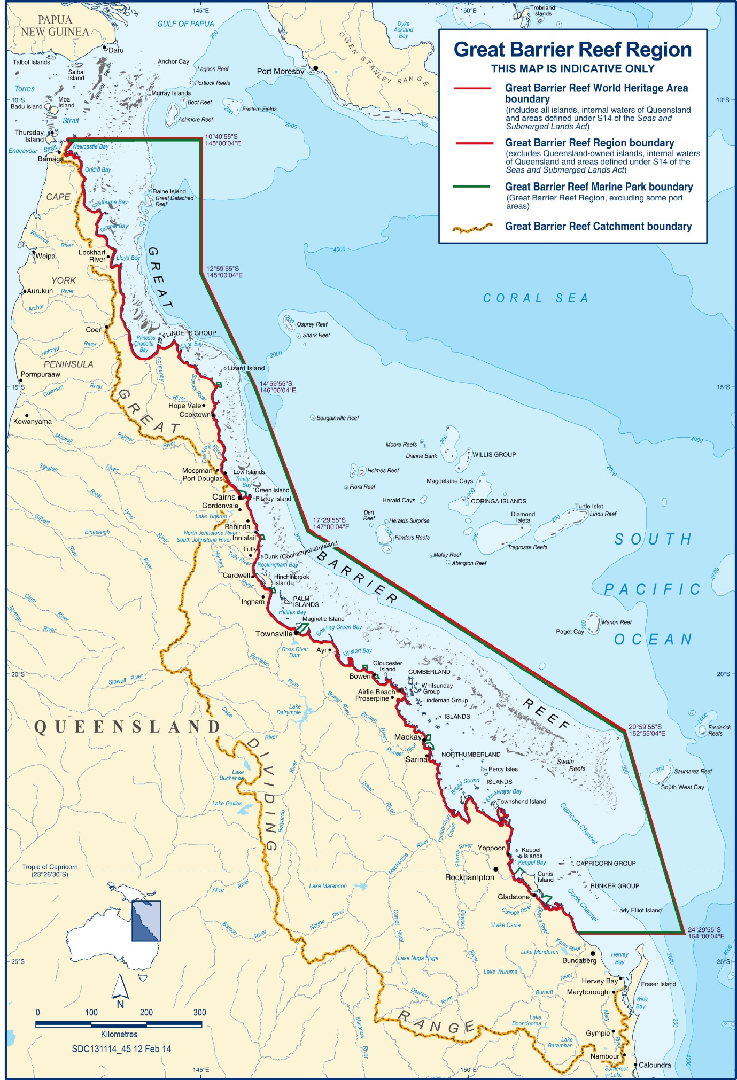
The Great Barrier Reef Region, World Heritage Area and Marine Park
The Outlook Report is a report about the entire Great Barrier Reef Region.

Executive summary
of the Great Barrier Reef Outlook Report 2014
The following is the complete text of the executive summary of the Great Barrier Reef Outlook Report 2014.
The Great Barrier Reef is an icon under pressure. Everyone’s actions, whether big or small, to reduce threats and help restore its condition will improve its outlook. Combined, they will make the Reef more able to recover from the legacy of past actions and better able to withstand those predicted to threaten its future.
In 2009, the Great Barrier Reef was considered to be at a crossroad, with decisions made in subsequent years likely to determine its long-term future. Since then, continuing investment in management of the Reef has had some positive results. For example, pollutant loads entering the Reef have measurably reduced as a result of comprehensive planning and local action, and Traditional Use of Marine Resource Agreements are improving Traditional Owner control of dugong and turtle hunting for traditional purposes.
Notwithstanding positive actions since 2009, the greatest risks to the Great Barrier Reef have not changed. Climate change, poor water quality from land-based run-off, impacts from coastal development, and some remaining impacts of fishing remain the major threats to the future vitality of the Great Barrier Reef.
In recent years, a series of major storms and floods have affected an ecosystem already under pressure. The accumulation of all impacts on the Reef has the potential to further weaken its resilience. This is likely to affect its ability to recover from serious disturbances, such as major coral bleaching events, which are predicted to become more frequent in the future.
The system as a whole retains the qualities contributing to its outstanding universal value as recognised in its listing as a world heritage property. The assessments of biodiversity and ecosystem health show that the northern third of the Great Barrier Reef Region has good water quality and its ecosystem is in good condition. In contrast, key habitats, species and ecosystem processes in central and southern inshore areas have continued to deteriorate from the cumulative effects of impacts. For example, the population of the iconic and culturally important dugong, which was already at very low levels compared with a century ago, has declined further in this part of the Region.
There are good examples of species continuing to show recovery after past significant declines. Populations of humpback whales, estuarine crocodiles, loggerhead turtles and the southern stock of green turtles are all increasing.
An assessment of heritage values was introduced into this report for the first time. It shows that many are inextricably linked to the health of the ecosystem and none more so than Indigenous heritage values. Traditional Owners with connections to the Region maintain their cultural practices and customs; however, these values have deteriorated as changes in coastal environments have reverberated through their culture, both now and in the past.
Some of the Region’s historic heritage values are well recognised and managed, especially known shipwrecks and Commonwealth heritage-listed lightstations. Many other places of historic significance are poorly recorded and their condition is not well understood.
The Great Barrier Reef remains a significant economic resource for regional communities and Australia. Major changes to the condition of the ecosystem have social and economic implications for regional communities because some uses, such as commercial marine tourism and fishing, depend on an intact, healthy and resilient ecosystem.
The Great Barrier Reef continues to be valued around the globe, well beyond its local communities. People’s experiences while visiting the Reef, combined with strong programs of information, education and interpretation, serve to maintain its social significance.
Climate change remains the most serious threat to the Great Barrier Reef. It is already affecting the Reef and is likely to have far-reaching consequences in the decades to come. Sea temperatures are on the rise and this trend is expected to continue, leading to an increased risk of mass coral bleaching; gradual ocean acidification will increasingly restrict coral growth and survival; and there are likely to be more intense weather events. The extent and persistence of these impacts depends to a large degree on how effectively the issue of rising levels of greenhouse gases is addressed worldwide. The impacts of increasing ocean temperatures and ocean acidification will be amplified by the accumulation of other impacts such as those caused by excess nutrient run-off.
Large areas of the Region continue to be exposed to elevated concentrations of suspended sediments, excess nutrients and pesticides, which are significantly affecting inshore areas along the developed coast. While improving land management practices are reducing amounts entering the Region, there will be significant time lags before improvements are evident in the Region’s water quality. Until then, chronic impacts, for example on the recovery of seagrass meadows and coral reefs, and outbreaks of the coral-eating crown-of-thorns starfish are likely to continue.
Intact coastal habitats (for example freshwater wetlands, floodplains and saltmarshes) are vital to a healthy Great Barrier Reef. They are important in the life cycle of some marine species and also play a role in slowing overland water flow and trapping sediments and nutrients. While not on the same scale as historic broadscale clearing, without active planning and management, incremental modification of these habitats is likely to continue based on projected economic and population growth.
Fishing, including recreational, charter and commercial fishing, occurs in many parts of the Region. There have been management reforms in recent decades, such as the use of bycatch reduction devices including those specifically for marine turtles, total allowable commercial catch limits (quotas) for some species, capping commercial fishing licences and fishery symbols, fish size and possession limits, restrictions on fishing apparatus, closed areas and seasonal closures. Notwithstanding these changes, across all fisheries risks to the ecosystem remain, especially from overfishing of some predators, incidental catch of species of conservation concern, effects on other discarded species and fishing of unprotected spawning aggregations. Illegal fishing continues to be a very high risk to the Reef. While understanding of commercial fishing has improved, recreational fishing and the cumulative impacts of fishing remain poorly understood.
Port activities in and adjacent to the Region are increasing and there are proposals for further expansions, including new capital works and continuing or increasing dredging in the coming decade. The direct and flow-on effects of port activities generally occur in areas of the Region that are already under pressure from an accumulation of impacts. Understanding of the ecosystem effects of port activities, in particular the fate of dredge material disposed at sea, is still incomplete but improving. While the effects of port activities are significant, they are relatively more localised than the broadscale impacts from land-based run-off.
Several strategic approaches are underway to address the risks to the Reef’s future and improve its resilience. For example, in addition to current major programs such as the Reef Water Quality Protection Plan 2013, the 2014 Queensland Ports Strategy and the draft North–East Shipping Management Plan, a strategic assessment for the Great Barrier Reef Region and adjacent coastal zone has been drafted by the Australian and Queensland governments. A Reef 2050 Long-term Sustainability Plan for the Great Barrier Reef is in preparation during 2014.
The independent assessment of management effectiveness undertaken for this report recognised the difficulties in achieving positive outcomes, given the complexity of the high risk issues, the geographic extent and time scales of the threats and the diminishing resource base to implement actions. This is reflected in the continuing poor outcomes grade for some management topics. The assessment concludes that, while many of the management measures implemented in the Great Barrier Reef Region and beyond are making a positive difference — for example the Great Barrier Reef Marine Park Zoning Plan 2003 and the Reef Water Quality Protection Plan 2013 — the ability to address cumulative impacts remains weak.
The independent assessment noted that management measures have improved in a number of areas since the Outlook Report 2009, in part as a result of that report. For example, planning effectiveness has improved for the management of land-based run-off and traditional use, and understanding of the scope of the Region’s heritage values has been considerably strengthened. At the same time, more users of the Region and residents and industries in the catchment are adopting best practices and contributing to monitoring to reduce impacts on the Reef and better protect it.
This 2014 Outlook Report, which is based on the best available information, has shown that there have been significant improvements in understanding of the Region’s values and impacts since the 2009 report (for example Reef water quality), however important information gaps still exist. In particular, knowledge and understanding of the cumulative impacts of the multitude of uses and activities remains to be developed.
Even with the recent management initiatives to reduce threats and improve resilience, the overall outlook for the Great Barrier Reef is poor, has worsened since 2009 and is expected to further deteriorate in the future. Greater reductions of all threats at all levels, Reef-wide, regional and local, are required to prevent the projected declines in the Great Barrier Reef and to improve its capacity to recover.

Table of contents
Preface 2
Executive summary 4
Table of contents 6
About this report 7
Biodiversity 10
Ecosystem health 13
Heritage values 16
Commercial and non-commercial use 19
Factors influencing the Region’s values 22
Existing protection and management 27
Resilience 30
Risks to the Region’s values 32
Long-term outlook 35
References 38

About this report
Every five years, the Great Barrier Reef Marine Park Authority prepares an Outlook Report for the Great Barrier Reef. The Great Barrier Reef Marine Park Act 1975 and Regulations stipulate what the report must contain and that it must be given to the Minister for the Environment for tabling in both houses of the Australian Parliament.
Outlook Reports are a regular and reliable means of assessing overall performance of all measures to protect and manage the Great Barrier Reef. They are a key input for any changes to Reef management and the consideration of broader issues by government. The Act does not provide for the Outlook Report to include recommendations about future protection or management initiatives.
The area examined in the report is the Great Barrier Reef Region (the Region) as defined in the Act. The Region covers 346,000 square kilometres from the tip of Cape York in the north to past Lady Elliot Island in the south, with mean low water as its western boundary and extending eastwards a distance of between 70 and 250 kilometres. It includes about 70 Commonwealth-owned islands. The majority of Great Barrier Reef islands are owned by the Queensland Government or privately and are not included in the Region. Where it is relevant to the Region’s ecosystem and its heritage values, the report looks beyond the Region’s boundaries and includes information about these adjacent islands, neighbouring marine areas and the Great Barrier Reef catchment.
[Photograph of coral reef from the air showing tourism pontoon and boats] Caption: The Region’s ecosystem and heritage values are considered, plus their links to economic and social values
The first Great Barrier Reef Outlook Report was released in September 2009. This second report builds upon the first. It provides a snapshot of current condition and examines progress in protecting the Reef since 2009. Importantly, it better encompasses the full range of the Reef’s values, reflecting the 2013 amendment of the Regulations which requires explicit assessment of heritage values in future Outlook Reports. To maintain the value of the Outlook Report as a time series, other changes have been limited to instances where they significantly improve the validity or utility of the assessment.
The report is structured around the nine assessments required by the Act and Regulations, with each assessment forming a chapter of the report. A systematic analysis of the components relevant to each assessment is presented, including an indication of trend since 2009 and, for the forward-looking assessments, trend into the future.
The information featured in the report is drawn from the best available published science to the end of 2013. In some cases, later information has been included where it was considered to make a significant difference to a key finding of the report.
The report has been prepared by the Great Barrier Reef Marine Park Authority. A number of Australian and Queensland government agencies and researchers from a range of institutions directly contributed to its development. The report draws extensively on the information contained in the draft Great Barrier Reef Region Strategic Assessment Report¹ and has been informed by the public submissions received on that draft.
The Great Barrier Reef Marine Park Authority’s 12 Local Marine Advisory Committees (committees based in regional centres along the coast); industry representatives; local government councils and teachers participating in the Reef Guardian program; and other stakeholders supported the report’s preparation in various ways.
The outcomes of a consensus workshop² involving 31 Reef scientists contributed to the assessments of biodiversity and ecosystem health, and also the assessment of risk.
Four independent experts in protected area management, monitoring and evaluation, public policy and governance independently assessed the effectiveness of existing protection and management arrangements for the Region’s ecosystem and its heritage values. The assessors’ report³ was independently peer reviewed. The outcomes form the basis of the assessment of existing measures to protect and manage the Region.
Finally, four reviewers appointed by the Minister for the Environment independently reviewed the draft Outlook Report. These reviewers are recognised national and international experts with biophysical, heritage and/or socioeconomic expertise and achievements, including conducting high level policy and scientific reviews. Their comments were considered and incorporated where appropriate in finalising the report.
[Photograph of a coral reef and a scuba diver as seen from underwater] Caption: The Great Barrier Reef is valued worldwide. Copyright: Matt Curnock
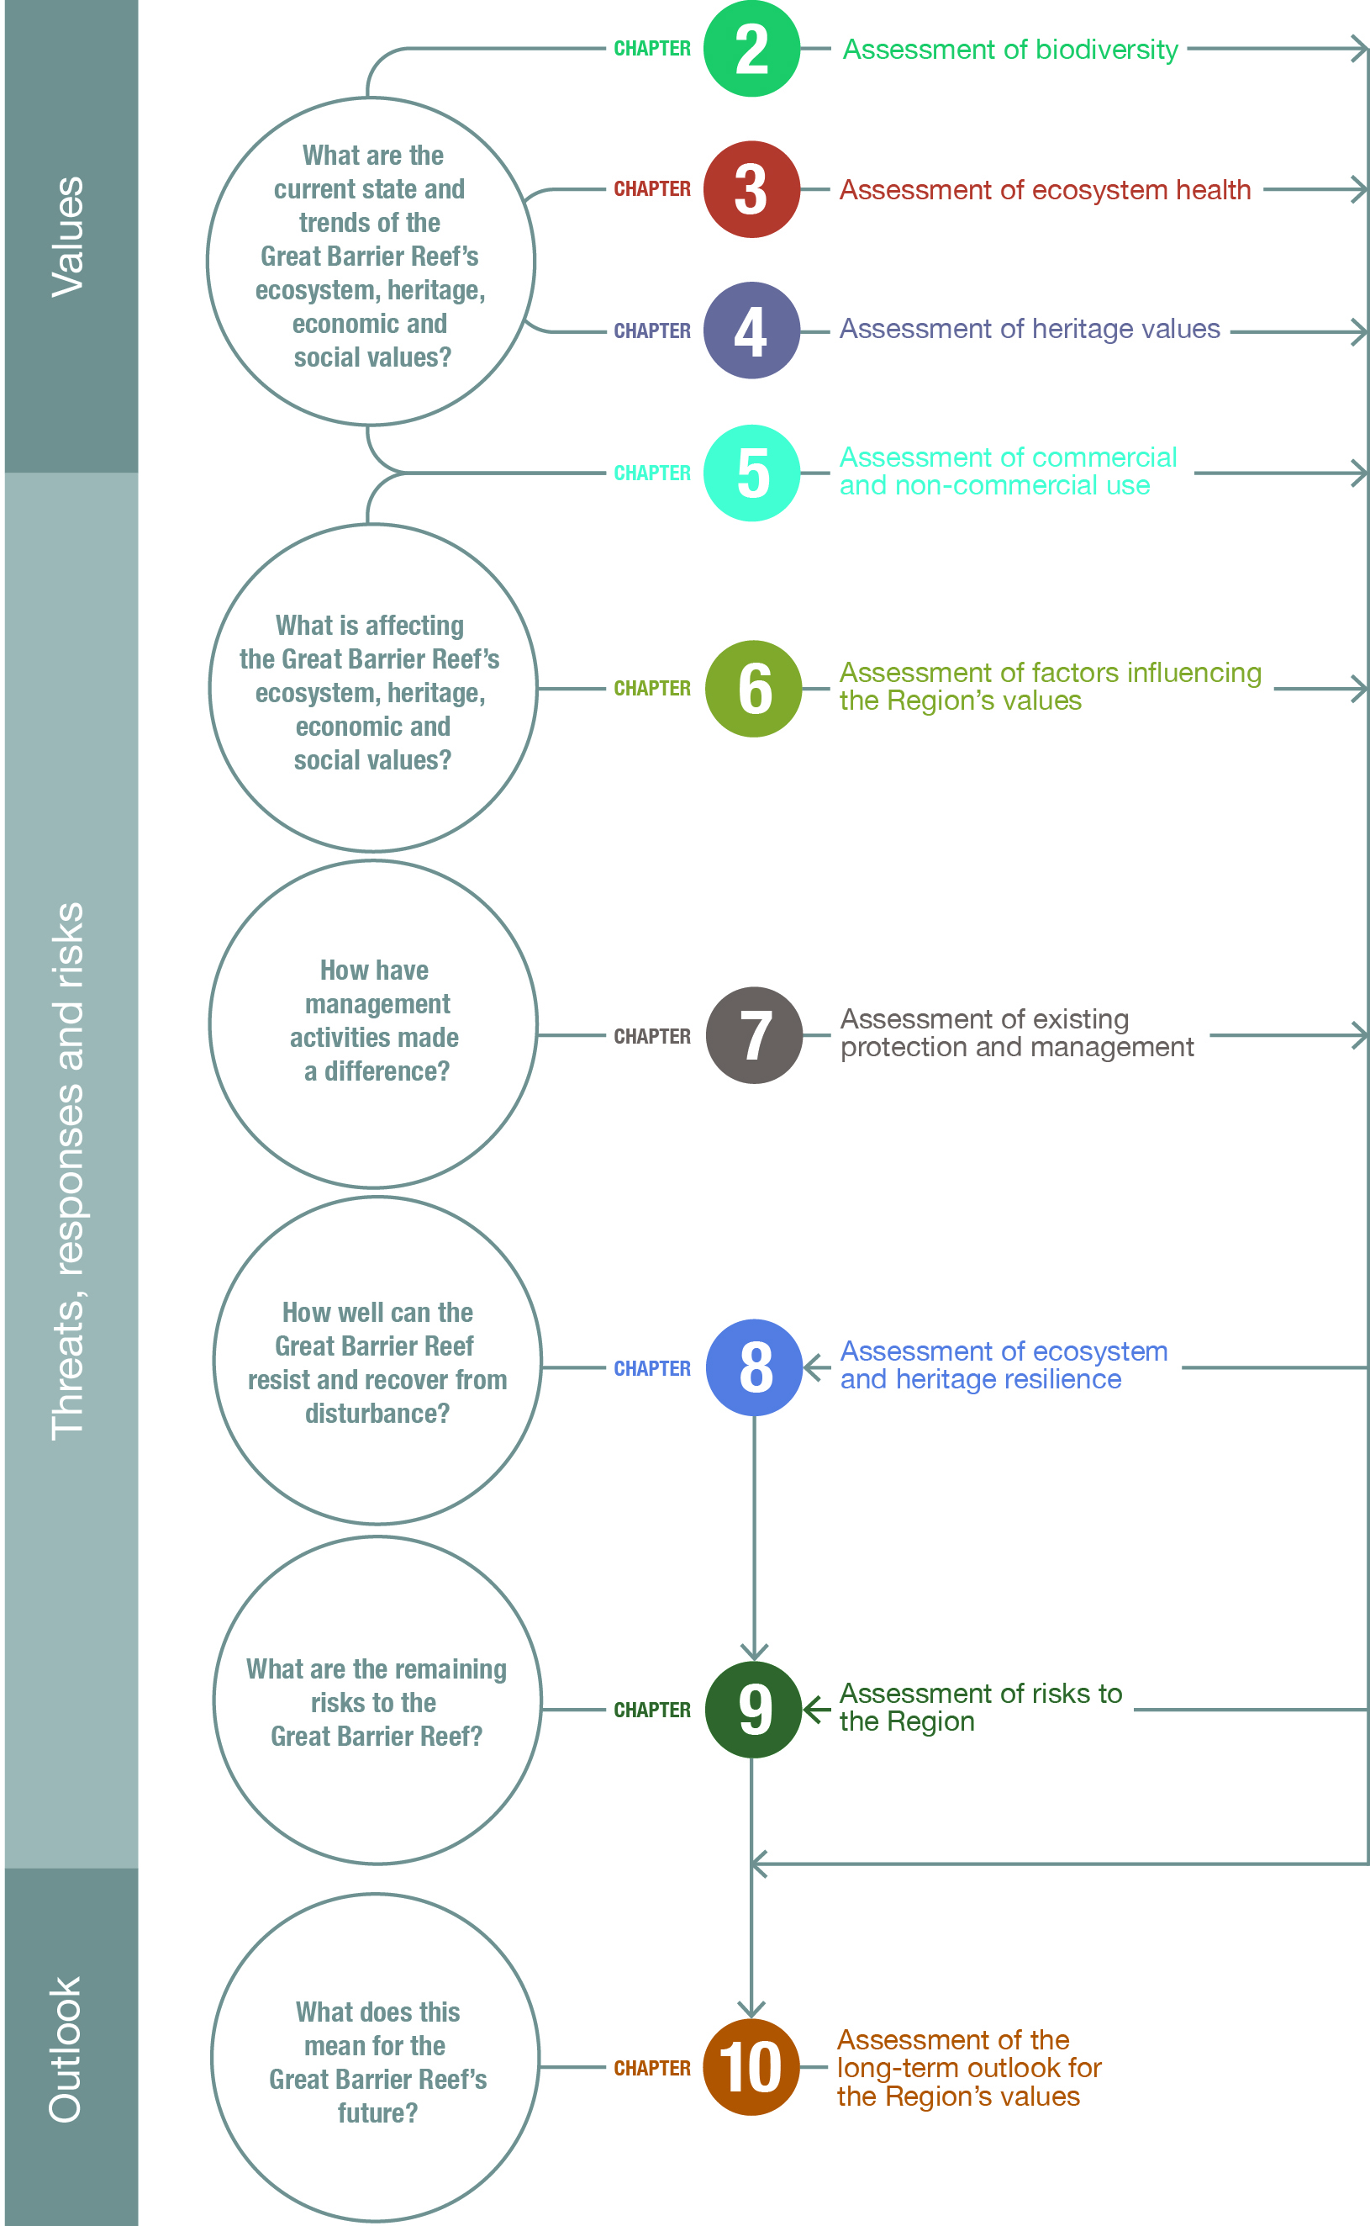
Assessments of the report
Each of the assessments required under the Great Barrier Reef Marine Park Act and Regulations forms a chapter of the report.
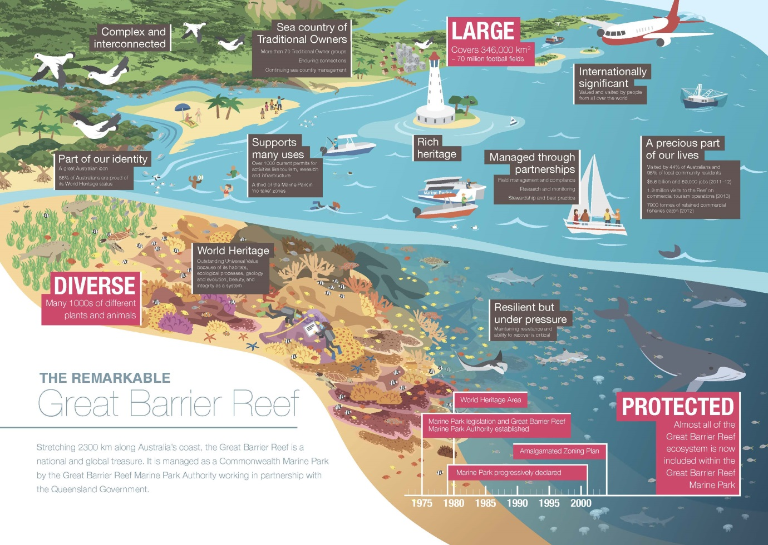

Biodiversity
The Great Barrier Reef is one of the world’s most diverse and remarkable ecosystems, with a wide range of habitats and many thousands of different species. The Reef’s biodiversity is the basis of its outstanding universal value recognised in its world heritage listing.
Legacies and shifted baselines Some previous activities have resulted in severe and long-lasting impacts on the Reef’s biodiversity. The most significant impacts were from large-scale commercial harvesting, especially of long-lived species such as dugongs, marine turtles, crocodiles and humpback whales. The legacies of these past activities need to be considered when assessing the current condition and trends of affected habitats and species.
Similarly, the lack of long-term scientific data across a number of habitats and groups of species presents a significant challenge when assessing the true condition and trend of the ecosystem. Most scientific research and monitoring began in the 1970s and 1980s, but there were significant changes in the Reef well before then, some stretching back over 150 years. As a result, many assessments are likely to be against a ‘shifted baseline’ and not reflect the full extent of change.
Habitats to support species The Great Barrier Reef ecosystem consists of a wide variety of habitats from mangroves and seagrass meadows to coral reefs and open waters. The overall condition of the Region’s biodiversity depends on maintaining the condition of all its habitats and the interconnections between them.
At the scale of the Region, the majority of habitats are assessed to be in good to very good condition; however, an increasing number are in poor condition or have deteriorated since 2009. This includes two key habitats — coral reefs and seagrass meadows.
Coral reefs are the cornerstone of the Great Barrier Reef ecosystem and its evolutionary history. Since monitoring began in 1986, though there have been some periods of recovery, the overall average hard coral cover in the Region is estimated to have declined from 28 to 13.8 per cent and the rate of decline has increased substantially in recent years. The decline in coral cover has been most severe in the southern two-thirds of the Region. It is largely the result of a combination of cyclones, crown-of-thorns starfish outbreaks and mass bleaching, with elevated nutrients, sediments and pesticides in land-based run-off likely to have affected recovery in inshore areas. While coral reefs have a natural ability to recover from periodic disturbances, corals exposed to chronic pressures such as poor water quality, are likely to have less resilience. There are early signs of regeneration of some reefs affected by severe weather, for example areas in the path of cyclone Yasi in 2011.
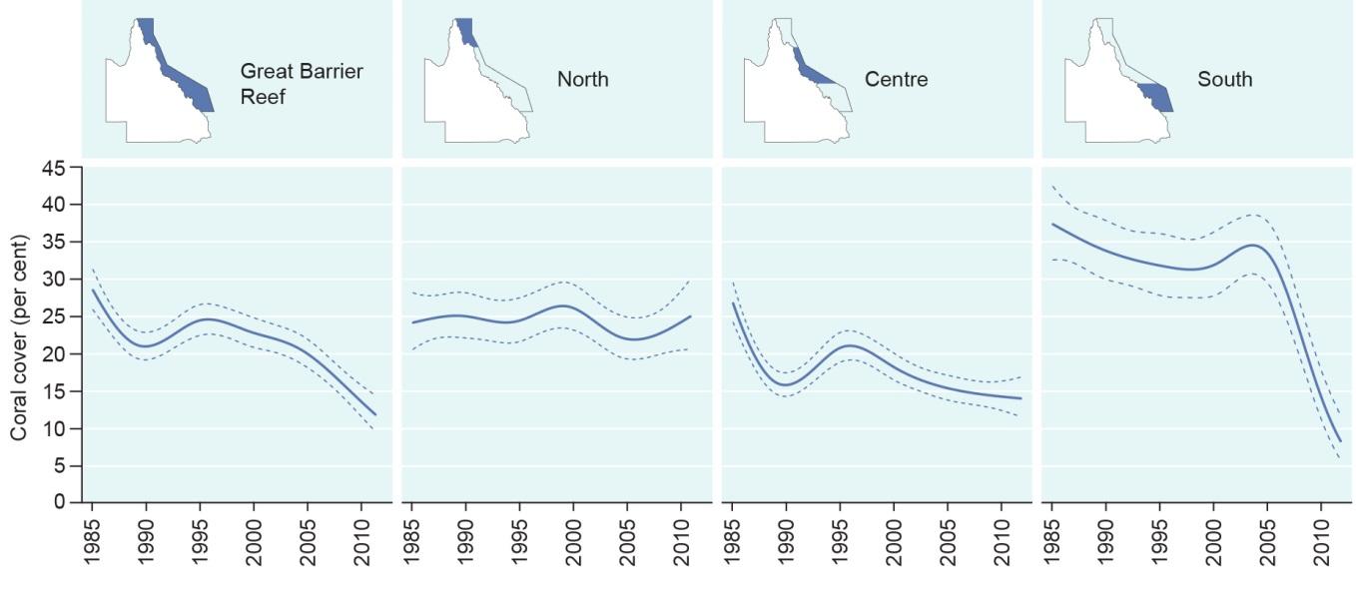
Hard coral cover, 1986–2012
Average hard coral cover in the Region has declined significantly since monitoring began in 1986. Declines have been most severe in the southern two-thirds. The solid line represents modelled coral cover based on the analysis of data collected from 214 reefs across the Region; while the dashed lines either side represent the associated standard errors.
Source: De’ath et al. 2012⁴
Seagrass meadows are the main food source for dugongs and green turtles, provide nursery habitat for many commercial fisheries species and are a major source of primary production. Many inshore seagrass meadows have declined since 2007, especially due to extreme weather (for example floods and cyclones) and ongoing chronic impacts such as poor water quality and extended periods of cloud cover. Some meadows are showing early signs of recovery.
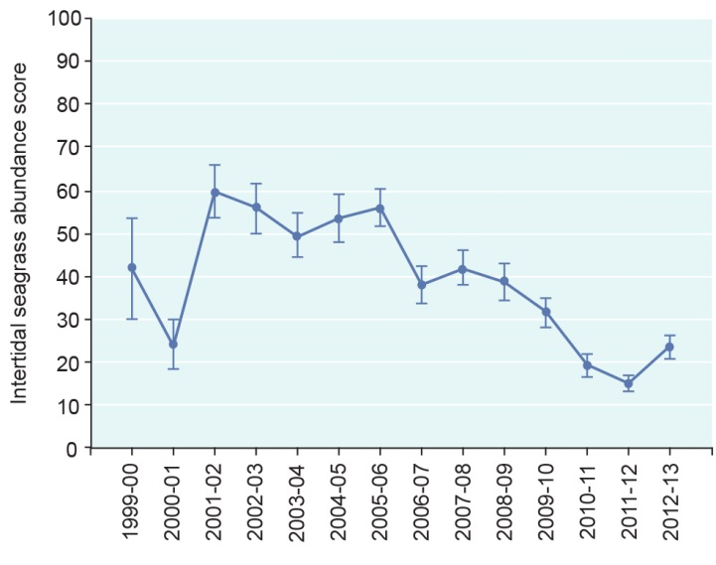
Seagrass abundance score for intertidal seagrass meadows, 1999–2013
Substantial declines in the abundance score of intertidal seagrass meadows have been recorded south of about Cooktown since 2007. Some recovery was observed during 2012-13.
Source: McKenzie et al. 2014⁵
On a regional scale, the habitats north of the Port Douglas–Cooktown area are in better condition than those further south. Also, habitats further offshore and in deeper water are typically subject to fewer threats and are therefore presumed to be in better condition, including the lagoon floor, shoals, Halimeda banks, deeper reefs and the continental slope.
Populations of species and groups of species The Region is home to thousands of species and provides important habitat for species of conservation concern such as dugongs, whales, dolphins, seabirds, marine turtles, sharks and rays. The condition of a number of species has deteriorated since the 2009 assessment, with some important species such as sharks and rays, corals, some marine turtles and dugongs now assessed as being in poor condition. Two species of inshore dolphins are considered at high risk and in decline.
There are some examples of recovering populations. Those that are recovering — humpback whales, estuarine crocodiles, loggerhead turtles and green turtles (southern stock) — are species that were affected by human-related impacts which have been eliminated or reduced, for example commercial whaling and incidental drowning of marine turtles in trawl nets. These populations are yet to recover to their original size and, as they tend to be long-lived species, full recovery is likely to take decades.
A range of past and current threats — including pollutants in land-based run-off, crown-of-thorns starfish outbreaks, death of discarded species, incidental catch of species of conservation concern and recent extreme weather — have resulted in declines in some species in the southern two-thirds of the Region, especially in inshore and mid-shelf areas. Examples include corals, dugongs and sharks and rays.

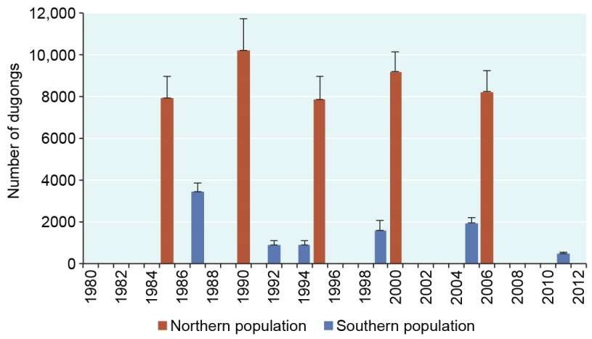
Dugong populations, 1985–2011
In 2009, the Region’s southern dugong population was thought to have stabilised after a long history of decline. However, recent surveys indicate further decline, principally as a result of deterioration in seagrass meadows. Surveys indicate the population north of Cooktown is stable.
Source: Marsh et al. (various years)^{6,7,8,9,10} and Sobtzick et al. 2012¹¹
Summary of assessment
Habitats to support species Information on the condition and trend of habitats is highly variable with some well known (for example shallower coral reefs) and others poorly known, particularly habitats in remote areas or deep waters (for example Halimeda banks). The habitats of the northern third of the Region are believed to remain in very good condition and are able to support dependent species. Habitats in the southern two-thirds of the Region — especially those inshore — have deteriorated, particularly seagrass meadows and coral reefs. | Good,  Deteriorated
Populations of species and groups of species There is only condition and trend information for a limited number of species and species groups; hence the assessment of some components is highly uncertain. Of those for which there is information, there have been significant declines in many, especially in the inshore southern two-thirds of the Region, and some iconic and cultural keystone species. For example, significant declines have been recorded in most hard corals and seagrasses, some fishes and sharks, dugongs, plus some seabird populations. There are four examples of species showing good recovery after past serious declines: humpback whales, estuarine crocodiles, loggerhead turtles and green turtles (southern stock). However, even these species have not recovered to their original numbers. The overall condition of the Region’s species appears to have deteriorated significantly and the assessment of ‘good’ is considered borderline with ‘poor’. | Good, Deteriorated

Ecosystem health
To systematically assess the health of the Great Barrier Reef ecosystem, its main physical, chemical and ecological processes are considered. These processes are interconnected and the overall health of the ecosystem requires all to be in good condition. Assessing terrestrial habitats that support the Great Barrier Reef is new to the report and recognises the important role of these habitats in Reef health. In addition, outbreaks of disease and introduced and pest species are examined as their frequency and severity are a gauge of overall ecosystem health.
Physical and chemical processes Over the past decade the Region experienced a series of extreme weather events, including floods and six category 3 or above cyclones. Combined with the continuing poor condition of key processes such as sedimentation and nutrient cycling, this has caused the overall health of the Great Barrier Reef ecosystem to deteriorate since 2009. While land management practices are beginning to reduce the amount of nutrients and sediments leaving the catchment, there is likely to be a long lag time between these improvements and reductions in pollutants flowing into the Region, and again between that and improvements in related marine processes.
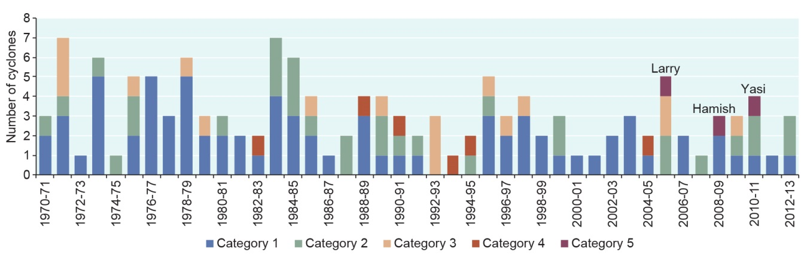
Number and severity of cyclones, 1970–2013
A number of severe cyclones have affected the Region over recent years.
Source: Bureau of Meteorology¹²
Sea temperature is increasing. While other environmental conditions (for example cloud cover and wind) shortened periods of elevated temperature compared to the late 1990s and early 2000s, the trend of increasing temperatures places the ecosystem at serious risk into the future. Other processes likely to have a Region-wide influence on ecosystem health, such as ocean pH and sea level, are also expected to deteriorate into the future.
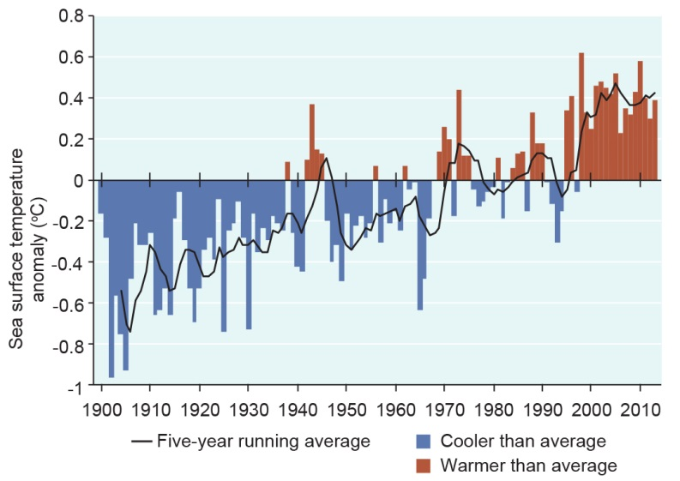
Sea surface temperature anomalies for the Coral Sea, 1900–2013
This graph uses the 1961 to 1990 average as a baseline for depicting change. The hottest five-year running averages have all been in the last 15 years, with temperatures above the baseline in all those years.
Source: Bureau of Meteorology 2014¹³
Ecological processes are integral to the attributes recognised in the world heritage listing of the Great Barrier Reef. The deteriorating condition of many is likely to be affecting its outstanding universal value. Recruitment is reduced for many key species such as corals, some fishes, dugongs, some marine turtles and seabirds and is assessed as being in poor condition overall. The process of predation is affected by decreased predator populations and is considered in poor condition overall. Many others processes such as connectivity, reef building and herbivory are considered in good condition, but have deteriorated since 2009.
Terrestrial habitats that support the Great Barrier Reef have been significantly affected by past broadscale land clearing and ongoing clearing and modification. Terrestrial habitats are generally in very good condition north of Port Douglas. Further south, in the bulk of the Region’s catchment, all supporting habitats have been substantially modified. This has affected connectivity and the capacity for these habitats to support marine habitats, species and processes.
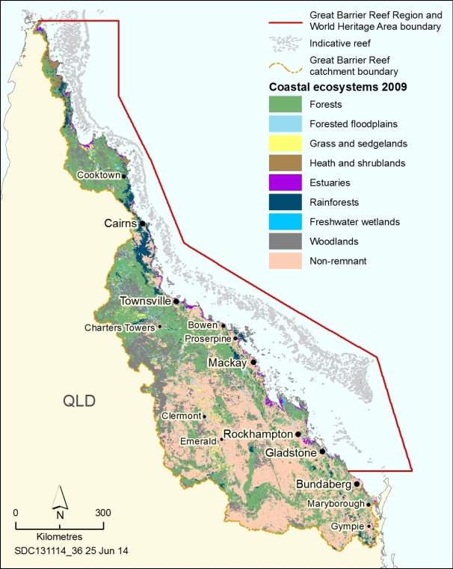
Changes in supporting terrestrial ecosystems, 2009
Before European settlement the catchment mainly comprised areas of forests, rainforests, woodlands, grasslands and forested floodplain interspersed with wetlands and other aquatic habitats. An extensive area of the catchment has been modified to the extent that its natural ecological function has been changed or lost (non-remnant), including the role it played in supporting the Great Barrier Reef.
Source: Great Barrier Reef Marine Park Authority, 2012¹⁴
Outbreaks of disease, introduced species and pest species Disease affected corals, green turtles, dugongs and the Queensland groper in recent years. Most outbreaks were not recorded on a wider scale. One indicator that ecosystem health is declining is more frequent outbreaks of crown-of-thorns starfish. Rather than experiencing outbreaks in a natural cycle of about every 50 to 80 years there has been three in the past 50 years and a new outbreak has begun. There is growing evidence of a link between outbreaks and increasing concentrations of nutrients. Outbreaks of some other species are likely to have resulted from declining ecosystem conditions.
Summary of assessment
Physical processes The condition of all physical processes has declined since 2009. Further changes in processes such as sea temperature, sea level, cyclones and wind, freshwater inflow, waves and currents are expected under climate change projections. Reduced sediment loads entering the Region are likely to improve the processes of sedimentation and light availability in the longer term. | Good, Deteriorated
Chemical processes Nutrient cycling in the Region continues to be affected by nutrients from land-based run-off but changes in land management are likely to result in long-term improvements. Heavy rainfall in recent years has temporarily affected ocean salinity in some parts of the Region. Ocean pH is changing and is projected to decline in the future under climate change scenarios. Unlike the Outlook Report 2009, this assessment does not include consideration of pesticide accumulation. | Good, Deteriorated
Ecological processes At a Reef-wide scale, most ecological processes are considered to be in good condition but significant losses in coral cover and declines in ecosystem health in the inshore, southern two-thirds of the Region are likely to have affected some key ecological processes such as connectivity, reef building and recruitment. | Good, Deteriorated
Terrestrial habitats that support the Great Barrier Reef Terrestrial habitats that support the Reef are generally in better condition in the northern catchment. However, supporting habitats have been substantially modified in areas south of about Port Douglas, especially wetlands, forested floodplains, grass and sedgelands, woodlands and forests, and rainforests. | Poor, Trend not assessed
Outbreaks of disease, introduced species and pest species Coral disease is being increasingly observed on the Great Barrier Reef and is predicted to increase in the future. There are few incidences of other disease and introduced species in the marine environment and they tend to be localised. Outbreaks may be becoming more frequent as ecosystem conditions decline. The overall assessment is ‘poor’ due to the severity of outbreaks of crown-of-thorns starfish which seriously affect coral reef habitats on a large scale. | Poor, No consistent trend

Heritage values
An assessment of the Region’s heritage values is new to this report.
Indigenous heritage values recognise the heritage of Aboriginal and Torres Strait Islander peoples who are the Traditional Owners of the Great Barrier Reef. Preserving these values ensures continued recognition of Traditional Owner culture and respect for past generations and the ancestral beings that shaped the land, seas and waterways.
Cultural practices, observances, customs and lore are integral to Traditional Owner connections to sea country and its ongoing management. Throughout the Region, Traditional Owners are maintaining their cultural practices and transferring them to future generations. Many sacred sites, sites of particular significance and places of cultural tradition are in good condition; others are under pressure, including from coastal development and severe weather. Some coastal activities and uses within the Region are affecting stories, songlines, totems and languages, especially in central and southern areas. Indigenous structures, technology, tools and archaeology have not been systematically identified and many are under pressure.
[Photograph of large boulders sitting in the ocean. Caption: Indigenous heritage values associated with these sacred rocks include protection over sea country areas.]
Historic heritage values relate to the occupation and use of the Region since the arrival of European and other migrants. Many significant voyages of discovery, such as those by Lieutenant James Cook and Lieutenant Matthew Flinders, sailed through the Region and there are several hundred historic shipwrecks. While many historic shipwrecks have been mapped and two are well documented, many others are not located or assessed. The Region was part of World War II and there is increasing awareness of the many significant features and sites from that time. Some have been identified, however little is known of their condition. Some World War II sites are being damaged by adjacent activities.
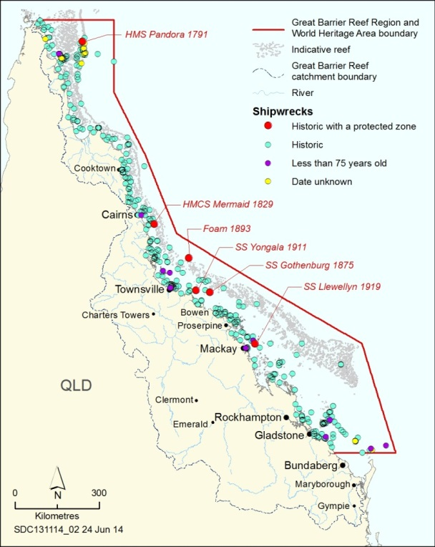
Shipwrecks
There are several hundred historic shipwrecks in the Region, including six with a declared protected zone.
Source: Queensland Department of Environment and Heritage Protection
[Photograph of a semi-submerged aircraft P39 Airacobra, Margaret Bay] Caption: Three World War II P39 Airacobra wrecks have been located in shallow water along the coast
Other heritage values, comprising social, scientific and aesthetic aspects, are generally being maintained. Continued education and interpretation combined with ongoing use serve to maintain the Reef’s social significance. Its scientific significance is based on the long history of study and the ground-breaking scientific advances that have happened there. The Region generally continues to be an area of great natural beauty; however, coastal infrastructure, marine debris, reduced water clarity and declining coral cover have reduced underwater aesthetic values, especially in central and southern inshore areas.
World heritage and national heritage values The Great Barrier Reef is on both the World Heritage List and the National Heritage List. The area’s national heritage listing is based on its recognition as a world heritage property. World heritage listing recognises the area has outstanding universal value — natural significance which is so exceptional as to transcend national boundaries and to be of common importance for present and future generations of all humanity.¹⁵
The Great Barrier Reef’s outstanding universal value is based on all the four natural criteria in place at the time of listing — acknowledging the Reef’s natural values, geomorphological significance and natural beauty, together with the strong ongoing links between Aboriginal and Torres Strait Islanders and their sea country.¹⁶ The property is comprehensively managed. External factors are affecting the resilience of the ecosystem in some areas.
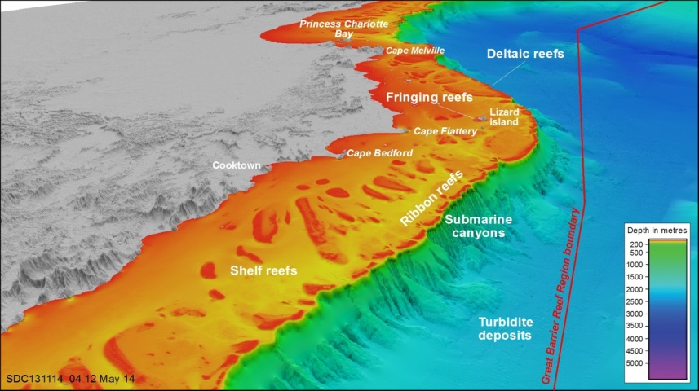
Geomorphological features
The area adjacent to Cooktown and Princess Charlotte Bay contains examples of many of the Region’s geomorphological features recognised in the Reef’s world heritage listing. They occur on the continental shelf, down the shelf edge and in the deeper water beyond.
Image courtesy of Dr Robin Beaman, www.deepreef.org
Commonwealth heritage values Five places in the Region are recognised on the Commonwealth Heritage List: Shoalwater Bay Military Training Area; Low Island and Low Islets lightstation (including its significance to Kuku Yalanji and Yirriganjdji Traditional Owner groups); Dent Island lightstation; North Reef lightstation and Lady Elliot Island lightstation. All sites are generally well maintained.
Natural heritage values The preceding assessments of biodiversity and ecosystem health indicate that natural heritage values are generally in good condition, with some in decline.
Summary of assessment
Heritage values not assessed in 2009 — trend not provided
Indigenous heritage values Traditional Owners with connections to the Region maintain their cultural practices and customs. Places of Indigenous heritage values have not been systematically identified and many have deteriorated, especially around developed areas and on islands. Some species of cultural significance are under pressure. Story, language and songlines are being affected by activities in the Region. | Poor
Historic heritage values There is good understanding and recording of some aspects of historic heritage in the Region, for example known historic shipwrecks, a small number of World War II features and lightstations. Heritage values are being maintained or restored at heritage-listed lightstations. Most other places of historic significance are poorly recorded and their condition is not well understood. | Good
Other heritage values The Region’s social and scientific heritage is being maintained. The Great Barrier Reef continues to have great scientific significance. People continue to value and connect with its environment and its natural beauty is widely appreciated. Declines in environmental condition in the central and southern inshore areas have reduced underwater aesthetic values. | Good
World heritage values and national heritage values The outstanding universal value of the world heritage property remains in good condition, however the overall condition of some key attributes is poor and many have deteriorated since the property’s listing in 1981. Those related to coral reef and seagrass meadow habitats, marine turtles, seabirds and dugongs are assessed as being in poor condition overall. The Region remains a globally outstanding example of an ecosystem that has evolved over the millennia. The natural beauty of most of the Region remains, however its underwater aesthetic value has declined in central and southern inshore areas. External pressures are affecting the property’s integrity. | Good
Commonwealth heritage values The five places in the Region that are included on the Commonwealth Heritage List retain the values for which they were listed. The Shoalwater Bay Military Training Area and the four historic lightstations have been well recorded, retain their integrity and are in good condition. Low Island retains its importance as part of Indigenous tradition. | Good
Natural heritage values Most of the Region’s natural heritage values remain in good condition, but some are in decline, especially in its southern two-thirds. Values in poor condition include coral reefs and corals, seagrasses, seabirds, sedimentation, nutrient cycling and sea temperature. Populations of some iconic species such as dugongs and marine turtles are also in poor condition. | Good

Commercial and non-commercial use
Commercial and non-commercial uses in the Region, especially commercial marine tourism and fishing, make an important economic contribution to regional and national economies, directly and indirectly contributing an estimated $5.6 billion to the Australian economy and supporting employment equivalent to about 69,000 full-time positions.¹⁷ Ports and shipping activities provide a link in the production chain for many industries and services in regional Queensland.
Commercial marine tourism extends throughout the Region and is almost exclusively nature based, focused in areas offshore Cairns and Port Douglas and around the Whitsundays. It continues to make a significant contribution to the presentation, management and economic value of the Great Barrier Reef. After a decline in the number of tourists to the Great Barrier Reef Marine Park of more than 16 per cent between 2005 and 2011, there was sustained recovery in 2012 and 2013. There were almost 1.9 million visitor days in 2013 — 64 per cent with independently eco-certified operators. The impacts of tourism activities are localised, mainly in a few intensively managed areas.
Defence activities are regularly undertaken in designated areas in the Region and directly contribute to Australia’s defence services. The level of planning and resourcing for defence activities means incidents are rare. The Region is predicted to increase in importance as a defence training area over the next 25 years.
Fishing, comprising recreational, charter and commercial activities, target a variety of species including fishes, sharks, crabs and prawns. In addition, since 1962, the Queensland shark control program has operated along the Region’s coast. The retained commercial catch in the Region was about 7900 tonnes in 2012, principally in the four major fisheries — trawl, net, line and pot. Catch and effort in these fisheries have fluctuated over the past couple of decades and have been lower in recent years. Commercial fishing principally harvests predators and particle feeders. The impacts of fishing include entanglement and death of species of conservation concern, effects on discarded catch, reductions of targeted species with implications on the food chain, extraction from unprotected spawning aggregations. Illegal fishing remains a concern, especially intentional targeting of protected zones. While understanding of commercial fishing has improved, the status of most targeted species is not well known, estimates of discarded catch are poor, and recreational fishing and cumulative impacts of fishing remain poorly understood.
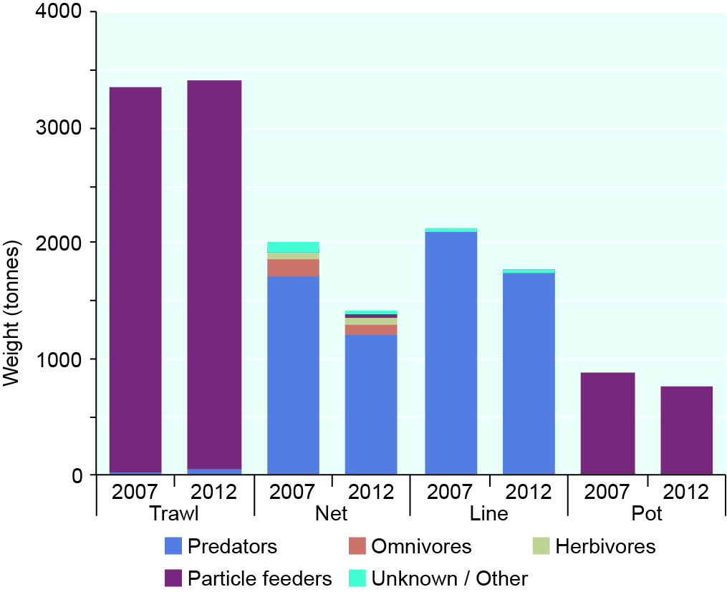
Ecological groups retained by major commercial fisheries, 2007 and 2012
By far the majority of species retained by commercial fishing in the Region are predators and particle feeders. Data for discarded catch and bycatch are not included.
Source: Department of Agriculture, Fisheries and Forestry (Qld) 2013¹⁸
Ports There are 12 ports in or adjacent to the Region and their imports and exports have increased over the last decade. In 2011–12, it was 76 per cent of the Queensland’s total throughput. Port activities can have local adverse impacts on the Region’s values and many operate in inshore areas which are already under pressure from an accumulation of other impacts. Both capital and maintenance dredging are undertaken within the Region, mostly associated with the larger and busier ports. Some permitted sites for the disposal of dredge material are within Great Barrier Reef World Heritage Area. Understanding of the effects of dredging and disposal is improving but the cumulative effects are not well understood.
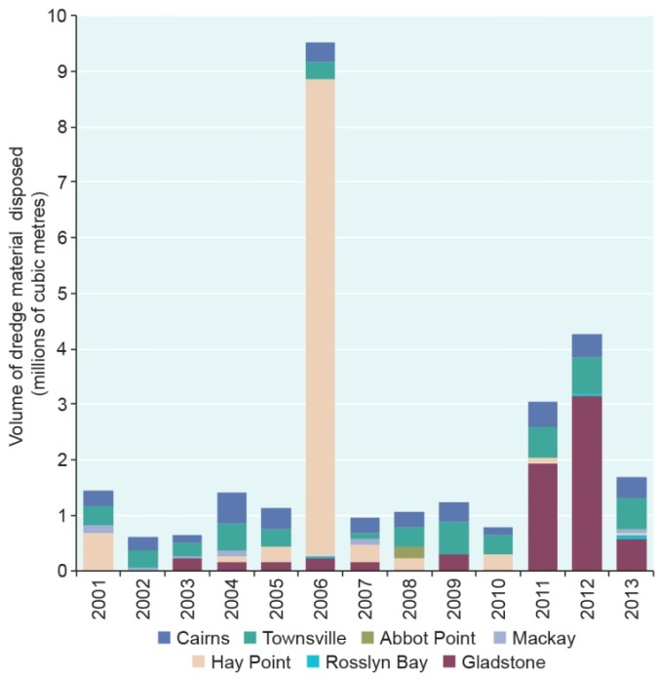
Dredge material disposal, Great Barrier Reef World Heritage Area, 2001–2013
Between 2001 and 2013, approximately 28 million cubic metres of dredge material was disposed in the World Heritage Area.
Recreation (not including fishing) For residents of the catchment, going to the beach, fishing and boating were the most popular activities in 2013. There has been a steady increase in vessel registrations over the past few decades which is likely to have translated into more recreational vessel trips in the Region. The impacts of recreation are mainly localised in inshore areas, particularly close to regional centres.
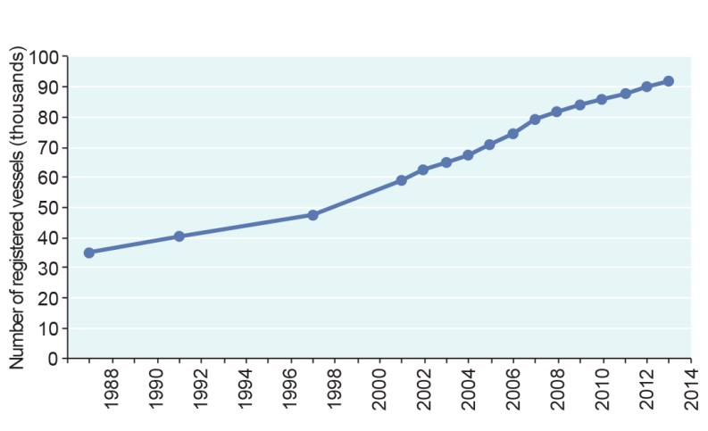
Number of recreational vessels registered in the catchment, 1987–2013
The number of vessels registered in areas close to the Great Barrier Reef has continued to increase.
Source: Department of Transport and Main Roads (Qld)¹⁹
Research and educational activities by a range of academic institutions and government agencies provide income and employment in regional communities and make a substantial contribution to the way the Region is understood, managed and used. These activities are concentrated around research stations and any effects are likely to be minor and localised.
Shipping through the Region provides a range of social and economic benefits to catchment communities and the nation. There were 9619 ship voyages through the Region in 2012–13 and the number of vessel calls to Great Barrier Reef ports is forecast to increase by about 250 per cent over the next 20 years. Proactive management, such as extending the vessel traffic service to the southern boundary of the Region in 2011, is addressing emerging risks and the number of reported ship groundings and collisions has remained relatively stable in recent years. While ship groundings are uncommon — now with only one or no groundings reported in a year — they have damaged some reefal areas and affected associated Indigenous heritage values. The grounding sites can take decades to recover.
Traditional use of marine resources within the Region continues to be practised and maintained according to traditional customs and spiritual lore, reflecting ongoing stewardship and custodianship. Traditional hunting, fishing and collecting involves a range of marine species (some of conservation concern) but levels of take are considered sustainable. Impacts attributable to traditional use undertaken according to customs and traditions are considered to have only minor or localised effects. This is distinct from illegal poaching of species of conservation concern undertaken without the customary approval of the relevant Traditional Owners — a focus of compliance effort in the Region.
Summary of assessment
Economic and social benefits of use Use of the Great Barrier Reef continues to contribute to local communities and the national economy. Its economic value has increased over the past five years as has the number of jobs it supports. The number of recreational visits appears to be increasing and declines in tourism visitor numbers until 2011 are now beginning to be reversed. Traditional use helps maintain Traditional Owner connections to their sea country. Some users financially contribute to management. | Very good, Stable
Impact of use The impacts of different uses of the Great Barrier Reef overlap and are concentrated inshore, particularly next to developed areas. Some uses have only minor and localised effects, for example defence activities, research and educational activities, and traditional use. Cumulative effects of tourism and recreation activities are localised around popular locations. Port activities and their flow-on impacts are generally in areas that are already under pressure from an accumulation of impacts. There are concerns about overfishing of some fish stocks, and the effects of fishing on some species of conservation concern. The survival of non-retained species is not monitored or well understood. | High impact, Increased

Factors influencing the Region’s values
A number of factors influence the condition of the Region’s ecosystem and heritage values and therefore the quality of the benefits those values provide. These factors are themselves affected by broadscale drivers of change.
Drivers are underlying causes of change in the environment. The four principal drivers considered are economic growth, population growth, technological development and societal attitudes.
Queensland has had Australia’s highest economic growth for over 20 years. Much of its economic activity is in the Great Barrier Reef Region and catchment. The scale and scope of growth in the resources sector has led to changes in land use within the catchment and created unprecedented demands for supporting services and infrastructure. There is also strong population growth in much of the catchment, with forecast annual population growth rates of 1.6 per cent or higher over the next 20 years. Technological development, such as communication technology, global positioning systems, satellite imagery and advances in farming technology, has changed understanding, management and use of the Region and land management practices in the catchment. Societal attitudes influence individual actions and community outcomes. Most Australians, even those who have not visited the Region, feel proud that the Reef is a world heritage area. Many believe it is part of their Australian identity and feel a strong sense of responsibility to protect it.
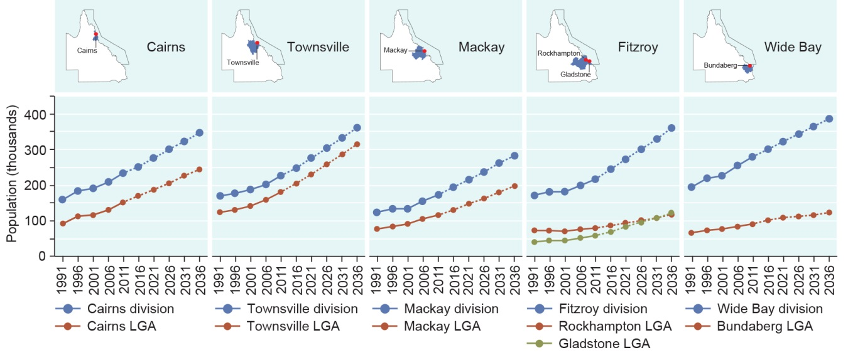
Population and forecast increases in the Great Barrier Reef catchment, 1991–2036
Over the last decade, populations have grown steadily along the coast of the Great Barrier Reef. Populations are predicted to continue growing in the statistical divisions and the main local government areas (LGAs) within the catchment.
Source: Department of Treasury and Trade (Qld) 2014 ^{20,21} and Australian Bureau of Statistics 2013²²
Climate change has both direct effects on values and indirect effects through other factors and processes. Over the last five years, global carbon dioxide levels have continued to increase at a rate similar to that of the last 50 years, increasing from 386 to 397 parts per million from July 2008 to December 2013. A number of climate-related variables are already changing in the Great Barrier Reef and are predicted to continue to have far-reaching consequences for the Reef ecosystem.
Over the last decade, particularly between 2005 and 2012, most of the Region has been exposed to severe cyclonic winds, with the area between Cairns and Townsville particularly affected, and there have been extensive flood plumes into the Region.
Future predictions indicate sea level rises and temperature increases will continue and the pH of the ocean will gradually decline. Weather will become more severe. While the frequency of tropical cyclones is likely to decrease or remain unchanged, there is a possible trend towards more intense storms. Average monsoon rainfall may increase causing more large freshwater inflows to the marine environment.
Over the next 50 years most ecosystem components are likely to be significantly affected by the impacts of climate change and, for some habitats and species, effects are likely to be widespread. Not all components will be affected equally, with corals and seabirds considered to be some of the most vulnerable species — both key attributes of the area’s outstanding universal value. The vulnerability of the ecosystem to climate change flows through to dependent heritage values, especially Indigenous and natural heritage values. Sea level rise and altered weather patterns increase the risks to built structures such as lightstations, shipwrecks and fish traps.
Climate change effects are expected to have major economic consequences for Reef-dependent industries and could affect patterns of use and visitor satisfaction. People’s awareness of the potential effects of climate change is increasing their concern about the ecosystem.
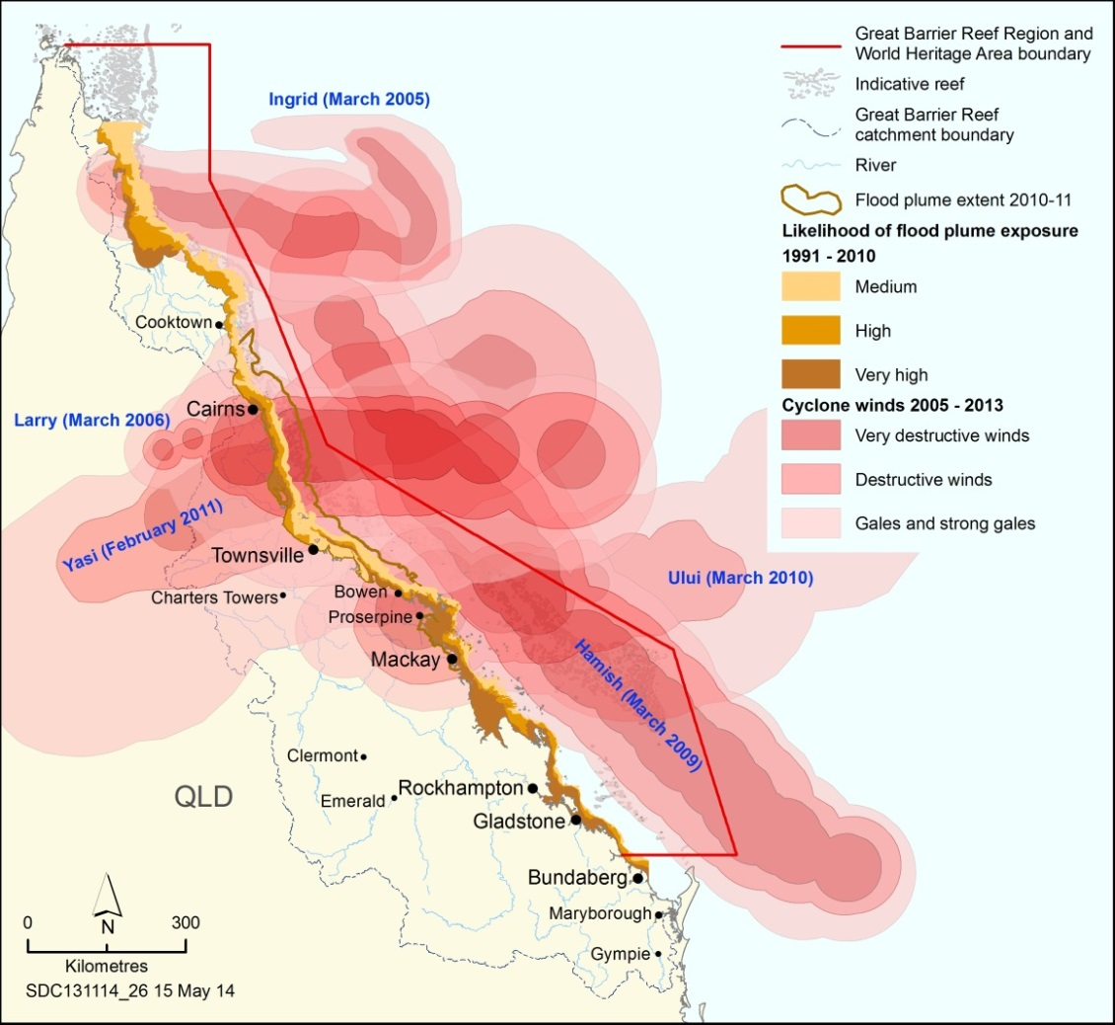
Cyclonic wind (2005–2013) and flood plume (1991–2010) exposure
The cluster of severe cyclones and flood events in recent years has significantly affected the condition of many Great Barrier Reef habitats and species. Winds shown are those associated with category 4 and 5 cyclones. The likelihood of flood plume exposure (brown areas) is a cumulative assessment of multiple flood plumes.
Source: Bureau of Meteorology 2013²³ (cyclones) and Devlin et al. 2011²⁴ (flood plume exposure)
Coastal development influences the Region through both the legacy of past development actions, such as broadscale clearing of catchment habitats for agriculture, and smaller scale current and future actions for agricultural, urban, industrial and island development. Since the Outlook Report 2009, a large body of work has been synthesised to better understand past changes to coastal ecosystems and implications for the marine environment.
Coastal development activities can include modifying coastal habitats, constructing artificial barriers to flow, exposing acid sulphate soils as well as increasing artificial light and noise pollution. It diminishes the capacity of coastal habitats to provide ecosystem services such as recycling nutrients and capturing sediments, reduces connectivity between freshwater and marine habitats and affects coastal scenic vistas. Coastal development has affected some Indigenous heritage values, for example story and songlines and sites of significance. Unidentified near-shore historic heritage values are also vulnerable.
An increasing coastal population and improved coastal infrastructure, such as boat ramps and marinas, are likely to improve accessibility for Reef users and increase use of the Region, ultimately increasing its economic worth.
Land-based run-off There are a range of land uses within the catchment and on Great Barrier Reef islands. Associated land management practices influence the quality and amount of freshwater that flows into the Region, including components known to affect the Region’s values — nutrients, sediments, pesticides and other pollutants such as heavy metals and marine debris.
Inshore areas are particularly at risk from poor water quality especially in central and southern areas. Sediments and nutrients continue to enter the Great Barrier Reef ecosystem at greatly enhanced levels compared to those prior to European settlement, resulting in increased exposure in inshore areas and exposed areas extending further offshore. It is estimated from 2013 modelling that at least 12,114 kilograms of herbicides are now introduced into the Region each year from diffuse source agricultural run-off. The highest pesticide risks are confined to only a couple of locations (Mackay region and the lower Burdekin area) with concentrations in waters around reefs remaining generally very low.
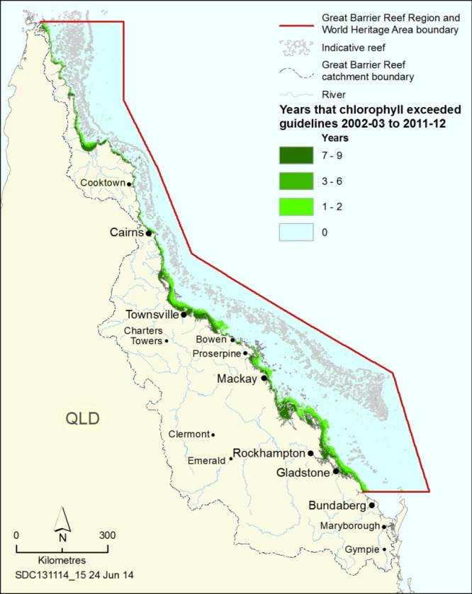
Years that chlorophyll concentrations exceeded guidelines, 2002–03 to 2011–12
The water quality guidelines for the Great Barrier Reef Marine Park use chlorophyll concentration as an indicator for nutrient concentrations in open waters. The guideline trigger value is an annual mean of 0.45 micrograms of chlorophyll per litre — an important ecological threshold for macroalgal cover and coral species richness. The map shows the number of years that the guideline value was exceeded. Source: Brodie et al. 2012²⁵
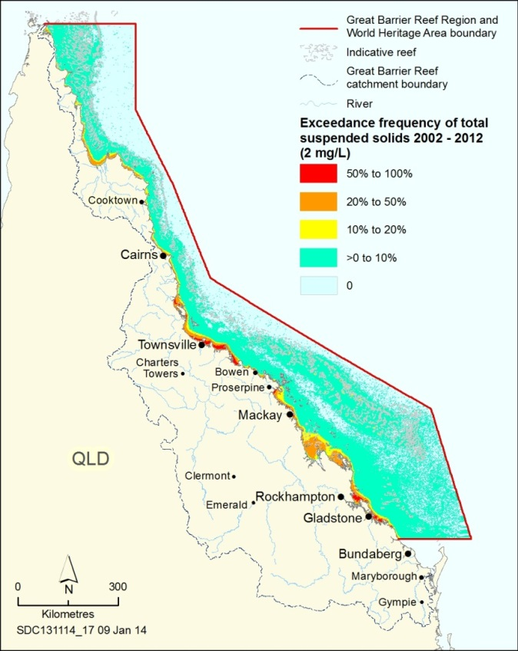
Frequency of total suspended solids above guidelines, 2002–2012
The map shows the proportion of valid daily observations that exceeded the total suspended solids guideline of two milligrams per litre in the Region. Source: Brodie et al. 2013²⁵
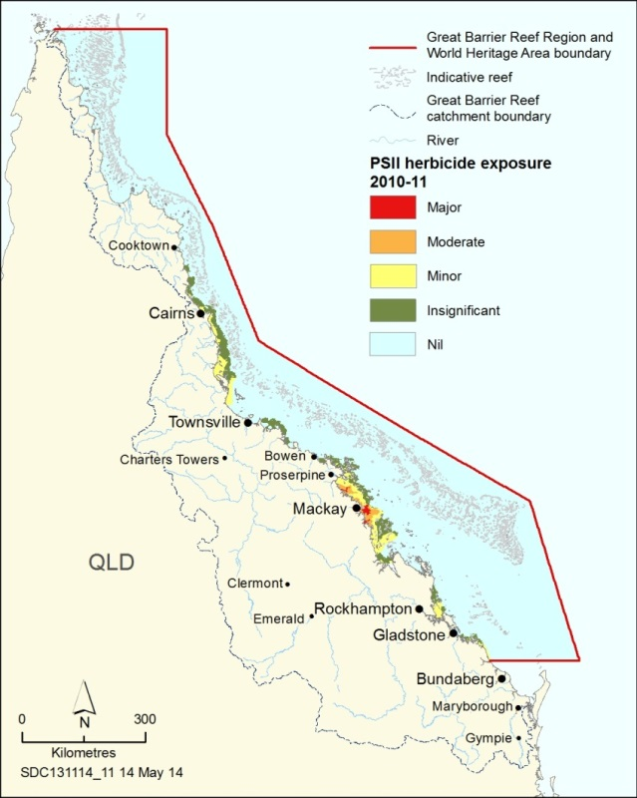
Modelled exposure of additive PSII herbicide residues, 2010–11
The map shows risk areas for photosystem II inhibiting (PSII) herbicide residue based on modelling. The categories of exposure were based on known thresholds of toxicity for coral and seagrass species. Source: Lewis et al. 2013²⁶
Declining marine water quality, influenced by land-based run-off, is one of the most significant threats to the long-term health and resilience of the Great Barrier Reef. The 2013 scientific consensus statement²⁷ concluded that ‘the decline of marine water quality associated with terrestrial run-off from the adjacent catchments is a major cause of the current poor state of many of the key marine ecosystems of the Great Barrier Reef. ...The greatest water quality risks to the Great Barrier Reef are from nitrogen discharge, associated with crown-of-thorns starfish outbreaks and their destructive effects on coral reefs, and fine sediment discharge which reduces the light available to seagrass ecosystems and inshore coral reefs. Pesticides pose a risk to freshwater and some inshore and coastal habitats’.
Agricultural practices in the catchment are improving and there have been some reductions in the amount of nutrients, sediments and pesticides entering the Region. However, there is likely to be a significant lag before water quality improvements are measured in the Region.
Marine debris, including that delivered through land-based run-off, continues to affect the ecosystem and is of particular concern for species of conservation concern. Many of the Region’s heritage values, including its outstanding universal value, are vulnerable to land-based run-off through its effects on the ecosystem. In addition, water quality declines and marine debris are likely to be diminishing the Region’s natural beauty.
Ecosystem declines from poor water quality also affect Reef-dependent industries. In particular, outbreaks of crown-of-thorns starfish can affect the viability of tourism operations.
Direct use of the Region maintains people’s connections to the Great Barrier Reef and continues to be a significant contributor to regional and national economies. The future value of many uses depends on a healthy, intact ecosystem. Fishing continues to affect the Region's values such as through effects on discarded catch; incidental catch of species of conservation concern; overfishing and illegal fishing. Increasing port activities directly affect local areas and uncertainty remains around ecosystem effects of dredging and the disposal and resuspension of dredge material. Uses such as fishing and ports are affecting some attributes that contribute to the outstanding universal value of the world heritage property.
Heritage values are vulnerable to physical damage and pollution from direct use, for example damage to historic shipwrecks and World War II sites from anchoring and fishing activities. Indigenous heritage values are especially vulnerable to reduced populations of culturally significant species and to incompatible uses in sea country areas.
Increasing regional populations and economic development will likely increase direct use and therefore the potential for impacts to both the Region’s ecosystem and its heritage values.
[Aerial photograph of a marina with many boats moored and houses in the adjacent catchment]. Caption: Use of the Region for recreation is likely to increase with population growth. Copyright: Susan Sobtzick
Summary of assessment
Impact on ecological values Climate change has already affected the Great Barrier Reef ecosystem. Its effects are compounding the ongoing impacts from land-based run-off and coastal development, particularly loads of sediments and nutrients entering the Region and the modification of supporting coastal habitats. Direct uses contribute to a range of impacts; most are localised. Economic and population growth will likely mean more use of the Region, increasing the likelihood of impacts. The combined influence of the four factors is concentrated in inshore central and southern areas. | High impact,  Increased, Increasing
Impact on heritage values Impacts on the ecosystem are reflected in declines in related heritage values, especially Indigenous heritage, natural heritage and world and national heritage values. Attributes of outstanding universal value relating to natural beauty, natural phenomena, ecological processes, and habitats and species are being affected. For built heritage, the threats from climate change and direct use are the most serious. | High impact,  Increasing
Impact on economic values Changes to the Great Barrier Reef ecosystem have serious economic implications for Reef-dependent industries, such as tourism and fishing, and for adjacent communities. Perceptions about the health of the ecosystem affect its attractiveness for tourism and recreation. An increasing coastal population is likely to increase the economic value of direct uses. | High impact, Increased, Increasing
Impact on social values Declining ecosystem condition, especially inshore adjacent to the developed coast, from the cumulative effects of many factors mean people’s attachment to and enjoyment of the Region may lessen in the future. This may have flow-on effects on Reef-dependent industries. Predicted increasing use may mean more instances of incompatible use. | Low impact, Increased, Increasing

Existing protection and management
Protection and management of the Region is a partnership between many Australian and Queensland government agencies, local government, Traditional Owners, stakeholders and community members, with activities both on the water and in the catchment. An understanding of the effectiveness of these activities is important in determining the likely resilience of the Region’s ecosystem and heritage values, assessing the major risks that remain for the Great Barrier Reef and predicting its outlook.
[Photograph of field management officers on a beach] Caption: The Australian and Queensland governments work in partnership to protect and manage the Region
The effectiveness of existing measures undertaken by all government agencies and other contributors was independently assessed by four independent expert assessors.³
The assessment approach was the same as for the Outlook Report 2009, using the framework for evaluating the effectiveness of protected area management developed by the International Union for the Conservation of Nature and Natural Resources (IUCN) World Commission on Protected Areas²⁸. This framework is based on a management cycle in which management is continuously evaluated and refined. A total of 49 indicators were used to assess effectiveness in each of the six elements of the management cycle: context, planning, inputs, processes, outputs and outcomes.
Fourteen broad management topics were considered against each of the six elements. The outcomes for each topic were:
- Sound governance and industry partnerships are in place to address issues related to commercial marine tourism. Effectiveness of tourism management has declined as emphasis has shifted to emerging issues.
- Defence activities continue to be managed very effectively with close cooperation between agencies.
- Understanding of fishing and its impacts has improved; however, outcomes remain poor.
- Individual ports are generally well managed; there has been a lack of coordinated planning and guidance.
- An overarching recreation management strategy has improved understanding and coordination.
- There is strong collaboration in management of research activities; improvements are slow.
- Shipping is generally well regulated and well managed; future risks are being addressed.
- There is strong cooperative management of traditional use of marine resources; outcomes have improved with increased planning and inputs.
- There is sound Region-scale management for climate change; management focus has declined on a broader scale.
- It is too early to judge the effectiveness of changes to the Queensland Government’s coastal development policy. Understanding of connectivity between the Region and its adjacent coast has improved.
- Programs addressing land-based run-off have better focus, clearer targets, coordinated monitoring and improved outputs. Continued poor outcomes are largely due to the scale of the issue and lags between improvements in land management being reflected in better water quality in the Region.
- There is an improved focus on outcomes for biodiversity values, including an overarching strategy.
- The Region’s heritage values are better defined and there is an increasing management focus.
- Understanding of community benefits of the environment is improving; their consideration lacks a policy framework.
The assessors concluded managing agencies are striving to manage effectively in all areas. Since the 2009 assessment, there have been considerable improvements in parts of the management cycle for a number of management topics. For example, outcomes for the traditional use of marine resources have improved following better planning, inputs and processes, and program outputs for land-based run-off have improved following improvements in planning, inputs and processes. This demonstrates how significant resources, extensive planning responses, and extensive research to inform management can improve management of an issue.
The difficulties in achieving positive outcomes on the ground — given the complexity of many issues, the spatial and temporal scales of the threats to the Region’s values and the diminishing resource base to implement actions — were recognised. Progress in reducing the threats is slow and desired outcomes are difficult to achieve for some of the most significant (and complex) management topics, for example climate change and coastal development.
Undertaking the comprehensive strategic assessment of the Great Barrier Reef World Heritage Area has further consolidated understanding about the Region, its values and threats, and focused management attention.
Summary of assessment
Understanding of context Context is assessed as the strongest management effectiveness element and trends are either stable or improving. Understanding of values, direct and indirect threats and stakeholders is generally strong. Understanding of cumulative and consequential impacts as well as condition and trend is improving and has been effectively documented through the Outlook Report and strategic assessment processes. In particular, tourism, defence activities, recreation, research activities and land-based run-off are well understood. This reflects a solid information and research base and a very mature understanding of the key values of the Region. | Very good, Improved
Planning Significant efforts have been made in planning for a number of topics such as biodiversity protection and recreation. Planning effectiveness has declined for climate change measures specific to the Region, principally as a result of changing policy and a lack of clarity about future directions. It has also declined for commercial marine tourism and research activities, largely because plans and policies have not been completed or updated. For coastal development, the fractured nature of the planning regime is problematic and recent changes have raised concerns. Planning effectiveness has improved for the management of land-based run-off and traditional use where the investment of resources is paying dividends. Lack of consistency across jurisdictions is the weakest aspect of planning. | Good, Stable
Financial, staffing and information inputs Adequacy of inputs is variable across management topics, being least effective for community benefits, coastal development, and non-Indigenous heritage management. Poor understanding of heritage values is a problem for most issues and is among the worst performing criteria across the whole assessment. Availability of socioeconomic knowledge has improved. Substantial resources have been devoted to the topics of land-based run-off and traditional use. Secure resourcing is a significant ongoing problem for many management topics. In many cases the lack of adequate resources to advance planning and management is constraining the effectiveness of other aspects of management. | Poor, Stable
Management systems and processes Management processes are particularly strong for defence activities, shipping and management of land-based run-off. They are weakest for coastal development, community benefits and Indigenous heritage values. Addressing consequential and cumulative impacts, application of socioeconomic and Indigenous knowledge, and setting of targets to benchmark performance are problematic for most issues. Consideration of cumulative and consequential impacts has improved substantially. Stakeholder engagement and application of biophysical information are the strongest aspects of management across all issues. | Good, Deteriorated
Delivery of outputs Delivery of desired outputs was rated as effective or very effective for all topics except coastal development. It is strongest for commercial marine tourism, defence activities, research activities and land-based run-off, where there has been a noticeable improvement. The knowledge base of managing agencies and the community has consistently improved. While the majority of management programs are progressing satisfactorily, timeframes frequently slip and it is not yet clear that the programs are achieving all their desired objectives. | Good, Stable
Achievement of outcomes Achievement of desired outcomes is highly variable across the management topics. Objectives in relation to community understanding of issues and development of effective partnerships are being achieved. Performance in outcomes is especially strong for research activities, shipping and defence activities. Overall, the weakest performance was for climate change, then coastal development, land-based run-off and fishing. For land-based run-off, the continued poor outcomes for the Region are largely due to scale of the problem and lags within the natural system. | Poor, Deteriorated

Resilience
Resilience is the capacity of a system to resist disturbance and undergo change while still retaining essentially the same function, structure, integrity, and feedbacks. It is not about a single, static state, but rather the capacity of an ever-changing, dynamic system to return to a healthy state after a disturbance or impact.
In the Outlook Report 2009, the resilience of the Great Barrier Reef ecosystem was assessed, including through a series of case studies examining recovery after disturbance. In the Outlook Report 2014, the assessment was expanded to include the resilience of heritage values, also including some case studies.
Ecosystem resilience Tropical marine ecosystems such as the Great Barrier Reef, and the coastal ecosystems that support it, are subject to a wide range of natural and human-related threats. These ecosystems are resilient if, given sufficient time, they are able to resist or recover from those threats, and maintain key functions without changing to a different state. A loss of ecosystem resilience cannot be attributed to any single cause, but is almost certainly the result of impacts from all the different activities and influencing factors, their extent and frequency, and their accumulation through time.
A series of case studies illustrate the extent to which some key components of the Reef ecosystem have recovered after disturbance:
- For coral reef habitats, increases in frequency and severity of disturbances such as cyclones, flooding and crown-of-thorns starfish outbreaks since 2009 have reduced their capacity to recover. There is some early evidence of recovery at a local scale.
- Ongoing management arrangements mean that some lagoon floor habitats previously at risk are continuing to recover from disturbances. There is little monitoring of the habitat’s condition or recovery.
- Based on recent modelling, recovery of the black teatfish population in the Region is likely to be slow. Populations have recovered in the Torres Strait.
- Coral trout populations demonstrate a strong ability to recover and increased reproduction in zones closed to fishing means larvae disperse beyond those zones. There are emerging concerns about the overall condition of coral trout populations.
[Photograph of a diver swimming over a section of reef where coral colonies have been reduced to rubble] Caption: Coral trout habitat can be almost completely destroyed when reefs are exposed to the full force of severe cyclones.
- Loggerhead turtle populations are recovering. There are comprehensive management arrangements in the Region, but some threats remain. Pressures from outside Australian waters are likely to influence their full recovery.
- The urban coast dugong population has declined further since 2009, affected by the loss of seagrass from cyclones and flooding. Continued effective implementation of all management arrangements is required to reduce direct threats.
- Humpback whales continue to recover at about 11 per cent per year, 50 years after whaling stopped.
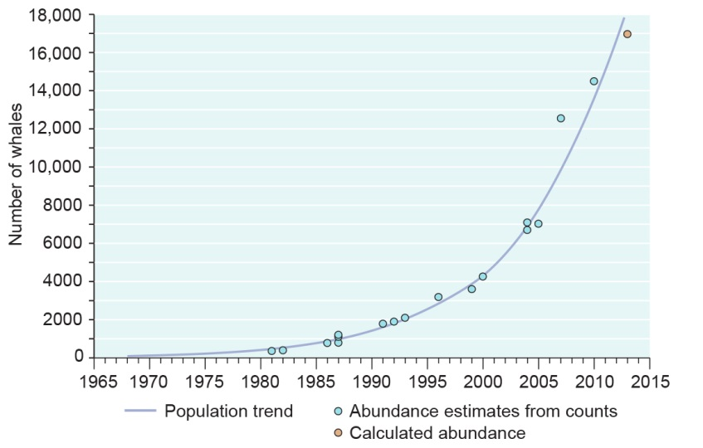
Recovery of the east Australian humpback whale population, 1981–2013
The east Australian humpback whale population continues to strongly recover after whaling ceased in the 1960s. Source: Adapted from Noad et al. 2008²⁹, Noad et al. 2011³⁰, Great Barrier Reef Marine Park Authority 2009³¹
Heritage resilience will depend upon the nature and condition of the heritage value, the way it is valued, the use that is made of it, the impacts on it, and the effectiveness of its management. In addition, the resilience of values derived from the natural environment (such as Indigenous heritage values and world heritage values) is a direct function of the resilience of their underpinning natural values.
The three case studies illustrate the likely resilience of some heritage values in the Region:
- Resilience of Indigenous heritage values such as cultural practices, observances, customs and lore depends on opportunities for Traditional Owners to access country and continue their cultural practices. Groups such as the Woppaburra in the south of the Region are working to strengthen cultural connections. Their aspirations are reflected in management arrangements such as a Traditional Use of Marine Resources Agreement.
[Photograph of people walking on the shore of North Keppel Island] Caption: Woppaburra Traditional Owners are working to improve the resilience of their cultural values, North Keppel Island.
- Formal recognition of the heritage values of the four major lightstations means there is comprehensive recording, restoration and regular maintenance. The heritage values of unlisted sites are less well known and more susceptible to being lost.
- Most underwater wrecks are poorly recorded or their locations are unknown. Those that are comprehensively recorded and are within a protected zone have the highest resilience. In some cases heritage values can be protected by recovery and conservation of artefacts. Resilience also varies depending on a wreck’s physical situation and can be diminished by one-off and chronic impacts. For example, for the wreck of the SS Yongala, the storm surge and associated churning sand during cyclone Yasi abraded large sections of protective coral and other concretions off its steel hull. In addition, the physical force of the storm and the movement of the sandy seafloor forced the ship to twist and move. While regrowth of marine life will slow deterioration, the damage inflicted is irreversible and has reduced the resilience of the wreck.
[Underwater photograph of the hull of the SS Yongala] Caption: Scouring and exposure of the Yongala’s hull after cyclone Yasi Copyright: Matt Curnock
Summary of assessment
Recovery in the ecosystem Some disturbed populations and habitats have demonstrated recovery after disturbance (for example lagoon floor, loggerhead turtles, humpback whales). For some species, recovery is not evident (black teatfish, dugongs) and is dependent on the removal of all threats. Increasing frequency and extent of some threats are likely to continue to reduce the resilience of species and habitats in the Region. | Poor,  Deteriorated
Improving heritage resilience The resilience of built heritage values has improved where the values are well recorded and well recognised and there is strong regulatory protection and regular maintenance (for example heritage-listed lighthouses). The resilience of intangible values, such as many Indigenous heritage values, depends on the active involvement of the custodians of those values so that connections and knowledge are kept alive. Such involvement has continued to grow. | Good,  Trend not assessed

Risks to the Region’s values
The 41 current and potential threats considered in the assessment of risks are relevant to both the Region’s ecosystem and its heritage values. They were developed based on the evidence presented in this report, and informed by advice from the Great Barrier Reef Marine Park Authority’s Local Marine Advisory Committees, Reef Guardian councils, teachers from Reef Guardian schools, Reef scientists, as well as the outcomes of national and local community surveys.
Outcomes of risk assessment Two separate risk assessments are presented, one for the Region’s ecosystem and one for its heritage values. The Australian Standard for Risk Assessment (AS/NZS ISO 31000:2009)³² was followed.
The close connections between the Region’s ecosystem and its heritage values mean that the projected risk of almost all threats is the same in both assessments. Two threats are assessed as presenting a different level of risk to heritage values compared to the ecosystem. Extraction of herbivores (excluding illegal fishing and poaching) is assessed as lower risk because, when performed by Traditional Owners, the activity has a positive effect on Indigenous cultural values. Wildlife disturbance is assessed as a higher risk because predicted increases in use of the Region could affect attributes identified as contributing to the area’s outstanding universal value and could change the nature of some Indigenous heritage values, especially as the species disturbed are often totemic animals.
Threats of highest risk Ten threats present a very high risk to the Region’s ecosystem and heritage values. A further eight and nine threats present a high risk to the Region’s ecosystem and heritage values, respectively. The threats assessed as very high and high risk (grouped by influencing factor) are:
- climate change — sea temperature increase; altered weather patterns; ocean acidification; and sea level rise
- coastal development — clearing and modifying coastal habitats; artificial barriers to flow; and disposal and resuspension of dredge material
- land-based run-off — nutrients from run-off (including its links to outbreak of crown-of-thorns starfish); sediments from run-off; pesticides from run-off; and marine debris
- direct use — illegal fishing, collecting and poaching; incidental catch of species of conservation concern; marine debris; incompatible uses (assessed for heritage values only); effects on discarded catch; retained take (extraction) of predators; disposal and resuspension of dredge material; and retained take (extraction) from unidentified or unprotected spawning aggregations.
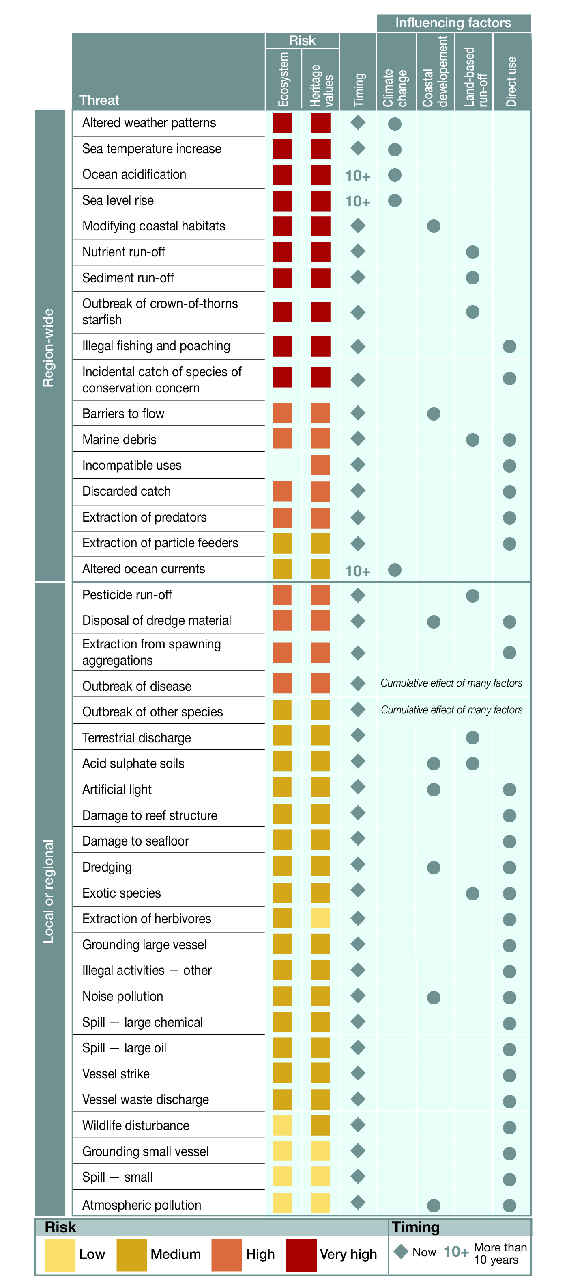
Risks to the Region’s values
Threats to the Region’s values are linked to the key factors that most influence them. Threats assessed as very high risk are mainly influenced by external factors, they are expected to have an effect over a broad or Region-wide scale and most are already having an effect.]
Outbreaks of disease, both naturally occurring and introduced, are also high risk. Such outbreaks are likely to be an indicator of overall stress in the natural system from the accumulation of impacts arising from many influencing factors.
Nine threats are assessed as having a higher risk than in 2009. Of these, six are now very high risk: altered weather patterns, illegal fishing and poaching, incidental catch of species of conservation concern, modifying coastal habitats, outbreak of crown-of-thorns starfish and sediment in land-based run-off. Only one threat has a lower risk grading — pesticides in land-based run-off — because more is now known about its effects and spatial extent.
Effectiveness at managing threats As was the case in the Outlook Report 2009, the origins of many of the highest risk threats are outside the Region (either global or within the Great Barrier Reef catchment). The effectiveness of their management was independently assessed as some of the weakest, especially in terms of outcomes.
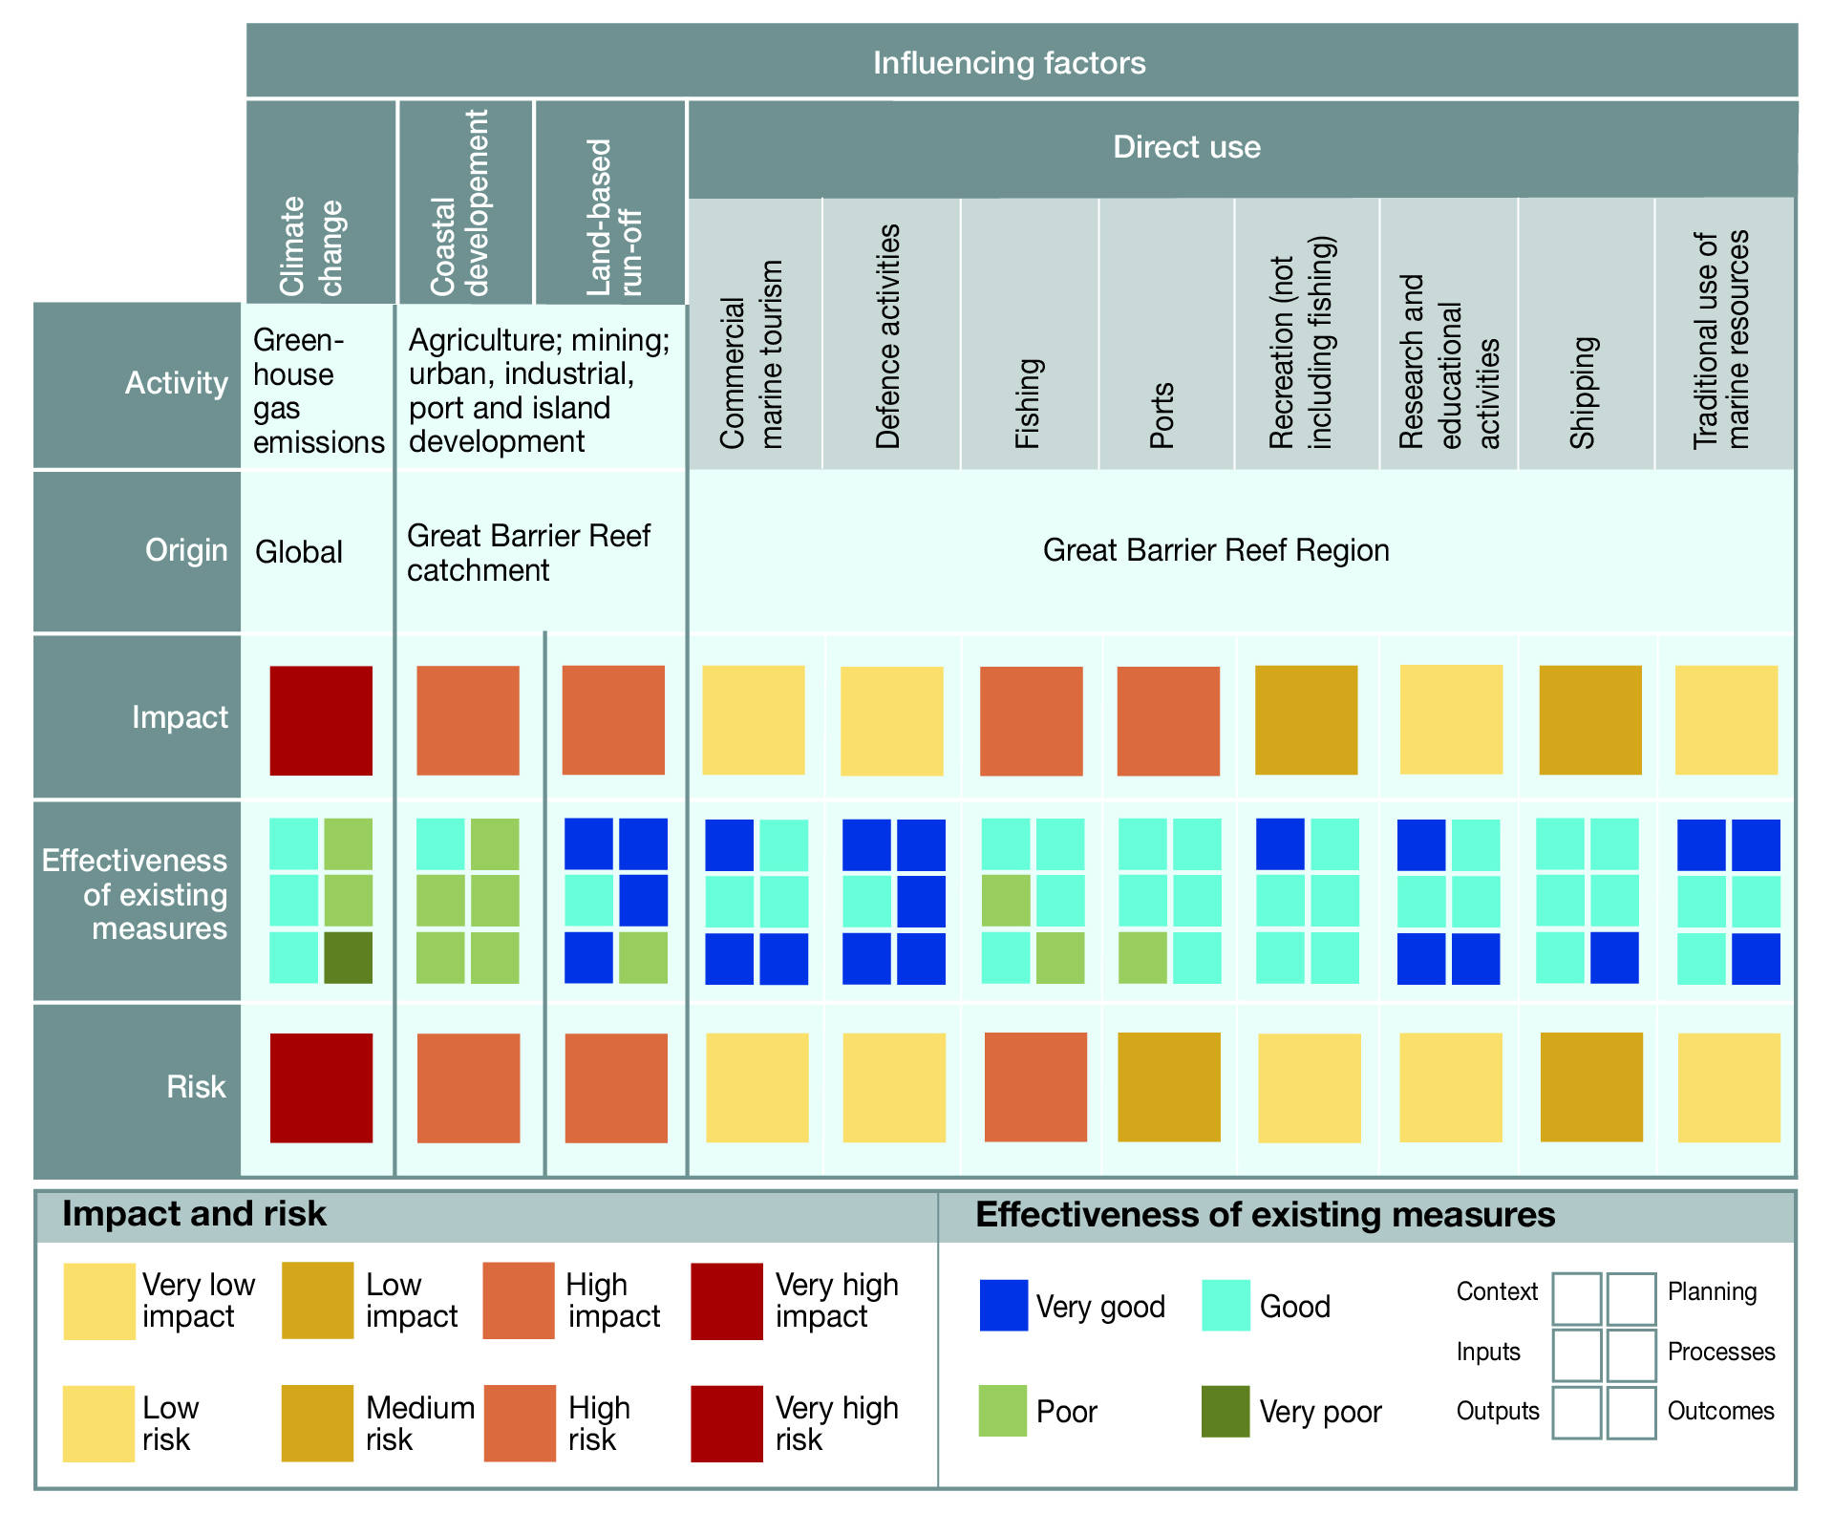
Management effectiveness, impacts and risk associated with factors influencing the Region’s values
In general, the influencing factors and direct uses that have the most severe impact on the Region’s values (as assessed in chapters 5 and 6) and weaker management effectiveness (as assessed in chapter 7) present a higher future risk.
Cumulative impacts relate to how the multiple threats interact and compound each other. Threats are connected through geographic location, the timeframes in which they act, and the habitats, species, ecosystem processes and heritage values they affect. Interactions between threats can have variable effects. For many of the threats considered in this report their combined impact is likely to be much worse than that expected from the sum of their individual impacts.
Summary of assessment
Overall risk to ecosystem The Region’s ecosystem continues to be at serious risk and the threats likely to affect it in the future are increasing and compounding. The most serious risks arise from climate change, land-based run-off, coastal development and some aspects of direct use (particularly fishing). Other threats relating to direct use are more effectively managed and of less overall risk to the Reef. | High risk, Increased, Increasing
Overall risk to heritage values The close connections between the Region’s ecosystem and many of its heritage values mean that the projected risk of almost all threats is the same in both assessments. As a result, the most serious risks to the Region’s heritage values are similarly climate change, land-based run-off, coastal development and some aspects of direct use. | High risk,  Increasing

Long-term outlook
The outcomes of the preceding assessments, combined with current and future management initiatives, can be used to build an updated picture of the long-term outlook for the Region’s ecosystem and heritage values.
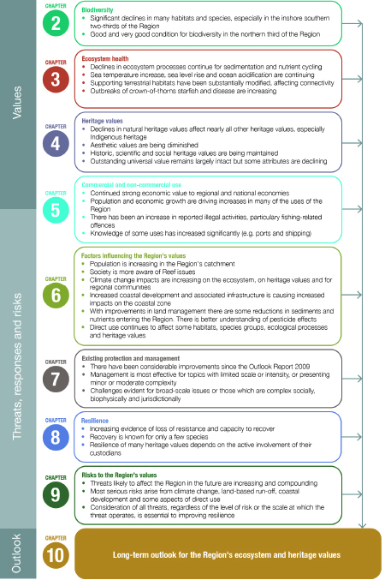
Building a picture of the long-term outlook for the Region’s ecosystem and heritage values
Combined, the conclusions from the preceding chapters build an up-to-date picture of the predicted long-term outlook for the Region’s ecosystem and heritage values.
Knowledge for management A continually improving understanding of the Region’s values and their threats will play a major role in securing their long-term future. Since 2009, understanding of recent trends in the condition of some ecosystem components has improved and the importance of good connectivity has been increasingly recognised. Techniques for better conceptualising cumulative impacts within the Region and its catchment have started to emerge and the need to develop decision-support tools for considering multiple direct, indirect and consequential impacts is recognised. Information from research and monitoring will be critical to developing thresholds for ecosystem health and targets for management actions, and for tracking the effectiveness of such actions. Research will also be needed to conceptualise and, in some cases, model the natural systems and how they respond to changing pressures. There is a need to develop strategies and technologies to restore degraded habitats.
The Region’s heritage values are now better defined. Traditional ecological knowledge and local community knowledge shared by Traditional Owners, stakeholders and members of the community will play a central role in better understanding heritage values and informing adaptive management and decision making. Furthermore, integrating traditional and community knowledge with scientific knowledge can extend the time perspective of scientific knowledge.
Likely future trends Trends in drivers such as economic growth and population growth and key external factors such as climate change, coastal development and land-based run-off will continue to affect the Region’s values. The future effectiveness of management will also play a key role. Improvements in management effectiveness for land-based run-off and traditional use of marine resources since 2009 illustrate the importance of strategic planning, research to inform management and significant commitment of resources. The difficulties in achieving positive outcomes on the ground are likely to continue — given the complexity of many issues, the spatial and temporal scales of the threats and the lags in response times.
As the effects of climate change worsen, it is likely that interactions between climate-related threats and threats from other sources will have increasingly serious and cumulative consequences. Given the only partial effectiveness of existing protection and management in addressing the most significant pressures on the ecosystem (principally arising from outside the Region), the loss of resilience is expected to continue.
Prospects for the outstanding universal value of the Great Barrier Reef World Heritage Area depend on global action to address the causes of climate change, and on coordinated, targeted and dedicated long-term commitments to continue to address the risks within and adjacent to the area. There is evidence that when there are concerted efforts to address damaging practices, impacts can be halted and reversed. Working at global, regional and local levels will be the best solution to preserving the outstanding universal value of the World Heritage Area.
Current and future initiatives to improve resilience and protect values are considered in assessing the long-term outlook for the Region’s ecosystem and its heritage values. The future commitments of both the Australian and Queensland governments identified in the program reports of the strategic assessments^{33,34} are part of these considerations. They recognise the need to implement a management framework that:
- establishes measurable ecosystem outcomes and is driven by specific measurable targets
- will either prevent or reduce cumulative impacts
- enables a net benefit approach — delivering an overall positive benefit to the Region values — to help achieve outcomes and targets, especially in areas requiring restoration
- is supported by a comprehensive integrated monitoring and reporting framework
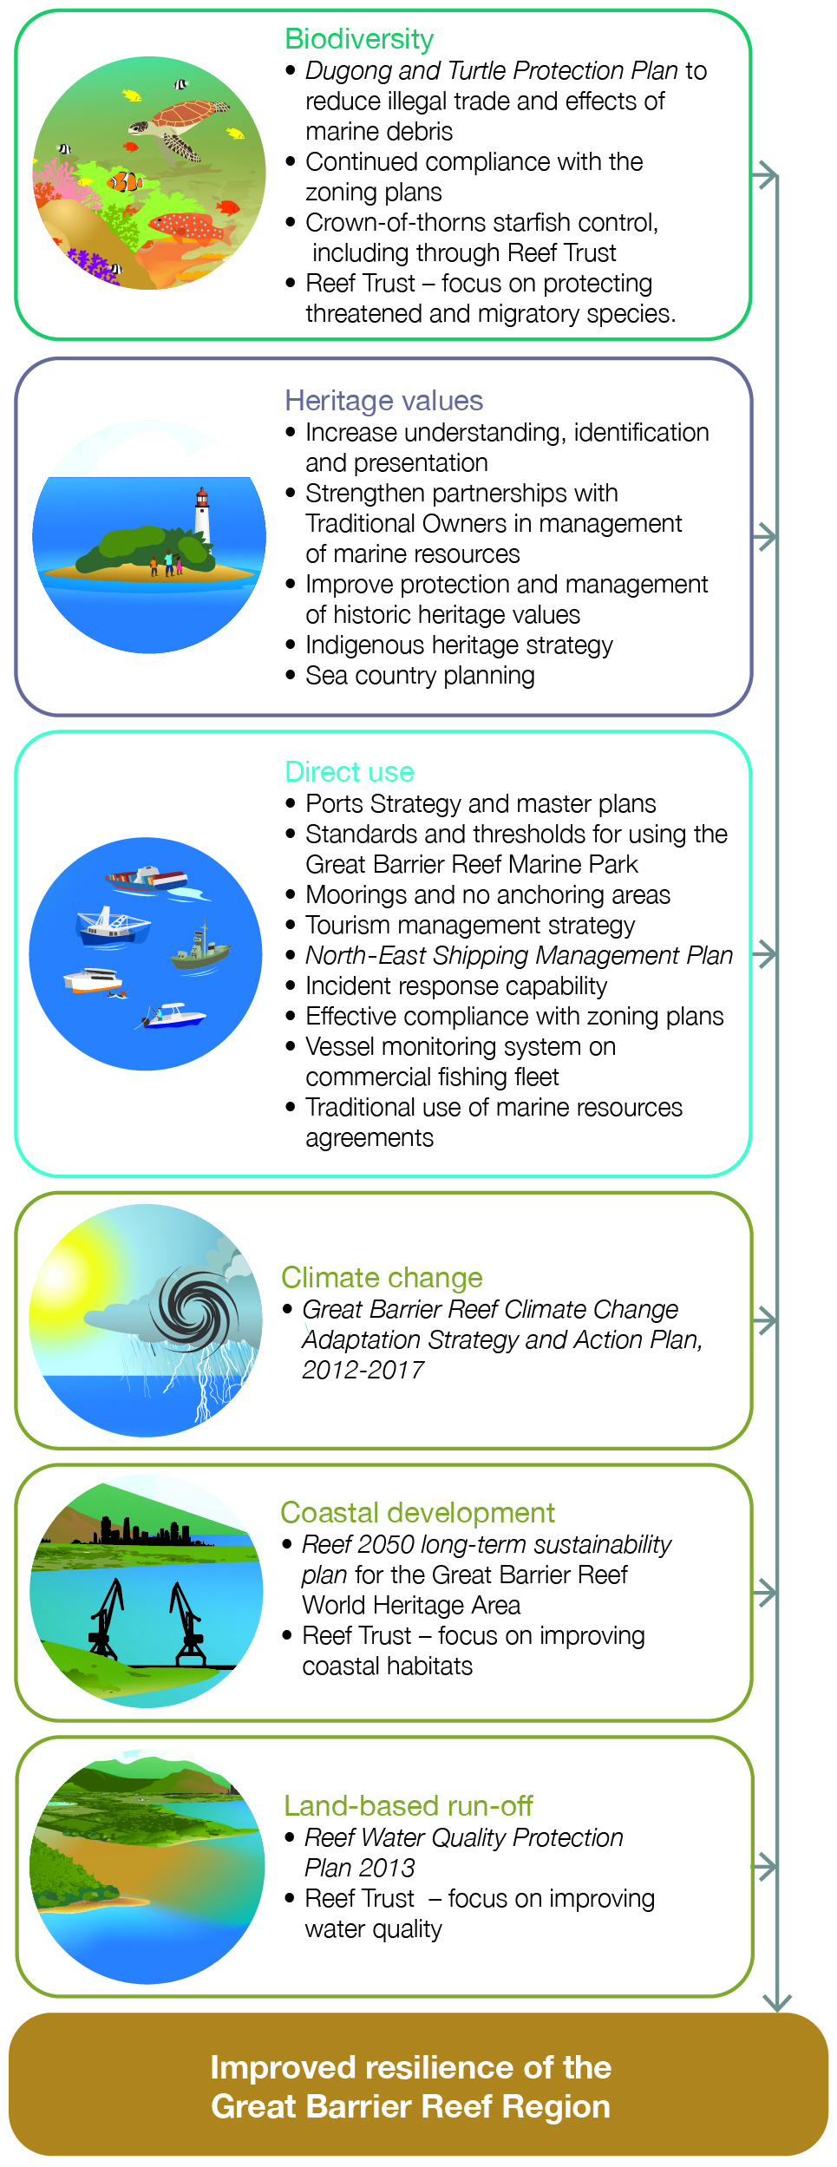
Current and future initiatives to improve the Region’s resilience
The Australian and Queensland governments have made range of future commitments aimed at strengthening management and improving the resilience of the Region’s values.
In addition to the government initiatives, there are many other partners that continue to make significant contributions to protecting and managing the Region’s values. Combined, everyone’s actions to reduce threats and help restore the Reef’s condition will improve its outlook.
Summary of assessment
Outlook for the ecosystem The Great Barrier Reef ecosystem is under pressure. Cumulative effects are diminishing the ecosystem’s ability to recover from disturbances. Some threats are increasing, driven mainly by climate change, economic growth and population growth. The emerging success of some initiatives (such as improving land-based run-off) means some threats may be reduced in the future. However, there are significant lags from when actions are taken to improvements being evident in the ecosystem. More than ever, a focus on building resilience by reducing all threats is important in protecting the Region’s ecosystem and its outstanding universal value into the future. | Poor,  Deteriorated, Deteriorating
Outlook for heritage values The close connection between the Region’s ecosystem and its heritage values means that many are deteriorating as ecosystem condition declines, for example Indigenous heritage values. Similarly, attributes that contribute to the outstanding universal value of the Great Barrier Reef are under pressure from a range of threats. The Region’s social significance, built around a history of personal experiences, will continue to shift as use changes. Underwater aesthetic values will likely continue to decline. The outlook for historic heritage values will be influenced by how well sites are recorded and maintained. Increasing recognition of the Region’s heritage values improves their likely outlook. | Good,  Deteriorating

References
1. Great Barrier Reef Marine Park Authority 2013, Great Barrier Reef Region strategic assessment: Strategic Assessment Report. Draft for public comment, GBRMPA, Townsville.
2. Ward, T.J. 2014, The rapid assessment workshop to elicit a scientific expert consensus to inform the development of the Great Barrier Reef Outlook Report 2014, Great Barrier Reef Marine Park Authority, Townsville.
3. Hockings, M., Leverington, A., Trinder, C. and Polglaze, J. 2014, Independent assessment of management effectiveness for the Great Barrier Reef Outlook Report 2014, Great Barrier Reef Marine Park Authority, Townsville.
4. De'ath, G., Fabricius, K.E., Sweatman, H. and Puotinen, M. 2012, The 27–year decline of coral cover on the Great Barrier Reef and its causes, Proceedings of the National Academy of Sciences 109(44): 17995-17999.
5. McKenzie, L.J., Collier, C. and Waycott, M. 2014, Reef Rescue Marine Monitoring Program: Inshore seagrass. Annual report for the sampling period 1st July 2012–31st May 2013, Centre for Tropical Water and Aquatic Ecosystem Research, James Cook University, Cairns.
6. Marsh, H., De'ath, G., Gribble, N.A. and Lane, B. 2005, Historical marine population estimates: triggers or targets for conservation? The dugong case study, Ecological Applications 15(2): 481-492.
7. Marsh, H. and Lawler, I.R. 2006, Dugong distribution and abundance on the urban coast of Queensland: A basis for management: Final report to Marine and Tropical Research Sciences Facility interim projects 2005-6, James Cook University, Townsville.
8. Marsh, H. and Lawler, I.R. 2001, Dugong distribution and abundance in the southern Great Barrier Reef Marine Park and Hervey Bay: Results of an aerial survey in October–December 1999, Great Barrier Reef Marine Park Authority, Townsville.
9. Marsh, H. and Lawler, I.R. 2002, Dugong distribution and abundance in the northern Great Barrier Reef Marine Park – November 2000, Great Barrier Reef Marine Park Authority, Townsville.
10. Marsh, H. and Saalfeld, W.K. 1989, Distribution and abundance of dugongs in the northern Great Barrier Reef Marine Park, Australian Wildlife Research 16: 429-440.
11. Sobtzick, S., Hagihara, R., Grech, A. and Marsh, H. 2012, Aerial survey of the urban coast of Queensland to evaluate the response of the dugong population to the widespread effects of the extreme weather events of the summer of 2010-11, Final report to the Australian Marine Mammal Centre and the National Environmental Research Program, James Cook University, Townsville.
12. Bureau of Meteorology 2014, The Australian tropical cyclone database, Bureau of Meteorology, <http://www.bom.gov.au/cyclone/history/>.
13. Bureau of Meteorology 2014, Australian climate variability and change: time series graphs. Coral Sea, Bureau of Meteorology, <http://www.bom.gov.au/cgi-bin/climate/change/timeseries.cgi?graph=sst&area=cor&season=0112&ave_yr=5>.
14. Great Barrier Reef Marine Park Authority 2012, Informing the outlook for Great Barrier Reef coastal ecosystems, GBRMPA, Townsville.
15. UNESCO Intergovernmental Committee for the Protection of the World Cultural and Natural Heritage 2012, Operational guidelines for the implementation of the World Heritage Convention, UNESCO, Paris.
16. Great Barrier Reef Marine Park Authority 1981, Nomination of the Great Barrier Reef by the Commonwealth of Australia for inclusion in the World Heritage List, GBRMPA, Townsville.
17. Deloitte Access Economics 2013, Economic contribution of the Great Barrier Reef, Great Barrier Reef Marine Park Authority, Townsville.
18. Department of Agriculture, Fisheries and Forestry 2013, 'Unpublished data. This work is licensed under the Creative Commons Attribution-NoDerivs 3.0 Australia License. To view a copy of this license, visit http://creativecommons.org/licenses/by/3.0/au/ or send a letter to Creative Commons, 444 Castro Street, Suite 900, Mountain View, California, 94041, USA.'.
19. Department of Transport and Main Roads 2014, Vessel Registration data retrieved by LGA from the Transport Registration And Integrated Licensing System (TRAILS), Unpublished data, DTMR, Brisbane.
20. Queensland Government Statistician's Office 2014, Queensland Government population projections, 2013 edition (data from 2011 to 2036), Queensland Treasury and Trade, Brisbane.
21. Queensland Government Statistician's Office 2014, Queensland Regional Database: population estimates 1991 to 2012 and population projections 2011 to 2036: local government areas (2014) and Statistical Area Level 2, Queensland Treasury and Trade, Brisbane, <http://www.qgso.qld.gov.au/products/qld-regional-database/qld-regional-database/index.php>.
22. Australian Bureau of Statistics 2013, Regional population growth, Australia. 2012-13 cat no. 3218.0, Australian Bureau of Statistics. This material has been used under a Creative Commons Attribution 2.5 Australia licence, <http://www.abs.gov.au/AUSSTATS/abs@.nsf/ProductsbyCatalogue/797F86DBD192B8F8CA2568A9001393CD?OpenDocument>.
23. Bureau of Meteorology 2013, The Australian tropical cyclone database: past tropical cyclone tracks, http://www.bom.gov.au/cyclone/history/index.shtml.
24. Devlin, M., Harkness, P., McKinna, L. and Waterhouse, J. 2011, Mapping the surface exposure of terrestrial pollutants in the Great Barrier Reef. Report to the Great Barrier Reef Marine Park Authority, Australian Centre for Tropical and Freshwater Research, Townsville.
25. Brodie, J., Waterhouse, J., Maynard, J., Bennett, J., Furnas, M., Devlin, M., Lewis, S., Collier, C., Schaffelke, B., Fabricius, K., Petus, C., da Silva, E., Zeh, D., Randall, L., Brando, V., McKenzie, L.J., O’Brien, D., Smith, R., Warne, M.S.J., Brinkman, R., Tonin, H., Bainbridge, Z., Bartley, R., Negri, A., Turner, R.D.R., Davis, A., Bentley, C., Mueller, J., Alvarez-Romero, J.G., Henry, N., Waters, D., Yorkston, H. and Tracey, D. 2013, Assessment of the relative risk of water quality to ecosystems of the Great Barrier Reef: A report to the Department of the Environment and Heritage Protection, Centre for Tropical Water & Aquatic Ecosystem Research, James Cook University, Townsville.
26. Lewis, S., Smith, R., O'Brien, D., Warne, M., Negri, A., Petus, C., da Silva, E., Aeh, D., Turner, R.D.R., Davis, A., Mueller, J. and Brodie, J. 2013, Chapter 4. Assessing the risk of additive pesticide exposure in Great Barrier Reef ecosystems, in Assessment of the relative risk of water quality to ecosystems of the Great Barrier Reef: supporting studies. A report to the Department of the Environment and Heritage Protection, Queensland Government, ed. J. Waterhouse, Centre for Tropical Water and Aquatic Ecosystem Research, James Cook University, Townsville.
27. Brodie, J., Waterhouse, J., Schaffelke, B., Kroon, F., Thorburn, P., Rolfe, J., Johnson, J., Fabricius, K., Lewis, S., Devlin, M., Warne, M. and McKenzie, L.J. 2013, 2013 Scientific Consensus Statement: Land use impacts on Great Barrier Reef water quality and ecosystem conditions, Reef Water Quality Protection Plan Secretariat, Brisbane.
28. Hockings, M., Stolton, S., Leverington, F., Dudley, N. and Courrau, J. 2006, Evaluating effectiveness: a framework for assessing management effectiveness of protected areas, 2nd edn, IUCN, Gland, Switzerland.
29. Noad, M.J., Dunlop, R.A., Cato, D. and Paton, D. 2008, Abundance estimates of the east Australian humpback whale population: Final report for the Australian Department of the Environment, Water, Heritage and the Arts, University of Queensland, Brisbane.
30. Noad, M.J., Dunlop, R.A., Paton, D. and Kniest, H. 2011, Abundance estimates of the east Australian humpback whale population: 2010 survey and update, University of Queensland, Brisbane.
31. Great Barrier Reef Marine Park Authority 2009, Great Barrier Reef outlook report 2009, GBRMPA, Townsville.
32. Standards Australia and Standards New Zealand 2009, Risk management – principles and guidelines (AS/NZS ISO 31000:2009), Standards Australia International, Sydney.
33. Department of State Development, Infrastructure and Planning 2013, Great Barrier Reef coastal zone strategic assessment 2013: Program Report. Draft for public consultation, DSDIP, Brisbane.
34. Great Barrier Reef Marine Park Authority 2013, Great Barrier Reef Region strategic assessment: Program Report. Draft for public comment, GBRMPA, Townsville.

