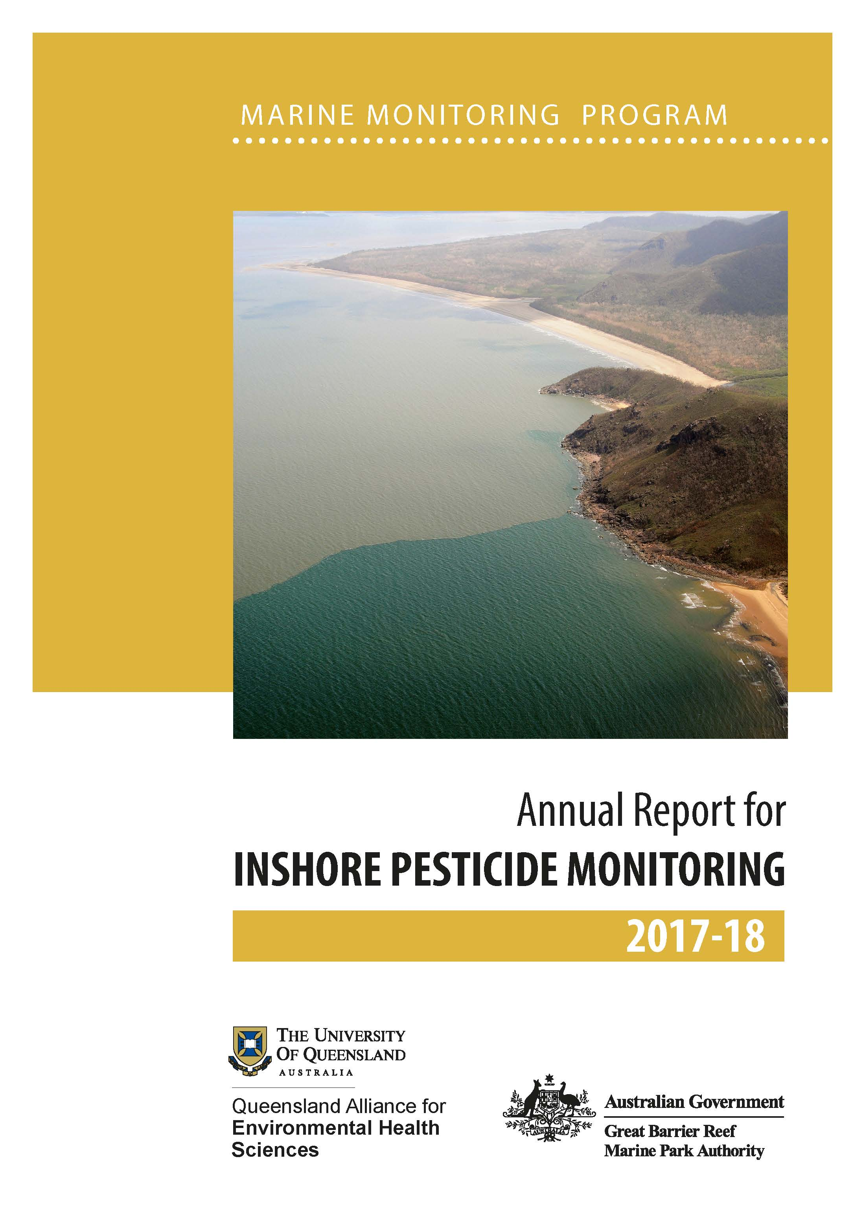
© The University of Queensland and James Cook University, 2019
Published by the Great Barrier Reef Marine Park Authority
ISSN: 2208-4134
Marine Monitoring Program: Annual report for inshore pesticide monitoring 2017–18 is licensed for use under a Creative Commons By Attribution 4.0 International licence with the exception of the Coat of Arms of the Commonwealth of Australia, the logos of the Great Barrier Reef Marine Park Authority, The University of Queensland and James Cook University, any other material protected by a trademark, content supplied by third parties and any photographs. For licence conditions see: http://creativecommons.org L-1icences/by/4.0

This publication should be cited as:
Gallen, C., Thai, P., Paxman, C., Prasad, P., Elisei, G., Reeks, T., Eaglesham, G., Yeh, R., Tracey, D., Grant, S. and Mueller, J. 2019, Marine Monitoring Program: Annual Report for inshore pesticide monitoring 2017–18. Report for the Great Barrier Reef Marine Park Authority, Great Barrier Reef Marine Park Authority, Townsville, 118 pp.

A catalogue record for this publication is available from the National Library of Australia

Front cover image Flood plume in Hinchinbrook Channel after Cyclone Yasi hit, on the 2nd February 2011. Photo by J Jones © Great Barrier Reef Marine Park Authority
DISCLAIMER
While reasonable efforts have been made to ensure that the contents of this document are factually correct, the University of Queensland and James Cook University do not make any representation or give any warranty regarding the accuracy, completeness, currency or suitability for any particular purpose of the information or statements contained in this document. To the extent permitted by law UQ and JCU shall not be liable for any loss, damage, cost or expense that may be occasioned directly or indirectly through the use of or reliance on the contents of this document.
Comments and questions regarding this document are welcome and should be addressed to:
¹Queensland Alliance for Environmental Health Sciences (QAEHS)
Incorporating the former National Research Centre for Environmental Toxicology (Entox)
The University of Queensland, 20 Cornwall St, Woolloongabba Qld 4102

² The Centre for Tropical Water & Aquatic Ecosystem Research (TropWATER),
Catchment to Reef Processes Research Group, James Cook University, Townsville, Qld 4811
This project is supported by the Great Barrier Reef Marine Park Authority through funding from the Australian Government Reef Program, the Australian and Queensland governments Reef 2050 Integrated Monitoring and Reporting Program, the University of Queensland and James Cook University.
Project Team - Inshore Marine Water Quality Monitoring – Christie Gallen¹, Phong Thai¹, Chris Paxman¹, Pritesh Prasad¹, Gabriele Elisei¹, Tim Reeks¹, Geoff Eagleshamr¹, Ruby Yeh¹, Jochen Mueller¹
Project Team - Assessment of Terrestrial Run-off Entering the Reef: Christie Gallen¹, Phong Thai¹, Chris Paxman¹, Gabriele Elisei¹, Pritesh Prasad¹, Tim Reeks¹, Geoff Eagleshamr¹, Ruby Yeh¹, Jochen Mueller¹, Jane Waterhouse², Stephen Lewis², Dieter Tracey², Caroline Petus²

Contents
Acknowledgements viii
Executive Summary 9
1. Introduction 12
1.1 Pesticide monitoring in the Marine Monitoring Program 12
1.2 The structure of this Report 13
2. Methods 14
2.1 Overview 14
2.2 Study area and sampling sites 14
2.2.1 Fixed monitoring sites (passive samplers) 14
2.2.2 Flood plume (transect) monitoring (‘event’ passive sampler and grab sampling) 16
2.3 Sampling approaches 17
2.3.1 Passive sampling (fixed monitoring sites) to establish long-term trends 18
2.3.2 Grab sampling to assess flood plume (transect) profiles 18
2.3.3 Sampler deployment and approaches for missing data 19
2.4 Pesticide analyses and reporting QA/QC 19
2.4.1 Target pesticides 19
2.4.2 Instrument analyses and quality assurance quality control (QA/QC) 19
2.4.3 Calculating the pesticide concentrations 20
2.5 Data analyses and reporting metrics 20
2.5.1 Water quality guideline values (GVs) 20
2.5.2 Risk assessment metric 21
2.5.3 Mapping the frequency and extent of flood plumes (water type frequency maps) 22
2.5.4 Other data sources (weather, rainfall) 22
3. Drivers and pressures influencing pesticide concentrations during 2017–18 23
3.1 Land use 23
3.2 Hydrological conditions in the Reef basins 24
3.2.1 Cyclones 25
3.2.2 Rainfall 25
3.2.3 River discharge 27
3.2.4 End-of-basin pesticide monitoring 29
4. Pesticides detected in marine waters 30
4.1 Frequency of pesticide detections 30
4.2 Summary of pesticide concentrations in 2017–18 31
4.3 Comparison to guideline values 32
4.4 Comparison to previous years: trends in pesticide concentrations 32
5. Regional results 37
5.1 Wet Tropics Region 37
5.1.1 Low Isles 37
5.1.2 High Island 38
5.1.3 Normanby Island 39
5.1.4 Dunk Island 40
5.1.5 Lucinda 42
5.1.6 Factors influencing the pesticide concentrations in the Wet Tropics 43
5.2 Burdekin Region 44
5.2.1 Barratta Creek passive sampling 44
5.2.2 Burdekin Focus Region flood plume sampling 46
5.3 Mackay Whitsunday Region 46
5.3.1 Repulse Bay 46
5.3.2 Round Top Island 47
5.3.3 Sandy Creek 48
5.3.4 Sarina Inlet 49
5.3.5 Factors influencing the pesticide concentrations in the Whitsunday region 50
5.4 Fitzroy Region 51
5.4.1 North Keppel Island 51
5.4.2 Factors influencing the pesticide concentrations in the Fitzroy region 52
6. Discussion 53
7. References 59

List of figures and tables
Figure 1: DPSIR framework used to guide the structure of the report 13
Figure 2: Locations of fixed monitoring sites where time-integrated passive sampling of pesticides occurred in 2017-18 15
Figure 3: Locations of grab (flood plume monitoring) and passive samplers (fixed monitoring) collected on the Russell-Mulgrave River transect, and Tully River transect 17
Figure 4: Land use in the Reef basins. Sourced from GBRMPA (2014a) 23
Figure 5: Annual average wet season rainfall (December 2017 - April 2018), as compared to the long-term wet season rainfall average (1961 – 1990). 25
Figure 6: Long-term total annual discharge (ML) (hydrological year: 1 October to 30 September) for the 35 main Reef river basins. 27
Figure 7: Corrected annual hydrological/water year (1 October to 30 September) discharge from each NRM region 28
Figure 8: Percentage of ED and PDMS samplers that had measurable pesticide levels 30
Figure 9: Maximum concentrations of individual pesticides at all sites monitored in 2017–18 compared to previous years (2009–10 onwards) 34
Figure 10: (A) Maximum % of species affected calculated using the ms-PAF method for all Wet Tropic sites and (B) Maximum % of species affected calculated using the ms-PAF method for all other sites 35
Figure 11: Maximum PSII herbicide equivalent concentrations at all sites compared to previous years 36
Figure 12: Temporal trends in % of species affected by pesticides (indicated by the black bars) in Low Isles in 2017-18, together with the flow rate of Mossman river. 37
Figure 13: Temporal trends in % of species affected by pesticides by passive (indicated by the black bars) and grab samples (indicated by the spots) in High Island in 2017-18, together with the flow rate of Mulgrave and Russell rivers. 38
Figure 14: Temporal trends in % of species affected by pesticides (indicated by the black bars) in Normanby Island in 2017-18, together with the flow rate of Mulgrave and Russell rivers. 40
Figure 15: Temporal trends in % of species affected by pesticides (indicated by the black bars) in Dunk Island in 2017–18, together with the flow rate of Tully river. 41
Figure 16: Temporal trends in % of species affected by pesticides (indicated by the black bars) in Lucinda in 2017-18, together with the flow rate of Herbert River. 43
Figure 17: Temporal trends in ms-PAF values at Barratta Creek mouth fixed passive sampling (black bar) and grab samples (blue triangles) relative to the flow rate of the rivers influencing the sampling sites. 45
Figure 18: Temporal trends in % of species affected by pesticides (indicated by the black bars) in Repulse Bay in 2017-18, together with the flow rates of adjacent rivers. 47
Figure 19: Temporal trends in % of species affected by pesticides (indicated by the black bars) in Round Top Island in 2017-18, together with the flow rates of adjacent rivers. 48
Figure 20: Temporal trends in % of species affected by pesticides (indicated by the black bars) in Sandy Creek in 2017–18, together with the flow rates of adjacent rivers. 49
Figure 21: Temporal trends in % of species affected by PSII pesticides (as indicated by the black bars) in Sarina Inlet in 2017–18, together with the flow rates of adjacent rivers. 50
Figure 22. Temporal trends in ms-PAF values in 2017-18, relative to the flow rate of the Fitzroy River influencing North Keppel Island’s fixed passive sampler site. 52

Table 1: Location of fixed passive sampling sites, closest influencing river and date that sampling first commenced 16
Table 2: The types of passive samplers deployed at each fixed monitoring site in 2017-18. 18
Table 3: Weekly mean basin rainfall (mm) in basins adjacent to fixed passive sampler sites during the 2017-18 wet season 26
Table 4: 2017-18 annual discharge (ML) of the major Reef basin rivers adjacent to passive sampling sites 28
Table 5: Maximum detected time integrated (or chronic) pesticide concentrations at each fixed passive sampling site 33
Table 6: Pesticides detected in passive sampler devices that were assessed using the ms-PAF method for multiple pesticides. 76
Table 7: Grading description for the pesticides indicator in the freshwater basin assessments. 77
Appendices: List of figures and tables
Figure D-1: Land Use map of the Reef basin (2009) from (DSITIA, 2012c). 82
Figure E-1: Total monthly rainfall for the wet 2017–18 season across Queensland 88
Figure E-2: Rainfall decile ranges 89
Figure E-3: A) Inter-annual rainfall difference between the previous monitoring year (2016-17) and the current monitoring year (2017-18). 90
Figure H-1: Temporal concentration profiles of individual herbicides at Low Isles in the Wet Tropics region 107
Figure H-2: Temporal concentration profiles of individual herbicides at High Island in the Wet Tropics region 108
Figure H-3: Temporal concentration profiles of individual herbicides at Dunk Island in the Wet Tropics region 109
Figure H-4: Temporal concentration profiles of individual herbicides at Normanby Island in the Wet Tropics region 110
Figure H-5: Temporal concentration profiles of individual herbicides at Lucinda in the Wet Tropics region 111
Figure H-6: Temporal concentration profiles of individual herbicides at Barratta Creek mouth in the Burdekin region 112
Figure H-7: Temporal concentration profiles of individual herbicides at Repulse Bay in the Mackay Whitsunday region 113
Figure H-8: Temporal concentration profiles of individual herbicides at Round Top Island in the Mackay Whitsunday region 114
Figure H-9: Temporal concentration profiles of individual herbicides at Sandy Creek in the Mackay Whitsunday region 115
Figure H-10: Temporal concentration profiles of individual herbicides at Sarina Inlet in the Mackay Whitsunday region 116
Figure H-11: Temporal concentration profiles of individual herbicides at North Keppel Island in the Fitzroy region 117

Table A-1: Summary of variability (% coefficient of variation, % CV) of replicate ED and grab sample analysis 67
Table A-2: QAEHS LC-MS/MS analyte list for positive and negative mode analysis 68
Table A-3: QAEHS GC-MS analyte list for PDMS extracts 69
Table A-4: Proposed priority pesticides and herbicides specified under the MMP 69
Table B-1: Water quality limits available for pesticides 72
Table C-1: Scientific publications indicating the effect concentrations and the end-points for the reference PSII herbicide diuron used to define specific PSII-HEq Index categories as an indicator for reporting purposes 78
Table E-1: Wet season discharge (ML; million litres) of the main GBR rivers 83
Table E-2: Weekly water type colour class (1 – 6) for fixed site passive sampler and river transect locations 87
Table F-1: Passive sampling return record for the 2017–18 monitoring year. 91
Table F-2: Low Isles, Wet Tropics region – Time integrated estimated concentrations in water ( ng L⁻¹) 93
Table F-3: High Island, Wet Tropics region – Time integrated estimated concentrations in water ( ng L⁻¹) 94
Table F-4: Dunk Island, Wet Tropics region – Time integrated estimated concentrations in water ( ng L⁻¹) 95
Table F-5: Normanby Island, Wet Tropics region – Time integrated estimated concentrations in water ( ng L⁻¹) 96
Table F-6: Lucinda, Wet Tropics region – Time integrated estimated concentrations in water ( ng L⁻¹) 97
Table F-7: Barratta Creek, Burdekin Region – Time integrated estimated concentrations in water ( ng L⁻¹) 98
Table F-8: Repulse Bay, Mackay Whitsunday region – Time integrated estimated concentrations in water ( ng L⁻¹) 99
Table F-9: Round Top Island, Mackay Whitsunday region – Time integrated estimated concentrations in water ( ng L⁻¹) 100
Table F-10: Sarina Inlet, Mackay Whitsunday region – Time integrated estimated concentrations in water ( ng L⁻¹) 101
Table F-11: Sandy Creek, Mackay Whitsunday region – Time integrated estimated concentrations in water ( ng L⁻¹) 102
Table F-12: North Keppel Island, Fitzroy Region – Time integrated estimated concentrations in water ( ng L⁻¹) 103
Table G-1: Concentrations in grab water samples ( ng L⁻¹) measured at various locations offshore and in river mouths (along transects) during the 2017–18 monitoring year 104
Common acronyms, abbreviations and units
Acronym | Detail
2,4-D | 2,4-Dichlorophenoxyacetic acid
ANZECC | Australian and New Zealand Environment and Conservation Council
ANZG 2018  ARMCANZ | Australian and New Zealand Guidelines for Fresh and Marine Water Quality 2018  Agriculture and Resource Management Council of Australia and New Zealand
Authority | Great Barrier Reef Marine Park Authority
%CV | per cent coefficient of variation
C_{W} | Concentration in water
DES | Department of Environment and Science (formerly DSITI)
DSITI | Department of Science, Information Technology and Innovation
EC_{x} | x per cent maximal effective concentration is observed
ED | Empore DiskTM passive sampler
GBRCLMP | Great Barrier Reef Catchment Loads Monitoring Program
GBRMPA | Great Barrier Reef Marine Park Authority
GC-MS | Gas Chromatography-Mass Spectrometry
GPC | Gel Permeation Chromatography
GV | Guideline value
IC_{x} | x per cent of the maximal inhibitory concentration is observed
IWL | Interim working level
K_{OW} | Octanol-water partition coefficient
LC_{x} | x per cent of the lethal concentration is observed
LC-MS/MS | Liquid Chromatography-Tandem Mass Spectrometry
LOD | Limit of Detection
LOR | Limit of Reporting
MCPA | 2-methyl-4-chlorophenoxyacetic acid
MMP | Marine Monitoring Program
ms-PAF | Multi-substance potentially affected fraction
NOEC | No Observed Effect Concentration
PDMS | Polydimethylsiloxane passive sampler
PFM | Passive/Plaster Flow Monitor
PSII-HEq | Photosystem II Herbicide Equivalent Concentration
PTFE | Polytetrafluoroethylene : Common brand name - Teflon
QAEHS | Queensland Alliance for Environmental Health Sciences (formerly Entox)
QA/QC | Quality Assurance/Quality Control
QHFSS | Queensland Health Forensic & Scientific Services
RPF | Relative Potency Factor
Reef 2050 WQIP | Reef 2050 Water Quality Improvement Plan
SOP | Standard Operation Procedure
SSD | Species sensitivity distribution
Note that the term pesticide is used to refer collectively to the group of insecticides, herbicides and fungicides.

Acknowledgements
Other contributors to this work include:
- The staff of the Australian Institute of Marine Sciences and James Cook University for the assessment of long term discharge data and mapping;

These monitoring activities have been undertaken in some form since 2005 and we acknowledge:
Dr Karen Kennedy, Andrew Dunn, Dr Michael Bartkow, Dr Tatiana Komarova, Dr Melanie Shaw, Anita Kapernick, Dr Jake O’Brien, Andrew Banks, Rachel Mackie, Bronwyn Houlden, Carol Honchin, Katherine Martin, Carol Marshall, Steve Carter of Queensland Health Forensic and Scientific Services.

We thank Rachael Smith, Olivia King and Ryan Turner (Department of Science, Information Technology and Innovation) who have provided data and advice on the ms-PAF model, proposed guideline values, and end-of-catchment load monitoring data (in advance of release of the annual GBRCLMP report).

QAEHS gratefully acknowledges the technical support provided by David Boadle, Brett Baker and staff (CSIRO Land & Water) as well as IMOS/CSIRO through funding of the Lucinda Jetty Coastal Observatory.

The assistance of the numerous volunteers who have deployed passive samplers is gratefully acknowledged:
Cahills Couriers | Dan Atherton | Quicksilver Connections
Australian Institute of Marine Science | Doug Baird | Centre for Tropical Water & Aquatic Ecosystem Research (TropWater)
CSIRO Land and Water | Frankland Islands Cruise & Dive | North Keppel Island Environmental Education Centre
David Boadle | Mission Beach Charters:  Bec Rowlands and Jason Shearer | REEF Catchments

Further thanks go to the Authority Regional coordinators for the role they have played in managing and facilitating this monitoring program throughout the years: Carolyn Roche, Phil Laycock, and Warwick Sheldon.

Executive Summary
This component of the Marine Monitoring Program provides an understanding of nearshore pesticide profiles and the exposure risk to marine organisms, as a part of water quality condition on the Great Barrier Reef.

Data are collected from eleven fixed monitoring sites located in four Natural Resource Management regions – the Wet Tropics (five sites at Low Isles, High Island, Normanby Island, Dunk Island and Lucinda), Burdekin (one site at Barratta Creek), Mackay Whitsundays (four sites at Repulse Bay, Round Top Island, Sandy Creek and Sarina Inlet) and Fitzroy (one site at North Keppel Island).

Sites are selected using several criteria, including being adjacent to areas of high pesticide usage on the catchment area, serviceability, likelihood of intercepting flood plumes during wet season river flow events and the safety of the site from public interference. The long-term monitoring data generated from these sites, aims to link changes in land-based agricultural activities (as a result of management initiatives) and how pressures such as catchment rainfall, river discharge and pesticide loads influence trends in marine pesticide concentrations.

Pesticide monitoring data is collected using two sampling techniques – passive and grab sampling. Two types of passive samplers are deployed at the fixed monitoring sites that allow the accumulation of pesticides from the water into the sampling device over a given deployment time. Using estimates of water flow at each site and uptake rates measured during laboratory calibration experiments, an average concentration in the water for accumulated pesticides are estimated for a deployment period (typically one month during the wet season, and two months during the dry season). Passive sampler extracts are analysed for a suite of thirty pesticides across two passive sampler types that target pesticides of varying water solubility:
- Empore DisksTM accumulate relatively water soluble pesticides
- Polydimethylsiloxane samplers accumulate less water soluble pesticides.

Grab samples are also taken during periods of high freshwater river discharge in the wet season to provide a single ‘point in time’ concentration of pesticides in water and capture potential peaks in pesticide concentration. This year sampling followed transects extending from the Russell-Mulgrave and Tully rivers (Wet Tropics region), and out from Barratta Creek in the Burdekin region.

The suite of pesticides monitored includes photosystem II (PSII) inhibiting herbicides (such as diuron, atrazine (and its metabolites), ametryn, hexazinone, tebuthiuron) which all affect photosynthesis, and are commonly detected due to their high usage in adjacent catchments. Other pesticides monitored include those that have non-photosynthetic effects (such as imidacloprid and metolachlor) and knockdown herbicides (such as 2,4-D) used increasingly as alternatives to the PSII herbicides.

Pesticide concentration data are evaluated in two ways:
- Individual estimates of concentration are checked against relevant water quality guidelines and exceedances noted;
- Measured concentrations in a given sample are assessed against a pesticide exposure risk metric which predicts the percentage of photosynthetic species that may be affected by mixtures of PSII herbicides detected. The risk metric used is the multi-substance potentially affected fraction.
A range of pesticides were detected at all monitoring sites in 2017–18. In line with previous monitoring years, diuron, atrazine and hexazinone were the most frequently detected and abundant of the pesticides at most sites, reflecting their high usage in sugar cane cultivation, which is located along much of the Great Barrier Reef coastline. Maximum concentrations of these three herbicides (778 ng L⁻¹, 405 ng L⁻¹ and 134 ng L⁻¹) all occurred at Round Top Island (Mackay Whitsunday region), which typically experiences the highest pesticide concentrations of this monitoring program.

Region-specific differences in pesticide profiles have emerged over time. Diuron typically dominates the pesticide profile at sites located in the Wet Tropics and Mackay Whitsundays regions, atrazine (and its metabolites) dominates the profile at Barratta Creek (Burdekin region) and tebuthiuron is almost exclusively detected at North Keppel Island (Fitzroy region).

No individual exceedances of the current marine trigger values (i.e. water quality guideline values) were detected although these values are undergoing a review. Assessment against the proposed aquatic ecosystem protection guideline values (levels determined to protect 99 per cent of marine species) would however result in two instances of exceedance, both from passive samplers located at Round Top Island, in the Mackay Whitsunday region and both for diuron: 778 and 531 compared to the proposed value of 430 ng L⁻¹. If these values are adopted, the pesticide exposure risk at this site will be interpreted higher.

Also consistent with historical data, monitoring sites located in the Mackay Whitsunday region experienced the greatest risk of toxic effects due to pesticide exposure. Conversely, the Wet Tropics have consistently been at low risk, likely due to a number of factors such as higher average rainfall and river runoff (and greater dilution of pesticide concentrations) as well as the adjacent catchment area being less developed for agriculture. Grab sampling within both these regions indicated that elevated concentrations were localised near river mouths and, assuming conservative mixing processes, these concentrations decreased with increasing distance from the river mouth.

When pesticide mixture concentrations are assessed with the risk metric, all sites in the Wet Tropics (five sites) and at North Keppel Island (one site) met the desired very low risk: protective of 99 per cent of species (i.e. less than 1 per cent of species are affected) in 2016-17 and 2017-18. Remaining sites, other than Round Top Island (i.e. Barratta Creek, Repulse Bay, Sandy Creek, and Sarina Inlet) had a mix of very low risk: protective of 99 per cent of species (i.e. less than 1 per cent of species are affected) and low risk: protective of >95 per cent but <99 per cent of species (or 1 to <5 per cent of species affected). Although at Repulse Bay (2016–17) and Sandy Creek (2017–18) limited samples were obtained due to sampler losses and deployment issues. No data is available for Normanby Island for 2016–17.

Round Top Island returned samples across all risk categories:
- Very low risk: protective of 99 per cent of species (i.e. less than 1 per cent of species are affected) – four samplers
- Low risk: protective of >95 per cent but <99 per cent of species (or 1 to <5 per cent of species affected) – one sampler
- Moderate risk: protective of >90 per cent but <95 per cent of species (or 5 to <10 per cent of species affected) – two samplers
- High risk: protective of >80 per cent but <90 per cent of species (or 10 to <20 per cent of species affected) – two samplers
- Very high risk: protective of ≤80 per cent of species (or ≥20 per cent of species potentially affected) – one sampler.

Pressures (i.e. rainfall and subsequent river discharge from rivers influencing passive sampler sites) affecting the release of pesticides into the Reef lagoon were highly localised this year. In the northern regions (Wet Tropics and Burdekin), rainfall was above average in the dry season, and the annual river discharge was high compared to the previous monitoring year (for the fourth consecutive year). Further south, the Mackay Whitsunday and Fitzroy regions experienced below-average wet season rainfall, and river discharge in both regions was also significantly lower than the previous year, which was influenced by high rainfall associated with cyclone Debbie.

Although no exceedances of current guidelines were detected, maximum pesticide concentrations at almost all fixed monitoring sites were higher than the previous monitoring year. At Round Top Island, the maximum pesticide concentration monitored this year was the highest recorded of any site since the Marine Monitoring Program commenced in 2005.

Given the high inter- and intra-annual climatic and other pressure variability, meaningful trend comparisons require a long term and complete monitoring dataset. Only five of the fixed monitoring sites have sampling records that predate 2009 and no trends have been detected yet. A statistical investigation of the data has commenced to assess the ability of the program to trace the effectiveness of the Reef 2050 Water Quality Improvement Plan.

Introduction
The Great Barrier Reef World Heritage covers an area of 348,000 km², extending 2000 kilometres along Queensland's coast and from the low water mark along the mainland coast up to 250 kilometres offshore (UNESCO, 1981). Thirty-five major rivers within a combined coastal catchment area of over 400,000 km² discharge into the Great Barrier Reef lagoon (Brodie et al., 2003). Poor quality water entering the Reef lagoon as run-off from adjacent catchments has, however, been identified as a key pressure on the Reef’s long-term health and resilience (Reef Plan, 2013). Other key pressures include climate change, crown-of-thorns starfish, coastal development, shipping and fishing (GBRMPA, 2014a; Hairsine, 2017).

1.1 Pesticide monitoring in the Marine Monitoring Program
In response to concerns about the impact of land-based run-off on water quality, the 2003 Reef Water Quality Protection Plan (Reef Plan) was implemented by the Australian and Queensland governments and updated in 2009 and 2013 (Reef Plan, 2009, 2013). In response to unprecedented pressures such as the mass coral bleaching events in 2016 and 2017 and severe cyclone Debbie in 2017, the review of the Reef Plan was brought forward to 2017 to ensure its continued effectiveness, which culminated in the current version of Reef Plan, known as the Reef 2050 Water Quality Improvement Plan (Reef 2050 WQIP) (Australian and Queensland governments, 2018).

A key difference of the pesticide targets in the Reef 2050 WQIP is the move away from a target to reduce end-of-catchment pesticide loads, to a new target of protecting at least 99% of aquatic species at the end-of-catchments by 2025. The active engagement of communities and land owners to implement agricultural best management practices to reduce pesticide run-off from agricultural land use is expected to deliver this target and the larger objective of improved ecosystem health.

To monitor the progress towards Reef 2050 WQIP targets, the Paddock to Reef Integrated Monitoring, Modelling and Reporting Program (Paddock to Reef Program) collects and integrates data and information on the paddock-catchment-marine environments adjacent to and within the Marine Park (Paddock to Reef, 2013).

The Marine Monitoring Program (MMP) is the component of the Paddock to Reef Program that covers monitoring of the Reef’s inshore environment, and is a collaborative effort between the Australian Government and several research groups. The program aims to assess long-term changes (trends) in the condition of inshore water quality, and link this to changes in the health of key inshore environments (coral reefs and seagrass) (GBRMPA, 2011).

The specific objectives of the 2017–18 pesticide monitoring component of the MMP were to:
- monitor and assess trends in inshore concentrations of pesticides against water quality guideline values relevant to the Marine Park
- link inshore concentrations of pesticides and their transport to end of catchment loads.

1.2 The structure of this Report
The next section presents a summary of the program’s methods. Section 3 addresses the factors influencing pesticides delivered to marine waters, referred to as drivers and pressures in the Driver-Pressure-State-Impact-Response framework (Figure 1). The state, or condition and trend of pesticide contamination of marine waters is presented in Section 4, with historical monitoring data at selected sites since 2005. Results are described by Region in Section 0. Further details provided at the regional scales and in the supporting Appendices. The reports concludes with a discussion, including management relevance.

Cause
Affect
Impact
Figure 1: DPSIR framework used to guide the structure of the report
, derived from the Great Barrier Reef Strategic Assessment (GBRMPA, 2014b). The aspects highlighted in yellow are included in this report.

Methods

Overview
Pesticide monitoring was conducted at fixed (long-term) monitoring sites using passive samplers: a time-integrated sampling technique that provides a time-averaged estimated concentration. The passive samplers accumulate chemicals into a sorbing material from water via passive diffusion over a month or more. The passive samplers used in this program include:

- SDB-RPS EmporeTM Disk (ED) polar passive samplers for relatively hydrophilic organic chemicals with relatively low octanol-water partition coefficients (log K_{OW}) such as the PSII herbicides (e.g. diuron).
- Polydimethylsiloxane (PDMS) non-polar passive samplers for organic chemicals that are relatively more hydrophobic (higher log K_{OW}) such as organophosphorus insecticides (e.g. chlorpyrifos).

In addition to the long-term pesticide levels assessment, flood plume monitoring was conducted during the wet season using both passive sampling (configured for deployments <7 days) and grab sampling. Full details regarding these methodologies have been described in the Marine monitoring program quality assurance and quality control manual 2017–18 (GBRMPA, 2019) and in previous reports (Gallen et al., 2013; Gallen et al., 2014; Gallen et al., 2016; Grant et al., 2017; Kennedy et al., 2012).

Study area and sampling sites

Fixed monitoring sites (passive samplers)
Based on criteria outlined in previous reports (Grant et al., 2017), eleven inshore Reef sites have been monitored since 2014-15, including five sites monitored since at least 2009 (Table 1). Sites are located within the expected extent of flood plumes from rivers that drain a variety of land uses on the adjacent catchment areas and discharge into the Reef lagoon (Table 1). Of the 11 sites monitored for pesticides, three (Low Isles, Dunk Island, and Sarina Inlet) are also seagrass monitoring sites under other elements of the MMP (McKenzie et al., 2017). Five sites (Low Isles, High Island, Normanby Island, Dunk Island and North Keppel Island) are nearby to monitored coral reefs (Thompson et al., 2017).

Fixed sampling sites in the Wet Tropics region in 2017-18 were at Low Isles, High Island, Normanby Island, Dunk Island and Lucinda (Figure 2).

There is one sampling site in the Burdekin region in 2017-18 at Barratta Creek mouth (Figure 2), which was established in 2014.

Sampling sites in the Mackay Whitsunday region in 2017-18 were Repulse Bay, Round Top Island, Sandy Creek and Sarina Inlet (Figure 2).

The one site in the Fitzroy region is at North Keppel Island (Figure 2).
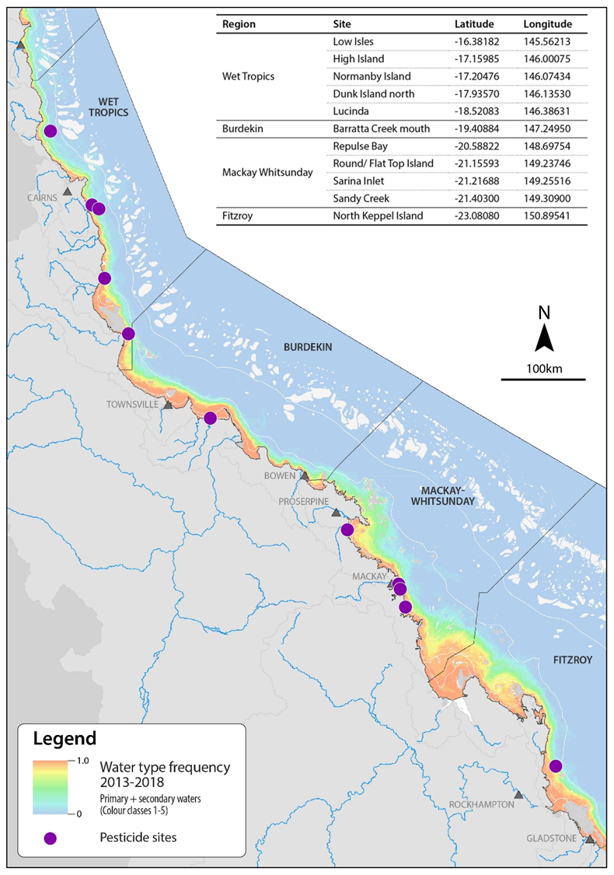
Figure 2: Locations of fixed monitoring sites where time-integrated passive sampling of pesticides occurred in 2017-18
. Sites are overlaid on the 2003 – 2018 water type frequency map (for more information see Section 2.5.3). Grey triangles indicate towns. (Source – Dieter Tracy, James Cook University)

Table 1: Location of fixed passive sampling sites, closest influencing river and date that sampling first commenced
NRM region | Basin | Major River/ Creek | Fixed site name | Sampled since | Approx. distance from river mouth (km)
Wet Tropics | Mossman | Mossman River | Low Isles | Aug-2005 | 18
Wet Tropics | Mulgrave-Russell | Mulgrave River/  Russell River | High Island | May-2015* | 8.0
Wet Tropics | Mulgrave-Russell | Mulgrave River/  Russell River | Normanby Island | Jul-2005 | 11
Wet Tropics | Tully | Tully River | Dunk Island | Sep-2008 | 13
Wet Tropics | Herbert | Herbert River | Lucinda | Jul-2014 | 12
Burdekin | Burdekin | Barratta Creek | Barratta Creek mouth | Mar-2014 | 1.5
Mackay Whitsunday | Proserpine O’Connell | Proserpine River O’Connell River | Repulse Bay | Sep-2014 | 12  3.3
Mackay Whitsunday | Pioneer  Plane | Pioneer River  Sandy Creek | Round Top Island | Sep-2014 | 5  9
Mackay Whitsunday | Plane | Sandy Creek | Sandy Creek | Sep-2014 | 8.6
Mackay Whitsunday | Plane | Plane Creek | Sarina Inlet | May-2009 | 2.8
Fitzroy | Fitzroy | Fitzroy River | North Keppel Island | Aug-2005 | 50

* High Island was reintroduced to the sampling program in 2015–16 after its discontinuation in 2008.

Flood plume (transect) monitoring (‘event’ passive sampler and grab sampling)
Terrestrial run-off assessments, i.e. flood plume monitoring, have been conducted in past monitoring years along transects extending from river mouths during discharge events in two or three Natural Resource Management regions with a high risk from pesticide exposure. The locations and timing of the flood plume sampling changes annually, as it is event-driven and requires a rapid response.

In 2017–18, flood plume monitoring was undertaken along transects extending from the mouths of two rivers in the Wet Tropics region – the Tully and Russell-Mulgrave rivers (Figure 3, Appendix G Table G-1). Both transects have been sampled in previous monitoring years, with the Tully transect first sampled in 2010 and the Russell-Mulgrave transect first sampled in 2013.

Four event passive samplers were deployed at Dunk Island North in the Wet Tropics for between four and five days in an effort to capture short-term pulses in pesticide concentrations during periods of freshwater discharge.

Grab samples were collected at Barratta Creek mouth within the Burdekin focus area during early-season discharge events by the James Cook University (JCU) Inshore Marine Water Quality team (Figure 3).

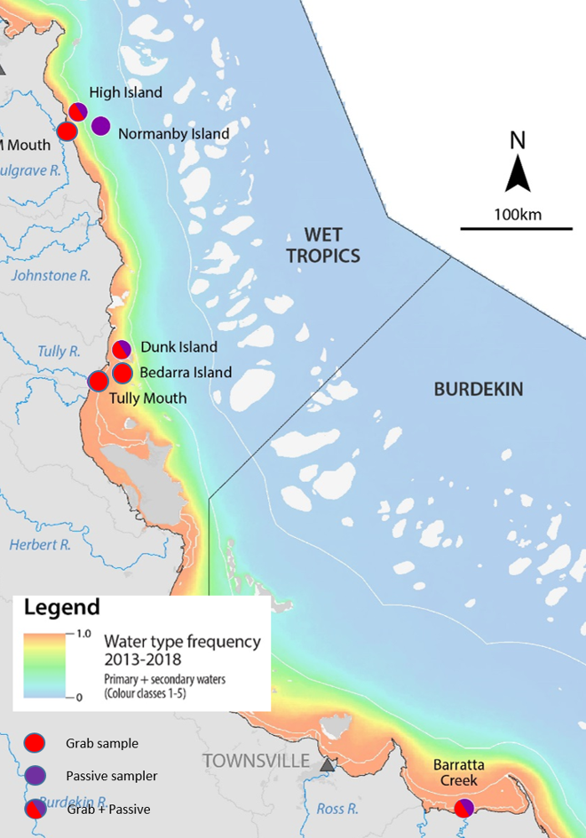

Figure 3: Locations of grab (flood plume monitoring) and passive samplers (fixed monitoring) collected on the Russell-Mulgrave River transect, and Tully River transect
. Sampling sites are overlaid on a colour-scale representing the water type frequency of flood plumes for 2003-2018. Maps edited from those provided by Dieter Tracey, James Cook University (JCU).

Sampling approaches
Details of the techniques for passive and grab sampling are given in the Marine Monitoring Program quality assurance and quality control manual 2017/2018 (GBRMPA, 2019). An overview of the sampling periods and types of samples collected is given below, with additional details in Appendix A.

Passive sampling (fixed monitoring sites) to establish long-term trends
Pesticide monitoring at fixed monitoring sites is reported for the year to 30 April 2018. The year is divided into “Dry 2017” (May 2017 to October 2017) and “Wet 2017-18” (November 2017 to April 2018) sampling periods for reporting purposes.

During dry sampling periods, passive samplers are typically deployed for two months at a time (maximum of three deployment periods each monitoring year), and for one month at a time during wet sampling periods (maximum of six deployment periods within each monitoring year). Time integrated concentrations are reported that reflect the average concentration over the actual period of deployment. The maximum number of samples obtained from each location in the monitoring year is nine.

Table 2: The types of passive samplers deployed at each fixed monitoring site in 2017-18.
Region | Site | EDs (polar) |  | PDMS (non-polar)
Region | Site | Dry | Wet | Dry | Wet
Wet Tropics | Low Isles | ✓ | ✓ | ✗ | ✗
Wet Tropics | High Island | ✓ | ✓ | ✗ | ✗
Wet Tropics | Normanby Island | ✓ | ✓ | ✗ | ✗
Wet Tropics | Dunk Island | ✓ | ✓ | ✗ | ✗
Wet Tropics | Lucinda | ✓ | ✓ | ✗ | ✗
Burdekin | Barratta Creek Mouth | ✓ | ✓ | ✗ | ✓
Mackay Whitsunday | Repulse Bay | ✓ | ✓ | ✗ | ✓
Mackay Whitsunday | Round Top Island | ✓ | ✓ | ✗ | ✓
Mackay Whitsunday | Sandy Creek | ✓ | ✓ | ✗ | ✓
Mackay Whitsunday | Sarina Inlet | ✓ | ✓ | ✗ | ✓
Fitzroy | North Keppel Island | ✓ | ✓ | ✗ | ✗

All eleven fixed sites were monitored in both the Dry 2017 and Wet 2017-18 sampling periods using EDs (Table 2), targeting polar pesticides (see Table A-2 for a list of the polar pesticides in the passive sampler analysis suite). Due to losses of samplers, three sites (Normanby Island, Repulse Bay and Round Top Island) had only one successful dry season deployment. Five sites also had PDMS samplers deployed during the Wet 2017-18 sampling period (Table 2), targeting non-polar pesticides (see Table A-3 for a list of the non-polar pesticides in the passive sampler analysis suite).

PDMS samplers were co-deployed with the EDs in the Burdekin region (one site) and the Mackay Whitsunday region (four sites) (Table 2). These two regions were chosen for targeting non-polar pesticides based on their high proportions of sugar cane land use relative to other regions, and the high pesticide risk assigned to these regions (Brodie et al., 2013). The deployment dates and results for each fixed monitoring site are in Appendix F Table F-2 to Table F-12.

Grab sampling to assess flood plume (transect) profiles
Sampling activities targeting discharge events from major Reef basin rivers occurred during the Wet 2017-18 sampling period, and typically coincided with large rainfall events in the adjacent basin area. Grab samples (250 mL) were collected along transects extending from river mouths to capture peak concentrations and establish the presence of any pesticides not adequately sampled by passive samplers (e.g. due to their high water solubility).

Forty-one grab samples were collected in 2017–18. Thirty-five were collected to monitor terrestrial run-off from the two river transects (the Tully and Russell-Mulgrave rivers) during flood plume events between January and March 2018 (Figure 3). A further six grab samples were collected from the Burdekin focus area at Barratta Creek mouth during major discharge events in both the dry and wet season. Further details for these samples including the date of collection and results for individual pesticides detected are provided in Appendix G Table G-1.

Sampler deployment and approaches for missing data
This monitoring year, 75 per cent of fixed site passive sampler sets sent to volunteers were successfully deployed, returned (undamaged) and analysed (Appendix F Table F-1). This return rate was comparable to the two previous years (75 and 73 per cent). The remainder of samplers were unsuccessful for several reasons but were typically because of a lost mooring following bad weather, human interference (e.g. theft of mooring) or in situ damage (e.g. membrane lost or fouled). Four sites (Dunk Island, High Island, Lucinda, and North Keppel Island) returned at least eight out of nine sampling kits. Once again, the sites located in the Mackay Whitsunday region experienced the highest sampler losses. Following a year of no sampling activity at Normanby Island in 2016-17, this site was successfully re-established, although only one dry season sampler was successfully returned this monitoring year.

For sites with lower successful deployment rates, trend comparisons with previous years are generally not possible, and care needs to be taken when comparing between the monitoring sites. Details on deployment procedures and approaches for data interpretation when samplers are not/ cannot be deployed or are lost are given in Appendix A: A-1.

Pesticide analyses and reporting QA/QC

Target pesticides
The list of target pesticides included in this report and their rationale for inclusion are given in Appendix A: A-2 and Table A-4.

Instrument analyses and quality assurance quality control (QA/QC)
Analysis of non-polar pesticides using Gas Chromatography-Mass Spectrometry (GC-MS) and polar pesticides using Liquid Chromatography-tandem Mass Spectrometry (LC-MS/MS) was conducted at Queensland Alliance for Environmental Health Sciences (formerly Entox) (QAEHS). Further analytical details are given in Appendix A.

Quality assurance quality control (QA/QC) includes the extraction and analysis of replicate ED samplers (i.e. to test the variability in the overall performance (chemical uptake) of the EDs). Duplicate analysis of 24 ED samplers and four grab samples resulted in mean coefficients of variation for replicates ranging from 3.3% to 55% Table A-1).

Blanks were extracted and analysed with every batch of samples. Most pesticides were below the limit of detection (LOD) in batch blanks. Where blank values were detected, sample concentrations in that batch that were less than 3 times the blank value were excluded from summary statistics and are shown with a “<” in the data tables in Appendix F .

The LOD for the LC-MS/MS instrument data are defined as follows: LODs are determined by adding a very low level of analyte to a matrix and injecting nine times into the instrument. The standard deviation of the resultant signals is obtained and a multiplication factor of three is applied to obtain the LOD. Values below the LOD are defined as non-detects (n.d.) in all tables in this report. The limit of reporting (LOR) is defined as three times the LOD. Values above LOD but below LOR are shown in the tables in this report in italics. Whilst there is some uncertainty regarding the accuracy of these relatively low concentrations, to be conservative, these values are included in summary statistics and multi-substance potentially affected fraction (ms-PAF) values and thus represent the worst-case scenario.

Calculating the pesticide concentrations
Once the concentrations of pesticides in the extract were measured, they are converted to a time-integrated concentration in water (ng L⁻¹) using an in-situ derived sampling rate R_{S} (L/day). In-situ sampling rates were derived using passive flow monitors (PFMs) deployed in duplicate alongside the passive samplers (O’Brien et al., 2011a). The R_{S} for atrazine and prometryn were directly predicted from the average in-situ flow velocity (m/s) estimated by the rate of loss of plaster from the PFMs during the deployment period based on data from previous calibration studies (O’Brien et al., 2011a; O’Brien et al., 2011b). The sampling rates of all other contaminants were either predicted from average ratios for the R_{S} of the target contaminant to that of atrazine based on a number of calibration studies (including for analogous contaminants for which no calibration data exist) or the sampling rate of atrazine was assumed (when no calibration data were available for analogous contaminants).

At present, there are limited passive sampler calibration data available for many of the other pesticides now in use in Reef basins. Some pesticides (e.g. the herbicide asulam) are highly water soluble and unlikely to accumulate in passive samplers, and therefore grab sampling may increase the probability of detecting them in the marine environment. Calibration studies in the field are labour intensive; however, they may need to be considered in the future to better understand the uptake of these chemicals into passive samplers, and more accurately estimate water concentrations.

Data analyses and reporting metrics

Water quality guideline values (GVs)
A key aim of this program is to compare measured concentrations of pesticides to current guideline values for chemicals in marine waters.

The Australian and New Zealand water quality guidelines (see Appendix B for more details) for freshwater and marine ecosystems are recently revised (DoE, 2016; Warne et al., 2015; Warne et al., 2018). For the purposes of this report, monitoring data are compared against the ANZECC and ARMCANZ guidelines however, pesticide concentrations that exceed the proposed aquatic ecosystem protection guideline values (PGV), which are still undergoing endorsement, are highlighted.

PGVs for 28 pesticides for freshwater and marine ecosystems have been determined using species sensitivity distributions (SSD) by the Department of Environment and Science (DES). All these guidelines will be submitted for consideration for national endorsement and inclusion into the Australian and New Zealand Water Quality Guidelines (King et al., 2017b; King et al., 2017c). If endorsed, they will supersede the current Water Quality Guidelines for the Great Barrier Reef Marine Park (GBRMPA, 2010) In advance of endorsed PGVs being released, ecotoxicity threshold (ET) values for diuron, ametryn, hexazinone and simazine in marine waters (PC99, 95, 90, 80) have recently been published (King et al., 2017a; King et al., 2017c; Warne et al., 2018).

Due to the high ecological value of the Reef, PC99 values are relevant to this ecosystem, and are required by Great Barrier Reef Marine Park Authority water quality guidelines (GBRMPA, 2010). The published ETs and the PGVs for 24 other pesticides submitted for endorsement and relevant to the current monitoring period, are detailed in Appendix B (Table B-1).

Risk assessment metric
Up until the 2016–2017 monitoring year, the Photosystem II Herbicide Equivalent Concentration (PSII-HEq) Index (based on diuron equivalent concentrations) has been used to assess ecological risk of mixtures of 13 PSII herbicides & metabolites for MMP reporting (for detailed information about this method see (Grant et al., 2018). This index defines ranges of PSII-HEq that equate with different levels of effect (based on published toxicity data using Reef relevant species). The index included only the five priority PSII herbicides – ametryn, atrazine, diuron, hexazinone and tebuthiuron.

In this current report, an alternative risk assessment metric, the ms-PAF method has been proposed as a more relevant approach to quantify the overall ecological risk of mixtures of pollutants for ecological communities. The ms-PAF method allows the effect of multiple pesticides on an ecosystem to be estimated by determining the potentially affected fraction of species (i.e. percentage of species that will theoretically be affected when exposed to a given mixture). The ultimate aim is to report a single assessment end point (PAF) for all monitored pesticides detected in the MMP program (further information on the ms-PAF metric and its application for this report is in Appendix C ).

Marine results are not directly comparable with the end-of-catchment results primarily due to differences in sampling. However, they provide insight into the transport and fate of pesticides, from the end of rivers to marine sites, and the risk to marine ecosystems from the mixture of pesticides. The key differences are:
- three of the pesticides are not analysed for in the marine samples (i.e. 19 of the 22 pesticides analysed at the end of catchment are analysed for in marine samples)
- passive sampler results are reported here and grab samples are used at end of catchment
- an area under the curve mathematical calculation is used to extrapolate end of catchment mixtures to a wet season single outcome and is not applied here for the marine samples.

The missing pesticides may mean that the mixture toxicity would be higher. The three pesticides not currently analysed for are fipronil, isoxaflutole, and triclopyr. Of these three pesticides, only isoxaflutole will regularly occur in freshwater catchments (i.e. in Mackay Whitsunday catchments) at concentrations that exceed draft ecosystem protection guidelines for protection of 99% species (0.33 µg L⁻¹) (King et al. 2017a). Even so, the highest concentration recorded during 2017–18 was 1.7 µg L⁻¹ (in water collected from Sandy Creek in Mackay Whitsunday) and is unlikely to contribute significantly to overall pesticide toxicity in inshore marine waters (Great Barrier Reef Catchment Loads Monitoring Program, pers comm). Fipronil has a very low draft ecosystem protection guidelines for protection of 99% species (0.0034 µg L⁻¹) (King et al. 2017b), and is below the limit of reporting for samples collected as part of routine analyses by Great Barrier Reef Catchment Loads Monitoring Program (0.02 µg L⁻¹). However, where more sensitive analysis methods are used the concentrations detected (if detected at all) were very low and again unlikely to contribute significantly to overall pesticide toxicity in inshore marine waters.

Passive samplers integrate pesticide concentrations over the time of their deployment so they represent a portion of the wet season, not the full season. Given there is a range of risk reported across the deployments, averaging for the season would likely result in a reduced overall score. In the coming years we will explore methods to increase the comparability. In the interim, we are reporting the ms-PAF value for the deployment with the highest concentrations (and highest ms-PAF scores).

Mapping the frequency and extent of flood plumes (water type frequency maps)
River flood plumes are the primary vehicles that deliver basin-derived pollutants to the Reef lagoon. The Marine Water Quality component of the MMP maps the frequency and extent of (surface) ‘water types’ associated with flood plumes (Waterhouse et al., 2017b; Waterhouse et al., 2018). Weekly water type colour class data were recorded for each of the fixed monitoring sites for the wet season (details provided in 0Table E2). Site maps presented in this report overlay the water type frequency maps to indicate sampling site positions relative to primary and secondary flood plume occurrences. The information on colour classes inform the likelihood of a passive sampling site to encounter a flood plume and how often and for how long it may be impacted by plume waters.

Further information on how plumes are characterised is given in Appendix E, Section E.1.

Other data sources (weather, rainfall)
This report utilises supporting data including:
- Land use
- Hydrological data
Those data were sources from GBRMPA (2014a), DNRM http://watermonitoring.dnrm.qld.gov.au/host.htm, and DNRM Stream Gauging Network.

Drivers and pressures influencing pesticide concentrations during 2017–18
Agricultural land use, as well as multiple paddock-scale pressures relating to pesticide usage, together with cyclones, rainfall and freshwater river discharge, collectively influence the end-of-catchment pesticide loads discharged to the Reef lagoon. Other sources of pesticide are the result of urban and industrial activities (GBRMPA, 2014b), although the relative contribution of these sources is not known.

Land use
A wide range of land uses occur in the Reef basins, with great diversity between Natural Resource Management regions (Figure 4).
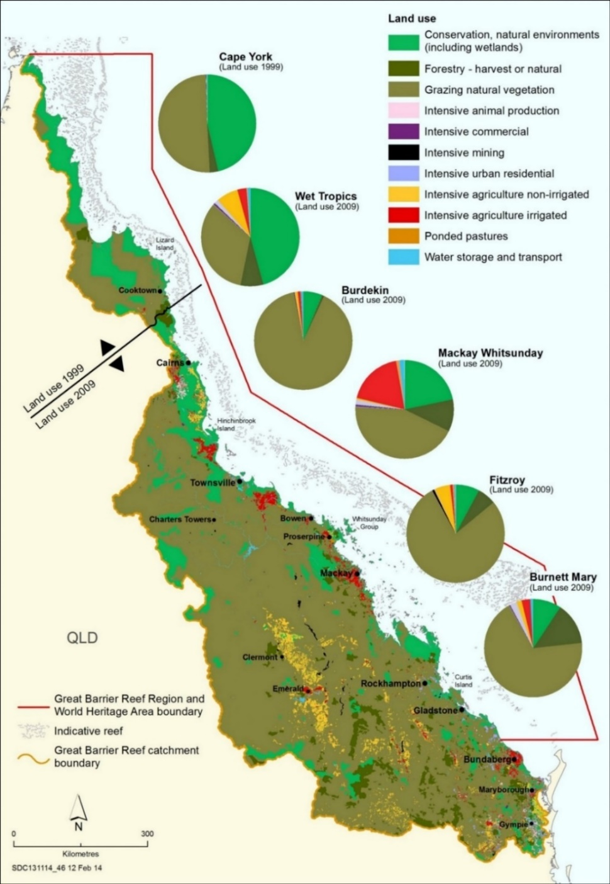
Figure 4: Land use in the Reef basins. Sourced from GBRMPA (2014a)

Land use in the Reef’s basins varies from being largely undeveloped in the far north, to agriculture, mining, and urban uses in the central and southern regions. In total, 80 per cent of the Reef basins support agricultural activities with cattle grazing the most extensive land use, particularly in the drier Burdekin and Fitzroy regions where 90 per cent and 77 per cent, respectively, are grazed (DSITIA, 2012a, b).
- The Wet Tropics region encompasses eight basin areas, covering approximately 2.2 million hectares (ABS, 2010).
- The Burdekin region spans five basins and covers 14 million hectares, of which 90 per cent is used for agricultural purposes, with grazing primarily inland and some sugar cane and horticulture along the coast (ABS, 2010; DSITIA, 2012b).
- The Mackay Whitsunday region is the smallest Natural Resource Management region, spanning four basins with an area of approximately 900,000 hectares (ABS, 2010). This region is dominated by grazing, which comprises 30 – 60 per cent of the region’s land use depending on the basin basin, and the sugar cane industry, which comprises 6 – 50 per cent of the region’s land use (DSITIA, 2012d).
- The Fitzroy region spans six basins and covers an area of 15.6 million hectares (ABS, 2010). Cattle grazing is the most prevalent industry (78 per cent of the land use), with broad acre cropping (five per cent of the land use) and cotton farming also present (DSITIA, 2012a).

The Wet Tropics and Mackay Whitsunday regions also have grazing activities (31 per cent and 42 per cent, respectively); however other uses such as nature conservation (49 per cent of land use in the Wet Tropics) and irrigated cropping (sugarcane) (18 per cent of land use in the Mackay Whitsunday) are also significant (DSITI, 2016; DSITIA, 2012d).

The range of land uses results in point and diffuse sources of pesticides from a variety of human activities. Certain regions and/or smaller coastal basins may represent areas of higher localised risk of pesticide run-off due to the intensity and nature of agricultural activities (such as sugar cane cropping) occurring in coastal areas (Brodie et al., 2013).

Although land-use is well characterised in the Reef basins, limited data on pesticide usage are available and models are used to extrapolate for estimates of run-off of pesticides from the different land use areas to a wider range of basin conditions and to also investigate the impact of management options (Shaw et al., 2011).

Hydrological conditions in the Reef basins
The magnitude of releases is also highly influenced by weather conditions and most run-off is delivered in short-lived flood events during the wet season, forming distinct flood plumes that sometimes disperse far into the lagoon (Devlin and Schaffelke, 2009). An overview of the rainfall and cyclonic activity, and associated river discharge, for the Reef region is given in the following three sections. These data provide a general understanding of the climatic and flow conditions experienced in Reef basins in 2017-18 and allow broad comparisons with previous years. Regional monitoring data are presented in the context of individual rivers’ hydrographs (river flow rates over time).

Cyclones
No cyclones influenced the Reef in 2017-18 and only one cyclone occurred in 2016–17 (cyclone Debbie), which passed through the Mackay Whitsunday region.

In the 11 years since the MMP began in 2006–07, ten cyclones have been Category 3 or above and have affected the health of the Reef.

Rainfall
Annual rainfall across the central and southern Reef basins and Cape York was at or below the wet season averages in 2017–18 (Figure 5), whilst the Wet Tropics basins (Mossman to Herbert) recorded above average rainfall. This is in contrast to the previous monitoring year when the central and southern basins experienced higher than average rainfall, largely due to cyclone Debbie. The first significant rainfall event (i.e. weekly rainfall >100mm) occurred in the Wet Tropics in early January 2018 and continued until late March (Table 4). Rainfall events did not occur until late February in the Mackay Whitsundays region, which experienced a second significant rainfall event in late March. Neither the Burdekin or Fitzroy regions recorded weekly rainfall >100mm for the entire wet season but recorded moderate rainfall events over the month of February (see 0for more details).
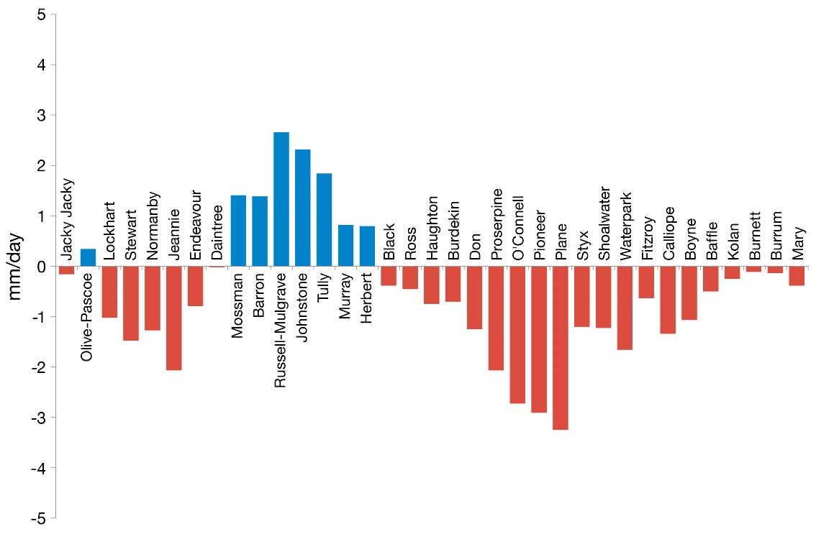

Figure 5: Annual average wet season rainfall (December 2017 - April 2018), as compared to the long-term wet season rainfall average (1961 – 1990).
Red and blue bars denote basins with rainfall below and above the long-term average, respectively. Basins are ordered from north to south (left to right). Figure is extracted from Gruber et al 2019.

Table 3: Weekly mean basin rainfall (mm) in basins adjacent to fixed passive sampler sites during the 2017-18 wet season
(beginning 1 December 2017). Data provided by Dieter Tracey, JCU
Colour gradient: Red indicates the highest value, yellow represents the 50th percentile and green represents the lowest value.

River discharge
Rivers located in the northern basins typically flow year-round, whereas rivers located in the drier southern basins only flood periodically following large rain events during summer (Larson et al., 2013; Lewis et al., 2006). The differences in the timing, duration and intensity of rainfall between the northern and southern Reef basins contribute to the pattern of pesticide discharge to the marine environment.

Total annual discharge of freshwater (based on corrected gauge values for the hydrological year) into the Reef lagoon in 2017-18 was equal to the long term median discharge over the last 15 years (Figure 6). Despite this close to median discharge, total discharge from rivers located in the Wet Tropics and Burdekin were the highest recorded in the previous three years (Figure 7).

With the exception of the Herbert River, all regions where passive or grab sampling sites were located in 2017-18 had annual discharge close to or less than the long term median (an average of 0.76 times the median) (Table 4).

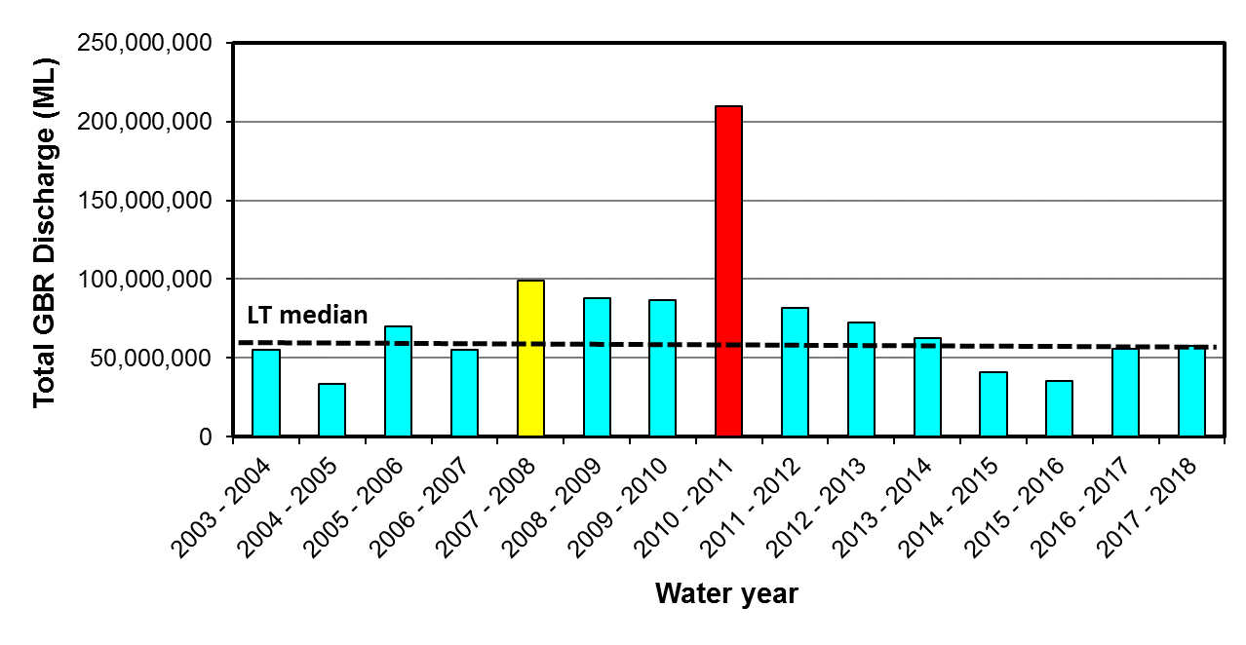

Figure 6: Long-term total annual discharge (ML) (hydrological year: 1 October to 30 September) for the 35 main Reef river basins.
Blue indicates <1.5 times the median, orange indicates 1.5 to 2 times the median and red indicates >2 times the median Data derived from DNRM http://watermonitoring.dnrm.qld.gov.au/host.htm. Figure is extracted from Gruber et al 2019.

Figure 7: Corrected annual hydrological/water year (1 October to 30 September) discharge from each NRM region
(using the correction factors in Table 2-2 (Waterhouse et al., 2018)) for 2002–03 to 2017–18 in millions of megalitres per year. Dot line is the long-term median discharge for each NRM; blue indicates <1.5 times the median, orange indicates 1.5 to 2 times the median and red indicates >2 times the median. Data derived from DNRM http://watermonitoring.dnrm.qld.gov.au/host.htm and figure provided by Steve Lewis, JCU.

Table 4: 2017-18 annual discharge (ML) of the major Reef basin rivers adjacent to passive sampling sites
(1 October to 30 September 2018, inclusive) compared to the long term (LT) median discharge. Relative discharge (fraction of long-term median) are shown
Region | Site | 2017–18 annual discharge (ML) | LT median annual discharge (ML) | Relative discharge (fraction of long-term median)
 |  |  |  | 2012 - 2013 | 2013 - 2014 | 2014 - 2015 | 2015 - 2016 | 2016 - 2017 | 2017 - 2018
Wet Tropics | Mossman | 1,503,754 | 1,207,012 | 1.0 | 1.6 | 0.7 | 1.0 | 0.9 | 1.2
Wet Tropics | Mulgrave-Russell | 5,759,716 | 4,457,940 | 0.8 | 1.2 | 0.7 | 0.7 | 0.7 | 1.3
Wet Tropics | Tully | 4,237,041 | 3,536,054 | 0.9 | 1.2 | 0.8 | 0.8 | 0.9 | 1.2
Wet Tropics | Herbert | 6,385,655 | 3,556,376 | 0.9 | 1.2 | 0.3 | 0.5 | 0.6 | 1.8
Burdekin | Burdekin | 5,542,306 | 4,406,780 | 0.8 | 0.3 | 0.2 | 0.4 | 0.9 | 1.3
Mackay Whitsunday | Proserpine | 543,452 | 887,771 | 1.0 | 0.8 | 0.2 | 0.4 | 1.9 | 0.6
Mackay Whitsunday | O'Connell | 487,713 | 796,718 | 1.0 | 0.8 | 0.2 | 0.4 | 1.9 | 0.6
Mackay Whitsunday | Pioneer | 249,530 | 776,984 | 1.5 | 0.8 | 2.6 | 0.8 | 1.8 | 0.3
Mackay Whitsunday | Plane | 273,639 | 1,052,831 | 1.9 | 0.7 | 0.2 | 0.8 | 2.5 | 0.3
Fitzroy | Fitzroy | 954,533 | 2,852,307 | 3.0 | 0.6 | 0.9 | 1.3 | 2.2 | 0.3
Colours highlight years for which river flow exceeded the median annual flow as estimated from available long-term time series for each river: yellow = 1.5 to 2-times LT median, orange = 2 to 3-times LT median, red= >3-times LT median. Discharge data were supplied by DNRM and corrected by Waterhouse et al. (2018) for different placements of gauges within each basin. The full dataset from which these data were derived is given in 0

End-of-basin pesticide monitoring
Systematic monitoring has identified that pesticide contamination in the rivers, streams and estuaries that drain into the Reef marine environment is widespread (Brodie et al., 2012), with the highest levels around Mackay (Brodie et al., 2013). In some cases, pesticide concentrations have been elevated above Australian and New Zealand Water Quality Guideline (2000) trigger values in basins adjacent to intensive agricultural activity (DSITI, 2015; O’Brien et al., 2016; Smith et al., 2012).

Forty-three pesticides and metabolites were monitored in 34 basins (comprising both end-of-basin and sub-basin sites) under GBRCLMP (Huggins et al., in prep). Samples were collected at regular intervals throughout the year (typically monthly) during low-flow (ambient) conditions and higher frequency sampling during high-flow (event) conditions.

Pesticides detected in marine waters

Frequency of pesticide detections
Thirteen PSII herbicides (including terbuthylazine for the first time this monitoring year) and two metabolites of atrazine (DE atrazine and DI atrazine) were included in the sample analysis suite of the polar passive sampler extracts. Of these fifteen compounds, thirteen were detected at one or more of the marine monitoring sites (Figure 8).

Consistent with previous years, the most commonly detected PSII herbicides (indicated in blue) were diuron, atrazine, and hexazinone (each detected in 88% of samplers). Conversely, prometryn and terbutryn were not detected at any site (LOD = 0.54 and 0.55 μg L⁻¹, respectively).

Of the eleven other pesticides (non-PSII) in the ED analysis suite (indicated in green in Figure 8), all were detected at measurable levels, with detection frequencies ranging between 3% (fluroxypyr) and 88% (metoloachlor) of samplers.

All five non-polar pesticides (indicated in yellow) were detected in the PDMS samplers, with detection frequencies ranging between 33% (trifluralin) and 100% (propazine) of samplers (Figure 8).

It is noted that the detection frequency information should be considered together with the return rate of the passive samplers. In this monitoring year, 75% of fixed site passive sampler sets sent to volunteers were successfully deployed, returned (undamaged) and analysed (Appendix F, Table F-1).

Figure 8: Percentage of ED and PDMS samplers that had measurable pesticide levels
(i.e. above the limit of detection, LOD) for each pesticide included in this study, out of a total of 68 ED samplers and 9 PDMS samplers returned in 2017-18 (Table F-1, Appendix F). Blue: PSII herbicides; Green: Other pesticides; Yellow: non-polar pesticides

Summary of pesticide concentrations in 2017–18
The PSII herbicides detected at the highest concentrations in 2017–18 were also the most frequently detected, with maximum concentrations (C_{max}) of:
- diuron 778 ng L⁻¹
- atrazine 405 ng L⁻¹
- hexazinone 134 ng L⁻¹.
All of these were detected at Round Top Island (Table 5), approximately five and nine km from the Pioneer River and Sandy Creek mouths respectively, in the Mackay Whitsunday region. This site also experienced the highest concentrations of these same PSII herbicides in the previous monitoring year (Grant et al., 2018).

Other PSII herbicides, including DE atrazine, tebuthiuron and simazine were also frequently detected (>70% of samplers), although most often at much lower concentrations (typically <5 ng L⁻¹), with the highest concentration being 32 ng L⁻¹ of DE atrazine (also at Round Top Island).

Similar to the previous monitoring year, the non-PSII pesticides 2,4-D, imidacloprid and metolachlor were consistently detected across the sampling sites (>60% of samplers), although at lower concentrations compared to the PSII herbicides with the maximum concentrations (C_{max}) of:
- 2,4-D 8.1 ng L⁻¹
- imidacloprid 42 ng L⁻¹
- metolachlor 28 ng L⁻¹.

When pesticide mixture concentrations are assessed with the risk metric results are variable. All sites in the Wet Tropics and at North Keppel Island met the desired very low risk category 5: protective of 99% of species (i.e. less than 1% of species are affected). Remaining sites, other than Round Top Island (i.e. Barratta Creek, Repulse Bay, Sandy Creek, and Sarina Inlet) had a mix of very low risk: protective of 99% of species (i.e. less than 1% of species are affected) and low risk: protective of >95% but <99% of species (or 1 to <5% of species affected). At Repulse Bay (2016–17) and Sandy Creek (2017–18) only one and zero wet season samples were obtained, respectively due to sampler losses and deployment issues. No data is available for Normanby Island for 2016–17.
Round Top Island had samples returned across all categories (Appendix F):
- Very low risk: protective of 99% of species (i.e. less than 1% of species are affected) - four
- Low risk: protective of >95% but <99% of species (or 1 to <5% of species affected) – one deployment from 6/12/2017 to 22/1/2018
- Moderate risk: protective of >90% but <95% of species (or 5 to <10% of species affected) – two deployment from 15/2/2018 to 15/3/2018 and 15/3/2018 to 12/4/2018
- High risk: protective of >80% but <90% of species (or 10 to <20% of species affected) – one deployment from 22/1/2018 to 15/2/2018
- Very high risk: protective of ≤80% of species (or ≥20% of species potentially affected) – one deployment from 7/11/2017 to 6/12/2017

The PSII-HEq Max was also calculated for all sites (ranging from 6.4 – 901 ng L⁻¹) of which the highest concentration also corresponded to the highest risk Category 1 on the Index:
- Category 1 (published demonstrated effects on the growth and death of aquatic plants and animals exposed): one site
- Category 2 (published scientific observations of reduced photosynthesis for three coral species): no sites
- Category 3 (published scientific observations of reduced photosynthesis for two seagrass species and three diatoms): two sites
- Category 4 (published scientific observations of reduced photosynthesis for two diatoms): four sites
- Category 5 (no published demonstrated ecosystem effects): four sites.

Both risk metrics indicate that the Round Top island site located in the Mackay Whitsunday region is exposed to elevated risk of pesticide exposure, compared to other sites.

Comparison to guideline values
No individual exceedances of the current marine trigger values (i.e. water quality guideline values) were detected but it is noted these values are undergoing a review. The current ANZECC and ARMCANZ trigger value for diuron is 1800 ng L⁻¹ (a low reliability interim working value) and the Authority’s PC99 (protective concentration values that will protect 99% of the species) is 900 ng L⁻¹ (Table B-1). Under both these guidelines, the Round Top Island diuron values are not an exceedance. Note that there are no existing PC99 or trigger values for imidacloprid.

Applying the proposed values under review (levels determined to protect 99% of marine species), there would be two instances of exceedance, both from passive samplers located at Round Top Island, in the Mackay Whitsunday region and both for diuron: 778 and 531 compared to 430 ng L⁻¹.(King et al., 2017a). Until endorsed, comparisons with this proposed value are provided only for consideration.

Comparison to previous years: trends in pesticide concentrations
The 2017–18 Cmax values for diuron and imidacloprid were in a similar range to those detected in 2016–17 (580 and 53 ng L⁻¹, respectively) when PGV exceedances also occurred. With the exception of Normanby Island (no sampling in 2016-17) and Sandy Creek (unreliable sampling in 2017–18), the 2017–18 C_{max} were generally similar to or higher than results from 2016–2017 (Grant et al., 2017).

The ms-PAF and PSII-HEq Max values assessments both find Round Top Island is the highest risk site (Figure 10 and Figure 11). Barratta Creek, Sandy Creek and Sarina Inlet return lower risk categories with the new mixture assessment. (Note that trend comparisons for sites most recently introduced to the program as well as sites that experience higher than average sampler losses should be interpreted with particular caution due to limited data).

Table 5: Maximum detected time integrated (or chronic) pesticide concentrations at each fixed passive sampling site

. % of species affected values are colour-coded according to their risk category. Shaded pesticides indicate that no calibration data is available and the sampling rate of atrazine was assumed.

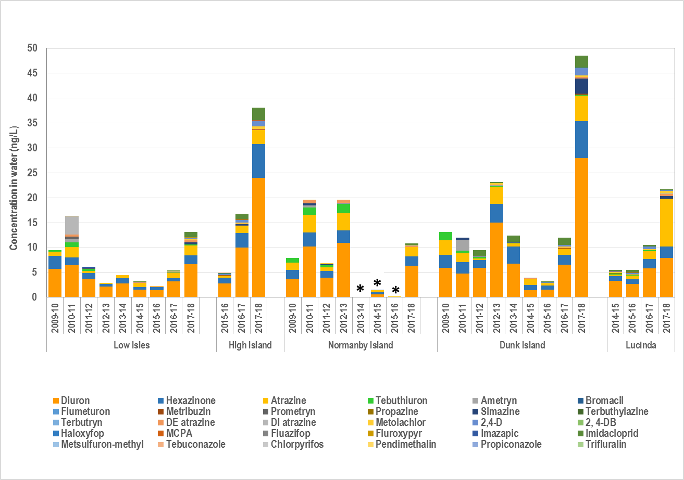
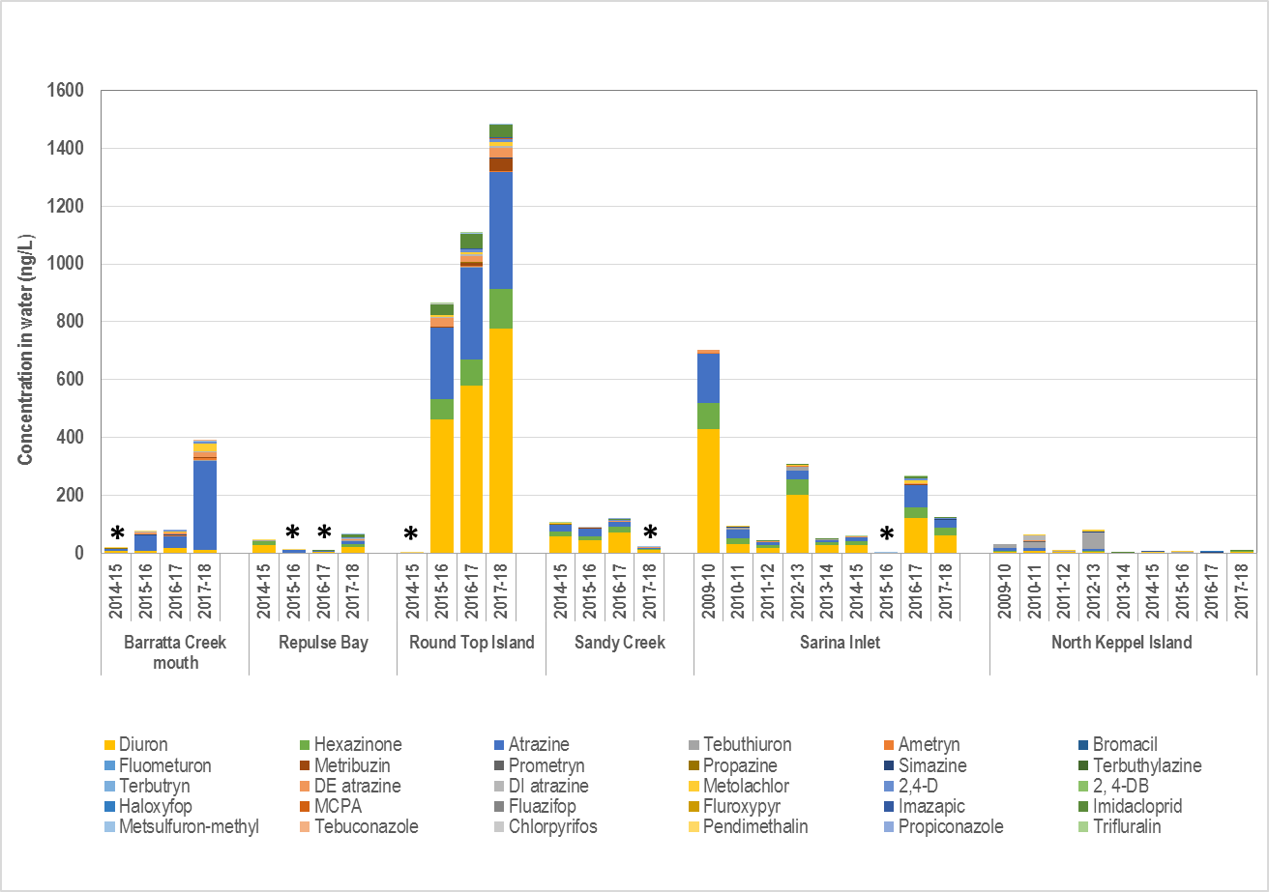
Figure 9: Maximum concentrations of individual pesticides at all sites monitored in 2017–18 compared to previous years (2009–10 onwards)
in the Wet Tropics (upper panel) and the Burdekin, Mackay-Whitsunday and Fitzroy (lower panel). Note that the scale of the vertical axis differs between the panels. Several pesticides were recently added to the analysis suite and are only included in the relevant years (2014-15 onwards). 2,4-DB and fluometuron are not shown as values were <LOD for all sites and all years. * Dates with an asterisk are not representative values due to incomplete wet season sampling and should be interpreted with caution.

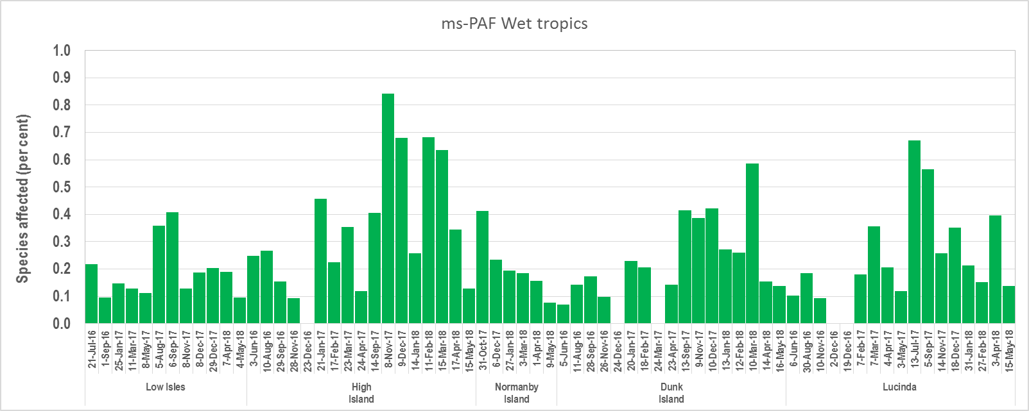
A
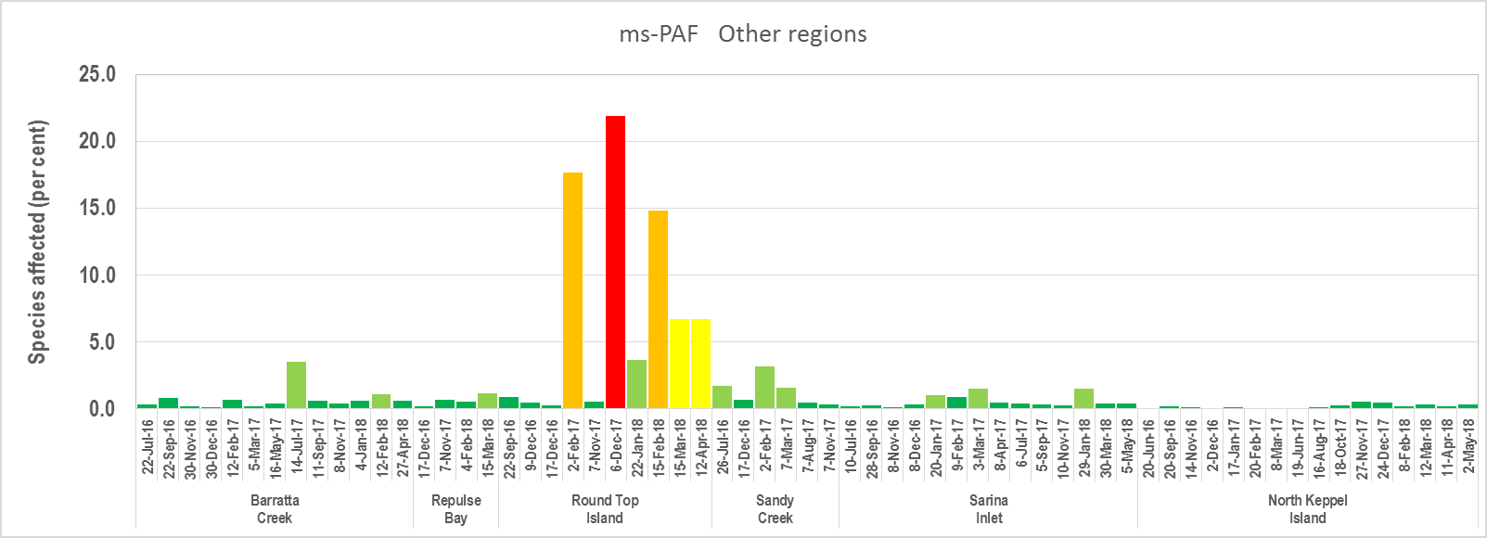
B

Figure 10: (A) Maximum % of species affected calculated using the ms-PAF method for all Wet Tropic sites and (B) Maximum % of species affected calculated using the ms-PAF method for all other sites
. Dates are when passive samplers were collected. Color scale: ■ = very low risk (>99% species protected). ■ = low risk (>95% but <99% of species protected), ■ = moderate risk (>90% but <95% of species protected), ■ = high risk (>80% but <90% of species protected), ■ = very high risk (≤80% of species protected). Note the difference in y-axis scale between panels A and B. Note the difference in y-axis scale.

Figure 11: Maximum PSII herbicide equivalent concentrations at all sites compared to previous years
(2016-18 shown). The risk categories are described in Appendix C, Table C-1. Asterisk indicates no data. Previous data is published in earlier reports.

Regional results

Wet Tropics Region
No exceedances of guideline values were detected in this monitoring year. Continuing the trend of previous monitoring years, the predominant pesticides detected using EDs in the Wet Tropics region in 2017–18 were atrazine, diuron and hexazinone. All three were detected in all wet season samplers returned from monitoring sites (Appendix F Table F2 to Table F-6). Simazine, tebuthiuron and DE atrazine (metabolite) were PSII herbicides that were also frequently detected in at least 50% of samplers at all sites as were the other non-PSII pesticides 2,4-D, imidacloprid and metolachlor. Ms-PAF values were calculated and no sites in the region are above Category 4. Note that the concentrations of non-PSII pesticides are yet to be integrated into this risk metric and thus the potential risk from all pesticides could be higher than what is reported here.

Low Isles
In 2017–18, there is no exceedances of guideline values at the Low Isles site.
Maximum concentration of PSII herbicides during the 2017–18 monitoring year was 6.7 ng L⁻¹ of diuron during the wet season of February/March 2018. Diuron is usually the pesticide with the highest concentration among the 26 chemicals analysed for at this site.

Figure 12: Temporal trends in % of species affected by pesticides (indicated by the black bars) in Low Isles in 2017-18, together with the flow rate of Mossman river.
Flow data from DNRM Stream Gauging Network.

The maximum concentrations of pesticides monitored in 2017–18 were higher than in the previous two monitoring years (Table 5; for historical data, see Figure H-1). The ms-PAF values in 2017–18 at this site met the desired very low risk category 5: protective of 99% of species (i.e. less than 1% of species are affected) for all deployments.

High Island
There is no exceedances of guideline values at the High Island site in 2017–18.

- For passive samplers
The maximum concentration of PSII herbicides at High Island in this monitoring year was 38.5 ng L⁻¹ of diuron at the start of the wet season in November 2017. Similar to Low Isles, diuron is usually the pesticide with the highest concentration among the pesticides monitored in this site.

Figure 13: Temporal trends in % of species affected by pesticides by passive (indicated by the black bars) and grab samples (indicated by the spots) in High Island in 2017-18, together with the flow rate of Mulgrave and Russell rivers.
Flow data from DNRM Stream Gauging Network.

At High Island, the maximum concentrations of pesticides monitored in 2017–18 were also higher than in the previous two monitoring years (Table 5; for historical data, see Figure H-1). It is noted that there was a high concentration detected early in the wet season when the flow is still low.

The ms-PAF values in 2017–18 at this site met the desired very low risk category 5: protective of 99% of species (i.e. less than 1% of species are affected) for all deployments.

- For grab samples along the transect
Grab samples were collected from the Russell/Mulgrave River mouth and High Island (fixed monitoring site) on four occasions (one ambient and three during flow events throughout the wet season). Wet season sampling coincided with the first flow event of the wet season in January 2018, with a subsequent flow in February, followed by the major flow event in March 2018. The Russell Mulgrave river mouth site was impacted more strongly by primary flood plume water than the High Island site returning a mix of low risk (category 4: protective of >95% but <99% of species (with a highest return of 3% of species affected) and the desired very low risk category 5: protective of 99% of species (i.e. less than 1% of species are affected).

Pesticide concentrations in grab samples collected at the river mouth were all below guideline values. Concentrations were higher during the wet season (diuron concentrations between 22 and 35 ng L⁻¹) than the dry season, before a decrease was observed in a sample collected on 19 March 2018. This final sample collection closely followed the major flow event of the season, and the additional volume of water may have served to further dilute pesticide loads already delivered by the initial flows of the season. For comparison, concentrations of pesticides in grab samples collected at the river mouth in the previous monitoring year (2016–2017) were significantly higher (C_{max} diuron of 299 ng L⁻¹).

Concentrations in grab samples collected at High Island gradually increased over the same time period (January to March 2018), reaching a peak diuron concentration, although of only 14 ng L⁻¹, on 15 March 2019. Concentrations of pesticides at this site were also lower than those in the previous monitoring year. The per cent of species affected in the grab samples at the river mouth compared to the High Island site once again demonstrating the effects of dilution and degradation in the flood plumes with increasing distance from their source.

The profile of the major pesticides in the grab samples was largely consistent with previous years, with dominant contributions of atrazine, diuron, hexazinone, imazapic and imidacloprid (Appendix G Table G-1). Other pesticides haloxyfop, MCPA, 2,4-D and metsulfuron methyl were frequently detected at the river mouth, but were less frequently detected at further distance from the river mouth at High Island.

A similar pesticide profile was observed between the grab and passive samplers at High Island (atrazine, diuron, hexazinone and imidacloprid dominance). The other pesticides, haloxyfop, MCPA and 2,4-D that were less frequently detected in grabs collected at High Island, were found during in many deployment period in the passive samplers, but at very low concentrations (~1 ng L⁻¹).

Normanby Island
There was no exceedance of guideline values in Normanby Island site in 2017–18.

The maximum concentration of PSII herbicides at Normanby Island in this monitoring year was 6.4 ng L⁻¹ of diuron in March 2018 during the wet season. Again, the pesticide with the highest concentration at this site is diuron.

At Normanby Island, the maximum concentrations of pesticides monitored in 2017–18 were higher than in 2015–2016 and 2014–2015, the two recent monitoring years where the data are available. In 2016-2017, there was no data (Table 5; for historical data, see Figure H-1).

The ms-PAF values in 2017–18 at this site met the desired very low risk category 5: protective of 99% of species (i.e. less than 1% of species are affected) for all deployments.

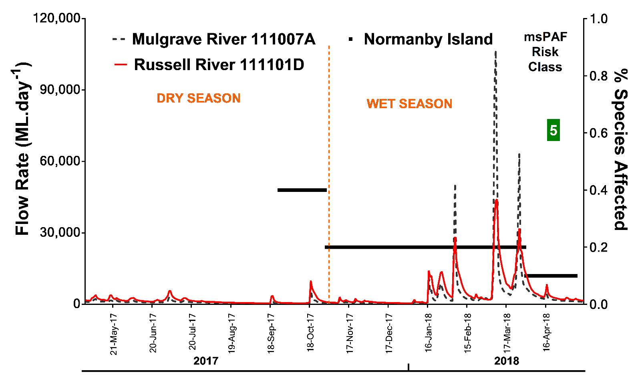

Figure 14: Temporal trends in % of species affected by pesticides (indicated by the black bars) in Normanby Island in 2017-18, together with the flow rate of Mulgrave and Russell rivers.
Flow data from DNRM Stream Gauging Network.

Dunk Island
There is no exceedances of guideline values at the Dunk Island site in 2017–18.

- For passive samplers
The maximum concentration of PSII herbicides at Dunk Island in this monitoring year was 27.9 ng L⁻¹ of diuron in February 2018 during the wet season. Diuron is still the pesticide with the highest concentration in this site.

At Dunk Island, the maximum concentrations of pesticides monitored in 2017–18 were higher than in the previous two years. The concentrations in 2015–2016 and 2014–2015 were the lowest on record since 2009–2010 (Table 5; for historical data, see Figure H-1).

The ms-PAF values in 2017–18 at this site met the desired very low risk category 5: protective of 99% of species (i.e. less than 1% of species are affected) for all passive sampler deployments.

Figure 15: Temporal trends in % of species affected by pesticides (indicated by the black bars) in Dunk Island in 2017–18, together with the flow rate of Tully river.
Flow data from DNRM Stream Gauging Network.

- For grab samples along the transect
In the Tully region, a grab sampling campaign was undertaken during the wet season, with samples collected from three sites,Tully River mouth, Bedarra Island directly offshore from the Tully River and Dunk Island, which lies to the north of the Tully (Figure 3).

The samples were collected on three main occasions, during base flow in June and October 2017 and during the major flow events in January/February 2018 and March 2018. Additionally, four ‘event’ passive samplers to capture shorter-term peaks in flood plume pesticide concentrations, were deployed at Dunk Island over the same time period.

The highest concentrations were detected in the grab sample collected at the Tully River mouth following the early-February 2018 flow (Table G-1). Similarly to the Russell Mulgrave transect, the pesticide profile at the river mouth site was dominated by (C_{max}):
- diuron 198 ng L⁻¹
- atrazine 154 ng L⁻¹
- hexazinone 159 ng L⁻¹
- imidacloprid 83 ng L⁻¹
- imazapic C_{max} 15 ng L⁻¹
- metolachlor, 2,4-D and haloxyfop were also frequently detected.

The mixture ms-PAF assessment returned a moderate risk of exposure for the sample following the flood with 8% of species affected at the Tully River mouth (category 3: protective of >90% but <95% of species (or 5 to <10% of species affected) (Table G-1). Follow-up samples on 12 and 14 March returned low risk assessments with 3 and 2% of species continuing to be affected, respectively (category 4: protective of >95% but <99% of species (or 1 to <5% of species affected). The 20 March sample saw pesticide risk returned to meeting the very low risk category 5: protective of 99% of species (i.e. less than 1% of species are affected). This shows that species were potentially affected for over a month in these waters.

The highest ms-PAF value observed at Bedarra Island also followed the early-February flow event with 2% of species affected (category 4: protective of >95% but <99% of species) Dunk Island met the very low risk category for all grab samples (further away). Both the Bedarra and Dunk Islands grab samples had a very similar pesticide profile but lower concentrations and frequencies of detections than at the river mouth (Table G-1).

Concentrations and pesticide profiles in both the event and fixed passive samplers overall closely reflected one another. But as expected, grab sampling during major flow events provided the opportunity to catch the peak concentrations of pesticides while passive sampling provided the average concentrations during the sampling period.

Water type frequency data collected at each of the transect sites indicated the Tully River mouth site was almost continually impacted by primary plume water types (colour class 4 and above) for the entire wet season, with the month of March experiencing the greatest impacts of colour class 1 and 2. Water type frequencies at the Bedarra Island and Dunk Island locations indicated these sites were less impacted by primary plumes over the wet season, with primary plume water types encountered over the month of March only, coinciding with the major rainfall on the basin and the largest river flow event of the season.

Lucinda
There was no exceedance of guideline values at the Lucinda site in 2017–18.

The maximum concentration of PSII herbicides at Lucinda in this monitoring year was 9.4 ng L⁻¹ of atrazine in November 2017 at the start of the wet season. At this site, atrazine and diuron are the two pesticides with the highest concentrations.

At Lucinda, the maximum concentrations of pesticides monitored in 2017–18 were higher than in the previous years, hence the highest since the monitoring started in 2014–2015 (Table 5; for historical data, see Figure H-1).

The ms-PAF values met the desired very low risk category 5: protective of 99% of species (i.e. less than 1% of species are affected) for all passive sampler deployments.

Figure 16: Temporal trends in % of species affected by pesticides (indicated by the black bars) in Lucinda in 2017-18, together with the flow rate of Herbert River.
Flow data provided by DNRM Stream Gauging Network.

Factors influencing the pesticide concentrations in the Wet Tropics
Wet season rainfall in the Wet Tropics in 2017–18 typically met the long term wet season average, and increased in comparison to rainfall in the 2016–2017 wet season. Rainfall in the dry season was considered very much above average. Consequently, the annual regional river discharge was increased by 1.7 times when compared with the previous monitoring year, continuing a trend of increase since the 2013–2014 monitoring year (Figure 7). Overall total discharge from the entire region was only marginally higher than the long term median (by 1.3 times).

The rivers in the Wet Tropics generally flowed year-round with small flow events occurring regularly throughout the dry season. In the wet season, a relatively small first flush event occurred in most Wet Tropics rivers in October, followed by the first wet season rainfall event in January 2018 that resulted in flow events in the rivers (Mossman, Russell, Mulgrave, Tully and Herbert Rivers). Subsequent widespread high rainfall events in March triggered the largest flow events of the season in all rivers.

Rainfall in the adjacent basins likely contributed to an increase in the frequency of colour class 4 and above water types impacting passive sampling sites at High Island, Dunk Island and Lucinda. Despite this brief increase, overall the Wet Tropics sites experienced the lowest water type frequencies of all regions (0.19–1.0), with three sites encountering only tertiary water types for at least half of the wet season.

Land use in the Wet Tropics differs between its northern and southern basins with the northern Daintree and Mossman River basins largely comprised of national parks and state forests. Large areas of land are used for sugarcane growing in the southern basins clustered around Cairns, Innisfail, Tully and Ingham (ABS, 2013). This regional variation in land use may lead to the difference in pesticide concentrations measured in each site although the PSII herbicide profiles (Figure H-1 to Figure H-5) remained very similar (dominated by diuron, atrazine and hexazinone) across all sites. The actual amount of pesticide uses and the level of river mixing may influence the actual pesticide concentrations measured.

There appears to be a seasonal change in herbicide profile across the sites within the region. In the wet season, diuron contributes approximately 50% and atrazine approximately 20% to the total pesticide concentration whereas in the dry season, the contribution of diuron drops to between 30 and 40%, and atrazine increases to an average contribution of 35%. Such change could be due to the difference between the half-lives of the two herbicides in the marine environment (Mercurio et al., 2015).

Burdekin Region

Barratta Creek passive sampling
No exceedances of pesticide concentration were detected at Barratta Creek in 2017–18.

Similarly to the previous monitoring year, most of the PSII herbicides (and metabolites) monitored in this program (with the exception of fluometuron, prometryn and terbutryn) were detected (Appendix F).

Historically, atrazine and atrazine metabolites have typically dominated the pesticide profile at Burdekin sites, including those sites monitored in previous years but no longer in the current program (e.g. Cape Cleveland; (Gallen et al., 2016)). The same atrazine-dominated profile was observed at Barratta Creek in 2017-18. In contrast to the pesticide profiles of the other regions, atrazine levels were higher than diuron in all sampling periods. Atrazine can contribute up to 80% of the total pesticide concentration (Figure H-6), and contributed an average of 45% in all sampling periods.

Of the other pesticides, metolachlor and 2,4-D were also detected, with maximum concentrations of 28 and 4.6 ng L⁻¹ respectively in May 2017. Unlike samplers from the Wet Tropics region, ametryn was consistently detected, albeit at low levels (1-10 ng L⁻¹), throughout the year. Using PDMS samplers, propazine, chlorpyrifos and pendimethalin were detected in the two samplers that were successfully returned but at very low concentrations (Appendix F). Total pesticide concentrations in the current year were comparable with the previous two monitoring years (Table 5; for historical data, see Figure H-1).

The ms-PAF values in 2017–18 at this site had a mix of very low risk: protective of 99% of species (i.e. less than 1% of species are affected) and low risk: protective of >95% but <99% of species (or 1 to <5% of species affected). The ms-PAF level was highest in May 2017 correlating with an out of season flow, although the risk level remained low.

Figure 17: Temporal trends in ms-PAF values at Barratta Creek mouth fixed passive sampling (black bar) and grab samples (blue triangles) relative to the flow rate of the rivers influencing the sampling sites.
Flow data from DNRM Stream Gauging Network.

The Burdekin River is historically the river with the highest long-term median discharge volume; however, above median discharge is intermittent and highly reliant on large rainfall events in the basin. In 2017–18, after several low discharge years, discharge from the Burdekin basin to the Reef lagoon increased for a third consecutive year. Unusually high rainfall during the dry season (May 2017), contributed to the highest concentrations in passive samplers detected (1.5% species affected) of this monitoring year, which was dominated by very high levels of atrazine (309 ng L⁻¹). The first notable rain of the wet season fell in early December 2017 with low rainfall over January, increasing in late January/ early February 2018 but did not result in significant flow. The major rainfall occurred in late February subsequently resulting in the flow event.

The Barratta Creek mouth fixed passive sampler site was highly impacted by primary water types (colour class 4 and above) for almost the entire wet season, particularly throughout February and March with several consecutive weeks of colour class 2 and 1. Unfortunately no data are available for a two week period starting in late February that coincided with the major flow event of the season.

A review of the extent of the Burdekin flood plume indicated that average flood events could reach a northward distance of approximately 200 km, and the maximum for extreme large flood events could be approximately 500 km (Lewis et al., 2006). Retrospective calculation of the ms-PAF metric, for the previous dry year of 2016–2017, showed this site met the desired very low risk category 5: protective of 99% of species (i.e. less than 1% of species are affected) for all deployments.

Burdekin Focus Region flood plume sampling
In addition to deploying passive samplers at the Barratta Creek mouth, grab samples were collected from this location throughout the year. Concentrations in grab samples were low, likely due to the timing of their collection during periods of relatively low flow, and therefore, it is likely that the concentrations of pesticides at this site were underestimated (Figure 17).

Despite the low flows recorded over the majority of the wet season, the water types recorded at this location indicated primary plume waters were impacting the site across the wet season. Two grab samples were taken during periods when colour class 2 waters were prevalent; however, these grab samples did not reflect the relatively high pesticide concentrations indicated by the passive samplers deployed over that period of time (Table E-2; Appendix E). All of the grab samples met the desired very low risk category 5: protective of 99% of species (i.e. less than 1% of species are affected). Atrazine and its metabolite DE atrazine were dominant in the pesticide profile although at very low concentration (Atrazine C_{max} 12 ng L⁻¹). Many of the PSII herbicides and other pesticides that were detected in passive samplers at this site were below detection limits in the grab samples.

Mackay Whitsunday Region
In 2017–18, in most sites of this region, there is no exceedance except on two occasions at the Round Top Island site where the PGVs of diuron was exceeded. This is the third consecutive year that wet season levels have exceeded proposed guideline values in a deployment period at this site. Round Top Island had the highest concentration of most pesticides monitored, compared to any other sites.

Despite breaks in the deployment record at several of these sites, overall the profiles of PSII herbicides (and metabolites) detected are comparable to previous monitoring years with diuron, hexazinone and atrazine being the most frequent (Table F-8 to Table F-11). Terbuthylazine (included in reporting for the first time this year) as well propazine were detected in almost every sampler deployed at Round Top Island and Sarina Inlet although at very low concentrations (<2 ng L⁻¹). Other pesticides, imidacloprid, 2,4-D, MCPA and metolachlor, were regularly detected in at least one sampler at all sites.

Despite being deployed at all four sites in the region, PDMS samplers were only successfully returned from Repulse Bay and Round Top Island and the sampling record is incomplete for both sites due to losses. At Repulse Bay, propazine propiconazole and chlorpyrifos were detected at low concentrations (<1 ng L⁻¹), whilst at Round Top Island trifluralin and pendimethalin were additionally detected in multiple samplers, again at concentrations typically less than 1 ng L⁻¹.

Repulse Bay
There is no exceedances of guideline values in the Repulse Bay site.

Maximum concentration of PSII herbicides during the 2017–18 monitoring year was 22.7 ng L⁻¹ of diuron during the wet season of February 2018. Diuron is usually the pesticide with the highest concentration, followed by hexazinone in this site.

Figure 18: Temporal trends in % of species affected by pesticides (indicated by the black bars) in Repulse Bay in 2017-18, together with the flow rates of adjacent rivers.
Flow data provided by DNRM Stream Gauging Network.

The maximum concentrations of pesticides monitored in 2017–18 were higher than in the previous two monitoring years (Table 5; for historical data, see Figure H-1).

The ms-PAF values in 2017–18 in this site met the desired very low risk category 5: protective of 99% of species (i.e. less than 1% of species are affected) for all except one deployment which returned a low risk, category 4 assessment at 1.1% of species affected: protective of >95% but <99% of species (or 1 to <5% of species affected).

Round Top Island
No individual exceedances of the current marine trigger values (i.e. water quality guideline values) were detected although some of these values are undergoing a review. Assessment against the PGVs for diuron (levels determined to protect 99% of marine species) would however result in two instances of exceedance, both from passive samplers located at Round Top Island, in the Mackay Whitsunday region: 778 and 531 compared to the proposed value of 430 ng L⁻¹. There was also a near-exceedance for imidacloprid.

The first exceedance occurred during the early wet season of November 2017 when diuron had its maximum concentration of the 2017–18 monitoring year (778 ng L⁻¹). The second exceedance happened in January/February 2018 with diuron concentration of 531 ng L⁻¹ (Appendix B, Table B-1). At this site, atrazine and hexazinone are also usually found at high concentrations.

Concentrations of imidaclopid were not as high as the PSII herbicides but in November 2017 reached the highest concentration of 42 ng L⁻¹ (the PGV for imidacloprid is 57 ng L⁻¹).

Figure 19: Temporal trends in % of species affected by pesticides (indicated by the black bars) in Round Top Island in 2017-18, together with the flow rates of adjacent rivers.
Flow data from DNRM Stream Gauging Network.

The total concentrations of pesticides monitored in 2017–18 were similar to those of the previous two monitoring years (Table 5; for historical data, see Figure H-1). Although at Repulse Bay in 2016–17 limited samples were obtained due to sampler losses and deployment issues.

Round Top Island returned samples across all risk categories, and is our highest risk monitored site:
- Very low risk: protective of 99% of species (i.e. less than 1% of species are affected) - four
- Low risk: protective of >95% but <99% of species (or 1 to <5% of species affected) - one
- Moderate risk: protective of >90% but <95% of species (or 5 to <10% of species affected) - two
- High risk: protective of >80% but <90% of species (or 10 to <20% of species affected) – two
- Very high risk: protective of ≤80% of species (or ≥20% of species potentially affected) - one

Sandy Creek
The number of samplers recovered for this monitoring period is low with only two retrieved in the dry season. There is no exceedances of guideline values from these two returns.

Maximum concentration of PSII herbicides during the monitoring year was 13 ng L⁻¹ for diuron in October 2017 at the end of the dry season. Diuron is the pesticide with the highest concentration, followed by atrazine and hexazinone.

The level of total concentrations of pesticides monitored in the dry season of 2017 were lower than the previous monitoring year 2016, with data not available in 2014 and 2015 (Table 5; for historical data, see Figure H-1).

Both of the dry season deployments returned ms-PAF values that met the desired very low risk category 5: protective of 99% of species (i.e. less than 1% of species are affected).

Figure 20: Temporal trends in % of species affected by pesticides (indicated by the black bars) in Sandy Creek in 2017–18, together with the flow rates of adjacent rivers.
Flow data from DNRM Stream Gauging Network.

Sarina Inlet
There was no exceedances of guideline values at the Sarina Inlet site.

The maximum concentration of PSII herbicides during the monitoring year was 60 ng L⁻¹ for diuron in November/January 2017 at the beginning of the wet season. Similar to the close-by site of Sandy Creek, in Sarina Inlet, diuron is the pesticide with the highest concentration, followed by atrazine and hexazinone.

The total concentrations of pesticides monitored in 2017–18 were similar to the previous monitoring year of 2016–2017 and higher than 2015–2016 (Table 5; for historical data, see Figure H-1).

The ms-PAF values in 2017–18 at this site met the desired very low risk category 5: protective of 99% of species (i.e. less than 1% of species are affected) for all except one deployment which returned a low risk, category 4 assessment at 1.5% of species affected: protective of >95% but <99% of species (or 1 to <5% of species affected).

Figure 21: Temporal trends in % of species affected by PSII pesticides (as indicated by the black bars) in Sarina Inlet in 2017–18, together with the flow rates of adjacent rivers.
Flow data from DNRM Stream Gauging Network.

Factors influencing the pesticide concentrations in the Whitsunday region
The rivers influencing passive sampling sites in the Mackay Whitsunday region discharged below median volumes (0.3 – 0.6 times the long-term median) this monitoring year. This is in contrast to the previous year, when rainfall in excess of 500 mm associated with cyclone Debbie contributed to above median discharge in all relevant rivers.

There were three wet season rainfall events in the basins this year occurring in late January, late February and late March 2018. This resulted in numerous flow events across the region during this period, with the highest flow event occurring following the late March rainfall event. Similarly to the Burdekin region, one large dry season flow event (similar in magnitude to the highest flow event in the wet season) occurred in May 2017.

The incomplete sampling records particularly at Repulse Bay and Sandy Creek (no successful wet season sampling) mean the maximum concentrations may be underestimated for this monitoring year at those sites. The pesticide levels and risk of pesticide exposure recorded at Round Top Island were also the highest reported in ED samplers across all the sites currently being monitored, compared to both the current year and all historically reported levels and is the first instance of a Risk Category 1 using the ms-PAF risk metric. These high levels may be a result of the small first flush events coinciding with pesticide applications in the basin and therefore dilution effects were minimal.

PSII-HEq Max values and the retrospective calculation of ms-PAF for 2016–2017 at sites located in this region have been consistently higher than sites in other Natural Resource Management regions. According to HEq Max data, this is the ninth consecutive year that a site in the Mackay Whitsunday region had the highest risk of exposure to pesticides using either risk metric. These comparatively higher concentrations may reflect the land use, pesticide usage and land management practices of the adjacent basin, but also the ideal positioning of the monitoring sites to intercept flood plumes from nearby rivers. Unfortunately, these sites experience some of the highest sampler losses due to possible human interference and lost moorings associated with poor weather, and sampling records are often incomplete. Efforts to improve the sampler return rate are ongoing.

Historical data from all MMP monitoring sites indicates that high pesticide concentrations (and guideline exceedances) are not necessarily correlated with large flow events possibly due to dilution effects associated with the high volume of water discharged during these events. Pesticide concentrations in river discharges may therefore be higher in drier years because there is less of a dilution effect. However, in dry years, a sufficiently large discharge volume is required for pesticides to reach monitoring sites that are not located directly at the river mouth.

Water type frequencies recorded at the sites in this region indicated both Repulse Bay and Sarina Inlet were frequently impacted by primary flood plume water types for at least half the wet season (Table E-2; Appendix E). Round Top Island and Sandy Creek did not experience water types with colour classes above 4. Despite the apparent low influence of flood plumes on the Round Top site, the highest pesticide concentrations for all sites was detected here.

Fitzroy Region

North Keppel Island
There was no exceedances at North Keppel Island in the Fitzroy region during the 2017–18 monitoring year.

PSII herbicides detected at North Keppel Island in 2017–18 included atrazine, diuron, hexazinone, simazine and tebuthiuron (Table F-12). Metolachlor, terbuthylazine, 2,4-D and MCPA were also detected, at relatively low concentrations. Diuron typically dominates the PSII herbicide profile at North Keppel Island with the maximum concentration of 6.1 ng L⁻¹ at the beginning of the wet season.

The ms-PAF values met the desired very low risk category 5: protective of 99% of species (i.e. less than 1% of species are affected) for all passive sampler deployments.

Tebuthiuron is only discharged at trace levels from basins other than the Fitzroy but is consistently detected up and down the Reef coastline at low levels. This suggests tebuthiuron has long-range transport potential reaching as far as the Wet Tropics region, which is consistent with its long half-life (under Reef relevant conditions) of over 900 days (Negri et al., 2014). Despite its widespread usage in grazing areas, there is little data relating to tebuthiuron application in Reef basins and its movement in basin run-off (Devlin et al., 2015). Tebuthiuron also has a relatively high PGV (4700 ng L⁻¹), much higher than the levels typically found in Reef samples.

Figure 22. Temporal trends in ms-PAF values in 2017-18, relative to the flow rate of the Fitzroy River influencing North Keppel Island’s fixed passive sampler site.
Flow data from DNRM Stream Gauging Network.

Factors influencing the pesticide concentrations in the Fitzroy region
The rivers influencing passive site, the Fitzroy River, had significantly lower discharge in 2017–18 (0.3 times the long-term median) than in the previous monitoring year (2.2 times the long-term median). An initial peak in river flow occurred in the dry season in October 2017. Only two moderate rainfall periods occurred throughout February (both <100 mm) which resulted in one main river flow event in late February/ early March 2018 (Figure 22).

Water type at the passive sampler site at North Keppel Island remained colour class 5 (indicative of secondary flood plumes) for the entirety of the wet season. Historically, this site is the one of the least impacted by primary plume water types, which is unsurprising, given its relatively distant location (50 km) from the Fitzroy River mouth. Despite the relatively low discharge, concentrations of pesticides detected during the wet season at North Keppel Island were the highest detected since 2012–13 at this site (for historical data see Figure H-11), albeit still at relatively low concentrations.

Discussion
Pressures and overall trends in pesticide levels at fixed monitoring sites.

In 2017–18, trends in the pesticide concentrations could be broadly interpreted with respect to hydrological conditions (river discharge and rainfall on adjacent basins). The pressures governing the release of pesticides into the Reef lagoon were highly localised in the current monitoring year, and were somewhat inversely related to the previous monitoring year.
- This year, river discharge in the northern NRM basins (Wet Tropics and Burdekin) was slightly above the long-term median and for the Wet Tropics region, several basins experienced weekly rainfall during the wet season exceeding 500 mm and above average rainfall during the dry season across the entire region. For both regions, it was the fourth consecutive year of increase in regional river discharge.
- Further south in the Mackay Whitsunday and Fitzroy regions, regional river discharge was below the long term median, and significantly lower than the previous year which was impacted by high rainfall and above median river discharge associated with cyclone Debbie in late March 2017.

Pesticide concentrations at fixed monitoring sites were, in most cases, higher than the previous monitoring year. Three currently monitored sites (Low Isles, Normanby Island and North Keppel Island) have long term (relatively) continuous monitoring data that extends to the ‘very wet’ La Niña years (2007– 2012) when rainfall, river discharge and cyclonic activity were considerably above long-term averages.

No individual exceedances of the current marine trigger values (i.e. water quality guideline values) were detected although some of these values are undergoing a review. Assessment against the proposed PGVs for diuron (levels determined to protect 99 % of marine species) would however result in two instances of exceedance, both from passive samplers located at Round Top Island, in the Mackay Whitsunday region: 778 and 531 compared to the proposed value of 430 ng L⁻¹. If these values are adopted, the pesticide exposure risk at this site will be interpreted higher.

This is the third year running that proposed guideline exceedances have occurred at the Round Top Island site (incomplete data from 2014–2015 does not allow comparison with the first year of sampling), suggesting this may be a higher risk site. The end-of-basin loads, ideal location of the monitoring site within the flood plumes, seasonal pulses of river flow patterns, discharge volumes and other factors (such as timing of pesticide application) affecting the transport of pesticides from the river mouth to the site all likely contribute to the higher concentrations at this site. Historically, the highest pesticide concentrations have been detected at the Mackay Whitsunday sites, which correlates with the dominant land-use in the adjacent basins.

The observed increase in pesticide levels was highest for the northern Reef basins, which may be the result of the moderately increased river discharge delivering pesticide-rich water following three ‘dry’ years (Wet Tropics) and five ‘dry’ years (Burdekin). Nevertheless, risk assessment of mixtures at these sites returned only low or very low risks.

In the southern Reef basins, the incomplete sampling records at the sites located in the Mackay Whitsundays (particularly at Repulse Bay, Round Top Island and Sandy Creek) makes comparison with the previous year wet season less meaningful. Nonetheless, despite below average rainfall across much of the Mackay Whitsunday region during the wet season, the observed integrated maximum levels of pesticides remained high at Round Top Island, continuing from the previous three monitoring years. The below median river discharge during this ‘dry’ year in these southern basins, likely resulted in a reduction in the dilution effects commonly associated with the large volumes of water during ‘wet’ years and may have contributed to the observed increase in pesticide levels at these sites.

As suggested by the current year’s data, even when complete monitoring data sets are available, it can still be challenging to elucidate the reasons behind observed trends in monitored offshore pesticide data, especially when changes to multiple pressures occur simultaneously. Whether a reduction in pesticide detections at offshore monitoring sites is due to, for example, climatic variabilities influencing pesticide transport potential from basin to Reef or better land management practices reducing pesticide usage and runoff, or both, requires a detailed understanding of all the factors driving these changes. Quite often, the necessary data needed to interpret these changes (particularly pesticide usage and application rates) are either not available or only updated periodically. All these factors, as well as the overall small number of fixed passive sampling sites, make it difficult to quantitatively assess the link between improved land management practices as a direct result of Reef 2050 WQIP initiatives and changes in nearshore marine water quality.

Since pesticides are principally exported during runoff events in the wet season, river discharge is expected to be a key driver of pesticide concentrations reaching offshore monitoring sites. To assess the ability of the monitoring program to trace the effectiveness of Reef 2050 WQIP, a statistical investigation of the data is proposed.

PSII herbicide profiles
Similar to previous monitoring years, diuron, atrazine and hexazinone were the most consistently detected and abundant PSII herbicides at most sites (Bentley et al., 2012; Gallen et al., 2013; Gallen et al., 2014; Gallen et al., 2016; Grant et al., 2017; Kennedy et al., 2010; Kennedy et al., 2012). These herbicide residues reflect land-use applications primarily in the sugar cane, horticulture and grain cropping industries (Bainbridge et al., 2009; Devlin et al., 2015; Kroon et al., 2013; Lewis et al., 2009).

Diuron is typically associated with the intensive sugar cane farming in the coastal area of the Tully River, Herbert River, Pioneer River and Sandy Creek basins, and high concentrations of diuron have been typically measured in sites of these basins since monitoring commenced in 2010.

Atrazine (also registered for use in sugarcane) has historically been used extensively in the Barratta and Burdekin basins, and has been found during recent passive sampling activities in these basins (O’Brien et al., 2016), and previous monitoring years by this MMP (in both passive and grab samples). This herbicide continues to represent the highest proportion of PSII herbicides at the monitoring sites in this region.

Tebuthiuron has been, and continue to be, associated almost exclusively with the Burdekin and Fitzroy River basins where land use is predominantly grazing. The North Keppel Island site in the Fitzroy region has in the past been characterised by relatively high concentrations of tebuthiuron, including an exceedance of the Authority guidelines in 2013 (Gallen et al., 2013). However, notably in the current monitoring year, the pesticide profile was characterised by only low levels of tebuthiuron and was dominated by diuron.

Other pesticide profile
Farming best management practice of Reef-catchment based agricultural industries (particularly sugar cane cultivation) endorses the use of alternative knock-down herbicides (such as 2,4-D, glyphosate) (Reef Plan, 2013; Smith et al., 2015). In addition, a large number of other pesticides are also now known to be used and transported in basins discharging to the Reef (Devlin et al., 2015), including insecticides, fungicides and other herbicides (i.e. herbicides that are not used as a PSII herbicide alternative weed control, e.g. metsulfuron-methyl).

The prevalence of other pesticides are now being monitored as part of GBRCLMP in addition to the PSII herbicides targeted as a priority for reduction in Reef Plan (2009 and 2013). Routine analysis of other pesticides in both passive and grab samples was initiated in 2014–2015, and many have been detected since then in both sampler types at most sites. Metolachlor, 2,4-D, MCPA, and imidacloprid were consistently detected in passive samplers in the current monitoring year. Other pesticides are also detected at low levels. Compared to PSII herbicides, detected concentrations of other pesticides at the fixed passive sites were generally very low (i.e. typically <1 ng L⁻¹) with the exception of isolated samples from Round Top Island where the maximum concentrations of metolachlor and 2,4-D were 16 and 8 ng L⁻¹, respectively.

The discharge of diverse mixtures of pesticides with multiple modes of action into the marine environment presents a combined toxicity risk to aquatic life, which is assessed by the ms-PAF matrix.

The end-of-basin pesticide monitoring under the GBRCLMP reflects the entirety of paddock-scale drivers and pressures resulting in pesticide losses into waterways and subsequent detection in marine environments. Overall, compared to rivers and estuarine waters in the catchment, concentrations of pesticides in the marine environment are low (Devlin et al., 2015), due to processes such as dilution and degradation (Lewis et al., 2009). Nevertheless, the chronic effects of low level pesticide exposure to corals and seagrass, especially in combination with other local and global pressures, remain a concern (Brodie et al., 2013; Wilkinson et al., 2017).

Pesticide metric for risk categorisation
The PSII-HEq index was identified as a suitable indicator of exposure risk to inshore pesticide levels over time based on a review by Kuhnert et al. (2015) and has been applied to MMP pesticide data since monitoring began. Presently, the index only includes 11 PSII herbicides and 2 metabolites; however, monitoring data in recent years confirms the extensive use of a number of non-PSII inhibiting pesticides in Reef basins, through loads delivered in runoff and detections in both passive and grab samples in the nearshore marine environment. It is therefore becoming ever more important to determine the increased risks (if any) they may have on the health and resilience of the Reef.

A desktop assessment of the relative risk of alternative herbicides (considering the risks of off-site run-off and toxicity across a range of indicative trophic levels) found that several of the proposed alternatives presented a risk comparable to those of the priority PSII herbicides they were replacing (Davis et al., 2014).

Given the uncertainty over the risk profile of this complex mixture of pesticides (i.e. the priority PSIIs, the alternative ‘knockdown’ herbicides and the non-PSII inhibiting pesticides), an alternative method of exposure risk assessment that can assess the cumulative risk for a suite of pesticides that have different modes of action is being adopted.

The multisubstance – potentially affected fraction (ms-PAF) approach to assess mixture toxicity of pesticides (Traas et al., 2002) is an alternative approach has been reported for the first time in this program for this monitoring year. For this report, pesticide condition was based on concentrations of 19 pesticides including 9 PSII herbicides from passive sampler devices and grab samples over the year. This differs from pesticide condition in the catchments, which is based on multiple grab samples over the wet season. Passive samplers provide a single time integrated concentration for each sampler representing the entire deployment time (typically four weeks). Passive samplers allow for a longer-term ‘average’ concentration to be identified, which suits annual condition reporting. While grab samples have the potential to identify acute, rapid, irregular peaks in pesticide concentration, this is only the case if taken at the opportune time.

Marine results are not directly comparable with the end-of-catchment results primarily due to differences in sampling. However, they provide insight into the transport and fate of pesticides, from the end of rivers to marine sites, and the risk to marine ecosystems from the mixture of pesticides. The key differences are:
- three of the pesticides, fipronil, isoxaflutole and triclopyr, are not included in the analysis suite for the marine samples (i.e. 19 of the 22 pesticides analysed at the end-of-catchment are analysed for in marine samples). This may mean that the mixture toxicity is underestimated (relative to the catchment monitoring results). However, it is likely at worst a minor underestimation as only isoxaflutole is regularly detected at the end-of-catchment (i.e. in Mackay Whitsunday catchments) at concentrations that exceed draft ecosystem protection guidelines for protection of 99% species (0.33 µg L⁻¹) and is unlikely to contribute significantly to overall pesticide toxicity in inshore marine waters (Great Barrier Reef Catchment Loads Monitoring Program, pers comm).
- passive samplers are deployed throughout the year providing an ~monthly average concentration of pesticides during both wet and dry seasons. In contrast, end-of-catchment pesticide results are based on high frequency, point in time, grab samples primarily targeting the wet season. Given there is a range of risk reported across the deployments, averages based on passive sampling would likely result in a reduced overall risk.
- the end of catchment pesticide data is converted to a single value representing the time-averaged per cent of species protected during a standardised wet season period (182 days = 6 months). Passive sampler concentrations are converted to a per cent of species protected during each passive sampler deployment.
In the coming years we will explore methods to increase the comparability of the marine and end of catchment pesticide reporting. In the interim, we are reporting the ms-PAF value of what we know is the minimum protection level achieved during a deployment (i.e. the passive samplers with the highest concentrations and highest ms-PAF scores at each site).

Grab sampling along flood plume salinity gradients has demonstrated localised areas of elevated PSII herbicide concentrations near river mouths (Grant et al., 2018). Grab samples collected several kilometres into the Reef lagoon have demonstrated a linear correlation between pesticide concentration and salinity, indicating the conservative mixing of these pesticides and that dilution rather than physical (e.g. flocculation), chemical (e.g. photolysis) or biological (e.g. biodegradation) processes (Lewis et al., 2009) governs the fate and transport mechanisms that are driving pesticide movement into the nearshore environment.

Whilst the frequency and intensity of concentration pulses associated with high flow river events are reduced with distance from river sources, low-level chronic exposure to pesticides in nearshore marine areas may still have negative impacts at the receiving environments. Effects may include changes in microbial communities (Magnusson et al., 2012), negative effects on seagrass energetics and growth (Negri et al., 2015), as well as reduced photosynthesis and reproductive output of corals (Cantin et al., 2007; Negri et al., 2005) and other Reef/tropical photosynthetic species. Furthermore, cumulative impacts of pesticide exposure and other external stressors (such as rising sea surface temperature) are likely to increase in the future based on current climate trends (Negri et al., 2011; van Dam, 2012; van Dam et al., 2012).

Future directions
The longer-term change in nearshore marine pesticide levels attributable to changed basin land management practices, which is the focus of the Reef 2050 WQIP, continues to be challenging to elucidate. Developing statistical approaches in collaboration with CSIRO to separate inter-annual and inter-event effects of flow variability on long-term trends in pesticide levels, to potentially assess the true impact of improved land management practices is a priority for the upcoming monitoring year.

Land use in the Reef basins continues to change, and thus the impacts of these activities on the surrounding environment are dynamic. With changing land use, it is likely that changes in both the amounts and types of agricultural chemicals being used, as well as the timing and methods of application, will influence environmental concentrations and the level of risk to aquatic marine life.

There are no data available for the current local-scale usage of pesticides in the Reef basins, apart from limited estimates in the 1990’s and more general estimates from 2008–2009 that are unlikely be relevant to current pesticide usage (ABS, 2010; Devlin et al., 2015). This lack of data limits assessments of pesticide losses (relative to the amount applied) as well as accurate modelling of pesticide loads at the basin scale. Pesticide usage is seasonal, crop-specific and can fluctuate yearly based on specific pest pressures, climatic conditions, regulatory action (such as the restriction on diuron use in 2012), use of resistant crop varieties or the development of herbicide resistance in weeds (Devlin et al., 2015). The currently available information allows only comparison of the types of pesticides being released in basin runoff (i.e. end-of-basin loads) and those pesticides monitored in near shore areas.

Despite observed increases in pesticide levels at several sites overall, relatively low levels of PSII herbicides were detected in 2017–18 at most sites. Although PSII herbicide exposure is not expected to be a high-risk factor for adverse impacts on Reef health, it is important to understand the cumulative impacts of this low level chronic exposure together with other stressors, including the effects of global climate change (increasing sea temperatures, ocean acidification), the severity and frequency of damaging weather events such as cyclones and the frequency of flood events.

Ultimately, a whole-of-system pesticide exposure assessment may become possible through the eReefs framework, a hydrodynamic model developed for the Reef system. Recent changes to the framework have opened opportunities to potentially apply this model to end-of-basin pesticide loads and predict the distribution of discharged loads from each basin into the near-shore environment. Monitoring data generated through the current MMP could provide necessary field data for model validation both spatially and temporally. The framework potentially provides three-dimensional capability to predict pesticide concentrations at any point within the Reef lagoon, which increases spatial coverage, as well as generating information that can inform the optimal placement of passive samplers to capture and measure key pesticide pulses released from adjacent basins. This information will facilitate insight into impacts on ecosystem health and assist in prioritising management action. Whilst monitoring an area as vast and complex as the Reef remains a challenge, long-term monitoring programs such as the MMP are valuable tools.

References
ABS, 2010. 4619.0 - Land Management Practices in the Great Barrier Reef Catchments, Preliminary, 2008-09, Australian Bureau of Statistics, Canberra.
Álvarez-Romero, J.G., Devlin, M., da Silva, E.T., Petus, C., Ban, N.C., Pressey, R.L., Kool, J., Roberts, J.J., Cerdeira-Estrada, S., Wenger, A.S., 2013. A novel approach to model exposure of coastal-marine ecosystems to riverine flood plumes based on remote sensing techniques. Journal of environmental management 119, 194-207.
ANZECC, 2018. Toxicant Default Guideline Values for Water Quality in Aquatic Ecosystems., in: Council, A.a.N.Z.E.a.C. (Ed.). Australian Government.
Australian and Queensland governments, 2018. Reef 2050 Water Quality Improvement Plan 2017 – 2022 State of Queensland.
Bainbridge, Z.T., Brodie, J.E., Faithful, J.W., Sydes, D.A., Lewis, S.E., 2009. Identifying the land-based sources of suspended sediments, nutrients and pesticides discharged to the Great Barrier Reef from the Tully–Murray Basin, Queensland, Australia. Marine and Freshwater Research 60, 1081-1090.
Batley, G.E., van Dam, R., Warne, M.S.J., Chapman, J.C., Fox, D.R., Hickey, C.W., Stauber, J.L., 2014. Revision of the Method for Deriving Water Quality Guideline Values for Toxicants. A Water for a Healthy Country Flagship Report. Prepared for the Council of Australian Government’s Standing Council on Environment and Water (SCEW), CSIRO.
Bentley, C., Devlin, M., Paxman, C., Chue, K., Mueller, J., 2012. Pesticide monitoring in inshore waters of the Great Barrier Reef using both time-integrated and event monitoring techniques (2011-2012).
Booij, K., Smedes, F., Van Weerlee, E.M., 2002. Spiking of performance reference compounds in low density polyethylene and silicone passive water samplers. Chemosphere 46, 1157-1161.
Brodie, J., Waterhouse, J., Schaffelke, B., Kroon, F., Thorburn, P., Rolfe, J., Johnson, J., Fabricius, K., Lewis, S., Devlin, M., Warne, M., McKenzie, L., 2013. Scientific Consensus Statement. Land use impacts on Great Barrier Reef water quality and ecosystem condition, The State of Queensland, Reef Water Quality Protection Plan Secretariat.
Brodie, J.E., Kroon, F.J., Schaffelke, B., Wolanski, E.C., Lewis, S.E., Devlin, M.J., Bohnet, I.C., Bainbridge, Z.T., Waterhouse, J., Davis, A.M., 2012. Terrestrial pollutant runoff to the Great Barrier Reef: An update of issues, priorities and management responses. Marine pollution bulletin 65, 81-100.
Brodie, J.E., McKergow, L.A., Prosser, I.P., Furnas, M., Hughes, A.O., Hunter, H., 2003. Sources of sediment and nutrient exports to the Great Barrier Reef World Heritage Area, Report. Australian Centre for Tropical Freshwater Research, Townsville, Australia.
Bureau of Meteorology, 2018. Daily rainfall totals for Australia. Bureau of Meteorology.
Cantin, N.E., Negri, A.P., Willis, B.L., 2007. Photoinhibition from chronic herbicide exposure reduces reproductive output of reef-building corals. Marine Ecology Progress Series 344, 81-93.
Davis, A.M., Lewis, S.E., Brodie, J.E., Benson, A., 2014. The potential benefits of herbicide regulation: A cautionary note for the Great Barrier Reef catchment area. Science of The Total Environment 490, 81-92.
Devlin, M., Lewis, S., Davis, A., Smith, R., Negri, A., Thompson, M., Poggio, M., 2015. Advancing our understanding of the source, management, transport and impacts of pesticides on the Great Barrier Reef 2011 - 2015. , Tropical Water and Aquatic Ecosystem Research (TropWATER), James Cook University, Cairns.
Devlin, M., Schaffelke, B., 2009. Spatial extent of riverine flood plumes and exposure of marine ecosystems in the Tully coastal region, Great Barrier Reef. Marine and Freshwater Research 60, 1109-1122.
Devlin, M.J., Wenger, A., Petus, C., da Silva, E.T., DeBose, J., Álvarez-Romero, J., 2012. Reef Rescue Marine Monitoring Program. Final Report of JCU Activities 2011/12– Flood Plumes and Extreme weather monitoring for the Great Barrier Reef Marine Park Authority., James Cook University. Townsville.
DoE, 2016. National Water Quality Management Strategy, Department of the Environment, Canberra.
DSITI, 2015. Notification of Reported Exceedances of Pesticide Water Quality Guidelines in 2015–16 No.7, Deparment of Science, Information Technology and Innovation, Brisbane.
DSITI, 2016. Land use summary 1999–2015 for the Wet Tropics NRM region, Queensland Department of Science, Information Technology and Innovation, Brisbane.
DSITIA, 2012a. Land use summary 1999–2009 for the Fitzroy NRM region, Queensland Department of Science, Information Technology, Innovation and the Arts, Brisbane.
DSITIA, 2012b. Land use summary 1999–2009: Burdekin NRM region, Queensland Department of Science, Information Technology, Innovation and the Arts, Brisbane.
DSITIA, 2012c. Land use summary 1999–2009: Great Barrier Reef catchments. Queensland Department of Science, Information Technology, Innovation and the Arts, Brisbane.
DSITIA, 2012d. Land use Summary 1999–2009: Mackay–Whitsunday NRM Region, Queensland Department of Science, Information Technology, Innovation and the Arts, Brisbane.
Gallen, C., Devlin, M., Paxman, C., Banks, A., Mueller, J., 2013. Pesticide monitoring in inshore waters of the Great Barrier Reef using both time-integrated and event monitoring techniques (2012-2013), The University of Queensland, The National Research Centre for Environmental Toxicology (Entox).
Gallen, C., Devlin, M., Thompson, K., Paxman, C., Mueller, J., 2014. Pesticide monitoring in inshore waters of the Great Barrier Reef using both time-integrated and event monitoring techniques (2013-2014), The University of Queensland, The National Research Centre for Environmental Toxicology (Entox).
Gallen, C., Thompson, K., Paxman, C., Devlin, M., Mueller, J., 2016. Marine Monitoring Program. Annual Report for inshore pesticide monitoring: 2014 to 2015. Report for the Great Barrier Reef Marine Park Authority. The University of Queensland, The National Research Centre for Environmental Toxicology (Entox), Brisbane.
GBRMPA, 2010. Water Quality Guidelines for the Great Barrier Reef Marine Park. Revised Edition 2010., Great Barrier Reef Marine Park Authority, Townsville.
GBRMPA, 2011. Marine Monitoring Program.
GBRMPA, 2014a. Great Barrier Reef Outlook Report 2014, Great Barrier Reef Marine Park Authority, Townsville.
GBRMPA, 2014b. Great Barrier Reef Region Strategic Assessment: Strategic assessment report, Great Barrier Reef Marine Park Authority, Townsville.
GBRMPA, 2019. Marine Monitoring Program: Quality Assurance and Quality Control Manual 2017-2018. Great Barrier Reef Marine Park Authority, Townsville.
Grant, S., Gallen, C., Thompson, K., Paxman, C., Tracey, D., Mueller, J., 2017. Marine Monitoring Program. Annual Report for inshore pesticide monitoring: 2015-2016. Report for the Great Barrier Reef Marine Park Authority. Great Barrier Reef Marine Park Authority, Townsville, p. pp 127.
Grant, S., Thompson, K., Paxman, C., Elisei, G., Gallen, C., Tracey, D., Kaserzon, S., Jiang, H., Samanipour, S., Mueller, J., 2018. Marine Monitoring Program: Annual report for inshore pesticide monitoring 2016-2017.
Hairsine, P.B., 2017. Sediment-related controls on the health of the Great Barrier Reef. Vadose Zone Journal 16.
Kaserzon, S., Hawker, D.W., Kennedy, K., Bartkow, M., Carter, S., Booij, K., Mueller, J., 2014. Characterisation and comparison of the uptake of ionizable and polar pesticides, pharmaceuticals and personal care products by POCIS and Chemcatchers. Environmental Science: Processes & Impacts 16, 2517-2526.
Kennedy, K., Bentley, C., Paxman, C., Dunn, A., Heffernan, A., Kaserzon, S., Mueller, J., 2010. Final Report-Monitoring of organic chemicals in the Great Barrier Reef Marine Park using time integrated monitoring tools (2009-2010).
Kennedy, K., Devlin, M., Bentley, C., Paxman, C., Chue, K., Mueller, J., 2012. Pesticide monitoring in inshore waters of the Great Barrier Reef using both time-integrated and event monitoring techniques (2010-2011), The University of Queensland, The National Research Centre for Environmental Toxicology (Entox).
King, O.C., Smith, R.A., J., W.M.S., 2017a. Proposed Default Guideline Values for Toxicants: Diuron – Marine. Department of Science, Information Technology and Innovation, Brisbane, Australia, p. pp 37
King, O.C., Smith, R.A., J., W.M.S., J.S., F., Mann, R., 2017b. Proposed aquatic ecosystem protection guideline values for pesticides commonly used in the Great Barrier Reef catchment area: Part 2 - Bromacil, Chlorothalonil, Fipronil, Fluometuron, Fluroxypyr, Haloxyfop, MCPA, Pendimethalin, Prometryn, Propazine, Propiconazole, Terbutryn, Triclopyr and Terbuthylazine. Department of Science, Information Technology and Innovation, Brisbane, Australia.
King, O.C., Smith, R.A., Mann, R., J., W.M.S., 2017c. Proposed aquatic ecosystem protection guideline values for pesticides commonly used in the Great Barrier Reef catchment area: Part 1 (amended) - 2,4-D, Ametryn, Diuron, Glyphosate, Hexazinone, Imazapic, Imidacloprid, Isoxaflutole, Metolachlor, Metribuzin, Metsulfuron-methyl, Simazine, Tebuthiuron. Department of Environment and Science, Brisbane, Queensland, Australia, p. pp 296.
Kroon, F., Turner, R., Smith, R., Warne, M., Hunter, H., Bartley, R., Wilkinson, S., Lewis, S., Waters, D., Carroll, C., 2013. 2013 Scientific Consensus Statement: Chapter 4 Sources of sediment, nutrients, pesticides and other pollutants in the Great Barrier Reef catchment.
Kuhnert, P.M., Liu, Y., Henderson, B., Dambacher, J., Lawrence, E., Kroon, F., 2015. Review of the Marine Monitoring Program (MMP), Final Report for the Great Barrier Reef Marine Park Authority (GBRMPA), CSIRO, Australia.
Larson, J., Leon, J., McGrath, C., Trancoso, R., 2013. Review of the catchment processes relevant to the Great Barrier Reef region, Great Barrier Reef Marine Park Authority, Townsville.
Lewis, S., Brodie, J.E., Ledee, E., Alewijnse, M., 2006. The Spatial Extent of Delivery of Terrestrial Materials from the Burdekin Region in the GBR Lagoon ACTFR Report No. 06/02 Australian Centre for Tropical Freshwater Research, Burdekin Dry Tropics NRM.
Lewis, S.E., Brodie, J.E., Bainbridge, Z.T., Rohde, K.W., Davis, A.M., Masters, B.L., Maughan, M., Devlin, M.J., Mueller, J.F., Schaffelke, B., 2009. Herbicides: a new threat to the Great Barrier Reef. Environmental Pollution 157, 2470-2484.
Magnusson, M., Heimann, K., Ridd, M., Negri, A.P., 2012. Chronic herbicide exposures affect the sensitivity and community structure of tropical benthic microalgae. Marine pollution bulletin 65, 363-372.
McKenzie, L., Collier, C., Langlois, L., Yoshida, R., Smith, N., Waycott, M., 2017. Marine Monitoring Program: Annual Report for inshore seagrass monitoring 2015-2016. Report for the Great Barrier Reef Marine Park Authority, Great Barrier Reef Marine Park Authority, Townsville, 243pp.
Mercurio, P., Mueller, J.F., Eaglesham, G., Flores, F., Negri, A.P., 2015. Herbicide Persistence in Seawater Simulation Experiments. PLOS ONE 10, e0136391.
Nash, S.B., McMahon, K., Eaglesham, G., Müller, J., 2005. Application of a novel phytotoxicity assay for the detection of herbicides in Hervey Bay and the Great Sandy Straits. Marine Pollution Bulletin 51, 351-360.
Negri, A., Vollhardt, C., Humphrey, C., Heyward, A., Jones, R., Eaglesham, G., Fabricius, K., 2005. Effects of the herbicide diuron on the early life history stages of coral. Marine Pollution Bulletin 51, 370-383.
Negri, A.P., Flores, F., Mercurio, P., Mueller, J.F., Collier, C.J., 2015. Lethal and sub-lethal chronic effects of the herbicide diuron on seagrass. Aquatic Toxicology 165, 73-83.
Negri, A.P., Flores, F., Röthig, T., Uthicke, S., 2011. Herbicides increase the vulnerability of corals to rising sea surface temperature. Limnology and Oceanography 56, 471-485.
Negri, A.P., Mercurio, P., Flores, F., Mueller, J.F., 2014. Pesticide dynamics in the Great Barrier Reef catchment and lagoon: grazing, bananas and grain. Herbicide persistence in the marine environment. Report to the Reef Rescue Water Quality Research & Development Program, Reef and Rainforest Research Centre Limited, Cairns
O’Brien, D., Bartkow, M., Mueller, J.F., 2011a. Determination of deployment specific chemical uptake rates for SDB-RPD Empore disk using a passive flow monitor (PFM). Chemosphere 83, 1290-1295.
O’Brien, D., Lewis, S., Davis, A., Gallen, C., Smith, R., Turner, R., Warne, M., Turner, S., Caswell, S., Mueller, J.F., 2016. Spatial and temporal variability in pesticide exposure downstream of a heavily irrigated cropping area: application of different monitoring techniques. Journal of agricultural and food chemistry 64, 3975-3989.
O’Brien, D.S., Booij, K., Hawker, D.W., Mueller, J.F., 2011b. Method for the in situ calibration of a passive phosphate sampler in estuarine and marine waters. Environmental science & technology 45, 2871-2877.
Paddock to Reef, 2013. Paddock to Reef Integrated Monitoring, Modelling and Reporting Program: Reef Water Quality Protection Plan 2013–2018.
Reef Plan, 2009. Reef Water Quality Protection Plan 2009: For catchments adjacent to the Great Barrier Reef World Heritage Area, Reef Water Quality Protection Plan Secretariat, September 2009. Great Barrier Reef Marine Park Authority, Townsville.
Reef Plan, 2013. Reef Water Quality Protection Plan 2013: Securing the health and resilience of the Great Barrier Reef World Heritage Area and adjacent catchments, Reef Water Quality Protection Plan Secretariat, July 2013. Great Barrier Reef Marine Park Authority, Townsville.
Shaw, M., Eaglesham, G., Mueller, J.F., 2009. Uptake and release of polar compounds in SDB-RPS Empore™ disks; implications for their use as passive samplers. Chemosphere 75, 1-7.
Shaw, M., Mueller, J.F., 2009. Time Integrative Passive Sampling: How Well Do Chemcatchers Integrate Fluctuating Pollutant Concentrations? Environmental Science & Technology 43, 1443-1448.
Shaw, M., Silburn, D.M., Thornton, C., Robinson, B., McClymont, D., 2011. Modelling pesticide runoff from paddocks in the Great Barrier Reef with HowLeaky. MODSIM 2011, Perth WA.
Smith, R., Middlebrook, R., Turner, R., Huggins, R., Vardy, S., Warne, M., 2012. Large-scale pesticide monitoring across Great Barrier Reef catchments–paddock to reef integrated monitoring, modelling and reporting program. Marine pollution bulletin 65, 117-127.
Smith, R., Turner, R., Vardy, S., Huggins, R., Wallace, R., Warne, M.S.J., 2015. An evaluation of the prevalence of alternate pesticides of environmental concern in Great Barrier Reef catchments: RP57C. , Department of Science, Information Technology, Innovation and the Arts. Brisbane.
Stephens, B.S., Kapernick, A., Eaglesham, G., Mueller, J., 2005. Aquatic passive sampling of herbicides on naked particle loaded membranes: accelerated measurement and empirical estimation of kinetic parameters. Environmental science & technology 39, 8891-8897.
Stephens, B.S., Kapernick, A.P., Eaglesham, G., Mueller, J.F., 2009. Event monitoring of herbicides with naked and membrane-covered Empore disk integrative passive sampling devices. Marine pollution bulletin 58, 1116-1122.
Thompson, A., Costello, P., Davidson, J., Logan, M., Coleman, G., Gunn, K., Schaffelke, B., 2017. Marine Monitoring Program. Annual Report for coral reef monitoring: 2015 to 2016. Australian Institute of Marine Science, Townsville.133 pp.
Traas, T.P., van de Meent, D., Posthuma, L., Hamers, T., Kater, B.J., De Zwart, D., Aldenberg, T., 2002. The potentially affected fraction as a measure of ecological risk. CRC Press: Boca Raton, FL, pp. 315-344.
UNESCO, 1981. Great Barrier Reef.
van Dam, J.W., 2012. title., The University of Queensland, Brisbane
van Dam, J.W., Negri, A.P., Mueller, J.F., Altenburger, R., Uthicke, S., 2012. Additive Pressures of Elevated Sea Surface Temperatures and Herbicides on Symbiont-Bearing Foraminifera. PLoS ONE 7, e33900.
Vermeirssen, E.L., Bramaz, N., Hollender, J., Singer, H., Escher, B.I., 2009. Passive sampling combined with ecotoxicological and chemical analysis of pharmaceuticals and biocides–evaluation of three Chemcatcher™ configurations. Water research 43, 903-914.
Warne, M.S.J., Batley, G.E., van Dam, R.A., Chapman, J.C., Fox, D.R., Hickey, C.W., Stauber, J.L., 2015. Revised Method for Deriving Australian and New Zealand Water Quality Guideline Values for Toxicants. Prepared for the Council of Australian Government’s Standing Council on Environment and Water (SCEW), Department of Science, Information Technology and Innovation, Brisbane, p. 50 pp.
Warne, M.S.J., King, O., Smith, R.A., 2018. Ecotoxicity thresholds for ametryn, diuron, hexazinone and simazine in fresh and marine waters. Environmental Science and Pollution Research, 1-19.
Waterhouse, J., Brodie, J., Tracey, D., Smith, R., Vandergragt, M., Collier, C., Petus, C., Baird, M., Kroon, F., Mann, R., Sutcliffe, T., Waters, D., Adame, F., 2017a. Scientific Consensus Statement 2017: A synthesis of the science of land-based water quality impacts on the Great Barrier Reef, Chapter 3: The risk from anthropogenic pollutants to Great Barrier Reef coastal and marine ecosystems. State of Queensland.
Waterhouse, J., Lønborg, C., Logan, M., Petus, C., Tracey, Lewis, S., Tonin, H., Skuza, M., da Silva, E., Carreira, C., Costello, P., Davidson, J., Gunn, K., Wright, M., Zagorskis, I., Brinkman, R., Schaffelke, B., 2017b. Marine Monitoring Program: Annual Report for inshore water quality monitoring 2015-2016. Report for the Great Barrier Reef Marine Park Authority, Townsville, 227pp.
Waterhouse, J., Lønborg, C., Logan, M., Petus, C., Tracey, D., Lewis, S., Howley, C., Harper, E., Tonin, H., Skuza, M., Doyle, J., Costello, P., Davidson, J., Gunn, K., Wright, M., Zagorskis, I., Kroon, F., 2018. Marine Monitoring Program: Annual Report for inshore water quality monitoring 2016-2017. Report for the Great Barrier Reef Marine Park Authority, Townsville, 393pp.
Wilkinson, A.D., Collier, C.J., Flores, F., Langlois, L., Ralph, P.J., Negri, A.P., 2017. Combined effects of temperature and the herbicide diuron on Photosystem II activity of the tropical seagrass Halophila ovalis. Scientific reports 7, 45404.

Supplemental information on methodology
A-1 Sampler deployment, approaches for missing data and sources of uncertainty

Sampler deployment and approaches for missing data
Samplers are cleaned, assembled and calibrated by QAEHS but are deployed in the field by a team of volunteers. The participation of volunteers from various community groups, agencies and tourist operations is a key feature of the long-term pesticide monitoring program and integral to the success of maintaining the program in often remote locations. Volunteers receive, deploy, retrieve and return the passive samplers to QAEHS for subsequent extraction and analysis. Volunteers are trained by the Great Barrier Reef Marine Park Authority (the Authority) and/or QAEHS staff in the Standard Operating Procedures (SOPs) for deploying and retrieving the passive samplers, ensuring high quality usable data.

Whilst every effort is made to deploy samplers in accordance with the proposed sampling schedule, there are circumstances every year where this is not possible. This may result in periods where passive samplers are not deployed (for example, during bad weather) or samplers are under- or over-deployed, i.e. the period the sampler is left in the water is less than or greater than the preferred period (2 months in dry season, 1 month in wet season). In addition, samplers are regularly lost in extreme weather events or are stolen or otherwise damaged. For periods of non-deployment, gaps between successful deployments are often up to 1-2 weeks at most and have minimum impact on the long-term trends. Longer periods of non-deployment or when samplers are lost can result in uncertainty in the representativeness of the pesticide concentration data for that deployment season and, therefore, may affect the long-term trends (for example, when only one wet season sampler is successfully deployed in one year, but all 6 are deployed for previous years). This can make interpretation of long term trends challenging. Actual dates of deployment are given in Appendix F and average concentrations where only one sampler was received for that season are highlighted in the summary statistics tables in the Results section.

Passive samplers are calibrated for an optimum deployment period and if they are over- or under-deployed, this reduces the confidence in the reported concentrations. If under-deployed, the amount of pesticide taken up into the sampler may be too low to be detected on the analytical instruments, resulting in a non-detect result when in fact the pesticide was present in the marine waters. If over-deployed, the samplers may become saturated, violate the assumptions of pesticide uptake dynamics or become bio-fouled or otherwise contaminated in the field. In these cases, samplers are excluded from the analysis.
Passive samplers that show evidence of inappropriate storage during transportation that may lead to contamination (such as transport lids not attached or EDs returned dry) or damage during deployment (mud underneath membrane or severe biofilm that impedes water flow) are also excluded from analysis.

Sources of uncertainty
To interpret both trends in the long-term data and true changes in concentrations year to year, there must be an understanding of the inherent variability of the data. Possible sources of uncertainty when using the passive samplers may include (but are not limited to) the effects of salinity and water temperature on chemical uptake into the sampler, accurate measurement of exposure time, the integrity of the flow-limiting membrane over the deployment period, degree of biofouling on the surface of the sampler and its effect on the sampling area, analytical error and variability in the dissolution of the PFM used to approximate water flow (and sampling rates).

Salinity (ionic strength) has been found to have a very small effect on the solubility of the gypsum contained in the PFM, which is subsequently used to estimate sampling rates with respect to the water flow at a given site (O’Brien et al., 2011b). The effect of salinity on a hypothetical calculation of water concentration from an ED found that a change in salinity from 5 g L⁻¹ (freshwater) to 35 g L⁻¹ (marine water) did not change the estimated flow rate (to two significant figures) under either low or high dissolution rate conditions. The effect of water temperature on the dissolution of the PFM is not well understood, but as water temperature remains relatively constant between the wet and dry seasons (20-25°C) it is assumed to have a negligible effect.

Replicate PFMs are deployed at each passive sampler site, and the mass lost per day is used to estimate the sampling rate of chemicals. Normalised difference percentages between duplicate PFMs deployed at each site this monitoring year ranged between <1 and 32% (mean of 9.8%), showing good agreement (this excludes 26 sampler-sets where PFM duplicates were both empty upon retrieval).

Duplicate EDs are deployed at each sampling site. One duplicate sampler is analysed for approximately every 10 samples to determine the variability in the overall performance (chemical uptake) of the EDs (Table A-1). This monitoring year, 24 ED sampler sets were analysed in duplicate, and four grab samples were also analysed in duplicate (results combined). There were 284 pesticide detections in both duplicates and 24 herbicide detections in only one of the duplicates. Mean coefficients of variation (%CVs) for chemicals (which includes detections in both duplicates only) ranged from 3.3% (terbutryn; however only one duplicate detection) to 55% (fluazifop; also only one duplicate detection). Variability for the most frequently detected pesticides (diuron, atrazine, hexazinone) were 26%, 22% and 24% respectively, similar to the previous monitoring year (20%, 23% and 23%).

The objective of most passive sampling field studies is to derive an accurate estimate of the concentration of pollutants present in the environment. However, the environmental concentrations obtained from passive sampling can only be accurate when appropriate calibration data (i.e. sampling or chemical uptake rates usually in units of L day⁻¹) is used to derive these values. Sampling rates are influenced by the prevailing conditions at a sampling site and include temperature, water flow and the degree of sampler biofouling, and cannot be easily predicted based on a chemical’s physico-chemical properties. Although there is an ever-increasing amount of calibration data available for commonly detected anthropogenic chemicals, calibration data is still lacking, particularly for new and emerging chemicals.

The sampling rates (R_{s}) of many polar chemicals relevant to the Reef have been reported in both field and laboratory calibration experiments throughout the literature (Booij et al., 2002; Kaserzon et al., 2014; O’Brien et al., 2011a; Shaw et al., 2009; Shaw and Mueller, 2009; Stephens et al., 2005; Stephens et al., 2009; Vermeirssen et al., 2009), although rates vary due to the conditions under which they were conducted. Atrazine was common to all of these studies and was chosen as a reference point to estimate compound specific sampling rates of other herbicides on a proportional basis (i.e. R_{s} of chemical X / R_{s} of atrazine).

The relationship between the sampling rate of atrazine and flow effects has been extensively investigated (O’Brien et al., 2011a). Using this relationship, a sampling rate for each herbicide was calculated, specific to the flow conditions encountered at a particular site during each deployment. By inserting the relevant water velocity (estimated from PFM loss rate) into the equation and adjusting the resulting sampling rate by their proportion relative to atrazine, compound specific sampling rates were estimated for other herbicides, to provide estimates of herbicide water concentrations. For herbicides where no calibration data is available, the sampling rate of atrazine has been assumed. Whilst there is always variability in calibration data, regardless of whether calibration data is available or has been assumed, the objectives of the pesticide monitoring component (to monitor trends in pesticide concentrations) of the MMP can be achieved, provided the same calibration data is used year-on-year.

Table A-1: Summary of variability (% coefficient of variation, % CV) of replicate ED and grab sample analysis
 | Detections in both duplicates (n) | Mean | Min | Max
 | Detections in both duplicates (n) | % CV | % CV | % CV
Ametryn | 8 | 25 | 10 | 85
Atrazine | 28 | 22 | 0.41 | 111
DE Atrazine | 20 | 25 | 0.53 | 83
Diuron | 28 | 26 | 0.67 | 108
Hexazinone | 28 | 24 | 0.28 | 100
Metolachlor | 26 | 23 | 0.15 | 93
Prometryn | 0
Simazine | 19 | 31 | 4.8 | 111
Tebuthiuron | 24 | 19 | 2.9 | 52
Terbutryn | 1 | 3.3 | 3.3 | 3.3
Terbutylazine | 3 | 40 | 0.74 | 76
Imazapic | 2 | 26 | 12 | 39
Imidacloprid | 16 | 30 | 2.9 | 91
DI Atrazine | 8 | 20 | 1.3 | 35
Metsulfuron methyl | 4 | 13 | 3.7 | 27
24-D | 19 | 17 | 2.6 | 62
24-DB | 1 | 22 | 22 | 22
Bromacil | 4 | 12 | 2.6 | 21
Fluazifop | 1 | 55 | 55 | 55
Fluometuron | 0
Fluroxypyr | 6 | 24 | 1.6 | 66
Haloxyfop | 10 | 26 | 1.4 | 101
MCPA | 9 | 15 | 1.1 | 27
Metribuzin | 8 | 32 | 0.91 | 95
Propazine | 10 | 23 | 2.5 | 65
Tebuconazole | 1 | 19 | 19 | 19
Note: Only instances where a chemical was detected in both replicates have been included

A-2. Target chemicals

The list of target chemicals originally derived at the commencement of the MMP through consultation with the Authority was based on the following criteria:
- pesticides detected in recent studies;
- those recognised as a potential risk;
- analytical affordability;
- pesticides within the analytical capabilities of Queensland Health and Forensic Scientific Services (QHFSS, who formerly conducted all analysis); and
- those likely to be accumulated using one of the passive sampling techniques (i.e. that exist as neutral species and are not too polar).

In 2015 in consultation with the Pesticide Working Group and the Authority, the list of target chemicals was further expanded to include several other pre- and post-emergent herbicides (Table A-4). The criteria by which these new target chemicals have been included are:
- registered for use in Reef basins to supplement or replace the use of some traditional Photosystem II (PSII) herbicides;
- included in the suite for PSII end-of-basin loads monitoring and basin pesticide modelling programs conducted by other agencies (and thus better harmonisation across complimentary monitoring programs); and
- detected in recent studies and monitoring programs.

Table A-2: QAEHS LC-MS/MS analyte list for positive and negative mode analysis
Positive Ion Mode | Negative Ion Mode
Ametryn | 2,4-D
Asulam | 2,4-DB
Atrazine | Fluroxypyr
Bromacil | Haloxyfop
Desethyl Atrazine | MCPA
Desisopropyl Atrazine
Diuron
Fluazifop
Fluometuron
Hexazinone
Imazapic
Imidacloprid
Metolachlor
Metribuzin
Metsulfuron-methyl
Prometryn
Propazine
Simazine
Tebuconazole
Tebuthiuron
Terbutryn

Table A-3: QAEHS GC-MS analyte list for PDMS extracts
Pesticide
Chlorpyifos
Pendimethalin
Propazine
Propiconazole
Trifluralin

Table A-4: Proposed priority pesticides and herbicides specified under the MMP
(proposed by PWG 18 August 2015) and other pesticides of interest for potential inclusion in monitoring and reporting activities (feedback from the Paddock to the Reef program). Instrument limit of detection (LOD) and limit of reporting (LOR) are given (μg L⁻¹), where available.
Chemical | Description | Priority or of interest | LC-MS/MS |  |  | GC-MS
Chemical | Description | Priority or of interest | LOD | LOR |  | LOR
2,4-D | Phenoxy-carboxylic-acid herbicide | Priority | 0.03 |  | 0.10
2,4-DB | Phenoxy-carboxylic-acid herbicide | Of interest | 5.0 |  | 15
Aciflurofen* | Herbicide: cell membrane disruptor | Of interest
Ametryn | PSII herbicide – methylthiotriazine | Priority | 0.56 |  | 1.69
Asulam | Herbicide: inhibition of DHP – carbamate | Of interest
Atrazine | PSII herbicide – chlorotriazine | Priority | 0.05 |  | 0.15
Atrazine – desethyl | PSII herbicide breakdown product (also active) | Priority | 0.005 |  | 0.10
Atrazine – desisopropyl | PSII herbicide breakdown product (also active) | Priority | 0.02 |  | 0.10
Bromacil | PSII herbicide – uracil | Of interest | 0.02 |  | 0.10
Chlorothalonil* | Organochlorine fungicide | Priority
Chlorpyrifos | Organophosphate insecticide | Priority |  |  |  |  | 0.5
Diazinon* | Insecticide: inhibits acetylcholinesterase | Of interest
Diuron | PSII herbicide – pheynylurea | Priority | 0.02 |  | 0.10
Ethametsulfuron methyl* | Herbicide: acetolactate synthase (ALS) inhibition | Of interest
Fipronil* | Phenylpyrazole insecticide | Priority
Fluazifop | Herbicide: inhibition of acetyl CoA carboxylase | Of interest | 0.02 |  | 0.10
Fluometuron | PSII herbicide – urea | Of interest | 0.01 |  | 0.10
Fluroxypyr | Pyridine carboxylic acid herbicide | Priority | 0.02 |  | 0.10
Glyphosate* | Broad-spectrum systemic herbicide | Priority
Haloxyfop | Aryloxyphenoxy-propionate herbicide | Priority | 0.04 |  | 0.13
Hexazinone | PSII herbicide – triazinone | Priority | 0.01 |  | 0.10
Imazapic | Imidazolinone herbicide | Priority | 0.02 |  | 0.10
Imidacloprid | Neonicotinoid insecticide | Priority | 0.01 |  | 0.10
Isoxaflutole and DKN* | Isoxazole herbicide | Priority
MCPA | Phenoxy-carboxylic-acid herbicide | Priority | 0.05 |  | 0.14
Mesosulfuron methyl* | Herbicide: acetolactate synthase (ALS) inhibition | Of interest
Metolachlor | Chloracetanilide herbicide | Priority | 0.03 |  | 0.10
Metribuzin | PSII herbicide – triazinone | Priority | 0.03 |  | 0.11
Metsulfuron methyl | Sulfonylurea herbicide | Priority | 0.03 |  | 0.10
MSMA* | Herbicide: inhibition of cell division | Of interest
Paraquat* | Herbicide: photosystem-I-electron diversion | Of interest
Pendimethalin | Dinitroaniline herbicide | Priority |  |  |  |  | 1.0
Prometryn | PSII herbicide – methylthiotriazine | Priority | 0.54 |  | 1.61
Propazine | PSII herbicide – chlorotriazine | Priority | 0.06 |  | 0.18
Propiconazole* | Conazole fungicide | Priority |  |  |  |  | 2.0
Prothiophos* | Insecticide: inhibits acetylcholinesterase | Of interest
Simazine | PSII herbicide – chlorotriazine | Priority | 0.08 |  | 0.24
Tebuconazole | Conazole fungicide | Priority | 0.10 |  | 0.31
Tebuthiuron | PSII herbicide – thiadazolurea | Priority | 0.01 |  | 0.10
Terbuthylazine* | PSII herbicide – triazine | Priority
Terbutryn | PSII herbicide – triazine | Of interest | 0.55 |  | 1.7
Triclopyr* | Pyridine carboxylic acid herbicide | Priority
Trifloxysulfuron* | Herbicide: inhibition of ALS – sulfonyl urea | Of interest
Trifluralin | Herbicide – dintiroaniline | Priority |  |  |  |  | 0.2
* Not currently analysed by QAEHS
Shaded chemicals are included as part of the Paddock 2 Reef Integrated Monitoring, Modelling and Reporting Program
Red text indicates that the sampling rate of atrazine has been assumed.

A-3. Analytical details

QAEHS undertakes all herbicide analysis of passive and grab samples using Liquid Chromatography-tandem Mass Spectrometry (LC-MS/MS).

ED extracts and grab samples were analysed for herbicides using a Sciex QTRAP 6500+ mass spectrometer (Sciex, Concord, Ontario, Canada) equipped with an electrospray (TurboV) interface coupled to a Shimadzu Nexera HPLC system (Shimadzu Corp., Kyoto, Japan). Separation was achieved using a 2.6 micron 50 x 2.0mm Phenomenex Biphenyl column (Phenomenex, Torrance, CA) run at 45˚C, and a flow rate of 0.3 mL min⁻¹ with a linear gradient starting at 5% B, ramped to 100% B in 5.2 minutes then held at 100% for 4.3 minutes followed by equilibration at 5% B for 3.5 minutes. (A = 1% methanol in HPLC grade water, B = 95% methanol in HPLC grade water, both containing 0.1% acetic acid). The mass spectrometer was operated in both positive and negative ion multiple reaction-monitoring mode, using nitrogen as the collision gas and monitoring two transitions for each analyte.

Positive results were confirmed by retention time and by comparing transition intensity ratios between the sample and an appropriate concentration standard from the same run. Samples were reported as positive if the two transitions were present (with peaks having a signal to noise ratio greater than 3), retention time was within 0.15 minutes of the standard and the relative intensity of the confirmation transition was within 20% of the expected value. The value reported was that for the quantitation transition.

Analysis of PDMS extracts for non-polar pesticides was conducted on a Thermo Scientific TSQ Quantum XLS Triple Quadrupole GC-MS/MS. The mass spectrometer was operated in positive ion, multiple reaction monitoring mode, using argon as the collision gas. Prior to introduction into the mass spectrometer, compounds were separated on an Agilent J & W DB5-MS (25m; 0.25mm i.d.; 0.25µm film thickness) column. Samples were injected in splitless mode at 80°C. The GC oven was held at 80°C for 2 minutes and ramped to 180°C at 20°C/minute; held for 0.5 minutes and ramped to 300°C at 10°C/minute and held for 10.5 minutes. The transfer line and ion source were heated at 280°C and 270°C respectively. Helium was used as the carrier gas at a rate of 1.0 mL/minute. A quantitative and qualitative ion transition was monitored for each compound.

Supplemental information on water quality guidelines
Water quality in Australia is currently managed in accordance with the Australian and New Zealand Guidelines for Fresh and Marine Water Quality (ANZECC, 2018). Trigger values are defined for a range of pesticides and an indication of the reliability of the value (low, moderate, high) is given in Table B-1. The guidelines paid considerable attention to values derived using the assessment factor approach (Batley et al., 2014). For several of the pesticides detected in this current monitoring year, no trigger values were yet available.

The use of species sensitivity distributions (SSDs) is the preferred method of deriving water quality guidelines (Warne et al., 2015). A SSD is a model of the variation in sensitivity of species in an ecosystem to a particular stressor and allows prediction of the percentage of species that is expected to be adversely affected at a given environmental stressor level (e.g. pesticide concentration). Under this approach, protective concentrations can be defined that typically offer four levels of protection: 99, 95, 90 and 80 per cent of species in the ecosystem being protected, referred to as PC99, PC95, PC90 and PC80, respectively (Batley et al., 2014).

Using this approach, marine protective concentrations were derived by the Great Barrier Reef Marine Park Authority (GBRMPA, 2010) for tropical species (Appendix B Table B-1). The Great Barrier Reef is considered as a high ecological value (HEV) ecosystem and, therefore, afforded the highest water quality protection level, i.e. protection of at least 99 per cent of species (PC99). This level of protection is judged the most suitable for this World Heritage Area, which is classified as having outstanding universal value and no change in the indicators of biological diversity beyond the natural variation is recommended.

Table B-1: Water quality limits available for pesticides
(protective concentration (PC) values, PC95 and PC99, will protect 95% and 99% of the species in the ecosystem, respectively) (ng L⁻¹).
Chemical | DES proposed guideline values (PGVs)ª |  | ANZECC^{c} |  | GBRMPA^{e}
Chemical | PGV | Notes | Trigger Value | Notes | PC Value |  | Notes
2,4-D | 1,040,000 | PC99; low reliability; Marine water
Ametryn | 100 | PC99; moderate reliability; Marine water |  |  | 500 | PC99; Moderate reliability
 |  |  |  |  | 1,000 | PC95; Moderate reliability
Atrazine | - |  | 700 | PC99; Fresh water | 600 | PC99; Moderate reliability
 |  |  | 1,300 | PC95; Fresh water | 1,400 | PC95; Moderate reliability
 |  |  | ID | PC99/95; Marine water
Bromacil | 230 | PC99; moderate reliability; Marine water
Chlorpyrifos | - |  | 0.5 | PC99; Marine water | 0.5 | PC99; High reliability
 |  |  | 9 | PC95; Marine water | 9 | PC95; High reliability
 |  |  | 0.04 | PC99; Freshwater
Diuron | 430^{b} | PC99; very high reliability; Marine water | 200^{d} | IWL; low reliability; Freshwater | 900 | PC99; moderate reliability
 |  |  | 1,800^{d} | IWL; low reliability; Marine water | 1,600 | PC95; moderate reliability
Fipronil | 3.4 | PC99; moderate reliability; Marine water
Fluometuron | 20,000 | PC99; moderate reliability; Marine water
Fluroxypyr | 87,000 | PC99; moderate reliability; Marine water
Haloxyfop | 589,000 | PC99; low reliability; Marine water
Hexazinone | 1,800 | PC99; low reliability; Marine water |  |  | 1,200 | Low reliability
Imazapic | 49 | PC99; very low reliability; Marine water
Imidacloprid | 57 | PC99; moderate reliability; Marine water
MCPA | 1,000 | PC99; low reliability; Marine water
Metolachlor | Marine data n.a. |  | 20^{d} | IWL, low reliability; Freshwater
 | Freshwater: 16 |  | 20^{d} | IWL, low reliability; Marine water
Metribuzin | 2,000 | PC99; moderate reliability; Marine water
Metsulfuron methyl | Marine data n.a.  Freshwater: 4.7
Pendimethalin | 240 | PC99; moderate reliability; Marine water
Prometryn | 110 | PC99; moderate reliability; Marine water
Propazine | 2,200 | PC99; low reliability; Marine water
Propiconazole | 2,100 | PC99; moderate reliability; Marine water
Simazine | 28,000 | PC99; low reliability; Marine water | 200 | PC99; Freshwater | 200 | PC99; Low reliability
 |  |  | 3,200 | PC95; Freshwater
 |  |  | ID | PC99/95: Marine water
Tebuthiuron | 4,700 | PC99; moderate reliability; Marine water | 20 | PC99; Freshwater | 20 | PC99; low reliability
 |  |  | 2,200 | PC95; Freshwater
 |  |  | ID | PC99/95: Marine water
Terbuthylazine | 400 | PC99; moderate reliability; Marine water
Terbutryn | 79 | PC99; moderate reliability; Marine water
Triclopyr | 36 | PC99; low reliability; Marine water
Trifluralin | - |  | 2,600 | PC99; Freshwater
 |  |  | ID | PC99/95: Marine water
ª Reported in the 2017 Scientific Consensus Statement (Waterhouse et al., 2017a) as proposed ecotoxicity threshold values
^{b} Sourced from King et al. (2017a) (King et al., 2017b; King et al., 2017c)(PC99, PC95, PC90 and PC80 are derived, only PC99 relevant to the Reef reported in the table)
^{c} ^{d} Interim Working Level (IWL) (rather than trigger value) as indicated in f the ANZECC Guidelines (ANZECC, 2018)
^{e} Sourced from Table 26 & Table 27 of the Water Quality Guidelines for the Great Barrier Reef Marine Park (GBRMPA, 2010)
ID - insufficient data were available to determine a trigger value

Supplemental information on risk assessment metrics
C-1. Overview of risk assessment metric: Multisubstance-potentially affected fraction (ms-PAF) method
Pesticide condition for the 2018 report card was based on the monitored concentrations of up to 19 pesticides (Table 6) in passive sampler devices and grab samples over the year. This differs from pesticide condition in the catchments, which is based on multiple grab samples over the wet season. Passive samplers provide a single time integrated concentration for each sampler representing the entire deployment time (typically four weeks).

Passive samplers allow for a longer-term ‘average’ concentration to be identified, which suits annual condition reporting. While grab samples have the potential to identify acute, rapid, irregular peaks in pesticide concentration, this is only the case if taken at the opportune time.

Table 6: Pesticides detected in passive sampler devices that were assessed using the ms-PAF method for multiple pesticides.
Not all of the listed pesticides were necessarily detected in collected water samples.
Name of pesticide | Type | MoA
Chlorpyrifos | Insecticide | Acetylcholine esterase (AChE) inhibitor
Imidacloprid | Insecticide | Nicotinic receptor agonist
Haloxyfop | Herbicide | Acetyl-coenzyme A carboxylase (ACCase) inhibitor
Imazapic | Herbicide | Group 1 Acetolactate synthase (ALS) inhibitor
Metsulfuron-methyl | Herbicide | Group 2 Acetolactate synthase (ALS) inhibitor
Pendimethalin | Herbicide | Microtubule synthesis inhibitor
Metolachlor | Herbicide | Acetolactate synthase (ALS) inhibitor
Ametryn | Herbicide | Group 1 PSII inhibitor
Atrazine | Herbicide | Group 1 PSII inhibitor
Terbuthylazine | Herbicide | Group 1 PSII inhibitor
Tebuthiuron | Herbicide | Group 1 PSII inhibitor
Simazine | Herbicide | Group 2 PSII inhibitor
Diuron | Herbicide | Group 3 PSII inhibitor
Terbutryn | Herbicide | Group 3 PSII inhibitor
Hexazinone | Herbicide | Group 4 PSII inhibitor
Metribuzin | Herbicide | Group 5 PSII inhibitor
2,4-D | Herbicide | Group 1 auxins (Phenoxy-carboxylic acid auxins)
MCPA | Herbicide | Group 1 auxins (Phenoxy-carboxylic acid auxins)
Fluroxypyr | Herbicide | Group 2 auxins (Pyridine-carboxylic acid auxins)

In order to express the concentration data for all selected pesticides as a single number that represented the overall risk to aquatic ecosystems, it was necessary to convert all the concentration data into a numerical term that represented the toxicity of the mixture of pesticides in each passive sampler or water sample, and then aggregate all the pesticide concentration data as a single number. In previous reports, the hazard equivalence (Heq) method was used to express the toxicity of PSII herbicides based on their toxicities relative to diuron (Table C-1).

In this report the multi substance potentially affected fraction (ms-PAF) approach was adopted to bring this metric in line with freshwater catchments (Grant et al., 2018a; Traas et al., 2002). The ms-PAF approach was applied to pesticides with multiple modes of action (Table 1). The ms-PAF for pesticides with different modes of action was calculated using the independent action model of joint action (Plackett and Hewlett, 1952). Further details on how the pesticide risk metric calculations were made is provided in Warne et al.(Warne et al., (in prep)).

The result of the ms-PAF analysis provides an estimate of the toxicity of the mixture of pesticides in each passive sampler device or water sample expressed as a percentage of species affected.

The corresponding per cent species protected (calculated for each passive sampler at 11 monitoring sites) were then allocated to the risk categories presented in Table 7. These categories are consistent with the ecological condition categories used in the Australian and New Zealand Water Quality Guidelines for Fresh and Marine Waters.

For the 2018 report card onwards, ms-PAF values were used to determine pesticide grades. All values were rounded to the nearest whole number.

Table 7: Grading description for the pesticides indicator in the freshwater basin assessments.
Risk categories (% species affected) | Risk categories (% species protected) | Risk category | Risk Level
≤1.0% | ≥99% | 5 | Very low risk
>1 ‒ <5% | >95 ‒ <99% | 4 | Low risk
5 ‒ <10% | >90 ‒ 95% | 3 | Moderate risk
10 ‒ <20% | >80 ‒ 90% | 2 | High risk
≥20.0% | ≤80% | 1 | Very high risk

Table C-1: Scientific publications indicating the effect concentrations and the end-points for the reference PSII herbicide diuron used to define specific PSII-HEq Index categories as an indicator for reporting purposes
Category | PSII-HEq Range  (ng L⁻¹) |  | Supporting Literature with Respect to the Reference Chemical Diuron
Category | PSII-HEq Range  (ng L⁻¹) | Description | Species | Effects Concentration  (ng L⁻¹) | Endpoint | Toxicity measure | Reference  (see footnotes)
5 | HEq ≤ 10 | No published scientific papers that demonstrate any effects on plants or animals based on toxicity or a reduction in photosynthesis. The upper limit of this category is also the detection limit for pesticide concentrations determined in field collected water samples.
4 | 10 < HEq ≤ 50 | Published scientific observations of reduced photosynthesis for two diatoms. | Diatoms
4 | 10 < HEq ≤ 50 |  | D. tertiolecta | 50 | ↓photosynthesis | LOEC | Bengston Nash et al 2005
4 | 10 < HEq ≤ 50 |  | N. closterium | 50 | Sensitivity | LOEC | Bengston Nash et al 2005
3 | 50 < HEq < 250 | Published scientific observations of reduced photosynthesis for two seagrass species and three diatoms. | Seagrass
3 | 50 < HEq < 250 |  | H. ovalis | 100 | ↓photosynthesis | LOEC | Haynes et al 2000
3 | 50 < HEq < 250 |  | Z. capriconi | 100 | ↓photosynthesis | LOEC | Haynes et al 2000
3 | 50 < HEq < 250 |  | Diatoms
3 | 50 < HEq < 250 |  | N. closterium | 100 | Sensitivity | IC10 | Bengston Nash et al 2005
3 | 50 < HEq < 250 |  | P. tricornutum | 100 | Sensitivity | IC10 | Bengston Nash et al 2005
3 | 50 < HEq < 250 |  | D. tertiolecta | 110 | ↓photosynthesis | IC10 | Bengston Nash et al 2005
2 | 250≤ HEq ≤ 900 | Published scientific observations of reduced photosynthesis for three coral species. | Coral - Isolated zooxanthellae
2 | 250≤ HEq ≤ 900 |  | S. pistillata | 250 | ↓photosynthesis | LOEC | Jones et al 2003
2 | 250≤ HEq ≤ 900 |  | Coral - Adult colonies
2 | 250≤ HEq ≤ 900 |  | A. formosa | 300 | ↓photosynthesis | LOEC | Jones & Kerswell, 2003
2 | 250≤ HEq ≤ 900 |  | S. hystrix | 300 | ↓photosynthesis | LOEC | Jones et al 2003
2 | 250≤ HEq ≤ 900 |  | S. hystrix | 300 | ↓photosynthesis | LOEC | Jones & Kerswell, 2003
1 | HEq > 900 | Published scientific papers that demonstrate effects on the growth and death of aquatic plants and animals exposed to the pesticide. This concentration represents a level at which 99 per cent of tropical marine plants and animals are protected, using diuron as the reference chemical. | Seagrass
1 | HEq > 900 |  | Z. capriconi | 1000 | ↓photosynthesis | LOEC | Chesworth et al 2004
1 | HEq > 900 |  | Z. capriconi | 5000 | ↓growth | LOEC | Chesworth et al 2004
1 | HEq > 900 |  | Z. capriconi | 10000 | ↓photosynthesis | LOEC | Macinnis-Ng & Ralph, 2004
1 | HEq > 900 |  | C. serrulata | 10000 | ↓photosynthesis | LOEC | Haynes et al 2000b
1 | HEq > 900 |  | Coral - Isolated zooxanthellae
1 | HEq > 900 |  | M. mirabilis | 1000 | ↓C¹⁴ incorporation | LOEC | Owen et al 2003
1 | HEq > 900 |  | F. fragum | 2000 | ↓C¹⁴ incorporation | LOEC | Owen et al 2003
1 | HEq > 900 |  | D. strigosa | 2000 | ↓C¹⁴ incorporation | LOEC | Owen et al 2003
1 | HEq > 900 |  | Larvae
1 | HEq > 900 |  | A. millepora | 300 | ↓ Metamorphosis | LOEC | Negri et al 2005
1 | HEq > 900 |  | Coral recruits
1 | HEq > 900 |  | P. damicornis | 1000 | ↓ photosynthesis | LOEC | Negri et al 2005
1 | HEq > 900 |  | P. damicornis | 10000 | Loss of algae | LOEC | Negri et al 2005
1 | HEq > 900 |  | Coral - Adult colonies
1 | HEq > 900 |  | A. formosa | 1000 | ↓ photosynthesis | LOEC | Jones et al 2003
1 | HEq > 900 |  | P. cylindrica | 1000 | ↓ photosynthesis | LOEC | Jones et al 2003
1 | HEq > 900 |  | M. digitata | 1000 | ↓ photosynthesis | LOEC | Jones et al 2003
1 | HEq > 900 |  | S. hystrix | 1000 | ↓ photosynthesis | LOEC | Jones et al 2003, Jones 2004
1 | HEq > 900 |  | A. millepora | 1000 | ↓ photosynthesis | LOEC | Negri et al 2005
1 | HEq > 900 |  | P. damicornis | 1000 | ↓ photosynthesis | LOEC | Negri et al 2005
1 | HEq > 900 |  | S. hystrix | 2300 | ↓ photosynthesis | EC50 | Jones et al 2003
1 | HEq > 900 |  | A. formosa | 2700 | ↓ photosynthesis | EC50 | Jones & Kerswell, 2003
1 | HEq > 900 |  | M. digitata | 10000 | Loss of algae | LOEC | Jones et al 2003
1 | HEq > 900 |  | P. damicornis | 10000 | Loss of algae | LOEC | Negri et al 2005
1 | HEq > 900 |  | S. hystrix | 10000 | Loss of algae | LOEC | Jones 2004
1 | HEq > 900 |  | P. cylindrica | 10000 | GPP* rate, GPP to respiration ration, effective quantum yield | LOEC | Råberg et al 2003
1 | HEq > 900 |  | Macro Algae
1 | HEq > 900 |  | H. banksia | 1650 | ↓ photosynthesis | EC50 | Seery et al 2006
1 | HEq > 900 |  | Red Algae
1 | HEq > 900 |  | P. onkodes | 2900 | ↓ photosynthesis | LOEC | Harrington et al 2005
1 | HEq > 900 |  | Diatoms
1 | HEq > 900 |  | Navicula sp | 2900 | ↓ photosynthesis | IC50 Acute, 6 m | Magnusson et al 2006
1 | HEq > 900 |  | P. tricornutum | 3300 | ↓ photosynthesis | I50 | Schreiber et al 2002
1 | HEq > 900 |  | Mangroves
1 | HEq > 900 |  | A. marina | 1100 | Health | NOEC | Duke et al 2003, 2005
1 | HEq > 900 |  | A. marina | 1500 | Reduced health | LOEC | Duke et al 2003, Bell & Duke 2005
1 | HEq > 900 |  | A. marina | 2000 | Dieback/ absence | Mortality | Duke et al 2003, Bell & Duke 2005
1 | HEq > 900 |  | A. marina | 1500 | Reduced health | LOEC | Duke et al 2003, Bell & Duke 2005
References:
ANZECC (Australian and New Zealand Environment and Conservation Council) and ARMCANZ (Agriculture and Resource Management Council of Australia and New Zealand) (2000). Australian and New Zealand guidelines for fresh and marine water quality. National Water Quality Management Strategy. Australian and New Zealand Environment and Conservation Council and Agriculture and Resource Management Council of Australia and New Zealand, Canberra.
APVMA (Australian Pesticides and Veterinary Medicines Authority (2005). The Reconsideration of Approvals of the Active Constituent Diuron, Registration of Products containing Diuron and their Associated Labels. Preliminary Review Findings. Volume I and II.
Bell A and Duke N (2005). Effects of Photosystem II inhibiting herbicides on mangroves – preliminary toxicology trials. Marine Pollution Bulletin 51(1-4):297-307.
Bengston-Nash S, Quayle PA, Schreiber U and Muller JF (2005).The selection of a model microalgal species as biomaterial for a novel aquatic phytotoxicity assay. Aquatic Toxicology72:315-326.
Chesworth JC, Donkin ME and Brown DT (2004). The interactive effects of the antifouling herbicides Irgarol 1051 and Diuron in the seagrass Zostera marina (L.). Aquatic Toxicology 66:293-305.
Duke N, Bell A, Pederson D, Roelfsema CM, Nash SB, Godson LM, Zahmel KN and Mackenzie J (2003). Mackay mangrove dieback. (Investigations in 2002 with recommendations for further research, monitoring and management).
Duke N, Bell A, Pederson D, Roelfsema CM, Nash SB (2005). Herbicides implicated as the cause of severe mangrove dieback in the Mackay region, NE Australia: consequences for marine plant habitats o the Great Barrier Reef World Heritage Area. Marine Pollution Bulletin 51(1-4):308-324.
Harrington L, Fabricius K, Eaglesham G, Negri A (2005). Synergistic effects of diuron and sedimentation on photosynthesis and survival of crustose coralline algae. Marine Pollution Bulletin 51:415-427.
Haynes D, Ralph P, Prange J and Dennison B (2000). The impact of the Herbicide Diuron on Photosynthesis in Three Species of Tropical Seagrass. Marine Pollution Bulletin 41(7-12):288-293.
Jones RJ (2004). Testing the ‘photoinhibition’ model of coral bleaching using chemical inhibitors. Marine Ecology Progress Series 284:133-145.
Jones RJ (2005). The ecotoxicological effects of Photosystem II herbicides on corals. Marine Pollution Bulletin 51(5-7):495-506.
Jones RJ and Kerswell AP (2003). Phytotoxicity of Photosystem II (PSII) herbicides to coral. Marine Ecology Progress Series 261 (October 17):149-159.
Jones R, Muller J, Haynes D, Schreiber U (2003). Effects of herbicides diuron and atrazine on corals of the Great Barrier Reef, Australia. Marine Ecology Progress Series 251:153-167.
Macinnis-Ng CMO and Ralph PJ (2003). Short term response and recovery of Zostera capricorni photosynthesis after herbicide exposure. Aquatic Botany 76:1-15.
Magnusson M, Heimann K, Negri A, Ridd M (2006). Pesticide Toxicity to estuarine benthic microflora in tropical Queensland. Oral Presentation, Australian Marine Sciences Association, 9-13 July 2006, Cairns Convention Centre, Queensland, Australia.
Negri A , Vollhardt C, Humphrey C, Heyward A, Jones R, Eaglesham G and Fabricius K (2005). Effects of the herbicide diuron on the early life history stages of coral. Marine Pollution Bulletin 51:370-383.
Owen R, Knap A, Ostrander N and Carbery K (2003). Comparative acute toxicity of herbicides to photosynthesis of Coral Zooxanthellae. Bulletin of Environmental Contamination and Toxicology 70:541-548.
Råberg S, Nystrom M, Eros M and Plantman P (2003). Impact of the herbicides 2,4-D and diuron on the metabolism of the coral Porites cylindrical. Marine Environmental Research 503-514.
Schreiber U, Muller JF, Haugg A and Gademann R (2002). New type of dual-channel PAM chlorophyll fluorometer for highly sensitive water toxicity biotests. Photosynthesis Research 74:317-330.
Seery CR, Gunthorpe L and Ralph PJ (2006). Herbicide impact on Hormosira banksii gametes measured by fluorescence and germination bioassays. Environmental pollution 140:43-51.
Sunsderam RIM, Warne MSJ, Chapman JC, Pablo F, Hawkins J, Rose RM, Patra RW (2000). The ANZECC and ARMCANZ water quality guideline database for toxicants. Supplied as a CD-rom in the ANZECC and ARMCANZ (2000) Australian and New Zealand Guidelines for Fresh and Marine Water Quality.

Supplemental information on drivers

Figure D-1: Land Use map of the Reef basin (2009) from (DSITIA, 2012c).

Supplemental information on pressures

Table E-1: Wet season discharge (ML; million litres) of the main GBR rivers
(1 October 2010 to 30 September 2018, inclusive) compared to the previous five wet seasons and long-term (LT) median discharge (1986–2018). Colours indicate levels above the long-term median: yellow for 1.5 to 2 times, orange for 2 to 3 times and red greater than 3 times. Data source: DNRM (http://watermonitoring.dnrm.qld.gov.au/host.htm). Table provided by Steve Lewis, JCU. (– = data not available).
Basin | LT median | 2010 - 2011 | 2011 - 2012 | 2012 - 2013 | 2013 - 2014 | 2014 - 2015 | 2015 - 2016 | 2016 - 2017 | 2017 - 2018
Jacky Jacky Creek | 2,149,681 | 4,735,197 | 1,820,422 | 1,986,825 | 3,790,832 | 1,498,138 | 630,787 | 2,383,057 | 2,226,350
Olive Pascoe River | 2,687,101 | 5,918,996 | 2,275,527 | 2,483,531 | 4,738,541 | 3,931,758 | 788,484 | 2,978,821 | 2,782,938
Lockhart River | 1,701,831 | 3,748,697 | 1,441,167 | 1,572,903 | 3,001,076 | 1,186,026 | 499,373 | 1,886,587 | 1,762,527
Stewart River | 689,498 | 2,180,850 | 616,070 | 523,353 | 1,311,775 | 298,816 | 311,901 | 685,263 | 826,295
Normanby River | 4,093,744 | 11,333,284 | 2,181,990 | 3,462,238 | 5,059,657 | 2,914,859 | 3,407,359 | 3,780,651 | 4,327,093
Jeannie River | 1,507,731 | 2,824,817 | 1,048,269 | 695,195 | 1,869,982 | 1,434,447 | 1,581,015 | 1,746,929 | 1,685,379
Endeavour River | 980,025 | 1,836,131 | 681,375 | 451,877 | 1,215,488 | 932,391 | 1,027,660 | 1,135,504 | 1,095,496
Daintree River | 1,722,934 | 3,936,470 | 2,396,905 | 1,668,302 | 5,137,023 | 1,905,224 | 1,623,478 | 1,931,878 | 1,242,633
Mossman River | 1,207,012 | 2,014,902 | 1,526,184 | 1,147,367 | 1,918,522 | 874,068 | 1,245,275 | 1,142,698 | 1,418,476
Barron River | 526,686 | 2,119,801 | 852,055 | 328,260 | 663,966 | 380,395 | 182,999 | 287,790 | 840,755
Mulgrave-Russell River | 4,457,940 | 7,892,713 | 5,696,594 | 3,529,862 | 5,420,678 | 3,145,787 | 3,253,825 | 3,015,734 | 5,510,213
Johnstone River | 4,743,915 | 9,276,874 | 5,338,591 | 3,720,020 | 5,403,534 | 3,044,680 | 3,416,331 | 4,017,617 | 5,644,908
Tully River | 3,536,054 | 7,442,768 | 3,425,096 | 3,341,887 | 4,322,496 | 2,659,775 | 2,942,770 | 3,098,701 | 3,922,655
Murray River | 1,227,888 | 4,267,125 | 2,062,103 | 1,006,286 | 1,531,172 | 366,212 | 974,244 | 947,985 | 1,648,662
Herbert River | 3,556,376 | 12,593,674 | 4,545,193 | 3,189,804 | 4,281,607 | 1,095,372 | 1,895,526 | 2,248,436 | 6,284,190
Black River | 228,629 | 1,424,283 | 747,328 | 188,468 | 419,290 | 17,654 | 129,783 | 64,873 | 456,795
Ross River | 355,343 | 2,092,684 | 1,324,707 | 276,584 | 1,177,255 | 3,229 | 23,741 | 11,867 | 342,596
Haughton River | 553,292 | 2,415,758 | 1,755,712 | 517,069 | 573,976 | 120,674 | 267,986 | 338,245 | 905,733
Burdekin River | 4,406,780 | 34,834,316 | 15,568,159 | 3,424,572 | 1,458,772 | 880,951 | 1,807,104 | 4,165,129 | 5,376,922
Don River | 342,257 | 3,136,184 | 802,738 | 578,391 | 324,120 | 171,305 | 101,562 | 920,610 | 135,367
Proserpine River | 887,771 | 4,582,697 | 2,171,287 | 851,504 | 720,427 | 157,123 | 316,648 | 1,683,894 | 540,101
O'Connell River | 796,718 | 4,112,676 | 1,948,591 | 764,170 | 646,537 | 141,008 | 284,171 | 1,511,187 | 484,706
Pioneer River | 776,984 | 3,630,422 | 1,567,684 | 1,162,871 | 635,315 | 2,028,936 | 597,117 | 1,388,687 | 249,425
Plane Creek | 1,052,831 | 4,809,239 | 2,854,703 | 1,948,929 | 737,580 | 241,254 | 832,508 | 2,613,261 | 261,201
Styx River | 205,186 | 906,144 | 275,219 | 968,106 | 544,155 | 376,009 | 343,877 | 507,927 | 250,888
Shoalwater Creek | 233,488 | 1,031,129 | 313,180 | 1,101,638 | 619,211 | 427,872 | 391,308 | 577,985 | 285,493
Water Park Creek | 615,559 | 2,718,432 | 825,657 | 2,904,319 | 1,632,466 | 1,128,027 | 1,031,630 | 1,523,780 | 752,664
Fitzroy River | 2,852,307 | 37,942,149 | 7,993,273 | 8,530,491 | 1,578,610 | 2,681,949 | 3,589,342 | 6,170,044 | 954,362
Calliope River | 152,965 | 1,000,032 | 345,703 | 1,558,380 | 283,790 | 479,868 | 148,547 | 406,321 | 141,133
Boyne River | 38,691 | 252,949 | 87,443 | 394,178 | 71,782 | 121,378 | 37,574 | 102,775 | 35,698
Baffle Creek | 465,218 | 3,650,093 | 1,775,749 | 2,030,545 | 275,517 | 710,352 | 257,093 | 829,460 | 1,844,466
Kolan River | 56,231 | 779,168 | 307,837 | 810,411 | 45,304 | 213,857 | 111,172 | 146,154 | 272,900
Burnett River | 285,534 | 9,421,517 | 643,137 | 7,581,543 | 218,087 | 853,349 | 381,054 | 536,242 | 839,021
Burrum River | 71,658 | 114,492 | 117,762 | 90,921 | 62,188 | 150,113 | 334,681 | 456,549 | 667,635
Mary River | 1,144,714 | 8,719,106 | 4,340,275 | 7,654,320 | 594,612 | 1,651,901 | 480,854 | 582,510 | 1,886,517

Missing values represent years for which >15% of daily flow estimates were not available. Daily discharge for Euramo site (Tully River) from July, 2011 to November, 2012 and from October, 2014 to August, 2015 were estimated from Gorge station (Tully River) using: Euramo Disch = Gorge Disch * 3.5941; Daily discharge for Pioneer river now includes Miriani station, allowing flow record since 1977-11-09. Dumbleton and Miriani stations are correlated by the following equation: Dumbleton Disch = Miriani Disch * 1.4276; All data from the Ross gauge station, which ceased in 2007-08-01 with no substitute in the same river, was replaced by Bohle gauge station; Boyne gauge station was ceased in 2012-06-30 with no substitute in the vicinities of the closed station; Endeavour gauge station was ceased 2015-05-10 with no substitute in the vicinities of the closed station. Proserpine gauge station was ceased on 3.6.2014 with no substitute in the vicinities of the closed station. The full dataset does not exist for the Normanby gauging station.

E.1 Flood water type frequency mapping
Mapping the frequency, spatial extent and duration of flood events can inform management about the areas that may be the most at risk from acute or chronic effects of pollutant exposure resulting from river discharge. It should be noted that whilst flood plumes are a major contributor to the movement of pesticide loads from basins to the Reef lagoon, the amount of pesticides released with an individual flood plume will depend on many factors in addition to water flow, e.g. timing of pesticide applications relative to rainfall events, degradation rates etc. For many basins, the highest concentrations of pesticides are released at the beginning of the wet season with the first ‘flush’. Flood plumes later in the year may deliver little or no pesticides to the marine environment. In this report, we present the plume maps and frequencies with the intention to inform the likelihood of a fixed (passive sampling) monitoring site to be located within a flood plume and how often and for how long it may be impacted by plume waters.

The Marine Water Quality component of the MMP maps the frequency and extent of (surface) flood plumes (Waterhouse et al., 2018). This is achieved using ocean colour (corresponding to different water types) collected via satellite imagery that exploits differences in colour of plume waters from ambient marine waters in 1km² ‘pixels’ (Devlin et al., 2012). Plumes are classified into three water types:
- Primary – very high turbidity, low salinity (0 to 10 ppt), and very high values of CDOM and TSS;
- Secondary – intermediate salinity, elevated CDOM concentrations, and reduced TSS due to sedimentation, where phytoplankton growth is prompted by the increased light (due to lower TSS) and high nutrient availability delivered by the river plume;
- Tertiary – exhibits no or low TSS associated with the river plume, and above-ambient concentrations of chlorophyll a and CDOM.
It should be noted that plume exposure mapping may be complicated by the resuspension of fine sediments during periods of high winds and waves (rather than periods of actual river discharge) as well as cloud cover.

Six colour classes have been defined that correspond to three water types – primary, secondary and tertiary. Each water type is associated with different levels and combination of pollutants which potentially have different impacts on Reef ecosystems (Álvarez-Romero et al., 2013; Devlin et al., 2012). These impacts relate to turbidity and other effects of CDOM and are not the same as for pesticides, but water type is an indicator of the potential for a flood plume to reach a particular monitoring site. For each of the fixed monitoring sites, the weekly colour class (i.e. the minimum colour class at each pixel recorded for the week) was recorded, for 22 weeks of the wet season (beginning on 1 December 2017) (see Table E-2). Weeks that have no data (a value of 7) indicate that the sites were beyond the plume extent for those weeks. The annual frequency of occurrence for primary and secondary water types (colour classes 1 – 5) were calculated for each fixed monitoring sites by dividing the number of weeks that a pixel was retrieved as either primary or secondary water types, by the maximum number of weeks (i.e. 22) in a wet season. The frequency of occurrence of flood plumes can then be aggregated into frequency classes of low risk of a flood plume reaching the site (frequency of 0.1) to high risk (frequency of 1) to create frequency maps for primary and secondary water types.
Annual water type frequency maps can then be prepared by overlaying weekly composite maps as the number of weeks that a pixel was retrieved as either primary, secondary or tertiary water type, divided by the maximum number of weeks in a wet season (as shown in Figure 3). Annual exposure maps are useful to identify the year to year variation of the surface water types but can also be useful to develop a long-term surface exposure map that can identify areas that are at higher risk of exposure to surface pollutants over a longer temporal scale. To create multi-annual exposure maps, the annual frequency maps are overlaid and the water type category for each pixel reclassified using the median pixel value (all plume frequency maps were prepared by Dieter Tracy (JCU)).

Table E-2: Weekly water type colour class (1 – 6) for fixed site passive sampler and river transect locations
during the 2017–18 wet season (beginning 1 December 2017)

A value of 7 indicates no data available (e.g. due to cloud cover or the pixel was beyond the plume area). Weekly data comprises the minimum colour class at each pixel recorded for the week. Dark blue colour class (6) = tertiary plume water; light blue (colour class 5) = secondary plume water; green, yellow, orange and red (colour classes 4 to 1 respectively) = primary plume water.

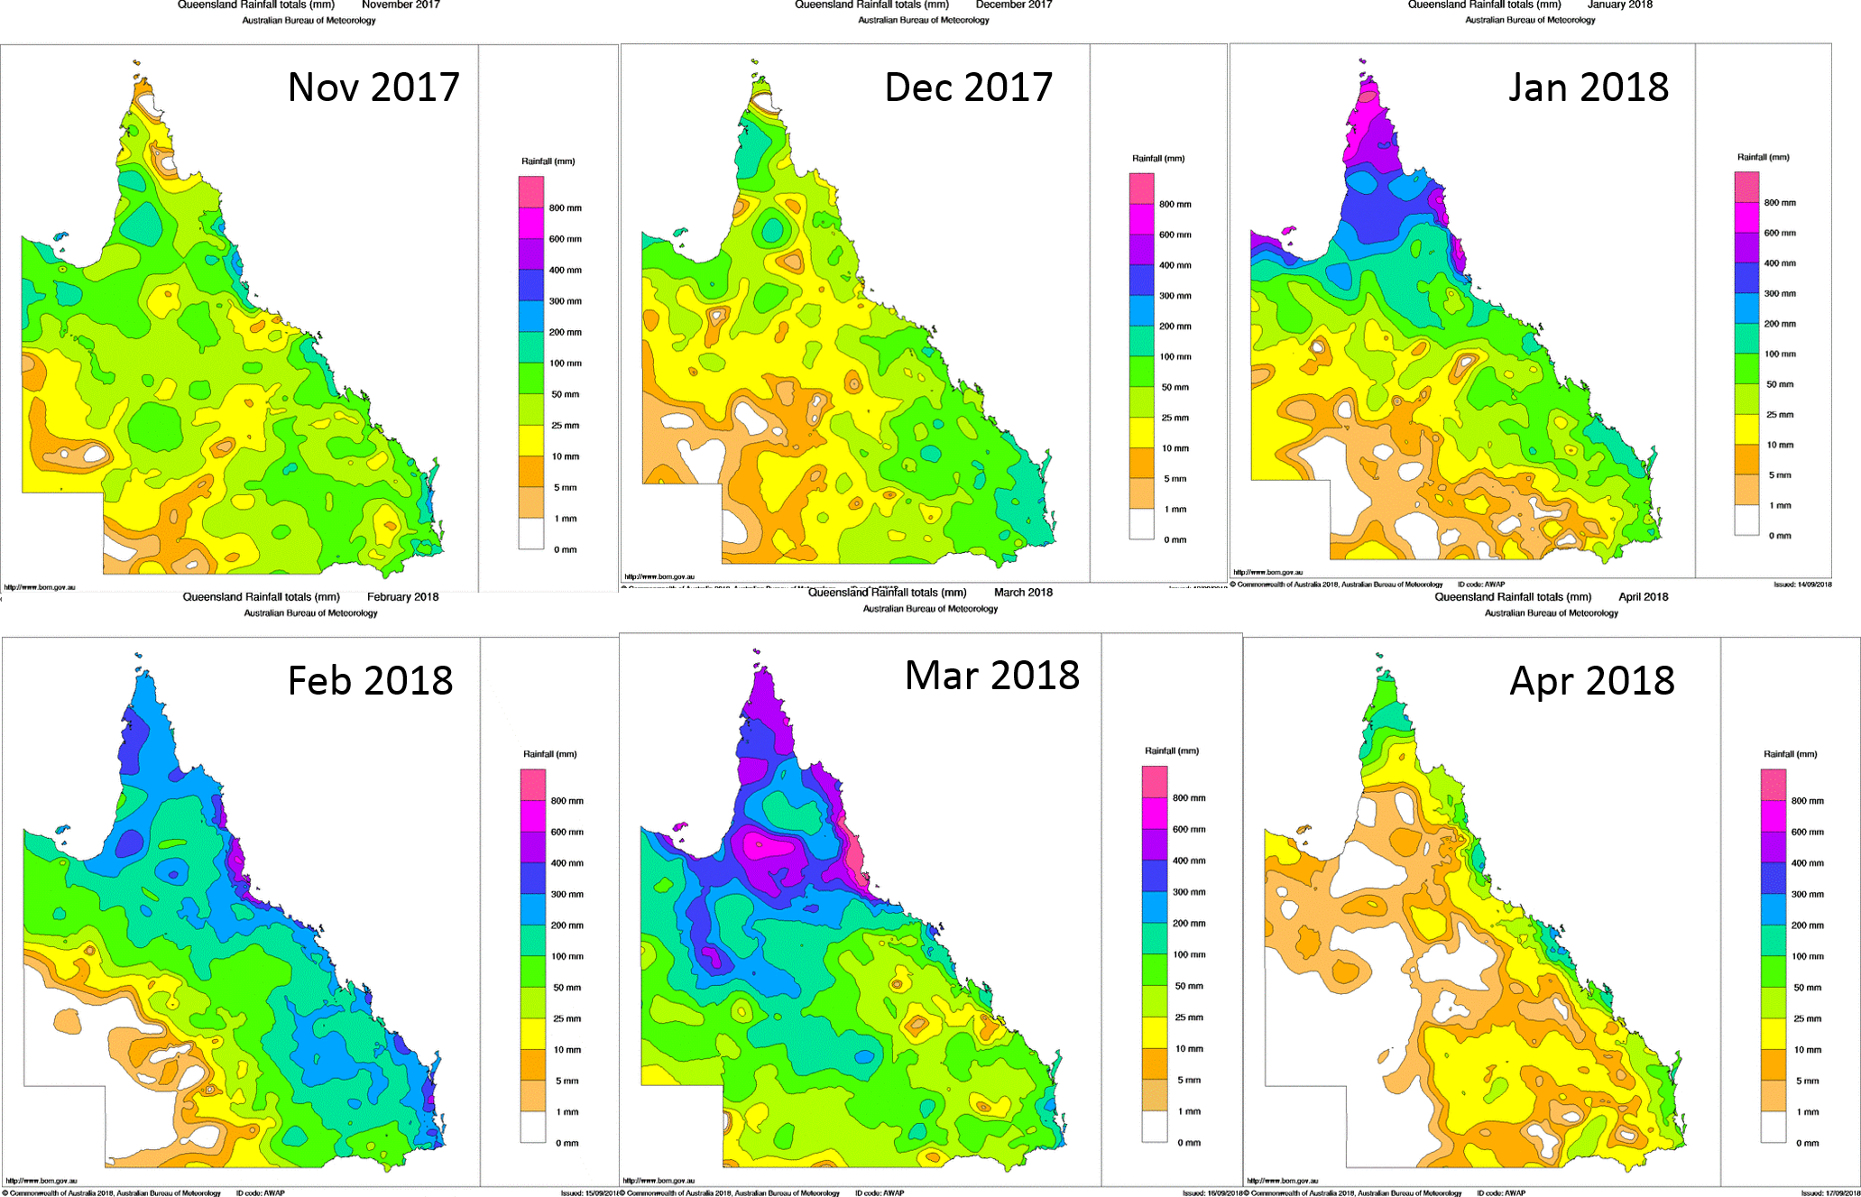
Figure E-1: Total monthly rainfall for the wet 2017–18 season across Queensland
(Bureau of Meteorology, 2018)

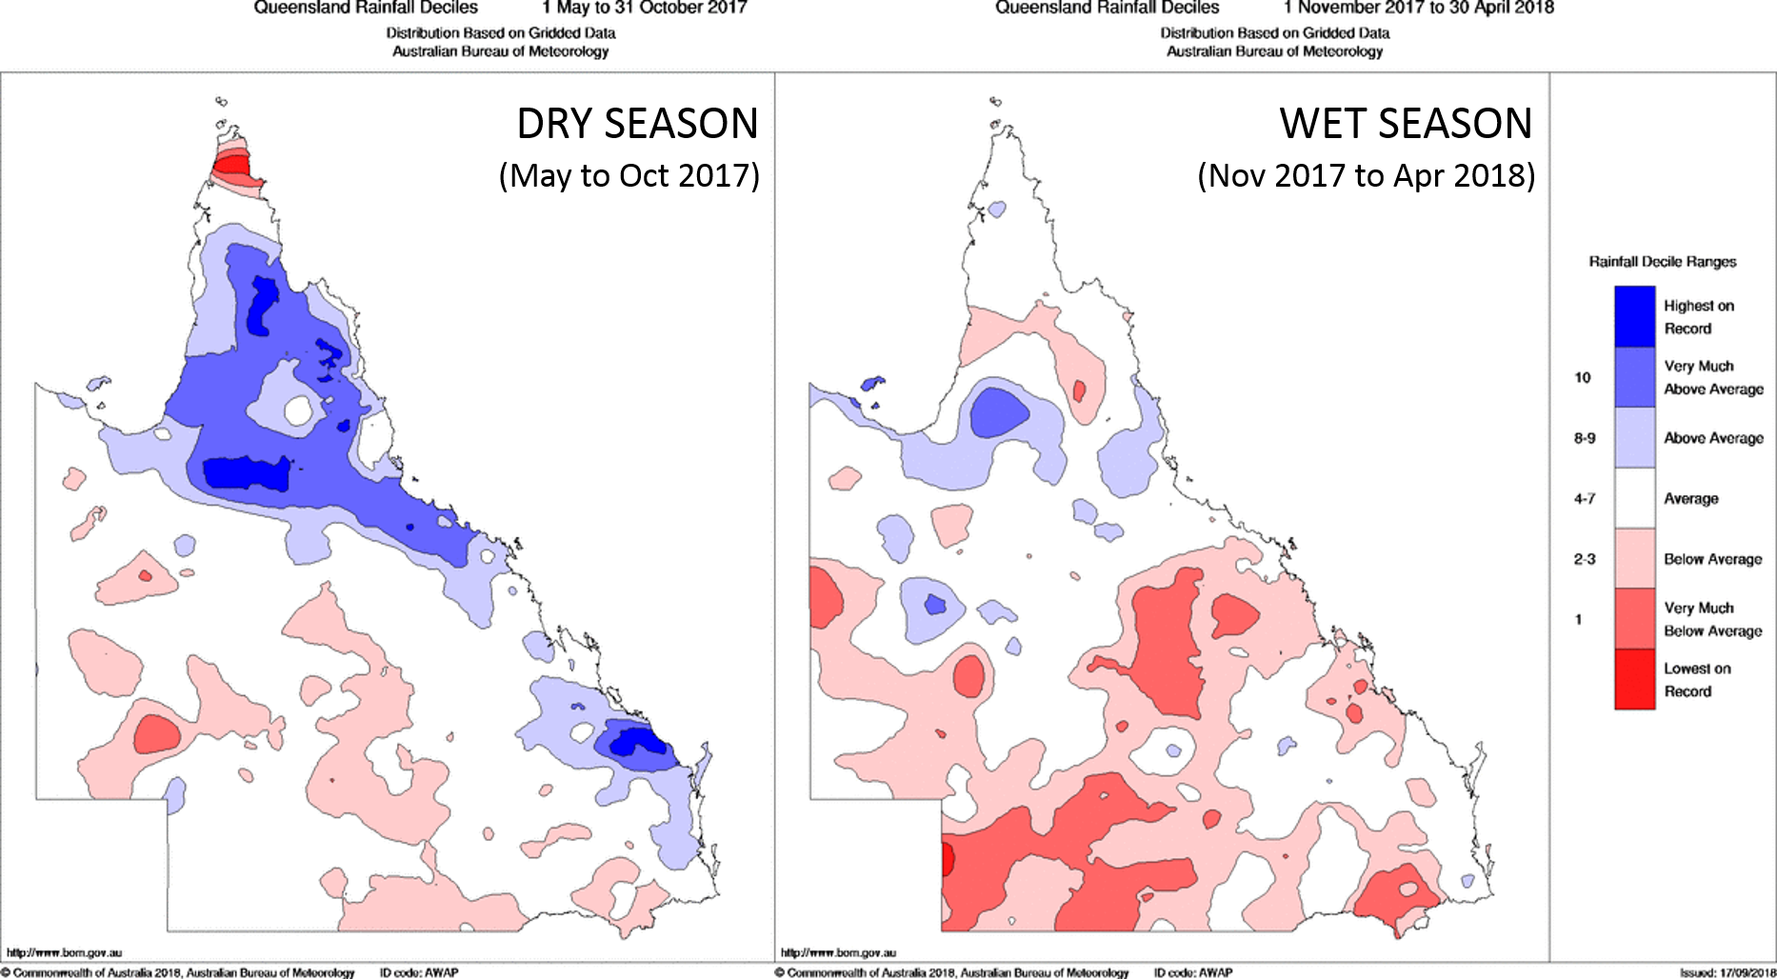

Figure E-2: Rainfall decile ranges
(comparison of current period with long term average) for the dry season between May 2017- October 2018 (left) and wet season between November 2017 – 30 April 2018 (right). Figure sourced from (Bureau of Meteorology, 2018)

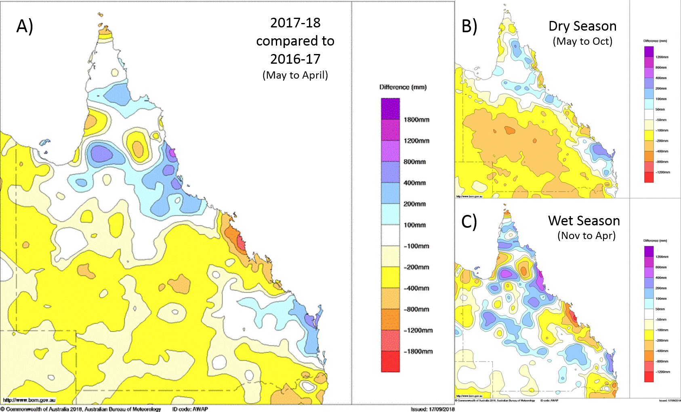
Figure E-3: A) Inter-annual rainfall difference between the previous monitoring year (2016-17) and the current monitoring year (2017-18).
B) and C) show comparison between previous year and current year for dry and wet season, respectively. A negative value indicates that rainfall was lower this year compared to the previous year. Figure sourced from (Bureau of Meteorology, 2018)

Fixed monitoring sites – sampler returns and individual site results
Table F-1: Passive sampling return record for the 2017–18 monitoring year.
ED sampler numbers are given with PDMS (non-polar) samplers in brackets after.
NRM Region | Site Name | No of samplers sent | No of samplers returned and analysed | Comments
Wet Tropics | Low Isles | 8 | 7 | January kit and mooring lost. Delayed and long February deployment meant that April sampler kit not required to be sent.
Wet Tropics | Normanby Island | 7 | 6 | Due to change of ownership of company, sampling in 2017/18 did not begin until September. Some minor over-deployments occurred resulting in April kit being deployed in May (2018/19 sampling year).
Wet Tropics | Dunk Island | 9 | 8 | May/June samplers at both Dunk and High Islands lost with moorings. Re-established in July.
Wet Tropics | High Island | 9 | 8 | May/June samplers at both Dunk and High Islands lost with moorings. Re-established in July.
Wet Tropics | Lucinda Jetty (CSIRO) | 8 | 8 | Long December deployment due to shutdown of site included all of January. Double ED setup used (as used during bi-monthly dry season deployments). January kit not needed.
Burdekin | Barratta Creek | 8 | 6 | Over-deployments between November and February resulted in February sampler not being required, and March and April samplers being deployed from May 2018 (2018/19 sampling year). Minor losses of individual PDMS cage (January) and 1 ED (Sept/Oct).
Mackay Whitsunday | Repulse Bay | 7 | 3 | Sept/Oct and February kits not sent due to sampler/mooring losses of May/June and January. March and April samplers removed from mooring and later recovered out of water, so samplers not analysed. 1 ED lost in December.
Mackay Whitsunday | Round Top Island | 8 | 6 | Lost samplers/mooring in May/June and April. Sept/Oct samplers not sent due to late deployment of July/Aug due to earlier lost mooring. 1 ED lost from July/August samplers.
Mackay Whitsunday | Sarina Inlet | 8 | 6 | PDMS cages lost in Nov, Dec and January. 1 ED not deployed in January. Long deployments due to illness of volunteer led to Feb sampler not being sent and March and April kits being returned unused.
Mackay Whitsunday | Sandy Creek | 9 | 2 | Only May/June and Sept/Oct samplers returned successfully. All others lost/stolen.
Fitzroy | North Keppel Island | 7 | 7 | Delayed and long deployments led to Sept/Oct and February samplers not being sent. Some kits deployed out of sequence without causing any problems, due to clear deployment info.
TOTAL  2017-18 | 11 sites | 89 (27) | 67 (13) | 2 PDMS cages returned but not analysed (Repulse Bay) not included in total PDMS returned/analysed (in brackets).
TOTAL  2016-17 | 11 sites | 84 (24) | 63 (14)
TOTAL  2015-16 | 11 sites | 93 (21) | 68 (13)

Table F-2: Low Isles, Wet Tropics region – Time integrated estimated concentrations in water ( ng L⁻¹)

Table F-3: High Island, Wet Tropics region – Time integrated estimated concentrations in water ( ng L⁻¹)

Table F-4: Dunk Island, Wet Tropics region – Time integrated estimated concentrations in water ( ng L⁻¹)

Table F-5: Normanby Island, Wet Tropics region – Time integrated estimated concentrations in water ( ng L⁻¹)

Table F-6: Lucinda, Wet Tropics region – Time integrated estimated concentrations in water ( ng L⁻¹)

Table F-7: Barratta Creek, Burdekin Region – Time integrated estimated concentrations in water ( ng L⁻¹)

Table F-8: Repulse Bay, Mackay Whitsunday region – Time integrated estimated concentrations in water ( ng L⁻¹)

Table F-9: Round Top Island, Mackay Whitsunday region – Time integrated estimated concentrations in water ( ng L⁻¹)

Table F-10: Sarina Inlet, Mackay Whitsunday region – Time integrated estimated concentrations in water ( ng L⁻¹)

Table F-11: Sandy Creek, Mackay Whitsunday region – Time integrated estimated concentrations in water ( ng L⁻¹)
Table F-12: North Keppel Island, Fitzroy Region – Time integrated estimated concentrations in water ( ng L⁻¹)

Terrestrial run-off assessment results
Table G-1: Concentrations in grab water samples ( ng L⁻¹) measured at various locations offshore and in river mouths (along transects) during the 2017–18 monitoring year

Table G-1 (cont.): Concentrations in grab water samples (ng L⁻¹) measured at various locations offshore and in river mouths (along transects) during the 2017–18 monitoring year

Historical concentration profiles at fixed monitoring sites
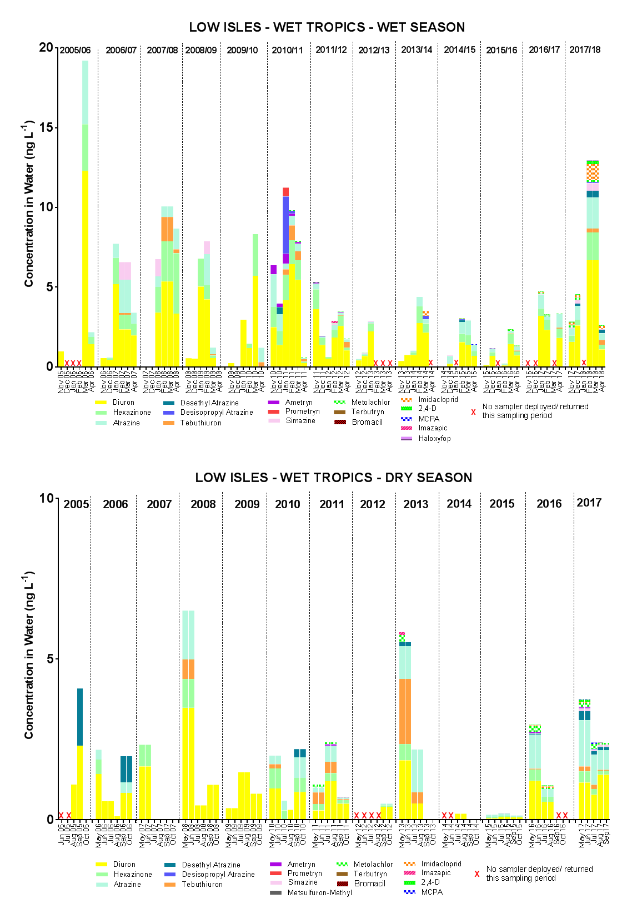
Figure H-1: Temporal concentration profiles of individual herbicides at Low Isles in the Wet Tropics region

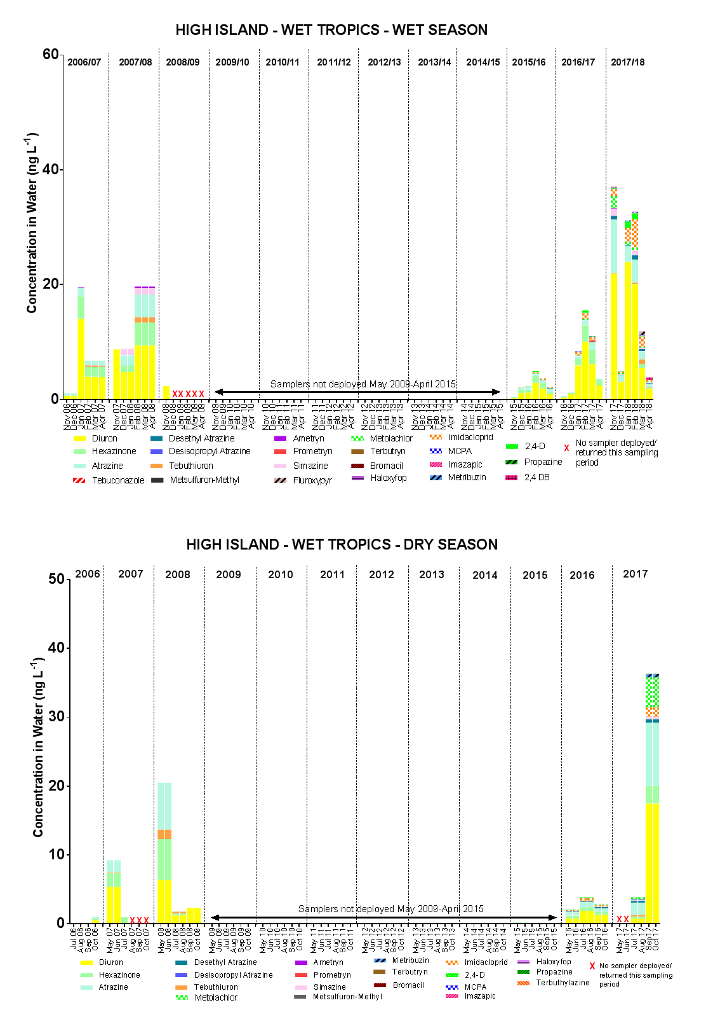
Figure H-2: Temporal concentration profiles of individual herbicides at High Island in the Wet Tropics region

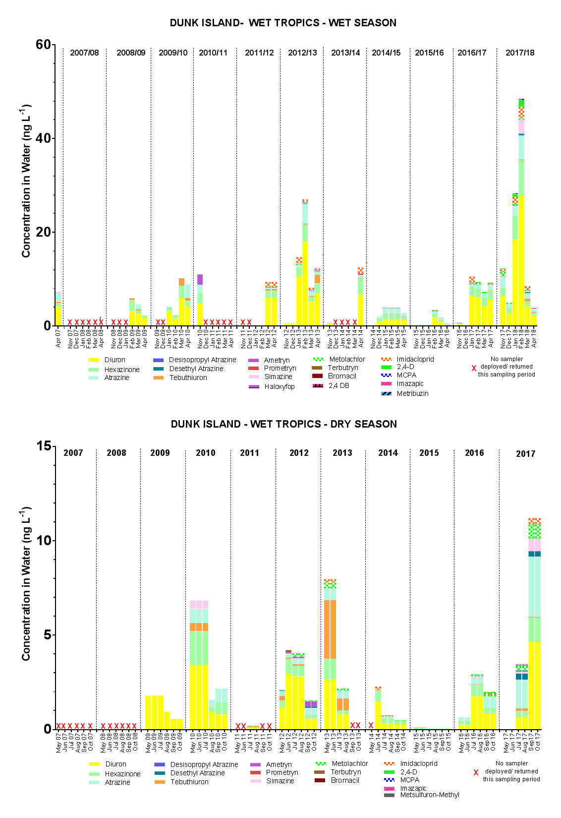
Figure H-3: Temporal concentration profiles of individual herbicides at Dunk Island in the Wet Tropics region
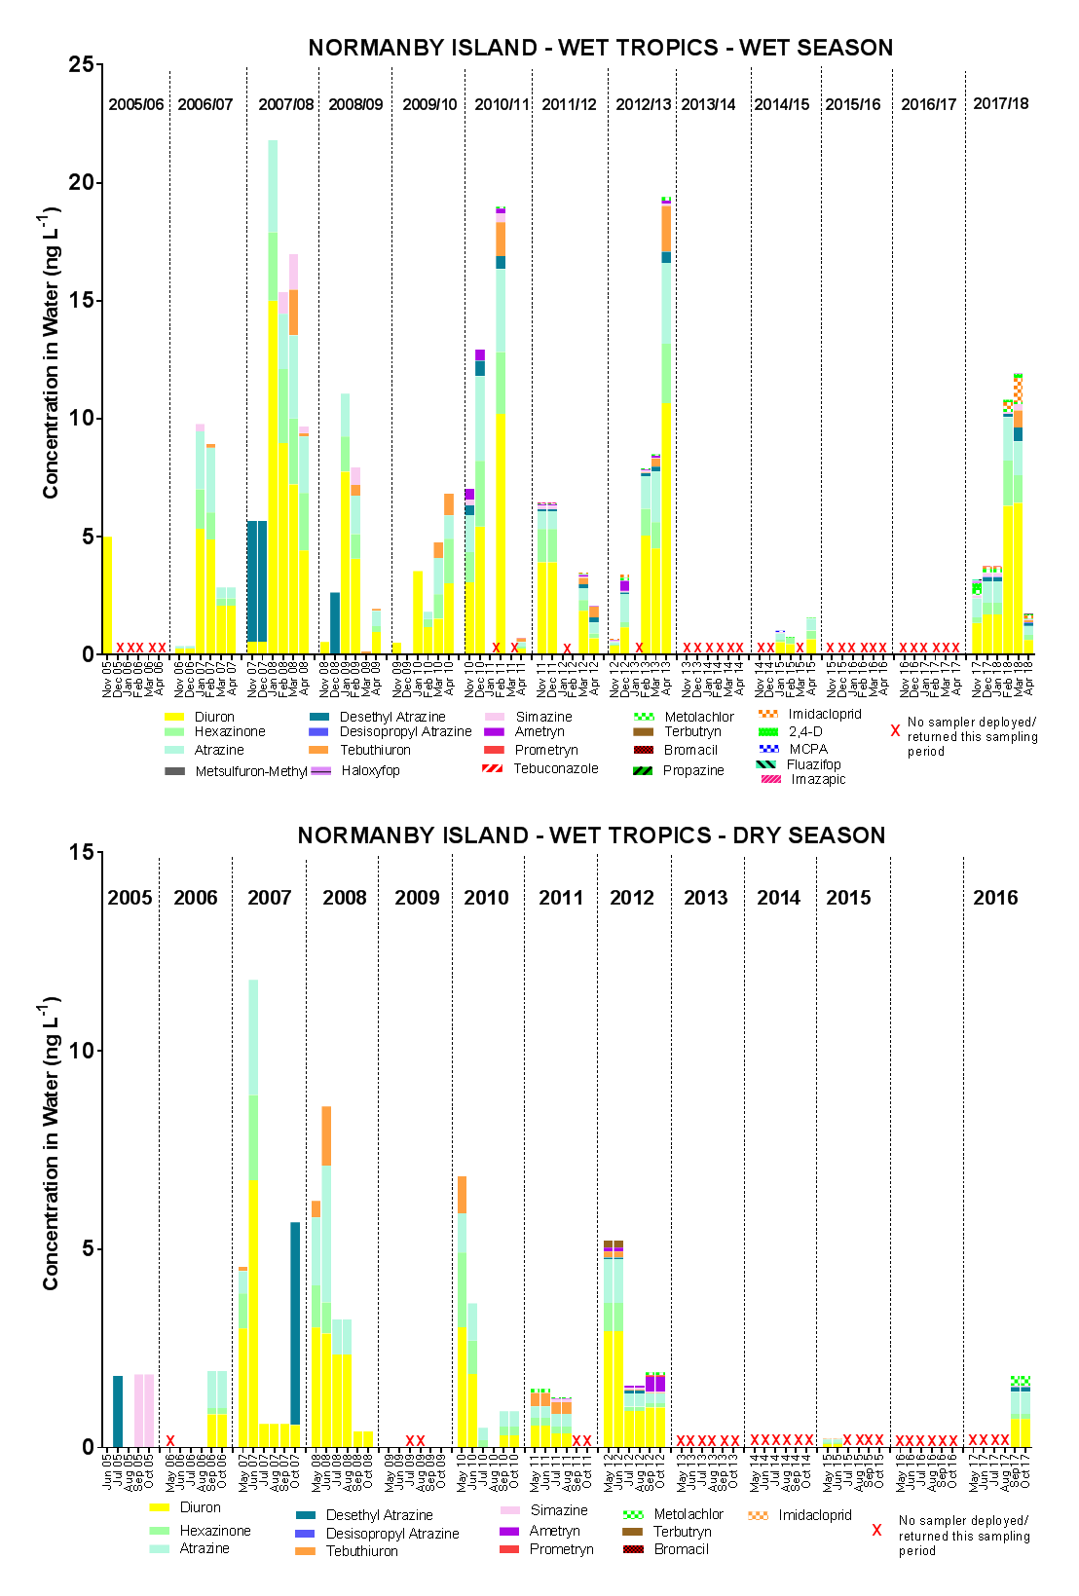
Figure H-4: Temporal concentration profiles of individual herbicides at Normanby Island in the Wet Tropics region
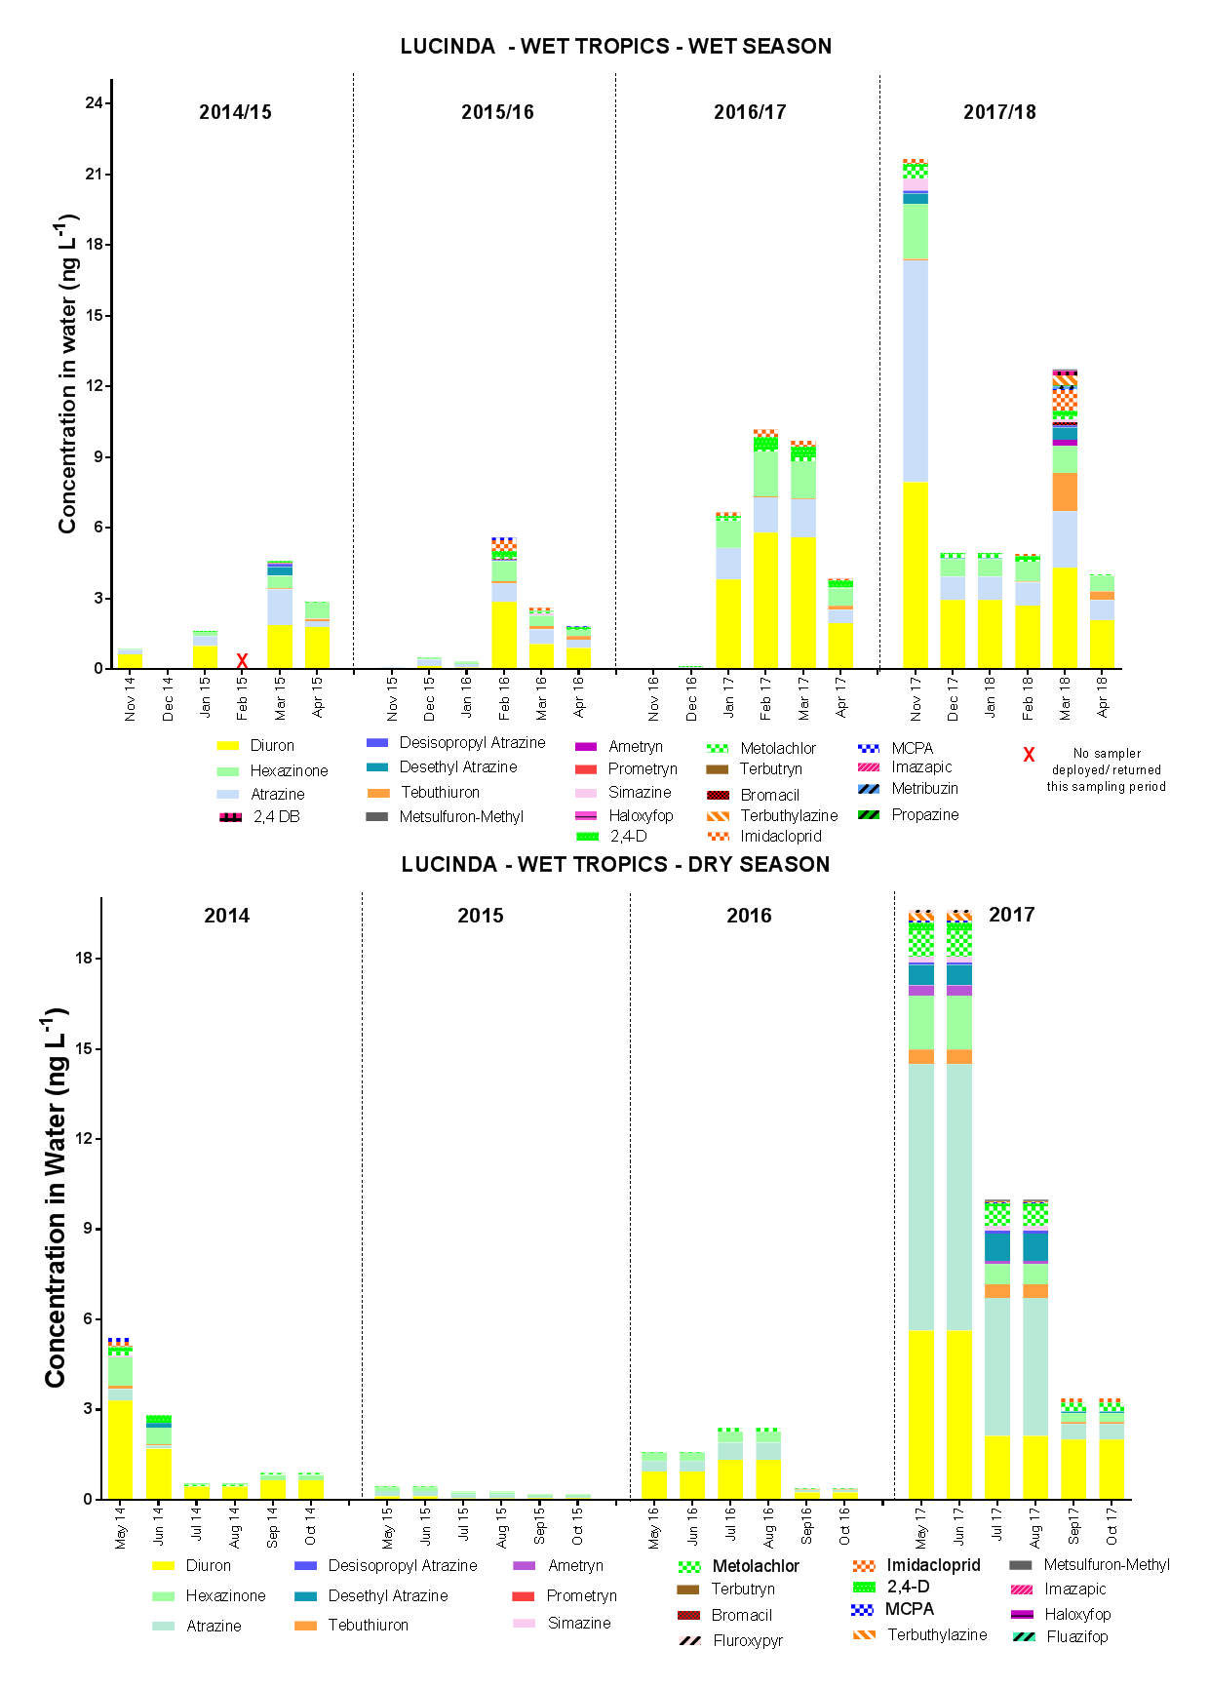
Figure H-5: Temporal concentration profiles of individual herbicides at Lucinda in the Wet Tropics region

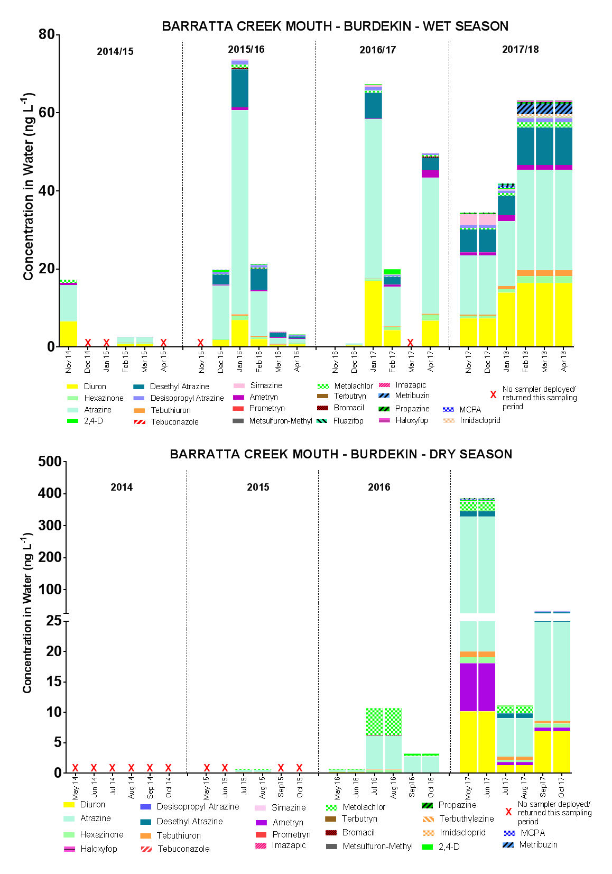
Figure H-6: Temporal concentration profiles of individual herbicides at Barratta Creek mouth in the Burdekin region
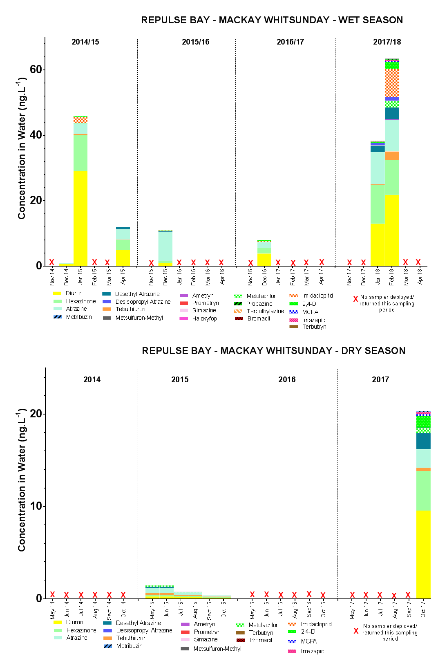
Figure H-7: Temporal concentration profiles of individual herbicides at Repulse Bay in the Mackay Whitsunday region
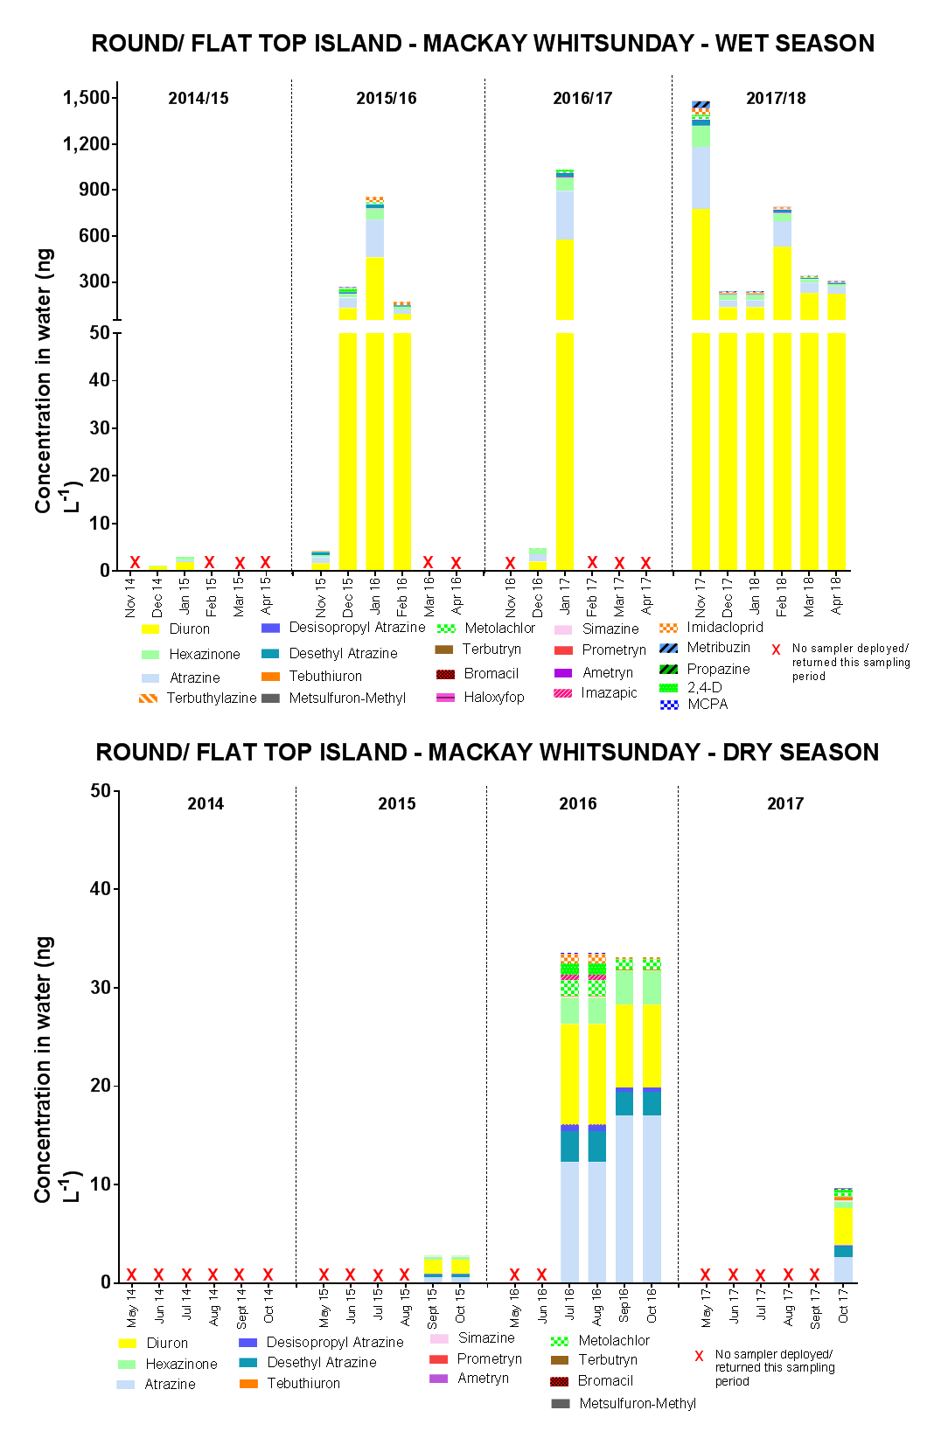
Figure H-8: Temporal concentration profiles of individual herbicides at Round Top Island in the Mackay Whitsunday region
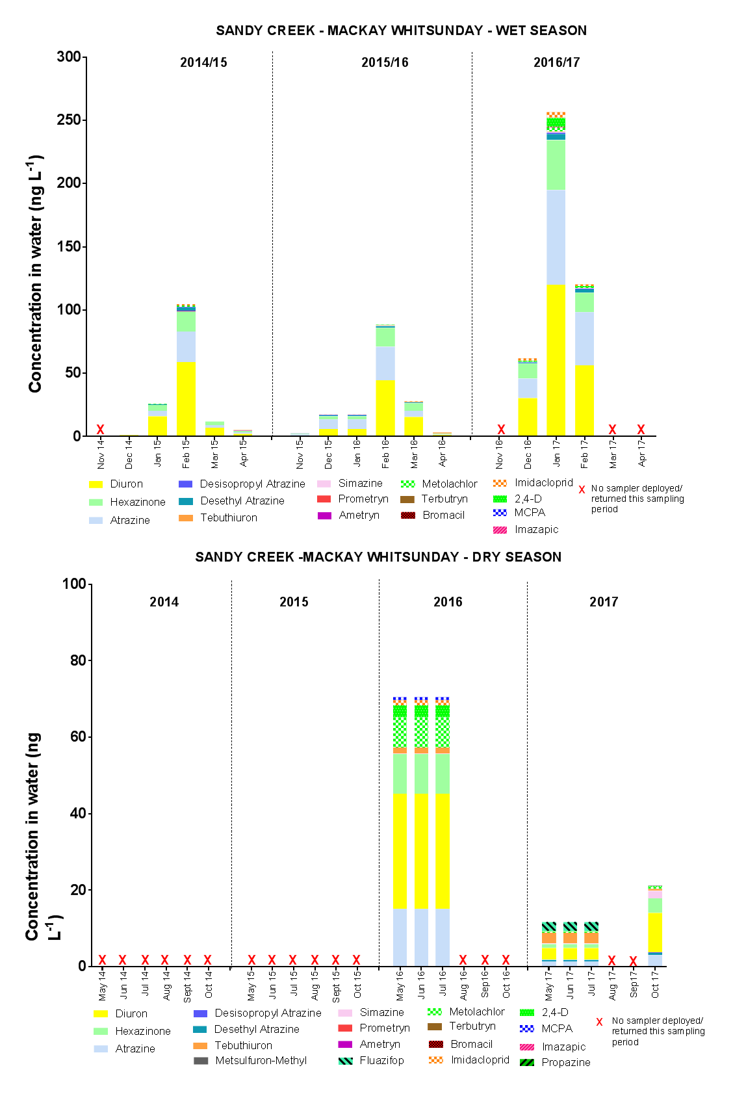
Figure H-9: Temporal concentration profiles of individual herbicides at Sandy Creek in the Mackay Whitsunday region
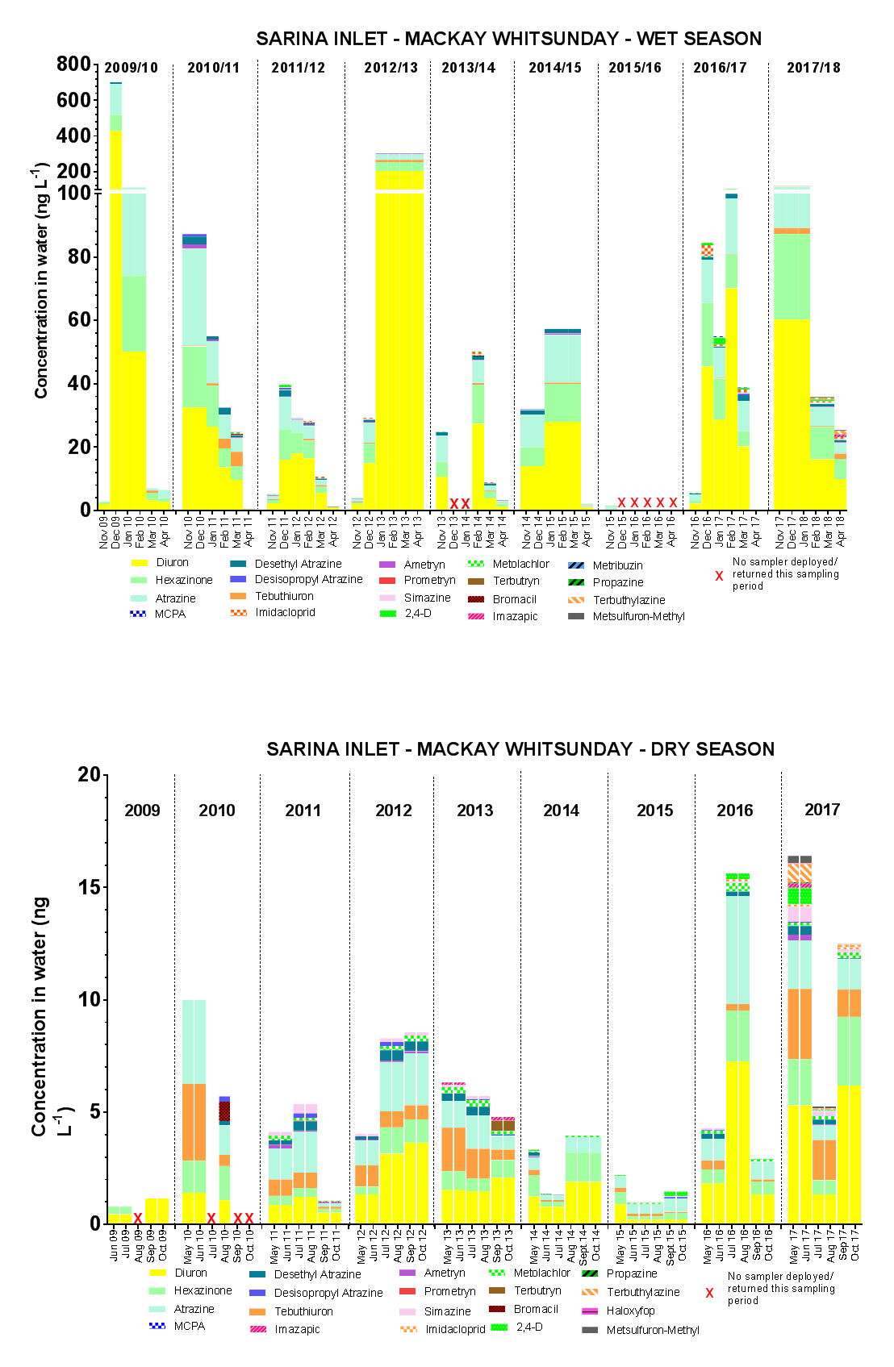
Figure H-10: Temporal concentration profiles of individual herbicides at Sarina Inlet in the Mackay Whitsunday region
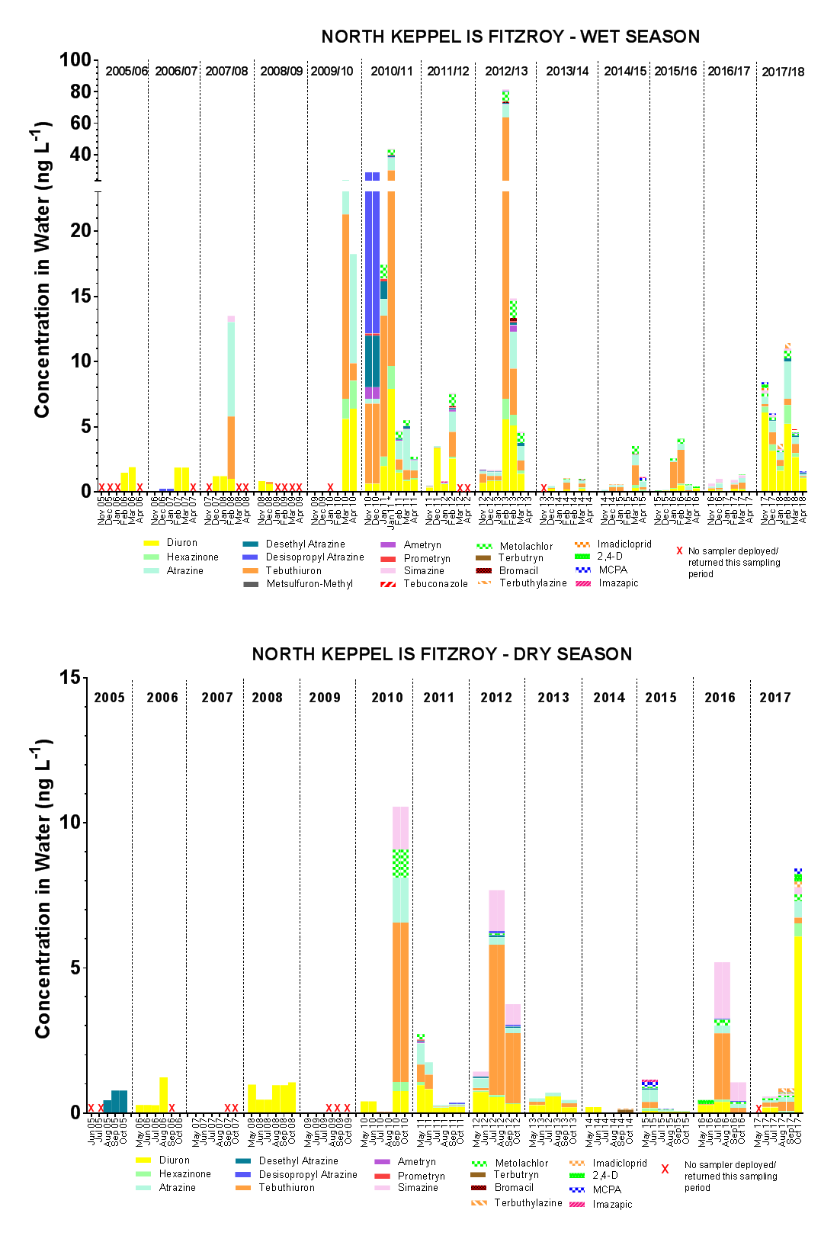
Figure H-11: Temporal concentration profiles of individual herbicides at North Keppel Island in the Fitzroy region

The average is calculated from a multiple imputation approach that uses statistical distributions to infill missing days of data.

