

Pesticide monitoring in inshore waters of the Great Barrier Reef using both time-integrated and event monitoring techniques
(2010 - 2011)
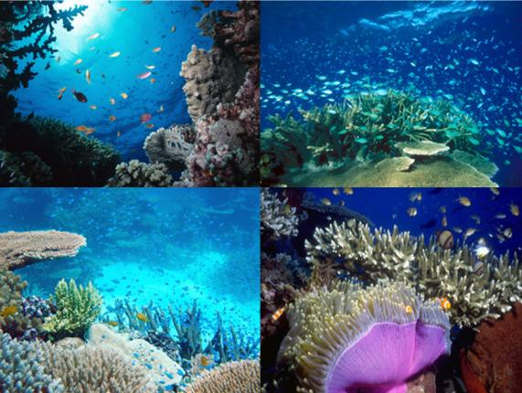

Images (Left to Right) – Top: B Cropp, D Wachenfeld; Bottom: A Chinn, E Matson © Commonwealth of Australia, GBRMPA

February, 2012
Prepared for – The Program Manager, The Great Barrier Reef Marine Park Authority
Project Teams –

- Inshore Marine Water Quality Monitoring

Karen Kennedy¹, Christie Bentley¹, Chris Paxman¹, Kristie Lee Chue¹, Jochen Mueller¹

- Assessment of Terrestrial Run-off Entering the Reef

Karen Kennedy¹, Christie Bentley¹, Chris Paxman¹, Kristie Lee Chue¹, Jochen Mueller¹, Jorge Alvarez Romero², Amelia Wengner², Michelle Devlin²

¹The University of Queensland, The National Research Centre for Environmental Toxicology (Entox)
²Australian Centre for Tropical and Freshwater Research (ACTFR), Catchment to Reef Research Group, James Cook University

Report should be cited as –

Kennedy, K., Devlin, M., Bentley, C., Paxman, C., Chue, K.L., Mueller, J. (2011) Pesticide monitoring in inshore waters of the Great Barrier Reef using both time-integrated and event monitoring techniques (2010 - 2011). The University of Queensland, The National Research Centre for Environmental Toxicology (Entox).

Direct Enquiries to –

Professor Jochen Mueller
Phone: +61 7 3000 9197
Fax: +61 7 3274 9003
Email: j.mueller@uq.edu.au
Web: www.entox.uq.edu.au

The University of Queensland
The National Research Centre for Environmental Toxicology (Entox)
39 Kessels Rd
Coopers Plains QLD 4108

Acknowledgements
Other contributors to this work include-
- Carol Honchin of the GBRMPA for her work on the PSII-HEq Index in 2010.
- Susanne Vardy and staff of the Paddock to Reef Team at the Department of Environment and Resource Management for provision of concentration data for the Tully River.
- Britta Schaffelke and staff of the Australian Institute of Marine Sciences for the assessment of long term discharge data.
- Steve Carter and Vince Alberts of Queensland Health Forensic and Scientific Services for the analysis and reporting of pesticide data for the project.
- Alison Jones of Central Queensland University and Peter Williams of Keppel Dive, Great Keppel Island for deploying additional passive samplers at monitoring sites in the Fitzroy Region.
- Adam Donovan and Alex Shanahan of the School of Geography, Planning and Environmental Management, University of Queensland for mapping project support (mapping).
- The early work of David Haynes, Joelle Prange and Deb Bass of the GBRMPA in establishing and managing this monitoring program.

These routine monitoring activities have been undertaken in some form since 2005. Entox therefore acknowledges the contribution of past staff to the continuous data record compiled –
Andrew Dunn, Dr Michael Bartkow, Dr Tatiana Komarova, Dr Melanie Shaw, Anita Kapernick, Jake O’Brien

The assistance of the numerous volunteers who have deployed passive samplers in what has been an extremely challenging year for many people in North and Central Queensland is gratefully acknowledged –

Whitsunday Moorings | Fitzroy Island Resort | Great Barrier Reef Marine Park Authority
Taylor’s Beach Caravan Park | Queensland Parks and Wildlife Service | Hamilton Island Enterprises
Sarina Bait Supplies | Frankland Island Cruise & Dive | North Keppel Island Environmental Education Centre
Jace Services | Voyages Dunk Island Resort | Department of Environment and Resource Management
Cassowary Coast Regional Council | Orpheus Island Research Station | Australian Institute of Marine Science
Low Isles Caretakers | Nautilus Aviation | Australian Centre for Tropical and Freshwater Research
Quicksilver Connections | Mike Ball Dive Expeditions
Raging Thunder | Mission Beach/ Dunk Island Water Taxi

In particular Entox thanks the GBRMPA Program Manager Katherine Martin and the GBRMPA Regional coordinators for the role they have played in managing and facilitating this monitoring program: -
John Rainbird, Cath McLean, Phil Laycock, Warwick Sheldon, Carolyn Thompson

About the Reef Rescue Marine Monitoring Program –

The Reef Rescue Marine Monitoring Program is a water quality and ecosystem health long-term monitoring program in the Great Barrier Reef lagoon to track the effectiveness of the Reef Rescue Plan. This project is supported by the Great Barrier Reef Marine Park Authority, through funding from the Australian Government’s Caring for Our Country.

Table of Contents
1 INTRODUCTION 6
2 METHODOLOGY 6
2.1 Target Chemicals and Limits of Reporting 6
2.2 Sampling Sites 8
2.3 Routine Sampling Periods 8
2.4 Routine Sampling for the Assessment of Water Quality by Region in Dry and Wet Periods 10
2.5 Sampling for the Assessment of Terrestrial Run-Off by Region in the Wet Season 10
2.5.1 Flood plume sampling 10
2.5.2 Tully Transect Case Study 12
2.6 Water Quality Guideline Trigger Values 14
2.7 Calculation of PSII-Herbicide Equivalent Concentrations (PSII-HEq) 15
2.8 PS-II Herbicide Index 16
2.9 Outline of Data Presentation 17
3 GBR-WIDE SUMMARY RESULTS 2010-2011 18
3.1 Routine Monitoring Results – Water Quality 18
3.2 Tully Transect Case Study 21
3.3 Flood Plume Sampling 25
3.3.1 Wet Tropics Transect 25
3.3.2 Burdekin Transect 25
3.3.3 Mackay Whitsunday to the Percys, Fitzroy 25
3.3.4 Fitzroy - Keppels (Shoalwater Bay to Gladstone) 25
4 REGIONAL SUMMARIES 2010-2011 28
4.1 Wet Tropics Region 28
4.2 Burdekin Regional Summary 31
4.3 Mackay Whitsunday Regional Summary 34
4.4 Fitzroy Regional Summary 37
5 DISCUSSION 40
6 SUMMARY 44
7 APPENDIX A: Complete analyte list for LCMS and GCMS analysis 46
8 APPENDIX B – Supporing literature for the development of the PSII-HEq Index 49
9 APPENDIX C – Routine monitoring – Individual site results 54
10 APPENDIX D – Tully transect case study – Site results 66
11 APPENDIX E – Tully transect case study – Change in PSII-HEq with distance & flow across the hydrograph 71
12 APPENDIX F – Terrestrial run-off - Results 75
13 APPENDIX G – Mean flow rates in major rivers when grab sampling occurred 77
14 APPENDIX H – Historical concentration profiles at routine monitoring sites 79
15 REFERENCES 82
List of Figures
Figure 1 The temporal trend in PSII-HEq Max determined using time integrating sampling at routine monitoring sites in inshore waters of the GBR 1
Figure 2 Locations of current inshore GBR routine monitoring sites where time-integrated sampling of pesticides occurred in 2010-2011 9
Figure 3 Tully Transect Case Study showing the location of the pesticide sampling sites Tully Mouth, Bedarra and Sisters Island 12
Figure 5 PSII-HEq Max at each site in 2010-2011 along with the two previous monitoring years 20
Figure 6 Temporal variation in the risk of exposure to PSII herbicides expressed as PSII-HEq Index Categories with distance from the source in the Tully River up the coast to Sisters Island in the Wet Tropics 24
Figure 7 Terrestrial run-off transects in the Wet Tropics, Burdekin, Mackay Whitsunday and Fitzroy regions showing both total concentration (ng.L⁻¹) and PSII-HEq Index category for specific samples - Concentrations of individual pesticides (metolachlor and tebuthiuron) which met or exceeded any Water Quality Guideline are indicated 27
Figure 8 Temporal concentration profile for Green Island in the Wet Tropics 28
Figure 9 Seasonal average PSII-HEq for Wet Tropics sites since routine monitoring commenced 29
Figure 10 Temporal concentration profile for Magnetic Island in the Burdekin region 31
Figure 11 Seasonal average PSII-HEq for Burdekin sites since routine monitoring commenced 32
Figure 12 Temporal concentration profile for Sarina Inlet in the Mackay Whitsunday region 34
Figure 13 Seasonal average PSII-HEq for Mackay Whitsunday sites since routine monitoring commenced 36
Figure 14 Temporal concentration profile for North Keppel Island in the Fitzroy Region. 37
Figure 15 Seasonal average PSII-HEq for North Keppel Island in the Fitzroy region since routine monitoring commenced 38
Figure 16 Temporal trends in both flow rate in rivers in adjacent catchments and PSII-HEq at inshore GBR sites 41
Figure 17 PSII-HEq Max (ng.L⁻¹) with the PSII-HEq Index of each value indicated for each routine site 2010-2011 42
Figure 18 Part 1 – PSII-HEq at each site determined using passive sampling at different stages of the hydrograph with the half distance (km) for decline in concentration indicated when possible. 72
Figure 19 Part 2 – PSII-HEq at each site determined using passive sampling at different stages of the hydrograph with the half distance (km) for decline in concentration indicated when possible. 73
Figure 20 Flow rates in Wet Tropics region rivers and the timing of grab samples to assess terrestrial run-off 77
Figure 21 Flow rates in the Burdekin River and the timing of grab samples to assess terrestrial run-off 77
Figure 22 Flow rates in the Pioneer River and Sandy Creek (top) and in the Fitzroy River (bottom) and the timing of grab samples to assess terrestrial run-off in the Mackay-Fitzroy transect 78
Figure 23 Flow rates in the Fitzroy River and the timing of grab samples to assess terrestrial run-off in the Fitzroy region. 78
Figure 24 Temporal concentration profiles of individual herbicides at routine monitoring sites in the Wet Tropics regions 79
Figure 25 Temporal concentration profiles of individual herbicides at routine monitoring sites in the Burdekin region. 80
Figure 26 Temporal concentration profiles of individual herbicides at routine monitoring sites in the Mackay Whitsunday region. 81

List of Tables
Table 1 An overview of key results for pesticide monitoring on the GBR in 2010-2011 5
Table 2. Pesticides specified under the MMP for analysis with different sampling techniques together with the limits of reporting 7
Table 3 The types of passive samplers deployed at each sampling site in either dry or wet sampling periods in 2009-2010 10
Table 4 The number and timing of grab samples taken to assess terrestrial run-off during the 2010-2011 wet season 11
Table 5 Tully Transect Case Study 12
Table 6. Water quality guideline trigger values available for specific pesticides 14
Table 7. Relative potency factors (REP) for PSII herbicides and selected transformation products 15
Table 8 PSII-Herbicide Equivalent Index developed as a indicator for reporting of PSII herbicides across the Reef Rescue Marine Monitoring Program 16
Table 9 The range in time-integrated concentrations of pesticides in water (ng.L⁻¹) measured using EDs at routine monitoring sites in 2010-2011 19
Table 10 The range in time-integrated and “snap-shot” concentrations in water with distance from the Tully River at Tully Transect sites 23
Table 11 Summary statistics for the concentrations (ng.L⁻¹) of individual PSII herbicides and PSII-HEq in 2010-2011 in comparison to the baseline reporting year in the Wet Tropics. 29
Table 13 Equilibrium concentrations of pesticides (ng.L⁻¹) measured using PDMS samplers in the Wet Tropics Region in 2010-2011 30
Table 14 Summary statistics for the concentrations (ng.L⁻¹) of individual PSII herbicides and PSII-HEq in 2010-2011 in comparison to the baseline reporting year in the Burdekin region. 32
Table 15 Equilibrium concentrations of pesticides (ng.L⁻¹) measured using PDMS samplers in the Burdekin region in 2010-2011 33
Table 16 Summary statistics for the concentrations (ng.L⁻¹) of individual PSII herbicides and PSII-HEq in 2010-2011 in comparison to the baseline reporting year in the Mackay Whitsunday region 35
Table 17 Equilibrium concentrations of pesticides (ng.L⁻¹) measured using PDMS samplers in the Mackay Whitsunday region in 2010-2011 36
Table 18 Summary statistics for the concentrations (ng.L⁻¹) of individual PSII herbicides and PSII-HEq in 2010-2011 in comparison to the baseline reporting year in the Mackay Whitsunday region 38
Table 19 A summary of terrestrial run-off monitoring results for the Fitzroy Region (ng.L⁻¹) 39
Table 20 LCMS Analyte List for Positive Mode 46
Table 21 GCMS analyte list for PDMS extracts with cells shaded grey to indicate chemicals which are not calibrated within the fraction collected during gel permeation (size exclusion) chromatography of extracts and cells shaded blue to indicated industrial chemicals/personal care products which may be detected but are not reported along with pesticides in the MMP results 47
Table 22 Scientific publications indicating the effect concentrations and the end-points for the reference PSII herbicide diuron used to define specific PSII-HEq Index categories as an indicator for reporting purposes 49
Table 23 Low Isles, Wet Tropics region – Concentration in water (ng.L⁻¹) 54
Table 24 Green Island, Wet Tropics region – Concentration in water (ng.L⁻¹) 55
Table 25 Fitzroy Island, Wet Tropics region – Concentration in water (ng.L⁻¹) 56
Table 26 Normanby Island, Wet Tropics region – Concentration in water (ng.L⁻¹) 57
Table 27 Dunk Island, Wet Tropics region – Concentrations in water (ng.L⁻¹) 58
Table 28 Orpheus Island, Burdekin region – Concentrations in water (ng.L⁻¹) 59
Table 29 Magnetic Island, Burdekin Region – Concentrations in water (ng.L⁻¹) 60
Table 30 Cape Cleveland, Burdekin Region – Concentrations in water (ng.L⁻¹) 61
Table 31 Pioneer Bay, Mackay Whitsunday – Concentrations in water (ng.L⁻¹) 62
Table 32 Outer Whitsunday , Mackay Whitsunday region – Concentrations in water (ng.L⁻¹) 63
Table 33 Sarina Inlet, Mackay Whitsunday region – Concentrations in water (ng.L⁻¹) 64
Table 34 North Keppel Island, Fitzroy Region – Concentrations in water (ng.L⁻¹) 65
Table 35 Tully Transect Case Study, Wet Tropics region – Tully River concentrations in water (ng.L⁻¹)ª 67
Table 36 Tully Transect Case Study, Wet Tropics region – Tully Mouth concentrations in water (ng.L⁻¹) 68
Table 37 Tully Transect Case Study, Wet Tropics region – Bedarra Island concentrations in water (ng.L⁻¹) 69
Table 38 Tully Transect Case Study, Wet Tropics region – Sisters Island concentrations in water (ng.L⁻¹) 70
Table 38 Concentrations in water (ng.L⁻¹) measured during terrestrial run-off events during the wet season using 1 L grab water samples. 75
Table 39 Passive sampling at other sites in the Fitzroy region during a period with a major flood event in the Fitzroy River. 76
Acronyms

ANZECC | Australian and New Zealand Environment and Conservation Council
APVMA | Australian Pesticides and Veterinary Medicines Authority
ARMCANZ | Agriculture and Resource Management Council of Australia and New Zealand
C_{W} | Concentration in water
DEET  EC₂₀  EC₅₀ | N,N-Diethyl-meta-toluamide  20% maximal effective concentration is observed  50% maximal effective concentration is observed
ED | Empore DiskTM passive sampler
Entox | National Research Centre for Environmental Toxicology
GBR | Great Barrier Reef
GBRMP | Great Barrier Reef Marine Park
GBRMPA | Great Barrier Reef Marine Park Authority
GC-MS | Gas Chromatography-Mass Spectrometry
GPC | Gel Permeation Chromatography
IWL | Interim working level
K_{OW} | Octanol-water partition coefficient
LC-MS | Liquid Chromatography-Mass Spectrometry
LOD | Limit of Detection
LOR | Limit Of Reporting
MMP | Reef Rescue Marine Monitoring Program
NATA | National Association of Testing Authorities
PDMS | Polydimethylsiloxane passive sampler
PSII-HEq | Photosystem II -Herbicide Equivalent Concentration
PTFE | Polytetrafluoroethylene : Common brand name - Teflon
QHFSS  RWQPP | Queensland Health Forensic & Scientific Services  Reef Water Quality Protection Plan
SDB-RPS | Poly(styrenedivinylbenzene) copolymer – reverse phase sulfonated
SPMD | Semi-permeable Membrane Devices

EXECUTIVE SUMMARY
The Reef Rescue Marine Monitoring Program (MMP) was designed to assess any improvement in water quality in the Great Barrier Reef (GBR) and the status of key ecosystems under the Reef Water Quality Protection Plan (RWQPP) 2003 which was updated in 2009. In 2010-2011 Entox conducted monitoring activities within two components of the MMP; Inshore Marine Water Quality Monitoring and the Assessment of Terrestrial Run-off Entering the Reef. The principal objectives of the monitoring conducted under each of these components were to assess temporal and spatial trends in water quality in inshore GBR waters and to quantify exposure to pollutants delivered to the reef lagoon during flood events. The water quality parameter assessed within this monitoring was exposure to pesticides. Trends in pesticide exposure were assessed using long-term routine monitoring at twelve sites across four Natural Resource Management regions (Wet Tropics, Burdekin, Mackay Whitsunday and Fitzroy) using passive sampling techniques. A case study was also conducted at fixed sites in the Wet Tropics region to characterise both spatial and temporal trends within regions more completely, using a combination of grab and passive sampling. Terrestrial run-off entering the reef lagoon was assessed using 1 L grab sampling during flood plumes in these regions.

Photosystem II (PSII) herbicides are frequent contaminants in inshore waters of the GBR. The concentration of these herbicides is expressed as a PSII herbicide equivalent concentration (PSII-HEq) based on the reference PSII herbicide diuron. A PSII-HEq Index was developed as an indicator of the risk of exposure to PSII herbicides. This index has Categories which range from 1 (> 900 ng.L⁻¹) to 5 (≤10 ng.L⁻¹), with 1 being the highest concentration category. PSII-HEq within Category 1 are at a higher concentration than the 99% species protection trigger value derived for the reference PSII herbicide diuron in the Water Quality Guidelines for the Great Barrier Reef Marine Park (GBRMPA 2010), which does not currently include sub-lethal effects data such as photosynthetic inhibition. Conversely, PSII-HEq values within Category 5 are below any published scientific results of effects on plants or animals based on toxicity including a reduction in photosynthesis. The reporting parameters for PSII herbicides in the GBR are the maximum PSII-HEq concentration (PSII-HEq Max) within each monitoring year and the average PSII-HEq during the wet season (PSII-HEq Wet Avg) at each site.

The temporal profile for the PSII-HEq Max since monitoring commenced at each of the routine monitoring sites is provided in Figure 1. These indicate that the PSII herbicide diuron continues to be the dominant contributor to PSII-HEq at all sites due to both its relative abundance and potency as a PSII inhibitor. Significantly, the Australian Pesticides and Veterinary Medicine Authority (APVMA) have proposed the banning of this pesticide in 2011, due to unacceptable risk to aquatic ecosystems. If this ban proceeds for all uses other than in antifouling paints and algal control, this MMP will provide the baseline data to assess any decline in risk of exposure to PSII herbicides for inshore waters of the GBR as a direct result of regulatory activity.

2010-2011 was characterized by extreme weather events, with both cyclones impacting specific areas and rivers in all regions flooding from between 1.5 to more than 3 times higher than long-term median discharge. The relationship between increased discharge and increased risk of exposure to PSII herbicides has been demonstrated using data from this current MMP. The result of this increased risk of exposure is evident with each region having Category 4 maxima on the PSII-HEq Index in 2010-2011.
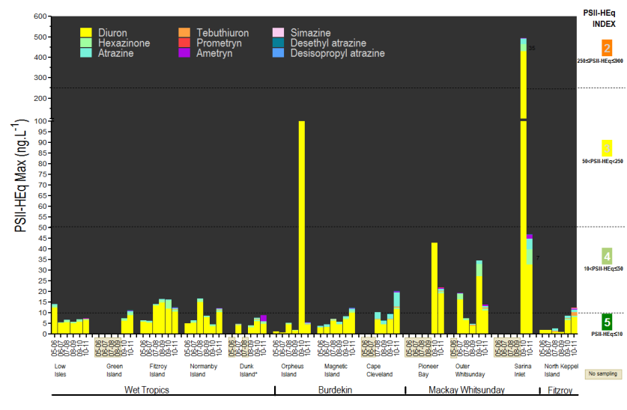
Figure 1 The temporal trend in PSII-HEq Max determined using time integrating sampling at routine monitoring sites in inshore waters of the GBR

The reporting parameters for PSII herbicides in 2010-2011, PSII-HEq Max and PSII-HEq Wet Avg, are provided in Table 1, which summarises key results from the routine monitoring and terrestrial run-off programs as well as the Tully transect case study, utilizing different sampling techniques. For routine monitoring sites where long-term, time-integrated monitoring with passive sampling occurs, these reporting parameters are compared to those obtained in the baseline reporting year (typically 2008-2009) using ratios (Table 1). A greater range of PSII herbicides were detected at all routine sites across the GBR and increases in either PSII-HEq Max or the PSII-HEq Wet Avg with respect to those determined in the baseline reporting year (typically 2008-2009) (Table 1) were observed. PSII-HEq Max is also provided in Table 1 for sites used in the Tully Transect Case Study and at sites sampled during terrestrial run-off assessments (flood plumes). The PSII-HEq Index Category (1-5) for each PSII-HEq Max is indicated (refer Figure 1 for Index Categories). Where pesticides other than PSII herbicides (i.e. metolachlor, imidacloprid, DEET, chlorpyrifos) have been detected either using time-integrated passive sampling (metolachlor, imidacloprid) or equilibrium phase sampling with non-polar passive samplers, (metolachlor, DEET, chlorpyrifos) these are also indicated in Table 1 together with the maximum concentrations. In certain cases, the equilibrium phase concentrations of PSII herbicides have also been estimated using non-polar passive samplers (i.e. ametryn at Dunk Island and atrazine at Magnetic Island in Table 1). Any pesticide which has met or exceeded Water Quality Guidelines (ANZECC and ARMCANZ 2000; GBRMPA 2010) with each sampling mode (time-integrated, equilibrium, snap-shot/grab sampling) are also indicated in Table 1. Individual pesticides which have met or exceeded Water Quality Guidelines include the PSII herbicide tebuthiuron (20 – 90 ng.L⁻¹) (GBRMPA 2010) and the chloracetanilide herbicide metolachlor (20 ng.L⁻¹) (ANZECC and ARMCANZ 2000). These exceedances occurred in the Burdekin and Fitzroy Regions, primarily during flood plume monitoring using snap-shot/grab sampling and are outlined in Table 1 and the key findings below.

The key findings for the 2010-2011 monitoring year were -
- Routine monitoring sites:
Tebuthiuron was the only individual PSII herbicide which exceeded Water Quality Guidelines for the Great Barrier Reef Marine Park 2010 (GBRMPA 2010) at a routine monitoring site using time-integrated passive sampling techniques. This occurred at North Keppel Island in the Fitzroy Region.

PSII herbicides detected with higher frequency at routine monitoring sites in 2010-2011 using time-integrated passive samplers included bromacil, ametryn and prometryn, albeit typically < 2 ng.L⁻¹.

The most abundant and frequently detected PSII herbicides at routine sites in 2010-2011using time-integrated passive sampling in each region were (from highest to lowest order):

- Wet Tropics – diuron, atrazine and hexazinone – highest concentrations of diuron (up to 6.5 -10 ng.L⁻¹) at Fitzroy and Normanby Islands
- Burdekin – atrazine, diuron, and tebuthiuron – atrazine concentrations (up to 42 ng.L⁻¹ at Cape Cleveland) exceeding the highest diuron concentrations (up to 12 ng.L⁻¹) also at Cape Cleveland
- Mackay Whitsunday – diuron, atrazine, hexazinone and tebuthiuron – higher concentrations of diuron (up to 11 - 33 ng.L⁻¹) at Sarina Inlet
- Fitzroy – diuron, atrazine and tebuthiuron – tebuthiuron (up to 20 ng.L⁻¹) and atrazine (up to 8.0 ng.L⁻¹) concentrations can be higher or comparable to the concentration of diuron (up to 7.9 ng.L⁻¹) when impacted by flood waters.

In certain cases, PSII herbicides were also detected in non-polar passive samplers. Equilibrium phase concentration estimates for these herbicides were often higher than the time-integrated estimates at these same sites. For example, ametryn (8.9 ng.L⁻¹) at Dunk Island and atrazine at Magnetic Island (28 ng.L⁻¹) and Cape Cleveland (49 ng.L⁻¹). The analysis of PSII herbicides by GCMS is less reliable than LCMS and may contribute to the differences in water concentration estimates between the two passive sampler types.

The trends in the reporting parameters PSII-HEq Max and PSII-HEq Wet Avg between 2010-2011 and the baseline reporting year are:

- Wet Tropics – PSII-HEq Max and the resulting PSII-HEq Index categories are mostly consistent with slight increases above the baseline reporting year at all routine monitoring sites resulting in both Normanby Is and Green Is shifting from Category 5 to Category 4 on the PSII-HEq Index. The PSII-HEq Wet Avg have more significantly increased (factors of 1.5 – 3.4), indicating exposure was higher for longer periods (i.e. more consistent) throughout the wet season.
- Burdekin – Both PSII-HEq Max and the PSII-HEq Wet Avg have increased by factors of ≥ 2 at all sites in this region (Orpheus Is, Magnetic Is and Cape Cleveland) compared to the baseline reporting year. At Magnetic Island and Cape Cleveland, PSII-HEq Max has shifted from Category 5 to Category 4.
- Mackay Whitsunday – PSII-HEq Max and PSII-HEq Wet Avg at Sarina Inlet and Pioneer Bay have decreased substantially from 2009-2010 when monitoring commenced. Pioneer Bay remains a Category 4 site while Sarina Inlet has improved from a Category 2 site in 2009-2010 to a relatively high Category 4 site in 2010-2011. Sarina Inlet was the routine site with the highest risk of exposure to PSII herbicides in 2010-2011 when assessed against the PSII-HEq Index, which was also the case in 2009-2010. While the PSII-HEq Max has decreased at Outer Whitsunday, the PSII-HEq Wet Avg has increased slightly (factor of 1.2).
- Fitzroy – Both PSII-HEq Max and the PSII-HEq Wet Avg have increased in 2010-2011 by factors of 12 and 5 respectively. 2010-2011 was the first monitoring year at North Keppel Is where PSII-HEq Max has shifted from Category 5 to Category 4 on the PSII-HEq Index.

- The Tully transect case study has demonstrated:
- The pesticides present in the highest concentrations in the Tully River itself were atrazine, diuron, hexazinone and imidacloprid. These chemicals were also detected by passive samplers at the three transect sites in the greatest concentrations, as well as ametryn, prometryn, simazine, tebuthiuron and metolachlor. Grab sampling also detected atrazine, diuron, hexazinone and imidacloprid as far out as the Tully Mouth site, but only diuron and hexazinone were detected at Bedarra Island and only diuron was detected at Sisters Island, situated 35 km from the Tully River.
- There is a higher risk of Category 3 PSII herbicide exposures in the Wet Tropics than the routine monitoring sites currently indicate (Category 4 PSII-HEq Max), not only at the Tully River Mouth (78 ng.L⁻¹), but also at Bedarra Island (72 ng.L⁻¹) situated 20 km from the Tully River. At times, the exposure at these two sites is relatively comparable, suggesting little dilution of plume waters between 5 and 20 km from the Tully River. The Sisters Island site is a relatively high Category 4 site compared with the routine monitoring sites in the Wet Tropics region.
- A clear decline in risk of exposure to PSII herbicides with distance from the Tully River between the Tully mouth and Sisters Island is evident in this region in most periods.
- The insecticide imidacloprid has been detected up to 35 km from the Tully River at Sisters Island using passive sampling. This insecticide which is used to control the cane grub in sugar cane and as a termiticide (chlorpyrifos replacement) is being routinely monitored using passive samplers in 2011-2012.

- Photosystem II herbicides in Terrestrial Run-Off (flood plumes)
- Most grab samples taken to monitor terrestrial run-off had PSII-HEq of Category 5 except for samples up to 16 km from the mouth of the Pioneer River in the Mackay Whitsunday region and one sample at East Peak Island in the Fitzroy region – both Category 4.
- A clear exposure gradient is apparent in grab samples collected out from the Pioneer River in the Mackay Whitsunday region through to the Percy Group of Islands in the Fitzroy region. Exposure changed from atrazine and diuron detections (Category 4) to no detections. Tebuthiuron was detected at the Percy Group of Islands under the influence of plume waters from the Fitzroy River to the south. The tebuthriuron concentration at this point was 10 ng.L,⁻¹ which is half the GBRMPA Guideline.
- The GBRMPA Guideline for tebuthiuron was met or exceeded at multiple sites in the Fitzroy region including North Keppel Island, Great Keppel Island, West Divided Island and East Peak Island (20-90 ng.L⁻¹). These exceedances were up to a factor of 4.5 times higher than the 99% species protection low reliability Guideline.
- The GBRMPA Guideline for tebuthiuron was met in Burdekin River plume grab samples collected at 3 and 11 km out from the mouth.

- Pesticides other than PSII herbicides:
- Metolachlor concentrations in flood plume grab samples of 20 ng.L⁻¹ at both East Peak Island and North Keppel Island in the Fitzroy region reached the ANZECC and ARMCANZ Interim Working Level for marine waters (ANZECC and ARMCANZ 2000).
- Metolachlor was detected in all regions using passive samplers. Equilibrium concentrations determined using non-polar passive samplers were typically higher than time-integrated estimates determined using polar passive samplers, with this difference likely attributed to the unreliability of herbicide analysis by GCMS. The highest time-integrated estimate (3.2 ng.L⁻¹) was measured at North Keppel Island in the Fitzroy Region (polar samplers only). Time-integrated estimates in the Burdekin and Mackay Whitsunday Region were higher than those at routine sites in the Wet Tropics. However, Tully transect sites recorded higher concentrations than other routine sites in this region. Normanby Island in the Wet Tropics Region, Cape Cleveland in the Burdekin Region and Outer Whitsunday in the Mackay Whitsunday Region had equilibrium concentration estimates of 2.5, 6.5 and 6.8 ng.L⁻¹ respectively.
- The personal (and animal/stock) insect repellant DEET was detected at Dunk Island in the Wet Tropics, Cape Cleveland in the Burdekin Region, and Outer Whitsunday in the Mackay Whitsunday Region at equilibrium concentration estimates of 2.6, 3.4 and 23 ng.L⁻¹ respectively.
- Chlorpyrifos was only detected at Magnetic Island in the Burdekin Region in 2010-2011 using non-polar passive samplers at a concentration of 0.22 ng.L⁻¹ which is just less than half of the high reliability GBRMPA Guideline of 0.5 ng.L⁻¹. This is in contrast to 2009-2010 where chlorpyrifos exceeded this Guideline at multiple sites in the Wet Tropics Region.
- Imidacloprid, an insecticide which can be used as a chlorpyrifos replacement was not routinely monitored in 2010-2011 but has been detected in grab samples at up to 150 ng.L⁻¹ at East Peak Island in the Fitzroy region and also in the Wet Tropics at up to 50 ng.L⁻¹. Concentration estimates from time-integrated passive samplers used in the Tully transect case study, ranged from 2.2 ng.L⁻¹ at Sisters Island to 30 ng.L⁻¹ at the Tully Mouth. Highly turbid flood waters may hinder the breakdown of this pesticide since the dominant loss pathway is phototransformation. There is currently no Water Quality Guideline established for this insecticide in Australia.

Table 1 An overview of key results for pesticide monitoring on the GBR in 2010-2011
NRM Region | Sites | Sample Type | Sampling Mode | PSII-HEq Max | Ratio to Baseline Year | PSII-HEq _{Wet} _{Avg} | Ratio to Baseline Year | Other Pesticides | Max Concentration | Guideline Exceedance
Wet Tropics | Low Isles | R | TI | 7.4 | 1.3 | 4.4 | 2.1 | Metolachlor | 0.059
Wet Tropics | Green Is | R | TI | 11 | 1.5 | 5.7 | 3.4 | Metolachlor | 0.091
Wet Tropics |  |  | E |  |  |  |  | n.d. | -
Wet Tropics | Fitzroy Is | R | TI | 13 | 0.8 | 8.8 | 1.5 | Metolachlor | 0.083
Wet Tropics |  |  | E |  |  |  |  | Metolachlor | 1.9
Wet Tropics | Normanby Is | R | TI | 12 | 1.4 | 6.2 | 2.4 | Metolachlor | 0.078
Wet Tropics |  |  | E |  |  |  |  | Metolachlor | 2.5
Wet Tropics | Dunk Is* | R | TI | 8.8 | 2.2 | 8.8 | 2.9 | Metolachlor | n.d.
Wet Tropics |  |  | E |  |  |  |  | Metolachlor | 1.7
Wet Tropics |  |  |  | 12 |  |  |  | Ametryn | 8.9
Wet Tropics |  |  |  |  |  |  |  | DEET | 2.6
Wet Tropics | Tully mouth | CS | TI | 76 |  |  |  | Metolachlor | 0.11
Wet Tropics |  |  |  |  |  |  |  | Imidacloprid | 30
Wet Tropics |  |  | SS | 68 |  |  |  | Imidacloprid | 50
Wet Tropics | Bedarra Is | CS | TI | 72 |  |  |  | Metolachlor | 0.20
Wet Tropics |  |  |  |  |  |  |  | Imidacloprid | 8.3
Wet Tropics |  |  | SS | 48 |  |  |  | n.d. | -
Wet Tropics | Sisters Is | CS | TI | 33 |  |  |  | Metolachlor | 0.14
Wet Tropics |  |  |  |  |  |  |  | Imidacloprid | 2.2
Wet Tropics |  |  | SS | 20 |  |  |  | n.d. | -
Burdekin | Orpheus Is | R | TI | 5.4 | 2.8 | 4.2 | 7.0 | Metolachlor | 0.10
Burdekin | Magnetic Is | R | TI | 12 | 2.2 | 6.8 | 3.0 | Metolachlor | 0.25
Burdekin |  |  | E |  |  |  |  | Metolachlor | 4.0
Burdekin |  |  |  | 4.5 |  |  |  | Atrazine | 28
Burdekin |  |  |  |  |  |  |  | Chlorpyrifos | 0.22
Burdekin | Cape Cleveland | R | TI | 20 | 3.2 | 11 | 4.6 | Metolachlor | 0.36
Burdekin |  |  | E |  |  |  |  | Metolachlor | 6.5
Burdekin |  |  |  | 7.8 |  |  |  | Atrazine | 49
 |  |  |  |  |  |  |  | DEET | 3.4
 | Burdekin mouth-3 & 11 km | TR | SS | 1.6 |  |  |  | n.d. | - | Tebuthiuron
Mackay Whitsunday | Pioneer Bay | R | TI | 22 | 0.51 | 12 | 0.41 | Metolachlor | 0.36
Mackay Whitsunday | Outer Whitsunday | R | TI | 14 | 0.73 | 9.2 | 1.23 | Metolachlor | 0.59
Mackay Whitsunday |  |  | E |  |  |  |  | Metolachlor | 6.8
Mackay Whitsunday |  |  |  |  |  |  |  | DEET | 23
Mackay Whitsunday | Sarina Inlet | R | TI | 47 | 0.09 | 22 | 0.20 | Metolachlor | 0.49
Mackay Whitsunday | Pioneer mouth-5 & 16 km out | TR | SS | 30,20 |  |  |  | n.d. | -
Mackay Whitsunday | Between Double Is & Digby Is | TR | SS | 0.8 |  |  |  | n.d. | -
Fitzroy | Middle Is, The Percy Group | TR | SS | 0.8 |  |  |  | n.d. | -
Fitzroy | Osborne Is, Shoalwater Bay | TR | SS | 0.8 |  |  |  | n.d. | -
Fitzroy | North Keppel Is | TR | SS | 5.6, |  |  |  | n.d. | - | Tebuthiuron
Fitzroy | North Keppel Is | R | TI | 12 | 12 | 4.0 | 5 | Metolachlor | 3.2 | Tebuthiuron
Fitzroy | North Keppel Island | TR | SS | 6.4 |  |  |  | Metolachlor | 20 | Tebuthiuron & Metolachlor
Fitzroy | East Peak Island | TR | SS | 12 |  |  |  | Metolachlor | 20 | Tebuthiuron & Metolachlor
Fitzroy |  | TR | SS | 5.6 |  |  |  | Metolachlor | 20 | Tebuthiuron & Metolachlor
Fitzroy |  |  |  |  |  |  |  | Imidacloprid | 50
 |  | TR | SS | n.d. |  |  |  | Imidacloprid | 140
R = Routine Monitoring Site, CS = Tully Transect Case Study Site, TR = Terrestrial Run-off sample; TI = Time-integrated Passive Sampling, E = Equilibrium Phase Passive Sampling, SS = Snap Shot Sample i.e. (1 L grab); The reporting parameters PSII-HEq Max and Wet Avg are colour coded according to PSII-HEq Index Categories (refer Figure 1 ); Ratios of these time-integrated reporting parameters to the same parameters in the baseline reporting year 2008-2009.(Exceptions: Green Island, Pioneer Bay, Sarina Inlet (2009-2010), Outer Whitsunday (2006-2007).

INTRODUCTION
The Reef Rescue Marine Monitoring Program (MMP) was designed to monitor and assess any improvement in water quality in the Great Barrier Reef (GBR) and the status of key ecosystems. In 2010-2011 Entox conducted monitoring activities within two components of the MMP: Inshore Marine Water Quality Monitoring and Assessment of Terrestrial Run-off Entering the Reef. The principal objectives of the monitoring conducted under each of these components were to:
- Assess temporal and spatial tends in marine water quality in inshore areas of the GBR lagoon; and
- Assess trends in the delivery of contaminants to the GBR lagoon during flood events and to quantify the exposure of reef ecosystems to these contaminants.

The contaminants assessed as an indicator of water quality, either routinely or during flood events were pesticides (insecticides, herbicides and fungicides). Temporal and spatial trends in water quality were assessed through fixed site routine monitoring at twelve sites across four Natural Resource Management (NRM) regions - Wet Tropics, Burdekin, Mackay Whitsunday and Fitzroy. This monitoring has been conducted for between two to six years at these locations.

The focus of the terrestrial run-off component in 2010-2011 was to analyse the links between the spatial and temporal pollutant profiles from the catchment to the inshore GBR in a case study conducted in the Wet Tropics region at three fixed sites. Terrestrial run-off was also assessed at other locations in the Wet Tropics, Burdekin, Mackay Whitsunday and Fitzroy regions during flood plume events.

METHODOLOGY
Routine water quality monitoring at fixed sites has been conducted using passive sampling techniques. These samplers accumulate chemicals from water via passive diffusion. The passive sampling techniques which are utilized in this component of the MMP include:
- SDB-RPS EmporeTM Disk (ED) based passive samplers for relatively hydrophilic organic chemicals with relatively low octanol-water partition coefficients (logK_{OW}) such as the PSII herbicides (example: diuron).
- Polydimethylsiloxane (PDMS) and Semipermeable Membrane Devices (SPMDs) passive samplers for organic chemicals which are relatively more hydrophobic (higher log K_{OW}) such as chlorpyrifos.

Terrestrial run-off assessments conducted at three sites in the Wet Tropics across the wet season have used a combination of time-integrated passive sampling (EDs) and 1 L grab water sampling. Combining these techniques has allowed both time-integrated and “snapshots” of concentration to be profiled through time at these locations. 1 L grab water samples were also taken during flood plume events at sites in other regions. Further details regarding these methodologies have been described in the Reef Rescue Marine Monitoring Program: Quality Assurance/Quality Control Methods and Procedures Manual 2011 (GBRMPA 2011) and in previous reports (Kennedy et al. 2010a).

Target Chemicals and Limits of Reporting
The pesticides targeted for analysis using the different sampling techniques and the limits of reporting (LOR) are indicated in Table 2. This list of target chemicals was derived at the commencement of the MMP through consultation with GBRMPA based on the following criteria: pesticides detected in recent studies, those recognised as a potential risk, analytical affordability, pesticides within the current analytical capabilities of Queensland Health Forensic and Scientific Services (QHFSS) and those likely to be accumulated within one of the passive sampling techniques (i.e. that exist as neutral species and are not too polar).

Table 2. Pesticides specified under the MMP for analysis with different sampling techniques together with the limits of reporting
Pesticide | Description | LOR
 |  | SPMD | PDMS | EDª | GRAB
Bifenthrin | Pyrethroid insecticide |  | <1
Fenvalerate | Pyrethroid insecticide |  | <0.5
Bromacil^{b} | PSII herbicide-uracil |  |  | <0.04 - 2 | <10
Tebuthiuron | PSII herbicide-thiadazolurea |  | <25 | <0.04 - 2 | <10
Terbutryn^{c} | PSII herbicides-methylthiotriazine |  |  | <0.04 – 0.4 | <10
Flumeturon | PSII herbicide-phenylurea |  | <30 | <0.08 - 2 | <10
Ametryn | PSII herbicide-methylthiotriazine |  | <10 | <0.04 – 2 | <10
Prometryn | PSII herbicide-methylthiotriazine |  | <5 | <0.04 - 2 | <10
Atrazine | PSII herbicide-chlorotriazine |  | <10 | <0.04 - 2 | <10
Propazine | PSII herbicide-chlorotriazine |  | <10
Simazine | PSII herbicide-chlorotriazine |  | <30 | <0.04 - 2 | <10
Hexazinone | PSII herbicide- triazinone |  | <25 | <0.04 - 2 | <10
Desethylatrazine | PSII herbicide breakdown product (also active) |  |  | <0.04 - 2 | <10
Desisopropylatrazine | PSII herbicide breakdown product (also active) |  | <25 | <0.08 - 2 | <10
Diuron | PSII herbicide - pheynylurea |  | <25 | <0.04 - 2 | <10
Oxadiazon | Oxadiazolone herbicide |  | <0.5
Chlorfenvinphos | Organophosphate insecticide |  | <2
Chlorpyrifos | Organophosphate insecticide | <0.03 | <0.5
Diazinon | Organophosphate insecticide | <5 | <5
Fenamiphos | Organophosphate insecticide |  | <5
Prothiophos | Organophosphate insecticide | <0.09 | <0.5
Chlordane | Organochlorine insecticide | <0.1 | <0.5
DDT | Organochlorine insecticide | <0.08 | <0.5
Dieldrin | Organochlorine insecticide | <0.2 | <0.5
Endosulphan | Organochlorine insecticide | <1.9 | <5
Heptachlor | Organochlorine insecticide | <0.07 | <0.5
Lindane | Organochlorine insecticide | <0.5 | <5
Hexachlorobenzene | Organochlorine fungicide | <0.09 | <0.5
Imidacloprid | Nicotinoid insecticide |  |  | <0.04 - 4 | <10
Trifluralin | Dintiroaniline |  | <0.5
Pendimethalin | Dinitroaniline herbicide | <0.4 | <0.5
Propiconazole | Conazole fungicide |  | <2
Tebuconazole | Conazole fungicide |  | <5
Metolachlor | Chloracetanilide herbicide |  | <10 | <0.04 - 2 | <10
Propoxur | Carbamate insecticide |  | <25
ªED sample extracts have been routinely analysed on the API 300 LCMS, However specific samples during the wet season were run on the 4000Q LCMSMS and EDs have been deployed in both an event (no membrane) and routine configuration (with membrane). LOR ranges are therefore indicated to reflect both changes in sampling rates under these conditions and differences in sensitivities on the different instruments for an assumed 30-day deployment period; ^{b}Bromacil was included in the list of target analytes from 2009-2010; ^{c}Imidacloprid and terbutryn are only analysed on the 4000Q LCMSMS . All grab samples were analysed on the 4000Q as well as some EDs deployed during the wet season.

Empore disc sampler extracts were routinely analysed using liquid chromatography mass spectrometry (API 300 LCMS) run in positive analysis mode. This excludes the detection of specific hydrophilic pesticides such as 2,4-D, MCPA, mecoprop, and picloram which would only be detected in negative analysis mode. 1 L grab water samples taken to monitor terrestrial runoff during flood plume events in the wet season were analysed similarly on the (4000Q LCMSMS) which is more sensitive. This more sensitive LCMSMS run includes two additional pesticides (imidacloprid and terbutryn). Specific EDs during flood plume events were also analysed on this more sensitive instrument in 2010-2011. PDMS and SPMD sampler extracts are analysed for pesticides using gas chromatography mass spectrometry (GCMS). While certain chemicals are specifically targeted using SPMDs and PDMS in this MMP (Table 2), a broader suite of organic chemicals including other pesticides and industrial chemicals are analysed in the PDMS and SPMD sampler extracts and these are indicated in Appendix A, Table 20.

Sampling Sites
Passive samplers were routinely deployed at twelve inshore GBR sites (in 2010-2011, including three sites which were only incorporated into the MMP in 2009-2010. These sites were Green Island in the Wet Tropics region and Pioneer Bay and Sarina Inlet in the Mackay Whitsunday region. Pioneer Bay and Sarina Inlet are also seagrass monitoring sites within the MMP.

Routine Sampling Periods
The monitoring year for routine pesticide sampling is from May 2010 to April 2011. The year is arbitrarily divided into “Dry 10” (May 2010 to October 2010) and “Wet 10-11” (November 2010 – April 2011) sampling periods for reporting purposes. Within each dry period, samplers are typically deployed for two months (maximum of three periods) and within each wet period, samplers are typically deployed for one month (maximum of six monitoring periods). The maximum number of samples which should be obtained from each location within each monitoring year is nine. Some sites have had two monthly samples rather than 1 two-monthly sample in one of the dry season sampling periods – in this case the total number of samples taken at each of these sites was 10.

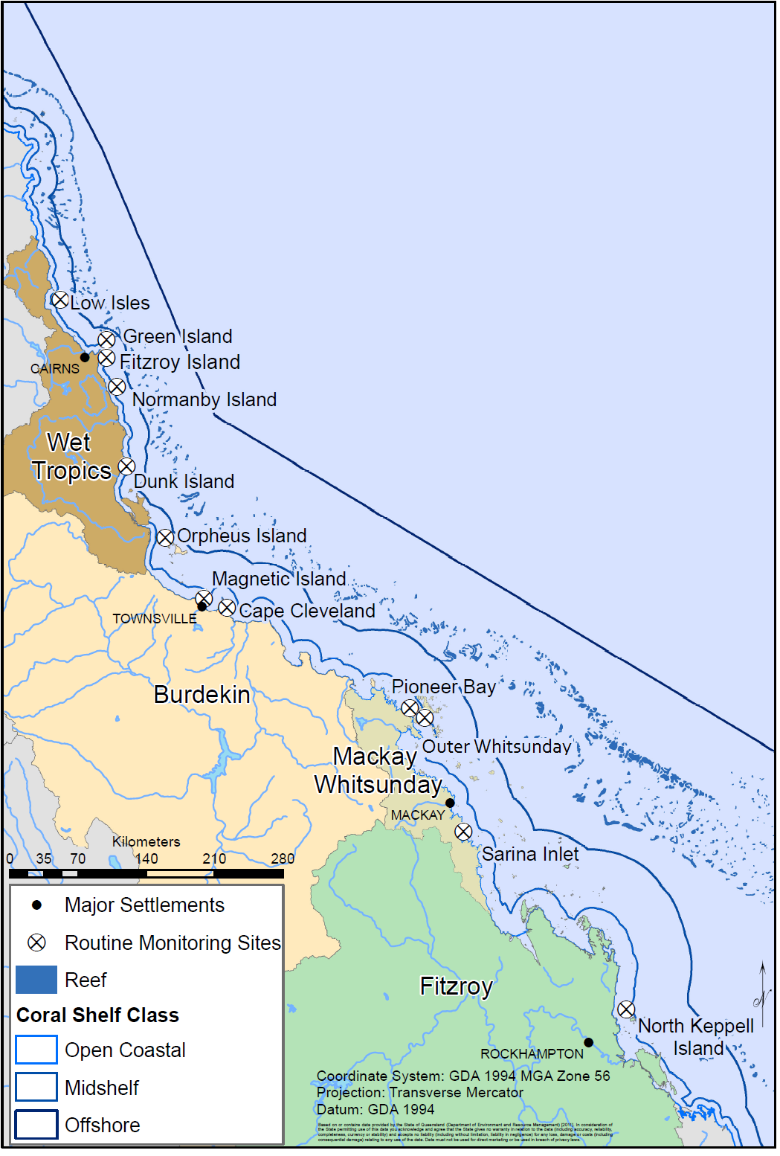
Figure 2 Locations of current inshore GBR routine monitoring sites where time-integrated sampling of pesticides occurred in 2010-2011

(Source – Adam Donovan and Alex Shanahan, School of Geography, Planning and Environmental Management, the University of Queensland)

Routine Sampling for the Assessment of Water Quality by Region in Dry and Wet Periods
The types of sampling conducted at each site have been indicated in Table 3. All sites are routinely monitored in both the dry and wet periods using EDs, while most sites in the Wet Tropics region and in the Burdekin region and one site in the Mackay Whitsunday region are monitored using PDMS samplers but only in the wet sampling period. Normanby Island is the only site which is monitored using PDMS in both the dry and wet period. SPMDs are also deployed at this site only. The sampling records and results for each routine monitoring site are provided in Appendix D, Tables 22-33.

Table 3 The types of passive samplers deployed at each sampling site in either dry or wet sampling periods in 2009-2010
Region | Site | EDs |  | PDMS |  | SPMD
Region | Site | Dry | Wet | Dry | Wet | Dry | Wet
Wet Tropics | Low Isles
Wet Tropics | Green Island
Wet Tropics | Fitzroy Island
Wet Tropics | Normanby Island
Wet Tropics | Dunk Island
Dry Tropics | Orpheus Island
Dry Tropics | Magnetic Island
Dry Tropics | Cape Cleveland
Mackay - Whitsunday | Pioneer Bay
Mackay - Whitsunday | Outer Whitsunday
Mackay - Whitsunday | Sarina Inlet
Fitzroy | North Keppel Island

Sampling for the Assessment of Terrestrial Run-Off by Region in the Wet Season

Flood plume sampling
A total of thirty-four 1 L grab samples were taken to monitor terrestrial run-off from four NRM regions during flood plume events in the 2010-2011 wet season (Table 4). Further details for these including co-ordinates and results for each sample are provided in Appendix G, Table 38.

Table 4 The number and timing of grab samples taken to assess terrestrial run-off during the 2010-2011 wet season
Transect | Sites | Sampling dates | Total number of samples
Wet Tropics | Fitzroy Island coral site | 11-Feb-11 | 1
 | Russell Island (Franklands) | 11-Feb-11 | 1
 | Dunk Island | 12-Feb-11 | 1
 | Offshore from Dunk Island | 12-Feb-11 | 1
 | Halfway between Tully River mouth & Dunk Island | 12-Feb-11 | 1
 | Close to Tully River mouth | 12-Feb-11 | 1 (6)
 | Samples taken 6 – 7 days after a peak discharge event in Wet Tropics rivers on a rising hydrograph –refer Appendix G, Figure 21
Burdekin | 3 km from Burdekin River mouth | 30-Dec-10 | 1
 | 11 km from Burdekin River mouth | 30-Dec-10 | 1 (2)
 | Samples taken during a peak discharge event 2 days after the maximum peak discharge – refer Appendix G, Figure 22
Mackay Whitsunday-Fitzroy | 5 km from Pioneer River mouth near Round Top (1) | 19-Jan-11 | 1
 | 16 km from Pioneer River mouth past Round Top (3) | 19-Jan-11 | 1
 | 26 km from Pioneer River mouth , out from Hay Point between Pioneer River and Prudhoe Island (5) | 19-Jan-11 | 1
 | 37 km from Pioneer River mouth near Prudhoe Island (2) | 19-Jan-11 | 1
 | Prudhoe Island (8,11) | 19-Jan-11 | 1
 |  | 19-Jan-11 | 1
 | Between Prudhoe Island and Double Island, out from Sarina Inlet (4) | 19-Jan-11 | 1
 | Between Double Island and Digby Island, the Percy Group (10) | 19-Jan-11 | 1
 | Digby Island, between Double Island and Middle Island (The Percy Group) (9) | 19-Jan-11 | 1
 | Between Double Island and Middle Island (7) | 19-Jan-11 | 1
 | Middle Island – the Percy Group, 53 km south-east of Double Island (6) | 19-Jan-11 | 1 (10)
 | Samples taken during a peak discharge event in the Pioneer River and following a major flood event in the Fitzroy River – refer Appendix G-Figure 23.
Fitzroy-Keppels | Osborne Island, Shoalwater Bay | 20-Jan-11 | 1
(Shoalwater Bay to | Shoalwater Bay | 7-Feb-11 | 1
Curtis Island) | Outer Rock, East of North Keppel Is | 18-Jan-11 | 1
 | Mazie Bay, North Keppel Is | 10-Jan-11 | 1
 |  | 17-Jan-11 | 1
 |  | 25-Jan-11 | 1
 | ½ Tide Rock, Great Keppel Is | 4-Jan-11 | 1
 | 24 km from Fitzroy River mouth, West Divided Is | 25-Jan-11 | 1
 | 22 km from Fitzroy River mouth, East Peak Is | 10-Jan-11 | 1
 |  | 17-Jan-11 | 1
 |  | 7-Feb-11 | 1
 | 15 km from Fitzroy River mouth, Buoy 2 | 4-Jan-11 | 1
 | Cape Capricorn to the south of the Fitzroy River | 18-Jan-11 | 1
 |  | 25-Jan-11 | 1
 | 31 km south of Cape Capricorn, off from Facing Island and Curtis Island | 18-Jan-11 | 1 (15)
 | Samples taken during (4-Jan-11 and 10-Jan-11) and following a major flood event in the Fitzroy River – refer Appendix G, Figure 24
Block colours indicate GRAB samples taken from the same site at different time points.

Tully Transect Case Study

Terrestrial run-off was assessed using a combination of both 1 L grab and passive sampling (EDs) in the Wet Tropics region for the Tully Transect Case Study (Table 5). Specific dates for each passive sampler deployment and grab sample collection and results for each are provided in Appendix D Tables 34 - 37. The study aimed to assess the spatial and temporal variation of PSII herbicides from the Tully River mouth to the inshore GBR sites (Bedarra and Sisters Island). Bedarra and Sisters Island are approximately 9 and 35 km from the Tully River mouth site (Figure 3).

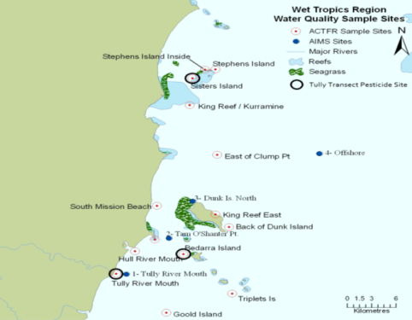
Figure 3 Tully Transect Case Study showing the location of the pesticide sampling sites Tully Mouth, Bedarra and Sisters Island
(Source – Michelle Devlin, ACTFR, James Cook University)

Table 5 Tully Transect Case Study
Site | Sampling Date Range |  | Passive Sampling Periods |  | Grab Sampling
 | Start | End | EDs | Number | 1 L | Number
Tully Riverª | 24-Nov-10 | 5-Mar-11 |  |  |  | 23
Tully mouth | 22-Nov-10  16-Dec-10 | 15-Apr-11  15-Apr-11 |  | 7^{b} |  | 11
Bedarra Island | 22-Nov-10  16-Dec-10 | 15-Apr-11  15-Apr-11 |  | 8^{c} |  | 11
Sisters Island | 22-Nov-10  16-Dec-10 | 15-Apr-11  15-Apr-11 |  | 7^{d} |  | 11
ª Grab samples were collected in the Tully River as part of the Paddock to Reef monitoring program. These samples were analysed by QHFSS and the data provided by DERM to assist in the evaluation of the concentrations measured in the MMP; ^{b} A total of 9 samplers were deployed at the Tully Mouth but two deployments were lost: 19 Jan to 22 Feb and 15 Feb to 18 Feb; ^{c} A total of 9 samplers were deployed at Bedarra Island but one deployment was lost: 19 Jan to 22 Feb;
^{d} A total of 9 samplers were deployed at Sisters Island but two deployments were lost: 19 Jan to 22 Feb and 12 Feb to 15 Feb

Other pesticides such as the herbicides terbutryn (PSII) and metolachlor (dinitroaniline – growth/long-chain fatty acid inhibitor) and the insecticide imidacloprid (nicotinoid – neurotoxic) were also consistently analysed in 1 L grab samples. Terbutryn and imidacloprid were not consistently analysed for in the passive samples since these were not routinely analysed on the 4000 Q LCMSMS. Using both passive and grab sampling allows a comparison of both time-integrated and “snap-shot” assessments of the risks of exposure to PSII herbicides in this region respectively. A total of 33 1 L grab water samples and 22 passive sampling periods (Table 5) were sampled between 22 November 2010 and 15 April 2011. The study was designed such that a grab water sample was taken when passive samplers were deployed and retrieved at each site. Passive samplers were deployed both with and without a diffusion limiting membrane typically for 15 and 3-5 days respectively. Samplers deployed without a diffusion limiting membrane accumulate chemicals faster and can therefore be used as event samplers to provide time-averaged estimates of concentration in water over shorter time periods.

Water Quality Guideline Trigger Values
In order to interpret the potential significance of measured concentrations, these were compared with available Water Quality Guideline Trigger Values (Guidelines). Guidelines have been developed by both the GBRMPA (GBRMPA 2010) and as part of the National Water Quality Management Strategy for fresh and marine waters (ANZECC and ARMCANZ 2000). A selection of relevant Guidelines and Interim Working Levels, are provided in Table 6.

Table 6. Water quality guideline trigger values available for specific pesticides
Chemical | GBRMPAª |  | ANZECC and ARMCANZ^{b}
Chemical | ng.L⁻¹ | Notes | ng.L⁻¹ | Notes
Dinitroaniline Herbicides
Trifluralin |  |  | 2600 | 99% species protection; Freshwater
Organophosphate Pesticides
Chlorpyrifos | 0.5 | 99% species protection; High reliability | 0.5 | 99% species protection; Marine water
 | 9 | 95% species protection; High reliability | 9 | 95% species protection; Marine water
 |  |  | 0.04 | 99% species protection; Fresh water
 |  |  | 10 | 95% species protection; Fresh water
Choracetanilide herbicides
Metolachlor |  |  | 20* | Low reliability; Fresh water
 |  |  | 20* | Low reliability; Marine water
Triazine or Triazinone Herbicides
Atrazine | 600 | 99% species protection; Moderate reliability | 700 | 99% species protection; Fresh water
 | 1400 | 95% species protection; Moderate reliability | 1300 | 95% species protection; Fresh water
Hexazinone | 1200 | Low reliability
Simazine | 200 | 99% species protection; Low reliability | 200 | 99% species protection; Fresh water
 |  |  | 3200 | 95% species protection; Fresh water
Ametryn | 500 | 99% species protection; Moderate reliability
 | 1000 | 95% species protection; Moderate reliability
Urea Herbicides
Diuron | 900 | 99% species protection; Moderate reliability | 200 * | Low reliability ; Fresh water
 | 1600 | 95% species protection; Moderate reliability | 200 * | Low reliability ; Marine water
Tebuthiuron | 20 | 99% species protection; Low reliability | 20 | 99% species protection; Fresh water
 |  |  | 2200 | 95% species protection; Fresh water
Transformation Product
3,4-dichloroaniline |  |  | 85000 | 99% species protection; Marine water
ª Sourced from Table 26 & Table 27 of the Water Quality Guidelines for the Great Barrier Reef Marine Park 2010 (GBRMPA 2010) ;; ^{b} Sourced from Table 3.4-1 of the ANZECC and ARMCANZ Guidelines (ANZECC and ARMCANZ 2000); “*” indicates values which are Interim Working Levels rather than Guidelines as indicated in Chapter 8.3.7 Volume 2 of the ANZECC and ARMCANZ Guidelines.

Guidelines which are protective of 99% of species are ideal for water bodies of high ecological value like the GBR World Heritage Area (GBRMPA 2010). In certain cases, only freshwater guidelines (ANZECC and ARMCANZ) or “low reliability” Guidelines or “interim working levels” (IWLs) rather than marine water quality Guideline values are available for assessing the concentrations of specific chemicals. In many cases no Guideline values are available to assess the concentrations of specific chemicals.

Calculation of PSII-Herbicide Equivalent Concentrations (PSII-HEq)
For the purpose of this work, Photosystem II (PSII) herbicide concentrations are expressed as PSII herbicide equivalent concentrations (PSII-HEq). PSII-HEq values were derived using relative potency factors (REP) for each chemical with respect to a reference PSII herbicide diuron.

If a given PSII herbicide is as potent as diuron, it will have a REP of 1. If it is more potent than diuron it will have a REP of >1, while if it is less potent than diuron it will have an REP of <1. To calculate the PSII-HEq, it is assumed that these herbicides act additively (Escher et al. 2006; Muller et al. 2008; Magnusson et al. 2010) and the PSII-HEq (ng.L⁻¹) is therefore the sum of the individual REPcorrected concentrations of each individual PSII herbicide (Ci, ng.L⁻¹) determined in each water sample using Equation 1.

PSII-HEq = ∑ C_{i} x REP_{i} Equation 1

REP values for the chemicals of interest were collated from relevant laboratory studies and are provided in Table 7. For this initial determination of consensus values, average values from studies obtained using corals, Phaeodactylum and Chlorella were used (different organisms were not weighted). The PSII-HEq concentrations in this report were then predicted using these mean preliminary consensus REP values giving equal weight to EC₅₀ (50% of the maximal effect observed) and EC₂₀ (20% of the maximal effect observed) values. These initial consensus values were developed and applied to determine PSII-HEq in the baseline reporting year 2008-09 and have not been updated for the sake of consistency. However it should be acknowledged that more data will continue to be published (Magnusson et al. 2010) and it is likely that these values would benefit from review and updating in the future to include not only more data for these chemicals but to include additional PSII herbicides such as bromacil and terbutryn.

Table 7. Relative potency factors (REP) for PSII herbicides and selected transformation products
PSII  Herbicides | Relative potency (range) |  |  | Relative potency (mean based on various EC values)
PSII  Herbicides | Zooxanthellae (Corals) ª | P.  tricornutum^{bcd} | C. vulgaris^{bde} |  | Zooxanthellae (Corals) ª | P. tricornutum^{bcd} | C. vulgaris^{bde} | Mean/  Preliminary consensus ª  REP
Diuron (reference) | 1 | 1 | 1 |  | 1 | 1 | 1 | 1
Ametryn | 1.2-1.35 | 0.94 | 0.9 -2.7 |  | 1.28 | 0.94 | 1.71 | 1.31
Atrazine | 0.05-0.06 | 0.1-0.4 | 0.15 -0.3 |  | 0.05 | 0.22 | 0.21 | 0.16
Desethyl-atrazine |  |  | 0.01-0.2 |  |  |  | 0.105 | 0.11
Desisopropyl- atrazine |  |  | 0.003 |  |  |  | 0.003 | 0.003
Flumeturon |  |  | 0.04 |  |  |  | 0.04 | 0.04
Hexazinone | 0.2-0.26 | 0.27-0.82 | 0.17-0.95 |  | 0.23 | 0.46 | 0.44 | 0.38
Prometryn |  |  | 1-1.1 |  |  |  | 1.05 | 1.05
Simazine | 0.02 | 0.03-0.05 | 0.02-0.26 |  | 0.02 | 0.04 | 0.14 | 0.07
Tebuthiuron | 0.01 | 0.07 | 0.11-0.2 |  | 0.01 | 0.07 | 0.15 | 0.08
Terbuthylazine |  |  | 0.3 |  |  |  | 0.3 | 0.3
ª(Jones and Kerswell 2003);^{b} (Muller et al. 2008); ^{c} (Bengtson-Nash et al. 2005); ^{d} (Schmidt 2005); ^{e} Macova et al., unpublished data (Entox); ^{f}Based on a preliminary summary of available data when derived in 2009 - it should be noted that bromacil (routinely analysed for since 2009-2010) and terbutryn (beginning to be routinely analysed for from the end of 2010-2011) are also PSII herbicides and not currently incorporated into PSII-HEq estimates (no REP). Similarly while terbuthylazine does have a REP it is not a target chemical in the analysis of EDs, but is part of the GCMS pesticide screen for PDMS. The herbicides which contribute to PSII-HEq in this report are therefore shaded in brown above.

PS-II Herbicide Index
For the interpretation of the PSII-herbicide data reported as PSII-HEq, an index has been compiled in consultation with the GBRMPA as an indicator to report against across the MMP (Table 8). This index uses published scientific evidence with respect to the effects of the reference PSII herbicide diuron and is summarized for each index category in Table 31 Appendix B. These index criteria have been slightly modified from those indicated in the baseline reporting year 2008-2009 (Kennedy et al. 2010b). It is important to note that an increase in the concentrations of herbicides detected, which translates to an increase in PSII-HEq, can subsequently result in a decline in Index category.

Table 8 PSII-Herbicide Equivalent Index developed as a indicator for reporting of PSII herbicides across the Reef Rescue Marine Monitoring Program
Category | Concentration  (ng.L⁻¹) | Description
5 | PSII-HEq ≤ 10 | No published scientific papers that demonstrate any effects on plants or animals based on toxicity or a reduction in photosynthesis. The upper limit of this category is also the detection limit for pesticide concentrations determined in field collected water samples
4 | 10 < PSII-HEq ≤ 50 | Published scientific observations of reduced photosynthesis for two diatoms.
3 | 50 < PSII-HEq < 250 | Published scientific observations of reduced photosynthesis for two seagrass species and three diatoms.
2 | 250 ≤ PSII-HEq ≤ 900 | Published scientific observations of reduced photosynthesis for three coral species.
1 | PSII-HEq > 900 | Published scientific papers that demonstrate effects on the growth and death of aquatic plants and animals exposed to the pesticide. This concentration represents a level at which 99 per cent of tropical marine plants and animals are protected, using diuron as the reference chemical.

For categories 2 – 4:
- The published scientific papers indicate that this reduction in photosynthesis is reversible when the organism is no longer exposed to the pesticide;
- Detecting a pesticide at these concentrations does not necessarily mean that there will be an ecological effect on the plants and animals present;
- These categories have been included as they indicate an additional level of stress that plants and animals may be exposed to in the Marine Park. In combination with a range of other stressors (e.g. sediment, temperature, salinity, pH, storm damage, and elevated nutrient concentrations) the ability of these plant and animal species to recover from impacts may be reduced.

Outline of Data Presentation
Detailed results for the 2010-2011 pesticide monitoring are provided in Appendices as outlined below:
- Routine Monitoring Data – Appendix C, Tables 22-33
- Tully Transect Case Study – Appendix D, Tables 34 - 37
- Flood Plume Sampling – Appendix F, Table 38

The data for this report is then summarised in several sections. These include:
- GBR Wide Summary Results for 2010-2011
- Regional Summaries for 2010-2011

GBR-WIDE SUMMARY RESULTS 2010-2011

Routine Monitoring Results – Water Quality
This latest wet season was characterised by massive flow events in major rivers discharging to the inshore GBR waters of between 1.5 to more than 3 times the long-term median discharge (Schaffelke et al. 2011). The most frequently detected and highest concentration herbicides were atrazine, diuron, hexazinone and tebuthiuron (Table 9) which is consistent with monitoring in previous years. However, it is notable that PSII herbicides such as ametryn and prometryn which are typically detected infrequently (if ever), have been detected at multiple sites. For example, ametryn was only detected at two sites in 2009-2010 (Cape Cleveland and Sarina Inlet) but has been detected at every routine monitoring site in 2010-2011, albeit at time-averaged concentrations ranging from 0.31 – 2.2 ng.L⁻¹. The only herbicide (with an individual Guideline to assess against) which has met the “low reliability” GBRMPA Guideline at a routine monitoring site was tebuthiuron at North Keppel Island. This is not surprising given that the Fitzroy River experienced major flood events with total discharge more than 3 times the long-term median (Schaffelke et al. 2011). It should be remembered that these passive sampler derived concentrations are time-averaged and represent longer term exposures.

The maximum concentrations of each individual herbicide measured in EDs at routine sites in 2010-2011 (Table 9) are compared to those in both the baseline reporting year (2008-2009) and the previous year in Figure 4.
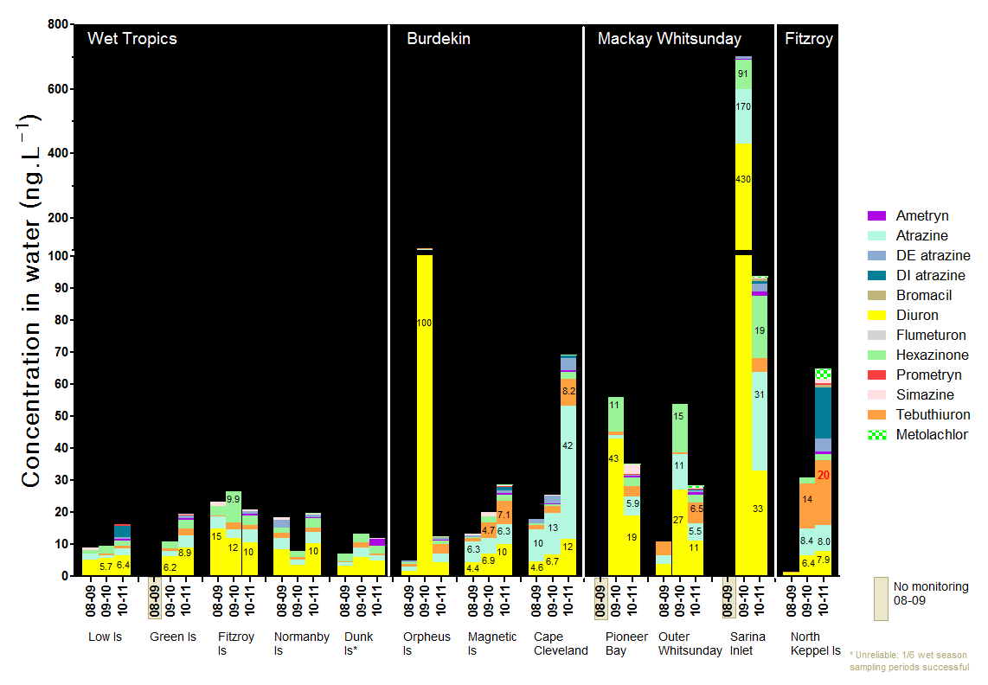Figure 4 Maximum concentrations of each individual herbicide at routine sites in 2010-2011 compared to the two previous monitoring years

Table 9 The range in time-integrated concentrations of pesticides in water (ng.L⁻¹) measured using EDs at routine monitoring sites in 2010-2011
NRM Region | Site | PSII Herbicides (Included in PSII-HEq Index) |  |  |  |  |  |  |  |  |  |  | Other Herbicides |  |  | Insecticides
 |  | Ametryn | Atrazine | DE Atrazine | DI Atrazine | Diuron | Hexazinone | Prometryn | Simazine | Tebuthiuron | PSII-HEq | PSII-HEq Max | Bromacil | Terbutryn | Metolachlor | Imidacloprid
Wet Tropics | Low Isles | n.d. – 0.62 | n.d.-2.1 | n.d.-0.43 | n.d-3.6 | n.d-6.5 | n.d.-1.6 | n.d.-0.55 | n.d | n.d.-0.92 | 0.16-7.4 | 7.4 | n.d. | n.m. | n.d.-0.059 | n.m.
Wet Tropics | % Detects | 50 | 90 | 20 | 20 | 90 | 90 | 30 | 0 | 50 | 100 |  | 0 |  | 30
Wet Tropics | Green Is | n.d.-0.45 | n.d.-3.9 | n.d.-0.78 | n.d. | n.d.-8.9 | n.d.-2.8 | n.d.-0.23 | n.d.-0.34 | n.d.-2.0 | n.d.-11 | 11 | n.d. | 0.087 | n.d.-0.091 | n.d.
Wet Tropics | % Detects | 30 | 70 | 40 | 0 | 60 | 70 | 10 | 20 | 40 | 70 |  | 0 | - | 30 | -
Wet Tropics | Fitzroy Is | n.d.-0.47 | n.d.-4.1 | n.d.-0.70 | n.d. | 0.67-10 | n.d.-3.2 | n.d.-0.021 | n.d.-0.51 | n.d.-1.3 | 0.75-13 | 13 | n.d. | n.m. | n.d.-0.083 | n.m.
Wet Tropics | % Detects | 20 | 80 | 30 | 0 | 100 | 90 | 10 | 30 | 50 | 100 |  |  |  | 20
Wet Tropics | Normanby Is | n.d.-0.47 | n.d.-3.6 | n.d.-0.66 | n.d. | n.d.-10 | n.d.-2.8 | n.d-0.009 | n.d.-0.40 | n.d.-1.4 | n.d-12 | 12 | n.d. | n.m. | n.d.-0.078 | n.m.
Wet Tropics | % Detects | 33 | 89 | 33 | 0 | 78 | 89 | 11 | 22 | 33 | 89 |  | 0 |  | 22
Wet Tropics | Dunk Isª | n.d.-2.2 | 0.74-1.8 | n.d. | n.d. | 0.80-4.8 | 0.25-2.3 | n.d. | n.d.-0.45 | n.d.-0.44 | 1.1-8.8 | 8.8 | n.d. | n.m. | n.d. | n.m.
Wet Tropics | % Detects | 25 | 100 | 0 | 0 | 100 | 100 | 0 | 25 | 25 | 100 |  | 0 |  | 0
Burdekin | Orpheus Is | n.d.-0.47 | n.d.-2.6 | n.d.-0.48 | n.d. | n.d.-4.4 | n.d.-0.98 | n.d.-0.13 | n.d. | n.d.-3.0 | n.d.-5.4 | 5.4 | n.d.-0.18 | n.m. | n.d.-0.10 | n.m.
Burdekin | % Detects | 43 | 86 | 43 | 0 | 86 | 86 | 29 | 0 | 71 | 86 |  | 14 |  | 29
Burdekin | Magnetic Is | n.d.-0.39 | 0.79.-6.3 | n.d.-0.94 | n.d.-0.93 | 1.3-10 | n.d.-2.1 | n.d.-0.26 | n.d.-0.36 | n.d.-7.1 | 1.4-12 | 12 | n.d. | n.m. | n.d.-0.25 | n.m.
Burdekin | % Detects | 50 | 100 | 63 | 38 | 100 | 88 | 25 | 25 | 88 | 100 |  | 0 |  | 25
Burdekin | Cape Cleveland | n.d.-0.31 | 0.24-42 | n.d.-3.9 | n.d-0.71 | n.d.-12 | 0.085-2.3 | n.d.-0.005 | n.d.-0.13 | 0.15-8.2 | 0.42-20 | 20 | n.d. | n.m. | n.d.-0.36 | n.m.
Burdekin | % Detects | 57 | 100 | 71 | 14 | 86 | 100 | 14 | 14 | 100 | 100 |  | 0 |  | 57
Mackay Whitsunday | Pioneer Bay^{b} | n.d.-0.40 | n.d.-5.9 | n.d.-0.49 | n.d. | 7.0-19 | 0.29-2.7 | n.d.-0.04 | n.d.-3.0 | n.d.-3.3 | 7.7-22 | 22 | n.d. | n.m. | n.d.-0.36 | n.m.
Mackay Whitsunday | % Detects | 67 | 83 | 33 | 0 | 100 | 100 | 50 | 50 | 83 | 100 |  | 0 |  | 50
Mackay Whitsunday | Outer Whitsunday | n.d.-0.64 | 0.20-5.5 | n.d.-0.66 | n.d.-0.29 | n.d.-11 | n.d.-2.5 | n.d.-0.17 | n.d.-0.36 | n.d.-6.5 | 0.37-14 | 14 | n.d. | n.m. | n.d.-0.59 | n.m.
Mackay Whitsunday | % Detects | 38 | 100 | 25 | 13 | 88 | 75 | 25 | 13 | 63 | 100 |  | 0 |  | 13
Mackay Whitsunday | Sarina Inlet | n.d.-1.5 | 0.16-31 | n.d.-2.4 | n.d.-0.74 | 0.17-33 | 0.10-19 | n.d.-0.052 | n.d.-0.23 | 0.16-4.5 | 0.26-47 | 47 | n.d.-0.87 | n.m. | n.d.-0.49 | n.m.
Mackay Whitsunday | % Detects | 43 | 100 | 86 | 29 | 100 | 100 | 29 | 14 | 100 | 100 |  | 33 |  | 29
Fitzroy | North Keppel Is | n.d.-0.90 | n.d.-8.0 | n.d.-3.9 | n.d.-16 | n.d.-7.9 | n.d.-1.8 | n.d.-0.42 | n.d.-1.5 | n.d.-20 | n.d.-12 | 12 | n.d.-0.83 | n.m. | n.d.-3.2 | n.m.
Fitzroy | % Detects | 56 | 78 | 67 | 13 | 89 | 67 | 44 | 33 | 89 | 100 |  | 11 |  | 67
ª Dunk Island maximum concentrations and frequency of detection only include 1/6 potential wet season sampling periods (refer Table 26) and should be interpreted with caution; ^{b} Pioneer Bay range only include 1/4 dry season sampling periods (refer Table 30) so the minimum values on these ranges and the frequency of detection should be interpreted with caution; Any sites where Water Quality Guideline trigger values were reached or exceeded are indicated in red text (refer to Appendix A, Table 34). % Detects indicates the proportion of sampling periods out of the total number of sampling periods that a herbicide was detected.

Clear increases in the total sum of these maximum concentrations across these monitoring years are evident at Green Island (more herbicides detected than previously) in the Wet Tropics, all sites in the Burdekin (excluding the dry season outlier at Orpheus Is in 2009-2010), and North Keppel Island in the Fitzroy region (Figure. 4). Dunk Island in the Wet Tropics only had a single successful sampling period in the 2010-2011 wet season period so no accurate trend could be delineated here. A positive change (i.e. decrease) in maximum concentration was, however, apparent at all sites in the Mackay Whitsunday region in 2010-2011 even though these sites still have some of the highest concentrations of diuron, atrazine and hexazinone out of all routine monitoring sites in 2010-2011. This change occurred in spite of the total discharge in rivers such as the Pioneer and O’Connell being more than 3 times higher than the long-term median (Schaffelke et al. 2011). The highest maximum concentrations of atrazine occurred at Cape Cleveland (42 ng.L⁻¹) in the Burdekin region and at Sarina Inlet (31 ng.L⁻¹) in the Mackay region. The high relative abundance of atrazine (> maximum diuron) is very typical for Cape Cleveland. The highest maximum concentrations of tebuthiuron occur in the Burdekin, Mackay Whitsunday and Fitzroy regions and tebuthiuron was also detected in higher frequencies in these regions with 63 -100% detections. In spite of the detection of ametryn and prometryn with higher frequency across the routine sites and bromacil at several, the photosystem II herbicide flumeturon which is also a target compound in the MMP, was not detected and has been detected only once (at Magnetic Island) since monitoring commenced.

The dinitroaniline herbicide metolachlor was detected at all sites excluding Dunk Island (with only one wet sampling period), mostly at < 1 ng.L⁻¹, except for a maximum of 3.3 ng.L⁻¹ detected at North Keppel Island in the Fitzroy region. To our knowledge this herbicide has not been detected previously using EDs at routine sites although it is also reported at sites where PDMS sampling is also used (refer Regional Summaries). The time-averaged maximum concentrations measured in the Wet Tropics region are approximately an order of magnitude lower than those in both the Mackay Whitsunday and Burdekin regions and two orders lower than the time-averaged estimate in the Fitzroy region.

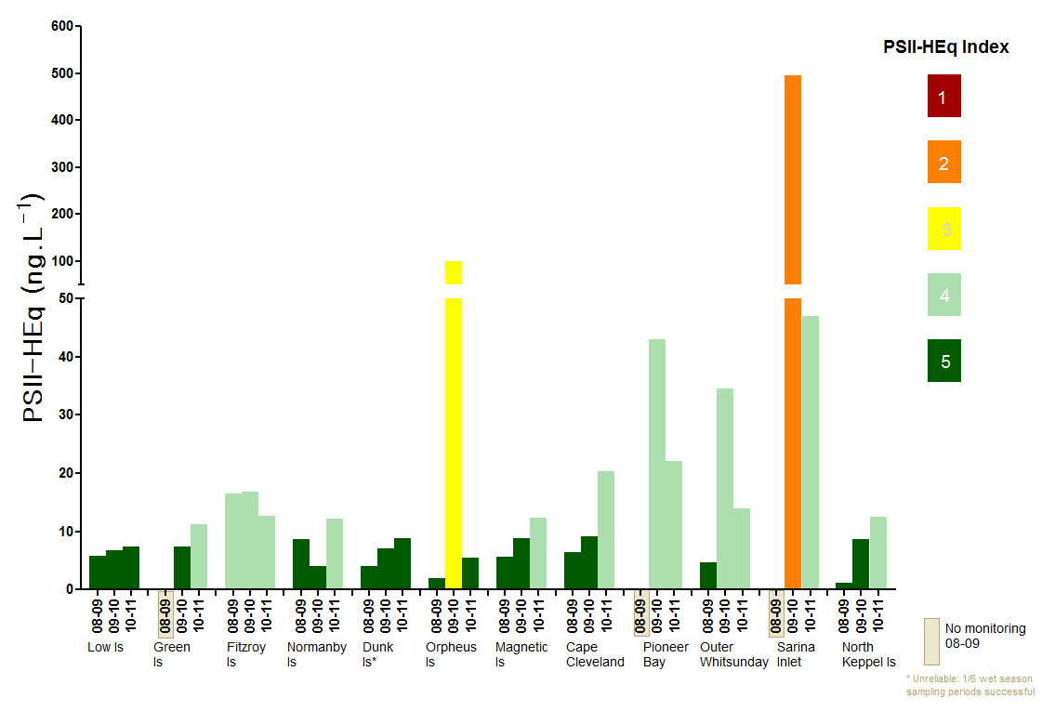
Figure 5 PSII-HEq Max at each site in 2010-2011 along with the two previous monitoring years

PSII-HEq Max for the regions ranged from 8 – 13 ng.L⁻¹ in the Wet Tropics, 5.4 – 20 ng.L⁻¹ in the Burdekin Region, 14 – 47 ng.L⁻¹ in the Mackay Whitsunday and was 12 ng.L⁻¹ at the single routine site in the Fitzroy region. These values indicate maximum PSII-HEq Index categories of 4 for each region in 2010-2011. The PSII-HEq Max values for each site in 2010-2011 are compared to both the baseline reporting year 2008-2009 and 2009-2010 in Figure 4.This year was the first time since monitoring commenced that the North Keppel Island site has had a Category 4 maximum. This essentially reflects the typical relative abundance of PSII herbicides such as tebuthiuron and atrazine which are less potent PSIIs (REPs < 1, Table 6) at this site, and an increase in maximum diuron concentrations in the last two years. The sites with the lowest PSII-HEq Max in 2010-2011 were Low Isles to the north of the Wet Tropics region and Orpheus Island at the northern end of the Burdekin region which were the only sites with Category 5 maxima. Dunk Island also had a Category 5 maximum of 8.8 ng.L⁻¹, but with only a single successful wet season sampling period this is an unreliable indicator for this site. The Sarina Inlet site in the Mackay Whitsunday region is again the site with the highest PSII-HEq maximum of 47 ng.L⁻¹, which is approaching Category 3 on the Index. Routine monitoring at fixed sites provides a good indicator of change through time within a region, but may not always characterise risk of exposure to PSII herbicides between and within regions. This is due to the low number of sites within a region and the varying location of sites with respect to major source rivers. The Sarina Inlet and Pioneer Bay sites for example are relatively close to the coast and we expect these kinds of sites to have higher concentrations by virtue of their proximity to sources if concentrations from the sources are high. In this year, the Tully Transect Case Study is used to illustrate the temporal and spatial variation which may exist within the Wet Tropics region which may not be adequately captured by fixed-site monitoring.

Tully Transect Case Study
Atrazine, diuron and hexazinone and imidacloprid are the pesticides present at the highest concentrations in the Tully River (Table 10). The insecticide imidacloprid was detected in every grab sample at concentrations ranging from 20-120 ng.L⁻¹. PSII Index Categories for these source waters to the inshore GBR ranged from Category 5 to 2, although Categories 4 and 3 occurred more frequently across this wet season sampling period (Figure 6). When the Category 2 maximum was measured on 22 January, there was no concurrent passive or grab sampling at the Tully transect sites.

Passive sampling has detected a greater range of herbicides present on the transect sites extending from the Tully mouth to Sisters Island. These herbicides include ametryn, prometryn simazine, tebuthiuron and metolachlor, albeit at concentrations lower than the most abundant pesticides atrazine, diuron, hexazinone and imidacloprid. Grab sampling has detected atrazine, diuron, hexazinone and imidacloprid as far as the Tully mouth, but only diuron (55% detects) and hexazinone (36% detects) as far as Bedarra Island, and only diuron (45% detects) 35 km from the Tully River at Sisters Island. The PSII-HEq Max determined at the Tully mouth are both Category 3 using either passive sampling (78 ng.L⁻¹) or grab sampling (68 ng.L⁻¹). At Bedarra Island PSII-HEq Max was Category 3 using passive sampling (72 ng.L⁻¹) and Category 4 using grab sampling (48 ng.L⁻¹). PSII-HEq Max at Sisters Island were Category 4 as indicated by both passive (33 ng.L⁻¹) and grab (20 ng.L⁻¹) sampling. These maximum PSII-HEq values at the Tully mouth and Bedarra Island were observed from the 12 – 15 February. Unfortunately, the passive sampler from Sisters Island was lost during this period so no concurrent estimate is available for this site; however, grab samples taken on 12 and 15 February were Categories 4 (20 ng.L⁻¹) and 5 (10 ng.L⁻¹). It is notable that while Category 3 time-averaged maxima over 3 days have been observed at Bedarra, Island the risk of PSII herbicide exposure at this site is more typically Category 4 and 5. However, at times during this wet season the concentrations of PSII herbicides measured at this site 20 km from the Tully River have been relatively synonymous with those measured at the Tully mouth during the same period of time indicating little dilution of plume waters over these distances in specific periods. A clear decline in risk of exposure to PSII herbicides with distance from the Tully River between the Tully mouth and Sisters Island is evident in this region in most periods. This is further illustrated for each site in Figure 6 and in Appendix E, Figures 18 and 19.

Table 10 The range in time-integrated and “snap-shot” concentrations in water with distance from the Tully River at Tully Transect sites

Site |  |  | PSII Herbicides (Included in PSII-HEq Index) |  |  |  |  |  |  |  |  |  |  |  | Other Herbicides |  | Insecticides
 | Sampling Modeª | Distance (km) | Ametryn | Atrazine | DE Atrazine | DI Atrazine | Diuron | Hexazinone | Prometryn | Simazine | Tebuthiuron | PSII-HEq | PSII-HEq Max | Bromacil | Terbutryn^{b} | Metolachlor | Imidaclprid^{b}
Tully River | SS | 0 | n.d. | n.d.-160 | n.d.-20 | n.d. | n.d.-270 | n.d.-110 | n.d. | n.d. | n.d. | n.d.-340 | 340 | n.d. | n.d. | n.d. | 20-120
% Detects |  |  | 0 | 48 | 13 | 0 | 87 | 70 | 0 | 0 | 0 | 87 |  | 0 | 0 | 0 | 100
Tully Mouth | TI | 5 | n.d.-1.5 | 1.5-16 | n.d.-2.0 | n.d.-0.43 | 6.4-59 | 5.0-36 | n.d.-0.02 | n.d.-1.9 | 0.24-3 | 8.6-76 | 76 | n.d.-0.22 | n.d.-0.03 | n.d.-0.11 | 5.8-30
% Detects |  |  | 43 | 100 | 86 | 43 | 100 | 100 | 29 | 86 | 100 | 100 |  | 43 | 25 | 57 | 100
 | SS |  | n.d. | n.d.-20 | n.d. | n.d. | n.d.-50 | n.d.-40 | n.d. | n.d. | n.d. | n.d.-68 | 68 | n.d. | n.d. | n.d. | n.d.-50
% Detects |  |  | 0 | 27 | 0 | 0 | 82 | 64 | 0 | 0 | 0 | 91 |  | 0 | 0 | 0 | 91
Bedarra Is | TI | 20 | n.d.-1.4 | 0.74-13 | n.d.-2.3 | n.d.-0.3 | 5.0-54 | 2.1-34 | n.d.-0.1 | n.d.-0.85 | 0.23-3.6 | 6.9-72 | 72 | n.d.-0.21 | n.d | n.d.-0.20 | 0.82-8.3
% Detects |  |  | 75 | 100 | 75 | 25 | 100 | 100 | 38 | 75 | 100 | 100 |  | 25 | 0 | 50 | 100
 | SS |  | n.d. | n.d. | n.d. | n.d. | n.d.-40 | n.d.-20 | n.d. | n.d. | n.d. | n.d.-48 | 48 | n.d. | n.d. | n.d | n.d.
% Detects |  |  | 0 | 0 | 0 | 0 | 55 | 36 | 0 | 0 | 0 | 55 |  | 0 | 0 | 0 | 0
Sisters Is | TI | 35 | n.d.-0.48 | 2.0-9.0 | n.d.-0.31 | n.d.-0.27 | 2.5-26 | 1.4-14 | n.d.-0.03 | n.d.-0.3 | 0.17-4.4 | 3.7-33 | 33 | n.d.-0.23 | n.d. | n.d.-0.14 | n.d.-2.2
% Detects |  |  | 57 | 100 | 57 | 29 | 100 | 100 | 29 | 57 | 100 | 100 |  | 29 | 0 | 57 | 100
 | SS |  | n.d. | n.d. | n.d. | n.d. | n.d.-20 | n.d. | n.d. | n.d. | n.d. | n.d.-20 | 20 | n.d. | n.d. | n.d. | n.d.
% Detects |  |  | 0 | 0 | 0 | 0 | 45 | 0 | 0 | 0 | 0 | 45 |  | 0 | 0 | 0 | 0

ª SS = “snap-shot” concentration estimates derived from 1 L grab water samples; TI = “time-integrated” concentration estimate derived using ED passive samplers; % detects = the proportion of sampling periods out of the total number of sampling periods that a herbicide was detected.; ^{b} Terbutryn and Imidacloprid were only analysed in passive samplers when run on the 4000Q LCMSMS (refer Tables 35-37) – 4 sampling periods, the frequency of detection refers only to the total number of measured samples and the concentration ranges for these should be interpreted with caution (no data between 12 and 22 February at the transect sites for these two compounds) ; There were no exceedances of Water Quality Guidelines (where available) for individual pesticides in this case study.
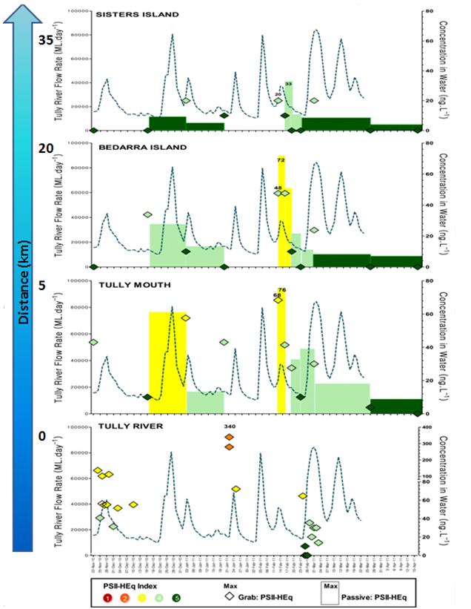

Figure 6 Temporal variation in the risk of exposure to PSII herbicides expressed as PSII-HEq Index Categories with distance from the source in the Tully River up the coast to Sisters Island in the Wet Tropics

Flood Plume Sampling
The results for all grab samples collected during flood plume sampling are provided in Table 38.

Wet Tropics Transect
Grab samples (6) taken on 11 and 12 February at Water Quality Monitoring sites in the Wet Tropics Region showed little risk of exposure on these days at these locations with no pesticides detected at most locations and 10 ng.L⁻¹ of diuron detected offshore from Dunk Island and at the Tully River mouth. These samples all indicate Category 5 PSII herbicide exposures. It is interesting to note that on 12 February grab samples taken from the Tully mouth, Bedarra and Sisters Island as part of the Tully Transect Case Study indicate PSII-HEq of 68, 48 and 20 ng.L⁻¹ respectively, which are Category 3, 4 and 4 on the PSII-HEq Index.

Burdekin Transect
Tebuthiuron was the only pesticide detected in this flood plume. However, the concentration of this herbicide was the same at both 3 and 11 km from the mouth of the Burdekin River at a concentration (20 ng.L⁻¹) which meets the 99% species protection GBRMPA Guideline. The PSII-HEq for these samples taken on 30 December during a peak discharge event was 1.6 ng.L⁻¹ which is Category 5 on the PSII-HEq Index.

Mackay Whitsunday to the Percys, Fitzroy
This transect taken at 10 sites on 19 January demonstrates a clear gradient in the influence of the current peak discharge in the Pioneer River to the north and the latent extent of influence of the Fitzroy River flood plume out to the Percys Group, to the south. Atrazine and diuron were detected both at Round Top Island, 5 km from the Pioneer River mouth and up to 16 km from the Pioneer River past Round Top Island. The diuron concentration remains consistent at these two sites (10 ng.L⁻¹), but the atrazine concentration declines from 20 to 10 ng.L⁻¹ across this distance. The PSII-HEq for these two samples were 30 and 20 ng.L⁻¹ which are both Category 4 on the PSII-HEq Index and consistent with monitoring at routine sites such as Outer Whitsunday (14 ng.L⁻¹, Category 4).

No pesticides were detected at 26 km from the Pioneer River (between Round Top Island and Prudhoe Island), approaching Prudhoe Island, at Prudhoe Island and between Prudhoe Island and Double Island. However at four sites from between Double Island and Digby Island, the Percy Group out to Middle Island, the Percy Group at the end of the transect tebuthiuron was detected at 10 ng.L⁻¹ in all samples. These indicate a PSII-HEq of 0.8 ng.L⁻¹ or Category 5 on the PSII-HEq Index. However, the fact that tebuthiuron is present on 19 January at half of its Guideline value at approximately 240 km from the Fitzroy River which peaked extensively between the 4 and 11 January, is significant.

Fitzroy - Keppels (Shoalwater Bay to Gladstone)
The pesticides detected in flood plumes in the Fitzroy region include atrazine, tebuthiuron, metolachlor and imidacloprid. Atrazine was detected at North Keppel Island (10 and 17 January), and East Peak Island (22 km from the Fitzroy River mouth). Atrazine was present (10 ng.L⁻¹) at North Keppel Island on both occasions and at East Peak Island, 30 and 10 ng.L⁻¹ respectively. By 7 February atrazine was no longer detected at East Peak Island during follow up sampling. Since atrazine is at or approaching the detection limit of 10 ng.L⁻¹ it is perhaps not surprising that it is reported at few sites, even those closer to the river mouth and between East Peak Island and North Keppel Island.

Tebuthiuron was the most frequently detected pesticide in the Fitzroy flood plume sampling (8/15 samples). It was detected at concentrations ranging from 10 ng.L⁻¹ at Osborne Island, Shoalwater Bay on the 20th January at the northern end of the transect to 90 ng.L⁻¹ at East Peak Island on the 10th of January. Tebuthiuron was also detected at Outer Rock (10 ng.L⁻¹), East of North Keppel Island, at North Keppel Island (50 and 60 ng.L⁻¹) on 10 and 17 January, ½ Tide Rock, Great Keppel Island (30 ng.L⁻¹) on 4 January, West Divided Island (20 ng.L⁻¹) on 25 January, and again at East Peak Island (50 ng.L⁻¹) on 17 January. Tebuthiuron was not subsequently detected at East Peak Island in follow up sampling on 7 February. All of these detected concentrations apart from those at Osborne Island, Shoalwater Bay and at Outer Rock, East of North Keppel Island would meet or exceed the GBRMPA Guideline. Interestingly while tebuthiuron has been detected above the Guideline as far as Great Keppel Island on 4 January, no pesticides were detected 15 km from the mouth of the Fitzroy heading toward Cape Capricorn on the same day. No pesticides were detected at a second Shoalwater Bay site to the north of the transect on 7 February, to the south at Cape Capricorn itself on the 18 and 25 January or at Curtis Island to the south on 20 January.

Apart from tebuthiuron Guideline exceedances at multiple sites and at different times, metolachlor has been detected at two sites (North Keppel Island 17 January, East Peak Island 10 and 17 January) at 20 ng.L⁻¹. This concentration is the ANZECC and ARMCANZ Interim Working Level for marine waters. Imidacloprid was detected at two sites (West Divided Island 25 January, East Peak Island 17 January and 7 of February). It is interesting to note that while the concentrations of atrazine and tebuthiuron decrease at East Peak Island between 10 and 7 February (30, 10, n.d.; 90, 50, n.d. respectively), the concentration of imidacloprid increases from n.d. to 50 to 140 ng.L⁻¹ across the same period at this site. At the only other site where imidacloprid was detected (West Divided Island) the imidacloprid concentration was10 ng.L⁻¹.

The PSII-HEq for these flood plume samples in the Fitzroy region are more typically Category 5 (n.d. – 6.4 ng.L⁻¹) with one Category 4 of 12 ng.L⁻¹ at East Peak Island on 10 January where the maximum atrazine and tebuthiuron concentrations were measured. It is notable that North Keppel Island which is also a routine monitoring site has PSII-HEq of between n.d. and 6.4 ng.L⁻¹ or Category 5. These PSII-HEq are likely to be less than the time-integrated estimates for North Keppel Island determined using passive sampling due to the non-detection of the more potent PSII herbicide, diuron in these grab samples. A Category 4 PSII-HEq Max has been detected as far out as North Keppel Island at the routine monitoring site and also at Halfway Island in additional time-integrated sampling done during this extreme flood event in the Region (Table 39).

The distribution of pesticides detected across the GBR in the current wet season during flood plume sampling is illustrated for specific sites in Figure 7. The PSII-HEq Index Category of each of these samples is also indicated. Any individual concentrations of metolachlor and tebuthiuron which met or exceeded Water Quality Guidelines (Table 6) are indicated on Figure 7 for each grab sample.

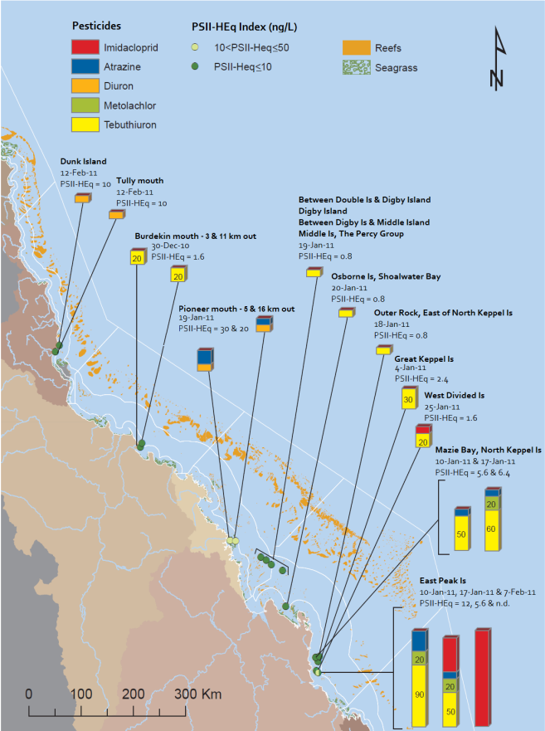
Figure 7 Terrestrial run-off transects in the Wet Tropics, Burdekin, Mackay Whitsunday and Fitzroy regions showing both total concentration (ng.L⁻¹) and PSII-HEq Index category for specific samples - Concentrations of individual pesticides (metolachlor and tebuthiuron) which met or exceeded any Water Quality Guideline are indicated
(Map source – modification of an original map provided by Michelle Devlin, ACTFR, JCU)

REGIONAL SUMMARIES 2010-2011

Wet Tropics Region
Routine sampling sites in the Wet Tropics Region in 2010-2011 were at Low Isles, Green Island, Fitzroy Island, Normanby Island and Dunk Island. Low Isles, Fitzroy Island and Normanby Island have been monitored since 2005 while Dunk Island has been monitored routinely since 2008 (once in 2007) and Green Island since 2009. The historical concentrations of individual PSII herbicides and the growth inhibitor metolachlor at these sites are indicated in Appendix H, Figure 25. A key feature of the results for this region in 2010-2011, was that the increase in concentrations typical of the wet season, were sustained for longer periods of times. This is most evident in the profiles for Low Isles, Green Island (Figure 8) and Fitzroy Island with results for 6 wet season sampling periods in this year. Normanby Island samplers were lost in January and March (4/6) and Dunk Island only had one successful sampling period in November 2010 at the start of the wet season (1/6).
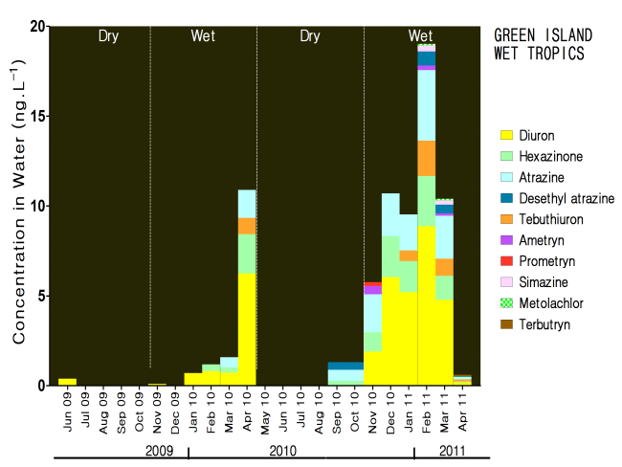
Figure 8 Temporal concentration profile for Green Island in the Wet Tropics

PSII herbicides detected in the Wet Tropics region in 2010-2011 using EDs include ametryn, atrazine, desethyl atrazine, desisopropyl atrazine, diuron, hexazinone, prometryn, simazine, tebuthiuron, terbutryn (only analysed at Green Island site once) and bromacil (only detected at Tully transect sites). Terbutryn and bromacil are not incorporated into the PSII-HEq due to a current lack of REP values but the concentrations are very low and unlikely to contribute significantly. The average and maximum of the detected PSII herbicide concentrations for each routine site in this region are provided in Table 11. The most abundant and most frequently detected herbicides in the Wet Tropics are atrazine, diuron and hexazinone. Diuron is the PSII herbicide present in the highest concentrations in the Wet Tropics. Fitzroy Island is the routine monitoring site which typically has the highest concentrations of these dominant PSII herbicides.

Table 11 Summary statistics for the concentrations (ng.L⁻¹) of individual PSII herbicides and PSII-HEq in 2010-2011 in comparison to the baseline reporting year in the Wet Tropics.
Site |  | Ametryn | Atrazine | DE Atrazine | DI Atrazine | Diuron | Hexazinone | Prometryn | Simazine | Tebuthiuron | PSII-HEq |  |  | Ratio to Baseline ^{b}
 |  |  |  |  |  |  |  |  |  |  | 10-11 | 09-10 | 08-09 | Ratio to Baseline ^{b}
Low Isles | Avgª | 0.34 | 0.65 | 0.32 | 2.0 | 2.8 | 0.89 | 0.19 | n.d. | 0.44 | 4.4 | 1.9 | 2.1 | 2.1
 | Max | 0.62 | 2.1 | 0.43 | 3.6 | 6.5 | 1.6 | 0.55 | n.d. | 0.92 | 7.4 | 6.7 | 5.7 | 1.3
Green Is | Avgª | 0.28 | 1.9 | 0.43 | n.d. | 4.5 | 1.4 | - | 0.29 | 0.90 | 5.7 | 1.7 | - | 3.4
 | Max | 0.45 | 3.9 | 0.78 | n.d. | 8.9 | 2.8 | 0.23 | 0.34 | 2.0 | 11 | 7.4 | - | 1.5
Fitzroy Is | Avgª | 0.36 | 2.1 | 0.44 | n.d. | 5.3 | 1.9 | - | 0.44 | 0.68 | 8.8 | 5.1 | 5.7 | 1.5
 | Max | 0.47 | 4.1 | 0.70 | n.d. | 10 | 3.2 | 0.021 | 0.51 | 1.3 | 13 | 17 | 16 | 0.76
Normanby Is | Avgª | 0.37 | 1.4 | 0.54 | n.d. | 3.7 | 1.2 | - | 0.32 | 0.84 | 6.2 | 1.9 | 2.6 | 2.4
 | Max | 0.47 | 3.6 | 0.66 | n.d. | 10 | 2.8 | 0.0089 | 0.40 | 1.4 | 12 | 4.0 | 8.6 | 1.4
Dunk Is | Avgª | - | 0.90 | n.d. | n.d. | 2.5 | 1.2 | n.d. | - | - | 8.8 | 4.4 | 3.0 | 2.9
 | Max | 2.2 | 1.8 | n.d. | n.d. | 4.8 | 2.3 | n.d. | 0.45 | 0.44 | 8.8 | 7.1 | 4.1 | 2.2
ª Averages for individual herbicides are across both wet and dry season sampling periods. Averages indicated for PSII-HEq are for the wet season sampling periods only (PSII-HEq Avg Wet) as this parameter will be used for trend monitoring in subsequent reports. ^{b} These are the ratio of PSII-HEq Avg Wet and PSII-HEq Max in the current year with respect to the baseline reporting year (08-09), except at Green Island which was only monitored from 2009-2010 Block colours indicate the maximum PSII-Heq Index category for that year.

Seasonal average PSII-HEq values are indicated for each routine site in the region across all monitoring years in Figure 9. Average wet season PSII-HEqs have increased by factors ranging from 1.5 at Fitzroy Island to 3.4 at Green Island between 2010-2011 and the baseline year. The increase in the average wet season PSII-HEq at Fitzroy Island occurs in spite of a reduction in the PSII-HEq Max between these years because of the consistently elevated concentrations across the wet season in 2010-2011. Even though only a single month of the wet season was sampled in 2010-2011 at Dunk Island both the maximum PSII-HEq and average wet season PSII-HEq have increased by more than a factor of 2. While the maximum diuron concentration at Dunk Island is not high, the more potent PSII herbicide ametryn has been detected at the highest concentration for this region at this site.

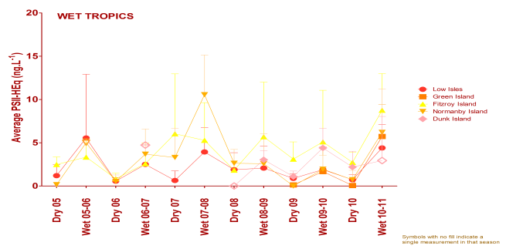
Figure 9 Seasonal average PSII-HEq for Wet Tropics sites since routine monitoring commenced
While the PSII-HEq maximum at routine sites in the Wet Tropics in 2010-2011 did not exceed Category 4, sites on the Tully Transect Case Study such as the Tully mouth and Bedarra Island had Category 3 maxima of 76 and 72 ng.L⁻¹ respectively. The PSII-HEq maximum of 33 ng.L⁻¹ at Sisters Island, whilst still Category 4, is higher than the other time-integrated maxima measured at the routine sampling sites. Other grab sampling conducted as part of terrestrial run-off monitoring (flood plume sampling) were consistently at Category 5 with only diuron (10 ng.L⁻¹) detected at two sites (the Tully mouth and offshore from Dunk Island).

The nicotinoid insecticide imidacloprid was not analysed for at routine sites in 2010-2011 but has been detected at all Tully Transect Case Study sites (Tully mouth, Bedarra Island and Sisters Island) using passive sampling at maximum concentrations of 30, 8.3 and 2.2 ng.L⁻¹ respectively when analysed. This insecticide was routinely analysed in grab samples from this transect but only detected at the Tully mouth at a maximum concentration of 50 ng.L⁻¹.

Metolachlor has also been detected in EDs at all routine monitoring sites (except Dunk Island with one wet season sampling period) at maximum concentrations ranging from 0.059 ng.L⁻¹ (Low Isles) to 0.091 ng.L⁻¹ (Green Island) and at all Tully Transect sites at time-averaged maximum concentrations ranging from 0.11 to 0.20 ng.L⁻¹. Pesticide results obtained using PDMS samplers in the region are summarised in Table 13. These indicate the presence of metolachlor at Fitzroy, Normanby and Dunk Islands, with DEET and ametryn also detected at Dunk Island. These all represent equilibrium concentration estimates and are therefore higher than the time-averaged estimates obtained using EDs. It is interesting to note that the only detection of ametryn in PDMS (8.9 ng.L⁻¹) coincides with the maximum time-integrated estimate for the region (2.2 ng.L⁻¹) in the November sampling period at Dunk Island.

Table 12 Equilibrium concentrations of pesticides (ng.L⁻¹) measured using PDMS samplers in the Wet Tropics Region in 2010-2011
Site |  | Ametryn | Metolachlor | DEET | Chlorpyrifos
Low Isles
Green Is |  | n.d. | n.d. | n.d. | n.d.
Fitzroy Is | Avgª | n.d. | - | n.d. | n.d.
 | Max |  | 1.9
Normanby Is | Avg | n.d. | - | n.d. | n.d.
 | Max |  | 2.5
Dunk Island | Avg | - | - | - | n.d.
 | Max | 8.9 | 1.7 | 2.6
ª Average detected concentrations. Where only one detection was made, the result is presented as Max concentration only.
No pesticides have exceeded the GBRMPA Guidelines (GBRMPA 2010) at Wet Tropics sites in 2010-2011. This is in contrast to 2009-2010 when chlorpyrifos concentrations exceeded the Guideline at all sites where monitoring occurred.

Burdekin Regional Summary
Routine sampling sites in the Burdekin region in 2010-2011 were Orpheus Island, Magnetic Island and Cape Cleveland. Orpheus and Magnetic Island have been monitored since 2005, while Cape Cleveland has been monitored since 2007. The historical concentrations of individual PSII herbicides and the growth inhibitor metolachlor at these sites are indicated in Appendix H, Figure 26. The Cape Cleveland site was cyclone impacted from February to March with sampling only resuming in April 2011. In spite of these missing sampling periods sustained increases in concentrations similar to those recorded in the Wet Tropics region were observed at all three sites in the Burdekin Region and are illustrated for Magnetic Island in Figure 10.

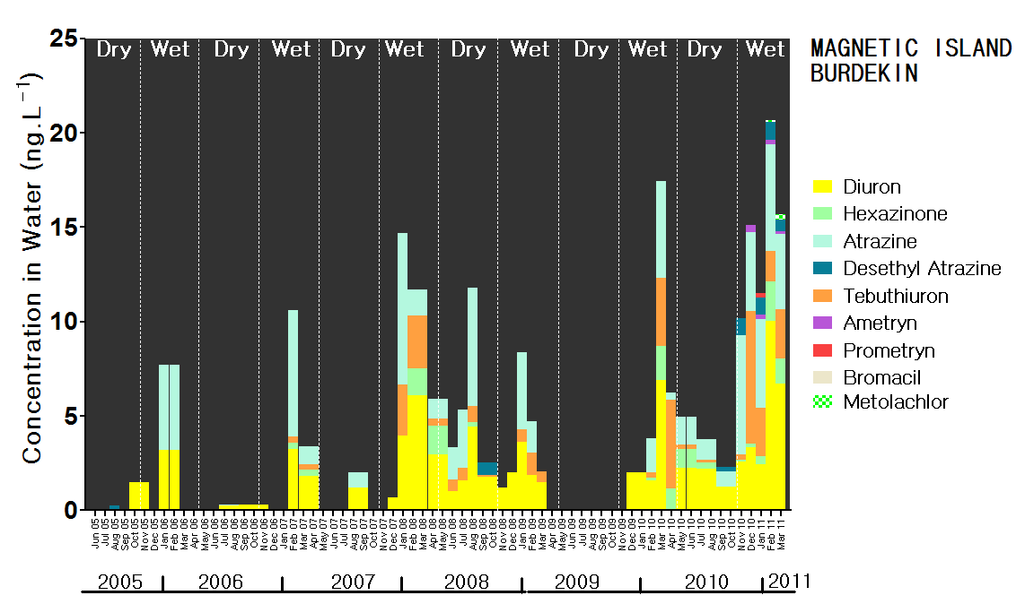

Figure 10 Temporal concentration profile for Magnetic Island in the Burdekin region

PSII herbicides (and transformation products) detected at routine sites in this region include ametryn, atrazine, desethyl atrazine, desisopropyl atrazine, diuron, hexazinone, prometryn, simazine, tebuthiuron and bromacil (Orpheus Island only). The average and maximum of the detected PSII herbicide concentrations for each routine site in this region are provided in Table 14.

The most abundant and frequently detected PSII herbicides in this region are atrazine, diuron, and tebuthiuron. Atrazine concentrations typically exceed diuron concentrations at Cape Cleveland and this is also frequently observed at Magnetic Island, while at Orpheus Island closer to the Wet tropics diuron is again the PSII herbicide present at higher concentrations. Cape Cleveland has the highest maximum concentrations of each of the dominant herbicides in this region and has the highest PSII-HEq maximum for the region of 20 ng.L⁻¹. The PSII-HEq maximum at Magnetic Island is approximately half that of Cape Cleveland, while the maximum at Orpheus Island is approximately half that of Magnetic Island. The PSII-HEq maxima in 2010-2011 were factors of 2.2 to 3.2 times higher than in the baseline reporting year of 2008-2009.

Table 13 Summary statistics for the concentrations (ng.L⁻¹) of individual PSII herbicides and PSII-HEq in 2010-2011 in comparison to the baseline reporting year in the Burdekin region.
Site |  | Ametryn | Atrazine | DE Atrazine | DI Atrazine | Diuron | Hexazinone | Prometryn | Simazine | Tebuthiuron | PSII-HEq |  |  | Ratio to Baseline^{b} | Bromacil
 |  |  |  |  |  |  |  |  |  |  | 10-11 | 09-10 | 08-09 | Ratio to Baseline^{b} | Bromacil
Orpheus Is | Avgª | 0.35 | 1.5 | 0.30 | n.d. | 2.5 | 0.71 | 0.070 | n.d. | 1.0 | 4.2 | 2.4 | 0.59 | 7.0 | -
 | Max | 0.47 | 2.6 | 0.48 | n.d. | 4.4 | 0.98 | 0.13 | n.d. | 3.0 | 5.4 | 100 | 2.0 | 2.8 | 0.18
Magnetic Is | Avgª | 0.25 | 3.5 | 0.72 | 0.48 | 3.8 | 0.79 | 0.14 | 0.32 | 2.1 | 6.8 | 3.4 | 2.3 | 3.0 | n.d.
 | Max | 0.39 | 6.3 | 0.94 | 0.93 | 10 | 2.1 | 0.26 | 0.36 | 7.0 | 12 | 8.8 | 5.6 | 2.2 | n.d.
Cape Cleveland | Avgª | 0.24 | 13 | 2.04 | - | 4.6 | 1.004 | - | - | 3.2 | 11 | 3.2 | 2.3 | 4.6 | n.d.
 | Max | 0.31 | 42 | 3.93 | 0.71 | 12 | 2.31 | 0.0046 | 0.13 | 8.2 | 20 | 9.1 | 6.3 | 3.2 | n.d.
ª Averages for individual herbicides are across both wet and dry season sampling periods. Averages indicated for PSII-HEq are for the wet season sampling periods (PSII-HEq Wet Avg) only as this parameter will be used for trend monitoring in subsequent reports. ^{b} These are the ratio of PSII-HEq Wet Avg and PSII-HEq Max in the current year with respect to the baseline reporting year (2008-2009) . Block colours indicate the maximum PSII-Heq Index category for that year.
Seasonal average PSII-HEq values are indicated for each routine site in the region across all monitoring years in Figure 11. Average wet season PSII-HEq have increased by factors ranging from 2.2 at Magnetic Island to 7 at Orpheus Island between 2010-2011 and the baseline reporting year.

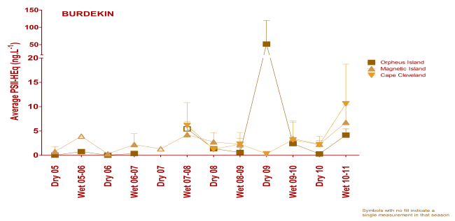
Figure 11 Seasonal average PSII-HEq for Burdekin sites since routine monitoring commenced

Metolachlor was also detected using EDs at all sites at maximum concentrations ranging from 0.10 ng.L⁻¹ at Orpheus Island to the north of the region to 0.36 ng.L⁻¹ at Cape Cleveland. Pesticide results obtained using PDMS samplers in the region are summarised in Table 15. These indicate maximum concentrations of metolachlor ranging from 4.0 ng.L⁻¹ at Magnetic Island to 6.5 ng.L⁻¹ at Cape Cleveland. Atrazine concentrations similarly decrease between Cape Cleveland and Magnetic Island with maximum concentrations of 49 and 28 ng.L⁻¹ respectively. It is notable that the equilibrium estimate at Cape Cleveland is consistent with the time-averaged estimate at this site which may indicate exposure has been relatively consistent at this site. DEET has also been detected at Cape Cleveland (3.4 ng.L⁻¹) and the organophosphate insecticide chlorpyrifos at Magnetic Island (0.22 ng.L⁻¹). This chlorpyrifos concentration was approximately a factor of 2 times lower than the GBRMPA Guideline.

Table 14 Equilibrium concentrations of pesticides (ng.L⁻¹) measured using PDMS samplers in the Burdekin region in 2010-2011
Site |  | Atrazine | Metolachlor | DEET | Chlorpyrifos
Orpheus Is
Magnetic Is | Avg | 20 | 2.0 | n.d. | -
 | Max | 28 | 4.0 | n.d. | 0.22
Cape Cleveland | Avg | 45 | 3.3 | 3.3 | n.d.
 | Max | 49 | 6.5 | 3.4

The only GBRMPA Guideline which was reached in 2010-2011 in the Burdekin region was that of tebuthiuron (20 ng.L⁻¹) in two grab samples taken during flood plume monitoring out from the mouth of the Burdekin River. No other pesticides were detected in these flood plume samples.

Mackay Whitsunday Regional Summary
Routine sampling sites in the Mackay Whitsunday region in 2010-2011 were Pioneer Bay, Outer Whitsunday and Sarina Inlet. Outer Whitsunday has been monitored since 2006 while the Pioneer Bay and Sarina Inlet sites were established in 2009. The historical concentrations of individual PSII herbicides and the growth inhibitor metolachlor at these sites are indicated in Appendix H, Figure 27. Concentrations were elevated during the wet season at sites in this region in 2010-2011 but not to the extent measured at these sites in 2009-2010. The temporal profile for Sarina Inlet is provided in Figure 12.
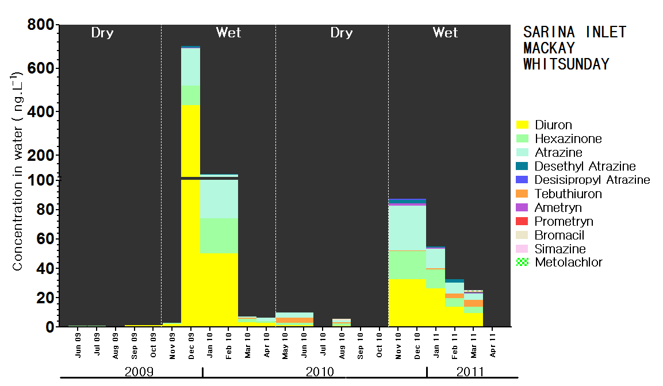
Figure 12 Temporal concentration profile for Sarina Inlet in the Mackay Whitsunday region

PSII herbicides (and transformation products) detected at routine sites in this region include ametryn, atrazine, desethyl atrazine, desisopropyl atrazine (except Pioneer Bay), diuron, hexazinone, prometryn, simazine, tebuthiuron, and bromacil (Sarina Inlet only). The average and maximum of the detected PSII herbicide concentrations for each routine site in this region are provided in Table 16. The most abundant and frequently detected PSII herbicides in this region are atrazine, diuron, hexazinone and tebuthiuron. Diuron is the PSII herbicide present in the highest concentration at each site in this region.

Sarina Inlet has the highest concentrations of the dominant PSII-herbicides and the highest PSII-HEq Max for this region of 47 ng.L⁻¹, a high Category 4 value on the PSII-HEq Index and the highest of all routine monitoring sites in 2010-2011. The PSII-HEq maximum at Pioneer Bay is approximately half that of Sarina Inlet and Outer Whitsunday is the lowest for the region. The PSII-HEq at Outer Whitsunday is more typical of maxima at several routine island sites in the Wet Tropics (Green, Fitzroy and Normanby Islands) and one in the Burdekin (Magnetic Island) in 2010-2011. The maximum PSII-HEqs in 2010-2011 were factors of 0.09 to 0.51 times lower than in the first monitoring year 2009-2010 at Pioneer Bay and Sarina Inlet (Table 14).

Table 15 Summary statistics for the concentrations (ng.L⁻¹) of individual PSII herbicides and PSII-HEq in 2010-2011 in comparison to the baseline reporting year in the Mackay Whitsunday region
Site |  | Ametryn | Atrazine | DE Atrazine | DI Atrazine | Diuron | Hexazinone | Prometryn | Simazine | Tebuthiuron | PSII-HEq |  |  | Ratio to Baseline^{b} | Bromacil
 |  |  |  |  |  |  |  |  |  |  | 10-11 | 09-10 | 06-07 | Ratio to Baseline^{b} | Bromacil
Pioneer Bay | Avgª | 0.23 | 1.8 | 0.27 | n.d. | 11 | 1.1 | 0.033 | 1.1 | 1.6 | 12 | 29 | - | 0.41 | n.d.
 | Max | 0.40 | 5.9 | 0.49 | n.d. | 19 | 2.7 | 0.04 | 3.0 | 3.33 | 22 | 43 | - | 0.51 | n.d.
Outer Whitsunday | Avg | 0.39 | 2.6 | 0.58 | - | 4.4 | 1.4 | 0.12 | - | 1.9 | 9.2 | 13 | 7.5 | 1.2 | n.d.
 | Max | 0.64 | 5.5 | 0.66 | 0.29 | 11 | 2.5 | 0.17 | 0.36 | 6.5 | 14 | 35 | 19 | 0.73 | n.d.
Sarina Inlet | Avg | 0.73 | 8.7 | 1.1 | 0.48 | 12 | 6.5 | 0.030 | - | 1.8 | 22 | 114 | - | 0.20 | 0.68
 | Max | 1.5 | 31 | 2.4 | 0.74 | 33 | 19 | 0.052 | 0.23 | 4.5 | 47 | 495 | - | 0.09 | 0.87
ª Averages for individual herbicides are across both wet and dry season sampling periods. Averages indicated for PSII-HEq are for the wet season sampling periods only (PSII-HEq Wet Avg) as this parameter will be used for trend monitoring in subsequent reports. ^{b} These are the ratio of PSII-HEq Avg Wet and PSII-HEq Max in the current year with respect to the first monitoring year for Sarina Inlet and Pioneer Bay – 2009-2010, and 2006-2007 at Outer Whitsunday due to the unreliable sampling record in the baseline reporting year (08-09) Block colours indicate the maximum PSII-Heq Index category for that year

PSII HEq comparisons to the baseline reporting year used in other regions (2008-2009) are not possible in Mackay Whitsunday due to either an unreliable sampling record in 2008-2009 (Outer Whitsunday – 1 wet season sampling period with nothing detected) or that Pioneer Bay and Sarina Inlet were new sites in 2009-2010. In this case, 2009-2010 is used as the baseline reporting year for the new sites, and 2006-2007 is used for Outer Whitsunday since this was the only previous year with a good sampling record in the wet season period (5 samples). PSII-HEq Max has reduced by a factor of between 0.51 – 0.09 at Pioneer Bay and Sarina Inlet. The reduction at Sarina Inlet has been very significant with PSII-HEq Max improving from Category 2 to a high Category 4. Outer Whitsunday also reduced by a factor of 0.40 from 2009-2010 similar to Pioneer Bay, but has only reduced by a factor of 0.73 from 2006-2007.

Seasonal average PSII-HEq values are indicated for each routine site in the region across all monitoring years on Figure 13. Average wet season PSII-HEq have decreased by factors ranging from 0.41 – 0.20 at Pioneer Bay and Sarina Inlet. The reduction in the seasonal average is less acute than that of the PSII-HEq Max at Sarina Inlet. The Outer Whitsunday wet season average has however increased slightly from 2006-2007 event though the PSII-HEq Max was 30% lower. There was however a reduction in the wet season average from 2009-2010 (factor of 0.71) though not as marked as those at Pioneer Bay and Sarina Inlet. Overall, in spite of long-term median discharges in both the Pioneer and O’Connell Rivers in the Mackay Whitsunday region being more than 3 times the long term median the relationship between discharge and exposure to PSII herbicides is beginning to show signs of improvement in this region.

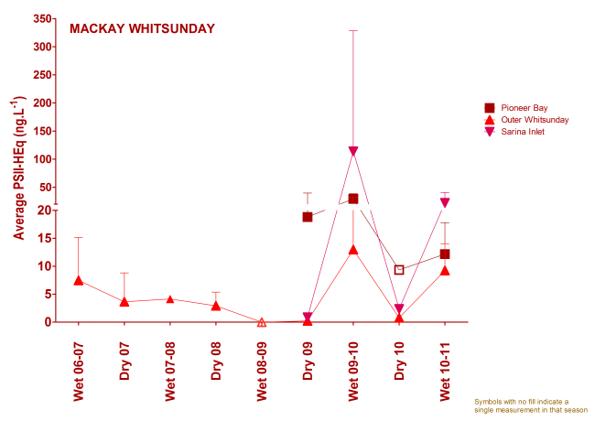
Figure 13 Seasonal average PSII-HEq for Mackay Whitsunday sites since routine monitoring commenced

PSII-HEq in flood plume samples at 5 and 16 km from the mouth of the Pioneer River at Round Top Island and east of Round Top Island were 30 and 20 ng.L⁻¹ respectively which are also Category 4 maxima but higher than that measured at Outer Whitsunday to the north of the O’Connell and Pioneer Rivers. All other flood plume samples in the transect extending out to the Percy’s Group in the Fitzroy region (where tebuthiuron begins to be detected at 10 ng.L⁻¹) were Category 5.

Metolachlor was also detected using EDs at all sites at maximum concentrations ranging from 0.36 ng.L⁻¹ at Pioneer Bay to 0.59 ng.L⁻¹ at Outer Whitsunday. Pesticide results obtained using PDMS samplers at Outer Whitsunday in the region are summarised in Table 17. The concentrations of metolachlor are similar to those measured in the Burdekin region and higher than in the Wet Tropics which is consistent with the relative distribution indicated using time-integrated sampling at routine sites. The concentrations of DEET are the highest detected by an order of magnitude in this year.

Table 16 Equilibrium concentrations of pesticides (ng.L⁻¹) measured using PDMS samplers in the Mackay Whitsunday region in 2010-2011
Site |  | Metolachlor | DEET | Chlorpyrifos
Pioneer Bay
Outer Whitsunday | Avgª | 3.5 | 21 | n.d.
 | Max | 6.8 | 23 | n.d.
Cape Cleveland
ª Average detected concentration

There were no exceedances of GBRMPA Guidelines (GBRMPA 2010) for any pesticide samples in the Mackay Whitsunday region in 2010-2011.

Fitzroy Regional Summary
The only routine monitoring site in the Fitzroy region is at North Keppel Island. This site has been monitored since 2005 although the sampling record is relatively patchy in some years. The historical concentrations profile for PSII herbicides and metolachlor at North Keppel Island with gaps in the sampling record indicated is shown in Figure 14.

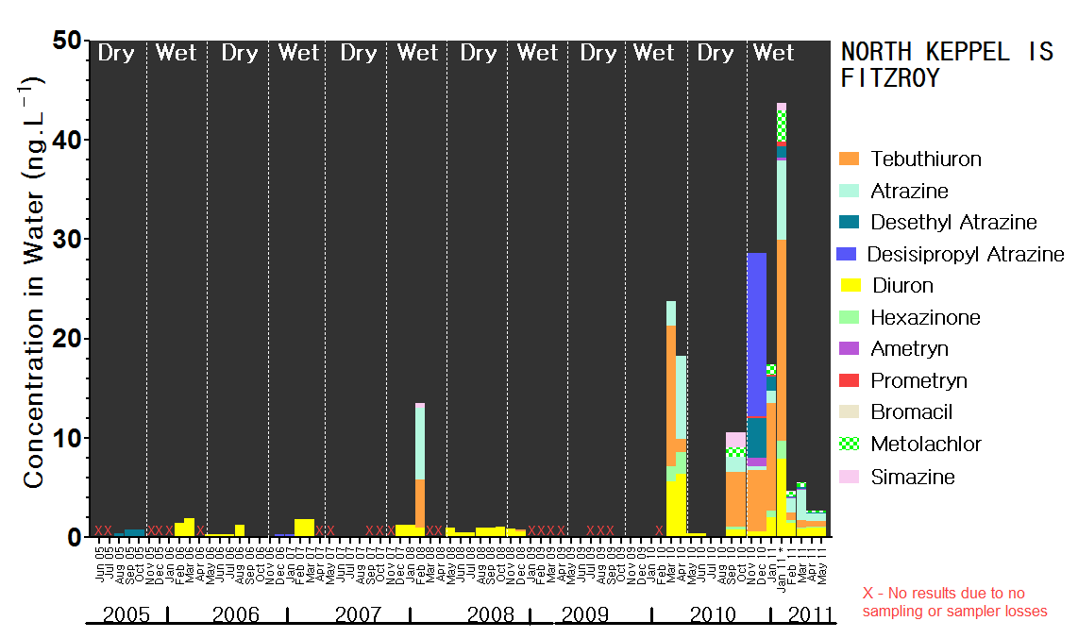

Figure 14 Temporal concentration profile for North Keppel Island in the Fitzroy Region.

PSII herbicides (and transformation products) detected at this site in 2010-2011 include ametryn, atrazine, desethyl atrazine, desisopropyl atrazine, diuron, hexazinone, prometryn, simazine, tebuthiuron and bromacil. The PSII herbicides detected with high frequency are atrazine, diuron and tebuthiuron. Tebuthiuron is the PSII herbicide present at highest concentrations particularly when the site is impacted by flood waters. Atrazine or the atrazine transformation product desisopropyl atrazine can also be present in the highest concentrations in specific periods in the wet season. Concentration profiles in this region were similar to sites in the Burdekin region such as Cape Cleveland and Magnetic Island. The average and maximum concentration for these herbicides at North Keppel Island in 2010-2011 are provided in Table 18.

PSII-HEq Max for 2010-2011 at North Keppel Island was 12 ng.L⁻¹ or a low Category 4 on the PSII-HEq Index. This is the first time a Category 4 has been measured at North Keppel Island which has consistently been a Category 5 site. Additional sampling undertaken at Middle Reef, Halfway Island and Clam Island in the same period as this maximum was observed at North Keppel Island (Appendix F, Table 39 and Figure 20), indicated PSII-HEq of 8.3, 10.3.,and 6.7 ng.L⁻¹ which are consistent being Category 5, 4 and 5 respectively. It should be noted that the diuron breakdown product 3,4-dichloroaniline and the herbicide haloxyfop were also detected in these samples. PSII-HEq determined from the analysis of grab samples from plume monitoring were all Category 5 except for one sample taken at East Peak Island on 10 January with PSII-HEq of 12 ng.L,⁻¹ which is Category 4.

Table 17 Summary statistics for the concentrations (ng.L⁻¹) of individual PSII herbicides and PSII-HEq in 2010-2011 in comparison to the baseline reporting year in the Mackay Whitsunday region
Site |  | Ametryn | Atrazine | DE Atrazine | DI Atrazine | Diuron | Hexazinone | Prometryn | Simazine | Tebuthiuron | PSII-HEq |  |  | Ratio to Baseline^{b} | Bromacil
 |  |  |  |  |  |  |  |  |  |  | 10-11 | 09-10 | 08-09 | Ratio to Baseline^{b} | Bromacil
North Keppel Is | Avgª | 0.27 | 2.3 | 1.1 | - | 1.9 | 0.54 | 0.20 | 0.78 | 6 | 4.0 | 4.1 | 0.73^{c} | 5 | -
 | Max | 0.90 | 8.0 | 3.9 | 16 | 7.9 | 1.8 | 0.42 | 1.5 | 20 | 12 | 8.7 | 1.1^{c} | 12 | 0.83
ª Averages for individual herbicides are across both wet and dry season sampling periods. Averages indicated for PSII-HEq are for the wet season sampling periods (PSII-HEq Wet Avg) only as this parameter will be used for trend monitoring in subsequent reports. ^{b} These are the ratio of PSII-HEq Wet Avg and PSII-HEq Max in the current year with respect to the baseline monitoring year 2008-2009; ^{c}In 2008-2009 North Keppel Island PSII HEq maximum was derived from 4 dry season sampling periods and 2 wet season sampling period, the average for the wet season is therefore from only two sampling periods. For comparison the ratios with respect to 2009-2010 for the average wet season and maximum are 0.98 and 1.4 respectively. Block colours indicate the maximum PSII-Heq Index category for that year.

Seasonal average PSII-HEq values are indicated for North Keppel Island on Figure 15. Average wet season PSII-HEq have increased by a factor of 5 from the baseline reporting year, but with only two wet season periods sampled in that year. The average for the 2010-2011 wet season is equivalent to that from 2009-2010 (factor of 0.98).

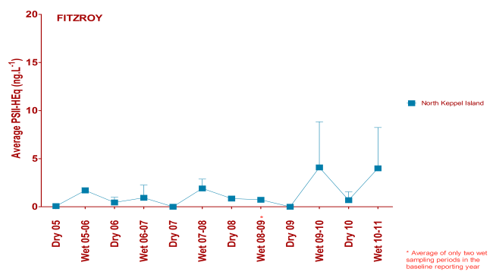
Figure 15 Seasonal average PSII-HEq for North Keppel Island in the Fitzroy region since routine monitoring commenced

The herbicide metolachlor was also detected in routine sampling at North Keppel Island with time-averaged maximum concentration of 3.2 ng.L⁻¹ which was the highest time-averaged estimate for routine monitoring sites. Middle Reef, Halfway Island and Clam Island had similar concentrations in the same period ranging from 2.1 – 3.5 ng.L⁻¹. No PDMS sampling is undertaken at North Keppel Island. Metolachlor was also detected in 3 grab samples taken from North Keppel Island on 17 January, and East Peak Island on 10 and 17 January, all 20 ng.L⁻¹ (Table 19).

A summary of pesticides detected in grab samples taken during terrestrial run-off monitoring of flood plumes is provided in Table 19. All results for this plume sampling are provided in Appendix D, Table 38, but no pesticides were detected in the other samples. It is notable that the only PSII herbicides detected in these flood plume samples are atrazine and tebuthiuron which is consistent with these being the dominant herbicides in this region. However it also means that the PSII-HEq estimates provided are only the sum of the equivalent concentrations of these two herbicides which are less potent PSIIs. It is notable that tebuthiuron at 10 ng.L⁻¹ was detected as far north as the Percy Group on the Mackay-Fitzroy transect on 19 January. Imidacloprid was also present in this region at West Divided Island and East Peak Island at concentrations ranging from 10 – 140 ng.L⁻¹. The maximum of 140 ng.L-1 occurred at East Peak Island, 22 km from the mouth of the Fitzroy River This finding is interesting as it was only measured as far out as the Tully mouth using grab sampling in the Wet Tropics region on the Tully transect study at a maximum concentration of 50 ng.L⁻¹. Unfortunately none of the passive sampling conducted in the Fitzroy region in this year has been analysed for imidacloprid.

Table 18 A summary of terrestrial run-off monitoring results for the Fitzroy Region (ng.L⁻¹)
 | Date | Atrazine | Diuron | Tebuthiuron | PSII-HEq | Metolachlor | Imidacloprid
Osborne Is, Shoalwater Bay | 20-Jan-11 | n.d. | n.d. | 10 | 0.8 | n.d. | n.d.
Outer Rock East of North Keppel Is | 18-Jan-11 | n.d. | n.d. | 10 | 0.8 | n.d. | n.d.
North Keppel Is | 10-Jan-11 | 10 | n.d. | 50 | 5.6 | n.d. | n.d.
 | 17-Jan-11 | 10 | n.d. | 60 | 6.4 | 20 | n.d.
Great Keppel Island | 4-Jan-11 | n.d. | n.d. | 30 | 2.4 | n.d. | n.d.
West Divided Island | 25-Jan-11 | n.d. | n.d. | 20 | 1.6 | n.d. | 10
East Peak Island | 10-Jan-11 | 30 | n.d. | 90 | 12 | 20 | n.d.
 | 17-Jan-11 | 10 | n.d. | 50 | 5.6 | 20 | 50
 | 7-Feb-11 | n.d. | n.d. | n.d. | n.d. | n.d. | 140
Red values indicate GBRMPA Guideline exceeded; orange values indicate the ANZECC and ARMCANZ interim working level for marine waters was met. Block colours indicate the maximum PSII-Heq Index category for that year.

There were exceedances of the GBRMPA Guideline for tebuthiuron in the Fitzroy region in 2010-2011. These were detected using time-integrated sampling at North Keppel Island and at Halfway Island during January 2011 (20 ng.L⁻¹) and also at North Keppel Island (50 -60 ng.L⁻¹), Great Keppel Island (30 ng.L⁻¹), West Divided Island (20 ng.L⁻¹) and East Peak Island (90 and 50 ng.L⁻¹). Metolachlor concentrations at North Keppel Island and East Peak Island reach the Interim Working Level for marine waters under the ANZECC and ARMCANZ Guidelines.

DISCUSSION
The wet season in 2010-2011 has been one of extreme weather events with discharges from rivers in the Wet Tropics achieving between 1.5 to 3 times higher and those in the Burdekin, Mackay Whitsunday and Fitzroy regions achieving more than 3 times higher than their long-term medians (Schaffelke et al. 2011). This has meant that the inshore waters of much of the GBR have been impacted by terrestrial discharge in flood plume waters over extended periods of time (Brando et al. 2011; Devlin et al. 2011). The influence of increases in discharge on concentrations of individual PSII herbicides has been demonstrated previously by correlations with the remotely sensed parameter coloured dissolved organic matter as a proxy for freshwater extent (reduced salinity) for pesticide data up to the 2009-2010 reporting year at specific sites in the Wet Tropics region (Kennedy et al. 2011; Schroeder et al. 2011 under review). In this year, clear relationships are apparent between daily mean discharge and PSII-HEq as an indicator of risk of exposure to PSII herbicides. This is illustrated for Low Isles and the Mossman River and Green Island and the Barron River in the Wet Tropics region in Figure 16.
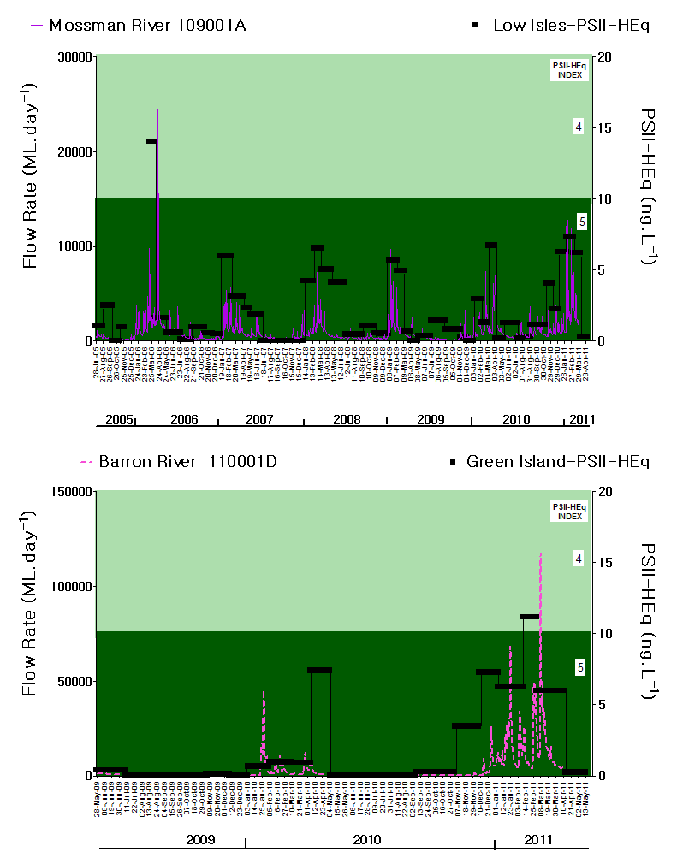
Figure 16 Temporal trends in both flow rate in rivers in adjacent catchments and PSII-HEq at inshore GBR sites

It is therefore problematic to assess trends in exposure in response to Reef Plan (Anon 2009) and Reef Rescue initiatives to reduce PSII herbicide loads since the baseline reporting year, due to concurrent increases in median discharge particularly in this latest wet season. Any reported increases in exposure should therefore be interpreted with the potential drivers of this change in mind. The PSII-HEq Max for routine monitoring sites in 2010-2011 are indicated in Figure 17. The relative contribution of individual PSII herbicides to these equivalent concentrations (accounting for the relative potency of each) are indicated.

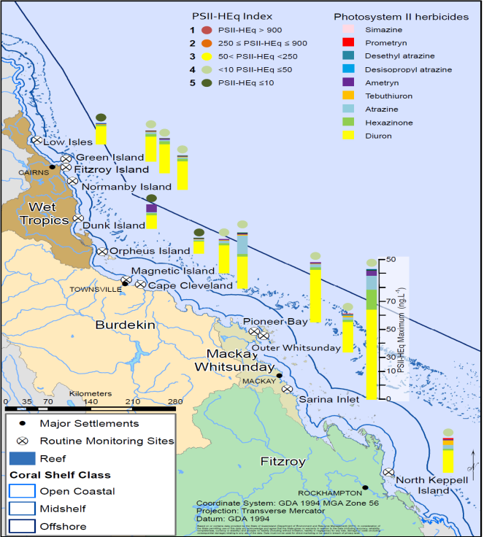Figure 17 PSII-HEq Max (ng.L⁻¹) with the PSII-HEq Index of each value indicated for each routine site 2010-2011
(Source – Modification of original map provided by Adam Donovan and Alex Shanahan, School of Geography, Planning and Environmental Management, The University of Queensland)

Diuron is the dominant contributor to the PSII-HEq Max at every routine site which is consistent with previous years of monitoring. Diuron contributes an average of 77% in the Wet Tropics (83% with Dunk Island excluded), 72% in the Burdekin, 76% in the Mackay Whitsundays and 64% at North Keppel Island in the Fitzroy region to these PSII-HEq Max. On 15 July 2011, the APVMA proposed the suspension of diuron use in Australia due to the risk posed to aquatic ecosystems based on the findings of their environmental assessment report (APVMA 2011). If the proposed suspension of diuron except for uses in antifoulant paints and for algae control does occur, the data generated in this marine monitoring program will provide baseline data for monitoring changes in PSII-HEq as a result of regulatory activity.

It is notable that tebuthiuron contributes 13% at North Keppel Island, 3% in the Burdekin region, 2% in the Mackay Whitsundays and 1% in the Wet Tropics. This herbicide has a strong signal associated with control of tree growth and woody weeds on grazing lands (Lewis et al. 2009). Atrazine contributes more at North Keppel Island in the Fitzroy region (10%), Sarina Inlet in the Mackay Whitsunday (10%) and at Cape Cleveland in the Burdekin region (33%). Atrazine and tebuthiuron have been shown to dominate loads in the Fitzroy region (Packett et al. 2009) while atrazine can be the dominant herbicide in rivers discharging in the Burdekin region (Davis et al. 2008). What we do tend to see is a reduction in the relative contribution of atrazine at sites further from the coast even when it is present at relatively high concentrations close to the coast. For example the contribution to the maximum is 33% at Cape Cleveland but reduces to 7% at Magnetic Island in the Burdekin region. Ametryn contributes a maximum of 33% to the single wet season maximum at Dunk Island, but averages between 2 – 4% elsewhere. Hexazinone average contributions are higher in the Wet Tropics and Mackay Whitsunday regions (both 9%). Prometryn contributes 3.5% at North Keppel Island but < 1% in all other region (0% in the Burdekin). Simazine, desethyl atrazine and particularly desisopropyl atrazine all contribute ≤ 1% to these maxima in all regions.

The PSII-HEq Index Categories for these maxima range from 5 to 4 in the Wet Tropics and Burdekin Region, and are Category 4 in the Mackay Whitsunday and Fitzroy region. The PSII-HEq Max at the Tully Mouth and Bedarra Island were Category 3 while Sisters Island was Category 4 which is more consistent with the routine sites in this region. PSII-HEq at the Sarina Inlet site in the Mackay Whitsunday region were again the highest of all routine monitoring sites, but all sites in this region have improved from 2009-2010 in spite of discharge being more than 3 times the long-term median in contributing rivers in this region.

Most grab samples taken to assess terrestrial run-off in flood plumes were Category 5 except for two samples taken 5 and 16 km out from the Pioneer River in the Mackay Whitsunday region which were both Category 4, and one sample in the Fitzroy region at East Peak Island which was Category 4. There were however exceedances of the GBRMPA Guideline for tebuthiuron in two samples taken at 3 and 11 km from the mouth of the Burdekin River, and at North Keppel Island, Great Keppel Island, West Divided Island and East Peak Island. Metolachlor has also reached the interim working level for marine waters at North Keppel and East Peak Island in this region. Tebuthiuron was the only PSII herbicide which reached the GBRMPA Guideline at a routine monitoring site in 2010-2011 (North Keppel Island).

While no guideline values exist for the insecticide imidacloprid it has been detected using passive sampling out as far as Sisters Island in the Wet Tropics region and at a maximum value of 140 ng.L⁻¹ at East Peak Island in the Fitzroy region. This insecticide has not been specifically targeted at routine monitoring sites in 2010-2011 but will be from next year. It has been assessed as both persistent and mobile and has seen increased usage as a termiticide in Australia with a reduction in usage of chlorpyrifos (Boyd et al. 2002). This insecticide has additionally seen increased usage in sugar cane farming to control cane grub as an alternative to chlorpyrifos (Davis et al. 2008). It is also registered for use in Australia as a seed treatment insecticide. The APVMA has noted that while imidacloprid is hydrolytically stable (hydrolysis half life 1 year (EC 2006)), it is susceptible to phototransformation (1 hour artificial light, sterile water (EC 2006)), but that this transformation may be inhibited in turbid Australian waters (Eichner 1994 (Web 2001)). This may account for the detection of this chemical in inshore waters during the wet season due to concomitant turbidity, and rate of phototransformation. Environmental half-lives of approximately 4 hours have been estimated for phototransformation (Liu et al. 2006). Maximum permissible (long-term exposure) and acceptable (short term exposure) concentrations of this insecticide in marine surface waters have been derived as 0.0036 and 360 ng.L⁻¹ respectively as environmental risk limits in Europe (Posthuma-Doodeman 2008). Time-averaged estimates of imidacloprid where measured in the Tully transect case study exceed the maximum permissible concentration to protect aquatic ecosystems from effects due to long-term exposure. However these values are advisory proposed values only to inform the development of Environmental Quality Standards.

The pesticide monitoring program will need to be continuously assessed to ensure that the target chemicals remain relevant through time to reflect changes in usage and to monitor this change. Pesticides for monitoring in the GBR catchments have recently been identified and prioritised and the top 30 list includes photosystem II herbicides such as diuron and atrazine but also pesticides such as imidacloprid and metolachlor (Shaw et al. 2011) which have been detected in inshore GBR waters in 2010-2011. Several of these pesticides such as glyphosate and the phenoxy herbicide 2,4-D are typically not measured either due to analytical expense or a lack of suitable sampling techniques. As these capabilities develop so should our capacity to identify the true risks of exposure on the GBR.

summary
Pesticide monitoring activities undertaken in 2010-2011 have included routine monitoring at fixed sites using time-integrated polar passive samplers (and in some cases non-polar passive samplers). In addition, a more intensive monitoring campaign on a spatial transect out from the Tully River mouth during the wet season using both passive and snap-shot/grab sampling techniques, and terrestrial run-off assessments during flood plume events in four regions using mainly snap-shot sampling was conducted in parallel.

The PSII herbicide tebuthiuron and the dinitroaniline herbicide metolachlor were the only pesticide contaminants which exceeded Water Quality Guidelines in 2010-2011. Most of these exceedances were determined in the Fitzroy Region during terrestrial run-off assessments. The regions where these exceedances were determined were in the Fitzroy Region (tebuthiuron and metolachlor) and in the Burdekin Region (tebuthiuron). The exceedances in the Fitzroy Region occurred at multiple sites and were even observed at up to 4.5 times the GBRMPA Guideline for tebuthiuron of 20 ng.L⁻¹.

The most striking features observed in the PSII herbicide results at the routine monitoring sites in 2010-2011, were the increasing frequency of detection of PSII herbicides such as ametryn, prometryn and bromacil. In addition, PSII-HEq Max were predominantly Category 4 for many sites which are more typically Category 5 across the GBR on the PSII-HEq Index. The reporting parameter PSII-HEq Max increased from the baseline reporting year in most cases, (except for specific sites in the Mackay Whitsunday Region and Fitzroy Island in the Wet Tropics Region). The most notable increases in PSII-HEq Max occurred in the Burdekin (factors of 2.2 – 3.2) and the Fitzroy Region (factor of 12). While the increases in PSII-HEq Max were not always significant, there was a noticeable and consistent increase in the wet season average PSII-HEq (PSII-HEq Wet Avg) at nearly every site. This indicates that exposures to PSII herbicides were more consistently elevated on the GBR across this extraordinary wet season.

Characterising the consistency of exposure remains a difficult task in the often remote areas encountered on the Great Barrier Reef. The Tully transect case study attempted to begin to understand this variability in exposure (spatially and temporally) by using multiple sampling techniques over an extended period of time during the wet season. Both passive and grab sampling indicated the same general trend in exposure to PSII herbicides during this current wet season. In general, there was a higher risk of exposure to PSII herbicides in the Wet Tropics (Category 3 PSII-HEq Max) than the current routine monitoring sites would indicate (Category 4 PSII-HEq Max). Most of the time there is a clear decline in PSII herbicide exposure between the Tully Mouth and Sisters Island to the north. However, at times the risk of exposure at Bedarra Island is consistent with that at the Tully Mouth, indicating little dilution of plume waters for short periods. Further work is required to analyse this data set more completely.

APPENDIX A: Complete analyte list for LCMS and GCMS analysis
Table 19 LCMS Analyte List for Positive Mode

Ametryn
Atrazine
Bromacil
Desethyl Atrazine
Desisopropyl Atrazine
Diuron
Flumeturon
Hexazinone
Imidaclopridª
Metolachlor
Prometryn
Simazine
Tebuthiuron
Terbutrynª

ª only analysed on the 4000Q

Table 20 GCMS analyte list for PDMS extracts with cells shaded grey to indicate chemicals which are not calibrated within the fraction collected during gel permeation (size exclusion) chromatography of extracts and cells shaded blue to indicated industrial chemicals/personal care products which may be detected but are not reported along with pesticides in the MMP results
  ACEPHATE
  ALDRIN
  AMETRYN
  AMITRAZ
  ATRAZINE
  AZINPHOS ETHYL
  AZINPHOS METHYL
  BENALAXYL
  BENDIOCARB
  BIFENTHRIN
  BIORESMETHRIN
  BITERTANOL
  BROMACIL
  BROMOPHOS ETHYL
  CADUSAPHOS
  CAPTAN
  CARBARYL
  CARBOPHENOTHION
  CHLORDANE cis
  CHLORDANE trans
  CHLORDENE
  CHLORDENE EPOXIDE
  CHLORDENE, 1-HYDROXY
  CHLORDENE, 1-OH-2,3-EPOXY
  CHLORFENVINPHOS e+Z
  CHLOROTHALONIL
  CHLORPYRIFOS
  CHLORPYRIFOS ME
  CHLORPYRIFOS OXON
  COUMAPHOS
  CYFLUTHRIN isomers
  CYHALOTHRIN isomers
  CYPERMETHRIN isomers
  DCPP isomers
  DDD o,p
  DDD p,p
  DDE o,p
  DDE pp
  DDT o,p
  DDT p,p
  DEET
  DELTAMETHRIN isomers
  DEMETON-S-METHYL
  DESETHYLATRAZINE
  DESISOPROPYLATRAZINE *900*
  DIAZINON
  DICHLOROANILINE 3,4
  TEBUTHIURON
  TEBUCONAZOLE
  TCPP
  TEMEPHOS
  TEP
  TERBUPHOS
  TERBUTHYLAZINE
  TERBUTRYN
  TETRACHLORVINPHOS
  TETRADIFON
  TETRAMETHRIN isomers
  THIABENDAZOLE
  TONALID
  TRANSFLUTHRIN
  TRIADIMEFON
  TRIADIMENOL ISOMERS
  TRIALLATE
  TRIFLURALIN
  VINCLOZALIN
  DICHLORVOS
  DICLOFOP METHYL
  DICOFOL o,p
  DICOFOL p,p bd
  DIELDRIN
  DIMETHOATE
  DIMETHOMORPH E,Z
  DIOXATHION
  DISULFOTON
  Diuron bd
  ENDOSULFAN alpha
  ENDOSULFAN beta
  ENDOSULFAN ETHER
  ENDOSULFAN LACTONE
  ENDOSULFAN SULPHATE
  ENDRIN
  ENDRIN ALDEHYDE
  ETHION
  ETHOPROP
  ETRIMIPHOS
  FAMPHUR
  FENAMIPHOS
  FENCHLORPHOS
  FENITROTHION
  FENTHION ETHYL
  FENTHION METHYL
  FENVALERATE isomers
  FIPRONIL
  FLUAZIFOP BUTYL
  FLUOMETURON
  FLUVALINATE isomers
  FURALAXYL
  GALOXOLIDE
  HALOXYFOP 2-EtOEt
  HALOXYFOP METHYL
  HCB
  HCH-a
  HCH-b
  HCH-d
  HEPTACHLOR
  HEPTACHLOR EPOXIDE
  HEXAZINONE
  IPRODIONE
  ISOPHENOPHOS
  LINDANE (HCH-g)
  MALATHION
  METALAXYL
  METHAMIDOPHOS
  METHIDATHION
  METHOMYL
  METHOPRENE
  METHOXYCHLOR
  METOLACHLOR
  METRIBUZIN
  MEVINPHOS z+E
  MOLINATE
  MONOCROTOPHOS
  MUSK KETONE
  MUSK XYLENE
  NICOTINE
  NONACHLOR cis
  NONACHLOR trans
  OMETHOATE
  OXADIAZON
  OXYCHLOR
  OXYDEMETON METHYL
  OXYFLUORFEN
  PARATHION ETHYL
  PARATHION METHYL
  PENDIMETHALIN
  PERMETHRIN isomers
  PHENOTHRIN isomers
  PHORATE
  PHOSMET
  PHOSPHAMIDON peak1 **200**
  PHOSPHAMIDON peak2 **800**
  PHOSPHATE TRI-n-BUTYL
  PIPERONYL BUTOXIDE
  PIRIMICARB
  PIRIMIPHOS METHYL
  PROCYMIDONE
  PROFENOPHOS
  PROMETRYN
  PROPAGITE
  PROPANIL
  PROPAZINE
  PROPICONAZOL isomers
  PROPOXUR
  PROTHIOPHOS
  PYRAZAPHOS
  ROTENONE
  SIMAZINE
  SULPROFOS
  TCEP

APPENDIX B – Supporing literature for the development of the PSII-HEq Index
Table 21 Scientific publications indicating the effect concentrations and the end-points for the reference PSII herbicide diuron used to define specific PSII-HEq Index categories as an indicator for reporting purposes
Category | PSII-HEq Range  (ng.L⁻¹) |  | Supporting Literature with Respect to the Reference Chemical Diuron
Category | PSII-HEq Range  (ng.L⁻¹) | Description | Species | Effects Concentration (ng.L⁻¹) | Endpoint | Toxicity measure | Reference
5 | HEq ≤ 10 | No published scientific papers that demonstrate any effects on plants or animals based on toxicity or a reduction in photosynthesis. The upper limit of this category is also the detection limit for pesticide concentrations determined in field collected water samples.
4 | 10 < HEq ≤ 50 | Published scientific observations of reduced photosynthesis for two diatoms. | Diatoms
4 | 10 < HEq ≤ 50 |  | D. tertiolecta | 50 | ↓photosynthesis | LOEC | Bengston Nash et al 2005
4 | 10 < HEq ≤ 50 |  | N. closterium | 50 | Sensitivity | LOEC | Bengston Nash et al 2005
3 | 50 < HEq < 250 | Published scientific observations of reduced photosynthesis for two seagrass species and three diatoms. | Seagrass
3 | 50 < HEq < 250 |  | H. ovalis | 100 | ↓photosynthesis | LOEC | Haynes et al 2000
3 | 50 < HEq < 250 |  | Z. capriconi | 100 | ↓photosynthesis | LOEC | Haynes et al 2000
3 | 50 < HEq < 250 |  | Diatoms
3 | 50 < HEq < 250 |  | N. closterium | 100 | Sensitivity | IC10 | Bengston Nash et al 2005
3 | 50 < HEq < 250 |  | P. tricornutum | 100 | Sensitivity | IC10 | Bengston Nash et al 2005
3 | 50 < HEq < 250 |  | D. tertiolecta | 110 | ↓photosynthesis | IC10 | Bengston Nash et al 2005
2 | 250≤ HEq ≤ 900 | Published scientific observations of reduced photosynthesis for three coral species. | Coral - Isolated zooxanthellae
2 | 250≤ HEq ≤ 900 |  | S. pistillata | 250 | ↓photosynthesis | LOEC | Jones et al 2003
2 | 250≤ HEq ≤ 900 |  | Coral - Adult colonies
2 | 250≤ HEq ≤ 900 |  | A. formosa | 300 | ↓photosynthesis | LOEC | Jones & Kerswell, 2003
2 | 250≤ HEq ≤ 900 |  | S. hystrix | 300 | ↓photosynthesis | LOEC | Jones et al 2003
2 | 250≤ HEq ≤ 900 |  | S. hystrix | 300 | ↓photosynthesis | LOEC | Jones & Kerswell, 2003
1 | HEq > 900 | Published scientific papers that demonstrate effects on the growth and death of aquatic plants and animals exposed to the pesticide. This concentration represents a level at which 99 per cent of tropical marine plants and animals are protected, using diuron as the reference chemical. | Seagrass
1 | HEq > 900 |  | Z. capriconi | 1000 | ↓photosynthesis | LOEC | Chesworth et al 2004
1 | HEq > 900 |  | Z. capriconi | 5000 | ↓growth | LOEC | Chesworth et al 2004
1 | HEq > 900 |  | Z. capriconi | 10000 | ↓photosynthesis | LOEC | Macinnis-Ng & Ralph, 2004
1 | HEq > 900 |  | C. serrulata | 10000 | ↓photosynthesis | LOEC | Haynes et al 2000b
1 | HEq > 900 |  | Coral - Isolated zooxanthellae
1 | HEq > 900 |  | M. mirabilis | 1000 | ↓C¹⁴ incorporation | LOEC | Owen et al 2003
1 | HEq > 900 |  | F. fragum | 2000 | ↓C¹⁴ incorporation | LOEC | Owen et al 2003
1 | HEq > 900 |  | D. strigosa | 2000 | ↓C¹⁴ incorporation | LOEC | Owen et al 2003
1 | HEq > 900 |  | Larvae
1 | HEq > 900 |  | A. millepora | 300 | ↓ Metamorphosis | LOEC | Negri et al 2005
1 | HEq > 900 |  | Coral recruits
1 | HEq > 900 |  | P. damicornis | 1000 | ↓ photosynthesis | LOEC | Negri et al 2005
1 | HEq > 900 |  | P. damicornis | 10000 | Loss of algae | LOEC | Negri et al 2005
1 | HEq > 900 |  | Coral - Adult colonies
1 | HEq > 900 |  | A. formosa | 1000 | ↓ photosynthesis | LOEC | Jones et al 2003
1 | HEq > 900 |  | P. cylindrica | 1000 | ↓ photosynthesis | LOEC | Jones et al 2003
1 | HEq > 900 |  | M. digitata | 1000 | ↓ photosynthesis | LOEC | Jones et al 2003
1 | HEq > 900 |  | S. hystrix | 1000 | ↓ photosynthesis | LOEC | Jones et al 2003, Jones 2004
1 | HEq > 900 |  | A. millepora | 1000 | ↓ photosynthesis | LOEC | Negri et al 2005
1 | HEq > 900 |  | P. damicornis | 1000 | ↓ photosynthesis | LOEC | Negri et al 2005
1 | HEq > 900 |  | S. hystrix | 2300 | ↓ photosynthesis | EC50 | Jones et al 2003
1 | HEq > 900 |  | A. formosa | 2700 | ↓ photosynthesis | EC50 | Jones & Kerswell, 2003
1 | HEq > 900 |  | M. digitata | 10000 | Loss of algae | LOEC | Jones et al 2003
1 | HEq > 900 |  | P. damicornis | 10000 | Loss of algae | LOEC | Negri et al 2005
1 | HEq > 900 |  | S. hystrix | 10000 | Loss of algae | LOEC | Jones 2004
1 | HEq > 900 |  | P. cylindrica | 10000 | GPP* rate, GPP to respiration ration, effective quantum yield | LOEC | Råberg et al 2003
1 | HEq > 900 |  | Macro Algae
1 | HEq > 900 |  | H. banksii | 1650 | ↓ photosynthesis | EC50 | Seery et al 2006
1 | HEq > 900 |  | Red Algae
1 | HEq > 900 |  | P. onkodes | 2900 | ↓ photosynthesis | LOEC | Harrington et al 2005
1 | HEq > 900 |  | Diatoms
1 | HEq > 900 |  | Navicula sp | 2900 | ↓ photosynthesis | IC50  Acute, 6 m | Magnusson et al 2006
1 | HEq > 900 |  | P. tricornutum | 3300 | ↓ photosynthesis | I50 | Schreiber et al 2002
1 | HEq > 900 |  | Mangroves
1 | HEq > 900 |  | A. marina | 1100 | Health | NOEC | Duke et al 2003, 2005
1 | HEq > 900 |  | A. marina | 1500 | Reduced health | LOEC | Duke et al 2003, Bell & Duke 2005
1 | HEq > 900 |  | A. marina | 2000 | Dieback/ absence | Mortality | Duke et al 2003, Bell & Duke 2005
1 | HEq > 900 |  | A. marina | 1500 | Reduced health | LOEC | Duke et al 2003, Bell & Duke 2005
ANZECC (Australian and New Zealand Environment and Conservation Council) and ARMCANZ (Agriculture and Resource Management Council of Australia and New Zealand) (2000). Australian and New Zealand guidelines for fresh and marine water quality. National Water Quality Management Strategy. Australian and New Zealand Environment and Conservation Council and Agriculture and Resource Management Council of Australia and New Zealand, Canberra.
APVMA (Australian Pesticides and Veterinary Medicines Authority (2005). The Reconsideration of Approvals of the Active Constituent Diuron, Registration of Products containing Diuron and their Associated Labels. Preliminary Review Findings. Volume I and II.
Bell A and Duke N (2005). Effects of Photosystem II inhibiting herbicides on mangroves – preliminary toxicology trials. Marine Pollution Bulletin 51(1-4):297-307.
Bengston-Nash S, Quayle PA, Schreiber U and Muller JF (2005).The selection of a model microalgal species as biomaterial for a novel aquatic phytotoxicity assay. Aquatic Toxicology72:315-326.
Chesworth JC, Donkin ME and Brown DT (2004). The interactive effects of the antifouling herbicides Irgarol 1051 and Diuron in the seagrass Zostera marina (L.). Aquatic Toxicology 66:293-305.
Duke N, Bell A, Pederson D, Roelfsema CM, Nash SB, Godson LM, Zahmel KN and Mackenzie J (2003). Mackay mangrove dieback. (Investigations in 2002 with recommendations for further research, monitoring and management).
Duke N, Bell A, Pederson D, Roelfsema CM, Nash SB (2005). Herbicides implicated as the cause of severe mangrove dieback in the Mackay region, NE Australia: consequences for marine plant habitats o the Great Barrier Reef World Heritage Area. Marine Pollution Bulletin 51(1-4):308-324.
Harrington L, Fabricius K, Eaglesham G, Negri A (2005). Synergistic effects of diuron and sedimentation on photosynthesis and survival of crustose coralline algae. Marine Pollution Bulletin 51:415-427.
Haynes D, Ralph P, Prange J and Dennison B (2000). The impact of the Herbicide Diuron on Photosynthesis in Three Species of Tropical Seagrass. Marine Pollution Bulletin 41(7-12):288-293.
Jones RJ (2004). Testing the ‘photoinhibition’ model of coral bleaching using chemical inhibitors. Marine Ecology Progress Series 284:133-145.
Jones RJ (2005). The ecotoxicological effects of Photosystem II herbicides on corals. Marine Pollution Bulletin 51(5-7):495-506.
Jones RJ and Kerswell AP (2003). Phytotoxicity of Photosystem II (PSII) herbicides to coral. Marine Ecology Progress Series 261 (October 17):149-159.
Jones R, Muller J, Haynes D, Schreiber U (2003). Effects of herbicides diuron and atrazine on corals of the Great Barrier Reef, Australia. Marine Ecology Progress Series 251:153-167.
Macinnis-Ng CMO and Ralph PJ (2003). Short term response and recovery of Zostera capricorni photosynthesis after herbicide exposure. Aquatic Botany 76:1-15.
Magnusson M, Heimann K, Negri A, Ridd M (2006). Pesticide Toxicity to estuarine benthic microflora in tropical Queensland. Oral Presentation, Australian Marine Sciences Association, 9-13 July 2006, Cairns Convention Centre, Queensland, Australia.
Negri A , Vollhardt C, Humphrey C, Heyward A, Jones R, Eaglesham G and Fabricius K (2005). Effects of the herbicide diuron on the early life history stages of coral. Marine Pollution Bulletin 51:370-383.
Owen R, Knap A, Ostrander N and Carbery K (2003). Comparative acute toxicity of herbicides to photosynthesis of Coral Zooxanthellae. Bulletin of Environmental Contamination and Toxicology 70:541-548.
Råberg S, Nystrom M, Eros M and Plantman P (2003). Impact of the herbicides 2,4-D and diuron on the metabolism of the coral Porites cylindrical. Marine Environmental Research 503-514.
Schreiber U, Muller JF, Haugg A and Gademann R (2002). New type of dual-channel PAM chlorophyll fluorometer for highly sensitive water toxicity biotests. Photosynthesis Research 74:317-330.
Seery CR, Gunthorpe L and Ralph PJ (2006). Herbicide impact on Hormosira banksii gametes measured by fluorescence and germination bioassays. Environmental pollution 140:43-51.
Sunsderam RIM, Warne MSJ, Chapman JC, Pablo F, Hawkins J, Rose RM, Patra RW (2000). The ANZECC and ARMCANZ water quality guideline database for toxicants. Supplied as a CD-rom in the ANZECC and ARMCANZ (2000) Australian and New Zealand Guidelines for Fresh and Marine Water Quality.

Additionally the following marine data is an excerpt from the Australian Pesticides and Veterinary Medicines Authority (APVMA 2005), Volume I and II as preliminary findings for diuron. Effects concentrations are reported in µg.L⁻¹. This data set has also been used in the derivation of Category 1 of the PSII-HEq Index.
Organisms and comments | Toxicity (ug.L⁻¹) test substance (95% CL) | Year reported | US EPA category
Fish
M. cephalus (striped mullet) tech. (95%) static | 6300 (NR)  48h, acute | 1986 | S
C. variegates (Sheephead minnow) 99% active constituent; static | 6700 (NR)  96h, acute  NOEC = 3600 | 1986 | Core
Invertebrates
M. bahia (Mysid shrimp) 99% active constituent; static | LC50 = 110  96h, acute  NOEC = 1000 | 1987 | Core
M. bahia (Mysid shrimp) 96.8% active constituent; early life stage; static | 28d LOEC = 110  560  NOEC = 270 | 1992 | Core
P. aztecus (Brown shrimp) 95% active constituent; flow through | LC50 = 1000  48h acute | 1986 | S
C. virginica (Eastern oyster) 96.8% active constituent; flow through | EC50 = 4800  96h, acute  NOEC = 2400 | 1991 | Core
C. virginica (Eastern oyster) 96.8% active constituent; flow through | EC50 = 3200  96h acute | 1986 | Core
Algae
D. tertiolecta 95% active constituent; static | EC50 = 20  240h chronic | 1986 | S
Platmonas sp 95% active constituent; static | EC50 = 17  72h chronic | 1986 | S
P. cruentum (red algae) 95% active constituent; static | EC50 = 24  72h chronic | 1986 | S
M. lutheri 95% active constituent; static | EC50 = 18  72h chronic | 1986 | S
I. galbana 95% active constituent; static | EC50 = 10  72h chronic | 1986 | S
Marine diatoms
N. incerta 95% active constituent; static | EC50 = 93  72h chronic | 1986 | S
N. closterium 95% active constituent; static | EC50 = 50  72h chronic | 1986 | S
P. tricornutum 95% active constituent; static | EC50 = 10  240h chronic | 1986 | S
S. amphoroides 95% active constituent; static | EC50 = 31  72h chronic | 1986 | S
T. fluviatilis 95% active constituent; static | EC50 = 95  72h chronic | 1986 | S
C.nana 95% active constituent; static | EC50 = 39  72h chronic | 1986 | S
A. exigua 95% active constituent; static | EC50 = 31  72h chronic | 1986 | S

APPENDIX C – Routine monitoring – Individual site results
Table 22 Low Isles, Wet Tropics region – Concentration in water (ng.L⁻¹)

DESCRIPTOR | Deployment Dates |  |  | PS II Herbicides (Indexed) |  |  |  |  |  |  |  |  |  | Other Herbicides |  |  | Insecticides
DESCRIPTOR | START | END | Sample Type | Ametryn | Atrazine | DE Atrazine | DI Atrazine | Diuron | Hexazinone | Prometryn | Simazine | Tebuthiuron | PSII-HEq | Bromacilª | Terbutrynª | Metolachlor | Imidacloprid | DEET | Chlorpyrifos
May 10 | 10-May | 8-Jul | ED | n.d. | 0.27 | n.d. | n.d. | 0.98 | 0.62 | n.d. | n.d. | 0.13 | 1.3 | n.d. |  | n.d.
Jun 10
Jul 10 | 8-Jul | 31-Jul | ED | n.d. | 0.31 | n.d. | n.d. | n.d. | 0.29 | n.d. | n.d. | n.d. | 0.16 | n.d. |  | n.d.
Aug 10 | 31-Jul | 6-Sep | ED | n.d. | n.d. | n.d. | n.d. | 0.31 | n.d. | n.d. | n.d. |  | 0.31 | n.d. |  | n.d.
Sep 10 | 6-Sep | 9-Nov | ED | n.d. | 0.64 | 0.25 | n.d. | 0.87 | 0.43 | n.d. | n.d. | n.d. | 1.2 | n.d. |  | n.d.
Oct 10
Nov 10 | 9-Nov | 8-Dec | ED | 0.57 | 2.05 | n.d. | n.d. | 2.5 | 1.3 | n.d. | n.d. | n.d. | 4.1 | n.d. |  | n.d.
Dec 10 | 8-Dec | 4-Jan | ED | 0.24 | 1.06 | 0.43 | n.d. | 1.4 | 0.88 | n.d. |  | 0.00 | 2.2
Jan 11 | 4-Jan | 6-Feb | ED | 0.62 | 0.35 | n.d. | 3.6 | 4.2 | 1.6 | 0.55 | n.d. | 0.35 | 6.3 | n.d. |  | n.d.
Feb 11 | 6-Feb | 7-Mar | ED | 0.13 | 0.61 | n.d. | 0.18 | 6.5 | 1.5 | n.d. | n.d. | 0.92 | 7.4 | n.d. |  | 0.042
Mar 11 | 7-Mar | 6-Apr | ED | 0.11 | 0.47 | n.d. | n.d. | 5.5 | 1.2 | 0.0082 | n.d. | 0.56 | 6.2 | n.d. |  | 0.059
Apr 11 | 6-Apr | 6-May | ED | n.d | 0.067 | n.d. | n.d. | 0.25 | 0.08 | 0.0045 | n.d. | 0.16 | 0.31 | n.d. |  | 0.016
Samples (n) |  |  |  | 10 | 10 | 10 | 10 | 10 | 10 | 10 | 10 | 10 | 10 | 10 |  | 10
Detects (n) |  |  |  | 5 | 9 | 2 | 2 | 9 | 9 | 3 | 0 | 5 | 10 | 0 |  | 3
% Detects |  |  |  | 50 | 90 | 20 | 20 | 90 | 90 | 30 | 0 | 50 | 100 | 0 |  | 30
Minimum Concentration |  |  |  | 0.11 | 0.11 | 0.25 | 0.18 | 0.25 | 0.083 | 0.0045 | n.d. | 0.13 | 0.16 | n.d. |  | 0.016
Average Concentration |  |  |  | 0.34 | 0.65 | 0.32 | 2.0 | 2.8 | 0.89 | 0.19 | n.d. | 0.44 | 3.1 | n.d. |  | 0.039
Maximum Concentration |  |  |  | 0.62 | 2.1 | 0.43 | 3.6 | 6.5 | 1.6 | 0.55 | n.d. | 0.92 | 7.4 | n.d. |  | 0.059
Max/Min Ratio |  |  |  | 5.8 | 31 | 1.7 | 20 | 26 | 19 | 122 | n.d. | 6.9 | 46 | n.d. |  | 3.6

ªBromacil and Terbutryn are both photosystem II herbicides but are not included in the PSII HEq Index

Table 23 Green Island, Wet Tropics region – Concentration in water (ng.L⁻¹)

DESCRIPTOR | Deployment Details |  |  | PS II Herbicides (Indexed) |  |  |  |  |  |  |  |  |  | Other Herbicides |  |  |  | Insecticides
DESCRIPTOR | START | END | Sampler | Ametryn | Atrazine | DE Atrazine | DEI Atrazine | Diuron | Hexazinone | Prometryn | Simazine | Tebuthiuron | PSII-HEq | Bromacilª | Terbutrynª | Metolachlor |  | Imidacloprid |  | DEET | Chlorpyrifos
May 10 | 4-May | 8-Jul | ED | n.d. | n.d. | n.d. | n.d. | n.d. | n.d. | n.d. | n.d. | n.d. | n.d. | n.d. |  | n.d.
Jun 10 |  |  | PDMS |  |  |  |  |  |  |  |  |  |  |  |  | n.d. |  |  |  | n.d. | n.d.
Jul 10 | 8-Jul | 7-Aug | ED | n.d. | n.d. | n.d. | n.d. | n.d. | n.d. | n.d. | n.d. | n.d. | n.d. | n.d. |  | n.d.
Aug 10 | 7-Aug | 6-Sep | ED | n.d. | n.d. | n.d. | n.d. | n.d. | n.d. | 0.00 | n.d. | n.d. | n.d. | n.d. |  | n.d.
Sep 10 | 6-Sep | 3-Nov | ED | n.d. | 0.61 | 0.42 | n.d. | n.d. | 0.27 | n.d. | n.d. | n.d. | 0.25 | n.d. |  | n.d.
Oct 10
Nov 10 | 3-Nov | 8-Dec | ED | 0.45 | 2.1 | n.d. | n.d. | 1.9 | 1.1 | 0.23 | n.d. | n.d. | 3.5 | n.d. |  | n.d.
 |  |  | PDMS |  |  |  |  |  |  |  |  |  |  |  |  | n.d. |  |  |  | n.d. | n.d.
Dec 10 | 8-Dec | 5-Jan | ED | n.d. | 2.4 | n.d. | n.d. | 6.0 | 2.3 | n.d. | n.d. | n.d. | 7.3 | n.d. |  | n.d.
 |  |  | PDMS |  |  |  |  |  |  |  |  |  |  |  |  | n.d. |  |  |  | n.d. | n.d.
Jan 11 | 5-Jan | 10-Feb | ED | n.d. | 2.0 | n.d. | n.d. | 5.2 | 1.7 | n.d. | n.d. | 0.59 | 6.2 | n.d. |  | n.d.
 |  |  | PDMS |  |  |  |  |  |  |  |  |  |  |  |  | n.d. |  |  |  | n.d. | n.d.
Feb 11 | 15-Feb | 2-Mar | ED | 0.25 | 3.9 | 0.78 | n.d. | 8.9 | 2.8 | n.d. | 0.34 | 1.97 | 11 | n.d. |  | 0.091
 |  |  | PDMS |  |  |  |  |  |  |  |  |  |  |  |  | n.d. |  |  |  | n.d. | n.d.
Mar 11 | 2-Mar | 13-Apr | ED | 0.13 | 2.4 | 0.48 | n.d. | 4.8 | 1.3 | n.d. | 0.24 | 0.95 | 6.0 | n.d. |  | 0.077
 |  |  | PDMS |  |  |  |  |  |  |  |  |  |  |  |  | n.d. |  |  |  | n.d. | n.d.
Apr 11 | 13-Apr | 13-May | ED | n.d. | 0.13 | 0.025 | n.d. | 0.2 | 0.054 | n.d. | n.d. | 0.12 | 0.23 | n.d. | 0.087 | 0.011 |  | n.d.
 |  |  | PDMS |  |  |  |  |  |  |  |  |  |  |  |  | n.d. |  |  |  | n.d. | n.d.
Samples (n) |  |  |  | 10 | 10 | 10 | 10 | 10 | 10 | 10 | 10 | 10 | 10 | 10 | 1 | 10 |  |  |  | 7 | 7
Detects (n) |  |  |  | 3 | 7 | 4 | 0 | 6 | 7 | 1 | 2 | 4 | 7 | 0 | 1 | 3 |  |  |  | 0 | 0
% Detects |  |  |  | 30 | 70 | 40 | 0 | 60 | 70 | 10 | 20 | 40 | 70 | 0 | - | 30 |  |  |  | 0 | 0
Minimum Concentration |  |  |  | 0.13 | 0.13 | 0.025 | n.d. | 0.18 | 0.054 | 0.23 | 0.24 | 0.12 | 0.23 | n.d. | 0.087 | 0.011 |  |  |  | n.d. | n.d.
Average Concentration |  |  |  | 0.28 | 1.9 | 0.43 | n.d. | 4.5 | 1.4 | - | 0.29 | 0.90 | 4.9 | n.d. | - | 0.060 |  |  |  | n.d. | n.d.
Maximum Concentration |  |  |  | 0.45 | 3.9 | 0.78 | n.d. | 8.9 | 2.8 | 0.23 | 0.34 | 2.0 | 11 | n.d. | 0.087 | 0.091 |  |  | n.d. |  | n.d.
Max/Min Ratio |  |  |  | 3.4 | 30 | 31 | n.d. | 49 | 52 | - | 1.4 | 17 | 48 | n.d. | - | 8.0 |  |  | n.d. |  | n.d.

Table 24 Fitzroy Island, Wet Tropics region – Concentration in water (ng.L⁻¹)

DESCRIPTOR | Deployment Details |  |  | PS II Herbicides (Indexed) |  |  |  |  |  |  |  |  |  | Other Herbicides |  |  | Insecticides
DESCRIPTOR | START | END | Sampler | Ametryn | Atrazine | DE Atrazine | DEI Atrazine | Diuron | Hexazinone | Prometryn | Simazine | Tebuthiuron | PSII-HEq | Bromacilª | Terbutrynª | Metolachlor^{b} | Imidacloprid | DEET | Chlorpyrifos
May 10 | 4-May | 15-Jul | ED | n.d. | 0.47 | n.d. | n.d. | 2.3 | 0.73 | n.d. | n.d. | 0.20 | 2.7 | n.d. |  | n.d.
Jun 10 |  |  | PDMS |  |  |  |  |  |  |  |  |  |  |  |  | n.d. |  | n.d. | n.d.
Jul 10 | 15-Jul | 5-Aug | ED | n.d. | n.d. | n.d. | n.d. | 3.9 | 0.51 | n.d. | n.d. | n.d. | 4.1 | n.d. |  | n.d.
Aug 10 | 5-Aug | 10-Sep | ED | n.d. | n.d. | n.d. | n.d. | 1.3 | n.d. | n.d. | n.d. | n.d. | 1.3 | n.d. |  | n.d.
Sep 10 | 10-Sep | 10-Nov | ED | n.d. | 1.1 | n.d. | n.d. | 2.2 | 1.1 | n.d. | n.d. | n.d. | 2.8 | n.d. |  | n.d.
Oct 10
Nov 10 | 10-Nov | 13-Dec | ED | 0.47 | 3.0 | 0.59 | n.d. | 5.5 | 2.5 | n.d. | 0.39 | n.d. | 7.6 | n.d. |  | n.d.
 |  |  | PDMS |  |  |  |  |  |  |  |  |  |  |  |  | n.d. |  | n.d. | n.d.
Dec 10 | 13-Dec | 10-Jan | ED | n.d. | 4.1 | n.d. | n.d. | 8.9 | 2.9 | n.d. | 0.51 | n.d. | 11 | n.d. |  | n.d.
 |  |  | PDMS |  |  |  |  |  |  |  |  |  |  |  |  | n.d. |  | n.d. | n.d.
Jan 11 | 10-Jan | 9-Feb | ED | n.d. | 2.1 | n.d. | n.d. | 8.6 | 3.2 | n.d. | n.d. | 0.76 | 10 | n.d. |  | n.d.
 |  |  | PDMS |  |  |  |  |  |  |  |  |  |  |  |  | n.d. |  | n.d. | n.d.
Feb 11 | 14-Feb | 8-Mar | ED | n.d. | 2.6 | n.d. | n.d. | 9.1 | 2.8 | n.d. | n.d. | 1.3 | 11 | n.d. |  | n.d.
 |  |  | PDMS |  |  |  |  |  |  |  |  |  |  |  |  | n.d. |  | n.d. | n.d.
Mar 11 | 8-Mar | 4-Apr | ED | 0.24 | 3.6 | 0.70 | n.d. | 10 | 3.0 | 0.021 | 0.41 | 0.96 | 13 | n.d. |  | 0.083
 |  |  | PDMS |  |  |  |  |  |  |  |  |  |  |  |  | n.d. |  | n.d. | n.d.
Apr 11 | 4-Apr | 17-May | ED | n.d. | 0.17 | 0.026 | n.d. | 0.67 | 0.10 | n.d. | n.d. | 0.18 | 0.75 | n.d. |  | 0.015
 |  |  | PDMS |  |  |  |  |  |  |  |  |  |  |  |  | 1.9 |  | n.d. | n.d.
Samples (n) |  |  |  | 10 | 10 | 10 | 10 | 10 | 10 | 10 | 10 | 10 | 10 | 10 |  | 10 |  | 7 | 7
Detects (n) |  |  |  | 2 | 8 | 3 | 0 | 10 | 9 | 1 | 3 | 5 | 10 | 0 |  | 2 |  | 0 | 0
% Detects |  |  |  | 20 | 80 | 30 | n.d. | 100 | 90 | 10 | 30 | 50 | 100 | n.d. |  | 20 |  | n.d. | n.d.
Minimum Concentration |  |  |  | 0.24 | 0.17 | 0.026 | n.d. | 0.67 | 0.10 | 0.021 | 0.39 | 0.18 | 0.75 | n.d. |  | 0.015 |  | n.d. | n.d.
Average Concentration |  |  |  | 0.36 | 2.1 | 0.44 | n.d. | 5.3 | 1.9 | - | 0.44 | 0.68 | 6.3 | n.d. |  | 0.049 |  | n.d. | n.d.
Maximum Concentration |  |  |  | 0.47 | 4.1 | 0.70 | n.d. | 10 | 3.2 | 0.021 | 0.51 | 1.3 | 13 | n.d. |  | 0.083 |  | n.d. | n.d.
Max/Min Ratio |  |  |  | 1.9 | 24 | 27 | n.d. | 15 | 33 | - | 1.3 | 7.2 | 17 | n.d. |  | 5.5 |  | n.d. | n.d.

ª Photosystem II herbicides but not included in the index at this stage; ^{b} Metolachlor has been detected in a single PDMS deployment in April 2011, the concentration of 1.9 ng.L⁻¹ is an equilibrium estimate and is not included in the summary statistics for the time-averaged estimates derived from EDs.

Table 25 Normanby Island, Wet Tropics region – Concentration in water (ng.L⁻¹)

Deployment Details |  |  |  | PS II Herbicides (Indexed) |  |  |  |  |  |  |  |  |  | Other Herbicides |  |  | Insecticides
Descriptor | START | END | Sample r | Ametryn | Atrazine | DE Atrazine | DI Atrazine | Diuron | Hexazinone | Prometryn | Simazine | Tebuthiuron | PSII-HEq | Bromacilª | Terbutrynª | Metolachlor^{b} | Imidacloprid | DEET | Chlorpyrifos
Apr-10 | 16-Apr | 24-May | ED | n.d. | 0.99 | n.d. | n.d. | 3.0 | 1.9 | n.d. | n.d. | 0.93 | 4.0 | n.d. |  | n.d.
May 10
Jun 10 | 24-May | 16-Jul | ED | n.d. | 0.94 | n.d. | n.d. | 1.9 | 0.84 | n.d. | n.d. | n.d. | 2.3 | n.d. |  | n.d.
Jul 10 | 16-Jul | 17-Aug | ED | n.d. | 0.31 | n.d. | n.d. | n.d. | 0.19 | n.d. | n.d. | n.d. | 0.12 | n.d. |  | n.d.
 | 24-May | 17-Aug | PDMS |  |  |  |  |  |  |  |  |  |  |  |  | n.d. |  | n.d. | n.d.
Aug 10 | 17-Aug | 3-Sep | ED | n.d. | n.d. | n.d. | n.d. | n.d. | n.d. | n.d. | n.d. | n.d. | n.d. | n.d. |  | n.d.
 |  |  | PDMS |  |  |  |  |  |  |  |  |  |  |  |  | n.d. |  | n.d. | n.d.
Sep 10 | 3-Sep | 29-Oct | ED | n.d. | 0.38 | n.d. | n.d. | 0.31 | 0.23 | n.d. | n.d. | n.d. | 0.46 | n.d. |  | n.d.
Oct 10 |  |  | PDMS |  |  |  |  |  |  |  |  |  |  |  |  | n.d. |  | n.d. | n.d.
Nov 10 | 29-Oct | 3-Dec | ED | 0.46 | 1.58 | 0.41 | n.d. | 3.1 | 1.3 | n.d. | 0.24 | n.d. | 4.5 | n.d. |  | n.d.
 |  |  | PDMS |  |  |  |  |  |  |  |  |  |  |  |  | n.d. |  | n.d. | n.d.
Dec 10 | 3-Dec | 24-Dec | ED | 0.47 | 3.58 | 0.66 | n.d. | 5.4 | 2.8 | n.d. | n.d. | n.d. | 7.8 | n.d. |  | n.d.
 |  |  | PDMS |  |  |  |  |  |  |  |  |  |  |  |  | n.d. |  | n.d. | n.d.
Jan 11 | Lost
Feb 11 | 7-Feb | 11-Mar | ED | 0.19 | 3.51 | 0.55 | n.d. | 10 | 2.6 | n.d. | 0.40 | 1.4 | 12 | n.d. |  | 0.078
 |  |  | PDMS |  |  |  |  |  |  |  |  |  |  |  |  | n.d. |  | n.d. | n.d.
Mar 11 | Lost
Apr 11 | 2-Apr | 14-May | ED | n.d. | 0.18 | n.d. | n.d. | 0.28 | 0.08 | 0.0089 | n.d. | 0.15 | 0.36 | n.d. |  | 0.020
 |  |  | PDMS |  |  |  |  |  |  |  |  |  |  |  |  | 2.5 |  | n.d. | n.d.
Samples (n) |  |  |  | 9 | 9 | 9 | 9 | 9 | 9 | 9 | 9 | 9 | 9 | 9 |  | 9 |  | 7 | 7
Detects (n) |  |  |  | 3 | 8 | 3 | 0 | 7 | 8 | 1 | 2 | 3 | 8 | 0 |  | 2 |  | 0 | 0
% Detects |  |  |  | 33 | 89 | 33 | n.d. | 78 | 89 | 11 | 22 | 33 | 89 | n.d. |  | 22 |  | n.d. | n.d.
Minimum Concentration |  |  |  | 0.19 | 0.18 | 0.41 | n.d. | 0.28 | 0.080 | 0.0089 | 0.24 | 0.15 | 0.12 | n.d. |  | 0.020 |  | n.d. | n.d.
Average Concentration |  |  |  | 0.37 | 1.4 | 0.54 | n.d. | 3.7 | 1.2 | - | 0.32 | 0.84 | 4.0 | n.d. |  | 0.049 |  | n.d. | n.d.
Maximum Concentration |  |  |  | 0.47 | 3.6 | 0.66 | n.d. | 10 | 2.8 | 0.0089 | 0.40 | 1.4 | 12 | n.d. |  | 0.078 |  | n.d. | n.d.
Max/Min Ratio |  |  |  | 2.6 | 20 | 1.6 | n.d. | 36 | 35 | - | 1.6 | 9.6 | 101 | n.d. |  | 4.0 |  | n.d. | n.d.

ª Photosystem II herbicides but not included in the index at this stage; ^{b} Metolachlor has been detected in a single PDMS deployment in April 2011, the concentration of 2.5 ng.L⁻¹ is an equilibrium estimate and is not included in the summary statistics for the time-averaged estimates derived from EDs; SPMDs were also deployed alongside PDMS with no detections.

Table 26 Dunk Island, Wet Tropics region – Concentrations in water (ng.L⁻¹)

DESCRIPTOR | Deployment Dates |  |  | PS II Herbicides (Indexed) |  |  |  |  |  |  |  |  |  |  |  |  |  |  | Other Herbicides |  |  | Insecticides
DESCRIPTOR | START | END | Sample Type | Ametryn | Atrazine |  | DE Atrazine |  | DI Atrazine |  |  | Diuron | Hexazinone | Prometryn |  | Simazine | Tebuthiuron | PSII-HEq | Bromacilª | Terbutrynª | Metolachlor^{b} | Imidacloprid | DEET | Chlorpyrifos
May 10 | 4-May | 9-Aug | ED | n.d. | 0.74 |  | n.d. |  | n.d. |  |  | 3.4 | 1.8 | n.d. |  | 0.45 | 0.44 | 4.3 | n.d. |  | n.d.
Jun 10
Jul 10
Aug 10 | 9-Aug | 4-Sep | ED | n.d. | 0.38 |  | n.d. |  | n.d. |  |  | 0.94 | 0.25 | n.d. |  | 0.00 | 0.00 | 1.1 | n.d. |  | n.d.
Sep 10 | 4-Sep | 5-Nov | ED | n.d. | 0.73 |  | n.d. |  | n.d. |  |  | 0.80 | 0.64 | n.d. |  | 0.00 | 0.00 | 1.2 | n.d. |  | n.d.
Oct 10
Nov 10 | 5-Nov | 3-Dec | ED | 2.2 | 1.8 |  | n.d. |  | n.d. |  |  | 4.8 | 2.3 | n.d. |  | 0.00 | 0.00 | 8.8 | n.d. |  | n.d.
 |  |  | PDMS | 8.9 |  |  |  |  |  |  |  |  |  |  |  |  |  | 11^{c} |  |  | 1.7 |  | 2.6 | n.d.
Dec 10 | 3-Dec | 3-Jan | ED | Samplers not deployed correctly – no data
 |  |  | PDMS | n.d. |  |  |  |  |  |  |  |  |  |  |  |  |  |  |  |  | n.d. |  | n.d. | n.d.
Jan 11 | 3-Jan | 2-Feb | ED | Samplers not deployed correctly – no data
 |  |  | PDMS | n.d. |  |  |  |  |  |  |  |  |  |  |  |  |  |  |  |  | n.d. |  | n.d. | n.d.
Feb 11 | Cyclone
Mar 11 | Affected
Apr 11
Samples (n) |  |  |  | 4 | 4 |  | 4 |  | 4 |  |  | 4 | 4 | 4 |  | 4 | 4 | 4 | 4 |  | 4 |  | 3 | 3
Detects (n) |  |  |  | 1 | 4 |  | 0 |  | 0 |  |  | 4 | 4 | 0 |  | 1 | 1 | 4 | 0 |  | 0 |  | 1 | 0
% Detects |  |  |  | 25 | 100 |  | n.d. |  | n.d. |  |  | 100 | 100 | n.d. |  | 25 | 25 | 100 | n.d. |  | n.d. |  | 33 | n.d.
Minimum Concentration |  |  |  | 2.2 | 0.38 |  | n.d. |  | n.d. |  |  | 0.80 | 0.25 | n.d. |  | 0.45 | 0.44 | 1.1 | n.d. |  | n.d. |  | 2.6 | n.d.
Average Concentration |  |  |  | - | 0.90 |  | n.d. |  | n.d. |  |  | 2.5 | 1.2 | n.d. |  | - | - | 3.9 | n.d. |  | n.d. |  | - | n.d.
Maximum Concentration |  |  |  | 2.2 | 1.8 |  | n.d. |  | n.d. |  |  | 4.8 | 2.3 | n.d. |  | 0.45 | 0.44 | 8.8 | n.d. |  | n.d. |  | 2.6 | n.d.
Max/Min Ratio |  |  |  | - | 4.6 |  | n.d. |  | n.d. |  |  | 5.9 | 9.1 | n.d. |  | - | - | 8.1 | n.d. |  | n.d. |  | - | n.d.

ª Photosystem II herbicides but not included in the index at this stage; ^{b} Metolachlor has been detected in a single PDMS deployment in November 2011, the concentration of 1.7 ng.L⁻¹ is an equilibrium estimate and is not included in the summary statistics for the time-averaged estimates derived from EDs. ^{c}This PSII-HEq estimate is contributed to solely by the ametryn concentration (equilibrium value) derived from PDMS sampling – it should be noted that ametryn is not specifically calibrated in the fraction collected off the GPC as indicated in Table 21.

Table 27 Orpheus Island, Burdekin region – Concentrations in water (ng.L⁻¹)

DESCRIPTOR | Deployment Dates |  |  | PS II Herbicides (Indexed) |  |  |  |  |  |  |  |  |  | Other Herbicides |  |  | Insecticides
DESCRIPTOR | START | END | Sample Type | Ametryn | Atrazine | DE Atrazine | DI Atrazine | Diuron | Hexazinone | Prometryn | Simazine | Tebuthiuron | PSII-HEq | Bromacilª | Terbutrynª | Metolachlor | Imidacloprid | DEET | Chlorpyrifos
April 10 | 4-Apr | 1-Jun | ED | n.d. | 0.98 | n.d. | n.d. | 2.19 | 0.86 | n.d. | n.d. | 0.44 | 2.7 | n.d. |  | n.d.
May 10
Jun 10 | 1-Jun | 1-Jul | ED | LOST
Jul 10 | 1-Jul | 14-Sep | ED | n.d. | 0.16 | n.d. | n.d. | 0.44 | 0.21 | n.d. | n.d. | 0.11 | 0.56 | n.d. |  | n.d.
Aug 10
Sep 10 | 14-Sep | 31-Oct | ED | n.d. | 0.00 | n.d. | n.d. | n.d. | n.d. | n.d. | n.d. | n.d. | n.d. | n.d. |  | n.d.
Oct 10
Nov 10 | 31-Oct | 5-Dec | ED | 0.41 | 2.39 | 0.31 | n.d. | 1.55 | 0.54 | 0.13 | n.d. | n.d. | 2.8 | n.d. |  | n.d.
Dec 10 | 5-Dec | 4-Jan | ED | 0.47 | 2.58 | 0.48 | n.d. | 1.86 | 0.88 | n.d. | n.d. | 0.58 | 3.3 | n.d. |  | n.d.
Jan 11 | 4-Jan | 13-Feb | ED | 0.19 | 2.26 | 0.12 | n.d. | 4.28 | 0.81 | n.d. | n.d. | 2.99 | 5.4 | 0.18 |  | 0.098
Feb 11
Mar 11 | 13-Feb | 30-Mar | ED | n.d. | 0.73 | n.d. | n.d. | 4.43 | 0.98 | 0.0091 | n.d. | 1.03 | 5.0 | n.d. |  | 0.10
Apr 11 | 30-Mar |  | ED | RESULTS NOT IN YET
Samples (n) |  |  |  | 7 | 7 | 7 | 7 | 7 | 7 | 7 | 7 | 7 | 7 | 7 |  | 7
Detects (n) |  |  |  | 3 | 6 | 3 | 0 | 6 | 6 | 2 | 0 | 5 | 6 | 1 |  | 2
% Detects |  |  |  | 43 | 86 | 43 | n.d. | 86 | 86 | 29 | n.d. | 71 | 86 | 14 |  | 29
Minimum Concentration |  |  |  | 0.19 | 0.16 | 0.12 | n.d. | 0.44 | 0.21 | 0.0091 | n.d. | 0.11 | 0.56 | 0.18 |  | 0.098
Average Concentration |  |  |  | 0.35 | 1.5 | 0.30 | n.d. | 2.5 | 0.71 | 0.070 | n.d. | 1.0 | 3.3 | - |  | 0.10
Maximum Concentration |  |  |  | 0.47 | 2.6 | 0.48 | n.d. | 4.4 | 0.98 | 0.13 | n.d. | 3.0 | 5.4 | 0.18 |  | 0.10
Max/Min Ratio |  |  |  | 2.5 | 16 | 4.2 | n.d. | 10 | 4.6 | 14 | n.d. | 27 | 9.8 | - |  | 1.0

ª Photosystem II herbicides but not included in the index at this stage

Table 28 Magnetic Island, Burdekin Region – Concentrations in water (ng.L⁻¹)

DESCRIPTOR | Deployment Details |  |  | PS II Herbicides (Indexed) |  |  |  |  |  |  |  |  |  | Other Herbicides |  |  | Insecticides
DESCRIPTOR | START | END | Sampler | Ametryn | Atrazine^{b} | DE Atrazine | DI Atrazine | Diuron | Hexazinone | Prometryn | Simazine | Tebuthiuron | PSII-HEq | Bromacilª | Terbutrynª | Metolachlor^{b} | Imidacloprid | DEET | Chlorpyrifos
May 10 | 12-May | 22-Jun | ED | n.d. | 1.5 | n.d. | n.d. | 2.3 | 0.97 | n.d. | n.d. | 0.23 | 2.9 | n.d. |  | n.d.
Jun 10 |  |  | PDMS |  | n.d. |  |  |  |  |  |  |  |  |  |  | 0.73 |  | n.d. | n.d.
Jul 10 | 22-Jun | 3-Sep | ED | n.d. | 1.1 | n.d. | n.d. | 2.2 | 0.32 | n.d. | n.d. | 0.18 | 2.5 | n.d. |  | n.d.
Aug 10
Sep 10 | 3-Sep | 1-Nov | ED | n.d. | 0.79 | 0.26 | n.d. | 1.3 | n.d. | n.d. | n.d. | n.d. | 1.4 | n.d. |  | n.d.
Oct 10
Nov 10 | 1-Nov | 2-Dec | ED | n.d. | 6.3 | 0.90 | n.d. | 2.6 | 0.13 | n.d. | n.d. | 0.27 | 3.7 | n.d. |  | n.d.
 |  |  | PDMS |  | 28 |  |  |  |  |  |  |  | 4.5^{c} |  |  | 1.8 |  | n.d. | n.d.
Dec 10 | 2-Dec | 28-Dec | ED | 0.39 | 4.2 | n.d. | n.d. | 3.3 | 0.19 | n.d. | n.d. | 7.1 | 5.1 | n.d. |  | n.d.
 |  |  | PDMS |  | 12 |  |  |  |  |  |  |  | 1.2^{c} |  |  | 1.3 |  | n.d. | n.d.
Jan 11 | 28-Dec | 3-Feb | ED | 0.23 | 4.7 | 0.90 | 0.93 | 2.5 | 0.42 | 0.26 | n.d. | 2.5 | 4.2 | n.d. |  | n.d.
 |  |  | PDMS |  | n.d. |  |  |  |  |  |  |  |  |  |  | n.d. |  | n.d. | n.d.
Feb 11 | 9-Feb | 6-Mar | ED | 0.25 | 5.6 | 0.94 | 0.40 | 10 | 2.1 | n.d. | 0.36 | 1.6 | 12 | n.d. |  | 0.10
 |  |  | PDMS |  | n.d. |  |  |  |  |  |  |  |  |  |  | n.d. |  | n.d. | 0.22
Mar 11 | 6-Mar | 5-Apr | ED | 0.15 | 4.0 | 0.62 | 0.11 | 6.7 | 1.4 | 0.018 | 0.28 | 2.6 | 8.4 | n.d. |  | 0.25
 |  |  | PDMS |  | n.d. |  |  |  |  |  |  |  |  |  |  | 4.0 |  | n.d. | n.d.
Apr 11 | 5-Apr | 6-May | ED | LOST
 |  |  | PDMS | LOST
Samples (n) |  |  |  | 8 | 8 | 8 | 8 | 8 | 8 | 8 | 8 | 8 | 8 | 8 |  | 8 |  | 6 | 6
Detects (n) |  |  |  | 4 | 8 | 5 | 3 | 8 | 7 | 2 | 2 | 7 | 8 | 0 |  | 2 |  | 0 | 1
% Detects |  |  |  | 50 | 100 | 63 | 38 | 100 | 88 | 25 | 25 | 88 | 100 | n.d. |  | 25 |  | n.d. | 17
Minimum Concentration |  |  |  | 0.15 | 0.79 | 0.26 | 0.11 | 1.3 | 0.13 | 0.018 | 0.28 | 0.18 | 1.4 | n.d. |  | 0.10 |  | n.d. | 0.22
Average Concentration |  |  |  | 0.25 | 3.5 | 0.72 | 0.48 | 3.8 | 0.79 | 0.14 | 0.32 | 2.1 | 5.1 | n.d. |  | 0.17 |  | n.d. | -
Maximum Concentration |  |  |  | 0.39 | 6.3 | 0.94 | 0.93 | 10 | 2.1 | 0.26 | 0.36 | 7.0 | 12 | n.d. |  | 0.25 |  | n.d. | 0.22
Max/Min Ratio |  |  |  | 2.7 | 8.0 | 3.6 | 8.7 | 8.0 | 16 | 14 | 1.3 | 39 | 8.7 | n.d. |  | 2.5 |  | n.d. | -

ª Photosystem II herbicides but not included in the index at this stage; ^{b} The concentrations of atrazine and metolachlor estimated using PDMS are equilibrium concentrations and not included in the summary statistics for EDs. ^{c} These estimates are based solely on the equilibrium concentrations of atrazine measured using PDMS and are not included in the summary statistics.

Table 29 Cape Cleveland, Burdekin Region – Concentrations in water (ng.L⁻¹)

DESCRIPTOR | Deployment Dates |  |  | PS II Herbicides (Indexed) |  |  |  |  |  |  |  |  |  | Other Herbicides |  |  | Insecticides
DESCRIPTOR | START | END | Sample Type | Ametryn | Atrazine^{b} | DE Atrazine | DI Atrazine | Diuron | Hexazinone | Prometryn | Simazine | Tebuthiuron | PSII-HEq | Bromacilª | Terbutrynª | Metolachlor^{b} | Imidacloprid | DEET | Chlorpyrifos
May 10 | 12-May | 22-Jun | ED | n.d. | 1.0 | n.d. | n.d. | n.d. | 0.84 | n.d. | n.d. | 0.41 | 0.52 | n.d. |  | n.d.
Jun 10 |  |  | PDMS |  | n.d. |  |  |  |  |  |  |  |  |  |  | 0.98 |  | 3.4 | n.d.
Jul 10 | 22-Jun | 8-Sep | ED | 0.21 | 3.9 | n.d. | n.d. | 1.1 | 0.36 | n.d. | n.d. | 0.23 | 2.2 | n.d. |  | 0.36
Aug 10
Sep 10 | 8-Sep | 30-Oct | ED | 0.17 | 11 | 1.05 | n.d. | 1.6 | 0.55 | n.d. | n.d. | 0.15 | 3.9 | n.d. |  | 0.35
Oct 10
Nov 10 | 30-Oct | 15-Dec | ED | 0.27 | 42 | 3.93 | n.d. | 12 | 2.31 | n.d. | n.d. | 5.5 | 20 | n.d. |  | n.d.
 |  |  | PDMS |  | 41 |  |  |  |  |  |  |  | 6.6^{c} |  |  | 6.5 |  | 3.1 | n.d.
Dec 10 | 15-Dec | 6-Jan | ED | n.d. | 22 | 2.40 | n.d. | 6.1 | 1.64 | n.d. | n.d. | 7.5 | 11 | n.d. |  | n.d.
 |  |  | PDMS |  | 49 |  |  |  |  |  |  |  | 7.8^{c} |  |  | 2.4 |  | n.d. | n.d.
Jan 11 | 6-Jan | 1-Feb | ED | 0.31 | 11 | 2.80 | 0.71 | 6.8 | 1.25 | n.d. | 0.13 | 8.2 | 10 | n.d. |  | 0.34
 |  |  | PDMS |  | n.d. |  |  |  |  |  |  |  |  |  |  | n.d. |  | n.d. | n.d.
Feb 11 | CYCLONE | AFFECTED | ED
Mar 11 |  |  | ED
Apr 11 | 6-Apr | 5-May | ED | n.d. | 0.24 | 0.04 | n.d. | 0.33 | 0.09 | 0.0046 | n.d. | 0.16 | 0.42 | n.d. |  | 0.026
 |  |  | PDMS |  | n.d. |  |  |  |  |  |  |  |  |  |  | n.d. |  | n.d. | n.d.
Samples (n) |  |  |  | 7 | 7 | 7 | 7 | 7 | 7 | 7 | 7 | 7 | 7 | 7 |  | 7 |  | 5 | 5
Detects (n) |  |  |  | 4 | 7 | 5 | 1 | 6 | 7 | 1 | 1 | 7 | 7 | 0 |  | 4 |  | 2 | 0
% Detects |  |  |  | 57 | 100 | 71 | 14 | 86 | 100 | 14 | 14 | 100 | 100 | n.d. |  | 57 |  | 40 | n.d.
Minimum Concentration |  |  |  | 0.17 | 0.24 | 0.040 | 0.71 | 0.33 | 0.085 | 0.0046 | 0.13 | 0.15 | 0.42 | n.d. |  | 0.026 |  | 3.1 | n.d.
Average Concentration |  |  |  | 0.24 | 13 | 2.04 | - | 4.6 | 1.004 | - | - | 3.15 | 7.0 | n.d. |  | 0.269 |  | 3.3 | n.d.
Maximum Concentration |  |  |  | 0.31 | 42 | 3.93 | 0.71 | 12 | 2.31 | 0.0046 | 0.13 | 8.17 | 20 | n.d. |  | 0.36 |  | 3.4 | n.d.
Max/Min Ratio |  |  |  | 1.8 | 173 | 98 | 1 | 35 | 27 | - | - | 53 | 48 | n.d. |  | 14 |  | 1.1 | n.d.

ª Photosystem II herbicides but not included in the index at this stage; ^{b} The concentrations of atrazine (average 45 ng.L⁻¹) and metolachlor (average 3.3 ng.L⁻¹) estimated using PDMS are equilibrium concentrations and not included in the summary statistics for EDs; ^{c} These estimates are based solely on equilibrium concentrations of atrazine measured in PDMS and are not included in the summary statistics.

Table 30 Pioneer Bay, Mackay Whitsunday – Concentrations in water (ng.L⁻¹)

DESCRIPTOR | Deployment Dates |  |  | PS II Herbicides (Indexed) |  |  |  |  |  |  |  |  |  | Other Herbicides |  |  | Insecticides
DESCRIPTOR | START | END | Sample Type | Ametryn | Atrazine | DE Atrazine | DI Atrazine | Diuron | Hexazinone | Prometryn | Simazine | Tebuthiuron | PSII-HEq | Bromacilª | Terbutrynª | Metolachlor | Imidacloprid | DEET | Chlorpyrifos
May 10 | 7-May | 7-Jul | ED | LOST
Jun 10
Jul 10 | 7-Jul | 13-Aug | ED | n.d. | 0.47 | n.d. | n.d. | 9.0 | 0.29 | n.d. | n.d. | 1.7 | 9.4 | n.d. |  | n.d.
Aug 10 | 13-Aug |  | ED | LOST
Sep 10 |  |  | ED | LOST
Oct 10
Nov 10 | 8-Nov | 11-Dec | ED | n.d. | 1.00 | n.d. | n.d. | 8.8 | 1.2 | n.d. | 2.96 | 0.16 | 9.6 | n.d. |  | n.d.
Dec 10 | 11-Dec | 10-Jan | ED | 0.30 | 0.89 | n.d. | n.d. | 11 | 1.6 | n.d. | n.d. | n.d. | 12 | n.d. |  | n.d.
Jan 11 | 10-Jan | 7-Feb | ED | LOST
Feb 11 | 7-Feb | 15-Mar | ED | 0.40 | 5.94 | 0.49 | n.d. | 19 | 2.7 | 0.034 | 0.19 | 3.3 | 22 | n.d. |  | 0.36
Mar 11 | 15-Mar | 13-Apr | ED | 0.075 | 0.77 | 0.055 | n.d. | 7.0 | 0.62 | 0.020 | 0.049 | 1.8 | 7.7 | n.d. |  | 0.15
Apr 11 | 13-Apr | 12-May | ED | 0.12 | n.d. | n.d. | n.d. | 9.2 | 0.51 | 0.044 | n.d. | 1.2 | 9.7 | n.d. |  | 0.19
Samples (n) |  |  |  | 6 | 6 | 6 | 6 | 6 | 6 | 6 | 6 | 6 | 6 | 6 |  | 6
Detects (n) |  |  |  | 4 | 5 | 2 | 0 | 6 | 6 | 3 | 3 | 5 | 6 | 0 |  | 3
% Detects |  |  |  | 67 | 83 | 33 | 0 | 100 | 100 | 50 | 50 | 83 | 100 | 0 |  | 50
Minimum Concentration |  |  |  | 0.075 | 0.47 | 0.05 | n.d. | 7.0 | 0.29 | 0.020 | 0.049 | 0.16 | 7.7 | n.d. |  | 0.15
Average Concentration |  |  |  | 0.23 | 1.8 | 0.27 | n.d. | 11 | 1.1 | 0.033 | 1.1 | 1.6 | 12 | n.d. |  | 0.23
Maximum Concentration |  |  |  | 0.40 | 5.9 | 0.49 | n.d. | 19 | 2.7 | 0.04 | 3.0 | 3.33 | 22 | n.d. |  | 0.36
Max/Min Ratio |  |  |  | 5.4 | 13 | 8.9 | n.d. | 2.7 | 9.3 | 2.2 | 61 | 20 | 2.8 | n.d. |  | 2.4

ª Photosystem II herbicides but not included in the index at this stage.

Table 31 Outer Whitsunday , Mackay Whitsunday region – Concentrations in water (ng.L⁻¹)

DESCRIPTOR | Deployment Dates |  |  | PS II Herbicides (Indexed) |  |  |  |  |  |  |  |  |  | Other Herbicides |  |  | Insecticides
DESCRIPTOR | START | END | Sample Type | Ametryn | Atrazine | DE Atrazine | DI Atrazine | Diuron | Hexazinone | Prometryn | Simazine | Tebuthiuron | PSII-HEq | Bromacilª | Terbutrynª | Metolachlor^{b} | Imidacloprid | DEET | Chlorpyrifos
May 10 | 7-May | 2-Jul | ED | n.d. | 2.3 | n.d. | n.d. | 0.90 | 0.18 | n.d. | n.d. | 1.5 | 1.5 | n.d. |  | n.d.
Jun 10 |  |  | PDMS |  |  |  |  |  |  |  |  |  |  |  |  | 6.8 |  | n.d. | n.d.
Jul 10 | 2-Jul | 31-Jul | ED | n.d. | 2.0 | n.d. | n.d. | n.d. | 0.21 | n.d. | n.d. | 1.3 | 0.50 | n.d. |  | n.d.
Aug 10 | 31-Jul | 5-Sep | ED | n.d. | 0.26 | n.d. | n.d. | 0.32 | n.d. | n.d. | n.d. | 0.16 | 0.37 | n.d. |  | n.d.
Sep 10 | 5-Sep | 9-Nov | ED | n.d. | 0.20 | n.d. | n.d. | 0.75 | n.d. | n.d. | n.d. | 0.15 | 0.80 | n.d. |  | n.d.
Oct 10
Nov 10 | 9-Nov | 6-Dec | ED | n.d. | 3.1 | 0.50 | n.d. | 4.8 | 1.9 | n.d. | n.d. | n.d. | 6.1 | n.d. |  | n.d.
 |  |  | PDMS |  |  |  |  |  |  |  |  |  |  |  |  | 1.5 |  | n.d. | n.d.
Dec 10 | 6-Dec | 9-Jan | ED | 0.13 | 2.5 | n.d. | n.d. | 3.1 | 1.4 | n.d. | n.d. | n.d. | 4.2 | n.d. |  | n.d.
 |  |  | PDMS |  |  |  |  |  |  |  |  |  |  |  |  | 0.71 |  | 20 | n.d.
Jan 11 | 9-Jan | 31-Jan | ED | 0.64 | 5.0 | n.d. | n.d. | 10 | 2.5 | 0.17 | n.d. | n.d. | 13 | n.d. |  | n.d.
 |  |  | PDMS | LOST
Feb 11 |  |  | ED | LOST
 |  |  | PDMS | LOST
Mar 11 | 22-Feb | 12-Mar | ED | 0.41 | 5.5 | 0.66 | 0.29 | 11 | 2.2 | 0.074 | 0.36 | 6.5 | 14 | n.d. |  | 0.59
 |  |  | PDMS |  |  |  |  |  |  |  |  |  |  |  |  | 5.0 |  | 23 | n.d.
Apr 11 |  |  | ED | NOT
 |  |  | PDMS | DEPLOYED
Samples (n) |  |  |  | 8 | 8 | 8 | 8 | 8 | 8 | 8 | 8 | 8 | 8 | 8 |  | 8 |  | 4 | 4
Detects (n) |  |  |  | 3 | 8 | 2 | 1 | 7 | 6 | 2 | 1 | 5 | 8 | 0 |  | 1 |  | 2 | 0
% Detects |  |  |  | 38 | 100 | 25 | 13 | 88 | 75 | 25 | 13 | 63 | 100 | 0 |  | 13 |  | 50 | 0
Minimum Concentration |  |  |  | 0.13 | 0.20 | 0.50 | 0.29 | 0.32 | 0.18 | 0.074 | 0.36 | 0.15 | 0.37 | n.d. |  | 0.59 |  | 20 | n.d.
Average Concentration |  |  |  | 0.39 | 2.6 | 0.58 | - | 4.4 | 1.4 | 0.12 | - | 1.9 | 5.0 | n.d. |  | - |  | 21 | n.d.
Maximum Concentration |  |  |  | 0.64 | 5.5 | 0.66 | 0.29 | 11 | 2.5 | 0.17 | 0.36 | 6.5 | 14 | n.d. |  | 0.59 |  | 23 | n.d.
Max/Min Ratio |  |  |  | 4.8 | 27 | 1.3 | - | 35 | 14 | 2.4 | - | 42 | 38 | n.d. |  | - |  | 1.1 | n.d.
ª Photosystem II herbicides but not included in the index at this stage; ^{b} The concentrations of metolachlor (average 3.5 ng.L⁻¹) estimated using PDMS are equilibrium concentrations and not included in the summary statistics for EDs.

Table 32 Sarina Inlet, Mackay Whitsunday region – Concentrations in water (ng.L⁻¹)

DESCRIPTOR | Deployment Dates |  |  | PS II Herbicides (Indexed) |  |  |  |  |  |  |  |  |  | Other Herbicides |  |  | Insecticides
DESCRIPTOR | START | END | Sample Type | Ametryn | Atrazine | DE Atrazine | DI Atrazine | Diuron | Hexazinone | Prometryn | Simazine | Tebuthiuron | PSII-HEq | Bromacilª | Terbutrynª | Metolachlor | Imidacloprid | DEET | Chlorpyrifos
May 10 | 30-Apr | 9-Jul | ED | n.d. | 3.7 | n.d. | n.d. | 1.4 | 1.4 | n.d. | n.d. | 3.4 | 2.8 |  |  | n.d.
Jun 10
Jul 10 | 9-Jul | 3-Aug | ED
Aug 10 | 3-Aug | 6-Sep | ED | n.d. | 1.3 | 0.20 | 0.23 | 1.1 | 1.5 | n.d. | n.d. | 0.49 | 1.9 | 0.87 |  | n.d.
Sep 10 | 6-Sep |  | ED
Oct 10
Nov 10 | 16-Nov | 31-Dec | ED | 1.5 | 31 | 2.4 | 0.74 | 33 | 19 | n.d. | n.d. | 0.26 | 47 | n.d. |  | n.d.
Dec 10
Jan 11 | 31-Dec | 8-Feb | ED | 0.52 | 13 | 1.0 | n.d. | 27 | 13 | n.d. | n.d. | 0.74 | 34 | n.d. |  | n.d.
Feb 11 | 8-Feb | 4-Mar | ED | n.d. | 7.4 | 2.3 | n.d. | 14 | 6.0 | n.d. | n.d. | 3.1 | 18 | n.d. |  | n.d.
Mar 11 | 4-Mar | 11-Apr | ED | 0.18 | 4.4 | 0.61 | n.d. | 9.7 | 4.3 | 0.052 | 0.23 | 4.5 | 13 | 0.48 |  | 0.49
Apr 11 | 11-Apr | 6-May | ED | n.d. | 0.16 | 0.029 | n.d. | 0.17 | 0.10 | 0.0070 | n.d. | 0.16 | 0.26 | n.d. |  | 0.021
Samples (n) |  |  |  | 7 | 7 | 7 | 7 | 7 | 7 | 7 | 7 | 7 | 7 | 6 |  | 7
Detects (n) |  |  |  | 3 | 7 | 6 | 2 | 7 | 7 | 2 | 1 | 7 | 7 | 2 |  | 2
% Detects |  |  |  | 43 | 100 | 86 | 29 | 100 | 100 | 29 | 14 | 100 | 100 | 33 |  | 29
Minimum Concentration |  |  |  | 0.18 | 0.16 | 0.03 | 0.23 | 0.17 | 0.10 | 0.0070 | 0.23 | 0.16 | 0.26 | 0.48 |  | 0.021
Average Concentration |  |  |  | 0.73 | 8.7 | 1.1 | 0.48 | 12 | 6.5 | 0.030 | - | 1.8 | 17 | 0.68 |  | 0.25
Maximum Concentration |  |  |  | 1.5 | 31 | 2.4 | 0.74 | 33 | 19 | 0.052 | 0.23 | 4.5 | 47 | 0.87 |  | 0.49
Max/Min Ratio |  |  |  | 8.2 | 187 | 83 | 3.2 | 189 | 199 | 7.5 | - | 28 | 182 | 1.8 |  | 23

ª Photosystem II herbicides but not included in the index at this stage.

Table 33 North Keppel Island, Fitzroy Region – Concentrations in water (ng.L⁻¹)

DESCRIPTOR | Deployment Dates |  |  | PS II Herbicides (Indexed) |  |  |  |  |  |  |  |  |  | Other Herbicides |  |  | Insecticides
DESCRIPTOR | START | END | Sample Type | Ametryn | Atrazine | DE Atrazine | DI Atrazine | Diuron | Hexazinone | Prometryn | Simazine | Tebuthiuron | PSII-HEq | Bromacilª | Terbutrynª | Metolachlor | Imidacloprid | DEET | Chlorpyrifos
May 10 | 13-May | 17-Jun | ED | n.d. | n.d. | n.d. | n.d. | 0.40 | n.d. | n.d. | n.d. | n.d. | 0.40 | n.d. |  | n.d.
Jun 10
Jul 10 | 17-Jun | 11-Sep | ED | n.d. | n.d. | n.d. | n.d. | n.d. | n.d. | n.d. | n.d. | 0.04 | n.d. | n.d. |  | n.d.
Aug 10
Sep 10 | 11-Sep | 1-Nov | ED | n.d. | 1.5 | n.d. | n.d. | 0.76 | 0.31 | n.d. | 1.48 | 5.50 | 1.7 | n.d. |  | 0.96
Oct 10
Nov 10 | 1-Nov | 23-Dec | ED | 0.90 | 0.37 | 3.9 | 16.47 | 0.64 | n.d. | 0.16 | n.d. | 6.13 | 3.0 | n.d. |  | n.d.
Dec 10
Jan 11 | 23-Dec | 31-Jan | ED | n.d. | 1.3 | 1.4 | n.d. | 2.0 | 0.75 | 0.18 | n.d. | 11 | 3.7 | n.d. |  | 1.1
Jan 11*^{b} | 2-Jan | 8-Feb | ED | 0.27 | 8.0 | 1.2 | n.d. | 7.9 | 1.8 | 0.42 | 0.74 | 20^{c} | 12 | 0.83 |  | 3.2
Feb 11 | 8-Feb | 8-Mar | ED | 0.083 | 1.4 | 0.095 | n.d. | 1.5 | 0.23 | n.d. | 0.11 | 0.78 | 2.0 | n.d. |  | 0.50
Mar 11 | 8-Mar | 8-Apr | ED | 0.064 | 3.1 | 0.21 | n.d. | 0.86 | 0.10 | n.d. | n.d. | 0.73 | 1.6 | n.d. |  | 0.43
Apr 11 | 8-Apr | 14-Jun | ED | 0.053 | 0.73 | 0.047 | n.d. | 0.96 | 0.11 | 0.032 | n.d. | 0.60 | 1.3 | n.d. |  | 0.19
May 11
Samples (n) |  |  |  | 9 | 9 | 9 | 8 | 9 | 9 | 9 | 9 | 9 | 9 | 9 |  | 9
Detects (n) |  |  |  | 5 | 7 | 6 | 1 | 8 | 6 | 4 | 3 | 8 | 9 | 1 |  | 6
% Detects |  |  |  | 56 | 78 | 67 | 13 | 89 | 67 | 44 | 33 | 89 | 100 | 11 |  | 67
Minimum Concentration |  |  |  | 0.053 | 0.37 | 0.047 | 16 | 0.40 | 0.10 | 0.032 | 0.11 | 0.039 | 0.40 | 0.83 |  | 0.19
Average Concentration |  |  |  | 0.27 | 2.3 | 1.1 | - | 1.9 | 0.54 | 0.20 | 0.78 | 6 | 3.3 | - |  | 1.1
Maximum Concentration |  |  |  | 0.90 | 8.0 | 3.9 | 16 | 7.9 | 1.8 | 0.42 | 1.5 | 20 | 12 | 0.83 |  | 3.2
Max/Min Ratio |  |  |  | 17 | 21 | 84 | - | 20 | 17 | 13 | 13 | 526 | 31 | - |  | 16

ª Photosystem II herbicides but not included in the index at this stage. ^{b} This sample covers a gap in the sampling period between January and February taken in the same vicinity as the routine site as part of more extensive monitoring at more sites in this region during the flood (refer Table 39). ^{c} Indicates that the water quality guideline for tebuthiuron is reached.

APPENDIX D – Tully transect case study – Site results

Table 34 Tully Transect Case Study, Wet Tropics region – Tully River concentrations in water (ng.L⁻¹)ª
Site | Date | Time | AM or PM | Sampler | Ametryn | Atrazine | DE Atrazine | DI Atrazine | Diuron | Hexazinone | Prometryn | Simazine | Tebuthiuron | PSII-HEq | Bromacil^{b} | Terbutryn^{b} | Metolachlor | Imidacloprid
Tully River | 24-Nov-10 | 10:40:00 | AM | GRAB | n.d. | 30 | 10 | n.d. | 100 | 80 | n.d. | n.d. | n.d. | 136 | n.d. | n.d. | n.d. | 80
 | 25-Nov-10 | 1:34:00 | PM | GRAB | n.d. | 20 | n.d. | n.d. | 30 | 20 | n.d. | n.d. | n.d. | 41 | n.d. | n.d. | n.d. | 60
 | 26-Nov-10 | 12:27:00 | PM | GRAB | n.d. | 80 | n.d. | n.d. | 70 | 50 | n.d. | n.d. | n.d. | 102 | n.d. | n.d. | n.d. | 50
 | 26-Nov-10 | 6:14:00 | PM | GRAB | n.d. | 30 | n.d. | n.d. | 40 | 30 | n.d. | n.d. | n.d. | 56 | n.d. | n.d. | n.d. | 40
 | 27-Nov-10 | 1:01:00 | PM | GRAB | n.d. | 20 | n.d. | n.d. | 40 | 30 | n.d. | n.d. | n.d. | 55 | n.d. | n.d. | n.d. | 40
 | 28-Nov-10 | 6:22:00 | PM | GRAB | n.d. | n.d. | n.d. | n.d. | 40 | 40 | n.d. | n.d. | n.d. | 55 | n.d. | n.d. | n.d. | 60
 | 29-Nov-10 | 3:56:00 | PM | GRAB | n.d. | 20 | n.d. | n.d. | 90 | 50 | n.d. | n.d. | n.d. | 112 | n.d. | n.d. | n.d. | 70
 | 01-Dec-10 | 1:12:00 | PM | GRAB | n.d. | n.d. | n.d. | n.d. | 20 | 30 | n.d. | n.d. | n.d. | 31 | n.d. | n.d. | n.d. | 50
 | 03-Dec-10 | 4:43:00 | PM | GRAB | n.d. | n.d. | n.d. | n.d. | 40 | 30 | n.d. | n.d. | n.d. | 51 | n.d. | n.d. | n.d. | 40
 | 10-Dec-10 | 11:05:00 | AM | GRAB | n.d. | n.d. | n.d. | n.d. | 40 | 40 | n.d. | n.d. | n.d. | 55 | n.d. | n.d. | n.d. | 80
 | 22-Jan-11 | 10:10:00 | AM | GRAB | n.d. | 160 | 20 | n.d. | 270 | 110 | n.d. | n.d. | n.d. | 340 | n.d. | n.d. | n.d. | 60
 | 22-Jan-11 | 5:42:00 | PM | GRAB | n.d. | 96 | 20 | n.d. | 220 | 110 | n.d. | n.d. | n.d. | 279 | n.d. | n.d. | n.d. | 70
 | 25-Jan-11 | 6:51:00 | PM | GRAB | n.d. | 20 | n.d. | n.d. | 50 | 50 | n.d. | n.d. | n.d. | 72 | n.d. | n.d. | n.d. | 120
 | 24-Feb-11 | 2:16:00 | PM | GRAB | n.d. | 20 | n.d. | n.d. | 50 | 30 | n.d. | n.d. | n.d. | 65 | n.d. | n.d. | n.d. | 60
 | 25-Feb-11 | 9:54:00 | AM | GRAB | n.d. | n.d. | n.d. | n.d. | 10 | n.d. | n.d. | n.d. | n.d. | 10 | n.d. | n.d. | n.d. | 30
 | 25-Feb-11 | 6:48:00 | PM | GRAB | n.d. | n.d. | n.d. | n.d. | n.d. | n.d. | n.d. | n.d. | n.d. | n.d. | n.d. | n.d. | n.d. | 20
 | 26-Feb-11 | 11:48:00 | AM | GRAB | n.d. | n.d. | n.d. | n.d. | n.d. | n.d. | n.d. | n.d. | n.d. | n.d. | n.d. | n.d. | n.d. | 30
 | 26-Feb-11 | 6:36:00 | PM | GRAB | n.d. | n.d. | n.d. | n.d. | n.d. | n.d. | n.d. | n.d. | n.d. | n.d. | n.d. | n.d. | n.d. | 30
 | 27-Feb-11 | 10:51:00 | AM | GRAB | n.d. | 10 | n.d. | n.d. | 30 | 10 | n.d. | n.d. | n.d. | 35 | n.d. | n.d. | n.d. | 30
 | 28-Feb-11 | 2:40:00 | PM | GRAB | n.d. | n.d. | n.d. | n.d. | 20 | n.d. | n.d. | n.d. | n.d. | 20 | n.d. | n.d. | n.d. | 40
 | 01-Mar-11 | 2:42:00 | PM | GRAB | n.d. | n.d. | n.d. | n.d. | 30 | n.d. | n.d. | n.d. | n.d. | 30 | n.d. | n.d. | n.d. | 40
 | 02-Mar-11 | 2:07:00 | PM | GRAB | n.d. | n.d. | n.d. | n.d. | 30 | n.d. | n.d. | n.d. | n.d. | 30 | n.d. | n.d. | n.d. | 60
 | 05-Mar-11 | 3:15:00 | PM | GRAB | n.d. | n.d. | n.d. | n.d. | 10 | 10 | n.d. | n.d. | n.d. | 14 | n.d. | n.d. | n.d. | 60
% Detection – Grab samples |  |  |  |  | 0 | 48 | 13 | 0 | 87 | 70 | 0 | 0 | 0 | 87 | 0 | 0 | 0 | 100
Minimum detected concentration |  |  |  |  | - | 10 | 10 | - | 10 | 10 | - | - | - | 10 | - | - | - | 20
Average detected concentration |  |  |  |  | - | 46 | 17 | - | 62 | 45 | - | - | - | 80 | - | - | - | 53
Maximum concentration |  |  |  |  | - | 160 | 20 | - | 270 | 110 | - | - | - | 340 | - | - | - | 120
Maximum/Minimum detected |  |  |  |  | - | 16 | 2 | - | 27 | 11 | - | - | - | 34 | - | - | - | 6
ª Grab sampling data for the Tully River courtesy of DERM; ^{b} Bromacil and terbutryn are both photosystem II herbicides but are not currently included in the PSII-HEq Index
Table 35 Tully Transect Case Study, Wet Tropics region – Tully Mouth concentrations in water (ng.L⁻¹)

Site | Start Date | End Date | Sampler | Ametryn | Atrazine | DE Atrazine | DI Atrazine | Diuron | Hexazinone | Prometryn | Simazine | Tebuthiuron | PSII-HEq | Bromacilª | Terbutrynª | Metolachlor | Imidacloprid^{b}
Tully Mouth | 22-Nov-10 |  | GRAB | n.d. | 10 | n.d. | n.d. | 30 | 30 | n.d. | n.d. | n.d. | 43 | n.d. | n.d. | n.d. | 20
 | 16-Dec-10 |  | GRAB | n.d. | n.d. | n.d. | n.d. | 10 | n.d. | n.d. | n.d. | n.d. | 10 | n.d. | n.d. | n.d. | n.d.
 | 16-Dec-10 | 2-Jan-11 | PASSIVE -ED | 1.5 | 9.9 | 1.1 | 0.43 | 50 | 19 | n.d. | 1.9 | 0.24 | 61 | n.d. | n.d. | 0.11 | 30
 |  | 2-Jan-11 | GRAB | n.d. | n.d. | n.d. | n.d. | 50 | 20 | n.d. | n.d. | n.d. | 58 | n.d. | n.d. |  | 20
 | 2-Jan-11 | 19-Jan-11 | PASSIVE-ED | 0.73 | 5.3 | 0.58 | n.d. | 8.5 | 7.6 | n.d. | 0.36 | 0.64 | 13 | 0.17 | n.d. | 0.07 | 5.8
 |  | 19-Jan-11 | GRAB | n.d. | 10 | n.d. | n.d. | 30 | 30 | n.d. | n.d. | n.d. | 43 | n.d. | n.d. | n.d. | 20
 | 19-Jan-11 | 22-Feb-11 | PASSIVE-ED | LOST
 | 12-Feb-11 |  | GRAB | n.d. | 20 | n.d. | n.d. | 50 | 40 | n.d. | n.d. | n.d. | 68 | n.d. | n.d. | n.d. | 30
 | 12-Feb-11 | 15-Feb-11 | PASSIVE-ED - EVENT | n.d. | 16 | n.d. | n.d. | 59 | 36 | n.d. | n.d. | 2.73 | 76 | n.d. |  | n.d.
 |  | 15-Feb-11 | GRAB | n.d. | n.d. | n.d. | n.d. | 30 | 30 | n.d. | n.d. | n.d. | 41 | n.d. | n.d. | n.d. | 30
 | 15-Feb-11 | 18-Feb-11 | PASSIVE-ED - EVENT | LOST
 |  | 18-Feb-11 | GRAB | n.d. | n.d. | n.d. | n.d. | 20 | 20 | n.d. | n.d. | n.d. | 28 | n.d. | n.d. | n.d. | 40
 | 18-Feb-11 | 22-Feb-11 | PASSIVE-ED - EVENT | n.d. | 6.7 | 0.58 | n.d. | 25 | 18 | n.d. | 0.77 | 3 | 33 | n.d. |  | n.d.
 |  | 22-Feb-11 | GRAB | n.d. | n.d. | n.d. | n.d. | 10 | n.d. | n.d. | n.d. | n.d. | 10 | n.d. | n.d. | n.d. | 10
 | 22-Feb-11 | 28-Feb-11 | PASSIVE-ED - EVENT | n.d. | 10 | 2.0 | n.d. | 31 | 18 | n.d. | 1.02 | 0.95 | 40 | n.d. |  | n.d.
 |  | 28-Feb-11 | GRAB | n.d. | n.d. | n.d. | n.d. | 30 | n.d. | n.d. | n.d. | n.d. | 30 | n.d. | n.d. | n.d. | 50
 | 28-Feb-11 | 25-Mar-11 | PASSIVE-ED | 1.3 | 4.3 | 1.5 | 0.14 | 13 | 7.78 | 0.02 | 0.35 | 0.42 | 18 | 0.22 | n.d. | 0.06 | 19
 |  | 25-Mar-11 | GRAB | n.d. | n.d. | n.d. | n.d. | n.d. | 10 | n.d. | n.d. | n.d. | 3.8 | n.d. | n.d. | n.d. | 40
 | 25-Mar-11 | 15-Apr-11 | PASSIVE-ED | n.d. | 1.5 | 0.27 | 0.16 | 6.38 | 4.97 | 0.01 | 0.14 | 0.37 | 8.6 | 0.17 | 0.03 | 0.07 | 11
 |  | 15-Apr-11 | GRAB | n.d. | n.d. | n.d. | n.d. | n.d. | n.d. | n.d. | n.d. | n.d. | n.d. | n.d. | n.d. | n.d. | 20
% Detection – Grab samples |  |  |  | 0 | 27 | 0 | 0 | 82 | 64 | 0 | 0 | 0 | 91 | 0 | 0 | 0 | 91
% Detection – Passive samples |  |  |  | 43 | 100 | 86 | 43 | 100 | 100 | 29 | 86 | 100 | 100 | 43 | 25 | 57 | 100
Minimum detected concentration |  |  |  | 0.73 | 1.5 | 0.27 | 0.14 | 6.4 | 5.0 | 0.01 | 0.14 | 0.24 | 3.8 | 0.17 | 0.03 | 0.06 | 5.8
Average detected concentration |  |  |  | 1.1 | 9.4 | 1.0 | 0.2 | 28 | 21 | 0.015 | 0.8 | 1.2 | 34 | 0.2 | - | 0.1 | 25
Maximum concentration |  |  |  | 1.5 | 20 | 2.0 | 0.43 | 59 | 40 | 0.02 | 1.9 | 3.0 | 76 | 0.22 | 0.03 | 0.11 | 50
Maximum/Minimum detected |  |  |  | 2 | 13 | 7.4 | 3.1 | 9.2 | 8.0 | 2 | 14 | 13 | 20 | 1.3 | - | 1.8 | 8.7
ª Photosystem II herbicides but not included in the index at this stage. ^{b} Imidacloprid and Terbutryn are only measured in passives when analysed on the 4000Q – this will happen routinely from 2011-2012.
Table 36 Tully Transect Case Study, Wet Tropics region – Bedarra Island concentrations in water (ng.L⁻¹)

Site | Start Date | End Date | Sampler | Ametryn | Atrazine | DE Atrazine | DI Atrazine | Diuron | Hexazinone | Prometryn | Simazine | Tebuthiuron | PSII-HEq | Bromacilª | Terbutrynª | Metolachlor | Imidacloprid^{b}
Bedarra | 22-Nov-10 |  | GRAB | n.d. | n.d. | n.d. | n.d. | n.d. | n.d. | n.d. | n.d. | n.d. | n.d. | n.d. | n.d. | n.d. | n.d.
 | 16-Dec-10 |  | GRAB | n.d. | n.d. | n.d. | n.d. | 30 | 10 | n.d. | n.d. | n.d. | 34 | n.d. | n.d. | n.d. | n.d.
 | 16-Dec-10 | 2-Jan-11 | PASSIVE -ED | 1.2 | 4.5 | 0.53 | n.d. | 21 | 9.8 | 0.13 | 0.62 | 0.23 | 28 | n.d. | n.d. | 0.08 | 8.3
 |  | 2-Jan-11 | GRAB | n.d. | n.d. | n.d. | n.d. | 10 | n.d. | n.d. | n.d. | n.d. | 10 | n.d. | n.d. | n.d. | n.d.
 | 2-Jan-11 | 19-Jan-11 | PASSIVE-ED | 0.65 | 4.6 | 0.64 | n.d. | 8.1 | 7.2 | n.d. | 0.36 | 0.79 | 13 | n.d. | n.d. | 0.11 | 5.4
 |  | 19-Jan-11 | GRAB | n.d. | n.d. | n.d. | n.d. | n.d. | n.d. | n.d. | n.d. | n.d. | n.d. | n.d. | n.d. | n.d. | n.d.
 | 19-Jan-11 | 22-Feb-11 | PASSIVE-ED | LOST
 | 12-Feb-11 |  | GRAB | n.d. | n.d. | n.d. | n.d. | 40 | 20 | n.d. | n.d. | n.d. | 48 | n.d. | n.d. | n.d. | n.d.
 | 12-Feb-11 | 15-Feb-11 | PASSIVE-ED - EVENT | 1.4 | 13 | 2.3 | n.d. | 54 | 34 | n.d. | n.d. | 3.2 | 72 | n.d. |  | n.d.
 |  | 15-Feb-11 | GRAB | n.d. | n.d. | n.d. | n.d. | 40 | 20 | n.d. | n.d. | n.d. | 48 | n.d. | n.d. | n.d. | n.d.
 | 15-Feb-11 | 18-Feb-11 | PASSIVE-ED - EVENT | n.d. | 9.5 | 1.8 | n.d. | 37 | 29 | n.d. | 0.85 | 3.6 | 51 | n.d. |  | n.d.
 |  | 18-Feb-11 | GRAB | n.d. | n.d. | n.d. | n.d. | 10 | n.d. | n.d. | n.d. | n.d. | 10 | n.d. | n.d. | n.d. | n.d.
 | 18-Feb-11 | 22-Feb-11 | PASSIVE-ED - EVENT | 0.37 | 3.9 | n.d. | n.d. | 16 | 11 | n.d. | n.d. | 3.1 | 21 | n.d. |  | n.d.
 |  | 22-Feb-11 | GRAB | n.d. | n.d. | n.d. | n.d. |  | n.d. | n.d. | n.d. | n.d. | n.d. | n.d. | n.d. | n.d. | n.d.
 | 22-Feb-11 | 28-Feb-11 | PASSIVE-ED - EVENT | n.d. | 3.6 | n.d. | n.d. | 8.3 | 4.4 | n.d. | 0.61 | 2.1 | 11 | n.d. |  | n.d.
 |  | 28-Feb-11 | GRAB | n.d. | n.d. | n.d. | n.d. | 20 | 10 | n.d. | n.d. | n.d. | 24 | n.d. | n.d. | n.d. | n.d.
 | 28-Feb-11 | 25-Mar-11 | PASSIVE-ED | 0.44 | 0.74 | 0.03 | 0.07 | 6.3 | 4.0 | 0.02 | 0.07 | 0.66 | 8.6 | 0.21 | n.d. | 0.09 | 3.9
 |  | 25-Mar-11 | GRAB | n.d. | n.d. | n.d. | n.d. | n.d. | n.d. | n.d. | n.d. | n.d. | n.d. | n.d. | n.d. | n.d. | n.d.
 | 25-Mar-11 | 15-Apr-11 | PASSIVE-ED | 0.3 | 3.1 | 0.37 | 0.28 | 5.0 | 2.1 | 0.04 | 0.2 | 1.8 | 6.9 | 0.16 | n.d. | 0.2 | 0.82
 |  | 15-Apr-11 | GRAB | n.d. | n.d. | n.d. | n.d. | n.d. | n.d. | n.d. | n.d. | n.d. | n.d. | n.d. | n.d. | n.d. | n.d.
% Detection – Grab samples |  |  |  | 0 | 0 | 0 | 0 | 55 | 36 | 0 | 0 | 0 | 55 | 0 | 0 | 0 | 0
% Detection – Passive samples |  |  |  | 75 | 100 | 75 | 25 | 100 | 100 | 38 | 75 | 100 | 100 | 25 | 0 | 50 | 100
Minimum detected concentration |  |  |  | 0.3 | 0.74 | 0.03 | 0.07 | 5.0 | 2.1 | 0.02 | 0.07 | 0.23 | 6.9 | 0.16 | - | 0.080 | 0.82
Average detected concentration |  |  |  | 0.72 | 5.3 | 0.96 | 0.18 | 22 | 14 | 0.06 | 0.45 | 1.9 | 27 | 0.19 | - | 0.12 | 4.6
Maximum concentration |  |  |  | 1.4 | 13 | 2.3 | 0.28 | 54 | 34 | 0.13 | 0.85 | 3.6 | 72 | 0.21 | - | 0.2 | 8.3
Maximum/Minimum detected |  |  |  | 4.6 | 17 | 78 | 4 | 11 | 17 | 6.5 | 12 | 16 | 10 | 1.3 | - | 2.5 | 10
ª Photosystem II herbicides but not included in the index at this stage. ^{b} Imidacloprid and Terbutryn are only measured in passives when analysed on the 4000Q – this will happen routinely from 2011-2012.
Table 37 Tully Transect Case Study, Wet Tropics region – Sisters Island concentrations in water (ng.L⁻¹)

Site | Start Date | End Date | Sampler | Ametryn | Atrazine | DE Atrazine | DI Atrazine | Diuron | Hexazinone | Prometryn | Simazine | Tebuthiuron | PSII-HEq | Bromacilª | Terbutrynª | Metolachlor | Imidacloprid^{b}
Sisters | 22-Nov-10 |  | GRAB | n.d. | n.d. | n.d. | n.d. | n.d. | n.d. | n.d. | n.d. | n.d. | n.d. | n.d. | n.d. | n.d. | n.d.
 | 16-Dec-10 |  | GRAB | n.d. | n.d. | n.d. | n.d. | n.d. | n.d. | n.d. | n.d. | n.d. | n.d. | n.d. | n.d. | n.d. | n.d.
 | 16-Dec-10 | 2-Jan-11 | PASSIVE -ED | 0.48 | 2.5 | 0.19 | n.d. | 7.0 | 3.4 | n.d. | 0.25 | 0.17 | 9.3 | n.d. | n.d. | 0.05 | 1.7
 |  | 2-Jan-11 | GRAB | n.d. | n.d. | n.d. | n.d. | 20 | n.d. | n.d. | n.d. | n.d. | 20 | n.d. | n.d. | n.d. | n.d.
 | 2-Jan-11 | 19-Jan-11 | PASSIVE-ED | 0.29 | 2.6 | 0.3 | n.d. | 3.0 | 2.7 | n.d. | 0.3 | 0.56 | 4.9 | n.d. | n.d. | 0.06 | 0.53
 |  | 19-Jan-11 | GRAB | n.d. | n.d. | n.d. | n.d. | 10 | n.d. | n.d. | n.d. | n.d. | 10 | n.d. | n.d. | n.d. | n.d.
 | 19-Jan-11 | 22-Feb-11 | PASSIVE-ED | LOST
 | 12-Feb-11 |  | GRAB | n.d. | n.d. | n.d. | n.d. | 20 | n.d. | n.d. | n.d. | n.d. | 20 | n.d. | n.d. | n.d. | n.d.
 | 12-Feb-11 | 15-Feb-11 | PASSIVE-ED - EVENT | LOST
 |  | 15-Feb-11 | GRAB | n.d. | n.d. | n.d. | n.d. | 10 | n.d. | n.d. | n.d. | n.d. | 10 | n.d. | n.d. | n.d. | n.d.
 | 15-Feb-11 | 18-Feb-11 | PASSIVE-ED - EVENT | n.d. | 9.0 | n.d. | n.d. | 26 | 14 | n.d. | n.d. | 4.4 | 33 | n.d. |  | n.d.
 |  | 18-Feb-11 | GRAB | n.d. |  | n.d. | n.d. | n.d. | n.d. | n.d. | n.d. | n.d. | n.d. | n.d. | n.d. | n.d. | n.d.
 | 18-Feb-11 | 22-Feb-11 | PASSIVE-ED - EVENT | n.d. | 3.3 | n.d. | n.d. | 7.7 | 6.3 | n.d. | n.d. | 2.4 | 11 | n.d. |  | n.d.
 |  | 22-Feb-11 | GRAB | n.d. |  | n.d. | n.d. | n.d. | n.d. | n.d. | n.d. | n.d. | n.d. | n.d. | n.d. | n.d. | n.d.
 | 22-Feb-11 | 28-Feb-11 | PASSIVE-ED - EVENT | n.d. | 2.8 | n.d. | n.d. | 6.1 | 4.0 | n.d. | n.d. | 1.7 | 8.2 | n.d. |  | n.d.
 |  | 28-Feb-11 | GRAB | n.d. | n.d. | n.d. | n.d. | 20 | n.d. | n.d. | n.d. | n.d. | 20 | n.d. | n.d. | n.d. | n.d.
 | 28-Feb-11 | 25-Mar-11 | PASSIVE-ED | 0.42 | 2.0 | 0.13 | 0.27 | 6.1 | 3.4 | 0.01 | 0.15 | 0.8 | 8.3 | 0.23 | n.d. | 0.09 | 2.2
 |  | 25-Mar-11 | GRAB | n.d. | n.d. | n.d. | n.d. | n.d. | n.d. | n.d. | n.d. | n.d. | n.d. | n.d. | n.d. | n.d. | n.d.
 | 25-Mar-11 | 15-Apr-11 | PASSIVE-ED | 0.19 | 2.1 | 0.31 | 0.25 | 2.5 | 1.4 | 0.03 | 0.17 | 1.17 | 3.7 | 0.09 | n.d. | 0.14 | 0.59
 |  | 15-Apr-11 | GRAB | n.d. | n.d. | n.d. | n.d. | n.d. | n.d. | n.d. | n.d. | n.d. | n.d. | n.d. | n.d. | n.d. | n.d.
% Detection – Grab samples |  |  |  | 0 | 0 | 0 | 0 | 45 | 0 | 0 | 0 | 0 | 45 | 0 | 0 | 0 | 0
% Detection – Passive samples |  |  |  | 57 | 100 | 57 | 29 | 100 | 100 | 29 | 57 | 100 | 100 | 29 | 0 | 57 | 100
Minimum detected concentration |  |  |  | 0.19 | 2.0 | 0.13 | 0.25 | 2.5 | 1.4 | 0.01 | 0.15 | 0.17 | 3.7 | 0.09 | - | 0.05 | 0.53
Average detected concentration |  |  |  | 0.35 | 3.5 | 0.23 | 0.26 | 11 | 5.1 | 0.02 | 0.22 | 1.6 | 13 | 0.16 | - | 0.085 | 1.3
Maximum concentration |  |  |  | 0.48 | 9.0 | 0.31 | 0.27 | 26 | 14 | 0.03 | 0.3 | 4.4 | 33 | 0.23 | - | 0.14 | 2.2
Maximum/Minimum detected |  |  |  | 2.5 | 4.4 | 2.4 | 1.1 | 10 | 11 | 3 | 2 | 26 | 8.9 | 2.6 | - | 2.8 | 4.2
ª Photosystem II herbicides but not included in the index at this stage. ^{b} Imidacloprid and Terbutryn are only measured in passives when analysed on the 4000Q – this will happen routinely from 2011-2012

APPENDIX E – Tully transect case study – Change in PSII-HEq with distance & flow across the hydrograph
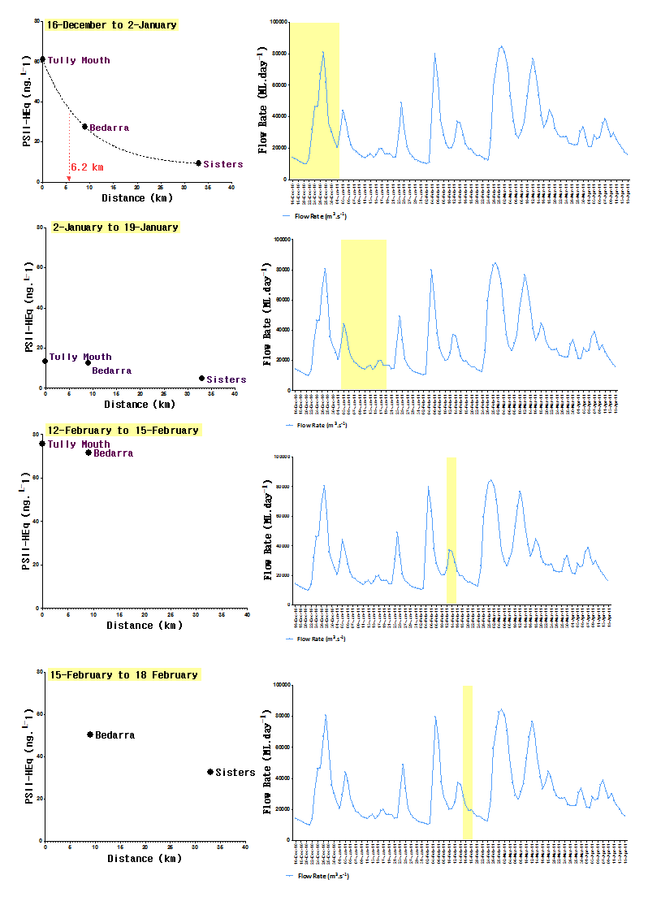
Figure 18 Part 1 – PSII-HEq at each site determined using passive sampling at different stages of the hydrograph with the half distance (km) for decline in concentration indicated when possible.
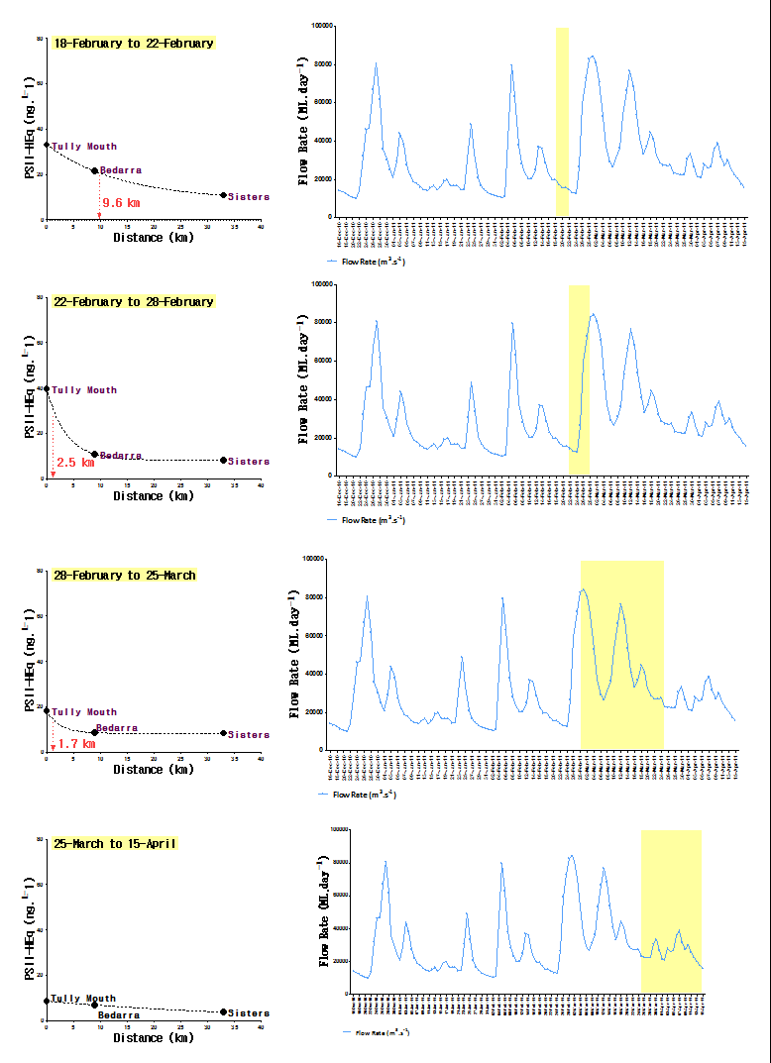
Figure 19 Part 2 – PSII-HEq at each site determined using passive sampling at different stages of the hydrograph with the half distance (km) for decline in concentration indicated when possible.

APPENDIX F – Terrestrial run-off - Results
Table 38 Concentrations in water (ng.L⁻¹) measured during terrestrial run-off events during the wet season using 1 L grab water samples.
Transect | Site | Date | Latitude | Longitude | Ametryn | Atrazine | DE Atrazine | DI Atrazine | Diuron | Hexazinone | Prometryn | Simazine | Tebuthiuron | PSII-HEq | Bromacilª | Terbutrynª | Metolachlor | Imidacloprid
Wet | Fitzroy Island coral site | 11/2/11 | -16.9201667 | 145.9973333 | n.d. | n.d. | n.d. | n.d. | n.d. | n.d. | n.d. | n.d. | n.d. | n.d. | n.d. | n.d. | n.d. | n.d.
Tropics | Russell Island (Franklands) | 11/2/11 | -17.2266667 | 146.0868333 | n.d. | n.d. | n.d. | n.d. | n.d. | n.d. | n.d. | n.d. | n.d. | n.d. | n.d. | n.d. | n.d. | n.d.
 | Dunk Island | 12/2/11 | -17.9245 | 146.143 | n.d. | n.d. | n.d. | n.d. | 10 | n.d. | n.d. | n.d. | n.d. | 10. | n.d. | n.d. | n.d. | n.d.
 | Off shore from Dunk Island | 12/2/11 | -17.8588333 | 146.285 | n.d. | n.d. | n.d. | n.d. | n.d. | n.d. | n.d. | n.d. | n.d. | n.d. | n.d. | n.d. | n.d. | n.d.
 | ½ way Tully Mouth & Dunk Is | 12/2/11 | -17.9758333 | 146.118 | n.d. | n.d. | n.d. | n.d. | n.d. | n.d. | n.d. | n.d. | n.d. | n.d. | n.d. | n.d. | n.d. | n.d.
 | Close to Tully Mouth | 12/2/11 | -18.0313333 | 146.0728333 | n.d. | n.d. | n.d. | n.d. | 10 | n.d. | n.d. | n.d. | n.d. | 10 | n.d. | n.d. | n.d. | n.d.
Burdekin | 3 km from Burdekin mouth | 30/12/10 | -19.623117 | 147.6136 | n.d. | n.d. | n.d. | n.d. | n.d. | n.d. | n.d. | n.d. | 20 | 1.6 | n.d. | n.d. | n.d. | n.d.
 | 11 km from Burdekin mouth | 30/12/10 | -19.556417 | 147.64178 | n.d. | n.d. | n.d. | n.d. | n.d. | n.d. | n.d. | n.d. | 20 | 1.6 | n.d. | n.d. | n.d. | n.d.
Mackay | 5 km from Pioneer, Round Top Is | 19/01/11 | -21.163617 | 149.2721 | n.d. | 20 | n.d. | n.d. | 10 | n.d. | n.d. | n.d. | n.d. | 30 | n.d. | n.d. | n.d. | n.d.
- | 16 km from Pioneer, past Round Top | 19/01/11 | -21.173367 | 149.37183 | n.d. | 10 | n.d. | n.d. | 10 | n.d. | n.d. | n.d. | n.d. | 20 | n.d. | n.d. | n.d. | n.d.
Fitzroy | 26 km from Pioneer between RT & Prudhoe Is | 19/01/11 | -21.232067 | 149.46243 | n.d. | n.d. | n.d. | n.d. | n.d. | n.d. | n.d. | n.d. | n.d. | n.d. | n.d. | n.d. | n.d. | n.d.
 | 11 km from Prudhoe Is | 19/01/11 | -21.275633 | 149.55997 | n.d. | n.d. | n.d. | n.d. | n.d. | n.d. | n.d. | n.d. | n.d. | n.d. | n.d. | n.d. | n.d. | n.d.
 | Prudhoe Is sample a | 19/01/11 | -21.321117 | 149.65767 | n.d. | n.d. | n.d. | n.d. | n.d. | n.d. | n.d. | n.d. | n.d. | n.d. | n.d. | n.d. | n.d. | n.d.
 | Prudhoe Is sample b- | 19/01/11 | -21.321117 | 149.65767 | n.d. | n.d. | n.d. | n.d. | n.d. | n.d. | n.d. | n.d. | n.d. | n.d. | n.d. | n.d. | n.d. | n.d.
 | Between Prudhoe Is & Double Is | 19/01/11 | -21.385383 | 149.74297 | n.d. | n.d. | n.d. | n.d. | n.d. | n.d. | n.d. | n.d. | n.d. | n.d. | n.d. | n.d. | n.d. | n.d.
 | Between Double Is & Digby Is, The Percy Group | 19/01/11 | -21.4343 | 149.84215 | n.d. | n.d. | n.d. | n.d. | n.d. | n.d. | n.d. | n.d. | 10 | 0.8 | n.d. | n.d. | n.d. | n.d.
 | Digby Island, between Double Is & Middle Is | 19/01/11 | -21.486233 | 149.94142 | n.d. | n.d. | n.d. | n.d. | n.d. | n.d. | n.d. | n.d. | 10 | 0.8 | n.d. | n.d. | n.d. | n.d.
 | Between Digby Is & Middle Is | 19/01/11 | -21.558117 | 150.03743 | n.d. | n.d. | n.d. | n.d. | n.d. | n.d. | n.d. | n.d. | 10 | 0.8 | n.d. | n.d. | n.d. | n.d.
 | Middle Is, The Percy Group | 19/01/11 | -21.650667 | 150.24877 | n.d. | n.d. | n.d. | n.d. | n.d. | n.d. | n.d. | n.d. | 10 | 0.8 | n.d. | n.d. | n.d. | n.d.
Shoalwater | Osborne Is, Shoalwater Bay | 20/01/11 | -22.2509 | 150.32015 | n.d. | n.d. | n.d. | n.d. | n.d. | n.d. | n.d. | n.d. | 10 | 0.8 | n.d. | n.d. | n.d. | n.d.
- | Shoalwater Bay | 7/02/11 | -22.610833 | 150.61112 | n.d. | n.d. | n.d. | n.d. | n.d. | n.d. | n.d. | n.d. | n.d. | n.d. | n.d. | n.d. | n.d. | n.d.
 | East of North Keppel Island, Outer Rock | 18/01/11 | -23.063217 | 150.96605 | n.d. | n.d. | n.d. | n.d. | n.d. | n.d. | n.d. | n.d. | 10 | 0.8 | n.d. | n.d. | n.d. | n.d.
Fitzroy | Mazie Bay, North Keppel Island | 10/01/11 | -23.086217 | 150.8983 | n.d. | 10 | n.d. | n.d. | n.d. | n.d. | n.d. | n.d. | 50 | 5.6 | n.d. | n.d. | n.d. | n.d.
Keppels | Mazie Bay, North Keppel Island | 17/01/11 | -23.086217 | 150.8983 | n.d. | 10 | n.d. | n.d. | n.d. | n.d. | n.d. | n.d. | 60 | 6.4 | n.d. | n.d. | 20 | n.d.
- | Mazie Bay, North Keppel Island | 25/01/11 | -23.086217 | 150.8983 | n.d. | n.d. | n.d. | n.d. | n.d. | n.d. | n.d. | n.d. | n.d. | n.d. | n.d. | n.d. | n.d. | n.d.
Curtis Island | ½ Tide Rock, Great Keppel Island | 4/01/11 | -23.151533 | 150.94425 | n.d. | n.d. | n.d. | n.d. | n.d. | n.d. | n.d. | n.d. | 30 | 2.4 | n.d. | n.d. | n.d. | n.d.
 | 24 km from Fitzroy River mouth, West Divided Is | 25/01/11 | -23.305867 | 150.92 | n.d. | n.d. | n.d. | n.d. | n.d. | n.d. | n.d. | n.d. | 20 | 1.6 | n.d. | n.d. | n.d. | 10
 | 22 km from Fitzroy mouth, East Peak Island | 10/01/11 | -23.337783 | 150.950417 | n.d. | 30 | n.d. | n.d. | n.d. | n.d. | n.d. | n.d. | 90 | 12 | n.d. | n.d. | 20 | n.d.
 | 22 km from Fitzroy mouth, East Peak Island | 17/01/11 | -23.337783 | 150.950417 | n.d. | 10 | n.d. | n.d. | n.d. | n.d. | n.d. | n.d. | 50 | 5.6 | n.d. | n.d. | 20 | 50
 | 22 km from Fitzroy mouth, East Peak Island | 7/02/11 | -23.337783 | 150.95042 | n.d. | n.d. | n.d. | n.d. | n.d. | n.d. | n.d. | n.d. | n.d. | n.d. | n.d. | n.d. | n.d. | 140
 | 15 km from Fitzroy mouth, Buoy 2 | 4/01/11 | -23.43465 | 150.98202 | n.d. | n.d. | n.d. | n.d. | n.d. | n.d. | n.d. | n.d. | n.d. | n.d. | n.d. | n.d. | n.d. | n.d.
 | Cape Capricorn to the South of Fitzroy | 18/01/11 | -23.46355 | 151.26655 | n.d. | n.d. | n.d. | n.d. | n.d. | n.d. | n.d. | n.d. | n.d. | n.d. | n.d. | n.d. | n.d. | n.d.
 | Cape Capricorn to the south of Fitzroy | 25/01/11 | -23.463333 | 151.26633 | n.d. | n.d. | n.d. | n.d. | n.d. | n.d. | n.d. | n.d. | n.d. | n.d. | n.d. | n.d. | n.d. | n.d.
 | Facing Island Cutis Island 31 km south | 20/01/11 | -23.73235 | 151.34144 | n.d. | n.d. | n.d. | n.d. | n.d. | n.d. | n.d. | n.d. | n.d. | n.d. | n.d. | n.d. | n.d. | n.d.
 |  |  |  |  |  |  |  |  |  |  |  |  | Indicates a Guideline value or Interim Working level has been met or exceeded

Table 39 Passive sampling at other sites in the Fitzroy region during a period with a major flood event in the Fitzroy River.

Site | Start Date | End Date | Sampler | Ametryn | Atrazine | DE Atrazine | DI Atrazine | Diuron | Hexazinone | Prometryn | Simazine | Tebuthiuron | PSII-HEq | Bromacilª | Terbutrynª | Metolachlor | 3,4-dichloraniline | Haloxyfop
Middle Reef | 2/1/11 | 8/2/11 | ED | n.d. | 5.9 | 0.91 | n.d. | 5.0 | 1.3 | 0.29 | 0.63 | 17 | 8.3 | 0.73 | n.d. | 2.5 | 0.65 | 0.54
North Keppel I | 2/1/11 | 8/2/11 | ED | 0.27 | 8.0 | 1.2 | n.d. | 7.9 | 1.8 | 0.42 | 0.74 | 20 | 12 | 0.83 | n.d. | 3.2 | 0.77 | 0.51
Halfway | 2/1/11 | 8/2/11 | ED | n.d. | 7.9 | 1.5 | n.d. | 5.8 | 2.0 | 0.36 | 0.92 | 23 | 10 | 0.89 | n.d. | 3.5 | 0.75 | 0.63
Clam | 3/1/11 | 8/2/11 | ED | n.d. | 5.4 | 0.69 | n.d. | 4.1 | 1.0 | 0.13 | 0.58 | 13 | 6.7 | 0.68 | n.d. | 2.1 | 0.60 | 0.22
These samples were analysed using both positive and negative analysis modes on the LCMSMS but imidacloprid is not a target herbicide on this run. |  |  |  |  |  |  |  |  |  |  |  | Indicates that a water quality guideline was met or exceeded

APPENDIX G – Mean flow rates in major rivers when grab sampling occurred
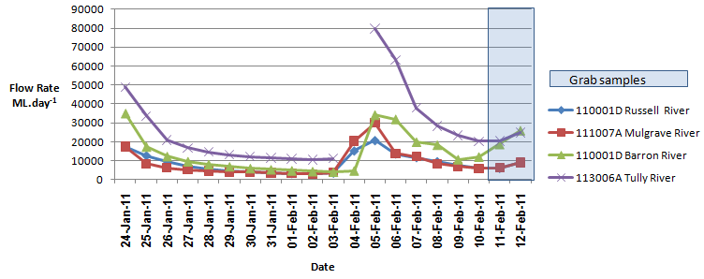
Figure 20 Flow rates in Wet Tropics region rivers and the timing of grab samples to assess terrestrial run-off

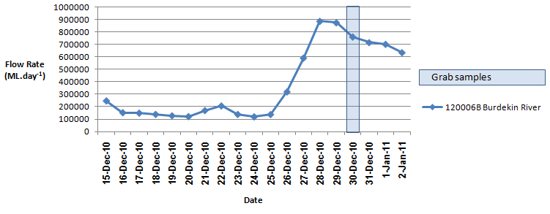
Figure 21 Flow rates in the Burdekin River and the timing of grab samples to assess terrestrial run-off

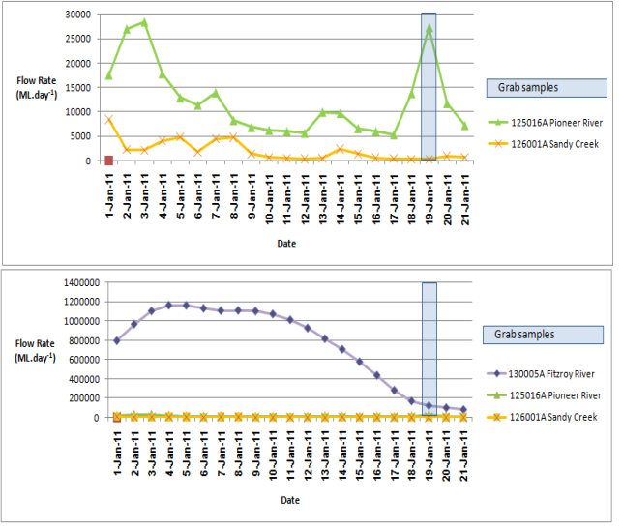
Figure 22 Flow rates in the Pioneer River and Sandy Creek (top) and in the Fitzroy River (bottom) and the timing of grab samples to assess terrestrial run-off in the Mackay-Fitzroy transect

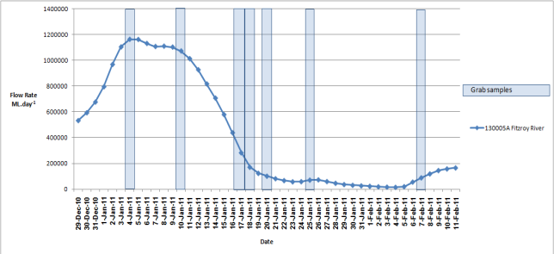
Figure 23 Flow rates in the Fitzroy River and the timing of grab samples to assess terrestrial run-off in the Fitzroy region.

APPENDIX H – Historical concentration profiles at routine monitoring sites
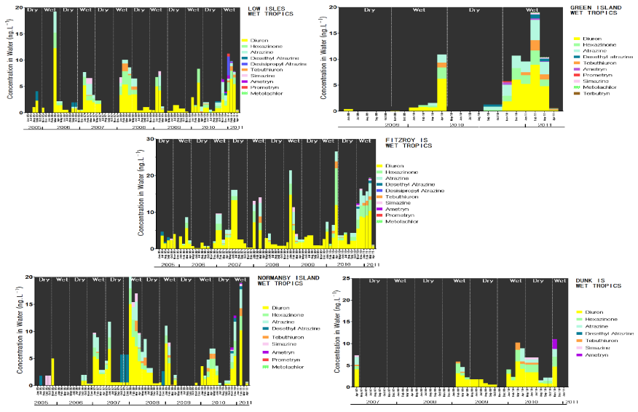

Figure 24 Temporal concentration profiles of individual herbicides at routine monitoring sites in the Wet Tropics region

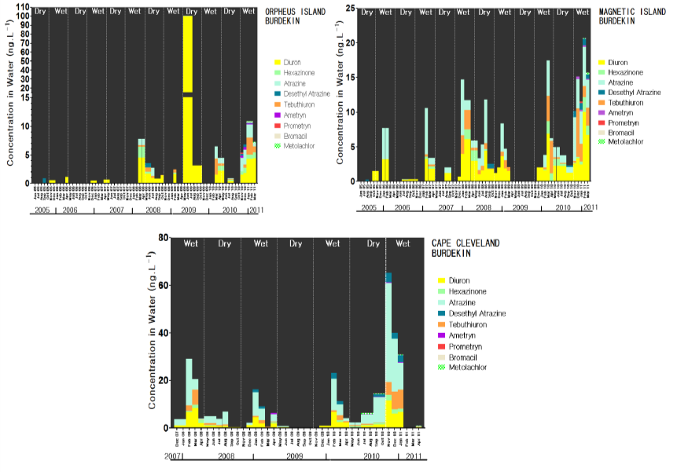
Figure 25 Temporal concentration profiles of individual herbicides at routine monitoring sites in the Burdekin region.
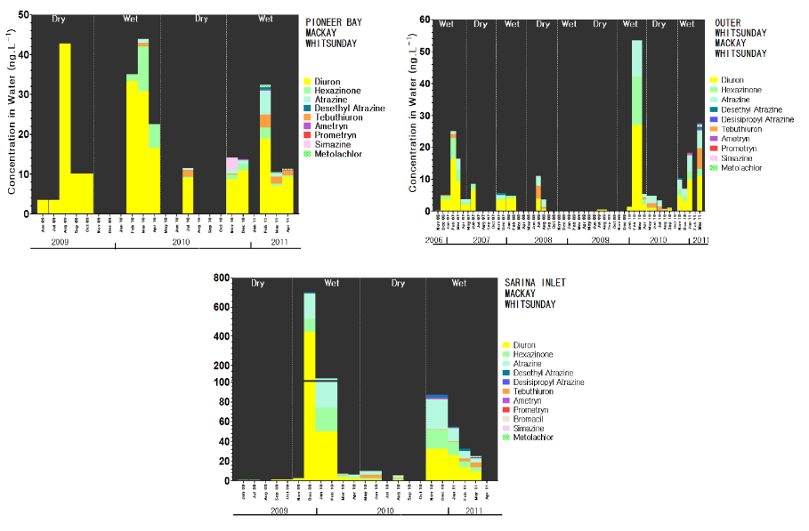
Figure 26 Temporal concentration profiles of individual herbicides at routine monitoring sites in the Mackay Whitsunday region

REFERENCES
Anon (2009). Reef Water Quality Protection Plan 2009. For the Great Barrier Reef World Heritage Area and adjacent catchments. Brisbane, Australian Government, Queensland Government, Reef Water Quality Plan Protection Secretariat.
ANZECC and ARMCANZ (2000). Australian and New Zealand Guidelines for Fresh and Marine Water Quality. Volumes 1 (& 2) The Guidelines. National Water Quality Management Strategy No. 4., Australian & New Zealand Environment & Conservation Council and the Agriculture & Resource Management Council of Australia & New Zealand.
APVMA (2011). Diuron. Environmental Assessment, Australian Pesticides and Veterinary Medicines Authority, Australian Government.
Bengtson-Nash, S. M., K. McMahon, G. Eaglesham and J. F. Müller (2005). "Application of a novel phytotoxicity assay for the detection of herbicides in Hervey Bay & the Great Sandy Straits." Marine Pollution Bulletin 51: 351-360.
Boyd, A. M., B. Noller, P. White, D. Gilbert, D. Smith, M. Mortimer, P. Langford, J. Martinkovic, R. Sadler, M. Hodge, M. Moore, J. Murray, C. Cristaldi, M. P. Zalucki, I. Francis, M. Brown, R. Cruice and D. Connell (2002). Environmental Effects of Currently Used Termiticides Under Australian Conditions, The National Research Centre for Environmental Toxicology, Brisbane.
Brando, V. E., D. Blondeau-Patissier, T. Schroeder, A. G. Dekker and L. Clementson (2011). Reef Rescue Marine Monitoring Program: Assessment of Terrestrial Run-off Entering the Reef and Inshore Marine Water Quality Monitoring using Earth Observation data. Final Report for 2010/11 Activities
CSIRO, Canberra.
Davis, A., S. Lewis, Z. Bainbridge, J. Brodie and E. Shannon (2008). "Pesticide residues in waterways of the Lower Burdekin Region: Challenges in ecotoxicological intepetation of monitoring data. ." Australasian Journal of Ecotoxicology 14: 89-108.
Devlin, M., A. Wenger, J. Waterhouse, J. Romero, B. Abbott, Z. Bainbridge and S. Lewis (2011). Reef Rescue Marine Monitoring Program: Flood Plume Monitoring Annual Report. Incorporating results from the Extreme Weather Incident Response program, flood plume monitoring. Final Report for 2010/11 Activities.Catchment to Reef Research Group. . ACTFR. James Cook University, Townsville.
EC (2006). Imidacloprid, Draft Assessment Report. Rapporteur Member State: Germany. Public version February 2006. With Addendum, European Commision.
Eichner, R. (1994 (Web 2001)). Imidachloprid in the Product Confidor Insecticide, National Registration Authority for Agricultural and Veterinary Chemicals, ACT.
Escher, B. I., P. Quayle, R. Muller, U. Schreiber and J. F. Müller (2006). "Passive sampling of herbicides combined with effect analysis in algae using a novel high-throughput phytotoxicity assay (Maxi-Imaging-PAM)." Journal of Environmental Monitoring 8: 456-464.
GBRMPA (2010). Water Quality Guidelines for the Great Barrier Reef Marine Park. Revised Edition 2010. Townsville, Great Barrier Reef Marine Park Authority.
GBRMPA (2011). Reef Rescue Marine Monitoring Program: Quality Assurance/Quality Control Methods and Proceedures Manual. Report prepared for the Great Barrier Reef Marine Park Authority., Great Barrier Reef Marine Park Authority, Townsville.
Jones, R. J. and A. P. Kerswell (2003). "Phytotoxicity of Photosystem II (PS II) herbicides to coral." Marine Ecology Progress Series 261: 149-159.
Kennedy, K., C. Bentley, C. Paxman, A. Heffernan, A. Dunn, S. Kaserzon and J. Mueller (2010a). Final Report - Monitoring of organic chemicals in the Great Barrier Reef Marine Park using time integrated monitoring tools (2009-2010), The University of Queensland, The National Research Centre for Environmental Toxicology (Entox).
Kennedy, K., C. Paxman, A. Dunn, J. O'Brien and J. F. Mueller (2010b). Monitoring of organic chemicals in the Great Barrier Reef Marine Park and selected tributaries using time integrated monitoring tools (2008-2009), The National Research Centre for Environmental Toxicology, The University of Queensland.
Kennedy, K., T. Schroeder, M. Shaw, D. Haynes, S. Lewis, C. Bentley, C. Paxman, S. Carter, V. E. Brando, M. E. Bartkow, L. Hearn and J. F. Mueller (2011). "Long-term monitoring of photosystem-II herbicides - correlation with freshwater extent
explored as a novel technique to monitor improvement in water quality entering the Great Barrier
Reef, Australia " Marine Pollution Bulletin, Special Issue Reef Continuum, doi:10.1016/j.marpolbul.2011.10.029.
Lewis, S., R. Milla, J. Brodie, Z. Bainbridge and A. Davis (2009). "Pesticide residues in the Great Barrier Reef." Pesticide News 86: 8-11.
Liu, W., W. Zheng, Y. Ma and K. K. Liu (2006). "Sorption and degradation of imidacloprid in soil and water." Journal of Environmental Science and Health Part B 41: 623-634.
Magnusson, M., K. Heimann, P. Quayle and A. Negri (2010). "Additive toxicity of herbicide mixtures and comparative sensitivity of tropical benthic microalgae." Marine Pollution Bulletin IN PRESS doi:10.1016/j.marpolbul.2010.07.031.
Muller, R., S. U., B. I. Escher, P. Quayle, S. M. Bengtson Nash and J. F. Müller (2008). "Rapid exposure assessment of PSII herbicides in surface water using a novel chlorophyll a fluorescence imaging assay." Science of the Total Environment 401(1-3): 51-59.
Packett, R., C. Dougall, K. Rohde and R. Noble (2009). "Agricultural lands are hot-spots for annual runoff polluting the southern Great Barrier Reef lagoon." Marine Pollution Bulletin 58: 976-986.
Posthuma-Doodeman, C. J. A. M. (2008). Environmental Risk Limits for Imidacloprid, National Institute for Public Health and the Environment, The Netherlands.
Schaffelke B, Carleton J, Doyle J, Furnas M, Gunn K, Skuza M, Wright M, Zagorskis I (2011) Reef Rescue Marine Monitoring Program. Final Report of AIMS Activities 2010/11– Inshore Water Quality Monitoring. Report for the Great Barrier Reef Marine Park Authority. Australian Institute of Marine Science, Townsville. (84 p.)
Schmidt, S. (2005). Development and evaluation of the Maxi-Imaging-PAM algae assay using 96 well plates, The National Research Centre for Environmental Toxicology.
Schroeder, T., M. J. Devlin, V. E. Brando, A. G. Dekker, J. E. Brodie, L. A. Clementson and L. McKinna (2011 under review). "Inter-annual variability of wet season freshwater plume extent into the Great Barrier Reef lagoon based on satellite ocean colour observations." Marine Pollution Bulletin, Special Issue Reef Continuum.
Shaw, M., J. Dunlop and G. McGregor (2011). Identifying Pesticides and Locations for Monitoring in the Great Barrier Reef Catchments. Approach and Assessment Outputs, Department of Environment and Resource Management, Queensland Government, Brisbane.

