Possible Priority Areas

Overview
This section identifies and describes possible priority areas for remediation. Key points are summarised below. Gaps are identified at the end of this section.

Key Points
- Using the data presented in Section 4, four distinct areas where physical damage and contamination are concentrated have been delineated (Figure 5-1).
- These areas, annotated A, C, E and F are predominantly within the grounding footprint and represent priorities for further investigation and possible remediation.
- Area A covers some 202,700 m² and is located at the eastern extent of the grounding footprint, the site Shen Neng 1 first ran aground. The largest of the four areas, it comprises an extensive complex of dislocated holes and gutters filled with sand and rubble. These features are likely to contain AFP particles. Due to the size of Area A, remediation is likely to generate significant volumes of material for either treatment and or disposal.
- Area C covers some 81,600 m². Located north-west of Area A, physical damage associated with the movement of Shen Neng 1 over the benthic substrate is clearly identifiable.
- A scar in the shape of the hull of Shen Neng 1 is clearly visible at Area E which is located west of Area A and north of Area F. Berms comprised of fractured and displaced benthic substrate may contain AFP particles. It is suggested these may represent a potential priority for remediation.
- Area F, covers 51,800 m². A deep scar in the shape of Shen Neng 1 is clearly identifiable in this area. This is the location Shen Neng 1 remained for seven days prior to being removed from Douglas Shoal. Berms comprising fractured and displaced substrate may prove to be priorities for remediation in this area.
- Damage sustained at both Area E and Area F, resemble the scar at Sudbury Cay associated with the grounding of the Bunga Teratai Satu. While these areas are significantly larger, similar remediation strategies may prove effective.

Approach
Using the data presented in Section 4, four distinct areas, where physical damage and contamination are concentrated have been delineated (Figure 5-1). These areas, annotated A, C, E and F are predominantly within the grounding footprint. However, nearby damage and contamination from outside the grounding footprint are included. These four areas are possible priority areas for further investigation and remediation.
An additional two areas (B and D), where reported physical damage and contamination are limited, have also been identified (Figure 5-1). A sixth area (G), to the south of the grounding footprint, comprising two cells with recorded damage and a single cell with reported contamination, has also been defined. It is suggested that these areas may represent less of a priority than areas A, C, E and F.
Descriptions of areas A, C, E and F are provided below.

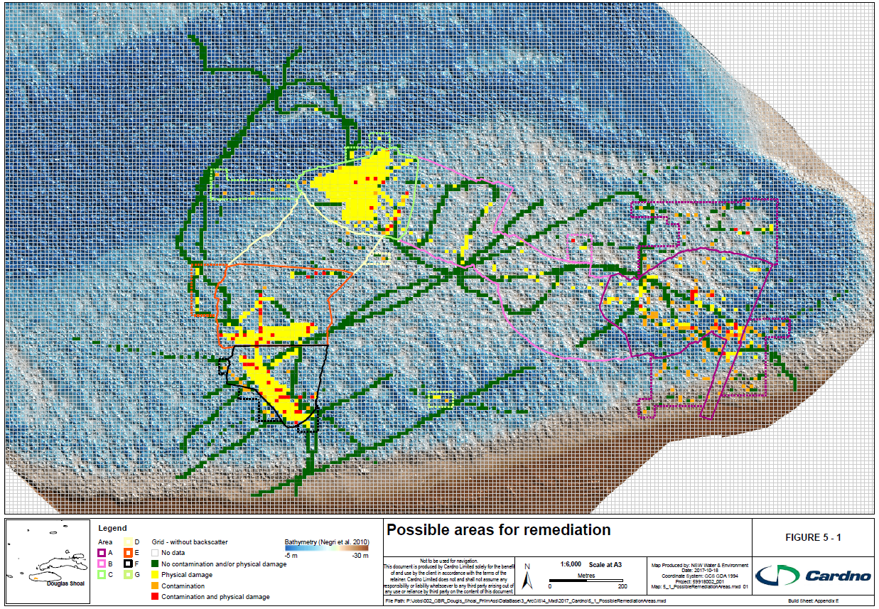
          - Possible areas for remediation

Possible Priority Areas

Area A

Summary
Area A (Figure 5-2, Figure 5-6 and Figure F-10) is located at the eastern extent of the grounding footprint, the site Shen Neng 1 first ran aground. In summary, Area A:
- Covers some 202,700 m²
- No data are available for 166,900 m², approximately 82% of the area
- Physical damage and contamination was recorded in 17 cells or 1%
- Cells with only contamination reported, total 112 or 5% of the area
- Cells with only recorded physical damage, total 52 or 3% of the area
- Cells with either no recorded physical damage or contamination represent 9% of the area.
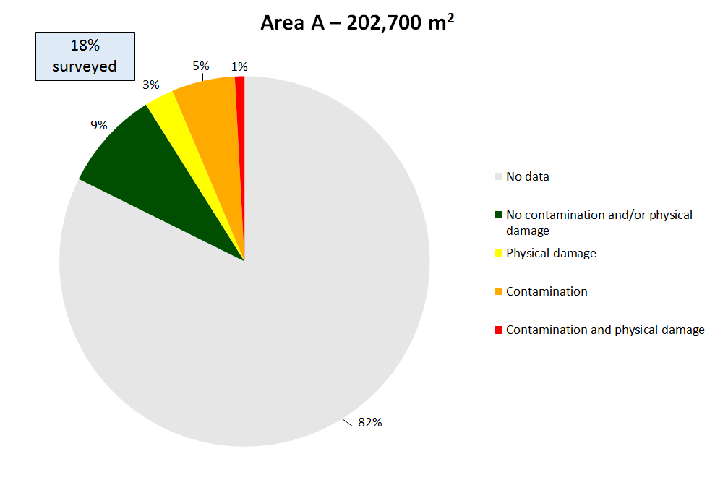
          - Area A - data summary

Observations and Descriptions
Area A, the largest of the possible priority areas, includes the site of the remediation trial completed by Kettle (2015). Kettle (2015a) describes the physical setting for the trial and summarises the distribution of AFP particles.
Negri et al. (2010) captured multibeam bathymetry and backscatter data across Area A, they state: ‘the bathymetry and slope maps of the site of initial grounding (Site 1) show little to no structural difference to the adjacent reef matrix. However, a systematic increase in backscatter strength is associated with this site (see Appendix Figs. A1 and A2). This is likely caused by an abrasion and flattening of the reef top, without destruction of the reef matrix itself’.
Figure F-10 (Appendix A) is a high resolution image taken from the multibeam data collected by Negri et al. (2010). No displaced substrate are discernible. However, low relief morphology, including disconnected gutters and holes are clearly visible.

Area C

Summary
Area C (Figure 5-3, Figure 5-7 and Figure F-11) is located north-west of Area A. In summary, Area C:
- Covers some 81,600 m²
- No data are available for 49,000 m², approximately 60% of the area
- Physical damage and contamination was recorded in 11 cells or 1% of the area
- Cells with only contamination reported, total 13 (AFP particles only) or 2% of the area
- Cells with only recorded physical damage, total 249 or 31%
- Cells with either no recorded physical damage or contamination represent 6% of the area.
Note that no sediment samples were collected from Area C for analysis of contaminant concentrations. However, Kettle (2014) did collect samples for AFP particle count analysis. Results indicate that 13 of the 24 samples, contained between 1 and 4 AFP particles (per sample).
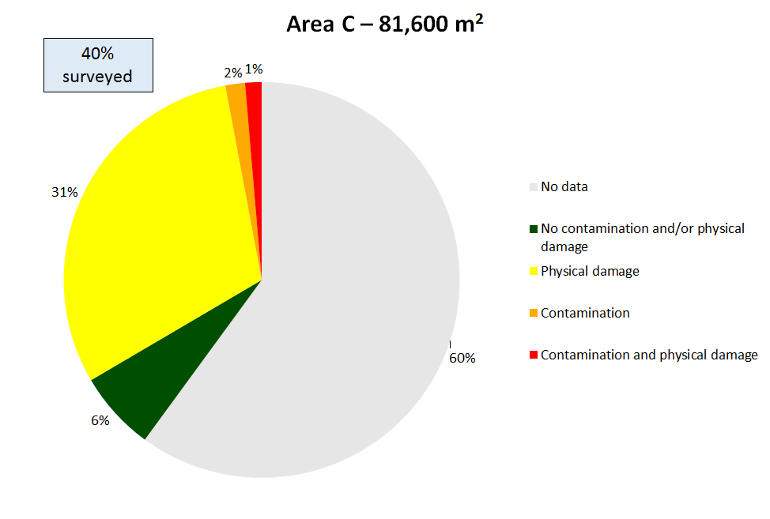
          - Area C – data summary

Observations and Descriptions
Figure 3-3, (plates a, b, c and d) show Shen Neng 1 aground on the Low Relief Terrace. Plumes of sediment are clearly visible on both the flood and ebb tide. The extent to which these plumes travelled is unknown.
A large scar caused by Shen Neng 1 is clearly visible in Figure F-11 (Appendix F). Negri et al. (2010) state that: ‘Shen Neng 1’s GPS and heading data shows that the stern remained in about the same location, whereas the bow was swaying in an approximately 45 degree arc, restricted to the north by the shallower reef (the High Relief Terrace in this report). This caused significant wearing-down of the seafloor, which resulted in substantial destruction; little reef structure remains at this site’.

Area E

Summary
Area E (Figure 5-4, Figure 5-8 and Figure F-12) is located west of Area A. In summary, Area E:
- Covers some 80,800 m²
- No data are available for 58,700 m², approximately 73% of the area
- Physical damage and contamination was recorded in 21 cells or 2% of the area
- Cells with only contamination recorded, total 3 (less than 1%)
- Cells with only reported physical damage, total 102 or 13% of the area
- Cells with either no recorded physical damage or contamination represent 12% of the area.
          - Area E – data summary

Observations and Descriptions
A scar in the shape of Shen Neng 1 is visible in Figure F-12 (Appendix F). In this figure, the impression left by the bow is obvious, with the aft sections of the hull less so. Negri et al. (2010) suggest that in the vicinity of the bow, substrate is fractured and displaced, while aft sections suffered lesser physical damage with abrasion ‘of the top of the coral reef matrix’ (displaced habitat).

Area F

Summary
Area F (Figure 5-5, Figure 5-9 and Figure F-13) is located west of Area E. In summary, Area F:
- Covers some 51,800 m²
- No data are available for 28,000 m², approximately 54% of the area
- Physical damage and contamination was recorded in 22 cells or 4% of the area
- Cells with only contamination recorded, total 14 or 3% of the area
- Cells with only reported physical damage, total 114 or 22% of the area
- Cells with either no recorded physical damage or contamination represent 17% of the area.
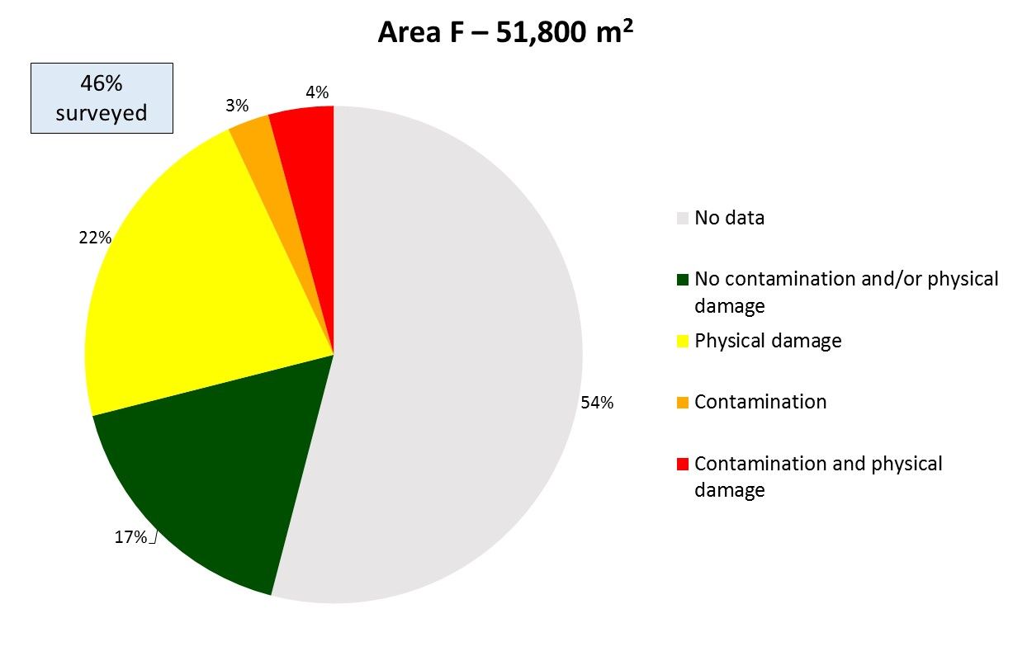
          - Area F – data summary

Observations and Descriptions
A deep scar in the shape of Shen Neng 1 is clearly identifiable in Figure F-13 (Appendix F). This is the location Shen Neng 1 remained for seven days prior to being removed from Douglas Shoal. Figure 3-3 (plates e, f, g and h) taken 6 April 2010, show Shen Neng 1 at this location. Negri et al. (2010) suggest that the increased seabed elevation at the eastern and western sides are likely the result of berms of displaced benthic substrate and habitat.

Data and Information Gaps
Key gaps are listed below. Potential risks associated with these gaps are presented in Section 6.
G5.1 Area A:
- No data are available for 166,900 m², approximately 80% of the area
- No data are available to further define the nature and scale of physical damage and contamination, allowing the refinement of the present boundary.
G5.2 Area C
- No data are available for 49,000 m², approximately 60% of the area
- No contaminant concentration data were available
- No data are available to further define the nature and scale of physical damage and contamination, allowing the refinement of the present boundary.
G5.3 Area E
- No data are available for 58,700 m², approximately 73% of the area
- No data are available to further define the nature and scale of physical damage and contamination, allowing the refinement of the present boundary.
G5.4 Area F
- No data are available for 28,000 m², approximately 54% of the area
- No data are available to further define the nature and scale of physical damage and contamination, allowing the refinement of the present boundary.

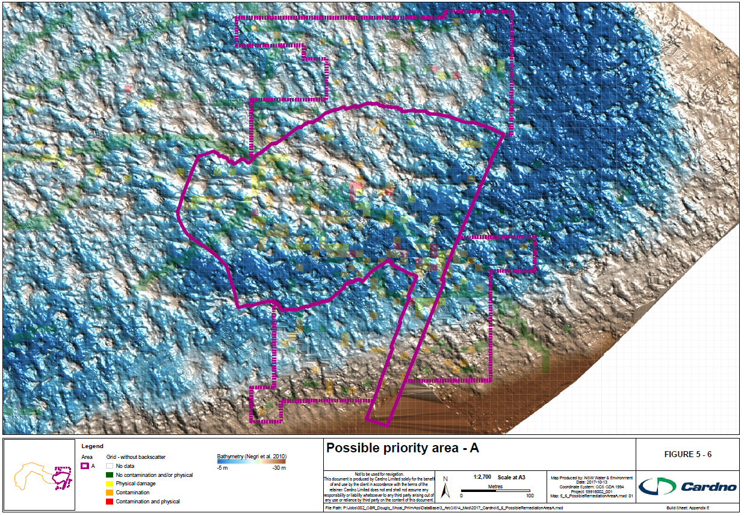
          - Possible Priority Area – A

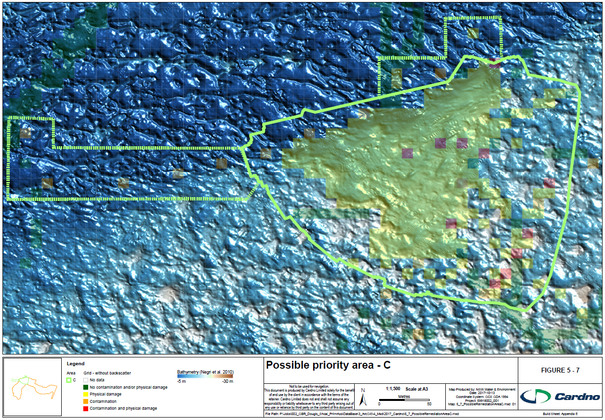
          - Possible Priority Area – C

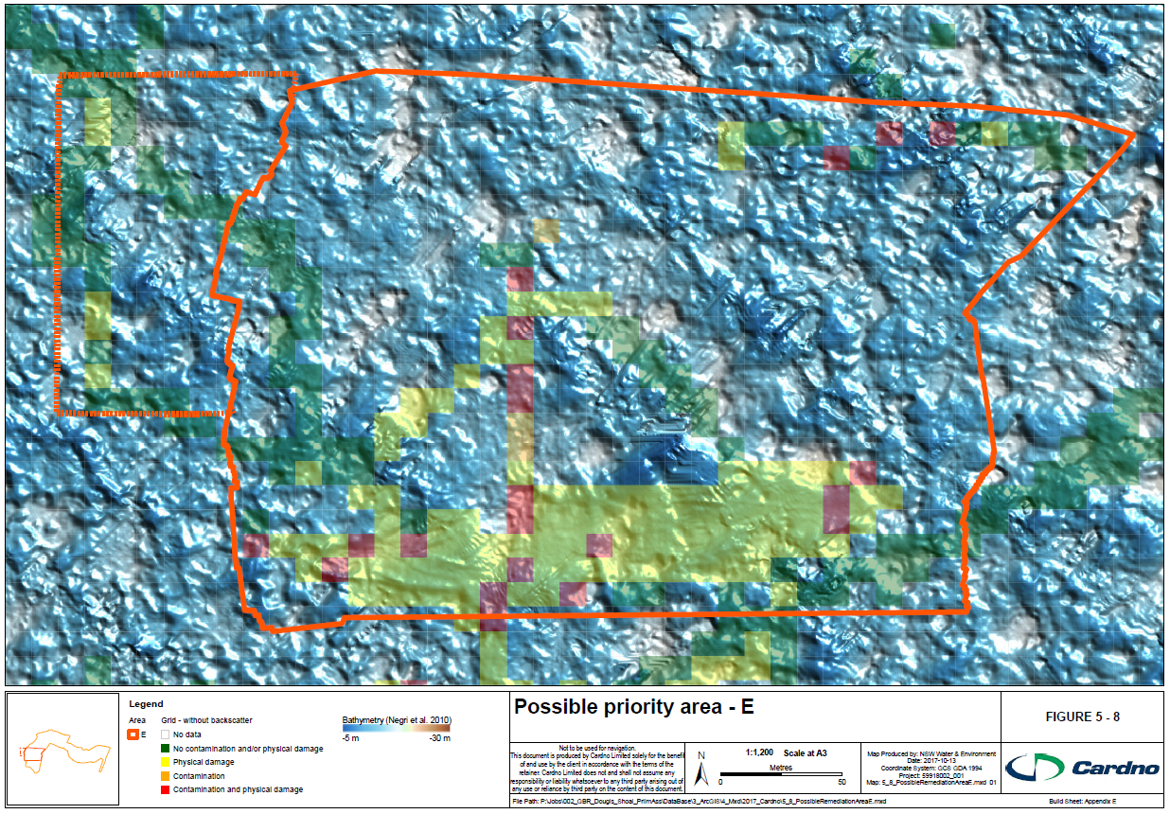
          - Possible Priority Area - E

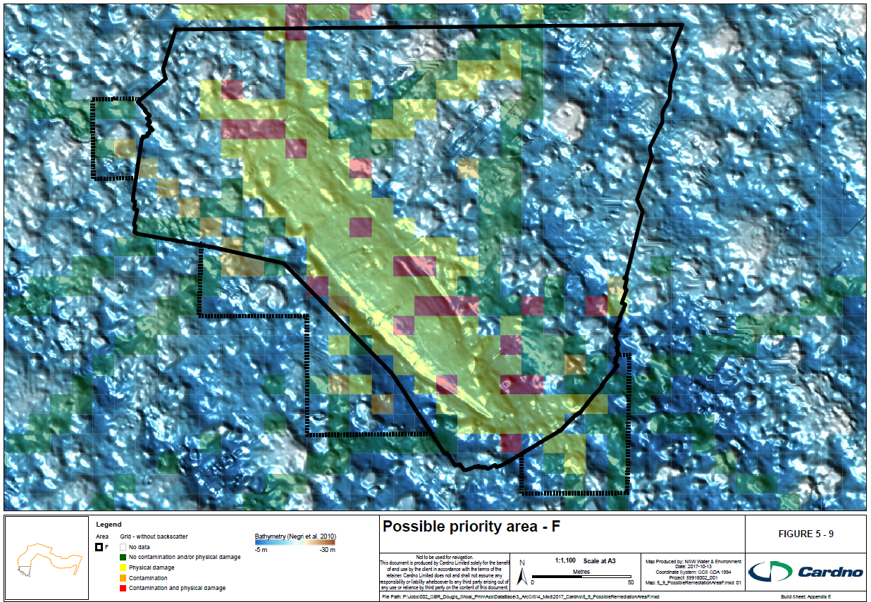
          - Possible Priority Area - F

Summary of Critical Information Gaps and Associated Risks

Overview
This section (Table 6-1) presents the results of an analysis of information / data gaps / uncertainties for aspects relevant to the effective planning and monitoring of remediation. Consequences / Impacts are expressed as either negligible, minor, moderate, major or extreme. GBRMPA’s Integrated Risk Rating Tool (Rev 4) was used to assign risk levels. Risk levels are untreated. Suggested treatment options are included.

            - Data and Information Gaps as Risks to effective remediation planning and monitoring
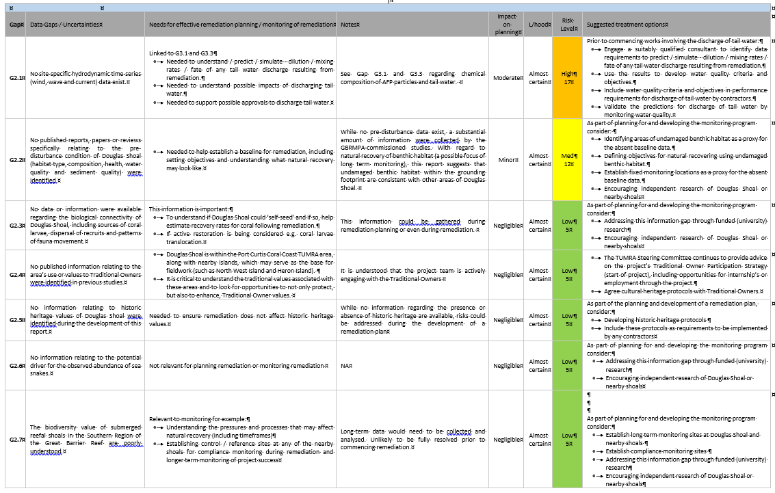
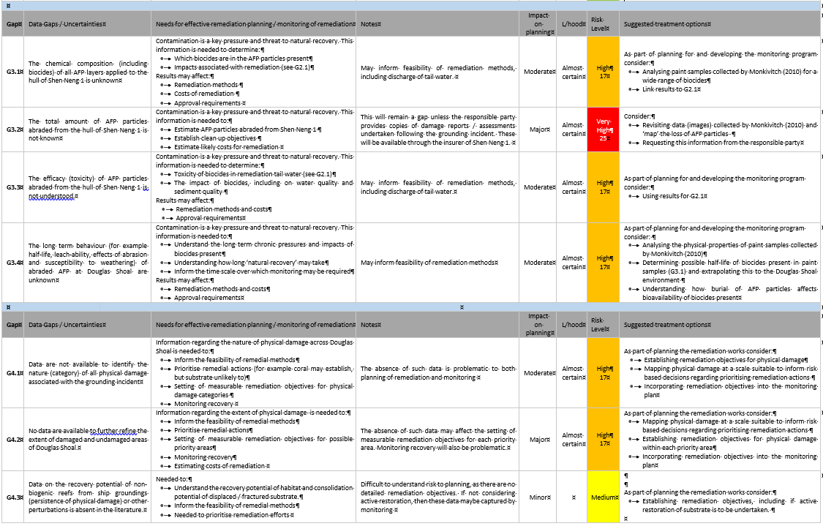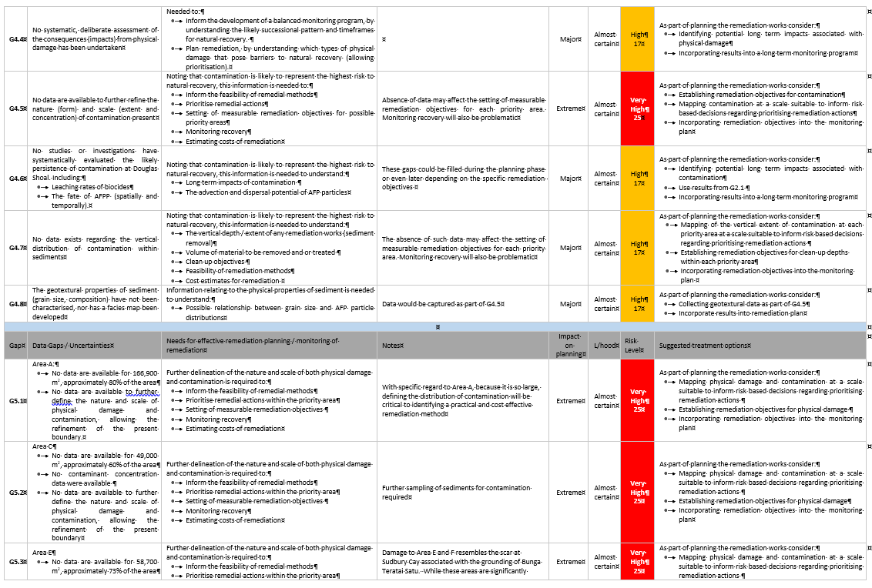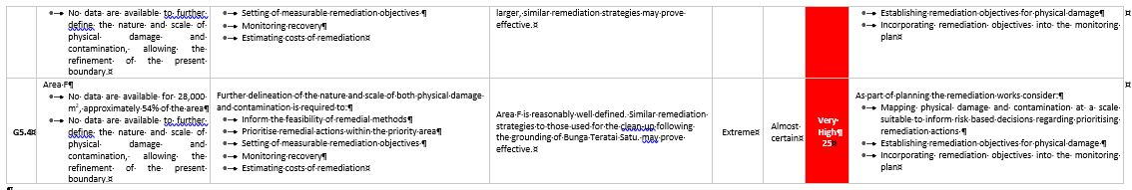

References
Abbey and Webster (2011). Abbey E, Webster JM (2011) Submerged Reefs. In: Hopley D (Ed.) Encyclopedia of modern coral reefs. Springer Verlag, New York,USA 1236 pp.
AMSA (2010).
ANZECC/ARMCANZ (2000). Australian and New Zealand Guidelines for Fresh and Marine Water Quality, Australian and New Zealand Environment and Conservation Council/Agriculture and Resource Management Council of Australia and New Zealand, October 2000.
Commonwealth of Australia (2010). Preliminary Grounding of the bulk carrier Shen Neng 1 at Douglas Shoal, Queensland 3 April 2010. Bureau, Transport Safety Report Marine Occurrence Investigation No. 274 MO-2010-003. April 2010.
DEH (2006). National Atlas of Marine Fishing and Coastal Communities, Final report to DEH. Fisheries Research and Development Corporation, Department of the Environment and Heritage and the Bureau of Rural Sciences, Canberra, 2006.
DEWHA (2009) National Assessment Guidelines for Dredging. National Assessment Guidelines for Dredging, Commonwealth of Australia, Canberra, 2009.
ESRI (2017) GIS Dictionary. http://support.esri.com/en/other-resources/gis-dictionary
Fairbanks (1989). Fairbanks, R.G., 1989, A 17,000-year glacio-eustatic sea level record; influence of glacial melting rates on the Younger Dryas event and deep-ocean circulation: Nature, v. 342, no. 6250, p. 637–642.
GBRMPA (2004). Great Barrier Reef Marine Park Zoning Plan 2003, GBRMPA, Townsville.
GBRMPA (2011). Great Barrier Reef Marine Park Authority 2011, Grounding of the Shen Neng 1 on Douglas Shoal April 201: Impact Assessment Report, GBRMPA, Townsville.
GBRMPA (2014). Great Barrier Reef Marine Park Authority 2014, Great Barrier Reef Region Strategic Assessment: Strategic assessment report, GBRMPA, Townsville.
GBRMPA (2015). Shen Neng 1 grounding: statement http://www.gbrmpa.gov.au/media-room/latest-news/corporate/2015/shen-neng-1-grounding Published: 27/05/2015.
GBRMPA (2017a). Great Barrier Reef Marine Park Authority: Assessment and Decision Guidelines, GBRMPA, Townsville.
Gilbert (2017). Personal communication, email, September 2017.
Hopley (1982). Hopley, D., 1982. The Geomorphology of the Great Barrier Reef: Quaternary Development of Coral Reefs. New York: Wiley.
Hopley, D. (1983). Morphological Classification of Shelf Reefs: A Critique with Special Reference to the Great Barrier Reef. In: Perspectives on Coral reefs (edited by Barnes, D. J).
Hopley et al. (2007). Hopley, D, Smithers, S and Parnell, K. (2007). The Geomorphology of the Great Barrier Reef - Development, Diversity, and Change. Cambridge University Press.
Jell, J. and Flood, P. (1978). Guide to the Geology of Reefs of the Capricorn and Bunker Groups, Great Barrier Reef Province, with special reference to Heron Island. Published by the Department of Geology, University of Queensland. April 1978.
Kettle (2011). Kettle, B. (2011) Independent review of the impact assessment report Grounding of the Shen Neng 1 on Douglas Shoal, April 2010, Project X Consulting, Brisbane.
Kettle (2014). Kettle, B. (2014) October 2013 Reef Damage Reassessment of the Shen Neng 1 Grounding Site, Douglas Shoal, Great Barrier Reef, Australia, Project X Consulting, Brisbane.
Kettle (2015a). Kettle, B. (2015) Remediation Trial for the Shen Neng 1 Grounding Site, Douglas Shoal, Great Barrier Reef, Australia, Project X Consulting, Brisbane,.
Kettle (2015b). Kettle, B. (2015) Supplementary Report: Remediation Trial for the Shen Neng 1 Grounding Site, Douglas Shoal, Great Barrier Reef, Australia, Project X Consulting, Brisbane.
Kohler KE and Gill SM (2006). Coral Point Count with Excel extensions (CPCe): A Visual Basic program for the determination of coral and substrate coverage using random point count methodology. Computers and Geosciences, Vol. 32, (9):1259-1269.
Marshall (1977). MARSHALL, J.F. 1977. Morphology of the east Australian continental margin between 21 ⁰ Sand 33 ⁰ S. Bull. Bur. Miner. Resour. Geol. Geophys.Aust., 163: 1-81.
Marshall (2010). Preliminary Impact Assessment: Grounding of the Shen Neng 1 on Douglas Shoal Great Barrier Reef – Summary Report, GBRMPA, Townsville.
Marshall (2016). Douglas Shoal Trophic Contamination Survey, Reef Ecologic, Townsville.
Maxwell (1968). Maxwell, W. G. H., 1968. Atlas of the Great Barrier Reef. Amsterdam: Elsevier.
McCook LJ (1999) Macroalgae, nutrients and phase shifts on coral reefs: scientific issues and management consequences for the Great Barrier Reef. Coral Reefs 18:357-367
McCook, L. (2010) Impact assessment report: Grounding of the Shen Neng 1 on Douglas Shoal, April 2010, Great Barrier Reef Marine Park Authority, Townsville, December 2010.
Merriam-Webster (2017). Online Dictionary. https://www.merriam-webster.com/dictionary
Monkivitch (2010). Monkivitch J.V. (2010). Shen Neng 1 Hull Sampling: Field Report 21 May 2010. Great Barrier Reef Marine Park Authority, Townsville.
Monkivitch (2016). Monkivitch J.V. (2016). Revised affidavit to: Shen Neng 1 Hull Sampling: Field Report 21 May 2010. Great Barrier Reef Marine Park Authority, Townsville.
NAGD (2009). National Assessment Guidelines for Dredging, Commonwealth of Australia, Canberra, 2009.
Negri A, Speare P, Berkelmans R, Stieglitz T, Botting T, Stowar M, Smith S, Steinberg C, Brinkman R, Heron M, Doherty P (2010) Douglas Shoal Ship Grounding Survey: RV Cape Ferguson Habitat Damage Monitoring using Multibeam Sonar and Towed Video (TVA) Assessments. Australian Institute of Marine Science.
Oesterwind et al. (2016). Daniel Oesterwind, Andrea Rau, Anastasija Zaiko, Drivers and pressures – Untangling the terms commonly used in marine science and policy, In Journal of Environmental Management, Volume 181, 2016, Pages 8-15, ISSN 0301-4797 https://doi.org/10.1016/j.jenvman.2016.05.058.
Precht (2006). Precht, W.F. (Ed.) (2006). Coral reef restoration handbook. Taylor & Francis: Boca Raton. ISBN 0-8493-2073-9. 363 pp.
Stieglitz (2010). Structural Damage to Douglas Shoal Caused by Grounding of Shen Neng 1 – Derived from High-resolution Multibeam Sonar Bathymetry and Backscatter Strength, Australian Institute of Marine Science, Townsville.

