MARINE MONITORING PROGRAM
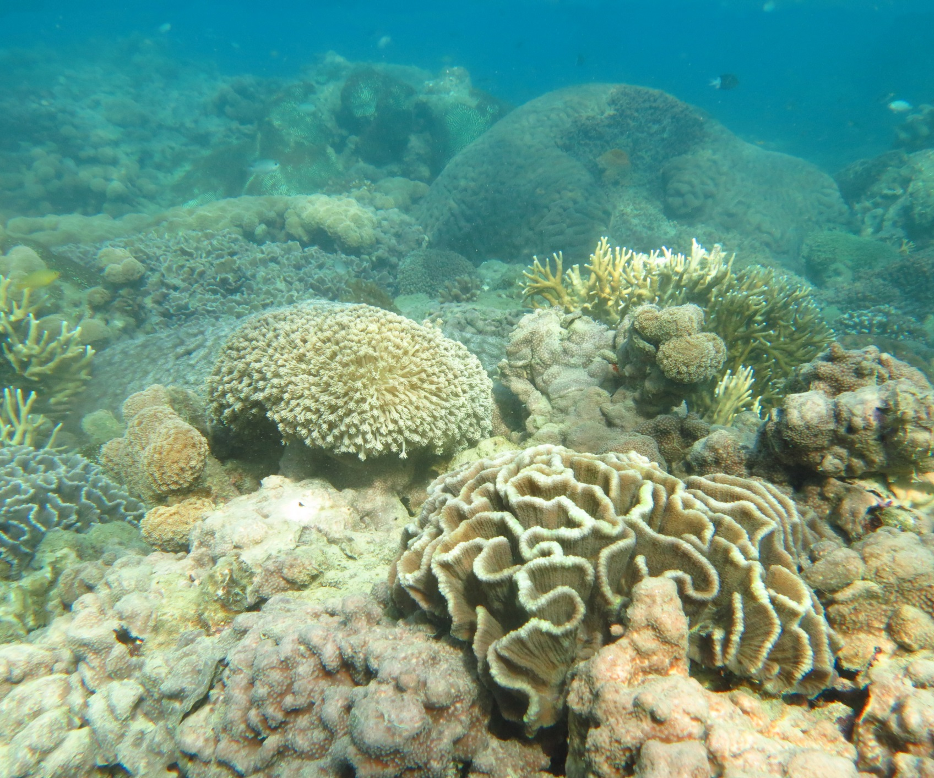

Authors - Angus Thompson, Paul Costello, Johnston Davidson, Murray Logan, Greg Coleman, Kevin Gunn, Britta Schaffelke

2015 - 2016
Annual Report
for inshore coral reef
monitoring

Marine Monitoring Program

Annual Report for Inshore Coral Reef Monitoring
2015 - 2016

Angus Thompson, Paul Costello, Johnston Davidson,
Murray Logan, Greg Coleman, Kevin Gunn, Britta Schaffelke

© Commonwealth of Australia (Australian Institute of Marine Science), 2017
Published by the Great Barrier Reef Marine Park Authority
ISBN: 2208-4118

Marine Monitoring Program: Annual report for inshore coral monitoring 2015-2016 is licensed for use under a Creative Commons By Attribution 4.0 International licence with the exception of the Coat of Arms of the Commonwealth of Australia, the logos of the Great Barrier Reef Marine Park Authority and Australian Institute of Marine Science any other material protected by a trademark, content supplied by third parties and any photographs. For licence conditions see: http://creativecommons.org/licences/by/4.0


This publication should be cited as:
Thompson, A., Costello, P., Davidson, J., Logan, M., Coleman, G., Gunn, K., Schaffelke, B., 2017, Marine Monitoring Program. Annual Report for inshore coral reef monitoring: 2015 to 2016. Report for the Great Barrier Reef Marine Park Authority, Great Barrier Reef Marine Park Authority, Townsville.133 pp.

A catalogue record for this publication is available from the National Library of Australia

Front cover image: The reef-flat coral community at Double Cone Island, Central Great Barrier Reef. Photographer Johnston Davidson © AIMS 2014.

DISCLAIMER
While reasonable efforts have been made to ensure that the contents of this document are factually correct, AIMS do not make any representation or give any warranty regarding the accuracy, completeness, currency or suitability for any particular purpose of the information or statements contained in this document. To the extent permitted by law AIMS shall not be liable for any loss, damage, cost or expense that may be occasioned directly or indirectly through the use of or reliance on the contents of this document.

Comments and questions regarding this document are welcome and should be addressed to:
Australian Institute of Marine Science
Jane Waterhouse, Christian Lønborg, Richard Brinkman, Paul Costello, Eduardo da Silva, Johnston Davidson, Kevin Gunn,Stephen Lewis, Murray Logan, Caroline Petus, Britta Schaffelke, Michele Skuza, Hemerson Tonin, Dieter Tracey, Margaret Wright, Irena Zagorskis

PMB No 3
Townsville MC, Qld 4810

This project is supported by the Great Barrier Reef Marine Park Authority through funding from the Australian Government Reef Program, the Reef 2050 Integrated Monitoring, and Reporting Program and AIMS.

Contents
1 Executive Summary 1
2 Preface 5
3 Introduction 6
4 Methods 9
4.1 Sampling design 9
4.1.1 Site Selection 9
4.1.2 Depth Selection 11
4.1.3 Site marking 11
4.1.4 Sampling timing and frequency 11
4.3 Environmental pressures 13
4.3.1 Water quality 13
4.3.2 Sea temperature 13
4.3.3 River discharge, DIN and TSS loads 14
4.3.4 Sediment sampling 14
4.3.5 SCUBA search transects 14
4.4 Pressure presentation 17
4.5 Coral community sampling 18
4.5.1 Photo point intercept transects 18
4.5.2 Juvenile coral surveys 18
4.6 Coral reef data analysis and presentation 19
4.6.1 Variation in index and metric scores among Regions and depths 19
4.6.2 Variation in index and metric scores to gradients in water quality 20
4.6.3 Relationship between index and metric scores and regional discharge 20
4.6.4 Temporal trends in coral index, indicators and measured water quality. 20
4.6.5 Analysis of change in index and metric scores 21
4.7 The Coral Index 21
4.7.1 Coral Cover metric 21
4.7.2 Macroalgae metric 22
4.7.3 Density of juvenile hard corals metric 23
4.7.4 Cover Change metric 24
4.7.5 Community Composition metric 26
4.7.6 Aggregating indicator scores to regional scale assessments 27
5 Results 29
5.1 Variation of coral index and indicator scores observed in 2016 29
5.1.1 Regional differences 29
5.1.2 Effect of depth 30
5.1.3 Response to environmental gradients 31
5.1.4 Influence of discharge and catchment loads 33
5.2 Regional condition of coral communities 35
5.2.1 Wet Tropics Region: Barron Daintree sub-region 35
5.2.2 Wet Tropics Region: Johnstone Russell-Mulgrave sub-region 39
5.2.3 Wet Tropics Region: Herbert Tully sub-region 43
5.2.4 Burdekin Region 46
5.2.5 Mackay Whitsunday Region 50
5.2.6 Fitzroy Region 54

6 Discussion 58
6.1 Pressures 58
Acute disturbances 58
Chronic conditions - water quality 59
6.2 Ecosystem State 59
Coral index 59
Coral cover 61
Rate of change in coral cover 61
Composition 62
Macroalgae 62
Juvenile density 63
6.3 Regional summaries 63
Wet Tropics 63
Burdekin 64
Whitsundays 65
Fitzroy 65
6.3 Conclusion 66
7 Case Study - Coral Bleaching 2016 67
7.1 Methods 67
7.2 Discussion of Results 68
8 Case Study – Water quality constraints on the abundance of brown macroalgae 73
8.1 Methods 73
8.2 Results 74
8.3 Discussion 75
9 Acknowledgments 79
10 References 79
Appendix 1: Additional Information 89
Appendix 2: Publications and presentations associated with the Program 2015-16 134

List of Figures and Tables
Figure 1 Regional Coral Index with contributing indicator scores. 4
Figure 2 Sampling locations of the MMP coral and water quality monitoring. 10
Figure 3 Scoring diagram for the Coral Cover metric. 22
Figure 4 Scoring diagram for the Macroalgae metric. 23
Figure 5 Scoring diagram for the Juvenile metric. 24
Figure 6 Scoring diagram for Cover Change metric 26
Figure 7 Scoring diagram for Community Composition metric 27
Figure 8 Regional distributions of index and metric scores.. 30
Figure 9 Relationship between coral index scores and environmental conditions. 31
Figure 10 Relationship between indicator metric scores and environmental conditions. 32
Figure 11 Relationship between the coral index and run-off from local catchments. 33
Figure 12 Barron Daintree sub-region environmental pressures.. 37
Figure 13 Barron Daintree sub-region index and indicator trends. 38
Figure 14 Johnstone Russell-Mulgrave sub-region environmental pressures 41
Figure 15 Johnstone Russell-Mulgrave sub-region index and indicator trends 42
Figure 16 Herbert Tully sub-region environmental pressures. 44
Figure 17 Herbert Tully sub-region index and indicator trends 45
Figure 18 Burdekin Region environmental pressures 48
Figure 19 Burdekin Region index and indicator trends 49
Figure 20 Whitsunday Mackay Region environmental pressures. 52
Figure 21 Mackay Whitsunday Region index and indicator trends 53
Figure 22 Fitzroy Region environmental pressures 56
Figure 23 Fitzroy Region index and indicator trends. 57
Figure 24 Eye on the reef bleaching observations 2016. 70
Figure 25 Seasonally adjusted temperature anomalies for (sub)-regions.. 72
Figure 26 Brown macroalgae proportion relationships to environmental conditions 75
Figure 27 Distribution of environmental condition thresholds supportive of brown macroalgae. 76

Table 1 Sampling locations. 12
Table 2 Summary of climate and environment data included in this report 16
Table 3 Categorisation of disturbances 17
Table 4 Survey methods used by the MMP and LTMP to describe coral communities 18
Table 5 Presentation of community condition 19
Table 6 Threshold values for the assessment of coral reef condition and resilience indicators. 28
Table 7 Regional differences in index and metric scores. 29
Table 8 Influence of depth on index and metric scores. 30
Table 9 Relationship between changes in index scores and run-off. 34
Table 10 Changes in index and metric scores in the Barren Daintree sub-region. 35
Table 11 Changes in index and metric scores in the Johnstone Russell-Mulgrave sub-region. 39
Table 12 Changes in index and metric scores in the Herbert Tully sub-region.. 43
Table 13 Changes in index and metric scores in the Burdekin Region. 46
Table 14 Changes in index and metric scores in the Mackay Whitsunday Region. 50
Table 15 Changes in index and metric scores in the Fitzroy Region. 54
Table 16 Bleaching categorisation used by GBRMPA Eye on the Reef and AIMS MMP surveys. 67
Table 17 Eye on the Reef bleaching categories. 68
Table 18 Degree Heating Days (DHD) for 2016 and 2015. 69
Table 19 Bleaching distribution among MMP reefs in 2016. 71
Table 20 Distribution of conditions supporting high abundance of brown macroalgae. 77

List of Figures and Tables – Appendices
Figure A1. 1 Barron Daintree sub-region benthic community composition 99
Figure A1. 2 Johnstone Russell-Mulgrave sub-region benthic community composition 100
Figure A1. 3 Herbert-Tully sub- region benthic community composition. 103
Figure A1. 4 Burdekin Region benthic community composition.. 105
Figure A1. 5 Mackay Whitsunday Region benthic community composition. 109
Figure A1. 6 Fitzroy Region benthic community composition. 113
Figure A1. 7 Coral disease by year in each region. 115
Figure A1. 8 Cyclone exposure history. 127
Figure A1. 9 Temporal trends in water quality: Baron Daintree sub-region.. 128
Figure A1. 10 Temporal trends in water quality: Johnstone Russell-Mulgrave sub-region.. 129
Figure A1. 11 Temporal trends in water quality: Herbert Tully sub-region. 130
Figure A1. 12 Temporal trends in water quality: Burdekin region. 131
Figure A1. 13 Temporal trends in water quality: Mackay Whitsundays region.. 132
Figure A1. 14 Temporal trends in water quality: Fitzroy region. 133

Table A 1 Thresholds for proportion of macroalgae in the algae communities. 90
Table A 2 Eigenvalues for hard coral genera along constrained water quality axis.. 91
Table A 3 Annual freshwater discharge for the major Reef Catchments. 92
Table A 4 Disturbance records for each reef.. 93
Table A 5 Reef level indicator scores. 96
Table A 6 Environmental covariates for coral locations. 98
Table A 7 Composition of hard coral communities. 116
Table A 8 Composition of soft coral communities. 120
Table A 9 Composition of macroalgal communities. 123

Abbreviations used:
AIMS - Australian Institute of Marine Science
COTS – crown-of-thorns starfish
The Reef - Great Barrier Reef World Heritage Area
MMP- Marine Monitoring Program
Reef Plan - Reef Water Quality Protection Plan
Reef 2050 Plan - Reef 2050 Long Term Sustainability Plan
BOM - Bureau of Meteorology
JCU - James Cook University
GBRMPA – Great Barrier Reef Marine Park Authority

Executive Summary
The Marine Monitoring Program (MMP) was established in 2005 to assess status and trends in ecosystem health and resilience indicators for the Great Barrier Reef (the Reef). The results of the MMP are integral to assessing the long-term effectiveness of the Reef Water Quality Protection Plan (Reef Plan) and are the basis for marine condition scores reported in annual Reef Report Cards. This report summarises coral reef benthic community results used to derive report card scores for 2016.
Report card scores are estimated at the scale Natural Resource Management (NRM) regions and represent an index that aggregates over five indicators; coral cover, hard coral community composition, macroalgae cover, juvenile coral density and the rate of coral cover increase. Data were derived from 2 m and 5 m depths at 32 reefs monitored by the MMP in addition to data from single depths at 9 inshore reefs monitored the Australian Institute of Marine Science – Long Term Monitoring Program (LTMP). Interpretation of trends in the index and individual indicators was reliant on the consideration of environmental data collected at coral monitoring sites or sourced from the Australian Bureau of Meteorology, the Queensland Department of Natural Resources and Mines and the water quality subprogram of the MMP.
Conditions over the 2015-16 summer were relatively benign in the areas of the Reef covered by this report. There were no cyclones and discharge from rivers was below long-term medians in all regions, with the exception of the Fitzroy region. Discharge from the Fitzroy River was 1.3 times median though no major flooding was recorded. Water temperatures were above site specific medians recorded over the last decade, however only minor coral bleaching occurred. Elevated populations of crown-of-thorns starfish were restricted to reefs in the Johnstone Russell – Mulgrave sub-region of the Wet Tropics where loss of coral cover was minimal.
In 2016 the coral index scores continued to improve in all regions. Improvements were generally consistent across community resilience indicators and contrast declining scores observed through to 2012-2014, depending on region. Declines in the index occurred as a result of the cumulative impact of acute disturbance events that coincided with a period of high rainfall that led to high loads of nutrients and sediments entering the Great Barrier Reef (the Reef). Importantly the observed improvements in index scores illustrate an underlying capacity for coral communities to recover when cumulative pressures are relatively low. Disentangling the role of acute disturbances in reducing index scores, revealed that in three of the four Regions (Mackay Whitsunday excepted), there was evidence for greater improvement in index scores when run-off from adjacent catchments was relatively low. This sensitivity to changes in run-off was in addition to a tendency for higher index scores on reefs less exposed to poor water quality.
The coral index for the Wet Tropics remains in the ‘moderate’ condition category, although has continued to improve from a low point recorded in 2013 (Figure 1). Improvements in the index have coincided with a period of reduced discharge from the adjacent catchments, although ongoing pressure from crown-of-thorns starfish (COTS) continued to affect some reefs. Partly mitigating the influence of COTS, has been an active population control programme with 13,339 individuals removed from the reefs reported herein prior to surveys in 2016. Within the region, improvement in the index is most evident in the Herbert Tully sub-region where, of the five metrics included in the index, it was only Macroalgae at 5 m depth that had not improved. The legacy of impacts associated with Cyclone Yasi that contributed to low coral cover and loss of sensitive species continues to suppress the coral index in the Herbert Tully sub-region. In the Johnstone Russell-Mulgrave sub-region the index achieved a ‘good’ categorisation for the first time since 2010 demonstrating the ongoing recovery from the impacts of Cyclone Tasha in late 2010 and Cyclone Yasi in early 2011, despite ongoing presence of COTS. Changes in the index were most evident at 2 m depths where only the Cover Change and Macroalgae metric scores showed little change as a result of maintaining consistently high scores. At 5 m depths improvement in the index since 2012 was limited by low scores of Macroalgae in the Frankland Group and a reduction in Composition scores, likely as a result of COTS feeding on corals that are also sensitive to poor water quality. In the Barron Daintree sub-region improvement in the index has been limited since the low point reached in 2014. Recovery was most evident at 5 m depths where scores for the Macroalgae and Cover Change metrics have improved. At 2 m depths clear improvement in the Cover Change and Coral Cover scores contrast declines in Composition and Macroalgae scores.
Since 2012 the coral index in the Burdekin Region has continued to improve with the current ‘moderate’ categorisation improving on the ‘poor’ categorisation recorded through to 2015 (Figure 1). The observed increase in the coral index coincides with a lack of acute disturbances and relatively low flows from adjacent catchments since 2013. Improvement in the coral index was most influenced by clear increase in Coral Cover scores at both 2 m and 5 m depths and a gradual return of genera sensitive to water quality (improved Composition scores). Although Coral cover has increased the legacy of cumulative pressures continues to influence coral cover in the region and the score for this indictor remains poor. Persistently high cover of macroalgae on the reefs with highest Chl a concentrations also continue to limit index scores both, directly, and likely as a contributing factor to unchanging scores for the Cover Change and Juvenile metrics at 2 m depths. After controlling for the influence of acute disturbance events (in particular Cyclones) the improvement in index scores was inversely related to discharge from the regions rivers. Suppression of coral communities, as a result of poor water quality was indicated by observations of high levels of coral disease as discharge, and associated contaminants, from the Burdekin, and other smaller rivers, transitioned from a series of below median years to above median levels from 2007 through to 2009.
The coral index in the Mackay Whitsunday Region has continued to improve from a low point in 2012 as a result of Cyclone Ului. In 2016, the coral index returned to ‘good’ condition for the first time since 2005 (Figure 1). The positive attributes of moderate to high Coral Cover coupled with regionally low cover of macroalgae and increasing sores for the Juvenile metric balanced low scores for Coral Change (Figure 1). The influence of prevailing environmental conditions such as high turbidity, nutrient availability and sedimentation, have clearly selected for coral species tolerant of those conditions. Marked differences in community composition between 2 m and 5 m depths at most reefs are indicative of the increasing selective pressures of light availability and accumulated sediments at the deeper sites. This process of selection appears ongoing, as indicated by increased levels of coral disease, which coincided with elevated discharge from both local rivers and the large rivers in neighbouring regions. The selection for corals tolerant of the regions water quality in combination with a lack of recent severe disturbance events, explains the relatively high coral cover in this region despite poor water quality. Increases in both the Coral Cover and Juvenile metric scores since 2012 were predominantly observed at the shallower depths, contrasting the resilience of shallow water corals to the resistance of the deeper water corals that are tolerant of the region’s water quality. What remains largely untested, is how resilient deeper communities will be if exposed to a severe disturbance event. Consistently low scores for the Cover Change metric suggests recovery from acute disturbances may be slow.
The coral index in the Fitzroy Region remained ‘poor’ in 2016, a score representing an improvement from the ‘very poor’ condition observed in 2014 (Figure 1). Improvement in the index to 2016 predominantly reflects improvement in the Cover Change metric at both 2 m and 5 m sites, along with improved Juvenile scores at 2 m depths, both are necessary precursors to future improvements in the index. Over the period 2006-2014 coral communities in the region were exposed to cumulative pressures, associated with a series of acute disturbances and chronic effects of water quality, as reflected in the decline of the coral index through to 2014 (Figure 1). Two acute disturbances stand out, high water temperatures in 2006 bleached and killed corals resulting in an average reduction in coral cover of 16% across the region, and then, coral cover was reduced by a similar amount in response to a major flood event in 2011. This flood predominantly affected the 2 m sites on reefs inshore of Great Keppel Island, where the majority of corals were killed as a result of exposure to low salinity waters. Elsewhere, increased levels of disease demonstrated a likely impact of reduced water quality during and following the flood. In the periods 2007-2011 and 2012-2014 recovery from these disturbance events was hampered by a series of storms and persistently high cover of macroalgae, low levels of coral recruitment and low rates of coral cover increase (Figure 1), all of which coincided with a period of high loads of land-based material being delivered by the Fitzroy River.
Overall, it is apparent that the cumulative impact of tropical cyclones, outbreaks of crown-of-thorns seastars and a period of high discharge carrying increased loads of nutrients and sediments to the Reef resulted in declines in coral community condition through to 2012-2014. Notwithstanding the prediction that the severity of disturbance events to coral reefs is projected to increase as a result of climate change, it is essential that communities retain the ability to recover from inevitable disturbances so as to maintain a coral dominated state in the long-term. The coral index is formulated explicitly to emphasise coral communities’ recovery potential. As such improvements in the index in all regions in 2016 are an important demonstration of the resilience inherent in inshore coral communities under situations of low cumulative pressure. The strong impact of acute disturbances such as: cyclones, bleaching, and outbreaks of crown-of-thorns seastars, on coral community state impose an unavoidable confounding between the influence of these pressures and those that can be attributed to water quality. By explicitly focusing on periods free from acute disturbance events we were able to demonstrate that incremental changes in the coral index, during periods when reefs should be recovering, was inversely related to discharge from local catchments in three of the four regions monitored. In combination with a spatial analysis that demonstrated higher index scores where chlorophyll a levels were below guideline values, the temporal relationships between the recovery potential of coral communities and environmental conditions provides support for the primary premise of Reef Plan, that load reduction will have downstream environmental benefits for the Reef.
In addition to the effects of run-off on the condition of inshore reefs reported here, increased nutrient loads delivered to the Reef lagoon during major flood events have been linked to the initiation of COTS outbreaks. Although not typically prevalent on inshore reefs, elevated numbers of COTS in the Barron Daintree and Johnstone Russell-Mulgrave sub-regions in recent years mirror much larger populations observed offshore. In 2016, small numbers of COTS were observed at Fitzroy Island, High Island and the Frankland Group where a range of size-classes indicate ongoing recruitment. The densities of COTS observed were sufficient that as these individuals grow they are likely to result in future damage to the coral communities. A single juvenile COTS was also observed at Palms East consistent with the general southward movement of COTS observed on more offshore reefs.
.

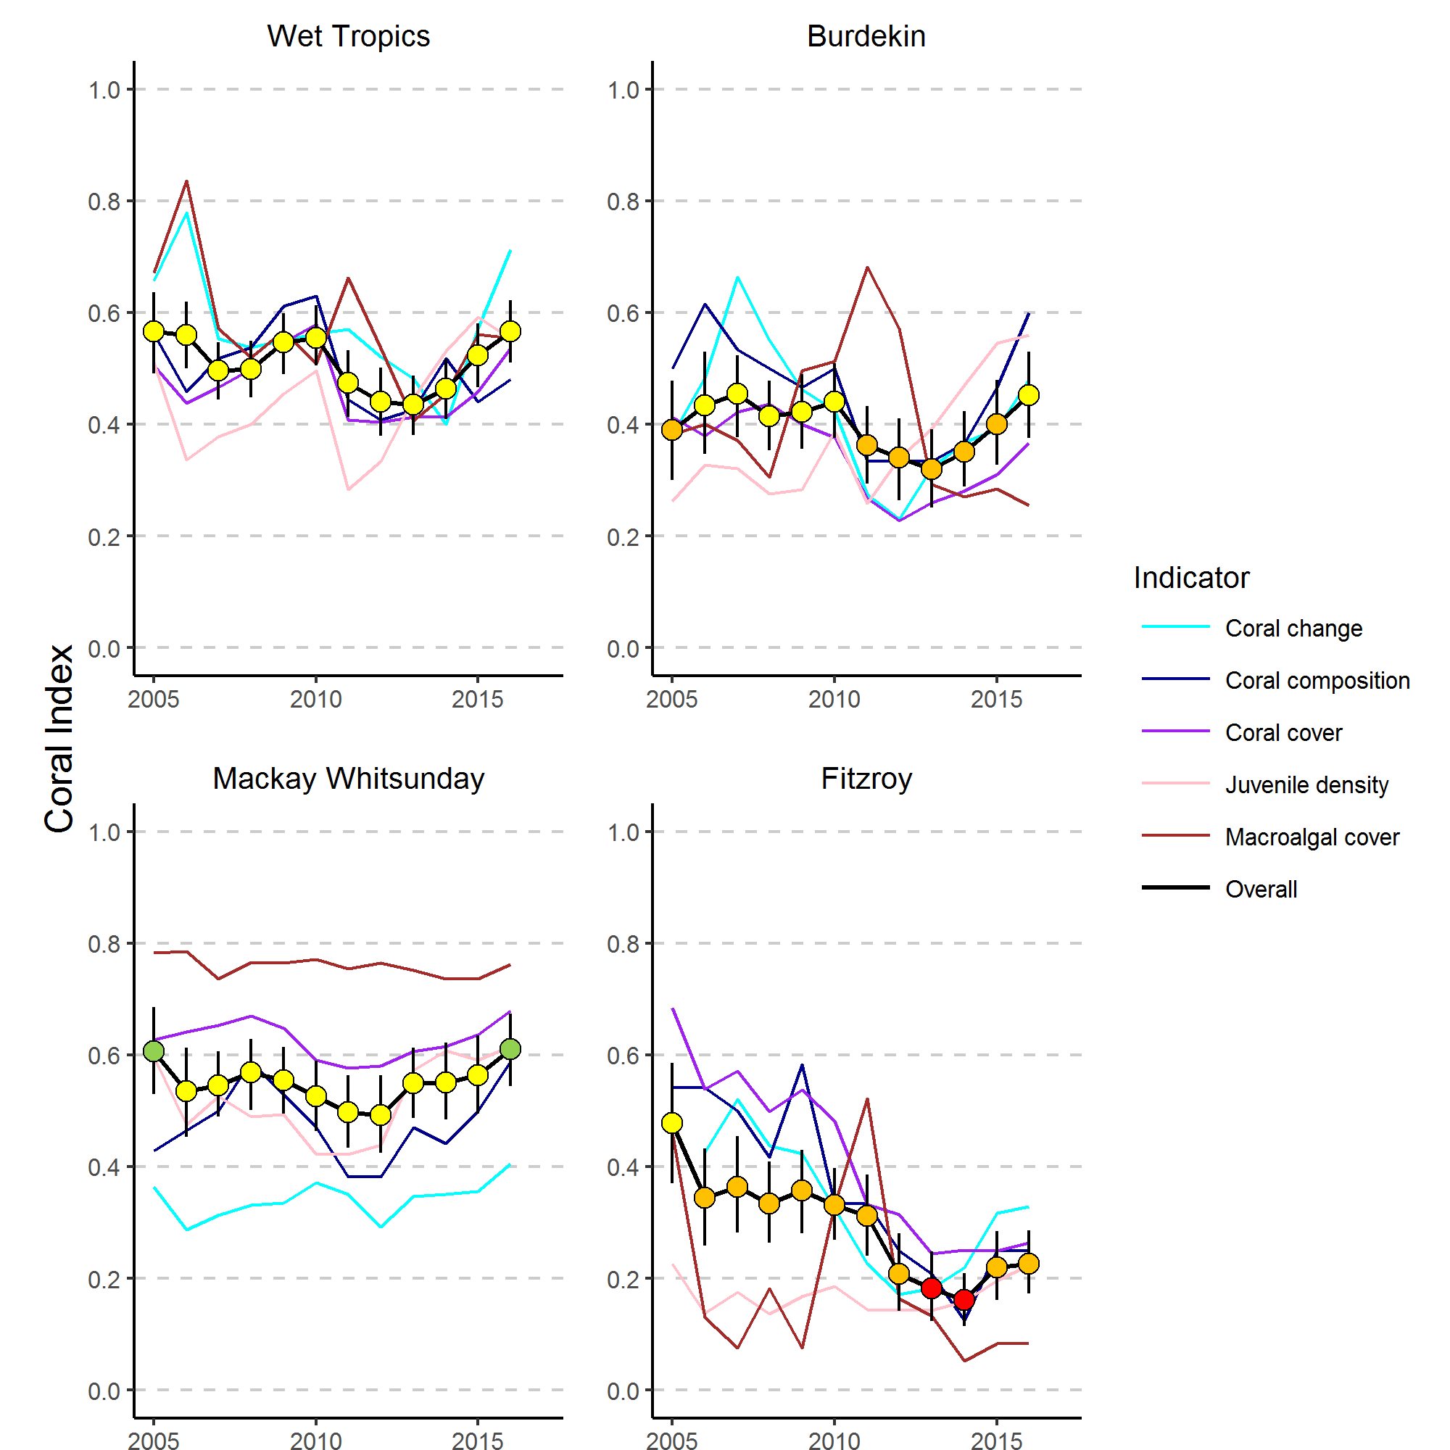

Figure 1 Regional Coral Index with contributing indicator scores.
The regional Coral Index is derived from the aggregate of metric scores for indicators of coral community health. The contributing indicators are described in the methods section

Preface
Management of human pressures, such as enhanced nutrient run-off and overfishing, is vital to provide corals, and reef organisms in general, with the optimum conditions to cope with global stressors, such as climate change and ocean acidification (Bellwood et al. 2004, Marshall & Johnson 2007, Carpenter et al. 2008, Mora 2008, Hughes et al. 2010). The management of water quality remains a strategic priority for the Great Barrier Reef Marine Park Authority (GBRMPA) to ensure the long-term protection of the coastal and inshore ecosystems of the Reef (GBRMPA 2014 a, b). A key policy is the Reef Water Quality Protection Plan (Reef Plan; Anon. 2013), a component of the Reef 2050 Long Term Sustainability Plan (Reef 2050 Plan; Commonwealth of Australia, 2015), which provides a framework for the integrated management of the Great Barrier Reef World Heritage Area.
The Marine Monitoring Program (MMP) was designed and developed by the GBRMPA in collaboration with science agencies and is currently funded by the Australian Government Reef Programme. A summary of the MMP’s overall goals and objectives and a description of the sub-programs are available at the GBRMPA 2050 marine monitoring program website and the e-atlas website. The MMP forms an integral part of the Paddock to Reef Integrated Monitoring, Modelling and Reporting Program, which is a key action of Reef Plan designed to evaluate the efficiency and effectiveness of implementation and report on progress towards Reef Plan goals and targets. A key output of the Paddock to Reef Program is an annual report card, including an assessment of Reef water quality and ecosystem condition, which is based on MMP information (www.reefplan.qld.gov.au).
The Australian Institute of Marine Science (AIMS) and the GBRMPA entered into a co-investment agreement in June 2015 to provide inshore coral reef monitoring under the MMP in 2015 and 2016. This monitoring is largely an extension of activities established under previous agreements covering 2005 to 2014. This report covers coral reef monitoring conducted between May 2016 and August 2016 with inclusion of data from previous MMP and AIMS Long-Term Monitoring Program observations (LTMP). In-keeping with the overarching objective of the MMP, to “Assess trends in ecosystem health and resilience indicators for the Great Barrier Reef in relation to water quality and its linkages to end-of-catchment loads”, key water quality results reported by (Waterhouse et al. 2017) are replicated here as required for interpretation.

Introduction
It is well documented that sediment and nutrient loads carried by land run-off into the coastal and inshore zones of the Great Barrier Reef World Heritage Area (the Reef) have increased since European settlement (e.g., Kroon et al. 2012, Waters et al. 2014). Ongoing concern that these increases were negatively impacting the Reef ecosystem triggered the formulation and subsequent updating of the Reef Water Quality Protection Plan (Reef Plan) for adjacent catchments (Anon. 2003, 2009, 2013). The Reef 2050 Plan includes the Reef Plan actions and initiatives to change land management practices to achieve improvement in downstream water quality of creeks and rivers. These actions and initiatives should, with time, lead to improved water quality in the coastal and inshore Reef that, in turn, support the ongoing health and resilience of the Great Barrier Reef (see Brodie et al. 2012a for a discussion of expected time lags in the ecosystem response).
Reef Plan can be considered in a Drivers-Pressures-States-Impacts-Responses (DPSIR) framework (Maxim et al. 2009, Rehr et al. 2012). Socio-economic factors are the drivers of human activities from local - within catchment, through to global scales. Human activities result in local scale pressures on downstream ecosystems such as increased exposure to sediments, nutrients and toxicants through to global pressures such as climate change. These pressures change the state of the Reef ecosystems. This state can then be interpreted in terms of impact on desirable ecosystem functioning or services that in turn can be used to inform decisions as to the need for response such as policy or regulatory actions to alleviate that impact.
To allow the full application of a DPSIR framework requires the monitoring of both pressures and states that should be reported, where possible, in terms of impacts so that appropriate management responses can be devised, or conversely, the outcomes of existing management strategies assessed. Reef Plan actions included the establishment of monitoring programs extending from the paddock to the Reef (Anon. 2010), to assess the effectiveness of Reef Plan's implementation. The MMP is an integral part of this monitoring providing physicochemical and biological data to document the state of: coral reefs, seagrass beds, water quality and concentrations of pesticides in inshore areas of the Reef. The MMP additionally collates observations of extrinsic pressures such as sea temperature variability, occurrence of tropical cyclones, river discharge volumes and predator populations that must be considered in any assessment of water quality impacts on ecosystem state. Ultimately the state of marine waters and the ecosystems of the Reef will provide both a basis for assessing the success of Reef Plan and the necessity for future management strategies.
The coral reef component of the MMP is based on the general understanding that healthy and resilient coral communities exist in a dynamic equilibrium, with communities in a cycle of recovery punctuated by acute disturbance events. Common disturbances to inshore reefs include cyclones (often associated with flooding), thermal bleaching, and outbreaks of crown-of-thorns seastars (COTS), all of which can result in widespread mortality of corals (e.g. Sweatman et al. 2007, Osborne et al. 2011). The potential impact of elevated nutrients carried into the system as run-off potentially compound the influences of acute disturbances by: increasing the susceptibility of corals to disease (Bruno et al. 2003, Haapkylä et al. 2011, Weber et al. 2012, Vega Thurber et al. 2013), promoting outbreaks of COTS (Wooldridge & Brodie 2015) and increasing susceptibility to thermal stress (Wooldridge & Done 2004, Wiedenmann et al. 2013). Pollutants in run-off may also suppress the recovery process (Schaffelke et al. 2013). The replacement of corals lost to disturbance is reliant on both the recruitment of new colonies and regeneration of existing colonies from remaining tissue fragments (Smith 2008, Diaz-Pulido et al. 2009). Elevated concentrations of nutrients, agrochemicals, and turbidity can negatively affect reproduction in corals (reviewed by Fabricius 2005, van Dam et al. 2011 Erftemeijer et al. 2012). High rates of sediment deposition and accumulation on surfaces can affect larval settlement (Babcock & Smith 2002, Baird et al. 2003, Fabricius et al. 2003) and smother juvenile corals (Harrison & Wallace 1990, Rogers 1990, Fabricius & Wolanski 2000). In addition, macroalgae have higher abundance in areas with high water column chlorophyll concentrations, indicating higher nutrient availability (De’ath & Fabricius 2010, Petus et al. 2016). High macroalgal abundance may suppress reef resilience (e.g. Hughes et al. 2007, Cheal et al. 2010, Foster et al. 2008, but see Bruno et al. 2009) by increased competition for space or changing the microenvironment into which corals settle and grow (e.g. McCook et al. 2001, Hauri et al. 2010). Macroalgae have been documented to suppress fecundity (Foster et al. 2008), reduce recruitment of hard corals (Birrell et al. 2008b, Diaz-Pulido et al. 2010), diminish the capacity of growth among local coral communities (Fabricius 2005),and suppress coral recovery by altering microbial communities associated with corals (Morrow et al. 2012, Vega Thurber et al. 2012).
In addition to influences on the early life stages of corals, changes in water quality have been shown to increase incidence of coral disease: for example increased organic carbon concentrations promote coral diseases and mortality (Kline et al. 2006, Kuntz et al. 2005). The selective pressure of water quality on coral communities is clearly evident in changes in community composition along environmental gradients (De’ath & Fabricius 2010, Thompson et al. 2010, Uthicke et al. 2010, Fabricius et al. 2012). Corals derive energy in two ways, by feeding on ingested particles and plankton organisms and from the photosynthesis of their symbiotic algae (zooxanthellae). The ability to compensate by feeding where there is a reduction in energy derived from photosynthesis, e.g. as a result of light attenuation in turbid waters, varies between species (Anthony 1999, Anthony & Fabricius 2000). Similarly, the energy required to shed sediment varies between species due to differences in the efficiencies of passive (largely depending on growth form) or active (such as mucus production) strategies for sediment removal (Rogers 1990, Stafford-Smith & Ormond 1992). At the same time, high nutrient levels may favour particle feeders such as sponges and heterotrophic soft corals which are potential space competitors of hard corals. The result is that the combination of environmental parameters at a given location will disproportionately favour some species and thus influence the community composition of coral reef benthos. However, coral communities occur in a wide range of environmental settings because different coral species have different tolerances to environmental pressures (e.g. Done 1982, Fabricius & De’ath 2001, DeVantier et al. 2006, De’ath & Fabricius 2010).
Coral reefs in the coastal and inshore zones of the Reef, which are often fringing reefs around continental islands, are subject to high turbidity due to frequent exposure to re-suspended sediment and episodic flood events. It is difficult to quantify the changes to coral reef communities caused by run-off of excess nutrients and sediments because of the lack of historical biological and environmental data that predate significant land use changes on the catchment. However, recent research has strengthened the evidence for causal relationships between water quality changes and the decline of some coral reefs and seagrass meadows in these zones (reviewed in Brodie et al. 2012b and Schaffelke et al. 2013).
Given that the benthic communities in inshore areas of the Reef show clear responses to gradients in turbidity, sedimentation rate and nutrient availability (van Woesik et al. 1999, Fabricius & De’ath 2001, Fabricius et al. 2005, Wismer et al. 2009, Uthicke et al. 2010, Fabricius et al. 2012), improved land management practices have the potential to reduce levels of chronic environmental stresses that impact on coral reef communities. However, recent assessments raise the question whether these actions will be sufficient to ensure the resilience of the Reef ecosystems into the future (Bartley 2014a, b, Kroon et al. 2014). Nutrients, that sustain the biological productivity of the Reef, are supplied by a number of processes and sources such as upwelling of nutrient-enriched deep water from the Coral Sea and nitrogen fixation by bacteria (Furnas et al. 2011). However, land run-off is the largest source of new nutrients to the inshore Reef (ibid.), especially during monsoonal flood events. These nutrients augment the regional stocks of nutrients already stored in biomass or detritus (Furnas et al. 2011) which are continuously recycled to supply nutrients for marine plants and bacteria (Furnas et al. 2005, Furnas et al. 2011).
The complexity of interactions between benthic communities and environmental pressures makes it important to synthesize coral community condition in a way that relates to the pressures of interest. The Reef report card includes coral index scores to annually summarise condition of coral communities in inshore areas of the Reef. The purpose of this report is to provide the data, analysis and interpretation underpinning coral index scores included in the 2016 Reef report card.
In order to relate changes in the condition of coral reef communities to variations in local reef water quality, the coral component of the MMP has the overarching objective to “quantify the extent, frequency and intensity of acute and chronic impacts on the condition and trend of inshore coral reefs and their subsequent recovery”. The specific objectives are to monitor, assess and report:
- the condition and trend of Great Barrier Reef inshore coral reefs in relation to desired outcomes (expressed as coral index scores) along identified or expected gradients in water quality;
- the extent, frequency and intensity of acute and chronic impacts on the condition of Great Barrier Reef inshore coral reefs, including exposure to flood plumes sediments, nutrients and pesticides;
- the recovery in condition of Great Barrier Reef inshore coral reefs from acute and chronic impacts including exposure to flood plumes, sediments, nutrients and pesticides; and
- trends in incidences of coral mortality attributed to coral disease, Crown of Thorns Starfish, Drupella, Cliona, physical damage and coral bleaching.

This report includes two case studies. During early 2016 high sea water temperatures caused severe bleaching to parts of the Reef. Although the temperature anomalies were not as great on the reefs monitored by the MMP, a summary of the impacts of this event is included (Section 7). Secondly, macroalgae has emerged as the most consistent indicator to be spatially related to water quality. Brown macroalgae (Phaeophyta) are often the dominant group on reefs where macroalgae cover is persistently high. We present an analysis exploring the distribution of environmental conditions within which brown macroalgae have the potential to limit coral community resilience (section 8).

Methods

4.1 Sampling design
Monitoring of inshore coral reef communities occurs at reefs adjacent to four of the six natural resource management (NRM) regions with catchments draining into the Reef: Wet Tropics, Burdekin, Mackay Whitsunday and Fitzroy. No reefs are included adjacent to Cape York due to logistic and occupational health and safety issues relating to diving in coastal waters in this region. Limited development of coral reefs in nearshore waters adjacent to the Burnett Mary NRM region precluded sampling there. Sub-regions were included in the Wet Tropics NRM to more closely align reefs with the combined catchments of; the Barron and Daintree rivers, the Johnstone and Russell-Mulgrave Rivers, and the Herbert and Tully rivers

4.1.1 Site Selection
Initial selection of sites was jointly decided by an expert panel chaired by the GBRMPA. The selection was based upon two primary considerations:
- Within the Reef, strong gradients in water quality exist with distance from the coast and increasing distance from rivers, particularly in a northerly direction (Larcombe et al. 1995, Brinkman et al. 2011). The selection of reefs for inclusion in the sampling design was informed by the desire to include reefs spanning these gradients so as to facilitate the teasing out of water quality associated impacts.
- Sampling locations were selected where there was either an existing coral reef community or evidence (in the form of carbonate-based substratum) of past coral reef development. Exact locations were selected without prior investigation, once a section of reef had been identified that was of sufficient size to accommodate the sampling design a marker was deployed from the surface and transects established from this point.
In the Wet Tropics region, where few reefs exist in the inshore zone and well-developed reefs existed on more than one aspect of an island, separate reefs on windward and leeward aspects were included in the design. Coral reef communities can be quite different on windward compared to leeward reefs even though the surrounding water quality is relatively similar. Differences in wave and current regimes determine whether materials, e.g. sediments, fresh water, nutrients or toxins imported by flood events, accumulate or disperse and hence determine the exposure of benthic communities to environmental stresses. A list of the selected reefs is presented in Table 1 and the geographic locations are shown in Figure 2 and in more detail on maps within each (sub-) regional section of the results.
Since the program began in 2005 there have been two changes to the selection of reefs sampled. In 2005 and 2006 three mainland fringing reef locations were sampled along the Daintree coast. Concerns over increasing crocodile populations in this area led to the cessation of sampling at these locations. In 2015 a revision of the marine water quality monitoring component of the MMP resulted in a concentration of sampling effort along a gradient away from the Tully River mouth. To better match the water quality sampling to the coral reef sampling in the Tully-Herbert sub-region a new reef site was initiated at Bedarra and sampling at King Reef discontinued.
In addition to reefs monitored by the MMP data from inshore reefs monitored by the AIMS long-term monitoring program (LTMP) have been included in this report (Table 1, Figure 1). As the MMP sites at Middle Reef in the Burdekin region were co-located with LTMP sites this reef was also removed from the MMP sampling schedule in 2015.

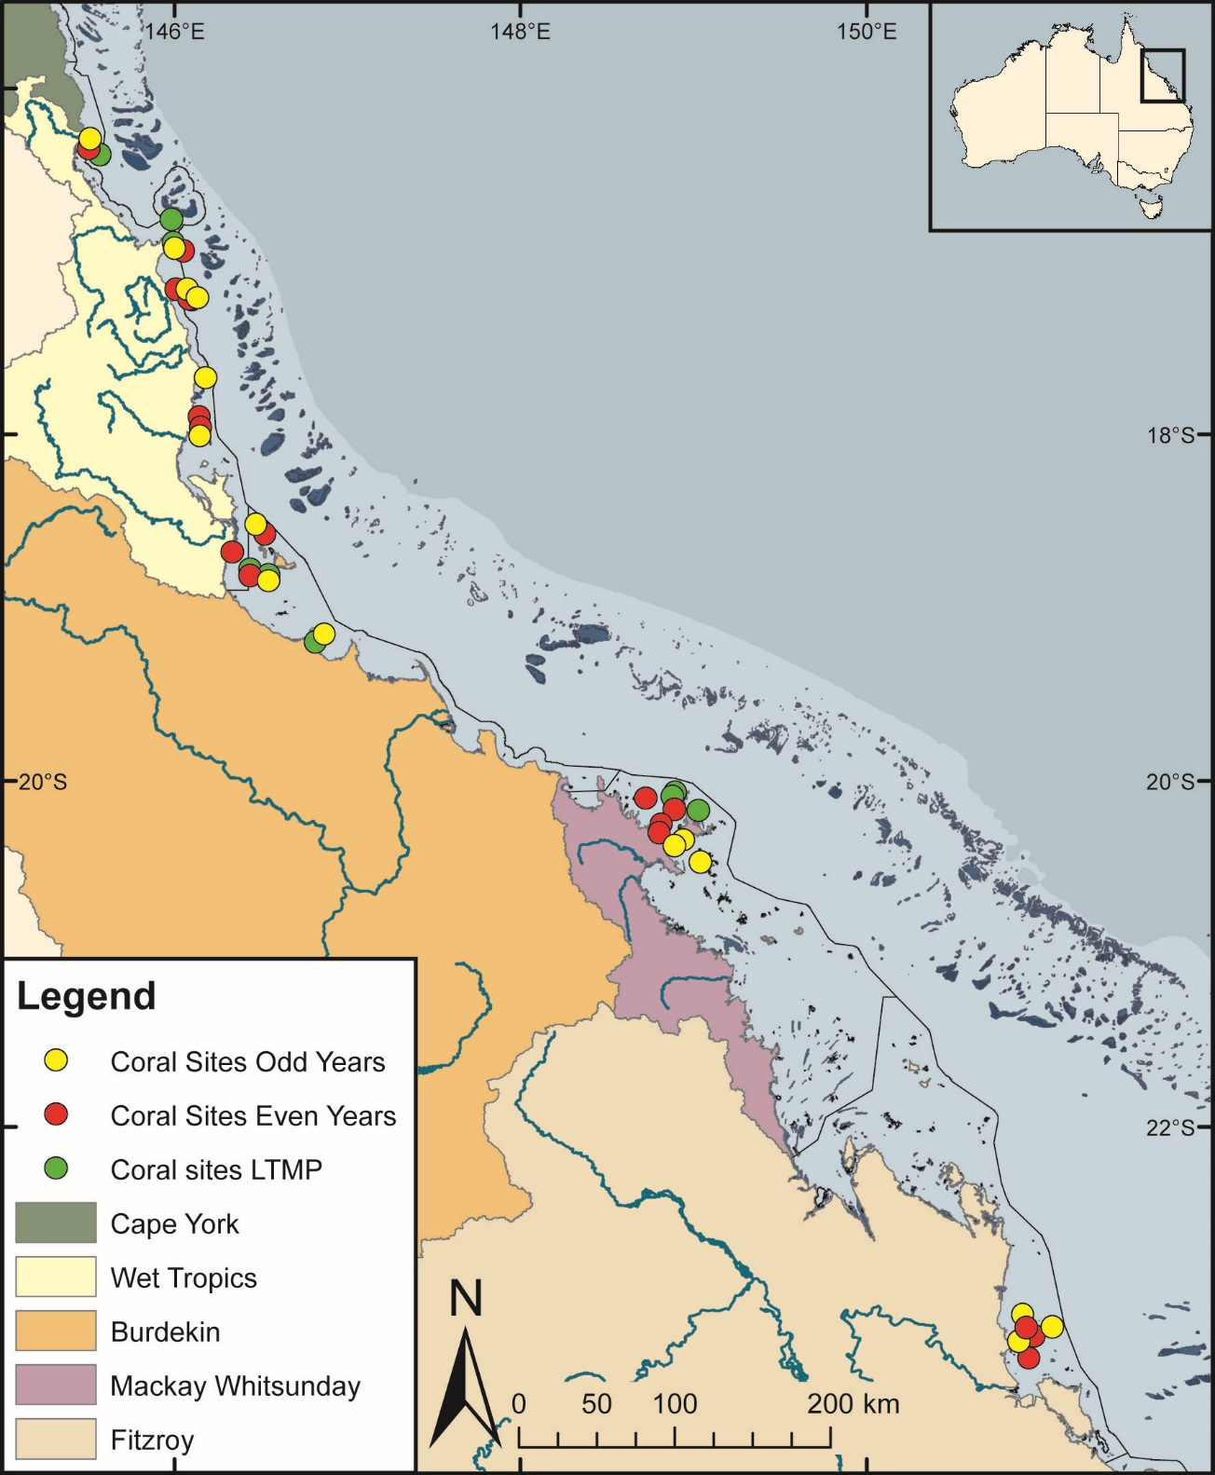
Figure 2 Sampling locations of the MMP coral and water quality monitoring.
Table 1 (below) describes monitoring activities undertaken at each location. NRM Region boundaries are represented by coloured catchment areas.

4.1.2 Depth Selection
Within the turbid inshore waters of the Reef the composition of coral communities varies strongly with depth as a result of differing exposure to pressures and disturbances (e.g. Sweatman et al. 2007). For the MMP transects were selected at two depths. The lower limit for the inshore coral surveys was selected at 5 m below datum, because coral communities rapidly diminish below this depth at many reefs. A shallower depth of 2 m below datum was selected as a compromise between a desire to sample the reef crest and logistical reasons, including the inability to use the photo technique in very shallow water, site markers creating a danger to navigation and difficulty in locating a depth contour on very shallow sloping substrata typical of reef flats. The AIMS LTMP sites are not as consistently depth defined as those of the MMP with most sites set in the range of 5-7m below LAT. Middle Reef is the exception with sites there at approximately 3m below LAT.

4.1.3 Site marking
At each reef two sites separated by at least 250 m were selected along a similar aspect. These sites are permanently marked with steel fence posts at the beginning of each of five 20 m transects and smaller (10 mm diameter) steel rods at the 10 m mark and the end of each transect. Compass bearings and measured distances record the transect path between these permanent markers. Transects were set initially by running two 60 m fibreglass tape measures out along the desired 5 m or 2 m depth contour. Digital depth gauges were used along with tide heights from the closest location included in ‘Seafarer Tides’ electronic tide charts produced by the Australian Hydrographic Service to set transects as close as possible to the desired depths of 5 m and 2 m below lowest astronomical tide (LAT). Consecutive 20 m transects were separated by 5 m. The position of the first picket of each site was recorded by GPS. Site directions and waypoints are stored electronically in AIMS databases.

4.1.4 Sampling timing and frequency
Coral reef surveys were undertaken predominantly over the months May-July as this allows the full influences of summer disturbances such as cyclones and bleaching events to be realised. Although the acute events occur over summer, the stress incurred can cause ongoing mortality for several months. The winter sampling also protects observers from potential risk from marine stingers over the summer months. The exception was Snapper Island where sampling occurred typically in the months August – October.
The frequency of survey has changed gradually over time due to budgetary constraints. In 2005 and 2006 all MMP reefs were surveyed. From 2007 through to 2014 a subset of reefs at which there were co-located water sampling sites, were classified as “core” reefs, and sampled annually. The remaining reefs were classified as “cycle” and sampled only in alternate years with half sampled in odd numbered years (i.e. 2009, 2011 & 2013) and the remainder in even numbered years. When an acute disturbance was suspected to have impacted cycle reefs during the preceding summer they were resurveyed irrespective of their odd or even year classification so as to gain the best estimate of the impact of the acute event and bookend the start of the recovery period. Further funding reductions necessitated the adoption of a biennial sampling cycle for all reefs, although a contingency for the out-of-phase resampling of reefs impacted by acute disturbance was maintained. In 2016 all out-of-cycle reefs in the Wet Tropics and Burdekin Regions were scheduled for contingency sampling to assess the impact of coral bleaching. Based on repeated observation of limited bleaching on reefs in the Wet Tropics one reef “Barnards” was not resurveyed. In the Keppels region the sampling of Peak (scheduled for sampling) was swapped with Pelican (not scheduled) due to our inability to survey as a result of very poor (<1 m) underwater visibility encountered at Peak on two consecutive survey attempts.

Table 1 Sampling locations. Black dots mark reefs surveyed as per sampling design, the “+” symbol indicates reefs surveyed out of schedule to assess disturbance. At each reef surveys of juvenile coral densities, benthic cover estimates derived from photo point intercept transects and scuba searches for incidence of coral mortality are undertaken. WQ, indicates reefs at which water quality monitoring is undertaken, * indicates WQ was ceased in 2014, and ** indicates WQ was begun in 2015.

Region | Sub Region | Reef | Program | 2005 | 2006 | 2007 | 2008 | 2009 | 2010 | 2011 | 2012 | 2013 | 2014 | 2015 | 2016
Wet Tropics | Barron Daintree | Cape Tribulation North | MMP | ● | ●
Wet Tropics | Barron Daintree | Cape Tribulation Mid | MMP | ● | ●
Wet Tropics | Barron Daintree | Cape Tribulation South | MMP | ● | ●
Wet Tropics | Barron Daintree | Snapper North (WQ) | MMP | ● | ● | ● | ● | ● | ● | ● | ● | ● | ● | ● | +
Wet Tropics | Barron Daintree | Snapper South | MMP | ● | ● | ● | ● | ● | ● | ● | ● | ● | ● | ● | ●
Wet Tropics | Barron Daintree | Low Isles | LTMP | ● |  | ● |  | ● |  | ● |  | ● |  | ●
Wet Tropics | Johnstone Russell-Mulgrave | Green | LTMP | ● |  | ● |  | ● |  | ● |  | ● |  | ●
Wet Tropics | Johnstone Russell-Mulgrave | Fitzroy West | LTMP | ● |  | ● |  | ● |  | ● |  | ● |  | ●
Wet Tropics | Johnstone Russell-Mulgrave | Fitzroy West (WQ) | MMP | ● | ● | ● | ● | ● | ● | ● | ● | ● | ● | ● | ●
Wet Tropics | Johnstone Russell-Mulgrave | Fitzroy East | MMP | ● | ● | + | ● |  | ● | + | ● |  | ● |  | ●
Wet Tropics | Johnstone Russell-Mulgrave | High East | MMP | ● | ● | ● |  | ● |  | ● |  | ● |  | ● | +
Wet Tropics | Johnstone Russell-Mulgrave | High West (WQ) | MMP | ● | ● | ● | ● | ● | ● | ● | ● | ● | ● |  | ●
Wet Tropics | Johnstone Russell-Mulgrave | Frankland East | MMP | ● | ● | ● |  | ● |  | ● |  | ● |  | ● | +
Wet Tropics | Johnstone Russell-Mulgrave | Frankland West (WQ) | MMP | ● | ● | ● | ● | ● | ● | ● | ● | ● | ● |  | ●
Wet Tropics | Tully | Barnards | MMP | ● | ● | ● |  | ● |  | ● |  | ● |  | ●
Wet Tropics | Tully | King | MMP | ● | ● |  | ● |  | ● |  | ● |  | ●
Wet Tropics | Tully | Dunk North (WQ) | MMP | ● | ● | ● | ● | ● | ● | ● | ● | ● | ● |  | ●
Wet Tropics | Tully | Dunk South | MMP | ● | ● |  | ● |  | ● | + | ● |  | ● |  | ●
Wet Tropics | Tully | Bedarra | MMP |  |  |  |  |  |  |  |  |  |  | ● | +
Burdekin |  | Palms West (WQ) | MMP | ● | ● | ● | ● | ● | ● | ● | ● | ● | ● | ● | +
 |  | Palms East | MMP | ● | ● |  | ● |  | ● | + | ● |  | ● |  | ●
 |  | Lady Elliot | MMP | ● | ● |  | ● |  | ● |  | ● |  | ● |  | ●
 |  | Pandora North | LTMP | ● |  | ● |  | ● |  | ● |  | ● |  | ●
 |  | Pandora (WQ) | MMP | ● | ● | ● | ● | ● | ● | ● | ● | ● | ● |  | ●
 |  | Havannah North | LTMP | ● |  | ● |  | ● |  | ● |  | ● |  | ●
 |  | Havannah | MMP | ● | ● | ● |  | ● |  | ● |  | ● |  | ● | +
 |  | Middle Reef | LTMP | ● |  | ● |  | ● |  | ● |  | ●
 |  | Middle Reef | MMP | ● | ● | ● |  | ● |  | ● |  | ●
 |  | Magnetic (WQ) | MMP | ● | ● | ● | ● | ● | ● | ● | ● | ● | ● | ● | +
Mackay Whitsunday |  | Langford | LTMP | ● |  | ● |  | ● |  | ● |  | ● |  | ●
 |  | Hayman | LTMP | ● |  | ● |  | ● |  | ● |  | ● |  | ●
 |  | Border | LTMP | ● |  | ● |  | ● |  | ● |  | ● |  | ●
 |  | Double Cone (WQ) | MMP | ● | ● | ● | ● | ● | ● | ● | ● | ● | ● |  | ●
 |  | Hook | MMP | ● | ● |  | ● |  | ● |  | ● |  | ● |  | ●
 |  | Daydream (WQ*) | MMP | ● | ● | ● | ● | ● | ● | ● | ● | ● | ● |  | ●
 |  | Shute Harbour | MMP | ● | ● |  | ● |  | ● |  | ● |  | ● |  | ●
 |  | Dent | MMP | ● | ● | ● |  | ● |  | ● |  | ● |  | ●
 |  | Pine (WQ) | MMP | ● | ● | ● | ● | ● | ● | ● | ● | ● | ● | ●
 |  | Seaforth (WQ**) | MMP | ● | ● | ● |  | ● |  | ● |  | ● |  | ●
Fitzroy |  | North Keppel | MMP | ● | ● | ● |  | ● |  | ● |  | ● | + | ●
 |  | Middle | MMP | ● | ● |  | ● |  | ● |  | ● |  | ● | + | ●
 |  | Barren (WQ) | MMP | ● | ● | ● | ● | ● | ● | ● | ● | ● | ● | ●
 |  | Keppels South (WQ) | MMP | ● | ● | ● | ● | ● | ● | ● | ● | ● | ● | ● | ●
 |  | Pelican (WQ) | MMP | ● | ● | ● | ● | ● | ● | ● | ● | ● | ● | ● | ●
 |  | Peak | MMP | ● | ● |  | ● |  | ● | + | ● |  | ● | +

4.3 Environmental pressures
A range of environmental variables are incorporated into this report as a basis for interpreting spatial and temporal trends in coral communities. Methods are detailed for data collected by this component of the MMP, or when aggregation to the level used required substantial manipulation of the data, sourced as listed in Table 2.

4.3.1 Water quality
Estimates of Chl a and non-algal particulate (NAP) concentration derived from the MODIS aqua satellite mounted sensor were downloaded from the Australian Bureau of Meteorology. Spatial gradients in water quality were estimated as the mean of monthly median values for individual pixel locations across the inshore GBR. As a background to regional maps of sampling locations Chl a and NAP concentrations were scaled to visually demonstrate concentrations relative to guideline values (GBRMPA 2010). As a covariate for analysis of spatial pattern in index scores, and the distribution of brown macroalgae (case study), reef level means were estimated. For each monitoring location a square of nine 1 km² pixels were identified in closely adjacent waters from which daily medians were used to estimate the mean of monthly means as a single description of reef level Chl a and NAP. In previous years the same process was used to provide reef level estimates of Chl a and NAP that were used to define reef specific thresholds for the macroalgae and coral community composition indicators.
Temporal trends in Chl a and Turbidity were plotted for each NRM (sub-)region. These plots represent Chl a and turbidity estimates derived from WET Labs ECO FLNTUSB Combination Fluorometer and Turbidity Sensors co-located with 5 m coral survey transects at a subset of reefs, and for Chl a, analysis of water sampled using niskin bottles at the logger sites. These plots are reproduced from the companion 2016 annual MMP Water Quality Monitoring report (Waterhouse et al. 2017) in which detailed descriptions of water quality sampling methods can also be found.
The data were analysed to generate trend predictions from thin-plate splines fitted via Generalised Additive Mixed Models (GAMM's). These models also incorporated seasonal cyclical cubic splines with sample location set as the random effect.

4.3.2 Sea temperature
Temperature loggers were deployed at each coral monitoring reef at both 2 m and 5 m depths and routinely exchanged at the time of the coral surveys (i.e. every 12 or 24 months). Exceptions were Snapper South, Fitzroy East, High East, Franklands East, Dunk South, and Palms East where loggers were not deployed due to the proximity of those sites to the sites on the western or northern aspects of these same islands, where loggers were deployed. Initially Odyssey temperature loggers (http://www.odysseydatarecording.com/) were used prior to gradual change over to Sensus Ultra temperature loggers (http://reefnet.ca/products/sensus/). The Odyssey loggers were set to take readings every 30 minutes. The Sensus loggers were set to take readings every 10 minutes. Loggers were calibrated against a certified reference thermometer after each deployment and were generally accurate to ± 0.2°C. Time series analyses were applied to temperature data over the period 2005-2015 to describe seasonal temperature climatology for each (sub-)region. Temperature data for each (sub-)region are plotted as anomalies, estimated as the mean difference between daily observations within a (sub-)region and the seasonal climatology. As a seasonal summary of temperature anomalies, the mean of summer season (December 1st to March 31st) degree heating day (DHD) estimates are included on temperature plots. DHD means were derived from pixels adjacent to each coral monitoring location downloaded from the Bureau of Meteorology satellite-based interactive website ReefTemp Next Generation. DHD values were calculated as the sum of daily positive deviations of mean temperature from the long-term seasonal average – a one degree exceedance for one day equates to one degree heating day. DHD values were based on 14 day IMOS climatology.

4.3.3 River discharge, DIN and TSS loads
Daily and records of river discharge were obtained from Queensland Government Department of Natural Resources and Mines river gauge stations for the major rivers draining to the Reef. Within each (sub-)region a time-series of the combined discharge from the major gauged rivers are plotted. Total annual discharge for each water year, 1st October to 30th September, are also included along with a long-term median reference estimated over the period 1970-2000. These annual estimates include a correction factor applied to gauged discharges to account for ungauged areas of the catchment following (Waterhouse et al. 2017). Annual discharge and medians for individual rivers are tabulated in the appendix of this report. Total annual river discharge for each region was used as a covariate in analysis of change in coral index scores. For this analysis biennial changes in index scores were considered due to the underlying sampling design of the program. To match this sampling frequency, the mean of the total annual discharge from all rivers discharging into a given region for each two year period between 2006 and 2016 was calculated. A similar aggregation of biennial means of annual dissolved inorganic nitrogen (DIN) and total suspended solids (TSS) delivered by rivers in each region was constructed based on estimated loads extracted from Waterhouse et al. (2017).

4.3.4 Sediment sampling
The proportion of sediments with grainsize < 63µm (clay and silt) in sediments from the reefs sites was used as a proxy for exposure to wave and tide mediated resuspension. These data were included as a covariate in analysis of brown algae distribution. The proportion of clay and silt sized particles was also included in analyses that determined reef level thresholds for macroalgae in previous reports. Grainsize distribution of sediments was estimated from samples collected from 5 m depth MMP sites at the time of coral sampling until 2014. At each site five 60 ml syringe tubes were used to collect cores of surface sediment from available deposits along the 120 m length of the site. The end of the syringe tube was cut away to produce a uniform cylinder. Sediment was collected by pushing the tube into the sediment being careful not to suck sediment and pore-water into the tube with the plunger. A rubber stopper was then inserted to trap the sediment plug. The surface centimetre of sediment was retained and grainsize distribution determined by a combination of sieving and laser analysis carried out by the School of Earth Sciences, James Cook University (2005-2009) and subsequently by Geoscience Australia. For LTMP sites the clay and silt content of sediments was estimated by interpolating between MMP reefs with similar exposure to the south east as the predominant direction of wave energy in the Reef. Estimated sediment composition was verified by visually checking images including sediment from photo transects against images from MMP reefs with similar exposure. For the new site at Bedarra sediment samples collected in 2015 were passed through a 63 µm sieve to estimate the clay and silt grain-sized proportion of the sample.

4.3.5 SCUBA search transects
SCUBA search transects document the incidence of disease and other agents of coral mortality and damage. Tracking of these agents of mortality is important, because declines in coral condition due to these agents are potentially associated with increased exposure to nutrients or turbidity (Morrow et al. 2012, Vega Thurber et al. 2013). The resulting data are used primarily for interpretive purposes and help to identify both acute events such as a high proportion of damaged corals following storms or high densities of coral predators, or periods of chronic stress as inferred from high levels of coral disease. This method follows closely the Standard Operation Procedure Number 9 of the LTMP (Miller et al. 2009). For each 20 m transect a search was conducted within a 2 m wide belt centred on the marked transect line. Within this this belt any colony exhibiting a scar (bare white skeleton) was identified to genus and the cause of the scar categories as either; brown band disease, black band disease, white syndrome (a catch all for unspecified disease), Drupella – in which case the number of Drupella snails were recorded, crown-of-thorns scar, and unknown when a cause could not be confidently assumed. In addition the number of crown-of-thorns and their size-class were counted and colonies being overgrown by sponges also recorded. Finally an 11 point scale was used to record the proportions of the coral community that were bleached or had been physically damaged - as indicated by toppled or broken colonies. The scale ranges from 0+ when individual colonies were bleached or damaged though the categories 1 to 5 when 1-10%, 11-30%, 31-50%, 50-75% and 75-100% of colonies affected. The categories 1 to 5 are further refined by inclusion of a –ve or +ve symbol when affected proportions are estimated as being in the lower or upper portion of the numeric category. The physical damage category may include anchor as well as storm damage. The LTMP include these surveys over the full 50 m length of transects used in that program.

Table 2 Summary of climate and environment data included in this report
 | Data range | Method | Usage | Data source
Climate
Cyclones | 1990 - 2016 | cyclone track mapping | cyclone disturbance categorisation | www.australiasevereweather.com
Riverine discharge | 1980 - 2016 | water gauging stations closest to river mouth, adjusted for ungauged area of catchment | regional discharge plots and table, analysis covariate | DNR, adjustment by MMP Water Quality (Waterhouse et al. 2017)
DIN and TSS loads | 2005-2016 |  | analysis covariate | MMP Water Quality (Waterhouse et al. 2017)
Environment at coral sites
Degree Heating days | 2006 - 2016 | remote sensing adjacent to coral sites | regional plots, bleaching disturbance categorisation | Bureau of Meteorology
Water temperature | 2005 - 2016 | in-situ sensor at coral sites | regional temperature anomaly plots, bleaching disturbance categorisation | MMP Inshore Coral monitoring
Chlorophyll a | 2002 - 2016 | remote sensing adjacent to coral sites | mapping, analysis covariate | Bureau of Meteorology
Chlorophyll a | 2006-2016 | in-situ sensor and niskin samples at subset of coral sites | regional trend plots | MMP Water Quality (Waterhouse et al. 2017)
Non-algal particulate | 2002 - 2016 | remote sensing adjacent to coral sites | mapping, analysis covariate | Bureau of Meteorology
Turbidity | 2006-2016 | in-situ sensor at subset of coral sites | regional trend plots | MMP Water Quality (Waterhouse et al. 2017)
Sediment grain size | 2006 – 2016 | optical and sieve analysis of samples from coral sites | analysis covariate | MMP Inshore Coral monitoring

4.4 Pressure presentation
- The most tangible immediate effect of disturbances to coral communities is the loss of coral cover. A summary of disturbance history within each (sub-)region is presented as bar plots of annual hard coral cover loss.. The height of the bar represents the mean coral cover lost across all 2 m and 5 m sites within a region. Bars are segmented based on the proportion of loss attributed to different disturbance types. For each observation of hard coral cover at a reef and depth, the observation was categorised (Table 3) by any disturbance that had impacted the reef since the previous observation and the coral cover lost calculated as:
$$Loss= predicted- observed$$
$w$here; observed is the hard coral cover observed, and predicted was the coral cover predicted from the application of the coral growth models described for the Cover Change metric (Section 4.7.4). The proportion of mean coral cover lost per year per region for each disturbance type is subsequently calculated as:

$$proportional Loss=(\frac{Loss}{∑{Loss}_{r}})×mean({Loss}_{r})$$

where; Loss_{r} is the overall mean cover lost within each region and year combination. It is important to note that, for each loss attributed to a specific disturbance any cumulative impact of water quality is implicitly included. For reference among regions the y axis of each plot was scaled to the maximum mean hard coral cover loss observed across regions in a single year (22% loss of coral cover within the Tully region in 2011). Only observations from MMP reefs are included as reefs are revisited following expected disturbances irrespective of the underlying biennial sampling design.
Table 3 Categorisation of disturbances
Bleaching | Greater than 60 degree heating days (see temperature figure description below) in the region during the preceding summer with observations of coral bleaching also considered.
COTS | SCUBA search revealing > 40 ha⁻¹ density of crown-of-thorns during present or previous survey of the reef
Disease | SCUBA search revealing above median incidence of coral disease during present or previous survey of the reef coinciding with decline in coral cover
Flood | Loss of cover coinciding with flooding in the preceding summer. Reserved for instances where exposure to low salinity can reasonably be inferred. An exception was classification of a flood effect in the Whitsundays region based on high levels of sediment deposition to corals. This classification has been retained for historical reasons and would not be classified as a flood effect under the current criteria
Storm | Observations of physical damage to corals during survey that can reasonably be attributable to a storm or cyclone event based nature of damage and the proximity of the reef to storm or cyclone paths.
Multiple | When a combination of the above occur
Chronic | In years that no acute disturbance was recorded a Loss was recorded when observed hard coral cover fell below the predicted cover and these losses classified as disturbance type ‘Chronic’. This categorisation will include the cumulative impacts of minor exposure to any of the above disturbances along with chronic environmental conditions. Importantly as estimates for each disturbance are a mean and the disturbance categorisation “Chronic” includes all non-disturbance observations any proportion of loss attributed to this category represents a mean under performance in rate of cover increase for reefs not subject to an acute disturbance.

4.5 Coral community sampling
Two sampling methodologies were used to describe the benthic communities of inshore coral reefs (Table 4).
Table 4 Survey methods used by the MMP and LTMP to describe coral communities
Survey Method | Information provided | Transect dimension
Survey Method | Information provided | MMP (20 m long transects) | LTMP (50 m long transects)
Photo point Intercept | Percentage covers of the substratum of major benthic habitat components. | Approximately 34cm belt along upslope side of transect sampled at 50 cm intervals from which 32 frames are sampled. | Approximately 34cm belt along upslope side of transect sampled at 1m intervals from which 40 frames are sampled.
Demography | Size structure and density of juvenile coral communities. | 34cm belt along the upslope side of transect. Size classes: 0-2 cm, 2-5 cm, 5-10 cm. | 34cm belt along the upslope side of the first 5 m of transect. Size class: 0-5 cm.

4.5.1 Photo point intercept transects
Estimates of the composition of benthic communities were derived from the identification of organisms on digital photographs taken along the permanently marked transects. The method followed closely the Standard Operation Procedure Number 10 of the AIMS Long-Term Monitoring Program (Jonker et al. 2008). In short, digital photographs were taken at 50 cm intervals along each 20 m transect. Estimations of cover of benthic community components were derived from the identification of the benthos lying beneath five fixed points digitally overlaid onto these images. A total of 32 images were randomly selected and analysed from each transect. Poor quality images were excluded and replaced by an image from those not originally randomly selected. The AIMS LTMP utilised longer 50 m transects sampled at 1m intervals from which 40 images were selected.
For the majority of hard and soft corals, identification to at least genus level was achieved. Identifications for each point were entered directly into a data entry front end to an Oracle-database, developed by AIMS. This system allows the recall of images and checking of any identified points.

4.5.2 Juvenile coral surveys
These surveys provide an estimate of the number of both hard and soft coral colonies that have successfully survived the early life cycle stages culminating in settlement and growth through to visible juvenile corals. The number of juvenile coral colonies were counted along the permanently marked transects. In the first year of this program juvenile coral colonies were counted as part of a demographic survey that counted the number of all individuals falling into a broad range of size classes that intersected a 34 cm wide (data slate length) belt along the upslope side of the first 10 m of each 20 m marked transect. As the focus narrowed to just juvenile colonies, the number of size classes was reduced allowing an increase in the spatial coverage of sampling. From 2006 coral colonies less than 10 cm in diameter were counted within a belt 34 cm wide along the full length of each 20 m transect. Each colony was identified to genus and assigned to a size class of either, 0-2 cm, >2-5 cm, or >5-10 cm. Importantly, this method aims to record only those small colonies assessed as juveniles, i.e. which result from the settlement and subsequent survival and growth of coral larvae, and so does not include small coral colonies considered as resulting from fragmentation or partial mortality of larger colonies. In 2006 the LTMP also introduced juvenile surveys though only within the first 5 m of each transect and focused on the single size-class of 0-5 cm

4.6 Coral reef data analysis and presentation
In this report coral condition scores are based on five indicator metrics of reef ecosystem state that provide the coral component of the Reef report card. This scoring system includes indicators representing different processes that contribute to coral community resilience that are potentially influenced by water quality:
- coral cover as an indicator of corals ability to resist the cumulative environmental pressures to which they have been exposed,
- proportion of macroalgae in algal cover as an indicator of competition with corals,
- juvenile coral density as an indicator of the success of early life history stages in the replenishment of coral populations,
- rate at which coral cover increases as an indicator of the recovery potential of coral communities due to growth and,
- community composition as an indicator of selective pressures.
For each of these indicators a metric has been developed to allow scoring of observed condition on a consistent scale that facilitates the aggregation of these scores into a single index used as a summary of coral community condition.
The presentation of coral community condition is presented in four sections (Table 5).
Table 5 Presentation of community condition
Section | Scope | Scale | Covariates | Analyses/Presentation
1 | Tends in coral index and metric scores | Regional |  | Coral index derivation, metric scaling.
5.1.1  5.1.2 | Spatial variability in coral index and individual metric scores observed in 2016 | Inshore GBR | Region and Depth | Bayesian generalised regression models
5.1.3 |  | Inshore GBR | Chl a, Suspended solids, sediment grainsize | Gradient boosted regression trees
5.1.4 | Temporal variability in coral index in relation to run-off | Regional | Regional discharge, DIN and TSS loads | Generalised Additive Models
5.2 | Observed trends in coral index and individual indicators | Regional | Time | Linear mixed models
Appendix | Trends in benthic community composition. | Reef/Depth |  | Plots and Tables
Appendix | Summaries of 2016 observations | Reef/Depth |  | Tables

4.6.1 Variation in index and metric scores among Regions and depths
Spatial variation in index and metric scores where explored using Bayesian generalised regression models. For the index and each individual metric, separate models were fit that included either a single factor for region or the interaction between region and depth as covariates. The model for depth also included a random term for individual reefs. Data were modelled assuming a Beta error distribution to conform to score ranges between 0 and 1. For individual metrics, scores of 0 and 1 were observed requiring a minor transformation of the observed scores of the form ((Score*0.998) + 0.001) prior to analysis. Weekly informative normally distributed (mean 0, standard deviation 10) priors were applied to model parameters and Cauchy distributed (mean 0, standard deviation 1) priors were applied to random effects. A total of 5,000 Markov-chain Monte Carlo (MCMC) samples were collected for each of three chains with a thinning rate of 5. Mean difference among levels of covariates were reported based on 95% credible intervals predicted from posterior distributions of model parameters. All modelling was conducted using the BRM package in R (R Core Team, 2015).
The community composition metric is scored categorically and spatial differences in this metric were based on multinomial models

4.6.2 Variation in index and metric scores to gradients in water quality
Environmental drivers of variation in index scores in 2016 were explored via Gradient Boosted Regression Tree (BRT) Models (Ridgeway 2017). BRT models were fit separately to 2 m and 5 m depth sites and included covariates of Chl a, NAP and grainsize. A total of 5000 trees were fit to an interaction depth of 3, bag fraction of 0.5 and shrinkage rate of 0.001. The optimal number of boosting iterations was determined by the ‘out-of-bag’ method. Uncertainty in partial effects and relative importance estimates was incorporated by bootstrapping (sampling with replacement) each BRT 100 times. Where BRT indicated a variation in index scores about a threshold in a covariate the magnitude and significance of that threshold was investigated with linear models. Linear models compared the predicted median of index scores for the partial effect of the covariate of interest categorised as either above or below the threshold in the environmental variable. All BRT models were fit via the gbm package (Ridgeway 2017) and linear models were fit via the stats package within the R Statistical and Graphical Environment (R Core Team 2016).

4.6.3 Relationship between index and metric scores and regional discharge from adjacent catchments
The response of coral communities to variation in land-based run-off was assessed by comparing changes in index scores to annual discharge from the rivers in each catchment. The assumption being made was that discharge is monotonically related to the cumulative influences of loads of nutrients and sediments delivered to the Reef lagoon. For this analysis Generalised Additive Models (GAMs) were applied separately for results from each Region. The response variable was the biennial change in the index score (I) at a given reef (r) from one year (y) to the year (y+2). Biennial changes were considered due to the biennial sampling design of the program.
$$ΔI = I_{ry+2}– I_{ry}$$
The covariate in each model was the sum of discharge from the main rivers in each region over the two water years ending in the survey year (y+2) (data underlying Table A1. 3 Annual freshwater discharge for the major Reef Catchments. ). To reduce confounding between the response of the index to acute disturbances observations of change in the index at reefs categorised as being influenced by an acute disturbance event in a given biennial period were excluded. In the first instance, GAMs allowed for the fitting of non-linear responses using natural splines; when these models did not support non-linear response, simple linear models were used.

4.6.4 Temporal trends in coral index, indicators and measured water quality.
A panel of plots provide temporal trends in the coral index and the five indicators on which the index is based. In addition, temporal trends in measured concentrations of Chl a and Turbidity or total suspended solids, as reported by the companion marine water quality report (Waterhouse et al. 2017) are provided for reference. The derivation of annual coral index scores and associated confidence intervals is detailed in the following section (4.7).
For each of the five indicators that inform the coral index, temporal trends and their and 95% confidence intervals were derived from linear mixed effects models. Models for each indicator included a fixed effect for year and random effect for each Reef and depth combination. To account for the sampling design, that alternately samples reefs in consecutive years, missing data were infilled with observations from the preceding year as is done for the estimation of annual index scores. Observed trends for individual reef and depth combinations (averaged over sites) are provided as grey lines. Trends in key water quality parameters of Chl a (as a general proxy for nutrient availability), and turbidity are reproduced from the companion water quality report (Waterhouse et al. 2017). For Chl a estimates were derived from in-situ data loggers as well analysis of water collected via Niskin sampling. Turbidity was also derived from in-situ data logger time series, with the exception of the Barron Daintree sub-region where Niskin sampled total suspended solids was used. We also include a range of additional water quality parameters in the Appendix and point the reader to Waterhouse et al. (2017) for detailed reporting of these data. Generalized additive mixed models (GAMMs, Wood 2006) were fitted to the water quality variables separately for each NRM region. Trends in these data sets were modeled as thin-plate splines fitted via Generalised Additive Mixed Models (GAMM's). These models incorporated seasonal cyclical cubic splines with sample location set as the random effect. All analyses were carried out using the R statistical package (R Development Core Team 2011).
A more detailed summary of raw data for benthic cover and juvenile density at each reef and depth combination is presented as bar plots in Appendix 1. These additional plots breakdown cover and density of corals to the taxonomic level of Family. Genus level data for the current year only are included in table form, also in Appendix 1.

4.6.5 Analysis of change in index and metric scores
Differences in the index, or individual metric, scores were estimated between focal years identified as local maxima or minima within the time-series of the index scores within each (sub-)region. Confidence in the magnitude of these differences are expressed as a probability that the mean difference in scores was greater or less than zero. Probabilities were estimated based on the location of zero (no difference) within the posterior distribution (n=1000) estimated from the mean and standard deviation of observed differences in scores between focal years. Probabilities were estimated separately for communities at 2 m and 5 m depths.

4.7 The Coral Index
The coral index is formulated around the concept of community resilience. The underlying assumption is that a ‘resilient’ community should show clear signs of recovery after inevitable acute disturbances, such as cyclones and coral bleaching events, or, in the absence of disturbance, maintain a high cover of corals and successful recruitment processes. Five indicators of coral communities are included, each representing different processes that contribute to coral community resilience:
- coral cover as an indicator of corals’ ability to resist the cumulative environmental pressures to which they have been exposed,
- macroalgae cover as in indicator of competition with corals for light and space,
- juvenile coral density as in indicator of the success of early life history stages in the replenishment of coral populations,
- rate at which coral cover increases as an indicator of the recovery potential of coral communities due to growth and,
- community composition as an indicator of selective pressures.
To formulate the coral index from these five indicators required transformation of observed data into metrics on a common scale. The methods used to calculate metric scores for each of the five indicators, the aggregation of these metrics into coral index scores and the categorisation of these scores into report card grades are outlined below. Data for each indicator are derived from LTMP and MMP point intercept transects and juvenile coral belt transects. The coral index was revised for the 2015 Reef report card and a detailed description including the reasoning behind threshold selection and methods used for the calculation of the coral index can be found in Thompson et al. (2016). We point the reader to section 4.7.4 where a slight revision to methods used to estimate the Cover Change metric is described (Table 6.).

4.7.1 Coral Cover metric
High coral cover is a highly desirable state for coral reefs both in providing essential ecological goods and services related to habitat complexity but also from a purely aesthetic perspective with clear socio economic advantages. In terms of reef resilience, although low cover may be expected following severe disturbance events, high cover implies a degree of resistance to any chronic pressures influencing a reef. Also, high cover equates to a large brood-stock: a necessary link to recruitment and an indication of the potential for recovery of communities in the local area.
This metric scores reefs based on the level of coral cover derived from point intercept transects. For each reef the proportional cover of all hard (order Scleractinia) and soft (subclass Octocorallia) corals are combined into two groups, “HC” and “SC” respectively. The coral cover indicator is then calculated as;
${Coral cover}_{ij}$ = ${HC}_{ij}$ + ${SC}_{ij}$
Where $i$ = reef and $j$ = time.
The threshold values for scoring this metric were based on assessment of coral cover from LTMP data (from 1992), MMP data (from 2005) and surveys from Cape Flattery to the Keppel’s by Sea Research prior to 1998 (Ayling 1997) which identified a mean of >50% for combined coral cover on inshore reefs. Due to the unlikelihood of coral cover at a particular reef ever reaching 100% the threshold for this indicator (where the score is a maximum of 1) has been set at 75%. This value is considered to capture the plausible level of coral cover achievable on reefs within the inshore Reef and allows a natural break point for the categorisation of coral cover into the 5 reporting bands of the report card. Thus the scoring for the coral cover indicator is scaled linearly from zero when cover is 0% through to 1 when cover is at or above the threshold level of 75% (Figure 3)

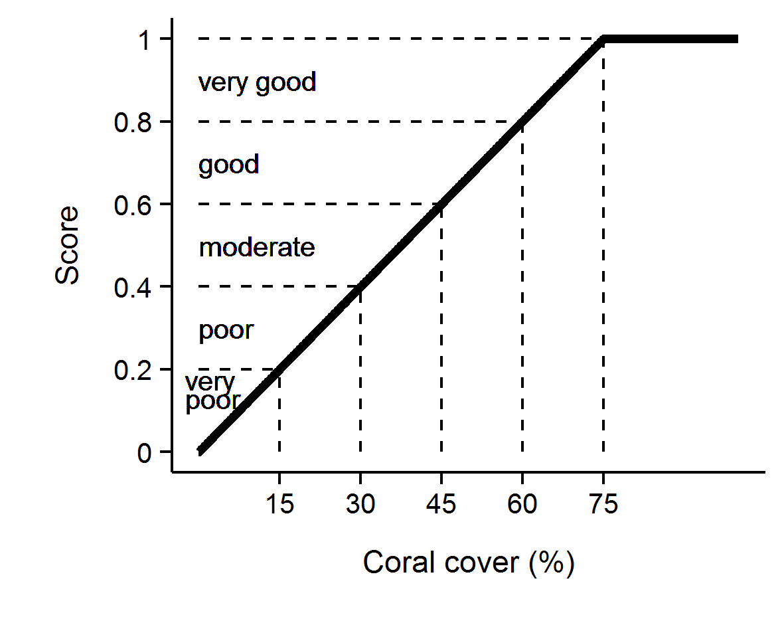
Figure 3 Scoring diagram for the Coral Cover metric.
Numeric scores and associated condition classifications based on observed coral cover are presented.

4.7.2 Macroalgae metric
In contrast to coral cover, high cover of macroalgae on coral reefs is widely accepted as representing a degraded state. As opportunistic colonisers, macroalgae generally out-compete corals, recovering more quickly following physical disturbances. Macroalgae have been documented to suppress coral fecundity (Foster et al. 2008), reduce recruitment of hard corals (Birrell et al. 2008a, b, Diaz-Pulido et al. 2010) and diminish the capacity for growth among local coral communities (Fabricius 2005). The macroalgae metric considers the proportional representation of macroalgae in the algal community based on cover estimates derived from point intercept transects and is calculated as;
${MAproportion}_{ij}$ = ${MA}_{ij}$ / $A_{ij}$
Where $A$= percent cover of all algae, $i$ = reef, $j$ = time and $MA$ = percent cover of macroalgae.
Importantly, for the purpose of calculating this metric, the collective term macroalgae defines a broad functional grouping that combines species clearly visible to the naked eye though excluding crustose coralline and fine filamentous or “turf” forms. In addition, as macroalgae show marked differences in abundance across the naturally steep gradient of environmental conditions within the inshore Reef, separate upper and lower thresholds were estimated for each reef and depth (Table A1. 1). The use of separate thresholds ensures the indicator is sensitive to changes likely to occur at a given reef. The thresholds for each reef were determined based on predicted MAproportion from Generalised Boosted Models (Ridgeway 2007) that included mean MAproportion over the period 2005-2014 as the response and long-term mean chlorophyll a concentration, suspended sediment concentration, and proportion of clay and silt sized grains in reefal sediments as covariates (Thompson et al. 2016). An additional consideration in setting the upper threshold for MAproportion was the ecological influence of macroalgae on other indicators of coral community condition. Regression tree analyses that included MAproportion as the predictor variable indicated reduced levels of the indicator metrics juvenile density, coral cover and the rate of change in coral cover at higher levels of MAproportion. These thresholds, for an ecological impact, serve as potential caps for MAproportion at any given reef. The thresholds for an influence of MAproportion are, however, variable both between indicators and depths. To set caps to the upper bound of MAproportion across all reefs at either 2 m or 5 m depths, the mean of the thresholds evident for the three indicators was taken, resulting in an upper bound cap of 23% at 2 m and a 25% at 5 m. The upper bounds for any reefs with predicted MAproportion higher than these caps were reduced to the cap level.
Scores for Macroalgae metric were scaled linearly from 0 when MAproportion is at or above the upper threshold through to 1 when MAproportion is at or below the lower threshold (Figure 4).
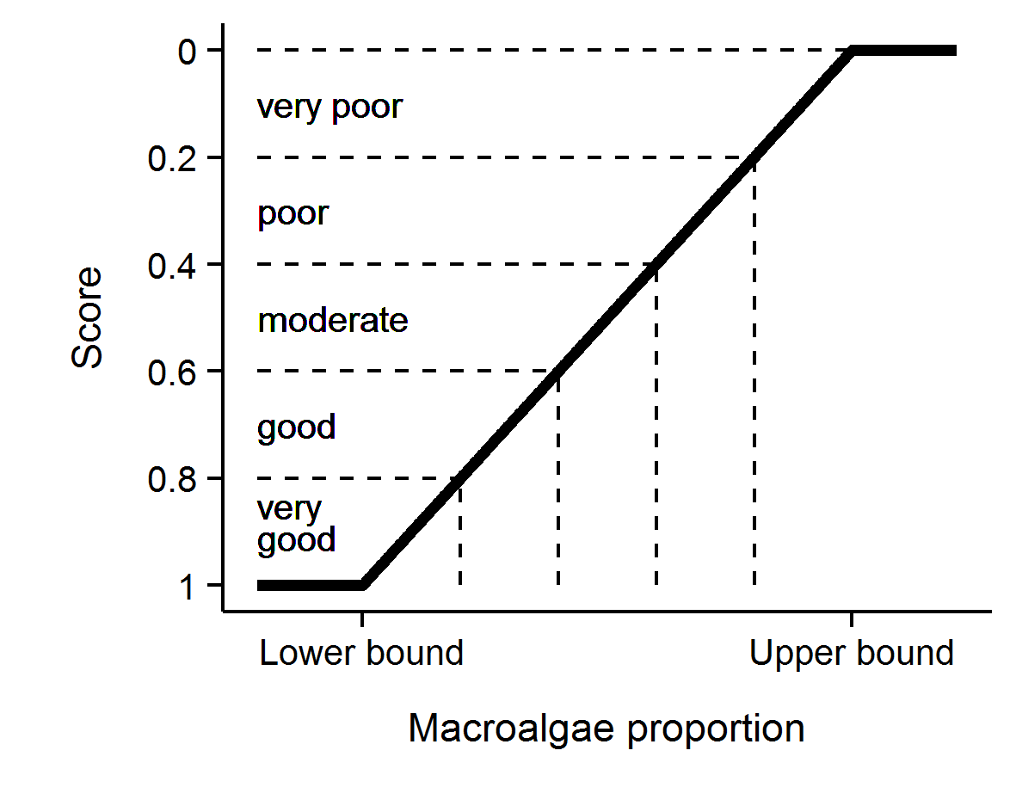
Figure 4 Scoring diagram for the Macroalgae metric.
Upper and lower threshold values are reef and depth specific. Numeric scores and associated condition classifications are presented

4.7.3 Density of juvenile hard corals metric
For coral communities to recover rapidly from disturbance events requires adequate recruitment of new corals into the population. This metric scores the important recruitment process by targeting corals that have survived the early life stages. With the inclusion of LTMP data into the coral index, juvenile count data were subset to only include colonies up to 5 cm in diameter as this size class is common to both MMP and LTMP sampling. Counts of juvenile hard corals were converted to density per m² of space available to settlement as;
${Juvenile density}_{ij}$ = $J_{ij}$ / ${AS}_{ij}$
Where, $J$= count of juvenile colonies < 5 cm in diameter, $i$ = reef, $j$ = time and $AS$ = area of transect occupied by algae as estimated from the co-located photo point intercept transects.
Selection of thresholds for the scoring of this metric was based on the analysis of recovery outcomes for MMP and LTMP reefs up to 2014 (Thompson et al. 2016). From these time series a binomial model was fitted to juvenile densities observed at times when coral cover was below 10% and categorised on the basis of recovery rate as being either below or above the predicted lower estimate of hard coral cover increase as estimated by the Cover Change indicator described below. This analysis identified a threshold of 4.6 juveniles per m⁻² beyond which the probability that coral cover would subsequently increase at predicted rates outweighed the probability of lower than predicted rates of recovery. Adding some weight to this result is that it was broadly consistent with the density of 6.3 juveniles per m⁻² in the wider size range <10 cm, necessary for recovery in the Seychelles (Graham et al. 2015). As the upper density of juvenile colonies is effectively unbounded, it was desirable to set an upper threshold for scoring purposes. The density at which the probability was > 80% for coral cover to recover at predicted rates was 13 juveniles per m⁻² and this density was chosen as the upper threshold. Based on this analysis, this metric was scored as follows; juvenile density was scaled linearly from 0 at a density of 0 through to 0.4 at a density of 4.6 colonies m⁻² then linearly though to a score of 1 when the density was 13 colonies per m⁻² or above (Figure 5).
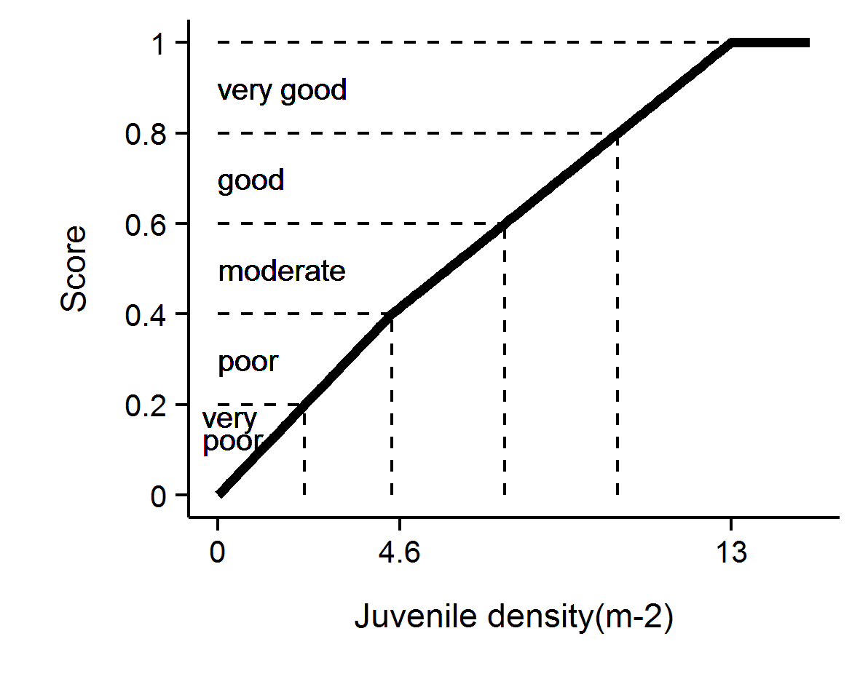
Figure 5 Scoring diagram for the Juvenile metric. Numeric scores and associated condition classifications are presented.

4.7.4 Cover Change metric
A second avenue for recovery of coral communities is the growth of corals during periods free from acute disturbance. Chronic pressures associated with water quality may suppress the rate that coral cover increases and contribute to a lack of resilience. The change in coral cover indicator score is derived from the comparison of the observed change in coral cover between two visits and the change in cover predicted by Gompertz growth equations parameterised from time-series of coral cover available on inshore reefs up until 2007. Gompertz equations were parameterised separately for the fast growing corals of the family Acroporidae and the slower growing combined grouping of all other hard corals at each of 2 m and 5 m depths. Years in which disturbance events occurred at particular reefs preclude the estimation of this indicator as there is no expectation for increase in such situations. A Bayesian framework was used to permit propagation of uncertainty through the predictions of expected coral cover increase from the two separately predicted coral types.

$\ln\left({Acr}_{it}\right) \sim N(μ_{it},σ^{2})$
$μ_{it}=v{Acr}_{i}+\ln\left({Acr}_{it-1}\right)+\left(-\frac{v{Acr}_{i}}{\ln\left(estK_{i}\right)}\right)*ln⁡({Acr}_{it-1}+ {OthC}_{it-1}+ {Sc}_{it-1})$
$v{Acr}_{i}= α+ \sum_{j=0}^{J}{β_{j}{Region}_{i}}\sum_{k=0}^{K}{γ_{k}{Reef}_{i}}$
$α \sim N(0,{10}^{6})$
$β_{j} \sim N(0, σ_{Region}^{2})$
$γ_{k} \sim N(0, σ_{Reef}^{2})$
$$σ^{2},σ_{Region}^{2},σ_{Reef}^{2}= U(0,100)$$
$rAcr=v{\overline{A}cr}_{i}$

Where ${Acr}_{it},{OthC}_{it}$ and ${Sc}_{it}$ are the cover of Acroporidae coral, other hard coral and soft coral respectively at a given reef at time ($t$). $eskK$ is the community size at equilibrium (100) and $rAcr$ is the rate of increase (growth rate) in percent cover of Acroporidae coral. Varying effects of Region and Reef ($β_{j}$ and $Υ_{k}$ respectively) were also incorporated to account for spatial autocorrelation. Model coefficients associated with the intercept, Region and Reef ($α_{i}, β_{j}$ and $Υ_{k}$) all had weakly informative Gaussian priors, the latter two with model standard deviation). The overall rate of coral growth$rAcr$, constituted the mean of the individual posterior rates of increase for ${vAcr}_{i}$ .
As model predictions relate to annual changes in coral cover, observed cover was adjusted to an estimated annual change since the previous observation (${Acr}_{adj}$) prior to comparison to modelled estimates. Adjusted values, ${Acr}_{adj},$ where estimated as per the following formula
$${Acr}_{adj}={Acr}_{i-1}+({Acr}_{i}{-Acr}_{i-1})*(365/(days between samples)$$
Where cover declined no adjustment was made and ${Acr}_{adj}$ assumed ${Acr}_{i}$ . For the 2015 report card, declines in cover we adjusted as for increases. For the 2016 report card all scores for this indicator were back calculated using this revised method.
Note, the above formulae apply to the family Acroporidae (Acr) and have the same form as those applied for Other Corals (OthC) if these terms are exchanged where they appear in the equations.
Gompertz models were fitted in a Bayesian framework to facilitate combining growth rates and associated uncertainties across models. A total of 20,000 MCMC sampling interactions across three chains with a warm up of 10,000 and thinned to every fifth observation resulted in well mixed samples from stable and converged posteriors (all rhat values less than 1.02).
The posteriors of Acroporidae predicted cover and Other Coral predicted cover were combined into posterior predictions of total coral cover from which the mean, median and 95% Highest Probability Density (HPD) intervals were calculated.
As changes in coral cover from one year to the next are relatively small, and in light of the biennial sampling design, the indicator value is averaged over consecutive surveys constituting a potential mean rate of increase over a four year period, when no disturbances have occurred.
To convert this indicator to a metric the following process was applied:
- If coral cover declined between surveys, a score of 0 was applied.
- If cover change was between 0 and the lower HPD interval of predicted total cover change, scores were scaled to between 0.1 when no change was observed through to 0.4 when change was equal to the lower interval of the predicted change.
- If cover change was within the upper and lower HPD intervals of the predicted change the score was scaled from 0.4 at the lower interval through to 0.6 at the upper interval.
- If cover change was greater than the upper HPD interval of predicted change, though less than double the upper interval, scores where scaled from 0.6 at the upper interval to 0.9 at double the upper interval.
- If change was greater than double the upper HPD interval, a score of 1 was applied.

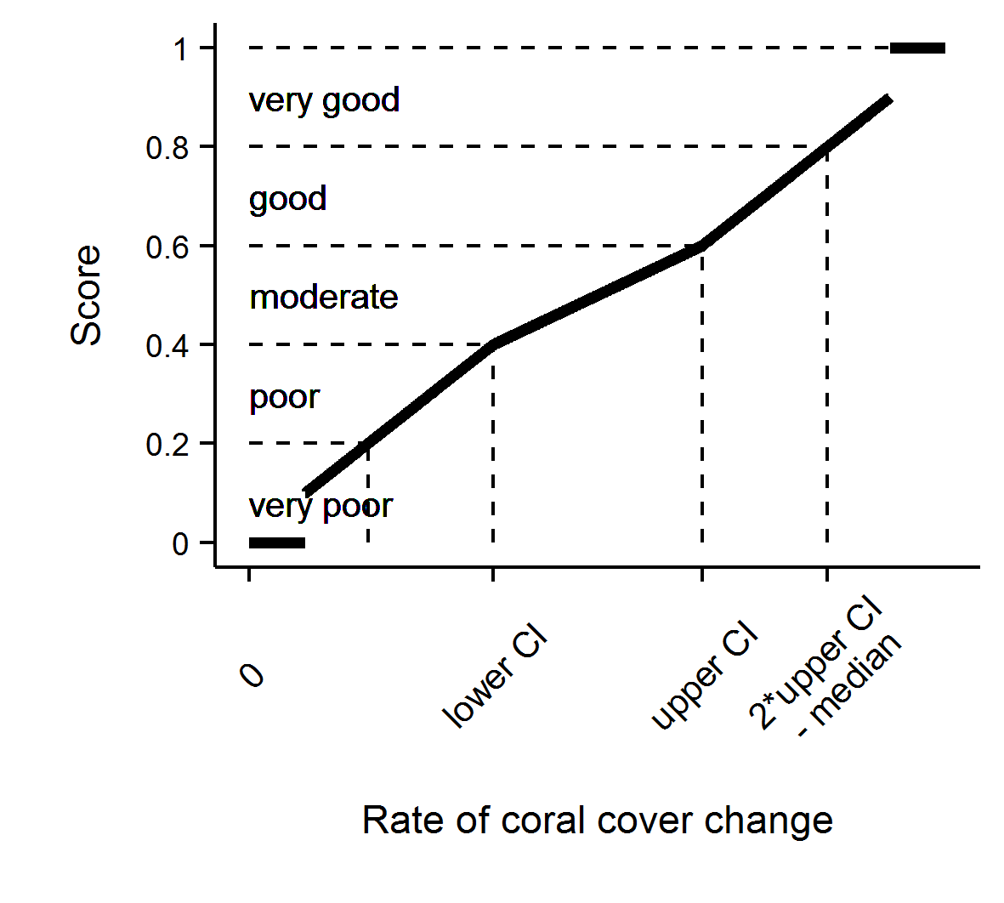
Figure 6 Scoring diagram for Cover Change metric

4.7.5 Community Composition metric
The coral communities monitored by the MMP vary considerably in the relative composition of coral species (Uthicke et al. 2010, Thompson et al. 2014b). As demonstrated by Uthicke et al. (2010) and Fabricius et al. (2012), some of this variability can be attributed to differences in environmental conditions between locations, which implies selection for certain species based on the environmental conditions experienced. Coral communities respond to environmental conditions in a variety of ways. Most noticeably they respond to acute shifts in conditions such as exposure to substantially reduced salinity (van Woesik 1991, Berkelmans et al. 2012), deviations from normal temperature (Hoegh-Guldberg 1999) or hydrodynamic conditions (cyclones); all of which result in reductions in coral cover as susceptible species are killed. In contrast, the increased loads of sediments and nutrients entering the Reef as a result of land use practices in the adjacent catchments (Waters et al. 2014) may include a combination of acute conditions associated with flood events and then chronic change in conditions as pollutants are cycled through the system. Chronic change in conditions, such as elevated turbidity or nutrient levels, could provide a longer period of selective pressures as environmental conditions disproportionately favour recruitment and survival of species tolerant to those conditions.
This metric compares the composition of hard coral communities at each reef to a baseline composition at that reef and interprets any observed change as being representative of communities expected under improved or worsened water quality. The basis of the metric is the scaling of cover for constituent genera (subset to life-forms for the abundant genera Acropora and Porites) by weightings that correspond to the distribution of each genus along a gradient of turbidity and Chl a concentration as determined by Canonical Analysis of Principal Coordinates (partial CAP; Anderson & Willis 2003) applied to MMP data (Thompson et al. 2014b, Table A1. 2) as:
$$C_{t}= \sum_{i=1}^{n}{H_{it}*G_{i}}$$
Where $C_{t}$ = the community composition location on along the water quality gradient at time $t$,
$H_{it}$ = the Hellinger transformed cover of genus $i$ at time $t$, and
$G_{i}$ = the score for genus $i$ taken from Table A1. 2.
Indicator metric scores are assigned based on the location of $C_{t}$ for the year of interest relative to a community specific baseline. The baseline for each community is bounded by the 95% confidence intervals about the mean $C_{t}$ from the first five years of observations of the community at each reef and depth. The scoring of the metric is categorical being 0.5 when $C_{t}$ falls within the 95% confidence intervals for the location, 1 if beyond the confidence interval in a direction toward communities representative of lower turbidity and Chl a concentrations, and 0 if beyond the confidence interval in the direction of communities representative of higher turbidity and Chl a concentrations (Figure 7).
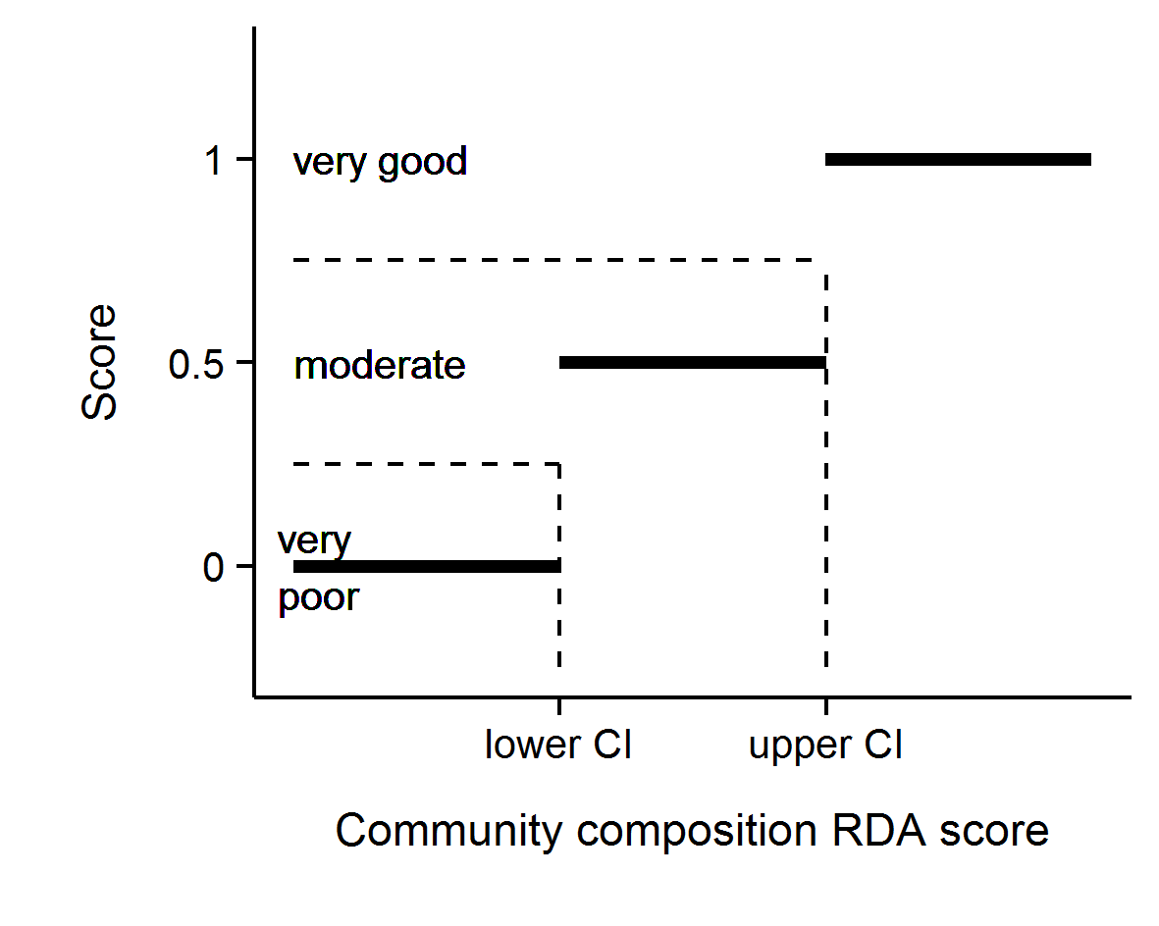
Figure 7 Scoring diagram for Community Composition metric

4.7.6 Aggregating indicator scores to regional scale assessments
In aggregating scores for various indicators into a single index uncertainty should be considered. The degree of uncertainty in an index score derived for any spatial scale of interest will include uncertainty across multiple levels: from basic observational error, the relevance of thresholds and then variation in scores for different indicators or communities being assessed.
In order to derive report card scores for regions that propagated uncertainty through the double hierarchical aggregation of indicators and then reefs a bootstrapping method was adopted. Firstly, for each indicator a distribution of 10,000 observations was created by resampling (with replacement) from the observed scores for all reef and depth combinations within the Region. For the Wet Tropics where there are three sub-regions an additional step involved the adding together of the three 10,000 strong distributions for each indicator from each sub-region and resampling the resulting distributions (with replacement) 10,000 times to derive a single 10,000 strong distribution for each indicator at the regional scale. Secondly these 5 resulting distributions (one for each indicator) were added together and collectively resampled 10,000 times (with replacement) to derive a single distribution comprising 10,000 scores. Importantly, the large number of resamples ensures that the distributions accurately reflect the underlying data distributions and yet comprise a known number of items independent of the original input sizes. This ensures that all inputs have equal weights and aggregations are not biased towards inputs with more data (for example, all reefs and sub-regions contribute equally to region level aggregations despite their being more reefs in some sub-regions than others).
The mean of the resulting distribution for the (sub)-region was taken as the coral health index score. Confidence intervals are typically based on estimates of precision (such as standard error) rather than variance. Precision is itself an estimate of repeatability - in the case of precision of a mean; it is an estimate of the variance of repeated means. Hence, we can estimate precision by repeatedly resampling from the distribution and each time calculating a mean. However, the more times the distribution is resampled, the more means are generated and thus the lower the variance of means.
To generate estimates of precision (and thus confidence intervals) appropriate for the scale of the sampling design, it was necessary to resample the distribution once for every original input (e.g. resample in proportion to the original sample size). This sample size is calculated by tabulating the number of unique items in the distribution (t) and then summing the division of the tabulated values by their minimum.
$$n= \sum{\frac{t}{min⁡(t)}}$$
Confidence intervals were thence calculated as the 95% quantiles of repeated means.

Lastly index scores were converted to qualitative assessments by converting to a five point rating and colour scheme with scores of:
- 0 to 0.2 were rated as ‘very poor’ and coloured red
- >0.2 to 0.4 were rated as ‘poor’ and coloured orange
- >0.4 to 0.6 were rated as ‘moderate’ and coloured yellow
- >0.6 to 0.8 were rated as ‘good’, and coloured light green
- >0.8 were rated as ‘very good’ and coloured dark green.

The indicators and the associated thresholds and scoring system utilised is summarised in Table 6. We note that the community composition indicator is likely to respond over longer time frames than the other indicators due to the inertia in community composition imposed by long lived coral species.

Table 6 Threshold values for the assessment of coral reef condition and resilience indicators.
Community attribute | Score | Thresholds
Combined hard and soft coral cover | Continuous between 0-1 | 1 at 75% cover or greater
Combined hard and soft coral cover | Continuous between 0-1 | 0 at zero cover
Rate of increase in hard coral cover (preceding 4 years) | 1 | Change > 2x upper 95% CI of predicted change
Rate of increase in hard coral cover (preceding 4 years) | Continuous between 0.6 and 0.9 | Change between upper 95% CI and 2x upper 95% CI
Rate of increase in hard coral cover (preceding 4 years) | Continuous between 0.4 and 0.6 | Change within 95% CI of the predicted change
Rate of increase in hard coral cover (preceding 4 years) | Continuous between 0.1 and 0.4 | Change between lower 95% CI and 2x lower 95% CI
Rate of increase in hard coral cover (preceding 4 years) | 0 | change < 2x lower 95% CI of predicted change
Proportion of algae cover classified as Macroalgae | Continuous between 0-1 | ≤ reef specific lower bound and ≥ reef specific upper bound
Density of hard coral juveniles (<5 cm diameter) | 1 | > 13 juveniles per m2 of available substrate
Density of hard coral juveniles (<5 cm diameter) | Continuous between 0.4 and 1 | 4.6 to 13 juveniles per m2 of available substrate
Density of hard coral juveniles (<5 cm diameter) | Continuous between 0 and 0.4 | 0 to 4.6 juveniles per m2 of available substrate
Composition of hard coral community | 1 | Beyond 95% CI of baseline condition in the direction of improved water quality
Composition of hard coral community | 0.5 | Within 95% Confidence intervals of baseline composition
Composition of hard coral community | 0 | Beyond 95% CI of baseline condition in the direction of declined water quality

Results
Results are presented in the following sequence. Firstly, spatial variability in communities in 2016 is related to regional differences, the depth of sampling sites and the location of reefs along water quality gradients. Secondly changes in index scores in relation to discharge from catchments at a regional scale are presented as a broad approximation of the influence of run-off on coral community resilience. Temporal trends in community attributes are then presented for each (sub-)region along with time-series of data relating to the primary pressures influencing coral communities. Finally, site-specific data and additional information tables are presented in Appendix 1 and may be referred to where specific detail is required.

5.1 Variation of coral index and indicator scores observed in 2016

5.1.1 Regional differences
In 2016 the scores for the coral index and its component metrics varied significantly between Regions (Table 7, Figure 8). Index scores were higher in the Wet Tropics and Mackay Whitsunday regions than the Burdekin Region, while the index scores in the Fitzroy Region were lower than in all other regions.
The highest index score was observed in the Mackay Whitsunday Region where metric scores were mostly higher or similar to those in other regions. It was only the Cover Change and Composition scores that were lower in the Mackay Whitsunday region compared to those observed in the Wet Tropics (Table 7, Figure 8). At the other end of the spectrum, the low index scores observed in the Fitzroy region result from the lowest median scores for all metrics with only the Cover Change and Composition metric scores not significantly lower than two of the other three regions.
Table 7 Regional differences in index and metric scores. Tabulated values represent the upper and lower 95% credible limits to the pair-wise comparison of scores between regions. Shading highlights where regional differences in scores were supported on the basis that the distribution of predicted differences excluded zero. Green shading indicates score were higher for the left-hand compared to right-hand region in the first column, red shading indicates higher scores for the right-hand region.
 | Index |  | Coral cover |  | Macroalgae |  | Cover change |  | Juvenile |  | Composition
Regions | u | l | u | l | u | l | u | l | u | l | u | l
Wet Tropics - Burdekin | 0.21 | 0.01 | 0.32 | 0.02 | 0.36 | -0.04 | 0.45 | 0.11 | 0.27 | -0.09 | 0.15 | -0.65
Wet Tropics - Fitzroy | 0.41 | 0.22 | 0.40 | 0.11 | 0.42 | 0.05 | 0.51 | 0.13 | 0.51 | 0.15 | 0.04 | -0.79
Mackay Whitsunday -Burdekin | 0.28 | 0.07 | 0.51 | 0.21 | 0.53 | 0.10 | 0.11 | -0.25 | 0.27 | -0.11 | 0.75 | 0.20
Mackay Whitsunday - Fitzroy | 0.47 | 0.26 | 0.60 | 0.31 | 0.59 | 0.18 | 0.18 | -0.22 | 0.53 | 0.14 | 0.26 | -0.54
Burdekin - Fitzroy | 0.30 | 0.08 | 0.25 | -0.07 | 0.28 | -0.13 | 0.26 | -0.16 | 0.45 | 0.02 | 0.98 | 0.42
Wet Tropics - Mackay Whitsunday | 0.04 | -0.14 | -0.06 | -0.32 | 0.03 | -0.35 | 0.51 | 0.20 | 0.17 | -0.14 | 1.00 | 0.52

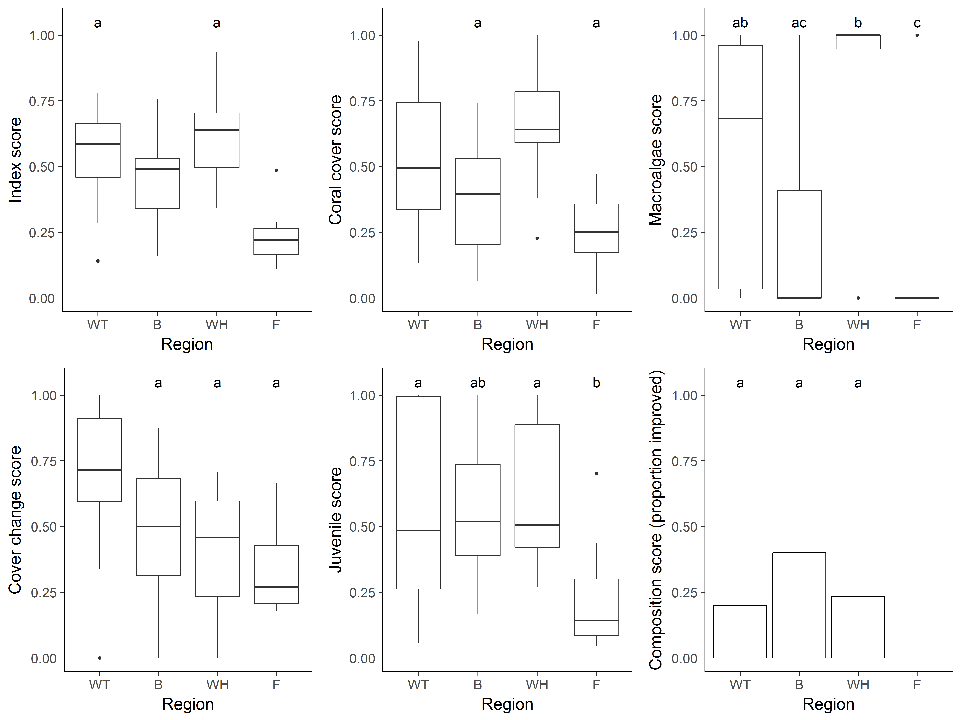
Figure 8 Regional distributions of index and metric scores. Boxplots show the median (bold horizontal line) 25th to 75th percentiles (box) and highest and lowest observations within 1.5 times the distance length of the box from the upper and lower box margins (vertical lines), observations beyond these values are represented as dots. For the composition score a bar chart represents the proportion of observations scored as improved (score = 1). Labels above bars or boxplot elements identify regions with statistically similar distributions.

5.1.2 Effect of depth
Index scores observed in 2016 did not differ consistently between 2 m and 5 m depths (Table 8). Of the individual indicator metrics only the Coral change scores in the Mackay Whitsunday region were consistently lower at 5 m than at 2 m. Conversely, the Juvenile metric scores were consistently higher at 5 m depth in the Burdekin Region. (Table 8).
Table 8 Influence of depth on index and metric scores. Tabulated values represent the upper (u) and lower (l) 95% credible limits to the pair-wise comparison of scores between 2 m and 5 m depths within each region. Shading highlights where depth differences in scores were supported on the basis that the distribution of predicted differences excluded zero. Green shading indicates scores were higher at 2 m depths, red shading indicates scores were higher at 5 m depth.
 | Index |  | Coral cover |  | Macroalgae |  | Cover change |  | Juvenile |  | Composition
Regions | u | l | u | l | u | l | u | l | u | l | u | l
Wet Tropics | -0.05 | 0.16 | -0.14 | 0.13 | -0.21 | 0.29 | -0.03 | 0.31 | -0.02 | 0.28
Burdekin | -0.13 | 0.14 | -0.19 | 0.16 | -0.37 | 0.20 | -0.37 | 0.17 | 0.03 | 0.47
Mackay Whitsunday | -0.22 | 0.03 | -0.29 | 0.01 | -0.24 | 0.31 | -0.49 | -0.02 | -0.17 | 0.21
Fitzroy | -0.12 | 0.13 | -0.06 | 0.28 | -0.34 | 0.21 | -0.34 | 0.27 | -0.22 | 0.17

5.1.3 Response to environmental gradients
Index scores in 2016 were significantly lower (r-square =0.89, p-value <0.001) at sites where long-term mean Chl a levels exceeded 0.5 µgL⁻¹ (Figure 9a). The median effect size of Chl a over the range observed at inshore reefs is sufficient to reduce index scores from over 0.55 at lower concentrations to below 0.4 corresponding to a reduction in report card scores from moderate to poor. Neither the concentration of total suspended solids nor the composition of sediments at the monitoring sites clearly influenced index scores (Figure 9b, c). Gradient boosted models applied to the separate metrics revealed that reductions in scores for Macroalgae and Coral Cover metrics and a higher probability of a decline in the Composition metric at higher Chl a concentrations, all contribute to the reduced index scores (Figure 10). There was no clear relationship between the scores for the Juvenile or Cover Change metrics observed in 2016 and the location of reefs along the environmental gradients tested (Figure 10)

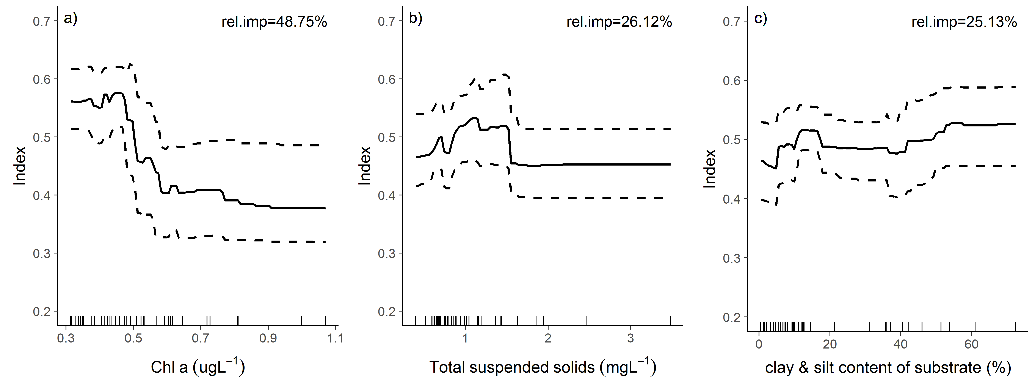
Figure 9 Relationship between coral index scores and environmental conditions. Predicted partial plots derived from gradient boosted model.

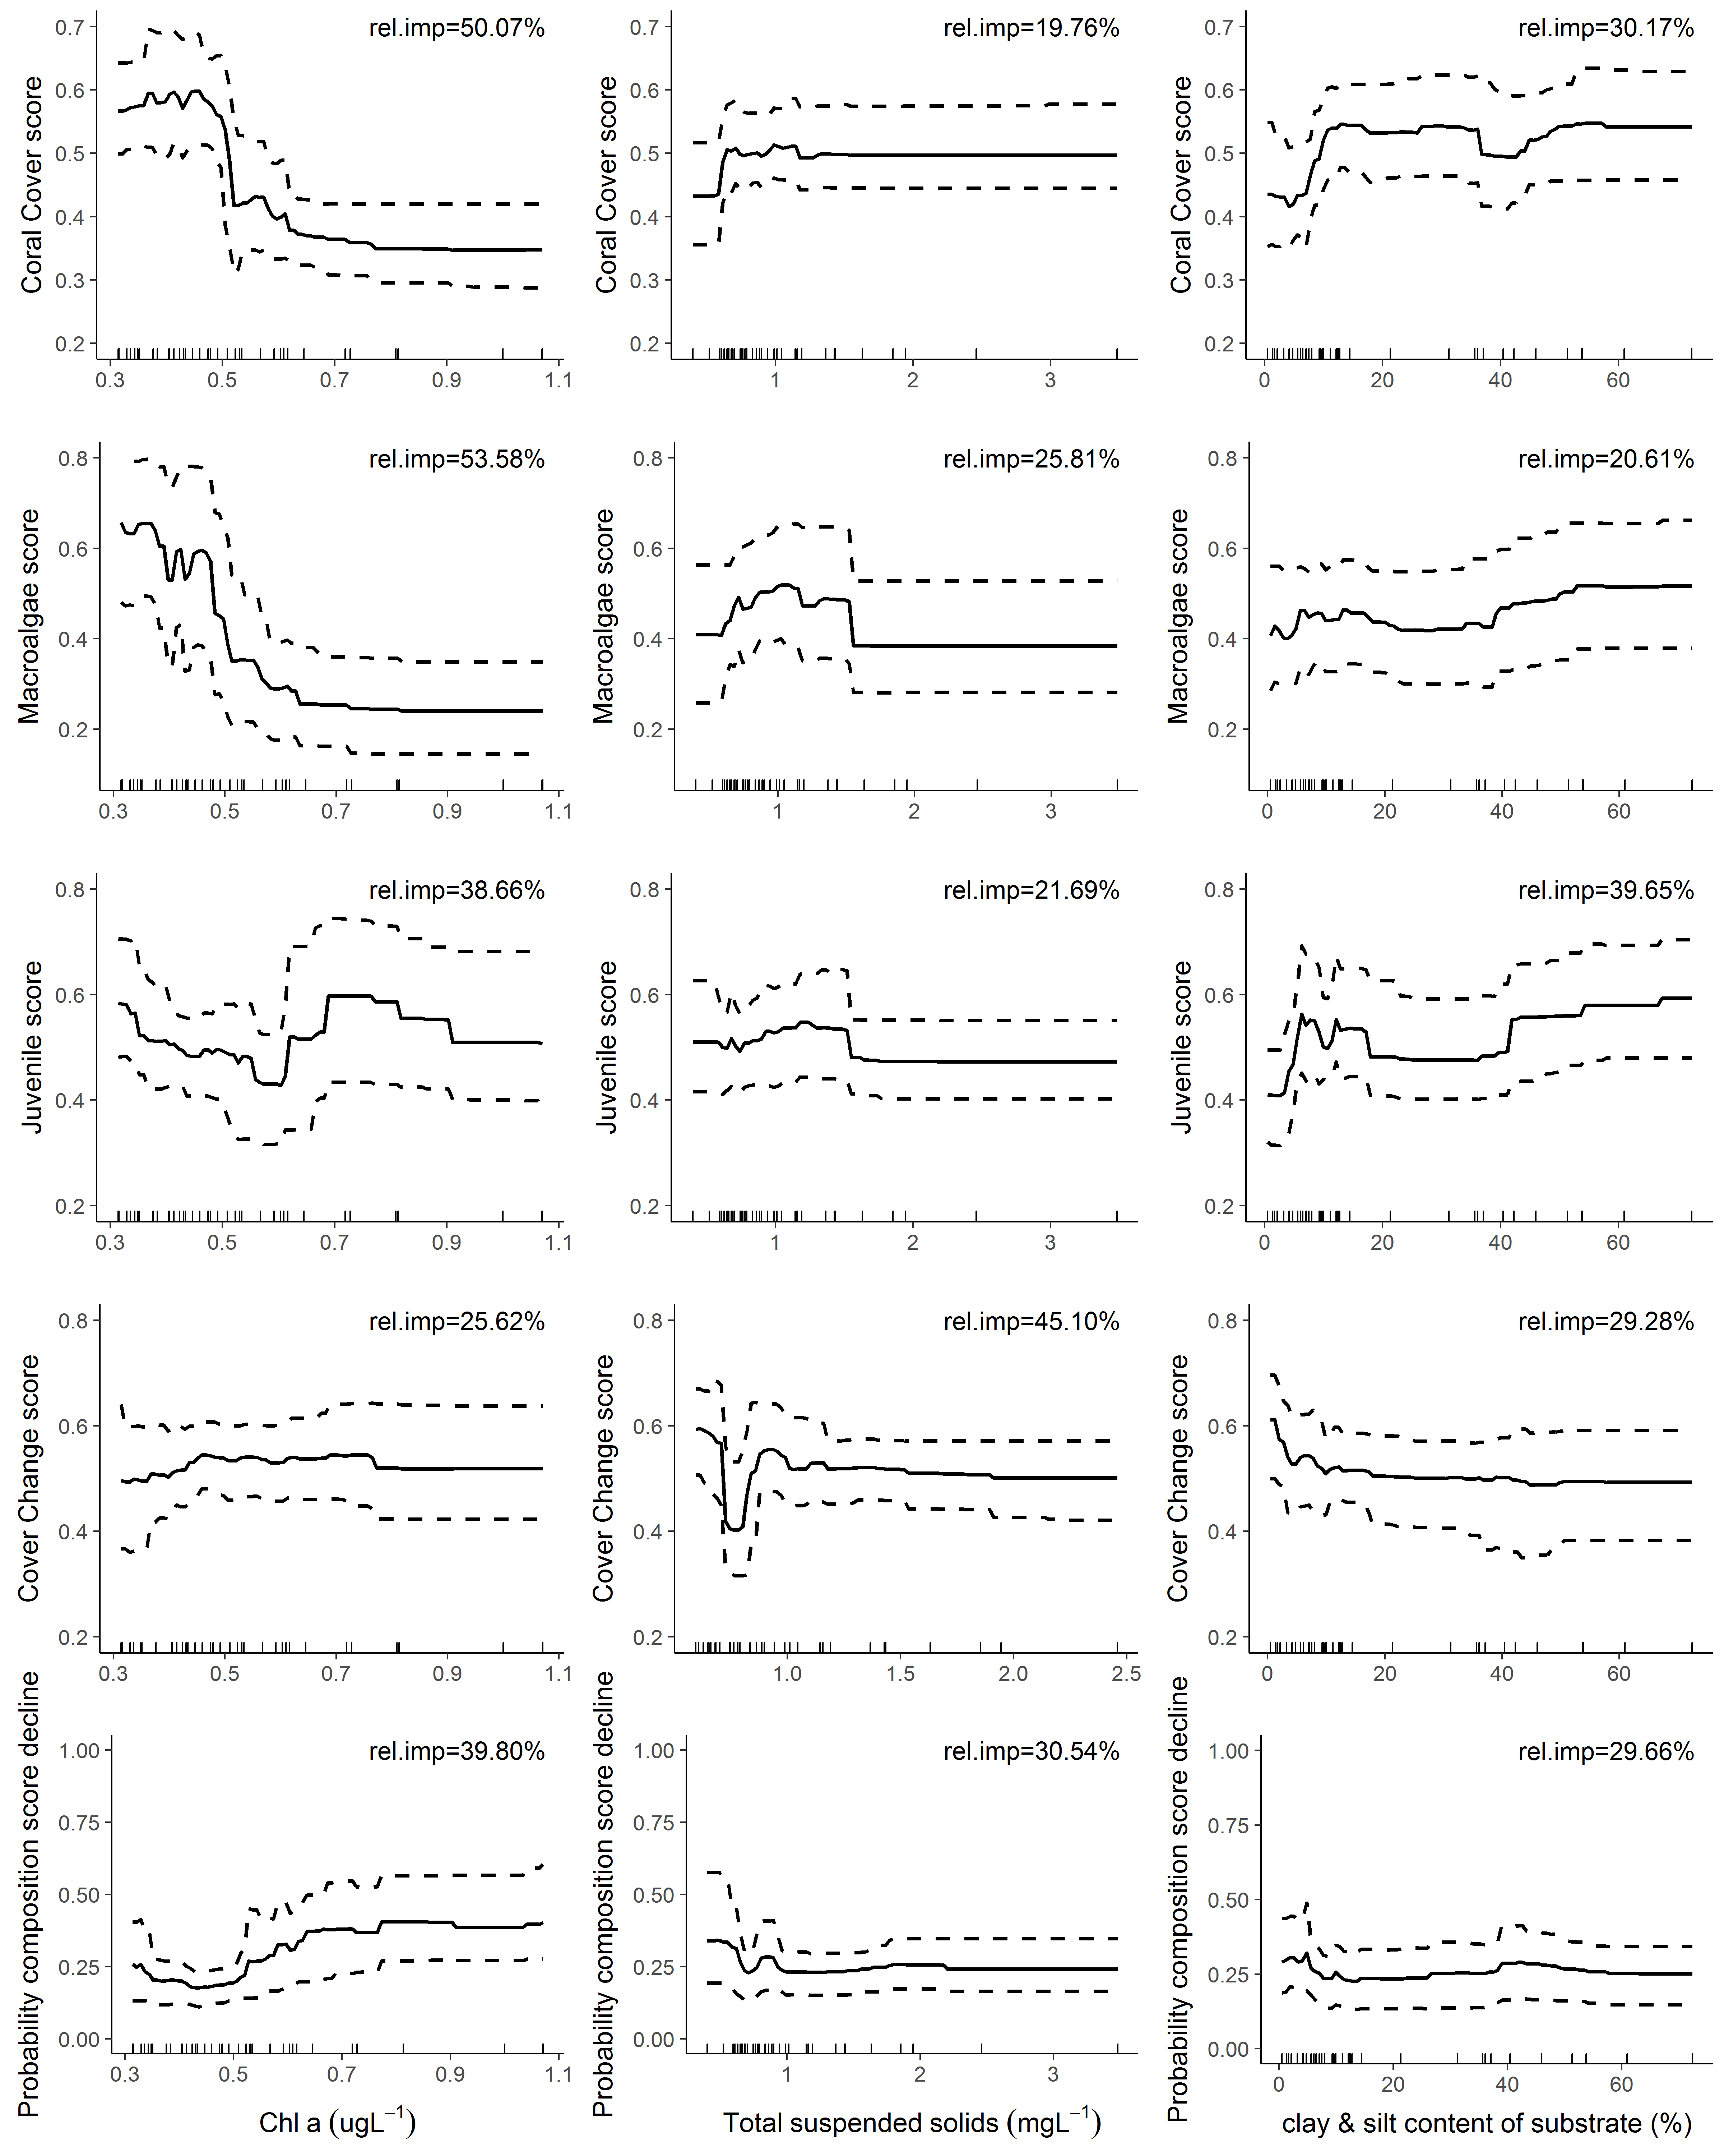
Figure 10 Relationship between indicator metric scores and environmental conditions. Predicted partial plots derived from gradient boosted model. Dashed lines are 95% confidence intervals of the predictions.

5.1.4 Influence of discharge and catchment loads
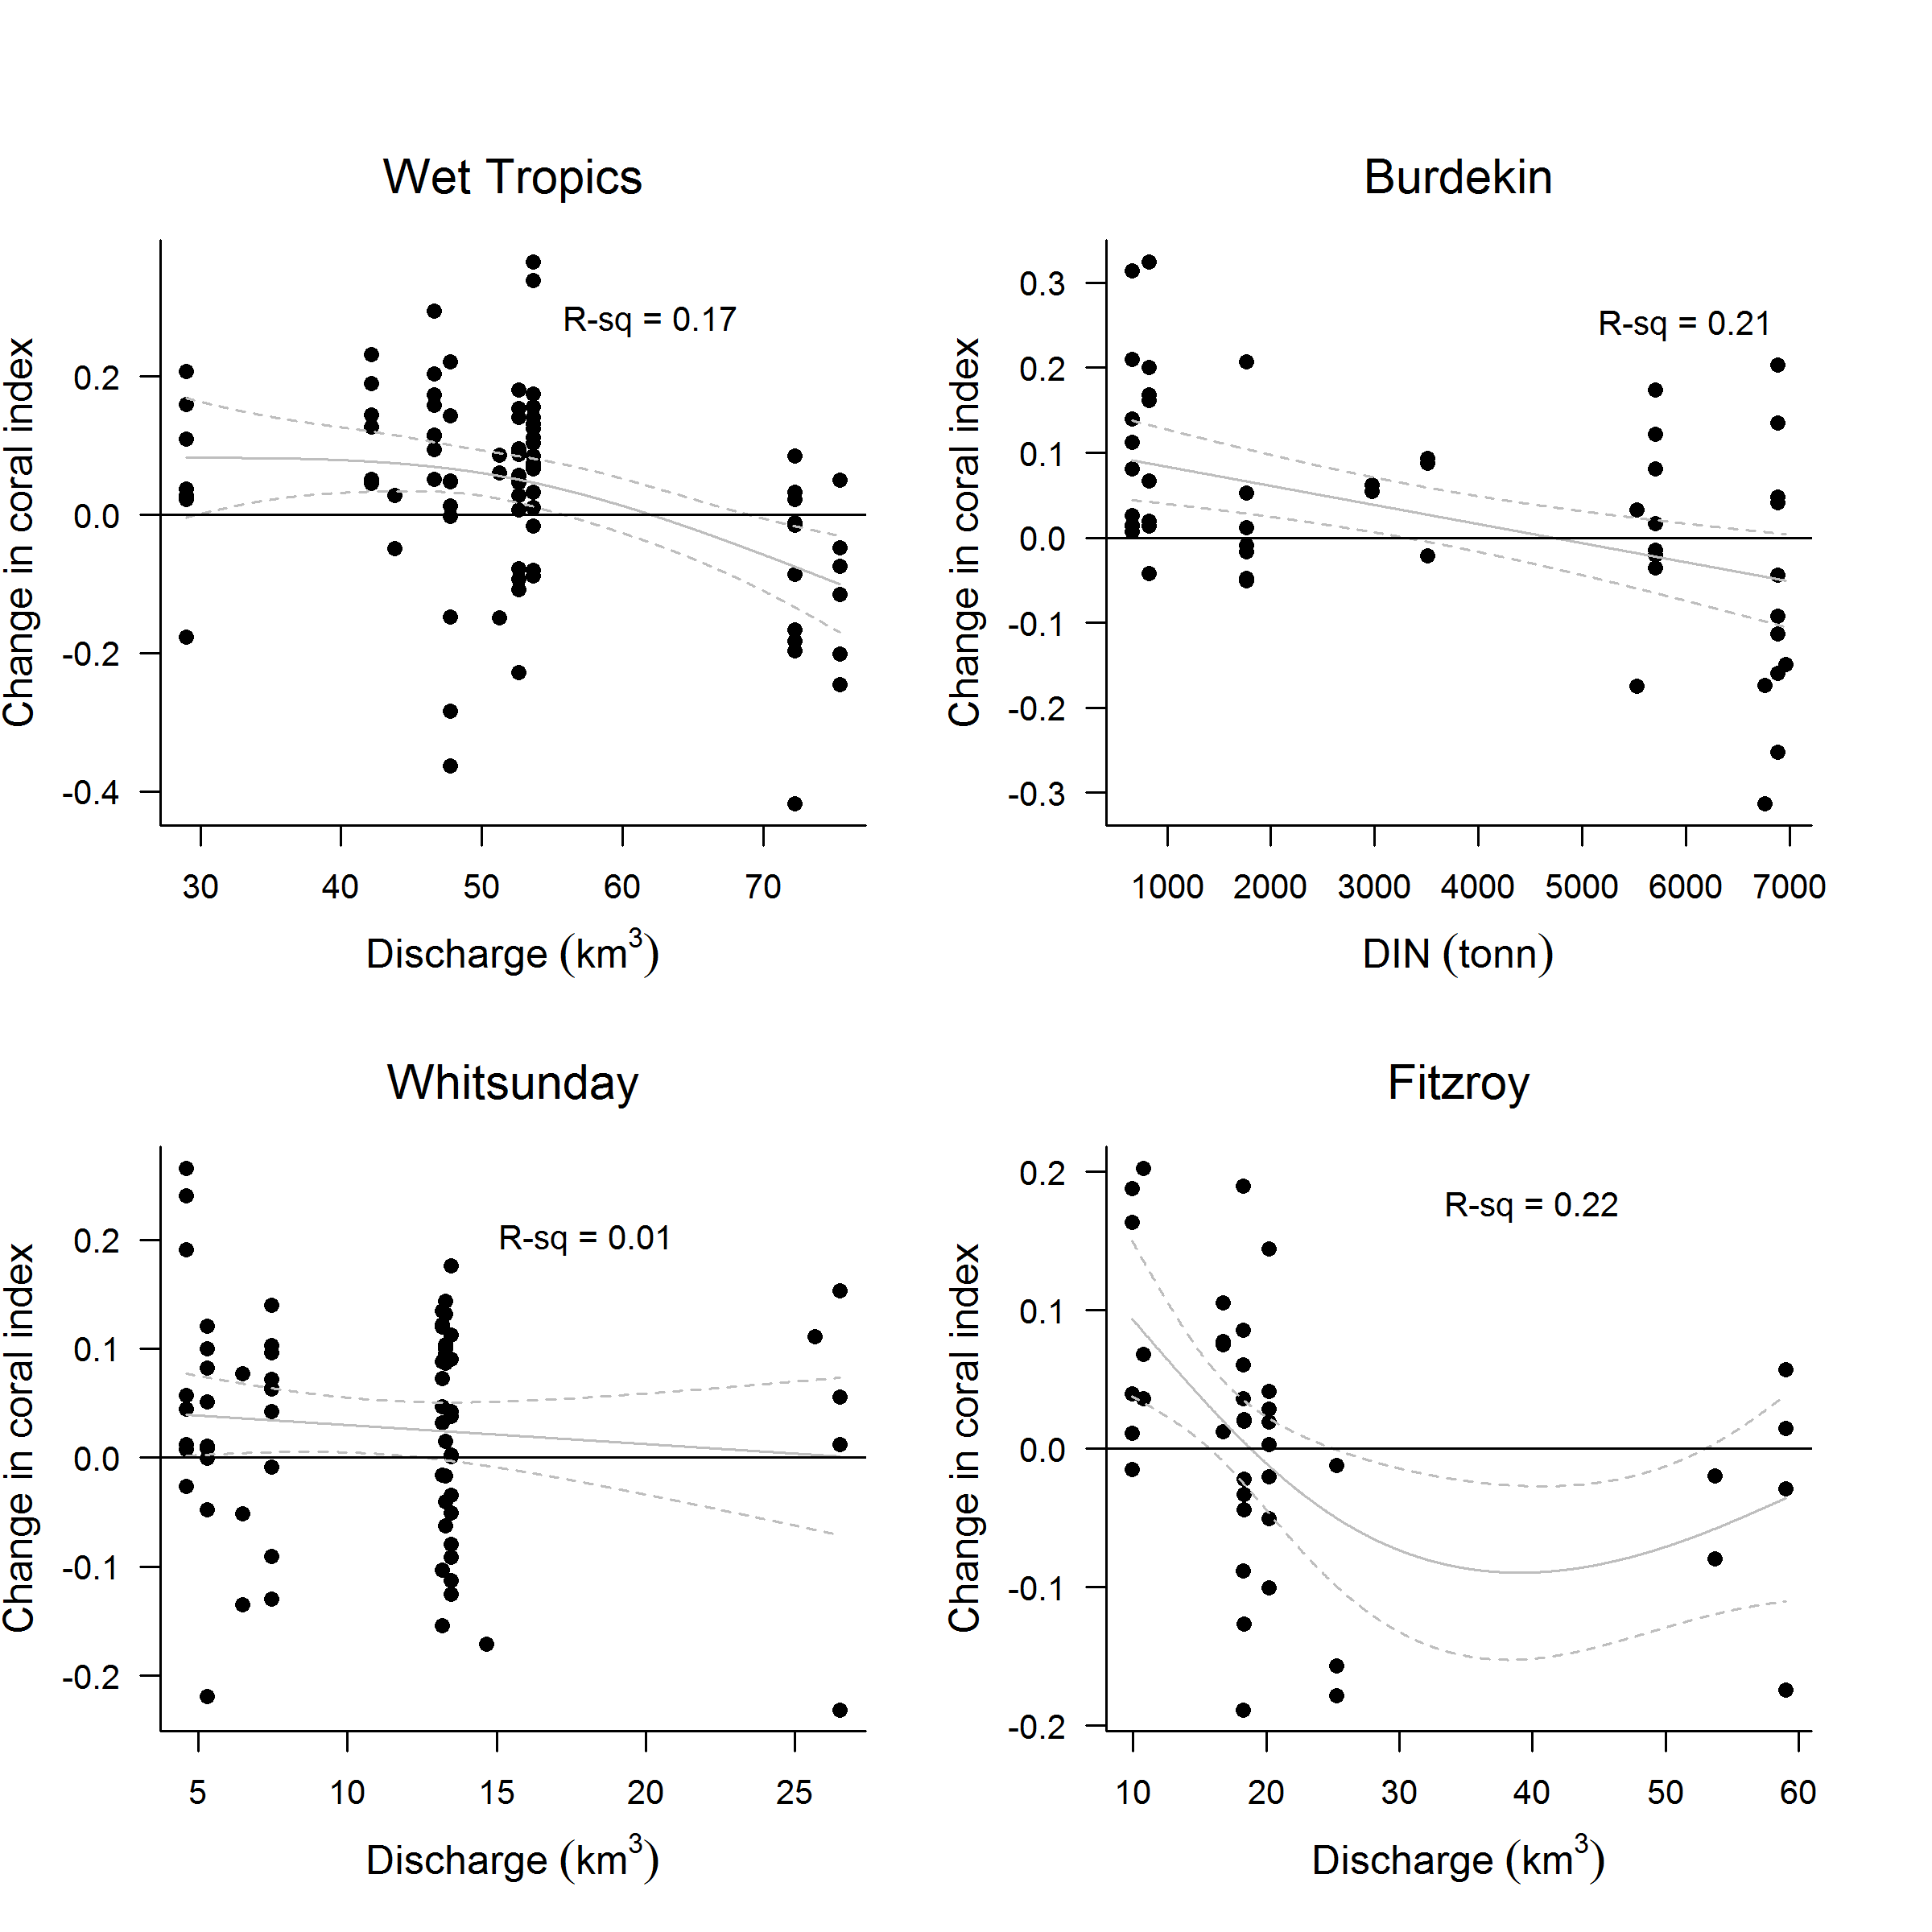
Figure 11 Relationship between the coral index and run-off from local catchments. Plotted points represent observed change in the index score at each reef and depth over a two year period. Observations for which acute disturbances impacted communities in the period between samples were excluded. Discharge values represent the cumulative discharge from the region’s major rivers over the two year period corresponding to index changes. For the Burdekin Region DIN load was a better predictor of index change than discharge and again DIN loads represent the cumulative annual loads over the two year period. Trend lines represent the predicted change in index scores (solid line) and the 95% confidence intervals of the prediction (dash lines).
Biennial changes in index scores since 2005 demonstrate a negative relationship to run-off from adjacent catchments in the Wet Tropics, Burdekin and Fitzroy regions. For each region, biennial change during years that individual reefs were not impacted by acute disturbances (cyclones, bleaching, COTS or direct exposure to low salinity floodwaters), were modelled separately against three measures of run-off: the biennial totals for freshwater discharge, dissolved inorganic nitrogen load (DIN) and total suspended solids load (TSS). Of the three run-off variables applied, the variable explaining the highest variability in the change in the coral index (model R-square, Table 9) was selected to predict relationships shown in Figure 11. In the Burdekin and Wet Tropics regions total discharge and DIN explained a similar amount of the variation in index changes with both having greater predictive capacity than TSS (Table 9). In the Fitzroy Region freshwater discharge had the greatest influence on index scores, despite the removal of observations in 2008 (Pelican and Peak 2 m depth) and 2011 (2 m and 5 m depths at Pelican and Peak, 2 m depth at Keppels South) when communities suffered an acute disturbance as a result of exposure to low salinity plumes.
Table 9 Relationship between changes in index scores and run-off. Tabulated are the model R-square value and p value for the relationship between change in coral index scores and each summary of regional run-off. Where responses where nonlinear the reported p value includes (^{gam}) indicating significance of the smoothed term as opposed to the significance of the slope of the relationship where linear responses occurred.
Region | Freshwater discharge |  | Dissolved inorganic Nitrogen |  | Total suspended solids
Region | R-square | p value | R-square | p value | R-square | p value
Wet Tropics | 0.167 | <0.001^{gam} | 0.154 | <0.001^{gam} | 0.143 | <0.001^{gam}
Burdekin | 0.182 | 0.0016 | 0.206 | <0.001 | 0.118 | 0.029^{gam}
Mackay Whitsunday | 0.001 | 0.43 | 0.012 | 0.37 | 0.001 | 0.67
Fitzroy | 0.223 | 0.005^{gam} | 0.067 | 0.14^{gam} | 0.084 | 0.095^{gam}

5.2 Regional condition of coral communities

5.2.1 Wet Tropics Region: Barron Daintree sub-region
The coral index improved from a low point reached in 2014 following a period of acute and chronic pressures (Figure 12, Figure 13). Improvements in the index to 2016 were restricted to 5 m depth sites where the rate of increase in coral cover improved, and the proportion of macroalgae in the algal community declined, resulting in improved scores for the associated Coral Cover and Macroalgae metrics (Table 10). At 2 m depth coral cover increased rapidly as reflected by improvements in the Coral Cover and Cover Change metrics (Table 10, Figure 13). These improvements were, however, contrasted by declines in the Composition and Macroalgae metrics resulting in minimal change in the overall index at 2 m depth.
Table 10 Pair-wise comparison between index and metric scores in the Barren Daintree sub-region. Data compare the changes in scores between local maxima and minima in the index time-series. For the index, and each metric, the observed change in the sub-regional score and the probability that the change was greater or less than zero (no change) are presented. Shading is used as a visual aid to highlight the magnitude of the probability the score improved (blue shades) or declined (red shades). Probabilities are derived from the posterior distribution of observed score changes at each reef and depth.
Period | Depth | Index |  | Cover Change |  | Composition |  | Coral Cover |  | Juvenile Coral |  | Macroalgae
Period | Depth | Score | P | Score | P | Score | P | Score | P | Score | P | Score | P
2008 to 2014 | 2 | -0.21 | 0.89 | -0.62 | 0.99 | 0.50 | 1.00 | -0.37 | 0.72 | -0.42 | 0.92 | -0.17 | 0.76
2008 to 2014 | 5 | -0.26 | 0.80 | -0.21 | 0.72 | -0.50 | 1.00 | -0.12 | 0.59 | -0.04 | 0.60 | -0.43 | 0.81
2014 to 2016 | 2 | -0.03 | 0.66 | 0.44 | 1.00 | -0.50 | 0.76 | 0.08 | 0.98 | -0.03 | 0.59 | -0.13 | 0.74
2014 to 2016 | 5 | 0.14 | 0.71 | 0.38 | 0.82 | 0.00 | 0.00 | -0.02 | 0.55 | 0.01 | 0.56 | 0.33 | 0.73

The recent improvement in the coral index coincides with a reprieve from a series of disturbance events that contributed to the declines observed through to 2014 (Figure 12c-e). Although the maximum index score occurred in 2008, scores remained in the ‘good’ range until 2011. The decline between 2011 and 2014 was initiated by a loss of coral cover attributed to disease. This attribution reflects the above average number of diseased colonies observed in 2010 and 2011 surveys (Figure A1. 7). Declines in the Cover Change metric through to 2014 will have been influenced by these levels of disease as the formulation of that metric considers disease as a reflection of chronic stress, and so, observations noted as influenced by disease are included in the comparison between observed and predicted coral cover on which the Cover Change metric is based. There was also a marked increase in the cover of macroalgae at Snapper North in 2011 (peaks at 2 m and 5 m reefs, Figure 13, Figure A1. 1). The persistence of this high proportion of macroalgae in the algal community at 2 m depth, Snapper North, is consistent with the typically above-guideline levels of Chl a in waters surrounding Snapper Island (Figure 12a).
The two most damaging disturbance types, in terms of loss of coral cover, over the period of monitoring were predation of corals by COTS and damage occurring during tropical cyclones and storms that have accounted for 47% and 35% of the hard coral cover losses since 2005 (Figure 12e).
At Snapper Island low densities of COTS were observed in 2012, pre-empting an outbreak in 2013 when densities reached 288 and 613 individuals per hectare at Snapper North and Snapper South respectively. This outbreak removed between 66% (Snapper North – 5 m depth) and 17% (Snapper South – 5 m depth) of the coral cover with the main losses occurring within the family Acroporidae (Table A1. 4, Figure A1. 1). By 2014, COTS numbers had substantially declined with no individuals recorded at Snapper North and densities reduced to 63 per hectare at Snapper South. In 2015 and 2016 no COTS were observed at Snapper Island. Low Isles also has a history of COTS outbreaks that were the likely cause of the 52% of hard coral cover loss over the period 1997-1999. More recently, COTS were observed in 2013 and 2015 assumed to have caused a 38% loss of hard corals (Table A1. 4, Figure A1. 1). Limiting the impact of the most recent COTS outbreaks were population control efforts that removed 135 (Snapper Island) and 846 (Low Isles) starfish from reefs prior to surveys in 2016. Physical impacts to these reefs were recorded following a severe storm in 2009 and, most significantly, Cyclone Ita in 2014 that removed 70% of the hard coral cover and almost eliminated soft corals form Snapper North (Table A1. 4, Figure A1. 1). Damage was less severe at Snapper South, though both 2 m and 5 m depths lost a substantial amount of coral (Table A1. 4, Figure A1. 1).
Despite variability in discharge (Figure 12d), and associated loads of nutrients and sediments delivered from adjacent catchments (Waterhouse et al. 2017), there have been no clear trends in regional water quality in the Barron Daintree sub-region (Figure 13g, h, Figure A1. 9).
Consistent with only minor summer temperature anomalies at Snapper Island (Figure 12c), the severe impact of coral bleaching over the summer of 2015/16 observed on the northern Reef (section 7) were avoided in this sub-region. Bleaching was limited to individual colonies during surveys in 2016 (Table 19), although these were conducted well after the late summer peak in likely bleaching response. While acute impacts of thermal stress were not observed, it remains possible that the sustained warmth through autumn 2016 (Figure 12c) contributed to the marginal rise in disease (Figure A1. 7) and increased proportion of macroalgae (Figure 13c).

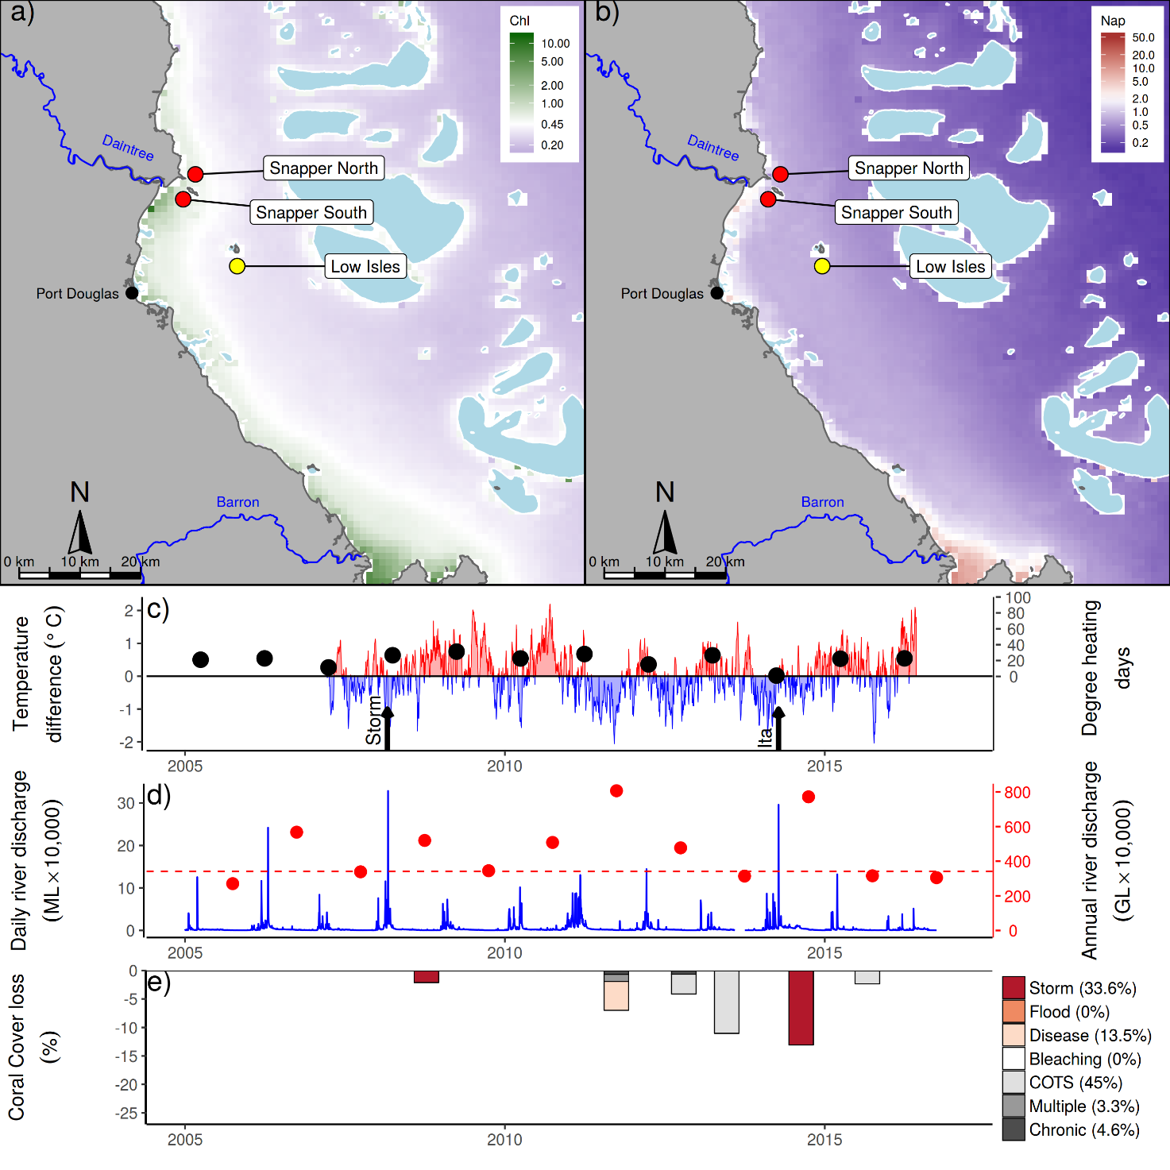
Figure 12 Barron Daintree sub-region environmental pressures. Maps show location of monitoring sites, red symbols MMP, yellow symbols LTMP along with a) mean chlorophyll a concentration and b) mean Non algal particulate concentrations. Water quality data are mean levels over the period 2003-2016. c) Seasonally adjusted temperature deviation, timing of cyclones and storms indicated by black arrows, accumulated degree heating days over the summer period (1st of December - 31st March) indicated by black symbols d) Combined daily (blue) and annual (red) discharge for the Daintree and Barron rivers, red dashed line represents long-term median discharge (1986-2016). e) break-down of hard coral cover loss by disturbance type; length of bars represent the mean loss of cover across all reefs (see methods section for further detail).

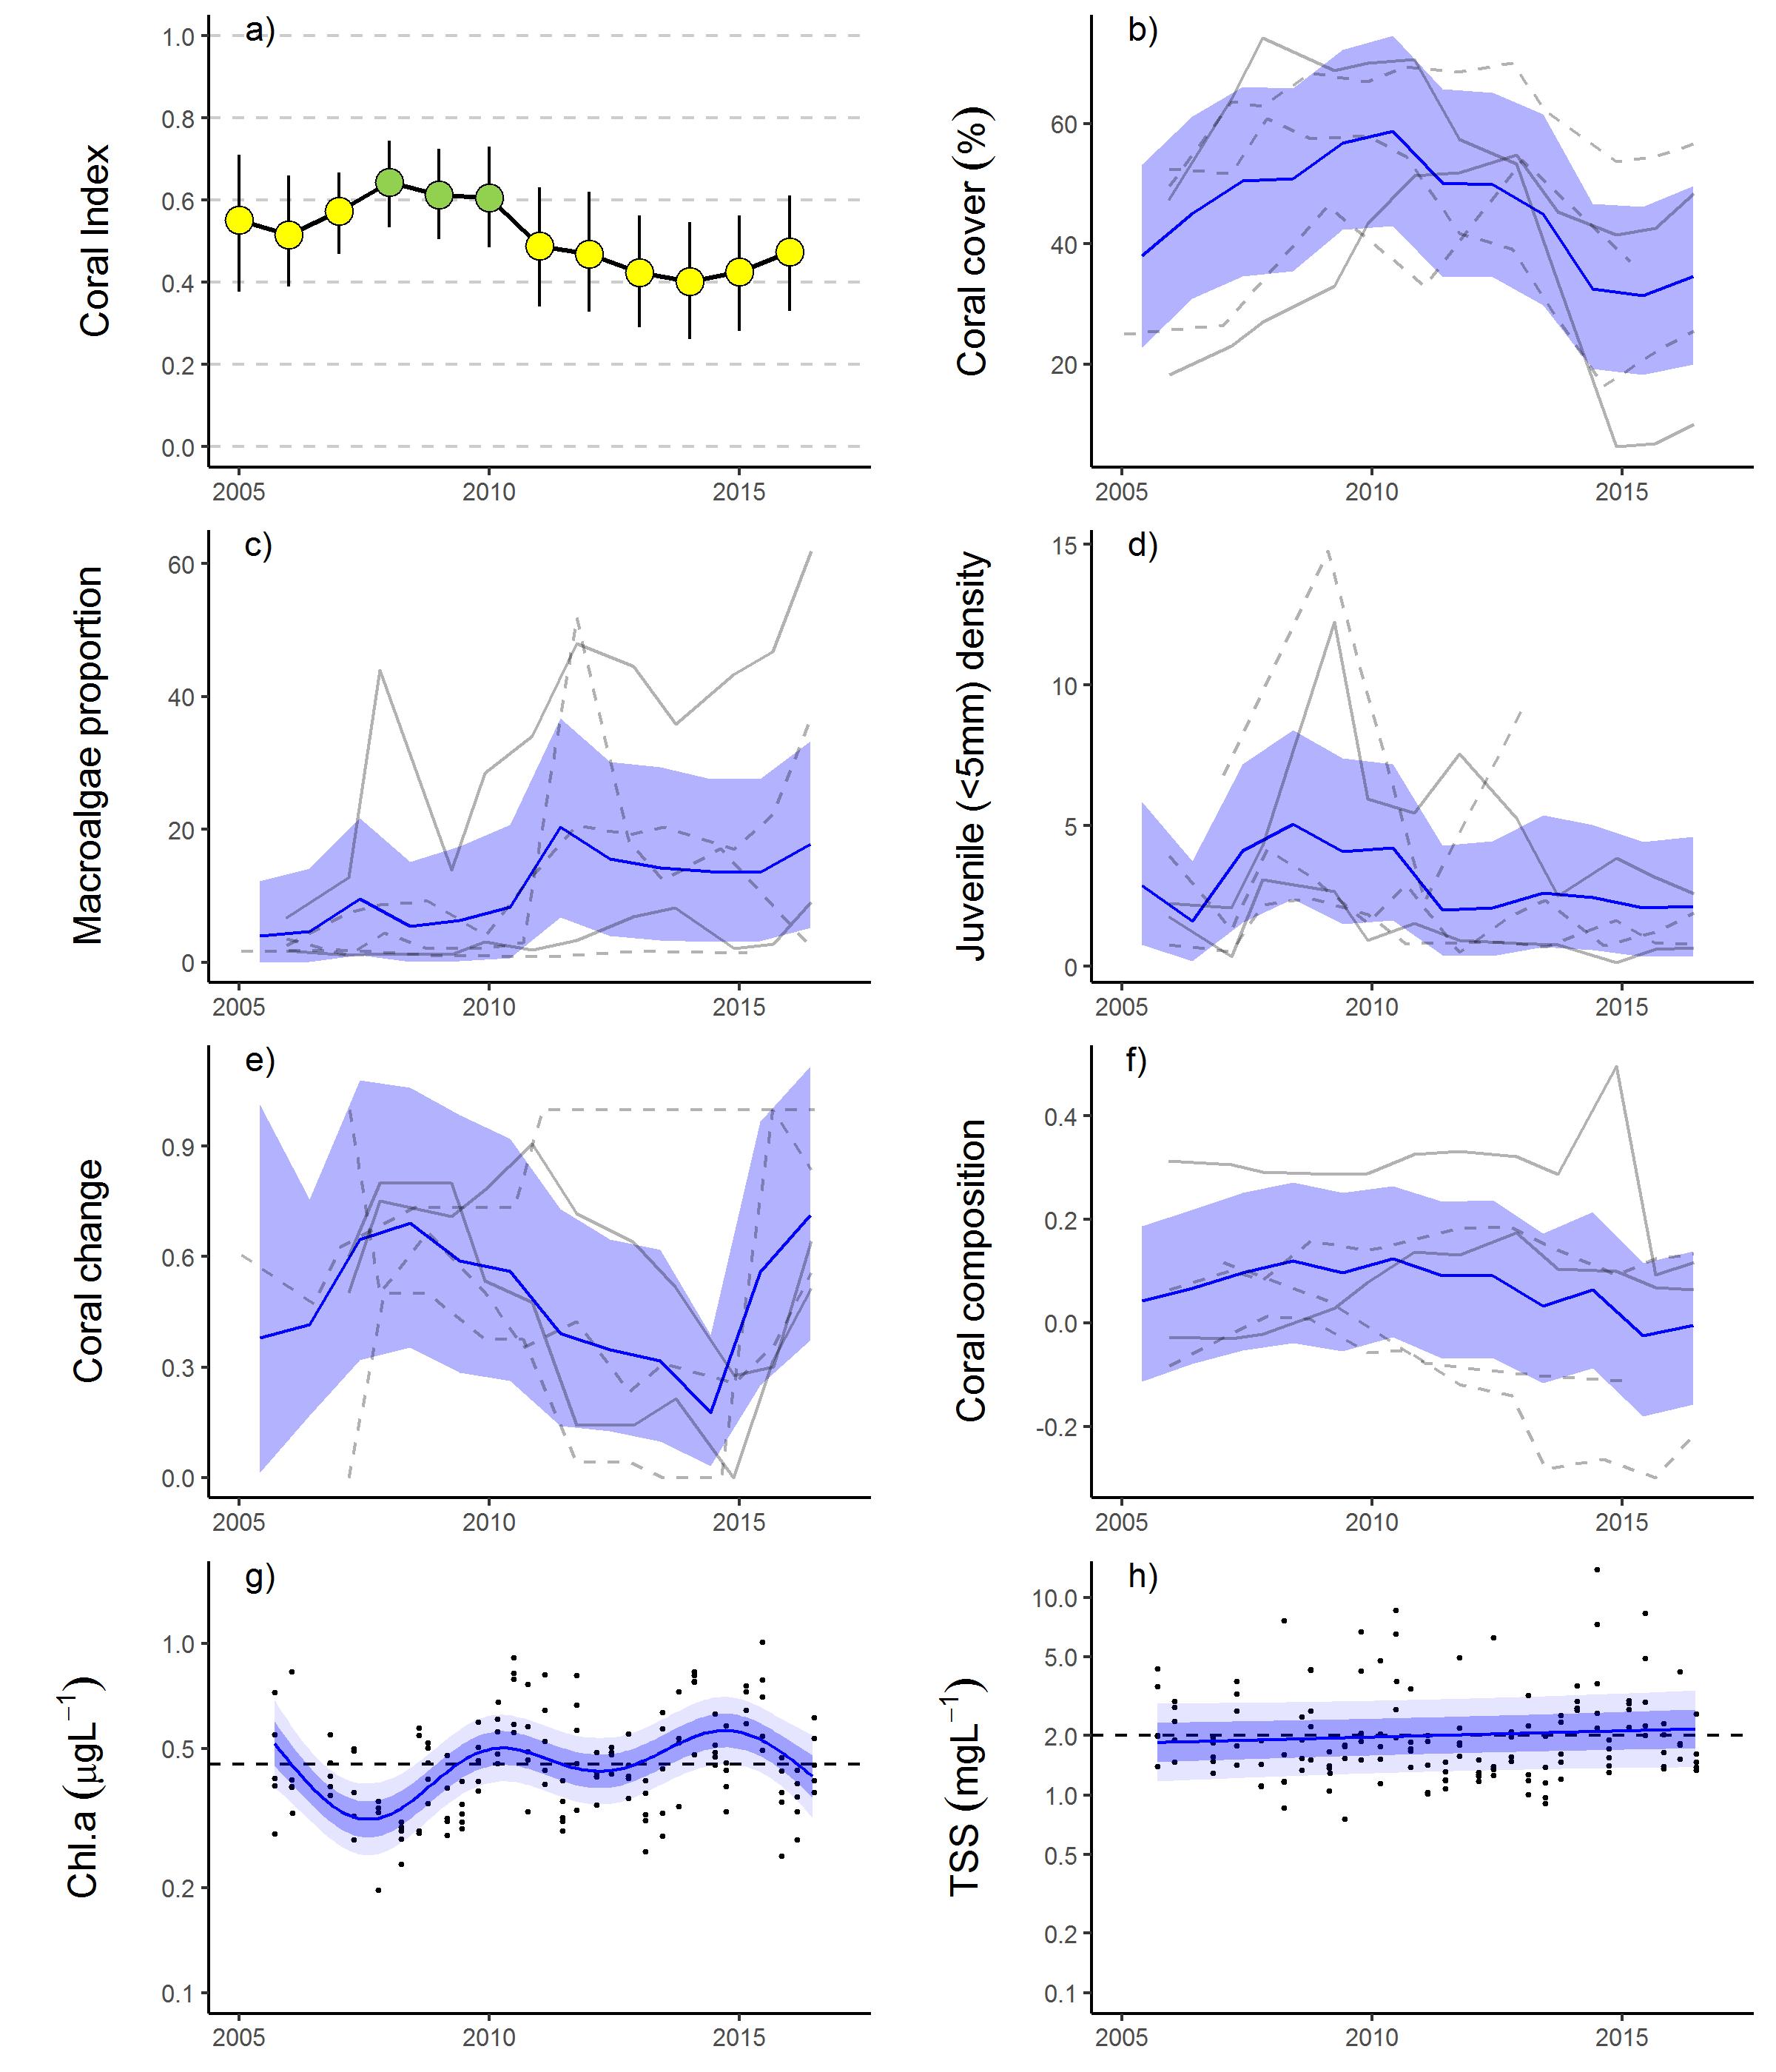

Figure 13 Barron Daintree sub-region index and indicator trends. a)
Coral index, colour coding: dark green- ‘very good’; light green-‘good’; yellow – ‘moderate; orange – ‘poor’; red – ‘very poor’. b – f) trends in individual indicators, (blue lines) bound by 95% confidence intervals of those trends (shading), grey lines represent observed profiles at 5 m (dashed) and 2 m (solid) depths for individual reefs, g) trend in chlorophyll a and, h) total suspended solids, shading defines 95% confidence intervals of water quality trends, black dots represent observed data. Dashed reference lines indicate GBRMPA (2010) guideline values.

5.2.2 Wet Tropics Region: Johnstone Russell-Mulgrave sub-region
In 2016 the coral index reached a ‘good’ classification as scores continued to improve from a low in 2012 (Figure 14a). Improvement in the index between 2012 and 2016 was most evident at 2 m depths where scores for the Coral Cover, Juvenile and Composition metrics have improved (

Table 11). While the Macroalgae and Cover Change scores have not consistently improved since 2012 (

Table 11, Figure 15c, e) it is worth noting that for both metrics the mean scores in the sub-region in 2016 equate to a ‘good’ condition categorisation (Table A1. 5). The lowest scores for Macroalgae occur at Franklands West and East where the communities includes a high proportion of red algae species (Table A1. 9); this pattern does not clearly reflect poor water quality at this site as conditions are consistently better than those observed at High Island and comparable to those observed at Fitzroy Island where Macroalgae scores are higher (Figure 14a, b, Waterhouse et al. 2017). Improvement in the index at 5 m depth was less consistent, increased density of Juvenile corals was the most evident change (

Table 11), although there was a tendency for a reduction in the density of juvenile corals recorded in 2016 (Figure 15d). Improvement in the Coral Cover metric since 2012, largely reflects increases in Acroporidae cover on the exposed eastern aspects of High Island and the Frankland Group, along with increase in the slower growing Poritidae at Frankland West (Figure A1. 2).

Table 11 Pair-wise comparison between index and metric scores in the Johnstone Russell-Mulgrave sub-region. Data compare the changes in scores between local maxima and minima in the index time-series. For the index, and each metric, the observed change in the sub-regional score and the probability that the change was greater or less than zero (no change) are presented. Shading is used as a visual aid to highlight the magnitude of the probability the score improved (blue shades) or declined (red shades). Probabilities are derived from the posterior distribution of observed score changes at each reef and depth.
Period | Depth | Index |  | Cover Change |  | Composition |  | Coral Cover |  | Juvenile |  | Macroalgae
Period | Depth | Score | P | Score | P | Score | P | Score | P | Score | P | Score | P
2009 to 2012 | 2 | -0.21 | 0.93 | -0.22 | 0.67 | -0.25 | 0.74 | -0.24 | 0.85 | -0.12 | 0.79 | -0.21 | 0.70
2009 to 2012 | 5 | -0.13 | 0.82 | -0.10 | 0.62 | -0.25 | 0.73 | -0.14 | 0.86 | -0.12 | 0.82 | -0.04 | 0.52
2012 to 2016 | 2 | 0.20 | 0.92 | 0.27 | 0.66 | 0.33 | 0.82 | 0.29 | 0.92 | 0.07 | 0.91 | 0.04 | 0.54
2012 to 2016 | 5 | 0.06 | 0.70 | 0.22 | 0.70 | -0.06 | 0.54 | 0.14 | 0.77 | 0.16 | 0.83 | -0.10 | 0.69

Prior to 2014 the trajectories for Cover Change scores have varied dramatically between reefs (Figure 15e). It is difficult to interpret inter-reef changes in this variable as scores average over changes in cover observed over the preceding four years, excluding those influenced by acute events. In this region in particular, the timing of disturbances has varied from reef to reef as COTS populations have been variously present at reefs in any given year and the exposure to storms has also varied due to the replication of sites on leeward and windward aspects of most reefs. The result is that estimates of Cover Change are based on a variable set of observations for each reef in any given year. With no disturbances in the last two years the scores for each reef are more comparable, and consistently improved (Figure 15e).
Reefs in this subregion were not severely impacted by high water temperatures over the 2015-2016 summer that lead to severe impacts on the northern Reef (GBRMPA 2016, Figure 14c). Bleaching during 2016 surveys was minor, limited to a scattering of individual colonies observed to be white or fluorescing on the reef slopes at Fitzroy and High Islands. Colonies exhibiting bleaching were principally from the more sensitive genera, Pocillopora, and Montipora. This is in contrast to the 1998 bleaching event where Fitzroy Island and the Frankland Group lost 81% and 44% of their coral cover respectively (Table A1. 4).
In 2011 the reefs in this region suffered their most severe setback (Figure 14e). Two consecutive cyclones, Tasha and Yasi, caused significant damage to coral communities at Franklands East, Franklands West and High East. At High West, loss of coral cover at 2 m depth following these cyclones was attributed to low salinity floodwaters (Table A1. 4, Figure A1. 2). In combination, these disturbances resulted in a sharp decline in the coral index in 2012 (Figure 15a). The effects of cyclones were further compounded by the increased prevalence of disease in 2011 (Figure A1. 7). Fitzroy Island, which had escaped serious damage from Tasha and Yasi, incurred the highest loss of coral as a result of disease. At Fitzroy East between 60% (2 m) and 42% (5 m) of the hard cover, predominantly Acropora, was lost as a result of disease (Figure A1. 2, Table A1. 4). While the cause of the marked increase in disease observed at the Fitzroy Island in 2011 is unknown, it did coincide with high discharge from local rivers (Figure 14d). This observation was influential in the regional-level association between change in index scores and discharge from local rivers (Figure 11).
Since 2012 COTS have been active in the area, and their feeding will have contributed to variability in the improvement in the Coral Cover metric through to 2016. Since monitoring began in 1992 two cycles of COTS outbreaks have impacted the reefs in this sub-region. Between1996 and 2000 substantial loss of cover at Green, Fitzroy West LTMP and the Frankland Group (Table A1. 4) was attributed to COTS. In 2012 and 2013 elevated numbers of COTS were again increasing. In 2013 COTS had caused a 44% reduction of the hard coral cover compared to that observed in 2011 (Table A1. 4, Figure A1. 2). At both Fitzroy Island and Green Island reductions in hard coral cover, in particular of the family Acroporidae (Figure A1. 2), through to 2015 were primarily the result of COTS feeding. In contrast, although low numbers of COTS were observed at the Frankland Group and High Island between 2012 and 2015, there was little evidence of an impact to coral cover at these reefs. Helping to limit coral cover losses at both Fitzroy Island and Green Island has been the removal of starfish by the Australian Government’s Crown-Of-Thorns Starfish Management Programme which removed 6074 starfish from Fitzroy Island reefs and a further 5556 from Green Island reef prior to 2016 coral surveys. In 2016, low numbers of juvenile and sub-adult COTS were again observed at all reefs in this sub-region indicating their ongoing recruitment. The highest density of COTS were observed at Frankland East 5 m (150 ha⁻¹) and Frankland West 2 m (125 ha⁻¹). While there was little effect on coral cover at the Frankland Group observed in 2016, this was due to COTS consuming corals in the understory of rapidly growing Acropora thickets; it likely, that if left unchecked, the observed density of COTS will reduce coral cover in the near future.
Despite recent low discharge (Figure 14d), and relatively low loads of nutrients and sediments being discharged into the marine environment there have been no clear reductions in regional concentrations of measured water quality parameters (Figure 14g, h, Figure A1. 10, Waterhouse et al. 2017).
Overall the recent trajectory of coral communities in this sub-region demonstrates their ability to recover when the cumulative impacts of acute events and run-off are low.

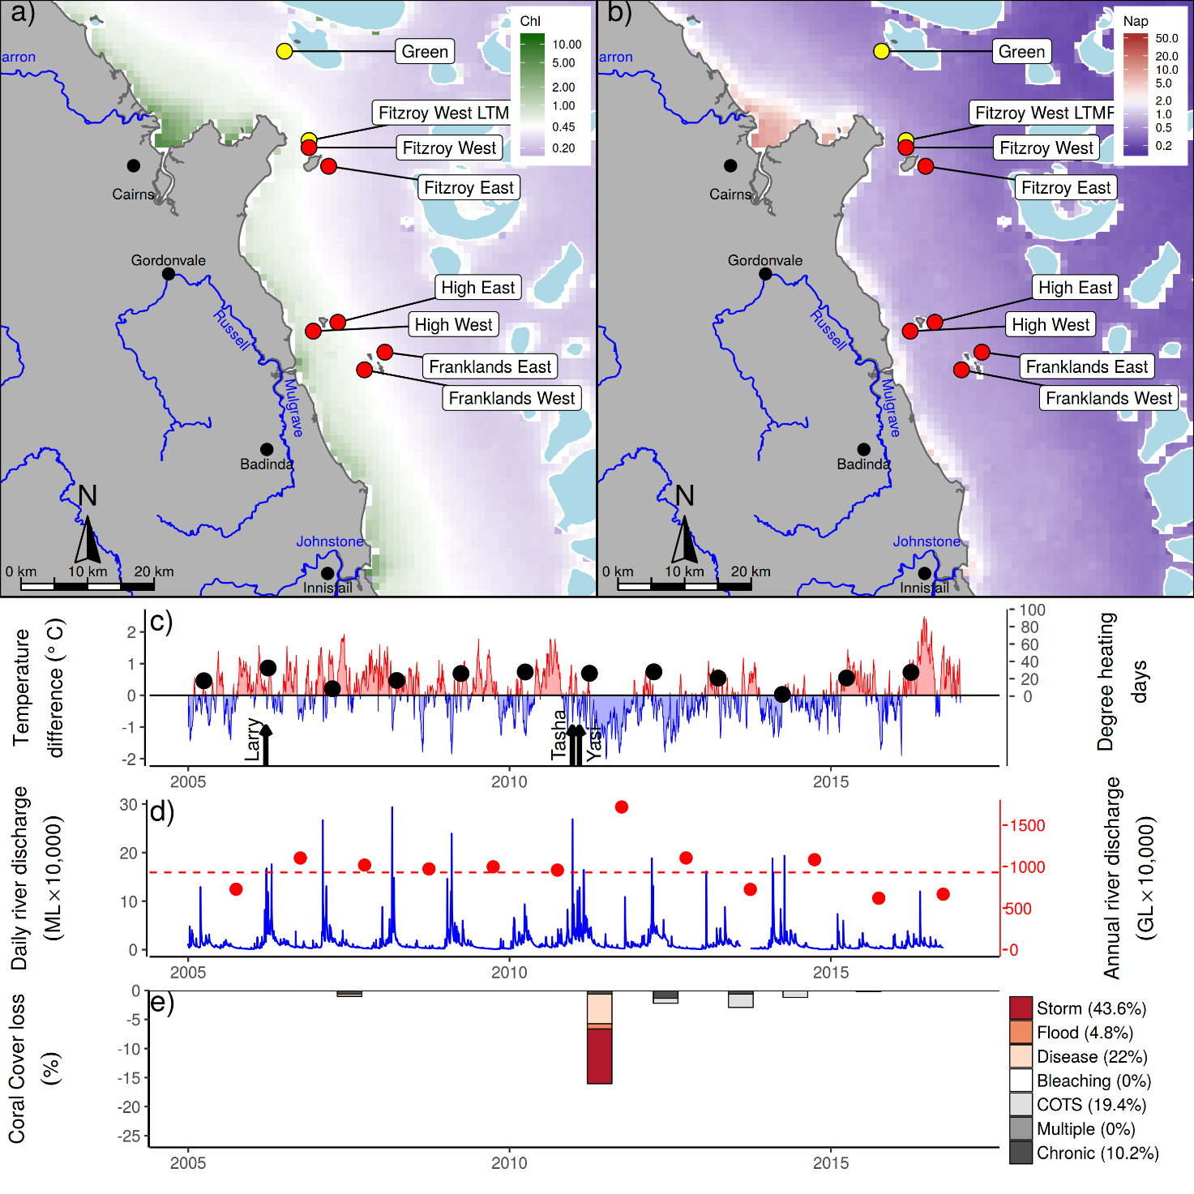
Figure 14 Johnstone Russell-Mulgrave sub-region environmental pressures. Maps show location of monitoring sites, red symbols MMP, yellow symbols LTMP along with a) mean chlorophyll a concentration and b) mean Non algal particulate concentrations. Water quality data are mean levels over the period 2003-2016. c) Seasonally adjusted temperature deviation, timing of cyclones and storms indicated by black arrows, accumulated degree heating days over the summer period (1st of December - 31st March) indicated by black symbols d) Combined daily (blue) and annual (red) discharge for the North Johnstone, South Johnstone, Russell and Mulgrave rivers, red dashed line represents long-term median discharge (1986-2016). e) break-down of hard coral cover loss by disturbance type; length of bars represent the mean loss of cover across all reefs (see methods section for further detail).

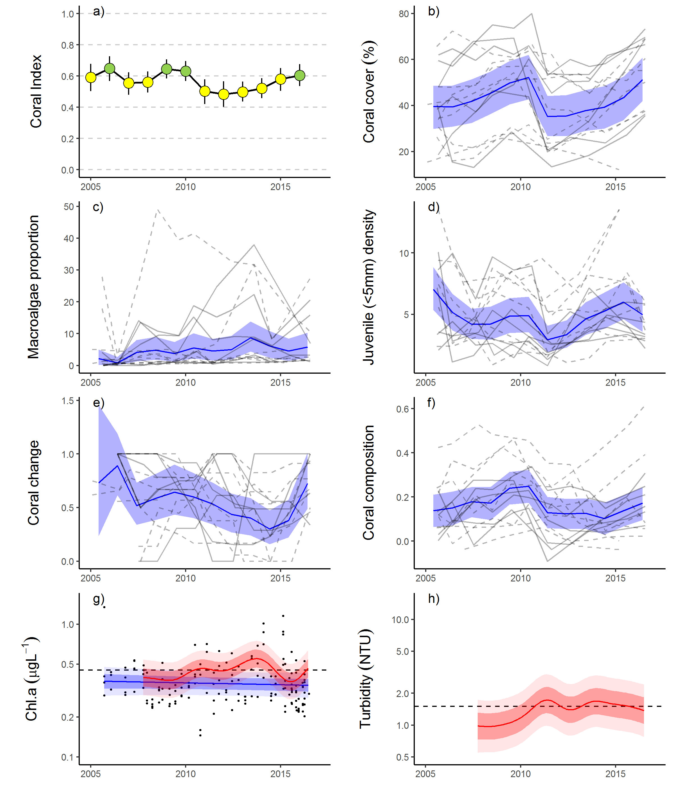
Figure 15 Johnstone Russell-Mulgrave sub-region index and indicator trends. a)
Coral index, colour coding: dark green- ‘very good’; light green-‘good’; yellow – ‘moderate; orange – ‘poor’; red – ‘very poor’. b – f) trends in individual indicators, (blue lines) bound by 95% confidence intervals of those trends (shading), grey lines represent observed profiles at 5 m (dashed) and 2 m (solid) depths for individual reefs, g) trend in chlorophyll a and, h) total suspended solids, shading defines 95% confidence intervals of water quality trends for hand sampled data (blue) or estimates derived from ECO FLNTUSB instruments (red), black dots represent observed data. Dashed reference lines indicate GBRMPA (2010) guideline values.

5.2.3 Wet Tropics Region: Herbert Tully sub-region
From 2013 the coral index has continued to improve to be categorised as ‘moderate’ in 2016, and the highest level recorded in the sub-region since monitoring began in 2005 (Table 12, Figure 17a). The improvement in the coral index coincides with both a hiatus in acute disturbances and median to below median discharges from adjacent catchments (Figure 16c-e). Between 2013 and 2016 all indicator metric scores improved, the most consistent improvements were for Coral Cover and Coral Change (Table 12). Improvement in the Composition metric indicates that recovering coral cover included increased cover of species sensitive to water quality, these taxa, largely Acropora were severely impacted by Cyclone Yasi (Figure A1. 3). Conversely, improvements in the Juvenile metric largely reflect increased abundance of Turbinaria (Family Dendrophylliidae, Figure A1. 3) a genus not considered sensitive to poor water quality (Table A1. 2). The least improved metric was for Macroalgae at 5 m depths, a result influenced by the generally low proportion of macroalgae in the algal communities at the deeper sites (Figure 17e) that limits room for improvement in this metric.
Reefs in this area escaped severe impact from coral bleaching over the 2015/16 summer. Temperature anomalies over the summer period did not reach the accumulated level assumed to cause coral bleaching (Figure 16c). During surveys in June 2016 scattered colonies from a range of genera including: Acropora, Goniastrea, Goniopora, Lobophyllia, and Porites were bleached or pale though it is expected that these corals will recover. It is possible that the slight reduction of coral cover at the 2 m depth of Bedarra was associated with the temperature anomalies as there is no other immediately plausible explanation for this reduction. Despite any minor impact of bleaching the clear improvement in the index observed since 2013 demonstrates the propensity for recovery among the coral communities in this sub-region.
Table 12 Pair-wise comparison between index and metric scores in the Herbert Tully sub-region. Data compare the changes in scores between local maxima and minima in the index time-series. For the index, and each metric, the observed change in the sub-regional score and the probability that the change was greater or less than zero (no change) are presented. Shading is used as a visual aid to highlight the magnitude of the probability the score improved (blue shades) or declined (red shades). Probabilities are derived from the posterior distribution of observed score changes at each reef and depth.
Period | Depth | Index |  | Coral Change |  | Composition |  | Coral Cover |  | Juvenile |  | Macroalgae
Period | Depth | Score | P | Score | P | Score | P | Score | P | Score | P | Score | P
2009 to 2013 | 2 | -0.04 | 0.65 | 0.05 | 0.56 | 0.00 | 0.00 | 0.02 | 0.63 | 0.39 | 0.84 | -0.67 | 0.92
2009 to 2013 | 5 | -0.12 | 0.85 | -0.08 | 0.58 | -0.13 | 0.71 | 0.01 | 0.56 | 0.20 | 0.74 | -0.59 | 0.89
2013 to 2016 | 2 | 0.26 | 0.92 | 0.36 | 0.92 | 0.33 | 0.72 | 0.21 | 1.00 | 0.17 | 0.79 | 0.20 | 0.85
2013 to 2016 | 5 | 0.25 | 1.00 | 0.28 | 0.88 | 0.33 | 0.86 | 0.20 | 1.00 | 0.17 | 0.74 | 0.25 | 0.65

The trend in the coral index identifies distinct declines caused by damage attributed to Cyclone Larry in 2006 and Cyclone Yasi in 2011 followed by recovery in subsequent years (Figure 17a). The combined impacts of these cyclones account for 91% of the hard coral cover lost since 2005 (Figure 16e). Of note is that following each cyclone, in addition an immediate reduction, there was a lagged decline in the index scores (Figure 16a). This lagged response reflects temporary improvement in the Macroalgae metric in the first post cyclone survey (Figure 17e). During cyclones, macroalgae are striped from the substrate, temporarily reducing their abundance. Subsequent rapid colonisation of space as a result of reduced coral cover ensures reduced scores of Macroalgae compounding the impact on index scores resulting from immediate losses of coral (Figure 17e).
The coral sampling sites in this sub-region are primarily influenced by discharge from the Tully and Herbert rivers. As of 2015, monitoring of King was ceased in favour of a new location at Bedarra that was selected to coincide more closely with a revised sampling design for water quality monitoring. All the coral monitoring sites in this sub-region are situated in relatively clear, though nutrient rich waters (turbidity below the Guideline, Chl a concentration above the Guideline) (Figure 12b, Table A1. 6). This combination of low turbidity and high nutrient availability is consistent with the prevalence of macroalgae observed in the shallow depths at most reefs (Figure 17c)
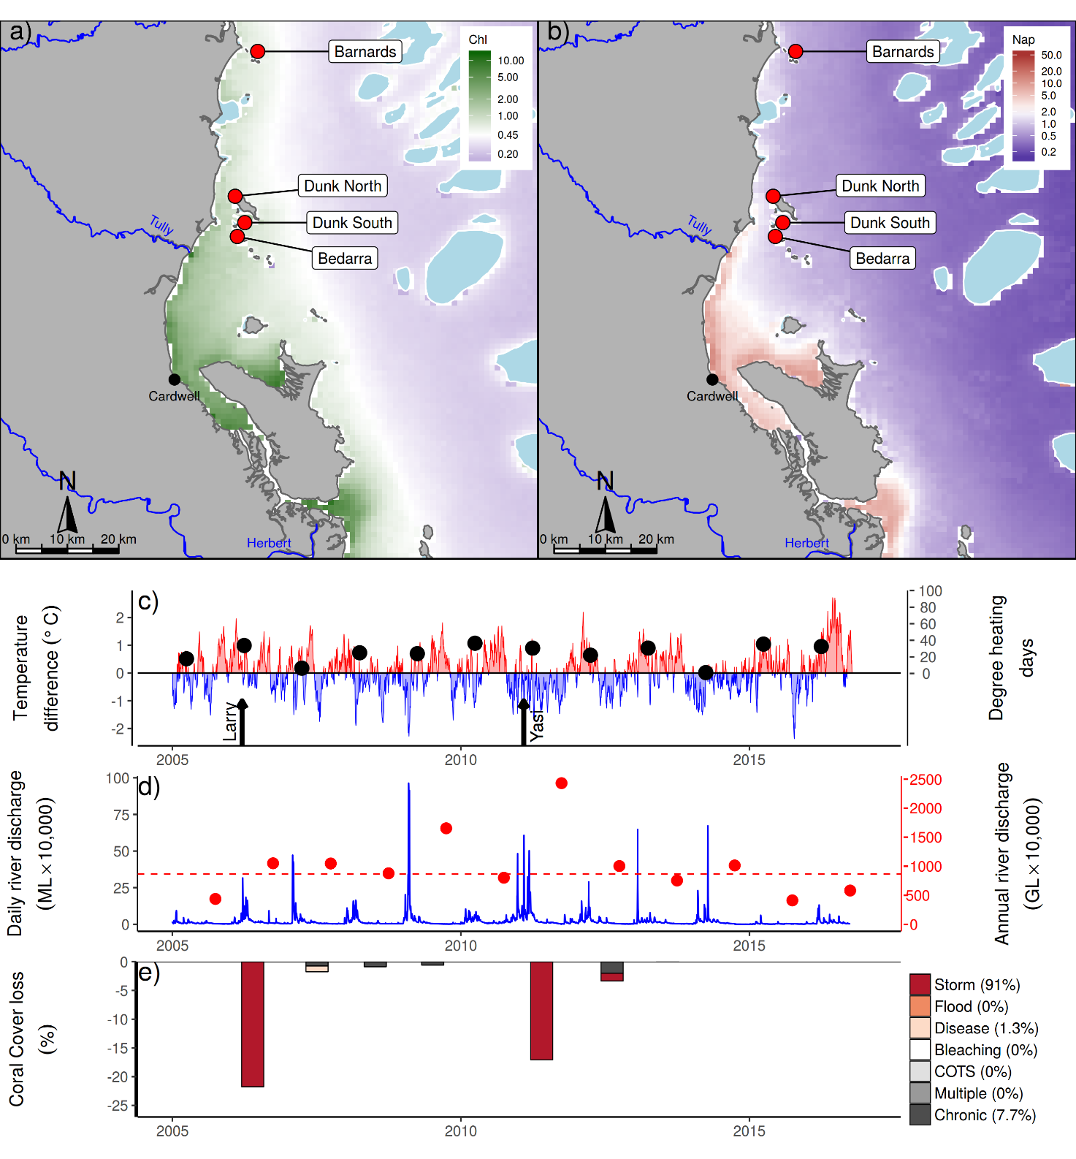
Figure 16 Herbert Tully sub-region environmental pressures.
Maps show location of monitoring sites, red symbols MMP, yellow symbols LTMP along with a) mean chlorophyll a concentration and b) mean Non algal particulate concentrations. Water quality data are mean levels over the period 2003-2016. c) Seasonally adjusted temperature deviation, timing of cyclones and storms indicated by black arrows, accumulated degree heating days over the summer period (1st of December - 31st March) indicated by black symbols d) Combined daily (blue) and annual (red) discharge for the Herbert, Murray and Tully rivers, red dashed line represents long-term median discharge (1986-2016). e) break-down of hard coral cover loss by disturbance type; length of bars represent the mean loss of cover across all reefs (see methods section for further detail).
The result of relatively low discharge in recent years may explain concentrations of Chl-a, TSS, and nitrogen oxides dipping below guideline values in 2016 (Figure 15d, Figure 16g, h, Figure A1. 11, Waterhouse et al. 2017). The in-situ monitoring of both Chl a and Turbidity, however, do not show similar declines (Figure 17g, h), reducing evidence for a clear response to run-off.
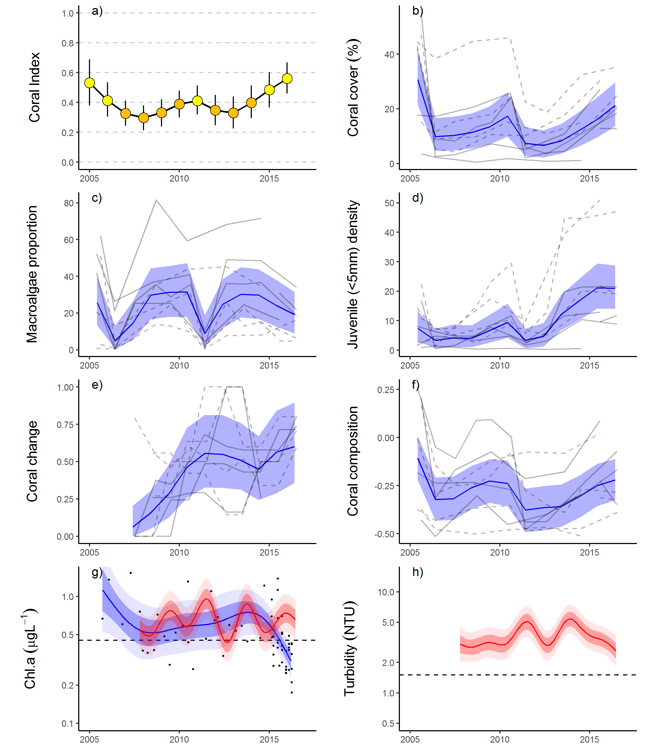
Figure 17 Herbert Tully sub-region index and indicator trends. a)
Coral index, colour coding: dark green- ‘very good’; light green-‘good’; yellow – ‘moderate; orange – ‘poor’; red – ‘very poor’. b – f) trends in individual indicators, (blue lines) bound by 95% confidence intervals of those trends (shading), grey lines represent observed profiles at 5 m (dashed) and 2 m (solid) depths for individual reefs, g) trend in chlorophyll a and, h) total suspended solids, shading defines 95% confidence intervals of water quality trends for hand sampled data (blue) or estimates derived from ECO FLNTUSB instruments (red), black dots represent observed data. Dashed reference lines indicate GBRMPA (2010) guideline values.
.

5.2.4 Burdekin Region
From 2012 to 2016 the coral index consistently improved, reversing declines observed between 2009 and 2012 (Table 13, Figure 19a). The improvement in the index reflects consistent increase in Coral Cover at both 2 m and 5 m depths, and improvement in the Cover Change and Juvenile metric scores at 5 m only (Table 13, Figure 19d, e). A general improvement in the Composition indicator (Table 13) indicates that cover increase includes recovery of taxa sensitive to poor water quality, in particular Acroporidae (Figure A1. 4). The observed improvement in the coral index coincides with a period free from acute disturbances (Figure 18c, e) and below median discharge from the regions rivers (Figure 18d). The only indicator not showing improved metric scores was Macroalgae (Table 13, Figure 19e). The proportional cover of macroalgae has been variable: low points were recorded in 2009, the reason for this decline remains unexplained, and then again in 2011 following stripping of cover that occurred during Cyclone Yasi (Figure 19c). By 2012 macroalgae had re-established and, though variable among reefs, the proportional cover of macroalgae regionally has remained consistent through to 2016 (Figure 19e).
Table 13 Pair-wise comparison between index and metric scores in the Burdekin Region. Data compare the changes in scores between local maxima and minima in the index time-series. For the index, and each metric, the observed change in the sub-regional score and the probability that the change was greater or less than zero (no change) are presented. Shading is used as a visual aid to highlight the magnitude of the probability the score improved (blue shades) or declined (red shades). Probabilities are derived from the posterior distribution of observed score changes at each reef and depth.
Period | Depth | Index |  | Cover Change |  | Composition |  | Coral Cover |  | Juvenile |  | Macroalgae
Period | Depth | Score | P | Score | P | Score | P | Score | P | Score | P | Score | P
2009 to 2012 | 2 | -0.09 | 0.65 | -0.37 | 0.73 | -0.14 | 0.65 | -0.16 | 0.74 | 0.07 | 0.59 | 0.03 | 0.55
2009 to 2012 | 5 | -0.18 | 0.92 | -0.37 | 0.87 | -0.25 | 0.82 | -0.17 | 0.89 | 0.08 | 0.68 | -0.18 | 0.70
2012 to 2016 | 2 | 0.13 | 0.89 | 0.11 | 0.61 | 0.33 | 0.75 | 0.18 | 0.95 | 0.08 | 0.69 | -0.07 | 0.58
2012 to 2016 | 5 | 0.16 | 0.93 | 0.21 | 0.85 | 0.25 | 0.73 | 0.10 | 0.95 | 0.23 | 0.76 | 0.00 | 0.53

Declines in the index through to 2012 coincided with the combined influence of Cyclone Yasi and a period of very high discharge from the region’s rivers (Figure 18d, e). Since 2005, cyclones and storms have accounted for 57% of hard coral losses (Figure 18e). East-facing locations, such as Palms East and Lady Elliot (2 m), were particularly exposed to storm driven seas, and show the impacts of Cyclone Larry (2006) and Cyclone Yasi (2011) (Figure A1. 4, Table A1. 4). The lag in influence from Cyclone Yasi, noted in 2012 (Figure 18e), is due to LTMP surveys post Yasi not occurring until that year. The last outbreak of COTS on the inshore reefs in this region occurred at Havannah in 2001. In 2016, a single juvenile COTS was observed at Palms East. On the mid shelf reefs in this region COTS numbers are in outbreak densities at some reefs (AIMS LTMP).
In addition to losses in coral cover attributed to Cyclone Yasi, the period 2009 to 2012 saw a reduction in the Coral Change metric (Table 13). Overall, low rates of increase in coral cover contributed to 35% of cover lost since 2005 (chronic pressures, Figure 18e). Although not categorised as a disease outbreak for the purpose of disturbance estimation, elevated levels of disease were observed from 2007 to 2009 (Figure A1. 7) and will have contributed to the chronic disturbances recorded in 2008, 2009 and 2010 (Figure 18e). Chronic pressures are assumed when there is no evidence for impacts associated with acute disturbances, and represent the cumulative impacts of environmental pressures that suppress the annual increments in cover increase that are the basis of the Coral Change scores. As Acropora and Montipora were the genera most infected by disease, the disproportional loss of these groups will have contributed to the decline in the Composition metric.
The ten reefs monitored span a distinct gradient in water quality. The reefs closer to the coast: Middle, Magnetic, Lady Elliot and Pandora are, on average, exposed to Chl a concentrations that exceed the Guideline (Figure 18a, Table A1. 6). The composition of coral communities vary in response these differences in environmental conditions (Figure 19f), shifting from a high proportional cover of the families Acroporidae, Pocilloporidae and Poritidae (genus Porites) in clear waters, or at 2 m depths in more turbid settings, through to a dominance of families including Agariciidae, Oculinidae, Pectiniidae and Poritidae (Genus Goniopora) as water quality declines (Figure A1. 4). Above Guideline concentration of Chl a also corresponds to a high abundance of macroalgae (Section 8) explaining the high proportion of macroalgae in the algal communities at Magnetic, Pandora, and Lady Elliot and low levels of macroalgae at Palms West. The reefs at Havannah appear at the crossroad for conditions supporting brown macroalgae, in 2016 cover of the brown algae Lobophora remained persistent at 5 m depths. Palms East is unusual in supporting a bloom of the green macroalgae Caulerpa that has persisted since first appearing in 2012 in the wake of Cyclone Yasi.
Of the reefs surveyed in 2016 it was only at Havannah, 2 m depth, that coral cover declined: here, white syndrome and brown band disease were prevalent amongst the branching Acropora community that dominate this site. These Acropora species (in particular A. pulchra and A. aspera) were highly sensitive to previous coral bleaching events in the region (Marshall & Baird 2000) suggesting the high summer and autumn temperatures observed in 2016 but also high winter temperatures in 2015 (Figure 18c) as a possible contributing factor to this outbreak of disease. The 2016 bleaching event saw widespread temperature anomalies within the Burdekin Region. The temperature anomalies developed mid-summer, accumulating 68 DHDs, and continued to rise beyond 2ºC through April to June (Figure 18c). Despite these higher temperatures, bleaching was minor across the region noted primarily as affecting individual colonies scattered within predominantly unbleached neighbours. Genera most commonly bleaching included Acropora, Pocillopora, Montipora, Merulina, Stylophora, Favites, Goniastrea, Lobophyllia, Porites, and Turbinaria.
Improvements in the coral index have coincided with a combination of an absence of acute disturbance events and low discharge, with correspondingly relatively low loads of nutrients and sediments being delivered to the Reef (Figure 18, Waterhouse et al. 2017). That there has been no clear improvement in measured attributes of water quality (Waterhouse et al. 2017, Figure 19g, h, Figure A1. 12) limits the ability to link improvement in the index scores to water quality drivers. It is clear, however, that the reefs in this region have demonstrated a capacity to recover under the conditions observed in recent years.

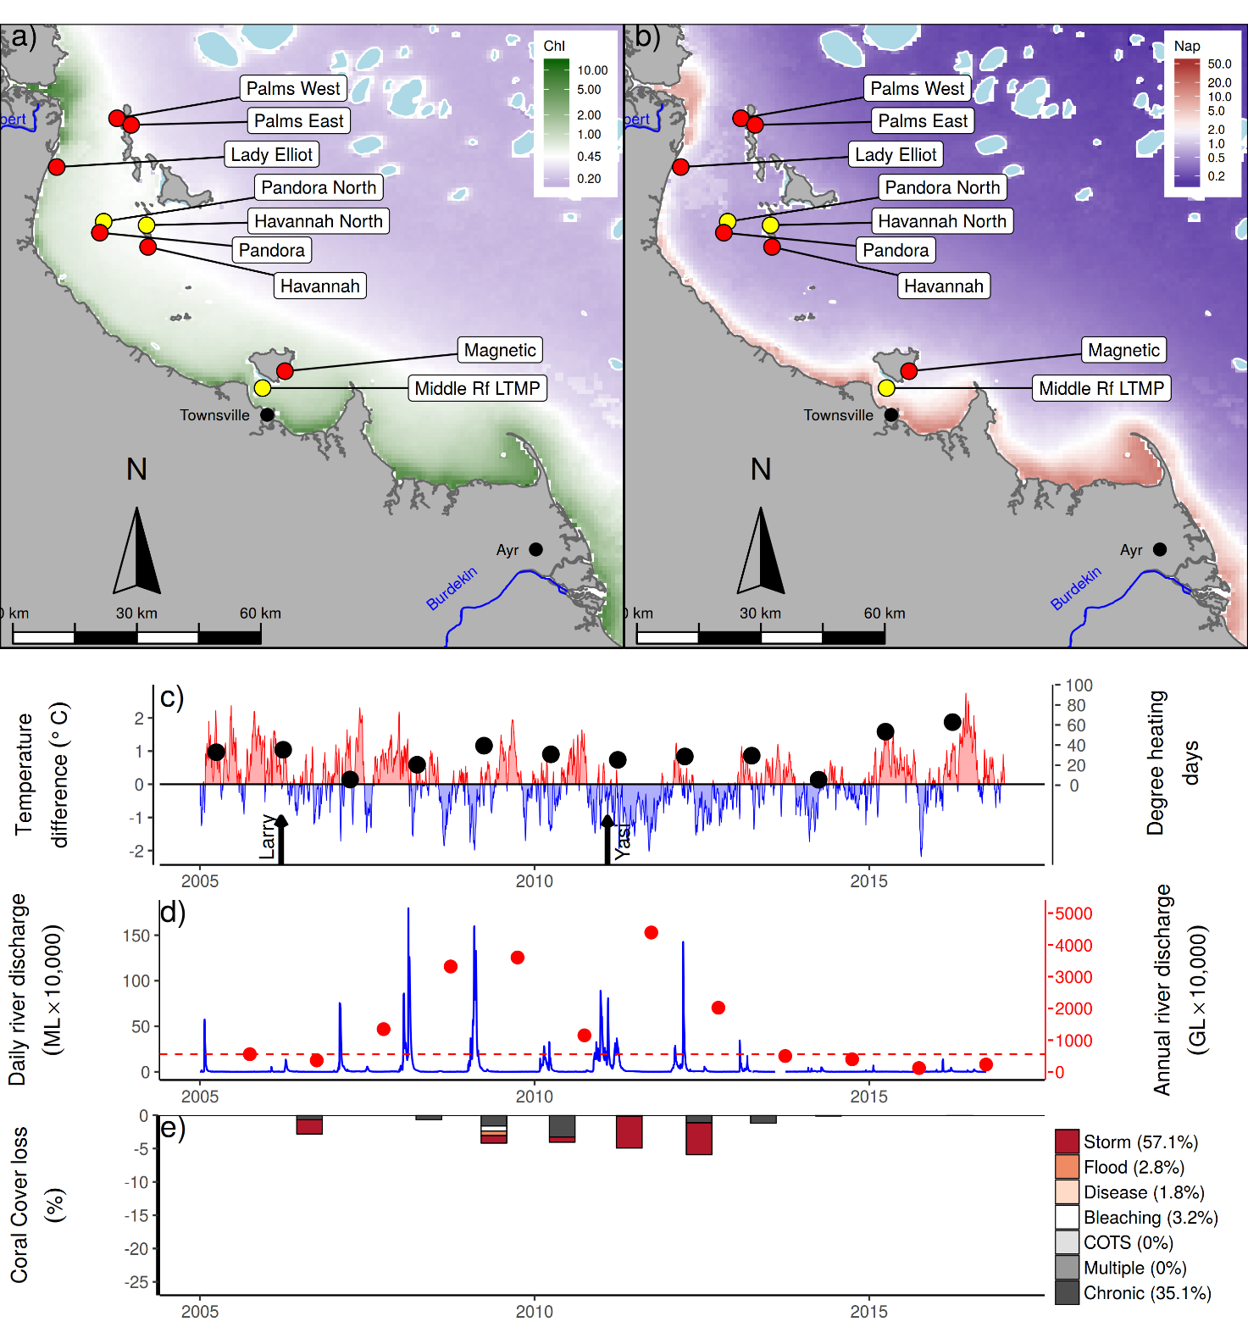
Figure 18 Burdekin Region environmental pressures. Maps show location of monitoring sites, red symbols MMP, yellow symbols LTMP along with a) mean chlorophyll a concentration and b) mean Non algal particulate concentrations. Water quality data are mean levels over the period 2003-2016. c) Seasonally adjusted temperature deviation, timing of cyclones and storms indicated by black arrows, accumulated degree heating days over the summer period (1st of December - 31st March) indicated by black symbols d) Combined daily (blue) and annual (red) discharge for the Black ,Burdekin, Don and Haughton rivers, red dashed line represents long-term median discharge (1986-2016). e) break-down of hard coral cover loss by disturbance type; length of bars represent the mean loss of cover across all reefs (see methods section for further detail).

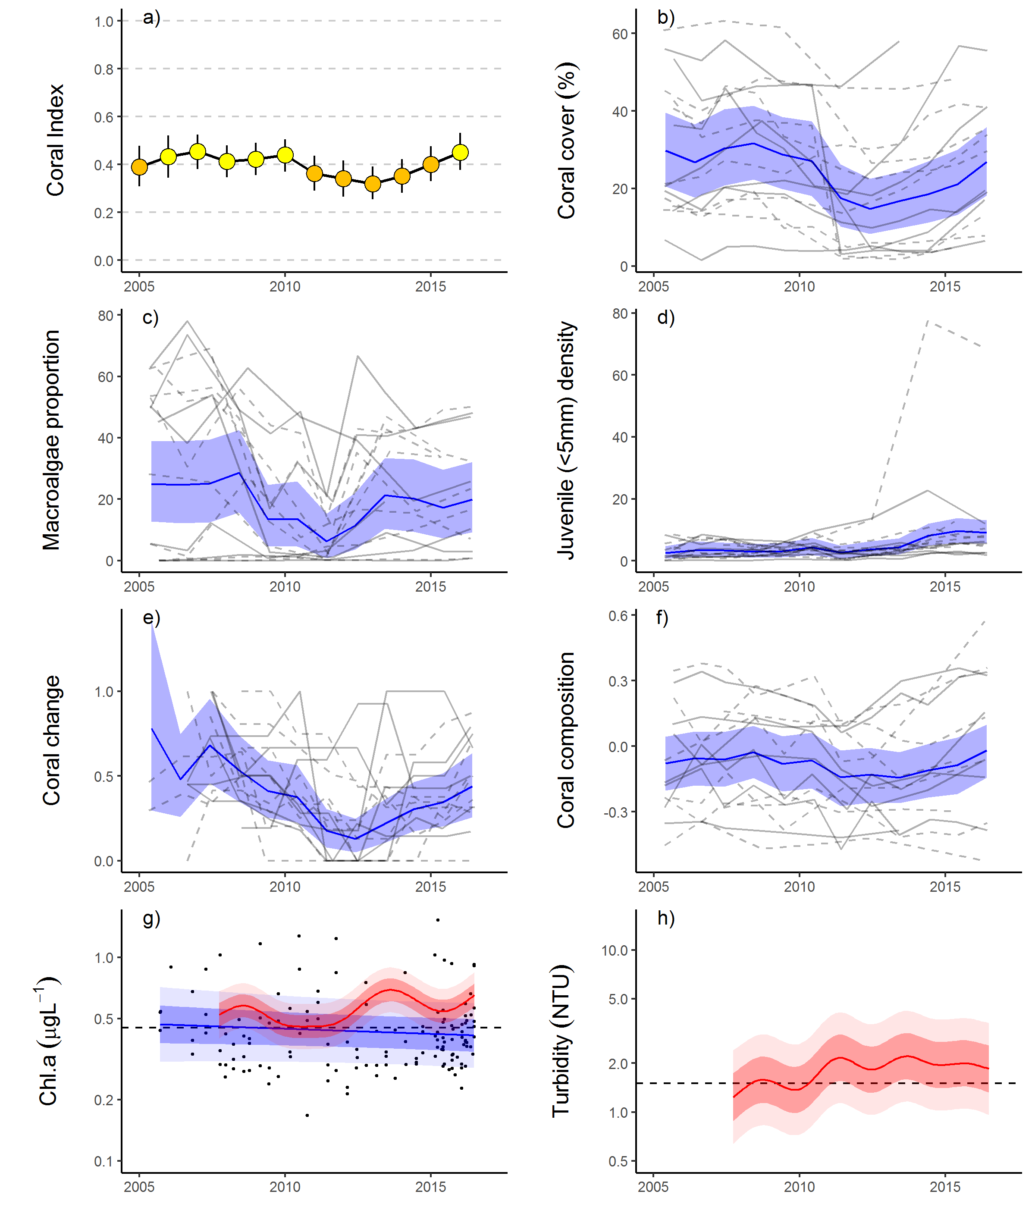
Figure 19 Burdekin Region index and indicator trends. a)
Coral index, colour coding: dark green- ‘very good’; light green-‘good’; yellow – ‘moderate; orange – ‘poor’; red – ‘very poor’. b – f) trends in individual indicators, (blue lines) bound by 95% confidence intervals of those trends (shading), grey lines represent observed profiles at 5 m (dashed) and 2 m (solid) depths for individual reefs, g) trend in chlorophyll a and, h) total suspended solids, shading defines 95% confidence intervals of water quality trends for hand sampled data (blue) or estimates derived from ECO FLNTUSB instruments (red), black dots represent observed data. Dashed reference lines indicate GBRMPA (2010) guideline values.

5.2.5 Mackay Whitsunday Region
The coral index was categorised as ‘good’ in 2016, having steadily improved since 2012 (Table 14, Figure 21a). Improvement in the index was most consistent at 2 m depths where only the Macro algae metric showed no improvement (Table 14). Improvement in coral cover at 2 m depths was most evident as increased cover of the coral family Acroporidae (predominantly branch Acropora) at Double Cone, Daydream and Shute Harbour (Figure A1. 5). These increases in Acropora cover will have contributed to the improvement in Composition scores. At 5 m depths, improvement in the index was less consistent, only the Composition and Juvenile metrics showed a moderate probability of improvement (Table 14).
A high proportion of macroalgae is only recorded at Pine and Seaforth the two reefs with the highest long-term mean concentrations of Chl a (Figure A1. 5, Table A1. 6), suggesting nutrient availability plays a role in the prevalence of macroalgae at these reefs. Neither of these reefs were surveyed in 2016, though there was a tendency for declines in the proportion of macroalgae these reefs in 2015 (Figure 21c). At all other reefs, the proportion of macroalgae in algal communities has remained consistently low, resulting in a high regional score for the Macroalgae metric (Figure 21, Table A1. 5).
The current index score is supported by the relatively low exposure to acute disturbances impacting the reefs in this region (Figure 20c-e). Flooding in 2009 and Cyclone Ului in 2010 were the only acute disturbance events recorded since 2005 (Figure 20e) and will have contributed to the slight declines in the index through to 2012. Cyclone Ului caused widespread loss of coral, while the magnitude of this loss was low at most sites (Figure 21b), Daydream was severely impacted losing 47% of the coral cover at 5 m depth (Figure A1. 5, Table A1. 4). Storm damage assigned to both 2010 and 2011 (Figure 20e) was due to Cyclone Ului, the losses span two years as a result of the biennial sampling design resulting in damage caused by Cyclone Ului not recorded until the following year at some reefs. Improvement in the index since 2012 has coincided with a period free from acute disturbance events (Figure 20).
Table 14 Pair-wise comparison between index and metric scores in the Mackay Whitsunday Region. Data compare the changes in scores between local maxima and minima in the index time-series. For the index, and each metric, the observed change in the sub-regional score and the probability that the change was greater or less than zero (no change) are presented. Shading is used as a visual aid to highlight the magnitude of the probability the score improved (blue shades) or declined (red shades). Probabilities are derived from the posterior distribution of observed score changes at each reef and depth.
Period | Depth | Index |  | Cover Change |  | Composition |  | Coral Cover |  | Juvenile |  | Macroalgae
Period | Depth | Score | P | Score | P | Score | P | Score | P | Score | P | Score | P
2008 to 2012 | 2 | -0.07 | 0.78 | -0.05 | 0.59 | -0.14 | 0.74 | -0.07 | 0.92 | -0.08 | 0.80 | 0.00 | 0.00
2008 to 2012 | 5 | -0.08 | 0.77 | -0.03 | 0.56 | -0.25 | 0.83 | -0.10 | 0.86 | -0.03 | 0.62 | 0.00 | 0.64
2012 to 2016 | 2 | 0.16 | 0.99 | 0.20 | 0.75 | 0.29 | 0.87 | 0.15 | 0.94 | 0.18 | 0.83 | 0.00 | 0.00
2012 to 2016 | 5 | 0.09 | 0.75 | 0.05 | 0.55 | 0.15 | 0.70 | 0.06 | 0.69 | 0.17 | 0.71 | -0.01 | 0.63

The low point in the index in 2012 was not only a result of Cyclone Ului with the index trending down from 2008 (Figure 21a). Over the period 2007 to 2013, annual discharge from the adjacent catchments was above median levels (Figure 20d), supplying elevated loads of nutrients and sediments (Turner et al. 2012, 2013, Wallace et al. 2014, 2015, Waterhouse et al. 2017). Although, there is no strong evidence for changes in measured marine water quality (Figure 21g, h, Figure A1. 13, Waterhouse et al. 2017), the onset of this increased run-off coincided with elevated incidence of coral disease (Figure A1. 7). Direct impacts due to flooding were recorded only in 2009 (Figure 20e), attributed primarily to the high loads of sediments observed on corals during surveys. The source of these sediments is not clear as the local rivers did not experience extreme flooding over the preceding summer (Figure 20d) although local heavy rainfall did result in a number of land-slides along the adjacent ranges.
Near guideline values for TSS at most of the MMP reef sites (Figure 20b, Table A1. 6) in combination with the limited exposure to wave energy among the Whitsunday Islands, which results in accumulation of fine sediments, have combined to select for coral communities tolerant of these conditions. Marked differences in composition of coral communities between 2 m and 5 m depths indicates a steep gradient in environmental conditions; there is a clear predominance of corals tolerant to low light and high rates of sedimentation at 5 m (e.g. families Oculinidae, Pectiniidae, Agariciidae, genus Goniopora) compared to at 2 m depths where Acroporidae and Porites are most represented (Figure A1. 5). This predominance of corals tolerant of low light sets the baseline location of communities to low values for the Composition metric (Figure 21f).

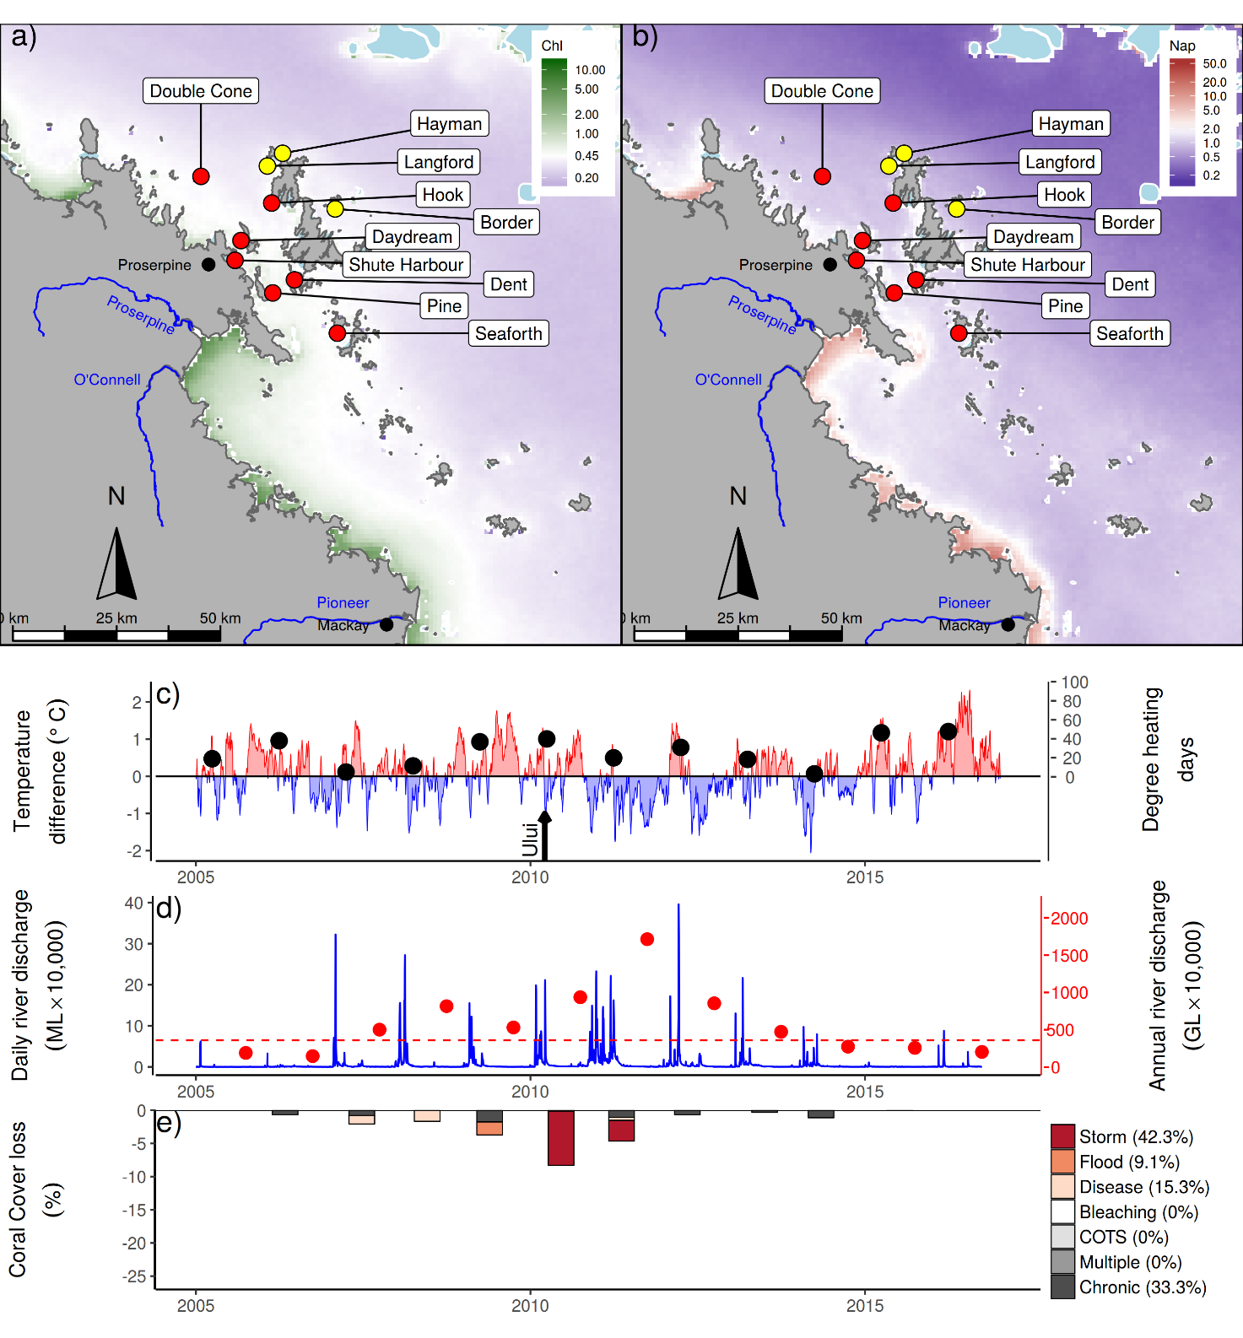
Figure 20 Whitsunday Mackay Region environmental pressures. Maps show location of monitoring sites, red symbols MMP, yellow symbols LTMP along with a) mean chlorophyll a concentration and b) mean Non algal particulate concentrations. Water quality data are mean levels over the period 2003-2016. c) Seasonally adjusted temperature deviation, timing of cyclones and storms indicated by black arrows, accumulated degree heating days over the summer period (1st of December - 31st March) indicated by black symbols d) Combined daily (blue) and annual (red) discharge for the Carmila and Sandy creeks, Gregory, O’Connell and Pioneer rivers, red dashed line represents long-term median discharge (1986-2016). e) break-down of hard coral cover loss by disturbance type; length of bars represent the mean loss of cover across all reefs (see methods section for further detail).

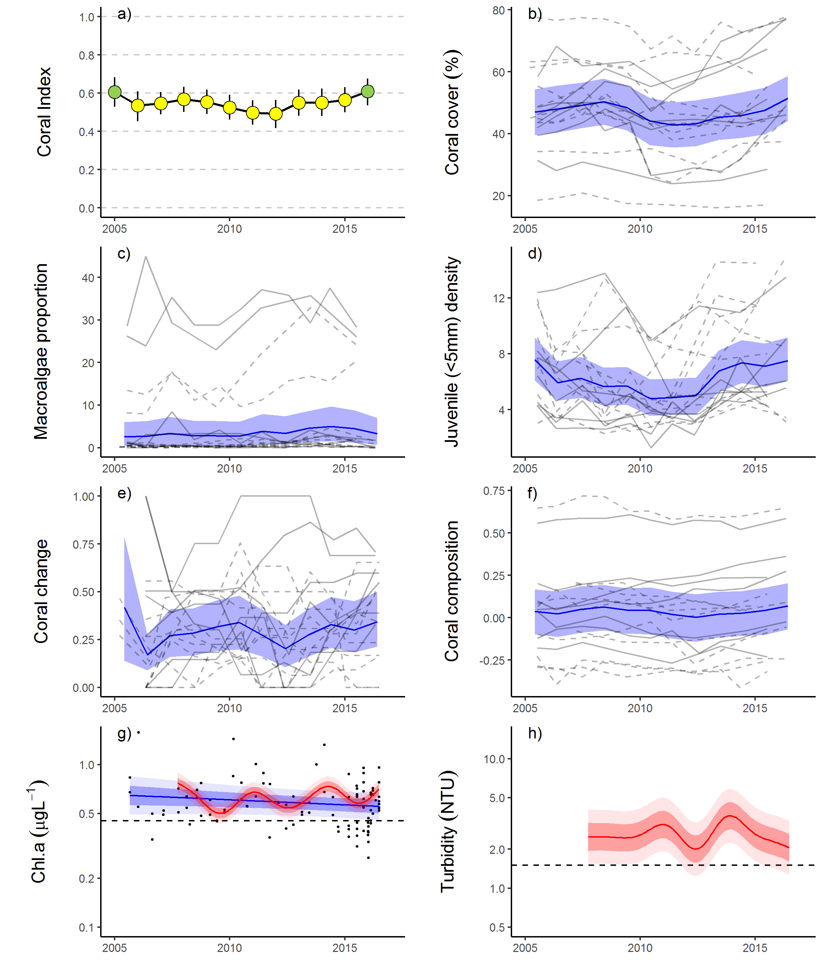
Figure 21 Mackay Whitsunday Region index and indicator trends.
a)
Coral index, colour coding: dark green- ‘very good’; light green-‘good’; yellow – ‘moderate; orange – ‘poor’; red – ‘very poor’. b – f) trends in individual indicators, (blue lines) bound by 95% confidence intervals of those trends (shading), grey lines represent observed profiles at 5 m (dashed) and 2 m (solid) depths for individual reefs, g) trend in chlorophyll a and, h) total suspended solids, shading defines 95% confidence intervals of water quality trends for hand sampled data (blue) or estimates derived from ECO FLNTUSB instruments (red), black dots represent observed data. Dashed reference lines indicate GBRMPA (2010) guideline values.

5.2.6 Fitzroy Region
In 2016 the coral index remained ‘poor’ having improved from ‘very poor’ in 2014 (Table 15, Figure 23a). Improvement in the index score was most evident at 2 m depth where, in addition to improved scores for the Cover Change metric at both 2 m and 5 m depths, the Juvenile metric also improved (Table 15). The improvement in the coral index is the first indication that coral communities are recovering following an extended period of cumulative pressures associated with acute disturbances and high discharge from the adjacent catchment (Figure 22c-e). The discrepancy between improved scores for the Coral Change metric and no change in Coral Cover scores (Table 15) occurs as a result of the variable reductions in coral cover that occurred in 2015 as a result of Cyclone Marcia (Figure 22e, Figure 23b). A high proportion of macroalgae amongst the algal community continues to suppress the coral index. With the exception of Barren 2 m, all reef and depth combinations returned Macroalgae metric scores of zero in 2016 (Table A1. 5)
Table 15 Pair-wise comparison between index and metric scores in the Fitzroy Region. Data compare the changes in scores between local maxima and minima in the index time-series. For the index, and each metric, the observed change in the sub-regional score and the probability that the change was greater or less than zero (no change) are presented. Shading is used as a visual aid to highlight the magnitude of the probability the score improved (blue shades) or declined (red shades). Probabilities are derived from the posterior distribution of observed score changes at each reef and depth.
Period | Depth | Index |  | Cover Change |  | Composition |  | Coral Cover |  | Juvenile |  | Macroalgae
Period | Depth | Score | P | Score | P | Score | P | Score | P | Score | P | Score | P
2006 to 2014 | 2 | -0.20 | 0.96 | -0.52 | 0.99 | -0.42 | 0.97 | -0.30 | 0.88 | 0.02 | 0.54 | -0.06 | 0.65
2006 to 2014 | 5 | -0.17 | 0.89 | 0.16 | 0.77 | -0.42 | 0.97 | -0.27 | 0.96 | 0.03 | 0.56 | -0.10 | 0.66
2014 to 2016 | 2 | 0.07 | 0.93 | 0.16 | 0.95 | 0.08 | 0.68 | 0.01 | 0.51 | 0.08 | 0.87 | 0.06 | 0.66
2014 to 2016 | 5 | 0.07 | 0.75 | 0.20 | 0.94 | 0.17 | 0.74 | 0.02 | 0.58 | 0.05 | 0.63 | 0.00 | 0.00

Coral communities are monitored at six fringing reefs within Keppel Bay. Peak and Pelican are situated in relatively turbid and nutrient rich waters compared to reefs further offshore (Figure 22a, b). Keppels South, Middle and North Keppel are also exposed to well above guideline concentrations of Chl a compared to Barren where mean Chl a is close to the Guideline; all these reefs share reasonably low levels of total suspended solids (Figure 22a, b, Table A1. 6 ). The gradients in water quality are clearly evident in the benthic communities. At Peak and Pelican benthic communities differ markedly between 2 m and 5 m depths (Figure A1. 6) illustrating the substantial attenuation of light as a result of high turbidity. The differences in community composition are evident in the baseline conditions for the Composition metric (Figure 23f). Pelican has a highly stratified environment, supporting slow growing, low-light tolerant corals at depth, and fast-growing Acroporidae in the shallows, although these shallow communities were killed when exposed to freshwater during the 2011 floods and replaced by macroalgae (Figure A1. 6). This loss of Acropora resulted in a marked reduction in Composition at this reef (Figure 23f). Since 2013 the gradual appearance of juvenile Acroporidae (Figure A1. 6) mark the beginning of a recovery of the coral community at the 2 m depth of Pelican. Closer to the Fitzroy River, Peak is defined by a low cover of corals, low density of juvenile corals, high cover of macroalgae (Figure A1. 6), and a lack of substantial reef development, suggesting that the environmental conditions at this location are marginal for most corals. In the less turbid waters at Keppels South, Middle Is, North Keppel, and Barren the coral communities are dominated Acroporidae (Figure A1. 6), principally, but not restricted to, the branching species Acropora intermedia and A. muricata.
Declines in the coral index through to 2014 (Table 15, Figure 23a) coincided with a period of frequent acute disturbances and major flooding of the Fitzroy River (Figure 22). Prior to the commencement of the MMP in 2005, Queensland Parks and Wildlife Service monitoring of reefs in Keppel Bay from 1993-2003 recorded substantial loss of coral cover, and subsequent recovery following thermal bleaching events in 1998 and 2002 (Table A1. 4). Initial MMP surveys in 2005 documented moderate to high hard coral cover on all the Acropora-dominated reefs confirming the potential for recovery at these reefs. High water temperatures over the 2005-06 summer (Figure 22c) again caused severe bleaching and loss of coral cover (Figure 22e, Figure 23b). Coincident with the loss of coral was a rapid increase in the cover of the brown macroalgae Lobophora variegata (Figure 23c, Diaz-Pulido et al. 2009) further contributing to the reduction in the coral index from ‘moderate’ to ‘poor’ (Figure 23a).
Following on from 2006 has been a period of frequent disturbances from both storms and flooding of the Fitzroy River (Figure 22d, e). While the region receives few cyclones compared to other regions (Figure A1. 8), the northward-facing reefs of Barren and Middle have been particularly vulnerable to storm damage. Storm driven waves in 2008, 2010, ex-TC Oswald 2013, ex-TC Dylan 2014 and Cyclone Marcia 2015 have been the main cause of coral cover declines at these reefs since the 2006 bleaching event (Figure 22e). Compounding the impact of these storm events has been a period of intense flooding with annual discharge from the Fitzroy River exceeding the long-term median in 2008, and 2010-2013 (Figure 22d). The 2011 flood event was the largest on record and exposed shallow coral communities to low salinity waters that caused widespread mortality of corals at the 2 m depths of Peak, Pelican and Keppels South (Table A1. 4). Flooding also pre-empted elevated levels of coral disease in 2008, 2010 and 2011 (Figure A1. 7).
Water quality monitoring (in situ) has been discontinued in the Keppels region since 2014-2015. The final year of water quality sampling saw an improvement in the water quality index (Lønborg et al. 2015). Measured levels of Chl a, particulate nitrogen and particulate organic carbon showed a slight downturn at this time coinciding with a respite in flooding in the region since 2012 (Lønborg et al. 2015). Modelling of total suspended solids and dissolved inorganic nitrogen indicate substantially lower concentrations in the region from 2014 to 2016 compared to those associated with the high discharge years of 2010, 2011 and 2013 (Waterhouse et al. 2017).
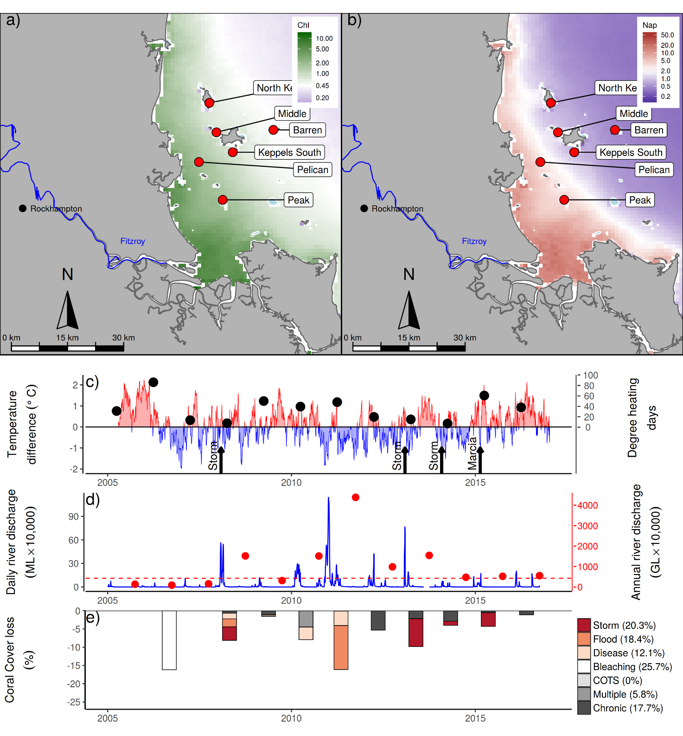
Figure 22 Fitzroy Region environmental pressures.
Maps show location of monitoring sites, red symbols MMP, yellow symbols LTMP along with a) mean chlorophyll a concentration and b) mean Non algal particulate concentrations. Water quality data are mean levels over the period 2003-2016. c) Seasonally adjusted temperature deviation, timing of cyclones and storms indicated by black arrows, accumulated degree heating days over the summer period (1st of December - 31st March) indicated by black symbols d) Combined daily (blue) and annual (red) discharge for the Calliope and Fitzroy rivers and Waterpark Creek, red dashed line represents long-term median discharge (1986-2016). e) break-down of hard coral cover loss by disturbance type; length of bars represent the mean loss of cover across all reefs (see methods section for further detail).

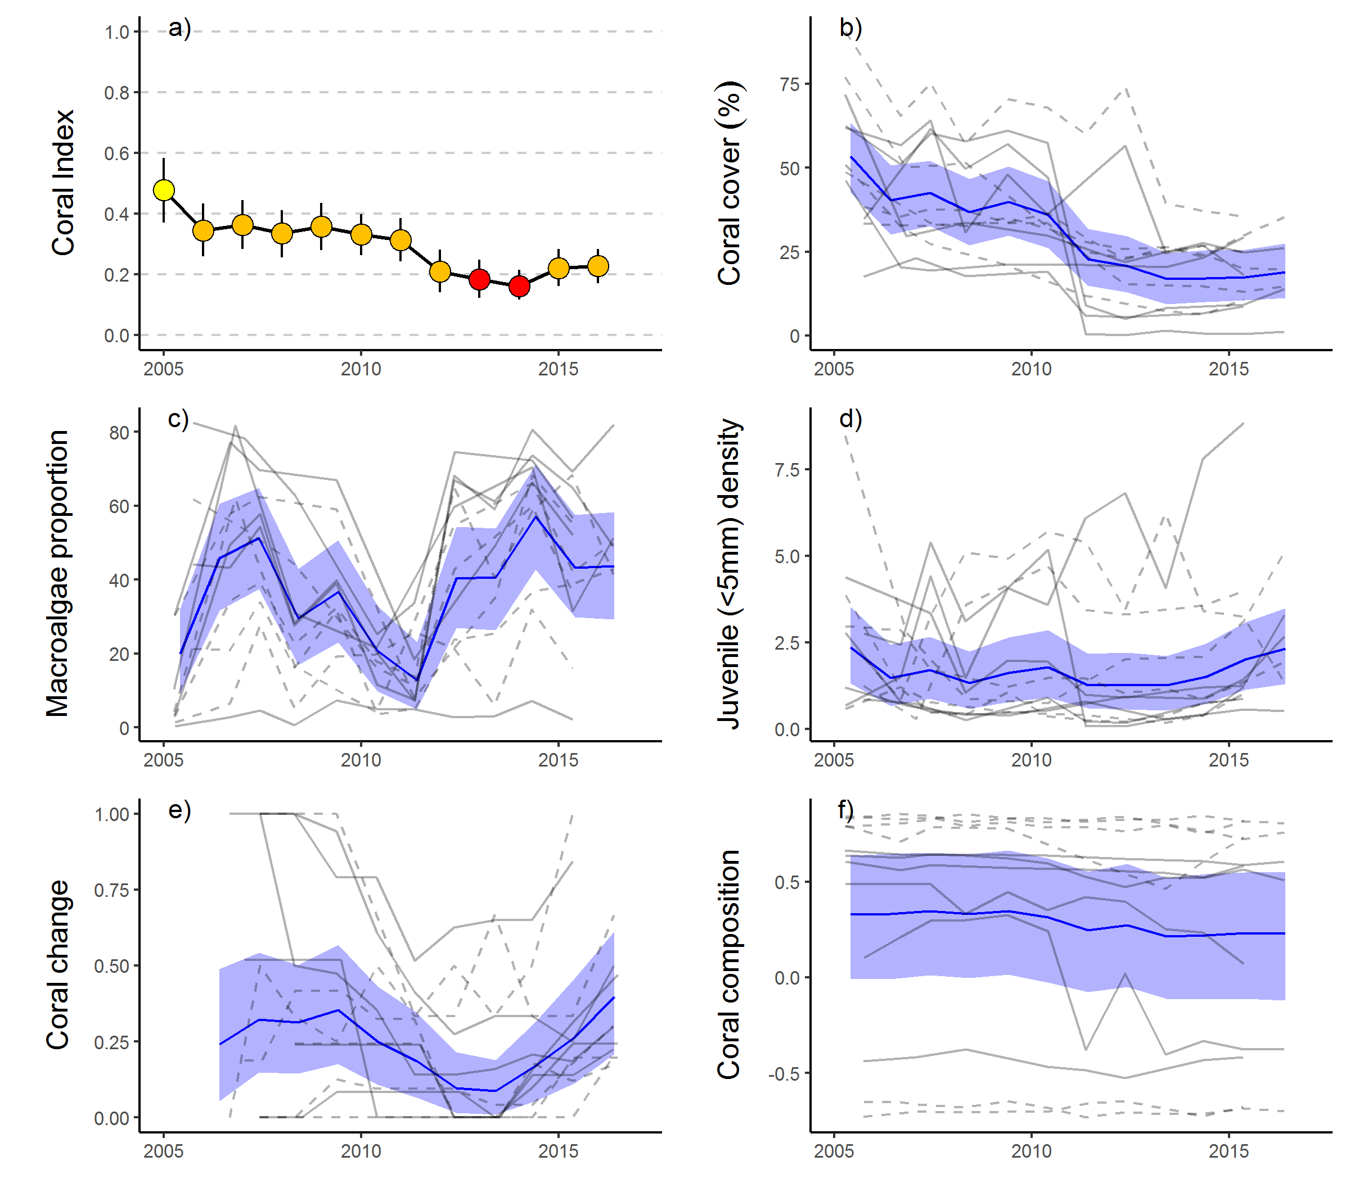
Figure 23 Fitzroy Region index and indicator trends. a)
Coral index, colour coding: dark green- ‘very good’; light green-‘good’; yellow – ‘moderate; orange – ‘poor’; red – ‘very poor’. b – f) trends in individual indicators, (blue lines) bound by 95% confidence intervals of those trends (shading), grey lines represent observed profiles at 5 m (dashed) and 2 m (solid) depths for individual reefs.
.

Discussion
As naturally dynamic systems that alternate between impacts and periods of recovery (Connell 1978) it is critical for the persistence of coral communities that there is a long-term balance between disturbance and recovery processes. It is the role of water quality in altering the balance between, the rate and intensity of impacts to coral communities associated with acute events, and the community’s subsequent recovery, that is the primary focus of the MMP. In this light, it is encouraging that, in 2016, the coral index scores continued to improve in all regions demonstrating that recovery was occurring during a period typified by reduced exposure to the cumulative pressures of acute disturbance events and the chronic influence of run-off.
Results are discussed in terms of the Pressure, State and Impact components of a broader Driver-Pressure-State-Impact-Response (DPSIR) framework. This allows identification of some of the key pressures influencing coral community condition. In this context, there is a natural distinction between pressures that are beyond the realm of management under Reef Plan, such as acute disturbances associated with severe storms or cyclones, and those related more tangibly to water quality, which are expected to be manageable.

6.1 Pressures

Acute disturbances
In the year preceding observations in 2016, no acute disturbance events substantially impacted the coral communities covered by this report. The lack of acute pressures builds on the similarly benign conditions in most regions observed in 2014/15 and contrasts the frequent and intense pressures that variously impacted reefs over the period 2006 to 2014.
High water temperatures over the 2015-16 summer were widely reported as causing severe coral bleaching in the Northern areas of the Reef (Hughes et al. 2017). Impacts to the inshore areas south of the Daintree were minimal, as summer temperatures remained below accepted thermal stress thresholds (Garde et al. 2014), largely as a result of the cooling effect of tropical low pressures systems over the central and southern Reef (GBRMPA 2016, see also section 7 this report). Minor loss of coral cover associated with coral disease among Acropora species at Havannah Island in the Burdekin region, was the most tangible direct impact of the bleaching event on the reefs reported herein.
Moderate numbers of crown-of-thorns seastars (COTS) continue to occur at reefs in the Johnstone Russell-Mulgrave region. The individuals observed represented a range of size classes including juveniles <15 cm in diameter indicating the recurrent recruitment of these seastars and raising concern that, as these individuals grow, they will cause ongoing loss of coral cover. COTS are recognised as a major contributor to loss of coral cover in mid-shelf areas of the Reef (Osborne et al. 2011, De’ath et al. 2012) with population outbreaks in 2016 recorded on reefs between Cairns and Townsville, as well as off Princess Charlotte Bay in the North and Mackay in the south (AIMS LTMP). The transport of coastal nutrients to the mid-shelf Reef remains the most plausible explanation for the promotion of COTS outbreaks as a result of human activities, potentially extending the influence of run-off to large tracts of the Reef and over long periods of time (Brodie et al. 2005, Fabricius et al. 2010, Furnas et al. 2013, Caballes & Pratchett 2014, Pratchett et al. 2014, Wooldridge & Brodie 2015).
Since MMP surveys began in 2005, substantial loss of coral cover has been ascribed to : thermal bleaching (Fitzroy Region - 2006), Cyclone Larry (Wet Tropics and Burdekin regions - 2006), Cyclone Ului (Whitsunday Region - 2010), Cyclone Tasha (Wet Tropics - 2011), Cyclone Yasi (Wet Tropics and Burdekin regions - 2011), Cyclone Ita (Wet Tropics - 2014), Cyclone Marsha (Fitzroy Region - 2015), sub-cyclonic storms (Barron Daintree sub-region - 2009, Burdekin - 2009, Fitzroy - 2008, 2010, 2013), predation by COTS (Wet Tropics - 2012 to 2014) and exposure to low salinity flood waters (2 m depths, Fitzroy Region 2011). These disturbance events contribute strongly to the declines in coral index in all regions. Acute pressures most directly influence coral cover and contributed to between 51% (Mackay Whitsunday Region) and 91% (Herbert Tully sub-region) of the coral cover lost since 2005. These losses unavoidably translated into reductions in the scores for the coral cover metric and contribute to declines in overall reef condition assessments following severe disturbance events. Each of the remaining four indicator metrics have been formulated to limit responsiveness to acute pressures to focus, as directly as possible, on changes in condition that can be interpreted as resulting from changes in water quality.

Chronic conditions - water quality
Water quality is a summary term for a range of chemical and physical properties of marine waters that exert a fundamental influence on the processes governing coral community composition and condition. Water quality in the inshore Reef shows a strong gradient, improving with distance from the coast and major rivers. Variation in benthic communities on coral reefs along this water quality gradient is evidence for the selective pressures imposed by water quality on coral reef communities (van Woesik & Done 1997, van Woesik et al. 1999, Fabricius et al. 2005, De’ath & Fabricius 2008, Uthicke et al. 2010, Fabricius et al. 2012), but also within individual reefs in response to localised hydrodynamic conditions and depth (Uthicke et al. 2010, Thompson et al. 2010, Browne et al. 2010). Such gradients are a natural part of the Reef ecosystem, albeit supported by lower levels of input of run-off-derived pollutants than presently occurs (Belperio & Searle 1988, Waters et al. 2014). The premise underpinning Reef Plan is that anthropogenic contaminant loads delivered by rivers create conditions that supress the health and/or resilience the Reefs ecosystems. It is the quantification of the compounding conditions along naturally occurring gradients, as a result of run-off, and any subsequent improvement under the Reef Plan, that is the core focus of the water quality monitoring component of the MMP (see separate report by Waterhouse et al. 2017).
For corals, the pressure relating to land management practices is the ‘state’ of marine water quality, which in turn is influenced by the pressure of contaminant loads entering marine waters as run-off. The MMP river plume monitoring (see Waterhouse et al. 2017), clearly shows that inshore Reefs monitored by MMP and the LTMP are directly exposed to elevated loads of sediments and nutrients carried by flood plumes. Variability in loads delivered to the Reef (Joo et al. 2012, Turner et al. 2011, 2012, Wallace et al. 2014, 2015, Garzon-Garcia et al. 2015) has, however, not been closely linked to variability in marine water quality conditions as measured by the MMP in-situ monitoring program. This is not unexpected given the complexity of nutrient cycling that occurs in marine waters, dilution of plumes, and the necessarily sparse in situ sampling regime of the long-term water quality monitoring program. It is evident from marine water quality time-series, however, that the period of high discharge into the Reef (2008-2013) resulted in a general increase in turbidity, oxidised forms of dissolved nitrogen (NOx) and dissolved organic carbon (DOC) with levels beginning to decline again in 2015-2016 (Waterhouse et al. 2017). Although these observations suggest that the carbon and nutrient cycling processes in the Reef lagoon have undergone changes, detailed understanding of these processes remains elusive (Lønborg et al. 2015). Turbidity in the Reef lagoon is strongly influenced by variations in the inflow of particles from the catchment and resuspension by wind, currents and tides (Larcombe et al. 1995). The trends emerging from the MMP support other studies showing that the additional flux of fine sediment imported by rivers remains in the coastal zone for periods of months to years leading to chronically elevated turbidity (Wolanski et al. 2008, Lambrechts et al. 2010, Brodie et al. 2012a, Thompson et al. 2014a, Fabricius et al. 2013a, Fabricius et al. 2014, Fabricius et al. 2016). Any increase in turbidity associated with run-off will reduce the level of photosynthetically active radiation reaching the benthos - a primary energy source for corals and so a key factor limiting coral distribution (Cooper et al. 2007, Muir et al. 2015).

6.2 Ecosystem State

Coral index
The formulation of the individual index metrics deliberately attempts to ensure that the index is applicable across the diversity of communities that occur along the steep gradients in water quality within the inshore Reef. Inclusion of reef-specific thresholds for the scoring of macroalgae, reef-specific baselines for community composition and formulation of the coral cover change metric to be sensitive, to a limited degree, to community composition, are all aimed at ensuring the index is applicable to the diversity of communities observed across the strong water quality gradients encountered within the inshore Reef.
In 2016 index scores were higher for reefs where long-term mean Chl a concentrations were below guideline values. Most influential in this result were the Coral Cover and Macroalgae metrics and to a lesser extent the Composition metric. Although the metrics are independent, as each can assume values across their full range irrespective of the other, these results indicate that where the availability of nutrients is sufficient to promote high Chl a the proportion of large fleshy algae “macroalgae” in the benthic algal communities is enhanced, coral cover is diminished, and communities have disproportionately shifted over the duration of the program to include a lower proportion of species susceptible to poor water quality. In particular, the distribution of large brown macroalgae shows a strong relationship to environmental conditions of high nutrient availability, adequate light (prevalence is limited by turbidity at 5 m depths) and sufficient water movement to preclude the build-up of fine sediments on the substrate (expanded upon in section 8 of this report). In terms of light availability and water movement the preferred habitat for brown macroalgae overlaps strongly with that of some corals, and in particular the fast growing Acroporidae, highlighting the direct completion for space between these groups. The correspondence between high prevalence of macroalgae and Chl a concentrations implies the potential that a reduction in the availability of nutrients, that promote high concentrations of Chl a in the water column, has the potential to shift the competitive relationship between macroalgae and coral, back toward coral.
The index has also demonstrated clear temporal variability. Index scores declined in all regions through to low points between 2012 and 2014, prior to improvements through to 2016 that demonstrated recovery was underway. Declines in the index reflect the cumulative influence of multiple acute disturbances that coincided with a period of high run-off and associated loads of contaminants entering the Reef from adjacent catchments. In contrast, improvement in index scores through to 2016 have occurred during a period largely free from acute disturbance events and typified by low loads of contaminants entering the reef in run-off (Waterhouse et al. 2017).
To understand the influence of run-off on the rate of change in the index, which we consider as representative of community resilience, required explicitly focusing our analysis on observations that were not confounded by the impact of acute events (Flower et al. 2017). In three of the four regions: Wet Tropics, Burdekin and Fitzroy biennial changes in index scores showed an inverse relationship to regional discharge. Although DIN loading explained a slightly higher proportion of the variance in change in index scores than TSS in both the Wet Tropics and Burdekin regions, we are hesitant to over interpret these results. We acknowledge that both the spatial and temporal response of the index to water quality, or discharge, were variable, and suggest this is not unexpected. Index scores at any point in space or time will reflect the cumulative responses of the communities to: past disturbance events and chronic pressures, selective pressures imposed by ambient conditions, and stochasticity in the population dynamics of the diverse communities inhabiting these reefs. In combination variable exposure to past events and location specific pressures are also likely to have selected for communities tolerant of those conditions. What this means, is that communities in different locations will be variously susceptible to exposure to water quality pressures (e.g. Morgan et al. 2016). It is precisely the inability to accurately measure, or predict, the role of cumulative impacts across a diversity of exposures that suggests the use of biological indicators, such as the coral and seagrass (McKenzie et al. 2017) indices used by the MMP, as tools to identify where and when environmental stress is occurring, when the stressors are not easily quantified (Karr 2006, Crain et al. 2008).
The observed relationship between discharge and changes in the coral index implies that the cumulative impacts of river-delivered contaminants suppress the resilience of coral communities. In general, the spatial and temporal variability in index scores presented in this report are consistent with well documented links between increased run-off and stress to corals (Bruno et al. 2003, Kline et al. 2006, Kuntz et al. 2005, Voss & Richardson 2006, Kaczmarsky & Richardson 2010, Haapkylä et al. 2011, 2013, Vega Thurber et al. 2013). That we did not observe a relationship between discharge and change in the index scores in the Mackay Whitsunday region may be explained by the relatively low discharge in this region, compared to others, had relatively little influence on the conditions experienced by corals. The strong vertical differentiation in community composition at many of the Mackay Whitsunday Reefs along with high coral cover demonstrate that communities are tolerant of the high turbidity to which they are often exposed. This tolerance is likely to offer a degree of resistance to additional pressures imposed by variable run-off, a point raised by Morgan et al. (2016). Influential in the results for the Mackay Whitsunday region are declines in the index that occurred in 2006 when discharge was low (1.47km³); these declines remain unexplained.
It should also be noted, that excluding changes in index scores influenced by acute events from our analysis may underestimate the influence of water quality on index scores. In addition to the reducing capacity for recovery, degraded water quality may also increase the susceptibility of corals to acute disturbance events. Evidence from recent research into the interactions between water quality and climate change suggests that the tolerance to heat stress of corals is reduced by exposure to contaminants including nutrients, herbicides and suspended particulate matter (Wooldridge & Done 2004, Negri et al. 2011, Wiedenmann et al. 2013, Fabricius et al. 2013b, Wooldridge 2016, Bessell-Browne et al. 2017). Similarly, increased susceptibility to disease may increase the loss of coral cover attributed to cyclones, floods, or COTS. With the exception of the Fitzroy Region in 2006, the water temperatures have not shown substantial deviations from the long-term summer climatology over the first 12 years of the MMP. However, this does not reduce the concern for inshore reefs given the persistence of altered water quality conditions and the ongoing threat of summer temperature anomalies due to the effects of climate change.

Coral cover
For corals to persist in a location they need to be able to survive extremes in environmental conditions but also maintain a competitive ability under ambient conditions. Although the coral cover metric is strongly influenced by disturbance events, low cover, as a response to water quality pressures, can also be inferred from our analyses. In 2016, coral cover was higher at reefs with low Chl a levels. In addition, there are a number of reefs monitored at which coral cover has remained low and not increased during periods free from acute disturbance events. The majority of these reefs have had a persistent cover of macroalgae; an attribute of benthic communities again linked to high Chl a levels. High turbidity and / or nutrient levels do not, however, preclude high cover of corals on inshore reefs. There is ample evidence from the data presented in this report along with other studies (e.g. Sweatman et al. 2007, Brown et al. 2010, Morgan et al. 2016) that reefs in highly turbid settings can support very high cover of species tolerant to those conditions. Despite claims for high diversity in turbid habitats based on aggregated diversity over a variety of microhabitats (Brown et al. 2010, Morgan et al. 2016), from sites that control for depth and exposure to wave energy, it is evident that as turbidity increases, high coral cover typically results from relatively few species tolerant of their local environment (De Vantier et al. 2006, Sweatman et al. 2007). The almost ubiquitous increase in coral cover observed in 2016, however, demonstrates that across the diversity of habitats monitored, corals retain the capacity for growth when the cumulative pressures of run-off and disturbance events are low.

Rate of change in coral cover
The Coral Change metric assesses the rate of change in coral cover (growth) during years free from acute disturbances. An adequate rate of coral cover increase is essential to ensure the long-term balance between cover lost to disturbances and that regained under ambient conditions. The indicator for rate of cover change either declined, or remained stable, as index scores within each region declined to low points between 2012 and 2014; a period that coincided broadly with the period of high loads of sediments and nutrients entering the Reef (Joo et al. 2012, Turner et al. 2012, 2013, Wallace et al. 2014, 2015). During this period the most evident changes in marine water quality were increased concentration of dissolved oxides of nitrogen and dissolved inorganic carbon (Lønborg et al. 2015). Dissolved inorganic carbon constitutes the major carbon source for heterotrophic microbial growth in marine pelagic systems (e.g. Lønborg et al. 2011) and increases in DOC have been shown to promote microbial activity and coral diseases (Kline et al. 2006, Kuntz et al. 2005). In each region we noted peaks in coral disease that corresponded to either the onset of flooding, or, in the case of the Johnstone Russell-Mulgrave region, flooding in catchments to the south. The conclusion that environmental conditions associated with increased loads of sediments and nutrients have been sufficiently stressful to corals to reduce growth rates and/or induce disease in susceptible species is consistent with previous observations linking nutrients and organic matter availability to higher incidence and severity of coral disease (Bruno et al. 2003, Haapkylä et al. 2011, Weber et al. 2012, Vega Thurber et al. 2013). In contrast, scores for this indicator increased through to 2016, coincident with relatively low inputs from the catchments. The exception was the Johnstone Russell-Mulgrave sub-region where there was no improvement, a result potentially influenced by ongoing low densities of COTS on these reefs.

Composition
It is well documented that compositional differences in coral communities occur along environmental gradients (Done 1982, van Woesik & Done 1997, van Woesik et al. 1999, Fabricius et al. 2005, De’ath & Fabricius 2008, Browne et al. 2010, De’ath & Fabricius 2010, Thompson et al. 2010, Uthicke et al. 2010, Browne et al. 2012, Fabricius et al. 2012). The relationships between disease and altered environmental conditions, discussed above, demonstrates the dynamic nature of coral community selection occurring on inshore reefs. Sensitive species gain a foot-hold during relatively benign, low disturbance, conditions, only to be removed during periods when environmental conditions are beyond their tolerance. The coral community composition indicator has tended to track the trend in coral cover indicating the disproportionate loss, and subsequent recovery, of genera sensitive to water quality. In 2016 the observation that there was a higher probability that the community composition indicator had improved at reefs with lower Chl a concentrations, suggests recovery was less evident at those reefs. The genus most susceptible to poor water quality is Acropora. As Acropora is also, fragile, and so particularly susceptible to loss of cover during cyclones (Fabricius et al. 2008), sensitive to thermal bleaching (Marshal & Baird 2000), and a preferred prey group for COTS (Pratchett 2007), means that trends in the composition indicator cannot unambiguously be interpreted as representing a response to, and subsequent release from, water quality pressures alone. Over the longer term, however, there is evidence that the representation of Acropora on reefs in the Burdekin region has declined since the mid-20th century, possibly as a result of increased run-off from the adjacent catchments (Roff et al. 2013). This consideration makes the recent recovery of this group in the Burdekin Region particularly positive as demonstrates that there remains a capacity for these species to re-establish under the conditions experienced in recent years. As a genus including a high diversity of rapidly growing species, the Acropora are a key group for the rapid recovery of coral cover and maintenance of diversity on inshore reefs.

Macroalgae
Macroalgae generally benefit from increased nutrient availability due to run-off (e.g., Schaffelke et al. 2005) and, as coral competitors, supress both coral growth and juvenile settlement or survival (e.g., Tanner 1995, McCook et al. 2001, Birrell et al. 2005, 2008). Clear correlative relationships between Chl a concentrations, a proxy for nutrient availability, and the proportion of macroalgae link nutrient availability to reduced coral community resilience in inshore areas of the Reef. Unlike the coral indicators that are plausibly responsive to water quality extremes, the observation of macroalgae during winter surveys may suggest that ambient water quality levels are also important for the maintenance of high macroalgal cover. Although reef specific thresholds for macroalgae allow for increased abundance of macroalgae in response to naturally occurring gradients of water quality, results in 2016 demonstrate that, where long-term Chl a concentrations exceed guideline levels, macroalgae are persisting at levels likely to have detrimental influences on coral recruitment and growth.
It is important to note that the relationship between high Chl a concentration and macroalgae cover is correlative only and does not necessarily indicate a direct cause-effect relationship between nutrient concentrations and pressures imposed by macroalgae. Chl a may be a proxy for environmental variables or ecological processes other than the direct availability of nutrients that influence macroalgae abundance. Wismer et al. (2009) demonstrate an inverse relationship between macroalgal cover and herbivore biomass and Cheal et al. (2013) link this relationship to water quality by demonstrating a decline in herbivorous fish populations with increasing turbidity. Importantly, the reduction in herbivore biomass noted by Cheal et al. (2013) occurred on the LTMP survey reefs included in this report and are among the reefs toward the better end of the strong water quality gradient in inshore waters. The higher turbidity at of the majority of reefs surveyed under the MMP suggest even lower biomass of herbivorous fishes.
Grazing is a key process for the control of macroalgal blooms and research demonstrates the importance of the maintenance of herbivore populations to avoid a phase shift to macroalgae (e.g. Hughes et al. 2007). Within the Burdekin region Hughes et al. (2007) demonstrated that dense macroalgal communities could be supported in the absence of grazing on a reef with generally low cover of fleshy macroalgae, partly divorcing macroalgae biomass from direct relationship to water-quality alone. The relative influences of herbivory and nutrients on coral reef macroalgae is undoubtedly complex and likely to “depend on the species, circumstances and life-history processes under consideration” (Diaz-Pulido & McCook 2003). Irrespective of the underlying mechanism that limits macroalgae on reefs with lower Chl a concentrations, our results demonstrate that the environmental conditions at sites with Chl a concentrations above guideline values also support macroalgal biomass at levels detrimental to coral community resilience.

Juvenile density
The density of juvenile corals has remained stable or improved in all regions since 2013. This reverses the declining trends that coincided with the period of high nutrient, sediment and pesticide loads entering the Reef from 2008-2012. The early life history stages of corals are sensitive to a range of water quality parameters that vary in response to run-off (Fabricius 2011). That the observed declines in the number of juvenile corals occurred at reefs across the range of exposures to poor water quality indicates that the causes of these declines are not clearly linked to a single environmental threshold. Rather, the stressors influencing larval settlement and/or subsequent survival are likely to vary across environmental gradients. Confounding direct links between water quality and coral recruitment will be secondary influences of water quality, such as the presence/absence of persistent macroalgal communities, as well as factors like reduced brood-stock due to disturbance events that are, mostly, independent of water quality. As this indicator aggregates over at least 2 cohorts of juvenile corals, the influence of acute disturbances that remove juvenile corals will lead to a reduction in juvenile densities for at least 2 years.
The density of juvenile corals remains low in both the Barron Daintree sub-region, where Cyclone Ita substantially impacted communities in 2014, and the Fitzroy Region where flooding in 2011 removed a high proportion corals in shallow waters resulting in a marked reduction of local brood-stock and the subsequent proliferation of macroalgae, that has persisted through to 2016 (Berkelmans et al. 2012, data herein). Elsewhere, the density of juvenile corals has remained high or increased in 2016. In the Herbert Tully sub-region, the high density of juvenile corals largely reflects very high numbers of the genus Turbinaria. As this genus was not well represented in the adult community prior to the successive cyclonic disturbances in 2006 and 2011, it is unclear whether this recruitment pattern is simply due to natural variability or indicates the selection for species more suited to the recent environmental conditions (Sofonia & Anthony 2008). The genus Turbinaria has also recruited in higher proportions to several of the more turbid water reefs in the adjacent Burdekin Region. In contrast, at a number of reefs at which water quality is better, increased number of juveniles of the genus Acropora in recent years indicates the recovery of this disturbance-sensitive group of coral.

6.3 Regional summaries

Wet Tropics
Regionally, the coral index has continued to improve since a low point reached in 2013. The recovery in index scores reiterates previously demonstrated potential for coral communities in this region to recover from disturbances including COTS, cyclones, bleaching and exposure to flood plumes in both the Barron-Daintree, and Johnstone Russell Mulgrave sub-regions (Ayling & Ayling 2005, Sweatman et al. 2007). Improvements in the index have coincided with a period of reduced discharge from the adjacent catchments and minimal impacts from acute disturbances. Across the region suppression of coral communities in response to run-off is demonstrated by a greater rate of improvement in the coral index when discharge from local rivers was relatively low. In 2016 low scores, for the Macroalgae index at 2 m depths in the Herbert Tully Region in particular, may indicate the ongoing pressure of high nutrient availability in that area. Of all the regions, the Wet Tropics continues to be the only area for which the current outbreak of crown-of-thorns starfish (COTS) has impacted inshore reefs. Recent improvement in the index has occurred despite the ongoing observation of juvenile COTS at Fitzroy Island, the Frankland Group and High Island. Helping to mitigate the impact of COTS in this region has been the ongoing removal of COTS with 13,339 starfish removed from the monitoring reefs in this region prior to surveys in 2016. The observation of juvenile COTS at Fitzroy, the Frankland Group and High Island present the likelihood of further loss of corals as this cohort matures, suggesting ongoing benefit of population control to protect these valuable sites for tourism. Within the region, improvement in the index is most evident in the Herbert Tully sub-region where recover from the severe impacts of Cyclone Yasi is clearly occurring. In the Herbert Tully sub-region, of the five metrics included in the coral index it was only Macroalgae at 5 m depth that had not improved through to 2016, although as mentioned above, macro algae cover does remain high at 2 m depths. The current recovery in the Barron Daintree sub-region is only just beginning following a low point in the index in 2014. Limiting improvement in the index in the Barron Daintree sub-region in 2016 is the continued increase of macroalgae at 2 m depth at Snapper North and ongoing low densities of juvenile corals. In addition to any nutrient related pressures implicated in the high levels of Macroalgae at some reefs, are the legacies of cyclones and COTS that have recently reduced coral cover across the region and for which recovery is expectedly gradual. Any link between nutrient availability and outbreaks of COTS on the Reef in general (most recently, Pratchett et al. 2014, Wooldridge & Brodie 2015) are thus implicate in the current index scores.

Burdekin
Since 2012 coral communities have continued to recover during a period free from acute disturbance events and low rainfall that has limited run-off form the adjacent catchments. The only metric not to have improved since 2012 was Macroalgae. The lack of improvement in the macroalgae metric was due to both the temporary removal, as a result of Cyclone Yasi, that improved metric scores in 2011 and also 2012 as well as the persistence of high cover of at Magnetic Island, Pandora South, Lady Elliot 2 m and Havannah Island 5 m. The persistence of macroalgae suggests the ongoing availability of nutrients at levels detrimental to coral communities at these locations. Despite the ongoing low scores for Macroalgae, changes in the index, when reefs are not impacted by acute disturbance events, demonstrate an inverse relationship to discharge from the regions rivers. It was not until 2014, a year into a period of below median discharges from the region’s rivers, that the average rates of hard coral increase began matching modelled expectations. In addition to generally low rates of cover increase, stress to corals was explicitly observed as increased levels of disease in 2007-2009 coinciding with a shift from a period of below, to a period of above, median discharges. A moderate increase in disease was also noted in 2011, again following a large discharge year. This expression of disease and downturn in the rate of cover increase also coincided with a shift in community composition at deeper sites toward communities tolerant of poor water quality. In combination, these results are consistent with the well documented link between increased run-off and stress in coral communities, expressed as increased levels of coral disease (Bruno et al. 2003, Kline et al. 2006, Kuntz et al. 2005, Voss & Richardson 2006, Kaczmarsky & Richardson 2010, Haapkylä et al. 2011, 2013, Vega Thurber et al. 2013).
In addition to likely links to run-off, the decline in the index through to 2012 reflected the damage incurred during Cyclone Yasi and other minor storms, that account for 57% of the coral cover lost in the region since 2005. Historically, recovery from acute events, in particular coral bleaching, has been slow (Sweatman et al. 2007, Cheal et al. 2013). Generally, low densities of juvenile corals imply that slow recovery of coral communities may, in part, reflect recruitment limitation. In addition to possible suppression of the recruitment process where macroalgae cover is high (Tanner 1995, McCook et al. 2001, Birrell et al. 2005, 2008), low settlement of coral larvae in this region (Thompson et al. 2013) may also indicate limited availability of brood-stock. Preliminary hydrodynamic modelling (Luick et al. 2007, Connie 2.0) and differences in population genetics of corals (Mackenzie et al. 2004) both indicate limited connectivity between Halifax Bay and reefs further offshore. This isolation, coupled with the widespread loss of cover in 1998 and 2002, as a result of thermal bleaching (Berkelmans et al. 2004), may explain the low densities of juvenile colonies observed (Done et al. 2007, Sweatman et al. 2007). Further work is required to more fully investigate the role of connectivity in limiting recovery potential of inshore reefs in this, and all other regions.

Whitsundays
In combination, high turbidity and the sheltered nature of most monitoring sites leads to high rates of sedimentation, which limits the proliferation of macroalgae and has selected for corals tolerant to these conditions (Thompson et al. 2014b). The current ‘good’ condition of reefs reflects both the tolerance of coral communities to their environmental setting but also the relatively low frequency and intensity of acute disturbance events to have impacted the reefs in this region in recent years. From 2005 to 2016 the only major disturbance was Cyclone Ului (2010) which contributed to the decline in the coral index though to 2012. Although this was the only region for which the change in index scores was not related to regional discharge, consistently low scores for the Coral Change metric imply a general suppression of coral growth potentially indicating persistently stressful environmental conditions. Improvement in the coral index through to 2016 was largely due to rapid recovery of communities at 2 m depths where, cover of the family Acroporidae rapidly increased. The more consistent improvement in index scores at 2 m depths compared to 5 m depths implicates turbidity as an ongoing pressure on the deeper coral communities in this region.

Fitzroy
The current poor score for the coral index reflects a decline in condition following the cumulative impacts of thermal stress in 2006, a series of cyclones and storms, and flooding of the Fitzroy River that variously exposed corals to lethal levels of salinity (Jones & Berkelmans 2014) and introduced high loads of nutrients and suspended sediments into Keppel Bay. The consistent pattern of high incidence of disease amongst coral communities following each of the recent floods supports the hypotheses that reduced salinity (Haapkylä et al. 2011), and increased nutrient enrichment (Vega Thurber et al. 2013) play a role in facilitating coral disease. Reduction in light levels over extended periods of time as a result of higher turbidity from increased concentrations of suspended sediments as well as dense plankton blooms following floods is another plausible explanation for reduced fitness of corals (Cooper et al. 2007) that may have supressed the recovery of coral communities.
Variation in recovery from disturbances among reefs illustrates the role of water quality in supressing coral community resilience. Following coral bleaching in 2006 recovery of coral cover was inversely related to the persistence of macroalgae. At the three Acropora sp. dominated communities with highest Chl a concentrations (Keppels South, Middle and North Keppel) macroalgae cover (predominantly Lobophora variegata) rapidly increased and persisted at high density, whilst rates of change in coral cover remained low or coral cover continued to decline. In contrast, at Barren, where Chl a concentration is lower, the bloom of L. variegata was less pronounced and recovery of the coral community clearly progressed. There is clear evidence that the abundance of macroalgae on the Reef is higher where Chl a concentrations (as a proxy for nutrients) are above the annual guideline values for coastal and mid-shelf waters of 0.45µgL⁻¹ (De’ath & Fabricius 2008, Thompson et al. 2016, section 8 this report) strongly suggesting that the persistence of macroalgae is related to nutrient levels. The continued increases in macroalgae at Middle Is and North Keppel recorded this year despite the lack of significant run-off events in recent years suggests either local inputs or chronic levels of nutrients in the system.
In contrast to persistent macroalgae, there has been a continued improvement in the juvenile density metric and a maintained rate of increase in coral cover; both key factors countering a long-term phase shift to macroalgae dominated states. Following the initial improvements observed last year, despite remaining ‘poor’ in 2016, the coral index continues to indicate coral communities are resilient when spared from acute disturbance events and high contaminant loads from the catchment (Garzon-Garcia et al. 2015).

6.3 Conclusion
The cumulative impacts of tropical cyclones and storms, feeding by COTS, and thermal stress, along with elevated loads of contaminants introduced to the Reef during a period of high discharges from adjacent catchments, resulted in clear declines in the condition of coral communities on inshore reefs through to 2012-2014. With the abatement of acute disturbances and lower loads of sediments and nutrients entering the Reef in recent years, coral communities have shown clear recovery. The long-term persistence of inshore coral communities will depend on the balance between frequency and severity of cumulative pressures and corals ability to recover. It is the overarching goal of Reef plan to ensure that run-off entering the reef does not alter this balance.
Disentangling the influence of run-off in observed declines in coral community condition, or the ability of communities to recover, remains difficult for two primary reasons. Firstly, coral’s threshold to the cumulative pressures associated with water quality are likely to be spatially variable because of the selection, and acclimation, of corals in response to location specific conditions. Secondly, extrinsic variability, along with low concentrations of many constituents of water quality limits the ability to quantify additional pressures resulting from run-off at the scales relevant to the communities monitored. In combination, these issues limit the ability to quantify critical thresholds for water quality that are appropriate to the diversity of coral communities found on inshore reefs. However, focusing on the response of the coral communities (as measured by differences in index scores) does allow identification of when and where communities have been least resilient. Spatially, it is clear that the guideline value for Chl a approximates a threshold for macroalgae that, in turn, appears to influence coral community resilience. Management options that reduce the availability of nutrients required to support Chl a levels beyond the threshold may also benefit coral communities be reducing the negative influence of macroalgae. That there is also a relationship between changes in coral index scores and run-off, or DIN , in most regions further implicates concentrations of contaminants being introduced to the Reef as having in the potential to suppress the recovery of coral communities.
Although the observed response of coral index scores to run-off is not strong the consistent direction of the relationship (i.e. higher rates of improvement when run-off is low), does suggest the sensitivity of community recovery to contaminant concentrations in run-off. Given projections for increased severity and/or frequency of pressures as a result of climate change, and human activities in general (Steffen et al. 2013, Halpern et al. 2015), the importance of reducing local pressures, so as to reduce cumulative pressures and foster improved recovery becomes increasingly essential to the long-term maintained of these communities. The GBRMPA Strategic Assessment identified the cumulative impact of multiple pressures on coral ecosystems as a key knowledge gap and the management of these impacts as a major strategic challenge (GBRMPA 2014a). While the results presented here do not provide clear guidance in terms of load reductions required to improve coral condition in the inshore Reef they do support the premise of Reef Plan that the loads entering the reef, during high rain fall periods in particular, are reducing the resilience of these communities.

Case Study - Coral Bleaching 2016
The 2016 mass bleaching event on the Reef was the culmination of a global bleaching event that began in 2014. This global event was driven by record-breaking sea surface temperatures and supported by a strong and unusually protracted El Niño event (Mann et al. 2016). For Australia, the strong El Niño reduced monsoonal activity over northern areas of the Reef during the 2016 austral summer, resulting in long periods without cloud cover that caused additional coral stress. For the five months between February and June 2016, the Australian Bureau of Meteorology recorded the hottest ever average sea surface temperatures across the Reef. However, this heat stress was not distributed uniformly, as local weather patterns provided storms, rain, and heavy cloud cover (for example from ex tropical cyclones Winston and Tatiana) that influenced local sea surface temperatures. Indeed, the influence of local weather patterns varied the intensity of coral bleaching both within and among regions, leaving large areas of the Reef with only minor disturbances.
To estimate the extent of mass bleaching on the Reef, a partnership of research agencies and collaborators under Australia’s National Coral Bleaching Taskforce conducted a series of coordinated surveys of the Reef between March and June 2016. The Australian Research Centre of Excellence for Coral Reef Studies carried out both aerial and in-water surveys. The Australian Institute of Marine Science (AIMS) and the Great Barrier Reef Marine Park Authority (GBRMPA) carried out in-water surveys. This section looks at the results from the Eye on the Reef program (EotR), GBRMPA’s principal monitoring group, in order to place the bleaching pattern observed by the AIMS MMP in context with the wider bleaching event. Information on the EotR draws heavily from their September 2016 interim report (Great Barrier Reef Marine Park Authority 2016).

7.1 Methods
The in-water survey methods used by the EotR and MMP both utilise a visual assessment category system to record bleaching severity (Table 16) and recent mortality attributed to bleaching (Table 17). The sampling method used for the EotR surveys was the reef health and impact survey (RHIS, Beeden et al. 2014), the basic unit of which is a 5 m diameter circle in which bleaching impacts were estimated. At each reef groups of three RHIS surveys comprised a sample with samples in 1 to 3 m depths at three locations around each reef broadly undertaken in the north-west, south-west and north-east aspects of the reef slope. At the north-east location additional samples were taken at 3-6 m and 6-9 m depths. Within these units the effects of bleaching were visually estimated as detailed in Table 16 and Table 17. Details of the scuba search methods used by the MMP are provided in Section 4.3.5 of this report.
Table 16 Bleaching categorisation used by GBRMPA Eye on the Reef and AIMS MMP surveys.
GBRMPA categories |  | MMP categories
Category | Bleaching severity | Category | Proportion of colonies bleached white, or fluorescing
None | 0% | 0 | 0
Minor | 10-50% bleaching in sensitive taxa  <10% bleaching in low-sensitive taxa  Paling of very low-sensitive taxa | 0+  1-  1+ | Individual colonies  1-5%  6-10%
Moderate | >50% bleaching in sensitive taxa  10-50% bleaching in low-sensitive taxa  <10% bleaching in very low-sensitive taxa  Some mortality among sensitive taxa | 2  3 | 11-30%  31-50%
Severe | >50% mortality of sensitive taxa  >50% bleaching in low-sensitivity taxa  10-50% bleaching in very low-sensitivity taxa | 4  5 | 51-75%  76-100%

Category data collected by the MMP were transformed to a single percentage score using the mid-point of each category. The average bleaching score was calculated for both shallow reef flat (2 m) and reef slope (5 m) sites at each reef.
Degree Heating Days are taken from Bureau of Meteorology satellite-based interactive website ReefTemp (see section 4.3.2).
Table 17 Eye on the Reef bleaching categories. Proportion of colonies suffering mortality attributed to bleaching
EotR category | Mortality
None | 0%
Low | >0% < 10%
Medium | >10% < 30%
High | >30% <50%
Very high | >50%

7.2 Discussion of Results
Between March and June 2016 the EotR carried out bleaching surveys across seven transects perpendicular to the coastline from Cape York in far north of the Reef to Rockhampton in south (Figure 24); a total of 63 reefs. They reported 22% coral mortality across all surveys. An estimated 85% of this bleaching mortality occurred between Cape York and north of Lizard Island. The severity of bleaching in this northern region was most severe at inner and mid-shelf reefs though still moderate on the outer-shelf (Figure 24). With increasing latitude severe bleaching shifted progressively to the outer-shelf reefs, leaving the majority of inshore and mid-shelf reefs south of Cairns with only minor bleaching.
Both the MMP and EotR shared inshore sites in three Regions: the Wet Tropics (Fitzroy), Burdekin (Havannah, Pandora), and Fitzroy (North Keppel, Middle, Keppels South). Both surveys recorded minor bleaching impact at these locations, with no mortality.
Of the 24 reefs monitored by the MMP in mid-2016 between Cairns and Rockhampton (Figure 2), 21 reefs showed signs of bleaching, more commonly at 5 m than at 2 m depths (Table 19). For the majority of these reefs, bleaching impact was less than 1%, patchily distributed among transects, and restricted to a few individual coral colonies. The most severely bleached reefs were in the Burdekin Region (Palms West, Pandora, Havannah) and at Double Cone in the Mackay Whitsunday Region, where bleaching was again minor; impacting less than 2% of the community, with the genera Montipora, Platygyra, Pocillopora, and Stylophora being the most sensitive. Mortality was not quantified though was almost certainly limited.
An examination of records from the MMP in-situ temperature shows a pattern of late-summer, positive temperature anomalies (Figure 25). This has influenced the distribution of Degree Heating Days (DHD) seen in Table 18.
From the Burdekin north, regional temperature anomalies approach or exceed previous anomaly records available back to 2002 (IMOS 2002-2012 temperature data, see Section 4.3.2). For the Burdekin, Tully and Russell Mulgrave (sub-)regions anomalies across the austral summer were generally low (< 1ºC), with temperatures approaching or exceeding two degrees above long term averages occurring either late in, or after, March. Indeed, reefs in the Tully sub-region experienced sizeable low-temperature anomalies in January and February (Figure 25). Post-summer anomalies occurring after March would not be captured by the DHD calculation period (December 1 – March 31), resulting in a lower DHD figure that may not adequately represent the heat stress on corals.

These temperature anomaly data correspond to the BOM description of temperature anomalies extending into post-summer across the north and far northern areas of the Reef that contributed to an increase in thermal stress to the coral communities (BOM 2016). It should be noted that DHDs are calculated for period of four months between December and March when summer temperatures are expected to be at their highest, so exceedance of historical average temperatures during this time means the corals are considered exposed to thermal stress. Exceedance of historical average temperatures outside of these times means the corals are experiencing temperatures not usually found at that time of year, but not necessarily beyond their stress range. This protracted thermal stress has largely unknown consequence for the dynamics of coral communities in inshore waters of the Reef.
To the south, the Mackay Whitsunday and Fitzroy regions exhibit more moderate temperature anomalies, less than two degrees, declining towards the end of summer. Most temperature anomalies in these regions were captured within the DHD calculation period, accumulating relatively large DHD values compared with the regions to the north. For the Fitzroy region, a comparison with 2015 shows a fall in DHDs for the 2016 year, reflecting the influence of the ex-TC Winston weather system on the southern Reef.

The Burdekin Region recorded the highest number of degree heating days for 2016, accumulating 68 DHDs between December and March. This is the highest DHDs for this region during our study, and the highest DHDs across all MMP regions in 2016. A DHD score above 60 has been used to describe a threshold above which bleaching and minor heat stress is expected (Garde et al. 2014). The Burdekin Region experienced consistently positive anomalies from January through to the end of March (captured by the DHD estimation), that continued through to April and May (Figure 25). Of the 48 combinations of reef and depth sampled by the MMP in 2016 hard coral cover only declined at three. A minor decline at High East 5 m was attributed to the low density (75 ha⁻¹) of crown-of-thorns starfish observed during surveys. A decline of less than 1% at Havannah 2 m was attributed to coral disease. This disease was prevalent among Acropora pulchra and A. aspera, both species proven highly susceptible to previous bleaching events in the Burdekin region. As fast growing species, the minor reduction underestimates the loss if expected growth of the colonies killed was assumed. There was also a less than 1% loss of cover at Bedarra 2 m, the cause of which is unknown. The losses at Havannah, and possibly Bedarra, are evidence for an acute impact of the 2016 thermal anomalies on reefs coral communities monitored by the MMP.

Overall, the MMP survey results confirm the EotR report of minor bleaching impact among inshore reefs south of Cairns (GBRMPA 2016). This contrasts with past bleaching events in 1998 and 2002 (Berkelmans et al. 2004) where widespread bleaching and loss of coral occurred throughout the MMP regions, and also in 2006, when bleaching mortality was restricted to the Fitzroy Region in the southern area of the Reef (Table A1. 4 Disturbance records for each reef. ). For the 2006 bleaching event in the Fitzroy Region, high temperatures were sustained across the summer season, often 2ºC above average, resulting in a DHD score of 87.

Table 18 Degree Heating Days (DHD) for 2016 and 2015. Estimates are averaged from available pixels adjacent to each monitoring reef.
MMP (sub) region | DHD 2016 | DHD 2015
Baron Daintree | 25 | 24
Russell Mulgrave | 29 | 22
Tully | 35 | 38
Burdekin | 68 | 57
Whitsundays | 52 | 50
Fitzroy | 41 | 66

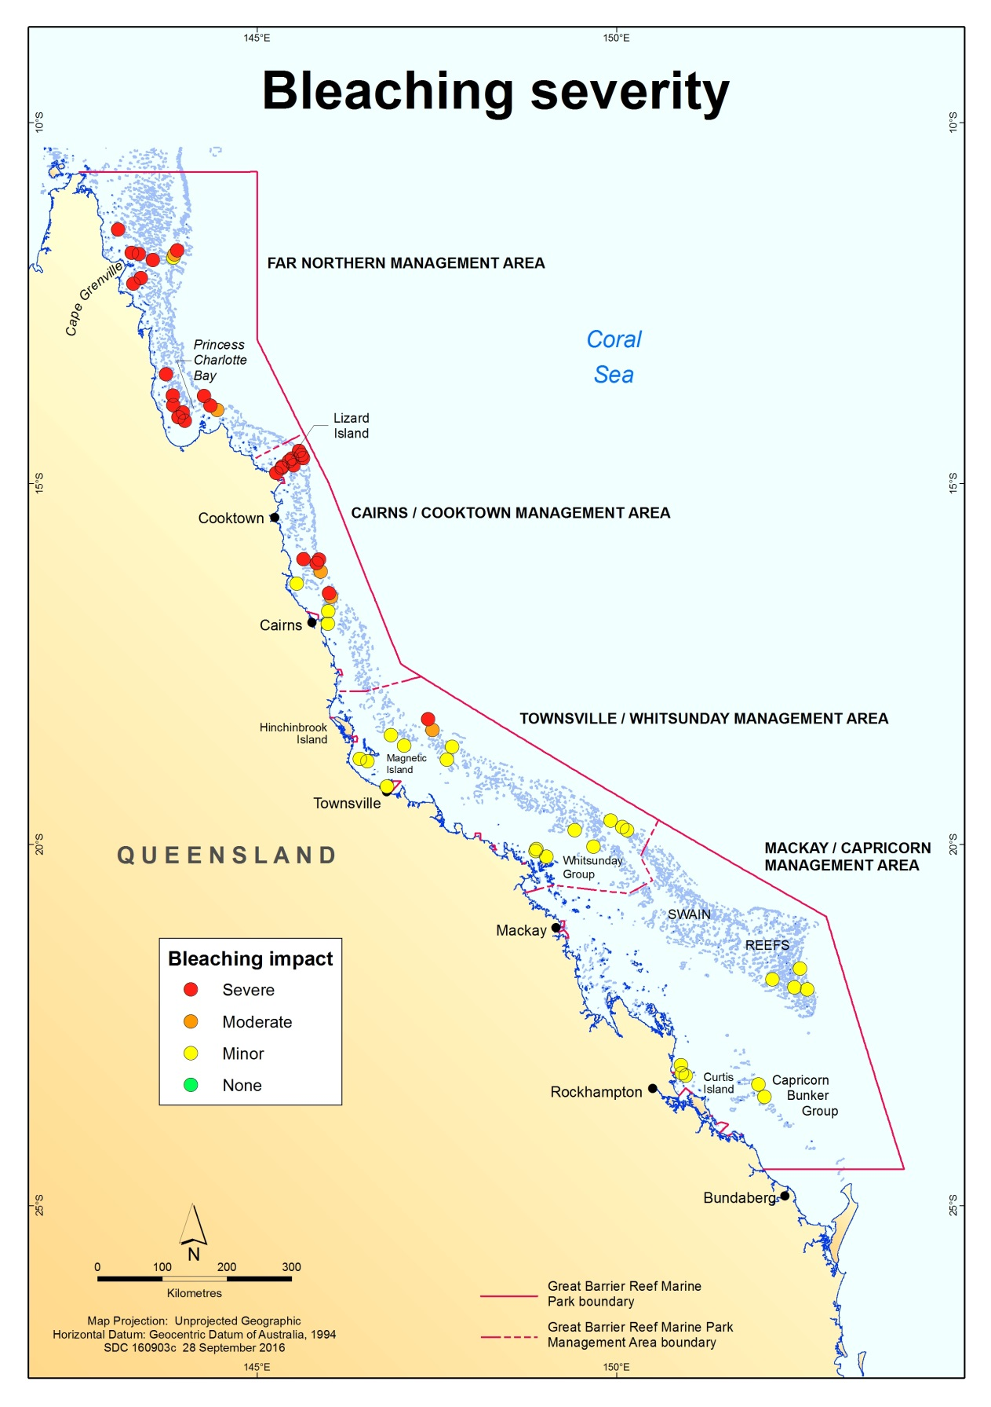
Figure 24 Reef-wide pattern of bleaching severity impacts based on Eye on the reef observations 2016. Each circle represents a survey reef and colours indicate severity category, with red indicating the most severely impacted reefs. Source: GBRMPA (2016)

Table 19 Bleaching distribution among MMP reefs in 2016. Values for 2 m and 5 m are averaged mid-point scores from ten transects at each depth expressed as percent coral community affected by bleaching. The percent change in coral cover is recorded between the last two surveys for each reef in the MMP sampling schedule. For 12 reefs this is 2015 and 2016. For 12 reefs this is 2014 and 2016 (denoted by *). Declines in coral cover between surveys are in bold.
NRM Region | Catchment | Reef | Depth  m | % bleaching | % change in coral cover
Wet Tropics | Barron Daintree | Snapper North | 2 | 0 | 1.83
Wet Tropics | Barron Daintree | Snapper North | 5 | 0.4 | 2.64
Wet Tropics | Barron Daintree | Snapper South | 2 | 0.4 | 4.64
Wet Tropics | Barron Daintree | Snapper South | 5 | 0.3 | 2.25
Wet Tropics | Johnstone  Russell  Mulgrave | Fitzroy East | 2 | 0.05 | 12.69 *
Wet Tropics | Johnstone  Russell  Mulgrave | Fitzroy East | 5 | 0.2 | 9.88 *
Wet Tropics | Johnstone  Russell  Mulgrave | Fitzroy West | 2 | 0 | 2.19
Wet Tropics | Johnstone  Russell  Mulgrave | Fitzroy West | 5 | 0.05 | 2.63
Wet Tropics | Johnstone  Russell  Mulgrave | High East | 2 | 0.05 | 12.15
Wet Tropics | Johnstone  Russell  Mulgrave | High East | 5 | 0.05 | -1.25
Wet Tropics | Johnstone  Russell  Mulgrave | High West | 2 | 0 | 2.94 *
Wet Tropics | Johnstone  Russell  Mulgrave | High West | 5 | 0.15 | 7.29 *
Wet Tropics | Johnstone  Russell  Mulgrave | Franklands East | 2 | 0 | 8.31
Wet Tropics | Johnstone  Russell  Mulgrave | Franklands East | 5 | 0 | 4.56
Wet Tropics | Johnstone  Russell  Mulgrave | Franklands West | 2 | 0 | 9.09 *
Wet Tropics | Johnstone  Russell  Mulgrave | Franklands West | 5 | 0 | 15.87 *
Wet Tropics | Herbert Tully | Dunk North | 2 | 0.05 | 9.75 *
Wet Tropics | Herbert Tully | Dunk North | 5 | 0 | 7.12 *
Wet Tropics | Herbert Tully | Dunk South | 2 | 0 | 7.14 *
Wet Tropics | Herbert Tully | Dunk South | 5 | 0.25 | 2.34 *
Wet Tropics | Herbert Tully | Bedarra | 2 | 0.1 | -0.69
Wet Tropics | Herbert Tully | Bedarra | 5 | 0.3 | 3.13
Burdekin | Burdekin | Palms East | 2 | 0.15 | 12.19
Burdekin | Burdekin | Palms East | 5 | 0.25 | 8.06
Burdekin | Burdekin | Palms West | 2 | 0.65 | 1.88 *
Burdekin | Burdekin | Palms West | 5 | 1.65 | 3.44 *
Burdekin | Burdekin | Lady Elliot | 2 | 0.15 | 10.88 *
Burdekin | Burdekin | Lady Elliot | 5 | 0.6 | 6.5 *
Burdekin | Burdekin | Pandora | 2 | 0.4 | 2.87 *
Burdekin | Burdekin | Pandora | 5 | 1 | 1.06 *
Burdekin | Burdekin | Havannah | 2 | 0.35 | -0.25
Burdekin | Burdekin | Havannah | 5 | 2 | 7.06
Burdekin | Burdekin | Magnetic | 2 | 0.35 | 4.63
Burdekin | Burdekin | Magnetic | 5 | 0.25 | 2.44
Mackay Whitsunday | Proserpine | Double Cone | 2 | 0.95 | 8.81 *
Mackay Whitsunday | Proserpine | Double Cone | 5 | 1.45 | 3.75 *
Mackay Whitsunday | Proserpine | Hook | 2 | 0.3 | 1.28 *
Mackay Whitsunday | Proserpine | Hook | 5 | 0.25 | 2.89 *
Mackay Whitsunday | Proserpine | Daydream | 2 | 0.6 | 14.44 *
Mackay Whitsunday | Proserpine | Daydream | 5 | 0.3 | 12.52 *
Mackay Whitsunday | Proserpine | Shute Harbour | 2 | 0.2 | 13.64 *
Mackay Whitsunday | Proserpine | Shute Harbour | 5 | 0.1 | 2.67 *
Fitzroy Basin Association | Fitzroy | Middle | 2 | 0 | 1.27
Fitzroy Basin Association | Fitzroy | Middle | 5 | 0 | 1.9
Fitzroy Basin Association | Fitzroy | Keppels South | 2 | 0.05 | 4.43
Fitzroy Basin Association | Fitzroy | Keppels South | 5 | 0.15 | 4.94
Fitzroy Basin Association | Fitzroy | Pelican | 2 | 0 | 0.81
Fitzroy Basin Association | Fitzroy | Pelican | 5 | 0.1 | 2.88

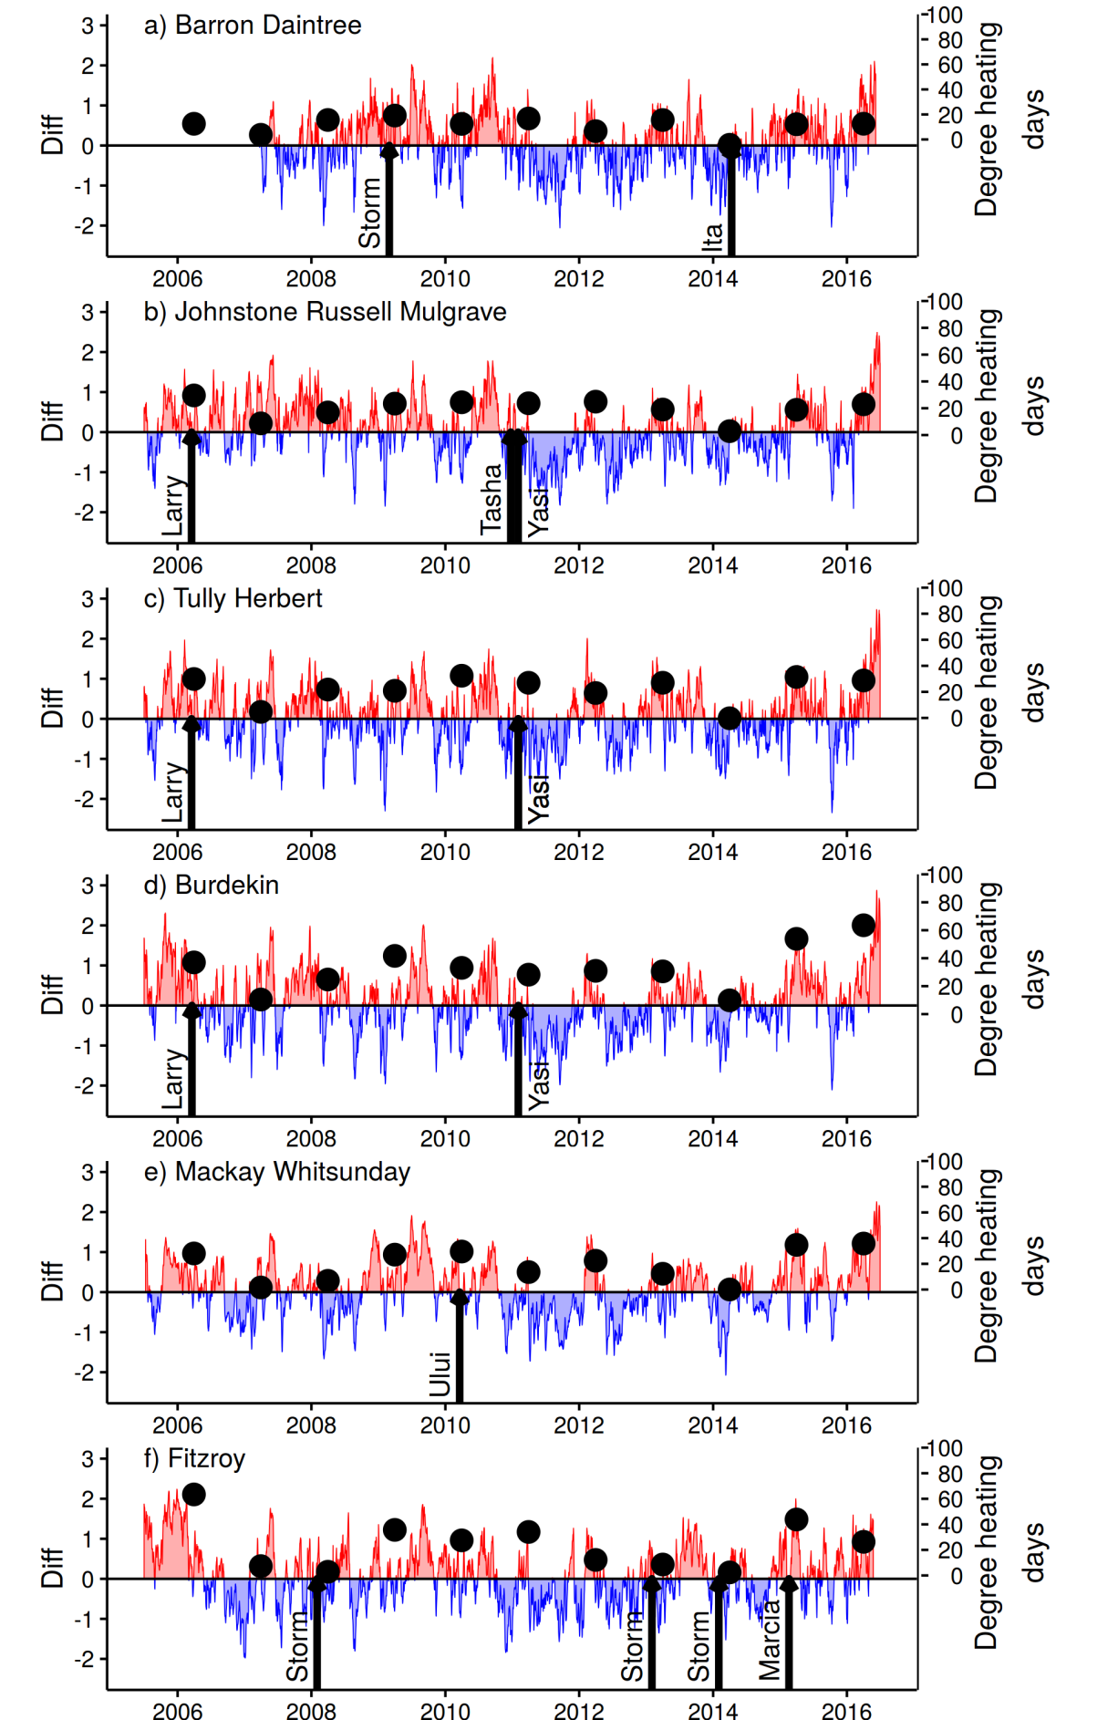

Figure 25 Seasonally adjusted temperature anomalies for (sub)-regions. Diff represents deviation in degrees Celsius (red = warmer, blue = cooler) from location specific climatology. Black symbols plot accumulated degree heating days between 1st of December - 31st March calculated as per Section 4.3.2. The timing of cyclones and storms are indicated by black arrows.

Case Study – Water quality constraints on the abundance of brown macroalgae
As naturally dynamic systems, coral reefs are continually changing through cycles of disturbance and recovery. It is assumed that throughout this process, reduced water quality has the potential to reduce the resilience of coral communities by increasing their susceptibility to disturbance events or suppressing their ensuing recovery.
Resilience can be described as the capacity of an ecosystem to absorb chronic and acute disturbances through recovery and adaptation whilst maintaining the same ecological structure and function (Holling 1973, Angeler & Allen 2016). Alongside the composition and dynamics of coral reef communities, resilience is considered to reflect the interactions of multiple physical, chemical and biological processes that determine cumulative pressures to which communities are exposed (Scheffer et al. 2001). For coral reefs, reduced resilience is often thought to result in the occurrence of intermittent or permanent phase shifts, i.e., the transition from a coral-dominated to a macroalgal-dominated state (Done 1992, McCook 1999, Nyström et al. 2000).
Teasing apart the relative contribution of cumulative pressures influencing resilience at any point in space or time has proven difficult, limiting the ability to identify key drivers which can be influenced through management actions. While there is considerable evidence that increased levels of suspended sediments, nutrients and toxicants discharged into the marine park strongly influence the local environmental conditions of nearshore coral reefs (Fabricius 2005), few studies have specifically demonstrated the impacts of water quality and terrestrial run-off on the resilience of coral reefs.
The occurrence of high abundances of fleshy macroalgae in the benthic communities associated with coral reefs is, in most cases, considered a consequence rather than a cause of coral mortality (McCook et al. 2001, Szmant 2002). However, once established macroalgae have the potential to supresses the resilience of coral communities through a combination of physical and chemical pathways that reduce coral fecundity (Foster et al. 2008), and the subsequent settlement, growth and survival of juveniles (McCook et al. 2001, Box & Mumby 2007, Hauri et al. 2010, Morrow et al. 2016).
In addition to the availability of space, a number of environmental factors control the recruitment, growth and density of macroalgae on coral reefs. These include both bottom-up processes such as the availability of sufficient nutrients and light (Schaffelke et al. 2005), and the top-down process associated with herbivory (Ceccarelli et al. 2011, Hughes et al. 2007). Evidently, both top-down and bottom-up processes are occurring simultaneously and their interactions are complex (Diaz-Pulido & McCook 2003, Smith et al. 2009). However, irrespective of the final processes that facilitate a change in benthic communities to a macroalgae-dominated state, the potential for this to occur is ultimately limited by the environmental conditions which support such a shift. The purpose of this case study was to investigate the relationship between long-term water quality and the distribution and abundance of brown macroalgae (class Phaeophyceae) on the Reef and the implications this has on the resilience of coral reef communities and the potential for phase shifts to occur.

8.1 Methods
The data used in this analysis were derived from the point intercept transects from both the LTMP and MMP, as detailed in section 4 of this report. The response variable, cover of brown macroalgae, was assessed as the proportion of all cover of all benthic algae. Explicitly, if we allow $A_{ij}$ to represent the percent cover of all algae ($A$) at a reef ($i$) at time ($j$), and ${BA}_{ij}$ to be the percent cover of brown macroalgae $BA$ at a reef ($i$) at time ($j$), then the response variable $BAproportion$ is:
${BAproportion}_{ij}$ = ${BA}_{ij}$ / $A_{ij}$
For the analyses presented here, estimates of the concentration of chlorophyll a (Chl a) and non-algal particulates (hereafter TSS) were sourced from the Bureau of Meteorology. Chl a and TSS estimates were extracted from daily MODIS Aqua satellite observations from a square of nine, 1-km² pixels located in optically deep waters as close as possible to sampling locations. The mean values of Chl a and TSS estimated from daily medians of these nine pixels constituted monthly estimates over the period 2002–2016 for each reef. Monthly estimates were then averaged over the entire period to provide an estimate of the long-term water quality condition for each reef. In addition, the same process was conducted to obtain long-term conditions for each 9 pixel block for the entire Reef to allow for spatial analysis and predictions of brown macroalgae distributions.

The relative hydrodynamic forcing of each site was estimated as the proportion of clay and silt-sized particles in sediments collected from 5 m depth at MMP sites. Data for each reef were averaged over samples collected during annual or biennial sampling of the coral communities between 2007 and 2014. Reefs with a high proportion of fine grained particles are assumed to represent locations at which turbulence is low and so the accumulation of fine sediments is promoted. In contrast, a low proportion of fine grained particles are assumed to reflect higher levels of turbulence that precludes the accumulation of fine-grained sediments. For LTMP reefs no sediment data exist and estimates of the proportion of clay and silt in the sediments was interpolated by placing the LTMP sites within the gradient of MMP sites by considering their comparable exposure to waves from the SE as the predominant direction of waves in the inner Reef. Images from LTMP photo-transects that included sand or silt observations were visually compared to images from MMP reefs with similar exposure to visually verify the validity of interpolated estimates.

Analysis
Generalised Boosted Models (GBM, Ridgeway 2007) were applied to the data according to the methods outlined for the GBM step function described by Elith et al. 2008 using the R statistical package (R_Development_Core_Team 2011). Output from the models was then used to determine threshold values affecting BAproportion. For each covariate the threshold was deemed to be the value at which the predicted BAproportion changed most significantly either positively or negatively.

8.2 Results
Concentration of Chl a was the most important of the environmental variables assessed in predicting BAproportion, which increased sharply at reefs experiencing mean Chl a concentrations in excess of 0.5 µgL⁻¹ and 0.45 µgL⁻¹ at 2 m and 5 m depths respectively (Figure 26b, e). The relative importance of the remaining two co-variates differed in relation to depth. At 5 m depths, the influence of TSS on BAproportion was more pronounced, with BAproportion decreasing at sites where TSS exceeded 1.07 mgL⁻¹, whilst TSS contributed very little to BAproportion at 2 m depths (Figure 26a, d). Proportion of clay and silt size particles in sediments was the second most important co-variate at 2 m depths with BAproportion with reduced once the fine fraction exceeded 12% (Figure 26c). At 5 m, high levels of fine, clay and silt size, particles in the sediment again suppressed BAproportion though the effect size was small (Figure 26f).

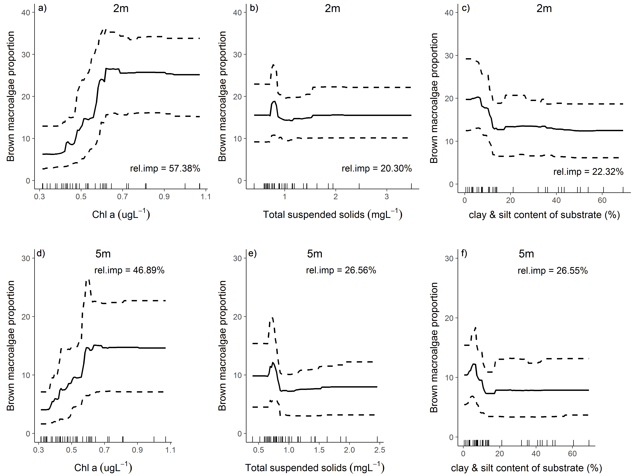
Figure 26 Brown macroalgae proportion relationships to environmental conditions
. Generalised boosted model partial plots demonstrating the relationship between BAproportion and environmental conditions. Dashed lines are 95% confidence intervals of the predictions.

8.3 Discussion
For the purpose of this analysis we focused specifically on brown macroalgae as these are identified as being the most abundant and diverse group of macroalgae in inshore areas of the Reef (McCook & Price 1997, Schaffelke & Klumpp 1997). Further, data collected under the MMP indicates that where macroalgal cover has increased and persisted genera of Phaeophyceae dominate over other major divisions (Rhodophyta and Chlorophyta).
Our results, demonstrate that the combination of water quality and hydrodynamic setting define the niche within which brown macroalgae constitute a substantial component within algal communities. Chl a concentration, presumed to be a proxy for nutrient availability, was identified as the most important factor contributing to high proportions of brown macroalgae. The proportion of brown macroalgae increased significantly on reefs with Chl a concentrations > 0.43 µgL⁻¹ (5 m), and 0.5 µgL⁻¹ (2 m) which is in close agreement to the analysis of De’ath & Fabricius (2008, 2010) and the resulting guideline of 0.45 µgL⁻¹ (GBRMPA 2010). At 5 m depths TSS concentrations above approximately 1 mgL⁻¹ imposed an additional limitation to the proportion of brown macroalgae. That the effects of TSS were not evident at 2 m at the same reefs suggest the attenuation of light with increasing depth was sufficient to suppress macroalgal growth in this situation. We note that sampling did not extend into the most turbid areas of the Reef where examples of high coral cover and low brown macroalgae cover (Brown et al. (2010, 2012), Morgan et al. 2016) suggest turbidity may become a limiting factor at shallower depths.
At both depths, brown macroalgae were also limited when the proportion of clay and silts sized particles in the sediment was greater than ~12%. The composition of reefal sediments, is considered here as a proxy for the turbulence of a site, representing the balance between the processes of resuspension leading to sediment removal and sedimentation leading to sediment accumulation. Previous studies have shown the abundance of macroalgae to be limited in areas of low turbulence where the availability of suitable substrate reduces recruitment and the smothering of thalli, limits growth and regeneration (Umar et al. 1998, Schaffelke et al. 2005, Irving et al. 2009). In general our results support a previous study by Hurrey et al. (2013) who identified sediment grainsize and light availability as the two most important variables influencing species richness and assemblage composition of macroalgae communities of the inter-reefal seabed areas on the Reef. For coral reef habitats, however, our analysis indicates that the primary limitation is nutrient availability, with turbidity and hydrodynamic setting imposing finer-scale restrictions on where, within the general confines of adequate nutrients, brown macroalgae flourish.
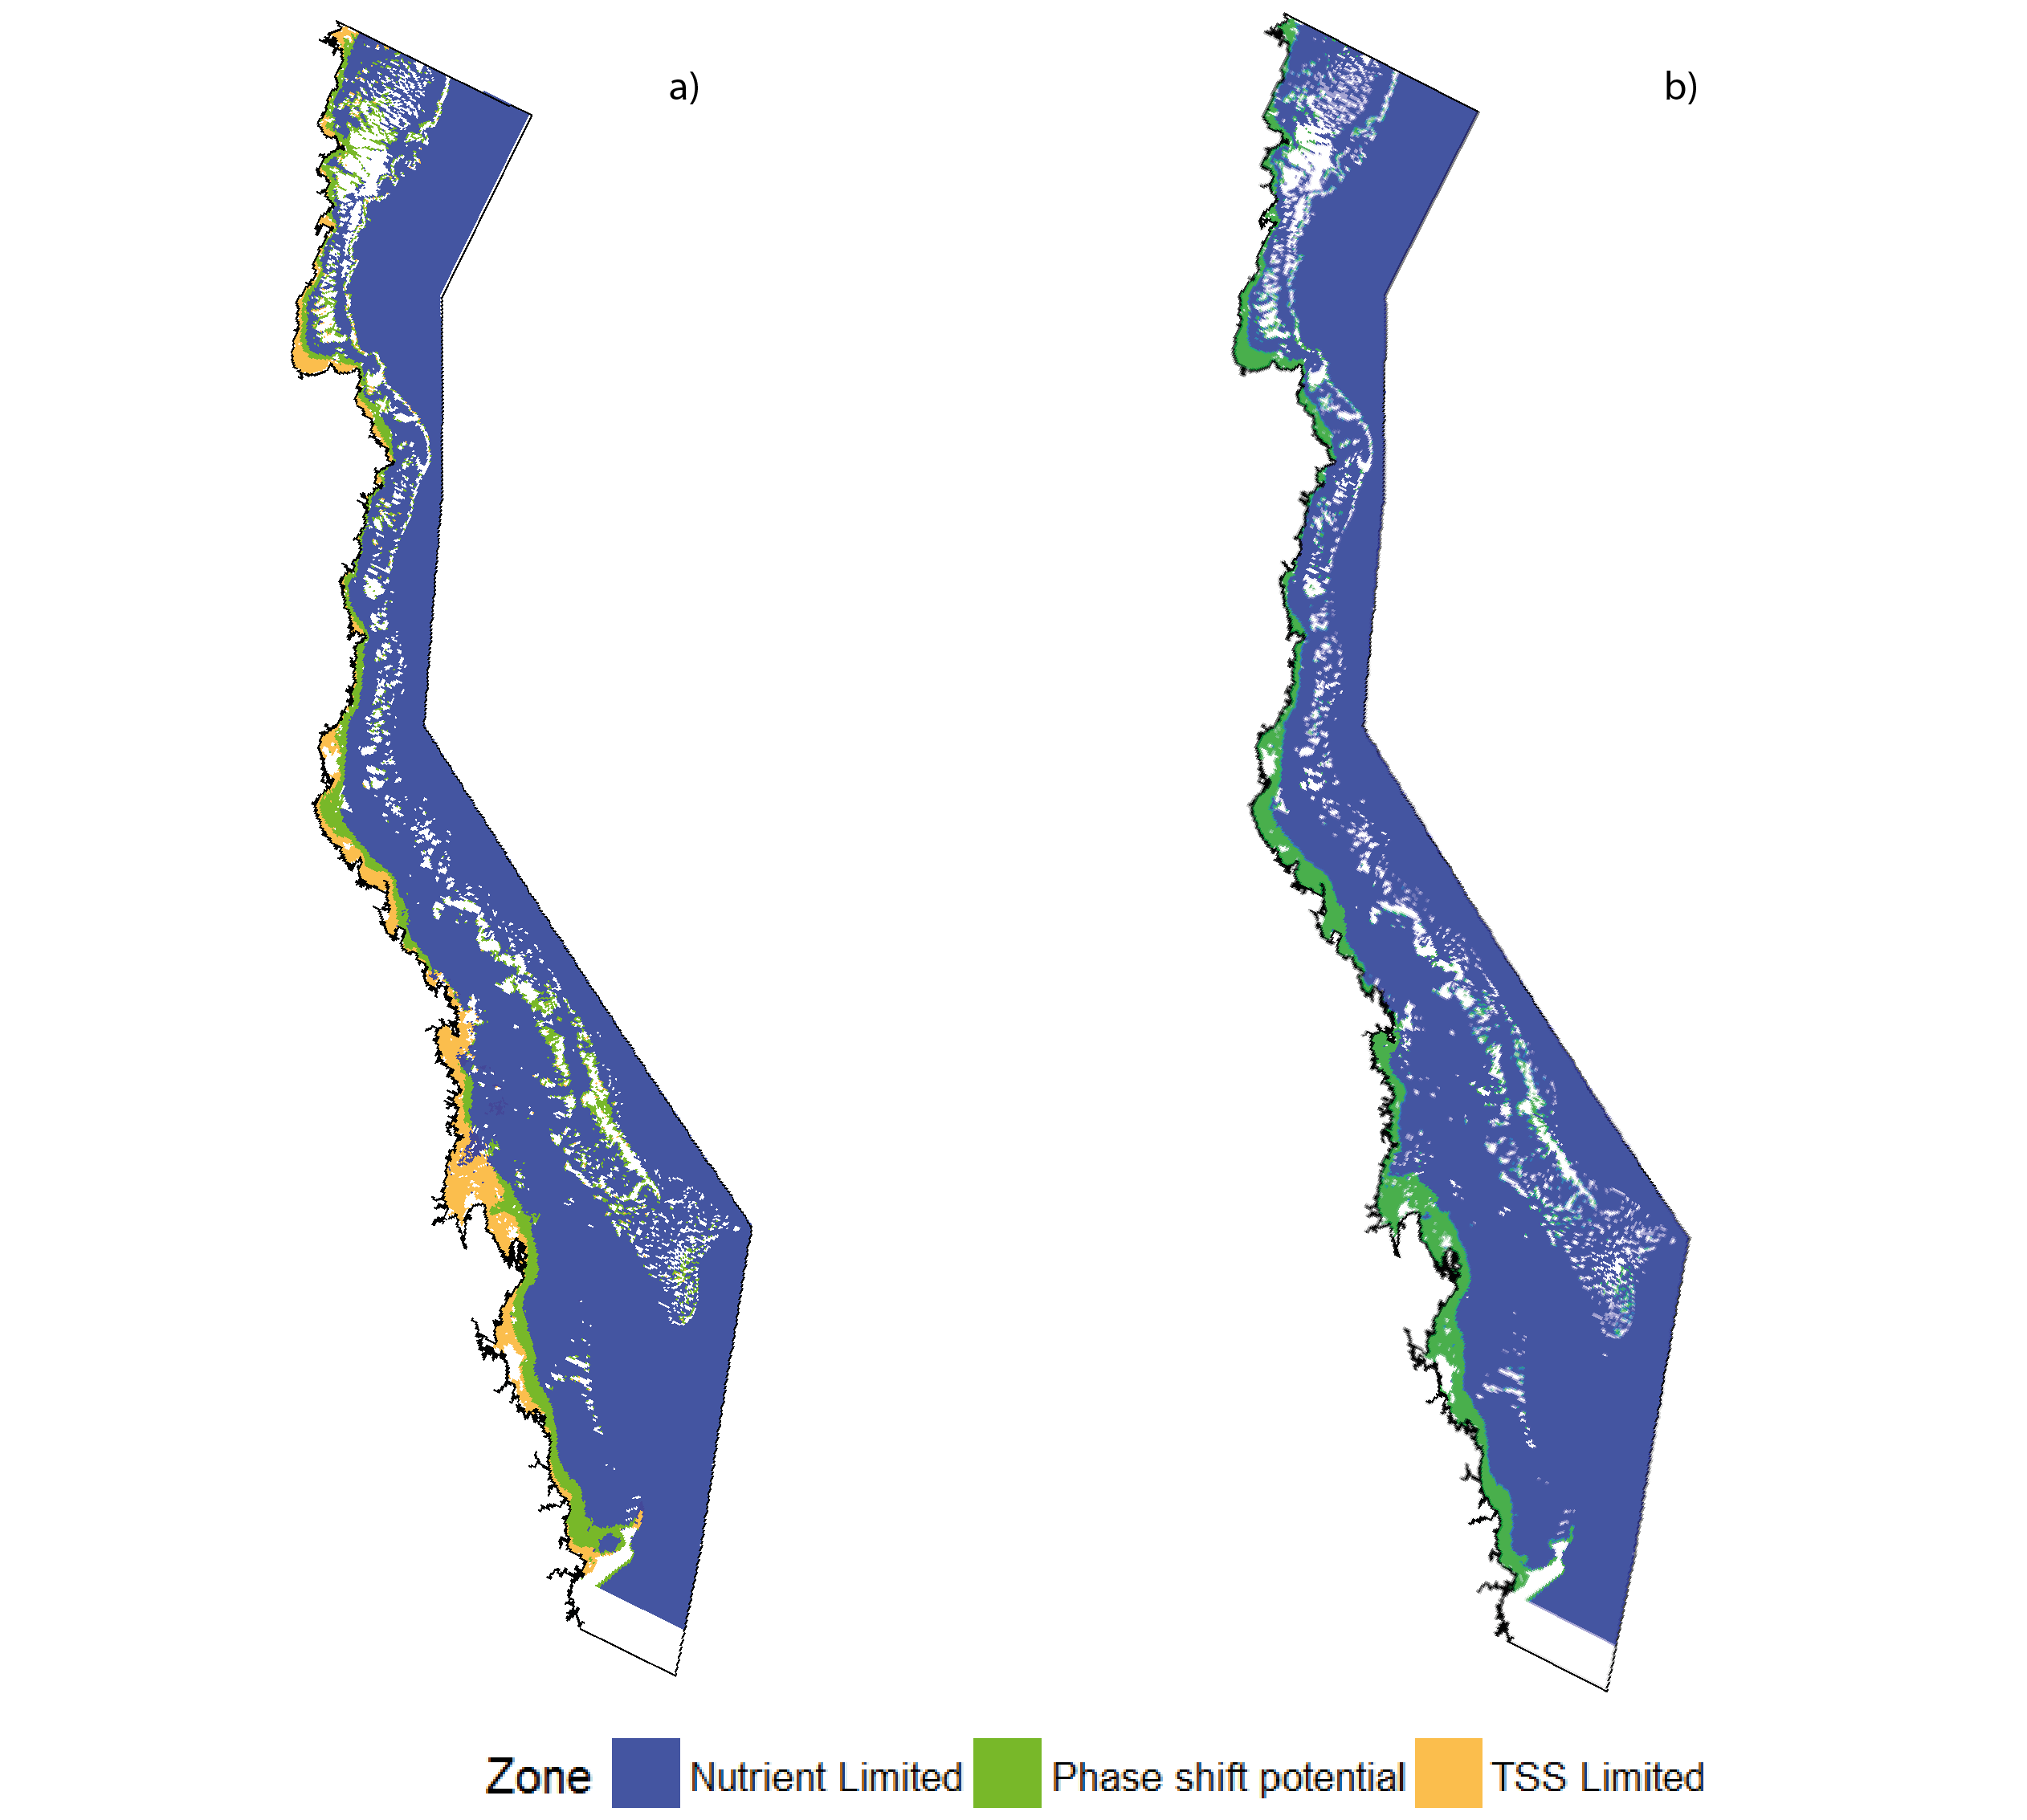
Figure 27 Distribution of conditions supporting high abundance of brown macroalgae. a) at 5 m depth, and b) at 2 m depth. ‘Nutrient Limited’ indicates where chlorophyll a levels are too low, ‘TSS Limited’ where turbidity is too high, and ‘Phase shift potential’ where conditions are currently optimum for a high proportional abundance of brown macroalgae to be supported

Using the threshold values determined from the models for the two most influential variables, Chl a and TSS, combined with long-term estimates based on satellite data available for the entire Reef, we were able to categorise the Reef into areas either, conducive to supporting high proportional abundance of brown macroalgae, or not. The resulting maps highlight the overlap between Chl a and TSS thresholds and the effect this has on the area with the potential to support high proportions of brown macroalgae (Figure 27). At 2 m depths, the area which supports high abundance of brown macroalgae is primarily driven by sufficient levels of nutrients. At 5 m depths the effects of high turbidity, in areas where nutrient levels are sufficient, lead to a reduction in the total area where high proportions of brown macroalgae are supported compared to that estimated for 2 m depths (Figure 27, Table 20). Importantly, within these areas a high proportion of brown macroalgae can only be expected where adequate substrate exists.
There are two important considerations for management that stem from these results. Firstly, at many reefs although there is a high proportion of brown macroalgae within the algal community the absolute cover remains low due to the presence of high coral cover. The worry is, that in the event of a severe reduction in coral cover, as a result of an acute disturbance, for example, the underlying environmental conditions appear suitable for a rapid increase in cover of brown macroalgae; in short, a latent phase shift may have already occurred. Secondly, the primary factor appearing to support brown macroalgae is nutrient availability, suggesting the reduction in nutrient loads in inshore waters as a safe-guard against potential phase shifts. Conversely, turbidity appears to limit the prevalence of brown macroalgae, especially at 5 m depths, raising the prospect that a reduction in fine sediment loads may extend the depth penetration of potential phase shifts in some areas if nutrient levels remain the same. It is well beyond the scope of this study to more fully explore the interplay between effects of reduced turbidity on the completive interactions between corals and brown macroalgae and suggest this is be a priority for further research.
Table 20 Area of the Reef classified based on conditions supporting high abundance of brown macroalgae.
Zone | 5 m | 2 m
TSS Limited | 28750km2 | NA
Nutrient Limited | 275661km2 | 292575km2
Phase shift potential | 29911km2 | 37052km2

There are relatively few cases of persistent phase shifts documented for the Reef (Cheal et al. 2010) and Indo-Pacific reefs are regarded, in general, as being more resilient to phase shifts compared to reefs in the Caribbean where phase shifts are well documented (Roff et al. 2012). Two of the most well documented cases on the Reef are based on shifts which followed a mass bleaching event and loss of coral cover due to storms. Cheal et al. (2010) investigated the drivers associated with phase shifts at Havannah North in the Burdekin region, concluding that herbivory and/or the diversity of herbivore communities, or rather lack thereof, were the most significant contributors to the observed phase-shift. Further, Cheal et al. (2010) determined that water quality conditions at the time did not exhibit any significant variation between two sites: Fitzroy West and Low Islets, where recovery occurred, and Havannah North, where a phase-shift to a dominance of macroalgae occurred. Based on the results of our analysis, however, it appears there are clear differences in the long-term ambient water quality conditions between the three reefs considered by Cheal et al. (2010), with only Havannah North having sufficient nutrient levels to support high abundances of brown macroalgae (Figure 27, Table A1. 6).
The second recent study documenting phase shifts on the Reef focused on inshore reefs in the Keppels region in the south of the Reef. As with the study mentioned above the shift to algal dominated state was primarily driven by the brown algae Lobophora variegata. In this case the authors indicated the shift to only last for about a year before being reversed by regeneration of remnant branching Acropora corals (Diaz-Pulido et al. 2009). The authors reported strong recovery at three of the four sites studied with weak recovery and continued persistence of macroalgae at the fourth. However, the authors did not take into account any water quality conditions in explaining the observed patterns, rather attributing differences to disturbance history and loss of structural complexity. Our results suggest nutrient levels as an additional or alternative explanation for the variability in recovery at these sites. Barren Island lies within the nutrient-limited zone and as such would not be expected to support persistent abundance of brown macroalgae. In contrast, conditions at North Keppel Island, where recovery was weakest, are optimal for supporting high abundances of macroalgae. Despite improvements in coral cover in the last three years, macroalgal cover continues to dominate the benthos at this reef a decade after the disturbance reported by Diaz-Pulido et al. (2009) (Figure A1. 6).
It is important to note that the relationship between water quality conditions and proportional cover of brown macroalgae is correlative only and does not prove a cause-effect relationship. Rather, the variables investigated here may in fact provide proxies for other environmental variables, or ecological processes, which influence macroalgae on inshore reefs. Wismer et al. (2009) and Cheal et al. (2013), for example, demonstrate a decline in herbivorous fish populations at turbidity levels observed in the inshore Reef. Grazing is a key process for the control of macroalgal blooms and there is a wealth of research demonstrating the importance of the maintenance of herbivore populations to avoid a phase shift to macroalgae (e.g. Hughes et al. 2007). McCook (1996) demonstrated using transplant experiments that Sargassum was able to persist on mid-shelf where it was rarely recorded, but only when protected from herbivory. It is interesting to note here that our analysis indicates that areas of the mid-shelf appear to harbour environmental conditions suitable for the support of high proportions of brown macroalgae and these areas include the reefs in McCook’s (1996) study (the Slashers group) (Figure 27). We caution, however, that these small scale areas of high Chl a may be an artefact of the remote-sensing derived Chl a data and the reef mask used.
The relative influences of herbivory and nutrients on coral reef macroalgae is undoubtedly complex and likely to “depend on the species, circumstances and life-history processes under consideration” (Diaz-Pulido & McCook 2003). Irrespective of the underlying mechanism limiting macroalgae on reefs, our results demonstrate that water quality conditions combined with hydrodynamic setting allow the identification of areas where brown macroalgae may occur at levels detrimental to coral community resilience, and potentially vulnerable to phase shifts to macroalgal-dominated states following future disturbance events.

9 Acknowledgments
We acknowledge the valuable contributions to data collection, sampling integrity and reporting of John Carlton, Stephen Neale and Damian Thomson over the first few years of the monitoring program. We thank Aaron Anderson, Joe Gioffre, Charlotte Johansson, Kate Osborne, Shawn Smith, Marcus Stowar and Irena Zagorskis for valuable field assistance over the years. We also thank Ed Butler, Terry Done, Johanna Johnson, Katherine Martin and a number of anonymous reviewers for their detailed reviews that improved the previous reports on which this current instalment builds.

10 References
Anderson MJ, Willis TJ (2003) Canonical analysis of principal coordinates: a useful method of constrained ordination for ecology. Ecology 84:511–525
Angeler DG, Allen CR (2016). Quantifying resilience. Journal of Applied Ecology, 53(3), 617-624
Anon. (2003) Reef Water Quality Protection Plan for catchments adjacent to the Great Barrier Reef World Heritage Area. The State of Queensland and Commonwealth of Australia. Queensland Department of Premier and Cabinet, Brisbane. 43p
Anon. (2009) Reef Water Quality Protection Plan 2009. For the Great Barrier Reef World Heritage Area and adjacent catchments. The State of Queensland and Commonwealth of Australia. Queensland Department of the Premier and Cabinet, Brisbane. 30 pp.
Anon. (2011) Reef Water Quality Protection Plan. First Report 2009 Baseline. The State of Queensland and Commonwealth of Australia. Queensland Department of Premier and Cabinet, Brisbane. 140 pp. Available at www.reefplan.qld.gov.au
Anon. (2013) Reef Water Quality Protection Plan 2013.Securing the health and resilience of the Great Barrier Reef World Heritage Area and adjacent catchments. The State of Queensland. Reef Water Quality Protection Plan Secretariat, Brisbane. 34 p. Available at www.reefplan.qld.gov.au
Anthony KRN (1999) Coral suspension feeding on fine particulate matter. Journal of Experimental Marine Biology and Ecology 232:85-106
Anthony KRN, Fabricius KE (2000) Shifting roles of heterotrophy and autotrophy in coral energetics under varying turbidity. Journal of Experimental Marine Biology and Ecology 252:221-253
Ayling AM, Ayling AL (2005) The dynamics of Cairns and Central section fringing reefs: 2005 Unpublished report submitted to the Great Barrier Reef Marine Park Authority, Townsville.
Ayling A (1997) The biological status of fringing reefs in the Great Barrier Reef world heritage area. Proceedings of the State of the Great Barrier Reef World Heritage Area Workshop pp. 109-113
Babcock RC, Smith L (2002) Effects of sedimentation on coral settlement and survivorship. In: Proceedings of the 9th International Coral Reef Symposium, Bali, Indonesia, 245–248
Baird AH, Babcock RC, Mundy CP (2003) Habitat selection by larvae influences the depth distribution of six common coral species. Marine Ecology Progress Series 252:289-293
Bartley R, Corfield JP, Hawdon AA, Kinsey-Henderson AE, Abbott BN, Wilkinson SN, Keen RJ (2014a) Can changes to pasture management reduce run-off and sediment loss to the Great Barrier Reef? The results of a 10-year study in the Burdekin catchment, Australia. The Rangeland Journal 36:67-84
Bartley R, Bainbridge ZT, Lewis SE, Kroon FJ, Wilkinson SN, Brodie JE, Silburn DM (2014b) Relating sediment impacts on coral reefs to watershed sources, processes and management: A review. Science of the Total Environment 468–469:1138-1153
Beeden, R.J., Turner, M.A., Dryden, J., Merida, F., Goudkamp, K., Malone, C., Marshall, P.A., Birtles, A. and Maynard, J.A. 2014, Rapid survey protocol that provides dynamic information on reef condition to managers of the Great Barrier Reef, Environmental Monitoring and Assessment 186(12): 8527-8540.
Belperio AP, Searle DE (1988) Terrigenous and carbonate sedimentation in the Great Barrier Reef province. In: J, D.L., H, R.H. (Eds.), Carbonate to Clastic Facies Changes. Developments in Sedimentology. Elsevier Science Publishers, Amsterdam, pp. 143–174
Bellwood DR, Hughes TP, Folke C, Nyströmm (2004) Confronting the coral reef crisis. Nature 429:827-833
Berkelmans R, De’ath G, Kininmonth S, Skirving WJ (2004) A comparison of the 1998 and 2002 coral bleaching events on the Great Barrier Reef: spatial correlation, patterns, and predictions. Coral reefs, 23(1):74-83
Berkelmans R, Jones A, Schaffelke B (2012) Salinity thresholds of Acropora spp. On the Great Barrier Reef. Coral Reefs 31:1103-1110
Bessell-Browne P, Negri A.P., Fisher R, Clode P.L., Jones R, (2017) Cumulative impacts: thermally bleached corals have reduced capacity to clear deposited sediment Scientific Reports doi:10.1038/s41598-017-02810-0
Birrell CL, McCook LJ, Willis BL (2005) Effects of algal turfs and sediment on coral settlement. Marine Pollution Bulletin 51:408-414
Birrell CL, McCook LJ, Willis BL, Diaz-Pulido GA (2008a) Effects of benthic algae on the replenishments of corals and the implications for the resilience of coral reefs. Oceanography and Marine Biology: An Annual Review 46:25-64
Birrell CL, McCook LJ, Willis BL, Harrington L (2008b) Chemical effects of macroalgae on larval settlement of the broadcast spawning coral Acropora millepora. Marine Ecology Progress Series 362:129-137
Box SJ, Mumby PJ (2007) Effect of macroalgal competition on growth and survival of juvenile Caribbean corals. Marine Ecology Progress Series 342:139–149
Brinkman R, Herzfeld M, Andrewartha J, Rizwi F, Steinberg C, Spagnol S (2011) Hydrodynamics at the whole of GBR scale. AIMS Final Project Report MTSRF Project 2.5i.1, June 2011. Report to Reef and Rainforest Research Centre. Australian Institute of Marine Science, Townsville. 42pp
Brodie J, Fabricius K, De’ath G, Okaji K (2005) Are increased nutrient inputs responsible for more outbreaks of crown-of-thorns starfish? An appraisal of the evidence. Marine Pollution Bulletin, 51(1):266-278
Brodie JE, Kroon FJ, Schaffelke B, Wolanski EC, Lewis SE, Devlin MJ, Bohnet IC, Bainbridge ZT, Waterhouse J, Davis AM (2012b) Terrestrial pollutant run-off to the Great Barrier Reef: An update of issues, priorities and management responses. Marine Pollution Bulletin 65:81-100
Brodie J, Wolanski E, Lewis S, Bainbridge Z (2012a) An assessment of residence times of land-sourced contaminants in the Great Barrier Reef lagoon and the implications for management and reef recovery. Marine Pollution Bulletin 65:267-279
Browne NK, Smithers SG, Perry CT (2010) Geomorphology and community structure of Middle Reef, central Great Barrier Reef, Australia: an inner-shelf turbid zone reef subject to episodic mortality events. Coral Reefs 29: 683-689
Browne NK, Smithers SG, Perry CT (2012) Coral reefs of the turbid inner-shelf of the Great Barrier Reef, Australia: An environmental and geomorphic perspective on the occurrence, composition and growth. Earth-Science Reviews 115:1-20
Bruno JF, Petes LE, Harvell CD, Hettinger A (2003) Nutrient enrichment can increase the severity of coral diseases. Ecology Letters 6:1056-1061
Bruno JF, Sweatman H, Precht WF, Selig ER, Schutte VGW (2009) Assessing evidence of phase shifts from coral to macroalgal dominance on coral reefs. Ecology 90:1478-1484
Caballes CF, Pratchett MS (2014) Reproductive biology and early life history of the crown-of-thorns starfish. In: Whitmore E (Ed) Echinoderms: ecology, habitats and reproductive biology. Nova Science Publishers, New York, NY, USA
Carpenter KE, Abrar M, Aeby G, Aronson RB, Banks S, Bruckner A, Chiriboga A, Cortes J, Delbeek JC, DeVantier L, Edgar GJ, Edwards AJ, Fenner D, Guzman HM, Hoeksema BW, Hodgson G, Johan O, Licuanan WY, Livingstone SR, Lovell ER, Moore JA, Obura DO, Ochavillo D, Polidoro BA, Precht WF, Quibilan MC, Reboton C, Richards ZT, Rogers AD, Sanciangco J, Sheppard A, Sheppard C, Smith J, Stuart S, Turak E, Veron JEN, Wallace C, Weil E, Wood E (2008) One-Third of Reef-Building Corals Face Elevated Extinction Risk from Climate Change and Local Impacts. Science 321:560-563
Ceccarelli DM, Jones GP, McCook LJ (2011) Interactions between herbivorous fish guilds and their influence on algal succession on a coastal coral reef. Journal of Experimental Marine Biology and Ecology 399:60-67
Cheal AJ, , Emslie M, MacNeil MA, Miller I, Sweatman H (2013) Spatial variation in the functional characteristics of herbivorous fish communities and the resilience of coral reefs. Ecological Applications 23:174-188
Cheal AJ, MacNeil MA, Cripps E, Emslie M, Jonker M, Schaffelke B, Sweatman H (2010) Coral-macroalgal phase shifts or reef resilience: links with diversity and functional roles of herbivorous fishes on the Great Barrier Reef. Coral Reefs 29:1005-1015
Cooper TF, Uthicke S, Humphrey C, Fabricius KE (2007) Gradients in water column nutrients, sediment parameters, irradiance and coral reef development in the Whitsunday Region, central Great Barrier Reef. Estuarine, Coastal and Shelf Science 74:458-470Darnell R, Henderson B, Kroon FJ, Kuhnert P (2012) Statistical power of detecting trends in total suspended sediment loads to the Great Barrier Reef. Marine Pollution Bulletin 65:203-209
Crain, C.M., Kroeker, K. and Halpern, B.S., 2008. Interactive and cumulative effects of multiple human stressors in marine systems. Ecology letters, 11(12), pp.1304-1315.
De'ath G, Fabricius KE (2008) Water Quality of the Great Barrier Reef: Distributions, Effects on Reef Biota and Trigger Values for the Protection of Ecosystem Health. Research Publication No. 89. Great Barrier Marine Park Authority, Townsville, p. 104p
De'ath G, Fabricius KE (2010) Water quality as a regional driver of coral biodiversity and macroalgae on the Great Barrier Reef. Ecological Applications 20:840–850
De’ath G, Fabricius KE, Sweatman H, Puotinen M (2012) The 27-year decline of coral cover on the Great Barrier Reef and its causes. Proceedings of the National Academy of Sciences 190(44):17995-17999
DeVantier L, De’ath G, Turak E, Done TJ, Fabricius KE (2006) Species richness and community structure of reef-building corals on the nearshore Great Barrier Reef. Coral Reef 25:329-340
Diaz-Pulido G, Harii S, McCook LJ, Hoegh-Guldberg O (2010) The impact of benthic algae on the settlement of a reef-building coral. Coral Reefs 29:203-208
Diaz-Pulido G, McCook LJ (2003) Relative roles of herbivory and nutrients in the recruitment of coral-reef seaweeds. Ecology 84:2026-2033
Diaz-Pulido G, McCook LJ, Dove S, Berkelmans R, Roff G, Kline DI, Weeks S, Evans RD, Williamson DH, Hoegh-Guldberg O (2009) Doom and Boom on a Resilient Reef: Climate Change, Algal Overgrowth and Coral Recovery. PLoS ONE 4(4): e5239
Done T, Turak E, Wakeford M, DeVantier L, McDonald A and Fisk D (2007) Decadal changes in turbid-water coral communities at Pandora Reef: loss of resilience or too soon to tell? Coral reefs 26:789–805
Done TJ (1982) Patterns in the distribution of coral communities across the central Great Barrier Reef. Coral Reefs 1:95-107
Done, T.J. (1992) Phase shifts in coral reef communities and their ecological significance. Hydrobiologia 247, 121–132
Erftemeijer PLA, Reigl B, Hoeksema BW, Todd PA (2012) Environmental impacts of dredging and other sediment disturbances on corals: A review. Marine Pollution Bulletin 64:1737-1765
Fabricius KE (2005) Effects of terrestrial run-off on the ecology of corals and coral reefs: Review and synthesis. Marine Pollution Bulletin 50:125-146
Fabricius KE (2011) Factors determining the resilience of coral reefs to eutrophication: a review and conceptual model. In: Dubinsky Z, Stambler N (Eds) Coral Reefs: An Ecosystem in Transition, Springer Press, pp.493-506
Fabricius KE, Cooper TF, Humphrey C, Uthicke S, De’ath G, Davidson J, LeGrand H, Thompson A, Schaffelke B (2012) A bioindicator system for water quality on inshore coral reefs of the Great Barrier Reef. Marine Pollution Bulletin 65:320-332
Fabricius KE, Cseke S, Humphrey CA, De’ath G (2013b) Does trophic status enhance or reduce the thermal tolerance of scleractinian corals? A review, experiment and conceptual framework. PLoS ONE 8 e54399
Fabricius KE, De’ath G (2001) Biodiversity on the Great Barrier Reef: Large-scale patterns and turbidity-related local loss of soft coral taxa. In Wolanski E (Ed) Biological-Physical Links: Oceanographic processes on the Great Barrier Reef. CRC Press, Boca Raton
Fabricius KE, De’ath G, Humphrey C, Zagorskis I, Schaffelke B (2013a) Intra-annual variation in turbidity in response to terrestrial run-off on near-shore coral reefs of the Great Barrier Reef, Estuarine Coastal and Shelf Science 116:57-65
Fabricius KE, De’ath G, McCook L, Turak E, Williams DMcB (2005) Changes in algal, coral and fish assemblages along water quality gradients on the inshore Great Barrier Reef. Marine Pollution Bulletin 51:384-396
Fabricius KE, De’ath G, Puotinen MJ, Done T, Cooper TF, Burgess SC (2008) Disturbance gradients on inshore and offshore coral reefs caused by a severe tropical cyclone. Limnology and Oceanography 53(2): 690-704
Fabricius KE, Logan M, Weeks S, Brodie J (2014) Assessing inter- and intra-annual changes in water clarity in response to river run-off on the central Great Barrier Reef from 10 years of MODIS-Aqua data. Marine Pollution Bulletin 84:191-200
Fabricius KE, Logan M, Weeks SJ, Lewis SE, Brodie J (2016) Changes in water clarity in response to river discharges on the Great Barrier Reef continental shelf: 2002-2013. Estuarine Coastal and Shelf Science 173:A1-A15
Fabricius KE, Okaji K, De’ath G (2010) Three lines of evidence to link outbreaks of the crown-of-thorns seastar Acanthaster planci to the release of larval food limitation. Coral Reefs 29:593-605
Fabricius KE, Wild C, Wolanski E, Abele D (2003) Effects of transparent exopolymer particles and muddy terrigenous sediments on survival of hard coral recruits. Estuarine, Costal and Shelf Science 57:613-621
Fabricius KE, Wolanski E (2000) Rapid smothering of coral reef organisms by muddy marine snow. Estuarine, Costal and Shelf Science 50:115-120
Fabricius KE, Logan M, Weeks SJ, Lewis SE, Brodie J (2016) Changes in water clarity in response to river discharges on the Great Barrier Reef continental shelf: 2002-2013. Estuarine Coastal and Shelf Science
Foster NL, Box SJ, Mumby PJ (2008) Competitive effects of macroalgae on the fecundity of the reef-building coral Montastrea annularis. Marine Ecology Progress Series 367:143-152
Furnas M, Alongi D, McKinnon AD, Trott L, Skuzam (2011) Regional-scale nitrogen and phosphorus budgets for the northern (14°S) and central (17°S) Great Barrier Reef shelf ecosystem. Continental Shelf Research 31:1967-1990
Furnas M, Brinkman R, Fabricius K, Tonin H, Schaffelke B (2013) Linkages between river run-off, phytoplankton blooms and primary outbreaks of crown-of-thorns seastars in the Northern GBR. Chapter 3 in Waterhouse et al. Assessment of the relative risk of water quality to ecosystems of the Great Barrier Reef. Department of the Environment and Heritage Protection, Queensland Government, Brisbane
Furnas MJ, Mitchell AW, Skuza M, Brodie J (2005) In the other 90%: Phytoplankton responses to enhanced nutrient availability in the Great Barrier Reef lagoon. Marine Pollution Bulletin 51: 253-256
Garde LA, Spillman CM, Heron S, Beeden R (2014) ReefTemp Next Generation: A New Operational System for Monitoring Reef Thermal Stress, Journal of Operational Oceanography, 7:21-33
Garzon-Garcia A, Wallace R, Huggins R, Turner RDR, Smith RA, Orr D, Ferguson B, Gardiner R, Thomson B, Warne MStJ (2015) Total suspended solids, nutrient and pesticide loads (2013–2014) for rivers that discharge to the Great Barrier Reef – Great Barrier Reef Catchment Loads Monitoring Program. Department of Science, Information Technology and Innovation. Brisbane
Graham NAJ, Jennings S, MacNeil MA, Mouillot D, Wilson SK (2015) Predicting climate-driven regime shifts versus rebound potential in coral reefs. Nature 518(7537):94-97
Great Barrier Reef Marine Park Authority (2010) Water Quality Guidelines for the Great Barrier Reef Marine Park. Revised Edition 2010. Great Barrier Reef Marine Park Authority, Townsville. 100p
Great Barrier Reef Marine Park Authority (2014a) Great Barrier Reef Region Strategic Assessment. Great Barrier Reef Marine Park Authority, Townsville
Great Barrier Reef Marine Park Authority (2014b) Great Barrier Reef Outlook Report 2014, Great Barrier Reef Marine Park Authority, Townsville.
Great Barrier Reef Marine Park Authority (2016b), Interim report: 2016 coral bleaching event on the Great Barrier Reef, GBRMPA, Townsville.
Haapkylä J, Melbourne-Thomas J, Flavell M, Willis B (2013) Disease outbreaks, bleaching and a cyclone drive changes in coral assemblages on an inshore reef of the Great Barrier Reef. Coral Reefs 32:815-824
Haapkylä J, Unsworth R, Flavell M, Bourne D, Schaffelke B, Willis BL (2011) Seasonal rainfall and run-off promote coral disease on an inshore reef of the Great Barrier Reef, Australia. PLoS One. 6(2): e16893
Halpern BS, Frazier M, Potapenko J, Casey KS, Koenig K, Longo C, Stewart Lowndes J, Rockwood C, Selig ER, Selkoe KA, Walbridge S (2015) Spatial and temporal changes in cumulative human impacts on the world’s oceans. Nature Communications 6:7615 DOI:10.1038/ncomms8615
Harrison PL, Wallace CC (1990) Reproduction, dispersal and recruitment of Scleractinian corals. In Dubinsky Z (Ed) Ecosystems of the world 25: Coral Reefs. Elsevier, New York, pp 133-202
Hauri C, Fabricius K, Schaffelke B, Humphrey C (2010) Chemical and physical environmental conditions underneath mat- and canopy-forming macroalgae, and the effects on understory corals. PLoS ONE 5(9): e12685
Hoegh-Guldberg O (1999) Climate change, coral bleaching and the future of the world’s coral reefs. Marine and Freshwater Research 50:839-866
Holling CS (1973) Resilience and Stability of Ecological Systems. Annual Review of Ecology and Systematics 4:1-23
Hughes AO , Olley JM , Croke JC , McKergow LA (2009) Sediment source changes over the last 250 years in a dry-tropical catchment, central Queensland, Australia. Geomorphology 104:262–265
Hughes TP, Graham NAJ, Jackson JBC, Mumby PJ, Steneck RS (2010) Rising to the challenge of sustaining coral reef resilience. Trends in Ecology and Evolution 25(11):633-642
Hughes TP, Rodrigues MJ, Bellwood DR, Ceccarelli D, Hoegh-Guldberg O, McCook L, Moltschaniwskyj N, Pratchett MS, Steneck RS, Willis B (2007) Phase Shifts, Herbivory, and the Resilience of Coral Reefs to Climate Change. Current Biology 17:360-365
Irving AD, Balata D, Colosio F, Ferrando GA, Airoldi L (2009) Light, sediment, temperature, and the early life-history of the habitat-forming alga Cystoseira barbata. Marine biology 156(6):1223-31
Jones AM, Berkelmans R (2014) Floodimpacts in Keppel Bay, Southern Great Barrier Reef in the aftermath of cyclonic rainfall. PLOS one doi:10.1371/journal.pone.0084739
Jonker M, Johns K, Osborne K (2008) Surveys of benthic reef communities using underwater digital photography and counts of juvenile corals. Long-term Monitoring of the Great Barrier Reef, Standard Operational Procedure Number 10, Australian Institute of Marine Science, Townsville
Joo M, Raymond MA, McNeil VH, Huggins R, Turner RD, Choy S (2012) Estimates of sediment and nutrient loads in 10 major catchments draining to the Great Barrier Reef during 2006–2009. Marine pollution bulletin, 65(4):150-166
Kaczmarsky L, Richardson LL (2010) Do elevated nutrients and organic carbon on Philippine reefs increase the prevalence of coral disease? Coral Reefs 30:253-257
Karr JR (2006) Seven foundations of biological monitoring and assessment. Biologia Ambientale 20(2):7-18
Kline DL, Kuntz NM, Breitbart M, Knowlton N, Rohwer F (2006) Role of elevated organic carbon levels and microbial activity in coral mortality. Marine Ecology Progress Series 314:119–125
Kroon FJ, Kuhnert PM, Henderson BL, Wilkinson SN, Kinsey-Henderson A, Abbott B, Brodie JE, Turner RDR (2012) River loads of suspended solids, nitrogen, phosphorus and herbicides delivered to the Great Barrier Reef lagoon. Marine Pollution Bulletin 65:167–181
Kroon FJ, Schaffelke B, Bartley R (2014) Informing policy to protect coastal coral reefs: Insight from a global review of reducing agricultural pollution to coastal ecosystems. Marine Pollution Bulletin 85:33-41
Kuntz N, Kline D, Sandin S, Rohwer F (2005) Pathologies and mortality rates caused by organic carbon and nutrient stressors in three Caribbean coral species. Marine Ecology Progress Series 294:173–180
Lambrechts J, Humphrey C, McKinna L, Gourge O, Fabricius KE, Mehta AJ, Lewis S, Wolanski E (2010) Importance of wave-induced bed liquefaction in the fine sediment budget of Cleveland Bay, Great Barrier Reef. Estuarine, Coastal and Shelf Science 89:154-162
Larcombe P, Ridd PV, Prytz A, Wilson B (1995) Factors controlling suspended sediment on inner-shelf coral reefs. Townsville, Australia. Coral Reefs 14:163-171
Lønborg C, Álvarez-Salgado XA, Martínez-Garcia S, Teira E (2011) Carbon cycling and bacterial growth efficiency in a coastal upwelling system (NW Iberian Peninsula). Aquatic Microbial Ecology 63:183-191
Lønborg C, Devlin M, Brinkman R, Costello P, da Silva E, Davidson J, Gunn K, Logan M, Petus C, Schaffelke B, Skuza M, Tonin H, Tracey D, Wrightm and Zagorskis I (2015) Reef Rescue Marine Monitoring Program. Annual Report of AIMS and JCU Activities 2014 to 2015– Inshore water quality monitoring. Report for the Great Barrier Reef Marine Park Authority. Australian Institute of Marine Science and JCU TropWATER, Townsville.168p
Luick JL, Mason L, Hardy T, Furnas MJ (2007) Circulation in the Great Barrier Reef Lagoon using numerical tracers and in situ data. Continental Shelf Research 27:757-778
Manly, B.F., 2006. Randomization, bootstrap and Monte Carlo methods in biology (Vol. 70). CRC Press.
McCook LJ (1999) Macroalgae, nutrients and phase shifts on coral reefs: scientific issues and management consequences for the Great Barrier Reef. Coral Reefs 18:357-367
McCook LJ, Jompa J, Diaz-Pulido G (2001) Competition between corals and algae on coral reefs: a review of evidence and mechanisms. Coral Reefs 19:400-417
Mackenzie JB, Munday PL, Willis BL, Miller DJ, Van Oppen MJH (2004) Unexpected patterns of genetic structuring among locations but not colour morphs in Acropora nasuta (Cnidaria; Scleractinia). Molecular Ecology 13(1):9-20
Mann, ME, Ramstorf S, Steinman BA, Tingley M, and Miller SK 2016. The likelihood of recent record warmth, Scientific Reports 6: 19831. doi: 10.1038/srep19831 (2016).
Marshall PA, Baird AH (2000) Bleaching of corals on the Great Barrier Reef: differential susceptibilities among taxa. Coral Reefs 19:155-163
Marshall PA, Johnson JE (2007) The Great Barrier Reef and climate change: vulnerability and management implications. In: Johnson JE, Marshall PA (Eds) Climate change and the Great Barrier Reef. Great Barrier Reef Marine Park Authority and the Australian Greenhouse Office, Australia, pp 774-801
Maxim L, Spangenberg JH, O’Connerm (2009) An analysis of risks for biodiversity under the DPSIR framework. Ecological Economics 69:12-23
Miller IR, Jonker M, Coleman G (2009) Crown-of-thorns seastars and coral surveys using the manta tow and SCUBA Search techniques. Long-term Monitoring of the Great Barrier Reef Standard Operational Procedure Number 9, Edition 3. Australian Institute of Marine Science, Townsville
Mora C (2008) A clear human footprint in the coral reefs of the Caribbean. Proceedings of the Royal Society B 275:767-773
Morgan KM, Perry CT, Smithers SG, Johnson JA, Daniell JJ (2016) Evidence of extensive reef development and high coral cover in nearshore environments: implications for understanding coral adaptation in turbid settings. Scientific Reports. 6:29616, DOI: 10.1038/srep29616
Morrow KM, Ritson-Williams R, Ross C, Liles MR, Paul VJ (2012) Macroalgal extracts induce bacterial assemblage shifts and sub lethal tissue stress in Caribbean corals. PLoS ONE 7(9):e44859
Muir PR, Wallace CC, Done T, Aguirre DJ (2015) Limited scope for latitudinal extension of reef corals. Science 348:1135-1138
Negri AP, Flores F, Röthig T, Uthicke S (2011) Herbicides increase the vulnerability of corals to rising sea surface temperature. Limnology and Oceanography 56:471-485
Nyström M, Folke C, Moberg F (2000) Coral reef disturbance and resilience in a human-dominated environment. Trends in Ecology and Evolution 15:413–417
Osborne K, Dolman AM, Burgess SC, Johns KA (2011) Disturbance and the Dynamics of Coral Cover on the Great Barrier Reef (1995–2009). PLoS ONE 6:e17516
Petus C, Devlin M, Thompson A, McKenzie L, Teixeira da Silva E, Collier C, Tracey D, Martin K (2016) Estimating the Exposure of Coral Reefs and Seagrass Meadows to Land-Sourced Contaminants in River Flood Plumes of the Great Barrier Reef: Validating a Simple Satellite Risk Framework with Environmental Data. Remote Sensing 8(3):210
Pratchett MS (2007) Feeding preferences of Acanthastrea planci (Echinodermata: Asteroidea) under controlled conditions of food availability 1. Pacific Science 61(1): 113-120
Pratchett MS, Caballes CF, Rivera-Posada Ja, Sweatman HPA (2014) Limits to understanding and managing outbreaks of crown-of-thorns starfish (Acanthaster spp.) Oceanography and Marine Biology: An Annual Review 52:133-200
Puotinen M, Maynard JA, Beeden R, Radford B, Williams GJ (2016) A robust operational model for predicting where tropical cyclone waves damage coral reefs. Sci. Rep. 6, 26009; doi: 10.1038/srep26009
Reef Health Incident Response System, Great Barrier Reef Marine Park Authority, Townsville (2013).
Rehr AP, Small MJ, Bradley P, Fisher WS, Vega A, Black K, Stockton T (2012) A decision support framework for science-based multi-stakeholder deliberation: A coral reef example. Environmental Assessment 50:1204-1218
Ridgeway G (2007) Generalized boosted models: a guide to the gbm package, http://www.saedsayad.com/docs/gbm2.pdf
Rogers CS (1990) Responses of coral reefs and reef organisms to sedimentation. Marine Ecology progress Series 62:185-202
Schaffelke B, Anthony K, Blake J, Brodie J, Collier C, Devlin M, Fabricius K, Martin K, McKenzie L, Negri A, Ronan M, Thompson A, Warnem (2013) Supporting evidence to Scientific consensus statement: Land use impacts on Great Barrier Reef water quality and ecosystem condition. Chapter 1, Marine and Coastal ecosystem impacts, Reef Water Quality Protection Plan Secretariat, Brisbane. Available at: www.reefplan.qld.gov.au
Schaffelke B, Klumpp DW, (1997) Biomass and productivity of tropical macroalgae on three nearshore fringing reefs in the central Great Barrier Reef, Australia. Botanica Marina 40:373-384
Schaffelke B, Mellors J, Duke NC (2005) Water quality in the Great Barrier Reef region: responses of mangrove, seagrass and macroalgal communities. Marine Pollution Bulletin 51:279-296
Scheffer M, Carpenter S, Foley JA, Folke C, Walker B (2001) Catastrophic shifts in ecosystems. Nature 413:591–596
Smith LD (2008) Resilience of coral communities on an isolated system of reefs following catastrophic mass-bleaching. Coral Reefs 27:197-205
Sofonia JJ, Anthony KRN (2008) High-sediment tolerance in the reef coral Turbinaria mesenterina from the inner Great Barrier Reef lagoon (Australia). Estuarine & Coastal Shelf Science 78: 748–752
Stafford-Smith MG, Ormond RFG (1992) Sediment-rejection Mechanisms of 42 Species of Australian Scleractinian Corals. Australian Journal of Marine and Freshwater Research 43:683-705
Steffen W, Hughes L, Karoly, D (2013) The Critical Decade: Extreme Weather. Climate Commission Secretariat, Department of Industry, Innovation, Climate Change, Science, Research and Tertiary Education, Commonwealth of Australia, 63p
Sweatman H, Thompson A, Delean S, Davidson J, Neale S (2007) Status of inshore reefs of the Great Barrier Reef 2004. Australian Institute of Marine Science, Townsville
Szmant AM (2002) Nutrient enrichment on coral reefs: is it a major cause of coral reef decline. Estuaries 25:743-766
Tanner, J. E. (1995) Competition between scleractinian corals and macroalgae: an experimental investigation of coral growth, survival and reproduction. Journal of Experimental Marine Biology and Ecology 190(2): 151-168
Thompson A, Brando VE, Schaffelke B, Schroeder T (2014a) Coral community responses to declining water quality: Whitsunday Islands, Great Barrier Reef, Australia. Coral Reefs 33:923-938
Thompson A, Schaffelke B, De’ath G, Cripps E, Sweatman H (2010) Water Quality and Ecosystem Monitoring Programme-Reef Water Quality Protection Plan. Synthesis and spatial analysis of inshore monitoring data 2005-08. Report to the Great Barrier Reef Marine Park Authority. Australian Institute of Marine Science, Townsville. 81p
Thompson A, Schaffelke B, Logan M, Costello P, Davidson J, Doyle J, Furnas M, Gunn K, Liddy M, Skuza M, Uthicke S, Wrightm and Zagorskis I (2013) Reef Rescue Marine Monitoring Program. Annual Report of AIMS Activities 2012 to 2013– Inshore water quality and coral reef monitoring. Report for the Great Barrier Reef Marine Park Authority. Australian Institute of Marine Science, Townsville. 182p
Thompson A, Lønborg C, Costello P, Davidson J, Logan M, Furnas M, Gunn K, Liddy M, Skuza M, Uthicke S, Wright M and Zagorskis I, Schaffelke B (2014b) Marine Monitoring Program: Annual Report of AIMS Activities 2013 to 2014– Inshore water quality and coral reef monitoring. Report for the Great Barrier Reef Marine Park Authority. Australian Institute of Marine Science 146p
Thompson A, Costello P, Davidson J, Logan M, Gunn K, Schaffelke B (2016) Marine Monitoring Program: Annual report for inshore coral reef monitoring. Report for the Great Barrier Reef Marine Park Authority. Australian Institute of Marine Science 133p
Turner RDR, Huggins R, Wallace R, Smith RA, Vardy S, Warne MStJ (2012) Sediment, nutrient, and pesticide loads: Great Barrier Reef Catchment Loads Monitoring Program 2009–2010. Department of Science, Information Technology, Innovation and the Arts, Brisbane
Turner RDR, Huggins R, Wallace R, Smith RA, Vardy S, Warne MStJ (2013) Total suspended solids, nutrient and pesticide loads (2010–2011) for rivers that discharge to the Great Barrier Reef: Great Barrier Reef Catchment Loads Monitoring Program 2010–2011. Department of Science, Information Technology, Innovation and the Arts, Brisbane.
Umar MJ, McCook LJ, Price IR (1998) Effects of sediment deposition on the seaweed Sargassum on a fringing coral reef. Coral Reefs 17: 169−177
Uthicke S, Thompson A, Schaffelke B (2010) Effectiveness of benthic foraminiferal and coral assemblages as water quality indicators on inshore reefs of the Great Barrier Reef, Australia. Coral Reefs 29:209-225
van Dam JW, Negri AP, Uthicke S, Muller JF (2011) Chemical pollution on coral reefs: exposure and ecological effects. In: Sanchez-Bayo F, van den Brink PJ, Mann RM (Eds.), Ecological Impact of Toxic Chemicals. Bentham Science Publishers Ltd.
van Woesik R (1991) Immediate impact of the January 1991 floods on the coral assemblages of the Keppel Islands. Research Publication No. 23, GBRMPA
van Woesik R, Done TJ (1997) Coral communities and reef growth in the southern Great Barrier Reef. Coral Reefs 16:103-115
van Woesik R, Tomascik T, Blake S (1999) Coral assemblages and physico-chemical characteristics of the Whitsunday Islands: evidence of recent community changes. Marine and Freshwater Research 50:427-440
Vega Thurber RL, Burkepile DE, Fuchs C, Shantz AA, McMinds R, Zaneveld JR (2013) Chronic nutrient enrichment increases prevalence and severity of coral disease and bleaching. Global Change Biology 2014 Feb; 20(2):544-54
Vega Thurber R, Burkepile DE, Correa AMS, Thurber AR, Shantz AA (2012) Macroalgae decrease growth and alter microbial community structure of the reef-building coral, Porites astreoides. PLoS ONE 7(9): e44246
Voss JD, Richardson LL (2006) Nutrient enrichment enhances black band disease progression in corals. Coral Reefs 25:569-576
Wallace R, Huggins R, Smith R, Turner R, Vardy S and Warne MStJ (2014) Total suspended solids, nutrient and pesticide loads (2011–2012) for rivers that discharge to the Great Barrier Reef – Great Barrier Reef Catchment Loads Monitoring Program 2011–2012. Department of Science, Information Technology, Innovation and the Arts. Brisbane
Wallace R, Huggins R, Smith RA, Turner RDR, Garzon-Garcia A and Warne MS J (2015) Total suspended solids, nutrient and pesticide loads (2012–2013) for rivers that discharge to the Great Barrier Reef – Great Barrier Reef Catchment Loads Monitoring Program 2012–2013. Department of Science, Information Technology and Innovation. Brisbane
Waterhouse J, Lønborg C, Brinkman R, Costello P, da Silva E, Davidson J, Gunn K, Lewis S, Logan M, Petus C, Schaffelke B, Skuza M, Tonin H, Tracey D, Wright M and Zagorskis I (2017) Marine Monitoring Program: Annual Report for inshore water quality monitoring, 2015-2016. Report for the Great Barrier Reef Marine Park Authority. Australian Institute of Marine Science and JCU TropWATER, Townsville
Waters DK, Carroll C, Ellis R, Hateley L, McCloskey GL, Packett R, Dougall C, Fentie B (2014) Modelling reductions of pollutant loads due to improved management practices in the Great Barrier Reef catchments – Whole of GBR, Technical Report, Volume 1, Queensland Department of Natural Resources and Mines, Toowoomba, Queensland (ISBN: 978-1-7423-0999)
Weber M, de Beer D, Lott C, Polerecky L, Kohls K, Abed RMM, Ferdelman TG, Fabricius KE (2012) Mechanisms of damage to corals exposed to sedimentation. Proceedings of the National Academy of Sciences 109(24):E1558-E1567
Wiedenmann J, D'Angelo C, Smith EG, Hunt AN, Legiret FE, Postle AD, Achterberg EP (2013) Nutrient enrichment can increase the susceptibility of reef corals to bleaching. Nature Climate. Change 3:160-164
Wismer S, Hoey AS, Bellwood DR (2009) Cross-shelf benthic community structure on the Great Barrier Reef: relationships between macroalgal cover and herbivore biomass. Marine Ecology Progress Series 376:45-54
Wolanski E, Fabricius KE, Cooper TF, Humphrey C (2008) Wet season fine sediment dynamics on the inner shelf of the Great Barrier Reef. Estuarine, Coastal and Shelf Science 77:755-762
Wood SN (2006) Generalized Additive Models: An Introduction with R. Chapman & Hall/CRC
Wooldridge SA (2016) Excess seawater nutrients, enlarged algal symbiont densities and bleaching sensitive reef locations: 1. Identifying thresholds of concern for the Great Barrier Reef, Australia. Marine Pollution Bulletin http://dx.doi.org/10.1016/j.marpolbul.2016.04.054
Wooldridge S, Done T (2004) Learning to predict large-scale coral bleaching from past events: A Bayesian approach using remotely sensed data, in-situ data, and environmental proxies. Coral Reefs 23:96–108
Wooldridge S, Brodie JE (2015) Environmental triggers for primary outbreaks of crown-of-thorns starfish on the Great Barrier Reef, Australia. Marine Pollution Bulletin. http://dx.doi.org/10.1016/j.marpollbul.2015.08.049

Appendix 1: Additional Information

Table A1. 1 Thresholds for proportion of macroalgae in the algae communities
Reef | 2 m Depth |  | 5 m Depth |  |  | Reef | 2 m Depth |  | 5 m Depth
Reef | Upper | Lower | Upper | Lower |  | Reef | Upper | Lower | Upper | Lower
Barnards | 23 | 4.8 | 20.8 | 1.7 |  | Keppels South | 23 | 3.9 | 24 | 1.7
Barren | 13 | 3.7 | 12.6 | 1.6 |  | King | 23 | 6.2 | 24.8 | 1.8
Bedarra | 23 | 5.3 | 15.6 | 1.9 |  | Lady Elliot | 23 | 6.1 | 15.3 | 1.9
Border |  |  | 8.2 | 1.4 |  | Langford |  |  | 7.9 | 1.4
Daydream | 13.5 | 3.5 | 10.4 | 1.5 |  | Low Isles |  |  | 8.9 | 1.4
Dent | 11.6 | 3.5 | 10.2 | 1.5 |  | Magnetic | 23 | 6.4 | 19 | 2
Double Cone | 8.9 | 3.4 | 7.6 | 1.4 |  | Middle Rf | 21.9 | 5.5
Dunk North | 23 | 4.6 | 13.5 | 1.7 |  | Middle | 23 | 5.2 | 23 | 1.8
Dunk South | 23 | 5.3 | 15.6 | 1.9 |  | North Keppel | 23 | 5.1 | 22.6 | 1.8
Fitzroy East | 11.7 | 3.5 | 10 | 1.5 |  | Palms East | 12.2 | 3.6 | 10.5 | 1.5
Fitzroy West | 12.5 | 3.3 | 13.3 | 1.5 |  | Palms West | 12.8 | 3.4 | 17.5 | 1.5
Franklands East | 12.2 | 3.4 | 10.5 | 1.5 |  | Pandora North |  |  | 13.1 | 1.6
Franklands West | 11.4 | 3.4 | 15.8 | 1.5 |  | Pandora | 23 | 4.7 | 16.2 | 1.6
Green |  |  | 11.9 | 1.6 |  | Peak | 23 | 6.3 | 19.1 | 2
Havannah North |  |  | 21.7 | 1.5 |  | Pelican | 23 | 6.4 | 18.8 | 2
Havannah | 18.2 | 3.4 | 25 | 1.6 |  | Pine | 18.3 | 4.4 | 11.2 | 1.6
Hayman |  |  | 9.4 | 1.4 |  | Seaforth | 11.8 | 3.4 | 10.2 | 1.4
High East | 11.2 | 3.4 | 13 | 1.4 |  | Shute Harbour | 17.6 | 4.2 | 11.7 | 1.6
High West | 22.4 | 4.4 | 12.1 | 1.6 |  | Snapper North | 18.7 | 4.4 | 11.3 | 1.6
Hook | 9.3 | 3.4 | 8.1 | 1.4 |  | Snapper South | 23 | 4.4 | 13.1 | 1.6
Keppels South | 23 | 3.9 | 24 | 1.7

Table A1. 2 Eigenvalues for hard coral genera along constrained water quality axis. * indicates genera with both low cover (maximum < 0.5% on any reef) and limited distribution (present on < 25% of reefs).
Genus | 2 m | 5 m | Genus | 2 m | 5 m
Psammocora | -0.194 | -0.366 | Scolymia * | 0.001 | 0.000
Turbinaria | -0.279 | -0.307 | Ctenactis * | 0.016 | 0.001
Goniopora | -0.320 | -0.304 | Anacropora * |  | 0.001
Goniastrea | -0.115 | -0.278 | Physogyra | 0 | 0.001
Pachyseris | -0.077 | -0.235 | Cynarina * | -0.000 | 0.004
Favites | -0.096 | -0.230 | Sandalolitha* | 0.003 | 0.005
Alveopora | -0.076 | -0.221 | Montastrea | 0.019 | 0.005
Hydnophora | -0.047 | -0.213 | Fungia | 0.013 | 0.015
Cyphastrea | -0.386 | -0.193 | Encrusting Acropora | 0.048 | 0.015
Galaxea | -0.081 | -0.159 | Acanthastrea * | -0.014 | 0.017
Mycedium | -0.017 | -0.151 | Symphyllia | 0.034 | 0.018
Favia | -0.134 | -0.136 | Seriatopora | 0.05 | 0.027
Pectinia | -0.030 | -0.126 | Stylophora | 0.035 | 0.033
Podobacia | -0.025 | -0.122 | Oulophyllia | 0.02 | 0.037
Plesiastrea | -0.125 | -0.114 | Digitate Acropora | 0.034 | 0.039
Echinophyllia | -0.002 | -0.11 | Montipora | -0.131 | 0.045
Moseleya * | -0.058 | -0.091 | Leptastrea * | 0.022 | 0.048
Oxypora | -0.008 | -0.076 | Coeloseris | 0.052
Merulina | -0.01 | -0.073 | Bottlebrush Acropora | 0.153 | 0.070
Coscinaraea | -0.011 | -0.062 | Pocillopora | 0.058 | 0.074
Duncanopsammia * |  | -0.042 | Branching Porites | 0.059 | 0.075
Caulastrea | 0.007 | -0.041 | Leptoria | 0.054 | 0.077
Platygyra | 0.048 | -0.040 | Porites rus | 0.122 | 0.087
Herpolitha | -0.013 | -0.034 | Echinopora | 0.076 | 0.096
Lobophyllia | 0.018 | -0.034 | Massive Porites | -0.054 | 0.122
Pavona | -0.152 | -0.024 | Diploastrea | 0.003 | 0.173
Astreopora | 0.031 | -0.023 | Tabulate Acropora | 0.052 | 0.224
Euphyllia | -0.012 | -0.023 | Corymbose Acropora | 0.060 | 0.240
Leptoseris | -0.011 | -0.021 | Branching Acropora | 0.657 | 0.810
Palauastrea * | 0.002 | -0.021
Polyphyllia * | 0 | -0.020
Heliofungia | 0.015 | -0.007
Catalaphyllia * | -0.002 | -0.006
Stylocoeniella * | 0.004 | -0.006
Pseudosiderastrea * | -0.001 | -0.006
Gardineroseris * | -0.004
Submassive Porites | -0.047 | -0.005
Submassive Acropora | 0.043 | -0.004
Halomitra * |  | -0.002
Plerogyra | 0.002 | -0.001
Lithophyllon* |  | -0.001
Tubastrea* | 0.005 | -0.000

Table A1. 3 Annual freshwater discharge for the major Reef Catchments. Values represented as proportional to the median (1986-2016). Flows corrected for ungauged area of catchments as per Waterhouse et al. 2017. Levels of exceedance of median flow expressed as multiples of median flow: Yellow = 1.5-1.9, Orange = 2.0-2.9, Red = 3.0 and above
Region | River | Median | 2001 | 2002 | 2003 | 2004 | 2005 | 2006 | 2007 | 2008 | 2009 | 2010 | 2011 | 2012 | 2013 | 2014 | 2015 | 2016
Wet Tropics | Daintree River | 1722934 | 1.4 | 0.1 | 0.2 | 2.0 | 0.7 | 1.7 | 1.0 | 1.2 | 0.9 | 1.7 | 2.3 | 1.4 | 1.0 | 3.0 | 1.1 | 0.9
Wet Tropics | Mossman River | 1207012 | 1.2 | 0.5 | 0.7 | 1.4 | 0.9 | 1.5 | 1.0 | 1.1 | 0.9 | 1.3 | 1.7 | 1.3 | 1.0 | 1.6 | 0.7 | 1.0
Wet Tropics | Barron River | 526686 | 1.8 | 0.3 | 0.2 | 2.0 | 0.8 | 1.6 | 0.9 | 3.4 | 1.6 | 1.0 | 4.0 | 1.6 | 0.6 | 1.3 | 0.7 | 0.3
Wet Tropics | Russell - Mulgrave River | 4457940 | 1.1 | 0.3 | 0.5 | 1.3 | 0.8 | 1.2 | 1.1 | 1.1 | 1.0 | 1.1 | 1.8 | 1.3 | 0.8 | 1.2 | 0.7 | 0.7
Wet Tropics | Johnstone River | 4743915 | 1.1 | 0.4 | 0.4 | 1.0 | 0.8 | 1.2 | 1.1 | 1.0 | 1.1 | 1.0 | 2.0 | 1.1 | 0.8 | 1.1 | 0.6 | 0.7
Wet Tropics | Tully River | 3536054 | 1.2 | 0.4 | 0.5 | 1.1 | 0.7 | 1.2 | 1.3 | 1.1 | 1.2 | 1.0 | 2.1 | 1.0 | 0.9 | 1.2 | 0.8 | 0.8
Wet Tropics | Murray River | 1227888 | 1.3 | 0.4 | 0.2 | 1.0 | 0.3 | 1.4 | 1.1 | 1.0 | 1.5 | 0.8 | 3.5 | 1.7 | 0.8 | 1.2 | 0.3 | 0.8
Wet Tropics | Herbert River | 3556376 | 1.4 | 0.3 | 0.2 | 1.0 | 0.4 | 1.2 | 1.2 | 1.0 | 2.9 | 1.0 | 3.5 | 1.3 | 0.9 | 1.2 | 0.3 | 0.5
Burdekin | Black River | 228629 | 1.9 | 0.7 | 0.2 | 0.8 | 0.5 | 1.0 | 2.5 | 3.2 | 5.4 | 2.7 | 6.2 | 3.3 | 0.8 | 1.8 | 0.1 | 0.6
Burdekin | Ross River | 445106 | 0.6 | 0.9 | 0.2 | 1.1 | 0.4 | 0.8 | 2.6 | 3.1 | 4.5 | 2.8 | 4.7 | 3.0 | 0.6 | 2.6 | 0.0 | 0.0
Burdekin | Haughton River | 553292 | 1.0 | 0.6 | 0.3 | 0.7 | 1.0 | 1.2 | 2.4 | 3.3 | 4.6 | 2.1 | 4.4 | 3.2 | 0.9 | 1.0 | 0.2 | 0.5
Burdekin | Burdekin River | 4406780 | 2.0 | 1.0 | 0.5 | 0.3 | 1.0 | 0.5 | 2.2 | 6.2 | 6.7 | 1.8 | 7.9 | 3.5 | 0.8 | 0.3 | 0.2 | 0.4
Burdekin | Don River | 342257 | 0.8 | 0.4 | 0.5 | 0.6 | 1.1 | 0.4 | 1.8 | 5.0 | 2.7 | 1.6 | 9.2 | 2.3 | 1.7 | 0.9 | 0.5 | 0.3
Mackay Whitsunday | Proserpine | 887771 | 1.3 | 0.7 | 0.2 | 0.2 | 0.7 | 0.8 | 1.6 | 2.3 | 1.7 | 2.9 | 5.2 | 2.4 | 1.0 | 0.8 | 0.2 | 0.4
Mackay Whitsunday | O’Connell River | 796718 | 1.3 | 0.7 | 0.2 | 0.2 | 0.7 | 0.8 | 1.6 | 2.3 | 1.7 | 2.9 | 5.2 | 2.4 | 1.0 | 0.8 | 0.2 | 0.4
Mackay Whitsunday | Pioneer River | 776984 | 1.0 | 0.3 | 0.2 | 0.1 | 0.3 | 0.1 | 1.3 | 1.9 | 1.3 | 2.0 | 4.7 | 2.0 | 1.5 | 0.8 | 2.6 | 0.8
Mackay Whitsunday | Plane Creek | 1052831 | 1.4 | 0.7 | 0.4 | 0.1 | 0.5 | 0.0 | 1.2 | 2.7 | 1.4 | 2.8 | 4.6 | 2.7 | 1.9 | 0.7 | 0.2 | 0.8
Fitzroy | Water Park Creek | 563267 | 0.6 | 0.2 | 1.0 | 0.1 | 0.4 | 0.2 | 0.5 | 2.5 | 1.0 | 2.8 | 4.8 | 1.5 | 5.2 | 2.9 | 2.0 | 1.8
Fitzroy | Fitzroy River | 2852307 | 1.1 | 0.2 | 0.9 | 0.5 | 0.3 | 0.2 | 0.4 | 4.4 | 0.7 | 4.1 | 13.3 | 2.8 | 3.0 | 0.6 | 0.9 | 1.3
Fitzroy | Calliope River | 152965 | 1.0 | 0.1 | 3.2 | 1.2 | 0.2 | 0.1 | 0.0 | 2.1 | 0.9 | 3.4 | 6.5 | 2.3 | 10.2 | 1.9 | 3.1 | 1.0

Table A1. 4 Disturbance records for each reef. Tabulated losses of coral cover represent the proportion of coral lost as opposed to reduction in % cover estimates.
Region | Catchment | Reef | Bleaching |  |  | Other recorded disturbances
Region | Catchment | Reef | 1998 | 2002 | 2006 | Other recorded disturbances
Wet Tropics | Barron  Daintree | Snapper North | 0.92 (19%) | 0.95 (Nil) |  | Flood 1996 (20%), Cyclone Rona 1999 (74%), Storm 2009 (13% at 2 m 8% at 5 m),Disease 2011 (20% at 2 m, 27% at 5 m), crown-of-thorns 2012-2013 (38% at 2 m, 66% at 5 m), Cyclone Ita 12th April 2014 (90% at 2 m, 49% at 5 m) – possible flood associated and crown-of-thorns 2014
Wet Tropics | Barron  Daintree | Snapper South | 0.92 (Nil) | 0.95 (Nil) |  | Flood 1996 (87%), Flood 2004 (32%), crown-of-thorns 2013 (25% at 2 m, 17% at 5 m), Cyclone Ita April 12th 2014, (17% at 2 m, 21% at 5 m)
Wet Tropics | Barron  Daintree | Low Islets |  |  |  | Crown-of-thorns 1997-1999 (52%), Multiple disturbances (Cyclone Rona, crown-of-thorns) 1999-2000 (61%), Multiple disturbances (Cyclone Yasi, bleaching and disease) 2009-2011 (23%), Crown-of-thorns 2013-2015(38%)
Wet Tropics | Johnstone  Russell-Mulgrave | Fitzroy East | 0.92 | 0.95 |  | Cyclone Felicity 1989 (75% manta tow data), Disease 2010 (14% at 2 m, 6% at 5 m), Disease 2011 (60% at 2 m, 42% at 5 m), crown-of-thorns 2012 (12%), ), crown-of-thorns 2014(26% at 2 m, 48% at 5 m)
Wet Tropics | Johnstone  Russell-Mulgrave | Fitzroy West | 0.92 (13%) | 0.95(15%) |  | Crown-of-thorns 1999-2000 (78%), Cyclone Hamish 2009 (stalled recovery trajectory),  Disease 2011 (41% at 2 m, 17% at 5 m), crown-of-thorns 2012 (12% at 5 m), crown-of-thorns 2013 (32% at 2 m,36% at 5 m),  crown-of-thorns 2014(5% at 2 m)
Wet Tropics | Johnstone  Russell-Mulgrave | Fitzroy West LTMP | 81% |  |  | Crown-of-thorns and continued bleaching 1999-2000 (81%), crown-of-thorns 2013 (5%) and 2014-15(46%)
Wet Tropics | Johnstone  Russell-Mulgrave | Franklands East | 0.92 (43%) | 0.80 (Nil) |  | Unknown though likely crown-of-thorns 2000 (68%) Cyclone Larry 2006 (63% at 2 m , 50% at 5 m), Disease 2007-2008 (34% at 2 m), Cyclone Tasha/Yasi 2011 (60% at 2 m, 41% at 5 m)
Wet Tropics | Johnstone  Russell-Mulgrave | Franklands West | 0.93 (44%) | 0.80 (Nil) |  | Unknown though likely crown-of-thorns 2000 (35%) Cyclone Tasha/Yasi 2011 (35% at 2 m)
Wet Tropics | Johnstone  Russell-Mulgrave | High East | 0.93 | 0.80 |  | Cyclone Tasha/Yasi 2011 (80% at 2 m, 58% at 5 m)
Wet Tropics | Johnstone  Russell-Mulgrave | High West | 0.93 | 0.80 |  | Cyclone Larry 2006 (24% at 5 m), Flood/Bleaching 2009(10% at 2 m), Storm 2011 (21% at 2 m, 33% at 5 m)
Wet Tropics | Johnstone  Russell-Mulgrave | Green |  |  |  | Crown-of-thorns 1997 (55%), crown-of-thorns 2011-2013 (44%), 2014-2015 (46%)
Wet Tropics | Herbert  Tully | Barnards | 0.93 | 0.80 |  | Cyclone Larry 2006 (95% at 2 m 87% at 5 m), Cyclone Yasi 2011 (53% at 2 m, 24% at 5 m)
Wet Tropics | Herbert  Tully | King Reef | 0.93 | 0.85 |  | Cyclone Larry 2006 (56% at 2 m,50% at 5 m), Cyclone Yasi2010-2012 Cyclone(70% at 2 m, 36% at 5 m)
Wet Tropics | Herbert  Tully | Dunk North | 0.93 | 0.80 |  | Cyclone Larry 2006 (81% at 2 m , 72% at 5 m), Disease 2007 (33% at 2 m), Cyclone Yasi 2011 (93% at 2 m, 75% at 5 m)
Wet Tropics | Herbert  Tully | Dunk South | 0.93 | 0.85 |  | Cyclone Larry 2006 (22% at 2 m , 18% at 5 m), Cyclone Yasi 2011 (79% at 2 m, 55% at 5 m)

Table A1. 4 continued
Region | Catchment | Reef | Bleaching |  |  | Other recorded disturbances
Region | Catchment | Reef | 1998 | 2002 | 2006 | Other recorded disturbances
Burdekin | Burdekin | Palms East | 0.93 | 0.80 |  | Cyclone Larry 2006 (22% at 2 m, 39% at 5 m), Cyclone Yasi 2011 (83% at 2 m, 83% at 5 m)
Burdekin | Burdekin | Palms West | 0.92 (83%) | 0.80 |  | Unknown 1995-1997 though possibly Cyclone Justin (32%) , Cyclone Larry 2006 (15% at 2 m),  Storm 2010 (68% at 2 m)
Burdekin | Burdekin | Lady Elliott Reef | 0.93 | 0.85 |  | Cyclone Yasi 2011 most likely although reef not surveyed that year (863% at 2 m, 45% at 5 m)
Burdekin | Burdekin | Pandora Reef | 0.93 (21%) | 0.85 (2%) |  | Cyclone Tessie 2000 (9%), Cyclone Larry 2006 (27% at 2 m, 7% at 5 m), Storm 2009 (40% at 2 m, 53% at 5 m), Cyclone Yasi 2011 (11% at 2 m, 46% at 5 m)
Burdekin | Burdekin | Pandora North | 11% |  |  | Cyclone Yasi 2011 (24%)
Burdekin | Burdekin | Havannah | 0.93 | 0.95 |  | Combination of Cyclone Tessie and Crown-of-thorns 1999-2001 (66%) Cyclone Yasi 2011 (3% at 2 m, 19% at 5 m)
Burdekin | Burdekin | Havannah North | 49% | 21% |  | Cyclone Tessie 2000 (54%), 2001 Crown-of-thorns (44%) Cyclone Yasi 2011 (68%)
Burdekin | Burdekin | Middle Reef LTMP | (7%) | (12%) |  | Flood/freshwater bleaching 2009 (20%)
Burdekin | Burdekin | Magnetic | 0.93 (24%) | 0.95 (37%) |  | Cyclone Joy 1990 (13%), Bleaching 1993 (10%), Cyclone Tessie 2000 (18%), Cyclone Larry 2006 (39% at 2 m, 6% at 5 m), Cyclone Yasi and Flood/Bleaching 2011 (38% at 2 m, 19% at 5 m)
Mackay Whitsunday | Proserpine | Hook | 0.57 | 1 |  | Coral Bleaching Jan 2006, probable though not observed as we did not visit region at time of event. Same for other reefs in region, Cyclone Ului 2010 (31% at 2 m,16% at 5 m)
Mackay Whitsunday | Proserpine | Dent | 0.57 (32%) | 0.95 |  | Disease 2007(16% at 2 m and 17% 5 m), Cyclone Ului 2010 most likely although reef not surveyed in that year (20% at 2 m,26% at 5 m)
Mackay Whitsunday | Proserpine | Seaforth | 0.57 | 0.95 |  | Flood 2009 (15% at 2 m,, 21% at 5 m)
Mackay Whitsunday | Proserpine | Double Cone | 0.57 | 1 |  | Flood 2009( 12% at 2 m), Cyclone Ului 2010 (26% at 2 m, 11% at 5 m)
Mackay Whitsunday | Proserpine | Daydream | 0.31 (44%) | 1 |  | Disease 2008 (25% at 2 m, 20% at 5 m), Cyclone Ului 2010 (46% at 2 m, 46% at 5 m)
Mackay Whitsunday | Proserpine | Shute Harbour | 0.57 | 1 |  | Cyclone Ului 2010 (7% at 2 m)
Mackay Whitsunday | Proserpine | Pine | 0.31 | 1 |  | Flood 2009(13% at 2 and 5 m), Cyclone Ului 2010 (12% at 2 m, 9% at 5 m), Disease 2011(14% at 5 m)
Mackay Whitsunday | Proserpine | Hayman |  |  |  | Cyclone Ului 2010 (36%)
Mackay Whitsunday | Proserpine | Langford
Mackay Whitsunday | Proserpine | Border |  | (10%)
Table A1. 4 continued
Region | Catchment | Reef | Bleaching |  |  | Other recorded disturbances
Region | Catchment | Reef | 1998 | 2002 | 2006 | Other recorded disturbances
Fitzroy | Fitzroy | Barren | 1 | 1 | (25%, 2 m ) (30%, 5 m) | Storm Feb 2008 (42% at 2 m, 25% at 5 m), Storm Feb 2010 plus disease (23% at 2 m,9% at 5 m),  Storm Feb 2013 (50% at 2 m, 49% at 5 m) ), Storm Feb 2014 (17% at 2 m, 19% at 5 m), Cyclone Marcia 2015 (62% at 2 m, 23% at 5 m)
Fitzroy | Fitzroy | North Keppel | 1 (15%) | 0.89 (36%) | (61%, 2 m) (41% , 5 m) | Storm Feb 2010 possible though not observed as site not surveyed that year. 2011 ongoing disease (26% at 2 m and 55% at 5 m) possibly associated with flood.
Fitzroy | Fitzroy | Middle Is | 1 (56%) | 1 (Nil) | (61%, 2 m) (38%, 5 m) | Storm Feb 2010 plus disease (28% at 2 m, 43% at 5 m) Cyclone Marcia 2015 (29% at 2 m, 33% at 5 m)
Fitzroy | Fitzroy | Keppels South | 1 (6%) | 1 (26%) | (27%, 2 m) (28%, 5 m) | Flood 2008 (6% at 2 m), Disease 2010 (10% at 2 m 23% at 5 m), Flood 2011 (84% at 2 m)
Fitzroy | Fitzroy | Pelican | 1 | 1 | 17%, 5 m | Flood /Storm 2008 (28% at 2 m, 6% at 5 m), Disease 2009 (12% at 5 m), Disease 2010 (26% at 2 m),  Flood 2011 (99%at 2 m, 32% at 5 m), Cyclone Marcia 2015 (34% at 5 m)
Fitzroy | Fitzroy | Peak | 1 | 1 |  | Flood 2008 (28% at 2 m), Flood 2011 (70% at 2 m, 26% at 5 m)
Note: As direct observations of impact were limited during the wide spread bleaching events of 1998 and 2002 tabulated values for these years are the estimated probability that each reef would have experienced a coral bleaching event as calculated using a Bayesian Network model (Wooldridge & Done 2004). The network model allows information about site-specific physical variables (e.g. water quality, mixing strength, thermal history, wave regime) to be combined with satellite-derived estimates of sea surface temperature (SST) in order to provide a probability (= strength of belief) that a given coral community in a given patch of ocean would have experienced a coral bleaching event. Higher probabilities indicate a greater strength of belief in both the likelihood of a bleaching event and the severity of that event. Where impact was observed the proportional reduction in coral cover is included. For all other disturbances listed the proportional reductions in cover are based on direct observation.

Table A1. 5 Reef level coral index and metric scores 2016. Coral index and (sub-)regional metric scores are colour coded by condition categories: red = very poor, orange = poor, yellow = moderate, light green = good and dark green = very good
Region | Reef | Depth | Coral Cover | Juvenile | Macroalgae | Coral Change | Composition | Coral index
Daintree | Low Isles | 5 | 0.49 | 0.72 | 1.00 | 1.00 | 0.5 | 0.74
Daintree | Snapper North | 2 | 0.13 | 0.06 | 0.00 | 0.51 | 0 | 0.14
Daintree | Snapper North | 5 | 0.34 | 0.17 | 0.94 | 0.84 | 0 | 0.46
Daintree | Snapper South | 2 | 0.65 | 0.23 | 0.75 | 0.64 | 1 | 0.65
Daintree | Snapper South | 5 | 0.76 | 0.07 | 0.00 | 0.56 | 0.5 | 0.38
Report Card Score - Moderate |  |  | 0.47 | 0.25 | 0.54 | 0.71 | 0.40 | 0.47
Johnstone Russell-Mulgrave | Green | 5 | 0.16 | 1.00 | 0.68 | NA | 0 | 0.46
Johnstone Russell-Mulgrave | Fitzroy East | 2 | 0.48 | 0.29 | 1.00 | 1.00 | 0.5 | 0.66
Johnstone Russell-Mulgrave | Fitzroy East | 5 | 0.51 | 0.49 | 0.97 | 1.00 | 0 | 0.59
Johnstone Russell-Mulgrave | Franklands East | 2 | 0.48 | 0.25 | 0.60 | 0.46 | 0.5 | 0.46
Johnstone Russell-Mulgrave | Franklands East | 5 | 0.67 | 0.32 | 0.00 | 0.91 | 1 | 0.58
Johnstone Russell-Mulgrave | Fitzroy West | 2 | 0.98 | 0.49 | 1.00 | 0.94 | 0.5 | 0.78
Johnstone Russell-Mulgrave | Fitzroy West | 5 | 0.81 | 0.50 | 0.95 | 0.50 | 0.5 | 0.65
Johnstone Russell-Mulgrave | Fitzroy West LTMP | 5 | 0.61 | 1.00 | 1.00 | NA | 0.5 | 0.78
Johnstone Russell-Mulgrave | Franklands West | 2 | 0.93 | 0.38 | 0.00 | 0.34 | 1 | 0.53
Johnstone Russell-Mulgrave | Franklands West | 5 | 0.92 | 0.26 | 0.00 | 0.67 | 0 | 0.37
Johnstone Russell-Mulgrave | High East | 2 | 0.92 | 0.19 | 1.00 | 1.00 | 0.5 | 0.72
Johnstone Russell-Mulgrave | High East | 5 | 0.73 | 0.37 | 0.99 | 0.77 | 0.5 | 0.67
Johnstone Russell-Mulgrave | High West | 2 | 0.89 | 0.28 | 0.36 | 0.64 | 1 | 0.63
Johnstone Russell-Mulgrave | High West | 5 | 0.50 | 0.26 | 0.90 | 0.68 | 0.5 | 0.57
Report Card Score - Good |  |  | 0.69 | 0.43 | 0.68 | 0.74 | 0.50 | 0.61
Tully | Barnards | 2 | 0.36 | 0.99 | 0.37 | 0.71 | 0.5 | 0.59
Tully | Barnards | 5 | 0.40 | 1.00 | 0.79 | 0.80 | 0.5 | 0.70
Tully | Dunk North | 2 | 0.27 | 1.00 | 0.24 | 0.74 | 0 | 0.45
Tully | Dunk North | 5 | 0.33 | 1.00 | 0.60 | 0.60 | 0.5 | 0.61
Tully | Dunk South | 2 | 0.25 | 0.71 | 0.00 | 0.81 | 1 | 0.55
Tully | Dunk South | 5 | 0.47 | 1.00 | 0.00 | 0.71 | 0.5 | 0.54
Tully | Bedarra | 2 | 0.17 | 0.91 | 0.07 | 0.00 | NA | 0.29
Tully | Bedarra | 5 | 0.28 | 1.00 | 0.75 | 1.00 | NA | 0.76
Report Card Score – Moderate |  |  | 0.32 | 0.95 | 0.35 | 0.67 | 0.50 | 0.56
Burdekin | Palms East | 2 | 0.23 | 0.52 | 0.21 | 0.50 | 1 | 0.49
Burdekin | Palms East | 5 | 0.18 | 0.65 | 0.00 | 0.69 | 1 | 0.50
Burdekin | Palms West | 2 | 0.55 | 0.48 | 1.00 | 0.75 | 1 | 0.76
Burdekin | Palms West | 5 | 0.54 | 0.45 | 1.00 | 0.50 | 0.5 | 0.60
Burdekin | Havannah North | 5 | 0.06 | 0.98 | 0.00 | 0.31 | 0.5 | 0.37
Burdekin | Havannah | 2 | 0.74 | 0.17 | 1.00 | 0.67 | 1 | 0.71
Burdekin | Havannah | 5 | 0.45 | 0.39 | 0.00 | 0.88 | 1 | 0.54
Burdekin | Pandora | 2 | 0.09 | 0.23 | 0.00 | 0.17 | 0.5 | 0.20
Burdekin | Pandora | 5 | 0.11 | 0.82 | 0.00 | 0.29 | 1 | 0.44
Burdekin | Pandora North | 2 | 0.64 | 0.39 | 0.00 | 0.00 | 0.5 | 0.31
Burdekin | Lady Elliot | 5 | 0.26 | 0.93 | 0.00 | 0.79 | 0.5 | 0.50
Burdekin | Lady Elliot | 5 | 0.47 | 1.00 | 0.61 | 0.51 | 0 | 0.52
Burdekin | Magnetic | 2 | 0.25 | 0.23 | 0.00 | 0.32 | 0 | 0.16
Burdekin | Magnetic | 5 | 0.40 | 0.61 | 0.00 | 0.36 | 0 | 0.27
Burdekin | Middle Rf LTMP | 2 | 0.52 | 0.54 | 0.00 | NA | 0.5 | 0.39
Report Card Score – Moderate |  |  | 0.37 | 0.56 | 0.25 | 0.48 | 0.60 | 0.45

Table A1. 5 continued
Region | Reef | Depth | Coral cover | Juvenile density | Macroalgal cover | Coral change | Coral composition | Coral index
Mackay Whitsunday | Hayman | 5 | 0.64 | 0.89 | 1.00 | 0.17 | 0.5 | 0.64
Mackay Whitsunday | Langford | 5 | 0.59 | 0.89 | 1.00 | 0.00 | 0 | 0.50
Mackay Whitsunday | Border | 5 | 0.78 | 1.00 | 1.00 | 0.23 | 0.5 | 0.70
Mackay Whitsunday | Hook | 2 | 0.61 | 0.51 | 1.00 | 0.33 | 0.5 | 0.59
Mackay Whitsunday | Hook | 5 | 0.64 | 0.30 | 1.00 | 0.15 | 0.5 | 0.52
Mackay Whitsunday | Double cone | 2 | 1.00 | 0.47 | 1.00 | 0.71 | 1 | 0.84
Mackay Whitsunday | Double cone | 5 | 1.00 | 0.27 | 1.00 | 0.49 | 0.5 | 0.65
Mackay Whitsunday | Seaforth | 2 | 0.38 | 0.45 | 0.00 | 0.39 | 0.5 | 0.34
Mackay Whitsunday | Seaforth | 5 | 0.23 | 0.64 | 0.00 | 0.00 | 1 | 0.37
Mackay Whitsunday | Dent | 2 | 0.90 | 0.37 | 1.00 | 0.60 | 1 | 0.77
Mackay Whitsunday | Dent | 5 | 0.74 | 0.49 | 0.95 | 0.65 | 0.5 | 0.66
Mackay Whitsunday | Shute Harbour | 2 | 1.00 | 1.00 | 1.00 | 0.69 | 1 | 0.94
Mackay Whitsunday | Shute Harbour | 5 | 0.50 | 0.67 | 1.00 | 0.50 | 0.5 | 0.64
Mackay Whitsunday | Daydream | 2 | 0.66 | 0.72 | 1.00 | 0.62 | 0.5 | 0.70
Mackay Whitsunday | Daydream | 5 | 0.60 | 1.00 | 1.00 | 0.46 | 0.5 | 0.71
Mackay Whitsunday | Pine | 2 | 0.68 | 0.42 | 0.00 | 0.55 | 0.5 | 0.43
Mackay Whitsunday | Pine | 5 | 0.59 | 0.37 | 0.00 | 0.34 | 0.5 | 0.36
Report Card Score – Good |  |  | 0.68 | 0.62 | 0.76 | 0.40 | 0.59 | 0.61
Fitzroy | Barren | 2 | 0.24 | 0.70 | 1.00 | NA | 0 | 0.48
Fitzroy | Barren | 5 | 0.47 | 0.08 | 0.00 | NA | 0.5 | 0.26
Fitzroy | Keppels South | 2 | 0.18 | 0.29 | 0.00 | 0.30 | 0 | 0.15
Fitzroy | Keppels South | 5 | 0.47 | 0.17 | 0.00 | 0.30 | 0.5 | 0.29
Fitzroy | North Keppel | 2 | 0.39 | 0.11 | 0.00 | 0.24 | 0.5 | 0.25
Fitzroy | North Keppel | 5 | 0.14 | 0.09 | 0.00 | 0.20 | 0.5 | 0.19
Fitzroy | Middle | 2 | 0.35 | 0.23 | 0.00 | 0.22 | 0 | 0.16
Fitzroy | Middle | 5 | 0.20 | 0.44 | 0.00 | 0.20 | 0 | 0.17
Fitzroy | Pelican | 2 | 0.02 | 0.04 | 0.00 | 0.50 | 0 | 0.11
Fitzroy | Pelican | 5 | 0.26 | 0.12 | 0.00 | 0.67 | 0 | 0.21
Fitzroy | Peak | 2 | 0.12 | 0.08 | 0.00 | 0.47 | 0.5 | 0.23
Fitzroy | Peak | 5 | 0.33 | 0.35 | 0.00 | 0.18 | 0.5 | 0.27
Report Card Score – Poor |  |  | 0.26 | 0.22 | 0.08 | 0.33 | 0.25 | 0.23

Table A1. 6 Environmental covariates for coral locations. or chlorophyll a (Chl a) and Non algal particulates (Nap) a square of nine 1km square pixels was selected adjacent to each reef location. From these pixels the mean concentrations over the period 2005-2016 were downloaded from the Bureau of Meteorology, Marine Water Quality Dashboard. Clay and silt is the mean proportion of sediments from reef sites with grainsize < 63um. Within (sub)Region reefs are ordered by Chl a concentration. Shading highlights where Chl a means are above guideline values
(sub) Region | Reef | Chl a  (µgL⁻¹) | Nap  (mgL⁻¹) | Clay and silt (%)
Barron Daintree | Low Isles | 0.340 | 0.864 | 7.5
Barron Daintree | Snapper North | 0.511 | 0.909 | 40.462
Barron Daintree | Snapper South | 0.544 | 0.974 | 11.154
Johnstone Russell-Mulgrave | Fitzroy East | 0.300 | 0.622 | 1.653
Johnstone Russell-Mulgrave | Franklands East | 0.317 | 0.652 | 3.236
Johnstone Russell-Mulgrave | Green | 0.326 | 0.528 | 6.5
Johnstone Russell-Mulgrave | Franklands West | 0.382 | 0.683 | 31.268
Johnstone Russell-Mulgrave | Fitzroy West | 0.393 | 0.680 | 9.302
Johnstone Russell-Mulgrave | High East | 0.422 | 0.719 | 1.349
Johnstone Russell-Mulgrave | High West | 0.583 | 0.888 | 12.758
Herbert Tully | Barnards | 0.514 | 0.712 | 6.101
Herbert Tully | Dunk North | 0.592 | 0.881 | 12.321
Herbert Tully | Dunk South | 0.697 | 0.954 | 2.2
Herbert Tully | Bedarra | 0.757 | 1.054 | 12.146
Burdekin | Palms East | 0.300 | 0.601 | 0.48
Burdekin | Havannah North | 0.390 | 0.694 | 7.1
Burdekin | Palms West | 0.404 | 0.667 | 5.59
Burdekin | Havannah | 0.415 | 0.700 | 7.049
Burdekin | Pandora North North | 0.492 | 0.780 | 46
Burdekin | Pandora | 0.507 | 0.766 | 4.141
Burdekin | Lady Elliot | 0.693 | 1.171 | 14.474
Burdekin | Magnetic | 0.781 | 1.893 | 9.963
Burdekin | Middle Rf | 1.025 | 3.361 | 51.539
Mackay Whitsunday | Hayman | 0.305 | 0.739 | 8
Mackay Whitsunday | Langford | 0.320 | 0.860 | 46
Mackay Whitsunday | Border | 0.338 | 0.980 | 12.5
Mackay Whitsunday | Hook | 0.343 | 0.990 | 35.636
Mackay Whitsunday | Double Cone | 0.360 | 1.127 | 36.103
Mackay Whitsunday | Seaforth | 0.415 | 1.146 | 37.121
Mackay Whitsunday | Dent | 0.444 | 1.271 | 53.768
Mackay Whitsunday | Daydream | 0.461 | 1.329 | 72.426
Mackay Whitsunday | Pine | 0.466 | 1.476 | 60.969
Mackay Whitsunday | Shute Harbour | 0.477 | 1.313 | 53.872
Fitzroy | Barren | 0.364 | 0.400 | 4.236
Fitzroy | Middle | 0.563 | 0.752 | 4.766
Fitzroy | North Keppel | 0.569 | 0.701 | 21.317
Fitzroy | Keppels South | 0.592 | 0.686 | 9.785
Fitzroy | Peak | 0.913 | 2.198 | 9.532
Fitzroy | Pelican | 0.965 | 1.702 | 2.125

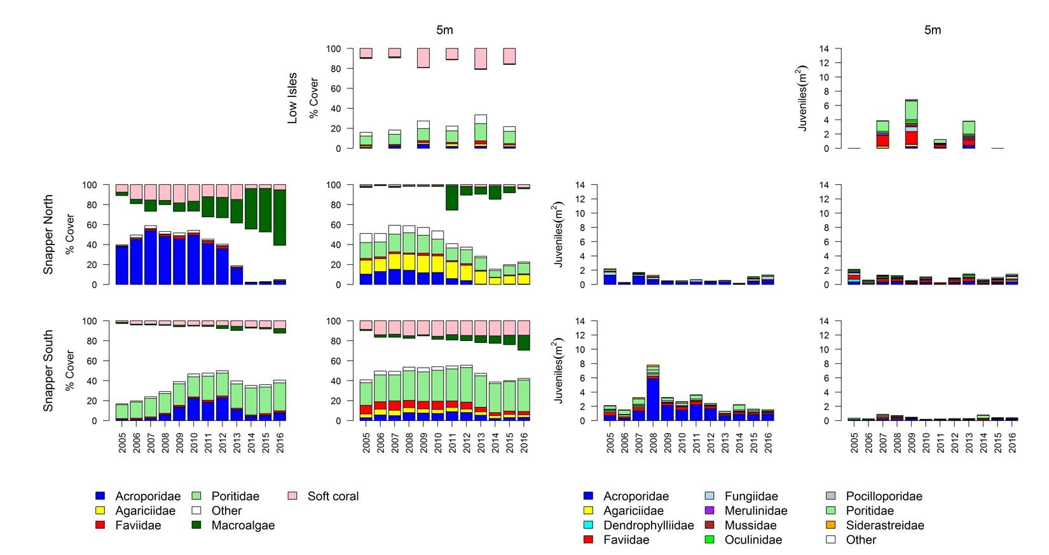
Figure A1. 1 Barron Daintree sub-region benthic community composition.
Cover estimates are separated into regionally abundant hard coral families and the total cover for soft corals and macroalgae (hanging). Juvenile density estimates are for regionally abundant hard coral families. Separate legends relevant groupings for cover and juvenile density estimates are located beneath the relevant plots.

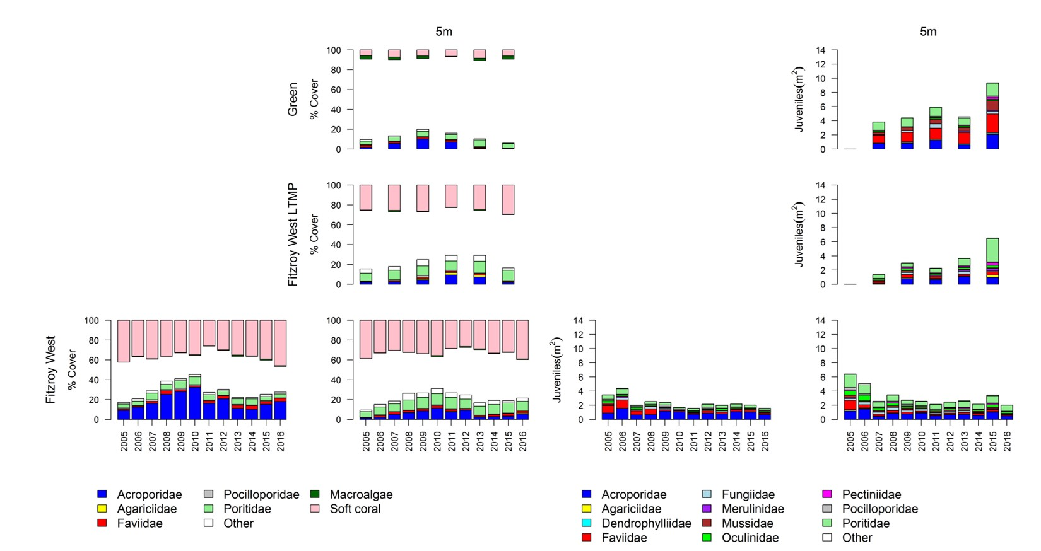
Figure A1. 2 Johnstone Russell-Mulgrave sub-region benthic community composition. Cover estimates are separated into regionally abundant hard coral families and the total cover for soft corals and macroalgae (hanging). Juvenile density estimates are for regionally abundant hard coral families. Separate legends relevant groupings for cover and juvenile density estimates are located beneath the relevant plots.

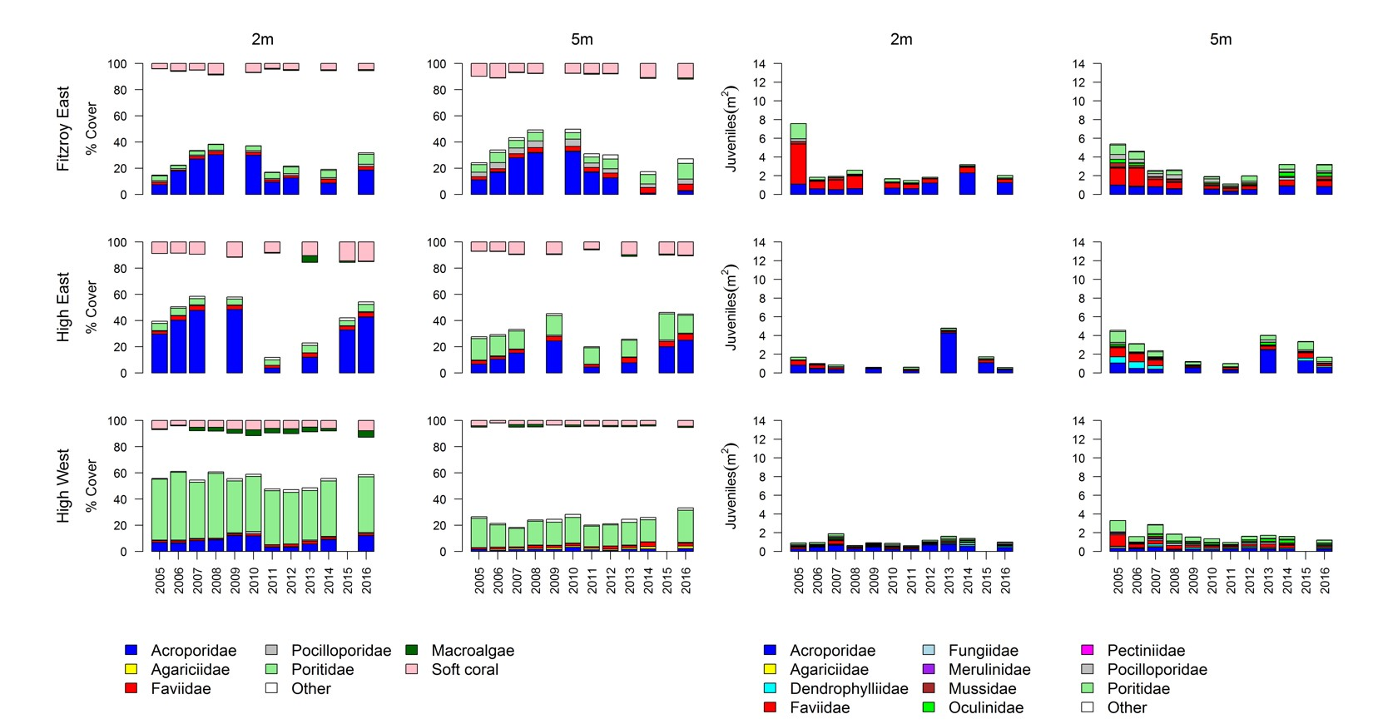
Figure A1. 2 continued

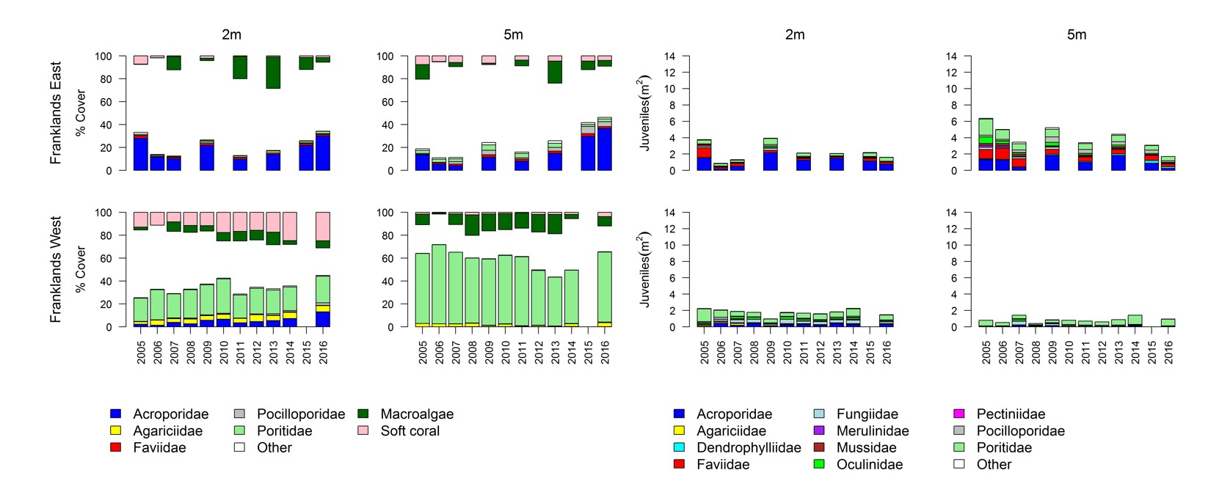
Figure A1. 2 continued

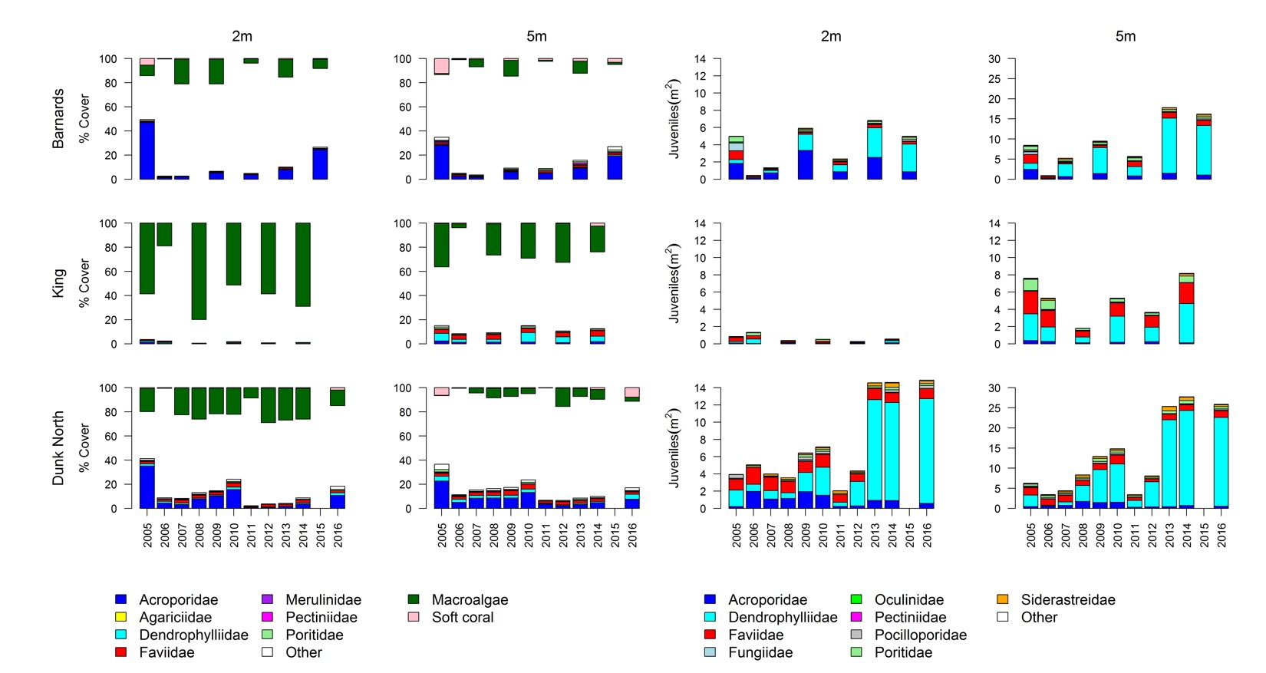
Figure A1. 3 Herbert-Tully sub- region benthic community composition. Cover estimates are separated into regionally abundant hard coral families and the total cover for soft corals and macroalgae (hanging). Juvenile density estimates are for regionally abundant hard coral families. Separate legends with relevant groupings for cover and juvenile density estimates are located beneath the respective plots.

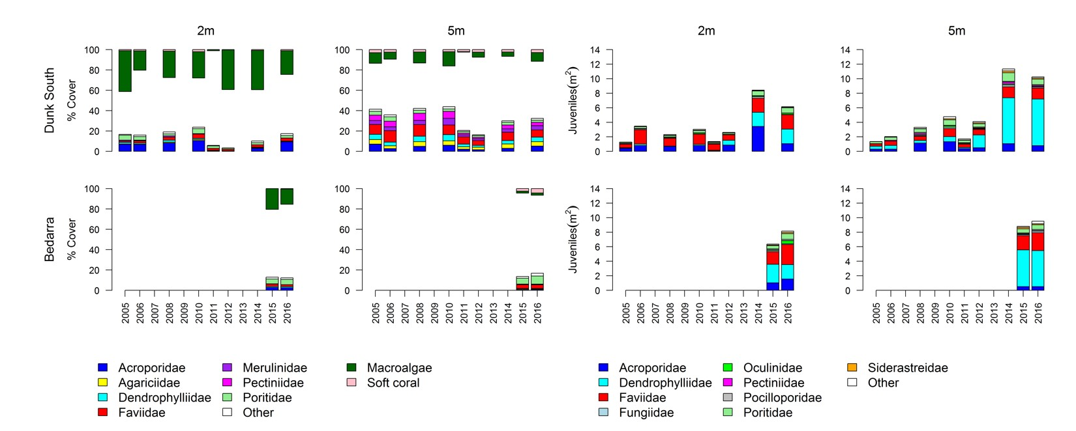
Figure A1. 3 continued

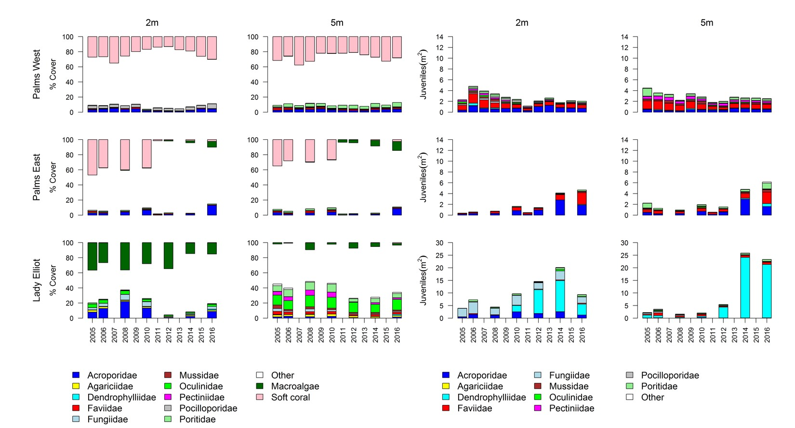
Figure A1. 4 Burdekin Region benthic community composition. Cover estimates are separated into regionally abundant hard coral families and the total cover for soft corals and macroalgae (hanging). Juvenile density estimates are for regionally abundant hard coral families. Separate legends with relevant groupings for cover and juvenile density estimates are located beneath the respective plots.

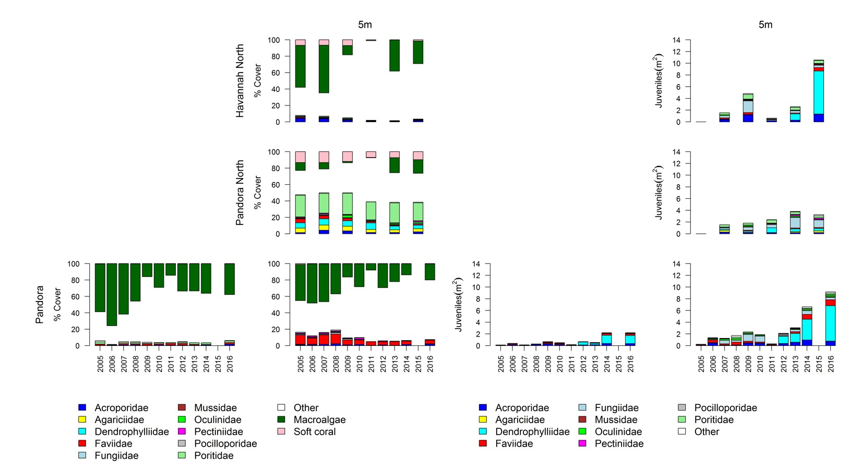
Figure A1. 4 continued

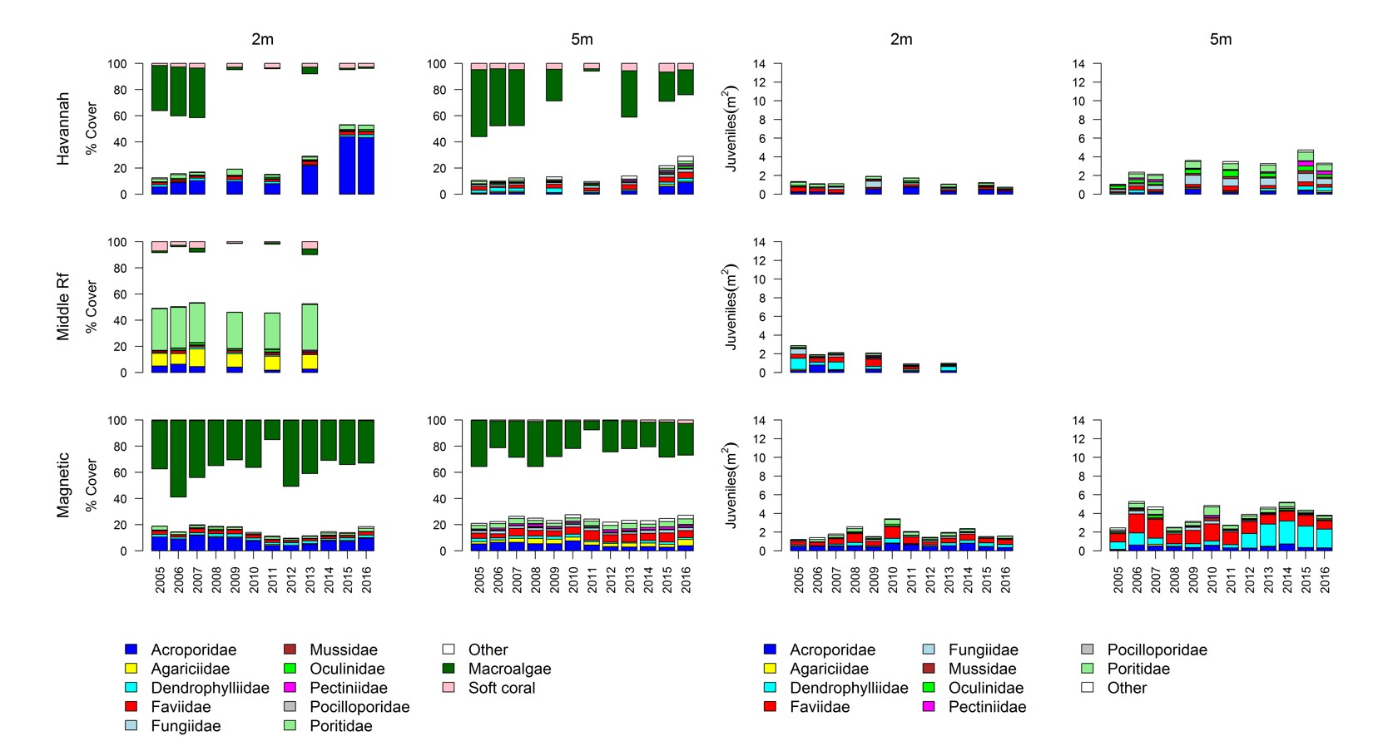
Figure A1. 4 continued

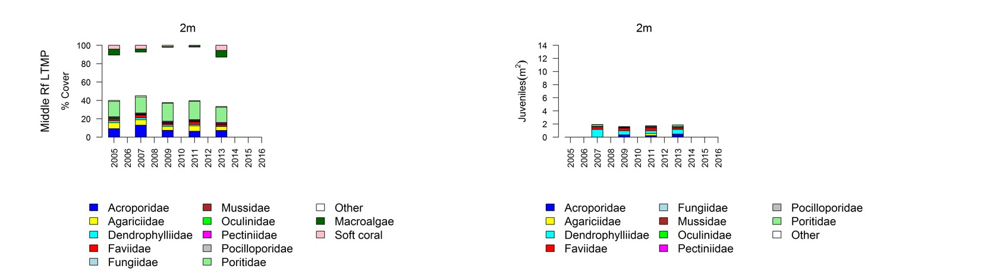
Figure A1. 4 continued

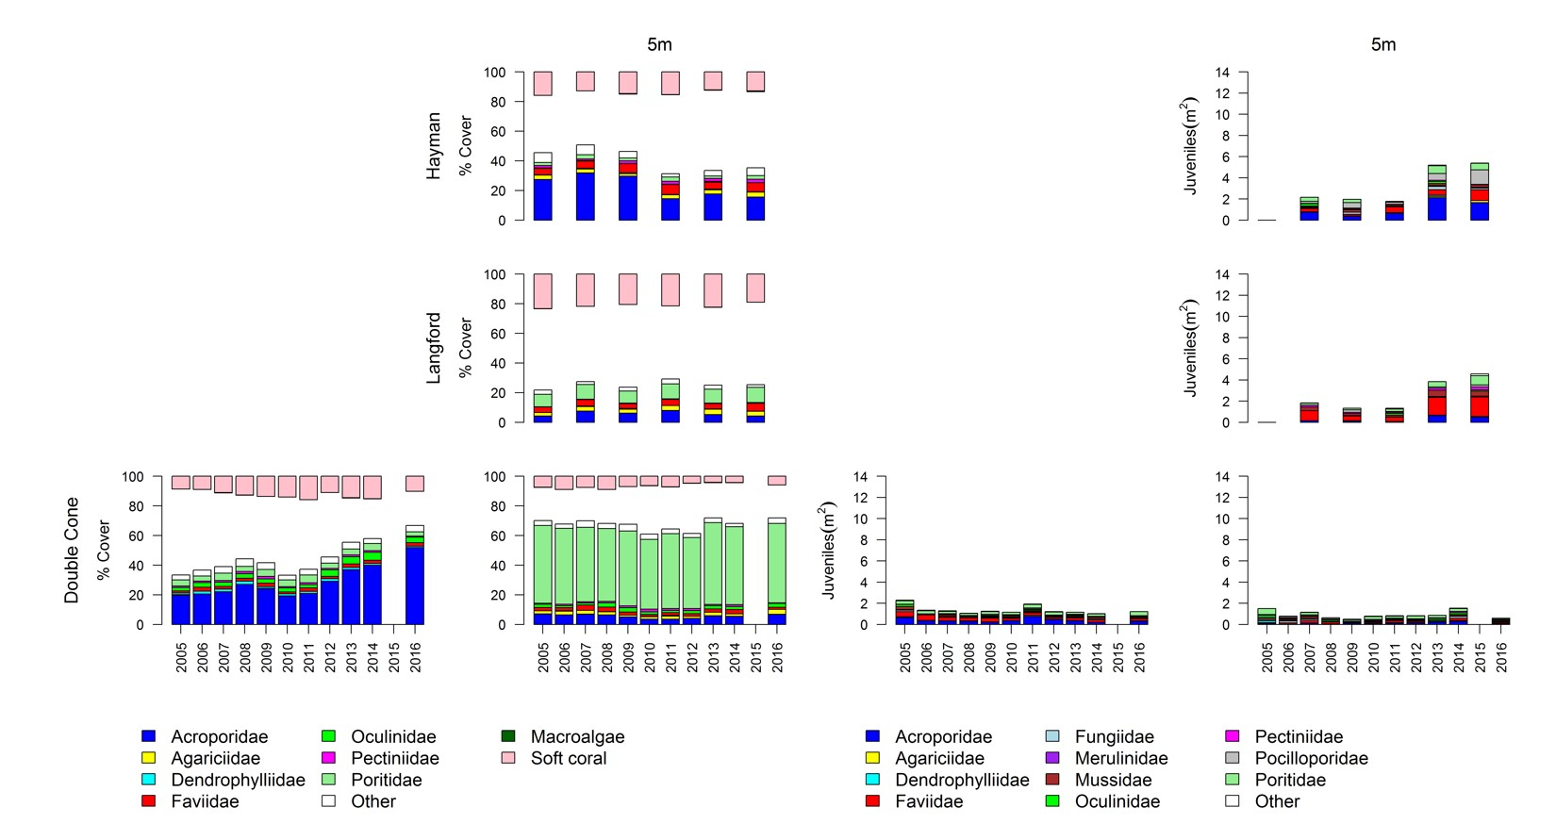
Figure A1. 5 Mackay Whitsunday Region benthic community composition.
Cover estimates are separated into regionally abundant hard coral families and the total cover for soft corals and macroalgae (hanging). Juvenile density estimates are for regionally abundant hard coral families. Separate legends with relevant groupings for cover and juvenile density estimates are located beneath the respective plots.

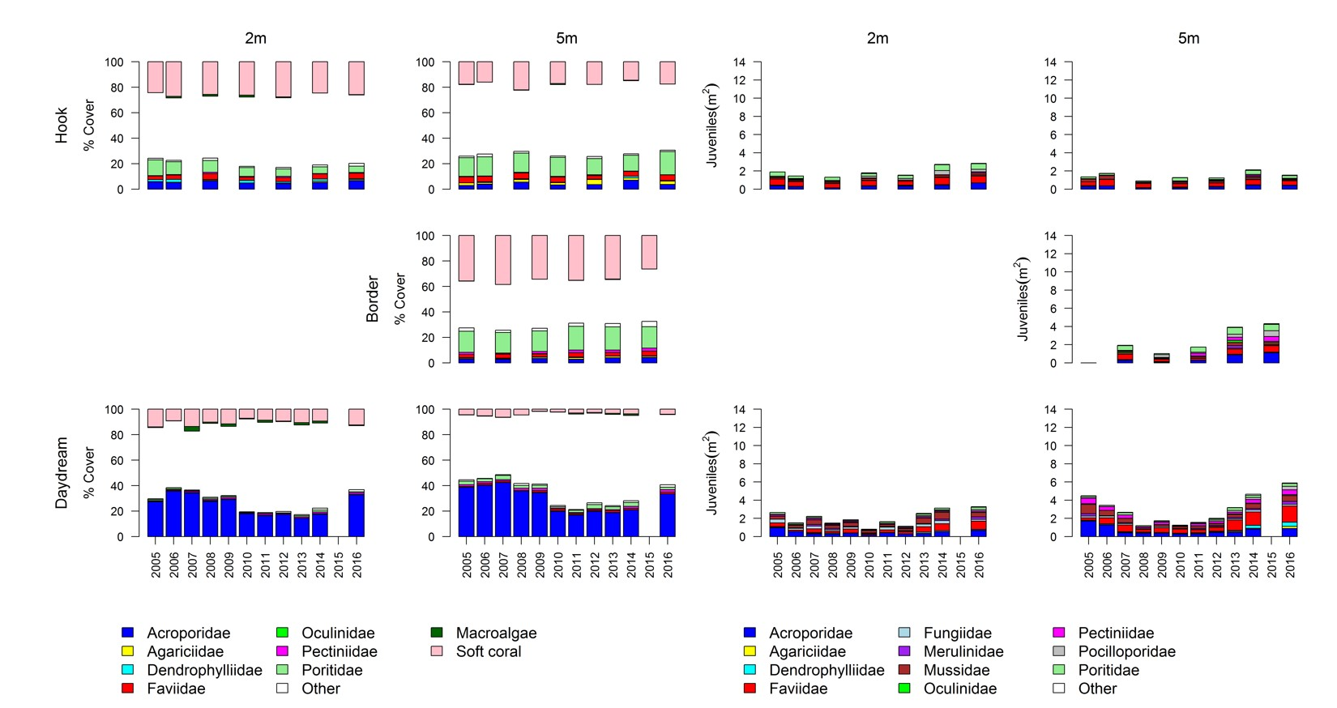
Figure A1. 5 continued

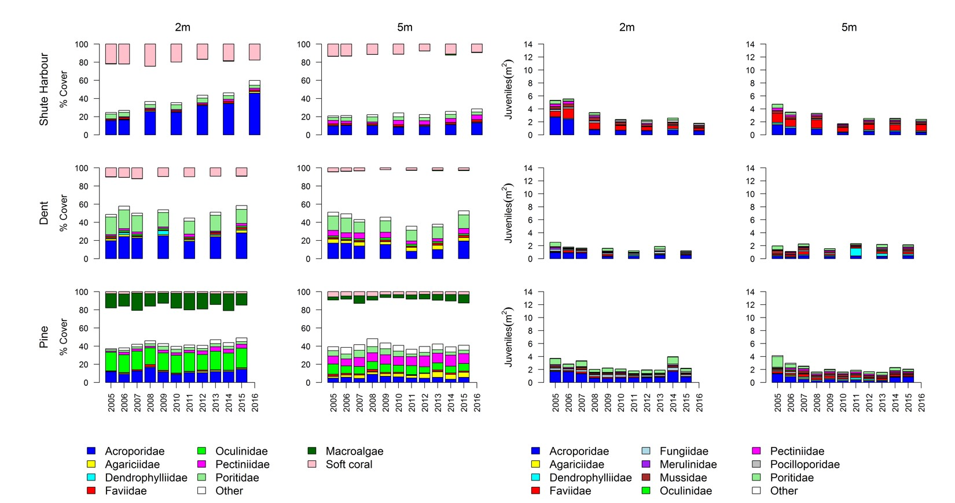
Figure A1. 5 continued

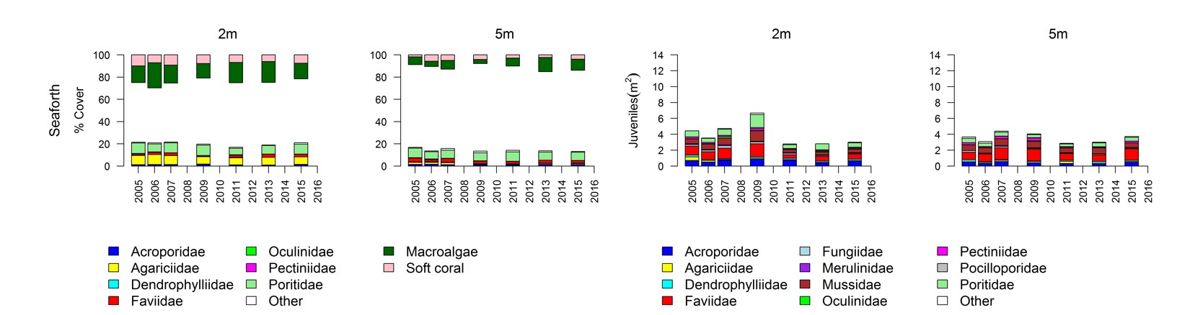
Figure A1. 5 continued

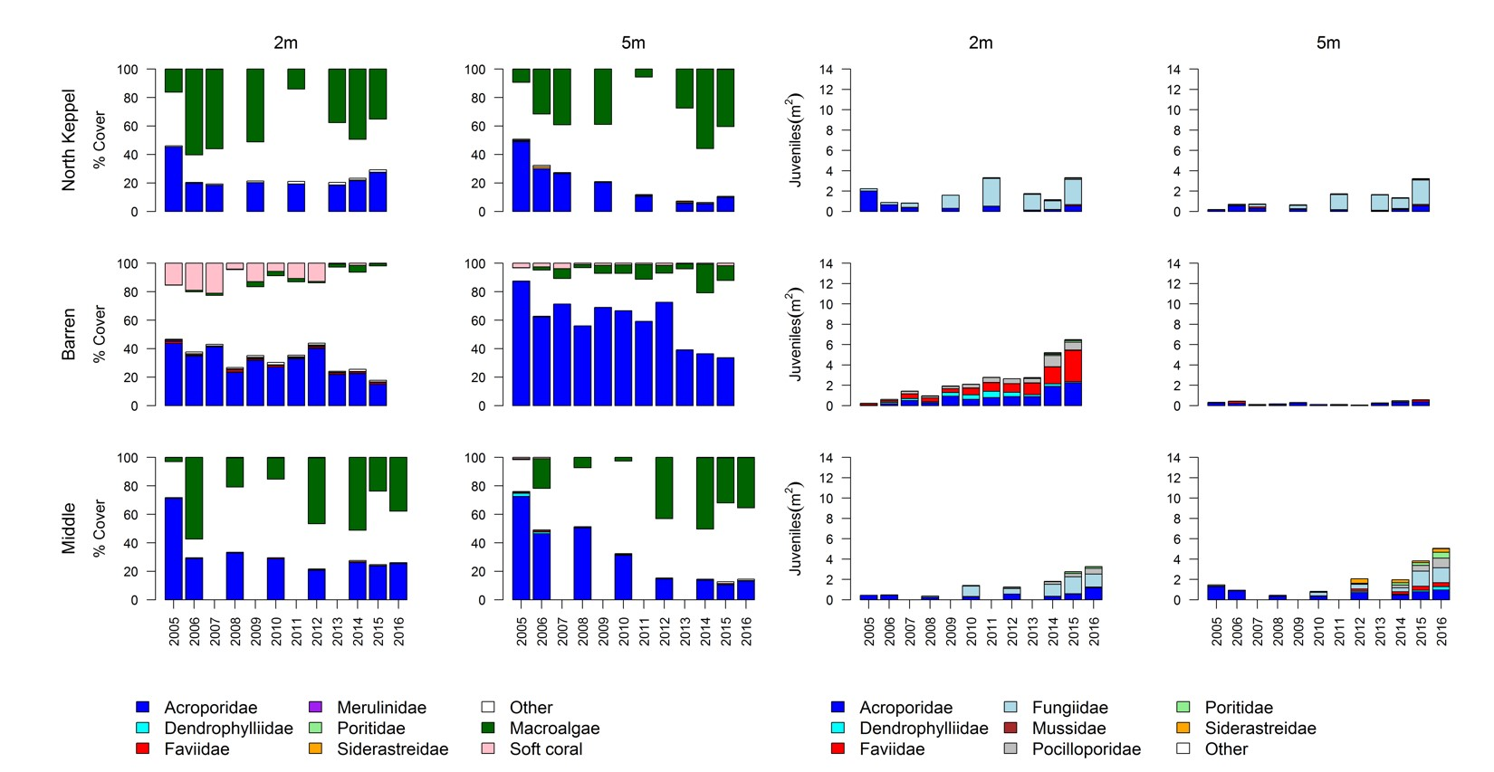
Figure A1. 6 Fitzroy Region benthic community composition. Cover estimates are separated into regionally abundant hard coral families and the total cover for soft corals and macroalgae (hanging). Juvenile density estimates are for regionally abundant hard coral families. Separate legends with relevant groupings for cover and juvenile density estimates are located beneath the respective plots.

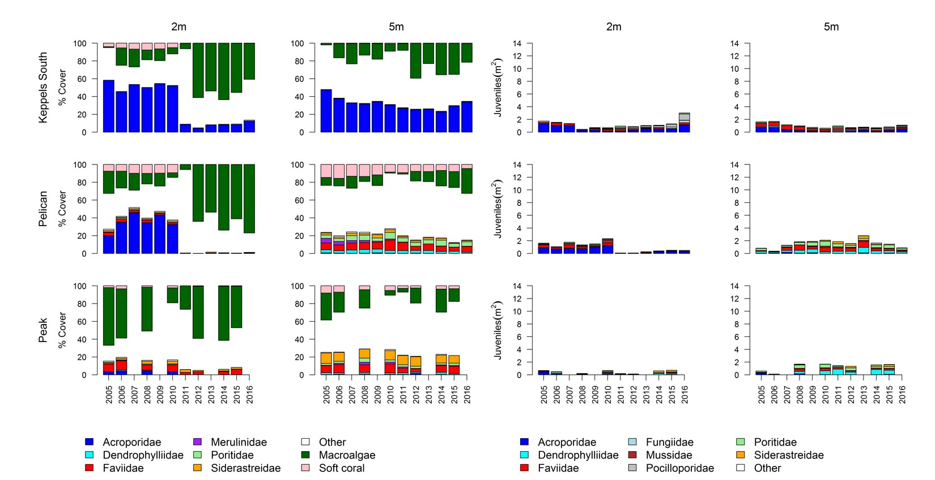
Figure A1. 6 continued

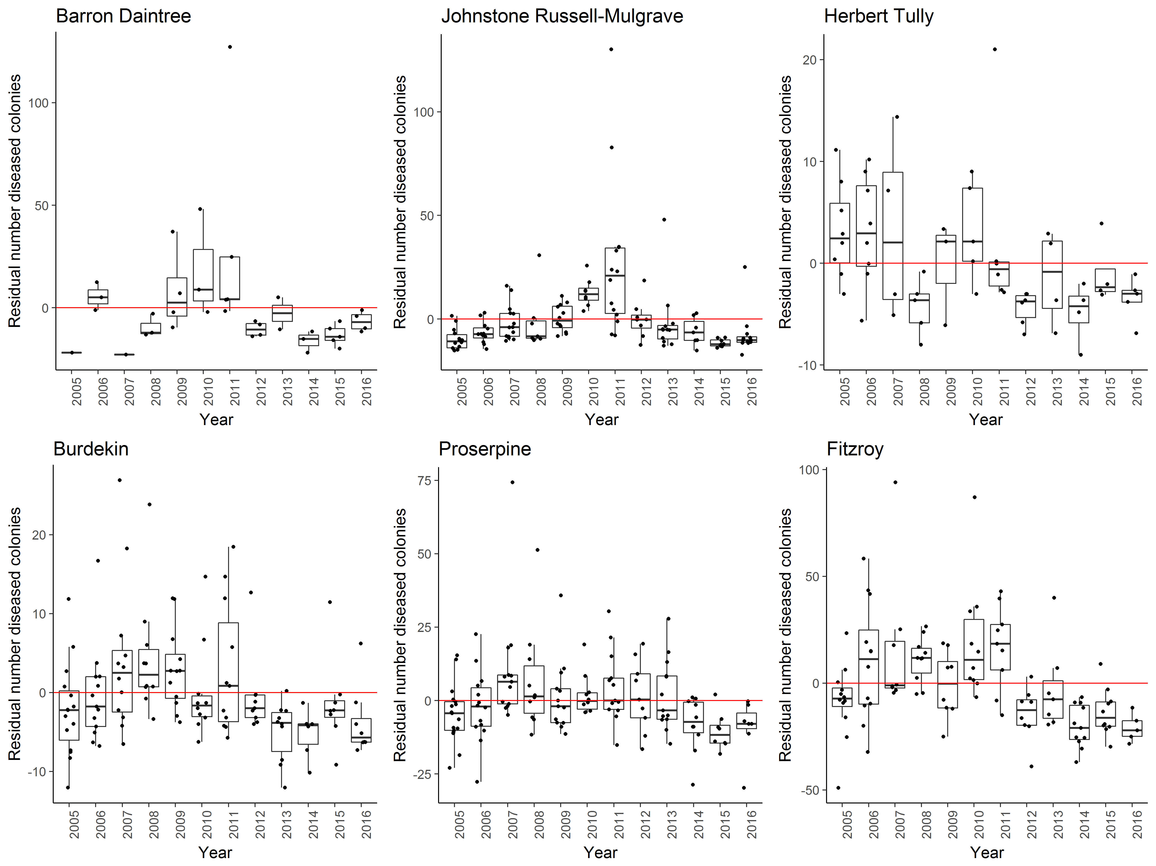
Figure A1. 7 Coral disease by year in each region. Boxplots include the number of coral colonies suffering ongoing mortality attributed to either disease, sedimentation or ‘unknown causes’ for each reef, depth and year. Data are standardised to the reef and depth mean across years.

Table A1. 7 Percent cover of hard coral genera 2016.
Genera for which cover did not exceeded 1% on at least one reef or were unidentified to genus level are grouped as “other”.
subregion | Reef | Depth | Acropora | Alveopora | Caulastrea | Cyphastrea | Diploastrea | Echinophyllia | Echinopora | Favia | Favites | Fungia | Galaxea | Goniastrea | Goniopra | Hydnophora | Isopora | Leptoseris | Lobophyllia | Merulina | Montipora | Mycedium | Oxypora | Pachyseris | Pavona | Pectinia | Platygyra | Plesiastrea | Pocillopora | Podobacia | Porites | Psammocora | Seriatopora | Stylophora | Symphyllia | Turbanaria | Other
Daintree | Snapper North | 2 | 2.08 |  |  |  |  |  | 0.75 |  |  | 0.08 | 0.04 |  |  |  | 0.54 |  | 0.04 |  | 0.17 |  |  |  |  |  |  |  | 0.21 |  | 0.79 |  |  |  |  |  | 0.04
Daintree | Snapper North | 5 | 0.06 |  | 0.25 |  |  |  |  | 0.13 |  | 0.06 | 0.19 |  | 5.19 |  |  | 0.44 |  |  | 0.38 |  |  | 7.20 | 1.50 |  | 0.32 |  |  | 0.06 | 5.44 |  | 0.31 |  |  |  | 1.00
Daintree | Snapper South | 2 | 5.89 |  |  | 0.13 |  |  | 0.04 | 0.25 | 0.04 |  | 1.58 | 0.96 | 0.17 |  |  |  | 0.04 |  | 1.88 |  |  |  | 0.21 |  | 0.21 |  | 0.71 |  | 27.83 | 0.21 |  |  | 0.17 | 0.08 | 0.21
Daintree | Snapper South | 5 | 3.19 |  | 3.00 |  |  |  | 0.19 | 0.06 |  | 0.13 | 0.25 |  | 2.25 |  |  |  | 0.06 |  | 0.06 |  |  | 2.19 | 0.38 |  |  |  | 0.06 |  | 29.19 | 0.31 |  |  |  | 0.50 | 0.44
Daintree | Low Isles | 5 |  |  | 0.07 |  | 0.30 |  | 0.63 | 0.13 | 0.03 | 0.27 | 2.03 | 0.07 | 0.23 | 0.07 |  |  | 0.87 | 0.07 | 1.57 |  |  | 1.60 | 0.03 | 0.13 | 0.13 |  | 0.10 |  | 12.17 | 0.13 | 0.17 | 0.03 |  | 0.23 | 0.57
Johnstone | Green | 5 | 0.10 |  |  | 0.07 | 0.10 |  | 0.07 | 0.03 |  |  | 0.10 | 0.03 | 0.13 |  |  |  | 0.17 |  | 0.17 |  |  | 0.07 |  |  | 0.20 |  |  |  | 4.43 |  | 0.03 |  | 0.03 | 0.07 | 0.23
Johnstone | Fitzroy West LTMP | 5 | 0.03 |  | 0.03 | 0.03 |  |  | 0.10 | 0.10 |  | 0.30 | 0.60 | 0.13 | 0.20 |  |  |  | 0.94 | 0.27 | 1.54 | 0.03 | 0.03 | 0.60 | 0.03 | 0.07 | 0.23 |  | 0.20 | 0.10 | 10.29 |  | 0.03 | 0.27 |  | 0.03 | 0.33
Johnstone | Fitzroy East | 2 | 11.25 |  |  | 0.06 |  | 0.13 | 0.06 | 0.38 | 0.44 |  |  | 0.63 | 0.25 | 0.19 |  |  | 0.13 |  | 6.94 |  |  |  | 0.19 |  | 0.56 |  | 1.75 |  | 7.44 |  |  |  | 0.44 |  | 0.94
Johnstone | Fitzroy East | 5 | 2.19 |  | 0.06 | 0.06 | 0.63 | 0.13 | 1.94 | 0.56 | 0.25 | 0.06 | 1.81 | 0.25 | 0.25 | 0.19 |  |  | 0.44 |  | 0.25 | 0.06 |  | 0.25 | 0.06 | 0.06 | 0.44 |  | 3.81 |  | 11.75 | 0.25 |  |  |  | 0.19 | 1.25
Johnstone | Fitzroy West | 2 | 12.69 |  | 0.06 |  | 0.63 |  | 1.38 | 0.06 | 0.25 | 0.19 | 0.38 | 0.38 | 0.25 |  |  |  | 0.75 | 0.25 | 5.19 |  |  | 0.06 | 0.06 |  | 0.06 |  | 0.38 |  | 3.81 | 0.06 |  |  | 0.19 |  | 0.50
Johnstone | Fitzroy West | 5 | 3.44 |  | 0.19 |  | 0.63 | 0.06 | 0.50 | 0.06 | 0.13 |  | 0.63 | 0.13 | 0.31 | 0.06 |  |  | 1.56 | 0.13 | 2.06 | 0.19 | 0.13 | 0.94 |  |  | 0.25 |  | 0.06 |  | 9.38 | 0.31 |  |  |  |  | 0.44
Johnstone | Franklands East | 2 | 16.81 |  |  |  | 0.06 |  |  | 0.38 | 0.50 |  | 0.06 | 0.13 |  |  | 0.06 |  |  |  | 13.19 |  |  |  |  |  | 0.38 |  | 0.19 |  | 1.94 | 0.06 | 0.13 | 0.25 |  |  | 0.06
Johnstone | Franklands East | 5 | 31.19 | 0.19 |  | 0.06 |  | 0.13 | 0.63 | 0.19 | 0.25 |  |  |  |  | 0.06 |  |  | 0.13 | 0.63 | 5.31 |  | 0.06 | 0.06 |  | 0.06 | 0.31 |  | 0.31 |  | 2.19 | 0.06 | 3.63 | 0.31 |  | 0.06 | 0.44
Johnstone | Franklands West | 2 | 12.95 |  |  |  |  | 0.06 | 0.31 |  |  | 0.25 | 0.13 | 0.06 | 1.06 |  |  |  |  |  | 0.13 |  |  | 5.38 |  |  |  |  | 0.44 |  | 22.14 | 0.13 | 1.69 |  |  | 0.06 | 0.06
Johnstone | Franklands West | 5 | 0.13 |  |  |  |  |  | 0.31 |  |  | 0.13 | 0.06 |  |  | 0.06 |  |  |  |  |  |  |  | 3.50 |  |  |  |  |  |  | 61.13 |  | 0.19
Johnstone | High East | 2 | 32.64 |  |  | 0.06 |  |  | 0.81 | 0.25 | 0.75 |  |  | 0.38 | 0.56 |  |  |  | 0.06 | 0.13 | 1 |  |  |  | 0.06 |  | 0.81 |  | 0.69 |  | 4.94 | 0.13 |  |  | 1.38 | 0.19 | 0.31
Johnstone | High East | 5 | 14.81 |  |  | 0.25 |  |  | 2.69 | 0.31 | 0.63 |  | 0.38 | 0.25 | 0.50 |  |  |  | 0.13 | 0.31 | 9.88 |  |  | 0.13 |  |  | 0.56 |  | 0.44 |  | 13.13 | 0.19 |  | 0.19 |  | 0.06 | 0.19
Johnstone | High West | 2 | 10.75 |  |  |  |  |  | 0.75 |  | 0.25 |  | 0.63 | 0.25 | 3.38 |  |  |  | 0.31 |  | 1.13 |  |  | 0.06 | 0.06 | 0.06 | 0.19 |  | 0.81 | 0.06 | 39.13 | 0.13 |  |  | 0.13 |  | 0.63
Johnstone | High West | 5 | 1.50 |  |  |  |  |  |  | 0.69 | 0.44 | 0.06 | 0.25 | 0.19 | 5.26 |  |  |  | 0.25 | 0.19 | 0.56 | 0.13 | 0.38 | 0.75 | 1.13 |  | 0.25 |  | 0.56 |  | 19.26 |  |  |  |  |  | 1.38
Tully | Barnards | 2 | 16.15 |  |  | 0.13 |  |  |  |  | 0.06 |  | 0.13 |  |  |  |  |  |  |  | 8.38 |  |  | 0.06 |  |  | 0.31 |  | 0.75 |  | 0.13 |  |  |  |  | 0.44
Tully | Barnards | 5 | 8.31 |  |  | 0.75 |  | 0.50 | 0.13 | 0.50 | 0.13 |  | 0.13 |  | 0.38 | 0.25 |  |  | 0.19 | 0.06 | 10.75 | 0.06 | 0.25 |  |  |  |  |  | 1.50 | 0.06 | 1.13 | 0.13 | 0.31 | 0.44 |  | 1.00 | 0.13
Tully | Dunk North | 2 | 6.50 | 0.13 |  | 0.69 |  |  |  | 0.13 | 0.56 |  | 0.38 | 0.13 | 0.31 | 0.06 |  |  |  |  | 4.19 |  |  |  |  |  | 0.13 |  | 1.94 |  | 0.50 | 0.31 |  |  |  | 2.25 | 0.19
Tully | Dunk North | 5 | 2.69 | 0.19 |  | 0.25 |  |  |  | 0.25 | 0.69 |  | 0.06 | 0.31 | 0.13 | 0.19 |  |  | 0.31 |  | 4.56 |  | 0.25 | 0.13 |  |  | 0.19 |  | 0.81 | 0.25 | 0.38 | 0.25 | 0.44 |  |  | 4.19 | 0.56
Tully | Dunk South | 2 | 7.63 |  |  | 1.75 |  |  |  | 0.19 | 0.31 |  | 0.50 | 0.06 | 0.06 | 0.06 |  |  | 0.50 |  | 1.69 |  |  |  | 0.19 |  |  |  | 0.06 |  | 2.38 | 0.31 |  |  | 0.06 | 0.56 | 1.00
Tully | Dunk South | 5 | 2.56 |  | 0.06 | 0.44 |  | 0.13 | 0.56 | 3.00 | 0.88 |  | 0.25 | 1.25 | 0.19 |  |  | 0.19 | 0.56 | 4.13 | 2.31 | 1.75 | 0.69 | 3.75 | 0.38 | 0.88 | 0.63 |  | 0.25 | 0.38 | 1.88 |  | 0.31 |  |  | 4.38 | 0.69
Tully | Bedarra | 2 | 1.81 |  |  | 0.63 |  |  |  | 0.31 | 0.63 | 0.13 | 0.13 | 0.06 | 0.44 | 0.06 |  |  | 0.88 |  | 0.69 |  |  |  | 0.06 |  | 0.31 |  |  | 0.06 | 4.75 | 0.06 |  |  | 0.06 | 1.00 | 0.19
Tully | Bedarra | 5 | 0.19 |  |  | 0.25 |  | 0.19 |  | 1.75 | 0.50 | 0.13 | 0.19 | 0.06 | 3.00 |  |  | 0.06 | 1.50 | 0.38 | 0.50 |  | 0.13 | 0.50 | 0.06 |  | 0.06 | 0.06 | 0.38 | 0.25 | 4.94 |  | 0.25 |  |  | 0.44 | 1.06
Burdekin | Palms East | 2 | 12.06 |  |  | 0.19 |  |  | 0.06 |  |  |  |  | 0.19 |  |  |  |  |  |  | 0.94 |  |  |  |  |  |  |  |  |  | 1.00 |  |  |  | 0.06 |  | 0.31
Burdekin | Palms East | 5 | 7.38 |  |  | 0.06 |  |  |  |  | 0.63 |  | 0.06 | 0.06 |  |  |  |  |  |  | 1.19 |  |  |  |  |  |  |  | 0.38 |  | 0.88 |  |  |  |  |  | 0.25
Burdekin | Palms West | 2 | 3.81 |  |  |  |  |  |  |  | 0.13 |  |  | 0.06 |  |  |  |  |  |  | 0.25 |  |  | 0.13 |  |  | 0.06 |  | 5.88 |  | 0.25 |  |  | 0.25 |  |  | 0.31
Burdekin | Palms West | 5 | 3.50 |  |  | 0.06 |  | 0.06 |  | 0.25 |  | 0.06 |  | 0.38 | 0.56 |  | 0.06 |  | 0.31 | 0.06 | 0.44 |  |  | 0.06 | 0.13 | 0.06 | 0.25 | 0.06 | 0.56 |  | 5.13 |  | 0.13 |  |  |  | 0.69
Burdekin | Havannah North | 5 | 0.90 |  |  | 0.03 |  | 0.17 |  |  |  | 0.07 | 0.17 | 0.13 | 0.07 | 0.13 |  |  |  |  | 0.57 | 0.17 | 0.07 |  | 0.03 |  |  |  |  |  | 0.20 | 0.17 | 0.20 | 0.13 |  | 0.10 | 0.07
Burdekin | Havannah | 2 | 34.31 |  |  |  |  |  | 0.69 | 0.13 | 0.25 |  | 1.00 | 0.31 | 0.25 |  | 1.88 |  | 0.31 | 0.13 | 6.75 |  |  |  | 0.31 |  | 1.00 |  | 0.13 | 0.06 | 2.88 | 0.06 |  | 0.06 |  | 2.13 | 0.19
Burdekin | Havannah | 5 | 5.25 |  |  | 0.31 | 1.56 |  | 1.13 | 0.31 | 0.69 | 1.75 | 1.44 | 0.13 | 0.44 | 0.19 |  |  | 0.63 | 3.38 | 2.88 | 0.06 | 0.81 | 0.75 | 0.06 | 0.19 | 0.56 |  | 0.19 | 0.06 | 1.50 | 0.13 |  | 0.75 |  | 2.31 | 1.44
Burdekin | Pandora North | 5 | 0.97 |  | 0.07 | 0.10 |  | 0.03 | 0.53 | 0.13 | 0.07 | 0.73 | 1.50 |  | 14.73 | 0.07 | 0.27 | 0.87 | 0.17 | 0.50 | 1.07 | 0.60 | 0.37 | 2.43 | 0.63 | 0.37 | 0.13 |  | 0.20 | 0.10 | 7.07 | 0.23 | 0.03 |  | 0.03 | 4.20 | 0.30
Burdekin | Pandora | 2 | 1.31 |  |  |  |  |  |  |  | 0.44 |  |  | 0.31 |  | 0.13 |  |  |  | 0.06 | 0.50 |  |  |  |  |  | 0.13 | 0.94 |  |  | 2.06 | 0.31 |  |  |  | 0.06
Burdekin | Pandora | 5 | 1.63 |  |  |  | 2.06 |  | 0.13 | 1.06 | 0.25 | 0.19 | 0.25 | 0.13 |  | 0.06 |  |  |  | 0.06 | 0.19 |  | 0.31 | 0.13 |  |  | 0.44 |  |  |  |  |  |  |  |  | 0.19 | 0.38
Burdekin | Lady Elliot | 2 | 4.88 |  |  | 0.13 |  |  |  | 0.06 |  | 3.50 | 2.63 |  | 0.13 | 0.06 |  |  |  |  | 3.94 |  |  |  | 1.56 |  |  |  |  | 0.13 | 0.75 | 0.13 |  |  |  | 1.25 | 0.19
Burdekin | Lady Elliot | 5 | 0.75 | 0.38 |  | 0.31 |  |  |  | 0.88 | 0.50 |  | 14.13 | 0.69 | 2.38 | 0.44 |  |  | 1.63 | 0.38 | 0.56 | 0.50 | 0.75 | 1.94 |  | 0.88 |  |  |  | 1.00 | 2.81 | 0.56 |  |  |  | 1.81 | 0.94
Burdekin | Middle Reef LTMP | 2 | 1.47 |  |  | 0.07 |  | 0.40 | 0.07 | 0.91 | 0.10 | 0.03 | 0.13 | 0.07 | 15.38 | 0.23 | 0.23 |  | 0.24 | 0.47 | 5.54 | 0.07 | 0.20 | 4.27 | 0.13 | 0.41 | 0.24 |  | 0.13 | 0.23 | 1.31 |  |  |  | 0.03 | 0.37 | 0.57
Burdekin | Magnetic | 2 | 1.63 |  |  | 1.50 |  |  | 0.13 | 0.25 | 0.44 |  | 0.25 |  | 0.50 | 0.19 |  |  |  | 0.13 | 7.94 |  |  | 0.31 | 0.13 |  |  | 0.13 | 0.06 |  | 1.94 | 0.75 |  |  |  | 1.94 | 0.31
Burdekin | Magnetic | 5 | 1.81 |  |  | 0.63 |  |  |  | 2.06 | 1.06 | 0.38 | 0.44 | 0.31 | 2.81 | 0.69 |  |  | 0.06 | 2.00 | 1.88 | 0.56 | 0.63 | 4.81 |  | 0.25 | 0.63 |  | 0.44 | 1.25 | 1.44 |  |  | 0.13 |  | 1.38 | 1.50
Proserpine | Hayman | 5 | 3.80 |  | 0.03 |  | 1.90 | 0.17 | 1.33 | 0.90 | 0.50 | 0.07 | 0.10 | 0.63 | 0.23 |  | 0.03 |  | 0.57 | 2.30 | 11.63 | 0.53 | 0.83 | 3.13 | 0.17 | 0.73 | 0.50 |  | 0.20 |  | 2.13 |  | 1.80 | 0.03 | 0.20 | 0.23 | 0.57
Proserpine | Langford | 5 | 2.63 |  |  | 0.07 | 0.80 |  | 1.50 | 1.30 | 0.43 |  |  | 0.50 | 6.10 | 0.23 | 0.03 |  | 0.70 | 0.17 | 1.13 | 0.07 | 0.03 | 0.10 | 3.00 | 0.43 | 0.10 |  | 0.13 | 0.03 | 4.13 |  | 0.20 | 0.03 |  | 0.13 | 1.30
Proserpine | Border | 5 | 2.97 |  |  | 0.17 | 0.43 | 0.20 | 0.33 | 1.20 | 0.37 | 0.10 | 0.10 | 0.40 | 11.50 | 0.60 |  |  | 1.23 | 0.30 | 1.17 | 0.33 | 0.67 | 0.50 | 0.47 | 1.07 | 0.57 |  | 0.23 |  | 5.43 |  | 0.97 | 0.33 | 0.03 | 0.27 | 0.63
Proserpine | Hook | 2 | 3.38 |  |  | 0.13 | 1.38 |  | 0.69 | 0.56 | 0.75 |  |  | 0.44 | 0.25 |  |  |  | 0.44 | 0.25 | 3.00 | 0.25 | 0.06 | 0.81 | 0.06 | 0.25 | 0.19 |  | 0.50 |  | 4.76 |  |  | 0.81 |  | 0.69 | 0.56
Proserpine | Hook | 5 | 1.63 | 0.13 |  | 0.06 | 0.44 |  | 0.19 | 1.06 | 1.44 | 0.06 |  | 0.25 | 3.25 | 0.06 |  |  | 0.63 |  | 1.94 |  |  | 0.88 | 1.75 | 0.13 | 0.31 |  | 0.06 |  | 14.81 |  |  | 0.06 |  | 0.31 | 1.19
Proserpine | Double Cone | 2 | 47.50 | 0.31 | 0.13 | 0.06 |  | 0.06 | 1.63 |  |  | 0.13 | 3.75 | 0.19 | 1.94 | 0.88 | 0.50 |  | 1.00 | 1.06 | 3.88 | 0.13 | 0.06 | 0.06 |  | 0.38 | 0.38 |  | 0.56 |  | 0.75 | 0.50 |  |  |  | 0.88 | 0.06
Proserpine | Double Cone | 5 | 6.56 | 0.06 |  | 0.13 | 0.31 |  | 0.56 |  |  | 0.06 | 2.63 |  | 51.06 | 0.25 |  |  | 2.44 | 0.13 | 0.25 |  | 0.25 | 1.94 | 1.44 | 0.19 |  | 0.06 | 0.44 |  | 2.38 | 0.06 |  |  |  |  | 0.75
Proserpine | Daydream | 2 | 31.06 |  |  |  |  | 0.06 |  |  |  | 0.06 |  | 0.13 | 0.13 |  | 0.38 |  | 0.50 | 0.06 | 1.44 | 0.06 | 0.56 |  |  | 0.50 | 0.13 |  | 0.50 | 0.06 | 0.69 |  | 0.19 | 0.13 |  |  | 0.19
Proserpine | Daydream | 5 | 29.01 |  |  | 0.06 |  |  | 0.44 | 0.13 | 0.06 |  |  | 0.50 |  |  | 0.88 |  | 0.25 | 0.19 | 3.32 | 0.56 | 0.56 |  | 0.06 | 0.81 |  |  |  | 0.06 | 1.94 |  | 1.00 | 0.19 |  |  | 0.69
Proserpine | Dent | 2 | 27.86 |  |  | 0.31 |  |  | 0.88 | 0.06 |  |  | 1.63 | 0.19 | 4.32 |  |  | 0.19 | 1.88 | 1.75 | 0.56 |  |  | 0.25 | 2.31 | 2.88 | 0.06 |  |  |  | 11.14 | 0.19 |  | 0.31 |  | 1.13 | 0.56
Proserpine | Dent | 5 | 18.65 | 0.19 |  | 0.06 |  | 0.13 | 0.81 | 0.38 | 0.25 | 0.06 | 1.69 | 0.19 | 12.56 | 0.19 |  | 1.19 | 1.50 | 1.44 | 0.81 | 0.31 | 2.94 | 2.06 | 0.38 | 2.51 | 0.31 |  | 0.06 | 0.31 | 2.25 |  |  | 0.44 |  | 0.06 | 1.00
Proserpine | Shute Harbour | 2 | 41.22 |  | 0.44 |  |  | 0.06 |  | 0.13 | 0.06 |  |  | 0.44 | 3.25 | 1.50 | 0.44 |  | 0.88 | 0.06 | 4.25 | 0.38 | 0.56 | 0.56 | 1.06 | 1.13 | 0.25 |  | 0.94 |  | 0.06 |  |  | 1.44 |  | 0.31 | 0.38
Proserpine | Shute Harbour | 5 | 8.57 |  |  | 0.19 | 0.38 | 0.25 | 0.06 | 0.50 | 0.13 |  | 0.06 | 0.31 | 2.13 |  | 0.06 |  | 0.75 | 0.38 | 4.51 | 1.00 | 2.56 | 0.63 | 0.06 | 1.44 | 0.44 |  | 0.44 | 0.06 | 1.13 |  |  | 0.75 | 0.13 | 0.25 | 1.31
Proserpine | Pine | 2 | 6.69 |  |  | 0.06 |  |  | 0.06 | 0.19 | 0.19 | 0.13 | 21.56 | 0.06 | 0.25 | 0.50 | 0.13 | 0.06 | 1.38 | 0.69 | 7.63 | 0.13 | 1.25 | 0.94 |  | 3.06 |  |  | 0.81 | 0.31 | 2.63 |  |  |  |  | 0.06 | 0.38
Proserpine | Pine | 5 | 1.75 |  |  |  |  | 1.25 | 0.31 | 0.38 | 0.13 | 0.13 | 8.31 | 0.13 | 2.88 | 0.19 |  | 0.31 | 2.31 | 0.13 | 3.94 | 1.75 | 2.00 | 5.13 |  | 5.94 |  |  |  | 1.19 | 1.00 |  |  |  |  | 0.13 | 1.75
Proserpine | Seaforth | 2 | 0.81 | 0.31 |  |  |  |  | 0.31 | 0.50 | 1.00 | 0.13 | 0.06 | 0.19 | 1.94 | 0.06 |  |  | 0.56 | 0.06 | 0.13 |  |  | 0.25 | 6.50 |  | 0.06 |  | 0.31 | 0.19 | 6.69 |  |  |  |  | 0.06 | 0.88
Proserpine | Seaforth | 5 | 0.25 |  | 0.31 |  | 0.50 |  | 0.06 | 0.31 | 0.13 | 0.06 | 0.06 | 0.56 | 5.69 | 0.06 |  |  | 0.19 |  | 0.69 |  | 0.13 | 0.13 | 0.69 |  | 0.31 |  |  | 0.13 | 1.75 |  |  |  |  | 0.38 | 0.81
Fitzroy | Barren | 2 | 6.00 | 0.13 |  | 0.13 |  |  |  |  |  |  |  | 0.25 |  |  | 3.13 |  |  |  | 5.69 |  |  |  | 0.50 |  | 0.25 |  | 0.50 |  | 0.25 | 0.19 |  |  |  |  | 0.81
Fitzroy | Barren | 5 | 32.65 |  |  |  |  |  |  |  | 0.06 |  |  |  |  |  |  |  |  |  | 0.81 |  |  |  |  |  |  |  | 0.06
Fitzroy | North Keppel | 2 | 26.17 |  |  |  |  |  |  |  |  | 1.69 |  | 0.06 |  |  |  |  |  |  | 1.13 |  |  |  |  |  |  |  |  |  |  | 0.13 |  |  |  |  | 0.06
Fitzroy | North Keppel | 5 | 9.00 |  |  |  |  |  |  |  |  | 0.50 |  |  |  |  |  |  |  |  | 0.69 |  |  |  |  |  |  |  |  |  |  | 0.31
Fitzroy | Middle | 2 | 24.02 |  |  |  |  | 0.06 |  |  |  | 0.31 |  |  |  |  |  |  |  |  | 1.38 |  |  |  |  |  | 0.13 |  | 0.13
Fitzroy | Middle | 5 | 11.90 |  |  |  |  |  |  |  |  | 0.13 |  |  |  |  |  |  |  |  | 1.13 |  |  |  |  |  |  |  | 0.88 |  | 0.13 |  |  |  |  | 0.25 | 0.13
Fitzroy | Keppels South | 2 | 11.00 |  |  | 0.19 |  |  |  |  |  |  |  |  |  |  |  |  |  |  | 1.25 |  |  |  |  |  |  |  | 0.88 |  | 0.13
Fitzroy | Keppels South | 5 | 32.50 |  |  |  |  |  |  |  |  | 0.06 |  |  |  |  |  |  | 0.06 |  | 1.19 |  |  |  |  |  |  |  | 0.25 |  | 0.25 |  |  |  |  | 0.19 | 0.13
Fitzroy | Pelican | 2 | 0.06 |  |  | 0.25 |  |  |  | 0.13 |  |  |  |  |  |  |  |  |  |  |  |  |  |  |  |  |  | 0.13 |  |  | 0.31 | 0.31
Fitzroy | Pelican | 5 |  | 3.75 |  | 0.13 |  |  |  | 0.31 | 3.25 |  |  | 1.38 | 1.19 | 0.25 |  |  | 0.38 |  |  |  |  |  |  |  | 0.44 | 0.75 |  |  | 0.06 | 1.44 |  |  |  | 1.19 | 0.56
Fitzroy | Peak | 2 |  |  |  | 0.56 |  |  |  | 0.06 | 0.81 |  |  |  | 0.19 |  |  |  |  |  | 0.06 |  |  |  |  |  |  | 4.31 |  |  | 0.31 | 1.88 |  |  |  | 0.06 | 0.06
Fitzroy | Peak | 5 |  | 1.00 |  | 1.88 |  |  |  | 0.25 | 3.88 |  |  | 0.25 | 0.81 | 1.00 |  |  |  |  | 0.25 |  |  |  |  |  | 0.06 | 1.81 |  |  | 0.75 | 8.38 |  |  |  | 1.13 | 0.19

Table A1. 8 Percent cover of soft coral families 2016.
Families for which cover did not exceeded 0.25% on at least one reef or corals not identified to family level are grouped to ‘Other’.
subregion | Reef | Depth | Alcyoniidae | Anthothelidae | Briareidae | Clavulariinae | Heliporidae | Neptheidae | Paralcyoniidae | Xeniidae | Gorgoniidae like | Other
Daintree | Snapper North | 2 | 0.02 |  | 2.33 | 1.35
Daintree | Snapper North | 5 |  |  | 0.31 | 0.06 |  |  |  | 0.31
Daintree | Snapper South | 2 | 0.54 |  | 0.96 | 0.04 | 1.92
Daintree | Snapper South | 5 | 0.03 |  | 8.88 |  | 5.06 |  |  |  |  | 0.09
Daintree | Low Isles | 5 | 0.65 |  | 9.30 |  | 0.13 |  |  |  | 0.03
Johnstone | Green | 5 | 0.59 |  | 0.23 |  |  |  |  | 0.02 | 0.03 | 0.27
Johnstone | Fitzroy West LTMP | 5 | 3.20 |  | 0.47 |  |  |  |  | 0.01 | 0.03 | 0.03
Johnstone | Fitzroy East | 2 | 0.31 |  | 1.06 | 0.09 |  | 0.05
Johnstone | Fitzroy East | 5 | 0.42 |  | 5.69 | 0.28 |  | 0.08 |  | 0.01
Johnstone | Fitzroy West | 2 | 5.07 |  | 0.19
Johnstone | Fitzroy West | 5 | 4.31 |  | 0.06 | 0.03 |  |  |  |  | 0.06
Johnstone | Franklands East | 2 | 0.08 |  |  | 0.28 | 0.13 |  |  | 0.01
Johnstone | Franklands East | 5 | 0.33 |  | 0.75 | 0.13
Johnstone | Franklands West | 2 | 1.74 |  |  | 4.53 | 0.06 | 0.01
Johnstone | Franklands West | 5 | 0.37 |  |  | 0.22
Johnstone | High East | 2 | 1.01 |  | 5.38 | 0.03 |  | 0.01 |  | 0.01
Johnstone | High East | 5 | 0.12 |  | 8.69 | 0.06 |  |  |  | 0.02
Johnstone | High West | 2 | 0.45 |  | 0.31 |  | 3.50
Johnstone | High West | 5 | 0.23 |  | 1.19 |  | 1.00 |  |  |  | 0.06
Tully | Barnards | 2 | 0.03 |  | 0.25
Tully | Barnards | 5 | 0.08 |  | 1.63 |  |  |  | 0.25 | 0.08
Tully | Dunk North | 2 | 0.19 |  |  | 0.09 |  |  |  |  | 0.06 | 0.03
Tully | Dunk North | 5 | 0.19 |  | 0.13 | 0.03 |  | 0.01 |  | 0.61 | 0.88 | 0.06
Tully | Dunk South | 2 | 0.01 |  | 0.88 | 0.06
Tully | Dunk South | 5 | 0.05 |  | 2.44
Tully | Bedarra | 2 | 0.03 |  | 0.06 | 0.03 |  |  |  |  | 0.03
Tully | Bedarra | 5 | 0.08 |  | 3.31 |  |  |  |  | 0.02 | 0.13 | 0.03
Burdekin | Palms East | 2 | 0.25
Burdekin | Palms East | 5 | 0.28
Burdekin | Palms West | 2 | 2.47 |  | 0.44 | 0.31 |  | 0.60 |  | 0.01
Burdekin | Palms West | 5 | 2.43 |  | 3.31 | 0.25 |  | 0.19 |  |  | 0.19
Burdekin | Havannah | 5 | 0.04 |  | 1.03 | 0.03 |  |  |  |  |  | 0.03
Burdekin | Havannah | 2 | 0.13 |  | 1.63
Burdekin | Havannah North | 5 | 0.01 |  | 4.75 |  |  |  |  | 0.02
Burdekin | Pandora North | 5 | 0.12 |  | 5.00 | 1.67 |  | 0.02 |  |  | 0.13 | 0.03
Burdekin | Pandora | 2 | 0.03
Burdekin | Pandora | 5 | 0.02 |  |  | 0.13 |  | 0.01
Burdekin | Lady Elliot | 2 | 0.02
Burdekin | Lady Elliot | 5 | 0.10 |  |  |  |  | 0.01
Burdekin | Magnetic | 2 | 0.06 |  | 0.06
Burdekin | Magnetic | 5 | 0.24 |  | 0.31 |  |  |  |  |  | 0.03
Burdekin | Middle Reef LTMP | 2 | 0.43 |  |  |  |  | 0.01 |  |  | 1.23 | 0.38
Proserpine | Hayman | 5 | 1.16 |  | 1.63 |  |  | 0.06 |  |  |  | 0.07
Proserpine | Langford | 5 | 2.00 |  | 0.43 |  |  | 0.04 |  |  |  | 0.13
Proserpine | Border | 5 | 2.86 |  | 0.30 |  |  | 0.02 |  | 0.01
Proserpine | Hook | 2 | 2.71 |  | 1.44 |  |  | 0.01
Proserpine | Hook | 5 | 1.88 |  | 0.31 |  |  | 0.01 |  |  | 0.13
Proserpine | Double Cone | 2 | 0.90 |  | 2.06
Proserpine | Double Cone | 5 | 0.52 |  | 1.06 |  |  | 0.01
Proserpine | Daydream | 2 | 1.37
Proserpine | Daydream | 5 | 0.42 |  |  |  |  |  |  | 0.02
Proserpine | Dent | 2 | 0.67 |  | 2.82
Proserpine | Dent | 5 | 0.24 |  | 0.25 |  |  | 0.01
Proserpine | Shute Harbour | 2 | 1.91 |  |  |  |  | 0.04
Proserpine | Shute Harbour | 5 | 0.93 | 0.03 |  |  |  | 0.05
Proserpine | Pine | 2 | 0.13 |  | 0.94
Proserpine | Pine | 5 | 0.31 |  | 0.50 |  |  |  |  |  | 0.06
Proserpine | Seaforth | 2 | 0.68 | 0.06 | 1.25
Proserpine | Seaforth | 5 | 0.10 | 1.34 | 0.19 |  |  | 0.01
Fitzroy | Barren | 2 | 0.03
Fitzroy | Barren | 5 |  |  |  |  |  |  |  | 0.23
Fitzroy | North Keppel | 2
Fitzroy | North Keppel | 5 | 0.03
Fitzroy | Middle | 2
Fitzroy | Middle | 5 | 0.03
Fitzroy | Keppels South | 2 |  |  |  |  |  |  |  | 0.05
Fitzroy | Keppels South | 5 | 0.02 |  |  |  |  |  |  | 0.05
Fitzroy | Pelican | 2
Fitzroy | Pelican | 5 | 0.30 | 0.22 |  |  |  | 0.01 |  | 0.06 | 0.41 | 0.03
Fitzroy | Peak | 2 | 0.01 | 0.09 |  |  |  | 0.01 |  |  | 0.13
Fitzroy | Peak | 5 | 0.14 | 0.06 |  | 0.09 |  | 0.05 |  | 0.02 | 0.94 | 0.13

Table A1. 9 Percent cover of Macroalgae groups 2016.
Genera for which cover exceeded 0.5% on at least one reef are included, rare or unidentified genera are grouped to ‘Other within major classes of Macroalgae’.
subregion | Reef | Depth | Rhodophyta (red algae) |  |  |  |  | Chlorophyta (green algae) |  |  | Phaeophyta (brown algae)
subregion | Reef | Depth | Hypnea | Peyssonnelia | Calcareous | Asparagopsis | Other | Caulerpa | Halimeda | Other | Stypopodium | Spatoglossum | Padina | Dictyota | Dictyopteris | Lobophora | Sargassum | Other
Daintree | Snapper North | 2 | 11.04 | 1.71 | 4.58 | 4.58 | 14.46 | 0.04 | 0.33 | 0.17 |  |  | 0.04 | 17.25 |  | 0.04 |  | 1.29
Daintree | Snapper North | 5 | 0.06 | 0.13 | 0.06 |  | 0.56 |  |  | 0.13 |  |  |  | 0.25 |  |  |  | 0.06
Daintree | Snapper South | 2 | 1.88 |  | 0.38 |  | 2.13 |  |  | 0.13
Daintree | Snapper South | 5 | 7.13 | 0.25 | 1.19 |  | 5.69 |  |  | 0.06 |  |  |  | 0.75
Daintree | Low Isles | 5 | 0.07 |  |  |  | 0.43 |  |  | 0.07 |  |  |  |  |  |  |  | 0.13
Johnstone | Green | 5 |  |  | 0.05 |  | 4.90 |  | 0.90 | 0.20 |  |  |  |  |  |  |  | 0.75
Johnstone | Fitzroy West LTMP | 5 |  | 0.10 |  |  | 0.50 |  |  | 0.10 |  |  |  |  |  |  |  | 0.50
Johnstone | Fitzroy East | 2 |  | 0.13 |  |  | 0.63 |  |  | 0.19
Johnstone | Fitzroy East | 5 |  | 0.44 |  |  | 0.56
Johnstone | Fitzroy West | 2 | 0.06 | 0.25 |  |  | 0.31 |  | 0.06 | 0.06 |  |  |  |  |  | 0.06
Johnstone | Fitzroy West | 5 | 0.25 | 0.31 |  |  | 0.06 |  | 0.06
Johnstone | Franklands East | 2 | 1.00 |  | 0.31 |  | 1.38 | 0.75 | 0.50 | 0.13
Johnstone | Franklands East | 5 |  | 0.06 | 0.25 |  | 0.81 | 3.69 |  |  |  |  |  | 0.06 |  | 0.06 |  | 0.06
Johnstone | Franklands West | 2 | 2.81 | 0.06 | 0.13 |  | 3.13 |  |  |  |  |  |  | 0.06
Johnstone | Franklands West | 5 | 0.13 | 0.56 | 0.13 |  | 7.31 |  |  | 0.06
Johnstone | High East | 2 | 0.06 |  |  |  | 0.19 |  |  | 0.06
Johnstone | High East | 5 |  | 0.25 |  |  | 0.25 |  |  | 0.06
Johnstone | High West | 2 | 2.81 |  |  |  | 2.00 |  |  | 0.06
Johnstone | High West | 5 | 0.31 | 0.19 |  |  | 0.50
Tully | Barnards | 2 | 0.19 | 0.13 | 0.25 | 0.13 | 0.75 | 1.31 |  | 0.75 |  |  | 0.13 | 2.19 |  | 0.69 | 0.56 | 0.69
Tully | Barnards | 5 |  | 0.31 | 0.19 | 0.06 | 0.44 |  | 0.06 |  |  |  |  | 0.50 |  |  |  | 0.25
Tully | Dunk North | 2 | 0.06 | 0.19 | 0.38 |  | 0.44 |  |  |  |  |  |  | 1.00 | 0.38 | 0.81 | 7.06 | 2.56
Tully | Dunk North | 5 |  | 0.25 |  |  | 0.81 |  | 0.06 |  |  |  |  | 0.44 |  | 0.88 | 0.38 | 0.69
Tully | Dunk South | 2 | 0.06 | 0.38 | 1.31 |  | 0.69 |  |  |  | 0.38 |  | 0.13 | 0.13 |  | 7.50 | 9.19 | 3.50
Tully | Dunk South | 5 |  | 0.44 | 0.06 |  | 0.63 |  |  |  |  |  |  | 0.25 |  | 6.19 | 0.38 | 0.69
Tully | Bedarra | 2 | 0.19 | 0.25 | 0.63 |  | 0.94 |  |  | 0.06 |  |  | 0.06 | 0.88 |  | 2.38 | 7.13 | 2.50
Tully | Bedarra | 5 |  | 0.13 |  |  |  |  |  | 0.06 |  |  |  | 1.13 |  | 0.56 | 0.13 | 0.13
Burdekin | Palms East | 2 |  |  |  |  | 0.19 | 7.25 |  | 0.06 |  |  |  | 0.25 |  |  |  | 0.06
Burdekin | Palms East | 5 |  |  |  |  | 0.31 | 11.50 |  |  |  |  |  | 0.13
Burdekin | Palms West | 2 |  |  |  |  |  |  |  | 0.25
Burdekin | Palms West | 5 |  |  | 0.13 |  | 0.19 |  |  |  |  |  |  |  |  | 0.06
Burdekin | Havannah | 2 |  |  |  |  | 0.19 | 0.25 |  | 0.25 | 0.06 |  |  | 0.06 |  | 0.19 |  | 0.06
Burdekin | Havannah | 5 |  | 0.19 |  |  | 0.38 | 0.88 |  | 0.13 | 0.06 |  |  | 4.13 |  | 9.44 | 2.63 | 1.25
Burdekin | Havannah North | 5 |  |  | 0.10 | 9.21 | 2.15 | 0.60 | 0.45 | 1.15 |  |  | 6.36 | 1.80 | 0.50 | 12.45 | 8.95 | 1.70
Burdekin | Pandora North | 5 |  | 0.20 | 0.10 | 3.70 | 3.40 |  |  | 0.50 |  |  | 0.50 | 5.00 |  | 15.60 | 11.00 | 2.10
Burdekin | Pandora | 2 |  | 0.13 |  | 0.13 | 0.75 | 0.25 |  | 0.06 |  |  | 0.25 | 1.38 |  | 2.50 | 29.56 | 2.44
Burdekin | Pandora | 5 |  | 0.25 |  | 2.56 | 0.25 | 0.63 |  |  |  |  | 0.56 | 5.81 |  | 3.13 | 5.06 | 1.19
Burdekin | Lady Elliot | 2 | 3.94 | 2.31 | 0.25 |  | 2.94 | 0.06 |  | 0.06 |  |  | 0.25 | 4.56 |  |  | 0.31 | 0.25
Burdekin | Lady Elliot | 5 |  | 1.00 | 0.44 |  | 0.63 |  |  |  |  |  |  | 0.31
Burdekin | Magnetic | 2 | 0.13 | 0.75 | 0.13 | 0.13 | 1.31 | 0.06 |  |  |  |  |  | 1.44 |  | 13.13 | 14.06 | 1.38
Burdekin | Magnetic | 5 | 0.38 | 0.88 | 2.63 | 0.06 | 7.38 |  |  |  |  |  |  | 0.31 |  | 1.56 | 10.44 | 0.69
Burdekin | Middle Reef LTMP | 2 |  | 0.55 | 0.10 | 1.25 | 0.65 |  |  |  |  |  | 0.35 | 2.51 |  | 2.81 | 1.32 | 0.51
Proserpine | Hayman | 5 |  |  |  |  | 0.50 |  |  | 0.70 |  |  |  |  |  |  |  | 0.50
Proserpine | Langford | 5 |  |  |  |  | 0.07
Proserpine | Border | 5 |  |  |  |  | 0.05
Proserpine | Hook | 2 |  |  |  |  | 0.13 | 0.06
Proserpine | Hook | 5
Proserpine | Double Cone | 2
Proserpine | Double Cone | 5
Proserpine | Daydream | 2 |  |  |  |  | 0.06 |  |  |  |  |  |  |  |  | 0.56
Proserpine | Daydream | 5 |  |  |  |  | 0.06 |  |  |  |  |  |  |  |  | 0.25
Proserpine | Dent | 2 |  | 0.31 | 0.06 |  |  |  | 0.06 | 0.06
Proserpine | Dent | 5 |  | 0.44 |  |  |  |  |  |  |  |  |  |  |  | 0.25
Proserpine | Shute Harbour | 2
Proserpine | Shute Harbour | 5 |  |  |  |  | 0.06 |  |  |  |  |  |  |  |  | 0.31 |  | 0.06
Proserpine | Pine | 2 | 0.44 | 0.19 | 0.19 |  | 2.38 |  |  |  |  |  | 0.06 |  |  | 6.50 | 3.00
Proserpine | Pine | 5 |  | 0.44 |  |  | 0.63 |  | 0.06 |  |  |  |  | 0.19 |  | 7.56 | 0.13 | 0.13
Proserpine | Seaforth | 2 | 3.88 | 0.06 | 1.25 |  | 2.06 |  |  | 0.25 |  |  | 1.31 | 0.13 |  | 2.31 | 2.13 | 0.75
Proserpine | Seaforth | 5 |  |  | 4.13 |  | 0.50 | 0.06 | 0.06 |  |  |  | 0.44 | 0.06 |  | 4.19 | 0.56 | 0.06
Fitzroy | Barren | 2 |  |  |  |  | 1.50 |  |  |  |  |  |  |  |  | 0.13
Fitzroy | Barren | 5 |  | 0.69 |  |  | 2.31 |  |  |  |  |  |  |  |  | 7.26 |  | 0.06
Fitzroy | North Keppel | 2 |  | 3.20 | 0.06 |  | 0.69 |  |  |  |  |  |  |  |  | 29.59 | 0.06 | 1.51
Fitzroy | North Keppel | 5 |  | 3.00 | 0.25 |  | 0.50 |  |  |  |  |  |  | 0.06 |  | 33.96 |  | 2.38
Fitzroy | Middle | 2 |  | 2.75 |  |  | 1.38 |  |  |  |  |  |  |  |  | 28.27 | 5.00 | 0.38
Fitzroy | Middle | 5 |  | 4.00 |  |  | 4.26 |  |  |  |  |  | 0.13 | 0.50 |  | 22.02 | 3.25 | 1.00
Fitzroy | Keppels South | 2 |  | 5.50 |  | 9.94 | 1.63 | 0.06 |  |  | 0.06 |  | 0.13 | 1.13 | 0.38 | 2 | 0.19 | 1.31
Fitzroy | Keppels South | 5 |  | 2.38 |  | 4.63 | 1.81 |  |  |  |  |  |  | 0.25 |  | 11.81 |  | 0.06
Fitzroy | Pelican | 2 |  | 0.25 | 3.13 |  | 11.75 |  |  | 0.13 | 0.06 | 0.56 | 0.19 | 6.13 | 1.00 | 9.25 | 40.88 | 3.63
Fitzroy | Pelican | 5 |  | 0.31 | 0.81 |  | 5.38 |  |  | 0.13 |  |  | 0.19 | 3.06 | 0.06 | 11.63 | 3.31 | 3.06
Fitzroy | Peak | 2 |  | 0.69 | 4.63 | 2.00 | 12.50 |  | 1.44 |  | 0.88 | 0.50 |  |  |  | 10.13 | 12.31 | 1.69
Fitzroy | Peak | 5 |  | 1.88 | 1.44 |  | 9.31 |  | 1.00 | 0.06 |  |  |  |  |  | 0.31 |  | 0.31

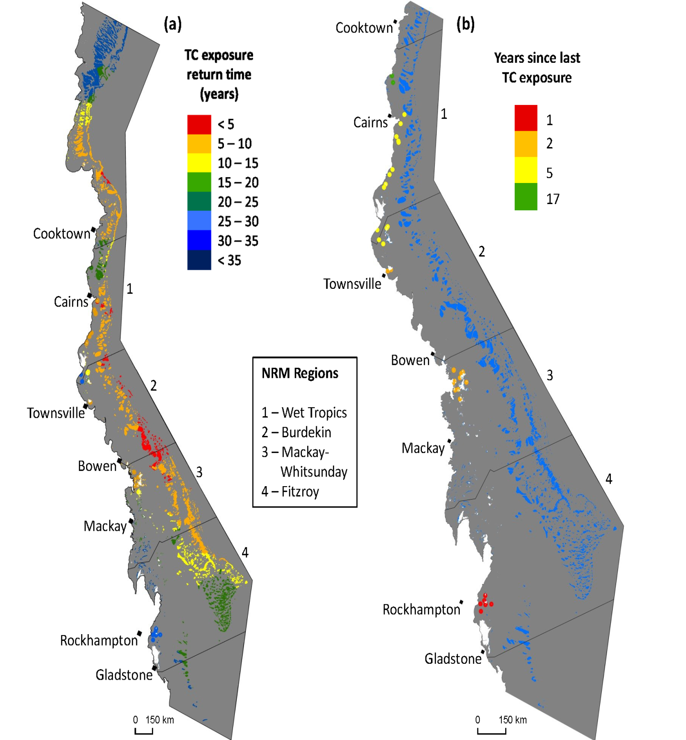

Figure A1. 8 Cyclone exposure history.
a) Return times (years) of exposure to cyclone-generated seas sufficient to damage most coral colonies (wave height = 4metres) on the Great Barrier Reef, based on 1985-2016 cyclone data. b) For MMP reef locations, the number of years from 2016 since last exposure to cyclone-generated damaging seas, based on 1985-2016 cyclone data. Courtesy M. Puotinen. Methods described in Puotinen et al. (2016).

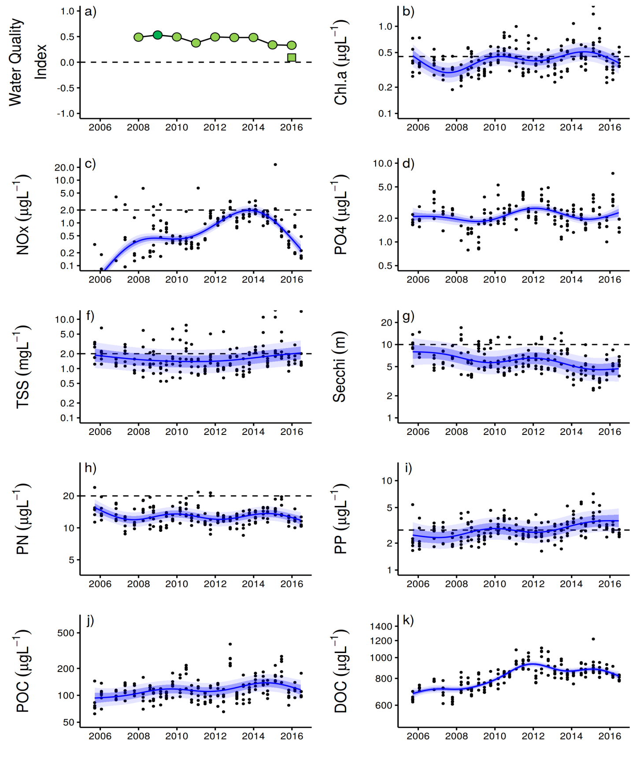
Figure A1. 9 Temporal trends in water quality: Baron Daintree sub-region. a) water quality index, b) chlorophyll a, c) total suspended solids, d) nitrate/nitrite, e) secchi depth, f) particulate nitrogen, g) turbidity, h) particulate phosphorus, i) particulate organic carbon and j) dissolved organic carbon. Water quality index colour coding: dark green- ‘very good’; light green-‘good’; yellow – ‘moderate; orange – ‘poor’; red – ‘very poor’. The water quality index is the aggregate of variables plotted in b - h and calculated as described in Waterhouse et al. (2017). Trends in POC and DOC values are plotted here (I, j); threshold levels have yet to be established. Trends in manually sampled water quality variables are represented by blue lines with blue shaded areas defining 95% confidence intervals of those trends, black dots represent observed data. Trends of records from ECO FLNTUSB instruments (b, g) are represented in red, individual records are not displayed. Dashed reference lines indicate guideline values (GBRMPA 2010). Extract from Waterhouse et al. (2017).

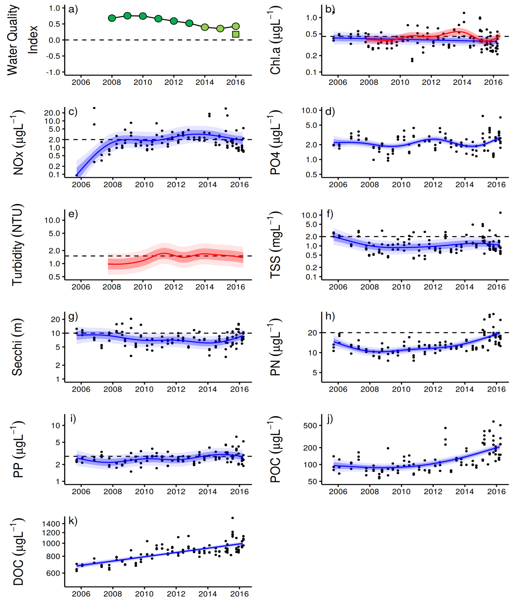
Figure A1. 10 Temporal trends in water quality: Johnstone Russell-Mulgrave sub-region. a) water quality index, b) chlorophyll a, c) total suspended solids, d) nitrate/nitrite, e) secchi depth, f) particulate nitrogen, g) turbidity, h) particulate phosphorus, i) particulate organic carbon and j) dissolved organic carbon. Water quality index colour coding: dark green- ‘very good’; light green-‘good’; yellow – ‘moderate; orange – ‘poor’; red – ‘very poor’. The water quality index is the aggregate of variables plotted in b - h and calculated as described in Waterhouse et al. (2017).Trends in POC and DOC values are plotted here (I, j); threshold levels have yet to be established. Trends in manually sampled water quality variables are represented by blue lines with blue shaded areas defining 95% confidence intervals of those trends, black dots represent observed data. Trends of records from ECO FLNTUSB instruments (b, g) are represented in red, individual records are not displayed. Dashed reference lines indicate guideline values (GBRMPA 2010). Extract from Waterhouse et al. (2017).

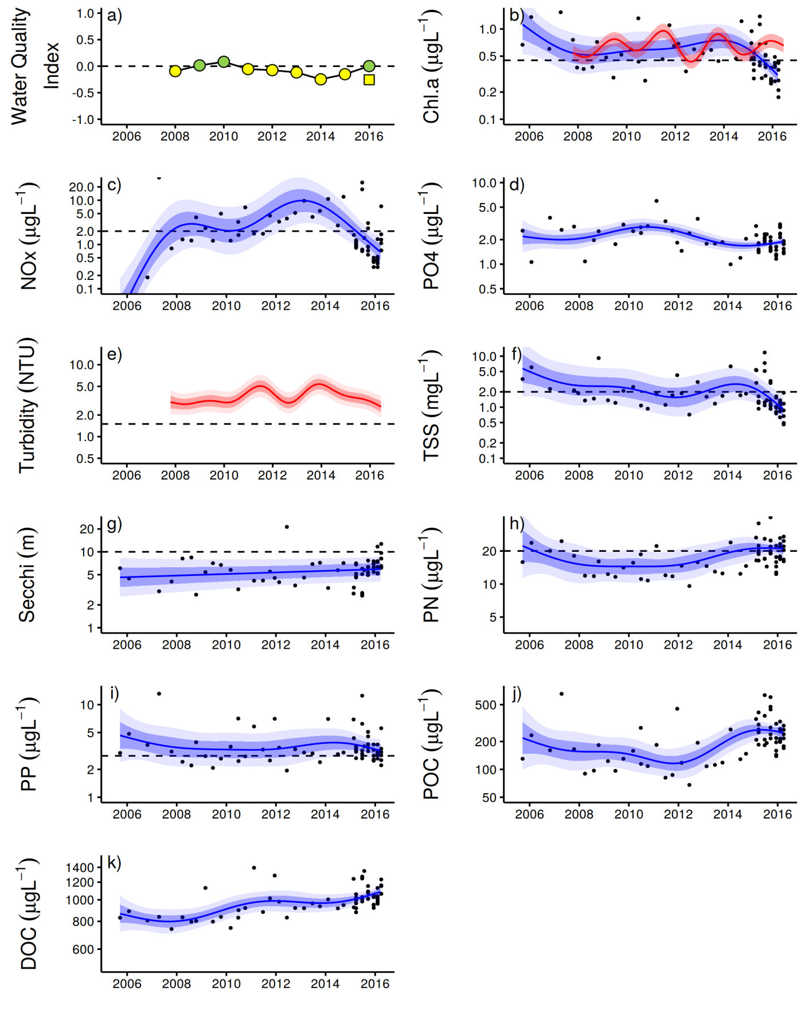
Figure A1. 11 Temporal trends in water quality: Herbert Tully sub-region.
a) water quality index, b) chlorophyll a, c) total suspended solids, d) nitrate/nitrite, e) secchi depth, f) particulate nitrogen, g) turbidity, h) particulate phosphorus, i) particulate organic carbon and j) dissolved organic carbon. Water quality index colour coding: dark green- ‘very good’; light green-‘good’; yellow – ‘moderate; orange – ‘poor’; red – ‘very poor’. The water quality index is the aggregate of variables plotted in b - h and calculated as described in Waterhouse et al. (2017).Trends in POC and DOC values are plotted here (I, j); threshold levels have yet to be established. Trends in manually sampled water quality variables are represented by blue lines with blue shaded areas defining 95% confidence intervals of those trends, black dots represent observed data. Trends of records from ECO FLNTUSB instruments (b, g) are represented in red, individual records are not displayed. Dashed reference lines indicate guideline values (GBRMPA 2010). Extract from Waterhouse et al. (2017).
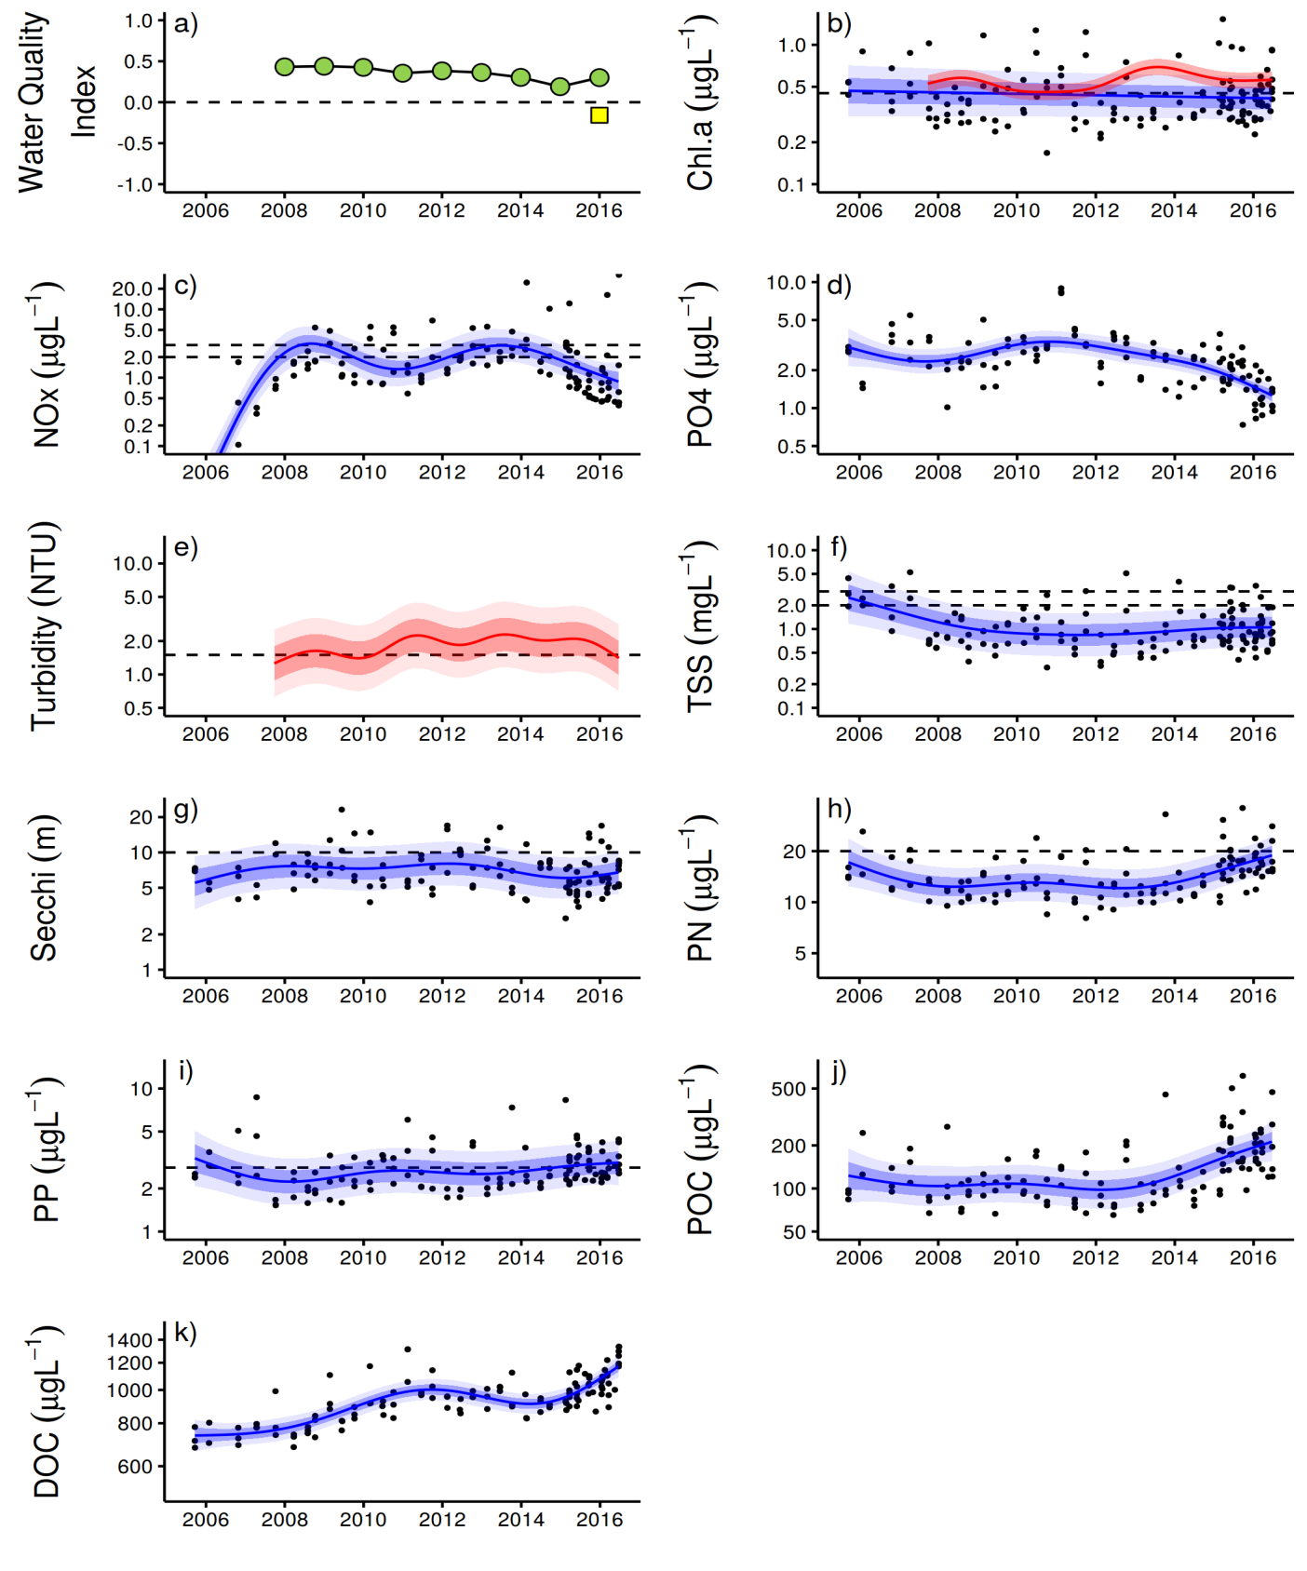
Figure A1. 12 Temporal trends in water quality: Burdekin region.
a) water quality index, b) chlorophyll a, c) total suspended solids, d) nitrate/nitrite, e) secchi depth, f) particulate nitrogen, g) turbidity, h) particulate phosphorus, i) particulate organic carbon and j) dissolved organic carbon. Water quality index colour coding: dark green- ‘very good’; light green-‘good’; yellow – ‘moderate; orange – ‘poor’; red – ‘very poor’. The water quality index is the aggregate of variables plotted in b - h and calculated as described in Waterhouse et al. (2017). Trends in POC and DOC values are plotted here (I, j); threshold levels have yet to be established. Trends in manually sampled water quality variables are represented by blue lines with blue shaded areas defining 95% confidence intervals of those trends, black dots represent observed data. Trends of records from ECO FLNTUSB instruments (b, g) are represented in red, individual records are not displayed. Dashed reference lines indicate guideline values (GBRMPA 2010). Extract from Waterhouse et al. (2017).

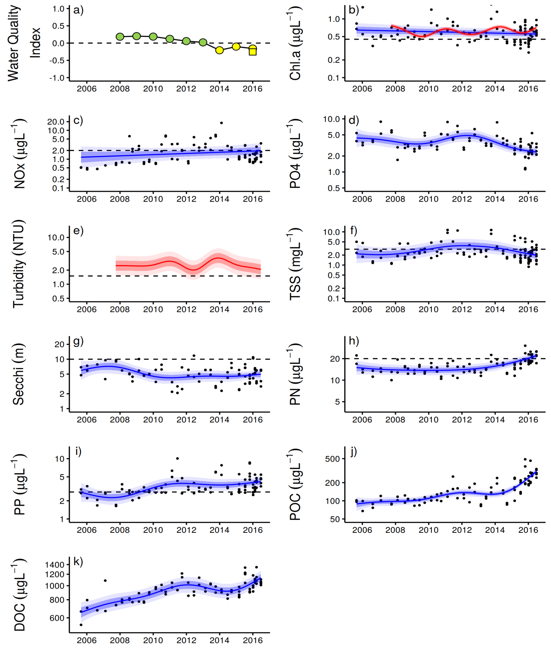
Figure A1. 13 Temporal trends in water quality: Mackay Whitsundays region. a) water quality index, b) chlorophyll a, c) total suspended solids, d) nitrate/nitrite, e) secchi depth, f) particulate nitrogen, g) turbidity, h) particulate phosphorus, i) particulate organic carbon and j) dissolved organic carbon. Water quality index colour coding: dark green- ‘very good’; light green-‘good’; yellow – ‘moderate; orange – ‘poor’; red – ‘very poor’. The water quality index is the aggregate of variables plotted in b - h and calculated as described in Waterhouse et al. (2017). Trends in POC and DOC values are plotted here (I, j); threshold levels have yet to be established. Trends in manually sampled water quality variables are represented by blue lines with blue shaded areas defining 95% confidence intervals of those trends, black dots represent observed data. Trends of records from ECO FLNTUSB instruments (b, g) are represented in red, individual records are not displayed. Dashed reference lines indicate guideline values (GBRMPA 2010). Extract from Waterhouse et al. (2017).

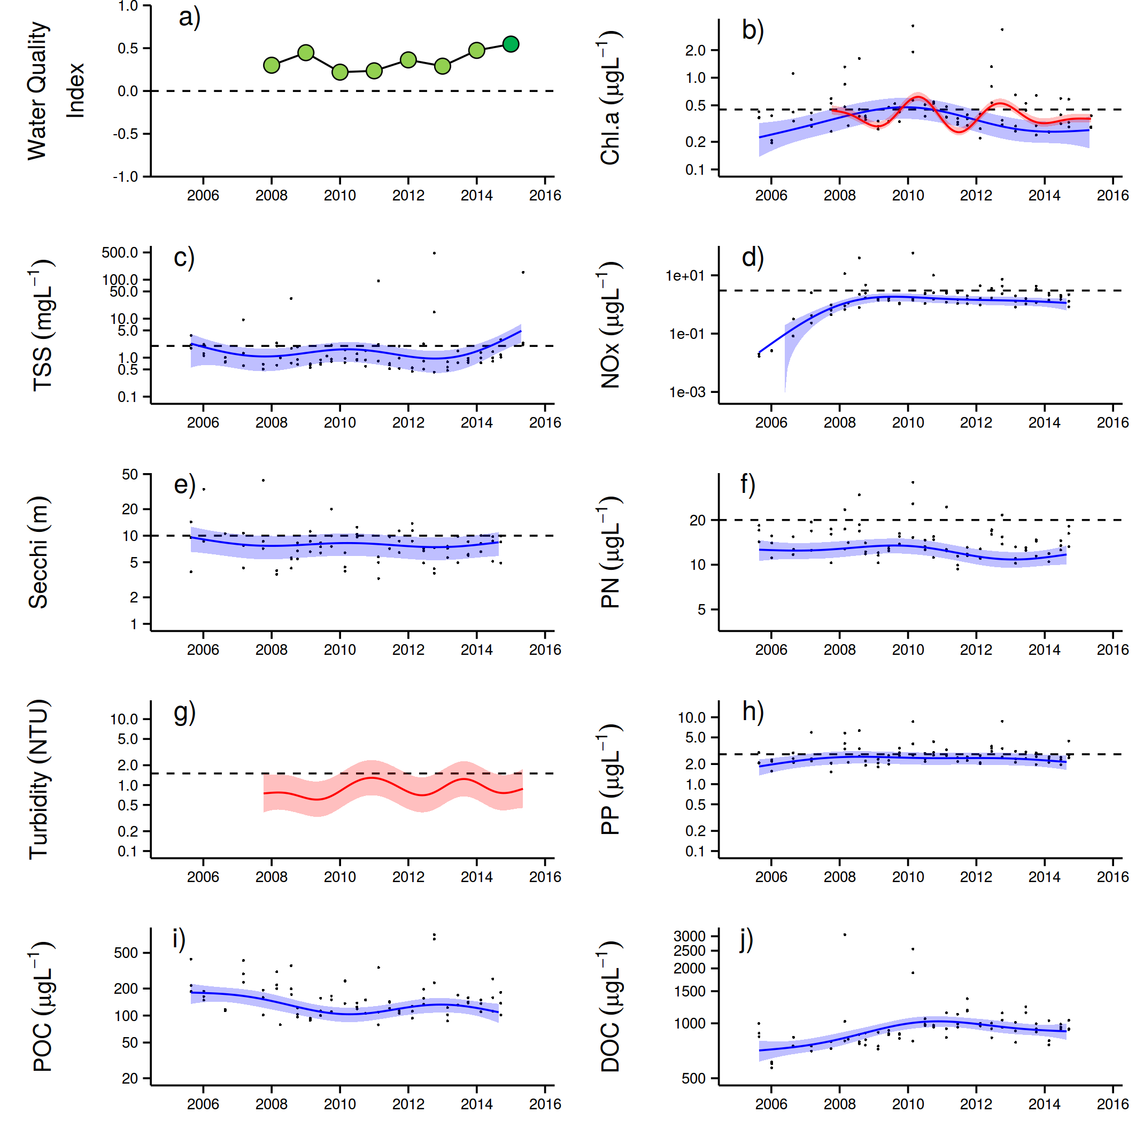
Figure A1. 14 Temporal trends in water quality: Fitzroy region.
a) water quality index, b) chlorophyll a, c) total suspended solids, d) nitrate/nitrite, e) secchi depth, f) particulate nitrogen, g) turbidity, h) particulate phosphorus, i) particulate organic carbon and j) dissolved organic carbon. Water quality index colour coding: dark green- ‘very good’; light green-‘good’; yellow – ‘moderate; orange – ‘poor’; red – ‘very poor’. The water quality index is the aggregate of variables plotted in b - h and calculated as described in Waterhouse et al. (2017). Trends in POC and DOC values are plotted here (I, j); threshold levels have yet to be established. Trends in manually sampled water quality variables are represented by blue lines with blue shaded areas defining 95% confidence intervals of those trends, black dots represent observed data. Trends of records from ECO FLNTUSB instruments (b, g) are represented in red, individual records are not displayed. Dashed reference lines indicate guideline values (GBRMPA 2010). Extract from Waterhouse et al. (2017).

Appendix 2: Publications and presentations associated with the Program 2015-16
Publications
Petus C, Devlin M, Thompson A, McKenzie L, Teixeira da Silva E, Collier C, Tracey D, Martin K (2016) Estimating the Exposure of Coral Reefs and Seagrass Meadows to Land-Sourced Contaminants in River Flood Plumes of the Great Barrier Reef: Validating a Simple Satellite Risk Framework with Environmental Data. Remote Sensing 8(3):210
Presentations
Thompson A, Logan M (2016) Assessing and communicating the status of coral communities using a condition index based on multiple indicators relevant to water quality. International Coral Reef Society, July 2016

Australian Government crown-of-thorns starfish management programme data supplied by Great Barrier Reef Marine Park Authority, Eye on the Reef.
Marine water quality indices produced by the Australian Bureau of Meteorology as a contribution to eReefs - a collaboration between the Great Barrier Reef Foundation, Australian Government, Bureau of Meteorology, Commonwealth Scientific and Industrial Research Organisation, Australian Institute of Marine Science and the Queensland Government. Data are acquired from NASA spacecraft. http://www.bom.gov.au/marinewaterquality/. Although the confidence in individual estimates of Chl a in turbid inshore waters is low the time averaged conditions do describe gradient that correspond to differences in benthic communities.
ReefTemp Next Generation was developed through the Centre for Australian Weather and Climate Research (CAWCR) – a partnership between CSIRO and the Bureau of Meteorology (Garde et al. 2014).
Australian Government crown-of-thorns starfish management programme data supplied by Great Barrier Reef Marine Park Authority, Eye on the Reef.
Australian Government Crown-Of-Thorns Starfish Management Programme data supplied by Great Barrier Reef Marine Park Authority, Eye on the Reef.
Australian Government Crown-Of-Thorns Starfish Management Programme data supplied by Great Barrier Reef Marine Park Authority, Eye on the Reef.
Connie 2.0, CSIRO Connectivity Interface, CSIRO connie2
Marine water quality indices produced by the Australian Bureau of Meteorology as a contribution to eReefs - a collaboration between the Great Barrier Reef Foundation, Australian Government, Bureau of Meteorology, Commonwealth Scientific and Industrial Research Organisation, Australian Institute of Marine Science and the Queensland Government. Data are acquired from NASA spacecraft. http://www.bom.gov.au/marinewaterquality/

