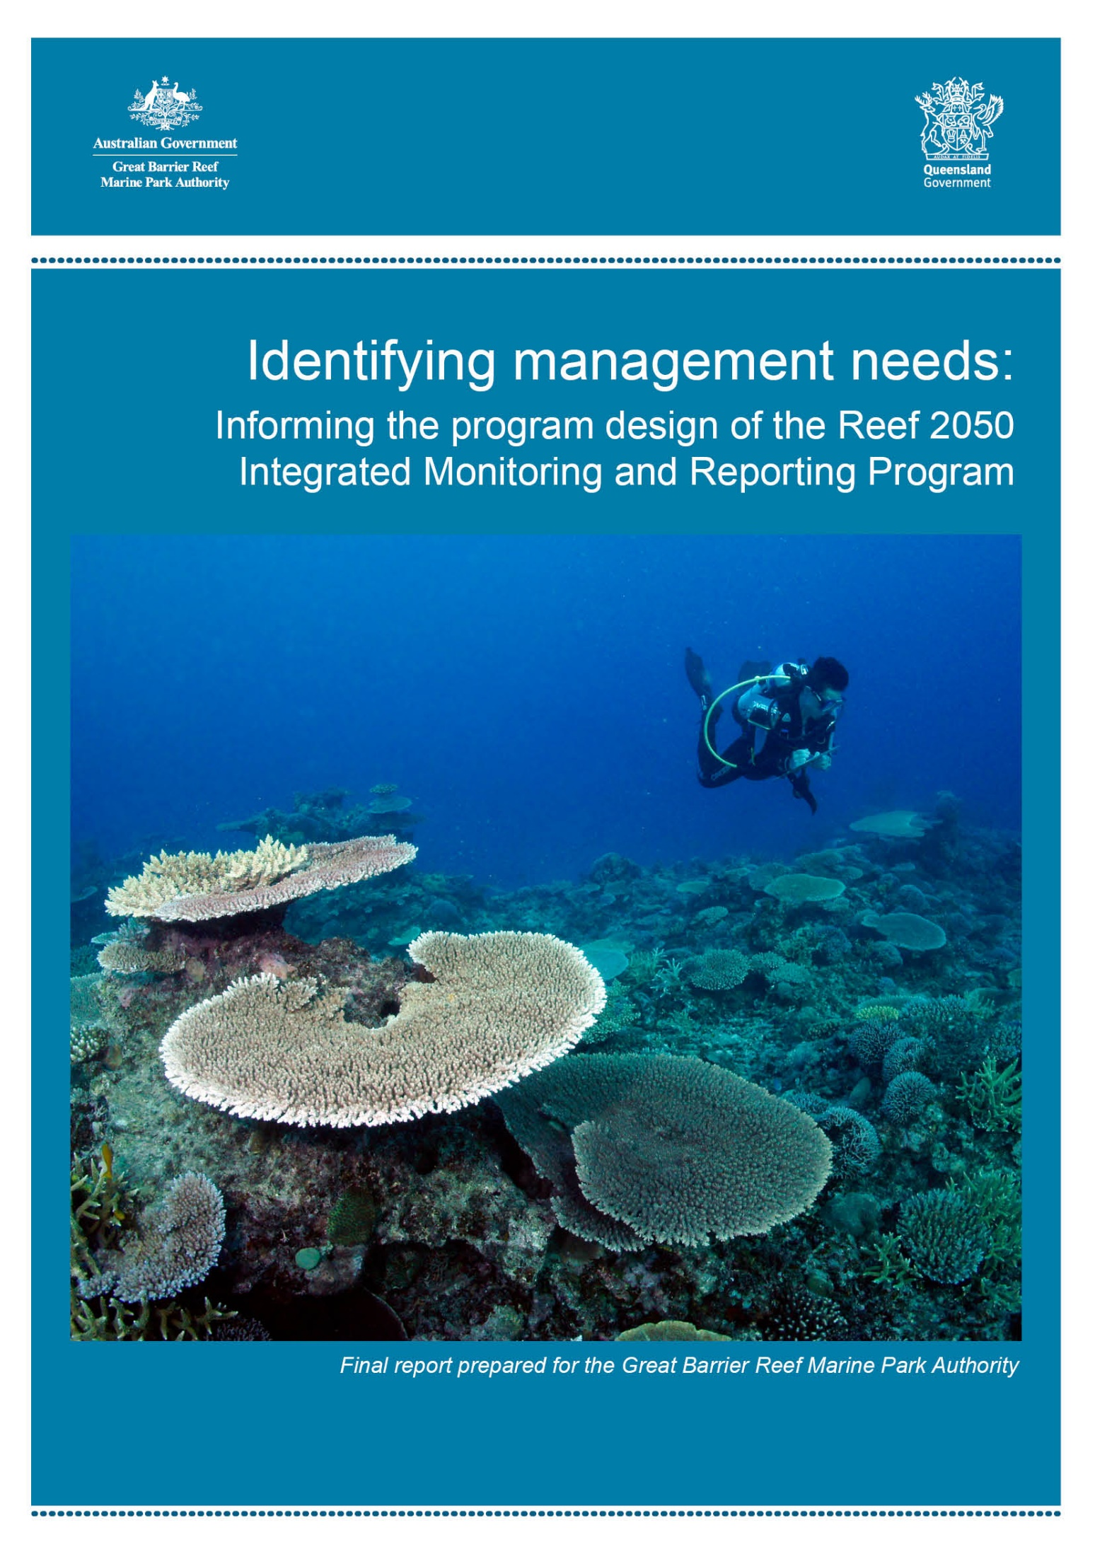

The Great Barrier Reef Marine Park Authority acknowledges the continuing sea country management and custodianship of the Great Barrier Reef by Aboriginal and Torres Strait Islander Traditional Owners whose rich cultures, heritage values, enduring connections and shared efforts protect the Reef for future generations.

© Commonwealth of Australia (GBRMPA), 2018
Published by the Great Barrier Reef Marine Park Authority
ISBN 9780648096573

This document is licensed by the Commonwealth of Australia for use under a Creative Commons By Attribution 4.0 International licence with the exception of the Coat of Arms of the Commonwealth of Australia, the logo of the Great Barrier Reef Marine Park Authority, any other material protected by a trademark, content supplied by third parties and any photographs. For licence conditions see: http://creativecommons.org/licences/by/4.0

This publication should be cited as:
Udy, J. 2017, Identifying management needs: Informing the program design of the Reef 2050 Integrated Monitoring and Reporting Program. Final report prepared for the Great Barrier Reef Marine Park Authority, GBRMPA, Townsville.
While all efforts have been made to verify facts, the Great Barrier Reef Marine Park Authority takes no responsibility for the accuracy of information supplied in this publication. The material within this publication includes the views of third parties, which do not necessarily reflect the views of the Commonwealth or Queensland Government, or indicate commitment to a particular course of action.
Comments and enquiries regarding this document should be addressed to:
Great Barrier Reef Marine Park Authority
PO Box 1379
TOWNSVILLE QLD 4810, Australia
Phone: (07) 4750 0700
Email: info@gbrmpa.gov.au
www.gbrmpa.gov.au
www.gbr.qld.gov.au

IMAGE ACKNOWLEDGMENTS
Photos taken by: Science Under Sail, Australia (Nicola Udy, Jacquetta Udy, Danielle Udy and James Udy)

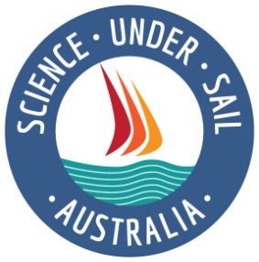

Identifying management needs:

Informing the program design of the Reef 2050
Integrated Monitoring and Reporting Program

Final Report prepared for the Great Barrier Reef Marine Park Authority

This report summarises discussions and interviews conducted with representatives from the Great Barrier Reef Marine Park Authority (June 2017), Queensland Government (August–September 2017) and Department of Environment and Energy – Reef Branch (September 2017).

Executive summary
This report summarises information needs identified through interviews with 45 people who are actively involved in managing various aspects of the Great Barrier Reef. The interviewees represented five Queensland Government departments, six sections within the Great Barrier Reef Marine Park Authority and the Department of the Environment and Energy’s Reef Branch. All participants were asked to summarise their current information sources as well as information they felt would improve their ability to manage the Great Barrier Reef and assist in achieving the Reef 2050 Long-Term Sustainability Plan’s outcomes.
Despite varied responsibilities, the information needs were common across groups and corresponded with broader stakeholder expectations. Desired information products –– as identified by stakeholders through market research (Enhance Report 2017) –– can be separated into three categories:
1) Maps showing the spatial distribution of pressures and the state of various attributes
2) Changes over time in pressure, state and resilience
3) Process understanding that informs decision support tools, to predict the outcomes of management actions

Given the large spatial scale of the Great Barrier Reef, as well as the broad scope of identified information needs, the different types of management uses were categorised to ensure that sufficient information is collected within each category to meet managers’ needs. A hierarchical design that focuses on spatial assessment, temporal assessment and quantification of processes is recommended for data collection for the Reef 2050 Integrated Monitoring and Reporting Program. Combining a hierarchical design with the Driver-Pressure-State-Impact-Response (DPSIR) Framework, will provide a structure to support integration and link Reef 2050 Integrated Monitoring and Reporting Program data collection with management actions and objectives.

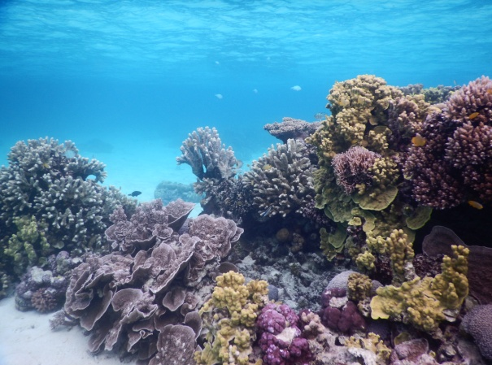
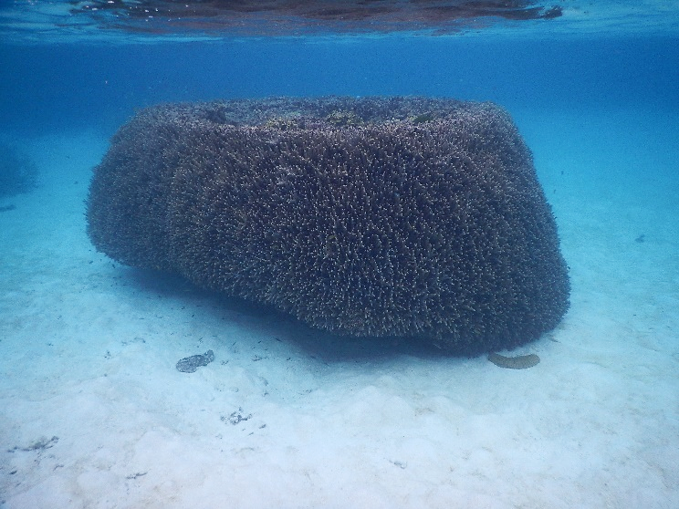
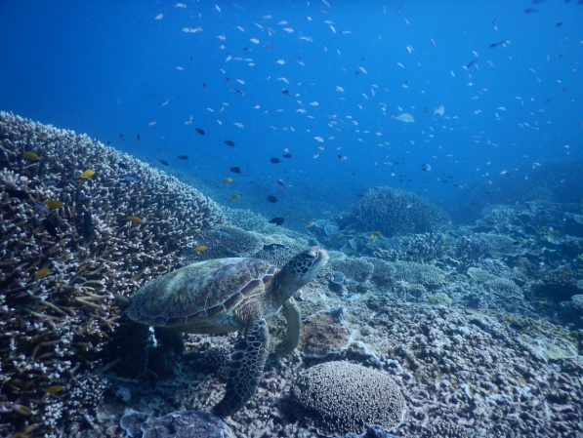
A summary table, showing examples of the type of information required for each management use, is provided for the various information products that managers requested. As the program design tasks for the Reef 2050 Integrated Monitoring and Reporting Program have been separated into nine themes, examples are also provided for each expert theme group to show how the data collection methodologies may provide information to managers, as well as how they can be integrated across the various themes.

Table of contents

Purpose... 6
Method... 7
Information products and attributes 8
Objectives of the Reef 2050 Integrated Monitoring and Reporting Program 9
Categories of management use 10
Information products 13
Hierarchical monitoring on the Great Barrier Reef 14
Example of hierarchical design for coral monitoring 15
Linking management needs with program design 16
Next steps 24
References 25

Figures
Figure 1: Summary of information products and attributes required by managers................ 8
Figure 2: Components of a hierarchical designed monitoring program ............................... 13
Figure3: Example of hierarchical framework applied to coral reef monitoring...................... 15

Tables
Table 1: Categories of management use and how information products will be used ........ 11
Table 2: Example of how information from expert theme groups fit into a spatial, temporal and process hierarchical design …………………………………………..........................19
Table 3: Example of how information from expert theme groups related to a management uses.........................................................................................................................20
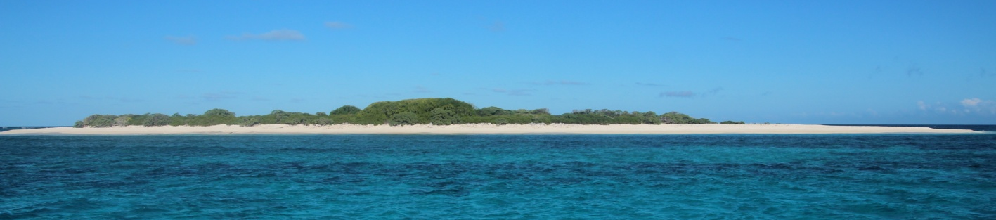
Table 4: Example of how existing programs fit within a hierarchical design ……………..... 22
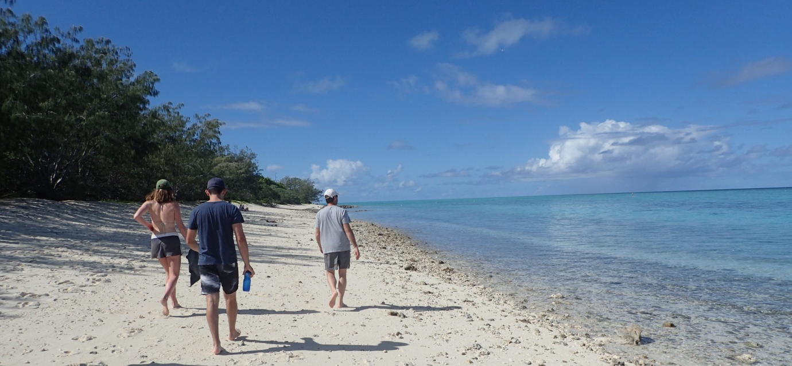

Purpose
The Great Barrier Reef is a diverse ecosystem with environmental, Indigenous, social and economic values. The diversity of values and human activities throughout the Great Barrier Reef presents challenges to management agencies in identifying and prioritising management actions. This report informs the program design component of the Reef 2050 Integrated Monitoring and Reporting Program in relation to managers’ needs. It provides direction to the expert theme groups in terms of recommendations and prioritisation of future monitoring activities. It provides a synthesis of interviews conducted with 45 key staff members from Australian and Queensland government agencies responsible for the management of various aspects of the Great Barrier Reef Marine Park and recommends a monitoring framework for integration between expert theme groups.

The expert theme groups are working to recommend monitoring designs across 10 Great Barrier Reef and catchment themes including the physico-chemical environment, seagrass, coral, fish, megafauna, Indigenous heritage, human dimensions, catchment and estuaries, islands, and microbes. The final design will focus on priority monitoring indicators to address management needs, and the methods, locations and frequency for data collection.

This work complements market research the Great Barrier Reef Marine Park Authority undertook to identify stakeholder expectations in regards to information needs (Enhance Research, 2017).

Method
In June 2017, Dr James Udy met with staff from six sections of the Great Barrier Reef Marine Park Authority (Reef 2050 Integrated Monitoring and Reporting Program, Reef Recovery, Heritage, International and Governance, Tourism and Stewardship, Field Management, Reef HQ Aquarium, and Communications and Parliamentary). In August and September 2017, interviews were conducted with five departments of the Queensland Government responsible for managing various aspects of the Great Barrier Reef (National Parks, Sport and Racing’s Queensland Parks and Wildlife Service, Strategic Policy and Racing Industry Governance, Department of Agriculture and Fisheries, Department of Science Information Technology and Innovation, Department of the Environment and Heritage Protection – Office of the Great Barrier Reef, and the Department of Natural Resources and Mines). In September 2017, representatives from the Reef Branch of the Department of the Environment and Energy were consulted about their information needs as well as providing input to the draft report. Additional input to this report was gained from participants of an integration workshop for the Reef 2050 Integrated Monitoring and Reporting Program (12 September 2017), which represented a cross section of managers and scientists. Groups or individuals unavailable for a face-to-face meeting were emailed components of this report and asked to add feedback and additional information of relevance to them.
Each interview lasted one–to–two hours. Participants explained their current role and how it relates to the management of the Reef as well as outlining the information sources they currently use for decision-making. Participants were then asked to describe the types of additional information that could provide the following outcomes to them on a daily, weekly and monthly frequency:
- Enhance current management activities
- Support current decision-making
- Enable different decisions to be made

Participants were also asked to imagine a time (approximately five years in the future) when information had been collected and stored so it was accessible through a conceptual
‘Reef Google’ search engine.

They were then asked two questions, assuming they had this tool:

- What search phrases would they use to find information to help them do their job?
- How would they want the information presented when they clicked on the links?

Information products and attributes
Despite varied responsibilities of the different groups interviewed, the information needs were varied yet common across groups and corresponded with findings of stakeholder expectations, conducted with a broader stakeholder group, including non-government organisations (Enhance Research, 2017). The desired information products by stakeholders can be separated into three broad categories (Figure 1):
- Maps showing the spatial distribution of pressures and the state of various attributes
- Changes over time in pressure, state and resilience of attributes
- Process understanding that determine cause and effect relationships and inform decision support tools to better predict the outcome of management actions

Future information products would also be expected to have the following attributes:
- ability to go from a simplistic summary to obtaining the underlying detailed information/data in a relatively short period of time
- spatial representation of information with the ability to scale from the entire Reef to a specific reef or bay (ability to search using either place names or GPS coordinates) with functionality similar to Google Earth, while also providing easy access to information on processes relevant to management decisions
- provide current information to managers appropriate to the timescale of management decisions, e.g. tactical/response (days or weeks), strategic (years)
- links between human actions, reef condition and the impact this has on how current and future generations are able to use the reef and obtain benefits from it — this cause and effect understanding needs to be clearly and simply communicated
- provide information on the range and location of habitats and species existing within the Reef and show the interconnectedness of these habitats through key processes
- spatially represent risks to the Reef to facilitate prioritisation of management actions
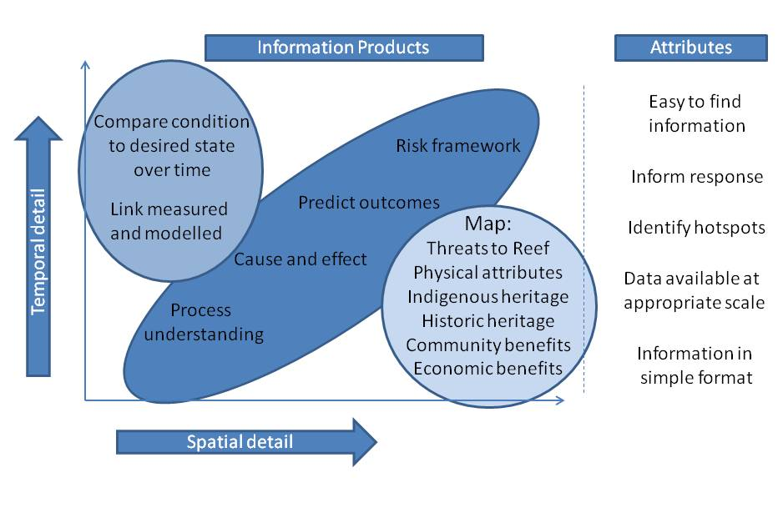

Figure 1: Summary of information products and attributes required by managers

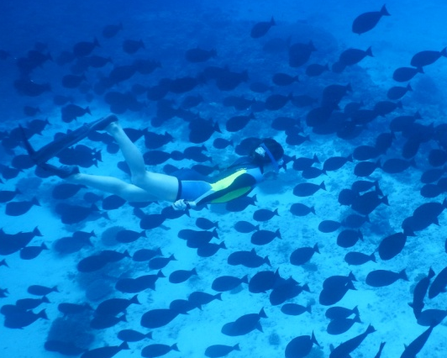
Objectives of the Reef 2050 Integrated Monitoring and Reporting Program

The primary purpose of the Reef 2050 Integrated Monitoring and Reporting Program is to provide information at the correct spatial and temporal scale to support Reef managers and facilitate adaptive management responses to realise the vision of the Reef 2050 Long-Term Sustainability Plan.
To achieve this, the information provided by the Reef 2050 Integrated Monitoring and Reporting Program needs to be accessible to multiple government departments responsible for management of the Reef and its catchments. This provides a challenge, as the Reef and catchments have multiple levels of governance (federal, state and local) across many departments, the activities and decisions of which directly and indirectly impact on its condition and resilience.
The Reef 2050 Long-Term Sustainability Plan highlights the need to have up to date information on the condition of all habitats and processes throughout the Great Barrier Reef and its catchments, rather than focusing only on a few habitats (coral and seagrass) or areas of the inner reef, most impacted by catchment run-off. The following categories of information are highlighted in Reef 2050 Long-Term Sustainability Plan as areas that the Reef 2050 Integrated Monitoring and Reporting Program should provide the ability for managers to determine current condition (State) as well as detect trends in the condition of:
- ecosystem health
- marine biodiversity
- water quality
- heritage values
- community benefits
- economic benefits
- governance
In addition, the Reef 2050 Integrated Monitoring and Reporting Program is intended to provide information on key threats to the Reef, provide information to inform management responses following a disturbance (e.g. cyclone, flood, crown-of-thorns starfish outbreak) and quantify linkages between management actions and either a reduction in threat or improvement in the condition of a population, habitat or ecosystem. The Reef 2050 Integrated Monitoring and Reporting Program uses the Driver-Pressure-State-Impact-Response (DPSIR¹) Framework to integrate between different aspects of the Reef and its catchments to inform management actions.

¹ Note: Terms in italics throughout report represent DPSIR categories.
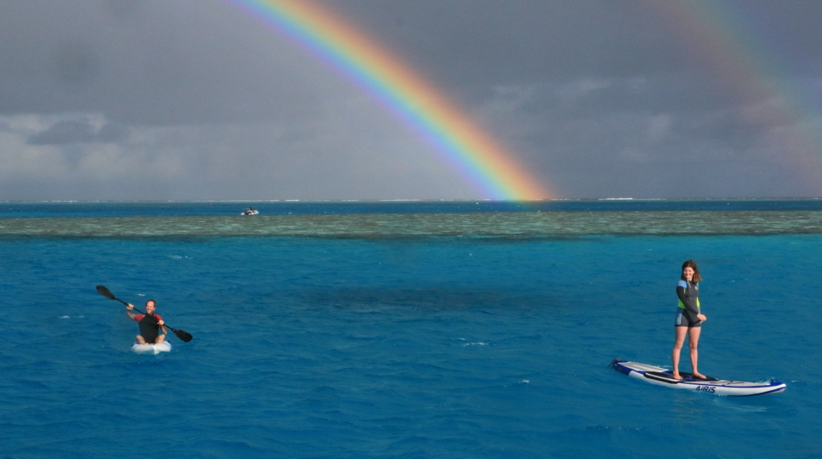
The Reef 2050 Plan provides actions (responses) that are designed to mitigate the impact of the four major categories of risk (drivers and pressures) highlighted in the Outlook Report 2014:
- climate change: long-term, system-wide
- land-based run-off: immediate, system-wide
- coastal land-use change: immediate, local/regional
- direct use: immediate, local/regional

Categories of management use

The interviews identified five different ways that managers use information. This information falls mainly into the DPSIR categories of Pressure, State and Impact to inform a Response. The way managers intend to use information is referred to throughout the report as the categories of management use. Each category of use may require information at a different spatial or temporal scale. Provided these different scales are incorporated into the design of information products the Reef 2050 Integrated Monitoring and Reporting Program will meet the multiple uses of managers (Table 1).
The categories of management use identified were:
- Tactical: Responding to an event or incident; for example, vessel grounding, flood, cyclone, coral bleaching, crown-of-thorns starfish.
- Operational: Including prioritisation of compliance effort, the provision of infrastructure to protect high use-reefs and permit assessment.
- Strategic planning: Including zoning and policy development and revisions to the Reef 2050 Water Quality Improvement Plan and Reef 2050 Long-Term Sustainability Plan.
- Quantifying effectiveness of management actions – outcomes achieved with funding.
- Reporting: Provide information to community and stakeholders; for example, report cards, Outlook reports, web and social media.
Table 1: Categories of management use and how information products will be used
 | Category of management use
 | Tactical | Operational | Strategic planning | Quantifying effectiveness | Reporting
Information product  (DPSIR category) | How information will be used
Map threats to the Great Barrier Reef  (Pressures) | Prioritise response to acute threats based on current and future risks | Identify locations where cumulative pressures may require a different management approach | Identify and prioritise areas for management actions based on risk of future disturbance (protection and recovery actions) | Identify if management actions are reducing extent or severity of threat to specific habitats and ecosystems | Communicate with stakeholders and community on the different threats and how they are being reduced
Map physical and ecological attributes  (State) | Identify attributes that may require protection or assistance to recover | Identify habitats at risk from proposed actions (e.g. permit assessment) | Understand the extent and variety of natural capital within the Reef | Prioritise where to take actions as well as the impact of an action on a region/location | Maps engage stakeholders and provide the basis for reporting both condition and the impact of actions
Map Indigenous heritage  (State and Impact) | Be aware of locations with cultural value so that appropriate care is taken during response to acute threats | Identify cultural heritage values that may be impacted by a proposed action | Understand the extent and variety of cultural heritage values within the Reef, and reduce impact from adjacent actions | Show locations where actions are being undertaken to protect cultural values | Integration of Indigenous heritage reporting with other values will enrich education, appreciation, stewardship and economic aspects
Map non-Indigenous historic and cultural heritage  (State and Impact) | Be aware of locations with historic and cultural value so that appropriate care is taken during response to acute threats | Identify historical and cultural values that may be impacted by proposed action | Promote these heritage values within the Reef, and reduce impact from adjacent actions | Show locations where actions are being undertaken to protect historical values | Integration of heritage reporting with other values will enrich community understanding, appreciation and stewardship
Map community benefits  (Pressure and Impact) | Inform response to acute threats to minimise harm to humans as well as locations with high social and/or cultural value | Improve ability for permitting to balance conflicting uses and prioritise compliance activities to optimise community benefits | Ensure future planning considers varied community benefits. Includes  managing carrying capacity of a location to optimise tourist experience, environmental impact and enhance community benefit | Improve cost benefit of actions by identifying high community value regions | Use reporting to communicate the numerous benefits provided by the Reef and showcase best or leading environmental practices by community groups
Map economic benefits  (Pressure, State and Impact) | Identify regions of reef that require additional management actions to protect Reef-dependent industries from acute pressure | Improve permitting to balance conflicting uses and manage for economic and ecological sustainability of Reef-associated and Reef-dependent industries | Apply Ecologically Sustainable Development principles to future planning for all economic activities undertaken in the Reef and its catchments | Improve cost benefit assessment of actions by identifying high economic value regions for Reef-dependent industries | Use reporting to communicate the numerous economic benefits provided by the Reef and showcase best or leading environmental practices by industry groups
Table 1 (cont.): Categories of management use and how information products will be used
 | Category of management use
 | Tactical | Operational | Strategic planning | Quantifying effectiveness | Reporting
Information product  (DPSIR category) | How information will be used
Provide a risk framework  (Pressure) | Inform optimal management response with current and future risks to an area | Highlight when proposed actions increase risks and identify mitigation strategies | Use planning tools to mitigate risks if possible | Track mitigating actions and intervention as well as the outcomes achieved | Use reporting to communicate and mitigate the key risks through education and stewardship
Compare condition with desired state  over time  (State  – temporal trend) | Understand if impact has degraded an attribute beyond its resilience threshold – is intervention required? | Provide guidance on choice of management tool(s) for achieving desired outcome(s) | Focus use of planning tools on regions that are not improving | Compare effectiveness of different actions in reaching objectives across regions | Track progress and report on quantifiable attributes – assess if attributes are above or below objectives
Process understanding  (Link between: Driver, Pressure, State, Impact and Response) | Ensure that tactical responses support recovery of processes that support reef resilience | Ensure current and proposed use/activities don’t have negative impacts on critical processes | Ensure planning supports the resilience of the reef so it can recover following impacts | Assess actions/ interventions and their ability to enhance resilience processes | Use reporting to educate and improve stewardship activities that support key processes
Cause and effect relationships  (Link between: Driver, Pressure, State, Impact and Response) | Understand possible recovery paths and the influence management can have on assisting resilience | Understand likely impacts of a proposed activity | Predict the likely pathway for recovery and use planning tools to enhance resilience | Understand the multiple/  cumulative impacts of interventions and monitor to ensure actions are helping to achieve intended outcomes | Report on actions completed and outcomes achieved.  - supporting cause and effect understanding
Link between measured and modelled information  (ability to predict; river, pressure, state, impact and response) | Need to understand impact frequency and severity of acute events has on reef condition and resilience | Provide predictive ability at locations where measurements are not made. | Enable planners to predict likely outcome of different actions - predictions from the scale of entire Reef to bays or islands | Compare observed outcomes with predicted impact of actions at the local, regional and Reef wide scale | Ability to incorporate different types of data collection and scale up from small local activities and measurement to the entire Reef
Predict outcome of actions  (effectiveness of response on driver and pressure and state) | Prioritise when and how to take remedial action following an event or incident | Supports approval or refusal of proposed activities | Improves planning process and likelihood of successful implementation | Assess proposed actions against multiple benefits and set realistic targets and objectives | Report progress towards targets/objectives

Information products

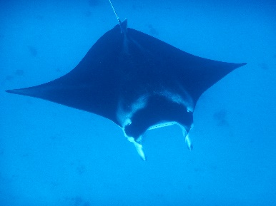
To meet the wide range of management information needs identified during these interviews, it is likely that the Reef 2050 Integrated Monitoring and Reporting Program will need to adopt a hierarchical design (Figure 2). The final solution and prioritisation of components and indicators will vary for the various attributes of the Reef. Adopting a similar hierarchical framework for all attributes will enhance opportunities for integration across the different disciplines, and improve the ability for the monitoring program to quantify interactions between attributes and resolve cause and effect relationships.
A hierarchical design is currently being used in the Paddock to Reef Integrated Monitoring, Modelling and Reporting Program, as well as the monitoring of coral condition on the Reef (Figure 3). Hence, adoption of a hierarchical monitoring framework across other aspects of the Reef 2050 Integrated Monitoring and Reporting Program will enhance integration with existing programs and provide a consistent framework for the expansion of monitoring to include other attributes of the Reef.

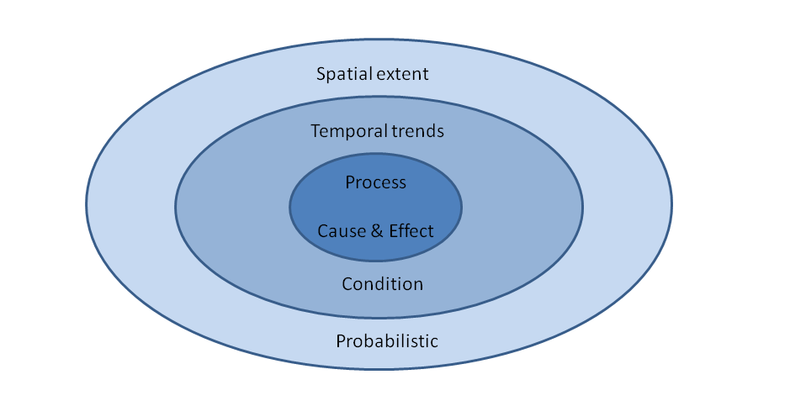

Figure 2: Components of a hierarchical designed monitoring program

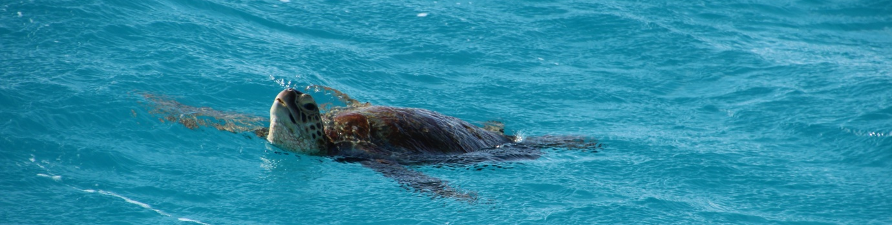

Hierarchical monitoring on the Great Barrier Reef

The consultation highlighted the need to report at a large spatial scale, obtain information on a broad spectrum of attributes, quantify key processes and make information available in a timely manner. However, without stratifying sampling effort, the requirements of managers will overwhelm any monitoring program. Many of the concerns raised by managers in relation to the currency or spatial scale of information could be improved and optimised by applying a hierarchical design from the outset.
The large spatial scale of the Reef means the highest level ‘key attributes’ for each expert theme group need to be identified in collaboration with managers. A cost-effective strategy needs to be developed to source this information and make it available through a map-based interface. A second tier of more detailed information will also need to be collected at representative sites (for environmental parameters) and within representative communities or industries (for social and economic aspects). The third tier of information relates to the need for managers to predict the impact of management actions and support the development of models and other decision support tools that inform their decisions. This third tier of information is the most detailed and is likely to occur at the least number of locations or times.
Many management examples were provided where relatively high spatial or temporal resolution of information was required by managers to effectively undertake their routine responsibilities, often relating to permitted actions. However, once this information was collected and the action approved, the data collection was not repeated and the information was often lost or difficult for others to find even if it would have been helpful to other management tasks.
A stratified hierarchical monitoring framework (Figure 2) will provide the best overall solution for developing a monitoring program that can meet varied management requirements and also provide a framework to capture and store data collected for different purposes at different scales. This framework lends itself to providing the information required to underpin a Reef manager’s ‘information dashboard’. This was discussed on multiple occasions and would require information collected at different spatial and temporal scales to be most effective. By linking information collected at different temporal and spatial scales most of the information needs identified during this consultation process will be met. The hierarchical design will also provide a unifying and integrating structure during the design of the program as well as improving accessibility of data to managers in the future.

Example of hierarchical design for coral monitoring
The Great Barrier Reef Marine Park Authority currently monitors coral condition on the Reef using a hierarchical framework and combines data/information from multiple sources to determine the condition of coral on the Reef. Figure 3 illustrates differences in the way managers can use information from the different sources and types of assessment currently occurring on the Reef (right side and titles in triangles). The Eye on the Reef (Reef Health and Impact Surveys) provides a network of observers that collect regular information on the status and trend (State) from hundreds of reef locations. This provides a broad spatial scale, with only limited information collected on the health of the reef. In contrast the Australian Institute of Marine Science conducts a more detailed long-term monitoring program at fewer reefs. The opposing arrows in Figure 3 highlight the trade-offs of each program and shows why these monitoring approaches complement each other and provide different information for managers (text modified from: Beeden et. al. 2014).

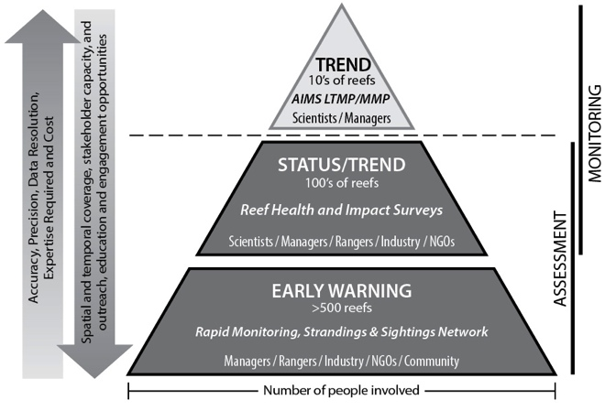

Figure 3: Example of hierarchical framework applied to coral reef monitoring
(Beeden et. al. 2014).

Linking management needs with program design
The program design component of the Reef 2050 Integrated Monitoring and Reporting Program separates the many components of the Reef into nine key attributes. These attributes have been prioritised by managers for monitoring and include:
- catchments and estuaries
- physical and chemical properties of the Reef lagoon and adjacent waters
- seagrass meadows
- coral reefs
- fish populations and fishing
- megafauna, focused on endangered species such as dugong, turtles and wader birds
- Indigenous heritage
- human dimension
- other, including the islands within the Great Barrier Reef.
Expert theme groups have or will be formed to provide recommendations to the Reef 2050 Integrated Monitoring and Reporting Program on monitoring strategies for each attribute. Currently seven of the nine attributes have expert theme groups developing recommendations on how best to monitor these varied aspects of the Reef. This report suggests that a hierarchical design would assist the expert-theme groups during the design process within each discipline as well as assisting with integration between different disciplines and aspects of the Reef.
To develop a comprehensive hierarchical monitoring program for the Reef each expert theme group would need to identify three tiers of indicators or measures:
- Indicators that can be undertaken cost-effectively at the scale of the entire Reef, with assessment at least every five years to support Outlook reporting. The Marine Park Authority produces an Outlook Report every five years which is a legislative requirement. These indicators would provide broad categories of the assets that occur in different regions with a focus on being reliable at Reef-wide and regional scales. Information at this scale will contribute to reporting on Reef 2050 Long-Term Sustainability Plan (Reef 2050 Plan) targets²:ecosystem health target one (EHT1), ecosystem health target three (ETH3), biodiversity target two (BT2), heritage target two (HT2), heritage target three (HT3), and water quality target one, two and five (WQT1, WQT2, WQT5). Provided the design includes an expansion of community engagement activities it will also assist in reporting on ecosystem health target five (EHT5), biodiversity target five (BT5), heritage target three (HT3), water quality target five (WQT5), community benefits three (CBT3), and economic benefits target one (EBT1).

- Indicators that can be measured at representative sites or in demographically defined community/industry groups to determine temporal changes on the Reef and communities that rely upon it. These indicators would provide an accurate assessment of condition (State) of the assets/attribute at the local scale as well as assessing resilience of key indicators (social indicators, species or habitats). Provided sampling locations had been representatively chosen, the information could be combined with information from tier one to provide regional and reef wide assessments of the condition of the Reef’s assets at an appropriate temporal scale to provide information for annual report cards. Information collected at this level will contribute towards reporting on Reef 2050 Plan targets²:ecosystem health target three (EHT3), ecosystem health target four (EHT4), ecosystem health target five (EHT5), biodiversity target two (BT2), biodiversity target three (BT3), biodiversity target four (BT4), biodiversity target five (BT5), water quality target three (WQT3), water quality target four (WQT4), community benefits target two (CBT2), community benefits target four (CBT4).
² Commonwealth of Australia, 2015

- A group of measures/indicators that quantify key processes, including environmental linkages, the impact human activities have on the natural assets of the Reef and the impact the condition (State) the Reefs natural asset have on human use and benefit (Pressure, State and Impact). These measures would focus on quantifying priority cause and effect relationships in specific locations or through targeted case studies. These indicators would not attempt to cover the entire scale of the Reef or integrate with regional report card programs. The information, once incorporated into models or other decision support tools, would provide managers with a predictive ability to assess future threats and impacts on the Reef. Improvements over time to predictive models, supported by these measures (Driver, Pressure, State and Impact) would inform many different management actions (Response). Information collected at this level will also contribute towards reporting on Reef 2050 targets²: ecosystem health target four (EHT4), economic benefits target three (EBT3), economic benefits target four (EBT4), economic benefit target five (EBT5).

The detail of implementation would vary between groups, yet it is important to ensure that the location and temporal frequency of sampling becomes integrated for measures that have links within the DPSIR framework. This is especially important for the more detailed, higher resolution measures that contribute towards information for the second and third tier in a hierarchical framework (corresponding to the two inner rings of Figure 2 - temporal trends and process understanding). The only Reef 2050 Plan targets that may not benefit from this structure are those relating to governance or polices and these can be quantified and managed by directly assessing changes.
The delivery of a hierarchical framework will require further discussions between expert theme group leads, statisticians and modellers. One solution may be to have ‘super sites’ where indicators recommended by many themes are collected at a similar location and temporal frequency, so that correlations between temporal or spatial patterns in different indicators can be verified and the understanding of cause and effect relationships improved over time. However, bringing together diverse (yet related) aspects of the Reef, such as water quality, habitat, fish, endangered species, Indigenous heritage and other human values and uses, provides a complex mix of information. Therefore finding the ‘optimal’ and ‘affordable’ solution will require trade-offs and prioritisation of specific aspects. This prioritisation will require discussions across multiple disciplines and balancing of different priorities or needs, while retaining a focus on Reef 2050 Plan targets and outcomes.
Tables 2 and 3 provide examples of potential indicators that could be measured showing how they relate to both hierarchical categories of spatial, temporal and process (Table 2) as well as the five management uses (Table 3). Table 4 provides examples of existing monitoring activities and possible expansions to existing programs that could provide input to the first version of the Reef 2050 Integrated Monitoring and Reporting Program.
² Commonwealth of Australia, 2015

Table 2: Example of how information from expert-theme groups fit into a spatial, temporal and process hierarchical design
Expert theme groups | Spatial | Temporal | Process
Estuaries and catchments | Catchment land use;  Estimated annual pollution loads | Measured flow and loads at gauging stations | Paddock scale experiments to determine impact of changes in land management
Physico-chemical | Sea surface temperature,  Reef wide turbidity and Chl a estimates | Benthic light and temperature at coral and seagrass monitoring locations | Grain size analysis during floods; recovery of water quality post flood
Seagrass | Species and % cover within defined habitats or zones | Temporal trends in biomass, condition and resilience measures at representative sites | Investigate response of seagrass resilience measures to changes in environmental pressures
Coral | Spatial extent and a colour/condition index (e.g. remote sampling,  Eye on the Reef, RHIS, CoralWatch) | Reef health transects  (e.g. AIMS long term monitoring program, Reef Check) | Conduct studies to improve understanding of resilience – require consultation with expert theme group.
Fish | Fishing zones on the Reef and estimated commercial and recreational take p.a. | Population estimates for key species relative to a desired state or pre-1981. | Population models for key species estimating causes and rates of gain or loss.
Mega-fauna | Identify zones where megafauna have been observed and apply a probability based abundance estimate across Reef | Population/breeding colonies at known locations or regions (e.g. turtle nesting, dugong numbers in a region) | Detailed study to assist with predicting abundance or impact of pressures on a population
Indigenous heritage | TBA – requires consultation with expert theme group. | TBA – requires consultation with expert theme group. | TBA – requires consultation with expert theme group.
Human dimension | Summarise primary and secondary data sets identified by the human dimensions expert theme group into the 35 basins of the Reef. | More detailed assessment and monitoring of social, cultural and economic aspects of the Reef and catchment. This includes governance, stewardship, community benefits, economic benefits and heritage values. | TBA – requires consultation with  expert theme group.
Other  (e.g. for islands) | Map of all islands with the Reef and collate metadata on vegetation cover and fauna, if known. | Undertake random/stratified surveys of representative islands to determine current condition and conservation priorities. | Study impact of management actions on islands  (E.g. Raine Island).  - may need to do more following outcomes of surveys.

Table 3: Example of how information from expert-theme groups relate to the management uses
Expert-theme groups | Tactical | Operational | Strategic planning | Quantifying effectiveness | Reporting
Estuaries and catchments | Quantify the scale and extent of pollution due to an event  (Pressure) | Inform if reduction in pollution (Pressure) is occurring as predicted | Identify land uses that have greatest ability to reduce pollution  (Response) | Estimate pollution reduction achieved relative to investment  (Response effectiveness) | Improvement towards best management practice;  reduction in pollution loads;  actions completed
Physico-chemical | Near real-time access to data on water quality (Pressure) | Changes in water quality during previous year  (Pressure) | Annual and inter-annual trends in water quality  (pressure) | Link with change in adjacent catchments (pressure) | Improvements towards WQ guidelines
Seagrass | Estimate spatial extent of loss/gain and inform on options  (State & Response) | Trends in condition and resilience of seagrass  – inform priority actions  (State & Response) | Compare condition of seagrass with threats – inform zoning  (Pressures, State, response) | Quantify changes in seagrass relative to management actions that impact on meadow (Response effectiveness) | Changes in extent or condition of seagrass at regional scale  (also desire to report at Reef wide and local scale)
Coral | Estimate spatial extent of loss/gain and inform on options  (State & Response) | Trends in condition and resilience of coral communities  – inform priority actions  (State & Response) | Compare condition of coral with threats – inform zoning, seed reefs (Pressures, State, response) | Quantify changes in coral relative to management actions (Response effectiveness) | Changes in extent or condition of coral reefs at regional scale  (also desire to report at Reef wide and local scale)
Fish | Estimate spatial loss/gain of habitat critical to fisheries and inform on options  (State & Response) | Trends in populations of key species  – inform priority actions  (State & Response) | Identify fisheries that are over allocated or have excessive pressure (Pressures, State, Response) | Track improvements in populations following changes in management practice  (Response effectiveness) | Temporal changes in use (fishing pressure) and condition of resource (population stocks)
Mega-fauna | Estimate impacts on key species and inform management options  (State & Response) | Trends in populations of key species  – inform priority actions  (State & Response) | Identify threatened species in decline and recommend actions (Pressures, State, Response) | Track improvements in populations following changes in management practice  (Response effectiveness) | Temporal changes in key aspects of endangered species (deaths, nesting’s, population estimates)
Indigenous heritage | TBA – require consultation with expert-theme group  (State & Response) | TBA – require consultation with expert-theme group  (State & Response) | TBA – require consultation with expert-theme group  (State, Response) | TBA – require consultation with expert-theme group  (Response effectiveness) | TBA – require consultation with expert-theme group.
Human dimension | Identify aspects of the Reef (governance, stewardship, heritage, community values and economic benefits) ‘at risk’ from acute threats to enable rapid response  (State & Response) | Inform on multiple uses in a region to reduce conflict between user groups  (State & Response) | Understand current and potential future uses and benefits community expect from the Reef  (Impact, Response) | Track improvements in governance, stewardship, user satisfaction, community benefits, heritage and economic benefits of Reef industries following changes  (Response effectiveness) | Improvements to perception /use/access and economic benefits

Table 4: Example of how existing programs fit within a hierarchical design
Expert-theme groups | Spatial | Temporal | Process
Estuaries and catchments | SOURCE and eReefs  (part of Paddock to Reef Integrated Monitoring, Modelling and Reporting Program) | Sensors and gauging stations  (part of Paddock to Reef Integrated Monitoring, Modelling and Reporting Program) | Determining the impact of best management practice; In-situ sampling; ‘super site’  (could build on Paddock to Reef Integrated Monitoring, Modelling and Reporting Program)
Physico-chemical | eReefs, remote sampling  (part of Marine Monitoring Program of Paddock to Reef Integrated Monitoring, Modelling and Reporting Program) | Sensors, passive samplers,  (part of Marine Monitoring Program of Paddock to Reef Integrated Monitoring, Modelling and Reporting Program) | Event sampling (e.g. flood, cyclones)  ‘super site’ shared between groups  (Could build on Marine Monitoring component of Paddock to Reef Integrated Monitoring, Modelling and Reporting Program)
Seagrass | Predict presence and biomass using pressure gradients/spot sampling  (Needs expansion, but could build on work by Qld Wetland Program, Qld Port monitoring and Marine Monitoring Program) | Condition and resilience measures at key locations.  (part of Marine Monitoring Program of Paddock to Reef Integrated Monitoring, Modelling and Reporting Program) | ‘Super site’ shared between groups  (Could build on Marine Monitoring component of Paddock to Reef Integrated Monitoring, Modelling and Reporting Program)
Coral | Aerial surveys, remote sensing, Eye on the Reef, Reef Guardian Schools  (opportunity to improve integration between existing programs as part of Marine Monitoring Program) | AIMS-Long Term Monitoring Program  (part of Marine Monitoring Program of Paddock to Reef Integrated Monitoring, Modelling and Reporting Program) | ‘Super site’ shared between groups  (Could build on Marine Monitoring component of Paddock to Reef Integrated Monitoring, Modelling and Reporting Program)
Fish | Fishing activity data and ecological risk assessments  (Collected as part of Sustainable Fisheries Strategy 2017 – 2027) | Stock assessment over time and biological monitoring data  (Collected as part of Sustainable Fisheries Strategy 2017 – 2027) | Management strategy evaluation and how fisheries impacts on human dimension  (Collected as part of Sustainable Fisheries Strategy 2017 – 2027: option to build on this if necessary)
Mega-fauna | Arial surveys (some regions)  (Opportunity to build on existing dugong monitoring programs) | Quantify survey bias in a region; number of nesting female turtles  (Opportunity to build on existing programs for dugong, turtles, wader birds) | Link trends in faunal populations (number or condition) with pressures; link with ‘super site’ (need to expand current programs)
Indigenous heritage | Require discussions with expert-theme group | Require discussions with expert-theme group | Require discussions with expert-theme group
Human dimension | National and regional data as well as social media opportunities  (need to expand on current program based on advice from expert-theme group) | Social and economic long term monitoring program  (need to expand on current program based on advice from expert-theme group) | Require discussions with expert-theme group

Next steps
Extensive data collection activities occur throughout the Great Barrier Reef at different spatial and temporal scales. It is important for the Reef 2050 Integrated Monitoring and Reporting Program to identify ways to improve integration between these activities so that additional benefits can be provided by quantifying cause and effect linkages between programs. The frameworks presented in this report will link information sources with different management uses. It also complements the frameworks currently implemented in key monitoring activities –– such as the Paddock to Reef Integrated Monitoring, Modelling and Reporting as well as coral monitoring –– and will provide an opportunity to optimise future data collection across the expert theme groups. Implementation of a hierarchical framework, linked with the DPSIR framework and a cost-benefit analysis will provide an objective decision making process that can be used to prioritise data collection so that monitoring budgets are optimised to support management decisions and actions.
To effectively implement the frameworks presented in this report the following steps will be required:
- Ensure the leads of each expert theme group support the framework and feel it will enhance delivery of monitoring solutions within their discipline.
- Build on the framework to provide cost-benefit analysis so that the type and scale of information each monitoring activity will provide to managers is defined.
- Confirm the format and scale of existing information (Table 4) and investigate how outputs from this information can be integrated to provide a version one of the Reef 2050 Integrated Monitoring and Reporting Program.
- Work with statisticians and modellers to ensure sampling design supports development of decision support tools and is considering cross theme linkages.
- Regular interaction between the leads of expert theme groups to ensure that monitoring activities effectively quantify the spatial and temporal aspects of cause and effect linkages between themes.
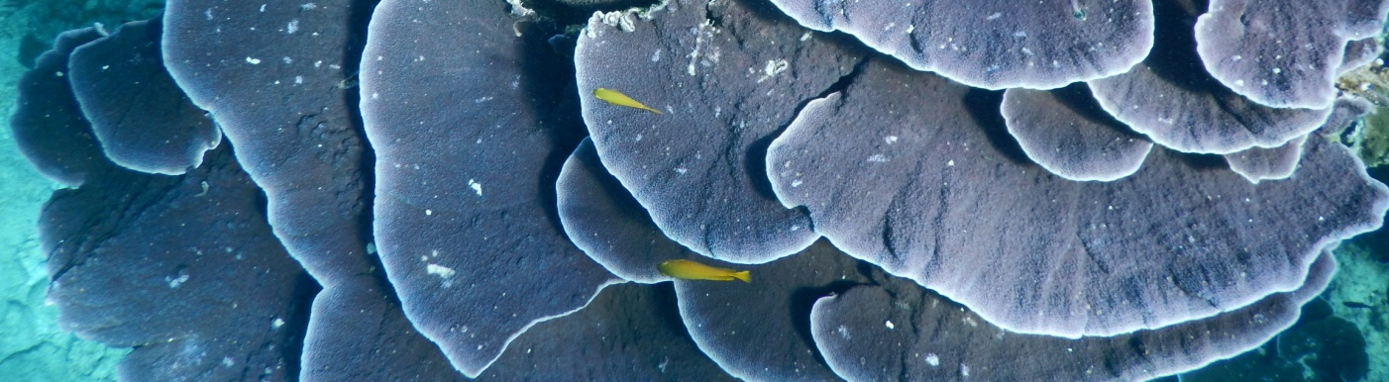

References
Beeden RJ, Turner MA, Dryden J, Merida F, Goudkamp K,Malone C, Marshall PA, Maynard JA, Birtles A, 2014. Rapid survey protocol that provides dynamic reef health condition information to managers of the Great Barrier Reef. Environmental Monitoring and Assessment Environmental Monitoring and Assessment. DOI 10.1007/s10661-014-4022-0
Commonwealth of Australia, 2015. Reef 2050 Long-Term Sustainability Plan, Commonwealth of Australia, Canberra.
Enhance Research, 2017. Reef 2050 Integrated Monitoring and Reporting Program Research Report 2017 draft report prepared for the Great Barrier Reef Marine Park Authority, Townsville.
Outlook Report, 2014. Great Barrier Reef Outlook Report 2014. Great Barrier Reef Marine Park Authority, Townsville.
