Reef Guardian Councils
Highlight Report
Summaries
2016–17

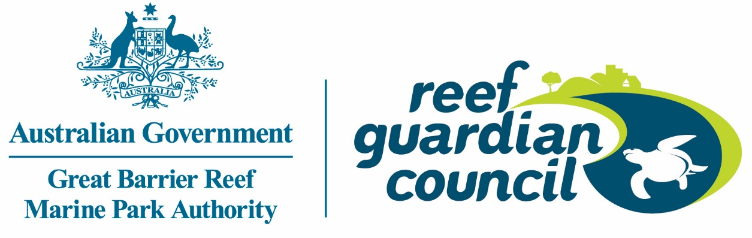

© Commonwealth of Australia 2017
Published by the Great Barrier Reef Marine Park Authority
ISBN 978-0-9953732-9-7The Reef Guardian Councils: Highlight reports 2016-2017 is licensed by the Commonwealth of Australia for use under a Creative Commons By Attribution 4.0 International licence with the exception of the Coat of Arms of the Commonwealth of Australia, the logo of the Great Barrier Reef Marine Park Authority, any other material protected by a trademark, content supplied by third parties and any photographs. For licence conditions see: http://creativecommons.org/licences/by/4.0

This publication should be cited as:
Great Barrier Reef Marine Park Authority and Reef Guardian Councils 2017, Reef Guardian Councils: Highlight reports 2016-2017, GBRMPA, Townsville.
A cataloguing record is available for this publication from the National Library of Australia
While all efforts have been made to verify facts, the Great Barrier Reef Marine Park Authority takes no responsibility for the accuracy of information supplied in this publication.
Aboriginal and Torres Strait Islander readers are advised this publication may contain names and images of deceased persons.
Unless otherwise noted all images are © to the Great Barrier Reef Marine Park Authority
Front cover inset photographs: second left Amy Yates, third left: Douglas Shire Council, forth left: Cairns Regional Council

Comments and questions regarding this document are welcome and should be addressed to:
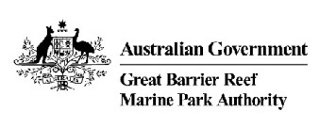
Great Barrier Reef Marine Park Authority
2–68 Flinders Street
(PO Box 1379)
Townsville QLD 4810, Australia

Phone: (07) 4750 0700
Fax: (07) 4772 6093
Email: info@gbrmpa.gov.au
www.gbrmpa.gov.au

REEF GUARDIAN
COUNCILS
HIGHLIGHT
REPORTS
2016 – 2017

The Reef Guardian Council stewardship program unites 17 councils working together to preserve the health and resilience of the Great Barrier Reef — for today and tomorrow.
The councils and their communities are taking positive environmental action to safeguard the Reef.
Each year, the Great Barrier Reef Marine Park Authority reviews each council’s activities and produces this report to celebrate their achievements.

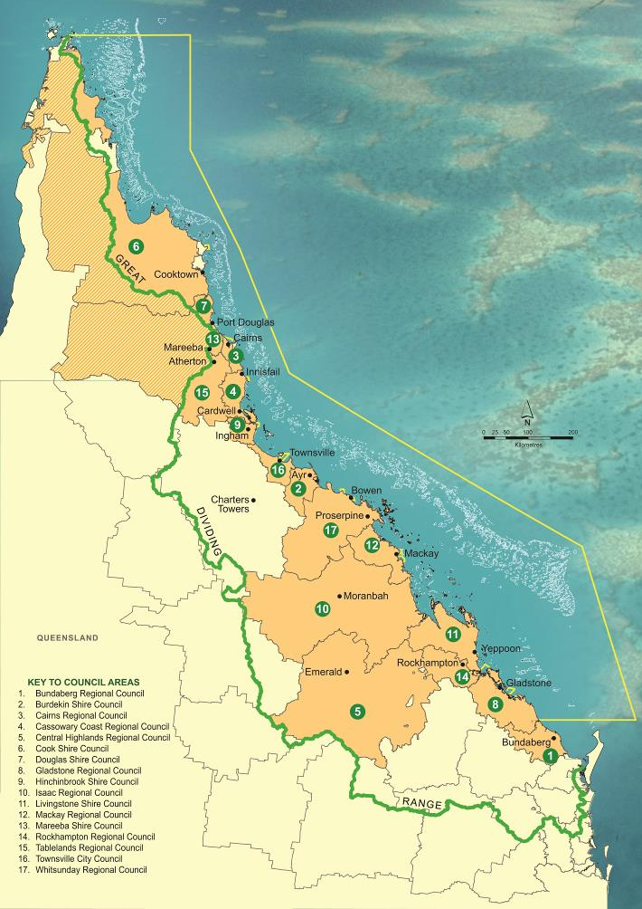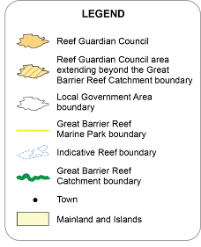

Contents
ABOUT REEF GUARDIAN COUNCILS 7
Bundaberg Regional Council 9
Burdekin Shire Council 11
Cairns Regional Council 14
Cassowary Coast Regional Council 16
Central Highlands Regional Council 18
Cook Shire Council 21
Douglas Shire Council 23
Gladstone Regional Council 26
Hinchinbrook Shire Council 28
Isaac Regional Council 31
Livingstone Shire Council 33
Mackay Regional Council 36
Mareeba Shire Council 38
Rockhampton Regional Council 41
Tablelands Regional Council 43
Townsville City Council 46
Whitsunday Regional Council 48

ABOUT REEF GUARDIAN COUNCILS
The Great Barrier Reef Marine Park Authority’s Reef Guardian stewardship program began in 2003, working with schools to encourage youth to take action to help protect the Reef. In 2007, the initiative was expanded to include local government councils within the Great Barrier Reef catchment.
There are now 17 participating councils, representing a 300,000-square-kilometre area and a population of more than one million people, between Cape York in the north and Bundaberg in the south.
The Reef Guardian Councils program showcases environmental initiatives undertaken by these councils to enhance the health of the Reef. It recognises the important role they play in planning for sustainable population growth, approving environmentally sound developments, and preparing the community for climate change impacts.
Through the Reef Guardian program, councils and their communities are demonstrating an active, ongoing commitment to securing a better future for the Great Barrier Reef.

Councils are partners
The Reef Guardian Councils program has evolved as a collaborative partnership between mayors, council officers and the Great Barrier Reef Marine Park Authority. Steering committee and working group meetings are convened throughout the year to enable these council representatives to share ideas and maintain the momentum for continuous environmental improvement. The councils have a strong sense of ownership and actively drive the program’s direction.

Annual action plans
Each Reef Guardian council prepares an annual action plan to identify activities that will be undertaken to promote and protect the health of the Reef. With the assistance of Marine Park Authority staff, councils compile a list of initiatives, under the general headings of land, water and waste management, community education, and climate change. Actions vary in scope, from ‘big picture’ new planning schemes, down to details for installing new pipes in causeways to improve waterway connectivity.

Highlight reports
The action plan is reviewed at the end of each year and each council produces a report outlining their key achievements. This document is a compilation of the 2016–17 highlight reports provided by the councils. It demonstrates how the frontline, community-based approach of Reef Guardians can make a real difference to the health and resilience of the Great Barrier Reef.

Reef Guardian projects
Healthy waterways and coastlines are vital for the Reef’s survival. Councils are playing a crucial role in restoring and reconnecting coastal ecosystems, and evaluating the environmental impact of future council planning scheme developments. They are also improving water quality through upgrades to wastewater treatment plants, enhanced stormwater management, and the minimisation of chemicals and other water-borne pollutants. Many of these projects are highlighted in this report.

Reef 2050 Plan
The Australian and Queensland governments released the Reef 2050 Long-Term Sustainability Plan in 2015. The plan provides a blueprint for governments, industry and communities to work in partnership to ensure the Great Barrier Reef remains a global icon into the future. Local government will play a vital role in 35 priority actions to be undertaken by 2020, in order to maintain progress towards 2050 targets. The Reef Guardian program is more important than ever, as participating councils align their activities with Reef 2050 and embrace the challenges ahead.

Bundaberg Regional Council

Putting down roots
The Council has formed a partnership with Victorian-based carbon offset company, Greenfleet. The joint project aims to help restore the vegetation communities of the Barolin Nature Reserve by planting some 89,000 indigenous trees. Greenfleet will also maintain the young trees, until the vegetation reaches a point of resilience. This is the biggest project of its kind in the Wide Bay Burnett region. It will help the Reef through the restoration of coastal wetlands, and will also reduce the disorientating effects of light glow on the region’s nesting and hatchling loggerhead turtles.
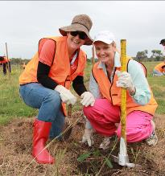
From little things, big things grow.

Foreshore project shows foresight
The Council’s natural resource management team is undertaking a large-scale coastal rehabilitation program at Moore Park Beach. The project aims to restore more than four hectares of coastal vegetation over three years, through a staged approach involving removal of weeds and exotic grasses; installation of irrigation; the use of locally sourced tree mulch, and; the planting of 4000 trees. The project will benefit the community by reducing the potential for harmful wildfires. It will also provide stability to the sandy beach environment, and training opportunities for trainee programs in the Bundaberg district.
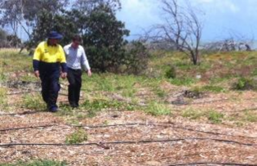
Green tide will transform Moore Park Beach.

Light relief
The Sea Turtle Alliance, in partnership with the Council and Ergon Energy, will undertake a streetlight retrofit project in and around key nesting beaches for the loggerhead turtle. Fourteen high pressure sodium lights will be replaced with specialised LED lights that have special eye-lids on the back of each bulb to reduce direct light spillage in these sensitive coastal environments. The project will directly benefit marine turtles, and help to raise awareness in coastal townships about the importance of low-light communities.
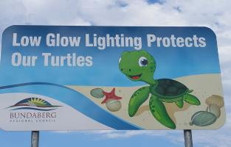
Low lights highlight environmental message.

Green lid for landfill
The Council’s waste and recycling department is adopting phytocapping techniques to move towards a more environmentally friendly and sustainable method of closing landfills. Local indigenous plant species will be used to cap the Qunaba Landfill, which is situated next door to the Barolin Nature Reserve and very close to the region’s primary marine turtle nesting beach within the Mon Repos Conservation Park. The planting will help reduce leachate and run-off from the landfill site; dramatically reducing the volume of pollutants entering the Reef and also increasing habitat for native wildlife.
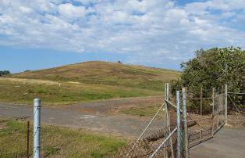
Landfill project improves eco-credentials.

Students sign off on environmental project
Moore Park Primary School and the Council worked together to develop signs to raise awareness of the importance of coastal wetlands. The school held a competition, asking its students to develop interpretive signs to promote the important role that coastal wetlands play in maintaining Reef health and providing habitat for a wide range of terrestrial and aquatic fauna. The Council turned the winning entry into a professionally designed sign, which has been installed at the school and in two prominent locations around the wetland system.
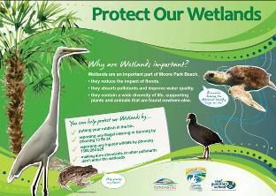
School students get the message.

Burdekin Shire Council

Recruiting young recyclers
Council officers visited a number of kindergartens and primary schools over the past year to educate children on the impact of littering on ecosystems and the importance of recycling. Officers visited kindergartens and demonstrated how household waste can be recycled using worm farms and compost bins. They also chatted to students in Prep to Year 6 during Recycling Week 2016. In October, the Council hosted a community street garage sale to encourage residents to turn trash into treasure and educate older community members about landfill waste and illegal dumping.
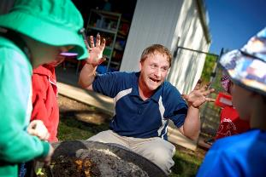
Getting down and dirty to promote recycling.

Green light for green project
The Council has given Pacific Hydro the green light to build one of Australia’s largest solar farms, to be located west of Giru. The solar farm will have the capacity to power around 170,000 homes and thereby reduce the amount of carbon entering the atmosphere and the stressful impact of climate change on the Great Barrier Reef. There have been three large scale solar farms approved by Council in the past year with a fourth in progress, turning the Burdekin into one of Australia’s largest renewable energy hubs .

Solar farms – a leading light in renewable energy.

War on water weeds
The Council puts enormous effort into maintaining the health of freshwater lagoons that connect to the Reef. In October 2016, an amphibious excavator was used to remove several stubborn weed species from the Kalamia lagoon system, directly upstream from Alva Beach. The clean-up effort aimed to remove all weed species, then instigate follow-up control. Weed removal from fishways helps fish migration throughout the system and also enhances flood mitigation. More than 4000 cubic metres of weeds were removed and transferred to nearby farms to trial as a crop fertilizer and reduce traditional fertilizer run-off into the Kalamia lagoon.
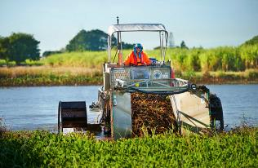
Carving clear waterways.

Clean sweep after Debbie
In the wake of cyclone Debbie, the council worked hard to ensure that rubbish and debris would not end up on the beaches, damage infrastructure or clog drainage in the area. All three waste facilities in the shire were opened for extended hours and extra waste and recycling bins were provided. Council officers went above and beyond the call of duty – emptying bins and cleaning up debris on properties left unoccupied by evacuated residents.
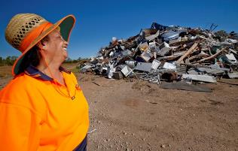
Council workers tackle mountain of pre cyclone debris.

Fishing for information
In June 2017, fish surveys commenced in the Sheep Station Creek system. Directly linked to the ocean, this system often acts as a nursery for juvenile fish. Data is being collected by boat, using an electric pulse method that temporarily stuns fish around the vessel, so they can be netted. Species are counted and measured to gain insight into fish movements in the area. The fish are then released, unharmed. The survey, which concludes in September 2017, will monitor the impact of ongoing weed management in the system on fish species in the area.
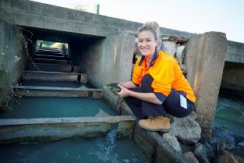
A fish tale – collecting data on aquatic residents.

Cairns Regional Council

Solar light at end of tunnel
In 2016–17, the Council tripled the number of solar panels on council buildings putting it on track to halve the organisation’s 2008 greenhouse gas emission levels by 2020. The new solar installs will generate 165 kilowatts of power, reducing emissions by 270 tonnes CO₂ (e) per year and slashing electricity costs by more than $100,000 annually. In 2017–18, an additional 800 kilowatts of rooftop solar will be installed – bringing the council’s total rooftop solar capacity to more than 1 megawatt.
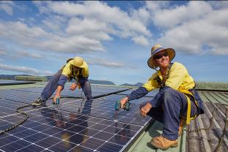
Solar panels light the way to CO₂ target.

Waterways report ticks all the boxes
The Council is a founding member of The Wet Tropics Healthy Waterways Partnership, which monitors the health of local waterways to measure the effectiveness of land management practices. Council provides both financial and technical support to the group, which pools scientific data collected by the region’s industry, academia and agencies to produce an annual report card on catchments from the Daintree River in the north to the Herbert River in the south. This knowledge is used to strengthen stakeholder relations and prioritise management actions for catchment and Reef health. For more information visit: www.wettropicswaterways.org.au
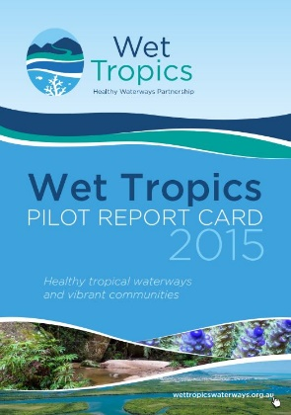
Waterways report receives “A” for effort.

Environment in the frame
CairnsPlan 2016 is the principal land use planning instrument for the Cairns region. Adopted on 28 June 2017, the plan provides the framework to ensure appropriate development occurs and that impacts on the local environment and Reef catchment are managed by a strategic framework and appropriate overlay codes, in particular the Coastal Processes Overlay Code and Natural Areas Overlay Code. For more information about CairnsPlan 2016, visit: www.cairns.qld.gov.au/building-planning-business/planning-schemes
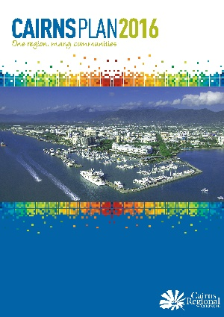
CairnsPlan for sustainable development.

Water-wise gardens
Gardens are the largest consumer of water in the average Cairns household. The Council’s latest water saving campaign, Thrive, aims to reduce the thirst to water gardens. Animated plants promote the importance of water conservation through song. They deliver the message that gardens in the Wet Tropics can survive and thrive with less water than gardens in other regions. A useful watering guide, specifically designed to cater for trees, flowers and other plants common to North Queensland, is available via the Thrive App. For more information visit: www.thrive.cairns.qld.gov.au
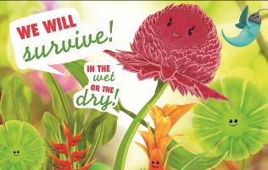
Survival manual for plants.

New access to underwater classroom
Cairns has two World Heritage-listed areas – the Wet Tropics Rainforest and the Great Barrier Reef – on its doorstep. Unfortunately, costs limit the ability of many schools to take their students to the Reef to savior this unique educational experience. In September 2016, the Council launched the Nature-based Learning Grant to help schools meet the cost of excursions directly linked to sustainability outcomes in the National Curriculum. Thirteen schools shared $20,000 for environment-focused excursions, including Mirriwinni State School, whose students visited the Reef for the first time in 11 years. For more information visit: www.cairns.qld.gov.au/sustainability
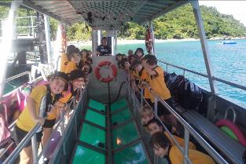
Mirriwinni students revel in the Reef.

Cassowary Coast Regional Council

The heat is on!
The Council has purchased an industrial steam weeding unit to control plant pests, including Singapore daisy, in sensitive coastal and waterway environments. The unit is also being used in urban parks and playgrounds, and to clean surfaces with low-pressure steam. Council nurseries are utilizing the unit and it is being trialed at revegetation sites. Increasing reliance on the steam unit reflects the Council's commitment to reducing the use of chemicals which pose the risk of entering waterways that lead to the Reef.
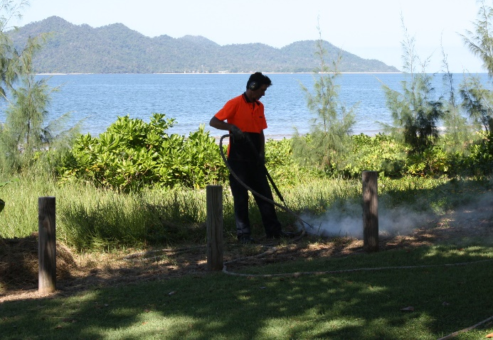
Steam weeding unit is a blast!

Building roots
Council nurseries stage four tree giveaway events each year. About 1000 people attend these two-day events, which also provide nursery staff with the opportunity to educate gardeners on plant species and pest management. In addition, they foster appreciation of plant life in the Wet Tropics region, including the importance of planting and maintaining trees, particularly along waterways and foreshores. These trees help to stabilise creek and river banks, and other open areas, thereby reducing sediment run-off that is carried out to the Reef.
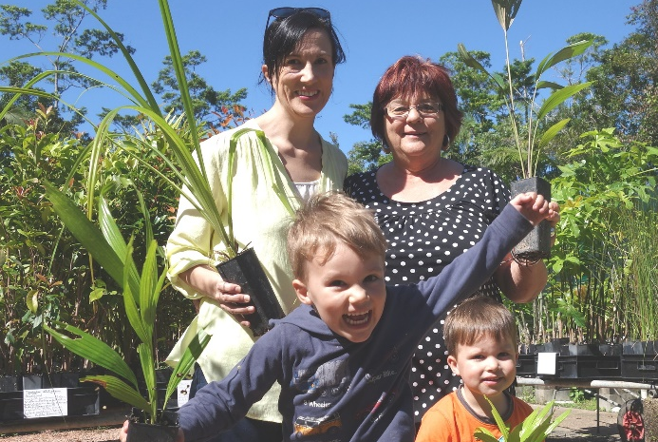
Budding gardeners enjoy tree giveaway events.

Sweet smell of success
The Council has constructed a wastewater treatment plant at Tully to hold and treat effluent in cases where there is a rise of pollutants such as ammonia. The waste system is equipped with a notification and environmental monitoring process, and the new pond effectively treats wastewater before discharge in an exceedance event, such as a tropical cyclone.
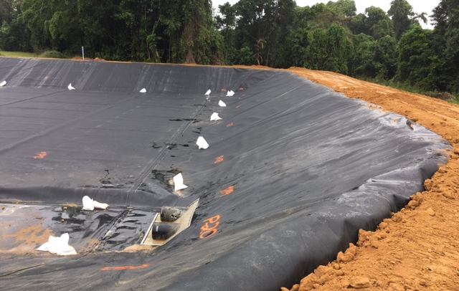
New pond designed to deal with pollutant problems.

Beach clean up to help turtles
The Cassowary Coast Regional Council worked in partnership with Mandubarra Land Aboriginal and Sea inc, Queensland Parks and Wildlife Service rangers and Green Army teams to remove more than 350 kilograms of marine debris from Kurrimine Beach. The group collected large amounts of plastic including 529 drink bottles, 930 plastic lids, almost 3000 pieces of hard plastic and more than 300 remnants of plastic bags. Aluminum cans, light bulbs, fluorescent tubes, thongs, rope, fishing line – even fridges and a television - were among the debris.
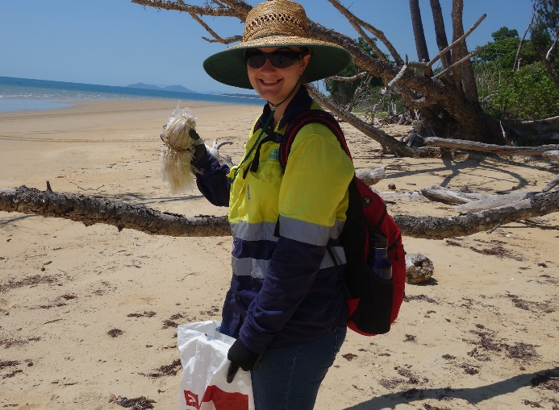
Savannah Roeser with plastic found on the beach that makes it easy to see how turtles can mistake rubbish for jelly fish.

Central Highlands Regional Council

One-ton turtle!
Commissioned by the Council to create a public artwork from recycled debris, local artist, Jace Moore, built a striking sculpture of the Fitzroy River Turtle. As part of the Great Barrier Reef Clean-up, the art project was designed to remind residents that the health of the Nogoa catchment has a direct impact on this endangered species. The sculpture’s shell is composed of old plough discs, and the legs of scrap mining machinery parts. Now on display at the Emerald Transfer Station, the artwork was funded by the Australian Government’s Reef Trust, in partnership with the Great Barrier Reef Marine Park Authority.
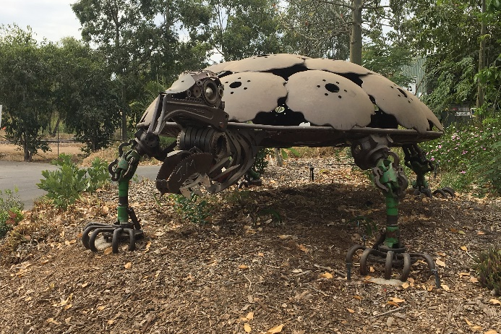
Heavy duty art!

Weed in retreat
Large volumes of the invasive hymenachne weed have been eradicated from the banks of the Nogoa River, as part of a Council-led control program. Hymenachne, which can grow up to 2.5 metres, chokes waterways and reduces their flow capacity. Council rangers have tackled the problem grass with herbicide between the John Gay Bridge and the Vince Lester Bridge, as well as areas around Fairbairn Dam. The control program, supported by the Department of Agriculture and Fisheries and Sunwater, is part of a Council push to revitalise the river for recreation purposes.
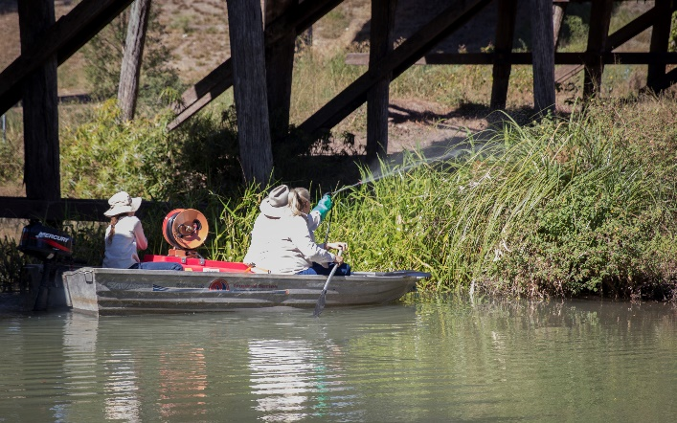
Hymenachne spraying helps revive river.

Bright future for Black Gully facility
The Council has launched a $23 million upgrade to Emerald’s Black Gully Waste Water Treatment Plant. The upgrade to the overloaded waste water treatment plant will more than double its current capacity and help achieve sustainable effluent irrigation. It will ensure all environmental legislative requirements are met in the future. The project is jointly funded by the Queensland Government’s Building our Regions program and the Council and is expected to be completed by June 2018.
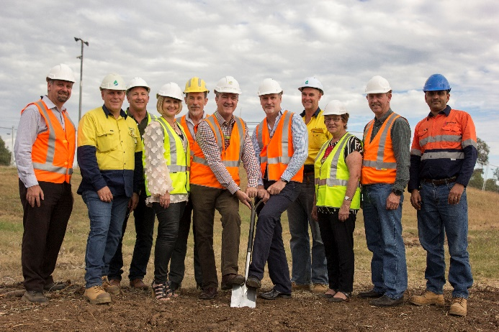
Breaking-of-ground event heralds plant upgrade.

Building a healthy future
The Central Highlands Regional Council Corporate Plan 2017–2022 recognises the Council’s primary responsibilities as caretaker of both the built and natural environment. These responsibilities include managing appropriate growth and development; protecting the natural landscape and waterways and building resilience. The Council plans to develop efficiencies in water and wastewater operations, and create a roads and transport strategy to ensure the efficient and effective use of resources. It also aims to deliver waste, recycling and re-use strategies across the region, and implement energy-efficient practices for assets and facilities.
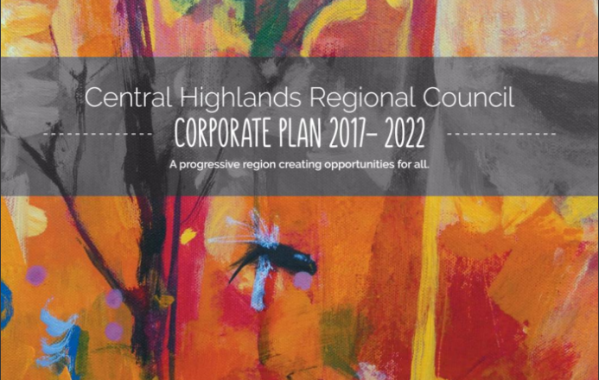
New plan for nurturing people and the environment.

Floating ideas
The Council hopes to attract community and corporate partner support to undertake a project to revive the Nogoa River as a recreational asset for Emerald residents. Weeds, snags, fallen timber and bank erosion currently impede navigation in the river around some blocked areas. While there is currently no funding available for such a project, the Council believes that recent feedback generated during discussions over a proposed levee system for the river (since rejected) could form the basis for a future river revival initiative.
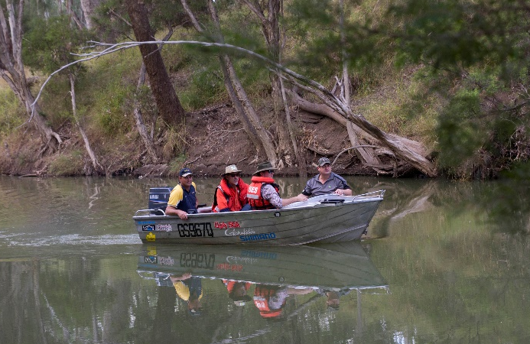
Council mayor, Kerry Hayes, chief executive officer, Scott Mason, and general manager infrastructure and utilities, Gerhard Joubert, inspect the river by boat.

Cook Shire Council

New life for landfill
Laura landfill was closed on 1 July 2016 and converted into a transfer station. The site posed significant environmental problems, such as windborne litter and burning rubbish, so the Council decided that a transfer station would reduce the risks. The conversion enables more items to be recycled and staff can now educate the public about recycling.
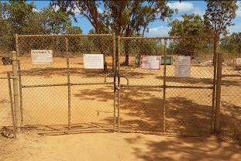
Laura landfill has new recycling role.

Time to tank up
The Cooktown Waste Transfer Station used to contain leachate in ponds. The system was outdated and possibly inefficient, so the Council’s director of infrastructure instigated the design of a new system, using suitable technology to guarantee the best results. Nothing was left to chance: a generator was installed, in case of power loss, and; a computer system introduced to signal pump failure or impeding overflow. Reinforced tanks were installed to contain the leachate. The Council is now confident that leachate produced at the facility can be contained onsite.
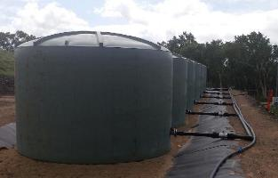
Leachate tanks tackle waste.

Big steps to reduce carbon footprint
The Council conducted an audit of all council buildings to measure energy efficiency and identify options to reduce energy output. Some measures were implemented immediately – such as changing light bulbs to LED lights and ensuring staff turn off lights. More complicated or expensive modifications were introduced over time. The audit and subsequent changes produced a significant reduction in carbon dioxide emissions, which correlates to lower energy consumption.
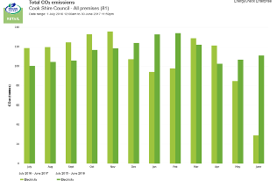
Comparison of total carbon dioxide emissions for Cook Shire Council premises for the 2015–16 financial and the 2016–17 financial year.

Councillor’s push to contain litter problem
Councillor Alan Wilson has worked tirelessly to get the Container Refund Scheme (CRS) up and running in Queensland. He even pursued another term in office to ensure he could be involved in the final stages of planning the scheme in July 2018. The initiative will provide an incentive for people to collect and return beverage containers for recycling in exchange for a refund. Cr. Wilson is looking forward to seeing good results from the scheme, as discarded drink containers are a major source of litter.
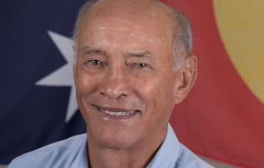
Councillor Alan Wilson champions waste reduction initiative.

Sensible sediment precautions
Cooktown’s Webber Esplanade will soon have a new waterfront precinct. During the construction project, Council has adopted measures to limit the impact on the Endeavour River, which flows directly out to the Reef. Geofabric is being laid along the erected seawall to reduce sediment run-off. Placed between the ground and the rock wall, the geofabric creates a permeable layer for water to pass through, while also filtering and protecting the soil. This will prevent sediments and pollutants from entering the river.
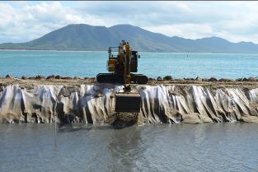
Eco-friendly solution – geofabric will minimise sediment loss from new seawall.

Douglas Shire Council

Just add water …
Drinking fountains have been installed across the shire to provide the community with an alternative to disposable plastic water bottles. The fountains have been placed in strategic locations, including the esplanade, parks and popular walking tracks. Drink containers are a commonly discarded item, so this initiative is expected to reduce the amount of littering in public areas. The Council is an active member of the Plastic Free Douglas community group. It is committed to working with the community and local businesses to reduce the amount of disposable plastic used and disposed of within the shire.
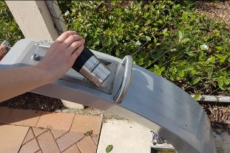
Tapping into solutions – drinking fountains combat litter.

Smoking out pipeline defects
The Council conducted smoke testing along the sewage pipelines to identify cracks, breaks and other problems that need to be repaired. Pipeline defects can allow rainwater, stormwater and groundwater to enter the network, contributing to sewage overflows into creeks and rivers which flow to the Reef. The smoke used is non-toxic and non-staining. It is an odourless gas, harmless to living things, food and material goods, and poses no fire hazard. Council officers located a number of damaged sewer manholes, which were repaired.
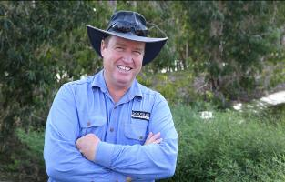
Council pipeline inspector on the look-out for a “smoking gun”.

Green facelift for old landfill
The Council has partially capped its biggest landfill site, Killaloe, to isolate waste and prevent the spread of windborne contaminated material offsite. It will also reduce stormwater infiltration and the generation of leachate. One third of the landfill was capped with low-permeable clay material, followed by mulch, and then seeded to provide a vegetative layer. Regular inspections and groundwater testing will monitor the environmental impact of the landfill as it approaches the end of its life. The Council promotes recycling and diverts as much waste as possible from landfill, in line with the waste hierarchy for efficient resource use.
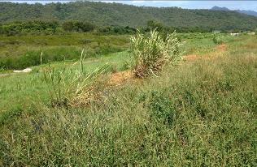
Sowing seeds for sustainability.

Dirty secrets
A sample of residential and commercial bins was audited as part of a Council initiative to better understand waste composition and characteristics. The results showed recycling bins were largely filled with compliant material, with minimal food and garden waste recorded. However, a number of recyclable items were found in the general waste bins, indicating the need for more targeted community education programs to encourage recycling. The waste audits have given the Council a baseline to measure future progress, particularly around the amount of waste being diverted from landfill.
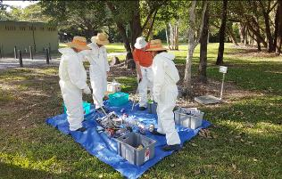
“Bin” there, done that – council workers audit rubbish.

New green goals
The Council has published a Corporate Sustainability Policy, which commits the Council to uphold six sustainable principles: preserve and restore the natural environment; utilise resources efficiently; protect and enhance Council’s environmental footprint; strengthen Council’s resilience to climate change; and display strong environmental leadership. The Councils new Corporate Sustainability Strategy 2017–18 outlines 28 actions towards implementing the sustainable principles. As the only local government area linking two World Heritage areas – the Wet Tropics Rainforest and the Great Barrier Reef – operating in a sustainable manner is a high priority for the Council.
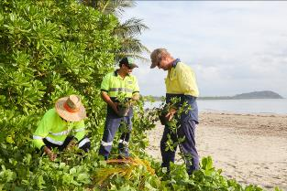
Council pursues green agenda.

Gladstone Regional Council

Winning project hits the gas
The Council's Benaraby Landfill Gas-to-Power Project was the winner of the Boosting Productivity through Infrastructure category of the 2017 National Awards for Local Government. Gas generated at the Benaraby Landfill is extracted and converted into power. This innovative project is boosting the region’s energy infrastructure, reducing landfill greenhouse gas emissions by more than 60 per cent, and abating more than 150,000 tonnes of carbon dioxide per year. The project also caters for the inclusion of an adjacent solar plant.
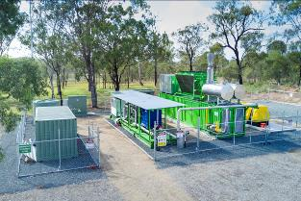
Landfill project taps into new energy source.

Turning the tide on water pollution
A joint initiative between the Council and Gladstone Ports Corporation will significantly reduce the amount of pollutants entering Auckland Creek and Gladstone Harbour. The installation of a SPEL Baffle Box gross pollutant trap in the Gladstone CBD is designed to prevent litter, such as cigarette butts and plastics, from reaching the harbour via the stormwater drainage system. The installation of the 13.5 tonne concrete structure was funded by the Gladstone Ports Corporation.
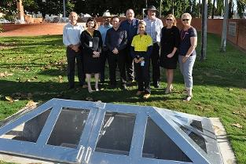
The trap, which features a glass lid to enable viewing of the trap contents, is also an educational tool, motivating residents to correctly dispose of litter.

Students learn their A, B, seas
The 2017 Future Leaders Eco Challenge on Curtis Island was organised by the Great Barrier Reef Marine Park Authority, with the proud support of the Council. Other supporters included CQ University, the Gladstone Ports Corporation, Gidjaril Sea Rangers and the Fitzroy Basin Association. The event focused on environmental education and learning in the field. It gave Years 6 and 7 students from local Reef Guardian Schools the opportunity to participate in tree planting, seagrass surveys and the removal of marine debris. Students also learned about marine life in Gladstone Harbour.
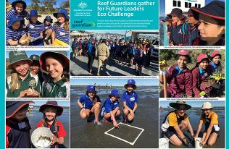
Educating future eco-leaders.

Crafty kids tackle marine debris
The Creative Recycling Centre was contracted by the Council, through its Reef Guardian Schools program, to deliver lessons to local primary schools about the importance of reducing marine debris. Through discussions and interactive games, the students learned about debris decomposition rates and ways to recycle items, in order to minimise marine debris. To reinforce the lessons, children were given the opportunity to make their own turtle fridge magnets from recycled materials. They then shared what they had learned and ideas on how they would protect the Reef.
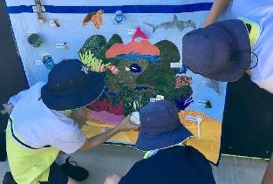
Primary students use their creative skills to promote a vital environmental message.

Be Great to Our Barrier Reef
Ecofest is an annual environmental festival that celebrates World Environment Day. It is the largest free-entry environmental event in central Queensland, promoting positive environmental actions in the Gladstone region. This year's theme, Be Great to Our Barrier Reef, sought to encourage the community to seek ways to mitigate our impacts on the marine environment. The event featured special guest speakers, as well as displays and interactive activities staged by the Council, industry, businesses, community and natural resource management groups.
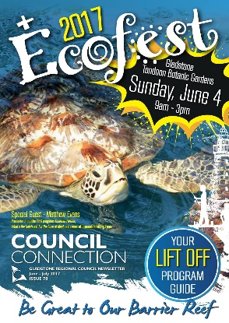
Ecofest 2017 focussed on safeguarding the Reef.

Hinchinbrook Shire Council

Pest control – a pig deal!
Since 2009 the Hinchinbrook Community Feral Pig Management program has reduced the loss of sugar cane, from around $1.2 million to just over $200,000 annually. It has also reduced pig damage to creek, river bank and wetlands to a manageable level. In recent years, the program has sought additional funding to expand its control area to include coastal wetland ecosystems. This move aims to minimise predation on nesting sea turtles along the shire’s coastline. A successful grant obtained under the Queensland Feral Pest Initiative is currently funding this expansion.
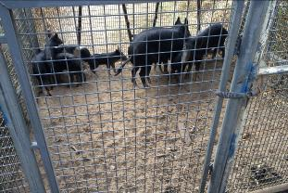
Feral pigs in retreat.

A growing relationship with volunteers
Every second Wednesday since 1 March 2017, the Council has opened its nursery doors to the public. The initiative is designed to welcome volunteers keen to learn new skills, make new friends and contribute to the community by growing plants for our local environment. Volunteers learn how to collect and store seeds and grow plants from seed/seed sowing. They are also taught direct seeding techniques, propagating by division and seed preparation.
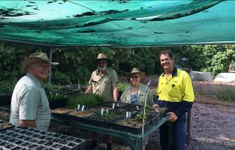
A blossoming relationship between Council and nursery volunteers.

Turtle-y awesome message
Council commissioned artists, Sally Moroney and John Heard, to embark on a novel marine debris public art project, Tidy Turtle is, a six-foot, freestanding, mobile educational artwork, which will be used to promote a range of environment-focussed events. The metal sculpture is interlaced with marine debris including the work of residents who participated in a series of Tidy Turtle weaving workshops. Participants also attached environmental messages to the sculpture, which was funded by the Australian Government’s Reef Trust, in partnership with the Great Barrier Reef Marine Park Authority.
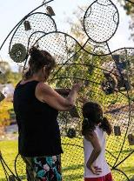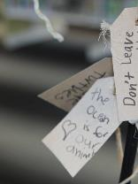
Art speaks for the Reef.

A vine state of affairs
The Herbert River Catchment Landcare Group has come to the aid of landholders concerned about the health of Waterview Creek. A number of vine species were choking out and killing native tree species, with a flow-on effect of erosion, due to falling dead trees. The presence of aquatic weeds also impacted water quality. The group held landholder workshops on how to manage the invasive species. The Council staff then offered technical assistance, working side by side with landholders to undertake urgent control works, funded by Terrain NRM.
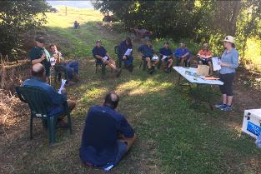
Workshops help safeguard creek system.

Floating weed takes nosedive
The Council is well on the way to winning the war against Hygrophila, an emerging weed problem locally. If left to its own devices, it poses a competitive threat to native water plants. The weed forms dense mats of floating growth that choke up waterways, creeks and drainage systems, destroying their natural functions. The eradication program started in December 2013 and is now down to controlling the odd individual seedling identified during the Council’s biannual inspections.
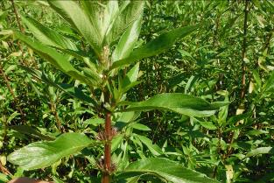
The days are numbered for aquatic weed, Hygrophila.

Isaac Regional Council

Plan to make beach bloom
The Council is forming a development plan for the Carmila Beach area. The plan will be used to highlight beach, camping and public amenities spaces that require protection and repair. It will provide the Council with a blueprint to pursue ongoing improvements over the coming years. These improvements will include the enhancement of beach and dune systems; reductions in erosion; encouragement of flora and fauna, and; an increase in visitor satisfaction. The Council is working with a number of stakeholders to ensure the plan can deliver meaningful outcomes.
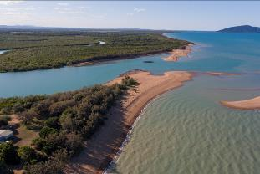
Joint effort to nurture Carmila Beach.

Race against waste
The Resource Recovery Centre Expansion and Improvement Project will deliver landfill cell, stormwater and leachate ponds, and provide a modern refuse transfer station. The new facility will improve environmental performance and efficient recovery of recyclable materials. It is critical to ensuring Moranbah can meet demand for effective waste infrastructure for the greater regional community. The project was jointly funded under the Queensland Government’s Building our Regions program.
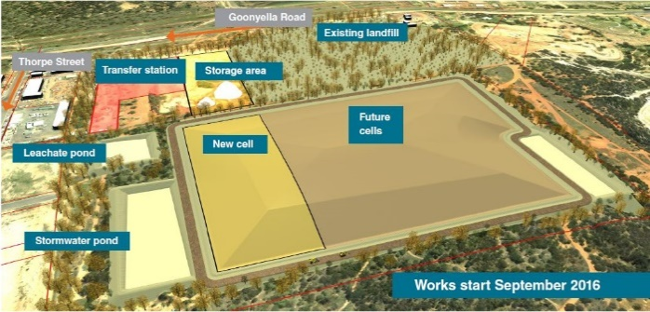
Project plan to manage waste disposal demands.

Wetlands Weekend makes a splash
The St Lawrence Wetlands Weekend attracted both locals and visitors to the annual festival in June. Birdlife Capricornia led bird-watching tours and discussions around bird conservation. Capricornia Catchments, the Great Barrier Reef Marine Park Authority and the Mackay and District Turtle Watch Association also gave presentations. The Council’s environmental team conducted a tour of the Wetlands that showcased local plant diversity, land management initiatives and fish ladders.
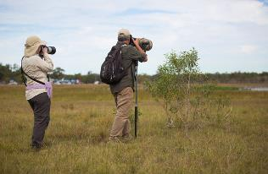
Focus on St Lawrence Wetlands.

Young artists brush up on marine debris
As part of the Great Barrier Reef Clean-up, Carmila State School, St Lawrence State School and the Council have installed three signs along the Isaac Coast that aim to curb littering. The Marine Debris Awareness campaign engaged students in a beach clean-up morning, before creating the inspired artworks featured on the signs. The Council hopes these colourful markers will remind us of the impact of marine debris on wildlife and simple ways to reduce it. This project was funded by the Australian Government’s Reef Trust, in partnership with the Great Barrier Reef Marine Park Authority.
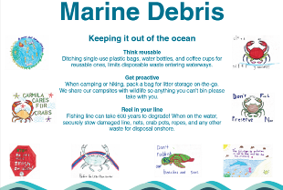
Bringing home an important message.

Quest to reduce pests
Coordinated pest management continues to benefit the region by minimising the impact of pest animal and weed species. Important projects conducted in 2016–17 include prickly acacia treatment at the St Lawrence Wetlands and the provision of the 1080 baiting service to landholders across the region. Biosecurity workshops facilitated planning and management of weeds at a property level.
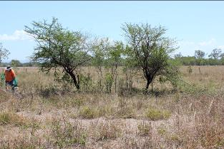
Prickly acacia the on pest hit list.

Livingstone Shire Council

A step in the right direction
The Council is participating in the award-winning Habitat Stepping Stones Program, administered by Macquarie University. The program encourages residents to create effective habitat stepping stones for local wildlife. It asks participants to enhance the urban landscape by adding three or more attractive habitat elements to their backyards. Participants receive online recognition, a plaque for their front fence, and discounts from local suppliers. They can also join the program’s supportive online community, where they can swap stories and advice, and learn about other Council environmental initiatives.
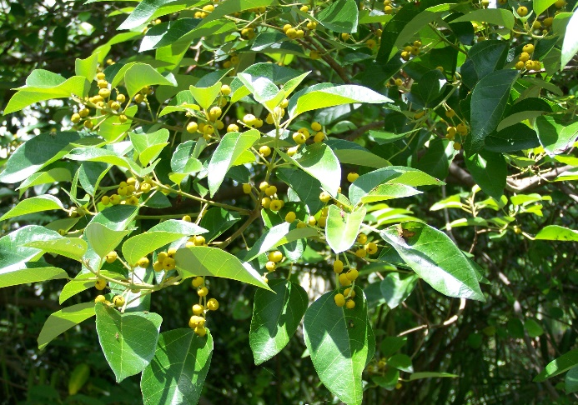
Mallotus discolour – a habitat stepping stone.

New nursery will blossom
The Council has commissioned the development of a new Livingstone Community Nursery at the Yeppoon landfill site to replace the old nursery at the depot. The new site will accommodate three to four times more flora. It will include two shade houses and more space for sun-hardening benches, as well as an office and storage building powered by rooftop solar panels. The nursery will remain a volunteer-based initiative to preserve local natural heritage; sourcing seed, and propagating and supplying endemic species to the community. It will also host biocontrol sites for salvinia, water lettuce and water hyacinth pest species.
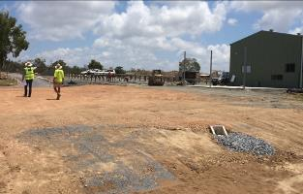
Spacious new nursery site.

Flow-on benefits
The Yeppoon Town Centre Stormwater Drain Management Project is trialling and monitoring the performance of two gully traps in heavily utilised areas of the town. Made from recycled milk crates, the gully traps are a low-cost way of capturing rubbish (both organic and general waste) before it enters waterways through existing stormwater infrastructure, without increasing the load during peak flow periods. A drain stencilling program in the town centre has also been rolled out to highlight the message that these drains lead to the Reef.
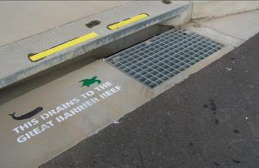
Drain delivers environmental message.

Key catchment under the microscope
The Council is partnering with a number of stakeholders to enhance management of Fig Tree Creek, a key urban waterway in the shire. The stakeholders include Capricornia Catchments, Capricorn Coast Landcare, the Great Barrier Reef Marine Park Authority and the Livingstone Remnant Vegetation Study Group. A master plan is being developed to analyse the entire creek catchment and then provide a range of options to address environmental issues. These include the extremely narrow and poorly defined creek channel through urban areas, weed infestation, poor water quality, flooding, sediment build-up, and poor physical access and amenities.
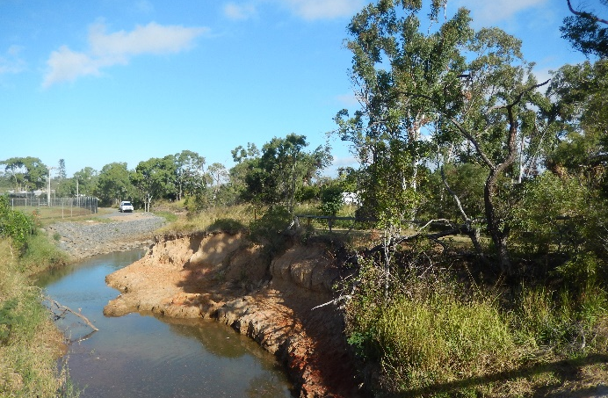
Focus on health of Fig Tree Creek.

Combating coastal hazards
The QCoast2100 Program assists councils threatened by existing and future coastal hazards to develop a Coastal Hazard Adaptation Strategy. Livingstone Shire possesses around 300 kilometres of coastline, where a number of key assets – centred on the main urban footprint from Farnborough to Keppel Sands and also on Great Keppel Island – are at risk. The strategy will identify vulnerabilities and coastal hazard risks, and help assess suitable adaptation options. The Council is currently delivering the first two phases of the program, which will produce a whole-of-project community stakeholder engagement strategy and a project scoping plan.
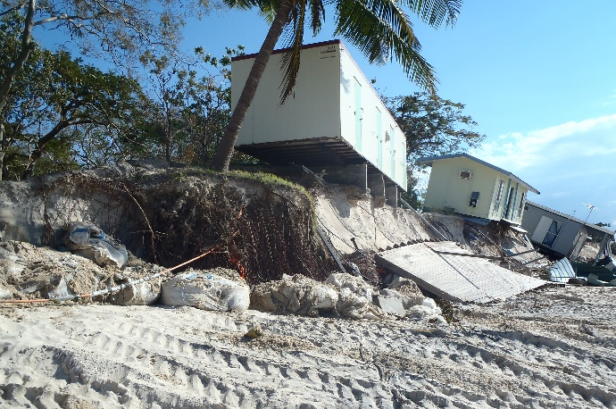
Great Keppel Island, in the wake of Cyclone Marcia, 2015.

Mackay Regional Council

Strategy to grow a sustainable region
The Council’s Environmental Sustainability Strategy 2017–2022 provides an integrated and coordinated approach to advancing sustainability in the Mackay region. The strategic vision recognises that the region’s prosperity, liveability and lifestyle is underpinned by a healthy and sustainable environment managed through council, industry and community partnerships. The Council’s key focus areas are to create a region that is sustainable, smart, resilient, low-carbon, resource efficient and productive. The strategy will also foster sustainability in the natural environment, transport, procurement and the local economy, and regional and community partnerships.
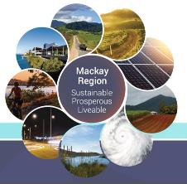
Blueprint for a sustainable future.

Plans to nurture beaches
Local coastal plans have been developed for Bucasia Beach, Blacks Beach and Grasstree Beach. The plans describe the natural and recreational values of the areas and provide clear actions to manage, restore and enhance the sites. Extensive community consultation was undertaken as part of this project, with opportunities for plan input. The plans will help raise awareness of the values of coastal environments and help provide a clear direction for management.
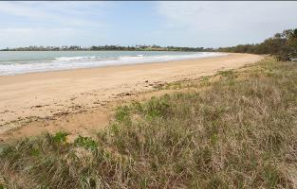
The foreshore environment at Grasstree Beach.

Take a walk on the wild side
Planning is well underway to create a nature trail at Shellgrit Creek to showcase the natural values of the area. These include critically endangered beach scrub vegetation, casuarina dune forest, tidal wetland, melaleuca wetlands and shorebird roost sites. The site is already popular with local bird watchers, and the nature trail and interpretive signs will encourage tourists and locals to learn more about this unique area. Weed control and rubbish removal are part of this project. Dogs will be seasonally restricted from the area to reduce disturbance to fauna, including migratory shorebirds.
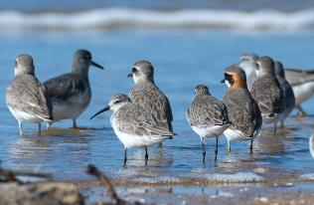
Migratory shorebirds savour Shellgrit Creek.

Paradise regained
The Works for Queensland program funded a river enhancement project at Platypus Beach, Mirani, which restored a sandy beach frontage and access to the river. The site had been smothered by accumulated sediment, resulting in weed proliferation and loss of beach. A picnic shelter has been installed. Local volunteers and school groups have planted more than 4000 plants to provide shade and help stabilise the area. The site has now resumed popularity with local residents and tourists. Platypus monitoring was also conducted as part of this project.
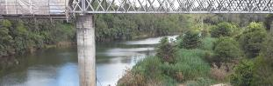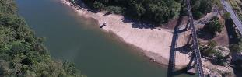
latypus Beach is once again an idyllic recreation spot.

Taming stormwater
The Council recently adopted an Urban Stormwater Quality Management Plan for the region. The plan establishes a framework for the management of stormwater quality in urban waterways, and aims to balance environmental, social and economic interests. It identifies current stormwater quality management issues in the region. It also recommends actions for planning, implementation, communication and education that will minimise the impact of urban stormwater quality on surrounding environments.
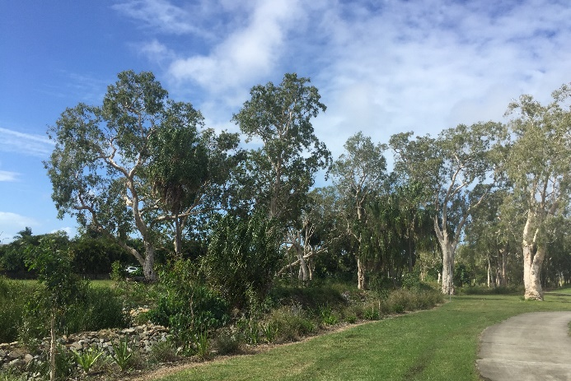
The Little McCreadys Creek rehabilitation project is helping to improve water quality, provide habitat for wildlife and enhance local amenities.

Mareeba Shire Council

Bright prospects for energy savings
The Council has installed 80 kilowatt solar photovoltaic (PV) systems on two administration buildings in Mareeba. The solar panels will power the facilities during the day, with minimal or no use of electricity from the grid, while reducing the Council's carbon footprint. Based on current electricity prices and upkeep estimates, the Council will save $38,000 annually. This will result in a payback period of just over three and a half years for the solar panels on one building and just over three years for the other.
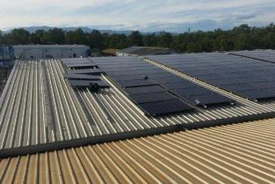
Solar panels power council depot. Image courtesy of Anthony Archie.

Mural weaves awareness
In early 2017, a Marine Debris Awareness Art Project was unveiled in Kuranda. The stunning mural by artist Zane Saunders highlights the impact of pollution on the rivers and rainforest ecosystem that nurture the Great Barrier Reef. Mr Saunders said the mural conveyed the message that we need to care for country and be mindful of how we interact with the land and the animals that occupy it. Mayor Tom Gilmore hailed the artwork as a commitment to protecting the Great Barrier Reef for future generations. The project was funded by the Australian Government’s Reef Trust, in partnership with the Great Barrier Reef Marine Park Authority.
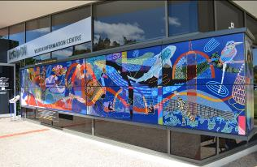
Bulmba Maminga – love and care for the country, by Zane Saunders. Image courtesy of Amy Yates.

Full steam ahead!
The Council recently purchased a steam weeder for use in parks, and in and around waterways, to limit the application of herbicides. The machine has now been incorporated into routine maintenance activities. Council staff have received training in the operation, safe use and maintenance of the unit. The steam weeder is being used to control aquatic weeds, as part of the Barron River Esplanade tidy up program. It has also proved popular with local environmental groups in Kuranda undertaking riparian rehabilitation projects.
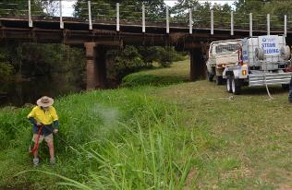
Steam weeding the banks of the Barron River. Image courtesy of Amy Yates.

The good oil on stormwater management
The stormwater management system at the Council's motor vehicle workshop, located adjacent to the Barron River, has been upgraded to protect the river from oily workshop waste. The improvements fulfil the Council’s environmental obligations under the Queensland Government's Environmental Code of Practice for Motor Vehicle Workshop Operations. The upgrade focused on roofing improvements to minimise clean stormwater ingress to wash down bays and bunded areas; the replacement of the oil water separator system, and; the connection of trade waste to the sewerage reticulation network.
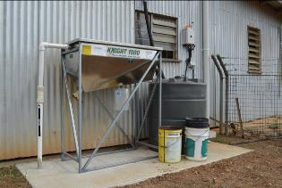
Workshop upgrades target environmental protection.

Weed teams triumph
Corporation to tackle invasive aquatic weeds in the Barron River catchment, between Tinaroo Creek Falls Dam and Kuranda Weir. The weeds are being mapped, and then strategically removed mechanically, manually, or through the use of biological agents or the steam weeder. Council partnerships with catchment management groups and volunteers have also accomplished the near-elimination of chinee apple along this stretch of the Barron River. The weeds had restricted the growth of endemic seedlings and grasses, which have since been replanted.
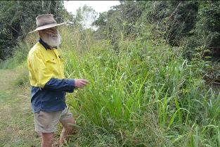
Targeting invasive weeds on the Barron River. Image courtesy of Amy Yates.

Rockhampton Regional Council

Big fish to fry
The Council adopted the Rockhampton Recreational Fishing Development Strategy after the declaration of a Net Free Zone over the lower Fitzroy River. The strategy addresses improvements to marine infrastructure, marketing activities, business development and fisheries management practices. It also focuses on enhancements to the freshwater and saltwater ecology/environment, in order to increase recreational fishing across the Rockhampton region. Importantly, the strategy includes a fisheries management plan to manage and protect fishery and catchment health, as well as monitor and forecast seasonal stocks.
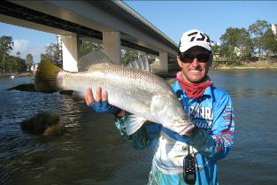
Strategy aims to yield big results for recreational fishers.

A global issue
The Council commissioned local artist, Amber Countryman, to tackle an eye-catching marine debris art project. She created a six-foot globe composed of plastic bottles, a major component of litter retrieved from beaches. The artwork has been installed in the free drop-off area at the region’s largest waste management facility to further promote the message that ‘our waste is not just a load of rubbish’, and that single-use packaging, like plastic bottles, can be avoided. The globe art project was funded by the Australian Government’s Reef Trust, in partnership with the Great Barrier Reef Marine Park Authority.
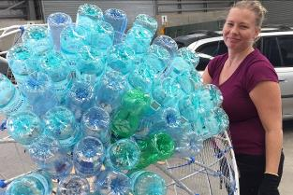
Fantastic plastic artwork highlighting the reality of single-use plastic products.

Pump up the volume – of energy savings
Fitzroy River Water completed projects to improve and maximise energy efficiency in their operational performance. The installation of new energy-efficient pumps and motors at the Glenmore High Lift Water Pump Station and Arthur Street Sewerage Pump Station achieved energy improvements of around 27 per cent and 16 per cent respectively. The installation of new energy-efficient positive displacement blowers at the South Rockhampton Sewerage Treatment Plant reduced power requirements by at least 30 per cent. These projects have led to an annual reduction in greenhouse gas emissions of approximately 90,000 tonnes of CO2 equivalents.
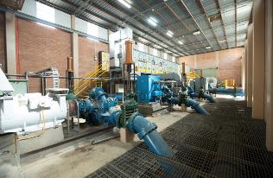
Upgraded facilities have major impact on energy efficiency.

The sensitive approach
Water Sensitive Urban Design is a holistic approach to the planning and design of integrated stormwater, water supply and sewerage management to minimise impacts on the natural water cycle and ecosystems. Council has adopted a coordinated interdepartmental approach to implement best practice design. A working group has commenced the roll-out of new policy development; preparation of a detailed stormwater infrastructure plan; creation of a suite of waterway restoration and creek rehabilitation projects, and; the development of an implementation guideline for stormwater quantity and quality management.
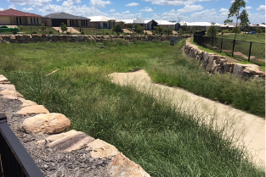
Putting water design into practice; a bio-swale in Norman Gardens, Rockhampton.

Down by the river
Day is held every three years to provide the community with an opportunity to take a tour of the Barrage. It promotes the importance of the Fitzroy River, as both a community water resource and for its significant environmental value. Some 1200 people took part in this year’s tour. The Open Day also featured FRW water treatment displays, and stalls from the Fitzroy Basin Association, Capricornia Catchments, Koorana Crocodile Farm, and the Council’s pest management and environmental health units.
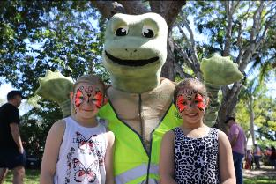
FRW mascot, Fitz, the Fitzroy River’s bum breathing turtle, was a popular guest.

Tablelands Regional Council

Eye on the environment
The Council’s Environmental Impact Monitoring Program (EIMP) is focused on ensuring the Council’s sewerage treatment plants meet or exceed State Government-stipulated quality criteria for discharged effluent. In 2016–17, environmental monitoring began on waterways adjacent to the treatment plants to generate data for an EIMP baseline study on water quality. The study will determine the extent (if any) of factors that may be detrimental to the water courses and their riparian zones.
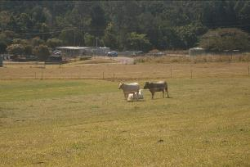
Cattle grazing in front of the Atherton Waste Treatment Plant, near the dense vegetation in the riparian zone of Mazlin Creek.

Flushed with success
Upgrades to the Ravenshoe Waste Treatment Plant, totalling $5 million, are expected to be completed in September 2017. The existing plant will be upgraded to comply with the negotiated draft licence, specifically effluent quality and hydraulic flows. It will also future-proof the infrastructure for the growing region. The plant upgrades will improve the quality of effluent released into the Millstream River and corresponding catchment. The upgrade project is being jointly funded by the Queensland Government’s Building our Regions program and the Council.
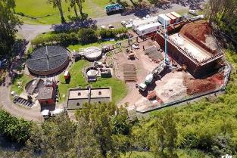
Bird’s eye view of upgrades to the Ravenshoe Waste Treatment Plant, near the Millstream River.

Hot new pest treatment!
The Council will trial the use of steam technology to remove navua sedge in environmentally sensitive areas. The steam delivery method features specially designed nozzles capable of penetrating the soil. These facilitate destruction of the pest plant’s underground, reproductive stem systems – rhizomes – as well as treatment of the plant above ground, with steam temperatures of up to 110 Celsius. The pilot program will be undertaken across selected infested sites at Millaa Millaa. The treatment project is being funded by the Queensland Government, through the Works for Queensland program.
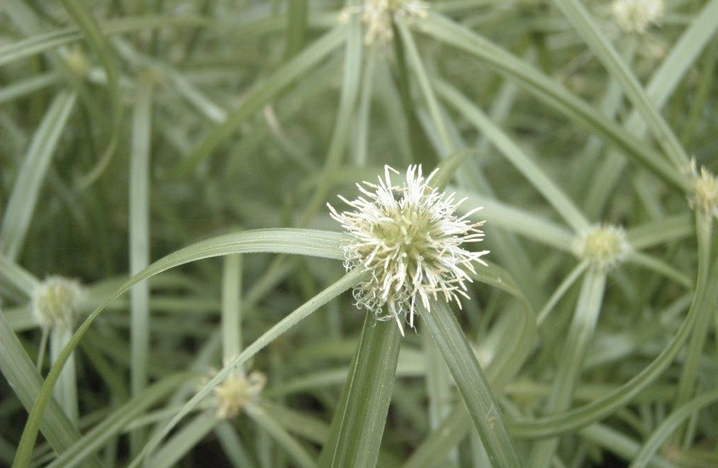
Navua sedge can produce up to 500 million seeds per hectare!

Germinating jobs
Upgrades and rehabilitation improvements undertaken at the Winfield Park Revegetation Nursery and Lakeside Rainforest Park have also generated hands-on work experience. Workers were engaged to assist in upgrades to the Revegetation Nursery. These included improvements to drainage and shade-houses, which will reduce the habitat for weeds and pathogens among nursery stock. Workers were also hired to help remove weeds from the Rainforest Park, with further work scheduled to treat invasive weeds that threaten the remnant Mabi rainforest. These projects have been funded through the Works for Queensland program.
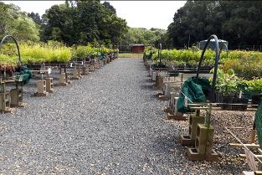
Improved surface drainage at revegetation nursery.

Retaining water
The Council aims to improve water efficiencies by raising the cost of water usage. A sewerage pricing method, approved by the Council in May 2017, is designed to raise public awareness of water consumption behaviour by placing a higher value on water as a resource. The approach aims to reduce overall water consumption and improve sewerage quality. It is hoped to reduce the amount of water the Council is required to take from local rivers, and thereby contribute to healthier riverine systems. The sewerage charges will be introduced in the 2018–19 financial year rating period.
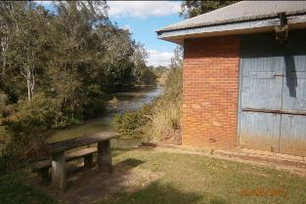
The Atherton Pump House on the Barron River.

Townsville City Council

From weed to feed
The Council purchased an aquatic weed harvester to tackle ongoing weed problems on the Ross River. The major culprits are four declared weeds: cabomba, salvinia, water lettuce and water hyacinth. The weeds are removed and stockpiled on the banks of the river, then inoculated with effective micro-organisms, which help rapidly break down the organic matter. The Council then uses the material as nutrient-rich mulch on garden beds. Rubbish is also being removed from the river to reduce the amount of litter entering the Great Barrier Reef lagoon.
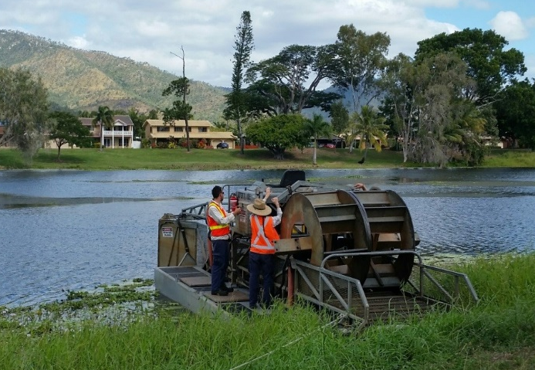
Weed harvesting on a roll.

A roving eye
Creekwatch is a Council-funded citizen science program implemented by Conservation Volunteers Australia to monitor waterway health in the Townsville area. Every week, teams of volunteers, led by an experienced team leader, visit creeks and rivers to conduct water quality monitoring. The monitoring includes macro-invertebrate assessments and chemical analysis with a water quality probe. Fish trapping and visual assessments of the riparian vegetation are also undertaken. This program is an important early warning system, as participants can quickly detect changes in the water quality or the surrounding vegetation.
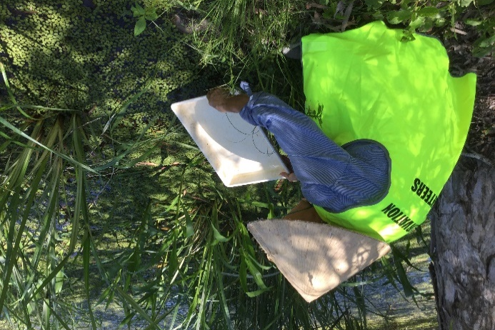
Creekwatch volunteer in action.

Student sleuths on the case!
The Council distributed a Water Detective Handbook to school students in Years 4 to 6, to recruit their assistance during Townsville’s ongoing water crisis. The initiative encourages children to reduce indoor water consumption via fun and engaging home activities. The handbook utilises behavioural science approaches, including Community Based Social Marketing and Thematic Communication techniques. A series of water-saving missions were chosen, based on their relevance to children.
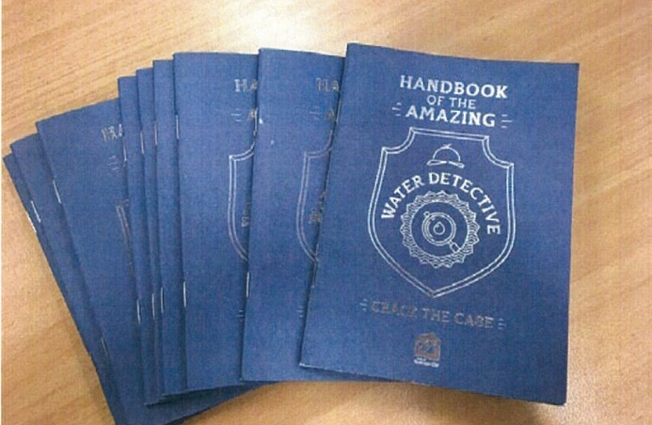
Passport to water-saving adventure!

A good grounding
Every year, the Council offers two-day and six-day training courses in soil erosion and sediment control. These courses are open to workers in the construction and engineering industries, as well as environmental consultants. They provide a valuable opportunity to learn from industry leaders in soil, vegetation and water management issues specific to North Queensland. Due to Townsville’s location and poor soil conditions, these courses also play a crucial role in protecting the Reef, through the provision of training necessary to design, implement and assess soil erosion and sediment control in new developments.
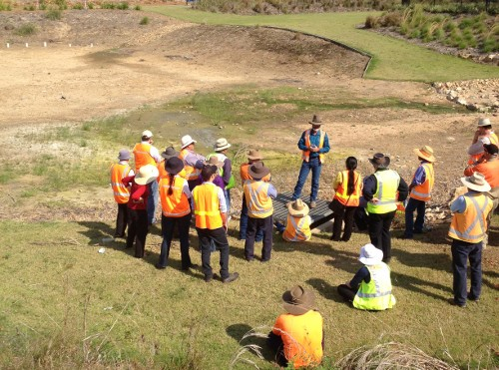
Course participants cover a lot of ground.

Whitsunday Regional Council

R.I.P. for pests
Council worked with regional land management stakeholders and the community to develop the Whitsunday Biosecurity Plan 20172020 for the region, as required under the Biosecurity Act 2014. The plan prioritises pest plants and animals which require control, and outlines strategies and processes which will be implemented to reduce infestations in the region. The plan also lists the roles and responsibilities of land management organisations and other landholders.
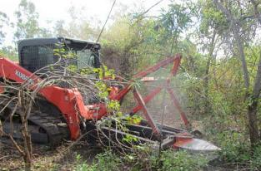
Plan targets pests such as chinee apple.

Fire away!
The Dingo Beach and Hydeaway Bay coastal communities include more than 580 hectares of state and trust land. This land is dominated by eucalypt woodland, which has a medium to high bushfire hazard rating. Council has developed a bushfire management plan for this land, in consultation with the Gloucester Rural Fire Brigade, the Dingo Beach Progress Association, Queensland Fire and Emergency Services, state agencies and the community. The fire plan identifies bushland management goals, the developed fire management area, preferred fire frequencies, stakeholder roles and responsibilities.
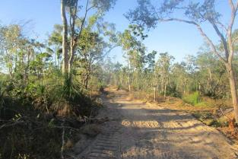
New fire breaks at Dingo Beach.

A good drop
Mullers Lagoon is one of Bowen’s most attractive parks. The Lagoon features 23.57 hectares of picturesque parkland in the centre of town, which has been turned into a superb botanical gardens and wetlands habitat. It is a hot spot for birdwatchers, with 176 species of bird life inhabiting the area. The lagoon water is sourced from run-off in urban areas. In order to improve water quality, the Council has installed a new wetlands treatment train to treat and remove nutrients and sediments before they enter the lagoon.
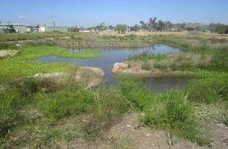
The Mullers Lagoon bio-retention basin delivers cleaner water.

Review of feral peril
Council has reviewed its feral animal control program. The review included an investigation into the size of feral animal populations, the amount of damage they cause, and methods employed to reduce their numbers. The results of the review have been used to develop a three-year feral animal control program, which aims to utilise a range of targeted techniques, in collaboration with landholders, to reduce feral animal numbers.
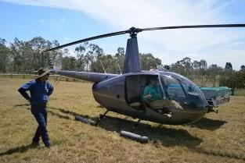
Getting on top of feral pig control.

Embracing a sea change
Council has obtained funding through the QCoast2100 program to implement a range of climate change-related projects. There are nine projects under the Council’s Climate Change Adaption Program. An internal committee has been appointed to steer the development and implementation of these projects; coordinate the engagement of consultants, and; ensure that the progress of these projects is monitored.
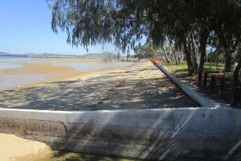
Bowen Front Beach – one of the foreshore areas which will benefit from a climate change adaption initiative.

