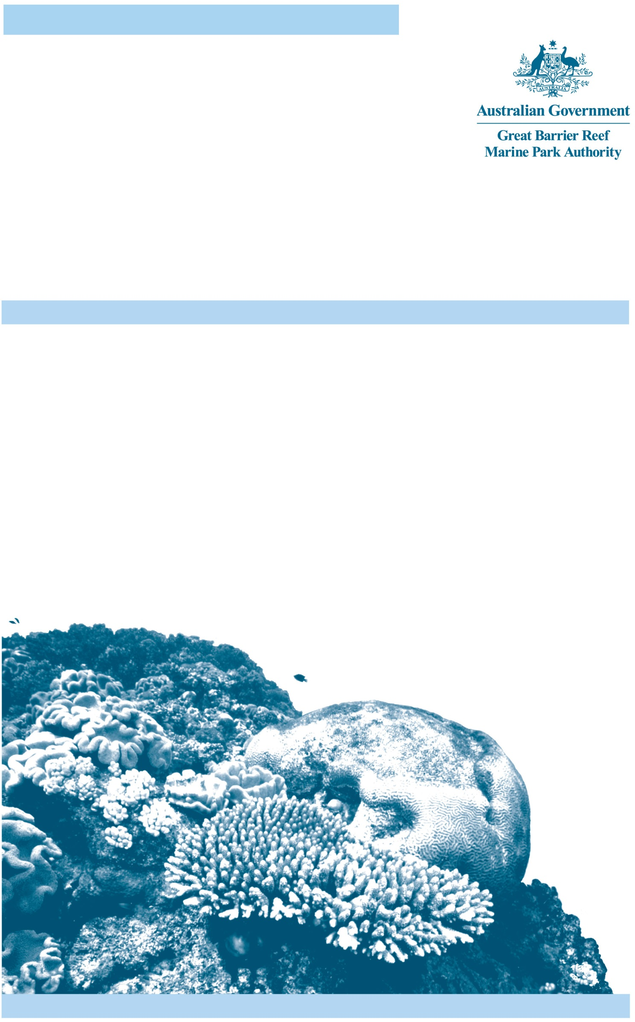
RESEARCH PUBLICATION No. 113
Historic Shipwreck Foam (1893)
Survey Report 2015

Peter Illidge

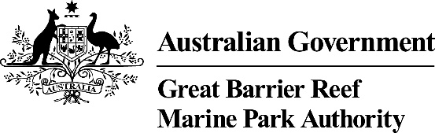
RESEARCH PUBLICATION No. 113
Historic Shipwreck Foam (1893)

Survey Report 2015

Peter Illidge
Project Manager, Maritime Cultural Heritage,
Great Barrier Reef Marine Park Authority

PO Box 1379
TOWNSVILLE QLD 4810
Australia
Phone: (07) 4750 0700
Fax: (07) 4772 6093
Email: info@gbrmpa.gov.au

www.gbrmpa.gov.au

© Commonwealth of Australia 2018
Published by the Great Barrier Reef Marine Park Authority
ISBN 978 1 922126 870 (pdf)
The Historic shipwreck Foam (1893): survey report 2015 is licensed by the Commonwealth of Australia for use under a Creative Commons By Attribution 4.0 International licence with the exception of the Coat of Arms of the Commonwealth of Australia, the logo of the Great Barrier Reef Marine Park Authority, any other material protected by a trademark, content supplied by third parties and any photographs. For licence conditions see: http://creativecommons.org/licences/by/4.0


A catalogue record is available for this publication from the National Library of Australia

This publication should be cited as:
Illidge, P. 2018, Historic shipwreck Foam (1893): survey report 2015, Research Publication No. 113, Great Barrier Reef Marine Park Authority, Townsville.
DISCLAIMER
The views and opinions expressed in this publication are those of the authors and do not necessarily reflect those of the Australian Government. While reasonable effort has been made to ensure that the contents of this publication are factually correct, the Commonwealth does not accept responsibility for the accuracy or completeness of the contents, and shall not be liable for any loss or damage that may be occasioned directly or indirectly through the use of, or reliance on, the contents of this publication.
Comments and inquiries on this document are welcome and should be addressed to:
Director, Communications and Regional Engagement
280 Flinders Street
PO Box 1379
TOWNSVILLE QLD 4810
Australia
Phone: (07) 4750 0700
Fax: (07) 4772 6093
info@gbrmpa.gov.au
www.gbrmpa.gov.au

Contents
ACKNOWLEDGEMENTS 6
1. EXECUTIVE SUMMARY 7
2. BACKGROUND 8
2.1. Survey Objectives 9
The Foam anchor site 9
The Foam wreck site 9
The Opportunistic tasks 10
2.2. The Historic Shipwreck Foam – Existing knowledge 10
Location 10
Site situation 10
History of Discovery 10
Legislation 10
Research to date 11
Excerpt from the Australian Historic Shipwrecks Database 12
3. 2015 SURVEY 13
3.1 Personnel 13
3.2 Survey Activities 13
Task 1: Locate Foam Anchor 14
Task 2 and 3: Survey and identify Foam Anchor 14
Task 4: Locate the Foam wreck site and confirm correct coordinates 15
Task 5: Orientate all personnel on the site 16
Task 6: Install a baseline tape along the main part of the site 16
Task 7: Record features of the site. 16
Task 8: Search for Foam Maritime Archaeology Project armbands 19
Task 9: Establish and accurately position the borders of the site using an underwater metal detector. 21
Task 10: Conduct a search for the wreck of the Florida 22
Task 11: Conduct Reef Health and Impact Survey (RHIS) on Myrmidon Reef 22
4. THREATS TO HERITAGE VALUES OF THIS SITE 23
4.1 Pilfering 23
4.2 Cyclones 23
4.3 Ocean Acidification 25
4.4 Other threats 25
5. OUTPUTS FROM THIS SURVEY 25
6. OUTCOMES FROM THIS SURVEY 26
7. REFERENCES 27
APPENDIX 1: DATA SHEET USED FOR THE ANCHOR SURVEY PROFORMA 28

ACKNOWLEDGEMENTS

The Great Barrier Reef Marine Park Authority acknowledges the Traditional Owners whose sea country in which this work was undertaken.

Conducted with the professional assistance of: James Aumend, Jacqui Dupavillon, Ben Kettle and Ben Palmer (Great Barrier Reef Marine Park Authority), Paul Crocombe, Warren Hayden and Andrew Schofield (at the time of the survey was with Adrenalin Dive) and Darren Larcombe and Brett Turnbull (Department of National Parks, Sport and Racing).

Notes:
All references to departments and legislation are accurate for the time of the assessment in 2015.

All geographic references are in WGS 84.

EXECUTIVE SUMMARY
This report summarises a site survey of Foam — one of the six declared historic shipwrecks in the Great Barrier Reef Marine Park. The Great Barrier Reef Marine Park Act 1975, provides for the long term protection and conservation of heritage values within the Great Barrier Reef Marine Park. The ability to achieve this relies on the collation and management of heritage information.

On the 5th February 1893 — en route to return one group of labourers and recruit the next— Foam ran aground on Myrmidon Reef, 68 nautical miles (nm) north-northeast (NNE) of Townsville (Stone 2006). This particular wreck of the labour (blackbirding) recruitment ship Foam, has the potential to inform the structure and mechanisms of life on board a vessel engaged in recruiting labour from the South Sea Islands at the end of the nineteenth century.

The objective of this survey was to:
- Confirm the location and extent of the Foam site, assess its condition, and familiarise Great Barrier Reef Marine Park Authority staff with the site and with maritime survey methodology;
- Create a comprehensive photographic record of the site for future reference;
- Identify management issues and risks;
- Document the current status of the Foam wreck site;
- Conduct Reef Health and Impact Surveys within the area.

This survey achieved all of its objectives and successfully:
- Located and recorded the position and condition, and conducted an analysis of a Foam anchor
- Located and defined the extent of the Foam wreck site, including correcting significant errors in the previously held official record
- Established a baseline location (via baseline survey tape) for key surface artefacts
- Recorded and established a photographic record for key features of the site, including a prominent anchor, the ballast pile, rigging, anchor winch, ships tank, and any other observable artefacts.
- Conducted Reef Health and Impact Surveys at three sites.

BACKGROUND

The Great Barrier Reef Marine Park Act 1975 provides for the long term protection of the heritage values of the Reef. Historical maritime archaeological evidence is therefore an important component of the Great Barrier Reef Marine Park Authority’s (the Authority) remit in reef protection. The Foam is a historic shipwreck over 75 years old and, as such, is automatically protected under the Historic Shipwrecks Act 1976. In recognition of its significance it is further protected by the declaration of a protected zone under the same Act.

The Foam enjoys a unique status as the only known wreck on the Great Barrier Reef of a Queensland labour vessel that was actively engaged in the labour trade at the time of its demise (Beck 2009). As a former blackbirder, Foam has the potential to illuminate the historical record on the structure and mechanisms of life on board a vessel engaged in recruiting of labour from the South Sea Islands at the end of the nineteenth century. Blackbirding verged on slavery and arguably qualified as it.

In the Australian context, South Sea Islander labourers were coerced to travel by ship to Australia and work on sugar cane farms in Queensland for very little recompense. Blackbirding started in the 1840’s and continued into the early twentieth century. The normal period of indenture for a labourer was three years, after which, under Australian law, the people were to be returned to their island of origin. At the time of its wrecking, Foam was returning a group of 84 South Sea Islanders with their earnings, in the form of trade goods. On delivering these workers home, the crew of Foam hoped to recruit the next group of workers for the farms of Queensland. Hence, Foam was also provisioned with additional trade goods to use as incentives to entice the next group (Beck 2009).

On its last voyage Foam was bound from Dungeness (near Lucinda in Queensland) to the Solomon Islands with returning labourers under the command of Captain Gilbert Norman (Marine Board, 1893). The vessel departed Dungeness on the morning of the 5th February 1893.

At 20:30 on the 5th February 1893 Foam ran aground on Myrmidon Reef. Captain Norman dispatched one of the ship’s boats to raise the alarm and get help for those remaining on board. Christina Gollan was chartered by the Government on the 7th February to assist Foam. Christina Gollan found Foam lying on its port side, with approximately two-thirds of the vessel under water at low tide, and the starboard quarter just visible above the water. All those on board were saved. Fittings from the vessel were recovered before the vessel was declared a total loss (Marine Board 1893). The Marine Board inquiry found the loss of the vessel to be attributed to strong currents, and Captain Norman and the mate were found to have navigated the vessel with all reasonable care and precaution (Marine Board 1893).

As one of six declared historic shipwrecks in the Great Barrier Reef Marine Park, Foam is an important component of the Reef’s heritage value; and falls within the Authority’s responsibilities. There has been no formal research on the Foam site for over 10 years or assessment of the site’s condition post cyclone Yasi in 2011. Current site delimiters are known to be inaccurate, which is detrimental to good management, particularly compliance and enforcement.

This report will outline survey objectives, discuss threats to the values of the site, explore management options and summarise the outcomes and outputs of this important work.

The Great Barrier Reef Outlook Report 2014 (GBRMPA, 2014) considers many places of historic significance, including this particular historic shipwreck site, to be poorly recorded and their condition not well-understood. This contribution to recording the condition of this site may therefore help improve the knowledge presented for the Outlook Report 2019.

Further, this report will add significant data to the development of the Conservation Management Plan for Foam. The development of this plan is listed as an action under the Reef 2050 Long Term Sustainability Plan (Commonwealth of Australia 2015), as are five other Conservation Management Plans for Historic Shipwrecks within the Great Barrier Reef Region. The production of these Conservation Management Plans are a responsibility of the Queensland Department of Environment and Science.

Survey Objectives

The objectives of this survey were to:
- Accurately confirm the location and extent of the Foam site, assess its condition, and familiarise Authority staff with the site and with maritime survey methodology
- Create a comprehensive photographic record of the site and archive at the Great Barrier Reef Marine Park Authority for future reference
- Identify management issues and risks
- Document the current status of Foam in a report.

The following additional objectives were a lower priority, if time permitted:
- Locate and assess the wreck of the Florida
- Conduct a Reef Health and Impact Survey at or near the site.

The following tasks were planned to achieve the principal objectives:

The Foam anchor site
Task 1:  Task 2:  Task 3: | Locate the anchor site using Diver Propulsion Vehicles (DPV).  Survey the anchor, and document its form and condition with accurate measurements and photogrammetry.  Identify the anchor (from amongst information available on Foam’s four anchors).

The Foam wreck site
Task 4:  Task 5:  Task 6:  Task 7:  Task 8:  Task 9: | Accurately position the main wreck site, as it is believed the coordinates available to management agencies are not accurate. This task had the highest priority.  Orientate all personnel on the site.  Install a baseline tape along the main part of the site.  Record features of the site.  Search the site for evidence of yellow arm bands deposited as part of an experiment in 2002 by James Cook University’s Maritime Archaeology Department, led by Dr Steve Beck.  Establish and accurately position the borders of the site using an underwater metal detector.

The Opportunistic tasks
Task 10:  Task 11: | Conduct a search for the wreck of the Florida, if time permitted.  Conduct Reef Health and Impact Survey (RHIS) on Myrmidon Reef if time permitted.

The Historic Shipwreck Foam – Existing knowledge

Location
Foam is located in the lagoon of Myrmidon Reef (18-034), MNP–18-1078. Myrmidon Reef is 68 nm, in a straight line, NNE of Townsville on the outer Great Barrier Reef.

Site situation
The wreck is situated on the edge of Myrmidon Reef on the western side being well-protected from the prevailing south-easterly trade winds, particularly at low tide. Visibility is normally excellent. Divers can expect 20 metres visibility on an average day with well over this around October, November and December. The bow is pointing roughly north and is in eight metres of water and the stern is towards the reef top in three metres of water.

The site is recorded as covering an area of approximately 32 metres by eight metres. This is a visual estimate and not based on a metal detector search. Thus, it may not take into account buried ferrous and nonferrous artefacts which may extend the area containing artefactual evidence.

History of Discovery
The Foam wreck was originally found by Mr Alan Mitchell (~early 1980’s) — who was conducting marine research for the Australian Institute of Marine Science (AIMS) at the time. Mr Mitchell did not report the discovery. It was later reported to the Queensland Museum in 1982 by John Bates of Divemaster Charters. The Museum inspected the site in 1982 and confirmed the wreck to be Foam.

Legislation
Foam is a significant historic shipwreck over 75 years old and, as such, is automatically protected under the Historic Shipwrecks Act 1976. In recognition of its significance it is further protected by the declaration of a protected zone under the same Act. The protected zone extends 200 metres from the site and restricts access without a permit from the Queensland Department of Environment and Heritage Protection.

The site is further protected under the Great Barrier Reef Marine Park Act 1975 and the Great Barrier Reef Marine Park Zoning Plan 2003. It lies within a Marine National Park Zone (Green Zone).

Research to date
1982 Initial site inspection by Queensland Museum, Maritime Archaeology Section.
1984 Queensland Museum, site inspection.
1991 Queensland Museum, site inspection.
1996 Queensland Museum, site inspection.
2002 Foam Archaeological Project 1, Dr Steve Beck.
2003 Foam Archaeological Project 2, Dr Steve Beck.
2009 Maritime Mechanisms of contact and change: archaeological perspectives on the history and conduct of the Queensland labour trade. Steven Beck, PhD thesis, James Cook University.
2015 Great Barrier Reef Marine Park Authority led survey

Excerpt from the Australian Historic Shipwrecks Database

Vessel Particulars: Extracted from the Australian Historic Shipwrecks Database, 8 December 2015.
Originally launched as the Archimedes and renamed Foam in August 1892 (Beck 2009, Department of the Environment and Energy 2016).

Australian National Shipwrecks Database (ANSD): Identification Number: 2525

Wrecked: 2030 EST on 5 February 1893

Owners Name: O’Dwyer and Co

Lloyds Official Number: 84265 (A1)

Port of Registry: Maryborough

Port Number: 1/1887

Vessel type: Top sail schooner

Construction: Timber carvel

Keel timber: English elm

Planking timber: English oak and pitch pine

Bracing: Timber and iron knees (hanging, lodging and rider found on survey)

Sheathing: Muntz Metal (patented 1832, found on survey)

Fastenings: Bronze or Muntz, fastenings on site (found on survey)

LOA: 101 foot, 30. 78 m

Beam: 23 foot, 7. 01 m

Displacement: 152 imperial ton, 154. 44 metric tonne

Draft: 11 foot, 3. 35 m

Crew: 14 all survived

Passengers: 84 all survived

Anchors: two bower at 355.6 kilograms (kg) each; one stream (106.6 kg) one kedge (50.8 kg), all admiralty patterns with iron stock.

2015 SURVEY

3.1 Personnel
Survey Personnel | Organisation | Position | Survey Training
Peter Illidge | GBRMPA | Project Manager, Maritime Cultural Heritage | Maritime Archaeologist
James Aumend | GBRMPA | Planning Coordinator, Field Management Compliance Unit | NAS
Jacqui Dupavillon | GBRMPA | Sustainable Development and Policy | Anchor Survey, RHIS
Ben Kettle | GBRMPA | Legal Officer, Field Management Compliance Unit | NAS and Anchor Survey
Darren Larcombe | DNPSR | Senior Ranger, Great Barrier Reef Region I Whitsunday, Department of National Parks, Sport and Recreation. | RHIS
Ben Palmer | GBRMPA | Project Manager, International, Heritage and International. | NAS and Anchor Survey
Brett Turnbull | DNPSR | Marine Parks Ranger, Great Barrier Reef Region I Whitsunday, Department of National Parks, Sport and Recreation. | RHIS
Paul Crocombe | Adrenalin Dive | Sea Esta, Master | Not applicable
Warren Hayden | Adrenalin Dive | Sea Esta, Deckhand | Not applicable
Andrew Schofield | Adrenalin Dive | Sea Esta, Dive Master | Anchor Survey, RHIS
NAS = Nautical Archaeology Society, Introduction to Maritime Archaeology, Part One Course
RHIS = Reef Health and Impact Survey

Immediately prior to the expedition, four team members undertook training in anchor survey methodology and terminology, taking advantage of two similar admiralty pattern anchors that are located at the Townsville Coast Guard on Ross Creek.

Three team members also attended the Introduction to Maritime Archaeology course which contributed significantly to the efficiency of the expedition.

The assistance from all personnel was very much appreciated and pivotal to the success of this survey.

3.2 Survey Activities
The survey team departed Townsville on Adrenalin Dive’s Sea Esta at 2030 on 26 November 2015. After steaming through the night, the team arrived at Myrmidon at 0530 on Friday 27 November. Poor navigation conditions due to glare from the rising sun meant that the Sea Esta had to stand off the reef to wait for the sun to rise further, allowing safer conditions to navigate between the coral bommies near the site of the anchor.

Task 1: Locate Foam Anchor
A weighted buoy was deployed at the recorded coordinates of the Foam anchor (18º 16.080’ S x 147º 22.811’ E WGS 84) and two DPV assisted divers located the anchor within six metres of the buoy weight. The buoy weight was relocated closer to the anchor and a series of photos taken without a scale. Several photos were taken around the anchor and used to trial a 3D modelling program called Agisoft (Figure 1).
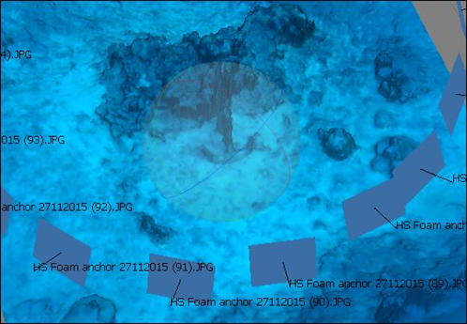
Figure 1: Agisoft 3D rendering of the Foam anchor.

Task 2 and 3: Survey and identify Foam Anchor
Two, two-person survey teams, both trained in anchor survey methodology, completed two surveys of the anchor using the Authority’s Anchor Survey Proforma (see example data sheet in Appendix 1). Photographs, with scale, were part of these surveys and are now archived in the Authority’s Image Collection.

The anchor is an admiralty pattern consistent with the period, with iron stock and shackle and no chain attached. The shank is 200 centimetres long with a diameter of 10 centimetres. The stock is approximately 200 centimetres long with a diameter of eight centimetres. The crown has an outside length of 186 centimetres and an average diameter of 10 centimetres.

Using the web site http://www.custompartnet.com/quick-tool/weight-calculator a very rough weight was calculated from the measurements at 317 kilograms. According to Beck (Beck 2009), the best bower anchors weighed 355.6 kilograms and were the largest anchors onboard, and the smaller stream anchor weighed 106.6 kilograms. Based on the weight calculation, the surveyed Foam anchor is most likely one of the two best bower anchors.

Comparison of the present position and condition of the anchor with archival data presents evidence that may be consistent with two attempts to steal this artefact. The author first dived the Foam anchor in 1982 when it was on top of the large coral bommie near its present position. It is now lying off this bommie. Also, on comparison of the archival photograph of the anchor taken 2009 (Figure 2) to recent pictures in its present situation (Figure 3) it looks to have been moved for a second time. It is unlikely that these movements would have been caused by cyclonic wave action because, on closer inspection of the anchor, it was noted that a piece of rope about 12 millimetres in diameter was attached to the shackle, further supporting the theory that it has been deliberately interfered with. The anchor’s size and design may make it attractive to theft and this risk should be taken into account in the future management of the site.

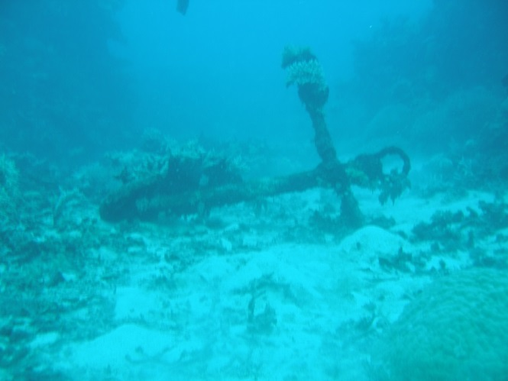  Figure 2: Picture of Foam anchor. © Commonwealth of Australia (Australian Institute of Marine Science), photographer: Joe Gioffre, 2009. | 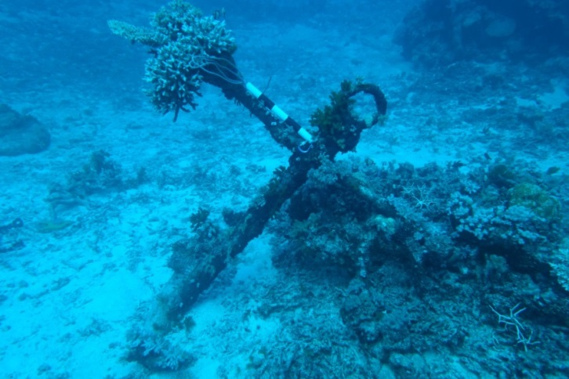  Figure 3: Foam anchor in 2015. Note the change in position from the 2009 picture.
The anchor is over 340 metres from the main wreck site and, though considered an artefact associated with Foam, it is outside the 200 metre Historic Shipwrecks protected zone and therefore does not carry the restriction to access as does the main site. This positioning and the potential attractiveness of the anchor to thieves suggest that moving the anchor to within the 200 metre protective zone or extending the protective zone could be considered. The anchor has already been moved at least twice. Moving it closer to the main site and within the protected zone will not subtract from its provenance but may save it from theft.

Task 4: Locate the Foam wreck site and confirm correct coordinates
The main wreck site was located by snorkelers using the coordinates 18º 16.201’ 147º22.970’ WGS 84 (Figure 4), these were the most recent coordinates and so considered the most reliable. Other coordinates considered are plotted in figure four which shows a discrepancy of between 429 m and 469 m from the Foam wreck actual position.
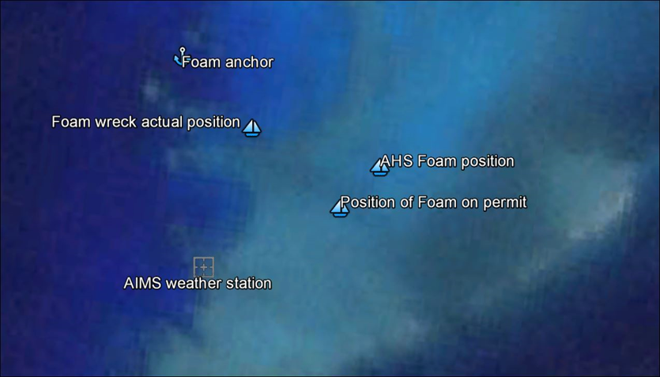
Figure 4: Relative positions plotted on Google Earth, 2015.

Task 5: Orientate all personnel on the site
All seven participants spent half an hour on site orientating themselves to the main features. Tasks were subsequently assigned with divers having a clear picture of the wreck site, saving time and providing clarity.

Task 6: Install a baseline tape along the main part of the site
A 30 metre baseline tape was run from the southern end of the ballast pile at the stern of the vessel out along the centreline of the ballast pile to past the cluster of artefacts that indicated where the bow section lay. This baseline was then used through the remaining surveys, to relate artefact positions. Coral growth limited the options for positioning the tape.

Task 7: Record features of the site.
The site is dominated by the ballast pile. Other exposed features include an anchor winch, ships tank and various fastenings which are mainly bronze, rigging including light chain and standing rigging and at least two piles of anchor chain.

Ballast Pile
The ballast pile is a concretion of the ballast material, stone and iron and the cargo which includes iron objects. Consequently, it is a conglomerate of iron, terracotta bricks and rounded rock (Figure 5) in the form of the timber hull which has since degraded and disappeared. Its area is approximately 11 metres by four metres and extends from underneath a significant area of coral near the reef top, towards the north through a valley of the same coral to an open area where the coral is sparse. There does not seem to be any significant damage to the ballast from cyclone Yasi. There are, however, significant areas of rust spots across the whole of the ballast pile (Figure 5) which seem to be fresh, perhaps caused by grazing herbivores (which are common in the area) removing the protective algae and exposing ferrous objects to the elements.
Several herbivores were noted feeding on the black algae growing on some iron artefacts around the site. Similar black algae are common on iron wrecks and associated reefs in the Line Islands in the Central Pacific Ocean, there it has smothered the living coral and devastated coral communities for over one kilometre from the wreck (personal observation P. Illidge). The low algae cover on the Foam is possibly due to high numbers of herbivores grazing it within the vicinity of the wreck, though this is not supported by Kelly et al (2012).
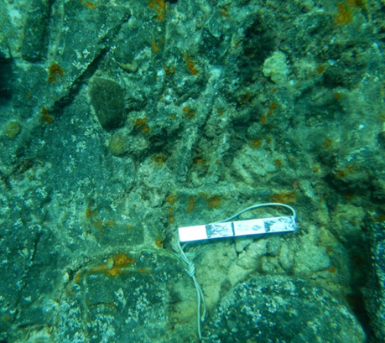
Figure 5: Ballast pile, showing concreted iron artefacts, stone and rust spots. (Scale is 20 centimetres in 5 centimetres sections).

Rigging
Several items of rigging exist around the site including light chain, possible bow sprit or sprit end brace (Figure 6) and standing rigging. The most obvious of these is the artefact in the ballast pile concretion which is likely to be the iron loop that encases a dead eye. Photographic evidence of this artefact from the Foam Maritime Archaeology Project in 2002 compared to this surveys data shows the absence of the bight of the rigging and erosion of the surrounding area.
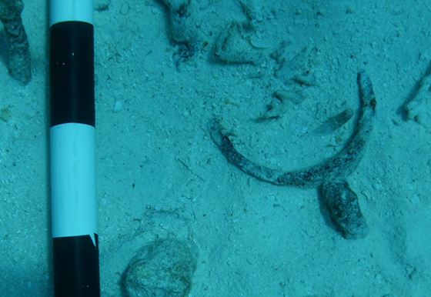
Figure 6: Possible bow sprit or sprit end brace. The white section of the scale shown is a 10 centimetre section of a 50 centimetre scale.

Anchor Winch
On a previous visit to the site in 2003 the anchor winch was noted to be over 60% exposed. The situation of the winch on this survey is 80% buried, see Figure 7 and Figure 8. It is mostly buried in coral rubble, possibly due to cyclone Yasi in 2011. Unfortunately, no inspection of this site immediately post-Yasi was undertaken so the benefits or not of the cyclone can only be based on decade old data. A possible benefit of a cyclone to a shipwreck is the deposition of rubble onto the wreck which creates a protective layer, negative impacts include removal of material from the site.
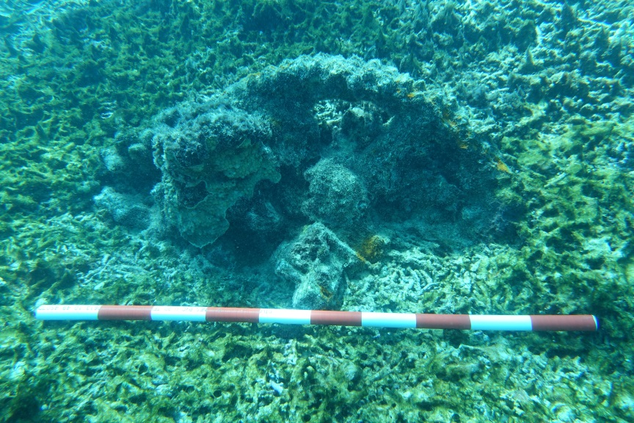
Figure 7: Anchor winch covered in coral rubble. One metre scale in 10 centimetre sections.

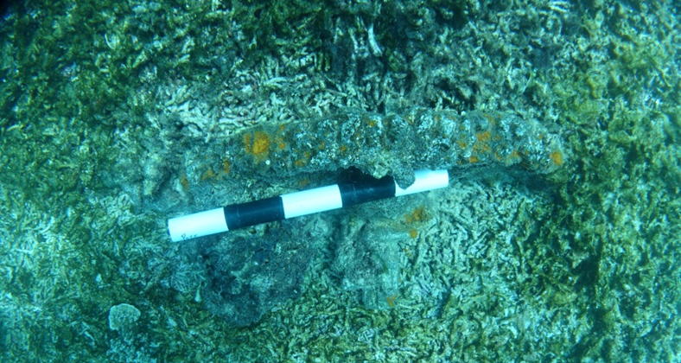
Figure 8: Anchor winch photographed in plan. Note black algae below the 50 centimetre scale.

Ship Tank
As Pearson notes in his 1992 paper; these cubic, mild steel containers are called ship tanks, and had their origin as shipping containers for water or perishable goods.

This artefact (Figure 9) was identified as a broken ship tank by a survey team from the Queensland Museum in 1982. The Foam artefact is 370 centimetres long by 122 centimetres wide. At first glance, these measurements do not correspond to the standard ship tank dimensions, being a triangle and not a cube as Pearson states. Three standard cubic ship tanks measuring 4 feet (122 - 123 centimetres), 3 feet (92 - 97 centimetres) and 2 feet 6 inches (72 - 77 centimetres) square, are noted by Pearson. The width of the Foam artefact does correspond to the width of a standard four foot ship tank. The length, if divided by three, measures 123 centimetres, suggesting that the length measurement noted in this survey is, in fact, three sides of a flattened out tank. As the tank decayed through time, the sides, lacking support, folded out flat. This could not be confirmed on this survey as there are significant Porites coral colonies blocking the view (Figure 9).

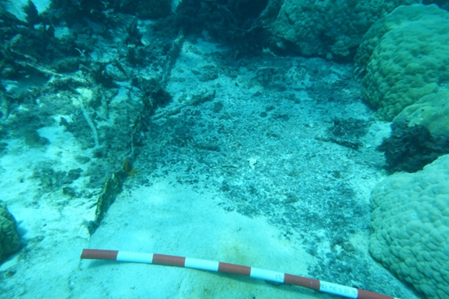
Figure 9: Possible ship tank partially covered with sand and disappearing under coral. One metre scale in 10 centimetre sections.

Fastenings
Fastenings on site are either bronze, Muntz metal or iron. One particularly open site to the eastern side of the wreck shows a variety of artefacts representing rigging of the ship (Figure 10).
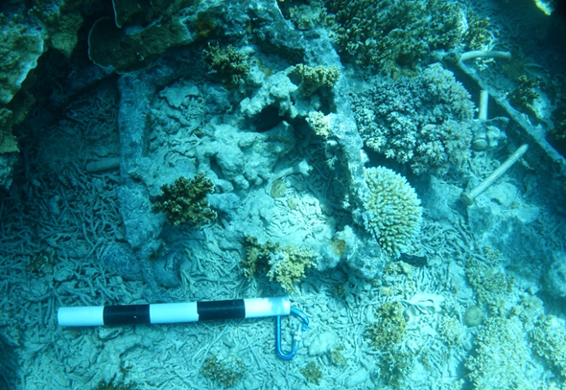
Figure 10: Various artefacts, including a par buried bottle (above the scale), and a possible chain plate with brass fastenings (to the right of the picture). The U-shaped artefact above the bottle could be part of the rudder assembly, a gudgeon or pintle. Scale is 50 centimetres in ten centimetre sections.

Anchor Chain
The anchor chain located on site is stud link, 17 centimetres long by 10 centimetres wide. At least two distinct anchor chain piles exist on site near where it is believed the bow structure was. There are also small lengths of the same chain type scattered around the site. When the author was on site in 2003 (Foam Archaeological Project 2) there was a length of anchor chain that extended from the main site out towards the north. This was not located on this survey suggesting it may have been buried by cyclonic action or broken up into smaller sections and dispersed.

Task 8: Search for Foam Maritime Archaeology Project armbands
A previous expedition led by maritime archaeologist Dr Steven Beck seeded the site with ceramic replicas of clam shell arm bands to study site formation and artefact distribution. On the 4 December 2002, 19 yellow glazed ceramic replica arm bands were distributed across the site, most on the ballast pile. Each yellow glazed arm band had the letters FMAP (Foam Maritime Archaeology Project) and a number (1 – 19) stamped on the inside. Dr Beck produced a detailed map showing the position of each of the 19 arm bands on the site, see Figure 11.
Figure 11: Seed arm band placement by Dr Steven Beck. (Map from Beck 2009).
The survey team spent the equivalent of 16.5 person hours between sites. In this period only one arm band was located towards the southern end of the ballast pile under a coral ledge and concreted into the ballast pile. If the marine growth on the found arm band is indicative of the condition of the others they will be difficult to see amongst the coral rubble. Figure 12 shows the arm band after some light cleaning to reveal the yellow colouring. The arm bands were all numbered so it would have been advantageous to know which arm band it was so its voyage around the site may be mapped. As it was concreted into the substrate, identification would have required the breaking away of the item and possible damage to it and the artefacts it is attached to. FMAP arm bands 15 and 19, as positioned on the map, are the closest and most likely to be the arm band located on this survey.
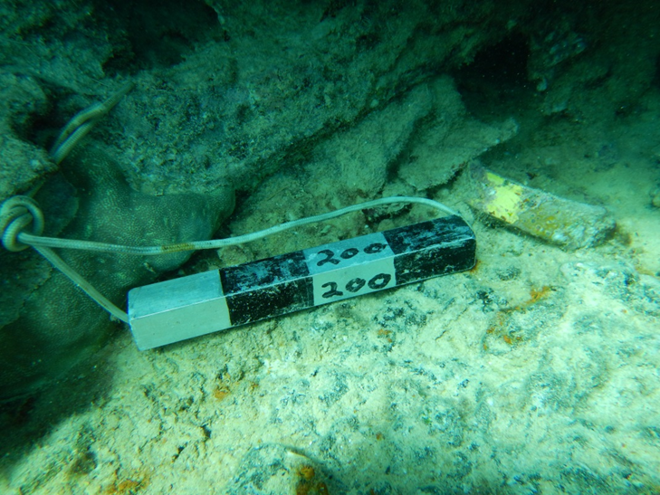
Figure 12: Foam Maritime Archaeology Project arm band with 20 centimetre (200 millimetre) scale in 5 centimetre sections.

Task 9: Establish and accurately position the borders of the site using an underwater metal detector.
From the 15 metre (middle) point of the baseline, two 30 metre tapes were run out at right angles. Two teams of divers using an Aquascan Underwater Metal detector scanned a minimum of two metres each side of the tape for anomalies for the length of the tape.

The transit on the port side of the wreck (western sector), where the remains of the ship’s tank is located, found no metal past the line of the tank.

The transit on the starboard side of the wreck (eastern sector) found significant anomalies up to eight metres from the baseline. In this area, what looks to be the iron brace possibly from the bow sprit or sprit end and a larger iron concretion were located.

Using the metal detector the team examined the area to the south, past the stern, towards the shallows of the reef top. This area at first glance looked to be a field of coral. On examination with the metal detector it was revealed that there are significant amounts of metal concealed by the coral for at least six metres past the aft most visible part of the ballast pile. A more detailed survey is needed to reveal the size of these artefacts.

Task 10: Conduct a search for the wreck of Florida
Time permitted a search for the 500 tonne cargo ship Florida. Florida was bound from the Cook Islands to Townsville with a cargo of volcanic rock. It was wrecked on Myrmidon Reef on 9 June 1976. HMAS Bayonet rescued the crew of 12 and the vessel was abandoned along with its cargo. The ship was owned by Silk and Boyd Ltd of Rarotonga. Its dimensions were 166.7 x 27.5 x 11.2 feet.

Though not qualifying as a historic shipwreck, the Florida is of interest as a monitoring site for infestations of algae associated with iron wrecks which cause black reefs (Kelly et al. 2012, Hatcher 1984). Some iron artefacts on the Foam site show signs of this infestation, see Figure 13. Previous research on the Florida site conducted by Hatcher (1984) monitored the effects of this iron wreck and its cargo on coral health. It would be useful to compare the current state of the wreck, algal populations, and adjacent reef health, to data gathered by Hatcher (1984). Such a comparison would allow the quantification of any ongoing detrimental impacts of iron shipwrecks on coral health.

Unfortunately, coordinates supplied to the team were not accurate and two DPV-assisted searches did not locate the wreck. Information provided by the Australian Hydrographic Service post expedition indicates the wreck is located near 18° 15.300' x 147° 24.000' (WGS 84).
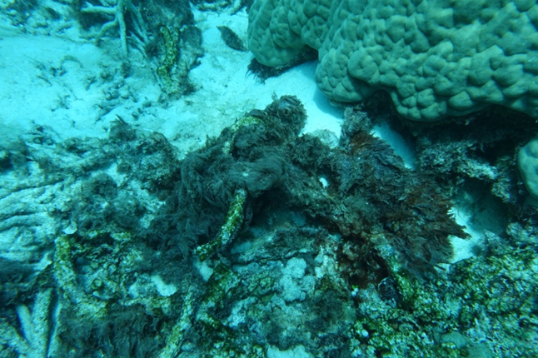
Figure 13: Algal growth on the Foam wreck site, the basis for "black reefs”.

Task 11: Conduct Reef Health and Impact Survey (RHIS) on Myrmidon Reef
Reef Health and Impact Surveys are a quick and efficient way to provide a snapshot of reef health. It is a quantifiable survey method that assesses reef health in a series of five-metre radius circles (a total of 78.5 square metres). It is a robust and effective method of surveying. http://www.gbrmpa.gov.au/managing-the-reef/how-the-reefs-managed/eye-on-the-reef/reef-health-and-impact-survey.

Having completed the Foam survey, three RHIS trained divers took the opportunity to survey three sites around Myrmidon Reef. Data from this work is held as a part of the Authority’s Eye on the Reef program.

THREATS TO HERITAGE VALUES OF THIS SITE

4.1 Pilfering
The Foam wreck site is currently within a Historic Shipwreck Protected Zone where there is a requirement to obtain a permit to enter the 200 metre radius exclusion zone. Permits to enter the zone are available through the Historic Shipwreck Delegate at the Queensland Department of Environment and Heritage Protection. The wreck is also within a Marine National Park Zone (Green Zone). This zoning may reduce visitation from fishers, though anecdotal reports suggest that the reef lagoon is a popular anchorage. The isolation of this reef makes it difficult to deploy regular patrols to monitor the site, but it also reduces visitation for the purpose of pilfering artefacts.

Currently, the Foam anchor sits in isolation from the main site, outside the 200 metre exclusion zone and therefore could be recovered as a souvenir by passing boaters with the right equipment reasonably easily (see Figure 4).

Note: Under subsection 4A (1) of the Historic Shipwrecks Act 1976 the anchor is a protected relic (as it is a relic situated in Australian waters, and is over 75 years old) and it is an offence to :
(i) destroy or cause damage to a historic shipwreck or historic relic; or
(ii) cause interference with a historic shipwreck or historic relic; or
(iii) cause the disposal of a historic shipwreck or historic relic; or
(iv) cause a historic shipwreck or historic relic to be removed from Australia (including State waters), from Australian waters or from waters above the continental shelf of Australia.

Circumstantial evidence is consistent with at least two attempts to steal the anchor, with the anchor having been removed from its original position and from its context within the wreck site. This survey compared the position and orientation of the anchor now to a picture taken on 11 December 2009 finding that it has been moved since that time. As its location is already out of context, one option to further protect it from theft would be to reposition it closer to the main site and within the 200 metre protected zone. Another option is to extend the current protected zone to include the anchor.

4.2 Cyclones
The biggest threat to cultural heritage within the Great Barrier Reef is cyclones. It is expected that Cyclone Sigma (1896) had a detrimental effect on the fabric of the wreck of Foam, even though site formation and stabilisation processes would have been well underway by this time. Several cyclones since would have potentially impacted the site, including cyclone Yasi in 2011 (Figure 14).

Being in a shallow environment, exposed on a detached reef on the outer Great Barrier Reef, the Foam site is more prone to damage from cyclonic elements than most wrecks. It is, however, quite a robust site, sitting low in a coral gully. Contribution to site formation in this case is 120 plus years of coral growth which helps secure a protective layer. Though exposed to the heavy seas associated with cyclonic events, the site is well-protected from the prevailing southeast trade winds as it is situated on the western side of Myrmidon Reef, approximately one kilometre from the weather or breaker edge.

Cyclonic damage to coral communities may benefit and in some cases assist in the protection of a wreck site. When cyclonic forces render coral into rubble and then move that rubble onto the wreck site, it may protect the fabric of the site from further damage by other forces. The accretion of protective rubble around the winch feature, possibly during cyclone Yasi, is a good example of this. The burial in rubble has occurred since 2002.
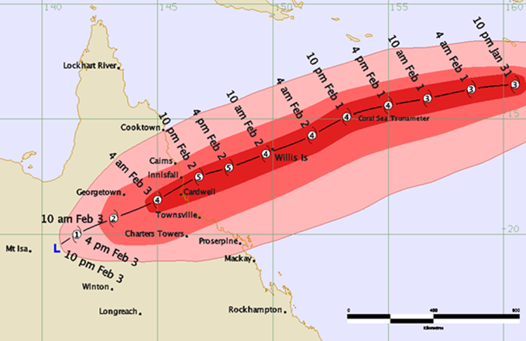
Figure 14: Cyclone Yasi track (Bureau of Meteorology 2016).

Cyclonic events and storms can certainly also disturb heritage sites by relocating artefacts. Artefacts such as a bronze fastening bolt and an iron knee were found situated in an unusual position on site. The bronze fastening and the knee are sitting amongst live coral as if placed there (Figure 15 and Figure 16). One hypothesis is that the artefacts were dislodged and redeposited by cyclone Yasi and new coral growth has grown up around them over the past five years. A second is that they have been repositioned by people disturbing the site. There was no sign of excavation on site so one must assume it was moved during a storm event, perhaps Yasi.
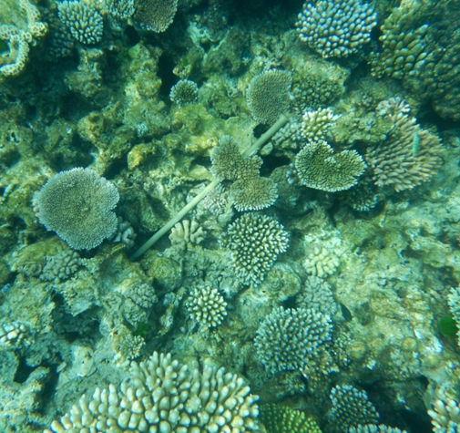
Figure 15: Bronze bolt sitting unattached amongst the coral.
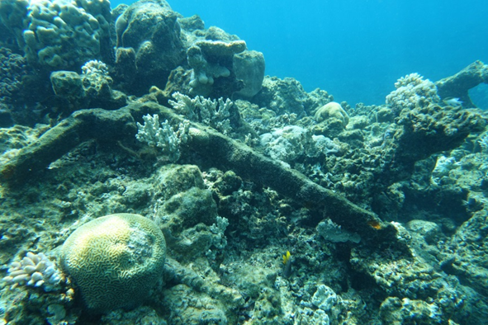
Figure 16: Iron knee loose amongst coral.

4.3 Ocean Acidification
Acidification has the potential to impact underwater heritage sites, by weakening the calcareous protective cover and reducing recruitment on exposed artefacts. The protective cover is created by the settlement of crustose coralline algae and encrusting invertebrates. In the context of Foam and other historic shipwrecks, the concretions over the anchor chain and other more prominent exposed iron artefacts may be at risk. However, acidification is unlikely to impact subsurface artefacts.

4.4 Other threats
Though it may be considered by some to not be a direct threat to the site, the loss of coral cover due to bleaching and algal blooms affects the stability of the natural covering and so protection of the site. Loss of the calcareous layer that protects the fabric of the site could be detrimental to the preservation of the shipwreck.

OUTPUTS FROM THIS SURVEY
- Site report on the historic shipwreck Foam.
- A digital photographic record from the expedition has been deposited in the Authority’s library and image services for future reference and research. These images will also be made available to the Queensland Department of Environment and Heritage Protection for their reference and inclusion in the Australian National Shipwrecks Database.
- Three Reef Health and Impact Surveys.
- Accurate coordinates of the historic shipwreck Foam, including the position of the off-site anchor, were recorded. This information was passed on to the relevant authorities, including the Department of Environment and Heritage Protection to update the Australian National Shipwrecks Database, and the Australian Hydrographic Service.
- Data was collected that will feed into the development of a Conservation Management Plan for the Historic Shipwreck Foam.
- A 3D model of the Foam anchor was made using the Agisoft program.

OUTCOMES FROM THIS SURVEY
- A significant advancement in maritime heritage knowledge in the Great Barrier Reef Marine Park including location specific knowledge of this high priority site.
- The Authority’s commitment to maritime cultural heritage in the Great Barrier Reef Marine Park has been demonstrated, and a collaborative working relationship has been developed with, maritime cultural stakeholders such as staff from the Department of National Parks, Sport and Racing.
- The partnership with Department of Environment and Heritage Protection has been strengthened, through sharing of expedition results, photographs and updated information for the database.
- The following actions and priorities could be further considered for the site:
  - prioritise timely post cyclone inspections of maritime heritage sites
  - conduct annual monitoring of the site to maintain site knowledge and understanding of site formation processes
  - prioritise surveillance flights and marine patrols of the area as part of the joint Field Management Program
  - encourage partner agencies’ participation in site monitoring work
  - extend the protected zone to include the anchor or move the anchor to within the 200 metres protected zone (see Figure 4).

REFERENCES
BECK, S., 2009. Maritime mechanisms of contact and change: archaeological perspectives on the history and conduct of the Queensland labour trade. Townsville: PhD Thesis, James Cook University.
BUREAU OF METEOROLOGY, 2016-last update, The Australian tropical cyclone database, [Online]. Available: http://www.bom.gov.au/cyclone/history/.
COMMONWEALTH OF AUSTRALIA, 2015. Reef 2050 long-term sustainability plan. Canberra: Department of the Environment and Great Barrier Reef Marine Park Authority.
DEPARTMENT OF THE ENVIRONMENT AND ENERGY, 2016-last update, View shipwreck: Foam. Australian historic shipwreck database, [Online]. Available: https://dmzapp17p.ris.environment.gov.au/shipwreck/public/wreck/wreck.do?key=2525.
GREAT BARRIER REEF MARINE PARK AUTHORITY, 2014. Great Barrier Reef Outlook Report 2014. Townsville: GBRMPA.
HATCHER, B.G., 1984. A maritime accident provides evidence for alternate stable states in benthic communities on coral reefs. Coral Reefs, 3, pp. 199-204.
KELLY, L.W., BAROTT, K.L., DINSDALE, E., FRIEDLANDER, A.M., NOSRAT, B., OBURA, D., SALA, E., SANDIN, S.A., SMITH, J.E., VERMEIJ, M.J.A., WILLIAMS, G.J., WILLNER, D. and ROHWER, F., 2012. Black reefs: iron-induced phase shifts on coral reefs. The ISME Journal, 6(3), pp. 638-649.
MARINE BOARD, 1893. Stranding, Schooner Foam. Marine Board of Queensland. Marine Board Report. Marine Board of Queensland.
PEARSON, M., 1992. From ship to the bush: Ship tanks in Australia. Australasian Historical Archaeology, 10, pp. 24-29.
STONE, P., 2006. Encyclopedia of Australian shipwrecks: And other maritime incidents, including vessels lost overseas, merchant ships lost at war, and those lost on inland waters, together with a bibliography of vessel entries and other maritime incidents. Yarram, Vic.: Oceans Enterprises.

APPENDIX 1: PROFORMA FOR THE ANCHOR SURVEY

