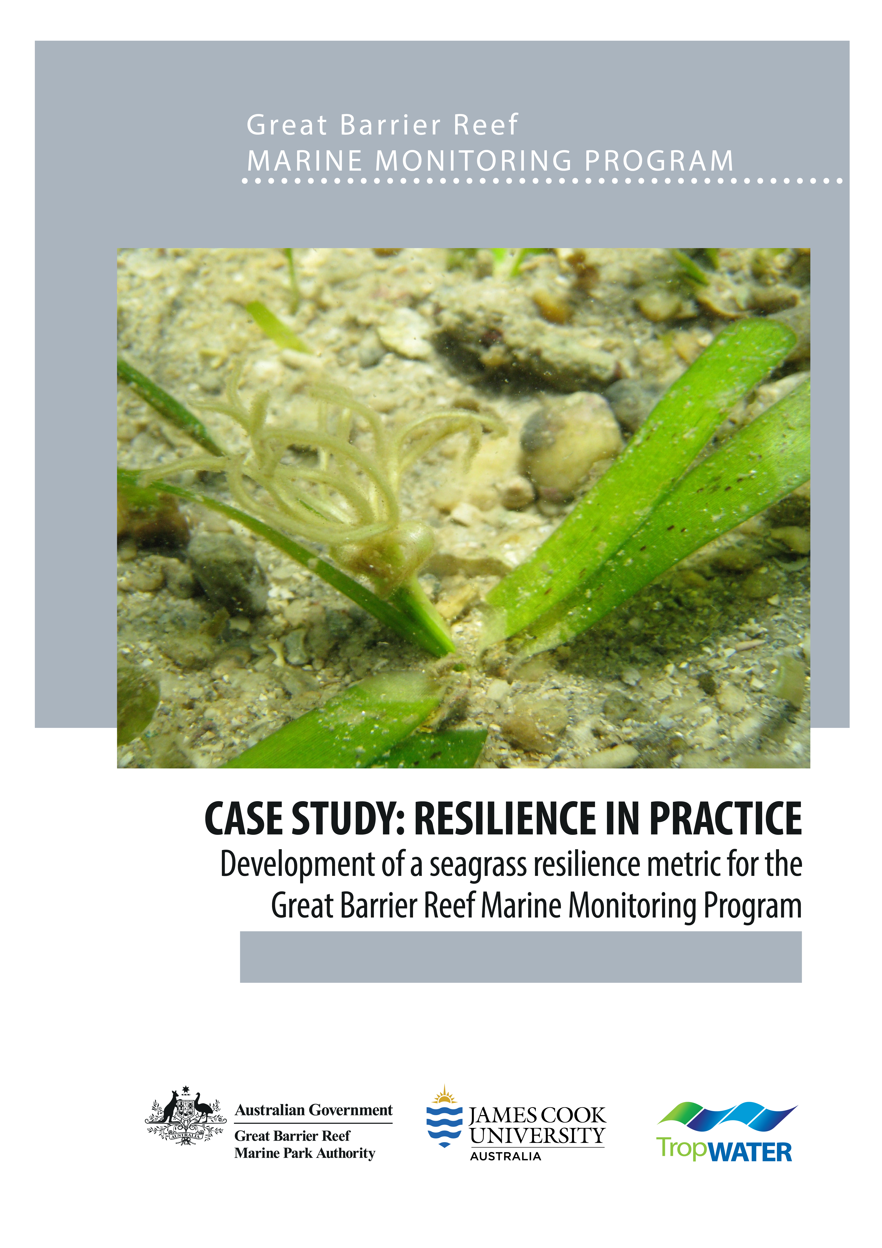

© James Cook University (TropWATER), 2021
Published by the Great Barrier Reef Marine Park Authority

ISBN: 978-0-6450437-7-8
A catalogue record for this publication is available from the National Library of Australia

This document is licensed for use under a Creative Commons By Attribution 4.0 International licence with the exception of the Coat of Arms of the Commonwealth of Australia, the logos of the Great Barrier Reef Marine Park Authority, James Cook University and TropWATER, any other material protected by a trademark, content supplied by third parties and any photographs. For licence conditions see: http://creativecommons.org/licences/by/4.0


This publication should be cited as:
Collier, C.J., Langlois, L., Waycott, M., McKenzie, L.J. 2021, Resilience in practice: development of a seagrass resilience metric for the Great Barrier Reef Marine Monitoring Program, Great Barrier Reef Marine Park Authority, Townsville, 61pp.

Front cover image: Seagrass Thalassia hemprichii flower © Catherine Collier

The Great Barrier Reef Marine Park Authority acknowledges the continuing Sea Country management and custodianship of the Great Barrier Reef by Aboriginal and Torres Strait Island Traditional Owners whose rich cultures, heritage values, enduring connections and shared efforts protect the Reef for future generations.

DISCLAIMER
While reasonable efforts have been made to ensure that the contents of this document are factually correct, JCU and TropWATER do not make any representation or give any warranty regarding the accuracy, completeness, currency or suitability for any particular purpose of the information or statements contained in this document. To the extent permitted by law JCU and TropWATER shall not be liable for any loss, damage, cost or expense that may be occasioned directly or indirectly through the use of or reliance on the contents of this document.

Comments and questions regarding this document are welcome and should be addressed to:

TropWATER- Centre for Tropical Water and Aquatic Ecosystem Research
James Cook University
Townsville, Qld 4811
Tropwater@jcu.edu.au

This project is supported by the Great Barrier Reef Marine Park Authority through funding from the Great Barrier Reef Marine Monitoring Program and James Cook University

Table of Contents
Tables ii
Figures iii
Executive summary 1
Introduction 5
Overall approach 12
Methods and results 13
Category 1. Sites with low resistance 13
Colonising species with low ‘resistance’ – threshold calculation 13
Seagrass meadows with low cover and low resistance - threshold calculation 15
The range of scores in the low resistance category 1 16
Identifying reproductive and non-reproductive sites 17
Calculating scores for category 1.1 – proportion of colonising species at the site 18
Calculating scores for category 1.2 – proportion of foundational species and their reproductive effort 19
Category 2. Sites with high resistance 21
Reproductive structures – the first split 21
Calculating scores for category 2.1 - reproductive history 22
Calculating scores for category 2.2 – the proportion of persistent species 28
Proposed resilience metric compared to the reproduction metric 32
Comparison for selected sites 32
New metric influence on Seagrass index and Reef-wide Scores 35
Power of detecting reproductive structures 36
Discussion and conclusions 37
References 39
Appendix 42
Additional information on the resilience metric tree 42
Percent colonising species and percent cover 42
Additional information on the effect of the using the 20th percentile of per cent cover in the first split differentiating category 1 44
Additional information for section 2.1 47
Seed model outputs 47
Additional information for scores distribution with new metric 48
Overall distribution of the scores 48
Additional information on the proposed resilience metric compared to the reproduction metric 51
Comparison for all sites per NRM regions 51

Tables
Table 1: Species classification as colonising, opportunistic or persistent as applied in the resilience metric, also identifying which of those are considered foundational for the reproductive effort metric. Frequency refers to how often each species has been observed in quadrats of the MMP sites: Never = 0, Extremely rare < 1 per cent, Rare < 5 per cent, Occasional < 10 per cent, Common >10 per cent. 9
Table 2: Models explored to investigate the effect of reproductive effort history and the seed bank 23
Table 3: Generalised linear model output for Seed model 3 23
Table 4: Results of the generalised linear model testing for the response of SE_cover to the presence of persistent species (P_presence) 25
Table 5: Sites selected for demonstrating the changes in the score based on the resilience metric and the reproduction metric 32
Table 6: Repartition of sites with the 47 per cent colonising species composition threshold throughout all and specific years 43
Table 7: Generalised linear model output for Seed model 1 47
Table 8: Generalised linear model output for Seed model 2 47

Figures
Figure 1: Overall structure of the proposed MMP resilience metric. The score ranges from 0 to 100. Splits in the tree are used to place a site in a grouping (red, yellow, or green), with grading within each grouping based on species composition and reproductive effort. Reproduction refers to sexual reproduction. 3
Figure 2: The Seagrass metric scores (lines: seagrass abundance, reproductive effort or resilience, and nutrient status) as well as the overall Seagrass Index (points), which is the average of the three metrics. 4
Figure 3: Map of all of the seagrass monitoring sites. Only some of the sites/locations were included in this analysis if long-term data were available. 5
Figure 4: Stages in the life cycle of some species occurring in the Reef. From Collier and Waycott (2009). 6
Figure 5: Count of the MMP sites that are dominated by each of colonising (C_dom in pink), opportunistic (O_dom in green) or persistent species (P_dom in blue). 8
Figure 6: Opportunistic species rely on a combination of resistance and recovery traits for resilience, such that resilience is highest over a broad range of having both features. The MMP sites are predominantly dominated by opportunistic species, and as such, the resilience metric has been developed to accommodate both resistance and recovery traits. 10
Figure 7: Trends in the indicators for abundance (percent cover, top row), colonising species proportion (second row), reproductive structures (third row) and seed count (bottom row) for each habitat type that are used in the analysis described here-in. Trends for each Natural Resource Management Region are shown for the abundance indicator. 11
Figure 8: (a) Seagrass percent cover for each site and sampling period, and the percentage of colonising species, and (b) generalised linear model (black line), 95 per cent confidence intervals (grey shading) on mean seagrass percent cover for each colonising species integer (1-100) (black point). A separate GLM has been conducted for %Col. threshold of 1-49 per cent and 50-100 per cent. 14
Figure 9: (a) Count of sites falling below the abundance guidelines, and (b) count of sites falling below the 20th percentile for each site from 2006 to 2019 and which would therefore be placed into the low resistance category of the resilience metric 16
Figure 10: Sites within Category 1 (1.1 and 1.2) including (a) a count of those with reproductive structures present and absent from 2007 to 2019 and (b) per cent cover from 2007 to 2019. 17
Figure 11: Sites placed in group 1.1 including (a) the count of sites with colonising species ranging from 0 – 100%, and (b) the distribution of scores (0 – 15) in years ranging from 2007 – 2019 (black line = average). 19
Figure 12: Sites in category 1.2 including (a) count of sites where reproductive structures are present or absent (Repro_PA_F) in years ranging from 2007 to 2019, and (b) the distribution of scores (5 – 30) over the same time period (black line = average). 20
Figure 13: Sites in category 2 including (a) count of sites with and without reproductive structures from the high resistance sites in either the late wet or late dry season (the highest season is chosen). 21
Figure 14: Seeds in relation to the reproductive history categories shown as (a) box plot of mean seed bank density for each of the five categories (t0, t1, t2, t3, t3+), (b) predicted mean and associated confidence interval from the zero-inflated GLM (model 1) of seed bank density for each of the five categories (t0, t1, t2, t3, t3+), (c) predicted mean probability of seed presence and associated confidence interval for each of the five categories (t0, t1, t2, t3, t3+) from the binomial GLM, and (d) predicted mean probability of seed presence and associated confidence interval for three categories (t0, t1-t3, and t3+) from the binomial GLM. 24
Figure 15: (a) Percentage of sites with persistent species from 2006 to 2019, and (b) the percentage of the species composition that was comprised of persistent species. 25
Figure 16: Standard error of percent cover as (a) three category box plot of raw data, and (b) predicted mean and confidence intervals from the GLM (model 4) based on absence (no), or presence (yes) of persistent species. 26
Figure 17: Persistent species at sites in non-reproductive sites category 2.1.1 as (a) count of sites/sampling times within each increment of persistent species, and (b) resulting scores based on the proportion of persistent species. 27
Figure 18: Count of non-reproductive sites (2.1.2) sites/sampling times with each category of persistent species (a), and resulting scores based on the proportion of persistent species (b). 28
Figure 19: Sites with high resistance and high recovery potential in category 2.2 as (a) number of sites in each year with persistent species present and absent and (b) box plot showing seagrass abundance (per cent cover). 29
Figure 20: High resistance, high recovery potential sites in category 2.2.1 showing (a) count of reproductive structures and (b) the scores over time. 30
Figure 21. High resistance, high recovery potential sites in category 2.2.2 showing (a) count of reproductive structures and (b) the scores over time. 31
Figure 22: The abundance metric, proposed resilience metric and the former reproduction metric at six example sites from 2006 to 2019, including Dunk Island subtidal (DI3), Piper Reef/Farmer Island intertidal (FR1), Green Island intertidal (GI2), Great Keppel Island intertidal (GK1), Shoalwater Bay intertidal (SB1), and Urangan intertidal (UG2). 34
Figure 23: The seagrass index based on the new proposed resilience metric (top), and the reproductive effort metric (bottom), in each of the NRMs. 35
Figure 24: The seagrass index based on the new proposed resilience metric (left), and the reproductive effort metric (right) for the Reef as a whole. 35
Figure 25: (a) Power analysis for different sample sizes (i.e. number of reproductive effort cores) for all sites, and (b) for sites in the four habitat types in which reproductive effort samples are collected. 36
Figure 26: Akaike Information Criterion from the GLM model b with %Col. Threshold set between 10 and 90. 42
Figure 27: The number of sites placed into category 1 in each year with and without the 20th percentile decision in the first split. 44
Figure 28: The abundance metric, proposed resilience metric and the former reproduction metric at six example sites from 2006 to 2019, including Dunk Island subtidal (DI3), Piper Reef/Farmer Island intertidal (FR1), Green Island intertidal (GI2), Great Keppel Island intertidal (GK1), Shoalwater Bay intertidal (SB1), and Urangan intertidal (UG2). This figure shows the influence on the resilience score if the 20th percentile abundance rule is not used to influence the first split. 45
Figure 29: Count of sites in each category of the resilience score, without the 20th percentile decision included. 46

Figure 30: The seagrass index based on the new proposed resilience metric (left), and the reproductive effort metric (right) for the Reef as a whole. 46
Figure 31: Distribution of the resilience scores 48
Figure 32: Distribution of the scores within each grouping 48
Figure 33: Distribution of the scores in dry seasons of a low impact year (2007–08), high impact year (2010–11), and moderate year (2014–15) 49
Figure 34: Distribution of scores in each region and year dry seasons of a low impact year (2007–08), high impact year (2010–11), and moderate year (2014–15) 50
Figure 35: The scores for abundance, reproductive effort and resilience for sites in Cape York (top group) and the Northern Wet Tropics (bottom group) 51
Figure 36: The scores for abundance, reproductive effort and resilience for sites in the Southern Wet Tropics and Burdekin 52
Figure 37: The scores for abundance, reproductive effort and resilience for sites in the Mackay-Whitsunday, Fitzroy and Burnett-Mary. 53
Figure 38: The seagrass index calculated using the proposed resilience metric as well as different weighting from the nutrient status index, as discussed in Langlois et al. 2020 (left) and the seagrass index calculated without the nutrient status included (right). 54

Executive summary
Sexual reproduction is an important aspect of seagrass resilience and has been in the condition and trend reporting metrics for the inshore seagrass Great Barrier Reef Marine Monitoring Program (MMP). The reproductive effort metric has been one of three equally weighted metrics in the seagrass Index, informing the Reef 2050 Water Quality Report Card (Report Card) since its inception. A recent analysis concluded that it should be replaced with a multivariate resilience metric, which we propose here.
Seagrass resilience is the capacity of the ecosystem to cope with disturbances. Central to the idea of seagrass resilience is the ability to resist disturbances through physiological processes and modifications to morphology, and recover following loss by regeneration from seed and through plant growth. Seagrass species vary in their dependence on resistance and recovery strategies. The species are classed as ‘colonising’, ‘opportunistic’, or ‘persistent’ with increasing dependency on ‘resistance’ and reduced dependency on ‘recovery’ strategies through these groups. The resilience indicator accommodates these species trait differences.
The resilience metric is based on:
- a conceptual understanding of what confers resilience;
- existing indicators and long-term data;
- statistical analysis and sensitivity testing.
Sites are scored from 0 to 100 in each year using a decision tree (Figure 1). The three main categories within the tree are:
- low resistance sites (red)
- non-reproductive but high resistance sites (yellow)
- reproductive and high resistance sites (green).
Throughout this report, we present the statistical analysis and data exploration that supports the decisions and thresholds of the tree
Low resistance sites are those dominated by colonising species (≥50% of the total seagrass composition), or those with very low total cover (<20th percentile for that site). These sites are highly vulnerable to one-off disturbances such as flood events. If a site has no reproductive structures, then the score (ranging from 0 to 15) is based on the proportion of colonising species (Figure 1: 1.1). If reproductive structures are present, then the score (ranging from 5 to 30) is based on the proportion of foundational species and the ratio of reproductive structures that are from foundational species (opportunistic or persistent species) (Figure 1: 1.2).
Non-reproductive and high resistance sites are those not dominated by colonising species (<50% of the total seagrass composition), with moderate to high cover (> 20th percentile), but without reproductive structures (Figure 1: 2.1). They are less vulnerable to individual, one-off, disturbance events, but if they do suffer mortality, they have reduced capacity to recover from seeds. The category is separated into those with:
- no reproductive structures in the previous 3 years and are less likely to have formed a seed bank (scored from 30 to 50, Figure 1: 2.1.1)
- reproductive structures in the previous three years (scored from 50 to 70, Figure 1: 2.1.2).
The score range within these categories is based on the proportion of the site that is comprised of persistent species, as they have higher levels of resistance, and are not expected to produce as many reproductive structures.
Reproductive and high resistance sites are those that are not dominated by colonising species (<50% of the total seagrass composition) and have moderate to high cover (> 20th percentile), but they also have reproductive structures recorded within the sampling year (Figure 1: 2.2). They are the most likely to have a high level of resistance to disturbances, including multi-annual disturbances such as elevated terrestrial run-off in El Niño years. This is enhanced by sexual reproduction potentially increasing clonal diversity and therefore resistance to stress. Sexual reproduction also indicates a higher probability of a recent and viable ‘seed bank’ and therefore ability to recover from seed if loss in cover occurs. Sites that do not have persistent species are scored from 70 to 100 (Figure 1: 2.2.1), while those with persistent species present are scored from 85 to 100 (Figure 1: 2.2.2). The score within these ranges is based on the count of reproductive structures relative to the historical count for the site.

Figure 1: Overall structure of the proposed MMP resilience metric. The score ranges from 0 to 100. Splits in the tree are used to place a site in a grouping (red, yellow, or green), with grading within each grouping based on species composition and reproductive effort. Reproduction refers to sexual reproduction.
The proposed resilience metric varies through time based on pressures acting on the inshore habitats, for example declining in 2009–2010 through to 2012–2013, but recovering in subsequent years (orange line, Figure 2 left hand panel). By contrast, the existing reproduction metric has been variable throughout, but the trend generally continued to decline over time (orange line, Figure 2 right hand panel). At a site level, the resilience metric is less variable over inter-annual time-scales than the reproduction metric, because it is multi-variate, and includes consideration of reproduction in previous years. Incorporation of the resilience metric into the Reef health index would lead to a higher overall score in almost all years, similar score in some years, and never a lower score based on analysis of historical data (Figure 2). A back-calculation of the Seagrass Index using the resilience metric would result in a predominance of years with moderate scores and no years with very poor scores. While the overall effect of the resilience metric is a lift in scores and the Seagrass Index at the regional or Reef-level, the resilience metric is lower than the reproductive effort metric at some sites and times, thereby identifying greater concern over the resilience of those sites, than the reproductive effort indicator alone identified. Changes to the Seagrass Index should be considered in conjunction with a down-weighting of the nutrient status metric (as described in a previous case study) and in a separate supporting report documenting the effect of incorporating both changes.
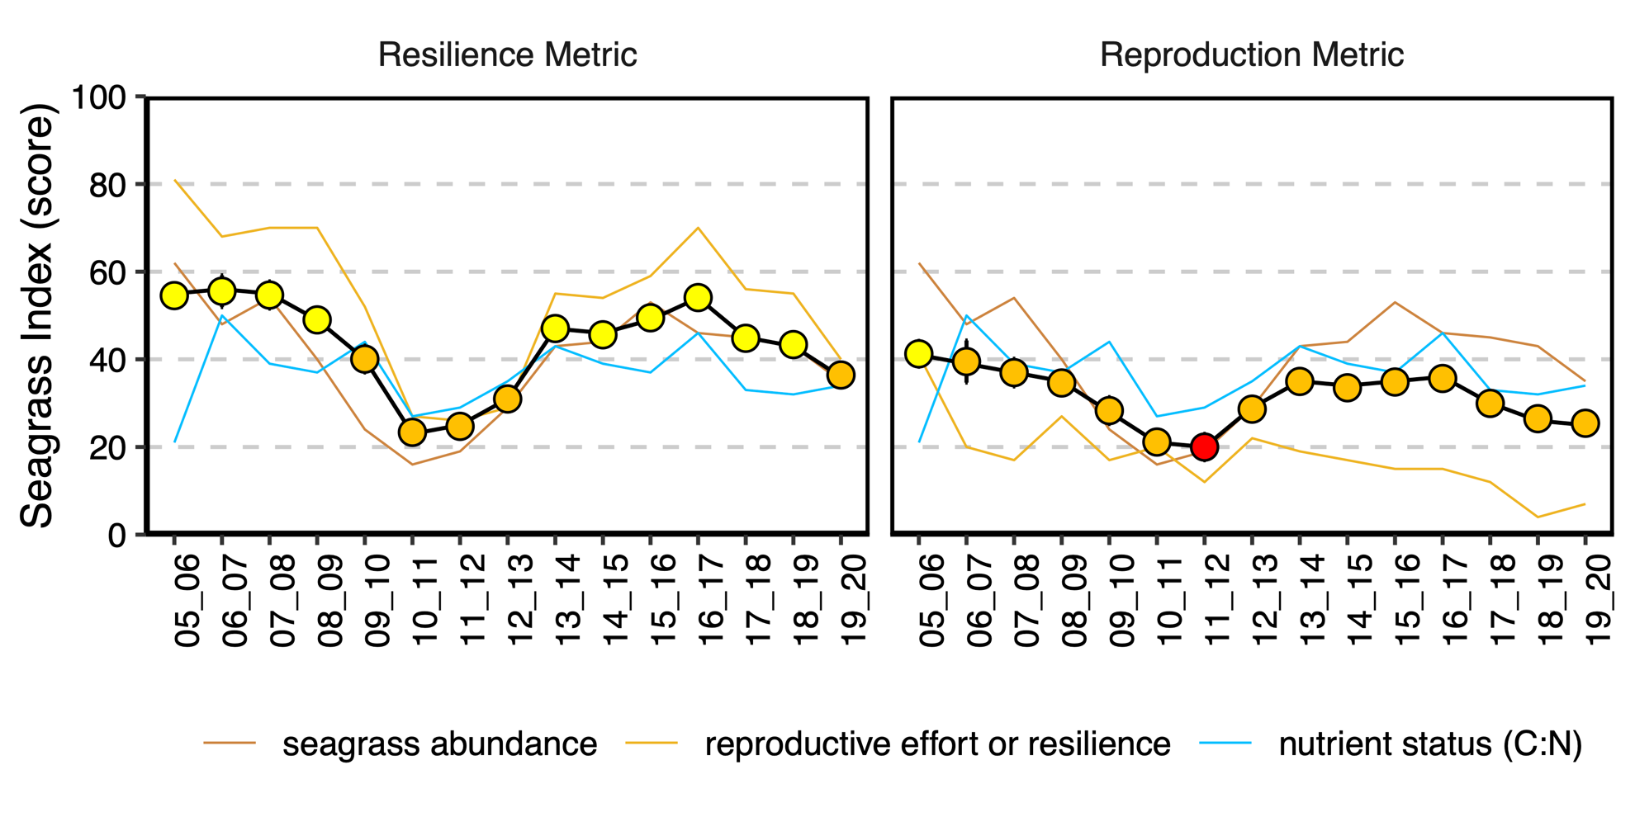
Figure 2: The Seagrass metric scores (lines: seagrass abundance, reproductive effort or resilience, and nutrient status) as well as the overall Seagrass Index (points), which is the average of the three metrics.
Differences in the overall Seagrass Index are shown with the proposed resilience metric (left plot), and the existing reproductive metric (right plot). Index scores (points) scaled from 0–100 and graded: ● = very good (81-100), ● = good (61 - 80), ● = moderate (41 - 60), ● = poor (21 - 40), ● = very poor (0 - 20). NB: Scores are unitless.

Introduction
The Marine Monitoring Program (MMP) forms an integral component of the Paddock to Reef Integrated Monitoring and Reporting Program (Paddock to Reef program). The inshore seagrass monitoring component of the MMP assesses a range of indicators as representative of plant-scale, meadow-scale, and state change throughout the Great Barrier Reef (the Reef) (McKenzie et al. 2019) (Figure 3). Three of these indicators are used for the seagrass component, which feeds into the Marine results of the Report Card. These are: seagrass abundance, reproductive effort, and nutrient status. An assessment of the nutrient status indicator is presented in McKenzie et al. (2020).
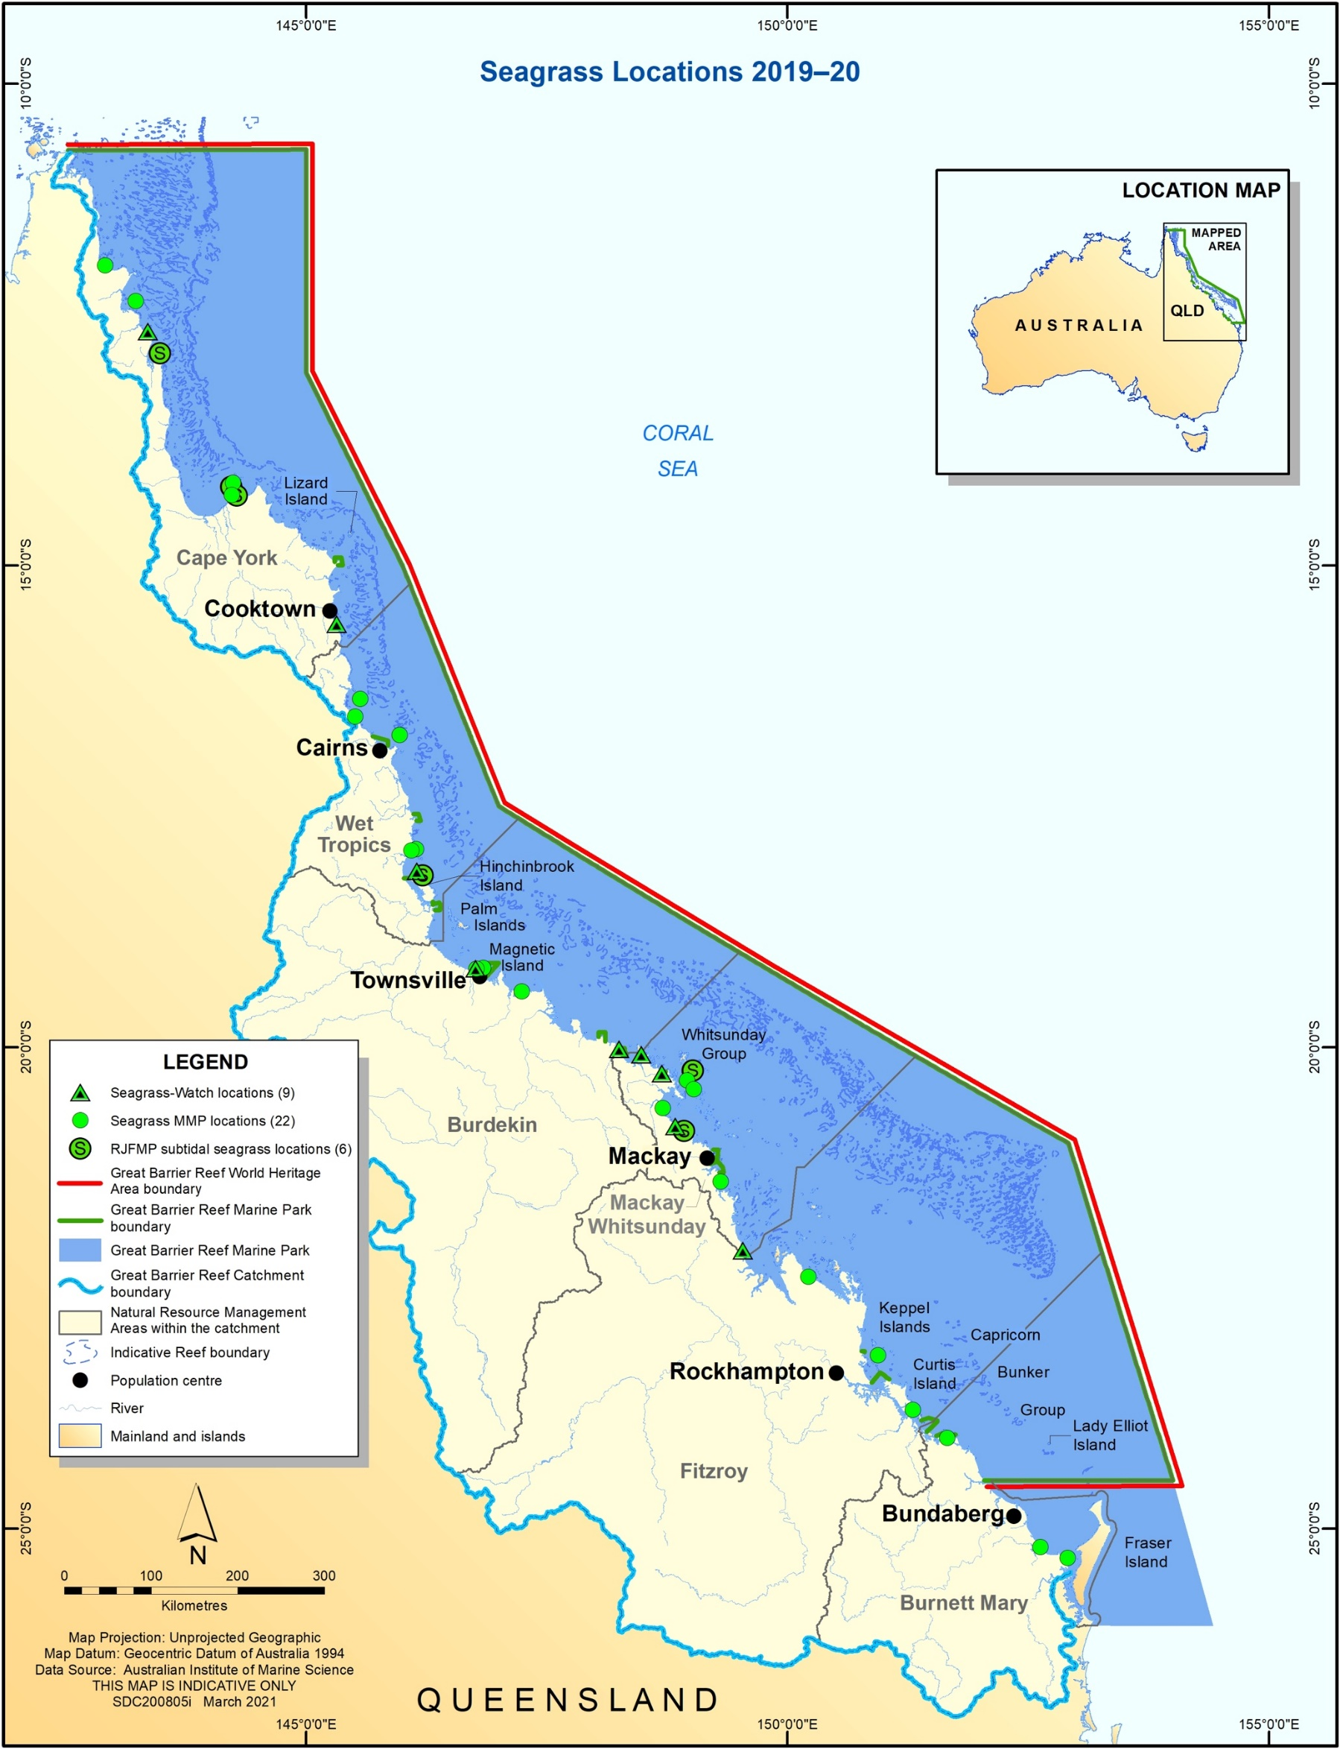
Figure 3: Map of all of the seagrass monitoring sites. Only some of the sites/locations were included in this analysis if long-term data were available.
Seagrasses expand and produce new shoots through clonal growth, but seagrasses are also angiosperms (flowering plants). Sexual reproduction leads to the formation of seeds, which for many species are deposited in the sediment where they persist for years, leaving a ‘seed bank’ (Figure 4). Sexual reproduction is vital for increasing clonal richness (diversity), which can increase resilience to stress (Reynolds et al. 2016). The seedbank can also facilitate recovery after seagrass loss through germination and subsequent clonal growth (Jarvis and Moore 2010). Therefore, sexual reproduction is vital to seagrass resilience. As such, it was included in the MMP from its inception, but with limited Reef-specific data to guide development of the metric. The principals of adaptive monitoring include iterative change to monitoring programs as new information becomes available, leading to improvements in program effectiveness (Lindenmayer and Likens 2009). After 15 years of monitoring, there is considerably more data and knowledge on reproductive effort that can be used to investigate revisions to the metric.

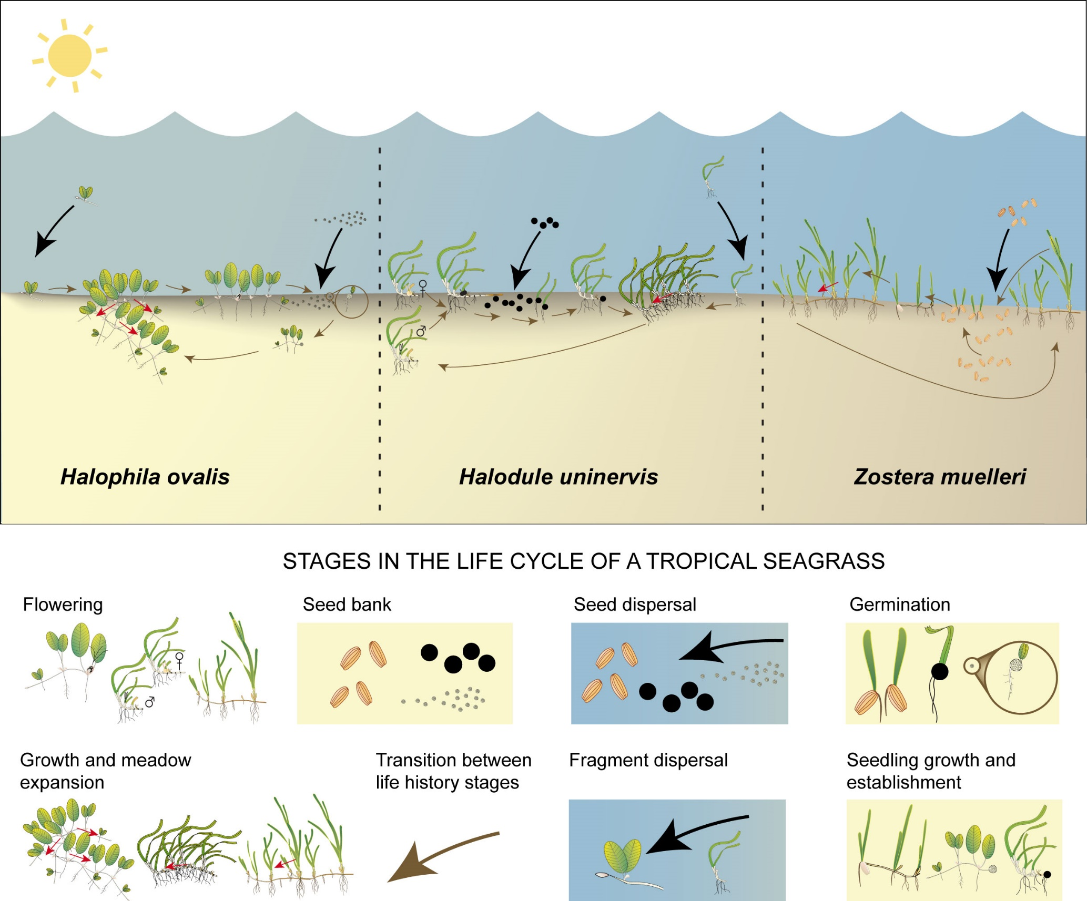
Figure 4: Stages in the life cycle of some species occurring in the Reef. From Collier and Waycott (2009).
The reproductive effort score is based on the count of reproductive structures (inflorescence, fruit, and spathe) in the late dry season (though it is also measured in the late wet season) and a grade score based on specific habitats (reef, coastal, or estuarine) baseline. A previous exploration of the reproductive effort data tested whether reproductive effort predicts seagrass cover in the following year (i.e., if reproductive effort confer resilience) (Lawrence and Gladish 2018; Collier et al. 2019). The conclusions were:
- Percent cover in the previous year was a strong predictor of seagrass cover, and the weighting of the metrics in the Report Card should reflect this.
- The measurement of reproductive effort is useful and important, but low power of this variable indicates that reducing its weighting in the Report Card is required.
- The presence of a seed bank showed importance in the models, but due to a lack of power in the seed data, it should not be added to the Report Card.
- A resilience metric that incorporates multivariate resilience indicators should be developed for reporting on seagrass in the Reef.
- Further resilience indicators should be explored as possible replacements or supplements to the reproductive indicators.
As such, the document here-in introduces a multivariate resilience metric. Resilience can be described as the capacity of an ecosystem to cope with disturbance (Connolly et al. 2018) and to adapt to change without switching to an alternative state (Holling 1973; Unsworth et al. 2015). For monitoring and reporting, ‘a set of measurable biological characteristics that exemplify seagrass meadows’ resistance to pressures and essential mechanisms for recovery’ are required to assess resilience (Udy et al. 2018). The characteristics that confer resilience are complex and multi-faceted, and can be considered at different spatial and temporal scales (O'Brien et al. 2018b). For example, at different ends of this spectrum, resilience can refer to physiological or plant-scale resilience (Maxwell et al. 2017; O'Brien et al. 2018a), but it can also be viewed as system level resilience including the interacting dependant fauna and processes underpinning survival including feedback cycles (Unsworth et al. 2015; Maxwell et al. 2017; Connolly et al. 2018). Partly because of this, implementing resilience into routine monitoring and management remains a challenge, and there are few quantitative examples in which this has occurred (McKenzie et al. 2017). We previously recommended that practical indicators of resilience continue to be investigated in seagrass habitats in the Reef (Collier et al. 2019), which is a view shared by the Reef Integrated and Monitoring Reporting Program seagrass expert group (Udy et al. 2018). For now, we introduce a multi-faceted resilience metric informed by existing metrics, historical data, and a conceptual understanding of resilience.
Resilience can be considered as having two main elements (Timpane-Padgham et al. 2017; Connolly et al. 2018):
- An ability to resist disturbance, and
- An ability to recover from disturbances.
Seagrasses are a functional grouping of plants, defined as submersed marine angiosperms, but they have very different life-history strategies and these are critical to understanding their resilience in terms of both resistance and recovery (Table 1). Species with low physiological resistance (for example, small below-ground biomass and limited carbohydrate reserves), are also fast-growing and able to recover quickly from disturbances (Kilminster et al. 2015; O'Brien et al. 2018a; O'Brien et al. 2018b). These are referred to as ‘colonising’ species. At the other end of the spectrum, there are species with high levels of physiological resistance (for example, large below-ground biomass, large carbohydrate storage reserves and an ability to slow growth and energy requirements), enabling them to tolerate periods of stress (Collier et al. 2009). If they suffer mortality, they may have limited seed banks from which to recover, and they have very slow growth rates. These are referred to as ‘persistent’ species. In between these two groups are species that are able to adopt either strategy to some extent, and they are referred to as ‘opportunistic’ species. The sites monitored in the inshore seagrass MMP are primarily opportunistic-species-dominated sites, with some persistent species dominant sites when they are in a good state (for example, moderate rating or higher). However, there are some sites that tend to be continually dominated by colonising species (Figure 5). In the historical dataset, there was an increase in the number of sites in which persistent species dominate as more reef intertidal sites were added to the program in Cape York from 2009 onwards. Three of the Cape York sites consistently maintain dominance of persistent species, while temporal variability in dominance occurs at Green Island and Dunk Island in the Wet Tropics.
The inshore seagrass MMP also differentiates foundational from non-foundational species. At all the MMP sites where reproductive effort is measured, foundational species include both opportunistic and persistent species. Foundational species are the dominant primary producer in an ecosystem both in terms of abundance and influence, playing central roles in sustaining ecosystem services (Angelini et al. 2011). The activities of foundation species physically modify the environment and produce and maintain habitats that benefit other organisms that use those habitats (Ellison 2019). In rare cases during recovery from large disturbances (for example, tropical cyclones and flooding), opportunistic species act as colonisers and adopt a rapidly spreading growth form. However, as this is a feature expected of opportunistic species (Kilminster et al. 2015), they are still opportunistic/foundational and classified as such for the resilience metric.
Figure 5: Count of the MMP sites that are dominated by each of colonising (C_dom in pink), opportunistic (O_dom in green) or persistent species (P_dom in blue).
The number of sites varies a little over time as new sites are introduced or decommissioned, but there is also some, but small variation, in the dominant species class through time.

Table 1: Species classification as colonising, opportunistic or persistent as applied in the resilience metric, also identifying which of those are considered foundational for the reproductive effort metric. Frequency refers to how often each species has been observed in quadrats of the MMP sites: Never = 0, Extremely rare < 1 per cent, Rare < 5 per cent, Occasional < 10 per cent, Common >10 per cent.
Species | Foundational | C-O-P class | Reason | Frequency in quadrats
Halophila decipiens | No | C | High annual (seasonal) levels of seed production and seedbank replenishment. Short-lived plants with rapid rates of turn-over, able to grow quickly after disturbances. | Extremely rare
Halophila ovalis | No | C | High annual (seasonal) levels of seed production and seedbank replenishment. Short-lived plants with rapid rates of turn-over, able to grow quickly after disturbances. | Common
Halophila spinulosa | No | C | High annual (seasonal) levels of seed production and seedbank replenishment. Moderate-lived plants with fibrous stems and rhizomes and moderate rates of turn-over. | Extremely rare
Halophila tricostata | No | C | High annual (seasonal) levels of seed production and seedbank replenishment. Short-lived plants with rapid rates of turn-over, able to grow quickly after disturbances. | Never
Halodule uninervis | Yes* | O | Moderate levels of seed production and seed bank replenishment. Moderate-lived plants. Can have features of both colonising (rapid growth) and persistent (tolerance to disturbances) species. | Common
Zostera muelleri | Yes* | O | Moderate levels of seed production and seed bank replenishment. Moderate-lived plants. Can have features of both colonising (rapid growth) and persistent (tolerance to disturbances) species. | Common
Syringodium isoetifolium | Yes | O | Low to moderate levels of seed production and rates of seedbank replenishment. Can have features of both colonising (rapid growth) and persistent (tolerance to disturbances) species. | Rare
Cymodocea rotundata | Yes | O | Low levels of seed production and rates of seedbank replenishment. Can have features of both colonising (rapid growth) and persistent (tolerance to disturbances) species. | Occasional
Cymodocea serrulata | Yes | O | Low levels of seed production and rates of seedbank replenishment. Can have features of both colonising (rapid growth) and persistent (tolerance to disturbances) species. | Rare
Thalassodendron ciliatum | Yes | P | Does not produce a seed bank. Recovers slowly after disturbances through asexual (clonal) growth, or from recruitment of propagules. Persists through unfavourable conditions (such as low light/flood plumes) by drawing on energy reserves. | Never
Thalassia hemprichii | Yes | P | Does not produce a seed bank. Recovers slowly after disturbances through asexual (clonal) growth, or from recruitment of propagules. Persists through unfavourable conditions (such as low light/flood plumes) by drawing on energy reserves. | Occasional
Enhalus acoroides | Yes | P | Does not produce a seed bank. Recovers slowly after disturbances through asexual (clonal) growth, or from recruitment of propagules. Persists through unfavourable conditions (such as low light/flood plumes) by drawing on energy reserves. | Extremely rare
*In rare cases during interpretation of seagrass status and trends in the MMP, these species are classified as colonising when they adopt rapidly spreading growth forms, but this coloniser classification is never applied in the resilience metric for these species.
Colonising species are highly dependent on sexual reproduction and formation of a seed bank to enable recovery (Figure 6). They are prolific flowering and seeding plants, and a count of their structures can lead to extremely high, though sporadic, counts of reproductive structures and a high rating in the reproductive metric at times (for example, at Keppel Island, GK1). Nevertheless, it is important to acknowledge their vulnerability to disturbance such as flood plumes, due to their low physiological resistance. On the other hand, persistent species can have low and unpredictable rates of sexual reproduction, leading to low, or zero scoring at sites dominated by persistent species. They have very high levels of physiological resistance, and appear to have a stabilising effect on meadows (Collier et al. 2021), so a scoring based on reproductive counts underestimates their ‘resistance’ resilience. For example, Piper Reef/Farmer Island in Cape York and Green Island in the Wet Tropics are sites dominated by persistent species and remain relatively stable in the face of disturbances, but they have zero or very low reproductive scores, respectively. Therefore, the current scoring system underestimates their resilience.
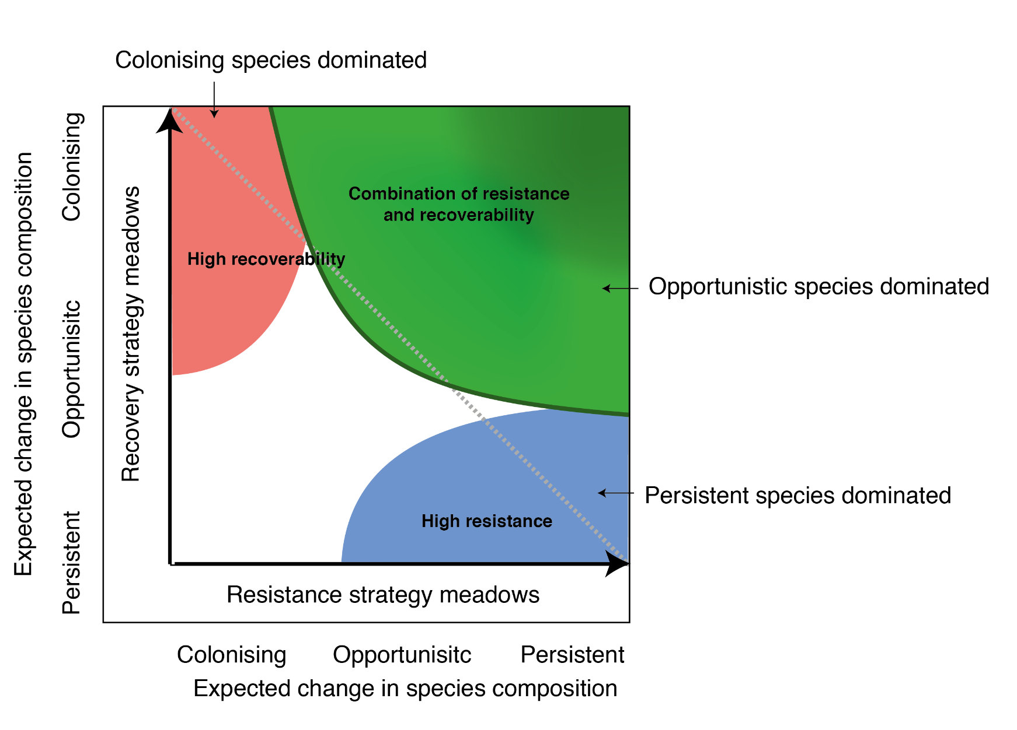
Figure 6: Opportunistic species rely on a combination of resistance and recovery traits for resilience, such that resilience is highest over a broad range of having both features. The MMP sites are predominantly dominated by opportunistic species, and as such, the resilience metric has been developed to accommodate both resistance and recovery traits.
Model adapted from O'Brien et al. 2018b and Kilminster et al. 2015.
One of the aims of this multivariate resilience metric is to consider aspects of both resistance and recovery, and differences among species in these traits. This analysis draws on 15 years data on abundance, species composition seed counts, and reproductive effort, which all vary over time in response to disturbances (Figure 7).
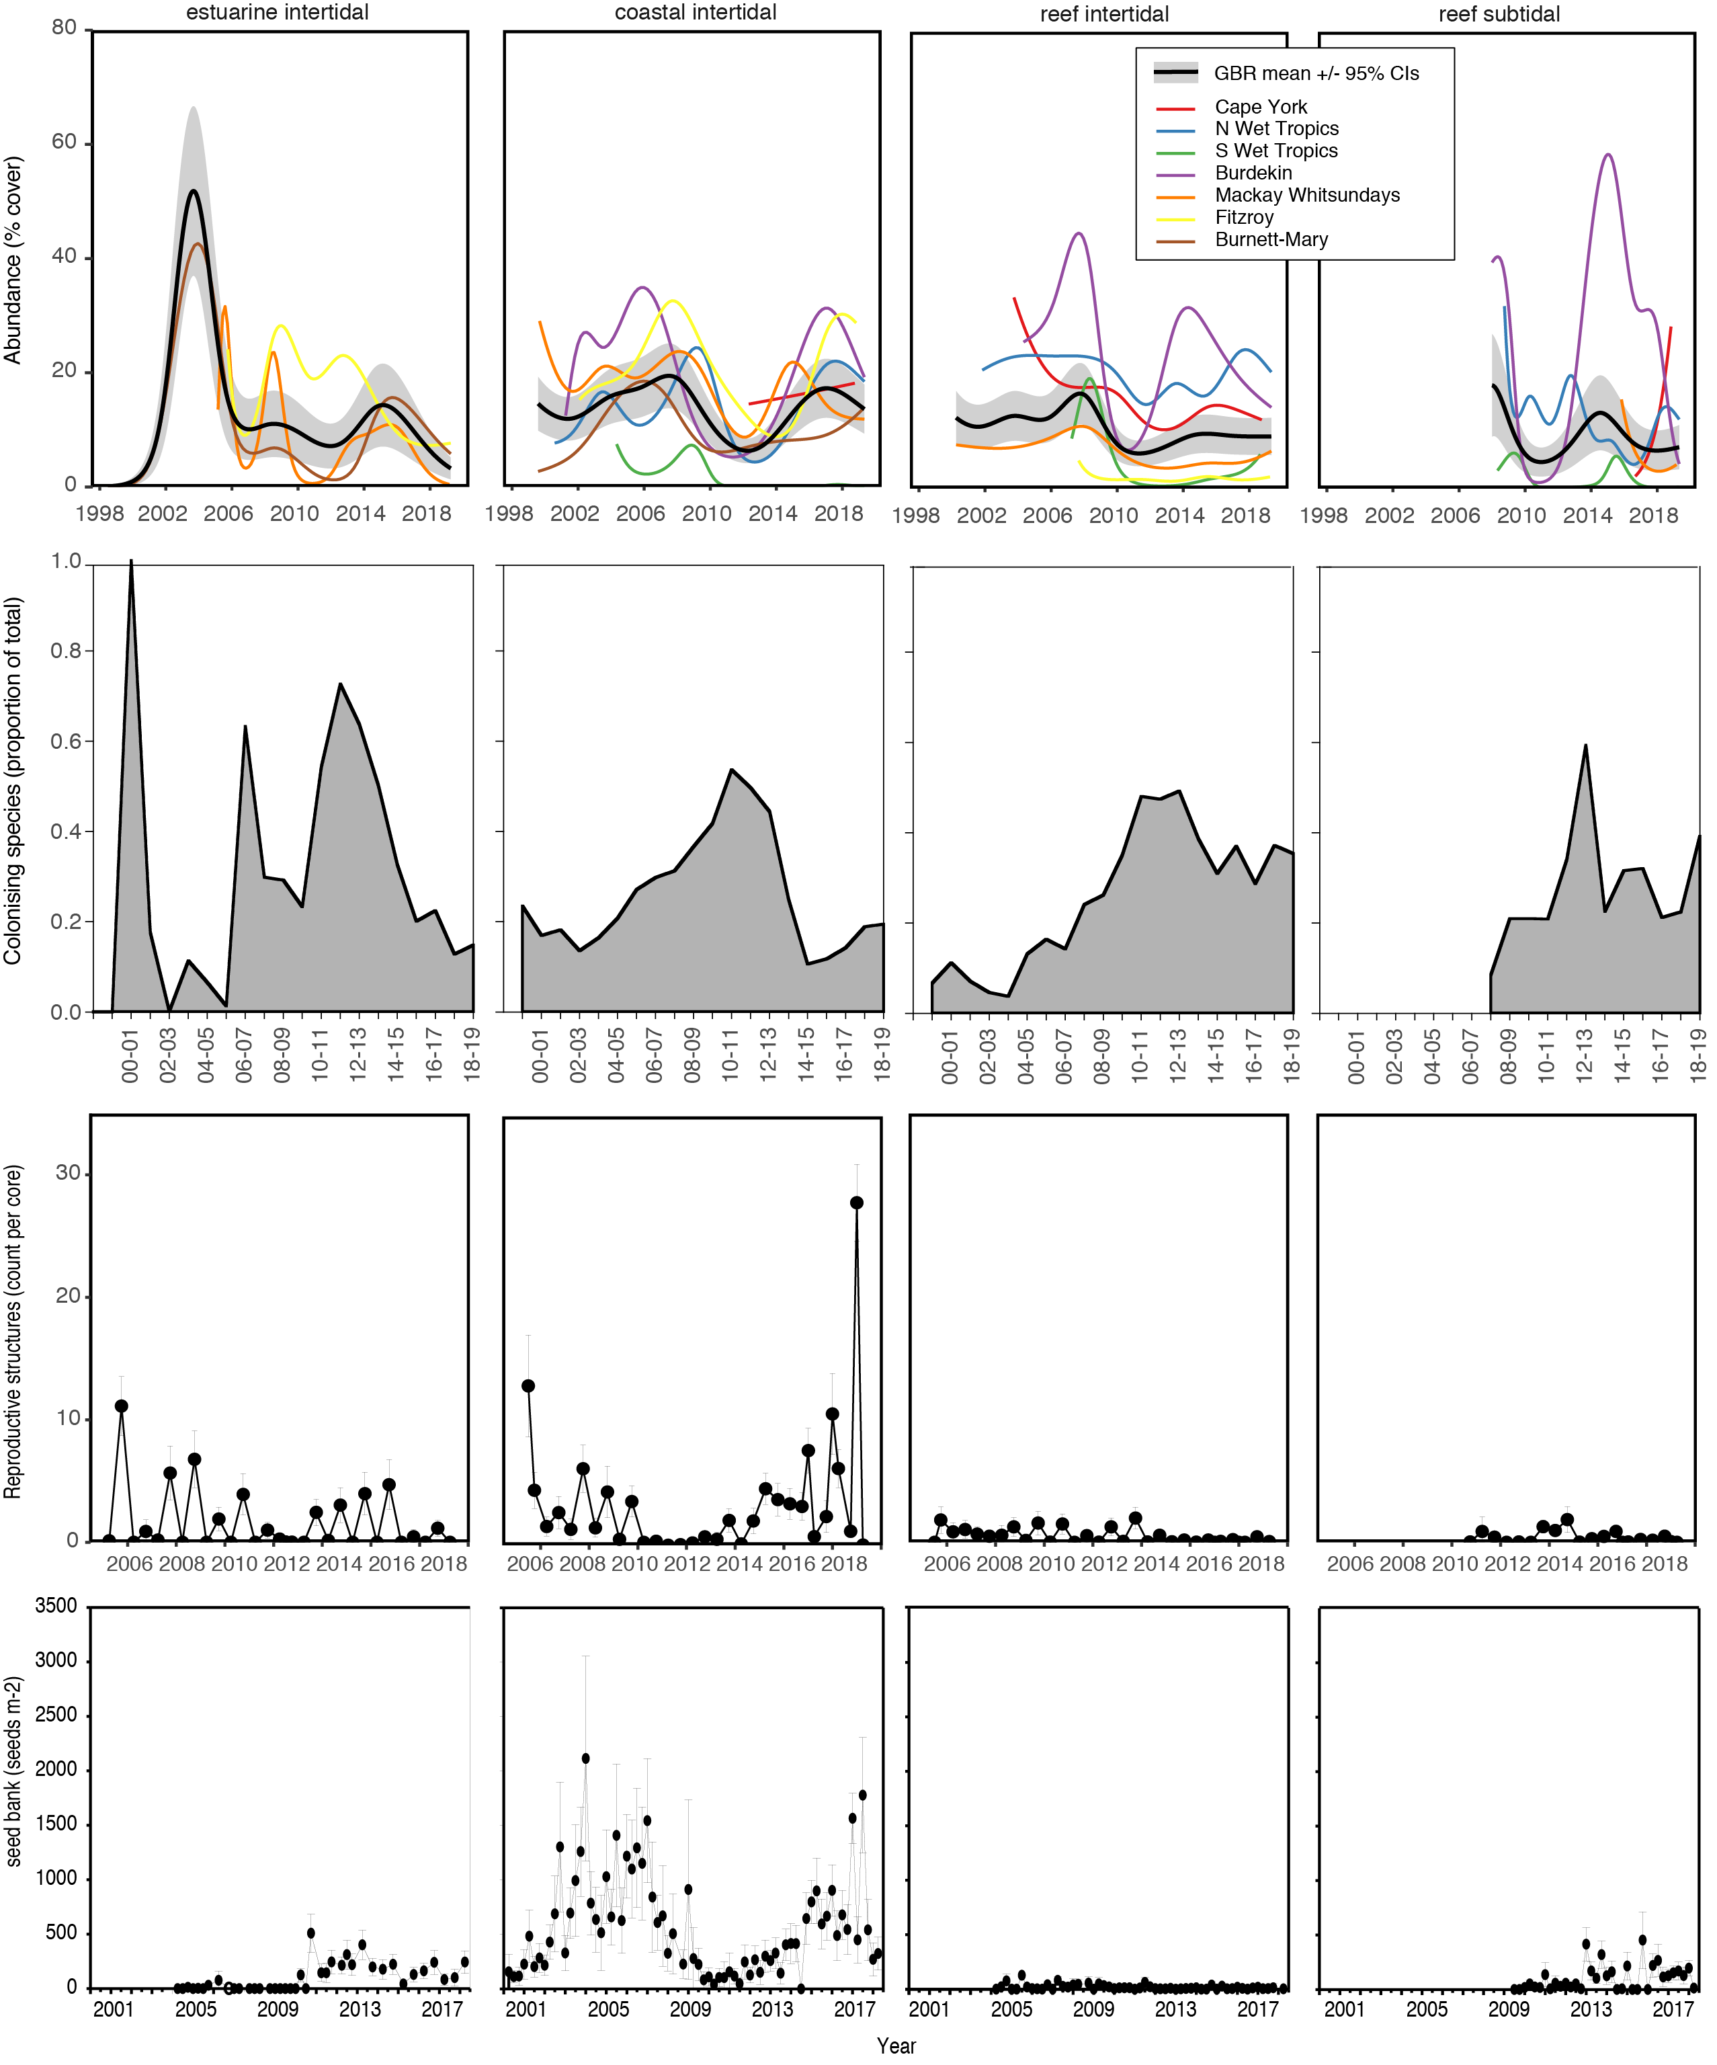
Figure 7: Trends in the indicators for abundance (percent cover, top row), colonising species proportion (second row), reproductive structures (third row) and seed count (bottom row) for each habitat type that are used in the analysis described here-in. Trends for each Natural Resource Management Region are shown for the abundance indicator.
NB seed data are not used in the resilience tree for scoring, but are included in this analysis demonstrating links between the probability of forming a seed bank and years since reproductive structures were observed.

Overall approach
We took a decision tree approach where each split is supported by existing seagrass knowledge and statistically tested on historical data. The decision tree is based on:
- a thorough conceptual understanding of what confers resilience in seagrasses (Reynolds et al. 2012; Kilminster et al. 2015; Unsworth et al. 2015; Connolly et al. 2018; O'Brien et al. 2018b),
- existing measures and data availability (McKenzie et al. 2019),
- statistical analysis of data (outlined in this report), and
- sensitivity testing to ensure that the resulting scores vary over time and result in a logical spread of the scores (outlined in this report).
The decision tree approach has multiple statistical modelling steps as opposed to a single large statistical model. The resilience metric incorporates a variety of concepts and data, making it difficult to use a single statistical model to define it. In addition, we are dealing with datasets that are unbalanced relative to each other. The decision tree includes thresholds defining the splits, and methods for calculating scores. The data is sourced from the MMP inshore seagrass monitoring, which includes 49 sites with data spanning from 2005 to 2019 (McKenzie et al. 2019). Most sampling is undertaken in the late dry season (~September–November), which is the peak growth season, and the most likely time to encounter reproductive structures; however, some sites are sampled twice per year (late wet, and late dry) for reproductive structures. A small number of sites are sampled four times per year, albeit not for reproductive structures, and includes percentage cover and seed density sampling (McKenzie et al. 2020). All sampling events are included in this analysis.
The main splits in the tree are based around:
- a ‘resistance’ component that assesses the seagrass meadow capacity to cope with disturbance based on their seagrass abundance and species composition. A low resistance site is one that has very low abundance based on the history of that site and/or has a high proportion of colonising species. These meadows are considered to be highly vulnerable to disturbances and, therefore, to have very low resilience.
- a ‘reproduction' component that is based around likelihood of producing seed banks given the presence and count of reproductive structures. These are scored based on the levels of expected reproductive effort given the life history strategy of the species present. For example, some ‘persistent’ species such as Thalassia are not expected to have a high number of reproductive structures, and nor does it depend on them quite as much for long-term survival compared to ‘colonising’ species.
Those two components work both individually and in collaboration, thus giving the best estimate of resilience using the existing data and indicators. The metric is scored linearly from 0 to 100. The 0–100 scale was split into thirds (rounded to the nearest ten score). This resulted in the following:
- Low resistance sites = 0–30
- Non-reproductive high resistance site = 30–70
- Reproductive high resistance site = 70–100
The overall structure of the metric is detailed in Figure 1. The methods used to arrive at each step are outlined in detail in the following document. We provide the evidence-base and implications of each step of the tree throughout the methods and results. In the final section, we present a comparison of the proposed resilience metric compared to the previous reproductive effort metric.

Methods and results

Category 1. Sites with low resistance
The first major decision in the tree (split 1), differentiates meadows that are likely to have very low resistance because they either:
- have a very high proportion of colonising species, and/or
- have a very low cover based on the history of that site (from 2005).
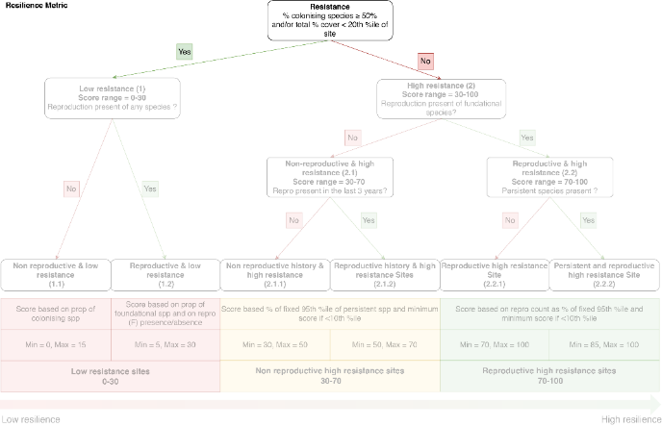
As previously described, colonising species have very low resistance to disturbances such as periods of light deprivation. Furthermore, meadows with low overall abundance or patchiness indicate recent or ongoing impacts, and are likely to have low resistance due to a breakdown of feedbacks (Unsworth et al. 2015; Connolly et al. 2018). These decisions influence whether they are placed into that low resistance category, but the steps outlined in section e, influence the final score calculation once they are in that category.

Colonising species with low ‘resistance’ – threshold calculation
A threshold level indicative of low resistance due to colonising species was based on a number of different quantitative tests. The site average seagrass percent cover for each MMP year period (June–May) was calculated from the entire quadrat data. The average percentage of colonising species (%Col.) was also calculated from the quadrat data (Figure 8). A visual assessment indicates that total seagrass cover decreased with increasing %Col. When the meadow was dominated by colonising species, there tended to be less variation in the total percent cover (Figure 8a). There are 7 cases (LI2 2018/19, MI2 2011/12 and 2012/13, SR1 2011/12 and 2012/13, UG2 2013/14, YP1 2010/11 ) in the historical dataset that appear to be outliers when the %Col. exceeded 50 and the total percent cover remained over 12% cover (Figure 8a). These were all associated with recovery following periods of decline.
To reduce noise and to be able to fit a linear regression without heterogeneity of variance, the data was summarised by taking the average of all the seagrass cover for each %Col. whole number increment for the entire dataset i.e. the average seagrass cover when %Col. was 1, 2, 3, and so forth. We chose a threshold level of %Col. = 50 per cent, indicative of the meadow being dominated by colonising species (%Col. = 50-100 per cent) compared to dominated by opportunistic or persistent species (%Col. = 1-49 per cent), to further explore the relationship of %Col. to total cover in the same year (t0) using Generalised Linear Models (GLM) (Figure 8).
%Col. model 1 = percent cover(t0)~%Col.(1-49 per cent)
%Col. model 2 = percent cover(t0)~%Col.(50-100 per cent)
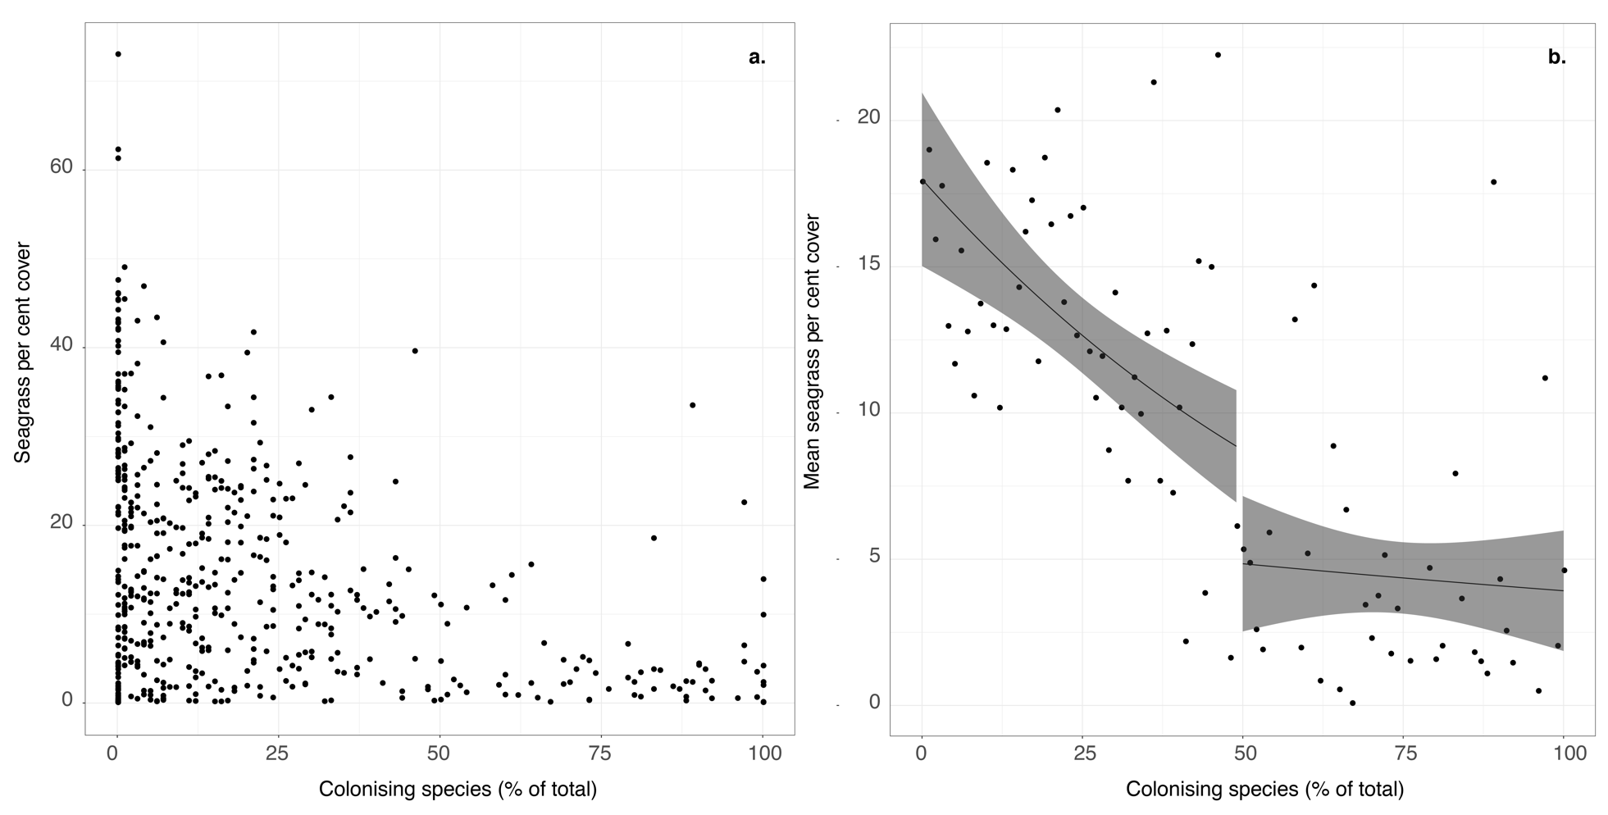
Figure 8: (a) Seagrass percent cover for each site and sampling period, and the percentage of colonising species, and (b) generalised linear model (black line), 95 per cent confidence intervals (grey shading) on mean seagrass percent cover for each colonising species integer (1-100) (black point). A separate GLM has been conducted for %Col. threshold of 1-49 per cent and 50-100 per cent.
This approach highlights the low range in seagrass cover when %Col. ≥50. Applying this threshold to the data resulted in sites with a majority of colonising species present to be placed into the low resistance category with a score range of 0-30 (with the absolute score within that category to be determined by later calculations).
To assess the influence of choosing this threshold level (50 %Col.), multiple GLM models were fitted through a subset of the data where %Col. > i for values of i from 0 to 99. For each iteration of the model the Akaike Information Criterion (AIC) was recorded. After the 47th iteration, when %Col. was constrained to 47-100, the AIC was the lowest indicating the most optimal model (Appendix, Figure 26). We chose 50 per cent as a conservative and more easily communicated threshold to indicate when the meadow is dominated by colonising species.
There were 82 percent of the sites with 50 %Col. or more with seagrass coverage higher than their 20th percentile (the 20th percentile range is 0 to 34.6 per cent, mean = 7.4 per cent). This indicates that the %Col. decision in the tree will identify the majority of the cases of low resilience, not identified in the alternative decision based on total cover (see next section), therefore demonstrating the complementarity of the two thresholds in identifying low resistance sites.
It is important to note that this analysis does not demonstrate that higher %Col. leads to lower resistance as we are unable to explore this at this time with this dataset. Instead, we rely on well-established resilience principals that identify colonising species as having very low resistance, and use the data to identify important thresholds. We recommend further exploration of the role that colonising species play in resistance and recovery in seagrass habitats of the Reef to relevant pressures and disturbances.
If monitoring were to be undertaken in meadows in which only colonising species are expected to dominate, for example in deep water Halophila meadows, and tend to be transitory, then this decision should not be applied. Those habitats will always have a high %Col. but it doesn’t imply they have low resilience because these habitats adopt a different resilience strategy (Figure 6), so new and tailored rules would need to be introduced to define resilience. In the inshore MMP, sites in which reproductive structures are measured are shallow (<5m) and generally dominated by opportunistic species when in good condition. Some deeper sites are monitored through the Reef Joint Field Management Program and Seagrass-Watch partnerships for abundance and composition only, but not reproductive effort, thus they will not be scored for resilience.

Seagrass meadows with low cover and low resistance - threshold calculation
When seagrass meadows are exposed to prolonged or severe levels of stress they can shift to a non-vegetated habitat i.e. disappear (Unsworth et al. 2015) as observed at some sites within the MMP, most of which have since recovered to some extent (McKenzie et al. 2019). A breakdown in the feedback loops that maintain seagrass accelerates rates of decline towards this non-vegetated state (Adams et al. 2016; Maxwell et al. 2017). The point at which this occurs is referred to as a tipping point (Connolly et al. 2018). Identifying tipping points is not a trivial exercise, and it depends on the nature of external stressors on the system (Adams et al. 2016; Hillebrand et al. 2020). Furthermore, adequate data that captures decline and the processes affecting them is also required (Maxwell et al. 2014). We recommend further investigation into seagrass decline and recovery in the Reef, and in the meantime, we accommodate this aspect of seagrass resilience by inclusion of a threshold that identifies low cover that is likely to relate to low resilience. Patchiness is another aspect of low cover that affects resilience (Unsworth et al. 2015), and a method to calculate patchiness is also being explored separately.
To determine the level at which a meadow is at a critical percentage cover we set the threshold as below a low percentile (20th percentile) of percent cover. The 20th percentile is a commonly applied trigger value for problems associated with low levels (for example, low dissolved oxygen levels in water quality monitoring; ANZECC and ARMCANZ 2000). This value is applied in the seagrass abundance guidelines for the MMP as one of the boundaries differentiating very poor and poor condition, and is therefore also applied here for consistency. However, there is a small, but important point of difference in how the low percentile was calculated in this metric. For this resilience metric, the low percentile for each site was identified and is set as a threshold. In each year, if percent cover is below the fixed threshold then it is placed into category 1 (low resistance). For a small number of sites, the abundance stays relatively stable so the low percentile is close to the mean value for that site and much higher than the average percent cover for that habitat type (estuarine intertidal, coastal intertidal, reef subtidal, and reef intertidal; Figure 7) such as Green Island in the intertidal habitat. For that reason, if the low percentile for a site is greater than the long-term average percent cover for that habitat type, then the threshold will be set as the long-term average for the habitat. In the historical dataset, there are 7 times when a site would have been put in category 1 based on the low percentile, but following the modification above is placed in category 2 because the low percentile is higher than the habitat long-term average.
By contrast, the abundance guideline for calculating the abundance score for the Report Card is based on a reference site as determined by the habitat and NRM region, and defaults to another site guideline if this cannot be found. The resilience abundance low percentile threshold proposed here results in much fewer sites going into the low resistance category: there were 69 sites/times falling into this category compared to 304 if we used the MMP abundance score guidelines. The mean cover low threshold is almost twice as low as the one from the abundance guideline (6.3 vs 17.1). All of those sites are already penalised through the abundance score and it would be duplication to place all of them into a low category for the resilience score again. We are seeking to identify only those at very high risk of having low resilience based on the expected level of cover for that site. In essence, we are placing a slightly greater weighting on abundance in the combined Seagrass Index (resilience and abundance scores), as previously recommended should occur (Lawrence and Gladish 2018; Collier et al. 2019), by inclusion of the low abundance threshold here. This influences individual sites and scores. However, the overall effect of this decision on the Index is barely detectable as outlined in the appendix (Figure 30).
Once the low threshold is set, it is fixed if sufficient sampling events have occurred. Thresholds have been fixed on data up to and including the 2018–19 dataset (not that this report also reports scores for 2019–20, but that data was not used for setting thresholds unless further information was needed for setting thresholds). As a general rule, approximately 15–20 sampling times are needed for the variance to asymptote, so sites that meet this criterion have their threshold fixed (McKenzie et al. 2020). For other sites, the 20th percentile will be recalculated each year, and only changed if it is higher than the previous low threshold. This will occur until 24 sampling events have occurred or variance has stabilised (McKenzie 2009; McKenzie et al. 2020). Only newer sites are affected by this, including: all of the Cape York sites, which were established in 2012 and are only sampled once per year, Jerona (JR1 and JR2), Rodds Bay (RD3), and Lindeman Island (LN1 and LN2).
The count of sites that fall below the 20th percentile varies over time, and is the highest when there are cumulative pressures, for example in the years 2011 to 2013, when meadows were in recovery following extreme weather (McKenzie et al. 2019) (Figure 9b). The count of sites below the site 20th percentile declined as recovery progressed, and opportunistic and foundational species became more dominant (on average), but cumulative pressures in all regions have hampered complete recovery and so the count of sites remains higher than historical levels (McKenzie et al. 2021). In addition, there are more sites in 2018–19 (47) than in 2010 (30) so the total count of sites is expected to be a little higher. The increase from 2005 is even more noticeable when examining the count of sites below the guidelines because the site-specific guidelines for newer sites have yet to be determined (requiring >15 sampling events), and regional guidelines based on reference sites (which may be higher) are used in the interim.
On average in the dataset to date, 56% of sites are placed into this low resistance category based on the low threshold rule, 52% based on %Col., with 8% of sites meeting both criteria.
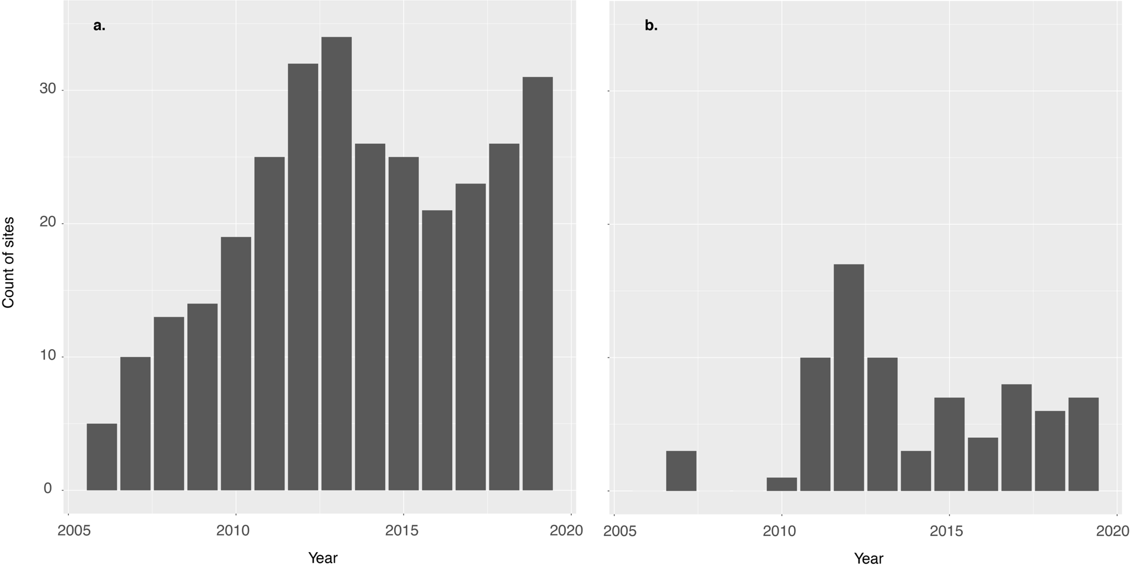
Figure 9: (a) Count of sites falling below the abundance guidelines, and (b) count of sites falling below the 20th percentile for each site from 2006 to 2019 and which would therefore be placed into the low resistance category of the resilience metric

The range of scores in the low resistance category 1
Sites that are deemed to have low resistance are further scored within the range from 0 to 30 in two different categories: 1.1 and 1.2 Meadows that are not reproductive (1.1) have a range of 0-15 and the ones that are reproductive (1.2) have an overlapping range of 5-30.

Identifying reproductive and non-reproductive sites
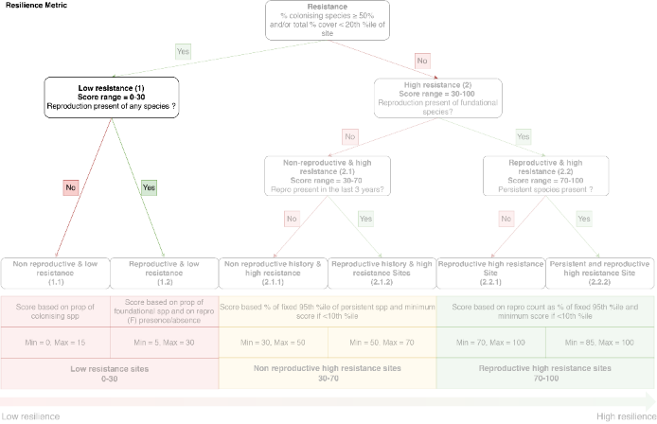
The first split within the low resistance category is based on whether the sites are reproductive or not. Sites that have low resistance, and are also non-reproductive, thereby not producing seedbanks from which to recover, have the lowest resilience and are highly vulnerable (1.1). The number of low resistance sites that have no reproductive structures and those that have some reproductive structures generally follows the same broad cycles, with peaks in the number of sites (n = 8 to 13) with or without reproductive structures occurring following disturbance years when abundance declined across the Reef sites as a whole (for example, 2011–2013, Figure 7). This trend for lower abundance in these years is not as readily observed within this category because the sites are in this category partly because of the low abundance (Figure 10b). There were low counts (2 or less) following low impact years (for example, 2007–2008; Figure 10). However, we see that when the count of sites were in the mid-range (2 to 7 sites) from (2014–2019), the number of meadows either with or without reproductive structures varies according to different temporal patterns, and it is in those years that this split in the score will become the most relevant.

Figure 10: Sites within Category 1 (1.1 and 1.2) including (a) a count of those with reproductive structures present and absent from 2007 to 2019 and (b) per cent cover from 2007 to 2019.

Calculating scores for category 1.1 – proportion of colonising species at the site

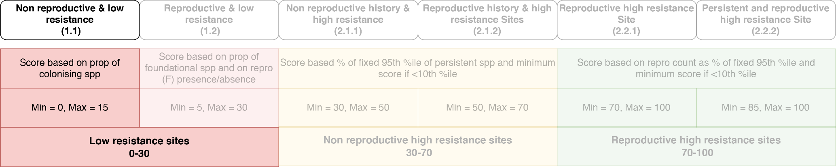
The sites falling into category 1.1 have no reproductive structures and are either dominated by colonising species or below the 20th percentile threshold for percent cover. We base the level of resilience within this category on the relative proportion of colonising species to foundational species (opportunistic or persistent). The reason is that foundational species have a higher level of physiological resistance to disturbance, and therefore the relative composition represented by colonising or foundational affects overall resilience. It is important to recall that a meadow can be placed in this category if the total percent cover is <20th percentile, but if it has no colonising species. Therefore, the range of both colonising and foundational species in this category ranges from 0 to 100%.
The score within this category is calculated according to:
$Score=\frac{\left(\%Foundational-F_{min}\right) × S_{range}}{F_{range}}+ S_{\begin{aligned}min \\ \end{aligned}}$ Equation 1
Where:
F_Max = 100 (maximum of % foundational species)
F_Min = 0 (minimum of % foundational species)
S_Max = 15 (maximum of score)
S_Min = 0 (minimum of score)
F_Range = (F_Max – F_Min)
S_Range = (S_Max – S_Min)
Therefore,
$Score=\frac{\%Foundational ×15}{100}+0$ Equation 2
As a result, sites that have low total percent cover and no reproductive structures, but are comprised of only foundational species (no colonising species), are scored as 15 (which has occurred 8 times in the dataset), but there are many cases where the score is greater than 10 (Figure 11). Sites with 100% colonising species and no reproductive structures can be scored 0 for resilience, which occurred 3 times in the entire dataset, and also sites where percent cover was zero based on the quadrats, but there was some seagrass in the reproductive effort cores. There were few sites to be scored within this category prior to 2011, but since then the number of sites has increased, with the score level varying through time, depending on individual site responses with a cluster around the extreme weather events of 2009 to 2011 (Figure 11).
Figure 11: Sites placed in group 1.1 including (a) the count of sites with colonising species ranging from 0 – 100%, and (b) the distribution of scores (0 – 15) in years ranging from 2007 – 2019 (black line = average).

Calculating scores for category 1.2 – proportion of foundational species and their reproductive effort
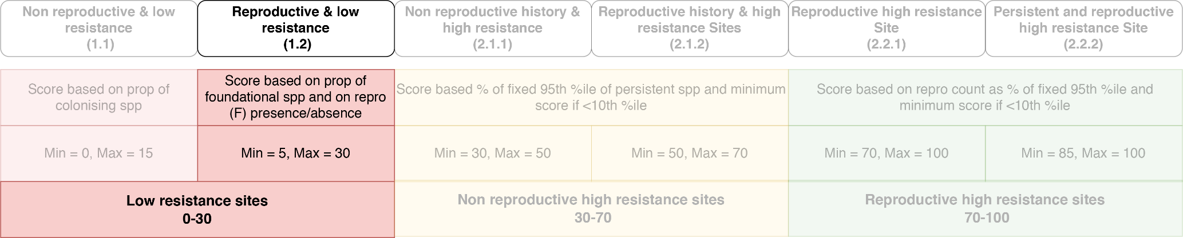
The sites falling into category 1.2 have low percent cover and/or a high proportion of colonising species, but they have some reproductive structures. The presence of reproductive structures is likely to increase their resilience compared to category 1.1 if we assume that seeds are produced. In this category we are still concerned about the proportion of colonising species, as it can range from 0 to 100%, which influences their level of resistance. But the level of flowering and reproduction is also relevant. For each site the maximum count of reproductive structures observed in that year (either in the late wet or late dry if both are sampled) is identified for all sites.
The score is calculated based on the proportion of foundational species and the presence/absence of reproductive structures in foundational species as:
$Score=\left[\frac{\left(\%Foundational-{Fs}_{min}\right) × {Sf}_{range}}{F_{s_range}}+ S_{\begin{aligned}min \\ \end{aligned}}\right]×\left[Repro_{PA_F}+1\right]$ Equation 3
Where:
Fs_Max = 100 (maximum of % foundational species)
Fs_Min = 0 (minimum of % foundational species)
Sf_Max = 15 (maximum of score for foundation species without reproductive multiplier)
Sf_Min = 5 (minimum of score for foundation species)
Fs_Range = (Fs_Max – Fs_Min)
Sf_Range = (Sf_Max – Sf_Min)
Repro_PA_F indicates the presence of reproductive structures from foundational species (=1), or absence of reproductive structures from foundational species (=0).
Therefore,
$Score=\left[\frac{\left(\%Foundational-0\right) × 10}{100}+ 5\right]×\left[Repro_{PA_F}+1\right]$ Equation 4
The first part of the equation is the same as category 1.1, albeit with different values. The second part of the equation (the reproduction component, which will vary between 1 and 2) will result in doubling the score if reproductive structures of foundational species are present. Reproductive structures of colonising species are accounted for in this category by being included in the count of structures used to determine whether the site is placed in category 1.1 or 1.2; however, the colonising species structures are not counted in the multiplication factor. The reason for this is that Halophila ovalis — the dominant colonising species at MMP sites — is expected to flower and produce seed at any time of year and often abundantly (Waycott et al. 2004), thus the presence of flowering structures is somewhat indicative of recovery potential but not especially informative. By contrast the opportunistic and persistent species have a more discreet (Waycott et al. 2004) and sensitive flowering season (Keddy 1987), although this can be complicated by genetics and a range of other factors (Jahnke et al. 2015). There were 41 sites/times when there were colonising species flowering in this category, over the 15-year dataset, so this decision is unlikely to be influential (Figure 12).
Figure 12: Sites in category 1.2 including (a) count of sites where reproductive structures are present or absent (Repro_PA_F) in years ranging from 2007 to 2019, and (b) the distribution of scores (5 – 30) over the same time period (black line = average).

Category 2. Sites with high resistance

Reproductive structures – the first split

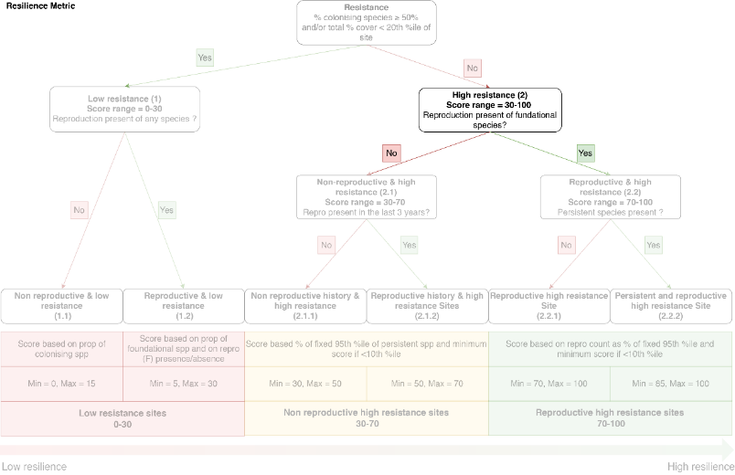
These sites are classified as ‘high resistance’ sites because they are dominated by opportunistic or persistent species. Within this category, the next important differentiation is whether there are reproductive structures (of foundational species) present. There is a tendency for a greater number of sites to have reproductive structures in years with minimal impact, or just following years with minimal impact (for example, 2006–2009), compared to years of extreme conditions, or just following those years when there are more sites without reproductive structures (for example, 2011–2014). The rise in sites in this category in the latter part of the dataset was also influenced by the addition of Cape York sites in 2012. In 2012, five Cape York sites (including four new sites) were in this category. But these alone don’t explain the large increase in sites in this category in 2014 when there was a Reef-wide increase in sites in that category.
Figure 13: Sites in category 2 including (a) count of sites with and without reproductive structures from the high resistance sites in either the late wet or late dry season (the highest season is chosen).

Calculating scores for category 2.1 - reproductive history

The range
Based on our analysis of the seed data (detailed in the following section), the category 2.1.2 is twice as likely to have a seed bank compared to 2.1.1. Therefore, 2.1 (score range 30–70) was split in two equal non-overlapping parts of 30–50 and 50–70 for 2.1.1 and 2.1.2, respectively.

The split - Reproductive history and seed bank longevity

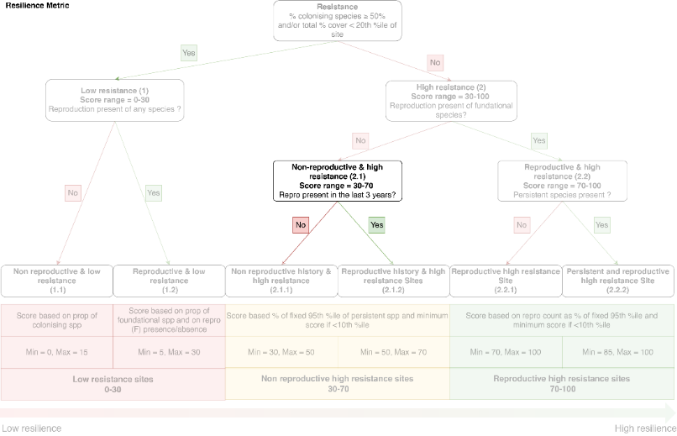
Seeds can stay dormant and viable for several years in the sediment constituting a seed bank (McMillan 1988; Inglis 2000; McMahon 2005; Waycott et al. 2005; Jarvis and Moore 2010). These can repopulate the meadow after disturbance (Jarvis and Moore 2010; Rasheed et al. 2014). Therefore, the absence of reproductive structures in any one year is an indication that seeds are not being generated in that year. However, if seeds were generated in previous years, these can enable recovery and confer resilience in the meadow, albeit with reduced longevity as they are already a year old. Seeds are primarily counted for the species Halodule uninervis (Hu) and Zostera muelleri (Zm). Seeds of Cymodocea serrulata and Cymodocea rotundata are also counted, but there are few cases represented in the data. Quantifying the seed bank of Halophila spp. is difficult and time consuming both in the field and in the laboratory and, as a result, are not included in the MMP seed dataset.
We identified five different time categories based on reproductive structures of Hu and Zm:
t0 = reproductive structures (Hu and/or Zm) present that year;
t1 = reproductive structures (Hu and/or Zm) present last year (but not this year);
t2 = reproductive structures present (Hu and/or Zm) 2 years ago and none observed since;
t3 = reproductive structures present (Hu and/or Zm) 3 years ago and none observed since;
t3+ = reproductive structures present (Hu and/or Zm) >3 years ago and none observed since.
Seed density of each category was then explored. For this we used seed monitoring data that is collected for each site at each monitoring event. The average seed density (seeds m⁻²) value for each site was calculated for t0. This was called Mean_Seed_Bank_m2.
Three separate models were fitted (Table 2). Seed model 3 was the best of these based on being the simplest model, and having a lower AIC (693.9) compared to seed model 2 (696). Seed model 3 is represented as:
Seed model 3 = Seed_Bank_m2_PA ~ repro_PA_time_3
Multiple comparisons (Tukey’s contrasts) were performed on seed model 3 to identify differences between the three categories.
Table 2: Models explored to investigate the effect of reproductive effort history and the seed bank
Model | R package | Response variable | Explanatory variable | Distribution
Seed model 1 | glmmTMB | Mean seed bank per m² | Reproduction history time category (5) | Zero inflated Gamma (inverse link)
Seed model 2 | glm | Probability of seed presence | Reproduction history time category (5) | Binomial (logit link)
Seed model 3 | glm | Probability of seed presence | Reproduction history time category (3) | Binomial (logit link)
Seed model 1 was a GLM model fitted to the seed count in each time category (Table 2). As 46% of the seed data records had a count of zero, a zero-inflated gamma data distribution was applied. Based on this, seed density was significantly higher in t0 compared to other years (t0-t1 p = 0.004, t0-t2=0.002, t0-t3=0.014, t0-t3+=<0.001, Table 6) but there was not much difference between the years t1, t2, t3 and t3+ (Figure 14b). The Mean_Seed_bank_m2 variable was also transformed into a presence/absence (1/0) variable called Seed_bank_PA and a binomial GLM was conducted for comparison (seed model 2). The model identified a significant (p <0.001 in all comparisons against t0, Table 7) difference between the probability of seeds being present in t0 compared to all other categories, but the category t3+ also appears to have a lower probability of seeds again. Therefore, the three category model was explored, and included t0, t1-3, and t3+ (Figure 14c).
The post-hoc analysis for seed model 3 identified that the probability of having a seed bank was the highest in the same year that reproductive structures were identified, and more than double if structures had been identified in the previous 1 to 3 years (t1 – t3) compared to more than 3 years (t3+) (0.47±0.04 vs 0.21±0.04) (Table 3, Figure 14d).
Table 3: Generalised linear model output for Seed model 3
Coefficients | Estimates | Std. Error | z value | P-value
Intercept (t0) | 0.9673 | 0.1457 | 6.638 | 3.18e-11
t1_3 | -0.9109 | 0.2223 | -4.097 | 4.18e-05
t3+ | -2.1529 | 0.2466 | -8.732 | < 2e-16
Tukey’s contrasts
Hypotheses | Estimate | Std. Error | z value | P-value
t1_3 - t0 == 0 | -0.9109 | 0.2223 | -4.097 | <0.001 ***
t3+ - t0 == 0 | -2.1529 | 0.2466 | -8.732 | <0.001 ***
t3+ - t1_3 == 0 | -1.2420 | 0.2603 | -4.771 | <0.001 ***
This analysis provides the basis for scoring categories within the no-reproductive-effort category (2.1). In summary, there is a higher probability of a seed bank forming if reproductive structures were found in the previous 3 years, so these sites are scored more highly (2.1.2, ranging 50–70), compared to the category with no reproductive history in the past 3 years (2.1.1, ranging from 30 to 50).
A previous analysis recommended that seed data should not be used in scoring at this stage, due to a lack of power in the data (Lawrence and Gladish 2018). However, ongoing monitoring of seed banks are still recommended, as the data are useful in some applications, as demonstrated here. The methods used to linearise the score within 2.1.1 and 2.1.2 are the same, but with these different scoring levels and based on the % composition of persistent species – see next section.

Figure 14: Seeds in relation to the reproductive history categories shown as (a) box plot of mean seed bank density for each of the five categories (t0, t1, t2, t3, t3+), (b) predicted mean and associated confidence interval from the zero-inflated GLM (model 1) of seed bank density for each of the five categories (t0, t1, t2, t3, t3+), (c) predicted mean probability of seed presence and associated confidence interval for each of the five categories (t0, t1, t2, t3, t3+) from the binomial GLM, and (d) predicted mean probability of seed presence and associated confidence interval for three categories (t0, t1-t3, and t3+) from the binomial GLM.

Linearisation of score for 2.1.1 and 2.1.2 based on persistent species
Persistent species are named as such because they are able to resist disturbances (Kilminster et al. 2015). The most common persistent species in the Reef is Thalassia hemprichii, which tends to occur at reef sites. From 26 to 42% of all the sites had some persistent species depending on the year (Figure 15). Within those sites that do have persistent species, most of them only have a very small proportion with the median ranging from 1.4 to 11%. There are only 3 sites (FR1, FR2 and GI2) that are consistently (more than 2 years) dominated (>50%) by persistent species. There is some variability in the number of sites with persistent species present, with a particularly large increase in 2012, when additional new sites were introduced in Cape York (Figure 15a). There is a slight rise in the median % composition that is from persistent species in disturbance years (2010–2011, 2017–2019), possibly because they have been able to resist disturbances and suffer declines less readily than other species (Figure 15b).
If persistent species resist disturbances, then we hypothesised that there would be lower variation in abundance in sites with persistent species.
To test this, we fitted the GLM, P_model 1 as:
P_model 1 = SE_cover ~ P_presence
Where SE_cover is the standard error of the average long-term percent cover for each MMP site, and P_presence is a binary variable categorising if the site ever had persistent species present or not. A gamma data distribution was used. There was a small, but significant (p<0.05, Table 4) decrease of the standard error when persistent species were present reducing it by about 37% on average (Figure 16).
Table 4: Results of the generalised linear model testing for the response of SE_cover to the presence of persistent species (P_presence)
 | Estimate | Std. Error | t value | P-value
(Intercept) | 0.9114 | 0.1221 | 7.463 | 1.14e-09 ***
P_presence - yes | -0.4586 | 0.2076 | -2.209 | 0.0318 *

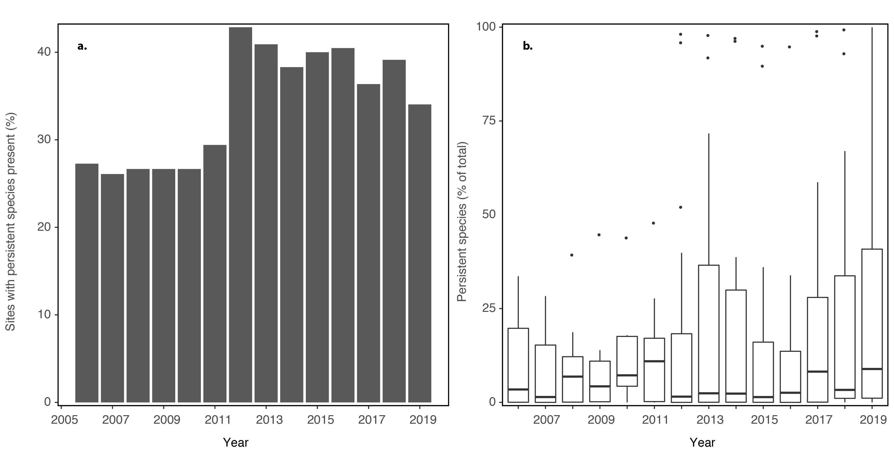
Figure 15: (a) Percentage of sites with persistent species from 2006 to 2019, and (b) the percentage of the species composition that was comprised of persistent species.
Therefore, the presence of persistent species appears to convey a level of resistance to disturbances, although we can only identify correlation in the data, not causality. Nevertheless, this finding (Figure 16) is consistent with our conceptual understanding of the level of resistance that persistent species provide (Kilminster et al. 2015; O'Brien et al. 2018b), and their apparent ‘stabilising’ effect (Collier et al. 2021). It is important to note that persistent species tend to occur predominantly at reef sites where the level of disturbances may also be lower. However, we do observe variability in total cover at some reef sites, and this level of variability is lower at sites with more persistent species present, for example in Piper Reef and Green Island, compared to those with fewer or no persistent species, such as in Magnetic Island (McKenzie et al. 2019).
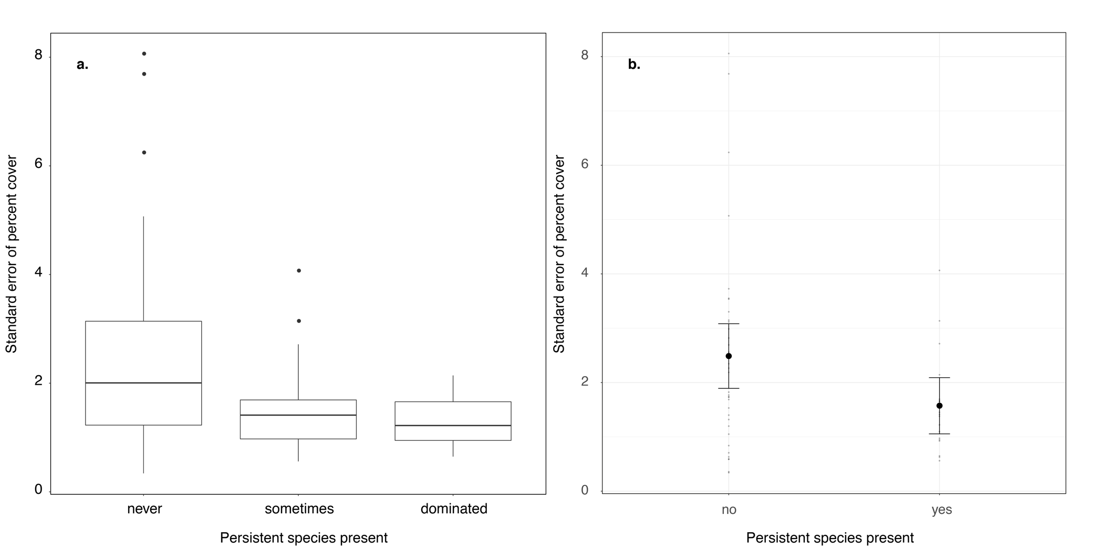
Figure 16: Standard error of percent cover as (a) three category box plot of raw data, and (b) predicted mean and confidence intervals from the GLM (model 4) based on absence (no), or presence (yes) of persistent species.

Score calculation for category 2.1.1 – absence of reproductive history
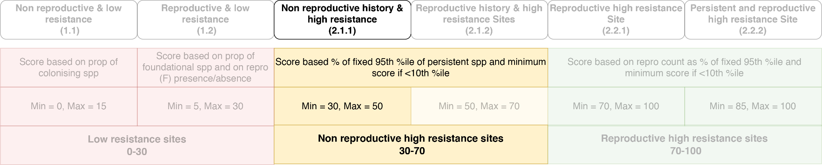
Category 2.1.1 (no reproductive structures) is scored over the range from 30 to 50 based on the proportion of persistent species (%P) present on the site. Sites that have never had persistent species in their monitoring history will score the minimum (30). For sites that have had persistent species present, the 10th and 95th percentile of persistent species was calculated.
To ensure a resulting variable with a 0–100 range any proportion of persistent species above the 95th percentile was given 100 and any below the 10th percentile was given 0.
Then the scores were calculated from the data on sites within this category as:
$Score=\frac{\left(PS_Max-Ps_Min\right) × {SC}_{range}}{{Ps}_{range}}+ {SC}_{\begin{aligned}min \\ \end{aligned}}$ Equation 5
Where,
Ps_Max = 100 (maximum of Perc_P_Comp)
Ps_Min = 0 (minimum of Perc_P_Comp)
SC_{max} = 50 (maximum of score category)
SC_{min} = 30 (minimum of score category)
Ps_{range} = (Ps_Max – Ps_Min)
SC_{range} = (SC_{max} – SC_{min}), and
Perc_P_Comp = (%P/95percentileP) *100
Therefore,
$Score=\frac{\left(Perc_P_Comp-0\right) × 20}{100}+ 30$ Equation 6
The grading within this category is biased towards a high number of sites with zero persistent species (Figure 17) as there are a lot of sites in this category scored as 30.
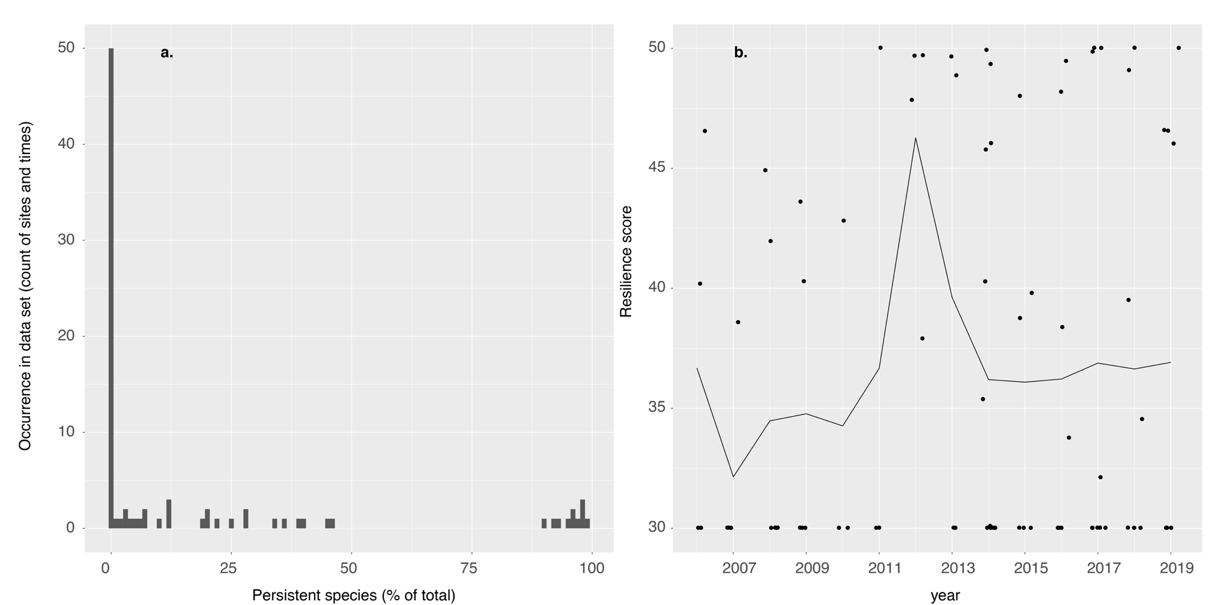
Figure 17: Persistent species at sites in non-reproductive sites category 2.1.1 as (a) count of sites/sampling times within each increment of persistent species, and (b) resulting scores based on the proportion of persistent species.

Score calculation for category 2.1.2 – presence of reproductive history
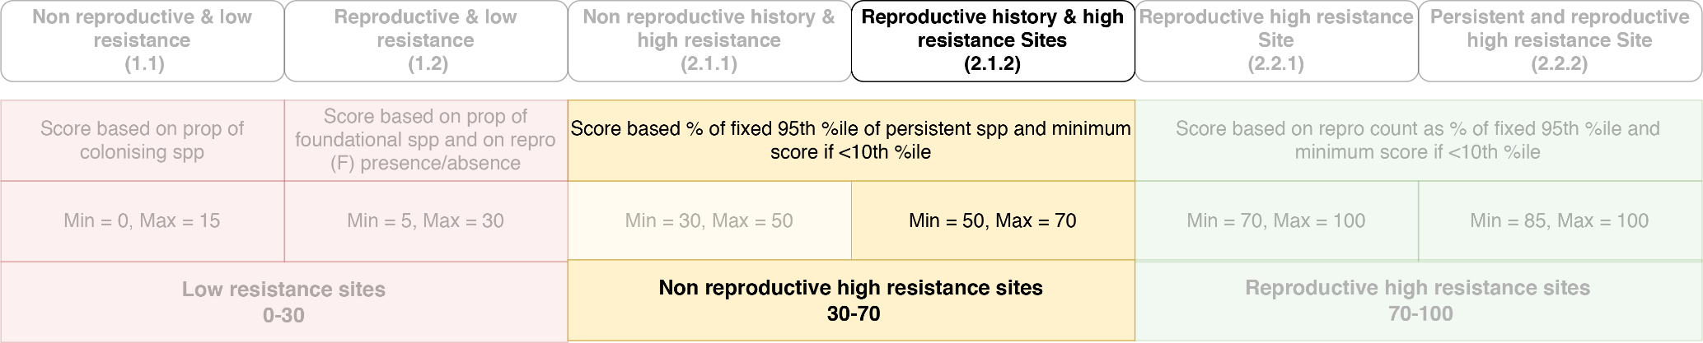
Category 2.1.2 is scored the same way as 2.1.1 except that the score category (SC) ranged from 50 to 70, instead of 30 to 50. This meant that if reproductive structures were present, but there were no persistent species, the site will score 50. There are not many sites with persistent species present so there is a greater number of scores that are 50.
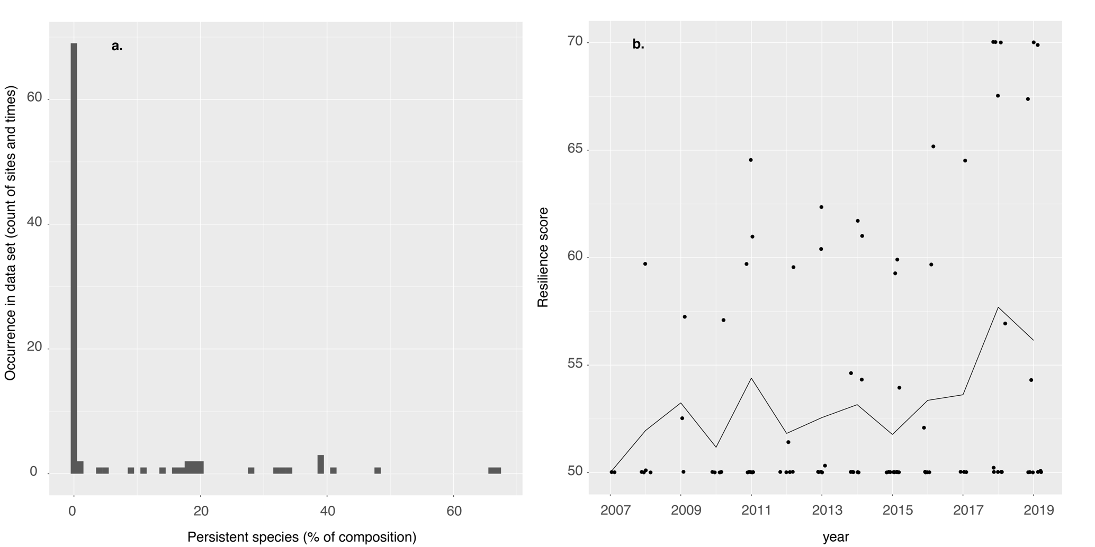
Figure 18: Count of non-reproductive sites (2.1.2) sites/sampling times with each category of persistent species (a), and resulting scores based on the proportion of persistent species (b).

Calculating scores for category 2.2 – the proportion of persistent species

The range
This category includes sites that have high total cover (>20percentile), low proportion of colonising species (<50%), and reproductive structures present in the current sampling year (as opposed to previous years). The overall range of category 2.2 is 70–100, which has been split into two sub-categories based on whether or not persistent species are absent (70–100) or present (85–100) for 2.2.1 and 2.2.2 respectively.

The split – persistent species presence
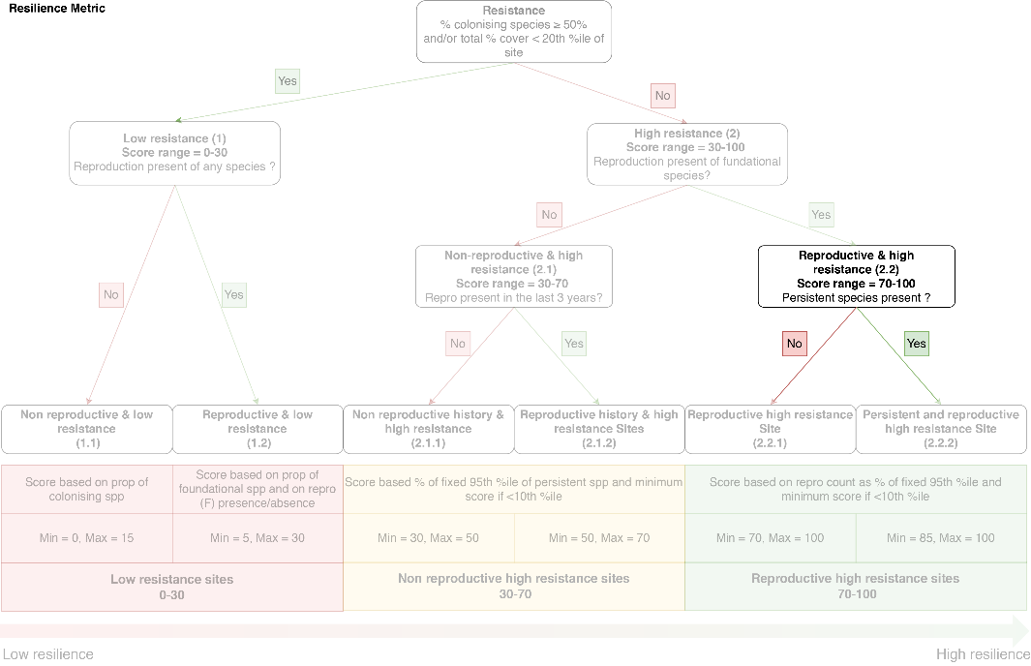
Based on the outcomes of equation 4, sites with persistent species are more likely to have a more stable percent coverage through time and higher resilience. Within this category, there are consistently less sites with persistent species present than sites with no persistent species (Figure 19) as we observed in the previous category 2.1 (Figure 17, Figure 18).
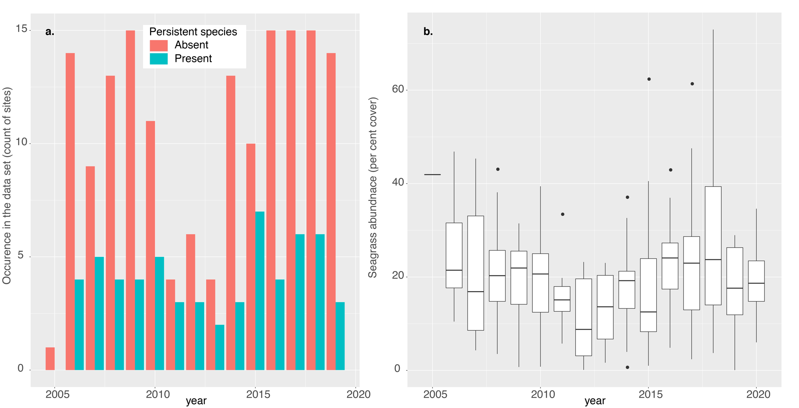
Figure 19: Sites with high resistance and high recovery potential in category 2.2 as (a) number of sites in each year with persistent species present and absent and (b) box plot showing seagrass abundance (per cent cover).

Score calculation for category 2.2.1 – count of reproductive structures at sites with no persistent species present

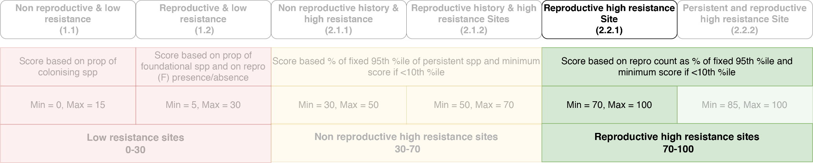
Category 2.2.1 sites are scored within the range 70–100 based on the number of reproductive structures of foundational species (F) at each site falling into category 2.2.1 (where there are no persistent species present).
The scores were calculated as:
$Score=\frac{\left(Perc_Repro_Count_F-RF_Min\right) × {S_RF}_{range}}{{RF}_{range}}+ {S_RF}_{\begin{aligned}min \\ \end{aligned}}$ Equation 7
Where at each site, the 10th and 95th percentile of the number of reproductive structures was calculated. To ensure a resulting variable with a 0–100 range any % Repro_Count_F above the 95th percentile was given 100 and any % Repro_Count_F below the 10th percentile was given 0. As such:
Perc_Repro_Count_F = (Repro_Count_F / 95th percentile Repro_Count_F) *100
RF_Max = 100 (maximum of % Perc_Repro_Count_F)
RF_Min = 0 (minimum of % Perc_Repro_Count_F)
S_RF_{max} = 100 (maximum of score)
S_RF_{min} = 70 (minimum of score)
RF_{range} = (RF_Max – RF_Min)
S_RF_{range} = (S_RF_{max} – S_RF_{min})
Therefore:
$Score=\frac{\left(Perc_Repro_Count_F-0\right) × 30}{100}+ 70$ Equation 8
There is a large number of sites/times that have low counts (<10th percentile) of reproductive structures (16% of sites), or have the maximum count of reproductive structures for that site (i.e. >95th percentile) (14% of sites) (Figure 20a). However, there is a predominance of sites (70% of sites) that fall between these levels, resulting in a reasonably even spread of scores within this category (Figure 20a). The score was reduced following years of disturbances (for example, 2012 and 2013) (Figure 20b).

Figure 20: High resistance, high recovery potential sites in category 2.2.1 showing (a) count of reproductive structures and (b) the scores over time.

Score calculation for category 2.2.2 – count of reproductive structures at persistent species sites

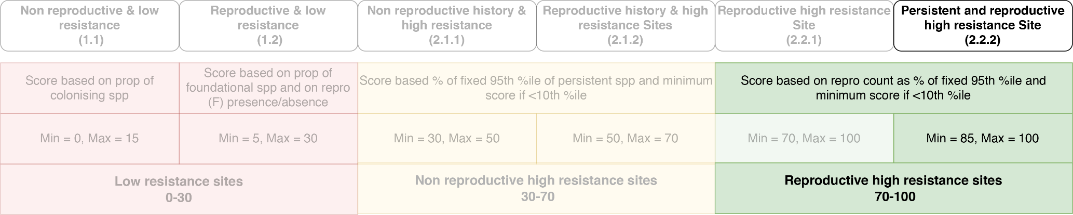
Category 2.2.2 is scored in a similar fashion to 2.2.1 and according to (Equation 8), however the S_RF_{min} was 85 and the S_RF_{max} was 100.
Therefore:
$Score=\frac{\left(Perc_Repro_Count_F-0\right) × 15}{100}+ 85$ Equation 9
As above, there are a number of sites/times when the count of reproductive structures is below the 10th percentile, or above the 95th percentile (Figure 21). There is more inter-annual variability in the score within this range, and this may relate to the more stochastic and unreliable reproduction strategies of persistent species. This is one of the reasons that the metric was shifted to a resilience metric rather than a reproductive effort metric. This variability in the score is constrained to the range 85 to 100, so will not have a very large effect on the overall rating.

Figure 21. High resistance, high recovery potential sites in category 2.2.2 showing (a) count of reproductive structures and (b) the scores over time.

Proposed resilience metric compared to the reproduction metric

Comparison for selected sites
When calculated across all MMP sites, the resilience metric spreads relatively well on a continuous scale between 0 and 100 (see appendix Figure 29 and Figure 30), does not disproportionally penalise specific species or habitats, and associates well with high and low disturbance (event) years (see appendix Figure 31 and Figure 32). As the resilience metric is proposed to replace the reproductive effort metric for inclusion the Reef health index, it is important to understand how it will affect scoring.
This is demonstrated by comparing historical data using the new and old metric for a selection of sites (Table 5). To report within the existing Report Card, the resilience score will be split into categories (very poor <20, poor 21–40, moderate 41–60, good 61–80, and very good 81–100), as per other metrics.
Table 5: Sites selected for demonstrating the changes in the score based on the resilience metric and the reproduction metric
Site code | Site name | Habitat | NRM Subregion | Disturbance level | Dominating Species type | Reproduction
DI3 | Dunk Island | Reef subtidal | Southern Wet Tropics | High | Foundational | Very rarely
FR1 | Farmer Is/  Piper Reef | Reef intertidal | Cape York | Limited | Persistent | None
GI2 | Green Island | Reef intertidal | Northern Wet Tropics | Limited | Persistent /  Foundational | Very rarely
GK1 | Great Keppel Island | Reef intertidal | Fitzroy | High | Colonising | Very rarely
SB1 | Shelley Beach | Coastal intertidal | Burdekin | High | Foundational | Often
UG2 | Urangan | Estuarine intertidal | Burnett Mary | High | Foundational / Colonising | Rarely

The first finding to highlight is that the resilience metric generally scores more highly than the reproduction metric (Figure 22), but there are exceptions. For example, the resilience metric scores lower when the count of reproductive structures is from colonising species (Figure 22, site GK1).
The reproductive effort metric changes in increments of 25, based on the categories of scoring (McKenzie et al. 2019). This led to a high degree of inter-annual variability at some sites (Figure 22, Figure 35, Figure 36, and Figure 37). There was some concern that not finding reproductive structures in any one year (which may be due to sampling time/effort) leads to a large change in the score and penalises a site too much. With the proposed resilience score, missing the peak of flowering, or missing it altogether will only penalise the resilience score within a given range depending on what category it is placed within according to resilience features. Furthermore, to determine if the site is placed in category 2.1, the resilience metric looks to whether reproductive structures were observed in previous years. The variability of the resilience metric among years also demonstrates that it is sensitive to inter-annual variability, but generally with smaller increments. The resilience metric tends to track with the abundance metric, but lagging behind in some cases, or responding sooner in most others (Figure 22, Figure 35, Figure 36, and Figure 37).

There are some important differences in the scoring that these example sites highlight (Figure 22):
- At site DI3, the reproduction metric dropped to 0 in 2016, while the resilience metric was at 70 in the same year. This is because, although reproductive structures were absent in that year, they occurred in the previous year and it was likely that a seed bank remained. In 2015, the high reproduction metric score was due to colonising species flowers, which are not scored in the resilience metric.
- At site FR1, the reproductive score has always been zero because no reproductive structures have been found. However, this site is usually dominated by persistent species, and as such the resilience score fluctuates within category 2.1.1.
- At site GI2, reproductive structures occur in some years but there are none in others. Furthermore, the species composition varies slightly, with a predominance of persistent species in some years, while the opportunistic species become more dominant in other years. Therefore, the resilience score fluctuates within the 2.1.1, 2.1.2, 2.2.1 and 2.2.2 categories.
- At site GK1, the reproductive effort score was very high in 2010 as a consequence of the high count of colonising species flowers (H. ovalis tends to flower prolifically). In the resilience metric, the predominance of colonising species places it in the low resistance categories in most years.
- At SB1, flowering structures are highly variable, and can reach very high levels, leading to high seed counts. As such the reproductive effort score is variable depending on whether the peak in flowering was observed in that year. With the resilience metric, the presence of reproductive structures in previous years can boost the scores, as it increases the likelihood of a seed bank being present for recovery. As such the resilience score is less variable than the reproductive effort score.
- At UG2, there is a wide range in the categories and scores achieved. The resilience score reaches zero (2.1.1) in 2006 when there is only colonising species present. As the composition recovers in 2007–2013, the score is increased by the presence of foundational species, and the presence of some reproductive structures. The count of structures was low for the site, so were scored zero in the reproductive metric but it was placed in category 2.2.1 simply by presence of some foundational species reproductive structures (i.e. >70) in the resilience metric. Furthermore, there were no reproductive structures in 2013, but as there had been some in previous years, the resilience score reaches category 2.1.1 (50 to 70) whereas the reproductive metric is zero. In 2014, the proportion of colonising species increased considerably and above the threshold for the first split in the tree (i.e. >50% Col.). There were some reproductive structures, but only of colonising species, so the site is scored low within category 1.2 (ranging from 5–30). As the meadow abundance and reproductive effort subsequently increases, so too does the resilience metric, and it remains buoyed in 2019 by reproductive structures in previous years, even though none were recorded in that year. This site is a good example of a site that retains a good resilience score while abundance is low, and recovery ensued.

Figure 22: The abundance metric, proposed resilience metric and the former reproduction metric at six example sites from 2006 to 2019, including Dunk Island subtidal (DI3), Piper Reef/Farmer Island intertidal (FR1), Green Island intertidal (GI2), Great Keppel Island intertidal (GK1), Shoalwater Bay intertidal (SB1), and Urangan intertidal (UG2).

New metric influence on Seagrass index and Reef-wide Scores
The Seagrass Index incorporates abundance, tissue nutrient (C:N), and the reproductive effort scores. Replacement of the reproductive effort score with the resilience score primarily influences the Seagrass Index by increasing it to a higher category at many sites and years (Figure 23). For example, in the Burnett–Mary, Fitzroy, and Cape York regions, there are no cases in which the Index reaches a very poor rating with the new resilience metric. Furthermore, the Reef-wide Seagrass Index does not reach very poor with the new resilience score, even in 2011–12, though it is very close (Figure 24). These higher scores are to be expected and the frequent low reproductive effort scoring was one for the reasons for exploring the resilience metric as an alternative because it does not fully reflect what is now understood about those habitats.
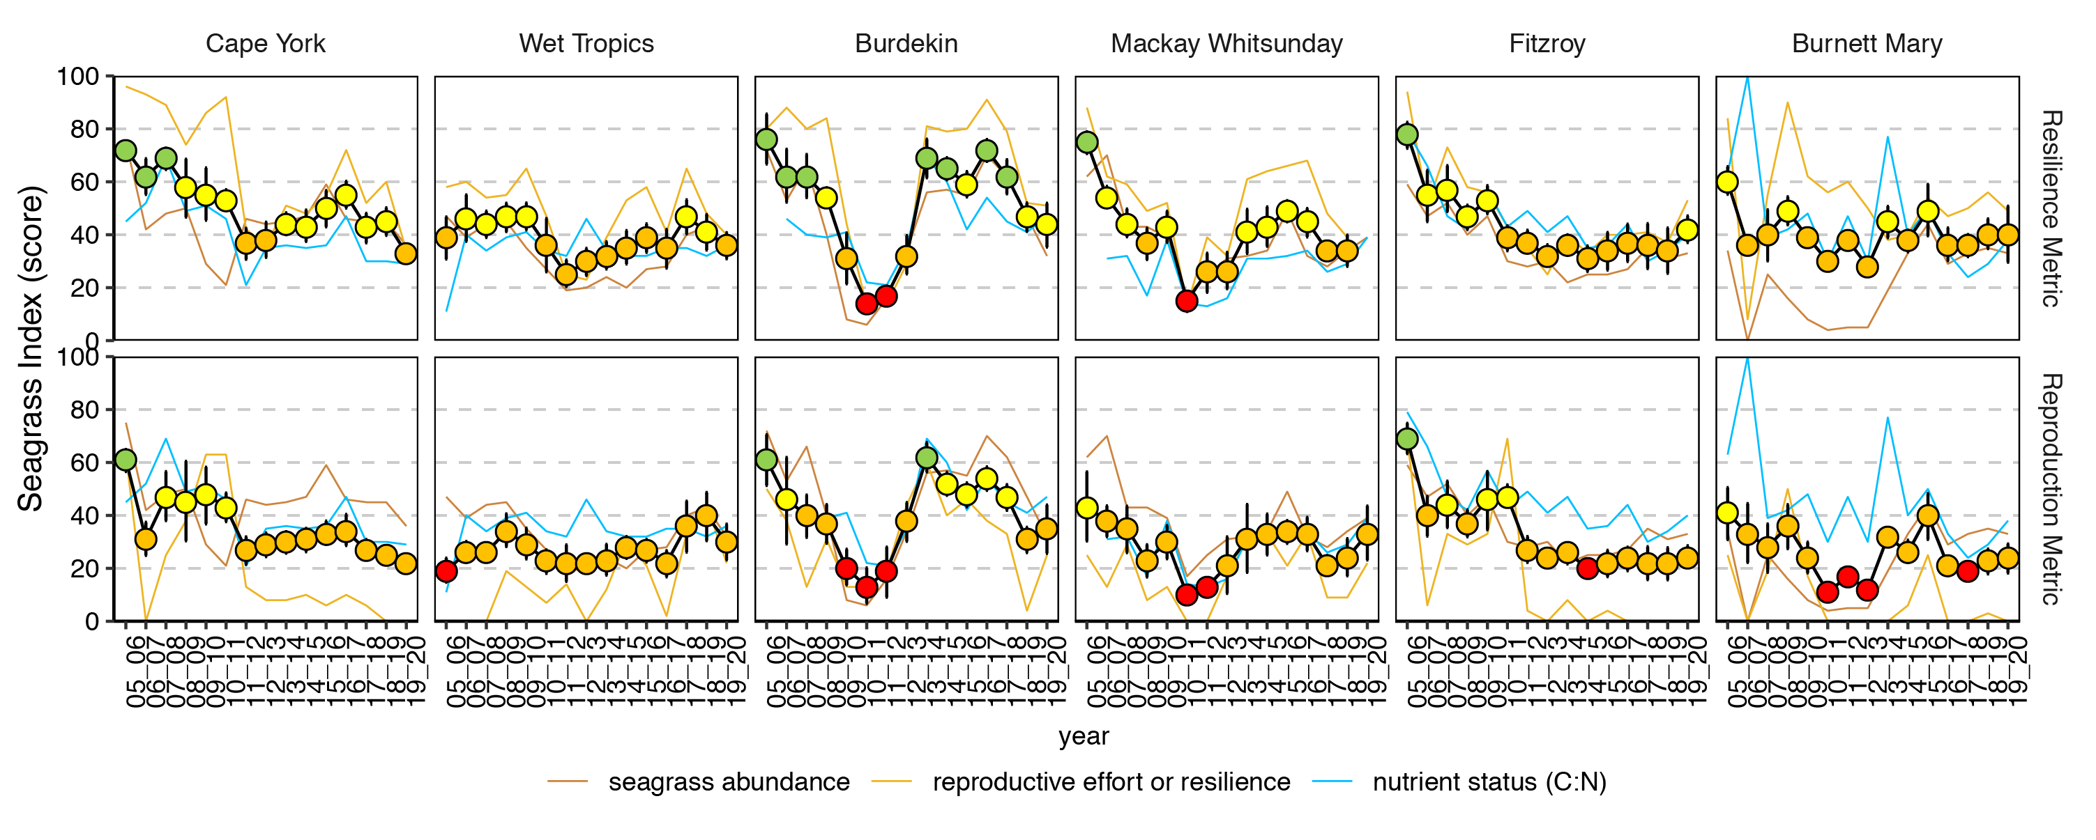
Figure 23: The seagrass index based on the new proposed resilience metric (top), and the reproductive effort metric (bottom), in each of the NRMs.
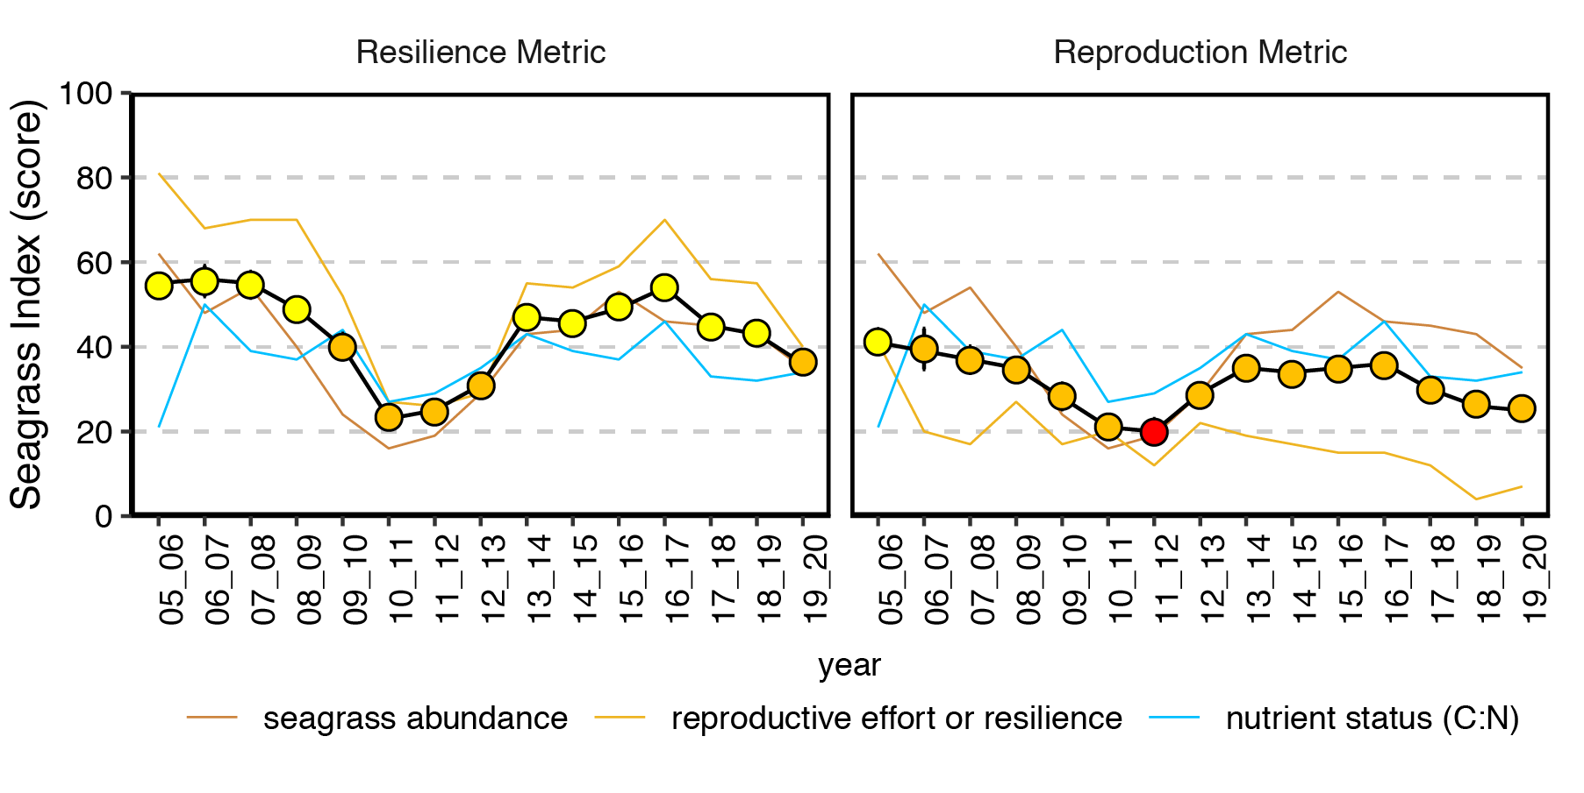
Figure 24: The seagrass index based on the new proposed resilience metric (left), and the reproductive effort metric (right) for the Reef as a whole.
The replacement of the reproductive metric with the resilience metric should be considered in conjunction with possible changes to the weighting of the nutrient status score, as discussed in McKenzie et al. (2020). Down-weighting or removing the nutrient status metric further increases the seagrass index in ‘good years’, but slightly reduces the index in the ‘bad years’ (Figure 38). The combined effects of updating the score based on the nutrient indicator and the resilience metric are discussed in a separate document.

Power of detecting reproductive structures
Due to the importance of the presence/absence of reproductive structures in the resilience scoring scheme, a power analysis (= 1 – probability of making a type II error) was conducted to investigate the power of detecting reproductive structures depending on the sampling size. Fifteen cores per sites are collected at present. For each complete sampling event (i.e. all 15 cores collected) with at least one core with reproduction structure present, the probability of presence of reproduction in a core was calculated (ranging from 0.0667 to 1) on our historical dataset (396 sampling events with a total of 5940 observations). Using these probabilities, 100 new simulated datasets were created based on a Bernoulli distribution with the probability calculated previously, and for 10 new different sampling sizes (ranging from 5 to 50). For each simulated dataset, if reproductive structures were present in at least one of the simulated cores then the simulated sampling was assigned 1, and if not then it was assigned 0. The average of the reproductive presence/absence variable for each new dataset gives us the power of the sampling design to detect a presence/absence effect. Traditionally the minimum power desired for a successful sampling design is 0.8. This analysis demonstrates that overall with our current sample size of 15 cores, the power is suitable with 0.9 and would only increase slightly with increased sample size (Figure 25). When looking at the habitat specific power it was still acceptable as the lowest power were for reef subtidal and intertidal habitats with 0.84 and 0.86, respectively (Figure 25).
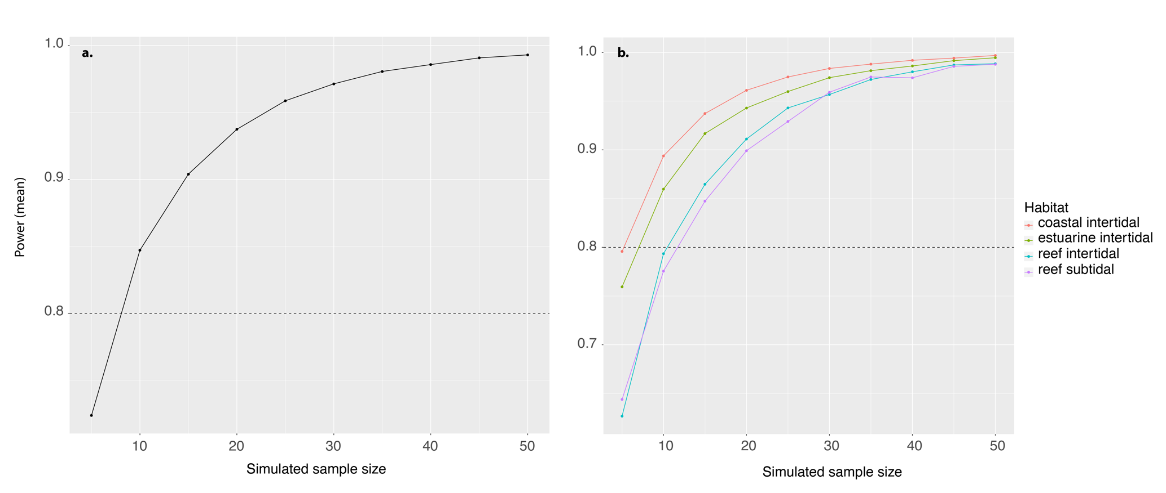
Figure 25: (a) Power analysis for different sample sizes (i.e. number of reproductive effort cores) for all sites, and (b) for sites in the four habitat types in which reproductive effort samples are collected.

Previous studies highlighted that the reproductive effort count data (in contrast to presence/absence) is of value in predicting seagrass cover but has low power due to the large number of zeroes and high standard error (Kuhnert et al. 2015; Lawrence and Gladish 2018). For this reason, the reliance on the count of reproductive structures has been kept to a minimum in this metric, affecting the scores within category 2.2 (ranging from 70 to 100). We were unable to examine the power in the reproductive count data at this stage, but it will have a very small effect on the resilience score given these restrictions. Further exploration into the power of reproductive counts is recommended, as is additional or supplemental resilience metrics as discussed below.

Discussion and conclusions
The objectives of this study were to develop a multivariate resilience metric based on an existing conceptual understanding of resilience in seagrasses, and on the patterns and trends observed in a long-term dataset from the inshore seagrass component of the MMP. We adopted a decision tree approach with analyses supporting each split in the tree and the categories, while sensitivity testing was also used to refine the score range within each split to optimise the distribution and sensitivity of the scores. This approach enabled us to overcome differences in the power in some datasets, in particular low power in the reproductive structures and seed data, which is caused by a high count of zeros in both. Following the recommendations of previous studies (Lawrence and Gladish 2018; Collier et al. 2019), we have:
- Down-weighted the reproduction metric and developed a multivariate (composite) metric that is scored based on community composition, abundance and reproductive structures, including historical (previous 3 years) reproductive effort.
- Focussed on presence/absence of reproductive structures (categories 1.1, 1.2, 2.1.1, 2.1.2) to overcome deficiencies in the power of the reproductive data, and only relied on the count of structures to quantify the highest levels of scoring (2.2).
- Accounted for differences in the dependency on resistance or recovery strategies amongst seagrass species, and the expected reproductive effort for the species including that sites with persistent species have less reliance on the presence of reproductive effort to obtain higher scores (2.1.2, 2.2.2).
- Developed a metric that uses existing long-term datasets, which provides a quantitative basis for the scoring, and will provide a long-term dataset to compare against future resilience scores.
The resilience metric proposed here is optimally suited to multi-species seagrass habitats, in particular those that tend to be dominated by opportunistic species, which rely on both resistance and recovery strategies for resilience.
Some insights that have emerged as a result of this analysis, include:
- A higher proportion of colonising species (above 43 or 47%) tends to be correlated to seagrass percent cover in the current and following year, respectively.
- If there is seagrass sexual reproduction in the current sampling year, then there is the greatest probability of seeds being present at the site. This probability declines if reproductive structures are not present in that year but have been observed at any time over the previous three years, and is the lowest if reproductive structures have not been observed for more than 3 years; however even then, there is some low probability that seeds will be observed.
- Persistent species appear to have a stabilising effect on seagrass meadows, in that the variation in seagrass cover tends to be lower at sites with persistent species present. However, this may also be affected by the occurrence of persistent species primarily at reef sites which are further away from riverine discharge and wet season influences.
The resilience metric does not vary as much on an inter-annual basis as the reproductive metric did, because it is not only influenced by multiple measures, but because the score is continuous, not categorical (Figure 22, Figure 35, Figure 36, and Figure 37). The resilience metric at a Reef-wide scale tends to follow periods of decline and recovery in association with the abundance metric. At an individual site level, there can be differences in the response of both indicators, with the new metric providing unique insight into seagrass health that abundance alone cannot provide.
It would be a valid decision to incorporate both the abundance and resilience metric into a single seagrass metric, given the influence of abundance on resilience (for example, Unsworth et al. 2015). They have been retained as separate metrics in this analysis for communication purposes; end users of the MMP program tend to require information on how much seagrass there is, and whether it is going up or down and therefore, having this scored separately is of benefit. For example, the 2035 objective of the Reef 2050 LTSP is “The Great Barrier Reef World Heritage Area retains its integrity and system function by maintaining and restoring the connectivity, resilience and condition of marine and coastal ecosystems”. However, the decision rule in the first split, that separates low resistance sites based on %Col. and the percent cover <20th percentile, does lead to a slightly elevated weighting of abundance (percent cover), in the combined Seagrass Index.
The proposed approach retains a separate assessment for resilience and condition, but is unable to address connectivity. We reiterate previous recommendations by Udy et al. (2018) for further research and exploration of connectivity including: (1) site level connectivity such as patchiness and fragmentation; (2) regional and Reef-wide level connectivity through regional seagrass mapping and connectivity analysis; (3) ecological connectivity as provision of ecosystem services; and (4) the role of these in seagrass resilience. Further process-based understanding of seagrass resilience is also required, including such characteristics as clonal diversity, recruitment and recovery strategies and feedback processes (Udy et al. 2018). It is possible to refine this resilience metric with some of these additional indicators if and when they are identified as suitable for routine measurement. For now, this resilience metric represents the most current understanding of seagrass resilience as measured by existing indicators of the inshore seagrass MMP.

References
Adams, M.P., Hovey, R.K., Hipsey, M.R., Bruce, L.C., Ghisalberti, M., Lowe, R.J., Gruber, R.K., Ruiz-Montoya, L., Maxwell, P.S., Callaghan, D.P., Kendrick, G.A., O'Brien, K.R. 2016, Feedback between sediment and light for seagrass: Where is it important? Limnology and Oceanography, 61: 1937-1955.
Angelini, C., Altieri, A.H., Silliman, B.R., Bertness, M.D. 2011, Interactions among foundation species and their consequences for community organization, biodiversity, and conservation. BioScience, 61: 782-789.
ANZECC and ARMCANZ. 2000, Australian guidelines for water quality monitoring and reporting: National Water Quality Management Strategy: no 7a.
Collier, C. and Waycott, M. 2009, Drivers of change to seagrass distributions and communities on the Great Barrier Reef: Literature review and gaps analysis. Report to the Marine and Tropical Sciences Research Facility. Reef and Rainforest Research Centre, ACirn, QLD, Australia.
Collier, C.J., Langlois, L.M., McMahon, K.M., Udy, J., Rasheed, M., Lawrence, E., Carter, A., Fraser, M.W., Mckenzie, L. 2021, What lies beneath: predicting seagrass below-ground biomass from above-ground biomass, environmental conditions and seagrass community composition. Ecological Indicators, 121: 107156.
Collier, C.J., Lavery, P.S., Masini, R.J., Ralph, P.J. 2009, Shade-induced response and recovery of the seagrass Posidonia sinuosa. Journal of Experimental Marine Biology and Ecology, 370: 89-103.
Collier, C.J., Lawrence, E., Waycott, M., Langlois, L.A., McKenzie, L.J. 2019, Case Study #2: Reproductive effort as a predictor of future seagrass cover: Model assessment and implications for report card metrics and the development of a seagrass resilience indicator. Annual report for the inshore seagrass monitoring 2017-2018. pp..140-147.
Connolly, R.M., Jackson, E.L., Macreadie, P.I., Maxwell, P.S., O’Brien, K.R. 2018, Seagrass dynamics and resilience. Chapter 7. In AWD Larkum, GA Kendrick & PJ Ralph (Eds.), Seagrasses of Australia.: Springer. pp. 197-212.
Ellison, A.M. 2019, Foundation species, non-trophic interactions, and the value of being common. iScience, 13: 254-268.
Hillebrand, H., Donohue, I., Harpole, W.S., Hodapp, D., Kucera, M., Lewandowska, A.M., Merder, J., Montoya, J.M., Freund, J.A. 2020, Thresholds for ecological responses to global change do not emerge from empirical data. Nature Ecology & Evolution, 4: 1502-1509.
Holling, C.S. 1973, Resilience and stability of ecological systems. Annual Review of Ecology and Systematics, 4: 1-23.
Inglis, G.J. 2000, Variation in the recruitment behaviour of seagrass seeds: implications for population dynamics and resource management. Pacific Conservation Biology, 5: 251-259.
Jahnke, M., Pagès, J.F., Alcoverro, T., Lavery, P.S., McMahon, K.M., Procaccini, G. 2015, Should we sync? Seascape-level genetic and ecological factors determine seagrass flowering patterns. Journal of Ecology, 103:1464-1474.
Jarvis, J. and Moore, K. 2010, The role of seedlings and seed bank viability in the recovery of Chesapeake Bay, USA, Zostera marina populations following a large-scale decline. Hydrobiologia, 649: 55-68.
Keddy, C.J. 1987, Reproduction of annual eelgrass: Variation among habitats and comparison with perennial eelgrass (Zostera marina L.). Aquatic Botany, 2: 243-256.
Kilminster, K., McMahon, K., Waycott, M., Kendrick, G.A., Scanes, P., McKenzie, L., O'Brien, K.R., Lyons, M., Ferguson, A., Maxwell, P., Glasby, T., Udy, J. 2015, Unravelling complexity in seagrass systems for management: Australia as a microcosm. Science of The Total Environment, 534: 97-109.
Kuhnert, P.M., Liu, Y., Henderson, B.L., Dambacher, J.M., Lawrence, E., Kroon, F.J. 2015, Review of the Marine Monitoring Program (MMP), Final Report for the Great Barrier Reef Marine Park Authority (GBRMPA.).
Langlois, L., Collier, C.J., Lewis, S., Tracey, D., Gruber, R., McKenzie, L.J. 2020, Case study: Leaf tissue nutrient C:N ratio in relation to water quality: Model assessment and implications for report card metrics. Annual report for inshore seagrass monitoring 2018-19.pp.142-169.
Lawrence, E. and Gladish, D. 2018, Analysis of seagrass and pressures data across the Great Barrier Reef. A report to the Great Barrier Reef Marine Park Authority.
Lindenmayer, D.B. and Likens, G.E. 2009, Adaptive monitoring: a new paradigm for long-term research and monitoring. Trends in Ecology & Evolution, 24: 482-486.
Maxwell, P.S., Eklöf, J.S., van Katwijk, M.M., O'Brien, K.R., de la Torre-Castro, M., Boström, C., Bouma, T.J., Krause-Jensen, D., Unsworth, R.K.F., van Tussenbroek, B.I., van der Heide, T. 2017, The fundamental role of ecological feedback mechanisms for the adaptive management of seagrass ecosystems – a review. Biological Reviews, 92: 1521-1538.
Maxwell, P.S., Pitt, K.A., Burfeind, D.D., Olds, A.D., Babcock, R.C., Connolly, R.M. 2014, Phenotypic plasticity promotes persistence following severe events: physiological and morphological responses of seagrass to flooding. Journal of Ecology, 102: 54-64.
McKenzie, L., Yoshida, R.L., Langlois, L., Rau, J., Weatherall, K., Bishop, F., Bain, D., Ferguson, S., Lindsay, M. 2017, Long‐term seagrass monitoring in Roebuck Bay, Broome: Report on the first 10 years. A report for the Broome Community Seagrass Monitoring Project, Environs Kimberley. TropWATER report 17/35.
McKenzie, L.J. 2009, Observing change in seagrass habitats of the GBR– Seagrass-Watch monitoring: Deriving seagrass abundance indicators for regional habitat guidelines,. In LJ McKenzie & M Waycott (Eds.), Marine and Tropical Sciences Research Facility Milestone and Progress Report #3, 2008-2009 (ARP 3) Project 1.1.3 Report 3, 11th June 2000. http://rrrc.org.au/wp-content/uploads/2014/06/113-QDPIF-McKenzie-L-2009-June-Milestone-Report.pdf accessed 23 February 2017. (pp. 7-1). Cairns: RRRC.
McKenzie, L.J., Collier, C.J., Langlois, L.A., Yoshida, R.L., Uusitalo, J., Smith, N., Waycott, M. 2019, Marine Monitoring Program: Annual Report for inshore seagrass monitoring 2017-2018. Report for the Great Barrier Reef Marine Park Authority, Great Barrier Reef Marine Park Authority.
McKenzie, L.J., Collier, C.J., Langlois, L.A., Yoshida, R.L., Uusitalo, J., Smith, N., Waycott, M. 2020, Marine Monitoring Program: Annual Report for inshore seagrass monitoring 2018-2019. Report for the Great Barrier Reef Marine Park Authority.
McKenzie, L.J., Collier, C.J., Langlois, L.A., Yoshida, R.L., Uusitalo, J., Waycott, M. 2021, Marine Monitoring Program: Annual Report for inshore seagrass monitoring 2019-2020. Report for the Great Barrier Reef Marine Park Authority.
McMahon, K.M. (2005). Recovery of subtropical seagrasses from natural disturbance. Doctor of Philosophy, The University of Queensland, Brisbane.
McMillan, C. 1988, The seed reserve of Halophila decipiens Ostenfeld (Hydrocharitaceae) in Panama. Aquatic Botany, 31: 177-182.
O'Brien, K.R., Adams, M.P., Ferguson, A.J.P., Villarreal-Samper, J., Maxwell, P.S., Baird, M.E., Collier, C.J. 2018a, Seagrass resistance to light deprivation: implications for resilience. In AWD Larkum, R P.J. & G Kendrick (Eds.), Seagrasses of Australia: Springer, Switzerland. pp. 287-311.
O'Brien, K.R., Waycott, M., Maxwell, P., Kendrick, G.A., Udy, J.W., Ferguson, A.J.P., Kilminster, K., Scanes, P., McKenzie, L.J., McMahon, K., Adams, M.P., Samper-Villarreal, J., Collier, C., Lyons, M., Mumby, P.J., Radke, L., Christianen, M.J.A., Dennison, W.C. (2018b). Seagrass ecosystem trajectory depends on the relative timescales of resistance, recovery and disturbance. Marine Pollution Bulletin, 134: 166-176.
Rasheed, M.A., McKenna, S.A., Carter, A.B., Coles, R.G. (2014). Contrasting recovery of shallow and deep water seagrass communities following climate associated losses in tropical north Queensland, Australia. Marine Pollution Bulletin, 83: 491-499.
Reynolds, L.K., DuBois, K., Abbott, J.M., Williams, S.L., Stachowicz, J.J. 2016, Response of a habitat-forming marine plant to a simulated warming event is delayed, genotype specific, and varies with phenology. PLoS ONE, 11: e0154532.
Reynolds, L.K., Waycott, M., McGlathery, K.J., Orth, R.J., Zieman, J.C. 2012, Eelgrass restoration by seed maintains genetic diversity: case study from a coastal bay system. Marine Ecology Progress Series, 448: 223-233.
Timpane-Padgham, B.L., Beechie, T., Klinger, T. 2017, A systematic review of ecological attributes that confer resilience to climate change in environmental restoration. PLoS ONE, 12: e0173812.
Udy, J., Waycott, M., Collier, C.J., Kilminster, K., McMahon, K., Rasheed, M., McKenzie, L., Carter, A.B., Lawrence, E., Maxwell, P., Dwane, G., Martin, K., Honchin, C. 2018, Monitoring seagrass within the Reef 2050 Integrated Monitoring and Reporting Program: Final report of the seagrass working group.
Unsworth, R.K.F., Collier, C.J., Waycott, M., McKenzie, L.J., Cullen-Unsworth, L.C. (2015). A framework for the resilience of seagrass ecosystems. Marine Pollution Bulletin, 100: 34-46.
Waycott, M., Longstaff, B.J., Mellors, J. (2005). Seagrass population dynamics and water quality in the Great Barrier Reef region: A review and future research directions. Marine Pollution Bulletin, 51: 343-350.
Waycott, M., McMahon, K., Mellors, J., Calladine, A., Kleine, D. 2004, A guide to tropical seagrasses of the Indo-West Pacific. Townsville: James Cook University.

Appendix

Additional information on the resilience metric tree

Percent colonising species and percent cover
The threshold for percent colonising species (%Col.) most highly correlated to seagrass abundance in the following year, was explored as a component of the first split in the tree.
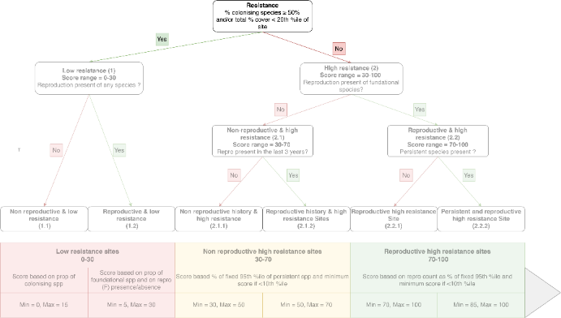

To find out the optimal %Col a GLM (model b) was run for %Col. as a binary value, either above or below a range of thresholds and percent cover. The thresholds for %Col ranged between 1 and 99 with 1% increments. The optimum threshold (47%) for predicting percent cover in the following year has the lowest Akaike Information Criterion (AIC) (Figure 26). This was used as additional supporting evidence in selecting a %Col. threshold of 50% to place sites in the low resistance sites category (page 14).

Figure 26: Akaike Information Criterion from the GLM model b with %Col. Threshold set between 10 and 90.

Table 6: Repartition of sites with the 47 per cent colonising species composition threshold throughout all and specific years
Years | Number of sites with % C < 47 | Number of sites with % C < 47
All | 456 (87%) | 71 (13%)
2008 | 28 (93%) | 2 (7%)
2011 | 25 (74%) | 9 (26%)
2015 | 39 (87%) | - (13%)

Additional information on the effect of the using the 20th percentile of per cent cover in the first split differentiating category 1
The abundance metric scores each site in each year based on abundance. By inclusion of the low resistance 20th percentile decision rule governing the first split in the tree, we are weighting abundance slightly more, which is consistent with previous recommendations (Lawrence and Gladish 2018; Collier et al. 2019). The influence of this decision is shown in this section.
There have been 66 sites/times placed into category 1 based on the 20th percentile rule in the entire set. The number of sites placed into category 1 on average in each year is 5 out of 49; however, it varies among years and more sites are influenced by this decision in impacted years (for example, 2011–2013), compared to relatively less impacted years (Figure 27). Therefore, the influence of this decision could be, and indeed was intended to be, important at those handful of sites where per cent cover has declined to very low levels for that site and is considered vulnerable.
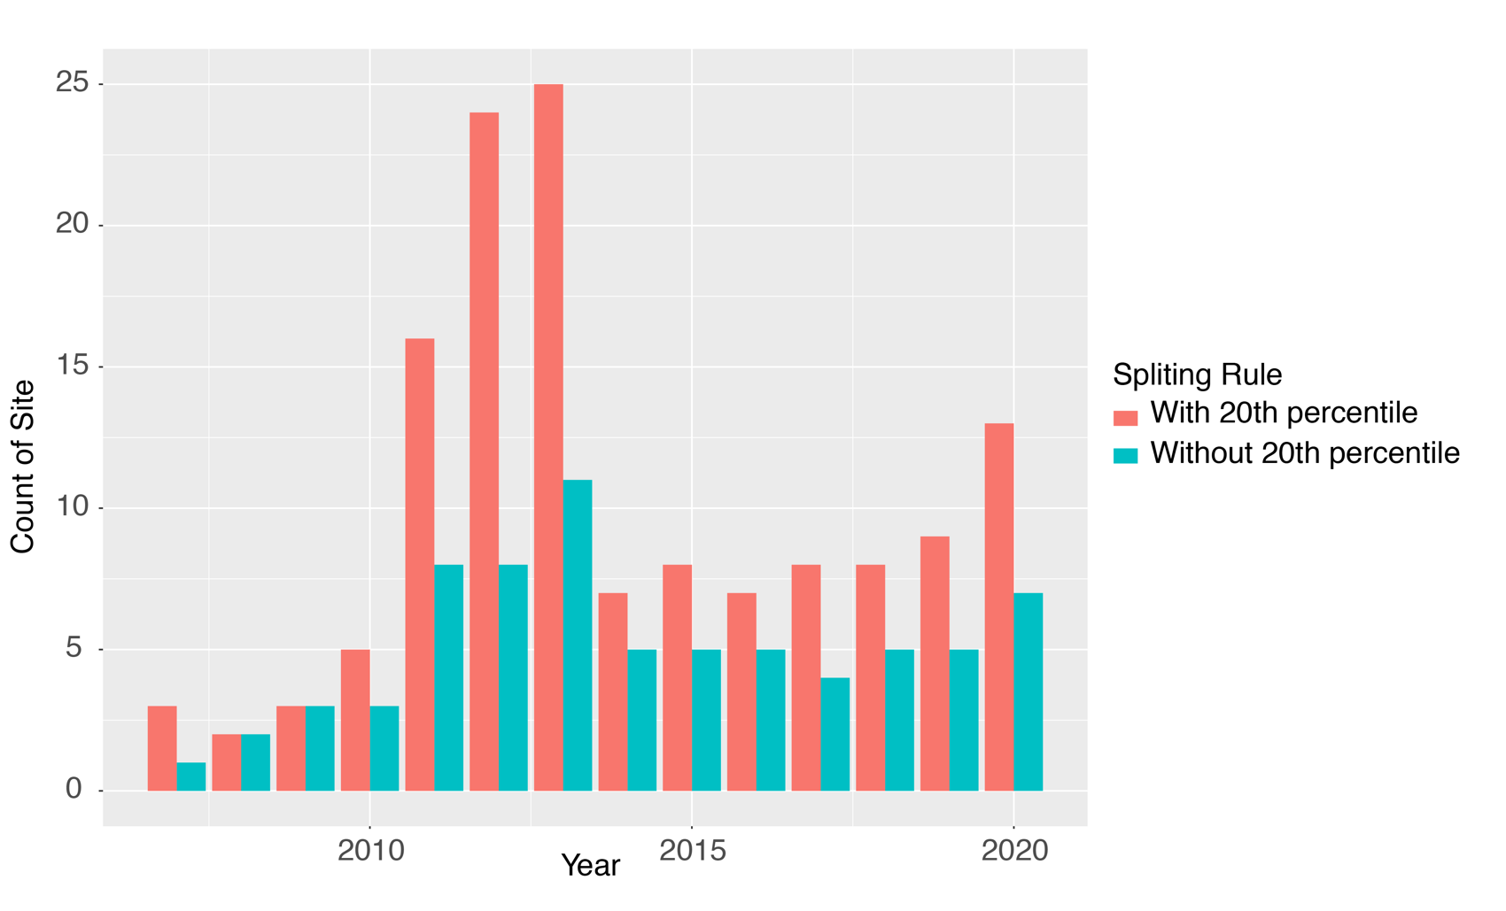
Figure 27: The number of sites placed into category 1 in each year with and without the 20th percentile decision in the first split.
The influence of this decision is shown for the example selection of sites (Figure 28). There is no, or no perceptible difference on the historical scores at four of these sites at DI3, GI2, or UG2. The sites where there is an effect at some time include:
- Piper Reef/Farmer Island (FR1), where there is a dip in the resilience metric in 2015 that mirrors the abundance metric with the 20th percentile rule included (Figure 22). This does not occur if the rule is not included, and instead the metric does not vary over inter-annual time-scales because it is a persistent species dominant site, that never has observed reproductive structures (Figure 28).
- Shelley Beach (SB1), where in 2011 and 2012, abundance was very low, and the resilience score dropped to 15 and 30 respectively with the rule included (Figure 22). Without this rule, the score remained at 50 or above in every year (Figure 28).
This rule has a greater influence when meadows are impacted. The overall effect on the score will be to reduce the score at a habitat or NRM level in impacted years.
Figure 28: The abundance metric, proposed resilience metric and the former reproduction metric at six example sites from 2006 to 2019, including Dunk Island subtidal (DI3), Piper Reef/Farmer Island intertidal (FR1), Green Island intertidal (GI2), Great Keppel Island intertidal (GK1), Shoalwater Bay intertidal (SB1), and Urangan intertidal (UG2). This figure shows the influence on the resilience score if the 20th percentile abundance rule is not used to influence the first split.
The spread of scores in the lower category is naturally affected by this decision, with fewer sites placed in 1.1 and 1.2 (Figure 29), compared to when this rule is not included (Figure 32). No sites reach the highest level in each category, because the highest score within these categories is achieved when the proportion of colonising species is at 0, which cannot be achieved with only the 50% colonising species rule included i.e. the 0% colonising species scores are from those sites put in the category because of the 20th percentile rule of per cent cover.
Figure 29: Count of sites in each category of the resilience score, without the 20th percentile decision included.
When the scores are rolled up to the regional or Reef-wide level, the influence of this decision on the overall Index becomes minor when comparing the Index with the 20th percentile rule (Figure 24) to that without this rule (Figure 30).
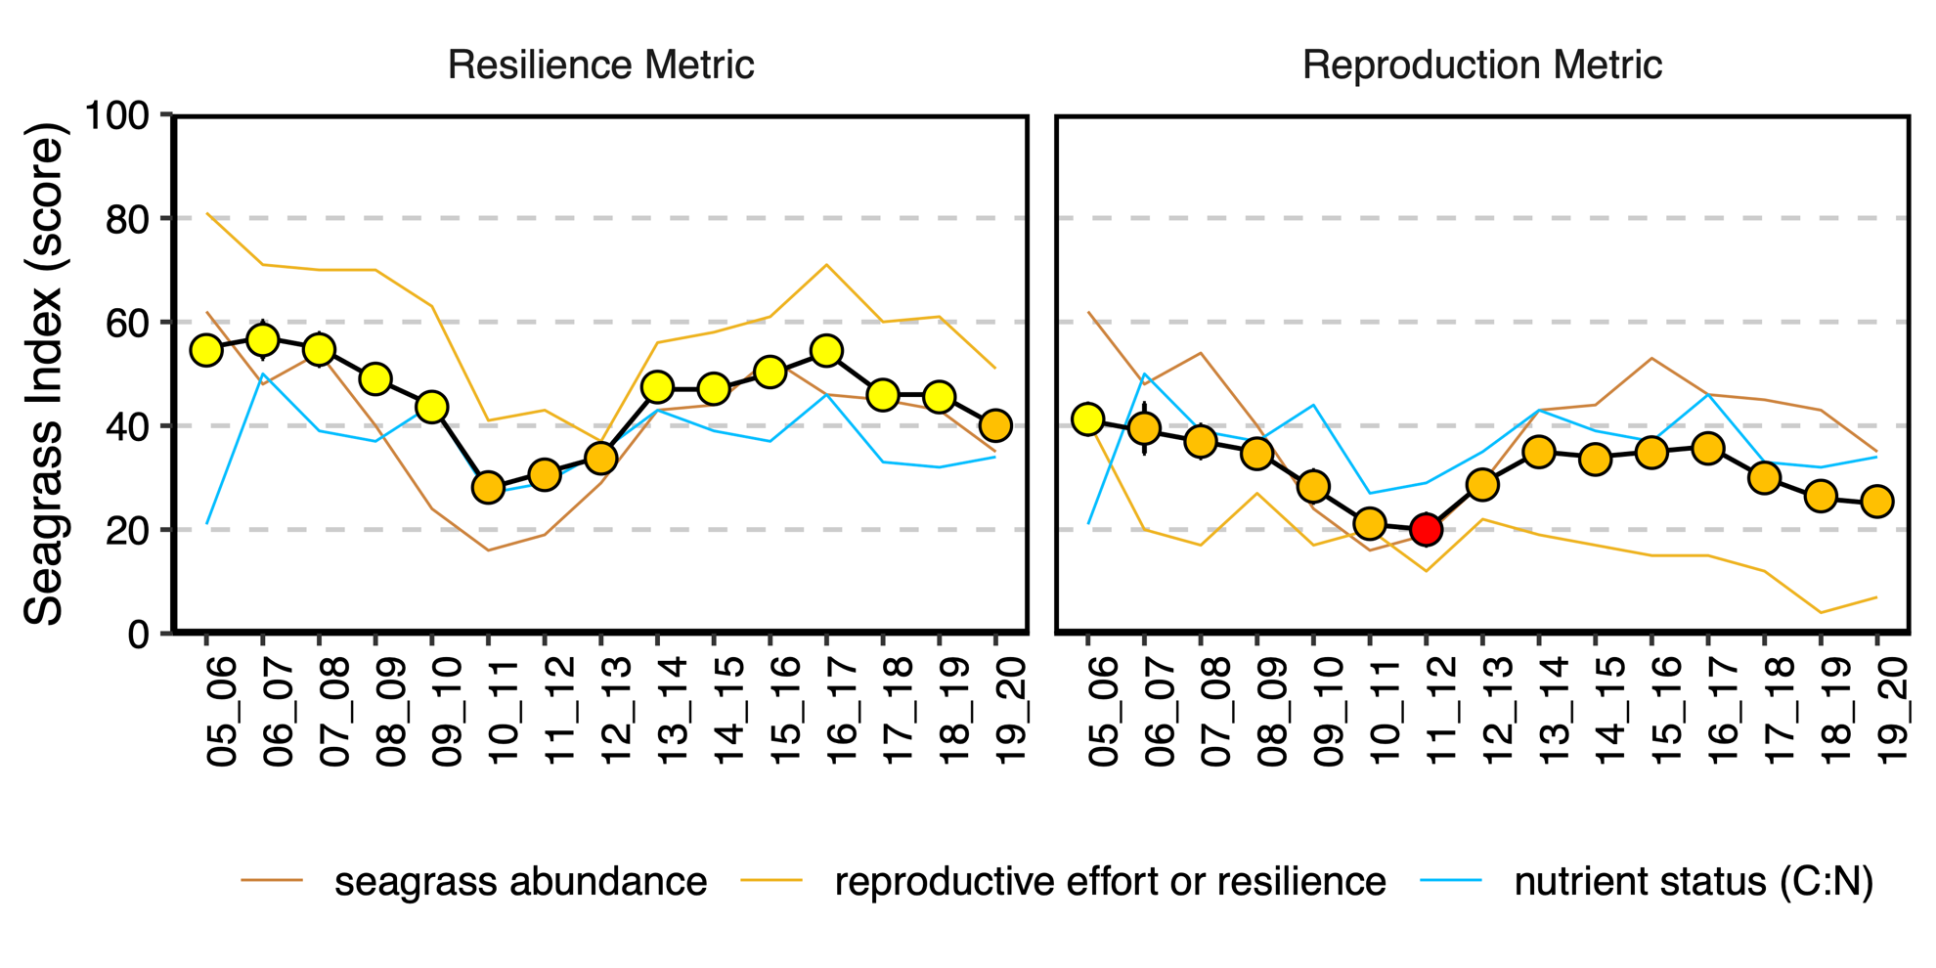
Figure 30: The seagrass index based on the new proposed resilience metric (left), and the reproductive effort metric (right) for the Reef as a whole.

Additional information for section 2.1

Seed model outputs
Three models testing for the influence of finding reproductive structures over the past 3+ years on the likelihood of finding a seed bank in the present year (Table 2). These were compared using the AIC, and on this basis, the third model was selected. Results of model 1 and 2 are presented here.
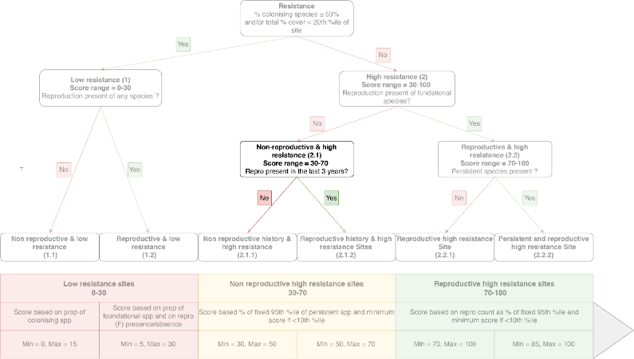

Seed Model 1
Table 7: Generalised linear model output for Seed model 1
Coefficients | Estimate | Std. Error | z-value | P-value
Intercept (t0) | -0.9673 | 0.1457 | -6.638 | 3.18e-11
t1 | 0.7850 | 0.2713 | 2.893 | 0.00381
t2 | 1.0674 | 0.3485 | 3.062 | 0.00220
t3 | 1.0473 | 0.4260 | 2.458 | 0.01396
t3+ | 2.1529 | 0.2466 | 8.732 | < 2e-16

Seed Model 2
Table 8: Generalised linear model output for Seed model 2
Coefficients | Estimates | Std. Error | z value | P-value
Intercept (t0) | 0.9673 | 0.1457 | 6.638 | 3.18e-11
t1 | -0.8421 | 0.2511 | -3.353 | 0.000798
t2 | -1.3102 | 0.3146 | -4.165 | 3.11e-05
t3 | -1.4781 | 0.3931 | -3.760 | 0.000170
t3+ | -2.3172 | 0.2850 | -8.132 | 4.23e-16

Additional information for scores distribution with new metric

Overall distribution of the scores
Looking at the overall distribution of the scores, there are spikes at 15, 30, 50, 70 and 85 and 100, which represent the boundaries for the categories. However, those only represented 30% of all scores calculated, so the new resilience metric spreads the sites pretty well on a continuous scale compared to the reproduction metric, which had values of 0, 25, 50, 75 and 100.
Figure 31: Distribution of the resilience scores
A Score at the boundaries for 15, 30, 50, 70 and 85, can come from the categories above or below that value. Therefore, Figure 32 shows the distribution based on the category. There is a fairly even distribution of sites placed into each category.
Figure 32: Distribution of the scores within each grouping
The distribution of the scores changes in each year, with higher scores more commom in low impact years (for example, 2008), more low scores in high impact years (for example, 2011), and an even spread in moderate years (for example, 2015) (Figure 33 and Figure 34).
Figure 33: Distribution of the scores in dry seasons of a low impact year (2007–08), high impact year (2010–11), and moderate year (2014–15)

Figure 34: Distribution of scores in each region and year dry seasons of a low impact year (2007–08), high impact year (2010–11), and moderate year (2014–15)

Additional information on the proposed resilience metric compared to the reproduction metric
The effect of applying the resilience score compared to the reproductive effort score was shown for a selection of sites in Figure 22. This section shows the effect at all sites, grouped by NRM region. As described above, in general the resilience metric scores more highly than the reproductive metric, though there are exceptions. For example at LI2, the reproductive metric reached high scores on three separate occasions. These were driven by a spike in the count of Halophila (colonising species) flowers, which are not scored in the resilience metric (Figure 35). The resilience metric also varies over a linear scale (as opposed to 25 point increments), and has less inter-annual variability.

Comparison for all sites per NRM regions
Figure 35: The scores for abundance, reproductive effort and resilience for sites in Cape York (top group) and the Northern Wet Tropics (bottom group)

Figure 36: The scores for abundance, reproductive effort and resilience for sites in the Southern Wet Tropics and Burdekin
Figure 37: The scores for abundance, reproductive effort and resilience for sites in the Mackay-Whitsunday, Fitzroy and Burnett-Mary.

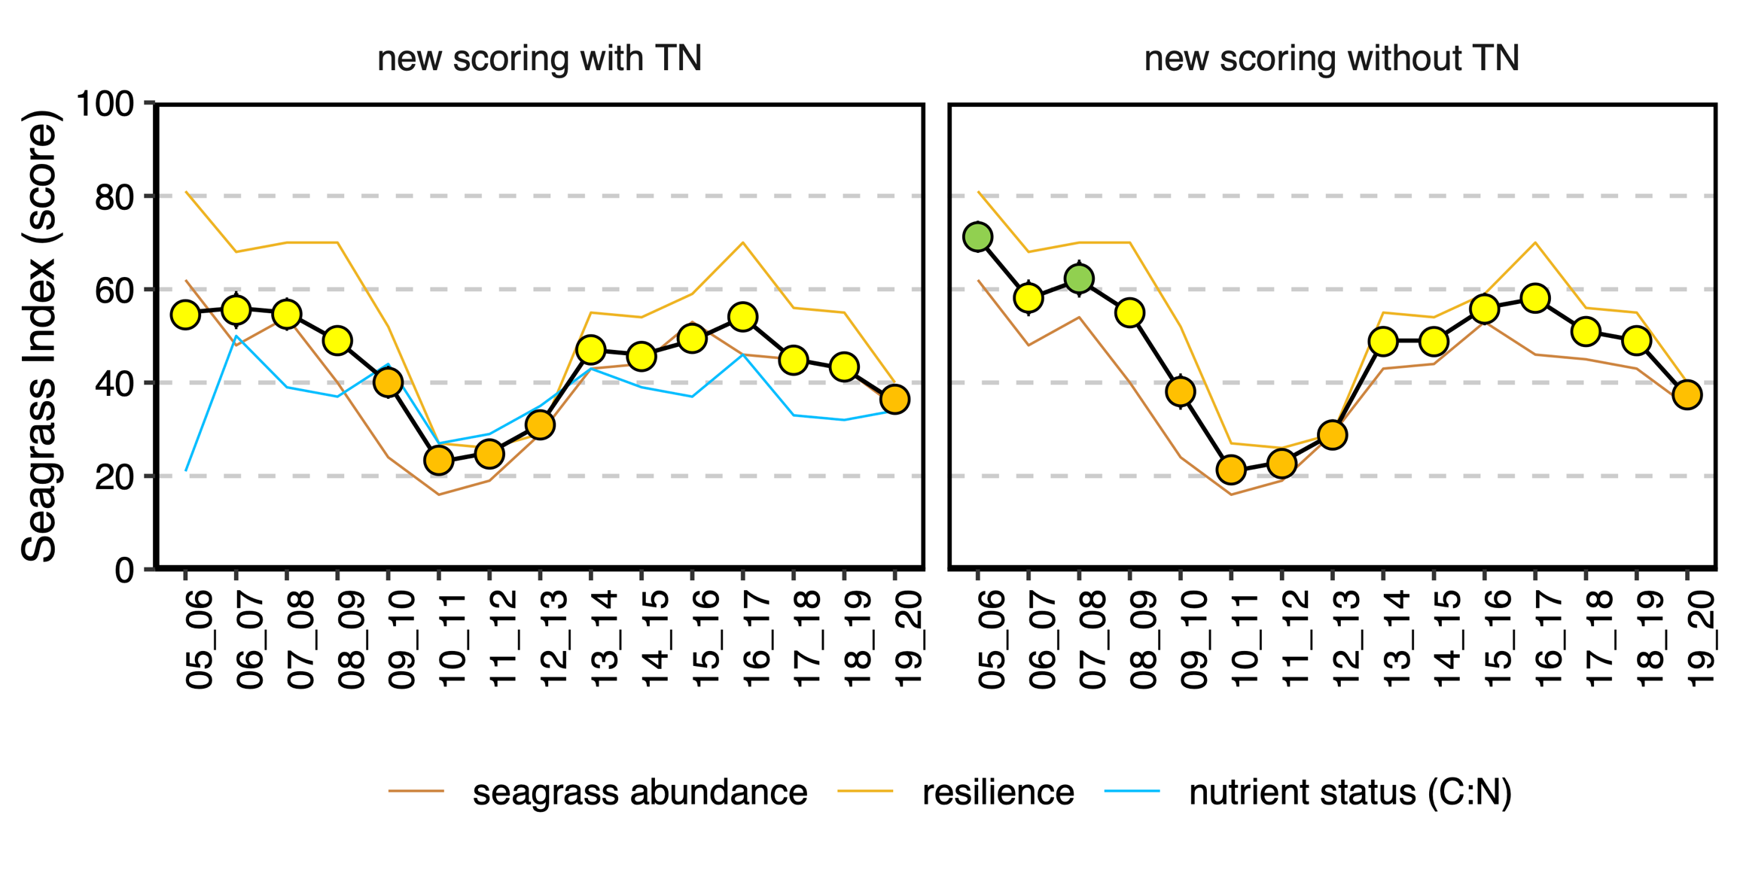

Figure 38: The seagrass index calculated using the proposed resilience metric as well as different weighting from the nutrient status index, as discussed in Langlois et al. 2020 (left) and the seagrass index calculated without the nutrient status included (right).

