AUSTRALIAN INSTITUTE OF MARINE SCIENCE

Monitoring the effects of rezoning on the Great Barrier Reef

Hugh Sweatman, Mike Emslie, Murray Logan

Report prepared for The Great Barrier Reef Marine Park Authority

Milestone Report November 2016

AIMS: Australia’s tropical marine research agency.

Australian Institute of Marine Science
PMB No 3  Townsville MC Qld 4810 | PO Box 41775  Casuarina NT 0811 | The UWA Oceans Institute (M096)  Crawley WA 6009

This report should be cited as:
Sweatman H, Emslie M, Logan M (2016) Monitoring the effects of rezoning on the Great Barrier Reef: Milestone Report November 2016. Report prepared for the Great Barrier Reef Marine Park Authority. Australian Institute of Marine Science, Location. (78 pp)

© Copyright: Australian Institute of Marine Science (AIMS) 2016
All rights are reserved and no part of this document may be reproduced, stored or copied in any form or by any means whatsoever except with the prior written permission of AIMS

DISCLAIMER
While reasonable efforts have been made to ensure that the contents of this document are factually correct, AIMS does not make any representation or give any warranty regarding the accuracy, completeness, currency or suitability for any particular purpose of the information or statements contained in this document. To the extent permitted by law AIMS shall not be liable for any loss, damage, cost or expense that may be occasioned directly or indirectly through the use of or reliance on the contents of this document.

Vendor shall ensure that documents have been fully checked and approved prior to submittal to client
Revision History: |  | Name | Date | Comments
1 | Prepared by: | Hugh Sweatman | 21 Nov 2016
1 | Approved by: | Britta Schaffelke | 21 Nov 2016
2 | Revised by: | Hugh Sweatman | 19 Dec 2016
2 | Approved by: | Britta Schaffelke | 19 Dec 2016

Cover photo: A diver counting fishes on a Long-term Monitoring transect encounters a school of Bumphead Parrotfishes Bolbometopon muricatum (in the “Excavators” guild of herbivorous fishes)

Contents
Acknowledgements 1
Executive Summary 2
Introduction 3
Study reefs 3
Survey methods 6
Analyses of survey data 7
Analysis of the effects of zoning on the frequency of outbreaks of Acanthaster planci 9
Results of surveys 2015-16: effects of zoning on reef communities 10
Overall summary of differences between populations and communities on no-take reefs and reefs that are open to fishing 10
1. Effects of zoning on coral trout 12
3 Effects of zoning on other target species 19
4 Effects of zoning on abundance of herbivorous fishes 26
5. Effects of zoning on other groups of fishes 37
6. Effects of zoning on overall species richness of reef fishes 46
7. Effects of zoning on broad groups of benthic organisms 49
8 The effects of zoning on the frequency of outbreaks of Acanthaster planci 56
Discussion 58
The effects of zoning on reef communities 58
The effects of zoning on the frequency of outbreaks of A. planci 59
References 59
Appendices 61
Notes on interpretation of the appendix tables. 61

Acknowledgements
We thank the crew of the RV Cape Ferguson for their help, and are grateful to all members of the Long-term Monitoring Team and all the volunteers who assisted with these surveys. Jenni Rasmussen helped greatly with the report. The first field trip, to Capricorn-Bunker reefs, was supported by the Tropical Water Quality Hub of the Australian Government’s National Environmental Science Program.

Executive Summary
Between October 2015 and May 2016, 56 reefs spread over five regions of the Great Barrier Reef Marine Park were surveyed using the established AIMS Long-term Monitoring methods. These surveys are designed to show the effects of closing reefs to fishing on reef biodiversity and also to provide situational awareness of reef condition across a large area.
Closing reefs to fishing allows the accumulation of biomass (and hence reproductive potential) of coral trout, which are the main target of the reef line fishery. After 12 years of protection, reefs that are closed to fishing generally have more than twice the biomass of coral trout than can be found on similar reefs nearby that are open to fishing, though this varies among regions.
Besides the direct effects that protection from fishing has on target species, there were few overall effects on other fishes or groups of benthic organisms, and these varied among the reefs in different regions. One guild of herbivorous fish, “Scrapers” – parrotfishes – were more abundant overall on reefs that were open to fishing, though this varied diametrically among regions. Herbivorous “detritivores,” planktivorous fishes and benthic foraging fishes were also positively affected overall by protection from fishing, though the effect was strongest on reefs in different regions for each group of fishes. Species richness (in terms of the families that are surveyed) was also 7% (equivalent to 2-3 species) higher overall on no-take reefs.
In terms of bottom-up effects on fish assemblages due to habitat differences, the cover of the broad benthic groups hard corals, soft corals and algae were not consistently different between no-take reefs and reefs that were open to fishing.
Secondly, under the zoning plan that was in place prior to 2004, a much smaller proportion of no-take reefs suffered outbreaks of crown-of-thorns starfish Acanthaster planci, than did reefs that were open to fishing. Since 2009 there have been large numbers of A. planci on reefs between Cape Melville and Innisfail, but the proportion of no-take reefs and reefs that are open to fishing that have suffered outbreaks has not been significantly different. .

Introduction
Following its declaration in 1975, the Great Barrier Reef Marine Park was zoned by stages up until 1989. Then, following a survey of the available data and expert opinion, the Marine Park was mapped into 70 bioregions and a zoning plan based on Comprehensiveness, Adequacy and Representativeness (C.A.R. principles) was drawn up. The plan was Comprehensive and Representative through being based on the bio-regionalisation, and adequacy was addressed by ensuring that 20% of the area of each bioregion was included in no-take zones (Fernandes et al. 2005). A very extensive public consultation process followed (Day 2002, Fernandes et al. 2005). The Amalgamated Zoning Plan (2003) came into effect on 1 July 2004. The Amalgamated Zoning Plan was politically risky because it greatly extended the area of the park that was closed to fishing from less than 5% to more than 30%, and it also established the largest network of marine protected areas in the world. Networks of marine protected areas are the preferred strategy for protecting biodiversity, so the GBRMP was a world-leading example of the approach. These two reasons made it important to monitor the effects of the Amalgamated Zoning Plan and the AIMS Long-term Monitoring Program was reconfigured so that the long-established program was interspersed in alternate years with surveys to track the consequences of zoning on fishes and benthic organisms. The first surveys were made during the summer of 2005-06.
A major paper on the findings from the first 10 years of surveys was published in 2015 (Emslie et al. 2015). This milestone report builds on those analyses incorporating data from surveys up until June 2016. Secondly, a publication based on the zoning plan that was in place before the implementation of the Amalgamated Zoning Plan found that outbreaks of the crown-of-thorns starfish, Acanthaster planci, were less frequent on no-take reefs (Sweatman 2008). The Amalgamated Zoning Plan includes a much greater proportion of reefs in no-take zones, and since 2011 the fourth recorded wave of starfish outbreaks has begun in the region north of Cooktown. This report applies the analysis of the frequency of outbreaks on no-take reefs and on reefs that are open to fishing with recent data from the fourth wave of outbreaks.

Study reefs
Following the implementation of the Amalgamated Zoning Plan, pairs of offshore reefs in 5 regions of the GBRMP were selected for survey. The reefs in each pair were relatively close to each other and were similar in size, in distance from shore and in underwater topography. Both reefs were open to fishing prior to the implementation of the Amalgamated Zoning Plan, but one was re-zoned to be no-take while the other reef in the pair remained open to fishing. The pairs of reefs were grouped in five regions; six pairs were located in each of the Cairns to Innisfail region, the Townsville region, near Mackay and in the Swain Reefs, while four pairs of reefs were selected in the Capricorn-Bunker group.
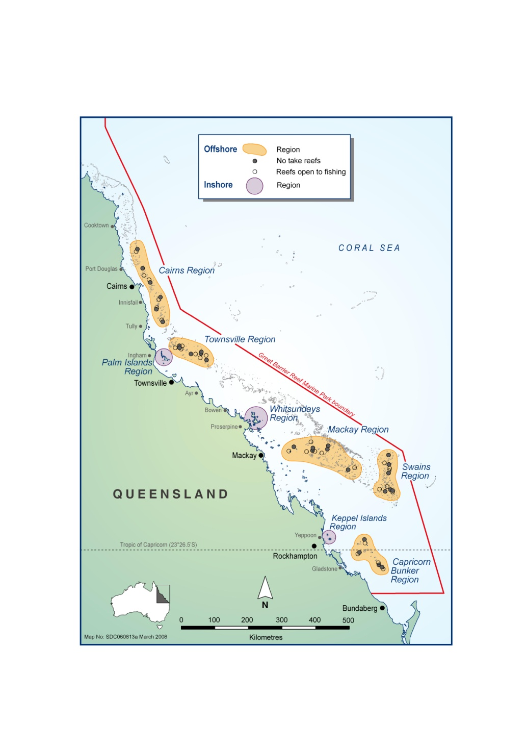
Figure 1: Map showing the location of the five regional clusters of offshore survey reefs (shaded orange).
Table 1. List of the survey reefs giving the pairing and zoning of each reef, as well as the date of survey. CA/IN = Cairns- Innisfail region, TO = Townsville, PO = Mackay - Pompeys, SW = Swains, CB = Capricorn-Bunker region
Region | Reef ID | Reef Name | Reef Pair | Zoning | Survey date
CA/IN | 15099C | Agincourt Reefs (No 1) | 1 | No take | 01-Dec-15
CA/IN | 16019S | St Crispin Reef | 1 | Open | 02-Dec-15
CA/IN | 16057S | Hastings Reef | 2 | No take | 04-Dec-15
CA/IN | 16064S | Arlington Reef | 2 | Open | 05-Dec-15
CA/IN | 16071S | Moore Reef | 3 | No take | 07-Dec-15
CA/IN | 16068S | Thetford Reef | 3 | Open | 06-Dec-15
CA/IN | 17014S | Hedley Reef | 4 | No take | 10-Dec-15
CA/IN | 17016S | McCulloch Reef | 4 | Open | 12-Dec-15
CA/IN | 17034S | Feather Reef | 5 | No take | 15-Dec-15
CA/IN | 17024S | Peart Reef | 5 | Open | 13-Dec-15
CA/IN | 17064S | Taylor Reef | 6 | No take | 17-Dec-15
CA/IN | 17063A | Farquharson Reef (No 1) | 6 | Open | 16-Dec-15
TO | 18030S | Kelso Reef | 7 | No take | 30-Apr-16
TO | 18042S | Roxburgh Reef | 7 | Open | 01-May-16
TO | 18076S | Helix Reef | 8 | No take | 04-May-16
TO | 18032S | Rib Reef | 8 | Open | 11-May-16
TO | 18031S | Little Kelso Reef | 9 | No take | 10-May-16
TO | 18043S | Fore And Aft Reef | 9 | Open | 02-May-16
TO | 18083S | Fork Reef | 10 | No take | 06-May-16
TO | 18077S | Grub Reef | 10 | Open | 07-May-16
TO | 18081S | Knife Reef | 11 | No take | 05-May-16
TO | 18086S | Chicken Reef | 11 | Open | 07-May-16
TO | 18091S | Lynchs Reef | 12 | No take | 14-May-16
TO | 18088S | Centipede Reef | 12 | Open | 17-May-16
PO | 20351A | Pompey Reef (No 1) | 13 | No take | 13-Mar-16
PO | 21060S | 21060s | 13 | Open | 16-Mar-16
PO | 20351B | Pompey Reef (No 2) | 14 | No take | 14-Mar-16
PO | 21591S | 21591s | 14 | Open | 17-Mar-16
PO | 20348S | 20348s | 15 | No take | 04-Mar-16
PO | 21062S | 21062s | 15 | Open | 06-Mar-16
PO | 20353S | 20353s | 16 | No take | 15-Mar-16
PO | 21064S | 21064s | 16 | Open | 07-Mar-16
PO | 21139S | 21139s | 17 | No take | 22-Jan-16
PO | 21187S | 21187s | 17 | Open | 09-Mar-16
PO | 20309S | Tern Reef | 18 | No take | 18-Mar-16
PO | 21025S | Penrith Reef | 18 | Open | 19-Mar-16
SW | 21278S | 21278s | 19 | No take | 06-Jan-16
SW | 21245S | 21245s | 19 | Open | 07-Jan-16
SW | 21584S | Jenkins Reef | 20 | No take | 18-Jan-16
SW | 21572S | Small Lagoon Reef | 20 | Open | 12-Jan-16
SW | 21588S | Wade Reef | 21 | No take | 19-Jan-16
SW | 22102S | Chinaman Reef | 21 | Open | 20-Jan-16
SW | 22084S | 22084s | 22 | No take | 17-Jan-16
SW | 21550S | 21550s | 22 | Open | 16-Jan-16
SW | 21558S | 21558s | 23 | No take | 11-Jan-16
SW | 21305S | East Cay Reef | 23 | Open | 10-Jan-16
SW | 21296S | 21296s | 24 | No take | 08-Jan-16
SW | 21302S | 21302s | 24 | Open | 09-Jan-16
CB | 23045A | North Reef (North) | 25 | No take | 06-Oct-15
CB | 23048S | Broomfield Reef | 25 | Open | 17-Oct-15
CB | 23080S | Hoskyn Islands Reef | 26 | No take | 14-Oct-15
CB | 23079S | Boult Reef | 26 | Open | 13-Oct-15
CB | 23081S | Fairfax Islands Reef | 27 | No take | 11-Oct-15
CB | 23082S | Lady Musgrave Reef | 27 | Open | 16-Oct-15
CB | 23068S | Erskine Reef | 28 | No take | 04-Oct-15
CB | 23069S | Mast Head Reef | 28 | Open | 02-Oct-15

Survey methods
Survey methods followed those used by the AIMS Long-term Monitoring Program. Three “Sites” were identified on the NE face of the study reefs. Within each site, five 50 m transects were marked with steel pickets. Sites were about 250 m apart. 130 mobile species of fishes were surveyed using underwater visual census (UVC) in 5 m x 50 m belt transects, while damselfishes (65 spp) were counted in 50 m x 1 m belt transects. The total lengths of all Serranids (groupers) and secondary fishery target species were also estimated underwater by trained divers. These lengths were then combined with published length-weight relationships (Kulbicki 2005, Froese & Pauly 2014) to estimate biomass in (kg).1000 m⁻² of coral trout and secondary targets.
Benthic organisms were sampled by taking photographs approximately every 1 m along the same marked 50m transects. Agents of coral mortality: crown-of-thorns starfish, Drupella spp, and coral colonies showing evidence of disease were also recorded along the transects, and juvenile coral colonies (<5 cm diameter) were counted in the first 5 m of each transect.
In order to give a reef-wide context to the data from the survey sites, weather permitting, the entire perimeter of each reef was surveyed by manta tow. The reef perimeter was surveyed in a series of 2 minute tows. Numbers of A. planci were recorded and coral cover was estimated using a 10-point scale.
Full details of survey methods can be found at the AIMS website:
Overview:
http://www.aims.gov.au/docs/research/monitoring/reef/sampling-methods.html
Standard Operating Procedures: http://www.aims.gov.au/docs/research/monitoring/reef/sops.html

Analyses of survey data
Benthic data (hard coral, soft coral and algae) were converted to per cent cover. All reef fish data were standardised by converting raw counts to densities 1000 m⁻². Within the GBRMP, commercial and recreational fishers using hook and line will primarily target and retain all species of Plectropomus and Variola (family Serranidae) that are above the minimum legal size (38cm T.L.), so abundance, size and biomass estimates for all these species were pooled and are hereafter referred to as “coral trout”. In addition, several species that are not the primary targets of fishers are retained if caught (hereafter “secondary targets”), and include species from the families Labridae (Choerodon spp., Cheilinus spp.), Lutjanidae (Lutjanus spp., Macolor spp.), Lethrinidae (Lethrinus spp., Monotaxis spp., Gymnocranius spp.) and Serranidae (Cephalopholis spp., Epinephelus spp.). As there are latitudinal and cross-shelf differences in reef fish assemblages with the replacement of some species by others (Williams 1982, Russ 1984, Emslie et al 2010, 2012, Cheal et al 2012), we grouped the remaining fish species into the following functional categories: benthic foragers (excluding obligate coral feeding butterflyfish), the herbivorous croppers, scrapers, excavators, detritivores and territorial farming damselfishes, obligate coral feeding butterflyfish, omnivorous damselfish and planktivorous damselfishes (Table 2).

Table 2. Reef fish trophic groups.
Benthic foragers
Aethaloperca rogaa, Chaetodon auriga, Chaetodon citrinellus, Chaetodon ephippium, Chaetodon flavirostris, Chaetodon kleinii, Chaetodon lineolatus, Chaetodon lunula, Chaetodon melannotus, Chaetodon mertensii, Chaetodon rafflessii, Chaetodon speculum, Chaetodon ulietensis, Chaetodon unimaculatus, Chaetodon vagabundus, Cheilinus undulatus, Chelmon rostratus, Coris gaimard, Epibulus insidiator, Forcipiger flavissimus, Gomphosus varius, Gymnocranius spp, Haliochoeres hortulanus, Hemigymnus fasciatus, Hemigymnus melapterus, Zanclus cornutus
Obligate corallivores
Chaetodon aureofasciatus, Chaetodon baronessa, Chaetodon bennetti, Chaetodon lunulatus, Chaetodon ornatissimus, Chaetodon plebeius, Chaetodon rainfordi, Chaetodon reticulatus, Chaetodon trifascialis
Omnivorous Damselfishes (Pomacentridae)
Acanthochromis polyacanthus, Amblyglyphidodon curacao, Amblyglyphidodon leucogaster, Amphiprion akindynos, Amphiprion clarkii, Amphiprion melanopus, Amphiprion percula, Amphiprion perideraion, Chrysiptera rex, Neoglyphidodon melas, Pomacentrus amboinensis, Pomacentrus australis, Pomacentrus brachialis, Pomacentrus moluccensis, Pomacentrus nagasakiensis, Premnas biaculeatus
Croppers
Acanthurus nigricans, Acanthurus nigrofuscus, Naso annularis, Naso lituratus, Naso tuberosus, Naso unicornis, Siganus argenteus, Siganus corallinus, Siganus doliatus, Siganus fuscescens, Siganus javus, Siganus lineatus, Zebrasoma scopas, Zebrasoma veliferum
Detritivores
Acanthurus blochii, Acanthurus dussumieri, Acanthurus grammoptilus, Acanthurus xanthopterus, Ctenochaetus binotatus, Ctenochaetus striatus
Excavators
Bolbometapon muricatum, Cetoscarus bicolor, Chlorurus bleekeri, Chlorurus japanensis, Chlorurus microrhinus, Chlorurus sordidus, Hipposcarus longiceps
Farmers
Acanthurus lineatus, Dischistodus melanotus, Dischistodus perspicillatus, Dischistodus prosopotaenia, Dischistodus pseudochrysopoecilus, Hemiglyphidodon plagiometapon, Neoglyphidodon nigroris, Plectroglyphidodon dickii, Plectroglyphidodon johnstonianus, Plectroglyphidodon lacrymatus, Pomacentrus adelus, Pomacentrus bankanensis, Pomacentrus chrysurus, Pomacentrus grammorhynchus, Pomacentrus vaiuli, Pomacentrus wardi, Stegastes apicalis, Stegastes fasciolatus, Stegastes gasgoynei, Stegastes nigricans
Scrapers
Calotomus carollinus, Scarus altipinnis, Scarus chameleon, Scarus dimidiatus, Scarus flavipinnis, Scarus forsteni, Scarus frenatus, Scarus ghobban, Scarus longipinnis, Scarus niger, Scarus oviceps, Scarus psittacus, Scarus rivulatus, Scarus rubroviolaceus, Scarus schlegeli, Scarus spinus
Planktivores
Acanthurus albipectoralis, Acanthurus mata, Amblyglyphidodon aureus, Chromis atripectoralis, Chromis amboinensis, Chromis chrysura, Chromis iomelas, Chromis lepidolepis, Chromis margaritifer, Chromis nitida, Chromis retrofasciatus, Chromis ternatensis, Chromis vanderbilti, Chromis weberi, Chromis xanthura, Chysiptera flavipinnis, Chrysiptera rollandi, Chrysiptera talboti, Dascyllus aruanus, Dascyllus reticulatus, Dascyllus trimaculatus, Pomacentrus coelestis, Pomacentrus lepidogenys, Pomacentrus philippinus
Secondary targets
Anyperodon leucogrammicus, Cephalopholis argus, Cephalopholis boenak, Cephalopholis cyanostigma, Cephalopholis miniatus, Cephalopholis microdon, Cephalopholis urodeta, Cheilinus fasciatus, Choerodon fasciatus, Cromileptes altivelis, Epinephelus coioides, Epinephelus coeruleopunctatus, Epinephelus corallicola, Epinephelus fasciatus, Epinephelus howlandi, Epinephelus malabaricus, Epinephelus merra, Epinephelus ongus, Epinephelus sexfasciatus, Epinephelus fuscoguttatus, Epinephelus lanceolatus, Epinephelus quoyanus, Lethrinus atkinsoni, Lethrinus harak, Lethrinus laticaudis, Lethrinus letjan, Lethrinus miniatus, Lethrinus nebulosus, Lethrinus obsoletus, Lethrinus ornatus, Lethrinus olivaceous, Lutjanus argentimaculatus, Lutjanus fulviflamma, Lutjanus fulvus, Lutjanus kasmira, Lutjanus lemniscatus, Lutjanus lutjanus, Lutjanus quinquelineatus, Lutjanus carponotatus, Lutjanus gibbus, Lutjanus monostigma, Lutjanus russellii, Lutjanus sebae, Lutjanus vitta, Monotaxis grandoculis
Coral Trout
Plectropomus laevis, Plectropomus leopardus, Plectropomus maculatus, Variola louti

The spatial and temporal variation in the effects of protection from fishing in no-take zones on the abundance and species richness of fish taxa and the percent cover of hard coral, soft coral and algae were estimated using Bayesian hierarchical linear mixed models (Gelman & Hill 2007) via the Integrated Nested Lapace Approximation (INLA) package (Rue, Martino & Chopin 2009) in R (R Core Development Team 2016). Each model included the fixed effects of Management Zoning (no-take or open to fishing), Region (offshore) and Survey Year, as well as their interactions. Models also included Reef Pair (since each region include four or six pairs of physically similar reefs – one zoned as no-take and one open to fishing), Reef, Site and Transect (all of the latter three nested within Management Zone, Region) as random effects. These random effects account for spatial variation and temporal auto-correlation arising from multiple and repeated observations of the same sampling units. Initial exploration indicated that the data were over dispersed and zero-inflated (e.g. 63% of all counts of transects recorded zero coral trout). Despite the high occurrence of zeroes, zero-inflated negative binomial models yielded essentially identical parameters to negative-binomial models. Thus the abundance, biomass and species richness of fishes and percent cover of benthic variables were modelled using the more parsimonious negative binomial distribution. Model convergence was assessed visually using trace plots (Brooks & Gelman 1998) for three simultaneously running Markov chains of 1,000,000 iterations, (including a discarded 50,000-iteration burn-in), and a thinning rate of 500. Thus posterior distributions derived from Markov chain each comprised 1900 samples.
Inferences about specific spatial and temporal differences between no-take reefs and those open to fishing were based on 95% Bayesian uncertainty intervals for modelled Higher Posterior Density (HPD) mean effects. Means were estimated from stable posterior distributions generated by Markov-chain Monte Carlo (MCMC) sampling from a model run for each parameter (e.g. fish abundance, fish biomass, fish species richness, hard coral cover, soft coral cover and cover of algae). Differences between no-take reefs and those open to fishing were then expressed as a percentage of the value on the fished reefs, such that a higher value on no-take reefs compared with fished reefs would yield a positive difference, while a lower value would give a negative difference. Where appropriate, we give Bayesian probabilities that the difference between no-take reefs and those open to fishing is greater than zero, based on the statistical model and the observed data. Thus a probability value close to 1.0 means that it is highly likely that the variable in question is greater in no-take reefs. Values close to zero indicate the reverse pattern. Relevant means, medians, Bayesian uncertainty limits and probabilities are given in the appendix. Differences between no-take and fished reefs were then tested using specific contrasts: (1) for overall difference across the GBR as a whole, and (2) whether the difference varied among years within each region.
Note that the analysis is fundamentally based on a paired design, comparing the effect of the different zoning using pairs of neighbouring similar reefs. This paired structure is not easily represented in the figures showing values through time, which present mean values for variables on reefs on each zone in each region, rather than the differences between the matched reef pairs.

Analysis of the effects of zoning on the frequency of outbreaks of Acanthaster planci
Analysis of the effects of zoning on the frequency of outbreaks of A. planci generally followed Sweatman’s (2008) analysis of patterns of outbreaks in the third recorded wave of outbreaks. The first records of outbreak densities of A. planci in the current (fourth recorded) wave of outbreaks were seen at Startle Reef (East) (Reef 15-028 S2, 15.2°S) in 2011, though sightings of A. planci had been increasing on reefs in the region 14.5 – 15.5°S since 2006. The analysis focussed on surveys from July 2010 to June 2016. It is assumed that most outbreaks are secondary outbreaks, that is, they are caused by the arrival at a reef of large numbers of recruits from outbreak populations on reefs upstream. Over the following two years and more, these recruits then grow and reproduce, spawning larvae that colonise other reefs further downstream so the wave of outbreaks progresses southward with the prevailing currents. This moving wave of outbreaks means that reefs in one band of latitude are likely to be at risk of colonisation by larvae at a particular time. Using this logic, it is reasonable to assume that the clouds of planktonic larvae from upstream reefs that led to outbreaks on some reefs also engulfed nearby reefs, while other reefs at greater distances were less likely to be affected. We considered reefs within an arbitrary radius of 25 km from reefs with outbreaks to be “at risk.” We then asked whether the zoning status of these “at risk” reefs has any effect on the probability that starfish larvae will survive to adulthood in outbreak densities. Since 2010, this fourth wave of outbreaks has affected reefs between Lizard Is and Innisfail. “At risk” reefs in this region were classified as No-take or Open to fishing. Reefs with split zoning were considered open to fishing if bottom fishing was allowed on any part of that reef. Outbreaks are also much less common on outer-shelf reefs than on midshelf reefs (James & Scandol 1992, Sweatman 2008), so outer shelf reefs were excluded, and separate analyses were made for midshelf reefs alone, and for inshore and mid-shelf reefs combined. The probability of detecting outbreaks also depends on the number of times a reef is surveyed in the study period; we excluded reefs that were surveyed less than twice in the six years (note that this differs from the preliminary analysis reported in June 2016). Evidence for an association between zoning and probability of outbreaks was tested using Fisher’s exact test.

Results of surveys 2015-16: effects of zoning on reef communities

Overall summary of differences between populations and communities on no-take reefs and reefs that are open to fishing
The average effect size due to differences between paired reefs due to zoning for 19 variables is shown in Figure 2. The symbol indicates the mean effect size and the error bars are 95% Bayesian uncertainty intervals. For interpretation, if the error bar intersects with the zero line, there is no evidence for a difference in values of the variable between no-take reefs and reefs that are closed to fishing. Displacement to the right of zero effect size indicates greater mean values were found on no-take reefs than reefs that were open to fishing. Displacement to the left of zero indicates the reverse
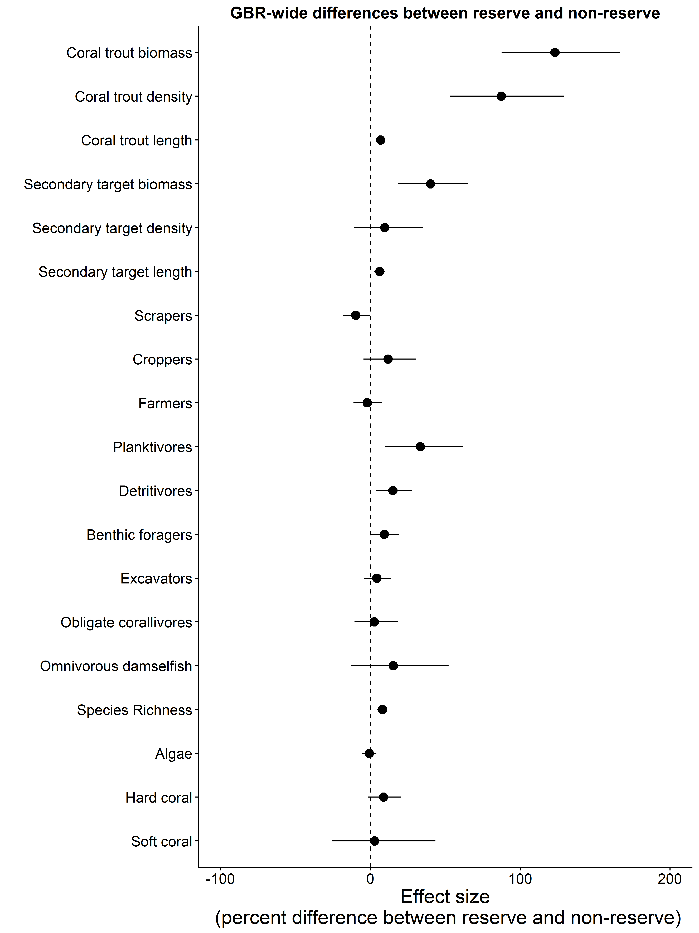
Figure 2. Plot of the modelled mean effect size for each variable based on all reefs in all regions and all years. If the mean effect size is positive (to the right of the reference line at zero) then values are greater on no-take reefs. Error bars are 95% Bayesian uncertainty intervals, if the error bar intersects with the zero line, there is no evidence for a difference in values of the variable between no-take reefs and reefs that are closed to fishing.

1. Effects of zoning on coral trout

Findings
Averaging for all the survey regions over the 12 years since the implementation of the Amalgamated Zoning Plan, abundance of coral trout on no-take reefs has been 88% greater than on reefs that were open to fishing (Figure 2). While this is the average result, there are substantial and consistent differences among the regions in the numbers of coral trout that were recorded, with the abundances being higher, and the proportional differences in abundance between no-take reefs and reefs that are open to fishing being greater in southern regions, particularly the Mackay Pompey region (Figures 3 and 4). There has not been a monotonic divergence in numbers of coral or biomass of coral trout with time (Figure 3, Figure 7), indicating that other ecological disturbances have disrupted any long-term cumulative effect of protection from fishing.
In general, coral trout were larger on no take reefs than on reefs that were open to fishing in all the survey regions of the GBR by an average of 7% (Figures 2 and 5), which presumably reflects greater survival in the absence of fishing. Regional effect sizes are shown in Figure 6. In combination, the greater numbers of larger individuals found on no-take reefs mean that, when averaged for all the survey regions over the 12 years since the implementation of the Amalgamated Zoning Plan, biomass of coral trout on no-take reefs has been more than double that on reefs that were open to fishing (mean increase = 124%, Figures 2 and 5, Bayesian probability = 1.0, Appendix Table A). While biomass was greater on no-take reefs in all regions (Appendix Table A), there are substantial and consistent differences among the regions in the numbers of coral trout that were recorded, with the densities being higher and the proportional differences in abundance between no-take reefs and reefs that are open to fishing being greater in southern regions, particularly the Pompeys (Mackay) region (Figure 5 and 6, Appendix Table A).
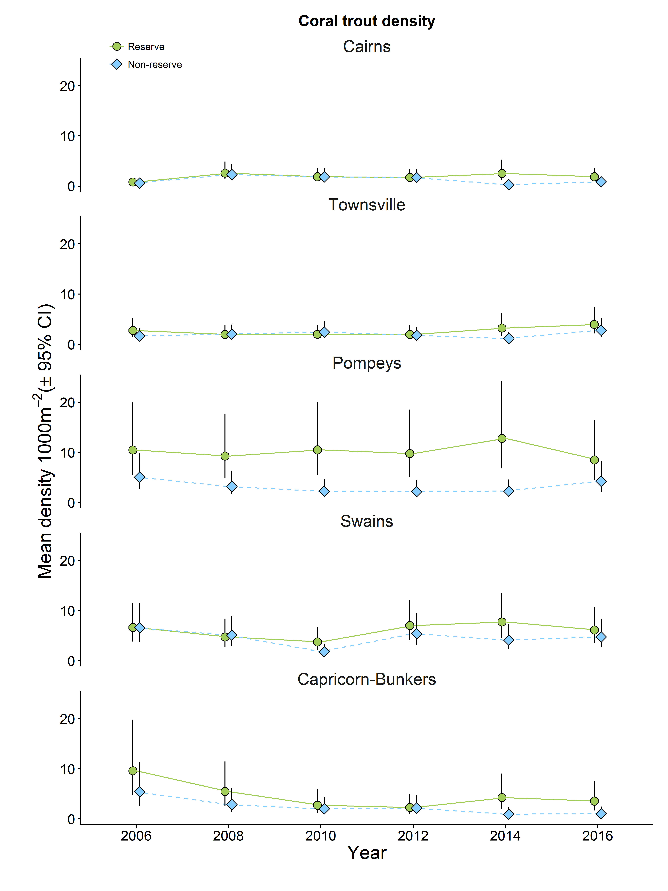
Figure 3. Modelled average number of coral trout per 1000m², 2006-2016, in sites in a standard habitat (NE face) of mid-shelf reefs in five regions of the GBR. Green circles show modelled means for no-take reefs; blue diamonds indicate modelled means for reefs that were open to fishing. Error bars are 95% Bayesian uncertainty intervals.
Figure 4 Effect size due to differences in zoning on abundance of coral trout spp. for each region in each survey year. A positive difference indicates that values are higher on no-take reefs. Note the varying scales on the Y-axes.
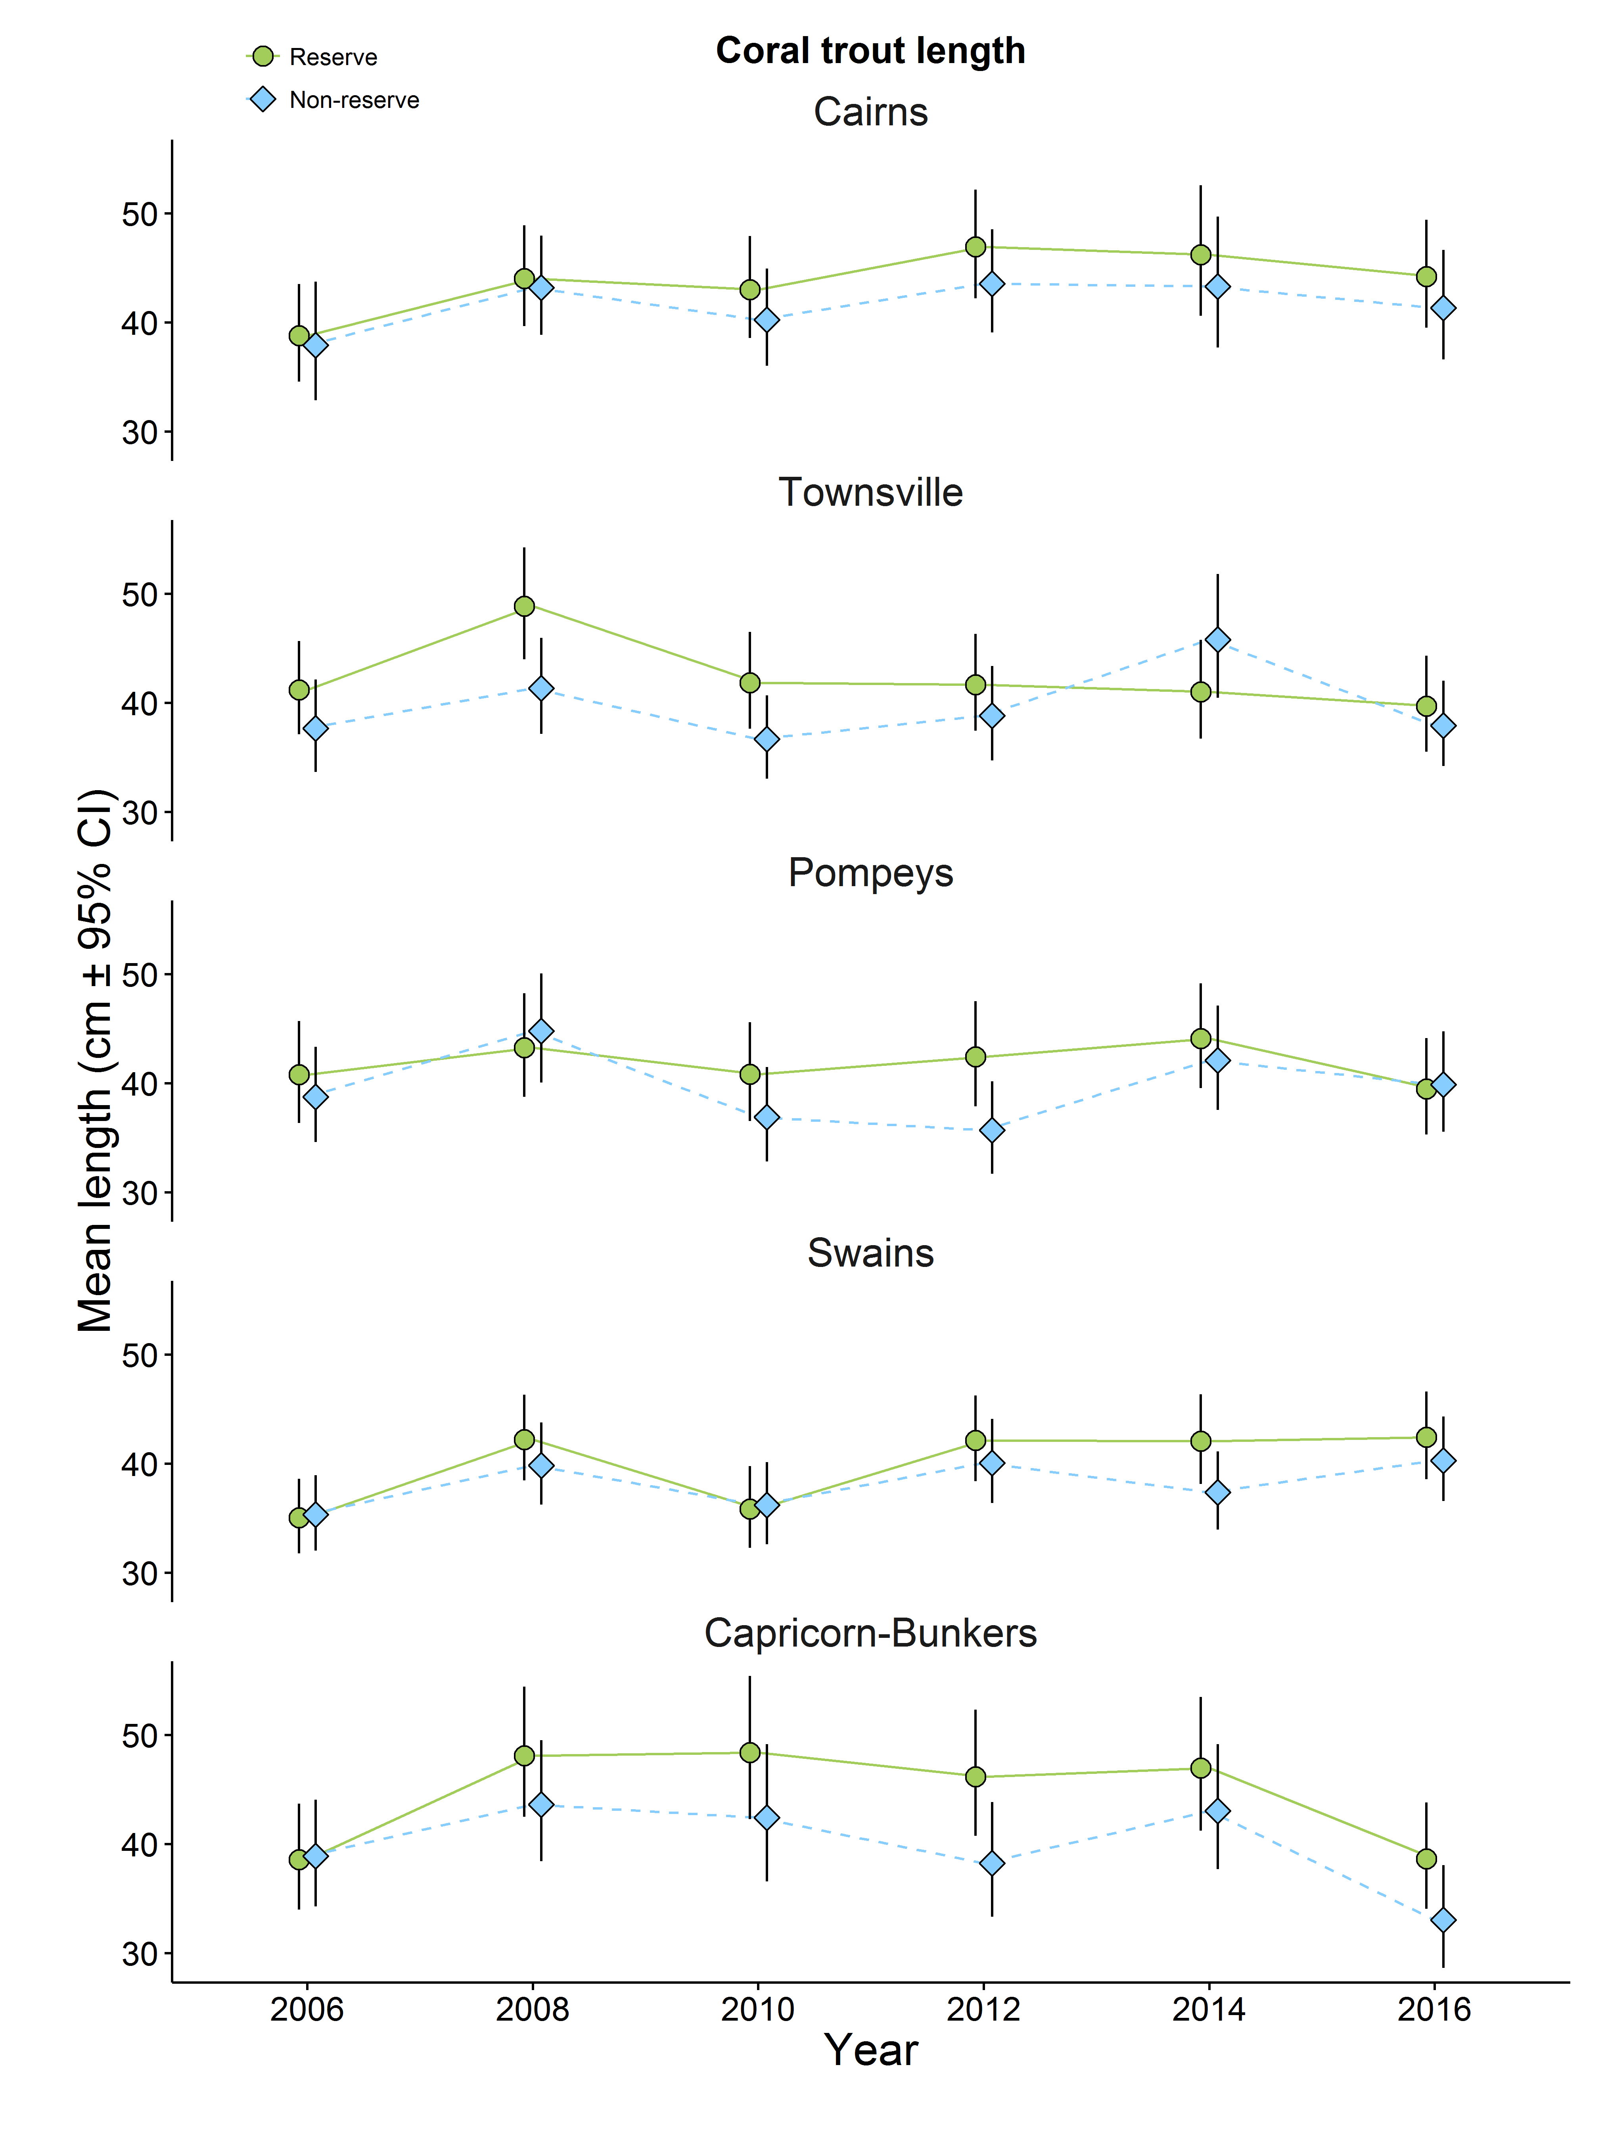
Figure 5. Modelled average total length of coral trout, 2006-2016, in sites in a standard habitat (NE face) of mid-shelf reefs in five regions of the GBR. Green circles show modelled means for no-take reefs; blue diamonds indicate modelled means for reefs that were open to fishing. Error bars are 95% Bayesian uncertainty intervals.

Figure 6 Effect size due to differences in zoning on mean length (TL) of coral trout spp. for each region in each survey year. A positive difference indicates that values are higher on no-take reefs. Note the varying scales on the Y-axes.
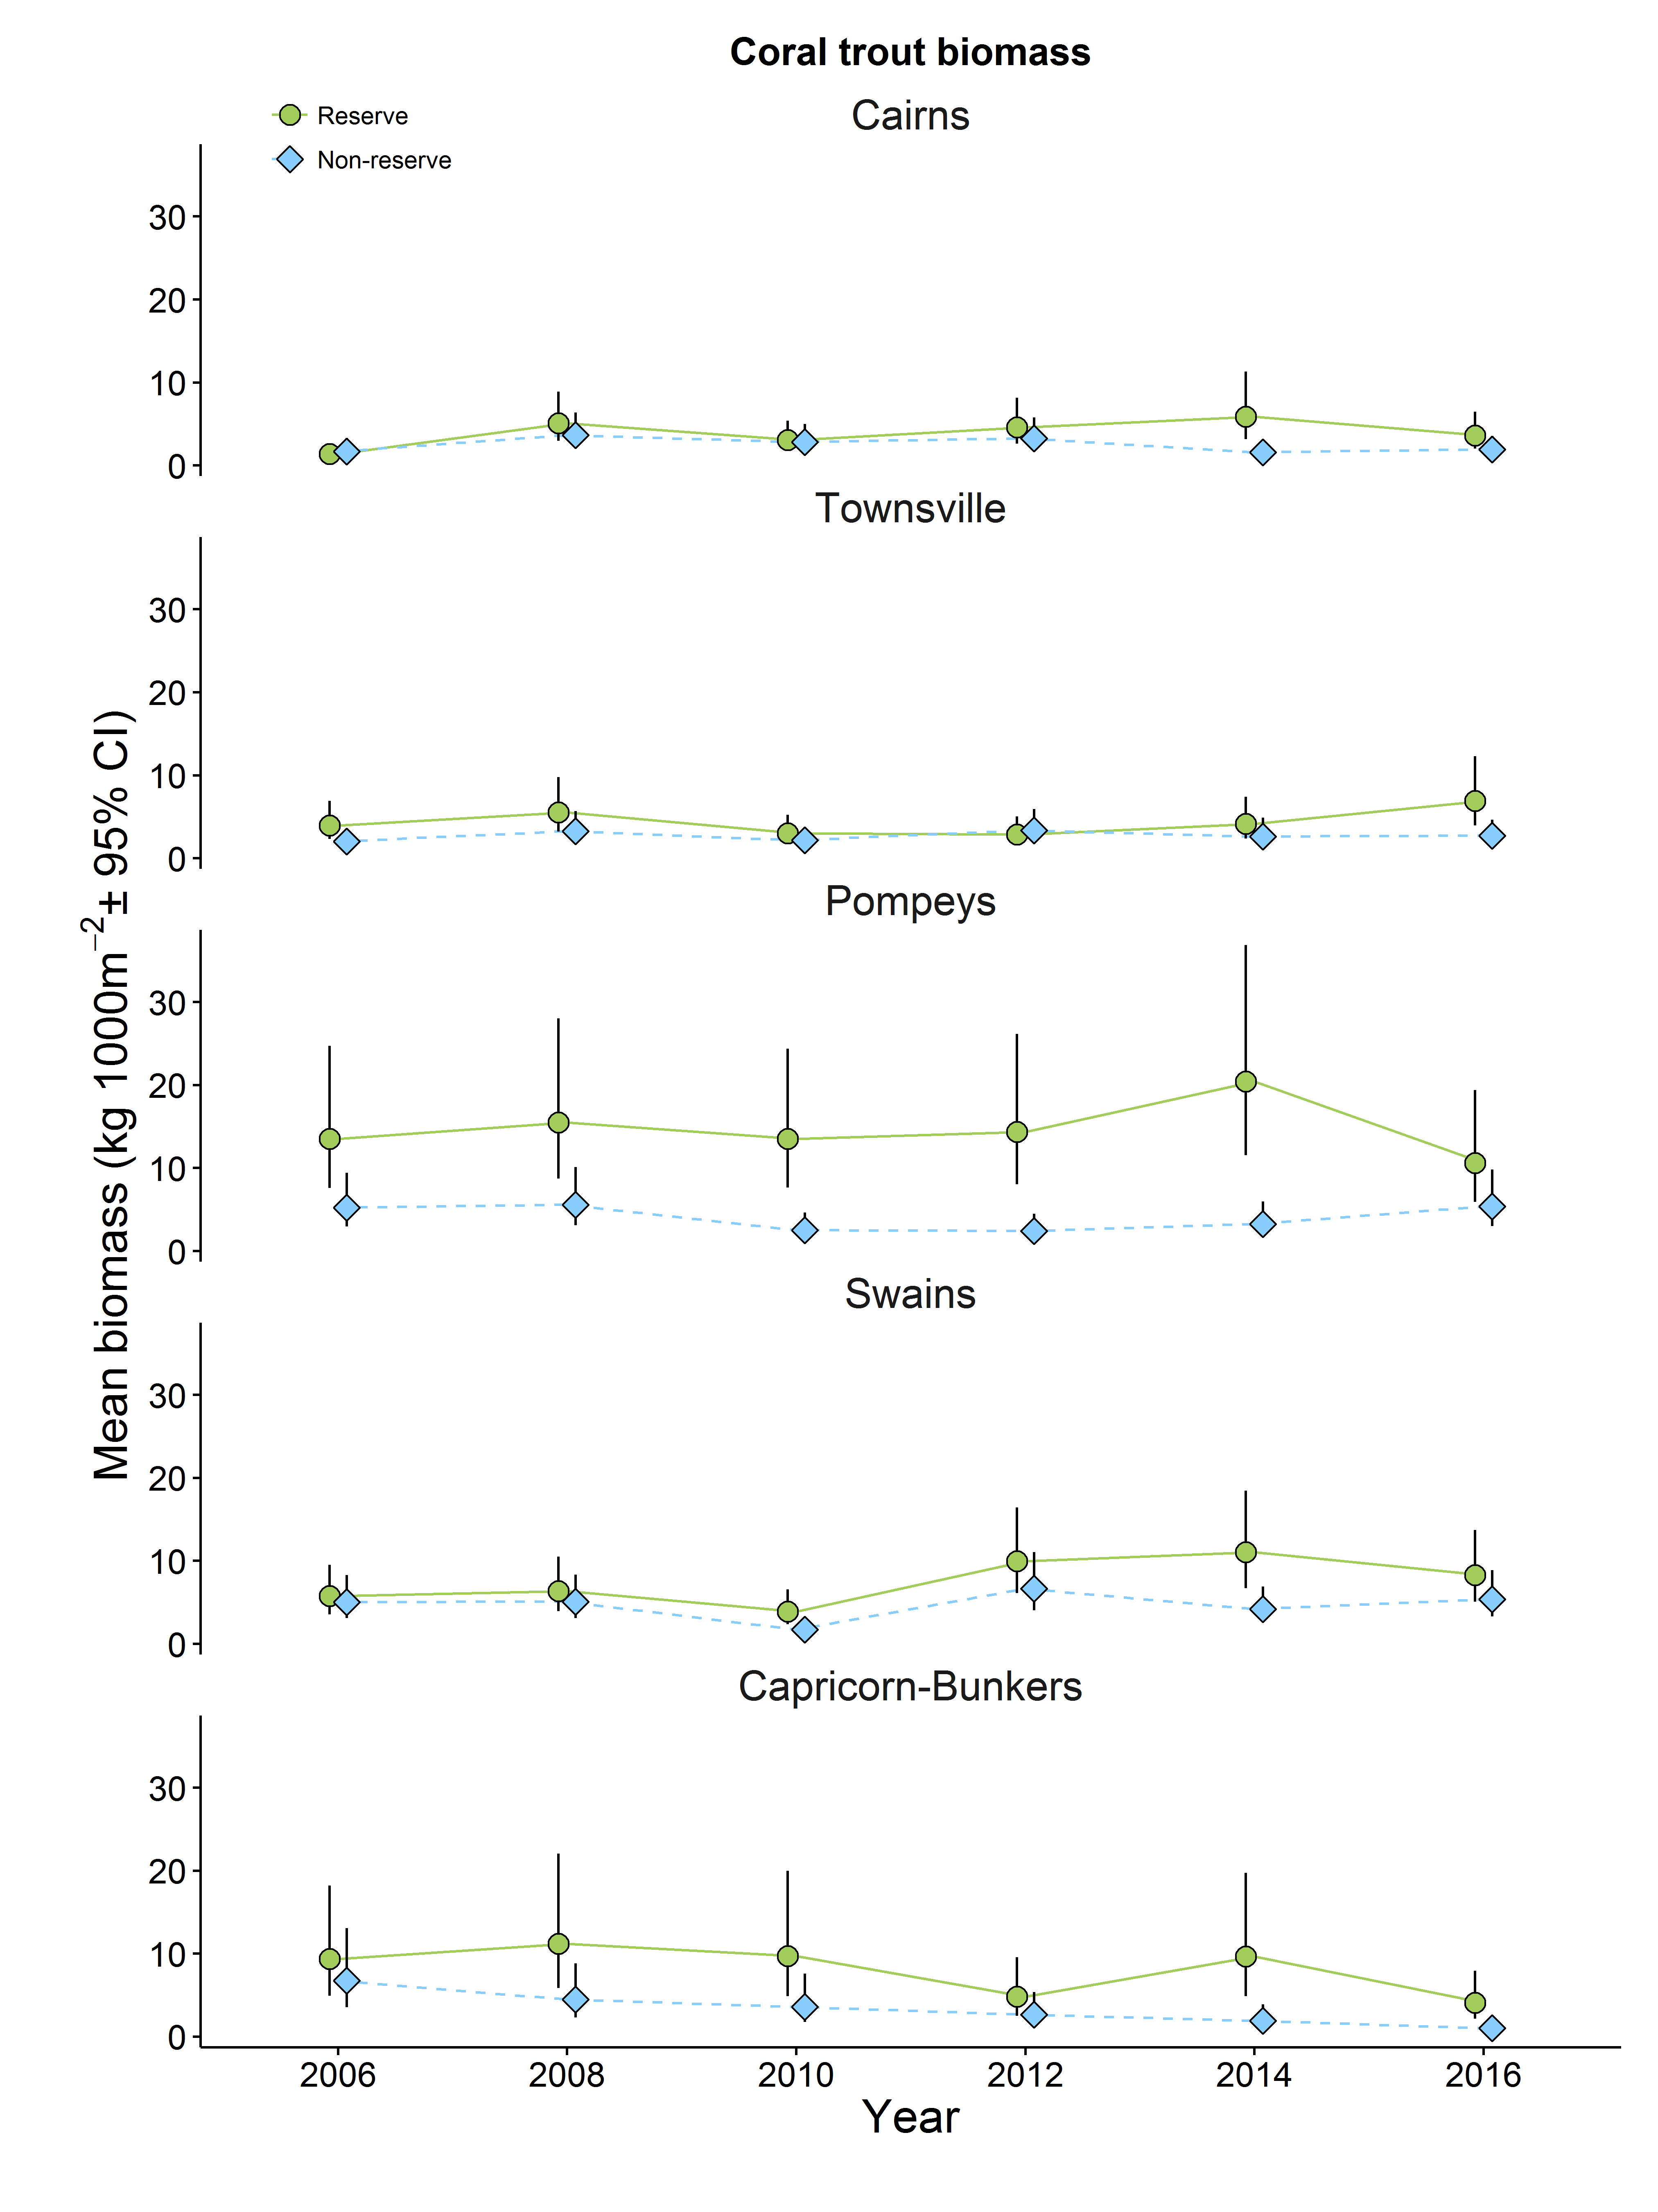.
Figure 7. Modelled average biomass of coral trout per 1,000 m², 2006-2016, in sites in a standard habitat (NE face) of mid-shelf reefs in five regions of the GBR. Green circles show modelled means for no-take reefs; blue diamonds indicate modelled means for reefs that were open to fishing. Error bars are 95% Bayesian uncertainty intervals
Figure 8 Effect size due to differences in zoning on biomass of coral trout spp. for each region in each survey year. A positive difference indicates that values are higher on no-take reefs. Note the varying scales on the Y-axes.

3 Effects of zoning on other target species
While coral trout are the primary targets of the Reef Line Fishery and many recreational fishers, a range of other species are taken as well. These “secondary targets” include species from the families Labridae (Choerodon spp., Cheilinus spp.), Lutjanidae (Lutjanus spp., Macolor spp.), Lethrinidae (Lethrinus spp., Monotaxis spp., Gymnocranius spp.) and Serranidae (Cephalopholis spp., Epinephelus spp.) (Table 2)..
Findings
Averaging over all the survey regions for the 12 years since the implementation of the Amalgamated Zoning Plan, the mean abundance of these all alternative target species combined has not differed substantially between on no-take reefs and reefs that were open to fishing (Figures 2, 9 and 10). Differences were consistently positive on reefs in the Capricorn-Bunkers (Bayesian probability = 0.98, Appendix Table B) and to a lesser extent in the Cairns region (Bayesian probability = 0.92, Appendix Table B). Abundances have been fairly consistent and are similar on reefs in all regions except the Mackay-Pompey region, where densities were greater overall (Figure 9). However the average length of fishes belonging to secondary target species was 6% greater on no-take reefs (Figure 2, Bayesian probability = 1.0, Appendix Table B) and the difference has increased in recent surveys in the Townsville, Swains and Capricorn-Bunker regions (Figures 11 and 12). In combination this has resulted in 40% greater biomass of these species on no take reefs compared with reefs that were open to fishing (Figures 13 and 14, Bayesian probability = 1.0, Appendix Table B)).

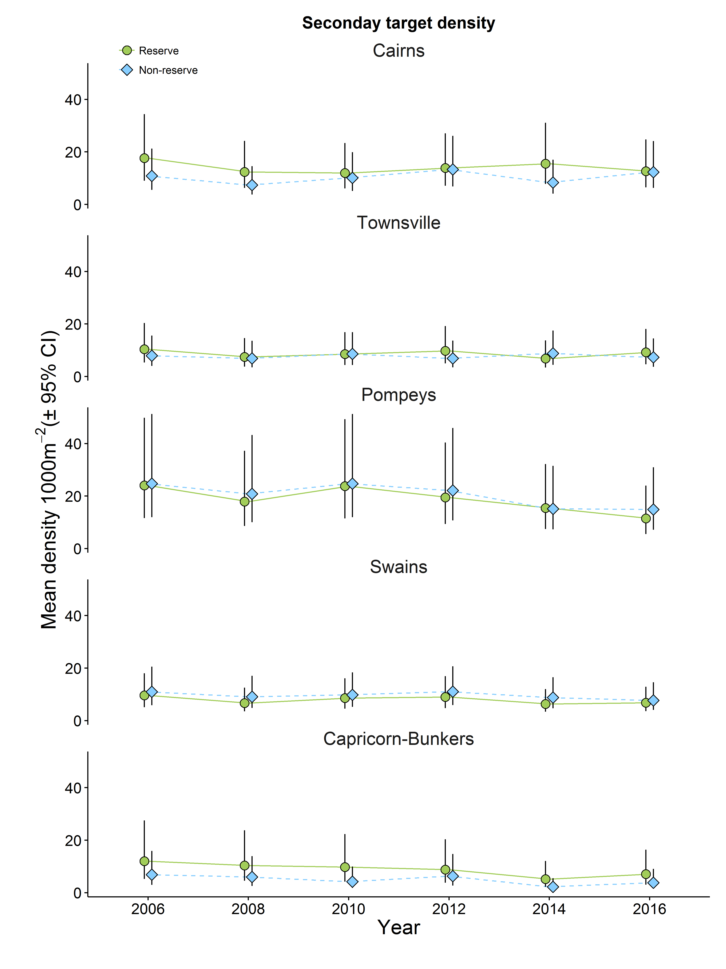
Figure 9. Modelled average number of secondary target species per 1000m², 2006-2016, in sites in a standard habitat (NE face) of mid-shelf reefs in five regions of the GBR. Green circles show modelled means for no-take reefs; blue diamonds indicate modelled means for reefs that were open to fishing. Error bars are 95% Bayesian uncertainty intervals
Figure 10 Effect size due to differences in zoning on abundance of secondary target species for each region in each survey year. A positive difference indicates that values are higher on no-take reefs. Note the varying scales on the Y-axes.
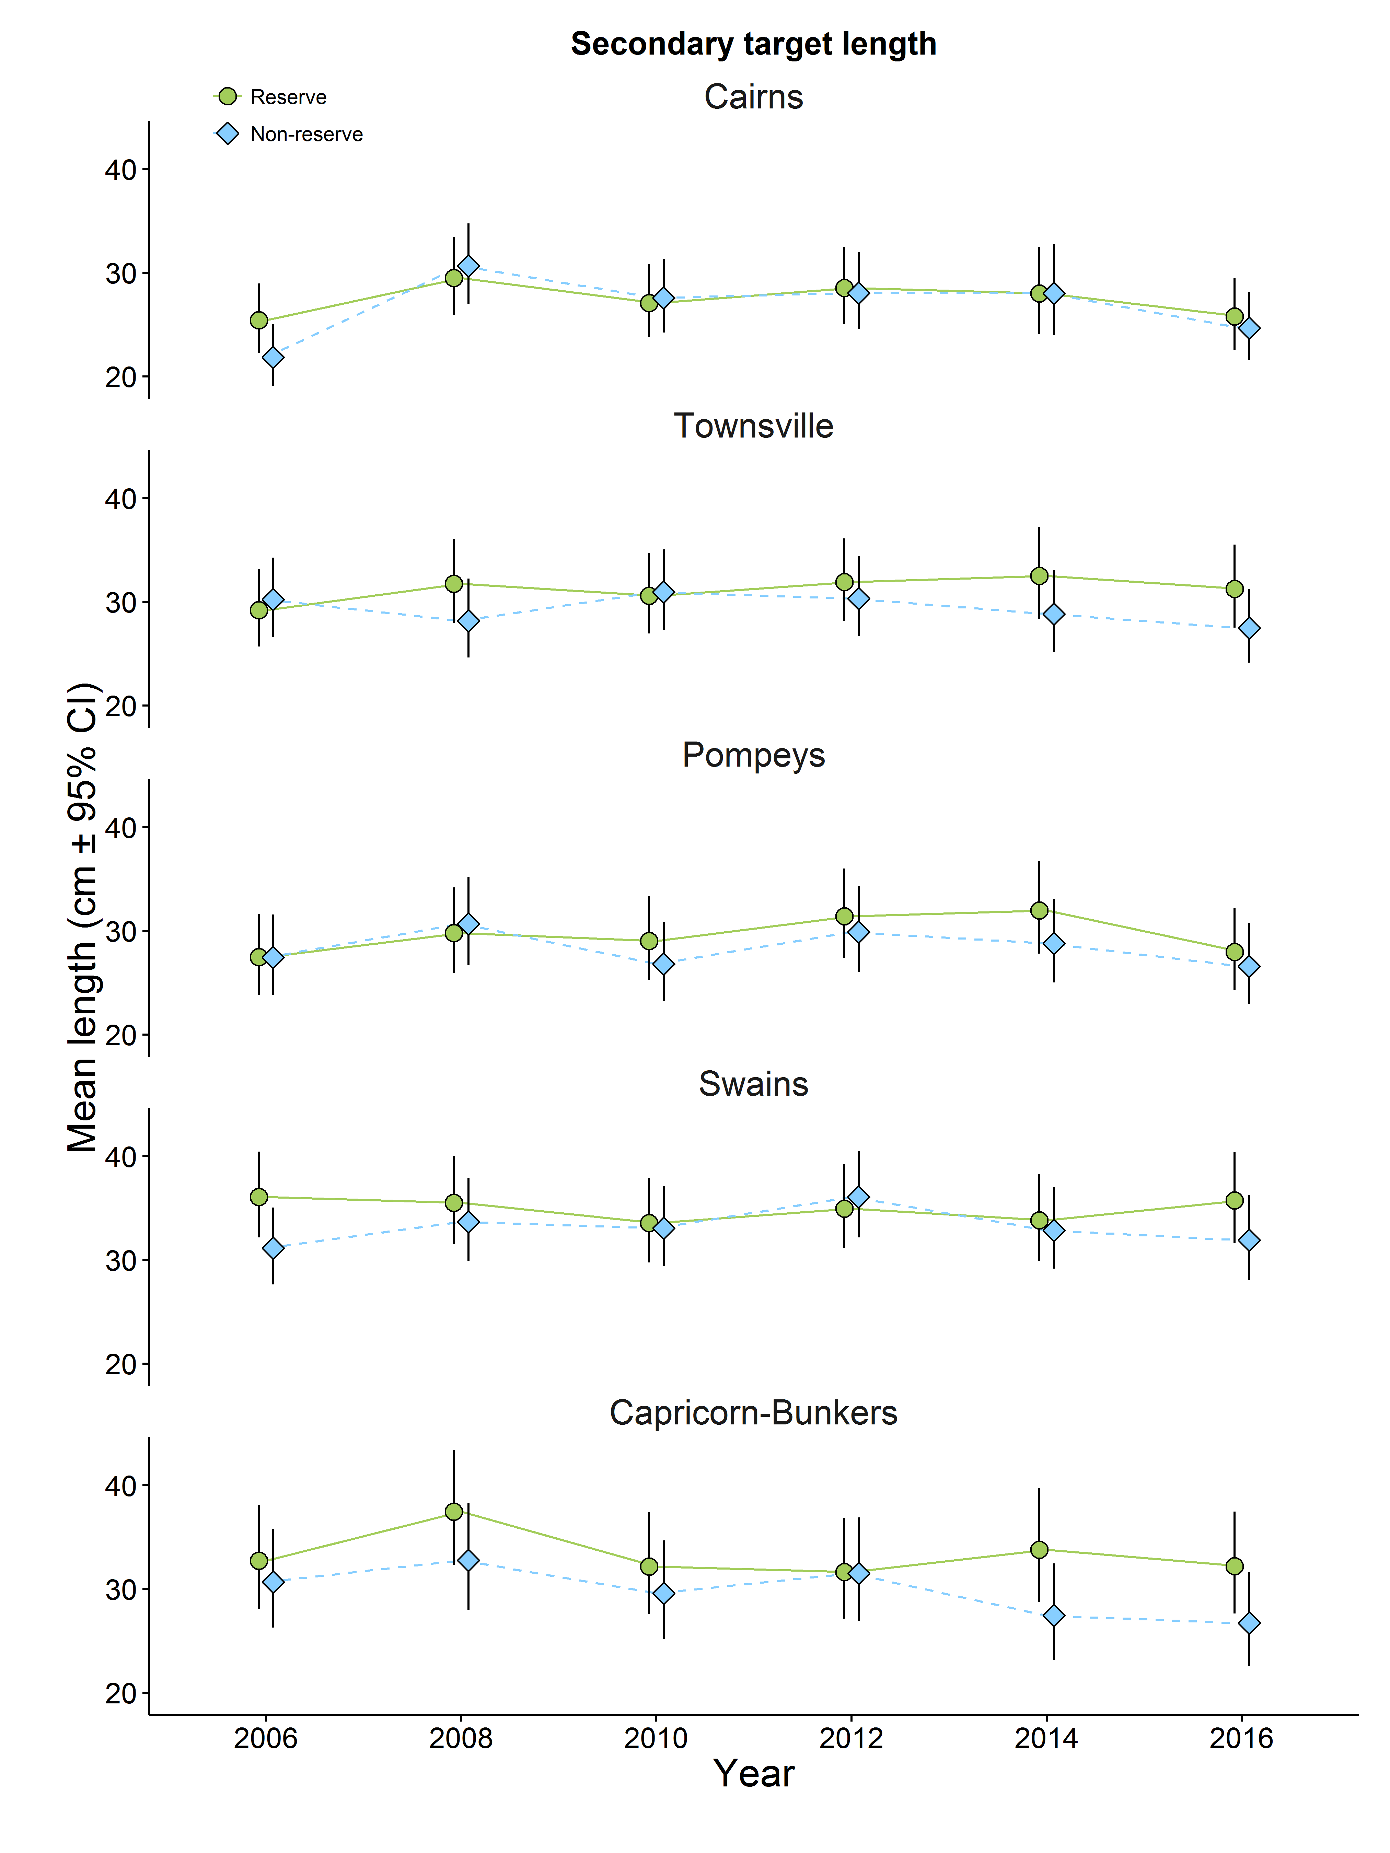
Figure 11. Modelled average total length secondary target species, 2006-2016, in sites in a standard habitat (NE face) of mid-shelf reefs in five regions of the GBR. Green circles show modelled means for no-take reefs; blue diamonds indicate modelled means for reefs that were open to fishing. Error bars are 95% Bayesian uncertainty intervals.

Figure 12 Effect size due to differences in zoning on average total length of secondary target species for each region in each survey year. A positive difference indicates that values are higher on no-take reefs. Note the varying scales on the Y-axes.

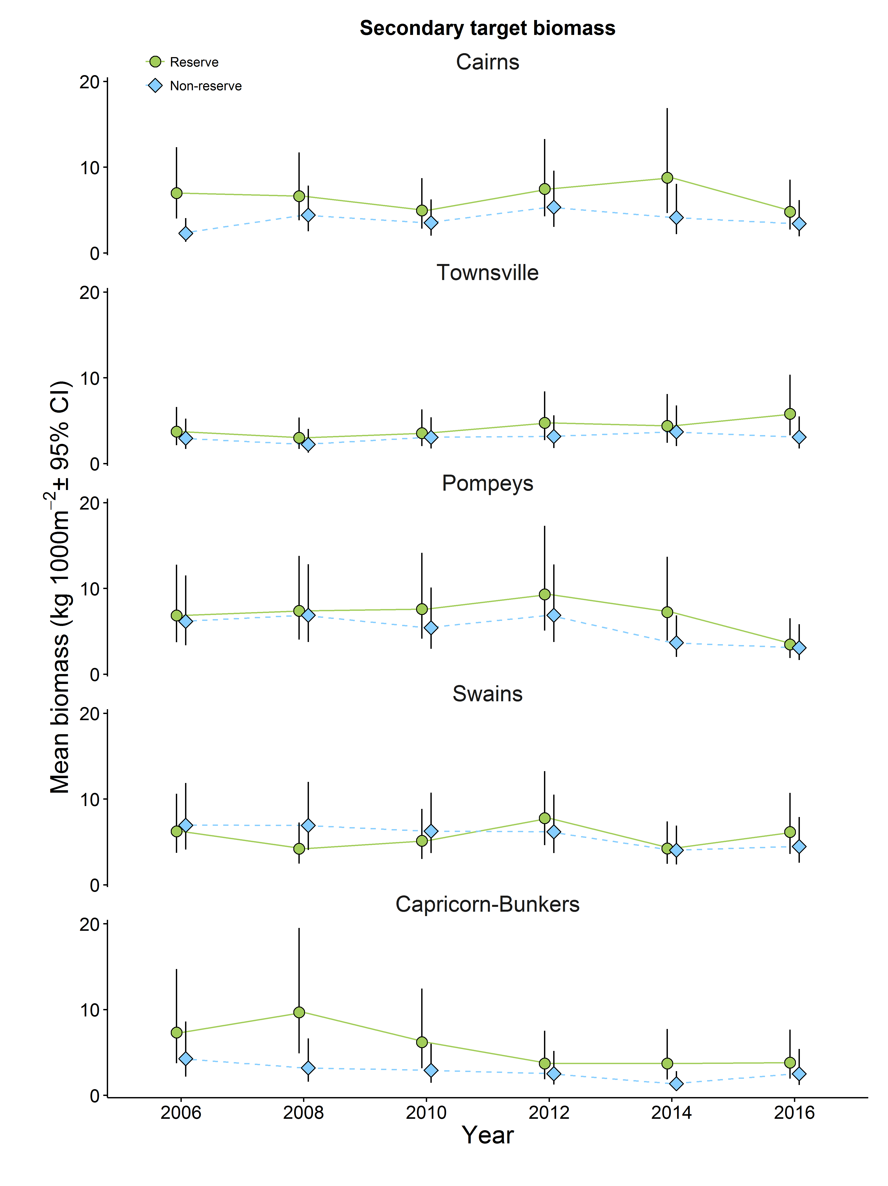
Figure 13. Modelled average biomass of secondary target species per 1,000 m², 2006-2016, in sites in a standard habitat (NE face) of mid-shelf reefs in five regions of the GBR. Note the different scales on the y-axes. Green circles show modelled means for no-take reefs; blue diamonds indicate modelled means for reefs that were open to fishing. Error bars are 95% Bayesian uncertainty intervals.
Figure 14 Effect size due to differences in zoning on average biomass of secondary target species per 1,000 m² for each region in each survey year. A positive difference indicates that values are higher on no-take reefs. Note the varying scales on the Y-axes.

4 Effects of zoning on abundance of herbivorous fishes
Herbivorous fishes are likely to be important in coral reefs conservation because of their potential role in mediating competition between corals and macroalgae. We distinguish five guilds of herbivorous fishes (Table 2), based in part on their manner of feeding and partly on the plant material they consume. Members of the “scrapers” guild are mainly parrotfishes that consume epilithic algae and scrape the surface of the reef, so that their feeding scars provide potential settlement sites for coral larvae. Excavators are large parrotfishes that bite into the reef surface, leaving scars which similarly provide settlements sites for coral larvae but also cause considerable erosion of the reef surface. Detritivores are mainly surgeonfishes that feed on a combination of epilithic algal turf, sediment and some animal material, but also provide clear substrate for settlement of coral larvae in the process. Croppers are mostly rabbitfishes and some surgeonfishes that feed on upright macroalgae. Farmers are generally small territorial species, mostly damselfishes but including some surgeonfishes, that defend an area of reef and may exclude coral predators as well as other herbivores (e.g. Gochfeld 2010), and modify the local algal community by selective feeding and removal.
Findings
There is no common pattern in abundance across all five groups of herbivores. Averaged over all sampling periods, scrapers were 9% more abundant on reefs that were open to fishing (Figure 2, Bayesian probability = 0.02, Appendix Table B)). This was primarily due to survey reefs in the Cairns region where there were consistently fewer scrapers on no-take reefs (12% decrease in abundance, Figures 15 and 16, Bayesian probability = 0.002, Appendix Table C). Reefs in the Pompey region showed a similar overall pattern with 10% fewer fish on no-take reefs (Figures 15 and 16, Bayesian probability = 0.03, Appendix Table C).This pattern was reversed on reefs in the Swains with 7% more fish on no-take reefs (Bayesian probability = 0.97, Appendix Table C). While the mean abundance of scraping herbivorous fishes was higher on reefs in the Pompey reefs in 2010, and on reefs that were open to fishing in the Capricorn-Bunker region in 2006 and 2008, these patterns varied among the reefs in those regions and did not persist over time (Figures 15 and 16).
In contrast fishes in the detritivore guild were 15% more numerous overall on reefs that were closed to fishing (Figure 2, Bayesian probability = 0.99, Appendix Table C). This was due to numbers increasing on no-take reefs in the Capricorn-Bunker region compared with reefs that were closed to fishing (Figures 17 and 18). The low numbers of detritivores on reefs in the Pompey region is striking, and has persisted. Ctenochaetus spp. are the most abundant members of this guild, and their low abundance on midshelf reefs in the Pompey region when compared with midshelf reefs in other regions has been recorded previously (Cheal et al. 2012).
The remaining guilds of herbivorous fishes, the excavators, croppers and farmers, showed no consistent differences in abundance between no-take reefs and reefs that are open to fishing (Figure 2). The mean densities of all three groups were higher on no-take reefs in the Capricorn-Bunker region in recent surveys, but the numbers were very variable, so the patterns were not consistent (Figures 19-24).
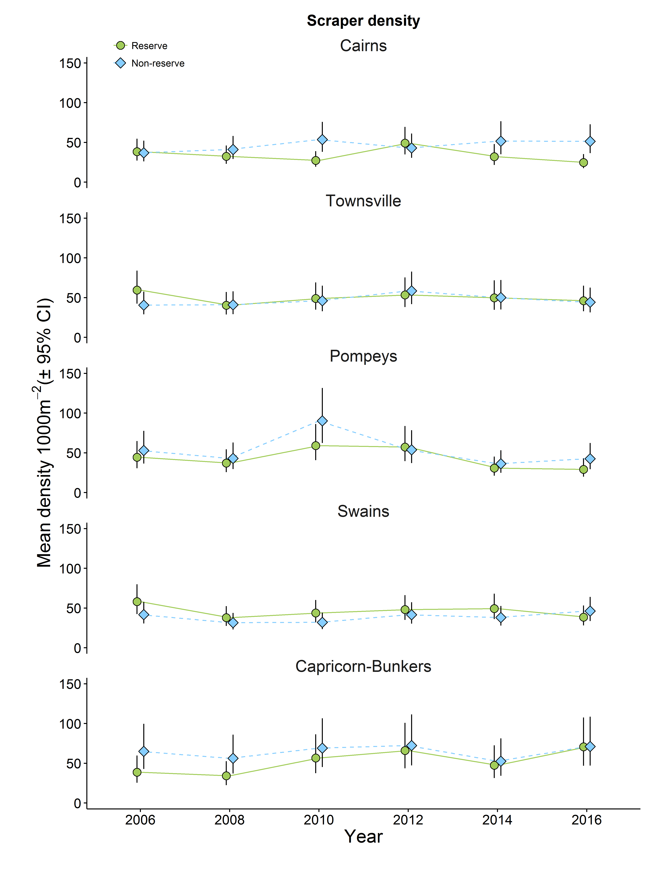
Figure 15. Mean abundance of the Scraper guild of herbivorous fishes per 1,000 m², 2006-2016, in sites in a standard habitat (NE face) of mid-shelf reefs in five regions of the GBR. Green circles show modelled means for no-take reefs; blue diamonds indicate modelled means for reefs that were open to fishing. Error bars are 95% Bayesian uncertainty intervals.
Figure 16 Effect size due to differences in zoning on abundance of the Scraper guild of herbivorous fishes for each region in each survey year. A positive difference indicates that values are higher on no-take reefs. Note the varying scales on the Y-axes.

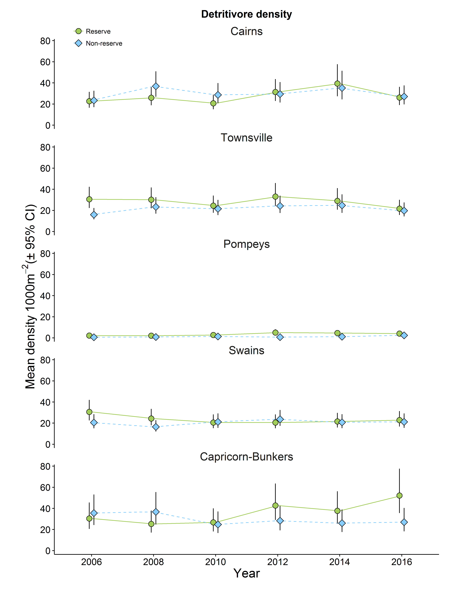
Figure 17. Mean abundance of the Detritivore guild of herbivorous fishes per 1,000 m², 2006-2016, in sites in a standard habitat (NE face) of mid-shelf reefs in five regions of the GBR. Green circles show modelled means for no-take reefs; blue diamonds indicate modelled means for reefs that were open to fishing. Error bars are 95% Bayesian uncertainty intervals.
Figure 18 Effect size due to differences in zoning on abundance of the Detritivore guild of herbivorous fishes for each region in each survey year. A positive difference indicates that values are higher on no-take reefs. Note the varying scales on the Y-axes.

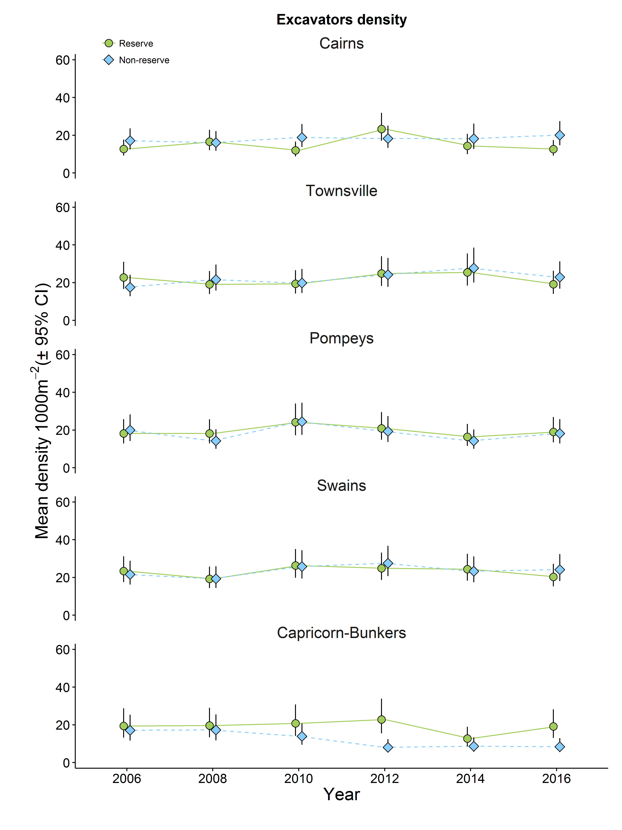
Figure 19. Mean abundance of the Excavator guild of herbivorous fishes per 1,000 m², 2006-2016, in sites in a standard habitat (NE face) of mid-shelf reefs in five regions of the GBR. Green circles show modelled means for no-take reefs; blue diamonds indicate modelled means for reefs that were open to fishing. Error bars are 95% Bayesian uncertainty intervals

Figure 20 Effect size due to differences in zoning on abundance of the Excavator guild of herbivorous fishes for each region in each survey year. A positive difference indicates that values are higher on no-take reefs. Note the varying scales on the Y-axes.

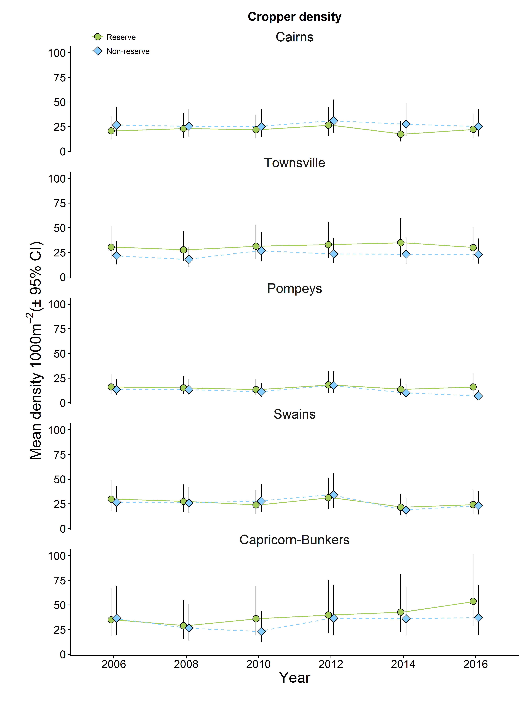

Figure 21 Mean abundance of the Cropper guild of herbivorous fishes per 1,000 m², 2006-2016, in sites in a standard habitat (NE face) of mid-shelf reefs in five regions of the GBR. Green circles show modelled means for no-take reefs; blue diamonds indicate modelled means for reefs that were open to fishing. Error bars are 95% Bayesian uncertainty intervals
Figure 22 Effect size due to differences in zoning on abundance of the Cropper guild of herbivorous fishes for each region in each survey year. A positive difference indicates that values are higher on no-take reefs. Note the varying scales on the Y-axes.

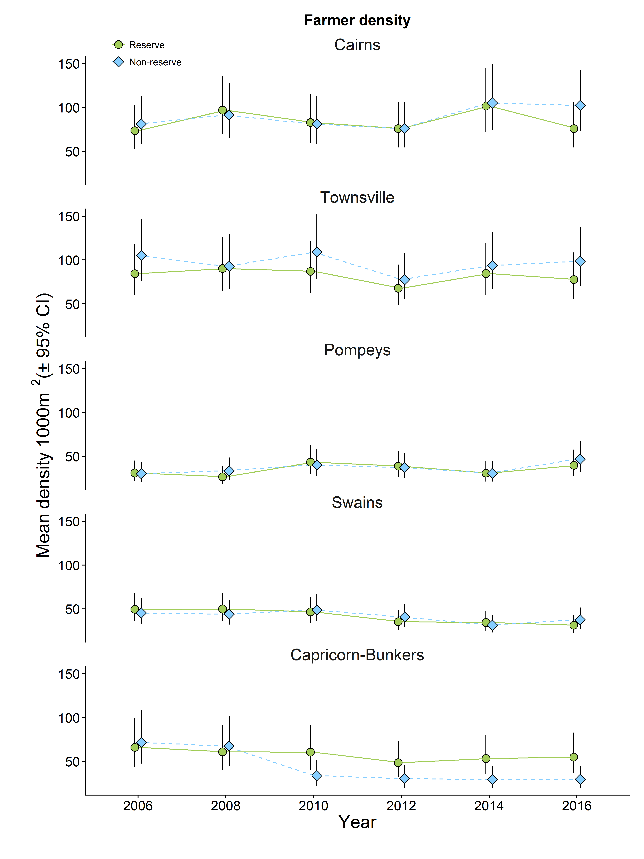
Figure 23 Mean abundance of the Farmer guild of herbivorous fishes per 1,000 m², 2006-2016, in sites in a standard habitat (NE face) of mid-shelf reefs in five regions of the GBR. Green circles show modelled means for no-take reefs; blue diamonds indicate modelled means for reefs that were open to fishing. Error bars are 95% Bayesian uncertainty intervals
Figure 24 Effect size due to differences in zoning on abundance of the Farmer guild of herbivorous fishes for each region in each survey year. A positive difference indicates that values are higher on no-take reefs. Note the varying scales on the Y-axes.

5. Effects of zoning on other groups of fishes
Groups of fishes other than species that are targets of fisheries may also be affected indirectly by zoning through potential changes to habitats or through trophic cascades resulting from changes in abundance of exploited species. Following Emslie et al. (2015) we examine the effects of zoning on fishes that are benthic foragers, planktivores, specialist corallivores and omnivorous damselfishes. Benthic foraging species were primarily generalist butterflyfishes and wrasses that feed on small invertebrates other than corals (Table 2). Planktivores consisted of a few species of large surgeonfishes and numerous small damselfishes, while obligate corallivores consisted of nine species of Chaetodont.

Findings
Benthic foraging species were slightly (9%) more abundant on no-take reefs overall (Figure 2). This appears to be based on small but consistent difference in abundance on reefs in the Townsville and Swains regions (Figures 25 and 26). Planktivores were consistently more abundant (34%) in no-take zones (Figure 2, Bayesian probability that difference is greater than zero = 0.99 Appendix Table D), principally due to persistent large mean differences on reefs in the Pompey region and lesser differences in the Townsville region (Figure 27 and 28, Appendix Table D). Obligate corallivores and omnivorous damselfishes showed no clear pattern of distribution between no-take reefs and reefs that were open to fishing (Figures 2, 29-32, Appendix Table D).
Figure 25. Mean abundance of the benthic foraging fishes per 1,000 m², 2006-2016, in sites in a standard habitat (NE face) of mid-shelf reefs in five regions of the GBR. Green circles show modelled means for no-take reefs; blue diamonds indicate modelled means for reefs that were open to fishing. Error bars are 95% Bayesian uncertainty intervals. Note varying scales on Y axis.
Figure 26 Effect size due to differences in zoning on abundance of benthic foraging fishes for each region in each survey year. A positive difference indicates that values are higher on no-take reefs. Note the varying scales on the Y-axes.

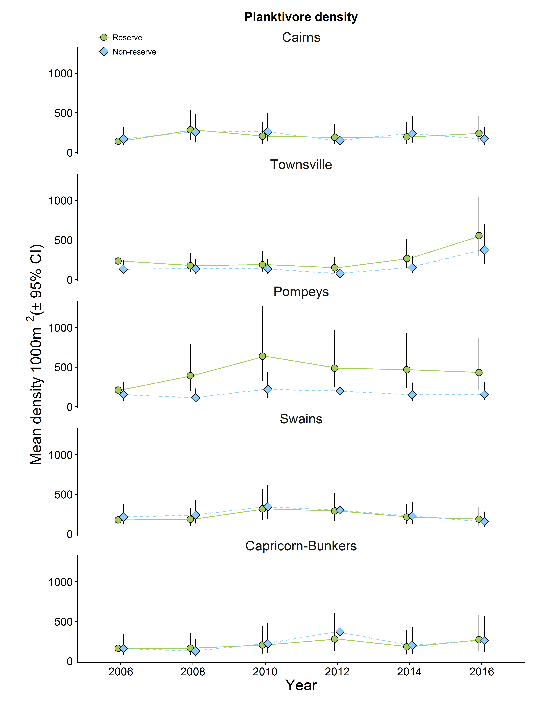
Figure 27. Mean abundance of the planktivorous fishes per 1,000 m², 2006-2016, in sites in a standard habitat (NE face) of mid-shelf reefs in five regions of the GBR. Green circles show modelled means for no-take reefs; blue diamonds indicate modelled means for reefs that were open to fishing. Error bars are 95% Bayesian uncertainty intervals. Note varying scales on Y axis.
Figure 28 Effect size due to differences in zoning on abundance of planktivorous fishes for each region in each survey year. A positive difference indicates that values are higher on no-take reefs. Note the varying scales on the Y-axes.

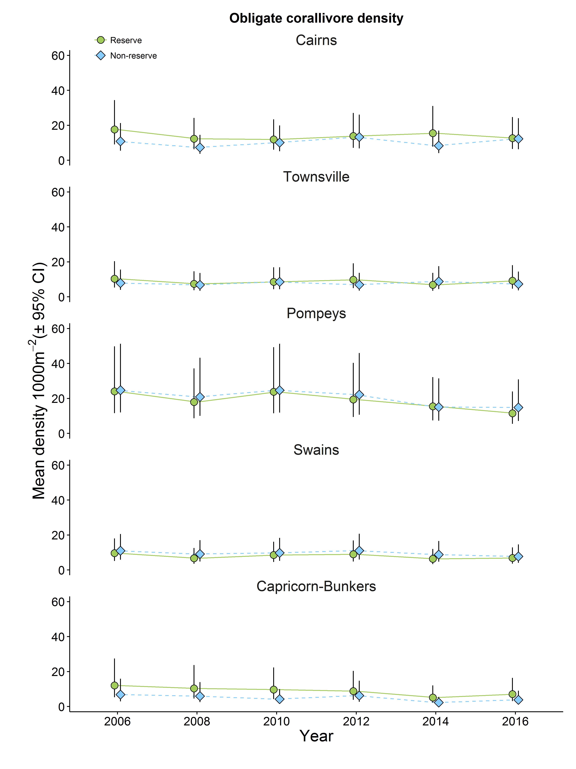
Figure 29. Mean abundance of the obligate coral feeding fishes per 1,000 m², 2006-2016, in sites in a standard habitat (NE face) of mid-shelf reefs in five regions of the GBR. Green circles show modelled means for no-take reefs; blue diamonds indicate modelled means for reefs that were open to fishing. Error bars are 95% Bayesian uncertainty intervals
Figure 30 Effect size due to differences in zoning on abundance of obligate coral feeding fishes for each region in each survey year. A positive difference indicates that values are higher on no-take reefs. Note the varying scales on the Y-axes.

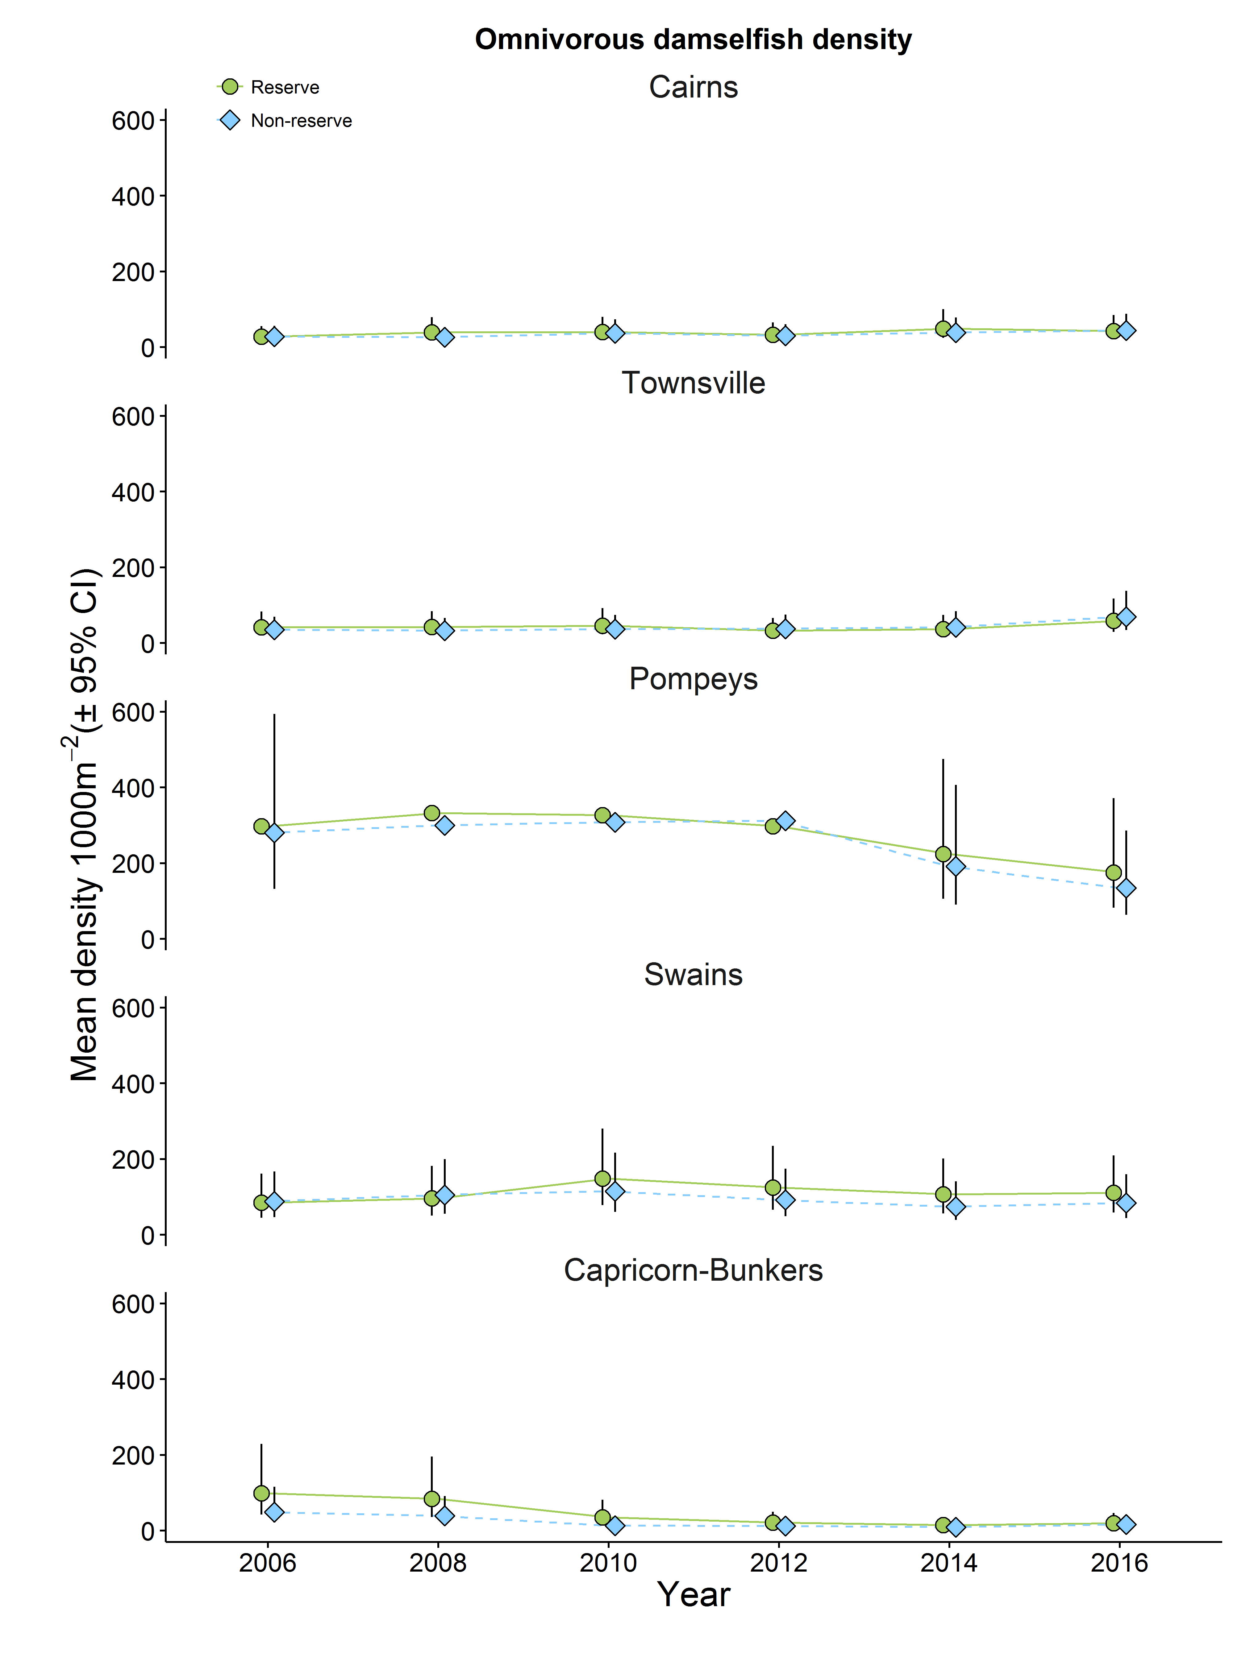
Figure 31. Mean abundance of the omnivorous damselfishes per 1,000 m², 2006-2016, in sites in a standard habitat (NE face) of mid-shelf reefs in five regions of the GBR. Green circles show modelled means for no-take reefs; blue diamonds indicate modelled means for reefs that were open to fishing. Error bars are 95% Bayesian uncertainty intervals.
Figure 32 Effect size due to differences in zoning on abundance of omnivorous damselfishes for each region in each survey year. A positive difference indicates that values are higher on no-take reefs. Note the varying scales on the Y-axes.

6. Effects of zoning on overall species richness of reef fishes
Increased diversity, commonly measured by species richness, could result from effects of zoning on habitat structure or from increased survivorship. Note that the AIMS program surveys a limited number of families of reef fishes, so this is relative species richness.

Findings
Species richness of reef fishes, based on the families that are surveyed by this program, was very consistent among reefs in the six regions and was ~8% greater overall on no-take reefs than on reefs that were open to fishing (Figure 2 , Bayesian probability = 1.0, Appendix Table E). This was primarily due to consistent patterns on reefs in the Pompey and Capricorn-Bunker regions (Figures 33 and 34, Appendix Table E).

Figure 33. Mean species richness of fishes, 2006-2016, in sites in a standard habitat (NE face) of mid-shelf reefs in five regions of the GBR. Green circles show modelled means for no-take reefs; blue diamonds indicate modelled means for reefs that were open to fishing. Error bars are 95% Bayesian uncertainty intervals. Note varying scales on the Y axes.
Figure 34 Effect size due to differences in zoning on mean species richness of fishes for each region in each survey year. A positive difference indicates that values are higher on no-take reefs. Note the varying scales on the Y-axes.

7. Effects of zoning on broad groups of benthic organisms
In many parts of the Tropics, the process of fishing is destructive to coral reef communities, from the effects of discarded fishing line (e.g. Lamb et al. 2015) to extreme examples of muro ami and blast fishing. Effects of zoning on coral predators could also affect coral cover and algal cover (McCook et al 2010). Here the effect of zoning on cover of three broad categories of benthic organism, hard coral, soft coral and algae, is examined.

Findings
Cover of hard coral showed some evidence of an overall positive effect with cover being on average 9% higher on no-take reefs (Figure 2, Bayesian probability = 0.95, Appendix Table F). This was most obvious on reefs in the Cairns region (Figures 35 and 36, Appendix Table F). Cover of soft corals and of algae did not show any consistent differences between no-take reefs and reefs that were open to fishing (Figure 2 and Figures 37 and 40). Hard coral cover and cover of algae fluctuated in a broadly reciprocal manner in response to disturbances such as outbreaks of Acanthaster and cyclones. Cyclones at least are unlikely to be affected by zoning.

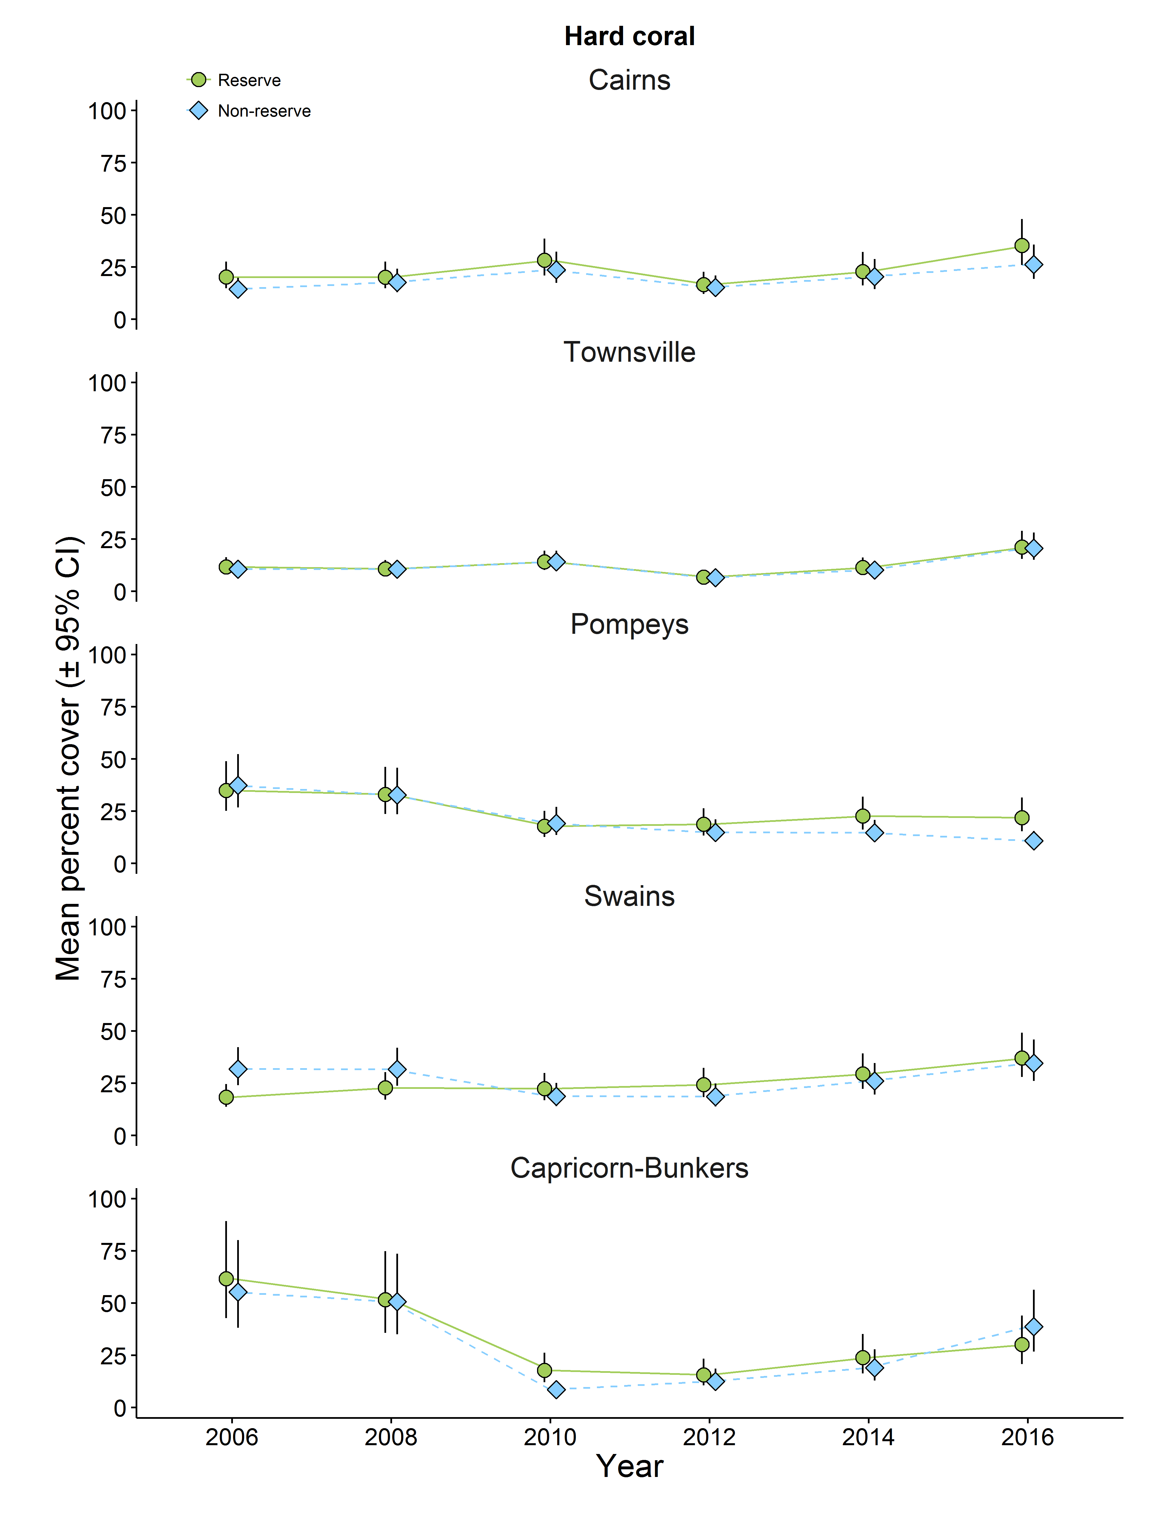
Figure 35. Mean percent cover of hard corals, 2006-2016, in sites in a standard habitat (NE face) of mid-shelf reefs in five regions of the GBR. Green circles show modelled means for no-take reefs; blue diamonds indicate modelled means for reefs that were open to fishing. Error bars are 95% Bayesian uncertainty interval
Figure 36 Effect size due to differences in zoning on hard coral cover on reefs for each region in each survey year. A positive difference indicates that values are higher on no-take reefs. Note the varying scales on the Y-axes.

Figure 37. Mean percent cover of soft corals, 2006-2016, in sites in a standard habitat (NE face) of mid-shelf reefs in five regions of the GBR. Green circles show modelled means for no-take reefs; blue diamonds indicate modelled means for reefs that were open to fishing. Error bars are 95% Bayesian uncertainty intervals. Note varying scales on the Y axes.
Figure 38 Effect size due to differences in zoning on soft coral cover on reefs for each region in each survey year. A positive difference indicates that values are higher on no-take reefs. Note the varying scales on the Y-axes.

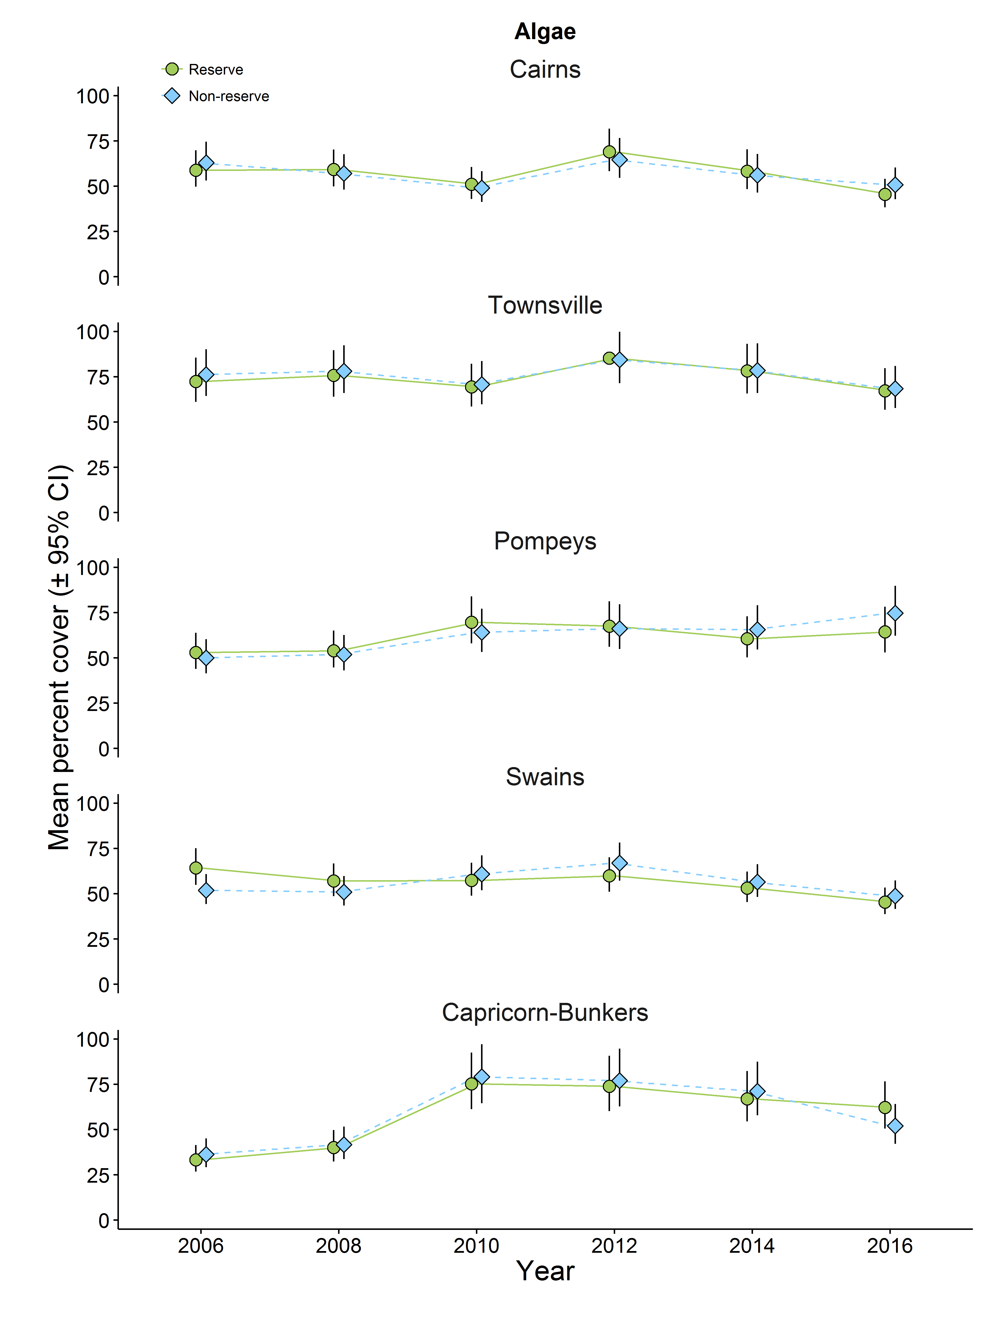
Figure 39. Mean percent cover of algae, 2006-2016, in sites in a standard habitat (NE face) of mid-shelf reefs in five regions of the GBR. Green circles show modelled means for no-take reefs; blue diamonds indicate modelled means for reefs that were open to fishing. Error bars are 95% Bayesian uncertainty intervals.
Figure 40 Effect size due to differences in zoning on cover of algae on reefs for each region in each survey year. A positive difference indicates that values are higher on no-take reefs. Note the varying scales on the Y-axes.

8 The effects of zoning on the frequency of outbreaks of Acanthaster planci
The first records of outbreak densities of A. planci in the current wave of outbreaks were from Startle Reef (East) (Reef 15-028 S2, 15.2°S) in 2011. This fourth recorded wave of outbreaks has since affected reefs between Lizard Is and Innisfail. This analysis focusses on the relationship between zoning and the frequency of outbreaks on the reefs in the region that has been affected by this fourth wave.

Findings
When the pattern of A. planci outbreaks on no-take reefs and on reefs that were open to fishing was first examined on the GBR under the zoning plan that preceded the Amalgamated Zoning Plan, the majority of reefs that were near to reefs that had outbreaks (e.g. were “at risk”) and were open to fishing had outbreaks, while only a minority of the nearby no-take reefs had outbreaks. This resulted in a statistically significant association between zoning and the frequency of outbreaks (Sweatman 2008).
More than a decade after fishing was prohibited on a greatly increased number of no-take reefs under the Amalgamated Zoning Plan in 2004, the proportions of no-take reefs that have experienced outbreaks in the fourth wave is lower than on reefs that are open to fishing (Figures 41 and 42) but the association between the frequency of outbreaks and zoning is non-significant (Fisher’s Exact Test (2-tailed): midshelf reefs alone p = 0.13 Figure 41; inshore and midshelf reefs combined, p = 0.064, Figure 42).
Note that these analyses differ from the preliminary results given in the Progress Report on this project in June 2016. The difference is due to the number of reefs that were included in the analyses. Two aspects of a reef need to be considered in these analyses. The first is whether a reef is likely to have been exposed to A. planci larvae and so have the potential to develop outbreaks (“at risk”). Secondly, sampling effort is also important. The more frequently reefs are surveyed, the more likely it is that an outbreak will be recorded if it occurs. The preliminary analysis included all survey reefs that were considered at risk. However, because more frequent sampling gives a better chance of assessing the true outbreak status of reefs, here we follow Sweatman (2008) and excluded reefs that were only surveyed once in the six years that the current wave of outbreaks has been in progress. Reefs that are a long way from reefs with outbreaks are generally unlikely to develop outbreaks, and limited sampling means outbreaks are unlikely to be detected even if they occur. Including reefs with these characteristics in the analyses adds noise and obscures any pattern.

Figure 41. The number of midshelf reefs that are likely to have been exposed to A. planci larvae that are zoned No-take (green) and that are open to fishing (blue) where outbreak densities of A. planci have been recorded (solid fill). Hatched areas indicate the numbers of reefs in each zone where lower densities (or no A. planci) were recorded.
Considering only the survey reefs that were specifically selected for monitoring the effects of the Amalgamated Zoning Plan from 2006 onwards (Table 1, Figure 1), five matched pairs of reefs in the northern cluster were classified as “at risk” in the period to 2011-16. A. planci were recorded on three of the five no-take reefs and on all five of the reefs that were open to fishing. Outbreak densities of starfish were recorded on three of the five reefs that were open to fishing, but no outbreaks were seen on any of the five no-take reefs. The number of these matched reefs that have been classified as “at risk” of developing outbreaks is small, but the results so far conform to the broader pattern of fewer outbreaks on no-take reefs.

Figure 42. The number of inshore and midshelf reefs that are likely to have been exposed to A. planci larvae that are zoned No-take (green) and that are open to fishing (blue) that have outbreak densities of A. planci (solid fill) versus lower densities or none (shaded fill).

Discussion

The effects of zoning on reef communities
The results of the surveys up to 2016 are generally consistent with the results for offshore reefs that were reported by Emslie et al. (2015) based on earlier surveys. Protection from fishing has clear positive effects on abundance and size of primary and secondary target species, leading to greater biomass on no-take reefs. Effects of zoning on other groups are also broadly the same. “Scraper” herbivores (mainly parrotfishes) were less abundant in no-take zones overall, but this was true in two regions (Cairns and Pompeys) while they were more abundant in no-take zones in the Swains (Appendix Table B). Planktivorous fishes were again more abundant overall on no-take reefs. This was most clear on reefs in the Pompey and Townsville regions. Planktivores have been found to respond positively to protection from fishing in other studies (Graham et al. 2011) but this was because they are targetted by fishers in other parts of the world. This does not apply on the GBR.
Emslie et al. (2015) argued against protection from fishing causing substantial top-down effects on prey species, because fishing on the GBR is regulated and focussed on a only a few of the predatory species, meaning that overall predator numbers may not be much affected by fishing at current levels. At a broad level, this study suggests that there is also little scope for bottom up effects, since cover of algae and hard and soft corals did not differ consistently between no-take reefs and reefs that were open to fishing.

The effects of zoning on the frequency of outbreaks of A. planci
A broadscale study of the dynamics of the benthic communities and reef fish assemblages on 46 reefs of the GBR (Mellin et al. 2016) found evidence that protection from fishing led to greater community stability and reduced effects from disturbances including coral bleaching, A. planci, coral disease and storms, on community structure. The communities on no-take reefs also recovered more rapidly in comparison with those on reefs that were open to fishing. The result of a previous study of the frequency of outbreaks of A. planci on the GBR in relation to marine park zoning (Sweatman 2008) under the zoning plan preceding the Amalgamated Zoning Plan was compatible with Mellin et al.’s (2016) findings.
A greater proportion of reefs that are open to fishing have had outbreaks in the current, fourth wave of outbreaks, though this effect was not statistically significant. However, there is still no convincing mechanism to explain such an effect. The fishes that are most directly affected by no-take zoning are the primary target fishes, coral trout. These are unlikely predators of A. planci. This means that a complex multilevel trophic cascade must be invoked to link increases in coral trout numbers and biomass to increased predation on A. planci. With current knowledge of the predators of different life stages of A. planci, this is pure speculation. The application of molecular techniques such as e-DNA may provide a more comprehensive and size-specific picture of predation on A. planci.

References
Brooks, S. P., and Gelman, A. (1998). General methods for monitoring convergence of iterative simulations. J. Comp. Graph. Stat. 7, 434-455.
Cheal, A., Emslie, M., Miller, I. and Sweatman, H., 2012. The distribution of herbivorous fishes on the Great Barrier Reef. Marine Biology, 159(5), pp.1143-1154.
Day J. (2002) Zoning – lessons from the Great Barrier Reef marine park. Ocean & Coastal Management 45:139–56.
Emslie, M.J., Pratchett, M.S., Cheal, A.J. Osborne, K., 2010. Great Barrier Reef butterflyfish community structure: the role of shelf position and benthic community type. Coral Reefs, 29: 705-715.
Emslie, M.J., Logan, M., Ceccarelli, D.M., Cheal, A.J., Hoey, A.S., Miller, I. Sweatman, H.P.A., 2012. Regional-scale variation in the distribution and abundance of farming damselfishes on Australia’s Great Barrier Reef. Marine Biology, 159: 1293-1304.
Emslie, MJ, Logan, M, Williamson, DH, Ayling, AM, MacNeil, MA, Ceccarelli, D, Cheal, AJ, Evans, RD, Johns, KA, Jonker, MJ and Miller, IR, (2015) Expectations and outcomes of reserve network performance following re-zoning of the Great Barrier Reef Marine Park. Current Biology, 25(8), pp.983-992.
Fernandes L, Day J, Lewis A, Slegers S, Kerrigan B, Breen D, et al. (2005) Establishing representative no-take areas over 1/3 of the Great Barrier Reef: large-scale implementation of Marine Protected Area theory with lessons for global application. Conservation Biology 19:1733–44.
Gelman, A., and Hill, J. (2007). Data analysis using regression and multilevel/hierarchical models. Cambridge University Press, Cambridge.
Gochfeld, D.J., 2010. Territorial damselfishes facilitate survival of corals by providing an associational defense against predators. Marine Ecology Progress Series, 398, pp.137-148.
Graham, N.A.J., Ainsworth, T.D., Baird, A.H., Ban, N.C., Bay, L.K., Cinner, J.E., De Freitas, D.M., Diaz-Pulido, G., Dornelas, M., Dunn, S.R. and Fidelman, P.I., 2011. From microbes to people: tractable benefits of no-take areas for coral reefs. Oceanography and Marine Biology-an Annual Review, 49, p.105.
James MK, Scandol JP (1992) Larval dispersal simulations: correlation with crown-of-thorns starfish outbreaks database. Aust J Mar Freshwater Res 43:569-82
Lamb, J.B., Williamson, D.H., Russ, G.R. and Willis, B.L., 2015. Protected areas mitigate diseases of reef‐building corals by reducing damage from fishing. Ecology, 96(9), pp.2555-2567.
McCook, L.J., Ayling, T., Cappo, M., Choat, J.H., Evans, R.D., De Freitas, D.M., Heupel, M., Hughes, T.P., Jones, G.P., Mapstone, B., Marsh, H. and others. 2010. Adaptive management of the Great Barrier Reef: a globally significant demonstration of the benefits of networks of marine reserves. Proceedings of the National Academy of Sciences, 107(43), pp.18278-18285.
Mellin, C., Aaron MacNeil, M., Cheal, A.J., Emslie, M.J. Caley, MJ., 2016. Marine protected areas increase resilience among coral reef communities. Ecology letters, 19(6), pp.629-637.
R Development Core Team. 2014. R: a language and environment for statistical computing. R Foundation for Statistical Computing, Vienna, Austria. ISBN 3-900051-07-0, URL http://www.Rproject.org/
Rue H, Martino S, and Chopin N (2009). Approximate Bayesian Inference for Latent Gaussian Models Using Integrated Nested Laplace Approximations (with discussion). Journal of the Royal Statistical Society B, 71, 319-392.
Russ, G., 1984. Distribution and abundance of herbivorous grazing fishes in the central Great Barrier Reef. I. Levels of variability across the entire continental shelf. Marine ecology progress series. 20: 23-34
Sweatman H (2008) No-take reserves protect coral reefs from predatory starfish. Current Biology 18: R598
Williams, D.M., 1982. Patterns in the distribution of fish communities across the central Great Barrier Reef. Coral Reefs, 1:35-43.

Appendices

Notes on interpretation of the appendix tables.
The following tables give the modelled means for the different variables summarised at three levels. These are (1) for the surveys data aggregated over all surveys and regions, (2) for each region aggregated over all surveys, and (3) for each region and survey year, aggregated over all reef pairs.
The “Mean” column gives the modelled mean differences between no-take reefs and reefs that are open to fishing, expressed as a percentage of the value for reefs that are open to fishing. Thus positive values indicate that values are higher on no-take reefs, and negative values indicate the reverse. The columns “Upper” and “Lower” give the 95% Bayesian uncertainty intervals (analogous to confidence intervals) for the mean difference. The column labelled “p” gives the Bayesian probability that the mean difference does not equal zero. Probabilities close to or equal to 1.0 indicate that the difference is substantial and positive (higher on no-take reefs). Probabilities close to zero indicate that the difference was substantial and values were higher on reefs that were open to fishing.
Appendix Table A. Modelled values and Bayesian probabilities for abundance, size and biomass of coral trout
Summary over all Regions and Years
Variable | Mean | lower | upper | p
Coral Trout Abundance | 88.25 | 53.21 | 129.00 | 1.00
Coral Trout Length | 6.72 | 3.60 | 9.91 | 1.00
Coral Trout Biomass | 124.28 | 87.49 | 166.49 | 1.00
Summary by Region over all Years
Variable | Region | Mean | lower | upper | p
Coral Trout Abundance | Cairns | 0.65 | -0.06 | 1.43 | 0.96
Coral Trout Abundance | Townsville | 0.69 | -0.28 | 1.71 | 0.92
Coral Trout Abundance | Pompeys | 7.32 | 4.52 | 10.78 | 1.00
Coral Trout Abundance | Swains | 1.42 | -0.43 | 3.38 | 0.93
Coral Trout Abundance | Capricorn-Bunkers | 2.38 | 0.51 | 4.63 | 0.99
Coral Trout Length | Cairns | 2.24 | -0.65 | 5.16 | 0.93
Coral Trout Length | Townsville | 2.68 | 0.06 | 5.33 | 0.98
Coral Trout Length | Pompeys | 2.11 | -0.61 | 4.76 | 0.94
Coral Trout Length | Swains | 1.78 | -0.38 | 3.98 | 0.94
Coral Trout Length | Capricorn-Bunkers | 4.56 | 1.34 | 7.79 | 1.00
Coral Trout Biomass | Cairns | 1.50 | 1.48 | 0.29 | 0.99
Coral Trout Biomass | Townsville | 1.79 | 0.29 | 2.81 | 1.00
Coral Trout Biomass | Pompeys | 11.09 | 0.58 | 3.18 | 1.00
Coral Trout Biomass | Swains | 2.97 | 7.43 | 15.52 | 1.00
Coral Trout Biomass | Capricorn-Bunkers | 5.01 | 1.03 | 5.05 | 1.00

Summary by Region and Year
Variable | Region | Year | Mean | lower | upper | p
Coral Trout Abundance | Cairns | 2006 | 0.20 | -0.65 | 1.13 | 0.69
Coral Trout Abundance | Cairns | 2008 | 0.29 | -2.15 | 2.83 | 0.60
Coral Trout Abundance | Cairns | 2010 | 0.01 | -1.92 | 1.91 | 0.51
Coral Trout Abundance | Cairns | 2012 | -0.03 | -1.88 | 1.78 | 0.49
Coral Trout Abundance | Cairns | 2014 | 2.37 | 0.81 | 4.95 | 1.00
Coral Trout Abundance | Cairns | 2016 | 1.07 | -0.26 | 2.74 | 0.94
Coral Trout Abundance | Townsville | 2006 | 1.13 | -0.92 | 3.60 | 0.86
Coral Trout Abundance | Townsville | 2008 | -0.09 | -2.15 | 1.92 | 0.47
Coral Trout Abundance | Townsville | 2010 | -0.52 | -2.82 | 1.61 | 0.31
Coral Trout Abundance | Townsville | 2012 | 0.18 | -1.75 | 2.17 | 0.58
Coral Trout Abundance | Townsville | 2014 | 2.18 | 0.06 | 5.11 | 0.98
Coral Trout Abundance | Townsville | 2016 | 1.25 | -1.79 | 4.79 | 0.79
Coral Trout Abundance | Pompeys | 2006 | 5.58 | -1.57 | 14.97 | 0.93
Coral Trout Abundance | Pompeys | 2008 | 6.29 | 0.62 | 14.54 | 0.99
Coral Trout Abundance | Pompeys | 2010 | 8.58 | 2.78 | 17.53 | 1.00
Coral Trout Abundance | Pompeys | 2012 | 7.96 | 2.35 | 16.31 | 1.00
Coral Trout Abundance | Pompeys | 2014 | 11.03 | 4.11 | 22.18 | 1.00
Coral Trout Abundance | Pompeys | 2016 | 4.50 | -1.45 | 12.27 | 0.93
Coral Trout Abundance | Swains | 2006 | 0.08 | -5.45 | 5.66 | 0.51
Coral Trout Abundance | Swains | 2008 | -0.38 | -4.63 | 3.74 | 0.43
Coral Trout Abundance | Swains | 2010 | 2.00 | -0.28 | 4.88 | 0.96
Coral Trout Abundance | Swains | 2012 | 1.63 | -3.40 | 7.14 | 0.74
Coral Trout Abundance | Swains | 2014 | 3.78 | -0.90 | 9.49 | 0.94
Coral Trout Abundance | Swains | 2016 | 1.43 | -3.03 | 6.41 | 0.73
Coral Trout Abundance | Capricorn-Bunkers | 2006 | 4.38 | -3.60 | 14.41 | 0.86
Coral Trout Abundance | Capricorn-Bunkers | 2008 | 2.76 | -1.70 | 8.67 | 0.88
Coral Trout Abundance | Capricorn-Bunkers | 2010 | 0.79 | -2.01 | 4.09 | 0.71
Coral Trout Abundance | Capricorn-Bunkers | 2012 | 0.15 | -2.76 | 3.15 | 0.54
Coral Trout Abundance | Capricorn-Bunkers | 2014 | 3.48 | 0.63 | 7.98 | 0.99
Coral Trout Abundance | Capricorn-Bunkers | 2016 | 2.73 | 0.18 | 6.74 | 0.98
Coral Trout Length | Cairns | 2006 | 0.80 | -6.50 | 7.72 | 0.59
Coral Trout Length | Cairns | 2008 | 0.87 | -5.44 | 7.35 | 0.60
Coral Trout Length | Cairns | 2010 | 2.69 | -3.91 | 9.21 | 0.79
Coral Trout Length | Cairns | 2012 | 3.34 | -3.35 | 10.21 | 0.83
Coral Trout Length | Cairns | 2014 | 2.84 | -5.69 | 11.23 | 0.75
Coral Trout Length | Cairns | 2016 | 2.89 | -4.07 | 9.97 | 0.79
Coral Trout Length | Townsville | 2006 | 3.51 | -2.55 | 9.59 | 0.88
Coral Trout Length | Townsville | 2008 | 7.54 | 0.95 | 14.44 | 0.99
Coral Trout Length | Townsville | 2010 | 5.19 | -0.71 | 11.08 | 0.96
Coral Trout Length | Townsville | 2012 | 2.81 | -3.44 | 8.95 | 0.81
Coral Trout Length | Townsville | 2014 | -4.77 | -12.06 | 2.20 | 0.10
Coral Trout Length | Townsville | 2016 | 1.79 | -4.05 | 7.82 | 0.72
Coral Trout Length | Pompeys | 2006 | 2.04 | -4.33 | 8.42 | 0.74
Coral Trout Length | Pompeys | 2008 | -1.61 | -8.54 | 5.40 | 0.32
Coral Trout Length | Pompeys | 2010 | 3.87 | -2.40 | 10.06 | 0.89
Coral Trout Length | Pompeys | 2012 | 6.73 | 0.33 | 13.25 | 0.98
Coral Trout Length | Pompeys | 2014 | 2.05 | -4.63 | 8.72 | 0.72
Coral Trout Length | Pompeys | 2016 | -0.43 | -6.82 | 5.86 | 0.45
Coral Trout Length | Swains | 2006 | -0.31 | -5.19 | 4.59 | 0.45
Coral Trout Length | Swains | 2008 | 2.39 | -3.14 | 7.88 | 0.81
Coral Trout Length | Swains | 2010 | -0.34 | -5.61 | 4.93 | 0.45
Coral Trout Length | Swains | 2012 | 2.11 | -3.40 | 7.65 | 0.77
Coral Trout Length | Swains | 2014 | 4.65 | -0.81 | 10.01 | 0.95
Coral Trout Length | Swains | 2016 | 2.16 | -3.43 | 7.87 | 0.78
Coral Trout Length | Capricorn-Bunkers | 2006 | -0.35 | -7.12 | 6.57 | 0.46
Coral Trout Length | Capricorn-Bunkers | 2008 | 4.46 | -3.76 | 12.60 | 0.86
Coral Trout Length | Capricorn-Bunkers | 2010 | 6.03 | -3.11 | 15.17 | 0.90
Coral Trout Length | Capricorn-Bunkers | 2012 | 7.83 | 0.11 | 15.82 | 0.98
Coral Trout Length | Capricorn-Bunkers | 2014 | 3.87 | -4.49 | 12.40 | 0.82
Coral Trout Length | Capricorn-Bunkers | 2016 | 5.54 | -1.32 | 12.20 | 0.95
Coral Trout Biomass | Cairns | 2006 | -0.34 | -2.05 | 1.07 | 0.33
Coral Trout Biomass | Cairns | 2008 | 1.49 | -2.01 | 5.38 | 0.80
Coral Trout Biomass | Cairns | 2010 | 0.24 | -2.20 | 2.77 | 0.58
Coral Trout Biomass | Cairns | 2012 | 1.36 | -1.83 | 5.14 | 0.79
Coral Trout Biomass | Cairns | 2014 | 4.46 | 1.09 | 9.57 | 1.00
Coral Trout Biomass | Cairns | 2016 | 1.77 | -0.58 | 4.64 | 0.93
Coral Trout Biomass | Townsville | 2006 | 2.04 | -0.28 | 4.99 | 0.96
Coral Trout Biomass | Townsville | 2008 | 2.39 | -1.03 | 6.65 | 0.91
Coral Trout Biomass | Townsville | 2010 | 0.86 | -1.19 | 3.22 | 0.79
Coral Trout Biomass | Townsville | 2012 | -0.48 | -3.34 | 2.05 | 0.36
Coral Trout Biomass | Townsville | 2014 | 1.60 | -1.30 | 5.03 | 0.87
Coral Trout Biomass | Townsville | 2016 | 4.35 | 0.71 | 9.47 | 0.99
Coral Trout Biomass | Pompeys | 2006 | 8.72 | 1.07 | 19.67 | 0.99
Coral Trout Biomass | Pompeys | 2008 | 10.43 | 2.10 | 22.70 | 0.99
Coral Trout Biomass | Pompeys | 2010 | 11.50 | 4.77 | 21.62 | 1.00
Coral Trout Biomass | Pompeys | 2012 | 12.49 | 5.27 | 23.93 | 1.00
Coral Trout Biomass | Pompeys | 2014 | 17.94 | 7.74 | 33.56 | 1.00
Coral Trout Biomass | Pompeys | 2016 | 5.44 | -1.10 | 14.23 | 0.94
Coral Trout Biomass | Swains | 2006 | 0.78 | -3.14 | 5.03 | 0.65
Coral Trout Biomass | Swains | 2008 | 1.37 | -2.67 | 5.70 | 0.75
Coral Trout Biomass | Swains | 2010 | 2.24 | 0.22 | 4.86 | 0.99
Coral Trout Biomass | Swains | 2012 | 3.32 | -2.57 | 10.18 | 0.86
Coral Trout Biomass | Swains | 2014 | 7.06 | 1.77 | 14.58 | 1.00
Coral Trout Biomass | Swains | 2016 | 3.04 | -1.85 | 8.67 | 0.89
Coral Trout Biomass | Capricorn-Bunkers | 2006 | 2.75 | -5.03 | 12.00 | 0.76
Coral Trout Biomass | Capricorn-Bunkers | 2008 | 7.13 | -0.21 | 17.70 | 0.97
Coral Trout Biomass | Capricorn-Bunkers | 2010 | 6.46 | -0.23 | 16.46 | 0.97
Coral Trout Biomass | Capricorn-Bunkers | 2012 | 2.26 | -1.43 | 6.93 | 0.89
Coral Trout Biomass | Capricorn-Bunkers | 2014 | 8.24 | 2.53 | 17.76 | 1.00
Coral Trout Biomass | Capricorn-Bunkers | 2016 | 3.24 | 0.87 | 6.96 | 1.00
Appendix Table B. Modelled values and Bayesian probabilities for abundance, size and biomass of secondary target species
Summary over all Regions and Years
Variable | Mean | lower |  | upper | p
Secondary targets Abundance | 10.23 | -11.04 |  | 35.03 | 0.808
Secondary targets Length | 6.17 | 2.46 |  | 9.94 | 1.000
Secondary targets Biomass | 40.46 | 18.48 |  | 65.28 | 1.000
Summary by Region over all Years
Variable | Region |  | Mean | lower | upper | p
Secondary targets Abundance | Cairns |  | 3.79 | -1.44 | 9.29 | 0.92
Secondary targets Abundance | Townsville |  | 1.01 | -2.48 | 4.60 | 0.71
Secondary targets Abundance | Pompeys |  | -1.86 | -11.17 | 7.36 | 0.35
Secondary targets Abundance | Swains |  | -1.81 | -5.37 | 1.57 | 0.15
Secondary targets Abundance | Capricorn-Bunkers |  | 4.30 | 0.45 | 8.77 | 0.99
Secondary targets Length | Cairns |  | 3.79 | -1.44 | 9.29 | 0.925
Secondary targets Length | Townsville |  | 1.01 | -2.48 | 4.60 | 0.715
Secondary targets Length | Pompeys |  | -1.86 | -11.17 | 7.36 | 0.347
Secondary targets Length | Swains |  | -1.81 | -5.37 | 1.57 | 0.146
Secondary targets Length | Capricorn-Bunkers |  | 4.30 | 0.45 | 8.77 | 0.987
Secondary targets Biomass | Cairns |  | 0.58 | -1.58 | 2.68 | 0.71
Secondary targets Biomass | Townsville |  | 1.86 | -0.36 | 4.11 | 0.95
Secondary targets Biomass | Pompeys |  | 1.25 | -1.10 | 3.56 | 0.85
Secondary targets Biomass | Swains |  | 1.84 | -0.53 | 4.17 | 0.94
Secondary targets Biomass | Capricorn-Bunkers |  | 3.55 | 0.62 | 6.47 | 0.99

Summary by Region and Year
Variable | Region | Year | Mean | lower | upper | p
Secondary targets Abundance | Cairns | 2006 | 7.21 | -6.10 | 24.48 | 0.848
Secondary targets Abundance | Cairns | 2008 | 5.29 | -4.06 | 16.99 | 0.861
Secondary targets Abundance | Cairns | 2010 | 1.84 | -9.59 | 13.83 | 0.624
Secondary targets Abundance | Cairns | 2012 | 0.47 | -13.53 | 15.02 | 0.525
Secondary targets Abundance | Cairns | 2014 | 7.54 | -4.36 | 23.16 | 0.888
Secondary targets Abundance | Cairns | 2016 | 0.37 | -13.01 | 13.41 | 0.524
Secondary targets Abundance | Townsville | 2006 | 5.62 | -5.99 | 21.00 | 0.825
Secondary targets Abundance | Townsville | 2008 | 4.81 | -5.19 | 18.16 | 0.826
Secondary targets Abundance | Townsville | 2010 | 5.93 | -2.35 | 18.10 | 0.910
Secondary targets Abundance | Townsville | 2012 | 2.72 | -7.16 | 14.44 | 0.709
Secondary targets Abundance | Townsville | 2014 | 3.13 | -1.57 | 9.70 | 0.904
Secondary targets Abundance | Townsville | 2016 | 3.58 | -3.24 | 12.62 | 0.847
Secondary targets Abundance | Pompeys | 2006 | -0.99 | -28.84 | 27.39 | 0.465
Secondary targets Abundance | Pompeys | 2008 | -2.95 | -26.22 | 19.32 | 0.396
Secondary targets Abundance | Pompeys | 2010 | -0.99 | -29.20 | 26.89 | 0.475
Secondary targets Abundance | Pompeys | 2012 | -2.91 | -28.27 | 20.61 | 0.402
Secondary targets Abundance | Pompeys | 2014 | 0.28 | -17.64 | 18.16 | 0.512
Secondary targets Abundance | Pompeys | 2016 | -3.62 | -20.21 | 10.63 | 0.312
Secondary targets Abundance | Swains | 2006 | -1.49 | -11.91 | 8.44 | 0.379
Secondary targets Abundance | Swains | 2008 | -2.48 | -10.57 | 5.09 | 0.257
Secondary targets Abundance | Swains | 2010 | -1.27 | -10.59 | 7.63 | 0.384
Secondary targets Abundance | Swains | 2012 | -2.14 | -12.33 | 7.29 | 0.330
Secondary targets Abundance | Swains | 2014 | -2.54 | -10.35 | 4.32 | 0.238
Secondary targets Abundance | Swains | 2016 | -0.95 | -8.45 | 6.06 | 0.398
Secondary targets Abundance | Capricorn-Bunkers | 2006 | 2.64 | -6.44 | 13.06 | 0.715
Secondary targets Abundance | Capricorn-Bunkers | 2008 | 0.60 | -6.98 | 8.62 | 0.563
Secondary targets Abundance | Capricorn-Bunkers | 2010 | -0.02 | -9.40 | 9.22 | 0.496
Secondary targets Abundance | Capricorn-Bunkers | 2012 | 2.98 | -5.37 | 12.60 | 0.755
Secondary targets Abundance | Capricorn-Bunkers | 2014 | -2.09 | -11.17 | 6.22 | 0.302
Secondary targets Abundance | Capricorn-Bunkers | 2016 | 1.93 | -6.72 | 11.22 | 0.672
Secondary targets Length | Cairns | 2006 | 3.56 | -0.92 | 8.15 | 0.943
Secondary targets Length | Cairns | 2008 | -1.15 | -6.57 | 4.27 | 0.335
Secondary targets Length | Cairns | 2010 | -0.47 | -5.50 | 4.51 | 0.427
Secondary targets Length | Cairns | 2012 | 0.47 | -4.76 | 5.67 | 0.571
Secondary targets Length | Cairns | 2014 | -0.04 | -6.18 | 6.06 | 0.492
Secondary targets Length | Cairns | 2016 | 1.12 | -3.55 | 5.94 | 0.674
Secondary targets Length | Townsville | 2006 | 2.00 | -4.87 | 8.90 | 0.717
Secondary targets Length | Townsville | 2008 | 4.75 | -2.80 | 12.33 | 0.893
Secondary targets Length | Townsville | 2010 | 2.66 | -4.12 | 9.66 | 0.777
Secondary targets Length | Townsville | 2012 | 0.07 | -6.99 | 7.09 | 0.509
Secondary targets Length | Townsville | 2014 | 6.36 | -0.66 | 13.58 | 0.961
Secondary targets Length | Townsville | 2016 | 5.48 | -1.21 | 12.30 | 0.949
Secondary targets Length | Pompeys | 2006 | 0.07 | -5.55 | 5.56 | 0.516
Secondary targets Length | Pompeys | 2008 | -0.93 | -6.77 | 4.93 | 0.379
Secondary targets Length | Pompeys | 2010 | 2.23 | -3.21 | 7.72 | 0.787
Secondary targets Length | Pompeys | 2012 | 1.53 | -4.44 | 7.45 | 0.692
Secondary targets Length | Pompeys | 2014 | 3.17 | -2.85 | 9.14 | 0.849
Secondary targets Length | Pompeys | 2016 | 1.43 | -4.04 | 6.87 | 0.694
Secondary targets Length | Swains | 2006 | 4.98 | -0.59 | 10.55 | 0.960
Secondary targets Length | Swains | 2008 | 1.79 | -3.95 | 7.62 | 0.722
Secondary targets Length | Swains | 2010 | 0.54 | -4.97 | 6.15 | 0.576
Secondary targets Length | Swains | 2012 | -1.13 | -6.89 | 4.67 | 0.356
Secondary targets Length | Swains | 2014 | 0.96 | -4.69 | 6.79 | 0.627
Secondary targets Length | Swains | 2016 | 3.88 | -2.06 | 9.76 | 0.901
Secondary targets Length | Capricorn-Bunkers | 2006 | -1.05 | -6.38 | 4.14 | 0.351
Secondary targets Length | Capricorn-Bunkers | 2008 | 3.55 | -1.95 | 9.20 | 0.896
Secondary targets Length | Capricorn-Bunkers | 2010 | -0.42 | -5.93 | 5.06 | 0.440
Secondary targets Length | Capricorn-Bunkers | 2012 | 1.60 | -3.93 | 7.10 | 0.717
Secondary targets Length | Capricorn-Bunkers | 2014 | 3.69 | -2.25 | 9.66 | 0.892
Secondary targets Length | Capricorn-Bunkers | 2016 | 3.80 | -1.59 | 9.20 | 0.918
Secondary targets Biomass | Cairns | 2006 | 4.91 | 1.24 | 10.13 | 0.996
Secondary targets Biomass | Cairns | 2008 | 2.26 | -2.28 | 7.49 | 0.841
Secondary targets Biomass | Cairns | 2010 | 1.50 | -1.90 | 5.47 | 0.805
Secondary targets Biomass | Cairns | 2012 | 2.20 | -3.16 | 8.19 | 0.795
Secondary targets Biomass | Cairns | 2014 | 4.88 | -1.09 | 12.81 | 0.944
Secondary targets Biomass | Cairns | 2016 | 1.46 | -1.96 | 5.41 | 0.797
Secondary targets Biomass | Townsville | 2006 | 3.24 | -2.60 | 10.57 | 0.861
Secondary targets Biomass | Townsville | 2008 | 6.83 | 0.48 | 16.16 | 0.984
Secondary targets Biomass | Townsville | 2010 | 3.51 | -0.99 | 10.08 | 0.931
Secondary targets Biomass | Townsville | 2012 | 1.27 | -1.88 | 5.15 | 0.777
Secondary targets Biomass | Townsville | 2014 | 2.52 | 0.02 | 6.42 | 0.976
Secondary targets Biomass | Townsville | 2016 | 1.37 | -2.09 | 5.45 | 0.791
Secondary targets Biomass | Pompeys | 2006 | 0.74 | -5.34 | 7.13 | 0.593
Secondary targets Biomass | Pompeys | 2008 | 0.48 | -6.21 | 7.47 | 0.551
Secondary targets Biomass | Pompeys | 2010 | 2.27 | -3.52 | 8.85 | 0.781
Secondary targets Biomass | Pompeys | 2012 | 2.57 | -4.74 | 10.89 | 0.755
Secondary targets Biomass | Pompeys | 2014 | 3.72 | -0.99 | 9.98 | 0.936
Secondary targets Biomass | Pompeys | 2016 | 0.41 | -2.76 | 3.72 | 0.604
Secondary targets Biomass | Swains | 2006 | -0.70 | -6.14 | 4.43 | 0.393
Secondary targets Biomass | Swains | 2008 | -2.83 | -7.99 | 1.47 | 0.101
Secondary targets Biomass | Swains | 2010 | -1.18 | -5.99 | 3.27 | 0.299
Secondary targets Biomass | Swains | 2012 | 1.66 | -3.71 | 7.47 | 0.734
Secondary targets Biomass | Swains | 2014 | 0.20 | -3.10 | 3.76 | 0.543
Secondary targets Biomass | Swains | 2016 | 3.88 | -2.06 | 9.76 | 0.901
Secondary targets Biomass | Capricorn-Bunkers | 2006 | -1.05 | -6.38 | 4.14 | 0.351
Secondary targets Biomass | Capricorn-Bunkers | 2008 | 3.55 | -1.95 | 9.20 | 0.896
Secondary targets Biomass | Capricorn-Bunkers | 2010 | -0.42 | -5.93 | 5.06 | 0.440
Secondary targets Biomass | Capricorn-Bunkers | 2012 | 1.60 | -3.93 | 7.10 | 0.717
Secondary targets Biomass | Capricorn-Bunkers | 2014 | 3.69 | -2.25 | 9.66 | 0.892
Secondary targets Biomass | Capricorn-Bunkers | 2016 | 3.80 | -1.59 | 9.20 | 0.918

Appendix Table C. Modelled values and Bayesian probabilities for abundance of five guilds of herbivorous reef fishes.
Summary over all Regions and Years
Variable | Mean | lower | upper | p
Scrapers | -9.72 | -18.45 | -0.34 | 0.022
Croppers | 12.02 | -4.70 | 30.23 | 0.915
Excavators | 4.32 | -4.49 | 13.64 | 0.828
Farmers | -2.16 | -11.35 | 7.81 | 0.316
Detritivores | 15.10 | 3.59 | 27.755 | 0.9966
Summary by Region over all Years
Variable | Region | Mean | lower | upper | p
Scrapers | Cairns | -12.46 | -21.14 | -4.05 | 0.00
Scrapers | Townsville | 2.83 | -7.18 | 12.75 | 0.71
Scrapers | Pompeys | -10.37 | -21.79 | 0.73 | 0.03
Scrapers | Swains | 7.48 | -0.50 | 15.66 | 0.97
Scrapers | Capricorn-Bunkers | -12.43 | -27.70 | 2.45 | 0.05
Croppers | Cairns | -5.09 | -13.42 | 2.83 | 0.10
Croppers | Townsville | 8.80 | 0.37 | 17.66 | 0.98
Croppers | Pompeys | 3.43 | -1.57 | 8.70 | 0.91
Croppers | Swains | 0.34 | -7.43 | 8.09 | 0.54
Croppers | Capricorn-Bunkers | 7.13 | -7.21 | 22.08 | 0.84
Excavators | Cairns | -2.83 | -6.11 | 0.41 | 0.04
Excavators | Townsville | -0.52 | -4.70 | 3.57 | 0.40
Excavators | Pompeys | 1.04 | -2.89 | 5.03 | 0.70
Excavators | Swains | -0.58 | -4.61 | 3.44 | 0.39
Excavators | Capricorn-Bunkers | 6.95 | 3.11 | 10.88 | 1.00
Farmers | Cairns | -4.97 | -22.58 | 12.35 | 0.29
Farmers | Townsville | -14.45 | -32.16 | 3.32 | 0.06
Farmers | Pompeys | -1.40 | -9.23 | 6.51 | 0.36
Farmers | Swains | -0.17 | -7.82 | 7.51 | 0.48
Farmers | Capricorn-Bunkers | 13.86 | 1.28 | 26.96 | 0.98
Detritivores | Cairns | -2.39 | -8.39 | 3.57 | 0.21
Detritivores | Townsville | 6.62 | 1.85 | 11.56 | 1.00
Detritivores | Pompeys | 2.34 | 1.56 | 3.20 | 1.00
Detritivores | Swains | 2.88 | -1.26 | 7.14 | 0.91
Detritivores | Capricorn-Bunkers | 6.20 | -1.64 | 14.15 | 0.94

Summary by Region and Year
Variable | Region | Year | Mean | lower | upper | p
Scrapers | Cairns | 2006 | 1.52 | -17.54 | 20.489 | 0.57
Scrapers | Cairns | 2008 | -8.76 | -27.82 | 9.180 | 0.17
Scrapers | Cairns | 2010 | -26.52 | -49.76 | -6.727 | 0.00
Scrapers | Cairns | 2012 | 6.02 | -16.72 | 29.088 | 0.70
Scrapers | Cairns | 2014 | -19.96 | -45.97 | 2.994 | 0.04
Scrapers | Cairns | 2016 | -27.06 | -48.95 | -8.678 | 0.00
Scrapers | Townsville | 2006 | 19.07 | -4.98 | 45.977 | 0.94
Scrapers | Townsville | 2008 | -0.70 | -21.06 | 19.707 | 0.47
Scrapers | Townsville | 2010 | 2.98 | -20.43 | 26.862 | 0.60
Scrapers | Townsville | 2012 | -5.44 | -34.03 | 22.444 | 0.35
Scrapers | Townsville | 2014 | -0.64 | -27.42 | 26.274 | 0.48
Scrapers | Townsville | 2016 | 1.71 | -20.99 | 23.788 | 0.57
Scrapers | Pompeys | 2006 | -8.70 | -36.56 | 17.333 | 0.26
Scrapers | Pompeys | 2008 | -5.98 | -28.85 | 15.228 | 0.30
Scrapers | Pompeys | 2010 | -32.21 | -76.07 | 7.952 | 0.06
Scrapers | Pompeys | 2012 | 3.82 | -25.88 | 34.754 | 0.59
Scrapers | Pompeys | 2014 | -5.40 | -24.43 | 12.269 | 0.28
Scrapers | Pompeys | 2016 | -13.75 | -35.59 | 5.027 | 0.08
Scrapers | Swains | 2006 | 16.38 | -6.04 | 40.931 | 0.92
Scrapers | Swains | 2008 | 6.31 | -9.43 | 23.044 | 0.78
Scrapers | Swains | 2010 | 12.10 | -4.54 | 30.591 | 0.92
Scrapers | Swains | 2012 | 6.72 | -13.79 | 27.474 | 0.75
Scrapers | Swains | 2014 | 11.27 | -8.26 | 32.551 | 0.87
Scrapers | Swains | 2016 | -7.91 | -28.32 | 11.379 | 0.21
Scrapers | Capricorn-Bunkers | 2006 | -27.03 | -63.87 | 4.353 | 0.05
Scrapers | Capricorn-Bunkers | 2008 | -22.36 | -54.65 | 4.321 | 0.05
Scrapers | Capricorn-Bunkers | 2010 | -13.11 | -54.66 | 25.802 | 0.25
Scrapers | Capricorn-Bunkers | 2012 | -6.33 | -51.10 | 35.275 | 0.39
Scrapers | Capricorn-Bunkers | 2014 | -5.30 | -38.25 | 26.805 | 0.37
Scrapers | Capricorn-Bunkers | 2016 | -0.48 | -44.61 | 44.349 | 0.49
Croppers | Cairns | 2006 | -6.33 | -26.09 | 11.869 | 0.24
Croppers | Cairns | 2008 | -2.31 | -21.95 | 16.542 | 0.40
Croppers | Cairns | 2010 | -3.28 | -22.18 | 14.500 | 0.36
Croppers | Cairns | 2012 | -4.82 | -27.78 | 17.722 | 0.33
Croppers | Cairns | 2014 | -10.68 | -31.88 | 7.520 | 0.12
Croppers | Cairns | 2016 | -3.14 | -22.54 | 15.282 | 0.37
Croppers | Townsville | 2006 | 9.29 | -10.00 | 31.789 | 0.83
Croppers | Townsville | 2008 | 10.04 | -7.22 | 30.064 | 0.88
Croppers | Townsville | 2010 | 4.68 | -18.05 | 28.604 | 0.66
Croppers | Townsville | 2012 | 9.69 | -11.47 | 33.683 | 0.81
Croppers | Townsville | 2014 | 12.08 | -10.03 | 37.610 | 0.86
Croppers | Townsville | 2016 | 7.00 | -12.95 | 28.514 | 0.76
Croppers | Pompeys | 2006 | 2.51 | -10.25 | 16.468 | 0.65
Croppers | Pompeys | 2008 | 1.67 | -10.99 | 14.720 | 0.60
Croppers | Pompeys | 2010 | 2.45 | -8.30 | 13.711 | 0.68
Croppers | Pompeys | 2012 | 0.62 | -15.40 | 16.583 | 0.53
Croppers | Pompeys | 2014 | 3.75 | -6.61 | 15.138 | 0.77
Croppers | Pompeys | 2016 | 9.57 | 0.10 | 22.463 | 0.98
Croppers | Swains | 2006 | 3.35 | -16.74 | 24.716 | 0.63
Croppers | Swains | 2008 | 1.79 | -17.72 | 22.041 | 0.57
Croppers | Swains | 2010 | -4.07 | -23.08 | 14.326 | 0.33
Croppers | Swains | 2012 | -3.12 | -27.32 | 19.981 | 0.40
Croppers | Swains | 2014 | 2.87 | -11.61 | 17.962 | 0.65
Croppers | Swains | 2016 | 1.25 | -16.04 | 18.641 | 0.56
Croppers | Capricorn-Bunkers | 2006 | -1.50 | -37.79 | 34.738 | 0.47
Croppers | Capricorn-Bunkers | 2008 | 2.47 | -25.18 | 30.640 | 0.58
Croppers | Capricorn-Bunkers | 2010 | 13.70 | -13.64 | 45.992 | 0.84
Croppers | Capricorn-Bunkers | 2012 | 3.22 | -34.99 | 41.485 | 0.57
Croppers | Capricorn-Bunkers | 2014 | 7.14 | -31.03 | 48.167 | 0.65
Croppers | Capricorn-Bunkers | 2016 | 17.77 | -24.97 | 67.462 | 0.80
Excavators | Cairns | 2006 | -4.37 | -11.80 | 2.463 | 0.10
Excavators | Cairns | 2008 | 0.49 | -7.31 | 7.870 | 0.56
Excavators | Cairns | 2010 | -6.88 | -14.36 | -0.004 | 0.03
Excavators | Cairns | 2012 | 5.12 | -4.19 | 15.002 | 0.86
Excavators | Cairns | 2014 | -3.84 | -12.70 | 4.271 | 0.18
Excavators | Cairns | 2016 | -7.51 | -15.80 | -0.058 | 0.02
Excavators | Townsville | 2006 | 5.20 | -4.02 | 14.751 | 0.87
Excavators | Townsville | 2008 | -2.55 | -11.84 | 6.697 | 0.29
Excavators | Townsville | 2010 | -0.54 | -9.64 | 8.123 | 0.45
Excavators | Townsville | 2012 | 0.75 | -10.35 | 11.699 | 0.56
Excavators | Townsville | 2014 | -2.30 | -14.93 | 10.157 | 0.36
Excavators | Townsville | 2016 | -3.69 | -13.33 | 5.627 | 0.22
Excavators | Pompeys | 2006 | -1.69 | -11.26 | 7.817 | 0.37
Excavators | Pompeys | 2008 | 3.87 | -4.27 | 12.367 | 0.83
Excavators | Pompeys | 2010 | -0.47 | -12.94 | 11.557 | 0.47
Excavators | Pompeys | 2012 | 1.51 | -8.49 | 11.549 | 0.62
Excavators | Pompeys | 2014 | 2.14 | -5.46 | 10.221 | 0.71
Excavators | Pompeys | 2016 | 0.85 | -8.41 | 10.200 | 0.57
Excavators | Swains | 2006 | 1.78 | -7.66 | 11.267 | 0.64
Excavators | Swains | 2008 | -0.07 | -8.09 | 7.981 | 0.50
Excavators | Swains | 2010 | 0.47 | -10.13 | 11.318 | 0.54
Excavators | Swains | 2012 | -2.77 | -13.41 | 7.928 | 0.30
Excavators | Swains | 2014 | 1.04 | -8.98 | 11.100 | 0.59
Excavators | Swains | 2016 | -3.91 | -13.40 | 5.419 | 0.21
Excavators | Capricorn-Bunkers | 2006 | 2.27 | -8.20 | 12.818 | 0.67
Excavators | Capricorn-Bunkers | 2008 | 2.39 | -8.01 | 13.151 | 0.68
Excavators | Capricorn-Bunkers | 2010 | 7.04 | -2.44 | 17.895 | 0.92
Excavators | Capricorn-Bunkers | 2012 | 15.01 | 6.32 | 26.023 | 1.00
Excavators | Capricorn-Bunkers | 2014 | 4.09 | -2.33 | 10.935 | 0.90
Excavators | Capricorn-Bunkers | 2016 | 10.88 | 3.14 | 20.073 | 1.00
Farmers | Cairns | 2006 | -7.53 | -46.27 | 30.148 | 0.35
Farmers | Cairns | 2008 | 6.29 | -39.57 | 51.616 | 0.61
Farmers | Cairns | 2010 | 1.62 | -38.28 | 41.349 | 0.53
Farmers | Cairns | 2012 | 0.31 | -35.77 | 37.405 | 0.50
Farmers | Cairns | 2014 | -3.73 | -57.62 | 48.929 | 0.44
Farmers | Cairns | 2016 | -26.77 | -72.30 | 15.065 | 0.11
Farmers | Townsville | 2006 | -21.05 | -68.78 | 22.903 | 0.18
Farmers | Townsville | 2008 | -2.64 | -46.89 | 41.940 | 0.45
Farmers | Townsville | 2010 | -22.70 | -72.59 | 23.487 | 0.17
Farmers | Townsville | 2012 | -9.88 | -45.22 | 24.714 | 0.28
Farmers | Townsville | 2014 | -8.95 | -53.34 | 35.244 | 0.34
Farmers | Townsville | 2016 | -21.47 | -65.35 | 20.928 | 0.16
Farmers | Pompeys | 2006 | 0.91 | -15.99 | 17.862 | 0.55
Farmers | Pompeys | 2008 | -7.03 | -24.02 | 8.850 | 0.20
Farmers | Pompeys | 2010 | 3.18 | -19.17 | 25.701 | 0.61
Farmers | Pompeys | 2012 | 1.63 | -19.31 | 22.186 | 0.57
Farmers | Pompeys | 2014 | 0.16 | -16.73 | 16.846 | 0.51
Farmers | Pompeys | 2016 | -7.24 | -30.59 | 15.362 | 0.26
Farmers | Swains | 2006 | 4.12 | -16.67 | 25.757 | 0.65
Farmers | Swains | 2008 | 6.10 | -14.97 | 27.964 | 0.72
Farmers | Swains | 2010 | -2.57 | -24.22 | 18.855 | 0.41
Farmers | Swains | 2012 | -5.35 | -23.18 | 11.578 | 0.27
Farmers | Swains | 2014 | 3.02 | -11.66 | 18.336 | 0.65
Farmers | Swains | 2016 | -6.33 | -22.46 | 9.552 | 0.22
Farmers | Capricorn-Bunkers | 2006 | -5.75 | -48.08 | 35.202 | 0.39
Farmers | Capricorn-Bunkers | 2008 | -7.09 | -46.78 | 32.002 | 0.36
Farmers | Capricorn-Bunkers | 2010 | 26.99 | -0.39 | 58.959 | 0.97
Farmers | Capricorn-Bunkers | 2012 | 18.58 | -4.77 | 44.375 | 0.94
Farmers | Capricorn-Bunkers | 2014 | 24.60 | -0.04 | 52.989 | 0.97
Farmers | Capricorn-Bunkers | 2016 | 25.83 | 1.26 | 54.251 | 0.98
Detritivores | Cairns | 2006 | -0.70 | -11.74 | 10.116 | 0.45
Detritivores | Cairns | 2008 | -11.24 | -26.70 | 2.888 | 0.06
Detritivores | Cairns | 2010 | -7.91 | -20.14 | 3.621 | 0.09
Detritivores | Cairns | 2012 | 1.97 | -12.05 | 16.500 | 0.60
Detritivores | Cairns | 2014 | 4.43 | -15.80 | 25.039 | 0.67
Detritivores | Cairns | 2016 | -0.88 | -13.56 | 11.787 | 0.45
Detritivores | Townsville | 2006 | 14.74 | 4.07 | 26.827 | 1.00
Detritivores | Townsville | 2008 | 6.82 | -5.05 | 19.618 | 0.87
Detritivores | Townsville | 2010 | 2.94 | -7.91 | 14.140 | 0.71
Detritivores | Townsville | 2012 | 8.97 | -4.31 | 23.227 | 0.90
Detritivores | Townsville | 2014 | 4.35 | -8.92 | 18.131 | 0.74
Detritivores | Townsville | 2016 | 1.86 | -7.86 | 11.951 | 0.64
Detritivores | Pompeys | 2006 | 1.61 | 0.49 | 3.038 | 1.00
Detritivores | Pompeys | 2008 | 1.29 | 0.03 | 2.840 | 0.98
Detritivores | Pompeys | 2010 | 1.42 | -0.23 | 3.335 | 0.96
Detritivores | Pompeys | 2012 | 4.38 | 2.28 | 7.286 | 1.00
Detritivores | Pompeys | 2014 | 3.55 | 1.55 | 6.115 | 1.00
Detritivores | Pompeys | 2016 | 1.77 | -0.52 | 4.390 | 0.93
Detritivores | Swains | 2006 | 10.25 | -1.08 | 22.739 | 0.96
Detritivores | Swains | 2008 | 8.08 | -0.98 | 18.112 | 0.96
Detritivores | Swains | 2010 | -0.54 | -10.10 | 9.125 | 0.45
Detritivores | Swains | 2012 | -3.06 | -13.40 | 6.897 | 0.27
Detritivores | Swains | 2014 | 0.83 | -8.89 | 10.462 | 0.57
Detritivores | Swains | 2016 | 1.71 | -8.39 | 11.678 | 0.63
Detritivores | Capricorn-Bunkers | 2006 | -5.19 | -24.66 | 13.422 | 0.29
Detritivores | Capricorn-Bunkers | 2008 | -11.70 | -31.61 | 5.643 | 0.10
Detritivores | Capricorn-Bunkers | 2010 | 1.92 | -13.05 | 16.887 | 0.60
Detritivores | Capricorn-Bunkers | 2012 | 14.73 | -5.09 | 37.410 | 0.93
Detritivores | Capricorn-Bunkers | 2014 | 11.77 | -6.17 | 31.389 | 0.90
Detritivores | Capricorn-Bunkers | 2016 | 25.68 | 4.05 | 51.980 | 0.99

Appendix Table DModelled values and Bayesian probabilities for abundance small carnivorous reef fishes
Summary over all Regions and Years
Variable | Mean | lower | upper | p
Planktivores | 33.79 | 10.04 | 62.10 | 1.00
Benthic foragers | 9.29 | 0.04 | 19.03 | 0.98
Omnivorous Pomacentridae | 16.35 | -12.74 | 52.11 | 0.84
Obligate corallivores | 2.83 | -10.611 | 18.24 | 0.64
Summary by Region over all Years
Variable | Region | Mean | lower | upper | p
Planktivores | Cairns | 1.17 | -83.15 | 87.21 | 0.51
Planktivores | Townsville | 98.17 | 5.36 | 202.93 | 0.98
Planktivores | Pompeys | 288.65 | 150.27 | 454.58 | 1.00
Planktivores | Swains | -19.06 | -110.08 | 67.89 | 0.34
Planktivores | Capricorn-Bunkers | -14.03 | -130.92 | 97.94 | 0.40
Benthic foragers | Cairns | -1.41 | -5.00 | 2.11 | 0.22
Benthic foragers | Townsville | 2.50 | 0.13 | 4.92 | 0.98
Benthic foragers | Pompeys | 0.96 | -1.15 | 3.06 | 0.81
Benthic foragers | Swains | 4.11 | 1.07 | 7.17 | 1.00
Benthic foragers | Capricorn-Bunkers | 1.81 | -3.83 | 7.30 | 0.74
Omnivorous Pomacentridae | Cairns | 4.84 | -11.32 | 21.51 | 0.72
Omnivorous Pomacentridae | Townsville | 0.76 | -18.64 | 20.09 | 0.53
Omnivorous Pomacentridae | Pompeys | 22.69 | -109.87 | 156.95 | 0.64
Omnivorous Pomacentridae | Swains | 19.37 | -21.71 | 62.30 | 0.83
Omnivorous Pomacentridae | Capricorn-Bunkers | 24.63 | 2.21 | 52.39 | 0.98
Obligate corallivores | Cairns | 1.24 | -1.65 | 4.10 | 0.80
Obligate corallivores | Townsville | 0.73 | -0.84 | 2.31 | 0.82
Obligate corallivores | Pompeys | 0.11 | -3.92 | 3.99 | 0.53
Obligate corallivores | Swains | 1.74 | -1.21 | 4.73 | 0.88
Obligate corallivores | Capricorn-Bunkers | -1.71 | -11.51 | 8.16 | 0.36

Summary by Region and Year
Variable | Region | Year | Mean | lower | upper | p
Planktivores | Cairns | 2006 | -29.87 | -193.63 | 114.05 | 0.34
Planktivores | Cairns | 2008 | 30.03 | -232.12 | 309.95 | 0.59
Planktivores | Cairns | 2010 | -61.14 | -306.88 | 160.07 | 0.29
Planktivores | Cairns | 2012 | 40.25 | -117.08 | 217.14 | 0.70
Planktivores | Cairns | 2014 | -45.42 | -278.46 | 164.12 | 0.34
Planktivores | Cairns | 2016 | 73.18 | -116.76 | 294.66 | 0.77
Planktivores | Townsville | 2006 | 108.21 | -59.40 | 315.16 | 0.89
Planktivores | Townsville | 2008 | 39.05 | -108.78 | 201.79 | 0.70
Planktivores | Townsville | 2010 | 54.79 | -96.12 | 226.95 | 0.77
Planktivores | Townsville | 2012 | 77.56 | -25.04 | 207.91 | 0.93
Planktivores | Townsville | 2014 | 119.05 | -69.95 | 362.83 | 0.89
Planktivores | Townsville | 2016 | 190.37 | -226.57 | 691.60 | 0.81
Planktivores | Pompeys | 2006 | 60.72 | -127.24 | 278.71 | 0.73
Planktivores | Pompeys | 2008 | 294.04 | 52.65 | 655.44 | 0.99
Planktivores | Pompeys | 2010 | 442.31 | 37.54 | 1044.29 | 0.98
Planktivores | Pompeys | 2012 | 311.32 | -22.07 | 791.76 | 0.97
Planktivores | Pompeys | 2014 | 330.86 | 37.78 | 764.97 | 0.99
Planktivores | Pompeys | 2016 | 292.63 | 13.30 | 700.44 | 0.98
Planktivores | Swains | 2006 | -38.87 | -220.56 | 127.25 | 0.33
Planktivores | Swains | 2008 | -52.70 | -250.53 | 125.46 | 0.28
Planktivores | Swains | 2010 | -26.89 | -335.53 | 273.91 | 0.43
Planktivores | Swains | 2012 | -13.17 | -284.03 | 250.09 | 0.46
Planktivores | Swains | 2014 | -13.93 | -211.61 | 184.58 | 0.44
Planktivores | Swains | 2016 | 31.22 | -124.09 | 194.10 | 0.66
Planktivores | Capricorn-Bunkers | 2006 | 1.67 | -194.76 | 204.56 | 0.51
Planktivores | Capricorn-Bunkers | 2008 | 40.22 | -132.84 | 236.24 | 0.68
Planktivores | Capricorn-Bunkers | 2010 | -17.78 | -295.67 | 244.04 | 0.45
Planktivores | Capricorn-Bunkers | 2012 | -99.50 | -530.40 | 282.23 | 0.31
Planktivores | Capricorn-Bunkers | 2014 | -19.61 | -265.58 | 214.08 | 0.43
Planktivores | Capricorn-Bunkers | 2016 | 10.84 | -328.40 | 343.24 | 0.53
Benthic foragers | Cairns | 2006 | 0.72 | -8.46 | 9.85 | 0.56
Benthic foragers | Cairns | 2008 | -4.56 | -13.37 | 3.85 | 0.14
Benthic foragers | Cairns | 2010 | -0.34 | -9.90 | 9.06 | 0.48
Benthic foragers | Cairns | 2012 | -1.97 | -11.15 | 6.85 | 0.34
Benthic foragers | Cairns | 2014 | -2.07 | -10.77 | 6.43 | 0.32
Benthic foragers | Cairns | 2016 | -0.24 | -7.81 | 7.37 | 0.48
Benthic foragers | Townsville | 2006 | 4.81 | -1.72 | 11.75 | 0.93
Benthic foragers | Townsville | 2008 | 1.40 | -4.32 | 7.12 | 0.69
Benthic foragers | Townsville | 2010 | 4.54 | -1.80 | 11.19 | 0.92
Benthic foragers | Townsville | 2012 | 2.48 | -3.40 | 8.49 | 0.80
Benthic foragers | Townsville | 2014 | 2.92 | -2.18 | 8.28 | 0.87
Benthic foragers | Townsville | 2016 | -1.14 | -6.28 | 4.05 | 0.33
Benthic foragers | Pompeys | 2006 | 0.66 | -5.26 | 6.53 | 0.60
Benthic foragers | Pompeys | 2008 | 0.32 | -4.98 | 5.66 | 0.55
Benthic foragers | Pompeys | 2010 | -0.14 | -5.92 | 5.79 | 0.48
Benthic foragers | Pompeys | 2012 | 1.31 | -3.67 | 6.43 | 0.70
Benthic foragers | Pompeys | 2014 | 2.44 | -2.49 | 7.58 | 0.83
Benthic foragers | Pompeys | 2016 | 1.14 | -2.93 | 5.34 | 0.71
Benthic foragers | Swains | 2006 | 3.30 | -4.83 | 11.70 | 0.79
Benthic foragers | Swains | 2008 | 8.35 | 1.14 | 16.24 | 0.99
Benthic foragers | Swains | 2010 | 2.04 | -5.02 | 9.23 | 0.72
Benthic foragers | Swains | 2012 | 5.39 | -1.31 | 12.46 | 0.94
Benthic foragers | Swains | 2014 | 1.74 | -5.52 | 9.05 | 0.69
Benthic foragers | Swains | 2016 | 3.86 | -3.77 | 11.91 | 0.84
Benthic foragers | Capricorn-Bunkers | 2006 | 1.48 | -17.31 | 20.53 | 0.57
Benthic foragers | Capricorn-Bunkers | 2008 | -0.66 | -18.46 | 17.17 | 0.47
Benthic foragers | Capricorn-Bunkers | 2010 | 8.21 | -3.29 | 20.57 | 0.92
Benthic foragers | Capricorn-Bunkers | 2012 | 3.61 | -5.68 | 13.09 | 0.79
Benthic foragers | Capricorn-Bunkers | 2014 | -0.44 | -9.02 | 7.97 | 0.46
Benthic foragers | Capricorn-Bunkers | 2016 | -1.33 | -13.60 | 10.41 | 0.41
Omnivorous Pomacentridae | Cairns | 2006 | -0.27 | -30.64 | 31.28 | 0.49
Omnivorous Pomacentridae | Cairns | 2008 | 13.87 | -20.05 | 55.31 | 0.79
Omnivorous Pomacentridae | Cairns | 2010 | 3.03 | -38.49 | 45.95 | 0.56
Omnivorous Pomacentridae | Cairns | 2012 | 2.55 | -31.22 | 38.27 | 0.56
Omnivorous Pomacentridae | Cairns | 2014 | 11.74 | -35.39 | 65.35 | 0.69
Omnivorous Pomacentridae | Cairns | 2016 | -1.90 | -49.69 | 44.72 | 0.47
Omnivorous Pomacentridae | Townsville | 2006 | 6.96 | -32.15 | 49.49 | 0.64
Omnivorous Pomacentridae | Townsville | 2008 | 9.70 | -30.25 | 53.98 | 0.69
Omnivorous Pomacentridae | Townsville | 2010 | 8.96 | -35.58 | 57.81 | 0.66
Omnivorous Pomacentridae | Townsville | 2012 | -4.26 | -44.26 | 33.18 | 0.41
Omnivorous Pomacentridae | Townsville | 2014 | -5.35 | -49.99 | 37.27 | 0.40
Omnivorous Pomacentridae | Townsville | 2016 | -11.42 | -84.35 | 56.95 | 0.37
Omnivorous Pomacentridae | Pompeys | 2006 | 18.86 | -328.35 | 367.37 | 0.55
Omnivorous Pomacentridae | Pompeys | 2008 | 35.32 | -347.17 | 424.68 | 0.58
Omnivorous Pomacentridae | Pompeys | 2010 | 19.29 | -363.84 | 408.85 | 0.54
Omnivorous Pomacentridae | Pompeys | 2012 | -16.33 | -395.45 | 352.85 | 0.47
Omnivorous Pomacentridae | Pompeys | 2014 | 35.90 | -203.25 | 301.95 | 0.62
Omnivorous Pomacentridae | Pompeys | 2016 | 43.09 | -133.79 | 247.47 | 0.69
Omnivorous Pomacentridae | Swains | 2006 | -3.57 | -92.20 | 80.14 | 0.47
Omnivorous Pomacentridae | Swains | 2008 | -9.53 | -110.53 | 88.73 | 0.42
Omnivorous Pomacentridae | Swains | 2010 | 34.95 | -88.92 | 171.81 | 0.71
Omnivorous Pomacentridae | Swains | 2012 | 33.21 | -66.74 | 147.26 | 0.74
Omnivorous Pomacentridae | Swains | 2014 | 32.66 | -51.86 | 132.25 | 0.78
Omnivorous Pomacentridae | Swains | 2016 | 28.51 | -62.33 | 133.68 | 0.73
Omnivorous Pomacentridae | Capricorn-Bunkers | 2006 | 54.10 | -37.84 | 182.44 | 0.87
Omnivorous Pomacentridae | Capricorn-Bunkers | 2008 | 49.45 | -25.38 | 158.84 | 0.90
Omnivorous Pomacentridae | Capricorn-Bunkers | 2010 | 23.66 | -4.71 | 67.24 | 0.95
Omnivorous Pomacentridae | Capricorn-Bunkers | 2012 | 9.91 | -11.28 | 37.24 | 0.82
Omnivorous Pomacentridae | Capricorn-Bunkers | 2014 | 6.72 | -8.47 | 26.35 | 0.81
Omnivorous Pomacentridae | Capricorn-Bunkers | 2016 | 3.95 | -21.25 | 32.35 | 0.63
Obligate corallivores | Cairns | 2006 | 3.75 | -1.89 | 10.03 | 0.90
Obligate corallivores | Cairns | 2008 | 3.27 | -3.43 | 10.61 | 0.83
Obligate corallivores | Cairns | 2010 | -1.62 | -10.24 | 6.94 | 0.35
Obligate corallivores | Cairns | 2012 | 1.04 | -5.29 | 7.50 | 0.63
Obligate corallivores | Cairns | 2014 | -1.75 | -8.47 | 4.91 | 0.29
Obligate corallivores | Cairns | 2016 | 2.71 | -5.01 | 11.14 | 0.75
Obligate corallivores | Townsville | 2006 | 2.45 | -2.25 | 7.73 | 0.84
Obligate corallivores | Townsville | 2008 | 0.16 | -4.02 | 4.34 | 0.53
Obligate corallivores | Townsville | 2010 | 1.72 | -2.72 | 6.62 | 0.78
Obligate corallivores | Townsville | 2012 | 0.77 | -2.27 | 3.90 | 0.69
Obligate corallivores | Townsville | 2014 | -0.02 | -2.47 | 2.43 | 0.49
Obligate corallivores | Townsville | 2016 | -0.73 | -4.42 | 2.83 | 0.34
Obligate corallivores | Pompeys | 2006 | -7.07 | -20.90 | 5.64 | 0.14
Obligate corallivores | Pompeys | 2008 | -2.14 | -15.46 | 11.00 | 0.37
Obligate corallivores | Pompeys | 2010 | 4.74 | -4.87 | 15.10 | 0.83
Obligate corallivores | Pompeys | 2012 | -1.36 | -9.13 | 6.05 | 0.36
Obligate corallivores | Pompeys | 2014 | 2.64 | -4.17 | 10.09 | 0.77
Obligate corallivores | Pompeys | 2016 | 3.84 | -1.34 | 9.58 | 0.93
Obligate corallivores | Swains | 2006 | -1.95 | -9.88 | 5.80 | 0.30
Obligate corallivores | Swains | 2008 | -2.90 | -10.23 | 4.29 | 0.21
Obligate corallivores | Swains | 2010 | 3.67 | -2.52 | 10.29 | 0.88
Obligate corallivores | Swains | 2012 | 1.36 | -4.04 | 6.90 | 0.70
Obligate corallivores | Swains | 2014 | 3.21 | -2.60 | 9.33 | 0.86
Obligate corallivores | Swains | 2016 | 7.03 | -2.54 | 17.25 | 0.93
Obligate corallivores | Capricorn-Bunkers | 2006 | 1.66 | -34.70 | 38.62 | 0.53
Obligate corallivores | Capricorn-Bunkers | 2008 | 10.24 | -26.33 | 49.41 | 0.72
Obligate corallivores | Capricorn-Bunkers | 2010 | -0.51 | -14.69 | 12.73 | 0.47
Obligate corallivores | Capricorn-Bunkers | 2012 | -8.83 | -22.44 | 2.34 | 0.06
Obligate corallivores | Capricorn-Bunkers | 2014 | 3.71 | -6.91 | 15.13 | 0.75
Obligate corallivores | Capricorn-Bunkers | 2016 | -16.53 | -35.66 | -0.18 | 0.02

Appendix Table E. Modelled values and Bayesian probabilities for species richness of reef fishes
Summary over all Regions and Years
Variable | Mean | lower | upper | p
Species Richness | 7.87 | 4.56 | 11.26 | 1.00
Summary by Region over all Years
Variable | Region | Mean | lower | upper | p
Species Richness | Cairns | 2.43 | -1.06 | 5.88 | 0.92
Species Richness | Townsville | 2.35 | -0.97 | 5.64 | 0.91
Species Richness | Pompeys | 5.54 | 2.51 | 8.56 | 1.00
Species Richness | Swains | 0.85 | -2.01 | 3.74 | 0.72
Species Richness | Capricorn-Bunkers | 6.73 | 3.04 | 10.32 | 1.00
Summary by Region and Year
Variable | Region | Year | Mean | lower | upper | p
Species Richness | Cairns | 2006 | 2.50 | -5.45 | 10.50 | 0.73
Species Richness | Cairns | 2008 | 3.15 | -5.04 | 11.56 | 0.77
Species Richness | Cairns | 2010 | 1.22 | -7.27 | 9.43 | 0.61
Species Richness | Cairns | 2012 | 2.17 | -6.24 | 10.57 | 0.69
Species Richness | Cairns | 2014 | 3.38 | -6.03 | 13.23 | 0.76
Species Richness | Cairns | 2016 | 2.19 | -5.92 | 10.33 | 0.70
Species Richness | Townsville | 2006 | 5.33 | -3.10 | 13.74 | 0.89
Species Richness | Townsville | 2008 | 1.88 | -6.06 | 9.91 | 0.68
Species Richness | Townsville | 2010 | 3.75 | -4.18 | 11.74 | 0.82
Species Richness | Townsville | 2012 | 2.05 | -6.04 | 10.22 | 0.69
Species Richness | Townsville | 2014 | 3.70 | -4.74 | 12.34 | 0.81
Species Richness | Townsville | 2016 | -2.61 | -10.92 | 5.76 | 0.27
Species Richness | Pompeys | 2006 | 2.64 | -4.78 | 10.01 | 0.76
Species Richness | Pompeys | 2008 | 4.08 | -3.22 | 11.43 | 0.86
Species Richness | Pompeys | 2010 | 5.96 | -1.84 | 13.84 | 0.93
Species Richness | Pompeys | 2012 | 7.31 | -0.37 | 15.10 | 0.97
Species Richness | Pompeys | 2014 | 6.86 | -0.38 | 14.08 | 0.97
Species Richness | Pompeys | 2016 | 6.38 | -0.96 | 13.56 | 0.96
Species Richness | Swains | 2006 | -0.53 | -7.65 | 6.62 | 0.45
Species Richness | Swains | 2008 | 1.42 | -5.66 | 8.36 | 0.65
Species Richness | Swains | 2010 | 2.35 | -4.93 | 9.50 | 0.74
Species Richness | Swains | 2012 | 1.15 | -5.90 | 8.33 | 0.62
Species Richness | Swains | 2014 | 1.49 | -5.37 | 8.32 | 0.67
Species Richness | Swains | 2016 | -0.80 | -7.93 | 6.40 | 0.41
Species Richness | Capricorn-Bunkers | 2006 | 1.69 | -8.68 | 11.93 | 0.63
Species Richness | Capricorn-Bunkers | 2008 | 4.50 | -5.04 | 14.17 | 0.82
Species Richness | Capricorn-Bunkers | 2010 | 7.77 | -0.73 | 16.58 | 0.96
Species Richness | Capricorn-Bunkers | 2012 | 7.81 | -0.09 | 15.84 | 0.97
Species Richness | Capricorn-Bunkers | 2014 | 9.04 | 1.22 | 17.06 | 0.99
Species Richness | Capricorn-Bunkers | 2016 | 9.59 | 0.86 | 18.32 | 0.98

Appendix Table F. Modelled values and Bayesian probabilities for cover of algae, hard corals and soft corals
Summary over all Regions and Years
Variable | Mean | lower | upper | p
Cover of Algae | -0.78 | -5.44 | 4.00 | 0.37
Hard coral cover | 8.83 | -1.59 | 20.11 | 0.95
Soft coral cover | 4.39 | -25.67 | 43.37 | 0.57
Summary by Region over all Years
Variable | Region | Mean | lower | upper | p
Cover of Algae | Cairns | 0.20 | -5.62 | 6.05 | 0.53
Cover of Algae | Townsville | -1.32 | -8.87 | 6.07 | 0.36
Cover of Algae | Pompeys | -0.57 | -7.36 | 6.14 | 0.44
Cover of Algae | Swains | 0.18 | -5.08 | 5.44 | 0.52
Cover of Algae | Capricorn-Bunkers | -1.00 | -8.36 | 6.30 | 0.39
Hard coral cover | Cairns | 4.35 | 0.26 | 8.56 | 0.98
Hard coral cover | Townsville | 0.57 | -1.92 | 3.04 | 0.68
Hard coral cover | Pompeys | 3.31 | -1.51 | 8.21 | 0.91
Hard coral cover | Swains | -1.15 | -5.61 | 3.36 | 0.31
Hard coral cover | Capricorn-Bunkers | 2.71 | -5.69 | 10.97 | 0.74
Soft coral cover | Cairns | -1.78 | -10.14 | 6.53 | 0.33
Soft coral cover | Townsville | 0.73 | -1.57 | 3.15 | 0.74
Soft coral cover | Pompeys | -1.14 | -3.81 | 1.30 | 0.17
Soft coral cover | Swains | 2.37 | -0.40 | 5.44 | 0.95
Soft coral cover | Capricorn-Bunkers | 0.62 | -0.64 | 2.04 | 0.84

Summary by Region and Year
Variable | Region | Year | Mean | lower | upper | p
Cover of Algae | Cairns | 2006 | -4.19 | -19.06 | 10.50 | 0.28
Cover of Algae | Cairns | 2008 | 2.14 | -11.93 | 16.46 | 0.62
Cover of Algae | Cairns | 2010 | 1.94 | -10.34 | 14.18 | 0.62
Cover of Algae | Cairns | 2012 | 4.45 | -11.51 | 20.61 | 0.70
Cover of Algae | Cairns | 2014 | 2.19 | -12.95 | 17.71 | 0.61
Cover of Algae | Cairns | 2016 | -5.32 | -17.40 | 6.21 | 0.19
Cover of Algae | Townsville | 2006 | -3.84 | -21.79 | 13.56 | 0.34
Cover of Algae | Townsville | 2008 | -2.23 | -20.57 | 15.91 | 0.41
Cover of Algae | Townsville | 2010 | -1.49 | -18.03 | 15.28 | 0.43
Cover of Algae | Townsville | 2012 | 0.88 | -19.12 | 21.05 | 0.53
Cover of Algae | Townsville | 2014 | -0.08 | -19.46 | 18.82 | 0.50
Cover of Algae | Townsville | 2016 | -1.18 | -17.69 | 15.16 | 0.45
Cover of Algae | Pompeys | 2006 | 2.95 | -10.80 | 16.94 | 0.67
Cover of Algae | Pompeys | 2008 | 2.00 | -11.77 | 15.98 | 0.60
Cover of Algae | Pompeys | 2010 | 5.65 | -11.82 | 23.29 | 0.74
Cover of Algae | Pompeys | 2012 | 1.46 | -16.29 | 19.02 | 0.57
Cover of Algae | Pompeys | 2014 | -5.04 | -21.81 | 11.47 | 0.27
Cover of Algae | Pompeys | 2016 | -10.45 | -29.71 | 8.35 | 0.13
Cover of Algae | Swains | 2006 | 12.37 | -0.53 | 25.75 | 0.97
Cover of Algae | Swains | 2008 | 5.91 | -6.16 | 18.34 | 0.83
Cover of Algae | Swains | 2010 | -3.38 | -16.82 | 9.86 | 0.31
Cover of Algae | Swains | 2012 | -7.06 | -21.39 | 7.11 | 0.16
Cover of Algae | Swains | 2014 | -3.39 | -15.63 | 9.13 | 0.29
Cover of Algae | Swains | 2016 | -3.36 | -14.12 | 7.61 | 0.27
Cover of Algae | Capricorn-Bunkers | 2006 | -3.00 | -13.86 | 7.82 | 0.29
Cover of Algae | Capricorn-Bunkers | 2008 | -1.71 | -14.13 | 10.87 | 0.39
Cover of Algae | Capricorn-Bunkers | 2010 | -4.06 | -26.46 | 18.67 | 0.36
Cover of Algae | Capricorn-Bunkers | 2012 | -3.19 | -25.33 | 19.28 | 0.38
Cover of Algae | Capricorn-Bunkers | 2014 | -4.33 | -24.74 | 15.67 | 0.34
Cover of Algae | Capricorn-Bunkers | 2016 | 10.32 | -6.07 | 27.51 | 0.89
Hard coral cover | Cairns | 2006 | 5.92 | -1.71 | 14.20 | 0.93
Hard coral cover | Cairns | 2008 | 2.47 | -5.99 | 11.36 | 0.72
Hard coral cover | Cairns | 2010 | 4.74 | -6.96 | 16.83 | 0.79
Hard coral cover | Cairns | 2012 | 1.35 | -5.92 | 8.77 | 0.65
Hard coral cover | Cairns | 2014 | 2.45 | -8.49 | 13.34 | 0.67
Hard coral cover | Cairns | 2016 | 9.15 | -4.30 | 23.74 | 0.91
Hard coral cover | Townsville | 2006 | 1.14 | -4.11 | 6.43 | 0.66
Hard coral cover | Townsville | 2008 | 0.25 | -4.71 | 5.28 | 0.54
Hard coral cover | Townsville | 2010 | -0.07 | -6.53 | 6.42 | 0.49
Hard coral cover | Townsville | 2012 | 0.33 | -3.00 | 3.72 | 0.58
Hard coral cover | Townsville | 2014 | 1.25 | -4.03 | 6.56 | 0.68
Hard coral cover | Townsville | 2016 | 0.52 | -9.05 | 9.95 | 0.54
Hard coral cover | Pompeys | 2006 | -2.34 | -20.13 | 15.10 | 0.40
Hard coral cover | Pompeys | 2008 | 0.19 | -15.73 | 16.37 | 0.51
Hard coral cover | Pompeys | 2010 | -1.36 | -10.77 | 7.94 | 0.38
Hard coral cover | Pompeys | 2012 | 3.90 | -4.44 | 12.41 | 0.82
Hard coral cover | Pompeys | 2014 | 8.13 | -1.18 | 17.84 | 0.96
Hard coral cover | Pompeys | 2016 | 11.33 | 2.96 | 21.12 | 1.00
Hard coral cover | Swains | 2006 | -13.61 | -24.84 | -3.30 | 0.00
Hard coral cover | Swains | 2008 | -8.84 | -20.27 | 1.92 | 0.06
Hard coral cover | Swains | 2010 | 3.65 | -4.70 | 12.30 | 0.80
Hard coral cover | Swains | 2012 | 5.79 | -2.91 | 14.91 | 0.91
Hard coral cover | Swains | 2014 | 3.55 | -7.81 | 15.28 | 0.73
Hard coral cover | Swains | 2016 | 2.52 | -11.63 | 17.08 | 0.64
Hard coral cover | Capricorn-Bunkers | 2006 | 6.36 | -24.65 | 38.90 | 0.66
Hard coral cover | Capricorn-Bunkers | 2008 | 1.01 | -27.03 | 29.29 | 0.53
Hard coral cover | Capricorn-Bunkers | 2010 | 9.39 | 2.09 | 18.10 | 0.99
Hard coral cover | Capricorn-Bunkers | 2012 | 3.20 | -4.86 | 11.85 | 0.78
Hard coral cover | Capricorn-Bunkers | 2014 | 5.01 | -6.75 | 18.03 | 0.79
Hard coral cover | Capricorn-Bunkers | 2016 | -8.73 | -28.69 | 9.26 | 0.17
Soft coral cover | Cairns | 2006 | 1.04 | -20.40 | 23.31 | 0.54
Soft coral cover | Cairns | 2008 | -1.37 | -24.10 | 19.59 | 0.44
Soft coral cover | Cairns | 2010 | -2.37 | -25.77 | 19.20 | 0.41
Soft coral cover | Cairns | 2012 | -2.89 | -20.54 | 12.13 | 0.34
Soft coral cover | Cairns | 2014 | -2.86 | -23.80 | 16.10 | 0.38
Soft coral cover | Cairns | 2016 | -2.21 | -23.94 | 17.77 | 0.41
Soft coral cover | Townsville | 2006 | 1.01 | -5.56 | 8.40 | 0.63
Soft coral cover | Townsville | 2008 | 0.57 | -6.02 | 7.71 | 0.57
Soft coral cover | Townsville | 2010 | 0.68 | -7.24 | 9.03 | 0.57
Soft coral cover | Townsville | 2012 | 0.56 | -1.46 | 3.06 | 0.71
Soft coral cover | Townsville | 2014 | 0.74 | -2.65 | 4.89 | 0.67
Soft coral cover | Townsville | 2016 | 0.78 | -4.36 | 6.38 | 0.63
Soft coral cover | Pompeys | 2006 | -2.30 | -9.51 | 2.78 | 0.19
Soft coral cover | Pompeys | 2008 | -1.92 | -9.73 | 3.75 | 0.25
Soft coral cover | Pompeys | 2010 | -1.38 | -7.67 | 3.60 | 0.28
Soft coral cover | Pompeys | 2012 | -1.77 | -9.48 | 4.56 | 0.28
Soft coral cover | Pompeys | 2014 | -0.39 | -7.93 | 6.55 | 0.45
Soft coral cover | Pompeys | 2016 | 0.90 | -4.28 | 7.08 | 0.64
Soft coral cover | Swains | 2006 | 2.36 | -4.54 | 10.93 | 0.75
Soft coral cover | Swains | 2008 | 3.11 | -4.25 | 12.75 | 0.79
Soft coral cover | Swains | 2010 | 2.82 | -4.55 | 12.37 | 0.77
Soft coral cover | Swains | 2012 | 1.82 | -3.21 | 8.13 | 0.76
Soft coral cover | Swains | 2014 | 1.66 | -4.20 | 8.61 | 0.71
Soft coral cover | Swains | 2016 | 2.45 | -3.81 | 10.40 | 0.78
Soft coral cover | Capricorn-Bunkers | 2006 | 0.86 | -2.12 | 4.81 | 0.72
Soft coral cover | Capricorn-Bunkers | 2008 | 0.90 | -2.20 | 5.16 | 0.72
Soft coral cover | Capricorn-Bunkers | 2010 | 0.81 | -1.34 | 3.96 | 0.76
Soft coral cover | Capricorn-Bunkers | 2012 | 0.28 | -2.75 | 3.56 | 0.58
Soft coral cover | Capricorn-Bunkers | 2014 | 0.53 | -2.93 | 4.57 | 0.63
Soft coral cover | Capricorn-Bunkers | 2016 | 0.37 | -2.83 | 3.91 | 0.60

