Effective from 4 October 2017

Objective
To provide guidance on assessing impacts to other places of historic and social significance within the permission system.
Target audience
Primary: Great Barrier Reef Marine Park Authority officers assessing applications for permission.
Secondary: Groups and individuals applying for permission; interested members of the public.
Warning: These guidelines include links to videos which may contain images of deceased persons that may cause sadness and distress when viewed by some Aboriginal and Torres Strait Islander people or communities.

Purpose
- Permission decisions contribute to maintaining and enhancing the historic heritage values of the Great Barrier Reef Marine Park.

Context

Description and importance of the value
- As described in the Great Barrier Reef Region Strategic Assessment: Strategic Assessment Report 2014 (Strategic Assessment Report) and the Great Barrier Reef Outlook Report 2014 (Outlook Report 2014), historic heritage will continue to evolve, representing the flow of history and changing community perceptions. Historic heritage relates to:
  - the occupation and use of the Marine Park since the arrival of European and other migrants, and
  - illustrates the way in which the many cultures of Australian people have modified, shaped and created the cultural environment.
- These guidelines consider ‘other places of historic and social significance’ which means sites or locations where historic events occurred. Historic heritage values are also captured under separate assessment guidelines for ‘World War II features and sites, and historic voyages and shipwrecks’ and ‘lightstations and aids to navigation’. Examples of other places of historic and social significance range from: Endeavour Reef where Lieutenant James Cook ran aground over two centuries ago; to Ellison Reef, a pivotal location in the modern fight to protect the Reef; and locations where the mistreatment of Traditional Owners took place during colonisation.
- Places that illustrate changes in use of the Great Barrier Reef are also significant, such as early guano mining and green turtle meat production factories on islands, bêche-de-mer stations, limestone and granite mining, and oil exploratory leases. The history of tourism based commerce on the Reef has also resulted in some places being of social significance, such as Cod Hole, John Brewer Reef, Whitehaven Beach and many of the islands (for example Green Island and Magnetic Island).
- Historical places of social significance may include those with only intangible attributes, such as stories about an incident, event, a person or clan. The intangible attributes of historic heritage can be determined through the assessment of social values, such as personal connection, appreciation, understanding, aesthetics, and equity. Refer to Social value assessment guidelines when considering impacts to intangible (and tangible) attributes.
- Historical places of social significance may also have tangible attributes, such as artefacts, features or structures. The social significance of these attributes is assessed not only through social values, such as aesthetics, personal connection, and understanding, but also its scientific value (including archaeological attributes). Refer to WWII features and sites, and voyages and shipwrecks assessment guidelines when considering impacts to tangible (and intangible) attributes.
- Most places of historic heritage value in the Great Barrier Reef Region are not well known and/or their condition is not well understood.¹

Early explorers
- There are many reefs and other places named by early explorers that give them historic significance. Lieutenant Phillip Parker King (1791-1856), who circumnavigated Australia three times and opened the inner-route of the Great Barrier Reef for the safe navigation of ships, named many reefs during his expeditions.² It is estimated almost 300 place names around Australia, many still used today, were due to LEUT King or others during voyages aboard Mermaid or in recognition of LEUT King and/or Mermaid.³ Refer to WWII features and sites, and voyages and shipwrecks assessment guidelines for further information.
- LEUT King named many reefs in the Marine Park using letters of the alphabet as is evident in the excerpt from his sailing directions of the inner route (see Figure 1).⁴ Many of LEUT King’s single letter named reefs have now been renamed using the original letter (for example ‘long reef e’ is now Eel Reef).
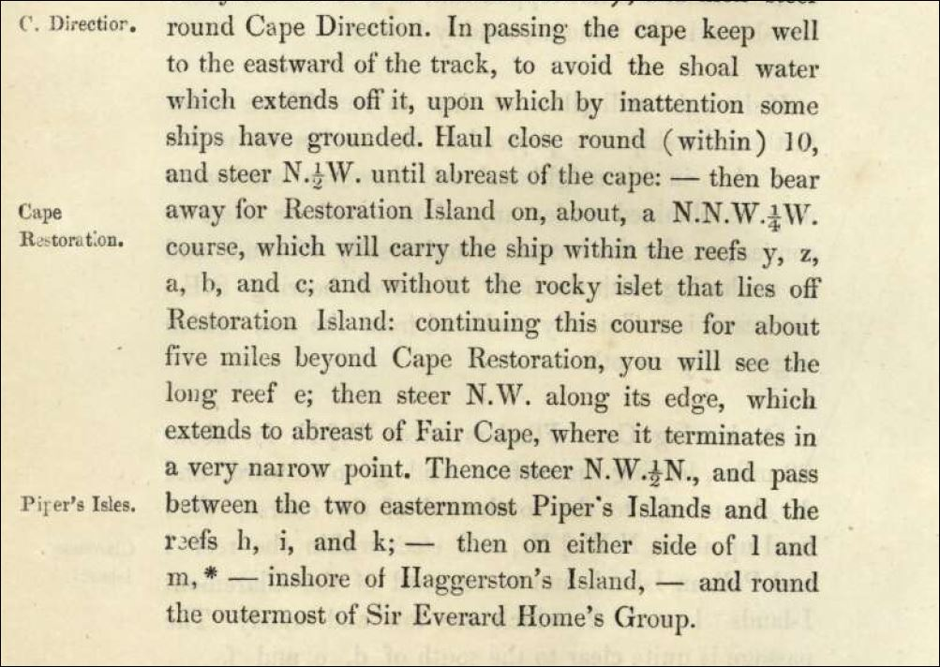
Figure 1: Excerpt from Lieutenant Phillip Parker King's 'Sailing directions for the inner route to Torres Strait from Break-Sea Spit to Booby Island.⁴

Historic events
- Endeavour Reef is where Captain James Cook ran aground over two centuries ago.¹
- Ellison Reef is important to the Great Barrier Reef as it is the place where a team of volunteers surveyed the reef to prove that it was ‘alive’ in order to protect it from being mined for limestone. The campaign raised the national profile of the Great Barrier Reef and a subsequent Royal Commission paved the way for the declaration of the Marine Park and the establishment of the Great Barrier Reef Marine Park Authority (the Authority).⁵
- Dunk Island is connected with the author and naturalist Edmund Banfield and his grave is located near his island home (which is listed on the Queensland Heritage Register).
- Low Isles was the base of the Great Barrier Reef Expedition led by Charles Maurice Yonge during 1928-29. The expedition was the first of its kind, investigating the Reef over 10-months. It was the first detailed scientific study of the Reef covering geography, biology, geology and coral taxonomy.⁶ The expedition also contributes to the scientific heritage of the Great Barrier Reef.¹
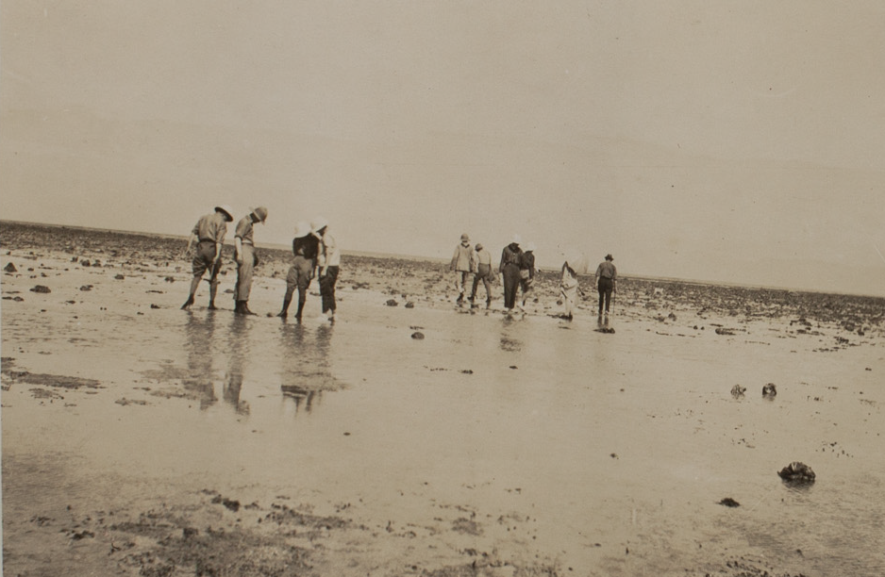Photograph from the Great Barrier Reef Expedition 1928-29, captioned ‘First day in reef Low Isles, 7 July 1928’. Source: Great Barrier Reef Marine Park Authority | Photograph from the Great Barrier Reef Expedition 1928-29, captioned ‘Batt Reef, 2 August 1928’. Source: Great Barrier Reef Marine Park Authority

Aboriginal and Torres Strait Islanders during colonisation
- During colonisation Traditional Owners were mistreated and there are known examples of slavery, removal, torture, poisoning, shootings, drownings, and massacres.^{7,8,9,10} For example at Little Peninsula on Great Keppel (Wop-pa) Island there are remnants of a metal stay in a tidal cave, known as ‘drowning cave’ – a place where Traditional Owners were chained up for punishment.^{7,9,10} Drownings occurred in the tidal cave but it is not known how many were killed in this way. On North Keppel (Ko-no-mie) Island a camping site remains and is where seven or eight male Traditional Owners were shot in one night.^{10,11}
- Such stories and sites associated with colonisation are reminders of this difficult time and link the present generations to their ancestors and are likely to be significant to Traditional Owners. These sites or locations may also be significant to other Aboriginal and Torres Strait Islanders out of respect for the Traditional Owners of the land and sea country (also see Traditional Owner heritage assessment guidelines and the Woppaburra heritage assessment guidelines). Further, the stories and sites of mistreatment may also be significant to non-Indigenous people by providing an important avenue to increase the knowledge of that time in Australian history.
- There are examples where survivors of shipwrecks were taken in and cared for by local Aboriginal communities. One such example is described in the biography of James Morrill.¹² Morrill was born in England in 1824 and was the only long-term survivor of the Peruvian (1846) shipwreck, which wrecked in the Coral Sea on her voyage from Sydney to China. Following the wreck, 21 people drifted at sea on a makeshift raft and after 42 days only seven people had survived the journey when the raft landed near Cape Cleveland, Townsville. Four died soon after making land, leaving the Captain George Pitkethly, his wife, and Morrill as the remaining survivors. The three of them were adopted by the local Aboriginals. Pitkethly and his wife joined a band in the region but both died within two years. Morrill continued to live with the local Aboriginal communities for 17 years. Morrill was an effective interpreter and known to promote peaceful conciliation. He accompanied George Dalrymple on an expedition to open the port of Cardwell in 1865 and was on the Ariel when the first cargo of bonded goods was delivered into a settlement of Cleveland Bay, now known as Townsville. He married Eliza Ann Ross and had one son. Morrill died on 30 October 1865.

Change in use
- Stephens Island in the Barnard Group is connected with early bêche-de-mer fisher Stephen Illidge who occupied the island in the late 1800s. Many Aboriginal people worked at the bêche-de-mer station until the 1890s when the station and dwellings were destroyed by a cyclone.¹³
- Lizard Island is connected with the early pioneer Mrs Watson whose husband shared a bêche-de-mer fishing station on Lizard Island. Whilst her husband was away fishing, she along with her baby and a Chinese workman fled Lizard Island in a square ship’s tank (used for boiling bêche-de-mer) following a conflict with Traditional Owners who may have arrived on the island for ceremonial reasons. Several days later the three had died of dehydration and their bodies found at No 5 Howick Island.¹⁴
- Cod Hole is an iconic dive site and one of the first parts of the Great Barrier Reef to receive marine park protection.
- John Brewer Reef is the site of the first floating hotel and is also known to have significant unexploded ordnance at a WWII disposal site (refer to WWII features and sites, and voyages and shipwrecks assessment guidelines).
- Green Island, Magnetic Island, Low Isles and Newry Island played significant roles in the evolution of tourism in the Marine Park. For example, organised pleasure cruises have been operating at Green Island since 1890 along with a passage ferry since 1924.¹⁵ The underwater observatory at Green Island was one of the first in the world.
- Whitehaven Beach is a spectacular and high-profile white sand beach in the Whitsundays, a beach that is a popular location visited and appreciated by many. Staff Commander Edward Parker Bedwell named Whitehaven Beach in 1879.¹⁶ During surveys on a steam pilot cutter vessel named Llewellyn, Staff CMDR Bedwell named many locations in the Whitsunday region, such as Keswick Island and St Bees Island.¹⁷ The vessel worked in Queensland waters from 1878-79 and is not to be confused with Q.G.S.S Llewellyn (pilot vessel).¹⁷ Ironically, Q.G.S.S Llewellyn became shipwrecked in 1919 south of the Whitsundays near Keswick Island and St Bees Island.¹⁷
- Scientific research stations along the reef are of historic and scientific significance. Fisheries scientist William Saville-Kent is a key figure in early Reef science. With the starting point of the commercial potential of the Reef, he collected and recorded hundreds of Reef species and advocated for teaching marine biology and establishing research stations.¹⁸

Names of reefs and geographic features
- In more recent times a Tripartite agreement was established in the 1980s, involving the Authority, the Australian Hydrographic Office and the Queensland Department of Environment and Heritage Protection, which sets out the naming protocols for reefs. Refer to the Authority naming of reefs and undersea geographic features for a list of reefs named through the tripartite agreement. Reefs and geographic features have been named after significant people, Traditional Owner clans or events, for example:
  - Felicity Wishart Reef named in 2017
  - Cowboys Reef named in 2005
  - Bandjin Reefs named in 2001
  - Rachel Carson Reef named in 1997.

Management
- The following section explains the legislation, standards and policies that are most commonly used in managing historic heritage. Also refer to the Permission System Policy for a list of legislation, standards and policies used through the permission system.

Zoning and legislation
- As stated in the Great Barrier Reef Marine Park Act 1975, “The main object of this Act is for the long term protection and conservation of the environment, biodiversity and heritage values of the Great Barrier Reef Region”. Another object of the Act is to allow ecologically sustainable use of the Great Barrier Reef Region so far as is consistent with the main object. Human uses which may be allowed include:
- public enjoyment and appreciation
- public education
- recreational, economic and cultural activities
- research in relation to the natural, social, economic and cultural systems and values of the Great Barrier Reef.
- Heritage is important to people of present and future generations, thus the significance of a site or location is determined through its social values, in particular aesthetics, personal connection, equity, enjoyment, appreciation and understanding (refer to Social value assessment guidelines for further information).
- There are management tools used to protect and manage impacts to historic heritage values.
  - Plans of Management are statutory plans used primarily for managing human uses in popular recreation or tourism areas. They seek to protect biodiversity and heritage but also to manage competing uses. For example, Low Isles is a popular destination for tourists and locals located offshore from Port Douglas where usage pressures are managed through the Cairns Area Plan of Management. The area around Low Island and the island’s lagoon area are referred to as the Low Island Locality and managed as a Sensitive Location identified as having special values (nature conservation, cultural and heritage, scientific or use values).
  - Special Management Areas (SMA) are designated for a number of reasons. One type of SMA that is particularly relevant to historic heritage is the Maritime Cultural Heritage Protection SMA, which limits activities that can be permitted in those areas (refer to Maritime Cultural Heritage Protection SMA assessment guidelines). Another relevant SMA is the Public Appreciation SMA, which restricts spearfishing, commercial aquarium collecting, and other extractive uses in specific Conservation Park (Yellow) Zones which are popular with recreational visitors.
- The Location specific assessment guidelines provide more information about Plans of Management and Special Management Areas.

Policy
- Site-specific plans, policies and management arrangements have been published for many locations and sites within the Marine Park. They identify significant values of the site and describe how the Authority intends to manage human uses to protect these values. See the Location-specific assessment guidelines for more information about these non-statutory site plans.
- The Authority’s Heritage Strategy 2005 outlines actions to identify, assess and monitor the Marine Park's heritage values, such as historic heritage. This includes developing a heritage register and heritage management plans for individual sites.
- The Authority is developing an Aboriginal and Torres Strait Islander Heritage Strategy to improve the conservation and protection of cultural heritage values in the Marine Park.

Management objectives
- The Reef 2050 Long-term Sustainability Plan (Reef 2050 Plan) explains how the Authority and the Queensland Government will respond to the challenges facing the Great Barrier Reef and contains a number of actions relevant to historic heritage, such as developing impact assessment guidelines for cultural heritage values in the Great Barrier Reef Region. The Reef 2050 Plan addresses the findings of the Outlook Report 2014 and builds on the Strategic Assessment Report.
- The values of the Marine Park, their integrity and their current condition are described in the Outlook Report 2014 and the Strategic Assessment Report 2014. Refer to Table 1 for summary assessment of historic heritage values.
Table 1: Summary assessment of historic heritage condition, trend and overall management objective based on the Outlook Report and the Strategic Assessment Report.
Historic heritage value | Area | Current Condition | Trend | Management Objective
Other places of historic significance | Reef-wide | Poor | Improving | Improve

Common assessment considerations
- The Authority expects that when submitting an application for Marine Parks permission, the applicant provides adequate information about the proposed activity to allow an assessment of potential impacts and determine appropriate avoidance and mitigation measures. The applicant should give consideration to the potential impacts (direct, indirect, flow-on and cumulative) on the Marine Park values (such as historic heritage values and social values) over time and space (refer to Application Guidelines and Assessment Guidelines).
- The way historic heritage sites are managed differs between sites and depends on the proposed location and the proposed activities and operation. Managing these sites requires specialist understanding of the features present and requires experts in the relevant discipline to determine the best management approach prior to disturbance of a site (such as social impact specialist, and/or maritime archaeologist). The Authority expects that applicants will engage the relevant experts and it is recommended to consult with the Authority on this matter before submitting an application for a permission and during the assessment of an application.
- As many of these places of historic and social significance have intangible attributes that contribute to historic heritage value, background research may be required to determine their social significance (refer to Social value assessment guidelines). This is mostly undertaken through research investigating archival records, historic news articles or local stories including face to face interviews. In some cases a social impact assessment may be required to understand how the proposed activities are likely to impact on the historic heritage value of the location (refer to Social value assessment guidelines).
- Particularly sensitive and unique historic heritage sites require special considerations when determining the level of risk and the assessment approach required. These sites may include those that contain human remains and/or are unique example in the Marine Park.
- If there is an identified likelihood of artefacts or features, or archaeological evidence at the site, pre-disturbance surveys may be required. The survey should identify the possible impact area (including indirect or flow-on impacts) and evaluate the likelihood of the site holding historic heritage significance.
- If research identifies that historic heritage is likely to be present and thus potentially impacted, the applicant may be required to arrange a field-based survey conducted by a qualified archaeologist using appropriate methods.
- For activities that are likely to disturb the seabed in any area (such as dredging, pipe or cable laying, marina development or installing moorings), an in-depth site survey may be required using visual, sonar or magnetometer surveys techniques.
- Depending on the assessment approach and the risks associated with the proposed activity, an Environmental Management Plan (EMP) may be required to be prepared by an applicant before submitting an application for a permission, during the assessment of the application, or after a permission has been granted (refer to Assessment Guidelines). If there are known tangible or intangible attributes of historic heritage that may be impacted from the proposed activity, a Heritage Management Plan may form a component of the EMP. The Heritage Management Plan may need to cover the site, and in some cases the adjacent area, to provide protection and a buffer around the site of interest.
- The Heritage Management Plan of the EMP should be developed by an appropriately qualified person (and if applicable, have experience in substrate stability and maritime archaeology). The EMP will require approval from the Authority prior to any permitted activities taking place (refer to Assessment Guidelines).
- Depending on the proposed activity and the assessment approach required, Traditional Owners may be required to be consulted to provide advice on potential impacts to their values and identify suitable avoidance and mitigation measures that reduce the risk to their values. Refer to Traditional Owner heritage assessment guidelines for further information about Traditional Owner consultation, as well as the location specific Woppaburra heritage assessment guidelines).

Links to other values

Social value
- The significance of a place, site or location may consist of historic, social, aesthetic and/or scientific (such as its archaeological attributes) values. The degree of significance may be influenced by its uniqueness or how rare it is, if it involves an influential or significant event or person/people and its importance on a local, state, national or international scale (also see Social values assessment guidelines).
- Examples of interactions between social values and historic heritage values include:
- Personal connection – people may have a personal connection to a location due to the story or history of a place, or a name association with a place. For example, Rachel Carson who was a well-respected American marine biologist, author and conservationist with an international profile may inspire a personal connection with Rachel Carson Reef. Further, Ellison Reef may be a source of inspiration for people and may influence people’s sense of empowerment due to its importance in the evolution of understanding about the Reef.
- Aesthetics – It is recognised that culture, knowledge, expectations and past experience mediate people’s perceptions and experiences. As a result, aesthetic responses are linked to both the characteristics of an environment and the cultural or personal preferences.¹
- The aesthetics of Ellison Reef for example is of social significance because it is the location where it was scientifically proven the reef system was ‘alive’.
However, the significance of that place is likely to be based not just on the story associated with Ellison Reef but also the biodiversity values which led to the identification of living reef that contributes to its significance.
- For natural features of a reef, aesthetic values are generally associated with the outstanding natural values and attributes of the environment.¹⁹ However, historic features and sites (for example a shipwrecks and lightstations) also have aesthetic value and aesthetics is one of the criterion used to measure its social significance.²⁰
- Traditional Owner perspective on aesthetics may include cultural expressions such as storytelling, mythology, spirituality, literature, music/art, symbols of power, or wealth.¹⁹
- Access – increased use of a location or site could provide opportunities for improved understanding, appreciation and enjoyment. On the other hand, more people visiting or a significant development at a location could negatively impact on the aesthetics, personal connection to place and their appreciation and enjoyment. It may add or detract from what gives it social significance.
- Understanding, appreciation and enjoyment – understanding the historic significance of a site or location is likely to increase appreciation of the place and enhance one’s experience. In some cases the experience may provide enjoyment, and in others stimulate a deeper sense of personal understanding. It can also be a source of inspiration.
- Equity – referring to both intra- and inter-generational equity, the value of historic heritage should be considered within each generation, as well as between generations. The loss or damage to historic heritage is likely to erode social equity. Equity is maintained through sustainable use.

Traditional Owner value
- As previously mentioned, places of historic heritage value can also have Aboriginal or Torres Strait Islander heritage value.
- Traditional Owners were severely impacted during colonisation and many Traditional Owner heritage values declined during and following that period in Australian history. Stories and sites associated with colonisation are reminders of this difficult time and link present generations to their ancestors.
- Traditional Owners have inhabited their sea country for tens of thousands of years and have Aboriginal and/or Torres Strait Islander names for many locations throughout the Marine Park. None of which have been formally recognised. However, there is increasing acknowledgement of the Aboriginal and Torres Strait Islanders and in recognition, their names of locations where known appear alongside European names in Marine Parks maps and signs.
- Further, historic heritage significance for Traditional Owners may include recent recognition and rights.
- Refer to the Traditional Owner heritage assessment guidelines for more information.

Historic heritage value
- In addition to the other places of significance described in these guidelines, there are three other categories of historic heritage: Maritime cultural heritage protection special management area; WWII features and sites, and voyages and shipwrecks; and Lightstations and aids to navigation (refer to respective value assessment guidelines).

Biodiversity value
- Many historic heritage sites and features became historically important because of their biodiversity value. Ellison Reef is a good example as it was the biodiversity value of the location that provided the scientific evidence the reef was alive.
- In some cases, plants and animals provide a protective encrusting layer over the fabric of a site or artefact, which may stop or at least slow the rate of corrosion.
- Submerged historic heritage structures or artefacts in the Marine Park may have been colonised by various marine organisms. If such a structure or artefact is proposed to be retrieved and conserved, the assessment should consider the proposed fate of corals and other marine organisms colonising the artefact. The expectation is that recovery of artefacts is conducted with minimal impact on plants and animals. In many cases, feasible alternatives may involve organisms relocated to suitable habitat near the site (refer to the Authority Translocation Position Statement).

Hazards
- The Risk Assessment Procedure lists the most common potential hazards to the values of the Marine Park, as well as permission types able to be granted under the Zoning Plan. The hazards associated with permitted activities that are most likely to impact on other places of historic heritage, including the flow-on effects are listed in Table 2 of the Social value assessment guidelines (particularly relevant when considering hazards to intangible attributes, such as stories) and Table 2 of the WWII features and sites, and voyages and shipwrecks assessment guidelines (particularly relevant when considering hazards to tangible attributes, such as artefacts and features).
- Maritime archaeological research (or cultural heritage research) is a diligent and systematic inquiry or investigation into historic heritage values in order to discover facts or principles and improve the understanding of a place, its condition and its history. Research may involve new techniques for investigating and preserving the value. Survey methods may include recording, cataloguing, mapping, or otherwise describing the site. It is recommended the applicant contact the Authority prior to submitting a Marine Parks permit application to undertake this type of research.

Mitigation and monitoring
- Mitigation and monitoring measures are discussed in the mitigation and monitoring section in the Social value assessment guidelines and WWII features and sites, and voyages and shipwrecks assessment guidelines.
- The Reef Integrated Monitoring and Reporting Program is establishing monitoring protocols for setting baseline conditions and monitoring changes to attributes of historic heritage value.

Consequence
- Consequences of proposed activities to the immediate and adjacent area of places of historic significance will be determined on a case by case basis. They will be assessed and evaluated by appropriate the Authority staff and in some cases involve other experts. Also refer to the Risk Assessment Procedure for more information on how to determine risk and consequence.
- When considering consequences to other places of historic significance, also consider the consequences described in the Social value assessment guidelines (in particular for intangible attributes, such as stories) and WWII features and sites, and voyages and shipwrecks assessment guidelines (in particular for tangible attributes, such as artefacts and features).
Assessment information
- Additional information may be required to be provided by an applicant for a permission depending on the type of activity. This is outlined based on the assessment approach. Refer to the Application Guidelines for more information on how assessment approach is determined.
- Depending on the permission type, the Authority may require applicants to provide social and heritage impact assessments conducted and reported by an appropriately qualified person. Other information that may be useful when assessing potential impacts on social values includes:
- Analysis of commercial and non-commercial uses that may be impacted positively or negatively from the proposed activity.
- Identification of broad drivers (direct and indirect impacts to social values) of change relevant to the proposed activity, as defined in the Strategic Assessment Report.
- Identification of stakeholders and affected parties to detect who may be affected (both positively and negatively) by the proposed activity and what level of public participation should occur.
- For higher risk or more complex proposals (those requiring public comment through the assessment approach), an Environmental Management Plan containing a Heritage Management Plan which considers social significance may be required from the applicant. The plan should:
- describe existing social values within the likely proposal impact zone
- explain how impacts to these social values were assessed including analysis (quantitatively where possible) of potential positive and negative impacts of the proposal
- explain stakeholder or public comment that was conducted and summarise the results
- describe proposed avoidance, mitigation or offset measures
- describe proposed monitoring and management strategies (if the proposal is approved), including ongoing roles of stakeholders throughout the life of the activity.

Implementation
- These guidelines will be reviewed and updated if required at least every three (3) years.
- The Permission System Policy and other guidelines are available which provide further detail on how the Authority assesses, decides and manages specific aspects of the permission system and the application process.
- For actions that are wholly or partially outside the Marine Parks, the Authority will continue to liaise with the Commonwealth Department responsible for the EPBC Act. Where a bilateral agreement exists between the Australian Government and the Queensland Government, depending on the terms of the agreement the Commonwealth Department’s role may be delivered by the Queensland Government. The Authority will work with both levels of government according to agreed procedures, such as a Memorandum of Understanding, to provide advice on matters that may affect the Great Barrier Reef.

Definitions
Refer to the Permission System Policy for a list of general definitions relating to the permission system.
Burra Charter
Is the primary reference for managing the heritage values of historic places.²⁰
Fabric
Means all the physical material of the place including components, fixtures, contents, and objects (Burra Charter).²⁰
Protective layer
Is the marine biota that includes the calcareous layer covering the fabric of a site protecting it from corrosion.

Supporting Information
1. Great Barrier Reef Marine Park Authority 2014, Great Barrier Reef Outlook Report 2014, Great Barrier Reef Marine Park Authority, Townsville.
2. Czechura, G. 2013, The Great Barrier Reef: a Queensland Museum discovery guide, Queensland Museum, South Brisbane.
3. Great Barrier Reef Marine Park Authority and the Department of Environment and Heritage Protection in draft, Mermaid 1816-1829 Conservation Management Plan, the Authority and EHP, Townsville, Queensland.
4. King, P.P. 1843, Sailing directions for the inner route to Torres Strait from Break-Sea Spit to Booby Island, http://nla.gov.au/nla.obj-189652771, Port Stephens, N.S.W.?.
5. Daley, B. 2005, Changes in the Great Barrier Reef since European settlement: Implications for contemporary management, PhD thesis, James Cook University, Townsville.
6. Bowen, J. 1994, The Great Barrier Reef: towards conservation and management, in Australian Environmental History, ed. S. Dovers, Oxford University Press, Melbourne, pp. 234-256.
7. Rowland, M. 2004, Myths and non‐myths. Frontier ‘massacres’ in Australian history: the Woppaburra of the Keppel Islands, Journal of Australian Studies 28(81): 1-16.
8. Roth, W.E. 1898, The Aboriginals of the Rockhampton and surrounding coast districts, in Reports to the Commissioner of Police and others, on Queensland aboriginal peoples 1898-1903, ed. W.E. Roth, State Library of Queensland, Brisbane.
9. Woppaburra People & Australian Museum 2013, Introduction to Woppaburra history, Australian Museum, viewed 27/06/2017, < https://www.australianmuseum.net.au/movie/introduction-woppaburra-history>.
10. Morris, A.J. 1989, My island in the sun: an early history of Great Keppel Island, Alan J. Morris, 56 Pattison Street, Emu Park, 4702.
11. McClelland, R. 1903, 'The proposed reserve for Aborigines: to the editor', Morning Bulletin (Rockhampton), 28 January, p. 6.
12. Bolton, G.C. published first in hardcopy 1967, Morrill, James (1824–1865), Australian Dictionary of Biography, National Centre of Biography, Australian National University, viewed 26 July 2017, < http://adb.anu.edu.au/biography/morrill-james-2484>.
13. Queensland Government 28 November 2016, Barnard Island Group National Park: Nature, culture and history, Queensland Government, viewed 31 May 2017, < https://parks.des.qld.gov.au/parks/barnard-island/culture.html>.
14. Stephens, S.E. published first in hardcopy, 1976, Watson, Mary Beatrice (1860–1881). Australian Dictionary of Biography, National Centre of Biography, Australian National University, viewed 14 June 2017, < http://adb.anu.edu.au/biography/watson-mary-beatrice-4813/text8025>.
15. Zeppel, H. 2011, Managing tourism on Green Island, Great Barrier Reef Marine Park: Conservation, commerce and compromises, in Island tourism: Sustainable perspectives, eds J. Carlsen and R. Butler, CABI Publishing, Wallington, UK, pp. 38-53.
16. Wikipedia 14 June 2017, Whitehaven Beach, Wikipedia, viewed 22 August 2017, < https://en.wikipedia.org/wiki/Whitehaven_Beach>.
17. Hopkins-Weise, J. 2006, A history of the service and loss of the Queensland Government Steamer Llewellyn, 1884-1919. in Memoirs of the Queensland Museum, Cultural Heritage Series4(1):29-51 edn, Queensland Museum, Brisbane.
18. Bowen, J. and Bowen, M. 2002, The Great Barrier Reef: history, science and heritage, Cambridge University Press, Melbourne, Australia.
19. Context Pty Ltd 2013, Defining the aesthetic values of the Great Barrier Reef, Department of Sustainability, Environment, Water, Population and Communities, Canberra.
20. Australia International Council on Monuments and Sites (ICOMOS) 2013, Charter for Places of Cultural Significance, The Burra Charter, 2013.
Further information
Director – Environmental Assessment and Protection
Great Barrier Reef Marine Park Authority
280 Flinders Street
PO Box 1379
Townsville Qld 4810
Australia
Phone + 61 7 4750 0700
Email: consultation@gbrmpa.gov.au
www.gbrmpa.gov.au
Document control information
Approved by: | General Manager, Biodiversity, Conservation and Sustainable Use | Approved date: | 27-Sep-17
Minor amendment approved: | General Manager, Reef Protection | Approved date: | 14 August 2019
Notes: | Minor amendments to reflect Great Barrier Reef Marine Park Regulations 2019. Full review not yet completed.
Last reviewed: | 31-Aug-17
Next review: | 27-Sep-20
Created: | 31-Aug-17
Document custodian: | Director, Environmental Assessment and Protection
Replaces:

