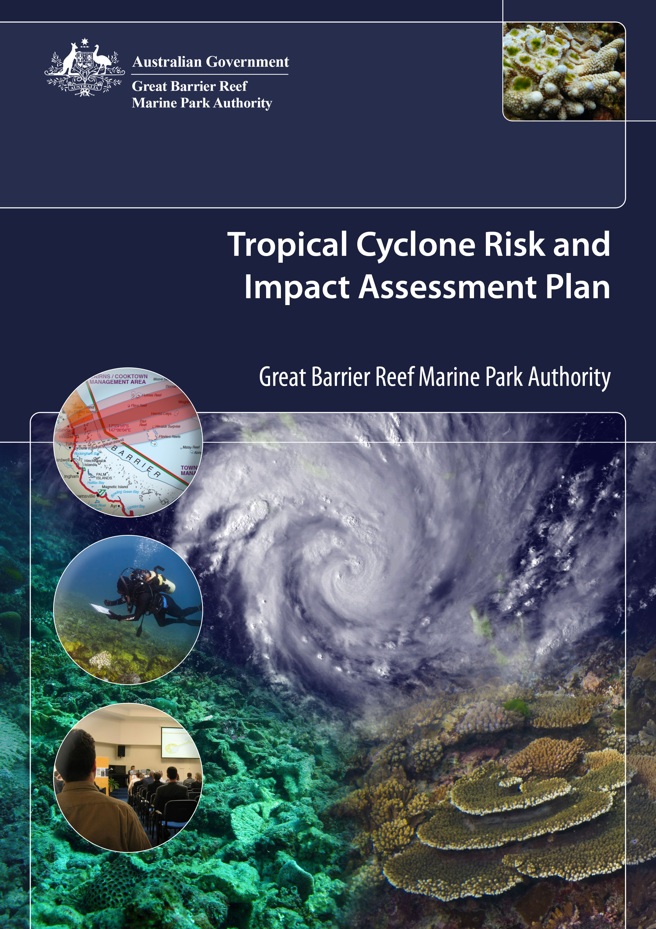

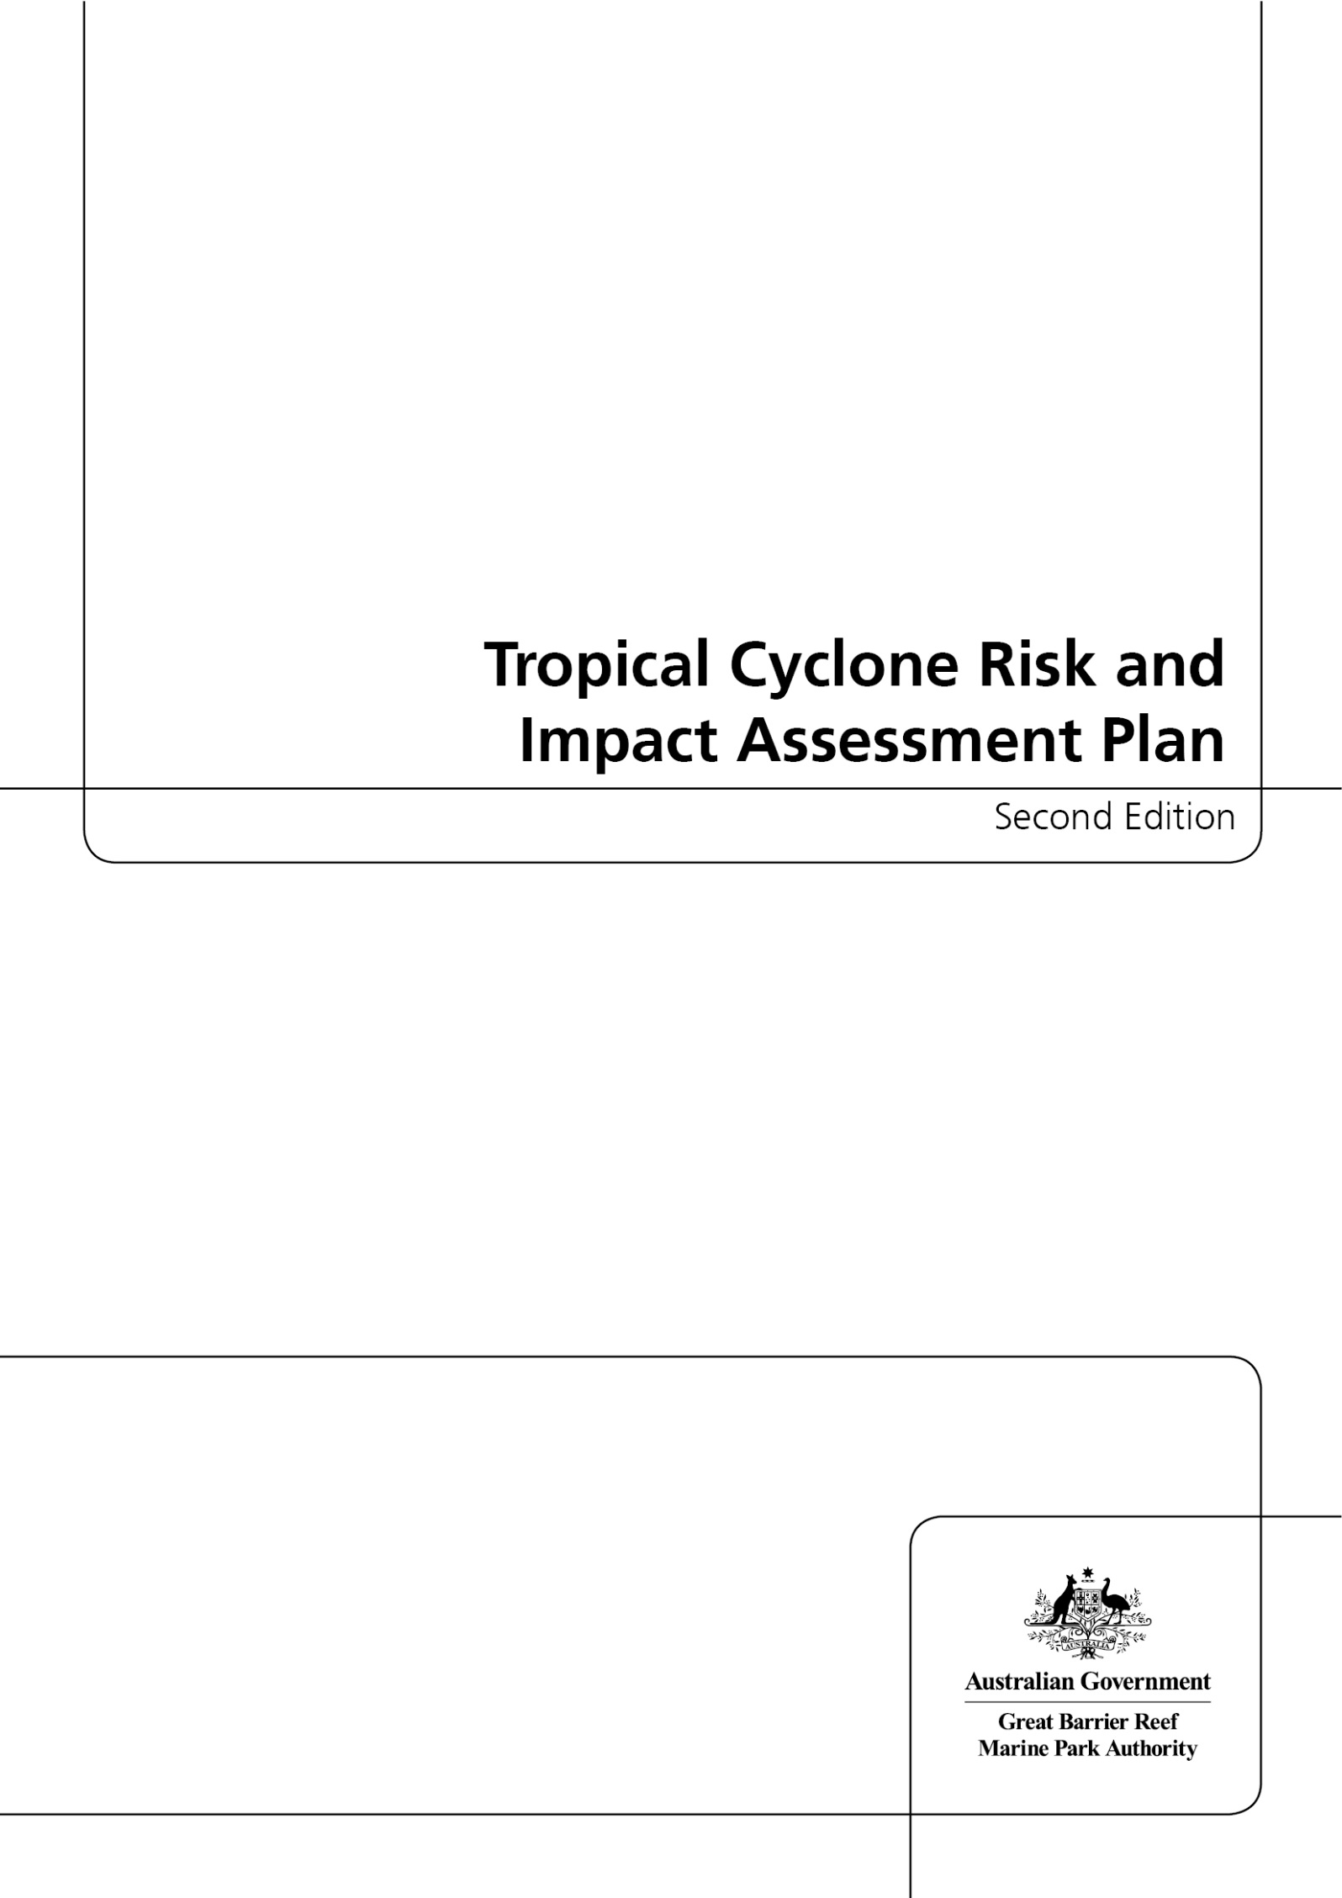

© Commonwealth of Australia 2013

Published by the Great Barrier Reef Marine Park Authority

Tropical Cyclone Risk and Impact Assessment Plan Second Edition

ISSN 2200-2049

ISBN 978-1-922126-34-4 Second Edition (pdf)

This work is copyright. Apart from any use as permitted under the Copyright Act 1968,
no part may be reproduced by any process without the prior written permission of the
Great Barrier Reef Marine Park Authority.

Requests and enquiries concerning reproduction and rights should be addressed to:

Director, Communications and Parliamentary
2-68 Flinders Street
PO Box 1379
TOWNSVILLE QLD 4810
Australia

Phone: (07) 4750 0700
Fax: (07) 4772 6093
info@gbrmpa.gov.au

Comments and enquiries on this document are welcome and should be addressed to:
Director, Ecosystem Conservation and Resilience
info@gbrmpa.gov.au
www.gbrmpa.gov.au
Executive summary

Waves generated by tropical cyclones can cause major physical damage to coral reef ecosystems. Tropical cyclones (cyclones) are natural meteorological events which cannot be prevented. However, the combination of their impacts and those of other stressors — such as poor water quality, crown-of-thorns starfish predation and warm ocean temperatures — can permanently damage reefs if recovery time is insufficient. In the short term, management response to a particular tropical cyclone may be warranted to promote recovery if critical resources are affected. Over the long term, using modelling and field surveys to assess the impacts of individual tropical cyclones as they occur will ensure that management of the Great Barrier Reef represents world best practice. This Tropical Cyclone Risk and Impact Assessment Plan was first developed by the Great Barrier Reef Marine Park Authority (GBRMPA) in April 2011 after tropical cyclone Yasi (one of the largest category 5 cyclones in Australia’s recorded history) crossed the Great Barrier Reef near Mission Beach in North Queensland. GBRMPA implements this plan each year during the tropical cyclone season — November to April.

The plan outlines a strategic approach for how we monitor tropical cyclone risks, and how we coordinate and implement responses before, during and after cyclone impacts. The plan has four components, the objectives of which are outlined and described in detail:

- Early warning system
- Mapping potential impacts
- Incident response
- Communications strategy

The early warning system (component 1) alerts the team to expect potential tropical cyclone impacts in the near term (weeks to days). When a cyclone warning is issued, an automated computer program collects relevant technical data from the Australian Bureau of Meteorology. Then, after the storm passes, an initial assessment of potential impact is generated, which rates impact risk from the storm based on its basic characteristics and where it tracked within the region. If a more comprehensive assessment is needed, a map of potential impact is created to rate impact risk based on a newly developed model of the risks of cyclone wave damage. Outputs from this map of potential impacts then inform whether further response is required (component 3, based on the Australasian Inter-service Incident Management System framework). Recommendations to respond at levels 1, 2, or 3 are based on the likelihood of catastrophic damage, its spatial distribution and the extent of the total reef area in the Marine Park that is affected (as estimated by the map of potential impacts). If warranted, detailed field surveys of reef damage enable the creation of a map of actual impact. The map of actual impacts contributes to an up-to-date dynamic understanding of the vulnerability of the Marine Park. It may also guide decisions to take short-term actions to promote reef recovery. Finally, a comprehensive communications strategy (component 4) ensures that key information is relayed in a timely manner to relevant staff, stakeholders, collaborators and members of the public whenever a cyclone poses a threat to the Reef.

The plan is a dynamic operational document that is updated each year to incorporate major advances in cyclone modelling and impact assessment techniques. The plan is one of a number of risk and impact assessment plans that use the multiple-component template (as above) for incident response described within our overarching Reef Health Incident Response System. As a component of our Reef Health Incident Response System, this plan is implemented along with other plans (e.g. for coral bleaching and coral disease) when simultaneous incidents occur. This plan also serves to keep representatives from key partner institutions and the public aware of the nature and extent of cyclone impacts on the Great Barrier Reef.

Contents

Introduction 1
1. Early warning system 6
2. Map potential impact 8
Collecting relevant operational data 8
Completing an assessment of potential impact 9
Producing the map of potential impact 13
3. Incident response 17
Recommendations for response 17
Determining actual response level 19
Response: Assessment and monitoring and reporting impacts 22
Assessing and monitoring cyclone impacts 22
Reporting cyclone impacts 27
4. Communications strategy 30
Importance of management actions 32
Conclusion 33
References 34
Appendix A— Schedule of Cyclone Risk and Impact Assessment Plan routine and responsive tasks for before, during and after the cyclone season 37
Appendix B — Reef Health and Impact Survey form 40
Appendix C — Survey protocol used in monitoring network 41
Appendix D — Assessment of potential impact of Great Barrier Reef cyclones, 1985–2011 42
Appendix E — Operational tool for assessing the likelihood of catastrophic damage to coral reefs of the Great Barrier Reef 45
E.1 Introduction 45
E.2 Stage 1: Assembling data to predict catastrophic damage 45
E.3 Stage 2: Predicting catastrophic damage 50
E.4 Stage 3: Visualising and interpreting the results 50

Introduction

Tropical cyclones (cyclones) can devastate coral reef communities. They generate large waves that can impact individual colonies — breaking, dislodging and stripping them from the reef — as well as reshape the entire reef framework (Harmelin-Vivien 1994). The ecological consequences of catastrophic tropical cyclone wave damage can persist in coral reef community structure for years to centuries (Hughes and Connell 1999). Because the potential for wave damage depends as much on the vulnerability of coral colonies within individual reefs to storm damage as it does on sea state induced by the cyclone (Done 1992, Madin and Connelly 2006), the distribution of damage is typically highly patchy (Fabricius et al. 2008). Consequently, damage to different sections within a single reef can range from none to severe (Figure 1). This happens because some parts of a single reef may be much more exposed to incident waves during the storm than others and because structural vulnerability to wave damage varies at very local scales (tens of metres).
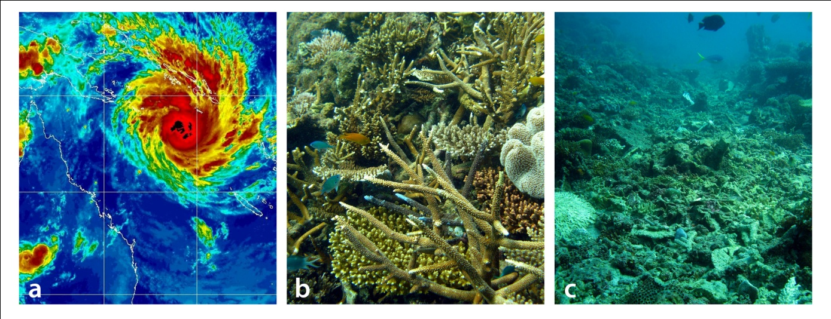

Figure 1: Examples of damage incurred by tropical cyclone Yasi (a) on mid-shelf reef communities in the central section of the Great Barrier Reef (off Tully and Mission Beach) in March 2011. Images (b) and (c) show sections of Bramble Reef; (b) shows a protected section that was untouched while (c) shows an exposed section of the same reef that was devastated.

Cyclones are a natural meteorological phenomenon and cannot be prevented. Indeed, reefs have persisted for millennia despite the intermittent devastation tropical cyclones can cause (Pandolfi 1999). However, like bleaching events and disease outbreaks, cyclones can reduce the resilience of reef ecosystems (Anthony et al. 2011) if the time between events (tropical cyclones and other disturbances) is insufficient for full recovery. This is becoming increasingly possible as chronic anthropogenic sources of stress (e.g. overfishing, pollution) have decreased recovery time between events (Hughes et al 2003, Pandolfi et al 2003), and as cyclones become more likely to cross the Great Barrier Reef (the Reef) at high intensity due to climate change (Walsh et al 2012). Though the Reef has a long history of recovery from tropical cyclones, nearly half of the decline in coral cover across the region over a 27-year period was attributed to cyclone damage (De’ath et al 2012). Indeed, catastrophic reef damage from recent severe tropical cyclone Yasi (2011 — Figure 1) was so widespread that the time needed for full recovery in some locations may well exceed the return times of subsequent storms, leading to lowered resilience and increased vulnerability. The Great Barrier Reef Outlook Report 2009 (GBRMPA 2009) identifies the need for managers to continually assess the ecosystem health of the Great Barrier Reef Marine Park and manage it for resilience. Assessing cyclone impacts ensures that managers have an up-to-date understanding of the vulnerability of the Reef. Managers can therefore distinguish between the effects of acute and chronic stressors (e.g. cyclones and water quality, respectively) and target resilience-building management strategies and awareness-raising communication efforts.

Cyclones that pose a potential risk to the Reef form during summer (November to April) over pools of warm (>26.5 ˚C) water in the Coral Sea and south-western Pacific. Once formed, tropical cyclones track largely within the latitudinal belt of 10 to 30˚S) which spans most of the Reef. Based on historical data since 1970, however, most cyclones crossing the Reef have occurred within the 13˚S to 20˚S latitude band (Figure 2).
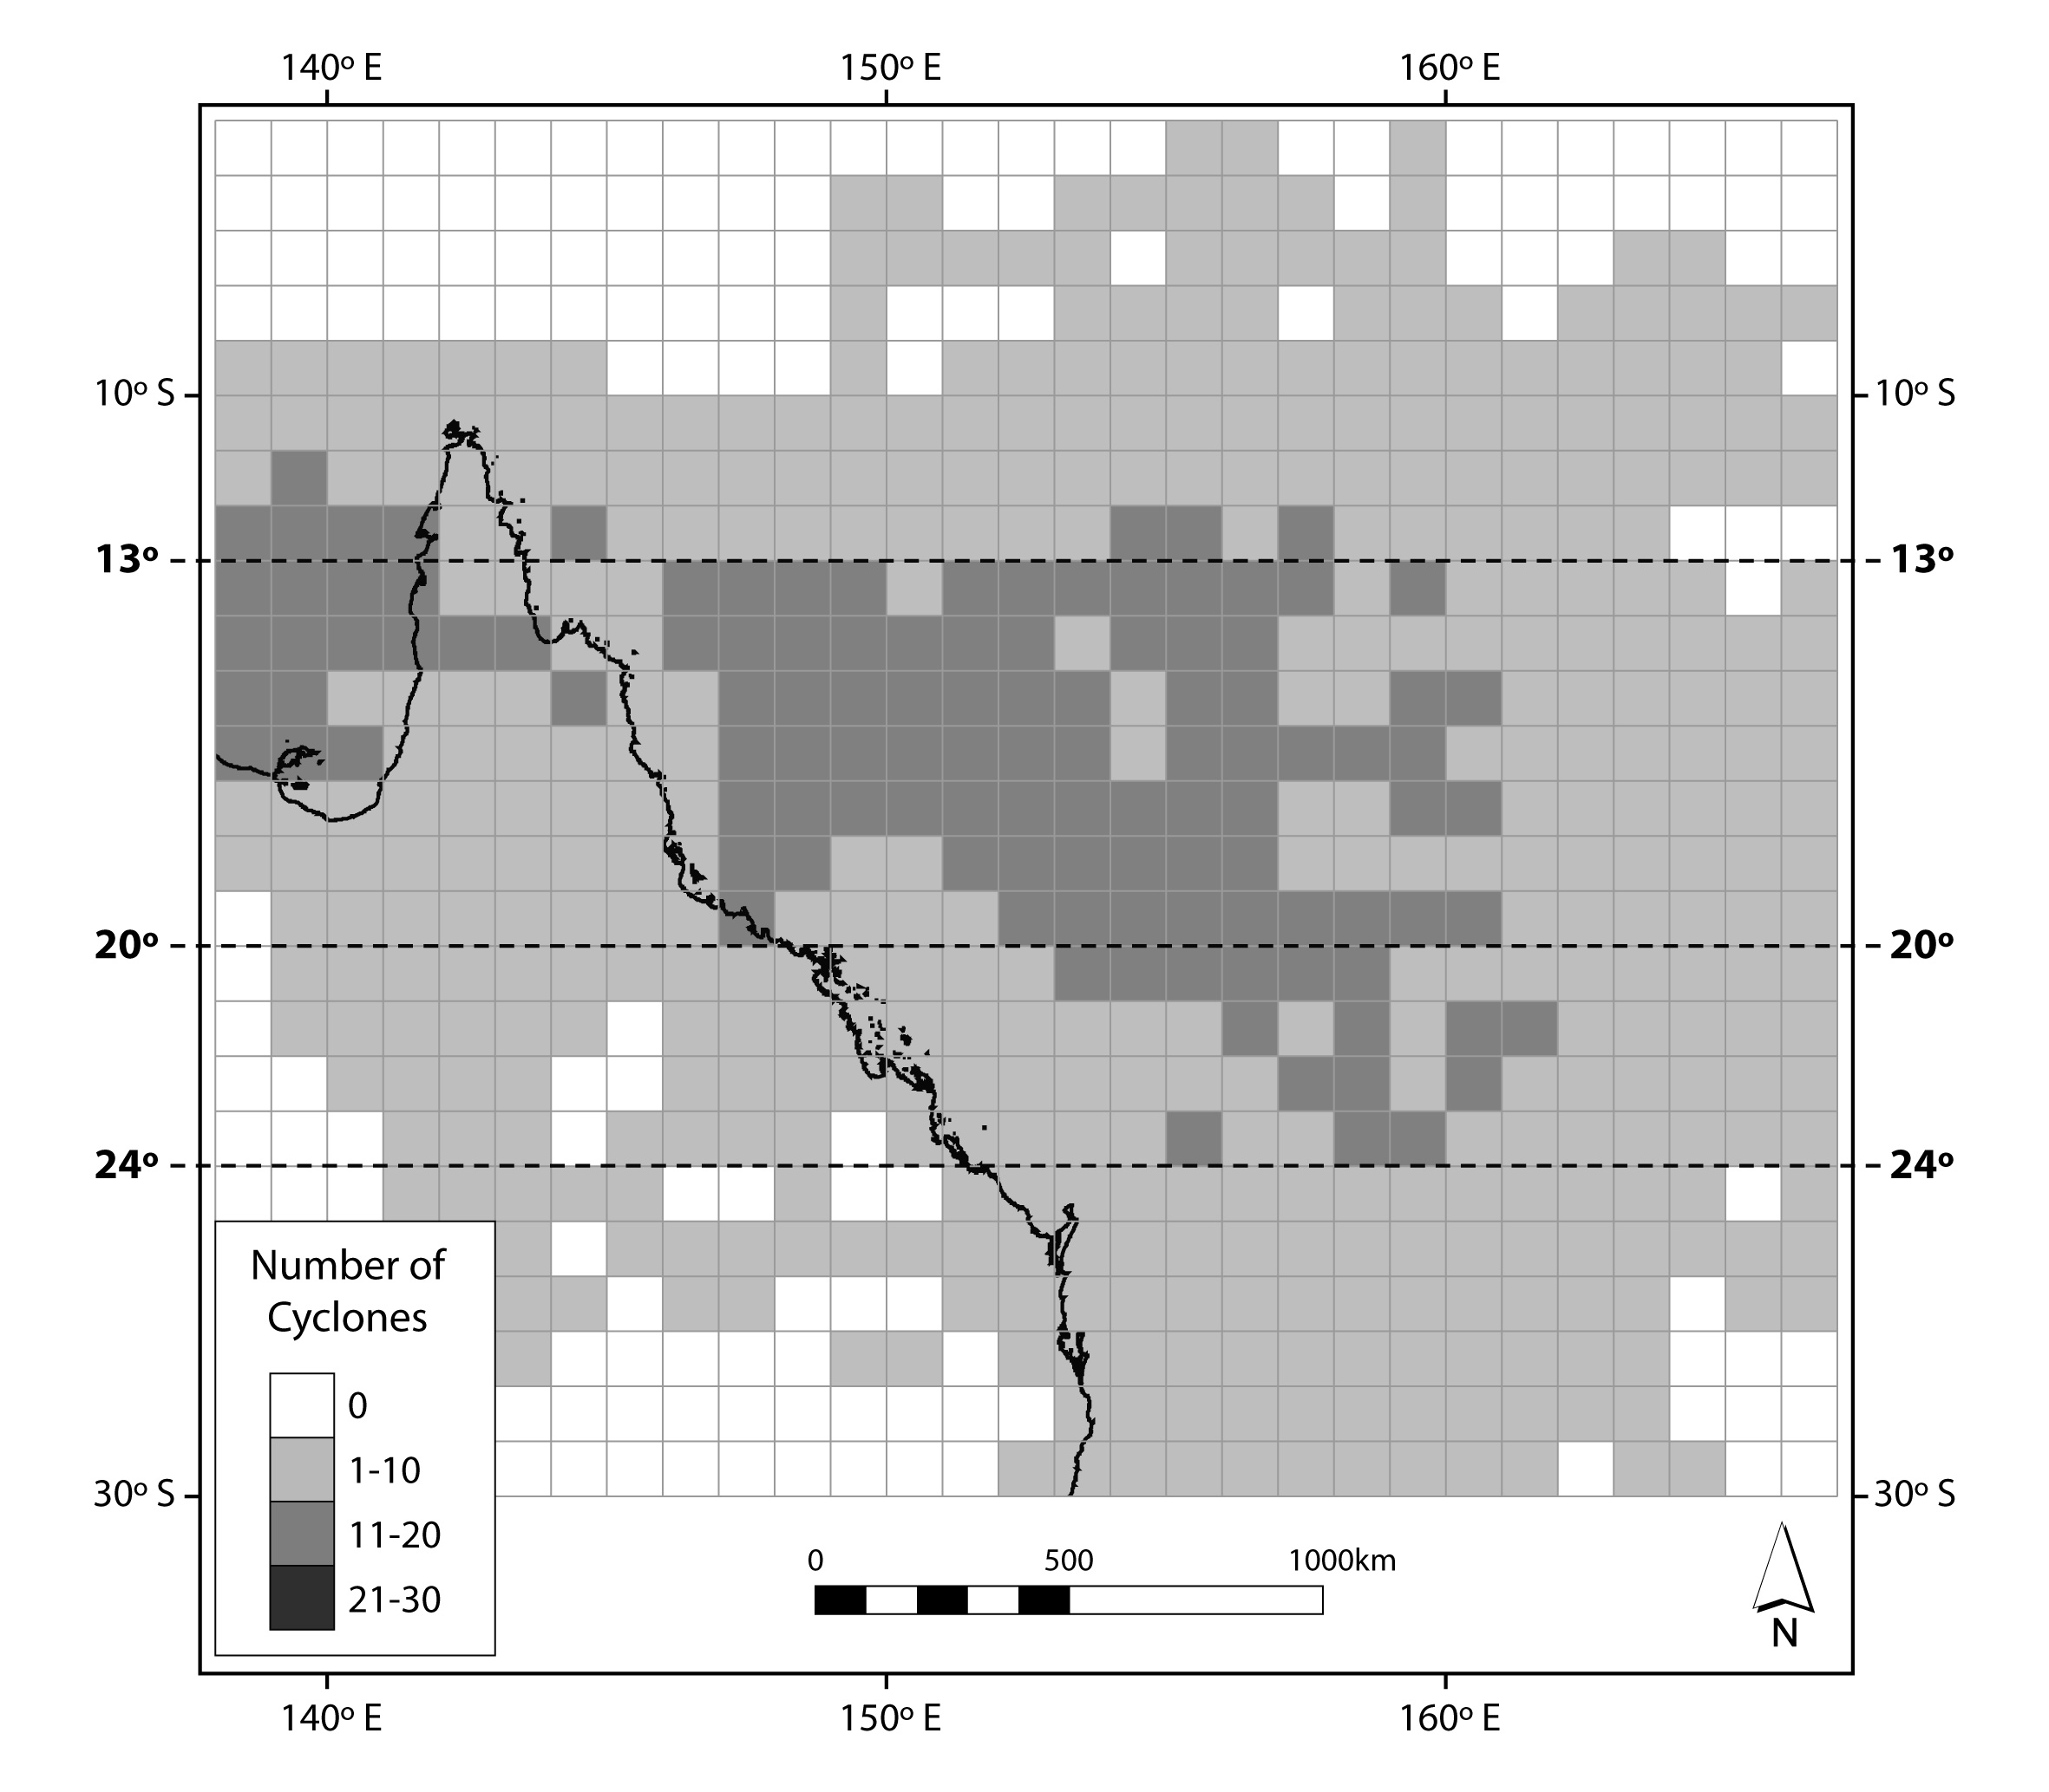

Figure 2: Distribution of the number of named tropical cyclones in Queensland waters between 1970 and 2006. Most named cyclones occurred between 13 and 20˚S. Data are based on observations within 1-degree latitude by longitude cells. (Adapted from Puotinen, 2007a).

On average, four cyclones threaten the Queensland coast every year (Australian Bureau of Meteorology 2012–2013 Tropical Cyclone Season Outlook). This typically results in up to five cyclone days (days during which a location is exposed to gale force or higher winds due to a cyclone) per year (based on 1985–2009 — Carrigan and Puotinen 2011). What happens in a particular year, however, varies depending on factors such as the El Niño-Southern Oscillation. During La Niña conditions, warmer water moves closer to the north-eastern Australian coast (Kuleshov et al 2008), increasing the chance that more of the cyclones that form will track within the Great Barrier Reef Marine Park.

We use the Tropical Cyclone Risk and Impact Assessment Plan (the plan) as an operational document throughout the cyclone season. This is one of a number of plans that use the template for incident response detailed within our Reef Health Incident Response System. The Reef Health Incident Response System guides us and is a transparent and consistent decision-making framework during reef health incidents. The plan serves to keep representatives from key partner institutions as well as the public aware of the technologies and protocols used to predict and assess cyclone impacts. In addition, the plan also describes the criteria that determine how we communicate about cyclone impacts on the Great Barrier Reef when they occur.

The risk and impact assessment plan has four primary components: 1) Early warning system, 2) Map potential impacts, 3) Incident response, and 4) Communications strategy (Figure 3). The plan includes linked routine (light blue) and responsive (dark blue) tasks. The latter are only undertaken if triggered by sufficient cyclone damage risk.

Each cyclone season, seasonal and daily cyclone outlooks are monitored to keep the team aware of potential threats via the early warning system (component 1). Whenever a cyclone warning is issued by the Australian Bureau of Meteorology, efforts to map potential impacts begin (component 2). First, basic data about the cyclone and its characteristics is collected through an automated computer program. This data is used to compile an operational track. Once the cyclone decays to below cyclone strength, these data are used to assess the potential for damage to the Reef through an assessment of potential impact. If risk is other than low to none, this triggers the team to generate a map of potential impact. The map of potential impact is based on reconstructing the distribution of cyclone winds and likely consequent waves around the eye for every hour that the storm could have potentially affected the Reef. The results of the map of potential impact then provide guidance as to whether further response within the incident response framework (component 3) is justified. This is based on the likelihood of catastrophic damage, how widespread it is, and whether it occurs within areas of particular interest, which is predicted in the map of potential impact.

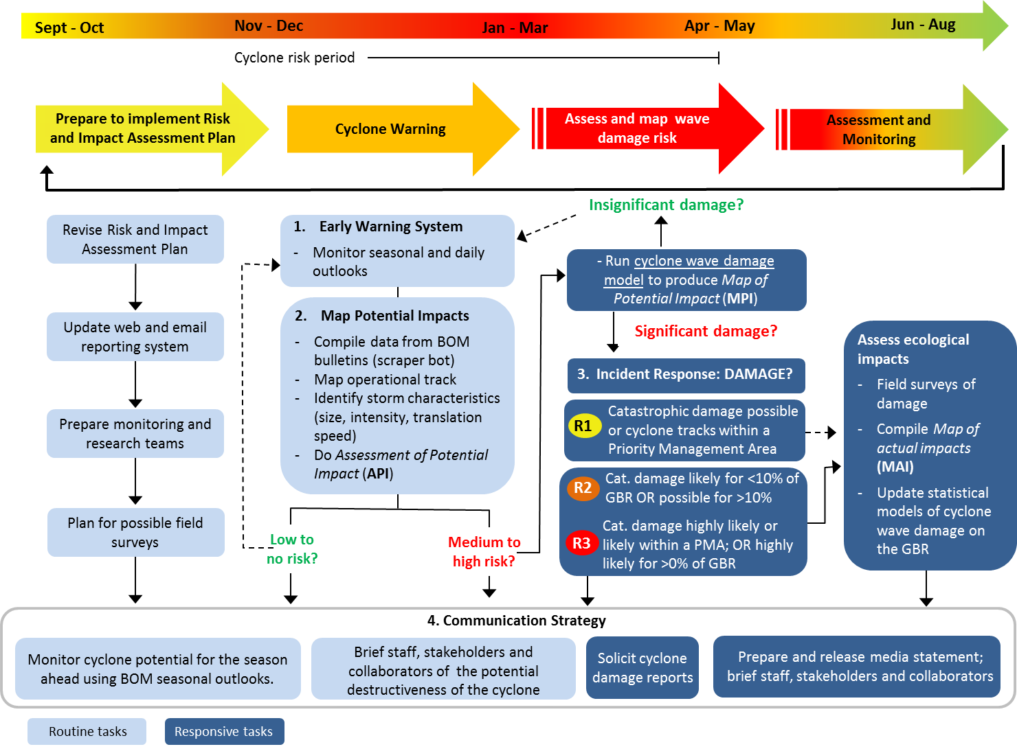

Figure 3: Plan schedule of routine and responsive tasks before, during, and after the cyclone season (see also Appendix A). Components of the plan follow on from each other, but responsive tasks are only undertaken if an incident response is triggered. Response levels 2 and 3 activate efforts to assess and monitor impacts, which is only conditionally activated under response level 1 (see also Figures 12 to 16).

The incident response section of the plan (based on the Australasian Inter-service Incident Management System framework) (see page 23) describes the potential responses in detail. If the map of potential impact triggers field surveys of tropical cyclone reef damage, the team then collates and interprets the resultant data in light of the predictions from the map of potential impact to produce a map of actual impact. The map of actual impact is then used for reporting as well as furthering our understanding of cyclone impacts on the Reef and ability to predict future impacts. Throughout the process, the communications strategy (component 4) ensures that staff, stakeholders, collaborators, and the general public are kept informed of developments as necessary and appropriate.

The remainder of this document outlines the objectives of each of the four primary components of the plan, and how each component contributes to ensuring a timely and effective response to a cyclone threat.

Early warning system

The objectives of the early warning system are:

- to monitor the potential for cyclones to form and track near the Reef within a given season
- to monitor the short-term risk of a cyclone forming in the Coral Sea on a daily basis as the season progresses.

Whether a tropical cyclone will form in the Coral Sea and track near or within the Reef is driven by a range of factors, including El Niño-Southern Oscillation and the projected sea surface temperatures for the western Pacific and Coral Sea region. For example, on average, almost twice as many cyclones are formed in La Niña (wet cold phase) as opposed to El Niño (dry warm phase) years. The Australian Bureau of Meteorology uses climate models to determine:

- whether relatively few (e.g. < 4) or many (e.g. > 4) cyclones will develop in the Coral Sea or Gulf of Carpentaria during a given season
- the likelihood that any named storms will track near to, or make landfall on, the Queensland coast.

From this, the Bureau of Meteorology releases a Tropical Cyclone Seasonal Outlook in October or November each year (Figure 4). This provides an indication of the potential for cyclones to threaten the Reef during a given season, and includes a measure of the reliability (or uncertainty) of the forecast. The early warning system uses these seasonal outlooks as an indication of what to expect in the season ahead.
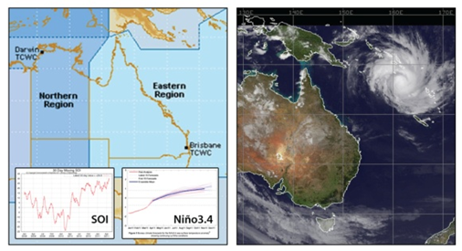
Figure 4: Under the Early Warning System, outputs such as these (from the Bureau of Meteorology seasonal tropical cyclone outlook) are used to assess the potential for cyclone formation in or adjacent to the Great Barrier Reef Marine Park.

On a daily basis, the bureau also publishes a three-day outlook for tropical cyclone development in the Coral Sea. The outlook provides a semi-quantitative assessment of the likelihood that a tropical low is formed during each day in the forecast period. The following chance categories are used for likelihood estimates for each day:

Very low: less than 5 per cent chance
Low: l5 per cent – 20 per cent chance
Moderate: 20 per cent – 50 per cent chance
High: greater than 50 per cent chance

The early warning system uses the daily outlooks as an indication of what to expect over the next few days.

Within a season, southwest Pacific cyclones have historically formed most frequently from late December to the end of March, with risk peaking in January and February (Figure 5).

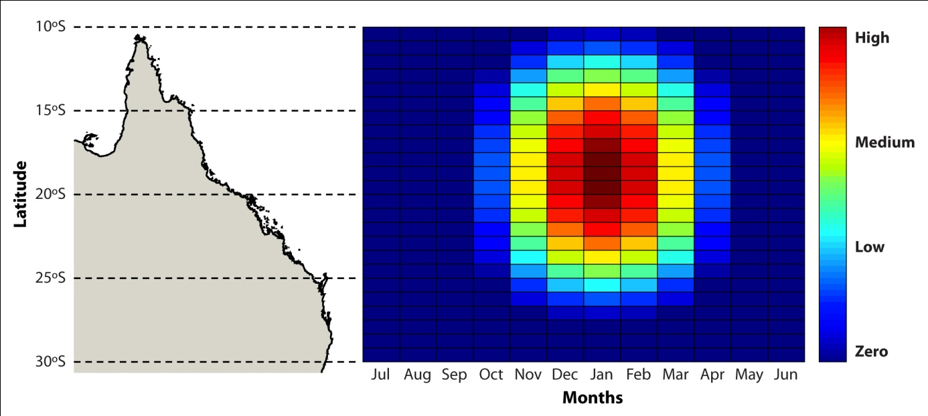

Figure 5: Risk distribution for cyclone occurrence in the Coral Sea and Great Barrier Reef area as a function of time of year and latitude. The distribution is derived based on data from McDonnell and Holbrook (2004) for the seasonal trend and from data by Puotinen (2007a) for the latitudinal trend. Specifically, risk is approximated based the accumulated number of named tropical cyclones formed in the Australian–southwest Pacific Ocean region (6˚–20˚S, 105˚–170˚E) during 1960–1993 (season) and 1969–2003. The highest risk zone corresponds to 10–15 per cent probability for a given year.

Thus, the early warning system team will be on highest alert in January and February of La Niña years, when cyclones are most likely to form and track near or within the Great Barrier Reef Region.

Map potential impact

The objective of the second component of the plan is:

- to provide the information needed for Marine Park managers to assess if and how they should respond to any cyclone that forms and tracks near or within the Reef.

The map potential impact component of the plan is thus used to trigger the possible responses detailed in the incident response (component 3) part of the plan. Assessing the potential impact of a given cyclone on the Reef involves three key steps. These are:

- collecting relevant operational data about the cyclone
- completing an assessment of potential impact and, if justified
- developing a map of potential impact.

The rest of this section will describe each of these steps in detail.

Collecting relevant operational data

Once a tropical low system develops in the Coral Sea and is expected to produce gale force winds (>62 kilometres per hour (km/h)) over land in Australia within 48 hours, the Bureau of Meteorology issues a tropical cyclone advice every six hours, increasing to every three hours (or hourly) when tropical cyclone warnings are issued (Figure 6).
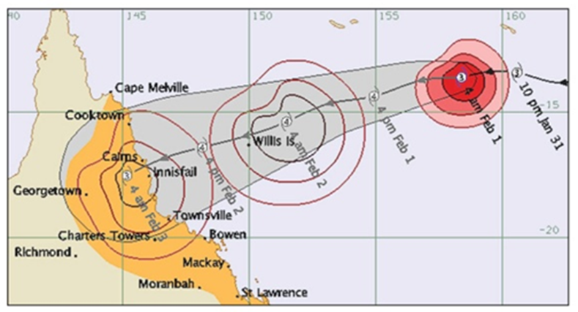
Figure 6: Example of cyclone data provided in Bureau of Meteorology warning messages and technical bulletins: location of the cyclone at various times, estimated intensity, and estimated span of various threshold wind speeds. The track map shown above is of tropical cyclone Yasi.

Additional data is provided via technical bulletins. Relevant information included in the above products includes:

- intensity of the cyclone (as indicated by central pressure and wind speed)
- latest observed location of the cyclone centre (eye-wall)
- expected or recent speed and direction of movement of the storm system
- range of gale force and higher winds.

The Bureau of Meteorology assigns cyclone categories from 1 to 5, based on maximum wind speeds as measured by the Beaufort scale (Table 1).

Table 1: Cyclone intensity categories used by the Australian Bureau of Meteorology.
Category | Max wind speeds (km/h) | Beaufort scale
1 | Gales: 90 – 125 | 8–9
2 | Destructive: 125 – 165 | 10–11
3 | Very destructive: 165 – 225 | 12
4 | Very destructive: 225 – 280 | 12
5 | Very destructive: > 280 | 12

An automated computer program (scraper bot) is used to automatically compile the warning messages and technical bulletins any time they appear on the Bureau of Meteorology web site. This ensures no key data is missed, such as warnings issued in the middle of the night. These data are then used to:

- map an operational track of the cyclone
- characterise the storm’s key characteristics along its track that influence its potential destructiveness: intensity, size of circulation, and translation speed.

These data enable the assessment of potential impact which is described in the next section.

Completing an assessment of potential impact

Once the data above are compiled, an assessment of potential impact examines the potential for a given cyclone to damage the Reef. This general assessment is based on the extent to which the cyclone tracks near reefs (especially within priority planning areas — reefs off Cairns and the Whitsundays), and the combination of its key characteristics (Figure 7) that influence the likely severity of wave damage. The purpose of this assessment is to determine whether or not to run the cyclone wave damage model to generate a map of potential impacts to assess damage risk in more detail (first responsive task on Figure 3).

The potential risk of a given cyclone to the Reef as a whole is shown by its position within the colour zones shown on Figure 7. The destructive potential of a cyclone with respect to reefs depends largely on four basic factors: size of circulation (big — >300 km versus small — <100 km), intensity (strong – winds > category 2 versus weak – winds < category 2), translation speed (fast — >5 km/hr versus slow — <5 km/hr), and the extent to which the cyclone tracks close enough to reefs to affect them. The latter is considered separately from the diagram.

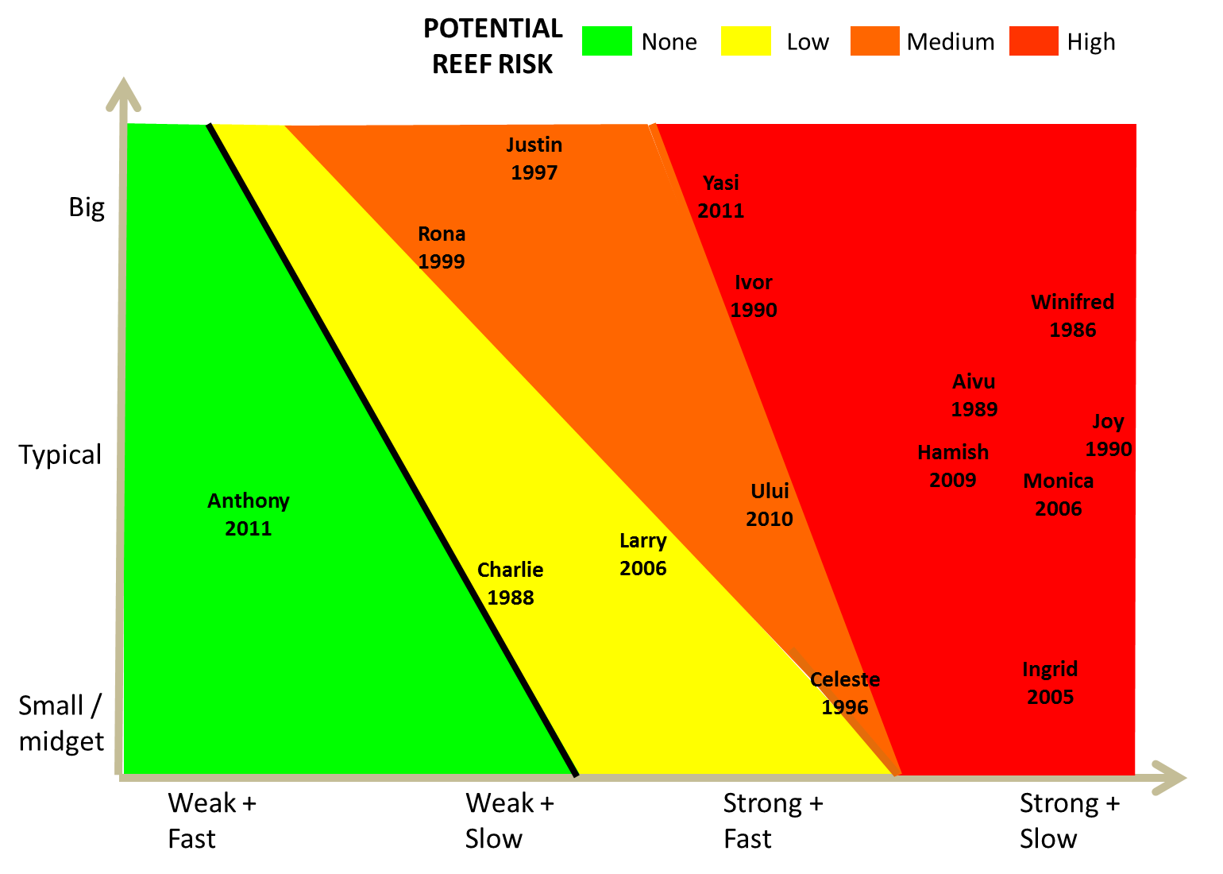
Figure 7: Relationship between cyclone characteristics (size of circulation, intensity and translation speed) and potential risk to reefs from wave damage used in the assessment of potential impact. A response to investigate further (by running the cyclone wave damage model and producing a map of potential impact) is triggered when a cyclone’s characteristics place it outside the green area on the diagram or if the cyclone tracks within priority planning areas. The green area is defined as: wind speeds equivalent to category 2 or below unless typical storm radius to gale force winds exceeds 300 km and typical translation speed is less than 5 km/hr.

Based on this, cyclones that fall within yellow, orange or red zones on Figure 7 are investigated further by running the cyclone wave damage model and producing a map of potential impact. These are:

- cyclones with maximum wind speeds equivalent to category 3 or above (strong) anywhere along the track
- cyclones with maximum winds speeds equivalent to category 2 or below (weak), but whose span of gale force or higher winds is typically greater than or equal to 300 km (big) and whose translation speed is typically less than 5 km/hr.

Cyclones that fall within the green areas on Figure 7 are only investigated further if they track near (within their radius to gales) or within priority planning areas (Figure 8).
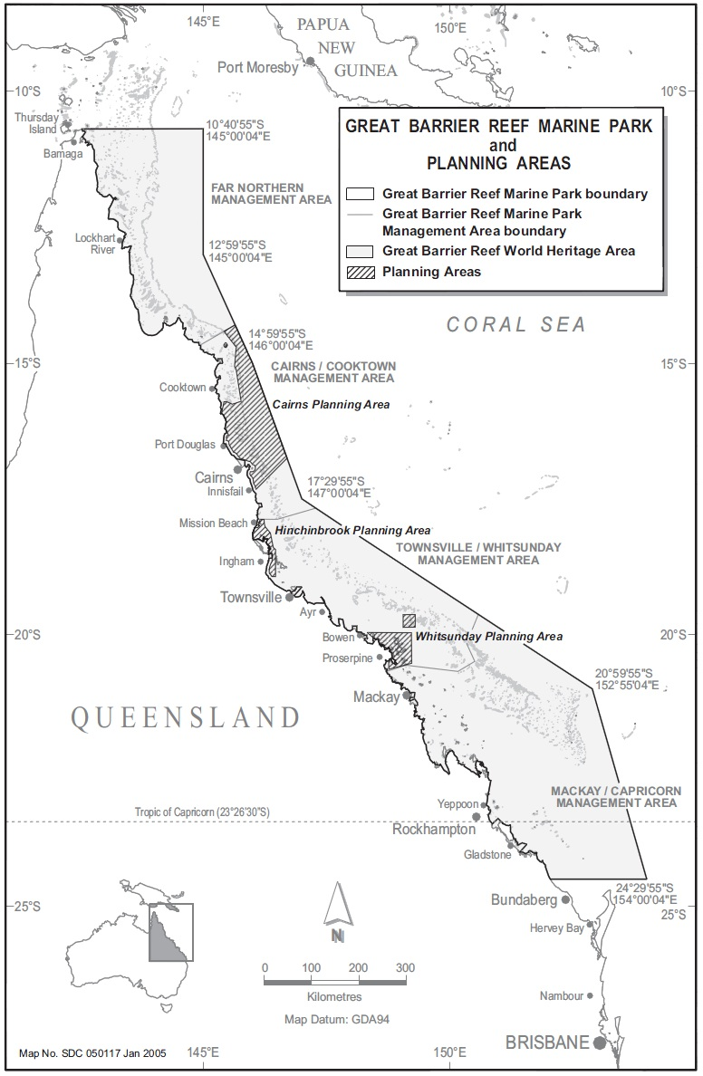
Figure 8: Plan of management areas within the Marine Park. Response levels warranted by a cyclone of a given intensity and spatial extent may increase if the storm crosses through one or more of the plans of management areas due to their ecological, social or economic significance. There are currently four plans of management within the Great Barrier Reef Marine Park: i) Cairns Area Plan of Management, ii) Hinchinbrook Plan of Management, iii) Shoalwater Bay (Dugong) Plan of Management, and iv) Whitsundays Plan of Management.

The size of circulation of a cyclone is important as it indicates the overall area over which high winds and heavy seas extend. Size of circulation refers to radius of the storm, i.e. the distance from the eye of the storm to the outer extent of the gale force winds (winds that travel at greater than 17 metres per second). Big cyclones have the potential to build heavy seas over a much more extensive area at each position along the track and thus can potentially damage more reef area. In contrast, gales generated by very small cyclones may only extend 50 km from the track. For example, catastrophic damage was much more widespread across the Great Barrier Reef during tropical cyclone Yasi than tropical cyclone Ingrid because Yasi was more than three times bigger (Yasi — ~350 km; Ingrid — ~100 km) even though the storms were similarly intense. Cyclone intensity is also important because it determines the maximum wind speeds possible. Faster winds require less time to build heavy seas, and have the potential to generate higher significant wave heights. Often overlooked but also important is how fast the cyclone as a whole moves along its track (translation speed). Slow moving storms provide more time for wind action to build heavy seas, and more time for a given reef to be exposed to those seas. For example, though tropical cyclone Larry was slightly more intense than cyclones Yasi and Ingrid, catastrophic damage was minimal because the total time many reefs were exposed to severe conditions was as short as 20 minutes. Finally, the location of the cyclone path with respect to reefs also plays a role in determining the risk of impact. Cyclones with relatively straight tracks that cross the Great Barrier Reef perpendicular to the coast (for example tropical cyclones Ingrid, Larry and Yasi) have less chance to track near as much reef area as those that have convoluted tracks or that track parallel to the Queensland coast (for example tropical cyclone Hamish).

A cyclone that is large, intense and moves slowly through the region on a track parallel to the coast poses the greatest possible risk to the Reef. Historically such storms have been very rare. Cyclones that are weak pose only minimal threat except when they are large and slow moving, such as Rona (size ~300 km) and Justin (size ~467 km). These types of storms have also tended to be rare. Small to typical sized weak cyclones, on the other hand, are very common in the region. Classifying historical cyclones in the Great Barrier Reef Region from 1985 to 2011 using the assessment of potential impact approach shows that just over one-third of these cyclones posed virtually no risk to the Great Barrier Reef (34 per cent), while 29 per cent posed high risk (Figure 9). Over time, high risk cyclones occurred most frequently in the early 1990s and, to a lesser degree, since 2005. See Appendix D for a version of Figure 7 that shows all tropical cyclones in or near the Reef from 1985 to 2011, with a table listing values for their key characteristics.

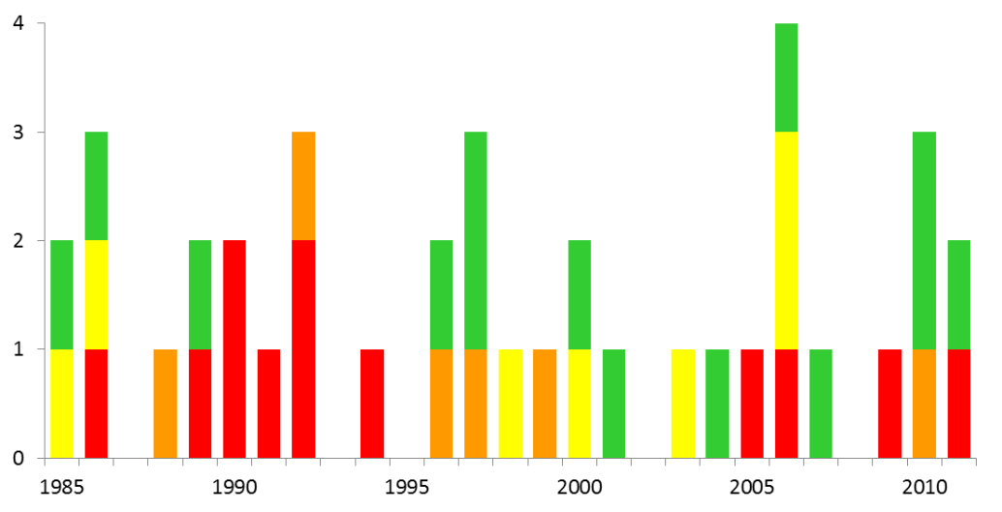
Figure 9: Number of tropical cyclones tracking near or within the Great Barrier Reef from 1985 to 2011 classified into risk categories (high = red, medium = orange, low = yellow, none = green) based on basic storm characteristics as per Figure 7. The percentages of cyclones in the region since 1985 that fell into each risk category were: high — 29 per cent; medium — 12 per cent; low — 24 per cent and none — 34 per cent.

The first responsive task — producing a map of potential impact — is triggered for cyclones which are either located in a priority planning area, or are assessed as having some damage potential (yellow, orange or red zones on Figure 7).

Producing the map of potential impact

The purpose of the map of potential impact is to provide key information to assist managers in determining whether management action in response to a given cyclone is warranted, triggering an incident response (see Figure 3). The map of potential impact predicts the likelihood that the Reef will be exposed to catastrophic wave damage, and measures the percentage of the total reef area of the Reef that is affected. Damage is deemed catastrophic if it involves:

- very extensive impact to coral colonies or the reef framework itself by one type of damage (for tropical cyclones surveyed with Fabricius et al 2008 method)
- moderately extensive physical impacts to coral colonies or the reef framework itself of at least three types (for tropical cyclones surveyed with Fabricius et al 2008 method)
- extensive to very extensive damage to colonies and/or some damage to the reef framework (for tropical cyclones surveyed using GBRMPA’s method for tropical cyclone Yasi).

Types of coral colony damage include: breakage, torn soft corals, burial under re-worked sediments, dislodgement, and scarring from water-borne debris. Types of damage to the reef framework include: exfoliation (entire sections of the reef removed) and broken slabs (entire pieces of the reef moved). See Puotinen et al 1997 and Fabricius et al 2008 for examples of each of the above types of damage observed following cyclones Ivor (1990), Justin (1997) and Ingrid (2005).
Examples of observed damage deemed catastrophic include:
- an entire reef slope where more than 90 per cent of colonies were dislodged and thrown above the high tide line
- an entire reef slope stripped bare of branching corals and overrun by algae
- a back reef lagoon site where a notable percentage of colonies were broken, buried by transported sand, or dislodged from the reef framework.
Damage of this severity affects the resilience of reefs as it requires decades to centuries for recovery, and thus other disturbances may occur and prevent full recovery.
The cyclone wave damage model (Figure 10) estimates the potential for reef damage by:
- reconstructing threshold wind and wave conditions across the Great Barrier Reef during a given cyclone (Figure 10 steps 1 and 2)
- developing parameters that predict the spatial distribution of damage (Figure 10, step 3)
- where possible, testing the predictors against field data of cyclone wave damage to reefs to identify which to use for a given storm (Figure 10, step 3)
- using the chosen predictors to map the likelihood of catastrophic damage across the Great Barrier Reef (Figure 10, step 4)
- defining damage likelihood classes (highly likely, likely, possible, unlikely) based on (iv), and finding the percentage of the total area of reef in the Great Barrier Reef that falls within each class (Figure 10, step 5).
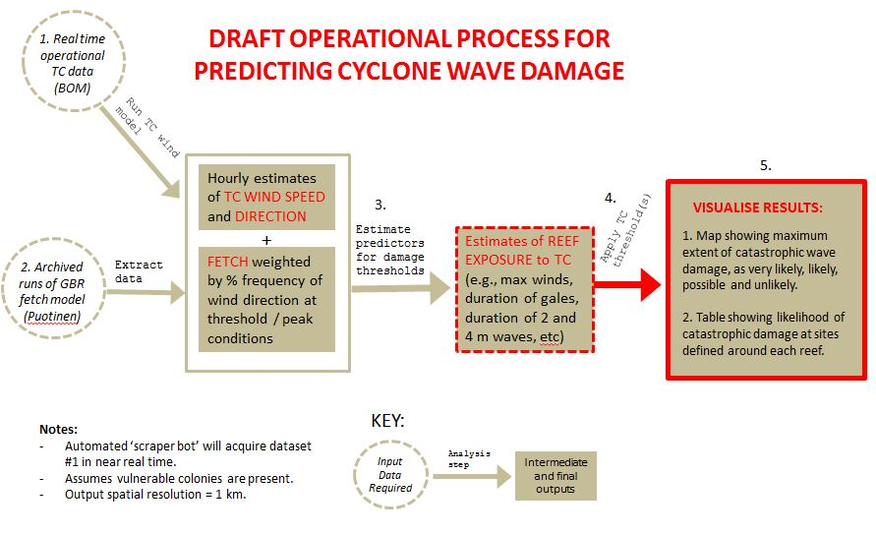
Figure 10: Draft operational process for predicting cyclone wave damage across the Great Barrier Reef (1 km resolution) using the cyclone wave damage model for sites around the boundaries of reefs (n=411,849). The final outputs listed are just two examples of the type of data that can be generated from the model.
As an example, Figure 11 illustrates key parameters used to define catastrophic damage thresholds for severe tropical cyclone Yasi (2011). In this case, the model estimated the number of hours during which 4 metre waves were possible (d) across the Great Barrier Reef based on wind speed (c), duration (b) and exposure (a). The significant wave height that was possible depended on whether winds blew long enough at a given speed over a sufficient distance of unobstructed water (fetch). See Appendix E for a detailed description of the process summarised in Figure 10, illustrated by the example of tropical cyclone Yasi.

Calculating the duration of 4 metre waves improves on previous efforts to estimate the potential for wave damage based on maximum wind speed or duration alone (e.g. Puotinen 2007b, Fabricius et al 2008). During cyclone Yasi, some areas where maximum winds did not exceed category 2 (Figure 11c — light pink areas south of the track) did have the potential to generate 4 metre waves (Figure 11d) because high winds were long lasting (Figure 11b). Using thresholds defined in the earlier studies would have assumed no catastrophic damage was possible in these areas based on maximum wind speed. However, during cyclone Yasi, catastrophic damage clearly occurred there (Figure 11e).
One key purpose of the thresholds is to define a zone beyond which damage is unlikely to occur. This is useful for broad-scale assessment of how much of the Reef is likely affected by a given cyclone and thus when further action should be triggered. It is also useful for spatially constraining field survey effort to ensure that: key areas of damage are detected, and that surveys include observations of both presence and absence of catastrophic damage. For example, Figure 11e shows the predicted likelihood of catastrophic damage from Yasi across the Reef based on the duration of 4 metre significant wave heights (damage unlikely when no 4 metre wave was possible). Comparison with field data of catastrophic wave damage from Yasi (Figure 11e) shows that very little catastrophic damage was found in the unlikely zone (<1 per cent) and most (93 per cent) fell within the likely to highly likely zones.
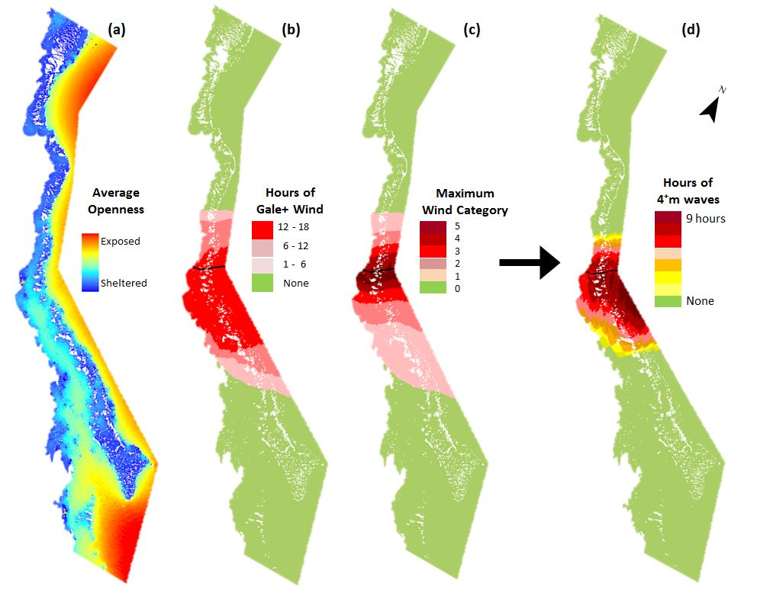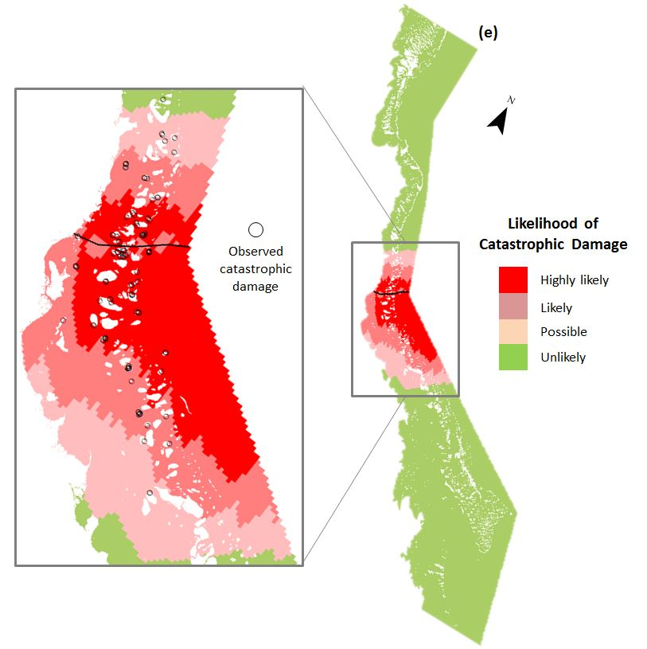
Figure 11: Modelled factors used to predict the likelihood of catastrophic cyclone wave damage (e) in the cyclone wave damage model for severe tropical cyclone Yasi (2011). The total hours during which 4+ metre significant wave heights were possible (d) is estimated using modelled openness (fetch — a) and duration of winds of a range of gale force and higher speeds (b, c) within standard engineering equations. Comparison with field data of catastrophic wave damage from severe tropical cyclone Yasi (e) shows that very little catastrophic damage occurs in the unlikely zone (<1 per cent) and most (93 per cent) falls within the likely to highly likely zones). See Appendix E.
Once thresholds for the potential for catastrophic damage for the given set of cyclone parameters have been chosen, areas that meet or exceed them are identified (Figure 10, step 4). From this, spatial zones are defined (Figure 10, step 5) where catastrophic wave damage to reefs is:
- very likely
- likely
- possible
- unlikely.
Figure 11e shows this for cyclone Yasi. For the 4 metre wave example, this equated to: very likely — 6+ hours of 4 metre waves possible; likely — 4–6 hours of 4 metre waves possible; possible — 1–4 hours of 4 metre waves possible; and unlikely — no 4 metre waves possible.
We then find the percentage of the total area of reef across the region that falls within each of the above categories, and rate it as high or low as follows:
- High: more than 10 per cent of the total area of reef across the Great Barrier Reef at some level of risk from catastrophic damage
- Low: 10 per cent or less of the total area of reef across the Great Barrier Reef at some risk from catastrophic damage.
In both cases, the reef areas affected may be localised or widespread, depending on the tropical cyclone track. For example, for Yasi, catastrophic damage was possible for 17 per cent of the total reef area of the Great Barrier Reef. Yasi’s large size and high intensity combined to produce an unusually extensive area at some risk from catastrophic damage. In this case, reefs likely to be affected were concentrated within a large but contiguous zone because Yasi transited the region perpendicular to the coast along a relatively straight track. It is possible, in contrast, for damage to be widely distributed but still limited in the total reef area affected. For example, a tropical cyclone that tracks parallel to the coast through the region has the potential to affect reefs located across a vast area. However, storm conditions may not be sufficient to cause catastrophic damage along the entire track. If the tropical cyclone repeatedly weakens and then re-intensifies along such a track, the total reef area affected may be relatively small, but the reefs affected may be far flung.
The likelihood of catastrophic damage described above, the per cent area of Great Barrier Reef reefs predicted to be affected, and whether or not a priority planning area was involved define whether the cyclone is significant enough to trigger management action. How this data is used to do so is described in the next section.

Incident response

The incident response component uses the internationally recognised incident management framework described in the Australasian Inter-agency Incident Management System (AIIMS). Once activated, the incident response component generates the scalable, common organisational structure required to respond in an efficient and effective manner to a reef health incident. Specifically, the incident response component identifies the governance, planning, operations, logistics, financial, and inter-agency liaison arrangements for a cyclone response. The level of response required, and management resources invested, is determined via a two-step process:

- recommendations for response based on interpretation of the map of potential impact
- determining actual response via a situation analysis.

Recommendations for response

A matrix (Figure 12) is used to determine what response level (R1, R2 or R3 — see Figure 3) to the cyclone is recommended. The response level is based on the likelihood of catastrophic damage, the proportion of the total reef area of the Great Barrier Reef that is likely affected, and whether or not the cyclone potentially damaged reefs within a priority management area (e.g. a high use plan of management area — Figure 8).

Figure 12: Combinations of the likelihood of catastrophic wave damage to reefs and the per cent total area of reef affected that inform the situation analysis (Figure 13). Plans of management areas are shown in Figure 8.

Based on how the results from the map of potential impact fit within the matrix (Figure 12), one of four possible recommendations will be made about what, if any, further action managers should take. These are:

- No further action — this will be recommended if catastrophic damage was unlikely for any reefs unless the cyclone potentially affected a priority planning area
- Response level 1 (conditional) — managers consider whether to undertake field surveys of damage or other actions. This will be recommended if catastrophic damage was possible anywhere across the Great Barrier Reef or if not, if the cyclone likely affected a priority planning area
- Response level 2 — managers prepare to investigate the ecological impacts of the cyclone in further detail via field surveys of damage. This enables the creation of a map of actual impact which will improve future cyclone modelling. It may also lead to other management response depending on the severity and location of damage. This will be recommended if damage is possible for more than 10 per cent of the total area of reef.
- Response level 3 — as for response level 2, but it is more likely that managers will consider additional intervention (e.g. temporarily closing a devastated area to fishing to facilitate recovery). This will be recommended if damage is likely within a plan of management area, or if no plan of management area is affected, if damage is highly likely anywhere else.
The parameters that best explain known patterns of catastrophic cyclone damage vary among the storms that have been surveyed (e.g. Puotinen 2007b, Fabricius et al 2008). This is due in part to differences in storm characteristics and a lack of sufficient field data to determine how patterns of damage vary between the storms. Given this, the plan provides an essential contribution to understanding reef resilience by facilitating the continued collection of high quality field data of cyclone wave damage across the Reef. This will enable on-going refinement of parameters and thresholds, although what has already been developed is likely to represent world best practice.

Determining actual response level

The actual response level is ultimately determined by the governance group based on a situation analysis (Figure 13).

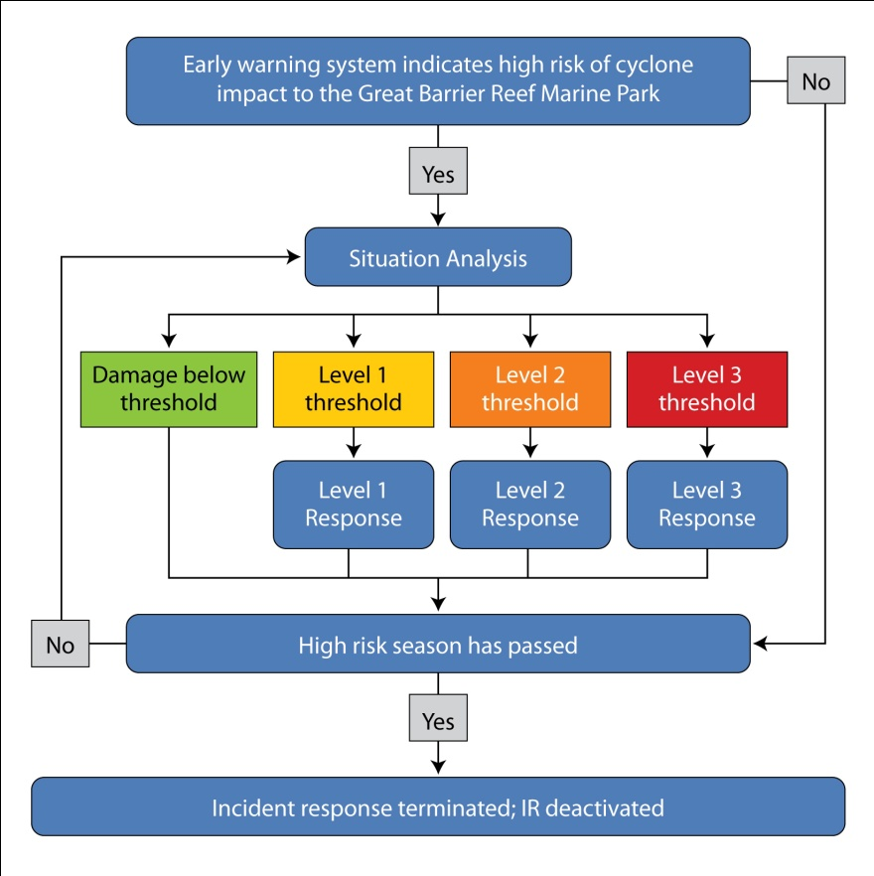
Figure 13: Incident response chain of events during a cyclone. The situation analysis is informed by the matrix seen in Figure 12 and is revisited following responses if the high risk season has not passed.

The information presented within the situation analysis is assessed by the governance group (the GBRMPA executive management group, the incident coordinator and the scientific, communication and media liaison, and stakeholder advisory groups) to make a final decision on the required level of response. We enlist the support of expert advisory groups to assist with incident responses (see incident response charts — Figures 14–16). The advisory groups provide independent advice to the incident coordinator to ensure timely, effective decision-making based upon the best available social, economic and ecological information. The scientific advisory group includes experts in reef health monitoring, and coral biology and ecology. The stakeholder advisory group is composed of relevant GBRMPA Reef Advisory Committee members. The communication and media liaison advisory group includes communication and public relations staff from each government agency involved in the response. Relevant GBRMPA and Queensland Parks and Wildlife Service staff facilitate the advisory group meetings.
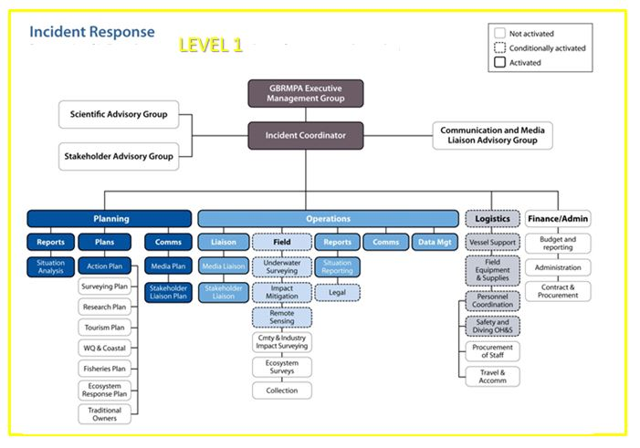

Figure 14: Response level 1 (R1) within the incident response. Activation and conditional activation of incident response components are illustrated by the intensity of colour and border for each box within the diagram above. For example, tropical cyclone Justin (1997) would trigger R1.

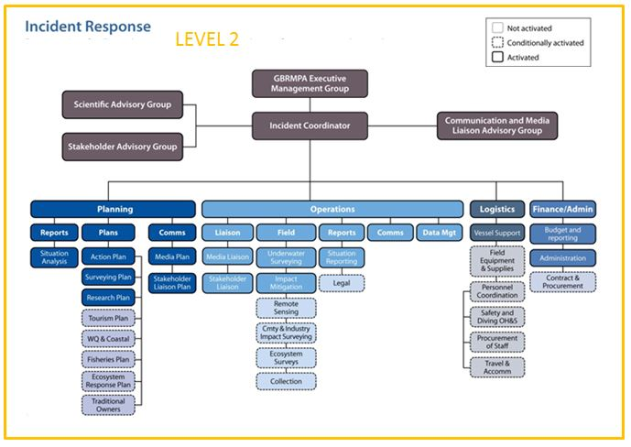
Figure 15: Response level 2 (R2) within the incident response. Activation and conditional activation of incident response components are illustrated by the intensity of colour and border for each box within the diagram above. Tropical cyclone Ingrid in 2005 is an example of a storm that would trigger R2.

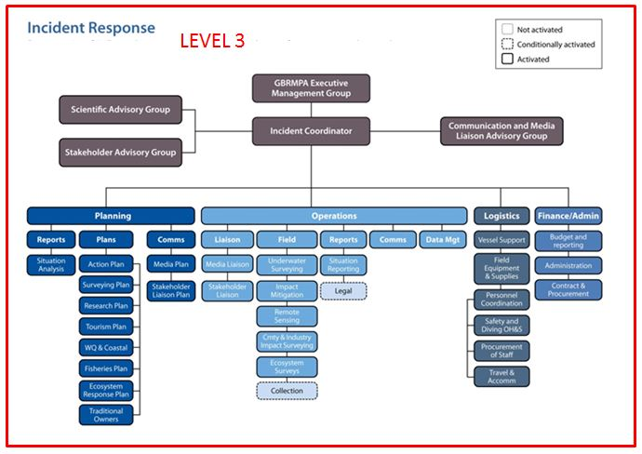
Figure 16: Response level 3 within the incident response. Activation and conditional activation of incident response components are illustrated by the intensity of colour and border for each box within the diagram above. Tropical cyclone Hamish in 2009 and tropical cyclone Yasi in 2011 are examples of storms that would trigger R3.

The next section describes the approach and field survey protocols used to assess and monitor cyclone impacts when the situation analysis determines triggers for response levels 2 and 3 have been exceeded.

Response: Assessment and monitoring and reporting impacts

Assessing and monitoring cyclone impacts
To accurately document the extent and severity of cyclone impacts and subsequent coral mortality, surveys are undertaken as soon as possible following the cyclone. Conducting surveys at sites that are monitored as part of the Australian Institute of Marine Science (AIMS) Long-term Monitoring Program or sites that have information stored in the Eye on the Reef database negates the need to conduct further baseline surveys. Thus, managers can focus post-cyclone Reef Health and Impact Surveys on documenting the severity of the impacts (Figure 17), and surveys six months to a year after the event can focus on assessing the ecological implications of cyclone impacts.
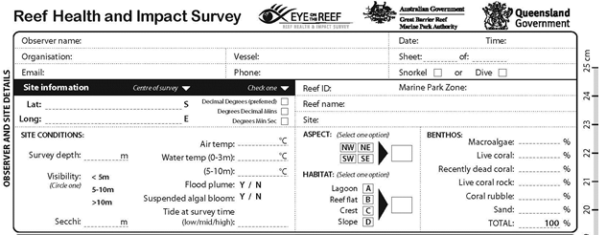

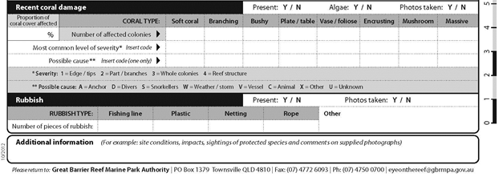

Figure 17: Relevant sections of the Reef Health and Impact Survey form used for cyclone impact assessment. Cyclone impact severity is documented using general estimates of coral rubble and recently killed coral (a) More detailed descriptions of cyclone impact are made by counting the total number and types of coral colonies affected and by documenting the severity of damage (b) based upon four impact categories: 1) Damage to edges or tips of coral colonies, 2) Damage to larger parts of colonies or entire branches of coral, 3) Damage to entire colonies and 4) Reef structure. Reef Health and Impact Survey data is entered into the Eye on the Reef database and is analysed via a damage matrix to provide detailed information about geographic extent and severity of cyclone damage (Figure 18).

If the situation analysis (Figure 13) determines thresholds for response levels 2 (Figure 15) or 3 (Figure 16) have been reached, managers implement intensive in-water reef health and impact surveys and video surveys at routine sites (surveyed by long-term monitoring programs) and targeted sites (those anticipated to be most affected by the cyclone). This approach is a pragmatic yet defensible way to collect comprehensive data quickly immediately after a cyclone event, while also creating a long-term record. These surveys are conditionally activated for response level 1 (Figure 14) and may be undertaken depending on the outcome of the situation analysis and the location of the cyclone (i.e., inside or outside a plan of management area — see Figure 12). The sites most likely to be affected by the cyclone are identified using the results of the map of potential impact (see section 2.3 and Figure 10).

Where conditions permit, the windward and leeward aspects of each reef are surveyed to assess the extent, severity and patchiness of cyclone damage. Most assessments are completed on snorkel, and cover only the upper reef slope. Surveys of sites that are part of the AIMS Long-term Monitoring Program are done on SCUBA to enable damage to be assessed for both the upper and lower slope, and thus enable comparison with long-term data from these sites. Survey teams complete a minimum of three reef health and impact surveys for at least three sites around each reef (Appendix B). Reef Health and Impact Survey impact assessment teams recorded cyclone damage over a series of randomly selected five metre radius circle plots (78.5 m²) at each site (Appendix C). Surveyors categorise both the extent and severity of the coral damage within each Reef Health and Impact Survey area. The extent of the damage is recorded as the proportion of coral cover affected within the survey area, whilst severity is evaluated using categories. The damage severity categories describe the most common characteristic of the hard coral colony damage in the Reef Health and Impact Survey area: Category 1 = colony tips/edges; Category 2 = colony parts/branches; Category 3 = whole colonies, Category 4 = reef structure (Figure 18, Appendix B).

Recovery surveys also include assessments of bleaching and disease as cyclones may increase the susceptibility of corals to these impacts (see Coral Disease Response Plan, GBRMPA 2013. In this sense, we take the lead on assessing impacts and the implications of cyclone events in the first year following the cyclone, while longer term ecological monitoring surveys are coordinated and undertaken by the AIMS Long-term Monitoring Program. Assessing reef health and condition during and in the months that follow incidents also informs estimates of reef resilience, which enables testing of the effectiveness of various strategies that support the natural resilience of reefs.
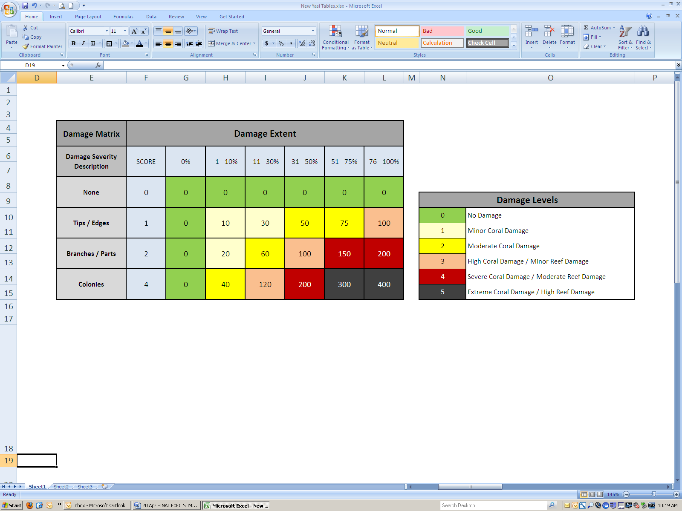
Figure 18: Cyclone damage matrix. Coral damage extent and severity scores in light blue represent the survey area that was damaged (damage extent) and the predominant type of colony damage observed in the survey area (damage severity description). Damage levels represent ecological impact groupings and encapsulate both colony and reef damage. For example, damage level 3 applies to either minor reef damage (e.g. 11–30 per cent of colonies damaged) or high coral damage (31–50 per cent branches or >75 per cent tips). Coral damage levels 1 and 2 indicate partial colony mortality. Reef damage Levels 3, 4 and 5 indicate the increasing extent of complete colony mortality and reef framework damage (Figure 19).

The implications of severe cyclones on reef ecology include but are not limited to coral mortality, shifts in coral community structure, altered habitat composition, and ecosystem flow-on effects. Of particular concern is the physical damage to individual coral colonies and, with severe cyclones, direct physical damage to the reef structural framework (Figure 19). Severe cyclones also have implications for industries and users that depend on the Reef as well as for associated human communities because cyclones can reduce the social or economic value of reef sites important to tourism operators, fishers, or recreational users. Monitoring of the social and economic impacts of cyclone events is undertaken in collaboration with industry bodies such as the Association of Marine Park Tourism Operators and the Queensland Seafood Industry Association and researchers from universities and the Commonwealth Scientific and Industrial Research Organisation (CSIRO).

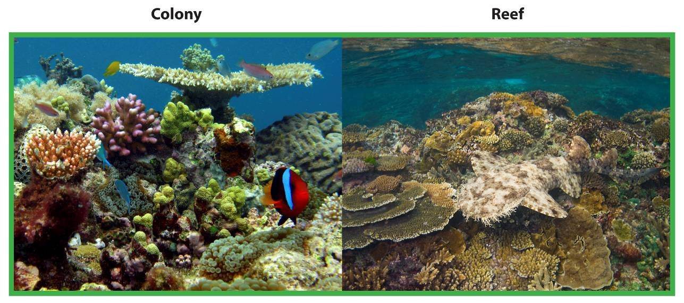
Damage Level 0 (No damage): Healthy reef.

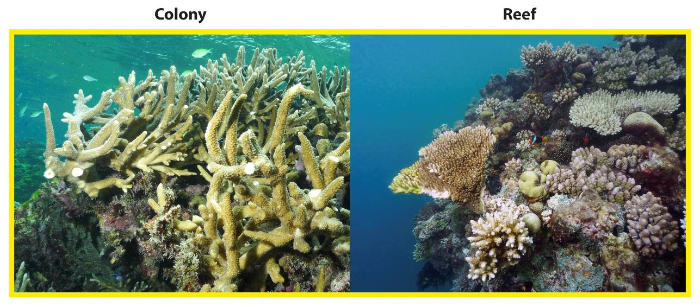

Damage level 1 (minor damage): Some 1–30 per cent) corals partially damaged; primarily broken tips and some branches
or plate edges.

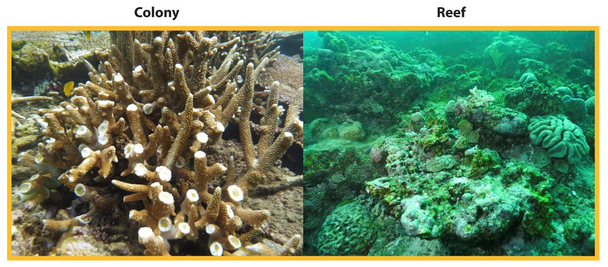

Damage level 2 (moderate damage): Many (31–75 per cent) corals partially damaged; most fragile colonies have tips or edges broken, some branches missing or as large rubble fragments.

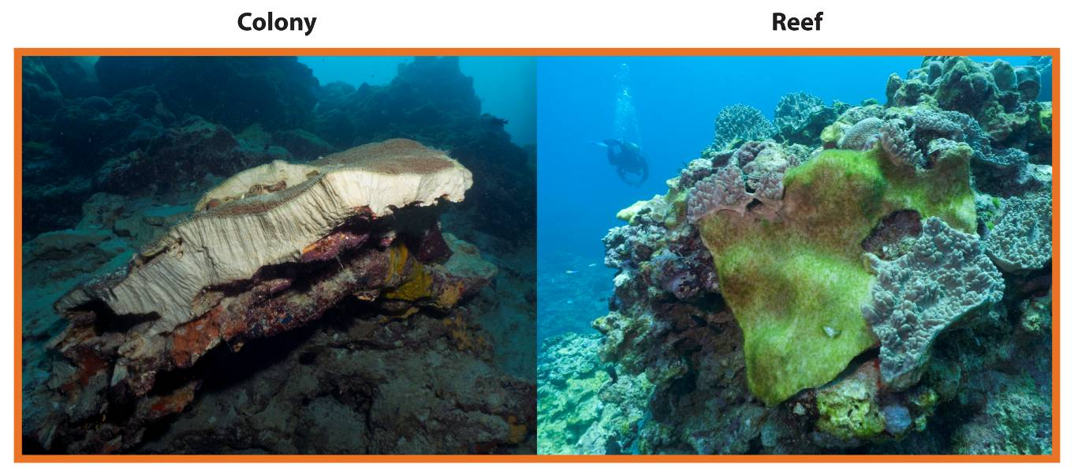
Damage level 3 (high damage): Up to 30 per cent of colonies removed, some scarring by debris, soft corals torn, coral rubble fragments from fragile and robust coral life forms.

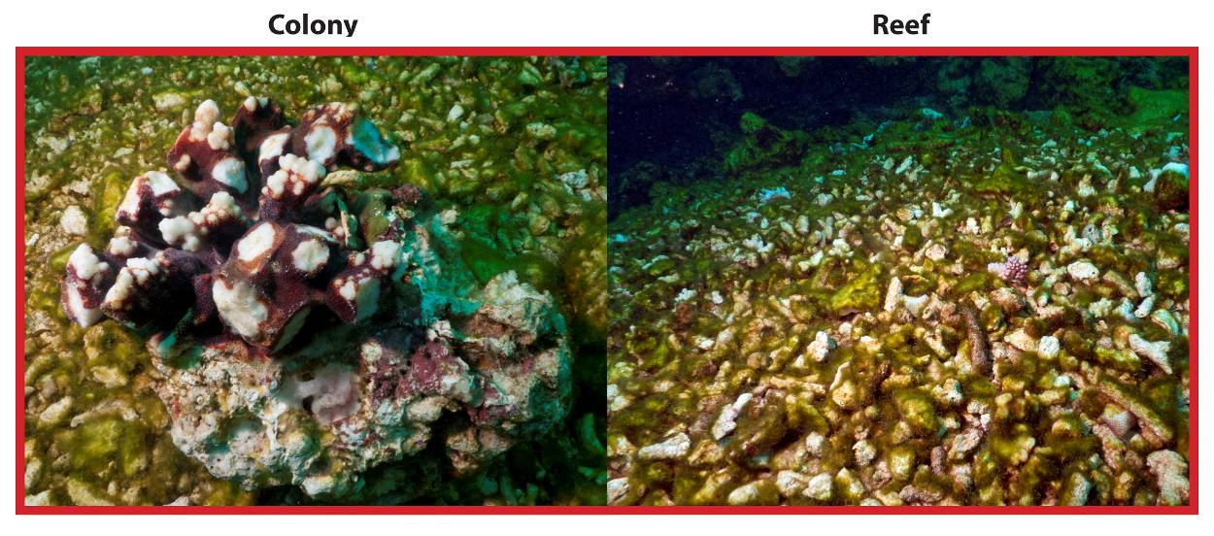
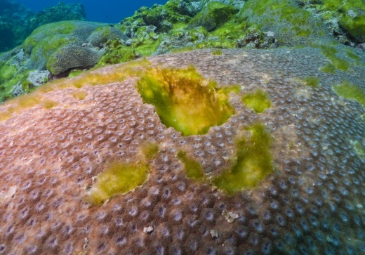
Damage level 4 (severe damage):
Many (31–50 per cent) colonies dead or
removed, extensive scarring by
debris, rubble fields littered with
small live coral fragments, soft
corals severely damaged or
removed and some large coral colonies
dislodged.
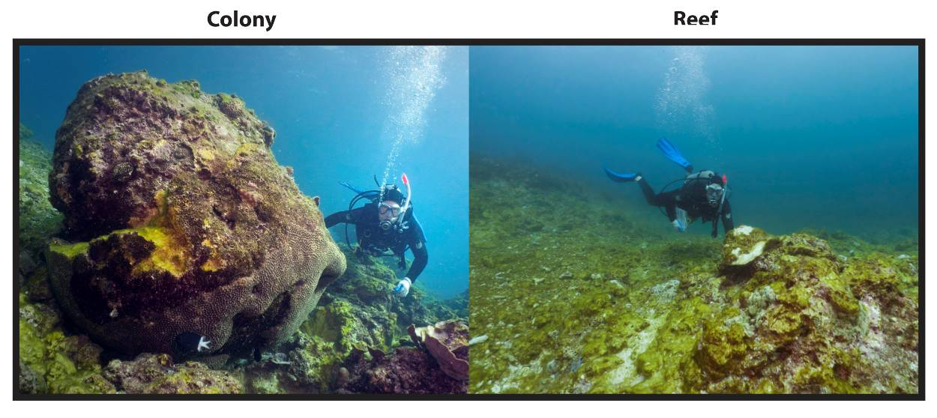

Damage level 5 (extreme damage): Most (51–100 per cent) corals broken or removed, soft corals removed and many large coral colonies dislodged. Damage
to underlying reef structure.

Figure 19: The six damage levels used in the Yasi assessment and analysis. The damage levels were used to evaluate the damage caused by tropical cyclone Yasi and are comparable to previous studies of cyclone damage on the Reef.

Reporting cyclone impacts
The rapid assessment via the Reef Health and Impact Survey protocol provides information about the extent and severity of the cyclone event in near real-time, which can be immediately communicated to senior management, government officials and the public. The data collected during post-cyclone rapid assessments must be analysed and presented quickly, while also providing a level of detail and accuracy that enables reporting. Below are three examples of the types of analysis outputs from the impact assessment of severe tropical cyclone Yasi in February 2011.

- Intra-reef variability: Contrasting benthic photographs of one reef area (taken within 100 metres of each other) to document the range of impacts provide an easily understood means of displaying the patchiness of cyclone impacts.

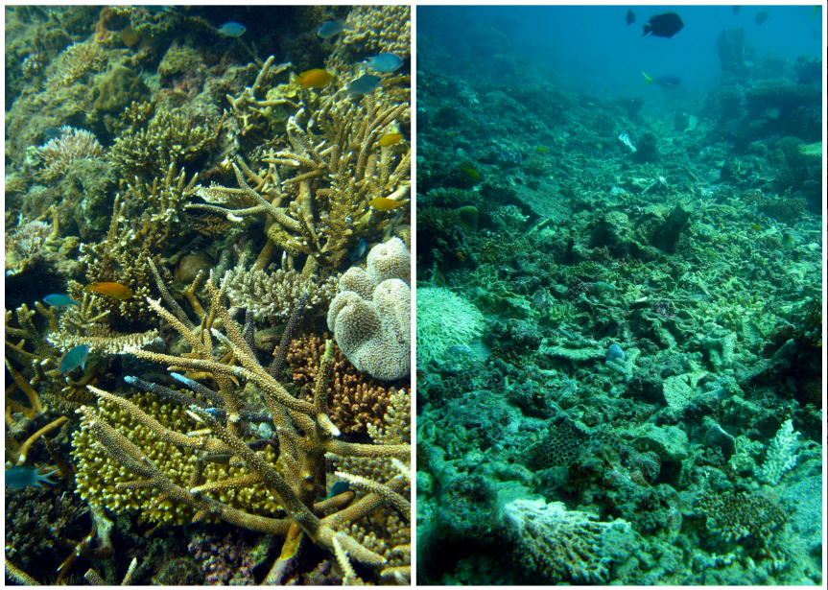

2. Percentage of surveys in each severity category within each wind zone boundary: Pie charts display the results of the damage matrix (Figure 18) both by geographic area (as overlaid on a map of Queensland) and wind boundary zone (as shown by very destructive, destructive and gale force winds). The histogram in the top right shows the same data included in the pie charts, but more effectively displays the contrast in impacts by distance from cyclone eye.

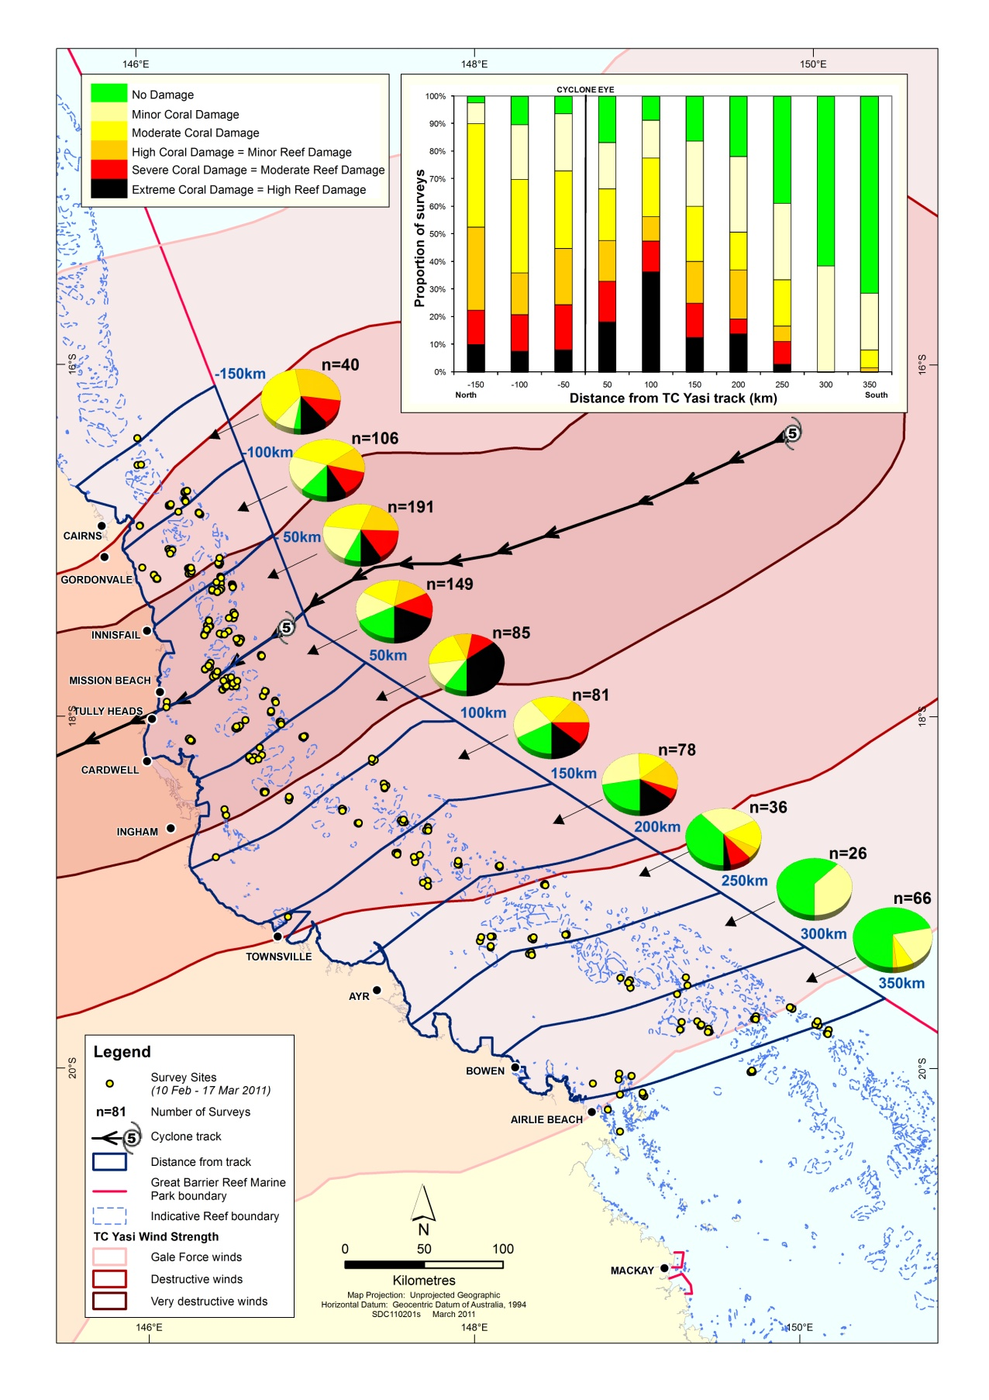

3. Reef area affected by damage matrix category. This simple histogram displays the matrix damage categories by both affected reef area affected and the proportion of reef area in the Marine Park.

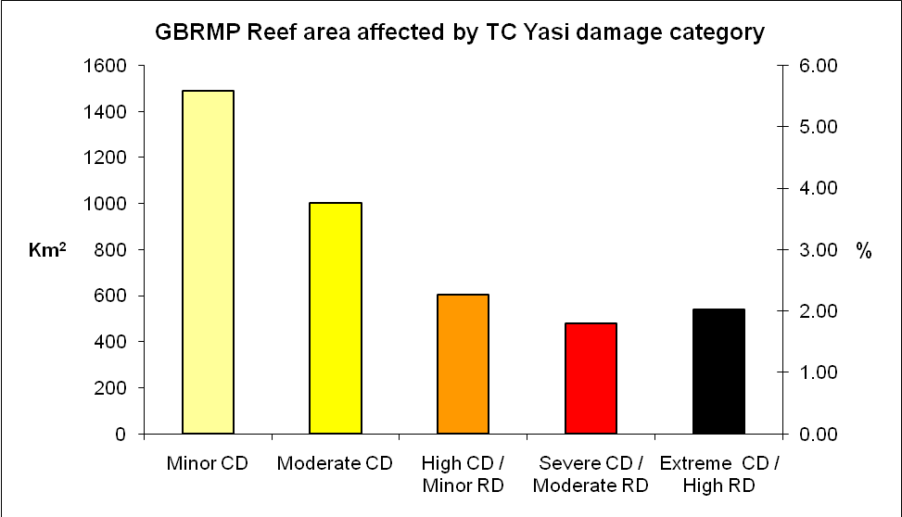

Communications strategy

Responding to tropical cyclones strategically and effectively involves a combination of routine and responsive tasks implemented via the early warning system and, if a cyclone occurs and damage is potentially significant, assessment and monitoring via the incident response (see Figure 3). Since cyclones attract attention from the public, media and senior decision-makers, all routine and responsive tasks rely on effective communication. The plan ensures that timely and reliable information on cyclone risks in the Great Barrier Reef Marine Park is available throughout the season.

Table 2: The frequency and timing of tasks associated with collating and effectively communicating current cyclone risk and impact information each summer. Tasks that appear in italics are common to both the cyclone and bleaching risk and impact assessment plans.
Frequency | Timing/Trigger | Task
Weekly | Monday | - Check Bureau of Meteorology cyclone outlooks
Weekly | Monday | - Monitor tropical lows that can potentially turn into cyclones
Weekly | Monday | - Prepare briefing for internal meetings
Weekly/ fortnightly | Constant | - Monitor and review synoptic cyclone situation, and compile against recent cyclones
Weekly/ fortnightly | Constant | - Advise GBRMPA senior management and the Minister if worsening of conditions
Weekly/ fortnightly | Constant | - Announce web update and send brief report to senior management
Event-based | Cyclone warning issued | - Automatically compile tropical cyclone technical data.  - Prepare assessment of potential impact. If warranted, prepare map of potential impact and recommendations for incident response
Event-based | Cyclone warning issued | - Alert relevant project coordinators and managers
Event-based | Cyclone warning issued | - Brief relevant GBRMPA staff
Event-based | Response level 1, 2, or 3 (see Figures 14–16) triggered. | - Brief GBRMPA executive and the Minister
Event-based | Response level 1, 2, or 3 (see Figures 14–16) triggered. | - Prepare media position, draft statement and consult with GBRMPA media coordinator and executive
Event-based | Response level 1, 2, or 3 (see Figures 14–16) triggered. | - Brief all GBRMPA staff, stakeholders and collaborators
Event-based | Response level 1, 2, or 3 (see Figures 14–16) triggered. | - Release media statement

In addition to the task and reporting schedule outlined in Table 2 above (see also Appendix A), a briefing schedule for GBRMPA senior management, the Minister, and stakeholders is outlined in Table 3. This schedule ensures these groups are aware when delivery of reports can be expected.

Table 3: Targeted briefing schedule to communicate cyclone risk and impacts during the high risk summer season (November to April). Asterisks denote triggers that will result in the development of a media position and the release of a media statement.

Approx. Date | Trigger¹ | Briefings
Approx. Date | Trigger¹ | Senior management | Minister | Stakeholders | Message
1 November | Annually | ^ | ^ | ^ | Cyclone season approaching; risk and impact assessment plan implemented
20 December | Annually | ^ |  |  | Seasonal outlook and summary of cyclone advice from Bureau of Meteorology; plans for Christmas break
 | Cyclone warnings | ^ | ^ |  | Category 4 cyclone developed in the Coral Sea, small storm heading for far north Queensland
 | Response level 1 | ^ | ^ | ^ | Cyclone crossed the Great Barrier Reef near Cairns; predicted catastrophic damage possible at reefs in both planning and non-planning areas.
 | Response levels 2 and 3 | ^ | ^ | ^ | Surveys observe extensive damage, with severe structural damage to planning areas.
15 February³ | Annually | ^ |  |  | Cyclone summary for first half of summer; outlook for remaining part of the season
31 March |  | ^ | ^ | ^ | Cyclone period concluded
30 May |  | ^ | ^ | ^ | Summary of full extent and severity of cyclone impacts; implications for affected regions and the Great Barrier Reef

Importance of management actions

The relative proportion of tropical cyclones tracking near or within the Reef at high intensity is expected to increase as a result of climate change (Walsh et al 2012), making the incidence of catastrophic damage to reefs more likely. Recovery from such damage can require decades to centuries (Connell 1997). If this type of damage becomes more frequent and more widespread, some reefs may lose resilience if they are unable to recover before the next disturbance (whether a cyclone or other stressor) hits. This could threaten their ability to persist as coral-dominated systems. Significantly, many human activities impose stresses on coral reefs that compound the risks imposed by other disturbances and can work to lengthen recovery timeframes. For example, chronic stress due to poor water quality can affect the recovery potential of reef communities as reproduction and larval recruitment in corals are particularly sensitive to environmental conditions. Through reducing compounding stressors, management actions help reefs to cope with or recover from cyclone event. This works to build the resilience of reefs to future climate-related disturbances.

By working in collaboration with researchers, we are also rapidly advancing our understanding of factors that increase the resilience of reefs, as measured by the capacity to resist, tolerate, cope with, and recover from climate-related disturbances. In particular, researchers are poised to increase our understanding of spatial variability in the likelihood that a site will be impacted by climate-related disturbances like bleaching, disease outbreaks, floods and cyclones based on geographic location, community composition and thermal history. Increased knowledge of the spatial variability in factors that confer resilience to reefs may enable us to explicitly incorporate resilience to climate change into management plans. Furthermore, knowledge of spatial variability in resilience factors enables assessments of the effectiveness of strategies implemented to support resilience.

In addition to measures to build ecosystem resilience, the plan can help build social and economic resilience to cyclone events. Resource users who are well-informed of risks and are included in decision-making processes about strategies to address resource issues can be expected to be much more resilient to resource impacts (Marshall and Marshall 2007). Similarly, community-based social marketing can encourage stewardship behaviours, (e.g. not anchoring on corals or disposing of rubbish on the Reef). Such communications efforts may be undertaken following reef health incidents like cyclones in the future.

Conclusion

As a greater proportion of cyclones affecting the Reef are of high intensity, impacts on reef resilience and reef users from catastrophic wave damage will become increasingly acute and apparent. This risk and impact assessment plan outlines the strategic approach that we employ to assess the risk posed by cyclones and the impacts caused by cyclones. The four-component structure described here is based on a model which has proven successful in responding to bleaching events on the Great Barrier Reef and which has also been adopted by reef managers in Florida and Hawaii.

Cyclones are inherently linked to coral bleaching and disease — they occur during the hotter summer season when the risk of bleaching is greatest, and corals on cyclone-damaged reefs are likely to be more susceptible to bleaching and disease. This plan and the coral disease and coral bleaching risk and impact assessment plans are united under the overarching Reef Health Incident Response System, which enables managers to evaluate and effectively respond to simultaneous and cumulative impacts. The capacity to predict and respond to simultaneous and cumulative impacts will be further developed in the coming years as the capacity to monitor conditions that cause reef health incidents increases. As with the other risk and impact assessment plans and the overarching Reef Health Incident Response System, this plan helps lay the foundations for an informed and adaptive approach to building the resilience of the Great Barrier Reef under a changing climate.

References

Anthony KRN, Maynard JA, Diaz-Pulido G, Mumby PJ, Cao L, Marshall PA, Hoegh-Guldberg O (2011) Ocean acidification and warming will lower coral reef resilience. Global Change Biology, 17, 1798-1808.

Carrigan, A.D. and Puotinen, M.L. (2011) Assessing the potential for tropical cyclone induced sea surface cooling to reduce thermal stress on the world’s coral reefs. Geophysical Research Letters. 38, L23604: doi: 10.1029/2011GL049722, 2011.

Chavas, D. R., and K. A. Emanuel (2010), A QuikSCAT climatology of tropical cyclone size, Geophys. Res. Lett., 37, L18816, doi:10.1029/2010GL044558.

Connell JH (1997) Disturbance and Recovery of Coral Assemblages. Coral Reefs, 16, S 101-S 113.

De’ath, G., Fabricius, K., Sweatman, H. and Puotinen, M. (2012). The 27 year decline of coral cover on the Great Barrier Reef and its Causes. Proceedings of the National Academy of Sciences (PNAS). doi:10.1073/pnas.1208909109.

Denny, MW (1988). Biology and the mechanisms of the waveswept environment. Princeton University Press, Princeton, NJ, 329 pp.

Done TJ (1992) Effects of tropical cyclone waves on ecological and geomorphological structures on the Great Barrier Reef. Continental Shelf Research, 12, 859-872.

Fabricius KE, De'Ath G, Puotinen M, Done TJ, Cooper TF, Burgess SC (2008) Disturbance gradients on inshore and offshore coral reefs caused by a severe tropical cyclone. Limnol. Oceanogr., 53, 690-704.

Harmelin-Vivien, M. L. (1994), The effects of storms and cyclones on coral reefs: A review, J. Coastal Res., 12, 211–231.

Hill, N, Pepper, A, Puotinen, M, et al. (2010). Development of a quantitative relative wave exposure index for shallow reefs in temperate Australia. Marine Ecology Progress Series, 417: 83–95. DOI: 10.3354/meps08815.

Hughes, TP and Connell, JH (1999). Multiple stressors on coral reefs: A long-term perspective. Limnology and Oceanography, 44 (3 pt 2): 932-940.

Holland, G. J., Belanger, J. I. & Fritz, A. 2010. A Revised Model for Radial Profiles of Hurricane Winds. Monthly Weather Review, 138, 4393-4401.

Hughes, TP, Baird, AH, Bellwood, DR, Card, M et al (2003). Climate change, human impacts, and the resilience of coral reefs. Science, 301(5635): 929-933.
Kuleshov, Y., L. Qi, R. Fawcett, and D. Jones (2008), On tropical cyclone activity in the Southern Hemisphere: Trends and the ENSO connection, Geophys. Res. Lett., 35(14).

Madin, J., and S. Connolly. 2006. Ecological consequences of major hydrodynamic disturbances on coral reefs. Nature 444: 477–480.

Marshall, NA and Marshall, PA (2007). Conceptualising and operationalising social resilience within commercial fisheries in northern Australia. Ecology and Society 12(1):1.

Massel, SR and Done, TJ (1993). Effects of cyclone waves on massive coral assemblages on the Great Barrier Reef: meteorology, hydrodynamics, and demography. Coral Reefs, 12: 153-166.

McConochie, JD, Mason, LB, and Hardy, TA (1999). A Coral Sea Cyclone Wind Model Intended for Wave Modelling. In: Coasts and Ports '99: Challenges and Directions for the New Century. Proceedings of the 14th Australasian Coastal and Ocean Engineering Conference and the 7th Australasian Port and Harbour Conference, Perth, Western Australia, 14-15 April, Vol 2, 413-418

McDonnell KA, Holbrook NJ (2004) A Poisson regression model approach to predicting tropical cyclogenesis in the Australian/southwest Pacific Ocean region using the SOI and saturated equivalent potential temperature gradient as predictors. Geophys. Res. Lett., 31, L20110.

Pandolfi, JM (1999) Response of Pleistocene coral reefs to environmental change over long temporal scales. American Zoologist 39(1): 113-130.

Pandolfi, JM et. al (2003). Global trajectories of the long-term decline of coral reef ecosystems. Science 301(5635): 955-958.

Pepper, A and Puotinen, M (2009). GREMO: A GIS-based generic model for estimating relative wave exposure. MODSIM 2009 International Congress on Modelling and Simulation (pp.1964-1970). Modelling and Simulation Society of Australia and New Zealand, Cairns, Australia, July 2009.

Puotinen, M. L. (2007a). Impact of data uncertainty on the spatio-temporal distribution of Australian cyclones, 1906-2006. In L. Oxley & D. Kulasiri (Eds.), MODSIM 2007: International Congress on Modelling and Simulation (pp. 1301-1307). New Zealand: Modelling and Simulation Society of Australia and New Zealand.

Puotinen, M. L. (2007b). Modelling the risk of cyclone wave damage to coral reefs using GIS: a case study of the Great Barrier Reef, 1969-2003. International Journal of Geographical Information Science, 21 (1), 97-120.

Puotinen, ML et al, (1997): An atlas of tropical cyclones in the Great Barrier Reef Region, 1969-1997. CRC Reef Research Centre, Technical Report No. 19. Townsville; CRC Reef Research Centre, 203 pp.
US Army Coastal Engineering Research Center (1977). Shore protection manual, Volume 3.
Walsh, K. J. E., K. L. McInnes, and J. L. McBride (2012), Climate change impacts on tropical cyclones and extreme sea levels in the South Pacific - A regional assessment, Glob. Planet. Change, 80-81, 149-164.

Young, IR and Hardy, TA (1993). Measurement and modelling of tropical cyclone waves in the Great Barrier Reef. Coral Reefs, 12: 85-95.

Appendix A— Schedule of Cyclone Risk and Impact Assessment Plan routine and responsive tasks for before, during and after the cyclone season

TIMING/  TRIGGER | TASK | EXPECTED OUTCOME | TICK WHEN COMPLETED
Pre-summer preparations and training
September | Seasonal outlook meeting | • Assessment of reef health incident risks (cyclones, flooding, coral bleaching, disease) for the approaching summer  • Preparations for coordinated response to high risk incidents
October –  May | Communications processes initiated (see Table 3) | Communications updated regularly on Reef health status
November | Incident response planning meeting | Preparations for activation of the incident response framework
November | Eye on the Reef training — Cairns, Port Douglas and Airlie Beach | Training of volunteer network in reef health impact assessment and reporting
November | GBRMPA internal staff training in the Reef Health and Impact Survey monitoring protocol | Training of GBRMPA Townsville and regional staff in Reef Health and Impact Survey assessment and reporting
November | Refresher training first aid, CPR and oxygen provider training; updates of AS2299 diver medicals | Field staff suitably qualified and prepared in case response initiated
December | Review of seasonal outlook, meeting convened if high likelihood of reef health incident(s) | Meeting convened to refine coordinated response if there is a high risk of one or more reef health incidents
December | Brief senior management, Minister and stakeholders | Senior management, Minister and stakeholders aware of approaching risk season
December | Revise risk and impact assessment plans for coral bleaching, coral disease and cyclones | Risk and impact assessment plans revised and published
December | In-water rescue refresher training | Staff proficient in in-water rescue and safety
January | Keppels scheduled monitoring | Support for ongoing resilience and monitoring of no-anchoring areas
January | Volunteer monitoring network training for southern region — Mackay, Yeppoon and Gladstone | Additional participants for the monitoring network recruited

Commencement of early warning system
December | Commence web based updates for seasonal outlook and reef health incident risk — current conditions reports | Communication of reef stressors to community through web on a monthly basis
December | Planning for Christmas closure period | • Assignment of duties over Christmas closure period  • Senior management notified of arrangements  • Minister advised if reef health incident risk is moderate–high
December –  April | Assess incident risk weekly | • Check AIMS, CSIRO (ReefTemp), Bureau of Meteorology and NOAA risk tools  • Review weekly weather summary reports  • Review reports from the monitoring network  • Prepare briefings for internal meetings, round table  • Advise senior management of any changes to risk assessment
February | Assess temperature, rainfall and cyclone patterns and monitoring network reports for first half of summer | • Senior management update  • Contact volunteer monitoring network participants

Event reported — incident response initiation
Reef health incident reported | Situation analysis conducted | Incident response situation analysis
Reef health incident reported | Situation analysis reviewed | Level of incident response agreed (this includes nil response)
Incident response activated | Appointment of incident controller | Incident coordinator appointed to establish a response team
Incident response active | Notification of incident to relevant agencies | Heightened awareness of the incident across relevant agencies
Incident response active | Incident response plan developed | • Incident response plans identify roles and responsibilities for response  • Incident response plans implemented and all sub plans including communications plan activated
Incident response active | Deploy operational teams | • Operational teams to manage incident deployed  • Incident managed effectively  • Emergency fast track permits authorised
High-risk season passed | Incident response terminated, incident response deactivated | Incident debrief convened

Incident response terminated and long-term management implemented
Post event | Progress implementation of long-term impact management actions and adaptation plans | • Sectoral impact management plans implemented  • Management actions (e.g. emergency special management areas) implemented
Post event  April | Preliminary report on the incident produced | Summary report of responses initiated for internal use
Post event  May – June | Formal incident report produced | Summary report of the extent and severity of the impact
Post event | Incident response revision and update | Review incident response implementation and incorporate feedback
Post event | Brief senior management, Minister and stakeholders | Senior management, Minister and stakeholders aware of summer impacts and reef recovery
May –  October | End of season updates | • End of season reports posted onto the Web  • End of season summary emailed to participants of the monitoring network
Post event ongoing | Impact recovery monitoring | Monitoring of recovery from severe reef health impacts

Appendix B — Reef Health and Impact Survey form

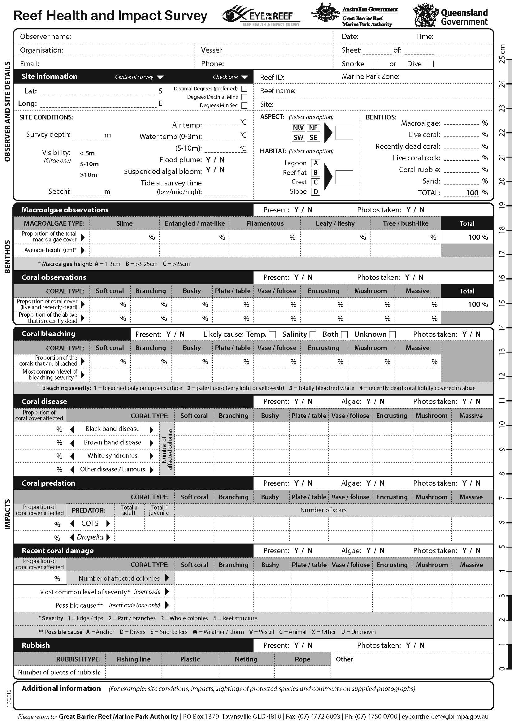

Appendix C — Survey protocol used in monitoring network

The protocol used by the monitoring network during site inspections can be completed by snorkelers or divers. It involves using a repeated Global Positioning System (GPS) tagged five metre radius point survey method (see image below). This method is used to assess a range of reef health indicators including coral and algal cover and the extent and severity of impacts such as coral bleaching, disease, rubbish, predation and anchor or storm damage (Appendix B). The protocol recognises the limited time that many participants have available to complete survey forms. One form will be completed for each point survey thus reducing the time taken to evaluate benthic cover and allowing ample time to accurately evaluate the presence or absence of the range of impacts included in the form. Ideally, observers will complete at least three point surveys at each site whilst remaining within one habitat type (e.g. reef slope or lagoon). Repeated surveys are conducted to enable statistical analysis of the data; however these surveys do not have to occur on the same day if time is limited.

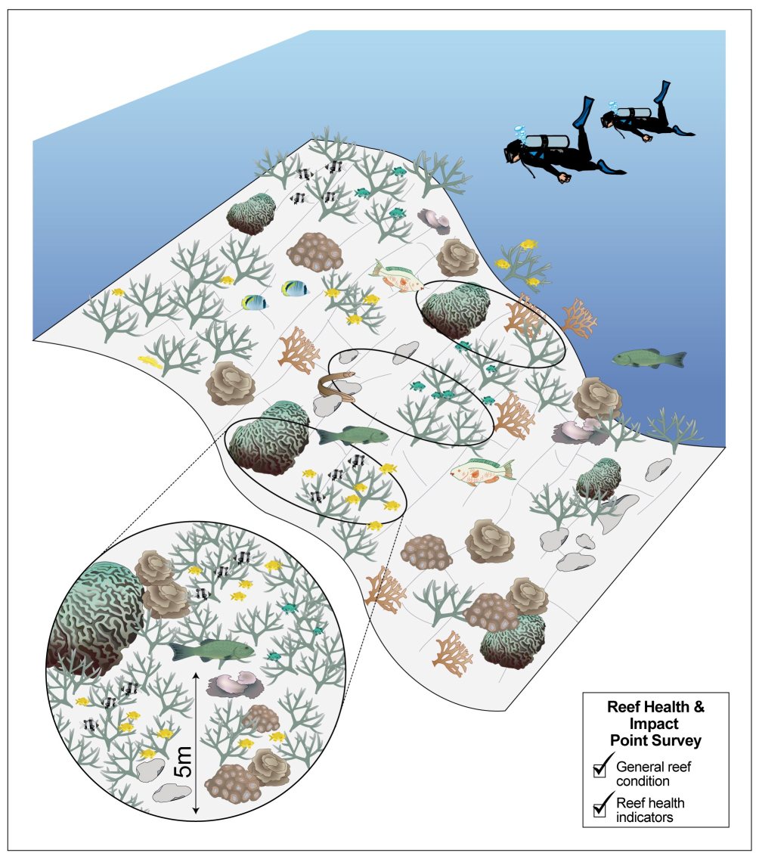
Protocol used by the monitoring network for site inspections. Observers use this protocol to assess reef condition and to detect and document impacts.

Appendix D — Assessment of potential impact of Great Barrier Reef Cyclones, 1985–2011

Note: The figure and table below are based on Puotinen and Maynard, in review, Geophysical Research Letters.

From 1985 to 2011, 41 cyclones generated winds of gale force (17 m/s) or above that affected at least part of the Great Barrier Reef Region. Figure 7 showed how a set of well-known historic cyclones fit within the assessment of potential impact framework described in section 2.2. Figure D-1 below shows this for the full set of cyclones.

Figure D-1: Tropical cyclones in the Great Barrier Reef from 1985–2011 and their estimated risk to reefs based on size, intensity and translation speed. Numbers on the diagram correspond to numbers in the first column of Table D-1 on the next page. The largest cyclone was tropical cyclone Justin – radius to gales = 467 km; the most intense was tropical cyclone Larry – maximum wind speed = 67.3 m/s; translation speed: tropical cyclones Mark and Niña – 2.1 m/s.

The potential for reef damage from each of the 41 cyclones was estimated to be: high — 29 per cent of tropical cyclones, medium — 12 per cent of tropical cyclones, low — 24 per cent of tropical cyclones and none — 34 per cent of tropical cyclones. Each number on Figure D-1 corresponds to a cyclone. The typical values for size of circulation, intensity and translation speed when each cyclone was close enough to be affecting the Reef are given in Table D-1, along with the estimated damage risk category.

For this analysis, size was defined as big (radius to gales >= 300 km), typical (radius to gales between 150-300 km), and small (radius to gales < 150 km). Intensity was defined as strong (maximum wind speeds >= 33 m/s — category 3 winds on the Australian cyclone ranking scale) or weak (maximum wind speeds < 33 m/s). Translation speed was defined as fast (storm moving more than 5 km/hr) versus slow (storm moving 5 km/hr or less).

Table D-1: Potential risk of damage from tropical cyclones generating gale force (17 m/s) or higher winds in the Great Barrier Reef from 1985–2011 and their size, intensity and translation speed. Maximum values for each characteristic are highlighted in red. Risk categories are: high (red), medium (orange), low (yellow), and minimal to none (green). Number in the first column corresponds to the number on Figure D-1.

Appendix E — Operational tool for assessing the likelihood of catastrophic damage to coral reefs of the Great Barrier Reef

E.1 Introduction

The Tropical Cyclone Risk and Impact Assessment Plan provides a strategic approach to monitoring cyclone risks, and coordinating and implementing responses before, during and after cyclone impacts. A key part of the risk assessment procedure used to determine whether management response to a given cyclone is necessary is component 2 of the plan: Mapping potential impact. As shown in Figure 3, for every named cyclone for which a Bureau of Meteorology warning is issued, this involves:

- compiling relevant data from the Bureau of Meteorology
- using the data to map an operational track of the cyclone and determine whether it moved near or within an area of particular management interest (plan of management area — Figure 8)
- using the data to characterise the cyclone by its size, intensity and translation speed while it was located near or within the Great Barrier Reef
- completing an assessment of potential impact to determine whether further examination of the cyclone’s potential impact on the Reef is warranted (Figure 7)
- if justified, running the cyclone wave damage model (Figure 10) to produce a map of potential impact.

The map of potential impact is then used within a matrix (Figure 12) to advise GBRMPA managers and other parties involved in the situation analysis (Figure 13) whether potential damage risk from the cyclone warrants response, and at what level.

The purpose of this appendix is to outline in detail the process involved in completing step 5 — running the wave damage model to produce a map of potential impact. The wave damage model (Figure 10) involves three basic stages:

- assembling data to predict catastrophic damage (Figure 10, steps 1 and 2)
- predicting catastrophic damage (Figure 10, steps 3 and 4)
- visualising and interpreting the results (Figure 10, step 5).

Each of these three stages is described in detail below. Examples for cyclone Yasi are provided to illustrate the process throughout.

E.2 Stage 1: Assembling data to predict catastrophic damage

The section outlines how the potential for catastrophic damage is modelled, including a justification for the method (sub section E.2.1: What to model?), a detailed description of each component (sub section E.2.2: Tropical cyclone wind speed and direction, and E.2.3: Fetch) and a brief explanation of how they are combined (E.2.4: Estimating significant wave heights).

E.2.1 What to model?

The likelihood that a given reef will be physically damaged by a cyclone depends on the magnitude and duration of wave energy, as well as the exposure and vulnerability of individual coral colonies to that energy. Ideally, estimates of likely damage would be therefore based on two key data sets. First, time series of significant wave heights during the storm measured at individual coral colonies are required to identify the larger and more persistent waves that lead to catastrophic damage. Second, data documenting colony growth forms and sizes immediately prior to the storm is needed because larger and more fragile forms are at greater risk of damage for a given level of wave energy (Denny 1988, Massel and Done 1993, Madin and Connelly 2006). None of this data, however, is typically available for the Great Barrier Reef. Instead, the model aims to predict and map the spatial distribution of tropical cyclone conditions likely to result in waves capable of catastrophically damaging reefs at regularly (hourly) intervals along the tropical cyclone track. At present, the model estimates where 2 metre and 4 metre significant wave heights were possible during a given cyclone and for how many hours. Presumably, sustained 2 metre waves and any 4 metre waves could cause such damage on reefs where vulnerable colonies are present. Keep in mind that a significant wave height of 2 metres (4 metres means that the average of the top one-third sized waves is 2 metres (4 metres). The largest wave possible will be higher than this.

Whether a given significant wave height is possible at a given location depends on the wind speed, duration that winds maintain that speed in a given wind direction, and the fetch (area of ocean over which winds can blow unobstructed in that direction). The relationship between these parameters needed to produce a particular significant wave height has been derived empirically and is documented in Figure 7.8, p111 of the US Army Shore Protection Manual, version 3. The duration (in hours) and fetch (in km) needed to generate 2 and 4 metre waves for a range of cyclonic wind speeds (17 – 33 m/s) extracted from the diagram is shown in Table E-1 below.

Higher waves require more fetch and longer lasting winds of a given speed. Shorter lived winds over less fetch are needed to achieve the same result for a higher speed. For example, generating a 4 metre (2 metre) wave at 17 m/s (gale force) requires winds of that strength to persist over 220 km (37 km) for 12 (3) hours. In contrast, generating a 4 metre (2 metre) wave at 33 m/s (Australian category 3 severe tropical cyclone strength) requires winds of that strength to persist over 28 km (5.2 km) for 1 (2) hours. It is for this reason that severe tropical cyclones, which generate higher wind speeds, generally have a greater chance of causing catastrophic reef damage. However, these relationships also show that slower winds can generate reef damaging waves if they persist long enough and blow in areas that are sufficiently exposed. This does not take into account local scale effects like diffraction, refraction and the like. Instead, it provides an approximation of the magnitude of conditions that were possible in a given cyclone. It also assumes that wind of a given speed blows in a consistent direction, which will not always be the case during a cyclone.

Table E-1: Duration of wind speeds and fetch required to generate 2 and 4 metre significant wave heights. Derived from Figure 7.8, p. 111 of the US Army Shore Protection Manual, version 3.

E.2.2 Tropical cyclone wind speed and direction

Tropical cyclone wind field models are used in conjunction with freely available meteorological data from the Bureau of Meteorology to estimate the maximum surface wind speeds and directions every hour along each tropical cyclones track for a grid of 1 km pixels encompassing the Great Barrier Reef (as per Puotinen 2007b, Fabricius et al 2008; but using an updated wind model as per De’ath et al 2012). Wind speeds at each cell are calculated as 10 minute maximum winds using a parametric wind model (Holland et al 2010) anchored in the outer radii of gale force winds. An asymmetry correction (McConochie et al. 2004) is applied and the resulting wind speeds are scaled to fit within the gale radii. Where necessary, missing radius data are calculated based on Moyer et al. (2007), and regionally adjusted (Chavas and Emanuel 2010). From the hourly time series of wind speed and direction, the model calculates the duration of winds of various speeds (every 1 m/s from 17 to 33 m/s) across the region. Wind directions at peak conditions, during gale conditions and overall define how exposure to wind varied across the Reef by measuring fetch in those directions (Figure 10, step 2).

EXAMPLE FOR CYCLONE YASI:

Figure 10 (c) shows maximum wind speed over the life of the storm, with different colours indicating different categories of cyclone strength. The tropical cyclone track is shown by the black line. Note how the distribution of winds is asymmetrical — high winds extend much further to the south (the ‘strong’ side of the cyclone) than to the north.

Figure 10 (b) shows the number of hours during Yasi that winds were at least gale force (17 m/s). Again, note how the long lasting winds (12+ hours — red) extended much farther to the south of the tropical cyclone track than the north.

E.2.3 Fetch

Fetch represents the distance over which wind can blow unobstructed to a particular location. At a given wind speed, generating a given wave height requires sufficient fetch. A fetch database has already been generated (Puotinen, unpublished data) using custom designed software (Pepper and Puotinen 2009, Hill et al 2010). The software recorded the distance to the nearest wave blocking obstacle every 7.5 degrees around a series of sites defined along the boundary of every reef across the region, as well as for inter-reef areas (n= 411,849). Sites located within the middle of large reefs were assumed to have zero fetch. This is justified as much of a wave’s energy is dissipated upon breaking at the reef edge, particularly at low tide (Young and Hardy 1993). Sites located near the edge of a reef were automatically moved to the reef edge (by using a nearest neighbour function to link them to the nearest vertex defining the reef, island and land boundary lines) before calculating fetch.

To estimate openness during a cyclone, fetch distances are combined for the range of directions affected by cyclone winds at key times (such as during maximum conditions or during gale force or higher winds). In addition, measuring openness in all directions provides an overview of how exposure to waves varies across the Great Barrier Reef under non-cyclone conditions. This approximates vulnerability as corals adapted to high wave energy are typically less vulnerable to damage during a cyclone (see Fabricius et al 2008 for a detailed explanation of this and other factors affecting reef vulnerability).

To achieve the above, wind directions are classified into eight compass directions, including 22.5 degrees on either side of the target direction. The most common of these eight directions is measured in a spreadsheet across the Great Barrier Reef for: i) the hour of maximum winds over the entire storm, ii) the hours where winds were gale force or higher, iii) the hours where winds were category 3 or higher.

EXAMPLE FOR CYCLONE YASI:

Figure 10 (a) shows the average openness across the Great Barrier Reef based on the fetch model with a maximum fetch distance of 220 km. Red areas are most exposed while dark blue areas are the most sheltered. Reefs are shown in white. From this, for example, it is clear that the Great Barrier Reef lagoon is the most open in general in the far southern Great Barrier Reef, and the least open in the far north. Under normal (non-cyclonic) conditions, exposed areas on reefs in the far south should typically experience higher levels of wave energy. This likely means that they are more wave adapted and thus less vulnerable to cyclone wave damage.

E.2.4 Estimating significant wave heights

The hourly modelled wind speed grids for a cyclone can then be used to count the duration of each of the 17 wind speeds across the Great Barrier Reef over the life of the storm. These are then reclassified such that values of 1 were assigned for wind speed of 17 m/s if winds persisted for at least 3 (12) hours for 2 (4) metre waves. This data is extracted for each of the 411,849 fetch locations across the region. The fetch data is then used in combination with these to identify whether a 2 or 4 metre wave was possible at each location across the Great Barrier Reef for the tropical cyclone, and if so, for how long. This is done by checking that the conditions for 2 and 4 metre wave formation were met, working in ascending order from wind speeds of 17m/s to 33 m/s.

EXAMPLE FOR CYCLONE YASI:

Figure 10 (d) shows the number of hours (ranging from 0 to 9) for which 4 metre significant wave heights were possible during cyclone Yasi. Look closely at panels (b), (c) and (d). Notice how the area that is not affected (green) expands for (d). This happened because weak cyclone winds (pink areas on (c)) did not persist long enough (needed to be red on (b) but instead are light pink — short lived) to generate 4 m significant wave heights. Also notice that the dark red area in (d) (longest lasting 4 metre waves) extends further to the south of the tropical cyclone track than the category 5 wind zone (dark red in (c)). This illustrates that lower winds speeds can generate heavy seas if they last long enough. That they did last long enough is shown by the red areas on (b) (gales for 12+ hours) which extend far to the south of the tropical cyclone track.

E.3 Stage 2: Predicting catastrophic damage

Predicting catastrophic damage from the data (Figure 10, step 4) generated above requires four basic steps:

- selecting appropriate predictors to use to define damage thresholds
- where possible refining the selection by using field data from the cyclone. Where this is not possible (most of the time), use field data from other cyclones that are the most relevant plus good judgement to select predictors
- using the literature (Puotinen 2007b, Fabricius et al 2008, Puotinen, Maynard, et al in review) to define threshold values of the predictors which can be assumed to cause catastrophic damage if vulnerable colonies are present
- using the mapped predictors and damage thresholds to map the likelihood of catastrophic damage from the cyclone.

A range of potential predictors are potentially relevant and possible to calculate. For a given cyclone, the predictors chosen to model will depend on the characteristics of the storm. This indicates which parameters are likely to do well in predicting a catastrophic damage zone that captures as much of the actual damage as possible. These predictors can be the number of hours / potential for 2 metre and 4 metre waves as described above. They can also include the individual measures of the wind speed, duration and fetch that help determine whether 2 or 4 metre waves were possible. For example, maximum wind speed and duration of gales have been shown to predict a zone beyond most damage does not occur (tropical cyclones Joy and Justin — Puotinen 2007b; tropical cyclone Ingrid — Fabricius et al 2008). Puotinen, Maynard et al (in review) are currently refining damage thresholds for the Reef based on extensive datasets from cyclones Yasi, Larry and Ingrid.

E.4 Stage 3: Visualising and interpreting the results

Once thresholds for the potential for catastrophic damage for the given set of cyclone parameters have been chosen, areas that meet or exceed them are identified (Figure 10, step 4). From this, spatial zones are defined (Figure 10, step 5) where catastrophic wave damage to reefs is:

- very likely
- likely
- possible
- unlikely.

The cut-off values for these categories will be defined as appropriate depending on the predictors that were used to map the potential catastrophic damage zone. Over time, this will be increasingly substantiated by field data from cyclone damage surveys as they are conducted.

EXAMPLE FOR CYCLONE YASI:

For tropical cyclone Yasi, the number of hours during which 4 metre waves were possible was calculated. As shown in Figure 10 (e), zones were defined where catastrophic wave damage to reefs was: very likely, likely, possible, and unlikely. Figure 3e shows this for cyclone Yasi. For the 4 metre wave example, this equate to: highly likely — 6+ hours of 4 metre waves possible (red); likely — 4–6 hours of 4 metre waves possible (dark pink); possible — 1–4 hours of 4 metre wave possible (light pink); and unlikely — no 4 metre waves possible (green). Sites where catastrophic damage was recorded in the GBRMPA tropical cyclone Yasi survey database are shown as open circles. Looking at the map (Figure 10 e), you can see that most of the catastrophic damage observed in the survey was found within the highly likely zone, and almost none (only one observation, < 1 per cent) falls in the unlikely zone.

We then examine how extensive damage is across the Great Barrier Reef by finding the percentage of the total area of reef across the region in each of the above categories, and rate it as high or low for each as follows:

- High: more than 10 per cent of the total area of reef across the Great Barrier Reef at some level of risk from catastrophic damage.
- Low: 10 per cent or less of the total area of reef across the Great Barrier Reef at some risk from catastrophic damage.

EXAMPLE FOR CYCLONE YASI:

For tropical cyclone Yasi, the per cent of total reef area in the region that fell in each risk category was:

Possible — 17 per cent
Likely — 12 per cent
Very likely — 6 per cent

Looking at the above data in the matrix in Figure 12, Yasi clearly triggers response level R3 because catastrophic damage is predicted to be highly likely for at least some of the Reef. In addition, Yasi’s large size and its track meant it affected both the Hinchinbrook and Cairns plans of management areas (Figure 8).

Beyond the specific needs of the Tropical Cyclone Risk and Impact Assessment Plan, the data generated by the cyclone wave damage model (and associated sub models) can be useful in a range of ways. Some examples include:

- Cyclone comparisons — A given cyclone can be quickly compared to historic cyclones using a range of measures like: maximum wind speed, duration of various threshold wind speeds, per cent of total reef area within various wind zones, per cent of total reef area potentially affected by various significant wave heights that persisted for a various numbers of hours, and so on. This enables GBRMPA to consider a given cyclone within a historic context.

- Field survey design — The spatial zones that define the likelihood of catastrophic damage are also useful for spatially constraining field survey effort to ensure that: i) key areas of damage are detected, and ii) that surveys include observations of both presence and absence of catastrophic damage. This is important as damage is highly patchy and can be easy to miss, especially for weaker, faster and smaller storms. Also, the area potentially damaged can be vast making it very difficult to collect a statistically useful sample.

- Cyclone damage history — Characterising cyclones by their catastrophic damage potential allows the creation of a likely cyclone damage history for the Great Barrier Reef. This is widely useful. For example:

  - This has already been done using maximum wind speeds instead of 2 metre and 4 metre waves and was used in the De’ath et al 2010 study to attribute 48 per cent of coral cover loss from 1985 to 2009 to cyclone damage.
  - It could be used to assess whether reefs that play a key role in maintaining the connectivity of the Great Barrier Reef (in terms of coral larvae transport for recovery from disturbance) are at risk of frequent catastrophic cyclone damage.
  - A global study of drivers of coral growth forms will use this data to examine the relative importance of cyclone damage patterns in determining which growth forms are prevalent across the world.

Australasian Fire Authority Council website, 2004, Australasian Fire Authority Council website
Australasian Fire Authority Council, 2004, Australasian Fire Authority Council website
http://www.bom.gov.au/cyclone/about/warnings/seasonal.shtml
Bureau of Meteorology website
Bureau of Meteorology website
http://knowledgeweb.afac.com.au/training/aiims
Sweatman, H.P.A., Cheal, A.J., Coleman, G.J., Emslie, M.J., Johns, K., Jonker, M., Miller, I.R. and Osborne, K. 2008, Long-term Monitoring of the Great Barrier reef, Status Report, Australian Institute of Marine Science.

