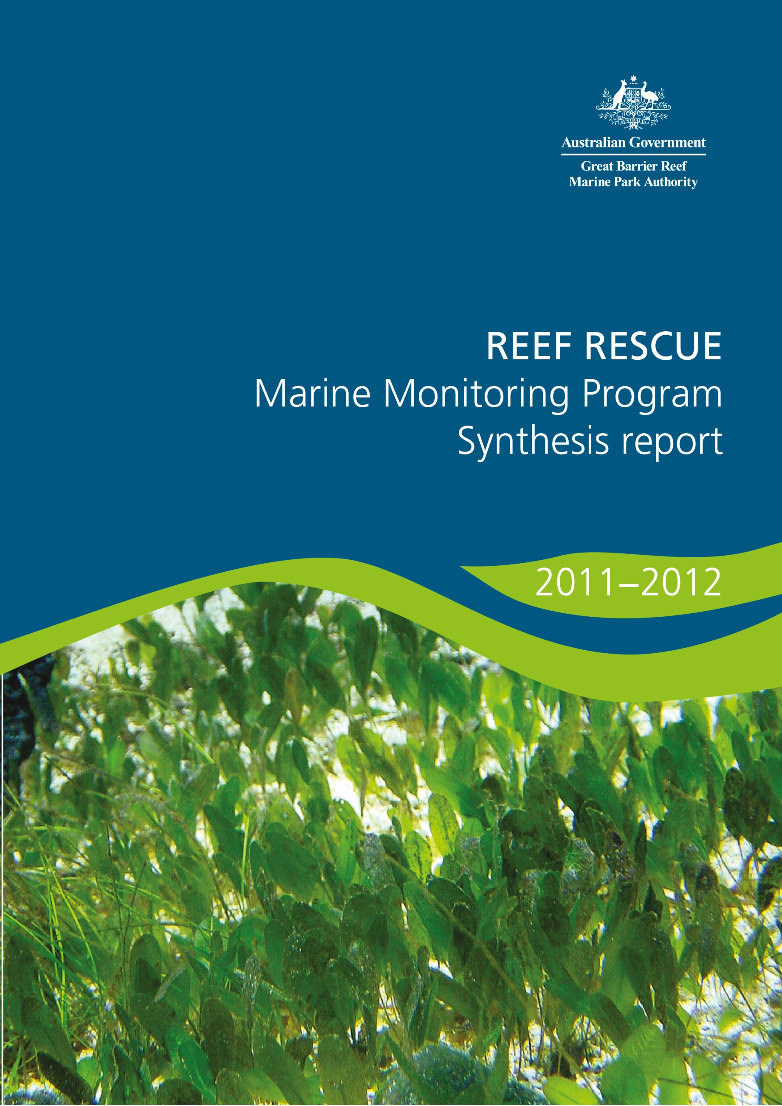

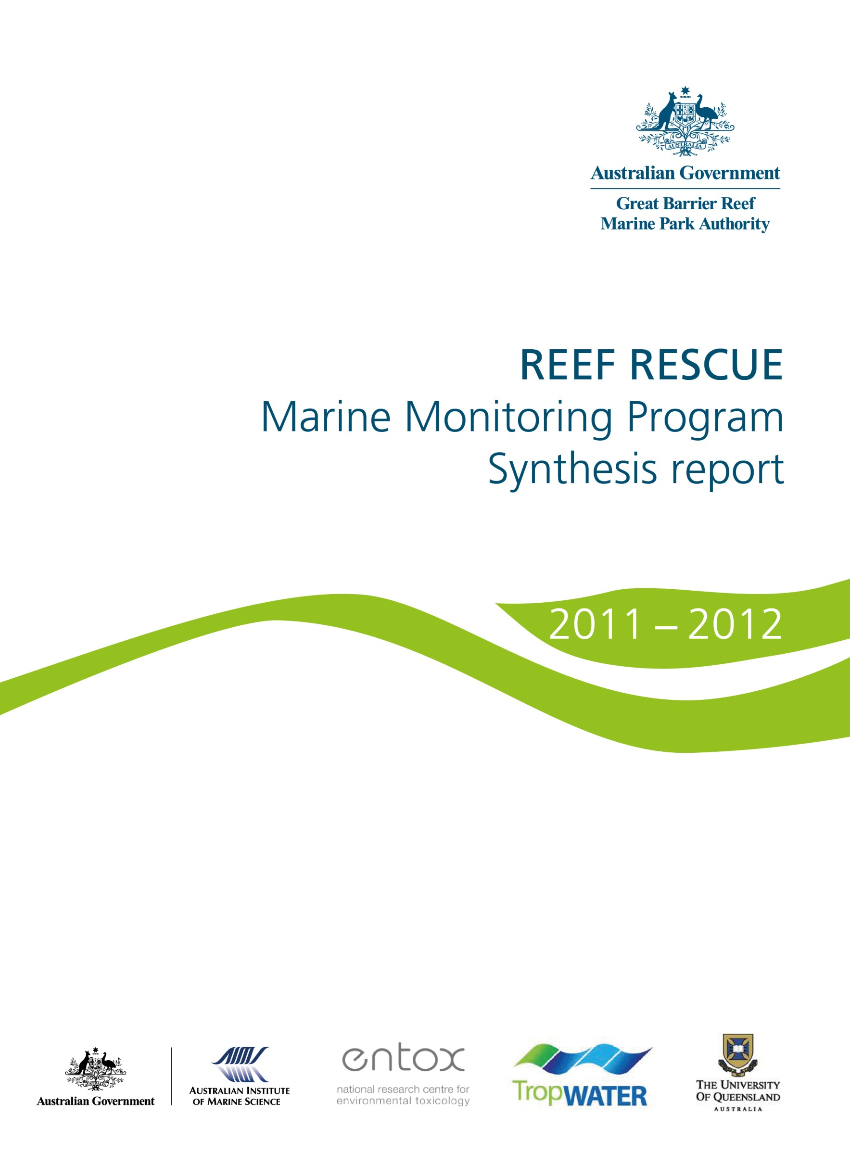

© Commonwealth of Australia 2014
Published by the Great Barrier Reef Marine Park Authority
ISSN 2200 4084
ISBN 978 1 921682 92 6 (ebook; pdf)
This work is copyright. Apart from any use as permitted under the Copyright Act 1968,
no part may be reproduced by any process without the prior written permission of the
Great Barrier Reef Marine Park Authority.
The Great Barrier Reef Marine Park Authority gratefully acknowledges the contributions of the MMP providers and their institutions to the Marine Monitoring Program Synthesis Report 2011-2012.
This publication should be cited as:
Martin, KC., Hele, A., Marshall, C., McKenzie, L.J., Thompson, A., Muller, J., Bentley, C., Paxman, C., Collier, C., Waycott, M., Brando, V. and Schaffelke, B. 2014 Reef Rescue Marine Monitoring Program synthesis report. 2011-2012, GBRMPA, Townsville.
Requests and inquiries concerning reproduction and rights should be addressed to:
Director, Communication and Parliamentary
2-68 Flinders Street
PO Box 1379
TOWNSVILLE QLD 4810
Australia
Phone: (07) 4750 0700
Fax: (07) 4772 6093
info@gbrmpa.gov.au

Comments and inquiries on this document are welcome and should be addressed to:
Director, Reef 2050
info@gbrmpa.gov.au
www.gbrmpa.gov.au

Table of Contents
List of Figures 3
List of Tables 6
1. Introduction 7
1.1 The Great Barrier Reef 7
1.2 Threats from poor land management practices 7
1.3 Disturbances affecting the Great Barrier Reef 8
1.4 Influence of climate change 8
2. Methods 10
2.1 The Marine Monitoring Program 10
2.1.1 Inshore water quality 10
2.1.2 Flood plume dynamics 11
2.1.3 Seagrass status 12
2.1.4 Coral reef status 13
2.2 Synthesis and integration of data and information 14
2.2.1 Inshore Great Barrier Reef and regional scores 15
2.2.2 Site-specific assessments 16
3. Results 18
3.1 The Inshore Great Barrier Reef Region 18
3.1.1 Summary results 18
3.1.3 Disturbances affecting the Great Barrier Reef 20
3.1.4 Water quality condition and trend 27
3.1.5 Case-study: Disease incidence in corals linked to river discharge 31
3.1.6 Seagrass condition and trend 32
3.1.7 Coral condition and trend 35
3.2 Cape York 38
3.2.1 Summary results 38
3.2.2 Water quality condition and trend 39
3.2.3 Seagrass condition and trend 40
3.3 Wet Tropics 42
3.3.1 Summary results 42
3.3.2 Water quality condition and trend 44
3.3.3 Seagrass condition and trend 47
3.3.4 Coral condition and trend 49
3.4 Burdekin 54
3.4.1 Summary results 54
3.4.2 Water quality condition and trend 55
3.4.3 Seagrass condition and trend 58
3.4.4 Coral condition and trend 60
3.5 Mackay Whitsunday 63
3.5.1 Summary results 63
3.5.2 Water quality condition and trend 64
3.5.3 Seagrass condition and trend 67
3.5.4 Coral condition and trend 69
3.6 Fitzroy 72
3.6.1 Summary results 72
3.6.2 Water quality condition and trend 74
3.6.3 Seagrass condition and trend 77
3.6.4 Coral condition and trend 79
3.7 Burnett Mary 82
3.7.1 Summary results 82
3.7.2 Water quality condition and trend 83
3.7.3 Seagrass condition and trend 84
4. Summary 86
5. References 88

List of Figures
Figure 1. Passive samplers monitor marine water pesticide concentrations and WetLabs fluorometer water quality loggers for in situ marine water quality monitoring 11
Figure 2: Satellite images (MODIS-Aqua) of the inshore Fitzroy region of the Great Barrier Reef during normal (low) flow conditions in November 2009 (a) and flood conditions in March and April 2010 (b, c, d). 12
Figure 3: Seagrass monitoring on the Great Barrier Reef. 13
Figure 4: Coral monitoring on the Great Barrier Reef. 14
Figure 5: The condition of water quality and ecosystem health (seagrass and corals) in 2011-2012 across the inshore region of the Great Barrier Reef. 18
Figure 6. All Category 4/5 cyclones that have affected the Great Barrier Reef from 2005 to 2012 with the zones of influence (wind categories) differentially shaded. 23
Figure 7: Water temperature as degree heating days and areas where coral bleaching occurred during summer 2011-2012. 25
Figure 8: The proportion of reefs with outbreaks of crown-of-thorns starfish since 1986 (AIMS). 26
Figure 9: Trend in the water quality index in the Great Barrier Reef from 2005-2006 to 2011-2012. 27
Figure 10: Maximum PS-II Herbicide equivalent concentrations at all sites monitored in the Great Barrier Reef from 2008-2009 to 2011-2012. 29
Figure 11: Maximum concentration of individual PS-II herbicides at all sites monitored across the Great Barrier Reef in 2011-2012, compared to the previous three seasons. 30
Figure 12: Staghorn coral showing loss of tissue due to coral disease 31
Figure 13: Trend in seagrass condition in the Great Barrier Reef from 2005-2006 to 2011-2012. 32
Figure 14: Trends in the abundance of inshore seagrass meadows at estuarine, coastal, intertidal reef and subtidal reef sites since 1999. 33
Figure 15: Median tissue nutrient content of seagrass tissue (percent nitrogen and phosphorus) for each habitat type since 2005. 34
Figure 16: Trend in coral condition in the Great Barrier Reef from 2007-2008 to 2011-2012 (blue solid line; numbers are index categories). 35
Figure 17: Variation in the cover of hard corals (A), cover of macroalgae (B), and density of hard coral juveniles (C) in the inshore Wet Tropics, Burdekin, Mackay Whitsunday and Fitzroy regions from 2005 to 2012. 37
Figure 18: The condition of water quality and ecosystem health (seagrass and corals) in 2011-2012 across the inshore region of Cape York. 38
Figure 19: Trend in the Water Quality Index in the inshore Cape York region from 2005-2006 to 2011-2012. 39
Figure 20: Trend in seagrass condition in the inshore Cape York region from 2005-2006 to 2011-2012. 40
Figure 21: Trend in seagrass abundance (per cent cover) at the inshore intertidal fringing reef habitat at Archer Point in the Cape York region 41
Figure 22: The condition of water quality and ecosystem health (seagrass and corals) in 2011-2012 across the inshore region for the Wet Tropics region. 42
Figure 23: Trend in the Water Quality Index in the inshore Wet Tropics region from 2005-2006 to 2011-2012 (blue solid line; numbers are index categories). 44
Figure 24: Water quality and pesticide ratings for PS-II herbicides at fixed monitoring sites in the inshore Wet Tropics region. 45
Figure 25: Trends in average PS-II herbicide equivalent concentrations at each sampling site in the Wet Tropics according to season. 46
Figure 26: Trend in seagrass condition in the inshore Wet Tropics region from 2005-2006 to 2011-2012 (blue solid line; numbers are index categories). 47
Figure 27: Trend in seagrass abundance (per cent cover) at inshore intertidal coastal habitats (Yule Point and Lugger Bay) and inshore intertidal reef habitats (Green and Dunk Islands) in the Wet Tropics. 48
Figure 28: Trend in coral condition in the Wet Tropics from 2007-2008 to 2011-2012 49
Figure 29: Cover of major benthic groups and levels of key environmental parameters: Barron Daintree sub-region, inshore Wet Tropics region. 50
Figure 30: Cover of major benthic groups and levels of key environmental parameters: Johnstone Russell-Mulgrave sub-region, Wet Tropics region. Stacked bars represent cumulative cover of hard coral (blue), soft coral (pink) and macroalgae (green). 52
Figure 31: Cover of major benthic groups and levels of key environmental parameters: Herbert Tully sub-region, Wet Tropics region. Stacked bars represent cumulative cover of hard coral (blue), soft coral (pink) and macroalgae (green). 53
Figure 32: The condition of water quality and ecosystem health (seagrass and corals) in 2011-2012 across the inshore region for the Burdekin region. 54
Figure 33: Trend in the Water Quality Index in the inshore Burdekin region from 2005-2006 to 2011-2012 (blue solid line; numbers are index categories). 55
Figure 34: Water quality and pesticide ratings for PS-II herbicides at fixed monitoring sites in the inshore Burdekin region. 56
Figure 35: Trends in average PS-II herbicide equivalent concentrations at each sampling site in the Burdekin according to season. 57
Figure 36: Trend in seagrass condition in the inshore Burdekin region from 2005-2006 to 2011-2012 (blue solid line; numbers are index categories). 58
Figure 37: Trend in seagrass abundance (per cent cover) at inshore intertidal coastal habitats (Bushland and Shelly Beaches) and inshore fringing platform reef habitats (Magnetic Island) in the inshore Burdekin region. 59
Figure 38: Trend in coral condition in the inshore Burdekin region from 2007-2008 to 2011-2012 (blue solid line; numbers are index categories). 60
Figure 39: Cover of major benthic groups and levels of key environmental parameters: inshore Burdekin region. Stacked bars represent cumulative cover of hard coral (blue), soft coral (pink) and macroalgae (green). 62
Figure 40: The condition of water quality and ecosystem health (seagrass and corals) in 2011-2012 across the inshore Mackay Whitsunday region. 63
Figure 41: Trend in the Water Quality Index in the inshore Mackay Whitsunday region from 2005-2006 to 2011-2012 (blue solid line; numbers are index categories). 64
Figure 42: Water quality and pesticide ratings for PS-II herbicides at fixed monitoring sites in the inshore Mackay Whitsundays region. 65
Figure 43: Trends in average PS-II herbicide equivalent concentrations at each sampling site in the Mackay Whitsundays according to season. 66
Figure 44: Trend in seagrass condition in the inshore Mackay Whitsunday region from 2005-2006 to 2011-2012. 67
Figure 45: Trend in seagrass abundance (per cent cover) at inshore intertidal estuarine habitats (Sarina Inlet), inshore intertidal coastal habitats (Pioneer Bay) and inshore fringing reef habitats (Hamilton Island) in the Mackay Whitsundays. 68
Figure 46: Trend in coral condition in the inshore Mackay Whitsunday region from 2007-2008 to 2011-2012. 69
Figure 47: Cover of major benthic groups and levels of key environmental parameters in the inshore Mackay Whitsunday region. 71
Figure 48: The condition of water quality and ecosystem health (seagrass and corals) in 2011-2012 across the inshore region for the Fitzroy region. 72
Figure 49: Trend in the Water Quality Index in the inshore Fitzroy region from 2005-2006 to 2011-2012. 74
Figure 50: Water quality and pesticide ratings for PS-II herbicides at fixed monitoring sites in the inshore Fitzroy region. 75
Figure 51: Trends in average PS-II herbicide equivalent concentrations at the sampling site in the Fitzroy according to season. 76
Figure 52: Trend in seagrass condition in the inshore Fitzroy region from 2005-2006 to 2011-2012 . 77
Figure 53: Trend in seagrass abundance (per cent cover) at inshore intertidal estuarine habitats (Gladstone Harbour), inshore intertidal coastal habitats (Shoalwater Bay) and inshore fringing reef habitats (Great Keppel Island) in the Fitzroy region. 78
Figure 54: Trend in coral condition in the inshore Fitzroy region from 2007-2008 to 2011-2012 (blue solid line; numbers are index categories). 79
Figure 55: Cover of major benthic groups and levels of key environmental parameters: inshore Fitzroy region. Stacked bars represent cumulative cover of hard coral (blue), soft coral (pink) and macroalgae (green). 81
Figure 56: The condition of water quality and ecosystem health (seagrass and corals) in 2011-2012 across the inshore region for the Burnett Mary. 82
Figure 57: Trend in the Water Quality Index in the inshore Burnett Mary region from 2005-2006 to 2011-2012. 83
Figure 58: Trend in seagrass condition in the inshore Burnett Mary region from 2005-2006 to 2011-2012. 84
Figure 59: Trend in seagrass abundance (per cent cover) at inshore intertidal estuarine habitats (Urangan and Rodds Bay) in the inshore Burnett Mary region. 85

List of Tables
Table 1: The five categories of the PS-II herbicide equivalent index used in the regional section of the report. Scientific studies have shown that concentrations of diuron Category 4 or above can negatively affect photosynthesis in non-target organisms such as microalgae, corals and seagrass 17
Table 2: Annual freshwater discharge (October to September) for the major rivers of each region in the Great Barrier Reef relative to the long-term median discharge. 21
Table 3: Relative area (per cent) of the inshore, mid-shelf and offshore waterbodies of each region where the annual mean value for chlorophyll a and total suspended solids from remote sensing data exceeded the Water Quality Guidelines from 1 May 2011 to 30 April 2012. 28

1. Introduction

1.1 The Great Barrier Reef
The Great Barrier Reef is renowned internationally for its ecological importance and beauty. It is the largest and best known coral reef ecosystem in the world, extending more than 2,300 kilometres along the Queensland coast and covering an area of 350,000 square kilometres. It includes more than 2900 coral reefs, as well as extensive seagrass meadows, mangrove forests and diverse seafloor habitats. It is a World Heritage Area and protected within the Great Barrier Reef Marine Park (Marine Park) in recognition of its diverse, unique and universal values. The Great Barrier Reef is also critical for the prosperity of Australia, contributing about $5.5 billion annually to the Australian economy.¹
The Great Barrier Reef is home to thousands of species, including corals and other invertebrates, bony fish, sharks, rays, marine mammals, marine turtles, sea snakes and seabirds, as well as a wide variety of other animals, algae and marine plants.¹ The high biodiversity of the region is nationally and internationally important for the continued survival of many species, particularly species of conservation concern such as dugongs, whales, dolphins, sharks and marine turtles. It is this biodiversity that builds such a remarkable ecosystem and supports human use of the Great Barrier Reef.
The Great Barrier Reef remains one of the most healthy and well managed coral reef ecosystems in the world.¹ However, there is no room for complacency as the future health and resilience of the Great Barrier Reef remains under threat from a range of factors including climate change, pollutants from the catchments and expanding coastal development. Effective management and strategic investment in improving water quality will mitigate some of the short-term impacts of climate change through enhancing Great Barrier Reef resilience. The health of the Great Barrier Reef depends on the integrity of its ecological processes and its capacity to recover from anthropogenic and natural disturbance.

1.2 Threats from poor land management practices
The Great Barrier Reef receives run-off from 35 major catchments, which drain 424,000 square kilometres of coastal Queensland. The Great Barrier Reef Region is relatively sparsely populated; however, there have been extensive changes in land use since European settlement, driven by increased urban, agricultural and industrial development, particularly in areas adjacent to the coast.^{2,3} The combination of expanding catchment development and modification of land use has resulted in a significant decline in the quality of water flowing into the Reef lagoon over the past 150 years.^{2,4,5,6} Flood events in the wet season deliver low salinity waters and loads of nutrients, sediments and pesticides from the adjacent catchments into the Great Barrier Reef lagoon that are well above natural levels and many times higher than in non-flood waters.⁷ Pesticides, which are manufactured chemicals with no natural level, are now widespread in Great Barrier Reef waters.
Numerous studies have shown that nutrient enrichment, turbidity, sedimentation and pesticides all affect the resilience of the Great Barrier Reef ecosystem, degrading coral reefs and seagrass meadows at local and regional scales.^{8,9,10} Pollutants may also interact to have a combined negative effect on Great Barrier Reef resilience that is greater than the effect of each pollutant in isolation.^{11,12} For example, differences in tolerance to nutrient enrichment and sedimentation between species of adult coral can lead to changes in community composition.^{10,13}
Generally, reef ecosystems decline in species richness and diversity along a gradient from outer reefs distant from terrestrial inputs to near-shore coastal reefs more frequently exposed to flood waters.^{10,14} The area at highest risk from degraded water quality is the inshore area, which makes up approximately eight per cent of the Marine Park within 20 kilometres of the shore. The inshore area supports significant ecological communities and is also the area of the Great Barrier Reef most utilised by recreational visitors, commercial tourism operators and commercial fishers.

1.3 Disturbances affecting the Great Barrier Reef
The Great Barrier Reef ecosystem is affected by a range of human-induced and natural disturbances, including floods, cyclones, high seawater temperatures, outbreaks of coral disease and crown-of-thorns starfish. The impact of disturbances on the Great Barrier Reef depends on their frequency, duration and severity, as well as the state of the ecosystem.¹⁰
A resilient coral community has high rates of recruitment and growth that compensate for losses resulting from the combination of acute disturbances (such as cyclones) and chronic environmental stressors (for example poor water quality). However, coral recovery following a major disturbance is variable, with slow growing species taking decades to recover.¹⁵ Over time, chronic stress may decrease the resilience of the Great Barrier Reef ecosystem, by slowing or inhibiting recovery from acute disturbances.^{8,10}
Importantly, reducing one stress will often help the ecosystem recover from or resist the impact of other pressures. For example, managing water quality may help minimise the effects of climate change.

1.4 Influence of climate change
Under future climate change scenarios, the frequency and intensity of disturbances is set to increase.¹⁶ The average annual seawater temperature on the Great Barrier Reef is likely to be as much as 1 to 3°C warmer than the present average temperature by 2100.^{17,18} In addition, it is predicted that Great Barrier Reef waters will become more acidic, sea level will continue to rise, patterns of ocean circulation will change and weather events will become more extreme.¹⁷ The Great Barrier Reef Outlook Report 2009¹ assessed the overall outlook for the Great Barrier Reef to be poor and reported that catastrophic damage to the ecosystem may not be averted. It reported that building ecosystem resilience will give the Reef the best change of adapting to and recovering from the serious threats ahead, especially from climate change.
The extent and persistence of damage to the Great Barrier Reef will depend to a large degree on the rate and magnitude of future change in the world’s climate and on the resilience of the Great Barrier Reef ecosystem.¹ This has important implications for the future management of the Great Barrier Reef and run-off entering the Great Barrier Reef lagoon. For example, modelling suggests that the upper thermal bleaching limit of corals is correlated with exposure to dissolved inorganic nitrogen and that reducing land-based run-off of this nutrient may enhance the resilience of inshore corals.¹⁹ There is strong evidence that halting and reversing the decline of water quality entering the Great Barrier Reef lagoon will increase the natural resilience of Great Barrier Reef ecosystems to future challenges.

2. Methods

2.1 The Marine Monitoring Program
The most significant water quality issues for the Great Barrier Reef are those affecting inshore waters, and the majority of the assessment and monitoring information relates to this area. The Reef Rescue Marine Monitoring Program (MMP) monitors the condition of water quality in the inshore Great Barrier Reef lagoon and the long-term health of key marine ecosystems (inshore coral reefs and seagrasses). There are four sub-programs, the broad objectives of which are outlined below along with a brief overview of a sub-section of the methods.
More information about the MMP is available from the Great Barrier Reef Marine Park Authority's (agency) website: http://www.gbrmpa.gov.au/about-the-reef/how-the-reefs-managed/science-and-research/our-monitoring-and-assessment-programs/reef-rescue-marine-monitoring-program

2.1.1 Inshore water quality
Long-term monitoring of marine water quality in inshore areas of the Great Barrier Reef lagoon is essential to assess improvements in regional water quality that will occur as a result of reductions in pollutant loads from adjacent catchments.
Monitoring includes the measurement of concentrations of dissolved and particulate nutrients (nitrogen and phosphorus) and carbon, chlorophyll, salinity, temperature, suspended solids (water turbidity) and pesticides. Techniques used to monitor water quality include satellite remote sensing, automated high-frequency data loggers, and collection of water samples from research vessels for standard laboratory analysis. Passive samplers are used to measure the concentration of pesticides in the water column integrated over time, by accumulating chemicals via passive diffusion.^{20,21} Key points include:
- Remote sensing of water quality utilises satellite images acquired on a daily basis across the Great Barrier Reef, except on overcast days.
- Monitoring of site-specific water quality by data loggers and direct water sampling is primarily conducted at the 14 inshore coral monitoring sites, two to three times per year, to allow for correlation with Great Barrier Reef ecosystem condition. Six open water sites off Cairns are also monitored to extend an existing long-term data series initiated in 1989 by the Australian Institute of Marine Science (AIMS).
- Pesticide concentrations are assessed with passive samplers at 12 sites at monthly intervals in the wet season and bi-monthly intervals in the dry season (Figure 1).
Water quality parameters are assessed against the Water Quality Guidelines for the Great Barrier Reef Marine Park (Water Quality Guidelines).²²
Further information is available in the annual science reports on the Agency website: http://www.gbrmpa.gov.au/resources-and-publications/publications/scientific-and-technical-reports

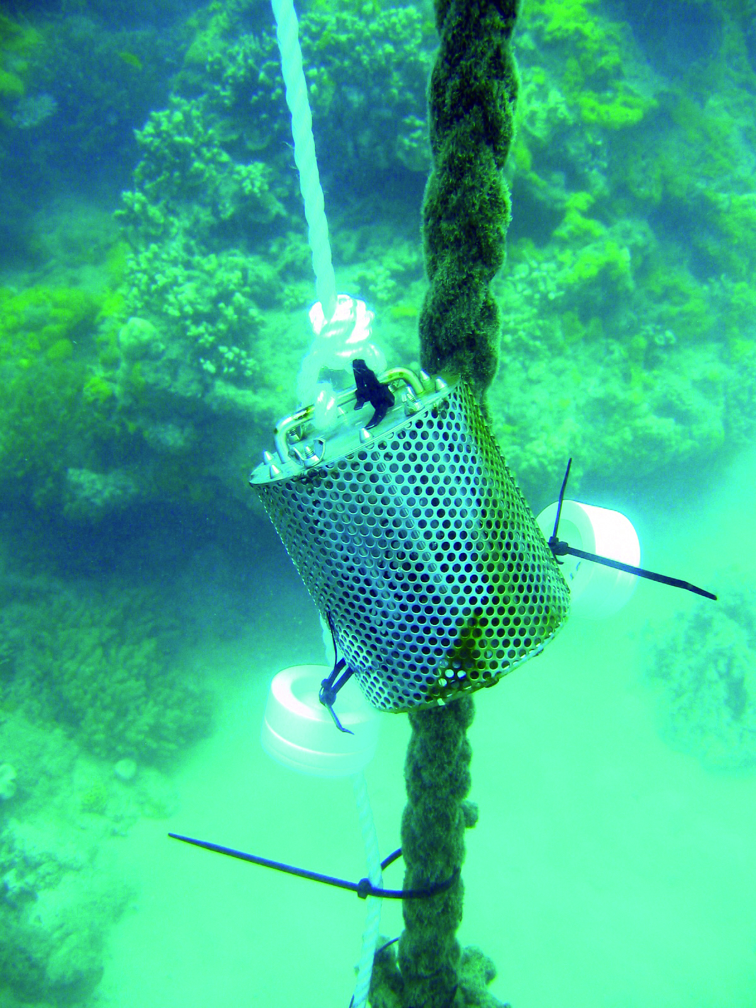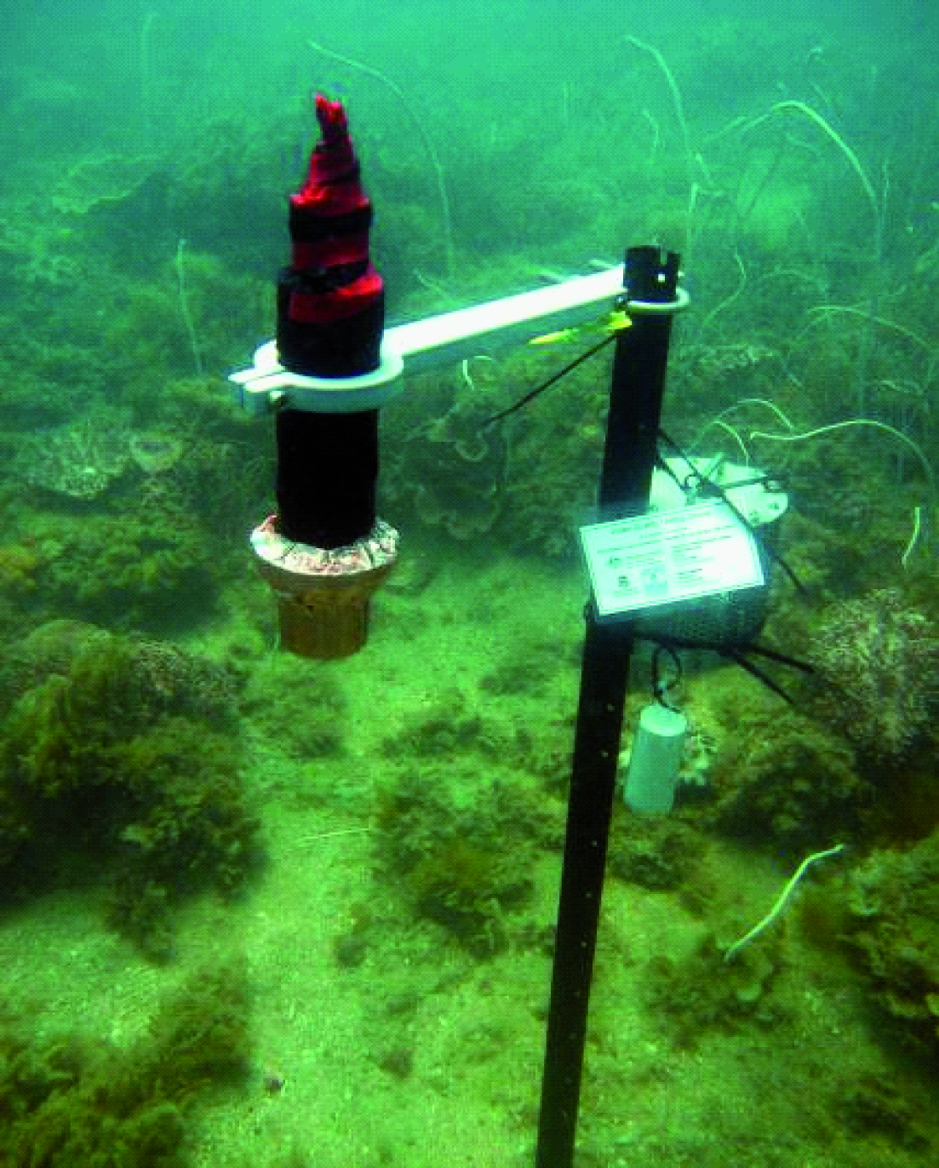
J. Muller, University of Queensland
Australian Institute of Marine Science
Figure 1. Passive samplers monitor marine water pesticide concentrations and WetLabs fluorometer water quality loggers for in situ marine water quality monitoring

2.1.2 Flood plume dynamics
The majority of the annual pollutant load to the Great Barrier Reef is delivered by flood events in the wet season. Assessing trends in the delivery of pollutants by floods and the exposure of inshore ecosystems is essential to target management actions in regions with a high probability of exposure to elevated pollutant concentrations.
Monitoring of water quality during flood events and throughout the wet season includes measurements of salinity, concentrations of nutrients, chlorophyll, suspended solids (water turbidity) and pesticides from water samples collected directly from research vessels. The movement of the flood plume across inshore waters of the Great Barrier Reef is assessed using images from aerial flyovers and remote sensing. Key points include:
- Monitoring is carried out in marine waters adjacent to targeted catchments along a north-east transect away from the river mouth, in the wet and dry tropics depending on flood conditions.
- Remote sensing of water quality utilises satellite images acquired on a daily basis across the Great Barrier Reef, except on overcast days (Figure 2).
Water quality parameters are assessed against the Water Quality Guidelines.²² Further information is available in the annual science reports on the Agency website: http://www.gbrmpa.gov.au/resources-and-publications/publications/scientific-and-technical-reports
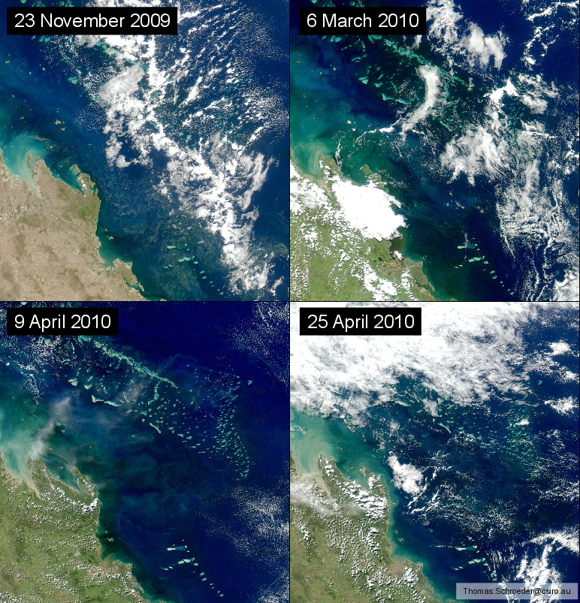
a
d
c
b
Figure 2: Satellite images (MODIS-Aqua) of the inshore Fitzroy region of the Great Barrier Reef during normal (low) flow conditions in November 2009 (a) and flood conditions in March and April 2010 (b, c, d).
The discharge from the Fitzroy River was more than four times the annual median flow and images b-d show large plumes of dissolved and suspended material in the coastal waters.

2.1.3 Seagrass status
Seagrasses are an important component of the marine ecosystem of the Great Barrier Reef. They form highly productive habitats that provide nursery grounds for many marine and estuarine species, including commercially important fish and prawns. Monitoring temporal and spatial variation in the status of intertidal seagrass meadows in relation to changes in local water quality is essential in evaluating long-term ecosystem health.
Monitoring includes assessment of the abundance of seagrass species, percentage of cover and seagrass reproductive effort (Figure 3), which provides an indication of the capacity for meadows to regenerate following disturbances and changed environmental conditions. Tissue nutrient composition is assessed in the laboratory as an indicator of potential nutrient enrichment. Key points include:
- Monitoring occurs at 30 sites across 15 locations, including nine inshore (intertidal coastal and estuarine) and six offshore reef intertidal locations. Three transects are monitored per site in both the late dry and monsoon seasons.
- Monitoring includes in situ within canopy temperature and light levels.
Further information is available in the annual science reports on the Agency website: http://www.gbrmpa.gov.au/resources-and-publications/publications/scientific-and-technical-reports
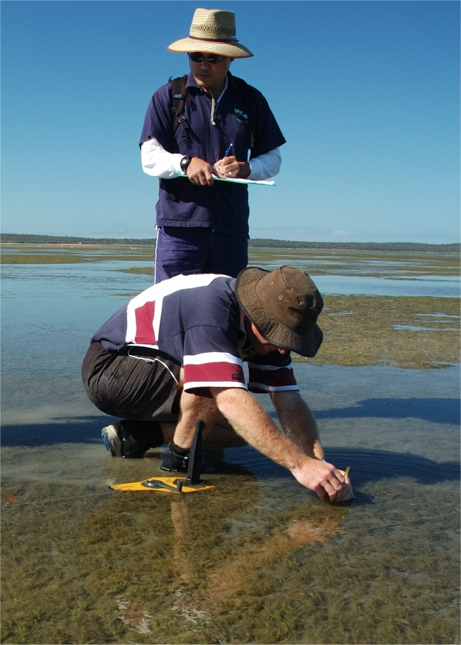
Figure 3: Seagrass monitoring on the Great Barrier Reef.

2.1.4 Coral reef status
Several reefs that make up the Great Barrier Reef are at inshore areas frequently exposed to run-off.²³ Monitoring temporal and spatial variation in the status of inshore coral reef communities in relation to changes in local water quality is essential in evaluating long-term ecosystem health.
Monitoring covers a comprehensive set of community attributes including the assessment of hard and soft coral cover; the density of hard coral juvenile colonies; macroalgae cover; and the rate of change in coral cover as an indication of the recovery potential of the Great Barrier Reef following a disturbance (Figure 4).²⁴ Comprehensive water quality measurements are also collected at many of the coral reef sites. Key points include:
- Monitoring of 32 inshore coral reefs in the Wet Tropics, Burdekin, Mackay Whitsunday and Fitzroy regions along gradients of exposure to run-off from regionally important rivers. At each reef, two sites are monitored at two depths (2 and 5 metres) across five replicate transects. Reefs are designated as either ‘core’ or ‘cycle’ reefs. The 15 core reefs are surveyed annually and the 17 cycle reefs are surveyed every second year.
- Monitoring includes sea temperature, sediment quality and assemblage composition of benthic foraminifera as drivers of environmental conditions at inshore reefs.
Further information is available in the annual science reports on the Agency website: http://www.gbrmpa.gov.au/resources-and-publications/publications/scientific-and-technical-reports
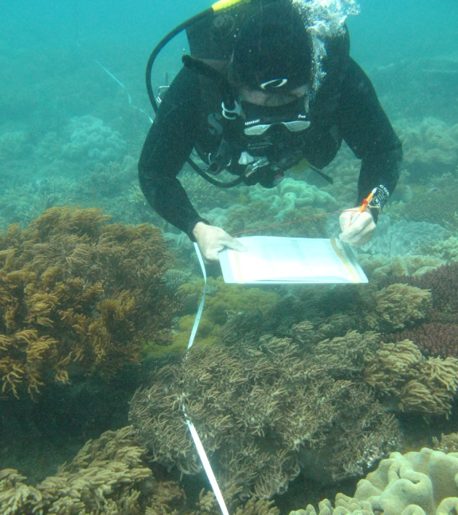
Figure 4: Coral monitoring on the Great Barrier Reef.

2.2 Synthesis and integration of data and information
A comprehensive list of water quality and ecosystem health indicators is measured under the MMP and a sub-set of these was selected to calculate the inshore water quality, seagrass and coral scores for the report card, based on expert opinion. These scores were expressed on a five point scale using a common colour scheme and integrated into an overall score that describes the status of the Great Barrier Reef and each inshore region, where:
- 0-20 per cent is assessed as ‘very poor’ and coloured red
- >20-40 per cent equates to ‘poor’ and coloured orange
- >40-60 per cent equates to ‘moderate’ and coloured yellow
- >60-80 per cent equates to ‘good’, and coloured light green
- >80 per cent is assessed as ‘very good’ and coloured dark green.
A brief overview of the methods used to calculate the Great Barrier Reef wide and regional scores is presented below. More detailed information, including refinements to methods used for the first report card, is available from the annual science reports on the Agency website: http://www.gbrmpa.gov.au/resources-and-publications/publications/scientific-and-technical-reports

2.2.1 Inshore Great Barrier Reef and regional scores

Water quality
The indicators used to evaluate inshore water quality status were near-surface concentrations of chlorophyll a and total suspended solids from remotely sensed images. Chlorophyll a is a measure of phytoplankton biomass that is related to the amount of available nutrients in the water column and therefore the productivity of the system. Total suspended solids are a measure of all other particulate matter in the water column, which influences water clarity and sedimentation regimes.
Water quality scores were calculated from the relative area (percentage) of inshore waters where the annual mean of chlorophyll a and total suspended solids exceeded the Water Quality Guidelines.²⁵ The method used to calculate relative area of exceedance was refined in 2009/10 and baseline values from 2008/09 used in this report have been recomputed. In inshore Cape York and Burnett Mary regions, estimates of chlorophyll a and total suspended solids derived from remote sensing require further field validation and were excluded from overall condition assessments of Great Barrier Reef water quality.

Seagrass
The indicators used to evaluate inshore seagrass condition were abundance, reproductive effort and tissue nutrient status. Seagrass abundance includes assessment of per cent cover determined in reference to seagrass abundance guidelines.²⁶ Reproductive effort is based on the average number of reproductive structures on an area basis and provides an indication of the capacity for recovery following disturbances. The nutrient status of seagrass is based on the ratio of carbon to nitrogen in leaf tissue and reflects the level of nutrients in the surrounding waters.
The methods used to calculate seagrass abundance, reproductive effort and tissue nutrient status was refined in 2009-2010 and baseline values from 2008-2009 used in this report have been recalculated. The number of seagrass sites in Cape York does not adequately reflect the variability of seagrass habitats in the inshore region and they were excluded from the overall condition assessments of Great Barrier Reef seagrass.

Corals
The indicators used to evaluate inshore coral reef condition were coral cover, coral cover change, the juvenile density and macroalgae cover. Coral cover is a measure of the abundance of hard and soft corals, and indicates the capacity of coral to persist under the current environmental conditions and to recover from disturbances. Coral change is a measure of the change in hard coral cover from the preceding three years and is an indicator of the resilience of corals to disturbance. Juvenile density is a measure of the abundance of hard coral juveniles and is an indicator of the potential of the community to recover from disturbances or stress. Macroalgal cover is a measure of the abundance of large, fleshy algae. High abundance of algae is an indicator of poor water quality and may negatively influence the resilience of coral communities.
The method used to calculate the coral score was refined in 2009-2010 to remove the settlement of coral larvae and to include the rate of change in hard coral cover as a separate indicator, which was previously combined with assessments of coral cover. In addition, estimates of juvenile density were improved. Baseline values from 2008-2009 used in this report have been recalculated to reflect the above changes.

2.2.2 Site-specific assessments

Water quality
To complement the water quality scores derived from remotely sensed images and to give greater resolution on a regional scale, site-specific water quality data were reported in the regional sections using an interim water quality index, based on expert opinion.
The water quality index aggregates the scores for four indicators of water quality relative to the Water Quality Guidelines²⁵ to give an overall rating for each of the 20 fixed sampling sites (section 2.1.1). The four indicators, which reflect important bio-physical processes of the inshore environment, are an integrated assessment of turbidity, chlorophyll a and concentrations of particulate nitrogen and phosphorus. Decision rules for the water quality index are outlined in Schaffelke et al., 2010.²⁷ The proportional scores were expressed on a five point scale and converted to the colour scheme used for the inshore Great Barrier Reef wide and regional reporting. The water quality index will be refined with future research and data analysis.

Pesticides
The most frequently detected pesticides in inshore waters include those that inhibit the photosynthetic pathway (PS-II) of plants in an additive manner: the PS-II herbicides diuron, atrazine, hexazinone, simazine and tebuthiuron.^{28,29,30,31,32,33} These PS-II herbicides may also have a negative impact on non-target organisms such as algae, corals and seagrass.^{34,35,28,29} The metric for reporting pesticide concentrations is based on the PS-II herbicide equivalent index, which incorporates both the relative potency and relative abundance of individual PS-II herbicides, compared with the PS-II herbicide, diuron (Table 1). The five categories of the PS-II herbicide equivalent index were developed with reference to the Water Quality Guidelines²⁵ and converted to the colour scheme used for the inshore Great Barrier Reef and regional reporting.

Table 1: The five categories of the PS-II herbicide equivalent index used in the regional section of the report. Scientific studies have shown that concentrations of diuron Category 4 or above can negatively affect photosynthesis in non-target organisms such as microalgae, corals and seagrass
Category | Concentration (ng.L⁻¹) | Description
5 | PS-II-HEq ≤ 10 | No published scientific papers that demonstrate any effects on plants or animals based on toxicity or a reduction in photosynthesis. The upper limit of this category is also the detection limit for pesticide concentrations determined in field collected water samples
4 | PS-II-HEq > 10  ≤ 50 | Published scientific observations of reduced photosynthesis for two diatoms.
3 | PS-II-HEq > 50  < 250 | Published scientific observations of reduced photosynthesis for two seagrass species and three diatoms.
2 | PS-II-HEq ≥ 250  ≤ 900 | Published scientific observations of reduced photosynthesis for three coral species.
1 | PS-II-HEq > 900 | Published scientific papers that demonstrate effects on the growth and death of aquatic plants and animals exposed to the pesticide. This concentration represents a level at which 99 per cent of tropical marine plants and animals are protected, using diuron as the reference chemical.

3. Results

3.1 The Inshore Great Barrier Reef Region
Figure 5: The condition of water quality and ecosystem health (seagrass and corals) in 2011-2012 across the inshore region of the Great Barrier Reef.

3.1.1 Summary results
- The condition of the Great Barrier Reef (similar to other reefs world-wide) has declined significantly over the last 150 years.
- No category 4 or 5 cyclones affected the Great Barrier Reef in 2011-2012. River discharges were below levels in 2010-2011, although still significantly above long-term median volumes in the Burdekin, Mackay Whitsunday and Fitzroy regions.
- The overall condition of the Great Barrier Reef in 2011-2012 remained poor (Figure 5). The scores of individual water quality, seagrass and coral metrics that comprise the overall condition assessment for the Great Barrier Reef varied spatially and temporally across sites monitored. It is important to refer to the regional sections for detailed information.
- Inshore water quality was rated as poor overall in 2011-2012 Concentrations of chlorophyll a and total suspended solids were rated as poor and moderate, respectively (Figure 5).
- A wide range of PS-II herbicides, other pesticides and industrial chemicals were frequently detected at pesticide monitoring sites in 2011-2012. Biologically relevant concentrations of PS-II herbicides were present at a single site in the inshore Burdekin region and two out of three sites in the inshore Mackay Whitsunday region. There was no pesticides that exceeded the Water Quality Guidelines. There was a clear decrease in the maximum concentrations of herbicides detected at all twelve routine monitoring sites when compared with the previous monitoring year, with the greatest decreases observed in the inshore Burdekin, Mackay Whitsundays and Fitzroy regions.
- Inshore seagrass meadows remained in very poor condition overall in 2011-2012, with their condition continuing to decline since 2006-2007 (Figure 5). Seagrass abundance and reproductive effort were both very poor, while nutrient status was poor.
- Inshore coral reefs remained in a poor condition overall in 2011-2012 (Figure 5). Coral cover and the level of cover from competing macroaglae were poor and moderate, respectively. The density of hard coral juveniles and the rate of change in coral cover were both very poor, indicating recovery potential from disturbances may be compromised at many inshore reefs.

3.1.3 Disturbances affecting the Great Barrier Reef
The health and resilience of the Great Barrier Reef is affected by a range of short-term acute and longer term chronic disturbances, including:
- floods
- cyclones
- elevated sea surface temperatures
- crown-of-thorns outbreaks.
The impact of disturbances on the Great Barrier Reef depends on their frequency, duration and severity, as well as the state of the ecosystem.^{13,36} Multiple disturbances may have a combined negative effect on Great Barrier Reef resilience that is greater than the effect of each disturbance in isolation.

Floods
La Niña caused significant rainfall events across Queensland during 2011-2012, which led to greater collective freshwater discharge to the Great Barrier Reef compared with the long-term annual median flows for all years since 2000 (total discharge was more than five times the annual median flow). This was primarily due to high flows from the Burdekin, Proserpine, Fitzroy and Pioneer Rivers (Table 2). This is the sixth consecutive year where the collective freshwater discharge from all rivers has been greater than the long-term annual median, with the largest flows consistently from rivers in the southern regions. For example, in the 2010-2011 wet season, flows from the Fitzroy and Proserpine Rivers were the largest on record and discharge from the Herbert River was comparable to the record flood in 1994.
The influence of flood plumes on the marine environment depends on the volume and duration of river flows, the influence of wind direction and velocity, local currents and tidal regimes. Flood plumes had an impact on inshore areas along the Queensland coast during 2011-2012.
In 2011-2012, river flows were below long-term median levels in the Cape York and Burnett Mary regions and close to median levels in most rivers in the Wet Tropics region in 2011-2012 (Table 2). The Burdekin and Fitzroy Rivers and all rivers in the Mackay Whitsundays region had flows significantly above median levels, with the Pioneer River having the highest proportional discharge at 5.7 times above median levels. However, flows were all well below the levels experienced in the 2010-2011 wet season.

Table 2: Annual freshwater discharge (October to September) for the major rivers of each region in the Great Barrier Reef relative to the long-term median discharge.
Median discharges were estimated from available long-term time series supplied by the Queensland Department of Environment and Resource Management and included data up to 2000, with the exception of the Burnett, Pioneer and Normanby Rivers where the mean of available data has been used. Colours highlight those years for which flow exceeded the median by 150-200 per cent (yellow), 200-300 per cent (dark orange), and more than 300 per cent (red)

Region | River | Median discharge (ML) | 2000-01 | 2001-02 | 2002-03 | 2003-04 | 2004-05 | 2005-06 | 2006-07 | 2007-08 | 2008-09 | 2009-10 | 2010-11 | 2011-12
Cape York | Normanby | 3,201,061 |  |  |  |  |  |  | 0.5 | 1.1 | 0.7 | 0.9 | 1.9 | 0.3
Wet Tropics | Daintree | 727,872 | 1.4 |  | 0.2 | 2.0 | 0.7 | 1.7 | 1.0 | 1.2 | 0.0 | 1.7 | 2.3 | 1.3
Wet Tropics | Barron | 604,729 | 1.2 | 0.3 | 0.2 | 1.6 | 0.6 | 1.2 | 0.7 | 2.7 | 1.3 | 0.8 | 3.2 | 1.3
Wet Tropics | Mulgrave | 751,149 |  | 0.2 | 0.4 | 1.5 |  | 1.2 | 1.0 | 1.2 | 0.9 | 0.9 | 1.9 | 1.4
Wet Tropics | Russell | 1,193,577 | 1.0 | 0.4 | 0.5 | 1.1 | 0.8 | 1.1 | 1.1 | 0.9 | 0.9 | 1.0 | 1.5 | 1.1
Wet Tropics | North Johnstone | 1,746,102 | 1.2 | 0.4 | 0.5 | 1.3 | 0.8 | 1.2 | 1.2 | 1.1 | 1.1 | 1.0 | 2.0 | 1.7
Wet Tropics | South Johnstone | 820,304 | 1.0 | 0.4 | 0.4 | 0.0 | 0.7 | 1.2 | 1.1 | 1.0 | 1.2 | 0.9 | 2.0 | 1.1
Wet Tropics | Tully | 3,074,666 | 1.2 | 0.4 | 0.5 | 1.1 | 0.7 | 1.2 | 1.3 | 1.0 | 1.2 | 1.0 | 2.0 | 1.2
Wet Tropics | Herbert | 3,067,947 | 1.5 | 0.3 | 0.2 | 1.1 | 0.4 | 1.3 | 1.3 | 1.1 | 3.1 | 1.0 | 3.7 | 1.4
Burdekin | Burdekin | 5,982,681 | 1.5 | 0.7 | 0.3 | 0.3 | 0.7 | 0.4 | 1.6 | 4.6 | 5.0 | 1.3 | 5.8 | 2.6
Mackay Whitsunday | Proserpine | 17,140 | 0.8 | 1.2 | 1.1 | 0.6 | 1.4 | 1.2 | 2.6 | 4.5 | 3.8 | 3.1 | 20.4 | 3.0
Mackay Whitsunday | O’Connell | 145,351 | 1.0 | 0.6 | 0.2 | 0.0 | 0.5 | 0.6 | 1.2 | 1.6 | 1.1 | 2.2 | 4.0 | 2.0
Mackay Whitsunday | Pioneer | 355,228 |  | 0.6 | 0.3 | 0.1 | 0.6 | 0.2 | 2.0 | 3.7 | 2.3 | 3.3 | 8.6 | 3.7
Fitzroy | Fitzroy | 2,754,600 | 1.1 | 0.2 | 0.0 | 0.0 | 0.3 | 0.2 | 0.4 | 4.4 | 0.7 | 4.2 | 13.8 | 2.8
Burnett Mary | Burnett | 970,045 |  | 0.1 | 0.5 | 0.2 | 0.1 | 0.1 | 0.0 | 0.0 | 0.0 | 1.1 | 2.6 | 0.0

Cyclones
There were no category 4 or 5 tropical cyclones in 2011-2012; however, the Reef is still recovering from the impacts of category 1 to 5 tropical cyclones in 2010-2011. Cyclone Tasha (Category 1) crossed the coast near Innisfail and caused large-scale flooding from Brisbane, Burnett, Fitzroy and Burdekin Rivers in January 2010. Cyclone Anthony (Category 2) passed through the Burdekin region in January 2011 and was closely followed by Cyclone Yasi (Category 5), which crossed the coast near Cardwell in early February 2011. Cyclone Yasi was one of the largest and most powerful cyclones to affect Queensland since records began (Figure 6).
About 13 per cent of the Great Barrier Reef, from Cairns to Townsville, was exposed to Tropical Cyclone Yasi's destructive or very destructive wind speeds. The affected area represents a 300 kilometre stretch of the 2400 kilometre-long Great Barrier Reef. However, the influence of Yasi extended beyond the destructive wind band with some damage occurring to reefs between Townsville and Mackay Whitsundays.³⁷ At the worst affected sites close to the eye of the storm, the impact of waves and debris generated by Yasi removed almost all traces of sessile marine life to depths of at least 15 metres.³⁷
Although storms of Yasi’s magnitude are generally considered rare, many areas of the Great Barrier Reef including the inshore area have been affected by Category 4 or 5 cyclones since 2005 (Figure 6). The combined paths of these cyclones have exposed 80 per cent of the Marine Park to gale force winds or above. Most of the affected reefs are outside the inshore area, which is a relatively small proportion of the whole Marine Park (7.8 per cent). Recent estimates attribute 34 per cent of total coral mortality recorded between 1995 and 2009 to cyclones and storms.³⁶
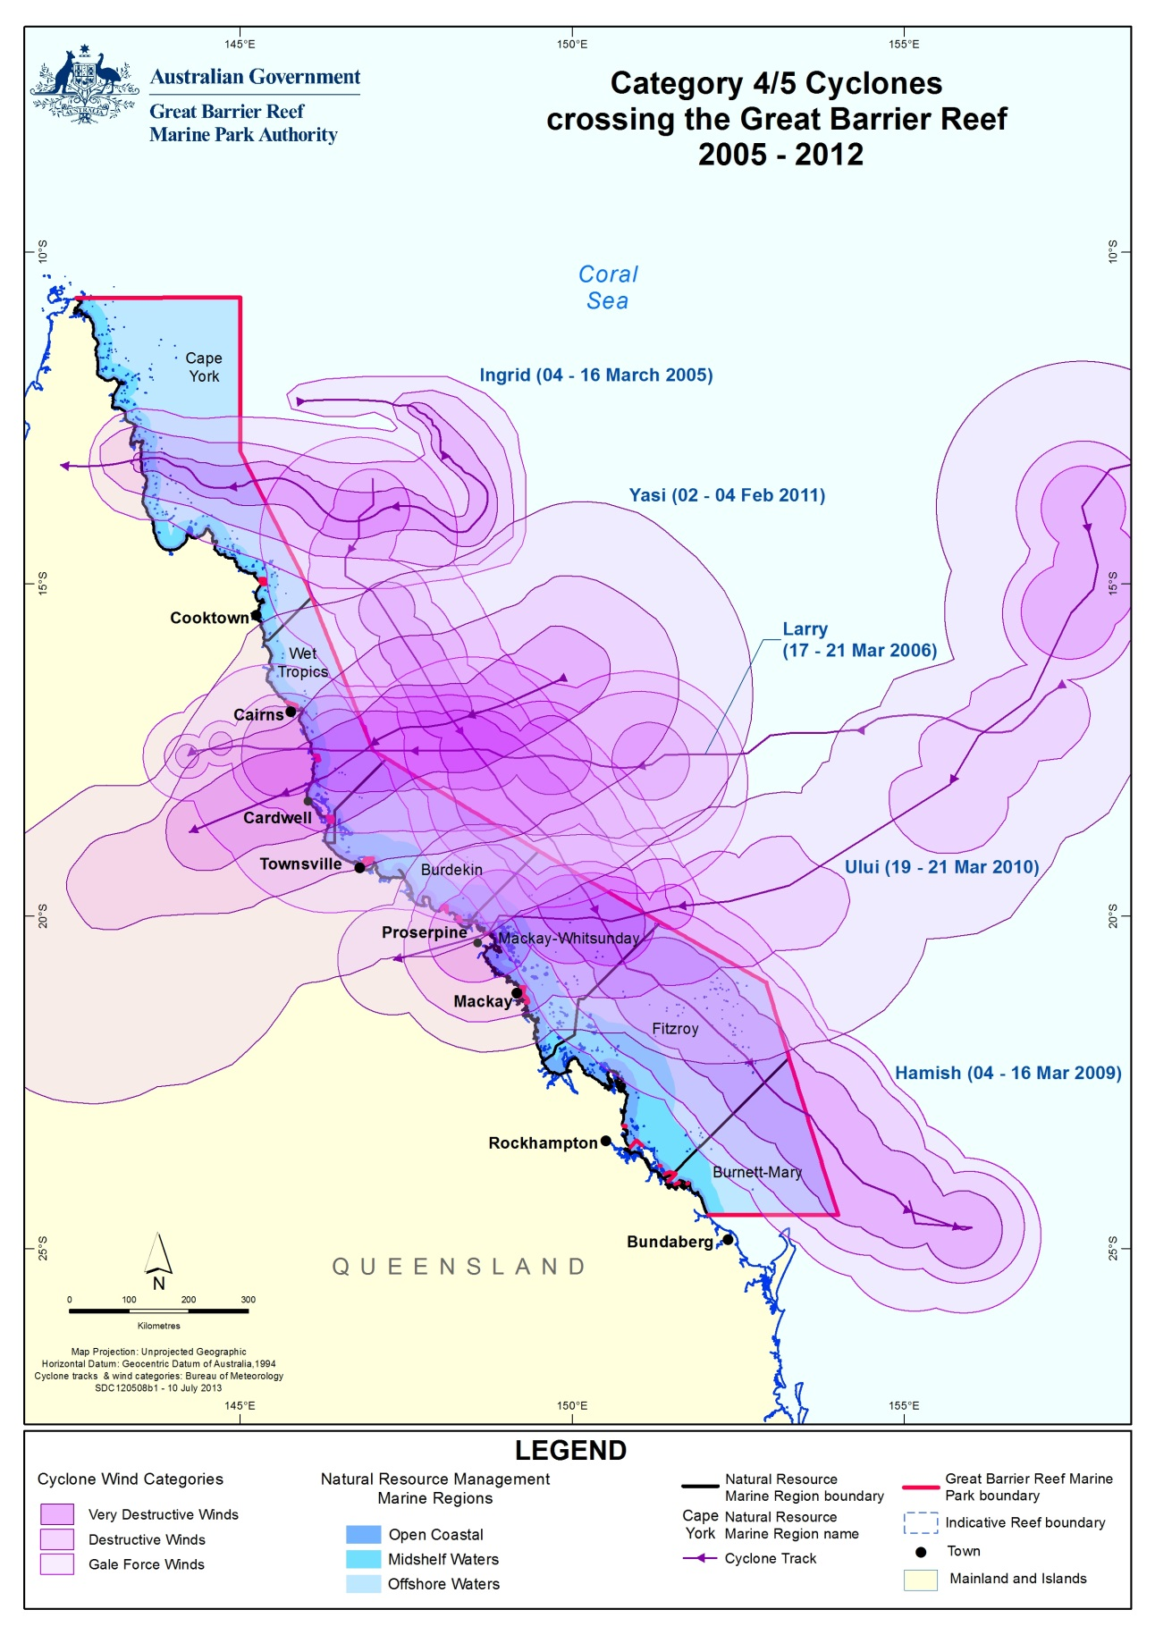
Figure 6. All Category 4/5 cyclones that have affected the Great Barrier Reef from 2005 to 2012 with the zones of influence (wind categories) differentially shaded.

Elevated sea surface temperatures
Coral bleaching commonly occurs when accumulated temperature stress, measured as degree heating days over the summer months, exceeds a threshold of about 60-100 degree heating days.³⁸ In the last 50 years, an increase in the long-term average temperature of Great Barrier Reef waters is narrowing the gap between a regular summer and a coral bleaching season. For example, the frequency of mass bleaching events has increased over the last two decades, corresponding to higher seawater temperatures. Major coral bleaching events caused by unusually warm water temperatures have been recorded in the Marine Park in 1998, 2002 and to a lesser extent in 2006. Prolonged exposure to elevated seawater temperatures may increase the susceptibility of corals to disease.³⁹
In summer 2011-2012, sea surface temperatures on the Great Barrier Reef were relatively mild throughout most of December, January and February. In late February, temperatures rose above monthly averages by 0.5 to 2.5°Celsius across most of the Great Barrier Reef during still, calm conditions. A period of monsoonal rains and high cloud cover followed, limiting further increases in sea temperature. However, conditions from Port Douglas to Mackay sustained sea temperatures at levels mildly stressful to corals. Sea surface temperatures remained above average monthly levels into April. Low to moderate level coral bleaching was reported, predominantly in the central region of the Great Barrier Reef, as well as isolated incidences in the northern and southern regions (Figure 7). Most of the coral bleaching observed occurred on temperature sensitive species, such as the needle coral (Seriatopora hystrix) and some branching Acropora.
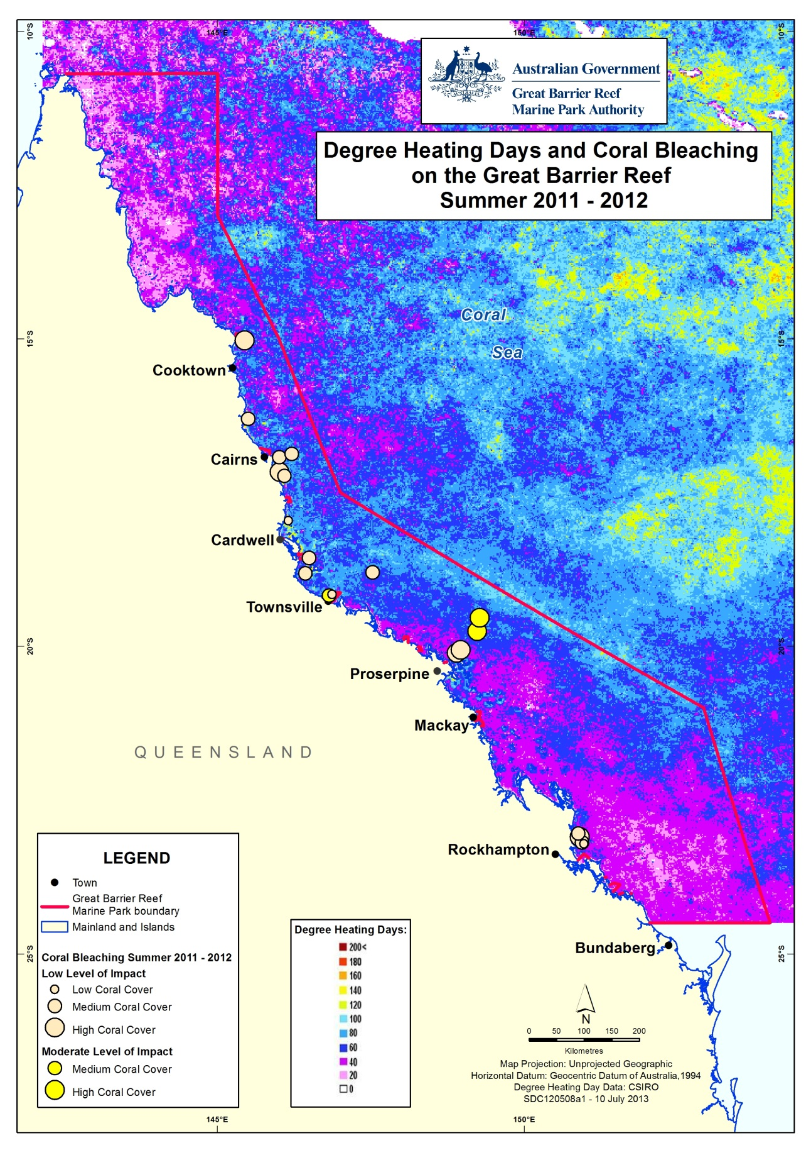
Figure 7: Water temperature as degree heating days and areas where coral bleaching occurred during summer 2011-2012.

Crown-of-thorns starfish
Most of the crown-of-thorns starfish monitoring in the Great Barrier Reef is conducted by the AIMS Long-term Monitoring Program (Figure 8). An active 'outbreak' of crown-of-thorns starfish is when densities are such that the starfish consume coral tissue faster than the corals can grow. This is generally considered to be densities greater than about 30 starfish per hectare.^{40,41} Most outbreaks occur on midshelf reefs, beginning along the narrow northern shelf between Cairns and Lizard Island and then moving to southern reefs as larvae are transported by the East Australian Current. The Swains Reefs in the Fitzroy region have had low-level chronic infestations throughout most of the last three decades, which is explained by the high density of reefs in this region and the regional oceanography.
Google Earth shows recent crown-of-thorns starfish densities:
(http://e-atlas.org.au/sites/default/files/datasetdetails/large-scale-manta-tow-surveys-densities-crown-thorns-starfish-and-benthic-cover-aims-ltmp-100/cots-outbreaks.kmz).
In 2011-2012, active outbreaks of crown-of-thorns starfish were detected on the northern Wet Tropics reefs. At Snapper Island in the Barron Daintree sub-region, high numbers of crown-of-thorns starfish were present and it is expected that this outbreak will substantially reduce coral cover over the next few years. Active outbreaks were also observed at Fitzroy Island and the Frankland Group in the Johnstone Russell-Mulgrave sub-region. In mid-2012 the crown-of-thorns were small (most <20 centimetres diameter) and feeding within the understory of the coral community. However, it is almost certain that they will mature over the 2012-13 summer and cause marked reduction in coral cover over coming years. The situation in 2011-2012 is consistent with a new cycle of crown-of-thorns starfish outbreaks on the Great Barrier Reef as a result of the repeated severe flood events since 2009. It is postulated that the extremely high discharges from most rivers in 2010-2011 increased likelihood of additional outbreaks by enhancing the survival of larvae from nutrient-rich flood waters.^{42,43}
Crown-of-thorns starfish have had a major impact on the Great Barrier Reef since surveys began in the 1960s. A recent analysis of long-term monitoring data showed that the starfish have been responsible for more than 40 per cent of the decline in coral cover since 1985.⁴⁴ However, a reduction in predator populations has also been suggested, as outbreaks are lower in zones closed to fishing.³⁶
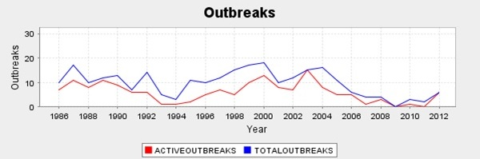
Figure 8: The proportion of reefs with outbreaks of crown-of-thorns starfish since 1986 (AIMS).

3.1.4 Water quality condition and trend
The water quality of the inshore Great Barrier Reef in 2011-2012 remained poor overall, reflecting the high freshwater discharges from catchments in multiple years (Figure 9). Concentrations of chlorophyll a and total suspended solids were poor and moderate overall, respectively.
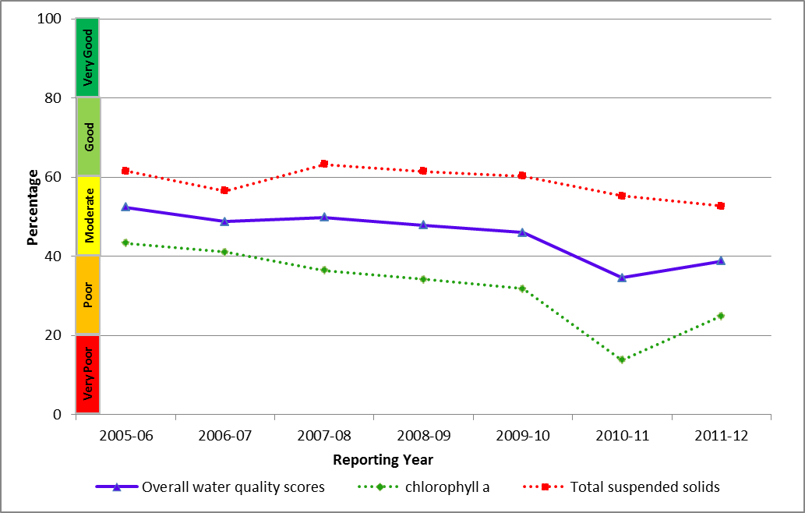
Figure 9: Trend in the water quality index in the Great Barrier Reef from 2005-2006 to 2011-2012.
In 2011-2012, remote sensing of water quality showed a clear gradient of declining water quality from offshore areas more distant from terrestrial inputs, to inshore areas more frequently exposed to flood waters. The inshore area of all regions, except Mackay Whitsundays, had annual mean chlorophyll a concentrations that exceeded the Water Quality Guidelines for more than 50 per cent of the waterbody area (Shaded areas; Table 3). In contrast, annual concentrations of total suspended solids exceeded the Water Quality Guidelines for less than 50 per cent of the inshore water body area in all regions. Regions where the Water Quality Guideline were exceeded had water quality scores that ranged from poor to moderate depending on the magnitude of exceedance.

Table 3: Relative area (per cent) of the inshore, mid-shelf and offshore waterbodies of each region where the annual mean value for chlorophyll a and total suspended solids from remote sensing data exceeded the Water Quality Guidelines from 1 May 2011 to 30 April 2012.
The confidence in water quality assessments is indicated by the relative number of valid observations used to calculate the values, where a higher number provides greater confidence in the results. Cells are shaded in grey where values exceeded the guidelines in more than 50 per cent of the waterbody area. Caution must be applied in interpreting the results for the inshore Cape York and Burnett Mary regions, as well as the offshore water body, because there has been limited field validation for these regions.
Region | Number of valid observations |  |  | Chlorophyll  exceedance  (per cent) |  |  | Total suspended solids exceedance  (per cent)
Region | Inshore | Mid-shelf | Offshore | Inshore | Mid-shelf | Offshore | Inshore | Mid-shelf | Offshore
Cape York | <500,000 | 500,000-1,000,000 | >2,000,000 | 53 | 14 | 0 | 24 | 2 | 6
Wet Tropics | <500,000 | <500,000 | 500,000-1,000,000 | 91 | 31 | 1 | 43 | 7 | 1
Burdekin | <500,000 | 500,000-1,000,000 | 1,000,000-2,000,000 | 66 | 12 | 0 | 35 | 0 | 0
Mackay Whitsunday | <500,000 | 500,000-1,000,000 | 1,000,000-2,000,000 | 42 | 6 | 1 | 40 | 8 | 6
Fitzroy | <500,000 | 1,000,000-2,000,000 | >2,000,000 | 81 | 8 | 0 | 42 | 3 | 1
Burnett Mary | <500,000 | <500,000 | 1,000,000-2,000,000 | 85 | 20 | 0 | 8 | 1 | 0

Pesticides
A wide range of PS-II herbicides, other pesticides and industrial chemicals were frequently detected in 2011-2012, with variability between regions and seasons. There was a clear decrease in the maximum concentrations of herbicides detected at all twelve routine monitoring sites when compared to the previous monitoring year, with the greatest decreases observed in the inshore Burdekin, Mackay Whitsundays and Fitzroy regions.
However, biologically relevant concentrations of PS-II herbicides (Category 4) were present at a single site in the inshore Burdekin region (Cape Cleveland) and two out of three sites in the inshore Mackay Whitsunday region (Sarina Inlet and Pioneer Bay) (Figure 10).

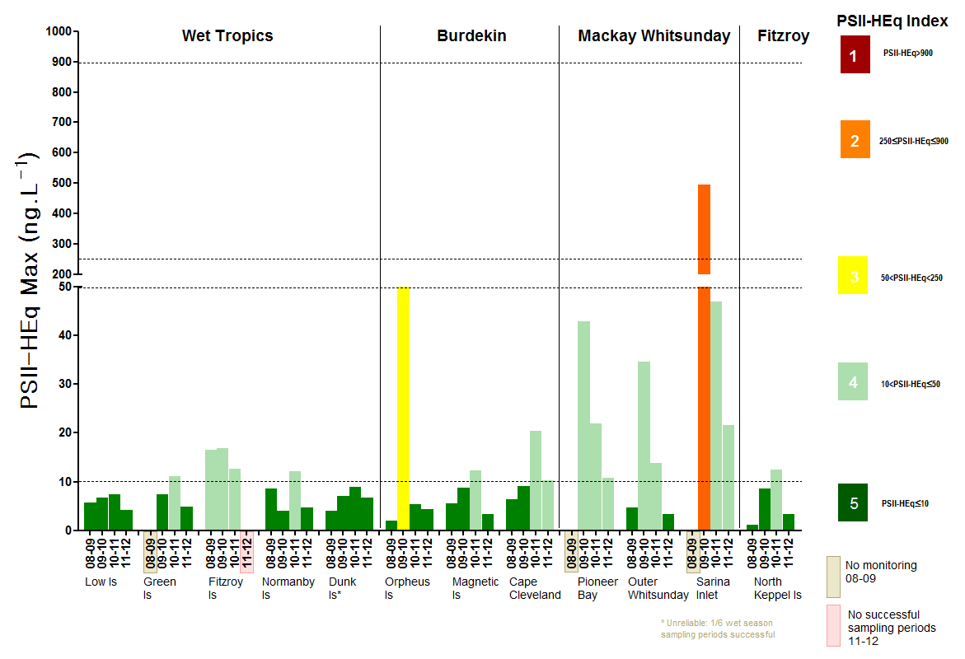
Figure 10: Maximum PS-II Herbicide equivalent concentrations at all sites monitored in the Great Barrier Reef from 2008-2009 to 2011-2012.
The PS-II herbicide equivalent concentration incorporates both the relative potency and relative abundance of individual PS-II herbicides compared to a reference PS-II herbicide, diuron.
Herbicide equivalent concentrations provide a single reporting parameter for PS-II herbicides with a similar mode of action; however, they may obscure differences in the abundance of individual herbicides detected in different regions, because herbicide equivalent concentrations also consider the potency of each herbicide.
The concentrations and types of pesticide detected in each region are often related to the land management activities in adjacent catchments. The most ubiquitous herbicide detected at the highest concentrations across the Reef in this current monitoring year was diuron. However, in the inshore Burdekin and Fitzroy region, atrazine and tebuthiuron were the predominant pesticides detected, respectively (Figure 11). There were no pesticides that exceeded the Water Quality Guidelines or the Australian and New Zealand Environment and Conservation Council (ANZECC) and the Agriculture and Resources Management Council of Australia and New Zealand (ARMCANZ) interim working level for marine waters.

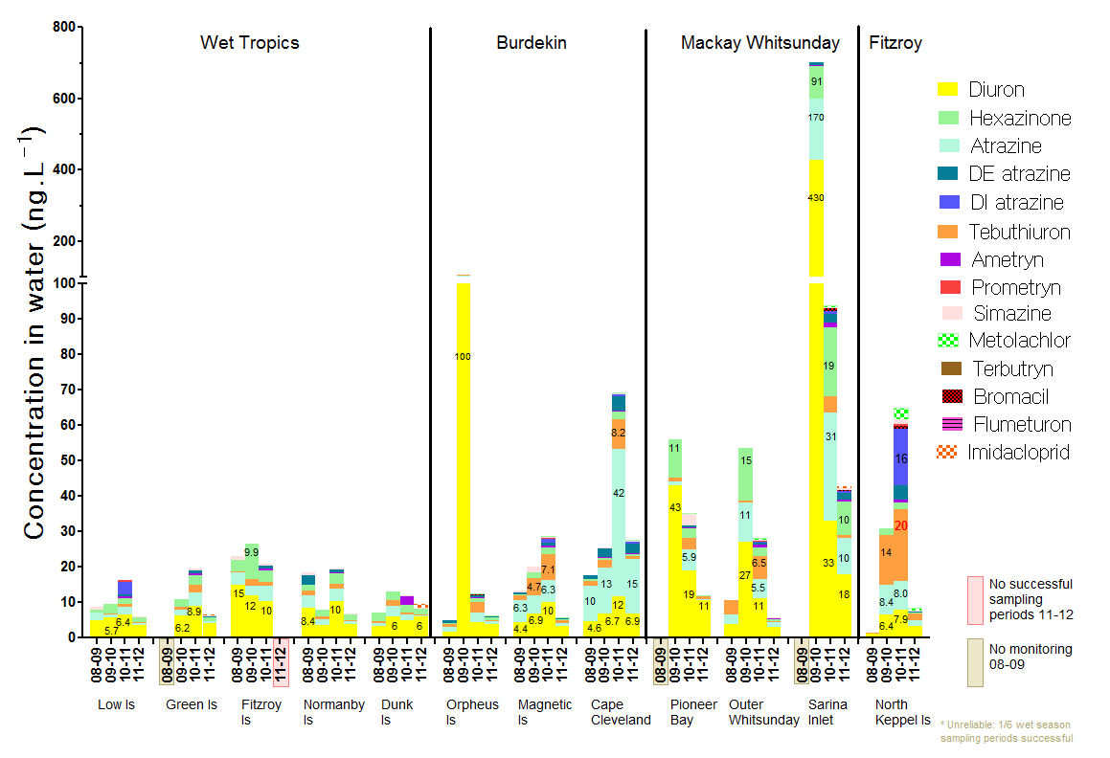
Figure 11: Maximum concentration of individual PS-II herbicides at all sites monitored across the Great Barrier Reef in 2011-2012, compared to the previous three seasons.

3.1.5 Case-study: Disease incidence in corals linked to river discharge
A significant finding emerging from the MMP (monitoring activities) is that high levels of coral disease appear to be linked to higher discharge from local rivers. This increased incidence of disease may be a chronic effect of exposure to elevated levels of pollutants, with negative consequences for coral cover.⁴⁵
Infectious disease in coral can be caused by bacteria, viruses, protozoa, or fungi, although in many cases the underlying infectious agent is unknown (Figure 12).⁴⁶ In addition to causing the death of coral tissue, disease can have a significant impact on reproduction, growth rate, community structure and species diversity.⁴⁷ Coral disease has caused widespread loss of coral cover in the Caribbean, but until relatively recently it was assumed that disease had little impact on Great Barrier Reef coral communities.⁴⁶ However, the recent detection of common and infectious Caribbean diseases on the Great Barrier Reef, in combination with other diseases unique to the region such as Brown Band disease, suggest that coral diseases may have a greater role in structuring coral communities in the Reef than previously thought.⁴⁸
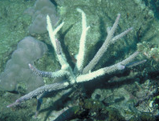
Figure 12: Staghorn coral showing loss of tissue due to coral disease
In all inshore regions, coral monitoring through the MMP has shown that the incidence of coral disease has increased proportionally with the discharge of local rivers. For example, in the Wet Tropics, the Barron River flooded in 2008 and again in 2011 when the Daintree River also flooded. The 2011 floods were the highest flows recorded for both rivers over the last ten years. At the nearby Snapper Island North, increased prevalence of Brown Band and Skeletal Eroding Band disease were observed in 2010 and 2011, and it is likely that these diseases were the primary agents reducing Acroporidae cover from 34 per cent to 27 per cent at this site. In the inshore Fitzroy region, the Fitzroy River had major floods in 2008, 2010, and in 2011. High levels of disease were observed in the region during surveys in 2008, 2010 and 2011 almost certainly contributing to loss of coral cover and resulting decline in the coral cover indicator from moderate in to 2010 to poor in 2011.
The consistent pattern of high incidence of disease following major flood events implies coral communities are chronically stressed region-wide from repeated exposure to elevated levels of pollutants. Increased availability of organic matter may alter microbial communities and enhance the virulence of disease.⁴⁹ in addition, the resistance of coral communities to outbreaks is likely to be reduced by stressors such as extended periods of low light availability from highly turbid waters.⁴⁹

3.1.6 Seagrass condition and trend
The overall condition of inshore seagrass meadows in 2011-2012 remained very poor and has been declining since 2006-2007 (Figure 13). Seagrass abundance and reproductive effort remained in very poor condition and nutrient status was poor. However, condition assessments vary between regions and the different seagrass habitats over time.
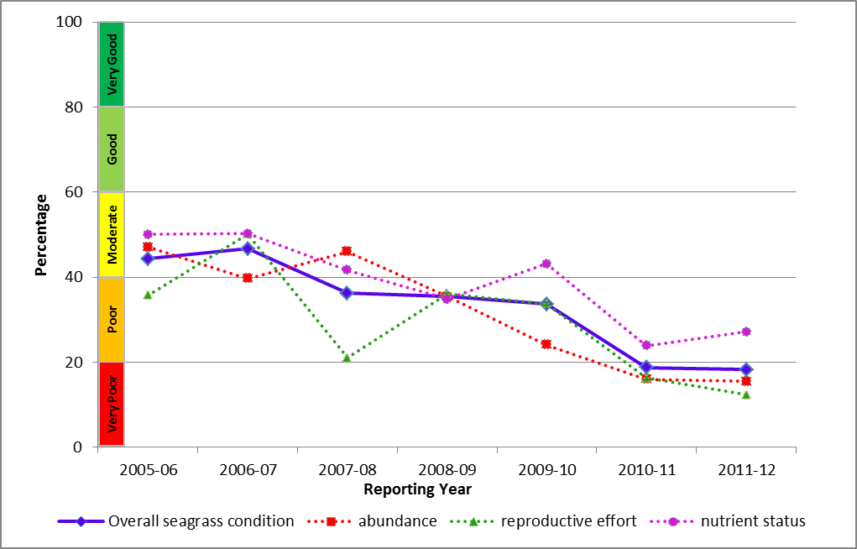
Figure 13: Trend in seagrass condition in the Great Barrier Reef from 2005-2006 to 2011-2012.
In 2011-2012, very low scores for seagrass abundance were driven mainly by declines in the coastal meadows in the northern Wet Tropics and Fitzroy regions, which may be a consequence sediment or sand bank movement caused by local scale disturbance. Seagrass abundance at most sites remained stable, reflecting the relatively milder wet season compared to 2010-2011. However, the generally very poor levels of abundance accompanied by very poor reproductive effort indicates that it may take several years for seagrass meadows to recover their foundational communities (Figure 14).
Figure 14: Trends in the abundance of inshore seagrass meadows at estuarine, coastal, intertidal reef and subtidal reef sites since 1999.
Long-term increases in the nutrient content of seagrass tissue above biological thresholds across all habitats (Figure 15) reflected local declines in water quality. At sites in the Burdekin and Mackay Whitsunday inshore regions, interactions between low light and elevated nutrients had a negative impact on the survival of seagrass meadows. Overall, the resilience of seagrass meadows in the Great Barrier Reef is variable due to spatial and temporal variation in abundance, nutrient loads and production of reproductive structures.

Figure 15: Median tissue nutrient content of seagrass tissue (percent nitrogen and phosphorus) for each habitat type since 2005.
Dashed lines indicate global biological thresholds of 1.8 per cent and 0.2 per cent for tissue nitrogen and phosphorus, respectively. Long-term increases in the nutrient content of seagrass tissue above biological thresholds may reflect local declines in water quality in some inshore regions.⁵⁰

3.1.7 Coral condition and trend
Inshore coral reefs remained in a poor condition overall in 2011-2012 (Figure 16). Coral cover and the level of cover from competing macroaglae were both moderate. The density of hard coral juveniles and the rate of change in coral cover were very poor overall. However, there are differences between inshore reefs in different regions (refer to regional sections).
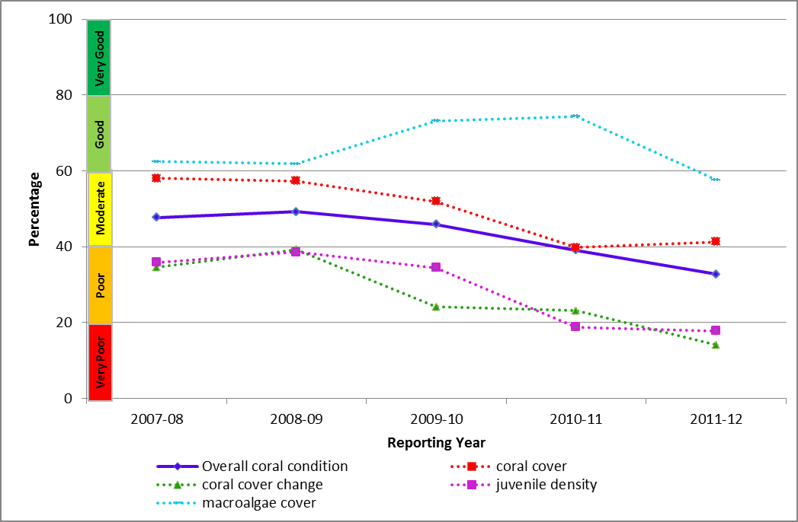
Figure 16: Trend in coral condition in the Great Barrier Reef from 2007-2008 to 2011-2012 (blue solid line; numbers are index categories).
Monitoring of inshore reefs since 2005 has shown that variation in environmental conditions, particularly with respect to the magnitude of wet season run-off and other acute disturbances such as cyclones can alter the dynamics of coral communities on inshore reefs. However, the processes shaping community composition are complex and highly variable. Coral cover declined in all inshore regions to the lowest point since surveys began in 2005 (Figure 17), due to a combination of impacts associated with tropical cyclones and broad-scale flooding. In all inshore regions, the incidence of coral disease increased proportionally with the discharge of local rivers. Flooding also increased in turbidity and the deposition of fine-grained sediments is likely to have had a negative impact on coral growth and recruitment by smothering and limiting the amount of available light.
Coral cover of inshore reefs in the Wet Tropics varied, with those in the north in better condition than those in the south. The legacy of Cyclone Yasi impacts on coral cover, combined with an increase in macroalgae cover at southern sites and the continuation of region-wide declines in the density of juvenile corals, suggests that rapid recovery of the coral reefs in this region is unlikely (Figure 17). Additionally, the high densities of crown-of-thorns starfish in the Daintree, Johnstone, Russell-Mulgrave subregions observed in 2012 present an immediate threat to reefs in the Wet Tropics.
In the Burdekin, coral cover has remained low since 2005 and there has been minimal recovery from a severe bleaching event in 1998. The decline in recent years is mostly due to damage caused by Cyclone Yasi.
Similar to the inshore Burdekin region, reefs in the Mackay Whitsunday have had very slow rates of increase in coral cover since Cyclone Ului passed through the region in 2010. However by 2012, there was some recovery in coral cover at some reefs in the region.
The largest decline in coral cover since monitoring began in 2005 occurred in the inshore Fitzroy region, primarily due to severe coral bleaching event in 2006 and record flooding in 2011. Recovery from bleaching varied among reefs and while rapid at some locations, recovery was suppressed at others by a combination of exposure to storm events and on-going incidence of coral disease. A high level of coral disease following flood events is emerging as a chronic impact of repeated disturbances in both the Fitzroy and in other inshore regions.
Cyclone Yasi physically reduced macroalgae cover at some sites in the inshore Wet Tropics and Burdekin regions (Figure 17). However, due to the high variability of substrate, macroalgae cover began to increase in 2012 and exceeded pre-cyclone levels at some sites. In the inshore Mackay Whitsunday region, there has been no substantial change in macroalgae cover, and macroalgae is only common at two of the reefs surveyed, which are closest to rivers influencing the region. In the inshore Fitzroy region, macroalgae cover increased dramatically on some reefs in 2012, as macroalgae recolonised space made available through the loss of corals due to a bleaching event in 2005-2006 and a combination of storm damage and disease.
The density of juveniles declined from 2005 to 2012 in all inshore regions except the Fitzroy, where densities have remained low but stable (Figure 17). Overall, the negative impact of Cyclone Yasi on juvenile densities persisted, with the largest declines on reefs in the Wet Tropics. In the inshore Mackay Whitsunday and Burdekin regions, declines in juvenile densities co-occurred with high turbidity from above-median discharge.
The relatively low levels of hard coral cover overall, coupled with a continual decline in the density of juvenile colonies, may indicate a lack of resilience of coral communities at many inshore reefs across the Great Barrier Reef. Acute disturbances in combination with periods of elevated stress from poor water quality are driving changes in the composition and condition of inshore coral reefs.

A
B
C
Figure 17: Variation in the cover of hard corals (A), cover of macroalgae (B), and density of hard coral juveniles (C) in the inshore Wet Tropics, Burdekin, Mackay Whitsunday and Fitzroy regions from 2005 to 2012.
Bold black curve represents predicted regional trend and blue dashed lines are the 95 per cent confidence intervals. Grey lines show observed trends for each reef. Data are averages from core reefs at 2m and 5m depths +/- standard error. Only reefs sampled in all years were included to ensure consistency between annual averages.

3.2 Cape York
Figure 18: The condition of water quality and ecosystem health (seagrass and corals) in 2011-2012 across the inshore region of Cape York.

3.2.1 Summary results
- Overall Great Barrier Reef health in the inshore Cape York region improved from poor to moderate in 2011-2012. Inshore water quality was moderate and seagrass was in poor condition overall (Figure 18). Slight improvements in overall condition were mainly due to improvements in water quality.
- Inshore water quality for the region has oscillated between poor and moderate condition since 2005-2006. The two components used to determine this overall rating, chlorophyll a and total suspended solids, were very poor and good, respectively, in 2011-2012.
- Routine pesticide monitoring has been carried out at only one offshore site in Cape York and monitoring was discontinued in 2010. In 2011-2012 grab samples were collected at two sites in the region in a transect that extended approximately two kilometres from the mouth of the Normanby River. No herbicides were detected in these samples.
- Inshore seagrass meadows were in very poor overall condition. Seagrass abundance was poor in 2011-2012 and reproductive effort declined sharply to very poor. Nutrient ratios of seagrass tissue declined to poor levels, indicating elevated nitrogen in the surrounding areas.
- The marine environment in the inshore Cape York region is relatively pristine compared with other regions. However, increasing pressure from development and the associated impacts on water quality in the inshore region mean that Cape York is a high priority for intensifying monitoring efforts. No coral monitoring occurs in the inshore Cape York region under the MMP, though some sites are monitored in the southern section as part of the AIMS Long-term Monitoring Program.

3.2.2 Water quality condition and trend
Inshore water quality in Cape York region, as determined by remote sensing, is moderate overall in 2011-2012 and has oscillated between poor and moderate ratings since 2005-2006 (Figure 19).
Chlorophyll a was very poor in 2011-2012, with concentrations exceeding the Water Quality Guidelines in 75 per cent of the inshore area in the dry season and 21 per cent of the inshore area in the wet season, mainly around river mouths and embayments. Total suspended solids were good in 2011-2012, with concentrations exceeding the Water Quality Guidelines in 39 and 9 per cent of the inshore area, in the dry and wet seasons, respectively.
There is no comprehensive, ongoing in situ water quality monitoring in the Cape York region. Estimates of chlorophyll a and total suspended solids are derived from remote sensing only, which requires further field validation and hence estimates have relatively low reliability compared with those for other regions. As such, Cape York water quality data was not used in overall assessments of Great Barrier Reef water quality and Great Barrier Reef health.
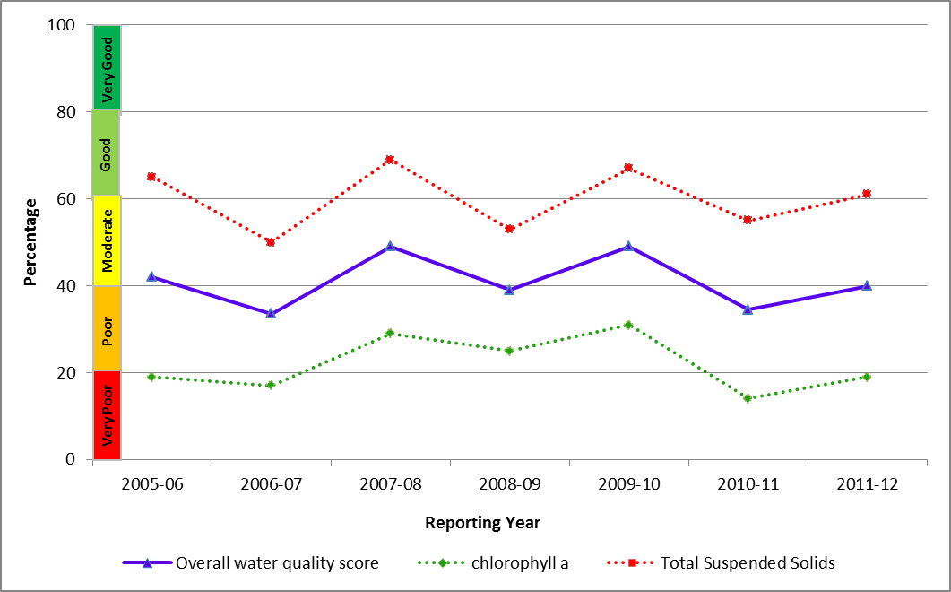
Figure 19: Trend in the Water Quality Index in the inshore Cape York region from 2005-2006 to 2011-2012.
Routine pesticide monitoring has been carried out at only one offshore site in Cape York and monitoring was discontinued in 2010. In 2011-2012, trial sampling was conducted along a transect that extended approximately two kilometres from the Normanby River mouth. No herbicides were detected in these samples.

3.2.3 Seagrass condition and trend
The condition of inshore seagrass in the Cape York region declined to poor overall and has been highly variable since 2005-2006 due to impacts of a complex and highly variable environment on seagrass abundance and reproductive effect (Figure 20). Although seagrass abundance increased in 2011-12 from very poor to poor (Figure 21), reproductive effort and nutrient status declined sharply.
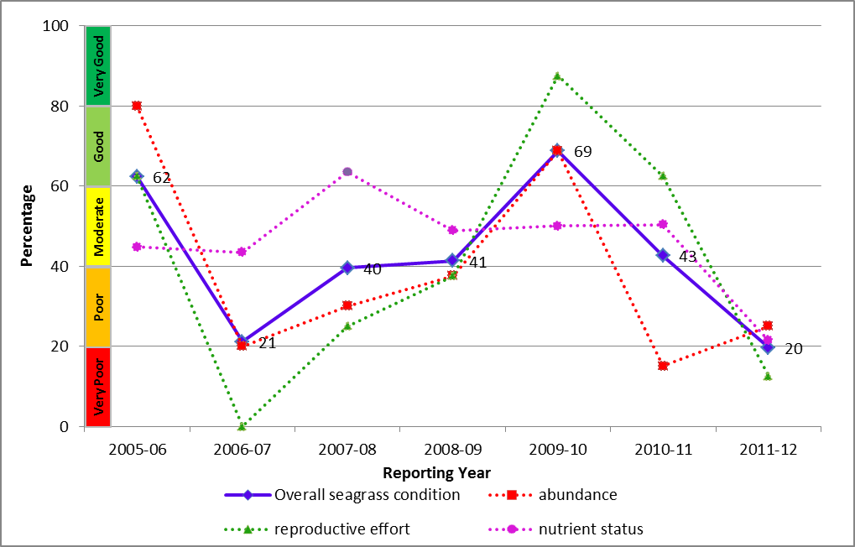
Figure 20: Trend in seagrass condition in the inshore Cape York region from 2005-2006 to 2011-2012.
Seagrass is monitored at Archer Point a fringing reef location in the southern part of the Cape York region, which supports a diverse range of species. The environment is characterised by fluctuating temperature and salinity, and the growth of seagrass is primarily influenced by physical disturbance from waves and swell and associated sediment movement. Reproductive effort declined from good in 2010-2011 to very poor in 2011-2012. However, a persistent Halodule uninervis seed bank indicates meadows have a high recovery potential. Nutrient ratios of seagrass tissue were poor, with results in late 2011 showing elevated levels of nitrogen.

Figure 21: Trend in seagrass abundance (per cent cover) at the inshore intertidal fringing reef habitat at Archer Point in the Cape York region
In early 2012, new seagrass monitoring locations were established at two reef and two coastal habitats in Cape York. The two reef habitat locations are Stanley Island, the northern most island of the Flinders Island group to the north of Bathurst Bay; and Piper Reef, adjacent to Farmer Island and 15 kilometres off the mainland coast. The new coastal habitat locations are Bathurst Head (paired with Stanley Island) and Shelburne Bay (paired with Piper Reef). As there was insufficient data available from these newly established sites, seagrass status in 2011-2012 has not been reported from these locations, and Cape York seagrass data was not used in overall assessments of Reef health.

3.3 Wet Tropics
Figure 22: The condition of water quality and ecosystem health (seagrass and corals) in 2011-2012 across the inshore region for the Wet Tropics region.

3.3.1 Summary results
- Overall inshore Great Barrier Reef health in the Wet Tropics region remained poor in 2011-2012. Inshore water quality was poor overall, and seagrass meadows and coral reefs were in very poor and poor condition, respectively (Figure 22).
- The inshore region of the Wet Tropics was influenced by flood waters and there were localised areas of coral bleaching where reefs were exposed to moderate levels of heat stress in late summer. The cover of branching coral in the northern part of the inshore region continued to increase as the reefs recovered from acute disturbances such as flooding in 2004 and from a crown-of-thorns outbreak in 2000. Reefs in the southern part of the inshore region are only now showing signs of recovery from cyclone Larry in 2006.
- Inshore water quality in the region, as determined by remote sensing, was poor overall in 2011-2012 and has been relatively consistent since 2005-2006. The poor state for water quality is a result of very different scores for chlorophyll a and total suspended solids, which were very poor and moderate, respectively. Site-specific assessments of water quality showed a gradient of increasing water quality from the inshore to the mid-shelf area, with five out of eleven sites rated in very good condition.
- A range of pesticides were detected in the Wet Tropics region, including diuron, ametryn, atrazine and its breakdown products, hexazinone, simazine and tebuthiuron. The PS-II Herbicide Equivalent Index, which considers the relative potency and abundance of each PS-II herbicide, showed that herbicides were present at biologically relevant concentrations at Green, Fitzroy and Normanby Islands (Category 4). No PS-II herbicides, other pesticides or industrial chemicals were detected at concentrations that exceeded Great Barrier Reef or ANZECC and ARMCANZ water quality guidelines.
- Inshore seagrass meadows declined to a very poor overall condition in 2011-2012, down from poor the previous year and every year since 2005-2006. Seagrass abundance declined from poor to very poor in 2011-2012 while reproductive effort and nutrient status remained unchanged, very poor and poor, respectively.
- The overall condition of inshore coral reefs in the region declined from moderate in 2010-2011 to poor in 2011-2012. Inshore reefs in the northern and central parts of the region remained in a moderate condition, while those in the south were again rated as poor. Legacy impacts of Cyclone Yasi in 2011 on coral cover include an increase in macroalgae cover at southern sites and a continued decline in the density of juvenile corals. In combination, these indicators suggest that recovery of the coral reefs in this region is poor.

3.3.2 Water quality condition and trend
Inshore water quality in the Wet Tropics region, as determined by remote sensing, was poor overall in 2011-2012 and has been consistently poor since 2005-2006 (Figure 23).
Chlorophyll a was again very poor in 2011-2012, exceeding the Water Quality Guidelines in 99 per cent of the inshore area in the dry season and 59 per cent of the inshore area in the wet season. Total suspended solids was moderate in 2011-2012, with concentrations exceeding the Water Quality Guidelines in 59 and 16 per cent of the inshore area, in the dry and wet seasons, respectively.
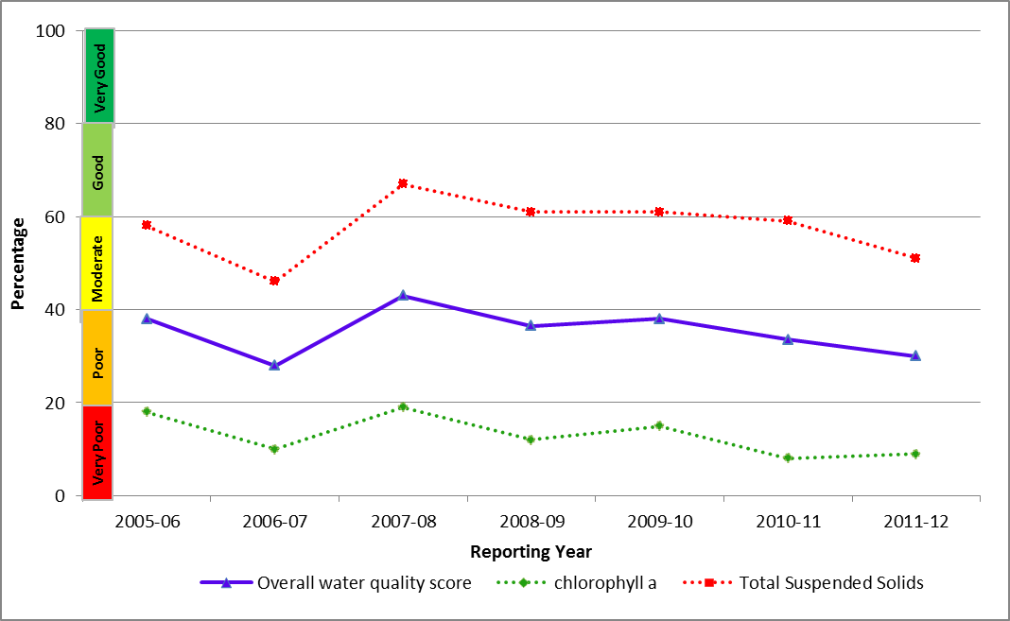
Figure 23: Trend in the Water Quality Index in the inshore Wet Tropics region from 2005-2006 to 2011-2012 (blue solid line; numbers are index categories).
Remote sensing of water quality across the inshore region showed a clear gradient of declining water quality from offshore areas more distant from terrestrial inputs, to inshore areas more frequently exposed to flood waters. This onshore-offshore gradient was supported by long-term assessments of water quality at specific sites, with variability between sites reflecting local hydrodynamic conditions and biophysical processes. Site-specific water quality was rated as very good at five sites (Port Douglas, Double, Green, Fitzroy and Russell Islands), three of which are located in the mid-shelf water body (Figure 24). Of the remaining sites, High Island had a moderate rating for the second consecutive year, while five sites were rated as poor. Cape Tribulation and Snapper Island in the northern Wet Tropics were downgraded to a poor rating this year. At Dunk Island, Yorkey’s Knob and Fairlead Buoy, locations relatively close to shore and to the influence of major rivers, water quality was again rated as poor due to particulate phosphorus, chlorophyll a and suspended solids levels that exceeded the Water Quality Guidelines.
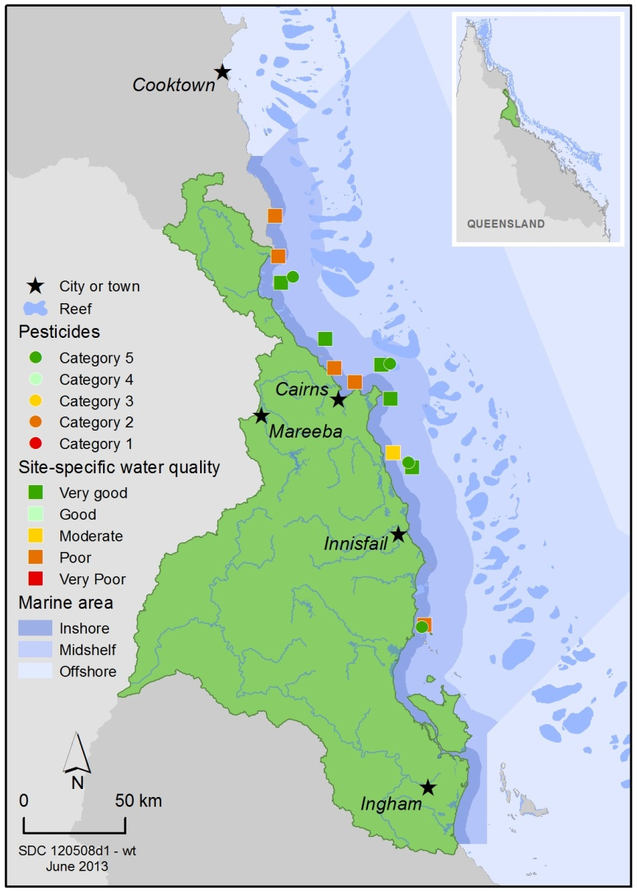
Figure 24: Water quality and pesticide ratings for PS-II herbicides at fixed monitoring sites in the inshore Wet Tropics region.
A range of herbicides were detected in the inshore Wet Tropics region in 2011-2012, including diuron, ametryn, atrazine and its breakdown products, hexazinone, simazine, tebuthiuron and metolachlor. In 2011-2012 there was a decrease in the maximum concentrations of PS-II herbicides detected, which correlates with decreased flows from major rivers in the region. In 2010-2011, concentrations of PS-II herbicides were above those known to affect photosynthesis in diatoms (Index Category 4) at Green, Fitzroy and Normanby Islands (Figure 25). In 2011-2012, Green Island and Normanby Island improved to PS-II Index Category 5 (Figure 24).
Concentrations of pesticides were typically higher in the wet season and these concentrations were sustained for longer, however low levels of pesticides were also detected in the dry season (Figure 25).
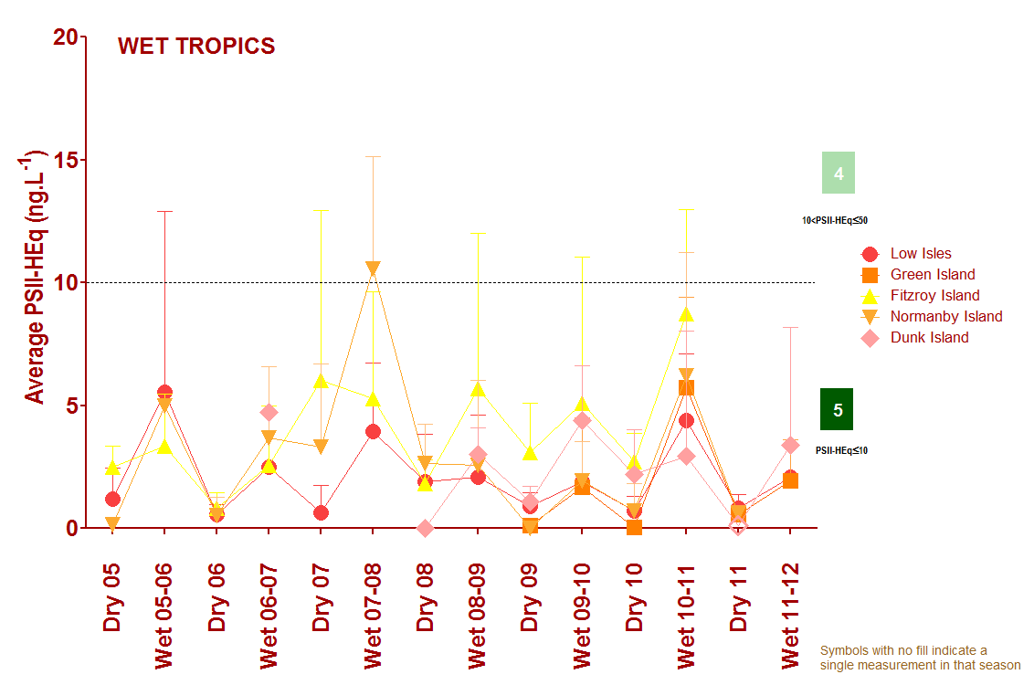
Figure 25: Trends in average PS-II herbicide equivalent concentrations at each sampling site in the Wet Tropics according to season.
Symbols with no fill indicate values with low reliability based on less than 30 per cent of the maximum number of deployments.

3.3.3 Seagrass condition and trend
The overall condition of inshore seagrass in the Wet Tropics region declined to very poor in 2011-2012 (Figure 26). Seagrass condition assessments are a product of complex interactions between the three indicators of abundance, reproductive effort and nutrient status, which have been highly variable between years and habitats. Tropical Cyclone Yasi had an impact on the south at the inshore region, with abundance and meadow extent reduced to a few isolated shoots at some sites (Figure 27). In 2011-12, seagrass abundance and reproduction effort were very poor and nutrient status was poor.
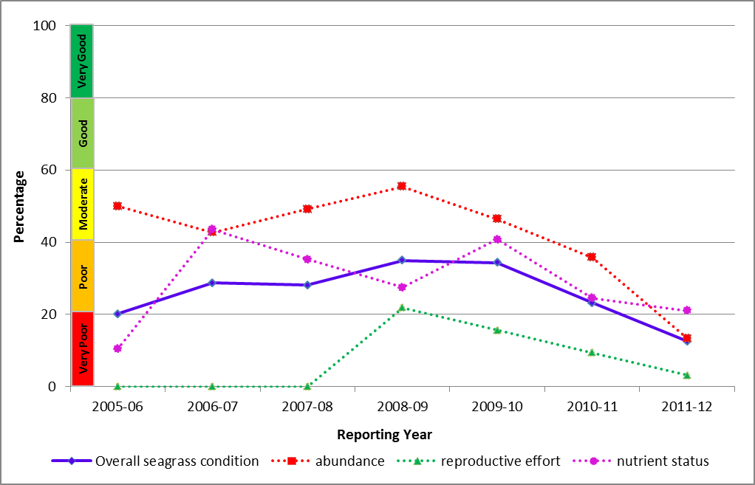
Figure 26: Trend in seagrass condition in the inshore Wet Tropics region from 2005-2006 to 2011-2012 (blue solid line; numbers are index categories).
Inshore seagrass is monitored in coastal and reef habitats in the Wet Tropics. There are minor increases in abundance in some areas and if environmental conditions remain favourable, abundance is expected to increase further and seagrass communities may become re-established over time. However, reproductive effort at coastal sites remained unchanged (at zero) and very poor at reef sites. Leaf tissue nutrient ratios were poor at reef sites and very poor at coastal sites.

Figure 27: Trend in seagrass abundance (per cent cover) at inshore intertidal coastal habitats (Yule Point and Lugger Bay) and inshore intertidal reef habitats (Green and Dunk Islands) in the Wet Tropics.

3.3.4 Coral condition and trend
The overall condition of inshore coral reefs in the Wet Tropics declined from moderate in 2010-2011 to poor in 2011-2012 (Figure 28). This was largely due to the impacts of Tropical Cyclone Yasi on coral communities in 2011, which resulted in an increase in macroalgae cover in the Herbert Tully area (temporarily removed by Cyclone Yasi) and the continuation of region-wide declines in the density of juvenile corals. In some areas, increased incidence of coral disease and evidence of feeding by crown-of-thorns starfish also contributed to the decline in condition.
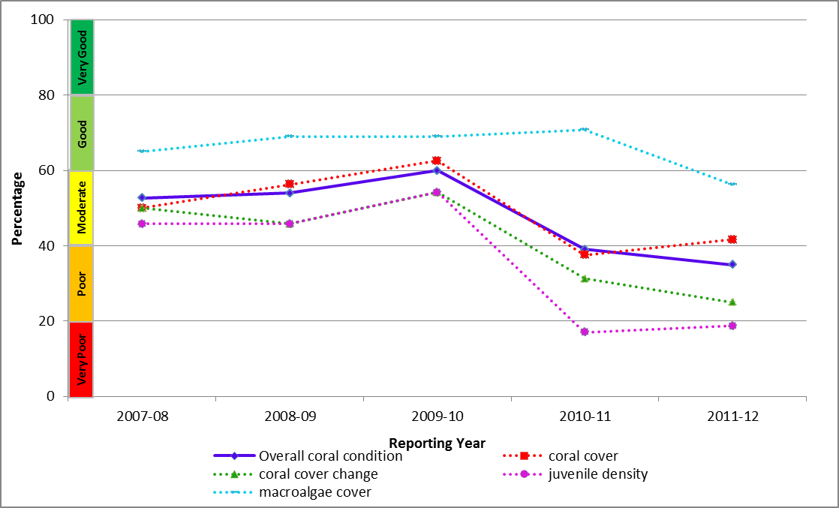
Figure 28: Trend in coral condition in the Wet Tropics from 2007-2008 to 2011-2012
In the northern part of the region, the overall condition of sites in the Barron and Daintree areas remained moderate. Coral cover was still very good however, there was a decline in the density of coral juveniles and coral cover change was rated as poor. Macroalgae cover was rated as moderate (Figure 29).
In the central section, the overall condition of sites in the Johnstone Russell-Mulgrave area also remained moderate as a result of disturbance from recent Tropical Cyclone Tasha and Yasi. Coral cover was moderate; however, the density of coral juveniles was very poor and coral cover change was rated as poor. Macroalgae cover was rated as good (Figure 30). Coral condition declined moving further south closer to the developed areas, reflecting site specific water quality assessments.
In the south, the overall condition of sites in the Herbert Tully area remained poor reflecting the severity of Tropical Cyclone Larry in 2006 and Tropical Cyclone Yasi in 2011. Coral cover was still very poor, the density of coral juveniles was poor and coral cover change was rated as very poor. Macroalgae cover increased to occupy space cleared by the cyclone activity and was rated as poor (Figure 31).
Figure 29: Cover of major benthic groups and levels of key environmental parameters: Barron Daintree sub-region, inshore Wet Tropics region.
Stacked bars represent cumulative cover of hard coral (blue), soft coral (pink) and macroalgae (green). Box plots for both water and sediment quality represent the distribution of all observations to date, i.e., median value (fine line within the grey box), mean value (heavy line, WQ only), and the ranges of the central 50 per cent (grey box), 80 per cent (whiskers), and 90 per cent (black dots) of observations. Red reference lines indicate the Guidelines for water quality parameters¹), and the overall mean across all MMP reefs for sediment parameters.
Figure 30: Cover of major benthic groups and levels of key environmental parameters: Johnstone Russell-Mulgrave sub-region, Wet Tropics region. Stacked bars represent cumulative cover of hard coral (blue), soft coral (pink) and macroalgae (green).
Box plots for both water and sediment quality represent the distribution of all observations to date, i.e., median value (fine line within the grey box), mean value (heavy line, WQ only), and the ranges of the central 50 per cent (grey box), 80 per cent (whiskers), and 90 per cent (black dots) of observations. Red reference lines indicate the Guidelines for water quality parameters¹, and the overall mean across all MMP reefs for sediment parameters.
Figure 31: Cover of major benthic groups and levels of key environmental parameters: Herbert Tully sub-region, Wet Tropics region. Stacked bars represent cumulative cover of hard coral (blue), soft coral (pink) and macroalgae (green).
Box plots for both water and sediment quality represent the distribution of all observations to date, i.e., median value (fine line within the grey box, mean value (heavy line, WQ only), and the ranges of the central 50 per cent (grey box), 80 per cent (whiskers), and 90 per cent (black dots) of observations. Red reference lines indicate the Guidelines for water quality parameters¹, and the overall mean across all MMP reefs for sediment parameters.

3.4 Burdekin
Figure 32: The condition of water quality and ecosystem health (seagrass and corals) in 2011-2012 across the inshore region for the Burdekin region.

Summary results
- Overall inshore Great Barrier Reef health in the Burdekin region remained poor in 2011-2012. Inshore water quality was moderate overall, and inshore seagrass meadows and coral reefs were in very poor and poor condition, respectively (Figure 32).
- Inshore water quality for the region, as determined by remote sensing, has fluctuated between poor and moderate since 2005-2006. Concentrations of suspended solids and chlorophyll a were moderate and poor, respectively, in 2011-2012. Site-specific assessments of water quality showed a gradient of increasing water quality from the inshore to the mid-shelf area, with poor water quality at Magnetic Island and good water quality at the two mid-shelf sites.
- A range of herbicides were detected in the inshore Burdekin region in 2011-2012, including diuron, ametryn, atrazine and its breakdown products, hexazinone, simazine, tebuthiuron and, at Orpheus Island only, bromacil. No PS-II herbicides, other pesticides or industrial chemicals were detected of concentrations that exceeded Great Barrier Reef or ANZECC and ARMCANZ water quality guidelines. The PS-II Herbicide Equivalent Index, which considers the relative potency and abundance of each PS-II herbicide, showed that herbicides were present at biologically relevant concentrations at Cleveland Bay (Category 4).
- Inshore seagrass meadows remained at very poor overall condition, having progressively declined from good in 2005-2006 following several large flows from the Burdekin River. Seagrass abundance and reproductive effect remained in very poor condition while nutrient status improved from very poor in 2010-2011 to poor in 2011-2012.
- Inshore coral reefs remained in a poor condition, reflecting very poor levels of coral cover, densities of juvenile colonies, and poor rates of increase in coral cover during periods free from acute disturbances. Macroalgae cover has been persistently high on several reefs.

3.4.2 Water quality condition and trend
Inshore water quality in the Burdekin region, as determined by remote sensing, has consistently been in moderate condition since 2005-2006 (Figure 33).
Chlorophyll a was again rated as poor in 2011-2012, with concentrations exceeding the Water Quality Guidelines in 79 per cent of the inshore area in the dry season and 59 per cent of the inshore area in the wet season. Total suspended solids were rated as moderate in 2011-2012 with concentrations exceeding the Water Quality Guidelines in 43 and 17 per cent of the inshore area, in the dry and wet seasons, respectively.
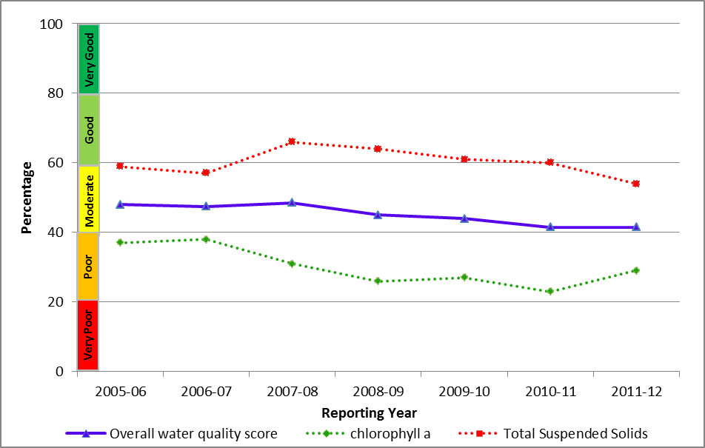
Figure 33: Trend in the Water Quality Index in the inshore Burdekin region from 2005-2006 to 2011-2012 (blue solid line; numbers are index categories).
Remote sensing of water quality across the inshore region showed a clear gradient of declining water quality from offshore areas more distant from terrestrial inputs, to inshore areas more frequently exposed to flood waters. This onshore-offshore gradient was supported by long-term assessments of water quality at specific sites, with variability between sites reflecting local hydrodynamic conditions and biophysical processes. Site-specific water quality was good at the two mid-shelf sampling sites (Pelorus Island and Pandora Reef) and poor at the inshore Magnetic Island site (Figure 34). The Water Quality Guidelines values for chlorophyll a, particulate phosphorus and suspended solids were exceeded at Magnetic Island and water clarity did not comply with the guidelines at any of the three sampling sites.

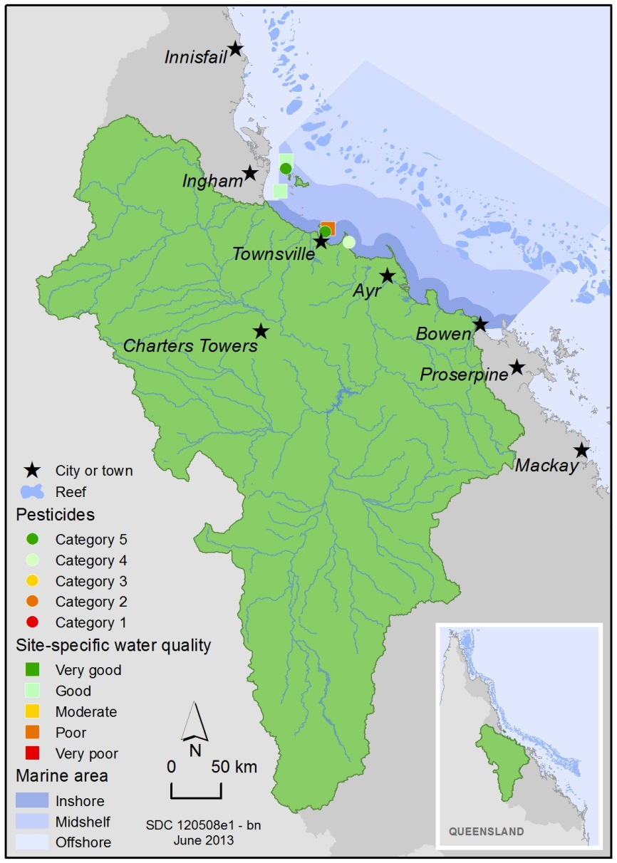
Figure 34: Water quality and pesticide ratings for PS-II herbicides at fixed monitoring sites in the inshore Burdekin region.
A range of herbicides were detected in the inshore Burdekin region in 2011-2012, including diuron, ametryn, atrazine and its breakdown products, hexazinone, simazine, tebuthiuron and, at Orpheus Island only, bromacil. Routine monitoring showed spatial variability in the abundance of herbicides; atrazine concentrations typically exceeded diuron concentrations at Cape Cleveland and Magnetic Island, while at Orpheus Island the herbicide profile more closely reflects sites in the Wet Tropics, with diuron present at higher concentrations.
Pesticide concentrations at Orpheus and Magnetic Island were PSII index Category 5, however levels at Cape Cleveland were above those known to affect photosynthesis in diatoms (Category 4). No PS-II herbicides, other pesticides or industrial chemicals with an individual guideline to assess against were detected in concentrations which met or exceeded the Great Barrier Reef Water Quality Guidelines²² or ANZECC and ARMCANZ guidelines.
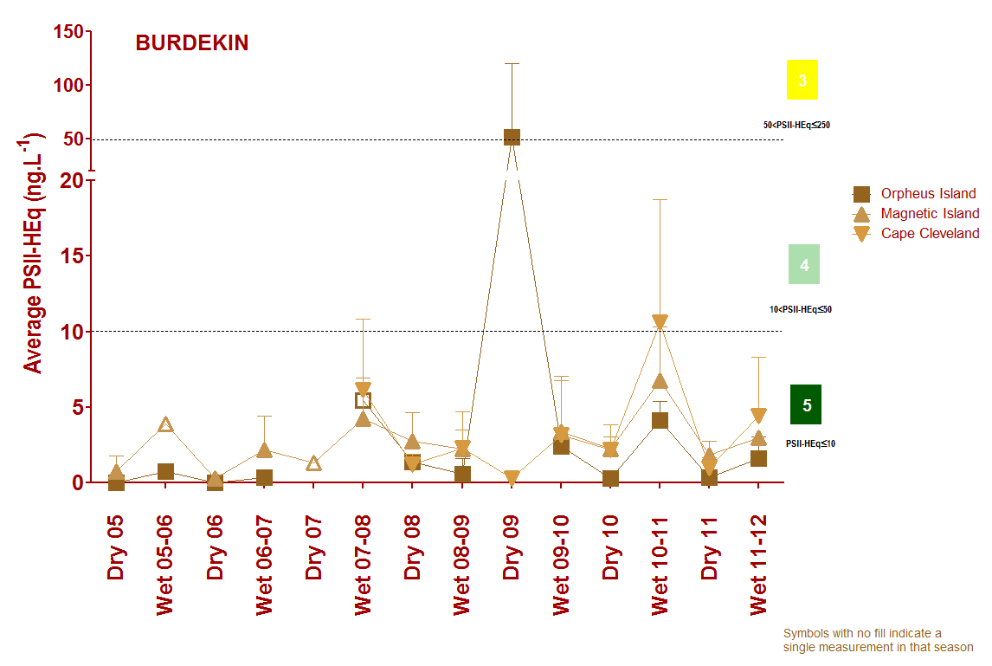
Figure 35: Trends in average PS-II herbicide equivalent concentrations at each sampling site in the Burdekin according to season.
High concentrations generally coincided with periods of high flow from the major rivers in the wet season compared to the dry season. Symbols with no fill indicate values with low reliability based on less than 30 per cent of the maximum number of deployments.

3.4.3 Seagrass condition and trend
The overall condition of inshore seagrass in the Burdekin region increased slightly in 2011-2012, however, was still rated as very poor (Figure 36). This assessment is driven by very low levels of abundance and reproductive effort, and increased nutrient enrichment of seagrass tissue, particularly at coastal sites.
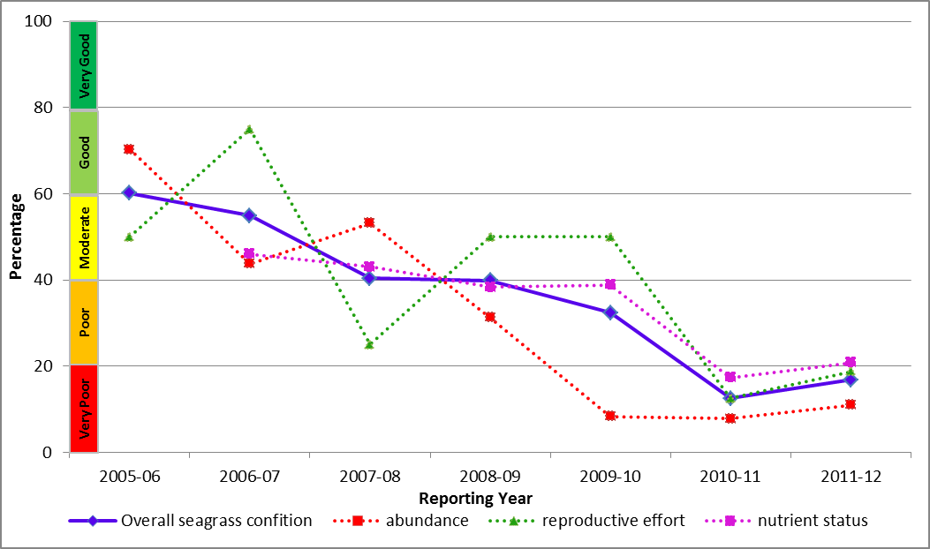
Figure 36: Trend in seagrass condition in the inshore Burdekin region from 2005-2006 to 2011-2012 (blue solid line; numbers are index categories).
Seagrass monitoring was conducted in coastal and reef habitats primarily influenced by wind-driven turbidity and pulsed delivery of nutrients and sediment (Figure 37). Seagrass abundance in coastal habitats remained very poor in 2011-2012, unchanged from the decline caused by Cyclone Yasi in 2011. Abundance at reef habitats increased slightly, primarily due to the proliferation of seagrass species such as Halophila ovalis, but still remained very poor. There was a decline in the reproductive effort of seagrass meadows at coastal locations (Bushland Beach and Shelly Bay), however, at reef locations (Picnic and Cockle Bay) reproductive effort increased due to colonising seagrasses. The nutrient content of seagrass tissue was very poor in coastal and poor in reef habitats, indicating elevated levels of nitrogen levels.

Figure 37: Trend in seagrass abundance (per cent cover) at inshore intertidal coastal habitats (Bushland and Shelly Beaches) and inshore fringing platform reef habitats (Magnetic Island) in the inshore Burdekin region.

3.4.4 Coral condition and trend
The overall condition of inshore coral reefs in the Burdekin was rated as poor in 2011-2012 (Figure 38).
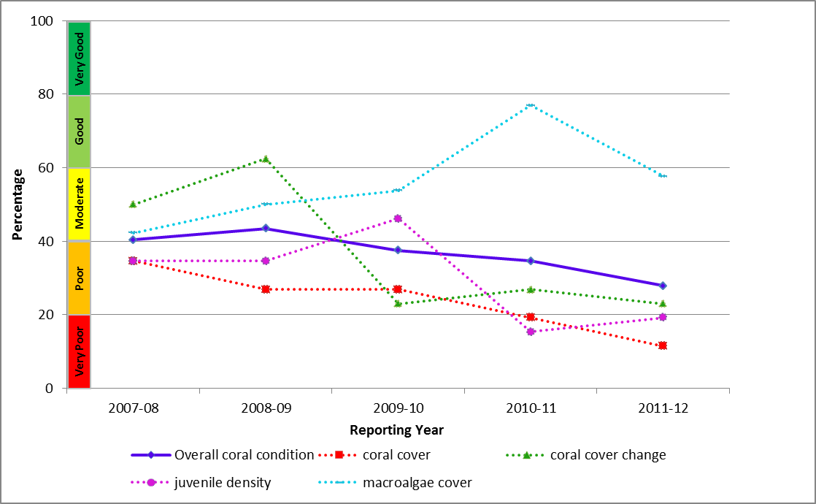
Figure 38: Trend in coral condition in the inshore Burdekin region from 2007-2008 to 2011-2012 (blue solid line; numbers are index categories).
Coral cover across the inshore Burdekin region has not recovered from the impact of coral bleaching in 1998 and 2002, and Cyclone Yasi in 2011, and was assessed as very poor. Macroalgae cover has been persistently high on several reefs and across the region the settlement of coral larvae has been low. Consequently, there were very poor densities of juvenile corals on most reefs in 2012 and slow rates of cover increase during disturbance free periods (Figure 39). The factors underlying the poor condition assessment suggest a lack of resilience of reef communities in the inshore Burdekin region.
Figure 39: Cover of major benthic groups and levels of key environmental parameters: inshore Burdekin region. Stacked bars represent cumulative cover of hard coral (blue), soft coral (pink) and macroalgae (green).
Box plots for both water and sediment quality represent the distribution of all observations to date, i.e., median value (fine line within the grey box), mean value (heavy line, WQ only), and the ranges of the central 50 per cent (grey box), 80 per cent (whiskers), and 90 per cent (black dots) of observations. Red reference lines indicate the Guidelines for water quality parameters¹, and the overall mean across all MMP reefs for sediment parameters.

3.5 Mackay Whitsunday
Figure 40: The condition of water quality and ecosystem health (seagrass and corals) in 2011-2012 across the inshore Mackay Whitsunday region.

3.5.1 Summary results
- Overall inshore Great Barrier Reef health in the Mackay Whitsunday region declined to poor in 2011-2012. Inshore water quality was moderate overall, and inshore seagrass meadows and coral reefs were in very poor and moderate condition, respectively (Figure 40).
- The inshore area of the Mackay Whitsunday was influenced by multiple high flow events from all catchments and rivers in 2011-2012. Inshore water quality for the Mackay Whitsunday region, as determined by remote sensing, remained moderate overall, showing some improvements in chlorophyll a concentrations since 2010-2011. The three sites in the inner Whitsundays had poor water quality in 2011-2012, with high long-term mean chlorophyll a concentrations and low water clarity.
- A range of herbicides were detected, including diuron, ametryn, atrazine and its breakdown products, hexazinone, simazine, tebuthiuron and, at Sarina Inlet only, bromacil. No PS-II herbicides, other pesticides or industrial chemicals with were detected in concentrations which exceeded Great Barrier Reef or ANZECC and ARMCANZ water quality guidelines. The PS-II herbicide equivalent index, which considers the relative potency and abundance of each PS-II herbicide, showed that herbicides were present at biologically relevant concentrations at Sarina Inlet and Pioneer Bay (Category 4).
- Inshore seagrass meadow condition improved slightly, but overall condition remains very poor and has progressively declined since 2005-2006. At all locations (coastal, estuarine and fringing reef), seagrass abundance, reproductive effort and nutrient status were very poor.
- Inshore coral reefs remained in moderate condition overall. Coral cover remained moderate and macroalgae cover was very good. However there was a continued decline in the density of juvenile coral colonies and a very poor rate of increase in coral cover. These declines, in the absence of acute disturbances, indicate that environmental conditions are having a chronic impact on inshore coral communities in this region.

3.5.2 Water quality condition and trend
Inshore water quality in the Mackay Whitsundays region, as determined by remote sensing, was rated as moderate overall in 2011-2012 (Figure 41).
Over the last five years there was a weak correlation between water quality and freshwater discharges from the Proserpine, O’Connell and Pioneer catchments. Chlorophyll a was rated as moderate in 2011-2012; however, concentrations exceeded the Water Quality Guidelines in 80 per cent of the inshore area in the dry season and 26 per cent of the inshore area (mainly around the river mouths of Proserpine, O’Connell, Pioneer and Plane Rivers) in the wet season. Total suspended solids was also rated as moderate in 2011-2012, and concentrations exceeded the Water Quality Guidelines in 56 and 31 per cent of the inshore area, in the dry and wet seasons, respectively.
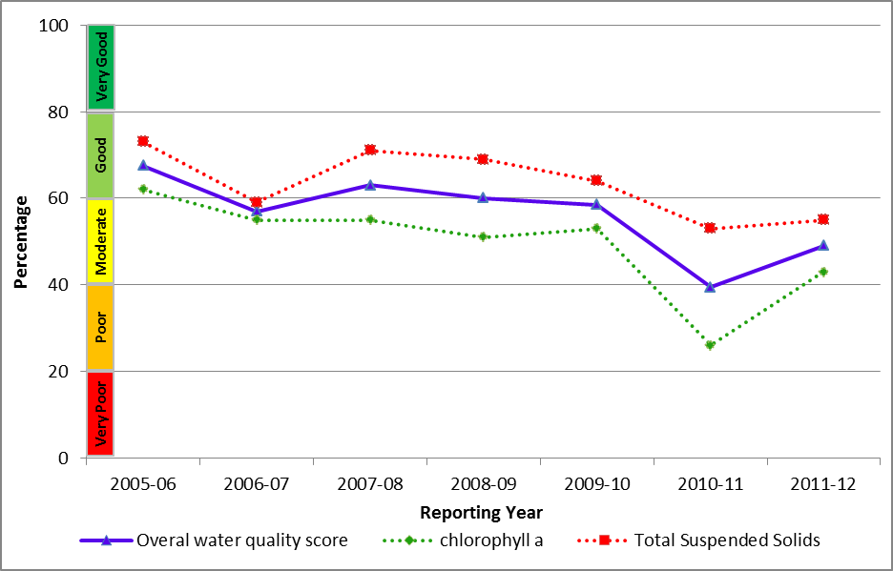
Figure 41: Trend in the Water Quality Index in the inshore Mackay Whitsunday region from 2005-2006 to 2011-2012 (blue solid line; numbers are index categories).
Remote sensing of water quality across the region showed a clear gradient of declining water quality from offshore areas more distant from terrestrial inputs, to inshore areas more frequently exposed to flood waters. This gradient was supported by long-term assessments of water quality at specific sites with variability between sites reflecting local hydrodynamic conditions and biophysical processes. Site specific water quality at all Whitsunday sites (Figure 42) was poor in 2011-2012, with high long-term mean chlorophyll a concentrations and low water clarity.
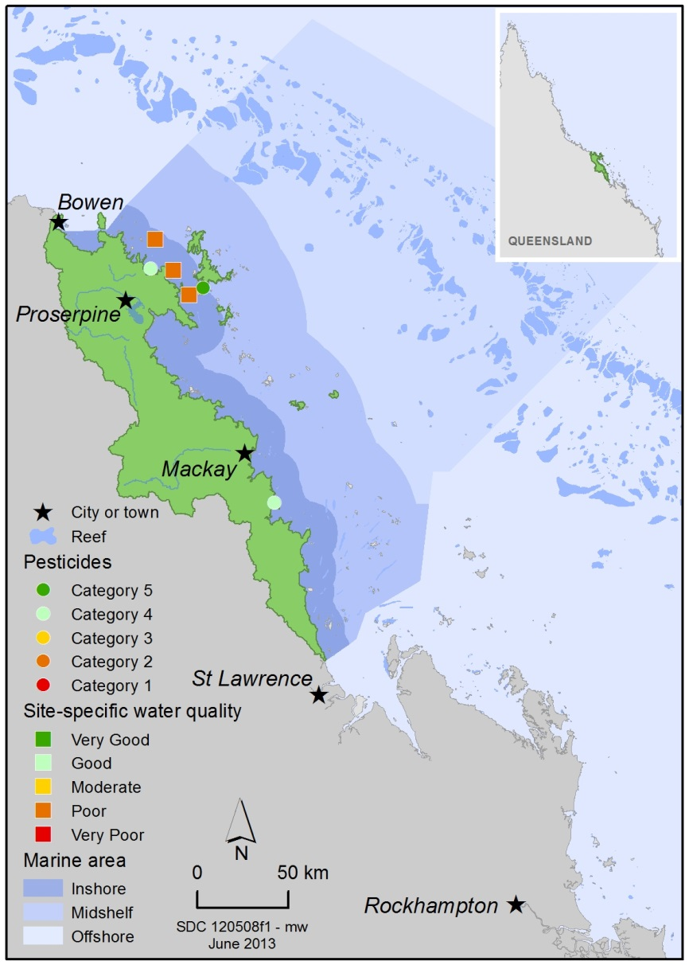
Figure 42: Water quality and pesticide ratings for PS-II herbicides at fixed monitoring sites in the inshore Mackay Whitsundays region.
A range of herbicides were detected in the inshore Mackay Whitsunday region in 2011-2012. The most abundant and frequently detected PSII herbicides in this inshore region include diuron, atrazine, and hexazinone. Sarina Inlet had the highest concentration of diuron than any other routine site in the Great Barrier Reef, with levels above those known to affect photosynthesis in diatoms (Category 4) (Figure 43). However, the maximum concentration detected at Sarina Inlet and Pioneer Bay was two-folds less since 2010-2011. This could be a result of continual high flow events diluting concentrations and accumulated herbicides in the upper catchment.

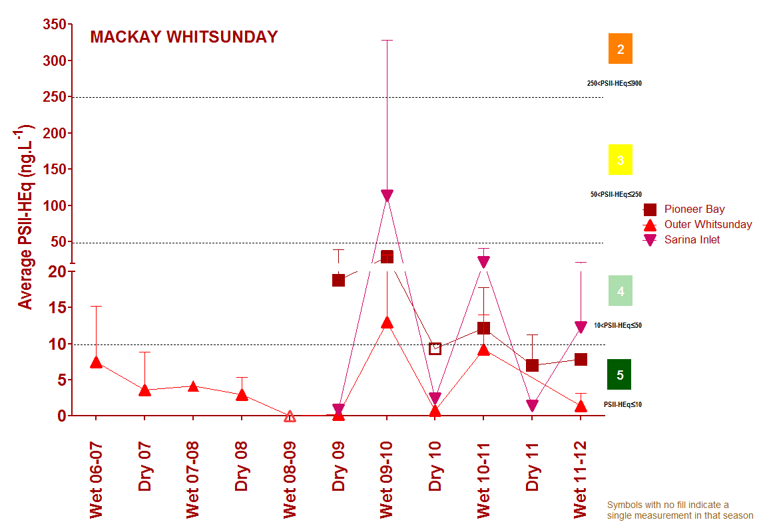
Figure 43: Trends in average PS-II herbicide equivalent concentrations at each sampling site in the Mackay Whitsundays according to season.
High concentrations generally coincided with periods of high flow from the major rivers in the wet season compared to the dry season. Symbols with no fill indicate values with low reliability based on less than 30 per cent of the maximum number of deployments.

3.5.3 Seagrass condition and trend
The overall condition of inshore seagrass in the Mackay Whitsundays region improved slightly in 2011-2012, however it remains very poor and has progressively declined since 2005-2006. The decline in seagrass condition reflects very poor abundance and reproductive effort and increased nutrient enrichment of seagrass tissue (Figure 44).
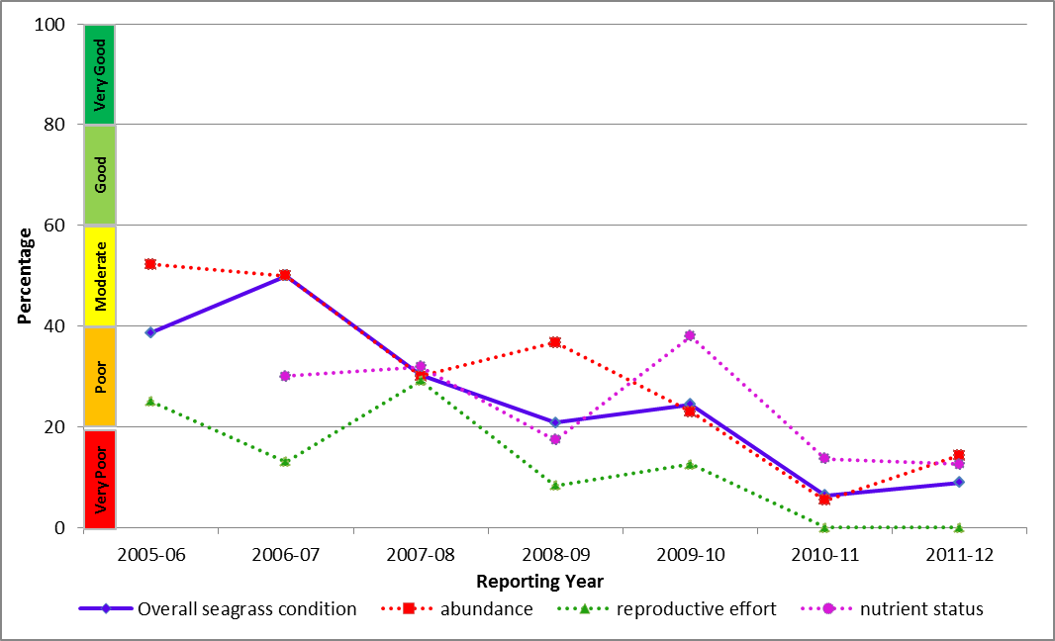
Figure 44: Trend in seagrass condition in the inshore Mackay Whitsunday region from 2005-2006 to 2011-2012.
Seagrass meadows were monitored at coastal, estuarine and fringing reef locations in the inshore Mackay Whitsunday region (Pioneer Bay, Sarina Inlet and Hamilton Island, respectively). Key environmental drivers of seagrass communities in this region include exposure at low tides and variable catchment run-off. At all locations, seagrass abundance, reproductive effort and nutrient status were rated as very poor in 2011-2012. Seagrass abundance declined in coastal habitats over the monitoring period and remained mostly unchanged in reef and estuarine habitats (Figure 45). Reproductive effort declined across the inshore region in 2011-2012, although seagrass meadow extent increased in early 2012. The nutrient status of seagrass tissue was similar across habitats, indicating elevated nitrogen levels.
Figure 45: Trend in seagrass abundance (per cent cover) at inshore intertidal estuarine habitats (Sarina Inlet), inshore intertidal coastal habitats (Pioneer Bay) and inshore fringing reef habitats (Hamilton Island) in the Mackay Whitsundays.

3.5.4 Coral condition and trend
The overall condition of inshore coral reefs in the Mackay Whitsundays has remained moderate since 2007-2008 (Figure 46).
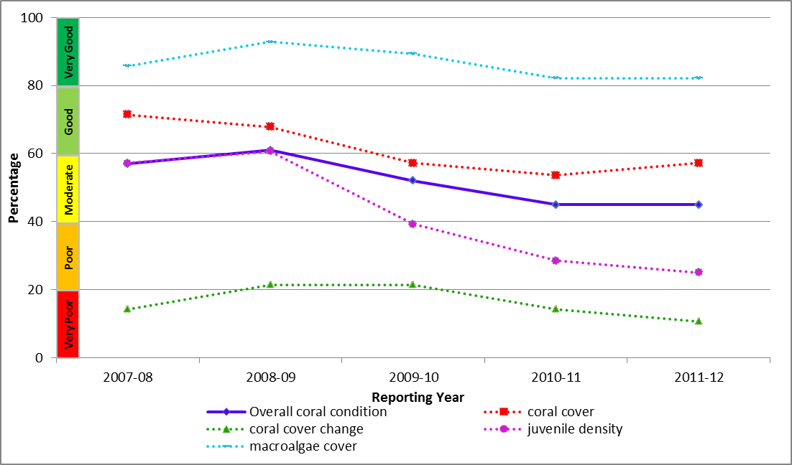
Figure 46: Trend in coral condition in the inshore Mackay Whitsunday region from 2007-2008 to 2011-2012.
Coral cover remained moderate in 2011-2012 and macroalgae cover very good (Figure 47). There was a ongoing decline in the density of juvenile coral colonies and a very poor rate of increase in coral cover. There were outbreaks of coral disease in the inshore region along with elevated turbidity and an increase in fine grained sediments from above-median river discharge. These declines indicate that the environmental conditions are having a chronic impact on inshore coral communities in this region.
Figure 47: Cover of major benthic groups and levels of key environmental parameters in the inshore Mackay Whitsunday region.
Stacked bars represent cumulative cover of hard coral (blue), soft coral (pink) and macroalgae (green). Box plots for both water and sediment quality represent the distribution of all observations to date, i.e., median value (fine line within the grey box), mean value (heavy line, WQ only), and the ranges of the central 50 per cent (grey box), 80 per cent (whiskers), and 90 per cent (black dots) of observations. Red reference lines indicate the Guidelines for water quality parameters¹, and the overall mean across all MMP reefs for sediment parameters.

3.6 Fitzroy
Figure 48: The condition of water quality and ecosystem health (seagrass and corals) in 2011-2012 across the inshore region for the Fitzroy region.

3.6.1 Summary results
- Overall inshore Great Barrier Reef health in the Fitzroy region declined to poor in 2011-2012. Inshore water quality condition was poor overall, and inshore seagrass meadows and coral reefs were n poor and very poor condition, respectively (Figure 48).
- The inshore area continued to be influenced by high flow events from the Fitzroy river. Inshore water quality for the region, as determined by remote sensing, remained poor overall in 2011-2012. Concentrations of chlorophyll a and suspended solids were very poor and moderate, respectively. Site-specific assessments of water quality showed a gradient of increasing water quality from the inshore to the mid-shelf area, with water quality poor at Pelican Island, moderate at Humpy Island and very good at Barren Island.
- A range of herbicides were detected at North Keppel Island (the only routine monitoring site in the Fitzroy region), including ametryn, atrazine and its breakdown products, diuron, hexazinone, simazine, tebuthiuron and bromacil (detected once only). No PS-II herbicides, other pesticides or industrial chemicals were detected in concentrations which exceeded Great Barrier Reef or ANZECC and ARMCANZ water quality guidelines. The PS-II herbicide equivalent index, which considers the relative potency and abundance of each PS-II herbicide, indicated that herbicides were present at concentrations below which no published PS-II inhibition effects have been observed (Category 5).
- Inshore seagrass meadows remained in poor condition overall. Seagrass abundance was poor, reproductive effort declined across all habitats and tissue nutrient status remained moderate.
- Inshore coral reefs declined to very poor condition overall. Coral cover remained poor across the region and the rate of increase in coral cover was very poor. The density of juvenile corals was also very poor and has been consistently low in this region, which may have implications for the resilience of coral communities. High incidences of coral disease were observed across the region and may be a consequence of chrome environmental stress following repeated flood events.

3.6.2 Water quality condition and trend
Inshore water quality in the Fitzroy region, as determined by remote sensing, remained poor overall in 2011-2012 (Figure 49).
Chlorophyll a was rated as very poor in 2011-2012, with concentrations exceeding the Water Quality Guidelines in 94 per cent of the inshore area in the dry season and 65 per cent of the inshore area in the wet season. Total suspended solids was rated as moderate in 2011-2012, with concentrations exceeding the Water Quality Guidelines for 47 per cent and 35 per cent of the inshore area in the dry and wet season, respectively.
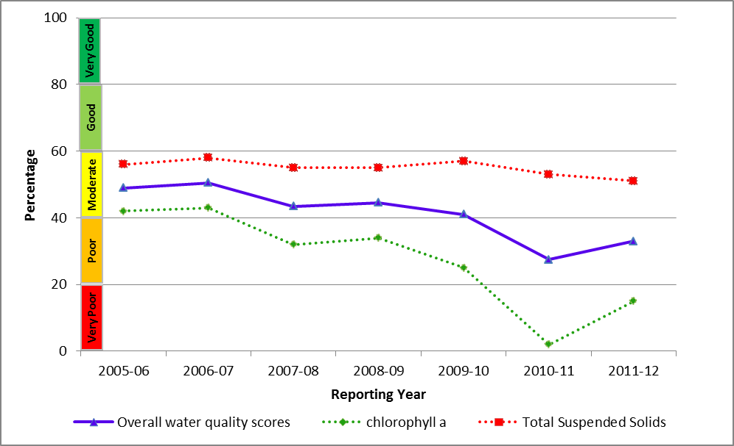
Figure 49: Trend in the Water Quality Index in the inshore Fitzroy region from 2005-2006 to 2011-2012.
Both remote sensing and site specific sampling (Figure 50) showed a clear pattern of improving water quality with distance from the coast and the mouth of the Fitzroy River. Pelican Island, the most inshore sampling site, had poor water quality. Here, the long-term means of all key parameters except for particulate nitrogen have exceeded Water Quality Guidelines. Barren Island, the sampling site furthest offshore, had very good water quality, with all parameters below guideline values. Humpy Island, the intermediate sampling site on the inshore-offshore gradient, had moderate water quality, with long-term means of chlorophyll a and water clarity exceeding guideline values.

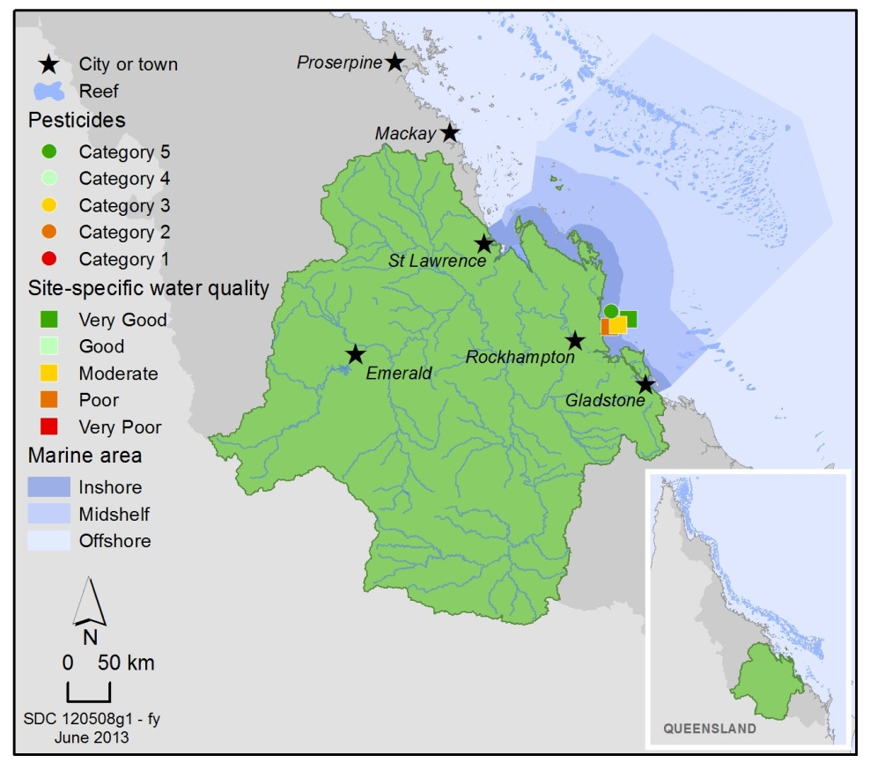
Figure 50: Water quality and pesticide ratings for PS-II herbicides at fixed monitoring sites in the inshore Fitzroy region.
The only routine monitoring site for pesticides in the inshore Fitzroy region is North Keppel Island. A range of herbicides were detected at North Keppel Island in 2011-2012. The most frequently detected PSII herbicices include atrazine, diuron, and tebuthiuron. Maximum PS-II herbicide concentrations in 2011-2012 were at Category 5 levels which represent concentrations below which any affects have been observed (Figure 51) and is an improvement from 2010-2011 levels. No PS-II herbicides, other pesticides or industrial chemicals were detected of concentrations that met or exceeded Great Barrier Reef or ANZECC and ARMCANZ water quality guidelines.

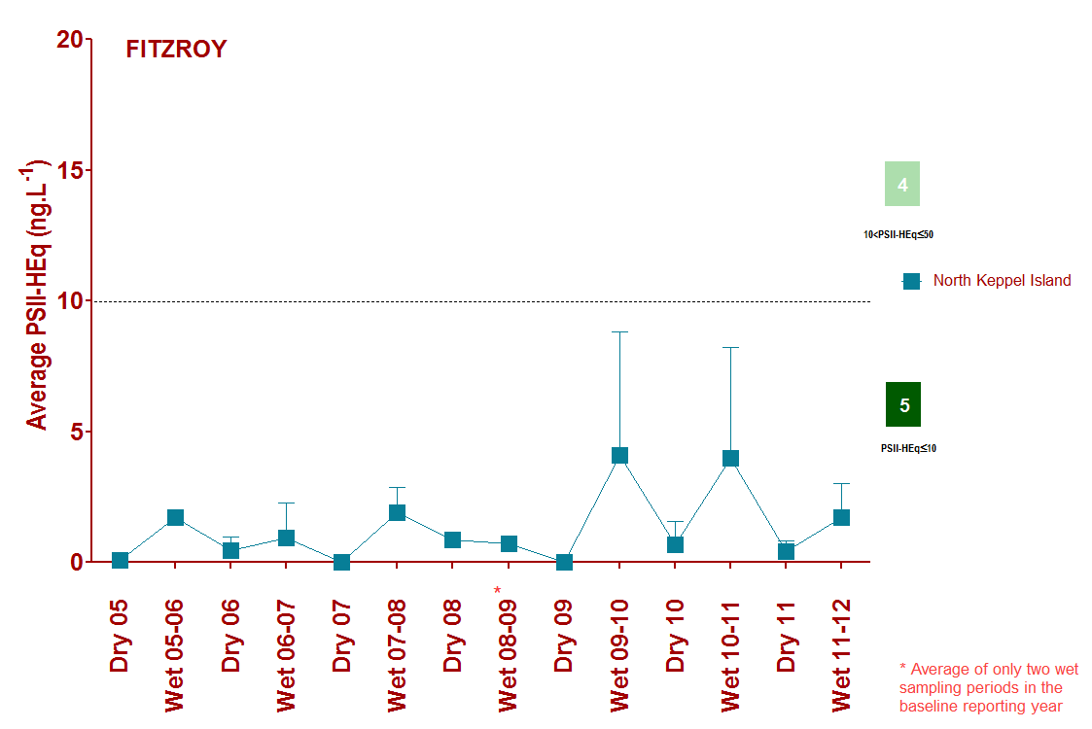
Figure 51: Trends in average PS-II herbicide equivalent concentrations at the sampling site in the Fitzroy according to season.
High concentrations generally coincided with periods of high flow from the major rivers in the wet season compared to the dry season.

3.6.3 Seagrass condition and trend
The overall condition of inshore seagrass in the Fitzroy region remained poor, driven largely by consistently poor abundance and a decline in reproductive effort (Figure 52). Nutrient ratios of seagrass tissue were moderate, reflecting local water quality conditions.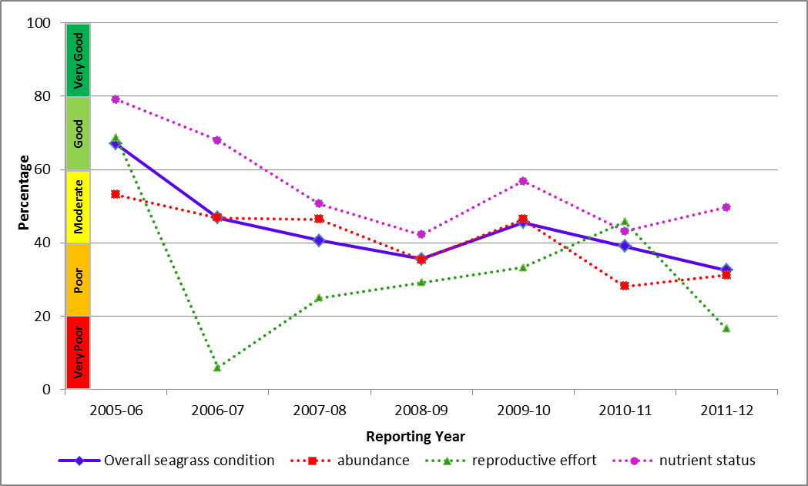
Figure 52: Trend in seagrass condition in the inshore Fitzroy region from 2005-2006 to 2011-2012 .
Seagrass meadows are monitored at coastal (Shoalwater Bay), estuarine (Gladstone Harbour) and fringing reef (Great Keppel) locations in the Fitzroy region. Key environmental pressures in the region include exposure at low tide and high turbidity.
Seagrass abundance in the coastal meadows declined and was rated as poor in 2011-2012, possibly due to local scale disturbances (Figure 53). Abundance in estuarine meadows increased and was rated as moderate and the observed abundances in 2011-2012 were some of the highest recorded since monitoring was established in the region. At reef habitats, abundance remained low and was rated as very poor, and meadow extent declined. Reproductive effort at all habitats declined relative to 2010-2011 and was rated as at poor in estuary and reef sites and very poor in coastal sites. However, an increase in seed banks may indicate a high recovery potential of estuary and coastal locations, while at the more vulnerable reef sites seed banks remained absent. The nutrient status of seagrass tissue varied between habitats, being moderate at coastal, very good at estuary and very poor at reef locations. These results suggest nitrogen limitation in estuarine habitats, while nitrogen and phosphorus were surplus to requirements in coastal and reef habitats.

Figure 53: Trend in seagrass abundance (per cent cover) at inshore intertidal estuarine habitats (Gladstone Harbour), inshore intertidal coastal habitats (Shoalwater Bay) and inshore fringing reef habitats (Great Keppel Island) in the Fitzroy region.

3.6.4 Coral condition and trend
The overall condition of inshore coral reefs in the Fitzroy region declined to very poor in 2011-2012 (Figure 54). Coral cover remained poor across the inshore Fitzroy region and there was a decline in macroalgae to poor. The density of juvenile corals was very poor and has been consistently low in this region reflecting ongoing disturbances from flooding.
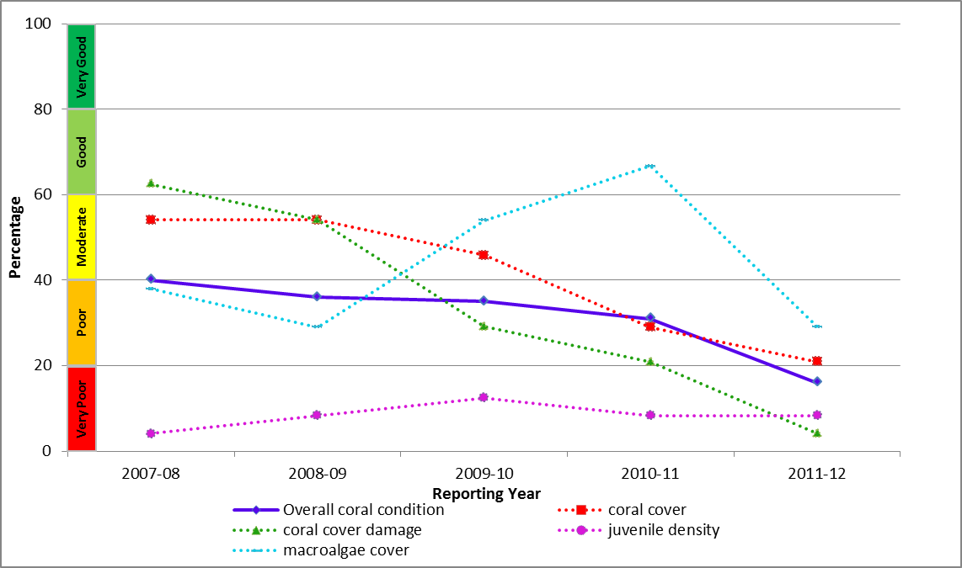
Figure 54: Trend in coral condition in the inshore Fitzroy region from 2007-2008 to 2011-2012 (blue solid line; numbers are index categories).
Coral data are available since 2005/06; however, the trend in coral condition is only able to be calculated from 2007-2008, because the coral change indicator requires the preceding three years of data.
There was a marked reduction in coral cover and juvenile densities at depths of at least two metres on reefs inshore of Great Keppel Island, consistent with exposure to low salinity waters in the 2011 Fitzroy River flood plume (Figure 55). With the exception of Barren Island, the reef least exposed to runoff, coral cover has not increased during the years between the recent flood and bleaching events.
High levels of coral disease were also observed during surveys in 2011 and most likely explain the low rate of increase in coral cover. The lack of recovery in coral cover during periods free from disturbance could be in part due to the high levels of coral disease observed during surveys in 2011.
Additionally, macroalgae cover on some reefs, which was temporarily reduced following the 2011 floods, has increased to levels higher than those in 2012 and contributed to the downgrading of reef condition.
Figure 55: Cover of major benthic groups and levels of key environmental parameters: inshore Fitzroy region. Stacked bars represent cumulative cover of hard coral (blue), soft coral (pink) and macroalgae (green).
Box plots for both water and sediment quality represent the distribution of all observations to date, i.e., median value (fine line within the grey box), mean value (heavy line, WQ only), and the ranges of the central 50 per cent (grey box), 80 per cent (whiskers), and 90 per cent (black dots) of observations. Red reference lines indicate the Guidelines for water quality parameters¹, and the overall mean across all MMP reefs for sediment parameters.

3.7 Burnett Mary
Figure 56: The condition of water quality and ecosystem health (seagrass and corals) in 2011-2012 across the inshore region for the Burnett Mary.

3.7.1 Summary results
- Overall Great Barrier Reef health in the inshore Burnett Mary region remained poor in 2011-2012. Inshore water quality was poor and the condition of seagrass was very poor (Figure 56).
- Inshore water quality has declined since 2006-2007, driven by changes in concentrations of chlorophyll a. The poor score for water quality in 2011-2012 was composed of very different ratings for chlorophyll a and total suspended solids, which were very poor and good, respectively.
- There is no comprehensive, ongoing in situ water quality monitoring in the Burnett Mary Region. Estimates of chlorophyll a and total suspended solids are derived from remote sensing only, which requires further field validation and hence estimates have relatively low reliability compared with those for other regions. As such, Burnett Mary water quality data was not used in the overall assessment of Great Barrier Reef water quality and reef health.
- Inshore seagrass meadows remained in very poor condition and the condition has generally been declining since 2005-2006. Seagrass abundance and reproductive effort were very poor throughout the region. The nutrient status of seagrass tissue was similar across the region and rated as moderate.
- No coral monitoring occurs in the inshore Burnett Mary region under the MMP.

3.7.2 Water quality condition and trend
Inshore water quality in the Burnett Mary region, as determined by remote sensing, was rated as poor in 2011-2012, continuing to decline from its good rating in 2006-2007 (Figure 57). Declines in water quality condition in the Burnett Mary have been largely driven by change in chlorophyll a concentration over time, with the concentrations exceeding the Water Quality Guidelines for 7 per cent and 14 per cent of the inshore area, in the dry and wet season, respectively. Very poor rating in 2011-2012 reflects the high freshwater discharges from Baffle Creek and the Burnett and Mary Rivers.
In contrast, the concentrations of total suspended solids have remained consistently good across all monitoring years. Concentrations of chlorophyll a exceeded the Water Quality Guidelines in 89 per cent of the inshore area in the dry season and 83 per cent of the inshore area in the wet season.
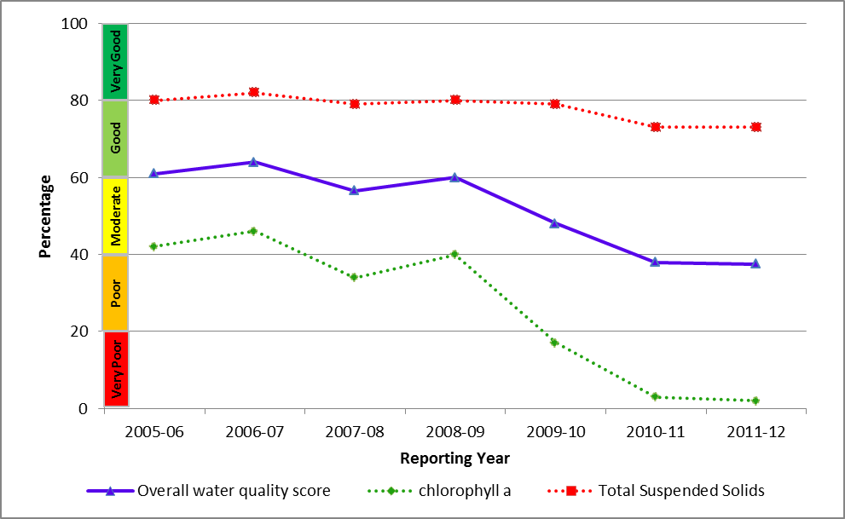
Figure 57: Trend in the Water Quality Index in the inshore Burnett Mary region from 2005-2006 to 2011-2012.

3.7.3 Seagrass condition and trend
The overall condition of inshore seagrass in the Burnett Mary region remained very poor in 2011-2012, reflecting very poor abundance and reproductive effort of seagrass meadows (Figure 58).
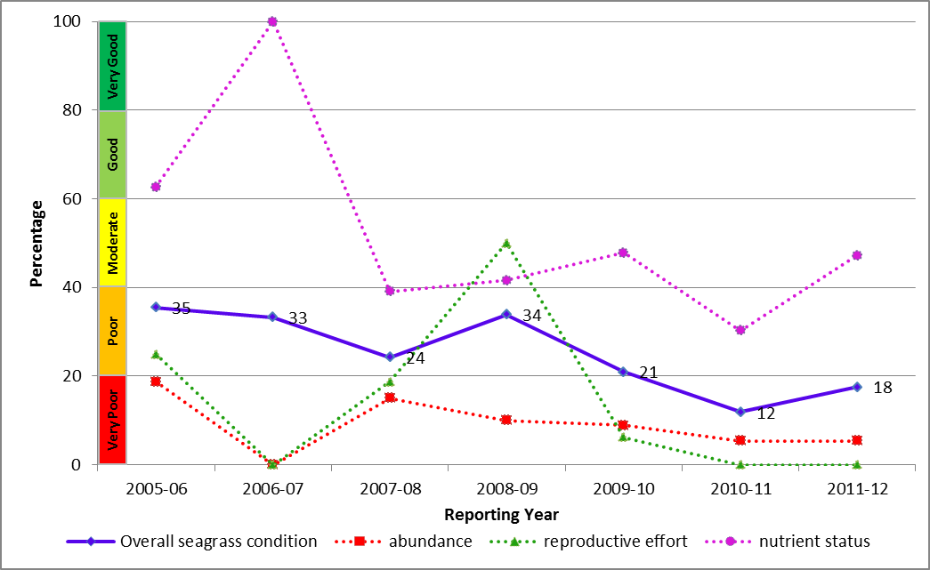
Figure 58: Trend in seagrass condition in the inshore Burnett Mary region from 2005-2006 to 2011-2012.
Seagrass in the inshore Burnett Mary region is monitored at estuarine sites at Rodds Bay in the north and Urangan in the south. The primary environmental drivers of community composition at these sites are fluctuating temperatures, exposure at low tides, catchment run-off and high turbidity. Seagrass abundance in 2011-2012 remained very poor throughout the inshore region (Figure 59). Reproductive effort remained very poor and declined in 2011-2012 compared to 2010-2011. However, seed banks increased across the region, suggesting the meadows may recover if conditions remain favourable. The nutrient status of seagrass tissue was moderate.
Figure 59: Trend in seagrass abundance (per cent cover) at inshore intertidal estuarine habitats (Urangan and Rodds Bay) in the inshore Burnett Mary region.

Summary
The summer of 2011-2012 was a season of moderate disturbances on the Great Barrier Reef compared to 2010-2011. No cyclones occurred, although there were significant flood events in the inshore Burdekin, Mackay Whitsundays and Fitzroy regions. Sea surface temperatures were mildly stressful to corals between Port Douglas and Mackay and low to moderate level coral bleaching were reported, predominantly in the central region of the Great Barrier Reef. Inshore water quality was moderate overall, reflecting an absence of major flooding, however biologically relevant concentrations of PS-II herbicides were present at sites in the inshore Burdekin and Mackay Whitsunday regions.
Despite these relatively benign conditions, seagrass meadows remained in very poor condition overall and their condition has continued to decline since 2006-2007. Seagrass abundance and reproductive effort were both very poor, while nutrient status was poor. Inshore coral reefs were in poor condition overall, there was a very poor density of hard coral juveniles and cover declined to the lowest point since surveys began in 2005. These results indicate that recovery potential from disturbances may be compromised at many inshore seagrass meadows and coral reefs.
While the current condition of inshore seagrass meadows and coral reefs reflect the ongoing compounding impacts of tropical cyclones and broad-scale flooding in recent years, it also is a product of chronic stresses from sediment, nutrient and contaminant loads carried by rivers, which both amplify the impacts of acute disturbances and then suppress recovery from such events.
Of further concern, active outbreaks of crown-of-thorns starfish were detected on the northern reefs and the situation is consistent with a new cycle of crown-of-thorns starfish outbreaks. Crown-of-thorns starfish have had a major impact on the Great Barrier Reef since surveys began in the 1960s. A recent analysis of long-term monitoring data showed that the starfish have been responsible for more than 40 per cent of the decline in coral cover since 1985. The increasing incidence of crown-of-thorns starfish in recent decades may be linked to nutrient-rich flood waters enhancing the survival of larvae.^{41,42}
While nothing can be done to prevent acute disturbances such as cyclones or flood-associated plumes of freshwater, it is possible to reduce the sediment, nutrient and contaminant loads carried by rivers to the Reef lagoon. Such reductions in loads through improved land management practices, would alleviate the chronic factors suppressing the recovery of many inshore areas and ecosystems, and improve the resilience of these ecosystems to disturbances.
However, improvements in marine water quality and associated coral reef and seagrass condition are likely to be slow and difficult to detect because of seasonal and regional variability, lags in ecosystem responses and potentially long recovery periods. The MMP has now completed its seventh year and the results have improved our understanding of the spatial and temporal variability of water quality and ecosystem condition. As a longer time series of data is acquired, our ability to separate the influences of land management changes from the high temporal variability in data will improve. In the meantime, adaptive management that incorporates monitoring and reporting, effective networks between stakeholders and collective responses based on our scientific understanding of water quality conditions and ecosystem impacts, are our best means of ensuring long-term Great Barrier Reef health and resilience outcomes.

References
1. Great Barrier Reef Marine Park Authority 2009a, Great Barrier Reef Outlook Report 2009, GBRMPA, Townsville, .
2. Furnas, M. 2003, Catchments and corals: terrestrial runoff to the Great Barrier Reef, Australian Institute of Marine Science, Townsville.
3. Hutchings, P. and Haynes, D. 2005, Marine Pollution Bulletin Special Edition editorial, Marine Pollution Bulletin 51(1-4): 1-2.
4. Moss, A.J., Rayment, G.E., Reilly, N. and Best, E.K. 1992, Sediment and Nutrient Exports from Queensland Coastal Catchments, A Desk Study, Dept of Environment & Heritage, Dept of Primary Industries, Queensland, viewed dd/mm/yyyy, <Nutrients Terresterial>.
5. Neil, D.T., Orpin, A.R., Ridd, P.V. and Yu, B. 2002, Sediment yield and impacts from river catchments to the Great Barrier Reef lagoon, Marine and Freshwater Research 53(4): 733-752.
6. McCulloch, M., Fallon, S., Wyndham, T., Hendy, E., Lough, J.M. and Barnes, D. 2003, Do sediments sully the reef? Ecos 115: 37-41.
7. Department of the Premier and Cabinet 2009, Reef Water Quality Protection Plan 2009 for the Great Barrier Reef World Heritage Area and Adjacent Catchments, Reef Water Quality Protection Plan Secretariat, DPC, Brisbane, viewed dd/mm/yyyy, <http://www.reefplan.qld.gov.au/resources/assets/reef-plan-2009.pdf>.
8. Department of the Premier and Cabinet 2008, Scientific consensus statement on water quality in the Great Barrier Reef, DPC, Brisbane, .
9. Waycott, M. and McKenzie, L.J. 2010, Final report project 1.1.3 to the Marine and Tropical Sciences Research Facility: Condition, trend and risk in coastal habitats: Seagrass indicators, distribution and thresholds of potential concern, Reef and Rainforest Research Centre, Cairns, .
10. Fabricius, K.E., Langdon, C., Uthicke, S., Humphrey, C., Noonan, S., De'ath, G., Okazaki, R., Muehllehner, N., Glas, M. and Lough, J.M. 2011, Losers and winners in coral reefs acclimatized to elevated carbon dioxide concentrations, Nature Climate Change 1: 165-169.
11. Collier, C. and Waycott, M. 2009, Drivers of change to seagrass distributions and communities on the Great Barrier Reef, literature review and gaps analysis. Report to the Marine and Tropical Sciences Research Facility, Reef and Rainforest Research Centre, Cairns, viewed dd/mm/yyyy, <http://www.rrrc.org.au/publications/downloads/113-JCU-Collier-C-et-al-2009-Seagrass-Disturbance-Review.pdf>.
12. van Dam, J.W., Negri, A.P., Mueller, J.F. and Uthicke, S. 2012, Symbiont-specific responses in foraminifera to the herbicide diuron, Marine Pollution Bulletin in press.
13. Fabricius, K.E. 2005, Effects of terrestrial runoff on the ecology of corals and coral reefs: Review and synthesis, Marine Pollution Bulletin 50(2): 125-146.
14. Cooper, T. and Fabricius, K. 2007, Coral-based indicators of changes in water quality on nearshore coral reefs of the Great Barrier Reef. Unpublished report to Marine and Tropical Sciences Research Facility, Reef and Rainforest Research Centre Limited, Cairns, .
15. Berumen, M.L. and Pratchett, M.S. 2006, Recovery without resilience: persistent disturbance and long-term shifts in the structure of fish and coral communities at Tiahura Reef, Moorea, Coral Reefs 25: 647-653.
16. Hoegh-Guldberg, O., Mumby, P.J., Hooten, A.J., Steneck, R.S., Greenfield, P., Gomez, E., Harvell, C.D., Sale, P.F., Edwards, A.J., Caldeira, K., Knowlton, N., Eakin, C.M., Iglesias-Prieto, R., Muthiga, N., Bradbury, R.H., Dubi, A. and Hatziolos, M.E. 2007, Coral reefs under rapid climate change and ocean acidification, Science 318: 1737-1742.
17. Intergovernmental Panel on Climate Change 2007, Climate change 2007 synthesis report, Summary for policymakers, IPCC Secretariat, Gland, Switzerland, .
18. Garnaut, R. 2008, The Garnaut Climate Change Review, Cambridge University Press, Melbourne, viewed dd/mm/yyyy, <http://www.garnautreview.org.au>.
19. Wooldridge, S.A. 2009, Water quality and coral bleaching thresholds: formalising the linkage for the inshore reefs of the Great Barrier Reef, Australia, Marine Pollution Bulletin 58(5): 745-751.
20. Booij, K., Vrana, B. and Huckins, J.N. 2007, Theory, modelling and calibration of passive samplers used in water monitoring, in Passive sampling techniques in environmental monitoring, eds R. Greenwood, G. Millis and B. Vrana, Elsevier Amsterdam, Amsterdam, pp. 141-169.
21. Shaw, M., Negri, A.P., Fabricius, K. and Mueller, J.F. 2009, Predicting water toxicity: Pairing passive sampling with bioassays on the Great Barrier Reef, Aquatic Toxicology 95(2): 108-116.
22. Great Barrier Reef Marine Park Authority 2010, Water quality guidelines for the Great Barrier Reef Marine Park, GBRMPA, Townsville, viewed dd/mm/yyyy, <http://www.gbrmpa.gov.au/__data/assets/pdf_file/0017/4526/GBRMPA_WQualityGuidelinesGBRMP_RevEdition_2010.pdf>.
23. Furnas, M. and Brodie, J. 1996, Current status of nutrient levels and other water quality parameters in the Great Barrier Reef, in Downstream effects of landuse, eds H.M. Hunter, A.G. Eyles and G.E. Rayment, Department of Natural Resources, Brisbane, pp. 9-21.
24. Thompson, A.A. and Dolman, A.M. 2010, Coral bleaching: one disturbance too many for near-shore reefs of the Great Barrier Reef, Coral Reefs 29(3): 637-648.
25. Great Barrier Reef Marine Park Authority 2009b, Water quality guidelines for the Great Barrier Reef Marine Park, GBRMPA, Townsville, .
26. McKenzie, L.J. MTSRF Milestone report for June 2009: Seagrass indicators, distribution and thresholds of potential concern, viewed dd/mm/yyyy, <http://www.rrrc.org.au/publications/downloads/113-QDPIF-McKenzie-L-2009-June-Milestone-Report.pdf> .
27. Schaffelke, B., Carleton, J., Doyle, J., Furnas, M., Gunn, K., Skuza, M., Wright, M. and Zagorskis, I. 2010, Reef Rescue Marine Monitoring Program: Final report of AIMS activities 2009/10: Inshore water quality monitoring, Australian Institute of Marine Science, Townsville, viewed dd/mm/yyyy, <http://www.rrrc.org.au/mmp/downloads/378_AIMS_final-annual-report_2009-10.pdf>.
28. Haynes, D., Mueller, J. and Carter, S. 2000, Pesticide and herbicide residues in sediments and seagrasses from the Great Barrier Reef World Heritage Area and Queensland coast, Marine Pollution Bulletin 41(7-12): 279-287.
29. Haynes, D., Ralph, P., Prange, J. and Dennison, W. 2000, The impact of the herbicide diuron on photosynthesis in three species of tropical seagrass, Marine Pollution Bulletin 41(7-12): 288-293.
30. Mitchell, C., Brodie, J.E. and White, I. 2005, Sediments, nutrients and pesticide residues in event flow conditions in streams of the Mackay Whitsunday Region, Australia, Marine Pollution Bulletin 51(1-4): 23-36.
31. Lewis, S.E., Brodie, J.E., Bainbridge, Z.T., Rohde, K.W., Davis, A.M., Masters, B.L., Maughan, M., Devlin, M.J., Mueller, J.F. and Schaffelke, B. 2009, Herbicides: A new threat to the Great Barrier Reef, Environmental Pollution 157(8-9): 2470-2484.
32. Kapernick, A., Shaw, C., Dunn, A., Komarova, T., Mueller, J., Carter, S., Eaglesham, G., Alberts, V., Masters, B., Rhode, K., Packett, R., Prange, J. and Haynes, D. 2007, River pesticide loads and GBR lagoon pesticide data (2006-2007), Report to the Great Barrier Reef Marine Park Authority. National Research Centre for Environmental Toxicology (EnTox), University of Queensland, Brisbane, .
33. Packett, R., Dougall, C., Rohde, K. and Noble, R. 2009, Agricultural lands are hot-spots for annual runoff polluting the southern Great Barrier Reef lagoon, Marine Pollution Bulletin 58(7): 976-986.
34. Magnusson, M., Heimann, K. and Negri, A.P. 2008, Comparative effects of herbicides on photosynthesis and growth of tropical estuarine microalgae, Marine Pollution Bulletin 56: 1545-1552.
35. Jones, R.J. and Kerswell, A.P. 2003, Phytotoxicity of Photosystem II (PSII) herbicides to coral, Marine Ecology Progress Series 261: 149-159.
36. Osborne, K., Dolman, A.M., Burgess, S.C. and Johns, K.A. 2011, Disturbance and the dynamics of coral cover on the Great Barrier Reef (1995–2009), PLoS ONE 6(3): e17516.
37. Great Barrier Reef Marine Park Authority 2011, Impacts of tropical cyclone Yasi on the Great Barrier Reef: A report on the findings of a rapid ecological impact assessment, GBRMPA, Townsville, viewed dd/mm/yyyy, <http://www.gbrmpa.gov.au/media-room/feature/cyclone-yasi-report-released>.
38. Maynard, J.A., Johnson, J.E., Marshall, P.A., Eakin, C.M., Goby, G., Schuttenberg, H. and Spillman, C.M. 2009, A Strategic Framework for Responding to Coral Bleaching Events in a Changing Climate, Environmental management 44(1): 1-11.
39. Bruno, J.F., Selig, E.R., Casey, K.S., Page, C.A., Willis, B., Harvell, C.D., Sweatman, H. and Melendy, A.M. 2007, Thermal stress and coral cover as drivers of coral disease outbreaks, PLoS Biology 5(6): e124.
40. Engelhardt, U. and andLassig, B. 1997, A review of possible causes and consequences of outbreaks of crown-of-thorns starfish (Acanthaster planci) on the Great Barrier Reef - an Australian perspective, in The Great Barrier Reef, science, use and management: a national conference, eds. N. Turia and C. Dalliston. , Great Barrier Reef Marine Park Authority, Townsville, pp.243-259.
41. Sweatman, H., Cheal, A.J., Coleman, G.J., Emslie, M.J., Johns, K., Jonker, M., Miller, I.R. and Osborne, K. 2008, Long-term monitoring of the Great Barrier Reef: Status Report 8, Australian Institute of Marine Science, Townsville, .
42. Brodie, J., Fabricius, K.E., De'ath, G. and Okaji, K. 2005, Are increased nutrient inputs responsible for more outbreaks of crown-of-thorns starfish? An appraisal of the evidence, Marine Pollution Bulletin 51(1-4): 266-278.
43. Fabricius, K.E. 2011, Factors determining the resilience of coral reefs to eutrophication: A review and conceptual model, in Coral Reefs: An Ecosystem in Transition, eds Z. Dubinsky and N. Stambler, Springer, Dordrecht, pp. 493-508.
44. De'ath, G., Fabricius, K.E., Sweatman, H. and Puotinen, M. 2012, The 27–year decline of coral cover on the Great Barrier Reef and its causes, Proceedings of the National Academy of Sciences 109(44): 17995-17999.
45. Thompson, A., Costello, P., Davidson, J., Logan, M., Schaffelke, B., Uthicke, S. and Takahashi, M. 2011, Reef Rescue Marine Monitoring Program, Report of AIMS Activities – Inshore coral reef monitoring 2011, Report for Great Barrier Reef Marine Park Authority, Australian Institute of Marine Science, Townsville, .
46. Harvell, C.D., Jordan-Dahlgren, E., Merkel, S., Rosenburg, E., Raymundo, L., Smith, G., Weil, G. and Willis, B. 2007, Coral disease, environmental drivers and the balance between coral and microbial associates, Oceanography 20(1): 36-59.
47. Loya, Y., Sakai, K., Yamazato, K., Nakano, Y., Sambali, H. and van Woesik, R. 2001, Coral bleaching: the winners and the losers, Ecology Letters 4(2): 122-131.
48. Willis, B.L., Page, C.A. and Dinsdale, E.A. 2004, Corals disease and the Great Barrier Reef, in Coral Health and Disease, eds E. Rosenberg and Y. Loya, Springer-Verlag, Helidelberg, pp. 69-104.
49. Haapkylä, J., Unsworth, R.K.F., Flavell, M., Bourne, D.G., Schaffelke, B. and Willis, B.L. 2011, Seasonal rainfall and runoff promote coral disease on an inshore reef, PLoS ONE 6(2): e16893.
50. McKenzie, L., Collier, C. and Waycott, M. 2014, Reef rescue marine monitoring program - inshore seagrass, annual report for the sampling period 1st Jul 2011 - 31st May 2012, Centre for Tropical Water & Aquatic Ecosystem Research, James Cook University, Cairns, .

