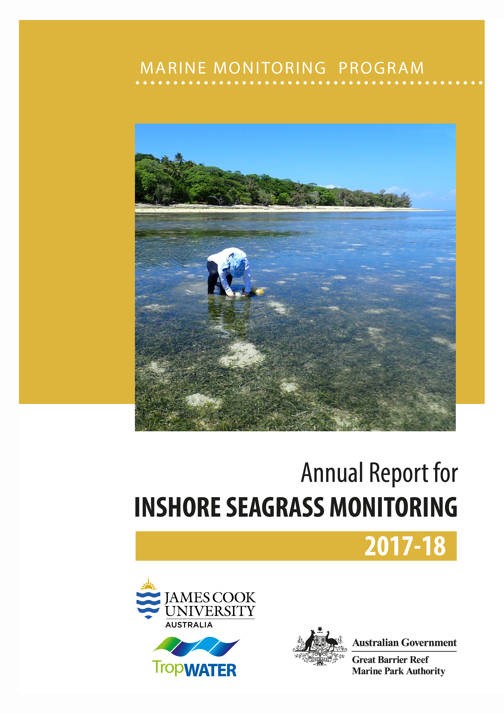
© James Cook University (TropWATER), 2019
Published by the Great Barrier Reef Marine Park Authority

ISSN: 2208-4037
A catalogue record for this publication is available from the National Library of Australia

This document is licensed for use under a Creative Commons By Attribution 4.0 International licence with the exception of the Coat of Arms of the Commonwealth of Australia, the logos of the Great Barrier Reef Marine Park Authority, James Cook University and TropWATER, any other material protected by a trademark, content supplied by third parties and any photographs. For licence conditions see: http://creativecommons.org/licences/by/4.0


This publication should be cited as:
McKenzie, L.J., Collier, C.J, Langlois, L.A., Yoshida, R.L., Uusitalo, J., Smith, N. and Waycott, M. 2019, Marine Monitoring Program: Annual Report for Inshore Seagrass Monitoring 2017–18. Report for the Great Barrier Reef Marine Park Authority, Great Barrier Reef Marine Park Authority, Townsville, 180pp.

Front cover photo: Green Island, Wet Tropics monitoring site. © GBRMPA 2018

DISCLAIMER
While reasonable efforts have been made to ensure that the contents of this document are factually correct, JCU and TropWATER do not make any representation or give any warranty regarding the accuracy, completeness, currency or suitability for any particular purpose of the information or statements contained in this document. To the extent permitted by law JCU and TropWATER shall not be liable for any loss, damage, cost or expense that may be occasioned directly or indirectly through the use of or reliance on the contents of this document.

Comments and questions regarding this document are welcome and should be addressed to:

TropWATER- Centre for Tropical Water and Aquatic Ecosystem Research
James Cook University
Townsville, Qld 4811
Tropwater@jcu.edu.au

This project is supported by the Great Barrier Reef Marine Park Authority through funding from the Australian Government Reef Program, the Australian and Queensland governments Reef 2050 Integrated Monitoring and Reporting Program, Australian Institute of Marine Science and James Cook University.

Contents

List of figures iv
List of tables xi
Acronyms, abbreviations and units used in this report xiii
Acknowledgements xiv
Executive summary 1
1 Introduction 4
1.1 Seagrass monitoring in the Marine Monitoring Program 4
1.2 Conceptual basis for indicator selection 6
1.3 Structure of the Report 10
2 Methods summary 11
2.1 Climate and environmental pressures 11
2.2 Inshore seagrass and habitat condition 14
2.2.1 Sampling design & site selection 14
2.2.2 Seagrass abundance, composition and extent 21
2.2.3 Seagrass reproductive status 21
2.2.4 Seagrass leaf tissue nutrients 21
2.2.5 Epiphytes and macroalgae 22
2.3 Data analyses 22
2.4 Reporting Approach 23
2.5 Calculating report card scores 24
2.5.1 Seagrass abundance 24
2.5.2 Seagrass reproductive effort 25
2.5.3 Seagrass nutrient status. 25
2.5.4 Seagrass condition index 26
3 Drivers and pressures influencing seagrass meadows in 2017–18 27
3.1 Summary 27
3.2 Rainfall 28
3.3 River discharge 29
3.4 Turbid water exposure and flood plume extent 31
3.5 Daily incident light 32
3.6 Within-canopy seawater temperature 33
3.7 Seagrass meadow sediments 35
4 Seagrass condition and trend 37
4.1 Reef-wide seagrass condition and trend 37
4.2 Trends in seagrass condition indicators between regions 38
4.3 Trends in seagrass condition indicators by habitat type 40
4.3.1 Seagrass abundance, composition and extent 40
4.3.2 Seagrass reproductive status 43
4.3.3 Seagrass leaf tissue nutrients 45
4.3.4 Epiphytes and macroalgae 47
5 Regional Reports 49
5.1 Cape York 49
5.1.1 2017–18 Summary 49
5.1.2 Climate and environmental pressures 50
5.1.3 Inshore seagrass and habitat condition 52
5.1.3.1 Seagrass index and indicator scores 53
5.1.3.2 Seagrass abundance, composition and extent 55
5.1.3.3 Seagrass reproductive status 56
5.1.3.4 Seagrass leaf tissue nutrients 57
5.1.3.5 Epiphytes and macroalgae 59
5.2 Wet Tropics 60
5.2.1 2017–18 Summary 60
5.2.2 Climate and environmental pressures 61
5.2.3 Inshore seagrass and habitat condition 65
5.2.3.1 Seagrass index and indicator scores 65
5.2.3.2 Seagrass abundance, community and extent 67
5.2.3.3 Seagrass reproductive status 71
5.2.3.4 Seagrass leaf tissue nutrients 72
5.2.3.5 Epiphytes and macroalgae 75
5.3 Burdekin 77
5.3.1 2017–18 Summary 77
5.3.2 Climate and environmental pressures 78
5.3.3 Inshore seagrass and habitat condition 80
5.3.3.1 Seagrass index and indicator scores 80
5.3.3.2 Seagrass abundance, composition and extent 81
5.3.3.3 Seagrass reproductive status 83
5.3.3.4 Seagrass leaf tissue nutrients 84
5.3.3.5 Epiphytes and macroalgae 86
5.4 Mackay-Whitsunday 87
5.4.1 2017–18 Summary 87
5.4.2 Climate and environmental pressures 88
5.4.3 Inshore seagrass and habitat condition 90
5.4.3.1 Seagrass index and indicator scores 90
5.4.3.2 Seagrass abundance, community and extent 91
5.4.3.3 Seagrass reproductive status 94
5.4.3.4 Seagrass leaf tissue nutrients 94
5.4.3.5 Epiphytes and macroalgae 96
5.5 Fitzroy 97
5.5.1 2017–18 Summary 97
5.5.2 Climate and environmental pressures 98
5.5.3 Inshore seagrass and habitat condition 100
5.5.3.1 Seagrass index and indicator scores 100
5.5.3.2 Seagrass abundance, composition and extent 101
5.5.3.3 Seagrass reproductive status 103
5.5.3.4 Seagrass leaf tissue nutrients 104
5.5.3.5 Epiphytes and Macroalgae 105
5.6 Burnett Mary 107
5.6.1 2017–18 Summary 107
5.6.2 Climate and environmental pressures 108
5.6.3 Inshore seagrass and habitat condition 110
5.6.3.1 Seagrass index and indicator scores 110
5.6.3.2 Seagrass abundance, composition and extent 111
5.6.3.3 Seagrass reproductive status 113
5.6.3.4 Seagrass leaf tissue nutrients 114
5.6.3.5 Epiphytes and macroalgae 115
6 Discussion 116
6.1 Seagrass resilience 116
6.2 Seagrass ecosystem service provisioning 117
6.3 Management Responses 117
7 Conclusion 119
8 References 122
Appendix 1 Case studies 134
Case study #1: Developing a computer program to predict cumulative light and temperature stress on seagrass in the Great Barrier Reef 135
Introduction 135
Program details 136
Using the Program 136
Program Outputs 136
Alpha testing 137
References 140
Case study #2: Reproductive effort as a predictor of future seagrass cover: Model assessment and implications for report card metrics and the development of a seagrass resilience indicator 141
Introduction 141
Methods 141
Results 143
Discussion 145
References 148
Appendix 2 Seagrass condition indicator guidelines for report card calculations 150
Seagrass abundance 151
Seagrass reproductive effort 156
Seagrass nutrient status. 156
Appendix 3 Detailed data 158
Climate and environmental pressures 162
Climate 162
Tidal exposure 165
Light at seagrass canopy 169
Seagrass habitat condition 173
Sediments composition 173
Appendix 4 Results of statistical analysis 185
List of figures
Figure 1. Reef-wide seagrass condition index (±SE) with contributing indicator scores over the life of the MMP 1
Figure 2. Major marine ecosystems (coral reefs and surveyed seagrass meadows) in the World Heritage Area and Natural Resource Management regions (including marine) 5
Figure 3. Climate, environmental, seagrass condition and seagrass resilience indicators reported as part of inshore seagrass monitoring. 8
Figure 4. General conceptual model of seagrass habitats in north east Australia and the water quality impacts affecting the habitat 9
Figure 5. Illustration of seagrass recovery after loss and the categories of successional species over time. 9
Figure 6. Difference between annual average daily wet season rainfall (December 2017–April 2018) and the long-term average (1961–1990). 28
Figure 7. Average daily rainfall (mm/day) in the Reef catchment: (left) long-term annual average (1961–1990; time period produced by BOM), (centre) 2017–18 and (right) the difference between the long-term annual average and 2017–18 rainfall patterns. From Gruber et al. 2019 29
Figure 8. Environmental pressures in the Reef during 2017–18 and relative to long-term: a. Frequency of turbid water (colour classes 1–5, primary and secondary water) exposure shown in the left-hand panel in the Reef from December 2017 to April 2018 31
Figure 9. Difference in the frequency of exposure to water colour classes 1 to 4 (left) and 1 to 5 (right) at seagrass monitoring sites during the wet season (December 2017–April 2018) compared to the long-term multiannual exposure (2003–2017). 32
Figure 10. Daily light for all sites combined from 2008 to 2018. In 2008–2009, light data is from the Burdekin and Wet Tropics regions. Other regions were included from 2009–2010, with Cape York added post 2012–2013 reporting period. 33
Figure 11. Number of days when inshore intertidal sea temperature exceeded 35°C, 38°C, 40°C and 43°C in each monitoring period in each NRM region. 34
Figure 12. Number of days when inshore subtidal sea temperature exceeded 35°C, 38°C, 40°C and 43°C in each monitoring period in each NRM region. 34
Figure 13. Inshore intertidal sea temperature deviations from baseline for Reef seagrass habitats from 2003 to 2018. 35
Figure 14. Proportion of sediment composed of mud (grain size <63µm) at Reef seagrass monitoring habitats from 1999–2018. 36
Figure 15. Reef-wide seagrass condition index (±SE) with contributing indicator scores over the life of the MMP 38
Figure 16. Seagrass condition index (±SE) with contributing indicator scores for each NRM region over the life of the MMP 39
Figure 17. Trends in the seagrass condition index and indicators used to calculate the index 40
Figure 18. Seagrass per cent cover measures per quadrat from meadows monitored from June 1999 to May 2018 (sites and habitats pooled). 41
Figure 19. Average relative spatial extent of seagrass distribution at monitoring sites across inshore Reef 42
Figure 20. Proportion of total seagrass abundance composed of species displaying colonising traits 42
Figure 21. Seagrass reproductive effort (number of reproductive structures produced by all seagrass species) during the late dry of each monitoring period 44
Figure 22. Average seeds banks (seeds per square metre of sediment surface, all sites and species pooled) in Reef seagrass habitats 44
Figure 23. Seagrass leaf tissue nutrient elemental ratios (C:N:P) and concentrations (%N, %P, δ¹³C and δ¹⁵N) for each seagrass habitat each year 46
Figure 24. Epiphyte abundance (percent cover) relative to the long-term average (the zero axis) for each Reef seagrass habitat 47
Figure 25. Macroalgae abundance (percent cover) relative to the long-term average for each inshore Reef seagrass habitat 48
Figure 26. Seagrass condition index (±SE) with contributing indicator scores for the Cape York NRM region 50
Figure 27. Environmental pressures in the Cape York region 51
Figure 28. Temporal trends in the Cape York seagrass condition index and the indicators used to calculate the index 53
Figure 29. Seagrass per cent cover measures per quadrat (sites pooled) and long-term trends for each habitat monitored in the Cape York region from June 2005 to May 2018. 55
Figure 30. Proportion of seagrass abundance composed of species displaying colonising traits at inshore habitats in the Cape York region 56
Figure 31. Change in spatial extent of seagrass meadows within monitoring sites for each habitat and monitoring period across the eastern Cape York NRM region. 56
Figure 32. Seed banks and reproductive effort at inshore intertidal coastal (a) and reef (b) habitats in the Cape York region 57
Figure 33. Seagrass leaf tissue nutrient elemental ratios (C:N:P) and concentrations (%N, %P, δ¹³C and δ¹⁵N) for each habitat in the Cape York NRM region 58
Figure 34. Deviations in mean epiphyte and macroalgae abundance (% cover) at monitoring habitats in the Cape York region, relative to the Reef long-term average 59
Figure 35. Report card of seagrass index and indicators for the northern (a.) and southern (b.) Wet Tropics NRM region 61
Figure 36. Environmental pressures in the northern Wet Tropics region 62
Figure 37. Environmental pressures in the southern Wet Tropics region 64
Figure 38. Temporal trends in the northern Wet Tropics seagrass condition index and the indicators used to calculate the index 66
Figure 39. Temporal trends in the southern Wet Tropics seagrass condition index and the indicators used to calculate the index 67
Figure 40. Seagrass per cent cover measures per quadrat (sites pooled) and long-term trends, for each habitat monitored in the northern Wet Tropics NRM region from 2001 to 2018. 68
Figure 41. Seagrass per cent cover measures per quadrat (sites pooled) and long-term trends, for each habitat monitored in the southern Wet Tropics NRM region from 2001 to 2018. 69
Figure 42. Proportion of seagrass abundance composed of colonising species at inshore habitats in the northern Wet Tropics region, from the 2000–2001 to the 2017–18 reporting periods. 70
Figure 43. Proportion of seagrass abundance composed of colonising species at inshore habitats in the southern Wet Tropics region, from the 2000–2001 to the 2017–18 reporting periods. 70
Figure 44. Change in relative spatial extent (±SE) of seagrass meadows within monitoring sites for each habitat and monitoring period across the northern Wet Tropics NRM region. 70
Figure 45. Change in relative spatial extent (±SE) of seagrass meadows within monitoring sites for each habitat and monitoring period across the southern Wet Tropics NRM region. 71
Figure 46. Reproductive effort for inshore intertidal coast and reef habitats in the northern Wet Tropics region, 2001–2018. 71
Figure 47. Reproductive effort for inshore intertidal coast and reef habitats in the northern Wet Tropics region, 2001–2018. 72
Figure 48. Seagrass leaf tissue nutrient elemental ratios (C:N:P) and concentrations (%N, %P, δ¹³C and δ¹⁵N) for each habitat in the northern Wet Tropics region 73
Figure 49. Seagrass leaf tissue nutrient elemental ratios (C:N:P) and concentrations (%N, %P, δ¹³C and δ¹⁵N) for each habitat in the southern Wet Tropics region 74
Figure 50. Long-term trend in mean epiphyte and macroalgae abundance (% cover) relative to the long-term average for each inshore seagrass habitat in the northern Wet Tropics region, 2001–2018 75
Figure 51. Long-term trend in mean epiphyte and macroalgae abundance (% cover) relative to the long-term average for each inshore seagrass habitat in the southern Wet Tropics region, 2001–2018 76
Figure 52. Report card of seagrass status indicators and index for the Burdekin NRM region 78
Figure 53. Environmental pressures in the Burdekin region 79
Figure 54. Temporal trends in the Burdekin seagrass condition index and the indicators used to calculate the index 81
Figure 55. Seagrass per cent cover measures per quadrat (sites pooled) and long-term trends, for each habitat monitored in the Burdekin NRM region from 2001 to 2018. 82
Figure 56. Proportion of seagrass abundance composed of colonising species at inshore habitats in the Burdekin region, 2001–2018. 83
Figure 57. Change in spatial extent of seagrass meadows within monitoring sites for each inshore intertidal habitat and monitoring period across the Burdekin region, 2005–2018. 83
Figure 58. Reproductive effort at inshore intertidal coast and reef and subtidal reef habitats in the Burdekin region. 84
Figure 59. Seagrass leaf tissue nutrient elemental ratios (C:N:P) and concentrations (%N, %P, δ¹³C and δ¹⁵N) for each habitat in the Burdekin region 85
Figure 60. Long-term trend in mean epiphyte and macroalgae abundance (% cover) relative to the long-term Reef average for each inshore seagrass habitat in the Burdekin region 86
Figure 61. Report card of seagrass status indicators and index for the Mackay-Whitsunday NRM region 87
Figure 62. Environmental pressures in the Mackay-Whitsunday NRM region 89
Figure 63. Temporal trends in the Mackay-Whitsunday seagrass condition index and the indicators used to calculate the index 91
Figure 64. Seagrass per cent cover measures per quadrat (sites pooled) and long-term trends, for each habitat monitored in the Mackay-Whitsunday NRM region from 1999 to 2018. 92
Figure 65. Proportion of seagrass abundance composed of colonising species at inshore intertidal habitats in the Mackay-Whitsunday region, 1999–2018. 93
Figure 66. Change in spatial extent of seagrass meadows within monitoring sites for each inshore intertidal habitat and monitoring period across the Mackay-Whitsunday NRM region. 93
Figure 67. Seed bank and reproductive effort at inshore intertidal coast, estuary, and reef habitats in the Mackay-Whitsunday region, 2001–2018. 94
Figure 68. Seagrass leaf tissue nutrient elemental ratios (C:N:P) and concentrations (%N, %P, δ¹³C and δ¹⁵N) for each habitat in the Mackay-Whitsunday region 95
Figure 69. Long-term trend in mean epiphyte and macroalgae abundance (% cover) relative to the long-term average for each inshore intertidal habitat in the Mackay-Whitsunday region, 1999–2018 96
Figure 70. Report card of seagrass status index and indicators for the Fitzroy NRM region 97
Figure 71. Environmental pressures in the Fitzroy region 99
Figure 72. Temporal trends in the Fitzroy seagrass condition index and the indicators used to calculate the index 101
Figure 73. Seagrass per cent cover measures per quadrat (sites pooled) and long-term trends, for each habitat monitored in the Fitzroy NRM region from 2002 to 2018. 102
Figure 74. Proportion of seagrass abundance composed of colonising species in inshore intertidal habitats of the Fitzroy region, 2001–2018. 103
Figure 75. Change in spatial extent of seagrass meadows within monitoring sites for each inshore intertidal habitat across the Fitzroy NRM region, 2005–2018. 103
Figure 76. Reproductive effort for inshore intertidal coastal, estuary and reef habitats in the Fitzroy region, 2005–2017. 104
Figure 77. Seagrass leaf tissue nutrient elemental ratios (C:N:P) and concentrations (%N, %P, δ¹³C and δ¹⁵N) for each habitat in the Fitzroy region 105
Figure 78. Long-term trend in mean epiphyte and macroalgae abundance (% cover) relative to the long-term average for each inshore intertidal seagrass habitat in the Fitzroy region, 2005–2018 106
Figure 79. Report card of seagrass index and indicators for the Burnett Mary region 108
Figure 80. Environmental pressures in the Burnett Mary region 109
Figure 81. Temporal trends in the Burnett Mary seagrass condition index and the indicators used to calculate the index 111
Figure 82. Seagrass per cent cover measures per quadrat (sites pooled) and long-term trends, for each habitat monitored in the Burnett Mary NRM region from 1999 to 2018. 112
Figure 83. Proportion of seagrass abundance composed of colonising species at: a. estuary and b. coastal habitats in the Burnett Mary region, 1998–2018. 112
Figure 84. Change in spatial extent of estuary seagrass meadows within monitoring sites for each habitat and monitoring period across the Burnett Mary NRM region. 113
Figure 85. Burnett Mary estuary seed bank and reproductive effort. 113
Figure 86. Seagrass leaf tissue nutrient elemental ratios (C:N:P) and concentrations (%N, %P, δ¹³C and δ¹⁵N) for each habitat in the Burnett Mary region 115
Figure 87. Long-term trend in mean epiphyte and macroalgae abundance (% cover) relative to the long-term average for each seagrass habitat in the Burnett Mary NRM region 115
Figure 88. Summary of inshore seagrass state illustrating pressures, abundance of foundation / colonising species, seed banks and reproductive effort from 2005 to 2018 120
Figure 89. Variability importance ranking of the Random forest model for M4. Variables higher in the list are more important in predicting percent cover. 145
Figure 90. Relationship between sample size and the error in estimation of percentile values for seagrass abundance ( % cover) in coastal and reef seagrass habitats in the Wet Tropics NRM. 152
Figure 91. Median seagrass abundance ( % cover) at Yule Point (left) and Green Island (right) plotted against the 50th and 20th percentiles for coastal and intertidal reef seagrass habitat in the Wet Tropics. 153
Figure 92. Number of days wind speed is above 25 km hr⁻¹ each monitoring period in the Cape York NRM region. 162
Figure 93. Number of days wind speed is above 25 km hr⁻¹ each monitoring period in the Wet Tropics NRM region. 162
Figure 94. Number of days wind speed is above 25 km hr⁻¹ each monitoring period in the Burdekin NRM region. 163
Figure 95. Number of days wind speed is above 25 km hr⁻¹ each monitoring period in the Mackay-Whitsunday NRM region. 163
Figure 96. Number of days wind speed is above 25 km hr⁻¹ each monitoring period in the Fitzroy NRM region. 164
Figure 97. Number of days wind speed is above 25 km hr⁻¹ each monitoring period in the Burnett Mary NRM region. 164
Figure 98. Annual daytime tidal exposure (total hours) and long-term median (dashed line) of intertidal reef seagrass meadows at Archer Point, Cape York NRM region; 2011–2018 166
Figure 99. Annual daytime tidal exposure (total hours) and long-term median (dashed line) of intertidal reef seagrass meadows in the Wet Tropics NRM region; 1999–2018. 166
Figure 100. Annual daytime tidal exposure (total hours) and long-term median (dashed line) of intertidal coastal seagrass meadows in Wet Tropics NRM region; 1999–2018. 166
Figure 101. Annual daytime tidal exposure (total hours) and long-term median (dashed line) of intertidal coastal seagrass meadows in Burdekin NRM region; 2000–2018. 167
Figure 102. Annual daytime tidal exposure (total hours) and long-term median (dashed line) of intertidal reef seagrass meadows in Burdekin NRM region; 2000–2018. 167
Figure 103. Annual daytime tidal exposure (total hours) and long-term median (dashed line) of intertidal estuarine (a, b) coastal (c, d) and reef (e, f) seagrass meadows in Mackay-Whitsunday NRM region; 1999–2018. 167
Figure 104. Annual daytime tidal exposure (total hours) and long-term median (dashed line) of intertidal estuarine (a, b) coastal (c, d) and reef (e, f) seagrass meadows in the Fitzroy NRM region; 1999–2018. 168
Figure 105. Annual daytime tidal exposure (total hours) and long-term median (dashed line) of intertidal estuarine seagrass meadows in the Burnett Mary NRM region; 1999–2018. 168
Figure 106. Daily light and 28-day rolling average at Cape York locations. 169
Figure 107. Daily light (yellow line) and 28-day rolling average (orange, bold line) for locations in the northern Wet Tropics. 169
Figure 108. Daily light (yellow line) and 28-day rolling average (orange, bold line) for locations in the southern Wet Tropics. 170
Figure 109. Daily light (yellow line) and 28-day rolling average (orange, bold line) at locations in the Burdekin region. 170
Figure 110. Daily light (yellow line) and 28-day rolling average (orange, bold line) at Mackay-Whitsunday habitats. 171
Figure 111. Daily light (yellow line) and 28-day rolling average (orange, bold line) at monitoring locations in the Fitzroy NRM region. 171
Figure 112. Daily light (yellow line) and 28-day rolling average (orange, bold line) at monitoring locations in the Burnett Mary NRM region. 172
Figure 113. Sediment grain size composition at reef habitat monitoring sites in the Cape York region, 2003–2018. 173
Figure 114. Sediment grain size composition at coastal habitat monitoring sites in the Cape York region, 2010–-2018. 174
Figure 115. Sediment grain size composition at intertidal coastal habitat monitoring sites in the Wet Tropics region, 2001–2018. 175
Figure 116. Sediment grain size composition at intertidal reef habitat monitoring sites in the Wet Tropics region, 2001–2018. 176
Figure 117. Sediment grain size composition at subtidal reef habitat monitoring sites in the Wet Tropics region, 2008–2018. 177
Figure 118. Sediment grain size composition at intertidal coastal habitat monitoring sites in the Burdekin region, 2001–2018. 178
Figure 119. Sediment grain size composition at intertidal reef habitat monitoring sites in the Burdekin region, 2004–2018. 178
Figure 120. Sediment grain size composition at subtidal reef habitat monitoring sites in the Burdekin region, 2010–2018. 179
Figure 121. Sediment grain size composition at intertidal estuary habitat monitoring sites in the Mackay-Whitsunday region, 2005–2018. 179
Figure 122. Sediment grain size composition at intertidal coastal habitat monitoring sites in the Mackay-Whitsunday region, 1999–2018. 180
Figure 123. Sediment grain size composition at intertidal reef habitat monitoring sites in the Mackay-Whitsunday region, 2007–2018. 180
Figure 124. Sediment grain size composition at intertidal estuary habitat monitoring sites in the Fitzroy region, 2005–2018. 181
Figure 125. Sediment grain size composition at intertidal coastal habitat monitoring sites in the Fitzroy region, 2005–2018. 181
Figure 126. Sediment grain size composition at intertidal reef habitat monitoring sites in the Fitzroy region, 2007–2018. 182
Figure 127. Sediment grain size composition at intertidal estuary habitat monitoring sites in the Burnett Mary region, 1999–2018. 182
Figure 128. Sediment grain size composition at intertidal coastal habitat monitoring sites in the Burnett Mary region, 1999–2018. 183

List of tables
Table 1. Summary of climate and environment data included in this report 13
Table 2. Inshore seagrass long-term monitoring site details including presence of foundation () and other () seagrass species 17
Table 3. Additional inshore seagrass long-term monitoring sites from the Seagrass-Watch and QPWS drop-camera programs, including presence of foundation () and other () seagrass species. 19
Table 4. Scoring threshold table to determine seagrass abundance status. 24
Table 5. Scores for late dry monitoring period reproductive effort average against Reef habitat baseline. NB: scores are unitless. 25
Table 6. Scores for leaf tissue C:N against guideline to determine light and nutrient availability. NB: scores are unitless. 25
Table 7. Area of seagrass shallower than 15 m in each region within the boundaries of the World Heritage Area. 26
Table 8. Summary of environmental conditions at monitoring sites across the Reef in 20172018 compared to the long-term average 27
Table 9. Annual water year discharge (ML) of the main GBR rivers (1 October 2017 to 30 September 2018, inclusive) compared to the previous seven wet seasons and long-term (LT) median discharge (1986–87 to 2017–18). 30
Table 10. Long-term average (±SE) sediment composition for each seagrass habitat (pooled across regions and time) monitoring within the Reef (1999–2018) 35
Table 11. List of data sources of seagrass and environmental condition indicators for each seagrass habitat type in the Cape York NRM region 52
Table 12. List of data sources of seagrass and environmental condition indicators for each seagrass habitat type in the Wet Tropics NRM region. 65
Table 13. List of data sources of seagrass and environmental condition indicators for each seagrass habitat type in the Burdekin NRM region. 80
Table 14. List of data sources of seagrass and environmental condition indicators for each seagrass habitat type in the Mackay-Whitsunday NRM region. 90
Table 15. List of data sources of seagrass and environmental condition indicators for each seagrass habitat type in the Fitzroy NRM region. 100
Table 16. List of data sources of seagrass and environmental condition indicators for each seagrass habitat type in the Burnett Mary NRM region. 110
Table 17. List of variables used for statistical modelling from Lawrence and Gladish (2018) 142
Table 18. R-squared values for models M1 – M4 using both the zero-inflated beta regression models and Random forest models, also testing different definitions of reproductive effort in the previous period. 143
Table 19. Coefficients and p-values for the Zero-inflated beta regression for percent cover response under formulations M1-M4 (model and data treatment c). The p-value is in the brackets and bold indicates p-value less than 0.05. 144
Table 20. Seagrass percentage cover guidelines (“the seagrass guidelines”) for each site/location and the subregional guidelines (bold) for each NRM habitat. 154
Table 21. Samples collected at each MMP inshore monitoring site per parameter for each season 159
Table 22. Height of intertidal monitoring meadows/sites above lowest astronomical tide (LAT) and annual daytime tidal exposure (total hours) when meadows become exposed at a low tide. 165
Table 23. Results of Mann­Kendall analysis to assess if there was a significant trend (decline or increase) over time in seagrass abundance (% cover). 186

Acronyms, abbreviations and units
Authority Great Barrier Reef Marine Park Authority
CV coefficient of variation
DES Department of Environment and Science, Queensland
JCU James Cook University
km kilometre
m metre
MMP Marine Monitoring Program
MTSRF Marine and Tropical Sciences Research Facility
NRM Natural Resource Management
Paddock to Reef program Paddock to Reef Integrated Monitoring, Modelling and Reporting Program
QPWS Queensland Park and Wildlife Service
Reef Great Barrier Reef
Reef 2050 WQIP Reef 2050 Water Quality Improvement Plan
Reef 2050 Plan Reef 2050 Long-Term Sustainability Plan
RIMReP Reef 2050 Integrated Monitoring and Reporting Program
SE Standard Error
TropWATER Centre for Tropical Water & Aquatic Ecosystem Research

Acknowledgements
We thank Louise Johns, Alice White, Cassie Peters, Abby Fatland, Tom Stevens, Sally Troy, Tegan Hartley, Satoshi Shiratsuchi, Abbi Scott, Mike Whiting, Antoinette de Wilde, Jenny Sebba, Yaiza Onoria, and Julia Hazel who assisted with field monitoring. We thank Mark Connell and the QPWS rangers who conducted the subtidal drop camera field monitoring in Cape York, southern Wet Tropics and Mackay-Whitsunday. We also thank Nicky Yoshida for assisting with the processing of laboratory samples and the many Seagrass-Watch volunteers who assisted and shared their data with us from Shelley Beach, Pioneer Bay, Hydeaway Bay and Clairview. We thank the water quality team at TropWATER (Gruber et al. 2019) for climate data including rainfall, river discharge and turbid water exposure maps included in this report. We also thank the Traditional Owners of the Sea Countries we visited to conduct our monitoring. In particular, we would like to thank the Wuthathi, Kuku Yau, Yuku Baja Muliku and Girringun groups for assisting in the field.
We thank the Range Control Officer (Department of Defence) for providing support and access to the Shoalwater Bay Training Area to conduct biannual monitoring; Great Adventures (part of the Quicksilver Group) for providing discounted transfers to Green Island; and Nancy Lowe of Dunk Island Water Taxi for assistance with the maintenance of light loggers at Mission Beach.
River discharge data provided by the State of Queensland (Department of Natural Resources, Mines and Energy) 2018. The conceptual diagram symbols are courtesy of the Integration and Application Network (ian.umces.edu/symbols/), University of Maryland Center for Environmental Science. Climate data courtesy of the Australian Bureau of Meteorology, and tide data courtesy Maritime Safety Queensland, Department of Transport and Main Roads.

Executive summary
The Marine Monitoring Program was established in 2005 to monitor the inshore health of the Great Barrier Reef. This document reports on the long-term health of inshore seagrass meadows and presents the findings in the context of the pressures faced by the ecosystem.
Inshore seagrass meadows across the Great Barrier Reef (the Reef) declined in overall condition in 2017–18, overturning some of the recovery experienced since 2011, with the condition grade remaining poor.

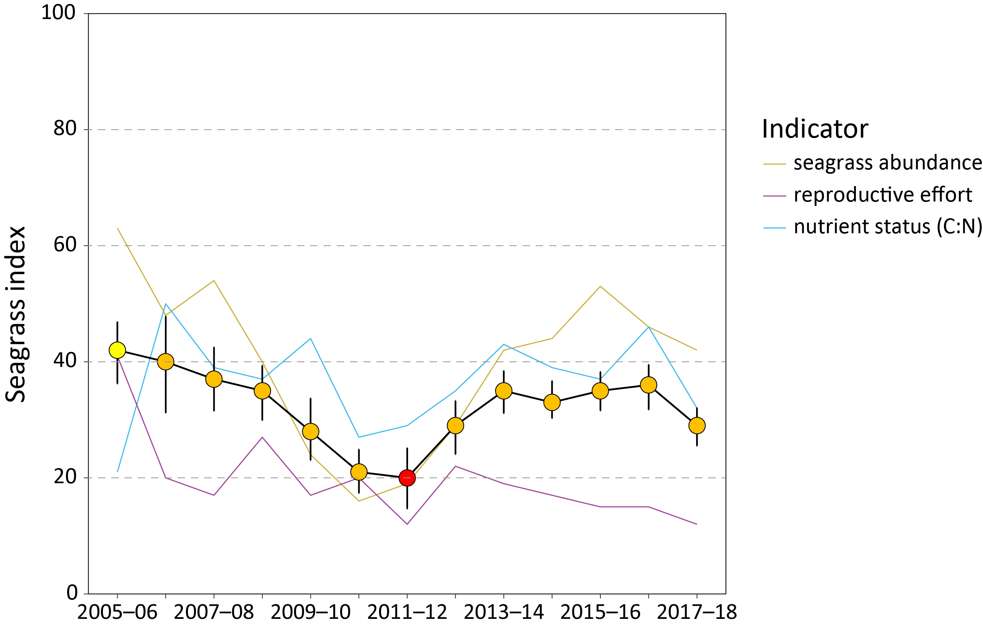
Figure 1. Reef-wide seagrass condition index (±SE) with contributing indicator scores over the life of the MMP
. The index is derived from the aggregate of metric scores for indicators of seagrass community health.Index scores scaled from 0–100 and graded: ● = very good (81-100), ● = good (61 - 80), ● = moderate (41 - 60), ● = poor (21 - 40), ● = very poor (0 - 20). NB: Scores are unitless.

Seagrass abundance had been increasing at most locations since 2010–11. Prior to that, there were widespread declines in seagrass condition, which were the result of above-average rainfall and climate-related impacts (2008–11).
Seagrass condition is a composite of three indicators which are measured at 23 locations (with duplicate sites nested within most locations) across the Reef. Combining these scores for all monitored seagrass meadows in a natural resource management region gives a rating for seagrass condition. Indicators are:
- seagrass abundance (per cent cover)
- reproductive effort
- leaf tissue nutrients.
Additional indicators of seagrass condition and resilience are assessed and used to assist with the interpretation of condition including:
- seagrass species composition
- relative meadow extent
- density of seeds in the seed bank.

Environmental pressures are also recorded including:
- within-canopy water temperature
- within-canopy benthic light
- sediment composition
- macroalgae and epiphyte abundance.
Inshore seagrass monitoring sites were predominately lower littoral (only exposed to air at the lowest of low tides), hereafter referred to as intertidal, although eight locations also included shallow subtidal meadows. Each of the major seagrass habitat types (estuarine, coastal, reef, subtidal) were assessed in each region where possible.
Inshore seagrass condition in 2017–18 declined as a result of continued exposure to brown and green waters and the legacy of severe climate events in the previous year, e.g. cyclone Debbie which crossed the coast near Airlie Beach in the Mackay-Whitsunday region and a marine heatwave that affected all inshore seagrass meadows.
There were indications that some seagrass meadows along the inshore developed coast had reduced resilience and increased their vulnerability to adverse environmental conditions in the near future.
Reproductive effort is a measure of resilience where the production of new seeds or fruits by a meadow in each season provides the basis of new propagules for recruitment in the following year. As such, the likelihood that the meadows are able to recover will be informed by the measure of reproductive effort. In addition, sexual reproduction is likely to enhance meadow scale genetic diversity thus increasing ‘resistance’ of the meadow to disturbance.
Indicators of reduced resilience include:
- decreasing abundance at nearly half of the meadows monitored predominately in the Burnett-Mary and Mackay-Whitsunday regions
- lower than average composition of foundational species at approximately 20 per cent of sites
- declining extent at almost 20 per cent of meadows, with subtidal meadows in the southern Wet Tropics and Burdekin regions showing the greatest decline
- declining and very poor reproductive effort at 90 per cent of sites (with reproductive structures absent from nearly half); and
- declining seed banks at 30 per cent of sites, with seed banks absent from another 40 per cent of sites.
The declines in seagrass condition and resilience in 2017–18 have occurred despite below-average wet season conditions. The most significant environmental conditions affecting inshore seagrasses in 2017–18 were lower than average benthic light availability at nearly half the meadows monitored (particularly across the southern Wet Tropics and Burdekin NRM regions), and lower than long-term growth requirements at 40 per cent of sites. This was coupled with above-average water temperatures for the the fifth consecutive year. The Reef also experienced above-average winds, which may have exacerbated inshore turbidity in far northern and central regions.
Seagrass tissue nutrients indicate the availability of nitrogen relative to growth demand (i.e. carbon fixation). The leaf tissue nutrient indicator declined in 2017–18. Just under 50 per cent of sites displayed symptoms of nutrient enrichment, with 43 per cent inferring elevated nitrogen (predominately estuary and coastal habitats, and particularly in Mackay-Whitsunday and Cape York regions). Also the higher than average epiphyte abundances observed at over 20 per cent of sites similarly suggest some level of increased nutrient availability.
The findings suggest some regions, such as the Burnett Mary and Mackay-Whitsunday regions may be more vulnerable to adverse or severe disturbances in the near future. Of greatest concern is the Mackay-Whitsunday region, which in 2017–18 had the greatest percentage of sites decrease in abundance, decrease in below-average reproductive effort, increase nitrogen in the leaf tissues, decrease seed density and lose seeds banks from half the sites.
The overall decline in seagrass condition is of concern, however, declines in indicators were not consistent and there were some ‘bright spots’ of improvement. Examples include:
- increasing or stable abundances at 36 per cent and 21 per cent of sites, respectively with greatest improvements in the Fitzroy and northern Wet Tropics regions
- nearly a quarter of meadows continuing to expand in area or become less fragmented, while just under half remained at or near their maximum extent
- declining epiphyte loads, with below average cover at 40 per cent sites
- just over 40 per cent of sites increasing in reproductive effort, particularly in the far north (Cape York and northern Wet Tropics) and Fitzroy regions.
These improvements demonstrate the maintenance or improvement of seagrass resilience in some regions, which are a consequence of variable climatic and environmental pressures. For example, the most significant improvement was benthic light availability in the Fitzroy region. Seagrass meadows under lower climatic and environmental pressures (in the northern Wet Tropics and parts of the Burdekin region) would be in a less vulnerable state, with greater resistance (conferred by increases in abundance, extent and composition of species) and an improved capacity to recover (higher seeds banks and reproductive effort).
In 2016–2017, cyclone Debbie and the second marine heatwave to impact the Reef in the last decade contributed to conditions that stalled recovery, from the losses caused by multiple years of above-average rainfall followed by extreme weather events, since early 2011. The legacy of these events and adverse environmental conditions in 2017–18 have reduced inshore seagrass condition and to a degree undermined seagrass resilience.
Four out of the six regions this year have an overall seagrass condition grade of poor, with an additional region graded very poor. Of particular concern is that reproductive effort remains well below historical levels across Cape York and the southern regions. Furthermore, most reef sites have no seed banks making them highly vulnerable to future disturbances.
The Reef is characterised by ongoing cumulative impacts and dynamic seagrass meadows. Intensifying pressures are slowing recovery but also increasing the need for meadow resilience. Water quality improvements that can be gained by land management initiatives (such as the Paddock to Reef program), will help to relieve the pressure from these impacts and improve meadow condition and resilience.
Case studies
Annual case studies are conducted as part of the program every year. Case study one describes “developing a computer program to predict cumulative light and temperature stress on seagrass in the Great Barrier Reef”. The cumulative stress index related to variation in the abundance indicator (per cent cover) and the seagrass index, but further validation is required. A simple user interface to the complex underlying model was developed, enabling the cumulative stress index to be easily calculated for any year with appropriate temperature and light input data.
Case study two investigated “reproductive effort as a predictor of future seagrass cover: Model assessment and implications for report card metrics and the development of a seagrass resilience indicator”. The main findings were that percent cover of seagrass in the previous year provides the best predictor of seagrass cover. Reproductive effort was also an important indicator, but due to low power in this indicator, there may need to be reduced weighting of this in the report card. Additional recommendations for development of a resilience indicator are discussed.

Introduction
Approximately 3,464 km² of inshore seagrass meadows has been mapped in Great Barrier Reef World Heritage Area (the World Heritage Area) in waters shallower than 15 m (McKenzie et al. 2014c; Saunders et al. 2015; Carter et al. 2016; McKenzie et al. 2016; C. Howley, Unpublished data) (Figure 2). The remaining modelled extent (90 % or 32,335 km²) of seagrass in the World Heritage Area is located in the deeper waters (>15 m) of the lagoon (Coles et al. 2009; Carter et al. 2016), however, these meadows are relatively sparse, structurally smaller, highly dynamic, composed of colonising species, and not as productive as inshore seagrass meadows for fisheries resources (McKenzie et al. 2010b; Derbyshire et al. 1995). Overall, the total estimated area of seagrass (34,841 km²) within the World Heritage Area represents more than 50 % of the total recorded area of seagrass in Australia (Green and Short 2003) and between six % and 12 % globally (Duarte et al. 2005), making the Reef’s seagrass resources globally significant.
Tropical seagrass ecosystems of the Reef are a complex mosaic of different habitat types comprised of multiple seagrass species (Carruthers et al. 2002). There are 15 species of seagrass in the Reef (Waycott et al. 2007) and high diversity of seagrass habitat types is provided by extensive bays, estuaries, rivers and the 2300 km length of the Reef with its reef platforms and inshore lagoon. They can be found on sand or muddy beaches, on reef platforms and in reef lagoons, and on sandy and muddy bottoms down to 60 m or more below Mean Sea Level (MSL).
Seagrasses in the Reef can be separated into four major habitat types: estuary/inlet, coastal, reef and deepwater (Carruthers et al. 2002). All but the outer reef habitats are significantly influenced by seasonal and episodic pulses of sediment-laden, nutrient-rich river flows, resulting from high volume summer rainfall. Cyclones, severe storms, wind and waves as well as macro grazers (e.g. fish, dugongs and turtles) influence all habitats in this region to varying degrees. The result is a series of dynamic, spatially and temporally variable seagrass meadows.
The seagrass ecosystems of the Reef, on a global scale, would be for the most part categorised as being dominated by disturbance-favouring colonising and opportunistic species (e.g. Halophila and Halodule), which typically have low standing biomass and high turnover rates (Carruthers et al. 2002, Waycott et al. 2007). In more sheltered areas, including reef top or inshore areas in bays, more stable and persistent species are found, although these are still relatively responsive to disturbances (Carruthers et al. 2002; Waycott et al. 2007; Collier and Waycott 2009).

Seagrass monitoring in the Marine Monitoring Program
The strategic priority for the Great Barrier Reef Marine Park Authority (the Authority) is to sustain the Reef’s outstanding universal value, build resilience and improve ecosystem health over each successive decade (Great Barrier Reef Marine Park Authority 2014). Improving water quality is a key objective, because good water quality aids the resilience of coastal and inshore ecosystems of Reef (GBRMPA, 2014a, b).
In response to concerns about the impact of land-based run-off on water quality, coral and seagrass ecosystems, the Reef 2050 Water Quality Improvement Plan (Reef 2050 WQIP) (Australian Government and Queensland Government 2018b) was recently updated by the Australian and Queensland governments, and integrated as a major component of Reef 2050 Long-Term Sustainability Plan (Reef 2050 Plan) (Australian Government and Queensland Government 2018a), which provides a framework for integrated management of the World Heritage Area.
A key deliverable of the Reef 2050 WQIP is the Paddock to Reef Integrated Monitoring, Modelling and Reporting Program (Paddock to Reef program), which is used to evaluate the efficiency and effectiveness of Reef 2050 WQIP implementation, and report on progress towards goals and targets (Australian Government and Queensland Government 2018b). The Marine Monitoring Program (MMP) forms an integral part of the Paddock to Reef program. The MMP has three components: inshore water quality, coral and seagrass.
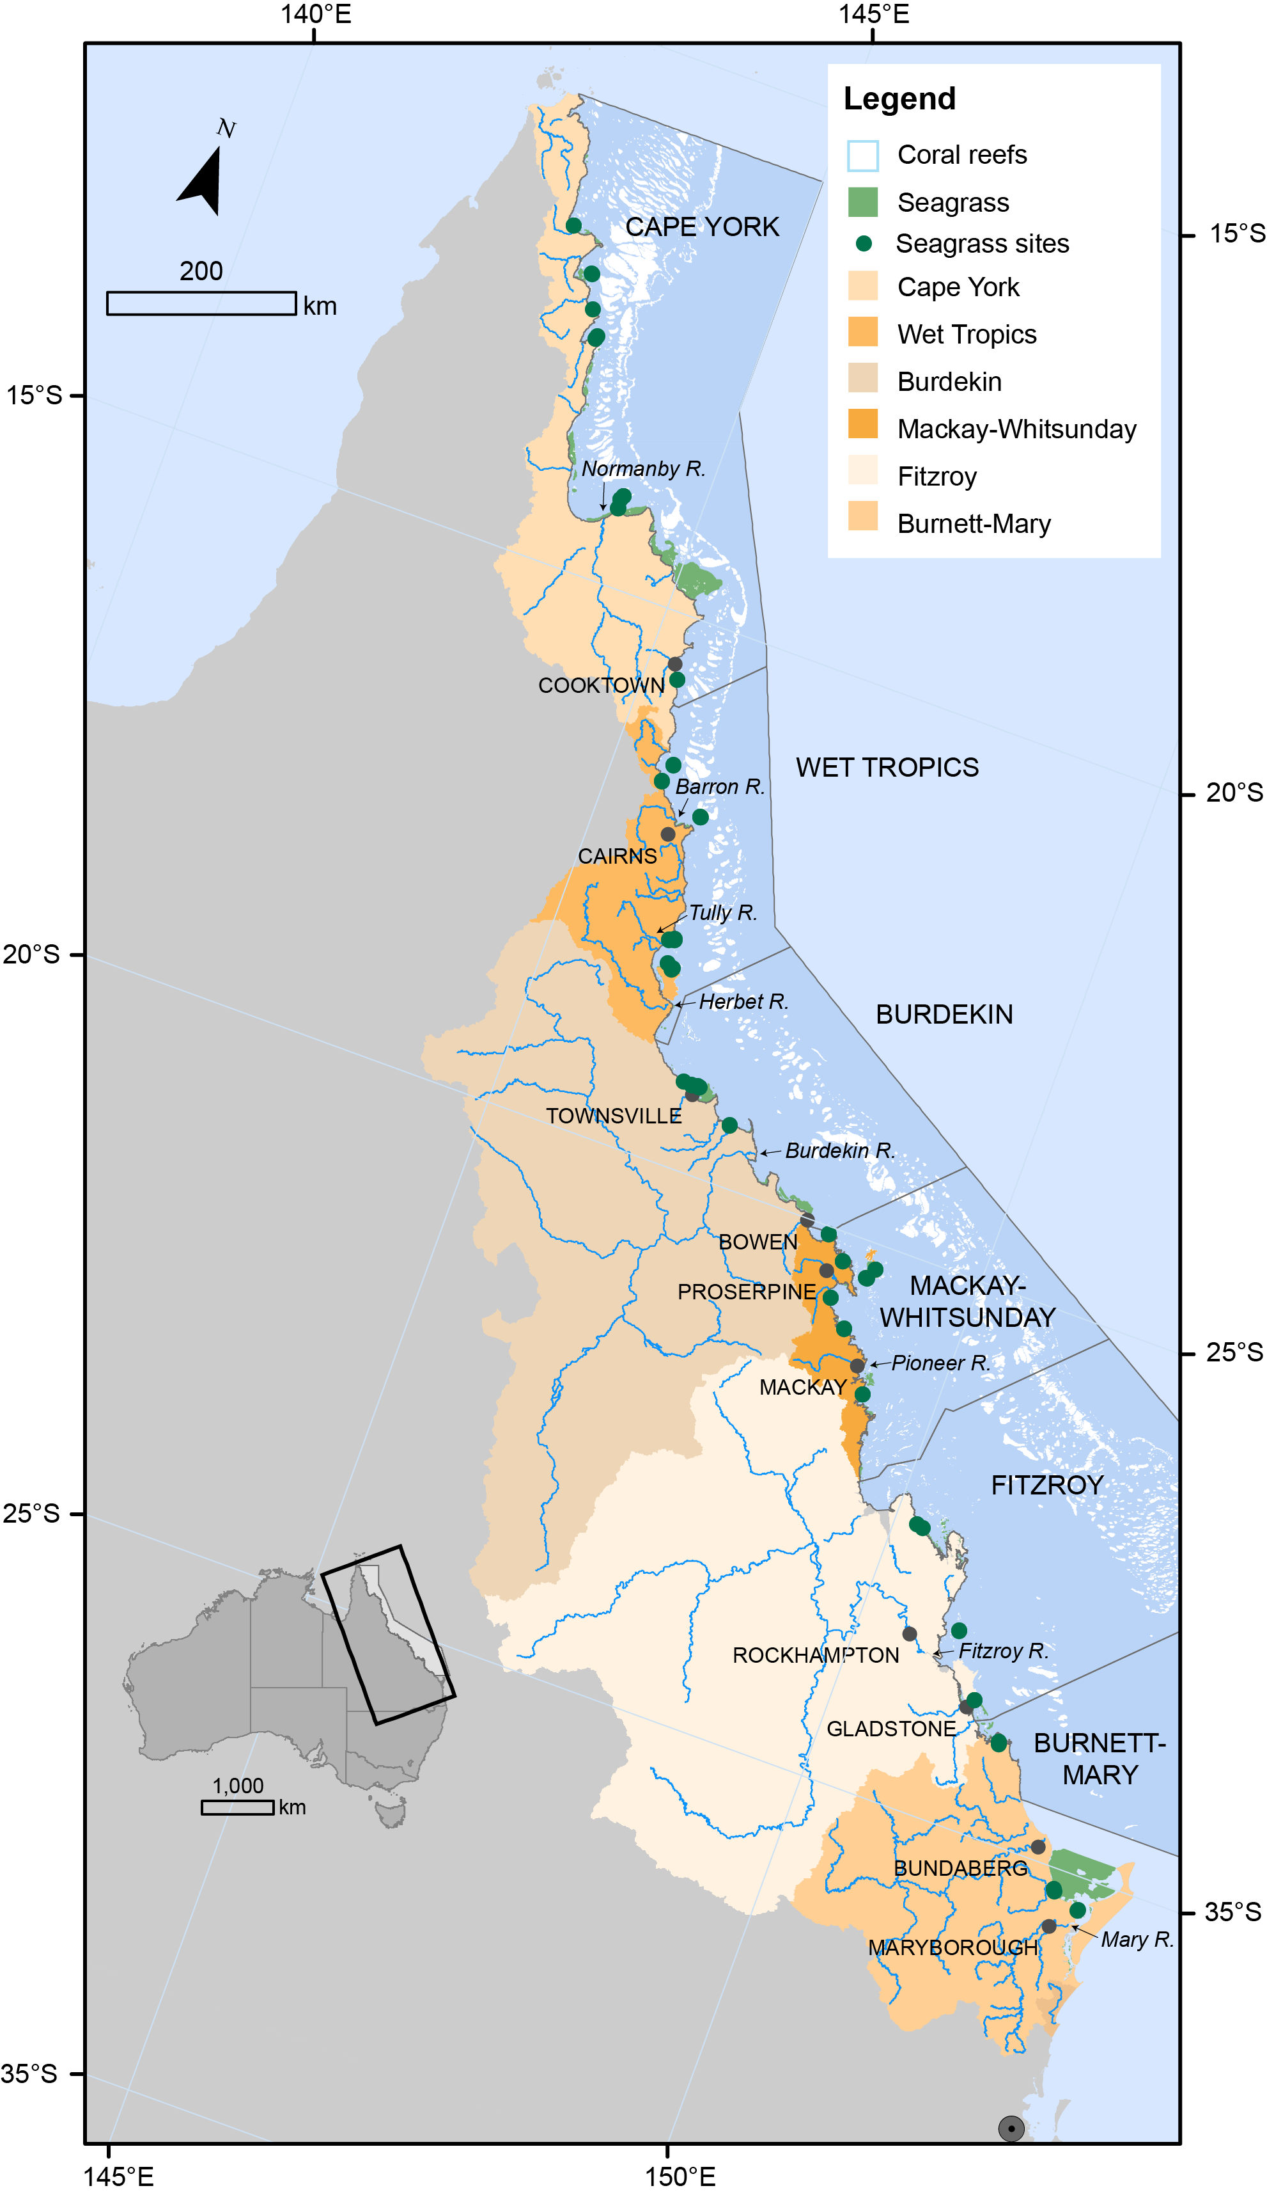
Figure 2. Major marine ecosystems (coral reefs and surveyed seagrass meadows) in the World Heritage Area and Natural Resource Management regions (including marine)
(delineated by dark grey lines) and major rivers.
The overarching objective of the inshore seagrass monitoring program is to quantify the extent, frequency and intensity of acute and chronic impacts on the condition and trend of seagrass meadows and their subsequent recovery.
The inshore water quality monitoring program has been delivered by James Cook University (JCU) and the Authority since 2005. The seagrass sub-program is also supported by contributions from the Seagrass-Watch program (Wet Tropics, Burdekin, Mackay-Whitsunday and Burnett Mary) and Queensland Parks and Wildlife Service (QPWS).
Further information on the program objectives, and details on each sub-program are available on-line (GBRMPA 2019; http://bit.ly/2mbB8bE).

Conceptual basis for indicator selection
As seagrasses are well recognised as indicators of integrated environmental pressures, monitoring their condition and trend can provide insight into the condition of the surrounding environment (e.g. Dennison et al. 1997). There are a number of measures of seagrass condition and resilience that can be used to assess how they respond to environmental pressures, and these measures are referred to here as indicators. We have developed a matrix of indicators that respond on different temporal scales (Figure 3). Indicators include:
- plant changes
- meadow-scale changes
- state change.
These indicators also respond at different temporal scales, with sub-lethal indicators able to respond from seconds to months, while the meadow-scale effects usually take many months to be detectable. A robust monitoring program benefits from having a suite of indicators that can indicate sub-lethal stress that forewarns of imminent loss, as well as indicators of meadow-scale changes, which are necessary for interpreting broad ecological changes. Indicators included in the MMP span this range of scales, in particular for indicators that respond from weeks (tissue nutrients, isotopes), through to months (abundance and reproduction), and even years (abundance and meadow extent). Furthermore, indicators are conceptually linked to each other and to environmental drivers of concern, in particular, water quality (p 34, in Kuhnert et al. 2014).
Measures of Environmental stressors
Climate and environment stressors are aspects of the environment, either physico-chemical or biological that affect seagrass meadow condition. Some environmental stressors change rapidly (minutes/days/weeks/months) but can also undergo chronic shifts (years) (Figure 3). Stressors include:
- climate (e.g. cyclones, seasonal temperature)
- local and short-term weather (e.g. wind and tides)
- water quality (e.g. river discharge, plume exposure, nutrient concentrations, suspended sediments, herbicides)
- biological (e.g. epiphytes and macroalgae)
- substrate (e.g. grain size composition)
- seagrass environmental integrators (e.g. tissue nutrients).
Indicators which respond more quickly (e.g. light) provide important early-warning of potentially more advanced ecological changes (as described below). However, a measured change in a fast-responding environmental indicator is not enough in isolation to predict whether there will be further ecological impacts, because the change could be short-term. These indicators provide critical supporting information to support interpretation of slower responding seagrass condition and resilience indicators. Epiphytes and macroalgae are an environmental indicator because they can compete with and/or block light reaching seagrass leaves, therefore compounding environmental stress.
These environmental indicators are interpreted according to the following general principals:
- Cyclones cause physical disturbance from elevated swell and waves resulting in meadow fragmentation and loss of seagrass plants (McKenzie et al. 2012). Seagrass loss also results from smothering by sediments and light limitation due to increased turbidity from suspended sediments. The heavy rainfall associated with cyclones results in flooding which exacerbates light limitation and transports pollutants (nutrients and pesticides), resulting in futher seagrass loss (Preen et al. 1995).
- Benthic light level below 10 mol m⁻² d⁻¹ are unlikely to support long-term growth of seagrass, and periods below 6 mol m⁻² d⁻¹ for more than four weeks can cause loss (Collier et al. 2016b). However, it is unclear how these relate to intertidal habitats because very high light exposure during low tide can affect light. Therefore, it may be more informative to look at change relative to the sites.
- Water temperature can impact seagrasses through chronic effects in which elevated respiration at high temperatures can cause carbon loss and reduce growth (Collier et al 2017), while acute stress results in inhibition of photosynthesis and leaf death (Campbell et al. 2006; Collier and Waycott 2014)
- Daytime tidal exposure can provide critical windows of light for positive net photosynthesis for seagrass in chronically turbid waters (Rasheed and Unsworth 2011). However, during tidal exposure, plants are susceptible to extreme irradiance doses, desiccation, thermal stress and potentially high UV-A and UV-B leading to physiological damage, resulting in short-term declines in density and spatial coverage (Unsworth et al. 2012b).
- Sediment grain size affects seagrass growth, germination, survival, and distribution (McKenzie 2007). Coarse, sand dominated sediments limit plant growth due to increased mobility and lower nutrients. However, as finer-textured sediments increase (dominated by mud (grain size <63μm)), porewater exchange with the overlaying water column decreases resulting in increased nutrient concentrations and phytotoxins such as sulphide, which can ultimately lead to seagrass loss (Koch 2001).
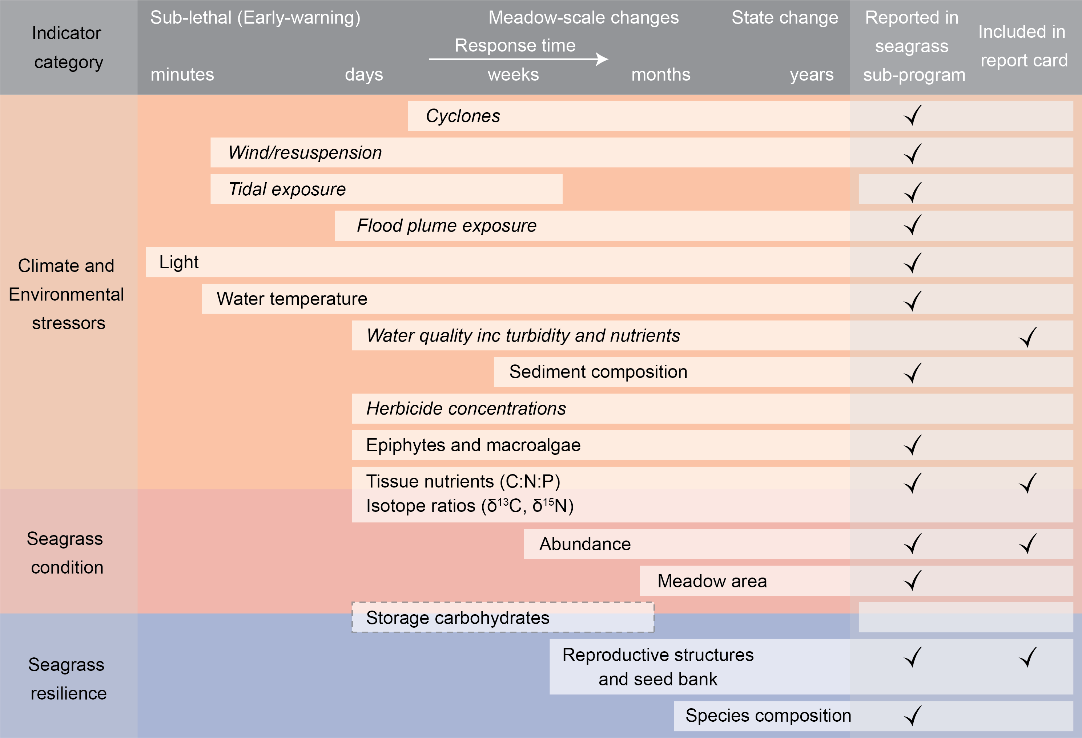
Figure 3. Climate, environmental, seagrass condition and seagrass resilience indicators reported as part of inshore seagrass monitoring.
Regular text are indicators measured in the inshore seagrass program, white box with dashed line are indicators in development, and italicised text are indicators collected in other programs or by other institutions (see Table 2 for details on data source). All indicators are shown against their response time.
Measures of seagrass condition
Condition indicators such as meadow abundance and extent indicate the state of the plants/population and reflect the cumulative effects of past environmental conditions (Figure 3). Abundance can respond to change on time-scales ranging from weeks to months (depending on species) in the Reef, while meadow area tends to adjust over longer time-scales (months to years). Seagrass area and abundance are integrators of past conditions, and are vital indicators of meadow condition; however, these indicators can also be affected by external factors such as grazing by dugongs and turtles. Therefore, they are not suitable as stand-alone indicators of environmental change and indicators that can be linked more directly to specific pressures are needed. These condition indicators also do not demonstrate capacity to resist or recover from additional impacts (Unsworth et al. 2015).
Changing ratios of seagrass tissue nutrients provide an indication of seagrass condition and environmental conditions. Carbon to nitrogen (C:N) ratios have been found in a number of experiments and field surveys to be related to light levels, as leaves with an atomic C:N ratio of less than 20, may suggest reduced light availability when N is not in surplus (Abal et al. 1994; Grice et al. 1996; Cabaço and Santos 2007; Collier et al. 2009). Therefore, C:N ratio is reported within the seagrass component of the Marine Results report and report card, while other tissue nutrients are also presented as supporting information.
Measures of seagrass resilience
Ecological resilience is ‘the capacity of an ecosystem to absorb repeated disturbances or shocks and adapt to change without fundamentally switching to an alternative stable state’ (Holling 1973), and relates to the ability of a system to both resist and recover from disturbances (Unsworth et al. 2015) (Figure 4). Changes in resilience indicators show if the ecosystem is in transition (i.e. has already, or may undergo a state-change). Sexual reproduction (flowering, seed production and persistence of a seedbank) is an important feature of recovery (and therefore, of resilience) in seagrass meadows.
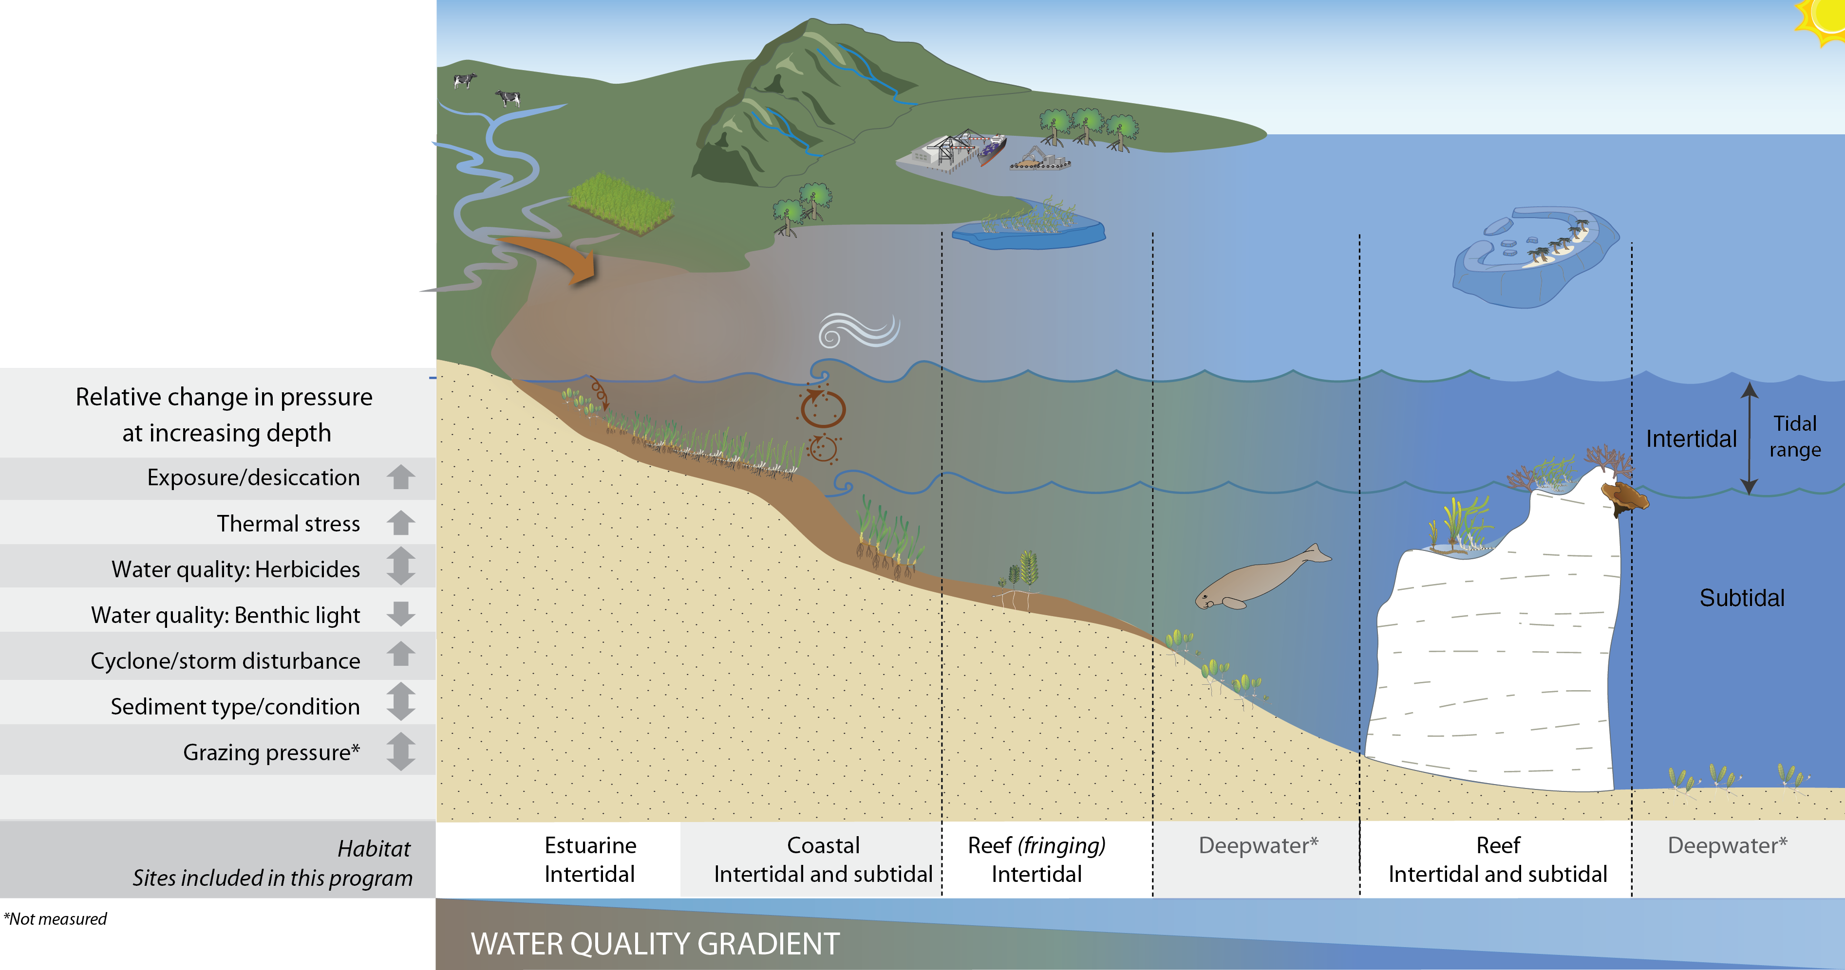
Figure 4. General conceptual model of seagrass habitats in north east Australia and the water quality impacts affecting the habitat
(adapted from Carruthers et al., 2002, and Collier et al. 2014)

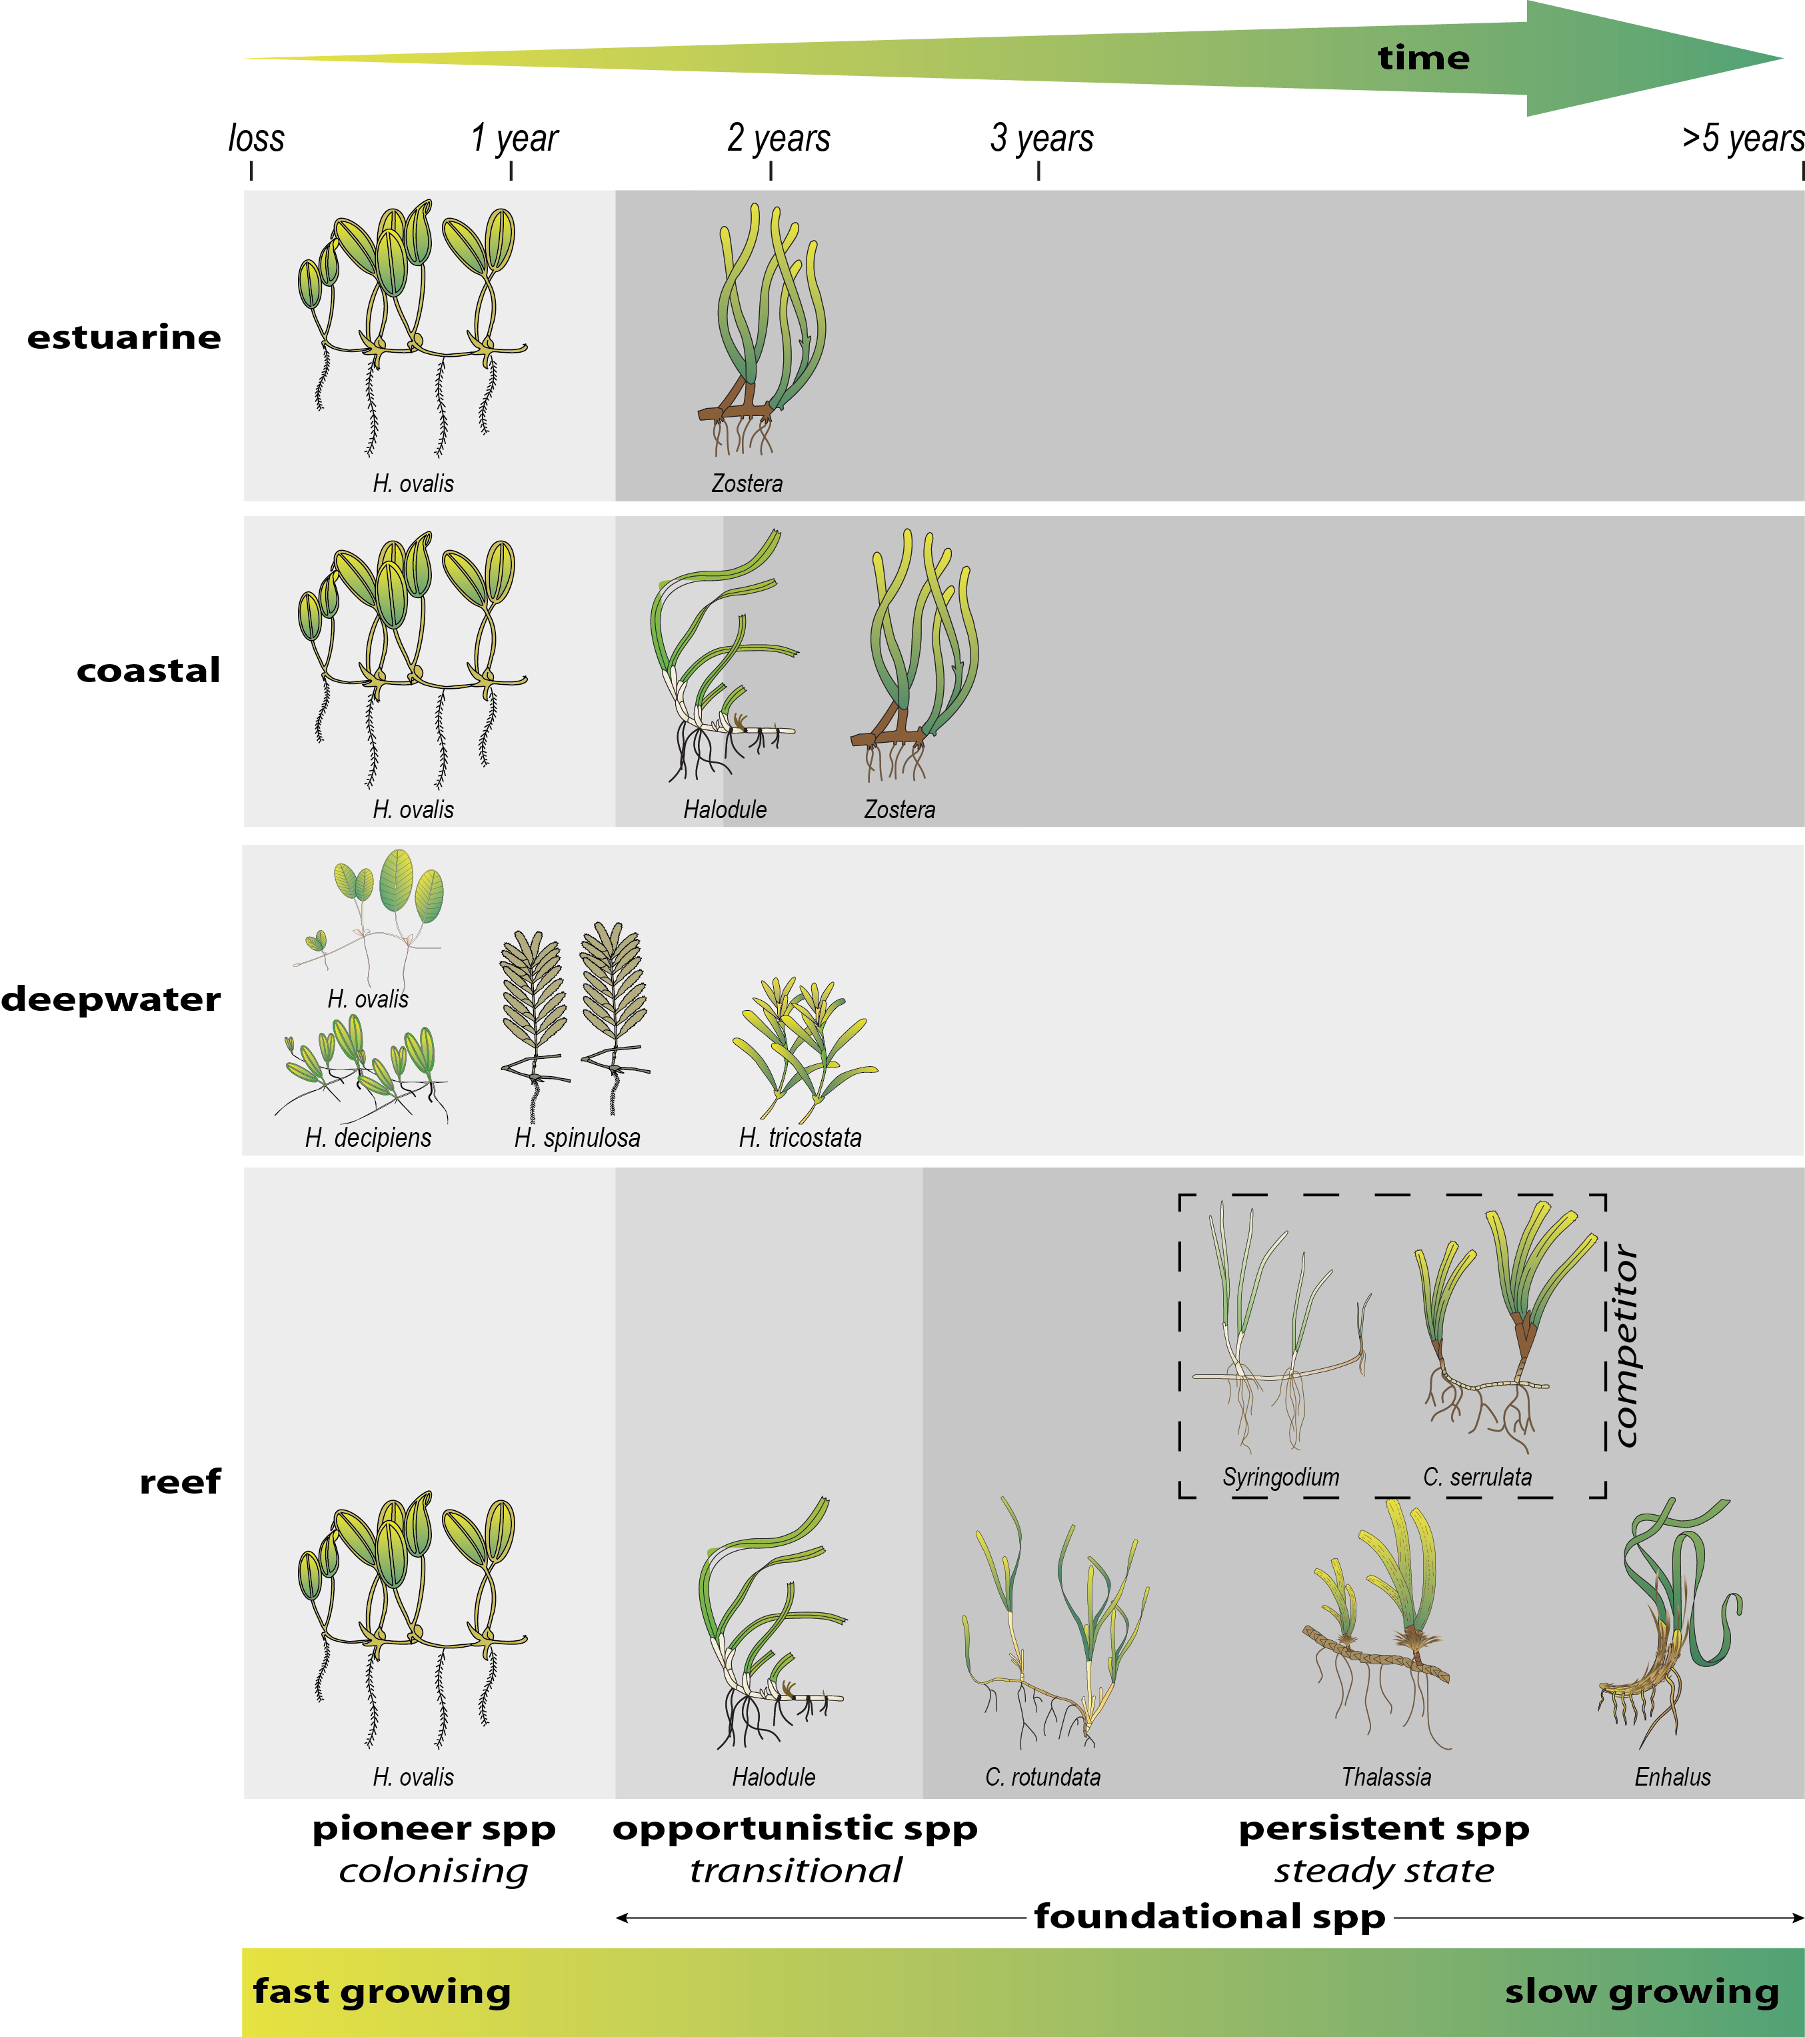
Figure 5. Illustration of seagrass recovery after loss and the categories of successional species over time.
Figure developed from observed recovery dynamics (Birch and Birch 1984; Preen et al. 1995; McKenzie and Campbell 2002; Campbell and McKenzie 2004; McKenzie et al. 2014a; Rasheed et al. 2014).

Coastal seagrasses are prone to small scale disturbances that cause local losses (Collier and Waycott 2009), and therefore disturbance-specialist species (i.e. colonisers) tend to dominate throughout the Reef. Community structure (species composition) is also an important feature conferring resilience, as some species are more resistant to stress than others, and some species may rapidly recover and pave the way for meadow development (Figure 5).

Structure of the Report
This report presents data from the thirteenth period of monitoring inshore seagrass ecosystems of the Reef under the MMP (undertaken from June 2017 to May 2018; hereafter called 2017–18). The inshore seagrass monitoring sub-program of the MMP reports on:
- abundance and species composition of seagrass (including landscape mapping) in the late dry season of 2017 and the late wet season of 2018 at inshore intertidal and subtidal locations
- reproductive health of the seagrass species present at inshore intertidal and subtidal locations
- tissue nutrient concentrations (carbon, nitrogen and phosphorus) and epiphyte loads of foundation seagrass species (e.g. genus Halodule, Zostera, Cymodocea) at each inshore intertidal and subtidal location
- spatial and temporal patterns in light, turbidity and temperature at sites where autonomous loggers are deployed
- trends in seagrass condition
- seagrass community in relation to environment condition and trends
- seagrass report card metrics for use in the annual Reef Report Card produced by the Paddock to Reef program.

The next section presents a summary of the program’s methods. Section 4 describes the condition and trend of seagrass in the context of environmental factors, referred to as drivers and pressures in Driver-Pressure-State-Impact-Response (DPSIR) framework.
In keeping with the overarching objective of the MMP, to “Assess trends in ecosystem health and resilience indicators for the Great Barrier Reef in relation to water quality and its linkages to end-of-catchment loads”, key water quality results reported by Gruber et al. (in prep.) are replicated to support the interpretation of the inshore seagrass results.

Methods summary
In the following, an overview is given of the sample collection, preparation and analyses methods. Detailed documentation of the methods used in the MMP, including quality assurance and quality control procedures, is available in McKenzie et al. (2019).

Climate and environmental pressures
Climate and environmental pressures affect seagrass condition and resilience (Figure 4). The pressures of greatest concern are:
- physical disturbance (cyclones and benthic sheer stress)
- water quality (turbidity/light and nutrients)
- water temperature
- low tide exposure
- sediment type.
The measures are either climate variables, that are generally not collected at a site-specific level, and within-canopy measures, that are recorded at each site. The data source and sampling frequency is summarised in Table 1.
Climate
Total daily rainfall, 3pm wind speed, and cyclone tracks were accessed from the Australian Bureau of Meteorology from meteorological stations which were proximal to monitoring locations (Table 1).
As the height of locally produced, short-period wind-waves can be the dominant factor controlling suspended sediment on inner-shelf of the Reef (Larcombe et al. 1995; Whinney 2007), the number of days wind speed exceeded 25 km hr⁻¹ was used as a surrogate for elevated resuspension pressure on inshore seagrass meadows.
Moderate sea state with winds >25 km hr⁻¹ can elevate turbidity by three orders of magnitude in the inshore coastal areas of the Reef (Orpin et al. 2004). To determine if the tidal exposure regime may be increasing stress on seagrass and hence drive decline, tidal height observations were accessed from Maritime Safety Queensland and duration of annual exposure (hours) was determined for each meadow (i.e. monitoring site), based on the meadows height relative to the lowest astronomical tide (Appendix 3, Table 22).
The presence of inshore seagrass meadows along the Reef places them at high risk of exposure to waters from adjacent water basins and exposure to flood plumes is likely to be a significant factor in structuring inshore seagrass communities (Collier et al. 2014; Petus et al. 2016). Hence we used river discharge volumes as well as frequency of exposure to inshore flood plumes as indicators of flood plume impacts to seagrasses.
Plume exposure is generated by wet season monitoring under the water quality sub-program (Gruber et al. 2019). The inshore water quality sub-program includes a remote sensing component, which describes water quality characteristics for 22 weeks of the wet season (November–April). Water quality is described as colour classes of turbid, brown primary water (class 1–4), green secondary water (class 5), and waters influenced by flood plumes (salinity <30 PSU, coloured dissolved organic matter (CDOM) threshold of 0.24 m⁻¹ class 6). Colour classes are derived from MODIS True colour satellite images. Exposure to flood plumes is described in this report as frequency of exposure to primary (turbid, sediment laden) or secondary (green, nutrient rich) water during the wet season. Methods are detailed in Devlin et al. (2015). Flood plume mapping (Devlin et al. 2015) interpreted to water type and frequency of exposure at seagrass sites has been confirmed as a predictor of changes in seagrass abundance (see case study 2, in McKenzie et al. 2016).
Environment within seagrass canopy
Autonomous iBTag™ submersible temperature loggers were deployed at all sites identified in Appendix 3, Table 21. The loggers recorded temperature (accuracy 0.0625°C) within the seagrass canopy every 30 – 90 minutes (Table 1). iBCod™22L submersible temperature loggers were attached to the permanent marker at each site above the sediment-water interface.
Submersible Odyssey™ photosynthetic irradiance autonomous loggers were attached to permanent station markers at 20 intertidal and 4 subtidal seagrass locations from the Cape York region to the Burnett Mary region (Appendix 3, Table 21). Detailed methodology for the light monitoring can be found in McKenzie et al. 2018b. Measurements were recorded by the logger every 15 minutes and are reported as total daily light (mol m⁻² d⁻¹). Automatic wiper brushes clean the optical surface of the sensor every 15 minutes to prevent marine organisms fouling.
Sediment type affects seagrass community composition and vice versa (McKenzie et al 2007, Collier et al In Prep). Changes in sediment composition can be an indicator of broader environmental changes (such as sediment and organic matter loads and risk of anoxia), and be an early-warning indicator of changing species composition. Sediment type was recorded at the 33 quadrats at each site in conjunction with seagrass abundance measures using a visual/tactile estimation of sediment grain size composition (0-2 cm below the sediment/water interface) as per standard protocols described in McKenzie et al. (2003). Qualitative field descriptions of sediment composition were differentiated according to the Udden-Wentworth grade scale as this approach has previously been shown to provide an equivalent measure to sieve-derived datasets (Hamilton, 1999; McKenzie 2007).

Table 1. Summary of climate and environment data included in this report
, showing historical data range, measurement technique, measurement frequency, and data source. *=variable duration of data availability depending on site
 | Data range | Method | Measurement  frequency | Reporting units | Data source
Climate
Cyclones | 1968–2018 | remote sensing and observations at nearest weather station | yearly | No. yr⁻¹ | Bureau of Meteorology
Rainfall | 1889–2018* | rain gauges at nearest weather station | daily | mm mo⁻¹  mm yr⁻¹ | Bureau of Meteorology
Riverine discharge | 1970–2018 | water gauging stations at river mouth |  | L d⁻¹  L yr⁻¹ | DES#, compiled by Gruber et al. 2019
Plume exposure | 2006–2018  wet season (Dec–Apr) | remote sensing and field validation | weekly | frequency of water type (1–6) at the site | MMP inshore water quality program (Gruber et al. 2019)
Wind | 1997–2018* | anemometer at 10 m above the surface, averaged over 10 minutes, at nearest weather station | 3pm wind speed | days >25 km hr⁻¹ | Bureau of Meteorology
Tidal exposure | 1999–2018 | wave height buoys at station nearest to monitoring site | 3–10 min | hours exposed during daylight | Maritime Safety Queensland, calculated exposure by MMP Inshore Seagrass monitoring
Environment within seagrass canopy
Water temperature | 2002–2018 | iBTag | 30–90 min | ºC, temperature anomalies,  exceedance of thresholds | MMP Inshore Seagrass monitoring
Light | 2008–2018 | Odyssey 2Pi PAR light loggers with wiper unit | 15 min | daily light (I_{d}) mol m⁻² d⁻¹  frequency of threshold exceedance (% days) | MMP Inshore Seagrass monitoring
Sediment grain size | 1999–2018 | visual / tactile description of sediment grain size composition | 3 mo–1yr | proportion mud | MMP Inshore Seagrass monitoring
# Department of Environment and Science

Inshore seagrass and habitat condition

Sampling design & site selection
Sampling is designed to detect changes in inshore seagrass meadows in response to changes in water quality associated with specific catchments or groups of catchments (region) and to disturbance events. The selection of locations/meadows was based upon a number of competing factors:
- meadows were representative of inshore seagrass habitats and seagrass communities across each region (based on Lee Long et al. 1993, Lee Long et al. 1997, Lee Long et al. 1998; McKenzie et al. 2000; Rasheed et al. 2003; Campbell et al. 2002; Goldsworthy 1994)
- where possible include legacy sites (e.g. Seagrass-Watch) or former seagrass research sites (e.g. Dennison et al. 1995; Inglis 1999; Thorogood and Boggon 1999; Udy et al. 1999; Haynes et al. 2000; Campbell and McKenzie 2001; Mellors 2003; Campbell and McKenzie 2004; Limpus et al. 2005; McMahon et al. 2005; Mellors et al. 2005; Lobb 2006)
- a Minimum Detectable Difference (MDD) below 20% (at the 5% level of significance with 80% power) (Bros and Cowell 1987).
Sites were selected using mapping surveys across the regions prior to site establishment. Ideally mapping was conducted immediately prior to site positioning, however in most cases (60 %) it was based on historic (>5 yr) information.
Representative meadows were those which covered the greater extent within the inshore region, were generally the dominant seagrass community type and were within Reef baseline abundances (based on Coles et al. 2001a; Coles et al. 2001c, 2001b, 2001d). To account for spatial heterogeneity of meadows within habitats, at least two sites were selected at each location. If meadow overall extent was larger than ~15 hectares (0.15 km²), replicate sites were often located within the same meadow (a greater number of sites was desirable with increasing meadow size , however not possible due to funding constraints).
From the onset, inshore seagrass monitoring for the MMP was focused primarily on intertidal/lower littoral seagrass meadows due to:
- accessibility and cost effectiveness (limiting use of vessels and divers)
- Occupational Health and Safety issues with dangerous marine animals (e.g. crocodiles, box jellyfish and irukandji)
- occurrence of meadows in estuarine, coastal and reef habitats across the entire Reef
- where possible, providing an opportunity for citizen involvement, ensuring broad acceptance and ownership of Reef 2050 Plan by the Queensland and Australian community.
Some of the restrictions for working in hazardous waters are overcome by using drop cameras, however, drop cameras only provide abundance measures and do not contribute to the other metrics (e.g. tissue nutrients, reproductive effort). Although considered intertidal within the MMP, the meadows chosen for monitoring were in fact lower littoral (rarely exposed to air).
The long-term median annual daylight exposure (the time intertidal meadows are exposed to air during daylight hours) was 1.7% (all meadows pooled) (Table 22). This limited the time monitoring could be conducted to the very low spring tides within small tidal windows (mostly 1–4 hrs per day for 3–6 days per month for 6–9 months of the year). Traditionally, approaches developed for monitoring seagrass to assess changes in water quality were developed for subtidal meadows typified by small tidal ranges (e.g. Florida = 0.7 m, Chesapeake Bay = 0.6 m) and clear waters where the seaward edges of meadows were only determined by light (EHMP 2008).
Depth range monitoring in subtropical/tropical seagrass meadows has had limited success due to logistic/technical issues and non-conformism with traditional ecosystem models because of the complexity (Carruthers et al. 2002), including:
- a variety of habitat types (estuarine, coastal, reef and deepwater)
- a large variety of seagrass species with differing life history traits and strategies
- tidal amplitudes spanning 3.42m (Cairns) to 10.4m (Broad Sound) (www.msq.qld.gov.au; Maxwell 1968)
- a variety of sediment substrates, from terrigenous with high organic content, to oligotrophic calcium carbonate
- turbid nearshore to clearer offshore waters
- grazing dugongs and sea turtles influencing meadow community structure and landscapes
- near-absence of shallow subtidal meadows south of Mackay-Whitsunday due to the large tides which scour the seabed.
Deepwater (>15 m) meadows across the Reef are comprised of only Halophila species and are highly variable in abundance and distribution (Lee Long et al. 1999; York et al. 2015; Chartrand et al. 2018). Due to this high variability they do not meet the current criteria for monitoring, as the MDD is very poor at the 5 % level of significance with 80% power (McKenzie et al. 1998).
Predominately stable lower littoral and shallow (>1.5 m below lowest astronomical tide) subtidal meadows of foundation species (e.g. Zostera, Halodule) are best for determining significant change/impact (McKenzie et al. 1998). Where possible, shallow subtidal and lower littoral monitoring sites were paired when dominated by similar species.
Due to the high diversity of seagrass species it was decided to direct monitoring toward the foundation seagrass species across the seagrass habitats. A foundation species is the dominant primary producer in an ecosystem both in terms of abundance and influence, playing central roles in sustaining ecosystem services (Angelini et al. 2011). The activities of foundation species physically modify the environment and produce and maintain habitats that benefit other organisms that use those habitats (Ellison 2019).
Foundation species are the species types that are at the pinnacle of meadow succession. A highly disturbed meadow (due to wave/wind exposure, or low light regime) might only ever have colonising species as the foundational species, while a less disturbed meadow can have persistent species form the foundation. Also, whether Zostera muelleri is a foundation species is influenced by whether it grows in the tropics or in the sub-tropics, as it is more likely to form a foundation species in the sub-tropics even if it is disturbed.
For the seagrass habitats assessed in the MMP, the foundation seagrass species were those species which typified the habitats both in abundance and structure when the meadow was considered in its steady state (opportunistic or persistent) (Kilminster et al. 2015). The foundation species were all di-meristematic leaf-replacing forms from the following families: Cymodocea, Enhalus, Halodule, Thalassia and Zostera (Table 2).
As the major period of runoff from catchments and agricultural lands is the tropical wet season/monsoon (December to April), monitoring is focussed on the late dry (growing) season and late wet season to capture the condition of seagrass pre and post wet.
Sixty-seven sites at 30 locations were assessed during the 2017–18 monitoring period (Appendix 3, Table 21). This covered fourteen coastal, four estuarine and twelve reef locations (i.e. two or three sites at each location).
At the reef locations in the Burdekin and Wet Tropics, intertidal sites were paired with a subtidal site (Table 2). Apart from the 49 MMP long-term monitoring sites, data included eight sites from Seagrass-Watch and eight sites from QPWS to improve the spatial resolution and representation of subtidal habitats (Table 3).
A description of all data collected during the sampling period has been collated by region, site, parameter, and the number of samples collected per sampling period (Table 21). The seagrass species (including foundation) present at each monitoring site is listed in Table 2 and Table 3.

Table 2. Inshore seagrass long-term monitoring site details including presence of foundation () and other () seagrass species
by region * = intertidal, ^=subtidal. CR = Cymodocea rotundata, CS = Cymodocea serrulata, EA = Enhalus acoroides, HD = Halophila decipiens, HO = Halophila ovalis, HS = Halophila spinulosa, HU = Halodule uninervis, SI = Syringodium isoetifolium, TH = Thalassia hemprichii, ZM = Zostera muelleri
Region | NRM region (Board) | Basin | Monitoring location | Site |  | Latitude |  | Longitude |  | CR | CS | EA | HD | HO | HS | HU | SI | TH | ZM
Far Northern | Cape York  (Cape York Natural Resource Management) | Jacky Jacky / Olive-Pascoe | Shelburne Bay  coastal | SR1* | Shelburne Bay | 11° | 53.220 | 142° | 54.853
 |  |  |  | SR2* | Shelburne Bay | 11° | 53.238 | 142° | 54.940
Far Northern | Cape York  (Cape York Natural Resource Management) | Jacky Jacky / Olive-Pascoe | Piper Reef  reef | FR1* | Farmer Is. | 12° | 15.339 | 143° | 14.021
 |  |  |  | FR2* | Farmer Is. | 12° | 15.433 | 143° | 14.186
Far Northern | Cape York  (Cape York Natural Resource Management) | Normanby / Jeannie | Flinders Group  reef | ST1* | Stanley Island | 14° | 8.563 | 144° | 14.682
 |  |  |  | ST2* | Stanley Island | 14° | 8.533 | 144° | 14.590
Far Northern | Cape York  (Cape York Natural Resource Management) | Normanby / Jeannie | Bathurst Bay  coastal | BY1* | Bathurst Bay | 14° | 16.068 | 144° | 13.963
 |  |  |  | BY2* | Bathurst Bay | 14° | 16.049 | 144° | 13.897
Far Northern | Cape York  (Cape York Natural Resource Management) | Endeavour | Archer Point  reef | AP1* | Archer Point | 15° | 36.508 | 145° | 19.147
 |  |  |  | AP2* | Archer Point | 15° | 36.533 | 145° | 19.118
Northern | Wet Tropics  (Terrain NRM) | Daintree | Low Isles  reef | LI1* | Low Isles | 16° | 23.110 | 145° | 33.884
 |  |  |  | LI2^ | Low Isles | 16° | 22.973 | 145° | 33.854
Northern | Wet Tropics  (Terrain NRM) | Mossman /  Barron /  Mulgrave-Russell /  Johnstone | Yule Point  coastal | YP1* | Yule Point | 16° | 34.149 | 145° | 30.756
 |  |  |  | YP2* | Yule Point | 16° | 33.825 | 145° | 30.568
Northern | Wet Tropics  (Terrain NRM) | Mossman /  Barron /  Mulgrave-Russell /  Johnstone | Green Island  reef | GI1* | Green Island | 16° | 45.709 | 145° | 58.372
 |  |  |  | GI2* | Green Island | 16° | 45.696 | 145° | 58.566
 |  |  |  | GI3^ | Green Island | 16° | 45.294 | 145° | 58.379
Northern | Wet Tropics  (Terrain NRM) | Tully / Murray / Herbert | Mission Beach  coastal | LB1* | Lugger Bay | 17° | 57.645 | 146° | 5.603
 |  |  |  | LB2* | Lugger Bay | 17° | 57.672 | 146° | 5.626
Northern | Wet Tropics  (Terrain NRM) | Tully / Murray / Herbert | Dunk Island  reef | DI1* | Pallon Beach | 17° | 56.646 | 146° | 8.452
 |  |  |  | DI2* | Pallon Beach | 17° | 56.734 | 146° | 8.450
 |  |  |  | DI3^ | Brammo Bay | 17° | 55.910 | 146° | 8.417
Central | Burdekin  (NQ Dry Tropics) | Ross / Burdekin | Magnetic island  reef | MI1* | Picnic Bay | 19° | 10.752 | 146° | 50.480
 |  |  |  | MI2* | Cockle Bay | 19° | 10.621 | 146° | 49.730
 |  |  |  | MI3^ | Picnic Bay | 19° | 10.888 | 146° | 50.634
Central | Burdekin  (NQ Dry Tropics) | Ross / Burdekin | Townsville  coastal | SB1* | Shelley Beach | 19° | 11.166 | 146° | 46.272
 |  |  |  | BB1* | Bushland Beach | 19° | 11.016 | 146° | 40.951
Central | Burdekin  (NQ Dry Tropics) | Ross / Burdekin | Bowling Green Bay  coastal | JR1* | Jerona (Barratta CK) | 19° | 25.369 | 147° | 14.487
 |  |  |  | JR2* | Jerona (Barratta CK) | 19° | 25.272 | 147° | 14.435
Central | Mackay-Whitsunday  (Reef Catchments) | Proserpine / O'Connell | Lindeman Is.  reef | LN1^ | Lindeman Is. | 20° | 26.293 | 149° | 1.691
 |  |  |  | LN2^ | Lindeman Is. | 20° | 26.014 | 149° | 1.923
Central | Mackay-Whitsunday  (Reef Catchments) | Proserpine / O'Connell | Repulse Bay  coastal | MP2* | Midge Point | 20° | 38.084 | 148° | 42.107
 |  |  |  | MP3* | Midge Point | 20° | 38.067 | 148° | 42.282
Central | Mackay-Whitsunday  (Reef Catchments) | Proserpine / O'Connell | Hamilton Island  reef | HM1* | Catseye Bay - west | 20° | 20.636 | 148° | 57.439
 |  |  |  | HM2* | Catseye Bay - east | 20° | 20.797 | 148° | 58.234
Central | Mackay-Whitsunday  (Reef Catchments) | Plane | Sarina Inlet  estuarine | SI1* | Point Salisbury | 21° | 23.770 | 149° | 18.248
 |  |  |  | SI2* | Point Salisbury | 21° | 23.719 | 149° | 18.288
Southern | Fitzroy  (Fitzroy Basin Association) | Shoalwater / Fitzroy | Shoalwater Bay  coastal | RC1* | Ross Creek | 22° | 22.912 | 150° | 12.810
 |  |  |  | WH1* | Wheelans Hut | 22° | 23.829 | 150° | 16.520
Southern | Fitzroy  (Fitzroy Basin Association) | Shoalwater / Fitzroy | Keppel Islands  reef | GK1* | Great Keppel Is. | 23° | 11.776 | 150° | 56.356
 |  |  |  | GK2* | Great Keppel Is. | 23° | 11.638 | 150° | 56.364
Southern | Fitzroy  (Fitzroy Basin Association) | Calliope / Boyne | Gladstone Harbour  estuarine | GH1* | Pelican Banks | 23° | 46.015 | 151° | 18.059 |  |  |  |  |  |  | *
 |  |  |  | GH2* | Pelican Banks | 23° | 45.884 | 151° | 18.233
Southern | Burnett Mary  (Burnett Mary Regional Group) | Baffle | Rodds Bay  estuarine | RD1* | Cay Bank | 24° | 3.467 | 151° | 39.333
 |  |  |  | RD2* | Turkey Beach | 24° | 4.854 | 151° | 39.752
Southern | Burnett Mary  (Burnett Mary Regional Group) | Mary | Hervey Bay  estuarine | UG1* | Urangan | 25° | 18.053 | 152° | 54.409
 |  |  |  | UG2* | Urangan | 25° | 18.197 | 152° | 54.364

Table 3. Additional inshore seagrass long-term monitoring sites from the Seagrass-Watch and QPWS drop-camera programs, including presence of foundation () and other () seagrass species.
NRM region from www.nrm.gov.au. * = intertidal, ^=subtidal.
Region | NRM region (Board) | Basin | Monitoring location | Site |  | Latitude |  | Longitude |  | CR | CS | EA | HD | HO | HS | HU | SI | TH | ZM
Far Northern | Cape York  (Cape York Nat Res Manage) | Lockhart | Weymouth Bay  reef | YY1* | Yum Yum Beach | 12° | 34.247 | 143° | 21.639
Far Northern | Cape York  (Cape York Nat Res Manage) | Lockhart | Lloyd Bay  coastal | LR1^ | Lloyd Bay | 12° | 47.792 | 143° | 29.118
 |  |  |  | LR2^ | Lloyd Bay | 12° | 49.502 | 143° | 28.488
Far Northern | Cape York  (Cape York Nat Res Manage) | Normanby / Jeannie | Flinders Group  reef | FG1^ | Flinders Island | 14° | 10.9464 | 144° | 13.522
 |  |  |  | FG2^ | Flinders Island | 14° | 10.932 | 144° | 13.522
Far Northern | Cape York  (Cape York Nat Res Manage) | Normanby / Jeannie | Bathurst Bay  coastal | BY3^ | Bathurst Bay | 14° | 16.556 | 144° | 17.069
 |  |  |  | BY4^ | Bathurst Bay | 14° | 16.482 | 144° | 18.006
Northern | Wet Tropics | Tully / Murray / Herbert | Rockingham Bay  reef | GO1 | Goold Island | 18° | 10.428 | 146° | 9.186
Northern | Wet Tropics | Tully / Murray / Herbert | Missionary Bay  coastal | MS1^ | Cape Richards | 18° | 12.950 | 146° | 12.753
 |  |  |  | MS2^ | Macushla | 18° | 12.316 | 146° | 13.010
Central | Burdekin  (NQ Dry Tropics) | Ross / Burdekin | Townsville  coastal | SB2* | Shelley Beach | 19° | 10.939 | 146° | 45.767
Central | Mackay-Whitsunday  (Reef Catchments) | Don | Shoal Bay  reef | HB1* | Hydeaway Bay | 20° | 4.481 | 148° | 28.943
 |  |  |  | HB2* | Hydeaway Bay | 20° | 4.292 | 148° | 28.861
Central | Mackay-Whitsunday  (Reef Catchments) | Proserpine | Pioneer Bay  coastal | PI2* | Pigeon Island | 20° | 16.163 | 148° | 41.585
 |  |  |  | PI3* | Pigeon Island | 20° | 16.232 | 148° | 41.850
Central | Mackay-Whitsunday  (Reef Catchments) | Proserpine / O'Connell | Whitsunday Island  reef | TO1^ | Tongue Bay | 20° | 14.399 | 149° | 0.934
 |  |  |  | TO2^ | Tongue Bay | 20° | 14.495 | 149° | 0.697
Central | Mackay-Whitsunday  (Reef Catchments) | O'Connell | Newry Islands  coastal | NB1^ | Newry Bay | 20° | 52.057 | 148° | 55.531
 |  |  |  | NB2^ | Newry Bay | 20° | 52.325 | 148° | 55.423
Central | Mackay-Whitsunday  (Reef Catchments) | Plane | Clairview  coastal | CV1* | Clairview | 22° | 6.2592 | 149° | 31.9902
 |  |  |  | CV2* | Clairview | 22° | 6.4932 | 149° | 32.0748
Southern | Burnett Mary  (Burnett Mary Regional Group) | Burrum | Burrum Heads  coastal | BH1* | Burrum Heads | 25° | 11.290 | 152° | 37.532
 |  |  |  | BH3* | Burrum Heads | 25° | 12.620 | 152° | 38.359

Seagrass abundance, composition and extent
Field survey methodology followed globally standardised protocols (detailed in McKenzie et al. (2003)). At each location, with the exception of subtidal sites, sampling included two sites nested within 500 m of each other. Subtidal sites were not always replicated within locations. Intertidal sites were defined as a 5.5 hectare area within a relatively homogenous section of a representative seagrass community/meadow (McKenzie et al. 2003).
Monitoring at sites in the late dry (September/October 2017) and late wet (March/April 2018) of each year was conducted by a qualified scientist who was trained in the monitoring protocols. In the centre of each site, during each survey, observers recorded the percentage seagrass cover within 33 quadrats (50 cm × 50 cm, placed every 5 m along three 50 m transects, located 25 m apart). The sampling strategy for subtidal sites was modified to sample along 50 m transects 2–3 m apart (aligned along the depth contour) due to logistics of SCUBA diving in waters of poor visibility.
Seagrass species were identified as per Waycott et al. (2004). Species were further categorised according to their life history traits and strategies and classified into colonising, opportunistic or persistent as broadly defined by Kilminister et al. (2015) (for detailed methods, see McKenzie et al. 2018b).
Mapping of the meadow extent and landscape (i.e. patches and scars) within each site was also conducted as part of the monitoring in both the late dry and late wet periods. Mapping followed standard methodologies (McKenzie et al. 2001) using a handheld GPS on foot. Where the seagrass landscape tended to grade from dense continuous cover to no cover, over a continuum that included small patches and shoots of decreasing density, the meadow edge was delineated where there was a gap with the distance of more than 3 metres (i.e. accuracy of the GPS). Therefore the entire 5.5 hectare site was mapped (seagrass and no seagrass).

Seagrass reproductive status
Seagrass reproductive health was assessed from samples collected in the late dry 2017 and late wet 2018 at locations identified in Table 2. Samples were processed according to standard methodologies (McKenzie et al. 2019).
In the field, 15 haphazardly placed cores (100 mm diameter x 100 mm depth) of seagrass were collected within each site from an area adjacent (of similar cover and species composition) to the monitoring transects. In the laboratory, reproductive structures (spathes, fruits, female and male flowers) of plants from each core were identified and counted for each sample and species. Reproductive effort was calculated as number of reproductive structures (fruits, flowers, spathes; species pooled) per core for analysis.
Seeds banks and abundance of germinated seeds were sampled according to standard methods (McKenzie et al. 2019) by sieving (2mm mesh) 30 cores (50mm diameter, 100mm depth) of sediment collected across each site and counting the seeds retained in each. For Zostera muelleri, where the seed are <1 mm diameter, intact cores (18) were collected and returned to the laboratory where they were washed through a 710 µm sieve and seeds identified using a hand lens/microscope.

Seagrass leaf tissue nutrients
In the late dry season (October 2017), leaf tissue samples from the foundational seagrass species were collected from each monitoring site for nutrient content analysis (Table 2). For nutrient status comparisons, collections are made during the growth season (e.g. late dry when nutrient contents are at a minimum) (Mellors et al. 2005) and at the same time of the year and at the same depth at the different localities (Borum et al. 2004). Shoots from three haphazardly placed 0.25 m² quadrats were collected from an area adjacent (of similar cover and species composition) to the monitoring transects.
Species within the sample are separated, and all species (except Halophila spp.) were analysed for tissue nutrient content. All leaves within the sample were separated from the below ground material in the laboratory and epiphytic algae removed by gently scraping. Dried and milled leaf samples were analysed according to McKenzie et al. 2019(McKenzie et al. 2019). Elemental ratios (C:N:P) were calculated on a mole:mole basis using atomic weights (i.e. C=12, N=14, P=31).

Epiphytes and macroalgae
Epiphyte and macroalgae cover were measured according to standard methods (McKenzie et al. 2003). The total percentage of leaf surface area (both sides, all species pooled) covered by epiphytes and percentage of quadrat area covered by macroalgae, were measured each monitoring event. Values were compared against the Reef long‐term average (1999‐2010) calculated for each habitat type.

Data analyses
All seagrass condition indicators had uncertainties associated with their measurements at the lowest reporting levels (e.g. percentage, count, ratio, etc) which was presented as Standard Error (calculated from the site, day, or core standard deviations). To propagate the uncertainty (i.e. propagation of error) through each higher level of aggregation (e.g. habitat, NRM and GBR), the square root of the sum of squares approach (using the SE at each subsequent level) was applied (Ku, 1966). The same propagation of error approach was applied to the annual seagrass report card scores to calculate a more exact measure of uncertainty in the three seagrass indicators and overall index.
Results are presented to reveal temporal changes in seagrass community attributes and key environmental variables. Generalised additive mixed effects models (GAMMs) are fitted to seagrass attributes for each habitat and NRM, to identify the presence and consistency of trends, using the mgcv (Wood 2006;Wood 2014) package in R 3.4.3 (R Core Team 2014). GAMMs (Wood 2006) were used to decompose the irregularly-spaced time-series into its trend cycles (long-term) and periodic (seasonal) components.
GAMMs are an extension of additive models, which allow flexible modelling of non-linear relationships by incorporating penalized regression spline types of smoothing functions into the estimation process. The degree of smoothing of each smooth term (and by extension, the estimated degrees of freedom of each smoother) is treated as a random effect and thus estimable via its variance as with other effects in a mixed modelling structure (Wood 2006). Results of these analyses are graphically presented in a consistent format: predicted values from the model were plotted as bold black lines, the 95 % confidence intervals of these trends delimited by grey shading.
Several GAMMs were used on seagrass cover and C:N ratio to tease out trends at the habitat, regional and location scale over time. The random effects were incorporated as a nested structure of quadrat within transect within site, to account for spatial correlation. As part of our regular validation process the residuals of all models were checked for violations of the generalised model assumptions. In few instances the random effects structure caused issues and the transect level had to be omitted.
Per cent seagrass cover data GAMMs were fitted using a quasi-binomial distribution due to the proportional (bound between 0 and 1) nature of the data. Raw data at the quadrat level was used to provide the maximum resolution for modelling. However, this led to a very large proportion of 0 in some data sets causing high heterogeneity of variance for some models. For this reason, GAMMs for epiphyte and macroalgae cover are not presented and the inclusion in future reports of zero-inflated GAMMs is being investigated. C:N data models were fitted using a gamma distribution due to the strictly positive continuous nature of the data. Here the random effects consisted of species nested within site.
For the analyses of the various tissue nutrients and isotopes variables Generalised Linear Mixed Models (GLMMs) were used instead of GAMMs as these samples are only collected once a year. The tissue nutrient variables (C:N, C:P, N:P, %N, %P) were analysed using the R-INLA (Rue et al. 2009) package with a gamma distribution and the isotopes variables (δ¹³C and δ¹⁵N) with a Gaussian distribution. Similarly to the C:N GAMMs, the random effects consisted of species nested within site.
Trend analysis was conducted to determine if there was a significant trend (reduction or increase) in seagrass abundance (% cover) at a particular site (averaged by sampling event) over all time periods. A Mann-Kendall test was performed using the “trend” package in R 3.2.1 (R Core Team, 2014). Mann-Kendall is a common non-parametric test used to detect overall trends over time. The measure of the ranked correlation is the Kendall’s tau coefficient (Kendall-τ), which is the proportion of up-movements against time vs the proportion of down-movements, looking at all possible pairwise time-differences. As the test assumes independence between observations, data was checked for autocorrelation and if present a corrected p-value was calculated using the “modifiedmk” package (Hamed and Rao 1998).
The majority of meadows have been in a "recovery mode" since losses during the periods 2008–2009 to 2010–2011. As such, there have been periods of limited sample availability (e.g. for tissue nutrients), and the absence of data has restricted whether multivariate analysis can be undertaken routinely. Analysis is currently underway to more fully interrogate the temporal and covariate components of the data as the time series of observations lengthen.

Reporting Approach
The data is presented in a number of ways depending on the indicator and section of the report:
- Report card scores for seagrass condition are presented at the start of each section. These are a numerical summary of the condition within the region relative to a regional baseline (described further below)
- Climate and environmental pressures are presented as averages (daily, monthly or annual) and threshold exceedance
- Seagrass community data such as seagrass abundance, leaf tissue nutrients are presented as averages (sampling event, season or monitoring period with SE) and threshold exceedance data
- Seagrass ecosystem data such as sediment composition, epiphyte and macroalgae are presented as averages (sampling event, season or monitoring period) and relative to the long-term
- Trend analysis (GAMM plots) are also used to explore the long-term temporal trends in biological and environmental indicators.
Within each region, estuarine and coastal habitat boundaries were delineated based on the Queensland coastal waterways geomorphic habitat mapping, Version 2 (1:100 000 scale digital data) (Heap et al. 2015).
Reef habitat boundaries were determined using the AUSLIG (now the National Mapping Division of Geosciences Australia) geodata topographic basemap (1:100 000 scale digital data).
Conceptual diagrams have been used to illustrate the general seagrass habitats type in each region and can be found in Appendix 1 with the background description of each NRM region. Symbols/icons have been used in the conceptual diagrams to illustrate major controls, processes and threats/impacts.

Calculating report card scores
Three indicators (presented as unitless scores) are used for the seagrass component of the Marine Results report and Reef report card:
- seagrass abundance (% cover)
- reproductive effort
- nutrient status (leaf tissue C:N ratio).
A seagrass condition index (score) is reported for each monitoring region based on changes in each of the indicators relative to a baseline. The methods for score calculation were chosen by the Paddock to Reef Integration Team and all report card scores are transformed to a five point scale from 0 to 100 to allow integration with other components of the Reef report card (Department of the Premier and Cabinet 2014). The methods and scoring system for the report card are detailed below. Please note that the scale from 0 to 100 is unitless and should not be interpreted as a proportion or ratio.

Seagrass abundance
Seagrass abundance state in the MMP is measured using the median seagrass per cent cover relative to the site or reference guideline(habitat type within each NRM region). Abundance guidelines (threshold levels) were determined using the long-term (>4 years) baseline where the percentile variance plateaued (generally 15-20 sampling events), thereby providing an estimate of the true percentile value (McKenzie 2009). Guidelines for individual sites were only applied if the conditions of the site aligned with reference conditions and the site had been subject to minimal/limited disturbance for 3–5 years (see Appendix 2, Table 20).
Abundance state at each site for each monitoring event was allocated a grade:
- very good, median % cover at or above 75th percentile
- good, median % cover at or above 50th percentile
- moderate, median % cover below 50th percentile and at or above low guideline
- poor, median % cover below low guideline
- very poor, median % cover below low guideline and declined by >20 % since previous sampling event).
The choice of whether the 20th or 10th percentile was used for the low guideline depended on the within-site variability; generally the 20th percentile is used, unless within-site variability was low (e.g. CV<0.6), whereby the 10th percentile was more appropriate as the variance would primarily be the result of natural seasonal fluctuations (i.e. nearly every seasonal low would fall below the 20th percentile). Details on the per cent cover guidelines can be found in Appendix 2.
A grade score from 0 to 100 (Table 4) was then assigned to enable integration with other seagrass indicators and other components of the Reef report card (Department of the Premier and Cabinet 2014). Annual seagrass abundance scores were calculated using the average grade score for each site (including all sampling events per year), each habitat and each NRM.
Table 4. Scoring threshold table to determine seagrass abundance status.
low = 10th or 20th percentile guideline. NB: scores are unitless.
grade | percentile category | score | status
very good | 75-100 | 100 | 81 - 100
good | 50-75 | 75 | 61 - 80
moderate | low-50 | 50 | 41 - 60
poor | <low | 25 | 21 - 40
very poor | <low by >20 % | 0 | 0 - 20

Seagrass reproductive effort
As most seagrass species of the Reef flower in the late dry season, reproductive effort is sampled during the late dry season to capture the sexual reproductive peak.
During the current monitoring period, the total number of reproductive structures per core (inflorescence, fruit, spathe, seed) was measured at each site in the late dry season (September/October 2017), and a grade score determined after normalising against the Reef habitat baseline (see Appendix 2) and using the ratio to rank the score from very good to very poor (Table 5).
Table 5. Scores for late dry monitoring period reproductive effort average against Reef habitat baseline. NB: scores are unitless.
grade | Reproductive Effort  (monitoring period / baseline) | ratio | score | 0-100 score | status
very good | ≥4 | 4.0 | 4 | 100 | 81 - 100
good | 2 to <4 | 2.0 | 3 | 75 | 61 - 80
moderate | 1 to <2 | 1.0 | 2 | 50 | 41 - 60
poor | 0.5 to <1 | 0.5 | 1 | 25 | 21 - 40
very poor | <0.5 | 0.0 | 0 | 0 | 0 - 20

Seagrass nutrient status.
Tissue nutrient content of seagrass leaves including carbon (C), nitrogen (N) and phosphorus (P) were measured annually. The absolute tissue nutrient concentrations (%C, %N and %P) are used to calculate the atomic ratio of nutrients in seagrass leaves (see Appendix 2).
The C:N ratio was chosen for the purpose of the report card score as it is the ratio that indicates a change in either light or nitrogen availability at the meadow scale. C:N ratios were compared to a global average value of 20:1 (Atkinson and Smith 1983; Fourqurean et al. 1992), with values less than 20:1 indicating either reduced light or excess N is available to the seagrass. Values higher than 20:1 suggest light saturation and low nitrogen availability (Abal et al. 1994; AM Grice, et al., 1996; Udy & Dennison 1997).
C:N ratios from the late dry season (September/October 2017) were categorised on their departure from the guideline and transformed to a score (see Appendix 2) which was then graded from very good to very poor (Table 6).
Table 6. Scores for leaf tissue C:N against guideline to determine light and nutrient availability. NB: scores are unitless.
grade | C:N ratio range | Score () range and status
very good | C:N ratio >30* | 81 - 100
good | C:N ratio 25-30 | 61 - 80
moderate | C:N ratio 20-25 | 41 - 60
poor | C:N ratio 15-20 | 21 - 40
very poor | C:N ratio <15* | 0 - 20

Seagrass condition index
The seagrass condition index is an average score (0–100) of the three seagrass condition indicators:
- seagrass abundance (% cover)
- reproductive effort
- leaf tissue nutrients.
Each indicator is equally weighted, in accordance with the Paddock to Reef Integration Team’s original recommendations.
Until the Paddock to Reef Independent Science Panel has reviewed the findings and recommendations of the case study, the equal weighting previously used will remain.
To calculate the overall score for seagrass of the Reef, the regional scores were weighted on the percentage of World Heritage Area seagrass (shallower than 15 m) within that region (Table 7). Please note: Cape York omitted from the score in reporting prior to 2012 due to poor representation of inshore monitoring sites.

Table 7. Area of seagrass shallower than 15 m in each region within the boundaries of the World Heritage Area.
(from McKenzie et al. 2014b; McKenzie et al. 2014c; Carter et al. 2016; Waterhouse et al. 2016).
NRM | Area of seagrass (km²) | Per cent of World Heritage Area
Cape York | 2,078 | 0.60
Wet Tropics | 207 | 0.06
Burdekin | 587 | 0.17
Mackay-Whitsunday | 215 | 0.06
Fitzroy | 257 | 0.07
Burnett Mary | 120 | 0.03
World Heritage Area | 3,464 | 1.00

Drivers and pressures influencing seagrass meadows in 2017–18
The following section provides detail on the overall climate and environmental pressures during the 2017–18 monitoring period, at a relatively broad level as context for understanding trends in seagrass conditon. It includes:
- climate, river discharge and flood plume exposure
- within-canopy light
- within-canopy temperature and threshold exceedance
- seagrass meadows sediment characteristics.
The ensuing section contains data on local environmental pressures and supporting data is detailed within Appendix 3 and 4:

Summary
In summary, environmental stressors from climate, river discharge, and water quality this year were relatively benign across the inshore Reef (Table 8).
The frequency with which the seagrass sites were exposed to ‘brown’ sediment-laden (1–4) and ‘green’ phytoplankton-rich waters (5) during the wet season was similar to the long-term average across most regions and slightly elevated in the Wet Tropics and Mackay-Whitsunday (Figure 9). The presence of this coloured water could have been affected by resuspension-driven events from above-average winds (e.g. Mackay-Whitsunday, and to a lesser extent in Burnett Mary and Burdekin), or subregional above-average wet season rainfall and discharge (e.g. southern Wet Tropics and Burnett Mary).
Table 8. Summary of environmental conditions at monitoring sites across the Reef in 20172018 compared to the long-term average
(range indicated for each data set). *intertidal only.
Environmental pressure | Long-term average | 2017–18
Climate
Cyclones (1968–2018) | 4 | 0
Daily rainfall (1960–1991) | 4.1 mm d⁻¹ | 3.5 mm d⁻¹
Riverine discharge (1986–2018) | 50,442,618 ML yr⁻¹ | 60,906,383 ML yr⁻¹
Wet season turbid water exposure (2003–2018) | 90 % | 90 %
Wind >25 km hr^{‐1} (2002–2018) | 108 d yr⁻¹ | 113 d yr⁻¹
Within seagrass canopy
Within canopy temperature (±) (max) (2003–2018)* | 25.8 ±0.1°C (46.6°C) | 25.9 ±0.1°C (41.6°C)
Within canopy light (2008–2018)  (min site–max site, annual average) | 12.7 mol m⁻² d⁻¹  (5.8–19.9 mol m⁻² d⁻¹) | 11.5 mol m⁻² d⁻¹  (2.1–21.2 mol m⁻² d⁻¹)
Proportion mud  estuary intertidal (1999–2018)  coast intertidal (1999–2018)  coast subtidal (2015–2018)  reef intertidal (2001–2018)  reef subtidal (2008–2018) | 50.6 ±2.1%  28.5 ±2.1%  46.4 ±2.7%  4.9 ±1.2%  6.9 ±0.5% | 46.8 ±1.8 %  26.9 ±1.8%  46.1 ±2.2%  2.4 ±0.9%  18.2 ±0.7%

Climatic and environmental pressures may have affected seagrass by reducing daily incident light reaching the seagrass canopy in some regions and habitats. Light levels were lower than annual light requirements (10 mol m⁻² d⁻¹) at 10 locations. The greatest deviation in benthic light from the long-term was in the southern Wet Tropics (Figure 8).The Fitzroy region was the only region with above-average light levels in 2017–18. Although within canopy temperatures in 2017–18 were cooler than the previous four reporting years, being on average similar to the long-term, this was not consistent throughout the entire Reef: the largest deviations occurred in estuarine habitats which are in the southern three regions, where weekly deviations were often 0.5°C above average (Figure 8). The number of extreme heat days, however, was similar to the long-term average in all regions (Figure 11), and the maximum recorded temperature was also lower (Table 8). The reduced light in northern regions and warm temperatures in southern regions likely exacerbated chronic stress conditions in the seagrass, further impacting growth and hampered recovery.

Rainfall
Rainfall was slightly elevated above the long-term average in the Wet Tropics and was below average through most of the remaining regions (Figure 6) (Figure 7). The largest deviations from the long-term averages occurred in the Mackay-Whitsunday region where it was drier than the long-term average.

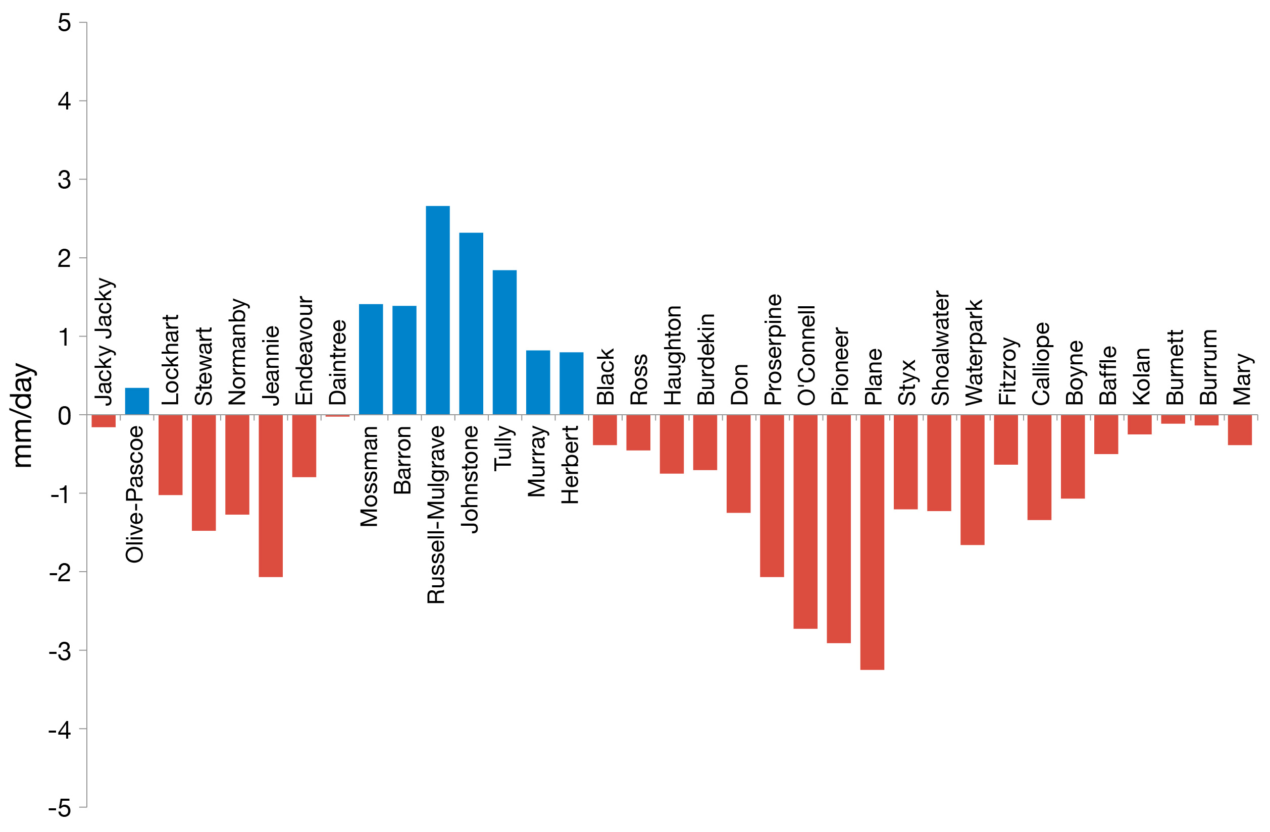
Figure 6. Difference between annual average daily wet season rainfall (December 2017–April 2018) and the long-term average (1961–1990).
Red and blue bars denote basins with rainfall below and above the long-term average, respectively. Note that the basins are ordered from north to south (left to right). Compiled by Gruber et al. 2019.
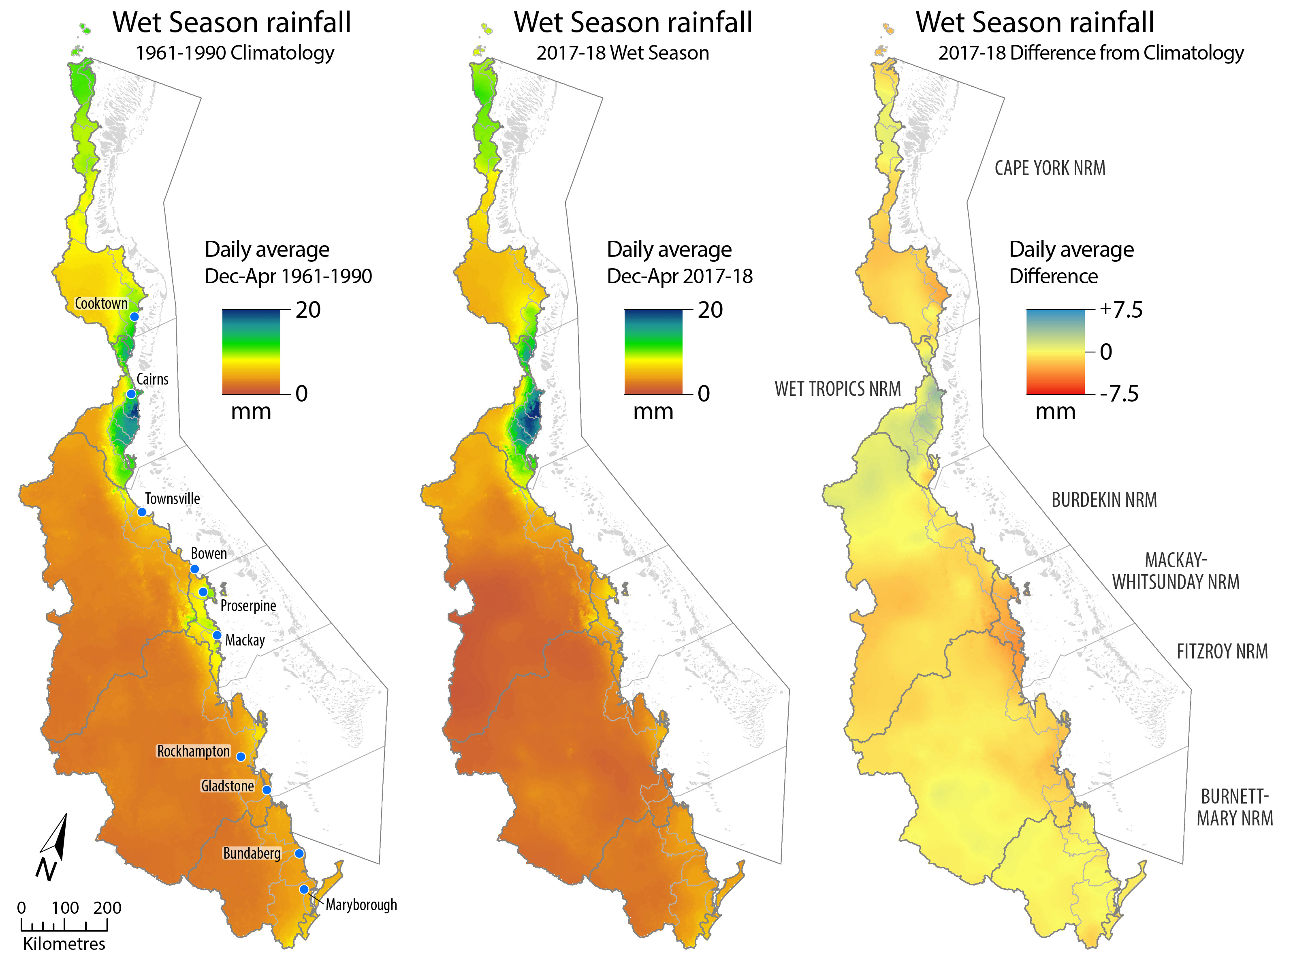
Figure 7. Average daily rainfall (mm/day) in the Reef catchment: (left) long-term annual average (1961–1990; time period produced by BOM), (centre) 2017–18 and (right) the difference between the long-term annual average and 2017–18 rainfall patterns. From Gruber et al. 2019

River discharge
Annual discharge for the 35 Reef catchment basins in 2017–18 is shown in Table 9 and compared to long-term median annual flow for that basin. River discharge was above the long-term average for the entire Reef (Table 8). This was due to small increases in discharge in most rivers (except those in the Mackay-Whitsunday) and large increases of more than 1.5 times the long-term median in some of the rivers in the Wet Tropics and Burdekin regions, and all rivers in the Burnett Mary region (Table 9).

Table 9. Annual water year discharge (ML) of the main GBR rivers (1 October 2017 to 30 September 2018, inclusive) compared to the previous seven wet seasons and long-term (LT) median discharge (1986–87 to 2017–18).
Colours indicate levels above the long-term median: yellow for 1.5 to 2 times, orange for 2 to 3 times and red greater than 3 times. (– = data not available). Compiled by Gruber et al. 2019.
 | Basin | LT median | 2010–11 | 2011–12 | 2012–13 | 2013–14 | 2014–15 | 2015–16 | 2016–17 | 2017–18
Cape York | Jacky Jacky Creek | 2,192,118 | 4,735,197 | 1,820,422 | 1,986,825 | 3,790,832 | 1,498,138 | 630,787 | 2,383,057 | 2,739,677
Cape York | Olive Pascoe River | 2,740,148 | 5,918,996 | 2,275,527 | 2,483,531 | 4,738,541 | 3,931,758 | 788,484 | 2,978,821 | 3,424,596
Cape York | Lockhart River | 1,735,427 | 3,748,697 | 1,441,167 | 1,572,903 | 3,001,076 | 1,186,026 | 499,373 | 1,886,587 | 2,168,911
Cape York | Stewart River | 689,498 | 2,180,850 | 616,070 | 523,353 | 1,311,775 | 298,816 | 311,901 | 685,263 | 826,499
Cape York | Normanby River | 4,096,709 | 11,333,284 | 2,181,990 | 3,462,238 | 5,059,657 | 2,914,859 | 3,407,359 | 3,780,651 | 4,333,023
Cape York | Jeannie River | 1,507,731 | 2,824,817 | 1,048,269 | 695,195 | 1,869,982 | 1,434,447 | 1,581,015 | 1,746,929 | 1,721,175
Cape York | Endeavour River | 980,025 | 1,836,131 | 681,375 | 451,877 | 1,215,488 | 932,391 | 1,027,660 | 1,135,504 | 1,118,764
Wet Tropics | Daintree River | 1,722,934 | 3,936,470 | 2,396,905 | 1,668,302 | 5,137,023 | 1,905,224 | 1,623,478 | 1,931,878 | 1,312,417
Wet Tropics | Mossman River | 1,207,012 | 2,014,902 | 1,526,184 | 1,147,367 | 1,918,522 | 874,068 | 1,245,275 | 1,142,698 | 1,503,754
Wet Tropics | Barron River | 526,686 | 2,119,801 | 852,055 | 328,260 | 663,966 | 380,395 | 182,999 | 287,790 | 867,748
Wet Tropics | Mulgrave-Russell River | 4,457,940 | 7,892,713 | 5,696,594 | 3,529,862 | 5,420,678 | 3,145,787 | 3,253,825 | 3,015,734 | 5,759,716
Wet Tropics | Johnstone River | 4,743,915 | 9,276,874 | 5,338,591 | 3,720,020 | 5,403,534 | 3,044,680 | 3,416,331 | 4,017,617 | 5,940,395
Wet Tropics | Tully River | 3,536,054 | 7,442,768 | 3,425,096 | 3,341,887 | 4,322,496 | 2,659,775 | 2,942,770 | 3,098,701 | 4,237,041
Wet Tropics | Murray River | 1,227,888 | 4,267,125 | 2,062,103 | 1,006,286 | 1,531,172 | 366,212 | 974,244 | 947,985 | 1,682,909
Wet Tropics | Herbert River | 3,556,376 | 12,593,674 | 4,545,193 | 3,189,804 | 4,281,607 | 1,095,372 | 1,895,526 | 2,248,436 | 6,385,655
Burdekin | Black River | 228,629 | 1,424,283 | 747,328 | 188,468 | 419,290 | 17,654 | 129,783 | 64,873 | 456,795
Burdekin | Ross River | 355,343 | 2,092,684 | 1,324,707 | 276,584 | 1,177,255 | 3,229 | 23,741 | 11,867 | 342,596
Burdekin | Haughton River | 553,292 | 2,415,758 | 1,755,712 | 517,069 | 573,976 | 120,674 | 267,986 | 338,245 | 826,904
Burdekin | Burdekin River | 4,406,780 | 34,834,316 | 15,568,159 | 3,424,572 | 1,458,772 | 880,951 | 1,807,104 | 4,165,129 | 5,542,306
Burdekin | Don River | 342,257 | 3,136,184 | 802,738 | 578,391 | 324,120 | 171,305 | 101,562 | 920,610 | 135,367
Mackay-Whitsundays | Proserpine River | 887,771 | 4,582,697 | 2,171,287 | 851,504 | 720,427 | 157,123 | 316,648 | 1,683,894 | 543,452
Mackay-Whitsundays | O'Connell River | 796,718 | 4,112,676 | 1,948,591 | 764,170 | 646,537 | 141,008 | 284,171 | 1,511,187 | 487,713
Mackay-Whitsundays | Pioneer River | 776,984 | 3,630,422 | 1,567,684 | 1,162,871 | 635,315 | 2,028,936 | 597,117 | 1,388,687 | 249,530
Mackay-Whitsundays | Plane Creek | 1,052,831 | 4,809,239 | 2,854,703 | 1,948,929 | 737,580 | 241,254 | 832,508 | 2,613,261 | 273,639
Fitzroy | Styx River | 205,186 | 906,144 | 275,219 | 968,106 | 544,155 | 376,009 | 343,877 | 507,927 | 263,556
Fitzroy | Shoalwater Creek | 233,488 | 1,031,129 | 313,180 | 1,101,638 | 619,211 | 427,872 | 391,308 | 577,985 | 299,909
Fitzroy | Water Park Creek | 615,559 | 2,718,432 | 825,657 | 2,904,319 | 1,632,466 | 1,128,027 | 1,031,630 | 1,523,780 | 790,668
Fitzroy | Fitzroy River | 2,852,307 | 37,942,149 | 7,993,273 | 8,530,491 | 1,578,610 | 2,681,949 | 3,589,342 | 6,170,044 | 954,533
Fitzroy | Calliope River | 152,965 | 1,000,032 | 345,703 | 1,558,380 | 283,790 | 479,868 | 148,547 | 406,321 | 141,438
Fitzroy | Boyne River | 38,691 | 252,949 | 87,443 | 394,178 | 71,782 | 121,378 | 37,574 | 102,775 | 35,775
Burnett Mary | Baffle Creek | 465,218 | 3,650,093 | 1,775,749 | 2,030,545 | 275,517 | 710,352 | 257,093 | 829,460 | 1,845,161
Burnett Mary | Kolan River | 56,231 | 779,168 | 307,837 | 810,411 | 45,304 | 213,857 | 111,172 | 146,154 | 273,170
Burnett Mary | Burnett River | 285,534 | 9,421,517 | 643,137 | 7,581,543 | 218,087 | 853,349 | 381,054 | 536,242 | 849,051
Burnett Mary | Burrum River | 71,658 | 114,492 | 117,762 | 90,921 | 62,188 | 150,113 | 334,681 | 456,549 | 670,012
Burnett Mary | Mary River | 1,144,714 | 8,719,106 | 4,340,275 | 7,654,320 | 594,612 | 1,651,901 | 480,854 | 582,510 | 1,902,531

Turbid water exposure and flood plume extent
The frequency of exposure to turbid water (colour classes 1–5), plume extent, and the within-canopy environmental pressures daily light and water temperature are summarised in Figure 8.
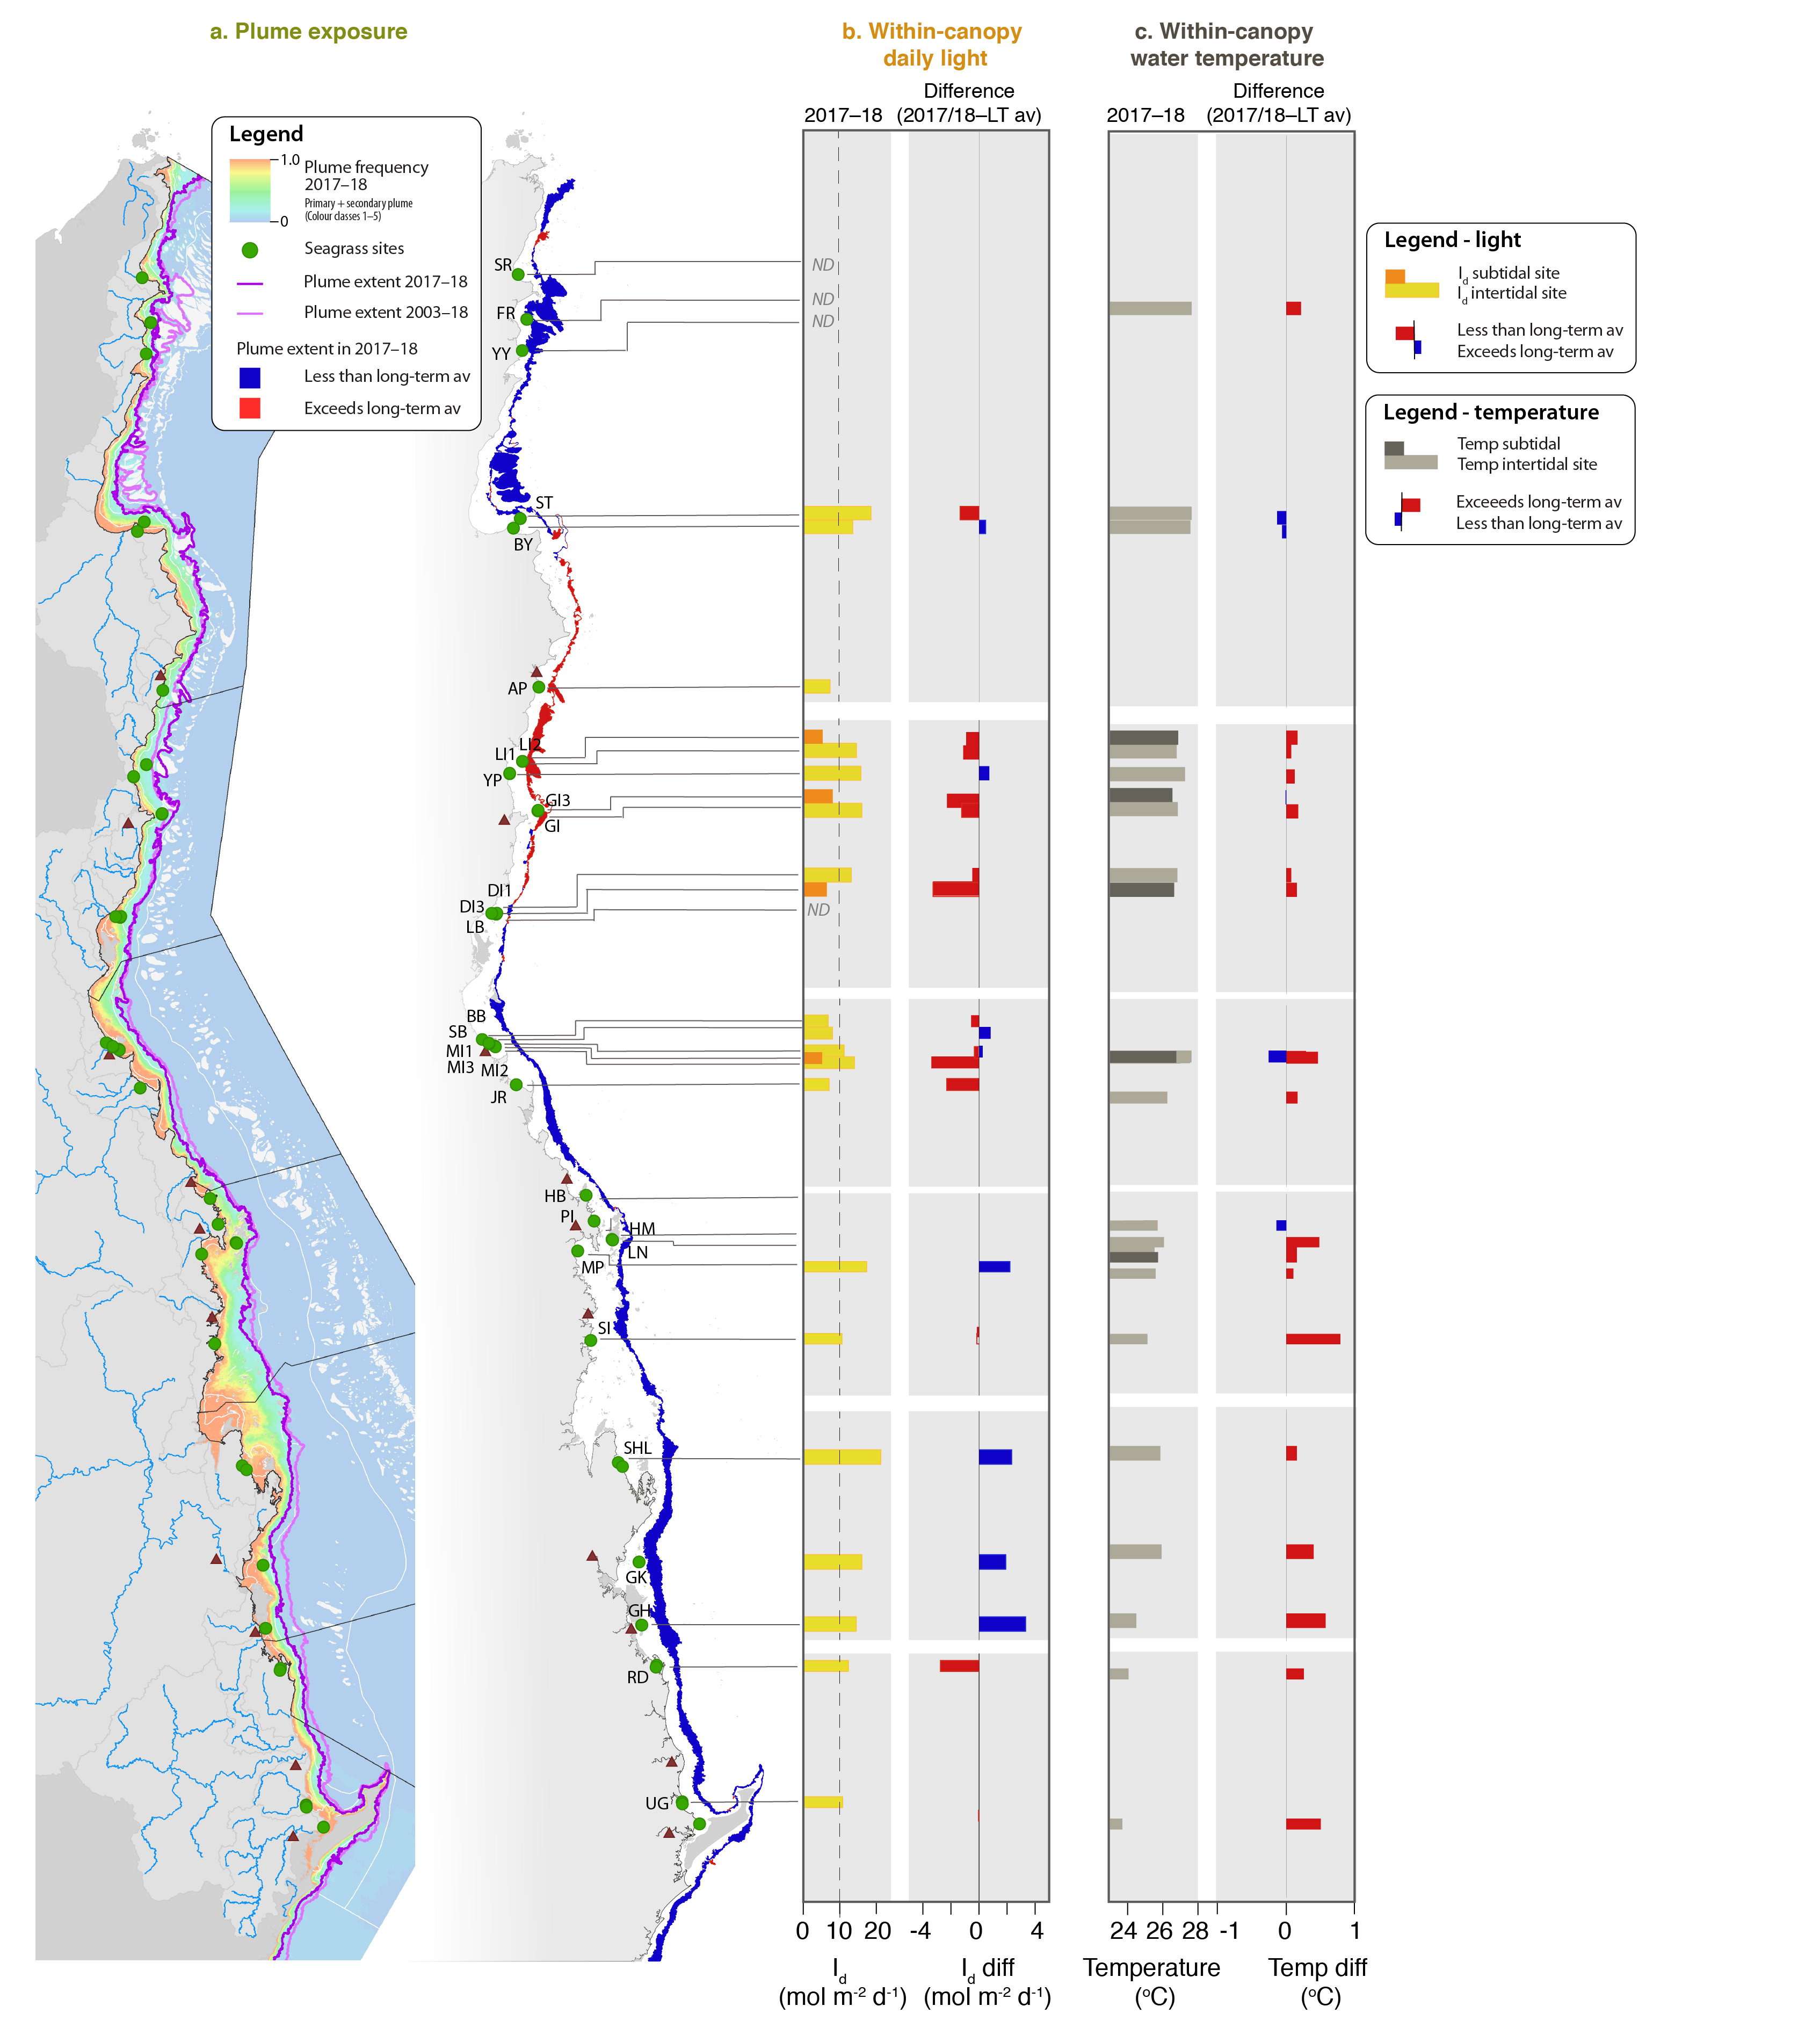
Figure 8. Environmental pressures in the Reef during 2017–18 and relative to long-term: a. Frequency of turbid water (colour classes 1–5, primary and secondary water) exposure shown in the left-hand panel in the Reef from December 2017 to April 2018
ranging from frequency of 1 (orange, always exposed) to 0 (pale blue, never exposed), and right-hand panel the plume extent (10% boundary) in 2017–18 relative to the long-term average, with red showing that plumes extended further in 2017–18 and blue showing they did not extend as far; b. within canopy daily light for all sites, and the deviation in daily light relative to the long-term average; and c. within canopy water temperature, and deviation water temperature from the long-term average.
The frequency of exposure to colour classes 1 to 4 (‘brown’ turbid water) during the wet season weeks (December 2017 - April 2018) was lower than multiannual annual conditions in all regions except the Wet Tropics (Figure 9). The frequency of exposure to colour classes 1 to 5 (including ‘green’ turbid water), also shows that there was a small elevated frequency of exposure at Mackay-Whitsunday seagrass sites despite low rainfall and discharge. But this was not reflected in the plume extent, or with-in canopy light levels for the Mackay-Whitsunday (Figure 8).
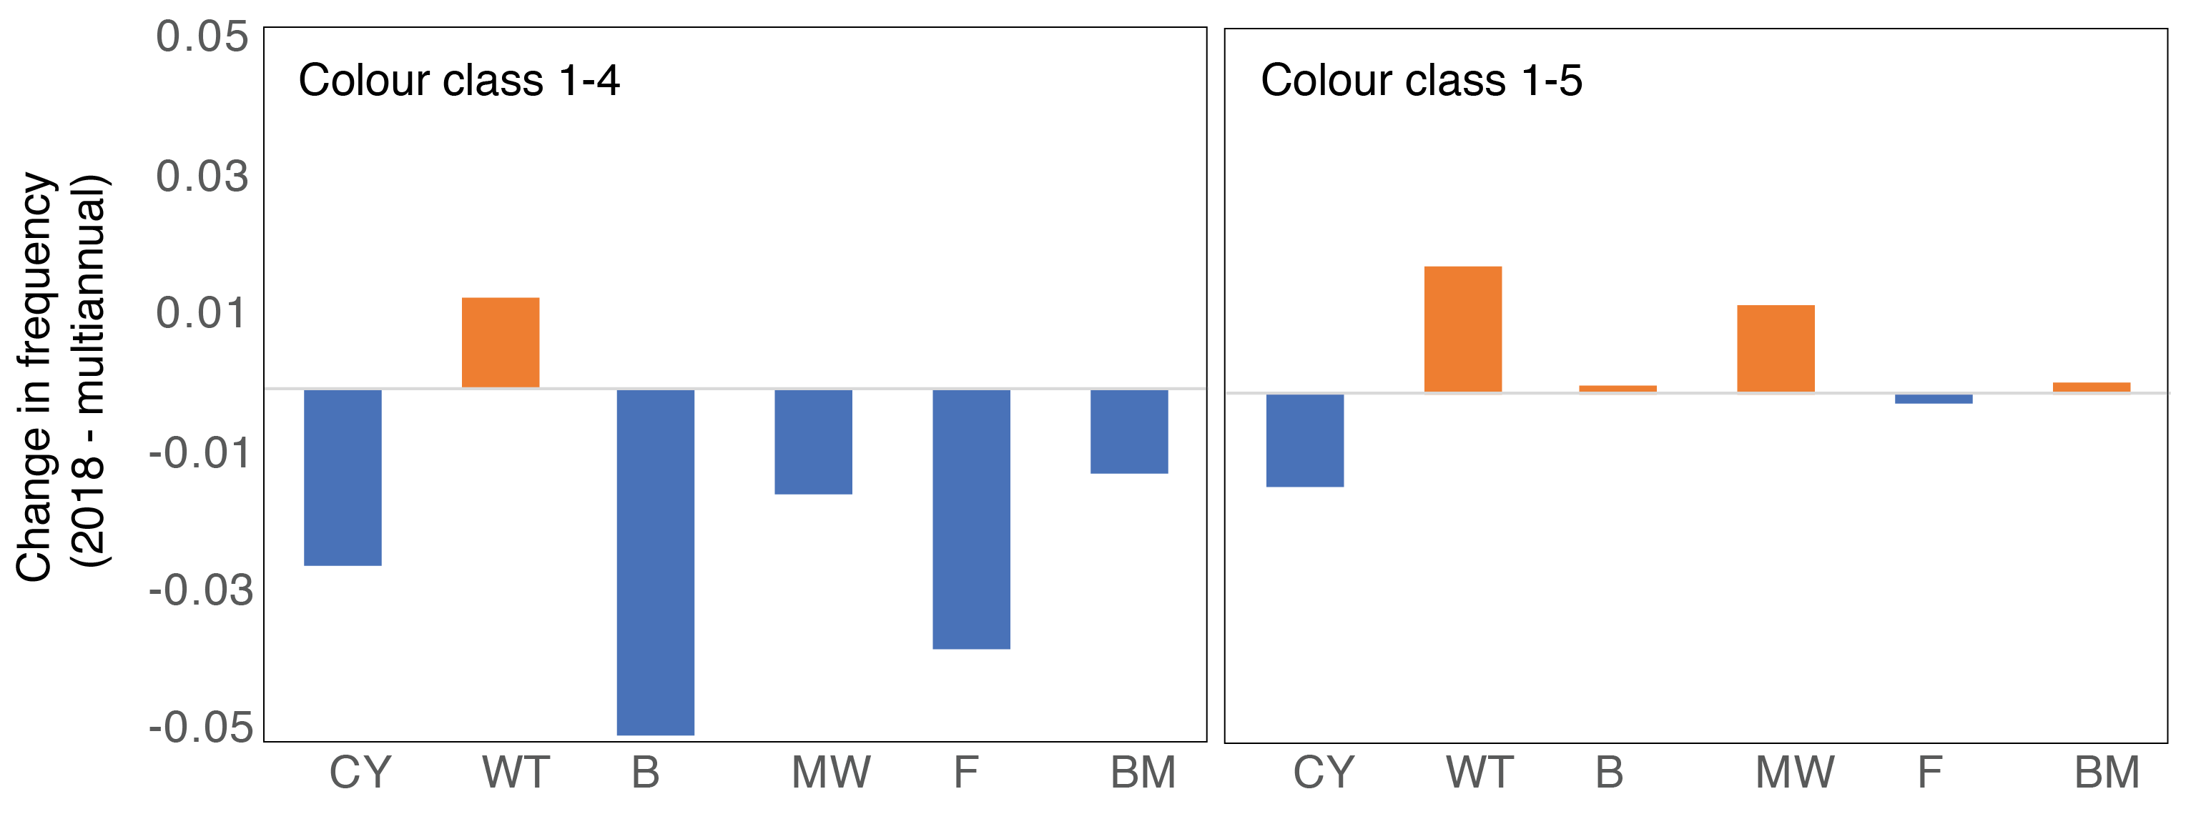
Figure 9. Difference in the frequency of exposure to water colour classes 1 to 4 (left) and 1 to 5 (right) at seagrass monitoring sites during the wet season (December 2017–April 2018) compared to the long-term multiannual exposure (2003–2017).

Daily incident light
Daily light in shallow habitats can be affected by water quality, depth of the site and cloudiness, which affects the frequency and duration of exposure to full sunlight at low tide (Anthony et al. 2004; Fabricius et al. 2012). Differences in I_{d} among seagrass meadows reported here is largely a reflection of site-specific differences in water quality.
Daily light reaching the top of the seagrass canopy in the Reef in 2017–18 was 11.5 mol m⁻² d⁻¹ when averaged for all sites (Table 8), but there are regional, habitat and location levels differences.
Daily light in the regions in 2017–18 from highest to lowest were:
- Fitzroy (17.2 mol m⁻² d⁻¹)
- northern Wet Tropics (12.0 mol m⁻² d⁻¹)
- Cape York (11.9 mol m⁻² d⁻¹)
- Mackay-Whitsunday (11.5 mol m⁻² d⁻¹)
- Burnett-Mary (10.5 mol m⁻² d⁻¹)
- southern Wet Tropics (9.8 mol m⁻² d⁻¹)
- Burdekin (8.6 mol m⁻² d⁻¹).
Daily light in the habitats in 2017–18 from highest to lowest were:
- coastal intertidal sites (13.8 mol m⁻² d⁻¹)
- reef intertidal habitat (11.7 mol m⁻² d⁻¹)
- estuarine sites (11.3 mol m⁻² d⁻¹)
- reef subtidal sites (6.7 mol m⁻² d⁻¹).
Daily light for each of the sites is presented in Figure 8. There were 10 locations in which the annual daily light level was lower than 10 mol m⁻² d⁻¹, a light threshold that is likely to support long-term growth requirements of the species in these habitats (Collier et al 2016). There were 14 locations in which daily light was lower than the long-term average (Figure 8).
Long-term trends show a peak in canopy light occurs in September to December as incident solar irradiation reaches its maximum and prior to wet season conditions (Figure 10). The lowest light levels typically occur in the wet season, in particularly January to April.
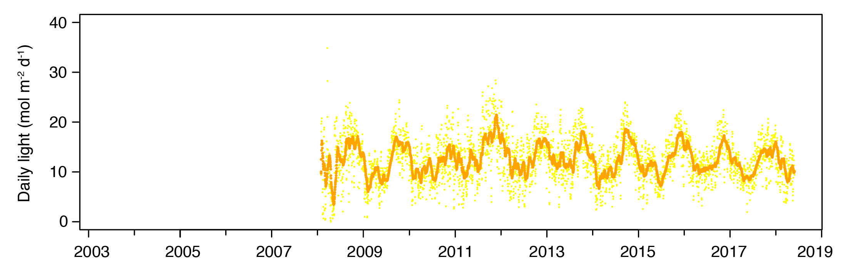
Figure 10. Daily light for all sites combined from 2008 to 2018. In 2008–2009, light data is from the Burdekin and Wet Tropics regions. Other regions were included from 2009–2010, with Cape York added post 2012–2013 reporting period.

Within-canopy seawater temperature
Daily within-canopy seawater temperature across the Reef in 2017–18 was cooler than the previous four reporting years, when there were a record number of temperature exceedances, and widespread bleaching throughout the Reef (Figure 11). The 2017–18 Reef temperature was on average (25.9°C) similar to the long-term (2003–2018, 25.8°C), an ‘insignificant’ difference, considering changes in sites that are monitored over that period (Table 8). However, there were regional and habitat differences relative to the long-term.
Daily within-canopy seawater temperatures in the regions in 2017–18 from largest to smallest difference (* = greater than 0.5°C) relative to the long-term were:
- Cape York (avg = 27.4°C, max = 41.3°C)*
- Burnett Mary (avg = 23.8°C, max = 39.4°C)*
- Fitzroy (avg = 24.6°C, max = 41.6°C)*
- Mackay-Whitsunday (avg = 25.7°C, max = 40.1°C)
- Burdekin (avg = 26.6°C, max = 38.8°C).
- northern Wet Tropics (avg = 27.0°C, max = 40.5°C)
- southern Wet Tropics (avg = 26.8°C, max = 41.2°C)
Daily within-canopy seawater temperatures in the habitats in 2017–18 from largest to smallest difference (* = greater than 0.5°C) relative to the long-term were:
- estuarine sites (avg = 24.3°C, max = 40.0°C)*
- reef intertidal habitat (avg = 26.5°C, max = 41.6°C)
- reef subtidal sites (avg = 26.4°C, max = 31.8°C)
- coastal intertidal sites (avg = 26.0°C, max = 41.3°C)
The hottest seawater temperature recorded at inshore seagrass sites along the Reef during 2017–18 was 41.6°C in the Fitzroy region, and all regions except the Burdekin and Burnett Mary, had at least one day above 40°C (Figure 11). Extreme temperature days (>40°C) can cause photoinhibition but when occurring at such low frequency, they were unlikely to cause burning or mortality. Subtidal temperatures remained below 35°C in 2017–18 (Figure 12), however were above the long-term average in the southern Wet Tropics and Burdekin regions.
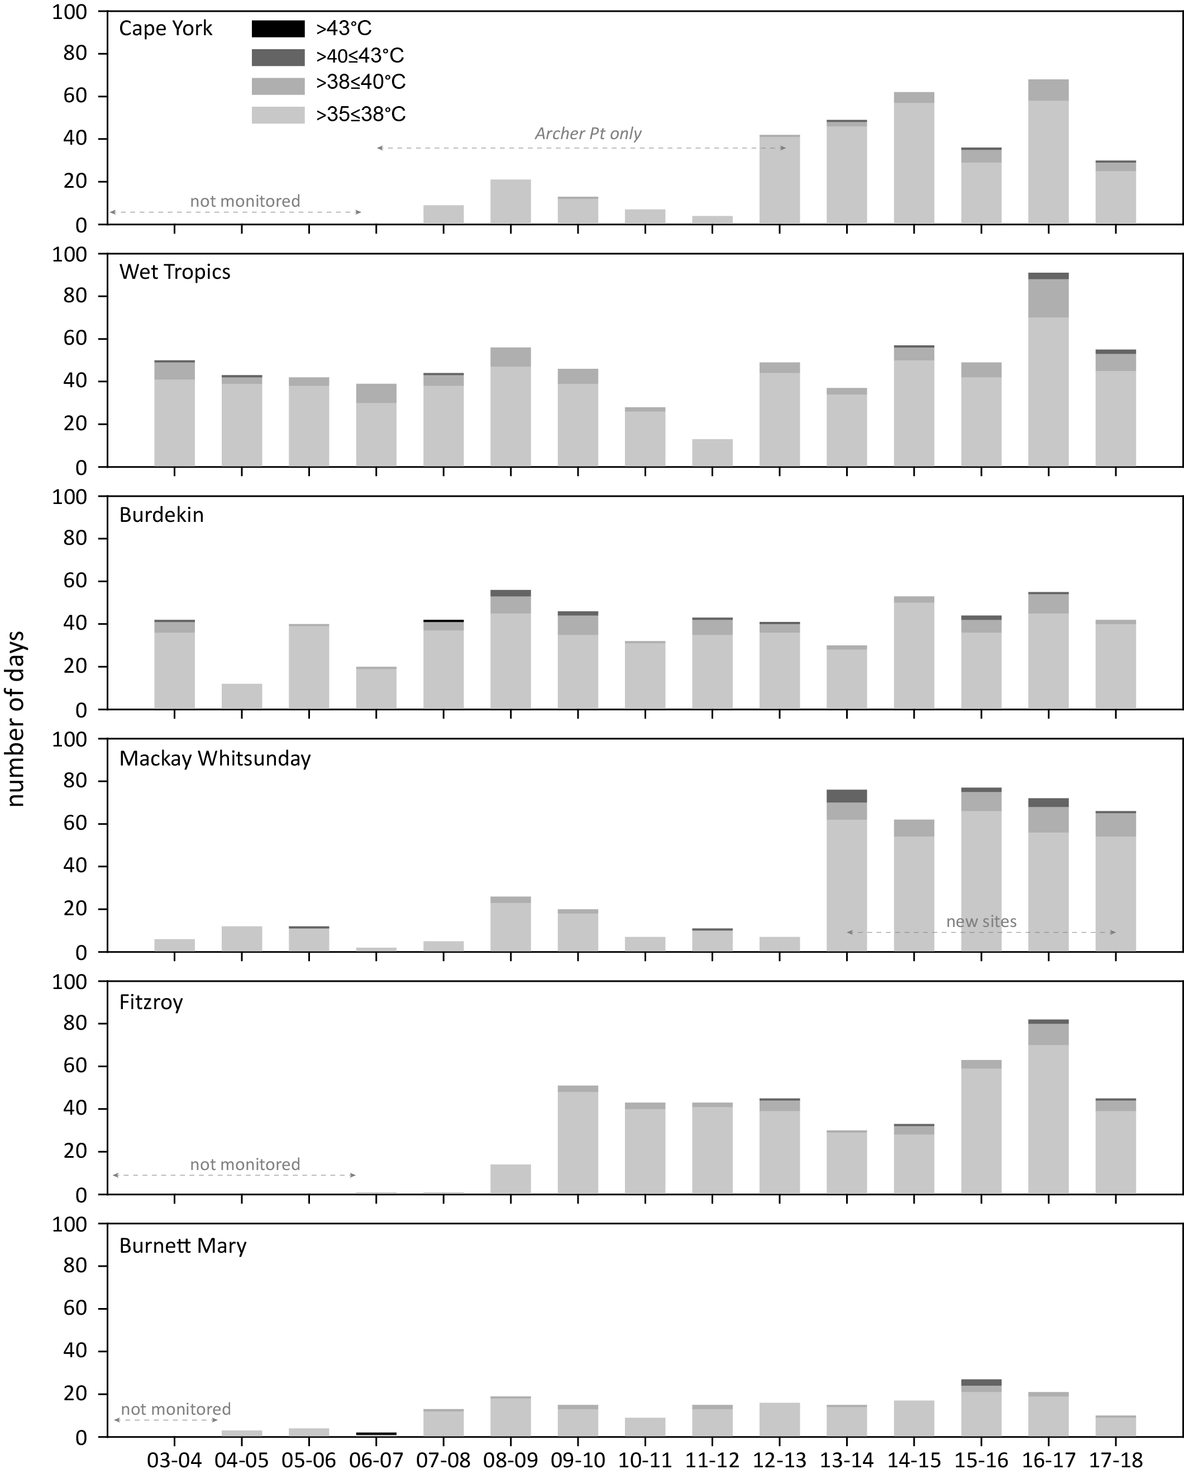
Figure 11. Number of days when inshore intertidal sea temperature exceeded 35°C, 38°C, 40°C and 43°C in each monitoring period in each NRM region.
Thresholds adapted from Campbell et al. 2006; Collier et al. 2012a.
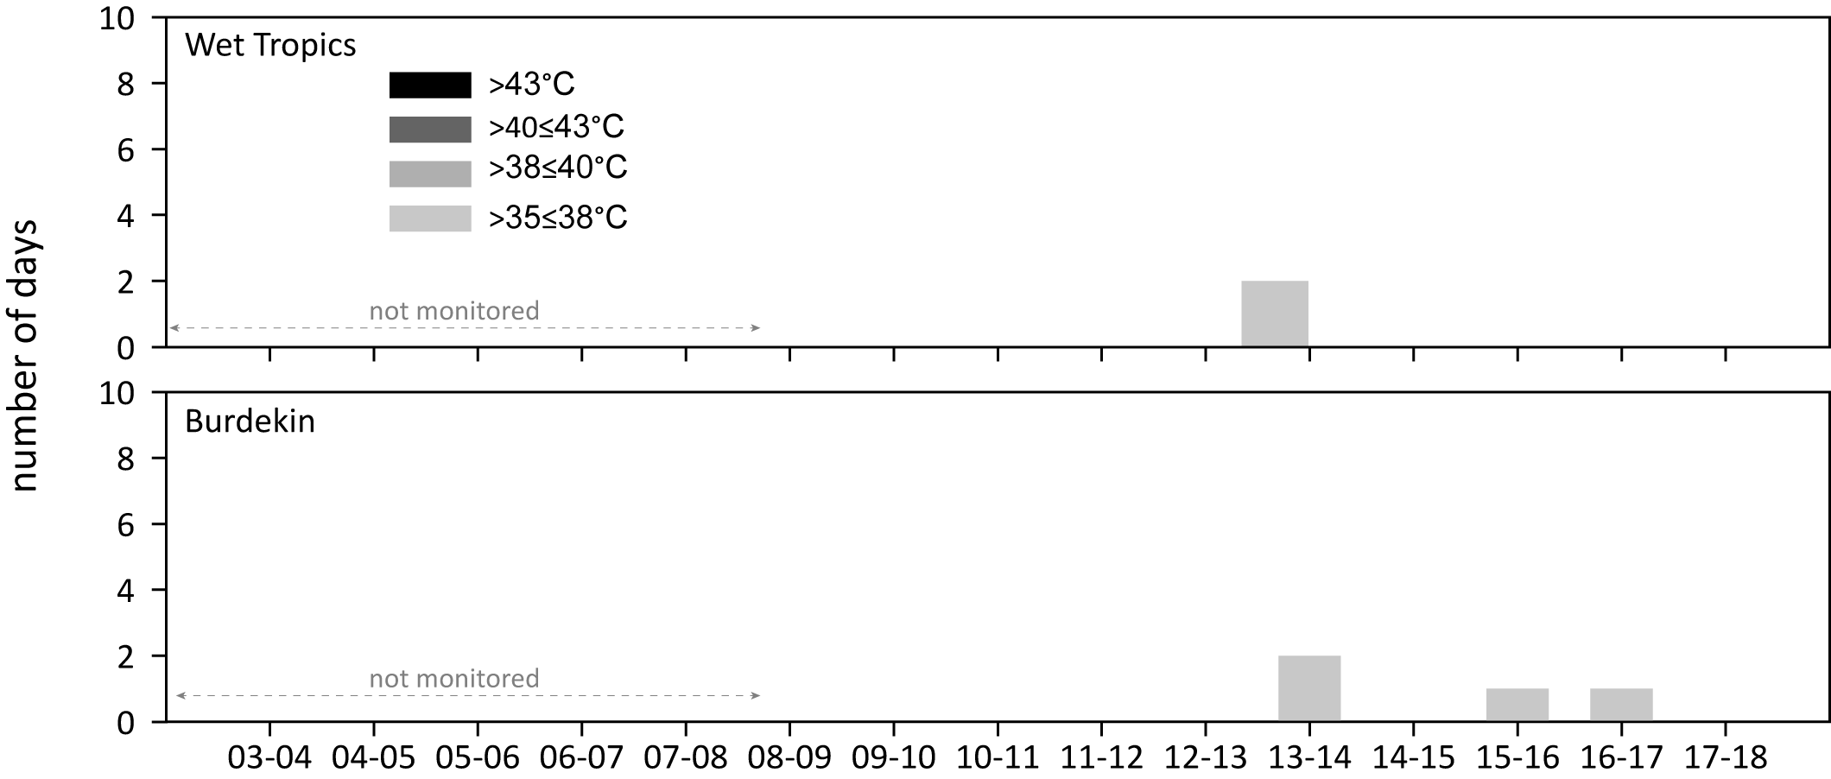
Figure 12. Number of days when inshore subtidal sea temperature exceeded 35°C, 38°C, 40°C and 43°C in each monitoring period in each NRM region.
Thresholds adapted from Campbell et al. 2006; Collier et al. 2012a.
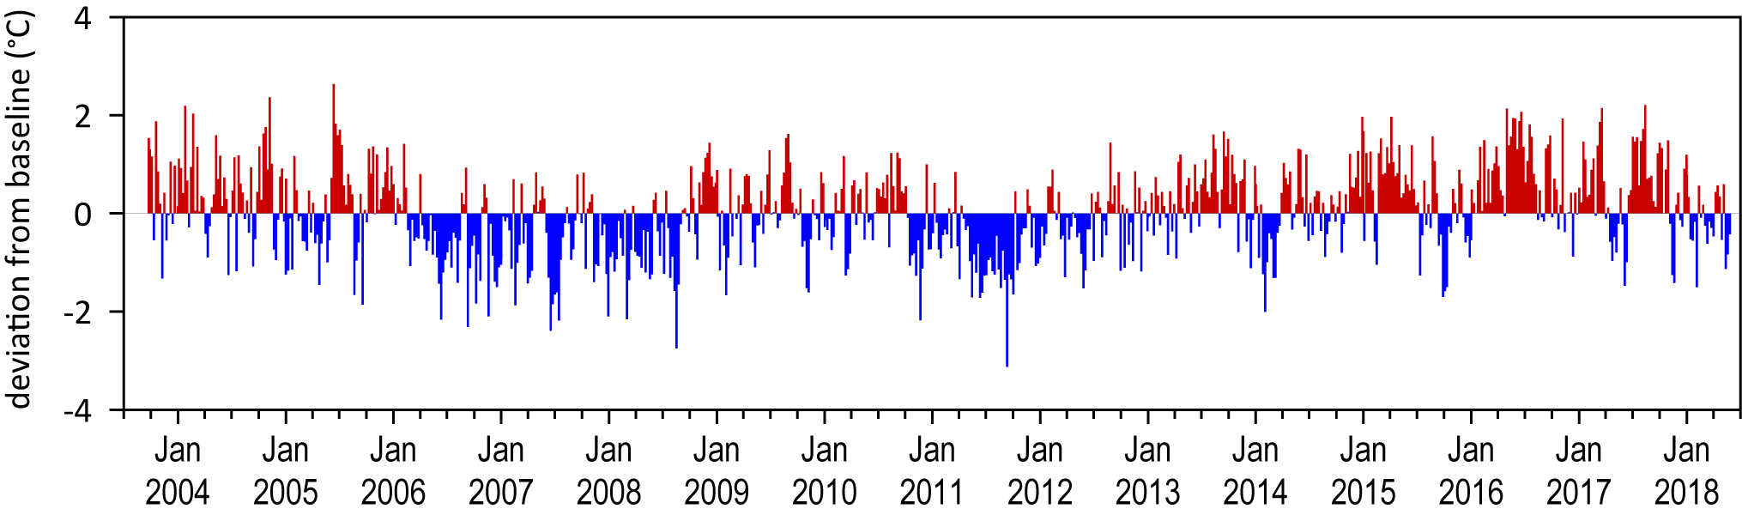
Figure 13. Inshore intertidal sea temperature deviations from baseline for Reef seagrass habitats from 2003 to 2018.
Data presented are deviations from 13-year mean weekly temperature records (based on records from September 2003 to June 2018). Weeks above the long-term average are represented as red bars and the magnitude of their deviation from the mean represented by the length of the bars, blue bars represent weeks with temperatures lower than the average and are plotted as negative deviations.

Seagrass meadow sediments
Coastal subtidal and estuarine seagrass habitats across the Reef had a greater proportion of fine sediments (i.e. mud) than other habitats (Table 10). Sediments at coastal habitats were predominately medium and fine sands, while reef habitats (intertidal and subtidal) were dominated by medium sands (Table 10).
Table 10. Long-term average (±SE) sediment composition for each seagrass habitat (pooled across regions and time) monitoring within the Reef (1999–2018)
Habitat | Mud | Fine sand | Sand | Coarse sand | Gravel
estuarine intertidal | 50.6 ±2.1 | 18.7 ±1.9 | 27.7 ±1.9 | 0.2 ±0.5 | 2.8 ±1.2
coastal intertidal | 28.5 ±2.1 | 33.1 ±2.4 | 33.1 ±2.5 | 0.3 ±0.5 | 4.6 ±1.2
coastal subtidal | 46.4 ±2.7 | 12.7 ±0.5 | 16.1 ±2.8 | 10.8 ±2.3 | 4.7 ±0.0
reef intertidal | 4.9 ±1.2 | 6.9 ±1.7 | 48.6 ±2. | 17.6 ±1.8 | 21.6 ±2.3
reef subtidal | 6.9 ±0.5 | 9.6 ±0.9 | 60.5 ±6.3 | 1.6 ±0.6 | 11.7 ±6.6

Since monitoring was established, the composition of sediments has fluctuated at all habitats, with the proportion of mud declining below the long-term average at estuary and coastal habitats immediately following periods of physical disturbance from storms (e.g. cyclones in 2006 and 2011). Conversely, the proportion of mud increased above the long-term average at reef (intertidal and subtidal) habitats during periods of extreme climatic events (e.g. cyclones and/or flood events). During the 2017–18 monitoring period there were small fluctuations in sediment type relative to the previous year (Figure 14).

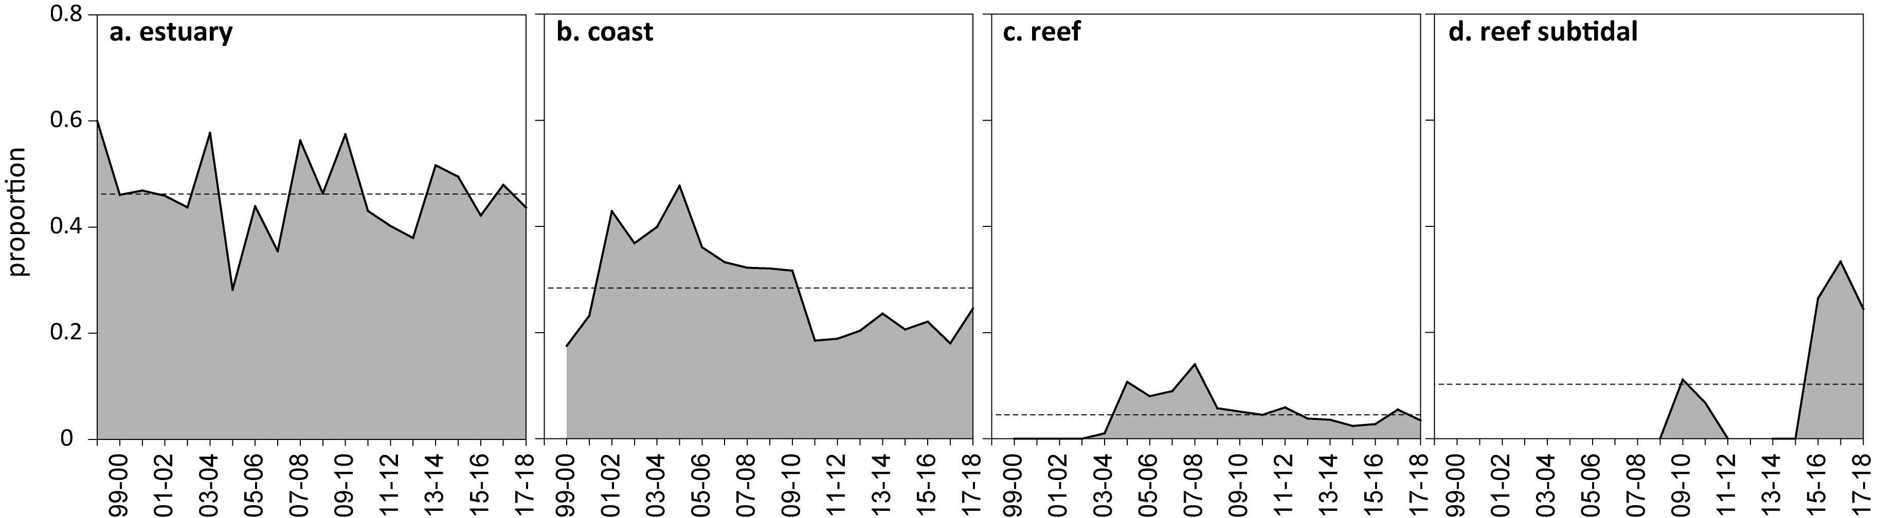
Figure 14. Proportion of sediment composed of mud (grain size <63µm) at Reef seagrass monitoring habitats from 1999–2018.

Seagrass condition and trend
The following results section provides detail on the overall seagrass responses for the 2017–18 monitoring period, in context of longer-term trends. It is structured as a Reef-wide summary: overall condtion and trend for each habitat type presented separately, including:
- a summary of the key findings from the overall section including a summary of the report card score
- seagrass abundance and extent
- seagrass species composition based on life history traits
- seagrass reproductive effort and seed banks
- seagrass leaf tissue content (C:N, N:P and C:P ratios)
- epiphyte and macroalgae abundance
- linkage back to broad-scale environmental pressures.
Detailed results for each region are presented in the next section. Supporting data identified as important in understanding any long-term trends is detailed within Appendix 3 and 4.

Reef-wide seagrass condition and trend
Inshore seagrass meadows across the Reef declined in overall condition in 2017–18 and remain poor (Figure 15). Seagrass meadows declined to their lowest score in 5 years, negating some of the recovery since its lowest score in 2011–2012 (Figure 15).
In summary, the decline was due to lower scores in each of the condition indicators:
- The 2017–18 year was the second consecutive year seagrass abundance had declined. Seagrass abundance (% cover) at meadows monitored in the MMP declined from 2005–2006 until 2012–2013, caused by multiple years of above-average rainfall followed by extreme weather events, after which abundances increased (Figure 15, Figure 17b). Based on the average score against the seagrass guidelines (determined at the site level), the abundance of inshore seagrass in the Reef over the 2017–18 period declined for the second year in a row but remained in a moderate grade (Figure 15).
- The 2017–18 year was the fourth consecutive year of declining reproductive effort (Figure 15). Reef-wide reproductive effort in 2017–18 remained very poor (Figure 15). Low reproductive effort will hinder replenishment of the depauperate seed banks, and seed banks are therefore likely to remain low in coming years. Most meadows can be considered vulnerable to further disturbances because of their limited capacity to recover from seed (i.e. low resilience).
- The regression in tissue nutrients follows an improving trend since 2010–2011 (Figure 15). The seagrass leaf tissue nutrient indicator (C:N ratio) decreased in late 2017 from the previous year, but remained poor for the eleventh consecutive year (Figure 15). This indicates an elevation in the availability of nitrogen at some locations, relative to the rate at which the leaves are growing and incorporating carbon. In most locations, δ¹⁵N values suggest diverse sources of nitrogen affecting nitrogen availability.
Trends in seagrass abundance and tissue nutrients demonstrate that until 2016–2017, the system was on a recovering trajectory. However in 2017–18, declines in abundance, tissue nutrients and continued very low reproductive effort throughout most of the Reef, may signal that inshore seagrass resilience has decreased and, recovery processes may be further hampered following future disturbances.

Figure 15. Reef-wide seagrass condition index (±SE) with contributing indicator scores over the life of the MMP
. The index is derived from the aggregate of metric scores for indicators of seagrass community health.Index scores scaled from 0–100 and graded: ● = very good (81-100), ● = good (61 - 80), ● = moderate (41 - 60), ● = poor (21 - 40), ● = very poor (0 - 20). NB: Scores are unitless.

Trends in seagrass condition indicators between regions
The Reef-wide score for seagrass is derived from the average of seagrass indicator scores in each of six Regions, weighted by seagrass area. In 2017–18 all but one NRM region (Wet Tropics) declined in seagrass condition (Figure 16), although trends in indicators between the six Regions are not uniform:
- The seagrass abundance score was poor in the 2017–18 monitoring period in all regions except the Burdekin, which remained good (Figure 16). There were increases in the abundance score compared to the previous year in the Wet Tropics, Fitzroy and Burnett Mary NRM regions, but they remained in the poor category. Furthermore, the score declined from moderate in the Cape York region.
- Reproductive scores were poor in the Wet Tropics (improving from very poor due primarily to Yule Point) and Burdekin NRMs in 2017–18, and very poor in the other four regions (Figure 16). Reproductive effort across the regions this year declined in Mackay-Whitsunday NRM, and was relatively stable in all other NRMs (Figure 16).
- Seagrass nutrient status scores (using only C:N) reduced in all regions except the Wet Tropics, furthermore the score was poor in all regions except for the Burdekin which was moderate (Figure 16). The C:N score was the lowest since monitoring began in the Fitzroy and Burnett Mary regions, but this has been influenced by changes in sites in both regions.
Inshore seagrass condition scores across the Regions reflect a system that is being impacted by heatwaves, cyclones, and elevated discharge from rivers. Regional differences in condition and indicator scores appear due to the legacy of significant environmental conditions in 2016–2017 (e.g. cyclone Debbie in Mackay-Whitsunday, above-average riverine discharge throughout the southern and central Reef, and a marine heatwave in the northern and central Reef) and/or less favourable environmental conditions in 2017–18.

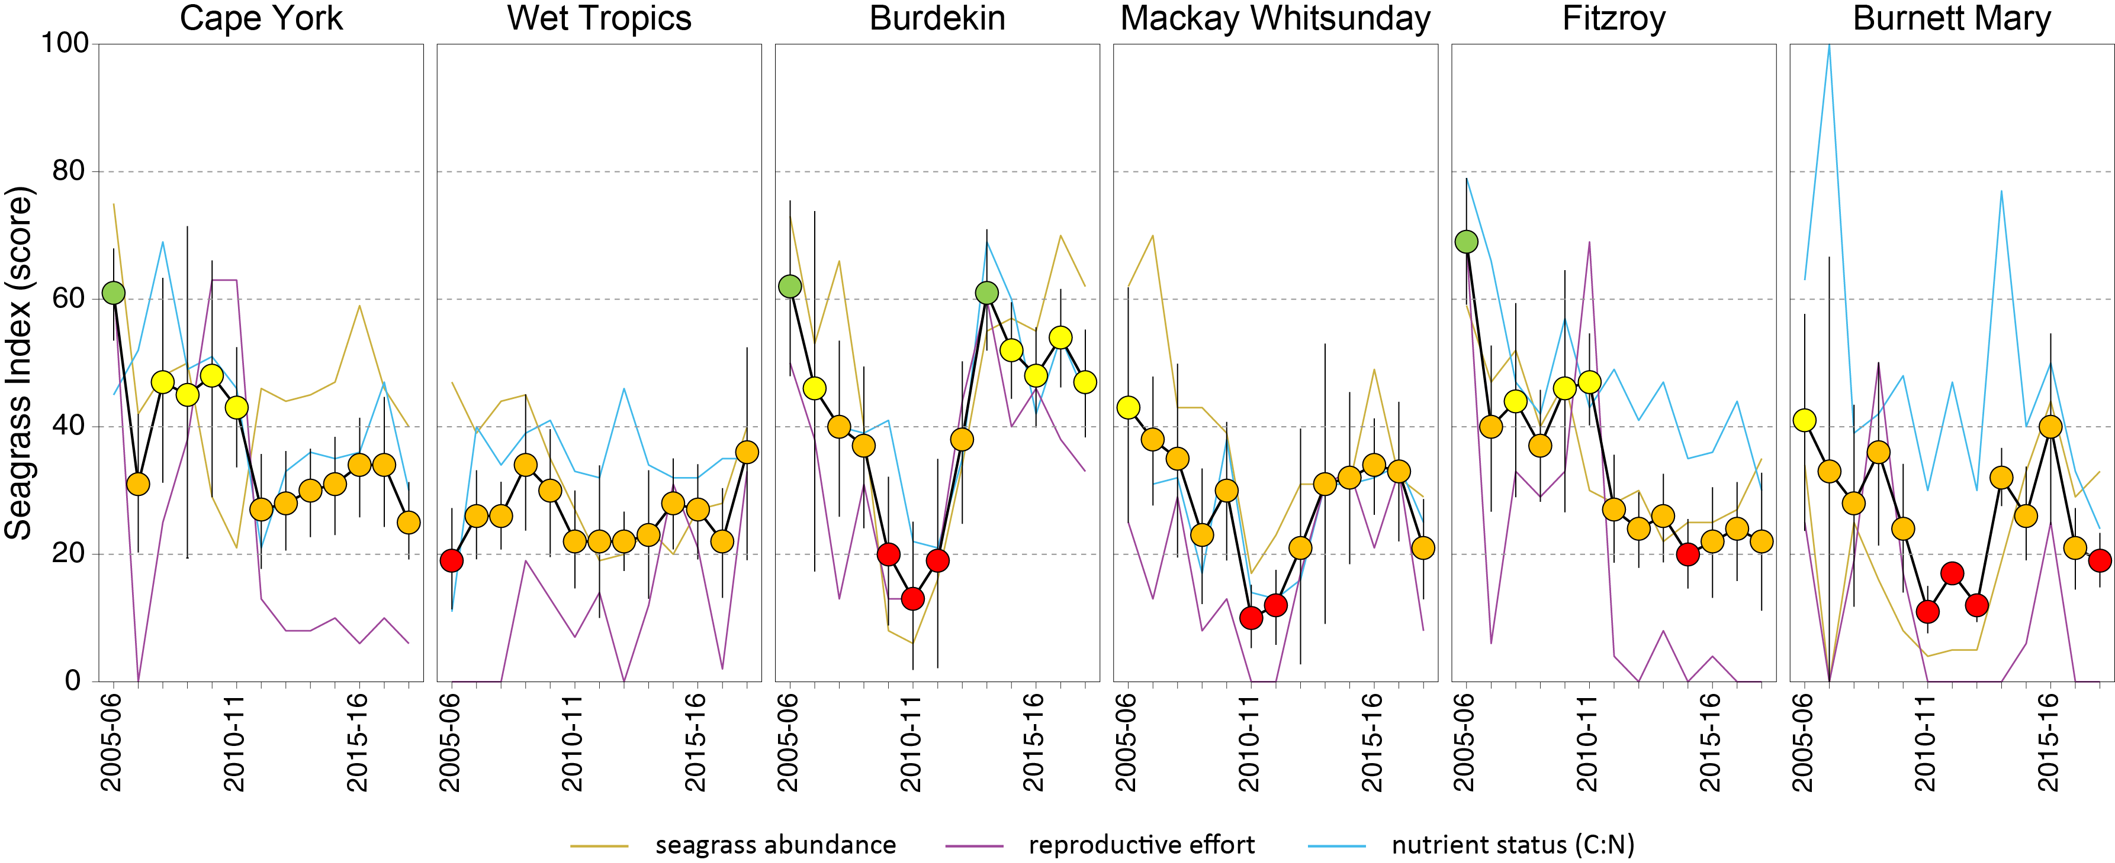
Figure 16. Seagrass condition index (±SE) with contributing indicator scores for each NRM region over the life of the MMP
. The index is derived from the aggregate of metric scores for indicators of seagrass community health.Values are indexed scores scaled from 0–100 and graded: ● = very good (81-100), ● = good (61 - 80), ● = moderate (41 - 60), ● = poor (21 - 40), ● = very poor (0 - 20). NB: Scores are unitless.

The long-term trends in the seagrass condition index, and the raw data for each of the indicators are shown in Figure 17. Generalised additive models are presented for per cent cover and tissue nutrients to show long-term trends in these indicators. These models could not be constructed on the reproductive data due to the large number of zeroes. Instead, reproductive effort is displayed as mean and standard errors, which highlights the large seasonal variability in reproductive effort.

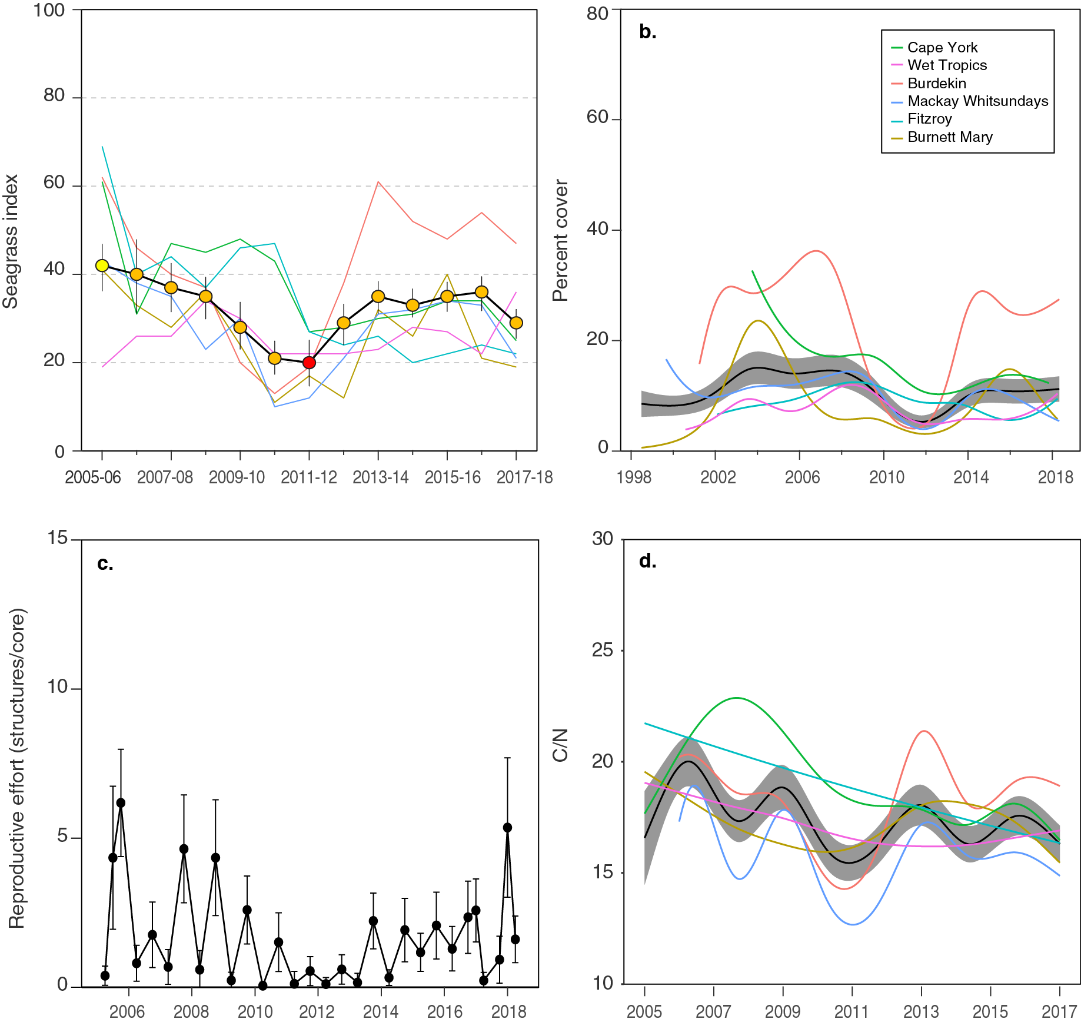
Figure 17. Trends in the seagrass condition index and indicators used to calculate the index
including: a. Reef-wide seagrass index (circles) and regional trends (lines); b. trends in seagrass abundance (% cover) represented by a GAM plot as dark lines with shaded areas defining 95% confidence intervals of those trends (Reef), and coloured lines representing NRM trends; c. reproductive structures (gam is not possible due to high count of zeroes); and d. tissue nutrient content represented by a GAM plot as dark lines with shaded areas defining 95% confidence intervals of those trends (Reef), and coloured lines representing NRM trends.

Trends in seagrass condition indicators by habitat type

Seagrass abundance, composition and extent
Seagrass abundance scores have fluctuated since monitoring was established. An examination of long-term abundances across the Reef indicates:
- no significant trends at 72% of long-term monitoring sites, however 10% of sites signficantly increased in abundance and 18% decreased (Appendix 4, Table 23)
- the rate of change in abundance was higher at sites increasing (1.1 ±0.5%, sampling event⁻¹) than decreasing (-0.3 ± 0.07%, sampling event⁻¹) (Appendix 4, Table 23)
- the most variable Reef seagrass habitat in abundance (since 2005) was subtidal reef (CV=87 %), followed closely by intertidal reef (CV=73.6 %), estuary (CV=66.5 %) and lastly intertidal coast (CV=57.9 %).
Since 1999, the median percentage cover values for the Reef were mostly below 25% cover, and depending on habitat, the 75th percentile occasionally extended beyond 50% cover (Figure 18). These long-term percentage cover values were similar to the Reef historical baselines, where surveys from Cape York to Hervey Bay (between November 1984 and November 1988) reported most (three-quarters) of the % cover values fell below 50% (Lee Long et al. 1993). The findings negate the assumption that seagrass meadows of the Reef should have abundances closer to 100% before they are categorised as good.

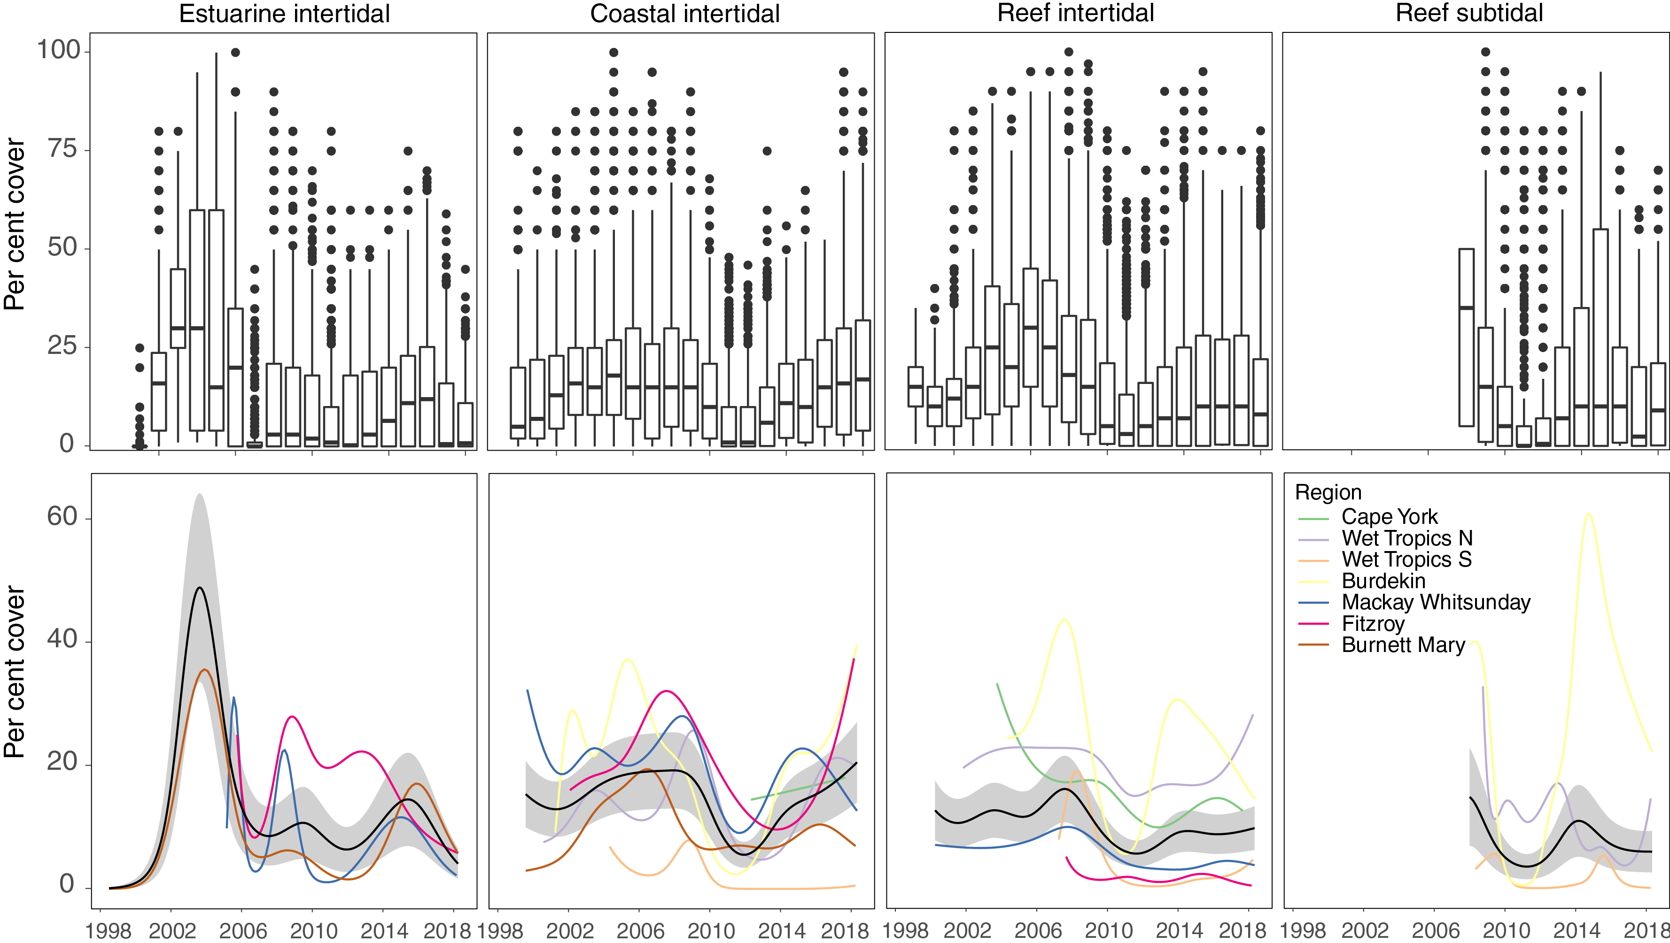
Figure 18. Seagrass per cent cover measures per quadrat from meadows monitored from June 1999 to May 2018 (sites and habitats pooled).
The box represents the interquartile range of values, where the boundary of the box closest to zero indicates the 25th percentile, a line within the box marks the median, and the boundary of the box farthest from zero indicates the 75th percentile. Whiskers (error bars) above and below the box indicate the 90th and 10th percentiles, and the dots represent outlying points. GAM plots (bottom), also showing trends for each NRM.

In 2017–18, coastal sites had the highest average abundance of the habitat types (Figure 18). Over the past decade, the patterns of seagrass abundance in each Reef habitat have been similar between coastal and reef sites; gradually increasing from 2001 to 2008 (with a mild depression in 2006-07 as a consequence of cyclone Larry), then declining from 2009 to 2011 due to above average rainfall and river discharge (Figure 17). The extreme weather events of early 2011 (e.g., TC Yasi) resulted in further substantial decline in inshore seagrass meadows throughout much of the Reef.
Estuarine habitats, which are monitored only in the southern Reef, reached record % cover in 2002 to 2003, but have remained low since 2005–06. Trends have fluctuated at a site level in estuary habitats, most often at smaller localised scales where there have been some acute event related changes (McKenzie et al. 2012).
Post 2011, seagrasses have progressively recovered, although by 2016–2017 still remained below the 2008 levels, except in coastal sites which have recovered (Figure 17).
In 2017–18, Reef-wide meadow extent was similar to the previous year, however these remain lower than the baseline (2005), 2014 and 2015 (Figure 19).
Since the MMP was established in 2005, meadow extent across inshore monitoring sites declined in early 2011, recovering within 3–4 years (Figure 19). Similar to seagrass abundance, this decline in extent was a consequence of extreme weather and associated flooding. Since 2014, the meadows across the Reef have varied in extent within and between years. The changes in extent over the last three years appear a consequence of severe weather events (e.g. cyclones) and regional climate (frequency of strong wind days).
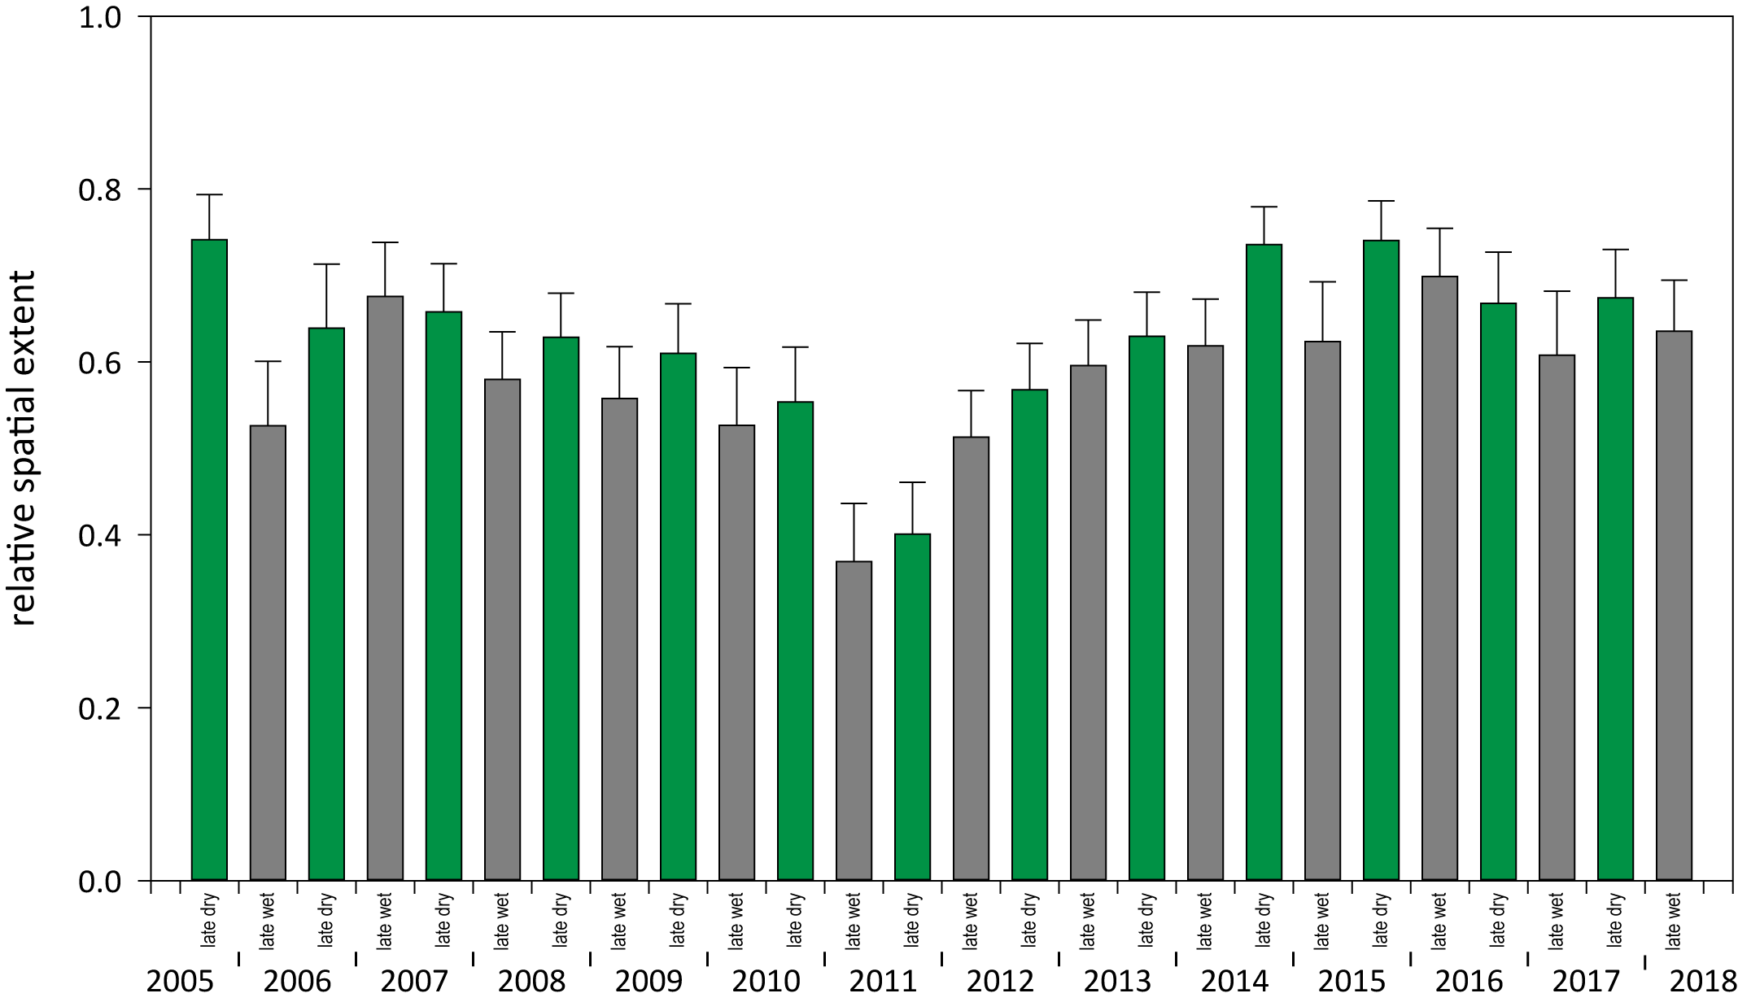
Figure 19. Average relative spatial extent of seagrass distribution at monitoring sites across inshore Reef
(locations, habitats and NRM pooled).

After the extreme weather events in 2009 to 2011 that caused widespread declines in seagrass area (Figure 19) and abundance, there was increasing proliferation of species displaying colonising traits, such as Halophila ovalis, at coast and reef sites (Figure 20). Over the 2017–18 monitoring period, the proportion of species displaying colonising traits remained around or lower than the Reef-wide average for each habitat type in coastal and estuarine habitats in favour of species displaying opportunistic or persistent traits (sensu Kilminster et al. 2015). The displacement of colonising species is a natural part of the meadow progression expected during the recovery of seagrass meadows. This is a positive sign of recovery for these habitats/meadows.
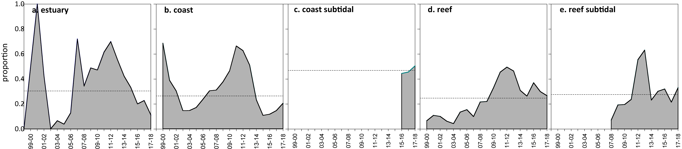
Figure 20. Proportion of total seagrass abundance composed of species displaying colonising traits
(e.g. Halophila ovalis) in: a) estuary intertidal, b) coastal intertidal, c) coast subtidal, d) reef intertidal and e) reef subtidal habitats (sites pooled) for the Reef (regions pooled) each monitoring period. Dashed line illustrates Reef average proportion of colonising species in each habitat type.

Seagrass reproductive status
Seagrass reproductive effort remained very low in reef intertidal and subtidal habitats and in estuarine habitats. By contrast, there were increases in reproductive effort in coastal habitat during the dry season, albeit with a high degree of variability depending on site. This resulted in the reproductive effort score remaining very poor in the Reef.
Reproductive effort had gradually been increasing at estuary, coastal and reef subtidal habitats since 2011, however, this year it decreased significantly in estuaries (based on non-overlapping standard error bars in the dry season compared to the previous dry season) and remained low in subtidal reefs. This occurred in conjunction with declining seagrass % cover in estuarine and reef habitats. Reproductive effort at reef intertidal habitats declined in 2014 and has remained very low since. Contrarily, reproductive effort in coastal habitats reached historically high levels in 2017–18 due to a record number of reproductive structures in the northern Wet Tropics, Burdekin and Mackay-Whitsunday regions. Despite these decreases in reproductive effort, seed banks continued to increase at subtidal reef habitats in 2017–18, a legacy of higher reproductive effort in the previous year. Coastal seed banks have continued to increase and remain high, but at estuary and intertidal reef habitats remain small or near absent.
Since the implementation of the MMP, the maximum reproductive effort and the inter-annual variability in reproductive effort has differed between habitats, and varied within and between years. Reef habitats, both intertidal and subtidal reef sites, had the lowest reproductive effort and smallest seed banks of all habitats (Figure 21, Figure 22).
Reproductive effort has been historically higher in estuary and coastal habitats but gradually decreased from 2006 to 2011 (in concert with decreasing seagrass cover) and has been increasing since. This increase continued in 2017–18 at coastal habitats, however, reproductive effort decreased significantly in estuaries. The historically high reproductive effort in coastal habitats is due to a record number of reproductive structures in the northern Wet Tropics (Yule Point), Burdekin (Bushland Beach and Jerona) and Mackay-Whitsunday (Midge Point). The decline in estuary habitats was most likely due to the declines in seagrass % cover. By contrast, reproductive effort at reef intertidal habitats declined in 2014 and has remained very low since.
Seed banks across the inshore Reef meadows were higher in late dry and greater in coastal than reef or estuarine habitats over the long-term (>10 years) (Figure 22). Coastal seed banks declined between 2008 and 2011, and have subsequently increased, but remain below the 2007–2008 levels. Seed banks continued to increase at subtidal reef habitats in 2017–18, but remain low or near absent at estuary and intertidal reef habitats, respectively.
The small seed banks could have been caused by reduced reproductive success (failure to form seeds) or loss of seed bank (germination or grazing). The low reproductive effort and low density of seeds in the seed bank in intertidal reef habitats in all regions (except Burnett Mary, where no reef sites are monitored), indicates a low seed production rate and vulnerability of these habitats to future disturbances, as recovery may be hampered.

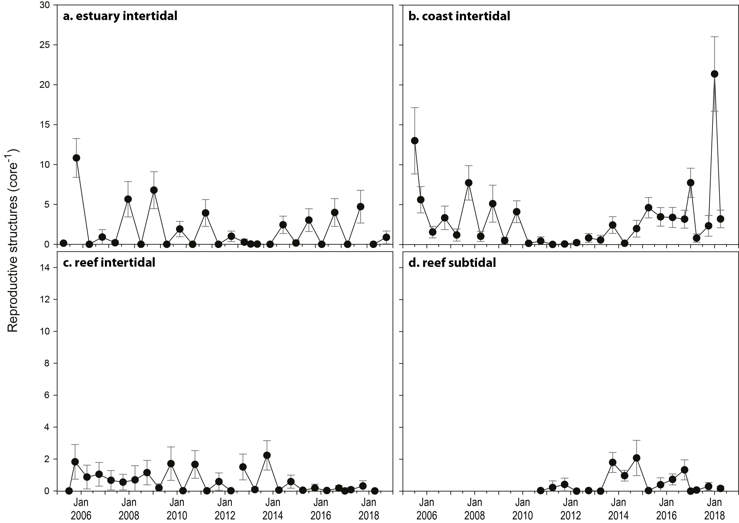
Figure 21. Seagrass reproductive effort (number of reproductive structures produced by all seagrass species) during the late dry of each monitoring period
for a) estuary intertidal; b) coast intertidal; c) reef intertidal; d) reef subtidal.
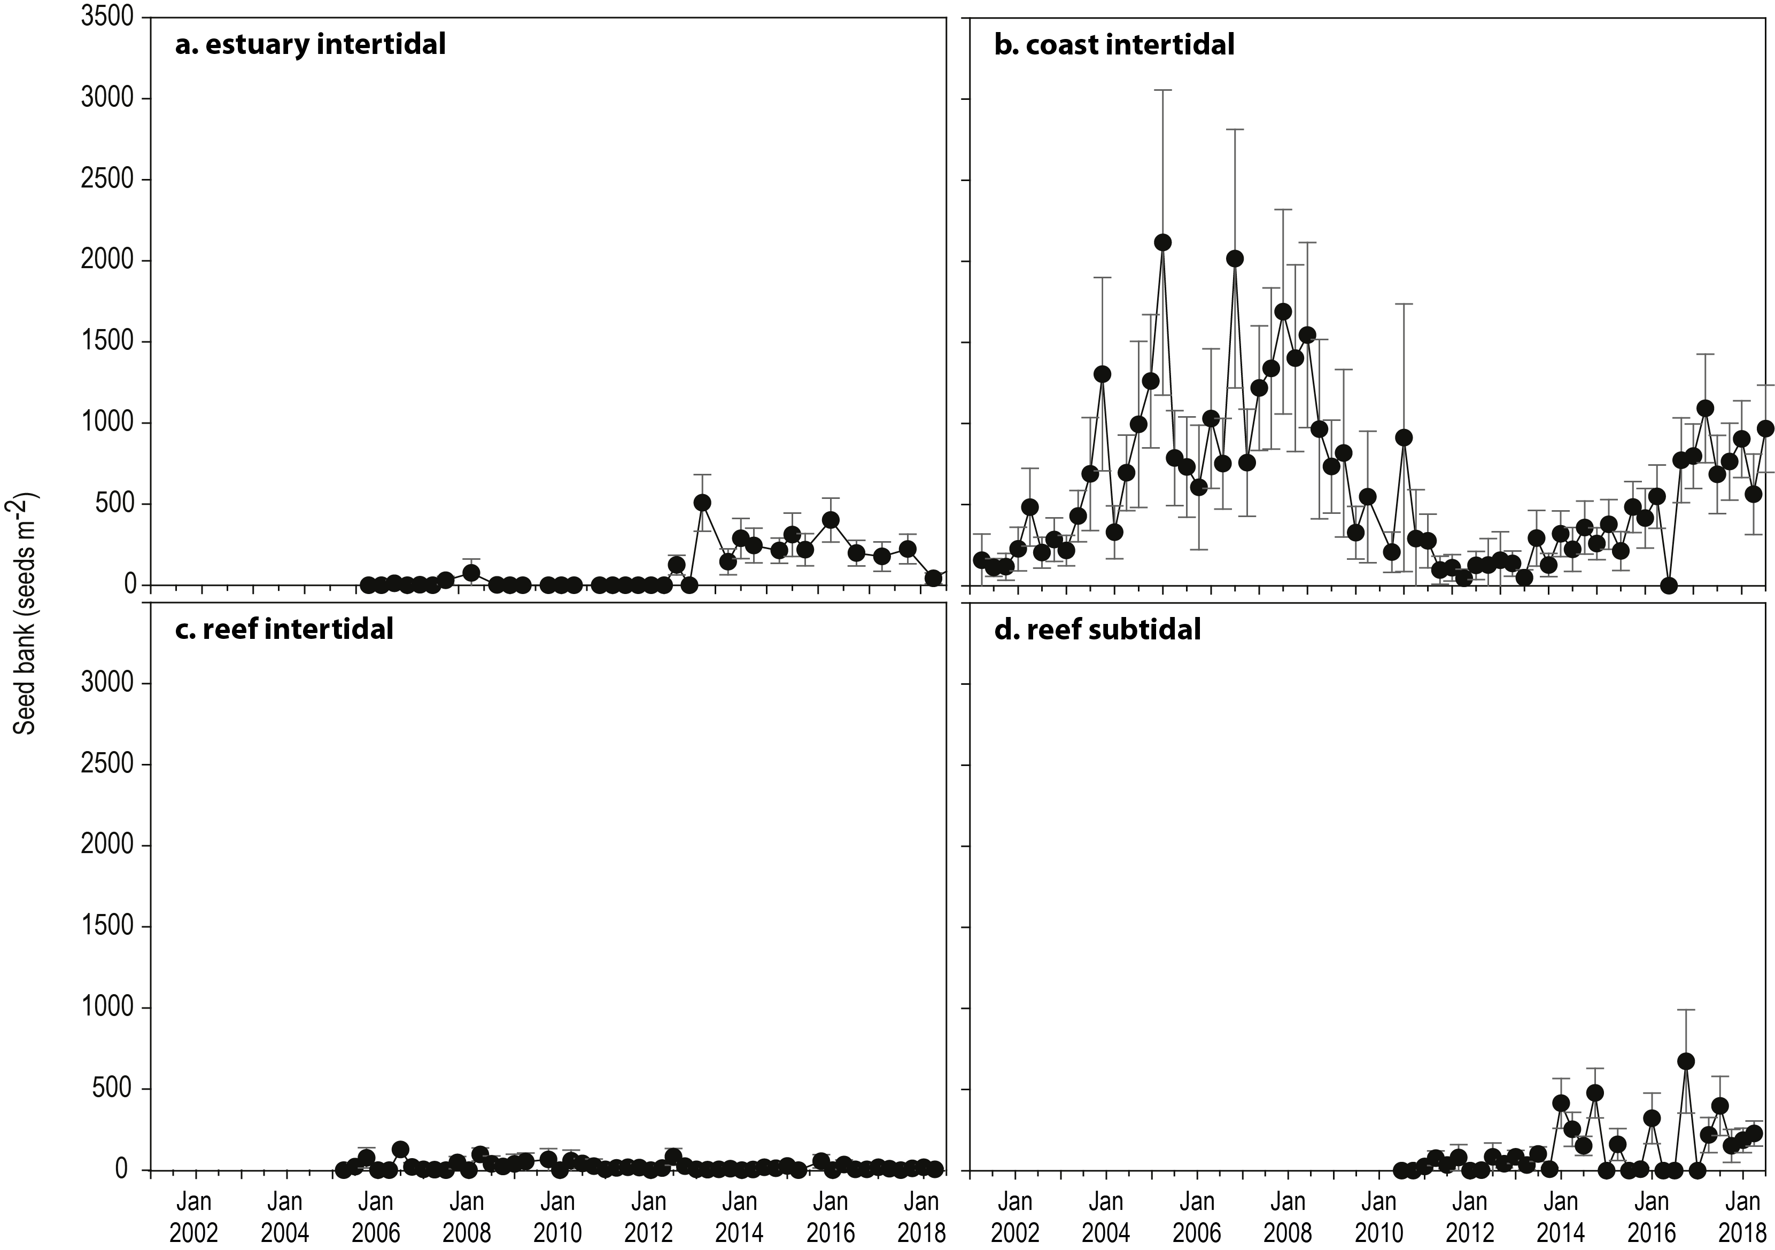
Figure 22. Average seeds banks (seeds per square metre of sediment surface, all sites and species pooled) in Reef seagrass habitats
: a) estuary intertidal; b) coast intertidal; c) reef intertidal; d) reef subtidal.

Seagrass leaf tissue nutrients
In 2017–18, the ratio of carbon (C) to nitrogen (N) was below the guideline value of 20 in all habitats except reef subtidal habitat. The C:N ratio is used as an indicator of water quality and seagrass condition because elevated carbon (and elevated C:N) suggests high light availability, while elevated N (lower C:N), indicates elevated nitrogen supply rates relative to growth requirements. Therefore, in all habitats other than reef subtidal, there was an oversupply of N relative to growth requirements.
In 2017–18, C:N ratio of seagrass leaves decreased at approximately a third of sites from the previous period, but this was not significant due to variation in this trend among regions and sites, and the number of sites remaining above the threshold of 20 was the lowest in 5 years. The lowest C:N values on average continue at Hamilton Island (10.1), Yule Point (12.8), and Shelburne Bay (12.9).
Multiple years of below average rainfall (Table 9) have been associated with small declines in dissolved inorganic nitrogen concentrations (NOx) particularly since 2014 in some of the basins of the Wet Tropics and Burdekin regions. However, nitrogen availability remains considerably elevated (Waterhouse et al. 2018).Light limitation could also be affecting the lower C:N. The findings indicate that N has been in elevated supply to seagrasses, which has been maintained despite low river discharge in most regions prior to 2017.
δ¹⁵N values can indicate the source of nitrogen. Very low (~0‰) or negative values of δ¹⁵N can indicate nitrogen sourced from nitrogen fixation (Peterson and Fry 1987; Owens 1988), which can supply one third to one half of seagrass demand (O'Donohue et al. 1991). Moderate values indicate internal sources from remineralisation (Peterson and Fry 1987; Owens 1988) and higher values (>3‰) can indicate anthropogenic sources (e.g. sewage (Costanzo et al. 2001; Jones et al. 2018) or from fertiliser (Udy et al. 1999)). In general, δ¹⁵N in seagrass tissues are low but variable (Figure 23), suggesting multiple sources of nitrogen. There is currently no indication or concern that anthropgenic point sources are strongly influencing seagrass N supply.
The less negative leaf tissue δ¹³C values at reef sites (Figure 23) suggest higher C uptake (and therefore less fractionation) (Grice et al. 1996), while at coastal sites the more negative values suggest lower C uptake (Figure 23).
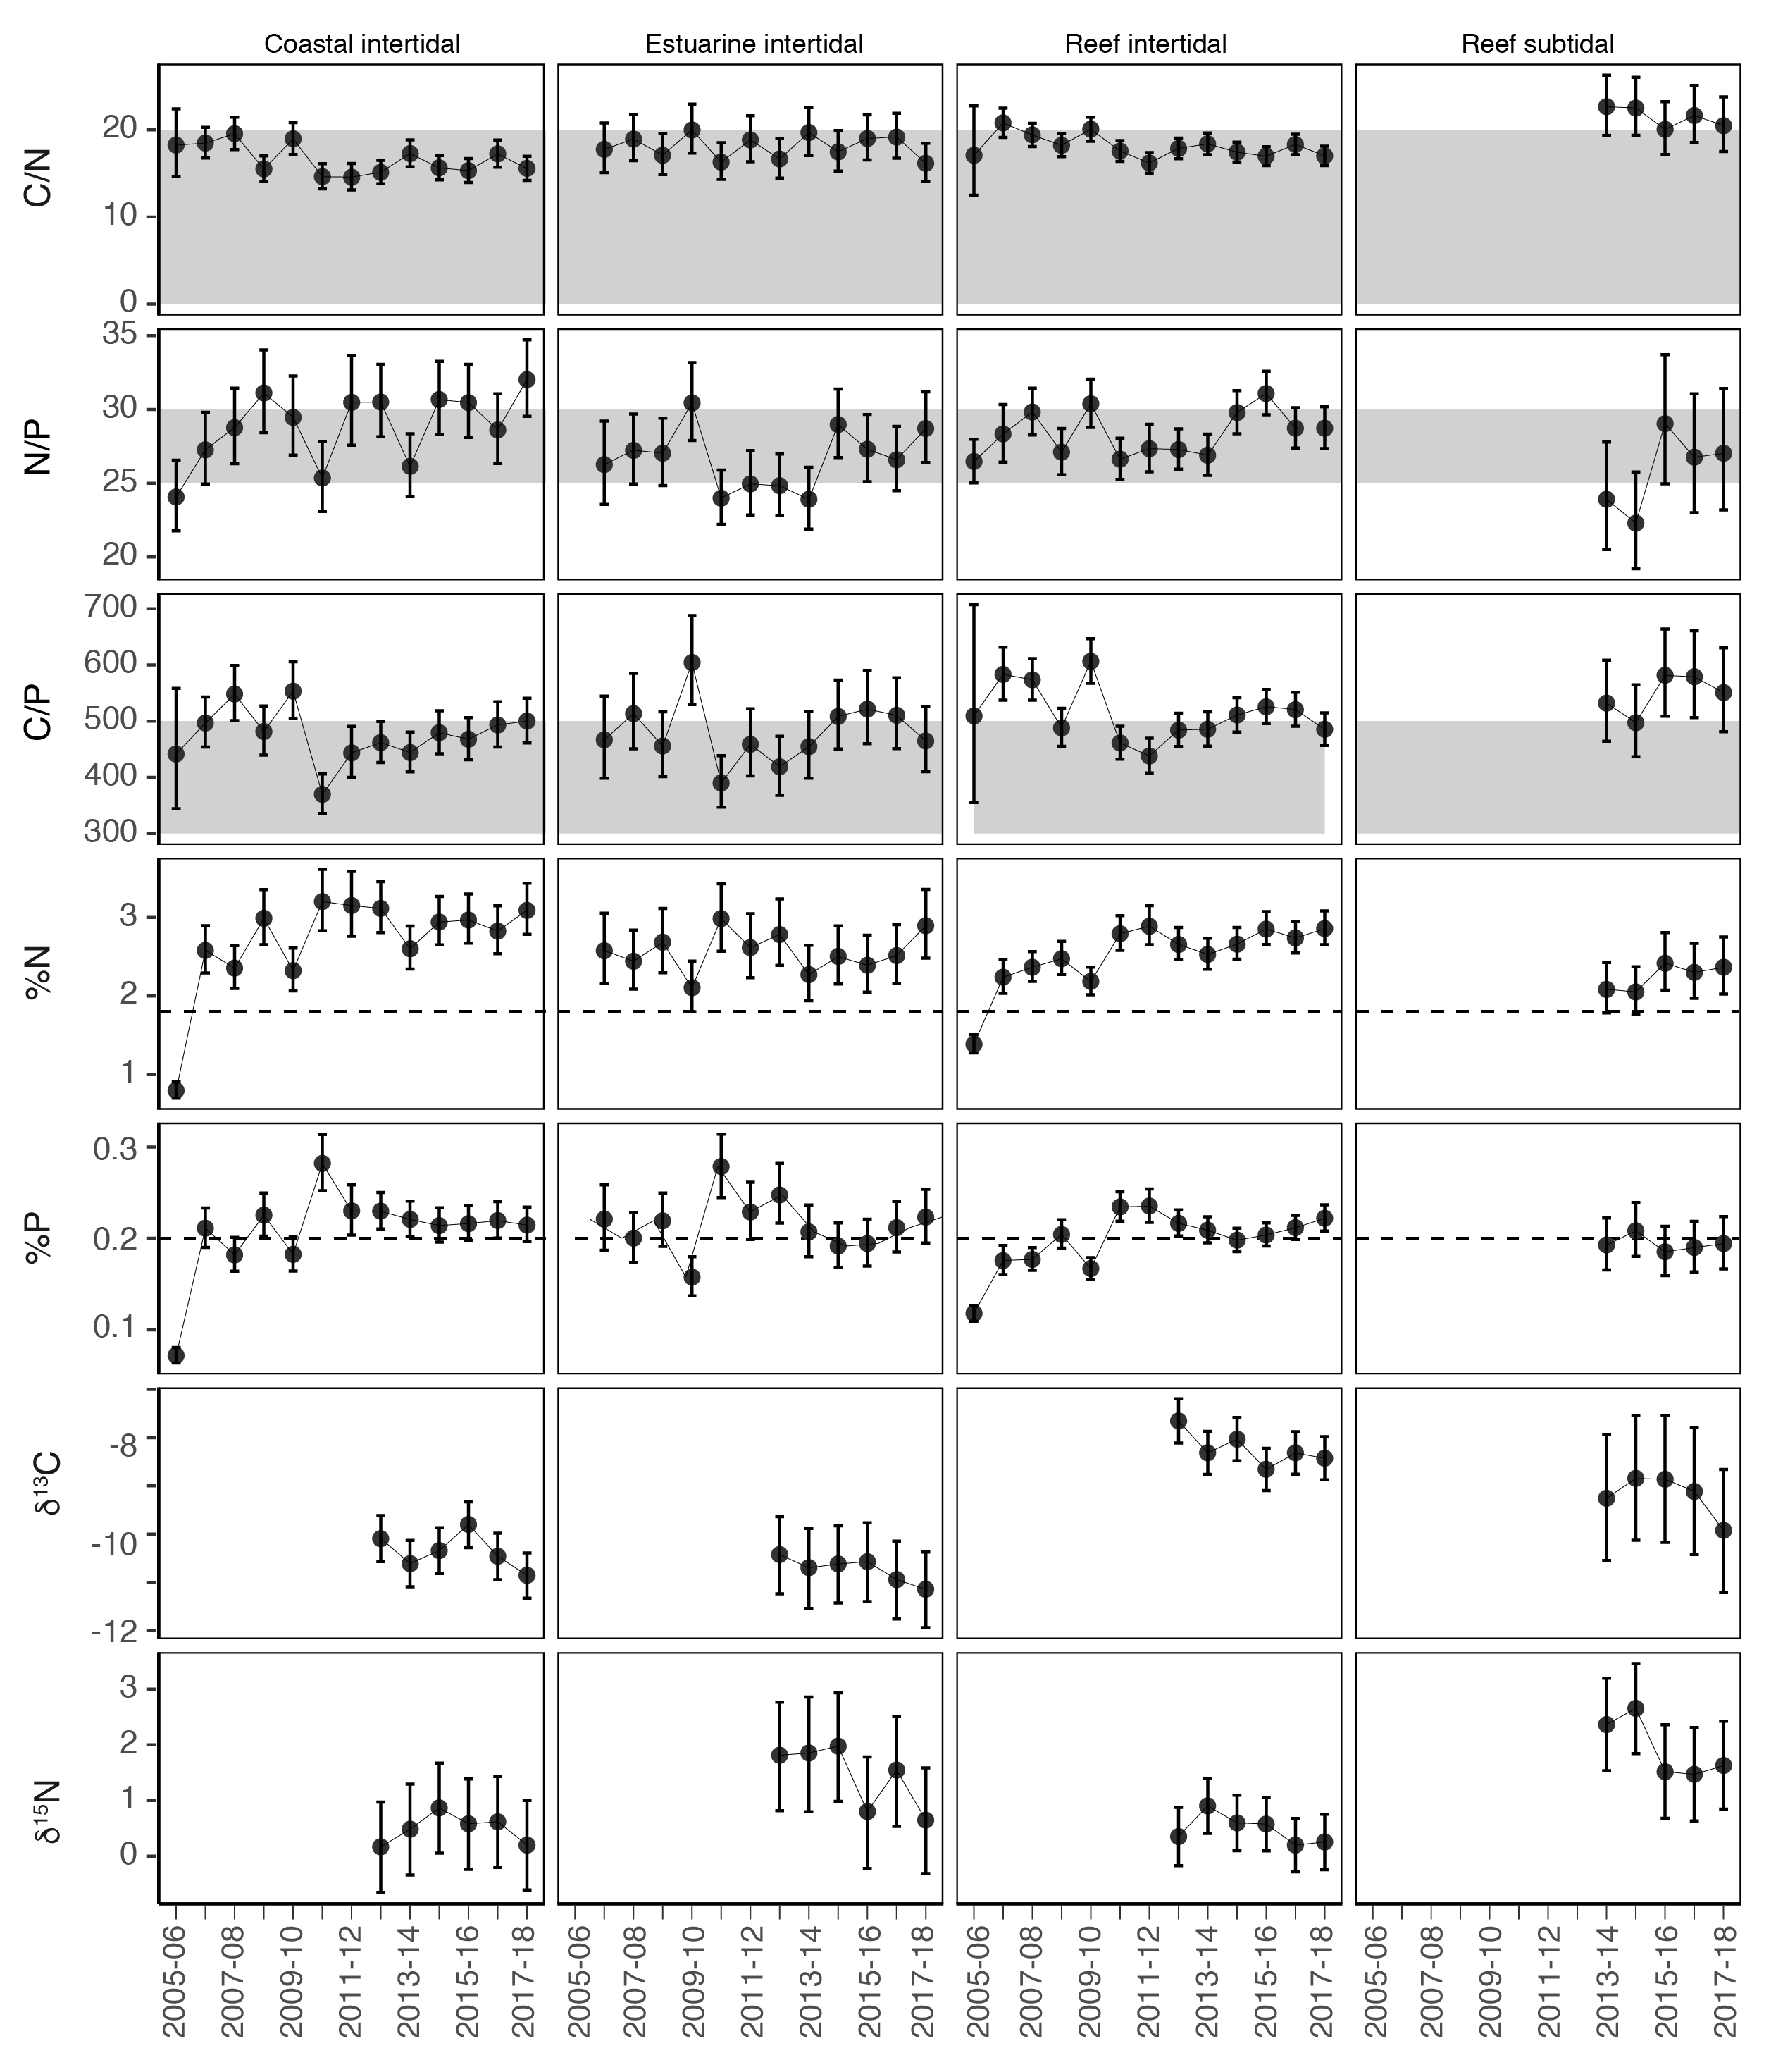
Figure 23. Seagrass leaf tissue nutrient elemental ratios (C:N:P) and concentrations (%N, %P, δ¹³C and δ¹⁵N) for each seagrass habitat each year
(± SE) (foundation species pooled). Horizontal shaded bands or dashed lines represents the accepted seagrass guideline values, where: C:N ratios within the band may indicate reduced light availability and/or N enrichment; N:P ratios above the band indicate P limitation, below indicate N limitation and within indicates replete, and; C:P ratios within the band may indicate nutrient rich habitats (large P pool). Dashed lines in %N and %P indicate global median values of 1.8 % and 0.2 % for tissue nitrogen and phosphorus, respectively (Duarte 1990).

Epiphytes and macroalgae
Epiphyte cover on seagrass leaves during 2017–18 was below or at the Reef-wide long-term average in all habitats except reef subtidal, where it has remained above average over the past four years due to high epiphyte cover at all sites (Figure 24).
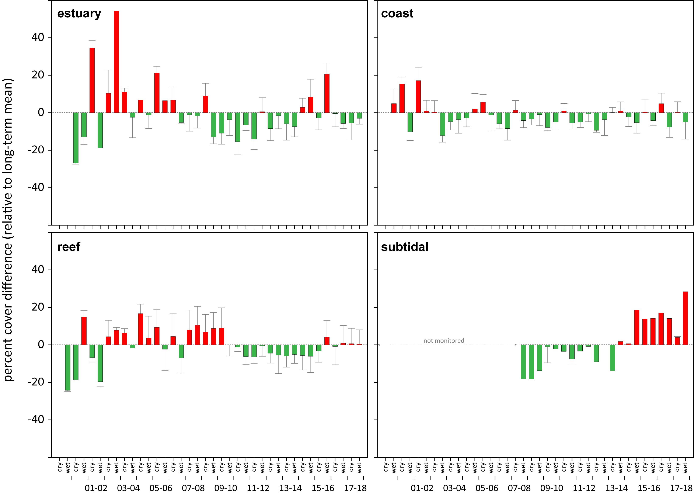
Figure 24. Epiphyte abundance (percent cover) relative to the long-term average (the zero axis) for each Reef seagrass habitat
(sites pooled, ± SE). Reef long-term average; estuarine = 25.1±5.6% coastal=17.8±3.7%, reef = 22.8±4.2%, subtidal= 20.6±3.1%.

Macroalgae abundance was generally low and stable at Reef seagrass habitats, with little change this year (Figure 25). A higher than long-term average at reef subtidal habitats during the late dry season has been evident at all sites over the last 3 years.
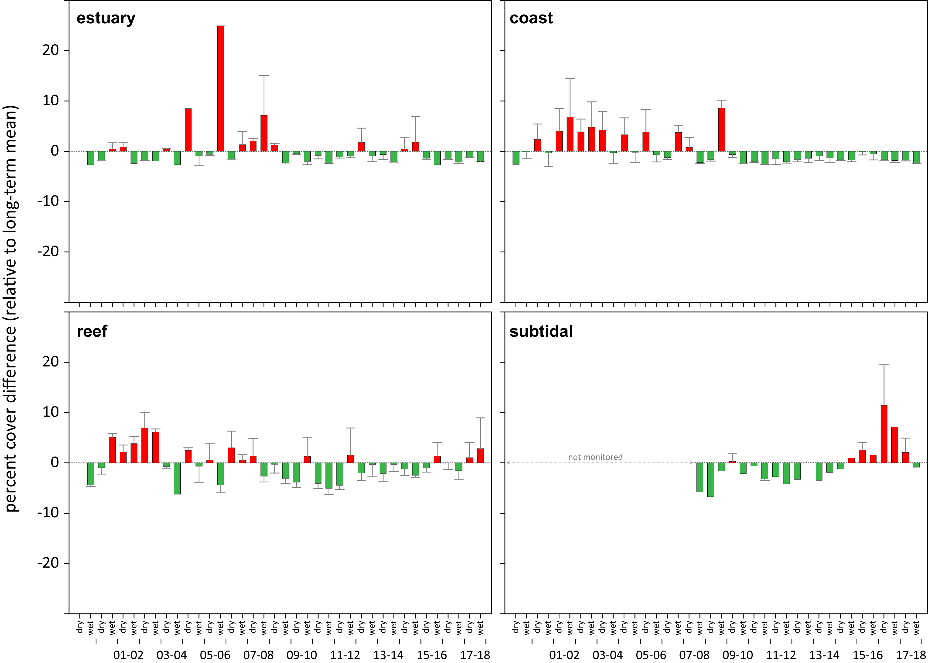
Figure 25. Macroalgae abundance (percent cover) relative to the long-term average for each inshore Reef seagrass habitat
. (sites pooled, ± SE). Reef long-term average; estuarine = 2.3±1.0%, coastal=2.5±1.2%, reef = 6.9±1.9%, subtidal = 6.6±2.0%.

Regional Reports

This section presents detailed results on the condtion and trend of indicators within Regions, and relates the results to local environmental factors including:
- monthly 3pm wind speed relevant to each monitoring location
- annual daytime tidal exposure at each monitoring site
- daily light each monitoring location
- sediment grain size composition at each monitoring site
- tables detailing statistical analysis.

Cape York

2017–18 Summary
Seagrass meadows across the Cape York NRM region declined in overall condition in 2017–18, to a condition of poor, due to declines in all condition indicators:
- abundance score was moderate
- tissue nutrient score was poor
- reproductive effort score was very poor.
On average, seagrass abundance marginally decreased relative to the previous period. Seagrass abundance (% cover) declined at 42% of sites across all habitats, predominately in coastal and intertidal reef meadows. Most declines occurred in meadows located in the south of the region.
Seagrass leaf tissue nutrient concentrations in 2017–18 corresponded with the higher ‘green’ water exposure, indicating that the availability of nitrogen (N), particularly in coastal habitats, has increased relative to the demand for carbon for growth. However, the N source appears primary natural fixation rather than anthropogenic, and levels are not of concern as they do not appear to have significantly influenced epiphytic and macroalgae abundances.
The capacity for the meadows to recover across the Cape York region is variable between habitats. The large seed banks which persist at intertidal coastal meadows could aid recovery in the short term, if environmental conditions are favourable for germination, but the low reproductive effort may limit replenishment and maintenance of the bank in the near future. The lack of seeds in most intertidal reef meadows currently limits recovery, however the increased reproductive effort may improve capacity in the near future.
Lastly, the region experienced above average elevated within-canopy water temperatures for the sixth consecutive year, which may have exacerbated chronic stress conditions in the intertidal meadows, further impacting growth.
An assessment of long-term trends in other Cape York habitats is affected by changes in the number, onset and duration of monitoring at individual sites. An examination of the long-term trend shows seagrass % cover progressively decreased at intertidal reef habitats across Cape York from 2003 to 2012, with relatively little improvement since. Coastal intertidal and subtidal habitats monitored since 2012 and 2015 respectively, generally showed no significant trend. Similarly, meadow extent across the region has been relatively stable since 2012.
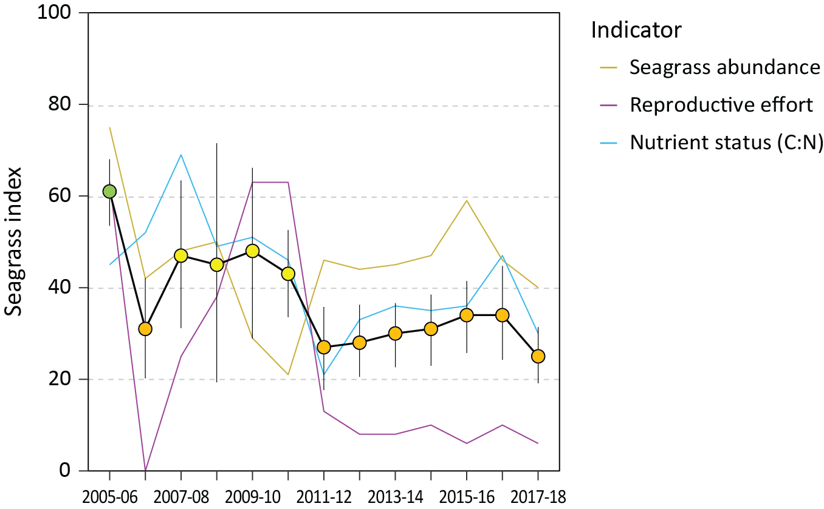
Figure 26. Seagrass condition index (±SE) with contributing indicator scores for the Cape York NRM region
(averaged across habitats and sites). Index scores scaled from 0-100 and graded: ● = very good (81-100), ● = good (61 - 80), ● = moderate (41 - 60), ● = poor (21 - 40), ● = very poor (0 - 20). NB: Scores are unitless.

Climate and environmental pressures
River discharge during the 2017–18 wet season was slightly above the long-term average in all basins within the Cape York NRM region, despite lower than average rainfall (Figure 27). Wind was also above the long-term average following two previous years of windy conditions (Figure 92). The inshore waters of Cape York had predominantly secondary water type (‘green’, phytoplankton rich water), and some primary (‘brown’, sediment laden) turbid water exposure through the wet season (December-April; Figure 27). Shelburne Bay sites (SR1 and SR2) had the highest exposure to turbid primary water, consistent with previous years. The frequency of exposure to both primary and secondary water ranged from 36% to 86% of wet season weeks at seagrass monitoring sites (Figure 27).
Daily incident light (I_{d}, mol m⁻² d⁻¹) reaching the top of the seagrass canopy is generally very high at all Cape York sites (Reef‐wide long‐term average = 12.7 mol m⁻² d⁻¹) (Figure 106). However in 2017–18, daily incident light (11.9 mol m⁻² d⁻¹) was below the long-term average (12.9 mol m⁻² d⁻¹) (Figure 27). This was most likely a consequence of the shorter/incomplete logging duration, where due to access restrictions, loggers are deployed beyond six months which increases risk of individual logger failure due to battery depletion or sensor fouling.
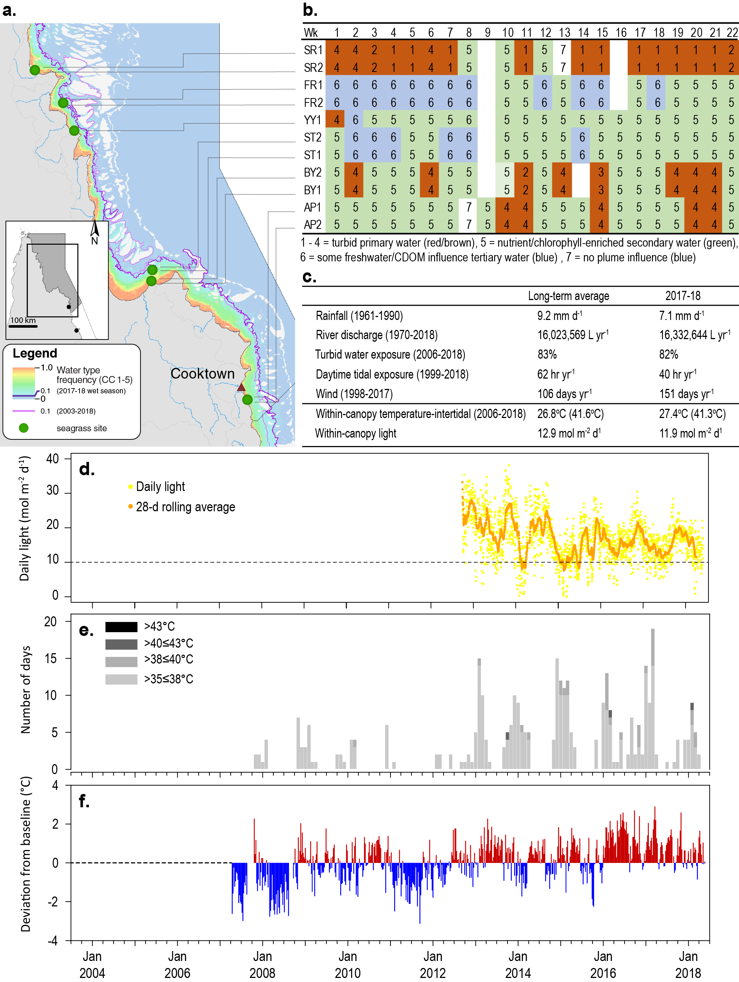
Figure 27. Environmental pressures in the Cape York region
including: a. frequency of exposure to turbid water (colour classes 1-5) (from Gruber et al. 2019), b. wet season water type at each site; c. average conditions over the long-term and in 2017–18; d. daily light and the 28-day rolling mean of daily light for all sites; e. number of day temperature exceeded 35°C, 38°C, 40°C and 43°C, and; f. deviations from 13-year mean weekly temperature records.
2017–18 was the sixth consecutive year intertidal within-canopy temperatures were above the long-term average and the second highest average annual temperatures (27.4°C) since 2006 (Figure 27). Maximum within-canopy temperatures exceeded 35°C for a total of 30 days during 2017–18 (Figure 27), with the highest temperature recorded at 41.3°C (BY1, 3pm 26Feb18). Daily tidal exposure (hours water has drained from the meadow) was below the long‐term average for the second consecutive year (Figure 27, Figure 98), which may have provided some respite from the elevated temperatures.
In the Cape York NRM region, reef habitats remain dominated by sands and coarser sediments, while coastal habitats contained a greater proportion of mud (Appendix 3, Figure 113, Figure 114).

Inshore seagrass and habitat condition
Four seagrass habitat types were assessed across the Cape York region in 2017–18, with data from 12 of the 15 long-term monitoring sites (Table 11).
Table 11. List of data sources of seagrass and environmental condition indicators for each seagrass habitat type in the Cape York NRM region
. For site details see Table 2 and Table 3. Open square indicates not measured in 2017-18. drop camera sampling (QPWS), *Seagrass-Watch.
Habitat | Site |  | abundance | composition | distribution | Reproductive effort | seed banks | Leaf tissue nutrients | Meadow sediments | Epiphytes | Macroalgae
coastal intertidal | BY1 | Bathurst Bay
coastal intertidal | BY2 | Bathurst Bay
coastal intertidal | SR1 | Shelburne Bay
coastal intertidal | SR2 | Shelburne Bay
coastal subtidal | BY3 | Bathurst Bay
coastal subtidal | BY4 | Bathurst Bay
coastal subtidal | LR1 | Lloyd Bay
coastal subtidal | LR2 | Lloyd Bay
reef intertidal | AP1 | Archer Point
reef intertidal | AP2 | Archer Point
reef intertidal | FR1 | Farmer Is. (Piper Reef)
reef intertidal | FR2 | Farmer Is. (Piper Reef)
reef intertidal | ST1 | Stanley Island (Flinders Group)
reef intertidal | ST2 | Stanley Island (Flinders Group)
reef intertidal | YY1* | Yum Yum Beach (Weymouth Bay)
Reef subtidal | FG1 | Flinders Island (Flinders Group)
Reef subtidal | FG2 | Flinders Island (Flinders Group)

Seagrass index and indicator scores
In the 2017-18 monitoring period, the seagrass condition index score for Cape York region reduced slightly since the previous monitoring period, but the overall grade remained poor (Figure 28). The reduction was due to lower scores across all three condition indicators.
The greatest score reduction occurred in nutrient status, which along with seagrass abundance lowered grade from the previous year from moderate to poor (Figure 28). Reproductive effort remained in the very poor grade.
Overall, the Cape York seagrass condtion index remains well below the 2005–06 baseline and in 2017–18 was the lowest score since the addition of new sites in 2012-13.
An examination of the long-term trends across the Cape York NRM region shows the indicators of seagrass condition have either progressively decreased since last decade (e.g. % cover and tissue nutrients) or remained low for the duration of the overall monitoring (e.g. reproductive effort) (Figure 28).

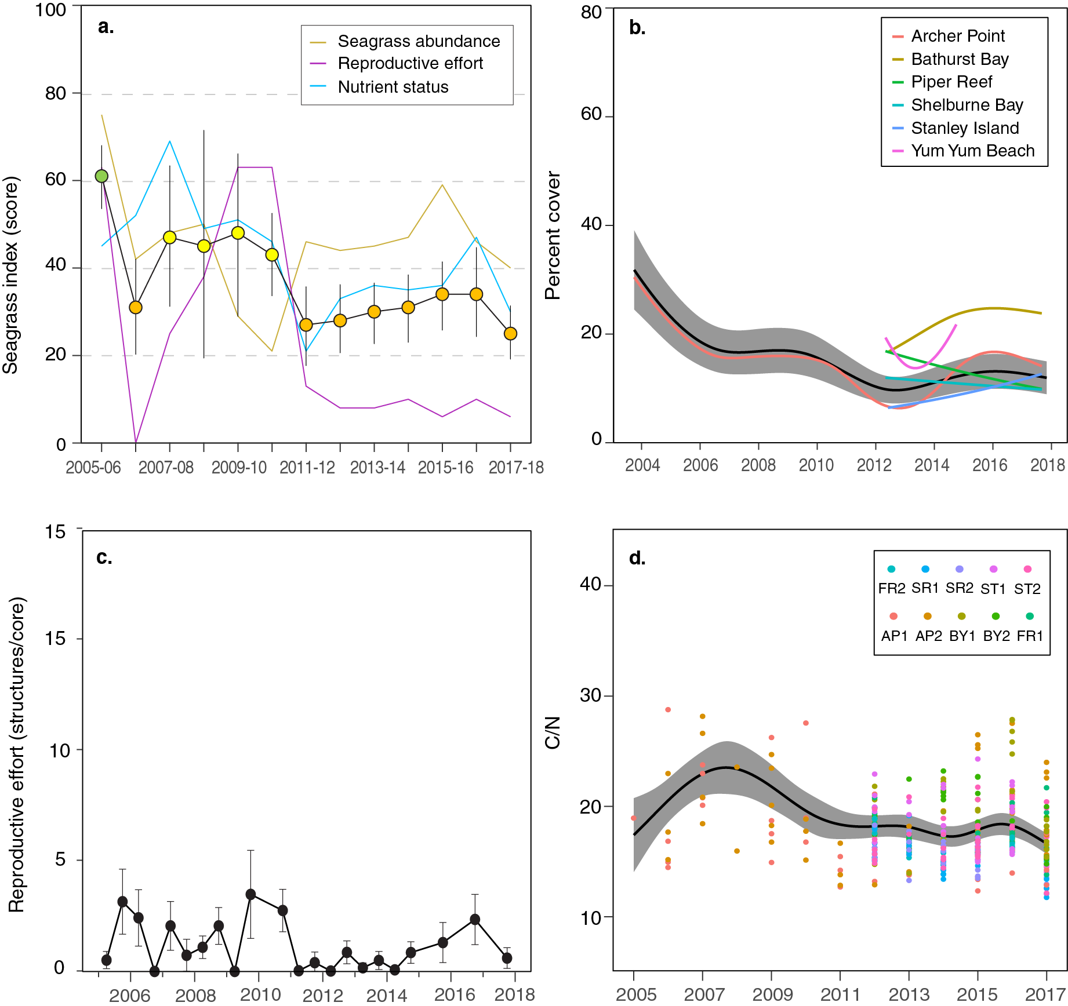
Figure 28. Temporal trends in the Cape York seagrass condition index and the indicators used to calculate the index
: a. seagrass condition index (circles) and indicator trends (lines); b. GAM plots of seagrass abundance (% cover) trends for each location (coloured lines) and the region (black line with grey shaded area defining 95% confidence intervals); c. average number of reproductive structures (±SE) (GAM not possible due to high count of zero values); and d. elemental ratios (atomic) of leaf tissue C:N nutrient content at each site (coloured circles) and regional trend represented by a GAM plot as dark line with shaded areas defining 95% confidence intervals of the trend.

Seagrass abundance, composition and extent
The decline in seagrass abundance in 2017–18 appears a consequence of reductions in per cent cover at 42% of sites across all habitats; except the subtidal reef habitats in the Flinders Group which increased (Figure 29).

An examination of the long-term trend in seagrass abundance shows seagrass per cent cover progressively decreased at intertidal reef habitats across Cape York from 2003 to 2012, with relatively little improvement since (i.e. no trend) (Figure 29, Table 23). Coastal intertidal and subtidal habitats which have only been monitoring since 2012 and 2015 respectively, generally showed no trend (Figure 29, Table 23).

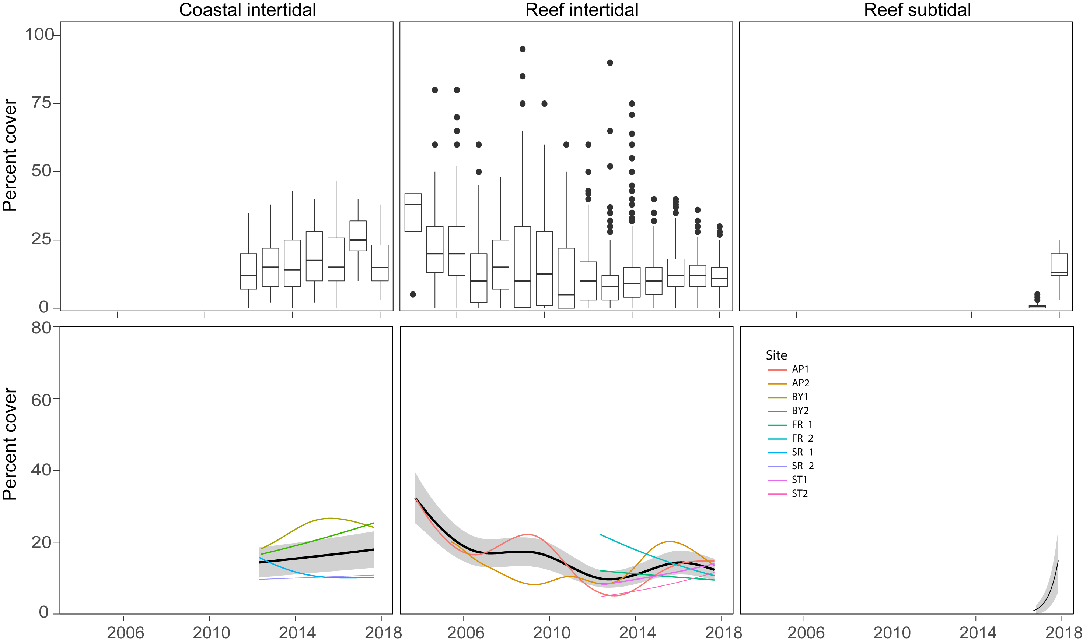
Figure 29. Seagrass per cent cover measures per quadrat (sites pooled) and long-term trends for each habitat monitored in the Cape York region from June 2005 to May 2018.
Whisker plots (top) show the box representing the interquartile range of values, where the boundary of the box closest to zero indicates the 25th percentile, a line within the box marks the median, and the boundary of the box farthest from zero indicates the 75th percentile. Whiskers (error bars) above and below the box indicate the 90th and 10th percentiles, and the dots represent outlying points. GAMM plots (bottom), show trends for each habitat and coloured lines represent individual site trends.

In 2017–18, intertidal and subtidal coastal seagrass habitats in the Cape York NRM region were composed of above Reef-average proportion of species displaying colonising traits (Figure 30). Subtidal habitats increased their composition of foundational species from the previous monitoring period; conversely intertidal habitats increased in composition of species displaying colonising traits (Figure 30). Fluctuations over the long-term suggests meadows are dynamic in nature, with possibly more physical disturbance at intertidal habitats in 2017–18.
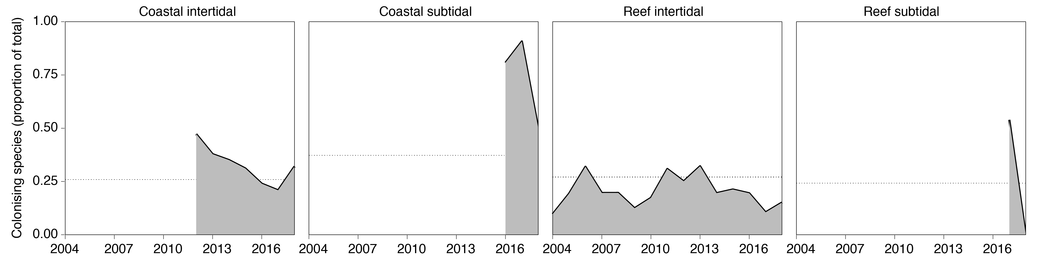
Figure 30. Proportion of seagrass abundance composed of species displaying colonising traits at inshore habitats in the Cape York region
.The dashed line represents Reef long-term average for each habitat type.
Seagrass spatial extent mapping was conducted within all monitoring meadows to determine if changes in abundance were a consequence of the meadow landscape changing and to indicate if plants were allocating resources to colonisation (asexual reproduction). Prior to 2012, the only meadow extent mapping in the Cape York region was conducted at Archer Point. The meadows within monitoring sites on the reef flat at Archer Point have fluctuated within and between years (Figure 31), primarily due to changes in the landward edge and appearance of a drainage channel from an adjacent creek (data not presented). Post 2011, additional reef and coastal meadows in the Cape York region were included. Overall, meadow extent has been relatively stable since 2012 (Figure 31).
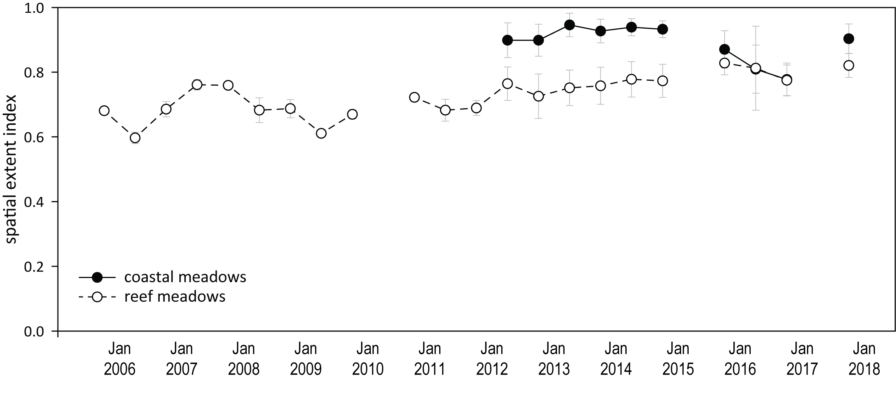
Figure 31. Change in spatial extent of seagrass meadows within monitoring sites for each habitat and monitoring period across the eastern Cape York NRM region.

Seagrass reproductive status
Seed banks are only measured at intertidal sites across Cape York and are dominated by Halodule uninervis. Seed density has been increasing at coastal habitats since 2012 and was considerably higher at coastal than reef sites this year. At reef sites, there has been few or no seeds recorded since 2013, and these meadows may have poor recovery rates if there is substantial decline in seagrass abundance. Total reproductive effort declined at coastal habitats in 2017–18, but conversely increased at reef habitats across the region, although still remained relatively low (Figure 32).
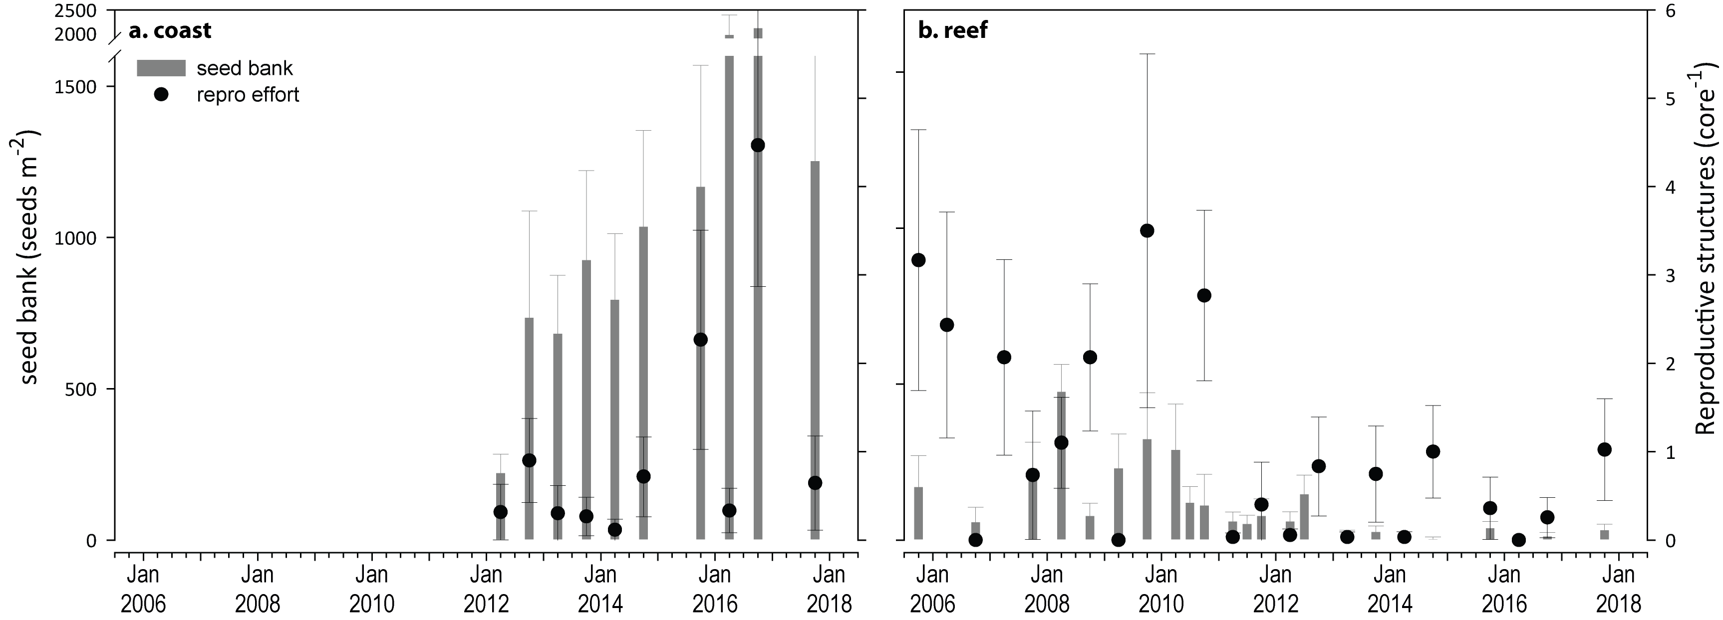
Figure 32. Seed banks and reproductive effort at inshore intertidal coastal (a) and reef (b) habitats in the Cape York region
(species and sites pooled). Seed banks (bars ± SE) presented as the total number of seeds per m² sediment surface. Reproductive effort for late dry season (dots ± SE) presented as the average number of reproductive structures per core.

Seagrass leaf tissue nutrients
Seagrass leaf molar C:N ratios decreased this year, particularly at coastal habitats (Figure 33). This indicates that the availability of nitrogen (N) has increased relative to the demand for carbon for growth. Leaf N:P ratios and %N also increased (Figure 33), providing further evidence that nitrogen has been elevated in the seagrass habitats of Cape York, but the low and reducing δ¹⁵N (Figure 33) suggests this is not an anthropogenic source of N.

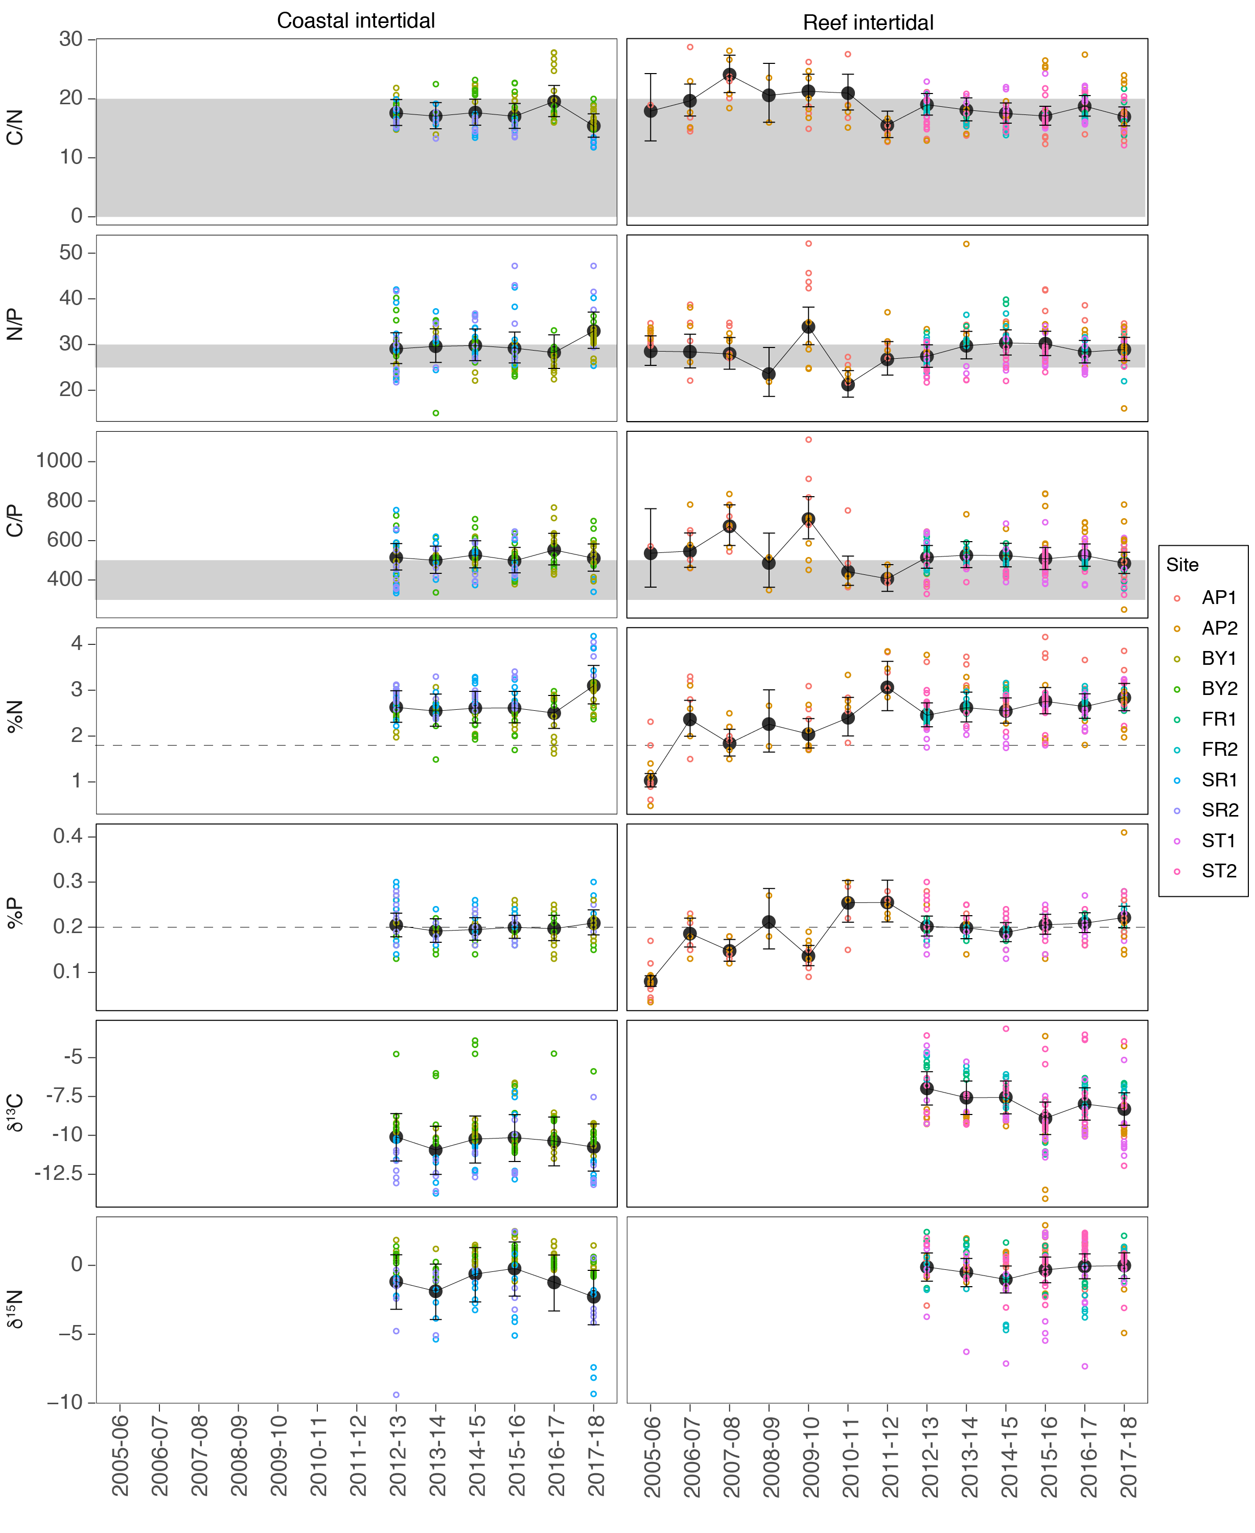
Figure 33. Seagrass leaf tissue nutrient elemental ratios (C:N:P) and concentrations (%N, %P, δ¹³C and δ¹⁵N) for each habitat in the Cape York NRM region
(± SE) (foundation species pooled). Horizontal shaded bands or dashed lines represents the accepted seagrass guideline values, where: C:N ratios within the band may indicate reduced light availability and/or N enrichment; N:P ratios above the band indicate P limitation, below indicate N limitation and within indicates replete, and; C:P ratios within the band may indicate nutrient rich habitats (large P pool). Dashed lines in %N and %P indicate global median values of 1.8 % and 0.2 % for tissue nitrogen and phosphorus, respectively (Duarte 1990).

Epiphytes and macroalgae
Epiphyte cover on seagrass leaf blades remained below the long-term average at coastal habitats, and fluctuated close to the long-term average at reef habitats (Figure 34).
Per cent cover of macroalgae was variable between locations, and remained above the Reef long-term average for reef habitats in the central and north of the region for the sixth consecutive year (Figure 34). Macroalgae cover at coastal sites has varied little and this year remained near to the Reef-wide long-term average (Figure 34).
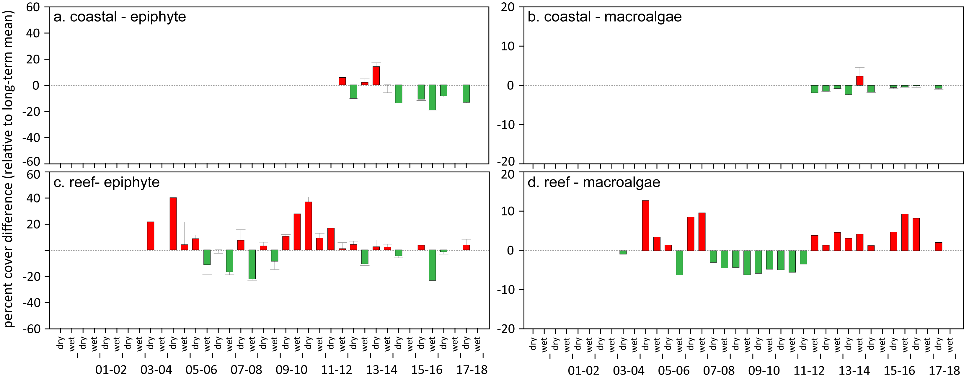
Figure 34. Deviations in mean epiphyte and macroalgae abundance (% cover) at monitoring habitats in the Cape York region, relative to the Reef long-term average
(sites pooled, ±SE). Green bars indicate positive deviations for condition, red bars negative.

Wet Tropics

2017–18 Summary
Seagrass meadows within the Wet Tropics were the only ones across the Reef to show an overall improvement in seagrass condition index in 2017–18, but they remain in a vulnerable state, particularly in the southern Wet Tropics region. Overall, the status of seagrass condition in the northern Wet Tropics NRM region was moderate, but remained very poor in the south (Figure 35). Combined regional condition was poor (Figure 7). Contributing indicators in the north were:
- abundance score was moderate
- reproductive effort score was poor
- tissue nutrient score was poor.
Contributing indicators in the south were:
- abundance score was poor
- reproductive effort score was very poor
- tissue nutrient score was poor.
Seagrass abundance increased relative to the previous period, with increases in % cover at nearly 60% of sites, predominately in reef meadows. In the north, this was likely assisted by the lower river discharge, adequate light (>10 mol m⁻² d⁻¹) and warmer sea temperatures. In the south, the improvement was not as great, possibly due to lower available light (<10 mol m⁻² d⁻¹), due to above-average river discharge, coupled with the warmer temperatures exacerbating chronic stress conditions in the seagrass and further impacting growth.
An examination of temporal trends in seagrass abundance across the region show a significant decrease over the long-term, however trends vary between the sub-regions reflecting a complex range of environmental and biological processes affecting recovery rates. In the north, 40% of reef sites have significantly declined in abundance over the long-term, while no trend was apparent for the remaining sites or habitats. In the south, only sites in coastal habitats have significantly declined over the long-term.
The declines are a consequence of the significant losses that occurred from 2009 to 2011, the result of multiple years of above-average rainfall and severe weather events. Recovery of seagrass meadows post 2011 has been challenged, particularly in the south, by unstable substrates (legacy of cyclone Yasi), chronic poor water quality (high turbidity, light limitation, elevated temperatures), and limited recruitment capacity.
While meadows in the north have maintained a healthy seed bank and reproductive effort peaked during 2017–18, in the south reproductive structures and seed banks remained absent. This has limited recovery in the south to relying on expansion of remnant plants or recruitment from elsewhere (e.g., vegetative fragments). The absence of reproductive structures and seed banks may render the seagrass at risk from further disturbances, as recovery potential remains extremely low without a seed bank.
Across both the north and south, leaf tissue nutrients (C:N), have remained unchanged for a number of years, and suggest an excess of nitrogen relative photosynthetic C uptake (C:N <20), which is consistent with the high frequency of exposure to secondary water. Nutrient status therefore remained poor. Examination of the sub-regional indicator scores highlights the differences between the seagrass condition index in the north and south of the Wet Tropics. The increase in the seagrass condition index was primarily due to improved scores in abundance, assisted in the north by reproductive effort.
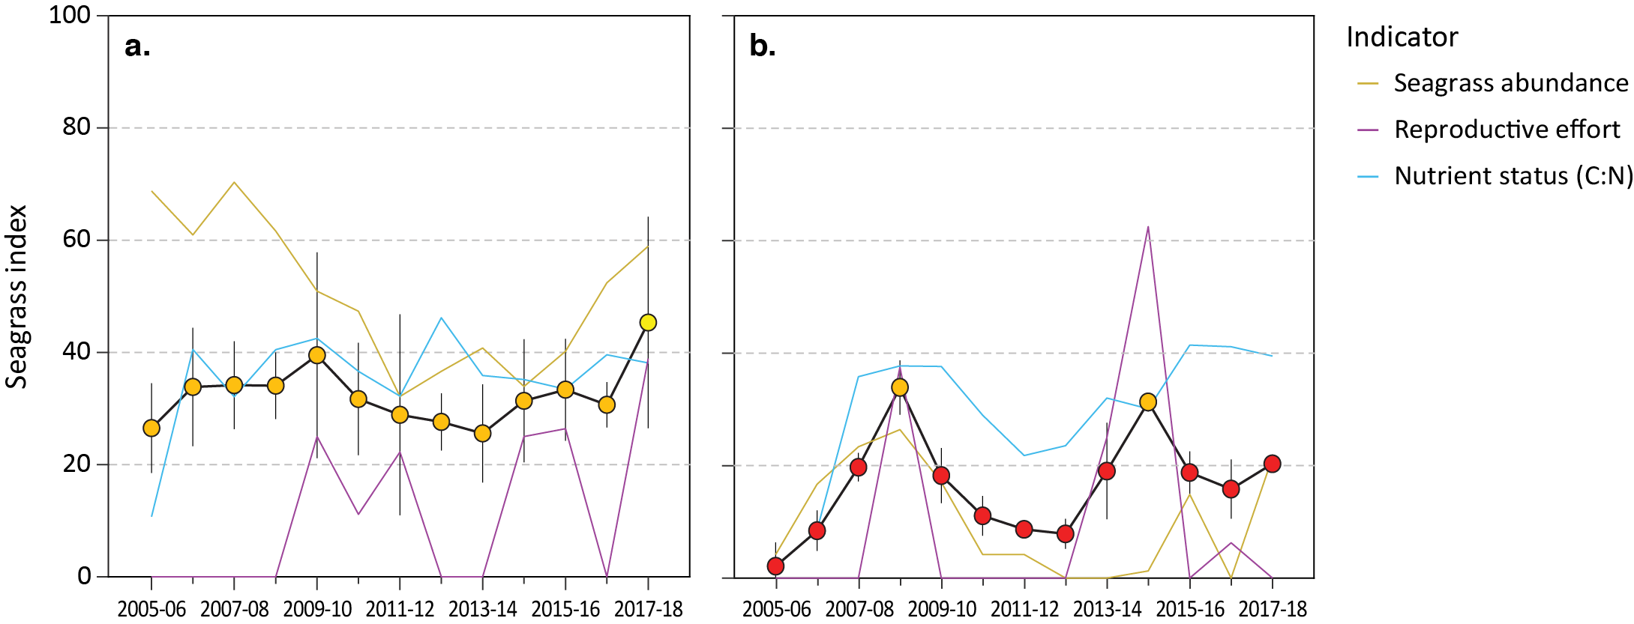
Figure 35. Report card of seagrass index and indicators for the northern (a.) and southern (b.) Wet Tropics NRM region
(average across habitats and sites). Values are indexed scores scaled 0–100 and graded: ● = very good (81-100), ● = good (61 - 80), ● = moderate (41 - 60), ● = poor (21 - 40), ● = very poor (0 - 20). NB: Scores are unitless.

Climate and environmental pressures
Annual rainfall and river discharge were slightly above the long-term average across the northern Wet Tropics during 2017–18. Exposure to primary (‘brown’ sediment laden) or secondary (‘green’, phytoplankton rich) turbid water was similar to the long-term average and highly variable among sites (Figure 36). Coastal sites at Yule Point (YP1 and YP2) were the only sites exposed to ‘brown’, sediment laden, waters (15–30% of wet season weeks), while the remaining reef sites were only exposed to ‘green’, phytoplankton rich, waters (20–33% of wet season weeks) (Figure 36). Within-canopy light was above 10 mol m⁻² d⁻¹ on average (12.0 mol m⁻² d⁻¹ in 2017–18) but was lower than the long-term average (12.7 mol m⁻² d⁻¹) (Figure 36). There was higher than average number of days where wind speeds exceeded 25 km hr⁻¹ (Figure 93), which resuspend fine sediments into the water column.
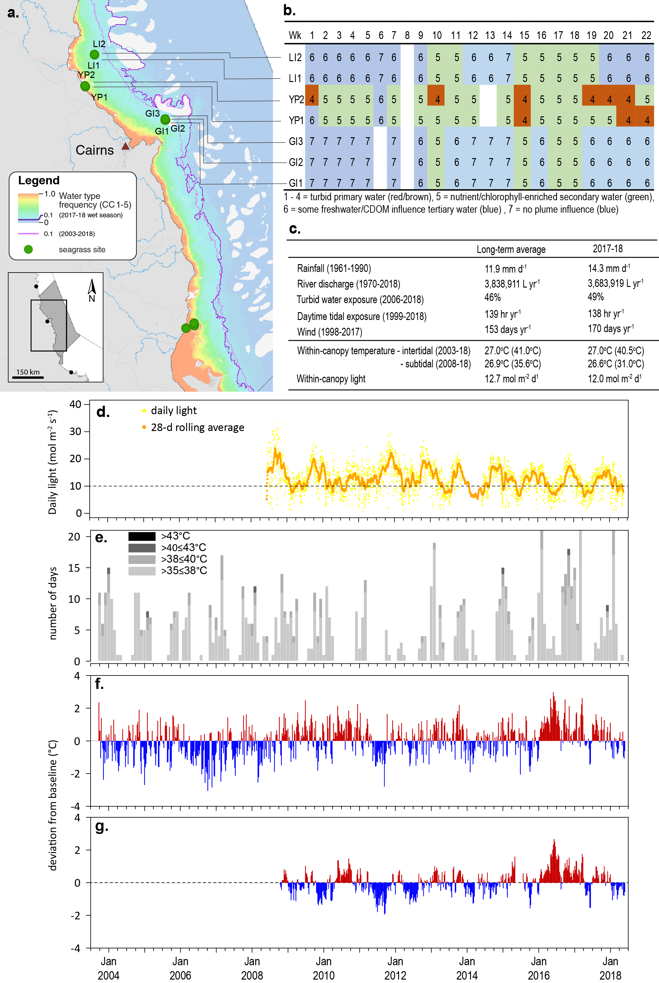
Figure 36. Environmental pressures in the northern Wet Tropics region
including: a. frequency of exposure to turbid water (colour classes 1–5) (from Gruber et al. 2019); b. wet season water type at each site; c. average conditions over the long-term and in 2017–18; d. daily light and the 28-day rolling mean of daily light for all sites; e. number of days temperature exceeded 35°C, 38°C, 40°C and 43°C; f. intertidal temperature deviations from 13-year mean weekly records, and; g. subtidal temperature deviations from 13-year mean weekly records.
This year was the third consecutive year intertidal within-canopy temperatures in the northern Wet Tropics were above the long-term average and the fifth highest average annual temperature (27.0°C) since 2003 (Figure 36). Maximum intertidal within-canopy temperatures exceeded 35°C for a total of 52 days during 2017–18, with the highest temperature recorded at 40.5°C (YP1, 2:30pm 26Feb18).
This was the first year since 2014–15 where annual subtidal within-canopy temperatures in the north were below the long-term average and the fifth highest average annual temperature (26.6°C) since 2008. The maximum subtidal temperature recorded this year was 30.9°C, below temperatures expected to stress seagrass (LB2, 3pm 15Jan18).
With the exception of Green Island intertidal reef meadows, daily tide exposure was below the long‐term average for the second consecutive year (Figure 36, Figure 99, Figure 100), which may have provided some respite from the elevated temperatures, particularly in coastal habitats.
As for the northern Wet Tropics, annual river discharge was slightly above-average across the southern Wet Tropics during 2017–18. All sites monitored throughout the southern Wet Tropics were exposure to ‘brown’ or ‘green’ turbid water for the entire wet season (100% frequency of exposure) (Figure 37). Coastal sites at Lugger Bay (LB1 and LB2) experienced the highest exposure to ‘brown’ turbid water (76% of wet season weeks), while the remaining reef sites were exposed predominately to ‘green’ water (81–86% of wet season weeks). Light levels were below 10 mol m⁻² d⁻¹, and the 2017–18 mean daily light (9.8 mol m⁻² d⁻¹), was lower than the long-term average (11.7 mol m⁻² d⁻¹) (Figure 37, Figure 108).
In the southern Wet Tropics, within-canopy temperatures in 2017–18 were the lowest (annual average = 26.8°C) in 4 years, and first year below the long-term average since 2014–15 (Figure 37). Maximum intertidal within-canopy temperatures exceeded 35°C for a total of 7 days during 2017–18, with the highest temperature recorded at 41.2°C (DI2, 3:30pm 30Mar18). The maximum subtidal within-canopy temperature recorded during 2017-18 was 31.2°C (3pm 01Jan18). Daily tide exposure was below the long‐term average for the second consecutive year (Figure 36, Figure 99, Figure 100), which may have provided some respite from the elevated temperatures, particularly in coastal habitats.
Overall, the inshore seagrass habitats throughout the southern Wet Tropics experienced much greater environmental pressures in 2017–18 than those in the northern Wet Tropics, and the previous monitoring period.

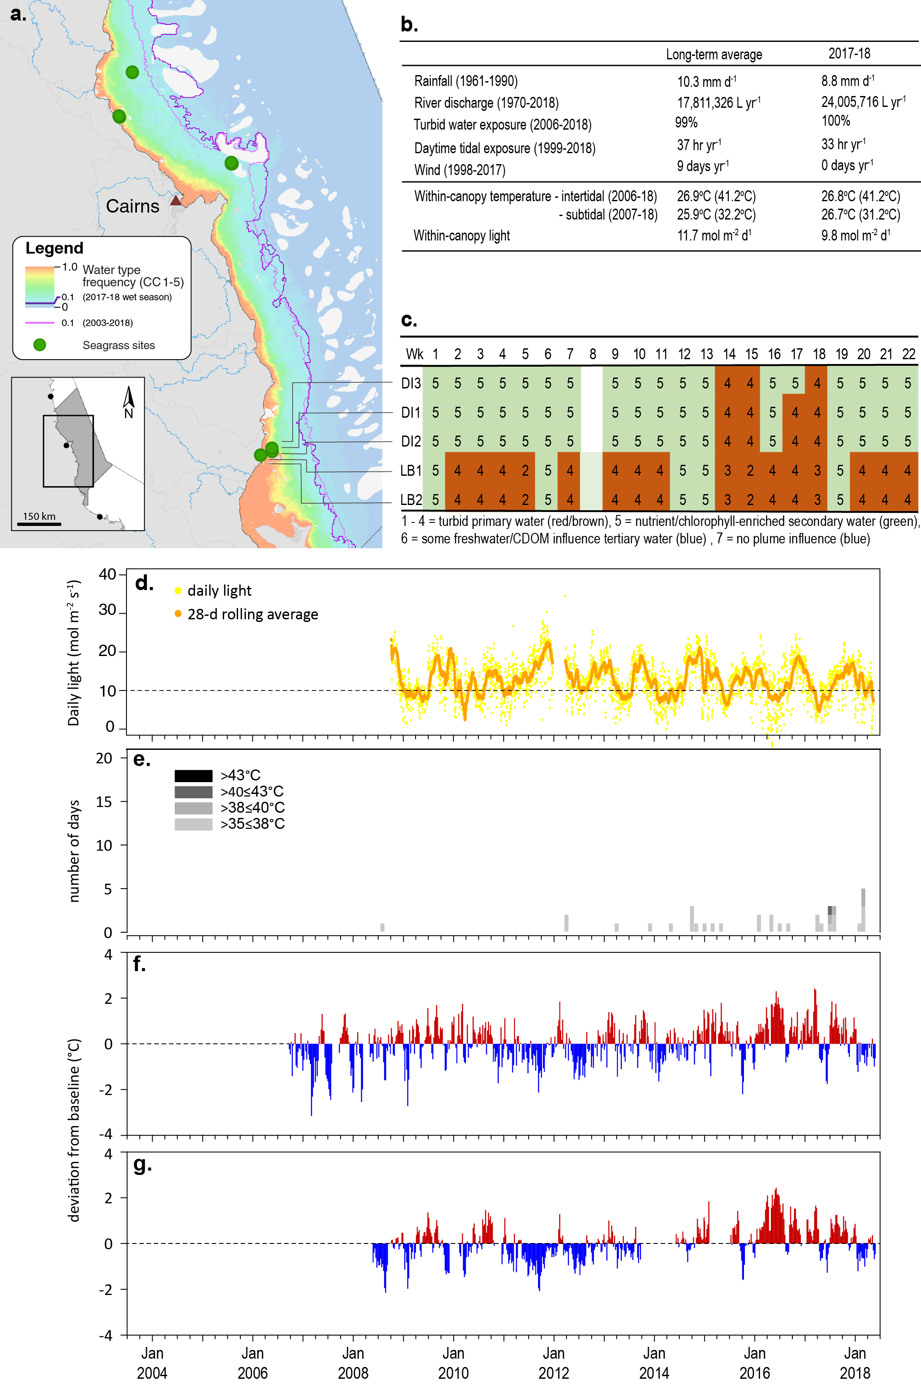
Figure 37. Environmental pressures in the southern Wet Tropics region
including: a. frequency of exposure to turbid water (colour classes 1–5) (from Gruber et al. 2019); b. wet season water type at each site; c. average conditions over the long-term and in 2017–18; d. daily light and the 28-day rolling mean of daily light for all sites; e. number of days temperature exceeded 35°C, 38°C, 40°C and 43°C; f. intertidal temperature deviations from 13-year mean weekly records, and; g. subtidal temperature deviations from 13-year mean weekly records.
In 2017–18, sediments appeared similar to the long-term and the proportion of fine sediments (i.e. mud) was well below the Reef-wide long-term average across all habitats (Figure 115, Figure 116). The only exception was one coastal site (YP1) in the northern Wet Tropics (Figure 114). Across the Wet Tropics region, coastal sediments were composed primarily of fine sand, while reef habitats were composed of sand and coarser sediments (Figure 115, Figure 116). Subtidal reef sediments were predominately sand, which in the southern region often included coarser grains (Figure 117).

Inshore seagrass and habitat condition
Three seagrass habitat types were assessed across the Wet Tropics region with data from 12 sites (Table 12).
Table 12. List of data sources of seagrass and environmental condition indicators for each seagrass habitat type in the Wet Tropics NRM region.
drop camera sampling (QPWS), *Seagrass-Watch. For site details see Table 2 and Table 3.
Sub region | Habitat | Site |  | abundance | composition | distribution | Reproductive effort | seed banks | Leaf tissue nutrients | Meadow sediments | Epiphytes | Macroalgae
north | coastal intertidal | YP1 | Yule Point
north | coastal intertidal | YP2 | Yule Point
north | reef intertidal | LI1 | Low Isles
north | reef intertidal | GI1 | Green Island
north | reef intertidal | GI2 | Green Island
north | reef subtidal | LI2 | Low Isles
north | reef subtidal | GI3 | Green Island
south | coastal intertidal | LB1 | Lugger Bay
south | coastal intertidal | LB2 | Lugger Bay
south | coastal subtidal | MS1 | Missionary Bay
south | coastal subtidal | MS2 | Missionary Bay
south | reef intertidal | DI1 | Dunk Island
south | reef intertidal | DI2 | Dunk Island
south | reef intertidal | GO1* | Goold Island
south | reef subtidal | DI3 | Dunk Island

Seagrass index and indicator scores
In the 2017-18 monitoring period, the seagrass condition index for the overall Wet Tropics region increased to the highest score since reporting was established, but the overall grade remained poor (Figure 38). The increase was due to improved scores in two indicators: abundance and reproductive effort. The only indicator to change grade from the previous year was reproductive effort, which increased from very poor to poor. Examination of the sub-regional scores highlights the differences between seagrass condition in the north and south of the Wet Tropics (Figure 35).
In the northern Wet Tropics, the seagrass condition index increased to the highest score since reporting was established, improving to a moderate grading (Figure 38). Similar to the overall NRM regional grade, the increase appears primarily due to improved abundance and reproductive effort scores.
The seagrass abundance score has progressively improved since 2014–2015, and although the highest since 2009–10 (and similar to 2008-09), remains graded as moderate in 2017–18 (Figure 38). The long-term trend in seagrass % cover is variable between monitoring locations, but closely reflects the sub-regional scores with improved cover from 2015.
Reproductive effort has fluctuated the most of the three condition indicators, and in 2017–18 was the highest score since monitoring was established (Figure 38). Due to the variable nature of sexual reproduction in seagrass systems, no long term trends are apparent.
In contract, seagrass leaf nutrient (C:N) status has varied the least of all indicators, and although declined marginally in 2017–18, has remained in a poor grade (Figure 38). Examination of the long-term trend in nutrient status, suggests a significant increase for a period between 2006 and 2009 (Figure 38).
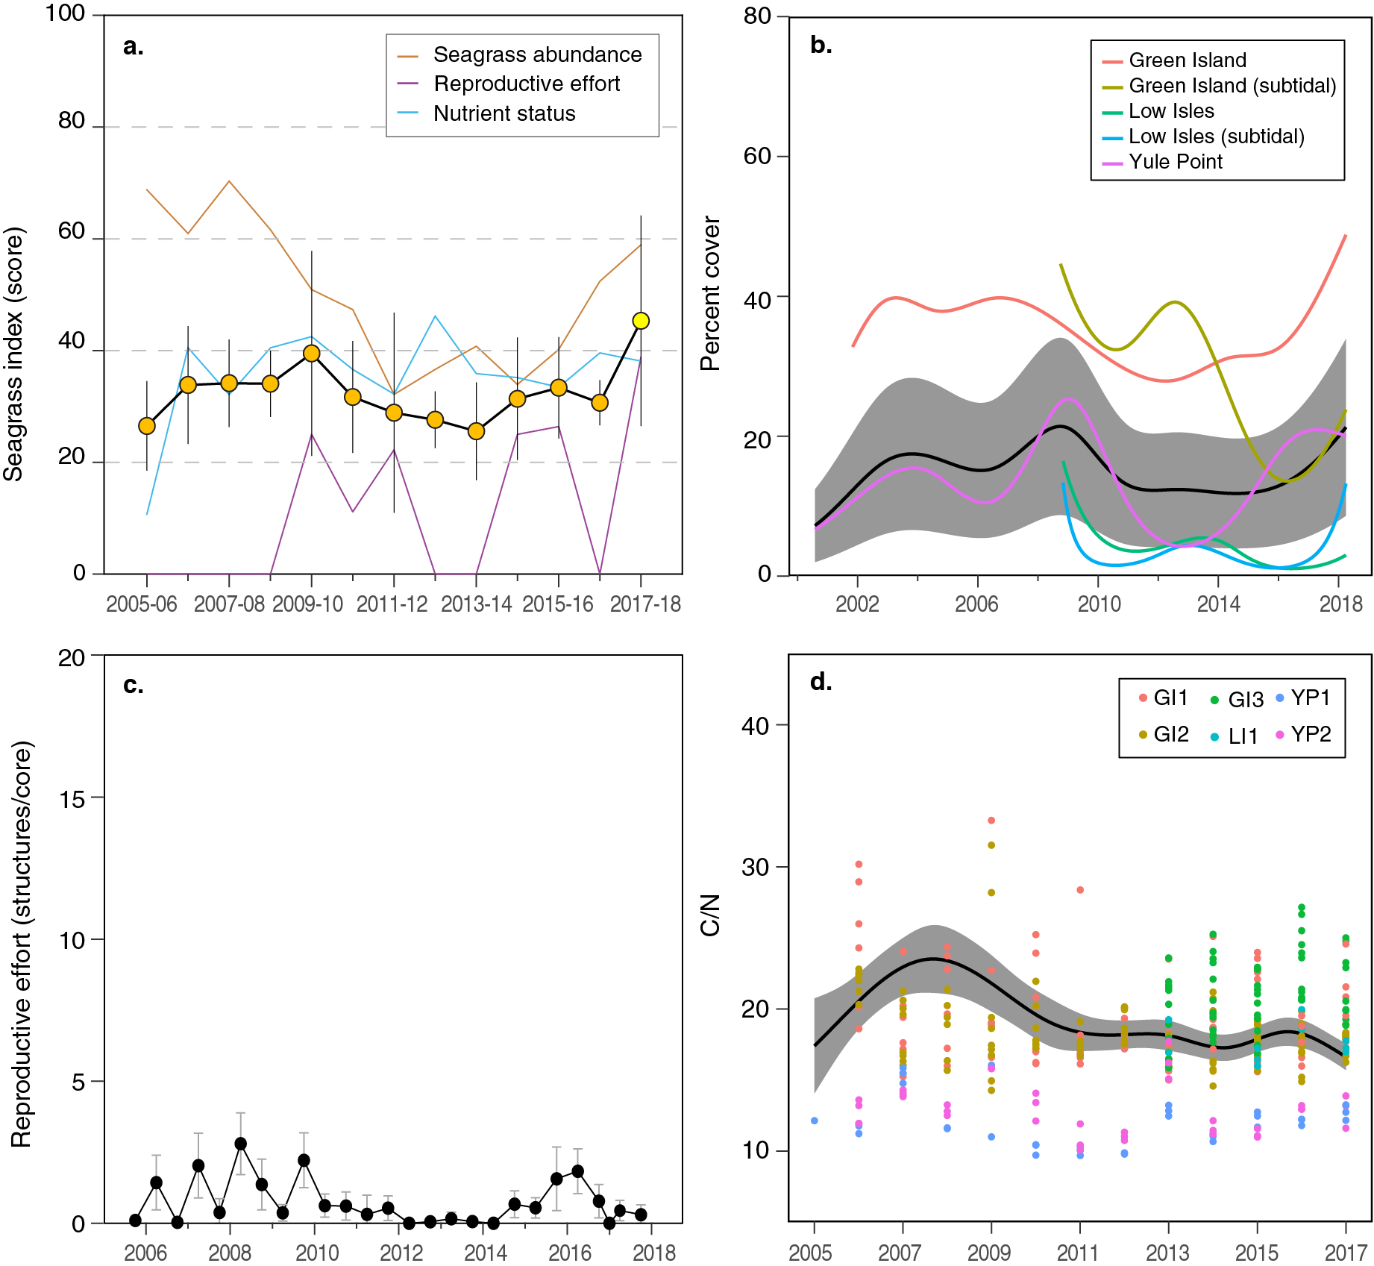
Figure 38. Temporal trends in the northern Wet Tropics seagrass condition index and the indicators used to calculate the index
: a. seagrass condition index (circles) and indicator trends (lines); b. GAM plots of seagrass abundance (% cover) trends for each location (coloured lines) and the region (black line with grey shaded area defining 95% confidence intervals); c. average number of reproductive structures (±SE) (GAM not possible due to high count of zero values); and d. elemental ratios (atomic) of leaf tissue C:N nutrient content at each site (coloured circles) and regional trend represented by a GAM plot as dark line with shaded areas defining 95% confidence intervals of the trend.
In the southern Wet Tropics, the seagrass condition index remains very poor, but has been close to reaching a poor grade in the last three reporting years (Figure 39).

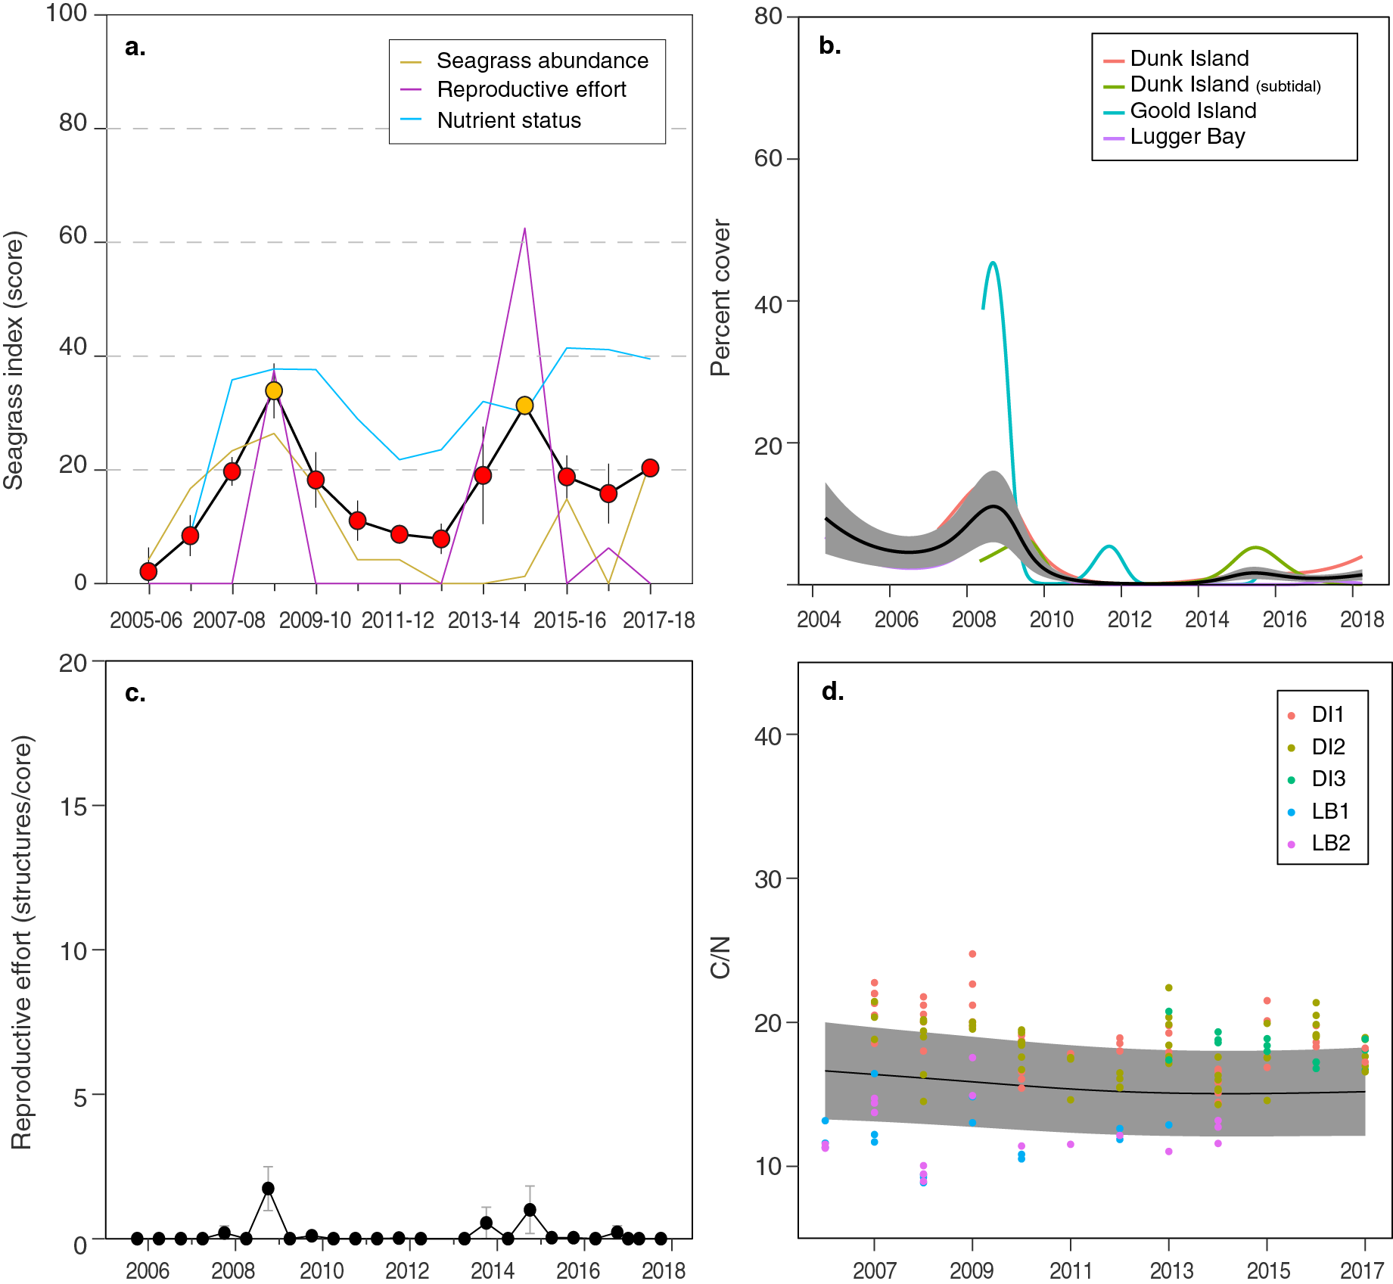
Figure 39. Temporal trends in the southern Wet Tropics seagrass condition index and the indicators used to calculate the index
: a. seagrass condition index (circles) and indicator trends (lines); b. GAM plots of seagrass abundance (% cover) trends for each location (coloured lines) and the region (black line with grey shaded area defining 95% confidence intervals); c. average number of reproductive structures (±SE) (GAM not possible due to high count of zero values); and d. elemental ratios (atomic) of leaf tissue C:N nutrient content at each site (coloured circles) and regional trend represented by a GAM plot as dark line with shaded areas defining 95% confidence intervals of the trend.

Seagrass abundance, community and extent
Seagrass meadows are more abundant across all habitats in the northern than the southern Wet Tropics (Figure 40, Figure 41). In the northern Wet Tropics, seagrass abundance over the long-term is higher at intertidal reef (25.8 ±1.9%) than subtidal reef (17.0 ±2.5%) or coastal habitats (13.6 ±1.5%).
Although seagrass losses have occurred at the local level (e.g. individual site) for some period over the duration of the monitoring, complete loss has not occurred at the habitat level. Nevertheless, abundance has fluctuated between and within years. For example, seagrass cover at coastal habitats differs between seasons (10.5 ±1.3% in the dry and 17.5 ±1.8% in the wet) and years (from 3.6% to 24.6% annual average).
In the southern Wet Tropics, although seagrass abundance is similarly higher at intertidal reef (3.8 ±1.0%) than subtidal reef (1.73 ±0.7%) or coastal habitats (1.5 ±0.5%), the abundances are a mere tenth of those to the north. This is a consequence of periods of complete loss occurring at all habitats for at least 3-6 months since early 2011. At coastal habitats in Lugger Bay, complete loss has been sustained for periods of years. Although recovery is very slow, isolated seagrass shoots appeared at Lugger Bay sites in 2016–17, and by 2017–18 small patches had established. Abundances similarly improved at the reef intertidal habitats, but remain well below historical levels.
An examination of temporal trends in seagrass abundance across the Wet Tropics NRM region show a significant decrease over the long-term (Table 23). In the northern Wet Tropics, changes in seagrass abundance were variable among habitats, with 29% of sites significantly declining over the long-term, while no trend was apparent for the remaining sites. The declines in the north are all in reef habitats; 33% of intertidal and 50% subtidal. In the southern sub-region, 33% of sites have significantly declined over the long-term, but these only occurred at coastal sites (Lugger Bay). No long-term trend was apparent in the reef habitats of the southern sub-region.

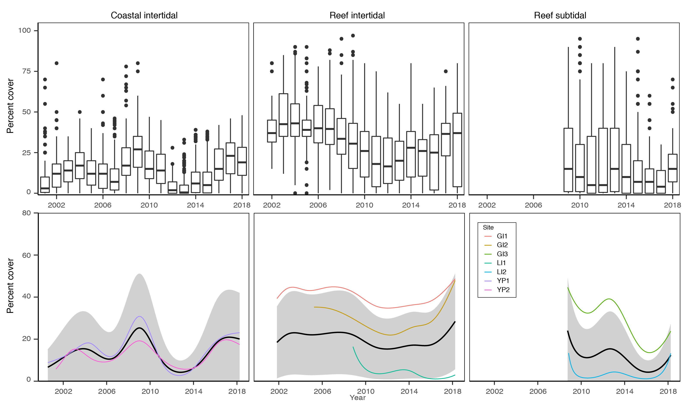
Figure 40. Seagrass per cent cover measures per quadrat (sites pooled) and long-term trends, for each habitat monitored in the northern Wet Tropics NRM region from 2001 to 2018.
Whisker plots (top) show the box representing the interquartile range of values, where the boundary of the box closest to zero indicates the 25th percentile, a line within the box marks the median, and the boundary of the box farthest from zero indicates the 75th percentile. Whiskers (error bars) above and below the box indicate the 90th and 10th percentiles, and the dots represent outlying points. GAMM plots (bottom), show trends for each habitat and coloured lines represent individual site trends.
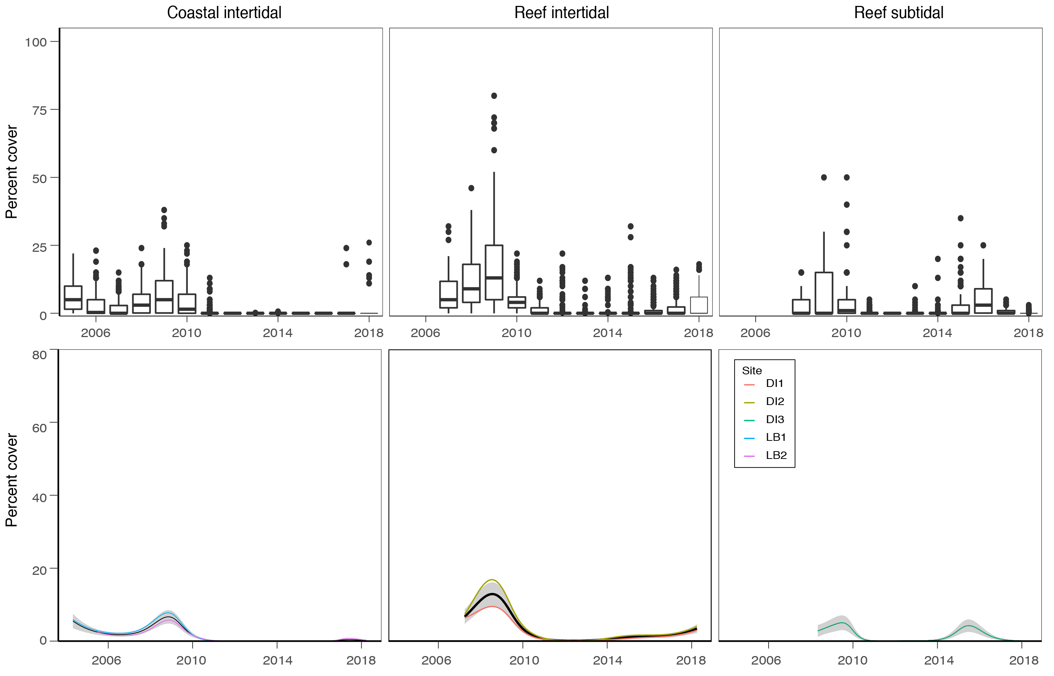
Figure 41. Seagrass per cent cover measures per quadrat (sites pooled) and long-term trends, for each habitat monitored in the southern Wet Tropics NRM region from 2001 to 2018.
Whisker plots (top) show the box representing the interquartile range of values, where the boundary of the box closest to zero indicates the 25th percentile, a line within the box marks the median, and the boundary of the box farthest from zero indicates the 75th percentile. Whiskers (error bars) above and below the box indicate the 90th and 10th percentiles, and the dots represent outlying points. GAMM plots (bottom), show trends for each habitat and coloured lines represent individual site trends.
The proportion of seagrass species displaying colonising traits varied across habitats in the northern Wet Tropics (Figure 42). In 2017–18 the proportion increased slightly at coastal intertidal habitats (Yule Point), suggesting some minor increase in physical disturbance. Between 2010 and 2014, all habitats were either dominated or had higher than the Reef-average of species displaying colonising traits. Post 2014, the composition of species displaying colonising traits has fallen below the Reef-wide average, with the exception of reef subtidal habitats.
In the southern Wet Tropics, the proportion of seagrass species displaying colonising traits has similarly varied across habitats (Figure 43). In 2017–18 the proportion of seagrass species displaying colonising traits increased across all habitats except coastal subtidal where colonising species were replaced by opportunistic species (Halodule uninervis).
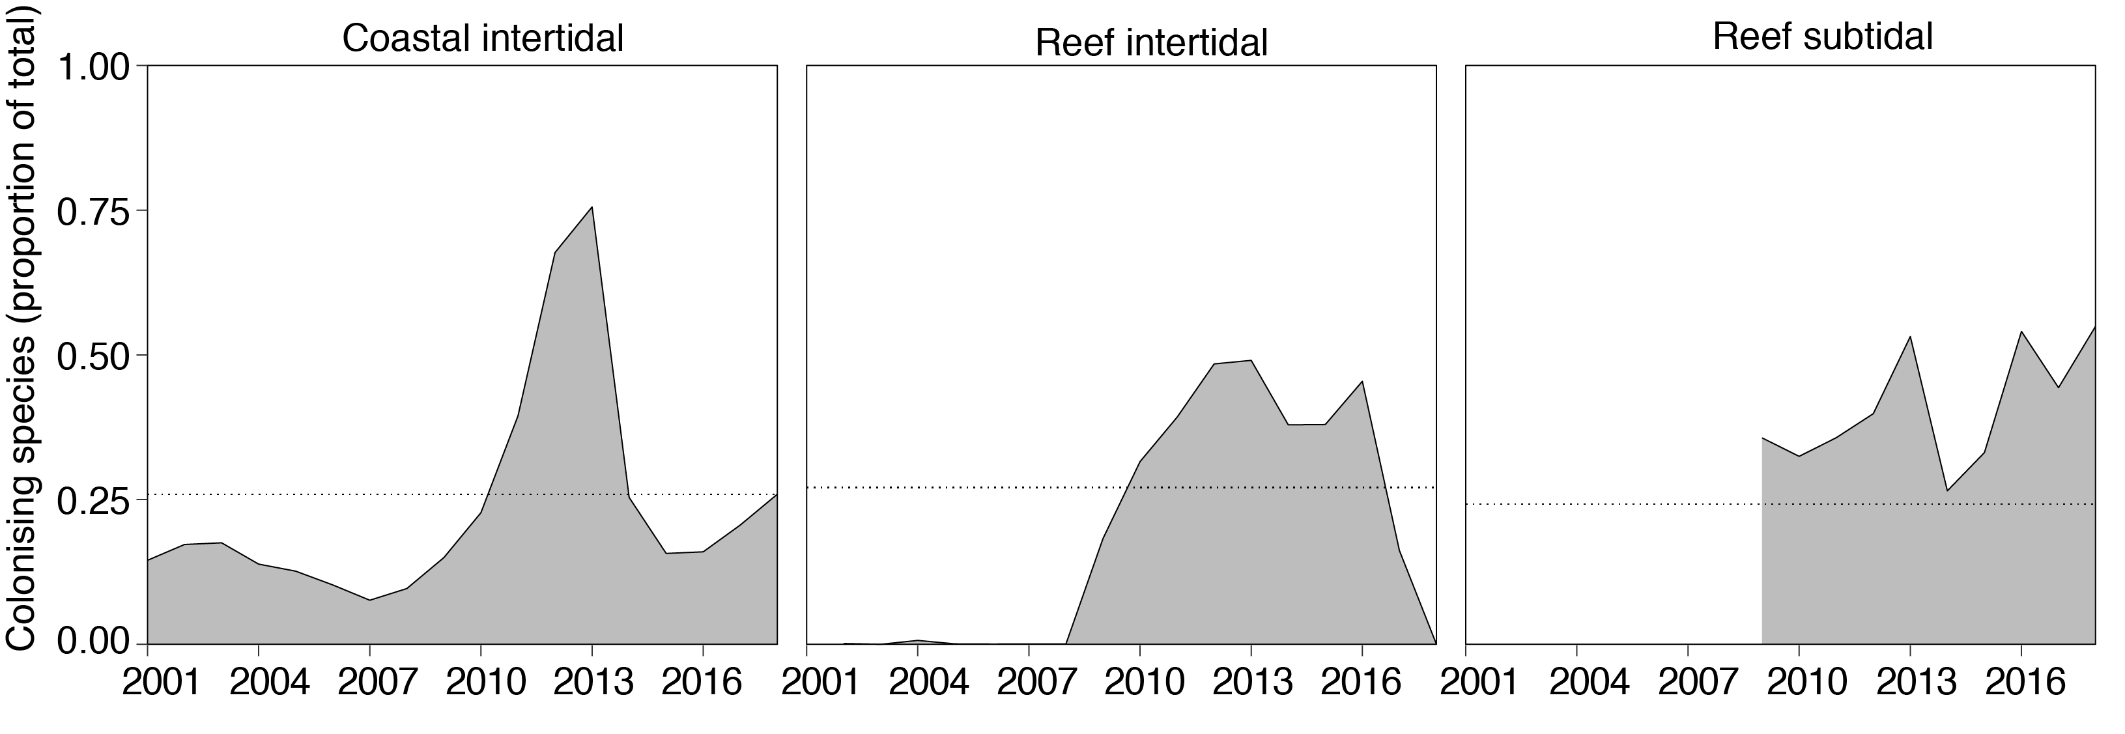
Figure 42. Proportion of seagrass abundance composed of colonising species at inshore habitats in the northern Wet Tropics region, from the 2000–2001 to the 2017–18 reporting periods.
The dashed line represents the Reef-wide average for each habitat type.

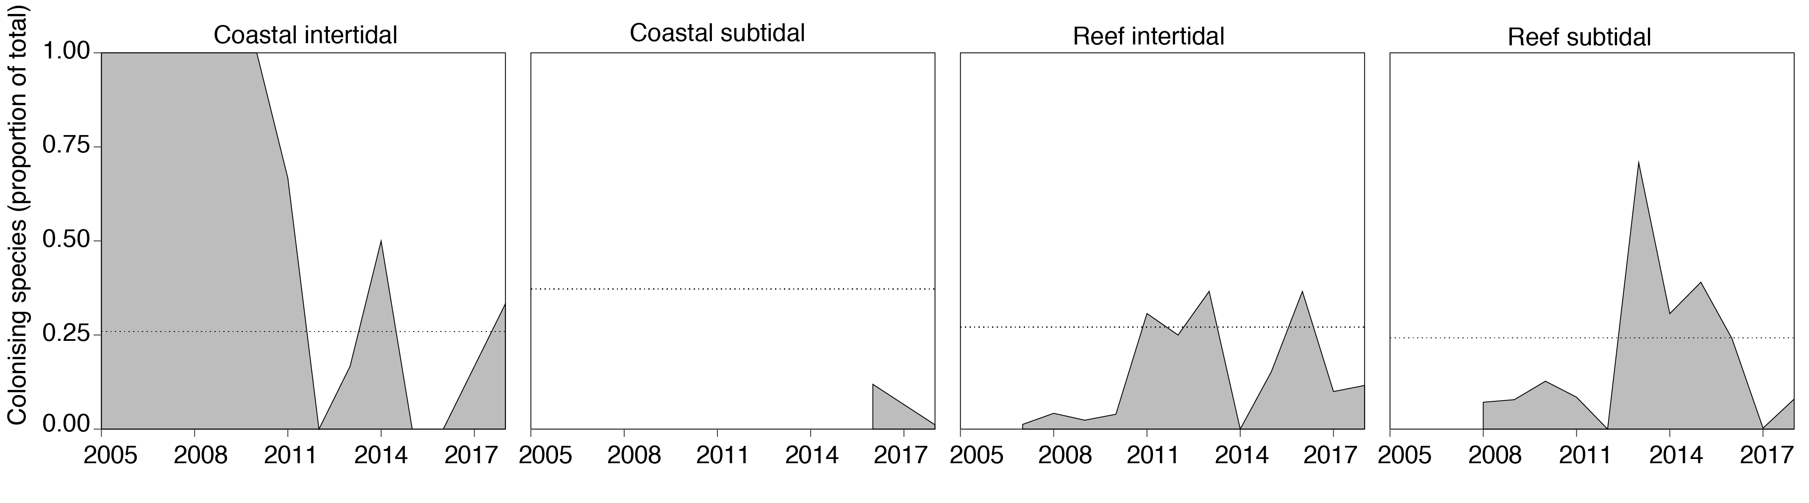
Figure 43. Proportion of seagrass abundance composed of colonising species at inshore habitats in the southern Wet Tropics region, from the 2000–2001 to the 2017–18 reporting periods.
The dashed line represents the Reef-wide average for each habitat type.

Seagrass meadow extent within all monitoring sites has fluctuated within and between years (Figure 44). At intertidal coastal and reef habitats in the northern Wet Tropics, meadow extent has gradually improved since 2011 and although relatively stable on reefs since 2015, has increased to the greatest extent at coastal habitats. Subtidal reef meadows in the north increased in 2017–18, but still remain below greatest extent achieved in late 2015.
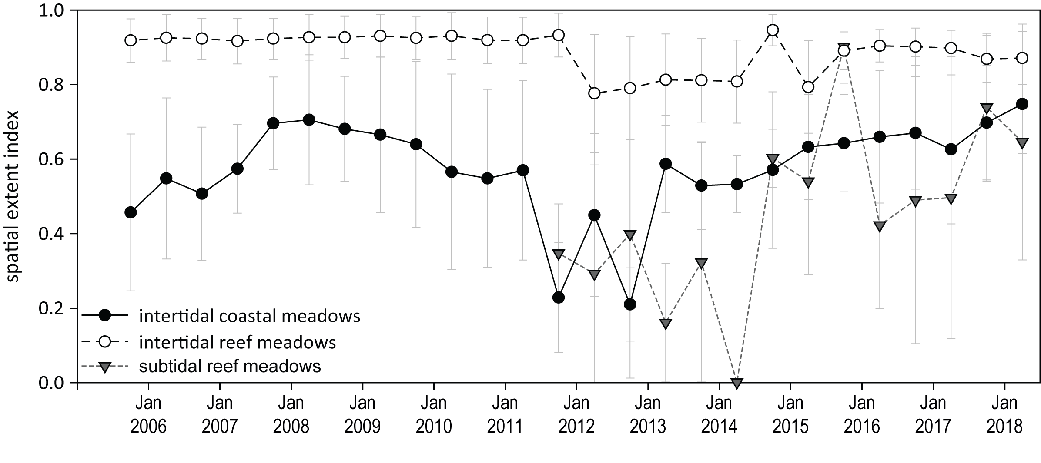
Figure 44. Change in relative spatial extent (±SE) of seagrass meadows within monitoring sites for each habitat and monitoring period across the northern Wet Tropics NRM region.

In the southern Wet Tropics, all seagrass meadows were lost in early 2011 as a consequence of cyclone Yasi (Figure 45). Since then, intertidal reef meadows have progressively improved, with the greatest extent since 2011 measured in 2017–18. At intertidal coastal habitats, the meadows have not improved, with occasional isolated patches colonising from time to time, but not establishing. The greatest fluctuation in extent has occurred in subtidal reef meadows, which established in 2014, but after rapidly expanding have sharply declined. In 2017–18, only a few small isolated patches of seagrass remained of the subtidal reef meadows.
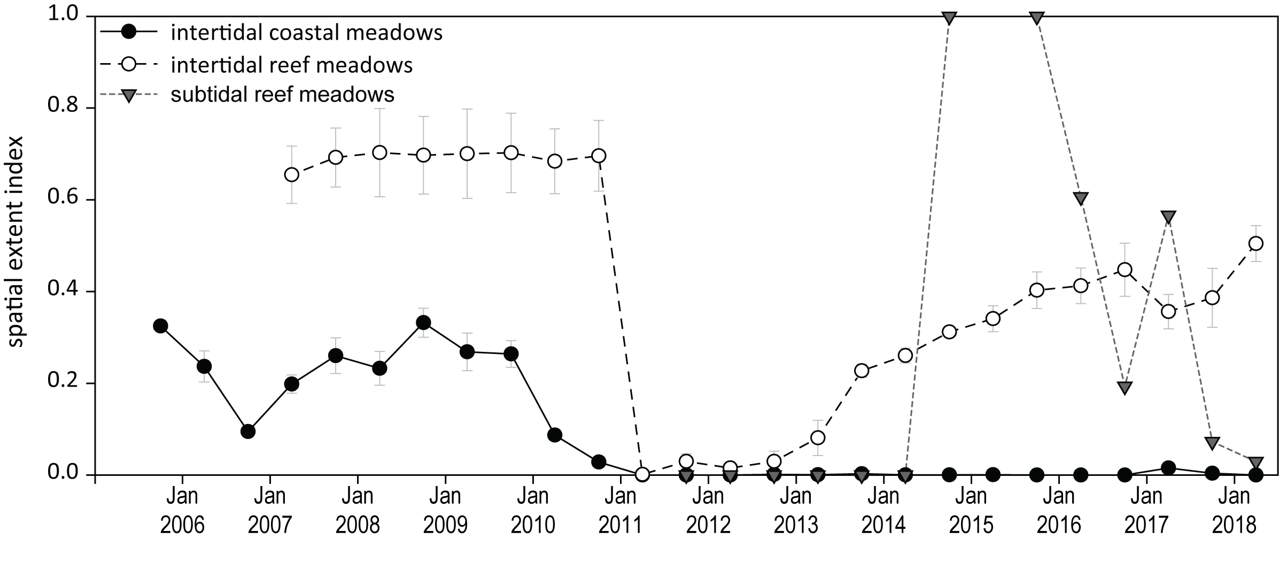
Figure 45. Change in relative spatial extent (±SE) of seagrass meadows within monitoring sites for each habitat and monitoring period across the southern Wet Tropics NRM region.

Seagrass reproductive status
Reproductive effort varies across habitats in the Wet Tropics, and is higher in the northern sub-region than the south. In the northern Wet Tropics, reproductive effort peaked during 2017–18 in coastal intertidal habitats (Yule Point) (Figure 46). The density of seeds in the coastal seedbank remained higher on average than it has been since 2011; although well below historical peaks. At intertidal and subtidal reef habitats reproductive effort remained low but increased slightly from the previous period. To date, seed banks have remained very low across the region in reef habitat (Figure 46). Some possible explanations for the low seed bank include failure to set seed, particularly in low density dioecious species (Shelton 2008), or rapid loss of seeds after release from germination or grazing (Heck and Orth 2006).
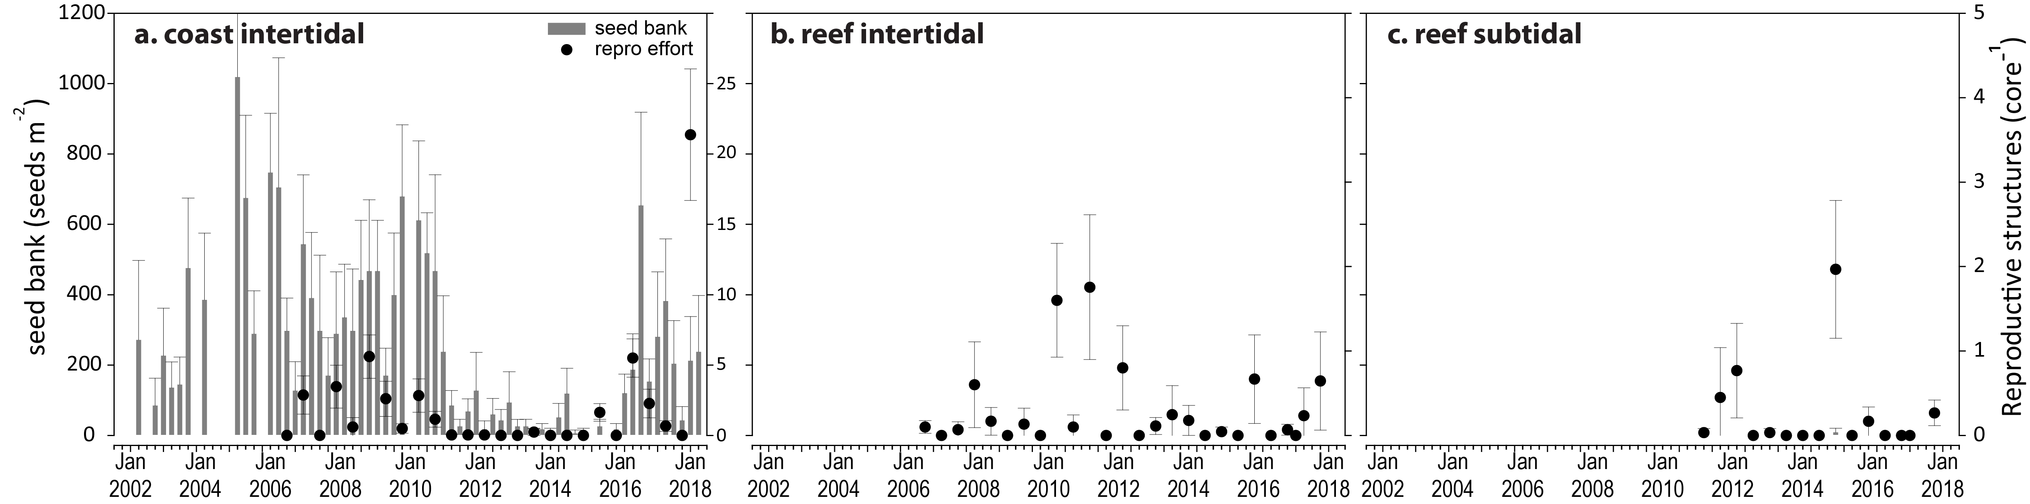
Figure 46. Reproductive effort for inshore intertidal coast and reef habitats in the northern Wet Tropics region, 2001–2018.
Seed banks presented as the total number of seeds per m² sediment surface (bars ±SE), and reproductive effort presented as the average number of reproductive structures per core (species and sites pooled) (dots ±SE).
In the southern Wet Tropics, sexually reproductive structures and seed banks were absent from seagrass in all habitats this year (Figure 47). The absence of reproductive structures and seed banks may render the seagrass at risk from further disturbances, as recovery potential remains extremely low without a seed bank.

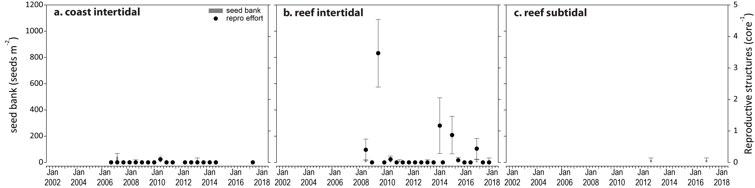
Figure 47. Reproductive effort for inshore intertidal coast and reef habitats in the northern Wet Tropics region, 2001–2018.
Seed banks presented as the total number of seeds per m² sediment surface (bars ±SE), and reproductive effort presented as the average number of reproductive structures per core (species and sites pooled) (dots ±SE).

Seagrass leaf tissue nutrients
Seagrass leaf tissue molar C:N ratios of the foundation seagrass species (in the late dry season 2017) have remained relatively stable across the northern Wet Tropics over the last few years (Figure 48). At intertidal coastal and reef habitats, the ratio has remained below the guideline value (20) and C:N ratios at the coastal sites were lower than other habitats in the north (Figure 48). This indicates that nitrogen loads are in excess of growth requirements, due possibly to elevated N or light limitation. High N:P ratios and %N in coastal habitats (Figure 48) also provides evidence of excess nitrogen loads at these sites. Seagrasses in subtidal reef habitats had higher leaf molar C:N ratios than those in intertidal habitats, and higher leaf C:P ratios (Figure 48).
In the southern Wet Tropics, no leaf tissue data is available for coastal habitats due to the lack of sufficient leaf tissue in the late dry season 2017. At the reef habitats, seagrass leaf tissue molar C:N ratios of the foundation seagrass species (in the late dry season 2017) have remained relatively stable below the guideline value (20) over the last few years (Figure 49). Similar to the northern sub-region, this indicates that nitrogen loads are in excess of growth requirements, due possibly to light limitation. Although %N was slightly above the global guideline value, the low C:N ratios combined with N:P ratios between 25–30 suggest some level of light limitation (Figure 49).

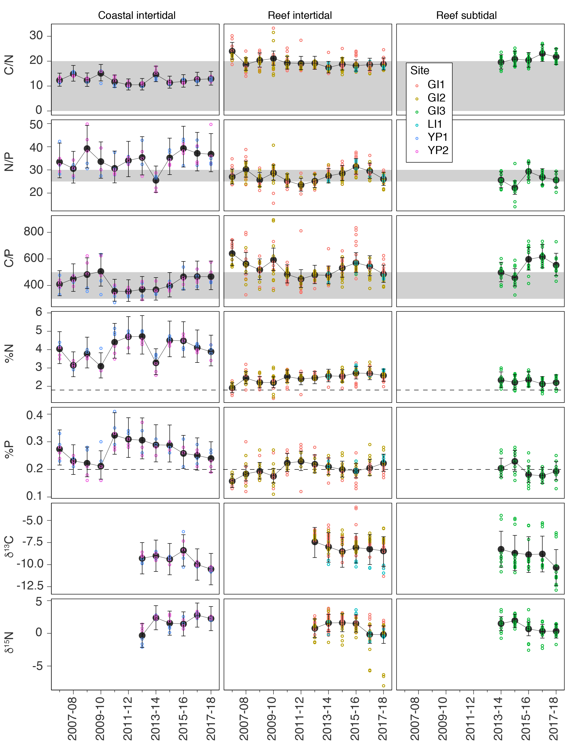
Figure 48. Seagrass leaf tissue nutrient elemental ratios (C:N:P) and concentrations (%N, %P, δ¹³C and δ¹⁵N) for each habitat in the northern Wet Tropics region
(± SE) (foundation species pooled). Horizontal shaded bands or dashed lines represents the accepted seagrass guideline values, where: C:N ratios within the band may indicate reduced light availability and/or N enrichment; N:P ratios above the band indicate P limitation, below indicate N limitation and within indicates replete, and; C:P ratios within the band may indicate nutrient rich habitats (large P pool). Dashed lines in %N and %P indicate global median values of 1.8 % and 0.2 % for tissue nitrogen and phosphorus, respectively (Duarte 1990).
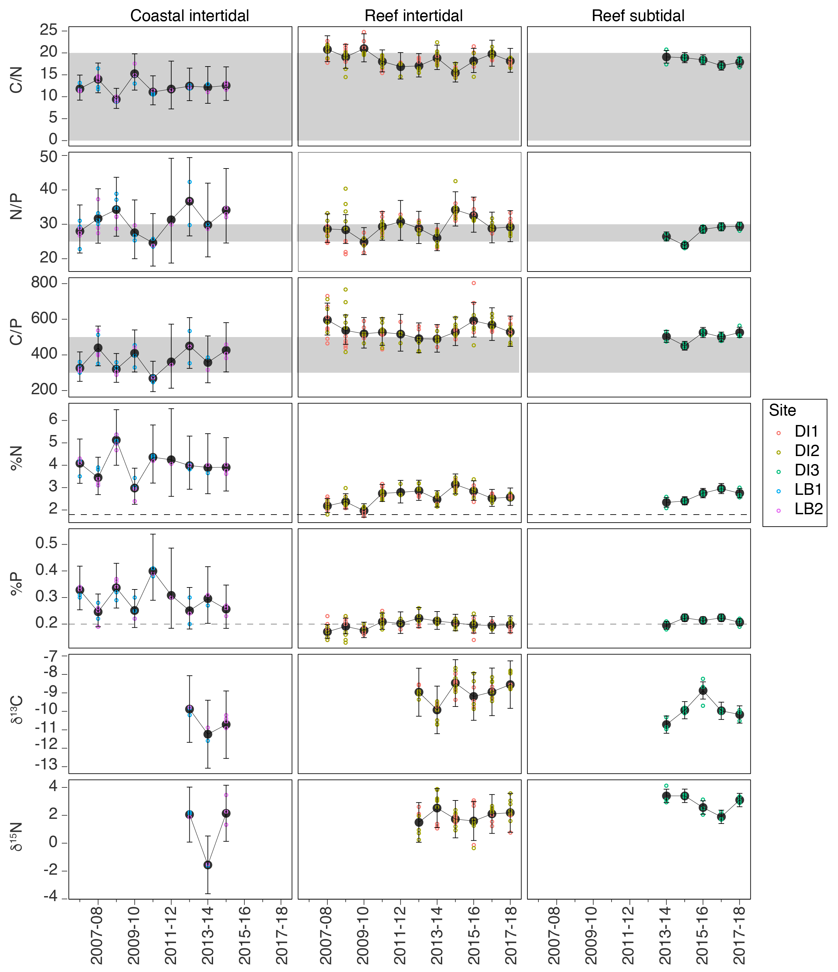
Figure 49. Seagrass leaf tissue nutrient elemental ratios (C:N:P) and concentrations (%N, %P, δ¹³C and δ¹⁵N) for each habitat in the southern Wet Tropics region
(± SE) (foundation species pooled). Horizontal shaded bands or dashed lines represents the accepted seagrass guideline values, where: C:N ratios within the band may indicate reduced light availability and/or N enrichment; N:P ratios above the band indicate P limitation, below indicate N limitation and within indicates replete, and; C:P ratios within the band may indicate nutrient rich habitats (large P pool). Dashed lines in %N and %P indicate global median values of 1.8 % and 0.2 % for tissue nitrogen and phosphorus, respectively (Duarte 1990).

Epiphytes and macroalgae
Epiphyte cover on seagrass leaf blades has historically been higher in the wet season across all habitats in the Wet Tropics region (Figure 50). Epiphyte cover remained above the Reef-wide long-term average across all habitats in the northern Wet Tropics in 2017–18 (Figure 50).
Macroalgae cover, however, differed between habitats. At coastal habitats macroalgae cover continued to remain below the Reef long-term average for the thirteenth year. At intertidal reef habitats, macroalgae cover was above the Reef long-term average in 2017–18, while at subtidal reef habitats it was below.
In the southern Wet Tropics, epiphyte cover at coastal intertidal and reef subtidal habitats was below the Reef long-term average, while at intertidal reef habitats it was above in 2017–18 (Figure 50).
Macroalgae cover continued to remain below the Reef long-term average for the tenth year at intertidal reef habitats and near absent at coastal habitats. However, macroalgae cover remained above the Reef long-term average at subtidal reef habitats in 2017–18.
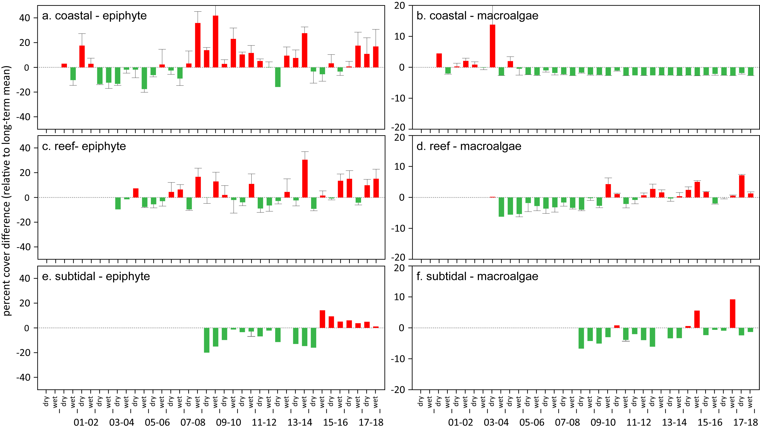
Figure 50. Long-term trend in mean epiphyte and macroalgae abundance (% cover) relative to the long-term average for each inshore seagrass habitat in the northern Wet Tropics region, 2001–2018
(sites pooled, ±SE). Red/green words
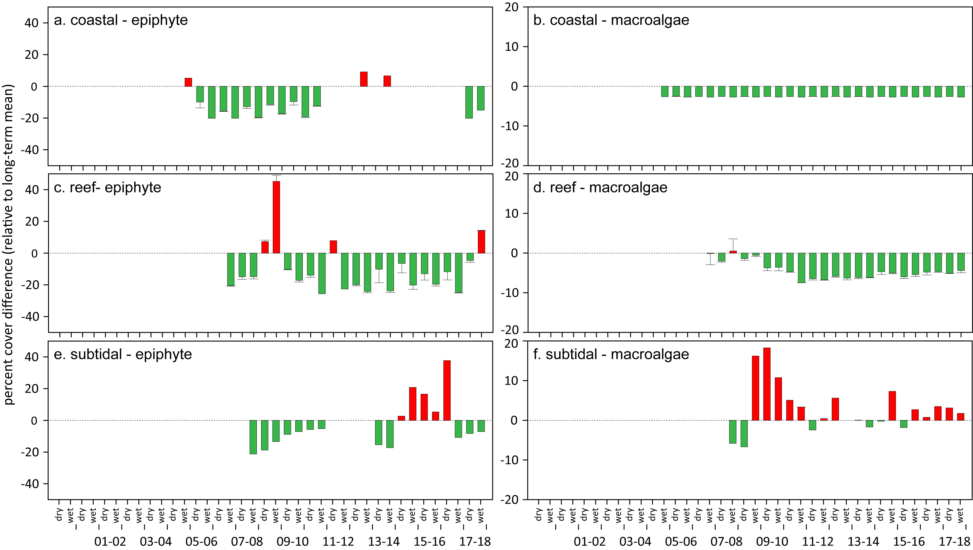
Figure 51. Long-term trend in mean epiphyte and macroalgae abundance (% cover) relative to the long-term average for each inshore seagrass habitat in the southern Wet Tropics region, 2001–2018
(sites pooled, ±SE).

Burdekin

2017–18 Summary
Seagrass meadows across the Burdekin NRM region declined slightly in overall condition in 2017–18, although remained moderate (Figure 52). All condition indicators declined:
- abundance score was good
- reproductive effort score was poor
- tissue nutrient score was moderate.
Seagrass abundance decreased marginally relative to the previous period, due to declines in % cover at nearly 40% of sites, predominately in reef meadows. Although 50% of sites increased in % cover, mainly coastal meadows, it was not sufficient to offset the overall declines.
The declines in abundance were likely the result of a combination of light limitation, physical disturbance and elevated water temperatures. As rainfall and river discharge were below the long-term average, the reduced benthic light experienced across the Burdekin region may have been a consequence of higher than average number of days in which wind speeds exceeded 25 km hr⁻¹, which may have suspended fine sediments into the water column. The greater physical disturbance from wind generated waves may have also contributed to the declines, as meadow extents declined in 2017–18 due to a proliferation of scarring and fragmentation.
This year was also the fourth consecutive year intertidal within-canopy temperatures were above the long-term average, and third consecutive year subtidal temperatures were above the long-term average. The higher water temperatures coupled with lower than average light conditions, may have exacerbated chronic stress conditions in the seagrass, further impacting growth. The long-term trend for the region indicates no significant direction, except a general increase at one of the coastal sites since 2012.
Reproductive effort was variable across Burdekin region habitats. Reproductive effort has remained moderately high at coastal sites, and the seed bank has the highest densities among all Reef monitoring sites; however, seed density remains lower than the historical peaks observed in 2004–2008. The continued decline in the indicator score was driven by reproductive effort at the reef intertidal and subtidal sites. Despite this, seed densities in the seed bank of the reef subtidal habitat remain high.
The decline in tissue nutrient indicator score in 2017–18 after reaching historical maxima in 2016–2017, was primarily due to leaf tissue molar C:N ratios declining in reef habitats. However, the change was not sufficient to indicate elevated N, irrespective of the maintenance of epiphyte abundance above the Reef-wide long-term average for the last few years (more likely a response to elevated temperatures).
Over the past decade, seagrass meadows of the Burdekin region have demonstrated high resilience particularly through their capacity for recovery. This may reflect a conditioning to disturbance (high seed bank, high species diversity), but also reflects the nature of the disturbances which are episodic and dominated by wind events and Burdekin River flows.
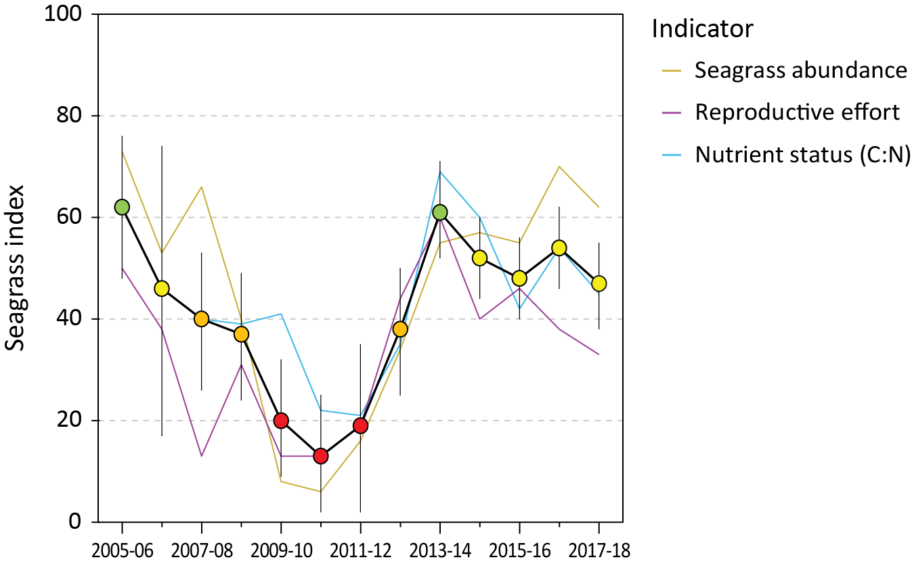
Figure 52. Report card of seagrass status indicators and index for the Burdekin NRM region
(averages across habitats and sites). Values are indexed scores scaled from 0–100 and graded: ● = very good (81-100), ● = good (61 - 80), ● = moderate (41 - 60), ● = poor (21 - 40), ● = very poor (0 - 20). NB: Scores are unitless.

Climate and environmental pressures
In 2017–18, rainfall was below the long-term average and river discharge were near the long-term median or greater depending on the river in the Burdekin region (Figure 53, ). The only significant flow events from the Burdekin River (the largest river in the region and dominant contributor to sediment loads) occurred in March 2018 (Gruber et al. 2019).
Exposure of inshore seagrass to turbid waters during the wet season was at the long-term average. All sites monitored throughout the region were exposed to ‘brown’ or ‘green’ turbid water for the entire wet season (100% frequency of exposure). Coastal sites (BB, SB and JR) experienced the highest exposure to ‘brown’ turbid, sediment laden, waters (89–100% of wet season weeks), while the remaining reef sites were exposed predominately to ‘green’, phytoplankton rich, waters (90% of wet season weeks) (Figure 53).
Daily light levels in the Burdekin region are below 10 mol m⁻² d⁻¹ on average, and in 2017–18, they were reduced even further to 8.6 mol m⁻² d⁻¹. The reduced light experienced across the Burdekin region (Figure 109) may have also been exacerbated by higher than average number of days in which wind speeds exceeded 25 km hr⁻¹ (Figure 94), which may have suspended fine sediments into the water column. Also, daytime tides were higher throughout 2017–18 (Table 22, Figure 101, Figure 102), which although may have provided some respite from intertidal exposure (less than half the long term average) (Figure 53), could have resulted in longer periods of reduced light availability during periods of higher water turbidity.
This year intertidal within-canopy temperatures were similar to the long-term average (Figure 53). Maximum intertidal within-canopy temperatures exceeded 35°C for a total of 42 days during 2017-18, with the highest temperature recorded at 38.8°C (BB1, 3pm 27Feb18). 2017–18 was the third consecutive year annual subtidal temperatures were above the long-term average and the third highest average annual temperature (26.8°C) since 2007. Maximum subtidal temperature during 2017–18 was 31.8°C (3:30pm 16Feb18). Daily tide exposure was below the long‐term average for the second consecutive year at all sites (Figure 53, Figure 101, Figure 102), which may have provided some respite from the elevated temperatures.

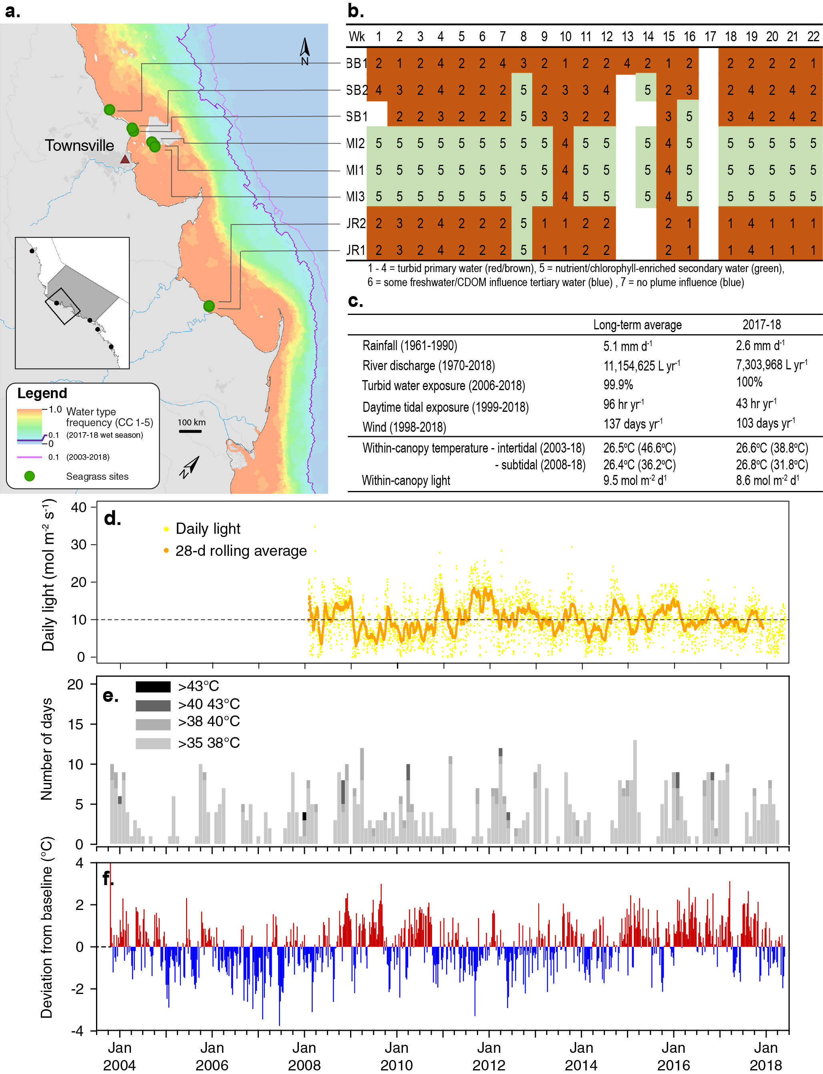
Figure 53. Environmental pressures in the Burdekin region
including: a. frequency of exposure to turbid water (colour classes 1–5) (from Gruber et al. 2019); b. wet season water type at each site; c. average conditions over the long-term and in 2017–18; d. daily light and the 28-day rolling mean of daily light for all intertidal sites; e. number of days intertidal site temperature exceeded 35°C, 38°C, 40°C and 43°C, and; f. deviations from 13-year mean weekly temperature records.
The proportion of mud at Jerona (Barratta Creek) coastal meadows was much higher than Townsville meadows (Bushland Beach and Shelley Beach) and has remained well above the Reef long-term average (Figure 118). Post 2011, Townsville coastal meadows have been dominated by fine sediments, although the proportion of mud increased at Bushland Beach this year (Figure 118). Conversely, reef habitats which were dominated by coarser sediment prior to 2009–10, having since gradually increased in composition of fine sand and mud. More fine sediments were present at the Cockle Bay (MI2) than the Picnic Bay (MI1) reef habitat meadows (Figure 119, Figure 120).

Inshore seagrass and habitat condition
Three seagrass habitat types were assessed across the Burdekin region in 2017–18, with data from 8 sites (Table 13).
Table 13. List of data sources of seagrass and environmental condition indicators for each seagrass habitat type in the Burdekin NRM region.
*Seagrass-Watch. For site details see Table 2 and Table 3.
Habitat | Site code and location |  | Seagrass abundance | Seagrass composition | Seagrass distribution | Reproductive effort | seed banks | Leaf tissue nutrients | Meadow sediments | Epiphytes & macroalgae
coastal intertidal | SB1 | Shelley Beach (Townsville)
coastal intertidal | SB2* | Shelley Beach (Townsville)
coastal intertidal | BB1 | Bushland Beach (Townsville)
coastal intertidal | JR1 | Jerona (Barratta CK, Bowling Green Bay)
coastal intertidal | JR2 | Jerona (Barratta CK, Bowling Green Bay)
reef intertidal | MI1 | Picnic Bay (Magnetic Island)
reef intertidal | MI2 | Cockle Bay (Magnetic Island)
reef subtidal | MI3 | Picnic Bay (Magnetic Island)

Seagrass index and indicator scores
In the 2017-18 monitoring period, the seagrass condition index for the Burdekin region declined slightly but remained moderate (Figure 54). Over the last four monitoring periods the index has changed little, increasing and subsequently decreasing, but at a relatively insignificant level. The changes generally reflect the gains and offsets between indicators. This year however, all indicators declined (Figure 54). Although seagrass abundance in 2017–18 remained in a good grade, previous gains at coastal intertidal and reef subtidal meadows were offset by declining abundances at reef intertidal sites and the continued decline of reproductive effort at reef sites.
Examination of contributing seagrass condition indicators over the long-term, show declines from 2009–2011 as a consequence of the years of above-average rainfall and severe weather, proceeded by rapid recovery. Since 2014–15 the indicators have fluctuated seasonally and between years (Figure 54).
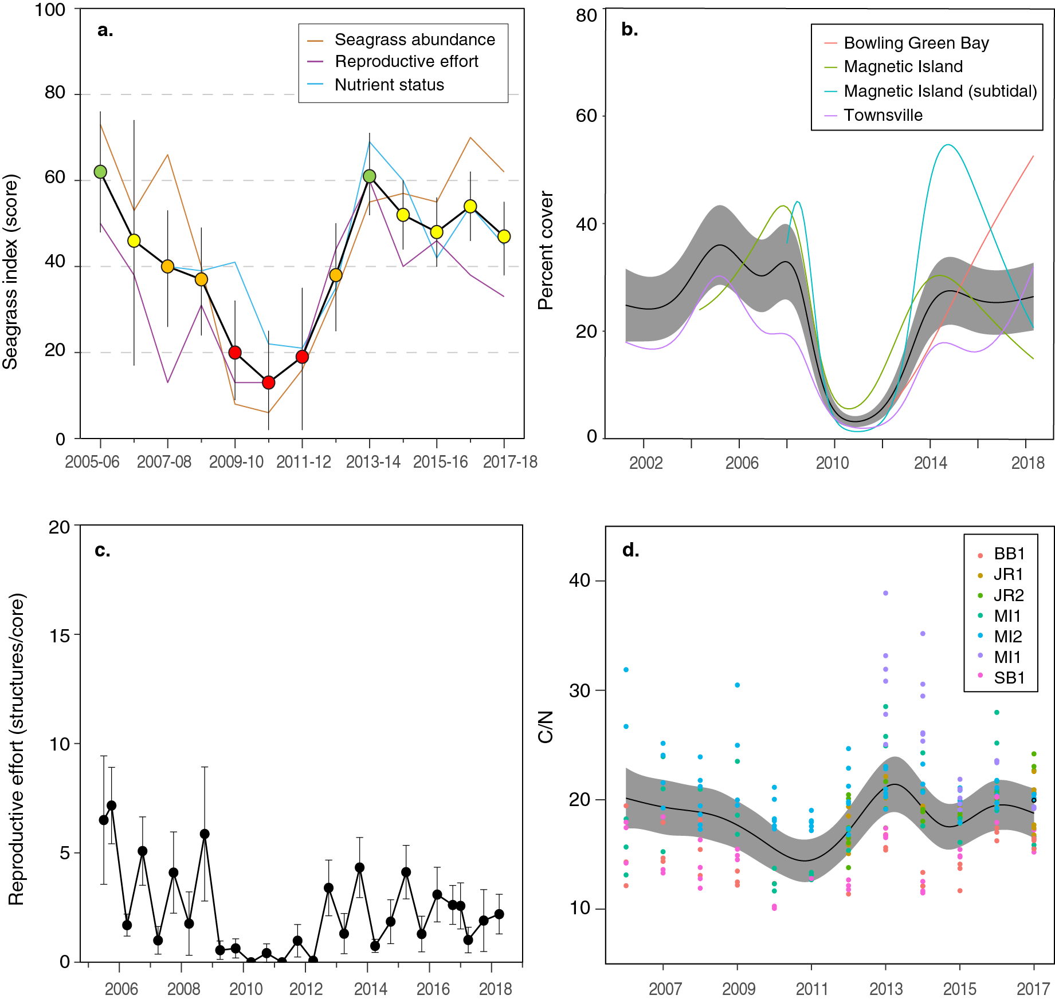
Figure 54. Temporal trends in the Burdekin seagrass condition index and the indicators used to calculate the index
: a. seagrass condition index (circles) and indicator trends (lines); b. GAM plots of seagrass abundance (% cover) trends for each location (coloured lines) and the region (black line with grey shaded area defining 95% confidence intervals); c. average number of reproductive structures (±SE) (GAM not possible due to high count of zero values); and d. elemental ratios (atomic) of leaf tissue C:N nutrient content at each site (coloured circles) and regional trend represented by a GAM plot as dark line with shaded areas defining 95% confidence intervals of the trend

Seagrass abundance, composition and extent
Over the duration of the MMP, seagrass abundance in the Burdekin region has shown a pattern of loss and recovery. Losses occurred as a result of multiple consecutive years of above-average rainfall (river discharge) and severe weather (cyclone Yasi) between 2008–09 and 2010–11. From 2011, seagrass rapidly recovered, however since 2014, seagrass abundance has progressively declined at reef (intertidal and subtidal) habitats. Nearly 40% of Burdekin region sites declined in abundance in 2017–18, which was predominately at reef habitats. The declines however, were offset to a degree by increases in 40% of coastal habitat sites.
An examination of the long term abundances across the Burdekin region habitats indicates no significant trend, except at one of the coastal sites near Jerona (Barratta Ck, Bowling Green Bay). As this site (JR2) has only been monitored since 2012, a significant increasing trend in abundance is not surprising, as this coincides with the main recovery period after the regional losses.

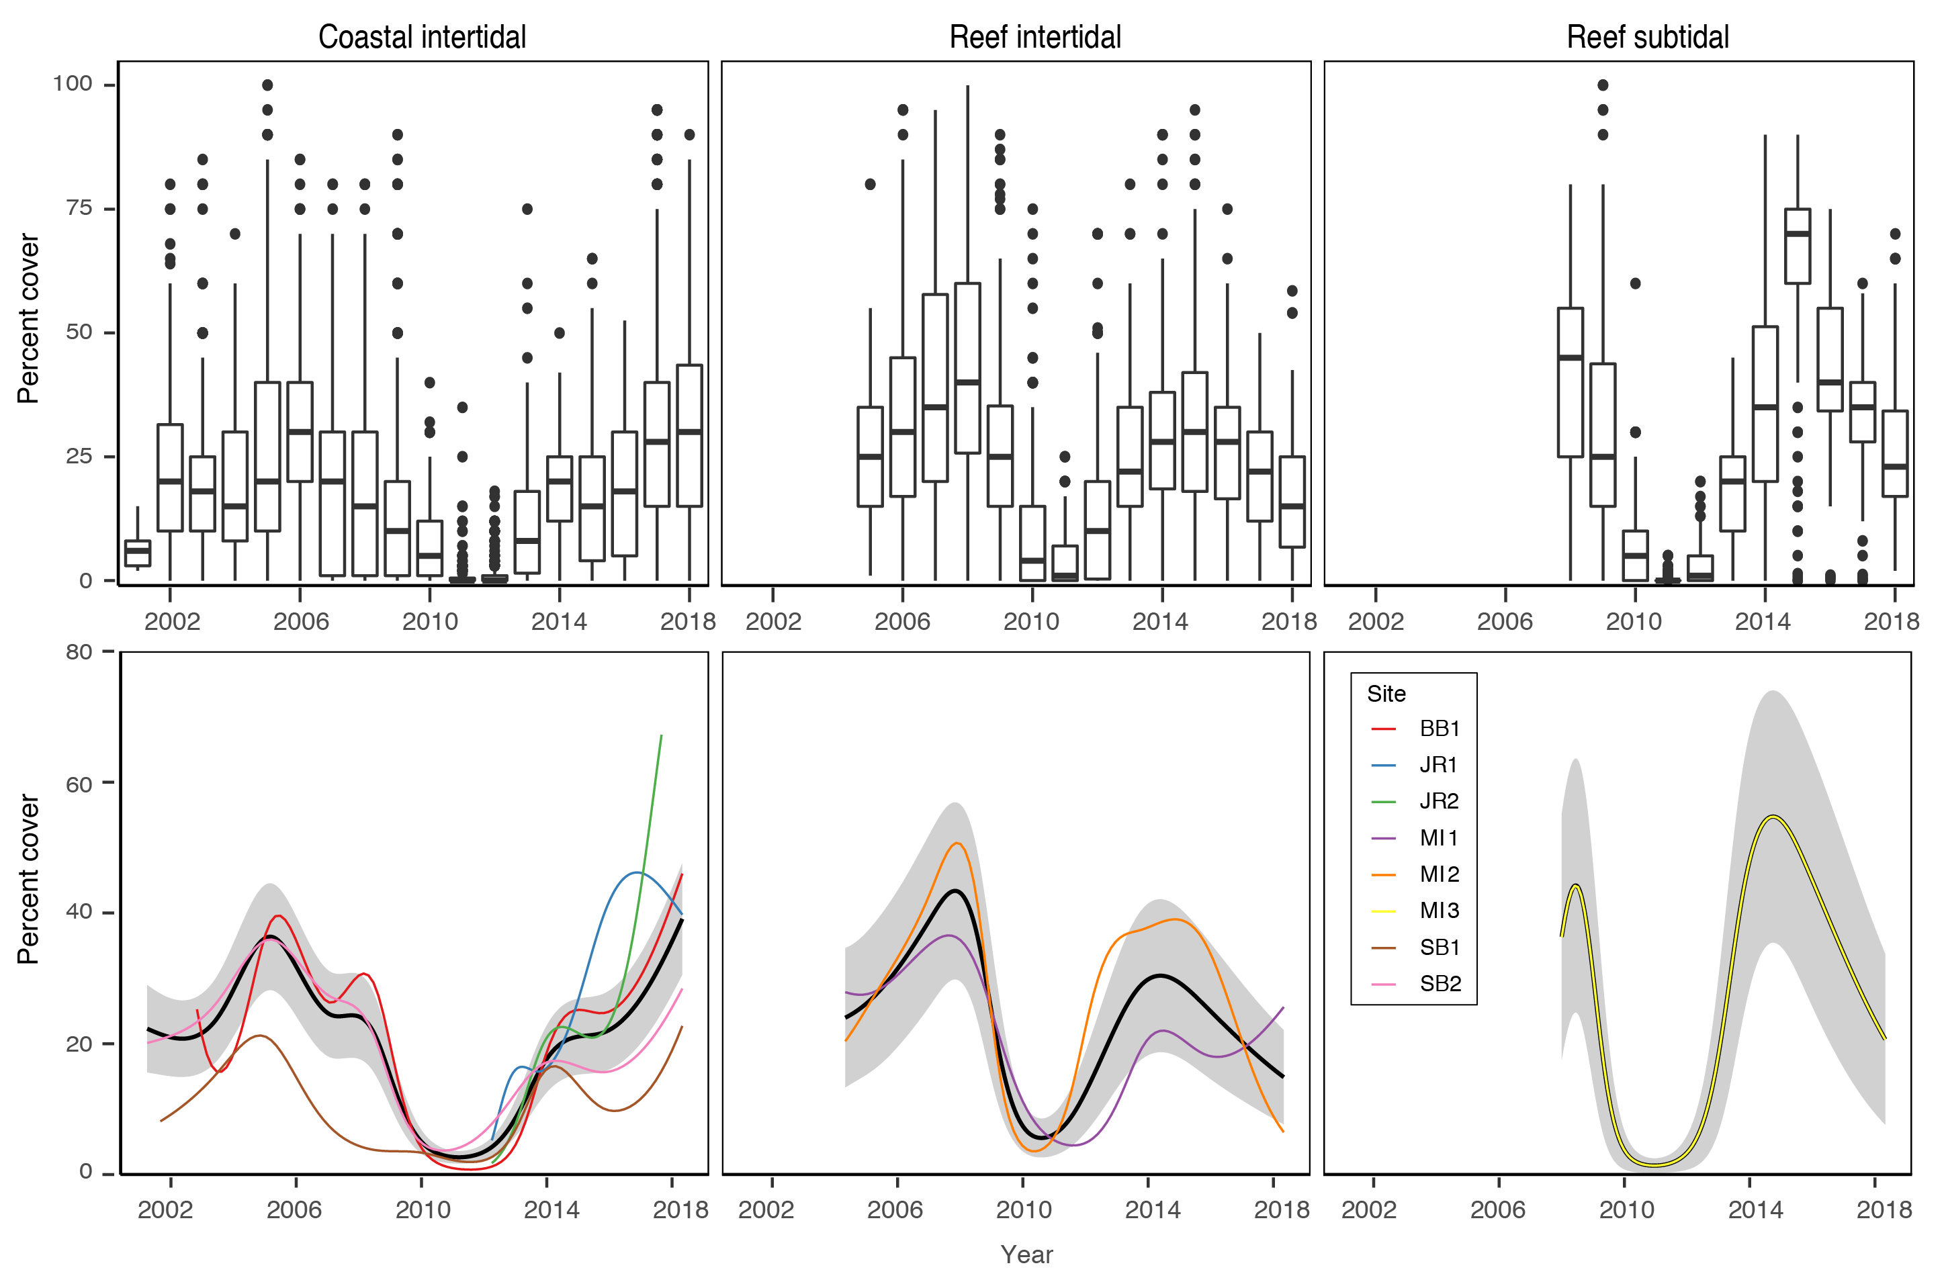
Figure 55. Seagrass per cent cover measures per quadrat (sites pooled) and long-term trends, for each habitat monitored in the Burdekin NRM region from 2001 to 2018.
Whisker plots (top) show the box representing the interquartile range of values, where the boundary of the box closest to zero indicates the 25th percentile, a line within the box marks the median, and the boundary of the box farthest from zero indicates the 75th percentile. Whiskers (error bars) above and below the box indicate the 90th and 10th percentiles, and the dots represent outlying points. GAMM plots (bottom), show trends for each habitat and coloured lines represent individual site trends.

This year, as it has been since 2014–2015, a low proportion of species displaying colonising traits are presentin all habitats (e.g. Halophila ovalis). Instead these habitats are dominated by opportunistic species (H. uninervis, Z. muelleri, C. serrulata) in coastal and reef sites or persistent species in intertidal reef habitat (T. hemprichii). This is a sign of meadow progression following near decimation after the events leading up to and including 2011. Opportunistic and persistent foundation species also have a capacity to resist stress (survive, through reallocation of resources) caused by acute disturbances (Collier et al. 2012b), and therefore, current species composition provides greater overall resilience in Burdekin meadows.
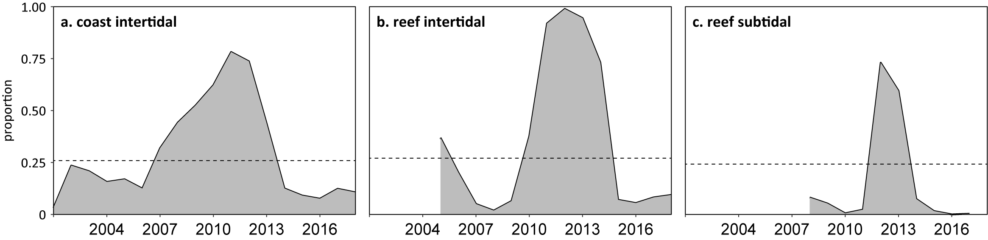
Figure 56. Proportion of seagrass abundance composed of colonising species at inshore habitats in the Burdekin region, 2001–2018.
Grey area represents Reef long-term average proportion of colonising species for each habitat type.
Seagrass meadow extent within all intertidal monitoring sites has fluctuated within and between years (Figure 57), primarily due to short-term losses and subsequent recolonisation. In the two to three years prior to 2011, significant changes occurred across the region with all seagrass meadows reducing in size and changing in landscape from continuous, to patchy, to isolated patches and finally to isolated shoots with the loss of meadow cohesion (Figure 57). That trend was also replicated at the bay-wide scale in Cleveland Bay, with considerable loss of meadow area and meadow fragmentation (Petus et al. 2014). This was caused by the high rainfall and riverine discharge that affected much of the Reef.
Since 2011, meadow extents have increased in both coastal and reef habitats to pre-2009 levels (Figure 57) and predominately remained stable until 2017–18. In early 2014, subtidal seagrass extent declined to the lowest in 2 years but subsequently recovered within 6 months to its maximum extent. In 2017–18, the subtidal reef seagrass extent again declined, but unlike in 2014, the coastal intertidal meadows have also declined in extent due to a proliferation of scarring and fragmentation.
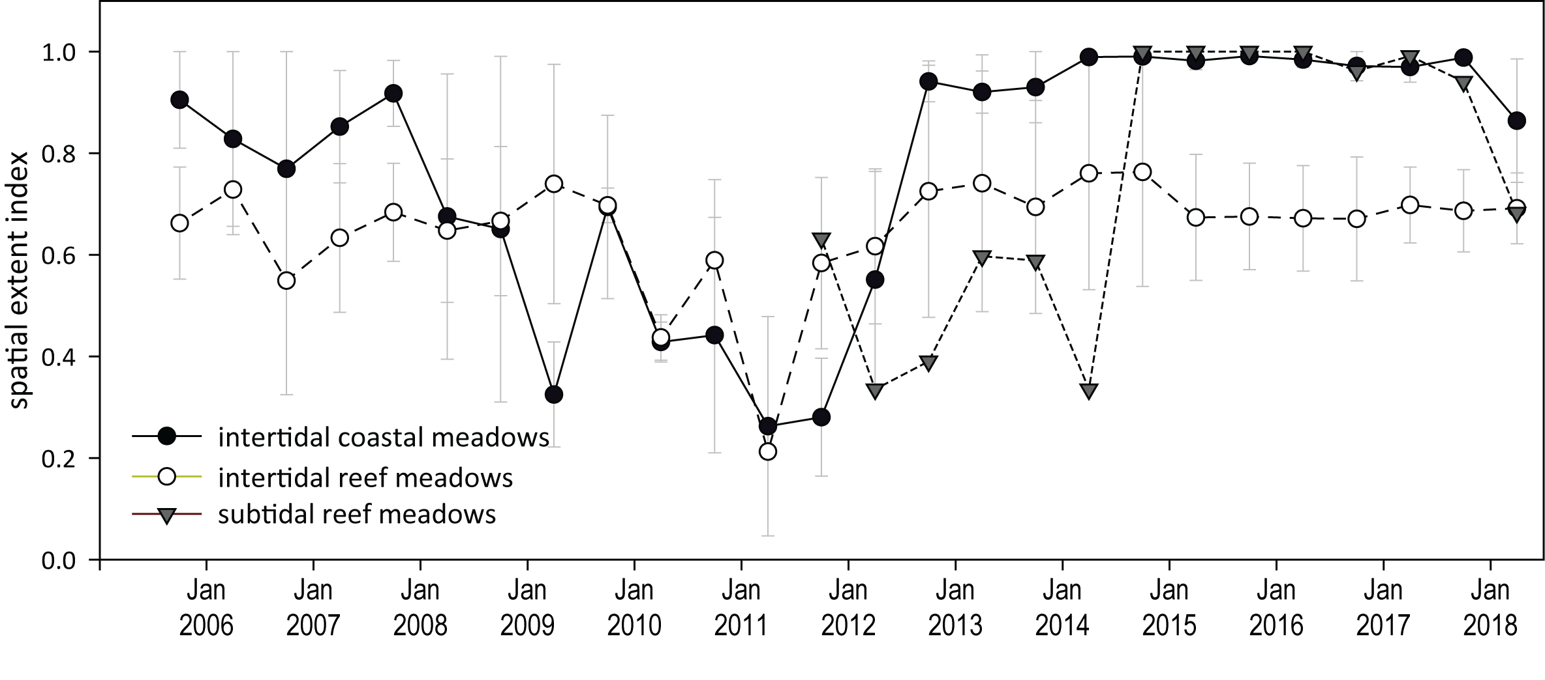
Figure 57. Change in spatial extent of seagrass meadows within monitoring sites for each inshore intertidal habitat and monitoring period across the Burdekin region, 2005–2018.

Seagrass reproductive status
Reproductive effort is variable across Burdekin region habitats. Coastal habitats had been on an increasing trajectory since 2012, and although fluctuating since 2016, both reproductive effort and seed density were higher than in other habitat types in 2017–18. At reef intertidal sites, reproductive effort has remained low, with similarly low seed densities due to lack of replenishment. By contrast, although reproductive effort is typically low at reef subtidal sites, a seed bank has built up from 2011, and was maintained this year (Figure 58).
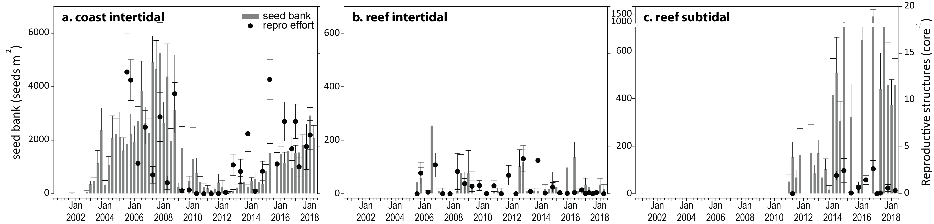
Figure 58. Reproductive effort at inshore intertidal coast and reef and subtidal reef habitats in the Burdekin region.
Seed bank presented as the total number of seeds per m² sediment surface (bars ±SE), and late dry season reproductive effort presented as the average number of reproductive structures per core (species and sites pooled) (dots ±SE). NB: Y-axis scale for seed banks differs between habitats.

Seagrass leaf tissue nutrients
Seagrass leaf tissue molar C:N ratios remained unchanged at coastal habitats in 2017–18 after reaching historical maxima in 2016–2017 (Figure 59). There were also small decreases at reef habitats, where the values were at or just above the threshold value (C:N <20) that indicates that nitrogen is not in supply at a rate in excess of growth requirements (i.e. N limited). The increase in N:P at all habitats suggests some degree of reduced P-availability, which is likely to be contributing to the rising C:P ratios and the slight decline in %P (Figure 59).
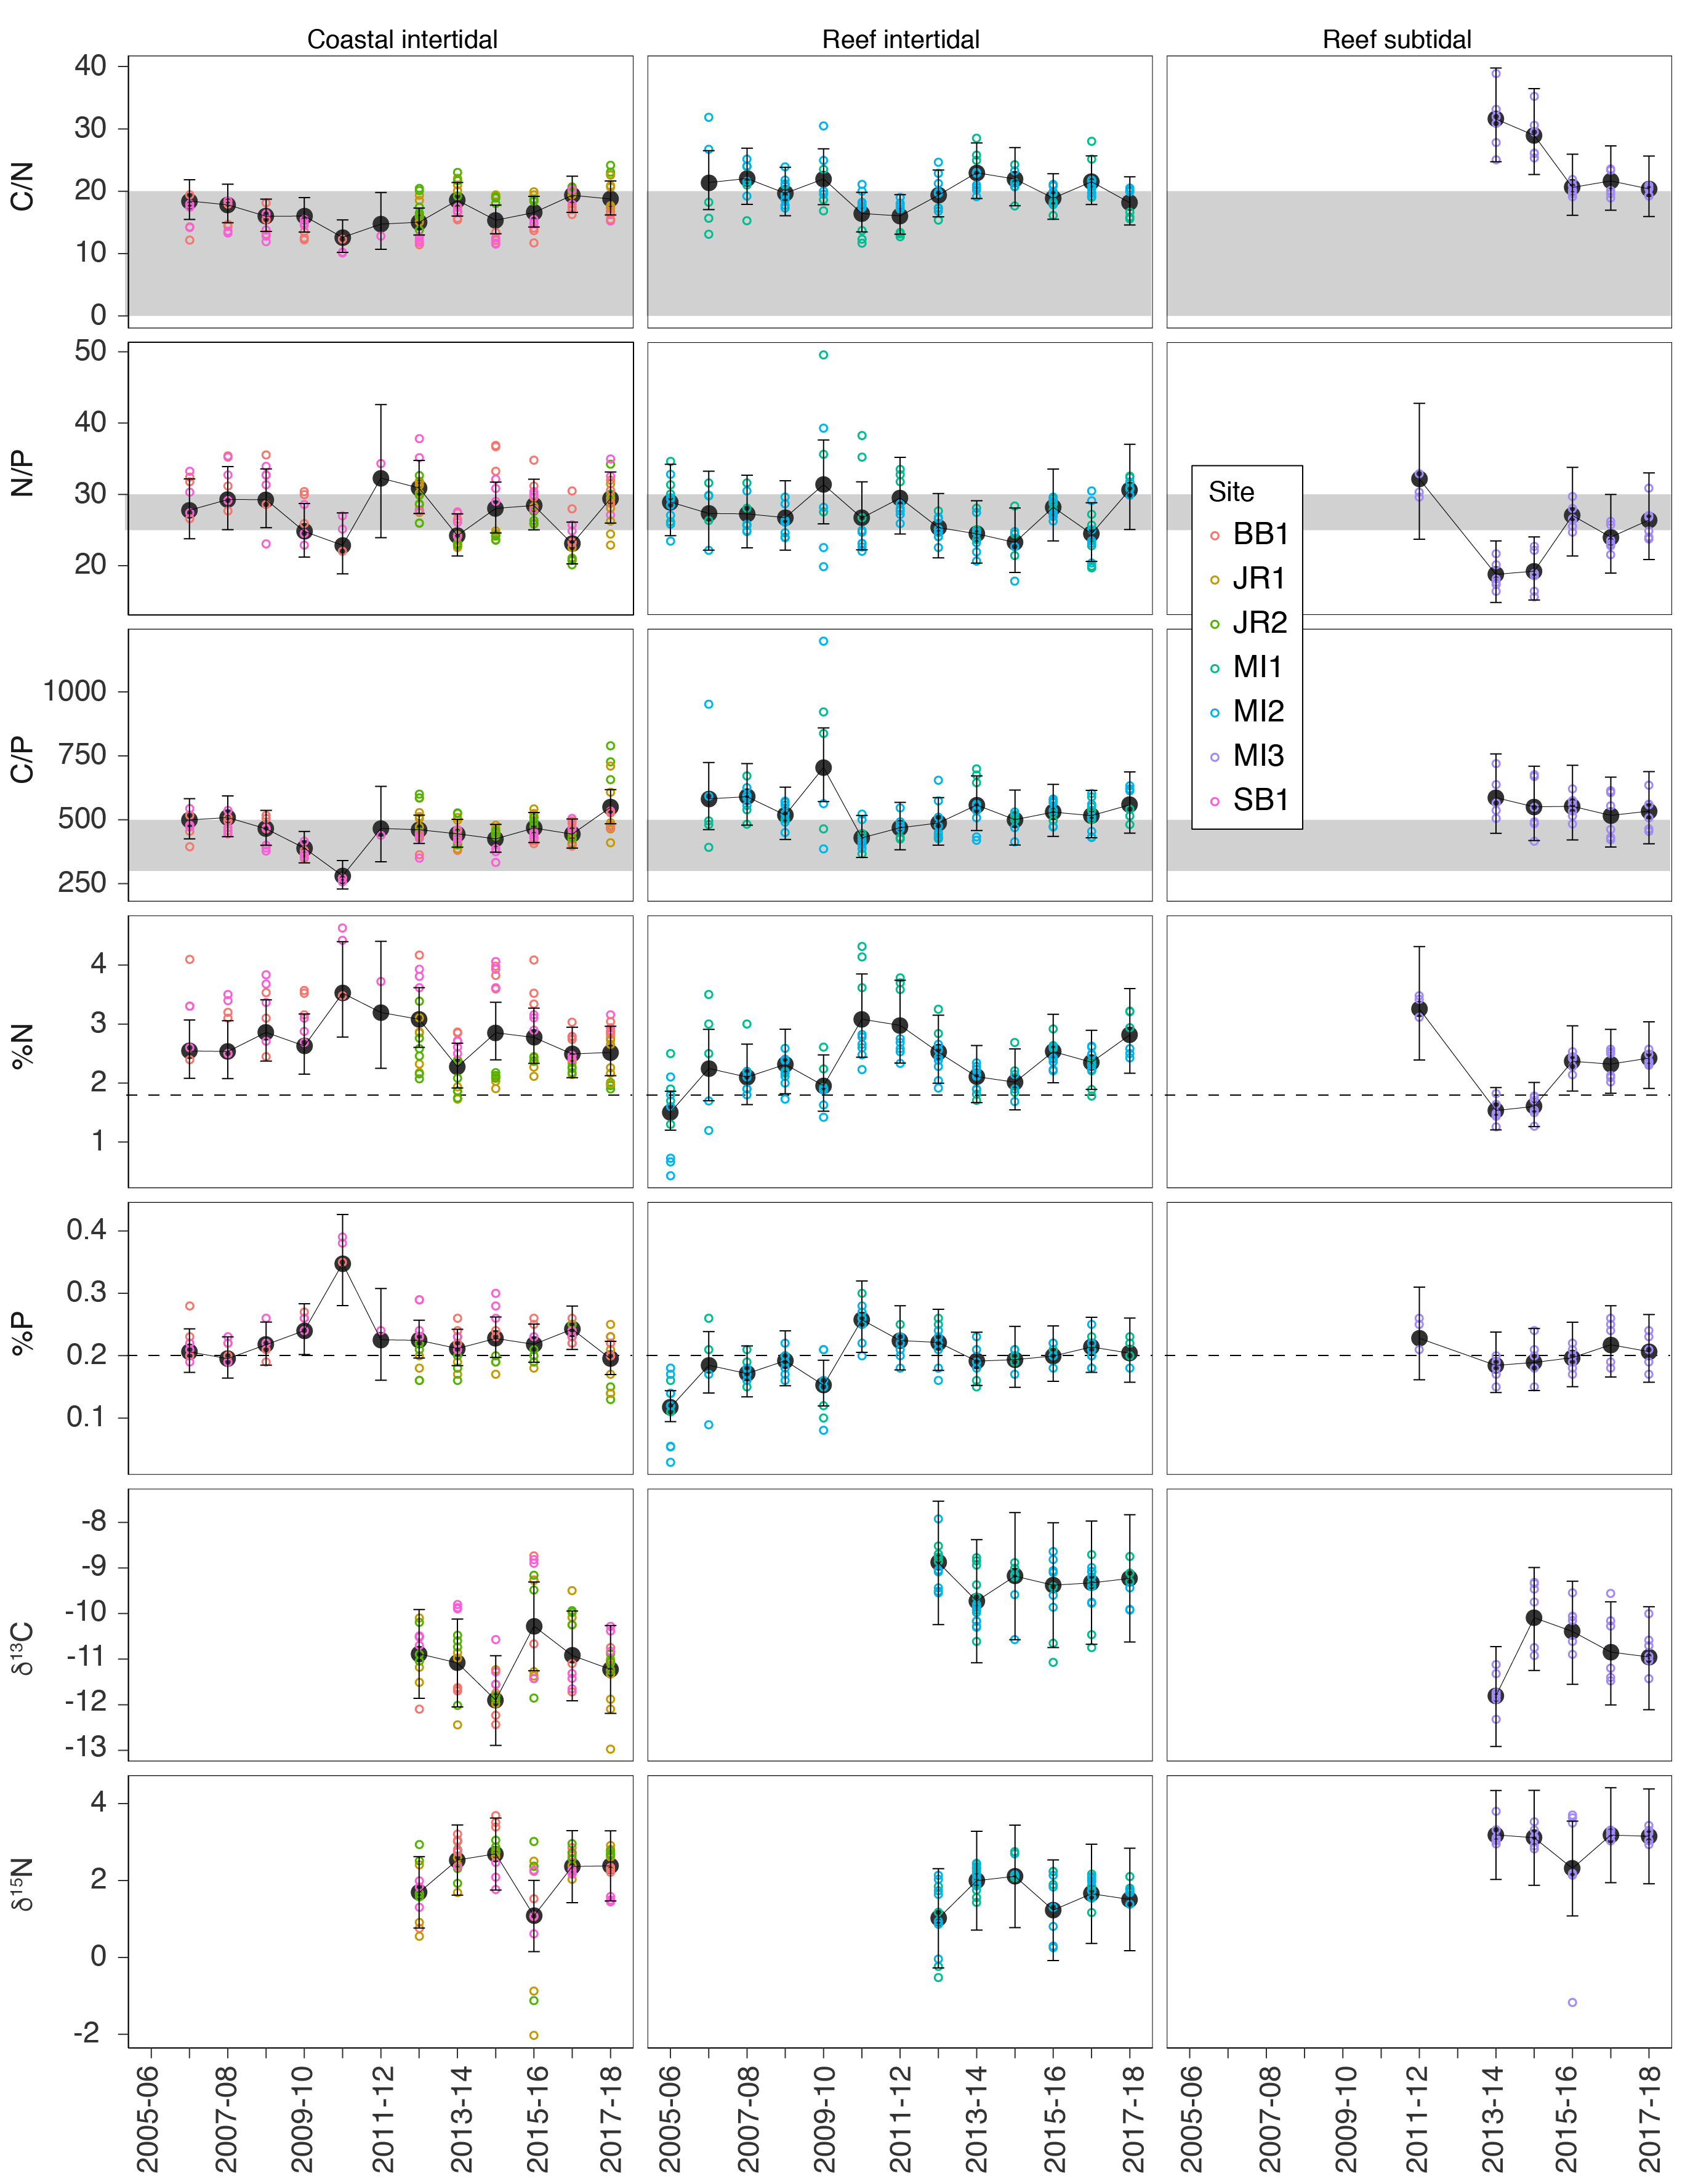
Figure 59. Seagrass leaf tissue nutrient elemental ratios (C:N:P) and concentrations (%N, %P, δ¹³C and δ¹⁵N) for each habitat in the Burdekin region
(± SE) (foundation species pooled). Horizontal shaded bands or dashed lines represents the accepted seagrass guideline values, where: C:N ratios within the band may indicate reduced light availability and/or N enrichment; N:P ratios above the band indicate P limitation, below indicate N limitation and within indicates replete, and; C:P ratios within the band may indicate nutrient rich habitats (large P pool). Dashed lines in %N and %P indicate global median values of 1.8 % and 0.2 % for tissue nitrogen and phosphorus, respectively (Duarte 1990).

Epiphytes and macroalgae
Epiphyte cover on seagrass leaf blades differs between the wet and dry season at coastal sites, but there is not a strong seasonal trend in other habitats. (Figure 60). Apart from a decline in epiphyte abundance at intertidal habitats in the late wet season 2017–18, epiphyte abundance have been above the Reef-wide long-term average for the last few years.
Macroalgae abundance has remained low and below the long-term average at coastal habitats, however abundances have increased over the last two monitoring periods at reef (intertidal and reef) habitats.
Both epiphytes and macroalgae cover can increase following nutrient enrichment (Cabaço et al. 2013; Nelson 2017); however, due to complex ecological and biological factors (e.g. grazing Heck and Valentine 2006), their abundance may not necessarily correlate to nutrient loading. Elevated water temperatures over the last four years may have also driven faster rates of epiphyte and macroalgae cover in reef habitats, as they can be highly responsive to temperature and less turbid waters.
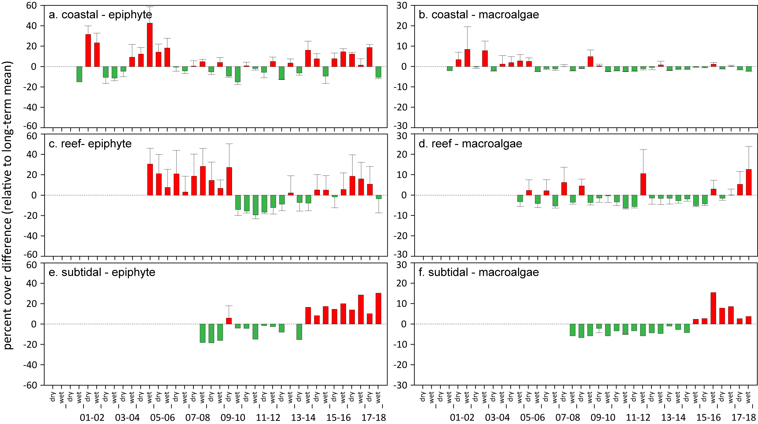
Figure 60. Long-term trend in mean epiphyte and macroalgae abundance (% cover) relative to the long-term Reef average for each inshore seagrass habitat in the Burdekin region
(sites pooled, ±SE). Red/green text

Mackay-Whitsunday

2017–18 Summary
Inshore seagrass meadows across the Mackay-Whitsunday NRM region declined in overall condition in 2017–18, with the condition grade remaining poor (Figure 61). All condition indicators also declined:
- abundance score was poor
- reproductive effort score was very poor
- tissue nutrient score was poor.
Although meadow distribution improved relative to the previous period, 64% of sites decreased in abundance. All subtidal sites decreased in abundance, however losses only occurred in 25% and 50% of coastal and reef intertidal sites, respectively. The long-term trend for the region indicates a significant decrease in abundance.
Recovery potential was varied across the region and habitats. Seagrass reproductive effort remained elevated at coastal habitats, however the overall indicator score declined greatly due to very low or absent reproductive effort in reef and estuarine habitats. In addition, declining and low seed banks at coastal habitats and reef habitats may limit recovery. Although a greater seed bank was present in the estuarine meadows, they lack replenishment capability due to deficient reproductive effort (i.e. limited recovery capacity), which coupled with low seagrass abundance (i.e. low resistance) may render the meadows vulnerable to large disturbances in the near future.
Leaf tissue C:N ratios were unchanged and remained poor overall.
The Mackay-Whitsunday regional seagrass condition had been improving since 2010–2011, when it reached its lowest level since monitoring commenced. However by 2016–2017 the recovery trend abated, as a consequence of cyclone Debbie, and the 2016–2017 decline continued this year.

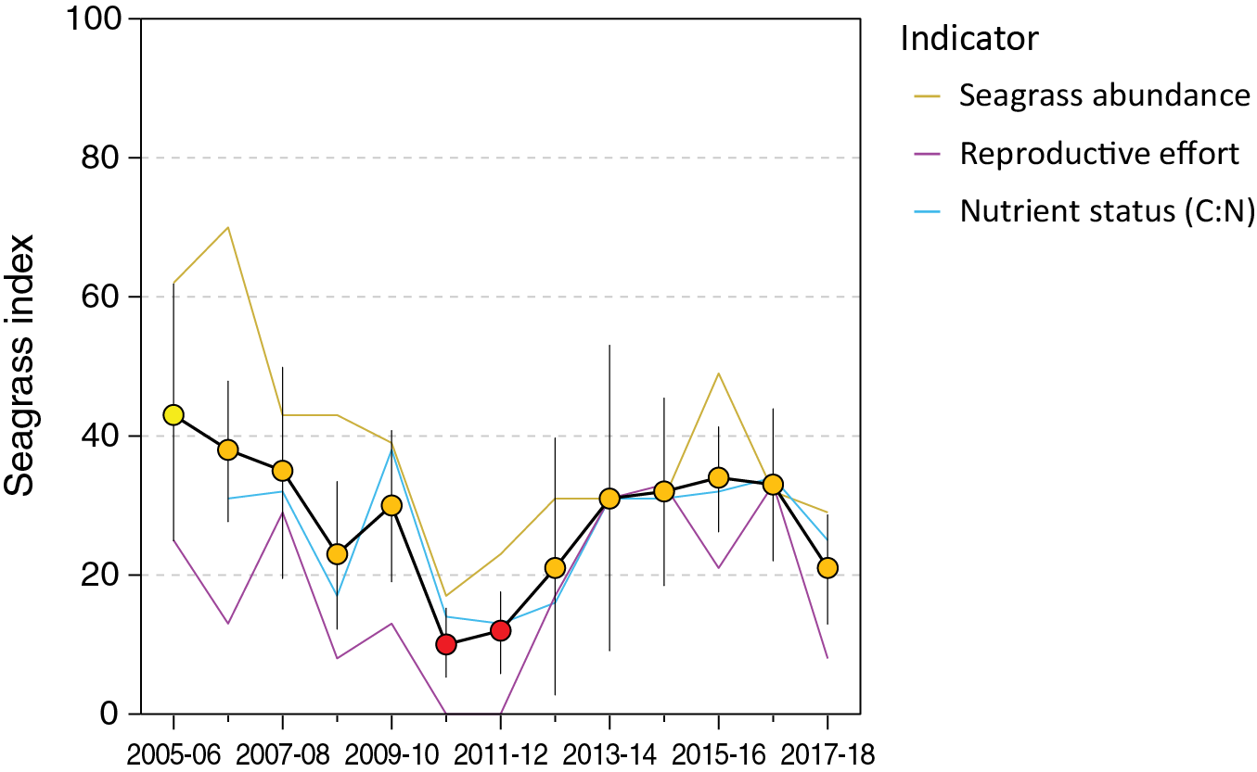
Figure 61. Report card of seagrass status indicators and index for the Mackay-Whitsunday NRM region
(averages across habitats and sites). Values are indexed scores scaled from 0–100 and graded: ● = very good (81-100), ● = good (61 - 80), ● = moderate (41 - 60), ● = poor (21 - 40), ● = very poor (0 - 20). NB: Scores are unitless.

Climate and environmental pressures
The 2017–18 monitoring period in the Mackay-Whitsunday region was characterised by rainfall and discharge that was well below the long-term average (Figure 53). Apart from a minor flow event in early April 2018, the region experienced a benign 2017–18 wet season (Gruber et al. 2019).
Exposure of inshore seagrass to turbid waters during the wet season was at the long-term average (Figure 62). Exposure to ‘brown’ or ‘green’ turbid water was variable among seagrass habitats (Figure 62). Estuarine and coastal were not only exposed to turbid waters for the entire wet season, but were the only habitats exposed to ‘brown’ sediment laden waters.
Estuarine sites in Sarina Inlet (SI1 and SI2), were exposed to ‘brown’ turbid water for 76% of the wet season, resulting in marginally lower benthic light (Figure 9, Figure 62). Reef habitats fringing the mainland (HB1 and HB2) and located on offshore islands (HM1 and HM2) were only exposed to ‘green’ water but at high frequency (95% and 81% of wet season weeks) and experienced average benthic light (Figure 9, Figure 62).
Within-canopy light was slightly lower than long-term average but remained above 10 mol m⁻² d⁻¹ on average. However, benthic light at the coastal meadows was above the long-term average (Figure 9, Figure 62, Figure 110), which could be due to the more sheltered position of the sites from prevailing weather. The reduced light experienced across the Mackay-Whitsunday region may have also been exacerbated by higher than average number of days in which wind speeds exceeded 25 km hr⁻¹ (Figure 95), which may have suspended fine sediments into the water column. Also, daytime tides were generally higher throughout 2017–18, which although potentially providing some respite from intertidal exposure (nearly a quarter less than the long term average), could have resulted in longer periods of reduced light availability during periods of higher water turbidity.
2017–18 was the fourth consecutive year intertidal within-canopy temperatures were the above long-term average and the third highest average annual temperature (25.7°C) since 2003 (Figure 62). Maximum intertidal within-canopy temperatures exceeded 35°C for a total of 66 days during 2017–18, with the highest temperature recorded at 40.1°C (MP1, 4pm 12Feb18). 2017–18 was the first full year of subtidal monitoring with an annual average temperature of 25.7°C, and maximum of 31°C (3pm 30Dec17).
Daily tide exposure was below the long‐term average in 2017–18 (Figure 62, Figure 103), which may have provided some respite from the elevated temperatures.
The proportion of fine grain sizes decreases in the sediments of the seagrass monitoring sites/meadows with distance from the coast/river mouths in the Mackay-Whitsunday region. Estuarine sediments were composed of greater proportion of finer sediments, and in 2017–18 the proportion of mud was slightly higher than 2016–17, but similar to the Reef-wide long-term average (Figure 121).
Coastal habitat meadows had less mud than estuarine habitats over the long term, but fluctuate within and between both meadows and years. In 2017–18 some sites/meadows had a higher proportion of mud (e.g. PI2 and MP2) than the Reef long-term average (Figure 122).
Reef habitats were composed predominately of fine to medium sand, however after cyclone Debbie in early 2017, one of the meadows has maintained a proportion of mud above the Reef long-term average (Figure 123).

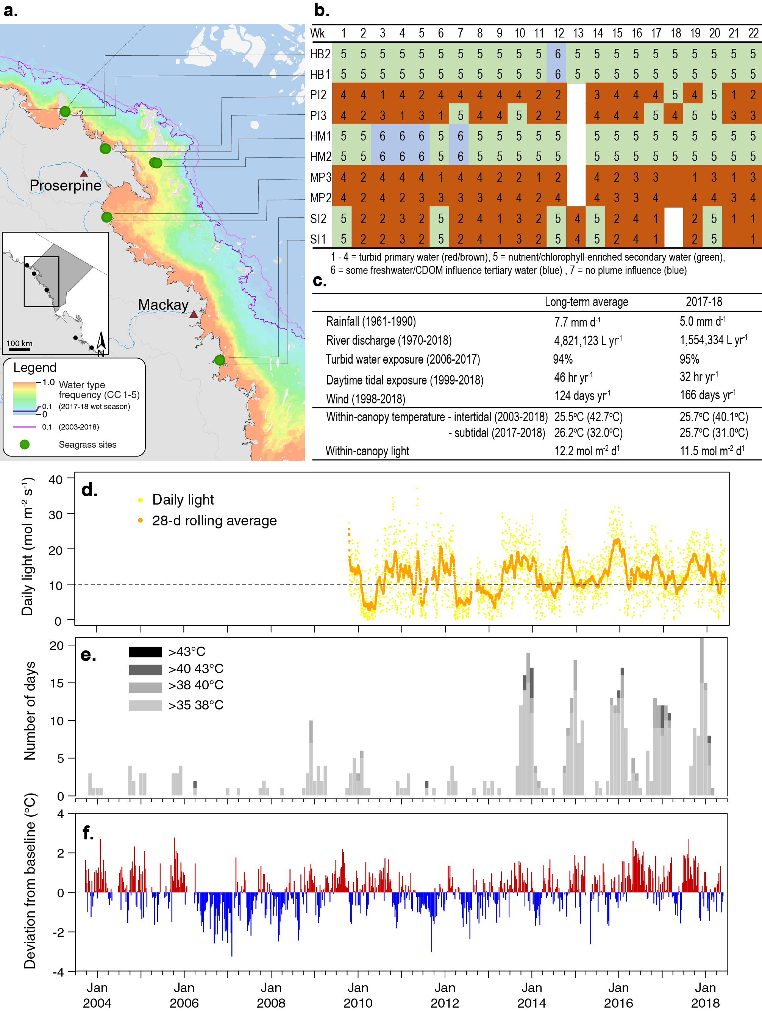
Figure 62. Environmental pressures in the Mackay-Whitsunday NRM region
including: a. frequency of exposure to turbid water (colour classes 1–5) (from Gruber et al. 2019); b. wet season water type at each site; c. average conditions over the long-term and in 2017–18; d. daily light and the 28-day rolling mean of daily light for all sites; e. number of day temperature exceeded 35°C, 38°C, 40°C and 43°C, and; f. deviations from 13-year mean weekly temperature records.

Inshore seagrass and habitat condition
Five seagrass habitat types were assessed across the Mackay-Whitsunday region this year, with data from 14 sites (Table 14).
Table 14. List of data sources of seagrass and environmental condition indicators for each seagrass habitat type in the Mackay-Whitsunday NRM region.
drop camera sampling (QPWS), *Seagrass-Watch. For site details see Table 2 and Table 3.
Habitat | Site |  | abundance | composition | distribution | Reproductive effort | seed banks | Leaf tissue nutrients | Meadow sediments | Epiphytes | Macroalgae
estuary intertidal | SI1 | Sarina Inlet
estuary intertidal | SI2 | Sarina Inlet
coastal intertidal | MP2 | Midge Point
coastal intertidal | MP3 | Midge Point
coastal intertidal | PI2* | Pioneer Bay
coastal intertidal | PI3* | Pioneer Bay
coastal subtidal | NB1 | Newry Bay
coastal subtidal | NB2 | Newry Bay
reef intertidal | HM1 | Hamilton Island
reef intertidal | HM2 | Hamilton Island
reef intertidal | HB1* | Hydeaway Bay
reef intertidal | HB2* | Hydeaway Bay
reef subtidal | LN1 | Lindeman Is
reef subtidal | LN2 | Lindeman Is
reef subtidal | TO1 | Tongue Bay
reef subtidal | TO2 | Tongue Bay

Seagrass index and indicator scores
In the 2017–18 monitoring period, the Mackay-Whitsunday region seagrass condition index declined from the previous year, but remained graded as poor (Figure 63).
Overall, the Mackay-Whitsunday seagrass index had been improving since 2010–11, when it reached its lowest level since monitoring commenced. In 2016–17 the improving trend abated and abundance declined as a consequence of cyclone Debbie; with the decline continuing this year (Figure 63). However, rather than the decline being offset by other condition indicators (as occurred in 2016–17), in 2017–18 all condition indictors declined simultaneously.
Both reproductive effort and tissue nutrients in 2017–18 were the lowest in five years (Figure 63). This similarly appears a legacy of losses experienced from the impacts of cyclone Debbie and associated flooding.
An examination of the long term trends across the Mackay-Whitsunday NRM region using GAM plots suggests seagrass abundance (% cover) and reproductive effort have been declining since 2015–16 (Figure 63).

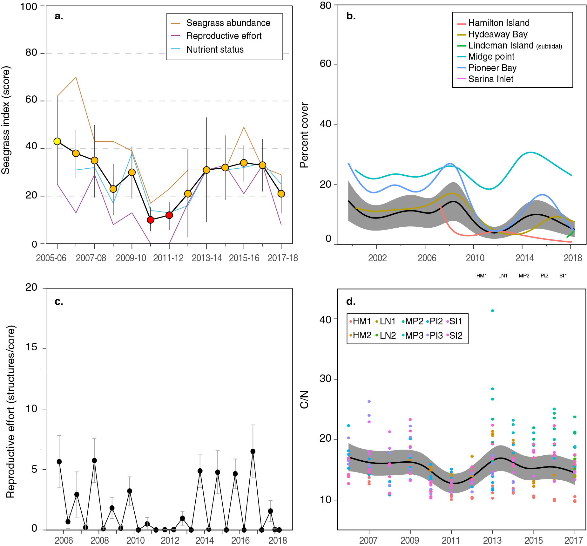
Figure 63. Temporal trends in the Mackay-Whitsunday seagrass condition index and the indicators used to calculate the index
: a. seagrass condition index (circles) and indicator trends (lines); b. GAM plots of seagrass abundance (% cover) trends for each location (coloured lines) and the region (black line with grey shaded area defining 95% confidence intervals); c. average number of reproductive structures (±SE) (GAM not possible due to high count of zero values); and d. elemental ratios (atomic) of leaf tissue C:N nutrient content at each site (coloured circles) and regional trend represented by a GAM plot as dark line with shaded areas defining 95% confidence intervals of the trend

Seagrass abundance, community and extent
Seagrass abundance declined in 2017–18 across all habitats in the region, a legacy of the losses experienced in early 2017 as a consequence of the impacts of TC Debbie and associated flooding (Figure 64).
Seagrass abundance (% cover) in the Mackay-Whitsunday region was higher in coastal habitats (intertidal = 19.2 ±1.8%, subtidal = 17.7 ±1.8%) than estuarine (8.5 ±1.6%) or reef habitats (intertidal = 7.7 ±1.4%, subtidal = 7.7 ±0.7%), respectively. Abundances were also higher in the dry than the wet season across all habitats (e.g. estuarine, dry = 11.3 ±1.8, wet = 5.3 ±1.4).
Seagrass abundance at estuary and coastal intertidal habitats has fluctuated greatly between and within years over the long-term, with some sites experiencing total or near total loss followed by recovery (Figure 64). In 2017–18, 64% of sites decreased in abundance relative to the previous period. All sites in subtidal (coastal and reef) habitats decreased, however only 25% and 50% of coastal and reef intertidal sites, respectively, decreased in 2017–18. There also appears no overall spatial pattern (e.g. relative to the landfall location of TC Debbie on 28 March 2017) to the losses.

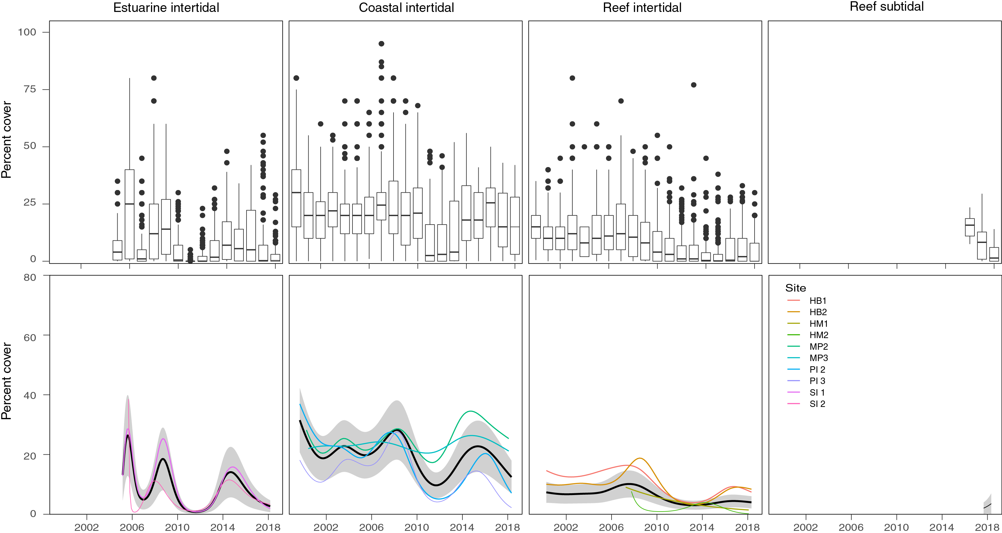
Figure 64. Seagrass per cent cover measures per quadrat (sites pooled) and long-term trends, for each habitat monitored in the Mackay-Whitsunday NRM region from 1999 to 2018.
Whisker plots (top) show the box representing the interquartile range of values, where the boundary of the box closest to zero indicates the 25th percentile, a line within the box marks the median, and the boundary of the box farthest from zero indicates the 75th percentile. Whiskers (error bars) above and below the box indicate the 90th and 10th percentiles, and the dots represent outlying points. GAMM plots (bottom), show trends for each habitat and coloured lines represent individual site trends

The most common seagrass species across all habitats in the Mackay-Whitsunday NRM region were Halodule uninervis and Zostera muelleri, mixed with the colonising species Halophila ovalis.
Colonising species dominated intertidal meadows across the Mackay-Whitsunday region in the first few years following the extreme weather in 2011. In the previous two years, there has been a dramatic reduction in colonising species in estuarine and coastal intertidal habitats. In all habitats except the reef intertidal habitats, opportunistic foundational species (H. uninervis and Z. muelleri) now dominate (Figure 65), suggesting meadows may have an improved ecosystem resistance to tolerate disturbances (Figure 65). In contrast, in reef habitats (Hamilton Island), colonising species have been steadily increasing since 2006 and remained above the Reef long-term average over the last few years. In 2017–18, the only notable change was an increase of colonising species in estuarine meadows, however the composition still remains below the Reef long-term average.
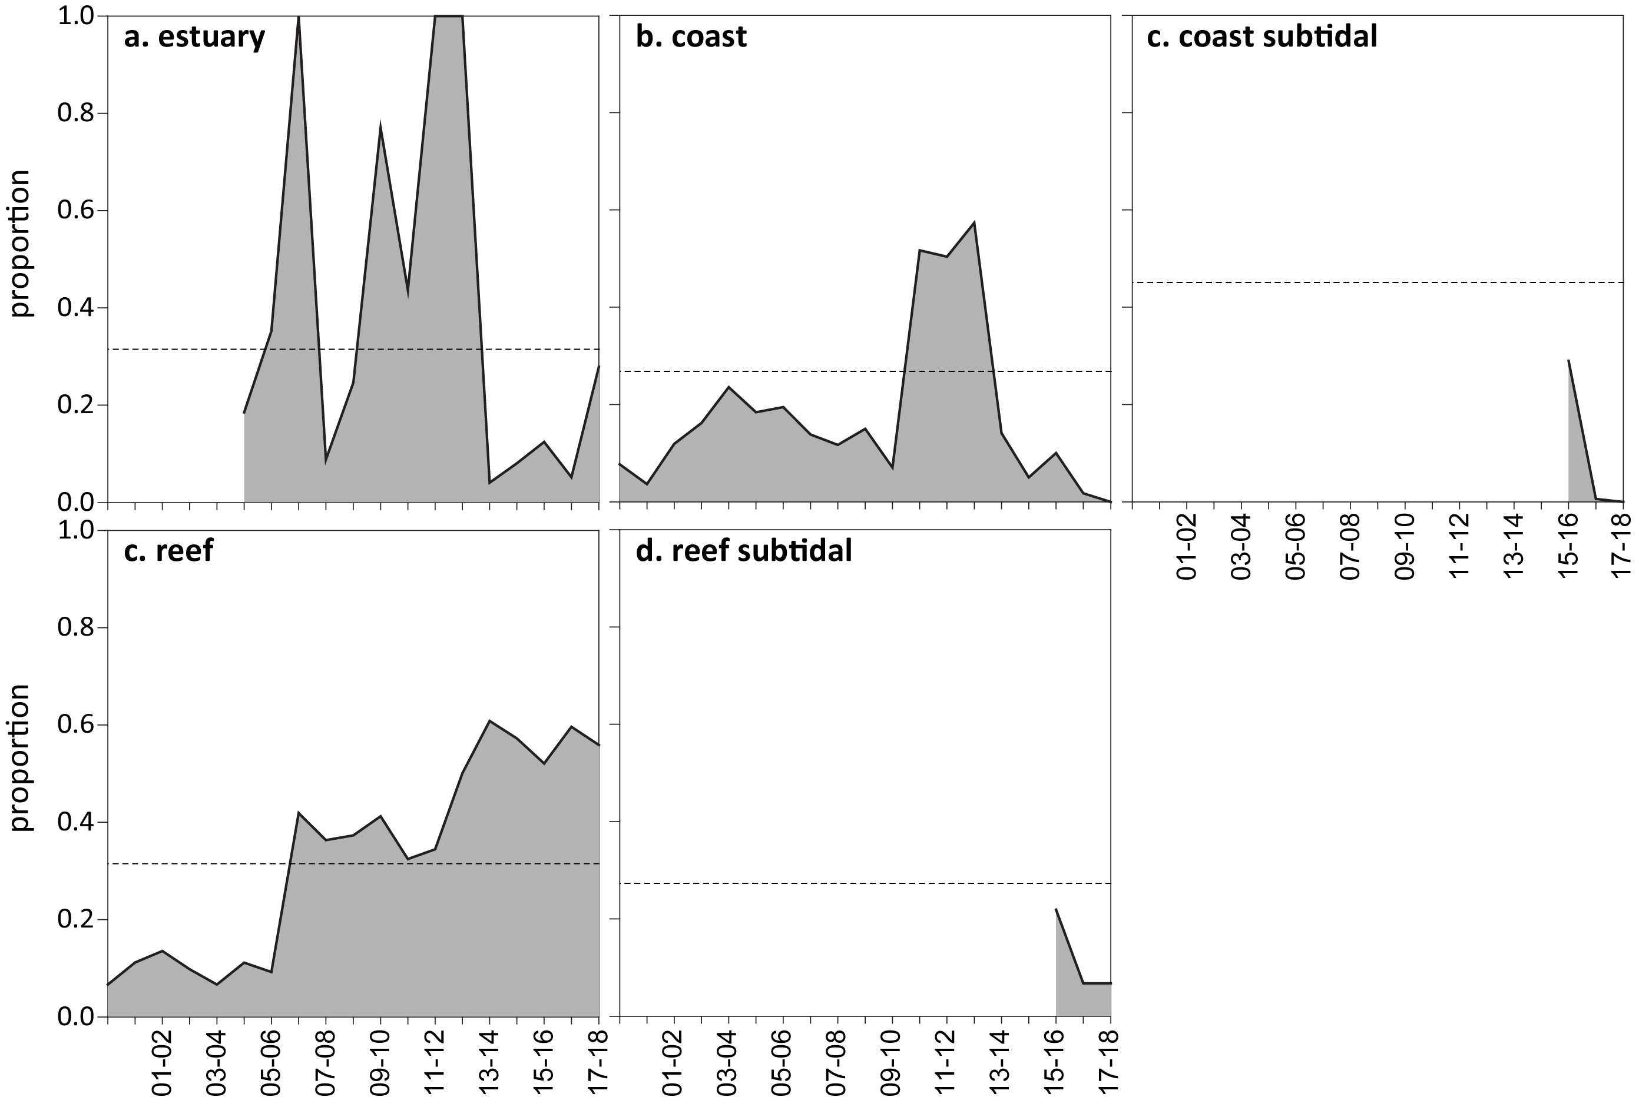
Figure 65. Proportion of seagrass abundance composed of colonising species at inshore intertidal habitats in the Mackay-Whitsunday region, 1999–2018.
Grey area represents Reef long-term average proportion of colonising species for each habitat type.
Seagrass meadow landscape mapping was conducted within all monitoring sites in October 2017 and April 2018 to determine if changes in abundance were a consequence of the meadow landscape changing (e.g. scarring, fragmentation, boundary) and to indicate if plants were allocating resources to colonisation (asexual reproduction). Over the past 12 months, spatial extent improved at estuarine meadows following the declines experienced in 2016–2017 as a consequence of the destructive effects of cyclone Debbie. At coastal meadows, extent improved slightly relative to the previous monitoring period, as the level of scarring dissipated and meadow cohesion improved. At reef meadows, however, extent changed little due to the high level of fragmentation experienced in the previous period (Figure 66).
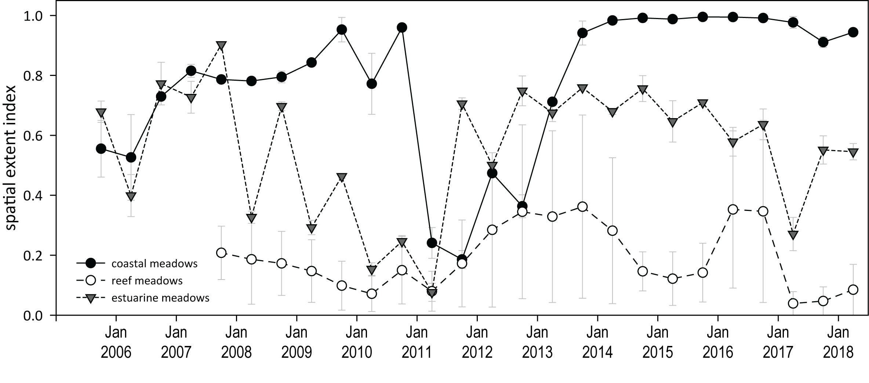
Figure 66. Change in spatial extent of seagrass meadows within monitoring sites for each inshore intertidal habitat and monitoring period across the Mackay-Whitsunday NRM region.

Seagrass reproductive status
Reproductive effort was highly variable and highly seasonal in the Mackay-Whitsunday region (Figure 67). Reproductive effort remained elevated in coastal habitats, although the density of seeds in the seedbank declined slightly in 2017–18 after TC Debbie, which may have been due to either scouring of the seed bank or germination. At the estuary site (Sarina Inlet), reproductive effort was absent, but seed bank increased slightly relative to the previous year, possibly a legacy of the highest ever recorded reproductive effort in late dry 2016. In contrast, reproductive effort and the seeds density continued to remain very low at reef sites in 2017–18, which appears usual for reef habitat meadows (Figure 67).

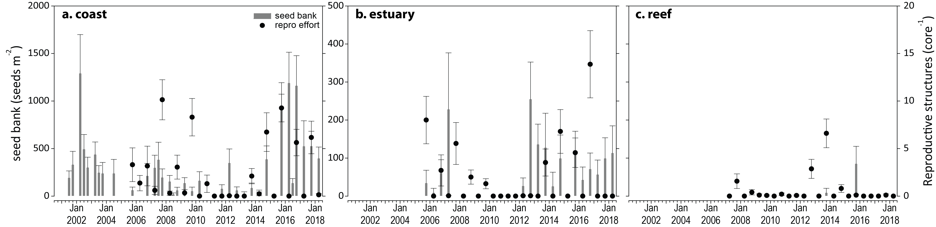
Figure 67. Seed bank and reproductive effort at inshore intertidal coast, estuary, and reef habitats in the Mackay-Whitsunday region, 2001–2018.
Seed bank presented as the total number of seeds per m² sediment surface and reproductive effort presented as the average number of reproductive structures per core (species and sites pooled). NB: Y-axis scale for seed banks differs between habitats.

Seagrass leaf tissue nutrients
Seagrass leaf molar C:N ratios were unchanged compared to the previous year, remaining below 20 (Figure 68), indicating a surplus of N relative to photosynthetic C incorporation. N:P ratios continued to increase across all habitats, and %N remained above the global median, indicating surplus availability of N across the region. The moderate and fluctuating δ¹⁵N (e.g. increasing at reef habitats), suggests some influence of an anthropogenic source of N at some sites (e.g., Hamilton Island) (Figure 68).
Figure 68. Seagrass leaf tissue nutrient elemental ratios (C:N:P) and concentrations (%N, %P, δ¹³C and δ¹⁵N) for each habitat in the Mackay-Whitsunday region
(± SE) (foundation species pooled). Horizontal shaded bands or dashed lines represents the accepted seagrass guideline values, where: C:N ratios within the band may indicate reduced light availability and/or N enrichment; N:P ratios above the band indicate P limitation, below indicate N limitation and within indicates replete, and; C:P ratios within the band may indicate nutrient rich habitats (large P pool). Dashed lines in %N and %P indicate global median values of 1.8 % and 0.2 % for tissue nitrogen and phosphorus, respectively (Duarte 1990).

Epiphytes and macroalgae
Epiphyte cover on seagrass leaf blades in 2017–18 has remained below the Reef-wide long-term average at estuarine and reef habitats since early 2017, however increased at coastal habitats relative to the previous reporting year (Figure 69).
Percentage cover of macroalgae remained unchanged, at or below the Reef-wide long-term average for all habitats throughout this year (Figure 69).
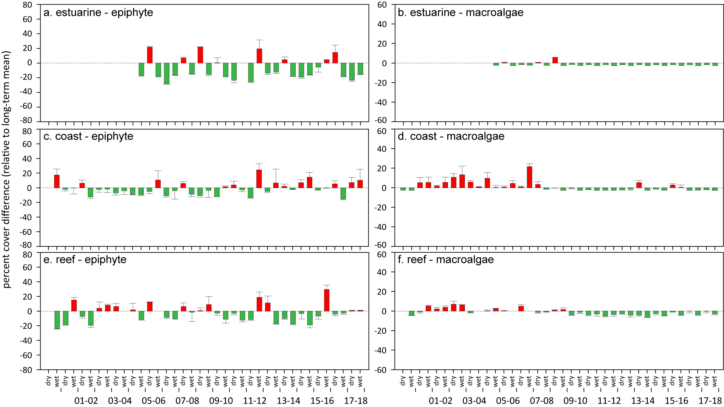
Figure 69. Long-term trend in mean epiphyte and macroalgae abundance (% cover) relative to the long-term average for each inshore intertidal habitat in the Mackay-Whitsunday region, 1999–2018
(sites pooled, ±SE). Red/green text

Fitzroy

2017–18 Summary
Overall, the Fitzroy regional seagrass condition decreased, but remain graded as poor in 2017–18 (Figure 70). The improvements in the abundance score were offset by decreased or low scores of the remaining indictors, where:
- abundance score was poor
- reproductive effort score was very poor
- tissue nutrient score was poor.
Approximately 67% of sites improved in abundance this year, however half of the estuary and reef sites decreased relative to the previous period. The improved abundances appear a consequence of a below average wet season, buoyed by improved benthic light, reproductive effort and a persistent seed bank. These improvements were despite elevated temperatures for the fifth consecutive year.
The low abundance in estuary meadows appears a legacy of declines in 2016–2017, and the meadows are expected to recove as the mud wave which caused the declines dissipated in 2017–18 and meadow integrity has improved.
However, the deteriorating condition of the reef habitats remains a concern. After the 2016 losses, the reef meadows remain highly fragmented, dominated by colonising species and showing little sign of recovery as reproductive effort remains very low and seed banks absent.
Examination of the long-term trend in seagrass abundance (% cover) across the region reveals a significant decrease, primarily influenced by significant decreases in estuary and reef habitats.
Seagrass leaf molar C:N ratios continue to indicate a surplus of N relative to photosynthetic C incorporation, however there is no indication of elevated N across the region, despite %N remaining above the global median. This is supported by continuing low epiphyte and macroalgae cover.
Inshore seagrass meadows across the region remain in the early stages of recovering from multiple years of climate related impacts which, similary to Mackay-Whitsunday, are more recent than in other regions. The coastal habitats have been improving, while other habitats demonstrate a legacy of reduced resilience.
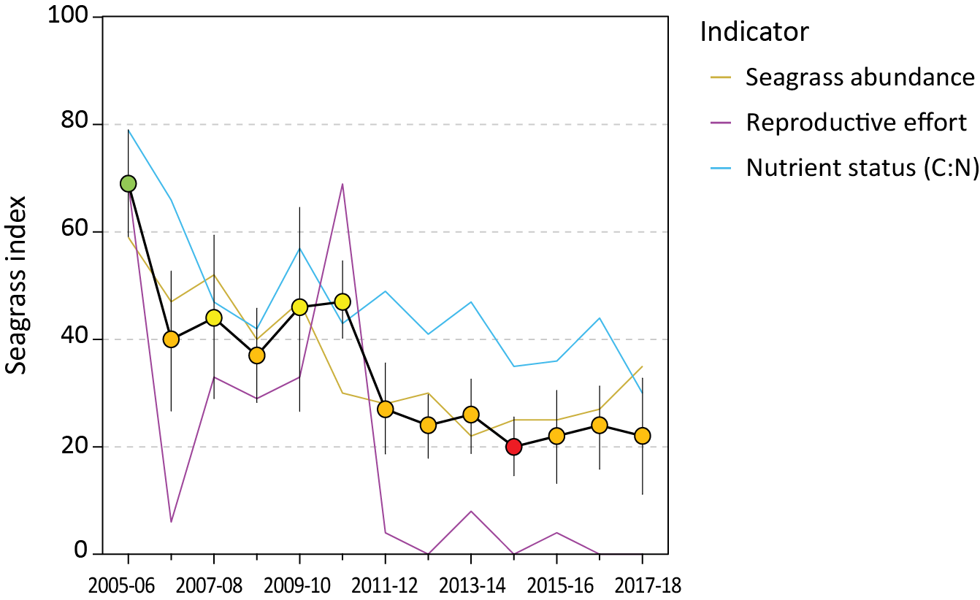
Figure 70. Report card of seagrass status index and indicators for the Fitzroy NRM region
(averages across habitats and sites). Values are indexed scores scaled from 0–100 and graded: ● = very good (81-100), ● = good (61 - 80), ● = moderate (41 - 60), ● = poor (21 - 40), ● = very poor (0 - 20). NB: Scores are unitless.

Climate and environmental pressures
Rainfall and river discharge in 2017–18 were well below the long-term average for the Fitzroy region (Figure 71). Exposure of inshore seagrass to turbid waters during the wet season was similar to the long-term average, however annual within-canopy light availability was the highest in seven years across all habitats (Figure 9, Figure 71).
All coastal and estuarine sites monitored throughout the region were exposed to ‘brown’ or ‘green’ turbid water for the entire wet season (100% frequency of exposure). Coastal sites in Shoalwater Bay (RC1 and WH1) experienced the highest exposure to ‘brown’ turbid, sediment laden, water (95-100% of wet season weeks). Estuarine sites in outer Gladstone Harbour (GH1 and GH2) were exposed to ‘brown’ turbid waters for 76% of wet season weeks (Figure 71). The reef sites at Great Keppel Island (GK1 and GK2) were exposed predominately to ‘green’ water (90% of wet season weeks) (Figure 71).
The improved light experienced across the Fitzroy region (Figure 111) may have also been assisted by lower than average number of days in which wind speeds exceeded 25 km hr⁻¹ (Figure 96), reducing suspension of fine sediments into the water column, and a shallowing of waters during daylight hour from lower than average tides. Countering the improved light, coastal intertidal meadows throughout the region experienced slightly more hours of carbon limitation due to more hours of daytime tidal exposure than average (Figure 104).
2017-18 was the fifth consecutive year intertidal within-canopy temperatures were above the long-term average and the second highest average annual temperature (24.6°C) since 2006 (Figure 71). Maximum intertidal within-canopy temperatures exceeded 35°C for a total of 45 days during 2017–18, with the highest temperature ever recorded in the region at 41.6°C (GK1, 1pm 06Oct17).
The proportion of fine grains in meadow sediments decreases with distance from the coast/river mouths. Estuarine sediments were composed primarily of finer sediments, with the mud portion around the Reef-wide long-term average, although one site (GH1) was much muddier this year (Figure 124). Coastal and reef habitat sediments were dominated by fine sand/sand, but the proportion of mud in coastal habitats increased greatly in 2017–18 to above the Reef long-term average and similar to the long-term for the meadows (Figure 125, Figure 126).

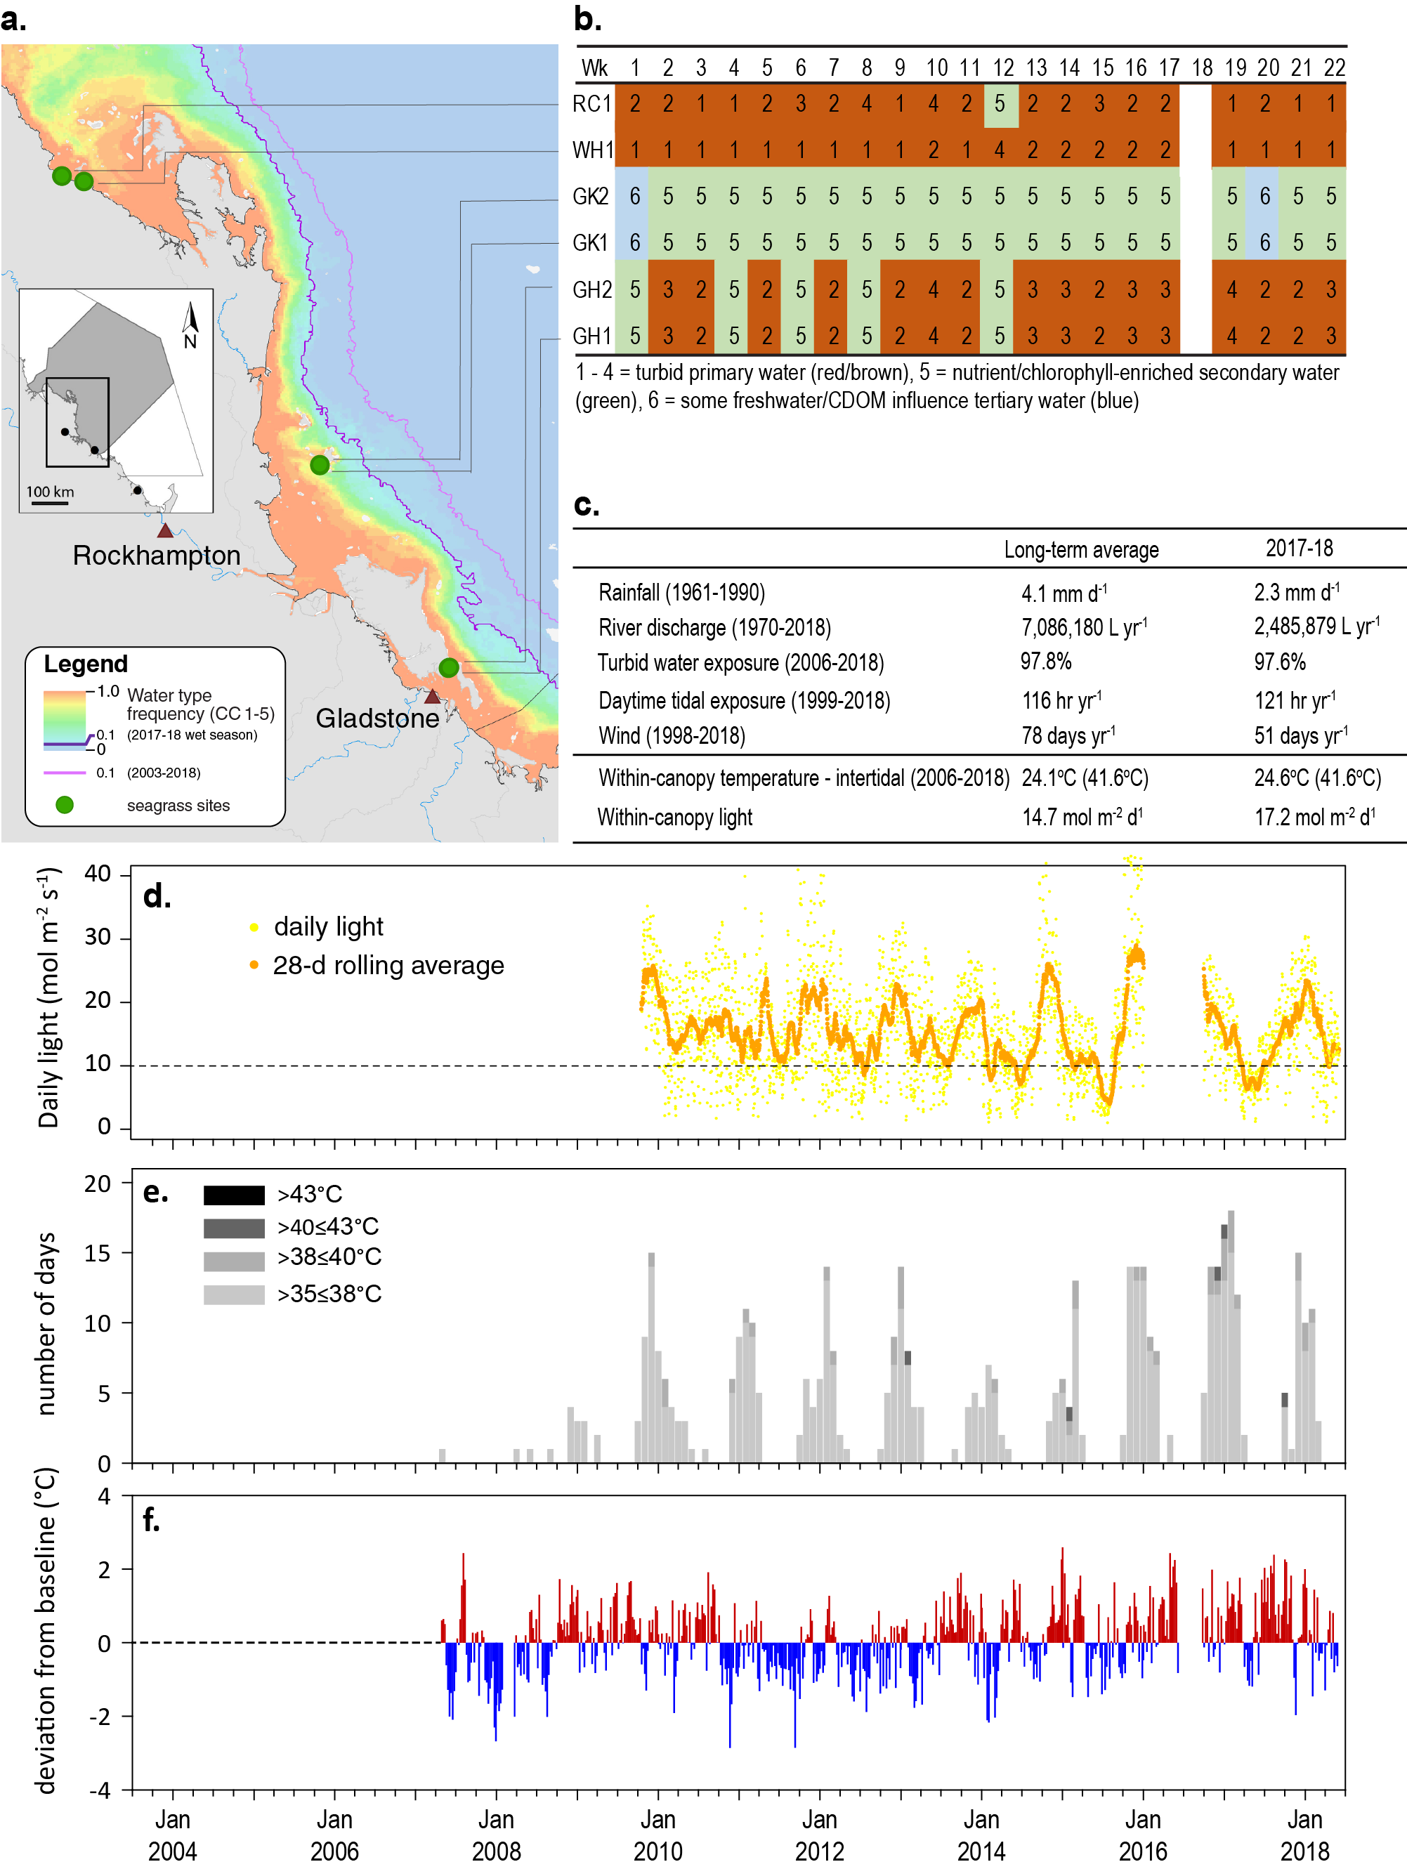
Figure 71. Environmental pressures in the Fitzroy region
including: a. frequency of exposure to turbid water (colour classes 1–5) (from Gruber et al. 2019); b. wet season water type at each site; c. average conditions over the long-term and in 2017–18; d. daily light and the 28-day rolling mean of daily light for all sites; e. number of day temperature exceeded 35°C, 38°C, 40°C and; 43°C, and f. deviations from 12-year mean weekly temperature records.

Inshore seagrass and habitat condition
Three seagrass habitat types were assessed across the Fitzroy region in 2017–18, with data from 6 sites (Table 15).
Table 15. List of data sources of seagrass and environmental condition indicators for each seagrass habitat type in the Fitzroy NRM region.
For site details see Table 2 and Table 3.
Habitat | Site |  | abundance | composition | distribution | Reproductive effort | seed banks | Leaf tissue nutrients | Meadow sediments | Epiphytes | Macroalgae
estuary intertidal | GH1 | Gladstone Hbr
 | GH2 | Gladstone Hbr
coastal subtidal | RC1 | Ross Creek (Shoalwater Bay)
 | WH1 | Wheelans Hut (Shoalwater Bay)
reef intertidal | GK1 | Great Keppel Is.
 | GK2 | Great Keppel Is.

Seagrass index and indicator scores
In the 2017-18 monitoring period, the seagrass condition index marginally decreased, but remained graded as poor (Figure 72).
Although there were improvements in the abundance score in Shoalwater Bay, this was offset by a decline in the tissue nutrients score and the reproductive effort score remaining at zero (Figure 72).
Reproductive effort has remained low since 2011–2012, and fluctuations in the seagrass condition index over the last 7 monitoring periods have been primarily driven by fluctuations in abundance and tissue nutrient status.
Of particular concern is that seagrass abundance (% cover) has significantly decreased over the long-term (Figure 72, Table 23).
Long term trends using GAM plots suggests tissue nutrient elemental C:N has been declining since 2005 across the region (Figure 72).

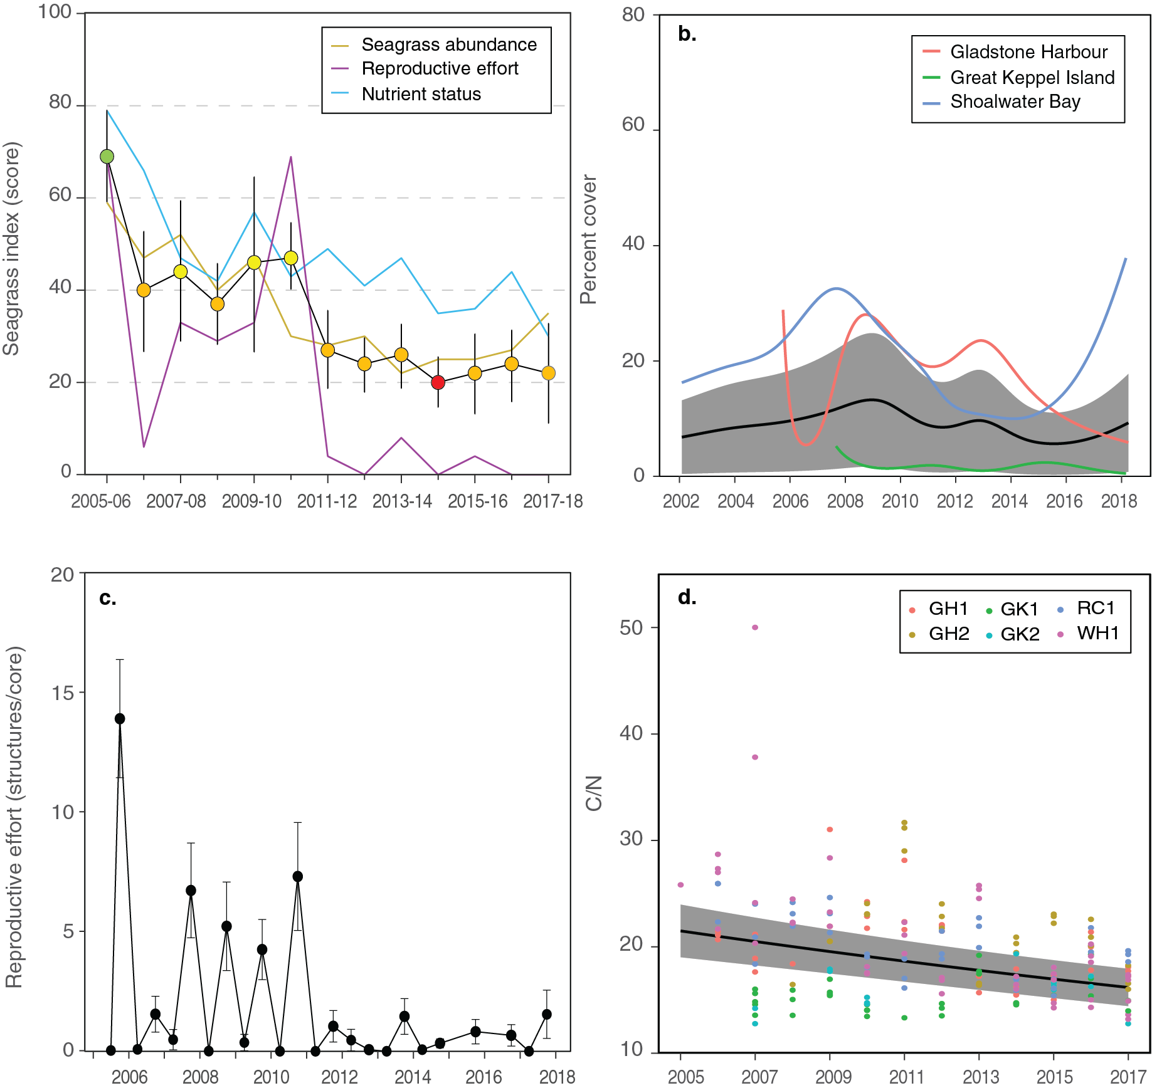
Figure 72. Temporal trends in the Fitzroy seagrass condition index and the indicators used to calculate the index
: a. seagrass condition index (circles) and indicator trends (lines); b. GAM plots of seagrass abundance (% cover) trends for each location (coloured lines) and the region (black line with grey shaded area defining 95% confidence intervals); c. average number of reproductive structures (±SE) (GAM not possible due to high count of zero values); and d. elemental ratios (atomic) of leaf tissue C:N nutrient content at each site (coloured circles) and regional trend represented by a GAM plot as dark line with shaded areas defining 95% confidence intervals of the trend

Seagrass abundance, composition and extent
Seagrass abundances (% cover) in the Fitzroy region were significantly higher in coastal (20.2 ±1.5%) and estuarine (18.3 ±1.5%) habitats, than reef (1.7 ±0.6%) (Figure 73). With the exception of estuarine habitats, there was little difference in seagrass abundance between the wet and dry seasons. In estuarine habitats, abundances were higher in the dry than the wet season (dry = 22.0 ±1.8%, wet = 13.4 ±1.2%).
Seagrass abundance at estuary and coastal intertidal habitats has fluctuated greatly between years over the life of the monitoring, with some sites experiencing total or near total loss followed by recovery (Figure 73). In 2017–18, half of the estuary and reef sites decreased in abundance relative to the previous period, with all remaining sites, including all coastal sites, increasing (Figure 73).
Examination of the long-term trend in seagrass abundance (% cover) across the region reveals a significant decrease (Figure 72, Table 23).These decreases have primarily occurred in the estuary and reef habitats, although two thirds of all monitoring sites in the region (including coastal) show no significant trend (Table 23).
The low seagrass abundance in the estuarine habitat appears a legacy of decline in 2016–17, the result of a mud wave traversing across the meadow. As the mud wave dissipated in 2017–18, meadow integrity (e.g. reduced scarring) improved.
In the north of the region, coastal sites receive low river discharge, however, the meadows were still exposed to turbid ‘brown’ sediment laden waters for much of the year. There turbid waters could be partly the result of wind driven suspension, but appear mainly the consequence of the extreme tidal movement in Shoalwater Bay (some of the highest along the Queensland coast).
Seagrasses in Shoalwater Bay are able to persist on the large intertidal banks, where periods of shallowing water provide some respite from the highly turbid waters. However, these periods of shallowing water and carbon limitation (when exposure to air coincides with low spring tides) not only stress plants with desiccation, but also fluctuating water temperatures.
Maximum water temperatures exceeded 35°C for a total of 35 days in Shoalwater Bay during 2017–18, with a highest temperature of 39.5°C. The high temperatures are particularly stressful for Z. muelleri communities which dominate the coastal habitats as it has a thermal optima for overall net primary productivity of 24°C and above 35°C net productivity goes into deficit, i.e. it loses energy (Collier et al. 2017). This is in stark contrast to other tropical species (H. uninervis and C. serrulata), which must exceed 40°C for respiration rates and photoinhibition to cause the plants to lose energy for pulsed exposure (Collier et al. 2017). Similarly water temperature exceeded 35°C (max 37.5) on 18 days at Pelican banks in Gladstone Harbour and this was likely to have placed a substantial stress on these Z. muelleri dominated communities.

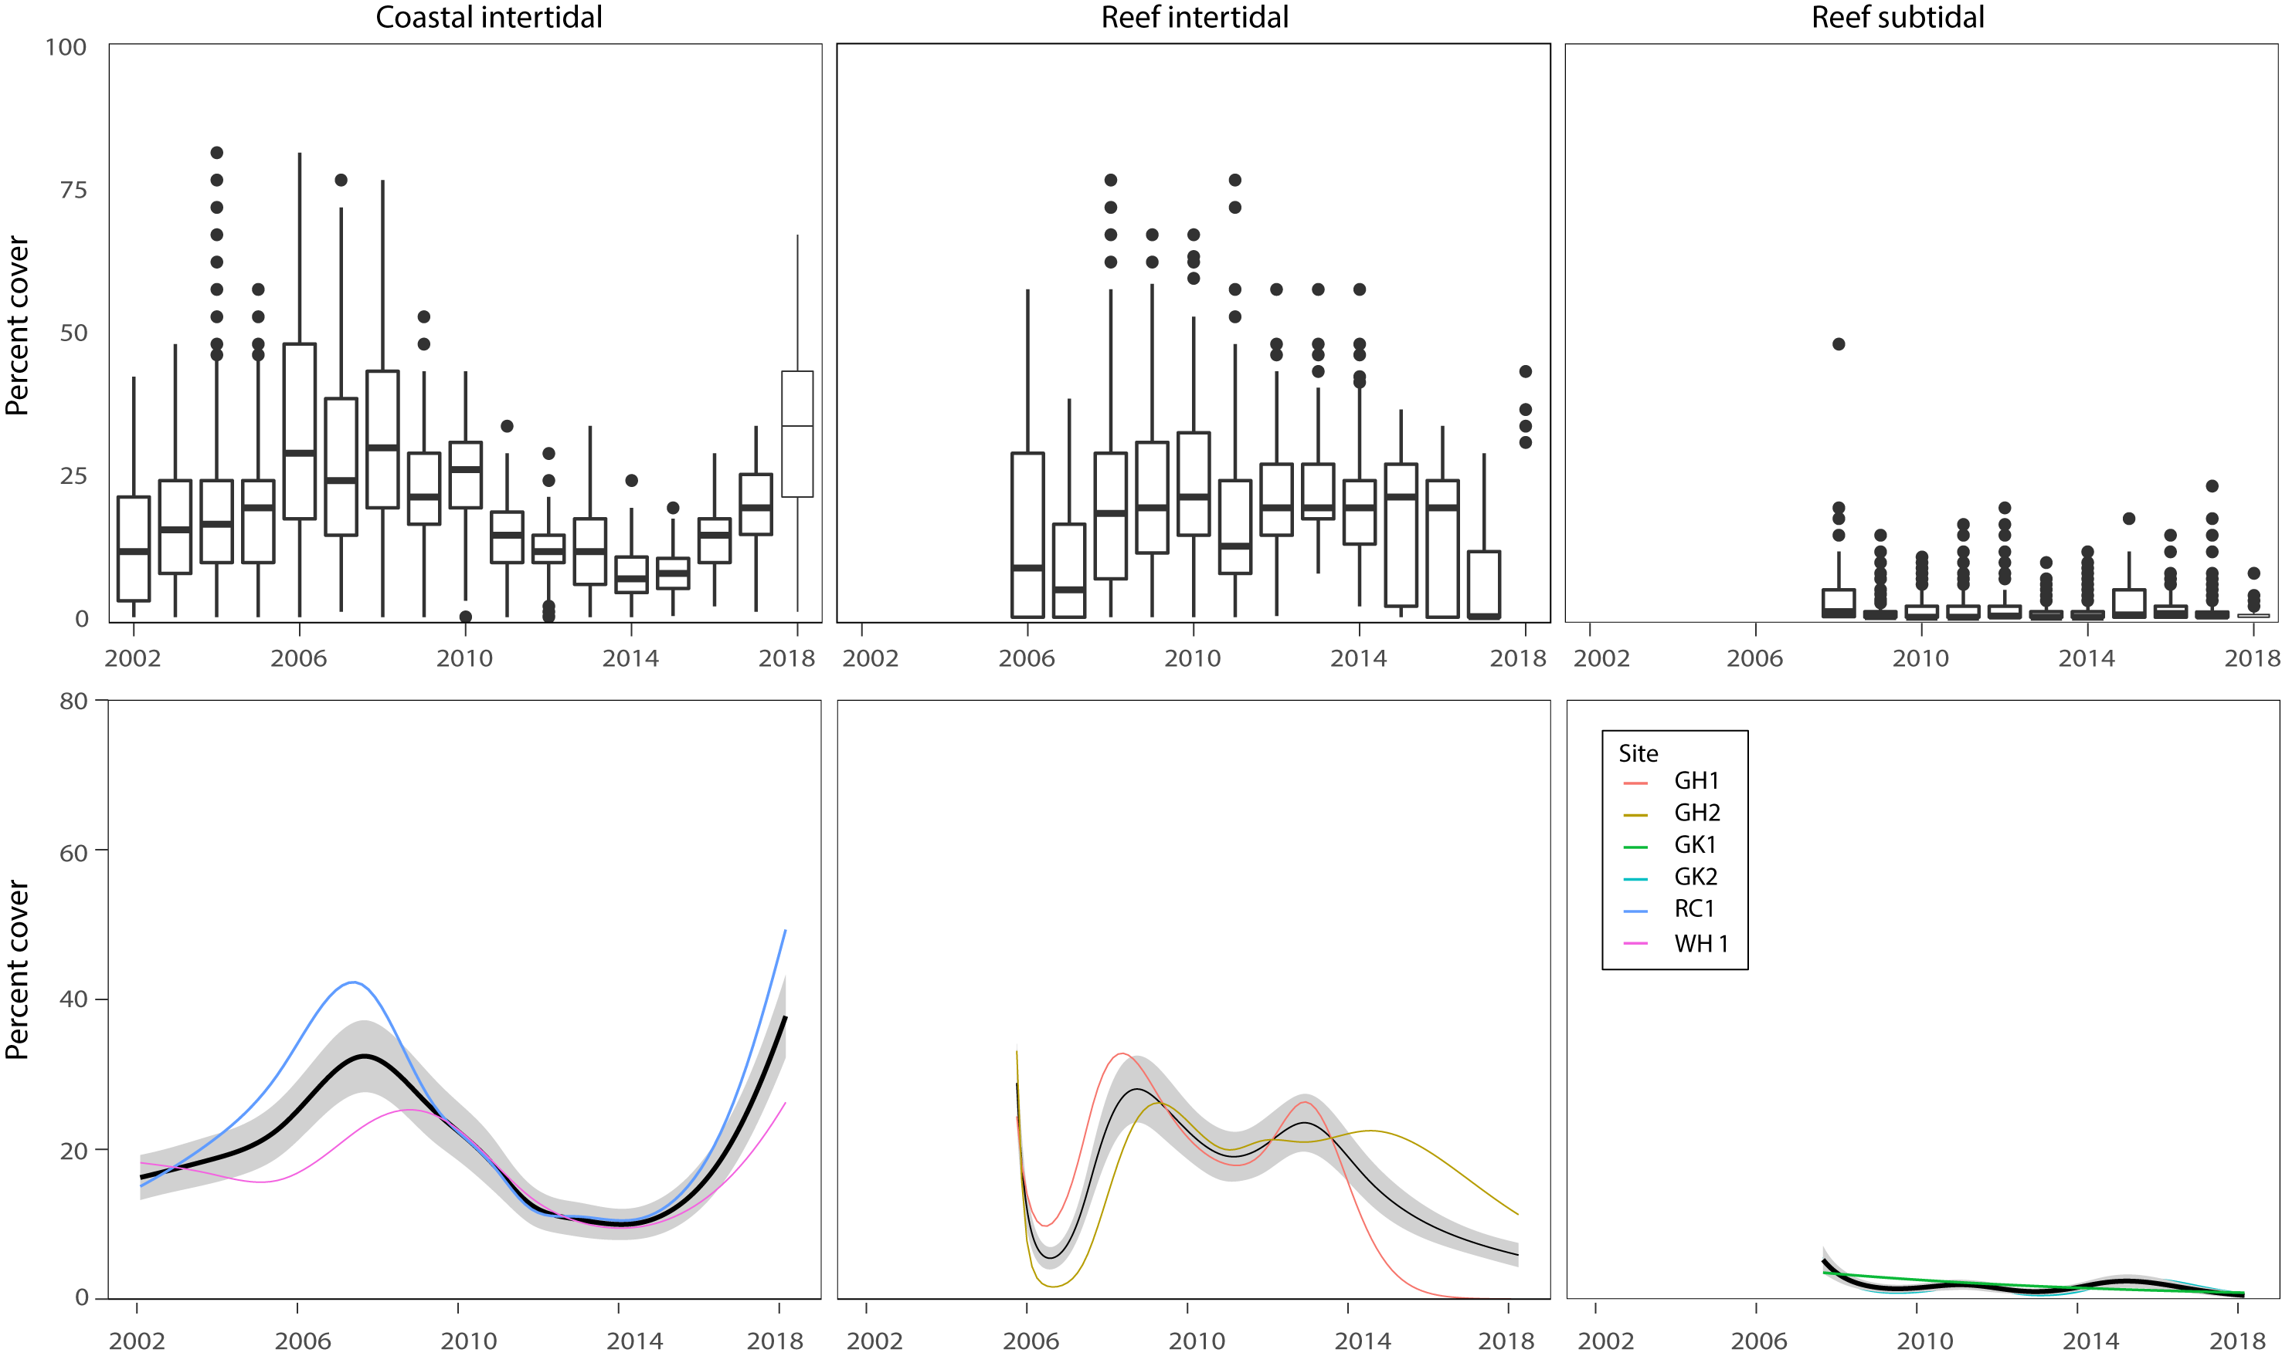
Figure 73. Seagrass per cent cover measures per quadrat (sites pooled) and long-term trends, for each habitat monitored in the Fitzroy NRM region from 2002 to 2018.
Whisker plots (top) show the box representing the interquartile range of values, where the boundary of the box closest to zero indicates the 25th percentile, a line within the box marks the median, and the boundary of the box farthest from zero indicates the 75th percentile. Whiskers (error bars) above and below the box indicate the 90th and 10th percentiles, and the dots represent outlying points. GAMM plots (bottom), show trends for each habitat and coloured lines represent individual site trends.

Coastal meadows in Shoalwater Bay (Ross Creek and Wheelans Hut) had an increased proportion of colonising species (H. ovalis) after 2011 but remained dominated (>0.5) by the opportunistic species Z. muelleri and H. uninervis (Figure 74). In 2017–18, the proportion of these opportunistic species increased at both the coastal and estuarine sites (Figure 74) which continued to be dominated by Zostera muelleri. Colonising species, however, continued to dominate the reef habitat sites (well above the Reef-wide long-term average), which appears a direct relationship with decreased abundances over the last few years (Figure 74).

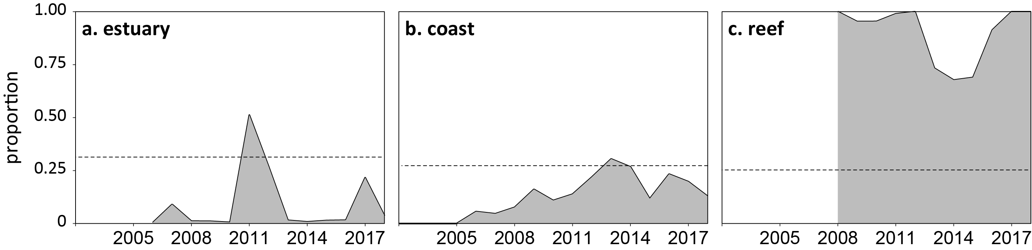
Figure 74. Proportion of seagrass abundance composed of colonising species in inshore intertidal habitats of the Fitzroy region, 2001–2018.
Grey area represents Reef long-term average proportion of colonising species for each habitat type.
The extent of the coastal meadows within monitoring sites in Shoalwater Bay has remained stable at the maximum since monitoring commenced in 2005. The extent of the estuarine meadows has fluctuated since 2016 when there was a large reduction in one of the sites due to extensive scarring and sediment deposition. This year the scarring had abated and the meadow was showing signs of recovering, e.g. shoot extension and improved meadow cohesion. Conversely, meadows on the reef flat at Great Keppel Island remained highly fragmented after the 2016 losses and show little sign of recovery, e.g. unstable sediments.

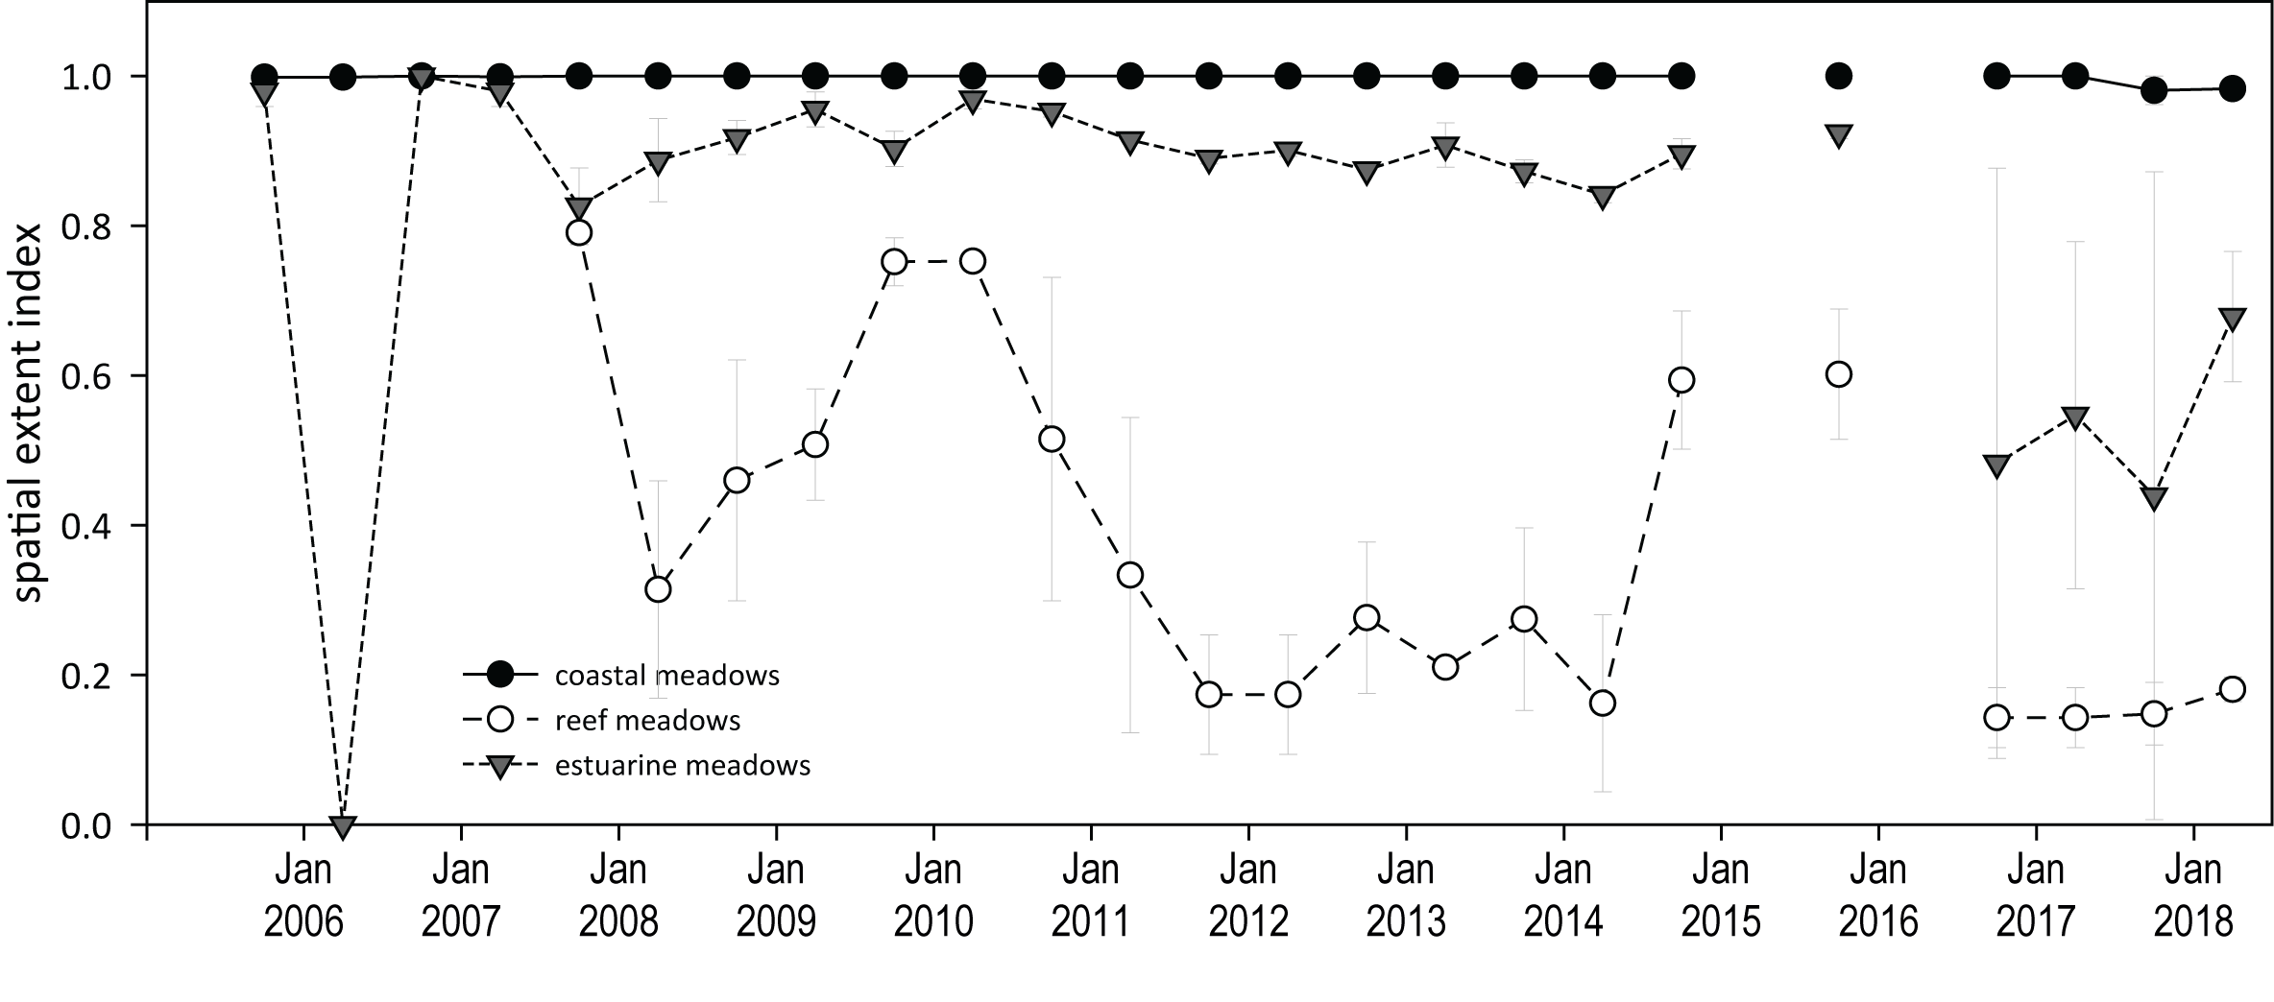
Figure 75. Change in spatial extent of seagrass meadows within monitoring sites for each inshore intertidal habitat across the Fitzroy NRM region, 2005–2018.

Seagrass reproductive status
Reproductive effort has varied inconsistently among habitats in the Fitzroy region over the life of the MMP (Figure 76). Reproductive effort increased at coastal and estuary sites in 2017–18, and a seed bank has persisted since 2012. Reproductive effort has remained very low at reef sites, and seed banks remain absent (Figure 76). This limits the meadow capacity to recover following further disturbance.

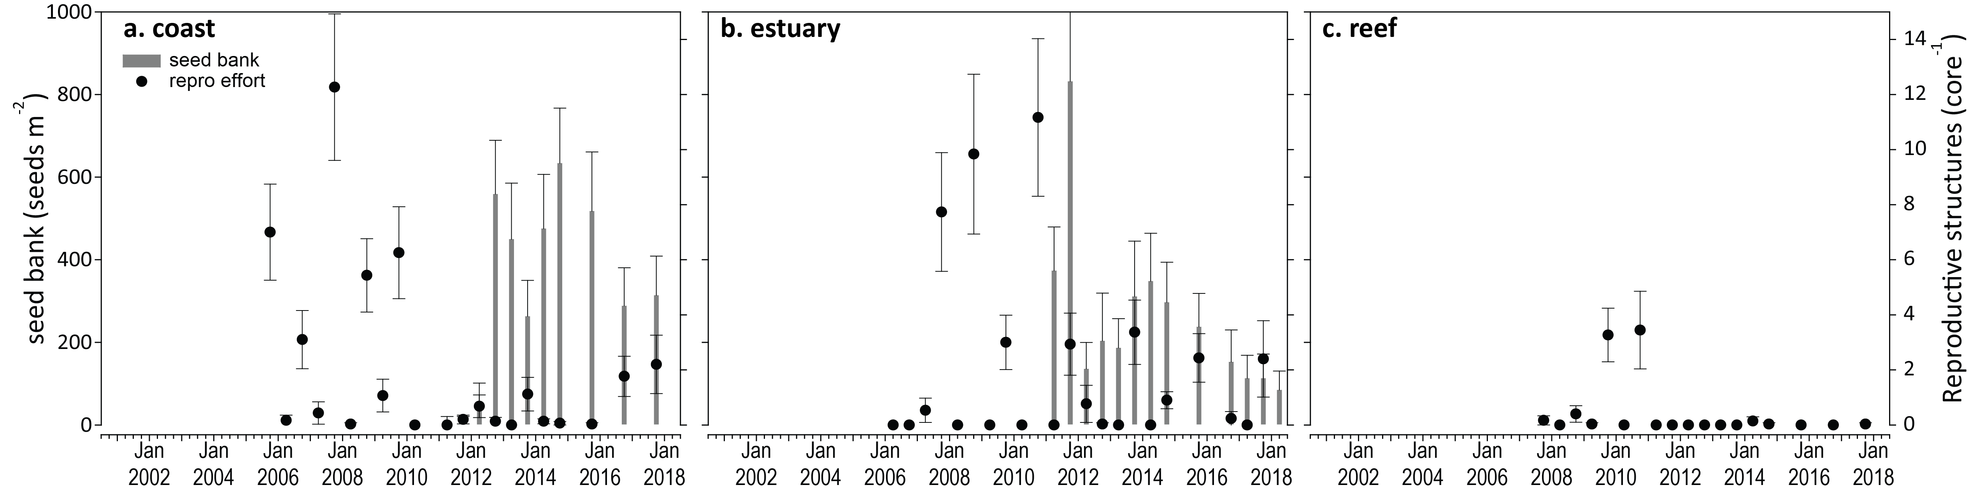
Figure 76. Reproductive effort for inshore intertidal coastal, estuary and reef habitats in the Fitzroy region, 2005–2017.
Seed bank presented as the total number of seeds per m² sediment surface and late dry season reproductive effort presented as the average number of reproductive structures per core (species and sites pooled).

Seagrass leaf tissue nutrients
Seagrass leaf molar C:N ratios marginally declined across all habitats in 2017–18 relative to the previous year, remaining below 20 (Figure 68), indicating a surplus of N relative to photosynthetic C incorporation. N:P ratios marginally increase across all habitats, which combined with C:N indicates sufficient availability of N across the region relative to seagrass growth requirements. There is no indication of elevated N, despite %N remaining above the global median. The low δ¹⁵N (e.g. decreasing at reef habitats), suggests negligible influence of an anthropogenic source of N (Figure 68).

Figure 77. Seagrass leaf tissue nutrient elemental ratios (C:N:P) and concentrations (%N, %P, δ¹³C and δ¹⁵N) for each habitat in the Fitzroy region
(± SE) (foundation species pooled). Horizontal shaded bands or dashed lines represents the accepted seagrass guideline values, where: C:N ratios within the band may indicate reduced light availability and/or N enrichment; N:P ratios above the band indicate P limitation, below indicate N limitation and within indicates replete, and; C:P ratios within the band may indicate nutrient rich habitats (large P pool). Dashed lines in %N and %P indicate global median values of 1.8 % and 0.2 % for tissue nitrogen and phosphorus, respectively (Duarte 1990).

Epiphytes and Macroalgae
Epiphyte cover on the leaves of seagrass across the Fitzroy region either remained below the Reef-wide long-term average for the fifth consecutive year (estuarine and reef habitats), or declined (coastal habitat) in 2017–18 compared to the previous reporting year (Figure 78).
Macroalgae cover remained very low and unchanged at all habitats in the Fitzroy region, with the exception of a minor increase in the late wet 2018 at the reef habitat (Figure 78).
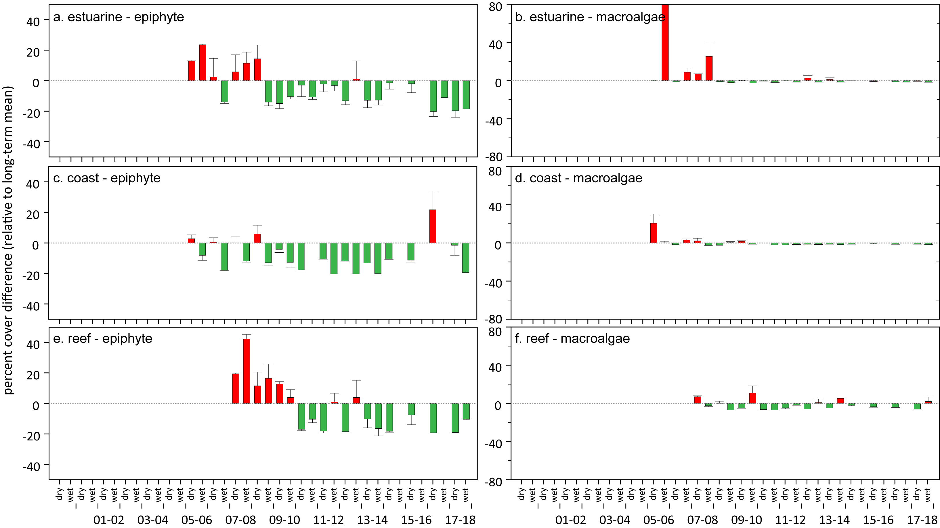
Figure 78. Long-term trend in mean epiphyte and macroalgae abundance (% cover) relative to the long-term average for each inshore intertidal seagrass habitat in the Fitzroy region, 2005–2018
(sites pooled, ±SE). Red/green text

Burnett Mary

2017–18 Summary
Inshore seagrass meadows across the Burnett Mary NRM region declined in overall condition, in response to the environmental pressures throughout in 2017–18, to the lowest grade in five years, dropping to a very poor grade (Figure 81). Contributing indicators were:
- abundance score was poor
- reproductive effort score was very poor
- tissue nutrient score was poor.
Seagrass meadow distribution remained stable but seagrass abundance varied between habitats across the region, with % cover lower than the previous year at two-thirds of sites. The declines, however, were not sufficient to reduce the abundance indicator score due to maintenance of high abundances or improvements at the remaining sites. Declines in per cent cover were possibly a consequence of turbid waters from above-average river discharges (predominately October 2017) resulting in slightly lower benthic light across the region during the peak seagrass growth period. The long-term trend in abundance for the region indicates no significant direction, despite some significant increases in the south.
2017–18 was also the fifth consecutive year where within-canopy temperatures were above the long-term average. The higher water temperatures coupled with lower benthic light, may have exacerbated chronic stress conditions in the seagrass, further impacting growth.
The increased seed banks may indicate a greater capacity for abundances to recover, provided conditions are favourable. However reproductive effort continues to remain very low across habitats, possibly limiting replenishment of seed bank in the near future.
In late 2017, seagrass leaf tissue C:N and C:P ratios indicated increased P at estuarine sites, while C:N and N:P ratios at coastal sites continue to indicate surplus (elevated) availability of N; from natural N-fixation rather than anthropogenic sources. Although macroalgae abundances remain low across the region, epiphyte abundances at estuarine habitats remained above the long-term average for the fourth consecutive year, which may further limit light availability of growth.
The proportion of seagrass species displaying colonising traits declined in meadows relative to the previous year, suggesting greater ability to tolerate/resist major disturbances.
The declining Burnett Mary region seagrass condition index in the 2017–18 follows the decline in 2016–2017, from the highest score in 10 years, and appears predominately driven by declining nutrient status and very low reproductive effort.
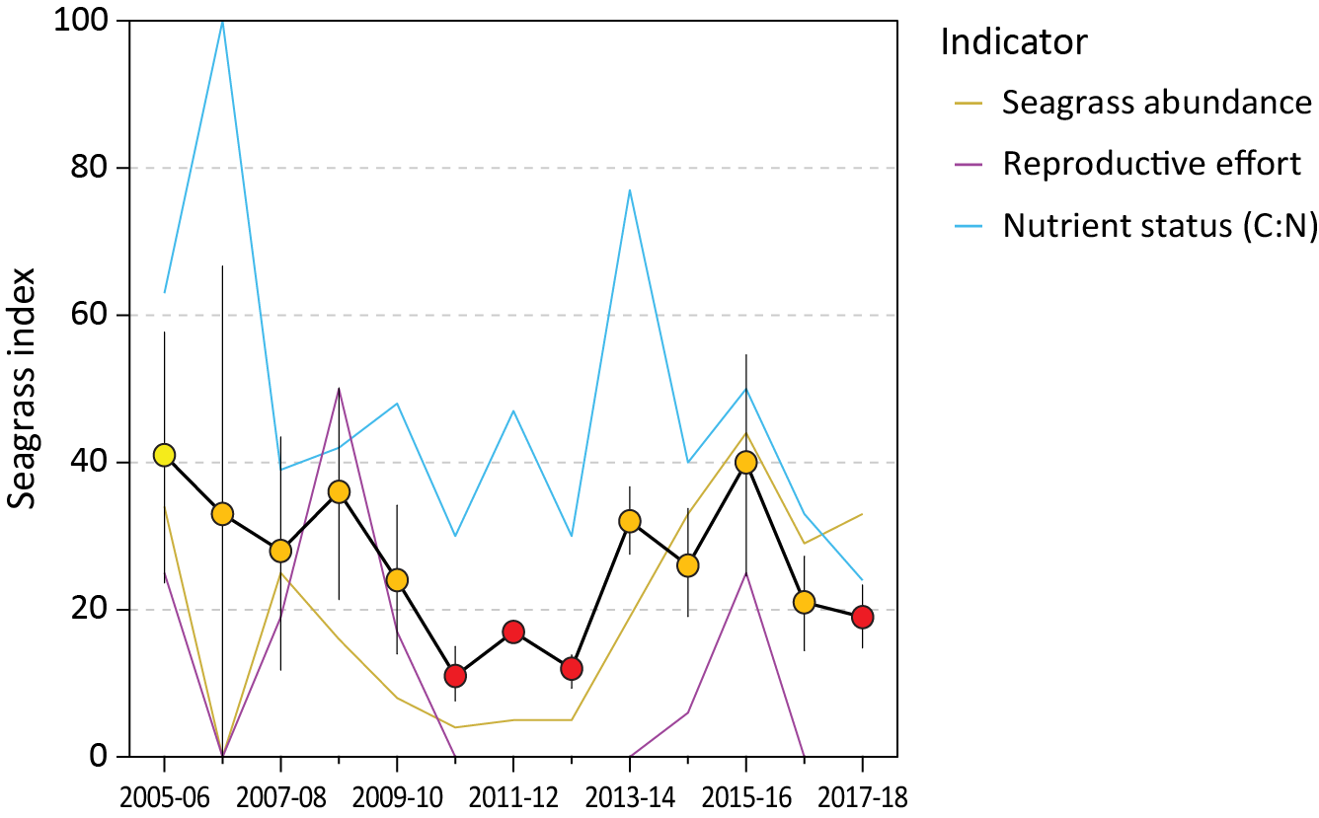
Figure 79. Report card of seagrass index and indicators for the Burnett Mary region
(averages across habitats and sites). Values are indexed scores scaled from 0–100 and graded: ● = very good (81-100), ● = good (61 - 80), ● = moderate (41 - 60), ● = poor (21 - 40), ● = very poor (0 - 20). NB: Scores are unitless.

Climate and environmental pressures
During 2017–18, the Burnett Mary region experienced a near average wet season rainfall, but above annual discharges with some rivers discharging between two and three times their long term median (Table 9). The most significant flow events from the largest rivers occurred in October 2017 (Gruber et al. 2019).
Exposure of inshore seagrass to turbid waters during the wet season was at the long-term average, however within-canopy light (I_{d}) at estuary habitats (10.5 mol m⁻² s⁻¹), was slightly lower than the long-term average (11.4 mol m⁻² s⁻¹) (Figure 80, Figure 112). Benthic light monitoring was not conducted at coastal habitats, however it is scheduled in future. All sites monitored throughout the region were exposed to ‘brown’ or ‘green’ turbid water for the entire wet season (100% frequency of exposure), and frequencies of exposure were similar or slightly lower than the previous period. Estuarine sites to the north (RD1 and RD2) and south (UG1 and UG2) of the region were exposed to ‘brown’ turbid, sediment laden, waters for 86-95% of the wet season, respectively. Coastal sites adjacent to the Burrum River (BH1 and BH3), experienced even higher frequencies of exposure to ‘brown’ turbid waters for 90-100% of the wet season.
The slightly reduced benthic light experienced across the Burnett Mary region may have been exacerbated by higher daytime tides throughout the year, which although provided some respite from intertidal exposure (nearly a quarter less than the long term average) (Figure 105), may have resulted in longer periods of reduced light availability during periods of higher water.
2017–18 was the fifth consecutive year intertidal within-canopy temperatures were above the long-term average and the fifth highest average annual temperature (23.8°C) since 2003 (Figure 80). Maximum intertidal within-canopy temperatures exceeded 35°C for a total of 10 days during 2017–18, with the highest temperature recorded at 39.4°C (RD2, 9am 12Oct17).
Daily tide exposure was below the long‐term average (Figure 80), including for the second consecutive year in the south (Figure 105), which may have provided some respite from the elevated temperatures.
Sediments in the estuary seagrass habitats of the Burnett Mary region were dominated by mud, and in 2017–18 remained relatively stable, albeit with seasonal variability (Figure 127). Coastal meadows in 2017–18 continued to be dominated by fine sand with little change from the previous year (Figure 128). The stabilising of sediments may have been assisted by calmer weather in 2017–18, where lower than average number of days in which wind speeds exceeded 25 km hr⁻¹ (Figure 97) resulted in less physical disturbance from wind generated waves.
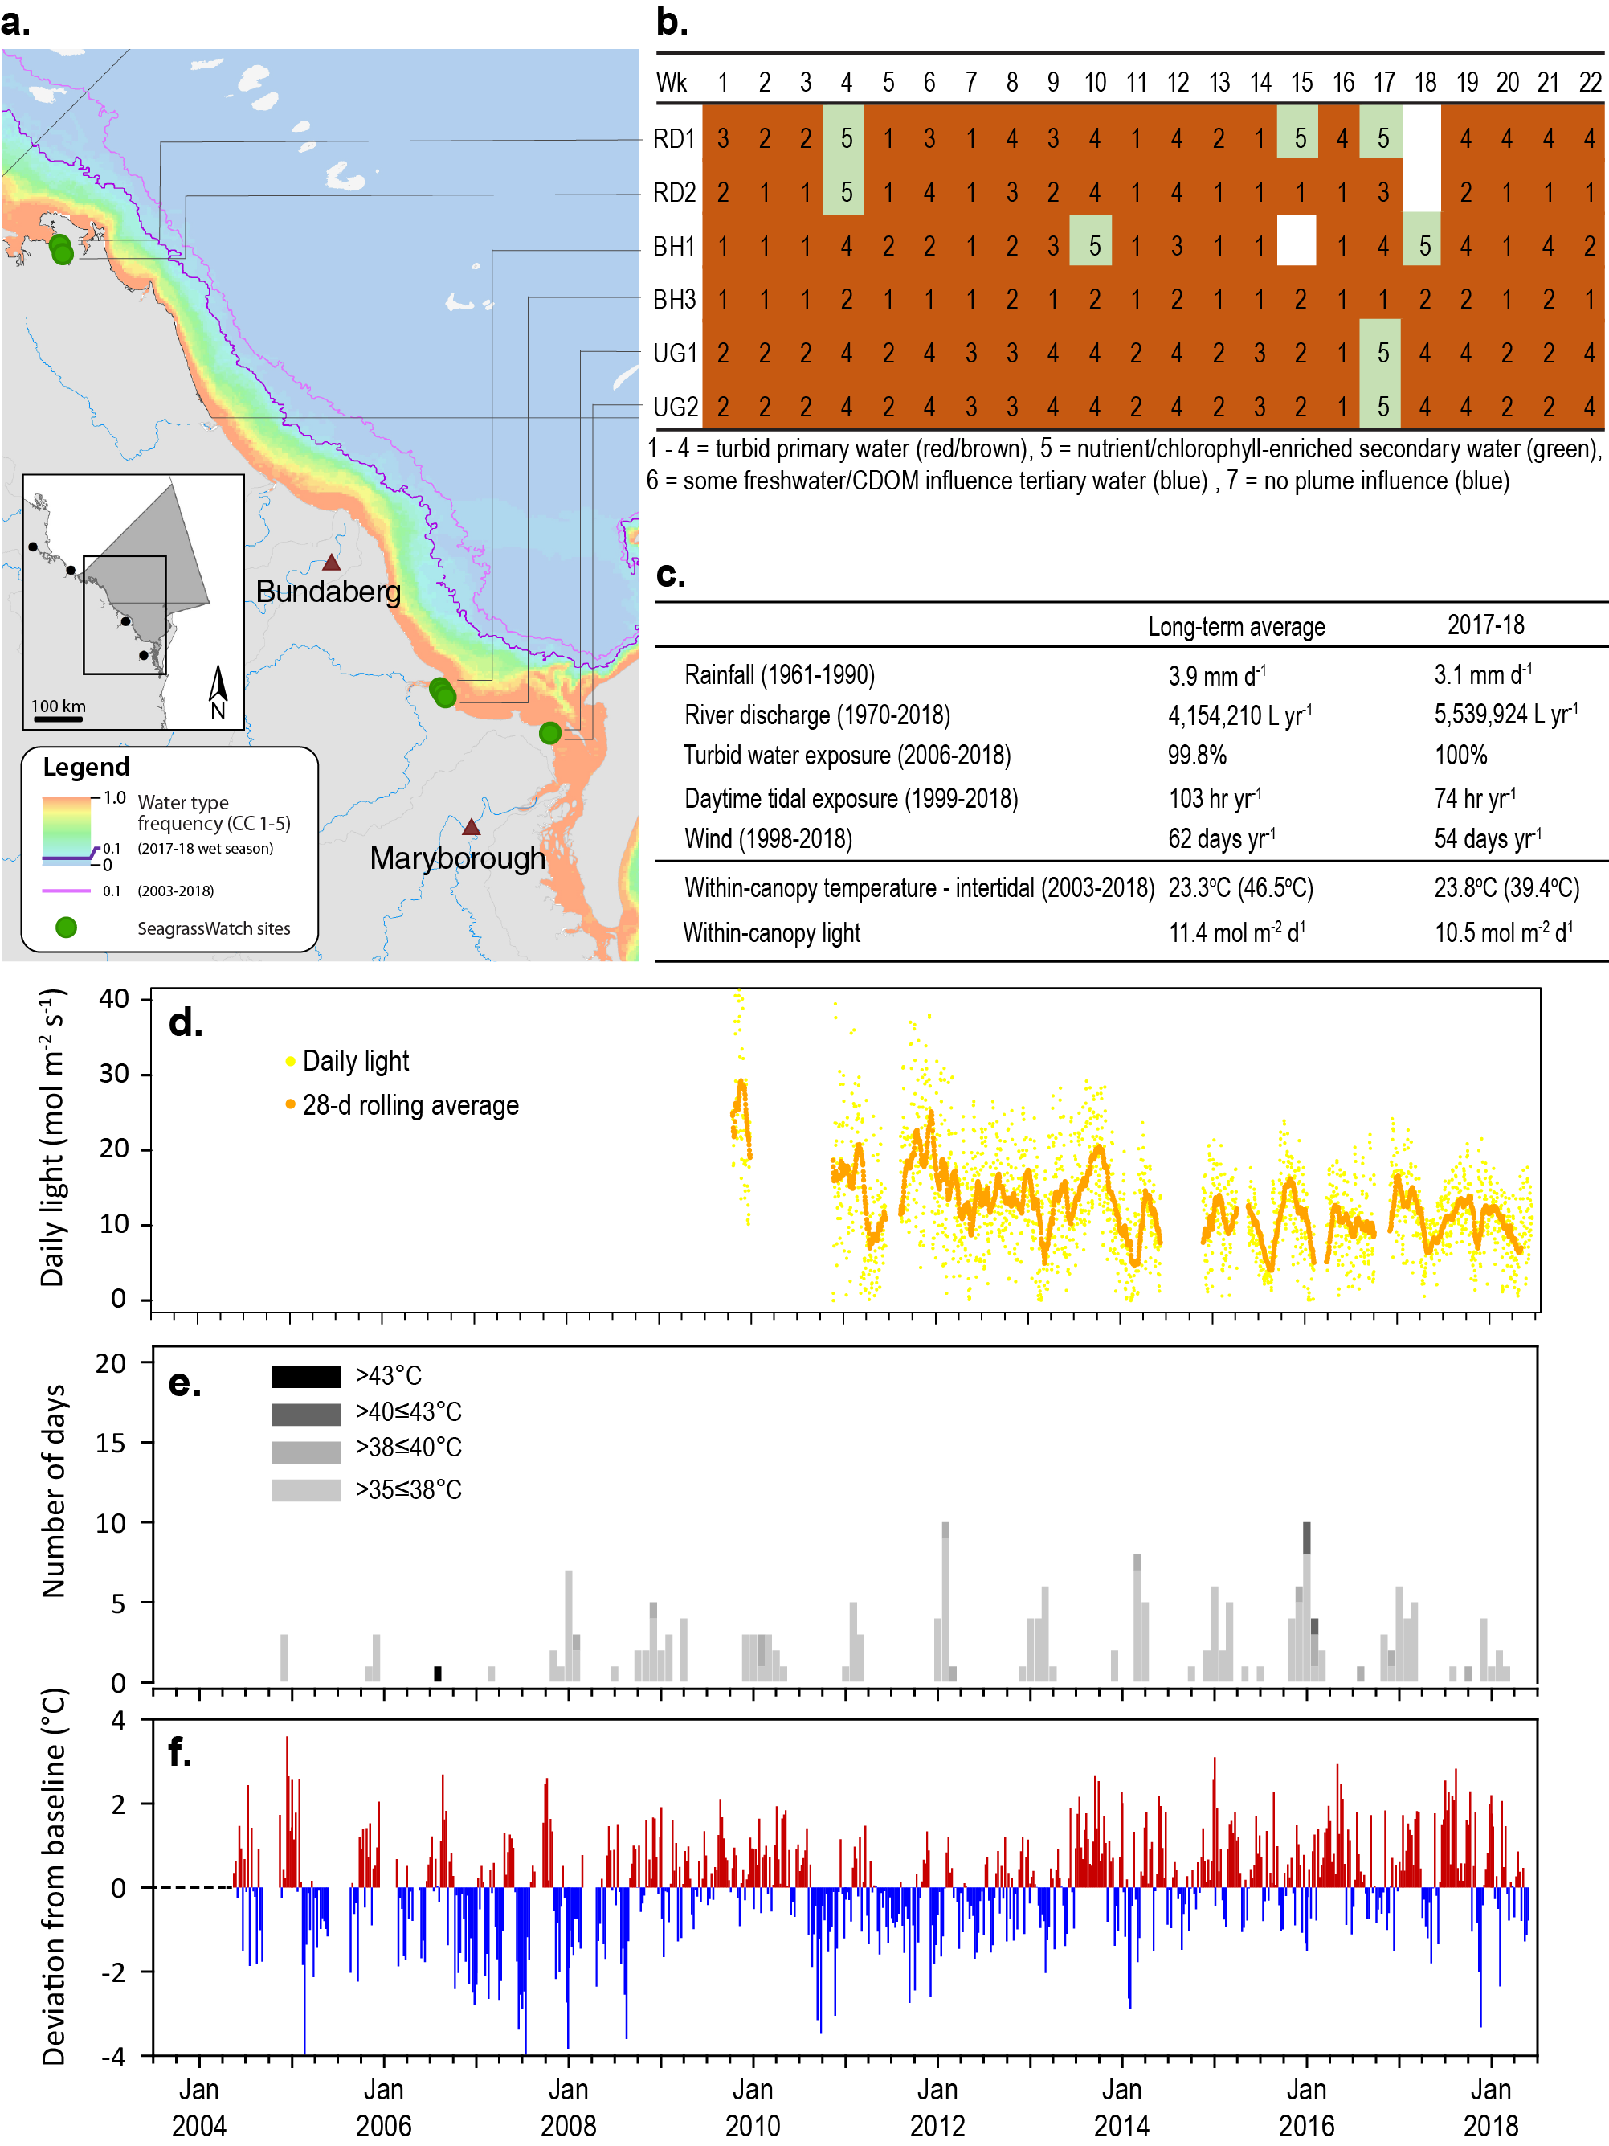
Figure 80. Environmental pressures in the Burnett Mary region
including: a. frequency of exposure to turbid water (colour classes 1–5) (from Gruber et al. 2019); b. wet season water type at each site; c. average conditions over the long-term and in 2017–18; d. daily light and the 28-day rolling mean of daily light for all sites; e. number of day temperature exceeded 35°C, 38°C, 40°C and 43°C, and; f. deviations from 13-year mean weekly temperature records.

Inshore seagrass and habitat condition
Only estuarine and coastal habitats were assessed across the Burnett Mary region in 2017–18, with data from 6 sites (Table 16).
Table 16. List of data sources of seagrass and environmental condition indicators for each seagrass habitat type in the Burnett Mary NRM region.
*Seagrass-Watch. For site details see Table 2 and Table 3.
Habitat | Site |  | abundance | composition | distribution | Reproductive effort | seed banks | Leaf tissue nutrients | Meadow sediments | Epiphytes & macroalgae
estuary intertidal | RD1 | Rodds Bay
estuary intertidal | RD2 | Rodds Bay
estuary intertidal | UG1 | Urangan
estuary intertidal | UG2 | Urangan
coastal intertidal | BH1* | Burrum Heads
coastal intertidal | BH3* | Burrum Heads

Seagrass index and indicator scores
In the 2017–18 monitoring period, the Burnett Mary region seagrass condition index declined to its lowest score in five years, dropping to a very poor grade (Figure 81). Overall, the Burnett Mary seagrass index had been improving since 2012–2013 until this trajectory abated in 2016–2017 following the highest score in 10 years. The decline this year follows the decline in 2016–2017, and appears predominately driven by declining nutrient status and very low reproductive effort (Figure 81).
Over the long term, seagrass abundance regionally has fluctuated greatly (e.g. periods of loss and subsequent recovery). Increases between 2012 and 2016 placed the meadows on a pathway towards recovery. The long-term trend suggests that the losses observed in 2016–2017 and 2017–18 may not be part of a declining trend (Table 23), despite reduction in the abundance score.
Similarly, an examination of the long term trends across the Burnett Mary region using GAM plots suggests tissue nutrient elemental C:N has no discernible trend since 2005 (Figure 81).
Reproductive effort, however, appears generally low with occasional increases in the number of reproductive structures corresponding to increased seagrass abundance (Figure 81).

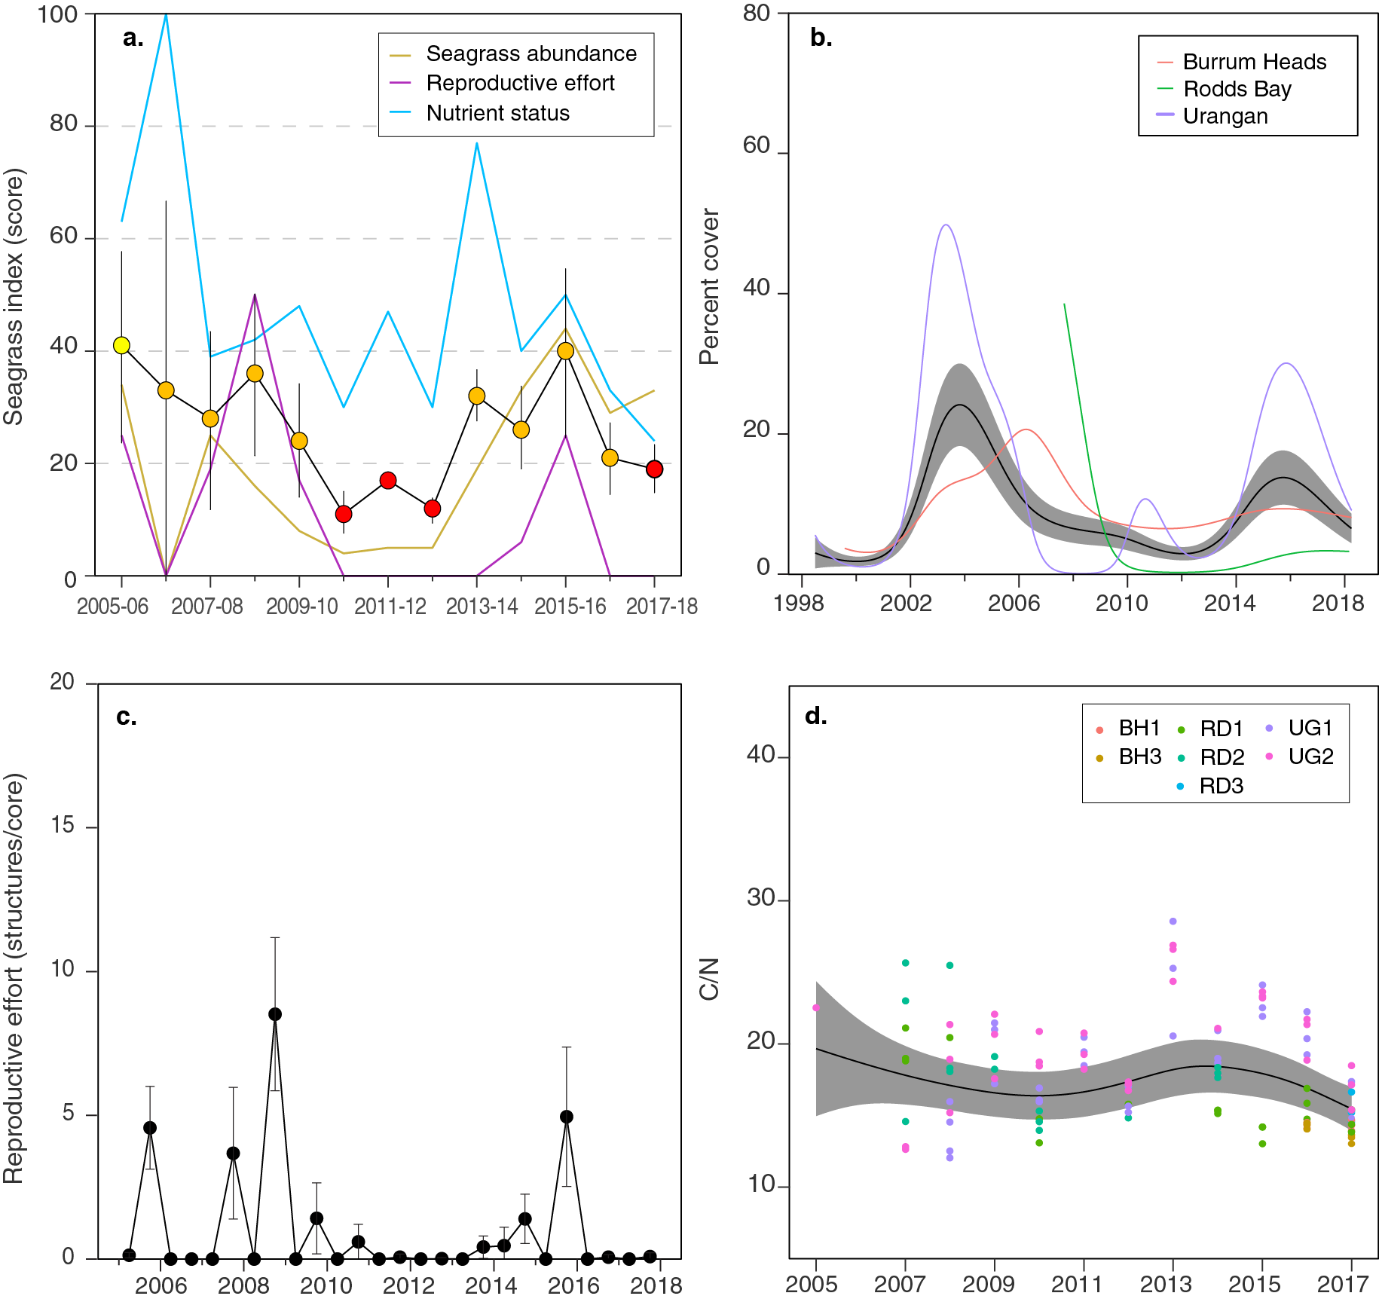
Figure 81. Temporal trends in the Burnett Mary seagrass condition index and the indicators used to calculate the index
: a. seagrass condition index (circles) and indicator trends (lines); b. GAM plots of seagrass abundance (% cover) trends for each location (coloured lines) and the region (black line with grey shaded area defining 95% confidence intervals); c. average number of reproductive structures (±SE) (GAM not possible due to high count of zero values); and d. elemental ratios (atomic) of leaf tissue C:N nutrient content at each site (coloured circles) and regional trend represented by a GAM plot as dark line with shaded areas defining 95% confidence intervals of the trend.

Seagrass abundance, composition and extent
Seagrass abundances (% cover) in the Burnett Mary region were similar across habitats coastal = 9.4 ±0.9%, estuarine = 10.2 ±1.5%), however estuarine abundances were higher in the dry than the wet season (dry = 13.7 ±1.8%, wet = 5.9 ±1.0%). Just over 80% of monitoring sites either declined in abundance in 2017–18 relative to the previous period, or seagrass remained absent. All estuarine meadows in both Rodds Bay and Urangan declined in 2017–18, with the greatest losses occurring in Rodds Bay. By comparison, only one of the coastal meadows declined, also in the late wet season 2018.
Since monitoring was established, the estuarine meadows have come and gone on an irregular basis. The only site to significantly decline over the long-term, was in the north of the region in the Rodds Bay estuary (RD2). In the south, both an estuary and a coastal site have significantly increased over the long-term, while no trend is apparent at the remaining monitoring sites (Table 23).
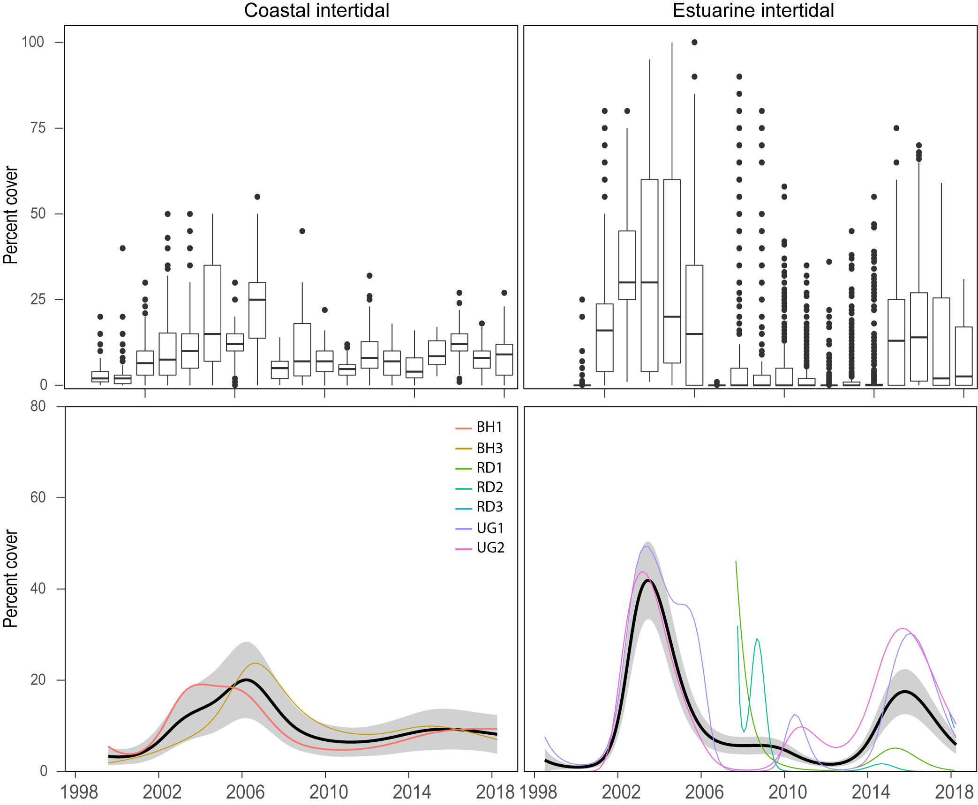
Figure 82. Seagrass per cent cover measures per quadrat (sites pooled) and long-term trends, for each habitat monitored in the Burnett Mary NRM region from 1999 to 2018.
Whisker plots (top) show the box representing the interquartile range of values, where the boundary of the box closest to zero indicates the 25th percentile, a line within the box marks the median, and the boundary of the box farthest from zero indicates the 75th percentile. Whiskers (error bars) above and below the box indicate the 90th and 10th percentiles, and the dots represent outlying points. GAMM plots (bottom), show trends for each habitat and coloured lines represent individual site trends.

The estuarine and coastal seagrass habitats have been dominated by Zostera muelleri with varying components of Halophila ovalis. In 2017–18, the proportion of colonising species declined compared to the previous monitoring year, and is considerably lower compared to 2011 when habitats were dominated by colonising species (Figure 83). A reduction in the proportion of colonising species in the meadows suggests greater ability to tolerate/resist major disturbances, particularly as the meadows improve abundance. The meadows in the Burnett Mary region have a smaller proportion of colonising species than the Reef-wide average.
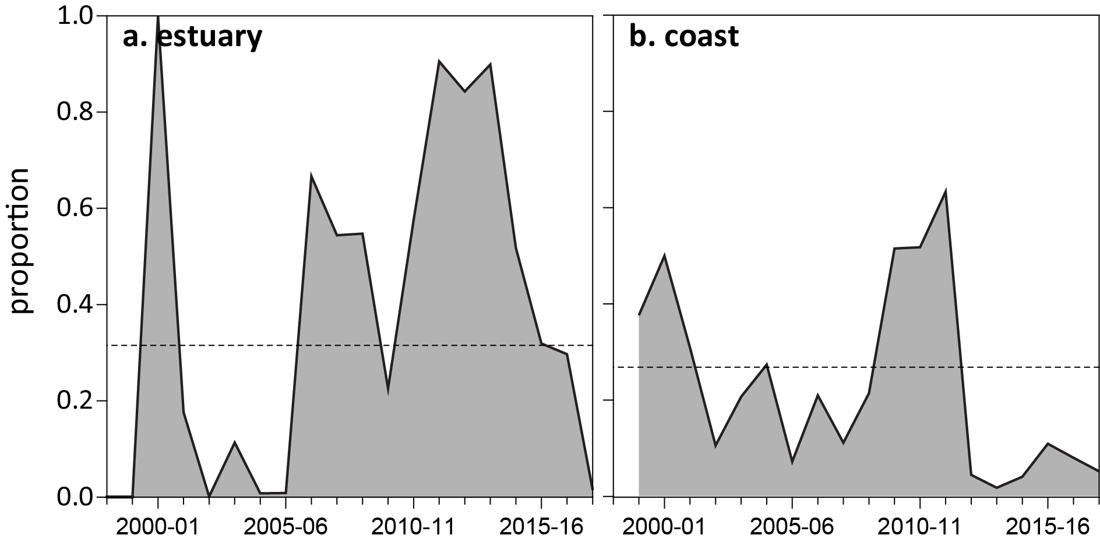
Figure 83. Proportion of seagrass abundance composed of colonising species at: a. estuary and b. coastal habitats in the Burnett Mary region, 1998–2018.
Dashed line represents Reef long-term average proportion of colonising species for each habitat type.
Over the last 12 months meadow extent has changed little relative to the previous year (Figure 84). Therefore changes in abundance are not attributable to meadow landscape changes. However, over the life of the MMP, the extent of the estuarine meadows has fluctuated greatly with periods of decline, absence and recovery.

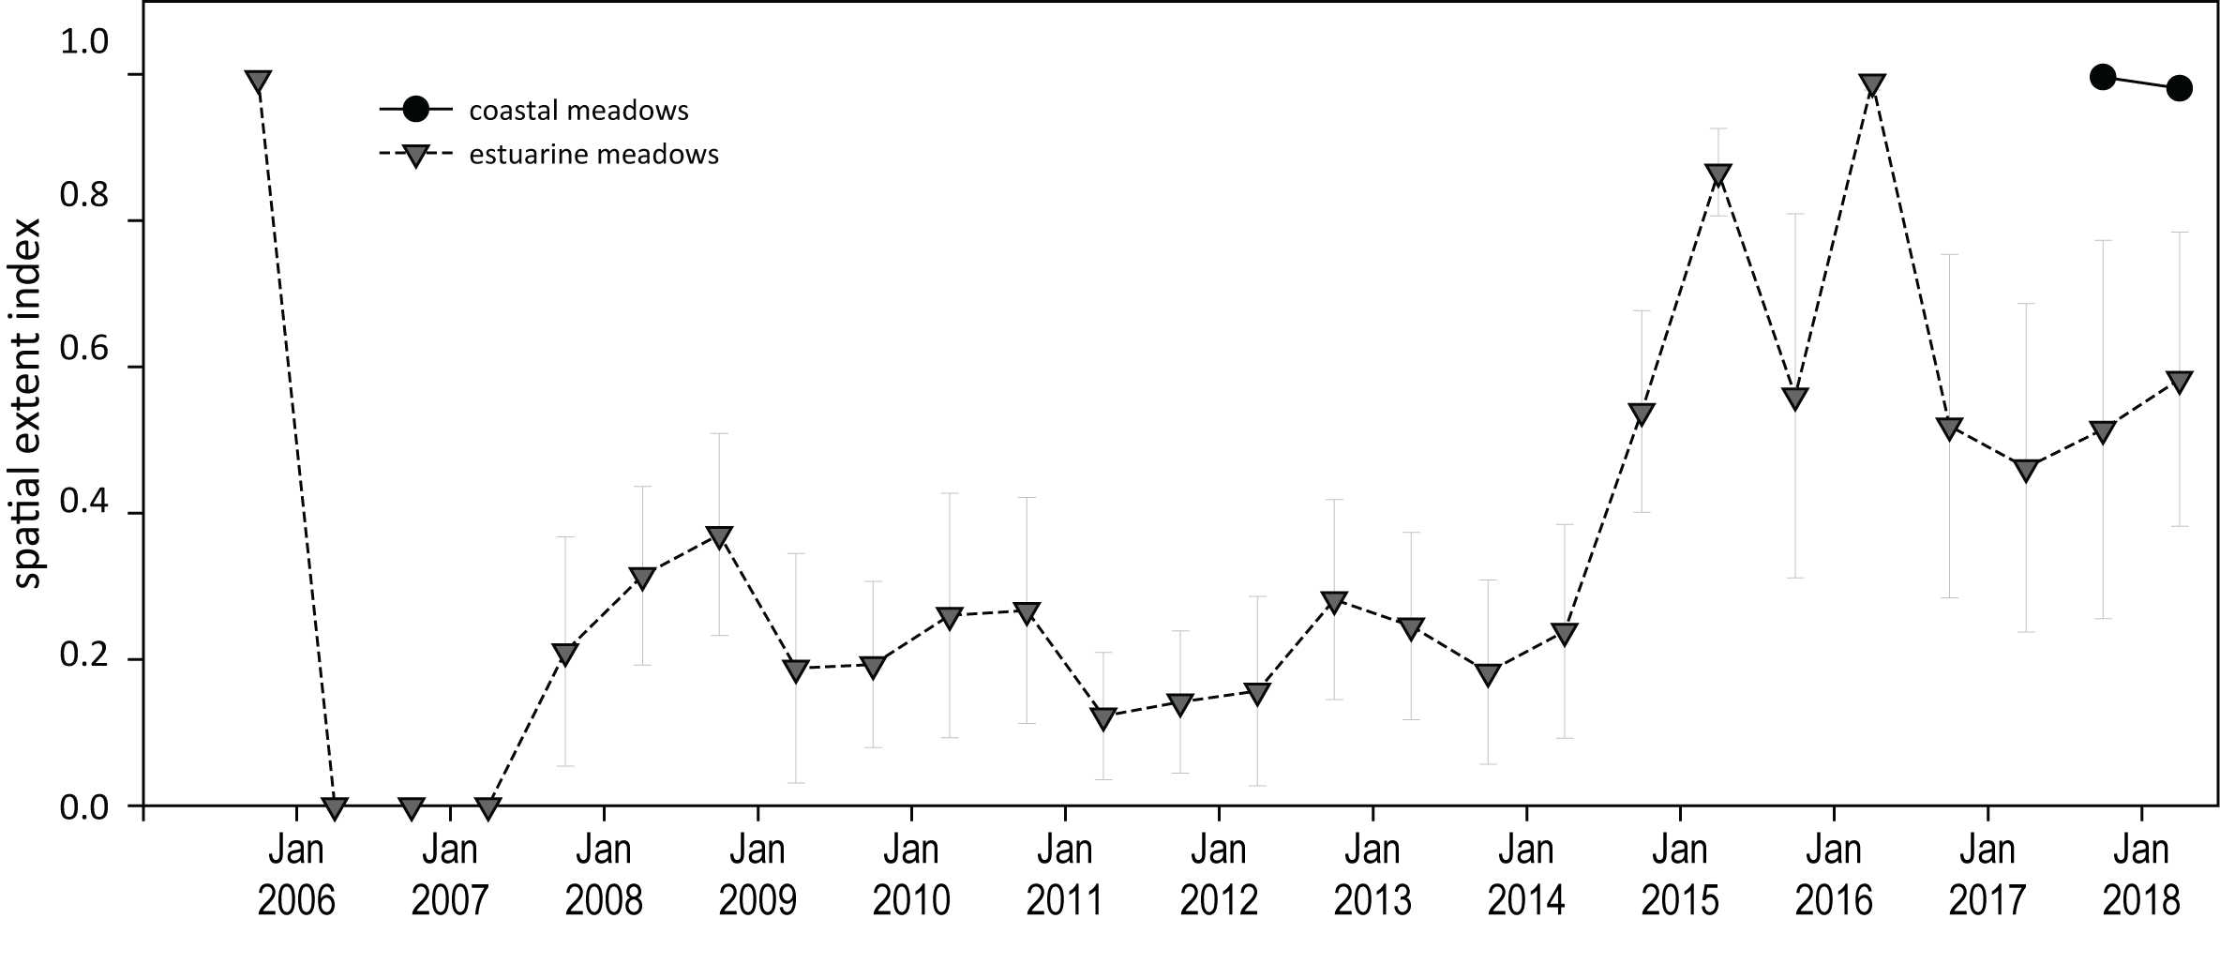
Figure 84. Change in spatial extent of estuary seagrass meadows within monitoring sites for each habitat and monitoring period across the Burnett Mary NRM region.

Seagrass reproductive status
Seagrass reproductive effort remained at almost zero across estuarine and coastal habitats this year, with little change from the previous monitoring period (Figure 85). A seed bank persists at estuary sites, which was greater in 2017–18 than the previous period (Figure 85). This may indicate the meadows have a greater capacity to recover from the declining abundances, provided conditions are favourable.
The apparent disconnect between reproductive effort and seed densities may be an artefact of the sampling frequency and the somewhat stochastic triggers and possibly short flowering period. A large seed bank was also measured at the coastal sites in the late dry 2017, however as seed banks have only been assessed ad hoc (Figure 85), no interpretation can be provided.
From 2018–19, coastal sites will be monitored under standard MMP protocols to match the indicators, frequency and timing of the estuarine site assessments in the region.

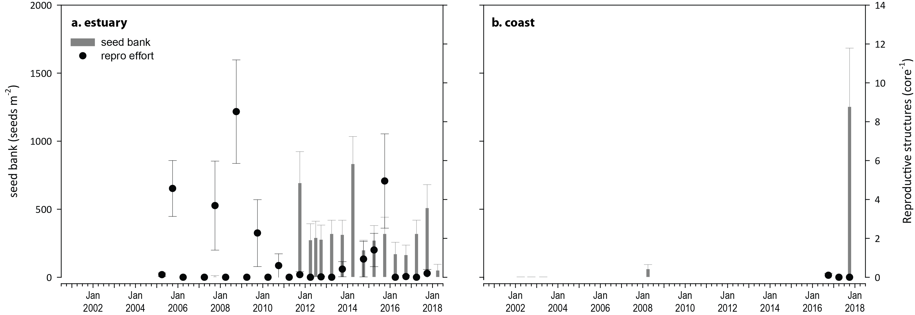
Figure 85. Burnett Mary estuary seed bank and reproductive effort.
Seed bank presented as the total number of seeds per m² sediment surface and reproductive effort presented as the average number of reproductive structures per core (species and sites pooled).

Seagrass leaf tissue nutrients
In 2017, Zostera muelleri leaf molar C:N ratios marginally reduced at the estuary sites compared to the previous two years (Figure 86). The C:P ratio declined more substantially overall at estuarine sites. This would appear to be due to an increase in P at all estuarine sites, while the lower δ¹³C indicates improved light availability.
At the coastal sites, seagrass (Halodule uninervis and Zostera muelleri) leaf molar C:N ratios were similar to the previous year, remaining below 20 (Figure 86), indicating a surplus of N relative to photosynthetic C incorporation.
N:P ratios remained very high (above 40), which is higher than global median %N, indicating surplus (elevated) availability of N (Figure 86).

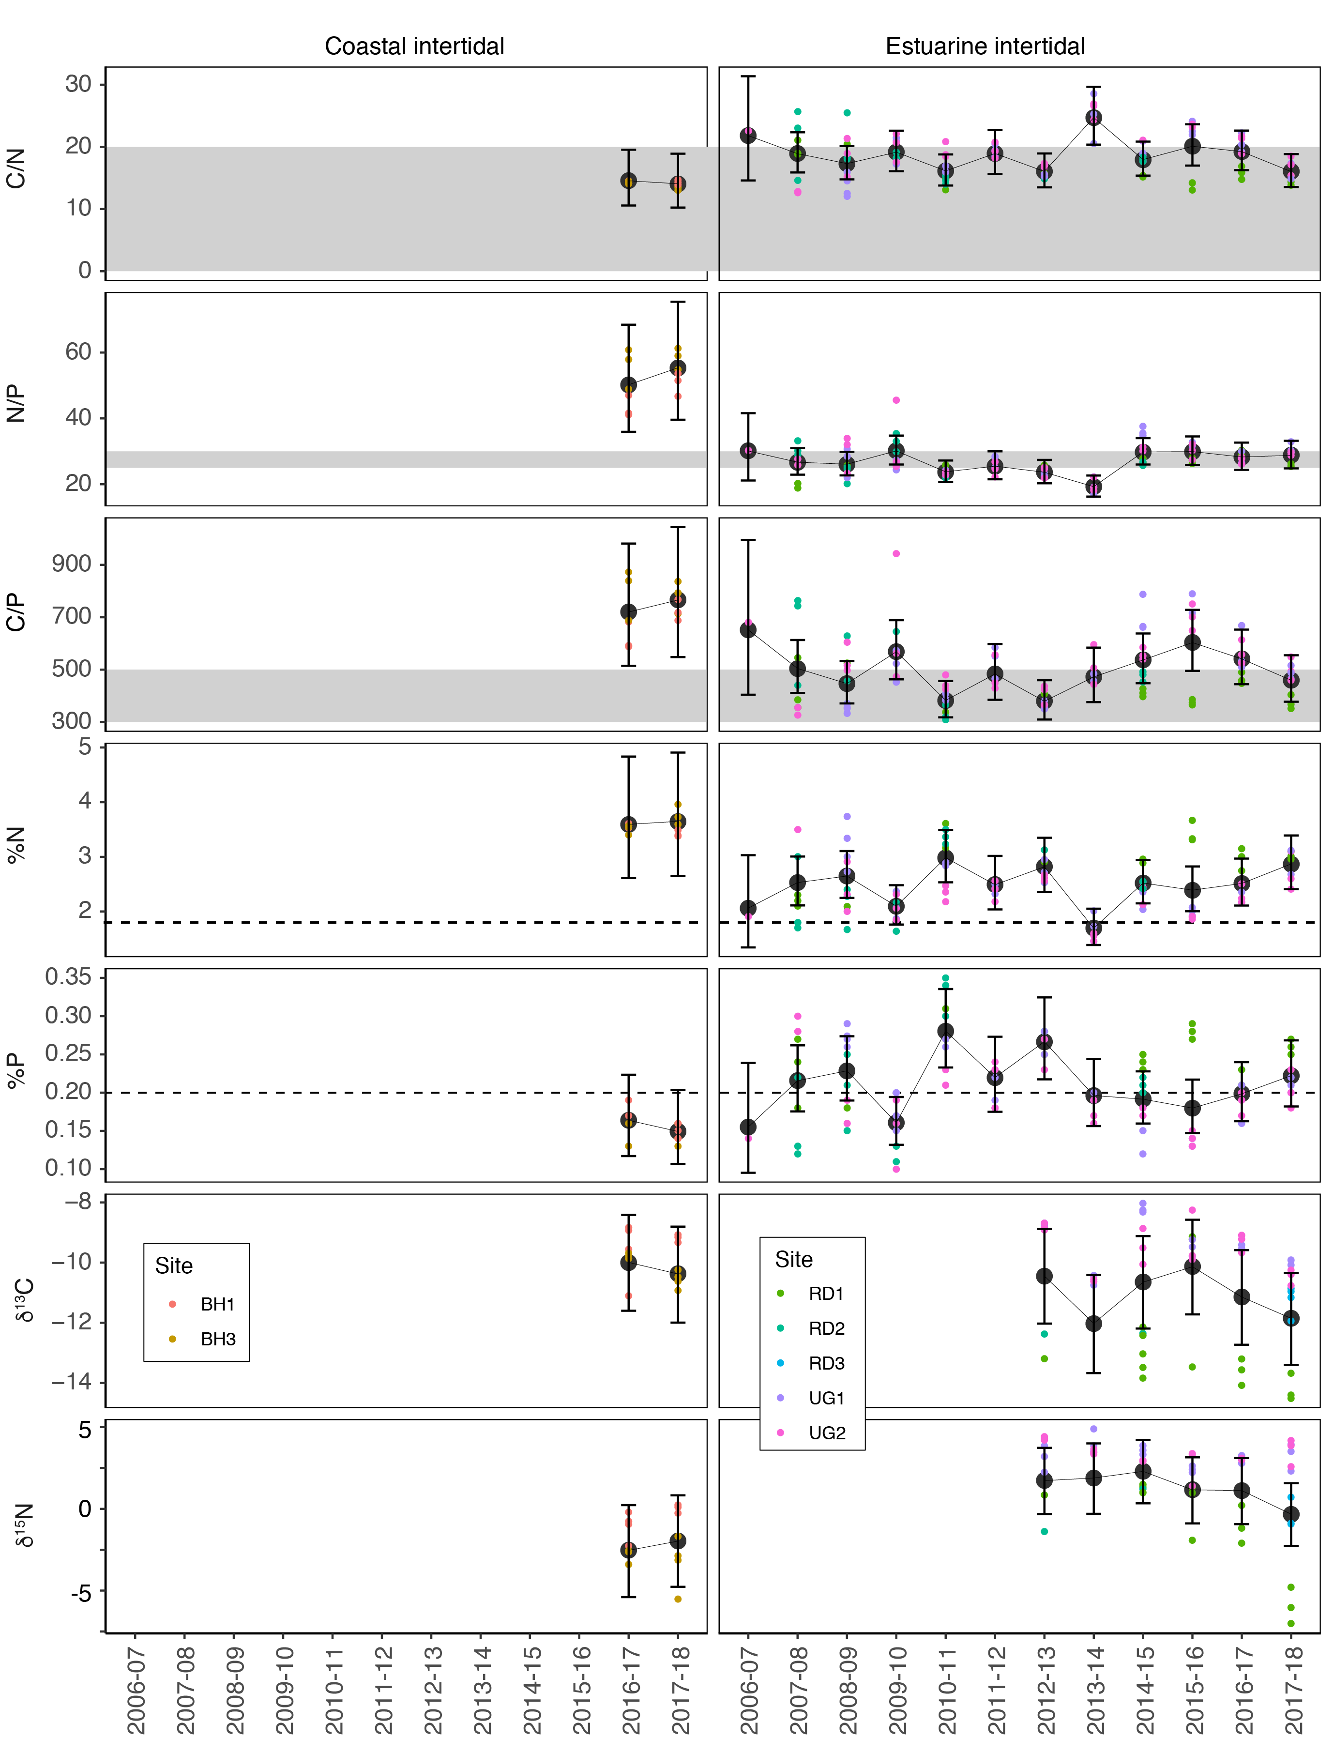
Figure 86. Seagrass leaf tissue nutrient elemental ratios (C:N:P) and concentrations (%N, %P, δ¹³C and δ¹⁵N) for each habitat in the Burnett Mary region
(± SE) (foundation species pooled). Horizontal shaded bands or dashed lines represents the accepted seagrass guideline values, where: C:N ratios within the band may indicate reduced light availability and/or N enrichment; N:P ratios above the band indicate P limitation, below indicate N limitation and within indicates replete, and; C:P ratios within the band may indicate nutrient rich habitats (large P pool). Dashed lines in %N and %P indicate global median values of 1.8 % and 0.2 % for tissue nitrogen and phosphorus, respectively (Duarte 1990).

Epiphytes and macroalgae
Epiphyte cover on seagrass leaf blades was similar in the wet and dry seasons, and in 2017–18 remained higher than the long-term average for the fourth consecutive year at estuarine habitats (Figure 87). Alternatively, at coastal habitats, the epiphyte abundance has remained below the long-term average for the second consecutive year (Figure 87).
Per cent cover of macroalgae has remained low and below the long-term average at across all habitats monitored (Figure 87).
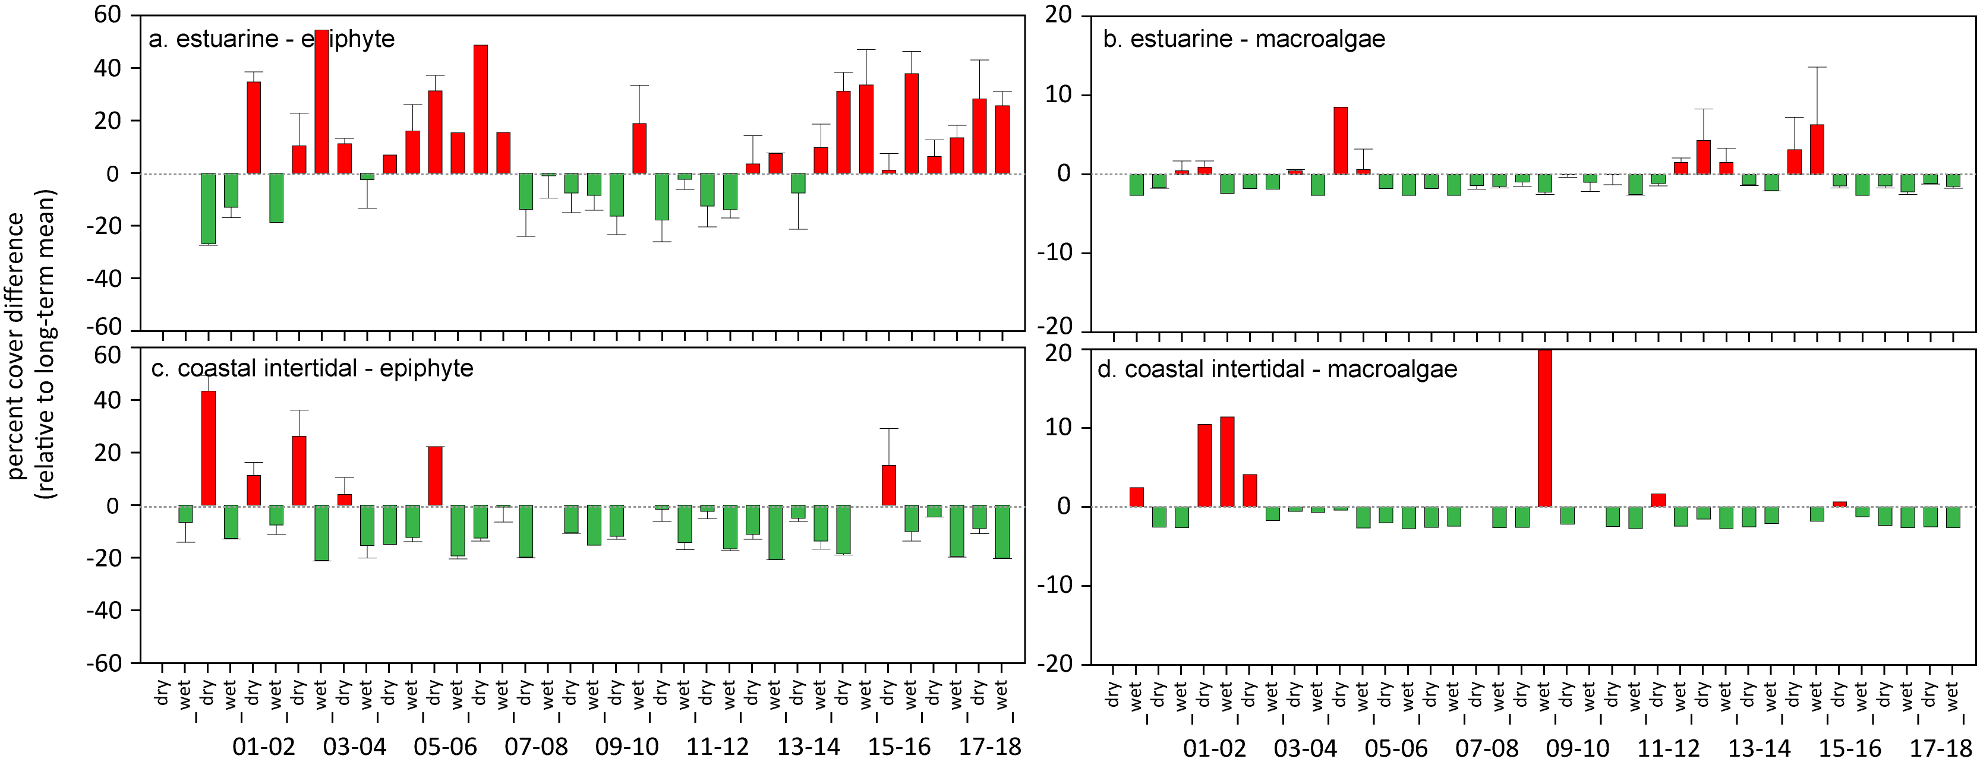
Figure 87. Long-term trend in mean epiphyte and macroalgae abundance (% cover) relative to the long-term average for each seagrass habitat in the Burnett Mary NRM region
(sites pooled, ±SE).

Discussion

Seagrass resilience
While seagrass meadows of the Reef are inherently dynamic, poor recovery rates at many locations and poor resilience (e.g. reproductive effort and seed density), suggest that capacity to recover from future impacts is compromised. This, coupled with intensifying disturbances presents a concerning outlook.
Throughout the inshore Reef, the rate of seagrass recovery since 2011 has been protracted in some locations compared to previous reports (e.g. Birch and Birch, 1984; Campbell and McKenzie 2004b), particularly at reef habitats. Low reproductive effort may be a contributing factor. At some of the reef sites reproductive structures are never observed for some species, while at others there is some reproductive effort but seed banks are not forming or persisting either because no seeds are being produced, or seeds are lost through other processes, such as predation (Orth et al. 2006). The presence of seeds is fundamental to building resilience at reef sites, as without them the meadows remain vulnerable to large disturbances and would need to rely on recruitment of propagules from other meadows. This external recruitment process may operate at timescales ranging up to centuries or millennia depending on whether the propagules are reproductive or through clonal expansion (Grech et al. 2016a, McMahon et al. 2014a). Absence of a seed bank at some sites and poor reproductive effort across the Reef, has left most of the MMP meadows vulnerable to further environmental perturbations.
The basis of poor and variable reproductive effort should be investigated as a matter of priority. For example, the lack of flowers, fruits and seeds may be due to sampling artefact (e.g. timing and frequency of sampling may miss short flowering periods). Alternatively, are these communities unable to reproduce due to their effective population size being reduced to a critical threshold. This is known to have happened for Cymodocea serrulata and Syringodium isoetifolium on Green Island where the meadows are made up of a single clone (and therefore a single sex as this species is dioecious) leading to their inability to set seed. If such factors are known, improved management strategies can be developed to accommodate processes that enhance seed bank formation (e.g. adjusting light or nutrient thresholds), or enhancement of resilience (e.g. introduction of new clones or seeds in the seed bank).
Recovery of seagrass meadows proceeding slower than expected might also be due to the frequent and repeated disturbances occurring over the past decade. The capacity of seagrass meadows to naturally recover requires environmental conditions that will enable expansion, sexual reproduction and seed bank formation. The environmental requirements for these recovery processes are not quantitatively described (by contrast thresholds leading to loss, such as light thresholds have been quantified for a number of species) and represent a research priority so that accurate recovery models can be developed.
The high energy demands of seagrass meadow recovery processes are likely to require optimum conditions of light and nutrient availability and the absence of major physical disturbances such as cyclones or even excessive sediment resuspension. For example, the low and variable light availability across the Reef habitats in 2014–2015, 2016–2017 and 2017–18 appears to have slowed and abated recovery, which in turn may reduce capacity to produce a viable seed banks in some locations (van Katwijk et al. 2010). Continued strategic monitoring through programs such as the MMP, as well as integration with complementary monitoring programs through the Reef Integrated Monitoring and Reporting Program (RIMReP), will enable continued assessment of their trajectories.

Seagrass ecosystem service provisioning
Seagrasses are an important component of the marine ecosystem of the Reef. Although inshore seagrass meadows represent only 10 % of the total seagrass area estimated within the World Heritage Area (McKenzie et al. 2010b), the ecosystem services inshore seagrass meadows provide are of great importance. Inshore seagrass meadows can be composed of foundational (opportunistic and persistent) species that are structurally large (McKenzie et al. 2010b). Inshore meadows also store more carbon in their sediments (Lavery et al. 2013), are of higher fisheries importance (Watson et al. 1993), and the main feeding pastures for dugong and green sea turtle (Lanyon et al. 1989; Sheppard et al. 2009). It is these meadows that occur at the frontline of runoff and inshore water quality deterioration (McKenzie et al. 2010b).
The ecosystem services provided by seagrass ecosystems makes them a high conservation priority (Cullen-Unsworth and Unsworth 2013; Unsworth et al. 2018a). Certain seagrasses are the primary food for marine green turtles and dugongs, which are seagrass specialists (Read and Limpus 2002; Arthur et al. 2008; Marsh et al. 2011;). Seagrass form highly productive habitats for a large number of invertebrates, fish and algal species (Carruthers et al. 2002), which are important to commercial (e.g. prawns) and subsistence fisheries (Coles et al. 1993; Cullen-Unsworth and Unsworth 2013). Seagrass also produce natural biocides and improve water quality by controlling pathogenic bacteria to the benefit of humans, fishes, and marine invertebrates such as coral (Lamb et al. 2017). Nutrient cycling in seagrass meadows makes them one of the most economically valuable ecosystems in the world (Costanza et al. 1997) and the retention of carbon within their sediments contributes significantly to Blue Carbon sequestration (Fourqurean et al. 2012; Unsworth et al. 2012a; Duarte and Krause-Jensen 2017; Macreadie et al. 2017).
Much of the connectivity in reef ecosystems depends on intact and healthy non-reef habitats, such as seagrass meadows (Waycott et al. 2011). These non-reef habitats are particularly important to the maintenance and regeneration of populations of reef fish such as Emperor fish (Lethrinus spp) and Tuskfish (Choerodon spp) (Cullen-Unsworth et al. 2014). In addition, the incorporation of carbon within seagrass tissues can affect local pH and increase calcification of coral reefs, thereby mitigating the effects of ocean acidification (Fourqurean et al. 2012; Unsworth et al. 2012a). Therefore, monitoring changes in seagrasses meadows not only provides an indication of coastal ecosystem health, but also improves our capacity to predict changes to adjacent reefs, mangroves and associated resources upon which coastal communities depend (Heck et al. 2008).
Chronic declines in inshore water quality in the Reef since European settlement have led to major ecological shifts in many Reef marine ecosystems (De'ath and Fabricius 2010; Roff et al. 2013). Multiple pressures are the cause of this decline, including intensive use of the catchments for agriculture and grazing, and coastal development for urban centres and commercial ports (Brodie et al. 2013). Flood waters deliver terrestrially sourced pollutants (e.g. sediments, nutrients, pesticides) dispersing them over the sensitive ecosystems including seagrass meadows (summarised in Schaffelke et al. 2013).

Management Responses
As coral reef ecosystems across the broader Reef continue to decline (with an uncertain future) primarily as a consequence of increasing rates of climate change and rising global temperatures, they remain the priority of conservation resources and efforts. Despite their critical value, for a suite of economic, ecological, cultural and intrinsic reasons, there is also an urgent need to broaden the focus of tropical marine conservation focus to other threatened ecosystems. As seagrasses within the World Heritage Area provide considerable ecosystem services, they are becoming ever more important for people and planet as coral reef health declines (Unsworth et al. 2018b).
Although climate change is an underlying concern for seagrass ecosystems of the Reef, they remain under greater pressure from increasing anthropogenic threats including runoff from modified catchments, urban and industrial runoff, and coastal development (Grech et al. 2010). There is a need to broaden the focus, increase and reprioritize conservation efforts, and use the limited conservation resources in a more targeted manner in order to attain sustainable systems (Unsworth et al. 2018a). For seagrass, practicable conservation opportunities exist which can make substantial and quantifiable improvements to seagrass condition. While minimising localised pressures from coastal and urban runoff will reduce cumulative stress, management initiatives that target reversing wider-scale catchment degradation and poor water quality (i.e. Paddock 2 Reef) will have the greatest benefit to inshore seagrass by reducing overall stress and improving resilience.
Implementing strategies to improve recovery and ultimately resilience of seagrass ecosystems across the Reef will also need to account for rising temperatures and changing disturbance regimes in attempting to avert any future losses due to reduced water quality. To do this, managers must increase their water quality targets at the local and regional levels to offset losses caused by global factors outside their immediate control (see Lefcheck et al. 2017).
Active restoration or enhancement of resilience may be required in some instances (van Oppen et al. 2017). The current focus of restoration is sharply on reef restoration, however, the poor signs of seagrass recovery on the Reef, in combination with increasing numbers of seagrass restoration success stories from elsewhere, indicates that restoration strategies to enhance resilience and promote recovery could be a viable option if trajectories do not improve. These restoration options, will require research and feasibility analysis. Targeted action now could restore and protect seagrass meadows to maintain the suite of ecosystem services they provide in to the future.

Conclusion
This year inshore seagrass meadows across the Reef declined in overall condition, with the condition grade remaining poor. Declines were primarily as a result of continued exposure to brown and green waters and the legacy of severe climate events in the previous year, which has reduced resilience and increased their vulnerability to adverse environmental conditions in the near future.
In 2017–18, the inshore seagrass of the Reef was graded in a poor condition in the majority of NRM regions; the exceptions being the Burdekin region which was graded moderate and the Burnett Mary graded as very poor.
Seagrass condition in the Fitzroy and southern Wet Tropics has maintained low overall condition for seven years including abundance and reproduction indicators. Seagrass in these regions continue to be highly vulnerable in some habitats.
The Reef occurs in a climate belt where variable rainfall patterns and cyclones, and increasingly in recent years — marine heatwaves — creates frequent disturbances moving up and down the 2,300 kilometre coastline creating complex and varied environmental conditions.
Climatic conditions across the Reef are highly seasonal and highly variable from year to year, and in 2017-18 were near the long-term average. The rainfall and river discharge across all basins of the Reef during the 2017–18 wet season was close to the long-term median, with the greatest differences of below median discharges in the Mackay-Whitsunday and Fitzroy regions. The only regions with above median discharges were in southern Wet Tropics and Burnett Mary.
Although no cyclones crossed the inshore areas of the Reef in 2017–18, there were above average winds, which may have exacerbated inshore turbidity, particularly in far northern and central regions. The most significant environmental conditions affecting inshore seagrasses in 2017–18 were lower benthic light availability across nearly half the meadows monitored, coupled with above average water temperatures in the southern regions for the the fifth consecutive year.
Inshore seagrass condition in 2017–18 appears to have declined as a result of exposure to brown and green waters reducing light required for growth, the legacy of severe climate events in the previous year (e.g. consequence of cyclone Debbie and associated flooding), coupled with elevated temperatures.
Tropical seagrasses of the Reef are a mosaic of different habitat types with multiple seagrass species assemblages. At a habitat level, those in poorest condition were reef habitats: intertidal and subtidal reef habitats which have consistently had very poor reproductive effort and low or no seeds in the seed banks, while the subtidal reef habitats have shown variable or little sign of recovery in abundance following 2011.
Trends
Seagrass meadows of the Reef are dynamic, with large changes in abundance being seemingly typical (e.g. Birch and Birch 1984; Preen et al. 1995; Campbell and McKenzie 2004; Waycott et al. 2007), but the timing and mechanisms that cause their dynamism (i.e. declines and subsequent recovery) are complex.
Declines in seagrass abundance occurring in 2006 and then from 2009 to 2012 (from Cooktown south) abated in late 2012 and seagrass condition although remaining poor had been improving until this year (Figure 88). More specifically, although some locations in the Wet Tropics and Burdekin regions experienced declines in early 2006 as a consequence of cyclone Larry, most recovered within 1–2 years; with the exception of the coastal sites in southern Wet Tropics where recovery was protracted.
In late 2008, locations in the northern Wet Tropics and Burdekin regions were in a moderate state of health with abundant seagrass and seed banks. In contrast, locations in the southern Mackay-Whitsunday and Burnett Mary regions were in a poor state, with low abundance, reduced reproductive effort and small or absent seed banks.
In 2009 with the onset of the La Niña, the decline in seagrass state steadily spread across the Burdekin region and to locations within the Fitzroy and Wet Tropics where discharges from large rivers and associated catchments occurred (McKenzie et al. 2010a; McKenzie et al. 2012). The only locations of better seagrass state were those with relatively little catchment input, such as Gladstone Harbour and Shoalwater Bay (Fitzroy region), Green Island (Wet Tropics), and Archer Point (Cape York) (McKenzie et al. 2012).
By 2010, seagrasses of the Reef were in a poor state with declining trajectories in seagrass abundance, reduced meadow extent, limited or absent seed production and increased epiphyte loads at most locations. These factors would have made the seagrass populations particularly vulnerable to large episodic disturbances, as demonstrated by the widespread and substantial losses documented after the floods and cyclones of early 2011.
Following the extreme weather events of early 2011, seagrass habitats across the Reef further declined, with severe losses reported from the Wet Tropics, Burdekin, Mackay-Whitsunday and Burnett Mary regions. By 2011–2012, the onset of seagrass recovery was observed across some regions, however a change had occurred in which colonising species dominated many habitats. The majority of meadows appeared to allocate resources to vegetative growth rather than reproduction, indicated by the lower reproductive effort and seed banks. In 2016–2017, recovery had slowed or stalled across most of the regions.
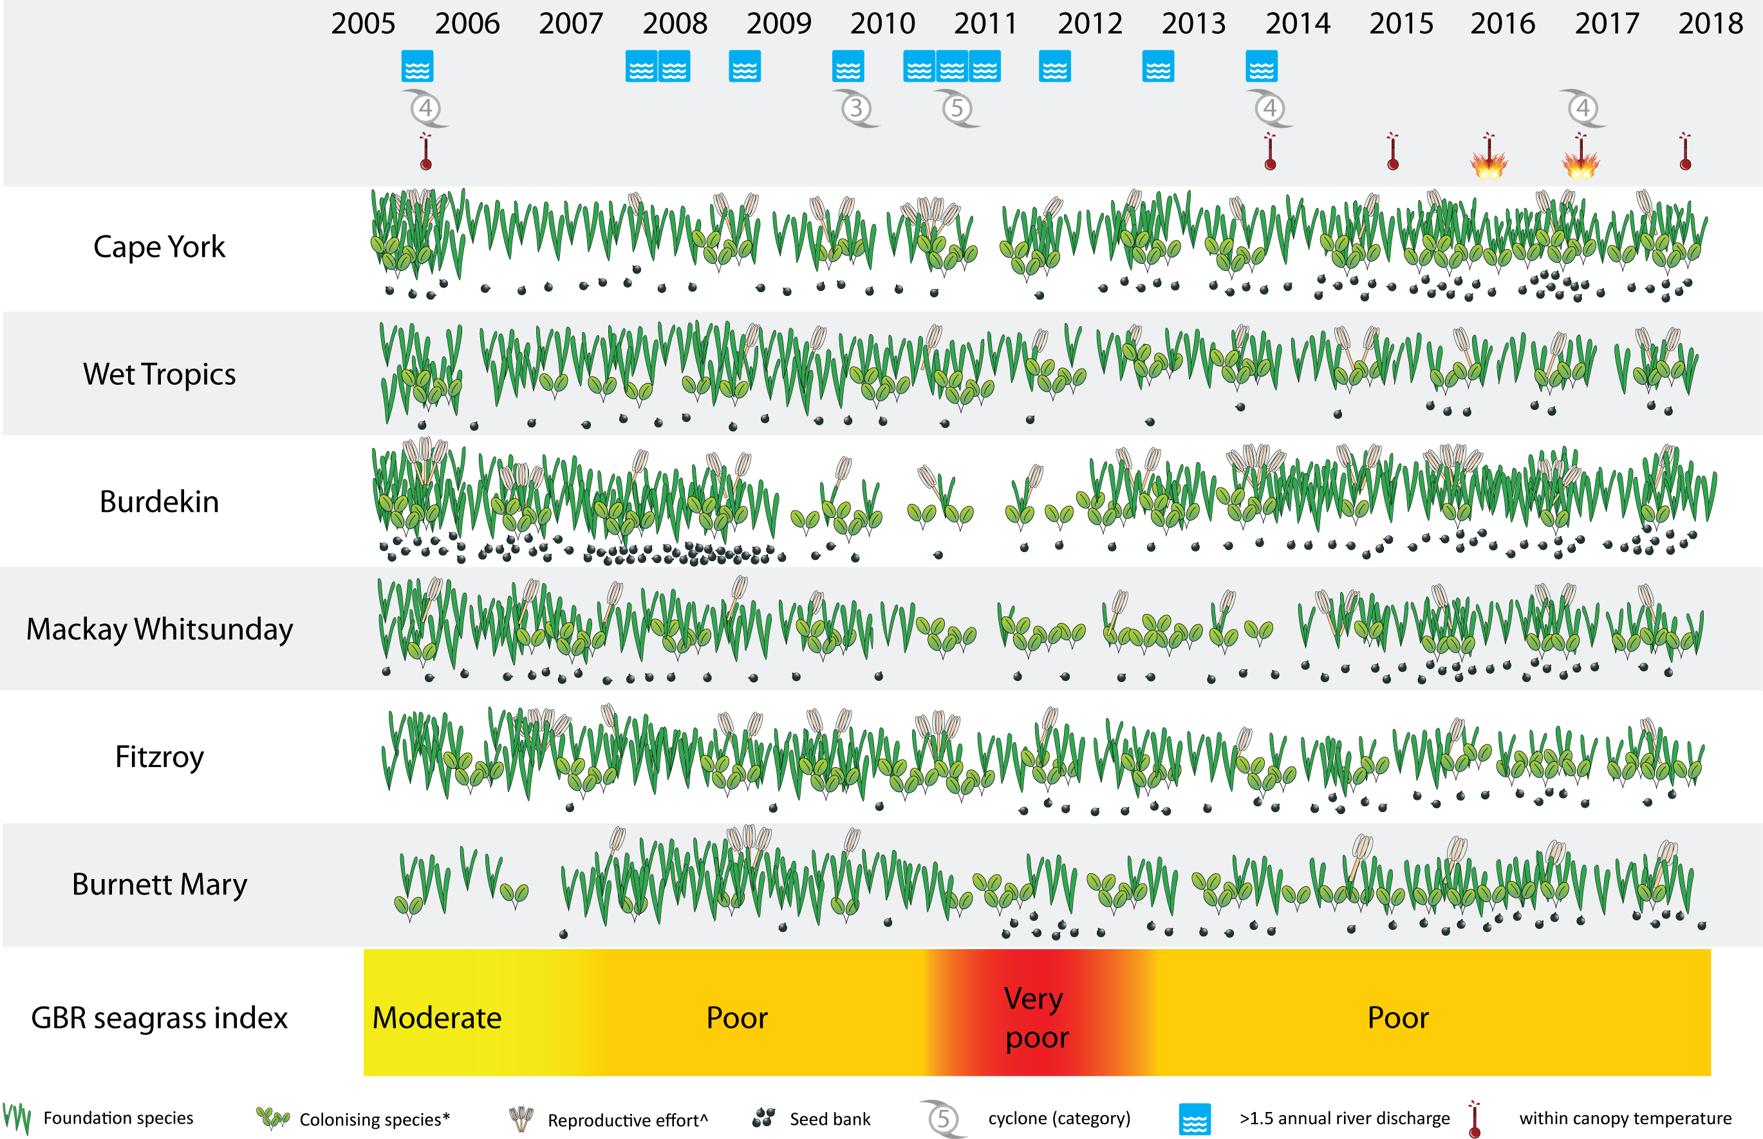
Figure 88. Summary of inshore seagrass state illustrating pressures, abundance of foundation / colonising species, seed banks and reproductive effort from 2005 to 2018
. * colonising species are represented by the genus Halophila, however, Zostera and Halodule can be both colonising and foundational species depending on meadow state. ^ not conducted in 2005.
The Wet Tropics and Fitzroy regions have shown the most protracted recovery rates, though the causes for this differ between the regions. In the Fitzroy region declines up to early 2011 were more moderate than in other regions, but the estuarine intertidal and coastal intertidal habitats declined further in 2013–2015, and recovery had since been slow except in coastal habitats. Abundance in the Wet Tropics declined in early 2011, and recovery has been delayed. In the southern Wet Tropics, it appears that sediment scouring caused by cyclone Yasi in 2011 altered bed elevation and substrate composition, however the growth substrate is not routinely measured. By contrast, slow recovery in the northern Wet Tropics reef sites (Low Isles intertidal and subtidal and Green Island subtidal) may be affected by water quality.
There was increasing evidence that water quality degradation within the seagrass meadows of the inshore Reef prior to the episodic disturbances of 2011 may have reduced their resilience. Light availability is one of the primary driving factors in seagrass growth and persistence (Collier and Waycott 2009; Brodie et al. 2013;Collier et al. 2012b). Seagrasses can survive in highly turbid sites if restricted to shallow areas where light reaches the canopy around low tide (Petrou et al. 2013). Conversely, infrequent low tide exposure occurring in summer months when water can be very turbid, coincident with high water temperatures, drives faster rates of decline (Collier et al. 2016a).
From 2009, reduced canopy light to low and limiting light levels was reported in seagrass meadows across the Reef, and, coincident with this, nutrients (N and P) increased relative to plant requirements. Conditions in the years leading up to 2011 were extremely turbid and were correlated with seagrass decline (e.g. Collier et al. 2012b; Petus et al. 2014). Since then, there have been periods of low light and exceedance of light thresholds, but the low light levels have not been as extreme (as low light, or for as long). The meadows have continued in a state of recovery, and the biological processes of recovery appears to complicate the response to environmental stressors.
For the Reef’s inshore seagrass meadows to improve from their current poor and vulnerable state with reduced resilience will require a return to conducive conditions for seagrass growth and reduced environmental pressures in the immediate future. To secure the future of the Reef’s seagrass ecosystems will also necessitate improved interdisciplinary and multidisciplinary ecosystem science on resilience and recovery, and the use of future climate adjusted conservation targets that allow for cumulative impacts and ecological feedbacks.

References
Abal, E.G., Loneragan, N.R., Bowen, P., Perry, C.J., Udy, J.W., Dennison, W.C. 1994, Physiological and morphological responses of the seagrass Zostera capricorni Aschers. to light intensity. Journal of Experimental Marine Biology and Ecology, 178(1): 113-129.
Angelini, C., Altieri, A.H., Silliman, B.R., Bertness, M.D. 2011, Interactions among Foundation Species and their Consequences for Community Organization, Biodiversity, and Conservation. BioScience, 61(10): 782-789.
Anthony, K.R.N., Ridd, P.V., Orpin, A.R., Larcombe, P., Lough, J. 2004, Temporal variation in light availability in coastal benthic habitats: Effects of clouds, turbidity, and tides. Limnology and Oceanography, 49(6): 2201-2211.
ANZECC. 2000, Australian and New Zealand guidelines for fresh and marine water quality. Canberra: Australian and New Zealand Environment and Conservation Council and Agriculture and Resource Management Council of Australia and New Zealand.
Arthur, K., Boyle, M., Limpus, C. 2008, Ontogenetic changes in diet and habitat use in green sea turtle (Chelonia mydas) life history. Marine Ecology Progress Series, 362: 303-311.
Atkinson, M.J. and Smith, S.V. 1983, C:N:P ratios of benthic marine plants. Limnology and Oceanography, 28(3): 568-574.
Australian Government and Queensland Government. 2018a, Reef 2050 Long-Term Sustainability Plan—July 2018. Canberra : Brisbane: Australian Government ; Queensland Government.
Australian Government and Queensland Government. 2018b, Reef 2050 Water Quality Improvement Plan: 2017 - 2022. Brisbane: State of Queensland.
Bainbridge, Z., Wolanski, E., Lewis, S., Brodie, J. 2012, Fine sediment and nutrient dynamics related to particle size and floc formation in a Burdekin River flood plume, Australia. Marine Pollution Bulletin, 65: 236-248.
Birch, W. and Birch, M. 1984, Succession and pattern of tropical intertidal seagrasses in Cockle Bay, Queensland, Australia: a decade of observations. Aquatic Botany, 19: 343-367.
Borum, J., Duarte, C.M., Krause-Jensen, D., Greve, T.M. 2004, European seagrasses: an introduction to monitoring and management. Copenhagen: The M&MS project.
Brodie, J., Waterhouse, J., Schaffelke, B., Johnson, J., Kroon, F., Thorburn, P., Rolfe, J., Lewis, S., Warne, M., Fabricius, K., McKenzie, L.J., Devlin, M. 2013, Reef Water Quality Scientific Consensus Statement 2013. Brisbane: Department of the Premier and Cabinet, Queensland Government.
Brodie, J.E., Kroon, F.J., Schaffelke, B., Wolanski, E.C., Lewis, S.E., Devlin, M.J., Bohnet, I.C., Bainbridge, Z.T., Waterhouse, J., Davis, A.M. 2012, Terrestrial pollutant runoff to the Great Barrier Reef: An update of issues, priorities and management responses. Marine Pollution Bulletin, 65(4–9): 81-100.
Bros, W.E. and Cowell, B.C. 1987, A technique for optimising sample size (replication). Journal of Experimental Marine Biology and Ecology, 114: 63-71.
Cabaço, S., Apostolaki, E.T., García-Marín, P., Gruber, R., Hernández, I., Martínez-Crego, B., Mascaró, O., Pérez, M., Prathep, A., Robinson, C., Romero, J., Schmidt, A.L., Short, F.T., van Tussenbroek, B.I., Santos, R. 2013, Effects of nutrient enrichment on seagrass population dynamics: evidence and synthesis from the biomass–density relationships. Journal of Ecology, 101(6): 1552-1562. doi: 10.1111/1365-2745.12134
Cabaço, S. and Santos, R. 2007, Effects of burial and erosion on the seagrass Zostera noltii. Journal of Experimental Marine Biology and Ecology, 340: 204-212.
Campbell, S.J. and McKenzie, L.J. 2001, Seagrass and algal abundance in the Whitsundays region. Status Report.
Campbell, S.J. and McKenzie, L.J. 2004, Flood related loss and recovery of intertidal seagrass meadows in southern Queensland, Australia. Estuarine, Coastal and Shelf Science, 60(3): 477-490.
Campbell, S.J., McKenzie, L.J., Kerville, S.P. 2006, Photosynthetic responses of seven tropical seagrasses to elevated seawater temperature. Journal of Experimental Marine Biology and Ecology, 330: 455-468.
Campbell, S.J., Roder, C.A., McKenzie, L.J., Lee Long, W.J. 2002, Seagrass resources in the Whitsunday region 1999 and 2000. DPI Information Series QI02043, 50.
Carruthers, T., Dennison, W., Longstaff, B., Waycott, M., Abal, E.G., McKenzie, L.J., Lee Long, W. 2002, Seagrass habitats of north east Australia: models of key processes and controls. Bulletin of Marine Science, 71(3): 1153-1169.
Carter, A.B., McKenna, S.A., Rasheed, M.A., McKenzie, L.J., Coles, R.G. 2016, Seagrass mapping synthesis: A resource for coastal management in the Great Barrier Reef World Heritage Area. Report to the National Environmental Science Programme. Cairns: Reef and Rainforest Research Centre Limited.
Chartrand, K.M., Szabó, M., Sinutok, S., Rasheed, M.A., Ralph, P.J. 2018, Living at the margins – The response of deep-water seagrasses to light and temperature renders them susceptible to acute impacts. Marine Environmental Research, 136: 126-138. doi: https://doi.org/10.1016/j.marenvres.2018.02.006
Coles, R., McKenzie, L.J., De'ath, G., Roelofs, A., Lee Long, W.J. 2009, Spatial distribution of deepwater seagrass in the inter-reef lagoon of the Great Barrier Reef World Heritage Area. Marine Ecology Progress Series, 392: 57-68. doi: 10.3354/meps08197
Coles, R.G., Lee Long, W.J., Watson, R.A., Derbyshire, K.J. 1993, Distribution of seagrasses, and their fish and penaeid prawn communities, in Cairns Harbour, a tropical estuary, northern Queensland, Australia. Australian Journal of Marine and Freshwater Research, 44: 193-210.
Coles, R.G., McKenzie, L.J., Mellors, J.E., Yoshida, R.L. 2001a, Validation and GIS of seagrass surveys between Cairns and Bowen – October/November 1987. CD Rom.
Coles, R.G., McKenzie, L.J., Yoshida, R.L. 2001b, Validation and GIS of seagrass surveys between Bowen and Water Park Point– March/April 1987. CD Rom.
Coles, R.G., McKenzie, L.J., Yoshida, R.L. 2001c, Validation and GIS of seagrass surveys between Cape York and Cairns - November 1984. CD Rom.
Coles, R.G., McKenzie, L.J., Yoshida, R.L. 2001d, Validation and GIS of seagrass surveys between Water Park Point and Hervey Bay – October/November 1988. CD Rom.
Collier, C., Devlin, M., Langlois, L., Petus, C., McKenzie, L.J., Texeira da Silva, E., McMahon, K., Adams, M., O’Brien, K., Statton, J., Waycott, M. 2014, Thresholds and indicators of declining water quality as tools for tropical seagrass management. Report to the National Environmental Research Program. Cairns: Reef and Rainforest Research Centre Limited.
Collier, C. and Waycott, M. 2009, Drivers of change to seagrass distributions and communities on the Great Barrier Reef: Literature review and gaps analysis. Report to the Marine and Tropical Sciences Research Facility.
Collier, C.J., Adams, M.P., Langlois, L., Waycott, M., O’Brien, K.R., Maxwell, P.S., McKenzie, L. 2016a, Thresholds for morphological response to light reduction for four tropical seagrass species. Ecological Indicators, 67: 358-366. doi: http://dx.doi.org/10.1016/j.ecolind.2016.02.050
Collier, C.J., Chartrand, K., Honchin, C., Fletcher, A., Rasheed, M. 2016b, Light thresholds for seagrasses of the GBR: a synthesis and guiding document. Including knowledge gaps and future priorities. Report to the National Environmental Science Programme. Cairns Reef and Rainforest Research Centre Limited.
Collier, C.J., Lavery, P.S., Ralph, P.J., Masini, R.J. 2009, Shade-induced response and recovery of the seagrass Posidonia sinuosa. Journal of Experimental Marine Biology and Ecology, 370(1–2): 89-103. doi: http://dx.doi.org/10.1016/j.jembe.2008.12.003
Collier, C.J. and Waycott, M. 2014, Temperature extremes reduce seagrass growth and induce mortality. Marine Pollution Bulletin, 83(2): 483-490. doi: http://dx.doi.org/10.1016/j.marpolbul.2014.03.050
Collier, C.J., Waycott, M., McKenzie, L.J. 2012a, Light thresholds derived from seagrass loss in the coastal zone of the northern Great Barrier Reef, Australia. Ecological Indicators, 23(0): 211-219. doi: 10.1016/j.ecolind.2012.04.005
Collier, C.J., Waycott, M., Ospina, A.G. 2012b, Responses of four Indo-West Pacific seagrass species to shading. Marine Pollution Bulletin, 65(4-9): 342-354. doi: 10.1016/j.marpolbul.2011.06.017
Costanza, R., d'Arge, R., de Groot, R., Farber, S., Grasso, M., Hannon, B., Limburg, K., Naeem, S., O'Neil, R.V., Paruelo, J., Raskin, R.G., Sutton, P., van der Belt, M. 1997, The Value of the world's ecosystem services and natural capital. Nature, 387(15): 253-260.
Costanzo, S.D., O'Donohue, M.J., Dennison, W.C., Loneragan, N.R., Thomas, M. 2001, A new approach for detecting and mapping sewage impacts. Marine Pollution Bulletin, 42(2): 149-156.
Cullen-Unsworth, L. and Unsworth, R. 2013, Seagrass Meadows, Ecosystem Services, and Sustainability. Environment: Science and Policy for Sustainable Development, 55(3): 14-28. doi: 10.1080/00139157.2013.785864
Cullen-Unsworth, L.C., Nordlund, L.M., Paddock, J., Baker, S., McKenzie, L.J., Unsworth, R.K.F. 2014, Seagrass meadows globally as a coupled social–ecological system: Implications for human wellbeing. Marine Pollution Bulletin, 83(2): 387-397. doi: http://dx.doi.org/10.1016/j.marpolbul.2013.06.001
De'ath, G. and Fabricius, K. 2010, Water quality as a regional driver of coral biodiversity and macroalgae on the Great Barrier Reef. Ecological Applications, 20(3): 840-850. doi: 10.1890/08-2023.1
Dennison, W.C., Longstaff, B.J., O'Donohue, M.J. 1997, Seagrasses as Bio-indicators. In S Hillman & S Raaymakers (Eds.), Karumba dredging 1996 - Environmental Monitoring Report. EcoPorts Monograph Series No.6 (pp. 255). Brisbane: Ports Corporation of Queensland.
Dennison, W.C., O'Donnohue, M.K., Abal, E.G. 1995, An assessment of nutrient bioindicators using marine plants in the region of Pioneer Bay, Airlie Beach, Queensland. Dry season sampling, September 1995. Brisbane: Marine Botany Section, Department of Botany, University of Queensland.
Department of Environment and Resource Management. 2009, Queensland Water Quality Guidelines, Version 3. ISBN 978-0-9806986-0-2. Brisbane: State of Queensland (Department of Environment and Resource Management).
Department of the Premier and Cabinet. (2014). Great Barrier Reef report card 2012 and 2013, Reef Water Quality Protection Plan, Scoring system. Retrieved 14/11/2014, from http://www.reefplan.qld.gov.au/measuring-success/methods/scoring-system.aspx
Derbyshire, K.J., Willoughby, S.R., McColl, A.L., Hocroft, D.M. 1995, Small prawn habitat and recruitment study : final report to the Fisheries Research and Development Corporation and the Queensland Fisheries Management Authority. Cairns: Department of Primary Industries.
Devlin, M., Petus, C., da Silva, E., Tracey, D., Wolff, N., Waterhouse, J., Brodie, J. 2015, Water Quality and River Plume Monitoring in the Great Barrier Reef: An Overview of Methods Based on Ocean Colour Satellite Data. Remote Sensing, 7(10): 12909.
Duarte, C., Borum, J., Short, F., Walker, D. 2005, Seagrass Ecosystems: Their Global Status and Prospects. In N Polunin (Ed.), Aquatic Ecosystems: Trends and Global Prospects: Cambridge Univ. Press.
Duarte, C.M. 1990, Seagrass nutrient content. Marine Ecology Progress Series, 67(1): 201-207.
Duarte, C.M. and Krause-Jensen, D. 2017, Export from Seagrass Meadows Contributes to Marine Carbon Sequestration. [Review]. Frontiers in Marine Science, 4(13). doi: 10.3389/fmars.2017.00013
EHMP. 2008, Ecosystem Health Monitoring Program 2006-07: Annual Technical Report. Brisbane: South East Queensland Healthy Waterways Partnership.
Ellison, A.M. 2019, Foundation Species, Non-trophic Interactions, and the Value of Being Common. iScience, 13: 254-268. doi: https://doi.org/10.1016/j.isci.2019.02.020
Fabricius, K., De'Ath, G., Humphrey, C., Zagorskis, I., Schaffelke, B. 2012, Intr-annual variation in turbidity in response to terrestrial runoff on near-shore coral reefs of the Great Barrier Reef. Estuarine, Coastal and Shelf Science, 3: 458-470.
Fourqurean, J.W., Duarte, C.M., Kennedy, H., Marba, N., Holmer, M., Mateo, M.A., Apostolaki, E.T., Kendrick, G.A., Krause-Jensen, D., McGlathery, K.J., Serrano, O. 2012, Seagrass ecosystems as a globally significant carbon stock. Nature Geoscience, 5(7): 505-509. doi: 10.1038/ngeo1477
Fourqurean, J.W., Zieman, J.C., Powell, G.V.N. 1992, Relationships between porewater nutrients and seagrasses in a subtropical carbonate environment. Marine Biology, 114(1): 57-65. doi: 10.1007/bf00350856
GBRMPA. (2019). Marine Monitoring Program Retrieved 29 March, 2019, from http://www.gbrmpa.gov.au/our-work/our-programs-and-projects/reef-2050-marine-monitoring-program
Goldsworthy, P.M. 1994, Seagrasses. In L Benson, P Goldsworthy, R Butler & J Oliver (Eds.), Townsville Port Authority Capital Dredging Works 1993: Environmental Monitoring Program (pp. 89-115). Townsville: Townsville Port Authority.
Great Barrier Reef Marine Park Authority. 2014, Great Barrier Reef Region Strategic Assessment: Program report. Townsville: GBRMPA.
Grech, A., Coles, R., Waycott, M., Rasheed, M., McKenzie, L. 2010, Risk Assessment for Coastal Seagrass Habitats of the Great Barrier Reef World Heritage Area: Outputs from the Risk Assessment Working Group.
Grech, A., Wolter, J., Coles, R., McKenzie, L., Rasheed, M., Thomas, C., Waycott, M., Hanert, E. 2016a, Spatial patterns of seagrass dispersal and settlement. Diversity and Distributions: n/a-n/a. doi: 10.1111/ddi.12479
Grech, A., Wolter, J., Coles, R., McKenzie, L., Rasheed, M., Thomas, C., Waycott, M., Hanert, E. 2016b, Spatial patterns of seagrass dispersal and settlement. Diversity and Distributions, 22(11): 1150-1162. doi: 10.1111/ddi.12479
Green, E. and Short, F. (Eds.). (2003). World Atlas of Seagrasses. Berkeley. USA: University of California Press,.
Grice, A., Loneragan, N., Dennison, W. 1996, Light intensity and the interactions between physiology, morphology and stable isotope ratios in five species of seagrass. Journal of Experimental Marine Biology and Ecology, 195: 91-110.
Gruber, R., Waterhouse, J., Logan, M., Petus, C., Howley, C., Lewis, S., Tracey, D., Langlois, L., Tonin, H., Skuza, M., Doyle, J., Costello, P., Davidson, J., Gunn, K., Wright, M., Zagorskis, I., Kroon, F., Neilen, A. 2019, Marine Monitoring Program: Annual Report for inshore water quality monitoring 2017–18. Report for the Great Barrier Reef Marine Park Authority. Townsville: Australian Institute of Marine Science and JCU TropWATER.
Haynes, D., Müller, J., Carter, S. 2000, Pesticide and Herbicide Residues in Sediments and Seagrasses from the Great Barrier Reef World Heritage Area and Queensland Coast. Marine Pollution Bulletin, 41(7-12): 279-287.
Heap, A.D., Murray, E., Ryan, D.A., Gallagher, J., Tobin, G., Creasey, J., Dyall, A. 2015, Queensland Coastal Waterways Geomorphic Habitat Mapping, Version 2 (1:100 000 scale digital data). [northlimit=-10.6; southlimit=-28.2; westlimit=137.8; eastLimit=153.2; projection=WGS84].
Heck, K.L. and Orth, R.J. 2006, Predation in seagrass beds. In WD Larkum, RJ Orth & CM Duarte (Eds.), Seagrasses: Biology, Ecology and Conservation. Dordrecht: Springer.
Heck, K.L. and Valentine, J.F. 2006, Plant-herbivore interactions in seagrass meadows. Journal of Experimental Marine Biology and Ecology, 330(1): 420-436.
Heck, K.L.J., Carruthers, T.J.B., Duarte, C.M., Hughes, A.R., Kendrick, G., Orth, R.J., Williams, S.W. 2008, Trophic transfers from seagrass meadows subsidize diverse marine and terrestrial consumers. [review]. Ecosystems, 11(7): 1198-1210. doi: 10.1007/s10021-008-9155-y
Holling, C.S. 1973, Resilience and stability of ecological systems. Annual Review of Ecology and Systematics, 4: 1-23.
Inglis, G.J. 1999, Variation in the recruitment behaviour of seagrass seeds: implications for population dynamics and resource management. Pacific Conservation Biology, 5: 251-259.
Jarvis, J. and Moore, K. 2010, The role of seedlings and seed bank viability in the recovery of Chesapeake Bay, USA, Zostera marina populations following a large-scale decline. Hydrobiologia, 649(1): 55-68. doi: 10.1007/s10750-010-0258-z
Jones, B.L., Cullen-Unsworth, L.C., Unsworth, R.K.F. 2018, Tracking Nitrogen Source Using δ15N Reveals Human and Agricultural Drivers of Seagrass Degradation across the British Isles. [Original Research]. Frontiers in Plant Science, 9(133). doi: 10.3389/fpls.2018.00133
Kilminster, K., McMahon, K., Waycott, M., Kendrick, G.A., Scanes, P., McKenzie, L., O'Brien, K.R., Lyons, M., Ferguson, A., Maxwell, P., Glasby, T., Udy, J. 2015, Unravelling complexity in seagrass systems for management: Australia as a microcosm. Science of The Total Environment, 534: 97-109. doi: http://dx.doi.org/10.1016/j.scitotenv.2015.04.061
Koch, E.M. 2001, Beyond light: Physical, geological, and geochemical parameters as possible submersed aquatic vegetation habitat requirements. Estuaries, 24(1): 1-17.
Ku, H.H., 1966. Notes on the use of propagation of error formulas. Journal of Research of the National Bureau of Standards. Section C: Engineering and Instrumentation 70C, 263-273.
Kuhnert, P.M., Liu, Y., Henderson, B.L., Dambacher, J., Lawrence, E., Kroon, F.J. 2014, Review of the Marine Monitoring Program (MMP), Final Report for the Great Barrier Reef Marine Park Authority (GBRMPA). Adelaide: CSIRO.
Lamb, J.B., van de Water, J.A.J.M., Bourne, D.G., Altier, C., Hein, M.Y., Fiorenza, E.A., Abu, N., Jompa, J., Harvell, C.D. 2017, Seagrass ecosystems reduce exposure to bacterial pathogens of humans, fishes, and invertebrates. Science, 355(6326): 731-733. doi: 10.1126/science.aal1956
Lanyon, J., Limpus, C.J., Marsh, H. 1989, Dugongs and turtles: grazers in the seagrass system. In AWD Larkum, AJ McComb & SA Shepherd (Eds.), Biology of Seagrasses: A treatise on the biology of seagrasses with special reference to the Australian region (pp. 610-634). New York: Elsevier.
Larcombe, P., Ridd, P.V., Prytz, A., Wilson, B. 1995, Factors controlling suspended sediment on inner-shelf coral reefs, Townsville, Australia. Coral Reefs, 14(3): 163-171. doi: 10.1007/bf00367235
Lavery, P.S., Mateo, M.-Á., Serrano, O., Rozaimi, M. 2013, Variability in the Carbon Storage of Seagrass Habitats and Its Implications for Global Estimates of Blue Carbon Ecosystem Service. Plos One, 8(9): e73748. doi: 10.1371/journal.pone.0073748
Lawrence, E. and Gladish, D. 2018, Analysis of seagrass and pressures data across the Great Barrier Reef. A report to the Great Barrier Reef Marine Park Authority.
Lee Long, W.J., Coles, R.G., McKenzie, L.J. 1999, Issues for Seagrass conservation management in Queensland. Pacific Conservation Biology, 5(4): 321-328.
Lee Long, W.J., McKenzie, L.J., Coles, R.G. 1997, Seagrass Communities in the Shoalwater Bay Region, Queensland; Spring (September) 1995 & Autumn (April) 1996. [Information Series]. Queensland Department of Primary Industries Information Series QI96042, 38.
Lee Long, W.J., McKenzie, L.J., Roelofs, A.J., Makey, L.J., Coles, R.G., C.A., R. 1998, Baseline Survey of Hinchinbrook Region Seagrasses - October (Spring) 1996. Research publication No. 51. 26.
Lee Long, W.J., Mellors, J.E., Coles, R.G. 1993, Seagrasses between Cape York and Hervey Bay, Queensland, Australia. Australian Journal of Marine and Freshwater Research, 44: 19-32.
Limpus, C.J., Limpus, D.J., Arthur, K.E., Parmenter, C.J. 2005, Monitoring Green Turtle Population Dynamics in Shoalwater Bay:2000 - 2004. GBRMPA Research Publication No 83 Townsville: Great Barrier Reef Marine Park Authority.
Lobb, K.F. (2006). Broad scale coastal nutrient assessment of the inshore Great Barrier Reef using carbon and nitrogen in marine plants and sediments. Bachelor of Science with Honours, The University of Queensland, Brisbane.
Macreadie, P.I., Serrano, O., Maher, D.T., Duarte, C.M., Beardall, J. 2017, Addressing calcium carbonate cycling in blue carbon accounting. Limnology and Oceanography Letters, 2(6): 195-201. doi: doi:10.1002/lol2.10052
Marsh, H., O'Shea, T.J., Reynolds III, J. 2011, Ecology and conservation of the sirenia: dugongs and manatees. New York: Cambridge University Press.
Maxwell, W.G.H. 1968, Atlas of the Great Barrier Reef. Amsterdam: Elsevier Publishing Company.
McCulloch, M., Pailles, C., Moody, P., Martin, C.E. 2003, Tracing the source of sediment and phosphorus into the Great Barrier Reef lagoon. Earth and Planetary Science Letters, 210: 249-258.
McKenzie, L.J. 2007, Relationships between seagrass communities and sediment properties along the Queensland coast. Progress report to the Marine and Tropical Sciences Research Facility. Cairns Reef and Rainforest Research Centre Ltd.
McKenzie, L.J. 2009, Observing change in seagrass habitats of the GBR– Seagrass-Watch monitoring: Deriving seagrass abundance indicators for regional habitat guidelines,. In LJ McKenzie & M Waycott (Eds.), Marine and Tropical Sciences Research Facility Milestone and Progress Report #3, 2008-2009 (ARP 3) Project 1.1.3 Report 3, 11th June 2000. http://rrrc.org.au/wp-content/uploads/2014/06/113-QDPIF-McKenzie-L-2009-June-Milestone-Report.pdf accessed 23 February 2017. (pp. 7-1). Cairns: RRRC.
McKenzie, L.J. and Campbell, S.J. 2002, Seagrass resources of the Booral Wetlands and the Great Sandy Strait: February/March 2002. DPI Information Series QI03016. Cairns: The State of Queensland, Department of Primary Industries.
McKenzie, L.J., Campbell, S.J., Roder, C.A. 2003, Seagrass-Watch: Manual for Mapping & Monitoring Seagrass Resources (2nd ed.). Cairns: QFS, NFC.
McKenzie, L.J., Collier, C., Waycott, M. 2014a, Reef Rescue Marine Monitoring Program - Inshore Seagrass, Annual Report for the sampling period 1st July 2011 – 31st May 2012. 176.
McKenzie, L.J., Collier, C.J., Langlois, L.A., Yoshida, R.L., Smith, N., Waycott, M. 2018a, Marine Monitoring Program: Annual Report for inshore seagrass monitoring 2016-2017. Townsville: Great Barrier Reef Marine Park Authority.
McKenzie, L.J., Collier, C.J., Waycott, M. 2012, Reef Rescue Marine Monitoring Program: Inshore seagrass, annual report for the sampling period 1st September 2010-31st May 2011. 230pp.
McKenzie, L.J., Finkbeiner, M.A., Kirkman, H. 2001, Methods for mapping seagrass distribution. In FT Short & RG Coles (Eds.), Global Seagrass Research Methods (pp. 101-121). Amsterdam: Elsevier Science B.V.
McKenzie, L.J., Lee Long, W.J., Roelofs, A., Roder, C.A., Coles, R. 1998, Port of Mourilyan seagrass monitoring - first four years. EcoPorts Monograph Serie No. 15. Brisbane: Ports Corporation of Queensland.
McKenzie, L.J., Roder, C.A., Roelofs, A.J., Lee Long, W.J. 2000, Post-flood monitoring of seagrasses in Hervey Bay and the Great Sandy Strait, 1999: Implications for dugong, turtle and fisheries management. [DPI Information Series]. Department of Primary Industries Information Series QI00059, 46.
McKenzie, L.J., Roder, C.A., Yoshida, R.L. 2016, Seagrass and associated benthic community data derived from field surveys at Low Isles, Great Barrier Reef, conducted July-August, 1997. PANGAEA: doi:10.1594/PANGAEA.858945. doi: 10.1594/PANGAEA.858945
McKenzie, L.J. and Unsworth, R.K.F. (2009). [Reef Rescue Marine Monitoring Program: Intertidal Seagrass, Final Report 2008/2009].
McKenzie, L.J., Unsworth, R.K.F., Waycott, M. 2010a, Reef Rescue Marine Monitoring Program: Intertidal Seagrass, Annual Report for the sampling period 1st September 2009 – 31st May 2010. 136.
McKenzie, L.J., Waycott, M., Unsworth Richard, K.F., Collier, C. 2018b, Inshore seagrass monitoring Marine Monitoring Program quality assurance and quality control manual 2016/17 (pp. 78-95). Townsville: Great Barrier Reef Marine Park Authority
McKenzie, L.J., Waycott, M., Unsworth Richard, K.F., Collier, C. 2019, Inshore seagrass monitoring. In Great Barrier Reef Marine Park Authority (Ed.), Marine Monitoring Program quality assurance and quality control manual 2017–18 (pp. 73-98). Townsville: Great Barrier Reef Marine Park Authority
McKenzie, L.J., Yoshida, R.L., Grech, A., Coles, R. 2010b, Queensland seagrasses. Status 2010 - Torres Strait and East Coast. Cairns: Fisheries Queensland (DEEDI).
McKenzie, L.J., Yoshida, R.L., Grech, A., Coles, R. 2014b, Composite of coastal seagrass meadows in Queensland, Australia - November 1984 to June 2010. . PANGAEA: http://doi.pangaea.de/10.1594/PANGAEA.826368.
McKenzie, L.J., Yoshida, R.L., Unsworth, R.K.F. 2014c, Disturbance influences the invasion of a seagrass into an existing meadow. Marine Pollution Bulletin, 86(1–2): 186-196. doi: http://dx.doi.org/10.1016/j.marpolbul.2014.07.019
McMahon, K., van Dijk, K.-j., Ruiz-Montoya, L., Kendrick, G.A., Krauss, S.L., Waycott, M., Verduin, J., Lowe, R., Statton, J., Brown, E., Duarte, C. 2014a, The movement ecology of seagrasses. Proceedings of the Royal Society of London B: Biological Sciences, 281(1795). doi: 10.1098/rspb.2014.0878
McMahon, K., van Dijk, K.-j., Ruiz-Montoya, L., Kendrick, G.A., Krauss, S.L., Waycott, M., Verduin, J., Lowe, R., Statton, J., Brown, E., Duarte, C. 2014b, The movement ecology of seagrasses. [10.1098/rspb.2014.0878]. Proceedings of the Royal Society B: Biological Sciences, 281(1795).
McMahon, K.M., Bengston-Nash, S., Eaglesham, G.K., Mueller, J., Duke, N.C., Winderlich, S. 2005, Herbicide contamination and the potential impact to seagrass meadows in Hervey Bay, Queensland, Australia. Marine Pollution Bulletin, 51: 325-334.
Mellors, J., Waycott, M., Marsh, H. 2005, Variation in biogeochemical parameters across intertidal seagrass meadows in the central Great Barrier Reef region. Marine Pollution Bulletin, 51(1-4): 335-342. doi: 10.1016/j.marpolbul.2004.10.046
Mellors, J.E. 2003, Sediment and nutrient dynamics in coastal intertidal seagrass of north eastern tropical Australia. PhD Thesis. School of Tropical Environment Studies and Geography: James Cook University, Townsville.
Monitoring River Health Initiative. 1994, River Bioassessment Manual, National River Processes and Management Program, Tasmania. http://www.environment.gov.au/water/publications/environmental/rivers/nrhp/bioassess.html, accessed 10 February 2014.
Nelson, W.G. 2017, Development of an epiphyte indicator of nutrient enrichment: Threshold values for seagrass epiphyte load. Ecological Indicators, 74: 343-356. doi: http://dx.doi.org/10.1016/j.ecolind.2016.11.035
O'Donohue, M.J., Moriarty, D.J.W., Mac Rae, I.C. 1991, Nitrogen fixation in sediments and the rhizosphere of the seagrass Zostera capricorni. Microbial Ecology, 22(1): 53-64.
Orpin, A.R., Ridd, P.V., Thomas, S., Anthony, K.R.N., Marshall, P., Oliver, J. 2004, Natural turbidity variability and weather forecasts in risk management of anthropogenic sediment discharge near sensitive environments. Marine Pollution Bulletin, 49(7–8): 602-612. doi: http://dx.doi.org/10.1016/j.marpolbul.2004.03.020
Orth, R.J., Harwell, M.C., Inglis, G.J. 2006, Ecology of seagrass seeds and dispersal strategies. In AWD Larkum, RJ Orth & CM Duarte (Eds.), Seagrasses: Biology, Ecology and Conservation (pp. 113-133). Dordrecht: Springer.
Owens, N.J.P. 1988, Natural Variations in 15N in the Marine Environment. In JHS Blaxter & AJ Southward (Eds.), Advances in Marine Biology (pp. 389-451): Academic Press.
Peterson, B.J. and Fry, B. 1987, Stable Isotopes in Ecostystem Studies. Annual Reveiw of Ecological Systematics, 18: 293-320.
Petrou, K., Jimenez-Denness, I., Chartrand, K., McCormack, C., Rasheed, M., Ralph, P. 2013, Seasonal heterogeneity in the photophysiological response to air exposure in two tropical intertidal seagrass species. Marine Ecology Progress Series, 482: 93-106. doi: 10.3354/meps10229
Petus, C., Collier, C., Devlin, M., Rasheed, M., McKenna, S. 2014, Using MODIS data for understanding changes in seagrass meadow health: A case study in the Great Barrier Reef (Australia). Marine Environmental Research, 98: 68-85. doi: http://dx.doi.org/10.1016/j.marenvres.2014.03.006
Petus, C., Devlin, M., Thompson, A., McKenzie, L., Teixeira da Silva, E., Collier, C., Tracey, D., Martin, K. 2016, Estimating the Exposure of Coral Reefs and Seagrass Meadows to Land-Sourced Contaminants in River Flood Plumes of the Great Barrier Reef: Validating a Simple Satellite Risk Framework with Environmental Data. Remote Sensing, 8(3): 210.
Preen, A.R., Lee Long, W.J., Coles, R.G. 1995, Flood and cyclone related loss, and partial recovery, of more than 1,000 km² of seagrass in Hervey Bay, Queensland, Australia. Aquatic Botany, 52: 3-17.
R Core Team. (2014). R: A language and environment for statistical computing. Retrieved from http://www.R-project.org/.
Rasheed, M.A., McKenna, S.A., Carter, A.B., Coles, R.G. 2014, Contrasting recovery of shallow and deep water seagrass communities following climate associated losses in tropical north Queensland, Australia. Marine Pollution Bulletin, 83(2): 491-499. doi: http://dx.doi.org/10.1016/j.marpolbul.2014.02.013
Rasheed, M.A., Thomas, R., Roelofs, A.J., Neil, K.M., Kerville, S.P. 2003, Port Curtis and Rodds Bay seagrass and benthic macro-invertebrate community baseline survey, November/December 2002. DPI Information Series QI03058. Cairns: DPI.
Rasheed, M.A. and Unsworth, R.K.F. 2011, Long-term climate-associated dynamics of a tropical seagrass meadow: implications for the future. Marine Ecology Progress Series, 422: 93-103.
Read, M.A. and Limpus, C.J. 2002, The green turtle (Chelonia mydas) in Queensland: Feeding ecology of immature turtles in a temperate feeding area. Memoirs of the Queensland Museum - Nature, 48(1): 207-214.
Reynolds, L.K., DuBois, K., Abbott, J.M., Williams, S.L., Stachowicz, J.J. 2016, Response of a Habitat-Forming Marine Plant to a Simulated Warming Event Is Delayed, Genotype Specific, and Varies with Phenology. PLoS ONE, 11(6): e0154532. doi: 10.1371/journal.pone.0154532
Roff, G., Clark, T.R., Reymond, C.E., Zhao, J.-x., Feng, Y., McCook, L.J., Done, T.J., Pandolfi, J.M. 2013, Palaeoecological evidence of a historical collapse of corals at Pelorus Island, inshore Great Barrier Reef, following European settlement. Proceedings of the Royal Society of London B: Biological Sciences, 280(1750). doi: 10.1098/rspb.2012.2100
Rue, H., Martino, S., Chopin, N. 2009, Approximate Bayesian inference for latent Gaussian models by using integrated nested Laplace approximations. Journal of the Royal Statistical Society: Series B (Statistical Methodology), 71(2): 319-392. doi: doi:10.1111/j.1467-9868.2008.00700.x
Saunders, M.I., Bayraktarov, E., Roelfsema, C.M., Leona, J.X., Samper-Villarreal, J., Phinn, S.R., Lovelock, C.E., Mumby, P.J. 2015, Spatial and temporal variability of seagrass at Lizard Island, Great Barrier Reef. Botanica Marina, 58(1): 35–49.
Schaffelke, B., Anthony, K., Blake, J., Brodie, J., Collier, C., Devlin, M., Fabricius, K., Martin, K., McKenzie, L.J., Negri, A., Ronan, M., Thompson, A., Warne, M. 2013, Marine and coastal ecosystem impacts Synthesis of evidence to support the Reef Water Quality Scientific Consensus Statement 2013 (pp. 47). Brisbane: Department of the Premier and Cabinet, Queensland Government.
Shelton, A.O. 2008, Skewed sex ratios, pollen limitation, and reproductive failure in the dioecious seagrass Phyllospadix. Ecology, 89: 3020-3029.
Sheppard, J.K., Jones, R.E., Marsh, H., Lawler, I.R. 2009, Effects of Tidal and Diel Cycles on Dugong Habitat Use. The Journal of Wildlife Management, 73(1): 45-59. doi: 10.2193/2007-468
Thorogood, J. and Boggon, T. 1999, Pioneer Bay environmental monitoring program. Fourth monitoring event, November 1999. Wellington Point, Brisbane: FRC Coastal Resource & Environmental.
Udy, J.W., Dennison, W.C., Lee Long, W.J., McKenzie, L.J. 1999, Responses of seagrass to nutrients in the Great Barrier Reef, Australia. Marine Ecology Progress Series, 185: 257-271.
Unsworth, R.K., Collier, C.J., Henderson, G.M., McKenzie, L.J. 2012a, Tropical seagrass meadows modify seawater carbon chemistry: implications for coral reefs impacted by ocean acidification. Environmental Research Letters, 7(2): 024026.
Unsworth, R.K.F., Collier, C.J., Waycott, M., McKenzie, L.J., Cullen-Unsworth, L.C. 2015, A framework for the resilience of seagrass ecosystems. Marine Pollution Bulletin, 100(1): 34-46. doi: http://dx.doi.org/10.1016/j.marpolbul.2015.08.016
Unsworth, R.K.F., McKenzie, L.J., Collier, C.J., Cullen-Unsworth, L.C., Duarte, C.M., Eklöf, J.S., Jarvis, J.C., Jones, B.L., Nordlund, L.M. 2018a, Global challenges for seagrass conservation. [journal article]. Ambio. doi: 10.1007/s13280-018-1115-y
Unsworth, R.K.F., McKenzie, L.J., Nordlund, L.M., Cullen-Unsworth, L.C. 2018b, A changing climate for seagrass conservation? Current Biology, 28(21): R1229-R1232. doi: https://doi.org/10.1016/j.cub.2018.09.027
Unsworth, R.K.F., Rasheed, M.A., Chartrand, K.M., Roelofs, A.J. 2012b, Solar radiation and tidal exposure as environmental drivers of Enhalus acoroides dominated seagrass meadows. Plos One, 7(3). doi: 10.1371/journal.pone.0034133
van Katwijk, M.M., Bos, A.R., Hermus, D.C.R., Suykerbuyk, W. 2010, Sediment modification by seagrass beds: Muddification and sandification induced by plant cover and environmental conditions. Estuarine Coastal And Shelf Science, 89(2): 175-181. doi: 10.1016/j.ecss.2010.06.008
van Oppen, M., Gates, R.D., Blackall, L.L., Cantin, N., Chakravarti, L.J., Chan, W.Y., Cormick, C., Crean, A., Damjanovic, K., Epstein, H., Harrison, P.L., Jones, T.A., Miller, M., Pears, R.J., Peplow, L.M., Raftos, D.A., Schaffelke, B., Stewart, K., Torda, G., Wachenfeld, D., Weeks, A.R., Putnam, H.M. 2017, Shifting paradigms in restoration of the world's coral reefs. Global Change Biology, 23: 3437-3448.
Waterhouse, J., Brodie, J., Coppo, C., Tracey, D., da Silva, E., Howley, C., Petus, C., McKenzie, L., Lewis, S., McCloskey, G., Higham, W. 2016, Assessment of the relative risk of water quality to ecosystems of the eastern Cape York NRM Region, Great Barrier Reef. A report to South Cape York Catchments. TropWATER Report 16/24, . Townsville, Australia.: TropWATER (JCU).
Watson, R.A., Coles, R.G., Lee Long, W.J. 1993, Simulation estimates of annual yield and landed value for commercial penaeid prawns from a tropical seagrass habitat, northern Queensland, Australia. Australian Journal of Marine and Freshwater Research, 44(1): 211-220.
Waycott, M., Collier, C., McMahon, K., Ralph, P.J., McKenzie, L.J., Udy, J.W., Grech, A. 2007, Vulnerability of seagrasses in the Great Barrier Reef to climate change - Chapter 8: . In JE Johnson & PA Marshall (Eds.), Climate Change and the Great Barrier Reef: A Vulnerability Assessment, Part II: Species and species groups (pp. 193-236). Townsville: Great Barrier Reef Marine Park Authority
Waycott, M., McKenzie, L.J., Mellors, J.E., Ellison, J.C., Sheaves, M.T., Collier, C., Schwarz, A.-M., Webb, A., Johnson, J., Payri, C.E. 2011, Vulnerability of mangroves, seagrasses and intertidal flats in the tropical Pacific to climate change. In JD Bell, JE Johnson & AJ Hobday (Eds.), Vulnerability of fisheries and aquaculture in the Pacific to climate change (pp. 97-168). Noumea, New Caledonia: Secretariat of the Pacific Community.
Waycott, M., McMahon, K.M., Mellors, J.E., Calladine, A., Kleine, D. 2004, A guide to tropical seagrasses of the Indo-West Pacific. Townsville: James Cook University.
Webster, I. and Ford, P. 2010, Delivery, deposition and redistribution of fine sediments within macrotidal Fitzroy Estuary/Keppel Bay: southern Great Barrier Reef, Australia. Continental Shelf Research, 30: 793–805.
Whinney, J. (2007). Physical conditions on marginal coral reefs. PhD, James Cook University, Townsville.
Wood, S. 2014, Mixed GAM Computation Vehicle with GCV/AIC/REML Smoothness Estimation, version 1.8-9. Comprehensive R Archive Network(cran.r-project.org): 10.
Wood, S.N. 2006, Generalized Additive Models: An Introduction with R: Chapman & Hall/CRC.
York, P.H., Carter, A.B., Chartrand, K., Sankey, T., Wells, L., Rasheed, M.A. 2015, Dynamics of a deep-water seagrass population on the Great Barrier Reef: annual occurrence and response to a major dredging program. Scientific Reports, 5: 13167. doi: 10.1038/srep13167 http://www.nature.com/articles/srep13167#supplementary-information

Case studies

Case study #1: Developing a computer program to predict cumulative light and temperature stress on seagrass in the Great Barrier Reef
Matthew P. Adams¹, Edwin J. Y. Koh¹, Maria P. Vilas^{1,2}, Catherine J. Collier³, Len J. McKenzie³, Kate R. O’Brien¹
¹School of Chemical Engineering, The University of Queensland, Brisbane, Australia
²CSIRO Agriculture & Food, Queensland Biosciences Precinct, Brisbane, Australia
³Centre for Tropical Water & Aquatic Ecosystem Research (TropWATER), James Cook University, Cairns, Australia

Introduction
Predicting cumulative stress to seagrass, due to multiple environmental factors, requires knowledge about how these factors interact. For such predictions to be trustworthy, quantification of the uncertainty in these predictions is a must. Additionally, a generic metric of cumulative stress has not yet been developed for seagrass, unlike e.g. degree-heating-weeks for corals (Gleeson and Strong 1995).
In this case study a computer program was developed, based on a mathematical model calibrated to laboratory measurements of seagrass responses to light and temperature (Collier et al. 2016; Collier et al. 2018). This program has an easy-to-use interface (Figure 1) that allows users to predict cumulative light and temperature stress on seagrass (defined as a percentage) based on current light and temperature conditions. Uncertainty in predictions is also calculated and shown by the program; this quantification of uncertainty is an output of the Bayesian inferential methodology we used for fitting the mathematical model to the laboratory data (Girolami 2008).
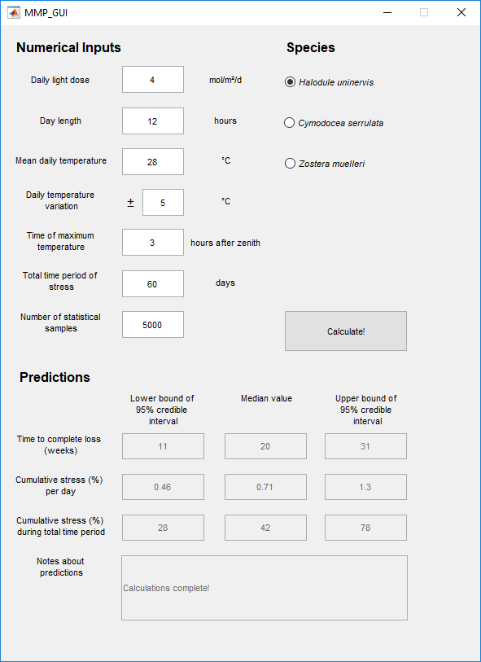
Figure 1. Graphical user interface for the computer program that can be used to predict cumulative stress on seagrass due to light and temperature.

Program details
Installation
The program shown in Figure 1 is a standalone executable file. To run this executable, the user only needs to install the program “MATLAB Runtime” first, available for free at https://www.mathworks.com/products/compiler/matlab-runtime.html. The program has been created for both Windows and Mac formats.
Underlying Science
An earlier version of the model used in this program is discussed in a case study in the 2016–17 MMP Seagrass Annual Report (McKenzie et al. 2018, pp. 119–124), although in that version the model-data calibration was performed using least-squares optimisation. Here the model-data calibration is performed using a Bayesian inferential methodology to provide the best predictions of uncertainty. The full details of the model and data fitting will be presented in a forthcoming publication.

Using the Program
The user inputs the following information to the program:
- Daily light dose, in mol quanta m⁻² d⁻¹
- Day length, in hours. A half-sinusoidal variation in light over the day is assumed (as in e.g. Monteith 1965)
- Mean daily temperature, in degrees Celsius. Note that this is mean temperature over the entire day (24 hours, including the night)
- Daily temperature variation, in degrees Celsius. This gives the maximum variation from the mean daily temperature over the 24 hour period. For example, if the user inputs a mean daily temperature of 28°C and a daily temperature variation of ±5°C, this means that the minimum temperature at any time during the day is 23°C and the maximum temperature at any time during the day is 33°C. A sinusoidal variation in temperature over the day is assumed
- Time of maximum temperature, in hours after zenith. Since temperature always peaks in the afternoon, this gives the number of hours, after the sun was at its highest point, at which the maximum temperature is reached
- Total time period of stress, in days. This input is used to forecast the “Cumulative stress (%) during total time period” (see next section)
- Number of statistical samples, with a default value of 10,000. A larger number of statistical samples takes longer for the program to calculate, but yields a more reproducible prediction. Hence, the user may want to run the program twice for the same inputs, to see if the results are reproducible. If the results are not the same, a larger number of statistical samples may be needed
- The seagrass species of interest. The user can choose one of 3 species available in the program: Halodule uninervis, Cymodocea serrulata or Zostera muelleri.

Program Outputs
After the user inputs all the above information, and clicks the “Calculate!” button, three outputs are generated:
- Time to complete loss (weeks). If this output is “>52” then the stress to the seagrass is very low.
- Cumulative stress (%) per day. This number is calculated from:

- Cumulative stress (%) during total time period. This number is calculated from

If this reaches 100%, then the program predicts that the seagrass may perish during the time period of stress due to light and temperature.
For all three program outputs, three numbers are generated: (1) the lower bound of the 95% credible interval, (2) the median value, and (3) the upper bound of the 95% credible interval. The lower and upper bounds of the 95% credible interval can be interpreted as follows: Given the data used to inform the model in the program, there is a 95% probability that the true value falls between these two bounds.

Alpha testing
The software was operationally tested internally, using actual data from four MMP locations, to assess application accuracy and credibility of model outputs. Intertidal and subtidal sites were selected from the Wet Tropics and the Burdekin (dry tropics) regions for comparison, because conditions between the regions can be extreme (both good and bad), and the sites/locations also have long (nearly two decade) data series.
The Cumulative Stress Index (CSI), average temperature and average daily light over the wet season (December to April) were plotted over the long-term for the four locations each monitoring period (Figure 2). Also included is the average abundance score (% cover relative to guideline, see section 2.5.1 in main report) for the site/location to determine if there was any type of relationship.
The NRM regional seagrass condition index (i.e. % cover, reproductive effort and tissue nutrient combined index, see section 0 in main report), was used to provide some indication of whether overall resilience corresponds to the CSI. The variation in the CSI appears to relate more closely to variation in the abundance indicator (% cover) and the seagrass condition index, than either temperature or daily light alone. Temperature and daily light vary greatly, and don’t necessarily reflect biological responses. The CSI appears more consistent, with the exception at Yule Point where there seems to be a lag in response.
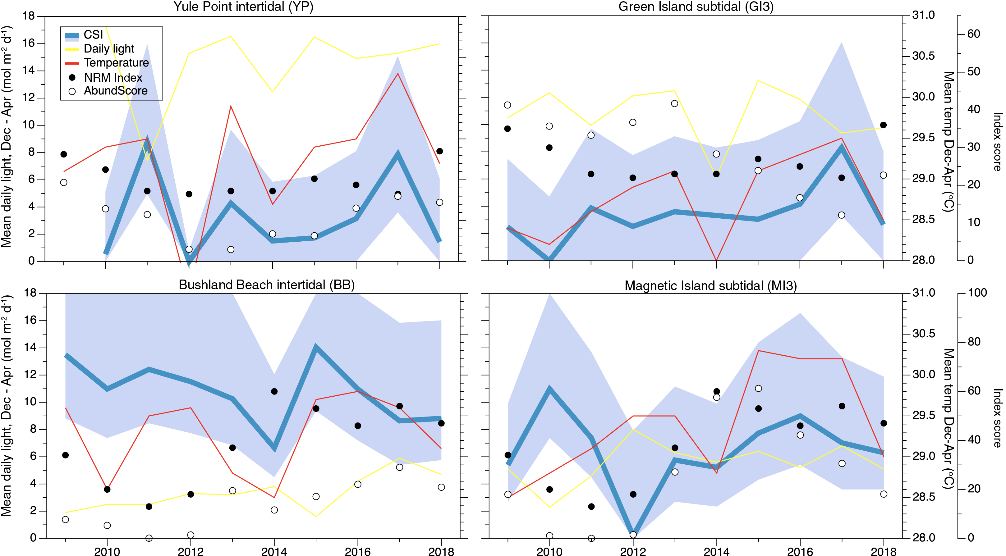
Figure 2. Example application of the CSI at sites in the Burdekin and Wet Tropics regions (Figure 41, Figure 55). The stress index was calculated for the wet season, from December to April, in each year. Also shown are the abundances and seagrass condition score for the region.

CSI at some sites was always quite low (e.g. GI3), while at BB1 it was always quite high. For this reason, it may be more rational to examine how CSI varies relative to how it usually is at that site. Therefore, we plotted the CSI deviation from the long-term average at Burdekin and Wet Tropics sites (Figure 3), as evaluating between the individual light and temperature plots to determine whether the response relative to the long-term is anomalous. This plot (Figure 3) provides a rapid view of the combined light and temperature risk, and assists in assessing how the wet season year was for these environmental variables at a glance. Overall, 2017–18 was a somewhat ‘moderate year’. In the Wet Tropics light was low at some sites, but temperature was moderate, so the overall CSI was quite neutral in terms of deviation from long-term average.
To provide a preliminary examination of the presence of any correlations between CSI, seagrass % cover or the seagrass condition index, we plotted a few examples (Figure 4). The correlation is present but weak for the Index and CSI. This requires more detailed analysis and in the future, we plan to examine how the CSI relates to a biological response using a lag function, as the CSI is for the wet season (Dec–April), but the Index is for the entire year (May–April).
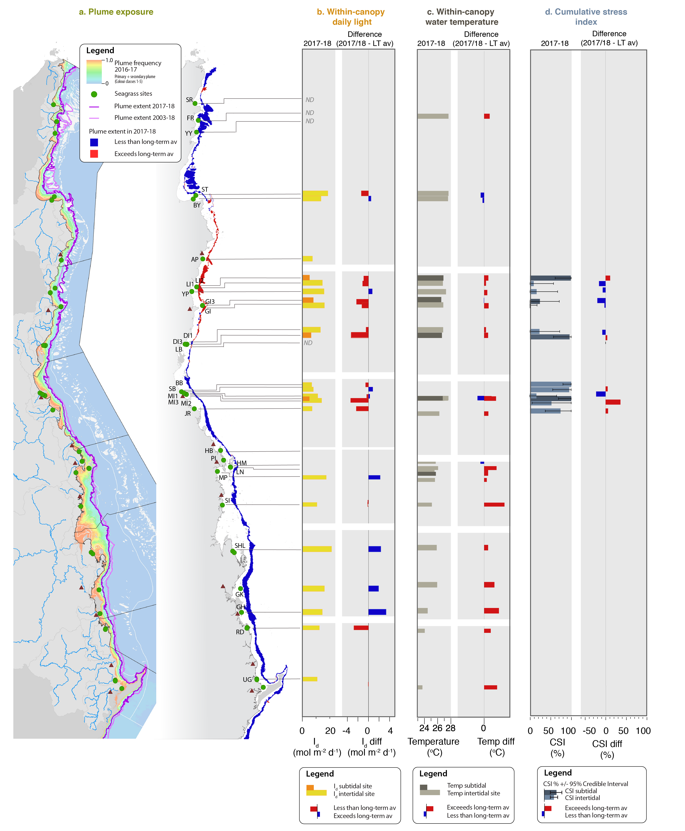
Figure 3. Example application of the CSI in comparison to augment the interpretation of light and temperature anomalies. Example given is for the Burdekin and Wet Tropics sites.
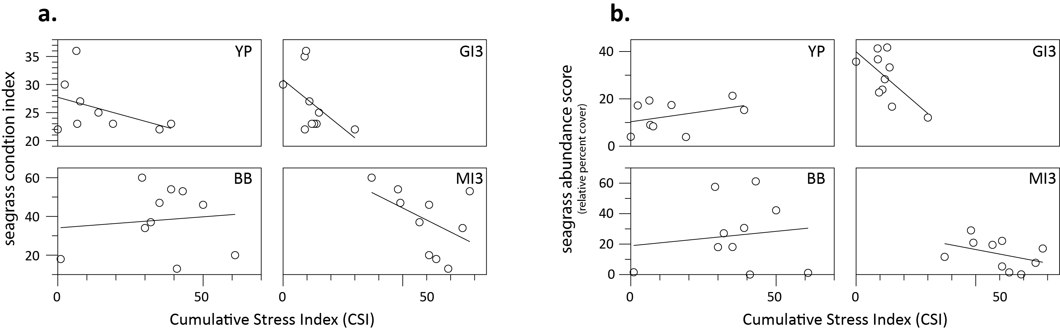
Figure 4. Preliminary examination to identify possible correlations at the Burdekin and Wet Tropics sites between CSI and the seagrass condition index (a), or the seagrass abundance indicator (b).

References
Collier, C.J., Adams, M.P., Langlois, L., Waycott, M., O’Brien, K.R., Maxwell, P.S., McKenzie, L.J. 2016, Thresholds for morphological response to light reduction for four tropical seagrass species. Ecological Indicators 67: 358-366.
Collier, C.J., Langlois, L., Ow, Y., Johansson, C., Giammusso, M., Adams, M.P., O’Brien, K.R., Uthicke, S. 2018, Losing a winner: thermal stress and local pressures outweigh the positive effects of ocean acidification for tropical seagrasses. New Phytologist 219: 1005-1017.
Girolami, M. 2008, Bayesian inference for differential equations. Theoretical Computer Science 408: 4-16.
Gleeson, M. W. and Strong, A.E. 1995, Applying MCSST to coral reef bleaching. Advances in Space Research 16: (10)151-(10)154.
McKenzie, L.J., Collier, C.J., Langlois, L.A., Yoshida, R.L., Smith, N., Waycott, M. 2018, Marine Monitoring Program: Annual Report for inshore seagrass monitoring 2016-2017. Report for the Great Barrier Reef Marine Park Authority. Great Barrier Reef Marine Park Authority, Townsville, 248 pp.
Monteith, J.L. 1965, Light Distribution and Photosynthesis in Field Crops. Annals of Botany 29(1): 17-37. doi: 10.1093/oxfordjournals.aob.a083934.

Case study #2: Reproductive effort as a predictor of future seagrass cover: Model assessment and implications for report card metrics and the development of a seagrass resilience indicator
Collier, C.J, Lawrence, E., Waycott, M., Langlois, L.A., and McKenzie, L.J.

Introduction
Although seagrasses are clonal plants, sexual reproduction is a process critical for maintaining seagrass resilience because it leads to the formation of a seed bank and also increases clonal richness (diversity) of the population (Unsworth et al. 2015). Sexual reproduction is the most critical in meadows that are under stress, as high genetic diversity can increase the resistance of a population to stress (Reynolds et al. 2016), and both higher genetic diversity, and the presence of a seed bank can facilitate recovery following seagrass loss (declines in abundance) through local germination (Jarvis and Moore 2010) and recruitment from external meadows (McMahon et al. 2014b; Grech et al. 2016b).

As investment of the plant into sexual reproduction is generally considered to impart a benefit following a major decline, it follows therefore, that reproductive effort should affect future seagrass cover. The aims of this case study were to explore the value of the seagrass reproductive data collected in the inshore seagrass MMP for predicting percent cover, as detailed in (Lawrence and Gladish 2018), and to use these findings to make recommendations for future inclusion of reproductive effort in the Reef Water Quality Protection Plan annual report card.

Methods
Data on seagrass percent cover, species composition, flower, spathe and fruit density, node (i.e. leaf scar) density, and seed density were compiled for all sites and all years of the inshore seagrass MMP (2005–2016) (Table 17). Two modelling frameworks were explored and the methods used are detailed in Lawrence and Gladish (2019). These were: (i) a parametric Generalized Linear Model (GLM); and (ii) a non-parametric statistical model (Random Forest).

Table 17. List of variables used for statistical modelling from Lawrence and Gladish (2018)
Variable Name | Description
Peak growth season | Indicator variable dictating if the cover measure was made in the peak (Sep-Nov) or non-peak season (all other months)
No. of species | Integer showing the number of species at the site for the season and year
Max no. of nodes | Maximum total number of nodes counted during one sampling point in the period
Max no. of flowers | Maximum total number of flowers counted during one sampling point in the period
Max no. of fruits & spathes | Maximum total number of fruits and spathes combined during one sampling point in the period
Seed density (seeds m⁻²) | Estimated sum of seeds per square meter
Site | Factor variable indicating which Site
C. rotundata | Indicator for presence of species Cymodocea rotundata (binary)
C. serrulata | Indicator for species Cymodocea serrulata
E. acoroides | Indicator for species Enhalus acoroides
H. decipiens | Indicator for species Halophila decipiens
H. spinulosa | Indicator for species Halophila spinulosa
H. ovalis | Indicator for species Halophila ovalis
H. uninervis | Indicator for species Halodule uninervis
S. isoetifolium | Indicator for species Syringodium isoetifolium
T. hemprichii | Indicator for species Thalassia hemprichii
Z. muelleri | Indicator for species Zostera muelleri
Percent cover, lagged | A variable indicating the previous year mean percent cover

Both the zero-inflated beta regression model and the random forest model link the explanatory variables in Table 2 to the percent cover of seagrass. Four different models were considered in Lawrence and Gladish (2018), which included the sequential addition of species and/or percent cover from the previous year (lag cover). These were:
- M1 is predicting seagrass percent cover based on site, current season, number of species present in the previous year, the reproductive/resilience variables from the peak of the previous year (nodes, flowers, fruits, spathes and seeds).
- M2 is the same but with indicator variables showing which species were present in the previous year.
- M3 is the same as M1 but with the addition of the seagrass cover in the previous year.
- M4 is the same as M3 with the addition of the species indicator variables.

For this case study, we further considered three definitions of reproductive effort. These were:
- Based on the total number of nodes or reproductive structures across the sample points collected during the peak season (September–December) of the previous year (a,b Table 18)
- Maximum total number of structures recorded during one sampling point in the preceding July–June (i.e. irrespective of the season in which it was observed, the maximum total count of reproductive effort for the previous period year was used) (as described in Table 17). This is the version of the models detailed in this case study (c,d)
- The presence or absence of reproductive structures and nodes in the sampling period (i.e. binary classification of whether reproductive structures were observed at any time in the previous peak) (e,f).

Results
All formulations fit the data reasonably well for both statistical models, with R-squared values between 0.63 and 0.74. We note that the R-squared values for the zero-inflated beta model is always at least slightly better than the random forest models, although the increase is sometimes very modest. The R-squared values also increase moving from M1 to M4 indicating that the models are improved by considering both species composition and the amount of seagrass in the year prior.

Table 18. R-squared values for models M1 – M4 using both the zero-inflated beta regression models and Random forest models, also testing different definitions of reproductive effort in the previous period.
 |  | Reproductive structures and node data treatment
 |  | original |  | maximum |  | binary
Model no. | Parameters included | a. Beta regression | b. Random forest | c. Beta regression* | d. Random forest | e. Beta regression | f. Random forest
M1 | No Species | 0.672 | 0.649 | 0.653 | 0.63 | 0.633 | 0.605
M2 | Species | 0.689 | 0.663 | 0.674 | 0.652 | 0.657 | 0.631
M3 | Lag, No Species | 0.716 | 0.684 | 0.709 | 0.673 | 0.704 | 0.658
M4 | Lag, Species | 0.741 | 0.688 | 0.738 | 0.684 | 0.733 | 0.68
*variables providing key indicators of seagrass cover for models M1 – M4 are detailed in Table 19

There are a lot of interesting relationships highlighted through the results of these models so we have summarised our findings for the zero-inflated beta regression model based on maximum reproductive effort (Table 19):
- The number of species in the year prior is significant in the models that don’t have the individual species indicators or lagged cover (M1, M2 and M3)
- The number of nodes in the year prior is significant in M4. The coefficients are negative indicating that a higher number of nodes in the year prior results in less seagrass. This could be due to the seagrass “working hard” to regenerate in periods of loss
- The number of flowers was significant in all of the models. In each case, the greater the number of flowers in the year prior, the greater the mean seagrass prediction
- The number of combined fruits/spathes was significant for M1 and M2 but not once lagged cover was added
- The seed bank variable was never significant
- Cymodocea serrulata and Zostera muelleri were significant in both of the models where they were considered. Each had a positive coefficient indicating that the presence of these seagrass in a particular year is an indicator for higher mean seagrass the following year. These are all considered to be foundation species in the Reef
- Lagged cover was always significant when included in the models.

The models comparing original, maximum and binary counts of reproductive structures and nodes had decreasing goodness of fit (R²), but these were very small reductions in R². This demonstrates that while the count of reproductive structures can improve predictions of seagrass percent cover in the following year, it adds only a small amount of information (a-d). The presence of any structures alone provides a suitable alternative (e and f).
We haven’t tried to interpret the coefficients, other than their direction, as the model is complex and a logit link was applied meaning that the relationships are non-linear.

Table 19. Coefficients and p-values for the Zero-inflated beta regression for percent cover response under formulations M1-M4 (model and data treatment c). The p-value is in the brackets and bold indicates p-value less than 0.05.
Variable | M1 | M2 | M3 | M4
Peak season (Sep-Dec) | 0.085  (0.22) | 0.052  (0.452) | -0.002  (0.974) | -0.046  (0.48)
No. species | 0.306  (0.000) | 0.253  (0.017) | 0.265  (0.000) | 0.147  (0.135)
Max no. nodes | -0.001  (0.05) | -0.001  (0.06) | -0.001  (0.088) | -0.001  (0.043)
Max_Flowers | 0.0207  (0.000) | 0.020  (0.000) | 0.015  (0.001) | 0.014  (0.001)
Max no. fruits & spathes | 0.013  (0.001 | 0.014  (0.000) | 0.005  (0.253) | 0.006  (0.101)
Seed density (seeds m⁻²) | 0.000  (0.297) | 0.000  (0.393) | 0.000  (0.671) | 0.000  (0.827)
C. rotundata | NA | 0.141  (0.556) | NA | 0.07  (0.975)
C. serrulata | NA | 0.375  (0.026) | NA | 0.471  (0.003)
E. acoroides | NA | -0.279  (0.587) | NA | -0.786  (0.118)
H. decipiens | NA | -0.162  (0.768) | NA | 0.105  (0.838)
H. spinulosa | NA | -0.282  (0.603) | NA | -0.954  (0.065)
H. ovalis | NA | -0.000  (0.995) | NA | 0.156  (0.266)
H. uninervis | NA | -0.119  (0.473) | NA | 0.003  (0.986)
S. isoetifolium | NA | -0.115  (0.779) | NA | -0.192  (0.637)
T. hemprichii | NA | -0.153  (0.365) | NA | -0.132  (0.396)
Z. muelleri | NA | 0.491  (0.003) | NA | 0.491  (0.001)
Percent cover, lagged | NA | NA | 3.271  (0.000) | 3.570  (0.000)

We next present the results for the random forest models. Since random forests are non-parametric in nature, we rank the importance of the variable rather than their indicating significance. Importance is based on what is known as reduction in MSE which indicates the reduction in error achieved through the introduction of each variable, with the variables depicted in decreasing value (importance) (see Breiman, 2001 for details).
As with the zero-inflated beta regression, the number of species, nodes, number of flowers, number of fruits/spathes and lagged cover were consistently important predictors of percent cover. The two Cymodocea species (C. serrulata and C. rotundata) and Zostera muelleri also showed importance when species were added, supporting the zero-inflated beta regression results.
Interestingly, seed density is important in the random forest model, disagreeing with the zero-inflated beta regression. This is likely to mean that seeds are important in predicting seagrass, and in particular seagrass recovery, but due to the sparcity of the data there is not enough power to display significance in the beta regression model. As such, while seed density may be too variable to be a good indicator of seagrass cover currently (due to low seed numbers), it may still be valuable in predicting seagrass recovery when combined with other relevant variables. This is a slight but critical distinction to note.

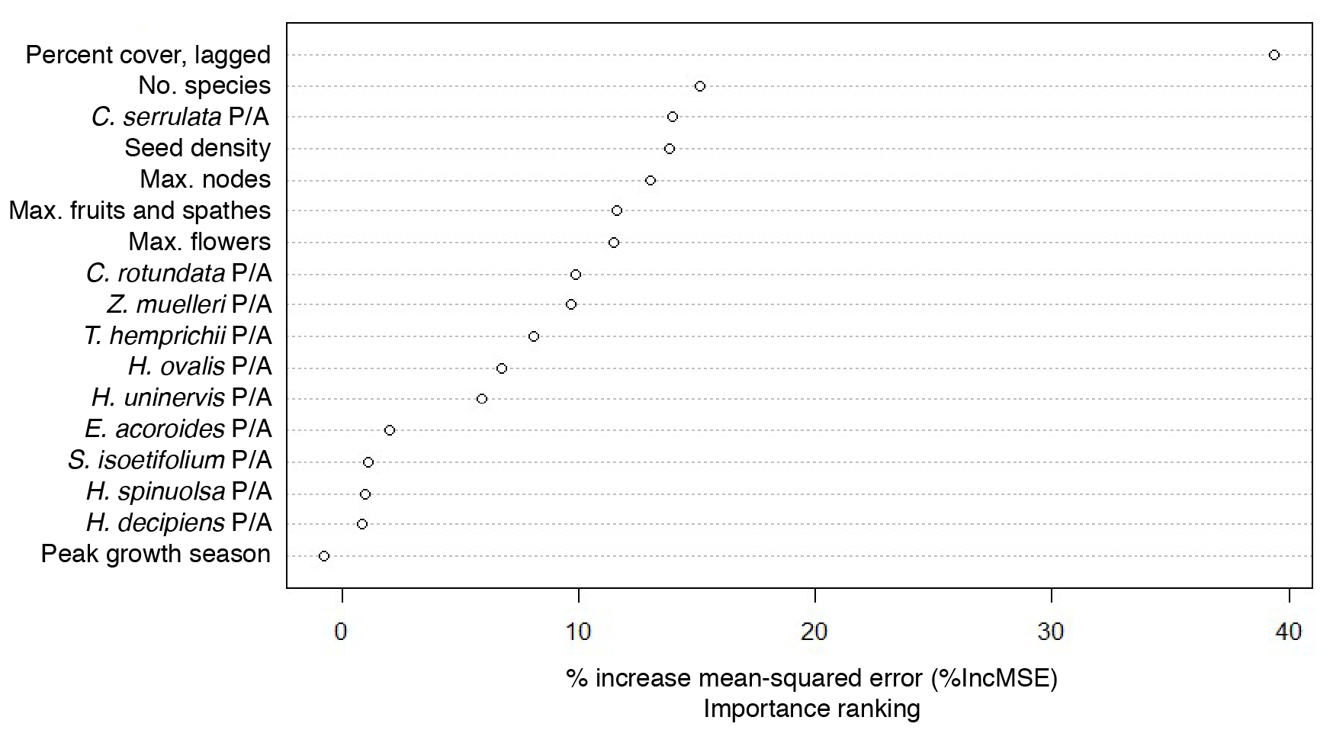
Figure 89. Variability importance ranking of the Random forest model for M4. Variables higher in the list are more important in predicting percent cover.

Discussion
The analysis outlined in this case study, and in Lawrence and Gladish (2018) has led to the following conclusions:

- Percent cover of seagrass in the previous year provides the best predictor of seagrass cover and weighting of the report card metrics should reflect this. In the beta regression model, the percent cover in the previous year was a highly significant variable (p<0.001) and in the random forest models, it had the highest importance ranking, far exceeding the importance ranking of other variables. We can consider the importance of this finding for the annual Reef 2050 WQIP report card. The consistency with which percent cover lagged influenced the percent cover predictions highlights that there is a strong case to be made for also increasing the weighting of percent cover in the report card metric.

- The measurement of reproductive effort is useful and important, but low power of this variable indicates that reducing its weighting in the report card is required. Reproductive effort data showed some promise in improving the predictions of seagrass coverage. Flowers, fruits and spathes (the variables currently forming the MMP reproductive effort indicator) were all significant in some of the models indicating that they have some value in predicting seagrass coverage and are therefore useful variables to continue to monitor and report on. However, the models typically found weak associations due to the power in the data (Lawrence and Gladish, 2018, Kuhnert et al 2015).

This highlights the need to investigate options for improving the power of the data if quantification of reproductive effort is required. For example, power could be potentially increased by increasing the temporal resolution of sampling and/or increasing the number of cores collected, and this would require investigation. However, the binary models which explored the presence/absence of reproductive structures, were also good models, with only little loss of information by removing the count of structures. This finding demonstrates that the effort placed into quantifying reproductive structures may be unnecessary, which would enable allocation of time/resources to the collection of additional, perhaps more informative data (as described in point 5). Furthermore, low reproductive effort at some sites, in particular reef sites (e.g. Green Island), does not correlate to low seagrass coverage highlighting the need to reduce the weighting of this metric.

- The presence of a seed bank showed importance in the models for predicting seagrass cover, but due to a lack of power should not be added to the report card. While the seed density data came out as very important in the random forests, most likely the lack of power in this data prevented this variable from being significant in most of the parametric models. We suggest the importance of continuing to continue to collect the seed density data and evaluate if an increase in power for this dataset in the future. The ongoing collection of seed density data will improve our understanding of how seed banks contribute to recovery in the Reef. We would not recommend adding it to the reproductive effort metric at this stage as these analyses do not indicate an analytical approach that would overcome seed density data adding further variability to an already highly uncertain metric.

- A resilience metric should be developed for reporting on seagrass in the Reef that incorporates multivariate resilience indicators. This could take the form of a quantitative decision tree such that the weighting and importance of a metric is conditional on the status of another metric. For example, seed density and reproductive effort have a higher importance rating at sites that are dependent on recovery from seed bank. Alternatively, multiple metrics are considered together e.g. if percent cover is lower than a given threshold and there are no signs of reproductive effort then a site is given a low score.

This analysis demonstrated that the number of species, and the presence of particular species were important predictors of seagrass percent cover. In terms of community composition, those sites with Zostera and Cymodocea serrulata in the previous year were associated with higher amounts of seagrass coverage. This is probably because these species act as foundational species, and when present the meadows are in a different state compared to when they are absent. Species diversity and community composition is not currently included in the seagrass report card, but is one of the variables that should be considered in a resilience metric.

- Further resilience indicators should be explored as possible replacements or supplements to the reproductive indicators. These suggested additional indicators could be added to the program without compromising the existing design, including:
  - Genetic diversity. Sexual reproduction is essential to 1. produce a seed bank, and 2. increase genetic diversity. Measuring genetic diversity in populations represents the accumulation of reproductive effort over time, so does not suffer the problem of timing of sampling (which also affects the low power in the reproductive effort). High diversity confers resilience by increasing the capacity of a meadow to withstand disturbances, and it also increases the capacity to recover, particularly if combined with species diversity as an indicator. When genetic diversity is used to assess ‘connectivity’ it can also indicate the likelihood seagrass will be able to recover as a result of external recruitment. Genetic diversity can also be improved (as a management action), by introducing more diversity to increase the number of clones. This could be included in a decision tree resilience metric, such that meadows that do not show presence of a seed bank and have low genetic diversity would be considered to be highly vulnerable.
  - Vegetative expansion and/or patchiness of a meadow indicates the meadow trajectory (decline or recovery), and the phase of the meadow (vegetative expansion/vs reproductive). A measure of vegetative expansion could be assessed initially by using patchiness measures from the existing site area data. Vegetative expansion is also likely to be assessable using remote sensing in intertidal, and some shallow subtidal areas, and this would also increase the coverage and temporal resolution of this metric.

On the basis of these findings, we make the following recommendations for implementation over the next 1–2 years:
  - Weighting of current metrics in the report card (increasing importance of percent cover, reducing importance of reproductive effort). This will require sensitivity analysis.
  - Further explore options to increase power of reproductive data and/or reduce the time spent on quantifying effort. The binary models showed that presence alone is probably enough, and this would enable a reallocation of resources towards other metrics, such as the genetic diversity and vegetative expansion metrics. Undertake cost analysis of reducing sample processing time of reproductive effort.
  - Collect samples on genetic diversity at all sites in preparation for the resilience metric. Undertake cost analysis.
  - Analyse existing data on meadow extent and patchiness in preparation for a resilience metric.

And the following recommendations for implementation in the next few years:
- Develop a resilience metric that includes multiple different metrics. This will benefit from the data described above (genetics, meadow patchiness), and additional years of data, particularly at sites that have more recently been established.

References
Grech, A., Wolter, J., Coles, R., McKenzie, L., Rasheed, M., Thomas, C., Waycott, M., Hanert, E. 2016, Spatial patterns of seagrass dispersal and settlement. Diversity and Distributions 22(11): 1150-1162. doi: 10.1111/ddi.12479
Jarvis, J. and Moore, K. 2010, The role of seedlings and seed bank viability in the recovery of Chesapeake Bay, USA, Zostera marina populations following a large-scale decline. Hydrobiologia 649(1): 55-68. doi: 10.1007/s10750-010-0258-z
Lawrence, E. and Gladish, D. 2019, Assessment of reproductive effort as an indicator of seagrass health for the Marine Monitoring Program. A report to the Great Barrier Reef Marine Park Authority.
McMahon, K., van Dijk, K.-j., Ruiz-Montoya, L., Kendrick, G.A., Krauss, S.L., Waycott, M., Verduin, J., Lowe, R., Statton, J., Brown, E., Duarte, C. 2014, The movement ecology of seagrasses. Proceedings of the Royal Society B: Biological Sciences 281(1795).
Monteith, J.L. 1965, Light Distribution and Photosynthesis in Field Crops. Annals of Botany 29(1): 17-37. doi: 10.1093/oxfordjournals.aob.a083934
Reynolds, L.K., DuBois, K., Abbott, J.M., Williams, S.L., Stachowicz, J.J. 2016, Response of a Habitat-Forming Marine Plant to a Simulated Warming Event Is Delayed, Genotype Specific, and Varies with Phenology. PLoS ONE 11(6): e0154532. doi: 10.1371/journal.pone.0154532
Unsworth, R.K.F., Collier, C.J., Waycott, M., McKenzie, L.J., Cullen-Unsworth, L.C. 2015, A framework for the resilience of seagrass ecosystems. Marine Pollution Bulletin 100(1): 34-46.

Seagrass condition indicator guidelines for report card calculations

Seagrass abundance
The status of seagrass abundance (% cover) was determined using the seagrass abundance guidelines developed by McKenzie (2009). The seagrass abundance measure in the MMP is the average % cover of seagrass per monitoring site. Individual site and subregional (habitat type within each NRM region) seagrass abundance guidelines were developed based on % cover data collected from individual sites and/or reference sites (McKenzie 2009). Guidelines for individual sites were only applied if the conditions of the site aligned with reference site conditions.
A reference site is a site whose condition is considered to be a suitable baseline or benchmark for assessment and management of sites in similar habitats. Ideally, seagrass meadows in near pristine condition with a long-term abundance database would have priority as reference sites. However, as near-pristine meadows are not available, sites which have received less intense impacts can justifiably be used. In such situations, reference sites are those where the condition of the site has been subject to minimal/limited disturbance for 3-5 years. The duration of 3-5 years is based on recovery from impact times (Campbell and McKenzie 2004).
There is no set/established protocol for the selection of reference sites and the process is ultimately iterative. The criteria for defining a minimally/least disturbed seagrass reference site is based on Monitoring River Health Initiative 1994) and includes some or all of the following:
- beyond 10 km of a major river: as most suspended solids and particulate nutrients are deposited within a few kilometres of river mouths (McCulloch et al. 2003; Webster and Ford 2010; Bainbridge et al. 2012; Brodie et al. 2012)
- no major urban area/development (>5000 population) within 10 km upstream (prevailing current)
- no significant point source wastewater discharge within the estuary
- has not been impacted by an event (anthropogenic or extreme climate) in the last 3-5 years
- where the species composition is dominated by the foundation species expected for the habitats (Carruthers et al. 2002)
- does not suggest the meadow is in recovery (i.e. dominated by early colonising).
The 80th, 50th and 20th percentiles were used to define the guideline values as these are recommended for water quality guidelines (Department of Environment and Resource Management 2009), and there is no evidence that this approach would not be appropriate for seagrass meadows in the Reef. At the request of the Paddock to Reef Integration Team, the 80th percentile was changed to 75th to align with other Paddock to Reef report card components. By plotting the percentile estimates with increasing sample size, the reduction in error becomes apparent as it moves towards the true value (e.g. Figure 90).
Across the majority of reference sites, variance for the 50th and 20th percentiles was found to level off at around 15–20 samples (i.e. sampling events), suggesting this number of samples was sufficient to provide a reasonable estimate of the true percentile value. This sample size is reasonably close to the ANZECC 2000 Guidelines recommendation of 24 data values.
Nonlinear regressions (exponential rise to maximum, two parameter) were then fitted to percent cover percentile values at each number of sampling events using the following model:
where y is the seagrass cover percentile at each number of sampling events (x), a is the asymptotic average of the seagrass cover percentile, and b is the rate coefficient that determines how quickly (or slowly) the maximum is attained (i.e. the slope). The asymptotic average was then used as the guideline value for each percentile (Table 20).
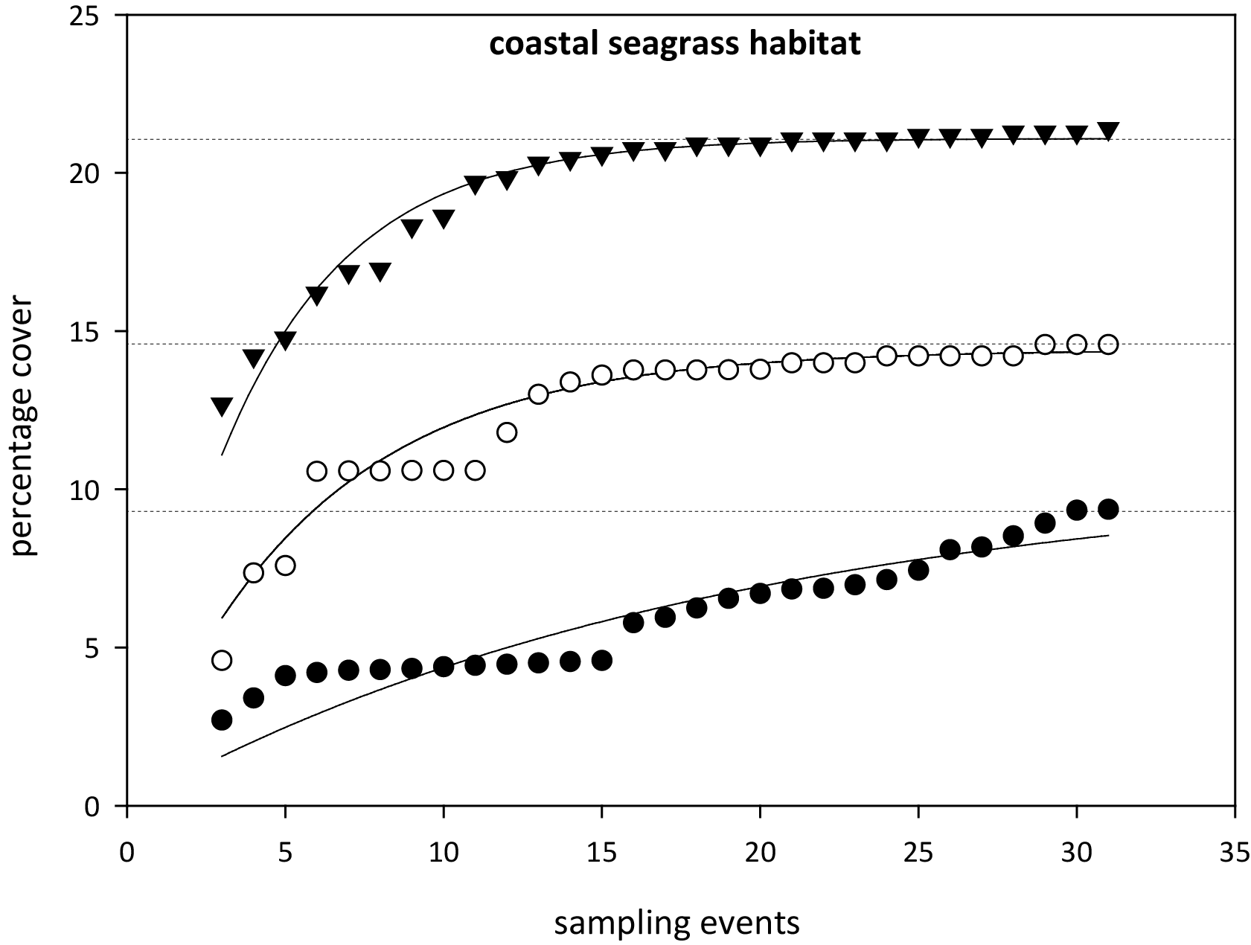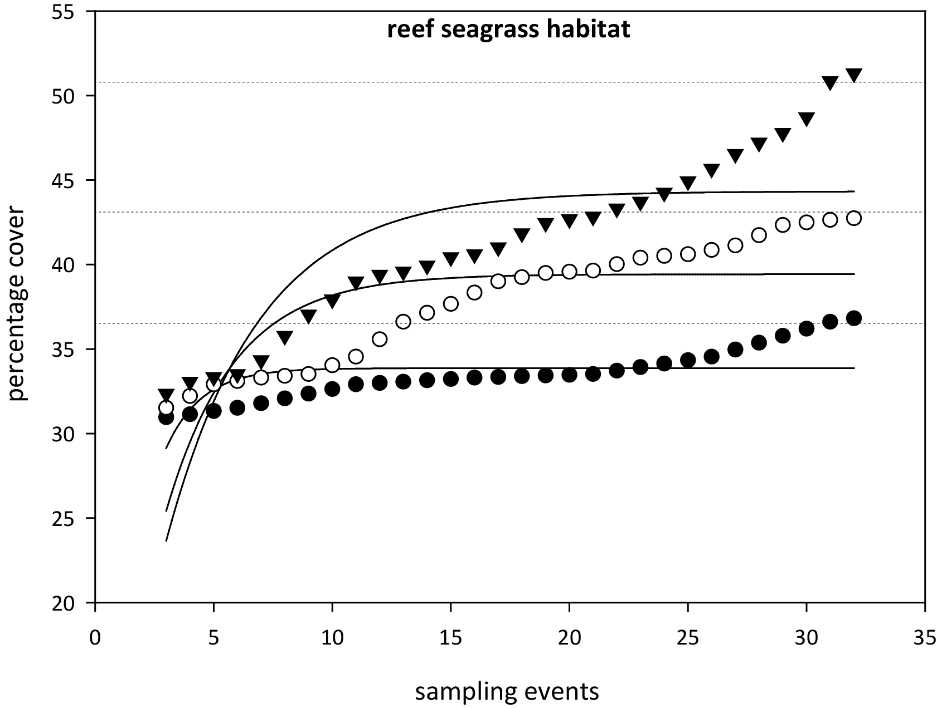
Figure 90. Relationship between sample size and the error in estimation of percentile values for seagrass abundance ( % cover) in coastal and reef seagrass habitats in the Wet Tropics NRM.
= 75th percentile, ○ = 50th percentile,● = 20th percentile. Horizontal lines are asymptotic averages for each percentile plot.
As sampling events occur every 3-6 months depending on the site, this is equivalent to 3–10 years of monitoring to establish percentile values. Based on the analyses, it was recommended that estimates of the 20th percentile at a reference site should be based on a minimum of 18 samples collected over at least three years. For the 50th percentile a smaller minimum number of samples (approximately 10–12) would be adequate but in most situations it would be necessary to collect sufficient data for the 20th percentile anyway. For seagrass habitats with low variability, a more appropriate guideline was the 10th percentile primarily the result of seasonal fluctuations (as nearly every seasonal low would fall below the 20th percentile). Percentile variability was further reduced within a habitat type of each region by pooling at least two (preferably more) reference sites to derive guidelines. The subregional guideline is calculated from the mean of all reference sites within a habitat type within a region.
Using the seagrass guidelines, seagrass state can be determined for each monitoring event at each site and allocated as good (median abundance at or above 50th percentile), moderate (median abundance below 50th percentile and at or above 20th percentile), poor (median abundance below 20th or 10th percentile). For example, when the median seagrass abundance for Yule Point is plotted against the 20th and 50th percentiles for coastal habitats in the Wet Tropics (Figure 91), it indicates that the meadows were in a poor condition in mid-2000, mid 2001 and mid 2006 (based on abundance).
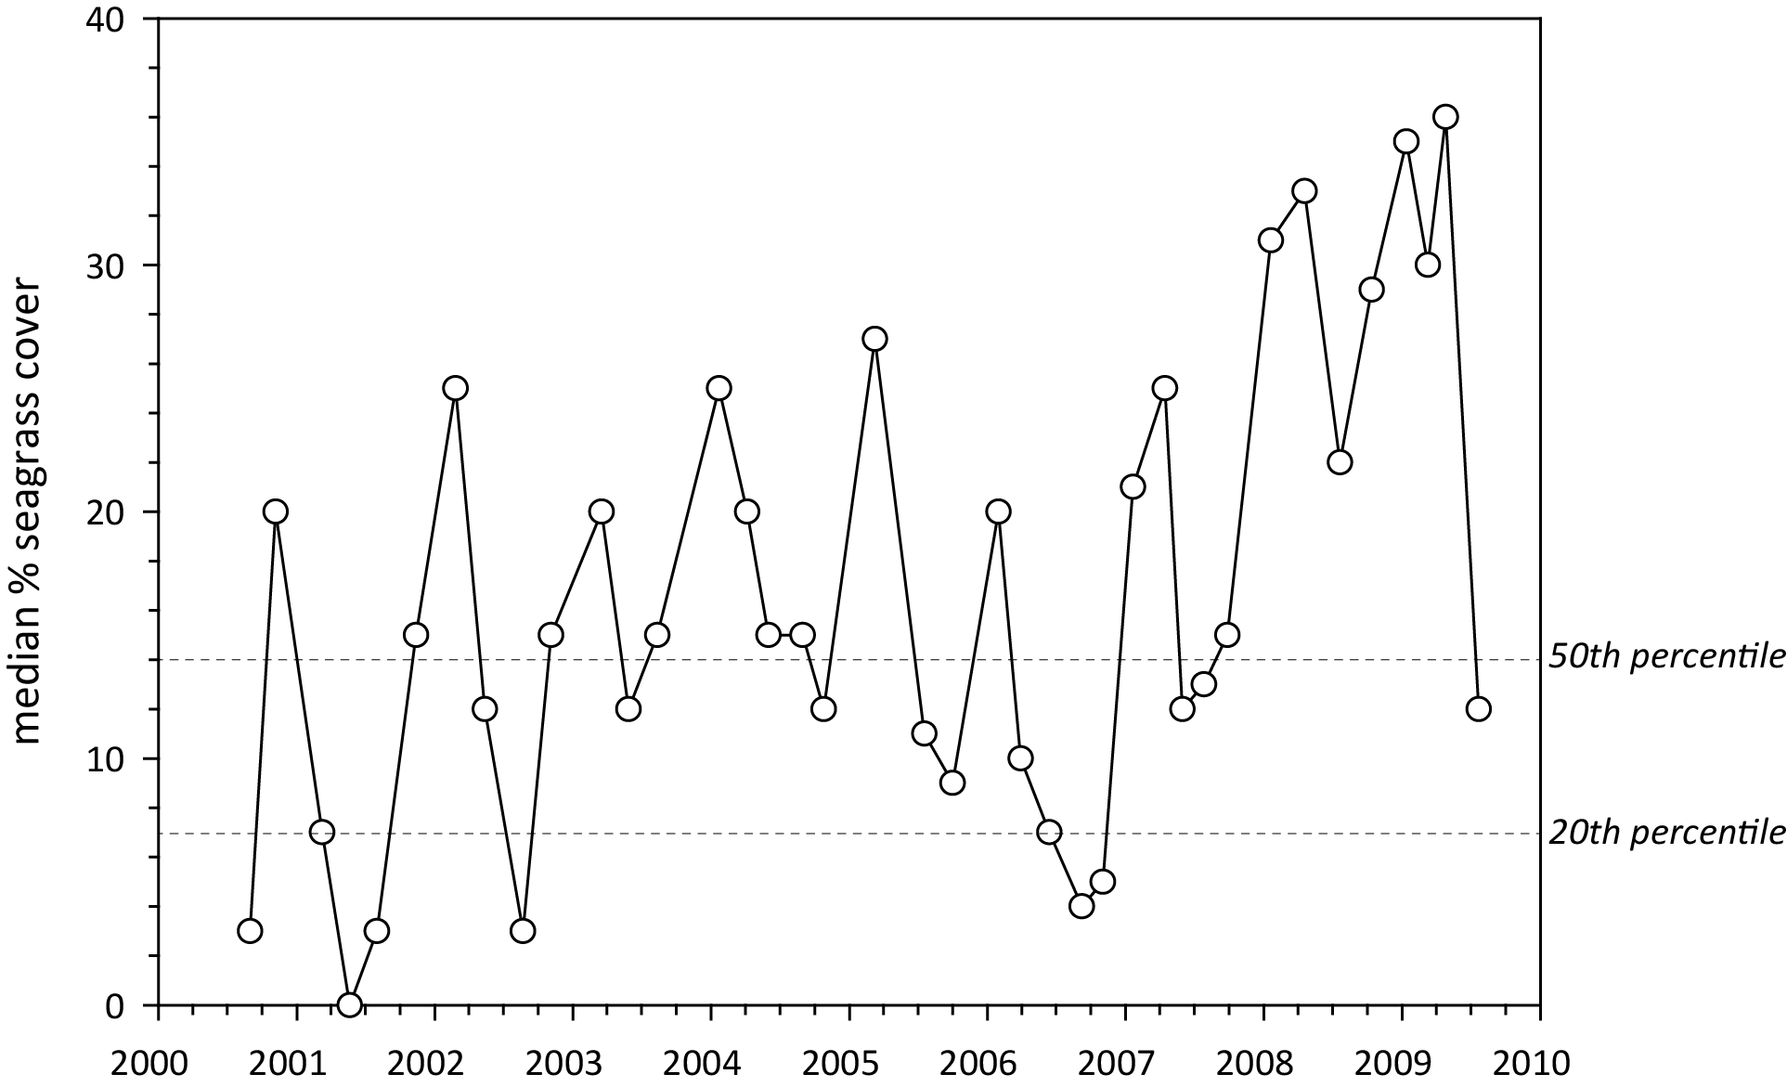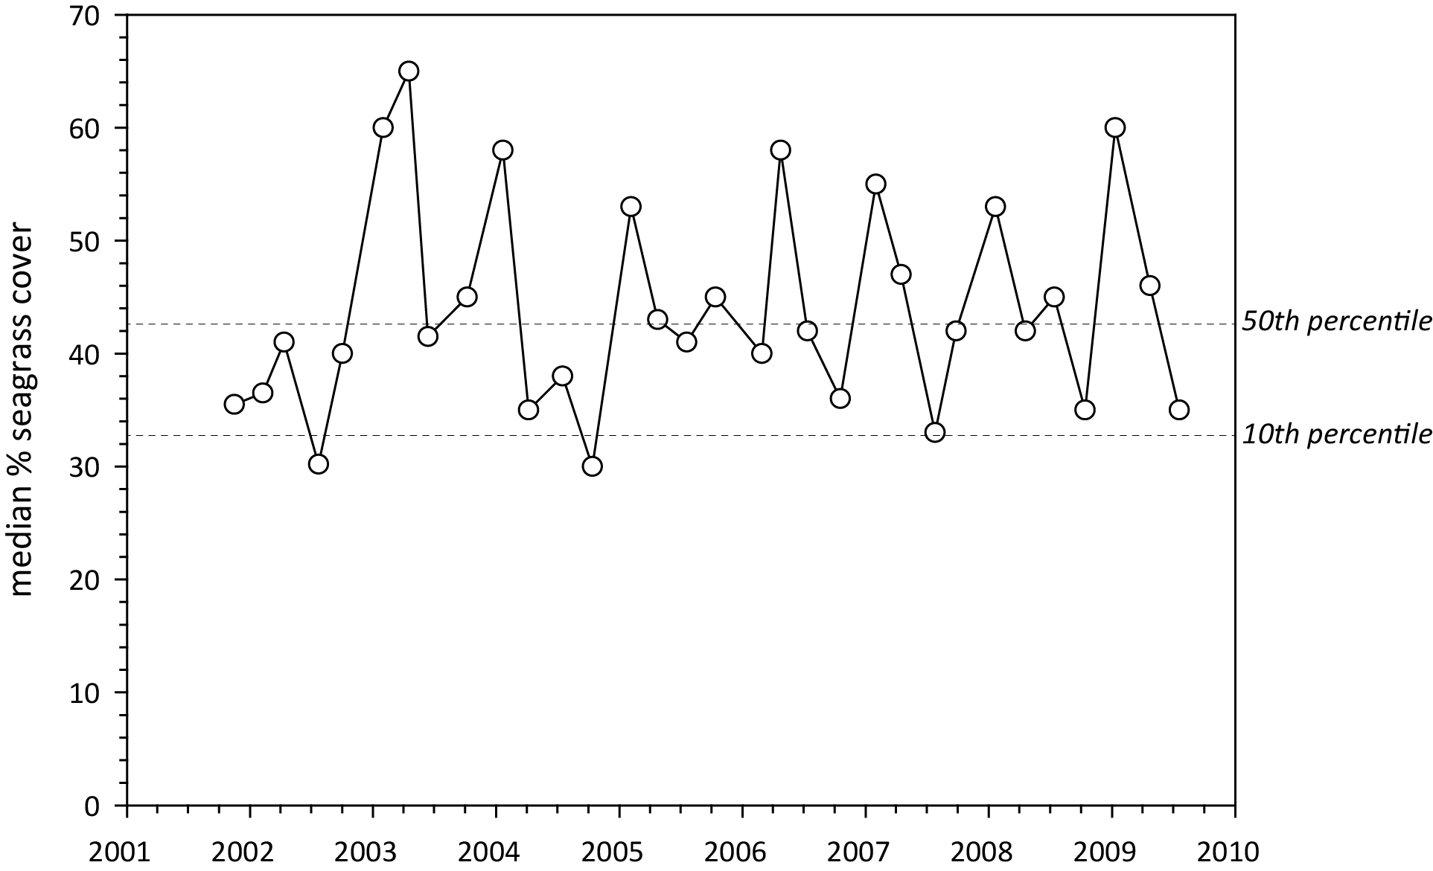
Figure 91. Median seagrass abundance ( % cover) at Yule Point (left) and Green Island (right) plotted against the 50th and 20th percentiles for coastal and intertidal reef seagrass habitat in the Wet Tropics.
Similarly, when the median seagrass abundance for Green Island is plotted against the 20th and 50th percentiles for intertidal reef habitats in the Wet Tropics, it indicates that the meadows were in a poor condition in the middle of most years (based on abundance). However, the poor rating is most likely a consequence of seasonal lows in abundance. Therefore, in this instance, it was more appropriate to set the guideline at the 10th rather than the 20th percentile.
Using this approach, subregional seagrass abundance guidelines (hereafter known as “the seagrass guidelines”) were developed for each seagrass habitat types where possible (Table 20). If an individual site had 18 or more sampling events and no identified impacts (e.g. major loss from cyclone), an abundance guideline was determined at the site or location level rather than using the subregional guideline from the reference sites (i.e. as more guidelines are developed at the site level, they contribute to the subregional guideline).
After discussions with GBRMPA scientists and the Paddock to Reef integration team, the seagrass guidelines were further refined by allocating the additional categories of very good (median abundance at or above 75th percentile), and very poor (median abundance below 20th or 10th percentile and declined by >20 % since previous sampling event). Seagrass state was then rescaled to a five point scale from 0 to 100 to allow integration with other components of the Paddock to Reef report card (Department of the Premier and Cabinet 2014). Please note that the scale from 0 to 100 is unitless and should not be interpreted as a proportion or ratio.

Table 20. Seagrass percentage cover guidelines (“the seagrass guidelines”) for each site/location and the subregional guidelines (bold) for each NRM habitat.
Values in light grey not used. ^ denotes regional reference site, * from nearest adjacent region. For site details, see Tables 3 & 4.
NRM region | site/  location | Habitat | percentile guideline
NRM region | site/  location | Habitat | 10th | 20th | 50th | 75th
Cape York | AP1^ | reef intertidal | 11 | 16.8 | 18.9 | 23.7
 | AP2 | reef intertidal | 11 |  | 18.9 | 23.7
 | FR | reef intertidal |  | 16.8 | 18.9 | 23.7
 | ST | reef intertidal |  | 16.8 | 18.9 | 23.7
 | YY | reef intertidal |  | 16.8 | 18.9 | 23.7
 | NRM | reef intertidal | 11 | 16.8 | 18.9 | 23.7
 | SR* | coastal intertidal |  | 6.6 | 12.9 | 14.8
 | BY* | coastal intertidal |  | 6.6 | 12.9 | 14.8
 | NRM | coastal intertidal* | 5 | 6.6 | 12.9 | 14.8
 | LR | coastal subtidal |  | 6.6 | 12.9 | 14.8
 | NRM | coastal subtidal |  | 6.6 | 12.9 | 14.8
Wet Tropics | LB | coastal intertidal |  | 6.6 | 12.9 | 14.8
 | YP1^ | coastal intertidal | 4.3 | 7 | 14 | 15.4
 | YP2^ | coastal intertidal | 5.7 | 6.2 | 11.8 | 14.2
 | NRM | coastal intertidal | 5 | 6.6 | 12.9 | 14.8
 | MS | coastal subtidal |  | 6.6 | 12.9 | 14.8
 | NRM | coastal subtidal |  | 6.6 | 12.9 | 14.8
 | DI | reef intertidal | 27.5 |  | 37.7 | 41
 | GI1^ | reef intertidal | 32.5 | 38.2 | 42.7 | 45.5
 | GI2^ | reef intertidal | 22.5 | 25.6 | 32.7 | 36.7
 | LI1 | reef intertidal | 27.5 |  | 37.7 | 41
 | GO1 | reef intertidal | 27.5 |  | 37.7 | 41
 | NRM | reef intertidal | 27.5 | 31.9 | 37.7 | 41
 | DI3 | reef subtidal | 22 | 26 | 33 | 39.2
 | GI3^ | reef subtidal | 22 | 26 | 33 | 39.2
 | LI2 | reef subtidal | 22 | 26 | 33 | 39.2
 | NRM | reef subtidal | 22 | 26 | 33 | 39.2
Burdekin | BB1^ | coastal intertidal | 16.3 | 21.4 | 25.4 | 35.2
 | SB1^ | coastal intertidal | 7.5 | 10 | 16.8 | 22
 | SB2 | coastal intertidal |  | 10 | 16.8 | 22
 | JR | coastal intertidal |  | 15.7 | 21.1 | 28.6
 | NRM | coastal intertidal | 11.9 | 15.7 | 21.1 | 28.6
 | MI1^ | reef intertidal | 23 | 26 | 33.4 | 37
 | MI2^ | reef intertidal | 21.3 | 26.5 | 35.6 | 41
 | NRM | reef intertidal | 22.2 | 26.3 | 34.5 | 39
 | MI3^ | reef subtidal | 18 | 22.5 | 32.7 | 36.7
 | NRM | reef subtidal | 18 | 22.5 | 32.7 | 36.7
Mackay-Whitsunday | SI | estuarine intertidal |  | 18 | 34.1 | 54
 | NRM | estuarine intertidal | 10.8* | 18* | 34.1* | 54*
 | PI2^ | coastal intertidal | 18.1 | 18.7 | 25.1 | 27.6
 | PI3^ | coastal intertidal | 6.1 | 7.6 | 13.1 | 16.8
 | MP2 | coastal intertidal |  | 18.9 | 22.8 | 25.4
 | MP3 | coastal intertidal |  | 17.9 | 20 | 22.3
 | NRM | coastal intertidal | 12.1 | 13.2 | 19.1 | 22.2
 | NB | coastal subtidal |  | 13.2 | 19.1 | 22.2
 | NRM | coastal subtidal | 12.1 | 13.2 | 19.1 | 22.2
 | HB1^ | reef intertidal |  | 10.53 | 12.9 | 14.2
 | HB2^ | reef intertidal |  | 7.95 | 11.59 | 13.4
 | HM | reef intertidal |  | 9.2 | 12.2 | 13.8
 | NRM | reef intertidal |  | 9.2 | 12.2 | 13.8
 | TO | reef subtidal |  | 22.5 | 32.7 | 36.7
 | NRM | reef subtidal* | 18* | 22.5* | 32.7* | 36.7*
Fitzroy | GH | estuarine intertidal |  | 18 | 34.1 | 54
 | NRM | estuarine intertidal | 10.8* | 18* | 34.1* | 54*
 | RC1^ | coastal intertidal | 18.6 | 20.6 | 24.4 | 34.5
 | WH1^ | coastal intertidal | 13.1 | 14.4 | 18.8 | 22.3
 | NRM | coastal intertidal | 15.85 | 17.5 | 21.6 | 28.4
 | GK | reef intertidal |  | 9.2 | 12.2 | 13.8
 | NRM | reef intertidal |  | 9.2* | 12.2* | 13.8*
Burnett Mary | RD | estuarine intertidal |  | 18 | 34.1 | 54
 | UG1^ | estuarine intertidal | 10.8 | 18 | 34.1 | 54
 | UG2 | estuarine intertidal |  | 18 | 34.1 | 54
 | NRM | estuarine intertidal | 10.8 | 18 | 34.1 | 54
 | BH1^ | coastal intertidal |  | 7.8 | 11.9 | 21.6
 | BH3 | coastal intertidal |  | 7.8 | 11.9 | 21.6
 | NRM | coastal intertidal |  | 7.8 | 11.9 | 21.6

Seagrass reproductive effort
The reproductive effort is the number of reproductive structures (inflorescence, fruit, spathe, seed) per core. Given the high diversity of seagrass species that occur in the Reef coastal zone (Waycott et al. 2007), and their variability in production of reproductive structures (e.g. Orth et al. 2006), a metric that incorporates all available information on the production of flowers and fruits per unit area is used.
The production of seeds also reflects a simple measure of the capacity of a seagrass meadow to recover following large scale impacts (Collier and Waycott 2009). As it is well recognized that coastal seagrasses are prone to small scale disturbances that cause local losses (Collier and Waycott 2009) and then recover in relatively short periods of time, the need for a local seed source is considerable. In the Reef, the production of seeds comes in numerous forms and seed banks examined at MMP sites are limited to foundational seagrass species (seeds >0.5mm diameter). At this time, seed banks have not been included in the metric for reproductive effort, but methods for future incorporation are currently being explored.
Using the annual mean of all species pooled in the late dry and comparing with the long-term (2005–2010) average for Reef habitat (coastal intertidal = 8.22±0.71, estuarine intertidal = 5.07±0.41, reef intertidal = 1.32±0.14), the reproductive effort is scored as the number of reproductive structures per core and the overall status determined as the ratio of the average number observed divided by the long term average.

Seagrass nutrient status.
The molar ratios of seagrass tissue carbon relative to nitrogen (C:N) were chosen as the indicator for seagrass nutrient status, as an atomic C:N ratio of <20 may suggest either reduced light availability or nitrogen enrichment. Both of these deviations may indicate reduced water quality.
As changing leaf C:N ratios have been found in a number of experiments and field surveys to be related to available nutrient and light levels (Abal et al. 1994; Grice et al. 1996; Cabaço and Santos 2007; Collier et al. 2009) they can be used as an indicator of the light that the plant is receiving relative to nitrogen availability or N surplus to light. With light limitation, seagrass plants are unable to build structure, hence the proportion of carbon in the leaves decreases relative to nitrogen. Experiments on seagrasses in Queensland have reported that at an atomic C:N ratio of <20, may suggest reduced light availability relative to nitrogen availability (Abal et al. 1994; AM Grice, et al., 1996;). The light availability to seagrass is not necessarily an indicator of light in the water column, but an indicator of the light that the plant is receiving as available light can be highly impacted by epiphytic growth or sediment smothering photosynthetic leaf tissue. However, C:N must be interpreted with caution as the level of N can also influence the ratio in oligotrophic environments (Atkinson and Smith 1983; Fourqurean et al. 1992). Support for choosing the elemental C:N ratio as the indicator also comes from preliminary analysis of MMP data in 2009 which found that the C:N ratio was the only nutrient ratio that showed a significant relationship (positive) with seagrass cover at coastal and estuarine sites; seagrass tissue C:N ratios explained 58 % of the variance of the inter-site seagrass cover data (McKenzie and Unsworth 2009). Using the guideline ratio of 20:1 for the foundation seagrass species, C:N ratios were categorised on their departure from the guideline and transformed to a 0 to 100 score using:
Equation 1
NB: C:N ratios >35 scored as 100, C:N ratios <10 scored as 0
The score was then used to represent the status to allow integration with other components of the report card.

Detailed data

Table 21. Samples collected at each MMP inshore monitoring site per parameter for each season
. Activities include: SG = seagrass cover & composition, SM=seed monitoring, TN=tissue nutrients, EM=edge mapping, RH=reproductive health, TL=temperature loggers, LL=light loggers, SH=sediment herbicides. ^=subtidal.
Region | NRM region | Basin | Monitoring location |  | late dry Season (2017) |  |  |  |  |  |  | late wet Season (2018)
 |  |  |  |  | SG | SM | TN | EM | RH | TL | LL | SG | SM | EM | RH | TL | LL
Far Northern | Cape York | Jacky Jacky / Olive Pascoe | Shelburne Bay | SR1 | 33 | 30 | 3 |  | 15
 |  |  |  | SR2 | 33 | 30 | 3 |  | 15
Far Northern | Cape York | Jacky Jacky / Olive Pascoe | Piper Reef | FR1 | 33 | 30 | 3 |  | 15
 |  |  |  | FR2 | 33 | 30 | 3 |  | 15
Far Northern | Cape York | Lockhart | Weymouth Bay | YY1
Far Northern | Cape York | Lockhart | Lloyd Bay | LR1^ | 19
 |  |  |  | LR2^ | 10
Far Northern | Cape York | Normanby / Jeanie | Flinders Group | ST1 | 33 | 30 | 3 |  | 15
 |  |  |  | ST2 | 33 | 30 | 3 |  | 15
 |  |  |  | FG1^ | 20
 |  |  |  | FG2^ | 23
Far Northern | Cape York | Normanby / Jeanie | Bathurst Bay | BY1 | 33 | 30 | 3 |  | 15
 |  |  |  | BY2 | 33 | 30 | 3 |  | 15
 |  |  |  | BY4^ | 11
Far Northern | Cape York | Endeavour | Archer Point | AP1 | 33 | 30 | 3 |  | 15
 |  |  |  | AP2 | 33 | 30 | 3 |  | 15
Northern | Wet Tropics | Daintree | Low Isles | LI1 | 33 | 30 | 3 |  | 15 |  |  | 33 | 30
 |  |  |  | LI2^ | 33 | 30 |  |  |  |  |  | 33 | 30
Northern | Wet Tropics | Mossman / Barron / Mulgrave - Russell / Johnstone | Yule Point | YP1 | 33 | 30 | 3 |  | 15 |  |  | 33 | 30 |  | 15
 |  |  |  | YP2 | 33 | 30 | 3 |  | 15 |  |  | 33 | 30 |  | 15
Northern | Wet Tropics | Mossman / Barron / Mulgrave - Russell / Johnstone | Green Island | GI1 | 33 | 30 | 3 |  | 15 |  |  | 33 | 30
 |  |  |  | GI2 | 33 | 30 | 3 |  | 15 |  |  | 33 | 30
 |  |  |  | GI3^ | 33 | 30 | 3 |  | 15 |  |  | 33 | 30
Northern | Wet Tropics | Tully / Murray / Herbert | Mission Beach | LB1 | 33 | 30 | 3 |  |  |  |  | 33 | 30
 |  |  |  | LB2 | 33 | 30 |  |  |  |  |  | 33 | 30
Northern | Wet Tropics | Tully / Murray / Herbert | Dunk Island | DI1 | 33 | 30 | 3 |  | 15 |  |  | 33 | 30
 |  |  |  | DI2 | 33 | 30 | 3 |  | 15 |  |  | 33 | 30
 |  |  |  | DI3^ | 33 | 30 | 3 |  | 15 |  |  | 33 | 30
Northern | Wet Tropics | Tully / Murray / Herbert | Rockingham Bay | GO1
Northern | Wet Tropics | Tully / Murray / Herbert | Missionary Bay | MS1^ | 17
 |  |  |  | MS2^ | 22
Central | Burdekin | Ross / Burdekin | Magnetic Island | MI1 | 33 | 30 | 3 |  | 15 |  |  | 33 | 30 |  | 15
 |  |  |  | MI2 | 33 | 30 | 3 |  | 15 |  |  | 33 | 30 |  | 15
 |  |  |  | MI3^ | 33 | 30 | 3 |  | 15 |  |  | 33 | 30 |  | 15
Central | Burdekin | Ross / Burdekin | Townsville | SB1 | 33 | 30 | 3 |  | 15 |  |  | 33 | 30
 |  |  |  | SB2 | 33 | 30 |  |  |  |  |  | 33 | 30
 |  |  |  | BB1 | 33 | 30 | 3 |  | 15 |  |  | 33 | 30 |  | 15
Central | Burdekin | Ross / Burdekin | Bowling Green Bay | JR1 | 33 | 30 | 3 |  | 15 |  |  | 33 | 30
 |  |  |  | JR2 | 33 | 30 | 3 |  | 15 |  |  | 33 | 30
Central | Mackay  Whitsunday | Don | Shoal Bay | HB1 | 33 | 30
 |  |  |  | HB2 | 33 | 30
Central | Mackay  Whitsunday | Proserpine | Pioneer Bay | PI2 | 33 | 30 |  |  |  |  |  | 33 | 30
 |  |  |  | PI3 | 33 | 30 |  |  |  |  |  | 33 | 30
Central | Mackay  Whitsunday | Proserpine / O’Connell | Lindeman Island | LN1^ | 33 | 30 | 3 |  | 15 |  |  | 33 | 30 |  | 15
 |  |  |  | LN2^ | 33 | 30 | 3 |  | 15
Central | Mackay  Whitsunday | Proserpine / O’Connell | Repulse Bay | MP2 | 33 | 30 | 3 |  | 15 |  |  | 33 | 30 |  | 15
 |  |  |  | MP3 | 33 | 30 | 3 |  | 15 |  |  | 33 | 30 |  | 15
Central | Mackay  Whitsunday | Proserpine / O’Connell | Hamilton Is. | HM1 | 33 | 30 | 3 |  | 15 |  |  | 33 | 30 |  | 15
 |  |  |  | HM2 | 33 | 30 | 3 |  | 15 |  |  | 33 | 30
Central | Mackay  Whitsunday | Proserpine / O’Connell | Whitsunday Island | TO1^ | 22
 |  |  |  | TO2^ | 20
Central | Mackay  Whitsunday | O’Connell | Newry Islands | NB1^ | 22
 |  |  |  | NB2^ | 21
Central | Mackay  Whitsunday | Plane | Sarina Inlet | SI1 | 33 | 30 | 3 |  | 15 |  |  | 33 | 30 |  | 15
 |  |  |  | SI2 | 33 | 30 | 3 |  | 15 |  |  | 33 | 30 |  | 15
Central | Mackay  Whitsunday | Plane | Clairview | CV1 | 33 | 30
 |  |  |  | CV2 | 33 | 30
Southern | Fitzroy | Fitzroy | Shoalwater Bay | RC1 | 33 | 30 | 3 |  | 15
 |  |  |  | WH1 | 33 | 30 | 3 |  | 15
Southern | Fitzroy | Fitzroy | Great Keppel Island | GK1 | 33 | 30 | 3 |  | 15
 |  |  |  | GK2 | 33 | 30 | 3 |  | 15
Southern | Fitzroy | Boyne | Gladstone Harbour | GH1 | 33 | 30 | 3 |  | 15
 |  |  |  | GH2 | 33 | 30 | 3 |  | 15
Southern | Burnett Mary | Burnett | Rodds Bay | RD1 | 33 | 30 | 3 |  | 15
 |  |  |  | RD2 | 33 | 30 |  |  | 15
Southern | Burnett Mary | Burrum | Burrum Heads | BH1 | 33 | 30 | 3 |  | 15 |  |  | 33 | 30
 |  |  |  | BH3 | 33 | 30 | 3 |  | 15 |  |  | 33 | 30
Southern | Burnett Mary | Mary | Hervey Bay | UG1 | 33 | 30 | 3 |  | 15 |  |  | 33 | 30
 |  |  |  | UG2 | 33 | 30 | 3 |  | 15 |  |  | 33 | 30

Climate and environmental pressures

Climate

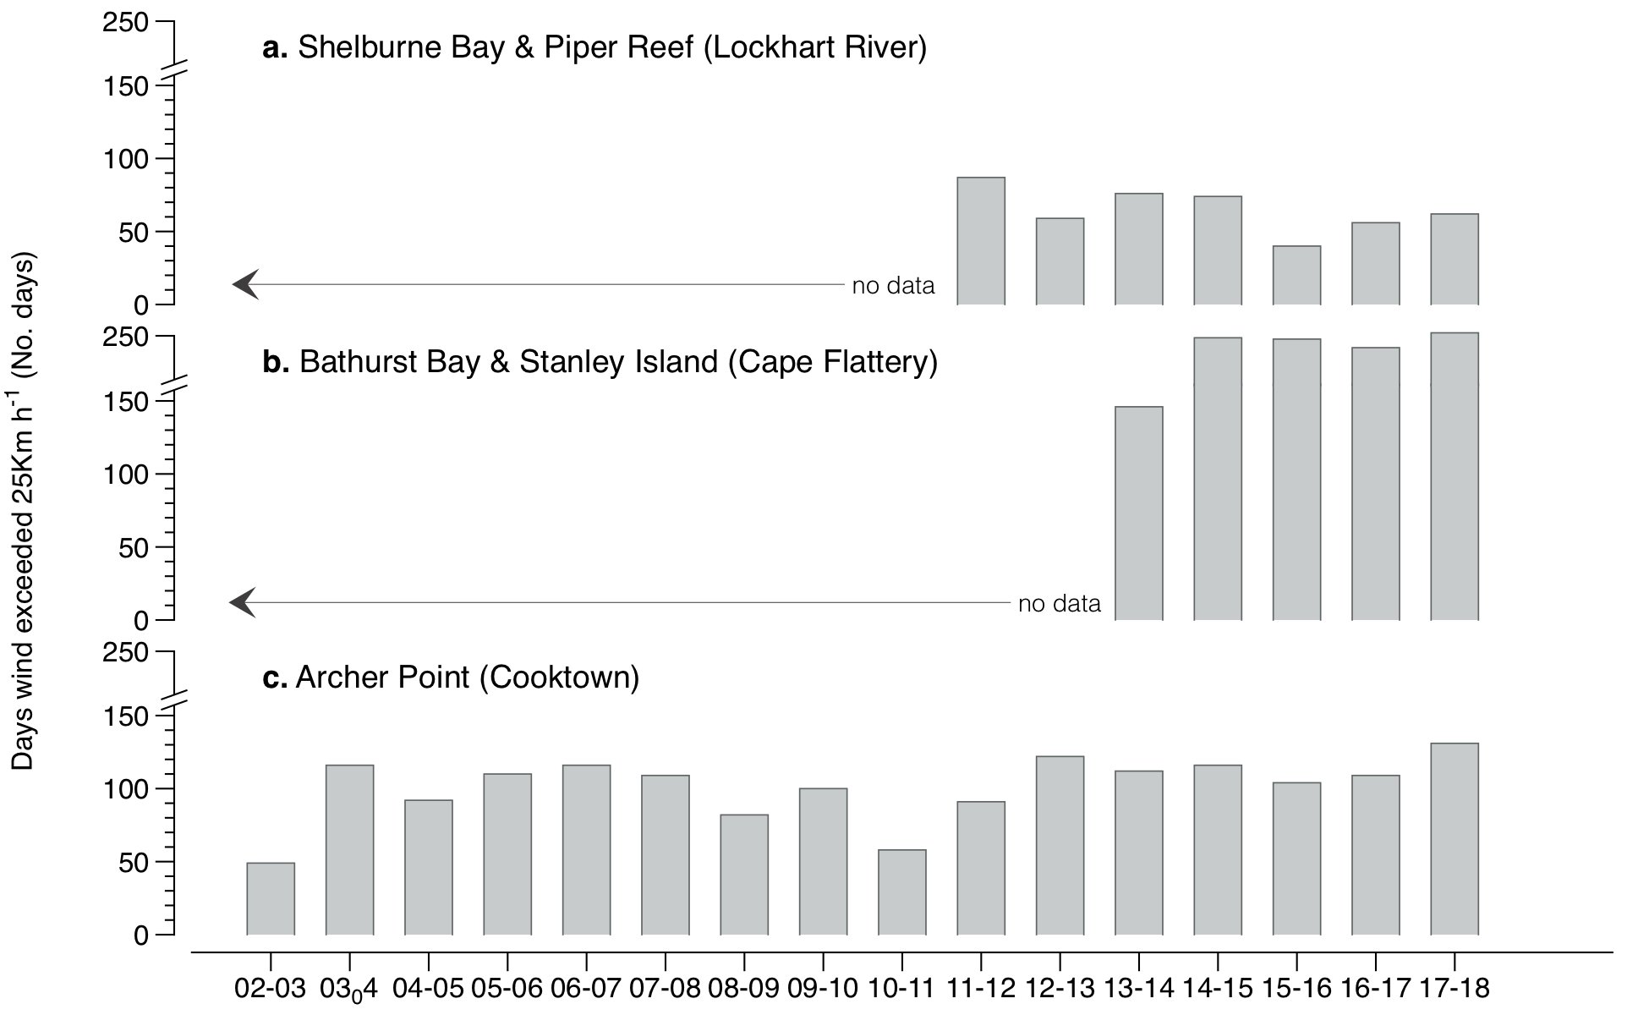
Figure 92. Number of days wind speed is above 25 km hr⁻¹ each monitoring period in the Cape York NRM region.
Daily 3pm wind speed from: a) from Lockhart River Airport (BOM station 028008, source www.bom.gov.au), located 108 km from Shelburne Bay and 61 km from Piper Reef monitoring sites; b) Cape Flattery (BOM station 031213), located approximately 139 km and 144 km from Bathurst Bay and Stanley Island monitoring sites, respectively and; c) Cooktown airport (BOM station 031209), located 16 km from Archer Point monitoring sites.

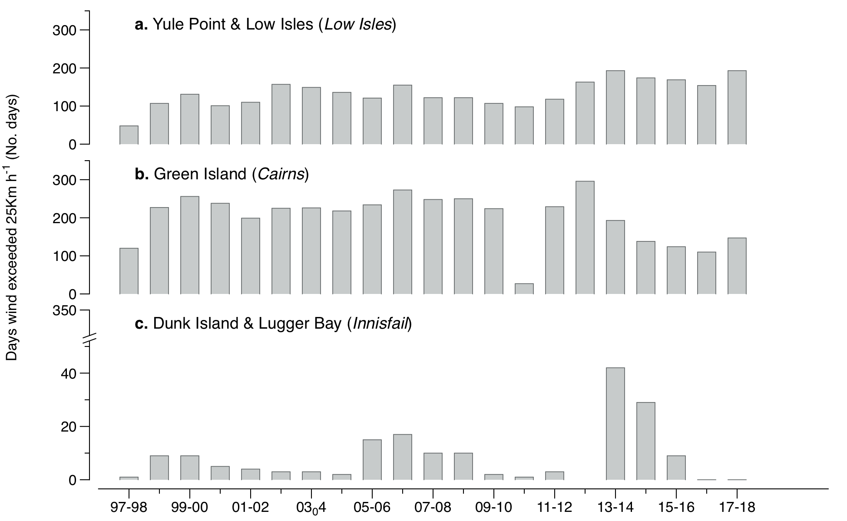
Figure 93. Number of days wind speed is above 25 km hr⁻¹ each monitoring period in the Wet Tropics NRM region.
Daily 3pm wind speed from: a) Low Isles (BOM station 31037), located approximately 21 km from Yule Point monitoring sites; b) Green Island (BOM station 31192); and C) Innisfail (BOM station 032025), located approximately 48 km from monitoring sites at Lugger Bay and Dunk Island.

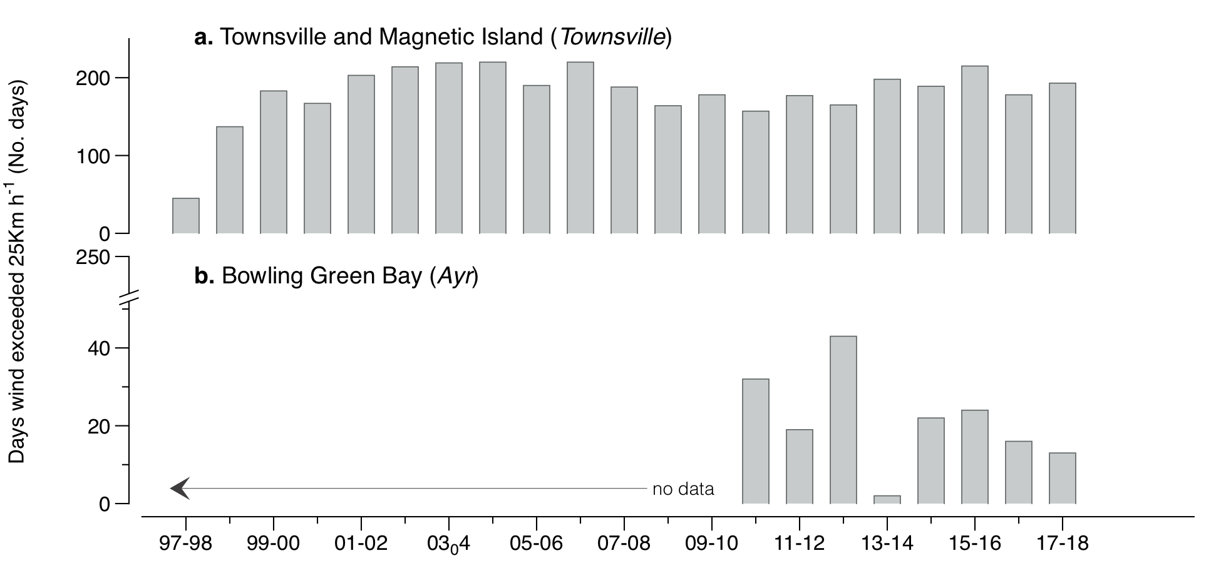
Figure 94. Number of days wind speed is above 25 km hr⁻¹ each monitoring period in the Burdekin NRM region.
Daily 3pm wind speed from: a) Townsville Airport (BOM station 032040) located approximately 11 km from coastal (Townsville) and reef (Magnetic Island) monitoring sites, and 53 km from Jerona (Bowling Green Bay) monitoring sites; and b) Ayr (BOM station 033002), located approximately 26 km from Jerona (Bowling Green Bay) monitoring sites.

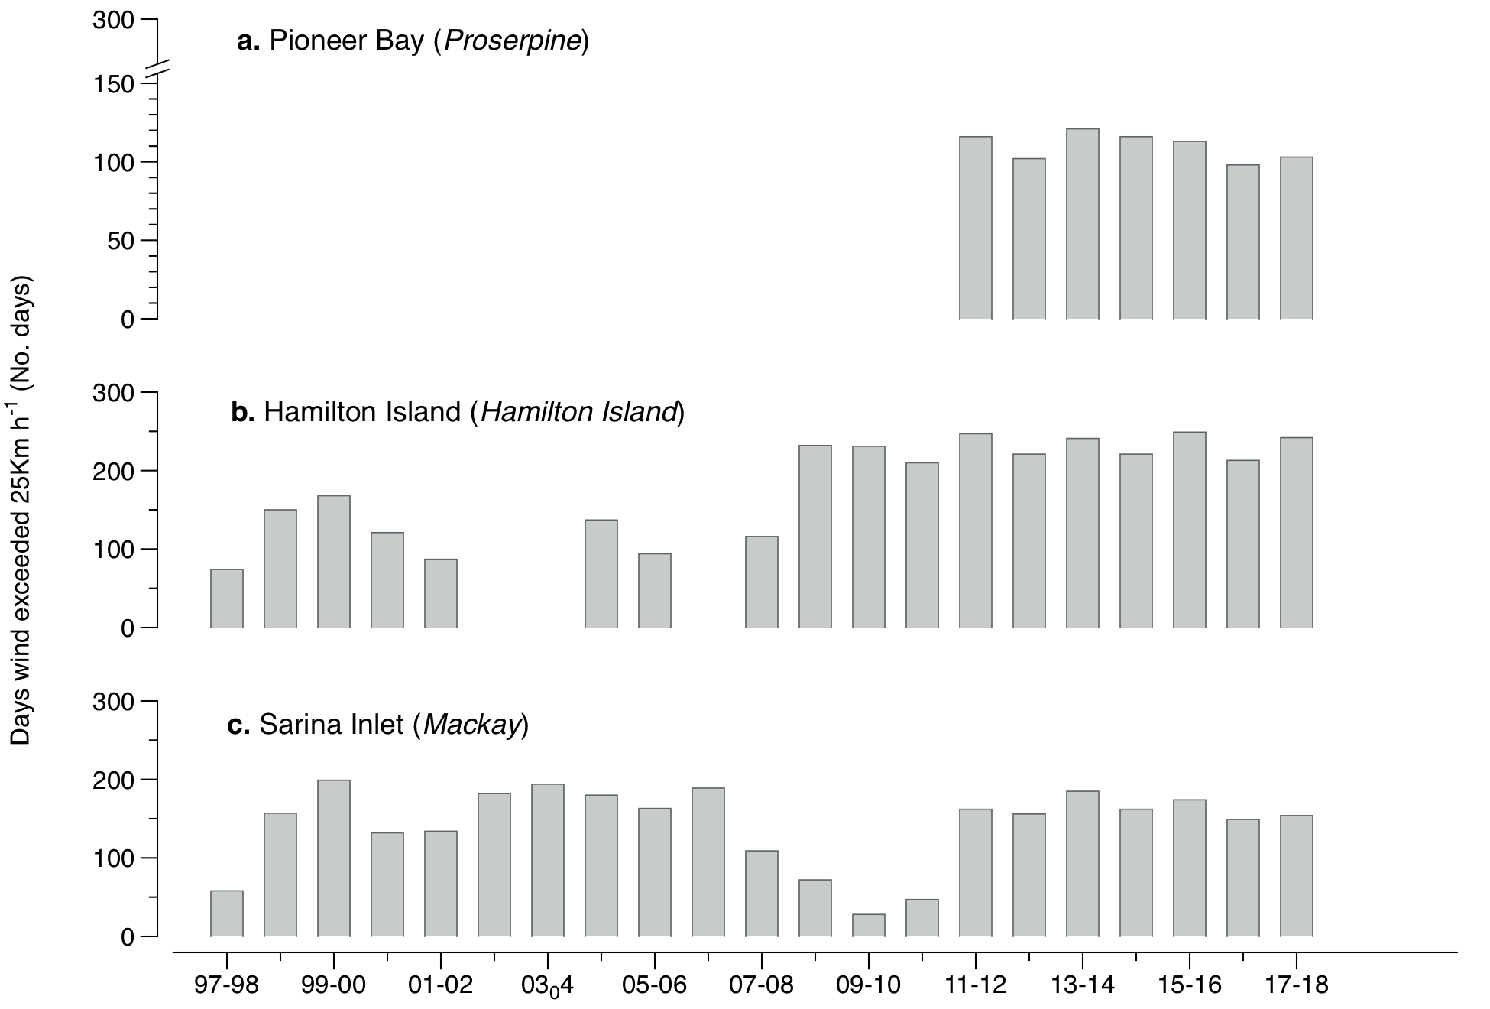
Figure 95. Number of days wind speed is above 25 km hr⁻¹ each monitoring period in the Mackay-Whitsunday NRM region.
Daily 3pm wind speed from: a) Proserpine Post Office (BOM station 33316) (post June 2011), located 18 km from Midge Point monitoring sites; b) Hamilton Island (BOM station 033106), located 1.5 km from Hamilton Island monitoring sites; and c) Mackay Airport (BOM station 033045, source www.bom.gov.au), approximately 28 km from Sarina Inlet monitoring sites.

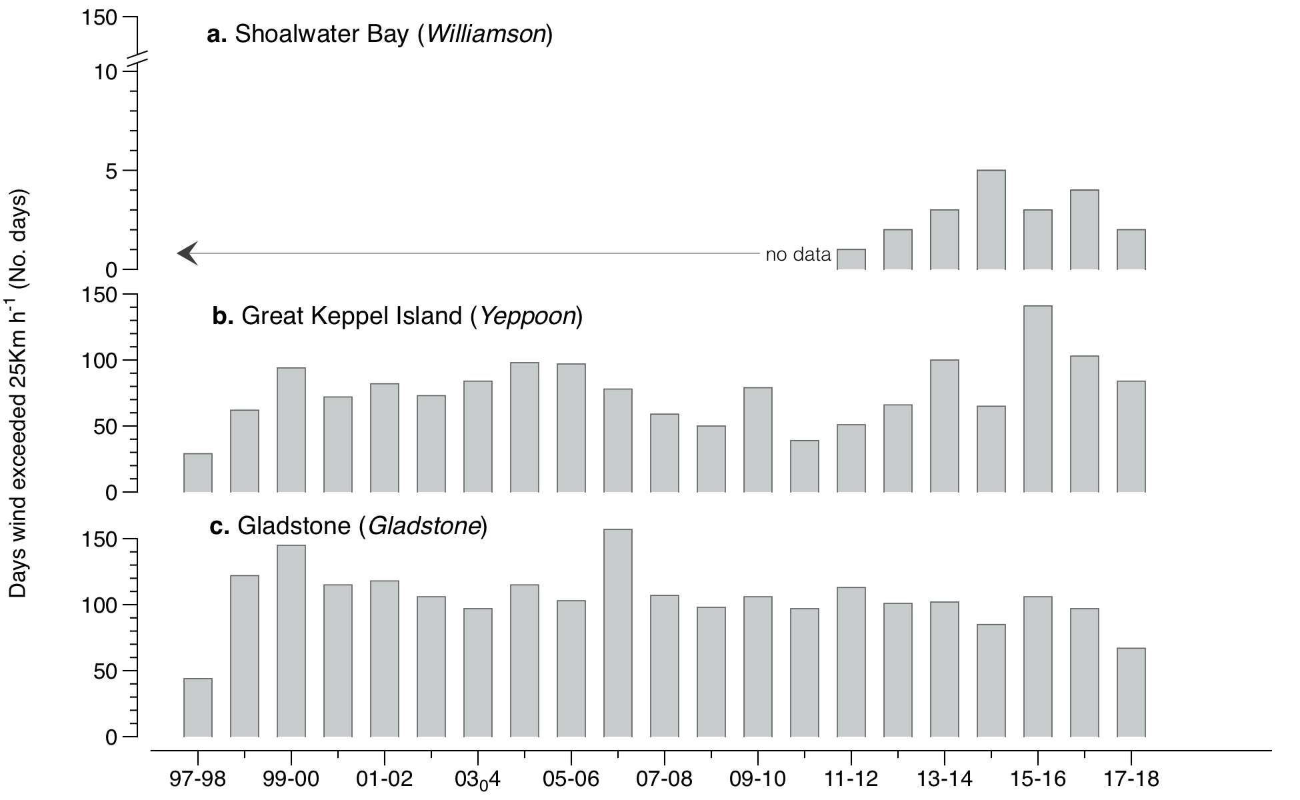
Figure 96. Number of days wind speed is above 25 km hr⁻¹ each monitoring period in the Fitzroy NRM region.
Daily 3pm wind speed from: a) Williamson, Shoalwater Bay (BOM station 033260), located 10 km from the monitoring sites; b) Yeppoon (BOM station 033106), approximately 22 km from monitoring sites; and c) Gladstone Airport (BOM station 039123), located approximately 13 km from monitoring sites.

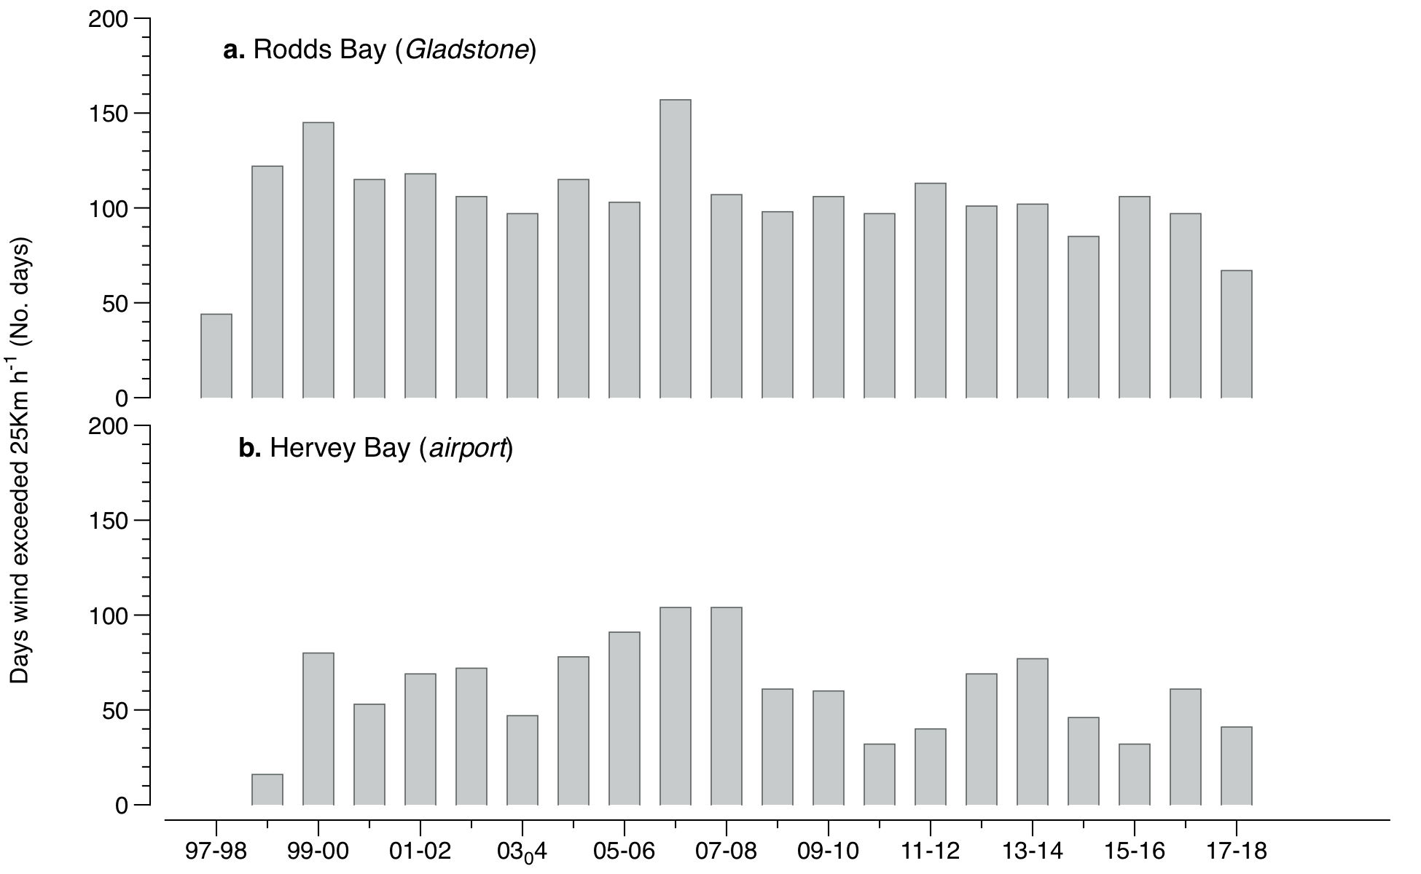
Figure 97. Number of days wind speed is above 25 km hr⁻¹ each monitoring period in the Burnett Mary NRM region.
Daily 3pm wind speed from: a) Seventeen Seventy (BOM station 039314), approximately 27 km from Rodds Bay monitoring sites; and b) Hervey Bay Airport (BOM station 040405), approximately 3 km from Urangan monitoring sites.

Tidal exposure

Table 22. Height of intertidal monitoring meadows/sites above lowest astronomical tide (LAT) and annual daytime tidal exposure (total hours) when meadows become exposed at a low tide.
Year is June–May. Observed tidal heights courtesy Maritime Safety Queensland, 2018. NB: Meadow heights have not yet been determined in the far northern Cape York.
NRM | Site | Meadow  height  (above LAT) | Site depth  (bMSL) | Meadow height  (above LAT)  relative to  Standard Port | Annual median  hours exposed  during daylight  (long-term) | Per cent of  annual daylight  hours meadow  is exposed  (long-term) | Annual  daytime  exposure  2017–18 (hrs) | Per cent of  annual daylight  hours meadow  is exposed  (2017–18)
Cape York | AP1 | 0.46 | 1.02 | 0.46 | 64.17 | 1.46 | 39.67 | 0.91
Cape York | AP2 | 0.46 | 1.02 | 0.46 | 64.17 | 1.46 | 39.67 | 0.91
Wet Tropics | LI1 | 0.65 | 0.90 | 0.65 | 176.67 | 4.03 | 156.00 | 3.56
Wet Tropics | YP1 | 0.64 | 0.94 | 0.64 | 169.67 | 3.87 | 150.33 | 3.43
Wet Tropics | YP2 | 0.52 | 1.06 | 0.52 | 96.00 | 2.19 | 83.17 | 1.90
Wet Tropics | GI1 | 0.51 | 1.03 | 0.61 | 118.25 | 2.70 | 131.00 | 2.99
Wet Tropics | GI2 | 0.57 | 0.97 | 0.67 | 154.58 | 3.53 | 171.50 | 3.92
Wet Tropics | DI1 | 0.65 | 1.14 | 0.54 | 73.67 | 1.68 | 63.50 | 1.45
Wet Tropics | DI2 | 0.55 | 1.24 | 0.44 | 42.17 | 0.96 | 31.67 | 0.72
Wet Tropics | LB1 | 0.42 | 1.37 | 0.31 | 17.75 | 0.40 | 19.50 | 0.45
Wet Tropics | LB2 | 0.46 | 1.33 | 0.35 | 19.25 | 0.44 | 18.67 | 0.43
Burdekin | BB1 | 0.58 | 1.30 | 0.58 | 84.5 | 1.93 | 37.67 | 0.86
Burdekin | SB1 | 0.57 | 1.31 | 0.57 | 67.08 | 1.53 | 36.17 | 0.83
Burdekin | MI1 | 0.65 | 1.19 | 0.67 | 183.00 | 4.18 | 62.50 | 1.43
Burdekin | MI2 | 0.54 | 1.30 | 0.56 | 170.00 | 3.88 | 34.17 | 0.78
Burdekin | JR1 | 0.47 | 1.32 | 0.47 | 63.33 | 1.44 | 42.50 | 0.97
Burdekin | JR2 | 0.47 | 1.32 | 0.47 | 63.33 | 1.44 | 42.50 | 0.97
Mackay-Whitsunday | PI2 | 0.28 | 1.47 | 0.44 | 80.17 | 1.83 | 48.00 | 1.10
Mackay-Whitsunday | PI3 | 0.17 | 1.58 | 0.33 | 40.00 | 0.91 | 26.83 | 0.61
Mackay-Whitsunday | HM1 | 0.68 | 1.52 | 0.38 | 55.107 | 1.26 | 32.83 | 0.75
Mackay-Whitsunday | HM2 | 0.68 | 1.52 | 0.38 | 55.107 | 1.26 | 32.83 | 0.75
Mackay-Whitsunday | SI1 | 0.60 | 2.80 | 0.54 | 24.75 | 0.56 | 24.33 | 0.56
Mackay-Whitsunday | SI2 | 0.60 | 2.80 | 0.54 | 24.75 | 0.56 | 24.33 | 0.56
Fitzroy | RC1 | 2.03 | 1.30 | 1.06 | 163.67 | 3.73 | 220.83 | 5.04
Fitzroy | WH1 | 2.16 | 1.17 | 1.19 | 236.17 | 5.39 | 298.50 | 6.82
Fitzroy | GK1 | 0.52 | 1.93 | 0.43 | 33.25 | 0.76 | 14.00 | 0.32
Fitzroy | GK2 | 0.58 | 1.87 | 0.49 | 49.83 | 1.14 | 28.17 | 0.64
Fitzroy | GH1 | 0.80 | 1.57 | 0.69 | 97.33 | 2.22 | 82.00 | 1.87
Fitzroy | GH2 | 0.80 | 1.57 | 0.69 | 91.58 | 2.09 | 82.00 | 1.87
Burnett Mary | RD1 | 0.56 | 1.48 | 0.56 | 66.58 | 1.52 | 63.83 | 1.46
Burnett Mary | RD2 | 0.63 | 1.41 | 0.63 | 93.17 | 2.13 | 94.50 | 2.16
Burnett Mary | UG1 | 0.70 | 1.41 | 0.70 | 144.00 | 3.29 | 92.00 | 2.10
Burnett Mary | UG2 | 0.64 | 1.47 | 0.64 | 105.83 | 2.41 | 47.17 | 1.08

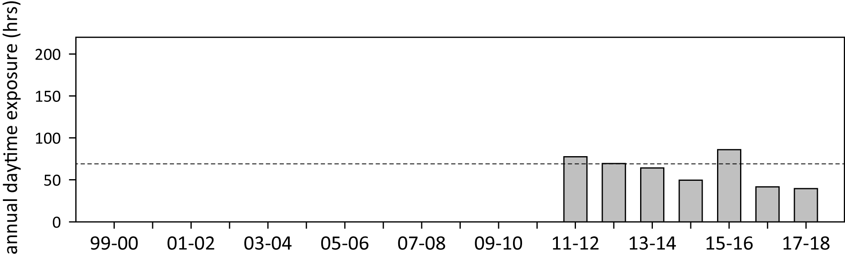
Figure 98. Annual daytime tidal exposure (total hours) and long-term median (dashed line) of intertidal reef seagrass meadows at Archer Point, Cape York NRM region; 2011–2018
. Year is June–May. For tidal exposure (when intertidal banks become exposed at a low tide) height at each site, see Table 22. Observed tidal heights courtesy Maritime Safety Queensland, 2018. NB: Meadow heights have not yet been determined in the far northern Cape York sites.

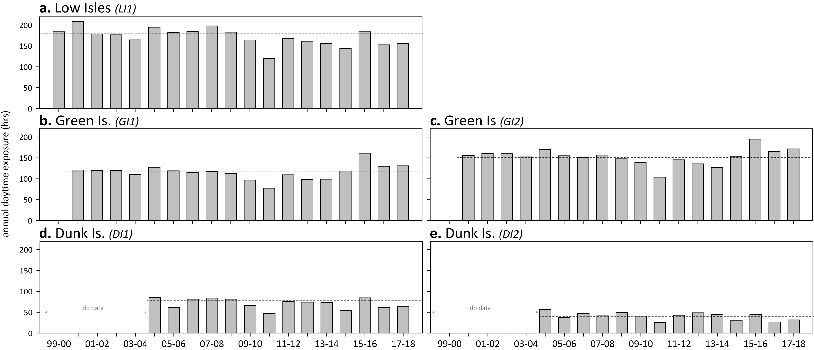
Figure 99. Annual daytime tidal exposure (total hours) and long-term median (dashed line) of intertidal reef seagrass meadows in the Wet Tropics NRM region; 1999–2018.
Year is June–May. For tidal exposure (when intertidal banks become exposed at a low tide) height at each site, see Table 22. Observed tidal heights courtesy Maritime Safety Queensland, 2018.

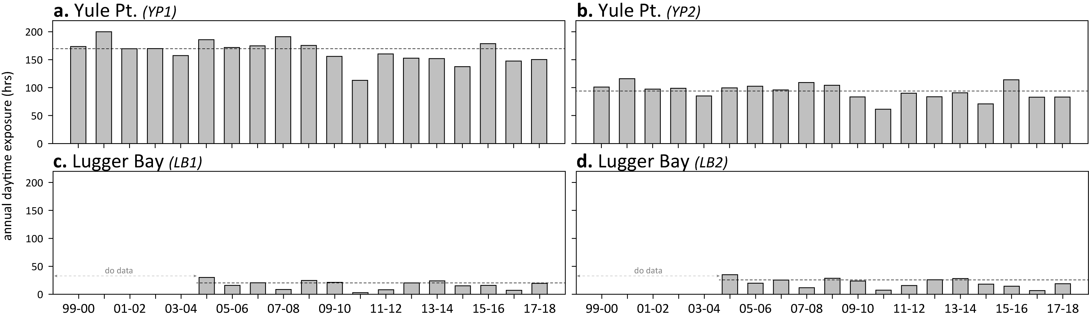
Figure 100. Annual daytime tidal exposure (total hours) and long-term median (dashed line) of intertidal coastal seagrass meadows in Wet Tropics NRM region; 1999–2018.
Year is June–May. For tidal exposure (when intertidal banks become exposed at a low tide) height at each site, see Table 22. Observed tidal heights courtesy Maritime Safety Queensland, 2018.

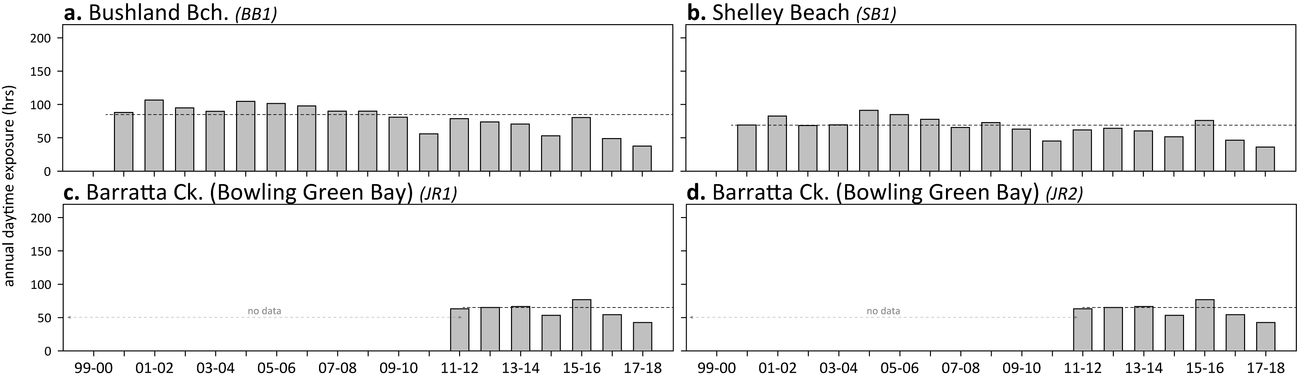
Figure 101. Annual daytime tidal exposure (total hours) and long-term median (dashed line) of intertidal coastal seagrass meadows in Burdekin NRM region; 2000–2018.
Year is June–May. For tidal exposure (when intertidal banks become exposed at a low tide) height at each site, see Table 22. Observed tidal heights courtesy Maritime Safety Queensland, 2018.

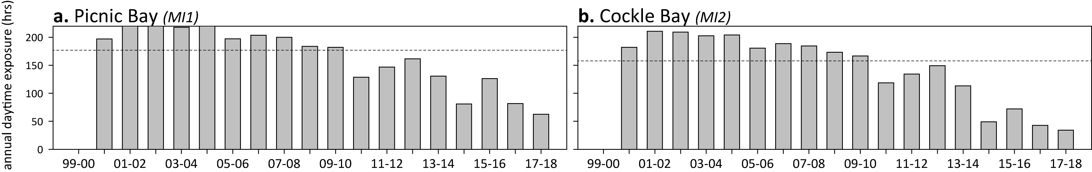
Figure 102. Annual daytime tidal exposure (total hours) and long-term median (dashed line) of intertidal reef seagrass meadows in Burdekin NRM region; 2000–2018.
Year is June–May. For tidal exposure (when intertidal banks become exposed at a low tide) height at each site, see Table 22. Observed tidal heights courtesy Maritime Safety Queensland, 2018.

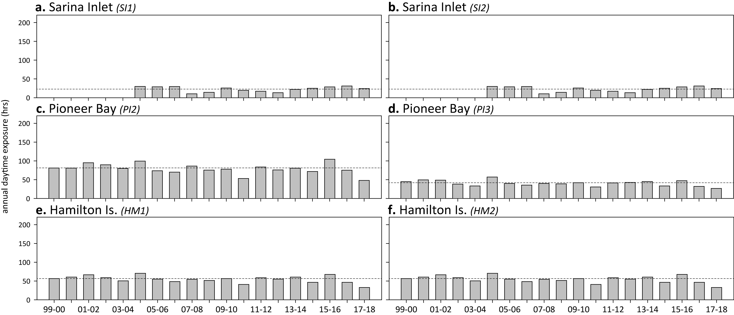
Figure 103. Annual daytime tidal exposure (total hours) and long-term median (dashed line) of intertidal estuarine (a, b) coastal (c, d) and reef (e, f) seagrass meadows in Mackay-Whitsunday NRM region; 1999–2018.
Year is June–May. For tidal exposure (when intertidal banks become exposed at a low tide) height at each site, see Table 22. Observed tidal heights courtesy Maritime Safety Queensland, 2018.

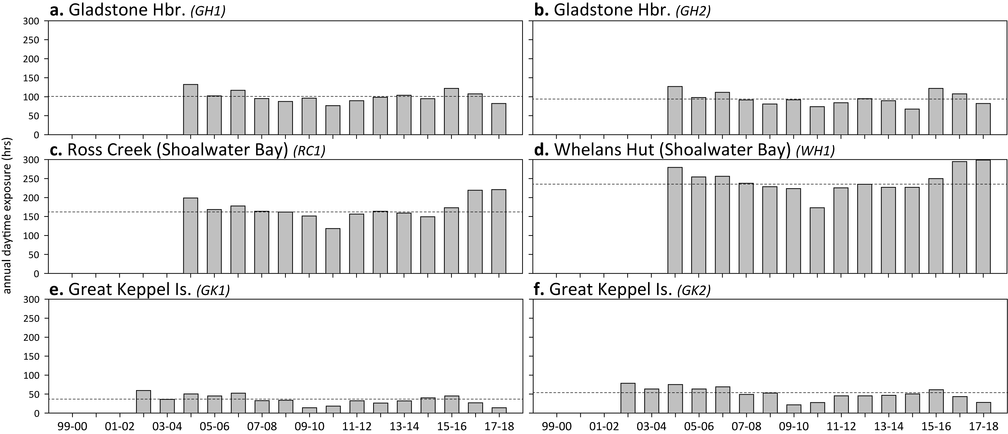
Figure 104. Annual daytime tidal exposure (total hours) and long-term median (dashed line) of intertidal estuarine (a, b) coastal (c, d) and reef (e, f) seagrass meadows in the Fitzroy NRM region; 1999–2018.
Year is June–May. For tidal exposure (when intertidal banks become exposed at a low tide) height at each site, see Table 22. Observed tidal heights courtesy Maritime Safety Queensland, 2018.

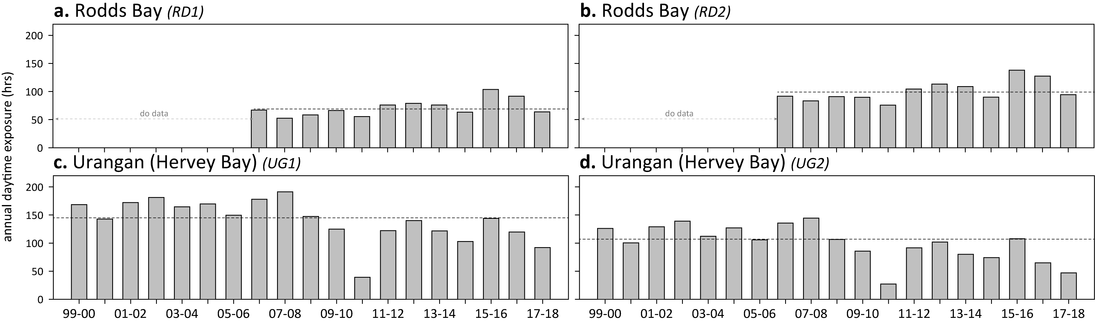
Figure 105. Annual daytime tidal exposure (total hours) and long-term median (dashed line) of intertidal estuarine seagrass meadows in the Burnett Mary NRM region; 1999–2018.
Year is June–May. For tidal exposure (when intertidal banks become exposed at a low tide) height at each site, see Table 22. Observed tidal heights courtesy Maritime Safety Queensland, 2018.

Light at seagrass canopy

Figure 106. Daily light and 28-day rolling average at Cape York locations.

Figure 107. Daily light (yellow line) and 28-day rolling average (orange, bold line) for locations in the northern Wet Tropics.

Figure 108. Daily light (yellow line) and 28-day rolling average (orange, bold line) for locations in the southern Wet Tropics.

Figure 109. Daily light (yellow line) and 28-day rolling average (orange, bold line) at locations in the Burdekin region.

Figure 110. Daily light (yellow line) and 28-day rolling average (orange, bold line) at Mackay-Whitsunday habitats.

Figure 111. Daily light (yellow line) and 28-day rolling average (orange, bold line) at monitoring locations in the Fitzroy NRM region.

Figure 112. Daily light (yellow line) and 28-day rolling average (orange, bold line) at monitoring locations in the Burnett Mary NRM region.

Seagrass habitat condition

Sediments composition

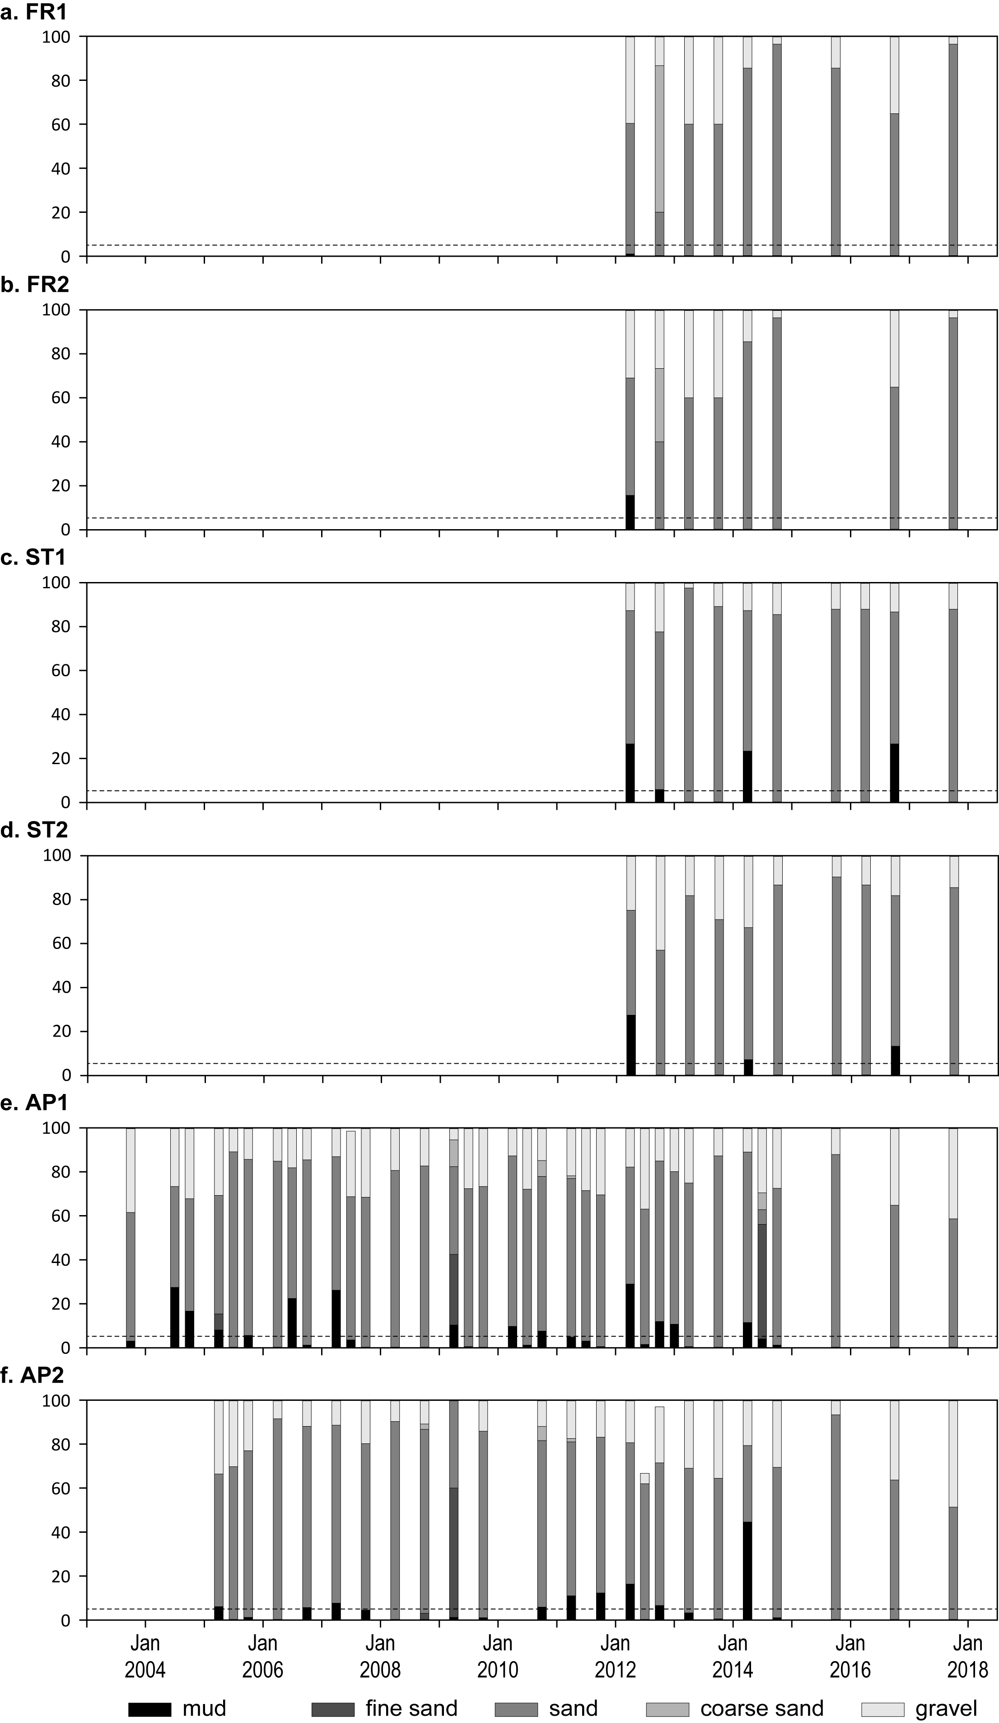
Figure 113. Sediment grain size composition at reef habitat monitoring sites in the Cape York region, 2003–2018.
Dashed line is the Reef long-term average proportion of mud.

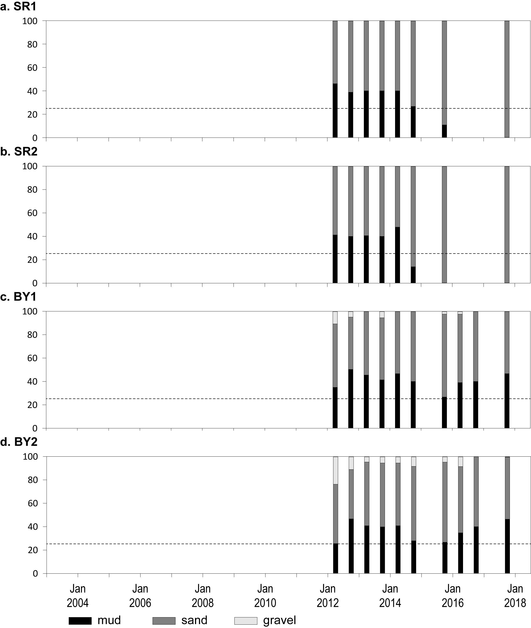
Figure 114. Sediment grain size composition at coastal habitat monitoring sites in the Cape York region, 2010–-2018.
Dashed line is the Reef long-term average proportion of mud.

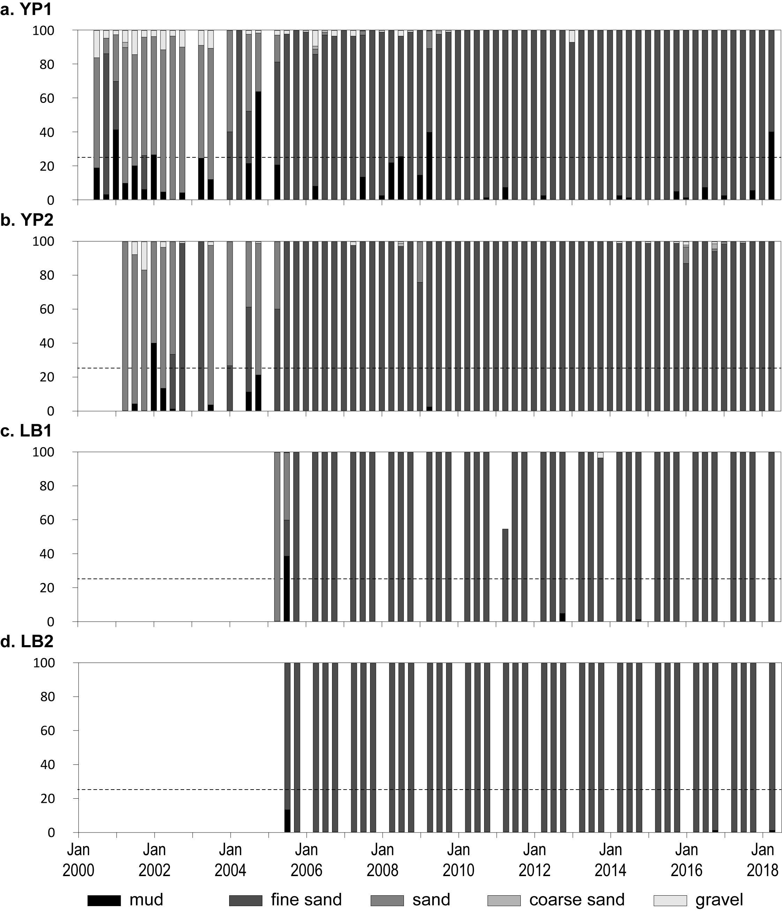
Figure 115. Sediment grain size composition at intertidal coastal habitat monitoring sites in the Wet Tropics region, 2001–2018.
Dashed line is the Reef long-term average proportion of mud.

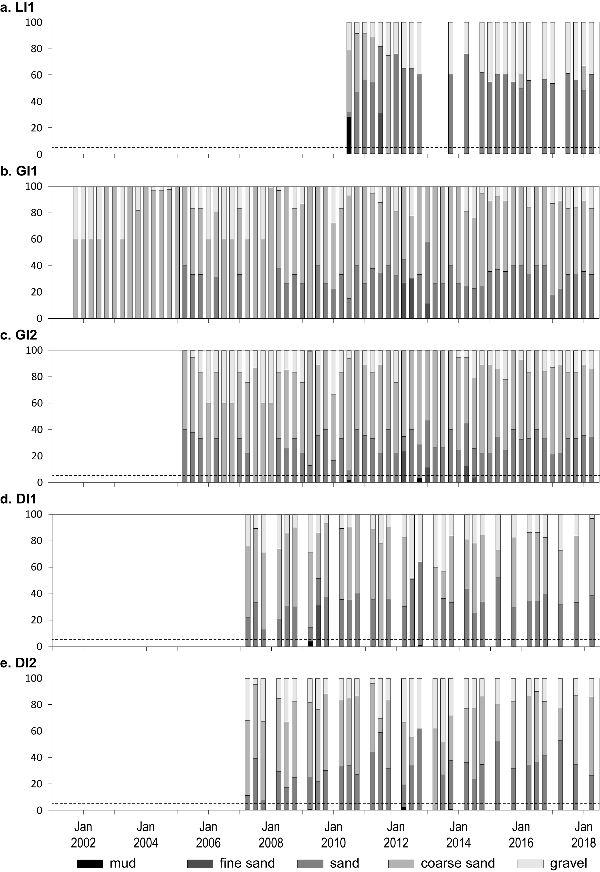
Figure 116. Sediment grain size composition at intertidal reef habitat monitoring sites in the Wet Tropics region, 2001–2018.
Dashed line is the Reef long-term average proportion of mud.

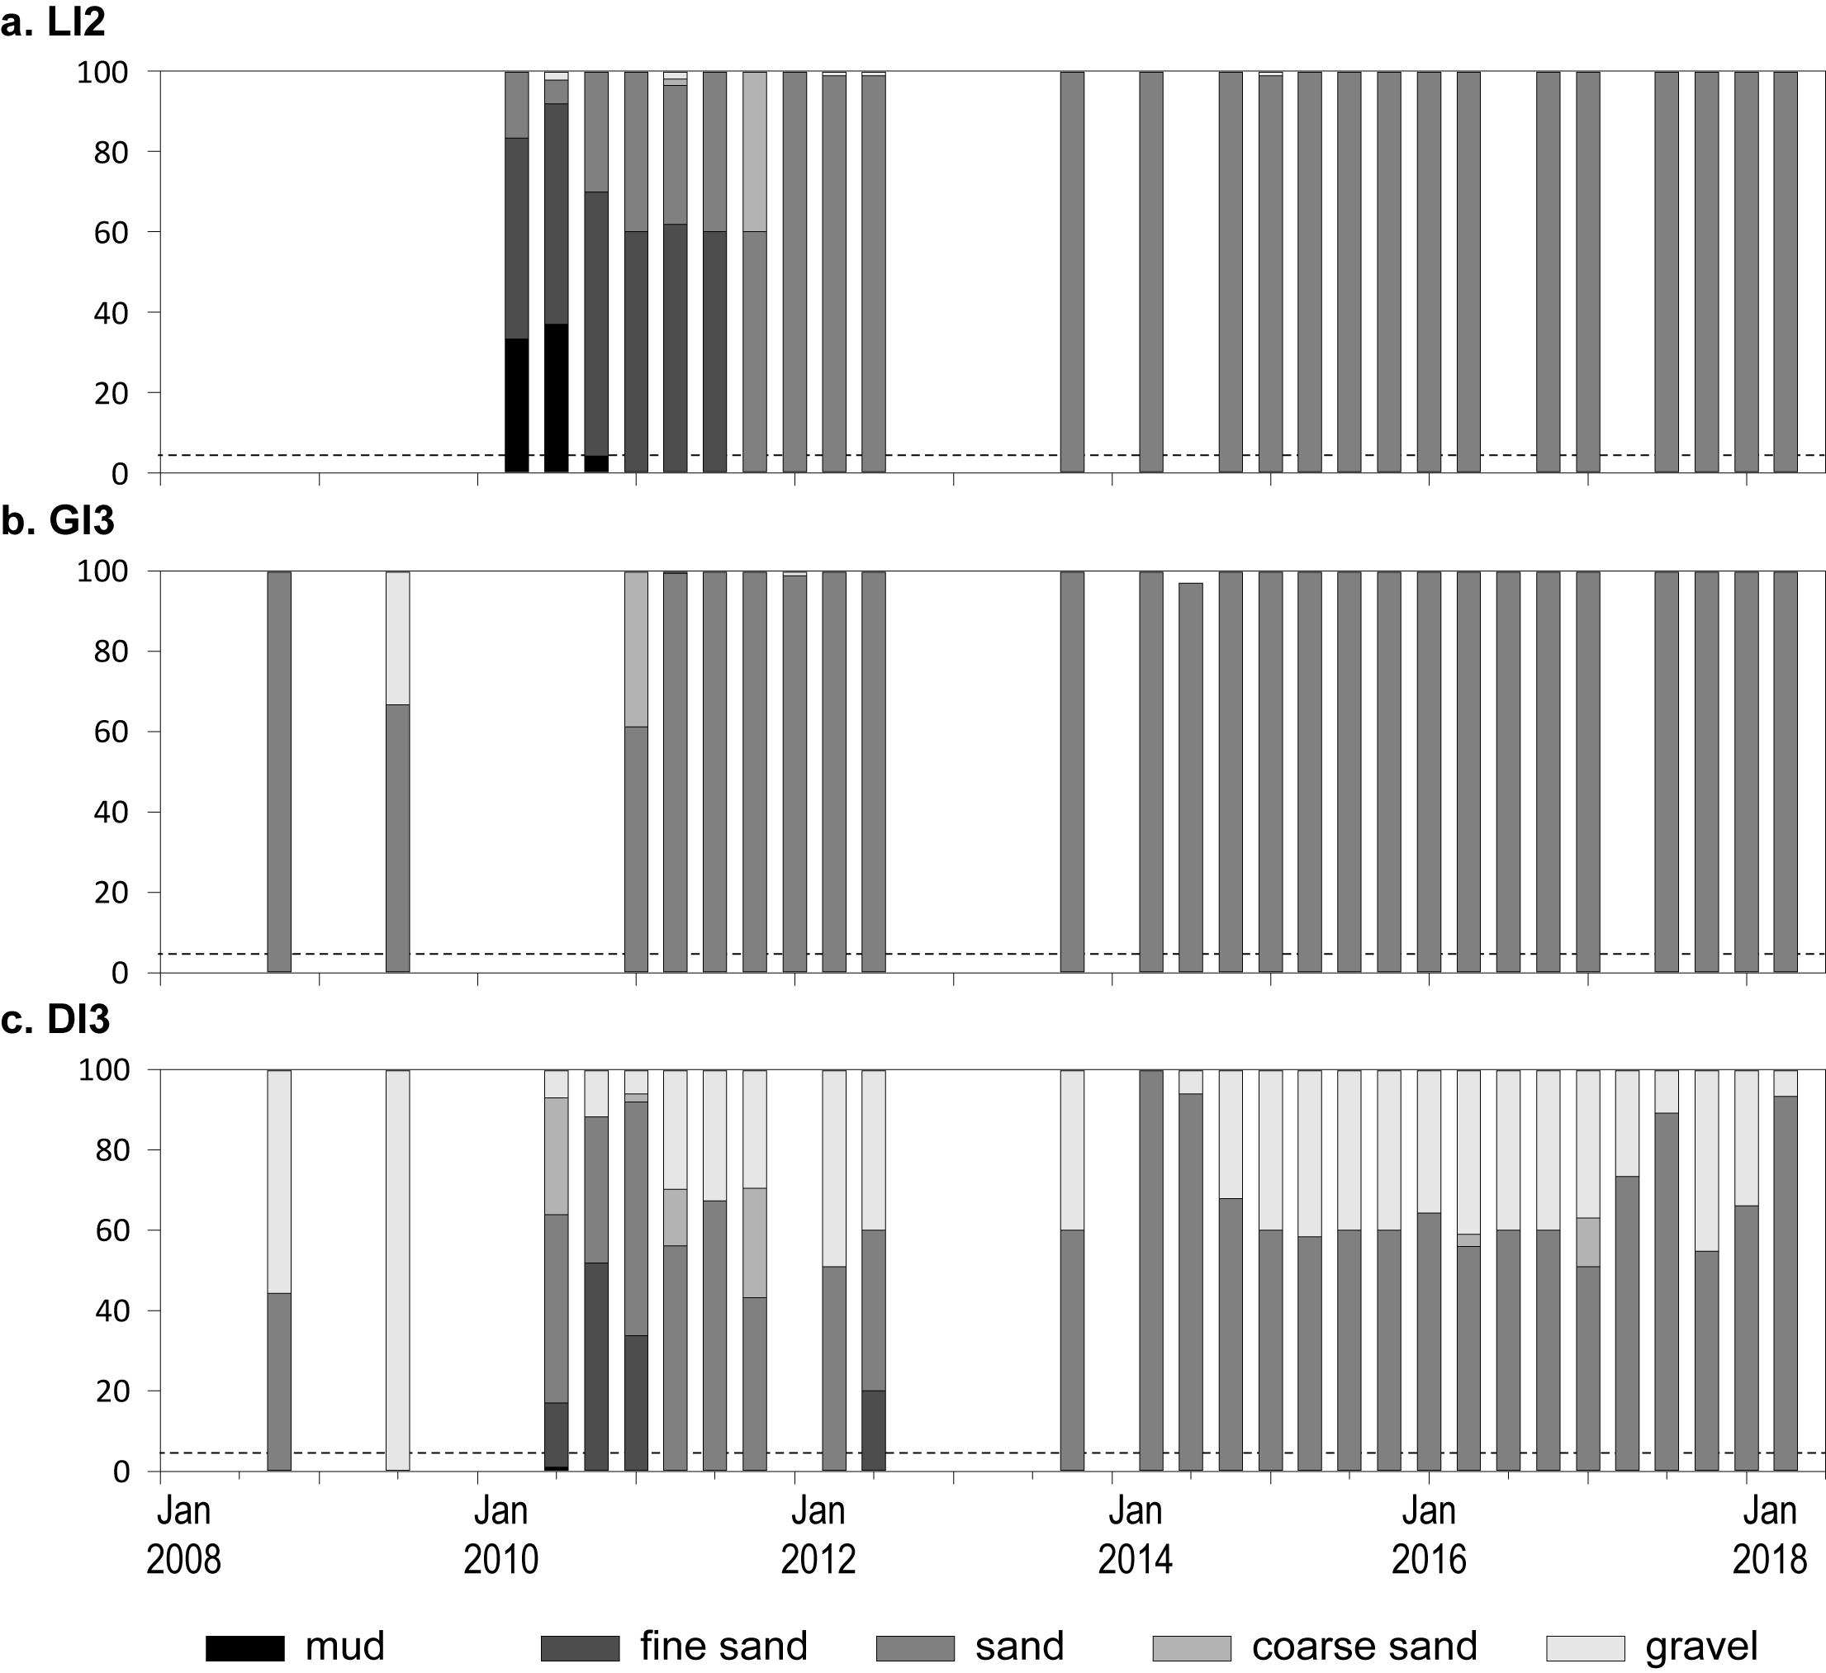
Figure 117. Sediment grain size composition at subtidal reef habitat monitoring sites in the Wet Tropics region, 2008–2018.
Dashed line is the Reef long-term average proportion of mud.

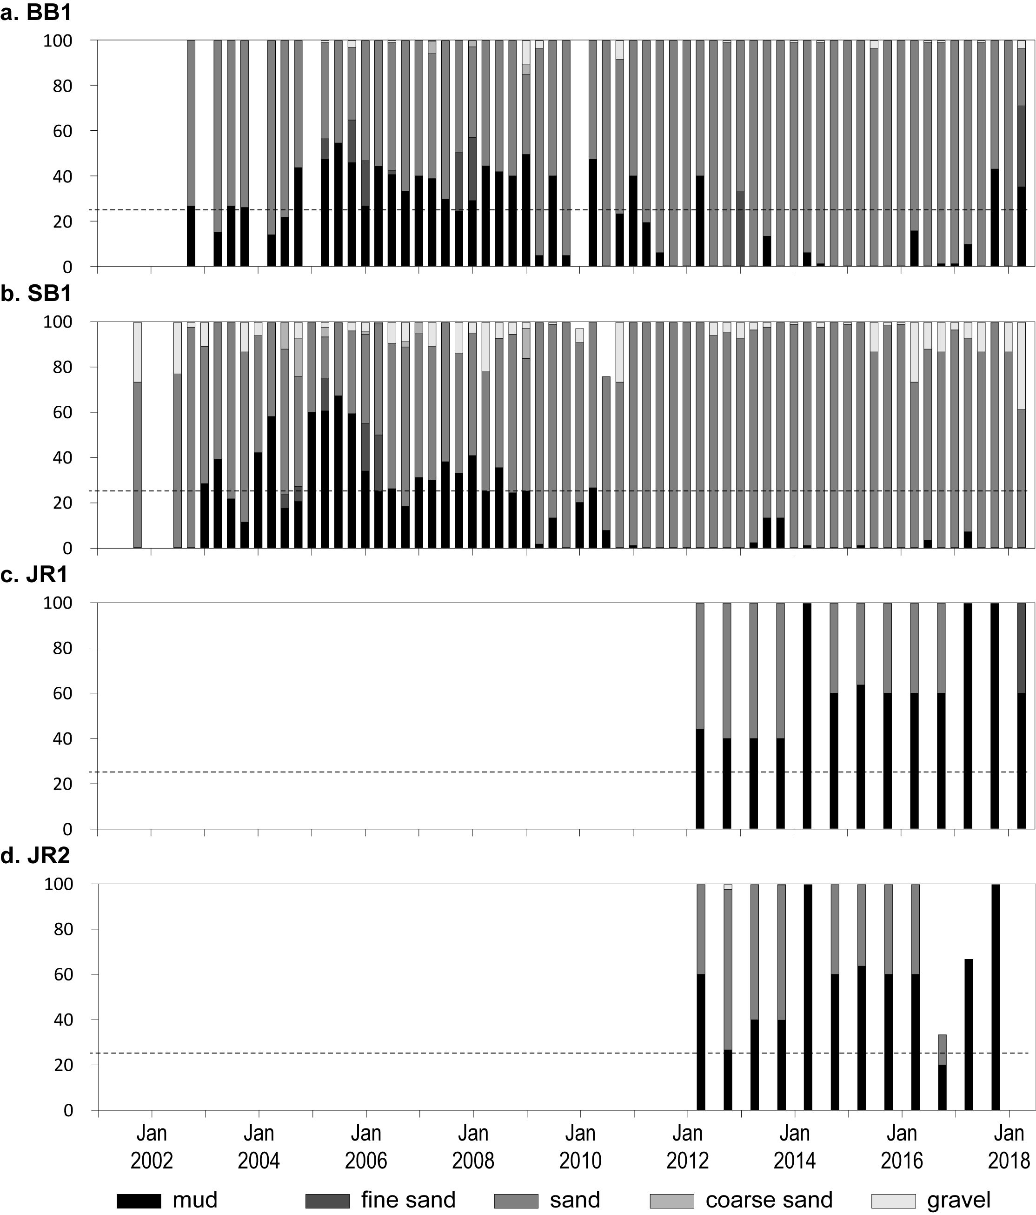
Figure 118. Sediment grain size composition at intertidal coastal habitat monitoring sites in the Burdekin region, 2001–2018.
Dashed line is the Reef long-term average proportion of mud.
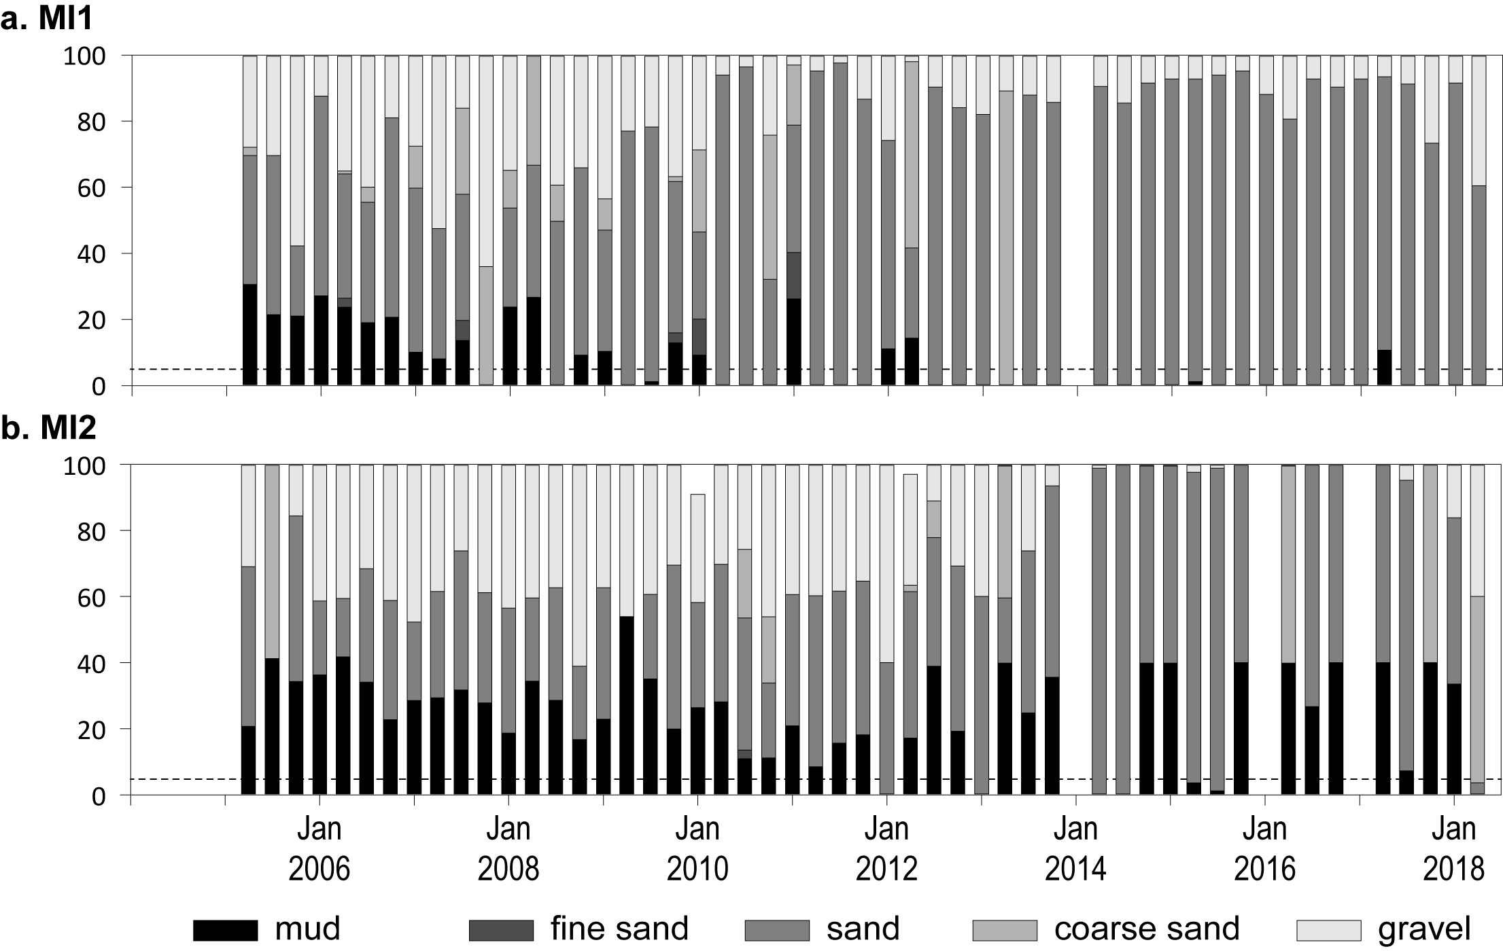
Figure 119. Sediment grain size composition at intertidal reef habitat monitoring sites in the Burdekin region, 2004–2018.
Dashed line is the Reef long-term average proportion of mud.

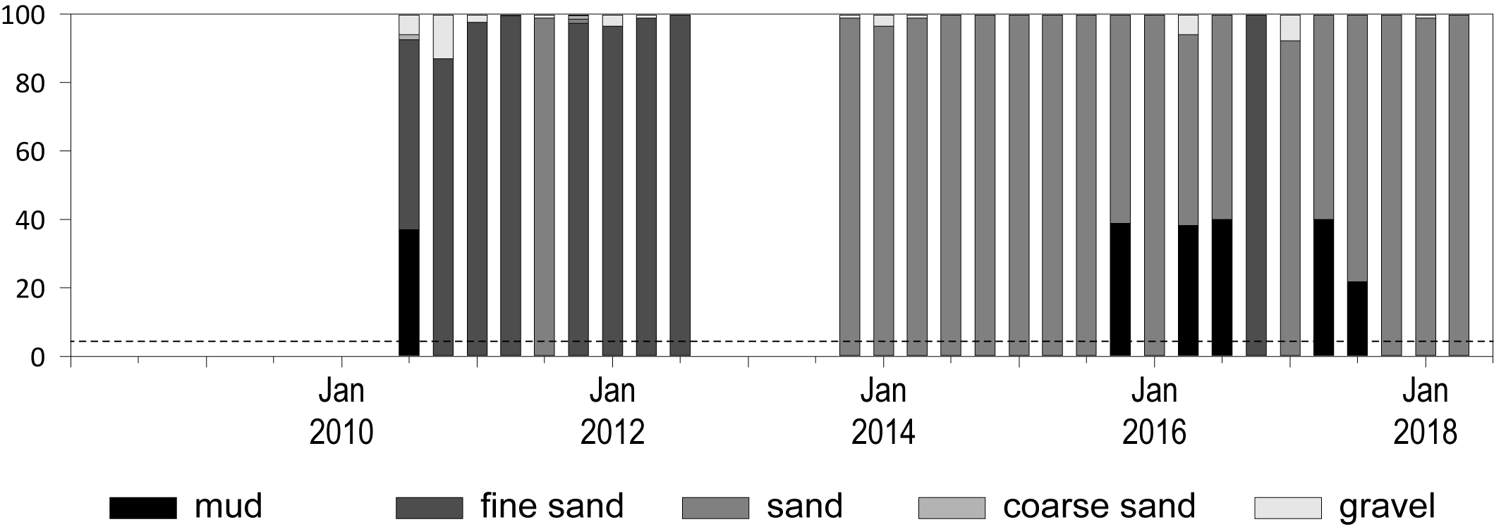
Figure 120. Sediment grain size composition at subtidal reef habitat monitoring sites in the Burdekin region, 2010–2018.
Dashed line is the Reef long-term average proportion of mud.

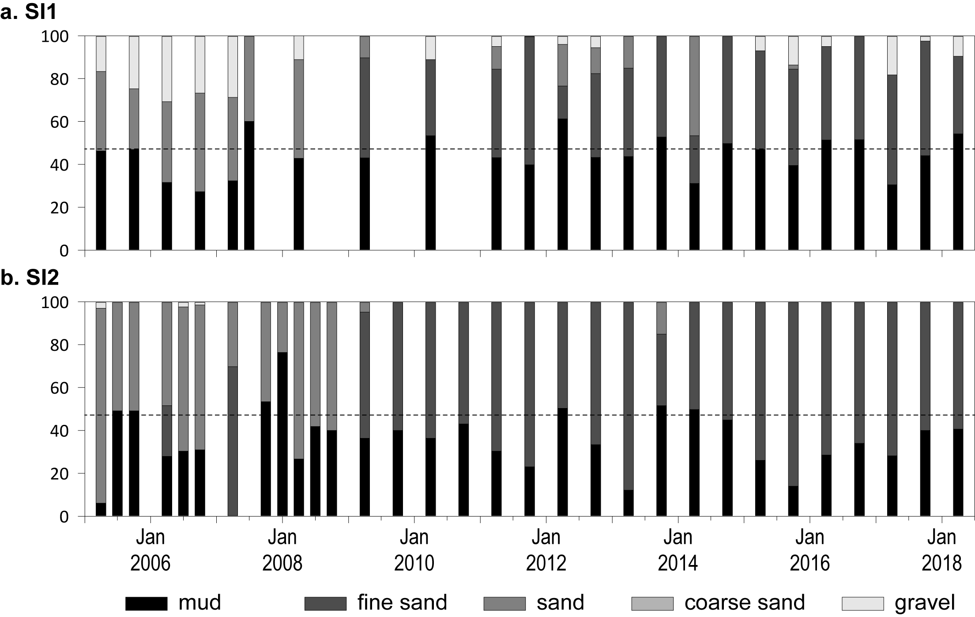
Figure 121. Sediment grain size composition at intertidal estuary habitat monitoring sites in the Mackay-Whitsunday region, 2005–2018.
Dashed line is the Reef long-term average proportion of mud.

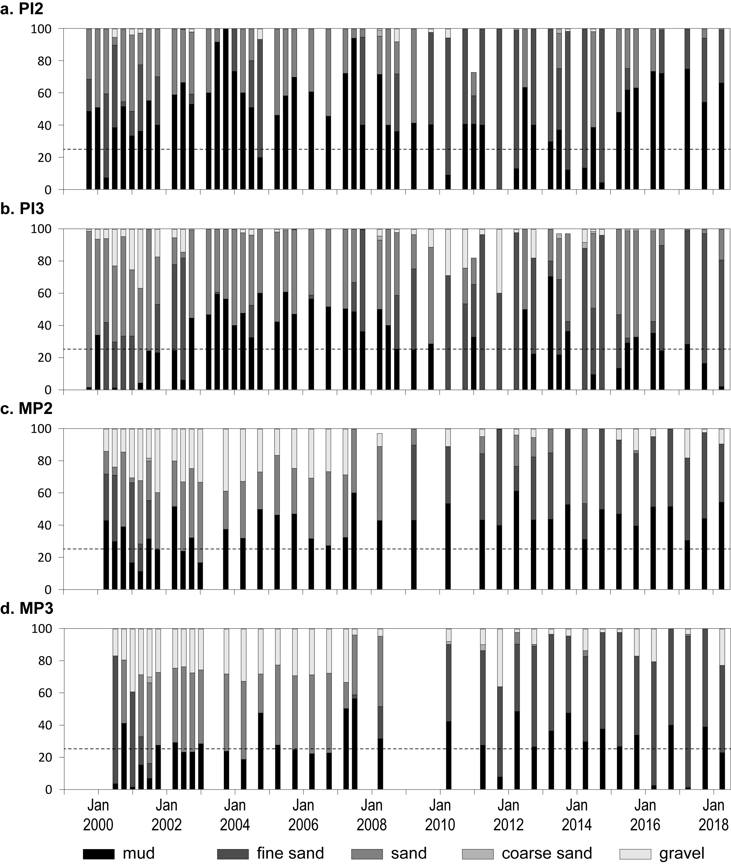
Figure 122. Sediment grain size composition at intertidal coastal habitat monitoring sites in the Mackay-Whitsunday region, 1999–2018.
Dashed line is the Reef long-term average proportion of mud.
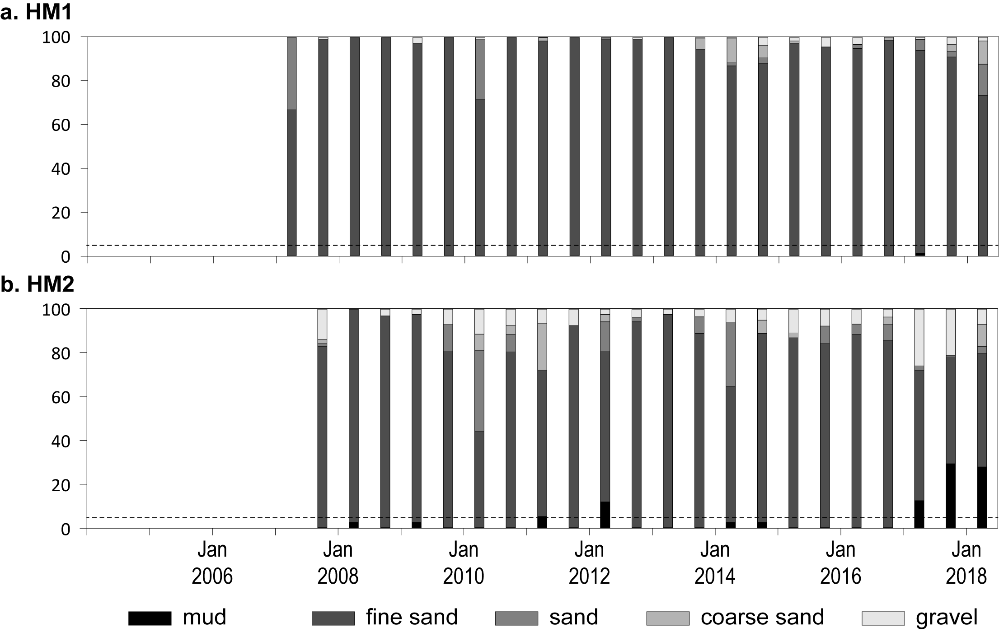
Figure 123. Sediment grain size composition at intertidal reef habitat monitoring sites in the Mackay-Whitsunday region, 2007–2018.
Dashed line is the Reef long-term average proportion of mud.

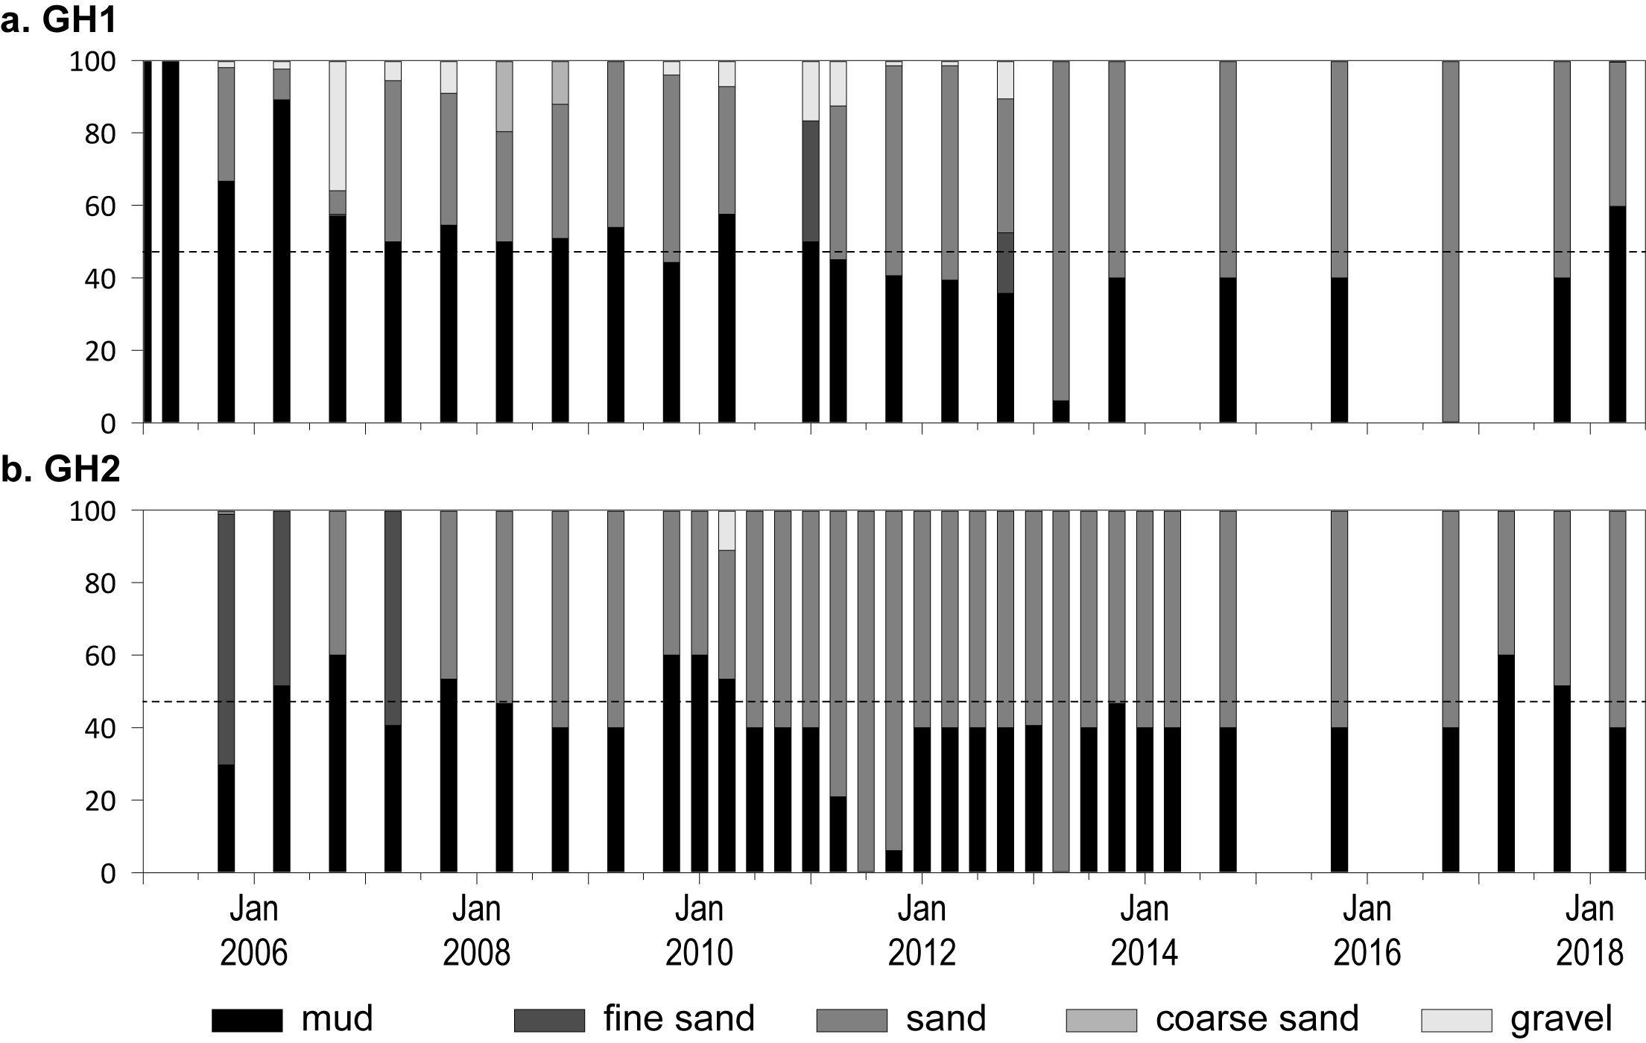
Figure 124. Sediment grain size composition at intertidal estuary habitat monitoring sites in the Fitzroy region, 2005–2018.
Dashed line is the Reef long-term average proportion of mud.

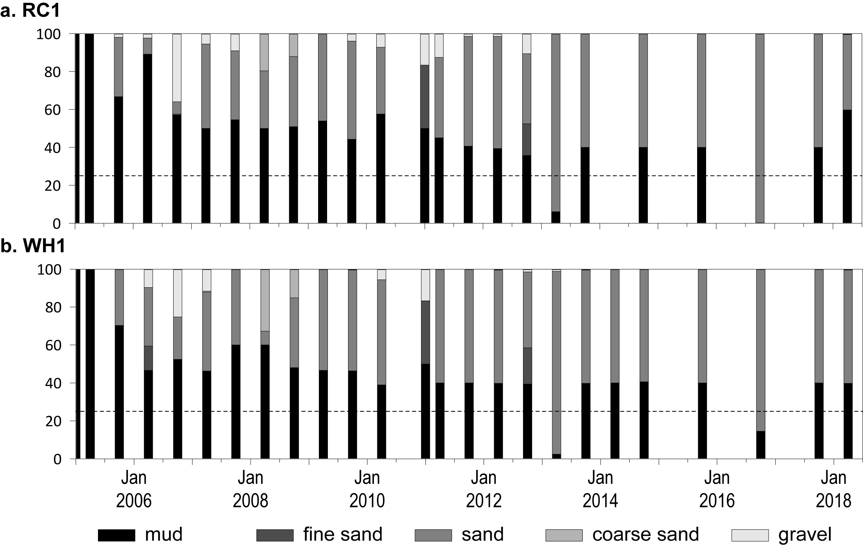
Figure 125. Sediment grain size composition at intertidal coastal habitat monitoring sites in the Fitzroy region, 2005–2018.
Dashed line is the Reef long-term average proportion of mud.

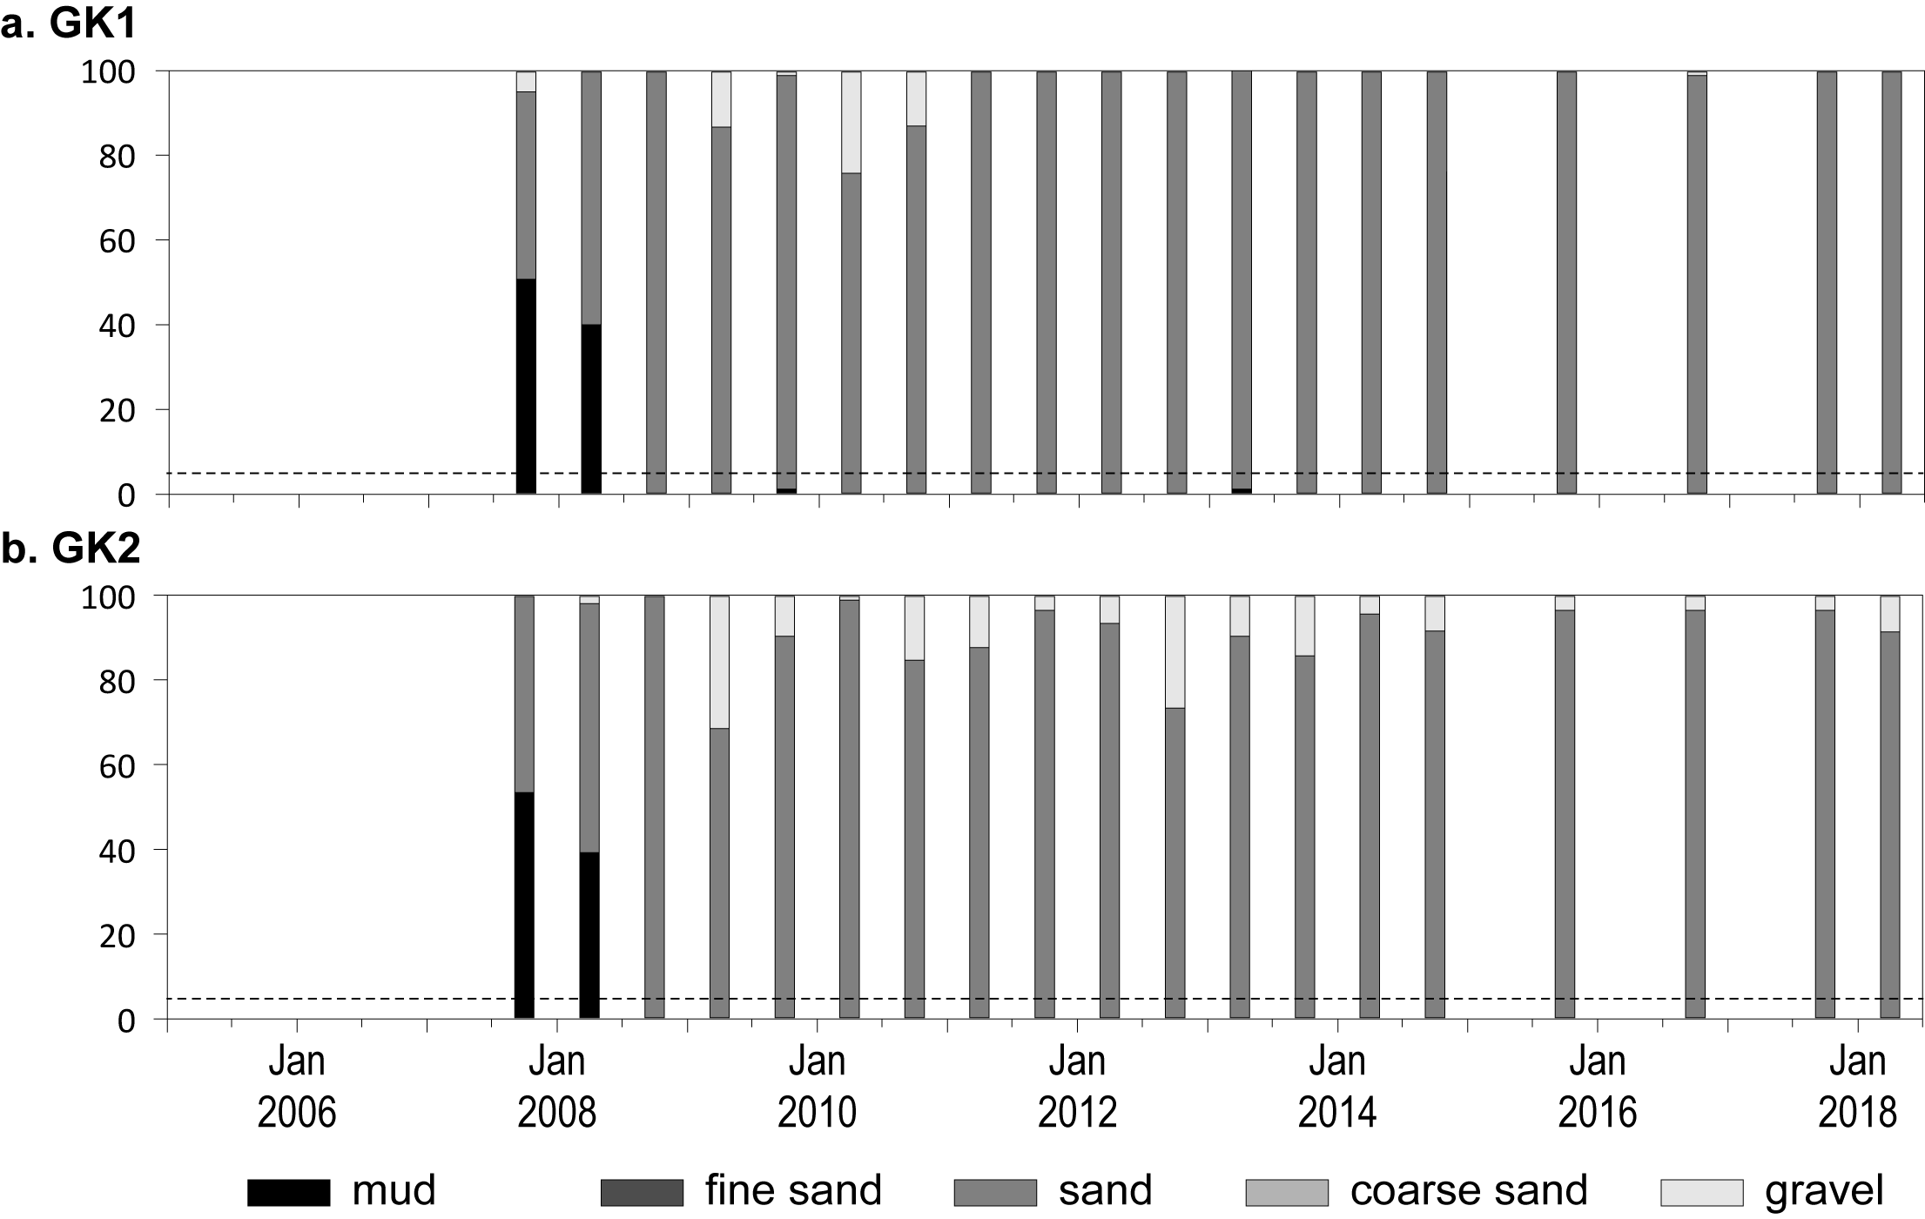
Figure 126. Sediment grain size composition at intertidal reef habitat monitoring sites in the Fitzroy region, 2007–2018.
Dashed line is the Reef long-term average proportion of mud.
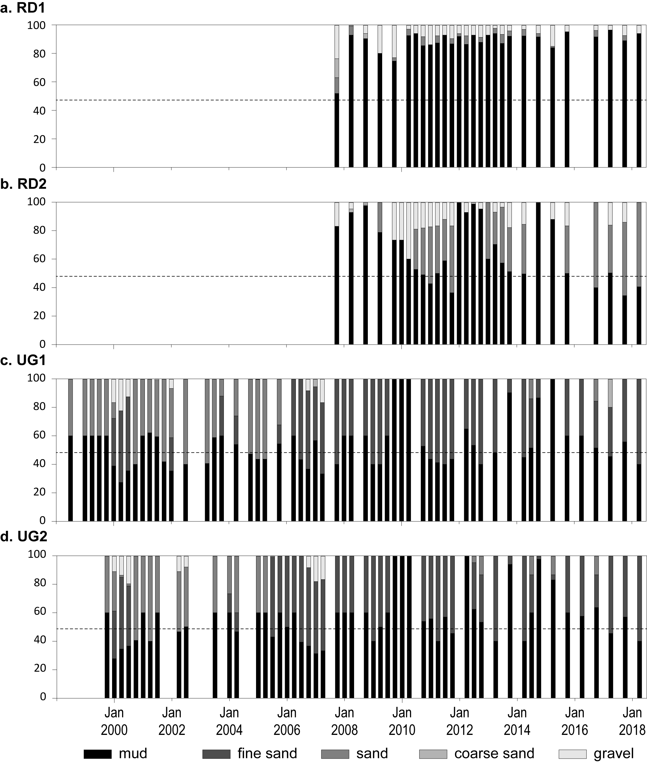
Figure 127. Sediment grain size composition at intertidal estuary habitat monitoring sites in the Burnett Mary region, 1999–2018.
Dashed line is the Reef long-term average proportion of mud.

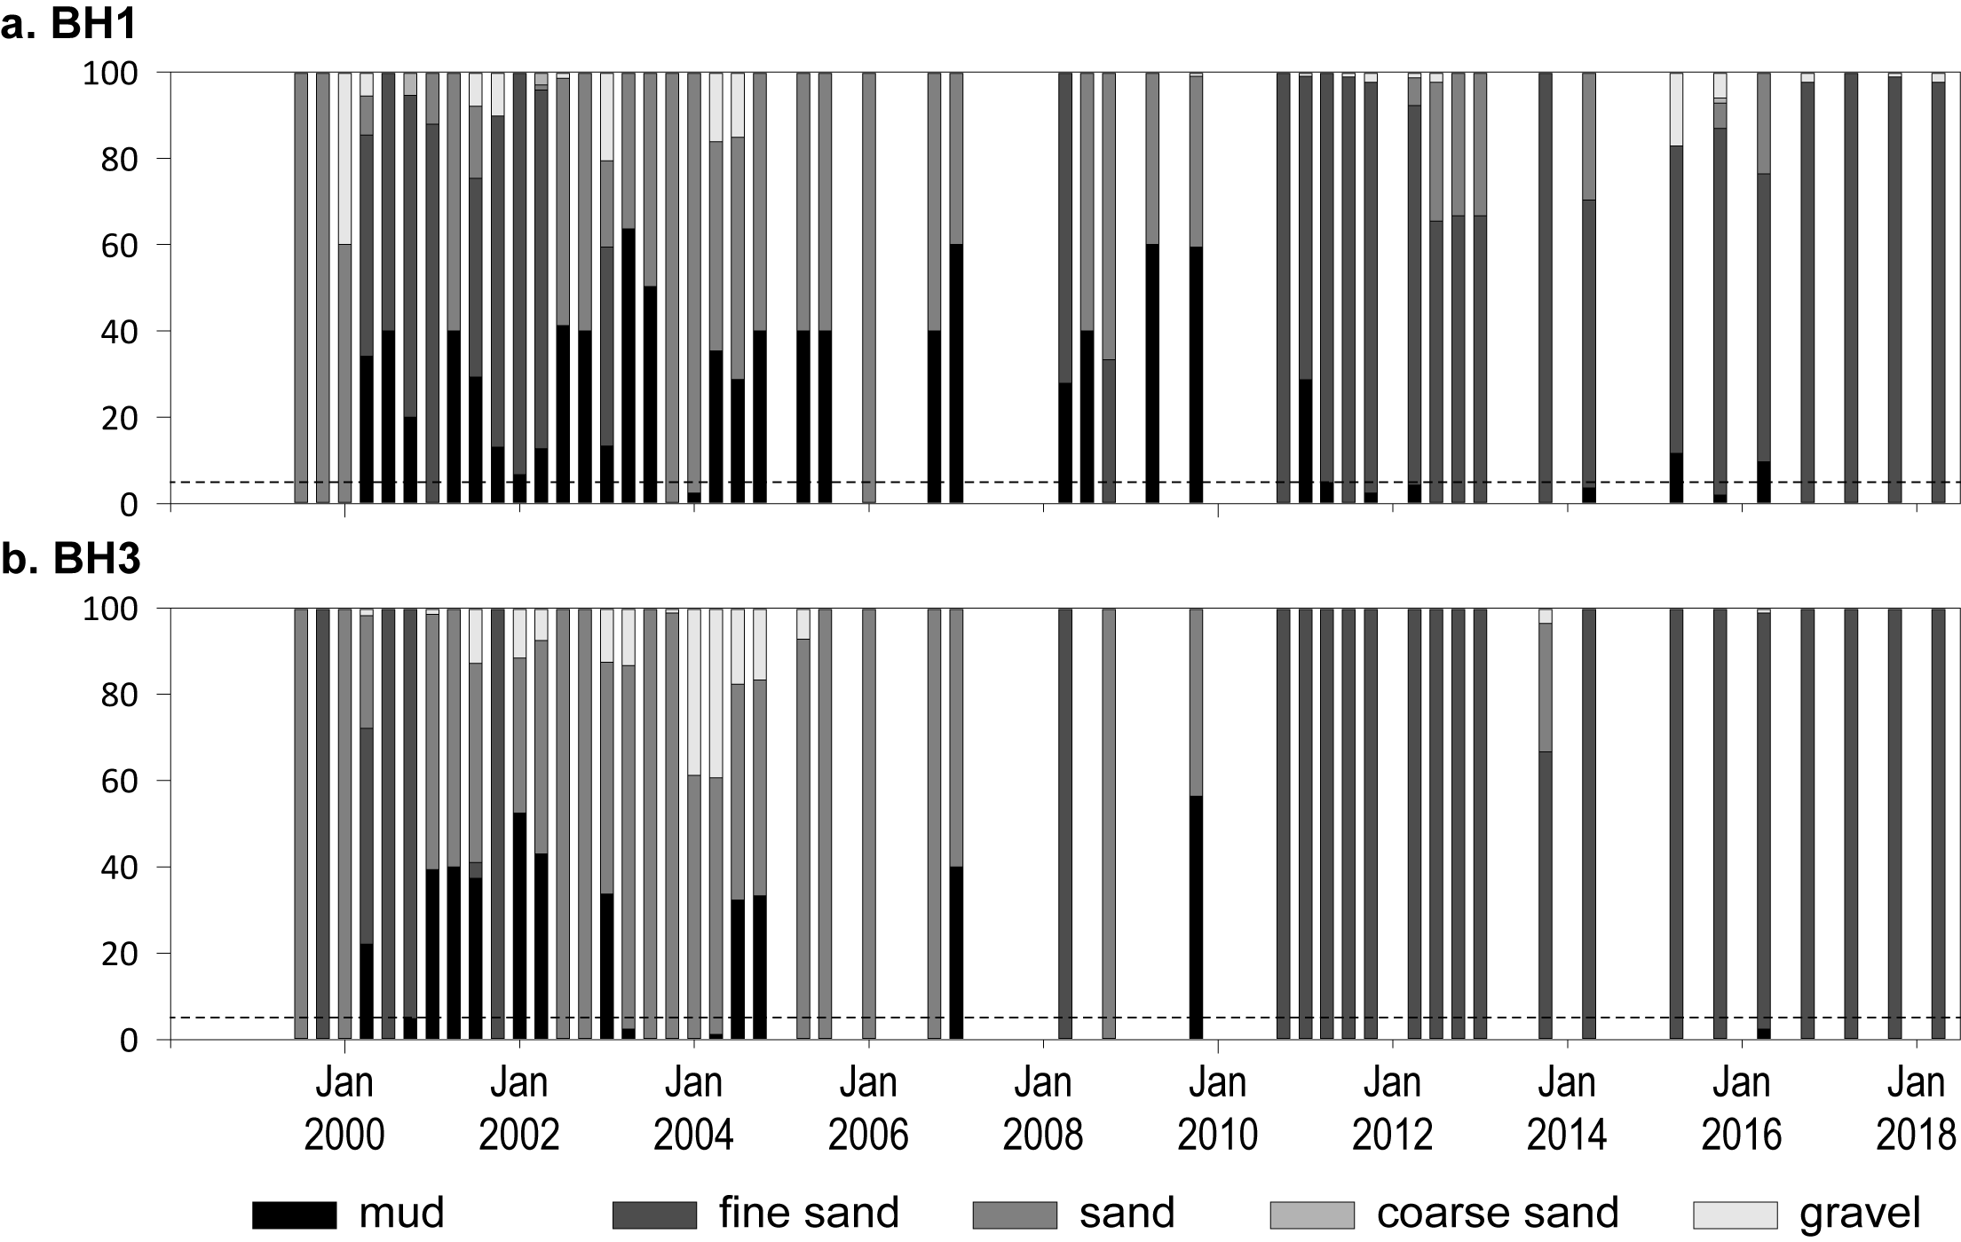
Figure 128. Sediment grain size composition at intertidal coastal habitat monitoring sites in the Burnett Mary region, 1999–2018.
Dashed line is the Reef long-term average proportion of mud.

Results of statistical analysis

Table 23. Results of Mann­Kendall analysis to assess if there was a significant trend (decline or increase) over time in seagrass abundance (% cover).
The reported output of the tests performed are Kendall’s tau coefficient (Kendall-τ), the two-sided p-value (significant at α = 0.05 in bold), the Sen’s slope (showing the sign and strength of the trend – including confidence intervals if significant) and the long-term trend.
NRM region | Habitat | Site | First Year | Last Year | n | Kendall-τ | p  (2-sided) | Sen’s slope  (confidence interval) | trend
Cape York | coastal intertidal | BY1 | 2012 | 2017 | 10 | 0.244 | 0.3711 | 0.798 | no trend
Cape York | coastal intertidal | BY2 | 2012 | 2017 | 10 | 0.511 | 0.0491 | 0.962 (0.027 to 2.103) | increase
Cape York | coastal intertidal | SR1 | 2012 | 2017 | 8 | -0.500 | 0.1078 | -0.848 | no trend
Cape York | coastal intertidal | SR2 | 2012 | 2017 | 8 | 0.143 | 0.7105 | 0.131 | no trend
Cape York | coastal subtidal | LR1 | 2015 | 2017 | 3 | -0.333 | 1.0000 | -3.376 | no trend
Cape York | coastal subtidal | LR2 | 2015 | 2017 | 3 | -1.000 | 0.2963 | -16.635 | no trend
Cape York | reef intertidal | AP1 | 2003 | 2017 | 35 | -0.459 | 0.0001 | -0.533 (-0.763 to -0.283) | decrease
Cape York | reef intertidal | AP2 | 2005 | 2017 | 24 | -0.022 | 0.9013 | -0.030 | no trend
Cape York | reef intertidal | FR1 | 2012 | 2017 | 9 | -0.366 | 0.2084 | -0.424 | no trend
Cape York | reef intertidal | FR2 | 2012 | 2017 | 8 | -0.286 | 0.3865 | -1.510 | no trend
Cape York | reef intertidal | ST1 | 2012 | 2017 | 10 | 0.511 | 0.0491 | 0.643 (0.091 to 1.212) | Increase
Cape York | reef intertidal | ST2 | 2012 | 2017 | 10 | 0.674 | 0.0092 | 0.591 (0429 to 1.065) | increase
Cape York | reef intertidal | YY1 | 2012 | 2014 | 3 | 0.333 | 1.0000 | 1.045 | no trend
 | pooled |  | 2003 | 2017 | 36 | -0.365 | 0.0018 | -0.321 (-0.448 to -0.097) | decrease
Wet Tropics | coastal intertidal | LB1 | 2005 | 2018 | 40 | -0.607 | 0.0097 | -0.049 (-0.133 to -0.013) | decrease
Wet Tropics | coastal intertidal | LB2 | 2005 | 2018 | 39 | -0.438 | 0.0538 | -0.047 (-0.108 to -0.0004) | decrease
Wet Tropics | coastal intertidal | YP1 | 2000 | 2018 | 69 | 0.052 | 0.7274 | 0.042 | no trend
Wet Tropics | coastal intertidal | YP2 | 2001 | 2018 | 65 | 0.070 | 0.5390 | 0.040 | no trend
Wet Tropics | reef intertidal | DI1 | 2007 | 2018 | 32 | -0.218 | 0.3793 | -0.155 | no trend
Wet Tropics | reef intertidal | DI2 | 2007 | 2018 | 32 | -0.192 | 0.4304 | -0.167 | no trend
Wet Tropics | reef intertidal | GI1 | 2001 | 2018 | 67 | -0.102 | 0.2234 | -0.065 | no trend
Wet Tropics | reef intertidal | GI2 | 2005 | 2018 | 53 | -0.028 | 0.7707 | -0.028 | no trend
Wet Tropics | reef intertidal | GO1 | 2008 | 2016 | 7 | -0.429 | 0.2296 | -1.682 | no trend
Wet Tropics | reef intertidal | LI1 | 2008 | 2018 | 35 | -0.489 | <0.0001 | -0.206 (-0.363 to -0.107) | decrease
Wet Tropics | reef subtidal | DI3 | 2008 | 2018 | 38 | -0.142 | 0.4420 | -0.021 | no trend
Wet Tropics | reef subtidal | GI3 | 2008 | 2018 | 37 | -0.441 | 0.0012 | -0.735 (-1.081 to -0.424) | decrease
Wet Tropics | reef subtidal | LI2 | 2008 | 2018 | 35 | -0.017 | 0.8983 | -0.005 | no trend
 | pooled |  | 2000 | 2018 | 72 | -0.175 | 0.03 | -0.11 (-0.2 to -0.011) | decrease
Burdekin | coastal intertidal | BB1 | 2002 | 2018 | 59 | 0.027 | 0.8918 | 0.024 | no trend
Burdekin | coastal intertidal | SB1 | 2001 | 2018 | 65 | -0.025 | 0.8808 | -0.022 | no trend
Burdekin | coastal intertidal | SB2 | 2001 | 2018 | 64 | -0.217 | 0.1181 | -0.221 | no trend
Burdekin | coastal intertidal | JR1 | 2012 | 2018 | 13 | 0.385 | 0.0769 | 2.768 | no trend
Burdekin | coastal intertidal | JR2 | 2012 | 2017 | 12 | 0.758 | 0.0008 | 4.038 (2.317 to 7.585) | increase
Burdekin | reef intertidal | MI1 | 2005 | 2018 | 52 | -0.162 | 0.4333 | -0.222 | no trend
Burdekin | reef intertidal | MI2 | 2005 | 2018 | 50 | -0.112 | 0.3612 | -0.191 | no trend
Burdekin | reef subtidal | MI3 | 2008 | 2017 | 41 | 0.239 | 0.1746 | 0.607 | no trend
 | pooled |  | 2001 | 2018 | 68 | 0.04 | 0.772 | 0.035 | no trend
Mackay-Whitsunday | estuarine intertidal | SI1 | 2005 | 2018 | 31 | -0.161 | 0.2085 | -0.160 | no trend
Mackay-Whitsunday |  | SI2 | 2005 | 2018 | 26 | 0.052 | 0.7243 | 0.034 | no trend
Mackay-Whitsunday | coastal intertidal | MP2 | 2000 | 2018 | 38 | 0.211 | 0.0646 | 0.204 | no trend
Mackay-Whitsunday |  | MP3 | 2000 | 2018 | 36 | 0.108 | 0.3615 | 0.064 | no trend
Mackay-Whitsunday |  | PI2 | 1999 | 2018 | 54 | -0.331 | <0.0001 | -0.321 (-0.515 to -0.159) | decrease
Mackay-Whitsunday |  | PI3 | 1999 | 2018 | 54 | -0.145 | 0.3824 | -0.118 | no trend
Mackay-Whitsunday | coastal subtidal | NB1 | 2015 | 2017 | 3 | -0.333 | 1.0000 | -10.391 | no trend
Mackay-Whitsunday | coastal subtidal | NB2 | 2015 | 2017 | 3 | 0.333 | 1.0000 | 0.893 | no trend
Mackay-Whitsunday | reef intertidal | HB1 | 2000 | 2018 | 40 | -0.374 | 0.0296 | -0.243 (-0.391 to -0.119) | decrease
Mackay-Whitsunday | reef intertidal | HB2 | 2000 | 2018 | 39 | -0.155 | 0.4098 | -0.091 | no trend
Mackay-Whitsunday | reef intertidal | HM1 | 2007 | 2018 | 23 | -0.502 | 0.0009 | -0.306 (-0.466 to -0.127) | decrease
Mackay-Whitsunday | reef intertidal | HM2 | 2007 | 2018 | 22 | -0.305 | 0.0514 | -0.141 | no trend
Mackay-Whitsunday | Reef subtidal | TO1 | 2015 | 2017 | 3 | -1.000 | 0.2963 | -7.675 | no trend
Mackay-Whitsunday | Reef subtidal | TO2 | 2015 | 2017 | 3 | -1.000 | 0.2963 | -7.588 | no trend
Mackay-Whitsunday | pooled |  | 1999 | 2018 | 61 | -0.380 | <0.0001 | -0.181 (-0.261 to -0.104) | decrease
Fitzroy | estuarine intertidal | GH1 | 2005 | 2018 | 33 | -0.360 | 0.0034 | -0.724 (-1.159 to -0.229) | decrease
Fitzroy |  | GH2 | 2005 | 2018 | 33 | 0.038 | 0.7685 | 0.067 | no trend
Fitzroy | coastal intertidal | RC1 | 2002 | 2018 | 34 | -0.013 | 0.9473 | -0.019 | no trend
Fitzroy |  | WH1 | 2002 | 2018 | 35 | -0.054 | 0.7065 | -0.065 | no trend
Fitzroy | reef intertidal | GK1 | 2007 | 2018 | 19 | -0.457 | 0.0070 | -0.123 (-0.258 to -0.046) | decrease
Fitzroy |  | GK2 | 2007 | 2018 | 19 | -0.064 | 0.7264 | -0.027 | no trend
Fitzroy | pooled |  | 2002 | 2018 | 44 | -0.253 | 0.016 | -0.161 ( -0.283 to -0.047) | decrease
Burnett Mary | estuarine intertidal | RD1 | 2007 | 2018 | 28 | -0.064 | 0.6490 | -0.005 | no trend
Burnett Mary |  | RD2 | 2007 | 2017 | 28 | -0.409 | 0.0032 | -0.009 (-0.096 to -0.001) | decrease
Burnett Mary |  | UG1 | 1998 | 2018 | 59 | 0.217 | 0.0656 | 0.034 | no trend
Burnett Mary |  | UG2 | 1999 | 2018 | 55 | 0.340 | 0.0288 | 0.165 (0.036 to 0.361) | increase
Burnett Mary | coastal intertidal | BH1 | 1999 | 2018 | 50 | 0.037 | 0.8075 | 0.018 | no trend
Burnett Mary |  | BH3 | 1999 | 2018 | 48 | 0.348 | 0.0070 | 0.162 (0.073 to 0.240) | increase
Burnett Mary | pooled |  | 1998 | 2018 | 71 | 0.022 | 0.891 | 0.006 | no trend

