About this report
Chapter 1
< Photograph of an aerial view of two vegetated sand cays and shallow reef area on front cover

About this report

Background
Key message: The Great Barrier Reef Marine Park Act and Regulations set out what the report must contain.
Every five years, the Great Barrier Reef Marine Park Authority prepares an Outlook Report for the Great Barrier Reef (the Reef). The Great Barrier Reef Marine Park Act 1975 (the Act) and the Great Barrier Reef Marine Park Regulations 1983 (the Regulations) stipulate what the report must contain and that it must be given to the Australian Government Minister for the Environment for tabling in both houses of the Australian Parliament (Appendix 1).
Outlook Reports are a regular and reliable means of assessing overall performance of all measures to protect and manage the Great Barrier Reef in an accountable and transparent manner. They are a key input for any changes to management arrangements and the consideration of broader issues by government.
The first Great Barrier Reef Outlook Report¹ was released in September 2009. As required by the Act, it provided a summary of the long-term outlook for the Reef based on assessments of condition, use, influencing factors, management effectiveness, resilience and risks.
This second report builds upon the first. It provides a snapshot of current condition and examines progress in protecting the Reef since 2009. Importantly, it better encompasses the full range of values. It reflects the 2013 amendment of the Regulations which requires explicit assessment of heritage values in future Outlook Reports (Appendix 1).

Scope
Key message: The Outlook Report focuses on the Great Barrier Reef Region and the factors that influence it.
The area examined in this report is the Great Barrier Reef Region (the Region) as defined in the Act. The Region covers 346,000 square kilometres from the tip of Cape York in the north to past Lady Elliot Island in the south, with mean low water as its western boundary and extending eastwards a distance of between 70 and 250 kilometres (Figure 1.1). It includes about 70 Commonwealth-owned islands. However, the majority of islands are owned by the Queensland Government or privately and are not included in the Region.
There are geographically small but important differences between the boundaries of the Region, the Great Barrier Reef World Heritage Area and the Great Barrier Reef Marine Park (Table 1.1). The Region’s boundaries match those of the Great Barrier Reef Marine Park, except the Region includes the areas around major ports that are not part of the Marine Park. The Great Barrier Reef World Heritage Area also has similar boundaries to the Region, except that it includes all islands and all Queensland internal waters that are within its outer boundary.
The Outlook Report aims to assess all parts of the ecosystem within the Region, including everything from mangroves and seagrass meadows to coral reefs and the open ocean. For the purposes of this report all the ecosystem components are referred to as the Great Barrier Reef ecosystem or simply the Great Barrier Reef. The report also aims to assess all aspects of the Region’s heritage values, from its world heritage values and outstanding universal value to its cultural values and historic places.
Where it is relevant to the Great Barrier Reef ecosystem and its heritage values, the report looks beyond the Region’s boundaries and includes information about adjacent islands, neighbouring marine areas and the catchments adjacent to the Great Barrier Reef.
As was the case in 2009, the Act does not provide for the Outlook Report to include recommendations about future protection or management initiatives.

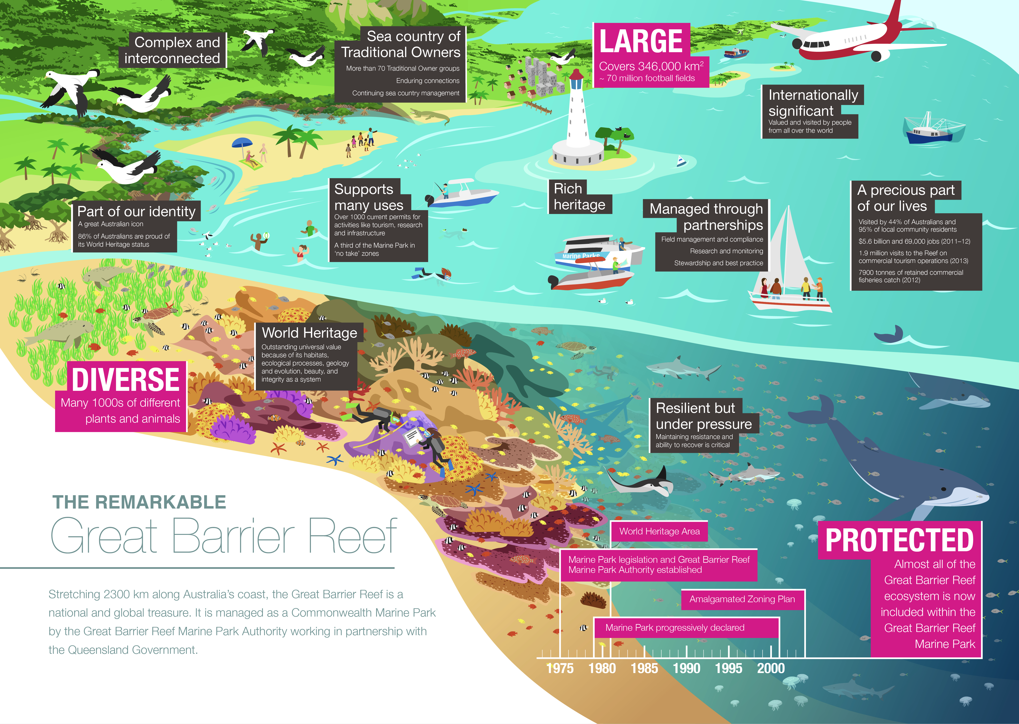

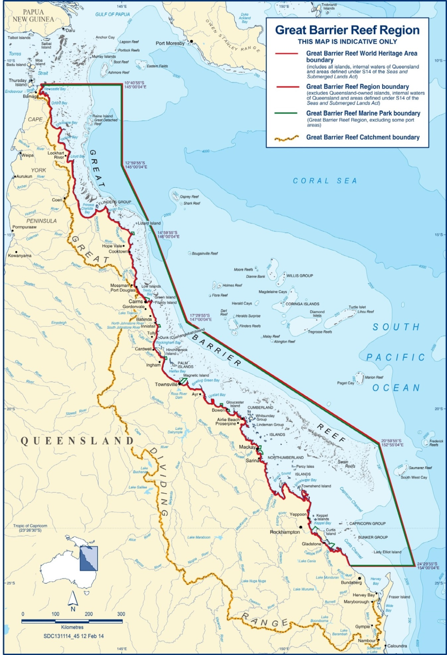
Figure 1.1 Great Barrier Reef Region

The Outlook Report is a report about the entire Great Barrier Reef Region.

Table 1.1 Differences between the Great Barrier Reef Region, World Heritage Area and Marine Park
Great Barrier Reef  Region | Great Barrier Reef  World Heritage Area | Great Barrier Reef  Marine Park
Established 1975 | Inscribed 1981 | Declared in sections between 1979 and 2001; amalgamated into one section in 2003
346,000 km² | 348,000 km² | 344,400 km²
Includes:  - approximately 70 Commonwealth islands  - all waters seaward of low water mark (excluding Queensland internal waters)  Does NOT include:  - internal waters of Queensland  - Queensland islands (about 980) | Includes:  - all islands within outer boundary (about 1050)  - all waters seaward of low water mark (including internal waters of Queensland and port waters)  - all 12 trading ports | Includes:  - approximately 70 Commonwealth islands  - all waters seaward of low water mark (excluding Queensland internal waters)  Does NOT include:  - internal waters of Queensland  - Queensland islands (about 980)  - 13 coastal exclusion areas

[START COLOURED BOX]
A place of outstanding universal value
The Great Barrier Reef is a world heritage area, comprising the Great Barrier Reef Region plus Queensland internal waters and islands within its boundaries. The property is recognised as having outstanding universal value: ‘natural significance which is so exceptional as to transcend national boundaries and to be of common importance for present and future generations of all humanity’.² Listing of the Great Barrier Reef is based on it having superlative natural phenomena and areas of exceptional natural beauty; it being an outstanding example of major stages in the Earth’s evolutionary history; it representing significant ongoing ecological and biological processes and Traditional Owners’ interaction with the natural environment; and it containing the most important and significant natural habitats for in situ conservation of biological diversity.
Almost all aspects of the Region’s environment contribute to its outstanding universal value (Appendix 3) and they are comprehensively considered throughout this report. A compiled assessment of the Region’s world heritage values is provided in Chapter 4.
As well as fulfilling the requirements of the Great Barrier Reef Marine Park Regulations, the assessments relating to world heritage values address a recommendation of the 2012 World Heritage Centre/IUCN Monitoring Mission³:
‘Include, in the future editions of the Outlook Report for the Great Barrier Reef, and commencing with the version to be published in 2014, a specific assessment on the condition, trends, threats and prospects for the Outstanding Universal Value of the Great Barrier Reef World Heritage Area. The assessment should be benchmarked at the date of inscription of the property in 1981, and its results should be reported to the World Heritage Committee for consideration at its 39th session in 2015’.
[Photograph of a coral reef and a scuba diver as seen from underwater. Copyright Matt Curnock. Caption: The Great Barrier Reef is valued worldwide]
[END COLOURED BOX]

Structure
Key message: Both ecosystem and heritage values of the Region are assessed.
This Outlook Report assesses the current condition of the Great Barrier Reef’s ecosystem and heritage values and their links with other environmental, social and economic values. It also examines pressures and current responses, and finally considers the likely outlook for the Region’s values. It is structured around the nine assessments required by the Act and Regulations, with each assessment forming a chapter of the report (Figure 1.2). The focus of the four chapters on the values of the Great Barrier Reef is their current state and trends. Likely future trends in those values and the factors influencing them are discussed in later chapters, such as those on the factors influencing the values, risks and outlook.
The findings of the Great Barrier Reef Outlook Report 2009¹ are summarised throughout the report. Excerpts of relevant summaries from the previous report are included at the beginning of each chapter and in association with assessment summaries at the end of the chapter.

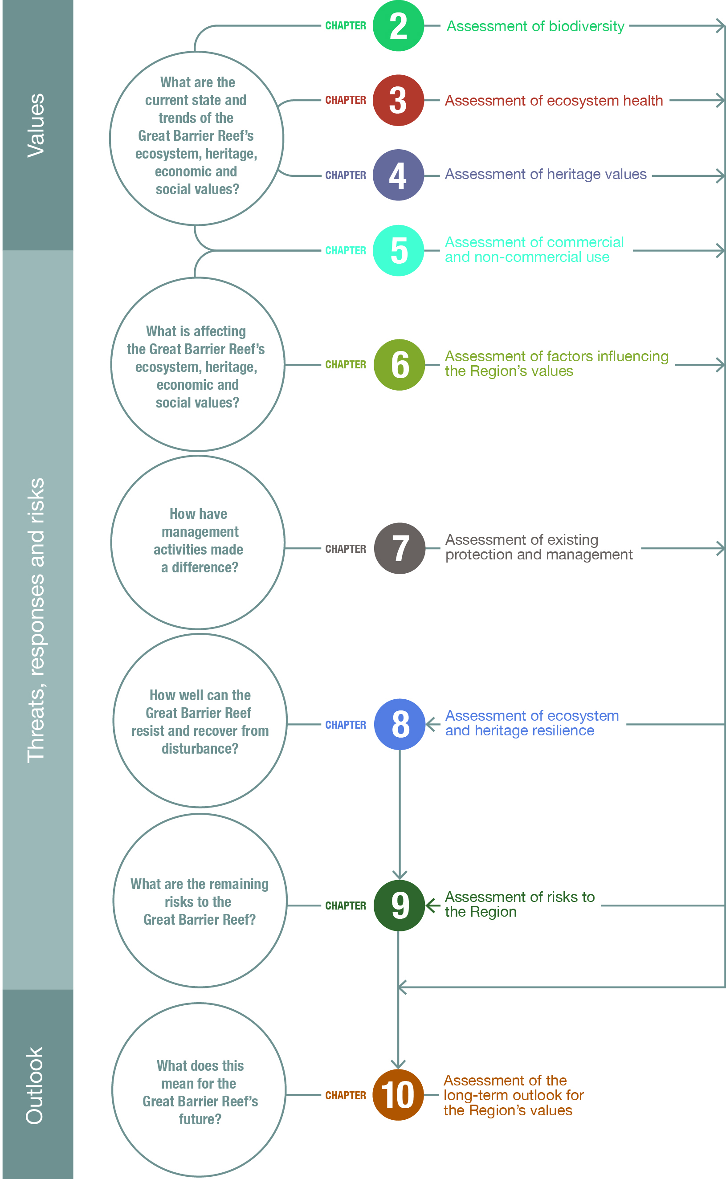
Figure 1.2 Assessments of the report

Each of the assessments required under the Great Barrier Reef Marine Park Act and Regulations forms a chapter of the report. The assessments relating to the Region’s ecosystem and its heritage values and those examining the threats, responses and risks inform an assessment of the likely outlook of the Great Barrier Reef.

Assessment approach
Key message: The required assessments are structured around assessment criteria.
For each of the assessments required under the Act and Regulations, a set of assessment criteria allow an ordered analysis of the available evidence (Figure 1.3). For example, the assessment of biodiversity uses two assessment criteria — habitats to support species and populations of species or groups of species.
Figure 1.3 Assessment approach

The required assessments are based on the best available evidence. The allocation of grades is standardised through reference to grading statements presented with each assessment summary.

Within each assessment criterion there are multiple assessment components. In some cases, adjustments have been made to assessment components since 2009. For example, in Chapter 3 the ecological process of recruitment has been added to the assessment, recognising the important role it plays in the maintenance and recovery of ecosystems. In Chapter 5 ‘Ports and shipping’ has been separated into two components, recognising the differences between the two uses, their management and impacts. These changes provide greater clarity and allow better assessment of the condition of values and benefits and impacts of activities.
To maintain the value of the Outlook Report as a time series, changes have been limited to instances where they significantly improve the validity or utility of the assessment. A list of key changes is provided in Appendix 2.
The outcomes for each criterion are provided in an assessment summary at the end of each chapter, along with an overall summary of the assessment findings.

Assessing heritage values
Key message: The assessment of heritage values is new; assessment approaches will continue to evolve.
Unlike the first Outlook Report, heritage values, both tangible and intangible, are explicitly considered throughout this report. Assessments of the current state, factors influencing, resilience of, risks to, and long-term outlook of the Region’s heritage values are provided. The approaches used are based on those developed for the Australia State of the Environment 2011⁴ and the 2013 draft Great Barrier Reef Region Strategic Assessment Report⁵and will undoubtedly be further refined over time. Likewise, as the amount of heritage information grows, so will the depth of the assessment and the degree of confidence in its findings.

Assessment grades
A series of statements standardise the allocation of grades for all components examined in an assessment, as well as the overall grade for the criterion. These statements are largely the same as for the Outlook Report 2009 — with a few amendments to improve clarity.
The grade allocated is a 'grade of best fit', based on a qualitative assessment of the available evidence for the Region. It is not a comparison of the Region in relation to other tropical ecosystems around the world.
The statements developed for assessing most heritage values are based on those used in the Australian state of the environment report⁴ and strategic assessment draft report⁵. Those for the assessment of world and national heritage values are adapted from a grading system developed by the International Union for Conservation of Nature to assess the outstanding universal value of natural world heritage sites.⁶ One aspect considered in grading the condition of heritage values is the degree to which those values have been recorded and identified. This recognises the important role an understanding of heritage plays in its protection.

Trend and confidence
Key message: Trend since 2009 and confidence are presented for most assessments.
The approach to grading is refined by including an indication of trend and confidence, similar to the Australian state of the environment report⁴ and the strategic assessment draft report⁵. Trend in each component is assessed in relation to the assessment in the previous Outlook Report, and therefore reflects change over the last five years. In the forward-looking assessments — those relating to the factors influencing the Region’s values, risks and outlook (Chapters 6, 9 and 10) — a future trend is also provided.
There are four categories for trend: improved, stable, deteriorated and no consistent trend. The category of ‘no consistent trend’ is applied to a component when the available information is too variable to establish a trend, for example where there is strong variation across broad areas or across species within a group. The terms ’improved’ and ‘deteriorated’ are replaced with ‘increased’ and ‘decreased’ in assessments of benefits, impacts, threats and risks (Chapters 5, 6 and 9).
Trends are not indicated for those components that were not assessed in the Outlook Report 2009, for example the heritage values of the Region (Chapter 4).
Similar to the Australian state of the environment report and the strategic assessment draft report, the level of confidence in each assessment of grade and trend is rated. The categories used are:
- adequate high quality evidence and high level of consensus
- limited evidence or limited consensus
- inferred, very limited evidence.
For components where the confidence level is ‘inferred, very limited evidence’, the assessment is based on knowledge from managing agencies, Traditional Owners, topic experts and informed stakeholders.
Confidence levels are not provided for the assessment of existing protection and management (Chapter 7).

Evidence used
Key message: The Outlook Report is based on the best available evidence.
This report contains brief background information on the Region, its ecosystem, heritage values, use and management and the key evidence for the assessments required under the Act and the Regulations.
The information featured in the report is only a small portion of all that is known about the Region. The evidence used is derived from existing research and information sources. It is drawn from the best available published science to the end of 2013 based on:
- relevance to the required assessments
- duration of study
- extent of area studied
- reliability (such as consistency of results across different sources, peer-review and rigour of study).
In some cases, new information that became available after 2013 has been included where it was considered to make a significant difference to a key finding of the report. For example, water quality data have been incorporated from the Great Barrier Reef Report Card 2012 and 2013⁷, released in June 2014. The sources of the evidence directly used in each chapter are cited at the end of that chapter. The web addresses provided were correct at the time of writing.
Despite the volume of information available, there remain many aspects of the Region, its values, uses and threats (in particular cumulative effects), about which little is known. Significant information gaps are noted in the text.

Terminology
In the various management, research and monitoring programs relevant to the Reef, there is no common way of dividing up the Region. Throughout this report, three areas are referred to: ‘northern’, ‘central’ and ‘southern’. These are broadly in keeping with the range of divisions used by managers and scientists. While the boundaries are not precisely defined, the northern area ranges from the tip of Cape York to about the latitude of Cooktown and Port Douglas, which marks the division between the developed and less-developed catchments adjacent to the Region. The central area extends from about Cooktown and Port Douglas to about the Whitsundays and the southern area is the area south of the Whitsundays. The term ‘southern two-thirds of the Region’ is often employed to describe the combined central and southern areas.
Some research and monitoring results reported specifically relate to a different set of sub-divisions for the Region, for example the natural resource management regions. Where possible, the area relevant to each set of evidence is mapped or described alongside the evidence.
Across the Region, the term ‘inshore’ is applied to areas within about 20 kilometres of the coast. It corresponds to enclosed coastal and open coastal water bodies described in the Water Quality Guidelines for the Great Barrier Reef Marine Park⁸ but also includes areas further offshore that are habitats for recognised inshore species such as dugongs. Areas beyond are generally referred to as ‘offshore’. For coral reefs, the term ‘outer shelf’ refers to those along the edge of the continental shelf and ‘mid-shelf’ refers to those between inshore areas and the outer barrier reefs.

[Photograph of coral reef from the air showing tourism pontoon and boats. Caption: The Region’s ecosystem and heritage values are considered, plus their links to economic and social values]

Developing the report
Key message: Producing an Outlook Report draws on the expertise and assistance of many people.
The report has been prepared by the Great Barrier Reef Marine Park Authority. A number of Australian and Queensland government agencies and researchers from a range of institutions directly contributed to its development.
The Great Barrier Reef Marine Park Authority’s 12 Local Marine Advisory Committees (committees based in regional centres along the coast); industry representatives; local government councils and schools participating in the Reef Guardian program; and other stakeholders supported the report’s preparation in various ways. In particular, advice provided during development of the draft Strategic Assessment Report⁵ and comments received on the draft report have subsequently informed this report.
The outcomes of a consensus workshop⁹ involving about 31 Reef scientists contributed to the assessments of biodiversity and ecosystem health. The outcomes also informed the assessment of risk. The consensus workshop was modelled on those similar workshops undertaken during development of the 2011 Australian state of the environment report¹⁰.
Four independent experts in protected area management, monitoring and evaluation, public policy and governance independently assessed the effectiveness of existing protection and management arrangements for the Region’s ecosystem and its heritage values. The assessment included identifying any gaps or deficiencies and a comparative analysis with the 2009 assessment. The assessors’ report¹¹ forms the basis of the assessment of existing measures to protect and manage the Region (Chapter 7).
Finally, four reviewers appointed by the Minister for the Environment independently reviewed the draft Outlook Report. These reviewers are recognised national and international experts with biophysical, heritage and/or socioeconomic expertise and achievements, including conducting high level policy and scientific reviews. Their comments were considered and incorporated where appropriate in finalising the report.

[START COLOURED BOX]
Comprehensive strategic assessment of the Great Barrier Reef World Heritage Area
Between 2012 and 2014, the Australian and Queensland governments undertook a comprehensive strategic assessment of the Great Barrier Reef World Heritage Area, comprising assessments for the Region⁵ and for the adjacent coastal zone¹². Undertaken under the Environment Protection and Biodiversity Conservation Act 1999 (Cth), the assessments aimed to improve management of existing and emerging risks to the Great Barrier Reef. They also form part of the Australian Government’s response to the World Heritage Committee’s concerns regarding development impacts on the World Heritage Area, originally raised at its meeting in June 2011.
The strategic assessment process had a different scope and purpose to the five-yearly Great Barrier Reef Outlook Report cycle. Both reports examine the condition, threats, management and likely future of the Great Barrier Reef. While the Outlook Report is a regular assessment of the Region’s ecosystem and its heritage values, the strategic assessment was a one-off report that focussed on all matters of national environmental significance relevant to the Region. It also makes recommendations for improvements to management. Matters of national environmental significance are Australia’s environmental assets. Those relevant to the Region are world heritage properties, the Great Barrier Reef Marine Park, national heritage places, Commonwealth marine areas, listed migratory and threatened species, and wetlands of international importance.
Because the values and attributes of the matters of national environmental significance are part of the Region’s ecosystem and its heritage values, this Outlook Report draws extensively on the information contained in the strategic assessment draft report and has been informed by the public submissions received on that draft.
[Photograph of front cover of Great Barrier Reef Region Strategic Assessment – Strategic Assessment Report, draft for public comment.
[END COLOURED BOX]

References
1. Great Barrier Reef Marine Park Authority 2009, Great Barrier Reef outlook report 2009, GBRMPA, Townsville.
2. UNESCO Intergovernmental Committee for the Protection of the World Cultural and Natural Heritage 2012, Operational guidelines for the implementation of the World Heritage Convention, UNESCO, Paris,.
3. UNESCO 2012, Mission report Great Barrier Reef, UNESCO, Paris.
4. State of the Environment 2011 Committee Australia state of the environment 2011: Independent report to the Australian Government Minister for Sustainability, Environment, Water, Population and Communities, Department of Sustainability, Environment, Water, Population and Communities, Canberra.
5. Great Barrier Reef Marine Park Authority 2013, Great Barrier Reef Region strategic assessment: Strategic Assessment Report. Draft for public comment, GBRMPA, Townsville.
6. International Union for the Conservation of Nature 2012, IUCN conservation outlook assessments: Guidelines for their application to natural world heritage sites, IUCN, Gland, Switzerland.
7. Reef Water Quality Protection Plan Secretariat 2014, Great Barrier Reef report card 2012 and 2013, Reef water quality protection plan. Report card key findings, Reef Water Quality Protection Plan Secretariat, Brisbane.
8. Great Barrier Reef Marine Park Authority 2010, Water quality guidelines for the Great Barrier Reef Marine Park, GBRMPA, Townsville.
9. Ward, T.J. 2014, The rapid assessment workshop to elicit expert consensus to inform the development of the Great Barrier Reef Outlook Report 2014, Great Barrier Reef Marine Park Authority, Townsville.
10. Ward, T., Dobbs, K., Harper, P., Harris, P., Hatton, T., Joy, R., Kanowski, P., Mackay, R., McKenzie, N. and Wienecke, B. 2014, Framing an independent, integrated and evidence-based evaluation of the state of Australia's biophysical and human environments, Journal of Environmental Planning and Management: 1-18.
11. Hockings, M., Leverington, A., Trinder, C. and Polglaze, J. 2014, Independent assessment of management effectiveness for the Great Barrier Reef Outlook Report 2014, Great Barrier Reef Marine Park Authority, Townsville.
12. Department of State Development, Infrastructure and Planning 2013, Great Barrier Reef coastal zone strategic assessment 2013: Strategic Assessment Report. Draft for consultation, DSDIP, Brisbane.

