
2016/17
MARINE MONITORING PROGRAM
Quality Assurance and Quality Control Manual
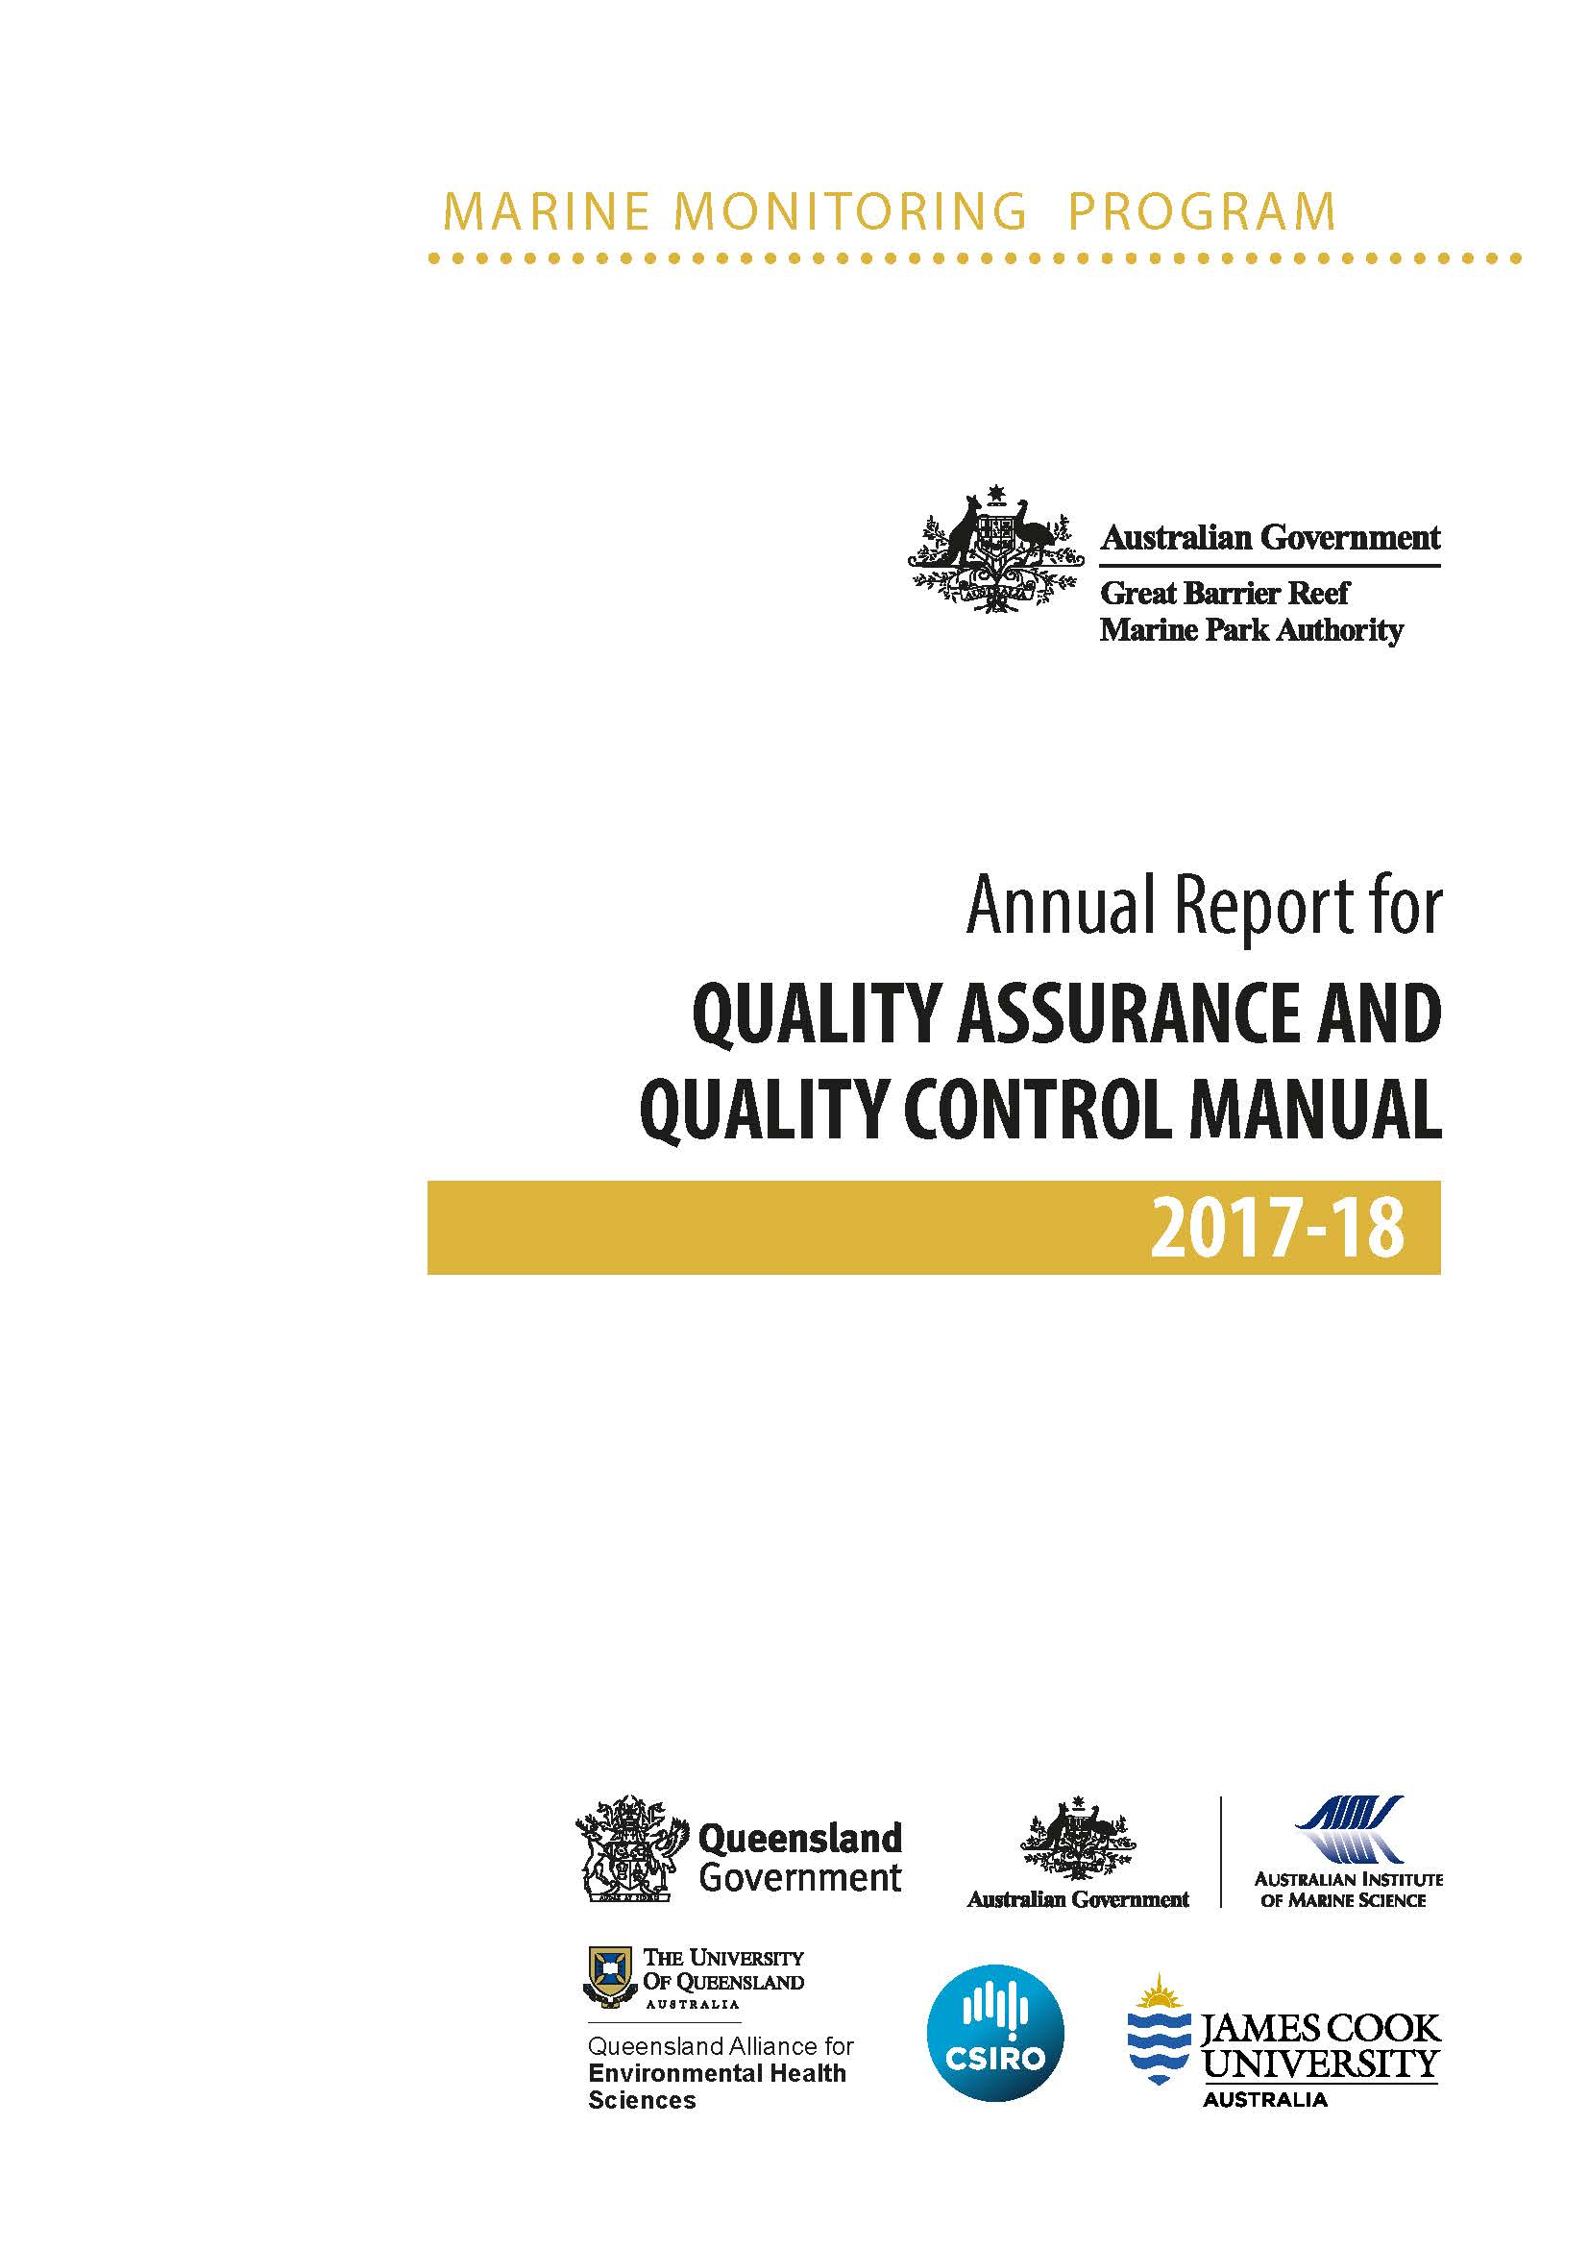
© Commonwealth of Australia (Great Barrier Reef Marine Park Authority) 2019
Published by the Great Barrier Reef Marine Park Authority
ISSN 2200-4084

This document is licensed by the Commonwealth of Australia for use under a Creative Commons By Attribution 4.0 International licence with the exception of the Coat of Arms of the Commonwealth of Australia, the logos of the Great Barrier Reef Marine Park Authority, Queensland Government, James Cook University, TropWater, University of Queensland and any other material protected by a trademark, content supplied by third parties and any photographs. For licence conditions see: http://creativecommons.org/licences/by/4.0


A catalogue record for this publication is available from the National Library of Australia

This publication should be cited as:
Great Barrier Reef Marine Park Authority 2019, Marine Monitoring Program quality assurance and quality control manual 2017–18, Great Barrier Reef Marine Park Authority, Townsville.

The Great Barrier Reef Marine Park Authority gratefully acknowledges the contributions of the Marine Monitoring Program providers and their institutions to this manual.

Front cover image: Clam Gardens in the Great Barrier Reef. Photo by Pete Niesen / ShutterStock
Comments and questions regarding this document are welcome and should be addressed to:

Great Barrier Reef Marine Park Authority
PO Box 1379
TOWNSVILLE QLD 4810
Australia
Phone: (07) 4750 0700
Email: info@gbrmpa.gov.au
www.gbrmpa.gov.au

MARINE MONITORING PROGRAM

Table of Contents
1 Introduction 4
1.1 Inshore marine water quality monitoring 5
1.2 Remote sensing of water quality 6
1.3 Pesticide monitoring 6
1.4 Inshore seagrass monitoring 7
1.5 Inshore coral monitoring 8
1.6 Synthesis of data and integration 8
1.7 Marine Monitoring Program quality assurance and quality control methods and procedures 9
2 Inshore marine water quality monitoring 11
2.1 Introduction 11
2.2 Methods 11
2.2.1 Sampling locations and frequency 11
2.2.2 Sample collection, preparation and analysis (JCU) 19
2.2.3 Sample collection, preparation and analysis (AIMS) 22
2.2.4 Autonomous environmental water quality loggers 24
2.2.5 Sample collection, preparation and analysis: wet season — event response (JCU) 26
2.3 Data management 27
2.4 Summary of Quality Control measures 29
2.5 Comparison of results obtained by AIMS and JCU 29
3 Remote sensing of the Reef water quality and river flood plumes 31
3.1 Introduction 31
3.2 Methods 31
3.2.1 MODIS satellite data 31
3.2.2 MODIS true colour monitoring products 32
3.3 Automated production and storage of the MODIS wet season water type maps 34
3.3.1 From raw data to true colour MODIS data 34
3.3.2 Maps of wet season water types and flood plumes 35
3.3.3 Derived monitoring products 36
3.4 Marine water quality metric 36
4 Pesticide monitoring 38
4.1 Introduction 38
4.2 Methods 39
4.2.1 Sampling design — Passive sampling for routine monitoring 39
4.2.2 Sampling design — Flood plume grab sampling 41
4.2.3 Target pesticides in the different passive samplers 41
4.2.4 Chemical analysis 43
4.2.5 Passive sampling techniques 45
4.2.6 Risk assessment metrics: 48
4.2.7 QA/QC procedures in the pesticide monitoring program 55
4.3 Data management and security 56
4.4 Summary 57
5 Inshore coral reef monitoring 58
5.1 Introduction 58
5.2 Methods 59
5.2.1 Sampling design 59
5.2.2 Site selection 60
5.2.3 Depth selection 63
5.2.4 Field survey methods 63
5.2.5 Observer training 65
5.2.6 Temperature monitoring 66
5.3 Data management 66
5.4 Summary of Quality Control measures 67
6 Inshore seagrass monitoring 68
6.1 Introduction 68
6.2 Methods 68
6.2.1 Sampling design 68
6.2.2 Field survey methods — Inshore seagrass meadow abundance, community structure and reproductive health 69
6.2.3 Observer training 75
6.2.4 Laboratory analysis — Inshore seagrass meadow abundance, community structure and reproductive health 75
6.2.5 Sampling design – Inshore seagrass meadow landscape/boundary mapping 77
6.2.6 Sampling design — Within seagrass canopy temperature loggers 78
6.2.7 Sampling design and logistics — Seagrass meadow canopy light loggers 79
6.2.8 Calibration procedures — Seagrass meadow canopy light loggers 81
6.3 Data management 82
6.3.1 Inshore seagrass meadow abundance, community structure and reproductive health 82
6.3.2 Inshore seagrass meadow boundary mapping 82
6.3.3 Within seagrass canopy temperature loggers 83
6.3.4 Seagrass meadow canopy light loggers 83
6.4 Summary of Quality Control measures 83
6.4.1 Inshore seagrass meadow abundance, community structure and reproductive health 83
6.4.2 Inshore seagrass meadow boundary mapping 83
6.4.3 Within seagrass canopy temperature loggers 84
6.4.4 Seagrass meadow canopy light loggers 84
7 References 85
Appendix A Detailed AIMS Manuals and Standard Operational Procedures 91
Section A1: Operating instructions for the AIMS Sea-Bird CTD 2
Section A2: Salinity measurements using Guildline Portasal Salinometer Model 8410A 7
Section A3: Automated analysis of dissolved nutrients in seawater 14
Section A4: Ship board ammonium analysis using the OPA method 22
Section A5: Analysis of dissolved organic carbon 38
Section A6: Analysis of Chromophoric Dissolved Ocean Matter (CDOM) in marine waters 44
Section A7: Analysis of particulate phosphorus in marine waters 48
Section A8: Analysis of particulate organic carbon and particulate nitrogen in marine waters 57
Section A9: Analysis of chlorophyll a in marine waters 67
Section A10: Determination of total suspended solids in marine waters 81
Section A11: AIMS In-house procedures for WET Labs FLNTUSB ECO logger 89
Section A12: AIMS Data Management Procedures for the Marine Monitoring Program 174
Appendix B James Cook University TropWater Appendices 182
Appendix B1 TropWater Water Sampling Procedures 174
Appendix B2 TropWater Water Sampling Field Sheet - Example 178
Appendix B3 Metadata for flood plume data entered into TropWater flood database 180
Appendix B4 TropWater Water Sampling Input Sheet 197
Appendix B5 TropWater Auto-analysis methods: Nitrogen – Ammonia 199
Appendix B6 TropWater Auto-analysis methods: Phosphorus (Filterable Reactive) 217
Appendix B7 TropWater Auto-analysis methods: Nitrate and Nitrite 234
Appendix B8 TropWater Auto-analysis methods: Nitrogen – Total Alkaline Persulfate 252
Appendix B9 TropWater Auto-analysis methods: Phosphorus – Total Alkaline Persulfate 272
Appendix B10 TropWater Auto-analysis methods: Chlorophyll 290
Appendix B11 TropWater Auto-analysis methods: Total Suspended Solids 298
Appendix B12 TropWater Auto-analysis methods: Colored Dissolved Organic Matter 305
Appendix B13 TropWater methods: Laboratory Salinity 307

List of figures
Figure 2-1 MMP water quality sampling sites in the Cape York region shown with water body boundaries. 16
Figure 2-2 MMP water quality sampling sites in the Wet Tropics region including the Barron Daintree, Russell-Mulgrave and Tully focus areas, shown with water body boundaries. 17
Figure 2-3 Sampling MMP sampling sites in the Burdekin focus area, shown with the water body boundaries. 18
Figure 2-4 Sampling locations under the MMP inshore marine water quality task for the Mackay- Whitsunday regions. 18
Figure 2-5 Correlation between instrument readings of turbidity (NTU) from field deployments of WET Labs Eco FLNTUSB loggers with values from concurrently-collected total suspended solids (TSS) samples. 26
Figure 2-6 Flow chart outlining the JCU procedures and QA/QC measures once samples have been collected in the field. 28
Figure 2-7 Relationships between (a) salinity, (b) total suspended solids, (c) chlorophyll a, (d) silicate, (e) nitrate and (f) phosphate (DIP or FRP) measured by AIMS (x-axis) and JCU (y-axis). Solid lines represent a linear regression 30
Figure 3-1 Summary description of the wet season water quality products from remote sensing information (modified from Devlin et al., 2015). 32
Figure 4-1 Locations of the 11 inshore reef routine monitoring sites where time-integrated sampling of pesticides have occurred from the 2014 monitoring year onwards. 39
Figure 4-2 An Empore Disk being loaded into the teflon Chemcatcher housing (LHS) and an assembled housing ready for deployment (RHS) 46
Figure 4-3 Passive flow monitors pre-deployment (left-hand side) and post-deployment (right-hand side) 46
Figure 4-4 Relationship between flow and sampling rates of specific herbicides indicating a shift from aqueous boundary layer control to diffusion limiting membrane control under higher flow conditions 47
Figure 4-5 Overview of approach to determine a multi-substance species sensitivity distribution for a mixture of herbicides with the same mode of action (concentration additive model). 50
Figure 4-6 PDMS passive samplers loaded onto stainless steel sampler supports that sits within the deployment cage and is sealed in place with wing nuts 53
Figure 4-7 PDMS and semipermeable membrane devices sampling rates (Rs) as a function of water velocity (rPFM) 54
Figure 4-8 A schematic for the deployment of passive samplers (Empore disc in Chemcatcher housings, and Polydimethylsiloxane cages) together with the passive flow monitors for in situ calibration of flow effects in the field. 55
Figure 5-1 Sampling design for coral reef benthic community monitoring. Terms within brackets are nested within the term appearing 60
Figure 5-2 Coral community sampling locations as at 2015 61
Figure 6-1 Inshore seagrass monitoring sites 70
Figure 6-2 Form and size of reproductive structure of the seagrasses collected: Halophila ovalis, Halodule uninervis and Zostera muelleri subsp. capricorni 76

List of tables
Table 1.1. Current monitoring themes, sub-programs and monitoring providers 4
Table 2.1 Great Barrier Reef inshore water quality monitoring locations by NRM regions. Monitoring is a collaborative effort between JCU and AIMS. 13
Table 2.2 Summary of sampling protocols with identification of post-sampling procedures needed, laboratory containers required and storage techniques. 20
Table 3.1 MODIS monitoring products. 33
Table 3.2 Keywords and justification used in SeaDAS 7.4 to process MODIS true colour images of the Great Barrier Reef. 35
Table 4.1 Types of passive sampling conducted at each of the routine monitoring sites in 2017–2018 during either the dry (May–October) or wet (November–April) periods 40
Table 4.2 Pesticides for analysis in different passive sampler extracts and water samples together with the approximate instrument limits of detection and limits of reporting for these analytes. 42
Table 4.3 Interim risk classes used for 2014–15 and 2015–16 reporting years for the ms-PAF method. 51
Table 5.1 Sites selected for inshore reef monitoring 62
Table 5.2 Distribution of sampling effort 63
Table 5.3 Observer training methods and quality measures 65
Table 6.1 Inshore seagrass long-term monitoring sites 71
Table 6.2 Extra inshore seagrass long-term monitoring sites from the Seagrass-Watch and Queensland Parks and Wildlife drop-camera programs 73
Table 6.3 Monitoring sites selected for light logger data collection 80

List of acronyms
AIMS Australian Institute of Marine Science
Authority Great Barrier Reef Marine Park Authority
ANZECC………. Australian and New Zealand Environment and Conservation Council
ARMCANZ……. Agriculture and Resource Management Council of Australia and New Zealand
CDOM Colored dissolved organic matter
Chl-a Chlorophyll a concentration
CSIRO Commonwealth Scientific and Industrial Research Organisation
CTD Conductivity Temperature Depth profiler
DIN Dissolved inorganic nitrogen concentration
DIP Dissolved inorganic phosphorus concentration
DON Dissolved organic nitrogen concentration
DOP Dissolved organic phosphorus concentration
ED Empore disk
GC Gas chromatography
GPC Gel permeation chromatography
HCl Hydrochloric acid
HPLC High-performance liquid chromatography
JCU James Cook University
LC-MS Liquid chromatography-mass spectrometry
MMP Marine Monitoring Program
MODIS Moderate-resolution imaging spectroradiometer
MS Mass spectrometry
MTSRF Marine and Tropical Sciences Research Facility
NASA National Aeronautics and Space Administration
NATA National Association of Testing Authorities
NH₄⁺ Ammonium concentration
NH₃ Ammonia concentration
NO₂ Nitrite concentration
NO₃ Nitrate concentration
NO_{x} Nitrate/nitrite (NO₃ + NO₂) concentration
NRM Natural resource management
PAH Polyaromatic hydrocarbons
PDMS Polydimethylsiloxane
PN Particulate nitrogen concentration
PP Particulate phosphorus concentration
PRC Performance reference compounds
QA Quality assurance
QAEHS Queensland Alliance for Environmental Health Sciences
QC Quality control
QHFSS Queensland Health Forensic & Scientific Service
Si(OH)₄ Silicate concentration
SOPs Standard operating procedures
SPMD Semipermeable membrane devices
TDN Total dissolved nitrogen concentration
TDP Total dissolved phosphorus concentration
TN Total nitrogen concentration
TP Total phosphorus concentration
TropWATER Centre for Tropical Water and Aquatic Ecosystem Research
TSS Total suspended solids concentration
UQ University of Queensland

Introduction
This manual describes the quality assurance and quality control (QA/QC) processes undertaken as part of the Marine Monitoring Program (MMP) activities associated with the annual technical reports for the 2017–18 monitoring year.
The MMP is a collaborative effort that relies on effective partnerships between governments, industry, community, scientists and managers. A conceptual model was used to identify indicators linking water quality and ecosystem health which were refined in consultation with monitoring providers and independent experts. The Great Barrier Reef Marine Park Authority (the Marine Park Authority) is responsible for the management of the MMP in partnership with monitoring providers including:
- Australian Institute of Marine Science (AIMS)
- James Cook University (JCU)
- University of Queensland (UQ)
- Howley Environmental Consulting
The monitoring providers work together to deliver the sub-programs of the MMP which monitor the inshore marine environment including water quality, seagrass and coral. The broad objectives of this monitoring includes:
- Inshore marine water quality monitoring: To assess temporal and spatial trends in marine water quality in inshore areas of the Reef lagoon in both ambient and wet season flood events.
- Inshore seagrass monitoring: To quantify temporal and spatial variation in the status of intertidal and subtidal seagrass meadows in relation to local water quality changes.
- Inshore coral reef monitoring: To quantify temporal and spatial variation in the status of inshore coral reef communities in relation to local water quality changes.
Each monitoring provider has a different responsibility in the delivery of the sub-programs that make up the monitoring sub-programs of the MMP (Table 1.1) including a description of the process for calculating Reef Plan Report Card scores.
Table 1.1. Current monitoring themes, sub-programs and monitoring providers
Monitoring sub-program | Component project(s) | Monitoring provider
Inshore marine water quality | Ambient water quality monitoring | AIMS, JCU and Howley Environmental Consulting
Inshore marine water quality | Pesticide monitoring | UQ
Inshore marine water quality | Wet season monitoring | JCU
Inshore marine water quality | eReefs biogeochemical model and satellite images | Not managed by the Authority
Inshore seagrass condition | Inshore seagrass monitoring | JCU
Inshore coral reef condition | Inshore coral monitoring | AIMS

Inshore marine water quality monitoring
Long-term in situ monitoring of spatial and temporal trends in the inshore water quality of the Reef lagoon is essential to assess improvements in regional water quality that will occur as a result of reductions in pollutant loads from adjacent catchments. In addition, understanding what is delivered by flood waters is essential to quantify the exposure of inshore ecosystems to these pollutants.
The MMP water quality design was revised in 2014 and is now closely aligned with the Driver, Pressure, State, Impact, and Response (DPSIR) framework. The revised design supports closer integration between MMP components, leading to outputs that are expected to meet the stakeholder needs, including:
- a robust data foundation and continuous improvement of all reporting metrics (those in the Great Barrier Reef Report Card Tier 1 and 2 reports)
- improved reporting of pressure indicators via models of exposure that link marine water quality to end-of-catchment loads (water quality as a state)
- a robust data foundation for detecting, attributing and interpreting relationships between water quality and coral reef and seagrass condition (water quality as a pressure)
- ongoing validation of the eReefs model to allow for more confident predictions of water quality in areas that are not monitored.
In 2015, a new sampling design for the inshore water quality monitoring program was implemented based on recommendations from a statistical review (Kuhnert et al., 2015). The redesign was intended to increase the detection of links between end-of-catchment loads and marine water quality through higher frequency sampling at a larger number of sites in the focus area. The design focused on four areas — the Russell-Mulgrave, Tully, Burdekin Rivers, and the Mackay Whitsunday region. Extra reporting for the Barron-Daintree sub-region of the Wet Tropics was also included due to the continued collection of data along the long-term ‘Cairns transect’ where sampling started in 1989. In 2016–17, four transects were added in the Cape York region relevant to the Pascoe, Normanby-Kennedy, Annan-Endeavour and Stewart Rivers. These transects are monitored by the Cape York Water Monitoring Partnership coordinated by Howley Environmental Consulting.
The sites in each focus area are located to capture water masses along cross-shelf and alongshore gradients. The site selection in the focus areas was informed by the plume frequency model (Petus, da Silva, et al., 2014) and the river tracer model (Brinkman et al., 2014).
Monitoring includes measurement of dissolved and particulate nutrients (nitrogen and phosphorus) and carbon, total suspended solids (TSS), chlorophyll a (Chl-a), silica, salinity, turbidity, colored dissolved organic matter (CDOM) and temperature. Additionally, during flood events samples for pesticides are collected.

Techniques used are a combination of:
- continuous measurement of salinity and temperature at eight stations
- continuous measurement of Chl-a and turbidity at 15 stations
- fifty-eight stations sampled during the year with more frequent sampling during the wet season
- a total of seventy-seven stations sampled during high flow conditions (flood response) including twenty-seven stations in addition to the routine stations.
Wet season water quality conditions and the movement of flood plumes is assessed using images from remote sensing (moderate-resolution imaging spectroradiometer, MODIS) imagery (see Chapter 3).
Other techniques may be considered over the duration of the program, depending on relevance, feasibility and funding.

Remote sensing of water quality
The use of remotely-sensed data in combination with in situ water quality measurements provides a powerful source of data in the assessment of water quality across the Reef. Remote sensing studies using derived water quality level-2 products and quasi-true colour (hereafter true colour) satellite images have been used to map and characterise the spatial and temporal distribution of river plumes and understand the impact of these river plumes on Reef ecosystems.
To define and map wet season conditions, and the movement, composition and frequency of occurrence of wet season water quality conditions across the Reef, current remote sensing methods based on the extraction and analysis of MODIS true colour data have been tested and are described more fully in Chapter 3.
To illustrate wet season marine conditions and identify where seagrass and coral reefs may be at risk, several satellite-derived products from MODIS satellite imagery are produced. These include weekly panel maps of environmental and marine wet season conditions, frequency maps of occurrence of wet season water types and exposure maps, as well as the extraction of the area (km²) and percentage (%) of coral reefs and seagrass meadows affected by different categories of exposure (or potential risk).
A more detailed description of methodologies is provided in Chapter 3.

Pesticide monitoring
The off-site transport of pesticides from land-based applications has been considered a potential risk to the Reef. Of particular concern is the potential for compounding effects that these chemicals have on the health of the inshore reef ecosystem, especially when delivered with other water quality pollutants during flood events (this project is also linked to flood plume monitoring and the collection of water samples directly from research vessels, Section 2).
Passive samplers are used to measure the concentration of pesticides in the water column integrated over time by accumulating chemicals via passive diffusion . The monitoring of specific pesticides during flood events and throughout the year is essential to evaluate long-term trends in pesticide concentrations along inshore waters of the Reef. Key points include:
- pesticide concentrations are measured with passive samplers at selected sites (continuous sampling has occurred at 11 sites since 2014-15) at monthly intervals during the wet season and bi-monthly intervals during the dry season
- pesticide concentrations are assessed against relevant Guidelines (Australian and New Zealand Environment and Conservation Council (ANZECC) and Agriculture and Resource Management Council of Australia and New Zealand (ARMCANZ), 2000; Great Barrier Reef Marine Park Authority, 2010), note that new pesticide guideline values are currently being endorsed for incorporation into the ANZECC and ARMCANZ fresh and marine water guidelines and reported as categories of sub-lethal stress defined by the published literature and taking into account mixtures of herbicides that affect photosynthesis
- the continual refinement of techniques that allow a more sensitive, time-integrated and relevant approach for monitoring pollutant concentrations in the lagoon and assessment of potential effects that these pollutants may have on key biota.

Inshore seagrass monitoring
Seagrasses are an important component of the marine ecosystem of the Reef. They form highly productive habitats that provide nursery grounds for many marine and estuarine species. Monitoring temporal and spatial variation in the status of inshore seagrass meadows in relation to changes in local water quality is essential in evaluating long-term ecosystem health. The seagrass monitoring project is closely linked to the global Seagrass-Watch monitoring program (http://www.seagrasswatch.org/home.html).
Monitoring includes seagrass abundance (% cover) and species composition, macroalgal cover, epiphyte cover, canopy height, mapping of the meadow landscape (extent) and assessment of seagrass reproductive effort, which provide an indication of the capacity for meadows to regenerate following disturbances and changed environmental conditions. Tissue nutrient composition is assessed in the laboratory as an indicator of potential nutrient enrichment. Key points include:
- monitoring occurs at 47 sites across 23 locations, including 13 nearshore (estuarine, coastal and fringing reef) and nine offshore reef locations.
- monitoring is conducted during the late-dry season and post-wet season; extra sampling is conducted at more accessible locations in the dry and monsoon seasons
- monitoring includes in situ within canopy temperature and light levels
- data is also collected annually from an additional 16 sites across nine locations by Seagrass-Watch (intertidal) and Queensland Parks and Wildlife Service (QPWS; subtidal drop-camera) during the late-dry season.

Inshore coral monitoring
Coral reefs in inshore areas of the Reef are frequently exposed to run-off (Schaffelke et al., 2012). Monitoring temporal and spatial variation on the status of inshore coral reef communities in relation to changes in local water quality is essential in evaluating long-term ecosystem health.
Monitoring covers a comprehensive set of community attributes including the assessment of hard and soft coral cover, macroalgal cover, density of juvenile hard coral colonies, hard coral community composition and the rate of change in coral cover as an indication of the recovery potential of the reef following a disturbance (A. A. Thompson & Dolman, 2010). In addition, the incidence of ongoing coral mortality is recorded and, where possible, attributed to the causative agent. Comprehensive water quality measurements are also collected at many of the coral reef sites (this project is linked to inshore water quality monitoring, Chapter 2). Key points include:
- reefs are monitored biennially at 31 inshore coral reefs in the Wet Tropics, Burdekin, Mackay Whitsunday and Fitzroy regions along gradients of exposure to run-off from regionally important rivers
- at each reef, two sites are monitored at two depths (two metres and five metres) across five replicate transects
- in addition to the monitoring of benthic community attributes, the measurement of sea temperature as an indicator of thermal stress is included.

Synthesis of data and integration
A comprehensive list of water quality and ecosystem health indicators are measured under the MMP and a sub-set of these are selected to calculate water quality, seagrass and coral scores for the Great Barrier Reef Report Card. These scores are expressed on a five-point scale using a common colour scheme and integrated into an overall score that describes the status of the Reef and each region, where scores of:
- 0–20 per cent are assessed as ‘very poor’ and coloured red
- 21–40 per cent equates to ‘poor’ and coloured orange
- 41–60 per cent equates to ‘moderate’ and coloured yellow
- 61–80 per cent equates to ‘good’, and coloured light green
- ≥81 per cent are assessed as ‘very good’ and coloured dark green.
More detailed information on the methods is available from https://www.reefplan.qld.gov.au/measuring-success/methods/.

Marine Monitoring Program quality assurance and quality control methods and procedures
Appropriate QA/QC procedures are an integral component of all aspects of sample collection and analysis. These QA/QC procedures have been approved by an expert panel convened by the Authority. The Authority set the following guidelines for implementation by MMP program leaders:
- Appropriate methods must be in place to make sure of consistency of in-field procedures to produce robust, repeatable and comparable results, including consideration of sampling locations, replication and frequency.
- All methods used must be fit for purpose and suited to a range of conditions.
- Appropriate accreditation of participating laboratories or provision of standard laboratory protocols to demonstrate that appropriate laboratory QA/QC procedures are in place for sample handling and analysis.
- Participation in inter-laboratory performance testing trials and regular exchange of replicate samples between laboratories.
- Rigorous procedures to guarantee ‘chain of custody’ and tracking of samples.
- Appropriate standards and procedures for data management and storage.
In addition to the QA/QC procedures outlined above, the MMP employs a proactive approach to monitoring through the continual development of new methods and the refinement of existing methods, such as the:
- operation and validation of autonomous environmental loggers
- validation of algorithms used for the remote sensing of water quality
- improvement of passive sampling techniques for pesticides
- introduction of extra monitoring sub-programs to evaluate the condition of inshore reefs, specifically coral recruitment.
The monitoring providers for the MMP have a long-standing culture of QA/QC in their monitoring activities. Common elements across the providers include:
- ongoing training of staff (and other sampling providers) in relevant procedures
- standard operating procedures (SOPs), both for field sampling and analytical procedures
- use of standard methods (or development of modifications)
- publishing of methods and results in peer-reviewed publications
- maintenance of equipment
- calibration procedures including participation in regular inter-laboratory comparisons
- established sample custody procedures
- QC checks for individual sampling regimes and analytical protocols
- procedures for data entry, storage, validation and reporting.
This manual summarises the monitoring methods and procedures for each project. Detailed sampling manuals, SOPs, analytical procedures and other details are provided as appendices.

Inshore marine water quality monitoring
Jane Waterhouse¹, Renee Gruber², Britta Schaffelke², Stephen Lewis¹, Caroline Petus¹, Christina Howley³, Michele Skuza², Dieter Tracey¹, Irena Zagorskis², and Murray Logan²
¹James Cook University, ²Australian Institute of Marine Science, ³Howley Environmental Consulting

Introduction
The aim of water quality monitoring is to assess the concentrations and transport of terrestrially derived components, with a focus on the movement of TSS, Chl-a and particulate and dissolved nutrients into the Reef. Current sampling methods include discrete water profile sampling combined with analysis of remote sensing imagery (MODIS) as a tool for qualitatively assessing flood plume extent within the Reef. The MMP inshore water quality monitoring program informs the Paddock to Reef program by:
- Describing spatial patterns and temporal trends in inshore concentrations of sediment, Chl-a, nutrients and pesticides, as assessed against the Guidelines (or other water quality guidelines if appropriate).
- Determining local water quality by autonomous instruments for high-frequency measurements at selected inshore locations.
- Determining the fine scale water quality depth profiles by deploying continuous monitoring equipment along transects in key areas (note, only from 2015–16).
- Determining the three dimensional extent and duration of flood plumes and link concentrations of suspended sediment, nutrients and pesticides to end-of-catchment loads.
- Calculating the marine water quality index and site-specific metrics for nutrients, turbidity and suspended solids.
- Determining trends in turbidity and light attenuation for key Reef inshore habitats against established thresholds and/or guidelines.
- Establishing the extent, frequency and intensity of impacts on Reef inshore seagrass meadows and coral reefs from flood plumes and the link to end-of-catchment loads.

Methods
This Section provides an overview of sample collection and preparation, and analyses the analytical methods used.

Sampling locations and frequency
The current design of the joint AIMS and TropWATER sampling program comprises 58 fixed sampling sites during the year, with more frequent sampling during the wet season (77 sites in total which includes 27 additional stations to the routine/fixed sites), across the focus areas in four NRM regions: Cape York —Pascoe, Normanby-Kennedy, Annan-Endeavour and Stewart Rivers; Wet Tropics — Barron-Daintree (Cairns transect), Russell-Mulgrave and Tully; Burdekin and Mackay Whitsunday. These include the original 14 ‘core’ sites of the inshore coral reef monitoring and key sites under the wet season monitoring (Table 2.1 and Figure 2-4). At these sites, detailed manual and instrumental water sampling is undertaken.

Table 2.1 Great Barrier Reef inshore water quality monitoring locations by NRM regions. Monitoring is a collaborative effort between JCU and AIMS.
Site Location |  |  |  | Logger Deployment |  | Routine grab samples at fixed sites |  | Reactive flood plume sampling
NRM Region | Site Code | Longitude | Latitude | Turbidity and chlorophyll | Salinity | Number of times site is visited/year by AIMS | Number of times site is visited/year by JCU | Additional surface-sampling/year by JCU
CAPE YORK |  |  |  |  |  | 0
Normanby-Kennedy transect |  |  |  |  |  |  |  | Up to 30 surface samples
Kennedy mouth | KR-01 | 143.972517 | 14.47245 |  |  |  | 4 (Surface sample only)
Kennedy inshore | KR-02 | 143.951246 | 14.424446 |  |  |  | 4 (Sampling 2 depths)
Cliff Islands | CL-01 | 143.786414 | 14.24359 |  |  |  | 4 (Sampling 2 depths)
Bizant River mouth | BR-01 | 144.024967 | 14.464033 |  |  |  | 4 (Surface sample only)
Normanby River mouth | NR-01 | 144.143433 | 14.394617 |  |  |  | 4 (Surface sample only)
Normanby inshore | NR-02 | 144.115917 | 14.375583 |  |  |  | 4 (Sampling 2 depths)
NR-03 | NR-03 | 144.090017 | 14.307367 |  |  |  | 4 (Sampling 2 depths)
NR-04 | NR-04 | 144.06859 | 14.23984 |  |  |  | 4 (Sampling 2 depths)
NR-05 | NR-05 | 144.04871 | 14.16915 |  |  |  | 4 (Sampling 2 depths)
Corbett Reef | NR-06 | 144.02425 | 14.094567 |  |  |  | 4 (Sampling 2 depths)
Pascoe transect |  |  |  |  |  |  |  | Up to 30 surface samples
Pascoe mouth | PR MOUTH S | 143.28021° | 12.49951° |  |  |  | 5 (Surface sample only)
Pascoe mouth | PR MOUTH N | 143.280833° | 12.4891° |  |  |  | 5 (Surface sample only)
PR-North 02 | PR N02 | 143.28374° | 12.46248° |  |  |  | 5 (Sampling 2 depths)
PR-North 03 | PR N03 | 143.31882° | 12.43559° |  |  |  | 5 (Sampling 2 depths)
PR-North 04 | PR N04 | 143.36966° | 12.38572° |  |  |  | 5 (Sampling 2 depths)
Eel Reef | PR N04 | 143.35854° | 12.41206° |  |  |  | 5 (Sampling 2 depths)
Middle Reef | PR BB | 143.37093° | 12.51114° |  |  |  | 5 (Sampling 2 depths)
Annan-Endeavour transect
Annan mouth | AR-01 | 145.27754° | 15.52458° |  |  |  | 5 (Surface sample only)
Walker Bay | AR-02 | 145.29223° | 15.50526° |  |  |  | 5 (Sampling 2 depths)
Dawson Reef | AR-03 | 145.32498° | 15.48301° |  |  |  | 5 (Sampling 2 depths)
Endeavour mouth | ER-01 | 145.25027° | 15.45740° |  |  |  | 5 (Surface sample only)
Endeavour north shore | ER-02 | 145.26870° | 15.43170° |  |  |  | 5 (Sampling 2 depths)
Endeavour offshore | ER-03 | 145.31630° | 15.41452° |  |  |  | 5 (Sampling 2 depths)
Egret and Boulder Reef | AE-04 | 145.40010° | 15.44250° |  |  |  | 5 (Sampling 2 depths)
Big Unchartered Reef | AE-05 | 145.46243° | 15.38362° |  |  |  | only during large flood events
Stewart transect |  |  |  |  |  |  |  | Up to 30 surface samples
Stewart mouth | SR-01 | 143.70085° | 14.06023° |  |  |  | 5 (Surface sample only)
S2 | SR-02 | 143.69950° | 14.04495° |  |  |  | 5 (Sampling 2 depths)
S3 | SR-03 | 143.71665° | 13.98672° |  |  |  | 5 (Sampling 2 depths)
Burkitt Island | SR-04 | 143.73053° | 13.92650° |  |  |  | 5 (Sampling 2 depths)
Hannah Island | SR-05 | 143.72287° | 13.88200° |  |  |  | 5 (Sampling 2 depths)
Site Location |  |  |  | Logger Deployment |  | Routine grab samples at fixed sites |  | Reactive flood plume sampling
NRM Region | Site Code | Longitude | Latitude | Turbidity and chlorophyll | Salinity | Number of times site is visited/year by AIMS | Number of times site is visited/year by JCU | Additional surface-sampling/year by JCU
WET TROPICS
Cairns Transect |  |  |  |  |  |  | 0
Cape Tribulation | C1 | 145.484 | -16.113 |  |  | 3 (Sampling 2 depths)
Port Douglas | C4 | 145.509 | -16.411 |  |  | 3 (Sampling 2 depths)
Double Island | C5 | 145.704 | -16.664 |  |  | 3 (Sampling 2 depths)
Yorkey's Knob | C6 | 145.748 | -16.788 |  |  | 3 (Sampling 2 depths)
Fairlead Buoy | C8 | 145.837 | -16.848 |  |  | 3 (Sampling 2 depths)
Green Island | C11 | 145.955 | -16.774 |  |  | 3 (Sampling 2 depths)
Russell-Mulgrave focus area |  |  |  |  |  |  |  | Up to 50 surface samples
Fitzroy Island West | RM1 | 145.996 | -16.923 | √ |  | 5 (Sampling 2 depths)
RM2 | RM2 | 146.01 | -17.042 |  |  |  |  | Surface sampling only
RM3 | RM3 | 145.994 | -17.07 |  |  | 5 (Sampling 2 depths) | 6 (Sampling 2 depths)
RM4 | RM4 | 145.991 | -17.112 |  |  |  |  | Surface sampling only
High Island East | RM5 | 146.022 | -17.159 |  |  |  |  | Surface sampling only
Normanby Island | RM6 | 146.052 | -17.191 |  |  |  |  | Surface sampling only
Frankland Group West (Russell Island) | RM7 | 146.09 | -17.227 | √ |  | 5 (Sampling 2 depths) | 6 (Sampling 2 depths))
High Island West* | RM8 | 146.005 | -17.163 | √ | √ | 5 (Sampling 2 depths) | 6 (Sampling 2 depths)
Palmer Point | RM9 | 145.992 | -17.183 |  |  |  |  | Surface sampling only
Russell-Mulgrave River mouth mooring | RM10 | 145.978 | -17.203 | √ | √ | 5 (Sampling 2 depths) | 6 (Sampling 2 depths)
Russell-Mulgrave River mouth | RM11 | 145.969 | -17.223 |  |  |  |  | Surface sampling only
Russell-Mulgrave junction [River] | RM12 | 145.953 | -17.229 |  |  |  |  | Surface sampling only
Tully focus area |  |  |  |  |  |  |  | Up to 50 surface samples
King Reef | TUL1 | 146.143 | -17.751 |  |  |  |  | Surface sampling only
East Clump Point | TUL2 | 146.26 | -17.89 |  |  | 5 (Sampling 2 depths) | 6 (Sampling 2 depths)
Dunk Island North* | TUL3 | 146.146 | -17.926 | √ | √ | 5 (Sampling 2 depths) | 6 (Sampling 2 depths)
South Mission Beach | TUL4 | 146.104 | -17.931 |  |  |  |  | Surface sampling only
Dunk Island South East | TUL5 | 146.191 | -17.96 |  |  | 5 (Sampling 2 depths) | 6 (Sampling 2 depths)
Between Tam O'Shanter and Timana | TUL6 | 146.116 | -17.975 |  |  | 5 (Sampling 2 depths) | 6 (Sampling 2 depths)
Hull River mouth | TUL7 | 146.079 | -17.997 |  |  |  |  | Surface sampling only
Bedarra Island | TUL8 | 146.133 | -18.014 |  |  | 5 (Sampling 2 depths) | 6 (Sampling 2 depths)
Triplets | TUL9 | 146.187 | -18.056 |  |  |  |  | Surface sampling only
Tully River mouth mooring | TUL10 | 146.074 | -18.023 | √ | √ | 5 (Sampling 2 depths) | 6 (Sampling 2 depths)
Tully River | TUL11 | 146.045 | -18.02 |  |  |  |  | Surface sampling only

Site Location |  |  |  | Logger Deployment |  | Routine grab samples at fixed sites |  | Reactive flood plume sampling
NRM Region | Site Code | Longitude | Latitude | NRM Region | Turbidity and chlorophyll | Salinity | Number of times site is visited/year by AIMS | Number of times site is visited/year by JCU
BURDEKIN
Burdekin focus area |  |  |  |  |  |  |  | Up to 50 surface samples
Pelorus and Orpheus Island West | BUR1 | 146.489 | -18.541 | √ |  | 4 (Sampling 2 depths) | 5 (Sampling 2 depths)
Pandora Reef | BUR2 | 146.435 | -18.817 | √ |  | 4 (Sampling 2 depths) | 5 (Sampling 2 depths)
Cordelia Rocks | BUR3 | 146.708 | -18.998 |  |  |  |  | Surface sampling only
Magnetic Island (Geoffrey Bay) | BUR4 | 146.869 | -19.155 | √ |  | 4 (Sampling 2 depths) | 5 (Sampling 2 depths)
Inner Cleveland Bay | BUR5 | 146.853 | -19.233 |  |  |  |  | Surface sampling only
Cape Cleveland | BUR6 | 147.051 | -19.19 |  |  |  |  | Surface sampling only
Haughton 2 | BUR7 | 147.174 | -19.283 |  |  | 4 (Sampling 2 depths) | 5 (Sampling 2 depths)
Haughton River mouth | BUR8 | 147.141 | -19.367 |  |  |  |  | Surface sampling only
Barratta Creek* | BUR9 | 147.249 | -19.409 |  |  |  |  | Surface sampling only
Yongala IMOS NRS | BUR10 | 147.622 | -19.305 | √ | √ | 12 (Sampling 2 depths)
Cape Bowling Green | BUR11 | 147.488 | -19.367 |  |  |  |  | Surface sampling only
Plantation Creek | BUR12 | 147.603 | -19.506 |  |  |  |  | Surface sampling only
Burdekin River mouth mooring | BUR13 | 147.582 | -19.588 | √ | √ | 5 (Sampling 2 depths) | 5 (Sampling 2 depths)
Burdekin Mouth 2 | BUR14 | 147.597 | -19.637 |  |  |  |  | Surface sampling only
Burdekin Mouth 3 | BUR15 | 147.623 | -19.719 |  |  |  |  | Surface sampling only
MACKAY WHITSUNDAY
Whitsunday focus area |  |  |  |  |  |  |  | Up to 50 surface samples
Double Cone Island | WHI1 | 148.722 | -20.105 | √ |  | 5 (Sampling 2 depths)
Hook Island W | WHI2 | 148.876 | -20.16 |  |  |  |  | Surface sampling only
North Molle Island | WHI3 | 148.778 | -20.237 |  |  |  |  | Surface sampling only
Pine Island | WHI4 | 148.888 | -20.378 | √ |  | 5 (Sampling 2 depths)
Seaforth Island | WHI5 | 149.039 | -20.468 | √ |  | 5 (Sampling 2 depths)
OConnell River mouth | WHI6 | 148.71 | -20.578 |  |  | 5 (Sampling 2 depths)
Repulse Islands dive mooring | WHI7 | 148.861 | -20.578 | √ | √ | 5 (Sampling 2 depths)
Rabbit Island NE | WHI8 | 148.953 | -20.769 |  |  |  |  | Surface sampling only
Brampton Island | WHI9 | 149.244 | -20.799 |  |  |  |  | Surface sampling only
Sand Bay | WHI10 | 149.074 | -20.939 |  |  |  |  | Surface sampling only
Pioneer River mouth | WHI11 | 149.245 | -21.157 |  |  |  |  | Surface sampling only
* Indicates sites where pesticide passive samplers are deployed.

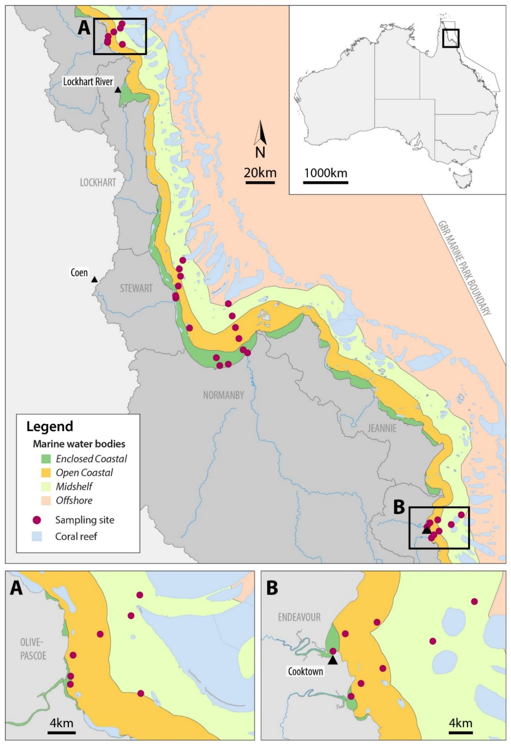
Figure 2-1 MMP water quality sampling sites in the Cape York region shown with water body boundaries.

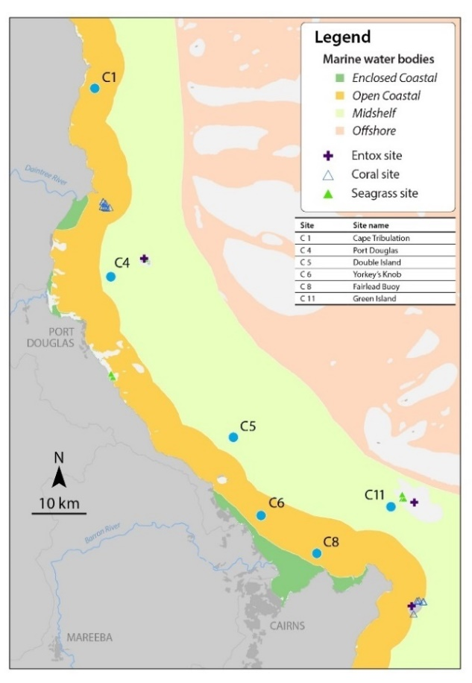 | 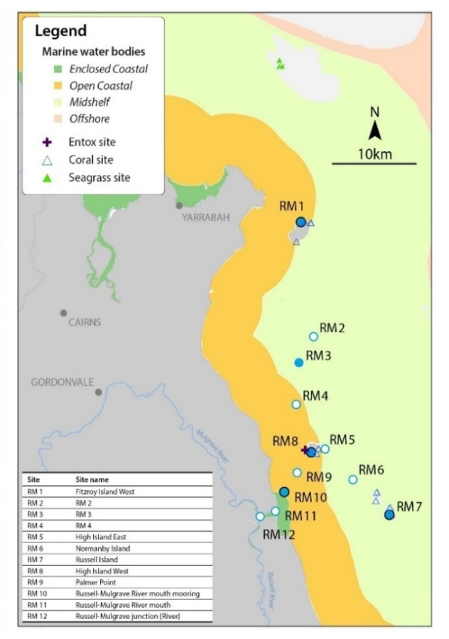
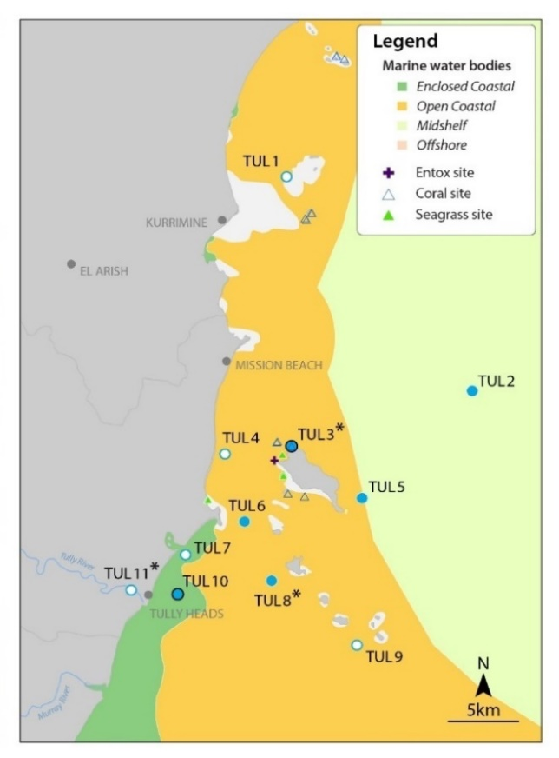
Figure 2-2 MMP water quality sampling sites in the Wet Tropics region including the Barron Daintree, Russell-Mulgrave and Tully focus areas, shown with water body boundaries.
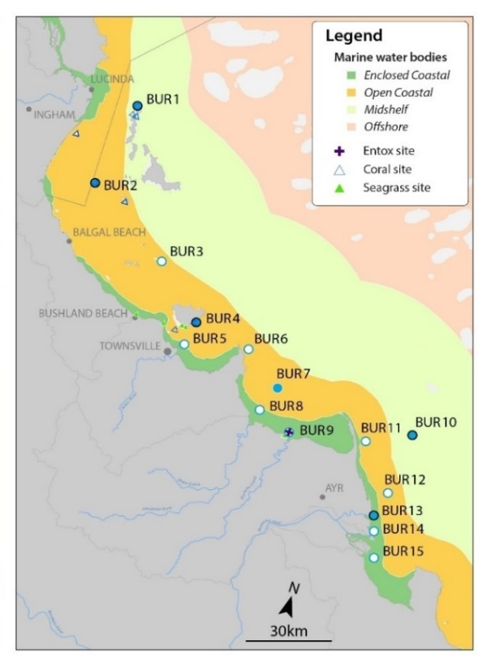
Figure 2-3 Sampling MMP sampling sites in the Burdekin focus area, shown with the water body boundaries.
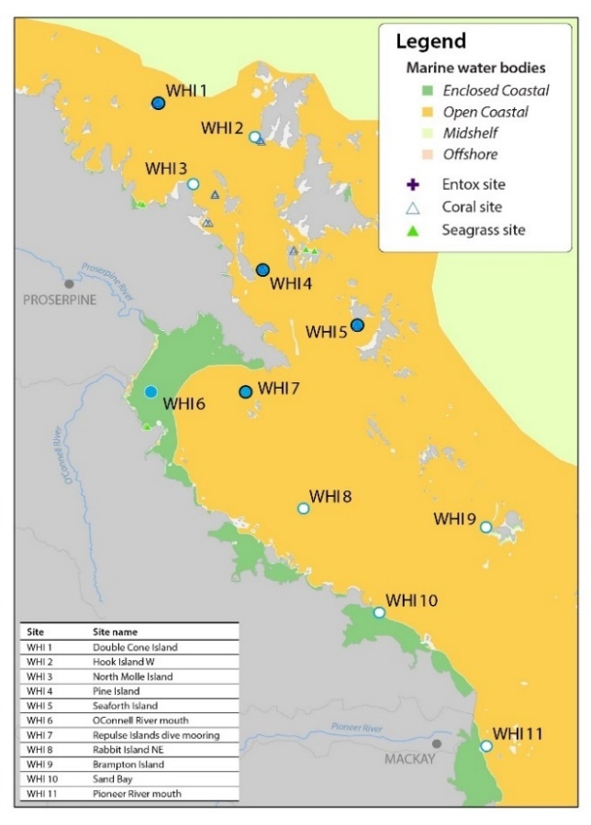
Figure 2-4 Sampling locations under the MMP inshore marine water quality task for the Mackay- Whitsunday regions.

Sample collection, preparation and analysis (JCU)
The guidelines for water quality sampling listed in this document are based on the protocols required by the TropWATER laboratory for the collection and storage of samples.
Staff must always be accompanied by at least one other person. Staff must have conducted a risk assessment of the sampling area incorporating current weather conditions and have an up-to-date emergency plan. Staff must be aware of the operational capabilities of the vessel and work through the safety protocols with the ship master. The following must also be observed:
- PVC disposable gloves must be worn by staff at all times during sample collection and manipulation. Before sampling, staff must clean their hands thoroughly with fresh water. Grease, oils, soap, fertilisers, sunscreen, hand creams and smoking can all contribute to contamination.
- The sampling bucket and boat bilge pump and rose must be well rinsed before sampling. Bottles must be rinsed if required by the TropWATER laboratory.
- The filling instructions (contained in the following sections) must be adhered to when filling containers.
- On each sampling run, the date, time and unique sample identification must be recorded on the field datasheet. Each sampling kit for each site contains sets of sampling bottles and vials with a unique ID number (convention is MMP-<sample number>).
- Any significant change of sampling conditions (i.e. weather and other factors which may influence the ability to collect samples) must be noted in the comments section of the record sheet.
- If possible, a few photographs at each sampling site should be taken.
At each sampling station in the Wet Tropics, Burdekin and Mackay Whitsunday regions, vertical profiles of water depth, temperature, salinity, dissolved oxygen, light and LISST acoustic backscatter (measure of suspended particulate matter) are taken with a SeaBird SBE-19Plus Conductivity Temperature Depth profiler (CTD). In Cape York, a CastAway CTD is used to collect vertical profiles of water temperature, salinity and depth. In all cases, the CTD must be deployed on the sunny side of the boat to avoid interference with light data from the boat shadow. The CTD must be held at the surface for three minutes before performing the downcast to allow for the stabilisation of the sensors. Secchi depth is determined at each station and is deployed on the shady side of the boat by a person not wearing sunglasses.
Immediately following the CTD cast, water samples are collected up to 0.5 metres below the surface and one to two metres from the bottomfor laboratory analyses. Surface samples are collected with a rinsed clean 10 L sampling container. Depth samples are collected using a rinsed 5 L Niskin bottle; the ‘bottom’ is determined by the depth sounder on the boat. The sample is then transferred to a rinsed 10 L container where sub samples are taken for different water quality parameters (see Appendix B1). For the Cape York transects, samples are collected using an extended sampling pole and clean 500 mL bottle due to lack of davits for deploying Niskin samplers.
The water quality parameters collected for all sites include:
- Concentrations of nitrate/nitrite (NO_{x}), ammonium (NH₄⁺), filterable reactive phosphorus (FRP), total dissolved nitrogen (TDN), total dissolved phosphorus (TDP), total nitrogen (TN), total phosphorus (TP)
- Concentrations of chlorophyll a (Chl-a)
- Concentrations of total suspended solids (TSS)
- Colored dissolved organic matter (CDOM)
- Salinity
- Silcia
Additional grab samples are collected for pesticide analysis (see Section 4) at the location of passive samplers and potentially across a cross-shelf gradient, depending on the size of the event.
A summary of the field processing and storage requirements are listed in Table 2.2 and explained in further detail in Appendix B1. A summary is provided below.
Table 2.2 Summary of sampling protocols with identification of post-sampling procedures needed, laboratory containers required and storage techniques.
Water quality parameter | Field processing | Post field processing | Laboratory container | Storage | Laboratory method
Oxidised nitrogen (nitrate + nitrite: NO_{x}) | Filtered sample (0.45 µm) | n/a | 10 mL plastic tube | Frozen | Appendix B7
Ammonium (NH₄⁺) | Filtered sample (0.45 µm) | n/a | 10 mL plastic tube | Frozen | Appendix B5
Total dissolved nitrogen (TDN) | Filtered sample (0.45 µm) | n/a | 10 mL plastic tube | Frozen | Appendix B8
Particulate nitrogen (PN) | n/a | Calculated via difference between TN and TDN | n/a | n/a
Particulate phosphorus (PP) | n/a | Calculated via difference between TP and TDP | n/a | n/a
Filterable reactivephosphorus (DIP) | Filtered sample (0.45 µm) | n/a | 10 mL plastic tube | Frozen | Appendix B6
Total dissolved phosphorus (TDP) | Filtered sample (0.45 µm) | n/a | 10 mL plastic tube | Frozen | Appendix B9
Total nitrogen (TN) and total phosphorus (TP) | Unfiltered sample | n/a | 60 mL plastic tube | Frozen | Appendix B8 and B9
Chlorophyll-a (Chl-a) | Unfiltered sample (1000 mL) in dark bottle | Filtered onto Whatman GF/F (0.7 µm) 47 mm paper within 24 hours of collection and preserved in magnesium carbonate | GF/F filter paper wrapped in aluminium foil | Frozen | Appendix B10
TSS | Unfiltered sample (1000 mL) in clear bottle | Filtered onto Whatman GF/C (1.2 µm) 47 mm paper | 1000 mL clear bottle | Stored at 4°C | Appendix B11
Salinity | Unfiltered sample (60 mL) in a clean dry vial | n/a | 60 mL plastic vial | Stored at 4°C | Appendix B13
Colored Dissolved Organic Matter (CDOM) | Filtered sample (0.2 µm) | n/a | 120 mL dark bottle | Stored at 4°C | Appendix B12
Silica | Filtered sample (0.45 µm) | n/a | 60 ml plastic tube | Stored at 4°C | Analysed on a Aquakem Discrete Analyser using APHA 4500-SiO₂ D Heteropoly Blue Method.
Pesticides | Unfiltered sample | n/a | 250 mL or 1000 mL dark bottle | Stored at 4°C | See Chaper 4
Total and dissolved nutrient, silica and CDOM samples are collected from the bucket using sterile 60 mL syringes. For TN and TP samples, water is transferred from the 60 mL syringes into 60 mL sampling tubes without filtering. Water in the 10 L container is rigorously stirred before being collected by the syringe to ensure it is well mixed before transferred to the sampling tubes. For dissolved nutrients, a 0.45 µm disposable membrane filter is fitted to the syringe and 60 mL of sample is filtered into six 10 mL sampling tubes. For silica, a 0.45 µm disposable membrane filter is fitted to the syringe and filtered into a 60 mL tube. All sampling tubes are placed in a clean plastic bag and stored on ice in an insulated container on the sampling vessel. Samples are then stored either at 4° C or frozen (see Table 2.2) prior to transport to the laboratory for analysis. The analysis methods are described in Appendix B5 to B9.
CDOM is collected by passing 100 mL of water through a 0.2 µm disposable membrane filter into 120 mL amber glass bottle. Samples are refridgerated prior to transport to the laboratory for analysis which must be completed within 7 days of collection. The analysis methods are described in Appendix B12.
Chl-a and TSS samples are collected in pre-rinsed 1000 mL plastic containers either directly or using a 10 L container . Each container is rinsed at least once with the sample water, taking care to avoid any contact with the sample (gloves are worn at all times). Chl-a bottles are dark to reduce the effect of sunlight on the phytoplankton species in the interim between collection and filtration. Both samples are stored on ice on the sampling vessel. Once the vessel has returned to shore, the Chl-a samples are filtered and frozen as soon as possible (but within 24 hours of collection) until they are sent to the laboratory for analysis (see Appendix B10 for analysis methods). The TSS samples are refridgerated and must be filtered within 7 days of collection. The analysis methods are described in Appendix B11. For pesticide samples, the procedure is the same as that for Chl-a and TSS, except that the bottles are not rinsed before filling. For salinity samples, unfiltered water is stored in 60 mL bottles and stored on ice on the sampling vessel (see Appendix B13 for analysis methods).
TropWATER laboratory takes part in an inter-calibration program with AIMS. All processed data is stored in a MS Access database.

Sample collection, preparation and analysis (AIMS)
Vertical profiles are conducted at every site using a Conductivity Temperature Depth (CTD) profiler. AIMS uses several Sea-Bird Electronics CTD profilers (SBE 19plus), which are also fitted with additional sensors such as fluorometers, transmissometers or Photosynthetically Active Radiation (PAR) sensors. Annual calibrations of the profiler instrumentation are carried out in Sea-Bird Electronics laboratories in the USA. These calibration values are included within the SBE configuration files. Pre-trip CTD checks are carried out at AIMS. These include checking the physical status of the sensors and cables. The C-T (Conductivity-Temperature) cell is also kept ‘soaked’ in de-ionised water for at least 1 h prior to use.
Pre-deployment of the CTD profiler on board the boat, the CTD is secured to the hydrographic wire. Tygon tubing is removed from the CTD to allow flush water to drain from the C-T cell and protective caps are removed from the other sensors. To activate logging, the magnetic switch is moved to the on position and the CTD cage is lowered into the water sitting ~0.2 m below the surface. A three minute ‘soak’ of the CTD begins, to allow sensors to equilibrate and air bubbles to be flushed by the pump.
The profile is commenced at a rate no greater than 0.5 m s⁻¹ to achieve a minimum sensor scan rate of 8 scans m⁻¹ vertically. The CTD is sent to near-bottom, ensuring it does not impact with the seabed, and retrieved to the surface where the switch is turned off. After completion of casts, the Tygon tubing is fitted back on and the C-T cell is filled with water. See Appendix A1 for details of data post-processing and storage.
Immediately following the CTD cast, discrete water samples are collected from two depths through the water column (~0.5 m below the water surface and ~1 m above the seabed) with Niskin bottles. Sub-samples taken from the Niskin bottles are analysed for dissolved nutrients (NH₃, NO₂, NO₃, DIP, Si(OH)₄), dissolved carbon, dissolved organic nitrogen (DON), dissolved organic phosphorus (DOP), dissolved organic carbon (DOC), CDOM, particulate nutrients (PN and PP), particulate organic carbon (POC), TSS and Chl-a. Subsamples are also taken for laboratory salinity measurements using a Portasal Model 8410A Salinometer (Appendix A2). Temperatures at the location of Niskin sampling are measured with reversing thermometers.
In addition to the ship-based sampling, water samples are collected by diver-operated Niskin bottle sampling for Chl-a and TSS close to the deployed fluorometers/nephelometers (WET Labs), as described below. These samples are processed for Chl-a concentration, TSS and salinity, using the same methods as those for the ship-based samples.
Samples for dissolved nutrient analysis are immediately filtered through a 0.45 µm filter cartridge (Sartorius Minisart N) into acid-washed, screw-cap plastic test tubes, which are pre-rinsed twice with filtered site water. Dissolved nutrient samples are then stored frozen (-18°C) until subsequent analysis ashore. Separate sub-samples for DOC analysis are acidified with 100 μL of AR-grade HCl and stored at 4°C until analysis. Separate sub-samples for Si(OH)₄ are filtered and stored refrigerated until analysis. Samples for CDOM analysis are filtered through a 0.2 µm filter cartridge (Pall-Acropak supor membrane) into acid-washed, amber glass bottles and stored at 4°C until analysis.
Inorganic dissolved nutrient (NH₃, NO₂, NO₃, DIP, Si(OH)₄) concentrations are determined by standard wet chemical methods (Ryle et al., 1981) implemented on a segmented flow analyser after return to the AIMS laboratory (Appendix A3). Analyses of total dissolved nutrients (TDN and TDP) are performed using persulfate digestion of water samples (Valderrama, 1981) (Appendix A3), which are then analysed for inorganic nutrients, as above. Concentrations of DON and DOP are calculated by subtracting the separately measured inorganic nutrient concentrations (above) from the TDN and TDP values.
To avoid potential contamination during transport and storage, analysis of ammonium concentrations in triplicate subsamples per Niskin bottle are immediately performed during the Cairns transect sampling aboard RV Cape Ferguson using a fluorometric method based on the reaction of ortho-phthal-dialdehyde with ammonium (Holmes et al., 1999). These samples are analysed on fresh unfiltered seawater samples using specially cleaned glassware because the experience of AIMS researchers shows that the risk of contaminating ammonium samples by filtration, transport and storage is high. If available, the ammonium values measured at sea are used for the calculation of DIN (Appendix A4).
DOC concentrations are measured by high temperature combustion (720°C) using a Shimadzu TOC-L carbon analyser. Before analysis, CO₂ remaining in the sample water is removed by sparging with O₂ carrier gas (Appendix A5).
CDOM samples are measured on a Shimadzu UV Spectrophotometer equipped with 10 centimetre quartz cells using Milli-Q water as a blank. Before analysis, samples are allowed to warm to room temperature (~25° C) (Appendix A5).
The sub-samples for POC, PN, PP and Chl-a are collected on pre-combusted (450°C for 4 h) glass fibre filters (Whatman GF/F). Filters are wrapped in pre-combusted aluminium foil envelopes and stored frozen (-18°C) until analysis.
PP is determined spectrophotometrically as inorganic P (PO₄) (Parsons et al., 1984) after digesting the particulate matter in five per cent potassium persulfate (Appendix A7). The method is standardised using orthophosphoric acid and dissolved sugar phosphates as the primary standards.
The POC content of material collected on filters is determined by high temperature combustion (950°C) using a Shimadzu TOC-V carbon analyser fitted with a SSM-5000A solid sample module (Appendix A8). Filters containing sampled material are placed in pre-combusted (950°C) ceramic sample boats. Inorganic C on the filters (for example CaCO₃) is removed by acidification of the sample with 2 M hydrochloric acid. The filter is then introduced into the sample oven (950°C), purged of atmospheric CO₂ and the remaining organic carbon is combusted in an oxygen stream and quantified by infrared gas analysis. The analyses are standardised using certified reference materials (for example NCS DC85104a).
PN is determined using a Shimadzu TN unit (model TNM-1) fitted in series to the aforementioned carbon analyser. After the carrier gas stream moves from the carbon detector it enters an ozone saturated reaction chamber where NO₂ reacts with ozone. This reaction generates chemiluminescence, which is then measured using a chemiluminescence detector. The analyses are standardised using certified reference materials (for example NCS DC85104a).
Chl-a concentrations are measured fluorometrically using a Turner Designs 10AU fluorometer after grinding the filters in 90% acetone (Appendix A9) (Parsons et al., 1984). The fluorometer is calibrated against Chl-a extracts from log-phase diatom cultures (Chl-a and c). The extract Chl-a concentrations are determined spectrophotometrically using the wavelengths and equation specified in Jeffrey and Humphrey (1975). The solutions were then diluted by orders of magnitude and used to produce a standard curve matching the sample concentration range and of suitable concentration for use in the fluorometer.
Sub-samples for TSS are collected on pre-weighed 0.4 µm polycarbonate filters. TSS concentrations are determined gravimetrically from the difference in weight between loaded and unloaded 0.4 µm polycarbonate filters (47 mm diameter, GE Water & Process Technologies) after the filters have been dried overnight at 60° C (Appendix A10).

Autonomous environmental water quality loggers
In situ autonomous water quality monitoring is undertaken using WET Labs Environmental Characterisation Optics (ECO) FLNTUSB Combination Fluorometer and Turbidity Sensors. The ECO FLNTUSB instruments perform simultaneous in situ measurements of chlorophyll fluorescence, turbidity and temperature (Appendix A11). The instrument runs at 1 or 1.4 kHz (version dependent), and interleaves the fluorescence and turbidity measurements. Ambient light rejection is accomplished by measuring the difference between the detector voltages while the LED lights are on and between the light flashes. The chlorophyll fluorescence measurement uses 470 nm LED light to stimulate the chlorophyll molecule and measures the emission response at 700 nm using a silicon photodiode behind a red interference filter. The instrument alternates the 470 nm LED flash with a 700 nm LED flash to measure the backscattering from particles calibrated with respect to formazin turbidity standards. The centroid angle of measurement of the FLNTU is 140° from the LEDs to the detector. As fluorescence is isotropic, the angle is not significant to the chlorophyll measurement, whereas for the backscattering measurement the angle is significant and comparisons with other turbidity datasets should account for this effect.
Chlorophyll fluorescence measured in situ is dominated by the concentration of the Chl-a pigment, but also includes accessory chlorophyll pigments and some degradation products. This water sampling procedure specifically measures the Chl-a from phytoplankton. To clarify the difference between the datasets, the in situ fluorescence measurement are refrred to as ‘chlorophyll’ to distinguish the fluorescence data from the direct water sampling measurement of ‘Chl-a’.
There are a variety of physiological and biological relationships that will alter the relationship between in situ fluorescence and phytoplankton chlorophyll concentration, i.e. chlorophyll vs. Chl-a. The two largest effects are changes in the phytoplankton species composition and light history. Optical interference, and hence an overestimation of the chlorophyll concentration in viable phytoplankton, can occur if fluorescent compounds in dissolved organic matter are abundant (Roesler et al., 2017), for example in waters affected by flood plumes. The instruments are used in ‘logging’ mode and record a data point every 10 minutes for each of the three parameters, which was a mean of 50 instantaneous readings (see Appendix A11 for detailed procedures).
Pre- and post-deployment checks of each instrument include measurements of the maximum fluorescence response and the dark count (instrument response with no external fluorescence, essentially the ‘zero’ point). Extra calibration checks, as recommended by the manufacturer, are performed less frequently (see Appendix A11 for details).
After retrieval from the field locations, the instruments are cleaned and data downloaded and converted from raw instrumental records into actual measurement units (µg L⁻¹ for chlorophyll fluorescence, NTU for turbidity and ºC for temperature) according to the standard procedures of the manufacturer. Deployment information and all raw and converted instrumental records are stored in an Oracle-based data management system developed by AIMS. Records are quality-checked using time-series data editing software (WISKI©-TV, Kisters) and unreliable data caused by instrument problems removed (see Appendix A11 for detailed data download and quality-checking procedures).
Instrument data are validated against concurrently-collected water samples. The relationship between optically measured turbidity and total suspended solids analysed on filters are relatively good (Figure 2-5), and the linear equation [TSS (mg L⁻¹)] = 1.3 x FLNTUSB Turbidity (NTU)] has been used for conversion between these two variables. The equation has been the same in the last four years. Though these relationships are valid it should be remembered that the two variables are measures of two different things that do not necessarily co-vary.
Using this equation, the TSS trigger value in the Guidelines of 2.0 mg L⁻¹ (GBRMPA, 2010) translates into a turbidity trigger value of 1.5 NTU.

Figure 2-5 Correlation between instrument readings of turbidity (NTU) from field deployments of WET Labs Eco FLNTUSB loggers with values from concurrently-collected total suspended solids (TSS) samples.

Sample collection, preparation and analysis: wet season — event response (JCU)
Event response sampling is conducted in addition to routine wet season sampling. Samples are collected at the fixed routine sites and at the reactive flood plume sampling sites (Table 2.1).
Extra samples may also be collected depending on the extent of the plume. The majority of extra samples are collected inside the visible area of the plume, although some samples are taken outside the edge of the plume for comparison purposes.
Reactive flood sampling is conducted in the focus areas, but may also be extended to other regions in large events, such as the Fitzroy River in 2016–17 with the high river flow associated with cyclone Debbie.
The timing of sampling is dependent on the type of event and how quickly boats are mobilised. Sampling in flood plumes requires rapid response sampling protocols as a detailed pre-planned schedule is not possible due to the unpredictability of the river flood events. The need for a responsive, event-driven sampling strategy to sample plumes from flowing rivers is essential to capture the high flow conditions associated with these rivers (Wheatcroft & Borgeld, 2000).

Data management
Data management practices are a major contributor to the overall quality of the data collected; poor data management can lead to errors and lost data, and can reduce the value of the MMP data.
Data from the AIMS MMP inshore water quality monitoring are stored in a custom-designed data management system in Oracle 11g databases to allow cross-referencing and access to related data. Once data is uploaded into the Oracle databases after the QA and validation processes, they are consolidated via Oracle views. These views of the data are used as the source for importing into Spatial and Scientific Information Management for Reef DARTS and SKIP systems (see Appendix A12 for details about general AIMS in-house procedures for data security, data quality checking and backup).
It is AIMS policy that all data collected have a metadata record created for it. The metadata record is created using a Metadata Entry System (also known as the AIMS Data Catalogue) where the metadata is in the form of ISO19139.MCP XML. This is the chosen format for many agencies across Australia and the international community that deal with spatial scientific data. You can visit the AIMS Data Catalogue at: http://data.aims.gov.au/metadataviewer/faces/search.xhtml
Several specific data systems have been developed for the MMP water quality monitoring to improve data management procedures (details on these are in Appendix A12):
- Field Data Entry System with an import Web Application
- Filter Weight Management web application
- Environmental Logger Data Management J2EE based web application
- CTD Data Management J2EE based web services application.
For JCU samples, station description and details (for example geographical position, date, time, sampling depth, local depth, weather, surface water temperature and comments) are recorded on weatherproof field datasheets (Appendix B2) and transferred into Microsoft® Excel spreadsheets. All Excel spreadsheets are collated and inputted into the TropWATER Flood Plume Monitoring database (Microsoft® Access database, see Appendix B3 for metadata details). The field sheets are also scanned and stored at JCU. All water samples and filters are labelled with unique sample identifiers. The TropWATER laboratory organises a flood sampling kit for each site that has the unique identifier for all dissolved and total nutrients, silica, salinity, Chl-a, TSS, phytoplankton and CDOM bottles. When there are pesticide grab samples, these receive the same sample identification as that of the water quality samples.
The spreadsheet data are then transferred into the TropWATER Flood Plume Monitoring Microsoft® Access database. Data are also relayed onto the TropWATER laboratory input sheets (see Appendix B4). Data are checked before and after transfer for completeness (for example agreement of station and sample numbers, all samples that were collected have been analysed) and correct data entry (i.e. comparison with previous data, cross-checking of data outside typical ranges with archived raw data records, for example, as hard copies or instrument files). Data are independently checked after entry into the database (seeFigure 2-6).
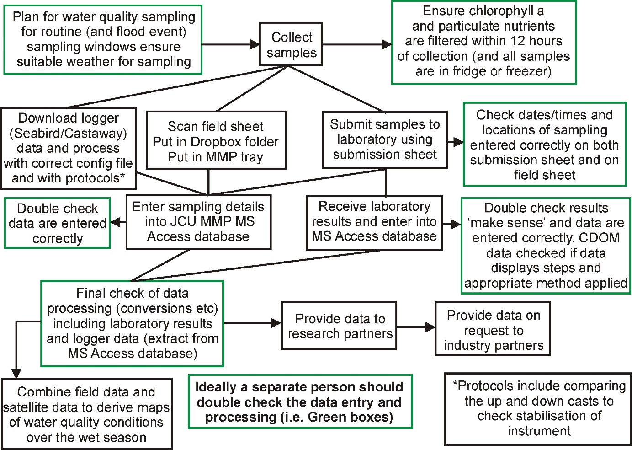
Figure 2-6 Flow chart outlining the JCU procedures and QA/QC measures once samples have been collected in the field.
For analysis of trends, data are transferred into the AIMS water quality database. Copies of the TropWATER Flood Plume Monitoring database (Microsoft® Access database) are stored in external media and also on Dropbox.

Summary of Quality Control measures
- Training of field personnel, including deployment guidelines and records
- Overlap of manual and instrumental sampling
- Unique sample identifiers
- Sample custody
- Analytical QC measures including inclusion of QA/QC samples (replication of sampling and procedural blanks)
- Regular inter-laboratory calibration exercises
- Continual evaluation, method development and improvement of methods
- Periodic servicing of sensors by manufacturer
- Advanced data management and security procedures
- Document control
- Metadata updates

Comparison of results obtained by AIMS and JCU
To test whether the results obtained by the AIMS and JCU water quality monitoring are comparable, samples have been collected over a range of concentrations during two sampling campaigns. Samples have been collected and analysed for salinity, TSS, Chl-a, dissolved silicate, nitrate and filterable reactvie phosphorus (FRP).
The fit between the AIMS and JCU data has been tested using linear regression analyses performed using the best-fit between the two variables X and Y obtained by regression model II (Figure 2-7) (Sokal & Rohlf, 1995). In the cases where the intercept was not significantly different from zero, it was set to zero and a new slope was calculated.
Overall, the results obtained by AIMS and JCU are comparable within a very narrow range, with the exception being phosphate where no linear relationship was obtained between the phosphate concentrations obtained by both laboratories. However, the concentration range obtained in the comparison samples (0.05–0.19 µmol L⁻¹) are very low, and are potentially more comparable over larger concentration ranges.
Overall, we conclude that the AIMS and JCU data are comparable and can reliably be joined into one dataset.

Figure 2-7 Relationships between (a) salinity, (b) total suspended solids, (c) chlorophyll a, (d) silicate, (e) nitrate and (f) phosphate (DIP or FRP) measured by AIMS (x-axis) and JCU (y-axis). Solid lines represent a linear regression

Remote sensing of the Reef water quality and river flood plumes
Caroline Petus¹, Jane Waterhouse¹, Dieter Tracey¹, Leon Majewski², Michelle Devlin*, Eduardo da Silva*, and Katherine Martin³
¹ James Cook University, ² Bureau of Meteorology, *formerly with JCU, ³ Great Barrier Reef Marine Park Authority

Introduction
This component of the MMP assesses trends in the delivery of land- sourced pollutants to the Reef lagoon during the wet season and flood events and quantifies the exposure of Reef ecosystems to these pollutants using satellite imagery. It provides remotely sensed information on river flood plume areas and resuspension events, frequencies and composition in the Reef as well as spatial information on the exposure and potential risk of coral reefs and seagrass meadows to river plumes, sediment resuspension and land-sourced pollutants.
A joint effort has been applied among CSIRO, AIMS and TropWATER to acquire, process, validate, interpret, archive and transmit geo-corrected ocean colour imagery and required information datasets derived from MODIS satellite data (http://modis.gsfc.nasa.gov/). There have been a number of different methods within the flood plume program to characterise, map and monitor flood events in the Reef over the last 20 years (Devlin et al., 2015).
These techniques and their resulting products evolved in complexity with time, from basic aerial photography in combination with in situ monitoring, to the application of advanced regional parameterised ocean colour algorithms, to the analyses of true colour products correlated with in situ water quality gradients (Figure 3-1). Current work focuses on improving the integration between true colour information and water quality and ecosystem health indicators (Álvarez-Romero et al., 2013; Petus, Collier, et al., 2014; Petus et al., 2018; Petus et al., 2016).

Methods

MODIS satellite data
The remote sensing component of the MMP uses remotely sensed ocean-colour information from NASA’s MODIS instrument (https://modis.gsfc.nasa.gov/). The MODIS instrument is carried by two different satellites, Terra (providing the morning overpass at approximately 10:30 am) and Aqua (providing the afternoon overpass at approximately 1:30 pm). Working in tandem to see the same area of the Earth in the morning and the afternoon, the two satellites help make sure that MODIS and other instruments are measuring accurately by optimising cloud-free remote sensing of the surface and minimising any optical effects — like shadows or glare — that are unique to morning or afternoon sunlight. The remote sensing component of the MMP (flood plume monitoring program and Marine Water Quality Dashboard) have used remotely sensed information from NASA’s MODIS Aqua satellite from 2002 onwards.

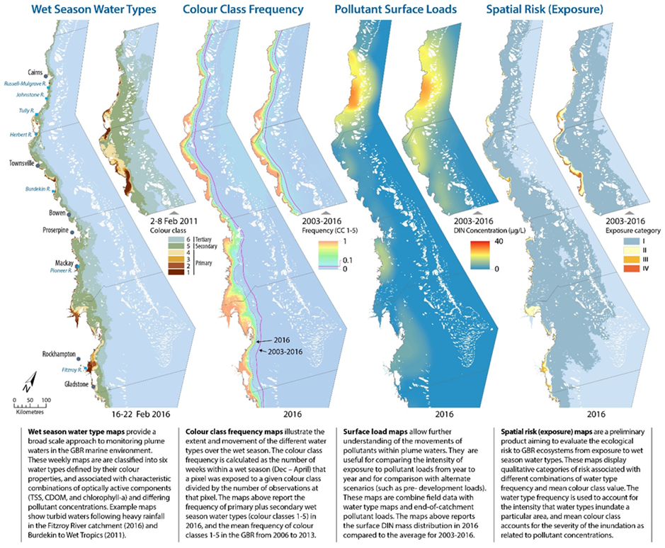
Figure 3-1 Summary description of the wet season water quality products from remote sensing information (modified from Devlin et al., 2015).

MODIS true colour monitoring products
TropWATER was funded by the Authority to collect information on the movement of flood plumes across inshore waters of the Reef and to quantify the exposure of Reef ecosystems to flood plumes and resuspension events, as well as to land-sourced pollutants carried by the flood plumes, using satellite imagery. To detect, map and characterise river flood plumes, ocean colour remote sensors can use differences in water colour properties between plumes and ambient marine waters. The optical signature and colour signature of a surface water body is related to the optical active constituents of the water, including the presence and combination of Chl-a, CDOM and TSS. Coastal water bodies, including resuspended sediments and flood river plumes of the Reef during the wet season are mapped using daily MODIS true colour images and an automated classification technique clustering bodies with homogeneous surface water colour (hereafter wet season water type maps) (Álvarez-Romero et al., 2013). The term “wet season waters” refers to flood river plumes and associated resuspension occurring in the GBR during the austral wet season.
Wet season water type maps are linked to water quality parameters sampled in inshore waters during the wet season, including plume waters, and several monitoring products have been derived from the MODIS true colour imagery. These products help estimate the exposure and potential risk for the Reef seagrass and coral reef ecosystems from exposure to river flood plume and sediment resuspension (Table 3.1. andFigure 3-1).
Table 3.1. MODIS monitoring products.
Product | Description | Spatial and temporal resolution
Wet season water type maps (including plume maps) | Illustrate the extent and movement of coastal water bodies, including riverine waters, during the wet season.  The Primary water type (colour classes 1 to 4) corresponds to the brownish to brownish-green turbid water masses typically found in near-shore areas with high concentrations of suspended sediments or inshore regions of river plumes. The Secondary water type (colour class 5) corresponds to the greenish to greenish-blue water masses typically found in the open coastal waters as well as in the mid-water plumes where relatively high nutrient availability and increased light levels due to sedimentation favour the coastal productivity. The Tertiary water type (colour class 6) is the transitional, greenish-blue water mass typically found towards the open sea or offshore regions of river flood plumes. | Reef wide and regional  Daily, weekly, annual or long-term (frequency of occurrence)
Water quality concentrations across wet season water types | In situ water quality data collected during the wet season through the inshore water quality monitoring program are overlaid with the wet season water type maps to provide a broad-scale reporting of water constituent concentrations in the Reef marine environment.  Several land-sourced pollutants (e.g., sediments, nutrients and pesticides) and light levels are investigated and statistical summaries (average, minimum, maximum) of the seasonal and long-term water quality values associated with each water type are calculated. | Whole-reef; NRM, river  Weekly, annual or long-term (frequency of occurrence)
Load maps of river-derived pollutants | Load mapping explores the movements of pollutants that are carried within the river plume waters. Pollutants plume load maps are produced combining in situ data collected under the MMP, the wet season water type maps and monitored end-of catchment pollutant load (Waterhouse et al., 2017).  The river loads provide the amount of a pollutant that has been delivered along the Reef. The in situ data provides the pollutant mass variation as a function of the river plume movement away from the river mouth. The satellite imagery provides the direction and intensity of the the pollutant mass as it is transported over the Reef lagoon. Therefore, this method produces maps of pollutants dispersion in the Reef waters expressed in mass per area and concentration. | Reef wide and regional  Annual or long-term
Wet season exposure maps | Product in development aiming to map the exposure and potential risk of Reef ecosystems from river plume, sediment resuspension and land-sourced pollutant exposure.  This product uses a magnitude × likelihood framework. The ‘potential risk’ corresponds to an exposure to above guideline concentrations of land-sourced pollutants during the wet season and focuses on TSS, Chl-a, PP and PN concentrations. The ‘magnitude of the exposure’ corresponds to the mean wet season concentration of pollutants (proportional exceedance of the guideline) mapped through the Primary, Secondary and Tertiary water types. The ‘likelihood of the exposure’ is estimated by calculating the frequency of occurrence of each wet season water type. The exposure for each of the water quality parameters defined is the proportional exceedance of the guideline multiplied by the likelihood of exposure in each of the wet season water types. | Reef wide and regional  Annual or long-term
Exposure assessment of coral reefs and seagrass beds | Assess the exposure of key Reef ecosystems to river plume and potential risk from this exposure. Expressed as the area (km²) and percentage (%) of coral reefs and seagrass meadows exposed.  Assumes that historical reef and coral shapefiles can be used to assess the coral and seagrass location (stable over years) | Reef wide, regional, ecosystem  Annual or long-term
Note: “Annual” refers to the wet season only (c.a., December to April, inclusive)

Automated production and storage of the MODIS wet season water type maps

From raw data to true colour MODIS data
Until 2016, MODIS remote sensing L0 (raw) data were ordered from the NASA Ocean Colour website (http://oceancolor.gsfc.nasa.gov/) and processed in-house by TropWATER. A routine written in R was used to download the data and a set of IDL/SeaDAS (SeaWiFS Data Analysis System) routines was implemented to process MODIS Aqua data from Level-0 to true colour images (Baith et al., 2001). In 2016–17, the processing of true colour images was handed over to the Bureau of Meteorology. MODIS-Aqua L0 data is routinely downloaded from the NASA Ocean Biology Processing Group (OBPG) webpage (https://oceancolor.gsfc.nasa.gov/). Downloaded data is routinely migrated to external drives . Observations within the area of interest that are not found on either the rolling or tape archives are downloaded from the OBPG webpage. The MODIS-Aqua L0 is processed using the SeaWiFS Data Analysis System (SeaDAS, version 7.4, https://seadas.gsfc.nasa.gov/) following several steps:
- L0 data (raw radiance counts — digital numbers) are processed using the SeaDAS modis_L0_to_L1A.py tool to get L1A data at native resolution (250, 500 and 1000 m); where multiple granules are required to cover the region of interest, the SeaDAS pdsmerge tool is used to merge the adjacent granules before being processed to make sure that there are no gaps between granules.
- The L1A file is then used to calculate the geometry (GEO file) using the SeaDAS modis_GEO.py tool.
- The GEO and L1A files are used to compute the calibrated top of atmosphere radiances (L1B data) using the SeaDAS modis_L1B.py tool at native resolution (250, 500 and 1000 m).
- The SeaDAS l1mapgen tool is then used to compute the Rayleigh corrected reflectance for MODIS bands 1 (645 nm at 250 m resolution), 4 (555 nm at 1000 m resolution) and 3 (469 nm at 1000 m resolution).
The output of the SEADAS l1mapgen tool is a true colour image in GeoTIFF format. Where multiple granules are required to cover the region of interest, the true colour GeoTIFF images are combined using the imagemagick convert tool. During this process, the GeoTIFF location tags are removed. They are added back to the GeoTIFF image via the use of the GDAL gdalcopyproj.py script. The argument and keywords used are shown in Table 3.2.

True colour images have a spatial resolution of 500 m × 500 m and combine three ocean bands (i.e. red, green and blue, RGB) in the visible spectrum. The true colourimages cover the wet season period (i.e. December to April, inclusive) since December 2003 (MODIS mission started in March, 2002). They have a daily temporal resolution and cover the entire Reef area (extreme coordinates: -10.5, -27.0, 142.3 and 154.0).
Table 3.2 Keywords and justification used in SeaDAS 7.4 to process MODIS true colour images of the Great Barrier Reef.
Step | Term | Description
Step 2: modis_GEO.py | terrain correction | Given the area of interest is the ocean, terrain correction is not used (in modis_GEO.py the --enable-dem flag is not used)
Step 3: modis_L1B.py | look up table  (LUT) | The arguments “-l 6.1.33.4_OC -d /short/er8/packages/seadas/7.0/ocssw/run/var/modisa/cal/EVAL/” are passed to use the 6.1.33.4_OC L1B look up table.
Step 4: l1mapgen | Calibration table | The msl12_defaults.par was updated to use the xcal_modisa_axc39d cross-calibration files.
Step 4: l1mapgen | Atmospheric correction | The atmocor keyword was set to “on” to make sure that the Rayleigh correction was applied.
Step 4: l1mapgen | resolution | The resolution keyword was set to “250” to use band 1 as input.
Processed MODIS data are stored in external media and also at the national Research Data Services, which is part of Research Data Australia (https://researchdata.ands.org.au/).

Maps of wet season water types and flood plumes
A set of spatial analyses (Python, ArcGIS) based on supervised classification of spectrally enhanced true colour images is used to classify ‘turbid’ waters, including river flood plumes and resuspension events, and ‘non-turbid’ areas in the Reef, focusing on the wet season period. These are described as six distinct colour classes and further reclassified to three wet season water types defined by their colour properties that are typical of water colours and water quality gradients existing across coastal waters of the Reef during the wet season (Álvarez-Romero et al., 2013). In Reef studies, the six colour classes are regrouped into three water types, referred to as Primary (colour classes 1 to 4), Secondary (colour class 5) and Tertiary (colour class 6) wet season water types. Each of the six colour class/three water types are characterised by different land-sourced pollutant concentrations, including particulate and dissolved nutrients concentrations, and light levels, which can vary the impact on the underlying ecological systems (see descriptions in Figure 3-1).

Derived monitoring products
A number of monitoring products have been developed by transferring the water type maps to ArcMAP 10.4 and linking them through spatial analysis to water quality parameters sampled in situ (Table 3.1. and Figure 3-1).

Marine water quality metric
A revised water quality metric was developed as a National Environmental Science Programme (NESP) 3.2.5 project in 2017 (and implemented in the Report Card 2016) as an initial step towards the integration of multiple streams of data to measure and report water quality condition. The previous metric relied exclusively on satellite data. The new metric is underpinned by the eReefs biogeochemical model and integrates data from satellite images for improved accuracy in what is commonly referred to as a data assimilation process. The new metric considers all six NRM regions in calculating the Reef-wide score and is based on results in open coastal waters.
The eReefs regional models include coupled hydrodynamic, sediment and biogeochemistry models for the entire Reef; however, the MMP focuses on results in the open coastal waters. The model allows quantification of the impacts of rivers and atmospheric forcing on circulation patterns and biogeochemical cycles (for example water clarity, nutrients, plankton, benthic plants). The skill of the model has been assessed and improved over six years (see http://ereefs.info).
Data assimilation further improves the model skill and provides a single best estimate of the biogeochemical state of the Reef obtained from the combination of both modelling and observations. Data assimilation systems quantify the difference between a modelled state and an observed state (for example in situ monitoring data) and improve the modelled state by incorporating the observed state in the simulation.
Across the whole area of the Reef, only remote-sensing provides the density of observations required to undertake a large-scale assimilation (see http://www.bom.gov.au/marinewaterquality/). For shallow inshore waters, using remote-sensing to estimate in-water properties is challenging, due to the interactions between chlorophyll, sediments, CDOM and benthic communities, which all absorb and scatter light in the blue and green wavebands. Instead of using remote sensing to estimate in-water properties, the water quality metric is based on the optical calculations of the biogeochemical model to simulate the normalised remote-sensing reflectance. The data assimilation system uses the mismatch between observed and modelled remote-sensing reflectance to constrain the biogeochemical model (Robillot et al., 2018).
Chl-a and Secchi depth (derived as the inverse of Kd (490)) were extracted from depth layer 44 of the assimilated eReefs biogeochemical model at a 4 × 4 kilometre spatial resolution and daily temporal resolution. Observations from each of these measures were partitioned temporally into Water Years (1 October through to 30 September 30) and spatially into zones representing combinations of NRM regions and cross-shelf water bodies (Great Barrier Reef Marine Park Authority, 2010). The enclosed coastal water body was excluded due to limitations associated with the four-kilometre model resolution near the coastline. The site-level data (4 × 4 kilometre) for each measure was standardised to indices on a continuous scale of 0 (very poor) to 100 (very good) by assessing individual values relative to the appropriate Great Barrier Reef Water Quality Guideline value (Great Barrier Reef Marine Park Authority, 2010) using a ‘modified amplitude indexation routine’ (fsMAMP: base 2 logarithm of the ratio of observed value to threshold).
Individual daily site-level indices for each measure were aggregated (averaged) into annual scores for each zone. The scores for Secchi depth were then aggregated with the Chl-a score to yield a single score for water quality per zone, which was weighted by the area of the open coastal waters (Robillot et al., 2018).
All reported scores were mapped onto a five-point (A–E) grading scale with associated green-red colour scheme (very good: 81–100, good: 61–80, moderate: 41–60, poor: 21–40 and very poor: 0–20).

Pesticide monitoring
Christie Gallen, Chris Paxman, Jochen Mueller, Tim Reeks, Gabriel Elisei, Pritesh Prasad
Queensland Alliance for Environmental Health Sciences (QAEHS)

Introduction
The inshore waters of the Reef are impacted by the water quality of discharges from a vast catchment area, which can include inputs of pesticides (i.e. insecticides, herbicides and fungicides). The need for a long-term monitoring program on the Reef, which provides time-integrated data to assess temporal changes in environmentally relevant pollutant concentrations, was identified as a priority to address the information deficiencies about risks to the ecological integrity of this World Heritage Area in 2000 (Haynes & Michalek-Wagner, 2000). The aim of this component of the MMP is to assess spatial and temporal trends in the concentrations of specific organic chemicals using time-integrated passive sampling techniques primarily through routine monitoring at specific sites.
Passive samplers accumulate organic chemicals such as pesticides from water in an initially time-integrated manner until equilibrium is established between the concentration in the water (C_{W} ng.L⁻¹) and the concentration in the sampler (C_{S} ng.g⁻¹). The concentration of the chemical in the water can be estimated from the amount of organic chemical accumulated within a given deployment period using calibration data obtained under controlled laboratory conditions (Booij et al., 2007).
Passive sampling techniques offer cost effective, time-integrated monitoring of both temporal and spatial variation in exposure in the often remote locations encountered on the Reef (Shaw & Müller, 2005). These techniques are particularly suited to large scale studies with frequently recurring pollution events (Schäfer et al., 2008) to make sure that these events are captured and to allow the assessment of temporal trends in concentrations in systems over the long term (Kennedy et al., 2010; Mueller et al., 2011).
Different types of organic chemicals must be targeted using different passive sampling phases. The passive sampling techniques that are utilized in the MMP include:
- SDB-RPS EmporeTM Disk (ED): passive samplers for relatively hydrophilic organic chemicals with relatively low octanol-water partition coefficients (K_{ow}) such as the photosystem II (PSII) herbicides (for example atrazine — a triazine herbicide); also referred to as polar organic chemical samplers.
- Polydimethylsiloxane (PDMS): passive samplers for organic chemicals that are relatively more hydrophobic (higher K_{ow}) (for example chlorpyrifos — an organophosphate insecticide); also referred to as non-polar organic chemical samplers.

Methods

Sampling design — Passive sampling for routine monitoring
Before the 2014–15 monitoring year, 12 sites were routinely monitored across the four NRM regions (Wet Tropics, Burdekin, Mackay Whitsunday and Fitzroy) (see previous QA/QC and annual reports). Following a review of the program in 2013 and 2014, there was a consensus to discontinue monitoring at several locations due to poor statistical power in detecting trends in pesticide concentrations, and initiate sampling in new locations that would better link end-of-catchment loads with inshore concentrations of pesticides. A total of 11 sites across the same four NRM regions were selected for the future monitoring program (Figure 4-1), which included five long-term sites monitored since 2005–09 (Table 4.1).
Figure 4-1 Locations of the 11 inshore reef routine monitoring sites where time-integrated sampling of pesticides have occurred from the 2014 monitoring year onwards.
The types of sampling that occurred at each site in either the dry (May–October) or wet (November–April) season sampling periods are indicated in Table 4.1. Samplers were deployed for two months during the dry season and one month during the wet season.
Table 4.1 Types of passive sampling conducted at each of the routine monitoring sites in 2017–2018 during either the dry (May–October) or wet (November–April) periods
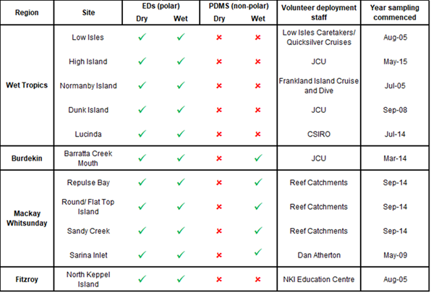
The scientific criteria for selection of sampling sites include:
- the site must be representative of an inshore reef location (as outlined by the initial tender document)
- the site is co-located in proximity to sites used by other MMP monitoring activities such as seagrass monitoring, as well as other agencies conducting related monitoring (such as end-of-catchment loads)
- the site should not be impacted by specific local point sources such as anti-foulants from boats or inlets of treated or untreated wastewater
- the sampling site can be maintained for a long period
- the site is located adjacent to catchments that have been identified as high risk for exposure to pesticides
- the site must have adequate statistical power to detect trends in pesticide concentrations
In addition to the scientific requirements of the project, the selection of passive sampling deployment sites is governed by practicalities, which include safety, security, site access and the availability of a responsible community representative to take responsibility for the maintenance of the site. Site establishment has been a collaborative effort between the Authority, AIMS, JCU and QAEHS.
The participation of volunteers from various community groups, agencies and tourist operations is a key feature of the routine pesticide monitoring program and is integral to the success of maintaining the program in often remote locations. These volunteers assist by receiving, deploying, retrieving and returning the passive samplers to QAEHS for subsequent extraction and analysis. This active participation of volunteers within the program is made possible by training from QAEHS staff in SOPs to make sure a high level of continuous sampling and high-quality usable data is obtained from these deployments.

Sampling design — Flood plume grab sampling
Since 2014, the collection of grab samples from flood plumes has been conducted in the Wet Tropics, Burdekin and Mackay Whitsunday regions. Extra samples were collected in 2016–17 in the Fitzroy region during the flood events following tropical cyclone Debbie. Samples (250 mL) are collected at the location of the passive samplers and, depending on the nature of the event, along transects extending from river mouths and during the pre- and post-wet season periods. Smaller volumes are now collected for ease of transportation back to QAEHS in eskies containing returning passive samplers. The information collected from the grab sampling will be used to validate risk models that can inform management about the areas that may be most at risk to acute and chronic exposure to pollutants resulting from river discharge.

Target pesticides in the different passive samplers
The chemicals targeted for analysis in the different passive samplers and the instrument limits of reporting (LOR) are indicated in Table 4.1. This list of target chemicals was derived through consultation with the Authority with the criteria being:
- detected in recent studies
- recognised as a potential risk (through known usage patterns, amounts and existing toxicity data)
- analytical affordability
- within the current analytical capabilities of QAEHS or Queensland Health Forensic and Scientific Services (QHFSS)
- likelihood of accumulation in one of the passive samplers (exist as neutral species in the environment)
- analysed frequently by other complimentary Reef Plan programs such as end-of-catchment loads monitoring.
As part of the review process and in consultation with the Pesticide Working Group, the list of target pesticides and herbicides for analysis has been modified to reflect recent changes in pesticide usage, those registered for use in Reef catchments and those frequently detected in passive samplers or water samples by the MMP or other agencies conducting monitoring in the Reef catchments (Department of Science, Information Technology and Innovation, DSITI). Table 4.2 lists the proposed priority pesticides that have been reported since 2014. Analytes for which analytical method development is required are noted. Note that this list includes priority pesticides and herbicides that may not accumulate well in passive samplers due to their polarity, and may be detectable in grab samples only.
Table 4.2 Pesticides for analysis in different sampler extracts and water samples together with the approximate instrument limits of detection and limits of reporting for analytes.
Chemical | Description | Priority or of interest | LC-MS/MS |  |  | GCMS
Chemical | Description | Priority or of interest | LOD µg L⁻¹ | LOR µg L⁻¹ |  | LOR µg L⁻¹
2, 4-D | Phenoxy-carboxylic-acid herbicide | Priority | 0.03 |  | 0.10
2,4-DB | Phenoxy-carboxylic-acid herbicide | Of interest | 5.0 |  | 15
Aciflurofen* | Herbicide: cell membrane disruptor | Of interest
Ametryn | PSII herbicide – methylthiotriazine | Priority | 0.56 |  | 1.69
Asulam^ | Herbicide: inhibition of DHP – carbamate | Of interest | 0.01 |  | 0.10
Atrazine | PSII herbicide – chlorotriazine | Priority | 0.05 |  | 0.15
Atrazine – desethyl | PSII herbicide breakdown product (also active) | Priority | 0.005 |  | 0.10
Atrazine – desisopropyl | PSII herbicide breakdown product (also active) | Priority | 0.02 |  | 0.10
Bromacil | PSII herbicide – uracil | Of interest | 0.02 |  | 0.10
Chlorothalonil* | Organochlorine fungicide | Priority
Chlorpyrifos | Organophosphate insecticide | Priority |  |  |  |  | 0.5
Diazinon* | Insecticide: inhibits acetylcholinesterase | Of interest
Diuron | PSII herbicide – pheynylurea | Priority | 0.02 |  | 0.10
Ethametsulfuron methyl* | Herbicide: acetolactate synthase (ALS) inhibition | Of interest
Fipronil* | Phenylpyrazole insecticide | Priority
Fluazifop^ | Herbicide: inhibition of acetyl CoA carboxylase | Of interest | 0.02 |  | 0.10
Fluometuron | PSII herbicide – urea | Of interest | 0.01 |  | 0.10
Fluroxypyr | Pyridine carboxylic acid herbicide | Priority | 0.02 |  | 0.10
Glyphosate* | Broad-spectrum systemic herbicide | Priority | Glyphosate-specific sampler required
Haloxyfop | Aryloxyphenoxy-propionate herbicide | Priority | 0.04 |  | 0.13
Hexazinone | PSII herbicide – triazinone | Priority | 0.01 |  | 0.10
Imazapic | Imidazolinone herbicide | Priority | 0.02 |  | 0.10
Imidacloprid | Neonicotinoid insecticide | Priority | 0.01 |  | 0.10
Isoxaflutole and DKN* | Isoxazole herbicide | Priority | 0.20 |  | 0.61
MCPA | Phenoxy-carboxylic-acid herbicide | Priority | 0.05 |  | 0.14
Mesosulfuron methyl* | Herbicide: acetolactate synthase (ALS) inhibition | Of interest
Metolachlor | Chloracetanilide herbicide | Priority | 0.03 |  | 0.10
Metribuzin | PSII herbicide – triazinone | Priority | 0.03 |  | 0.10
Metsulfuron methyl | Sulfonylurea herbicide | Priority | 0.01 |  | 0.10
MSMA* | Herbicide: inhibition of cell division | Of interest
Paraquat* | Herbicide: photosystem-I-electron diversion | Of interest
Pendimethalin | Dinitroaniline herbicide | Priority |  |  |  |  | 1.0
Prometryn | PSII herbicide – methylthiotriazine | Priority | 0.54 |  | 1.61
Propazine | PSII herbicide – chlorotriazine | Priority | 0.06 |  | 0.18
Propiconazole | Conazole fungicide | Priority |  |  |  |  | 2.0
Prothiophos* | Insecticide: inhibits acetylcholinesterase | Of interest
Simazine | PSII herbicide – chlorotriazine | Priority | 0.08 |  | 0.24
Tebuconazole | Conazole fungicide | Priority | 0.10 |  | 0.31
Tebuthiuron | PSII herbicide – thiadazolurea | Priority | 0.01 |  | 0.10
Terbuthylazine* | PSII herbicide – triazine | Priority
Terbutryn | PSII herbicide – triazine | Of interest | 0.55 |  | 1.7
Triclopyr* | Pyridine carboxylic acid herbicide | Priority
Trifloxysulfuron* | Herbicide: inhibition of ALS – sulfonyl urea | Of interest
Trifluralin | Herbicide – dintiroaniline | Priority |  |  |  |  | 0.2
* Not currently analysed by QAEHS
^ Currently analysed in grab samples, but ED passive sampler uptake is not adequate to quantify time-averaged water concentrations
Shaded chemicals are included as part of the Paddock to Reef Integrated Monitoring, Modelling and Reporting Program
Red text indicates that the sampling rate (Rs) of atrazine has been assumed
Pesticides are identified as ‘priority’ (proposed by Pesticide Workign Group 18 August 2015) or ‘of interest’ to the program (feedback from the Paddock to Reef program), and include pesticides that are not currently analysed by QAEHS and are therefore not included in the MMP.

Chemical analysis
Before the 2013–14 monitoring year, ED sampler extracts were analysed by Queensland Health using liquid chromatography mass spectrometry (LC-MS) run in positive analysis mode. From the beginning of the 2013 monitoring year, analysis of these extracts was transferred to QAEHS and an AB Sciex QTRAP 5500 mass spectrometer (AB Sciex, Concord, Ontario, Canada) equipped with an electrospray (TurboV) interface coupled to a Shimadzu Nexera high-performance liquid chromatography (HPLC) system (Shimadzu Corp., Kyoto, Japan), also run in positive mode, was used.
From the 2014–2015 monitoring year onwards, the analysis of ED extracts at QAEHS was transferred to the AB Sciex QTRAP 6500 (a new LC-MS/MS model of the QTRAP 5500). The added advantage of this instrument is the enhanced sensitivity of some analytes and the ability to analyse in both positive and negative modes in one injection (effectively halving the analysis time required). LORs of the target analytes were not negatively influenced by the change in instrumentation.
Each year, a selection of sample extracts is analysed by both QAEHS and QHFSS as an on-going inter-laboratory comparison to validate the QAEHS analysis. In 2017–18, at least 15 samples will be analysed by both methods.
Before the 2014–15 monitoring year, PDMS sampler extracts were analysed for pesticides using gas chromatography mass spectrometry (GCMS) by Queensland Health. QAEHS has developed a pesticide GCMS method that includes five priority pesticides (pendimethalin, propazine, propiconazole, trifluralin and chlorpyrifos), identified by the Pesticide Working Group (Aug 2015). Analysis is conducted on a Thermo Scientific TSQ Quantum XLS Triple Quadrupole GCMS/MS. The mass spectrometer is operated in positive ion, multiple reactions monitoring mode, using argon as the collision gas. Before introduction into the mass spectrometer, compounds are separated on an Agilent J & W DB5-MS (25 m; 0.25 mm i.d.; 0.25 µm film thickness) column. A quantitative and qualitative ion transition is monitored for each compound.
Before the 2013–14 monitoring year, solid-phase extraction (SPE) and analysis of PSII herbicides in grab samples was performed by Queensland Health. QAEHS developed a very sensitive online SPE method that avoided the need for a costly and time consuming traditional SPE and the bulk concentration of the sample. Instrument LORs are in the range of 0.2–2.0 µg L⁻¹, which are up to five-fold lower than those of Queensland Health. This method has been employed since the 2013–14 monitoring year. During 2014–15, an alternative direct injection method was trialled that allowed shorter analysis times, less setup of the LC-MS/MS and smaller injection volumes of sample. However, as this method resulted in higher LORs and the potential to miss the detection of some herbicides, it was decided to remain with the traditional SPE method, which requires pre-concentration of the sample but yields superior detection limits.
The LOD and LOR for the LC-MS/MS and GCMS instrument data have been defined as follows: a very low level amount of analyte is added to a range of matrices (which include saline (sea) water, MilliQ water and bore water) and injected 6–7 times into the analytical instrument. The standard deviation of the resultant signals is obtained and a multiplication factor of three is applied to determine the LOD and a factor of nine is applied to get the LOR. A further criterion for the LOR is that the analyte value should exceed three times the mass detected in the blank. It should be noted that the LODs and LORs included in Table 4.2 are for the analytical instrument and do not represent the reporting limits for the water concentrations determined using the passive samplers. The LORs relevant to a particular sample will vary according to the site’s sampling rates (i.e. sampler deployment duration and flow rate at the site).
Positive results at QAEHS are confirmed by retention time and by comparing transition intensity ratios between the sample and an appropriate concentration standard from the same run. Samples were reported as positive if the two transitions were present (with peaks having a signal to noise ratio greater than three), retention time was within 0.15 minutes of the standard and the relative intensity of the confirmation transition was within 20 per cent of the expected value. The value reported was that for the quantitation transition.

Passive sampling techniques
SDB-RPS Empore discs
- 3MTM EmporeTM Extraction Disks (SDB-RPS) – Phenomenex.
- Deployed in a Teflon “Chemcatcher” housing (Kingston et al., 2000) (Figure 4-2).
Routine time integrated monitoring:
- Deployed with a diffusion limiting 47 mm, 0.45 µm polyether sulfone membrane for either one month or two months. From January 2012 onwards, Phenomenex membranes of the same specifications have been used.
- Deployed in a two disk configuration to extend the time-integrated monitoring period when deployed for two months.
Preparation:
- Condition in methanol for no more than five minutes (HPLC grade, Merck).
- Condition in milliQ water for a minimum of five minutes.
- Load into acetone rinsed teflon Chemcatcher housing.
- Cover with membrane and solvent rinsed wire mesh.
- Fill housing with milliQ water.
- Seal for transport.
- Store in fridge and transport with ice packs.
Extraction:
- Remove membrane and wipe surface of disk with Kimwipe to remove excess water.
- Spike disk with labelled internal standard.
- Extract disk using acetone and methanol in a solvent rinsed 15 mL centrifuge tube in an ultrasonic bath.
- Filter (0.22 µm PFTE) and concentrate to <0.5 mL using evaporation under purified N₂.
- Add ultra-pure water to a final volume of 0.5 mL existing in 20 per cent methanol and 80 per cent water solution.
- Spike sample with labelled recovery standard.
- Analyse using LC-MS/MS
- Convert to concentration in water using compound specific in situ sampling rates.

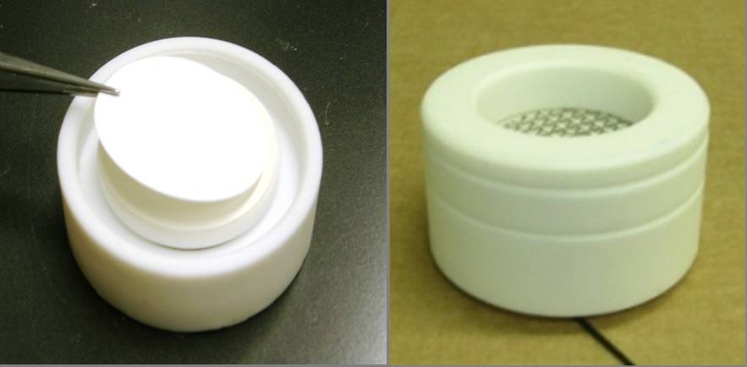
Figure 4-2 An Empore Disk being loaded into the teflon Chemcatcher housing (LHS) and an assembled housing ready for deployment (RHS)
In situ flow monitoring for Empore Disks sampling rate adjusment
Compound specific sampling rates have been determined for a broad suite of herbicides and are applied to the estimation of concentrations in water. Sampling rates are influenced by in situ environmental conditions such as flow. A passive flow monitor (PFM), comprised of dental plaster cast into a plastic holder (Figure 4-3), was developed during the PhD of Dominique O’Brien at QAEHS as a means of flow-adjusting sampling rates using an in situ calibration device (O'Brien et al., 2009). The elimination rate of dental plaster from the PFM during the deployment is proportional to flow velocity, and the influence of ionic strength (salinity) on this process has been quantified (D. S. O’Brien et al., 2011). The sampling rates of reference chemicals in the ED, such as atrazine, have subsequently been cross-calibrated to the loss of plaster from the PFM under varying flow conditions (Figure 4-4) (D. O’Brien et al., 2011).
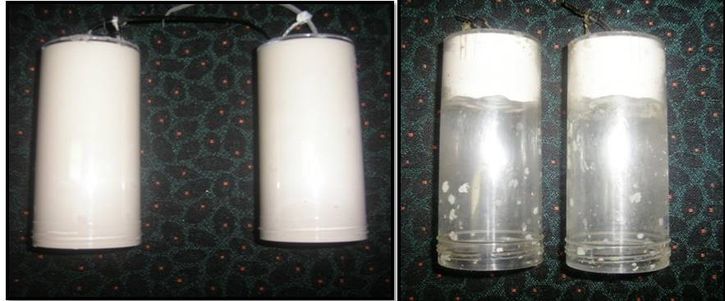
Figure 4-3 Passive flow monitors pre-deployment (left) and post-deployment (right)
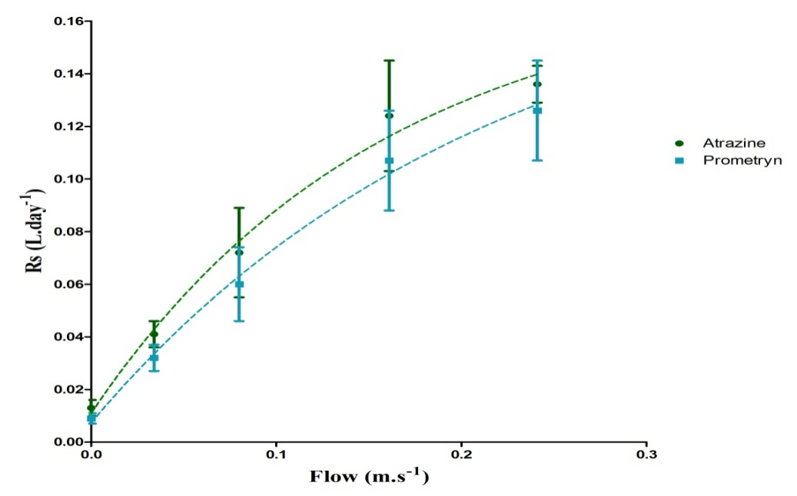
Figure 4-4 Relationship between flow and sampling rates of specific herbicides indicating a shift from aqueous boundary layer control to diffusion limiting membrane control under higher flow conditions

The in situ calibration procedure of EDs employed at QAEHS is:
- PFMs are co-deployed alongside EDs.
- Deployment in:
      - Wet season (one month).
      - Dry season (two months) – with a flow-limiting cap (reduces loss rate by 15 per cent).
- The loss rate of plaster is determined while accounting for the influence of ionic strength.
- The sampling rates of atrazine and prometryn are directly predicted from the PFM loss rate using models.
The sampling rates of other individual herbicides are predicted based on the average ratio of the R_{s} of atrazine to the individual herbicide R_{S} across multiple calibration studies (D. S. O’Brien et al., 2011; Shaw & Mueller, 2009; Stephens et al., 2009; Vermeirssen et al., 2009). For newly included target herbicides where there is no calibration data available, QAEHS may adopt the sampling rate of atrazine (and report this consistently throughout the monitoring program to allow inter-site and inter-year comparisons) or present the data as ng accumulated per sampler per day. Chemicals for which the R_{s} of atrazine are assumed are highlighted red in Table 4.2. An in-field calibration would be beneficial in determining R_{s} for the newly included chemicals.

Risk assessment metrics:
i) PSII herbicide equivalent concentrations
PSII herbicides sampled by the SDB-RPS ED are a priority focus of the MMP pesticide monitoring due to the requirements of the Reef Water Quality Protection Plan (Department of Premier and Cabinet, 2009). The risk of PSII inhibition to Reef species may be underestimated when concentrations of herbicides are considered individually rather than as part of a more complex mixture. Therefore, the concentrations of individual PSII herbicides (ametryn, atrazine, diuron, hexazinone, flumeturon, prometryn, simazine and tebuthiuron) and atrazine transformation products (desethyl- and desiso-propyl – atrazine) are also expressed as a PSII herbicide equivalent concentration (PSII-HEq Equation 1) and assessed against a PSII-HEq Index described previously for reporting purposes (Kennedy et al., 2010). PSII-HEq provides a quantitative assessment of PSII herbicide mixture toxicity and assumes that these herbicides have an additive toxic mode of action (Escher et al., 2006).
Equation 1

Where:
(ng.L⁻¹) is the concentration of the individual PSII herbicide in water.
(dimensionless) is the average relative potency of the individual
PSII herbicide with respect to the reference PSII herbicide diuron.
ii) Multisubstance-potentially affected fraction
Despite being widely used and simple to calculate, a limitation of the PSII-HEq approach is that matched datasets should ideally be used to derive the potencies relative to a reference chemical (i.e. for each species tested, all PSII herbicides should be included in the same study to assess their toxicity relative to diuron). However, this seldom occurs and, typically, datasets will have data for only a few select compounds. This requirement for matched datasets dramatically reduces the amount of data suitable to derive relative potencies.
The multisubstance-potentially affected fraction ms-PAF method has been proposed as a more relevant approach to quantify the overall ecological risk of mixtures of pollutants for ecological communities (Traas et al., 2002). This approach is based on species sensitivity distributions (SSDs) for all chemicals in a mixture, and thus aligns more closely with the revised methods for proposed individual water quality guideline value derivation, as well as the risk-based approach adopted by the Paddock to Reef program. The PAF of species, i.e. percent of species in an ecosystem that will theoretically be affected at a given mixture environmental concentration, is considered an ecologically relevant assessment end point, which better suits the goals of the Reef Plan.
Unlike the HEq method, the ms-PAF can account for both additive and non-additive interactions, i.e. it can determine a cumulative toxicity for a mixture of chemicals with the same toxic mode of action (for example, for PSII inhibition, effects are assumed additive for all PSII-inhibiting herbicides in a mixture), but also for a mixture of chemicals with different modes of action (non-additive model). Non-additive interactions are an important consideration given the apparent shift towards the use of alternative pesticides with different modes of action in the Reef catchments. At present, however, only the additive model is being implemented (for PSII inhibiting herbicides and SSDs for the full suite of priority chemicals are currently under development). The benefits and rationale of adopting this method include:
- It does not rely on matched toxicity datasets (as the HEq method does) and therefore more data can be used to generate more robust estimates of risk.
- The use of SSDs is consistent with the Australian and New Zealand Guidelines for Fresh and Marine Water Quality (Australian and New Zealand Environment and Conservation Council (ANZECC) and Agriculture and Resource Management Council of Australia and New Zealand (ARMCANZ), 2000) and with the risk-based approach of the Paddock to Reef Program.
- The risk is quantified in easy to understand terms of a percentage of species that will theoretically be effected (i.e. protecting 95 per cent of species is better than protecting 75 per cent) and again is consistent with the Australian and New Zealand Guidelines for Fresh and Marine Water Quality (Australian and New Zealand Environment and Conservation Council (ANZECC) and Agriculture and Resource Management Council of Australia and New Zealand (ARMCANZ), 2000).
- It allows for aggregating risks of compounds in a mixture.
- The toxic effect of mixtures on multiple species can be determined.
- It can be used as a measure of ecological risk, i.e. a certain fraction of species expected to be (potentially) affected above its no-effect level at a given environmental concentration and allows comparisons between substances, species groups, sites and regions.
- Any consistent set of toxicity endpoints can be used to generate SSDs, e.g. no observed effect concentration (NOEC) and half maximal effective concentration (EC₅₀).
To determine the ms-PAF of a field sample that contains a mixture of PSII herbicides, a multisubstance SSD for the global mix, SSDG, which represents the percentage of species affected by a mixture of pesticides, is determined. To determine the SSDG for a PSII herbicide mix, individual SSDs for each herbicide are normalised to a common dimensionless scale based on hazard units (HU) so that each re-scaled SSD has a PC50 (concentration at which 50 per cent of species are affected) of one HU (Figure 4-5). To achieve this for each data point in an individual SSD, the concentration is divided by its PC50 value (also referred to as its α (alpha) value, which is the mid-point of the logistic cumulative frequency distribution (CFD) fitted to the SSD) and replotted. An ‘averaged’ logistic CFD is then fitted to the individual HU-scaled SSDs (Figure 4-5, right graph) to determine a single SSDG for the mixture defined by an average midpoint of the global distribution (αG) and an average slope (βG). To determine the ms-PAF for a field sample using the SSDG, the concentration of each PSII herbicide in the sample is converted to HUs (by dividing each concentration by the herbicide’s SSD α value (PC50)) and then summed for all PSII herbicides. This gives the total HUs for all PSII herbicides in the sample, HUms = Σi HUi for each herbicide, i. The ms-PAF can then be determined from:
$$ms-PAF (\%)=\frac{1}{1+{\left(\frac{\sum{HU}}{α_{G}}\right)}^{-β_{G}}} Equation (1)$$
The ms-PAF method evaluated in the MPP report has three modifications from the method of Traas et al. (2002): (1) a logistic CFD, rather than a log-logistic CFD, is fitted to the ecotoxicity data of individual herbicides to generate the individual SSDs; (2) the midpoint of the curve (α) when PAF equals 50 per cent is used rather than the median to calculate the HUs; and (3) the parameters, αG and βG, are determined by fitting a global CFD using SigmaPlot 13.0 (Systat) rather than assuming α_{G} = 1 and then determining β_{G} as the average of the β’s from the individual SSDs.

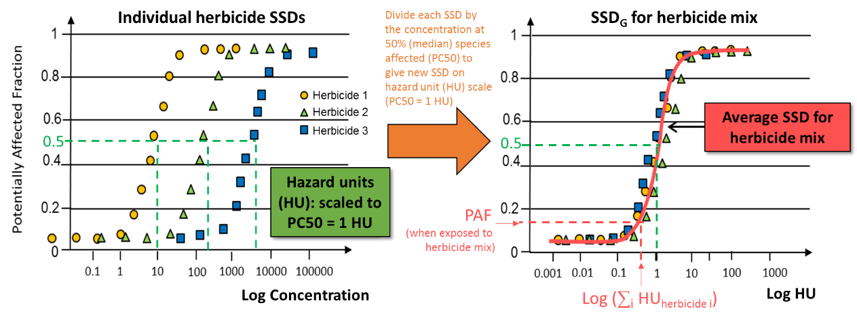
Figure 4-5 Overview of approach to determine a multi-substance species sensitivity distribution for a mixture of herbicides with the same mode of action (concentration additive model).

Phototrophs are highly relevant for ecological risk assessments of Reef ecosystems because corals, which contain photosynthetic zooxanthellae, and seagrasses, which are phototrophs, are keystone species. Additionally, phototrophs (in the form of micro-algae) form the basis of many food chains. Chemicals that have a specific mode of action (such as PSII herbicides), have a bimodal SSD. That is, a more sensitive distribution for the target organisms (phototrophs for PSII herbicides) and another less sensitive distribution for the non-target organisms (all non-phototrophs for PSII herbicides). In such cases, not all the toxicity data can be used, rather only the data from the most sensitive group of organisms are used to calculate the SSD (Australian and New Zealand Environment and Conservation Council (ANZECC) and Agriculture and Resource Management Council of Australia and New Zealand (ARMCANZ), 2000). Therefore it is appropriate to only use toxicity for phototrophs to assess the potential impact of PSII herbicides on the Reef ecosystem.
Data (NOEC and EC₅₀ data collated from the literature) used in the SSDs should be selected based on the following considerations:
- relevance of species to the Reef region (i.e. phototrophs such as photosynthetic zooxanthellae, seagrasses and micro algae; keystone species of the Reef)
- appropriateness of the exposure duration (toxicity data that includes both acute and chronic exposure to mimic the extensive periods of low concentrations in the dry season, and pulses in the wet season)
- relevance of the toxicity endpoints (i.e. those related to the long-term survival of populations, communities and ecosystems and include death, immobilisation, growth (individual or population), abundance and reproductive impairment)
- relevance of the measures of toxicity (toxicity data indicative of both a minor and a major risk are used for both short-term (acute) and long-term (chronic) exposure calculations).
In cases where the minimum data requirements to generate a reliable marine SSD are not able to be met, freshwater and estuarine species can also be used. The inclusion of freshwater and estuarine species in the development of SSDs suggests that the risk classes may at least in part be influenced by species irrelevant to the Reef and this should be considered, including in recommendations as to which marine species and pesticides should be further investigated to develop more robust SSDs.
Implementing new risk classes for the ms-PAF method is a current task of the Pesticide Working Group. Five interim risk classes were implemented for the 2014–15 and 2015–16 reporting years (
Table 4.3); however, it is important to note that the risk classes need to be validated against Reef species to determine whether these represent meaningful tipping points. Note that these risk classes are for herbicides only and that different classes need to be developed for neurotoxic pesticides that cause mortality.
Table 4.3 Risk classes used for 2016–17 and 2017–18 reporting years for the mixture method.
% species protected | Risk Level | Pesticides assessment
≥99% | Very low | Very good
>95 ‒ <99% | Low | Good
>90 ‒ 95% | Moderate | Moderate
>80 ‒ 90% | High | Poor
≤80% | Very high | Very poor
The ms-PAF approach is being developed by the Queensland DSITI. This approach was first evaluated in the context of quantifying the risk associated with pesticide exposure to the Reef ecosystem in 2014–15. As part of DSITI’s ongoing work, the overall model, as well as the number of PSII herbicides for which reliable SSDs are available, has subsequently been further developed and the model was re-evaluated in 2015–16. The ultimate aim for the MMP projects is to transition from the PSII-HEq metric to the ms-PAF to assess risk. The ms-PAF model will be evaluated each year to determine its suitability for application to the Reef ecosystem.
Polydimethylsiloxane (PDMS) samplers
- Silicone rubber 92 cm × 2.5 cm × 410 µm strips.
- Deployed in a marine grade stainless steel deployment cage (Figure 4-6).
- Routine time-integrated (and equilibrium) monitoring:
      - Deployed each month during the wet season at specific sites (Table 4.1) and for two months during the dry season.
- Preparation:
      - Dialysis with acetone (2 × 24 hours) and then hexane (2 × 24 hours) in solvent rinsed glass jars in batches on a shaker.
      - Stored in solvent rinsed glass jars, with Teflon-lined lids, under purified N₂.
      - Individual strips are wound around stainless steel spikes within the deployment cage (acetone rinsed) in a standard configuration.
      - The cage is assembled and sealed inside a metal can, stored at 4°C and transported with ice packs.
- Extraction and purification:
      - Biofouling is removed from each strip by scrubbing with water.
      - Each strip is then dried with Kimwipes and spiked with a surrogate standard.
      - Each strip is dialysed with 200 mL of a 1:1 ratio of acetone and hexane (2 – 24 hours) (tests in 2015–16 indicated that recoveries using a 1:1 mixture of acetone and hexane resulted in improved recoveries, 92–120 per cent across the five compounds compared to hexame alone (3–106 per cent).
      - Sample extracts are rotary evaporated, further evaporated under purified N₂, dried using Na₂SO₄ columns and filtered (0.45 µm PTFE) and reduced to 1 mL final volume.
      - Up until 2016–17, samples were made up to 10 mL using dichloromethane and subjected to gel permeation chromatography (GPC). Due to the relocation of the QAEHS laboratory in 2018, the use of GPC will no longer be available. Tests conducted comparing samples cleaned up by GPC versus those that were not have shown no appreciable differences in analysis.
- Chemical analysis – GCMS.
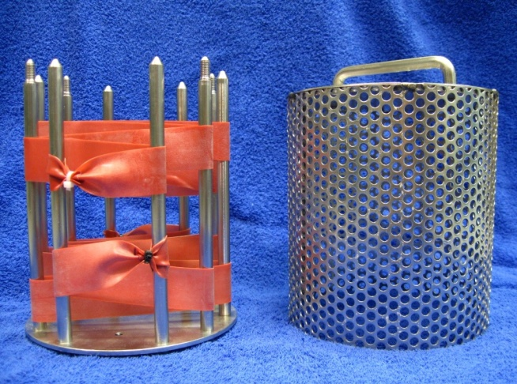
Figure 4-6 PDMS passive samplers loaded onto stainless steel sampler supports that sits within the deployment cage and is sealed in place with wing nuts
In situ calibration sampling rate adjustment of PDMS passive samplers using PFMs
Previous work has demonstrated the usefulness of the PFM for the in situ calibration of herbicides in the ED (O'Brien et al., 2009; D. O’Brien et al., 2011). Furthermore, (O’Brien et al., 2012) have demonstrated that the loss of plaster from the PFM can be applied to predict changes in R_{s} dependant on flow and turbulence, when deploying PDMS samplers.
The uptake of bifenthrin, dieldrin, oxadiazon, pendimethalin, permethrin, prothiophos and trifluralin were investigated as a function of water velocity (determined from r_{PFM}) at flows between 0 and 24 cm s⁻¹ (Figure 4-7). A one phase association describing this relationship between R_{s} and flow for each chemical is shown in Equation 2.
Equation 2
R_{s}= R_{s(0 cm/s)} + (R_{s(max)}- R_{s(0 cm/s)})*(1-exp(-Kr_{PFM} *r_{PFM}))

Where:
R_{s(0 cm/s)} is the R_{s} of the chemical of interest when exposed to still waters
R_{s(max)} is the maximum R_{s} for the chemical of interest
Kr_{PFM} is a rate constant expressed in reciprocal of the units of r_{PFM}
r_{PFM} is the loss rate of the PFM in g/day.

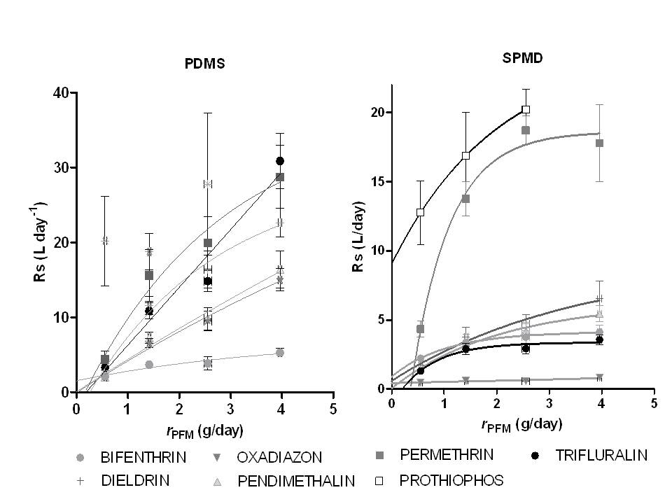
Figure 4-7 PDMS and semipermeable membrane devices sampling rates (Rs) as a function of water velocity (rPFM)
The in situ calibration procedure of PDMS using PFMs employed at QAEHS is:
- PFMs are co-deployed alongside marine cages containing PDMS (Figure 4-8).
- Deployment in:
      - Wet season (one month) – previously with no flow limiting cap. From the 2015–16 monitoring year onwards, a flow limiting cap (reduces plaster loss rate by 15 per cent) has been used to limit the number of PFMs that return to QAEHS empty (and provides an estimate of flow used) due to high flow rates.
      - Dry season (two months) – with a flow limiting cap.
- The loss rate of plaster is determined while accounting for the influence of ionic strength.
- Chemical analysis (GCMS) of samplers.
- R_{s} of ‘reference’ chemicals — bifenthrin, dieldin, oxadizon, pendimethalin and permethrin (prothiophos and trifluralin) were excluded — are calculated for each site at their specific r_{PFM} using Equation 4.
- Log K_{ow} of the seven reference chemicals are plotted against their R_{s.}
- The R_{s} of accumulated chemicals is predicted using the relationship between Log K_{ow} and R_{s} of the seven reference chemicals.
- Using R_{s}, estimate C_{w} using Equation 1.
- For accumulated chemicals with Log K_{ow} < 4.
  - Equilibrium phase sampling is assumed.
  - Measured Log K_{sw} (from unpublished collaborative experiment with DES in 2010) is used to estimate a C_{w} using Equation 2.
  - If no measured log K_{sw} value is available, the Log K_{sw} is predicted from the relationship between Log K_{ow} and Log K_{sw} and the Cw estimated using Equation 2.
- For accumulated chemicals with Log K_{ow} > 4, unless otherwise specified, PFM-adjusted R_{s} is used to estimate C_{w}.
The PFM method to predict the R_{s} of chemicals accumulated by PDMS samplers is now routinely used.
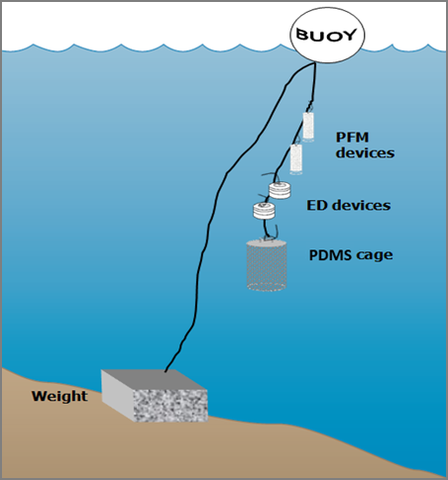
Figure 4-8 A schematic for the deployment of passive samplers (Empore disc in Chemcatcher housings, and Polydimethylsiloxane cages) together with the passive flow monitors for in situ calibration of flow effects in the field.

QA/QC procedures in the pesticide monitoring program
The development, calibration, field application and validation of passive sampling for monitoring water has been a research focus of QAEHS over many years. The methods described above have been developed as a result of this work in collaboration with analytical method development by QHFSS. These methods are formalized as SOPs, which describe the preparation, extraction and analysis of each type of passive sampler used in the MMP. Considering the number of new target pesticides and herbicides included as priorities under the MMP, an in-field calibration study would be beneficial to determine chemical uptake kinetics.
QA/QC procedures routinely employed by QAEHS in the MMP include:
- SOPs for the preparation, deployment, extraction and analysis of passive samplers
- staff training in these SOPs (laboratory) and a record of this training is maintained
- deployment guides for the training of field staff and volunteers
- generation of a unique alphanumeric identifier code for each passive sampler
- preparation, extraction, storage (4°C or -20°C) and subsequent analysis of procedural blank passive samplers with each batch of exposed passive samplers
- use of labelled internal standards or other surrogate standards to evaluate or correct for recovery or instrument sensitivity throughout the extraction and within the analysis process respectively
- exposure of replicate samplers during each deployment that are extracted and archived in QAEHS specimen bank at -80°C.
QHFSS laboratories are accredited by the National Association of Standards Testing. Details of QHFSS accreditation can be found on the National Association of Testing Authorities (NATA) website (http://www.nata.asn.au/). Sample receipting, handling, analysis and data reporting at QHFSS are based on NATA certified methods. The NATA accreditation held by the QHFSS includes a wide variety of QA/QC procedures covering the registration and identification of samples with specific codes and the regular calibration of all quantitative laboratory equipment required for the analysis.

Data management and security
The data management protocols for QAEHS are outlined below and include documentation of all steps within the sampling program: passive sampler identification, transport, deployment, transfer of samples to QHFSS for chemical analysis, analytical results, data manipulation, storage and access. This protocol may be summarised as:
- The unique alphanumeric identifier code attached to each passive sampler is applied to all subsequent daughter samples and results, ensuring a reliable link with the original sample.
- Deployment records are sent with the sampling devices, and include information on the unique sampling device identifier, deployment identifier, name of the staff/volunteer who performed the operation, storage location, destination site, important dates, details of sample treatment and any problems that may have occurred. When returned, the information is entered into Excel spreadsheets and stored on the QAEHS main server with a back-up on one local hard drive.
- Detailed chain of custody records are kept with the samplers at all times. Devices are couriered directly to the tourism operators/community member and monitored via a tracking system. Delivery records are maintained by QAEHS to guarantee traceability of samples.
- Hard copy records are maintained of all sample submission forms provided to QHFSS for analysis.
- Results files provided by QHFSS along with a unique identifier code are transferred from the instrumentation computer to the Entox server and archived on the QHFSS network using an established data management system.
- Excel spreadsheets used for data manipulation and a summary results file (concentration in water estimates) are stored on the QAEHS server. Access to the QAEHS server is restricted to authorised personnel only via a password protection system. Provision of data to a third party only occurs at the consent or request of the program manager.

Summary
In summary, the following QA/QC measures are employed within the Pesticide Monitoring Program:
- unique sample identifiers
- comprehensive records and chain of custody paperwork across all components
- training of field personnel, including deployment guidelines and records
- analytical quality control measures
- procedural QA/QC for the preparation, extraction and analysis of passive samplers including SOPs
- inclusion of QA/QC samples (replication of sampling and procedural blanks)
- continual evaluation, method development and improvement of methods for sampler processing and estimation of concentration in water.
In addition to these measures, QAEHS has recently undertaken an independent and comprehensive internal review of its processes, with the objective being to guarantee and improve consistency and quality of work. This review (conducted in February 2016) was assessed by a retired chemist from SAS Laboratories (Queensland Urban Utilities) with 40 years of experience in public and private sector analysis and consulting. The review consisted of tracking a sample/sample batch from receipt to reporting (i.e. entire lifecycle from receipt, storage, processing, extraction, analysis, data interpretation/validation and reporting). While the review did not centre around the MMP specifically, the recommendations from the review could be directly transferrable and helped to streamline and improve aspects of this program including updating documentation of training and SOPs, improved record keeping of equipment calibration and maintenance, automation of spreadsheets (through the use of macros and hyperlinks) to avoid human error involved in excessive copy and pasting, and simplification of sample labelling. Using the reviewer’s input, QAEHS seeks to implement many of their recommendations throughout the current monitoring year.

Inshore coral reef monitoring
Angus Thompson, Johnston Davidson, Paul Costello
Australian Institute of Marine Science

Introduction
The objective of the biological monitoring of inshore reefs is to document spatial and temporal trends in the benthic reef communities. Changes in these communities may be due to acute disturbances such as cyclonic winds, bleaching and crown-of-thorns starfish as well as more chronic disturbances such as those related to run-off (for example increased sedimentation and nutrient loads), which disrupt processes of recovery such as recruitment and growth. A subset of reef monitoring sites are co-located with the sampling locations for lagoon water quality, enabling the assessment of the relationship between reef communities and water quality as well as other, more acute, impacts.
Salient attributes of a healthy ecological community are that it should be self-perpetuating and ‘resilient’, that is able to recover from, or resist, disturbance. One of the ways in which water quality is most likely to shape reef communities is through effects on coral reproduction and recruitment. Laboratory and field studies have shown that elevated concentrations of nutrients and other agrichemicals and levels of suspended sediment and turbidity can affect one or more of gametogenesis, fertilisation, planulation, egg size and embryonic development in some coral species (Fabricius, 2005). High levels of sedimentation can affect larval settlement or net recruitment of corals. Similar levels of these factors may have sub-lethal effects on established adult colonies. Because adult corals can tolerate poorer water quality than recruits and colonies are potentially long-lived, reefs may retain high coral cover even under conditions of declining water quality, but have low resilience. Some high-cover coral communities may be relic communities formed by adult colonies that became established under more favourable conditions. Such relic communities would persist until a major disturbance; however, subsequent recovery may be slow if recruitment is reduced or non-existent. This would lead to long-term degradation of reefs, because extended recovery time increases the likelihood that further disturbances will occur before recovery is complete (McCook et al., 2000). For this reason, the MMP surveys estimate cover of various coral taxa and also collect information on the abundance of juvenile colonies as evidence for the extent of ongoing recruitment.
This component of the MMP aims to accurately quantify temporal and spatial variation in inshore coral reef community status in relation to variations in local reef water quality. A detailed report linked the consistent spatial patterns in coral community composition observed over the first three years of the project with environmental parameters (A. Thompson et al., 2010). As the temporal span of this project has extended, there has been a natural shift in the focus toward understanding and documenting the differences in community dynamics (status) across the spatial extent of the sampling rather than reiterating spatial differences in composition.
To quantify inshore coral reef community status in relation to variations in local reef water quality, this section of the project has several key objectives:
- Identify the trends in the condition and composition of benthic communities for Great Barrier Reef inshore coral reefs against desired outcomes along identified or expected gradients in water quality.
- Assess the extent, frequency and intensity of acute and chronic impacts on the condition of inshore coral reefs associated with sediments and nutrients transported by run-off.
- Identify the trajectories of recovery for inshore coral reef communities following impacts resulting from exposure to flood plumes (and associated sediments and nutrients), cyclones and thermal bleaching events.
- Identify the key drivers of coral mortality and the trends in coral reef resilience indicators on inshore reefs.
- Provide information about sea temperature as a potential driver of environmental conditions at inshore reefs.
- Provide an integrated assessment of coral community condition for the inshore reefs monitored to serve as a report card against which changes in condition can be tracked.
- Maintain a local database of all sample data and associated metadata and data summaries, with relevant excerpts provided for storage in the Spatial and Scientific Information Management for Reef database.

Methods

Sampling design
The sampling design was selected for the detection of change in benthic communities on inshore reefs in response to improvements in water quality parameters relevant to specific catchments, or groups of catchments (Region), and to disturbance events. Within each Region, reefs are selected along a gradient of exposure to run-off, largely determined as increasing distance from a river mouth in a northerly direction. To account for spatial heterogeneity of benthic communities within reefs, two sites were selected at each reef (Figure 5-1).
Observations on a number of inshore reefs undertaken by AIMS in 2004 during the pilot study to the current monitoring program (Sweatman et al., 2007) highlighted marked differences in community structure and exposure to perturbations with depth; hence sampling within sites is stratified by depth. Within each site and depth, fine scale spatial variability is accounted for by the use of five replicate transects.

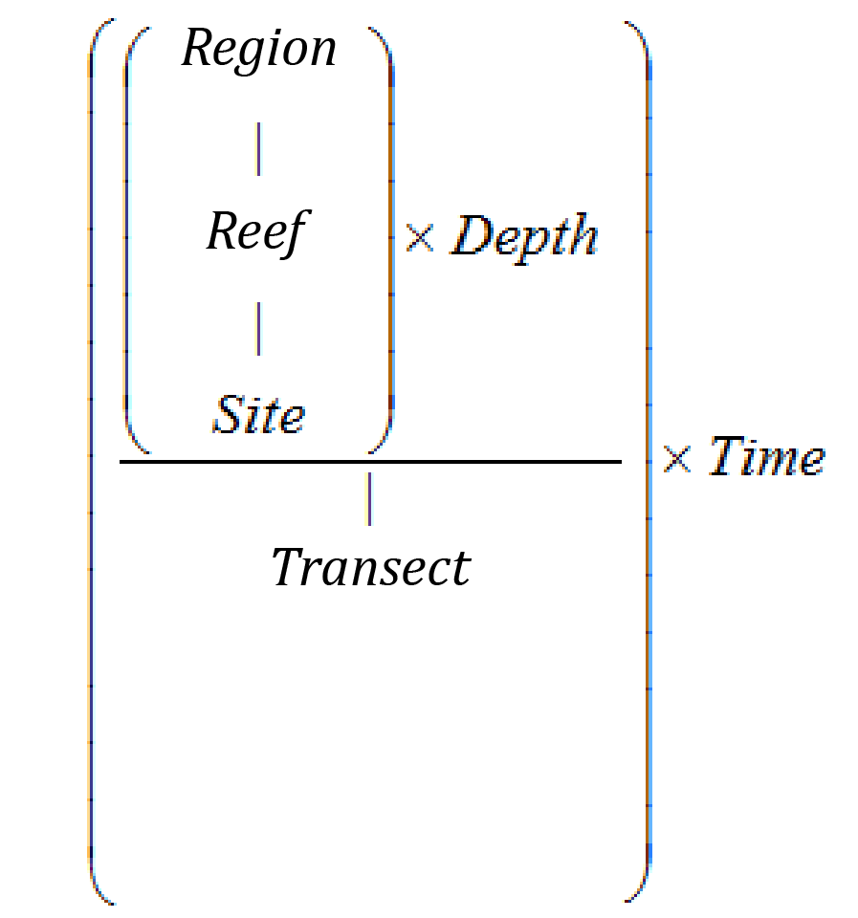
Figure 5-1 Sampling design for coral reef benthic community monitoring. Terms within brackets are nested within the term appearing

Site selection
The reefs monitored were selected by the Authority, using advice from expert working groups. The selection of reefs was based upon two primary considerations:
- To make sure that the sampling locations in each catchment of interest were spread along a perceived gradient of influence from river output.
- Evidence (in the form of carbonate-based substrate) that coral reef communities had been viable (net positive accretion of a carbonate substrate) in the past.
Where well-developed reefs existed on more than one aspect of an island, two reefs were included in the design because, although position relative to run-off exposure would be similar, often quite different communities exist on windward compared to leeward reefs.
Over time, there have been some adjustments made to the sampling design (Table 5.1). For the first two years of the project (2005 and 2006), 35 reefs were surveyed each year. In 2007 to 2014 the fringing reefs along the Cape Tribulation coast were no longer surveyed due to concerns over crocodile attack. In addition, the sampling frequency changed so that only a subset of “core” reefs were surveyed every year with the remaining “cycle” reefs surveyed every other year (Table 5.1). From 2015, the sampling changed again with King Reef replaced by Bedarra Island in the Tully Catchment and all reefs now surveyed biannually. In addition to these adjustments, as of 2015 data from inshore reef sites surveyed under the Long Term Monitoring Program (LTMP) are now included in the analysis and reporting of inshore coral reef condition (Table 5.1). A map of sites included from 2015 is presented in Figure 5-2.

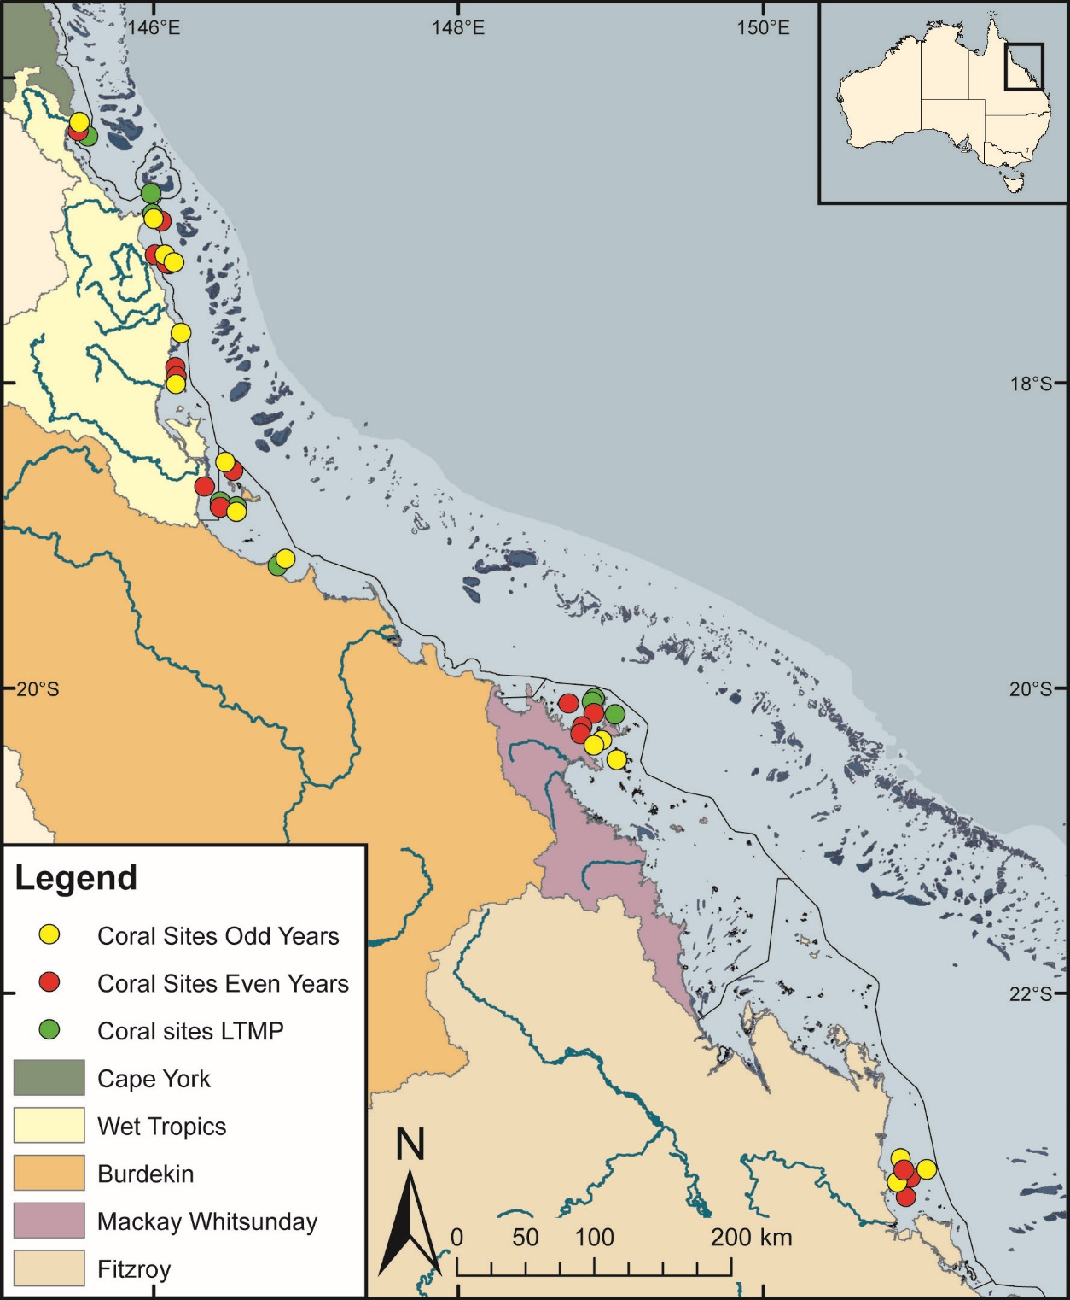
Figure 5-2 Coral community sampling locations as at 2015
Table 5.1 Sites selected for inshore reef monitoring
NRM Region | Catchment | 2005–2014 | 2015 to present | Team
Wet Tropics | Daintree | Cape Tribulation (North) #  Cape Tribulation (Mid) #  Cape Tribulation (South) #  Snapper Island (North)*  Snapper Island (South) | Snapper Island (North)**  Snapper Island (South) | Sea Research
Wet Tropics | Russell / Mulgrave Johnstone | Fitzroy Island (East)  Fitzroy Island (West)*  Frankland Island Group (East)  Frankland Island Group (West)*  High Island (East)  High Island (West) | Fitzroy Island (East)  Fitzroy Island (West)**  Frankland Is. Group (East)**  Frankland Is. Group (West)  High Island (East)**  High Island (West)  Fitzroy Island (West)  Green Island  Low Isles | AIMS
Wet Tropics | Tully | Dunk Island (North)*  Dunk Island (South)  North Barnard Group  King Reef | Dunk Island (North)  Dunk Island (South)  North Barnard Group**  Bedarra Island** | AIMS
Burdekin | Herbert | Lady Elliot Reef  Orpheus Island (East)  Pelorus Is & Orpheus Is (West)* | Lady Elliot Reef  Orpheus Island (East)  Pelorus Is & Orpheus Is (West)** | AIMS
Burdekin | Burdekin | Geoffrey Bay*  Middle Reef  Pandora Reef*  Havannah Island | Geoffrey Bay**  Pandora Reef  Havannah Island**  Havannah North  Pandora North  Middle Reef | AIMS
Mackay Whitsunday | Proserpine | Pine Island*  Shute Island  Daydream Island*  Double Cone Island*  Seaforth Island  Dent Island  Hook Island | Pine Island**  Shute Island  Daydream Island  Double Cone Island  Seaforth Island**  Dent Island**  Hook Island  Hayman Island  Langford Island  Border Island | AIMS
Fitzroy | Fitzroy | Peak Island  Pelican Island*  Humpy & Halfway Islands*  Middle Island  North Keppel Island  Barren Island* | Peak Island  Pelican Island**  Humpy & Halfway Islands  Middle Island  North Keppel Island**  Barren Island** | AIMS
# Sampling discontinuded after 2006
* Reefs designated as ‘core reefs’ and sampled annually
** Reefs sampled in odd numbered years under the biennial sampling design
Italics identifieds reefs surveyed by the AIMS long-term monitoring program

Table 5.2 Distribution of sampling effort
Survey Method | Information provided | Transect coverage | Spatial coverage
Photo point intercept | Percentage cover of the substrate for major benthic habitat components | Approximately 25 cm belt along upslope side of transect from which 160 points are sampled | Full sampling design
Juvenile counts | Size structure of coral communities, density post settlement recruitment | A 34 cm belt along the upslope side of each transect | Full sampling design
Scuba search | Incidence of factors causing coral mortality | Two-metre belt centred on transect | Full sampling design

Depth selection
From observations of a number of inshore reefs undertaken by AIMS in 2004, marked differences in community structure and exposure to perturbations with depth were noted (Sweatman et al., 2007). The lower limit for the inshore coral surveys was selected at five metres below datum because coral communities rapidly diminish below this depth at many reefs; two metres below datum was selected as the shallow depth as this allowed surveys of the reef crest. Shallower depths were considered but discounted for logistical reasons, including the inability to use the photo technique in very shallow water, site markers creating a danger to navigation and difficulty in locating a depth contour on very shallow sloping substrata typical of reef flats. Sites surveyed under the LTMP are only surveyed at five metres below datum.

Field survey methods
Site marking
Each selected reef site is permanently marked with steel fence posts at the beginning of each 20-metre transect and smaller (10 mm diameter) steel rods at the 10-metre mark and end of each transect. Compass bearings coupled with distance along transects record the transect path between these permanent markers. Transects were set initially by running two 60-metre fibreglass tape measures out along the desired five- or two-metre depth contours. Digital depth gauges are used along with tide heights from the closest location included in ‘Seafarer Tides’ electronic tide charts produced by the Australian Hydrographic Service. There are five-metre gaps between each consecutive 20-metre transect. The position of the first picket of each site is recorded with a Global Positioning System (GPS).
Sampling methods
Three separate sampling methodologies are used to describe the benthic communities of inshore coral reefs (Table 5.2). These are each conducted along the fixed transects identified in the sampling design, although there are subtle differences in width or length of transect or spatial extent of the datasets as listed in Table 5.1.
Photo point intercept method
This method is used to gain estimates of the per cent cover of benthic community components. The method follows closely SOP Number 10 of the AIMS LTMP (Jonker et al., 2008). In short, digital photographs are taken at 50-centimetre intervals along each 20-metre transect. Estimation of cover of benthic community components is derived from the identification of the benthos lying beneath points overlaid onto these images. For the majority of hard and soft corals, at least genus level identification is achieved. The categories used for identification of benthos are listed in Jonker et al. (2008).
The primary difference in the application of the method in this project from that described in Jonker et al. (2008) is in the sampling design. Sampling for this project is based on 20-metre transects, rather than 50-metre transects. To compensate for transects being shorter than in the standard method, the density of frames per unit area of transect is doubled (images captured at 0.5 metres rather than at one-metre intervals). This alteration to the standard technique was adopted owing to the limited size of some of the reefs sampled. This modification in methodology of course does not apply to the sites monitored under the LTMP, which use the 50-metre transects and one image per meter.
Juvenile coral surveys
These surveys aim to provide an estimate of the number of coral colonies that were successfully recruiting and surviving early post-settlement pressures. In the first year of sampling under this program, these juvenile coral colonies were counted as part of a demographic survey that counted the number of individuals falling into a broader range of size classes. As the focus narrowed to just juvenile colonies, the number of size classes reduced allowing an increase in the spatial coverage of sampling.
From 2006 to 2017, coral colonies less than 10 centimetres in diameter were counted within a belt 34-centimetres wide (data slate length) along the upslope side of each 20-metre transect. Each colony was identified to genus and assigned to a size class of 0–2 cm, >2–5 cm or >5–10 cm. Importantly, this method aims to estimate the number of juvenile colonies that result from the settlement and subsequent survival and growth of coral larvae rather than small coral colonies resulting from fragmentation or partial mortality of larger colonies. With the exception of the transect dimension and the size classes used, this method is consistent with SOP Number 10 of the AIMS LTMP, Part 2, in which further detail relating to juvenile/fragment differentiation can be found (Jonker et al., 2008). Data on juvenile density provided by the LTMP for the relevant sites listed in Table 5.1 are collected according to these procedures with no modification.
Scuba search transects
Scuba search transects document the incidence of agents causing coral mortality or disease. Tracking of these mortality agents is important because declines due to these agents must be carefully considered as covariates for possible trends associated with response to outcomes. The method used follows closely SOP Number 9 of the AIMS LTMP, Part 2 (Miller et al., 2009). In short, a search is made of a two-metre wide belt (one metre either side of the transect midline) for any recent scars, bleaching, disease or damage to coral colonies. An extra category not included in the standard procedure is physical damage. This is recorded on the same five-point scale as coral bleaching and describes the proportion of the coral community that has been physically damaged, as indicated by toppled or broken colonies. This category may include anchor as well as storm damage. Scuba search data provided by the LTMP for the relevant sites listed in Table 5.1 is collected with strict adherence to SOP Number 9 of the AIMS LTMP, Part 2 (Miller et al., 2009).

Observer training
The AIMS personnel collecting data in association with this project are without exception highly experienced in the collection of benthic monitoring data. Each observer was employed specifically for their skills in benthic monitoring and intercept analysis.
Ongoing standardisation of observers is achieved by in-field and photo based comparisons that for the most mitigate inconsistencies in identification. As a final step in reducing bias in sampling, all photo transect identifications are double checked by a single observer.
In the event that new observers enter the team, training in each sampling method is by direct tuition with an experienced observer. New observers must meet the standards listed in Table 5.3 before collecting data for the project.
Table 5.3 Observer training methods and quality measures
Monitoring method | Training method | Quality measure
Photo point intercept | In-field identification of benthic components.  On screen classification of photo points.  In-field tuition on photographic protocol. | All identifications double checked.
Juvenile counts | In-field identification of corals to genus level and application of technique with experienced observer supervision. | No greater than 10 per cent of colonies misidentified, overlooked or misclassified in size during supervised demographic surveys of two sites.
Scuba search | In-field tuition in the classification of coral scars and damage. | Observation of at least 90 per cent of damaged colonies and their correct classification during supervised surveys of two sites of damaged colonies.
Classification to genus level underwater is augmented by the use of a small digital camera to take images for post-dive scrutiny of difficult to identify colonies. However, some small juvenile corals are difficult to differentiate in the field and, while they are identified to genus level, they are typically merged with similar genera for analysis and reporting.
Sea Research is responsible for surveys in the Daintree catchment. The Sea Research observer, Tony Ayling, is the most experienced individual in Australia in surveying the benthic communities of near-shore coral reefs. He has 30-years’ experience surveying the sites in this catchment, amongst many others. His taxonomic skills are undoubted at genus level and, as such, observer standardisation for demography and scuba search surveys are limited to detailed discussion of methodologies with AIMS observers and explicit following of the protocols listed here. Sea Research also use the same pre-printed datasheets and data entry programs. Analysis of video footage collected by Sea Research is undertaken by AIMS.

Temperature monitoring
Temperature loggers are deployed at, or in close proximity to, all locations at both two-metre and five-metre depths and routinely exchanged either at the time of the coral surveys (i.e. every 24 months) or every three months at sites where FLNTU loggers are co-located (Table 2.1). Three types of temperature loggers have been used for the sea surface temperature logger program. The first type was the Odyssey temperature loggers (http://www.odysseydatarecording.com/), which were superseded by the Sensus Ultra Temperature logger (http://reefnet.ca/products/sensus/). In 2015, Vemco minilog temperature loggers (http://vemco.com/products/minilog-ii-t/) began to replace aging Sensus loggers.
The Odyssey loggers were set to take readings every 30 minutes. The Sensus and Vemco loggers were set to take readings every 10 minutes. Loggers were calibrated against a certified reference thermometer after each deployment and generally accurate to ± 0.2°C.
Detailed data download, quality checks and data management methods are described in Appendix A12.

Data management
Data management practices are a major contributor to the overall quality of the data collected; poor data management can lead to errors and lost data, and can reduce the value of the Reef Plan MMP data. Data from the AIMS MMP inshore coral reef monitoring are stored in a custom-designed MMP data management system in Oracle databases to allow cross-referencing and access to related data (see Appendix A12 for details about general AIMS in-house procedures for data security, data quality checking and backup).
It is AIMS policy that all data collected have a metadata record created for it. The metadata record is created using a Metadata Entry System where the metadata is in the form of ISO19139 XML. This is the chosen format for many agencies across Australia and the international community that deal with spatial scientific data.
Metadata is available here:
https://apps.aims.gov.au/metadata/view/c30cfb2d-46be-4837-9733-9bb60489b65b
All coral monitoring field data is recorded on pre-printed datasheets. The use of standard datasheets aids in ensuring standard recording of attributes and makes sure that required data are collected.
On return from the field, all data is entered on the same day into a SQLite database using a custom written data entry program. Each field on the data entry program forms mirror those on the pre-printed datasheets and includes lookup fields to make sure that data entered is of the appropriate structure or within predetermined limits. For example, entry of genera to the demography data table must match a pre-determined list of coral genera.
On return to the office, the data is uploaded to an Oracle Database using a custom written synchronisation process. All keyed data is printed and checked against field datasheets before final logical checking (ensuring all expected fields are included and tally with the number of surveys). Photo images are also stored on a server that is included in a routine automatic backup schedule. Photo images are copied to an external hard drive before analysis as a second backup.
Image analysis of reef monitoring photos is performed within the AIMS monitoring data entry package “reefmon”. This software contains logical checks to all keyed data and is directly linked to a database to guarantee data integrity. The directory path to transect images is recorded in the database. This functionality allows the checking of benthic category identification. All photo transect data is checked by a second experienced observer before data analysis and reporting of results.

Summary of Quality Control measures
Quality control is achieved by:
- Use of published SOPs.
- Data collection staff are trained and assessed by experienced observers before commencing field work to make sure that their identification skills are consistent with the resolution required.
- Data entry via database forms that include logical checking on format and content of entered fields, and confirmation of data by second observer.
- Continual evaluation, method development and improvement of methods.
- Advanced data management and security procedures.

Inshore seagrass monitoring
¹Len McKenzie, ²Michelle Waycott, ³Richard Unsworth, ¹Catherine Collier
¹Centre for Tropical Water & Aquatic Ecosystem Research (TropWATER), James Cook University, Cairns, QLD
² University of Adelaide / Plant Biodiversity Centre, Department of Environment and Natural Resources, Adelaide, SA
³Seagrass Ecosystem Research Group, College of Science, Wallace Building, Swansea University SA2 8PP, UK

Introduction
Approximately 3063 square kilometres of inshore seagrass meadows have been mapped in Great Barrier Reef World Heritage Area waters shallower than 15 metres, relatively close to the coast, and in locations that can potentially be influenced by adjacent land use practices. Monitoring of the major marine ecosystem types most at risk from land-based sources of pollutants is being conducted to make sure that any change in their status is identified. Seagrass monitoring sites are associated with the river mouth and inshore marine water quality monitoring tasks in the MMP to enable correlation with concurrently collected water quality information.
The key aims of the inshore seagrass monitoring under the MMP are to:
- Monitor, assess and report the condition and trend of Great Barrier Reef inshore seagrass meadows against desired outcomes along identified or expected gradients in water quality.
- Monitor, assess and report the extent, frequency and intensity of acute and chronic impacts on the condition of Great Barrier Reef inshore seagrass meadows from sediments, nutrients and pesticides.
- Monitor, assess and report recovery of Great Barrier Reef inshore seagrass meadows from exposure to flood plumes, sediments, nutrients and pesticides.

Methods

Sampling design
The sampling design was selected to detect changes in inshore seagrass meadows in response to improvements in water quality associated with specific catchments or groups of catchments (NRM region) and to disturbance events. Within each region, a relatively homogenous section of a representative seagrass meadow is selected to represent each of the seagrass habitats present (estuarine, coastal, reef). Meadow selection was informed using mapping surveys across the regions before site establishment and by the Authority, using advice from expert working groups. To account for spatial heterogeneity, two sites are selected within each location (Site [Habitat (Region)]). Subtidal sites are not replicated within some locations. Within each site, finer scale variability is accounted for by assessing 33 quadrats. The final constraint on site selection is that the minimum detectable relative difference (MDRD) must be below 20 per cent (at the 5 per cent level of significance with 80 per cent power). An intertidal site is defined as a 5.5 hectare area and in the centre of each site a 50 m × 50 m area is examined using 33 quadrats (50 cm × 50 cm), placed every five metres along each of the 50 metre transects, placed 25 metres apart. A pilot assessment is conducted prior to establishing long-term monitoring to ensure no spatial autocorrelation within or between transects. The sampling strategy for subtidal sites is modified depending on whether assessments were conducted using SCUBA or drop-camera. Owing to logistical problems with scuba diving in often poor visibility, sampling is conducted along 50-metre transects two–three metres apart (aligned along the depth contour). Drop-camera sampling is conducted from a surface vessel using a real-time underwater GoPro® camera mounted to a frame with a 0.25 m² quadrat in the field of view. The drop-camera is deployed within a 50 metre radius of permanent waypoints, using vertical drops and the footage recorded for post-field analysis. A van Veen grab is used in conjunction with the visual assessment to confirm seagrass taxonomy and sediment type. At each site, monitoring is conducted during the late-monsoon (April) and late-dry (October) periods each year; extra sampling is conducted at more accessible locations in the dry (July) and monsoon (January) periods.

Field survey methods — Inshore seagrass meadow abundance, community structure and reproductive health
Site marking
The sampling locations for this program are shown in Figure 6-1 and listed in Table 6.1. Where possible, each selected inshore seagrass site is permanently marked with a plastic star picket at the start of the centre transect. Labels identifying the sites and contact details for the program are attached to these pickets. Positions of zero metre and 50 metre points for all transects at a site are also noted using GPS (accuracy ±3 m). This guarantees that the same site is monitored at each event.
Seagrass cover and species composition
Survey methodology follows standardised protocols (weblink http://www.seagrasswatch.org/monitoring.html). A site is defined as an area within a relatively homogenous section of a representative seagrass community/meadow (LJ McKenzie et al., 2000).
Monitoring at the 47 sites identified for the MMP long-term inshore monitoring in late-monsoon (April) and late-dry season (October) of each year is conducted by qualified and trained scientists who have demonstrated competency in the methods (see Sub-section 6.2.3). Monitoring conducted outside these periods is also conducted by a trained scientist and, at two locations (Magnetic Island and Townsville), is assisted by volunteers.

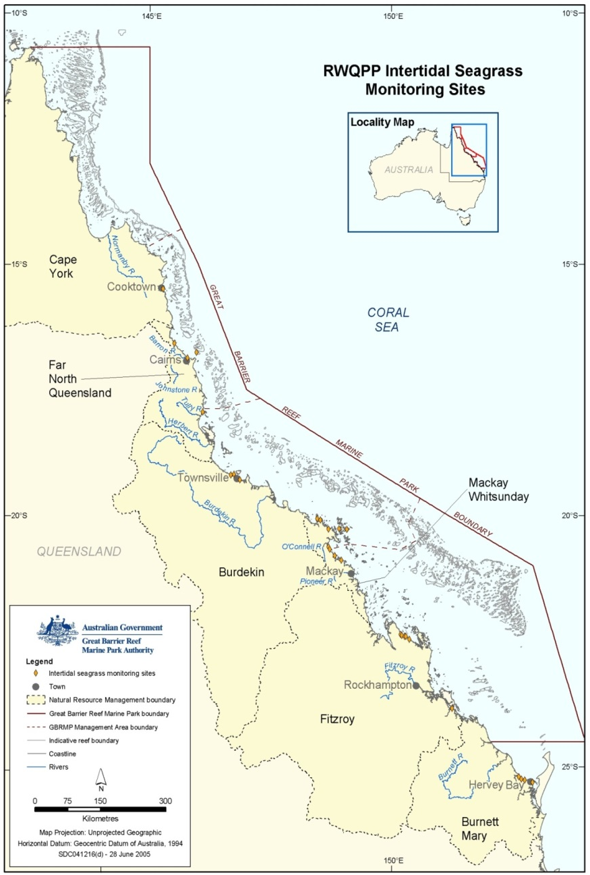
Figure 6-1 Inshore seagrass monitoring sites

Table 6.1 Inshore seagrass long-term monitoring sites
NRM region from www.nrm.gov.au. * = intertidal, ^=subtidal.
Region | NRM region | Basin | Monitoring location | Site |  | Latitude |  | Longitude |  | Seagrass community type
Far Northern | Cape York | Jacky Jacky / Olive-Pascoe | Shelburne Bay  coastal | SR1* | Shelburne Bay | 11° | 53.233 | 142° | 54.851 | H. ovalis with H. uninervis/T. hemprichii
 |  |  |  | SR2* | Shelburne Bay | 11° | 53.251 | 142° | 54.938 | H. ovalis with H. uninervis/T. hemprichii
Far Northern | Cape York | Jacky Jacky / Olive-Pascoe | Piper Reef  reef | FR1* | Farmer Is. | 12° | 15.352 | 143° | 14.020 | T. hemprichii with C. rotundata/H. ovalis
 |  |  |  | FR2* | Farmer Is. | 12° | 15.448 | 143° | 14.185 | T. hemprichii with C. rotundata/H. ovalis
Far Northern | Cape York | Normanby / Jeannie | Stanley Island  reef | ST1* | Stanley Island | 14° | 8.576 | 144° | 14.680 | H. ovalis/H. uninervis with T. hemprichii/C. rotundata
 |  |  |  | ST2* | Stanley Island | 14° | 8.547 | 144° | 14.588 | H. ovalis/H. uninervis with T. hemprichii/C. rotundata
Far Northern | Cape York | Normanby / Jeannie | Bathurst Bay  coastal | BY1* | Bathurst Bay | 14° | 16.082 | 144° | 13.961 | H. uninervis with H. ovalis/T. hemprichii/C. rotundata
 |  |  |  | BY2* | Bathurst Bay | 14° | 16.062 | 144° | 13.896 | H. uninervis with H. ovalis/T. hemprichii/C. rotundata
Far Northern | Cape York | Endeavour | Cooktown  reef | AP1* | Archer Point | 15° | 36.500 | 145° | 19.143 | H. univervis/ H. ovalis with Cymodocea/T. hemprichii
 |  |  |  | AP2* | Archer Point | 15° | 36.525 | 145° | 19.108 | H. univervis/H. ovalis with C. rotundata
Northern | Wet Tropics | Daintree | Low Isles  reef | LI1* | Low Isles | 16° | 23.11 | 145° | 33.88 | H.ovalis/H.uninervis
 |  |  |  | LI2^ | Low Isles | 16° | 22.97 | 145° | 33.85 | H.ovalis/H.uninervis
Northern | Wet Tropics | Mossman /  Barron /  Mulgrave-Russell /  Johnstone | Yule Point  coastal | YP1* | Yule Point | 16° | 34.159 | 145° | 30.744 | H. uninervis with H. ovalis
 |  |  |  | YP2* | Yule Point | 16° | 33.832 | 145° | 30.555 | H. uninervis with H. ovalis
Northern | Wet Tropics | Mossman /  Barron /  Mulgrave-Russell /  Johnstone | Green Island  reef | GI1* | Green Island | 16° | 45.789 | 145° | 58.31 | C. rotundata/T. hemprichii with H. uninervis/H. ovalis
 |  |  |  | GI2* | Green Island | 16° | 45.776 | 145° | 58.501 | C. rotundata/T. hemprichii with H. uninervis/H. ovalis
 |  |  |  | GI3^ | Green Island | 16° | 45.29 | 145° | 58.38 | C. rotundata/ H. uninervis/C.serrulata/S.isoetifolium
Northern | Wet Tropics | Tully / Murray / Herbert | Mission Beach  coastal | LB1* | Lugger Bay | 17° | 57.645 | 146° | 5.61 | H. uninervis
 |  |  |  | LB2* | Lugger Bay | 17° | 57.674 | 146° | 5.612 | H. uninervis
Northern | Wet Tropics | Tully / Murray / Herbert | Dunk Island  reef | DI1* | Dunk Island | 17° | 56.6496 | 146° | 8.4654 | H. uninervis with T. hemprichii/ C. rotundata
 |  |  |  | DI2* | Dunk Island | 17° | 56.7396 | 146° | 8.4624 | H. uninervis with T. hemprichii/ C. rotundata
 |  |  |  | DI3^ | Dunk Island | 17° | 55.91 | 146° | 08.42 | H. uninervis / H. ovalis/H.decipiens/C. serrulata
Central | Burdekin | Ross / Burdekin | Magnetic Island  reef | MI1* | Picnic Bay | 19° | 10.734 | 146° | 50.468 | H. uninervis with H. ovalis & Zostera/T. hemprichii
 |  |  |  | MI2* | Cockle Bay | 19° | 10.612 | 146° | 49.737 | C. serrulata/ H. uninervis with T. hemprichii/H. ovalis
 |  |  |  | MI3^ | Picnic Bay | 19° | 10.734 | 146° | 50.468 | H. uninervis with H. ovalis & Zostera/T. hemprichii
Central | Burdekin | Ross / Burdekin | Townsville  coastal | SB1* | Shelley Beach | 19° | 11.046 | 146° | 45.697 | H. uninervis with H. ovalis
 |  |  |  | BB1* | Bushland Beach | 19° | 11.028 | 146° | 40.951 | H. uninervis with H. ovalis
Central | Burdekin | Ross / Burdekin | Bowling Green Bay  coastal | JR1* | Jerona (Barratta CK) | 19° | 25.380 | 147° | 14.480 | H. uninervis with Zostera/H. ovalis
 |  |  |  | JR2* | Jerona (Barratta CK) | 19° | 25.281 | 147° | 14.425 | H. uninervis with Zostera/H. ovalis
Central | Mackay Whitsunday | Proserpine / O'Connell | Repulse Bay  coastal | LN1^ | Lindeman Is. | 20° | 26.293 | 149° | 1.691 | H. uninervis with H. ovalis
 |  |  |  | LN2^ | Lindeman Is. | 20° | 26.014 | 149° | 1.923 | H. uninervis with H. ovalis
 |  |  |  | MP2* | Midge Point | 20° | 38.099 | 148° | 42.108 | Zostera with H. uninervis/H. ovalis
 |  |  |  | MP3* | Midge Point | 20° | 38.080 | 148° | 42.280 | Zostera with H. uninervis/H. ovalis
Central | Mackay Whitsunday | Proserpine / O'Connell | Whitsundays  reef | HM1* | Hamilton Island | 20° | 20.7396 | 148° | 57.5658 | H. uninervis with H. ovalis
 |  |  |  | HM2* | Hamilton Island | 20° | 20.802 | 148° | 58.246 | Z. muelleri with H. ovalis/H. uninervis
Central | Mackay Whitsunday | Plane | Mackay  estuarine | SI1* | Sarina Inlet | 21° | 23.76 | 149° | 18.2 | Z. muelleri with H. ovalis (H. uninervis)
 |  |  |  | SI2* | Sarina Inlet | 21° | 23.712 | 149° | 18.276 | Z. muelleri with H. ovalis (H. uninervis)
Southern | Fitzroy | Shoalwater / Fitzroy | Shoalwater Bay  coastal | RC1* | Ross Creek | 22° | 22.953 | 150° | 12.685 | Zostera muelleri with H. ovalis
 |  |  |  | WH1* | Wheelans Hut | 22° | 23.926 | 150° | 16.366 | Zostera muelleri with H. ovalis
Southern | Fitzroy | Shoalwater / Fitzroy | Keppel Islands  reef | GK1* | Great Keppel Is. | 23° | 11.783 | 150° | 56.3682 | H. uninervis with H. ovalis
 |  |  |  | GK2* | Great Keppel Is. | 23° | 11.637 | 150° | 56.3778 | H. uninervis with H. ovalis
Southern | Fitzroy | Calliope / Boyne | Gladstone Harbour  estuarine | GH1* | Gladstone Hbr | 23° | 46.005 | 151° | 18.052 | Zostera muelleri with H. ovalis
 |  |  |  | GH2* | Gladstone Hbr | 23° | 45.874 | 151° | 18.224 | Zostera muelleri with H. ovalis
Southern | Burnett Mary | Baffle | Rodds Bay  estuarine | RD1* | Rodds Bay | 24° | 3.4812 | 151° | 39.3288 | Zostera muelleri with H. ovalis
 |  |  |  | RD2* | Rodds Bay | 24° | 4.866 | 151° | 39.7584 | Zostera muelleri with H. ovalis
Southern | Burnett Mary | Mary | Hervey Bay  estuarine | UG1* | Urangan | 25° | 18.053 | 152° | 54.409 | Zostera muelleri with H. ovalis
 |  |  |  | UG2* | Urangan | 25° | 18.197 | 152° | 54.364 | Zostera muelleri with H. ovalis

Table 6.2 Extra inshore seagrass long-term monitoring sites from the Seagrass-Watch and Queensland Parks and Wildlife drop-camera programs
NRM region from www.nrm.gov.au. * = intertidal, ^=subtidal.
Region | NRM region | Basin | Monitoring location | Site |  | Latitude |  | Longitude |  | Seagrass community type
Far Northern | Cape York | Lockhart | Weymouth Bay  reef | YY1* | Yum Yum Bch | 12° | 34.247 | 143° | 21.639 | H. uninervis / C. rotundata / T. hemprichii with H. ovalis
Far Northern | Cape York | Lockhart | Lloyd Bay  coastal | LR1^ | Lloyd Bay | 12° | 47.788 | 143° | 29.117 | H. uninervis / H. ovalis with H. spinulosa
 |  |  |  | LR2^ | Lloyd Bay | 12° | 49.488 | 143° | 28.500 | H. uninervis / H. ovalis with H. spinulosa
Far Northern | Cape York | Normanby / Jeannie | Flinders Group  reef | FG1^ | Flinders Island | 14° | 10.9464 | 144° | 13.522 | H. uninervis / H. ovalis with H. spinulosa
 |  |  |  | FG2^ | Flinders Island | 14° | 10.932 | 144° | 13.522 | H. uninervis / H. ovalis with H. spinulosa
Northern | Wet Tropics | Tully / Murray / Herbert | Rockingham Bay  reef | GO1 | Goold Island | 18° | 10.437 | 146° | 9.196 | C. serrulata / H. uninervis with H. ovalis
Northern | Wet Tropics | Tully / Murray / Herbert | Missionary Bay  coastal | MS1^ | Missionary Bay | 18° | 12.950 | 146° | 12.753 | H. uninervis with H. ovalis
 |  |  |  | MS2^ | Missionary Bay | 18° | 12.316 | 146° | 13.010 | H. uninervis with H. ovalis
Central | Burdekin | Ross / Burdekin | Townsville  coastal | SB2* | Shelley Beach | 19° | 10.953 | 146° | 45.764 | H. uninervis with H. ovalis
Central | Mackay Whitsunday | Don | Shoal Bay  reef | HB1* | Hydeaway Bay | 20° | 4.487 | 148° | 28.930 | H. uninervis / C. rotundata / T. hemprichii with H. ovalis
 |  |  |  | HB2* | Hydeaway Bay | 20° | 4.297 | 148° | 28.846 | H. uninervis / C. rotundata / T. hemprichii with H. ovalis
Central | Mackay Whitsunday | Proserpine | Pioneer Bay  coastal | PI2* | Pioneer Bay | 20° | 16.176 | 148° | 41.586 | Zostera / H. uninervis with H. ovalis
 |  |  |  | PI3* | Pioneer Bay | 20° | 16.248 | 148° | 41.844 | Zostera / H. uninervis with H. ovalis
Central | Mackay Whitsunday | Proserpine / O'Connell | Whitsundays  reef | TO1^ | Tongue Bay | 20° | 14.399 | 149° | 0.931 | H. uninervis / T. hemprichii with H. ovalis
 |  |  |  | TO2^ | Tongue Bay | 20° | 14.197 | 149° | 0.697 | H. uninervis / T. hemprichii with H. ovalis
Central | Mackay Whitsunday | Proserpine / O'Connell | Newry Islands  coastal | NB1^ | Newry Bay | 20° | 52.057 | 148° | 55.531 | H. uninervis with H. ovalis / H. spinulosa
 |  |  |  | NB2^ | Newry Bay | 20° | 52.328 | 148° | 55.436 | H. uninervis with H. ovalis / H. spinulosa
Southern | Burnett Mary | Burrum | Hervey Bay  coastal | BH1* | Burrum Heads | 25° | 11.290 | 152° | 37.532 | H. uninervis / Zostera with H. ovalis
 |  |  |  | BH3* | Burrum Heads | 25° | 12.620 | 152° | 38.359 | H. uninervis / Zostera with H. ovalis

At each site, during each survey, observers record the per cent seagrass cover within a 50 cm × 50 cm quadrat every five metres along three 50 metre transects, placed 25 metres apart. A total of 33 quadrats are sampled per site. Seagrass abundance is visually estimated as the fraction of the seabed (substrate) obscured by the seagrass species leaves (living) when submerged and viewed from above. This method is used because the technique has wider application and is very quick, requiring only minutes at each quadrat; yet it is robust and highly repeatable, thereby minimising among-observer differences. Quadrat per cent cover measurements have also been found to be far more efficient in detecting differences in seagrass abundance than seagrass blade counts or measures of above- or below-ground biomass. To improve resolution and allow greater differentiation at very low percentage covers (e.g. < three per cent), shoot counts based on global species density maxima are used. For example: 1 pair of Halophila ovalis leaves in a quadrat = 0.1%; 1 shoot/ramet of Zostera in a quadrat = 0.2%. Extra information is collected at the quadrat level, including seagrass canopy height of the dominant strap leaved species; macrofaunal abundance; abundance of burrows, as a measure of bioturbation; presence of herbivory (for example dugong and sea turtle); a visual/tactile assessment of sediment composition (L. McKenzie, 2007) and observations on the presence of superficial sediment structures such as ripples and sand waves to provide evidence of physical processes in the area (Koch, 2001).
Monitoring at an extra 16 sites is conducted during the late-dry season by trained Seagrass-Watch observers (scientists assisted by community volunteers) or QPWS rangers who have demonstrated competency in the methods (see Sub-section 6.2.3; Table 6.2). Seagrass-Watch observers monitor sites using standard protocols; however, QPWS rangers use drop-cameras to collect basic site data and field imagery that is submitted to JCU scientists for post-field assessments. Digital video footage is examined post-field and seagrass abundance is visually estimated as the fraction of the seabed (substrate) obscured by the seagrass species for each clearly visible drop to the sea bed. Due to the turbid/low light conditions in the field, some post-processing may be necessary to enhance image features and improve assessments. Species visible in imagery are verified from van Veen grab samples.
Seagrass reproductive health
An assessment of seagrass reproductive health at locations identified in Table 6.1 via flower production and seed bank monitoring is conducted in late-dry season (October) of each year at each site. Extra collections are also conducted in late-monsoon (April) where possible.
In the field, 15 haphazardly placed cores (100 mm diameter × 100 mm depth) of seagrass are collected from an area adjacent, of similar cover and species composition, to each monitoring site. All samples collected are given a unique sample code/identifier providing a custodial trail from the field sample to the analytical outcome.
Seeds banks and the abundance of germinated seeds are sampled according to standard methods by sieving (2 mm mesh) 30 cores (50 mm diameter, 100 mm depth) of sediment collected across each site and counting the seeds retained in each (LJ McKenzie et al., 2000). For Zostera muelleri subsp. capricorni, where the seeds are <1 mm diameter, intact cores (18) are collected and returned to the laboratory where they are washed through a 710 µm sieve and seeds identified using a hand lens/microscope.
Seagrass tissue nutrients
The collection of seagrass leaf tissue (targeted foundation genus include Halodule, Zostera and Cymodocea) for the analysis of tissue nutrients (C, N, P, δ¹⁵N, δ¹³C) is conducted during the late-dry season (October) sampling period at regions identified in Table 6.1. Approximately five–10 g wet weight of seagrass leaves is harvested from three to six haphazardly chosen plots (two to three metres apart) in an area adjacent, of similar cover and species composition, to each monitoring site. All samples collected are given a unique sample code/identifier providing a custodial trail from the field sample to the analytical outcome.

Observer training
The JCU personnel collecting data in association with this project are without exception highly experienced in the collection of seagrass monitoring data. The majority of observers have been involved in seagrass monitoring for at least a decade and were employed specifically for their skills associated with the tasks required.
All observers have successfully completed a Level 1 Seagrass-Watch training course (seagrasswatch.org/training.html) and have demonstrated competency across nine core units, achieved 80 per cent of formal assessment (classroom and laboratory) (5 units) and demonstrated competency in the field both during the workshop (1 unit) and post workshop (3 units = successful completion of 3 monitoring events/periods within 12 months). Volunteers who assist JCU scientists have also successfully completed a Level 1 training course.
Technical issues concerning QC of data are important and are resolved by using standard methods that make sure of completeness in the field (the comparison between the amounts of valid or useable data originally planned to collect versus how much were collected); using standard seagrass cover calibration sheets to guarantee precision (the degree of agreement among repeated measurements of the same characteristic at the same place and the same time) and consistency between observers and across sites at monitoring times. Ongoing standardisation of observers is achieved through routine comparisons during sampling events. Any discrepancy is used to identify and subsequently mitigate bias. For the most part, however, uncertainties in per cent cover or species identification are mitigated in the field via direct communication or by the collection of voucher specimens (to be checked under a microscope and pressed in the herbarium) and the use of a digital camera to record images (protocol requires that all quadrats are photographed) for later identification and discussion. Evidence of competency is securely filed on a secure server at JCU Cairns campus.

Laboratory analysis — Inshore seagrass meadow abundance, community structure and reproductive health
Seagrass reproductive health
In the laboratory, reproductive structures (spathes, fruits, female flowers or male flowers; Figure 6-2) of plants from each core are identified and counted for each sample and species. If Halodule uninervis seeds (brown green colour) are still attached to the rhizome, they are counted as fruits. Seed estimates are not recorded for Halophila ovalis due to time constraints (if time is available post this first pass of the samples, fruits are dissected and seeds counted). For Zostera muelleri subsp. capricorni, the number of spathes is recorded, and male and female flowers and seeds are counted during dissection if there is time after the initial pass of the samples. Apical meristems are counted if possible. The number of nodes for each species is counted, and for each species present in the sample, 10 random internode lengths and 10 random leaf widths are measured. Approximately five per cent of samples are cross-calibrated between technicians. All samples, including flowers and spathes and fruits/fruiting bodies are kept and re-frozen in the site bags for approximately two years for revalidation if required. Reproductive effort is calculated as the number of reproductive structures per core.
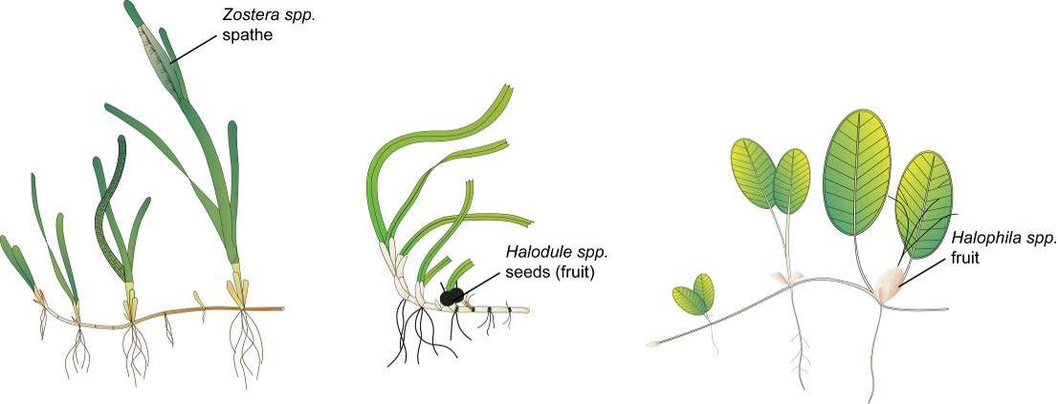
Figure 6-2 Form and size of reproductive structure of the seagrasses collected: Halophila ovalis, Halodule uninervis and Zostera muelleri subsp. capricorni
Seagrass tissue nutrients
Leaves are separated in the laboratory into seagrass species and epiphytic algae is removed by gently scraping the leaf surface. Samples are oven dried at 60°C to weight constancy. Dried biomass samples of leaves are then homogenised by milling to fine powders before nutrient analyses and stored in sealed vials.
The ground tissue samples are sent to Chemcentre (Western Australia) for analysis. Chemcentre holds NATA accreditation for constituents of the environment including soil, sediments, waters and wastewaters (details of Chemcentre accreditation can be found at the NATA website: http://www.nata.asn.au/). NATA accreditation held by the ChemCentre includes a wide variety of QA/QC procedures covering the registration and identification of samples with unique codes and the regular calibration of all quantitative laboratory equipment required for the analysis. ChemCentre has developed appropriate analytical techniques including QA/QC procedures and detection of nutrients. These procedures include blanks, duplicates where practical and internal use of standards. In 2010, QA/QC also included an inter-laboratory comparison (using Queensland Health and Scientific Services – also a NATA accredited laboratory) and an extra blind internal comparison.
Nitrogen and phosphorus are extracted using a standardised selenium Kjeldahl digest and the concentrations determined with an automatic analyser using standard techniques at Chemcentre in Western Australia. Percentage of C is determined using atomic absorption, also at Chemcentre. Elemental ratios (C:N:P) are then calculated on a mole:mole basis using atomic weights (i.e., C = 12, N = 14, P = 31). Analysis of all seagrass tissue nutrient data is based on the calculation of the atomic ratios of C:N:P.
To determine per cent carbon, dried and milled seagrass leaf tissue material is combusted at 1400°C in a controlled atmosphere (for example a LECO analyser). This converts all carbon containing compounds to carbon dioxide. Water and oxygen is then removed from the system and the gaseous product is determined spectrophotometrically.
Samples are digested in a mixture of sulphuric acid, potassium sulfate and a copper sulfate catalyst (cf. Kjeldahl). This converts all forms of nitrogen to the ammonium form and all forms of phosphorus to the orthophosphate form. The digest is diluted and any potentially interfering metals present are complexed with citrate and tartrate. For the nitrogen determination, an aliquot is taken and the ammonium ions are determined colorimetrically following reduction with hydrazine to the nitrate ion, followed by diazotisation of 1-naphthylenediamine and subsequent coupling with sulphanilamide. For TP, an aliquot of the digest solution is diluted and P is determined as the phosphomolybdenum blue complex (modified from Murphy & Riley, 1962).
Seagrass leaf isotopes
A subset of each ground tissue sample is sent to UC Davis Stable Isotope Facility (California, USA) for δ¹⁵N and δ¹³C analysis. The samples are weighed into tin capsules and combusted by an elemental analyser (ANCA-SL, SerCon Limited, Crewe, United Kingdom) to N₂ and CO₂. The N₂ and CO₂ are purified by gas chromatography and the nitrogen and carbon elemental composition and isotope ratios are determined by continuous flow isotope ratio mass spectrometry (20-22 IRMS, SerCon Limited). Reference materials of know elemental composition and isotopic ratios are interspaced with the samples for calibration.
Raw nitrogen and carbon elemental composition and isotope ratio data are corrected for instrument drift and blank contribution using Callisto software (SerCon Limited). A standard is analysed at variable weights to correct for instrument linearity, for example IAEA-N-2 and IAEA-N-1 are used to normalise the nitrogen isotope ratio, and IAEA-CH-6 and IAEA-CH-7 normalise the carbon isotope ratio, such that IAEA-N-2 (δ¹⁵N = 20.32‰), IAEA-N-1 (δ¹⁵N = 0.43‰), IAEA-CH-6 (δ¹³C = -10.45‰) and IAEA-CH-7 δ¹³C = -32.15‰).
Nitrogen isotope ratios are reported in parts per thousand (per mil) relative to N₂ in air. The nitrogen bearing internationally distributed isotope reference material N₂ in air has a given value of 0‰ (exactly). Carbon isotope ratios are reported in parts per thousand (per millilitre) relative to V-PDB. The carbon bearing internationally distributed isotope reference materials NBS19 and L-SVEC has a given value of +1.95‰ (exactly) and -46.6‰ (exactly), respectively. Compositional values are reported as percent nitrogen and percent carbon present in the sample analysed.

Sampling design – Inshore seagrass meadow landscape/boundary mapping
Mapping the edge of the seagrass meadow within each monitoring site (i.e. 5.5 hectares) is conducted in both the late-dry (October) and late-monsoon (April) monitoring periods at all sites identified in Table 6.1. Training and equipment (GPS) are provided to personnel involved in the edge mapping.
Mapping methodology follows standard methodology (weblink http://www.seagrasswatch.org/monitoring.html) (L. J. McKenzie et al., 2001). Meadow, patch or scar edges are recorded as tracks (one second polling) or a series of waypoints in the field using a portable GPS receiver (i.e. Garmin GPSmap® 60CSx or 62s). Accuracy in the field is dependent on the portable GPS receiver (Garmin GPSmap® 60CSx is <15 metres RMS95 per cent (DGPS (USCG) accuracy: three–five metres, 95 per cent typical) and how well the edge of the meadow is defined. Generally, accuracy is within that of the GPS (i.e. three–five metres) and datum used is WGS84. Tracks and waypoints are downloaded from the GPS to a portable computer using MapSource or BaseCamp software as soon as practicable (preferably on returning from the day’s activity) and exported as *.dxf files to ESRI® ArcGIS™.
Field mapping procedures at subtidal sites are altered to suit the low visibility conditions and the requirement to map by SCUBA. From the central picket (deployment location of light and turbidity loggers) straight lines of 50 m lengths are swum at an angle of 45 degrees from each other. The locations where the edges of the seagrass meadows/patches intercept the line are recorded. A GPS is attached to a flotation device at the surface of the water and fastened to the scuba diver to record travelling distance and transect orientation. Eight lines at 45 degrees are performed, with the first following the orientation of the monitoring transects; the others are undertaken at 45 degree angles from the first.
Mapping is conducted by trained and experienced scientists using ESRI® ArcMap™ 10.4.1 (Environmental Systems Research Institute, ArcGIS™ Desktop 10.4.1). Boundaries of meadows/patches are determined based on the positions of survey tracks and/or waypoints and the presence of seagrass. Edges are mapped using the polyline feature to create a polyline (i.e. ‘join the dots’), which is then smoothed using the B-spline algorithm. The smoothed polyline is then converted to a polygon and saved as a shapefile. The coordinate system (map datum) used for projecting the shapefile is AGD94.
In certain cases, seagrass meadows form very distinct edges that remain consistent over many growing seasons. However, in other cases the seagrass landscape tends to grade from dense continuous cover to no cover over a continuum that includes small patches and shoots of decreasing density. Boundary edges in patchy meadows are vulnerable to interpreter variation, however, the general rule is that a boundary edge is determined where there is a gap with the distance of more than three metres (i.e. accuracy of the GPS). Final shapefiles are overlayed with aerial photographs and base maps (AusLig™) to assist with illustration/presentation.
The expected accuracy of the map product gives some level of confidence in using the data. Using GIS, meadow boundaries are assigned a quality value based on the type and range of mapping information available for each site and determined by the distance between waypoints and GPS position fixing error. These meadow boundary errors are used to estimate the likely range of area for each meadow mapped (Lee Long et al., 1997).

Sampling design — Within seagrass canopy temperature loggers
Autonomous iBTag™ submersible temperature loggers are deployed at all sites identified in Table 6.1. The loggers record temperature (degrees Celsius) within the seagrass canopy every 30 to 90 minutes (depending on the duration of deployment and logger storage capacity) and store data in an inbuilt memory, which is downloaded every three to six months, depending on the site.
The iBCod 22L model of iBTag™ loggers is used as it can withstand prolonged immersion in salt water to a depth of 600 metres. It is reinforced with solid titanium plates and over molded in a tough polyurethane casing that can take a lot of rough handling.
The main features of the iBCod 22L include:
- operating temperature range: -40 to +85°C
- resolution of readings: 0.5°C or 0.0625°C
- accuracy: ±0.5°C from -10°C to +65°C
- sampling Rate: 1 second to 273 hours
- number of readings: 4096 or 8192 depending on configuration
- password protection, with separate passwords for read only and full access.
The large capacity of this logger allows the collection of 171 days of readings at 30 minute intervals.
The iBCod 22 litre submersible temperature loggers are placed at a permanent marker at each site for three to six months (depending on monitoring frequency). Loggers are attached to the permanent station marker using cable ties, above the sediment-water interface. This location makes sure that the sensors are not exposed to air unless the seagrass meadow is completely drained and places them out of sight of curious people.
Each logger has a unique serial number that is recorded within a central secure database. The logger number is recorded on the monitoring site datasheet with the time of deployment and collection. At each monitoring event (every three to six months), the iBTag™ temperature loggers are removed and replaced with a fresh logger (these are dispatched close to the monitoring visit). After collection, details of the logger number, field datasheet (with date and time) and logger are returned for downloading.
Logger deployment and data retrieval are carried out by JCU professional and technical personnel who have been trained in the applied methods. Methods and procedures documents are available to relevant staff and are collectively kept up-to-date. Changes to procedures are developed and discussed and recorded in metadata records.

Sampling design and logistics — Seagrass meadow canopy light loggers
Autonomous light loggers are deployed at selected nearshore and offshore seagrass sites in all regions monitored (Table 6.3).
Submersible Odyssey™ photosynthetic irradiance loggers are placed at the permanent marker at each of the sites for three to six month periods (depending on monitoring frequency).
Odyssey™ data loggers (Odyssey, Christchurch, New Zealand) record photosynthetically active radiation (400–1100 nm) and store data in an inbuilt memory, which is retrieved every three to six months, depending on the site. Each logger has the following technical specifications:
- cosine corrected photosynthetic irradiance sensor 400–700 nm
- cosine corrected solar irradiance sensor 400–1100 nm
- integrated count output recorded by Odyssey data recorder
- user defined integration period
- submersible to 20-metre water depth
- 64 k memory.

Table 6.3 Monitoring sites selected for light logger data collection
Region | Basin | Water body | Site | Latitude |  | Longitude
Cape York | Jacky Jacky / Olive-Pascoe | Enclosed Coastal intertidal | Shelburne Bay | 11° | 53.251 | 142° | 54.938
Cape York | Jacky Jacky / Olive-Pascoe | Midshelf intertidal | Piper Reef | 12° | 15.352 | 143° | 14.020
Cape York | Normanby / Jeannie | Open coastal intertidal | Stanley Island | 14° | 8.576 | 144° | 14.680
Cape York | Normanby / Jeannie | Open coastal intertidal | Bathurst Bay | 14° | 16.062 | 144° | 13.896
Cape York | Endeavour | Enclosed Coastal intertidal | Archer Point | 15° | 36.525 | 145° | 19.108
North | Daintree | Midshelf intertidal & subtidal | Low Isles | 16° | 23.11 | 145° | 33.88
North | Mossman /  Barron /  Mulgrave-Russell /  Johnstone | Midshelf intertidal & subtidal | Green Island | 16° | 45.789 | 145° | 58.31
North | Mossman /  Barron /  Mulgrave-Russell /  Johnstone | Enclosed Coastal intertidal | Yule Point | 16° | 34.159 | 145° | 30.744
North | Tully / Murray / Herbert | Open coastal intertidal & subtidal | Dunk Island | 17° | 56.75 | 146° | 08.45
Central | Ross / Burdekin | Open coastal intertidal & subtidal | Picnic Bay | 19° | 10.734 | 146° | 50.468
Central | Ross / Burdekin | Open coastal intertidal & subtidal | Cockle Bay | 19° | 10.612 | 146° | 49.737
Central | Ross / Burdekin | Enclosed coastal intertidal | Bushland Beach | 19° | 11.028 | 146° | 40.951
Central | Ross / Burdekin | Enclosed coastal intertidal | Barratta Creek | 19° | 25.380 | 147° | 14.480
Central | Proserpine / O'Connell | Open coastal intertidal & subtidal | Hamilton Island | 20° | 20.802 | 148° | 58.246
Central | Proserpine / O'Connell | Open coastal intertidal & subtidal | Lindeman Island | 20° | 26.293 | 149° | 1.691
Central | Proserpine / O'Connell | Enclosed coastal intertidal | Midge Point | 20° | 38.099 | 148° | 42.108
Central | Plane | Enclosed coastal intertidal | Sarina Inlet | 21° | 23.76 | 149° | 18.2
Southern | Shoalwater / Fitzroy | Open coastal intertidal | Great Keppel Island | 23° | 11.7834 | 150° | 56.3682
Southern | Shoalwater / Fitzroy | Macro tidal Enclosed coastal intertidal | Shoalwater Bay | 22° | 23.926 | 150° | 16.366
Southern | Calliope / Boyne | Enclosed coastal intertidal | Gladstone Hbr | 23° | 46.005 | 151° | 18.052
Southern | Baffle | Enclosed coastal intertidal | Rodds Bay | 24° | 4.866 | 151° | 39.7584
Southern | Mary | Enclosed coastal intertidal | Urangan | 25° | 18.197 | 152° | 54.364

The logger is self-contained in a pressure-housing with batteries providing sufficient power for deployments of longer than six months. For field deployment, loggers are attached to a permanent station marker using cable ties; this is above the sediment-water interface at the bottom of the seagrass canopy. Similar to the submersible temperature loggers, this location makes sure that the sensors are not exposed to air unless the seagrass meadow is almost completely drained and places them out of sight of curious people. At subtidal sites, the loggers are deployed on the sediment surface (attached to a permanent marker) with the sensor at seagrass canopy height. Two loggers are deployed at subtidal sites as there is an increased chance of logger fouling, and the dual logger set-up offers a redundant dataset in the instance that one logger fouls completely. Where possible, extra light loggers are deployed at subtidal sites 80 centimetres from the sediment surface. Data from this logger, together with data from the logger at canopy height, is used for calculation of the light attenuation co-efficient. Furthermore, another logger is deployed above the water surface at each of the subtidal monitoring stations. These extra loggers (surface and subtidal higher in the water column) allow comparison of water quality indices for some of the time.
Measurements are recorded by the logger every 30 minutes (this is a cumulative 30 minute reading). Experiments utilising loggers with and without wipers have been conducted to determine the benefits of wiper use and it was confirmed that the wipers improved the quality of the data by keeping the sensor free from fouling. Automatic wiper brushes are attached to each logger to clean the optical surface of the sensor every 15 minutes to prevent marine organisms fouling the sensor or sediment settling on the sensor, both of which diminish the light reading.
Each light logger has a unique serial number that is recorded within a central secure database. The logger number is recorded on the monitoring site datasheet with the time of deployment and collection. At each monitoring event (every three to six months) the light loggers are removed and replaced with a ‘fresh’ logger. At subtidal monitoring sites, the loggers are checked by scuba by JCU personnel (and replaced if fouled) every three months due to the increased fouling rates at permanently submerged sites. After collection, details of the logger number, field datasheet (with date and time) and logger are returned to JCU for downloading.
Photographs of the light sensor and/or notes on the condition of the sensor are recorded at logger collection. If fouling is major (e.g. wiper failure), data are truncated to included only that data before fouling began — usually one to two weeks. If fouling was minor (up to ~25 per cent of the sensor covered), back corrections to the data are made to allow for a linear rate of fouling (linear because with minor fouling it is assumed that the wiper was retarding algal growth rates, but not fully inhibiting them).

Calibration procedures — Seagrass meadow canopy light loggers
Loggers are calibrated against a certified reference photosynthetically active radiation sensor (Li-Cor™ Li-192SB Underwater Quantum Sensor) against a Li-Cor light source under controlled laboratory conditions.
The Li-192SB sensor is cosine corrected and specifications are:
- absolute calibration: ± 5 per cent in air
- relative error: <± 5 per cent under most conditions
- sensitivity: typically 3 μA per 1000 μE s⁻¹ m⁻² in water.
The reference light sensor is calibrated before deployment by JCU. The calibration of each logger is recorded within metadata and corresponds to the serial numbers attached to each logger. The calibration is performed in air and a 1.33 conversion factor is applied to the data to allow for the difference in light transmission to the sensor between air and water (Kirk, 1994). This factor is not applied when the sensor is immersed at low tide and emersion is estimated from actual sea level data provided by Maritime Safety Queensland.
Logger deployment and data retrieval is carried out by scientific personnel who have been trained in the applied methods. Methods and procedures documents are available to relevant staff and are collectively kept up-to-date. Changes to procedures are developed and discussed and recorded in metadata records.

Data management

Inshore seagrass meadow abundance, community structure and reproductive health
TropWATER (JCU) has systems in place to manage the way MMP data is collected, organised, documented, evaluated and secured. All data is collected and collated in a standard format. Seagrass-Watch HQ (JCU) has implemented a QA management system to make sure that the data collected are organised and stored and able to be easily used.
All data (datasheets and photographs) received are entered into a relational database on a secure server at JCU, Cairns campus. Receipt of all original data hardcopies is documented and filed within the Seagrass-Watch HQ File Management System, a formally organised and secure system. The database is routinely backed up (in multiple places). Seagrass-Watch HQ (JCU) operates as custodian of data collected and provides an evaluation and analysis of the data for reporting purposes. Access to the IT system and databases is restricted to only authorised personnel.
Seagrass-Watch HQ (JCU) performs a quality check on the data. Seagrass-Watch HQ provides validation of data and attempts to correct incidental/understandable errors where possible (for example blanks are entered as -1 or if monospecific meadow percentage composition = 100 per cent) (seagrasswatch.org/data_entry.html). Validation is provided by checking observations against photographic records to make sure of the consistency of observers and by identification of voucher specimens submitted.
Keeping to QA/QC protocols, Seagrass-Watch HQ tells observers via an official data error notification of any errors encountered/identified and provides an opportunity for correction/clarification (this may include extra training). Any data which does not pass QA/QC is quarantined or removed from the database.

Inshore seagrass meadow boundary mapping
After field collection, data points are downloaded from the GPS into computer memory and the data exported to ESRI® ArcGIS™. An administration file (*.gdb) is generated by the MapSource software that contains metadata information about the tracks, waypoints, dates and times of the measurements, as well as general comments. Data and metadata are stored on the TropWATER (JCU, Cairns campus) secure server.

Within seagrass canopy temperature loggers
After retrieval, data are downloaded into computer memory and the data are displayed as graphs to allow visual identification of outliers. These outliers are then tagged and removed from the datasets (for example a temperature spike below -10°C or above 65°C). Other data adjustments include the removal of data points from the beginning and end of the data series, for example when the logger was not attached to the permanent peg. An administration file is generated by the logger software that contains metadata information about the deployment site, dates and times of the start and stop of measurements, as well as general comments. Data and metadata are stored in a temporary Microsoft® Access database.
Loggers are then launched for the next deployment. All data are transferred into the existing TropWATER (JCU) database.

Seagrass meadow canopy light loggers
After retrieval, data are downloaded into computer memory and the data are displayed as graphs to allow visual identification of outliers. These outliers are then tagged and removed from the datasets; however, such outliers have mostly not been present. During the placement and retrieval of the logger, the site or logger may suffer a short disturbance from the technician; adjustments are made to the data to remove a small number of data points from the beginning and end of the data series to account for this.
An administration file is generated by the logger software that contains metadata information about the deployment site, dates and times of the start and stop of measurements, as well as general comments. Data and metadata are stored in a temporary Microsoft® Access database.
Loggers are then launched for the next deployment. All data are transferred into the existing TropWater (JCU) database.
JCU is also working on assigning values to the level of confidence in the data. For example, sometimes corrections are made to light data to account for minor fouling. We would like to add a code to the data that indicates that we have reduced confidence in it because we have made adjustments.

Summary of Quality Control measures

Inshore seagrass meadow abundance, community structure and reproductive health
- Training of field staff
- Sampling guidelines
- Document control
- Analytical QC measures
- QC of data entry

Inshore seagrass meadow boundary mapping
- Training of deployment and retrieval staff
- Data download control
- Training of staff using ESRI® ArcGIS™ Desktop 10.4.1 software

Within seagrass canopy temperature loggers
- Training of deployment and retrieval staff
- Use of serial numbers to provide unique identification to individual loggers
- Data download control
- QC of data entry

Seagrass meadow canopy light loggers
- Use of serial numbers to provide unique identification to individual loggers
- Training of deployment and retrieval staff
- Calibration of loggers with certified reference light sensor
- QC of data entry

References
Álvarez-Romero, J. G., Devlin, M., Teixeira da Silva, E., Petus, C., Ban, N. C., Pressey, R. L., . . . Brodie, J. (2013). A novel approach to model exposure of coastal-marine ecosystems to riverine flood plumes based on remote sensing techniques. Journal of Environmental Management, 119, 194-207. doi:https://doi.org/10.1016/j.jenvman.2013.01.036
Australian and New Zealand Environment and Conservation Council (ANZECC) and Agriculture and Resource Management Council of Australia and New Zealand (ARMCANZ). (2000). Australian and New Zealand guidelines for fresh and marine water quality, National Water Quality Management Strategy Paper No 4. ANZECC and ARMCANZ, Canberra. Retrieved on 23/05/2019 from https://www.environment.gov.au/about-us/publications/archive
Baith, K., Lindsay, R., Fu, G., & McClain, C. R. (2001). Data analysis system developed for ocean color satellite sensors. Eos, Transactions American Geophysical Union, 82(18), 202-202. doi:10.1029/01eo00109
Booij, K., & Smedes, F. (2010). An improved method for estimating in situ sampling rates of nonpolar passive samplers. Environmental Science & Technology, 44(17), 6789-6794. doi:10.1021/es101321v
Booij, K., Smedes, F., & van Weerlee, E. M. (2002). Spiking of performance reference compounds in low density polyethylene and silicone passive water samplers. Chemosphere, 46(8), 1157-1161. doi:https://doi.org/10.1016/S0045-6535(01)00200-4
Booij, K., Vrana, B., & Huckins, J. N. (2007). Theory, modelling and calibration of passive samplers used in water monitoring. In R. Greenwood, G. Mills, & B. Vrana (Eds.), Passive Sampling Techniques in Environmental Monitoring (Vol. 48, pp. 141-169): Elsevier.
Brinkman, R., Tonin, H., Furnas, M., Schaffelke, B., & Fabricius. (2014). Targeted analysis of the linkages between river runoff and risks for crown-of-thorns starfish outbreaks in the Northern GBR: Report for Terrain NRM. Australian Institute of Marine Science, Townsville, Queensland. Retrieved on 23/05/2019 from https://terrain.org.au/projects/water-quality-improvement-plan/studies-reports/
Department of Premier and Cabinet. (2009). Reef Water Quality Protection Plan 2009 for the Great Barrier Reef World Heritage Area and Adjacent Catchments. Reef Water Quality Protection Plan Secretariat, DPC, Brisbane. Retrieved on 27/05/2019 from http://www.reefplan.qld.gov.au/resources/assets/reef-plan-2009.pdf
Devlin, M. J., Petus, C., Da Silva, E., Tracey, D., Wolff, N. H., Waterhouse, J., & Brodie, J. (2015). Water quality and river plume monitoring in the Great Barrier Reef: An overview of methods based on ocean colour satellite data. Remote Sensing, 7(10), 12909-12941.
Escher, B. I., Quayle, P., Muller, R., Schreiber, U., & Mueller, J. F. (2006). Passive sampling of herbicides combined with effect analysis in algae using a novel high-throughput phytotoxicity assay (Maxi-Imaging-PAM). Journal of Environmental Monitoring, 8(4), 456-464. doi:10.1039/B517512G
Fabricius, K. E. (2005). Effects of terrestrial runoff on the ecology of corals and coral reefs: review and synthesis. Marine Pollution Bulletin, 50(2), 125-146. doi:10.1016/j.marpolbul.2004.11.028
Great Barrier Reef Marine Park Authority. (2010). Water quality guidelines for the Great Barrier Reef Marine Park. Great Barrier Reef Marine Park Authority, Townsville. Retrieved on 23/05/2019 from http://www.gbrmpa.gov.au/__data/assets/pdf_file/0017/4526/GBRMPA_WQualityGuidelinesGBRMP_RevEdition_2010.pdf
Haynes, D., & Michalek-Wagner, K. (2000). Water quality in the Great Barrier Reef World Heritage Area: Past perspectives, current issues and new research directions. Marine Pollution Bulletin, 41(7), 428-434. doi:https://doi.org/10.1016/S0025-326X(00)00150-8
Holmes, R. M., Aminot, A., Kérouel, R., Hooker, B. A., & Peterson, B. J. (1999). A simple and precise method for measuring ammonium in marine and freshwater ecosystems. Canadian Journal of Fisheries and Aquatic Sciences, 56(10), 1801-1808. doi:10.1139/f99-128
Huckins, J. N., Petty, J. D., Prest, H. F., Clark, R. C., Alvarez, D. A., Orazio, C., . . . Johnson, B. T. (2002). A guide for the use of semipermeable membrane devices (SPMDs) as samplers of waterborne hydrophobic organic contaminants. American Petroleum Institute Publication, 4690, 1-192.
Jeffrey, S. W., & Humphrey, G. F. (1975). New spectrophotometric equations for determining chlorophylls a, b, c₁ and c₂ in higher plants, algae and natural phytoplankton. Biochemie und Physiologie der Pflanzen, 167(2), 191-194. doi:https://doi.org/10.1016/S0015-3796(17)30778-3
Jonker, M. M., Johns, K. K., & Osborne, K. K. (2008). Surveys of benthic reef communities using underwater digital photography and counts of juvenile corals. Long-term Monitoring of the Great Barrier Reef. Standard Operational Procedure No. 10. Australian Institute of Marine Science, Townsville. Retrieved on 27/05/2019 from http://epubs.aims.gov.au/11068/8019
Kennedy, K., Bentley, C., Paxman, C., Dunn, A., Heffernan, A., Kaserzon, S., & Mueller, J. (2010). Monitoring of organic chemicals in the Great Barrier Reef Marine Park using time integrated monitoring tools (2009-2010). National Research Centre for Environmental Toxicology (EnTox), University of Queensland, Brisbane. Retrieved on 27/05/2019 from https://espace.library.uq.edu.au/data/UQ_230971/reef.pdf?Expires=1559008263&Signature=XtYjJr81Ja6ICSMmo-XrQSGHqoFvMQlN8ING6sBsdk8OLPWhUfH08WNgxc1nqs1sq34~2Mc9EwgdmDOjku7yR-LzrXMrCYok4rcCd~rTAqugNIZ0VUQYr5Ad7AayUGvY6oSDbmGWKdZkl~33I-YabneTN1Eb5NvEA7mp-KLRkhYN3vVJdT0nNH7kBW4fwcxcbuvmQ0Xg3elVdD4TEy7e0C85EMONtohOnz6yV39XI3fwOHMhG456B42lts9~-gdFd4Zx1-f5HBO4SYc662NMk~mf2FJ1PQixyaMf-c2rmA-a8RsQQ6Uzk7fix8xmJH-RPaL8kxaF6Og7538gGgbMAg__&Key-Pair-Id=APKAJKNBJ4MJBJNC6NLQ
Kingston, J. K., Greenwood, R., Mills, G. A., Morrison, G. M., & Björklund Persson, L. (2000). Development of a novel passive sampling system for the time-averaged measurement of a range of organic pollutants in aquatic environments. Journal of Environmental Monitoring, 2(5), 487-495. doi:10.1039/B003532G
Kirk, J. T. (1994). Light and photosynthesis in aquatic ecosystems: Cambridge University Press.
Koch, E. W. (2001). Beyond light: Physical, geological, and geochemical parameters as possible submersed aquatic vegetation habitat requirements. Estuaries and Coasts, 24(1), 1-17.
Kuhnert, P. M., Liu, Y., Henderson, B., Dambacher, J., Lawrence, E., & Kroon, F. J. (2015). Review of the Marine Monitoring Program (MMP). Final Report for the Great Barrier Reef Marine Park Authority (GBRMPA), CSIRO, Australia. Retrieved on 27/05/2019 from https://core.ac.uk/download/pdf/50851864.pdf
Lee Long, W. J., McKenzie, L. J., & Coles, R. G. (1997). Seagrass communities in the Shoalwater Bay region, Queensland: Spring (September) 1995 and Autumn (April) 1996. Great Barrier Reef Marine Park Authority, Townsville. Retrieved on 27/05/2019 from http://hdl.handle.net/11017/306
McCook, L. J., Wolanski, E., & Spagnol, S. (2000). Modelling and visualising interactions between natural disturbances and eutrophication as causes of coral reef degradation. In E. Wolanski (Ed.), Oceanographic Processes of Coral Reefs: Physical and biological links in the Great Barrier Reef (pp. 133-146): CRC Press.
McKenzie, L. (2007). Relationships between seagrass communities and sediment properties along the Queensland coast. Progress report to the Marine and Tropical Sciences Research Facility. Reef and Rainforest Research Centre Ltd, Cairns. Retrieved on 27/05/2019 from https://rrrc.org.au/wp-content/uploads/2014/06/371-DPI-McKenzie-L-2007-Seagrass-Communities-Sediments.pdf
McKenzie, L., Long, L., Coles, R., & Roder, C. (2000). Seagrass-Watch: Community based monitoring of seagrass resources. Biologia marina mediterranea, 7(2), 393-396.
McKenzie, L. J., Finkbeiner, M. A., & Kirkman, H. (2001). Methods for mapping seagrass distribution. In F. T. Short & R. G. Coles (Eds.), Global seagrass research methods (pp. 101-121): Elsevier.
Miller, I. R., Jonker, M., & Coleman, G. (2009). Crown-of-thorns starfish and coral surveys using the manta tow and SCUBA search techniques. Australian Institute of Marine Science, Townsville.
Mueller, J. F., Mortimer, M. R., O’Brien, J., Komarova, T., & Carter, S. (2011). A cleaner river: Long term use of semipermeable membrane devices demonstrate that concentrations of selected organochlorines and PAHs in the Brisbane River estuary, Queensland have reduced substantially over the past decade. Marine Pollution Bulletin, 63(5), 73-76. doi:https://doi.org/10.1016/j.marpolbul.2011.03.026
Murphy, J., & Riley, J. P. (1962). A modified single solution method for the determination of phosphate in natural waters. Analytica Chimica Acta, 27, 31-36. doi:https://doi.org/10.1016/S0003-2670(00)88444-5
O'Brien, D. S., Chiswell, B., & Mueller, J. F. (2009). A novel method for the in situ calibration of flow effects on a phosphate passive sampler. Journal of Environmental Monitoring, 11(1), 212-219. doi:10.1039/B809901D
O’Brien, D., Bartkow, M., & Mueller, J. F. (2011). Determination of deployment specific chemical uptake rates for SDB-RPD Empore disk using a passive flow monitor (PFM). Chemosphere, 83(9), 1290-1295. doi:https://doi.org/10.1016/j.chemosphere.2011.02.089
O’Brien, D., Komarova, T., & Mueller, J. F. (2012). Determination of deployment specific chemical uptake rates for SPMD and PDMS using a passive flow monitor. Marine Pollution Bulletin, 64(5), 1005-1011. doi:https://doi.org/10.1016/j.marpolbul.2012.02.004
O’Brien, D. S., Booij, K., Hawker, D. W., & Mueller, J. F. (2011). Method for the in situ calibration of a passive phosphate sampler in estuarine and marine waters. Environmental Science & Technology, 45(7), 2871-2877. doi:10.1021/es101645z
Parsons, T. R., Maita, Y., & Lalli, C. M. (1984). A manual of chemical and biological methods for seawater analysis: Pergamon Press, Oxford.
Petus, C., Collier, C., Devlin, M., Rasheed, M., & McKenna, S. (2014). Using MODIS data for understanding changes in seagrass meadow health: A case study in the Great Barrier Reef (Australia). Marine Environmental Research, 98, 68-85. doi:https://doi.org/10.1016/j.marenvres.2014.03.006
Petus, C., da Silva, E. T., Devlin, M., Wenger, A. S., & Álvarez-Romero, J. G. (2014). Using MODIS data for mapping of water types within river plumes in the Great Barrier Reef, Australia: Towards the production of river plume risk maps for reef and seagrass ecosystems. Journal of Environmental Management, 137, 163-177. doi:https://doi.org/10.1016/j.jenvman.2013.11.050
Petus, C., Devlin, M., Teixera da Silva, E., Lewis, S., Waterhouse, J., Wenger, A., . . . Tracey, D. (2018). Defining wet season water quality target concentrations for ecosystem conservation using empirical light attenuation models: A case study in the Great Barrier Reef (Australia). Journal of Environmental Management, 213, 451-466. doi:https://doi.org/10.1016/j.jenvman.2018.02.028
Petus, C., Devlin, M., Thompson, A., McKenzie, L., Teixeira da Silva, E., Collier, C., . . . Martin, K. (2016). Estimating the exposure of coral reefs and seagrass meadows to land-sourced contaminants in river flood plumes of the Great Barrier Reef: Validating a simple satellite risk framework with environmental data. Remote Sensing, 8(3), 210.
Robillot, C., Logan, M., Baird, M., Waterhouse, J., Martin, K., & Schaffelke, B. (2018). Testing and implementation of an improved water quality index for the 2016 and 2017 Great Barrier Reef Report Cards - Detailed technical report. Report to the National Environmental Science Program. Reef and Rainforest Research Centre Limited, Cairns. Retrieved on 27/05/2019 from https://nesptropical.edu.au/index.php/final-reports-round-3/
Roesler, C., Uitz, J., Claustre, H., Boss, E., Xing, X., Organelli, E., . . . Barbieux, M. (2017). Recommendations for obtaining unbiased chlorophyll estimates from in situ chlorophyll fluorometers: A global analysis of WET Labs ECO sensors. Limnology and Oceanography: Methods, 15(6), 572-585. doi:doi:10.1002/lom3.10185
Ryle, V., Mueller, H., & Gentien, P. (1981). Automated analysis of nutrients in tropical sea waters. Technical bulletin Oceanography series No. 3. AIMS-OS-81-2. Australian Institute of Marine Science, Townsville.
Schäfer, R. B., Paschke, A., Vrana, B., Mueller, R., & Liess, M. (2008). Performance of the Chemcatcher® passive sampler when used to monitor 10 polar and semi-polar pesticides in 16 Central European streams, and comparison with two other sampling methods. Water Research, 42(10), 2707-2717. doi:https://doi.org/10.1016/j.watres.2008.01.023
Schaffelke, B., Carleton, J., Skuza, M., Zagorskis, I., & Furnas, M. J. (2012). Water quality in the inshore Great Barrier Reef lagoon: Implications for long-term monitoring and management. Marine Pollution Bulletin, 65(4–9), 249-260. doi:http://dx.doi.org/10.1016/j.marpolbul.2011.10.031
Shaw, M., & Mueller, J. F. (2009). Time integrative passive sampling: How well do Chemcatchers integrate fluctuating pollutant concentrations? Environmental Science & Technology, 43(5), 1443-1448. doi:10.1021/es8021446
Shaw, M., & Müller, J. F. (2005). Preliminary evaluation of the occurrence of herbicides and PAHs in the Wet Tropics region of the Great Barrier Reef, Australia, using passive samplers. Marine Pollution Bulletin, 51(8), 876-881. doi:https://doi.org/10.1016/j.marpolbul.2005.04.015
Sokal, R., & Rohlf, F. J. (1995). Biometry 3rd Ed. Columbia, NY.
Stephens, B. S., Kapernick, A. P., Eaglesham, G., & Mueller, J. F. (2009). Event monitoring of herbicides with naked and membrane-covered Empore disk integrative passive sampling devices. Marine Pollution Bulletin, 58(8), 1116-1122. doi:https://doi.org/10.1016/j.marpolbul.2009.04.012
Sweatman, H., Thompson, A., Delean, S., Davidson, J., & Neale, S. (2007). Status of Near-Shore Reefs of the Great Barrier Reef 2004. Reef and Rainforest Research Centre Limited, Cairns. Retrieved on 27/05/2019 from http://rrrc.org.au/wp-content/uploads/2014/06/Final-Status-of-Near-Shore-Reefs-120707.pdf
Thompson, A., Schaffelke, B., De’ath, G., Cripps, E., & Sweatman, H. (2010). Water Quality and Ecosystem Monitoring Programme - Reef Water Quality Protection Plan: Synthesis and spatial analysis of inshore monitoring data 2005-08. Australian Institute of Marine Science, Townsville. Retrieved on 27/05/2019 from http://www.gbrmpa.gov.au/__data/assets/pdf_file/0011/7688/Reef_Plan_MMP_2008_Stats_report_Jan2010.pdf
Thompson, A. A., & Dolman, A. M. (2010). Coral bleaching: one disturbance too many for near-shore reefs of the Great Barrier Reef. Coral Reefs, 29(3), 637-648. doi:10.1007/s00338-009-0562-0
Traas, T. P., van de Meent, D., Posthuma, L., Hamers, T., Kater, B. J., de Zwart, D., & Aldenberg, T. (2002). The potentially affected fraction as a measure of ecological risk. In L. Posthuma, G. W. Suter, & T. P. Traas (Eds.), Species sensitivity distributions in ecotoxicology (pp. 315-344). Lewis Publishers, Boca Raton, FL.
Valderrama, J. C. (1981). The simultaneous analysis of total nitrogen and total phosphorus in natural waters. Marine Chemistry, 10, 109-122.
Vermeirssen, E. L. M., Bramaz, N., Hollender, J., Singer, H., & Escher, B. I. (2009). Passive sampling combined with ecotoxicological and chemical analysis of pharmaceuticals and biocides – evaluation of three Chemcatcher™ configurations. Water Research, 43(4), 903-914. doi:https://doi.org/10.1016/j.watres.2008.11.026
Waterhouse, J., Brodie, J., Tracey, D., Smith, R., Vandergragt, M., Collier, C., Petus, C., Baird, M., Kroon, F., Mann, R., Sutcliffe, T., Waters, D., Adame, F. (2017). Scientific Consensus Statement 2017: A synthesis of the science of land-based water quality impacts on the Great Barrier Reef, Chapter 3: The risk from anthropogenic pollutants to Great Barrier Reef coastal and marine ecosystems. State of Queensland, 2017.
Waterhouse, J., Burton, J., Garzon-Garcia, A., Lewis, S., Brodie, J., Bainbridge, Z., . . . Dougall, C. (2018). Synthesis of knowledge and concepts - Bioavailable Nutrients: Sources, delivery and impacts in the Great Barrier Reef, July 2018. Supporting Concept Paper for the Bioavailable Nutrients Workshop, 15 March 2018. Reef and Rainforest Research Centre. Retrieved on 27/05/2019 from https://nesptropical.edu.au/wp-content/uploads/2018/11/NESP-TWQ-Bioavailability-of-Nutrients-Workshop-Concept-Paper.pdf
Wheatcroft, R. A., & Borgeld, J. C. (2000). Oceanic flood deposits on the northern California shelf: Large-scale distribution and small-scale physical properties. Continental Shelf Research, 20(16), 2163-2190. doi:https://doi.org/10.1016/S0278-4343(00)00066-2

Appendix A Detailed AIMS Manuals and Standard Operational Procedures

Prepared by

Britta Schaffelke, Michele Skuza, Renee Gruber, Irena Zagorskis, Kevin Gunn



Australian Institute of Marine Science Private Mail Bag 3
TOWNSVILLE QLD 4810
http://www.aims.gov.au/

Disclaimer
This report has been produced for the sole use of the party who requested it. The application or use of this report and of any data or information (including results of experiments, conclusions, and recommendations) contained within it shall be at the sole risk and responsibility of that party. The AIMS does not provide any warranty or assurance as to the accuracy or suitability of the whole or any part of the report, for any particular purpose or application. Subject only to any contrary non- excludable statutory obligations neither AIMS nor its personnel will be responsible to the party requesting the report, or any other person claiming through that party, for any consequences of its use or application (whether in whole or part).

Table of Contents

Section A1: Operating instructions for the AIMS Sea-Bird CTD 2
Section A2: Salinity measurements using Guildline Portasal Salinometer Model 8410A 7
Section A3: Automated analysis of dissolved nutrients in seawater 14
Section A4: Ship board ammonium analysis using the OPA method 22
Section A5: Analysis of dissolved organic carbon 38
Section A6: Analysis of Chromophoric Dissolved Ocean Matter (CDOM) in marine waters 44
Section A7: Analysis of particulate phosphorus in marine waters 48
Section A8: Analysis of particulate organic carbon and particulate nitrogen in marine waters 57
Section A9: Analysis of chlorophyll a in marine waters 67
Section A10: Determination of total suspended solids in marine waters 81
Section A11: AIMS In-house procedures for WET labs FLNTUSB ECO logger 89
Section A12: AIMS Data Management Procedures for the Reef Rescue Marine Monitoring Program 174

Section A1: Operating instructions for the AIMS Sea-Bird CTD

  - Objective

To conduct vertical measurements of water temperature, salinity and other parameters throughout the water column to obtain depth profiles of water quality characteristics with a Conductivity Temperature Depth profiler (CTD) (Sea-Bird Electronics SBE19plus).

  - Materials and equipment

As currently configured, the AIMS SBE19plus’ are set up to measure: Pressure (depth), temperature, conductivity (salinity), PAR (either downwelling [2π] or scalar [4π], depending on which one you take), chlorophyll fluorescence (in situ fluorometer for chlorophyll a, WET Labs), turbidity (beam transmissometer, Sea Tech, 25cm, 660nm) and either oxygen or optical backscatter.
The Sea-Bird SBE19 CTD profiler is operated through two pieces of software, which may be downloaded from www.seabird.com:
- SeaTerm V2 – a terminal program which communicates with the CTD and controls many CTD functions, and
- SeaSave V7 – a plotting program which displays the data.

  - Operating the CTD

Before you start a cast:
- Connect the CTD to the computer: The CTD communications cable has a DB9 serial connector at the computer end.
- At the CTD end both the CTD communications cable (4 conductor) and the bulkhead connector plug on the CTD have watertight rubber dummy plugs. Remove them and plug the communications cable into the CTD plug. Check to see that the 4 connector pins (CTD side) and the corresponding socket holes (cable side) are clean. When making a connection, make sure the thickest pin of the CTD plug aligns with the larger hole on the CTD comms cable socket. The bump on the outside of the comms cable socket identifies the location of the larger socket hole. When you plug the cables together, don’t force or twist the connection. They should push together with a little ‘pop’.
- Check to see that the magnetic slider switch on the side of the CTD is in the OFF position (down). This puts the CTD in the sleep mode.

Communicating with the CTD:
- Start up the computer, launch Seaterm V2 and connect the CTD cable.
- Click the Instruments menu on the SeatermV2 window, and select C. SBE 19plus V2 from the drop-down list. Seaterm automatically connects to the instrument if the Options tab has Connect at startup enabled. The program may cycle through several baud rates if not already configured to 9600 under Configure in the Communications menu. Once connected, the CTD prompt will appear in the main window as S> or <Executed/>. The top status bar displays Serial Port - COM1, Baud Rate 9600.Click the CONNECT button on the SeaTerm window. You should get a little window with a windows moving bar that says you are trying to connect at 9600 baud.
- In the Send Commands window, click Status and select the Display status and configuration parameters command, then press the Execute button. Alternately type ds (for display status) in the main display window. The information displayed includes battery voltage, check to see that vbatt > 12 volts. With new batteries, it should read > 13.5 volts.

Performing a CTD cast:
- Connect to the CTD as above, and check the battery voltage is >12 volts via Seaterm V2.
- To clear the CTD memory prior to the cast, select General Setup from the Send Commands menu of Seaterm V2 and select Initialize Logging. The Execute button must be clicked twice to take efffect.
- Check the depth under the keel, and manoeuver the ship so it is facing upwind and the CTD side faces the sun.
- Connect the CTD to the hydrographic wire.
- Unplug the communications cable and install the dummy plug and lock collar on the CTD connector.
- Slide the magnetic switch on the side of the CTD to the ON position (up).
- Steady the CTD by hand to stop it swinging against the boat. Lower the CTD into the water with the CTD winch so the ring at the top of the cage is just at the sea surface and the PAR sensor is just under the surface. Some bubbles will be expelled from the tubing at the top of the CTD.
- Whilst keeping the CTD at the top of the profile, wait 3 minutes for the CTD to start pumping and purge the air and water out of the salinity cell, and to equilibrate the temperature of the sensors. (The CTD has an internal pump which pumps water through the conductivity cell at a constant rate for high accuracy salinity measurements. The pump starts when the conductivity circuitry determines it is in salt water. It needs at least 30 seconds thereafter to purge the lines.).
- After 3 minutes, lower the CTD to within 2-3 m of the bottom at no more than 1 m per sec. Slightly slower is preferred. [The SBE19 samples @ 4 Hz, so a slower speed allows you to average more readings per 1 metre depth bin in the later processing step]
- Reel in the CTD at the same speed and retrieve to the deck.
- Switch the CTD slider switch OFF (down) and secure the instrument.
- Pull the dummy plug off the CTD bulkhead connector, and re-connect the communications cable.

  - Data retrieval and management

Retrieving the data:
- Electronically capture the position of the CTD cast using the Access Field Data Entry System database, or record it on the field data sheets.
- Re-establish communications with the CTD using Seaterm V2, once the cable is connected. You should get the S> prompt, but if Seaterm display window indicates ‘time out’ you may need to select the Instruments menu and click on Disconnect and reconnect. If the display starts scrolling out lines of HEX characters, you’ve forgotten to switch the CTD off.
- Click the Upload… menu on Seaterm V2. The screen will display a header for the CTD cast, giving a range of metadata for the cast which is saved at the top of the uploaded file. Note the text specifying the number of samples to confirm data has been captured. A Save As dialog box will open, then navigate to C:\Field\CTD files\ folder to store the file. Whilst the default file name includes the serial number and date, we type in the unique station identifier as the file name.
- Navigate the window to the and type your desired output filename into the box. The program will automatically append a .HEX delimiter to the filename. A small window ask which cast number you want to download. Type in “1” to download the first cast in memory. You should then get a progress window with a moving bar that counts the bytes transferred.
- When it’s complete, the CTD file is now saved on the computer. Use Windows Explorer if you want to check that the datafile is stored in the correct location.
Plotting the Data
- Launch SeaSave V7 on the computer. Normally for CTD plots, the vertical scale is depth (m).
- Click the ArchiveData tab and then Start opens an input window that lets you select a file to plot. Navigate to your datafile using the Select Data File button in the usual Windows way and click on it to select it.
- Click on the button at the bottom of the input box (Start Display) to plot your data using the default plot parameters stored in the computer.
- To change the plot parameters, use the ScreenDisplay tab to select “Edit Selected Display Window”. This will allow you to load another plot parameter file (.dso) that might be more appropriate to your data set, to directly modify the plot you already have or save the plot parameters for future use. There are a number of .dso files on the pathway in the box. The plotname usually gives the depth range.
- If you select to Modify Display Parameters, you will get a menu to change the output style. The Y axis is normally depth on the CTD computer. The Select Variable button puts you in a small window that lets you select the variable (from a particular instrument type) that you want to plot.
- Save the plot as a .dso file if you want to shut down the laptop and use it again later. After you click “OK” to close the above window, you will be in the previous dialog which lets you save the parameters in a .dso file. Exit that box and you will be looking at a changed, but blank plot.
- To replot the data, select the ArchiveData tab and Start, check the input filename in the next dialog box and click the Start Display button again to see the plot. If you are not happy, go back to step 4 and try again.
- Save all data on the hard drive and the back up external hard drive. Immediately upon return to AIMS transfer all data to the Reef Rescue MMP shared file area on the AIMS Server. For more details about AIMS Data Management procedures for Reef Rescue MMP refer to Section A12.

  - Maintenance

After the CTD profiles are completed:
- Disconnect the CTD from the communications cable and reattach the dummy plugs on both ends.
- Wash the CTD thoroughly with fresh water.

  - Quality control

- When on board RV Cape Ferguson, CTD cast data are immediately plotted and checked so the cast can be repeated if there were erroneous readings or other technical problems.
- The CTD sensors are regularly sent to either the manufacturer or CSIRO Oceans and Atmosphere Oceanographic Calibration Facility for calibration (generally annually).
- Salinity and chlorophyll readings from CTD sensors are validated against results from direct water sampling using Niskin bottles conducted immediately after the CTD cast.
- Temperature readings from CTD sensors are validated against temperature readings from high quality reversing thermometers attached to the surface and bottom Niskin bottles.

Section A2: Salinity measurements using Guildline Portasal Salinometer Model 8410A

  - Objective

To measure the salinity of seawater samples.

  - Principle of analysis

This method outlines the operational and calibration procedures for measuring salinity using a Guildline Portasal Salinometer model 8410A. It contains large excerpts from the machine’s manual (TM8410A-F-00) where more detailed operational instructions can be found if needed.
Laboratory measurements of salinity with a Portasal Salinometer are based on a high-precision comparison of the conductivity of an unknown water sample with the conductivity of a well- characterised sample of sample of IAPSO (International Association of Physical Science Organisations) Standard Seawater (SSW). “The conductivity of seawater is proportional to the salinity. With the appropriate corrections for temperature and pressure, the measurement of conductivity has become the most generally used method of determining salinity. Electrical conductivity is a measure of total electrolyte concentration in seawater and it is a technique which can be performed rapidly and with great accuracy, both in laboratories and in situ (Devlin and Lourey, 2000).
The reliability and accuracy of salinity analyses by conductivity are best if the unknown samples have a salinity that is reasonably close to that of the standard. While estuarine samples can readily be run, conductivity comparisons with very low salinity samples are progressively less reliable. In most cases, samples with salinities > 25-30% should be suitable. Low salinity “standards” can be made by precise dilution of standard seawater. In low salinity estuarine samples, the use of conductivity is confounded by the potentially differing ratios of ions in the “fresh” water which may have a different conductivity-mass relationship from seawater.

  - Sample analysis

    - Equipment

- 250 ml screw cap polyethylene bottles - acid washed, rinsed and air-dried
- Standard seawater - 1 ampoule
- 5-10 litres of surface seawater from the Coral Sea as a secondary standard.
- Guildline Portasal Salinometer

    - Sample collection and storage

Surface water for secondary standards is normally pumped into 40 L plastic drums at convenient times when an AIMS vessel is operating outside the reef. With the deck hose running, rinse out the drum thoroughly, then pump at least 30 L into the drum. Screw the lid on fully and store against the rail. At the lab, the seawater is stored in a walk-in cold room (5°C).
Water samples for laboratory salinity analysis and calibration checks on the CTD are normally drawn from one to two Niskin bottles at each hydro station. In case of a failure or the unavailability of the CTD, manual salinity samples are taken from all Niskin bottles. The salinity sample is usually taken last from the Niskin bottle as gas exchange or contamination are not issues. Salinity samples should be taken from bottles tripped near the top and bottom of the water column to get the maximum range of salinities measured by the CTD at a station. However, to allow a good match with the CTD readings, avoid sampling depths where there are significant salinity and temperature gradients, as there is likely to be difference between the sample depth and the depth recorded by the CTD due to wire angle.
Salinity samples are stored in 250 ml screw-capped plastic bottles. Before a cruise, the bottles are soaked in RO water and air dried to remove old salt crystals. Before taking a sample from the Niskin Bottle, rinse the sample bottle and cap with sample water. Fill the bottle to near the top, leaving only a small air bubble (< 20 ml) in the bottle to minimize evaporation. Put the cap on tightly. Store in a cool room (4-5°C), if possible. Air-conditioned room temperature is next best. Do not expose to full sunlight or excessive heat. Do not freeze.
The reliability and accuracy of salinity analyses by conductivity are best if the unknown samples have a salinity that is reasonably close to that of the standard. While estuarine samples can readily be run, conductivity comparisons with very low salinity samples are progressively less reliable. In most cases, samples with salinities > 25-30 ‰ should be acceptable. Low salinity “standards” can be made by precise dilution of standard seawater. In low salinity estuarine samples, the use of conductivity is confounded by the potentially differing ratios of ions in the “fresh” water which may have a different conductivity-mass relationship from seawater.

    - Method

2.3.3.1 Preliminary to using salinometer
- Bring the salinity samples out of the cold room at least the day before analysis and put them in the lab next to the salinometer to fully equilibrate to room temperature.
- The temperature of the bath water should be set to about 2oC above ambient.
- Get an ampoule of standard seawater and let it equilibrate next to the salinometer as well.
- Make sure you have enough (> 5 L) secondary standard seawater (SSSW) in the carboy. If you need more, put it in at least the night before to allow temperatures to equilibrate.
- Before turning on power make sure the FUNCTION switch is in the STDBY or ZERO position (Power switch is at back of instrument).
- Turn on Machine and perform Flow Rate Check, Zero Check, Temperature Check, Bath Temperature Check and Conductivity Cell Check (detailed procedures in Attachment 2.2).
- Each time the Portasal is has been powered up or the bath temperature has been changed, allow 3 hours before standardising or calibrating.
For consistency, it is best to use 10-15 L of SSSW in one batch. After collection, the water is stored in a cool room in a drum to reduce evaporation. Several days before use, some of the water should be transferred to a 20 L carboy on the lab bench next to the salinometer. The carboy is fitted with a siphon to remove water without bubbles. The secondary water should be allowed to fully equilibrate to room temperature before use.
      - Standardisation
The Portasal is usually quite stable but to ensure quality control a standardization routine should be performed, in the following sequence, every time the machine is powered up or the bath temperature is changed.
Perform the Reference Calibration and the Zero Calibration and then the Standardization and Drift Correction Routines as described below.

- Reference Calibration
- The instrument must have been powered up for a minimum of 3 hours after the bath temperature begins regulating before any calibration is performed.
- Set the FUNCTION switch to STDBY and press REF key. After a delay of approximately 8 seconds the display will read -REFERENCE xxxxx and will update for 16 seconds. Next, the display will read
+REFERENCE xxxxx and will update for 7 seconds, after which the display will read REFERENCE xxxxx for 8 seconds. This procedure will repeat itself until any key is pressed. The -REFERENCE and
+REFERENCE numbers must stabilize to between 19750 and 19999. The -REFERENCE and
+REFERENCE numbers must agree with each other to within ±2 counts after 10 cycles and must remain stable to within ±2 counts over 10 minutes.

- Zero Calibration
Before any calibration is performed the instrument must have been powered for a minimum of 3 hours with the bath temperature regulating. Set the FUNCTION switch to ZERO and press COND key. When satisfied that the zero conductivity ratio measurement is stable press ZERO. The display will then read ZERO x.xxxxx. The ZERO value should not exceed ± 0.00075.When satisfied that this number is not drifting press COND key. The display should then read RATIO 0.00000.

- Standardization Routine
Using a vial of Standard Sea Water (SSW) as the primary standard obtain a good conductivity measurement as described above in the Sample Measurement procedure steps 1 through 7 .

Reduce the flow rate to minimum and do the following:
NOTE: Once the following procedure has commenced do not flush the cell and do not move the FUNCTION switch from READ.
- Leave FUNCTION switch in READ and press STD.
- The following prompt will be displayed: STD STANDARDIZE
Press ENTER key.
- You will then be prompted with, for example: COND NO 0.999 84
Enter the conductivity ratio of the Standard Sea Water.
- You will then be prompted with, for example: BATCH NO P113
Enter the Standard Sea Water batch number.
- You will then be prompted with: ENTER WHEN READY
Turn FLOW RATE to a suitable flow rate and, when satisfied that the conductivity cell is full and sample is flowing, press ENTER key.
- “Measuring... “will briefly appear on the display followed by, for example: STANDARD 4.22000
When satisfied that the displayed STANDARD number is stable, press COND key. This will terminate STD operation and display the conductivity ratio using the new calibration values.
Note: Because a digital filter is applied to the measurement data during standardization, any significant change in STANDARD number will cause the new standardization to approach its final value over a period of several minutes. This apparent drift in standardization will be minimized by strictly adhering to the above procedure. Depending on the circumstances between standardizations, the change in STANDARD number may be up to ±0.000 5 typical (Guildline).
- If another sample will not be measured immediately leave the vial in the sample bottle holder, set FUNCTION switch to STDBY and turn off the flow rate. If another sample will not be measured for at least 12 hours set FUNCTION switch to STDBY, remove the vial, install a bottle of distilled water, fill and flush the conductivity cell at least 3 times, then with the conductivity cell full, turn off the flow rate.

- Drift Correction Routine
To minimise the use of expensive commercial primary standard (SSW), a secondary standard (Sub SSW) is used. This is just clean seawater (preferably collected off the continental shelf to ensure maximum clarity). This is run directly after the SSW and every 20 samples thereafter. A drift calculation is then applied to the sample readings assuming linear drift between the two sub standard readings.

      - Sample Measurement
Samples up to 15oC below the bath temperature or 5oC above the bath temperature can be measured if the flow rate is reduced sufficiently to allow the sample to reach the bath temperature while in the heat exchanger, however this practice may not give the most accurate results obtainable. To measure the conductivity of a given sample, do the following:
- Install sample bottle by the following steps:
  - Write information about sample on sample sheet (an example of this logsheet can found below)
  - Rock sample gently to eliminate gradients.
  - Open bottle and place in holder, inserting pick-up tube into bottle neck and hold bottle mouth over rubber stopper7. Ensure that pick-up tube reaches almost to bottom of bottle such that flow will not be restricted. Care must be exercised not to contaminate the sample. Do not handle the pick-up tube, rubber stopper or neck of the bottle except with clean lint-free tissue for wiping or surgical gloves for handling. Insert the end of the pick-up tube into the pick-up tube holder to allow sample water in the pick-up tube to siphon away from the end of the tube.
  - Raise bottle platform to press bottle mouth against rubber stopper making an airtight seal. Secure platform by tightening thumb screw.
- Turn on FLOW RATE to a medium flow rate and allow conductivity cell to fill with sample water. If the cell does not fill completely, cover FLUSH vent momentarily with fingertip then allow to refill after increasing flow rate, if necessary to maximum. A marked change in the duty cycle of the heater lamps indicates that the flow rate is too fast. Slowly reduce the flow rate until the heater lamps cycle at a slow regular rate.
- Flush sample water out of cell by placing fingertip over FLUSH air vent.
- Fill and flush again.
- Allow conductivity cell to refill and sample water to flow out of the CELL DRAIN. Be sure there are no air bubbles in the conductivity cell. Then set FUNCTION switch to READ.
- Press COND key. Allow the ratio measurement to stabilize. Note the ratio measurement.
- Set the FUNCTION switch to STDBY. Flush and fill the conductivity cell. Set the FUNCTION switch to READ. Allow the ratio measurement to stabilize. Repeat this process until measurement agrees with previous flushing
- To display the sample salinity in Practical Salinity Units press SAL key. Record this number on the sample worksheet.
- If another sample will not be measured immediately leave the sample bottle in the sample bottle holder, set FUNCTION switch to STDBY and turn off the flow rate. If another sample will not be measured for at least 12 hours set FUNCTION switch to STDBY, remove the sample bottle, install a bottle of distilled water, fill and flush the conductivity cell at least 3 times then, with the conductivity cell full, turn off the flow rate.
- Remove sample bottle by the following steps:
  - Set FUNCTION switch to STDBY.
  - Reduce flow rate to minimum.
  - Flush conductivity cell.
  - Lower bottle platform and remove sample bottle.
  - Wipe pick-up tube.
  - Raise and insert end of pick-up tube into pick-up tube holder.

  - Data management
The sample reading is logged with standards and substandards in the exact order indicated on a laboratory worksheet. A proforma of this log sheet can be found below. All information from this lab sheet is then entered into a Microsoft Excel spreadsheet template called "Salinity- Portasal blank worksheet" which is a visual copy of the laboratory form but has all the calculation equations imbedded. It will automatically perform the all calculations once the values are typed in. These Excel worksheets are then used as ‘feeder sheets’ for the Oracle Database. Utilising the import tool, all the analytical results are transferred into the database and a copy of the related excel file complete with QAQA data is stored within the database. All hard copy laboratory work forms are then archived. For a detailed description of the data management procedure developed at AIMS for the Reef Rescue MMP refer to Section A12.

  - Quality control
QAQC tests undertaken and reporting as part of the data reporting include: Assessment of accuracy of the analysis
NB: This is generally achieved by using reference materials to assess recovery of known amount of analyte.
The certified reference material available is IAPSO Standard Seawater (www.osil.co.uk), which is included at regular intervals during the analysis.
Assessment of precision of the analysis
NB: This is generally achieved by the repeated analyses of the same concentration of analyte to check for reproducibility.
Repeated analysis of secondary standard.

  - References
Guildline Insruments (2001) Manual for Guildline Model 8410A Portable Salinometer.
Devlin, M.J. and Lourey, M.J. (2000) Long term Monitoring of the Great Barrier Reef Standard Operational Procedure Number 6, Australian Institute of Marine Science.

Sample analysis worksheet

Salinity Measurements on the Portasal Model 8410A
Date:
Analyst:
Sample Series:
Reference Calibration: Y/N
Zero Calibration: Y/N
Standardization:
 | Conductivity No.
 | Batch No.
Bottle | Sample Name | Conductivity | Salinity
1 | SSW
2 | Sub SSW
3
4
5
6
7
8
9
10
11
12
13
14
15
16
17
18
19 | Sub SSW
20 | SSW

Section A3: Automated analysis of dissolved nutrients in seawater

  - Objective
Analyses of concentrations of ammonia (NH₃), nitrite (NO₂), nitrate (NO₃), phosphate (PO₄), silicate (Si(OH)₄), total dissolved nitrogen (TDN), and total dissolved phosphorus (TDP) in water samples, with a focus on detecting very low concentrations of nutrients (< 0.1 µmol L⁻¹) with a high levels of precision.

  - Principle of analysis
Inorganic dissolved nutrient concentrations are determined by standard wet chemical methods (e.g. Parsons et al. 1984) with spectrophotometric detection based on Ryle et al. (1981) and Bran and Luebbe (1997), implemented on a Seal AA3 Analyser segmented flow analyser .

  - Sample analysis
    - Materials and Equipment
A nutrient analytical section is established at AIMS in a dedicated laboratory to undertake low-level nutrient analysis where all laboratory ware and equipment are used for that sole purpose to assist in avoiding contamination.
- Continuous segmented flow autoanalyser (SEAL AA3 Ananyser and its accompanying software, (SEAL AACE Software Version 7.06).
- Laboratory facilities and labware:
  - Lab air intakes in location likely to be minimally affected by atmospheric contaminants.
  - Sample storage in dedicated, clean, locked and alarmed freezers. The freezers are on power circuits with UPS/generator backup and are checked regularly by security personnel. Initially, racks of samples to be analysed are stored in a holding freezer. When the samples are logged into the laboratory data system, they are transferred to a pre-analysis freezer, where they are tracked by rack number.
  - Weighing balances (serviced/calibrated annually).
  - Volumetric flasks and positive displacement pipettes for preparation of standard solutions.
  - Cleaned, plastic ware is used where possible to avoid contamination from dissolution of silicate.
  - All glass and plastic ware is washed with 10%HCl and rinsed with 18MΩ water; other equipment is rinsed with 18MΩ water.
- Reagents and Water
  - Nutrient standards are prepared using AR grade chemicals, wherever possible [(NH₄)₂SO4, KNO₃, NaNO₂, KH₂PO₄, NaSiO₃ ₉H₂O].
  - Analytical reagents are prepared with AR grade chemicals wherever possible.
  - Water is 18MΩ quality.

    - Method

      - Samples
- Samples are received and stored frozen in dedicated freezers. Before analysis, samples are thawed overnight in 4oC refrigerator, then uncapped, placed in sample racks and covered with alfoil for analysis.
- Samples for analyses of total dissolved nitrogen and phosphorus are oxidised with persulfate reagent under alkaline conditions before analyses are carried out (Attachment 3.1).

      - Standards
- Primary stock standards are prepared in 18MΩ water and stored for up to 6 months at 4oC.
- Six working standards are prepared fresh from stock standards prior to each analysis run.
- Working standards are prepared over the following (low/high) ranges are:
- Working standards are prepared over the following ranges are: NH₃: 0-10 µmol-N L⁻¹; NO₃: 0-30 µmol-N L⁻¹; NO₂: 0-3 µmol-N L⁻¹; PO₄:0-3 µmol-P L⁻¹; Si: 0-30 µmol-Si L⁻¹.
- Working standards are prepared in a matrix which matches the refractive index of samples (e.g. fresh, estuarine or marine waters) by addition of appropriate amounts of AR grade NaCl to DIW.
- Certified reference standards for each nutrient analysis are purchased from Oceans Scientific International and Research Council of Canada (NRC) and prepared as a mixed standard to fit within the working concentration rangeof the samples being analysed
- In-house sea water storage reference samples:
Coastal seawater obtained from the AIMS pontoon is filtered through 0.45 µM cellulose acetate filters. The final filtered volume (approx. 4 L) is spiked with stock standards to read within working concentration range (e.g. NH₃: 2.4 µmol L⁻¹, PO₄: 1.7 µmol L⁻¹, NO₂: 0.7 µmol L⁻¹, NO₃+NO₂: 2.3 µmol L⁻¹, Si: 9 µmol L⁻¹), dispensed into 10ml plastic sample tubes and frozen. Aliquots of a batch of these reference samples usually last for several years and are prepared as required.

      - Calibration
- Pipettes are gravimetrically calibrated before use.
- The auto-analyser is calibrated for each analysis (nutrient species) with mixed working standards. The working standards are utilised for each run to establish a standard curve from which the sample concentrations are calculated.
- The linear response of the working ranges utilises a 1st order linear regression fit, calculated as
part of the auto-analyser software package.
- Each tray protocol as part of every analysis session consists of:
  - Six working standards for a linear calibration curve.
  - QA/QC standards: replicate in-house seawater storage reference samples and certified reference standards.
  - Blank samples for drift and baseline corrections (part of the autoanalyser software) are included at regular intervals within the sample set (maximum up to 60 samples per interval).

    - Calculations
- Instrument charts are checked and edited upon completion of a run to ensure signals are correctly detected. Editing is performed within the standard auto-analyser software by moving the peak markers to the top of the sample peak. The auto-analyser software is used for the initial processing which include:
- Standard-curve fit, drift correction, base calibration, calculation of sample concentrations.
- Further processing is carried out using Excel functions in a spreadsheet: e.g. Data is standardised against reference standards and corrected for any dilution factors.
- If there are problems with the chart output, (excessive noise, power outages, hardware problems, software problems) sample peaks are hand measured using digital vernier callipers and a 1st order regression calibration is performed in an Excel spreadsheet.

  - Instrument performance
The method for determination of method detection limits (mdl) is that adopted by Bran and Luebbe from the US Environmental Protection Agency (Bran & Luebbe 1997). Given the variability inherent in environmental samples and that conditions for each automated run are never absolutely identical, detection limits are calculated for each run. Detection limits are statistically derived from multiples of the standard deviation of the baseline readings. Increased gain with acceptable baseline noise (at lower concentration ranges) yielded detection limits of: 0.02 µmol L⁻¹ NH₃ (0-4 µmol L⁻¹), 0.01 µmol L⁻¹ PO₄ (0-2 µmol L⁻¹), 0.03 µmol L⁻¹ NO₂+NO₃ (0-4 µmol L⁻¹), 0.01 µmol L⁻¹ NO₂ (0-2 µmol L⁻¹), 0.10 µmol L⁻¹ Si (0-20 µmol L⁻¹).

  - Data management
Unique sample identifiers for all samples are supplied by staff requesting analyses. These are provided electronically as an Excel spreadsheet linked to the request form. Sample ID’s are transferred to Analytical Technology datasheets (Excel). A unique Job Number is assigned to each analytical request, under which all information associated with the analyses is filed. Spreadsheets with the nutrient data results are send to staff requesting analyses (example of client report in Attachment 3.2). All nutrient data results incl. QA/QC data are archived by the analytical section as Excel spreadsheets. For more details about AIMS Data Management procedures for Reef Rescue MMP refer to Section A12.

  - Quality control
QAQC tests undertaken and reporting as part of the data reporting include: Assessment of the limit of detection (LOD)
NB: the Limit of Detection (LOD) or detection limit, is the lowest concentration level that can be
determined to be statistically different from a blank (99% confidence).
- Detection limits are reported for each analytical batch and are statistically derived from multiples of the standard deviation of the baseline readings, which are conducted during analysis.

Assessment of accuracy of the analysis
NB: This is generally achieved by using reference materials to assess recovery of known amount of analyte.
- External certified reference standards are measured at regular intervals during analysis.
- Regular validation of the analyses by continued participation in inter-laboratory trials, e.g. biannually with Quasimeme (http://www.quasimeme.marlab.ac.uk/about.htm) and annually with the national low-level nutrient collaborative trials (NLLNCT, Australia).
- As a further measure to ensure analytical accuracy, spikes of known concentration were added to natural seawater samples on board of the research vessel, during the normal sample preparation and analysed as part of the sample batch, unbeknown to the analyst

Assessment of precision of the analysis
NB: This is generally achieved by the repeated analyses of the same concentration of analyte to check for reproducibility.
- Recording of in-house seawater storage reference samples for each nutrient species analysed.

Procedural blanks:
- Blank samples for drift and baseline corrections (part of the autoanalyser software) are included at regular intervals within the sample set (maximum up to 60 samples per interval)

Reproducibility of duplicate analytical units
NB: The variation between results for sample duplicates indicates the reproducibility of the analysis and also the effects of various sources of contamination and analytical error during collection, sample preparation and analyses. Before data analysis, results are generally averaged over duplicates.
- Coefficients of variance are calculated from analytical results of sample duplicates. Duplicates with CV>30% are discarded from the analysis and the analysis repeated using extra duplicates that are generally collected as a backup.

Other
- Spike recovery: As a further measure to ensure analytical accuracy, spikes of known concentration were added to natural seawater samples on board of the research vessel, during the normal sample preparation and analysed as part of the sample batch, unbeknown to the analyst.

  - References

Bran and Luebbe (1997) Directory of Autoanalyser Methods, Bran and Luebbe GmbH, Norderstedt, Germany.

Parsons,T.R., Yoshiaki, M. and Lalli, C.M. (1984) A manual of chemical and biological methods for seawater analysis, Pergamon, London. pp22-25.

Ryle VD, Mueller HR, Gentien P (1981) Automated analysis of nutrients in tropical sea waters. AIMS Technical Bulletin, Oceanography Series No. 3, Australian Institute If Marine Science, Townsville. P. 24.

Section A3 Attachments
Attachment 3.1 Persulfate digestion for analysis of total dissolved nutrients

Principle
Significant pools of N and P are complexed within dissolved organic matter or organisms. To measure of the total amount of N and P within a sample, it is necessary to decompose these N and P pools to a form that can be quantified. This decomposition can be achieved by exposure of samples to an oxidising reagent with the speed to completion of the oxidation reaction being promoted by exposure to heat and pressure via an autoclave. Persulfate oxidation under alkaline conditions results in conversion to nitrate which can then be converted to nitrite for colourometric quantitation in the Bran+Luebbe AutoAnalyzer III.

Hardware
- Harvey SterileMax Autoclave (Barnstead, USA) with attached printer located in West First Photo- oxidiser Room
- Sarstedt vials (Cat # 60.9922.210)
- Sarstedt lids (Cat # 65.9923.335)

Reagents
- Potassium peroxidisulfate (K2S2O8) - use the highest quality reagent with low N and P
- Sodium hydroxide (NaOH) - use the highest quality reagent with low N and P
- Boric Acid (H3BO3) - use the highest quality reagent with low N and P
- Persulfate oxidising solution: mix 7.5 g of NaOH and 25 g of K2S2O8 and 15 g H3BO3in 400 mL of reagent grade water. Stir until all reagents are dissolved. Make volume to 500mL. Make fresh daily.

Procedure
- If samples are frozen, thaw samples by running under a continuous flow of cold water
- Make up test samples, calibration standards, In-House Reference Materials and Certified Reference Materials
- Thoroughly mix samples and then decant 10 mL into a Sarstedt vial. If samples contain high amounts of particulates dilution series should be carried out at this point
- Add 5 mls of Persulfate oxidising solution to each Sarstedt vial for digestion, put the lid on tightly and mix well using vortex equipment. Loosen vial lid by half a turn back and place vial into digestion rack for the autoclave
- Insert samples into autoclave and program autoclave cycle as detailed in Attachment 3.1.
- Let samples cool before analyzing or freeze for later analysis.

Autoclave use
- For freshwater samples digest the samples, calibration standards, In-House Reference Materials and Certified Reference Materials in the autoclave at 121°C for a continuous period of 70 minutes
- For saltwater samples, digest the calibration standards, In-House Reference Materials and Certified Reference Materials in the autoclave at 121°C for a period of 70 minutes,
- For samples of unknown salinity and having a salinity between that of fresh and full seawater, treat the samples as if they were seawater i. e. autoclave at 121°C for a period of 70 minutes.
- Ensure the external water supply to the right of the autoclave is filled with reverse osmosis water
- To change the autoclave cycle setting to the desired conditions, do the following:
  - Press “Optional Cycle” button
  - Press the down arrow button (▼) to reject use of default settings
  - Press the down arrow button (▼) to set the temperature to 121°C
  - Press “Start” button to proceed
  - Press Up arrow button (▲) to desired time (ie 35 or 70 minutes)
  - Press down arrow button (▼) for Optional Liquid Cycle
  - Press “Start” button for the cycle to commence
- A printer has been attached to the autoclave which will record autoclave conditions during the cycle
- Note the operator's name, date of use, cycle conditions and result of autoclave performance check in the log book associated with the Harvey SterileMax Autoclave.

Attachment 3.2 Example of analytical data report

............................................................................................................................................................................................
Australian Institute of Marine Science
LABORATORY SERVICES
Telephone: Manager 263 ICP Facility 385 Nutrient Facility 363 E-mail f_tirendi Laboratory 223 TOC/CHNS 214 GC facility 392
Postal Mail: PMB 3, Townsville Qld. Australia. 4810
............................................................................................................................................................................................

ANALYTICAL REPORT
Organisation/Project: AIMS
Project Leader: M. Furnas
Job No : 2291
Order Number : 1106l13910
Date Commenced: 12 August 2004
Date Issued: 17 August 2004
Sample Type: Freshwater - Normanby River
Report Filename: Sku2291.xls
Sample Preparation: Direct
comments: [Frozen samples - Si values may not be absolute.
*mdl: the lowest amount of analyte which can be detected but not necessarily quantitated as an exact value.]
Analytical Method: Segmented Flow Analysis - B+L AA3

Method Reference: Ryle V.D., Mueller H.R. and Gentien P.(1981),
Automated Analysis of Nutrients in Tropical Seawaters , AIMS Oceanography Series Tech. Bulletin No.3, AIMS.OS.81.2

Analyst: J. Wu Won Laboratory Services Manager: F. Tirendi
 |  |  |  |  |  |  | nh4 | po4 | no2+no3 | no2 |  | si
 |  |  |  |  |  |  | µmol/L | µmol/L | µmol/L | µmol/L |  | µmol/L
 |  |  |  |  |  | mdl | 0.08 | 0.01 | 0.03 | 0.01 |  | 0.08
 |  | STATION_ | Number | date | dup
1 |  | Normanby | 1 | 10-Feb | 1 |  | 2.60 | 0.25 | 4.67 | 0.12 |  | 0.17
2 |  | Normanby | 1 | 10-Feb | 2 |  | 1.66 | 0.25 | 5.11 | 0.13 |  | 0.06
3 |  | Normanby | 2 | 11-Feb | 1 |  | 2.00 | 0.36 | 4.63 | 0.13 |  | 16.04
4 |  | Normanby | 2 | 11-Feb | 2 |  | 2.09 | 0.36 | 4.67 | 0.14 |  | 16.54

Section A4: Ship board ammonium analysis using the OPA method

  - Objective

To measure the concentration of ammonium (NH₄+) present in fresh seawater samples with a focus on detecting low concentrations (< 0.1 µM) using shipboard analysis to minimize contamination through elimination of storage and reducing handling effects.
4

  - Principle of analysis

This method is based on the fluorescent detection of ammonium which combines with the fluorochrome OPA. OPA (orthopthaldialdehyde) has been widely used as a reagent for measuring primary amines (e.g. amino acids) in marine and freshwaters. In these cases, ammonium is considered a contaminant. By altering the reagents and reaction conditions, this method inhibits the reaction of OPA with bound primary amines (amino acids) and encourages the binding with free ammonium.

  - Sample handling and processing protocols

Ammonium (NH₄+) is the preferred nitrogen source for all marine plants (macro-algae, seagrasses and phytoplankton) and bacteria. It is the primary form of N excreted by most marine animals. Because of active demand for N by marine plants and bacteria, natural concentrations of NH4-N are usually very low (<0.1 µM). Despite its low concentration, ammonium is ubiquitous in natural waters, on surfaces (natural and man-made) and in the atmosphere (including tobacco smoke). As a result, water samples, sample containers and labware used for handling water samples are readily contaminated with NH4-N. The amount of NH4-N in samples that is derived from this contamination is often of similar order, or greater, than natural concentrations of NH4-N. Accordingly, every precaution should be taken to minimize contamination of samples during the sampling process, handling and preservation, and during analysis.
4
People handling samples should have clean hands, at the least. A “normal” fingerprint contains several nano moles of NH4-N. Plastic gloves are an option for sample handlers. Smokers, in particular, should wear gloves and refrain from smoking while handling samples.
Labware should be acid soaked prior to use, kept apart in a clean state to reduce contamination, and well rinsed with deionized and sample water prior to handling low-N seawater samples. In doing analyses, it is preferable to be able to transfer the sample water directly to a graduated reaction tube without additional handling, filtration or measurement steps. Avoid touching the rims of tubes or flasks used to contain sample water. Filtration of the sample will almost always introduce significant contamination.
When using pyrex analysis tubes a) for the first time after acid cleaning, b) when there has been a significant time lag between sample runs (>2 days) or c) when the tubes have previously had high concentration of ammonia, it is advisable to “burn” them out. This is done by filling the tubes with 20ml of fresh deionised water, adding 5 mL of working reagent, mixing the contents by inversion and soaking them for several hours. This will strip the glass walls and stopper of any residual ammonia adhering to them.

  - Materials and equipment

    - Laboratory preparation prior to going to sea

- 2 x 100 ml acid cleaned Schott bottles for NH4 stock solution.
- 2 litre volumetric flask for sodium tetraborate.
- 100 mL volumetric flask for OPA.
- 150 mL glass bottle for sodium sulfite.
- 10 mL pipette.
- 2 litre brown polyethylene bottles for working reagent (WR).
- Magnetic stirrer to mix sodium tetraborate buffer.
- Electronic balance to weigh chemicals.

    - Shipboard laboratory materials and equipment

- Turner Designs Trilogy Laboratory Fluorometer with Ammonium module
- Manual for Turner DesignsTrilogy Laboratory Fluorometer.
- 10x10x45mm cuvette for reading.
- 6 x 250 mL glass or plastic volumetric flasks for standards. Acid-soak (10% HCl) before use.
- 100 to 250 µl adjustable pipettes for dispensing stock solution to make standards. (Calibrate pipettes gravimetrically before use.)
- 5 mL Eppendorf and pipettes to transfer sample to cuvette, and dispense buffer for matrix analysis.
- 1 litre brown polyethylene bottle with 5 mL dispenser for working reagent.
- 75 reaction tubes (Use 30 mL graduated test tubes with Teflon stoppers or 30 mL screw top pyrex test tubes scored/marked at 20mL with lid liners removed.)
- Dark box to hold reaction tubes.

  - Method

    - Reagents and water

- (1) Borate Buffer: Dissolve 80 g sodium tetraborate in 2 litres of DiW. Shake thoroughly, or use magnetic stirrer overnight to dissolve. Stable.
- (2) Sodium Sulfite: Dissolve 1 g of sodium sulfite (Sigma S4672) in 125 mL of deionized water (DiW). Store at room temp, stable for ~1 month.
- (3) OPA solution: Dissolve 4 g of OPA (Sigma P1378) in 100 mL of high grade (HPLC) Ethanol. Store in an opaque brown or grey polyethylene bottle.
- Working reagent (WR): Mix 2 litres of (1) + 10 mL of (2) + 100 mL of (3). Allow this solution to “age” for 1 day prior to use. Store in a 2 litre brown polyethylene bottle. Stable for at least 3 months if stored in dark at room temperature.
- Primary NH4 Stock Standard Solution: (1 mmol L⁻¹ NH4-N) Dissolve 0.0134 g of ammonium chloride (NH4Cl) in 250 mL of DiW. 1 mL of this stock contains 1 µmol of ammonium-N.
- Deionised water is 18 mega ohm quality.

    - Procedure
Adapted from Protocol A (Holmes et al.1999).9
- Rinse triplicate reaction tubes with sample water and fill to 20 mL mark.10
- Prepare series of standards using DiW (as outlined in Section 4.6.1). Rinse and fill triplicate reaction tubes to 20 mL mark with each standard.
- Prepare the same series of standards using a representative seawater sample as the matrix instead of DiW (as outlined in Section 4.6.2). Rinse and fill triplicate reaction tubes to 20 mL mark with each seawater matrix standard.
- Add 5 mL of WR to all the reaction tubes with a dispenser, replace stoppers, shake (or mix with vortex mixer) and store in the dark at ambient temperature. Record the time of incubation on the laboratory log sheet (see Attachment 4.3).
- From the same representative seawater sample above, rinse and fill triplicate reaction tubes with
20 mL of seawater and add 5mL of borate buffer. This is for a background fluorescence determination (as outlined in Section 4.6.2). Do not add working reagent.
- After incubating in the dark for 2-3 hours (2.5 hrs preferred), read fluorescence of all standards and samples on the fluorometer, noting the time of reading on the laboratory log sheet. If samples are being run progressively through the day, read each batch after the same incubation interval as the initial batch of standards and samples.

9 A flow chart of this protocol has been included (see Attachment 4.2) to facilitate easy use during fieldwork.
10 Prior to commencing a new series of sampling, all reaction tubes must be cleaned. Firstly acid soaked and rinsed in DiW,
then “burned out” by filling with 20 mL of DiW and 5 mL of WR. This strips off ammonia adsorbed to the reaction tubes, minimizing contamination of the sample.

  - Calibration

    - Standard Curve – Fresh Deionised Water

- Using 1mM Primary Standard Stock Solution make up the following Secondary Standard Solutions 0, 0.5 and 1.0 µM as follows:
  - 0 µM Standard (Blank) DiW only– Fresh DiW from the MilliQ system is best.
  - 0.5 µM Standard - Add 125 µL of primary standard to 250 mL volumetric flask and make up to mark with DiW
  - 1.0 µM Standard - Add 250 µL of primary standard to 250 mL volumetric flask and make up to mark with DiW
- Rinse tubes three times with the standard, and then pour 20 mL of each of the above standards into a corresponding series of graduated test tubes (tubes 1 to 9) as per schedule in Attachment 4.3.1.
- Add 5 mL of Working Reagent with dispenser to each tube, stopper and vortex mix.
- Let stand in dark for 2-3 hours (2.5 hours preferred) then read on fluorometer as for samples.

    - Control Curve (Matrix Effect) – Fresh Seawater

- Make up another set of standards in the same concentrations as for the Standard Curve, but use a representative seawater sample for the dilutant instead of DiW. Use the fresh seawater sample as the 0 uM Secondary Standard.
- Rinse tubes three times with the standard, and then pour 20 mL of each of the above standards into tubes (10 to 18) as per Attachment 4.3.1. This is for a “control” curve to determine matrix effects.
- Add 5 mL of Working Reagent with dispenser to each tube, stopper and vortex mix.
- Let stand in dark for 2-3 hours (2.5 hours preferred) then read on the fluorometer as for samples

    - Background fluorescence

- Rinse and add 20 mL aliquots of fresh representative seawater to tubes (19 to 21) for determining background fluorescence.
- Add 5 mL of borate buffer to these 3 tubes only. DO NOT add Working Reagent!
- Let stand in dark for 2-3 hours (2.5 hours preferred) then read on fluorometer as for samples.
NB Standards should be prepared and analysed at least once daily, or with each discrete batch of samples if there are large time gaps between sampling events. If sample collection takes place more or less continuously over longer time periods, make sure you read each new batch of samples after the same incubation interval as the original batch of standards and samples. This ensures colour development will be at a similar stage on the reaction curve.

  - Calculations

    - Background Fluorescence [FBF]

FBF is determined by mixing the sample with borate buffer instead of working reagent (WR). No incubation period is necessary before reading.

Sample fluorescence is calculated as:
      - Fsample NH4 = Fsample obs - Fsample BF
Where: Fsample NH4 = fluorescence of sample due to ammonium
Fsample obs = measured fluorescence when incubated with working reagent Fsample BF = measured fluorescence when mixed with borate buffer
    - Matrix Effect

Matrix Effect (ME) is determined by preparing a “standard curve” as above using natural sample water instead of DiW). The difference between the slopes of the standard curve for standards made up with DiW and representative sample seawater is the ME. Materials in the sample water may either quench or enhance the OPA fluorescence due to ammonium. The matrix effect correction [ME] is the ratio of the standard curve slope measured in DiW divided by the standard curve slope measured in seawater diluted standards.
When working in an environment with different water types (e.g. salinities) or analysing batches of samples with different water characteristics (e.g. different levels of coloured organic matter), matrix effect standard curves should be prepared for each water type.

- ME = [slope of standard curve in DiW]/[slope of standard curve in dilutant]

    - Corrected Fluorescence
To calculate the combined effects of BF and ME the following equation must be used.
Fsample corr = Fsample NH4 x [ME]
Where: Fsample corr = corrected sample fluorescence
Fsample NH4 = fluorescence of sample due to ammonium (from equation 1) The concentration of ammonium in the sample is: H +
4
(umol L⁻¹) = [Fsample corr – FDiW blank] x slope factor from DiW calibration curve

  - Data management
Each sample is uniquely identified with a combination of station name, depth in the water column from which the sample was taken (e.g. WQP005 D1) and the replicate number.
The raw fluorescence reading and analysis time are recorded against the sample identifiers on a laboratory worksheet. A pro forma of this worksheet can be found in Attachment 4.3. All information from this lab sheet is then entered on to a Microsoft Excel Spreadsheet template (see Attachment 4.4). This data entry results in other data cells being populated, plots the Standard and Control Calibration Curves, and calculates the slope and intercept of these curves. The derived values are used to calculate the original sample concentration of ammonia using calculations described in 4.7. All the calculation equations are imbedded in the spreadsheet template, except the slope and intercept of the Standard Curve must be entered into specific cells once data entry is completed. The Dixon Test is manually employed to check outlying results from triplicate sample sets, and rejected individual sample results may be flagged with a tabulated risk of 10% false rejection. An Excel Data “Feeder” sheet is then compiled from the sample results for an entire cruise (see Attachment 4.5) and stored in the same Excel Workbook containing the raw data. All Excel calculation and feeder files are archived when the results are loaded into the Water Quality FDES Sample Import Management System. This System includes Feeder Spreadsheet Import “Actions” for all water quality analyses, and enables the user to both upload and import Sample Replicate Data Spreadsheets including NH4 Feeder Sheet results of ammonium analyses using the OPA method. For details about data management procedures developed at AIMS under Reef Rescue MMP see Section A12.

  - Method capabilities and limits of detection
The method is linear over the range 0 to 5 µmol L⁻¹ NH4-N in solution. The effective detection limit is
0.05 µmol L⁻¹ NH4 (or 0.7 µg L⁻¹ as N). Samples with ammonium concentrations greater than this range will require additional calibration standards but should still exhibit a linear response.

  - Quality control

- All samples analysed in triplicate.
- Control standards are used to measure possible matrix effects.
- Background fluorescence is measured with each sample batch.
- Use of primary standards to generate a calibration curve for every batch of samples read.
- Reagent blanks run with each sample batch.
- Stringent attention to cleanliness is necessary to achieve low blanks.
- Elimination of the need to freeze samples and elimination of potential contamination risks while in storage.
- Potential contamination significantly reduced by acid cleaning and subsequent “burning out” reaction tubes with working reagent before use.

  - References

Holmes, R.M., A. Aminot, R. Kerouel, B.A. Hooker and B.J. Peterson 1999. A simple, precise method for measuring ammonium in marine and freshwater ecosystems. Can. J. Fish. Aquat. Sci. 56: 1801- 1808.
Solorzano, L. 1969. Determination of ammonium in natural waters by the phenolypochlorite method. Limnol. Oceanogr. 14: 799-801.

Section A4 Attachments
Attachment 4.1 Using the Turner Design Trilogy Fluorometer
Setup
- Place the Trilogy Fluorometer on a flat, level surface. Allow at least 6 inches (16 cm) of clearance above the instrument to open and close the lid. Position the instrument so that the touch screen faces you .

- Connect the power supply into the power connection of the instrument (see Figure 1), and plug it into a wall outlet. See Specifications for power requirements.

Figure 1. Rear view of Trilogy

- With the unit turned off, lift the lid and insert the ammonium optical module kit into position, (see Figure 2). Then press down on the module until you hear it snap into place. Be sure to close the fluorometer lid so that the Trilogy power on step will complete successfully.

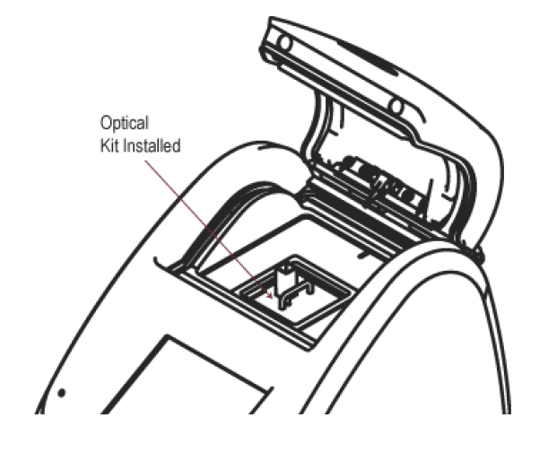
Figure 2 showing Optical Kit installed in preparation for getting to the Home Screen.
Trilogy Fluorometer User’s Manual P/N 998-7210 Page 6 of 38

4. Turn on the On/Off switch located on the back of the Trilogy, (see Figure 1). Verify the display becomes active, and shows the module selection screen, (see Figure 3).

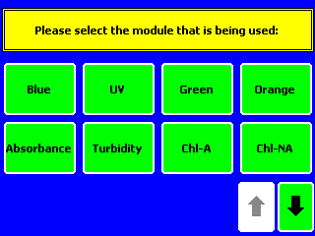
Figure 3 Module Selection Screen

4. Select the UV module inserted, and touch “OK” on the confirming screen.
5. When the Home Screen is displayed (Fig. 4), you are now ready to use Trilogy in its Raw Mode (measurements are relative) or calibrate the Trilogy and the snapped-in Optical Application Module to make quantitative measurements.

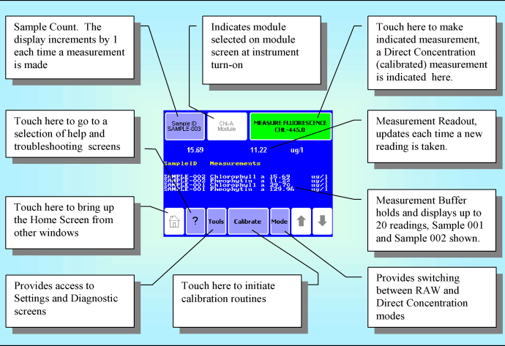
Figure 4: Trilogy Home Screen Display for Fluorescence Module Configuration.

Precautions
The Trilogy is intended for indoor use only. Wipe up spills immediately. The Trilogy contains sensitive optical components and precision-aligned mechanical assemblies. Avoid rough handling. Do not leave the lid open for extended periods of time. Turn OFF the Trilogy to change or install Optical Application Modules.
Note: After 20 minutes without activity or user stimulation, the Touch Screen hibernates. Lightly touch the screen to activate.

Touch screen Basics (Fluorescence)
Home Screen The "Home" screen appears after confirmation of the Optical Application Module. The "Home" screen provides orientation for the multiple functions of the Trilogy. From the "Home" screen, select "Calibrate," "Tools," "Mode," or "Help." The "Home" screen is also the measurement screen. (See over for Figure 6 showing Home Screen with callouts).
Trilogy Fluorometer User’s Manual P/N 998-7210 Page 8 of 38
Figure 6 – Trilogy Home Screen for Fluorescence Module Configuration.

Calibration
Refer to method.
Measuring Samples
There are two measurement modes available on the Trilogy when using the Fluorescence Module:
Raw Fluorescence Mode – No calibration required, choose this option
Direct Concentration Mode – Calibration required (see Section V)
Touch “Mode” on the Home Screen to select the measurement mode.
1. Raw Fluorescence Mode: The Raw Fluorescence Mode should be used for qualitative measurement, relative changes in fluorescence rather than absolute concentration values. Readings are displayed in Relative Fluorescence Units (RFU).
2. Direct Concentration Mode: The Direct Concentration mode makes absolute measurements based on a calibration; see Section V for the Calibration Procedure.
The Trilogy accommodates 10 x 10 mm methacrylate and polystyrene cuvettes (minimum 2 mL volume). Use 12 x 35 mm or 12 x 75 mm glass test tubes for measuring solvent applications, such as extracted chlorophyll, and use methacrylate cuvettes for UV water applications.
1. Open the lid of the Trilogy and insert the cuvette. Close the lid.
2. Touch "Sample ID" to name your sample (optional).
3. Using the keypad, enter the sample name into the name field and touch "Save" to save the sample ID.
4. Touch "Measure Fluorescence" to make a measurement. The Trilogy will measure the sample for 6 seconds and report the average reading for the sample.

The Trilogy reports data on the "Home" screen and displays the results for the most recent 20 measurements. Use the arrow keys to scroll through the most recent measurements. The data automatically exports to a printer or PC when properly connected, (see Section VII). Please note the Trilogy does not store more than 20 measurements at one time. If more than 20 readings are taken, the oldest reading will be overwritten. Measurements are not stored between power cycles.

Summary
To measure OPA ammonia samples
- Insert “CDOM-Ammonia Module” Optical Kit
- Turn on at switch at back
- Select "UV"
- Confirm "OK" for fluorometer UV
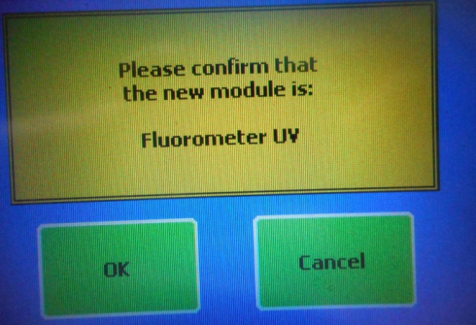
- Insert sample and select "Measure Fluorescence – Raw”
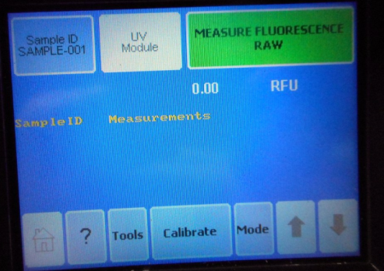
- Result will be displayed in Raw Fluorescence Units (RFU)
- n.b. The machine has a storage buffer of 20 readings

Attachment 4.2 Flow chart for ammonium analysis (by OPA method)
- Make up working reagent (WR) at least 24 hours in advance and store in 2L brown bottle. WR keeps for up to 3 months.
- Label with coloured tape, and number tubes according to DiW standard, seawater standard, matrix effect test solution and real seawater samples. Eg blue, green, red and white label tape to highlight the different solutions, and colour code volumetric flasks of standards accordingly.
- Clean tubes by filling 10% HCl in SuperQ acid wash solution. Do the same for the 250 mL volumetric flasks.
- Put working reagent in brown bottle with 5 mL dispenser on top.
- On board and prior to real sampling, use DiW and 5 mL working reagent to ‘burn out’ tubes 1-9.
- On board and prior to real sampling, use fresh seawater and 5 mL working reagent to ‘burn out’ remainder of tubes.
- Make up standards 0.5 uM and 1 uM in 250 mL volumetric flasks for both DiW and seawater.
- Pour 20 mL into sample tubes as per worksheet, rinsing tube appropriate with solution 3 times. Using fresh seawater solution, process without delay to avoid consumption of NH4. Add 5 mL working reagent to each set of standards (DiW tubes 1-9 and seawater tubes 10-18), cap, shake with vortex, place in box with lid and note time of WR addition.
- Add seawater to tubes 19-21 for determining background fluorescence. Add 5 mL of borate buffer (not working reagent) to these 3 tubes only.
- If during the cruise you expect an increase in NH₄ levels (eg. flood plume) you should redo the standards calibration so that the samples collected are calculated using readings from a representative seawater sample as a matrix. Collect real samples in triplicate (rinse tubes with sample 3 times and then fill to 20 mL mark).
- Using dispenser add 5 mL working reagent to tubes containing real seawater samples. Make note of the time that the working reagent was added on the laboratory worksheet.
- Read standards on the fluorometer after 2-3 hours.
- Note this time period, and use timer to proceed with reading the real seawater samples after the same time interval (between the addition of WR to fluorometer reading).
- Soak the standards volumetric flasks in 5-10% HCl in DiW overnight every evening to prepare for following day sampling.
- If there is a day or more of no water sampling, the tubes must at least once daily have fresh seawater or DiW with WR added to keep the tubes stripped of ammonia.

Attachment 4.3 Example data entry of shipboard laboratory worksheet NH4 analysis (OPA method)
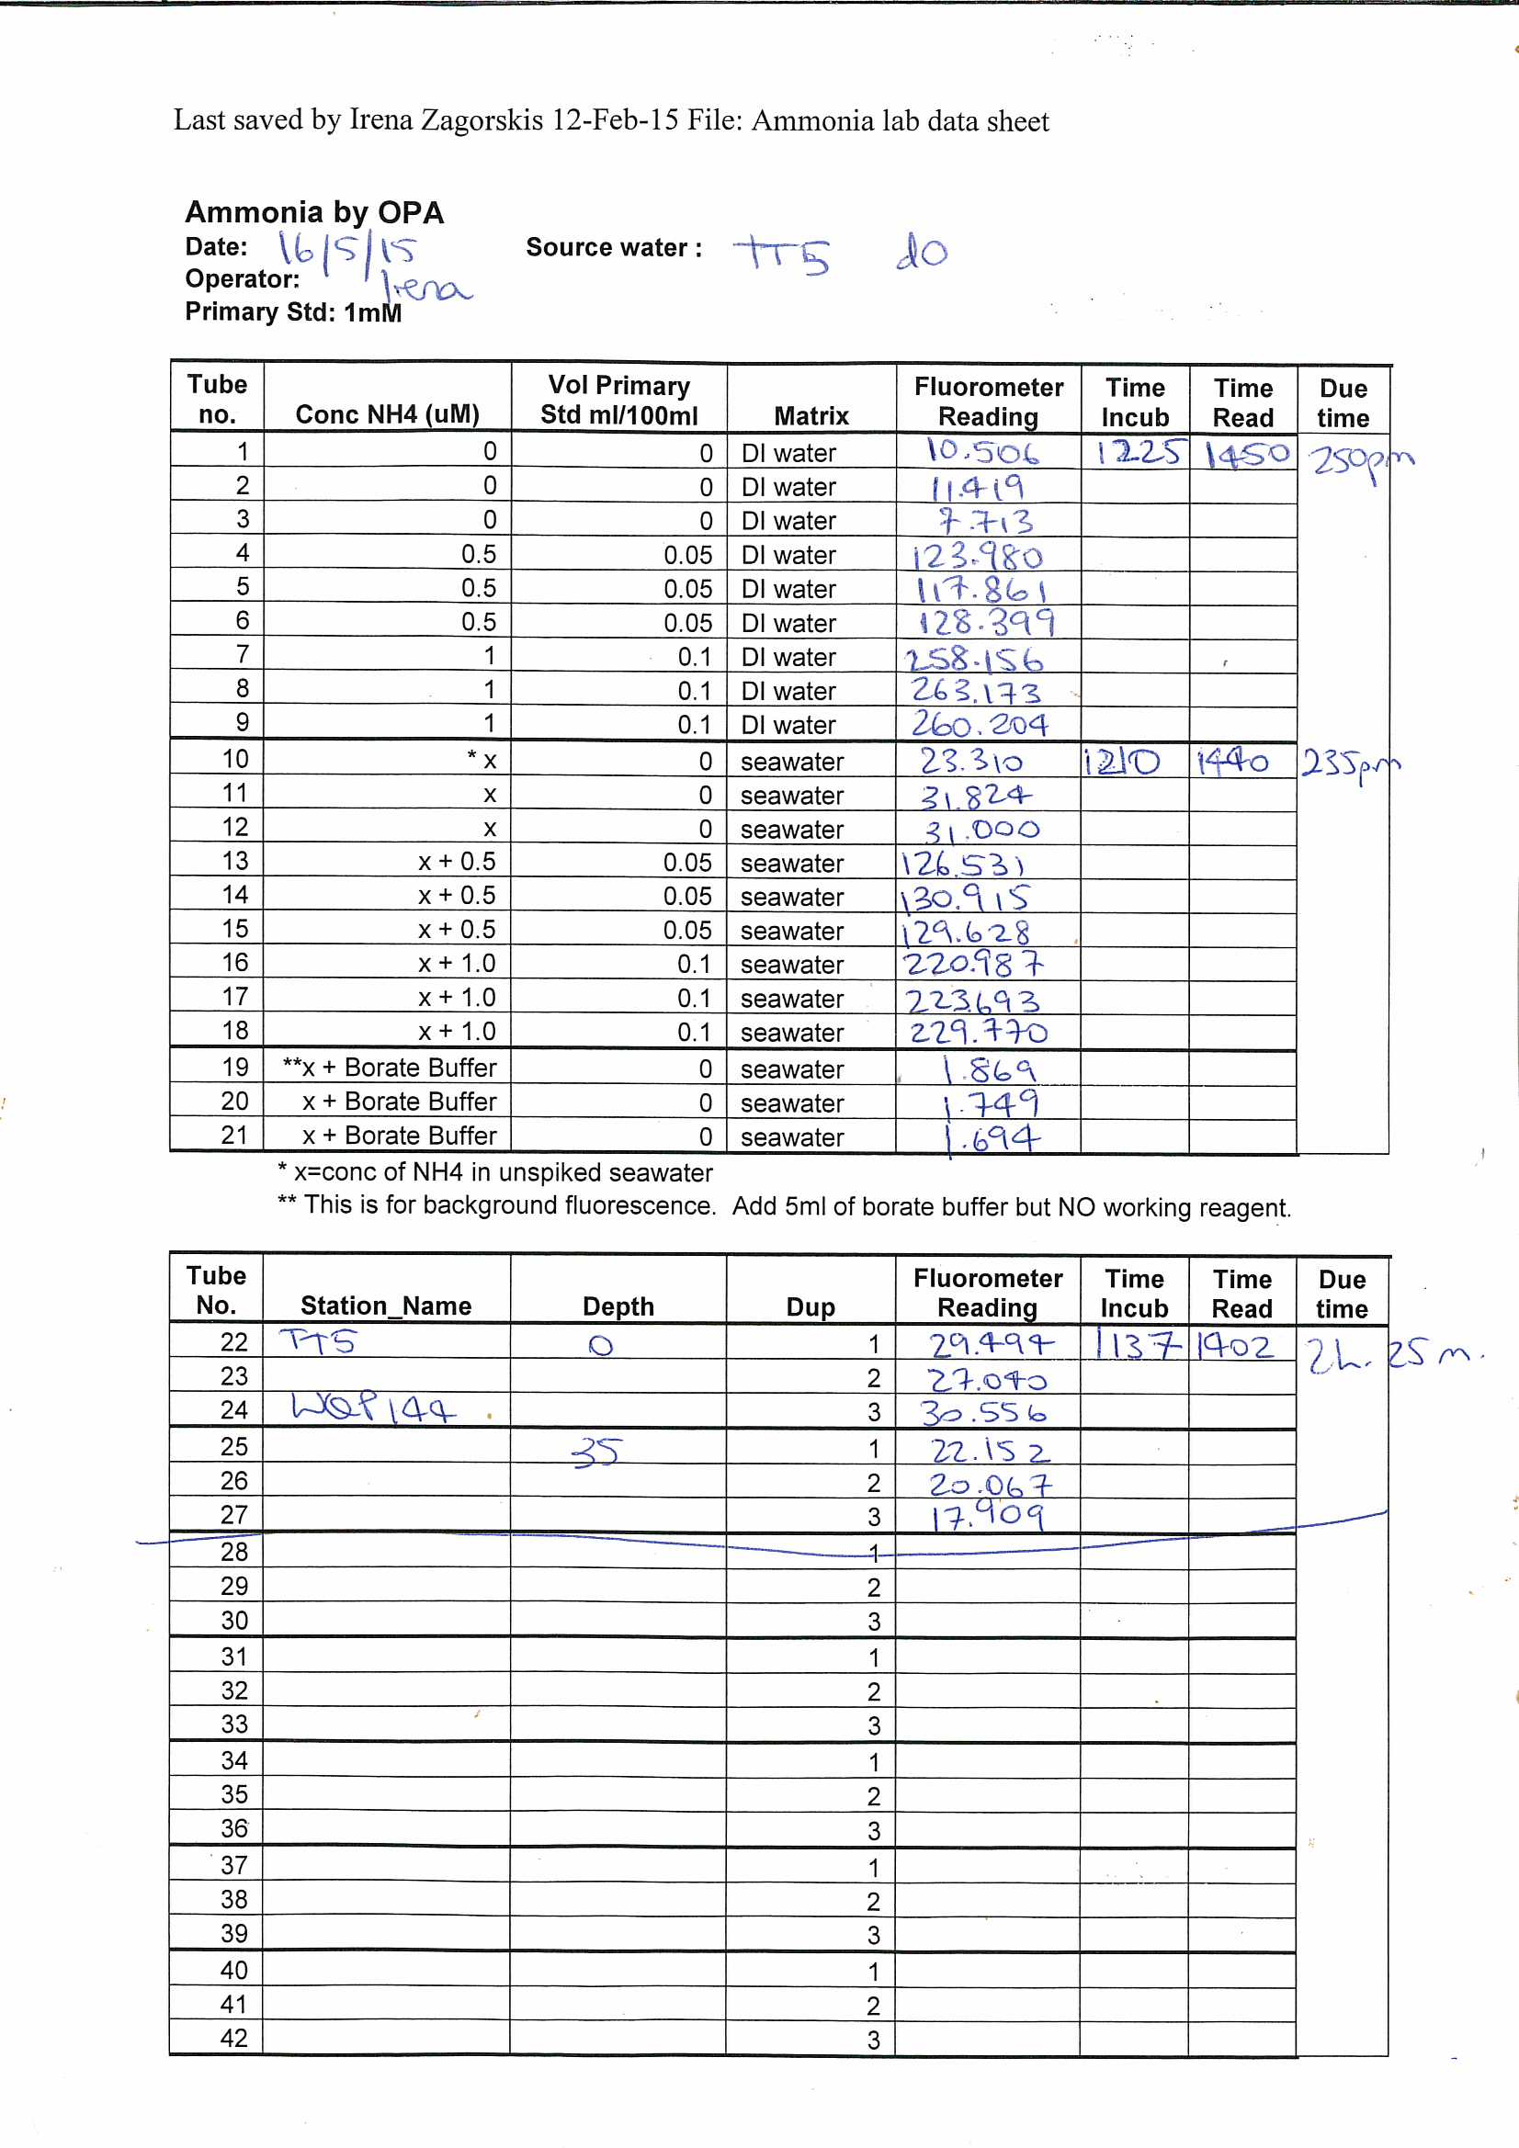

Attachment 4.4 Example Excel preliminary data entry and calculations
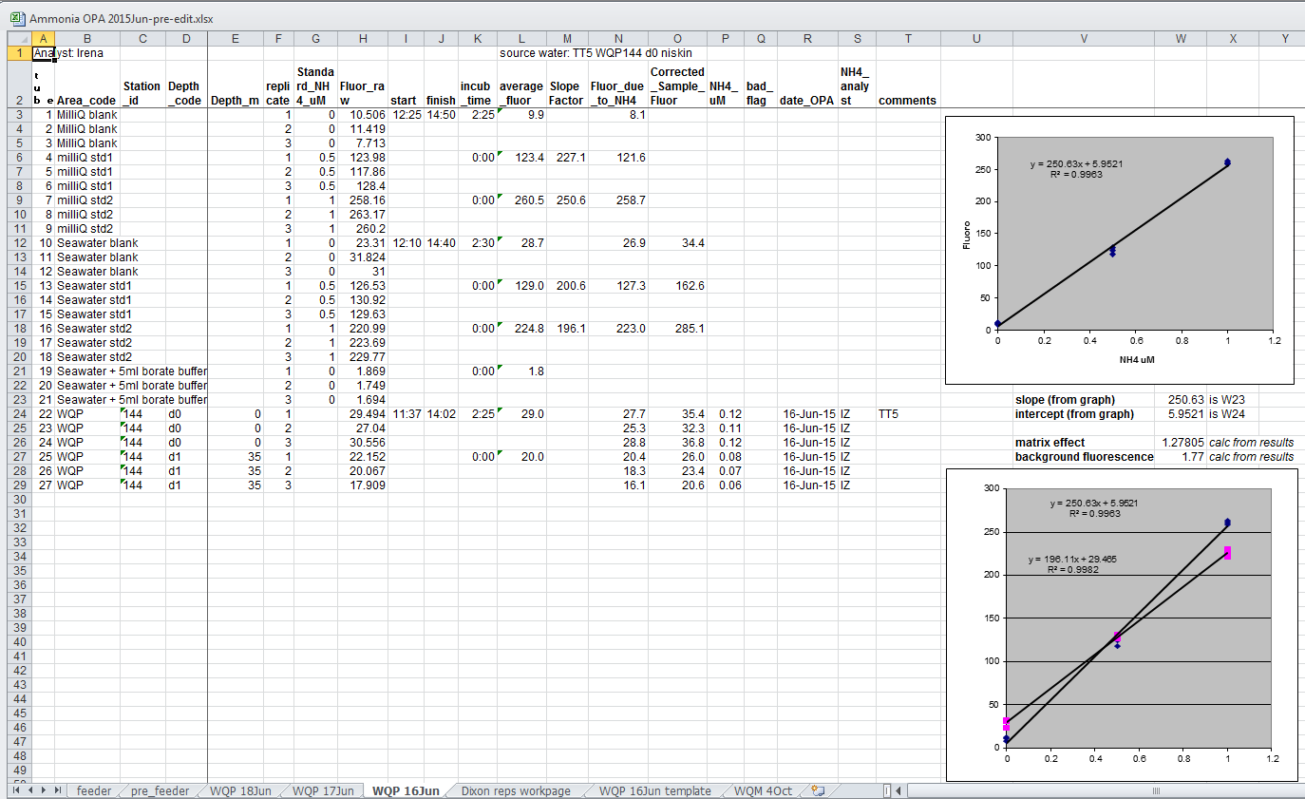
Attachment 4.5 Example Excel data “Feeder” spreadsheet
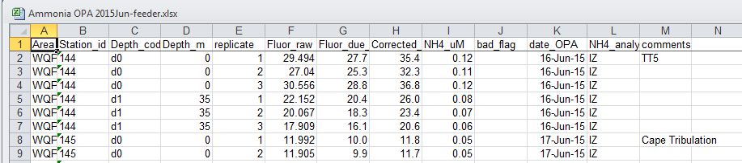

Section A5: Analysis of dissolved organic carbon

  - Objective

The analysis of dissolved organic carbon in seawater with a focus on detecting low level concentrations.

  - Principle of analysis

The SHIMADZU TOC-L is used to analyse Total Carbon (TC) and Inorganic Carbon (IC) in liquid samples. It uses High Temperature Combustion (at 720 Celsius) for the analysis of TC/ POC and acidification/sparging for the analysis of IC (at room temperature).

Total Carbon is essentially equivalent to Inorganic Carbon plus Non- Purgeable Organic Carbon (NPOC). This method eradicates the IC by acidification and sparging before NPOC is determined by a TC analysis on the sample remaining. Any volatile (purgeable) Organic Carbon present in the sample could be lost during the sparging process, but this is usually insignificant for the types of samples analysed at AIMS. TC determinations are done by converting Carbon to Carbon Dioxide by the high temperature combustion at 680 Celsius. The solution is then sparged with the carrier gas to transport the carbon dioxide (CO2) from the reaction chamber to the non-dispersive infra red detector (NDIR) in the TOC-L. Results are calculated from a calibration curve prepared from known amounts of Total Carbon (using Potassium Hydrogen Phthalate)

  - Sample collection procedure and storage

    - Equipment and reagents

- Screw Cap Sample Tubes (Glass or Polypropylene, 5 or 10 mL capacity, Acid Cleaned by soaking in 10 % HCl)
- 50 mL Terumo Syringes (Acid Cleaned by soaking in 10 % HCl)
- 25 mm Polycarbonate filters (0.4 µm pore size) or pre-combusted GF/F glass fibre filters and filter holders
- Hydrochloric acid

    - Collection, Preservation and Storage

- Draw the sample into a 50 mL Terumo syringe.
- Connect the filter and discard the first 15 to 20 mL of sample through the filter. Then rinse the sample tube with filtered sample if you have enough to do so.
- Fill the sample tube(s) with filtered sample. (2 or 3 replicate samples are usually prepared).
- Add 100 µL conc. HCl to 10 mL of filtered sample, and store in the refrigerator.

  - Sample analysis

    - Materials and Reagents

- Hydrochloric Acid
- Potassium Hydrogen Phthalate standards 0,1 and 2 ppm (as supplied by Shimadzu)
- Reef Pontoon water (In house quality control standard)
- Highly pure Deionised water
- SHIMADZU TOC-L

    - Procedure
- Turn instrument on using button next to start.
- Turn computer on (it will start up windows program)
- Press Crt Alt Del and enter password “Abcde123”
- Double click on “TOC Control L” icon.
- H/W Settings = to change to Std Cat_Std Syr-9 mL tubes or to change instrument properties eg temp from 720 to 680, vial sizes etc.
- Online Manual = opens manual
- Sample Table Editor = “Enter user name” press Ok.
- Go into Sample Table Editor by pressing Ok to “enter user name”.
- Can either open an old table to see past results by clicking on the date under “Sample Table” or Click the “New” tab.
- Use dropdown box to select “StdCat_Std Syr_9 mL tubes. Table type = normal, press “Ok”. A spreadsheet will open up. Click on “Insert” tab and then “Multiple Samples”. Under “Method” select NPOCTNnorm9ml.met and press “Open”.
- Press “Next”. Enter number of samples to be analysed. Press “Finish”. Press “Ok” when the vial settings bring up a picture of how the samples will sit in the autosampler.
- Enter the sample names from Row 1 into the Sample Table in either the Name or ID section.
- Connect the instrument by clicking the “Connect” button on the top right side. A sequence box will come up on screen and the instrument will initialize. When complete it will close the sequence box. The status box at the bottom left corner will show the sequence of events.
- Click on the “monitor” tab to show current temperatures and pressures. Check that you have enough gas in the cylinders. Temperature should be either 680 or 720 depending on your method. Instrument will not start unless parameters are met. Supply pressure should be minimum 150 mL min⁻¹.
- When instrument is at correct temperature click the “Start” button at top right of screen. Make sure samples are loaded into auto sampler and the ASI cover is closed.
- The screen will bring up “Save As file” – enter or save the date as the file name.
- A “Measurement Start” box will appear on the screen. Click on the “Shut down Instrument” dot and press the “start” button at the bottom of the box.

    - Sample Analysis Protocols

Before each run:
- Make sure Halogen scrubber is clean.
- Combustion tube has been refurbished and fitting tight.
- Drain tube from loader head is inside Y junction drain.
- Rinse bottle is full.
- Drain discharge tubing is unrestricted.
- B Type Halogen scrubber tube is topped up. (4.2% HCl)
- Number 6 drain tubing is inside drain (black top).
- Humidifier is full of water.
- Cooler drain vessel – water level should be within 10mm of overflow tube.
- Water dilution bottle water level. Verify there is sufficient water for analysis.
- Inspect acid levels.

  - Data management
Each sample is assigned a unique identifier which is usually a combination of sampling site reference, depth in the water column from which the sample was taken and the replicate number. The analysis reporting units is in mg L⁻¹ and presented as per Attachment 5.2.
An Excel worksheet combining sample details and analysis results is then used to create a feeder sheet for the Oracle database (http://waterquality.aims.gov.au:8080/waterquality) which will input all the analytical results and convert them from mg L⁻¹ to uM. It will also keep a copy of the related excel file complete with QAQC data. All laboratory work forms are then archived. For details about data management procedures developed at AIMS under Reef Rescue MMP see Section A12.

  - Quality control
QAQC tests undertaken and reporting as part of the data reporting include: Assessment of the limit of detection (LOD)
NB: the Limit of Detection (LOD) or detection limit, is the lowest concentration level that can be
determined to be statistically different from a blank (99% confidence).
- Minimum detection limits were calculated for this method using repetition of blanks.

Assessment of accuracy of the analysis
NB: This is generally achieved by using reference materials to assess recovery of known amount of analyte.
- There is no commercially available reference material at the low concentrations found in the GBR so repeated analysis of an “in-house” standard is used to detect any loss in accuracy with regard to the thiopthalate standard.
- A reference curve is generated with every sample batch.

Assessment of precision of the analysis
NB: This is generally achieved by the repeated analyses of the same concentration of analyte to check for reproducibility.
- Each sample reading is only generated when the standard deviation between three consecutive readings is less than 2%.
- Repeated analysis of standards throughout the sampling run allows continuous adjustment of the calibration for drift.

Reproducibility of duplicate analytical units
NB: The variation between results for sample duplicates indicates the reproducibility of the analysis and also the effects of various sources of contamination and analytical error during collection, sample preparation and analyses. Before data analysis, results are generally averaged over duplicates.
- Coefficients of variance are calculated from analytical results of sample duplicates. Duplicates with CV>30% are discarded from the analysis and the analysis repeated using extra duplicates that are generally collected as a backup.

Section A5 Attachments
Attachment 5.1 Example worksheet for analysis of dissolved organic carbon using the Shimadzu TOC-V

10th March 2009
Blanks
Predicted minus
Blank Blank
Predicted
2ppm Std
Drift
Corr
Resloped
2ppm OC
Pontoon Seawater 22-Dec 0ppm OC
0ppm OC 2ppm OC 2ppm OC 1ppm OC 1ppm OC 1ppm OC 0ppm OC 0ppm OC
Pontoon Seawater 22-Dec
Pontoon Seawater 22-Dec
2ppm OC 2ppm OC 1ppm OC 1ppm OC 1ppm OC 0ppm OC 0ppm OC
Pontoon Seawater 22-Dec
4.42 0.55 3.86 3.79 2.04
2.61 0.55 2.06 3.81 1.08
0.64 0.54 0.09 3.82 0.05
0.43 0.54 -0.11 3.83 -0.06
4.33 0.53 3.79 3.84 1.97
4.36 0.52 3.84 3.86 1.99
2.53 0.52 2.01 3.87 1.04
2.40 0.51 1.88 3.88 0.97
2.56 0.51 2.06 3.89 1.06
0.70 0.50 0.20 3.90 0.10
0.32 0.50 -0.17 3.91 -0.09
2.63 0.49 2.14 3.92 1.09
2.14 0.49 1.66 3.92 0.84
2.02 0.48 1.54 3.93 0.78
2.19 0.48 1.71 3.94 0.87
2.14 0.47 1.67 3.95 0.85
2.66 0.47 2.19 3.95 1.11
2.65 0.46 2.18 3.96 1.10
2.07 0.46 1.61 3.97 0.81
2.08 0.45 1.62 3.97 0.82
2.30 0.45 1.85 3.98 0.93
2.27 0.45 1.82 3.98 0.91
2.69 0.44 2.25 3.99 1.13
2.88 0.44 2.45 3.99 1.23
2.65 0.43 2.21 4.00 1.11
4.44 0.43 4.01 4.00 2.01
4.39 0.43 3.96 4.00 1.98
2.66 0.42 2.23 4.00 1.12
2.49 0.42 2.07 4.01 1.03
2.32 0.42 1.90 4.01 0.95
0.41 0.42 0.00 4.01 0.00
0.36 0.41 -0.05 4.01 -0.02
2.55 0.41 2.14 4.01 1.07
1.99 0.41 1.59 4.01 0.79
2.07 0.40 1.66 4.01 0.83
2.25 0.40 1.84 4.01 0.92
2.12 0.40 1.72 4.01 0.86
3.69 0.40 3.29 4.00 1.64
4.05 0.39 3.65 4.00 1.83
2.34 0.39 1.95 4.00 0.97
2.10 0.39 1.71 4.00 0.86
2.28 0.39 1.89 3.99 0.95
2.20 0.39 1.81 3.99 0.91
2.06 0.39 1.67 3.98 0.84
1.97 0.38 1.58 3.98 0.80
2.47 0.38 2.09 3.97 1.05
2.53 0.38 2.15 3.97 1.08
2.36 0.38 1.98 3.96 1.00
4.30 0.38 3.92 3.96 1.98
4.42 0.38 4.04 3.95 2.04
2.42 0.38 2.05 3.94 1.04
2.30 0.38 1.92 3.93 0.98
2.37 0.38 2.00 3.92 1.02
0.43 0.38 0.06 3.92 0.03
0.38 0.38 0.01 3.91 0.00
2.50 0.37 2.13 3.90 1.09
2.14 0.37 1.76 3.89 0.91
2.06 0.37 1.68 3.88 0.87
2.20 0.37 1.83 3.87 0.94
2.03 0.38 1.65 3.86 0.86
2.22 0.38 1.84 3.84 0.96
2.12 0.38 1.74 3.83 0.91
2.70 0.38 2.33 3.82 1.22
2.79 0.38 2.41 3.81 1.27
2.50 0.38 2.12 3.79 1.12
2.75 0.38 2.37 3.78 1.26
2.15 0.38 1.77 3.77 0.94
2.18 0.38 1.80 3.75 0.96
1.84 0.38 1.46 3.74 0.78
1.94 0.38 1.55 3.72 0.84
2.37 0.38 1.99 3.71 1.07
4.13 0.39 3.75 3.69 2.03
3.99 0.39 3.60 3.67 1.96
2.31 0.39 1.92 3.66 1.05
2.20 0.39 1.81 3.64 0.99
2.41 0.39 2.02 3.62 1.12
0.39 0.39 -0.01 3.60 0.00
0.38 0.40 -0.02 3.58 -0.01
2.04
1.05
0.05
-0.05
1.97
1.99
1.01
0.94
1.03
0.10
-0.08
1.06
0.82
0.76
0.84
0.82
1.08
1.07
0.78
0.79
0.90
0.88
1.10
1.20
1.08
2.01
1.98
1.09
1.00
0.92
0.00
-0.02
1.04
0.76
0.80
0.89
0.83
1.63
1.82
0.94
0.83
0.92
0.88
0.81
0.77
1.02
1.05
0.97
1.98
2.05
1.01
0.95
0.99
0.03
0.00
1.06
0.88
0.84
0.91
0.83
0.93
0.88
1.19
1.24
1.09
1.23
0.91
0.93
0.75
0.81
1.04
2.03
1.96
1.02
0.96
1.09
0.00
-0.01
3
4
10
11
31
32
54
55
77
78
0.64
0.43
0.70
0.32
0.41
0.36
0.43
0.38
0.39
0.38
0.80

0.70
2
1
2
3
4
5
6
7
8
9
10
11
12
13
14
15
16
17
18
19
20
21
22
23
24
25
26
27
28
29
30
31
32
33
34
35
36
37
38
39
40
41
42
43
44
45
46
47
48
49
50
51
52
53
54
55
56
57
58
59
60
61
62
63
64
65
66
67
68
69
70
71
72
73
74
75
76
77
78
y = 0.00005550x - 0.00643085x + 0.56106944
0.60

0.50

0.40

0.30

0.20

0.10

0.00
1 0.27
2 0.25
5 0.38
6 0.31
12 0.16
13 0.18
31 0.31
32 0.29
54 0.50
55 0.41
77 0.30
78 0.38
0
20
40
60
80
100
WQM194
WQM194 WQM194 WQM194 WQM195 WQM195 WQM195 WQM195 WQM195 WQM195 WQM195 WQM195
d0
d0 d1 d1 d0 d0 d1 d1
d2
d2 d3 d3
2ppm Standards
1
5
6
26
27
49
Pontoon Seawater 22-Dec 50
2ppm OC 72
2ppm OC 73
1ppm OC 1ppm OC 1ppm OC 0ppm OC 0ppm OC
Pontoon Seawater 22-Dec
3.86
3.79
3.84
4.01
3.96
3.92
4.04
3.75
3.60
4.10
4.05
4.00
3.95
3.90
3.85
3.80
3.75
3.70
3.65
3.60
3.55
5 4.56
9 4.40
10 4.30
28 4.29
29 4.20
51 4.24
52 4.11
72 4.12
73 3.97
y = -0.000209729x2 + 0.013846387x + 3.780167920
0 10
20
30
40
50
60
70
80
WQM196
WQM196 WQM196 WQM196 WQM197 WQM197 WQM197 WQM197 WQM198 WQM198 WQM198 WQM198 WQM199 WQM199
d0
d0 d1 d1 d0 d0 d1 d1 d0 d0 d1 d1 d0 d0
Reslope (recalibration)
2.00
1.03
0.00
2.00
1.00
0.00
2.50
2
y = 0.029900x + 0.940200x - 0.000000
2.00

1.50

1.00
1.04
0.97
1.06
1.12
1.03
0.95
1.04
0.98
1.02
1.05
0.99
1.12
0.50
1.03
0.00
0.00
0.50
1.00
1.50
2.00
2.50
-0.50
WQM199 d1
WQM199 d1 WQM200 d0 WQM200 d0 WQM200 d1 WQM200 d1 WQM201 d0 WQM201 d0 WQM201 d1 WQM201 d1 WQM201 d2 WQM201 d2 WQM201 d3 WQM201 d3
Pontoon Seawater 22-Dec 2ppm OC
2ppm OC 1ppm OC 1ppm OC 1ppm OC 0ppm OC 0ppm OC

Attachment 5.2 Example report from AIMS Analytical Services for Analysis of Dissolved Organic Carbon using the Shimadzu TOC-V

..............................................................................................................................................................................
Australian Institute of Marine Scienc
LABORATORY SERVICES
Telephone: Manager 263 ICP Facility 385 Nutrient Facility 363 E-mail f_tirendi Laboratory 223 TOC/CHNS 214 GC facility 392
Postal Mail: PMB 3, Townsville Qld. Australia. 4810
............................................................................................................................................................................................

ANALYTICAL REPORT
Organisation/Project: AIMS
Project Leader: B. Schaffelke Order Number: 2215L15090 Job No: 2598
Date Received: 02-Mar-2009 Date Issued: 13-Mar-2009
Sample Type: Feb 2009 WQ Seawaters for DOC (trip 4725) Report Filename: \\pearl\labdata\b_schaff\Sch2598 DOC.xls
Sample Preparation:

Analytical Method: SHIMADZU TOC-5000A
Method Reference:

Analyst: S. Boyle Reviewed By: C. Payn
Sample |  | NPOC |  |  | Sample |  | NPOC
 |  | mg/l |  |  |  |  | mg/l
WQM177 | d0 | 1.09 |  |  | IOP001 | d0 | 1.20
WQM177 | d0 | 0.99 |  |  | IOP001 | d0 | 21.0
WQM177 | d1 | 1.02 |  |  | IOP001 | d1 | 1.42
WQM177 | d1 | 1.02 |  |  | IOP001 | d1 | 1.12
WQM177 | d2 | 0.80
WQM177 | d2 | 0.80
WQM177 | d3 | 0.85
WQM177 | d3 | 0.87
WQM178 | d0 | 1.00
WQM178 | d0 | 1.06
WQM178 | d1 | 0.96
WQM178 | d1 | 0.87
WQM178 | d2 | 0.83
WQM178 | d2 | 0.84
WQM178 | d3 | 0.78
WQM178 | d3 | 0.77
WQM179 | d0 | 1.21
WQM179 | d0 | 1.23
WQM179 | d1 | 1.10
WQM179 | d1 | 1.13
WQM179 | d2 | 0.78
WQM179 | d2 | 0.80

Section A6: Analysis of Chromophoric Dissolved Ocean Matter (CDOM) in marine waters

  - Objective

The analysis of Chromophoric Dissolved Ocean Matter (CDOM) in seawater with a focus on detecting low level concentrations.

  - Principle of analysis
Chromophoric dissolved organic matter (CDOM) is a term used to describe a group of mixed, and mostly undefined, organic compounds dissolved in natural waters that absorb ultraviolet or short-wavelength visible light. This characteristic is used to operationally quantify CDOM by spectroscopic UV-visible absorption spectroscopy. The applied method is based on Nelson and Coble (2009).

  - Sample collection procedure and storage

    - Equipment
- 50 mL Amber (Glass) Bottles.
- Gloves must be worn

    - Collection and Storage
- Collected water sample (taken from the niskin bottle) is filtered with a clean syringe through the 0.2 μm filter (Pall-Acropak supor Membrane).
- Fill up the syringe with water and wash once, attach 0.2 μm filter to syringe and push some sample through to prime the filter.
- Fill up the glass amber bottle provided – minimum 50 mL filtered sample is required.
- Store sample at 4ºC until analysis.

  - Sample analysis

    - Materials and Equipment
The analysis require: Two 1x10 cm quartz cuvette, Lens tissue to clean the cuvette surfaces, fresh MilliQ water for baseline and cleaning the cuvette, and a spectrophotometer (AIMS uses a Shimadzu UV-1800 Spectrophotometer, see Section A 6 Attachment for detailed instructions). Gloves must be worn during analysis to ensure that the quartz cuvette remains clean.

    - Method

- The Spectrophotometer should be allowed to warm up for at least 30 min before analysis.
- With MilliQ in both cuvettes run a baseline absorption spectrum between 240 and 700 nm.
- Rinse cuvette twice with some sample water, then fill to just below the label on the cuvette and run an absorption spectrum between 240 and 700 nm.

    - Calculation
Firstly the absorption spectrum of the MilliQ blank is subtracted from the sample absorption measured between 240 and 700 nm. The absorption coefficient at any wavelength, a_{CDOM}(λ) (m^{–1}), is hereafter calculated as:
a_{CDOM}(λ) = 23.03 × [Abs(λ) – Abs(600–750)]
Where Abs(λ) is the absorbance at wavelength λ, and Abs(600–750) is the average absorbance between 600 and 750 nm, which corrects for the residual scattering by fine size particle fractions, micro-air bubbles or colloidal material present in the sample, or refractive index differences between the sample and the reference (m^{–1}), the factor 23.03 converts from decadic to natural logarithms and furthermore considers the cell path-length.

The CDOMs spectral properties can thereafter be modelled by:
a_{CDOM}(λ) = a_{CDOM}(λ₀) × EXP[-S×(λ- λ₀)]
Where a_{CDOM}(λ) is the absorption coefficient at wavelength λ, a_{CDOM}(λ₀) absorption at reference wavelength λ0, and S is the spectral slope coefficient. The parameters were calculated simultaneously via a nonlinear regression of the equation using the Sigmaplot package.

  - Method capabilities and limits of detection
The method is newly added to the suite of AIMS water quality methods and the limit of detection for the analytical set up used has not been fully quantified. The main determinant of the LOD is the photometric accuracy of a spectrophotometer, which is typically around 0.005 absorption units. Literature LODs for CDOM range from an absorption coefficient of 0.004 m⁻¹ to _{o} 0.013 m⁻¹. (Nelson and Coble 2009)

  - Data management
Each sample is assigned a unique identifier: usually a combination of sampling site reference, depth in the water column from which the sample was taken and the replicate number.
All absorption spectra are saved as Excel files on the spectrophotometer and archived. All calculation results are saved in SigmaPlot and archived. An Excel worksheet combining sample details and analysis results is then used to create a feeder sheet for the Oracle database (http://waterquality.aims.gov.au:8080/waterquality). It will also keep a copy of the related excel file complete with QAQC data. All laboratory work forms are then archived. For details about data management procedures developed at AIMS under Reef Rescue MMP see Section A12.

  - Quality control
QAQC tests undertaken and reporting as part of the data reporting include: Assessment of the limit of detection (LOD)
NB: the Limit of Detection (LOD) or detection limit, is the lowest concentration level that can be determined to be statistically different from a blank (99% confidence).
Minimum detection limits will be calculated for this method using repetition of baseline spectra.

Assessment of precision of the analysis
NB: This is generally achieved by the repeated analyses of the same concentration of analyte to check for reproducibility.

Reproducibility of duplicate analytical units:
NB: The variation between results for sample duplicates indicates the reproducibility of the analysis and also the effects of various sources of contamination and analytical error during collection, sample preparation and analyses. Before data analysis, results are generally averaged over duplicates.
- Coefficients of variance are calculated from analytical results of sample duplicates. Duplicates with CV>30% are discarded from the analysis and the analysis repeated using extra duplicates that are generally collected as a backup.

  - References
Nelson, N.B., and P.G. Coble, 2009: Optical analysis of chromophoric dissolved organic matter. Chapter 5 in: Practical Guidelines for the Analysis of Seawater, O. Wurl (editor), CRC Press, 401 pp.

Section A6 Attachments
Attachment 6.1 Detailed procedures for the analysis CDOM using the Shimadzu UV-1800 Spectrophotometer
- Turn on the spectrophotometer (switch on side) and open the UV-Probe software. At the bottom of the screen is a button called “Connect”, click on in and the instruments lamps and filters will be turned on and initialised. This takes 5 mins. as the software goes through a check list. Click “OK” after the test is finished.
- The instrument should be allowed to warm up for at least 1 hour (2 hours is best). Before you leave the instrument (to warm up), place the reference cuvette with MilliQ water in into the sample compartment in the reference holder. While the instrument warms up the temperature of the reference water also warms up a becomes stable.
- Click the “File” menu and select “open”. Go to “C:\Absorption\Methods\”. In the “File of type” box select “Method File” and then the file “Galathea-DOM.smd” should be visible. Select it and click “open”.
- Rinse and fill both 10cm cuvettes with fresh collected MilliQ water. Fill to just below the label on the cuvettes. Hold up to the light and ensure there is no bubbles, dirt or fingerprints on the cuvette windows. Clean with lens paper.
- Place the cuvettes in each of the cuvette holders with the cuvette labels facing right (towards the light source). The cuvettes do not sit absolutely tight in the cuvette holders and it is important they are placed in the same position each time. So push them gently to the right and then nudge towards you.
- With MilliQ in both cuvettes you can now run a baseline by clicking the “Baseline” button at the bottom of the screen. This will zero the instrument. A box with “Baseline Properties” will come up. It should be 240nm to 700nm, click “OK”. The instrument will run a baseline and then you are ready to start measuring samples.
- Take the sample cuvette out and rinse twice with some sample water, then fill to just below the label on the cuvette. Clean the cuvette windows and place in the cuvette holder. As before ensure the cuvette is sitting in the same position within the holder (bottom right corner). Look at the Abs. (absorbance) value at 700nm (bottom left of screen), this should be between –0.005 and 0.005. If it is higher, check the cuvette is sitting correctly in the holder, cuvette windows are clean and that there are no bubbles, and that the sample water is a room temperature. If the value is still high, run a new MQ baseline (step 6).
- Click “Start” at the bottom of the screen. After it has completed the scan a box will pop up and ask for a location and name for the file. Save the data in “C:\Absorption\Data\Leg#\” and call the file “DOMABS#”, where # is the sample number. Next click “File” “Save” (or keyboard short cut [Ctrl] [S]) to save the data. Record the sample number details in the cruiseleg log file (excel sheet).
- Repeat 7-8 for the next sample. If you want to stop for a while ensure that you run a MilliQ blank as the last sample otherwise run a MilliQ blank every 10th sample. This will take into account most of the variability in the temperature that can occur as a results of changes in room temperature (samples) and warming of the instrument (reference cuvette). Save the MilliQ data as “DOMABSMQ#” where # corresponds to the sample number of the last seawater sample run before the blank.When finished with all DOM ABS samples and the final MilliQ blank is run, select “File”, “Save all”.
- Now select “Operations” then “Data Print”. All the data that you have measured now appear in a table on screen to the right. Right click on a cell in the table and click “Select all”. Right click again and select “Copy”. Paste the data into an Excel file. Save the Excel file as “DOMABSDDMMYY.xls” in the same location as the spectra (C:\Absorption\Data\Leg#). Close the file.
- Close the “UV Probe” program. Turn off spectrophotometer if finished with all absorption measurements for the day.

Section A7: Analysis of particulate phosphorus in marine waters

  - Objective

Analysis of total particulate phosphorus in seawater with a focus on detecting low level concentrations of bioavailable phosphorus.

  - Principle of analysis

The method is based on the oxidation of organic phosphorus and the extraction of acid-labile inorganic phosphorus from particles by hot acid persulfate (Menzel and Corwin,1965) and the subsequent colorimetric determination of the P released as orthophosphate (Parsons et al,1984),. Phosphorus occurs in many organic and inorganic forms in the environment. Forms available for quantitation by instrumental means depend strongly on the extraction method employed (e.g. Ruttenberg, 1992).

  - Sample collection procedure and storage

7.3.1 Equipment

    - 25 mm Whatman GF/F glass fibre filters
    - tweezers, aluminium foil
    - black labelling pen
    - 250 mL plastic measuring cylinder
    - 25 mm filter funnels, manifold, water reservoir and vacuum pump.

7.3.2 Methods

- Duplicate 250 mL of seawater sub-sample are filtered through 25 mm Whatman GF/F glass fibre filters to collect the particulate matter for phosphorus analysis.
- The filters folded in half so sediment will not dislodge and then wrapped in alfoil, labelled with site, depth, date collected and volume filtered. There should be 2 replicate filters per alfoil packet.
- Freeze or freeze-dry the filters immediately.

  - Sample analysis

    - Materials and Equipment

NB. All plasticware and glassware should be well-rinsed, soaked in dilute Hydrochloric Acid (HCl), rinsed again in Deionised Water (DiW) and heat dried (where possible). Detergents, which may contain phosphates, must be avoided.
- Automatic pipettes (volumes needed 50, 100 and 250µl, 2.5 and 5 mL).
- 2.5 mL dispenser on a reagent bottle for the persulfate digestion reagent.
- 5 mL dispenser on a reagent bottle for deionized water.
- 50 mL stoppered graduated measuring cylinder for making up mixed reagent.
- 200 x 7 mL glass scintillation vials in 2 foam trays. One tray of vials (100) is to be used for the sample digestions and the other for the colorimetric analyses. Clean the glass vials in 10% HCl
and oven dry. It is convenient to bake the vials at 450°C in a muffle furnace to remove the inked labels on used vials rather than wiping them off with solvent.
- Aluminium heating block in a sand-filled electric frypan
- GF/F glass fibre filters. (Can be used either straight from the packet or denitrified by heating for 2 hours at 450oC in a muffle furnace).
- 100 small glass marbles (acid washed in 10% HCl, DiW rinsed).
- Mini homogeniser (see Attachment 7.1) with beaker of DiW for rinsing.
- Reagent bottles.
- Tweezers and al-foil
- 3 x 100 mL and 1000 mL volumetric flasks.
- Safety glasses.
- Spectrophotometer with 1 cm cell (capable of reading to 900 nm). Although not essential, an automated, low-volume, sipper cell attachment for the spectrometer will speed up analysis time considerably.

    - Methods

      - Samples
Samples (on filters) remain frozen until analysis. The frozen filters are placed directly into labelled reaction vessels for digestion. After the digestion step they may be stored in a covered, dust-free container at room temperature for several days.

      - Reagents
NB: All deionised water is 18 MΩ quality
- Potassium Persulfate: 5 g of K₂S₂O₈ in 100 g of deionised water (DiW). Make fresh daily.
- Colour Reagent:
  - Ammonium Molybdate - 15 g of (NH4)6Mo7O24 in 500 mL of DiW. Reasonably stable. If kept for too long, a precipitate will form. If this happens, discard it and make up a fresh solution, though small amounts of precipitate will not affect the analysis.
  - Sulphuric Acid - 140 mL of H2SO4 and 900 mL DiW. Stable.
  - Ascorbic Acid - 2.4 g of C6H8O6in 50 mL of DiW. This solution is unstable. Freeze in 10 mL portions and defrost as needed.
  - Potassium Antimonyl Tartrate - 0.34 g of K(SbO)C4H4O6 in 250 mL of DiW. Stable.
  - Mixed Reagent - Mix 10 mL of (a) with 25 mL of (b), then add 10 mL of (c) and finally add 5 mL of (d). This solution will remain stable for no longer than 4 hours.

- Standard solutions:
Primary Standard
1 mM - PO₄-P Dissolve 0.136 g of anhydrous potassium dihydrogen phosphate (KH₂PO₄) in 1000 mL of DiW. Add a few drops of chloroform. Stable if preserved.

Working Standards
- Blank- Deionised water
- 5 µmol L⁻¹ PO₄-P - Pipette 0.5 mL of the primary standard into a 100 mL volumetric flask and make to the mark with deionised water.
- 10 µmol L⁻¹ PO₄-P - Pipette 1.0 mL of the primary standard into a 100 mL volumetric flask and make to the mark with deionised water.
- 20 µmol L⁻¹ PO₄-P - Pipette 2.0 mL of the primary standard into a 100 mL volumetric flask and make to the mark with deionised water.

      - Procedure
Place each sample filter in a numbered 7 mL scintillation vial and add 2.5 mL of the persulfate solution. When all samples are completed, move the vials to the heating block. A distilled water blank and two digestion/recovery standards (in duplicate) should be run in each digestion (vial pairs numbered 1-3). Sample vials (in duplicate) should be numbered from 4 to
50. Put a clean glass marble on each vial to allow the sample to reflux while gradually evaporating to dryness. Turn on the fry pan and adjust the temperature so the vials reflux gently.

- When all vials are refluxed dry, allow to cool and then add precisely 5 mL DiW to each vial. Cover with plastic wrap (e.g. Gladwrap) and let stand overnight.
- The filter in each vial is homogenized using a small motorized mixer made from a hobby engraver. Rinse the head of the mixer between samples in a beaker of clean DiW. After mixing, the solid particles in the vials are spun down in a centrifuge.
- Pipette 2.5 mL of the supernatant into a similarly numbered, clean 7 mL scintillation vial.
- Add 0.25 mL of colour reagent to each vial and mix gently.
- After 30 minutes (but in less than 2 hours) measure the absorbance of the solutions in the vials at 885nm on a spectrophotometer using a 1 cm cell. All measurements should be recorded on the Excel Spreadsheet “pp work form”.

    - Calibration

Standard Curve
A standard curve of 0, 5, 10 and 20 µmol L⁻¹ phosphate (prepared from the primary standard) is run each day. This is done by pipetting 0, 0.5, 1.0 and 2.0 mL of primary standard in four 100 mL volumetric flasks. The slope is calculated and used to convert the sample absorbance (with correction for blank) to phosphate concentration in the sample. The efficiency factor and a dilution factor are then applied to calculate the P content of the sample. The final value should be the concentration of particulate phosphorus (PP), in µmol L⁻¹.

Control Standards
Deionized water blanks and digestion/recovery control standards are to be run with each batch of samples digested and treated in the same way as unknowns to determine efficiency. The suggested range of controls is 0, 50 and 100 µL of the primary standard solution per vial, corresponding to 0, 10 and 20 µM P respectively.

    - Calculations

The following equation is used to calculate particulate phosphorus concentration:

F = concentration of standard in µmol L⁻¹ AbsStd-AbsBlank
For a given standard concentration and a 1 cm spectrophotometer cell, the value of F should be very close to 50. When using spec cells of other pathlengths, divide F by the pathlength in cm.

efficiency = measured concentration of control standard real concentration of control standard

dilution factor = initial volume of sample (i.e. 250 mL)
concentrated volume of sample (i.e. 5 mL)

  - Method capabilities and limits of detection

The colorimetric method is linear over the range 0 to 20 µmol L⁻¹ phosphate in solution (or 0 to 0.100 µmol of total phosphorus per filter). Samples with phosphate concentrations greater than this range (as is often the case with river or estuarine samples) will need to be diluted before the colour reagent is added. Where high P concentrations are likely, it maybe beneficial to filter a few extra samples that can be used to establish approximate concentration ranges. Remember if you dilute the samples, then you will need to dilute the control standards (vials 1 to 3) as well in order to calculate true digestion and extraction efficiencies. The effective detection limit is 0.010 µmol P (0.310 µg P) on a filter.

  - Data management

Each filter is assigned a unique identifier which is usually a combination of sampling site reference, depth in the water column from which the sample was taken and the replicate number.
The sample identifier is logged on a laboratory worksheet against the vial into which it is being placed. A proforma of this log sheet can be found in Attachment 7.2. The spectrophotometer absorption reading for each sample is then written on this sheet. All information from this lab sheet is then entered into a Microsoft Excel spreadsheet template called "Phosphorus Calc" which is a visual copy of the laboratory form but has all the calculation equations imbedded. It will automatically perform the all calculations once the values are typed in. These Excel worksheets are then used as feeder sheets’ for the Oracle Database (http://waterquality.aims.gov.au:8080/waterquality). Utilising the import tool, all the analytical results are transferred into the database and a copy of the related excel file complete with QAQA data is stored within the database. All hard copy laboratory work forms are then archived. For details about data management procedures developed at AIMS under Reef Rescue MMP see Section A12.

  - Quality control
QAQC tests undertaken and reporting as part of the data reporting include: Assessment of the limit of detection (LOD)
NB: the Limit of Detection (LOD) or detection limit, is the lowest concentration level that can be
determined to be statistically different from a blank (99% confidence).
- Minimum detection limits were calculated for this method using repetition of blanks.

Assessment of accuracy of the analysis
NB: This is generally achieved by using reference materials to assess recovery of known amount of analyte..
- There is no certified reference material available in the particulate phosphorus concentration range of GBR marine samples. Hence, no direct assessment of accuracy is possible for this method. As an indirect assessment, a set of separate standards is analysed to determine a method efficiency factor for each analytical batch. Analytical data are adjusted using the batch- specific efficiency factor.

Assessment of precision of the analysis
NB: This is generally achieved by the repeated analyses of the same concentration of analyte to check for reproducibility.
- Repeated analysis of replicate standards

Procedural blanks:
- Filter blanks are run with every batch (generally daily). These are used as blank readings in the calculation of analytical results.
- Wet filter blanks (filter placed on filtration unit and wetted with filtered seawater, then further handled like samples) were prepared during the on-board sample preparation to measure contamination during the preparation procedure

Reproducibility of duplicate analytical units
NB: The variation between results for sample duplicates indicates the reproducibility of the analysis and also the effects of various sources of contamination and analytical error during collection, sample preparation and analyses. Before data analysis, results are generally averaged over duplicates.
- Coefficients of variance are calculated from analytical results of sample duplicates. Duplicates with CV>30% are discarded from the analysis and the analysis repeated using extra duplicates that are generally collected as a back up.

Other
- Intercalibration of this method with the ICP method used by AIMS laboratories (Thompson and Walsh, 1993) showed agreement of +/- 15%.
- The linear range of this method was established utilising increasing concentrations of primary standard. Samples are diluted if above this range.
- A reference curve is generated with every sample batch.

  - References

Menzel, D.W. and Corwin, N. 1965. The measurement of total phosphorus in seawater based on the liberation of organically bound fractions by persulphate oxidation. Limnology and Oceanography 10: 280
Parsons,T.R., Yoshiaki, M. and Lalli, C.M. 1984. A manual of chemical and biological methods for seawater analysis, Pergamon, London. pp22-25
Ruttenberg, K.C. 1992. Development of a sequential extraction method for different forms of phosphorus in marine sediments. Limnology and Oceanography 37(7): 1460-1482.
Thompson M. and Walsh J. N. 1993 Handbook of Inductively Coupled Plasma spectrometry. 2nd ed. Chapman and Hall.

Section A7 Attachments

Attachment 7.1Homogeniser
Made from a hand held hobby engraver (Arlec Supertool) fitted with custom-built shaft made from a thin (1 mm) stainless steel rod with a fluted Teflon disc at the end to act as a mixing blade. This is basically modelled on a kitchen hand-held milkshake maker.

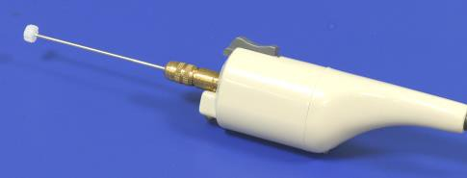

Fig 1: Hand held hobby engraver with custom built shaft.

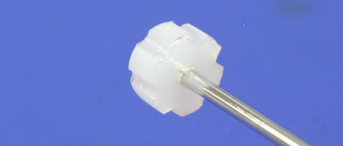

Fig 2: Detail of modified shaft.

Attachment 7.2 Example blank laboratory worksheet
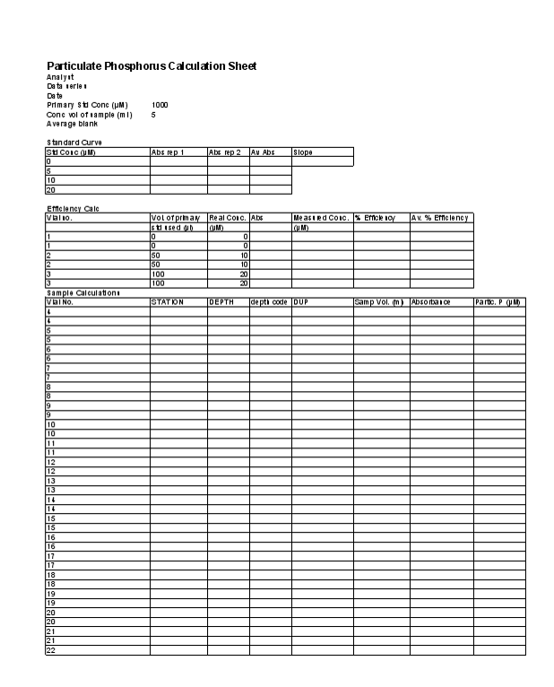

Section A8: Analysis of particulate organic carbon and particulate nitrogen in marine waters

  - Objective

The analysis of total particulate organic carbon in seawater with a focus on detecting low level concentrations.

  - Principle of analyses

For Carbon: The Shimadzu TOC-V analyser uses high temperature combustion to measure the Total Organic Carbon (TOC) in samples. In preparation for analysis, a small amount of hydrochloric acid is added to the sample to convert all Inorganic Carbon (IC) in the sample to carbon dioxide. The sample is dried (100 degrees C) in a “sample boat” and introduced into the combustion tube (950°C), where the TOC of the sample is simultaneously oxidized to form CO2. This carbon dioxide is detected by a nondispersive infrared (NDIR) gas analyser. The area of the carbon dioxide peak signal is measured and this peak area is converted to TOC concentration, calculated from a calibration curve prepared from known amounts of carbon (using standard sediments).

For Nitrogen: This method is based on high temperature combustion of organic nitrogen to nitrogen oxides coupled to the chemiluminescent emission of light by meta-stable nitrogen dioxide (NO2*) . Using the same sample that was generated by the high temperature combustion chamber of the TOC-V, a carrier gas stream moves the oxidised sample to a Shimadzu Total Nitrogen unit (model TNM-1) fitted in series to the aforementioned carbon analyser. It enters an ozone saturated reaction chamber where, on contact with ozone, the combustion gases forms NO2*. When this meta-stable species decays it produces a photon of light which is detected by a photomultiplier tube. The signal is integrated to produce a numerical output. This ‘count’ of chemiluminescent emission is proportional to the amount of nitrogen in the sample.

  - Sample collection procedure and storage

8.3.1 Equipment

    - Denitrified 25 mm Whatman GF/F glass fibre.*
    - Millipore filter forceps (or equivalent).
    - Squares of denitrified aluminium foil (8 x 8 cm).*
    - Black, fine-tipped, waterproof labelling pen (eg Staedtler Lumocolour) or alternately use pre-printed label generated by Field Data Entry System.
    - 500 mL measuring cylinders.
    - 25 mm filter funnels and bases.
    - Vacuum manifold, water reservoir, vacuum tubing and vacuum pump.

NB. All plasticware and glassware should be soaked in dilute hydrochloric acid (10%), rinsed in deionised water and heat dried (where possible).

8.3.2 Method and Storage
- Filter 500 mL of seawater sample through a 25 mm Whatman GF/F glass fibre filter to collect the particulate nitrogen. Duplicate samples are recommended.
- The filter is then wrapped in alfoil, labelled with site, depth, date collected and volume filtered or alternately use pre-printed label. When sampled in duplicate, there should be 2 filters per alfoil packet.
- Freeze the filters immediately.
- Without allowing the filters to defrost, place in freeze drier to dry overnight.
- Store in desiccator. Do not store your samples with organic/volatile materials that may contaminate them.
  - Sample analysis

8.4.1 Materials and Reagents
    - Hydrochloric Acid
    - Primary Standard - Standard reference material MESS1 – National Research Council of Canada
    - Secondary Standard - QTM070MS (from Round 40 of Quasimeme Laboratory Performance studies)
    - Secondary Standard - Coastal Sediment (AIMS in-house sediment reference material)
    - Shimadzu-TOC V Total Organic Carbon Analyser with Solid Sample module
    - AR grade HCl (32%)
    - Muffle furnace
    - Pre-combusted ceramic sample ‘boats’
    - Small spatula suitable for weighing milligrams of standard.
    - 5 place analytical balance.
    - Pre-dried sediment samples to be analysed, in sample jars labelled with unique Sample ID

    - Procedure

The samples were analysed using a Shimadzu-TOC V Total Organic Carbon Analyser with Solid Sample module fitted in series to a Shimadzu Total Nitrogen Module (model TNM-1). The detailed instructions for the operation of these can be found in Attachment 8.1

    - Calibration

The Shimadzu-TOC V Total Organic Carbon Analyser are calibrated each day using China NCS DC85104a. The procedures for calibration were carried out using the sample analysis protocols described in Attachment 8.1. An example of the resulting calibration curves for carbon can be found in Attachment 8.2.
QTM070MS and Coastal Sediment standards are analysed as QC samples.
The following weights for standards are generally appropriate when analysing GBR seawater particulates
- China NCS DC85104a (C-2%; N-0.197%) range 1-6 mg C
- Round 40 (C –0.86%; N-0.032%) range 12-15 mg C
- Coastal Sediments (C-3.32%; N-0.072%) range 3-5 mg C

    - Calculation
For Carbon:
Plot Cstd against Astandard and use the slope to calculate Csample as follows:
Where:Csample =[ (Asample * Slope)+intercept]
Astandard = Area per standard
Cstd = Amount of Carbon (µg) in standard Asample = Area per sample filter
Csample = Amount of Carbon (µg) on sample filter
Slope = Slope of line of best fit for graph Astandard vs Cstd
Then calculate the amount of carbon in the wet filter (procedural) blank:
Where:
Cblank = [(Ablank * Slope)+intercept]
Cblank = Amount of Carbon (µg) on wet filter blank Ablank = Area per wet filter blank
The concentration of particulate carbon in the original seawater sample can then be calculated as follows:
Msample = ((Csample - Cblank) / 12) / Vsample
here:
Msample = Concentration of Carbon in original seawater sample (µmol L⁻¹) Csample = Amount of Carbon (µg) on sample filter
Vsample = Volume of sample filtered (l)

For Nitrogen:
Plot Nstd against Astandard and use the slope to calculate Nsample as follows:
Where:
Nsample =[ (Asample * Slope)+intercept]
Astandard = Area per standard
Nstd = Amount of Nitrogen (µg) in standard Asample = Area per sample filter
Nsample = Amount of Nitrogen (µg) on sample filter
Slope = Slope of line of best fit for graph Astandard vs Nstd
Then calculate the amount of Nitrogen in the wet filter (procedural) blank
Where:
Nblank =[ (Ablank * Slope)+intercept]
Nblank = Amount of Nitrogen (µg) on wet filter blank Ablank = Area per wet filter blank
The concentration of particulate carbon in the original seawater sample can then be calculated as follows:
Msample = ((Nsample - Nblank ) / 14) / Vsample
Where:
Msample = Concentration of Carbon in original seawater sample (µmol L⁻¹) Nsample = Amount of Carbon (µg) on sample filter
Vsample = Volume of sample filtered (L)

  - Method capabilities and limits of detection

The limits of detection for this method are influenced by the range and type of standards used to calibrate the instrument. The instrument is calibrated each day with a suite of reference material that accurately reflects the range of carbon and nitrogen typical of tropical inshore marine sediments. The method of calculating inorganic carbon as the difference between the measured total carbon and measured organic carbon is preferred for samples high in IC and low in OC such as reef sediments (S. Boyle pers comm.)

  - Data management

Each filter is assigned a unique identifier which is usually a combination of sampling site reference, depth in the water column from which the sample was taken and the replicate number.
The integrated area reading of each analyte is logged against each filter on a laboratory worksheet. A proforma of this log sheet can be found in Attachment 8.2. It will graph the Calibration curve and calculate the slope and intercept for each analyte. Using these derived values it then calculates the original sample concentration of particulate organic carbon per filter. All calculation equations are embedded. It will automatically perform the all calculations once the values for the slope and intercept are typed in. An Excel worksheet combining the ug/filter, blank values and the volume filtered is then used to create a feeder sheet for the Oracle database (http://waterquality.aims.gov.au:8080/waterquality) which will input all the analytical results, convert them to uM units and keep a copy of the related excel file complete with QAQC data. All laboratory work forms are then archived.

  - Quality control
QAQC tests undertaken and reporting as part of the data reporting include: Assessment of the limit of detection (LOD)
NB: the Limit of Detection (LOD) or detection limit, is the lowest concentration level that can be
determined to be statistically different from a blank (99% confidence).
    - Minimum detection limits were calculated for this method using repetition of blanks.

Assessment of accuracy of the analysis
NB: This is generally achieved by using reference materials to assess recovery of known amount of analyte.
QTM070MS and Coastal Sediment standards were analysed as QC samples. A reference curve is generated with every sample batch.

Assessment of precision of the analysis
NB: This is generally achieved by the repeated analyses of the same concentration of analyte to check for reproducibility.
    - Repeated analysis of replicate standards

Procedural blanks:
    - Filter blanks are run with every batch (generally daily). These are used as blank readings in the calculation of analytical results.
    - Wet filter blanks (filter placed on filtration unit and wetted with filtered seawater, then further handled like samples) were prepared during the on-board sample preparation to measure contamination during the preparation procedure

Reproducibility of duplicate analytical units
NB: The variation between results for sample duplicates indicates the reproducibility of the analysis and also the effects of various sources of contamination and analytical error during collection, sample preparation and analyses. Before data analysis, results are generally averaged over duplicates.
- Coefficients of variance are calculated from analytical results of sample duplicates.
- Duplicates with CV>30% are discarded from the analysis and the analysis repeated using extra duplicates that are generally collected as a back up.

Section A8 Attachments
Attachment 8.1 Detailed procedure for the analysis of particulate organic carbon and particulate nitrogen using the Shimadzu TOC-V with solid sample module in series with the TNM-1

The Shimadzu TOC-V analyser uses high temperature combustion to measure the total organic carbon (TOC) and total nitrogen (TN) in samples.
In preparation for analysis, a small amount of hydrochloric acid is added to the sample (e.g. the filter containing the solids) to convert all inorganic carbon (IC) in the sample to carbon dioxide.
The sample is dried (100 degrees C) in a “sample boat” and introduced into the combustion tube (950°C), where the TN decomposes to nitrogen oxides and the TOC of the sample is simultaneously oxidized to form CO2. This carbon dioxide is detected by a nondispersive infrared (NDIR) gas analyser. The area of the carbon dioxide peak signal is measured and this peak area is converted to TOC concentration, calculated from a calibration curve prepared from known amounts of carbon (using standard sediments).
After exiting the NDIR, the carrier gas, which contains the nitrogen oxides, then enters the TMN-1 nitrogen unit, where reaction with ozone results in emission of light (chemiluminescence). This is detected by a photomultiplier and converted to an analog signal. The TN concentration of the sample is measured against a calibration curve prepared from known amounts of nitrogen.

Users must have completed a general laboratory safety induction and an induction specific to the equipment intended to be used before operating the equipment. Arrange inductions with designated laboratory staff.

Note: Potential hazards
- CO₂ Absorber (soda Lime) and Acids used in this method are corrosive and toxic. Ensure all necessary precautions are taken when handling these materials.
- High Temperature – TOC-V furnace operates at 680C or 720C; the SSM TC furnace operates at 950C and IC at 200C.
- Electric Shock – Do not remove the back panel as there is a danger of electric shock.
- Injury – The sample injection components move during operation, do not allow hands to go near the mechanism. During operation the CO2 absorber is about 200kPa. Turn off power to main unit and wait for pressure to return to atmosphere pressure before performing any maintenance.
- Ozone is generated within the Nitrogen unit.

The following Personal Protective Equipment (PPE) must be used:
- Safety shoes/boots
- Lab coat
- Safety glasses

Calibration preparation
- With a ceramic boat on the weighing balance, zero the balance (Tare)
- Add the standard material and note the weight in the PC Excel spreadsheet The repeats and weights for the standard material used in this study are:
  - 85104a six samples, 1 – 6mg
  - Round40 two samples, 12 – 15mg
  - Coastal Sediments two samples, 3 – 5mg
- Analyse the standard sample following steps 18 – 24 below
- Repeat for each standard sample

Sample preparation
- With a ceramic boat on the weighing balance, zero the balance (Tare)
- Remove the boat from the balance and add the sample material (20 – 30mg)
- Weigh the sample and note this weight against the Sample ID in the MS Excel spreadsheet
- Add 5 x 100 mL HCL (32%) to the sample to decompose Inorganic Carbon (IC) and set to dry on a hotplate at 100 degrees Celsius.
- Analyse the standard sample following steps 18 – 24 below
- Repeat for each sediment sample

Starting the Instrument
- Turn on Gases (Air and Oxygen)
- Turn on TOC-V instrument, TN unit and Solid Sample Module (SSM)
- Turn on PC
- Double click on TOC_Control V icon
- Double click on Sample Table Editor
- Enter `OK' to `user' box (do not need to enter a name)
- `Sample Table' will open up. Click `File' then `New'
- Double click `sample run (unless wanting to do a new curve or method)
- In `General Info' box change `system' to `TC/TN Solid' using drop down box, press `ok'
- `Save As' box is displayed with a file name using current time and date. Click `Save'
- The sample table will now be on the screen. Press `Insert' then `Auto generate'
- In `Sample Group Wizard Sample Source' Box under `Method' use drop down box to choose
`TCNSSMonly.met' and press `open' then press `Next.'
- Enter the number of samples to be analysed during the day and press `next' until `finish' pops up. Press `finish'. This will insert `defined' samples into table.
- Connect instrument by pressing the crooked yellow arrow icon. Click `use settings on PC'
- Wait for instruments to come up to temperature (`Instrument' then `Background Monitor' - monitor should have all ticks in the boxes)
- To see Sample Window, press `View' then select `Sample Window'
- Press `Instrument' then `Start'

Note: Before the first standard sediment is entered into the analyser for calibration, enter an empty boat as a blank sample to allow for the contribution of carbon and nitrogen in the air that accompanies the sample into the analyser. Follow steps 18 – 24 below. Withdraw this blank boat and continue calibration. After calibration continue with samples to be analysed.

- Place boat into holder, close port cover and screw in.
- Wait 2 minutes.
- Press `Set' on PC, press `Start' (if it is available), push boat into the measure position (all the way in).
- When you can see that both graphs are returning to the baseline and are more than half way back, pull the boat to the cooling position (half way)
- Note: click on TN graph. Right click on graph, click on `Limits' Change `max' to required limit. Press `ok'
- `TOC Measurement' will come up on PC. Write down the TC and TN Area values against the Sample ID. Click `Next'
- Pull boat back (there should be at least two minutes in the cool position) to the start position. Open up the holder. Take the old boat out and put the new boat in. Seal holder. Repeat from 18.

Shutting down the Instrument
- Save a copy of the Excel file to disk / memory stick and close Excel file.
- Press `Stop' on PC, and shut down PC.
- Turn off TOC-V instrument, TN unit and Solid Sample Module (SSM)
- Turn off Gases (Air and Oxygen)

Attachment 8.2 Example worksheet for analysis of particulate carbon using the Shimadzu TOC-V

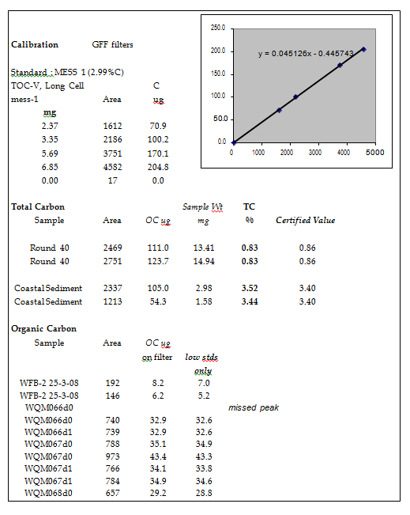

Section A9: Analysis of chlorophyll a in marine waters

  - Objective

To measure the concentration of chlorophyll a present in seawater to obtain an estimation of phytoplankton biomass.

  - Principle of analysis

This method utilises the natural fluorescence of chlorophyll a to derive the concentration of the pigment present in an extract of material filtered from seawater. The fluorescence of decomposition products (phaeophytin) can cause significant interference. This method compensates by taking an additional fluorescence reading after acidification of the original sample (by which all pigments present are decomposed) and using the decreased fluorescence reading to derive the original concentration of live pigment.
This method follows the basic fluorometric method set out in Strickland and Parsons (1972). The concentration of the primary standard used for calibration is determined spectrophotometrically using the equations laid out in Jeffrey and Humphrey (1975).

  - Sample collection procedure and storage

9.3.1 Equipment
    - 25 mm Whatman GF/F glass fibre filters.
    - Millipore filter forceps (or equivalent).
    - Squares of aluminium foil (8 x 8 cm)
    - Black, fine-tipped, waterproof labelling pen (eg Staedtler Lumocolour).
    - 250 mL measuring cylinders.
    - 25 mm filter funnels.
    - Vacuum manifold, water reservoir, vacuum tubing and vacuum pump.

9.3.2 Method
- Filter 100 mL of seawater sample through a 25 mm Whatman GF/F glass fibre filter. Duplicate samples are recommended.
- The filter is then wrapped in alfoil, labelled with site, depth, date collected and volume filtered. When sampled in duplicate, there should be 2 filters per alfoil packet.
- Freeze the filters immediately.

  - Sample analysis

9.4.1 Equipment
    - Turner Designs Model 10-Au or TD700 digital fluorometer.
    - 10 mL quartz cuvette.
    - High speed tissue grinder comprising motor, pestle and tube (Potter Elversham No. 23).
    - 12 mL centrifuge tubes with caps.
    - Centrifuge with 12 mL holders.
    - Filter forceps.
    - Thin spatula.
    - Chlorophyll laboratory log sheets.
    - Fume cupboard (see notes).

Note 1: Chlorophyll, especially when extracted, is extremely light sensitive. If possible, carry out all extractions in the dimmest light possible. When not using extracted solutions, keep them wrapped to exclude light and store in a refrigerator. Keep extracted samples in a closed light box or cover with a black cloth.
Note 2: Chlorophyll is rapidly and irreversibly degraded by acid, converting active chlorophyll to phaeophytin. Do all chlorophyll sample grinding, extractions and analyses in the designated chlorophyll fume cupboard. Do not use acids especially HCl in this fume cupboard. Keep all equipment used for chlorophyll analysis free of acid.

    - Reagents
- 90% Acetone – 900 mL of analytical grade acetone and 100 mL of deionised water.
- 10% hydrochloric acid – 10 mL of analytical grade hydrochloric acid and 95 mL of deionised water.

    - Procedure
      - Grind the filter in 90% acetone in a tissue grinding tube.
      - Pour suspension into a graduated or marked centrifuge tube and make up to 10 mL.
      - Cap tube and shake.
      - Leave stand in the dark for 2 hours. We either cover the box of extracted samples or cover the tubes with a thick black cloth.
      - Centrifuge for 10 minutes at 3500 rev/min and read the fluorescence of the supernatant on the Turner Designs (Model 10-AU or TD700) Digital Fluorometer. Make note of reading on log sheet (Attachment 9.1).
      - Add 2 drops of 1N HCl. Allow the acid to react and take another reading. Make note of reading on log sheet.
      - An unused filter should also be processed in the same manner to give a blank value.

    - Calibration

- Machine Calibration
Primary Standard:
  - Filter an aliquot from an exponentially-growing phytoplankton culture through a Whatman GF/F filter (or equivalent). It is best to use diatom (e.g. Chaetoceros) or chrysophyte (e.g. Isochrysis, Phaeodactylum) cultures. Do not use a of a chlorophyte (e.g. Dunaliella, Tetraselmis) culture as they contain chlorophyll b which distorts the fluorometric analysis of chlorophyll a.
  - Grind the filter in 90% acetone in a tissue grinding tube. If you have filtered enough culture, a light green solution will be obtained. Do the grinding and extraction of the culture in the dark to prevent photo-degradation of the pigments. Keep all extracts in the dark as much as possible (wrap flasks in foil, etc…).
  - Clear the extract by centrifugation.
  - Read extinctions of the extract on a UV/VIS spectrometer (using a 1cm quartz cell) at the following wavelengths; 750nm, 664nm, 647nm and 630nm.

The concentration of chlorophyll a (Ca) in µg L⁻¹ can then be calculated using the formulae:
Ca = (11.85E664 - 1.54E647 - 0.08E630) x 1000
where Ex is the absorbance at wavelength X nm minus the absorbance at wavelength 750nm.

Calibration Curve:
Using this solution as a primary standard solution make up a diluted pigment solution of about 4µg L⁻¹. This should read about 0.400 mV on the fluorometer. If it does not the fluorometer may need to be adjusted. The routine for adjusting the Turner Designs Fluorometer Model 10Au to suit low level marine samples is shown in Attachment 9.2. Make up a series of dilutions ranging from 1 to 25 µg L⁻¹ and measure the original and acidified fluorescence values.

Calculating Door Factor (FD):
FD = Ca /(1830(RB - RA))
where:
FD = door value
RA = reading before acid RB = reading after acid
Ca = concentration of chlorophyll a in diluted sample
Calculate a working FD value (FD") for the Excel spreadsheet that includes normal volumes FD" = (1.83 x v x FD)/V
where:
v = 10 mL acetone extract
V = 0.100 litres of seawater filtered per sample (100 mL)
therefore:
FD" = 183 x FD
The calculations for this calibration can be done automatically using the EXCEL spreadsheet template "Calib. fluoro template". A example work form derived from this spreadsheet is shown in Attachment 9.3.

The new calibration should then be assigned a number and recorded against the date of the calibration on the EXCEL spreadsheet "Chl-a calibration equations" as shown in Attachment 9.4. All measurements taken by the machine after this date must use this calibration equation.

- Calibration Control
Each fluorometer has a manufactured fluorescence standard that can be used for a daily working calibration or to calculate drift. Notes from Turner Designs web page on use of the Solid Secondary Standard can be found in Attachment 9.5. Insert the standard at the beginning and end of each set of samples read and at regular intervals throughout the set. Make sure the “L” marking on the barrel is placed toward the left hand side of the holder. A record is kept of the Solid Standard measured at the time of machine calibration and drift should be corrected making reference to this original measurement.
Drift corrected Ca = (Calculated Ca x Original Solid Standard) / (Measured Solid Standard)
If at the beginning of the day the reading shows greater than 5% variation from the original, the emission and excitation filters of the fluorometer may need to be cleaned with an ethanol dampened tissue.

    - Calculations

Chlorophyll a and phaeophytin a may then be calculated using the following equations. The equation assumes that the filtered sample volume is 100 mL and that there is 10 mL of acetone extract. The calculation spreadsheet allows for variation of these numbers for individual samples.

Ca = FD"(RB - RA)
Phaeo = FD"(2.2RA - RB)

where:
Ca = concentration of chlorophyll a in µg L⁻¹ Phaeo = concentration of phaeophytin a in µg L⁻¹ FD" = door factor (see Attachment 9.1)
RB = reading before acid addition-blank RA = reading after acid addition-blank

  - Method capabilities and limits of detection.

The optimal working range of this method is for chlorophyll a concentrations ranging from 0.5 to 50 µg L⁻¹ in the acetone extract (ie a 100 mL sample ranging in concentration between 0.05 to 5 µg L⁻¹). Actual detection limits are estimated from individual batches and reported with the data. Detection capability for water samples with very low concentrations can be improved by increasing the volume of water filtered. Likewise, in high concentration samples, either smaller volumes may be filtered or the extracted sample may be diluted.

  - Data management

Each filter is assigned a unique identifier which is usually a combination of sampling site reference, (or site, date, time), depth in the water column from which the sample was taken and the replicate number.
The fluorescence reading before and after the acid addition is noted on a laboratory worksheet against the sample identifier on a laboratory worksheet. A proforma of this log sheet can be found in Attachment 9.1. These readings are then enter onto an Excel spreadsheet which then acts as feeder sheets for the Oracle Database (http://waterquality.aims.gov.au:8080/waterquality). Utilising the import tool, all the analytical results will be inputted and a copy of the related excel file complete with QAQA data will be embedded within the database. It will automatically perform the all calculations required. All laboratory work forms are archived. All Excel calculation files are archived after the results have been entered in a Microsoft Access database. For details about data management procedures developed at AIMS under Reef Rescue MMP see Section A12.

  - Quality control
QAQC tests undertaken and reporting as part of the data reporting include: Assessment of the limit of detection (LOD)
NB: the Limit of Detection (LOD) or detection limit, is the lowest concentration level that can be
determined to be statistically different from a blank (99% confidence).
    - Minimum detection limits were calculated for this method using repetition of blanks.

Assessment of accuracy of the analysis
NB: This is generally achieved by using reference materials to assess recovery of known amount of analyte.
- The Solid secondary standard is run daily at beginning, middle and end of sample run and for each sample set an average of the readings as a percentage of the true value is used to determine accuracy.

Assessment of precision of the analysis
NB: This is generally achieved by the repeated analyses of the same concentration of analyte to check for reproducibility.
- The coefficient of variance between repeated readings of the secondary solid standard associated with a set of samples is calculated to assess precision.

Procedural blanks:
- Filter blanks are run with every batch (generally daily). These are used as blank readings in the calculation of analytical results.
- Wet filter blanks (filter placed on filtration unit and wetted with filtered seawater, then further handled like samples) were prepared during the on-board sample preparation to measure contamination during the preparation procedure

Reproducibility of duplicate analytical units
NB: The variation between results for sample duplicates indicates the reproducibility of the analysis and also the effects of various sources of contamination and analytical error during collection, sample preparation and analyses. Before data analysis, results are generally averaged over duplicates.
- Coefficients of variance are calculated from analytical results of sample duplicates. Duplicates with CV>30% are discarded from the analysis and the analysis repeated using extra duplicates that are generally collected as a back up.

Other
- Inter-calibration of this method with the HPLC method used by AIMS laboratories showed agreement of +/- %10.
- The linear range of this method was established utilising increasing concentrations of primary standard. Samples are diluted if above this range.
- Calibrations cross referenced by computer to analysis date.
- External calibration run periodically or if solid standard standard detects machine drift greater than 5%.

  - References

Jeffrey, S.W. and G.F. Humphrey, (1975). New spectrophotometric equations for determining chlorophylls a,b,c1 and c2 in higher plants, algae and natural phytoplankton. Biochem. Physiol.Pflanzen, 167: 191-194
Strickland, J.D.H. and T.R. Parsons, (1972). A Practical Handbook of Seawater Analysis, Bull. Fish. Res.
Board Can.167.
USEPA METHOD 445.0: In vitro Determination of chlorophyll a and phaeophytin a in marine and freshwater phytoplankton by fluorescence, United States Environmental Protection Agency Methods for the Determination of Chemical Substances in Marine and Estuarine Environmental Samples, EPA/600/R-92/121.

MARINE MONITORING PROGRAM 2015/2016 QA/QC METHODS AND PROCEDURES - APPENDICES

Section A9 Attachments
Attachment 9.1 Chlorophyll laboratory log sheet

Date Analysed: |  |  |  |  |  |  | Blank:
Transect: |  |  |  |  |  |  | Calib Std (L):
Analyst: |  |  |  |  |  |  | Calib Equ:
File Name:
Tube No | Station/Site | Depth/Date collected | Rep | Vol Filtered | Vol Extract | Dilution | Forig | Facid

80

Attachment 9.2 Initial machine set up for Turner Designs Fluorometer model 10au
    - Turn on the fluorometer and allow to warm up for at least one hour.
    - See page 3-14 and 3-15 of manual. Follow instructions 1 to 7(choose MED).
    - Access screen 2.2 Use the solid state standard L and set the raw fluorescence to 0.999 (as per page 3-15 step 8).
    - Set subtract blank to NO (step9).
    - Run a blank(step 10).
    - Access screen 2.11.

Attachment 9.3 Example spreadsheet for spectrophotometric calibration of fluorometer (example showing equations)

CALIBRATING FLUOROMETERS
Date:9 Feb 2006
PRIMARY STANDARD |  |  |  | Ca in primary standard µg/l
Wavelength | Absorbance | Abs-Blank |  | =(11.85*C6-1.54*C7-0.08*C8)*1000
750 | 0.003 |  |  | Ca in Secondary standard µg/l 1in 200
664 | 0.264 | =B6-$B$5 |  | =(11.85*C6-1.54*C7-0.08*C8)*1000/50
647 | 0.072 | =B7-$B$5
630 | 0.081 | =B8-$B$5
Instrument - Turner Fluorometer Model 10AU
CALIBRATION STANDARDS
Flask No. | FLASK VOL. | VOL STD USE | Ca in calib sample | Abs before aci | Abs after acid | Door Value
1 | 50 | 0.5 | =(C14/B14)*$E$6 | 0.073 | 0.053 | =D14/(1830*(E14-F14))
3 | 50 | 1 | =(C15/B15)*$E$6 | 0.112 | 0.072 | =D15/(1830*(E15-F15))
4 | 50 | 2 | =(C16/B16)*$E$6 | 0.193 | 0.112 | =D16/(1830*(E16-F16))
5 | 50 | 3 | =(C17/B17)*$E$6 | 0.272 | 0.15 | =D17/(1830*(E17-F17))
6 | 25 | 2.5 | =(C18/B18)*$E$6 | 0.433 | 0.229 | =D18/(1830*(E18-F18))
7 | 25 | 3.5 | =(C19/B19)*$E$6 | 0.595 | 0.313 | =D19/(1830*(E19-F19))
8 | 25 | 4.5 | =(C20/B20)*$E$6 | 0.761 | 0.398 | =D20/(1830*(E20-F20))
9 | 25 | 5.5 | =(C21/B21)*$E$6 | 0.793 | 0.413 | =D21/(1830*(E21-F21))
9 | 25 | 10 | =(C22/B22)*$E$6 | 1.65 | 0.807 | =D22/(1830*(E22-F22))
9 | 25 | 25 | =(C23/B23)*$E$6 | 3.88 | 1.98 | =D23/(1830*(E23-F23))
Average door value | =AVERAGE(G14:G23) |  | 0.033
Vol. acetone extract(m | 10 |  | solid standard = | 0.982
Vol. seawater sampled | 0.1
Working Door Value | =(1.83*B26*B24)/B27

Attachment 9.4 Chlorophyll a calibration equations Excel worksheet (example)

Code | Date | Rep | Blank | Vol | volume | Calib | Fo | Fa | Correct | Correct | Chl-a | Phaeo | comments
 | analysed |  |  | of sample | of extract | no. |  |  | Fo | Fa | ug/l | ug/l
std | 01-Oct-03 | 1 | 0.034 | 10 | 10 | new13 | 0.755 | 0.446 | 7.21 | 4.12 | 8.87 | 5.32
std | 02-Feb-04 | 1 | 0.017 | 10 | 10 | new14 | 0.312 | 0.164 | 2.95 | 1.47 | 9.53 | 1.83
std | 30-Jun-04 | 1 | 0.035 | 1000 | 10 | new15 | 5.22 | 3.04 | 0.5185 | 0.3005 | 0.65 | 0.42
std | 11-Aug-04 | 1 | 0.033 | 1000 | 10 | new16 | 5.22 | 3.04 | 0.5187 | 0.3007 | 0.68 | 0.45

Attachment 9.5 Notes on the use of Solid Secondary Standards in Turner fluorometers

(reproduced from the Turner Designs web page)
Solid Secondary Standards for Chlorophyll a & Rhodamine Analysis for the 10-AU

Preparing primary standard for Chlorophyll a or Rhodamine WT analysis can be troublesome as well as time consuming. Handling of concentrated solutions should be minimized since they are temperature and photosensitive. Stability of the final standard is always a concern. Solid Secondary standards circumvent some of these concerns, especially in field applications where there is little time and few resources to prepare new standards or examine the stability of existing standards. This product provides a simple, stable, and less expensive alternative to multiple calibrations with of a primary standard. Once the instrument is calibrated with a primary standard, the solid secondary standard can be used effectively for calibration, with only occasional verification with a primary standard. Thus, solid secondary standards make it simple to check for instrument drift and to perform routine recalibrations. Turner Designs now offers solid secondary standards, sealed in a holder, that contains two ready-to-use fluorometric standard concentrations: one high-level and one low-level concentration equivalent.

Features of the Solid Secondary Standards 10-AU: P/N 10-AU-904
    - Saves Time and Money. Preparation of primary standards are capital and labor intensive. Purchasing premade primary standards each time you calibrate is extremely costly. Traditional secondary standards are often used to decrease costs, but can require special handling and preparation time. Our solid secondary standards are stable and ready to use upon arrival with no preparation needed.
    - No Special Storage Conditions. The solid secondary standards can be stored in a drawer or on the benchtop. They are not photosensitive or temperature sensitive. Degradation is minimal after years of environmental exposure.
    - Guaranteed. The solid secondary standards are guaranteed for two years after arrival in your lab.

Calibrating with the Solid Secondary Standards:
- Calibrate your fluorometer with a known primary standard.
- With the 10-AU, insert the 13 mm adaptor if you have not already done so.
- Insert the solid secondary standard and record the reading for low concentration. Rotate your standard and record the reading for high concentration. Record these numbers on the log sheet included with your standard.
- Future instrument calibrations or checks may be performed by using the solid secondary standards and values obtained in step 3.

Relative Concentration of the Solid Standard
10-AU | Chlorophyll (10-040 kit) | Rhodamine WT(10-041Rkit)
High | ~ 40 µg L⁻¹ | ~ 5 ppb
Low | ~ 6 µg L⁻¹ | ~ 0.6 ppb
TD-700 | Chlorophyll (10-040 kit) | Rhodamine WT(10-041Rkit)
High | ~ 120 ppb | ~ 15 ppb
Low | ~ 15 ppb | ~ 1 ppb
These are approximate values. Values will vary from standard to standard and instrument to instrument due to slight variations in alignment.

Attachment 9.6 Chlorophyll calculations Excel worksheet (example)

Station | Depth | Rep | Date analysed | Blank | Volume of sample (mL) | Volume of extract (mL) | Dilution factor (eg 5 in 20  =4) | Calibration no. | Fo | Fa | Correct Fo | Correct Fa | Chl-a (ug/l) | Phaeo (ug/l) | Calib Std L
 | 0 | 1 | 27-Oct-04 | 0.033 | 100 | 10 | 1 | new16 | 0.639 | 0.388 | 0.606 | 0.355 | 0.79 | 0.55 | .977
DGL030 | 0 | 2 | 27-Oct-04 | 0.033 | 100 | 10 | 1 | new16 | 0.613 | 0.372 | 0.58 | 0.339 | 0.76 | 0.52
DGL030 | 0 | 1 | 13-Jan-05 | 0.031 | 100 | 10 | 1 | new16 | 0.232 | 0.151 | 0.201 | 0.12 | 0.25 | 0.20 | .978
CNS941 | 9 | 2 | 13-Jan-05 | 0.031 | 100 | 10 | 1 | new16 | 0.22 | 0.142 | 0.189 | 0.111 | 0.24 | 0.17
CNS941 | 18 | 1 | 13-Jan-05 | 0.031 | 100 | 10 | 1 | new16 | 0.195 | 0.124 | 0.164 | 0.093 | 0.22 | 0.13

Section A10: Determination of total suspended solids in marine waters

  - Objective

To measure the concentration of suspended material present in seawater samples with a focus on etecting low concentrations.

  - Principle of analysis

The method is based on gravimetrically determining the dry weight of particulate material collected from a known volume of water onto a pre-weighed membrane filter.

  - Method

    - Materials

- 1 litre plastic bottle or jar.
- Polycarbonate membrane filters - 0.4 µm pore diameter x 47 mm diameter (Nuclepore, Poretics, etc.)
- Clean 20 mL scintillation vials - Rinse new and old vials before use/re-use in deionized water and bake at 450°C for 2 hrs to remove any dust, sediment or organic matter. Recap with clean caps.
- Millipore tweezers (2)
- Filter funnels (47 mm), bases and clamps
- Vacuum manifold, water trap and pump.
- Analytical balance (5 decimal places) linked to Water Quality Filter Weigh Station Tool
- 1 litre measuring cylinder
- Drying oven set at 60°C

    - Preparation prior to field work

Pre-label the lids of one or more trays (100) of clean, dry 20 mL scintillation vials with an alphanumeric sequence (e.g. J100, J101, J102……) using a fine tip marker pen. Into each vial place a preweighed polycarbonate filter recording the number, weight and date weighed. All filters should be pre-weighed using a 5-place analytical balance. Handle the filters only with the tweezers. Without wrinkling or creasing the filter, place each weighed filter into a numbered vial and make a record of the filter weight against the vial number. The recording process is automated to a large degree by utilisation of the Oracle database “WQFilters” 11 which is the Water Quality Filter Weigh Station Tool and found at http://waterquality.aims.gov.au:8080/wqfilters. (For details see Section A12).

    - Sample Collection and Handling12

Collect 2 x 1 litre samples of water in a plastic bottle. Thoroughly mix/shake the collected water sample and vacuum filter (ca. 10 HPa) the sample onto a pre-weighed polycarbonate membrane filter (0.4 µm pore size x 47 mm diameter). After the filter is sucked dry, rinse with deionised water, suck dry again and, while leaving the vacuum on, remove the filter funnel, Gently lift one side of the filter with the tweezers to break the vacuum. When the vacuum is broken, use the tweezers to fold the filter in half with the filtered material on the inside, then in quarters. Return the folded filter to the numbered vial from which it came.
Record the vial number, volume sampled and replicate number against the station name and depth in both the laboratory book and the Field Data Entry System database (For details see Section A12).
The filtered samples can be stored at room temperature if kept dry but avoid hot or humid storage areas as mould may become a problem.

11 To automatically record initial filter weights in the Water Quality database see Attachment 10.1a. This facility is only available to nominated AIMS staff.
12 See Attachment 10.2 for an illustrated Quick Reference Field Guide to sampling procedures.

    - Blanks

A set of wet filter blanks (wfb) should also be run with collection as part of the sample processing routine. This involves putting a filter on the filtering funnel as for an unknown sample, wetting the filter with a very small volume (1-2 mL) of filtered seawater, sucking the filter dry under vacuum, rinsing with deionised water, sucking to dryness again and then removing the filter as an unknown sample would be removed and stored. This procedure combines both a transport and handling blank and corrects for the very small amount of salt left behind in and on the polycarbonate filter. A set of blanks should be taken with each collection trip. It is best to run at least 6 - 8 wfb samples at a time. The average weight of the set (av wfb) then becomes the wfb value for that collection trip.

    - Calculation

If the Water Quality database ( http://waterquality.aims.gov.au:8080/waterquality ) is used the results will be automatically calculated and recorded against the station details using the method outlined below:
Where:
Suspended Solids = (final weight – initial weight) – wfb / Sample volume
initial weight = weight of unused filtered (g) final weight = weight of loaded filtered (g)
wfb = weight of averaged wet filter blanks (g)
Sample volume = volume of sample filtered (litres

  - Capabilities and limits of detection

As with any gravimetric measurement the limiting factor for detection is often sampling technique, the homogeneity of a sample and the level of reproducibility that can be achieved when subsampling. Following a series of wet filter blank trials, it was concluded that the smallest amount of solid that can be confidently measured is 0.36 mg. Therefore, when one litre of seawater is filtered, the lower limit of detection is 0.36 mg L⁻¹. The upper limit is dependent on particle load and size. Turbid water, with a lot of fine material, will block the filter prematurely, allowing only a small volume to be filtered. Water samples with large concentrations of fine particles may clog the filter after only a small amount is filtered. Such small volumes will lead to a greater relative error due to small variations in the volume filtered and degree of homogeneity within the sample.
  - Quality control
QAQC tests undertaken and reporting as part of the data reporting include: Assessment of the limit of detection (LOD)
NB: the Limit of Detection (LOD) or detection limit, is the lowest concentration level that can be
determined to be statistically different from a blank (99% confidence).
      - Minimum detection limits were calculated for this method using repetition of blanks.

Assessment of precision of the analysis
NB: This is generally achieved by the repeated analyses of the same concentration of analyte to check for reproducibility.
      - Repeated analysis of replicate samples

Procedural blanks:
      - Wet filter blanks (filter placed on filtration unit and wetted with filtered seawater, rinsed with deionised water, then further handled like samples) were prepared during the on-board sample preparation. An average of these readings is then used as the blank reading in the calculation of analytical results.

Reproducibility of duplicate analytical units
NB: The variation between results for sample duplicates indicates the reproducibility of the analysis and also the effects of various sources of contamination and analytical error during collection, sample preparation and analyses. Before data analysis, results are generally averaged over duplicates.
      - All filter weights are recorded electronically, which eliminates any data entry errors (For details see Section A12).
Coefficients of variance are calculated from analytical results of sample duplicates. Duplicates with CV>30% are discarded from the analysis and the analysis repeated using extra duplicates that are generally collected as a back up.

13 To automatically record final filter weights in the Water Quality database see Attachment 10.1b. This facility is only available to nominated AIMS staff.

Section A10 Attachments
Attachment 10.1 Weighing and recording suspended solid filters using the water quality filter weigh station tool

NB: These instructions are designed specifically for the entering Suspended Solid filter weights into the Oracle database for Water Quality. You must be assigned access privileges to this site before you will be able to enter data.

- Procedure for weighing empty filters (i.e. entering “Initial weights”).
  - Using the WQ database Open Winwedge using the shortcut icon.
  - Under File, open balance.cfg. Press ok to accept.
  - Under Activate, select normal mode.
  - Open WQFilters using the shortcut icon (or alternately use internet address http://waterquality.aims.gov.au:8080/wqfilters/ ).
  - Logon with AIMS username and password.
  - Click on Initial Wt icon.
  - Select an alphanumeric code range that has not already been used (eg J101 to J200 should be used if J001 to J100 was the last set weighed) and press Search. A data entry form will be generated to allow your filter weight to be automatically updated to the Oracle database. If the alphanumeric code you have chosen has already been used the form will show “greyed out” fields and you will be unable to enter any new data against these codes. You will then have to choose another code range.
  - If the “initial weight” fields are blank you may go ahead and fill in the following fields on the first row:
filter size: 0.04 pc (if using polycarbonate 0.04micron 47mm)
initial tech: your name
Initial Instr.: choose the balance you are using from the drop down list (normally Satorius/MCI ResearchRC210P)
These fields need only be filled once and will thereafter generate automatically unless you skip a line.
  - The computer is now ready to accept data from the balance. Click in the Initial Wt. field and place your filter on the balance.
  - Press the print button on the balance to send the weight to computer. Note: the print symbol will be visible on the LED until the signal is stable and it can send the result to the computer. The signal will not be sent until the balance stabilizes. All entries will be automatically saved but reweighing is possible if an incorrect weigh is entered, simply reposition the cursor over the incorrect value and press the print button again.
  - When you have completed weighing, exit the program.

- Procedure for weighing loaded filters (i.e. entering “Final weights”).
- Using the WQ database Open Winwedge using the shortcut icon.
- Under File, open balance.cfg. Press ok to accept.
- Under Activate, select normal mode.
- Open WQFilters using the shortcut icon (or alternately use internet address http://waterquality.aims.gov.au:8080/wqfilters/).
- Logon with AIMS username and password.
- Click on Final Wt icon.
- Select the alphanumeric code range that matches the samples you wish to weigh (e.g. J101 to J200) and press Search. A data entry form will be generated to allow your filter weight to be automatically updated to the Oracle database. If the filters you have chosen have already been weighed the form will display values in the Final Wt field and you should not proceed any further without checking with a supervisor.
- If the field are blank you may go ahead and fill in the following fields on the first row:
final tech: your name
Final Instr.: choose the balance you are using from the drop down list (normally Satorius/MCI ResearchRC210P)
These fields need only be filled once and will thereafter generate automatically unless you skip a line.
- The computer is now ready to accept data from the balance. Click in the Final Wt. field and place your filter on the balance.
- Press the print button on the balance to send the weight to computer. Note: the print symbol will be visible on the LED until the signal is stable and it can send the result to the computer. The signal will not be sent until the balance stabilizes. All entries will be automatically saved but reweighing is possible if an incorrect weigh is entered, simply reposition the cursor on the incorrect value and press the print button again.
- When you have completed weighing, exit the program.

Attachment 10.2 Quick reference guide for filtering suspended solids
  - Using larger 47 mm filter funnel sets as seen at right in figure 1, put the base on the filter manifold, place a pre-weighed PC 47 mm filter from a numbered vial (see fig 2) on the base (see fig 3) and clamp on a funnel with a black filter clamp. After clamping, give the filter funnel a little wiggle to make sure the funnel and clamp are properly seated (see fig 4). Make sure that you note the vial numbers (e.g. k105, k106) in your logbook or datasheet next to the appropriate sample.

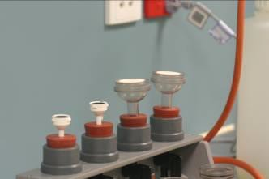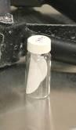
Fig 1: 25 mm and 47 mm filter bases Fig 2: Pre-weighed filter in labelled bottle.

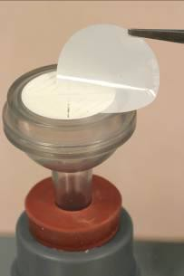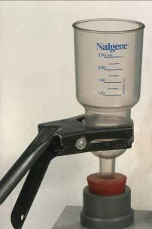
Fig 3: Placing filter on base. Fig 4: Clamp on a funnell

  - Turn on the vacuum pump, creating suction through the filtration units
  - Using a clean stirrer, thoroughly mix up the water sample in the bucket to ensure the sediment is evenly dispersed, then immediately measure 100 mL of collected water using the measuring cylinder and pour into one filter funnel, repeat for other filtration unit. If the water is particularly turbid it may be necessary to reduce the amount filtered (ie 10-20 mL instead of 100 mL etc). Make a note of this volume in your logbook.

  - When each sample has finished filtering, rinse the walls of the filter funnel (see fig 5) with a small amount of deionized water (about 20 mL) from the squeeze bottle supplied. Steam iron water should be used if you run out of deionized water.

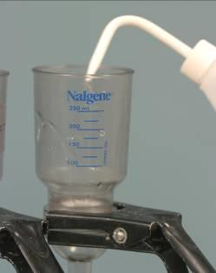
Fig 5: Washing down funnel walls

  - When the samples are sucked dry, unscrew or unclamp the filtration tops or funnels. Using forceps, lift one side of the filter while keeping under vacuum and fold the filter over onto itself so that none of the sediment falls off and then place it back in the vial from which it came.
  - Filtered suspended sediment samples should be stored in a relatively cool, dry place to avoid mould (it is not necessary to freeze them, though it doesn’t hurt) until they can be dried and weighed.

Section A11: AIMS In-house procedures for WET Labs FLNTUSB ECO logger

  - Set up WET Labs FLNTUSB ECO logger:
    - Start ECOView and the logger

      - Connect the battery leads on the test cable to the 12V battery (adaptation of the test cable by AIMS). Connect the DB-9 connector to a computer with the ECO View program installed.
      - Start up the ECO View software:

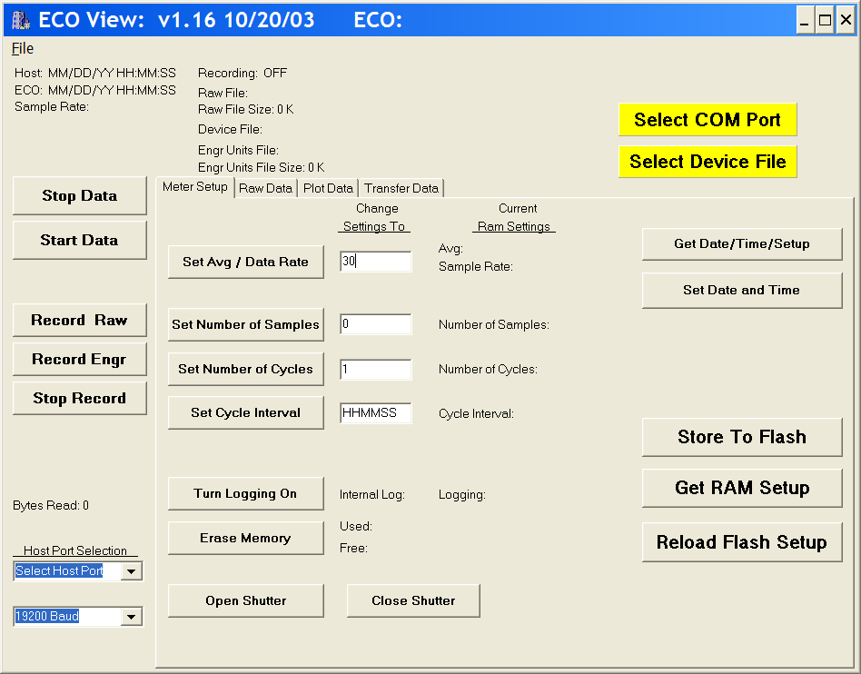
      - Click 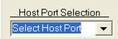 and select appropriate port for the DB-9.
      - Click 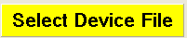 and browse for the most recent version of the device file (.dev) appropriate to the logger you are running.
The logger with serial number 818 requires device file FLNTUSB-818.dev. Device files are updated by WET Labs when the logger is returned the manufacturer for calibration and maintenance. (The device file is specific to the logger if creating output in ‘Engineering units’, but not for ‘Raw’ output. However a device file must still be selected to create raw output.)
Note that ECO View cannot read files stored in folders containing spaces in the folder names, therefore do not store sub-folders in the ‘My Documents’ folder or others with spaces in the name.
      - Connect the 6-socket connector on the test cable to the logger to provide power to the LEDs and electronics. Light should emanate from the optical window of the logger, the frequency determined by the setup. Quickly stop the logger (you can only stop the logger when the light is flashing during a reading, so if the logger is set to read at 10 minute intervals you have limited opportunities.)
      - To stop logger, click 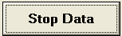 multiple times whilst the instrument is emanating light during the reading. The logger should stop running.

    - Check ECO View settings.

In ‘Meter Setup’ tab view, ensure the logger is setup to sample correctly during lab calibration.
      - Click 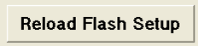
      - Then 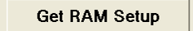
The ‘Current Ram Settings’ column of the parameter list is now updated with the current settings of the logger:

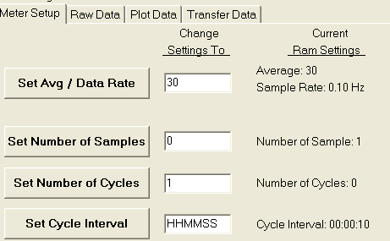

If the logger was set for logging in the field, the settings will need to be altered for laboratory calibrations.

Settings for laboratory calibration checks:
      - Enter ‘50’ as Avg / Data Rate. 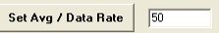 Then click ‘Set Avg / Data Rate’ button to set.
      - Enter ‘1’ as Number of Samples. 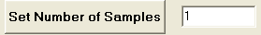 Then click ‘Set Number of Samples’ button to set.
      - Enter ‘0’ as the Number of Cycles. 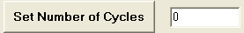 Then click ‘Set Number of Cycles’ button to set.
      - Enter ‘000005’ as the Cycle Interval. 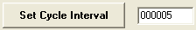 Then click ‘Set Cycle Interval’ button to set. (Samples every 5 seconds.)
The instrument will average 50 samples, for one reading, once every 5 seconds; beginning on power- up.

Settings for field logging:
      - Enter ‘50’ as Avg / Data Rate. Then click ‘Set Number of Samples’ button to set.
      - Enter ‘1’ as Number of Samples. Then click ‘Set Number of Samples’ button to set.
      - Enter ‘0’ as the Number of Cycles. Then click ‘Set Number of Cycles’ button to set.
      - Enter ‘000957’ as the Cycle Interval. 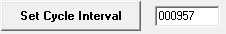 Then click ‘Set Cycle Interval’ button to set. (Records every 10 minutes.)
      - Alternatively you may need to enter ‘000958’ in older instrument versions.
      - IMPORTANT: Turn logging on, click so that the data is stored in the logger memory.
The instrument will average 50 samples, for one reading, recording every 10 minutes; beginning on power-up.
Set Avg/Data Rate = 50 Average 50 Samples for one measurement Set Number of Samples = 1 Take 1 Measurement (takes 2 seconds) Set Number of Cycles = 0 Cycle continuously
Set Time Interval = 000957 (HHMMSS) 9 minutes 57 sec per cycle.

Commit logger settings:
To commit the above settings to the logger, click 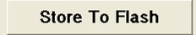
      - When settings committed, the yellow warning symbol 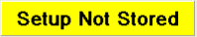 should disappear from the top right hand corner of the screen.
      - To ensure flash storage, first click 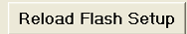
      - Then click 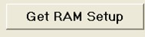 and check that ‘Current RAM settings’ have been changed to the correct values.
      - To align time on logger with time on laptop click 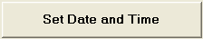 (This will not work if the instrument is currently logging.)

  - AIMS Laboratory calibration checks

The loggers monitor turbidity, chlorophyll and temperature as described in Attachment 11.1 ‘ECO logger theory of operation’. To determine instrument drift between field deployments, several checks can be performed.
- Dark counts (in fresh water)
- Determination of maximum fluorescence (in air)
- In-house turbidity and chlorophyll calibration checks (in-situ in seawater, co-deployment from AIMS pontoon)
- In-house temperature calibrations (in calibration bath).
The settings used for the checks 1 and 2 are as per Section 11.1.2 ‘Settings for laboratory calibration’. Field sampling and AIMS pontoon co-deployment readings occur every 10 minutes which is too infrequent for laboratory tests.
    - Dark counts

Pre-logging preparation
The ‘dark cap’ is used for dark counts performed as a comparison to WET Labs factory calibration dark counts and therefore carried out as in WET Labs servicing laboratory. The external battery source is used, the bio wiper is removed.
      - Setup logger as per Section 11.1 and settings as per Section 11.1.2 ‘Settings for laboratory calibration’
      - Stop the logger if it is running.
      - Remove the bio-wiper.
Remove the bio-wiper with an allen key. IMPORTANT the logger must not be running when you do this. Note, manually turning the motor shaft can damage the wiper motor and void the warranty. (See Attachment 11.2.1 and 11.2.2 WET Labs technical notes)
      - Apply black electrical insulation tape to cover the optical window.
      - Fill large plastic beaker with water and immerse the ‘back cap’.
      - Insert the optical head of the logger into the ‘black cap’ immersed in water.
AIMS Water Quality group standard height of the logger collar is positioned 6cm from the optical end of the logger, which locates the logger at a suitable standard height within the calibration cap. (The height is not relevant for dark counts, but it is for protection of the bio-wiper in transit to the field.)

Logging
Run logger in ambient light.
      - Click 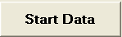
      - View ‘Plot data’ menu tab:

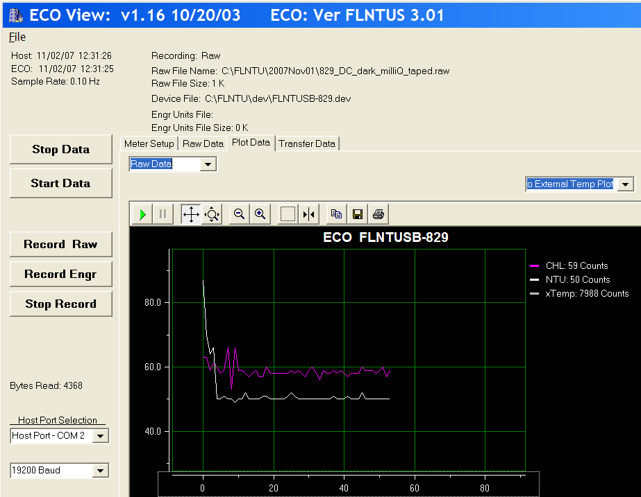
      - Once plot has settled to consistent readings, click 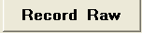
      - Browse to the appropriate folder to store the .raw file, and ‘save’.
      - Record this start time on the data sheet (Attachment 11.3).
      - File name convention: 829_DC_2007Dec06.raw Ie. Logger 829, Dark Count, year, month, day.
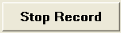
      - Continue logging for 5 minutes to obtain ample readings to calculate a minimum dark count.
      - Stop logging, click Then click multiple times whilst the instrument is emanating light during the next reading. The logger should stop running.
      - Record this end time on the data sheet.
      - Remove the logger from the calibration cylinder and remove the black tape from the optical port.
      - Unplug the logger.
Your raw data file can be found in the folder you specified.

    - Determination of maximum fluorescence.
WET Labs provides a pink fluorescence stick as one of the ‘spare parts’. This can be used to check whether the maximum fluorescence output is reading the same as the output specified in the FLNTU Characterization Sheet for each logger. See Maximum Output as Digital counts in the Chlorophyll specifications (Attachment 11.4).

Pre-logging preparation
To measure maximum fluorescence the external battery source is used, and the bio wiper is removed.
      - Setup logger as per Section 11.1 and settings as per Section 11.1.2 ‘Settings for laboratory calibration’
      - Stop the logger if it is running.
      - Remove the bio-wiper.
Remove the bio-wiper with an allen key. IMPORTANT the logger must not be running when you do this. Note, manually turning the motor shaft can damage the wiper motor and void the warranty. (See Attachment 11.2.1 and 11.2.2 WET Labs technical notes)

Logging
Run the logger in ambient light.
      - Click
      - View ‘Raw data’ menu tab:
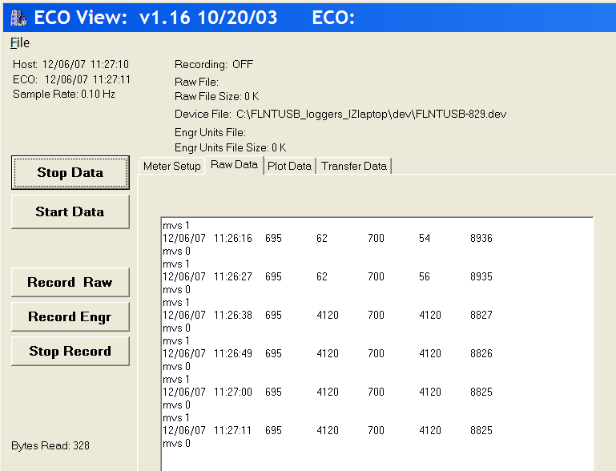

      - Hold the fluorescent stick approx 1 cm from the optical port, in the air parallel to the logger optics as per the Wet Labs information sheet below.
When it is apparent that the position of the stick is suitable (by reading maximum counts on the Raw data’ window in 4th column, see Attachment 11.5)
      - Click
Example above indicates maximum output for chlorophyll signal 4120 counts.
      - Browse to the appropriate folder to store the .raw file, and ‘save’.
      - File name convention: 829_fluor_2007Dec06.raw, i.e. Logger 829, Fluorescence determination, year, month, day.
      - Record three maximum output readings to compare with FLNTUSB Characterization Sheet. Enter maximum value on data sheet.
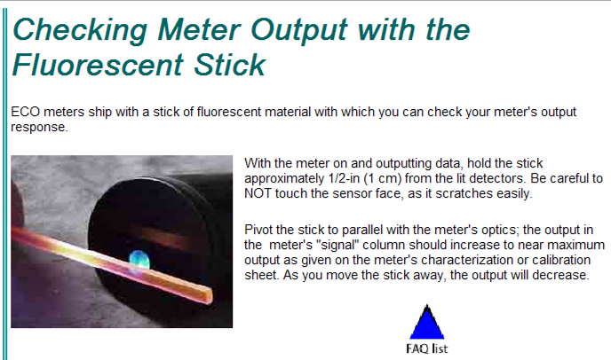
      - Stop logger, click , then click multiple times whilst the instrument is emanating light during the next reading. The logger should stop running.
      - Unplug the logger.
Your raw data file can be found in the folder you specified.

    - AIMS In-house ‘Pontoon’ turbidity and chlorophyll calibration checks.
Individual ECO loggers are deployed at different reefs when monitoring water quality at reef sites. To test the ECO logger data output against laboratory analyses, as well as to compare logger output relative to each other, AIMS has adopted a co-deployment of the ECO loggers in addition to laboratory checks. Results from AIMS Pontoon deployments provided to WET Labs initiated a new calibration procedure in their factory (see Attachment 11.6 - WET Labs Customer Alert).
- All available ECO loggers are co-deployed for a 2-3 day period prior to servicing and between redeployment cruises
- they are placed in a rack and hung in coastal seawater off the AIMS Pontoon
- they are set to log in ‘field mode’ with readings at the same times, every ten minutes
During this period the loggers are exposed to varied turbidity and chlorophyll levels, due to the tides and relatively high turbidity of the location of the pontoon.
- Water samples are collected to co-incide with the logger readings, (3-6 times per day) at the same 10 minute intervals that the loggers are set to record
- Water samples are collected adjacent to the logger rack with weighted bottle holders which have acid washed bottles inserted and suspended by stainless cable
- The water samples are filtered immediately after collection, in the AIMS laboratory
- These water samples are filtered for Chlorophyll and Suspended Solids (SS)
- 2 replicate Chlorophyll bottles are collected at each time, resulting in 4xChlorophyll GF filters
- 2 replicate Suspended Solids containers are collected at each time, resulting in 4xSS filters
- The water sample collection times, volumes filtered, filter numbers are recorded and entered into the Oracle database using the same procedures as the AIMS field water sampling
- The water samples are analysed as per procedures for routine field water sampling
- The logger data is downloaded following deployment as per field deployment procedures
- The data records from the loggers are loaded into the database with the site name ‘AIMS’ and the filter samples collected identified with the ‘ECO’ sample i.d. code to distinguish them from field cruise samples
- The logger data is plotted together to determine differences between loggers, and against the laboratory samples how they sit within the range of the laboratory analyses

The logger rack was built by the AIMS workshop, specifically for the purpose of co-deployment. The loggers are in close proximity and effectively measure the same water body. Photo below illustrates that the rack can hold up to 18 loggers at one time.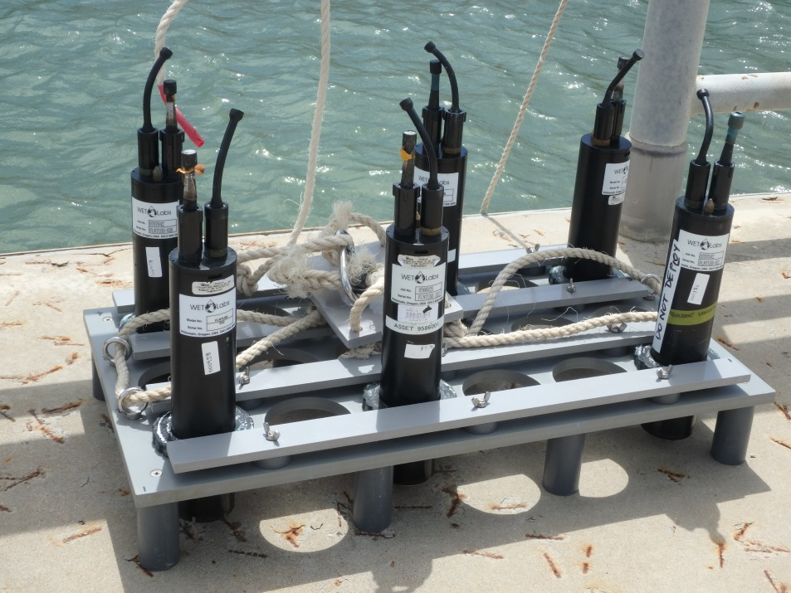
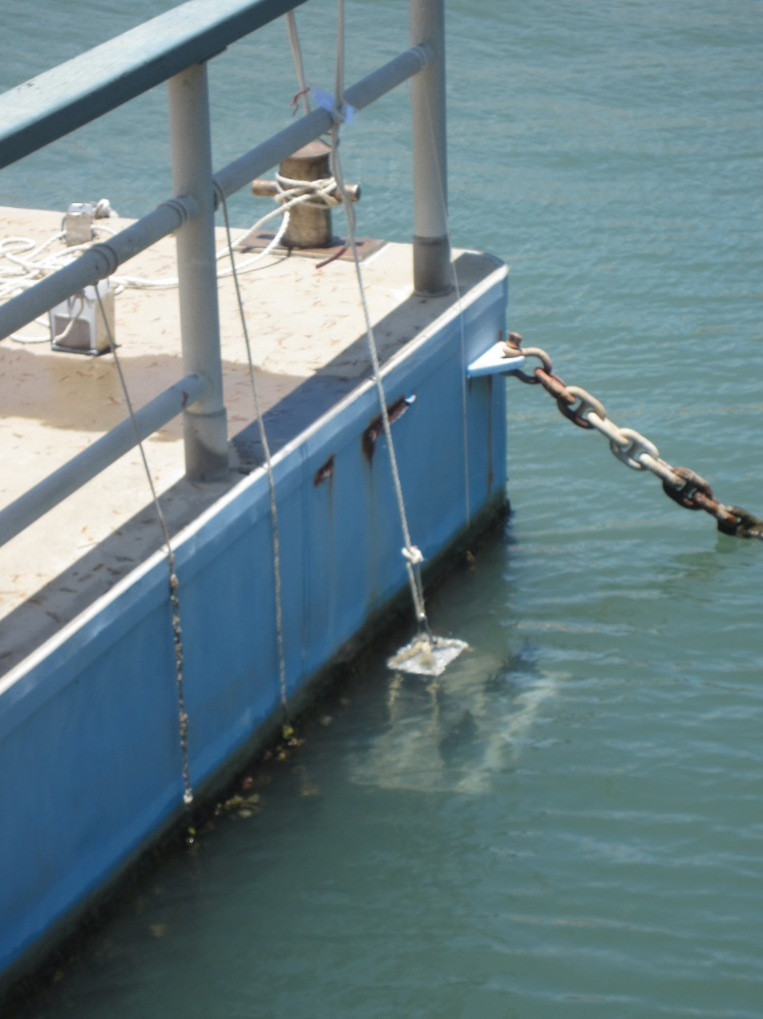

    - AIMS In-house temperature calibrations.
When plotting up AIMS Pontoon ECO Logger co-deployment tests following recovery from AIMS cruises, it was apparent that using WET Labs factory calibration coefficients there were sometimes significant differences between loggers deployed at the same time. Initially the temperature data was a lower priority, as we also deploy small temperature loggers at the reef sites. During the exploration of the possible causes for Dark Count variation from the WET Labs factory, AIMS performed tests to ensure that temperature differences did not affect the Dark Count readings of the loggers. Given AIMS has the capability to do our own more reliable temperature calibrations, in early 2015 it was decided to also begin using AIMS temperature calibrations for the ECO loggers.
Setting up the temperature bath for calibration
- Plug the sensor measurement module into the temperature reference thermometer
- Turn on the temperature reference thermometer by turning on the green switch on the face of the reference measurement module
- Place the sensor measurement module of the temperature reference thermometer into the water bath using the clamp.
- Remove a small amount of water using a bucket and mix hot water from the tap into the bath to raise the temperature to approximately 33 degrees
- Ensure the water level is within 2-3cm of the lip of the bath
- Turn on the temperature bath
- Set the bath set point to 33 degrees C as follows:
Press the SETPNT key
Enter 33.00
Press <Enter>
- Wait until the set point is achieved and holding steady in the bath.
Setting up the Temperature Bath Calibration Tool for calibration
- Turn on the PC attached to the temperature reference thermometer and log in.
- Start Temperature Bath Calibration Tool on the desktop
- Choose a file location for temperature cycle calibration. Name the file with a .txt extension. The file will be created by the software. e.g. 20160319-FLNTUSB.txt
Sample Interval 1 Minutes
Setpoint Duration 1 Hour
Start Setpoint 33 Degrees
End Setpoint 16 Degrees
Setpoint change 1 Degree

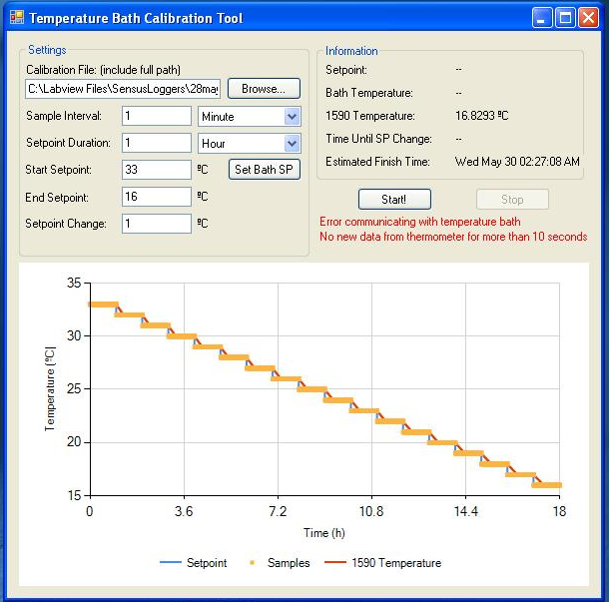
Note: the above image was taken after the bath had finished the calibration from 33 to 16 degrees
Running the calibration
- Run essential.exe in C:\temp This program mimics key strokes on your pc to stop it hibernating.
- Start the calibration on the 30 second mark of the minute. (this is to assist in the data management of the calibration data.)
- To start the calibration, simultaneously plunge the sensors into the calibration bath and press the Start! button. The calibration will now be underway.
- The calibration should take approximately 18 hours to complete. Once it has finished:
**Remove the loggers from the water
**Create a folder with the datestamp in \\pearl\temp\FLNTU
**Save the calibration file created by the Calibration Tool in the folder above.

Calculating the temperature calibration slope and intercept
- Use the STDMS Sea Temperature Data Management System (STDMS)
- The latest STDMS is here:
- \\PEARL\aims-data\adc-tools\stdms
- Open STDMS
- Put a valid folder in “working directory” Eg C:\underway\Calibration
- Press “set up folders”

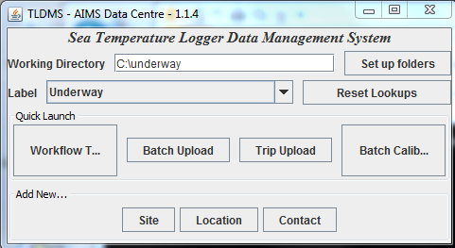

- Copy your data files to a sub-folder of <working directory>/calibration/cals
- Eg C:\underway\Calibration\Cals

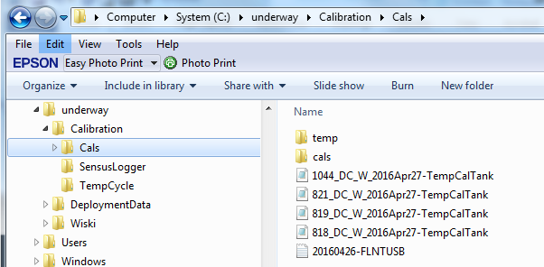

- Press the button “batch calibration”
- Use the “…” buttons to choose a folder and a reference file

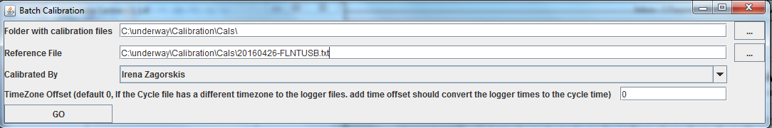

- Press the “GO” button.
- Find your calibration files in the “cals” subdirectory of the data directory.
- Eg C:\underway\Calibration\Cals\cals

Example calibration file output:
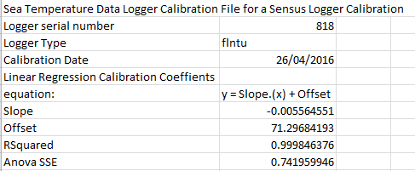

  - Components and preparation of the ECO logger for field deployment

    - Components

Connectors
The logger uses a six-pin bulkhead connector for External Power, RS232 and Analog Communications. (See Specifications Attachment 11.7) A three-pin bulkhead connector “jumpers” power from internal batteries to the logger for autonomous operation. (See ECO logger connector schematic below.)

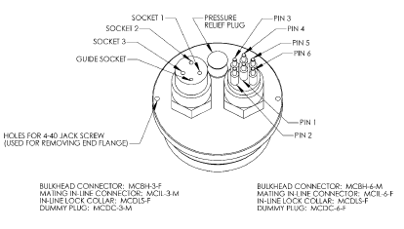
  - Pin 6 of the 6 pin bulkhead connector is always “HOT”. Ensure the dummy plug is inserted if not in use. Pin 3 of the 3 pin bulkhead connector is connected to the internal battery supply. Ensure dummy plug is on the logger when not in operation, or when external supplies are being used to power the unit.

Plugs
The three plugs are provided with the logger:
    - 6 socket female dummy plug
    - 3 pin male power plug (with 4th guide pin)
    - 3 pin male dummy plug (with 4th guide pin)

Bio-Wiper™
  - DO NOT MOVE THE WIPER MANUALLY.
The logger is fitted a non-contact anti-fouling bio-wiper™. The Bio-wiper extends the possible deployment duration by retarding biological growth on the instrument’s optical surface.
The shutter covers the optical surface:
    - While the sensor is in “sleep” mode.
    - When it has completed the number of samples requested.
    - When the user selects Stop Data in ECOView.
When the logger “wakes-up” for measurements, the shutter’s counter-clockwise rotation exposes the optical surface.
If power is disconnected in mid cycle, the shutter will reinitialize to the beginning of the user- selected settings when power is applied again.

    - Pre-field logger checks
After recovery of the loggers from field deployment a variety of maintenance checks are required prior to subsequent deployments. Initial handling of the logger whilst still in the field (as per Section 11.4.4) includes photographing the condition of the logger, removing anti-fouling copper tape, washing the logger, removing the bio-wiper and downloading data files. In the AIMS laboratory this is followed up with maintenance and calibration checks, and it is determined whether any instruments may require shipment back to WET Labs for repair.
Maintenance in the laboratory begins with removing the metal faceplate of the logger, cleaning the logger and includes assessment of physical damage of the logger, in particular the optical window and the bio-wiper.
WET Labs advises: ‘After each cast or exposure of the instrument to natural water, flush with clean fresh water, paying careful attention to the sensor face. Use soapy water to cut any grease or oil accumulation. Gently wipe clean with a soft cloth. The sensor face is composed of ABS plastic and optical epoxy and can easily be damaged or scratched.’
On occasions of logger failure causing fouling of the logger optical window, Ian Walsh of WET Labs advises ‘We soak the face in household vinegar for an hour and then use a soap solution and a cloth or sponge to wipe the face off. A fingernail works to pick pieces off. Repeat as necessary. Away from the optical face you can use a Scotchbrite pad.’
      - Unscrew the faceplate from the logger.
      - Clean the faceplate with a green scourer (or Scotchbrite).
      - Re-attach the clean faceplate to the clean logger.
The laboratory maintenance datasheet (Attachment 11.8) prompts to:
      - Check old battery voltage post recovery
      - Photograph the optical window of the logger
      - Include information regarding o-ring, desiccant and other checks made after opening the pressure casing
      - Check new battery voltage once changed
      - The bio-wiper removed from the logger is cleaned and assessed to determine if the rubber strip is too worn down to re-use and therefore must be replaced with a new one.
The photos of each logger and stored on the AIMS network Water Quality share area labelled with logger serial number, year and month to enable monitoring changes in condition of the logger (in particular the optical window).
      - Re-attach the bio-wiper. Pay careful attention to the height of the bio-wiper above the logger face (refer to Attachments 11.2.1 and 11.2.2) and test function whilst connected to the computer using the ‘open shutter’ and ‘close shutter’ buttons on Eco View.
      - Set the logger for field logging as per Section 11.1.2 ‘Settings for field logging’
Changing of internal batteries is described below in Section 11.3.2.

    - Replacing internal batteries
The following section was extracted, with minor alterations, from the WETLabs ECO logger User’s Guide. Attachment 11.9 is the WETLabs Technical Note which includes photos. The logger uses six 9-volt batteries as the power source. They can use either standard alkaline cells for a total capacity of approximately 1000 mA-hrs, or for longer deployments, LiMnO more than 2000 mA-hrs of operational capacity. Actual total usage time of the internal batteries is a function of several parameters. These include nominal water temperature, sequence timing, sample periods, and total deployment duration.
  - For autonomous operation, the “power plug” must be connected to the 3 pin bulkhead connector. This “jumper” shorts pins 1 and 3, connecting the internal battery supply to the logger.

Using Internal Batteries
ECO sensors powered with internal batteries can either run directly from the internal batteries or can operate from power supplied by an external DC power supply (7–15 volts). Internal-to external source conversion is facilitated by a jumper plug that plugs into the unit’s bulkhead connector. When inserted, the plug forms a connection from the battery to the electronics power supply. By removing the plug, the instrument can be powered and communicate via a test or deployment cable.

Removing End Flange and Batteries
WARNING!
Changing the batteries will require opening the pressure housing of the ECO sensor. Only people qualified to service underwater oceanographic instrumentation should perform this procedure. If this procedure is performed improperly, it could result in catastrophic instrument failure due to flooding or in personal injury or death due to abnormal internal pressure as a result of flooding. WET Labs Inc. disclaims all product liability from the use or servicing of this equipment. WET Labs Inc. has no way of controlling the use of this equipment or of choosing qualified personnel to operate it, and therefore cannot take steps to comply with laws pertaining to product liability, including laws that impose a duty to warn the user of any dangers involved with the operation and maintenance of this equipment. Therefore, acceptance of this equipment by the customer shall be conclusively deemed to include a covenant by the customer to defend and hold WET Labs Inc. harmless from all product liability claims arising from the use and servicing of this equipment. Flooded instruments will be covered by WET Labs Inc. warranties at the discretion of WET Labs, Inc.
    - Make sure the instrument is thoroughly dry.
    - Remove the dummy plugs.
    - With connector end flange pointed downwards away from face, release seal from vent plug.
    - Remove moisture from vent plug area.
    - Using needle nose pliers, remove filament from end flange.
    - Lift flange from pressure housing until seal is broken. The jacking screws can be used to “push” the flange from the pressure housing and then can be removed or left in the end flange.
    - Remove any excess moisture from flange–can seal area.
    - Work end flange out of pressure housing and remove any residual moisture. Remove the grey foam spacer and the neoprene insulator.
    - The battery pack is connected to the processor boards by a six-pin Molex connector: do NOT pull too hard or far on the battery pack or it will come unplugged and the unit returned to WET Labs.
    - Gently pull the white cord at the loop to remove the battery pack from the housing.
    - Remove the black plastic protectors from the ends of the long screws securing the batteries.
    - Loosen and remove the screws (3/16-in slotted driver).

Replacing End Flange and Batteries
- Replace the batteries.
- Re-install the screws:
  - Align the groove in each of the plates so the six-wire extension bundle will fit in it along its length.
  - Be careful not to cross-thread into the bottom end plate nor to over-tighten the screws.
  - If they are too tight, the fibre washers that act as separators between the batteries will flex.
  - Make sure there are equal amounts of screw threads protruding from the bottom end plate when they are secure. This will ensure the pack is straight and will fit into the pressure housing with no difficulty.
- Re-install the black plastic protective covers on the ends of the screws.
- Remove and check the pressure housing O-ring for nicks or tears. Replace if necessary. Before re-installing, apply a light coat of vacuum grease on the O-ring.
- Carefully replace the battery pack in the pressure housing. Place the neoprene insulator on the battery assembly and lay the white cord on the top.
- Plug in the two-pin, then the six-pin Molex connectors. Sensor operation can now be tested if desired.
- Align the hole in the end flange (NOT the jack screw holes) with the white dowel pin. While coiling the six wire bundle and making sure none are pinched between the end flange and the pressure housing, position the flange on the housing. Leave space to reinsert the gray foam spacer and fresh packet of oven-dried desiccant, making sure the cut-out accommodates the vent plug screw.
- Push the end flange all the way on to the pressure housing, making sure no wires are pinched. Be sure the vent plug does not pop up.
- Re-insert the monofilament.

  - Field deployment of ECO logger

    - Final logger preparation for deployment
The final preparation of the logger for deployment includes:
      - The 6 pin dummy plug must be connected.
      - Apply insulation tape to parts of the instrument to be taped with copper tape. This protects the logger casing from the significant adhesive residue of the copper foil tape (see Attachment 11.10).
      - Subsequently copper tape (3M 1194 copper foil with non conductive adhesive) is applied to the outer casing of the instrument adjacent to the faceplate as per Attachment 11.10.
      - Connect the 3 pin power plug (identified by red or orange tape). This turns on the internal battery. N.B. For autonomous operation, the ‘power plug’ must be connected to the 3 pin bulkhead connector. This ‘jumper’ shorts pins 1 and 3, connecting the internal battery supply to the logger.
      - Record the connection time on the deployment datasheet. (See Attachment 11.11)
      - Ensure the lock collars of the dummy and power plugs are screwed firmly.
      - Check the vent seal plug for full insertion.
      - Wrap the remainder of the exposed logger casing and plugs with plastic (we use cut up garbage bags) and secure firmly with insulation tape.
      - Wrap tape over most of the logger deployment clamp to protect from fouling.
      - Attach plastic AIMS identification label to clamp with cable tie.
      - Attach the logger clamp to the logger, securing firmly with the allen key.
      - Ten minutes after the logger was turned on, check the bio-wiper and logger function and ensure it is running (the logger is set to read at 10 minute intervals for field deployments).
      - Protect the logger face with the field deployment black cap, to ensure the bio-wiper is not touched.
      - Place the logger in the padded case.

    - Deployment equipment list
When loading the work boat the following gear is required:
      - Logger (in protective padded case)
      - SCUBA gear including dive watch
      - Dive log sheet and pencil
      - GPS (with dive site loaded)
      - Marker buoy with rope and chain weight attached
      - Niskin bottles x 1
      - Large rubber bands to secure niskin closed during handling back onto boat
      - Spanner to attach logger clamp to star picket (plus a spare)
      - Safety gear according to AIMS Field Work Procedures.

    - Logger deployment and recovery dive
The logger site is located by GPS and the marker buoy deployed to mark the site. The work boat is anchored up close to the site, typically up-current but mindful the anchor should not be dropped near the underwater benthic survey transect lines.
Once the divers are kitted up to dive, they enter the water and the boatperson passes 1 niskin (filling with surface water to allow the niskins to sink) and the logger to the divers on the surface. Care is taken that the bio-wiper of the logger does not contact anything, to ensure it is not disabled. The divers proceed down the buoy line and locate the logger star picket.
The divers are careful not to disturb the bottom sediment or disturb fouling on the star picket until the ‘ground truth’ water sample is collected. The niskin (‘D0’ or depth zero) is used to sample the water immediately adjacent to the logger. Both ends of the niskin bottle are opened, and the diver swings the niskin through the water to ensure the niskin water is flushed, and the water representing that adjacent to the logger is contained in the niskin. This niskin is closed and placed gently on the substrate until logger changeover complete. The depth of the water sample is checked on the SCUBA depth gauge.
The new logger to be deployed is placed gently on the substrate with the bio-wiper clear from obstruction. The diver uses the spanner to detach the clamp of the logger to be recovered from the star picket. It may be necessary to remove fouling such as barnacles, hydroids and algae from the star picket. The face of the logger is inspected to assess whether it is still functioning, and the recovered logger placed gently on the substrate whilst the new logger and clamp attached to the star picket.
The loggers are mounted with the optical window facing downward, so that the infrared LED source will not ‘see’ any part of the deployment hardware. A final function check of the newly deployed logger is done by checking that the bio-wiper turns and the logger samples underwater after the appropriate 10 minute time interval. See photo of deployed logger below.
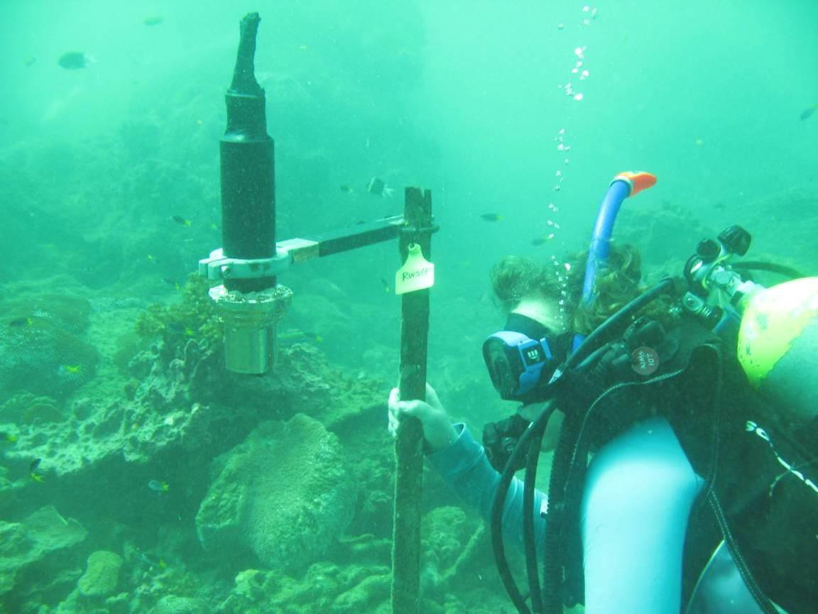
The divers return to the work boat with the recovered logger, and niskin bottle. The boatperson carefully collects these from the divers at the surface. The field deployment black cap pre-filled with seawater and the logger placed upright with the logger face immersed in the seawater.
AIMS Water Quality group standard height of the logger collar is positioned 6cm from the optical end of the logger, which locates the logger at a suitable standard height within the black cap used for field deployment. This protects the biowiper from being bumped and contains seawater to allow the logger optical face to be protected until the logger can be switched off. Do not fill cap with fresh water, as this appears to react with the corrosion on the recovered logger and may cause damage to the optical window, if the bio-wiper is operating.
The 5L niskin is clamped shut using No.109 rubber bands used to ensure the sample water is not lost until placed in the niskin rack on board the boat.
The niskin seawater samples are processed without delay as per shipboard filtering procedures for chlorophyll a and suspended solids, and salinity sample is collected. This sampling is part of the routine water quality sampling under Reef Rescue MMP, but also provides samples for the validation of instrument data.

    - Post recovery logger handling on board boat
Once the logger is on board the boat, the logger is switched off as soon as possible. To do this:
      - The face of the logger should remain immersed in seawater in the cap, with the top (connector end) of the logger out of water.
      - Using a Stanley knife, cut the protective tape and plastic from the connecter end of the logger to expose the connectors and plugs.
      - Dry the connector end, and remove the 3 pin power plug (identified by red or orange tape, or the newest plugs now have blue ends).
      - Replace this with the 3 pin dummy plug (identified by green tape).
      - Record the time the logger is switched off on the logger recovery datasheet
Once there is time available, following processing of the water samples, other tasks with the recovered logger include:
      - Photograph the logger to show the degree of fouling on the instrument. (Example photo below showing fouling on a recovered logger).
      - Carefully remove the plastic and tape from the logger casing.
      - Rinse the logger clean with fresh water (now that the bio-wiper is no longer functioning because the logger is switched off). Allow to dry.
      - Take further macro photographs to record the condition of the faceplate, bio-wiper and optical window of the logger.
Once there is time available, following processing
      - Remove the bio-wiper carefully with the allen key.
      - Download the data as per Section 11.5.1, and complete details in the logger download datasheet including a function check of the shutter
      - When the data download is complete, the rinsed and dry logger should be returned to a padded Pelican case for return to the laboratory.
      - Details of the dive time and depth should be transferred from the dive log sheet to the logger recovery datasheet.

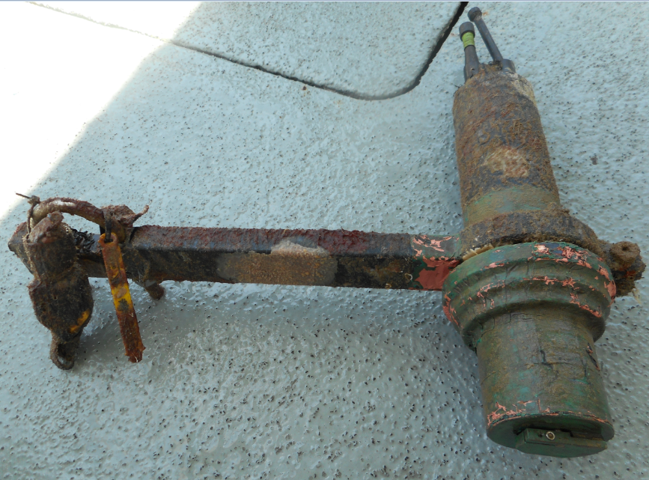

  - ECO logger data download and storage

    - Data retrieval from ECO logger
Data is downloaded from the logger using the ECO View software on the computer.
      - Connect the logger to the computer and software package as per Section 11.1.1.
      - View ‘transfer data’ menu tab:

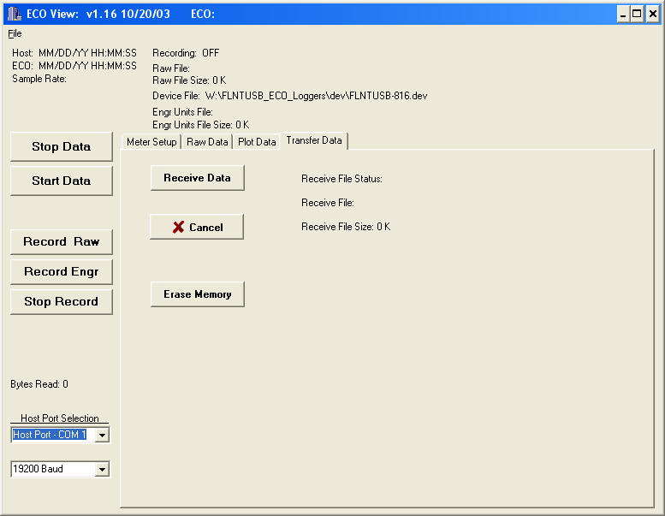
      - Click 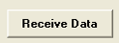 and the file naming window will appear.
      - Browse to the appropriate folder and name the raw data file.
      - File name convention: 817_reef_2014Sep22_Dunk.raw
Ie. Logger 817, reef deployment, year, month, day (RECOVERY date), site name.
A typical logger field deployment download may take about 10 minutes with a file size of 700-800 KB for a 4 month deployment. The ‘Receive File Status’ will indicate ‘Complete’.
      - Fill in details on the logger download datasheet
      - Disconnect the logger from the computer connection cable, and reconnect the 6 pin dummy plug.

    - Upload raw and QA/QC files to AIMS Data Centre Water Quality Environmental Logger Data Management System
The raw field data files are uploaded into the AIMS Data Centre Water Quality Environmental Logger Data Management System (ELDMS) and is discussed in more detail in Section A12. The ELDMS can be found on the AIMS internet, the current address is:
http://waterquality.aims.gov.au:8080/waterquality/index_gui.iface

The ELDMS currently has the structure as in the following screen view:
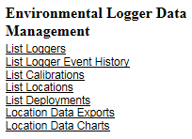
Information about the loggers and the deployment locations (example screen shots below)is held in this database as well as the device calibration files and logger data files.
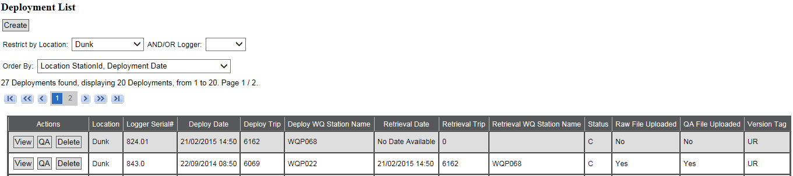
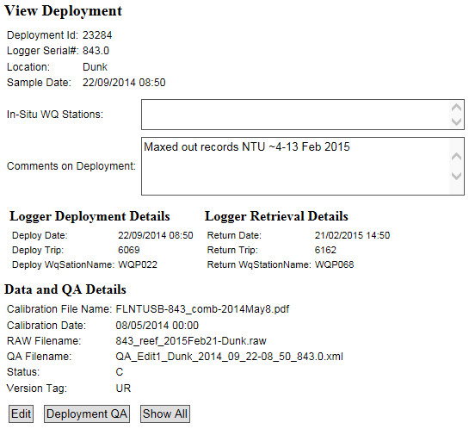

Upload raw data file to the ELDMS
      - Login to the ELDMS.
      - Click ‘List Deployments’.
      - Select site by ‘Restrict by Location’ and/or Logger to be uploaded.
      - Select ‘QA’ Action for the chosen deployment.
      - Click ‘Upload Raw Data File’.
      - Browse for raw file, then ‘Upload’
      - Click ‘Create Raw Data Records’ which will automatically calculate ‘engineering’ units.
      - The record processing will indicate it is ‘running in the background’ until the process is complete, and then a ‘pop-up’ window will confirm this.
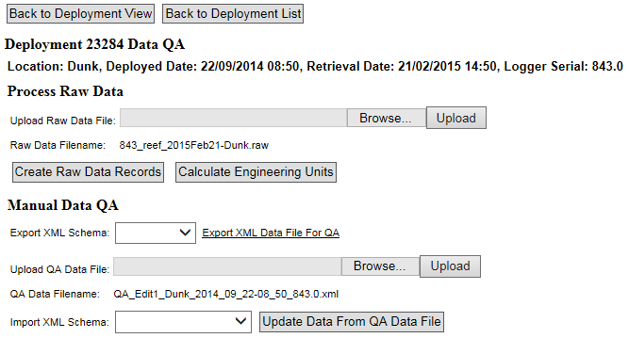
      - Click ‘Export XML File for QA’
The logger data files are stored on the AIMS network Water Quality share area in sub folder FLNTUSB_ECO_loggers\data_export_files
Once edits using WISKI-TV have been performed as per Section 11.5.3 the QA/QC edited files are re- imported to the ELDMS.

Upload QA/QC XML files to the ELDMS
      - Login to the ELDMS.
      - Click ‘List Deployments’.
      - Select site by ‘Restrict by Location’ and/or Logger to be uploaded.
      - Select ‘QA’ Action for the chosen deployment.
      - Click ‘Upload QA Data File’.

    - WISKI-TV ECO logger data quality control
Sub folders on the AIMS network Water Quality share area contain the XML files in two main stages of the QA edit process. The folders and example file names are listed in the table below.
The XML file exported (Section 11.5.2) from the Data Centre ELDMS is saved to the folder 1QA_export_xml
The files exported are stored into folders ordered by their file type, deployment location and
DEPLOYMENT date and time, ending with the logger serial number.
  - Raw logger field deployment data files are named with the recovery date to avoid errors, but the exported files from the ELDMS are named with the convention including the deployment date.
The next step is the QA WISKI-TV editing process.
    - Original exported files are left untouched as reference in 1QA_export_xml (with the file name convention format as per table below).
    - Using Windows Explorer, copies made to folder 2QA_edit1_xml (using the file name convention as per table below).
    - Using WISKI-TV the first edit (edit1) we delete start and end records of the logger when the logger was not in the water or when the logger had a physical malfunction. The information supplied on the logger deployment and logger recovery datasheets is used in the first edit.
    - Once WISKI-TV QA/QC editing is complete, the XML files are re-imported to the AIMS Data Centre ELDMS and final individual point edits may occur in Oracle via the ELDMS.
Files are stored as follows:

Folder name | Example file name
1QA_export_xml | QA_Export_Barren_2008_07_29-11_40_1091.xml
2QA_edit1_xml | QA_Edit1_Barren_2008_07_29-11_40_1091.xml

For further details about data management procedures developed at AIMS under Reef Rescue MMP see Section A12.

  - References
WET Labs Combination Fluorometer and Turbidity Sensor ECO FLNTU User’s Guide. Revision Y, 12 November 2008. WET Labs Inc., Philomath, OR, USA www.wetlabs.com
WET Labs ECO View Host Software for ECO Meters User’s Guide. Revision I, 18 March 2008. WET Labs Inc., Philomath, OR, USA www.wetlabs.com
Anderson, C.W., 2005, Turbidity (version 2.1): U.S. Geological Survey Techniques of Water-Resources Investigations, book 9, chap. A6., section 6.7, July, accessed November 2007 from http://pubs.water.usgs.gov/twri9A6/

Section A12: AIMS Data Management Procedures for the Marine Monitoring Program

  - Introduction
Data Management practices are a major contributor to the overall quality of the data collected; poor data management can lead to errors, lost data and can reduce the value of the Marine monitoring program (MMP) data. This appendix details the overall approach AIMS is taking to develop data management practices that will actively protect and enhance the quality of the data collected as part of the program.

  - Basic principles
The fundamental goal is to ensure that at each step where data is transformed, modified or ‘handled’ the process is understood, documented and that there is a clear logical connection between the raw data coming into the system and the final processed data. It should always be possible to back-track from the final processed data to the raw data from the instrument or data sheet.
The Reef Plan MMP data management system will centrally store all the generated data in an integrated data system designed to allow cross-referencing and access to related data. The data will be described in a metadata system and procedures will be developed for people to query and access the data. The focus is on getting the data into the AIMS central database and ensuring and documenting the quality of the data.

  - Data storage
All data will be stored in the Institutes Oracle 9i database. This is located on a secured central UNIX server which is protected by a UPS power supply and fire suppression systems. The Oracle database operates in a ‘zero data loss’ mode with the following backups:
- Nightly backups to tape via Export of the main database.
- Mid-day ‘hot-backup’ to disk using Oracles backup utility.
- Log files are stored on a separate server allowing for complete roll-back and roll-forward of data to the database.

The backup tapes are stored off site (initially at the AIMS Marine operations building and then at the Recall service in Townsville) and a Disaster Recovery disk facility is being set up at James Cook University for remote storage of on-line backups.

  - Metadata
Metadata are recorded as an important part of the data record, especially to record information about the different collection methods (collection details are described in each individual sampling and analytical procedure). The metadata must be captured to allow for accurate analysis and calculation of the particular parameter. Metadata include, e.g. location information, weather and sea state conditionsat that location, date and times of sampling, volumes of water sampled, filter identification. This information must be part of the data entry process when the nutrient sampling takes place, and when the samples are analysed back in the laboratory.

  - Water quality data management
Entry of data must be captured in a process that does its utmost to eliminate error. Manual entry of data is the biggest source of errors in data collection. For this reason various specific data management applications for the Reef Rescue MMP have been developed at AIMS. These are:
- The Field Data Entry System (FDES)
- The Filter Weight Management Web Application, and a
- The FDES Import Web Application which provides a form entry system with limited text entry other than where absolutely required (for example commentary, naming, and description metadata for the sample).

The Field Data Entry System (FDES) is an implementation of a Microsoft Access Database which has two main components. A database schema that models the data collection process to provide data integrity, and a set of forms that control the data entry process by providing drop down selection lists, radio buttons of predefined selection options. This document will not provide in-depth details on the schema or form design. The FDES is constantly evolving to make it simple to use, and automate data entry as much as possible. Being an Access Database it’s very portable, making it easy to transport on a laptop when on the boat in the field. The FDES is integrated with a labelling system for the samples taken. This labelling system consists of Bar Tender software for constructing the label format and printing the labels via a Zebra Label printer. The label format provides a barcode and text label that describes the location, depth, and duplicate of the sample taken.
The FDES data entry process is as follows:
    - Create a station/location to sample at using the ‘New Location / Print Barcode’ and ‘Bridge Book Entry’ Forms.
    - Define the depths to sample at using the ‘New Location / Print Barcode’ form.
    - Define what nutrients will be sample at this location using the ‘New Location / Print Barcode’ form.
    - Print of labels required for the defined sampled nutrient types and duplicates for each depth using the ‘New Location / Print Barcode’ form.
    - Define the metadata attributes to the location, and to the sample nutrient types using the ‘Water Sample Data’ form.
    - After the samples have been taken, apply labels and store samples appropriately.

The Filter Weight Management Web Application is a J2EE based application that is accessed via any browser within the AIMS internal network. Using a set of forms with drop pre-defined selection lists where ever possible, data entry error is kept to a minimum. The software forming the application’s backend is integrated with the five decimal place precision weight scales and an oracle database dedicated to storing filter weights. The integration with the scales is such that when the weight is finalised on the scales, that value is automatically placed in the web applications form for the particular weight with no manual weight entry required. For every filter, an initial weight is taken before the sampling, and a final weight is taken after sampling, both weights are performed in the laboratory using the same scales and Web Application.
The FDES Import Web Application is another J2EE based application that is accessed via any browser within the AIMS internal network. Data entry error is kept to a minimum by not allowing manual data entry. The process for data entry for the analytical results is through a series of file import tasks using the FDES Access Database, and a set of Microsoft Excel Sample Results Feeder Sheets. The Web Application is integrated with a dedicated Oracle database (the AIMS Nutrients Database). The Nutrients database schema is complex and ties in with an AIMS workflow schema for tracking and recording when particular database manipulation actions take place. This document does not cover in-depth design of this database.The Sample Results Feeder sheets are created from the analytical results for the various water quality parameters. The laboratory analyses are carried out by qualified Laboratory Technicians (details are described in individual procedures, see above). The results are checked by the analyst and then provided (generally in MS Excel format) to an Experimental Scientist who performs the necessary transformations, calculations and quality checks. Using an Excel document provides access to simple mathematical and graphing tools to perform any required conversions and quality assurance (finding outliers etc). The last step in this process is to collate the sample results into a work sheet which is the ‘Feeder Sheet’. By convention, this Feeder Sheet is always the first work sheet in the excel document. Every time data are imported, a copy of the Excel file is stored in the Nutrients Database.
The file import steps are as follows:
- Upload the FDES Access Database using the ‘WQ Data Import Tasks->Lagoon Access Database Import Actions->Upload Field Data Entry System Access DB’ application form path.
- Import the location and Condition data for the sample using the ‘WQ Data Import Tasks-
>Lagoon Access Database Import Actions->Import Location and Condition Data’ application form path.
- Import the Sample Replicate data for the sample using the ‘WQ Data Import Tasks->Lagoon Access Database Import Actions->Import Sample Replicate Data’ application form path.
- Confirm the Locations were uploaded using the ‘WQ Sample Station List’ application form path. If there are errors, fix in the Access Database and repeat steps 2 and 4.
- Confirm the Sample Replicates were uploaded using the ‘WQ Sample Replicate List’ application form path. If there are errors, fix in the Access Database and repeat steps 3 and 5.
- Confirm the Metadata for the Sample Replicates was uploaded using the ‘WQ Sample Metadata List’ application form path. If there are errors, fix in the Access Database and repeat steps 3 and 6.
- At this stage we have created/modified entries in the Nutrients database ready for results to be imported. Proceed with Feeder Sheet imports.
- For each sample type;
  - Upload the feeder sheet for the sample results using the ‘WQ Data Import Tasks-
>Analysis Feeder Spread Sheet Import Actions->Upload “Sample Type” Sample Replicate Data Spreadsheet’ application form path.
  - Import the sample results for the sample using the ‘WQ Data Import Tasks->Analysis Feeder Spread Sheet Import Actions->Import “Sample Type” Sample Replicate Data’ application form path.
- Confirm the Sample Replicate results were uploaded using the ‘WQ Sample Replicate List’ application form path. If there are errors, fix in the feeder Sheet and repeat steps 8 and 9.
- Confirm the Metadata for the Sample Replicate results were uploaded using the ‘WQ Sample Metadata List’ application form path. If there are errors, fix in the Access Database and repeat steps 8 and 10.

  - Coral monitoring data management
All field data is recorded on pre-printed datasheets. The use of standard data sheets aids in ensuring standard recording of attributes, and ensures required data are collected.
Upon return from the field, all data is entered on the same day into database forms linked directly to a Oracle Lite database. Each field on these forms mirror those on pre-printed data sheets and include lookup fields to ensure data entered is of appropriate structure or within predetermined limits. For example, entry of genera to the demography data table must match a pre-determined list of coral genera.
Upon return to the office, the data is uploaded to an Oracle Database using the Oracle Lite synchronization process. All keyed data is printed and checked against field data sheets prior to final logical checking (ensuring all expected fields are included and tally with number of surveys). The Oracle database is backed up on a daily basis. Photo images are burnt to DVD prior to analysis this copy to DVD doubles as a backup of the photo images. Photo images are stored on a server that is included in a routine automatic back up schedule.
Image analysis is performed within the AIMS monitoring data entry package “reefmon”. This software contains logical checks to all keyed data and is directly linked to a database to ensure data integrity. The directory path to transect images is recorded in the data base. This functionality allows the checking of benthic category identification. All photo transect data is checked by an experienced observer prior to analysis and reporting of results.

  - Instrument data management
Data from instruments is currently limited to a set of Environmental Loggers, CTD Profilers and Temperature Loggers.

    - Chlorophyll and turbidity loggers
The Environmental Loggers are deployed at 14 locations across the GBR. These loggers are Wet Labs Eco FLNTUSB instruments that measure temperature, chlorophyll, and turbidity (see Section 11 for details). After retrieval, the raw data are extracted in CSV format using Wet Labs software and a serial communication port on a laptop. The calibration files and raw data files are backed up on a UNIX server which has a comprehensive backup regime. The data from the loggers are managed by the ‘Environmental Logger Data Management’ J2EE based web application that is accessed via any browser within the AIMS internal network. Data entry error is kept to minimum using pre-defined selection lists, and a set of import tasks. The Web Application is integrated with a dedicated Oracle database (the AIMS EnvLogger Database).
The steps for data management for the Logger data are as follows:
      - For each logger;
        - Create the Logger using the ‘Environmental Logger Actions->Add New Logger’ application form path.
        - Create the Logger Calibration using the ‘Environmental Logger Actions->Add Environmental Logger Calibration’ application form path
      - Create the location using the ‘Environmental Logger Actions->Add Deployment Location’ application form path only if it doesn’t already exist.
      - Add the deployment details for the Logger using the ‘Environmental Logger Actions->Add Environmental Logger Deployment’ application form path. .
      - Add the retrieval details for the Logger using the ‘Environmental Logger Actions->Add Environmental Logger Retrieval’ application form path.
      - Associate the calibration for the deployment time to the Logger using the ‘Environmental Logger Actions->Associate Environmental Logger Retrieval’ application form path.
      - Import the raw data CVS file using the ‘Environmental Logger Actions->Deployment Data File I/O->Data File I/O->Import Raw Data File’ application form path.
      - Check calibration association using the ‘Environmental Logger Actions->Deployment Data File I/O->Data File I/O->Associate Calibration’ application form path.
      - Calculate the engineering units using the ‘Environmental Logger Actions->Deployment Data File I/O->Data File I/O->Calc Engineering Units’ application form path.
      - Check the engineering units using the ‘Environmental Logger Actions->Deployment Data File I/O->Data File I/O->Export Eng Units Data File’ application form path. If errors confirm and/or repeats steps 6 – 9.
      - Export a Kisters XML file for Quality Assurance using the ‘Environmental Logger Actions-
>Deployment Data File I/O->Data File I/O->Export XML Data File For QA’ application form path.
      - Perform quality assurance on the time series data using the Kisters Wiski TV software. Save the resulting data as a Kisters XML file with different name to file produced from step 10.
      - Import the QA’s data (File resulting from step 11) using the ‘Environmental Logger Actions-
>Deployment Data File I/O->Data File I/O->Import XML Data File Post QA’ application form path.
      - Check QA data using the ‘Environmental Logger Actions->Deployment Data File I/O->Data File I/O->Export QA’d Data’ application form path. If errors/anomalies confirm and/or repeats steps 10 – 13.

    - CTD Profilers
At the MMP sites where Niskin data is collected, and also at other sites depending on needs of the program, Sea-Bird CTD Profilers are deployed to analyse the vertical column of water for salinity, temperature, conductivity, turbidity, flouresence, and other data depending on the capability of the Profiler being used. This data set is over depth. Also some CTD instruments are deployed at Enviromental Logger locations to record changes in Salinity and Temperature over time. Both instruments record data in the same format and are processed in a very similar fashion, the main difference being vertical casts are over depth (distance in meters) and in-situ deployments are over time (seconds, minutes, hours etc). For vertical and in-situ deployments, Sea-Bird Sea-Save and SBE-DataProcessing software modules are used to produce data files in the Sea-Bird HEX format. These HEX files contain the raw data readings, and are stored on a server which has a backup and retention policy that ensures the data files are retrievable as required over the long term. Each Sea-Bird CTD instrument (SBE37, SBE19plus, etc), calibration information is kept in a CON file. These instruments are factory serviced and re-calibrated at regular intervals.
The processing of the data is done via the CTD Data Management J2EE web services application, and the Sea-Bird DataProcessing Software. The HEX files and CON files are used as input to these. During the process, four PSA files are created for each data file, and these represent the initial QAQC process.
- Raw data conversion PSA: Convesion of raw HEX charaters to ASCII characters
- Wild Edit PSA: 2 pass running mean filter/de-spike.
- Loop Edit PSA: vertical shift correction (boat rocking in a swell)
- Bin Average PSA: Data is averaged to per meter readings for each parameter.
The creation of the four PSA files is automated by the CTD Data Management System using the HEX and CON files are input. Once the data has been Bin Averaged, the data is then ingested into an Oracle 9i database schema, the same schema used to house the nutrients data.

    - Temperature loggers
Temperature loggers are deployed at, or in close proximity to, all locations at both 2m and 5m depths and routinely exchanged at the time of coral surveys.
There are two types of Temperature loggers used for the sea surface temperature logger program. The first type is an Odyssey temperature logger that comes with either 64 kb or 128 kb of memory (http://www.odysseydatarecording.com/). These are currently being phased out. The second type is a Sensus Ultra Temperature logger (http://reefnet.ca/products/sensus/). The odyssey Temperature loggers are set to take readings every 30 minutes. The Sensus Temperature loggers are set to take readings every 10 minutes.
Prior to deployment, the Temperature loggers are calibrated to within 0.02 Degrees Celsius using a temperature bath and a Hart Scientific 1522 thermometer.
The deployment process involves deploying two Temperature loggers at a location designated by the experimental scientist. The first logger is deployed in shallow water on a reef flat. The second logger is deployed in deeper water on a reef slope. The temperature loggers are deployed for a period of approximately one year.
After the temperature loggers are retrieved the data is downloaded and imported into an Oracle database as raw or level 0 data. To accomplish this task the Odyssey loggers have proprietary software to download and transfer their data into a Microsoft Access database via a serial port. The software then uploads this data from the Access database into the Oracle database. The Sensus loggers download their data to a Microsoft Excel spreadsheet via a serial port. The spreadsheet is uploaded into the Oracle database using an Java application written by the AIMS data centre.
Quality control is performed on all temperature logger data using Wiski Time Series Viewer (www.kisters.de/english/html/WISKI/WiskiTV.html). The Wiski input files are generated using an Java application written by the AIMS data centre. Data from the same location (the flat and the slope) and nearby locations are plotted together for comparison. Any bad points are removed. If a logger has suffered any drift in its recorded data points this can be corrected using Wiski Time Series Viewer. After this process the data is inserted into the database as quality controlled or level1 data.

  - Data validation
As the previous section describes, the resulting data from sampling and instrumentation is place into oracle databases. Once the data is in oracle, views are created of the data to simplify processing and hide the complexities of the underlying database schemas. The views are made available 3 mechanisms:
- On-line forms via the Intranet.
- On-line file downloads/exports.
- Microsoft Access Databases.
All 3 give the scientist the data validation capability, and when issues with the data are found, they are addressed by fixing/removing the inconsistency in it’s raw format, then re-importing the values back into oracle. Once back in oracle the provided views will reflect the changes made via data validation. Mechanisms for data validation are as follows;
- Bounds checking – is the data within acceptable limits.
- Logical checking – is the data logical (is the value possible).
- Comparative checking – is the data similar to other comparable data (such as previously collected data or better previous equivalent data).
- Correlative checking – if there is a relationship between two variables, if so is the relationship valid, if sample data should exist for this data, is it present.

  - Data integration
Once data is available in the oracle databases after the quality assurance and validation processes have gone through the cycles, the data is then consolidated in an Access Database via oracle views. The Access Database product was chosen as the delivery mechanism for its simplicity, and with a view that most are familiar with the software. Providing the oracle database lends it self to database schema complexity and licensing issues for the software required to use the exported oracle databases.
It is AIMS policy that all data collected have a metadata record created for it. The metadata record is created using a Metadata Entry System where the metadata is in the form of ISO19139 XML. This is the chosen format for many agencies across Australia and the International Community that deal with spatial scientific data. You can visit the AIMS Metadata System at http://data.aims.gov.au/metadataviewer/faces/search.xhtml?searchType=title&searchValue=RRMMP.

  - Outputs
The outputs from the data management system include Standard Operating Procedures for all data manipulation, transfer, uploading and processing, a full database description, the metadata records, the data quality reports from the automated checking programs, the progress statistics from the data tracking system and a copy of the data in the appropriate format (such as an Access Database).

Appendix B James Cook University TropWater Appendices


B1: TropWATER Water Sampling Procedures
B2: TropWATER Water Sampling Field Sheet - Example
B3: Metadata for flood plume data entered into TropWATER flood database
B4: TropWATER Water Sampling Input Sheet
B5: TropWATER Auto-analysis methods – Nitrogen – Ammonia
B6: TropWATER Auto-analysis methods – Phosphorus
B7: TropWATER Auto-analysis methods – Nitrogen – Nitrate and Nitrite
B8: TropWATER Auto-analysis methods – Nitrogen – Total Alkaline Persulfate
B9: TropWATER Auto-analysis methods – Phosphorus – Total Alkaline Persulfate
B10: TropWATER Auto-analysis methods – Chlorophyll
B11: TropWATER Auto-analysis methods – Total Suspended Solids

Appendix B1 TropWater Water Sampling Procedures

Nutrient Sampling
Dissolved nutrients (DIN’s [NO₃, NO₂, NH₄⁺,] FRP (PO₄),TDN/TDP, (Si(OH)₄)
Six 10 mL vials, yellow lids plus one 60 mL vial for silica
Samples need to be FILTERED.
- Sample is collected from the 10 L container using sterile 60 mL syringes.
- Rinse syringe at least once with the water to be sampled. Discard rinse water away from sampling area.
- Attach yellow minisart 0.45 μm filter to tip of syringe.
- Fill syringe with sample water and push some sample water through to prime the filter.
- Minimise the air gap between water sample and black syringe plunger to prevent contamination.
- Do not rinse vials with sample water.
- Fill the vials to the line (10 mL or 60 mL) (prefer to be just below the mark to avoid loss of sample). Do not overfill, this may cause the vials to split when frozen – destroying the sample.
- To minimise contamination please keep fingers away from all tops and lids (wear gloves if available).
- If possible, freeze the 10 mL samples before sending to the laboratory. Otherwise, store in the dark on ice for transport the laboratory as soon as possible. The 60 mL vial for silica analysis is not frozen, just kept in fridge or on ice.
Total Nitrogen/Total Phosphorus (TN/TP)
One 60 mL plastic vial
Filtering NOT Required
- Sample is collected from the 10 L container using sterile 60 mL syringes. Water in the bucket is rigorously stirred before being collected using the syringe.
- Requires 60 mL plastic vial.
- Do not rinse the vial with the water to be sampled.
- Fill the vial leaving approx. a 3cm air-gap from the top. Do not overfill, this may cause the vial to split when frozen – destroying the sample.
- To minimise contamination please keep fingers away from all tops and lids.
- If possible, freeze samples before sending to the laboratory.
- Otherwise, store in the dark on ice for transport the laboratory as soon as possible.

Chlorophyll a/Phaeophytin (Chl-a)
One 1 L black plastic bottle
Filtering not required on vessel, but must be filtered within 24 hours of collection.

- Sample is collected directly in-situ over the side of the boat or from 10 L sample container (stirred rigorously) into collection bottle (requires a one-litre black plastic bottle to reduce the effect of sunlight on the phytoplankton species in the interim between collection and filtration).
- Rinse each container at least once with the sample water, taking care to avoid any contact with the sample (gloves must be worn at all times).
- Fill to overflowing and seal. Do not leave an air gap.
- Once sample is taken it should be kept in the dark on ice.
- The filtering is undertaken off the vessel either in the laboratory or beforehand depending on the time required for transport.
- Filter using manifolds, provided – ensure manifold cups are washed with deionised water between samples to avoid contamination. Record volume of sample filtered.
- Wash cups with deionised water to ensure the capture of the entire sample.
- ***Important – add magnesium carbonate to wash (~0.2 mL is required to preserve/fix Chl-a on the filter paper).
- Fold filter papers in half and wrap in aluminium foil to avoid loss of sample on the filter paper.
- Place wrapped filter paper in envelope with site no. reference (i.e. MMP 68) and the volume of sample filtered is written on the envelope.
- Store papers dry and frozen or as cold as possible prior to analysis in the laboratory.

Total Suspended Solids
One 1 L plastic bottle
Filtering not required on vessel, but must be filtered within 7 days of collection.
- Sample is collected directly in-situ over the side of the boat or from 10 L sample container (stirred rigorously) into sample collection bottle.
- Rinse each container at least once with the sample water, taking care to avoid any contact with the sample (gloves must be worn at all times).
- Fill to overflowing and seal. Do not leave an air gap.
- Once sample is collected, it should be kept on ice and stored at 4° C.
- TSS sampling requires filtering within 7 days of collection. The filtering is undertaken off the vessel either in the laboratory or beforehand depending on the time required for transport.
- Filter using manifolds, provided – ensure manifold cups are washed with deionised water between samples to avoid contamination. Record volume of sample filtered.
- Wash cups with deionised water to ensure the capture of the entire sample.
- At least 500 mL of deionised water is rinsed through the sample to rinse the salts from the filter papers.

CDOM (Colored Dissolved Organic Matter)
120 mL glass amber bottle
- Sample is collected from the 10 L container using sterile 60 mL syringes.
- Requires 120 mL amber (glass) bottle.
- Rinse syringe at least once with the water to be sampled.
- Attach 0.45 μm (yellow) to syringe, fill with sample and insert plunger; air contact must be minimised so filter needs to be removed at this point to expel any trapped air.
- Place filter back onto syringe and push some sample through to prime the filter.
- Place a 0.2 μm filter (blue) onto the yellow filter; ensure they are secure and fitted onto the syringe by turning them until there are ‘locked’ together – at this point the syringe should have two filters attached with the yellow next to the syringe. If syringes and filters aren’t fitted together correctly there may be a risk of contamination.
- Push the sample water through both filters into the glass amber bottle– a minimum 100 mL filtered sample is required.
- Samples are stored at 4° C and need to be analysed within 7 days of sample collection.
- When there is too much back pressure on the syringe, the yellow filter will need replacing first — if this does not alleviate the back pressure, the blue one also needs replacing; however, always replace the yellow filter first.

Salinity
One 60 mL plastic vial
Filtering NOT Required
- Sample is collected from the 10 L container using sterile 60 mL syringes.
- Rinse syringe at least once with the water to be sampled.
- Fill the syringe with water from the 10 L container and fill the vial to just below the line.

Pesticide sampling
One 250 mL or 1 L amber glass bottle (obtained from Queensland Health laboratory)
Filtering NOT Required
- Sample is collected directly in-situ over the side of the boat or extended pole sample collection bottle.
- Do not rinse bottles. Fill them to the neck of the bottle leaving an air gap.
- Immediately place samples in an esky on ice until being returned to laboratory. Samples should be refrigerated if not transported immediately. Do not freeze the bottles.

Appendix B2 TropWater Water Sampling Field Sheet - Example

Date
Samplers
Weather
Vessel
 |  |  |  |  |  |  |  |  |  |  |  |  |  | Extra samples
Site | Lat | Long | Sample ID | Time | Site Depth | Sample Depth | Temp | SPC | Sal | pH | Chl | DO | DO% | Duplicate | Pesticide | Phytoplankton | Trace Metals | Comment

Appendix B3 Metadata for flood plume data entered into TropWater flood database

Metadata for flood plume data entered into TropWater flood database

Water quality data for flood plumes 1991 – 2008
Mandatory fields

Field | Description
Unique ID | Id that links the sample and water quality data. Note all duplicates have been combined
Cyclone | Name of Cyclone associated with flood event (non cyclone = low pressure)
Cyclone number | Number associated with the cyclone [Joy = 1, Sadie = 2, Violet = 3, Ethel = 4, Justin = 5, Sid = 6, Rona = 7, Steve = 8, etc.]
Catchment | Catchment adjacent to sampling station
Catchment number | Number associated with the catchment
River | Most closely located flooding river ( if able to identify)
Year | Year of sample
Month | The month that the sample was taken in
Dist_Mou | Distance from river mouth (as plume moves)
Reef | Identifies if sample is located near a reef (within 1km) (R)
Agency | Agency responsible for sampling of data [string]
T_B_S | Denotes location in water column. S(surface sample < 1m), top (3 meters below surface, W (water column) , B (bottom)
S_Depth | Surface depth of sample
Latitude | Latitude in decimal degrees [integer]
Longitude | Longitude in decimal degrees [integer]
DIN | Dissolved Inorganic Nitrogen (addition of NO2 +NO3+ NH4) measured in µM [integer with 2 decimal places]
NO_{x} | Nitrate (addition of NO2 +NO3) , measured in µM[integer with 2 decimal places]
NO₂ | Nitrite, measured in µM [integer, 2 decimal places]
NO₃ | Nitrate, measured in µM [integer, 2 decimal places]
NH₄ | Ammonium
DON | Dissolved organic nitrogen , measured in µM [integer with 2 decimal places]
TDN | Total dissolved nitrogen (DIN + DON)
PN | Particulate Nitrogen (measured in µM[integer with 2 decimal places]
TN | Total Nitrogen (PN plus TDN)
DIP | Dissolved inorganic phosphorus (measured in µM[integer with 2 decimal places]
DOP | Dissolved organic phosphorus, (measured in µM) [integer with 2 decimal places]
PP | Particulate Phosphorus
TP | Total phosphorus
DIN%TN
DIN:DIP | Ratio
NOx:DIP
SPM | Suspended particulate matter
Salinity
Chlorophyll
Phaeo
Chl method

(Quality control identified by laboratories and need further explanation).

1. Historical data

1(a) Flood plume data collected during 1991 – 2001

Program: Great Barrier Reef Marine Park Authority flood plume monitoring.
Duration: 1991 – 2000
Organisation: GBRMPA, AIMS
Individuals: Michelle Devlin, Jane Waterhouse, David Haynes
Area: Various catchments – see below
Reports: Devlin et al. (2001) Flood plume monitoring in the Great Barrier Reef: spatial and temporal patterns in composition and distribution
Devlin et al. 2002
Devlin et al. 2004
Events: 8
[Cyclone Joy – 1991]
[Cyclone Sadie – 1994]
[Cyclone Violet – 1995]
[Cyclone Ethel – 1996]
[Cyclone Justine – 1997]
[Cyclone Sid – 1998]
[Cyclone Rona – 1999]
[Cyclone Steve – 2000]

For further information on cyclones, refer to Devlin et al. 2001

Parameters for each cyclone.
2. 2001 – 2007 data

2.1 Flood plume data collected during 2002

Program: National Action Plan for Salinity and Water Quality (NAP)
Duration: 2002 – 2005
Organisation: TropWater (JCU), ANU.
Individuals: Jon Brodie, Malcolm McCulloch
Area: Burdekin catchment
Events: 1
[Major flow event in February 2002, no cyclone associated]

Description:
Water samples collected from multiple sites within flood plume in transect heading out from river mouth. Majority of samples collected inside the visible area of the plume though some samples taken outside of plume for comparison. Surface samples were collected at 0.5 metres below the surface, with either a reversing thermometer Niskin Bottle for a rinsed clean sampling container with temperature measured by thermometer. Samples taken at depth were collected with Niskin Bottles. Salinity and temperature profiles were measured at all sites with an YSI salinity meter. Water samples for nutrient and chlorophyll analysis were collected, filtered and stored for further analysis. Volumes filtered for all analyses were dependent on turbidity of the water. Sub samples were filtered through GF/F (glass fibre) filters for chlorophyll and phaeoyphytin, and the filter immediately wrapped in aluminium foil and frozen. The second sub-sample was filtered through 0.45µM membrane filter for SS.

Samples were collected at 13 stations in the plume covering range of salinities on February 20 and 21, 2002. The Burdekin flow in this event was moderate at Home Hill (Clare), the total February flow being 3.6 million ML, compared to a long term median flow at Clare of 1.2 million ML. Exact latitude and longitude can be found in database. While profiles for salinity and temperature with depth were taken only surface samples were collected for SS, nutrients and chlorophyll analysis.

Data conversion:
Latitude and longitude converted to degrees and minutes.

Comments:
Only chlorophyll, phaeophytin, SPM and salinity data (nutrient data lost in analysis process)
SPM – mg L⁻¹
Chl - µg L⁻¹
Salinity

2.2 TropWater flood plume data collected 2007

Program: MTSRF 3.7.2
Duration: 2007
Organisation: TropWater (GBRMPA)
Individuals: Steve Lewis, Zoe Bainbridge, Jon Brodie,
Area: Burdekin catchment
Black and Bohle River (Townsville)
Events: 1
[February 2007]
Description:
Data conversion:
Nutrient concentrations (measured in µg L⁻¹) were converted to µM.
- TN, NO₂, NO₃, NO_{X}, DON, PN converted by multiplying by 14.0067.
- TP, FRP (DIP), PP, DOP converted by multiplying by 30.97376 (for description of parameters, see Appendix 1).
- DIN calculated by addition of NO_{X} and NH_{4.}

Comments:
Three separate events were sampled, being in the Burdekin flood plume, off the mouth of the Haughton (Barrattas) and the Bohle and Black river.

Unique id and sites for each event are listed below:
- Burdekin samples collected on 6th and 7th February 2007
- Townsville-Thuringowa (Ross and Black River) collected on 2nd February 2007
- Lower Burdekin (Haughton) collected on 3rd February 2007

NO TN data available for Townsville (Ross and Black Rivers) and for Burdekin plume samples. Need to check with lab.

Parameters measured in the 2007 flood plume data (x denotes if the parameter was appended to the overall flood plume dataset.
2.3 AIMS data collected during 2007

Program: Catchment to Coast MTSFR 3.7.2
Duration: 2007
Organisation: JCU
Individuals: Britta Schaffelke
Area: Burdekin and Mackay Whitsundays catchment
Events: 1
[Major flow event in February 2007, no cyclone associated]

Description:
For description of samples in each trip refer to the table below.

Data conversion:
Latitude and longitude converted to degrees and minutes
Nutrient Laboratory results given in µg L⁻¹ – converted to µM
Comparison between in situ salinity and laboratory salinity
CHECK TDP (DOP plus DIP)
TDN (DIN plus DON)

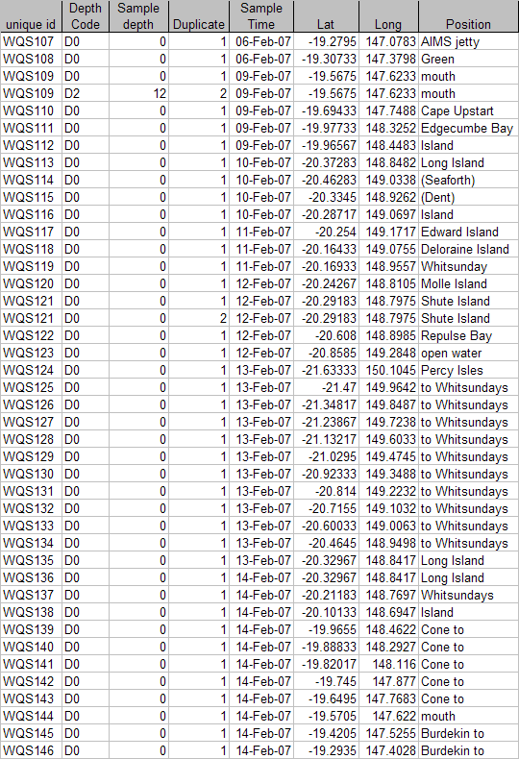

2.3 AIMS data collected during 2007

Program: Catchment to Coast MTSFR 3.7.2
Duration: 2007
Organisation: JCU
Individuals: Katarina Fabricius
Area: Tully Murray catchment
Events: 1
[February 2007, Cyclone Nelson]

Description:
For description of samples in each trip refer to the table below.

Data conversion:
Latitude and longitude converted to degrees and minutes.
Nutrient Laboratory results given in µg L⁻¹ – converted to µM.
Comparison between in situ salinity and laboratory salinity.

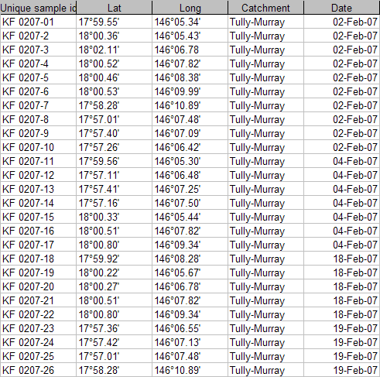

3. New data (post 2008 – MTSRF program)

3.1. Flood plume data collected during 2008 – TropWater/JCU

Program: Spatial and temporal monitoring of flood plumes MTSFR 3.7.2
Duration: 2008
Organisation: TropWater
Individuals: M Devlin, Z Bainbridge, S. Lewis
Area: Fitzroy and Burdekin catchment
Events: 3
[Major flow event in January 2008, no cyclone associated]

Description:
For description of samples in each trip refer to the table below.

[Burdekin sampling trip 2]
[Burdekin sampling trip 3]
[Fitzroy sampling trip 1]

Data conversion:
Latitude and longitude converted to degrees and minutes.
Nutrient Laboratory results given in µg L⁻¹ – converted to µM.
Comparison between in situ salinity and laboratory salinity.

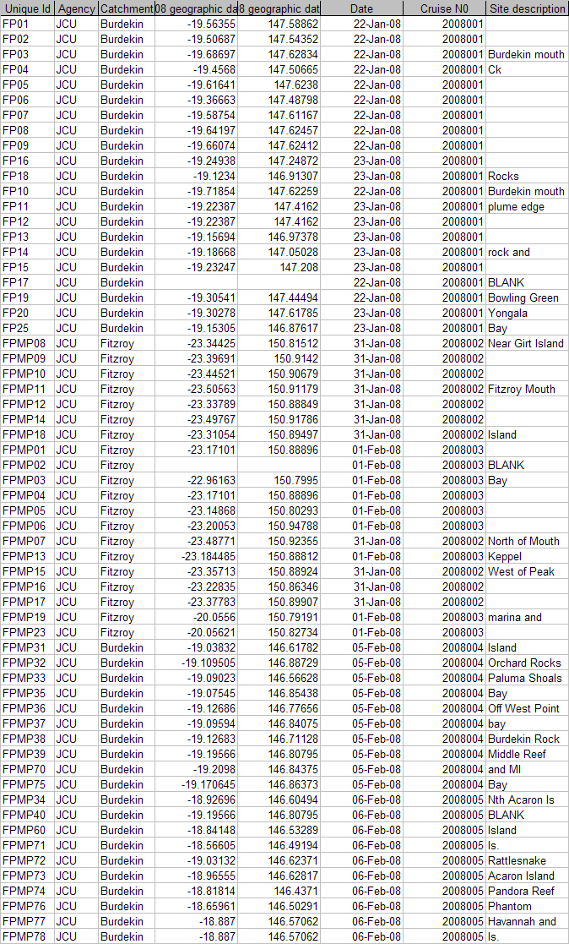
Table: Sampling details for Burdekin and Fitzroy flood plumes taken by JCU.

2e. Flood plume data collected during 2008 – CSIRO (FITZROY)

Program: CSIRO
Duration: 2008
Organisation: CSIRO
Individuals: V. Brando
Area: Fitzroy catchment
Events: 1
[Major flow event in January 2008, no cyclone associated]

Data conversion
Latitude and longitude converted to degrees and minutes

Combined tables in ACCESS db

Sampling data for flood plume 1991- 2008
Mandatory fields

Field | Description
Unique Id | Id that links the sample and water quality data. Note all duplicates have been combined
Latitude
Longitude
Wind
Clouds

Appendix B4 TropWater Water Sampling Input Sheet

See ‘Appendix B4_TropWater input sheet.xls’ available for download from:
http://www.rrrc.org.au/mmp/mmp_pubs.html

Appendix B5 TropWater Auto-analysis methods: Nitrogen – Ammonia

Nitrogen – Ammonia
1.0 SCOPE AND APPLICATION

This method provides a procedure for the determination of ammonia in drinking, surface, groundwater, saline and effluent wastewater samples.

The working range is 0.001 – 0.15 mg L⁻¹ as N using the Alpkem segmented flow auto analyser.

The ammonium ion reacts with a basic media to form ammonia gas. The ammonia gas diffuses across a polypropylene membrane and is retained in a slightly acidic stream. The ammonia then reacts with phenol and alkaline hypochlorite to form indophenol blue in amounts proportional to the ammonia concentration present within the sample. This blue colour is then intensified with the addition of sodium nitroferricyanide and measured spectrophotometrically at 630 nm.

  - Interferences
1.1.1 Contamination of samples by ammonia is the most common interference. Be aware of potential sources of contamination such as laboratory atmosphere, tobacco smoke, sweat on the hands of workers, and take steps to minimise as much as possible (such as close laboratory door and uncap samples only minutes prior to analysis).
1.1.2 Maintain an awareness of biological organisms such as algae which can assimilate ammonia rapidly and deplete the content of ammonia within a sample.
1.1.3 Turbid samples can interfere and should be filtered be through a 0.45 μm polysuphone membrane filter
1.1.4 Metal ions such as calcium and magnesium interfere by causing precipitation at high levels. The addition of sodium citrate should minimise this problem.
1.1.5 Positive interference may be attributed to substances e.g. urea, which when present in samples may hydrolyse to form ammonia.
1.1.6 Amines and nitrates can cause positive interference at high concentrations.
1.1.7 Cyanide, thiocyanate and sulfide give positive interference at >10 mg L⁻¹.
1.2 Approximately 26 samples per hour can be analysed.

1.3 This method requires experience in the use of automated gas segmented flow colorimetric analyses. A minimum of 6 months training under the direct supervision of an experienced nutrient analyst is required before independent nutrient analyses can be performed.

2.0 DEFINITIONS

2.1 Calibration Standard (CAL) – A solution prepared from the primary dilution standard solution or stock standard solution containing analytes. The CAL solutions are used to calibrate the instrument response with respect to analyte concentration.

2.2 Reagent Water (RM) - Type 1 reagent grade water equal to or exceeding standards established by American Society for Testing Materials (ASTN). Reverse osmosis system followed by a Reagent water System that produces water with 18 MΩohm resistance is used. To avoid contamination the reagent water should be used the day of preparation.

2.3 Laboratory Spike Blank (B+) - An aliquot of reagent water to which a known quantity of nitrogen is added. The B+ is analysed exactly like a sample, its purpose is to determine the amount of nitrogen added to samples and further used in the calculation on spike recoveries aiding confidence in the digestion procedure.

2.4 Laboratory Reagent Blank (LRB) - an aliquot of reagent water that is treated exactly as a sample including exposure to all lab ware, equipment, digestion mixture, digestion and reagents that are used with all other samples. The LRB is used to determine if any background interference is present and therefore needs to be taken into consideration when sample results are calculated.

2.5 Method Detection Limit (MDL) - The minimum concentration of an analyte that can be identified, measured and reported with 99% confidence that the analyte concentration is greater than zero.

2.6 Stock Standard Solution (SSS) – A concentrated solution of method analyte prepared in the laboratory using assayed reference compounds or purchased from a reputable commercial source.

2.7 Certified Reference Material (CRM) - “Real’ samples that have been purchased from an external reputable commercial source. The CRM’s are used to match matrices and concentrations with the samples being analysed to determine the accuracy of results.

2.8 SYNC Peak Solution – A coloured solution used to produce a synchronization peak in the refractive index measurement. A synchronization peak is required by the data acquisition programs to initialize the peak finding parameters. The first cup in every run must always be identified as a SYNC sample. The SYNC sample is usually a high standard, but can be any sample that generates a peak at least 25% of full scale.

3.0 SAFETY

3.1 Water samples collected from the estuarine and coastal environments are generally not hazardous, however it is of paramount importance that the individual collecting the samples use the proper collection techniques and be aware of potential sources of contamination.

3.2 High standards of laboratory technique should be used when preparing reagents. Laboratory personnel should obtain material safety data sheets (MSDS) for all chemicals used in this method, and read and sign acknowledgement over the handling of these chemicals. A lab coat, safety glasses and gloves should be used when handling concentrated acid.

4.0 EQUIPMENT AND SUPPLIES

4.1 Gas Segmented Continuous Flow Autoanalyser consisting of:

4.1.1 Autosampler.

4.1.2 Analytical manifold with membrane module for ammonia analyses.

4.1.3 Peristaltic Pump and appropriate tubing.

4.1.4 Spectrophotometer equipped with a tungsten lamp (380-800 nm) or photometer with a 630 nm interference filter (2 nm bandwidth).

4.1.5 Computer based data acquisition system.

4.2 Glassware and Supplies

4.2.1 All labware used in the analysis must be low in residual ammonia to avoid sample or reagent contamination. Soaking with lab grade detergent, rinsing with reverse osmosis water, followed by rinsing with 10% HCl and thoroughly rinsing with reagent water is sufficient.

4.2.2 Automatic pipetters capable of delivering volumes ranging from 10 – 100 μL and 100 – 1000 μL with an assortment of high quality disposable pipette tips. It is standard protocol to check the accuracy of the pipetters at least once per week using a four decimal place analytical balance.

4.2.3 Analytical balance, with capability to measure 4 decimal places for preparing SSS. It is standard protocol to have this balanced serviced and calibrated once per year, then checked weekly with certified weights.

4.2.4 10 mL sterile high density polypropylene, glass volumetric flasks, and glass pipettes.

4.2.5 105° C drying oven.

4.2.6 Desiccator.

4.2.7 Polysulphone sterile membrane filters with 0.45 μm nominal pore size. Plastic sterile terumo syringe.

5.0 REAGENTS AND STANDARDS

5.1 Stock Reagent Solutions – all chemicals are analytical grade quality.

5.1.1 Stock Ammonia Solution (1000 mg N L⁻¹) – Quantitatively transfer 3.819 g of pre-dried (105°C for 1 hour minimum) ammonium chloride (NH₄CL FW 53.49) to a 1000 mL glass volumetric flask containing approximately 800 mL of reagent water and dissolve. Fill to the mark with Reagent water and refrigerate. This solution is to be made daily.

5.1.2 Stock Ammonia Check Solution (100 mg N L⁻¹) - Quantitatively transfer 0.4721 g of pre-dried (105°C for 1 hour minimum) ammonium sulfate ((NH₄)₂SO₄ FW 132.14) to a 1000 mL glass volumetric flask containing approximately 800 mL of reagent water and dissolve. Fill to the mark with Reagent water and refrigerate. This solution is to be made daily.

5.1.3 Spiking Stock Solution (10 mg N L⁻¹) - Pipette 1 mL of the stock ammonia solution into a 10 mL Sarstedt tube and fill to the marked line with reagent water. Mix well. This solution should be made daily.

    - Stock Phenol Colour Reagent– Quantitatively transfer 0.05 g sodium nitroprusside (Sodium nitrosopentacyanoferrate III Na₂[Fe(CN)₅NO]*2H₂0 FW 297.95) to an 80 mL glass volumetric containing approximately 80 mL of reagent water and dissolve. Fill to the mark with reagent water and then add 2 mL of phenol solution (phenol liquefied 80% ww/in water). Invert until phenol becomes well mixed. Transfer to the working phenol reagent glass amber bottle. This solution should be made daily.

    - Stock Hypochlorite Colour Reagent – Quantitatively transfer 0.5 g sodium hydroxide (NaOH FW 40.00) to an 80 mL glass volumetric containing approximately 80 mL of reagent water and dissolve. Fill to the mark with reagent water and then add 1 mL of 12% sodium hypochlorite solution (12% liquid chlorine). Invert until well mixed. Transfer to the working phenol reagent glass amber bottle. This solution should be made daily.

    - Stock Tri Sodium Citrate Colour Reagent – Quantitatively transfer 1.0g sodium hydroxide (NaOH FW 40.00) to a 250 mL glass volumetric containing approximately 180 mL of reagent water and dissolve. Then quantitatively transfer 28.0 g tri sodium citrate (Na₃C₆H₅O₇.2H₂0 FW 294.10) to the same 250 mL glass volumetric containing approximately 180 mL of reagent water and dissolve. Fill to the mark with reagent water and then add 1 mL of Brij - 35 solution (30% solution). Invert until well mixed. Transfer to the working tri sodium citrate reagent glass amber bottle. This solution should be made daily.

    - Stock 10% Hydrochloric acid solution – Measure 25 mL of concentrated hydrochloric acid into a plastic 250 mL bottle containing 200 mLs of reagent water. Fill to the mark with reagent water and then add 1 mL of Brij - 35 solution (30% solution). Invert until will mixed. This solution should be made monthly.

5.2 Working Reagents

5.2.1 10% Hydrochloric Start up Solution – add 1 mL of Brij - 35 surfactant to 250 mL of a 10% hydrochloric solution. Shake gently.

5.2.2 Brij – 35 Start up Solution – add 1 mL of Brij 28 surfactant to 500 mL of reagent water and mix gently.

5.2.3 Phenol Colour Reagent – Transfer reagent from volumetric flask to the 250 mL glass amber working reagent bottle.

    - Hypochlorite Colour Reagent – Transfer reagent from volumetric flask to the 250 mL glass amber working reagent bottle.

    - Tri Sodium Citrate Colour Reagent – Transfer reagent from volumetric flask to the 250 mL glass amber working reagent bottle.

5.2.6 Colored SYNC Peak Solution – Use either a high ammonia standard that will obtain a peak between 25 to 100 percent full scale.

5.2.7 Calibration Standards – Prepare a series of calibration standards (CAL) by diluting a suitable volume of the stock standard solution to 100 mL volumetric flask using reagent water. Prepare these standards daily. The concentration range of calibration standards should bracket the expected concentrations of samples and not exceed two orders of magnitude. At least five calibration standards should be used to construct the calibration curve.

6.0 SAMPLE COLLECTION, PRESERVATION AND STORAGE

6.1 Sample Collection

6.1.1 Samples collected for nutrient analyses from estuarine, coastal waters, streams and lakes are usually collected by one of two methods: either a peristaltic pump or grab sample.

6.1.2 A peristaltic pump has a length of tube attached that is weighted down so that particular depths can be sampled if required. A grab sample is obtained using a hand held sampling pole with 1 L polypropylene bottle which is filled sub surface.

6.1.4 The filterable nutrient component is filtered immediately at the point of collection using a Terumo sterile 60 mL syringe and 0.45 µm polysulphone Mini-Sart filter purchased from Sartorius (Cat #165333K).

6.2 Sample Preservation

6.2.1 After collection and filtration the samples should either be analysed immediately or if this is not possible frozen at -18°C until analysis can be performed.

6.3 Sample Storage

6.3.1 Samples should be stored in a freezer that contains nutrient samples only. If possible samples should further be stored into there relevant matrix and concentration to further minimise any possible contamination e.g. store low level marine samples away from effluent samples.

7.0 QUALITY CONTROL

7.1 The minimum requirements of this program is to demonstrate performance using in house reference materials (IHRM), duplicate analyses, spiking samples, and the use of certified reference material (CRM’s) purchased from an external source. Also, all vials used for sampling, the digestion procedure, and syringe filters (if used) are subject to rigorous quality control checks before being utilised.

Additionally, to participate in inter collaborative nutrient trials at least once per year e.g. National Low Level Nutrient Collaborative Trials (NLLNCT).

7.2 In House Reference Material (IHRM)

7.2.1 A 100 µg N L⁻¹ ammonia check standard is made up from the stock standard solution (SSS) of the ammonium sulfate solution. This standard is used to assess the accuracy of the ammonia calibration standards.

Step 1: Make up a secondary ammonium sulfate stock solution

Stock Ammonium sulfate Solution (mL) | Size Volumetric Flask (mL) | Calculated Concentration (µg N L⁻¹)
1 | 100 | 1000

Step 2: Using the secondary stock solution made in step 1 make up the following dilutions which are used as a check standard.

Stock Ammonium sulfate Solution (mL) | Size Volumetric Flask (mL) | Calculated Concentration (µg N L⁻¹)
1 | 100 | 100

7.3 Duplicate Analyses

7.3.1 Duplicate analyses of samples are performed to a minimum of 5% per TropWater job submission. The standard deviation of these results should fall between +/- 10%. Failure to achieve this standard will result in samples being re-analysed.

7.4 Spiked Samples

    - Samples are spiked to a minimum of 5% per TropWater job submission. The result of this addition should calculate to be between 90-110% recovery. Failure to achieve satisfactory recovery will results in samples being re- analysed. This may mean using a different series of dilutions.
    - CRM are purchased in 250 mL containers. After the first thawing the whole CRM is sub – sampled into 10 mL tubes for future usage. These 10 mL tubes are then thawed as required.
  - Consumable Quality Checks

7.5.1 10 mL Sarstedt vials are ordered in large batches of at least 10,000 units (Cat # 60.9921.820). These vials are divided into their manufacturer batches and 1% of the vials are randomly selected and analysed for back ground contamination.

7.5.2 The sterile minisart 0.45 μm polysulphone filters are ordered in large batches. These filters are divided into their manufacturer batches and 1% of the filters are randomly selected and analysed for back ground contamination.

7.6 Certified Reference Material (CRM)

7.6.1 CRM’s are purchased from Queensland Health in both freshwater and saltwater. The CRM’s are matched to the sample matrices being analysed and also concentration. The certified value range must be achieved for sample results to be deemed accurate or all samples must be re- analysed with the correct value for the CRM’s obtained.

8.0 CALIBRATION AND STANDARDISATION

8.1 At least seven calibration standards should be prepared daily for system calibration.

8.1.1 The following dilutions are used for a working range of 0.001 – 0.15 mg N L⁻¹:

Step 1: Make up a secondary ammonium chloride stock solution

Stock Ammonium chloride Solution (mL) | Size Volumetric Flask (mL) | Calculated Concentration (mg N L⁻¹)
10 | 100 | 100

Step 2: Using the secondary stock solution made in step 1 make up the following tertiary stock solution.

Secondary Stock Ammonium chloride Solution (mL) | Size Volumetric Flask (mL) | Calculated Concentration (µg N L⁻¹)
1 | 100 | 1000

Step 3: Using the tertiary stock solution made in step 2 make up the following dilutions which are used as working calibration standards.

Tertiary Stock Ammonium chloride Solution (mL) | Size Volumetric Flask (mL) | Calculated Concentration (µg N L⁻¹)
1 | 100 | 10
2 | 100 | 20
4 | 100 | 40
5 | 100 | 50
8 | 100 | 80
10 | 100 | 100
15 | 100 | 150

8.2 A calibration curve should be constructed for each sample run.

  - The calibration standards should be placed at the start, middle and end of the run to allow for any sensitivity drift.

NOTE: For large amounts of samples it may be necessary to increase the amount of calibration standards digested to ensure that a ratio of one set of standards per 20 – 30 samples is achieved.

  - The CRM’s should be placed at the start and the end of the run to ensure the accuracy of results is maintained throughout the whole run.

  - Spiked samples should be prepared as follows:

8.5.1 Ensure that the sample randomly chosen to be spiked is 10 mL exactly (marked line). Use a micro pipette to remove any excess sample of conversely to add a little more sample into the vial.

NOTE: Thoroughly mix the sample before remove or adding any sample

8.5.2 Make up the spiking stock mixture by adding 1 mL of the Secondary Stock Ammonium chloride solution to a Sarstedt 10 mL tube and fill with reagent water to the mark. Mix well.

8.5.3 Add 20µl of the spiking stock mixture (equivalent of 20 µg N L⁻¹) to the 10 mL sample and mix well.

8.5.4 A minimum of three spiked reagent water samples are to be prepared and analysed for every run.

9.0 SAMPLE, CALIBRATION STANDARDS, IHRM AND DRM PREPARATION PROCEDURE

9.1 If samples are frozen, thaw samples by running under a continuous flow of cold water.

9.2 Make up the seven calibration standards (refer 8.1.1), and prepare the CRM’s (refer 7.4.2).

9.3 Choose and make up the spiked samples (refer 8.5).

9.4 Choose and make up the IHRM check standard (refer 7.2.1).

10.0 ANALYTICAL PROCEDURE
.
  - Turn on the auto analyser and peristaltic pump and run the 10% hydrochloric solution through the system which has the ammonia membrane module removed for a minimum of thirty minutes to let the system equilibrate.

NOTE: If ammonia membrane module is not removed then the 10% hydrochloric acid solution will destroy the membrane and a replacement will be required.
Remove 10% hydrochloric solution and run reagent water with Brij added for fifteen minutes then add the ammonia membrane module and continue to run for another fifteen minutes. Turn on the spectrophotometer and check that the baseline is stable and you have a consistent bubble pattern through the manifold.
NOTE: The absorbency on the spectrophotometer should read 630 nm and should be set at the required sensitivity level for the range of working standards.

10.2 Set up the autosampler software for the run. This will include the unique TropWater job number and sample identification number, along with any dilution data associated with samples.

  - Mix the samples by inverting three times, and place in the appropriate rack number and cup position as allocated by the autosampler software.

NOTE: Lids are to remain on samples, calibration standards and laboratory reagent blanks until the last moment before they are analysed to minimise potential ammonia contamination.

10.4 Remove the reagent water with Brij and add the working phenol solution, working hypochlorite solution, and working tri sodium citrate solution to the system. Allow to equilibrate for 5 minutes.

10.5 Inject a high level ammonia standard e.g. 100 µg N L⁻¹ for 90 seconds and observe the peak absorbency through the spectrophotometer.

10.6 Start the autosampler run. Observe that the first set of standards peak heights are normal and then check run periodically to ensure no malfunctions have occurred.

10.8 When autosampler run is finished stop the software, remove the working phenol solution, working hypochlorite solution and the working tri sodium citrate solution then put the reagent water with Brij back on. Rinse the manifold for a minimum of one hour and then turn the auto-analyser and peristaltic pump off.

10.9 Print out a hard copy of the trace and calculate results.

11.0 DATA ANALYSIS AND CALCULATIONS

11.1 Concentrations of ammonia in samples are calculated from both quadratic and cubic equations obtained from the calibration standards.

  - The Quality Control of the results (refer 7.0) is assessed and results are either accepted or rejected and re-run at a later date.

  - Results should be reported in µg N L⁻¹ unless otherwise requested (e.g. high values > 5 mg N L⁻¹) with the replicate and spike values stated on the report.

    - To calculate spike values for undiluted samples:

Spike Recovery (%) = | Sample + Average of Blanked Spiked Samples | X 100
Spike Recovery (%) = | Spiked Sample | X 100

    - To calculate spike values for diluted samples:

Spike Recovery (Dilutions) (%) = | (Sample/Dilution) + Average of Blanked Spiked Samples | X 100
Spike Recovery (Dilutions) (%) = | (Spiked Sample/dilution) | X 100

12.0 TABLES, DIAGRAMS, FLOWCHARTS

Debubbler
Color Reagent
Sample
Inert Gas (Ar)
NH₄Cl Buffer
1
2
4
3
6
5
8
7
10
9
540 nm Detector

Waste
TN Manifold – Nitrogen Total Alkaline Persulfate

Appendix B6 TropWater Auto-analysis methods: Phosphorus (Filterable Reactive)

Phosphorus – Filterable Reactive
1.0 Scope and Application

This method provides a procedure for the determination of 0.45 μm filterable reactive phosphorus (FRP) in drinking, surface, groundwater, saline and effluent wastewater samples.

Both filterable reactive phosphorus and nitrate or nitrite are auto analysed simultaneously.

The working range is 0.005 – 0.15 mg L⁻¹ as P using the Alpkem segmented flow auto analyser.

This is an automated colorimetric method for the detection of 0.45 μm filterable reactive phosphorus. Ammonium molybdate and antimony potassium tartrate react in an acidic medium with dilute solutions of phosphate to form an antimony-phosphomolybdate complex. This complex is reduced to an intense blue colored complex by the addition of ascorbic acid. The color produced is proportional to the phosphate concentration present in the sample. This color is read spectrophotometrically at 885nm.

  - Interferences

1.1.2 Samples with high levels of turbidity cause interference. Particulates should be removed by filtering through a Minisart sterile 0.45μm polysulphone membrane filter at the point of collection.

1.1.3 As phosphates are common in many detergents it is necessary that no phosphate detergents are used during the cleaning of any glassware or sample containers used in the laboratory. The technician must always be aware of potential contaminants and take the necessary steps to avoid this error, therefore ensuring the most accurate results are obtained.

1.1.4 Arsenate in concentrations above 0.1 mg As L⁻¹ can interfere with the filterable reactive phosphorus results with arsenate forming a similar color complex to phosphate with these colorimetric reagents.

1.1.5 Sulfides and nitrites at concentrations greater than 10 mg L⁻¹ and 1 mg L⁻¹ respectively can cause positive interference. Sulfide effects can be treated by simple dilution of the sample since high sulfide concentrations are most often associated with high phosphate values.

1.1.6 Chromium (VI) and chromium (III) at >2 mg L⁻¹ and 30 mg L⁻¹ respectively cause negative interference by reacting with phosphate.

1.1.7 Metal ions, Cu (II) and Fe (III) interfere at concentrations >10 mg L⁻¹ causing negative interference by reacting with phosphate by precipitating out the phosphorus from the dissolved phase.

1.2 Samples should be between pH 5.0 and 9.0.

1.3 Approximately 30 samples per hour can be analysed.

1.4 This method requires experience in the use of automated gas segmented flow colorimetric analyses. A minimum of 6 months training under the direct supervision of an experienced nutrient analyst is required before independent nutrient analyses can be performed.

2.0 DEFINITIONS

2.1 Calibration Standard (CAL)
A solution prepared from the primary dilution standard solution or stock standard solution containing analytes. The CAL solutions are used to calibrate the instrument response with respect to analyte concentration.

2.2 Reagent Water (RM)
Type 1 reagent grade water equal to or exceeding standards established by American Society for Testing Materials (ASTN). Reverse osmosis system followed by a Reagent Water System that produces water with 18 MΩohm resistance is used. To avoid contamination the reagent water should be used the day of preparation.

2.3 Laboratory Spike Blank (B+)
An aliquot of reagent water to which a known quantity of phosphorus is added. The B+ is analysed exactly like a sample, its purpose is to determine the amount of phosphorus added to samples and further used in the calculation on spike recoveries aiding confidence in the digestion procedure recovery.

2.4 Laboratory Reagent Blank (LRB)
An aliquot of reagent water that is treated exactly as a sample including exposure to all lab ware, equipment, digestion mixture, digestion and reagents that are used with all other samples. The LRB is used to determine if any background interference is present and therefore needs to be taken into consideration when sample results are calculated.

2.5 Method Detection Limit (MDL)
The minimum concentration of an analyte that can be identified, measured and reported with 99% confidence that the analyte concentration is greater than zero.

2.6 Stock Standard Solution (SSS)
A concentrated solution of method analyte prepared in the laboratory using assayed reference compounds or purchased from a reputable commercial source.

2.7 Certified Reference Material (CRM)
“Real’ samples that have been purchased from an external reputable commercial source. The CRM are used to match matrices and concentrations with the samples being analysed to determine the accuracy of results.

2.8 SYNC Peak Solution
A colored solution used to produce a synchronization peak in the refractive index measurement. A synchronization peak is required by the data acquisition programs to initialize the peak finding parameters. The first cup in every run must always be identified as a SYNC sample. The SYNC sample is usually a high standard, but can be any sample that generates a peak at least 25% of full scale.

3.0 SAFETY

3.1 Water samples collected from the estuarine and coastal environments are generally not hazardous, however it is of paramount importance that the individual collecting the samples use the proper collection techniques and be aware of potential sources of contamination.

3.2 High standards of laboratory technique should be used when preparing reagents which should all be of analytical grade. Laboratory personnel should obtain material safety data sheets (MSDS) for all chemicals used in this method, and read and sign acknowledgement over the handling of these chemicals. A lab coat, safety glasses and gloves should be used when handling concentrated acid.

4.0 EQUIPMENT AND SUPPLIES

4.1 Gas Segmented Continuous Flow Autoanalyser consisting of :

4.1.1 Autosampler.

4.1.2 Analytical manifold with a cartridge equipped for heating set to 60°.

4.1.3 Peristaltic Pump and appropriate tubing.

4.1.4 Spectrophotometer equipped with a tungsten lamp (380-885 nm) or photometer with an 885 nm interference filter (2 nm bandwidth).

4.1.6 Computer based data acquisition system.

4.2 Glassware and Supplies

4.2.1 All labware used in the analysis must be low in residual phosphate to avoid sample or reagent contamination. Rinsing with reverse osmosis water, followed by rinsing with 10% HCl and thoroughly rinsing with reagent water is sufficient.

4.2.2 Automatic pipetters capable of delivering volumes ranging from 10-100 μL and 100 – 1000 μL with an assortment of high quality disposable pipette tips. It is standard protocol to check the accuracy of the pipetters at least once per week using a four decimal place analytical balance.

4.2.3 Analytical balance, with capability to measure 4 decimal places for preparing SSS. It is standard protocol to have this balanced serviced and calibrated once per year, then checked weekly with certified weights.

4.2.4 10 mL sterile high density polypropylene, glass volumetric flasks, and glass pipettes.

4.2.5 105°C drying oven.

4.2.6 Desiccator.

4.2.7 Polysulphone sterile membrane filters with 0.45 μm nominal pore size. Plastic sterile Terumo syringe.

5.0 REAGENTS AND STANDARDS

5.1 Stock Reagent Solutions – all chemicals are analytical grade quality.

5.1.1 Stock Phosphorus Solution (1000 mg P L⁻¹) – Quantitatively transfer 4.393 g of pre- dried (105°C for 1 hour minimum) potassium phosphate monobasic (KH₂PO₄ FW 136.09) to a 1000 mL glass volumetric flask containing 800 mL of reagent water and dissolve. Fill to mark with reagent water and refrigerate. This solution is stable for 2 – 3 weeks.

5.1.2 Spiking Stock Solution (250 mg P L⁻¹) – Pipette 1 mL of the stock phosphorus solution into a 250 mL glass volumetric containing 230 mL of reagent water and then fill to marked line and mix well. This solution should be made daily.

5.1.3 Sulphuric Acid Solution –Using a 25 mL glass measuring cylinder measure out 14 mL of concentrated sulphuric acid (H₂SO₄ 98.08) into a 250 mL glass volumetric flask containing approximately 200 mL of reagent water and mix well. Fill to the mark with reagent water. This solution is stable for 1 week.

5.1.4 Ammonium Molybdate Solution - Quantitatively transfer 5.000 g of pre-dried (105°C for 1 hour minimum) ammonium molybdate ((NH₄)₆Mo₇O₂₄.4H₂0 FW 1235.86) into a 250 mL glass volumetric flask containing approximately 180 mL of reagent water and mix well. Using a 25 mL glass measuring cylinder measure out 8 mL of concentrated sulphuric acid (H₂SO₄ 98.08) and add to the molybdate mixture. Mix well and fill to the mark with reagent water. This solution is stable for 1 week.

5.1.5 Antimony Potassium Tartrate Solution – Quantitatively transfer 0.125 g of antimony potassium tartrate (KSbO.C₄H₄O₆ FW 324.92) and 5.000 g of L-ascorbic acid (C₆H₈O₆ FW 176.13) into a 250 mL glass volumetric flask containing approximately 180 mL of reagent water and mix well until the antimony is dissolved. Using a 25mL glass measuring cylinder measure out 12.5 mL of concentrated sulphuric acid (H₂SO₄ 98.08) and add to the antimony mixture. Mix well and fill to the mark with reagent water and cover with foil. This solution is stable for 1 day.

5.2 Working Reagents

5.2.1 Dowfax 2A1 Start up Solution – add 1 mL of Dowfax surfactant to 500 mL of reagent water and mix gently.

NOTE: Dowfax contains levels of nitrate, therefore keep away from Triton X 100 start up solution.

5.2.2 Working Sulphuric Solution – add 1 mL of Dowfax to the 250 mL glass volumetric flask of stock sulphuric solution and shake gently.

5.2.3 Working ammonium molybdate solution – 250 mL glass volumetric flask of stock molybdate solution.

5.2.4 Working antimony potassium tartrate solution – 250 mL glass volumetric flask of stock antimony solution (covered in foil).

5.2.5 Colored SYNC Peak Solution – Use either a high phosphorus standard that will obtain a peak between 25 to 100 percent full scale. Or add 50 µL of blue food coloring solution to 1000 mL and mix thoroughly.

5.2.6 Calibration Standards – Prepare a series of calibration standards (CAL) by diluting a suitable volume of the stock standard solution into a 100 mL volumetric flask using reagent water. Prepare these standards daily. The concentration range of calibration standards should bracket the expected concentrations of samples and not exceed two orders of magnitude. At least five calibration standards should be used to construct the calibration curve.

6.0 SAMPLE COLLECTION, PRESERVATION AND STORAGE

6.1 Sample Collection

6.1.1 Samples collected for nutrient analyses from estuarine, coastal waters, streams and lakes are usually collected by one of two methods: either a peristaltic pump or grab sample.

6.1.2 A peristaltic pump has a length of tube attached that is weighted down so that particular depths can be sampled if required. A grab sample is obtained using a hand held sampling pole with 1 L polypropylene bottle which is filled sub surface.
6.1.3 The filterable nutrient component is filtered immediately at the point of collection using a Terumo sterile 60 mL syringe and 0.45 µm sterile polysulphone Mini-Sart filter purchased from Sartorius (Cat #165333K).

6.2 Sample Preservation

6.2.1 After collection and filtration the samples should either be analysed immediately or if this is not possible frozen at -18°C until analysis can be performed.

6.3 Sample Storage

6.3.1 Samples should be stored in a freezer that contains nutrient samples only. If possible samples should further be stored into there relevant matrix and concentration to further minimise any possible contamination e.g. Store low level marine samples away from effluent samples.

7.0 QUALITY CONTROL

7.1 The minimum requirements of this program is to demonstrate performance using duplicate analyses, spiked samples, and the use of certified reference material (CRM’s) purchased from an external source. Also, all vials for sampling and the digestion procedure, and syringe filters are subject to rigorous quality control checks before being utilised.

Additionally, to participate in inter collaborative nutrient trials at least once per year e.g. National Low Level Nutrient Collaborative Trials (NLLNCT).

7.2 Duplicate analyses

7.3.1 Duplicate analyses of samples are performed to a minimum of 5% per TropWater job submission. The standard deviation of these results should fall between +/- 10%. Failure to achieve this standard will results in samples being re-analysed.

7.3 Spiked Samples

7.4.1 Samples are spiked to a minimum of 5% per TropWater job submission. The result of this addition should calculate to be between 90 – 110% recovery. Failure to achieve satisfactory recovery will result in samples being re-analysed. This may mean using a different series of dilutions if required.
7.4 Certified Reference Material (CRM)

7.4.1 CRM’s are purchased from Queensland Health in both freshwater and saltwater. The CRM’s are matched to the sample matrices being analysed and also concentration. The certified value range must be achieved for sample results to be deemed accurate or all samples must be re- analysed with the correct value for the CRM obtained.

7.4.2 CRM’s are purchased in 250 mL containers. After the first thawing the whole CRM is sub – sampled into 10 mL tubes for future usage. These 10 mL tubes are then thawed as required.

7.5 Consumable Quality Checks

    - 10 mL Sarstedt vials are ordered in large batches of at least 10,000 units (Cat # 60.9921.820). These vials are divided into their manufacturer batches and 1% of the vials are randomly selected and analysed for back ground contamination.
    - The sterile minisart 0.45 μm polysulphone filters are ordered in large batches. These filters are divided into their manufacturer batches and 1% of the filters are randomly selected and analysed for back ground contamination.

8.0 CALIBRATION AND STANDARDISATION

8.1 At least seven calibration standards should be prepared daily for system calibration. These calibration standards should undergo the same digestion procedure for samples being analysed.

8.1.1 The following dilutions are used for a working range of 0.005 – 0.200 µg P L⁻¹:

Step 1: Make up a secondary stock phosphorus solution

Stock Phosphorus Solution (mL) | Size Volumetric Flask (mL) | Calculated Concentration  (µg P L⁻¹)
1 | 1000 | 1000

Step 2: Using the secondary stock solution made in step 1 make up the following dilutions which are used as working calibration standards.

Secondary Stock Phosphorus Solution  (mL) | Size Volumetric Flask (mL) | Calculated Concentration (µg P L⁻¹)
1 | 100 | 10
2 | 100 | 20
4 | 100 | 40
5 | 100 | 50
8 | 100 | 80
10 | 100 | 100
15 | 100 | 150

NOTE: The calibration standards are mixed phosphorus and either nitrate or nitrite standards (refer to Nitrate and Nitrite SOP 8.1.1 or 8.1.2 for direction)

8.2 A calibration curve should be constructed for each sample run.

8.3 The calibration standards should be placed at the start, middle and end of the run to allow for any sensitivity drift.

NOTE: For large amounts of samples it may be necessary to increase the amount of calibration standards to ensure that a ratio of one set of standards per 20 – 30 samples is achieved.

8.4 The CRM should be placed at the start and the end of the run to ensure the accuracy of results is maintained throughout the whole run.

8.5 Spiked samples should be prepared as follows:

8.5.1 Step 1: Ensure that the sample randomly chosen to be spiked is 10mLs exactly (marked line). Use a micro pipette to remove any excess sample or conversely to add a little more sample into the vial.

NOTE: Thoroughly mix the sample before remove or adding any sample.

8.5.2 Step 2: Make up the spiking stock mixture by adding 1mL of Stock Phosphorus Solution (SSS) to 230 mL of reagent water in a 250 mL glass volumetric flask. Mix well and fill to the marked line,

8.5.3 Step 3: Add 50µL of the spiking stock mixture (equivalent of 20 µg P L⁻¹) to the 10 mL sample and mix well.

8.5.4 A minimum of three spiked reagent water samples are to be prepared and analysed for every run.

9.0 SAMPLE, CALIBRATION STANDARDS, AND CRM PREPARATION PROCEDURE

9.1 If samples are frozen, thaw samples by running under a continuous flow of cold water.

9.2 Make up the seven calibration standards (refer 8.1.1), and prepare the CRM’s (refer 7.4.2).

9.3 Choose and make up the spiked samples (refer 8.5).

10.0 ANALYTICAL PROCEDURE
.
10.1 Turn on the auto analyser and peristaltic pump, run reagent water with Dowfax added through the system for a minimum of thirty minutes to let the system equilibrate. Turn on the spectrophotometer and check that the baseline is stable and you have a consistent bubble pattern through the manifold.

NOTE: The absorbency on the spectrophotometer should read 885 nm and should be set at the required sensitivity level for the range of working standards.

10.2 Set up the autosampler software for the run. This will include the unique TropWater job number and sample identification number, along with any dilution data associated with samples.

10.3 Mix the samples by inverting three times, remove lid and place in the appropriate rack number and cup position as allocated by the autosampler software.

10.4 Remove the reagent water with Dowfax and add the working sulphuric solution, working ammonium molybdate solution, and working antimony potassium tartrate solution to the system. Allow to equilibrate for 5 minutes.

  - Inject a high level phosphorus standard e.g. 100 µg P L⁻¹ for 40 seconds and observe the peak absorbency through the spectrophotometer.

  - Start the autosampler run. Observe that the first set of standards peak heights are normal and then check run periodically to ensure no malfunctions have occurred.

NOTE: If any samples are observed to exceed the upper working range standard then dilution of the sample and re-analysis should occur at the positions allocated for this purpose at the end of the run.

10.7 When the autosampler run is finished stop the software, remove the working sulphuric solution, working ammonium molybdate solution, and working antimony potassium tartrate solution then put the reagent water with Dowfax back on. Rinse the manifold for a minimum of one hour and then turn the auto analyser and peristaltic pump off.

10.8 Print out a hard copy of the trace and calculate results using the relevant Excel spreadsheets located in the JCU team drive (internal access only),

11.0 DATA ANALYSIS AND CALCULATIONS

11.1 Concentrations of filterable reactive phosphorus in samples are calculated from both quadratic and cubic equations obtained from the calibration standards.

11.2 The Quality Control of the results (refer 7.0) is assessed and results are either accepted or rejected and re-run at a later date.

11.3 Results should be reported in µg P L⁻¹ unless otherwise requested (e.g. High values > 1 mg P L⁻¹) with the replicate and spike values stated on the report.

11.3.1 To calculate spike values for undiluted samples:

Spike Recovery (%) = | Sample + Average of blanked spiked samples | X 100
Spike Recovery (%) = | Spiked Sample | X 100

11.3.2 To calculate spike values for diluted samples:

Spike Recovery (Dilutions) (%) = | (Sample/Dilution) + Average of Blanked Spiked Samples | X 100
Spike Recovery (Dilutions) (%) = | (Spiked Sample/Dilution) | X 100

Appendix B7 TropWater Auto-analysis methods: Nitrate and Nitrite

Nitrogen – Nitrate and Nitrite
1.0 SCOPE AND APPLICATION

This method provides a procedure for the determination of 0.45 μm filtered nitrate and nitrite in drinking, surface, groundwater, saline and effluent wastewater samples.

Nitrate or nitrite are auto analysed simultaneously with filterable reactive phosphorus.

The working range for nitrite is 0.001 – 0.1 mg L⁻¹ as N using the Alpkem segmented flow auto analyser.
The working range for nitrate is 0.002 – 2.0 mg L⁻¹ as N using the Alpkem segmented flow auto analyser.

Determination of nitrate is made by calculation (i.e. Oxidised nitrogen – Nitrite).

This is an automated colorimetric method for the detection of 0.45 μm filterable nitrate and nitrite using an automated segmented flow analyser utilizing a copper coated cadmium reduction column. Samples are passed through the copper coated cadmium reduction column with the nitrate in the sample reducing to nitrite which is then determined by diazotizing with sulfanilamide and coupling with N-1-naphthylethylenediamine dihydrochloride to form a red color azo dye which is read spectrophotometrically at 540 nm. The absorbance measured at 540 nm is linearly proportional to the concentration of nitrite + nitrate in the samples. Nitrate concentrations are obtained by subtracting the nitrite values which have been separately determined by analyzing the same sample minus the copper coated cadmium reduction column from the nitrate plus nitrite value obtained when using the cadmium column.

  - Interferences
1.1.1 Hydrogen sulfide at concentrations >0.1 mg S L⁻¹ can interfere with the efficiency of the cadmium column causing a decrease in sensitivity.

1.1.2 Iron, Copper and other heavy metals at concentrations greater than 1 mg L⁻¹ can reduce the efficiency of the cadmium column. The addition of EDTA in the buffer solution will complex these metal ions.
1.1.3 Oil and grease can interfere by coating the reactive surface of the cadmium column.

    - Residual chlorine oxidizes the cadmium column and should be removed by the addition of sodium thiosulfate to the sample.
    - Samples with high levels of turbidity cause interference. Particulates should be removed by filtering through a Minisart sterile 0.45 μm polysulphone membrane filter at the point of collection.
    - Highly coloured samples can bias the results. The effect of colour can be ascertained by removing the colour reagent and running the sample through the spectrophotometer.
    - Organic compounds such as phenols and aromatic amines, which couple with the diazonium ions can cause interference.
1.2 Approximately 30 samples per hour can be analysed.

1.3 This method requires experience in the use of automated gas segmented flow colorimetric analyses, and familiarity with the techniques of preparation, activation and maintenance of the cadmium reduction column. A minimum of 6 months training under the direct supervision of an experienced nutrient analyst is required before independent nutrient analyses can be performed.

2.0 DEFINITIONS

2.1 Calibration Standard (CAL) – A solution prepared from the primary dilution standard solution or stock standard solution containing analytes. The CAL solutions are used to calibrate the instrument response with respect to analyte concentration.

2.2 Reagent Water (RM) - Type 1 reagent grade water equal to or exceeding standards established by American Society for Testing Materials (ASTN). Reverse osmosis system followed by a Reagent water System that produces water with 18 MΩohm resistance is used. To avoid contamination the reagent water should be used the day of preparation.

2.3 Laboratory Spike Blank (B+) - An aliquot of reagent water to which a known quantity of nitrogen is added. The B+ is analysed exactly like a sample, its purpose is to determine the amount of nitrogen added to samples and further used in the calculation on spike recoveries aiding confidence in the digestion procedure.

2.4 Laboratory Reagent Blank (LRB) - an aliquot of reagent water that is treated exactly as a sample including exposure to all lab ware, equipment, digestion mixture, digestion and reagents that are used with all other samples. The LRB is used to determine if any background interference is present and therefore needs to be taken into consideration when sample results are calculated.

2.5 Method Detection Limit (MDL) - The minimum concentration of an analyte that can be identified, measured and reported with 99% confidence that the analyte concentration is greater than zero.

2.6 Stock Standard Solution (SSS) – A concentrated solution of method analyte prepared in the laboratory using assayed reference compounds or purchased from a reputable commercial source.

2.7 Certified Reference Material (CRM) - “Real’ samples that have been purchased from an external reputable commercial source. The CRM’s are used to match matrices and concentrations with the samples being analysed to determine the accuracy of results.

2.8 SYNC Peak Solution – A coloured solution used to produce a synchronization peak in the refractive index measurement. A synchronization peak is required by the data acquisition programs to initialize the peak finding parameters. The first cup in every run must always be identified as a SYNC sample. The SYNC sample is usually a high standard, but can be any sample that generates a peak at least 25% of full scale.

3.0 SAFETY

3.1 Water samples collected from the estuarine and coastal environments are generally not hazardous, however it is of paramount importance that the individual collecting the samples use the proper collection techniques and be aware of potential sources of contamination.

3.2 High standards of laboratory technique should be used when preparing reagents. Laboratory personnel should obtain material safety data sheets (MSDS) for all chemicals used in this method, and read and sign acknowledgement over the handling of these chemicals. A lab coat, safety glasses and gloves should be used when handling concentrated acid.

4.0 EQUIPMENT AND SUPPLIES

4.1 Gas Segmented Continuous Flow Autoanalyser consisting of:

4.1.1 Autosampler.

4.1.2 Analytical manifold with reaction coils for nitrate analyses.

4.1.3 Open Tubular Cadmium Reactor (OTCR) is a laboratory prepared packed copper coated cadmium reduction column (prepared according to procedures in section 5.3.1)

4.1.4 Peristaltic Pump and appropriate tubing.

4.1.5 Spectrophotometer equipped with a tungsten lamp (380-800 nm) or photometer with a 540 nm interference filter (2 nm bandwidth).

4.1.6 Computer based data acquisition system.

4.1.7 Inert gas (high purity grade, 99.99%) e.g. argon, nitrogen.

4.2 Glassware and Supplies

4.2.1 All labware used in the analysis must be low in residual nitrate to avoid sample or reagent contamination. Soaking with lab grade detergent, rinsing with reverse osmosis water, followed by rinsing with 10% HCl and thoroughly rinsing with reagent water is sufficient.

4.2.2 Automatic pipettes capable of delivering volumes ranging from 10 – 100 μL and 100 – 1000 μL with an assortment of high quality disposable pipette tips. It is standard protocol to check the accuracy of the pipettes at least once per week using a four decimal place analytical balance.

4.2.3 Analytical balance, with capability to measure 4 decimal places for preparing SSS. It is standard protocol to have this balanced serviced and calibrated once per year, then checked weekly with certified weights.

4.2.4 10 mL sterile high density polypropylene, glass volumetric flasks, and glass pipettes.

4.2.5 105° C drying oven.

4.2.6 Desiccator.

4.2.7 Polysulphone sterile membrane filters with 0.45 μm nominal pore size. Plastic sterile terumo syringe.

4.2.8 A pH meter with glass electrode and a reference electrode. A set of standard buffer solutions for calibration of the pH meter.

5.0 REAGENTS AND STANDARDS

5.1 Stock Reagent Solutions – all chemicals are analytical grade quality.

5.1.1 Stock Sulfanilamide Solution – Dissolve 40g Sulfanilamide and 1g N-1-Naphthylethylenediamine dihydrochloride (C₁₂H₁₆C_{l2}N₂ (NEDD) FW 259.18) in 800 mL of reagent water. Add 100 mL ortho-phosphoric acid (H₃PO₄ 85%) and make up to 1 L mark in a glass volumetric flask. Stir for one hour on a magnetic stirrer. Store refrigerated in an amber glass bottle. This solution is stable for 6 weeks.

5.1.2 Stock Nitrate Solution (200 mg N L⁻¹) – Quantitatively transfer 1.4436 g of pre-dried (105°C for 1 hour minimum) potassium nitrate (KNO₃ FW 101.099) to a 1000 mL glass volumetric flask containing approximately 800 mL of reagent water and dissolve. Fill to the mark with Reagent water and refrigerate. This solution is stable for 2-3 weeks.

5.1.3 Spiking Stock Solution (20 mg N L⁻¹) - Pipette 1 mL of the stock nitrate solution into a 10 mL Sarstedt tube and fill to the marked line with reagent water. Mix well. This solution should be made daily.

5.1.4 Stock Nitrite Solution (50 mg N L⁻¹) - Quantitatively transfer 0.246 g of pre dried (105°C for 1 hour minimum) sodium nitrite (NaNO₂ FW 68.99) to a 1000 mL glass volumetric flask containing approximately 800 mL of reagent water and dissolve. Fill to the mark with Reagent water and refrigerate. This solution is stable for 2-3 weeks.

5.1.5 Ammonium Chloride Buffer – Dissolved 85 g of ammonium chloride (NH₄CL FW 53.49) and 1 g of Ethylene-diamine – tetra-acetic acid (EDTA C₁₀H₁₃N₂O₈Na₃ FW 358.2) in 800 mL of reagent water. Using a 6 N NaOH solution buffer the pH up till pH 8.5 is reached. Add Reagent water to reach the 1000 mL fill line and then store refrigerated in an amber glass bottle.

5.2 Working Reagents

5.2.1 Triton X 100 Start up Solution – add 1 mL of Triton X 100 surfactant to 500 mL of reagent water and mix gently.

5.2.2 Working Sulfanilamide Solution – add 1 mL of triton X 100 to 200 mL of the stock sulfanilamide solution in a glass amber bottle and shake gently.

5.2.3 Ammonium Chloride Buffer – Mix a 1:3 ratio of ammonium chloride buffer to Reagent water in a 1L amber glass bottle and add 2 mL of Triton X 100.

5.2.4 Copper Sulfate Solution (2%) – Dissolve 20 g of copper sulfate (CuSO₄.5H₂O, FW 249.61) in 1 L of reagent water.

5.2.5 Colored SYNC Peak Solution – Use either a high nitrate standard that will obtain a peak between 25 to 100 percent full scale. Or add 50 µL of red food coloring solution to 1000 mL and mix thoroughly.

5.2.6 Calibration Standards – Prepare a series of calibration standards (CAL) by diluting a suitable volume of the stock standard solution to 100 mL volumetric flask using reagent water. Prepare these standards daily. The concentration range of calibration standards should bracket the expected concentrations of samples and not exceed two orders of magnitude. At least five calibration standards should be used to construct the calibration curve.

5.3 Open Tubular Cadmium Reactor (OTCR)

5.3.1 Open Tubular Cadmium Reactor – nitrate in the samples is reduced to nitrite by either a commercial open tubular cadmium reactor or a laboratory packed copper coated cadmium reduction column. If an OTCR is being employed the following procedure should be used to activate it:

Prepare reagent water, 10% HCl solution and 2% CuSO₄ solution in three 60 mL syringes with unions. Firstly flush through 10 mL of reagent water, then flush with 10 mL of 10% HCl in 3 seconds and follow immediately with 30 mL of reagent water. Slowly flush 20 mL CuSO₄ solution until a large amount of black precipitated copper comes out of the OTCR then stop flushing. Finally flush the OTCR with reagent water and then fill with ammonium chloride buffer for short term storage.

6.0 SAMPLE COLLECTION, PRESERVATION AND STORAGE

6.1 Sample Collection

6.1.1 Samples collected for nutrient analyses from estuarine, coastal waters, streams and lakes are usually collected by one of two methods: either a peristaltic pump or grab sample.

6.1.2 A peristaltic pump has a length of tube attached that is weighted down so that particular depths can be sampled if required. A grab sample is obtained using a hand held sampling pole with 1 L polypropylene bottle which is filled sub surface.

6.1.4 The filterable nutrient component is filtered immediately at the point of collection using a Terumo sterile 60 mL syringe and 0.45 µm polysulphone Mini-Sart filter purchased from Sartorius (Cat #165333K).

6.2 Sample Preservation

6.2.1 After collection and filtration the samples should either be analysed immediately or if this is not possible frozen at -18°C until analysis can be performed.

6.3 Sample Storage

6.3.1 Samples should be stored in a freezer that contains nutrient samples only. If possible samples should further be stored into there relevant matrix and concentration to further minimise any possible contamination e.g. store low level marine samples away from effluent samples.

7.0 QUALITY CONTROL

7.1 The minimum requirements of this program is to demonstrate performance using in house reference materials (IHRM), duplicate analyses, spiking samples, and the use of certified reference material (CRM’s) purchased from an external source. Also, all vials used for sampling, the digestion procedure, and syringe filters (if used) are subject to rigorous quality control checks before being utilised.

Additionally, to participate in inter collaborative nutrient trials at least once per year e.g. National Low Level Nutrient Collaborative Trials (NLLNCT).

7.2 In House Reference Material (IHRM)

7.2.1 A 1000 µg N L⁻¹ nitrite standard is made up from the stock standard solution (SSS). This standard is used to assess the efficiency of the OTCR.

Stock Nitrite Solution (mL) | Size Volumetric Flask (mL) | Calculated Concentration (µg N L⁻¹)
2 | 100 | 1000

7.3 Duplicate Analyses

7.3.1 Duplicate analyses of samples are performed to a minimum of 5% per TropWater job submission. The standard deviation of these results should fall between +/- 10%. Failure to achieve this standard will result in samples being re-analysed.

7.4 Spiked Samples

    - Samples are spiked to a minimum of 5% per TropWater job submission. The result of this addition should calculate to be between 90-110% recovery. Failure to achieve satisfactory recovery will results in samples being re- analysed. This may mean using a different series of dilutions.
    - CRM are purchased in 250 mL containers. After the first thawing the whole CRM is sub – sampled into 10 mL tubes for future usage. These 10 mL tubes are then thawed as required.
  - Consumable Quality Checks

7.5.1 10 mL Sarstedt vials are ordered in large batches of at least 10,000 units (Cat # 60.9921.820). These vials are divided into their manufacturer batches and 1% of the vials are randomly selected and analysed for back ground contamination.

7.5.2 The sterile Mini-sart 0.45 μm polysulphone filters are ordered in large batches. These filters are divided into their manufacturer batches and 1% of the filters are randomly selected and analysed for back ground contamination.

7.6 Certified Reference Material (CRM)

7.6.1 CRM’s are purchased from Queensland Health in both freshwater and saltwater. The CRM’s are matched to the sample matrices being analysed and also concentration. The certified value range must be achieved for sample results to be deemed accurate or all samples must be re- analysed with the correct value for the CRM’s obtained.

8.0 CALIBRATION AND STANDARDISATION

8.1 At least seven calibration standards should be prepared daily for system calibration. These calibration standards should undergo the same digestion procedure as the samples being analysed.

8.1.1 The following dilutions are used for a working range of 0.002 – 2.0 mg N L⁻¹ as nitrate:

Step 1: Make up a secondary nitrate stock solution

Stock Nitrate Solution (mL) | Size Volumetric Flask (mL) | Calculated Concentration (mg N L⁻¹)
5 | 100 | 10

Step 2: Using the secondary stock solution made in step 1 make up the following dilutions which are used as working calibration standards.

Secondary Stock Nitrate Solution (mL) | Size Volumetric Flask (mL) | Calculated Concentration (µg N L⁻¹)
1 | 100 | 100
2 | 100 | 200
4 | 100 | 400
5 | 100 | 500
8 | 100 | 800
10 | 100 | 1000
20 | 100 | 2000

NOTE: The calibration standards are mixed phosphorus and either nitrate or nitrite standards (refer to FRPSOP 8.1.1 for direction). Once the initial nitrogen specie has been analysed simultaneously with filterable reactive phosphorus the remaining specie is then analysed with new working calibration standards which has no phosphorus mixed in.

8.1.2 The following dilutions are used for a working range of 0.001 – 0.1 mg N L⁻¹ as nitrite:

Step 1: Make up a secondary nitrite stock solution

Stock Nitrite Solution (mL) | Size Volumetric Flask (mL) | Calculated Concentration (mg N L⁻¹)
2 | 100 | 1

Step 2: Using the secondary stock solution made in step 1 make up the following dilutions which are used as working calibration standards.

Secondary Stock Nitrate Solution (mL) | Size Volumetric Flask (mL) | Calculated Concentration (µg N L⁻¹)
1 | 100 | 10
2 | 100 | 20
4 | 100 | 40
5 | 100 | 50
8 | 100 | 80
10 | 100 | 100

  - A calibration curve should be constructed for each sample run.

  - The calibration standards should be placed at the start, middle and end of the run to allow for any sensitivity drift and or reduction in OTCR efficiency. A high nitrite standard should immediately follow the calibration standards to determine if any change in OTCR efficiency is occurring. The decline in efficiency should be less than 5% during a run. To correct for OTCR efficiency change, multiply the sample peak height by the corresponding sensitivity drift correlation.
NOTE: For large amounts of samples it may be necessary to increase the amount of calibration standards digested to ensure that a ratio of one set of standards per 20 – 30 samples is achieved.

  - The CRM’s should be placed at the start and the end of the run to ensure the accuracy of results is maintained throughout the whole run.

  - Spiked samples should be prepared as follows:

8.5.1 Ensure that the sample randomly chosen to be spiked is 10 mL exactly (marked line). Use a micro pipette to remove any excess sample of conversely to add a little more sample into the vial.

NOTE: Thoroughly mix the sample before remove or adding any sample

8.5.2 Make up the spiking stock mixture by adding 1 mL of Stock Nitrate Solution (SSS) to a Sarstedt 10 mL tube and fill with reagent water to the mark. Mix well.

8.5.3 Add 50 µL of the spiking stock mixture (equivalent of 100 µg N L⁻¹) to the 10 mL sample and mix well.

8.5.4 A minimum of three spiked reagent water samples are to be prepared and analysed for every run.

9.0 SAMPLE, CALIBRATION STANDARDS, IHRM AND CRM PREPARATION PROCEDURE

9.1 If samples are frozen, thaw samples by running under a continuous flow of cold water.

9.2 Make up the seven calibration standards (refer 8.1.1 or 8.1.2, IHRM and prepare the CRM.

9.3 Choose and make up the spiked samples (refer 8.5).

10.0 ANALYTICAL PROCEDURE
.
10.1 Turn on the auto analyser and peristaltic pump and run reagent water with Triton X 100 added through the system for a minimum of thirty minutes to let the system equilibrate. Turn on the spectrophotometer and check that the baseline is stable and you have a consistent bubble pattern through the manifold.

NOTE: The absorbency on the spectrophotometer should read 540 nm and should be set at the required sensitivity level for the range of working standards.

10.2 Set up the autosampler software for the run. This will include the unique TropWater job number and sample identification number, along with any dilution data associated with samples.

  - Mix the samples by inverting three times, remove lid and place in the appropriate rack number and cup position as allocated by the autosampler software.

10.4 Remove the reagent water with Triton X-100 and add the working sulfanilamide solution, the working ammonium chloride buffer, and the inert gas to the system. Allow to equilibrate for 5 minutes.

10.5 If analysing for Nitrate and Nitrite then Regenerate the OTCR (refer 5.3.1) and place into the correct position on the manifold. Allow baseline to stabilize for 5 minutes. If analysing for nitrite only then ignore this step.

10.6 Inject a high level nitrate or nitrite standard e.g. 1000 µg N L⁻¹ for 90 seconds and observe the peak absorbency through the spectrophotometer.

NOTE: If the peak height it too low then remove OTCR and regenerate again. If this still does not fix peak height then use a new OTCR.

  - Start the autosampler run. Observe that the first set of standards peak heights are normal and then check run periodically to ensure no malfunctions have occurred.

NOTE: If any samples are observed to exceed the upper working range standard then dilution of the sample and re-analysis should occur at the positions allocated for this purpose at the end of the run.

10.8 When autosampler run is finished stop the software, remove the OTCR (if used) followed by the working sulfanilamide solution and the working ammonium chloride buffer then put the reagent water with Triton X 100 back on. Rinse the manifold for a minimum of one hour and then turn the auto-analyser and peristaltic pump off.

10.9 Print out a hard copy of the trace and calculate results using the relevant excel spreadsheets located in the team drive (internal access only).

11.0 DATA ANALYSIS AND CALCULATIONS

11.1 Concentrations of nitrate and nitrite in samples are calculated from the linear regression obtained from the calibration standards.

  - The Quality Control of the results (refer 7.0) is assessed and results are either accepted or rejected and re-run at a later date.

  - Results should be reported in µg N L⁻¹ unless otherwise requested (e.g. high values > 5 mg N L⁻¹) with the replicate and spike values stated on the report.

    - To calculate spike values for undiluted samples:

Spike Recovery (%) = | Sample + Average of Blanked Spiked Samples | X 100
Spike Recovery (%) = | Spiked Sample | X 100

11.3.2 To calculate spike values for diluted samples:

Spike Recovery (Dilutions) (%) = | (Sample/Dilution) + Average of Blanked Spiked Samples | X 100
Spike Recovery (Dilutions) (%) = | (Spiked Sample/dilution) | X 100

Appendix B8 TropWater Auto-analysis methods: Nitrogen – Total Alkaline Persulfate

Nitrogen – Total Alkaline Persulfate
1.0 SCOPE AND APPLICATION

This method provides a procedure for the determination on Total Nitrogen (TN) in drinking, surface, groundwater, saline and effluent wastewater samples.

Both Total Nitrogen/Total Filterable Nitrogen and Total Phosphorus/Total Filterable Phosphorus are digested simultaneously and also auto analysed simultaneously.

The working range is 0.025 – 2.0 mg L⁻¹ as N.

Organically bound nitrogen in water samples is converted to free nitrate by digestion at elevated temperature in an alkaline solution of potassium persulfate. The resulting digest is then analysed using an automated segmented flow analyser utilizing a copper coated cadmium reduction column. The nitrate in the sample is reduced to nitrite which is then determined by diazotizing with sulfanilamide and coupling with N-1-naphthylethylenediamine dihydrochloride to form a red color azo dye which is read spectrophotometrically at 540nm. The absorbance measured at 540nm is linearly proportional to the concentration of nitrite + nitrate in the samples.

  - Interferences
1.1.1 Samples containing high amounts of particulate matter (i.e. TSS mg L⁻¹ value > 100) may give poor total nitrogen recoveries. These samples require dilution pre-digest that include a spike to check the nitrogen recoveries during the digestion procedure.

1.1.2 For saline samples a two stage digestion is required to ensure that the white precipitate formed with the addition of the digestion mixture is dissolved, therefore ensuring adequate nitrogen recoveries.
1.1.3 Contamination by ammonia can be a pre-digestion interference caused by the laboratory atmosphere, sweat on the technicians hand and tobacco smoke etc. To negate this contamination the technician must always be aware of any potential contaminants and take the necessary steps to minimise this error, therefore ensuring the most accurate results is obtained.

1.1.4 Samples which contain high ammonia may cause lower nitrogen recoveries due to the addition of the alkaline digestion mixture. Replicates using different dilutions and spike recoveries will ensure accurate results are obtained.
1.2 Approximately 30 samples per hour can be analysed.

1.3 This method requires experience in the use of automated gas segmented flow colorimetric analyses, and familiarity with the techniques of preparation, activation and maintenance of the cadmium reduction column. A minimum of 6 months training under the direct supervision of an experienced nutrient analyst is required before independent nutrient analyses can be performed.

2.0 DEFINITIONS

2.1 Calibration Standard (CAL) – A solution prepared from the primary dilution standard solution or stock standard solution containing analytes. The CAL solutions are used to calibrate the instrument response with respect to analyte concentration.

2.2 Reagent Water (RM) - Type 1 reagent grade water equal to or exceeding standards established by American Society for Testing Materials (ASTN). Reverse osmosis system followed by a Reagent water System that produces water with 18 MΩohm resistance is used. To avoid contamination the reagent water should be used the day of preparation.

2.3 Laboratory Spike Blank (B+) - An aliquot of reagent water to which a known quantity of nitrogen is added. The B+ is analysed exactly like a sample, its purpose is to determine the amount of nitrogen added to samples and further used in the calculation on spike recoveries aiding confidence in the digestion procedure.

2.4 Laboratory Reagent Blank (LRB) - an aliquot of reagent water that is treated exactly as a sample including exposure to all lab ware, equipment, digestion mixture, digestion and reagents that are used with all other samples. The LRB is used to determine if any background interference is present and therefore needs to be taken into consideration when sample results are calculated.

2.5 Method Detection Limit (MDL) - The minimum concentration of an analyte that can be identified, measured and reported with 99% confidence that the analyte concentration is greater than zero.

2.6 Stock Standard Solution (SSS) – A concentrated solution of method analyte prepared in the laboratory using assayed reference compounds or purchased from a reputable commercial source.

2.7 Certified Reference Material (CRM) - “Real’ samples that have been purchased from an external reputable commercial source. The CRM’s are used to match matrices and concentrations with the samples being analysed to determine the accuracy of results.

2.8 SYNC Peak Solution – A coloured solution used to produce a synchronization peak in the refractive index measurement. A synchronization peak is required by the data acquisition programs to initialize the peak finding parameters. The first cup in every run must always be identified as a SYNC sample. The SYNC sample is usually a high standard, but can be any sample that generates a peak at least 25% of full scale.

3.0 SAFETY

3.1 Water samples collected from the estuarine and coastal environments are generally not hazardous, however it is of paramount importance that the individual collecting the samples use the proper collection techniques and be aware of potential sources of contamination.

3.2 High standards of laboratory technique should be used when preparing reagents. Laboratory personnel should obtain material safety data sheets (MSDS) for all chemicals used in this method, and read and sign acknowledgement over the handling of these chemicals. A lab coat, safety glasses and gloves should be used when handling concentrated acid.

4.0 EQUIPMENT AND SUPPLIES

4.1 Gas Segmented Continuous Flow Autoanalyser consisting of:

4.1.1 Autosampler.

4.1.2 Analytical manifold with reaction coils for nitrate analyses.

4.1.3 Open Tubular Cadmium Reactor (OTCR) is a laboratory prepared packed copper coated cadmium reduction column (prepared according to procedures in section 5.3.1)

4.1.4 Peristaltic Pump and appropriate tubing.

4.1.5 Spectrophotometer equipped with a tungsten lamp (380-800 nm) or photometer with a 540 nm interference filter (2 nm bandwidth).

4.1.6 Computer based data acquisition system.

4.1.7 Inert gas (high purity grade, 99.99%) e.g. argon, nitrogen.

4.2 Glassware and Supplies

4.2.1 All labware used in the analysis must be low in residual nitrate to avoid sample or reagent contamination. Soaking with lab grade detergent, rinsing with reverse osmosis water, followed by rinsing with 10% HCl and thoroughly rinsing with reagent water is sufficient.

4.2.2 Automatic pipetters capable of delivering volumes ranging from 10 – 100 μL and 100 – 1000 μL with an assortment of high quality disposable pipette tips. It is standard protocol to check the accuracy of the pipetters at least once per week using a four decimal place analytical balance.

4.2.3 Analytical balance, with capability to measure 4 decimal places for preparing SSS. It is standard protocol to have this balanced serviced and calibrated once per year, then checked weekly with certified weights.

4.2.4 10 mL and 60 mL sterile high density polypropylene, 30 mL polycarbonate vials, glass volumetric flasks, and glass pipettes.

4.2.5 105° C drying oven.

4.2.6 Desiccator.

4.2.7 Polysulphone sterile membrane filters with 0.45 μm nominal pore size. Plastic sterile terumo syringe.

4.2.8 A pH meter with glass electrode and a reference electrode. A set of standard buffer solutions for calibration of the pH meter.

4.3 Autoclave

5.0 REAGENTS AND STANDARDS

5.1 Stock Reagent Solutions – all chemicals are analytical grade quality.

5.1.1 Stock Sulfanilamide Solution – Dissolve 40g Sulfanilamide and 1g N-1-Naphthylethylenediamine dihydrochloride (C₁₂H₁₆C_{l2}N₂ (NEDD) FW 259.18) in 800 mL of reagent water. Add 100mL ortho-phosphoric acid (H₃PO₄ 85%) and make up to 1 L mark in a glass volumetric flask. Stir for one hour on a magnetic stirrer. Store refrigerated in an amber glass bottle. This solution is stable for 6 weeks.

5.1.2 Stock Nitrate Solution (200 mg N L⁻¹) – Quantitatively transfer 1.4436 g of pre-dried (105°C for 1 hour minimum) potassium nitrate (KNO₃ FW 101.099) to a 1000 mL glass volumetric flask containing approximately 800 mL of reagent water and dissolve. Fill to the mark with Reagent water and refrigerate. This solution is stable for 2-3 weeks.

5.1.3 Spiking Stock Solution (20 mg N L⁻¹) - Pipette 1 mL of the stock nitrate solution into a 10 mL Sarstedt tube and fill to the marked line with reagent water. Mix well. This solution should be made daily.

5.1.4 Stock Nitrite Solution (50 mg N L⁻¹) - Quantitatively transfer 0.246 g of pre dried (105°C for 1 hour minimum) sodium nitrite (NaNO₂ FW 68.99) to a 1000 mL glass volumetric flask containing approximately 800 mL of reagent water and dissolve. Fill to the mark with Reagent water and refrigerate. This solution is stable for 2-3 weeks.

5.1.5 Ammonium Chloride Buffer – Dissolved 85 g of ammonium chloride (NH₄CL FW 53.49) and 1 g of Ethylene-diamine – tetra-acetic acid (EDTA C₁₀H₁₃N₂O₈Na₃ FW 358.2) in 800 mL of reagent water. Using a 6 N NaOH solution buffer the pH up till pH 8.5 is reached. Add Reagent water to reach the 1000 mL fill line and then store refrigerated in a polypropylene bottle.

5.1.6 Digestive reagent – Mix 9 g of sodium hydroxide (NaOH FW 40.0) and 40 g of potassium persulfate (K₂S₂O₈ FW 270.33) in 800 mL of reagent water in a 1000 mL polypropylene bottle and then fill to the 1000 mL marked line. Magnetic stir for a minimum of 1 hour or until all reagents are dissolved. Make daily.

5.2 Working Reagents

5.2.1 Triton X 100 Start up Solution – add 1 mL of Triton X 100 surfactant to 500 mL of reagent water and mix gently.

5.2.2 Working Sulfanilamide Solution – add 1 mL of triton X 100 to 200 mL of the stock sulfanilamide solution in a glass amber bottle and shake gently.

5.2.3 Ammonium Chloride Buffer – Mix a 1:3 ratio of ammonium chloride buffer to Reagent water in a 1L polypropylene bottle and add 2 mL of Triton X 100.

5.2.4 Copper Sulfate Solution (2%) – Dissolve 20 g of copper sulfate (CuSO₄.5H₂O, FW 249.61) in 1 L of reagent water.

5.2.5 Colored SYNC Peak Solution – Use either a high nitrate standard that will obtain a peak between 25 to 100 percent full scale. Or add 50 µL of red food coloring solution to 1000mL and mix thoroughly.

5.2.6 Calibration Standards – Prepare a series of calibration standards (CAL) by diluting a suitable volume of the stock standard solution to 100 mL volumetric flask using reagent water. Prepare these standards daily. The concentration range of calibration standards should bracket the expected concentrations of samples and not exceed two orders of magnitude. At least five calibration standards should be used to construct the calibration curve.

5.3 Open Tubular Cadmium Reactor (OTCR)

5.3.1 Open Tubular Cadmium Reactor – nitrate in the samples is reduced to nitrite by either a commercial open tubular cadmium reactor or a laboratory packed copper coated cadmium reduction column. If an OTCR is being employed the following procedure should be used to activate it:

Prepare reagent water, 10% HCl solution and 2% CuSO₄ solution in three 60 mL syringes with unions. Firstly flush through 10mL of reagent water, then flush with 10 mL of 10% HCl in 3 seconds and follow immediately with 30 mL of reagent water. Slowly flush 20 mL CuSO₄ solution until a large amount of black precipitated copper comes out of the OTCR, then stop flushing. Finally flush the OTCR with reagent water and then fill with ammonium chloride buffer for short term storage.

6.0 SAMPLE COLLECTION, PRESERVATION AND STORAGE

6.1 Sample Collection

6.1.1 Samples collected for nutrient analyses from estuarine, coastal waters, streams and lakes are usually collected by one of two methods: either a peristaltic pump or grab sample.

6.1.2 A peristaltic pump has a length of tube attached that is weighted down so that particular depths can be sampled if required. A grab sample is obtained using a hand held sampling pole with 1 L polypropylene bottle which is filled sub surface.

6.1.3 The total nutrient component is sampled into a gamma sterile 60 mL Sarstedt polypropylene tube (Cat# 60.596.001).

6.1.4 The total filterable nutrient component is filtered immediately at the point of collection using a Terumo sterile 60 mL syringe and 0.45 µm polysulphone Mini-Sart filter purchased from Sartorius (Cat #165333K).

6.2 Sample Preservation

6.2.1 After collection and filtration the samples should either be analysed immediately or if this is not possible frozen at -18°C until analysis can be performed.

6.3 Sample Storage

6.3.1 Samples should be stored in a freezer that contains nutrient samples only. If possible samples should further be stored into there relevant matrix and concentration to further minimise any possible contamination e.g. store low level marine samples away from effluent samples.

7.0 QUALITY CONTROL

7.1 The minimum requirements of this program is to demonstrate performance using in house reference materials (IHRM), duplicate analyses, spiking samples, and the use of certified reference material (CRM’s) purchased from an external source. Also, all vials used for sampling, the digestion procedure, and syringe filters (if used) are subject to rigorous quality control checks before being utilised.

Additionally, to participate in inter collaborative nutrient trials at least once per year e.g. National Low Level Nutrient Collaborative Trials (NLLNCT).

7.2 In House Reference Material (IHRM)

7.2.1 A 1000 µg N L⁻¹ nitrite standards is made up from the stock standard solution (SSS). This standard is used to assess the efficiency of the OTCR.

Stock Nitrite Solution (mL) | Size Volumetric Flask (mL) | Calculated Concentration (µg N L⁻¹)
2 | 100 | 1000

7.3 Duplicate Analyses

7.3.1 Duplicate analyses of samples are performed to a minimum of 5% per TropWater job submission. The standard deviation of these results should fall between +/- 10%. Failure to achieve this standard will result in samples being re-analysed.

7.4 Spiked Samples

    - Samples are spiked to a minimum of 5% per TropWater job submission. The result of this addition should calculate to be between 90-110% recovery. Failure to achieve satisfactory recovery will results in samples being re- analysed. This may mean using a different series of dilutions.
    - CRM are purchased in 250 mL containers. After the first thawing the whole CRM is sub – sampled into 10 mL tubes for future usage. These 10 mL tubes are then thawed as required.
  - Consumable Quality Checks

7.5.1 10 mL Sarstedt vials are ordered in large batches of at least 10,000 units (Cat # 60.9921.820). These vials are divided into their manufacturer batches and 1% of the vials are randomly selected and analysed for back ground contamination.

7.5.2 60 mL Sarstedt vials are ordered in batches of 1,000 units (Cat #60.596.001).These vials are divided into their manufacturer batches and 1% of the vials are randomly selected and analysed for back ground contamination.

7.5.3 30 mL Sarstedt vials are ordered in batches of 5,000 units (Cat # 60.9922.216 and 60.9922.210 (saltwater samples) with lids C3011 HDPE natural). These vials are divided into their manufacturer batches and 1% of the vials are randomly selected and analysed for back ground contamination.

7.6 Certified Reference Material (CRM)

7.6.1 CRM’s are purchased from Queensland Health in both freshwater and saltwater. The CRM’s are matched to the sample matrices being analysed and also concentration. The certified value range must be achieved for sample results to be deemed accurate or all samples must be re- analysed with the correct value for the CRM’s obtained.

8.0 CALIBRATION AND STANDARDISATION

8.1 At least seven calibration standards should be prepared daily for system calibration. These calibration standards should undergo the same digestion procedure as the samples being analysed.

8.1.1 The following dilutions are used for a working range of 0.025 – 2.0 mg N L⁻¹:

Step 1: Make up a secondary nitrate stock solution

Stock Nitrate Solution (mLs) | Size Volumetric Flask (mL) | Calculated Concentration (mg N L⁻¹)
5 | 100 | 10

Step 2: Using the secondary stock solution made in step 1 make up the following dilutions which are used as working calibration standards.

Secondary Stock Nitrate Solution (mLs) | Size Volumetric Flask (mL) | Calculated Concentration (µg N L⁻¹)
1 | 100 | 100
2 | 100 | 200
4 | 100 | 400
5 | 100 | 500
8 | 100 | 800
10 | 100 | 1000
20 | 100 | 2000

NOTE: The calibration standards are mixed phosphorus and nitrogen standards (refer to TPSOP 8.1.1 for direction).

8.2 A calibration curve should be constructed for each sample run.

  - The calibration standards should be placed at the start, middle and end of the run to allow for any sensitivity drift and or reduction in OTCR efficiency. A high nitrite standard should immediately follow the calibration standards to determine if any change in OTCR efficiency is occurring. The decline in efficiency should be less than 5% during a run. To correct for OTCR efficiency change, multiply the sample peak height by the corresponding sensitivity drift correlation.

NOTE: For large amounts of samples it may be necessary to increase the amount of calibration standards digested to ensure that a ratio of one set of standards per 20 – 30 samples is achieved.

  - The CRM’s should be placed at the start and the end of the run to ensure the accuracy of results is maintained throughout the whole run.

  - Spiked samples should be prepared as follows:

8.5.1 Ensure that the sample randomly chosen to be spiked is 10 mL exactly (marked line). Use a micro pipette to remove any excess sample of conversely to add a little more sample into the vial.

NOTE: Thoroughly mix the sample before remove or adding any sample

8.5.2 Make up the spiking stock mixture by adding 1 mL of Stock Nitrate Solution (SSS) to a Sarstedt 10 mL tube and fill with reagent water to the mark. Mix well.

8.5.3 Add 50µl of the spiking stock mixture (equivalent of 100 µg N L⁻¹) to the 10 mL sample and mix well.

8.5.4 A minimum of three spiked reagent water samples are to be prepared and analysed for every run.

9.0 SAMPLE, CALIBRATION STANDARDS, IHRM AND DRM PREPARATION PROCEDURE

9.1 If samples are frozen, thaw samples by running under a continuous flow of cold water.

9.2 Make up the seven calibration standards, IHRM and prepare the CRM.

9.3 Thoroughly mix the sample then decant 10 mL into a Sarstedt 10 mL sterile vial (if total filterable nitrogen is being analysed the sample will already be in the appropriate tube). If samples contain high amounts of particulates dilution series should be carried out at this point.

NOTE: Alternatively if samples fall outside of the working range for this method, samples should be diluted, re- digested, and re- analysed.

9.4 Choose and make up the spiked samples (refer 8.5).

9.5 Take the 10mL aliquot of samples, CRM, IHRM, and spiked samples and transfer after shaking sample to the Sarstedt 30 mL vial for digestion (ensure correct vial is used refer 9.7). Add 5 mL of digestive reagent and put the lid on tightly, mix well using vortex equipment and then loosen half a turn back and place vial into digestion rack for the autoclave.

9.6 Thoroughly mix and decant three lots of 10 mL for each working calibration standard and add 5mLs of digestion mixture. Put the lid on tightly, mix well using vortex equipment and then loosen half a turn back and place vial into digestion rack for the autoclave.

9.7 For freshwater digests use Sarstedt vials (Cat # 60.9922.216) and for saltwater digests use Sarstedt vials (Cat # 60.9922.210 with HDPE lids Cat # C3011).

9.8 For freshwater samples digest the samples, calibrations standards, IHRM and CRM in an autoclave at 121°C for a period of seventy minutes. For saltwater samples, also digest the calibration standards, IHRM and CRM autoclave at 121°C for a period of 35 minutes, remove samples and vortex stir then autoclave for another period of 35 minutes.

9.9 Let samples sit overnight to cool before analysing.

10.0 ANALYTICAL PROCEDURE
.
10.1 Turn on the auto analyser and peristaltic pump and run reagent water with Triton X 100 added through the system for a minimum of thirty minutes to let the system equilibrate. Turn on the spectrophotometer and check that the baseline is stable and you have a consistent bubble pattern through the manifold.

NOTE: The absorbency on the spectrophotometer should read 540 nm and should be set at the required sensitivity level for the range of working standards.

10.2 Set up the autosampler software for the run. This will include the unique TropWater job number and sample identification number, along with any dilution data associated with samples.

10.3 Mix the digested sample using a vortex and decant into a 10 mL Sarstedt tubes (Cat # 60.9921.820) and place into the correct cup position as identified by the autosampler software.

10.4 Remove the reagent water with Triton X-100 and add the working sulfanilamide solution, the working ammonium chloride buffer, and the inert gas to the system. Allow to equilibrate for 5 minutes.

10.5 Regenerate the OTCR (refer 5.3.1) and place into the correct position on the manifold. Allow baseline to stabilize for 5 minutes.

10.6 Inject a high level nitrate standard e.g. 1000 µg N L⁻¹ for 90 seconds and observe the peak absorbency through the spectrophotometer.

NOTE: If the peak height it too low then remove OTCR and regenerate again. If this still does not fix peak height then use a new OTCR.

10.7 Start the autosampler run. Observe that the first set of standards peak heights are normal and then check run periodically to ensure no malfunctions have occurred.

10.8 When autosampler run is finished stop the software, remove the OTCR followed by the working sulfanilamide solution and the working ammonium chloride buffer then put the reagent water with Triton X 100 back on. Rinse the manifold for a minimum of one hour and then turn the auto-analyser and peristaltic pump off.

10.9 Print out a hard copy of the trace and calculate results.

11.0 DATA ANALYSIS AND CALCULATIONS

11.1 Concentrations of total nitrogen in samples are calculated from the linear regression obtained from the calibration standards.

  - The Quality Control of the results (refer 7.0) is assessed and results are either accepted or rejected and re-run at a later date.

  - Results should be reported in µg N L⁻¹ unless otherwise requested (e.g. high values > 5 mg N L⁻¹) with the replicate and spike values stated on the report.

    - To calculate spike values for undiluted samples:

Spike Recovery (%) = | Sample + Average of Blanked Spiked Samples | X 100
Spike Recovery (%) = | Spiked Sample | X 100

    - To calculate spike values for diluted samples:

Spike Recovery (Dilutions) (%) = | (Sample/Dilution) + Average of Blanked Spiked Samples | X 100
Spike Recovery (Dilutions) (%) = | (Spiked Sample/dilution) | X 100

12.0 TABLES, DIAGRAMS, FLOWCHARTS

Debubbler
Colour Reagent
Sample
Inert Gas (Ar)
NH₄Cl Buffer
1
2
4
3
6
5
8
7
10
9
540 nm Detector

Waste
TN Manifold – Nitrogen Total Alkaline Persulfate

Appendix B9 TropWater Auto-analysis methods: Phosphorus – Total Alkaline Persulfate

Phosphorus – Total Alkaline Persulfate
1.0 Scope and Application

This method provides a procedure for the determination on Total Phosphorus (TP) in drinking, surface, groundwater, saline and effluent wastewater samples using persulfate digestion. This method is also used for Total Filterable Phosphorus (TFP) determination.

Both Total Phosphorus/Total Filterable Phosphorus and Total Nitrogen/Total Filterable Nitrogen are digested simultaneously and also auto analysed simultaneously.

The working range is 0.005 – 0.2 mg L⁻¹ as P.

This is an automated colorimetric method for the detection of Total Phosphorus. Organic phosphorus in water samples is converted to ortho-phosphate by digestion at 121°C with persulfate in an acidic medium. The resulting digest is then analysed using an automated segmented flow analyser. Ammonium molybdate and antimony potassium tartrate react in an acidic medium with dilute solutions of phosphate to form an antimony-phosphomolybdate complex. This complex is reduced to an intense blue colored complex by the addition of ascorbic acid. The color produced is proportional to the phosphate concentration present in the sample. This color is read spectrophotometrically at 885nm.

  - Interferences

1.1.2 Samples containing high amounts of particulate matter (i.e. TSS mg L⁻¹ value > 100) may give poor total phosphorus recoveries. The dilution of these samples will derive nutrient concentrations that are considered to best reflect the ‘total’ phosphorus that is potentially bioavailable and limited to the non-geochemical phosphorus that is unlikely to be bioavailable, at least within a relative short term period e.g. months to years. This issue confronts some laboratories with respect to the most reliable nutrient digest procedure, but the focus of the TropWater Water Quality Laboratory is primarily to utilise the most appropriate method to determine the total bioavailable pool of phosphorus to the aquatic system.

1.1.3 For saline samples a two stage digestion process is required to ensure that the white precipitate formed with the addition of the digestion mixture is dissolved, therefore ensuring adequate phosphorus recoveries.

1.1.4 Phosphorus is commonly found in many detergents, therefore it is extremely important that phosphate based detergents are not used to clean any glassware or sample containers. The technician must always be aware of any potential contaminants and take the necessary steps to minimise this error, therefore ensuring the most accurate results are obtained.

1.1.5 Arsenate in concentrations above 0.1 mg As L⁻¹ can interfere with the total phosphorus results with arsenate forming a similar color complex to phosphate with these colorimetric reagents.

1.1.6 Sulfides and nitrites at concentrations greater than 10 mg L⁻¹ and 1 mg L⁻¹, respectively, can cause positive interference.

1.1.7 Chromium (VI) and chromium (III) at >2 mg L⁻¹ and 30 mg L⁻¹, respectively, cause negative interference by reacting with phosphate.

1.1.8 Metal ions, Cu (II) and Fe (III) interfere at concentrations >10 mg L⁻¹ causing negative interference by reacting with phosphate.

1.2 Approximately 30 samples per hour can be analysed.

1.3 This method requires experience in the use of automated gas segmented flow colorimetric analyses. A minimum of 6 months training under the direct supervision of an experienced nutrient analyst is required before independent nutrient analyses can be performed.

2.0 DEFINITIONS

2.1 Calibration Standard (CAL)
A solution prepared from the primary dilution standard solution or stock standard solution containing analytes. The CAL solutions are used to calibrate the instrument response with respect to analyte concentration.

2.2 Reagent Water (RM)
Type 1 reagent grade water equal to or exceeding standards established by American Society for Testing Materials (ASTN). Reverse osmosis system followed by a Reagent Water System that produces water with 18 MΩohm resistance is used. To avoid contamination the reagent water should be used the day of preparation.

2.3 Laboratory Spike Blank (B+)
An aliquot of reagent water to which a known quantity of phosphorus is added. The B+ is analysed exactly like a sample, its purpose is to determine the amount of phosphorus added to samples and further used in the calculation on spike recoveries aiding confidence in the digestion procedure recovery.

2.4 Laboratory Reagent Blank (LRB)
An aliquot of reagent water that is treated exactly as a sample including exposure to all lab ware, equipment, digestion mixture, digestion and reagents that are used with all other samples. The LRB is used to determine if any background interference is present and therefore needs to be taken into consideration when sample results are calculated.

2.5 Method Detection Limit (MDL)
The minimum concentration of an analyte that can be identified, measured and reported with 99% confidence that the analyte concentration is greater than zero.

2.6 Stock Standard Solution (SSS)
A concentrated solution of method analyte prepared in the laboratory using assayed reference compounds or purchased from a reputable commercial source.

2.7 Certified Reference Material (CRM)
“Real’ samples that have been purchased from an external reputable commercial source. The CRM are used to match matrices and concentrations with the samples being analysed to determine the accuracy of results.

2.8 SYNC Peak Solution
A colored solution used to produce a synchronization peak in the refractive index measurement. A synchronization peak is required by the data acquisition programs to initialize the peak finding parameters. The first cup in every run must always be identified as a SYNC sample. The SYNC sample is usually a high standard, but can be any sample that generates a peak at least 25% of full scale.

3.0 SAFETY

3.1 Water samples collected from the estuarine and coastal environments are generally not hazardous, however it is of paramount importance that the individual collecting the samples use the proper collection techniques and be aware of potential sources of contamination.

3.2 High standards of laboratory technique should be used when preparing reagents which should all be of analytical grade. Laboratory personnel should obtain material safety data sheets (MSDS) for all chemicals used in this method, and read and sign acknowledgement over the handling of these chemicals. A lab coat, safety glasses and gloves should be used when handling concentrated acid.

4.0 EQUIPMENT AND SUPPLIES

4.1 Gas Segmented Continuous Flow Autoanalyser consisting of:

4.1.1 Autosampler.

4.1.2 Analytical manifold with a cartridge equipped for heating set to 60°.

4.1.3 Peristaltic Pump and appropriate tubing.

4.1.4 Spectrophotometer equipped with a tungsten lamp (380-885 nm) or photometer with an 885 nm interference filter (2 nm bandwidth).

4.1.6 Computer based data acquisition system.

4.2 Glassware and Supplies

4.2.1 All labware used in the analysis must be low in residual phosphate to avoid sample or reagent contamination. Rinsing with reverse osmosis water, followed by rinsing with 10% HCl and thoroughly rinsing with reagent water is sufficient.

4.2.2 Automatic pipetters capable of delivering volumes ranging from 10-100 μL and 100 – 1000 μL with an assortment of high quality disposable pipette tips. It is standard protocol to check the accuracy of the pipetters at least once per week using a four decimal place analytical balance.

4.2.3 Analytical balance, with capability to measure 4 decimal places for preparing SSS. It is standard protocol to have this balanced serviced and calibrated once per year, then checked weekly with certified weights.

4.2.4 10 mL and 60 mL sterile high density polypropylene, 30 mL polycarbonate vials, glass volumetric flasks, and glass pipettes.

4.2.5 105°C drying oven.

4.2.6 Desiccator.

4.2.7 Polysulphone sterile membrane filters with 0.45 μm nominal pore size. Plastic sterile Terumo syringe.

4.3 Autoclave
5.0 REAGENTS AND STANDARDS

5.1 Stock Reagent Solutions – all chemicals are analytical grade quality.

5.1.1 Stock Phosphorus Solution (1000 mg P L⁻¹) – Quantitatively transfer 4.393 g of pre- dried (105°C for 1 hour minimum) potassium phosphate monobasic (KH₂PO₄ FW 136.09) to a 1000 mL glass volumetric flask containing 800 mL of reagent water and dissolve. Fill to mark with reagent water and refrigerate. This solution is stable for 2 – 3 weeks.

5.1.2 Spiking Stock Solution (250 mg P L⁻¹) – Pipette 1 mL of the stock phosphorus solution into a 250 mL glass volumetric containing 230 mL of reagent water and then fill to marked line and mix well. This solution should be made daily.

5.1.3 Sulphuric Acid Solution –Using a 25 mL glass measuring cylinder measure out 14 mL of concentrated sulphuric acid (H₂SO₄ 98.08) into a 250 mL glass volumetric flask containing approximately 200 mL of reagent water and mix well. Fill to the mark with reagent water. This solution is stable for 1 week.

5.1.4 Ammonium Molybdate Solution - Quantitatively transfer 5.000 g of pre-dried (105°C for 1 hour minimum) ammonium molybdate ((NH₄)₆Mo₇O₂₄.4H₂0 FW 1235.86) into a 250 mL glass volumetric flask containing approximately 180 mL of reagent water and mix well. Using a 25 mL glass measuring cylinder measure out 8 mL of concentrated sulphuric acid (H₂SO₄ 98.08) and add to the molybdate mixture. Mix well and fill to the mark with reagent water. This solution is stable for 1 week.

5.1.5 Antimony Potassium Tartrate Solution – Quantitatively transfer 0.125 g of antimony potassium tartrate (KSbO.C₄H₄O₆ FW 324.92) and 5.000 g of L-ascorbic acid (C₆H₈O₆ FW 176.13) into a 250 mL glass volumetric flask containing approximately 180 mL of reagent water and mix well until the antimony is dissolved. Using a 25mL glass measuring cylinder measure out 12.5mLs of concentrated sulphuric acid (H₂SO₄ 98.08) and add to the antimony mixture. Mix well and fill to the mark with reagent water and cover with foil. This solution is stable for 1 day.

5.1.6 Digestive reagent – Mix 9 g of sodium hydroxide (NaOH FW 40.0) and 40 g of potassium persulfate (K₂S₂O₈ FW 270.33) in 800 mL of reagent water in a 1000 mL polypropylene bottle and then fill to the 1000 mL marked line. Magnetic stir for a minimum of 1 hour or until all reagents are dissolved. Make daily.

5.2 Working Reagents

5.2.1 Dowfax 2A1 Start up Solution – add 1 mL of Dowfax surfactant to 500 mL of reagent water and mix gently.

NOTE: Dowfax contains levels of nitrate, therefore keep away from Triton X 100 start up solution.

5.2.2 Working Sulphuric Solution – add 1 mL of Dowfax to the 250 mL glass volumetric flask of stock sulphuric solution and shake gently.

5.2.3 Working ammonium molybdate solution – 250 mL glass volumetric flask of stock molybdate solution.

5.2.4 Working antimony potassium tartrate solution – 250 mL glass volumetric flask of stock antimony solution (covered in foil).

5.2.5 Colored SYNC Peak Solution – Use either a high phosphorus standard that will obtain a peak between 25 to 100 percent full scale. Or add 50 µL of blue food coloring solution to 1000 mL and mix thoroughly.

5.2.6 Calibration Standards – Prepare a series of calibration standards (CAL) by diluting a suitable volume of the stock standard solution into a 100 mL volumetric flask using reagent water. Prepare these standards daily. The concentration range of calibration standards should bracket the expected concentrations of samples and not exceed two orders of magnitude. At least five calibration standards should be used to construct the calibration curve.

6.0 SAMPLE COLLECTION, PRESERVATION AND STORAGE

6.1 Sample Collection

6.1.1 Samples collected for nutrient analyses from estuarine, coastal waters, streams and lakes are usually collected by one of two methods: either a peristaltic pump or grab sample.

6.1.2 A peristaltic pump has a length of tube attached that is weighted down so that particular depths can be sampled if required. A grab sample is obtained using a hand held sampling pole with 1L polypropylene bottle which is filled sub surface.

6.1.3 The total nutrient component is sampled into a gamma sterile 60mL Sarstedt polypropylene tube (Cat# 60.596.001).

6.1.4 The total filterable nutrient component is filtered immediately at the point of collection using a Terumo sterile 60 mL syringe and 0.45 µm sterile polysulphone Mini-Sart filter purchased from Sartorius (Cat #165333K).

6.2 Sample Preservation

6.2.1 After collection and filtration the samples should either be digested immediately or if this is not possible frozen at -18°C until analysis can be performed.

6.3 Sample Storage

6.3.1 Samples should be stored in a freezer that contains nutrient samples only. If possible samples should further be stored into there relevant matrix and concentration to further minimise any possible contamination e.g. Store low level marine samples away from effluent samples.

7.0 QUALITY CONTROL

7.1 The minimum requirements of this program is to demonstrate performance using duplicate analyses, spiked samples, and the use of certified reference material (CRM’s) purchased from an external source. Also, all vials for sampling and the digestion procedure, and syringe filters (if used) are subject to rigorous quality control checks before being utilised.

Additionally, to participate in inter collaborative nutrient trials at least once per year e.g. National Low Level Nutrient Collaborative Trials (NLLNCT).

7.2 Duplicate analyses

7.3.1 Duplicate analyses of samples are performed to a minimum of 5% per TropWater job submission. The standard deviation of these results should fall between +/- 10%. Failure to achieve this standard will results in samples being re-analysed.

7.3 Spiked Samples

7.4.1 Samples are spiked to a minimum of 5% per TropWater job submission. The result of this addition should calculate to be between 90 – 110% recovery. Failure to achieve satisfactory recovery will result in samples being re-analysed. This may mean using a different series of dilutions if required.
7.4 Certified Reference Material (CRM)

7.4.1 CRM’s are purchased from Queensland Health in both freshwater and saltwater. The CRM’s are matched to the sample matrices being analysed and also concentration. The certified value range must be achieved for sample results to be deemed accurate or all samples must be re- analysed with the correct value for the CRM obtained.

7.4.2 CRM’s are purchased in 250 mL containers. After the first thawing the whole CRM is sub – sampled into 10 mL tubes for future usage. These 10mL tubes are then thawed as required.

7.5 Consumable Quality Checks

7.5.1 10 mL Sarstedt vials are ordered in large batches of at least 10,000 units (Cat # 60.9921.820). These vials are divided into their manufacturer batches and 1% of the vials are randomly selected and analysed for back ground contamination.

7.5.2 60 mL Sarstedt vials are ordered in batches of 1,000 units (Cat # 60.596.001). These vials are divided into their manufacturer batches and 1% of the vials are randomly selected and analysed for back ground contamination.

7.5.3 30 mL Sarstedt vials are ordered in batches of 5,000 units (Cat # 60.9922.216 and 60.9922.210 (saltwater samples) with lids C3011 HDPE natural). These vials are divided into their manufacturer batches and 1% of the vials are randomly selected and analysed for back ground contamination.

8.0 CALIBRATION AND STANDARDISATION

8.1 At least seven calibration standards should be prepared daily for system calibration. These calibration standards should undergo the same digestion procedure for samples being analysed.

8.1.1 The following dilutions are used for a working range of 0.005 – 0.200 µg P L⁻¹:

Step 1: Make up a secondary stock phosphorus solution

Stock Phosphorus Solution (mL) | Size Volumetric Flask (mL) | Calculated Concentration  (µg P L⁻¹)
1 | 1000 | 1000

Step 2: Using the secondary stock solution made in step 1 make up the following dilutions which are used as working calibration standards.

Secondary Stock Phosphorus Solution  (mL) | Size Volumetric Flask (mL) | Calculated Concentration (µg P L⁻¹)
1 | 100 | 10
2 | 100 | 20
4 | 100 | 40
5 | 100 | 50
8 | 100 | 80
10 | 100 | 100
20 | 100 | 200

NOTE: The calibration standards are mixed phosphorus and nitrogen standards (refer to TNSOP 8.1.1 for direction)

8.2 A calibration curve should be constructed for each sample run.

8.3 The calibration standards should be placed at the start, middle and end of the run to allow for any sensitivity drift.

NOTE: For large amounts of samples it may be necessary to increase the amount of calibration standards digested to ensure that a ratio of one set of standards per 20 – 30 samples is achieved.

8.4 The CRM should be placed at the start and the end of the run to ensure the accuracy of results is maintained throughout the whole run.

8.5 Spiked samples should be prepared as follows:

8.5.1 Step 1: Ensure that the sample randomly chosen to be spiked is 10mLs exactly (marked line). Use a micro pipette to remove any excess sample or conversely to add a little more sample into the vial.

NOTE: Thoroughly mix the sample before remove or adding any sample.

8.5.2 Step 2: Make up the spiking stock mixture by adding 1mL of Stock Phosphorus Solution (SSS) to 230 mL of reagent water in a 250 mL glass volumetric flask. Mix well and fill to the marked line,

8.5.3 Step 3: Add 50µL of the spiking stock mixture (equivalent of 20 µg P L⁻¹) to the 10 mL sample and mix well.

8.5.4 A minimum of three spiked reagent water samples are to be prepared and analysed for every run.

9.0 SAMPLE, CALIBRATION STANDARDS, AND CRM PREPARATION PROCEDURE

9.1 If samples are frozen, thaw samples by running under a continuous flow of cold water.

9.2 Make up the seven calibration standards (refer 8.1.1), and prepare the CRM’s (refer 7.4.2).

9.3 Thoroughly mix the sample then decant 10 mL into a Sarstedt 10mL sterile vial (if total filterable phosphorus is being analysed the sample will already be in the appropriate tube). If samples contain high amounts of particulates dilution series should be carried out at this point.

NOTE: Alternatively if samples fall outside of the working range for this method, samples should be diluted, re- digested, and re- analysed.

9.4 Choose and make up the spiked samples (refer 8.5).

9.5 Take the 10 mL aliquot of samples, CRM, or spiked samples and transfer after shaking sample to the Sarstedt 30 mL vial for digestion (ensure correct vial is used refer 9.7). Add 5 mL of digestive reagent and put the lid on tightly, mix well using vortex equipment and then loosen half a turn back and place vial into digestion rack for the autoclave.

9.6 Thoroughly mix and decant three lots of 10 mL for each working calibration standard and add 5 mL of digestion mixture. Put the lid on tightly, mix well using vortex equipment and then loosen half a turn back and place vial into digestion rack for the autoclave.

9.7 For freshwater digests use Sarstedt vials (Cat # 60.9922.216) and for saltwater digests use Sarstedt vials (Cat # 60.9922.210 with HDPE lids Cat # C3011).

9.8 For freshwater samples digest the samples, calibrations standards, and CRM’s in an autoclave at 121°C for a period of seventy minutes. For saltwater samples, calibration standards, and CRM autoclave at 121°C for a period of 35 minutes, remove samples and vortex stir then autoclave for another period of 35 minutes.

9.9 Let samples sit overnight to cool before analysing.

10.0 ANALYTICAL PROCEDURE
.
10.1 Turn on the auto analyser and peristaltic pump, run reagent water with Dowfax added through the system for a minimum of thirty minutes to let the system equilibrate. Turn on the spectrophotometer and check that the baseline is stable and you have a consistent bubble pattern through the manifold.

NOTE: The absorbency on the spectrophotometer should read 885 nm and should be set at the required sensitivity level for the range of working standards.

10.2 Set up the autosampler software for the run. This will include the unique TropWater job number and sample identification number, along with any dilution data associated with samples.

10.3 Mix the digested sample using a vortex and decant into 10 mL Sarstedt tubes (Cat # 60.9921.820) and place into the correct cup position as identified by the autosampler software.

10.4 Remove the reagent water with Dowfax and add the working sulphuric solution, working ammonium molybdate solution, and working antimony potassium tartrate solution to the system. Allow to equilibrate for 5 minutes.

10.5 Inject a high level phosphorus standard e.g. 100 µg P L⁻¹ for 40 seconds and observe the peak absorbency through the spectrophotometer.

10.6 Start the autosampler run. Observe that the first set of standards peak heights are normal and then check run periodically to ensure no malfunctions have occurred.

10.7 When the autosampler run is finished stop the software, remove the working sulphuric solution, working ammonium molybdate solution, and working antimony potassium tartrate solution then put the reagent water with Dowfax back on. Rinse the manifold for a minimum of one hour and then turn the auto analyser and peristaltic pump off.

10.8 Print out a hard copy of the trace and calculate results.

11.0 DATA ANALYSIS AND CALCULATIONS

11.1 Concentrations of total phosphorus in samples are calculated from both quadratic and cubic equations obtained from the calibration standards.

11.2 The Quality Control of the results (refer 7.0) is assessed and results are either accepted or rejected and re-run at a later date.

11.3 Results should be reported in µg P L⁻¹ unless otherwise requested (e.g. High values > 1 mg P L⁻¹) with the replicate and spike values stated on the report.

11.3.1 To calculate spike values for undiluted samples:

Spike Recovery (%) = | Sample + Average of blanked spiked samples | X 100
Spike Recovery (%) = | Spiked Sample | X 100

11.3.2 To calculate spike values for diluted samples:

Spike Recovery (Dilutions) (%) = | (Sample/Dilution) + Average of Blanked Spiked Samples | X 100
Spike Recovery (Dilutions) (%) = | (Spiked Sample/Dilution) | X 100

Appendix B10 TropWater Auto-analysis methods: Chlorophyll

Chlorophyll
DEFINITION

The concentration of photosynthetic pigments is used extensively to estimate phytoplankton biomass. All green plants contain chlorophyll a which constitutes approximately 1 to 2 % of the dry weight of planktonic algae. Other pigments that occur in phytoplankton include chlorophylls b and c, xanthophylls, phycobilins and carotens. The important chlorophyll degradation products found in the aquatic environment are the chlorophyllides, pheophorbides and pheophytins. The presence or absence of the various photosynthetic pigments is used, among other features, to separate the major algal groups.

PRINCIPLE

The three methods for determining chlorophyll a in phytoplankton are the spectrophotometric, the fluorometric, and the high-performance liquid chromatographic (HPLC) techniques. Fluorometry is more sensitive than spectrophotometry, requires fewer samples, and can be used for in-vivo measurements. These optical methods can significantly under- or overestimate chlorophyll a concentrations, in part because of the overlap of the absorption and fluorescence bands of co-occurring accessory pigments and chlorophyll degradation products.

Pheophorbide a and pheophytin a, two common degradation products of chlorophyll a, can interfere with the determination of chlorophyll a because they absorb light and fluoresce in the same region of the spectrum as does chlorophyll a. If these pheopigments are present, significant errors in chlorophyll a values will result. Pheopigments can be measured either by spectrophotometry or fluorometry, but in marine and freshwater environments the fluorometric method is unreliable when chlorophyll b co-occurs. Upon acidification of chlorophyll b, the resulting fluorescence emission of pheophytin b is coincident with that of pheophytin a, thus producing underestimation and overestimation of chlorophyll a and pheopigments, respectively.

SAMPLING AND STORAGE

Collect appropriate sample volumes in 1 L opaque plastic or glass bottles. If processing must be delayed, hold sample on ice or at 4 ºC and protect from exposure to light. If samples are to be stored use opaque bottles because even brief exposure to light during storage will alter chlorophyll values.

SPECTROPHOTOMETRIC METHOD

Even though the laboratory has the capability to perform the fluorometric method the spectrophotometric method is preferred in the laboratory due to the above principle.

PROCEDURE

Laboratory Apparatus

Filtration apparatus:
- Solvent resistant filter assembly with vacuum pump
- GFB filters (1.0 µm porosity, 47 mm diameter)
- Measuring cylinder
- Rinse bottles

Tissue grinder:
- Preferably use round-bottom grinding tubes with a matching pestle having grooves in the TFE tip.
- Clinical centrifuge
- Centrifuge tubes: 15 mL graduated, screw-cap
- Spectrophotometer: with a narrow band (pass) width (0.5 to 2.0 nm) because the chlorophyll absorption peak is relatively narrow. At a spectral band width of 20 nm the chlorophyll a concentration may be underestimated by as much as 40%.
- Cuvettes: with 1-, 4-, and 10-cm path lengths
- Pasteur pipette

Reagents

- Saturated magnesium carbonate solution: Add 1.0 g finely powdered MgCO3 to 100 mL distilled water.
- Aqueous acetone solution: Mix 90 parts acetone (reagent grade BP 56 ºC) with 10 parts milli-Q.
- 100% Acetone
- Hydrochloric acid, HCl: 0.1 N

METHOD

Filtration

- Concentrate sample by filtering as soon as possible after collection. If processing must be delayed, hold sample on ice or at 4 ºC and protect from exposure to light.
- Insert filter paper into filtration apparatus.
- Mix sample thoroughly before pouring a measured volume onto the filter. Apply vacuum.
- Filter as much sample as possible, however if more than 10 mins is required to complete filtration decrease sample volume and repeat filtration.
Record volume of sample filtered and wash filter with approx 10 mL RO water. Before applying vacuum, add a 200 μL ofMgCO₃ solution to aid in the preservation of chlorophyll a.
- Remove filter when all traces of water are removed and fold in half. Wrap in a small piece of paper towel and insert into an envelope labelled with job and sample number.
- Freeze envelope until grinding is carried out. Samples on filters taken from water having pH 7 or higher may be stored frozen for 3 weeks. Process samples from acidic water promptly after filtration to prevent possible chlorophyll degradation from residual acidic water on filter.

Pigment extraction

Conduct work with chlorophyll extracts in subdued light to avoid degradation. Use opaque containers or wrap with aluminium foil. The pigments are extracted from the plankton concentrate with aqueous acetone and the optical density (absorbance) of the extract is determined with a spectrophotometer. The ease with which the chlorophylls are removed from the cells varies considerably with different algae. To achieve consistent complete extraction of the pigments, disrupt the cells mechanically with a tissue grinder.

Glass fibre filters are preferred for removing algae from water. The glass fibres assist in breaking the cells during grinding, larger volumes of water can be filtered, and no precipitate forms after acidification.

- Pour 10 mL 90 % aqueous acetone solution into a measuring cylinder
- Place sample in tissue grinder, cover with 2 to 3 mL of the 90 % aqueous acetone solution, and macerate at 500 rpm for 1 min.
- Transfer sample to a screw cap centrifuge tube and use the remaining 7 to 8 mL 90 % aqueous acetone solution to wash remaining sample into centrifuge tube.
- Keep samples between 2 and 24 hrs at 4 ºC in the dark.
- Centrifuge samples in closed tubes for approximately 10 min at 500 g, shake tubes and centrifuge again for another 10 min.

Spectrophotometric determination of chlorophyll using a dual beam spectrophotometer (Determination of chlorophyll a in the presence of pheophytin)

- Turn spectrophotometer on allowing time for instrument to self-check.
- Use 90 % aqueous acetone solution to blank spectrophotometer:
- Pipette 3mL of 90% acetone into two 1 cm cuvettes and place in spectrophotometer.
- Press: Params [F1] Set [F2] CHLOA [5] [Enter] BaseCorr [F1]
- Leave the back cuvette in the cell for the rest of the analysis.
- Remove the front cuvette, dispose of blank and transfer 3 mL clarified sample extract to cuvette. Place in spectrophotometer cell, close lid and press: MeasDisp [F3] [Enter]. This reads the absorbance of the extract at both 664nm and 750nm.
- Record the 664 nm – 750 nm value.
- Acidify extract in the cuvette with 0.1 mL of 0.1 N HCl. Cover with Parafilm and mix by inversion and place cuvette back in cell. Set a timer for 90 s and start timing as soon as acid is added to sample in cuvette.
- Press: [Return] [Mode] Params [F1] Set [F2] CHLOROAA [6] [Enter]
- When 90 s is up, read the sample by pressing MeasDisp [F3] [Enter]. This reads the absorbance of the extract at both 665nm and 750nm.
- Record the 665 nm – 750 nm value.
- Press: [Return] [Mode] to get back to main screen to read next sample.
- Rinse cuvette 3 times with 100% acetone and repeat sequence without the base correction, i.e.: Params [F1] Set [F2] CHLOA [5] [Enter] MeasDisp [F3] [Enter].

Note: The OD 664 before acidification should be between 0.1 and 0.8. For concentrated extracts (above 0.8) dilute sample 1:10 before measuring absorbances.

Calculations

Subtract the 750 nm OD value from the readings before (OD 664 nm) and after acidification (OD 665 nm).

Using the corrected values calculate chlorophyll a and pheophytin a per cubic meter as follows:

Chlorophyll a, mg/m³ = 26.7 (664_{b} – 665_{a}) x V₁/ V₂ x L

Pheophytin a, mg/m³ = 26.7 [1.7 (665_{a}) – 664_{b}) x V₁/ V₂ x L

Where:

V₁ = volume of extract, L,
V₂ = volume of sample, m³
L = light path length or width of cuvette, cm, and
664_{b}, 665_{a} = optical densities of 90% acetone extract before and after acidification, respectively

The value 26.7 is the absorbance correction and equals A x K

Where:

A = absorbance coefficient for chlorophyll a at 664 nm = 11.0, and
K = ratio expressing correction for acidification.

= (664_{b}/665_{a}) pure chlorophyll a
(664_{b}/665_{a}) pure chlorophyll a – (664_{b}/665_{a}) pure pheophytin a

= 1.7/ 1.7-1.0 = 2.43

RESULTS DOCUMENTATION

Report:

Values in the range of 0 to 10 mg L⁻¹: to two decimals place e.g.: 6.79 mg L⁻¹
Values in the range of 10-99 mg L⁻¹: to unit place e.g.: 54 mg L⁻¹
Values 100 mg L⁻¹ or over: to 2 significant figures e.g.: 340 mg L⁻¹, 2500 mg L⁻¹

Record results on data sheets:

Results sheet 14: Chlorophyll and Phaeophyta Analysis
Results sheet 15: Chlorophyll Standards
Results sheet 16: Blank Analysis - Chlorophyll

ACCEPTABLE LIMITS

The OD 664 before acidification should be between 0.1 and 0.8. Dilute samples where the OD is higher than this.

VERIFICATION

Check spectrophotometer and method accuracy monthly with inter-laboratory standards and bimonthly with a purchased chlorophyll standard. Results should fall within 5% of standard results.

Perform a Blank Analysis monthly to check levels of contamination throughout the procedure by using at least 500 mL RO water as the sample.

Perform duplicate analyses on at least 10% of samples. Accept results if duplicates are within 10% of each other.

For data assessment for bias precision see Section 1020 Standard Methods.

Appendix B11 TropWater Auto-analysis methods: Total Suspended Solids



Total Suspended Solids (TSS)
DEFINITION

Suspended solids refers to any matter suspended in water or wastewater. Solids may affect water or effluent quality adversely in a number of ways. Waters high in suspended solids may be aesthetically unsatisfactory for such purposes as drinking or bathing. Solids analyses are important in the control of biological and physical wastewater treatment processes and for assessing compliance with regulatory agency wastewater effluent limitations.

“Total suspended solids” or TSS comprise the portion of total solids retained by a filter.

Sources of error and variability

Sampling, sub-sampling, and pipetting may introduce serious errors. Make and keep samples homogeneous during transfer. If part of a sample adheres to the sample container, consider this in evaluating and reporting results.

The temperature at which the residue is dried has an important bearing on results, because weight losses due to volatilization of organic matter, mechanically occluded water, water crystallization, and gases from heat-induced chemical decomposition, as well as weight gains due to oxidization, depend on temperature and time of heating. Each sample requires close attention to desiccation after drying; note the characteristic of both the filtered material and dried material through the analysis. Minimize opening desiccator because moist air enters. Some solids may be stronger desiccants than those used in the desiccator and may take on water.

Residues dried at 103 to 105ºC may retain not only water of crystallization but also some mechanically occluded water. Because removal of occluded water is marginal at this temperature, attainment of constant weight may be very slow.

Results for residues high in oil or grease may be questionable because of the difficulty of drying to constant weight in a reasonable time.

To aid in quality assurance, analyse a proportion of the samples in duplicate and dry samples to a constant weight. This entails including multiple drying-cooling-weighing cycles for one batch of samples per week.

PRINCIPLE – TSS_{GF/C}

A well-mixed sample is filtered through a weighed standard glass fibre filter and the residue retained on the filter is dried to a constant weight at 103 to 105ºC. The increase in weight of the filter represents the total suspended solids.

Interferences and Control Measures

Exclude large, floating particles from the sample if it is determined that their inclusion is not desired in the final result. Because excessive residue in the filter may form a water-trapping crust and adhere to the filtration vessel wall, limit sample size to no more than 200 mg residue. For samples high in dissolved solids (e.g. marine and brackish waters) thoroughly wash the filter to ensure removal of dissolved material. Prolonged filtration times resulting from filter clogging may produce high results owing to increased colloidal materials captured on the clogged filter. When filtering less than 100 ml of sample perform replicates where possible. Measure volumes less than 250 ml using a measuring cylinder. For marine water samples and samples of known low TSS filter no less than 3 L if possible.

SAMPLING AND STORAGE

Use resistant glass or plastic bottles provided that the material in suspension does not adhere to the container walls. Begin analysis as soon as possible because of the impracticality of preserving the sample. Refrigerate sample at 0 to 4 ºC up to the time of analysis to minimize microbiological decomposition of solids. It is preferable to analyse the samples within 24 hours of collection. In this holding period can not be met due to field work commitments or otherwise, the sample should not be held for more that 7 days. Bring samples to room temperature before analysis.

PROCEDURE

Laboratory Apparatus

- 250 ml measuring cylinder
- Filtration apparatus
- ProWeigh pre-weighed filter papers, Whatman GF/C or similar quality (47 mm diameter, nominal pore size - 1.2µm)
- Labelled dishes
- Measuring cylinder
- Rinse bottles
- Drying Oven for operation at 103 to 105ºC
- Fine forceps (light weight, broad ended to prevent spiking the filter (e.g. those used for macro-invertebrate sorting))
- Analytical balance, capable of weighing to 0.1 mg

Method

ProWeigh pre-weighed filter papers are to be used, but if these are unavailable, Whatman GF/C or similar quality filters are to be used and have their weight determined as outlined below.

Determining dry filter weight:

- Heat clean dish carrying filter paper to 103 to 105ºC for at least 3 hours.
- Store and cool dish in desiccator until needed.
- Once in balance room, open desiccator, remove a filter dish and close desiccator.
- Remove filter using the forceps and place on the balance tray.
- Weigh filter paper.
- For one batch a week repeat cycle of drying, cooling, desiccating and weighing until a constant weight is obtained or until weight change is less than 4% of the previous weight or 0.5 mg whichever is less.
- Record weight and clean dish label in TSS analyses log book.
- Place filter back in dish and return to the desiccator.
- For one batch per week determine filter paper purity by placing pre-weighed filter on clean filtration apparatus and washing with three successive 20 ml portions of deionized water. Remove all traces of water and repeat steps a. to h. Compare results with unwashed filter papers.

Sample filtration

- Run samples in numerical order.
- Choose a sample volume that will yield a residue between 2.5 and 200mg. Residues generally greater than 200mg are likely to adhere to the side of the filtration vessel and will result in an underestimate of suspended solids. Use a 100 ml measuring cylinder to measure volumes between 250mL & 25mL. For volumes less than 25mL, use a pipette (5mL, 10mL & 20mL).
- Use the filter papers in numerical order. Place pre-weighed filter on filtration apparatus and wet filter with a small volume of RO water and apply vacuum to seal it and check for leaks.
- Ensure vacuum is turned off, even when adding sample from a cylinder or pipette.
- Pour a measured volume of well mixed sample into filter. Apply sample evenly and quickly (if water samples with a high amount of fine suspended solids are added slowly to the filter a proportion of fine material (<1µm) will pass through the filter – it is best to flood the filter). Be sure to shake sample well each time before pouring or before extracting each aliquot if using a pipette.
- Apply vacuum.
- Filter as much sample as possible; however, if more than 10 minutes is required to complete filtration repeat with a lower volume. If there is insufficient sample to repeat, the allow sample to filter completely and mark record with ‘10+’.
- Record volume of sample filtered in TSS analyses log book.
- After complete filtration, rinse filter and sides of manifold (and measuring cylinder if used) with a total of 50mL RO water for fresh water samples and 500mL RO water for salt water samples.
- Ensure filter paper is almost dry via suction, remove and place on labelled dish.

Determining dry TSS weight:
- Dry filter for at least 3 hours in 103 to 105ºC oven.
- Cool dish carrying filter in desiccator to balance temperature, and weigh filter paper and record weight.
- For one batch a week repeat cycle of drying, cooling, desiccating and weighing until a constant weight is obtained, or until weight change is less than 4% of previous weight or 0.5 mg, whichever is less.

Note: When weighing dried filter paper, be alert to change in weight due to air exposure and/or sample degradation. Keep filter in the desiccator until weighing, carefully removing the filters and re-sealing the desiccator between each filter weighing. Also check that silicate beads in the desiccator are still bright blue. If pale, change beads before use.

Refrigerate remaining sample after filtration and retain for one week if possible.

Blanks

Analyse at least one blank filter per week. The blank filter should be carried through the filtration process using 250mL deionized water and oven drying. The average of the blank filter should be accounted for in the TSS calculation.

Calculations

mg TSS_{GF/C} L⁻¹ = ((A – B) – filter blank) x 1000 / sample volume, ml

where:
A = dry weight of dried residue + filter paper, mg, and
B = dry weight of filter, mg

RESULTS DOCUMENTATION

Report:

Values in the range of 0 to 10 mg L⁻¹: to one decimal place e.g. 6.7 mg L⁻¹
Values in the range of 10-99 mg L⁻¹: to unit place e.g. 54 mg L⁻¹
Values 100 mg L⁻¹ or over: to 2 significant figures e.g. 340 mg L⁻¹, 2500 mg L⁻¹

Record results on data sheets:
Results sheet # Total Suspended Solids Analysis
Results sheet # Total Suspended Solids Batch Blanks
Results sheet # Total Suspended Solids RO Blank

ACCEPTABLE LIMITS

Report values above 0.2 mg L⁻¹ on a 1 L filtered volume basis

VERIFICATION

Analyse at least 10% of all samples in duplicate. Duplicate determinations should agree within 10% of their average weight (as per APHA (2000) methods). When filtering less than 50 ml of sample perform replicates 50% of the samples.

Sample duplicates should be marked with the appropriate symbol to indicate reason for performing repeat:

R - Replicate for QC purposes
RL - Repeated due to leak
RV - Repeated with a lower volume

Perform replicates between analysts once per month. Duplicate determinations should agree within 10% of their average weight (as per APHA (2000) methods).

Where possible continue quality assurance practices with purchased standards and inter-laboratory standards.

QA STATISTICS
REFERENCES
- Standard Methods for the Examination of Water and Wastewater APHA AWWA WEF 20th Ed 1998

Appendix B12 TropWater Auto-analysis methods: Colored Dissolved Organic Matter

CDOM
Samples are allowed to come to room temperature before placement into a 10 cm path-length quartz cell. The CDOM absorption coefficient (m-1) of each filtrate is measured from 250-800 nm using a Shimadzu UV1700 spectrophotometer. Milli-Q water (Millipore) is used as a reference.
CDOM absorption is measured using a dual beam Shimadzu UV1700 spectrophotometer.
The instrument is baselined with a pure MilliQ water reference cuvette and a 0.2 μm filtered MilliQ water as the sample. After baselining the instrument the reference remains in the machine and a field sample is then placed into the sample cuvette. The optical density (OD) of the sample is then measured over 250-800 nm at 0.5 nm resolution. To obtain the absorption spectrum, the mean value from 680 nm where absorption is deemed to be zero is subtracted from spectrum.
For a complete description of the method refer to ‘Ocean Optics Protocols for Satellite Ocean Color Sensor Validation, Revision 4, Volume IV’ (NASA/TM-2003-211621/Rev4-Vol.IV).
The resultant is multiplied by 2.303/L (where L is the path-length of the cuvettes, ca. 0.1 m) to give the absorption in units of inverse metres (m-1). CDOM absorption spectra are fitted to an exponential function over the range 370-600 nm. Not only the nominal value for CDOM at 443 nm is stored in the data base, but also the fitting coefficients, allowing the CDOM determination at any wave-length between 370-600 nm as required.

Appendix B13 TropWater methods: Laboratory Salinity



EC/SALINITY
Samples are allowed to come to room temperature before using a Metrohm 912 Lab Conductometer to read the Electrical Conductivity (μS/cm) at 25°C and Salinity(PSU) is calculated using the formula on page 36 of the“USGS Guidelines and Standard Procedures for Continous Water Quality Monitors: Operation, Record Computation and Data”

The Conductometer is calibrated with the 0.5M KCl (58670 μS/cm) at 25°C and the OSIL/IAPSO salinity standard is used as a QC check after calibration.

