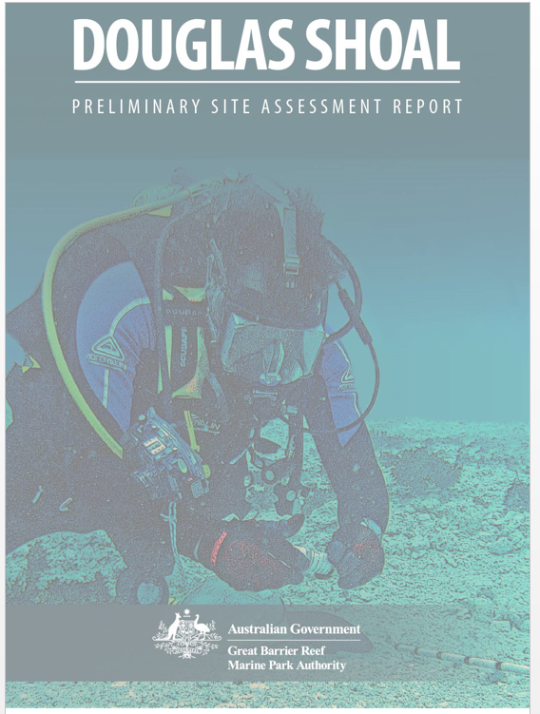

© Commonwealth of Australia 2017
Published by the Great Barrier Reef Marine Park Authority
ISBN 978-0-9953732-8-0
This document is licensed by the Commonwealth of Australia for use under a Creative Commons By Attribution 4.0 International licence with the exception of the Coat of Arms of the Commonwealth of Australia, the logo of the Great Barrier Reef Marine Park Authority, any other material protected by a trademark, content supplied by third parties and any photographs. For licence conditions see: http://creativecommons.org/licences/by/4.0


While all efforts have been made to verify facts, the Great Barrier Reef Marine Park Authority takes no responsibility for the accuracy of information supplied in this publication.

This publication should be cited as:
Costen, A. Ims, S. and Blount, C. 2017, Douglas Shoal Preliminary Site Assessment Report. Document R.1.59918002, Version 1. Report prepared by Cardno Ltd for the Great Barrier Reef Marine Park Authority, Townsville.

Comments and questions regarding this document are welcome and should be addressed to:
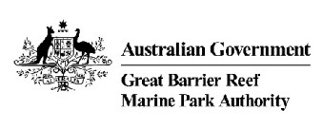
Great Barrier Reef Marine Park Authority
2–68 Flinders Street
(PO Box 1379)
Townsville QLD 4810, Australia

Phone: (07) 4750 0700
Fax: (07) 4772 6093
Email: info@gbrmpa.gov.au
www.gbrmpa.gov.au

Executive Summary
The Chinese bulk carrier ‘Shen Neng 1 (Figure 1-1) ran aground on Douglas Shoal in April 2010 and caused the largest known direct impact on a coral reef (within the Great Barrier Reef World Heritage Area) by a ship grounding’ (GBRMPA, 2015).
Following the court settlement associated with the grounding incident, the Great Barrier Reef Marine Park Authority (GBRMPA) established the Douglas Shoal Environmental Remediation Project. As part of a broad planning exercise, GBRMPA engaged Cardno to review 10 previously commissioned studies relating to the grounding of Shen Neng 1, and incorporate relevant data into an ArcGIS database.
This report presents the current consolidated state of knowledge regarding Douglas Shoal, including the environmental conditions and values.
Situated in approximately 40 m of water, Douglas Shoal is a non-biogenic, ‘submerged shoal-reef’ located approximately 90 km east of Yeppoon. The benthic substrate is predominantly hard limestone pavement (85%), with the remainder comprising gutters and holes filled with carbonate dominated rubble and sand. Benthic habitats are dominated by macro algae, with Sargassum abundant over 53% of surveyed tracks. A further 38% was classified as macro algae and filter feeder dominated communities, including various algal species, and hard and soft corals. A diverse assemblage of benthic invertebrate animals take advantage of these habitats.
The morphology of Douglas Shoal comprises a distinct ‘Reefal Shoal Top’, which includes a ‘Low Relief Terrace’ and a ‘High Relief Terrace’. Undamaged benthic habitat within the grounding footprint are consistent with other areas of Douglas Shoal.
On 3 April 2010, Shen Neng 1 grounded on Douglas Shoal, moving across some 42 hectares during the 10 days before she was re-floated and towed away. The vessel suffered extensive plate damage during the grounding, which comprised plate indentation, push-up, buckling and cracking. The rudder was slightly damaged but the propeller was not.
Underwater inspection and sampling of the hull was undertaken some 6 weeks following the grounding incident indicated that damaged sections of the hull showed evidence of significant paint loss. Chemical analysis of paint samples confirmed the presence of active (biocide) ingredients including tributyltin, zinc oxide and copper oxide, copper pyrithione and zineb at environmentally significant concentrations.
Data provided by GBRMPA were used to develop a series of figures and maps that broadly define the nature and scale of physical damage and contamination associated with the grounding incident. Importantly, most physical damage and contamination is situated in a single low relief morphological zone at the western end of Douglas Shoal. These figures also show extensive areas of contamination associated with antifouling paint particles.
While no data are available for 77% of the grounding footprint, the distribution of physical damage and contamination is focussed at four quite distinct areas. These distinct areas, annotated A, C, E and F are predominantly within the grounding footprint and represent priorities for further investigation and possible remediation.
A number of important data and information gaps were identified which may require consideration before any remediation works commence. These include mapping of each priority area to help establish specific remediation objectives and project success criteria.

Table of Contents
1 Introduction 9
1.1 Background 9
1.2 Purpose and Intended Audience 9
1.3 Scope 10
1.4 Approach 10
1.4.1 Cardno’s Team 11
1.4.2 Key Terms 11
1.4.3 Data and Information Sources 11
1.4.4 Synthesis of Data and Information 11
1.4.5 Information Gaps and Risks 11
1.5 Report Structure 12
1.6 Assumptions and Limitations 12
2 Setting, Environmental Values and Condition 14
2.1 Overview 14
2.2 Location 14
2.3 Management Arrangements 16
2.3.1 Key Legislation 16
2.3.2 Marine Park Zoning 16
2.3.3 Relevant Policies 16
2.3.4 Regulatory Environment 16
2.4 Great Barrier Reef Marine Park Values 17
2.5 Biodiversity Values 17
2.5.1 Physical Processes 17
2.5.2 Geomorphological Setting and Features 20
2.5.3 Benthic Substrate an Habitat 23
2.5.4 Marine Species 25
2.5.5 Listed Threatened and Migratory Species 29
2.6 Traditional Owner Heritage Values 31
2.7 Historic Heritage Values 31
2.8 Social and Economic Values 31
2.9 Gaps 32
3 Incident Summary 33
3.1 Overview 33
3.2 Key Information and Data Sources 33
3.3 Shen Neng 1 33
3.4 Grounding of the Shen Neng 1 34
3.5 Damage to Shen Neng 1 35
3.6 Data and Information Gaps 35
4 Physical Damage and Contamination 39
4.1 Overview 39
4.2 GBRMPA-commissioned Studies – Summary of Damage and Contamination 39
4.3 Approach to Consolidating Results and Findings 40
4.3.1 Rationale 40
4.3.2 Concepts and Definitions 40
4.4 Physical Damage 43
4.4.1 Nature of Physical Damage 43
4.4.2 Scale of Physical Damage 44
4.5 Contamination 47
4.5.1 Nature 47
4.5.2 Scale of Contamination 47
4.6 Physical Damage and Contamination 50
4.7 Potential Impacts 50
4.7.1 Biodiversity 50
4.7.2 Traditional Owner Values 50
4.7.3 Historic Heritage Values 54
4.7.4 Social and Economic Values 54
4.8 Data and Information Gaps 54
5 Possible Priority Areas 55
5.1 Overview 55
5.2 Approach 55
5.3 Possible Priority Areas 57
5.3.1 Area A 57
5.3.2 Area C 58
5.3.3 Area E 59
5.3.4 Area F 60
5.4 Data and Information Gaps 61
6 Summary of Critical Information Gaps and Associated Risks 66
6.1 Overview 66
7 References 71
Appendix A – DSERP Objectives 73
Appendix B – GBRMPA Request for Quote 75
Appendix C - Cardno Team CVs 77
Appendix D – Method Statement - GIS Database 79
Appendix E – Build Reports for Maps and Figures 81
Appendix F – Additional Figures 83
Appendix G – EPBC Act Protected Matters Report 93
Tables
Table 1-1 GBRMPA-commissioned site investigations and reports 12
Table 1-2 Report structure / concordance with scope 13
Table 2-1 Distances to known anchorages, ports and harbours 16
Table 2-2 Reported / Observed site conditions 19
Table 3-1 Applied paint products, volumes and key active ingredients 34
Table 4-1 Summary of results / observations relating to physical damage and contamination (GBRMPA-commissioned studies) 41
Table 4-2 Framework components and definitions 43
Table 6-1 Data and Information Gaps as Risks to effective remediation planning and monitoring 67

Figures
Figure 1-1 Shen Neng 1 aground on Douglas Shoal – 4 April 2010 (AMSA 2010) 9
Figure 2-1 Douglas Shoal - Location 15
Figure 2-2 Quick Bird image and bathymetry data 21
Figure 2-3 Bathymetry of Capricorn-Bunker Group with a cross section (A – B) through Douglas, Haberfield and Innamincka shoals 22
Figure 2-4 Geomorphic features and zones of the south western section of Douglas Shoal 24
Figure 2-5 Representative images from of benthic substrate types within the south-western section of Douglas Shoal (outside the grounding footprint) 26
Figure 2-6 Select images of benthic habitats from outside grounding footprint (Negri et al. (2010) 27
Figure 2-7 Turbinaria sp coral on macro algae dominated limestone substrate (Marshall 2010) 28
Figure 2-8 Visually dominant macro algae – October 2013 (Kettle 2014) 28
Figure 2-9 School of Trevally and a diver (Marshall 2010) 29
Figure 2-10 Aggregation of fish over area of higher relief (Marshall 2010) 30
Figure 2-11 Sea snakes were abundant during the site visits (Marshall 2010) 30
Figure 3-1 Location, path and speed of Shen Neng 1 during grounding incident 36
Figure 3-2 Grounding footprint 37
Figure 3-3 Images of Shen Neng 1 aground at Douglas Shoal. Aerial imagery of sediment plumes created during the Shen Neng 1 grounding period. Flood tide (A, B, C; MSQ 2010) and ebb tide (D; AMSA 2010) plume movement on April 4. Aerial images from April 6 (E), (F) (G & H) (MSQ, 2010) 38
Figure 4-1 Composite map of physical damage 45
Figure 4-2 Images of physical damage 46
Figure 4-3 Composite map of contamination 49
Figure 4-4 Images of in-situ AFP 51
Figure 4-5 Composite map of physical damage and contamination 52
Figure 4-6 2016 World View 2 satellite imagery (red arrows point to visible scars, see Figure 3-2 for corresponding bathymetry) 53
Figure 5-1 Possible areas for remediation 56
Figure 5-2 Area A - data summary 57
Figure 5-3 Area C – data summary 58
Figure 5-4 Area E – data summary 59
Figure 5-5 Area F – data summary 60
Figure 5-6 Possible Priority Area – A 61
Figure 5-7 Possible Priority Area – C 63
Figure 5-8 Possible Priority Area - E 64
Figure 5-9 Possible Priority Area - F 65

Glossary of commonly used terms
The glossary below provides definitions for terminology used throughout this report.
Antifouling Paint: A marine paint composition containing Biocides, which prevent or retard fouling or growth on vessel hulls.
Antifouling Paint Particle: a particle antifouling paint abraded from the hull of Shen Neng 1
Benthic: The bottom of the seafloor which includes the collection of organisms living on or in the bottom
Biocide: The active ingredient in Antifouling Paint that prevent the settlement, adhesion and growth of organisms to a painted surface Biocides may include heavy metals, organometallics, herbicides and pesticides.
Fauna: the animals of a particular region, habitat, or geological period
Geomorphology: Scientific study of landforms and the processes that shape them. (Australia State of the Environment Report 2011)
Geomorphic Zone: a zone with discrete morphological features
Georeferenced: Geographic data aligned to a known coordinate system (ESRI 2017)
Grounding Footprint: The area of Douglas Shoal over which the Shen Neng 1 moved during the incident
Habitat: The environment occupied by an organism or groups of organisms. (Adapted from EPBC Act)
High Relief Terrace: a morphological zone of Douglas Shoal comprising high relief gutters and holes. Part of the Reefal Shoal Top
Impact: An event or circumstance which has an effect, either positive or negative, on a value
Incident: The events associated with the grounding, refloating and salvage of Shen Neng 1
Indirect impact: An impact that is not the direct result of a particular action but has been made possible by that action. These include downstream or upstream impacts, as well as facilitated or consequential impacts resulting from further actions (including actions by third parties. Indirect impacts may manifest over the longer term.
Low Relief Terrace: a morphological zone of Douglas Shoal comprising low relief features such as gutters and holes. Part of the Reefal Shoal Top
Macro algae: a collective term used for seaweeds and other benthic marine algae that are generally visible to the naked eye
Marine Park: Great Barrier Reef Marine Park
Matters of national environmental significance: Those matters defined in the Environment Protection and Biodiversity Conservation Act 1999
Mean Low Water: The average of all the low water heights observed over a 19-year period
Morphology: The form and structure of animals and plants, without regard to their functions
Natural Recovery: recovery of a system without active intervention
Nature: In this report, the location and type of physical damage or a contaminants chemical or physical properties
Non-biogenic: non-reef building
Outstanding universal value: Cultural and/or natural heritage which is exceptional as to transcend national boundaries and to be of such significance to humanity as a whole to make it worthy of special protection. (Adapted from Operational guidelines for the implementation of the World Heritage Convention)
Protected species: A species that is prescribed as endangered wildlife, vulnerable wildlife or rare wildlife under the Nature Conservation Act 1992 (Qld); as defined in the GBRMP Act
Reefal Shoal Top: Morphological zone, top of Douglas Shoal. Comprises a Low Relief Terrace and a High Relief Terrace
Reefal Shoal Slope: Morphological feature or zone. Gentle and or steep slope of a shoal
Rehabilitation: the act of partially or, more rarely, fully replacing structural or functional characteristics of an ecosystem that have been diminished or lost, or the substitution of alternative qualities or characteristics than those originally present with the proviso that they have more social, economic or ecological value than existed in the disturbed or degraded state
Remediation: the act or process of remedying or repairing damage including the removal of contamination and / or pollutants.
Resilience: the capacity of an ecosystem to recover from disturbance or withstand ongoing pressures
Responsible party: The owner and insurers of Shen Neng 1
Restoration: the act of bringing a degraded ecosystem back into, as nearly as possible, its original condition
Risk: effect of uncertainty on objectives (Australian Standard for Risk Assessment (AS/NZS ISO 31000:2009))
Submerged Reefal Shoal: Reefs not at modern sea level, but with some growth over the older foundations
Substrate: the surface or material on or from which an organism lives, grows, or obtains its nourishment (Merriam-Webster 2017)
Traditional Owner: An Indigenous person recognised in the Indigenous community or by a relevant representative Aboriginal or Torres Strait Islander body as having spiritual or cultural affiliations with a site or area in the Marine Park, or as holding native title in relation to that site or area; and who is entitled to undertake activities under Aboriginal or Torres Strait Islander custom or tradition in that site or area
Value: Those aspects or attributes of an environment that make it of significance
Vessel – Shen Neng 1
World Heritage Area: Great Barrier Reef World Heritage Area
Zones of influence: Areas where impacts have detectable effects on values

Acronyms
AMSA: Australian Marine Safety Authority
AFP particle: Antifouling paint particle
AFP: Antifouling paint
ATSB: Australian Transport Safety Bureau
C’th: Commonwealth
DPSIR: Driver, Pressure, State, Impact, Response framework
GBRMP: Great Barrier Reef Marine Park
GBRMPA: Great Barrier Reef Marine Park Authority
GBRWHA: Great Barrier Reef World Heritage Area
MLW: Mean Low Water
Sp.: Species
TBT: Tributyltin

Introduction

Background
The Chinese bulk carrier Shen Neng 1 (Figure 1-1) ran aground on Douglas Shoal in April 2010 and caused the largest known direct impact on a coral reef by a ship grounding (GBRMPA, 2015).
The Great Barrier Reef Marine Park Authority (GBRMPA) established the Douglas Shoal Environmental Remediation Project (the project) in late 2016 with funds from a court settlement associated with the grounding incident.
The primary objective of the Douglas Shoal Environmental Remediation Project (the project) is to “ensure that settlement funds provided by the responsible party deliver the greatest long-term environmental benefits”. The project will focus on maximising the chances for natural recovery and minimising the environmental and human risks of remediation activities.
As part of a broader planning exercise, the Douglas Shoal Environmental Remediation Project team (the project team) identified the need to synthesise findings from 10 studies (Table 1-1) commissioned by GBRMPA between 2010 and 2016 and compile a Preliminary Site Assessment Report. GBRMPA engaged Cardno in July 2017 to assist the project team deliver this report.
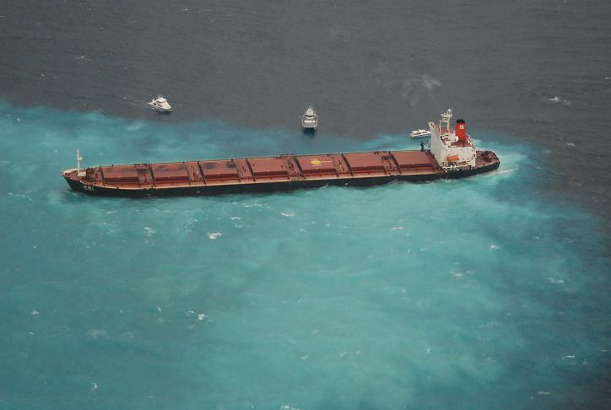
          - Shen Neng 1 aground on Douglas Shoal – 4 April 2010 (AMSA 2010)

Purpose and Intended Audience
The purpose of this Douglas Shoal Preliminary Site Assessment Report (‘this report’) is to:
- Present the current consolidated state of knowledge regarding Douglas Shoal, including the:
- Environmental conditions and values (pre and post incident)
- Nature and scale of physical damage associated with the grounding incident
- Nature and scale of contamination associated with the grounding incident
- Identify possible priority areas for remediation
- Identify critical information gaps that represent risks to the successful delivery of key project objectives, including the effective planning of remediation activities.
The intended audience include:
- Great Barrier Reef Marine Park Authority staff, project team members and the Great Barrier Reef Marine Park Authority Board
- Partner agencies, research institutions and interested members of the public
- Potential contractors.

Scope
Cardno’s scope comprised the following::
- Compile a summary table of previous studies, site visits and reports (existing information)
- Prepare a report plus supporting maps or diagrams summarising what is known about:
- Douglas Shoal pre-disturbance (inferred), including typical habitat type(s), the values present and their condition
- The typical oceanic and meteorological conditions at Douglas Shoal
- The location and nature of disturbance (e.g. cause, width, depth) at Douglas Shoal caused by the Shen Neng incident, including any observed changes in habitat type(s) or the condition of values in impacted areas
- The location, extent, composition, concentration and migration of grounding-generated antifouling paint particles, and its environmental impacts that have been observed (past/present) and have been predicted (future)
- The location, extent, composition and migration of grounding-generated rubble, and its environmental impacts that have been observed (past/present) and have been predicted (future).
- Based on (a) to (e):
- Possible priority geographical areas of Douglas Shoal for remediation
- Critical knowledge gaps that pose a major risk to successful remediation of Douglas Shoal.
- In addition to the above, GBRMPA requested Cardno:
- Create a project specific geographic information (GIS) dataset comprising information available to the project
- Prepare any maps, figures and tables required to support the development of this Preliminary Site Assessment Report.
Explicitly excluded from Cardno’s scope of work were:
- Fieldwork or site visits to Douglas Shoal
- Scientific review or critique (critical assessment) of GBRMPA-commissioned studies
- Literature review or research into the potential environmental impacts of antifouling paint or rubble on natural recovery of tropical marine environments
- Literature review or research into possible remediation methods.

Approach
Cardno’s team, data / information sources used, and the approach to develop this report are summarised below with further detail provided in each section (where required).

Cardno’s Team
Prior to the project inception meeting, Cardno established a team comprising specialist staff to deliver the scope of work. The project team was led by Andrew Costen, who worked closely with GBRMPA’s project manager. CV’s for Cardno staff are included in Appendix C.

Key Terms
Where possible, language and key terminology used in this report, reflects that found in the Great Barrier Reef Strategic Assessment: Strategic Assessment Report (GBRMPA, 2014). A glossary of terms is provided.

Data and Information Sources
A list of GBRMPA-commissioned site assessments, reviews and reports provided to Cardno are included in Table 1-1. GBRMPA also provided Cardno with 35.9 gigabytes of electronic data relating to the grounding of Shen Neng 1. This data included 10,672 files sorted into 164 different folders.

Synthesis of Data and Information
This task, largely a desk top exercise comprised:
- A review of written reports listed in Table 1-1 and the development of a summary table
- A search for relevant and publicly available information and data
- Sorting the GBRMPA-provided electronic data and building a GIS database for this project
- Interrogation of data within the GIS database and development of consolidated maps and figures for use in this report.
The structure and content of the project GIS database is shown in Appendix D. References for publically available information and data, where used to support the development of this report, are included in Section 7. Photos that appear in this report are supplied by GBRMPA or other organisations where noted. Data sources for figures developed by Cardno have been referenced accordingly. Build reports for figures and maps are provided in Appendix E.

Information Gaps and Risks
A key task for Cardno, was identifying critical information gaps, and rating these gaps as risks to the project realising its objectives.
In this report, a ‘gap’ refers to the space between "where we are" (the present state) and "where we want to be" (project success). In other words, the gap between what is known about the grounding of Shen Neng 1, and what information is needed to effectively plan and implement remediation works.
The “what we know” component is essentially the information presented in sections 2, 3, 4 and 5 of this this report. Qualitative descriptions of key gaps and uncertainties are provided at the conclusion of each section.
In order to systematically identify information gaps that may present a risk to project success (the “where we want to be” component), Cardno completed a literature search to identify information needs for the effective planning of ship grounding remediation activities. No specific guidelines for the remediation of coral reefs were identified. Following discussions with Cardno land remediation specialists, and consultation with the project team, it was decided to evaluate identified information gaps (for each section of this report) as risks to remediation planning and monitoring of remediation (the likely next phases of the project). This approach is deliberately descriptive and qualitative.
GBRMPA’s Integrated Risk Rating Tool (Rev 4) was used to assign risk levels for identified information gaps. Risks are presented as untreated. However, suggested treatment actions are included. Further detail is provided in Section 6 of this report.
            - GBRMPA-commissioned site investigations and reports
Year | Report Title | Citation
2010 | Structural Damage to Douglas Shoal Caused by Grounding of Shen Neng 1 - Derived from High-resolution Multibeam Sonar Bathymetry and Backscatter Strength (data only) | Stieglitz 2010
2010 | Grounding of the Shen Neng 1 on Douglas Shoal: Multibeam Sonar Bathymetry and Towed Video Assessments | Negri et al. 2010
2010 | Preliminary Impact Assessment: Grounding of the Shen Neng 1 on Douglas Shoal Great Barrier Reef - Summary | Marshall 2010
2010 | Shen Neng 1 Hull Sampling: 21 May 2010 | Monkivitch 2010
2011 | Grounding of the Shen Neng 1 on Douglas Shoal, April 2010: Impact Assessment Report | GBRMPA 2011
2011 | Independent Review of Impact Assessment Report ''Grounding of the Shen Neng 1 on Douglas Shoal, April 2010" | Kettle 2011
2014 | October 2013 Reef Damage Reassessment of the Shen Neng 1 Grounding Site, Douglas Shoal, Great Barrier Reef, Australia* | Kettle 2014
2015 | Remediation Trial for the Shen Neng 1 Grounding Site, Douglas Shoal, Great Barrier Reef, Australia.* | Kettle 2015ª
2015 | Supplementary Report: Remediation Trial for the Shen Neng 1 Grounding Site, Douglas Shoal, Great Barrier Reef, Australia.* | Kettle 2015^{b}
2016 | Douglas Shoal Trophic Contamination Survey | Marshall 2016
*Reports produced by Dr Brett Kettle between 2014 and 2015 were provided to Cardno in redacted form.

Report Structure
The structure and content of this report is shown in Table 1-2. Where possible, call out boxes, tables and figures are used to help expedite review and relay key messages. Supporting information is provided in a series of appendices. Identified information gaps are listed at the end of Sections 2 through 5 and consolidated in Section 6.

Assumptions and Limitations
Please note the following qualification when reading this report:
- It is not the intention of this report to present the results of previous studies in their entirety, nor is it a critical review of GBRMPA-commissioned investigations and reports
- Interpolations, predictions of damage (for example predictions of the possible migration of AFP), are not included (however, reference is made to the potential for migration)
- Figures / maps (herein) incorporate georeferenced data from the project GIS only
- While based on georeferenced data, locations of data reflect the inaccuracies associated with the original source.
Where required, additional qualifications are included in each section.

            - Report structure / concordance with scope
Section |  | Content and Purpose
1 | Introduction | - Context, approach and structure of this report
2 | Setting, Values and Condition | - Provides an overview of management arrangements for the Marine Park (relevant to Douglas Shoal)  - Describes the Marine Park Values of Douglas Shoal  - Likely pre-disturbance (inferred/interpreted) condition of Douglas Shoal, including substrate, habitats and biota  - Identifies gaps and uncertainties that may represent a risk to remediation planning and monitoring.
3 | Incident Summary | - Provides a synopsis of the grounding of Shen Neng 1  - Includes a summary of damaged sustained by Shen Neng 1  - The purpose of this section is to help contextualise the description of physical damage and antifouling paint contamination associated with the grounding incident (Section 4)  - Identifies gaps and uncertainties that may represent a risk to remediation planning and monitoring.
4 | Physical Damage and Contamination | - Summarises the results of damage to Douglas Shoal and contamination reported in GBRMPA-commissioned studies / reports  - Presents a series of figures / maps that incorporate relevant and available georeferenced data  - Describes the nature and scale of physical damage and contamination associated with the grounding incident (as shown in supporting figures)  - Informs the identification of possible priority areas for remediation  - Identifies gaps and uncertainties that may represent a risk to remediation planning and monitoring.
5 | Possible Priority Areas for Remediation | - Identifies and describes possible priority areas of Douglas Shoal for remediation  - Identifies gaps and uncertainties that may represent a risk to remediation planning and monitoring.
6 | Critical Information Gaps and Risks | - Presents the results of the gap analysis  - Evaluates the identified gaps as risks  - Includes suggestions to ameliorate risks
7 | References
Appendices

Setting, Environmental Values and Condition

Overview
This section:
- Includes locational information
- Provides and overview of management arrangements for the Marine Park (relevant to Douglas Shoal)
- Describes the Marine Park Values of Douglas Shoal
- Includes a description of the likely pre-disturbance (inferred/interpreted) condition of Douglas Shoal, including substrate, habitats and biota.
The purpose of this section is to:
- Identify the Marine Park Values likely affected by the grounding incident
- Help guide future discussions regarding what ‘natural recovery’ may look like for areas of Douglas Shoal impacted by the grounding incident
- Inform future contractors regarding working conditions at the site (potential constraints)
- Identify gaps and uncertainties that may represent a risk to remediation planning and monitoring.
Key points are presented below. Identified gaps are included at the end of this section.

Key Points
- Douglas Shoal is in the sea country of the Gooreng Gooreng, Gurang, Byellee and Tarebilang Bunda people.
- Situated in approximately 40 m of water, Douglas Shoal is a non-biogenic, ‘submerged shoal-reef’ located approximately 90 km east of Yeppoon.
- The benthic substrate is predominantly hard limestone pavement (85%), with the remainder comprising gutters and holes filled with carbonate dominated rubble and sand.
- Benthic habitats are dominated by macro algae, with Sargassum abundant over 53% of surveyed tracks. A further 38% was classified as macro algae and filter feeder dominated communities, including various algal species, and hard and soft corals.
- A diverse assemblage of benthic invertebrate animals take advantage of these habitats.
- The morphology of Douglas Shoal comprises a distinct ‘Reefal Shoal Top’, which includes a ‘Low Relief Terrace’ and a ‘High Relief Terrace’.
- The grounding footprint is situated entirely within the Low Relief Terrace.
- Undamaged benthic habitat within the grounding footprint are consistent with other areas of Douglas Shoal.
- Pelagic and coral associated fish are common.
- Other vertebrate taxa observed included turtles, dolphins and large stingrays, with abundant sea snakes.
- Trawling is prohibited over most of Douglas Shoal (Habitat Protection Zone), however, commercial line fishers targeting coral trout and Spanish mackerel may work the area.
- Due to the exposed location of Douglas Shoal, it is unlikely that it is heavily visited by tourism operators. However, it holds considerable value to recreational fishers who visit it during calmer conditions.

Location
Douglas Shoal is situated within the ‘Southern Region’ of the Great Barrier Reef, which extends from 20° S to 24° S and includes the Swains Reefs and the Capricorn-Bunker group. Douglas Shoal is located approximately 90 km east of Yeppoon (151º40'E, 23º5'S), and north of the Capricorn Group of reefs and islands (Figure 2-1). Table 2-1 identifies distances to anchorages, coastal ports and harbours.

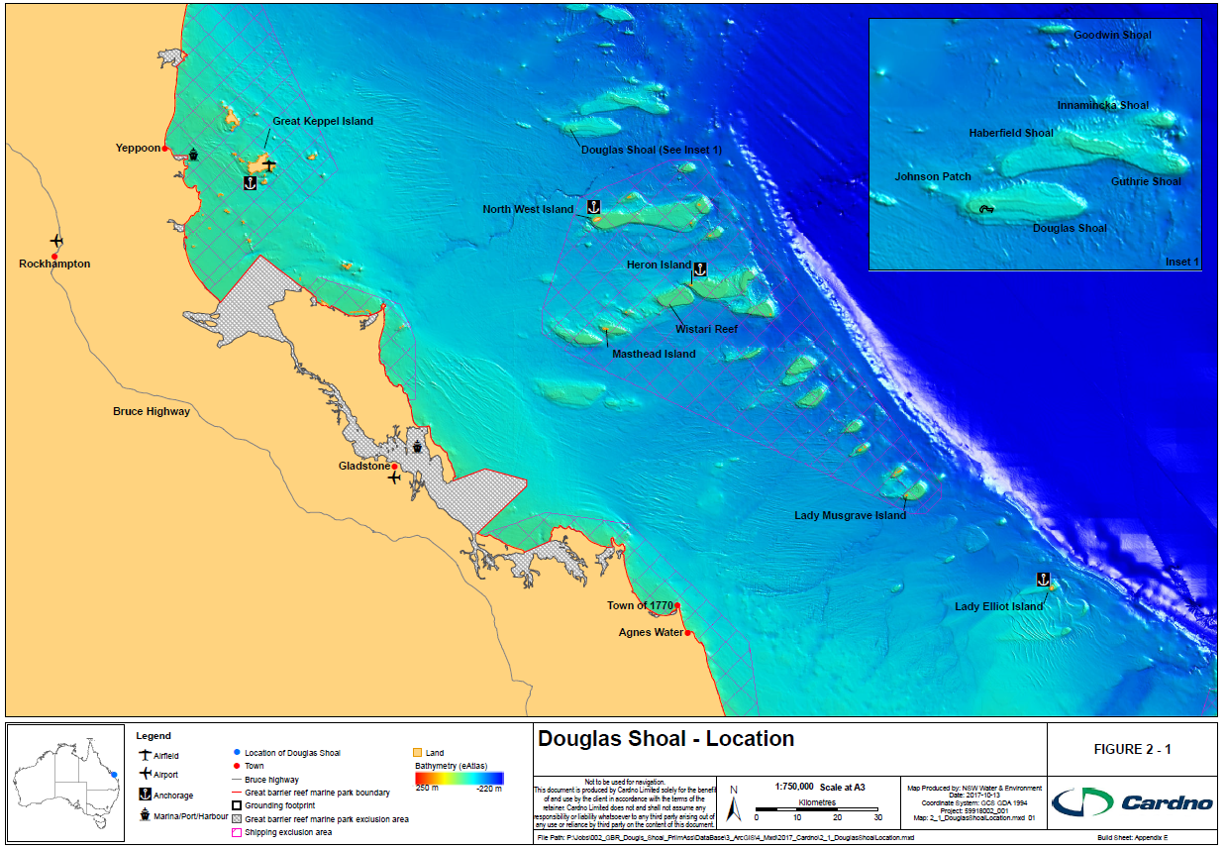
          - Douglas Shoal - Location

            - Distances to known anchorages, ports and harbours
Place | Kilometres (km) | Nautical Miles(NM)
Lady Musgrave Island | 117.4 | 63.4
Gladstone | 93.3 | 50.4
Heron Island | 47.32 | 25.5
Northwest Island | 23.5 | 12.7
Great Keppel Island | 72.5 | 39.1
Yeppoon | 93.6 | 50.5

Management Arrangements
GBRMPA uses a wide range of tools to manage the Marine Park. Key instruments are summarised below. Further details are available at www.gbrmpa.gov.au

Key Legislation
Douglas Shoal is one of the 2900 reefs and shoals within the Marine Park and the Great Barrier Reef World Heritage Area (GBRWHA). The Marine Park is managed by the Great Barrier Reef Marine Park Authority. Key legislation includes the Great Barrier Reef Marine Park Act (1975) the Great Barrier Reef Marine Park Regulations (1983) and the Environment Protection and Biodiversity Conservation Act (1999).

Marine Park Zoning
The Great Barrier Reef Marine Park is a multiple-use area. The Great Barrier Reef Marine Park Zoning Plan 2003 provides for a range of ecologically sustainable recreational, commercial and research opportunities and for the continuation of traditional activities. Zoning helps to manage and protect the values of the Marine Park that people enjoy. Each zone has different rules for the activities that are allowed, the activities that are prohibited, and the activities that require a permit. Zones may also place restrictions on how some activities are conducted.
Most of Douglas Shoal falls within the Habitat Protection Zone (HPZ); however, a small part of the northern and eastern shoal margins falls within the General Use Zone (GUZ). The grounding footprint is located entirely within the HPZ. For a map showing the zoning, see:
http://elibrary.gbrmpa.gov.au/jspui/bitstream/11017/609/4/Map17-EditionV-Capricorn.pdf
The objectives of the HPZ are to provide for the conservation of Douglas Shoal through the protection and management of sensitive habitats by being generally free from potentially damaging activities while providing opportunities for its reasonable use. A notable difference between HPZ and GUZ is that trawling is prohibited in HPZ, as the focus is on protecting sensitive benthic habitat. This is relevant as the grounding incident specifically damaged sensitive benthic habitat that the Zoning Plan aims to protect.

Relevant Policies
The following policies are likely to be relevant to the project and can be found on GBRMPA’s website:
- Policy on moorings in the Great Barrier Reef
- Dredging and spoil disposal policy
- Guidelines for the use of hydrodynamic numerical modelling for dredging projects in the Great Barrier Reef Marine Park.

Regulatory Environment
A range of permits, licences and approvals may be required for remediation-related activities. These include:
- Permits or authorisations for carrying out works and/or conducting research under the Great Barrier Reef Marine Park Zoning Plan 2003
- Approval under the Environment Protection (Sea Dumping) Act 1981 for dumping at sea of material including the placement of materials to form artificial reefs.
- Local or State approvals for land-based, coastal or island activities.
Additionally, once a remediation plan is developed, the project team will evaluate whether the proposed works may require referral to the Federal Minister for the Environment under the Environment Protection and Biodiversity Conservation Act 1999 (C’th).

Great Barrier Reef Marine Park Values
The Great Barrier Reef Marine Park is one of the seven relevant matters of national environmental significance (GBRMPA 2014). The values of the Marine Park are grouped into four categories:
- Biodiversity values including physical processes, geomorphology, habitats and marine fauna species
- Traditional Owner heritage values
- Historic heritage values
- Social and economic values.

Biodiversity Values

Physical Processes

Key Information and Data Sources
The Commonwealth Bureau of Meteorology (BOM) maintains weather stations on Heron Island, North Reef and Lady Elliot Island and has recorded data since 1963. The Great Barrier Reef Ocean Observing System (GBROOS) sensor located on Heron Reef provides current and historic weather information including air and water temperature, humidity, pressure, rainfall and wind speed and direction.
Maxwell (1968) and Hopley (1982) summarised the hydrology of the Great Barrier Reef and Wolanski (1994) reviewed its oceanography and hydrodynamics. Marshall (1977), and Hopley et al (2007) provided general details for the Capricorn-Bunker Group.
An analysis of the hydrodynamic conditions for three-16-day periods (during 2015) was undertaken by Cardno using data obtained from the eReefs website’s data portal.
Observations relating to physical conditions (weather, currents) experienced at Douglas Shoal during site visits were recorded by Marshall 2010, GBRMPA 2011 and Kettle 2011, Kettle 2014(a) and Marshall 2016. These observations are summarised in Table 2-2 and provide useful qualitative information.
Historic wave and current data are available from the Great Barrier Reef Ocean Observing System (GBROOS) portal: http://data.aims.gov.au/gbroos

Climate and Weather
The climate is subtropical with summer conditions occurring around November / December to May and slightly milder (winter) conditions between June and late October. The yearly mean temperature is 24.5°C. Monthly average maximums range from 21.5 to 30°C and minimums from 16.5 to 24.2°C. Sea-surface temperatures vary from a summer maximum of 27°C, to a winter low of 21.5°C (AIMS, 2014).
Rainfall averages 1047 mm (BOM 2017), with December to May the wettest months. June to September is the driest period of the year, as anticyclones that track east across the Australian continent at this time bring mostly calm and settled conditions to region. The wind regime is dominated by the southeasterly trade winds, while a more westerly component develops during winter following the passage of cold fronts over southern Australia. Wind direction becomes more variable in summer with the occurrence of occasional strong northeasterlies, although southeasterly winds still dominate. The strongest winds are associated with the passage of tropical cyclones during the summer.
For weather forecast information see: www.bom.gov.au/qld/forecasts/map.shtml

Regional Oceanographic Conditions
Prevailing currents are driven by the tides and wind forcing, with the contribution from wind forcing being proportional to the wind strength.
During periods of south-south easterly winds, flow on the inner- and mid-shelf is predominantly north-north-west with tidal motion superimposed on the wind driven circulation. On the outer shelf, the flood tide sets west and the ebb east, producing strong currents through the Capricorn reefs.
Swell and wind waves from the east and southeast provide the greatest sources of wave energy to Douglas Shoal. Large southerly swells refract around Fraser Island and the southern tip of the Capricorn Bunker to Douglas Shoal, but wave heights are significantly reduced during this refraction. Guthrie and Innamincka Shoals to the north-east offer little protection from east to southeast swells and seas, which frequently reach 2-3 m in height east of the Capricorn-Bunker Group, and occasionally become much larger during storm and cyclone events.

Wind, Currents and Tidal Measurements
An analysis of hydrodynamic conditions was undertaken using data obtained from the eReefs website’s data portal. This interactive platform provides access to a diverse range of modelled and measured data for the Great Barrier Reef, including the CSIRO‘s GBR1 shelf model, a 1km resolution model that integrates hydrodynamics, biogeochemistry and sediment processes.
The hydrodynamic components were extracted from the nearest grid point to Douglas Shoal (~ 1 km to the south west of the grounding footprint) for three 16-day periods in February, June and October 2015. Plots for wind, wave and currents for February, June and October are included in Appendix F (Figures F-1, F-2 and F-3 respectively). This snapshot provides some context regarding variations in the hydrodynamic conditions due to tides and seasonality. Analysis of this hourly data set showed the following:
- Winds
- Winds speeds on average, ranged between 2 m/s(~ 7 km/hr) and 15 m/s (54 km/hr)
- Winds are predominantly from the south easterly and southerly direction\Strongest winds were found to be slightly higher during February with the maximum of 14.1 m/s (~ 50 km/hr)
- Wind direction during June was more varied, ranging from south to south easterly, while directions remained reasonably constant from south east during February and October.
- Currents
- The current appears to the largely bidirectional along the north westerly- south easterly plane.
- Magnitudes range between 0.1 m/s (0.194 knots) to 0.8 m/s (1.55 knots)
- Magnitudes drop off significantly (<0.5 m/s or less than 1 knot) during the neap tides
- Current magnitudes are highest during the spring tides.
- Tides
- The tides at Douglas Shoal range between -1.8 m AHD and 1.8 m AHD across two daily cycles
- This tidal range was found to diminish slightly during October
- Tidal range of approximately 1 m during neap tides and up to 3.6 m during spring tides
- Tide times lag Gladstone tide times by approximately 30 minutes.
Tide forecasts for Heron Island are available here: https://www.tide-forecast.com/locations/Heron-Island-Australia/tides/latest

Site Visit Observations
Observations, including wind, wave and current conditions at Douglas Shoal and how they impacted field work are reproduced in Table 2-2. While unlikely to be representative of the full range of local oceanographic conditions, they do provide a useful description of some of the constraints to working at Douglas Shoal.

            - Reported / Observed site conditions
Reference | Date of Site Visit | Reported / Observed Site Conditions
Stieglitz 2010 | 15-17 April 2010 | - ‘Adverse weather conditions reduced data quality (multibeam bathymetry and backscatter)’
Negri et al. 2010 | 15-18 April 2010 | - ‘Adverse weather conditions reduced the sensitivity and resolution of both sonar and towed video surveys’  - Collection of sediment samples… ‘was not attempted due to poor weather conditions’  - ‘Rough weather and strong currents precluded data collection in replicated transects’  - ‘Visual survey was severely limited by sea surface conditions and strong currents due to spring tides’  - ‘Prevailing sea conditions resulted in a meandering track intersecting the known position of the Shen Neng 1’
Marshall 2010 | 12-13 April 2010 | - ‘...strong currents and rough seas….’
GBRMPA 2011 | 11-12 May 2010 | - ‘strong winds and resultant waves made it too difficult to manage diving operations, especially in such an exposed location, with no emergent reef or island for shelter’.  - ‘very strong tidal currents at Douglas Shoal make diving work very difficult except at the turn of the tides, when a 1-2 hour period of minimal water movement provided easier conditions’  - ‘The depth of the impact site (generally 12+ metres) is beyond snorkelling depth for all but very brief inspections, and limited scuba dive times due to limits for no-decompression diving’  - ‘The remoteness of the shoal from safety facilities (~7-8 hours travel) increased the need for margins of error in safety procedures especially regarding diving practices’  - ‘The variable nature of the substratum (shoal bottom), made it difficult to collect sufficient loose sediment in some areas’
Kettle 2011 | 12 May 2011 | - ‘Water currents are very strong at the site, and limit underwater work by divers to 1 – 1.5 hours per high or low tide’  - Water depth….’14 m to 15 m of actual water depth, meaning that divers will run into bottom time limits, or will need to switch to nitrox gas mixes’
Kettle 2014 | 9-13 October 2013 | - “Other than periods of moderate seas hampering surface operations, underwater conditions were comfortable for performing observations and sampling, and visibility was good”
Kettle 2015(a) | 11-18 November 2014 | - ‘At 13 m to 16 m water depth, divers have approximately 50 minutes of breathing air before nitrogen builds to dangerous levels in the blood’  - ‘Visibility less than 15 m (typically)’  - ‘Water temperatures pose no risks to divers’  - ‘Currents and waves limit operational safety from time-to-time and the work method therefore needs to be adapted to making the most of favourable conditions’.
Marshall 2016 | 10-13 July 2016 | - ‘The site visit was undertaken 10-13 July 2016 during a period of favourable tidal and sea conditions’

Weather windows
Noting the above descriptions and the authors own experience on-site, metocean conditions are likely to impact field related remediation tasks. And while June through to October may present the best ‘window’ with regard to avoiding cyclones, careful planning and selection of appropriate equipment will be critical to realising the projects key objectives.

Geomorphological Setting and Features
Maxwell (1968) identified three broad regions of common bathymetry and dissimilar reef distributions on the continental shelf of the Great Barrier Reef (Northern, Central and Southern). Douglas Shoal is situated in the ‘Southern Region’, between 20°S and 24°S, the widest section of shelf, which gradually slopes toward the shelf-edge (Maxwell, 1968).
A majority of coral reefs within the Capricorn-Bunker group are mature lagoonal or planar platform reefs that reach the surface. However, this section of the shelf is also lined with numerous submerged (at all tides) reefal platforms or shoals (GBRMPA 1979). The submerged state of these non-biogenic shoals is most often attributed to ‘drowning’ when rapid post-glacial sea level rise out-paced vertical reef accretion, which was limited by difficult conditions for coral reef growth associated with the last deglaciation (e.g. Fairbanks, 1989; Abbey and Webster, 2011).
Regional bathymetric data collected as part of Project 3DGBR and the Negri et al. (2010) high resolution multibeam bathymetry data (shown in Figure 2-2) indicate that Douglas Shoal is large (5180ha), solitary, wholly sub-tidal, and elongated east – west. The western section of the shoal is the dominant morphological feature, rising some 45 m from the mid-shelf floor to a relatively low relief reefal-shoal top (10 to 15 m below MLW). East of this feature, the shoal dips gently for approximately 7 km’s before sharply dipping to the off-reefal-shoal floor (Figure 2-2).
The morphology of Douglas Shoal is consistent with the nearby Haberfield and Innamincka shoals (see Figure 2-3, which includes cross-section A-B) and the classification of a ‘submerged shoal reef’ by Hopley et al. (2007:152); that is, they are “reefs not at modern sea level, but with some growth over the older foundations, usually most prolific on the highest parts of these Pleistocene foundations.”
The focus of this report is on the south-western section of Douglas Shoal, where the grounding incident occurred. The grounding footprint is shown as an orange polygon. A series of cross sections derived from high resolution multibeam bathymetry data collected by Negri et al. (2010) are provided in Figure 2-4. Of these cross sections, A-B corresponds to a truncated portion of the line shown in Figure 2-3. Cross section C-D intersects part of the grounding footprint from west to east. The north-south cross section (E-F) also intersects the grounding footprint (Figure 2-4). These cross sections were used to describe the local scale morphology of Douglas Shoal.
This report adopts the following terms to refer to the geomorphic zones:
- Off Reefal Shoal Floor
- Reefal Shoal Slope (windward and leeward)
- Reefal Shoal Top
- Low Relief Terrace
- High Relief Terrace.
At the south western margin of Douglas Shoal, and between Haberfield Shoal and Douglas Shoal, the Off Reefal Shoal Floor lies 40 to 45 m below MLW (cross section shown in Figure 2-3) and corresponds to the geological mid-shelf. Seward of Innamincka Shoal, this feature is greater than 60 m below MLW and is contiguous with the carbonate sediment dominated geological outer-shelf.
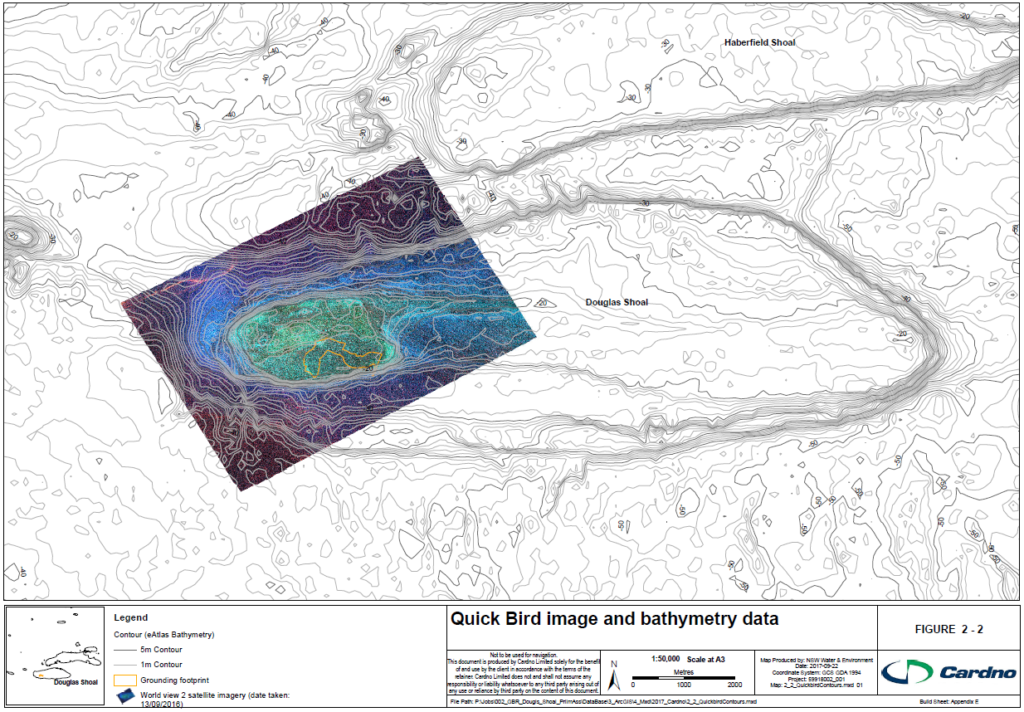
          - Quick Bird image and bathymetry data

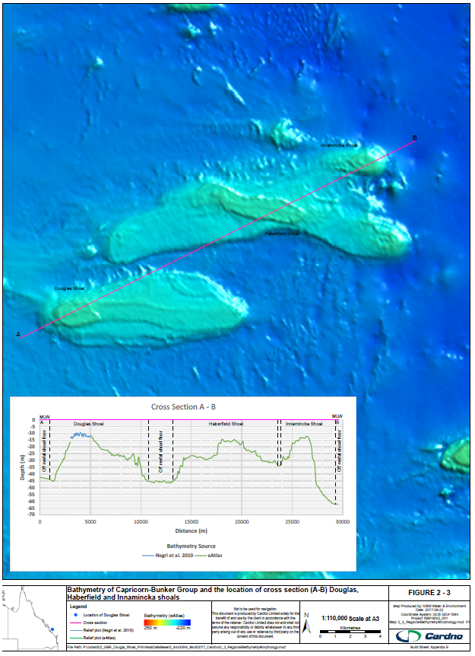
          - Bathymetry of Capricorn-Bunker Group with a cross section (A – B) through Douglas, Haberfield and Innamincka shoals

The Reefal Shoal Slope, with a substrate comprising hard limestone intersected by shallow sand and gravel filled gutters, rises sharply from the Off Reefal Shoal-Floor where it meets the Reefal Shoal Top. As shown in cross sections C–D and E–F (Figure 2-4), the Reefal Shoal Top comprises a Low Relief Terrace, and High Relief Terrace. The Low Relief Terrace rises to within 14 m of MLW, with disconnected gutters and holes the dominant fine scale morphological features. The High Relief Terrace rises to within 9 m of MLW with increased rugosity associated with greater frequency of deep gutters. The substrate of these zones is described in the following section.
Due to the ‘drowned’ nature of Douglas Shoal, geomorphic zonation and features are somewhat simplified. For example, there is no emergent reef flat. It is also likely that the gutters, holes and ridges are relic drainage features that developed during the Pleistocene, when the now Douglas Shoal was a coastal limestone hill, rising some 40 to 50 m above the then adjacent coast.

Benthic Substrate an Habitat

Key Information and Data Sources
No known baseline habitat, coral cover and health data are available for Douglas Shoal. For example:
- Douglas Shoal is not surveyed as part of the AIMS Reef Wide Monitoring Program
- No published reports, papers or reviews relating to the pre-incident condition of Douglas Shoal (habitat type, composition, health) were identified during the literature search component of this study.
Post grounding incident benthic substrate and habitat data (within and outside the grounding footprint), were captured by Negri et al. (2010), Marshall (2010) and (GBRMPA 2011). The relative contribution of benthic substrate and habitat classes is inferred using these data.

Benthic Substrate
Towed Underwater Video (TUV) collected by Negri et al (2010) from undamaged areas of Douglas Shoal indicates that the dominant substrate class across the western section is hard limestone pavement (85%), with gutters and holes filled with carbonate dominated gravel / rubble (10%) and sand (5%).
Images of undamaged benthic substrate are shown in Figure 2-5. A review of the video and still images collected by Negri et al. (2010) indicates that undamaged benthic substrate within the grounding footprint is consistent with other areas of the Low Relief Terrace.
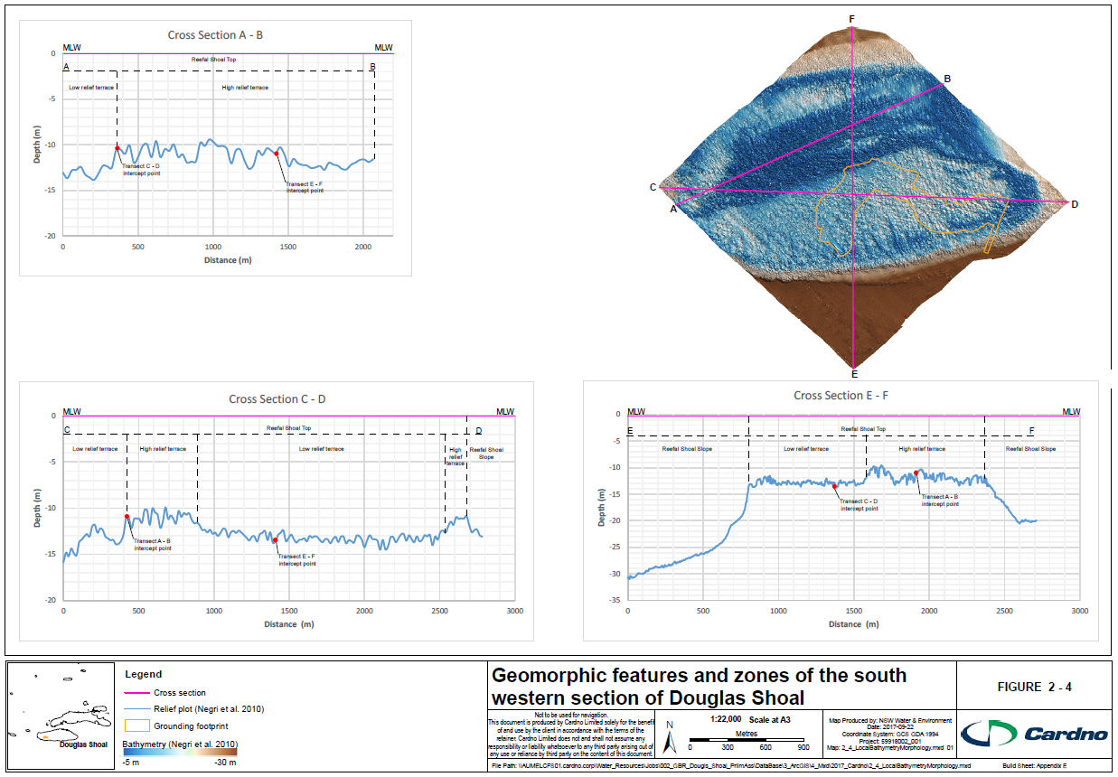
          - Geomorphic features and zones of the south western section of Douglas Shoal

Benthic Habitat
TUV data (Negri et al. 2010), indicate that (undamaged) benthic habitats are dominated by macro algae, with Sargassum abundant over 53% of surveyed tracks. A further 38% was classified as macro algae and filter feeder dominated communities, including various algal species, and hard and soft corals (Figure 2-6). The TUV data indicate that approximately 8% of the surveyed area was dominated by small hard coral colonies and the remaining 1% uncolonised.
Select images of benthic habitat are shown in Figure 2-6. The location of these images is shown in Appendix F, Figure F-5. Of these images A, B, C and F are from Low Relief Terrace and D and E from the High Relief Terrace. These images (and a review of other images within the GIS database collected by Negri et al. 2010), suggest that undamaged benthic habitats (type and composition) within the grounding footprint are consistent with other areas of the Low Relief Terrace, and likely representative of habitat physically damaged by the grounding incident.
Results from other site inspections and surveys of habitat outside the grounding footprint (Marshall 2010, GBRMPA 2011) are consistent with Negri et al. (2010). For example, Marshall (2010) noted that macroalgae visually dominated the shoal substrate, with Sargassum, the most abundant genus. These macro algae were interspersed with coralline red algae and a range of other seaweeds.
A qualitative review of the TUV data provided by Negri et al. (2010) suggests that while hard corals are relatively abundant, they are sparse and tend to occur as individual colonies. These colonies appear to be attached to bare limestone substrate and rarely exceed more than 1 m in diameter. These observations are consistent with the non-biogenic status of Douglas Shoal, and or environments that experience frequent perturbations (disturbances such as cyclones) or are at the outer range of conditions suitable for biogenic reef development.
Another important observation was that made by Kettle (2014). Field work for this study was undertaken in October 2013, while other surveys were completed in either April, May or June. During Kettle’s visit, high standing crops of macro algae (Sargassum) were reported as visually dominant, with a diverse range of small algal species present as understory. Sargassum are strongly seasonal, with peaks in biomass and reproduction during the summer and lowest biomass during the winter (McCook 1999). These high stands of Sargassum may limit future mapping of damaged areas during summer.

Marine Species
A summary of marine species observed at Douglas Shoal is provided below.
Marshall (2010) describes a diverse assemblage of benthic invertebrate animals inhabiting Douglas Shoal. This assemblage included sponges (up to 20 cm), ascidians, zooanthids, anemones, soft corals (particularly Sarcophytyon, Lobophytum, and Sinularia), hard corals, echinoderms (Asteroidea and Crinoidea), and crustaceans (Palinuridae). Hard coral colonies represented approximately 10% of benthic cover, and included the genera, Acropora, Stylophora, Pocillopora, Porites, Montipora, Goniastrea, Goniopora, Scolymia, Turbinaria and various other faviid species. Turbinaria and plating Acropora were the most visually dominant hard corals. (Figure 2-9), many of which were 0.5 to 1 m in diameter.
Abundant fish life was observed on areas of Douglas Shoal by Marshall (2010). Species of emperor (Lethrinidae) and sweetlip (Haemulidae) were observed congregating around small outcrops amidst schools of fusiliers (Caesionidae), damselfishes (Pomacentridae) and other small fish. Coral trout (Plectropomus sp.) and other cods (Serranidae) were observed commonly over the shoal, as were breams (Sparidae), wrasses (Labridae), parrotfishes (Scaridae), and large schools of pelagic fish such as mackerels (Scombridae) and trevally (Carangidae) (Figure 2-9).

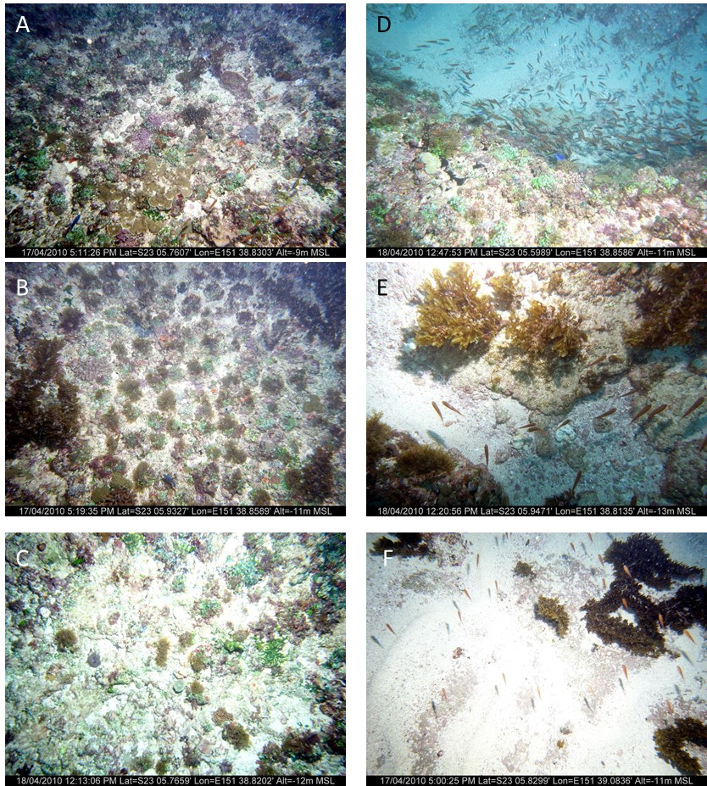
          - Representative images from of benthic substrate types within the south-western section of Douglas Shoal (outside the grounding footprint)
Figure 2-5: Images A, B and C) limestone substrate (with macro algae); D) limestone substrate (covered with macro algae with a sandy gutter; E) rubble with sparse macro algae; F) sand with macro algae.

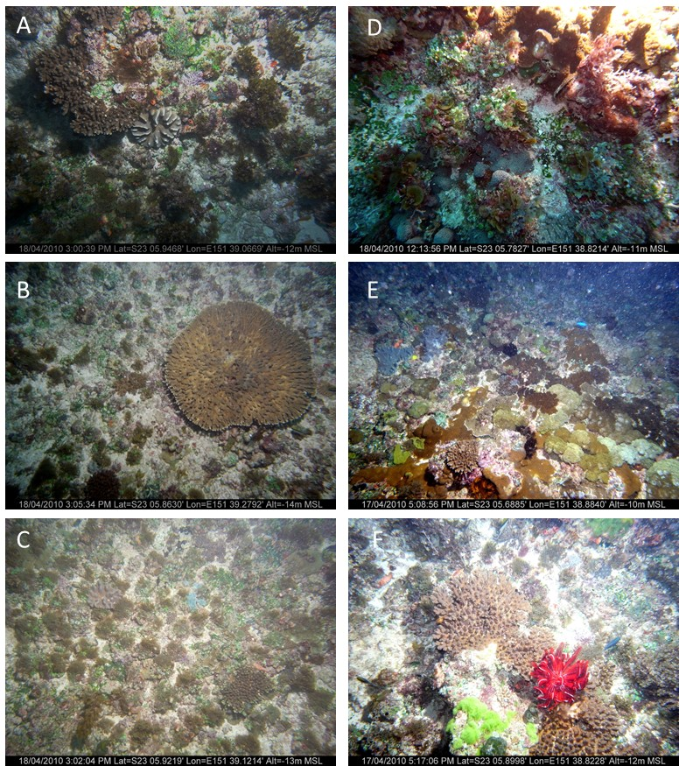
          - Select images of benthic habitats from outside grounding footprint (Negri et al. (2010)
Figure 2-6: A) macro algae and filter feeders with coral; B) macro algae with Acopora spp hard coral; C) macro algae and filter feeders; D) macro algae and filter feeders; E) soft corals, hard corals with filter feeders; F) hard coral and filter feeders.
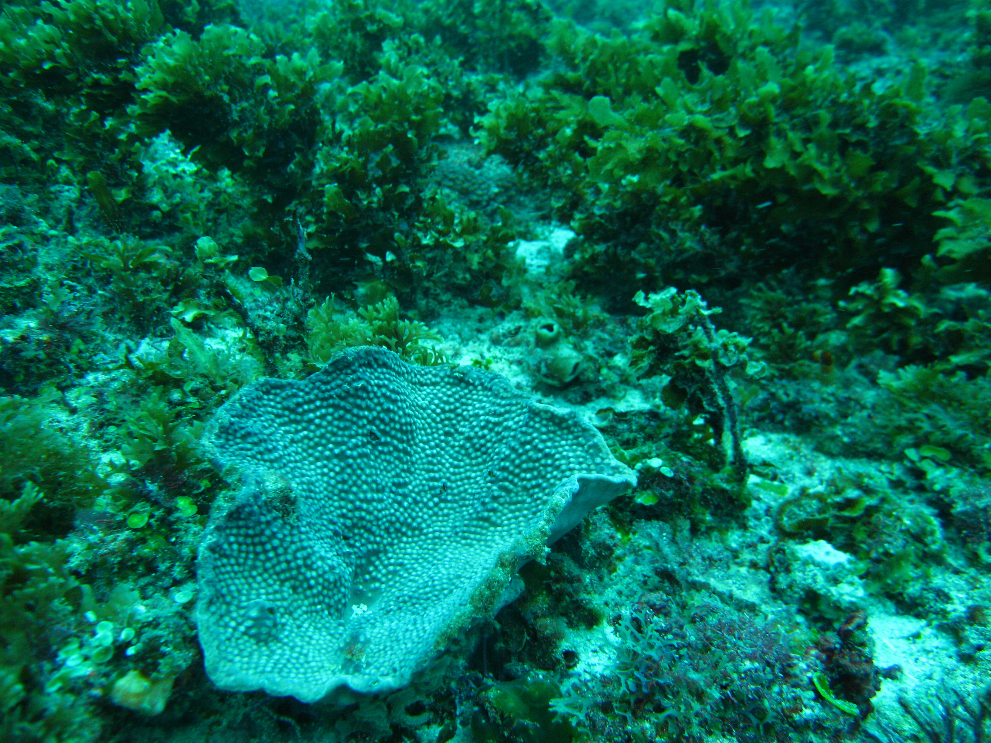
          - Turbinaria sp coral on macro algae dominated limestone substrate (Marshall 2010)
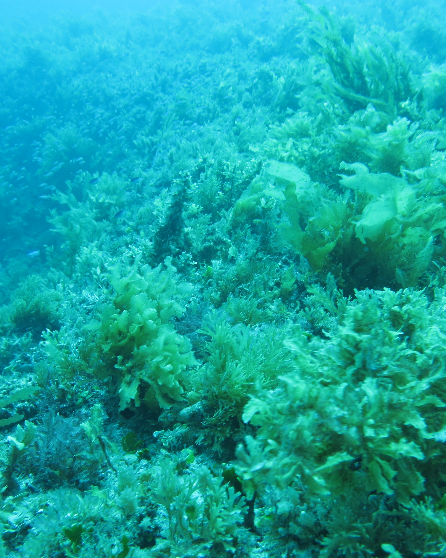
          - Visually dominant macro algae – October 2013 (Kettle 2014)
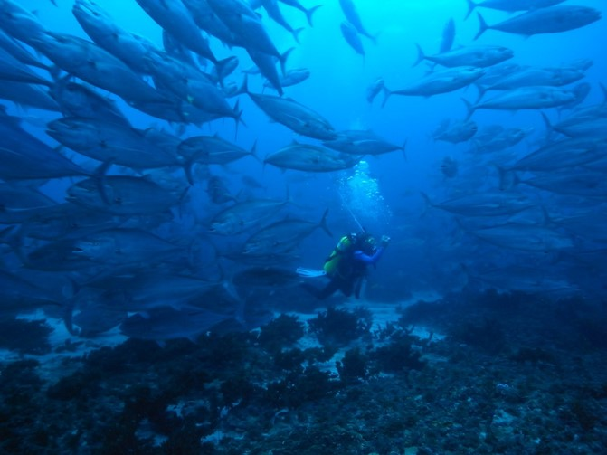
          - School of Trevally and a diver (Marshall 2010)
Coral associated fish included butterfly fishes (Chaetodontidae), angel fishes (Pomacanthidae), blennies (Blennidae), and gobies (Gobidae) as well as extremely large schools of cardinalfishes (Apogonidae), which blanketed large areas of the shoal Negri et al. (2010).
Other vertebrate taxa observed included turtles, dolphins and large stingrays, with abundant sea snakes (Marshall 2010).
No data or information were available regarding the biological connectivity of Douglas Shoal, including sources of coral larvae, dispersal of recruits and patterns of fauna movement.

Listed Threatened and Migratory Species
An EPBC Protected Matters Report was generated on 19 July 2017. The search was undertaken within a 1 km radius of the grounding footprint. In summary, the report identified 19 Listed Threatened Species, including Green Turtles (Chelonia mydas) and 31 Listed Migratory Species, including Tryon's Pipefish (Campichthys tryoni). The complete report is included in Appendix G.
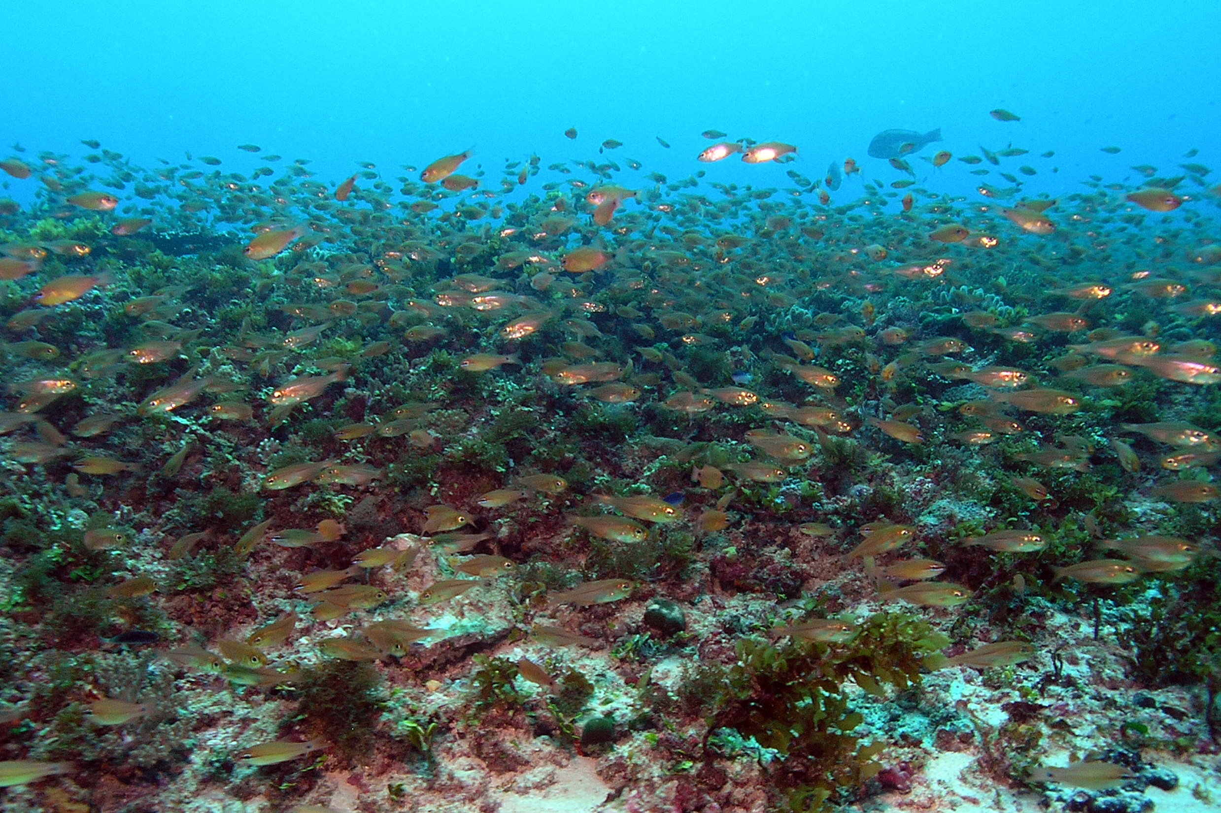
          - Aggregation of fish over area of higher relief (Marshall 2010)
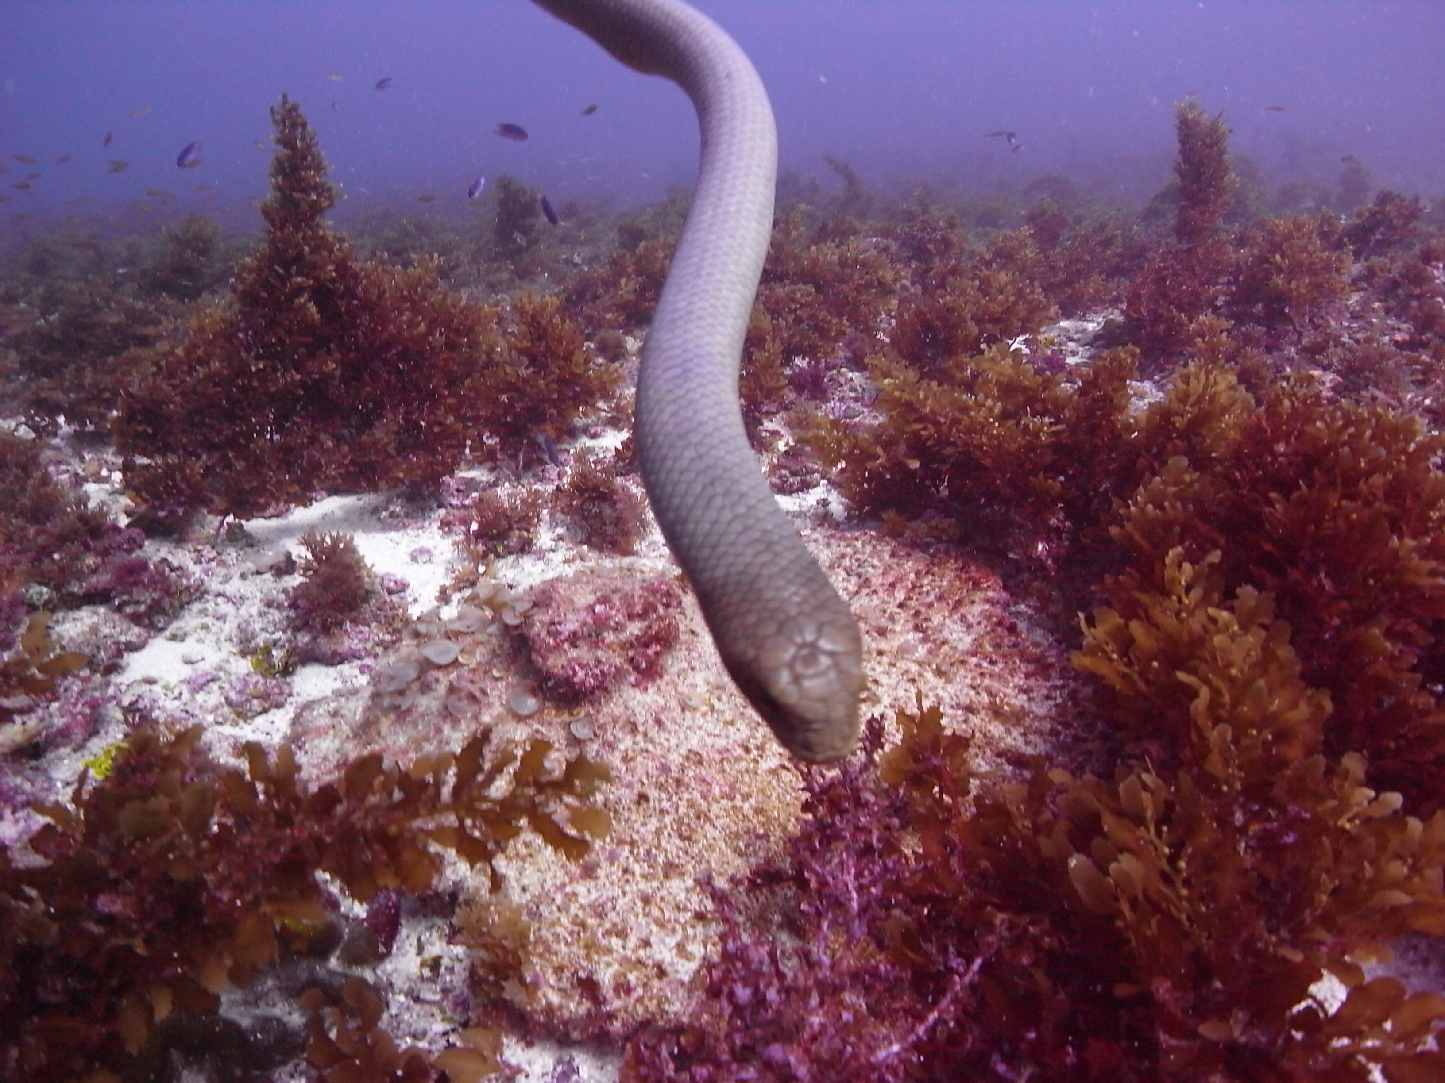
          - Sea snakes were abundant during the site visits (Marshall 2010)

Traditional Owner Heritage Values
Heritage is a central element in Indigenous custom, and its conservation ensures continued respect for Indigenous ancestors and the ancestral beings who shaped the land and waterways GBRMPA (2014). The Great Barrier Reef Region Strategic Assessment combines indigenous heritage values into four broad categories:
- Cultural practices, observances, customs and lore
- Sacred sites, sites of particular significance, places important for cultural tradition
- Stories, songlines, totems and languages
- Indigenous structures, technology, tools and archaeology.
Douglas Shoal is situated within the Port Curtis Coral Coast Traditional Use of Marine Resource Area (TUMRA) in the sea country of the Gooreng Gooreng, Gurang, Byellee and Tarebilang Bunda people.
No published information relating to the area’s use or values of traditional owners were identified in previous studies. However, the project team is now engaging with the Traditional Owners to understand their values and interests related to Douglas Shoal and its remediation.

Historic Heritage Values
Historic heritage relates to the occupation and use of an area since the arrival of European and other migrants, and describes the way in which the many cultures of Australian people have modified, shaped and created the cultural environment (GBRMPA 2017ª). Historic heritage values of the GBRMP include:
- World War II features and sites
- Historic voyages and shipwrecks
- Other places of historic significance.
No information relating to historic heritage values of Douglas Shoal was identified during the development of this report. Previous surveys have not reported any evidence of historic heritage, such as shipwrecks or artefacts.

Social and Economic Values
The Great Barrier Reef Region Strategic Assessment (GBRMPA (2014), groups cultural, social and economic benefits derived from the environment into the following broad elements: income and employment; access to Reef resources; understanding, appreciation and enjoyment; personal connection; health benefits; and aesthetics.
Most of Douglas Shoal falls within the Habitat Protection Zone (HPZ); however, a small part of the northern and eastern shoal margins falls within the General Use Zone (GUZ). In these zones, activities such as recreational and commercial line-fishing, recreational diving, photography and boating are allowed without permission of GBRMPA. However, other activities such as tourism or commercial collections of marine species require the written approval of GBRMPA.
Due to the exposed location of Douglas Shoal, it is unlikely that it is heavily visited by tourism operators. However, it holds considerable value to recreational fishers who visit it during calmer conditions.
Douglas Shoal falls within commercial catch grid T29, which covers much of the northern Capricorn Bunker Reef group, including Wistari, Wreck, Wilson, Northwest, Tryon, Bloomfield, and North Reefs, as well as Guthrie, Haberfield, Innamincka, Jason, and several other unnamed shoals and parts of Erskine and Heron Reefs.
Raw commercial fishing catch data are available for the entire T29 grid for all fisheries between 1988 and 2005, and from individual sites within this grid between 2001 and 2005 (DEH 2006). Commercial fishing between 1988 and 2005 within grid T29 comprised 54 species or species groups. Ten of these groups dominated the commercial catch, making up 89.8% of total GVP within. The top 10 fisheries and their relative contributions to total GVP ($AUD 41.8 mil) were: scallops (46.5%) bugs (12.2%) king prawns (9.2%), coral trout (6.1%) red-throated emperor (4.9%), Spanish mackerel (2.1%), coral prawns (1.7%), hussar (1.7%), and mixed reef fish (1.3%).
Importantly, although scallops, bugs & prawns make up 70% of the catch in T29, none of this occurs at Douglas Shoal due to zoning restrictions. Trawlers do transit Douglas Shoal between port and the trawling grounds.
Because vessel tracking is at this time only implemented on trawl, shark and beche-de-mer fleets, no data for commercial line fishing in the vicinity of Douglas Shoal is available. There is anecdotal evidence that Douglas Shoal may be commercially fished for coral trout and Spanish mackerel by fleets based in Rosslyn Bay, Gladstone and Bundaberg. These line fishers utilising Douglas Shoal would likely be smaller vessels without dories. The larger vessels with dories are more likely to head out further, toward the Swains and Outer Reef.
With relevance to remediation planning, the scallop fishery is closed from 1 May to 31 October every year, so timing remediation works for this period would minimise disruptions to the scallop fleet (noting they are only transiting past Douglas Shoal). During the scallop closure, some vessels tie up at home port while others shift to prawn trawling.

Gaps
Key gaps are listed below. Potential risks associated with these gaps are presented in Section 6.
G2.1 No site specific hydrodynamic time-series (wind, wave and current) data exist.
G2.2 No published reports, papers or reviews specifically relating to the pre-disturbance condition of Douglas Shoal (habitat type, composition, health, water quality and sediment quality) were identified.
G2.3 No data or information were available regarding the biological connectivity of Douglas Shoal, including sources of coral larvae, dispersal of recruits and patterns of fauna movement.
G2.4 No published information relating to the area’s use or values of traditional owners were identified in previous studies.
G2.5 No information relating to historic heritage values of Douglas Shoal were identified during the development of this report.
G2.6 No information relating to the potential driver for the observed abundance of sea snakes.
G2.7 The biodiversity value of submerged reefal shoals in the Southern Region of the Great Barrier Reef are poorly understood.

Objectives and performance indicators for the Douglas Shoal Environmental Remediation Project are included in Appendix A
Excluded from this review - data and reports commissioned by the responsible party.
See Appendix B for a copy of GBRMPA’s request for quote
Great Barrier Reef Marine Park Zoning Plan 2003 GBRMPA (2004)
Note there are numerous other unnamed submerged deep shoals throughout the region (Harris 2011).
The bathymetry data collected by Negri et al. (2010) does not cover the entire area of Douglas Shoal.
The area of Douglas Shoal was calculated using the bathymetry data – the point at which the reefal shoal slope meets the off reefal shoal floor was traced, a polygon created and an estimated area (ha) generated.
Location unknown
Location unknown
TUMRA’s describe how Great Barrier Reef Traditional Owner groups work in partnership with the Australian and Queensland governments to manage traditional use activities on their sea country.

