Reef Rescue Marine Monitoring Program:
Using remote sensing for GBR-wide water quality
Final Report for 2012/13 Activities

Vittorio E. Brando, Thomas Schroeder, Edward King, Peter Dyce

Copyright and Disclaimer
© 2015 CSIRO To the extent permitted by law, all rights are reserved and no part of this publication covered by copyright may be reproduced or copied in any form or by any means except with the written permission of CSIRO.

Important Disclaimer
CSIRO advises that the information contained in this publication comprises general statements based on scientific research. The reader is advised and needs to be aware that such information may be incomplete or unable to be used in any specific situation. No reliance or actions must therefore be made on that information without seeking prior expert professional, scientific and technical advice. To the extent permitted by law, CSIRO (including its employees and consultants) excludes all liability to any person for any consequences, including but not limited to all losses, damages, costs, expenses and any other compensation, arising directly or indirectly from using this publication (in part or in whole) and any information or material contained in it.

Please cite as:
Brando VE, Schroeder T, King E, Dyce P, 2015. Reef Rescue Marine Monitoring Program: Using remote sensing for GBR-wide water quality. Final Report for 2012/13 Activities. CSIRO Report to the Great Barrier Reef Marine Park Authority, 213 pp.

Table of Contents
Executive summary 20
Acknowledgments 23
1 Introduction 24
2 Methods 27
2.1 Regionally valid retrieval of water quality parameters from satellite imagery 27
2.1.1 The eReefs pre-operational system 28
2.2 Management relevant remote sensing products to monitor water quality in the GBR 28
2.2.1 Estimate of freshwater extent 29
2.2.2 Evaluation of compliance to guidelines 30
2.2.3 Calculating metrics for the P2R reporting for marine water quality 34
2.2.4 Guide to interpreting the maps 34
3 Results and discussion 36
3.1 Great Barrier Reef wide summary 36
3.1.1 Assessment of freshwater extent during the wet season 36
3.1.2 Assessment of the exceedance of water quality guidelines 41
3.1.3 Assessment of the Paddock to Reef index 41
3.2 Regional reports: Cape York region 52
3.2.1 Assessment of freshwater extent during the wet season 52
3.2.2 Assessment of the exceedance of water quality guidelines 57
3.2.3 Assessment of the Paddock to Reef index 64
3.3 Regional reports: Wet Tropics region 65
3.3.1 Assessment of freshwater extent during the wet season 65
3.3.2 The annual mean maps for Chlorophyll-a and Total Suspended Solids. 70
3.3.3 Assessment of the exceedance of water quality guidelines 70
3.3.4 Assessment of the Paddock to Reef index 78
3.4 Regional reports: Burdekin region 79
3.4.1 Assessment of freshwater extent during the wet season 79
3.4.2 The annual mean maps for Chlorophyll-a and Total Suspended Solids. 82
3.4.3 Assessment of the exceedance of water quality guidelines 82
3.4.4 Assessment of the Paddock to Reef index 83
3.5 Regional reports: Mackay Whitsunday region 88
3.5.1 Assessment of freshwater extent during the wet season 88
3.5.2 The annual mean maps for Chlorophyll-a and Total Suspended Solids. 93
3.5.3 Assessment of the exceedance of water quality guidelines 93
3.5.4 Assessment of the Paddock to Reef index 100
3.6 Regional reports: Fitzroy region 101
3.6.1 Assessment of freshwater extent during the wet season 101
3.6.2 The annual mean maps for Chlorophyll-a and Total Suspended Solids. 106
3.6.3 Assessment of the exceedance of water quality guidelines 106
3.6.4 Assessment of the Paddock to Reef index 113
3.7 Regional reports: Burnett Mary region 114
3.7.1 Assessment of freshwater extent during the wet season 114
3.7.2 The annual mean maps for Chlorophyll-a and Total Suspended Solids. 119
3.7.3 Assessment of the exceedance of water quality guidelines 119
3.7.4 Assessment of the Paddock to Reef index 127
4 Conclusions and recommendations 128
5 References 132
6 APPENDIX A: Satellite data accuracy assessment 135
6.1 The validation data-base 135
6.2 Matchup analysis 136
6.3 Validation results 136
7 APPENDIX B: Additional satellite derived maps and tables 140
7.1 Data Availability for regional reports 140
7.2 Seasonal Regional reports 158
7.2.1 Seasonal Regional reports: Cape York region 158
7.2.2 Seasonal Regional reports: Wet Tropics region 167
7.2.3 Regional reports: Burdekin region 176
7.2.4 Regional reports: Mackay Whitsunday region 181
7.2.5 Regional reports: Fitzroy region 190
7.2.6 Regional reports: Burnett Mary region 199
8 APPENDIX C: Summary of the exceedance of annual mean values from 2002/03 to date 208

List of Tables
Table 1 List of acronyms used in this report. 25
Table 2 Approximate distance from shore for the outer boundary of the Open Coastal, Midshelf and Offshore marine water bodies in the six NRM regions from the Great Barrier Reef Marine Park Authority Water Quality Guidelines (Table 1 at page 12 of GBRMPA 2009). 31
Table 3 Trigger values from the Great Barrier Reef Marine Park Authority Water Quality Guidelines (GBRMPA 2009). Guideline values for the assessment of the annual mean values. *: Geographical adjustment: Cape York, Wet Tropics and Mackay Whitsunday/ Burdekin, Fitzroy and Burnett Mary. 32
Table 4 Trigger values from the Great Barrier Reef Marine Park Authority Water Quality Guidelines (GBRMPA 2009). Seasonally adjusted Guideline values for the assessment of seasonal mean values in dry/wet seasons. 32
Table 5 Summary of the exceedance of annual mean values of Chlorophyll-a and non-algal particulate matter (as a measure of Total Suspended Solids) for the reporting period 01-May-2012 - 30-Apr-2013 for the Inshore, Mid-shelf and Offshore water bodies (IS, MS, OS). Cells are shaded in gray when more than 50% of the area of the water body exceeds the Guideline value. * Caution should be used when interpreting the results for the Cape York and Burnett Mary regions as limited field information was used for the parameterization and validation on the remote sensing retrievals. 45
Table 6 Summary of the exceedance of annual mean values of Chlorophyll-a and non-algal particulate matter (as a measure of Total Suspended Solids) for the reporting period 01-May-2011 - 30-Apr-2012 for the Inshore, Mid-shelf and Offshore water bodies (IS, MS, OS). Cells are shaded in gray when more than 50% of the area of the water body exceeds the Guideline value. * Caution should be used when interpreting the results for the Cape York and Burnett Mary regions as limited field information was used for the parameterization and validation on the remote sensing retrievals. 45
Table 7 Paddock to Reef marine water quality index (P2R_WQI) and component scores (P2R_CHL and P2R_TSS) for the reporting period 1 May 2012 – 30 April 2013. Cells are shaded to reflect the colour coding of the P2R reporting scheme from red to green in steps of 20%. * Caution should be used when interpreting the results for the Cape York and Burnett Mary regions as limited field information was used for the parameterization and validation on the remote sensing retrievals. The regional scores for Cape York and Burnett Mary are excluded from calculations of the overall GBR score for each metric. 48
Table 8 Summary of the correlations between the Paddock to Reef marine water quality index (P2R_WQI) as well asthe component scores for Chlorophyll-a Total Suspended Solids (P2R_CHL and P2R_TSS) with the freshwater extent. Correlations are statistically significant when the p-values are bolded (p<0.05). * Caution should be used when interpreting the results for the Cape York and Burnett Mary regions as limited field information was used for the parameterization and validation on the remote sensing retrievals. 50
Table 9 Summary table for the Paddock to Reef marine water quality component scores based on CHL compliance (P2R_ CHL). Percentage of compliance is reported over the surface area of the Inshore region. Cells are shaded to reflect the colour coding of the P2R reporting scheme from red to green in steps of 20%. 51
Table 10 Summary table for the Paddock to Reef marine water quality component scores based on TSS compliance (P2R_ TSS ). Percentage of compliance is reported over the surface area of the Inshore region. Cells are shaded to reflect the colour coding of the P2R reporting scheme from red to green in steps of 20%. 51
Table 11 Summary table for the Paddock to Reef marine water quality index (P2R_WQI). Percentage of compliance is reported over the surface area of the Inshore region. Cells are shaded to reflect the colour coding of the P2R reporting scheme from red to green in steps of 20%. 51
Table 12 Summary of the annual exceedance maps from 01-May-2012 to 30-Apr-2013 for Chlorophyll-a and Total Suspended Solids for the Cape York region. Surface Area is the surface area in square kilometres for each of the reporting water bodies for this region Numbr valid obs. is the number of pixels with valid observations (i.e. cloud-free and error-free pixels); Number total obs. provides the total number of observations; Mean> trigger and Median > trigger report the relative area for each water body where the mean or the median exceeded the WQ Guideline value. 57
Table 13 Summary of the annual exceedance maps from 01-May-2012 to 30-Apr-2013 for Chlorophyll-a and Total Suspended Solids for the Wet Tropics region. Surface Area is the surface area in square kilometres for each of the reporting water bodies for this region Number valid obs. is the number of pixels with valid observations (i.e. cloud-free and error-free pixels); Number total obs. provides the total number of observations; Mean> trigger and Median > trigger report the relative area for each water body where the mean or the median exceeded the WQ Guideline value. 71
Table 14 Summary of the annual exceedance maps from 01-May-2012 to 30-Apr-2013 for Chlorophyll-a and Total Suspended Solids for the Burdekin region. Surface Area is the surface area in square kilometres for each of the reporting water bodies for this region Number valid obs. is the number of pixels with valid observations (i.e. cloud-free and error-free pixels); Number total obs. provides the total number of observations; Mean> trigger and Median > trigger report the relative area for each water body where the mean or the median exceeded the WQ Guideline value. 82
Table 15 Summary of the annual exceedance maps from 01-May-2012 to 30-Apr-2013 for Chlorophyll-a and Total Suspended Solids for the Mackay Whitsunday region. Surface Area is the surface area in square kilometres for each of the reporting water bodies for this region Number valid obs. is the number of pixels with valid observations (i.e. cloud-free and error-free pixels); Number total obs. provides the total number of observations; Mean> trigger and Median > trigger report the relative area for each water body where the mean or the median exceeded the WQ Guideline value. 94
Table 16 Summary of the annual exceedance maps from 01-May-2012 to 30-Apr-2013 for Chlorophyll-a and Total Suspended Solids for the Fitzroy region. Surface Area is the surface area in square kilometres for each of the reporting water bodies for this region Number valid obs. is the number of pixels with valid observations (i.e. cloud-free and error-free pixels); Number total obs. provides the total number of observations; Mean> trigger and Median > trigger report the relative area for each water body where the mean or the median exceeded the WQ Guideline value. 107
Table 17 Summary of the annual exceedance maps from 01-May-2012 to 30-Apr-2013 for Chlorophyll-a and Total Suspended Solids for the Burnett Mary region. Surface Area is the surface area in square kilometres for each of the reporting water bodies for this region Number valid obs. is the number of pixels with valid observations (i.e. cloud-free and error-free pixels); Number total obs. provides the total number of observations;Mean> trigger and Median > trigger report the relative area for each water body where the mean or the median exceeded the WQ Guideline value. 120
Table 18 Validation statistics for the measurements collected within±3 hours of the overpass. 137
Table 19 Validation statistics for the measurements collected within±3 hours of the overpass. Statistics excluding the data points collected by ACTFR during flood monitoring projects are reported. 138
Table 20 Summary of the exceedance maps for Chlorophyll-a for the dry and wet season for the Cape York region. 158
Table 21 Summary of the exceedance maps for Non-algal particulate matter (NAP as a measure of TSS) for the dry and wet season for the Cape York region. 158
Table 22 Summary of the exceedance maps for Chlorophyll-a for the dry and wet season for the Wet Tropics region. 167
Table 23 Summary of the exceedance maps for Non-algal particulate matter (NAP as a measure of TSS) for the dry and wet season for the Wet Tropics region. 167
Table 24 Summary of the exceedance maps for Chlorophyll-a for the dry and wet season for the Burdekin region. 176
Table 25 Summary of the exceedance maps for Non-algal particulate matter (NAP as a measure of TSS) for the dry and wet season for the Burdekin region. 176
Table 26 Summary of the exceedance maps for Chlorophyll-a for the dry and wet season for the Mackay Whitsunday region. 181
Table 27 Summary of the exceedance maps for Non-algal particulate matter (NAP as a measure of TSS) for the dry and wet season for the Mackay Whitsunday region. 181
Table 28 Summary of the exceedance maps for Chlorophyll-a for the dry and wet season for the Fitzroy region. 190
Table 29 Summary of the exceedance maps for Non-algal particulate matter (NAP as a measure of TSS) for the dry and wet season for the Fitzroy region. 190
Table 30 Summary of the exceedance maps for Chlorophyll-a for the dry and wet season for the Burnett Mary region. 199
Table 31 Summary of the exceedance maps for Non-algal particulate matter (NAP as a measure of TSS) for the dry and wet season for the Burnett Mary region. 199
Table 32 Summary of the exceedance of annual mean values of Chlorophyll-a and non-algal particulate matter (as a measure of Total Suspended Solids) for the reporting period 01-May-2002 - 30-Apr-2003 for the Inshore, Mid-shelf and Offshore water bodies (IS, MS, OS). Cells are shaded in gray when more than 50% of the area of the water body exceeds the Guideline value. * Caution should be used when interpreting the results for the Cape York and Burnett Mary regions as limited field information was used for the parameterization and validation on the remote sensing retrievals. 208
Table 33 Summary of the exceedance of annual mean values of Chlorophyll-a and non-algal particulate matter (as a measure of Total Suspended Solids) for the reporting period 01-May-2003 - 30-Apr-2004 for the Inshore, Mid-shelf and Offshore water bodies (IS, MS, OS). Cells are shaded in gray when more than 50% of the area of the water body exceeds the Guideline value. * Caution should be used when interpreting the results for the Cape York and Burnett Mary regions as limited field information was used for the parameterization and validation on the remote sensing retrievals. 209
Table 34 Summary of the exceedance of annual mean values of Chlorophyll-a and non-algal particulate matter (as a measure of Total Suspended Solids) for the reporting period 01-May-2004 - 30-Apr-2005 for the Inshore, Mid-shelf and Offshore water bodies (IS, MS, OS). Cells are shaded in gray when more than 50% of the area of the water body exceeds the Guideline value. * Caution should be used when interpreting the results for the Cape York and Burnett Mary regions as limited field information was used for the parameterization and validation on the remote sensing retrievals. 209
Table 35 Summary of the exceedance of annual mean values of Chlorophyll-a and non-algal particulate matter (as a measure of Total Suspended Solids) for the reporting period 01-May-2005 - 30-Apr-2006 for the Inshore, Mid-shelf and Offshore water bodies (IS, MS, OS). Cells are shaded in gray when more than 50% of the area of the water body exceeds the Guideline value. * Caution should be used when interpreting the results for the Cape York and Burnett Mary regions as limited field information was used for the parameterization and validation on the remote sensing retrievals. 210
Table 36 Summary of the exceedance of annual mean values of Chlorophyll-a and non-algal particulate matter (as a measure of Total Suspended Solids) for the reporting period 01-May-2006 - 30-Apr-2007 for the Inshore, Mid-shelf and Offshore water bodies (IS, MS, OS). Cells are shaded in gray when more than 50% of the area of the water body exceeds the Guideline value. * Caution should be used when interpreting the results for the Cape York and Burnett Mary regions as limited field information was used for the parameterization and validation on the remote sensing retrievals. 210
Table 37 Summary of the exceedance of annual mean values of Chlorophyll-a and non-algal particulate matter (as a measure of Total Suspended Solids) for the reporting period 01-May-2007 - 30-Apr-2008 for the Inshore, Mid-shelf and Offshore water bodies (IS, MS, OS). Cells are shaded in gray when more than 50% of the area of the water body exceeds the Guideline value. * Caution should be used when interpreting the results for the Cape York and Burnett Mary regions as limited field information was used for the parameterization and validation on the remote sensing retrievals. 211
Table 38 Summary of the exceedance of annual mean values of Chlorophyll-a and non-algal particulate matter (as a measure of Total Suspended Solids) for the reporting period 01-May-2008 - 30-Apr-2009 for the Inshore, Mid-shelf and Offshore water bodies (IS, MS, OS. Cells are shaded in gray when more than 50% of the area of the water body exceeds the Guideline value. * Caution should be used when interpreting the results for the Cape York and Burnett Mary regions as limited field information was used for the parameterization and validation on the remote sensing retrievals. 211
Table 39 Summary of the exceedance of annual mean values of Chlorophyll-a and non-algal particulate matter (as a measure of Total Suspended Solids) for the reporting period 01-May-2009 - 30-Apr-2010 for the Inshore, Mid-shelf and Offshore water bodies (IS, MS, OS). Cells are shaded in gray when more than 50% of the area of the water body exceeds the Guideline value. * Caution should be used when interpreting the results for the Cape York and Burnett Mary regions as limited field information was used for the parameterization and validation on the remote sensing retrievals. 212
Table 40 Summary of the exceedance of annual mean values of Chlorophyll-a and non-algal particulate matter (as a measure of Total Suspended Solids) for the reporting period 01-May-2010 - 30-Apr-2011 for the Inshore, Mid-shelf and Offshore water bodies (IS, MS, OS). Cells are shaded in gray when more than 50% of the area of the water body exceeds the Guideline value. * Caution should be used when interpreting the results for the Cape York and Burnett Mary regions as limited field information was used for the parameterization and validation on the remote sensing retrievals. 212
Table 41 Summary of the exceedance of annual mean values of Chlorophyll-a and non-algal particulate matter (as a measure of Total Suspended Solids) for the reporting period 01-May-2011 - 30-Apr-2012 for the Inshore, Mid-shelf and Offshore water bodies (IS, MS, OS). Cells are shaded in gray when more than 50% of the area of the water body exceeds the Guideline value. * Caution should be used when interpreting the results for the Cape York and Burnett Mary regions as limited field information was used for the parameterization and validation on the remote sensing retrievals. 213
Table 42 Summary of the exceedance of annual mean values of Chlorophyll-a and non-algal particulate matter (as a measure of Total Suspended Solids) for the reporting period 01-May-2012 - 30-Apr-2013 for the Inshore, Mid-shelf and Offshore water bodies (IS, MS, OS). Cells are shaded in gray when more than 50% of the area of the water body exceeds the Guideline value. * Caution should be used when interpreting the results for the Cape York and Burnett Mary regions as limited field information was used for the parameterization and validation on the remote sensing retrievals. 213

List of Figures
Figure 1 Linear regression of concurrent in situ CDOM absorption (443 nm) and salinity measurements. Modified from Figure 4 of Schroeder et al.(2012). 30
Figure 2 Regional and cross shelf boundaries defined by GBRMPA for the MMP 2008/09 reporting (red lines), the cyan areas identify the Enclosed Coastal waters delineated in the MMP 2011/12 report based on a statistical analysis of a decade of satellite data 33
Figure 3 Comparison of freshwater discharge for 2012/2013 and the long-term mean and the maximum for each reporting region of GBRWHA. Data are aggregated to the reporting regions from data supplied by the Queensland Department of the Environment and Resource Management for each river (Schaffelke et al. 2011). 37
Figure 4 Map of freshwater extent for the wet season for the whole GBR Freshwater extent estimated with a threshold for the CDOM seasonal maximum of 0.24 m⁻¹. 38
Figure 5 Map of freshwater extent for the wet season for the whole GBR Superimposed seasonal maximum freshwater plume extents for the wet seasons between 2003 and 2013. 39
Figure 6 Total freshwater discharge and total estimated freshwater extent for the whole GBRWHA based on the CDOM maximum for the wet seasons. 40
Figure 7 Comparison of freshwater extent based on the CDOM maximum for the wet season 2012/2013 (November 2012- April 2013), the median and the maximum extent for 2002-2013 for each reporting region of GBRWHA. 40
Figure 8 Chlorophyll-a exceedance maps for the whole GBR for the reporting year 2012/13 (May 2012 –April 2013).The Guideline values for annual means of Chlorophyll–a are 0.45 µg L-1 for Inshore and Midshelf and 0.40 µg L-1 for Offshore waters. 43
Figure 9 Non-algal particulate matter exceedance maps for the whole GBR for the reporting year 2012/13 (May 2012 –April 2013). The Guideline values for annual means of TSS are 2.0 mg L-1 for Inshore and Midshelf and 0.7 mg L-1 for Offshore waters. 44
Figure 10 Superimposed annual exceedance extents for Chlorophyll-a for the whole GBR for the reporting years between 2002/03 and 2012/13. 46
Figure 11 Superimposed annual exceedance extents for Non-algal particulate matter (NAP as a measure of TSS) for the whole GBR for the reporting years between 2002/03 and 2012/13. 47
Figure 12 Trends in the Paddock to Reef marine water quality index (P2R_WQI) and component scores (P2R_CHL and P2R_TSS) aggregated for the whole GBR. The regional scores for Cape York and Burnett Mary are excluded from calculations of the overall GBR score for the metrics. 48
Figure 13 Relation between the Paddock to Reef marine water quality index (P2R_WQI) and the freshwater extent for each NRM region and the whole GBR. The regional scores for Cape York and Burnett Mary are excluded from calculations of the overall GBR score for the P2R metrics 49
Figure 14 Relation between the Paddock to Reef marine water quality index component score for Chlorophyll (P2R_CHL) and the freshwater extent for each NRM region and the whole GBR. The regional scores for Cape York and Burnett Mary are excluded from calculations of the overall GBR score for the P2R metrics. 49
Figure 15 Relation between the Paddock to Reef marine water quality index component score for TSS (P2R_TSS) and the freshwater extent for each NRM region and the whole GBR. The regional scores for Cape York and Burnett Mary are excluded from calculations of the overall GBR score for the P2R metrics 50
Figure 16 Freshwater discharge and estimated freshwater extent for the Cape York region based on the CDOM maximum for the wet seasons. 53
Figure 17 Map of freshwater extent for the wet season the Cape York region. Maximum value of CDOM for the wet season 2012/2013 (November 2012 - April 2013). 54
Figure 18 Map of freshwater extent for the 2012/13 wet season in the Cape York region. Freshwater extent estimated with a threshold for the CDOM seasonal maximum of 0.24 m⁻¹. 55
Figure 19 Map of multi annual freshwater extent for the wet season for the Cape York region. Superimposed seasonal maximum freshwater plume extents for the wet seasons between 2003 and 2013. 56
Figure 20 Annual mean map for Chlorophyll-afor the Cape York region for the reporting year 2012/13 (May 2012 –April 2013). 58
Figure 21 Annual mean map for Non-algal particulate matter (NAP as a measure of TSS) for the Cape York region for the reporting year 2012/13 (May 2012 –April 2013). 59
Figure 22 Exceedance maps for the Cape York region for the reporting year 2012/13 (May 2012 –April 2013). Chlorophyll-a exceedance map. The Guideline values for annual means of Chlorophyll–a are 0.45 µg L-1 for Inshore and Midshelf and 0.40 µg L-1 for Offshore 60
Figure 23 Exceedance maps for the Cape York region for the reporting year 2012/13 (May 2012 –April 2013). Non-algal particulate matter (NAP as a measure of TSS) exceedance map. The Guideline values for annual means of TSS are 2.0 mg L-1 for Inshore and Midshelf and 0.7 mg L-1 for Offshore 61
Figure 24 Superimposed annual exceedance extents for Chlorophyll-a for the Cape York region for the reporting years between 2002/03 and 2012/13. 62
Figure 25 Superimposed annual exceedance extents for Non-algal particulate matter (NAP as a measure of TSS) for the Cape York region for the reporting years between 2002/03 and 2012/13. 63
Figure 26 Trends in the Paddock to Reef marine water quality index (P2R_WQI) and component scores (P2R_CHL and P2R_TSS) for the Cape York region. 64
Figure 27 Freshwater discharge and estimated freshwater extent for the Wet Tropics region based on the CDOM maximum for the wet seasons. 66
Figure 28 Map of freshwater extent for the wet season for the Wet Tropics region. Maximum value of CDOM for the wet season 2012/2013 (November 2012 - April 2013), 67
Figure 29 Map of freshwater extent for the wet season for the Wet Tropics region. Freshwater extent estimated with a threshold for the CDOM seasonal maximum of 0.24 m⁻¹. 68
Figure 30 Map of freshwater extent for the wet season for the Wet Tropics region. Superimposed seasonal maximum freshwater plume extents for the wet seasons between 2003 and 2013. 69
Figure 31 Annual mean map for Chlorophyll-a for the Wet Tropics region for the reporting year 2012/13 (May 2012 –April 2013). 72
Figure 32 Annual mean map for Non-algal particulate matter (NAP as a measure of TSS) for the Wet Tropics region for the reporting year 2012/13 (May 2012 –April 2013). 73
Figure 33 Exceedance maps for the Wet Tropics region for the reporting year 2012/13 (May 2012 –April 2013). Chlorophyll-a exceedance map. The Guideline values for annual means of Chlorophyll–a are 0.45 µg L-1 for Inshore and Midshelf and 0.40 µg L-1 for Offshore 74
Figure 34 Exceedance maps for the Wet Tropics region for the reporting year 2012/13 (May 2012 –April 2013). Non-algal particulate matter (NAP as a measure of TSS) exceedance map. The Guideline values for annual means of TSS are 2.0 mg L-1 for Inshore and Midshelf and 0.7 mg L-1 for Offshore 75
Figure 35 Superimposed annual exceedance extents for Chlorophyll-a for the Wet Tropics region for the reporting years between 2002/03 and 2012/13. 76
Figure 36 Superimposed annual exceedance extents for Non-algal particulate matter (NAP as a measure of TSS) for the Wet Tropics region for the reporting years between 2002/03 and 2012/13. 77
Figure 37 Trends in the Paddock to Reef marine water quality index (P2R_WQI) and component scores (P2R_CHL and P2R_TSS) for the Wet Tropics region. 78
Figure 38 Freshwater discharge and estimated freshwater extent for the Burdekin region based on the CDOM maximum for the wet seasons. 79
Figure 39 Map of freshwater extent for the wet season for the Burdekin region. Maximum value of CDOM for the wet season 2012/2013 (November 2012 - April 2013), 80
Figure 40 Map of freshwater extent for the wet season for the Burdekin region. Freshwater extent estimated with a threshold for the CDOM seasonal maximum of 0.24 m⁻¹. 80
Figure 41 Map of freshwater extent for the wet season for the Burdekin region. Superimposed seasonal maximum freshwater plume extents for the wet seasons between 2003 and 2013. 81
Figure 42 Trends in the Paddock to Reef marine water quality index (P2R_WQI) and component scores (P2R_CHL and P2R_TSS) for the Burdekin region. 83
Figure 43 Annual mean map for Chlorophyll-a for the Burdekin region for the reporting year 2012/13 (May 2012 –April 2013). 84
Figure 44 Annual mean map for Non-algal particulate matter (NAP as a measure of TSS) for the Burdekin region for the reporting year 2012/13 (May 2012 –April 2013). 84
Figure 45 Exceedance maps for the Burdekin region for the reporting year 2012/13 (May 2012 –April 2013). Chlorophyll-a exceedance map. The Guideline values for annual means of Chlorophyll–a are 0.45 µg L-1 for Inshore and Midshelf and 0.40 µg L-1 for Offshore 85
Figure 46 Exceedance maps for the Burdekin region for the reporting year 2012/13 (May 2012 –April 2013). Non-algal particulate matter (NAP as a measure of TSS) exceedance map. The Guideline values for annual means of TSS are 2.0 mg L-1 for Inshore and Midshelf and 0.7 mg L-1 for Offshore 86
Figure 47 Superimposed annual exceedance extents for Chlorophyll-a for the Burdekin region for the reporting years between 2002/03 and 2012/13. 87
Figure 48 Superimposed annual exceedance extents for Non-algal particulate matter (NAP as a measure of TSS) for the Burdekin region for the reporting years between 2002/03 and 2012/13. 87
Figure 49 Freshwater discharge and estimated freshwater extent for the Mackay Whitsunday region based on the CDOM maximum for the wet seasons. 89
Figure 50 Map of freshwater extent for the wet season for the Mackay Whitsunday region. Maximum value of CDOM for the wet season 2012/2013 (November 2012 - April 2013), 90
Figure 51 Map of freshwater extent for the wet season for the Mackay Whitsunday region. Freshwater extent estimated with a threshold for the CDOM seasonal maximum of 0.24 m⁻¹. 91
Figure 52 Map of freshwater extent for the wet season for the Mackay Whitsunday region. Superimposed seasonal maximum freshwater plume extents for the wet seasons between 2003 and 2013. 92
Figure 53 Annual mean map for Chlorophyll-a for the Mackay Whitsunday region for the reporting year 2012/13 (May 2012 –April 2013). 94
Figure 54 Annual mean map for Non-algal particulate matter (NAP as a measure of TSS) for the Mackay Whitsunday region for the reporting year 2012/13 (May 2012 –April 2013). 95
Figure 55 Exceedance maps for the Mackay Whitsunday region for the reporting year 2012/13 (May 2012 –April 2013). Chlorophyll-a exceedance map. The Guideline values for annual means of Chlorophyll–a are 0.45 µg L-1 for Inshore and Midshelf and 0.40 µg L-1 for Offshore 96
Figure 56 Exceedance maps for the Mackay Whitsunday region for the reporting year 2012/13 (May 2012 –April 2013). Non-algal particulate matter (NAP as a measure of TSS) exceedance map. The Guideline values for annual means of TSS are 2.0 mg L-1 for Inshore and Midshelf and 0.7 mg L-1 for Offshore 97
Figure 57 Superimposed annual exceedance extents for Chlorophyll-a for the Mackay Whitsunday region for the reporting years between 2002/03 and 2012/13. 98
Figure 58 Superimposed annual exceedance extents for Non-algal particulate matter (NAP as a measure of TSS) for the Mackay Whitsunday region for the reporting years between 2002/03 and 2012/13. 99
Figure 59 Trends in the Paddock to Reef marine water quality index (P2R_WQI) and component scores (P2R_CHL and P2R_TSS) for the Mackay Whitsunday region. 100
Figure 60 Freshwater discharge and estimated freshwater extent for the Fitzroy region based on the CDOM maximum for the wet seasons. 102
Figure 61 Map of freshwater extent for the wet season for the Fitzroy region. Maximum value of CDOM for the wet season 2012/2013 (November 2012 - April 2013), 103
Figure 62 Map of freshwater extent for the wet season for the Fitzroy region. Freshwater extent estimated with a threshold for the CDOM seasonal maximum of 0.24 m⁻¹. 104
Figure 63 Map of freshwater extent for the wet season for the Fitzroy region. Superimposed seasonal maximum freshwater plume extents for the wet seasons between 2003 and 2013. 105
Figure 64 Annual mean map for Chlorophyll-a for the Fitzroy region for the reporting year 2012/13 (May 2012 –April 2013). 107
Figure 65 Annual mean map for Non-algal particulate matter (NAP as a measure of TSS) for the Fitzroy region for the reporting year 2012/13 (May 2012 –April 2013). 108
Figure 66 Exceedance maps for the Fitzroy region for the reporting year 2012/13 (May 2012 –April 2013). Chlorophyll-a exceedance map. The Guideline values for annual means of Chlorophyll–a are 0.45 µg L-1 for Inshore and Midshelf and 0.40 µg L-1 for Offshore 109
Figure 67 Exceedance maps for the Fitzroy region for the reporting year 2012/13 (May 2012 –April 2013). Non-algal particulate matter (NAP as a measure of TSS) exceedance map. The Guideline values for annual means of TSS are 2.0 mg L-1 for Inshore and Midshelf and 0.7 mg L-1 for Offshore 110
Figure 68 Superimposed annual exceedance extents for Chlorophyll-a for the Fitzroy region for the reporting years between 2002/03 and 2012/13. 111
Figure 69 Superimposed annual exceedance extents for Non-algal particulate matter (NAP as a measure of TSS) for the Fitzroy region for the reporting years between 2002/03 and 2012/13. 112
Figure 70 Trends in the Paddock to Reef marine water quality index (P2R_WQI) and component scores (P2R_CHL and P2R_TSS) for the Fitzroy region. 113
Figure 71 Freshwater discharge and estimated freshwater extent for the Burnett Mary region based on the CDOM maximum for the wet seasons. 115
Figure 72 Map of freshwater extent for the wet season for the Burnett Mary region. Maximum value of CDOM for the wet season 2012/2013 (November 2012 - April 2013), 116
Figure 73 Map of freshwater extent for the wet season for the Burnett Mary region. Freshwater extent estimated with a threshold for the CDOM seasonal maximum of 0.24 m⁻¹. 117
Figure 74 Map of freshwater extent for the wet season for the Burnett Mary region. Superimposed seasonal maximum freshwater plume extents for the wet seasons between 2003 and 2013. 118
Figure 75 Annual mean map for Chlorophyll-a for the Burnett Mary region for the reporting year 2012/13 (May 2012 –April 2013). 121
Figure 76 Annual mean map for Non-algal particulate matter (NAP as a measure of TSS) for the Burnett Mary region for the reporting year 2012/13 (May 2012 –April 2013). 122
Figure 77 Exceedance maps for the Burnett Mary region for the reporting year 2012/13 (May 2012 –April 2013). Chlorophyll-a exceedance map. The Guideline values for annual means of Chlorophyll–a are 0.45 µg L-1 for Inshore and Midshelf and 0.40 µg L-1 for Offshore 123
Figure 78 Exceedance maps for the Burnett Mary region for the reporting year 2012/13 (May 2012 –April 2013). Non-algal particulate matter (NAP as a measure of TSS) exceedance map. The Guideline values for annual means of TSS are 2.0 mg L-1 for Inshore and Midshelf and 0.7 mg L-1 for Offshore 124
Figure 79 Superimposed annual exceedance extents for Chlorophyll-a for the Burnett Mary region for the reporting years between 2002/03 and 2012/13. 125
Figure 80 Superimposed annual exceedance extents for Non-algal particulate matter (NAP as a measure of TSS) for the Burnett Mary region for the reporting years between 2002/03 and 2012/13. 126
Figure 81 Trends in the Paddock to Reef marine water quality index (P2R_WQI) and component scores (P2R_CHL and P2R_TSS) for the Burnett Mary region. 127
Figure 82 MODIS Aqua retrievals versus in situ data. The dashed lines present an over or underestimate of 100%. Only the measurements collected within ±3 hours time difference to the overpass were plotted. 139
Figure 83 Number of observations used to calculate all maps for the reporting year 2012/13 (May 2012 –April 2013) for the Cape York region. 141
Figure 84 Number of observations used to calculate all maps for the dry season 2012 (May - October) for the Cape York region. 142
Figure 85 Number of observations used to calculate all maps for the wet season 2012/20123 (November 2012 - April 2013) for the Cape York region. 143
Figure 86 Number of observations used to calculate all maps for the reporting year 2012/13 (May 2012 –April 2013) for the Wet Tropics region. 144
Figure 87 Number of observations used to calculate all maps for the dry season 2012 (May - October) for the Wet Tropics region. 145
Figure 88 Number of observations used to calculate all maps for the wet season 2012/20123 (November 2012 - April 2013) for the Wet Tropics region. 146
Figure 89 Number of observations used to calculate all maps for the reporting year 2012/13 (May 2012 –April 2013) for the Burdekin region. 147
Figure 90 Number of observations used to calculate all maps for the dry season 2012 (May - October) for the Burdekin region. 147
Figure 91 Number of observations used to calculate all maps for the wet season 2012/20123 (November 2012 - April 2013) for the Burdekin region. 148
Figure 92 Number of observations used to calculate all maps for the reporting year 2012/13 (May 2012 –April 2013) for the Mackay Whitsunday region. 149
Figure 93 Number of observations used to calculate all maps for the dry season 2012 (May - October) for the Mackay Whitsunday region. 150
Figure 94 Number of observations used to calculate all maps for the wet season 2012/20123 (November 2012 - April 2013) for the Mackay Whitsunday region. 151
Figure 95 Number of observations used to calculate all maps for the reporting year 2012/13 (May 2012 –April 2013) for the Fitzroy region. 152
Figure 96 Number of observations used to calculate all maps for the dry season 2012 (May - October) for the Fitzroy region. 153
Figure 97 Number of observations used to calculate all maps for the wet season 2012/20123 (November 2012 - April 2013) for the Fitzroy region. 154
Figure 98 Number of observations used to calculate all maps for the reporting year 2012/13 (May 2012 –April 2013) for the Burnett Mary region. 155
Figure 99 Number of observations used to calculate all maps for the dry season 2012 (May - October) for the Burnett Mary region. 156
Figure 100 Number of observations used to calculate all maps for the wet season 2012/2013 (November 2012 - April 2013) for the Burnett Mary region. 157
Figure 101 Chlorophyll-a mean maps for the dry and wet season for the Cape York region. Mean for the dry season 2012 (May - October), 159
Figure 102 Chlorophyll-a mean maps for the dry and wet season for the Cape York region. Mean for the wet season 2012/20123 (November 2012 - April 2013). 160
Figure 103 Non-algal particulate matter (NAP as a measure of TSS)mean maps for the dry and wet season for the Cape York region. Mean for the dry season 2012 (May - October), 161
Figure 104 Chlorophyll-a exceedance maps for the dry and wet season for the Cape York region. Exceedance for the dry season 2012 (May - October). The seasonally adjusted Guideline values for Chlorophyll–a for the dry season are 0.32 µg L-1 for Inshore and Midshelf and 0.28 µg L-1 for Offshore. 163
Figure 105 Chlorophyll-a exceedance maps for the dry and wet season for the Cape York region. Exceedance for the wet season 2012/2013 (November 2012 - April 2013). The seasonally adjusted Guideline values for Chlorophyll–a for the wet season are 0.63 µg L-1 for Inshore and Midshelf and 0.56 µg L-1 for Offshore. 164
Figure 106 Non-algal particulate matter (NAP as a measure of TSS) exceedance maps for the dry and wet season for the Cape York region. Exceedance for the dry season 2012 (May - October). The seasonally adjusted Guideline values for TSS for the dry season means are 1.6 mg L-1 for Inshore and Midshelf and 0.6 mg L-1 for Offshore. 165
Figure 107 Non-algal particulate matter (NAP as a measure of TSS) exceedance maps for the dry and wet season for the Cape York region. Exceedance for the wet season 2012/2013 (November 2012 - April 2013).The seasonally adjusted Guideline values for TSS for the wet season means are 2.4 mg L-1 for Inshore and Midshelf and 0.8 mg L-1 for Offshore. 166
Figure 108 Chlorophyll-a mean maps for the dry and wet season for the Wet Tropics region. Mean for the dry season 2012 (May - October), 168
Figure 109 Chlorophyll-a mean maps for the dry and wet season for the Wet Tropics region. Mean for the wet season 2012/20123 (November 2012 - April 2013). 169
Figure 110 Non-algal particulate matter (NAP as a measure of TSS) mean maps for the dry and wet season for the Wet Tropics region. Mean for the dry season 2012 (May - October), 170
Figure 111 Non-algal particulate matter (NAP as a measure of TSS) mean maps for the dry and wet season for the Wet Tropics region. Mean for the wet season 2012/20123 (November 2012 - April 2013). 171
Figure 112 Chlorophyll-a exceedance maps for the dry and wet season for the Wet Tropics region. Exceedance for the dry season 2012 (May - October). The seasonally adjusted Guideline values for Chlorophyll–a for the dry season are 0.32 µg L-1 for Inshore and Midshelf and 0.28 µg L-1 for Offshore. 172
Figure 113 Chlorophyll-a exceedance maps for the dry and wet season for the Wet Tropics region. Exceedance for the wet season 2012/2013 (November 2012 - April 2013). The seasonally adjusted Guideline values for Chlorophyll–a for the wet season are 0.63 µg L-1 for Inshore and Midshelf and 0.56 µg L-1 for Offshore. 173
Figure 114 Non-algal particulate matter (NAP as a measure of TSS) exceedance maps for the dry and wet season for the Wet Tropics region. Exceedance for the dry season 2012 (May - October). The seasonally adjusted Guideline values for TSS for the dry season means are 1.6 mg L-1 for Inshore and Midshelf and 0.6 mg L-1 for Offshore. 174
Figure 115 Non-algal particulate matter (NAP as a measure of TSS) exceedance maps for the dry and wet season for the Wet Tropics region. Exceedance for the wet season 2012/2013 (November 2012 - April 2013).The seasonally adjusted Guideline values for TSS for the wet season means are 2.4 mg L-1 for Inshore and Midshelf and 0.8 mg L-1 for Offshore. 175
Figure 116 Chlorophyll-a mean maps for the dry and wet season for the Burdekin region. Mean for the dry season 2012 (May - October), 177
Figure 117 Chlorophyll-a mean maps for the dry and wet season for the Burdekin region. Mean for the wet season 2012/20123 (November 2012 - April 2013). 177
Figure 118 Non-algal particulate matter (NAP as a measure of TSS)mean maps for the dry and wet season for the Burdekin region. Mean for the dry season 2012 (May - October), 178
Figure 119 Non-algal particulate matter (NAP as a measure of TSS)mean maps for the dry and wet season for the Burdekin region. Mean for the wet season 2012/20123 (November 2012 - April 2013). 178
Figure 120 Chlorophyll-a exceedance maps for the dry and wet season for the Burdekin region. Exceedance for the dry season 2012 (May - October). The seasonally adjusted Guideline values for Chlorophyll–a for the dry season are 0.32 µg L-1 for Inshore and Midshelf and 0.28 µg L-1 for Offshore. 179
Figure 121 Chlorophyll-a exceedance maps for the dry and wet season for the Burdekin region. Exceedance for the wet season 2012/2013 (November 2012 - April 2013). The seasonally adjusted Guideline values for Chlorophyll–a for the wet season are 0.63 µg L-1 for Inshore and Midshelf and 0.56 µg L-1 for Offshore. 179
Figure 122 Non-algal particulate matter (NAP as a measure of TSS) exceedance maps for the dry and wet season for the Burdekin region. Exceedance for the dry season 2012 (May - October). The seasonally adjusted Guideline values for TSS for the dry season means are 1.6 mg L-1 for Inshore and Midshelf and 0.6 mg L-1 for Offshore. 180
Figure 123 Non-algal particulate matter (NAP as a measure of TSS) exceedance maps for the dry and wet season for the Burdekin region. Exceedance for the wet season 2012/2013 (November 2012 - April 2013).The seasonally adjusted Guideline values for TSS for the wet season means are 2.4 mg L-1 for Inshore and Midshelf and 0.8 mg L-1 for Offshore. 180
Figure 124 Chlorophyll-a mean maps for the dry and wet season for the Mackay Whitsunday region. Mean for the dry season 2012 (May - October), 182
Figure 125 Chlorophyll-a mean maps for the dry and wet season for the Mackay Whitsunday region. Mean for the wet season 2012/20123 (November 2012 - April 2013). 183
Figure 126 Non-algal particulate matter (NAP as a measure of TSS) mean maps for the dry and wet season for the Mackay Whitsunday region. Mean for the dry season 2012 (May - October), 184
Figure 127 Non-algal particulate matter (NAP as a measure of TSS) mean maps for the dry and wet season for the Mackay Whitsunday region. Mean for the wet season 2012/20123 (November 2012 - April 2013). 185
Figure 128 Chlorophyll-a exceedance maps for the dry and wet season for the Mackay Whitsunday region. Exceedance for the dry season 2012 (May - October). The seasonally adjusted Guideline values for Chlorophyll–a for the dry season are 0.32 µg L-1 for Inshore and Midshelf and 0.28 µg L-1 for Offshore. 186
Figure 129 Chlorophyll-a exceedance maps for the dry and wet season for the Mackay Whitsunday region. Exceedance for the wet season 2012/2013 (November 2012 - April 2013). The seasonally adjusted Guideline values for Chlorophyll–a for the wet season are 0.63 µg L-1 for Inshore and Midshelf and 0.56 µg L-1 for Offshore. 187
Figure 130 Non-algal particulate matter (NAP as a measure of TSS) exceedance maps for the dry and wet season for the Mackay Whitsunday region. Exceedance for the dry season 2012 (May - October). The seasonally adjusted Guideline values for TSS for the dry season means are 1.6 mg L-1 for Inshore and Midshelf and 0.6 mg L-1 for Offshore. 188
Figure 131 Non-algal particulate matter (NAP as a measure of TSS) exceedance maps for the dry and wet season for the Mackay Whitsunday region. Exceedance for the wet season 2012/2013 (November 2012 - April 2013).The seasonally adjusted Guideline values for TSS for the wet season means are 2.4 mg L-1 for Inshore and Midshelf and 0.8 mg L-1 for Offshore. 189
Figure 132 Chlorophyll-a mean maps for the dry and wet season for the Fitzroy region. Mean for the dry season 2012 (May - October), 191
Figure 133 Chlorophyll-a mean maps for the dry and wet season for the Fitzroy region. Mean for the wet season 2012/20123 (November 2012 - April 2013). 192
Figure 134 Non-algal particulate matter (NAP as a measure of TSS) mean maps for the dry and wet season for the Fitzroy region. Mean for the dry season 2012 (May - October), 193
Figure 135 Non-algal particulate matter (NAP as a measure of TSS) mean maps for the dry and wet season for the Fitzroy region. Mean for the wet season 2012/20123 (November 2012 - April 2013). 194
Figure 136 Chlorophyll-a exceedance maps for the dry and wet season for the Fitzroy region. Exceedance for the dry season 2012 (May - October). The seasonally adjusted Guideline values for Chlorophyll–a for the dry season are 0.32 µg L-1 for Inshore and Midshelf and 0.28 µg L-1 for Offshore. 195
Figure 137 Chlorophyll-a exceedance maps for the dry and wet season for the Fitzroy region. Exceedance for the wet season 2012/2013 (November 2012 - April 2013). The seasonally adjusted Guideline values for Chlorophyll–a for the wet season are 0.63 µg L-1 for Inshore and Midshelf and 0.56 µg L-1 for Offshore. 196
Figure 138 Non-algal particulate matter (NAP as a measure of TSS) exceedance maps for the dry and wet season for the Fitzroy region. Exceedance for the dry season 2012 (May - October). The seasonally adjusted Guideline values for TSS for the dry season means are 1.6 mg L-1 for Inshore and Midshelf and 0.6 mg L-1 for Offshore. 197
Figure 139 Non-algal particulate matter (NAP as a measure of TSS) exceedance maps for the dry and wet season for the Fitzroy region. Exceedance for the wet season 2012/2013 (November 2012 - April 2013).The seasonally adjusted Guideline values for TSS for the wet season means are 2.4 mg L-1 for Inshore and Midshelf and 0.8 mg L-1 for Offshore. 198
Figure 140 Chlorophyll-a mean maps for the dry and wet season for the Burnett Mary region. Mean for the dry season 2012 (May - October), 200
Figure 141 Chlorophyll-a mean maps for the dry and wet season for the Burnett Mary region. Mean for the wet season 2012/20123 (November 2012 - April 2013). 201
Figure 142 Non-algal particulate matter (NAP as a measure of TSS) mean maps for the dry and wet season for the Burnett Mary region. Mean for the dry season 2012 (May - October), 202
Figure 143 Non-algal particulate matter (NAP as a measure of TSS) mean maps for the dry and wet season for the Burnett Mary region. Mean for the wet season 2012/20123 (November 2012 - April 2013). 203
Figure 144 Chlorophyll-a exceedance maps for the dry and wet season for the Burnett Mary region. Exceedance for the dry season 2012 (May - October). The seasonally adjusted Guideline values for Chlorophyll–a for the dry season are 0.32 µg L-1 for Inshore and Midshelf and 0.28 µg L-1 for Offshore. 204
Figure 145 Chlorophyll-a exceedance maps for the dry and wet season for the Burnett Mary region. Exceedance for the wet season 2012/2013 (November 2012 - April 2013). The seasonally adjusted Guideline values for Chlorophyll–a for the wet season are 0.63 µg L-1 for Inshore and Midshelf and 0.56 µg L-1 for Offshore. 205
Figure 146 Non-algal particulate matter (NAP as a measure of TSS) exceedance maps for the dry and wet season for the Burnett Mary region. Exceedance for the dry season 2012 (May - October). The seasonally adjusted Guideline values for TSS for the dry season means are 1.6 mg L-1 for Inshore and Midshelf and 0.6 mg L-1 for Offshore. 206
Figure 147 Non-algal particulate matter (NAP as a measure of TSS) exceedance maps for the dry and wet season for the Burnett Mary region. Exceedance for the wet season 2012/2013 (November 2012 - April 2013).The seasonally adjusted Guideline values for TSS for the wet season means are 2.4 mg L-1 for Inshore and Midshelf and 0.8 mg L-1 for Offshore. 207

Executive summary
Given the size and variability of conditions within the Great Barrier Reef (GBR) catchments and receiving waters, monitoring the water quality in the GBR lagoon waters is challenging. In situ monitoring data tends to be sparse in both space and time and as a result, earth observation is now recognised as a suitable and cost-effective technique for the large-scale monitoring of coastal water quality.
The Great Barrier Reef Marine Park Authority (GBRMPA) and the Paddock to Reef Integrated Monitoring, Modelling and Reporting Program need management-relevant products from remote sensing data that provide information beyond that of simple concentration maps. Hence, this report delivered management-relevant information of flood events and inshore water quality compliance based on tailored temporal and spatial analysis of remote sensing data.
MODIS ocean colour imagery was used to quantify for the GBR near-surface concentrations of key water quality variables: total suspended solids (TSS) as an indicator of water clarity, coloured dissolved organic matter (CDOM) as a tracer of terrestrial discharge of low salinity waters, and chlorophyll-a (CHL) as an indicator of phytoplankton biomass and a proxy for nutrient availability. At present, MODIS Aqua represents a time series (November 2002 – present) of water quality estimates with spatial coverage at 1 km resolution, nominally acquired on a daily basis (except on overcast days) for the whole-of-GBR lagoon.
For this report the whole MODIS Aqua time series was processed by the eReefs pre-operational system for marine water quality assessment in the Great Barrier Reef(King et al. 2014). To improve temporal stability of the time series of the MODIS Aqua aging sensor, the most recent NASA provided calibration updates incorporated into the SeaDAS (version 7.0.2) processing software for conversion raw counts into physical units. As such, all the results presented in this report supersede the previous reports.
Flood events in the wet season are the main delivery mechanism for nutrients, sediments and pesticides from the adjacent catchments into the Reef lagoon. The freshwater extent was estimated for each region from MODIS measurements within the wet season of each year by applying a threshold to maps of aggregated seasonal maximum CDOM concentrations. The estimated freshwater extent for the whole GBRWHA was significantly highly correlated to the total freshwater discharges (R=0.850, p=001), The freshwater extent for 2012/2013 was the second highest after the 2010-2011 wet season as observed with the MODIS Aqua time series. For the Burnett Mary region the 2012/2013 estimated freshwater extent was larger than in all previous reporting years, while for Fitzroy, Wet Tropics and Cape York regions it was larger than the median extents observed with the MODIS time series.
The GBRMPA released specific Water Quality Guidelines for the Marine Park in 2009 (hereafter called the Guidelines). These Guidelines provide triggers for management action where exceedance occurs and threshold levels for analysis of current condition as well as trend monitoring. The exceedance of the Guidelines was assessed for two water quality variables that can be retrieved accurately from remote sensing: CHL and TSS retrieved from MODIS Aqua using a regional adapted water quality algorithm developed by the CSIRO. The assessment results for CHL and TSS were presented in form of geographical maps showing the spatial extent of the exceedance of the Guidelines values, i.e. when the mean values for a given year or seasons exceed the thresholds. The spatial patterns in exceedance were a function of the coastal to offshore gradients in particulate and dissolved matter that can be observed in the mean maps as well as the different trigger values between the Enclosed Coastal and Open Coastal waters as well as the Midshelf and Offshore areas.
The two component indicators of the Paddock to Reef marine water quality index (P2R_WQI) are based on the spatial extent of non-compliance in the Inshore water body. The marine water quality for this reporting year for the whole GBR was scored as “poor”, reflecting the two “poor” and two “moderate” scores for P2R_WQI in the four reporting regions that contribute the whole of GBR score (the regional scores for Cape York and Burnett Mary are excluded from calculations of the overall GBR score for the metrics). The scores for the two component indicators for the whole GBR were “poor” for P2R_CHL and “moderate” for P2R_TSS, reflecting the “very poor” to “moderate” regional scores for P2R_CHL and “moderate” to “good” regional scores from P2R_TSS. The marine water quality index was similar to the reporting year 2011/12, higher than the reporting year 2010/11 and lower than for the previous reporting years for all regions, as well as the whole GBR, reflecting the high freshwater discharges from the GBR catchments in 2010/11 and 2012/13 and the associated estimated freshwater plume extent.
The GBR scores forP2R_WQI were significantly highly correlated with the estimated freshwater plume extent (R=-0.915, p<0.001). While the component scores for Chlorophyll (P2R_CHL) were significantly highly correlated with the estimated freshwater plume extent (R=-0.958, p<0.001), P2R_TSS was poorly correlated (R=-0.474). Also four regional P2R_CHL scores (Wet Tropics, Burdekin, Fitzroy and Burnett Mary reporting regions) were significantly correlated indicating that the chlorophyll component score incorporates a strong response to the nutrient loads delivered during the wet seasons from the GBR catchments to the Inshore water body, while P2R_TSS score seems to be less sensitive to the wet season sediment delivery.
The eReefs pre-operational ocean colour system is a demonstrator for an operational implementation that has been successfully deployed by the Bureau of Meteorology to deliver the marine water quality products via a web-based dashboard in near real time (http://www.bom.gov.au/marinewaterquality/). At the moment of writing it remains unclear whether the assessment of compliance to the guidelines and the estimate of the freshwater extent for the GBRWHA will be also carried out by this near real-time system.
This program has shown that remote sensing can be effectively used as a tool for collecting data to support the implementation of the monitoring activities outlined in the Guidelines. However, despite the undisputable advantages offered by satellite sensors, remote sensing relies on the collection of in situ data for the development and the validation of algorithms and models. Hence the systematic collection of in situ data to be used for validation should be performed as an integral part of the marine water quality assessment in the GBR. This role could be fulfilled as part of a dedicated component of the P2R MMP routine direct water sampling from research vessels.

Table: Paddock to Reef marine water quality index (P2R_WQI) and component scores (P2R_CHL and P2R_TSS) for the reporting period 1 May 2012 – 30 April 2013. Cells are shaded to reflect the colour coding of the P2R reporting scheme from red to green in steps of 20%. * Caution should be used when interpreting the results for the Cape York and Burnett Mary regions as limited field information was used for the parameterization and validation on the remote sensing retrievals. The regional scores for Cape York and Burnett Mary are excluded from calculations of the overall GBR score for each metric.
Location | P2R_Chl | P2R_TSS | P2R_WQI
Cape York* | 25 | 66 | 45
Wet Tropics | 14 | 63 | 38
Burdekin | 29 | 59 | 44
Mackay Whitsunday | 36 | 61 | 48
Fitzroy | 8 | 49 | 28
Burnett Mary* | 2 | 72 | 37
GBR | 20 | 56 | 38

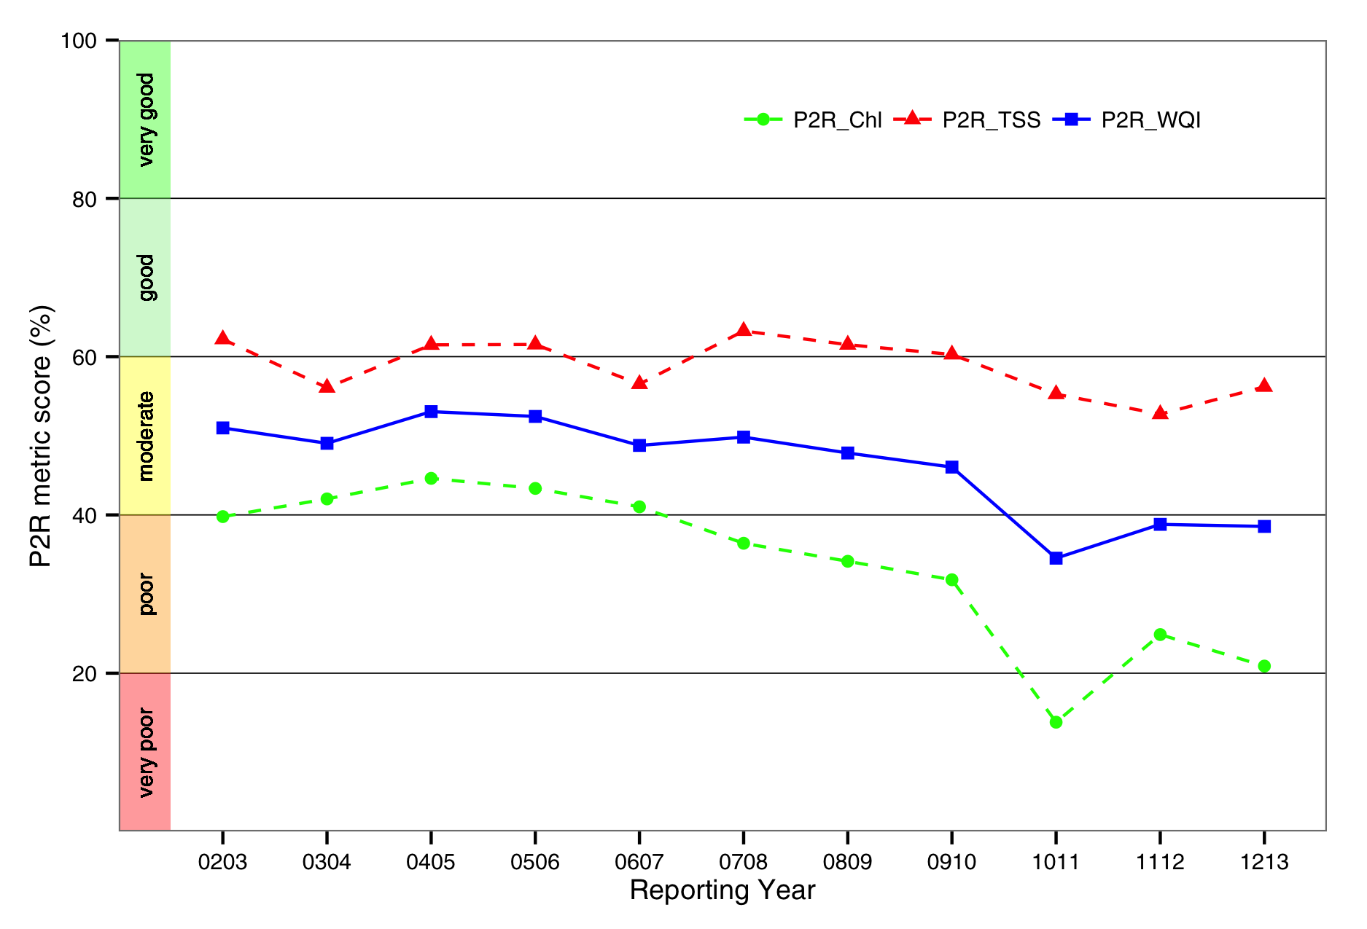
Figure: Trends in the Paddock to Reef marine water quality index (P2R_WQI) and component scores (P2R_CHL and P2R_TSS) aggregated for the whole GBR. The regional scores for Cape York and Burnett Mary are excluded from calculations of the overall GBR score for the metrics.

Acknowledgments

Funding for this study was provided by the Reef Rescue Marine Monitoring Program and by the CSIRO Wealth from Oceans research flagship program. The algorithm development and validation activities presented in this study were in partly supported by the eReefs GBR Information System partnership.
We are grateful to the GBR Long Term Monitoring Program as well as Britta Schaffelke, Miles Furnas and Michelle Devlin for the provision of valuable in situ data used for accuracy assessment.
We acknowledge the MODIS mission scientists and associated NASA personnel for the production of the data used in this work and Geoscience Australia for the reception of MODIS raw data. The full reprocessing of the MODIS Aqua time series with the most recent updates in NASA’s software (SeaDAS version v7.0.2) was carried out by the IMOS Satellite Remote Sensing Facility using the National Computing Infrastructure (NCI) high performance distributed storage. The subsequent MODIS processing with the CSIRO algorithms was carried out at the NCI by the eReefs pre-operational system for monitoring marine water quality of the GBR.

Introduction
Water quality is a key issue for the health of the Great Barrier Reef (GBR; all abbreviations and acronyms of this report are summarized in Table 1catchments and for the communities, industries and ecosystems that rely on good water quality in North Queensland).
The Great Barrier Reef Water Quality Protection Plan (GBRWQPP) was released by the Australian and Queensland Governments in October 2003 with the ultimate goal to ‘halt and reverse the decline in water quality entering the reef within 10 years’. The Reef Plan Marine Monitoring Program (now Reef Rescue Marine Monitoring Program, MMP hereafter) was established to assess the health of key marine ecosystems (inshore coral reefs and seagrasses), the condition of water quality in the inshore GBR lagoon and water quality of water masses entering the Great Barrier Reef during the wet season. The MMP is currently funded under the Australian Government’s Reef Rescue initiative and is managed directly by the Great Barrier Reef Marine Park Authority (GBRMPA).
This report describes the activities carried out under the projects “Reef Rescue Marine Monitoring Program – Assessment of Terrestrial Run-off Entering the Reef" and “Reef Rescue Marine Monitoring Program – Inshore Marine Water Quality Monitoring".
The underlying activity for both projects is the acquisition, processing with regionally valid algorithms, validation and transmission of geo-corrected Moderate Resolution Imaging Spectroradiometer (MODIS) ocean colour imagery. MODIS ocean colour imagery was used to quantify for the GBR near-surface concentrations of key water quality variables: total suspended solids (TSS) as an indicator of water clarity, coloured dissolved organic matter (CDOM) as a tracer of terrestrial discharge of low salinity waters, and chlorophyll-a (CHL) as an indicator of phytoplankton biomass and a proxy for nutrient availability.
Key objectives of the two projects are to:
- Report on algorithm development to detect trends and anomalies in the data based on long-term datasets, and how techniques have improved integration with in situ monitoring data;
- Provide summary images derived from MODIS data for TSS, CHL and CDOM within the inshore and offshore areas during the wet and dry seasons;
- Assess the temporal and spatial variation in the extent of available 2012/13 river flood plumes across the 6 GBR natural resources management (NRM) regions; and
- Contribute to the Paddock to Reef (P2R) reporting by assessing the exceedance of water quality guidelines for two of the water quality variables that can be retrieved from remote sensing, namely CHL and TSS retrieved from MODIS Aqua using CSIRO’s algorithms.
Section 2 of this report will provide details on the methods used to retrieve water quality from satellite imagery and how management relevant information is produced from time series of satellite imagery. In section 3 the assessment of the P2R marine water quality index and the exceedance of the Guidelines is described for the whole GBRWHA and the six NRM reporting regions with maps and tables summarising the exceedance results for CHL and TSS.

- List of acronyms used in this report.
AIMS | Australian Institute for Marine Science
ANN | Artificial Neural Network
CDOM | Coloured Dissolved Organic Matter
CHL | Chlorophyll
DAAC | Distributed Active Archive Centre (NASA)
EF | Exceedance frequency, calculated as the ratio of the number of days where the concentration exceeded the threshold to the number of days with (error-free) data for that period.
EG | Exceedance of the Guidelines, determined by comparing the mean values for the year (and seasons) to the appropriate Guideline thresholds
ESA | European Space Agency
GBR | Great Barrier Reef
GBRWHA | Great Barrier Reef World Heritage Area
GBRMPA | Great Barrier Reef Marine Park Authority
IOCCG | International Ocean Colour Coordinating Group
LMI | Linear Matrix Inversion
MODIS | MODerate resolution Imaging Spectroradiometer (operated by NASA)
MODIS-Terra | Launched in 1999 – a nominal 10:30 equatorial overpass time
MODIS-Aqua | Launched in 2002– a nominal 13:30 equatorial overpass time
MERIS | Medium Resolution Imaging Spectrometer (operated by ESA); a nominal overpass time of ca 10:00 AM
NASA | National Aeronautics and Space Administration
NAP | Non algal particulate matter
NRM | Natural Resource Management
OCR | Ocean Colour Radiometry
P2R | Paddock to Reef
P2R_CHL | Paddock to Reef indicator for marine water quality, based on the Relative extent of exceedance of the Guidelines for Chlorophyll
P2R_TSS | Paddock to Reef indicator for marine water quality, based on the Relative extent of exceedance of the Guidelines for Chlorophyll
P2R_WQI | Paddock to Reef marine water quality index, calculated for as the average value of the metric scores for the two component indicators, i.e. P2R_WQI=(P2R_CHL+P2R_TSS)/2
REEF50 | Relative extent of exceedance frequency greater than 0.50, i.e. when the median values are used for the assessment of the Guidelines.
REEG | Relative extent of exceedance of the Guidelines, i.e. when the mean values are used for the assessment of the Guidelines.
RT | Radiative transfer
SA | Semi analytic
SeaDAS | SeaWiFS Data Analysis System
SeaWiFS | Sea-viewing Wide Field-of-view Sensor (Launched in 1997) a nominal overpass time of ca 12:00 AM
TSS | Total Suspended Solids
WQIP | Water Quality Improvement Plan

Methods
Given the size and variability of conditions within the GBR catchments, monitoring the water quality in the GBR lagoon waters is challenging. The MMP water quality monitoring uses three complementary approaches to collect data at various spatial (location, region, and whole GBR lagoon) and temporal (ad hoc, daily, 10-minutely) scales: traditional direct water sampling from research vessels, in situ data loggers at a small number of selected inshore reef locations and satellite based remote sensing. While data loggers provide detailed information on the local variability in water quality parameters, remote sensing observations provide extensive spatial coverage at 1 km resolution.
Remote sensing is a suitable and cost-effective technique for monitoring of coastal water quality, because it provides synoptic views of the spatial distribution of CHL, CDOM and TSS concentrations, and water clarity of near-surface water. The data generated from regular daily satellite acquisition of the GBR region should help to identify patterns of spatial variation over scales of kilometres to hundreds of kilometres and temporal scales of days to years. Management-relevant products from remote sensing data that provide information beyond that of a simple concentrations map are needed by management agencies to make more informed decisions.
Data collected by Moderate Resolution Imaging Spectroradiometer (MODIS) Aqua sensor provide a time series from November 2002 to present of water quality estimates with spatial coverage at 1 km resolution for the whole-of-GBR lagoon, nominally on a daily basis (except overcast days).

Regionally valid retrieval of water quality parameters from satellite imagery
Based on studies conducted in the Fitzroy River estuary (Brando et al. 2006, Oubelkheir et al. 2006) and the Mossman Daintree coastal waters (Steven et al. 2007), it has been demonstrated that the NASA standard global Ocean Colour algorithms are inaccurate in nearshore GBR waters (Qin et al. 2007). Subsequently there has been considerable effort in developing regionally appropriate algorithms for these optically complex GBR waters. Studies commissioned by GBRMPA on water quality monitoring (Schaffelke et al. 2006) and optical characterisation of coastal waters (Blondeau-Patissier et al. 2009) have also been undertaken and contribute to the development of regionally appropriate algorithms using a semi-analytical physics-based approach parameterised and validated with local measurements (Brando et al. 2010, Brando et al. 2010).
In this report, the water quality estimates from MODIS Aqua data for GBR Lagoon coastal waters are derived using two coupled physics-based inversion algorithms published in the peer review literature (Schroeder et al 2007, Brando et al, 2012).Within the eReefs GBR Information System partnership(Schiller et al. 2014),these research-grade algorithms were migrated from desktop computers into a mass-production environment deployed at a high performance computing facility to enable the operation of these systems at scale over large areas and decadal time series (King et al. 2014).

The eReefs pre-operational system
The algorithms’ theoretical basis, the implementation and the validation of the satellite data processing workflow of the eReefs pre-operational system for monitoring marine water quality for the GBR are described in details in King et al 2014, and briefly summarized here.
The eReefs pre-operational system for monitoring marine water quality for the GBR builds upon an IMOS-supported framework in which satellite imagery, from the NASA MODIS/Aqua instrument, is processed to standard top-of-atmosphere products. CSIRO-developed algorithms are applied to correct for the effect of the atmosphere and retrieve estimates of concentrations of various in-water constituents, including Chlorophyll and suspended sediments. The atmospheric correction algorithm is based on inverse modelling of radiative transfer simulations and Artificial Neural Network (ANN) inversion is used to derive the remote sensing reflectance at mean sea level (Schroeder et al. 2007, Schroeder et al. 2008). Then, the inherent optical properties and the concentrations of the optically active constituents, namely CHL, non-algal particulate matter (NAP, as a measure of TSS) and CDOM, are retrieved using an adaptive implementation of the Linear Matrix Inversion (LMI, Hoge and Lyon 1996) that incorporates regional and seasonal knowledge of specific Inherent Optical Properties (Brando et al. 2008, Brando et al. 2012, Schroeder et al. 2012).
As the ANN atmospheric correction uses as input the NASA standard top-of-atmosphere MODIS radiance spectra, the MODIS Aqua time series is first processed with the NASA’s software (SeaDAS), and then with CSIRO’s coupled physics-based inversion algorithms. For this report the whole MODIS Aqua time series was reprocessed by eReefs pre-operational system with the most recent updates in NASA’s software (SeaDAS version v7.0.2), incorporating the improved knowledge of instrument temporal calibration to improve temporal stability of the time series of the MODIS Aqua aging sensor. As such, all the results presented in this report supersede the previous reports.
The comparison of MODIS Aqua retrievals of CHL, CDOM and NAP data to in situ data showed that the a-LMI water quality algorithm coupled with the ANN atmospheric correction is more accurate than NASA’s algorithms for GBR waters in the dry and wet seasons (see section 5 for details). The uncertainty associated with the retrieval of CHL, CDOM and TSS with eReefs pre-operational system was a relative error of 90%, 138% and 88%respectively.TheMean Absolute Percentage Errors values are not directly comparable to those reported in previous accuracy assessments as the number of data points in the matchup analysis are continuously increasing.
The parameterization and validation on the remote sensing retrievals was mainly based on observations performed in coastal and lagoonal waters during the dry season between Keppel Bay and the Wet Tropics region. The accuracy of the retrieval is likely to likely to be lower in shallow and turbid waters systems such as Princess Charlotte Bay, Broad Sound and Shoalwater Bay, as there is little or no data available for parameterization and validation.

Management relevant remote sensing products to monitor water quality in the GBR
In this report MODIS ocean colour imagery was used to quantify for the GBR near-surface concentrations of key water quality variables: total suspended solids (TSS) as an indicator of water clarity, coloured dissolved organic matter (CDOM) as a tracer of terrestrial discharge of low salinity waters, and chlorophyll-a (CHL) as an indicator of phytoplankton biomass and a proxy for nutrient availability. The data products, presented as spatial maps at (up to) daily frequency, can then be used to assess the conditions affecting the reef.
If environmental managers are to take full advantage of remote-sensing capabilities then products that translate remotely-sensed scenes into useful information for managers are required. From daily remote sensing data, it is possible to produce a number of derived products suited to the specific needs of end-users or to particular geographic regions. Maps are the most common product and depending on user requirements, any number of variables or derived indices and attributes can be mapped over specified spatial aggregations and/or over timescales ranging from days to years. A prime example of management-relevant products are those providing water quality compliance information for environmental reporting (Brando et al. 2010).
This section will provide details on the methods used to generate all the maps and tables of the main body of the report (section 3).

Estimate of freshwater extent
Riverine freshwater plumes connect the land with the receiving coastal and marine waters and are the major transport mechanism for nutrients, sediments and pollutants into the GBR lagoon. The extent and duration of freshwater plumes can have significant implications for the health of marine ecosystems such as seagrasses and coral reefs. Low salinity runoff waters may transport natural and anthropogenic contaminants into the sea, and can directly stress marine ecosystems that are adapted to higher salinity levels (Burrage et al. 2003). Concentrations of riverine pollutants have been attributed to the specific land use of the catchments and positive correlations have been reported between river-discharged material and water quality of the GBR receiving waters (Brodie et al. 2008, Kennedy et al. 2012).
The dynamics of a flood plume as it moves freshwater from the river mouth into the marine environment can be described in terms of the hydrodynamic and chemical behaviour. At first flood plumes contain elevated concentrations of sediments (and associated nutrients and contaminants). Later, when particulate matter falls out of the plume waters the plume is characterised mainly by the presence of the dissolved materials and the associated nutrients (Devlin et al. 2012).
In freshwater plumes, CDOM concentrations are high and are largely derived from terrestrial sources, making CDOM a quasi-conservative tracer of terrestrial discharge of low salinity waters. Negative correlations between CDOM and sea surface salinity have been established from in situ data in several studies (Ferrari and Dowell 1998, Bowers and Brett 2008, Astoreca et al. 2009, Molleri et al. 2010). In this report we use CDOM as a surrogate for salinity to estimate low salinity waters indirectly from MODIS ocean colour observations for the entire GBR region as detailed in Schroeder et al.(2012). Based on a linear regression of 250 GBR-wide concurrent in situ CDOM and salinity measurements a relationship was used to establish a cut-off threshold of CDOM absorption at 443nm of 0.24 m⁻¹ corresponding to a salinity of 30±4 PSU (Figure 1) (Schroeder et al. 2012). The freshwater extent for the wet season can be estimated by applying the threshold for freshwater mapping (0.24 m⁻¹≈30±4 salinity) to the maximum CDOM values for the wet season.
The remote sensing algorithms adopted in this study cannot differentiate between the sources of CDOM, which for this aim are assumed to be mainly influenced by flood waters during the wet seasons. As a consequence any estimated freshwater extent is potentially biased by additional supratidal, intertidal and subtidal and oceanic CDOM sources such as bacterial degradation of phytoplankton, mangroves, sea grass beds, coral reef and benthic organisms living in the sediment (Schroeder et al. 2012 and references therein). However, the CDOM production of these additional non-runoff related sources is usually much lower than the applied CDOM absorption threshold of 0.24 m⁻¹ at 443 nm(Schroeder et al. 2012).
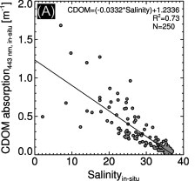
- Linear regression of concurrent in situ CDOM absorption (443 nm) and salinity measurements. Modified from Figure 4 of Schroeder et al.(2012).
Unusually high CDOM absorption was observed from remote sensing by Schroeder et al.(2012) for the mid and outer shelf reefs of the Mackay and Fitzroy NRM regions, which are not directly influenced by flood waters. In these regions remotely sensed CDOM absorption was observed to vary between 0.15 and 0.2 m⁻¹ at 443 nm and further in situ measurements are needed to understand these high values in off-shore waters. The conservative CDOM threshold for freshwater mapping (0.24 m⁻¹≈30±4 salinity) enables us to separate the autochthonous reef matrix CDOM production from the estimate of freshwater plume extent for the wet season.
Shallow coastal embayments, where turbidity is dominated by tidal resuspension of bottom sediments composed of terrigenous mud in the near-shore areas are also regions where CDOM may not be attributed solely to terrestrial runoff. The freshwater extents estimated for these regions are potentially overestimated if no rivers empty directly into these embayments, e.g. Broad Sound. For this region an along-shore transport of northward directed freshwater from the Fitzroy River is observed in years of high discharge only (Schroeder et al. 2012).

Evaluation of compliance to guidelines
In addition to the mean concentration maps, the exceedance of water quality guidelines was assessed for CHL and TSS retrieved from MODIS Aqua imagery using CSIRO’s algorithm. The exceedance could also be evaluated for the recently published regional Secchi Depth algorithm based of in situ data collected by AIMS (Weeks et al. 2012).
A set of water quality guideline values and objectives was released in 2009 by Commonwealth and state legislation for the GBR, with an effort to avoid inconsistency in the regions of overlap. Version 3 of the Queensland Water Quality Guidelines (DERM 2009) was released to promote regionally and locally relevant guideline water quality values for Queensland coastal waters which extend up to 3 nautical miles offshore. Regionally-specific environmental values and objectives have been set in the GBR catchments in the P2R program and in some specific areas through the development of Water Quality Improvement Plans (WQIPs). GBRMPA released the Water Quality Guidelines for the Marine Park (hereafter called the Guidelines) in 2009 and identified five types of water bodies: the Enclosed Coastal waters, the Open Coastal waters, the Midshelf waters, the Offshore waters, and the Coral Sea (GBRMPA 2009). Much of the Great Barrier Reef Marine Park lies beyond Queensland state waters but there is an area of overlap within the nearshore coastal waters for which protocols have been agreed. Namely, Queensland guidelines are to be adopted for all waters inshore of and within the Enclosed Coastal zone. Offshore from the Enclosed Coastal zone and within waters of the GBR Marine Park, the Guidelines will apply, even if the boundary of the Enclosed Coastal zone lies inside the three nautical mile zone (DERM 2009).
Figure 2reports the regional and cross shelf boundaries defined by GBRMPA for the MMP 2008/09 reporting and used for this study. These boundaries were delineated by implementing in a GIS environment the "Approximate water body delineations of the Open Coastal, Midshelf and Offshore marine water bodies in the six NRM regions" (Figure 2)(Table 1, GBRMPA 2009). The water bodies vary in width from north to south in the GBRWHA, as the outer boundary of the water bodies was defined as function of the relative distance across the shelf boundaries for each NRM region. The figure also includes the delineation of the Enclosed Coastal waters proposed in the previous report based on a statistical analysis of a decade of satellite-derived CHL and CDOM data (Brando et al. 2013).This proposed delineation is currently being taken in consideration by GBRMPA together with other data sources including the Queensland Wetlands 2009 data, depth contours, hydrodynamics and sources of freshwater input to the coast prior to selecting the final water body delineation for formal adoption and implementation in the Guidelines.
The methods used in this study to evaluate compliance were originally developed to provide a demonstration of the use of remotely-sensed data in the assessment of exceedance of the Guidelines (Brando et al. 2010). These methods were then implemented in the previous MMP reports (Brando et al. 2010, Brando et al. 2010) to contribute to the indicators and metrics for the P2R reporting for marine water quality (RWQPP 2011, RWQPP 2011, RWQPP 2013, RWQPP 2013).
- Approximate distance from shore for the outer boundary of the Open Coastal, Midshelf and Offshore marine water bodies in the six NRM regions from the Great Barrier Reef Marine Park Authority Water Quality Guidelines (Table 1 at page 12 of GBRMPA 2009).
NRM region | Open Coastal (km) | Midshelf (km) | Offshore (km)
Cape York | 6 | 24 | 250
Wet Tropics | 6 | 24 | 170
Burdekin | 12 | 48 | 180
Mackay-Whitsunday | 15 | 60 | 280
Fitzroy | 20 | 80 | 340
Burnett-Mary | 7 | 28 | 270

In previous reports we have shown that given the skewness of the raw data, the median CHL concentrations are a more representative measure of central tendency than the arithmetic mean, particularly for the wet season (Brando et al. 2011). Moreover, the estimate of the mean values for the wet season, and to a lesser extent for the whole year, are more likely to be affected than the estimate of the median values by the "non-sampling" of the higher values due to cloud cover. In previous reports, in an attempt to address this issue, the exceedance of the Guidelines for CHL and TSS was evaluated by comparing the mean as well as the median values of the variables to the appropriate seasonal and regional values, even if the mean values are identified in the Guidelines. To simplify the reporting structure, in this report the exceedance of the Guidelines for CHL and TSS is presented only by comparing the mean values of the variables to the appropriate seasonal and regional guideline threshold values.
The Guideline trigger values used as threshold levels for the analysis of exceedance are reported in Table 3 (annual means) and Table 4 (seasonal means).The Guidelines trigger values for Enclosed coastal for CHL is 2.0 µg L⁻¹ for the whole GBR, while for TSS varies across regions. For Cape York, Wet Tropics and Mackay Whitsundays a value of 5 mg L⁻¹ should be applied, while a value of 15 mg L⁻¹ should be applied to the Burdekin, Fitzroy and Burnett-Mary Regions (Table 3 page 26 of the Guidelines and K. Martin & C. Honchin, pers comm. 18/3/2013).
The maps are accompanied by tables summarising the exceedance results for each variable and each reporting region. The summary of the exceedance extent in each map provides the relative surface area where mean concentration exceeded the trigger values for the year (or seasons), expressed as relative area (%) of the water body. The relative extent of exceedance of the Guidelines (REEG) values for CHL and TSS (REEG_CHL, REEG_TSS) are presented within each reporting region as separate values for the Inshore (i.e. the Enclosed Coastal and the Open Coastal waters) Midshelf, and Offshore water bodies.
The assessments of the exceedance results presented in this report are based on a large number of observations (ranging from thousands of valid observations for the Enclosed Coastal waters in the wet season to millions of valid observations for the Offshore area in the dry season).
To visualize the spatial patterns in the exceedance within years, in this report a new map is introduced, presenting annual exceedance extents superimposed for the reporting years between 2002/03 and 2012/13. This new map represents a “frequency of exceedance” enabling to identify areas within the NRM regions that consistently exceed the guidelines and areas that are compliant.
- Trigger values from the Great Barrier Reef Marine Park Authority Water Quality Guidelines (GBRMPA 2009). Guideline values for the assessment of the annual mean values. *: Geographical adjustment: Cape York, Wet Tropics and Mackay Whitsunday/ Burdekin, Fitzroy and Burnett Mary.
Parameter | Enclosed Coastal | Open Coastal | Midshelf | Offshore
Chlorophyll-a (µg L⁻¹) | 2.0 | 0.45 | 0.45 | 0.40
Secchi Depth (m) | 1.0/1.5* | 10 | 10 | 17
Total Suspended Solids | 5.0/15* | 2.0 | 2.0 | 0.7

- Trigger values from the Great Barrier Reef Marine Park Authority Water Quality Guidelines (GBRMPA 2009). Seasonally adjusted Guideline values for the assessment of seasonal mean values in dry/wet seasons.
 | Water body
Parameter | Enclosed Coastal | Open Coastal | Midshelf | Offshore
Chlorophyll-a (µg L⁻¹) | 2.8/1.4 | 0.32/0.63 | 0.32/0.63 | 0.28/0.56
Secchi Depth (m) | 1.0/1.5 | 10 | 10 | 17
Total Suspended Solids (mg L⁻¹) | 6.0/4.0  18/12 | 1.6/2.4 | 1.6/2.4 | 0.6/0.8

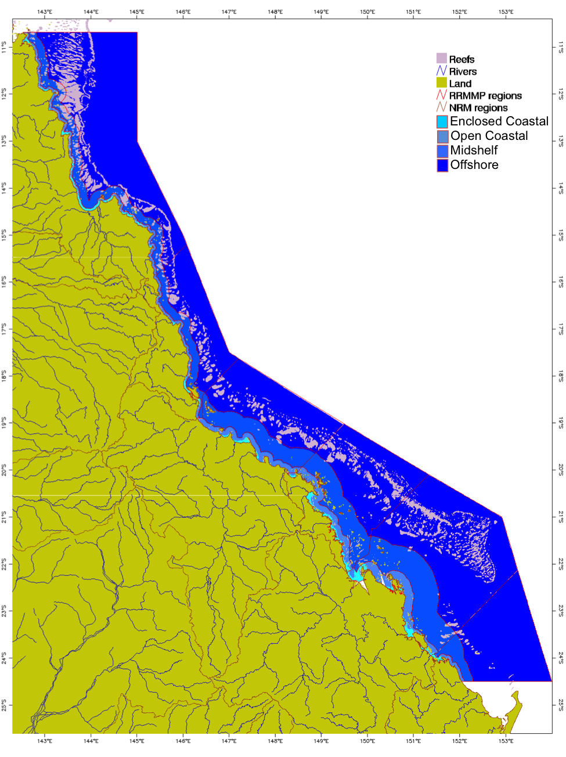
- Regional and cross shelf boundaries defined by GBRMPA for the MMP 2008/09 reporting (red lines), the cyan areas identify the Enclosed Coastal waters delineated in the MMP 2011/12 report based on a statistical analysis of a decade of satellite data

Calculating metrics for the P2R reporting for marine water quality
The metrics for the P2R reporting for marine water quality are based on the assessment of the exceedance of Guidelines for Chlorophyll-a and Total Suspended Solid (RWQPP 2011, RWQPP 2011). In P2R reporting, the two indicators for marine water quality are based on the summary of the exceedance of annual mean values of Chlorophyll-a and non-algal particulate matter (as a measure of Total Suspended Solids) for each reporting period for the inshore water body (i.e. the Enclosed Coastal and the Open Coastal waters). Hence the indicator data considered for the P2R metric calculations are the REEG values for CHL and TSS (REEG_CHL, REEG_TSS) for the Inshore water body(RWQPP 2011, RWQPP 2011).
Consistently with the marine water quality P2R reporting scheme, in this report the metric scores are expressed the precent area that does NOT exceed the Guidelines value for the Inshore water body (i.e. the Enclosed Coastal and the Open Coastal waters), hence the REEG values are simply subtracted from 100% to calculate the metric score (i.e. P2R_CHL=100- REEG_CHL and P2R_TSS=100- REEG_TSS). The rationale for this metric calculation method is to provide consistency with other P2R metrics, as all final metrics are standardized to a range from 0 to 100 such that zero is the lowest score and 100 is the highest, i.e. ranging from the worst to the best possible environmental condition (RWQPP 2011, RWQPP 2011).
The overall GBR score is calculated by linearly combining the regional scores weighting them by the relative contribution to the GBRWHA total surface area. The surface area weighting is used to prevent overweighting of scores from reporting regions that represent a small area in relation to the total area of GBR. As limited field information was used for the parameterization and validation on the remote sensing retrievals for these two regions (see section 2.1 and Appendix 1), the regional scores for Cape York and Burnett Mary are excluded from the area weighting calculations(RWQPP 2011, RWQPP 2011). The four reporting regions (Wet Tropics, Burdekin, Mackay Whitsunday, Fitzroy) contribute 13%, 21% 27% and 39% to the overall GBR score for each metric (RWQPP 2011, RWQPP 2011).
The P2R marine water quality index (P2R_WQI) is then calculated for each region, as well for the whole GBR, as the average value of the metric scores for the two component indicators, i.e. P2R_WQI=(P2R_CHL+P2R_TSS)/2 (RWQPP 2011, RWQPP 2011).
The estimate of the P2R_WQI and the metric scores for the two component indicators (P2R_CHL and P2R_TSS) does not include an assessment of associated uncertainty. Such assessment would account for the uncertainty associated with the retrieval of CHL and TSS from MODIS data with the coupled physics-based inversion algorithms. The uncertainty associated with the P2R metric score could be estimated following the approach proposed by Schroeder et al.(2012) to assess the uncertainty associated to the estimates of freshwater extent, where the uncertainty associated with the retrieval of CDOM was accounted for when setting the CDOM thresholds. Future work will extend this method to also assess the uncertainty associated to the two component indicators of the marine water quality index from the spatial extent of non-compliance in the Enclosed Coastal and Open Coastal waters.

Guide to interpreting the maps
All maps presented in section 3 have a consistent presentation: land is represented as dark gray; the coastal boundary is based on a standard coastline vector; main rivers are represented by blue lines; and coral reefs including a 1 km buffer zone (to avoid mixed land or reef and water pixels) are depicted as white. The maps of mean, median or maximum values will present data for all the pixels in the bounding box, while the maps of freshwater extent for the wet season, exceedance of the Guidelines and EF present data only for the reporting region of interest. The areas outside the reporting region are depicted in light gray.
Several boundary lines are overlayed onto the maps to enable the identification of water bodies identified by the Guidelines (Open Coastal, Midshelf, and Offshore). The boundaries for the reporting region are presented in each map as defined by GBRMPA in accordance with the NRM boundaries for the catchment and marine extensions (Figure 2). The cross shelf boundaries were defined by GBRMPA to implement the Guidelines: the thick white line defines the Inshore waters (Enclosed Coastal and Open Coastal water bodies); the thin pink line separates the Midshelf from the Offshore waters while the thick gray line to the East in all images represents the limit of the marine park.
In this report, seasonal and annual mean maps for CHL and TSS are presented for each reporting region. The seasonal mean values for the wet and dry seasons were calculated for each pixel in the region from the valid (i.e. cloud-free and error-free) daily observations. Seasonal maps that indicate the number of valid observations (i.e. cloud-free and error-free) used for calculating the mean values are also presented.
In the maps of freshwater extent for the wet season, pixels in the reporting region of interest are mapped in dark red when the maximum values for the wet season exceed the CDOM threshold for freshwater mapping (0.24 m⁻¹≈ 30±4 salinity). The surface area (km²) of the freshwater plume extent in the wet season for each region can then be estimated by tallying the number of the 1 km² pixels exceeding the CDOM threshold in each map.
In the maps of exceedance of the Guidelines, pixels in the reporting region of interest are mapped in dark red when the annual (and seasonal) mean concentrations exceed the appropriate thresholds reported in Table 3and Table 4. Pixels are mapped in light gray if they did not exceed the thresholds. The spatial patterns in the exceedance maps are a function of the coastal to offshore gradients that can be observed in the mean maps of CHL and TSS as well as changes in thresholds between the Midshelf and Offshore areas. Hence most often the exceedance in the Offshore areas is present in clusters to the East of the thin pink line delineating the ‘Offshore’ waters.

Results and discussion
This section will provide an overview of the satellite-based water quality monitoring results for the whole Great Barrier Reef World Heritage Area (GBRWHA) followed by a detailed regional report for each of the six reporting regions. For each region the wet season freshwater extent as estimated from CDOM maps is correlated with the river discharges; then, the exceedance of the Guidelines is assessed for CHL and TSS (as NAP) over the whole year and is presented as maps and summarised in tabular form.

Great Barrier Reef wide summary

Assessment of freshwater extent during the wet season
Wet season flood plume movements across Great Barrier Reef marine waters are a consequence of the volume and duration of river (flood) flows, wind direction and velocity, as well as the local marine currents and tidal dynamics.
Freshwater discharge from the Great Barrier Reef catchments in 2012/2013 was close to the long term mean (Figure 3) following a near-average year for rainfall for the northern GBRWHA catchments, while the Fitzroy and Mary Burnett NRM regions recorded above-average summer rainfall and flood events associated with the remnants of tropical cyclone Oswald that tracked south-eastwards parallel to the coast and brought heavy rain. The Burnett and Mary Rivers flooded in January and March reaching record peak and flow levels, while most other rivers peaked below their highest levels of 2010–11(www.bom.gov.au/).
Figure 4provides an overview of the freshwater extent for wet season 2012/2013 (November 2012- April 2013) for the whole GBRWHA. The freshwater extent was estimated by applying a threshold of 0.24 m⁻¹ for the CDOM seasonal maximum. Detailed maps for each region are presented in the regional reporting sections. Flood plumes extended across inshore waters of the southern and northern Great Barrier Reef, but had a more limited influence on far northern Great Barrier Reef waters. The freshwater extent based on the CDOM maximum provides a conservative estimate of the extent as the flood plumes could have extended further in cloudy or overcast days and hence may not been captured with the satellite imagery. The spatial variability of freshwater extents across the regions reflects the variability in flow conditions across the regions for the wet season 2012/2013 (Figure 4).
The estimated freshwater extent for the whole GBRWHA was significantly strongly correlated to the total freshwater discharges (R=0.850, p<0.001,Figure 6). The freshwater extent for 2012/2013 was the second highest after the 2010-2011wet season as observed with the MODIS time series. The estimated freshwater extent for 2012/2013 was larger than all previous reporting years in for the Burnett Mary region, while for Fitzroy, Wet Tropics and Cape York regions it was higher than the median extents observed with the MODIS time series (Figure 5, Figure 7). These large freshwater extent observations are somewhat unexpected as the freshwater discharge in 2012/2013 was close to the long term mean. These high CDOM estimates during the wet season may possibly be coastal river runoff not captured by the river gauges or to MODIS Aqua aging sensor.

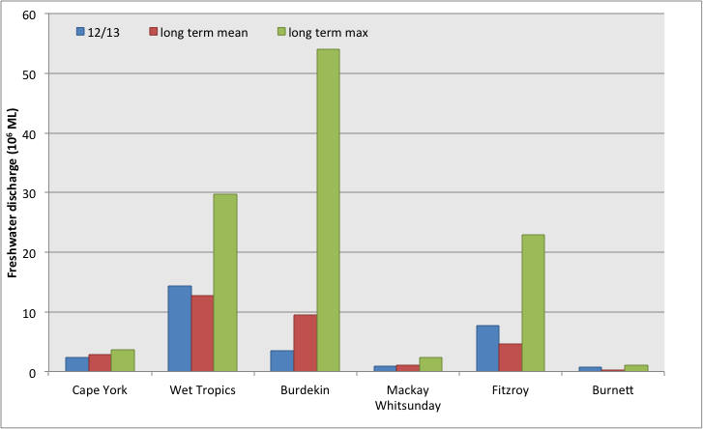
- Comparison of freshwater discharge for 2012/2013 and the long-term mean and the maximum for each reporting region of GBRWHA. Data are aggregated to the reporting regions from data supplied by the Queensland Department of the Environment and Resource Management for each river (Schaffelke et al. 2011).

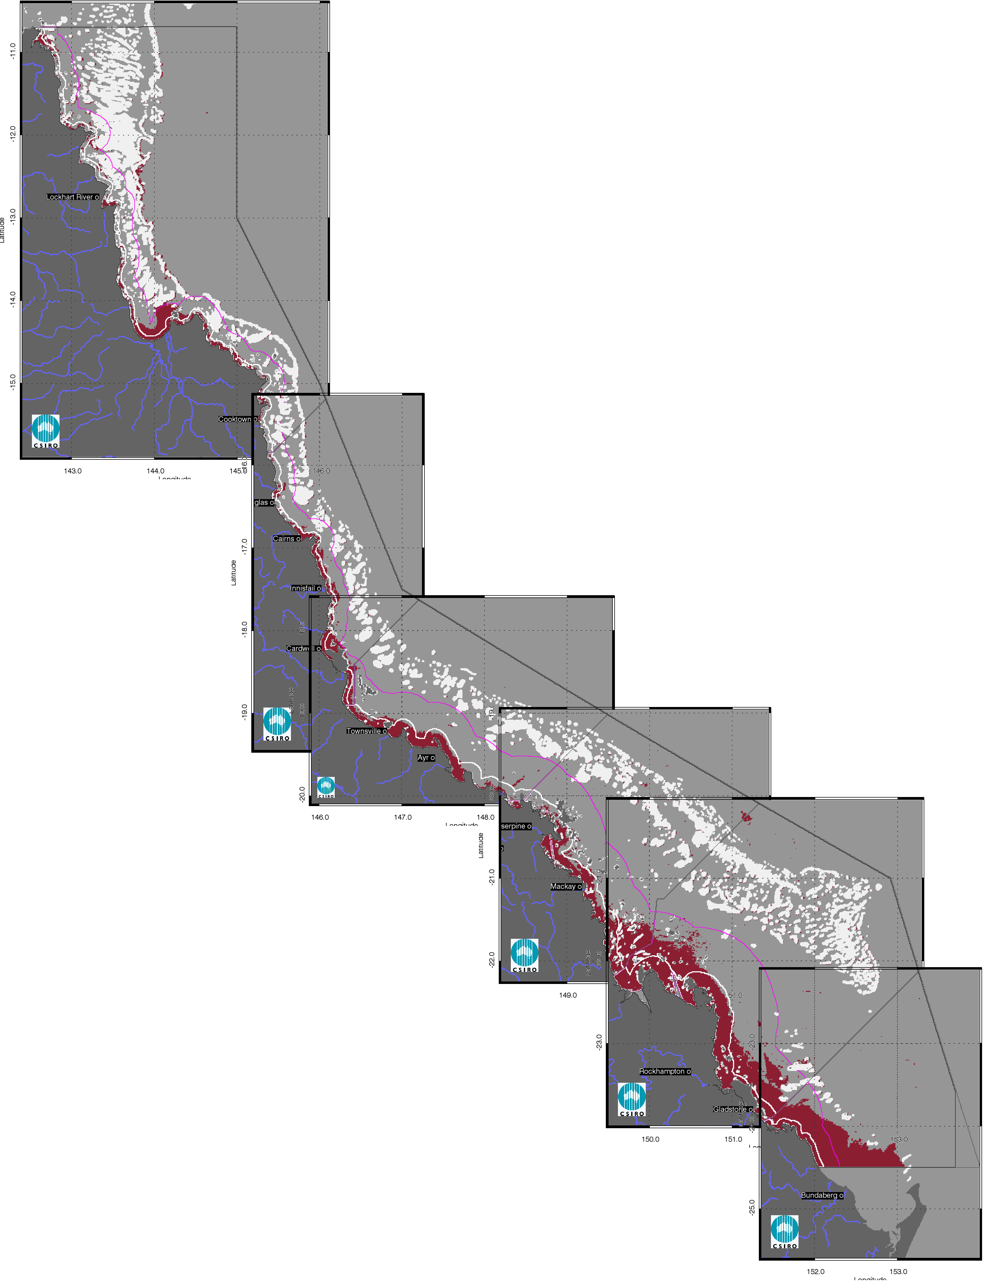

- Map of freshwater extent for the wet season for the whole GBR Freshwater extent estimated with a threshold for the CDOM seasonal maximum of 0.24 m⁻¹.

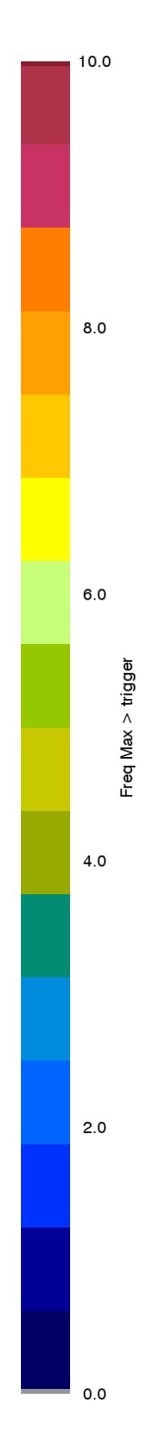
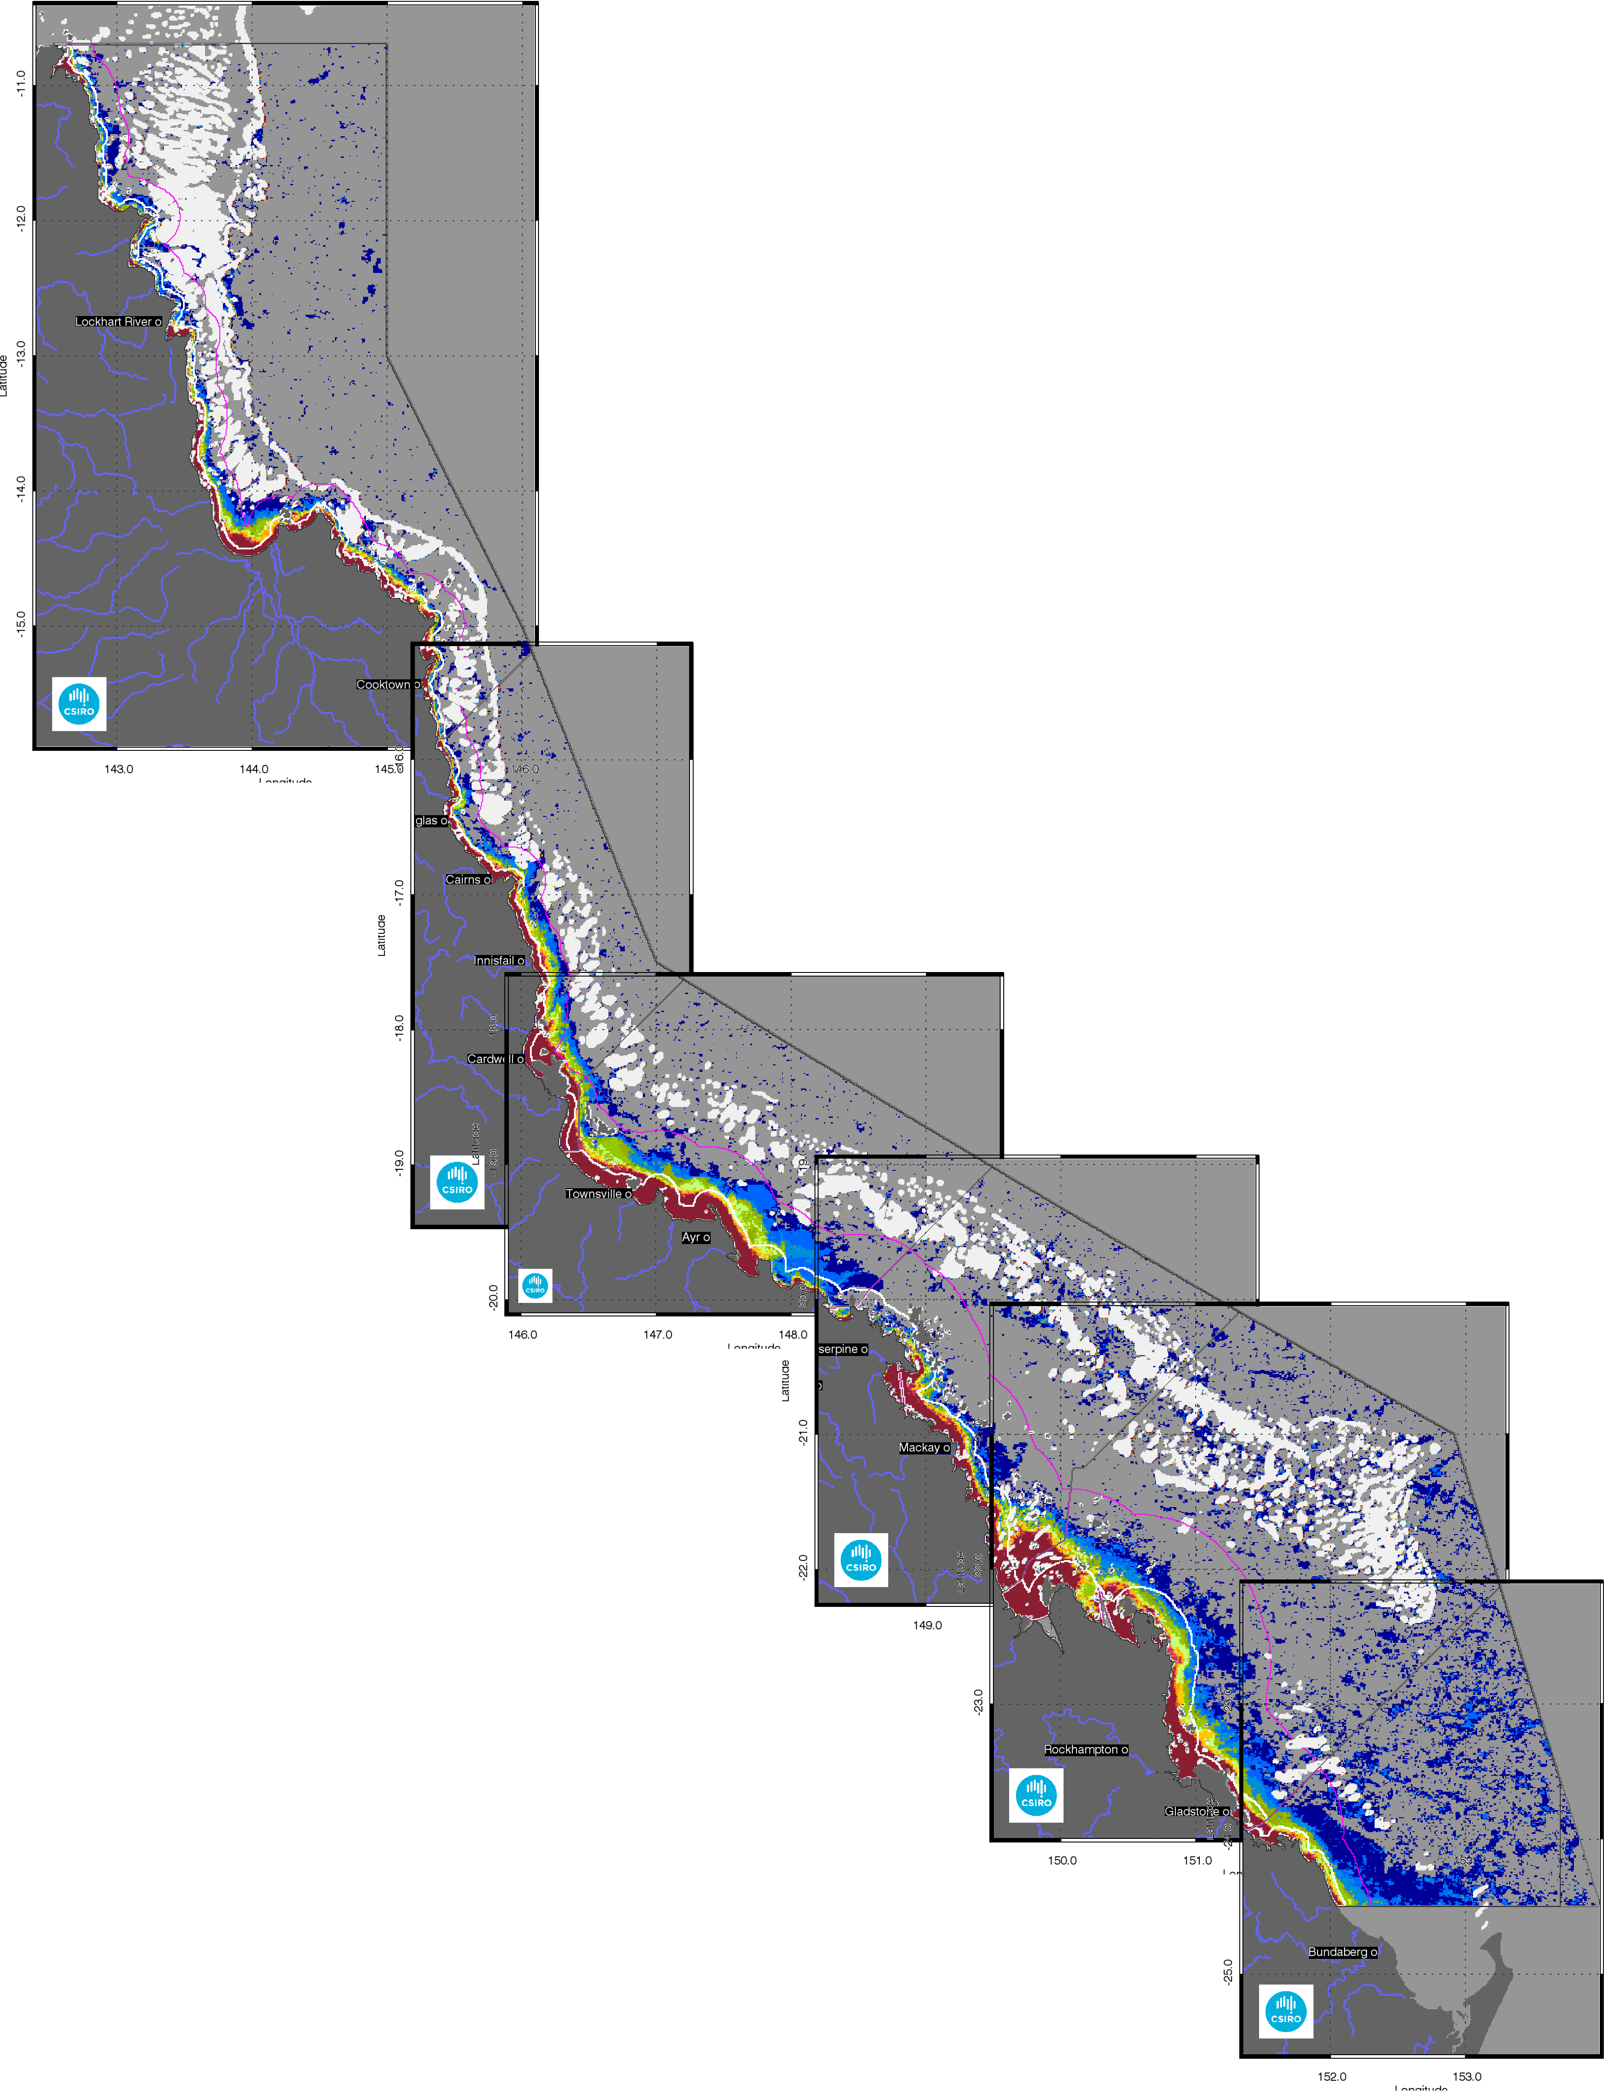
- Map of freshwater extent for the wet season for the whole GBR Superimposed seasonal maximum freshwater plume extents for the wet seasons between 2003 and 2013.
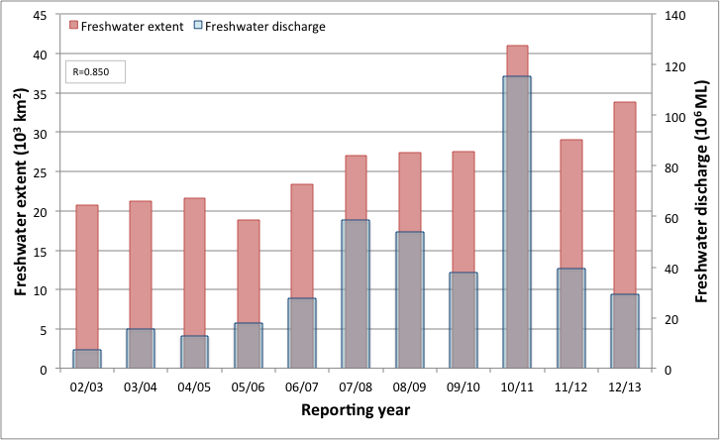
- Total freshwater discharge and total estimated freshwater extent for the whole GBRWHA based on the CDOM maximum for the wet seasons.
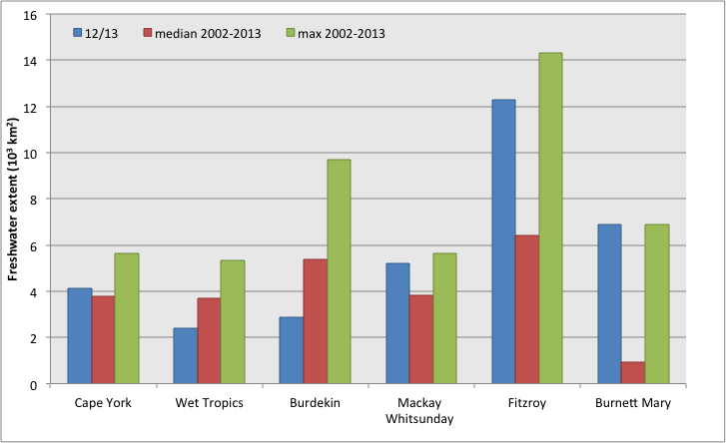
- Comparison of freshwater extent based on the CDOM maximum for the wet season 2012/2013 (November 2012- April 2013), the median and the maximum extent for 2002-2013 for each reporting region of GBRWHA.

Assessment of the exceedance of water quality guidelines
The assessment of exceedance of water quality guidelines is based on the spatial analysis of the annual mean values of CHL and TSS for each reporting region in the GBRWHA. Figure 8andFigure 9present the maps of exceedance of the mean annual values for CHL and TSS for the 2012/2013 (1 May 2012– 30 April 2013) for the whole GBRWHA. These maps are calculated applying the guideline threshold values for CHL (0.45 µg L⁻¹ for Inshore, encompassing Enclosed Coastal and Open Coastal, as well as Midshelf and 0.40 µg L⁻¹for Offshore) and TSS (2.0 mg L⁻¹for Inshore and Midshelf and 0.7 mg L⁻¹for Offshore) on the annual average maps presented in the regional reporting sections. Detailed maps for the wet and dry season for each region are also provided as an appendix (section 7.2).
In 2012/13, the Inshore water body shows high areas of CHL exceedance for all reporting regions (64-98% of relative area of the water body, Table 5). These values were overall comparable to the previous reporting year (REEG_CHL=57- 98%, Table 6). For TSS exceedance, all reporting regions the Inshore water body shows areas of exceedance (REEG_TSS=28-51% of relative area of the water body, Table 5) comparable to the previous reporting year (27- 49% for 2011/12, Table 6).
The Exceedance maps for CHL show that the mean CHL values of exceeded the Guidelines thresholds over the whole year in a coastal band 10- 20 km wide, thus including most of the Inshore water body and sometimes the Midshelf water body (Figure 8). This spatial pattern has been consistent over the GBRWHA region over the last few years, while in the first part of the decade between 2003 and 2013 the exceedance was mainly observed in embayments and closer to river mouths, as shown by the map of frequency of CHL exceedance (Figure 10).
TSS exceedance occurred also in Offshore areas for the Cape York and Mackay-Whitsunday reporting regions (TSS_REEG 6-8%, Table 5), consistently with the previous reporting years (Table 6). This is a consistent feature of the annual TSS exceedance maps as shown in Figure 11with the map of frequency of annual exceedance. These large areas of exceedance of the mean annual TSS values occur where the delineation between the Midshelf and Offshore regions does not lie close to the western edge of the reef matrix (Figure 9, Figure 12).This spatial pattern has been consistent for this region over the decade between 2003 and 2013 (Figure 11). As such, this may be due to an over-estimate of the mean TSS concentrations in these Offshore waters or to a low guideline threshold value. Also, exceedance of the Guidelines in these offshore waters may not be directly related to the land influence on these waters as for large portions of the Offshore areas other oceanographic processes, e.g. upwelling events, influence the TSS concentrations during the year (Wooldridge et al. 2006, Brodie et al. 2008).

Assessment of the Paddock to Reef index
The relative extent of exceedance of the Guidelines values for CHL and TSS (Table 5) are then used to calculate the P2R marine water quality index (P2R_WQI) and the metric scores for the two component indicators, i.e. P2R_CHL and P2R_TSS (Table 7), following the method outlined in section 2.2.3.The marine water quality for this reporting year for the whole GBR was scored as “poor”, reflecting the two “poor” and two “moderate” scores for P2R_WQI in the four reporting regions that contribute the whole of GBR score (Table 7, the regional scores for Cape York and Burnett Mary are excluded from calculations of the overall GBR score for the metrics). The scores for the two component indicators for the whole GBR were “poor” for P2R_CHL and “moderate” for P2R_TSS, reflecting the “very poor” to “moderate” regional scores for P2R_CHL and “moderate” to “good” regional scores from P2R_TSS. The marine water quality index was similar to the reporting year 2011/12, higher than the reporting year 2010/11 and lower than for the previous reporting years for all regions, as well as the whole GBR (Figure 12), reflecting the high freshwater discharges from the GBR catchments in 2010/11 and 2012/13 and the associated estimated freshwater plume extent (Figure 6).
Between 2002 and 2013 the GBR scores forP2R_WQI were significantly highly correlated with the estimated freshwater plume extent (R=-0.915, p<0.001 (Figure 14Figure 13Table 8).While the component scores for Chlorophyll (P2R_CHL) were significantly highly correlated with the estimated freshwater plume extent(R=-0.958, p<0.001, Figure 12) , P2R_TSS was poorly correlated (R=-0.474, Figure 15,Table 8) indicating that P2R_CHL score incorporates a response to the nutrient loads delivered during the wet seasons form the GBR catchments to the Inshore water body, while the P2R_TSS score seems to be less sensitive to the wet season sediment delivery and more to dry season wind-driven re-suspension.
The calculation of the P2R marine water quality index and the exceedance of the Guidelines are described in detail in the regional reporting sections with maps and tables summarising the exceedance results for CHL and TSS.
As all the results presented in this report supersede the exceedance assessments and the historical time-series of P2R scores presented in previous reports, a summary of all P2R scores for all reporting year is provided in Table 9Table 10and Table 11. The revised REEG values for CHL and TSS (REEG_CHL, REEG_TSS) within each reporting region for the Inshore, Midshelf, and Offshore water bodies for all reporting years are presented in Appendix 3.

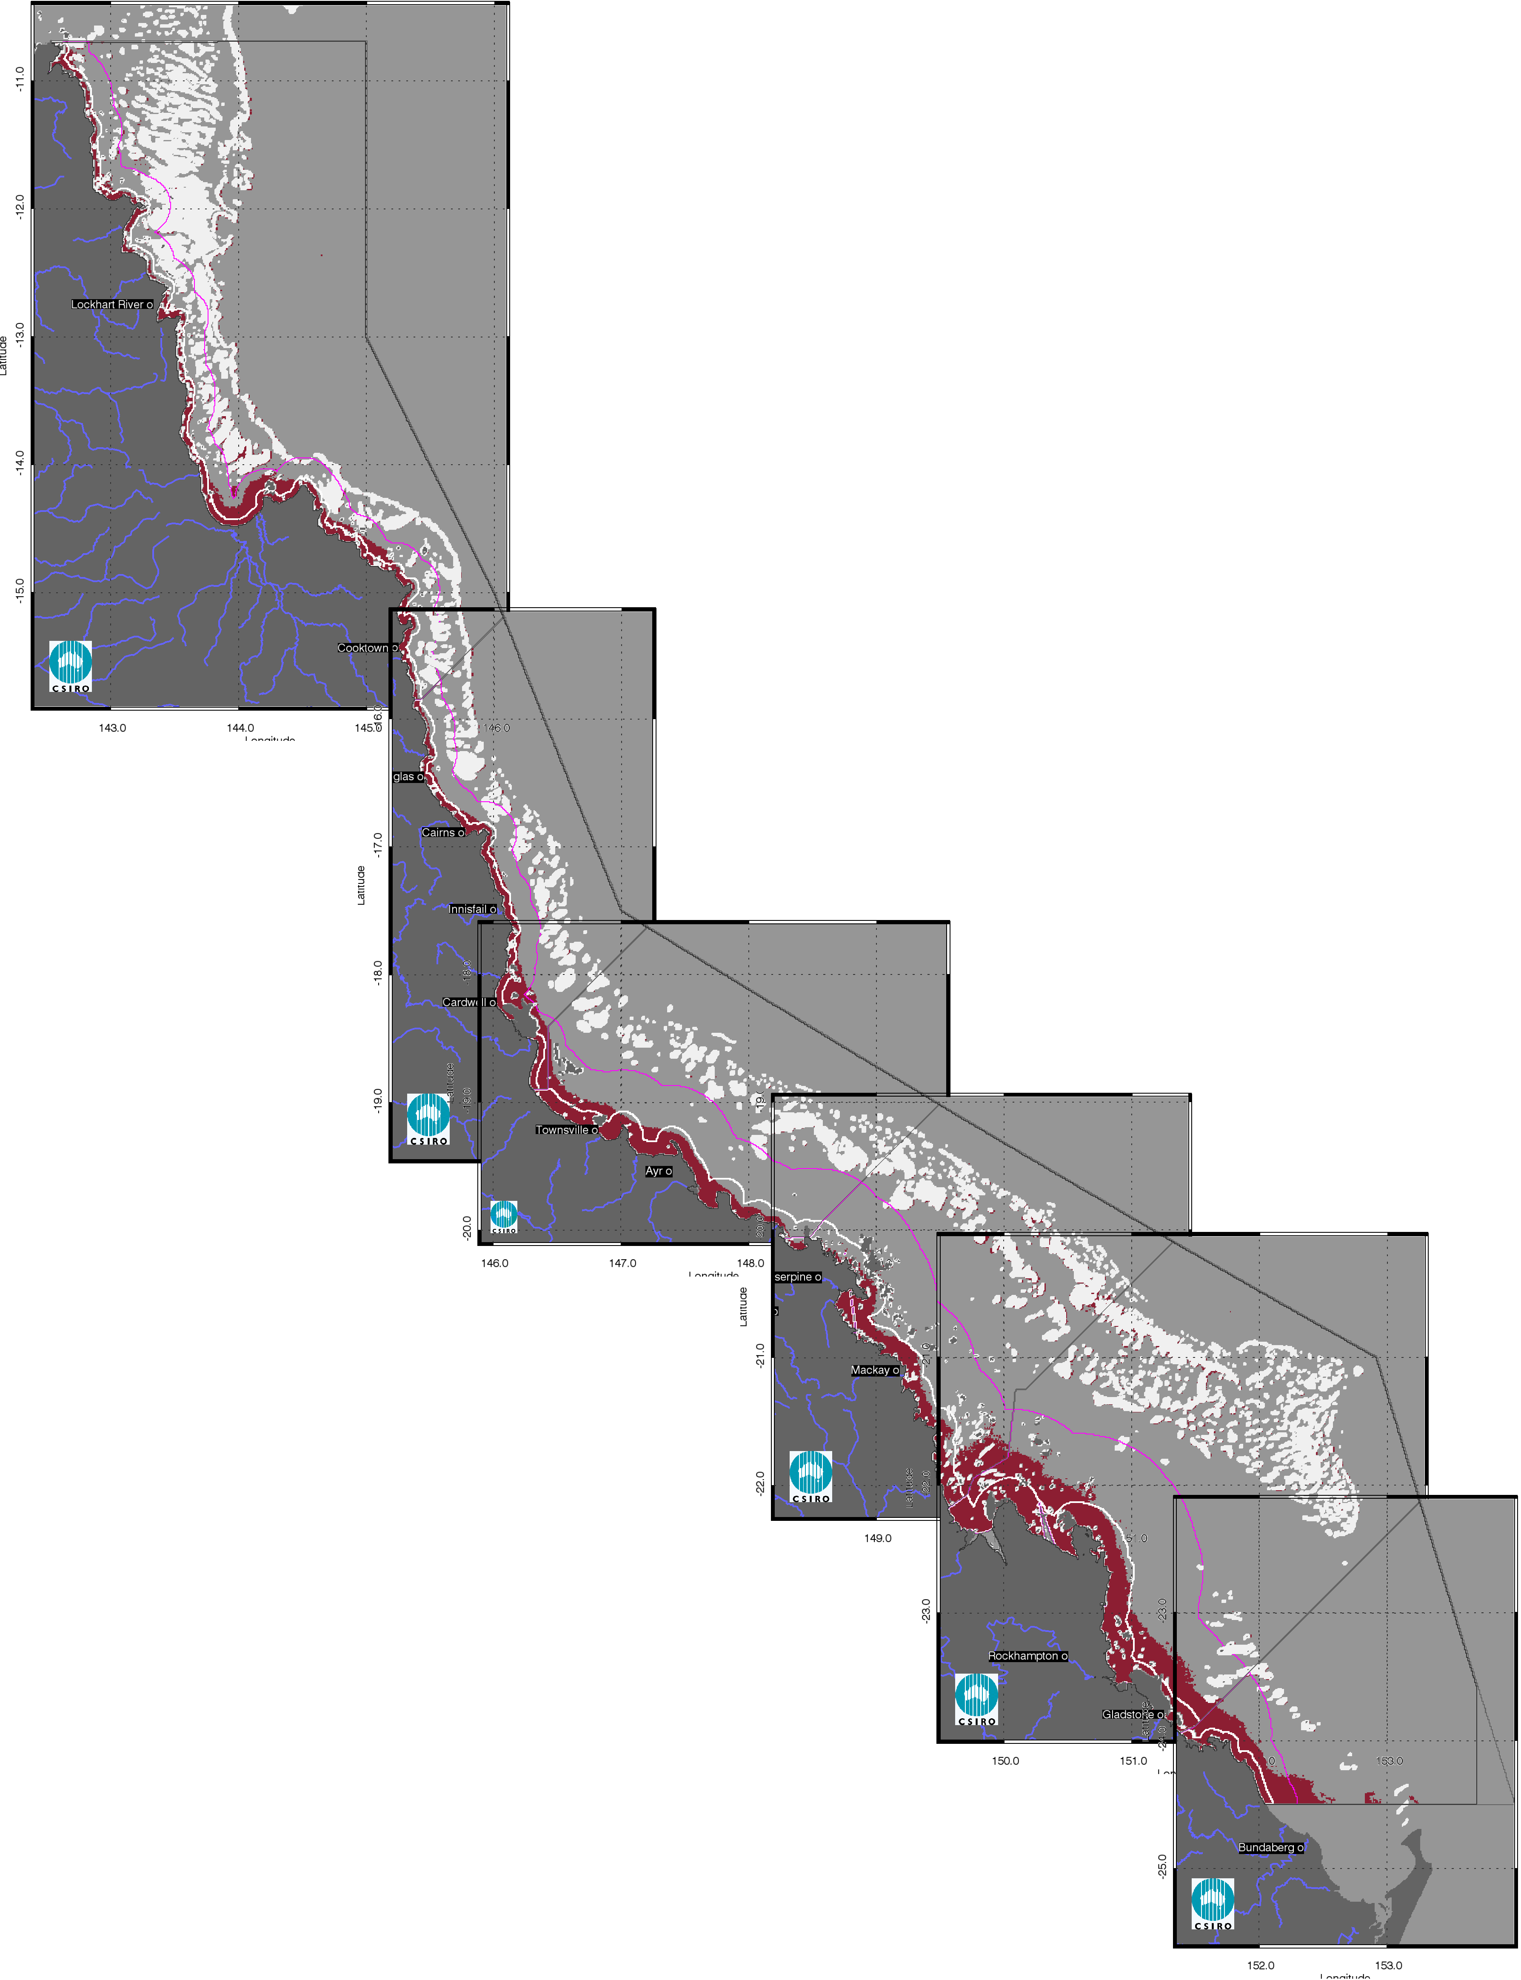

- Chlorophyll-a exceedance maps for the whole GBR for the reporting year 2012/13 (May 2012 –April 2013).The Guideline values for annual means of Chlorophyll–a are 0.45 µg L-1 for Inshore and Midshelf and 0.40 µg L-1 for Offshore waters.

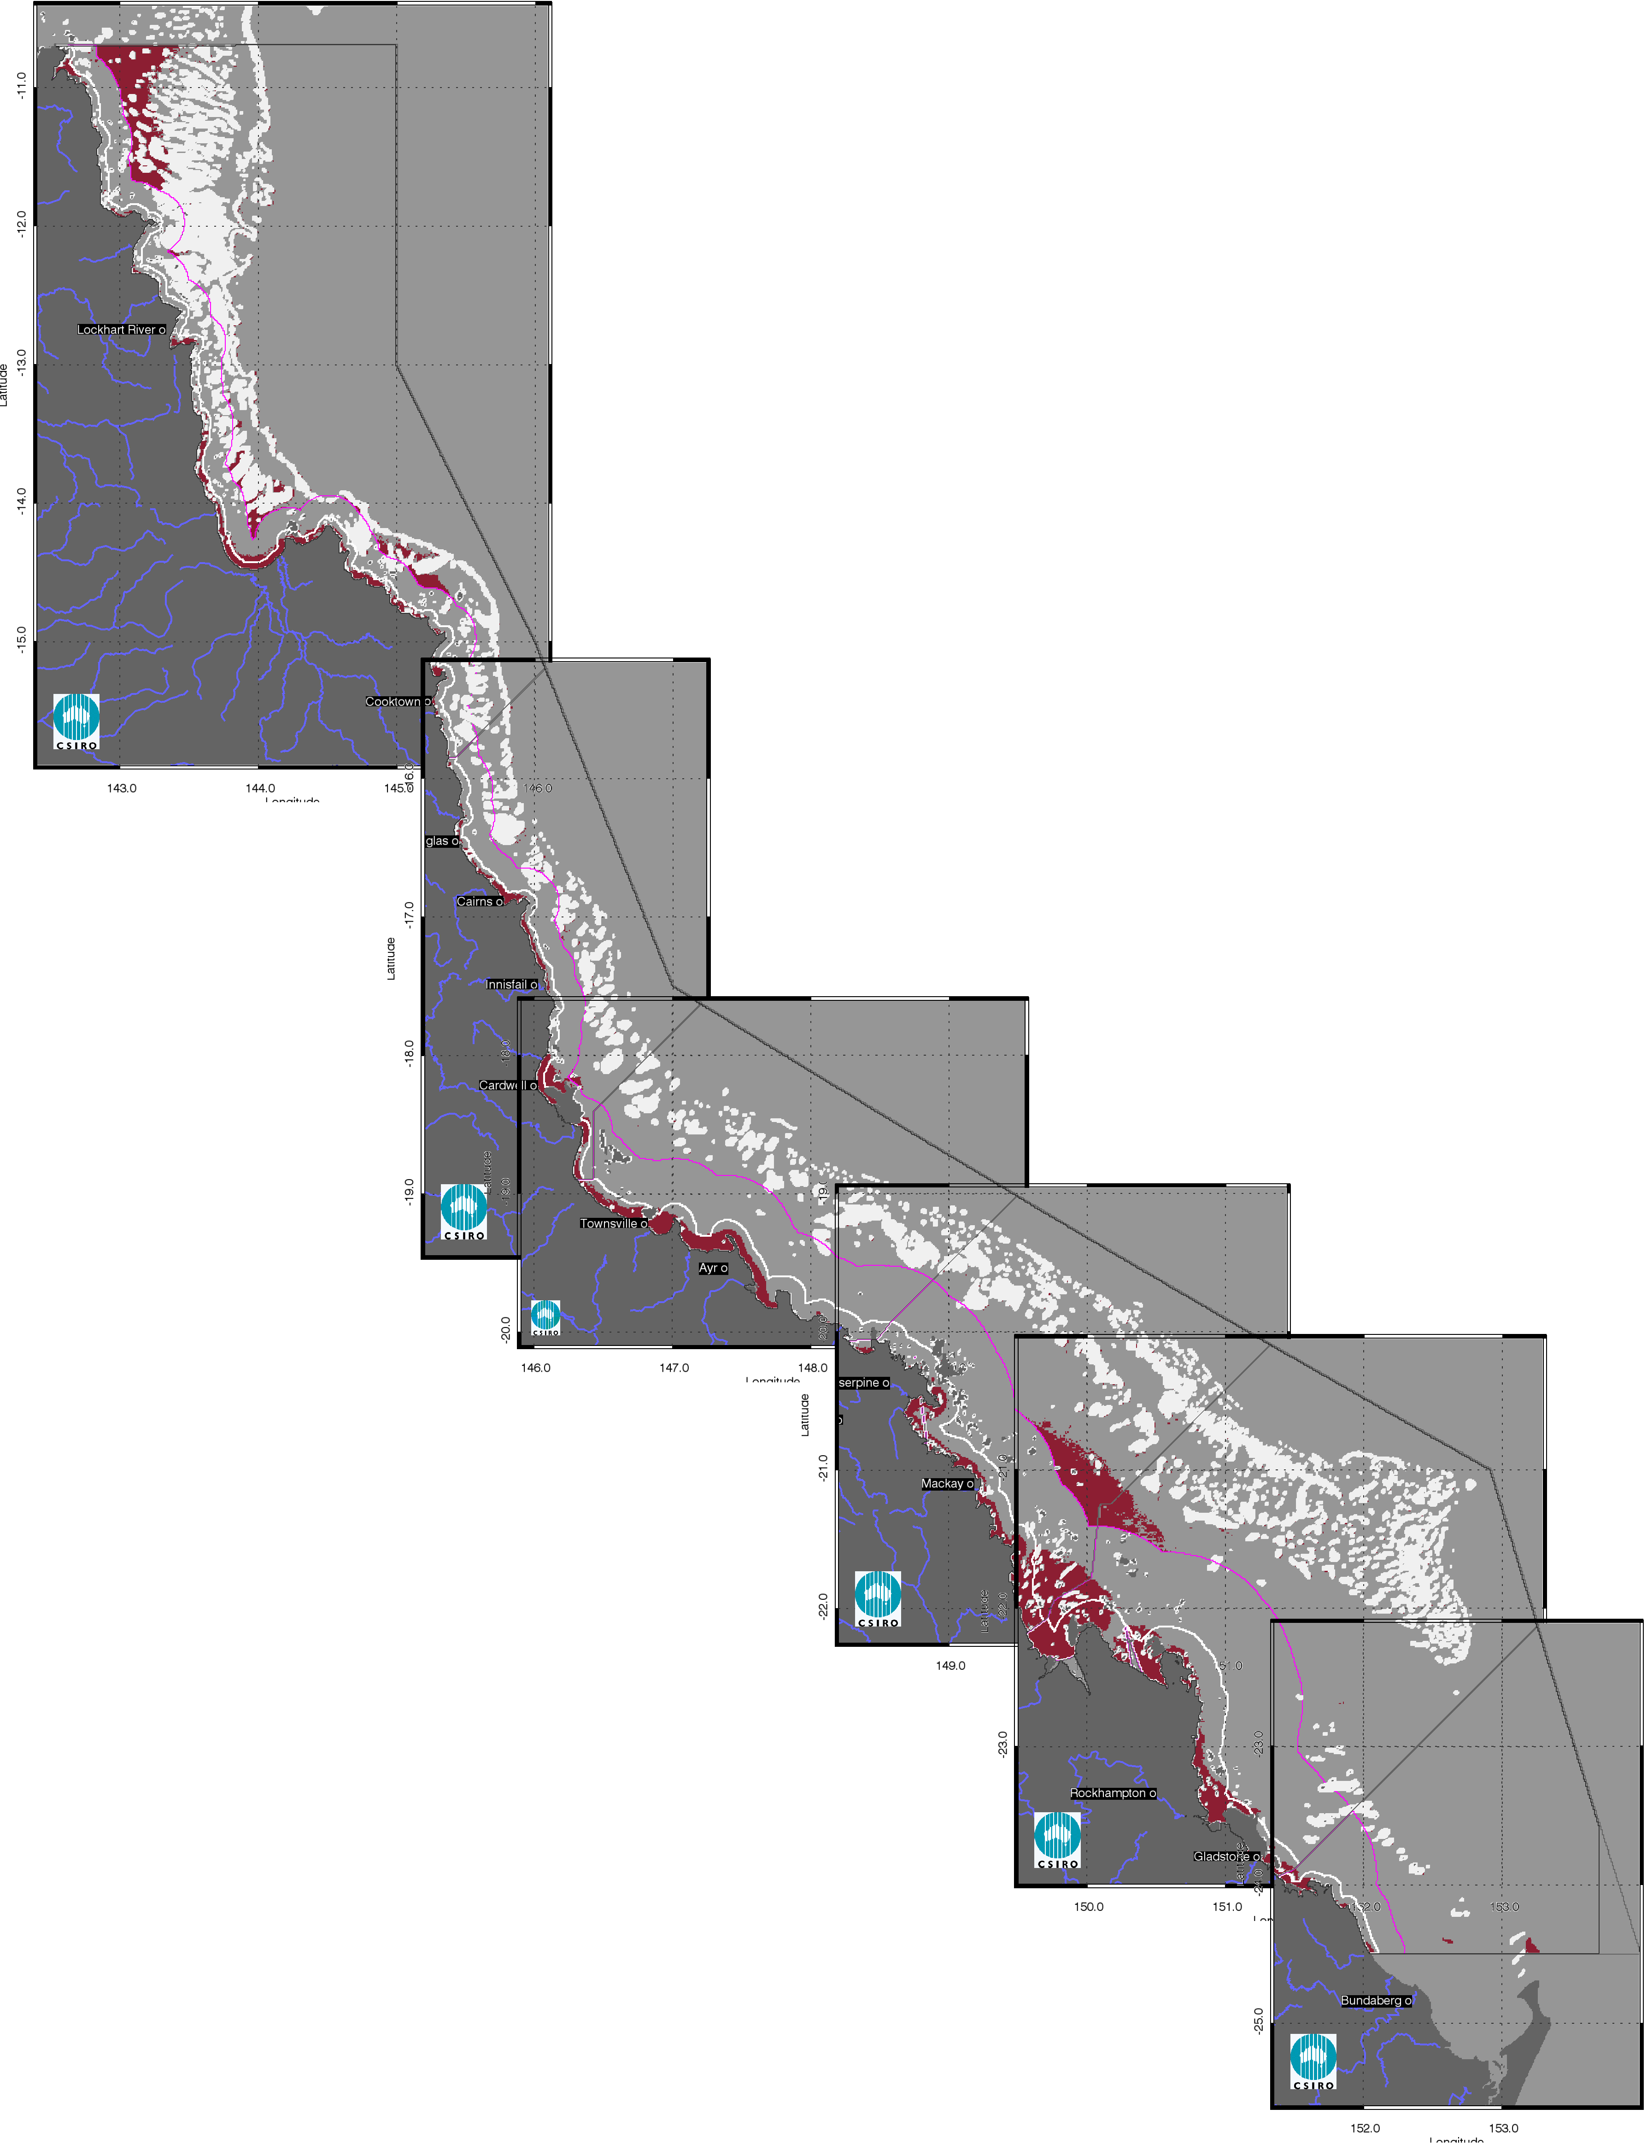

- Non-algal particulate matter exceedance maps for the whole GBR for the reporting year 2012/13 (May 2012 –April 2013). The Guideline values for annual means of TSS are 2.0 mg L-1 for Inshore and Midshelf and 0.7 mg L-1 for Offshore waters.

- Summary of the exceedance of annual mean values of Chlorophyll-a and non-algal particulate matter (as a measure of Total Suspended Solids) for the reporting period 01-May-2012 - 30-Apr-2013 for the Inshore, Mid-shelf and Offshore water bodies (IS, MS, OS). Cells are shaded in gray when more than 50% of the area of the water body exceeds the Guideline value. * Caution should be used when interpreting the results for the Cape York and Burnett Mary regions as limited field information was used for the parameterization and validation on the remote sensing retrievals.
Location | Chlorophyll-a: Relative area (%) of the water body where the annual mean value exceeds the WQ Guideline value |  |  | Total Suspended Solids: Relative area (%) of the water body where the annual mean value exceeds the WQ Guideline value
1213 | IS | MS | OS | IS | MS | OS
Cape York* | 75% | 17% | 1% | 34% | 3% | 6%
Wet Tropics | 86% | 24% | 1% | 37% | 4% | 1%
Burdekin | 71% | 8% | 0% | 41% | 0% | 0%
Mackay Whitsunday | 64% | 10% | 2% | 39% | 10% | 8%
Fitzroy | 92% | 20% | 1% | 51% | 4% | 2%
Burnett Mary* | 98% | 46% | 2% | 28% | 1% | 0%

- Summary of the exceedance of annual mean values of Chlorophyll-a and non-algal particulate matter (as a measure of Total Suspended Solids) for the reporting period 01-May-2011 - 30-Apr-2012 for the Inshore, Mid-shelf and Offshore water bodies (IS, MS, OS). Cells are shaded in gray when more than 50% of the area of the water body exceeds the Guideline value. * Caution should be used when interpreting the results for the Cape York and Burnett Mary regions as limited field information was used for the parameterization and validation on the remote sensing retrievals.
Location | Chlorophyll-a: Relative area (%) of the water body where the annual mean value exceeds the WQ Guideline value |  |  | Total Suspended Solids: Relative area (%) of the water body where the annual mean value exceeds the WQ Guideline value
1112 | IS | MS | OS | IS | MS | OS
Cape York* | 81% | 16% | 1% | 39% | 1% | 5%
Wet Tropics | 91% | 33% | 1% | 49% | 8% | 1%
Burdekin | 71% | 12% | 0% | 46% | 0% | 0%
Mackay Whitsunday | 57% | 6% | 2% | 45% | 8% | 6%
Fitzroy | 85% | 9% | 1% | 49% | 3% | 1%
Burnett Mary* | 98% | 21% | 0% | 27% | 1% | 0%

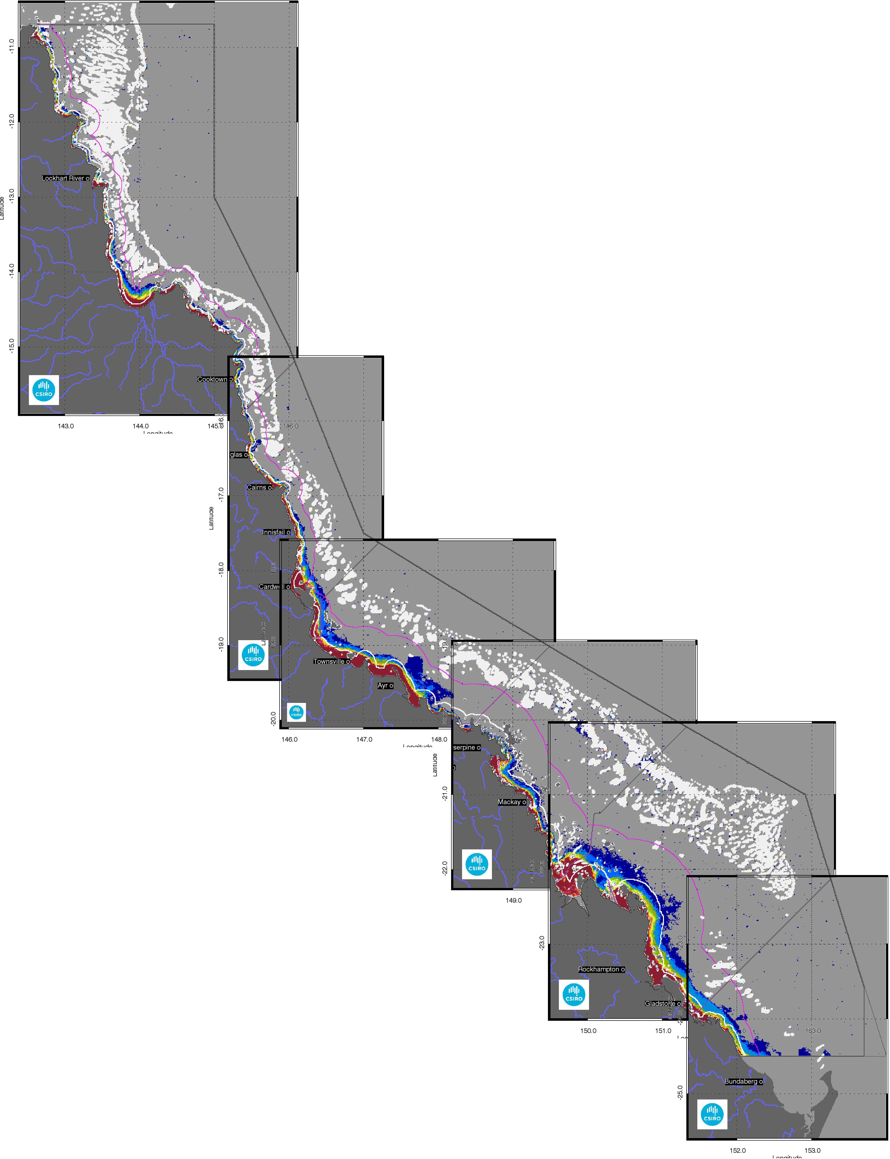

- Superimposed annual exceedance extents for Chlorophyll-a for the whole GBR for the reporting years between 2002/03 and 2012/13.
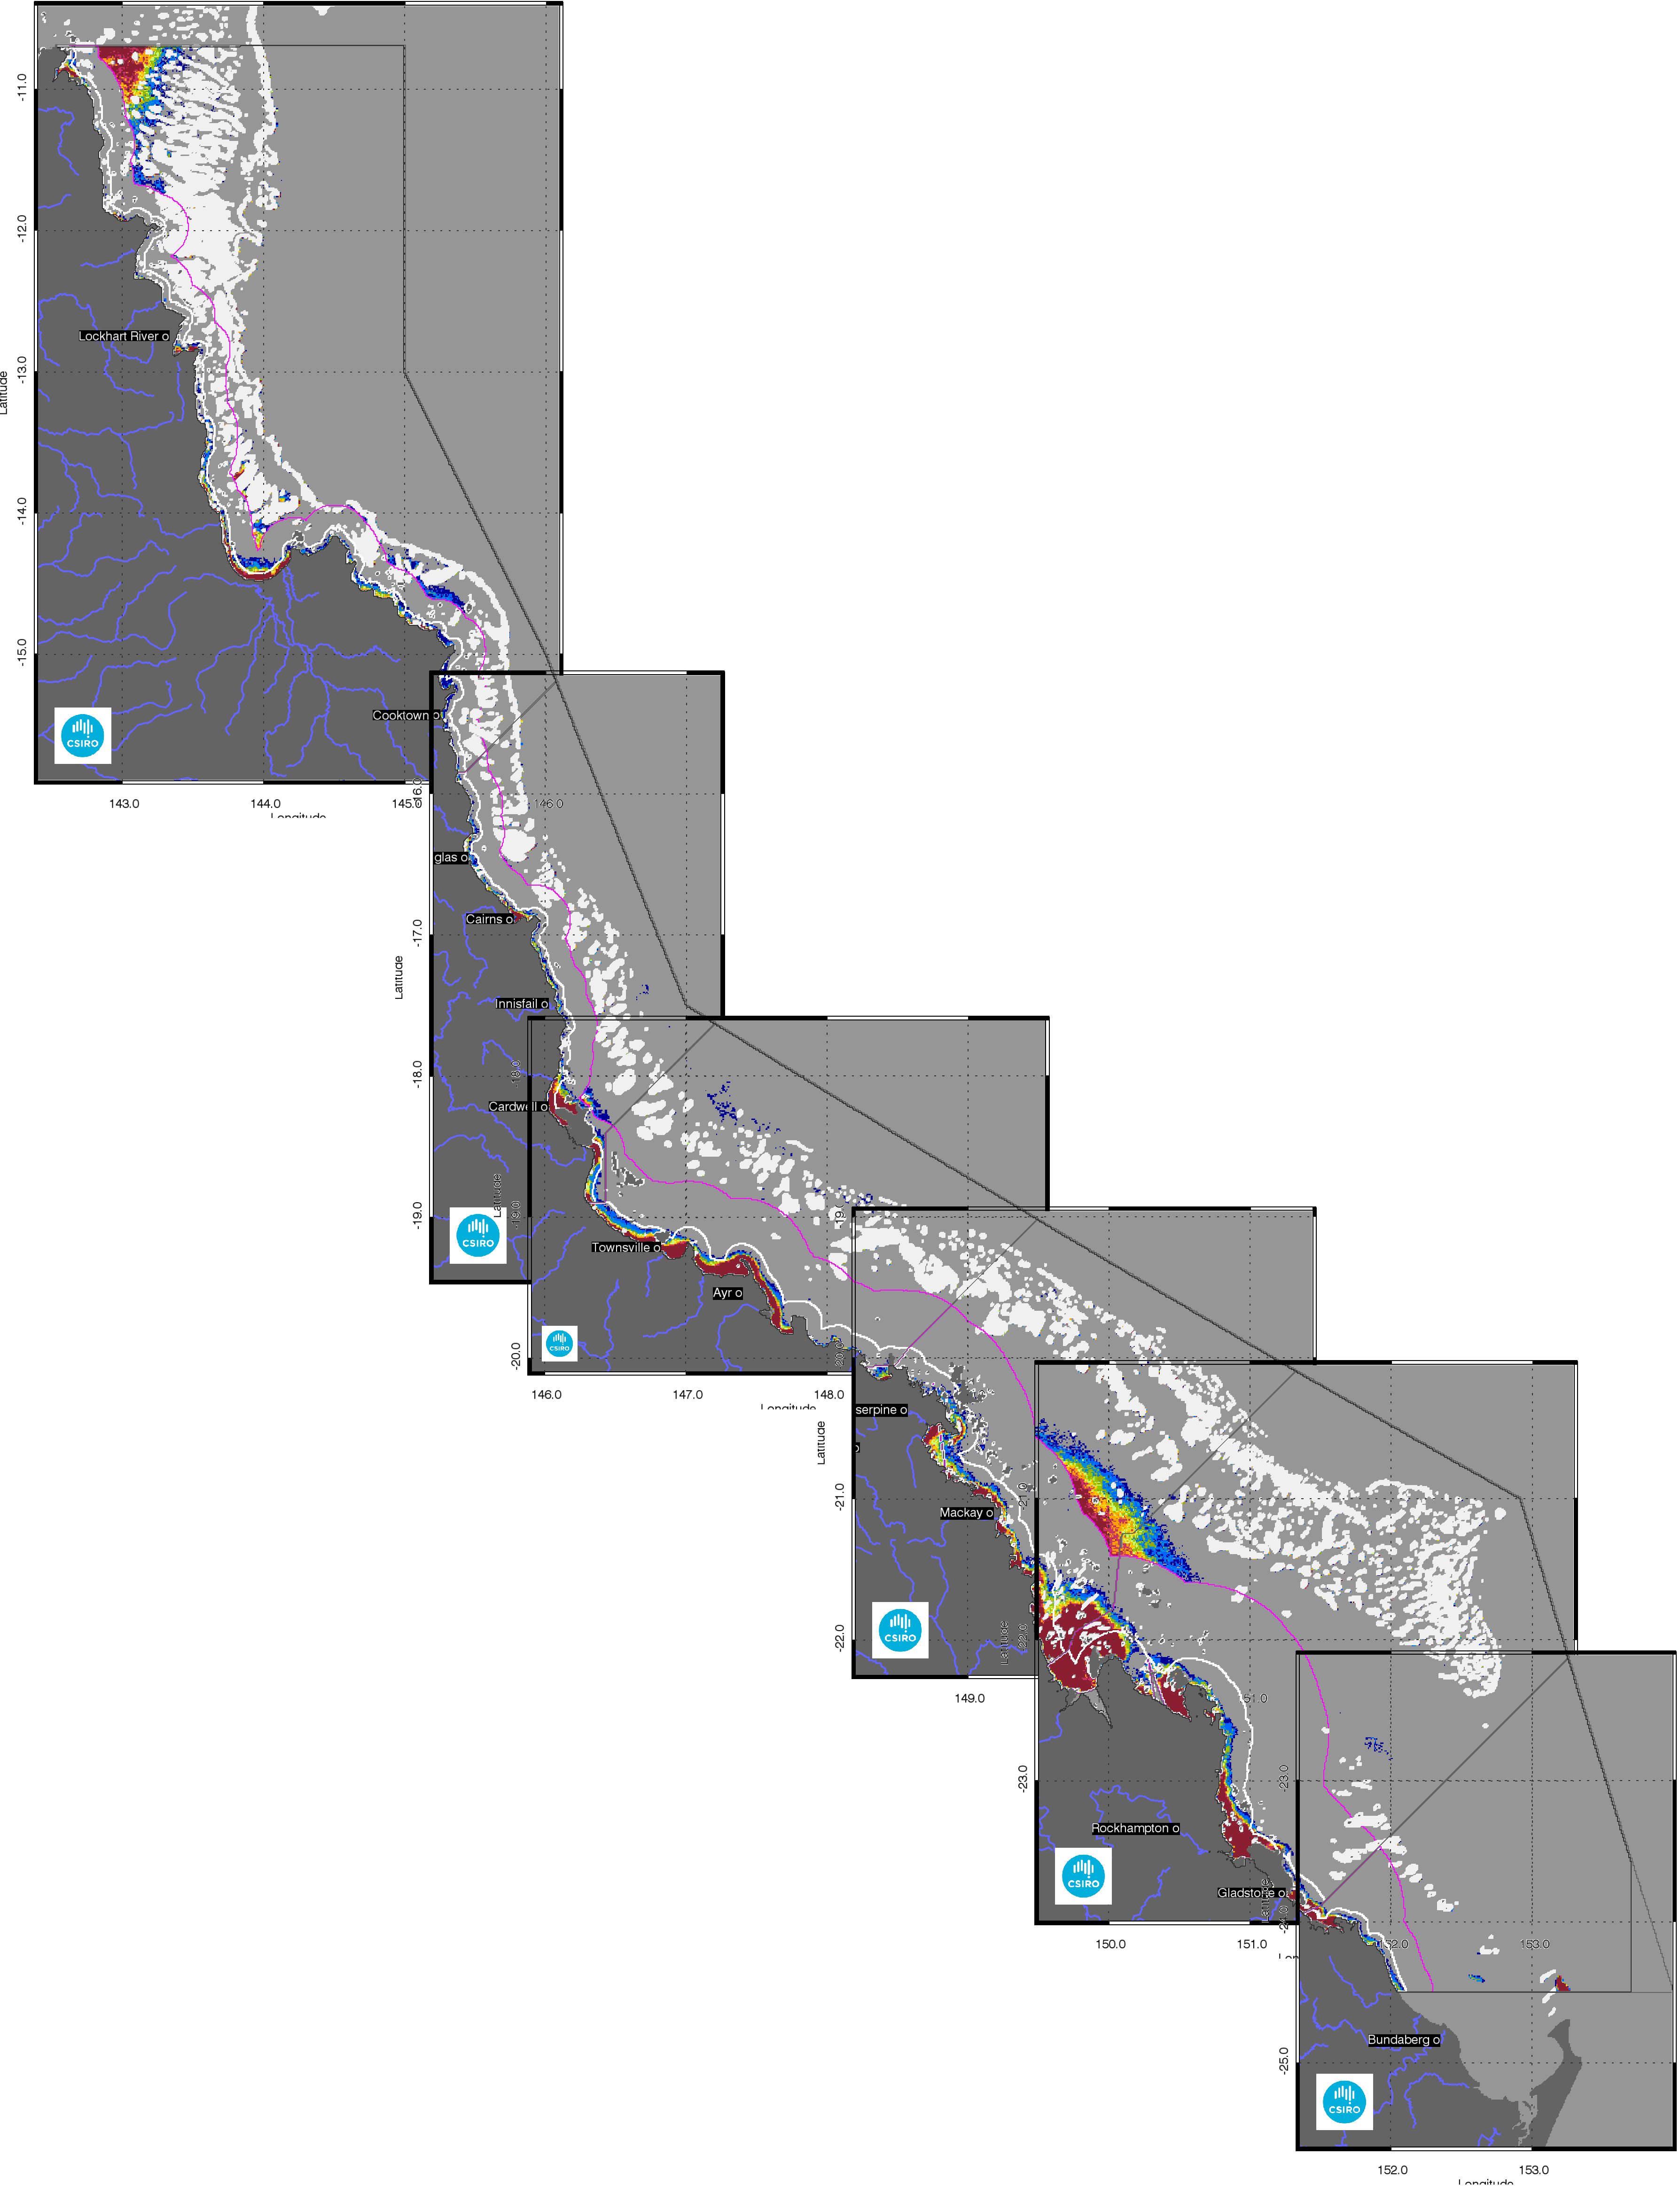

- Superimposed annual exceedance extents for Non-algal particulate matter (NAP as a measure of TSS) for the whole GBR for the reporting years between 2002/03 and 2012/13.

- Paddock to Reef marine water quality index (P2R_WQI) and component scores (P2R_CHL and P2R_TSS) for the reporting period 1 May 2012 – 30 April 2013. Cells are shaded to reflect the colour coding of the P2R reporting scheme from red to green in steps of 20%. * Caution should be used when interpreting the results for the Cape York and Burnett Mary regions as limited field information was used for the parameterization and validation on the remote sensing retrievals. The regional scores for Cape York and Burnett Mary are excluded from calculations of the overall GBR score for each metric.
Location | P2R_Chl | P2R_TSS | P2R_WQI
Cape York* | 25 | 66 | 45
Wet Tropics | 14 | 63 | 38
Burdekin | 29 | 59 | 44
Mackay Whitsunday | 36 | 61 | 48
Fitzroy | 8 | 49 | 28
Burnett Mary* | 2 | 72 | 37
GBR | 20 | 56 | 38

- Trends in the Paddock to Reef marine water quality index (P2R_WQI) and component scores (P2R_CHL and P2R_TSS) aggregated for the whole GBR. The regional scores for Cape York and Burnett Mary are excluded from calculations of the overall GBR score for the metrics.

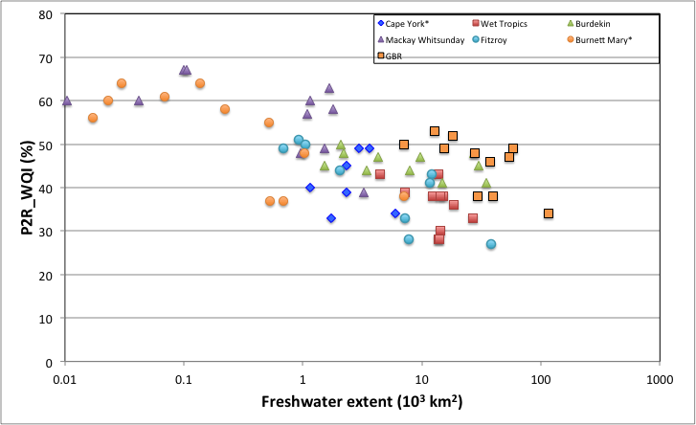
- Relation between the Paddock to Reef marine water quality index (P2R_WQI) and the freshwater extent for each NRM region and the whole GBR. The regional scores for Cape York and Burnett Mary are excluded from calculations of the overall GBR score for the P2R metrics
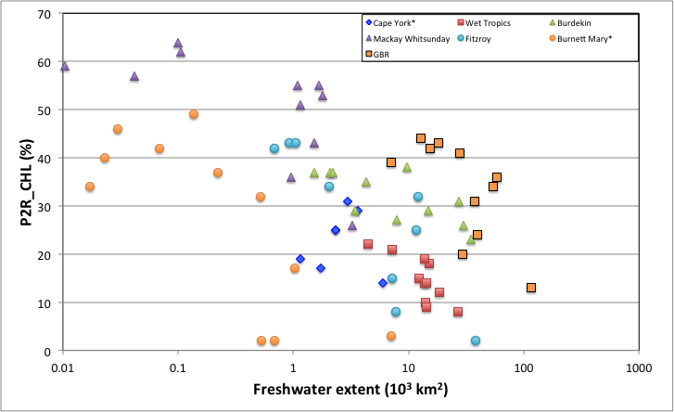
- Relation between the Paddock to Reef marine water quality index component score for Chlorophyll (P2R_CHL) and the freshwater extent for each NRM region and the whole GBR. The regional scores for Cape York and Burnett Mary are excluded from calculations of the overall GBR score for the P2R metrics.
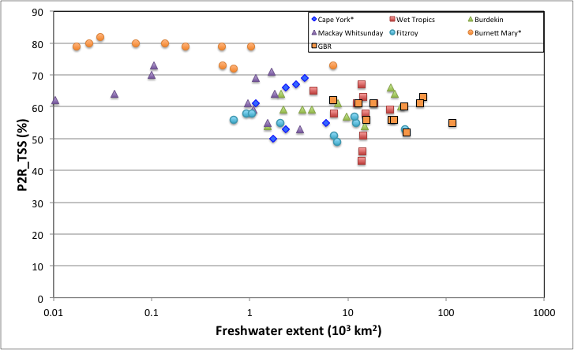
- Relation between the Paddock to Reef marine water quality index component score for TSS (P2R_TSS) and the freshwater extent for each NRM region and the whole GBR. The regional scores for Cape York and Burnett Mary are excluded from calculations of the overall GBR score for the P2R metrics
- Summary of the correlations between the Paddock to Reef marine water quality index (P2R_WQI) as well asthe component scores for Chlorophyll-a Total Suspended Solids (P2R_CHL and P2R_TSS) with the freshwater extent. Correlations are statistically significant when the p-values are bolded (p<0.05). * Caution should be used when interpreting the results for the Cape York and Burnett Mary regions as limited field information was used for the parameterization and validation on the remote sensing retrievals.
 | P2R_WQI | p | P2R_Chl | p | P2R_TSS | p
Cape York* | -0.453 | 0.156 | -0.538 | 0.082 | -0.236 | 0.481
Wet Tropics | -0.774 | 0.004 | -0.808 | 0.002 | -0.582 | 0.055
Burdekin | -0.402 | 0.214 | -0.614 | 0.040 | 0.255 | 0.446
Mackay Whitsunday | -0.375 | 0.251 | -0.476 | 0.132 | -0.127 | 0.708
Fitzroy | -0.950 | 0.000 | -0.967 | 0.000 | -0.718 | 0.010
Burnett Mary* | -0.767 | 0.004 | -0.755 | 0.005 | -0.813 | 0.001
GBR | -0.915 | 0.000 | -0.958 | 0.000 | -0.474 | 0.135

- Summary table for the Paddock to Reef marine water quality component scores based on CHL compliance (P2R_ CHL). Percentage of compliance is reported over the surface area of the Inshore region. Cells are shaded to reflect the colour coding of the P2R reporting scheme from red to green in steps of 20%.
P2R_Chl | 0203 | 0304 | 0405 | 0506 | 0607 | 0708 | 0809 | 0910 | 1011 | 1112 | 1213
Cape York* | 37 | 28 | 35 | 19 | 17 | 29 | 25 | 31 | 14 | 19 | 25
Wet Tropics | 22 | 14 | 21 | 18 | 10 | 19 | 12 | 15 | 8 | 9 | 14
Burdekin | 37 | 37 | 35 | 37 | 38 | 31 | 26 | 27 | 23 | 29 | 29
Mackay Whitsunday | 57 | 59 | 64 | 62 | 55 | 55 | 51 | 53 | 26 | 43 | 36
Fitzroy | 35 | 42 | 43 | 42 | 43 | 32 | 34 | 25 | 2 | 15 | 8
Burnett Mary* | 32 | 37 | 49 | 42 | 46 | 34 | 40 | 17 | 3 | 2 | 2
GBR | 39 | 42 | 44 | 43 | 41 | 36 | 34 | 31 | 13 | 24 | 20
- Summary table for the Paddock to Reef marine water quality component scores based on TSS compliance (P2R_ TSS ). Percentage of compliance is reported over the surface area of the Inshore region. Cells are shaded to reflect the colour coding of the P2R reporting scheme from red to green in steps of 20%.
P2R_Nap | 0203 | 0304 | 0405 | 0506 | 0607 | 0708 | 0809 | 0910 | 1011 | 1112 | 1213
Cape York* | 69 | 49 | 65 | 65 | 50 | 69 | 53 | 67 | 55 | 61 | 66
Wet Tropics | 65 | 43 | 58 | 58 | 46 | 67 | 61 | 61 | 59 | 51 | 63
Burdekin | 64 | 54 | 59 | 59 | 57 | 66 | 64 | 61 | 60 | 54 | 59
Mackay Whitsunday | 64 | 62 | 70 | 73 | 59 | 71 | 69 | 64 | 53 | 55 | 61
Fitzroy | 59 | 57 | 58 | 56 | 58 | 55 | 55 | 57 | 53 | 51 | 49
Burnett Mary* | 79 | 79 | 80 | 80 | 82 | 79 | 80 | 79 | 73 | 73 | 72
GBR | 62 | 56 | 61 | 61 | 56 | 63 | 61 | 60 | 55 | 52 | 56
- Summary table for the Paddock to Reef marine water quality index (P2R_WQI). Percentage of compliance is reported over the surface area of the Inshore region. Cells are shaded to reflect the colour coding of the P2R reporting scheme from red to green in steps of 20%.
P2R_WQI | 0203 | 0304 | 0405 | 0506 | 0607 | 0708 | 0809 | 0910 | 1011 | 1112 | 1213
Cape York* | 53 | 38 | 50 | 42 | 33 | 49 | 39 | 49 | 34 | 40 | 45
Wet Tropics | 43 | 28 | 39 | 38 | 28 | 43 | 36 | 38 | 33 | 30 | 38
Burdekin | 50 | 45 | 47 | 48 | 47 | 48 | 45 | 44 | 41 | 41 | 44
Mackay Whitsunday | 60 | 60 | 67 | 67 | 57 | 63 | 60 | 58 | 39 | 49 | 48
Fitzroy | 47 | 49 | 51 | 49 | 50 | 43 | 44 | 41 | 27 | 33 | 28
Burnett Mary* | 55 | 58 | 64 | 61 | 64 | 56 | 60 | 48 | 38 | 37 | 37
GBR | 50 | 49 | 53 | 52 | 48 | 49 | 47 | 46 | 34 | 38 | 38

Regional reports: Cape York region
Cape York Peninsula is the northernmost extremity of Australia. From its tip at Cape York this NRM region extends southward along the Queensland coast for about 800km, widening to its base, which spans 650km from Cairns in the east to the Gilbert River in the west. The largest rivers in the Cape region flow into the Gulf of Carpentaria, however there are several large catchments that drain into the GBR. The region has a monsoonal climate with distinct wet and dry seasons. Most rain falls between December and April(Johnson et al. 2011)with mean annual rainfall ranging from 1715mm in the Starke region to 2159mm near the Lockhart River airport. The Cape is an area of exceptional conservation value and has cultural value of great significance to both Indigenous and non-Indigenous communities. The majority of the land is relatively undeveloped, therefore water entering the lagoon is perceived to be of a high quality(Johnson et al. 2011).
This system is characterized by shallow and turbid waters (e.g. in Princess Charlotte Bay) and a relatively narrow coastal water body. The outer boundary for the Open Coastal marine water body approximate delineation in the Guidelines for this NRM region is only 6 km from shore (Table 1 at page 12 of GBRMPA 2009). According to the delineation proposed in the previous report(Figure 2), the Enclosed Coastal marine water body accounts for ~30% of the inshore waters used for P2R reporting and for most of the area in Princess Charlotte Bayas well as Shelburne Bay, Temple Bay, Lloyds Bay, Bathurst Bay and Ninian Bay. Caution should be used when interpreting the results for this region as limited field information was used for the parameterization and validation on the remote sensing retrievals. In January 2013, fieldwork was carried out within the eReefs activities to fill this knowledge gap. Optical data acquired during this fieldwork will form the basis of an extension of the algorithm parameterization.

Assessment of freshwater extent during the wet season
Figure 18 reports the freshwater extent for wet season 2011/2012 (November 2012- April 2013) for the Cape York region. The freshwater extent (salinity S≤30) was estimated by applying a threshold of 0.24 m⁻¹ to the CDOM seasonal maximum (Figure 17).
For the Cape York region the freshwater extent in 2012/2013 was 4140km² above the median value of the last decade. The annual flow data for the Normanby River for this year was the above median. The freshwater extent for the Cape York region varied between 2601 and 5644 km² (Figure 16). The freshwater extent was well correlated with the freshwater discharge (R=0.564, Figure 16): the largest extent of 2010/11 reflected the maximum river discharge, while the low extent of 2011/12 reflected the lowest discharge.
Following the January flood of the Normanby River, in 2012/13 the freshwater extended for 10-15 kmfrom shore in Princess Charlotte Bay and reached the reef matrix ~30 km offshore in the Eastern portions of the Bay with CDOM higher than of 0.5 m⁻¹ (Figure 17, Figure 18). The map of frequency of salinity ≤30 (Figure 19), shows that in all ten the wet seasons between 2003 and 2013 the freshwater extended into most of the in Inshore water body, while the Midshelf water body was reached by low salinity waters several times. The freshwater reached the reef matrix once or twice almost everywhere in this region between 2003 and 2013.
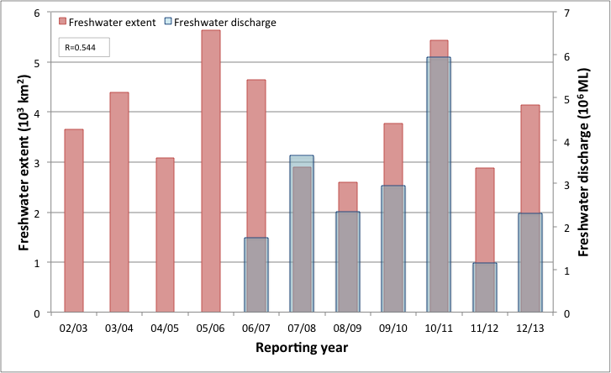
- Freshwater discharge and estimated freshwater extent for the Cape York region based on the CDOM maximum for the wet seasons.

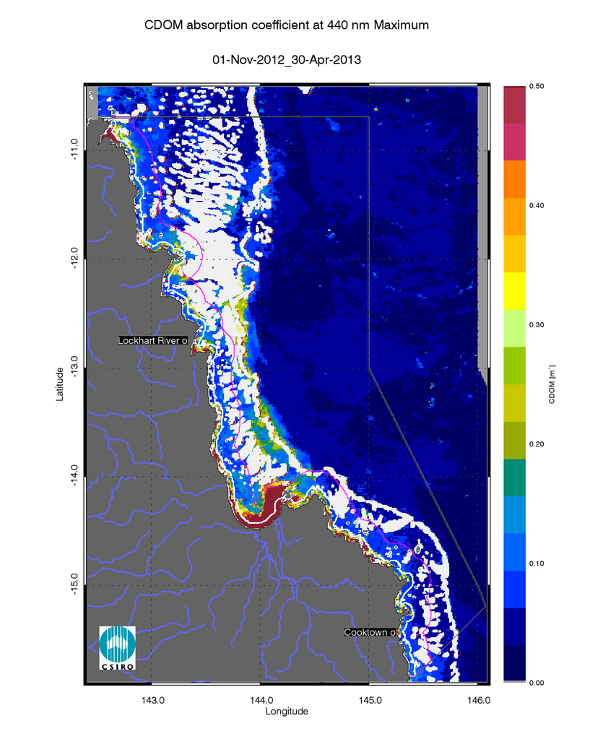
- Map of freshwater extent for the wet season the Cape York region. Maximum value of CDOM for the wet season 2012/2013 (November 2012 - April 2013).
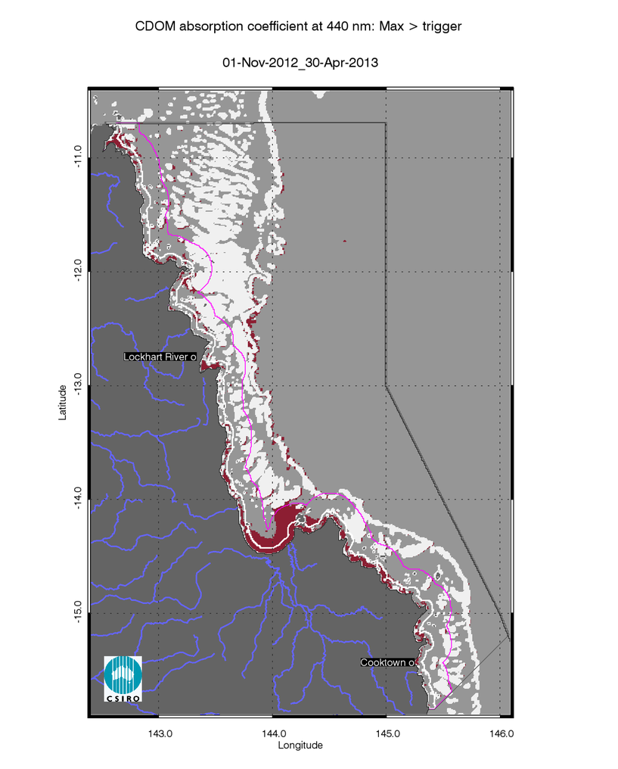
- Map of freshwater extent for the 2012/13 wet season in the Cape York region. Freshwater extent estimated with a threshold for the CDOM seasonal maximum of 0.24 m⁻¹.
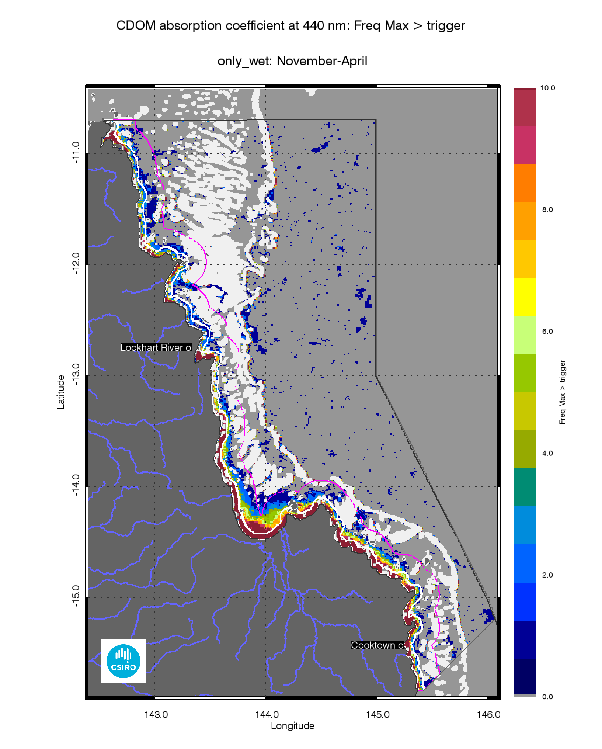
- Map of multi annual freshwater extent for the wet season for the Cape York region. Superimposed seasonal maximum freshwater plume extents for the wet seasons between 2003 and 2013.

Assessment of the exceedance of water quality guidelines
The P2R scores are based on exceedance of the Guidelines assessed for CHL and TSS retrieved from MODIS Aqua using the CSIRO ocean colour algorithm. For the Cape York region the annual mean CHL values of exceeded the Guidelines threshold values for 75% of the Inshore Coastal area, 13% of the Midshelf and 1% of the Offshore areas (Table 11). The Exceedance maps for CHL show that the mean CHL values of exceeded the Guidelines thresholds over the whole year only in river mouths and embayments in the Inshore and Midshelf water bodies (Figure 20Figure 22). This spatial pattern has been consistent for this region over the decade between 2003 and 2013, as shown by the map of frequency of CHL exceedance (Figure 23).
Over the whole year, exceedance of TSS Guideline values was recorded in 34% of Inshore, 3% of Midshelf and 6% of Offshore areas (Table 11,Figure 21, Figure 23). The Exceedance maps for TSS show that the mean TSS values of exceeded the Guidelines thresholds over the whole year only in river mouths and embayments, as well as in the Offshore waters between the Midshelf to Offshore boundary and the reef matrix (Figure 21, Figure 23). This spatial pattern has been consistent for this region over the decade between 2003 and 2013, as shown by the map of frequency of TSS exceedance (Figure 25).
Maps and tables providing details for the seasonal exceedance in the wet and dry seasons are reported in section 7.2 (Table 20, Table 21, Figure 101, Figure 102, Figure 103, Figure 104, Figure 105, Figure 106, Figure 107).

- Summary of the annual exceedance maps from 01-May-2012 to 30-Apr-2013 for Chlorophyll-a and Total Suspended Solids for the Cape York region. Surface Area is the surface area in square kilometres for each of the reporting water bodies for this region Number valid obs. is the number of pixels with valid observations (i.e. cloud-free and error-free pixels); Number total obs. provides the total number of observations; Mean> trigger and Median > trigger report the relative area for each water body where the mean or the median exceeded the WQ Guideline value.
 |  | 01-May-2012_30-Apr-2013 |  | Chlorophyll-a |  | Total Suspended Solids
Region | Surface Area | Number valid obs. | Number total obs. | Mean > trigger | Median > trigger | Mean > trigger | Median > trigger
Inshore | 4363 | 200126 | 2273123 | 75% | 71% | 34% | 18%
Midshelf | 10686 | 641788 | 5567406 | 17% | 13% | 3% | 1%
Offshore | 63092 | 2319274 | 32840044 | 1% | 1% | 6% | 5%

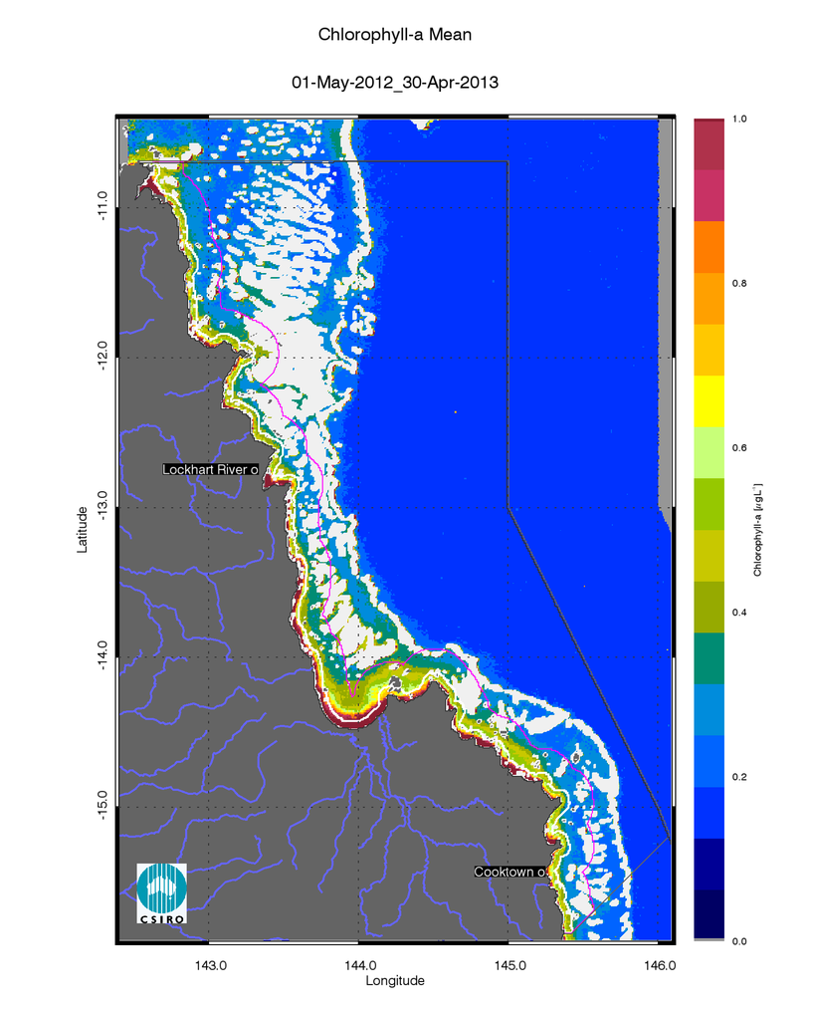
- Annual mean map for Chlorophyll-afor the Cape York region for the reporting year 2012/13 (May 2012 –April 2013).
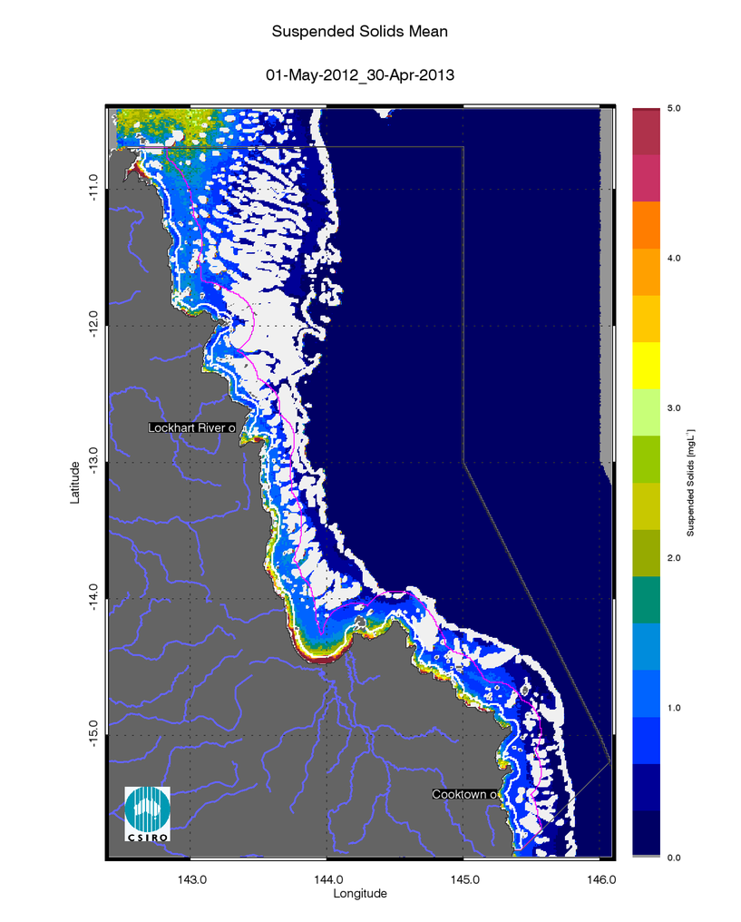
- Annual mean map for Non-algal particulate matter (NAP as a measure of TSS) for the Cape York region for the reporting year 2012/13 (May 2012 –April 2013).

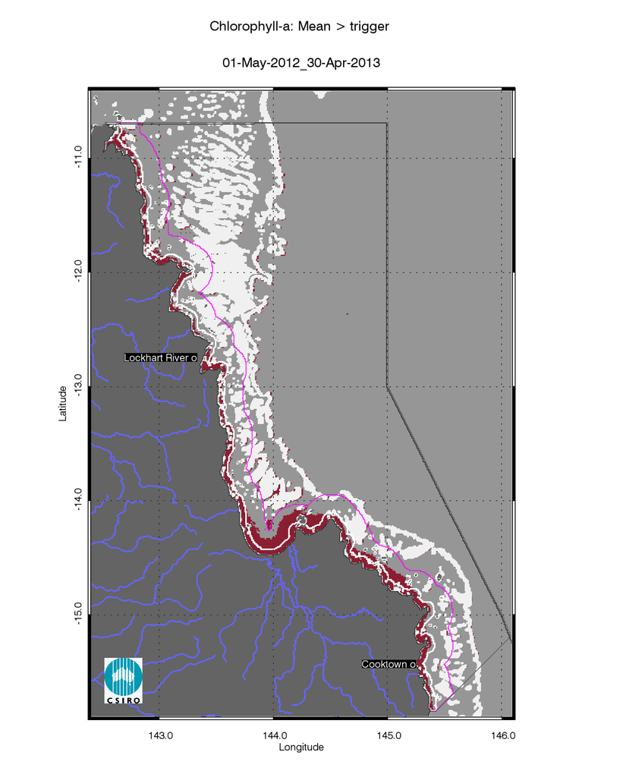
- Exceedance maps for the Cape York region for the reporting year 2012/13 (May 2012 –April 2013). Chlorophyll-a exceedance map. The Guideline values for annual means of Chlorophyll–a are 0.45 µg L-1 for Inshore and Midshelf and 0.40 µg L-1 for Offshore
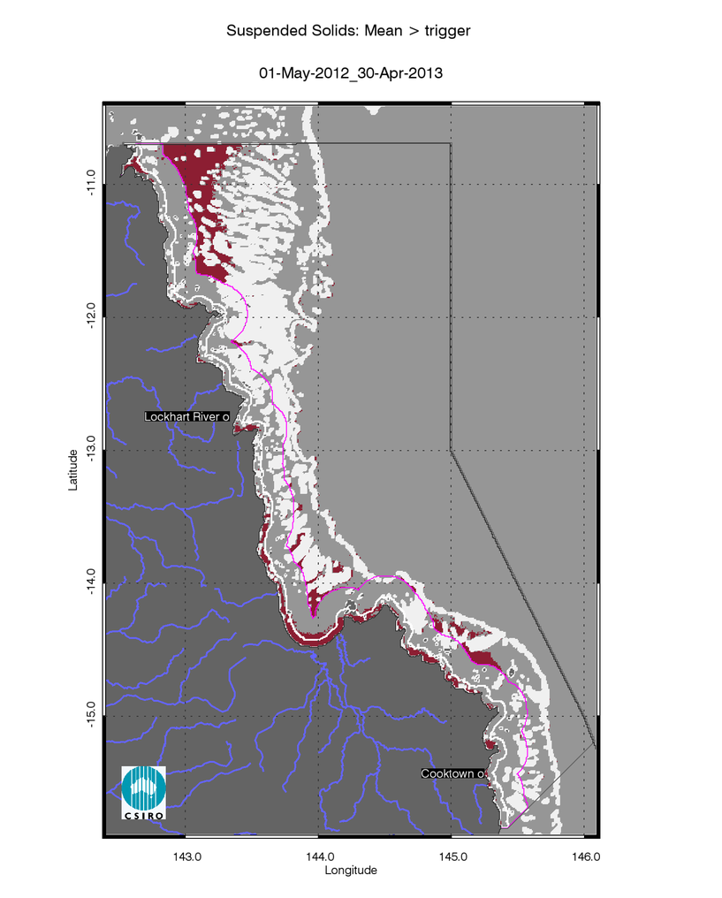
- Exceedance maps for the Cape York region for the reporting year 2012/13 (May 2012 –April 2013). Non-algal particulate matter (NAP as a measure of TSS) exceedance map. The Guideline values for annual means of TSS are 2.0 mg L-1 for Inshore and Midshelf and 0.7 mg L-1 for Offshore

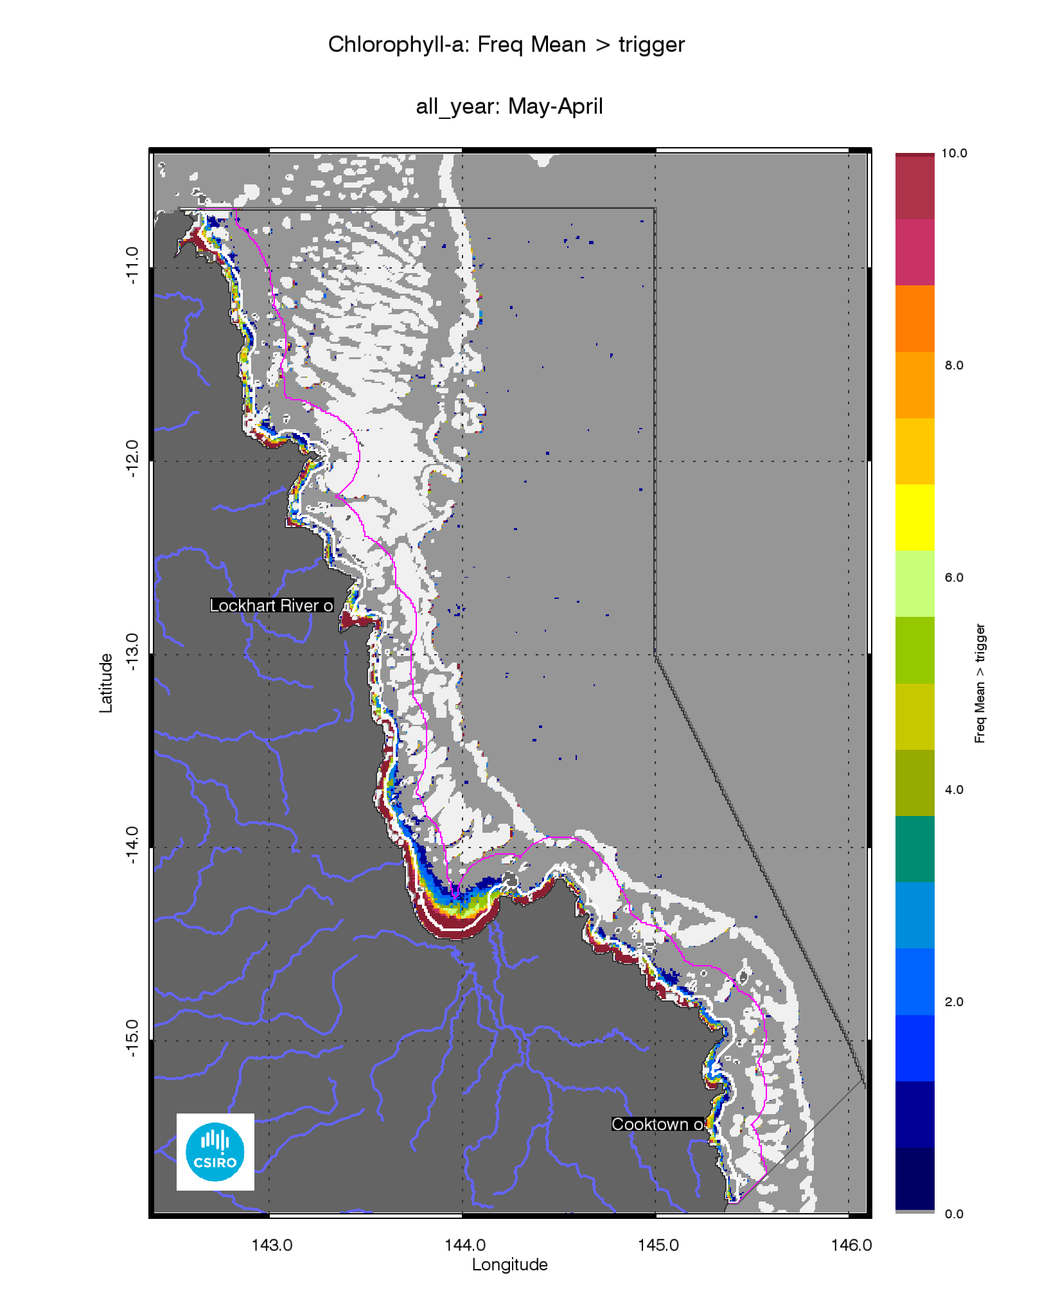
- Superimposed annual exceedance extents for Chlorophyll-a for the Cape York region for the reporting years between 2002/03 and 2012/13.
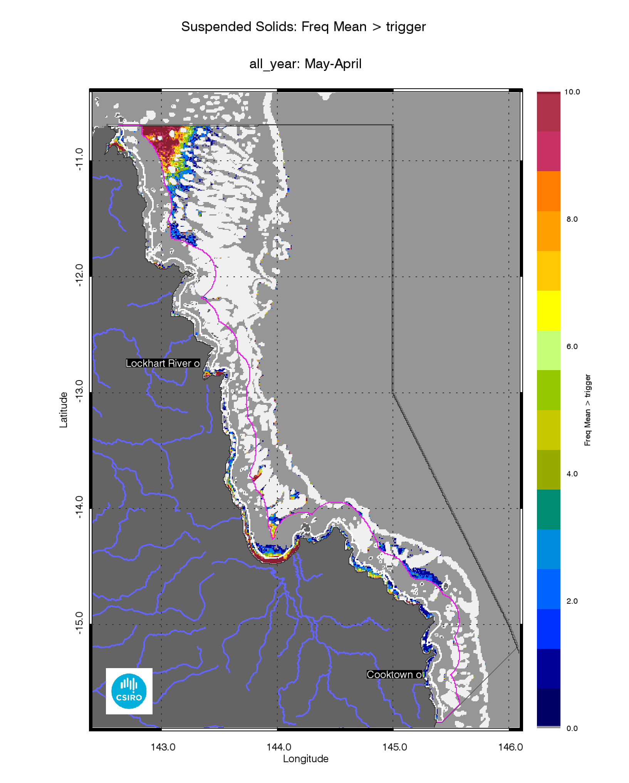
- Superimposed annual exceedance extents for Non-algal particulate matter (NAP as a measure of TSS) for the Cape York region for the reporting years between 2002/03 and 2012/13.

Assessment of the Paddock to Reef index
The marine water quality for this reporting year for the Cape York region was scored as “moderate”, reflecting a “poor” score for P2R_CHL and “good” for P2R_TSS (Figure 26). The marine water quality index and the component scores have been oscillating between “poor” and “moderate” since the 2002/03 reporting season, showing a clear negative correlation for P2R_CHL(R=-0.534) with the freshwater plume extents from the Cape York catchments (Figure 26Figure 14).

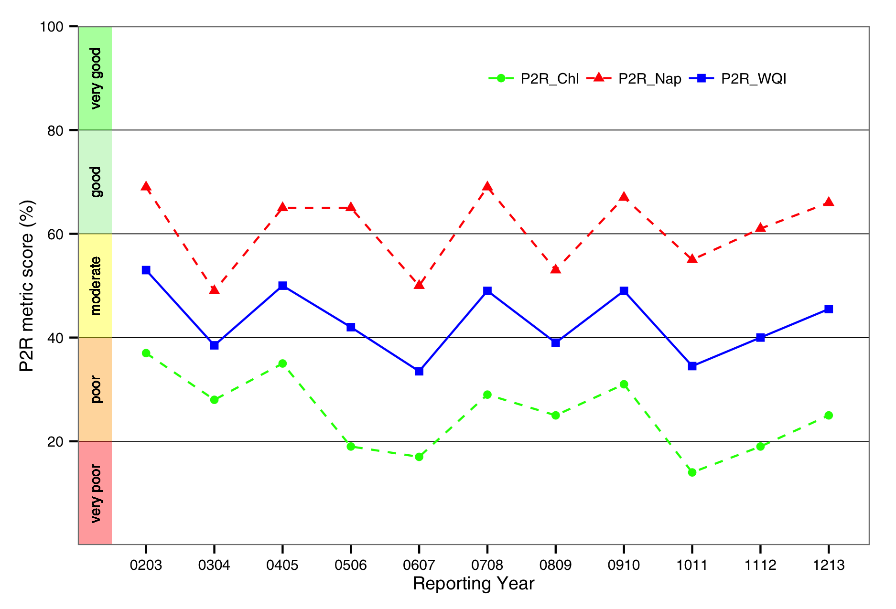
- Trends in the Paddock to Reef marine water quality index (P2R_WQI) and component scores (P2R_CHL and P2R_TSS) for the Cape York region.

Regional reports: Wet Tropics region
Land use practices within the wet tropics catchment include primary production such as sugar cane and banana farming, dairying, beef, cropping and tropical horticulture. Other uses within the region include fisheries, mining, and tourism(Johnson et al. 2011). Declining water quality, due to sedimentation combined with other forms of pollutants, the disturbance of acid sulphate soils, and point source pollution have been identified as a major concern to the health of coastal and marine ecosystems. Major environmental controls on GBR water quality in the wet tropics include pulsed terrigenous runoff, salinity and temperature extremes(Johnson et al. 2011).According to the delineation proposed in the previous report(Figure 2), the Enclosed Coastal marine water body accounts for ~15% of the inshore waters used for P2R reporting: the enclosed waters included the Mossman- Daintree, Barron and Herbert River estuary mouths. In Rockingham Bay the seaward limit of the enclosed coastal waters coincides with the outer boundary for the Open Coastal waters in front of the Tully and Murray river mouths.

Assessment of freshwater extent during the wet season
Figure 29reports the freshwater extent for wet season 2011/2012 (November 2011- April 2012) for the Wet Tropics region. The freshwater extent was estimated by applying a threshold of 0.24 m⁻¹ for the CDOM seasonal maximum (Figure 28). For the Wet Tropics region the freshwater extent for the wet season 2012/2013 (November 2012- April 2013) was 2382 km², a value lower than the median extent of the last decade (Figure 27). In 2012/13 most of the rivers in the Wet tropics (Daintree, Barron, Mulgrave, South Johnstone, Tully and Herbert rivers) were just below the median flows. The freshwater extent was significantly correlated to the freshwater discharge (R=0.560, p=0.026, Figure 27).
The map of frequency of salinity ≤30 (Figure 30), shows that in all ten the wet seasons between 2003 and 2013 the freshwater extended into most of the in Inshore water body, while the Midshelf water body was affected by low salinity several times. The freshwater reached the reef matrix once or twice almost everywhere in this region between 2003 and 2013.
In 2012/13, some of the CDOM and freshwater extent reported for this region (Figure 26,Figure 30), in particular to the East of the Herbert River and Hinchinbrook Island where CDOM absorption were higher than 0.50 m⁻¹ are probably associated with the Burdekin River flows (Figure 28). Also for some years, some of the discharge due to the Herbert River is possibly accounted for in the Burdekin Region. These difficulties in clearly associating the sources of freshwater discharge with the estimated freshwater extent are due to local hydrodynamics, as well as the nature of the marine boundaries for the reporting regions.

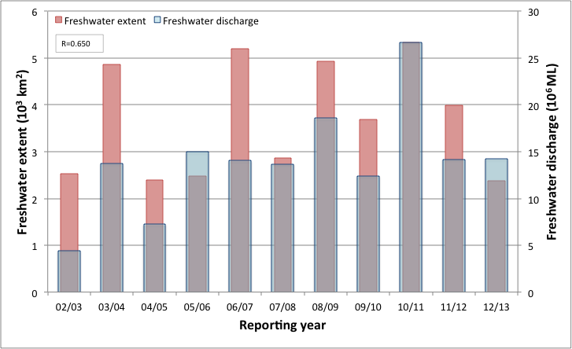
- Freshwater discharge and estimated freshwater extent for the Wet Tropics region based on the CDOM maximum for the wet seasons.

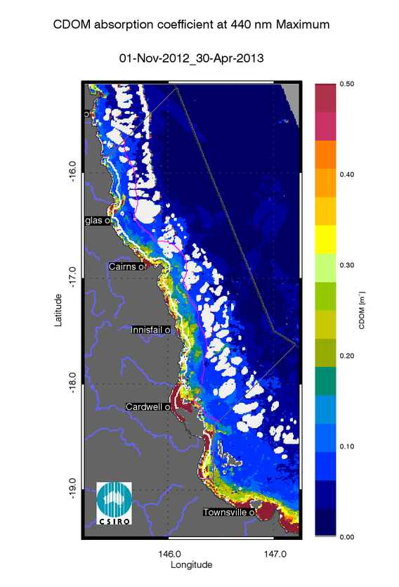
- Map of freshwater extent for the wet season for the Wet Tropics region. Maximum value of CDOM for the wet season 2012/2013 (November 2012 - April 2013),
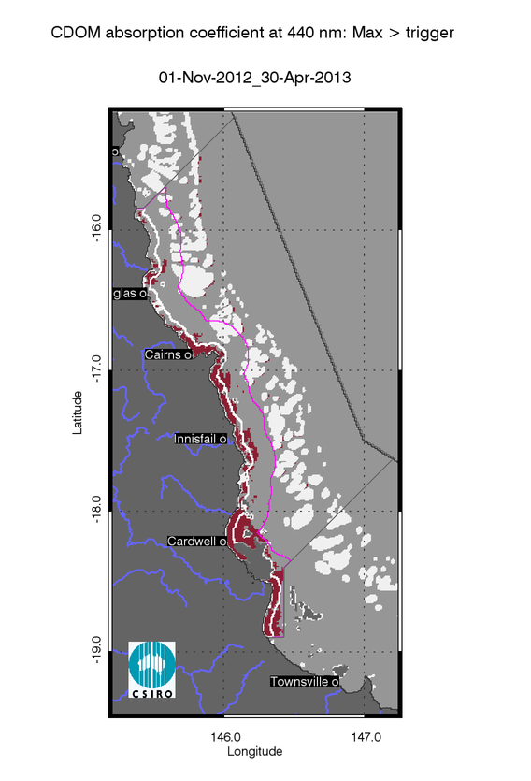
- Map of freshwater extent for the wet season for the Wet Tropics region. Freshwater extent estimated with a threshold for the CDOM seasonal maximum of 0.24 m⁻¹.
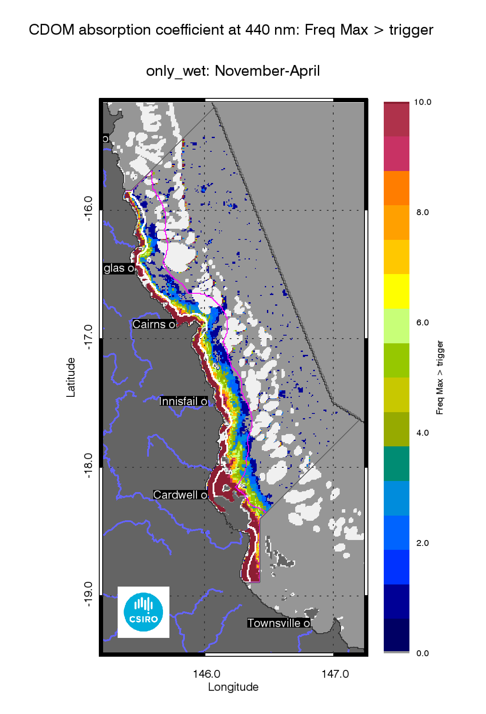
- Map of freshwater extent for the wet season for the Wet Tropics region. Superimposed seasonal maximum freshwater plume extents for the wet seasons between 2003 and 2013.

The annual mean maps for Chlorophyll-a and Total Suspended Solids.
The annual CHL mean maps for the Wet Tropics region (Figure 31) show high CHL concentrations near the coast and in the estuary to lower concentrations towards the East. Mean CHL values of up-to 1.0µg L⁻¹extended beyond the coastal to inshore boundary, and it ranged 0.3-0.6 µg L⁻¹in the Midshelf. The median CHL values in the offshore region in the reef matrix ranged between 0.15-0.25 µg L⁻¹.
The annual median maps of non-algal particulate matter (as a measure of TSS) (Figure 32for the Wet Tropics region show values higher than 5 mgL⁻¹ in Rockingham Bay and Halifax Bay and in front of the Herbert River Mouth.
The number of image observations available for calculating the median values varies from 20 to 30 observations for the wet season and 40-60 for the dry season for each pixel location, as reported in section 7.1.

Assessment of the exceedance of water quality guidelines
The exceedance of the Guidelines was assessed for CHL and TSS retrieved from MODIS Aqua using CSIRO’s algorithm. For the Wet Tropics region the annual mean CHL values of exceeded the Guidelines threshold values for 75% of the Inshore Coastal area, 13% of the Midshelf and 1% of the Offshore areas (Table 13). The Exceedance maps for CHL show that the mean CHL values of exceeded the Guidelines thresholds over the whole year only in river mouths and embayments in the Inshore and Midshelf water bodies (Figure 32,Figure 33). This spatial pattern has been consistent for this region over the decade between 2003 and 2013, as shown by the map of frequency of CHL exceedance (Figure 35).
Over the whole year, exceedance of TSS Guideline values was recorded in 34% of Inshore, 3% of Midshelf and 6% of Offshore areas (Table 13, Figure 32, Figure 34)..The Exceedance maps for TSS show that the mean TSS values of exceeded the Guidelines thresholds over the whole year only in river mouths and embayments, as well as in the Offshore waters between the Midshelf to Offshore boundary and the reef matrix (Figure 32, Figure 34). This spatial pattern has been consistent for this region over the decade between 2003 and 2013, as shown by the map of frequency of TSS exceedance (Figure 25).
Maps and tables providing details for the seasonal exceedance in the wet and dry seasons are reported in section 7.2 (Table 20, Table 21, Figure 101, Figure 102, Figure 103, Figure 104, Figure 105, Figure 106, Figure 107).

- Summary of the annual exceedance maps from 01-May-2012 to 30-Apr-2013 for Chlorophyll-a and Total Suspended Solids for the Wet Tropics region. Surface Area is the surface area in square kilometres for each of the reporting water bodies for this region Number valid obs. is the number of pixels with valid observations (i.e. cloud-free and error-free pixels); Number total obs. provides the total number of observations; Mean> trigger and Median > trigger report the relative area for each water body where the mean or the median exceeded the WQ Guideline value.
 |  | 01-May-2012_30-Apr-2013 |  | Chlorophyll-a |  | Total Suspended Solids
Region | Surface Area | Number valid obs. | Number total obs. | Mean > trigger | Median > trigger | Mean > trigger | Median > trigger
Inshore | 2082 | 134442 | 1084722 | 86% | 86% | 37% | 18%
Midshelf | 5940 | 460957 | 3094740 | 24% | 23% | 4% | 2%
Offshore | 20028 | 1023847 | 10434588 | 1% | 1% | 1% | 0%

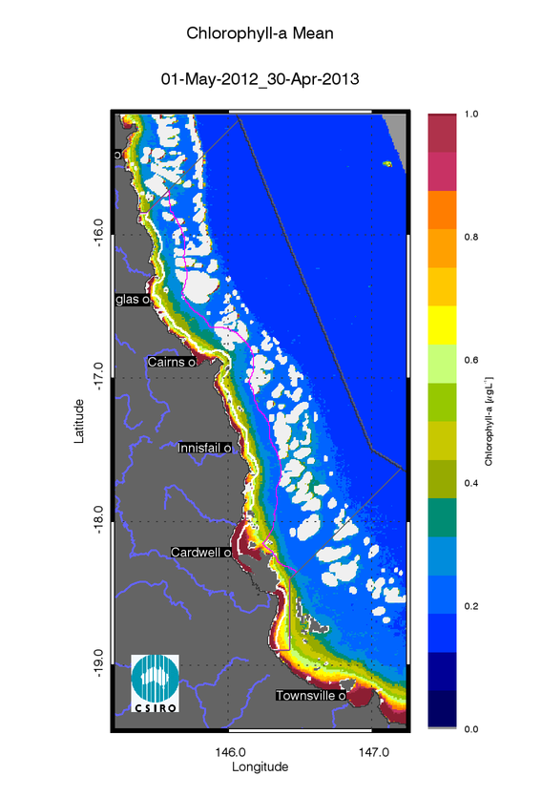
- Annual mean map for Chlorophyll-a for the Wet Tropics region for the reporting year 2012/13 (May 2012 –April 2013).
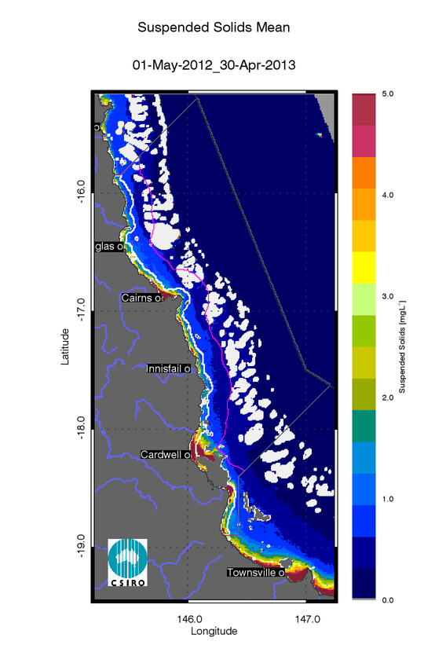
- Annual mean map for Non-algal particulate matter (NAP as a measure of TSS) for the Wet Tropics region for the reporting year 2012/13 (May 2012 –April 2013).

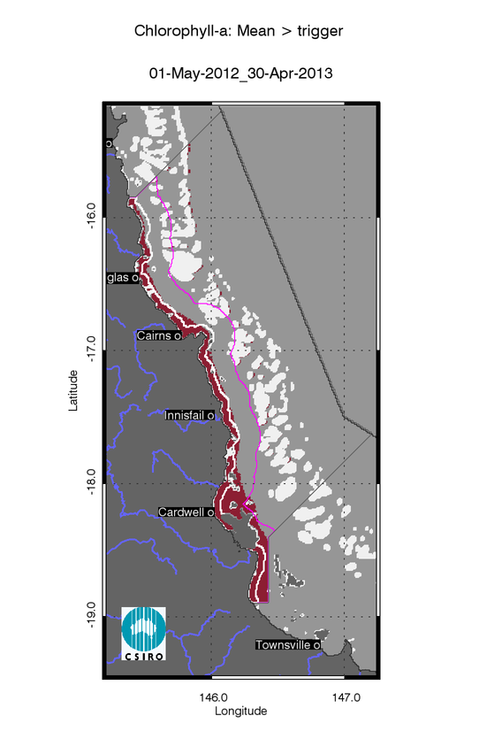
- Exceedance maps for the Wet Tropics region for the reporting year 2012/13 (May 2012 –April 2013). Chlorophyll-a exceedance map. The Guideline values for annual means of Chlorophyll–a are 0.45 µg L-1 for Inshore and Midshelf and 0.40 µg L-1 for Offshore
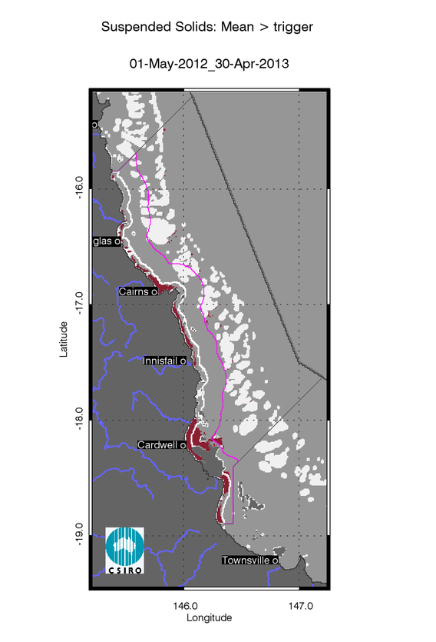
- Exceedance maps for the Wet Tropics region for the reporting year 2012/13 (May 2012 –April 2013). Non-algal particulate matter (NAP as a measure of TSS) exceedance map. The Guideline values for annual means of TSS are 2.0 mg L-1 for Inshore and Midshelf and 0.7 mg L-1 for Offshore

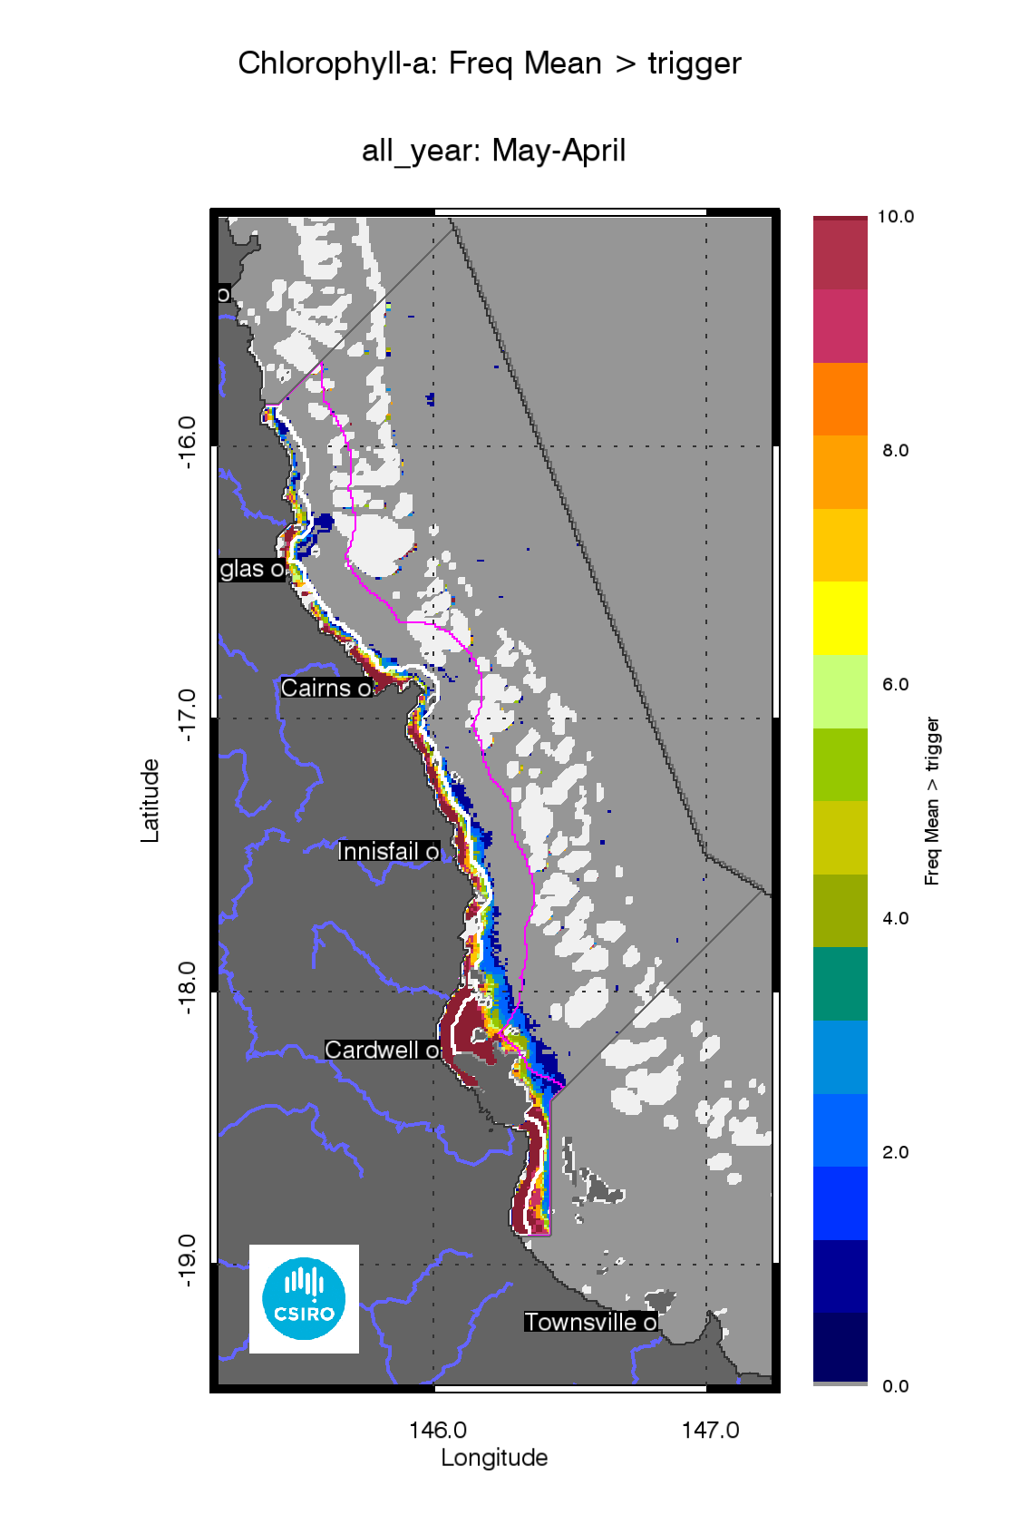
- Superimposed annual exceedance extents for Chlorophyll-a for the Wet Tropics region for the reporting years between 2002/03 and 2012/13.
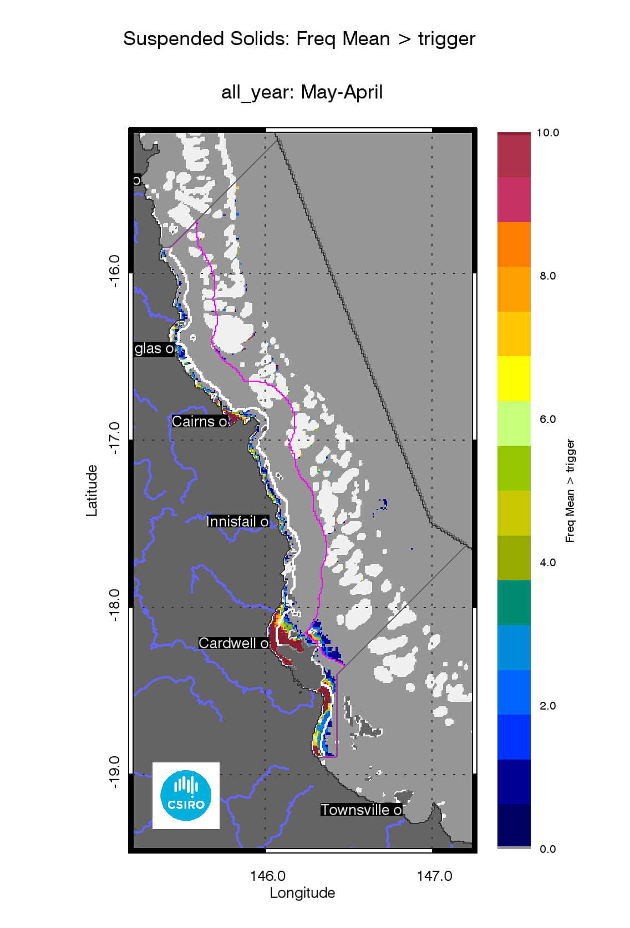
- Superimposed annual exceedance extents for Non-algal particulate matter (NAP as a measure of TSS) for the Wet Tropics region for the reporting years between 2002/03 and 2012/13.

Assessment of the Paddock to Reef index
The marine water quality for this reporting year for the Wet Tropics region was scored as “poor”, reflecting a “very poor” score for P2R_CHL and “good” for P2R_TSS (Figure 37). The marine water quality index and the component scores have been oscillating between “poor” and “moderate” since the 2002/03 reporting season (Figure 37).
Between 2002 and 2013 the P2R_WQI scores the Wet Tropics region were significantly highly correlated with the estimated freshwater plume extent (R=-0.774, p=0.004, Figure 14, Figure 13Table 8). While the component scores for Chlorophyll (P2R_CHL) were significantly highly correlated with the estimated freshwater plume extent (R=-0.808, p=0.002, Figure 12) , P2R_TSS was moderately correlated (R=-0.582, p=0.055, Figure 15,Table 8) indicating that P2R_CHL score incorporates a response to the nutrient loads delivered during the wet seasons from the Wet tropics catchments to the Inshore water body., while P2R_TSS score seems to be less sensitive to the wet season sediment delivery.

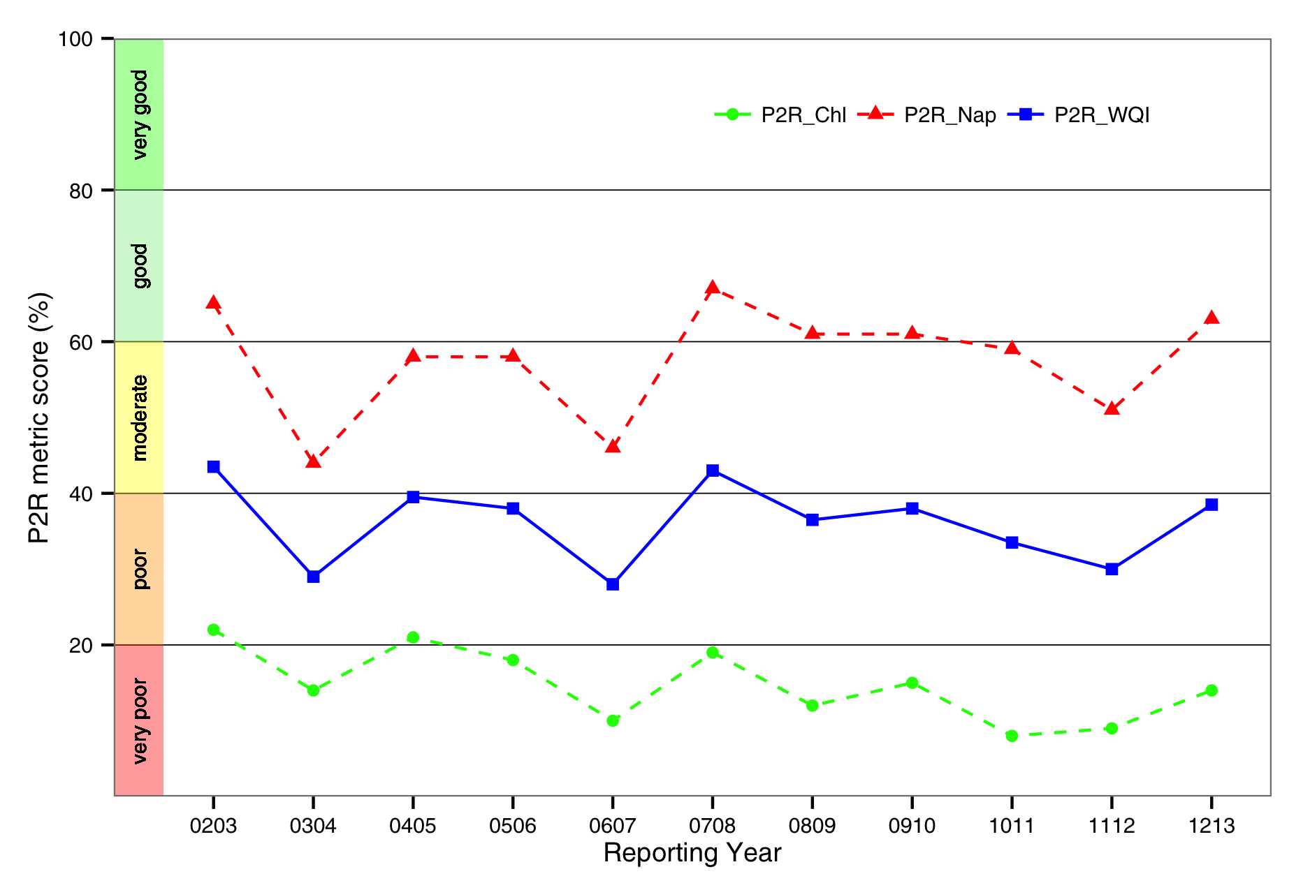
- Trends in the Paddock to Reef marine water quality index (P2R_WQI) and component scores (P2R_CHL and P2R_TSS) for the Wet Tropics region.

Regional reports: Burdekin region
The Burdekin Dry Tropics region includes an aggregation of the Black, Burdekin, Don, Haughton and Ross River catchments and includes several smaller coastal catchments, all of which empty into the GBR lagoon. Because of its geographical location, rainfall in the region is lower than other regions within tropical Queensland, though there is considerable variation year to year with 75% of the annual rainfall received during December to March(Johnson et al. 2011).

Assessment of freshwater extent during the wet season
Figure 40reports the freshwater extent for wet season 2011/2012 (November 2011- April 2012) for the Burdekin region. The freshwater extent was estimated by applying a threshold of 0.24 m⁻¹ for the CDOM seasonal maximum (Figure 39). For the Burdekin region the freshwater extent for the wet season 2011/2012 (November 2011- April 2012) was 2875 km²following a river flow half the median flows (Figure 38). The freshwater extent was significantly highly correlated with the freshwater discharge (R²=0.880, p<0.001,Figure 38): in 2003/04, 2005/06and 2012/13 lower extents (~2800 km²) reflected the freshwater discharges from the Burdekin River below the median values while for the wet seasons 2008/2009 and 2010/2011 (9690 and 8548 km²) the flows were more than five times the annual median flow. In 2010/11 the Burdekin region was also affected by TC Yasi strong winds, large rainfalls and associated flooding.
The map of frequency of salinity≤30 (Figure 41), shows that in all ten the wet seasons between 2003 and 2013 the freshwater extended into most of the in Inshore water body, while the Midshelf water body was affected by low salinity several times. The freshwater reached the reef matrix once or twice almost everywhere in this region between 2003 and 2013

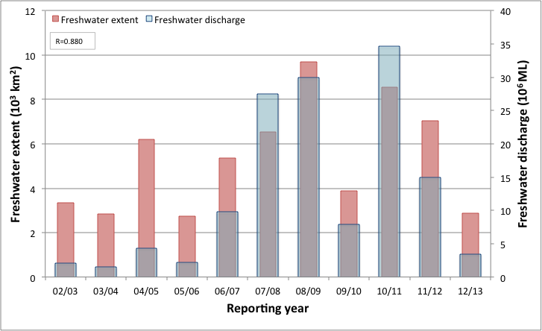
- Freshwater discharge and estimated freshwater extent for the Burdekin region based on the CDOM maximum for the wet seasons.

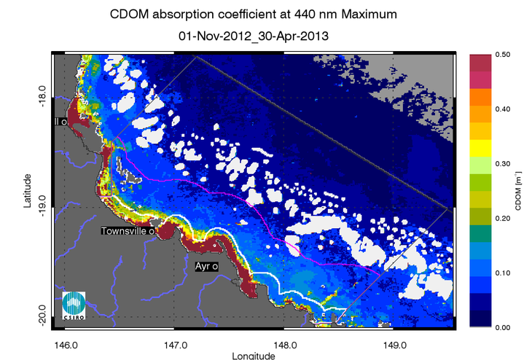
- Map of freshwater extent for the wet season for the Burdekin region. Maximum value of CDOM for the wet season 2012/2013 (November 2012 - April 2013),
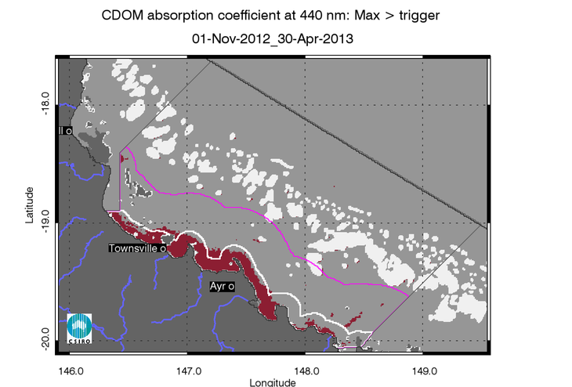
- Map of freshwater extent for the wet season for the Burdekin region. Freshwater extent estimated with a threshold for the CDOM seasonal maximum of 0.24 m⁻¹.
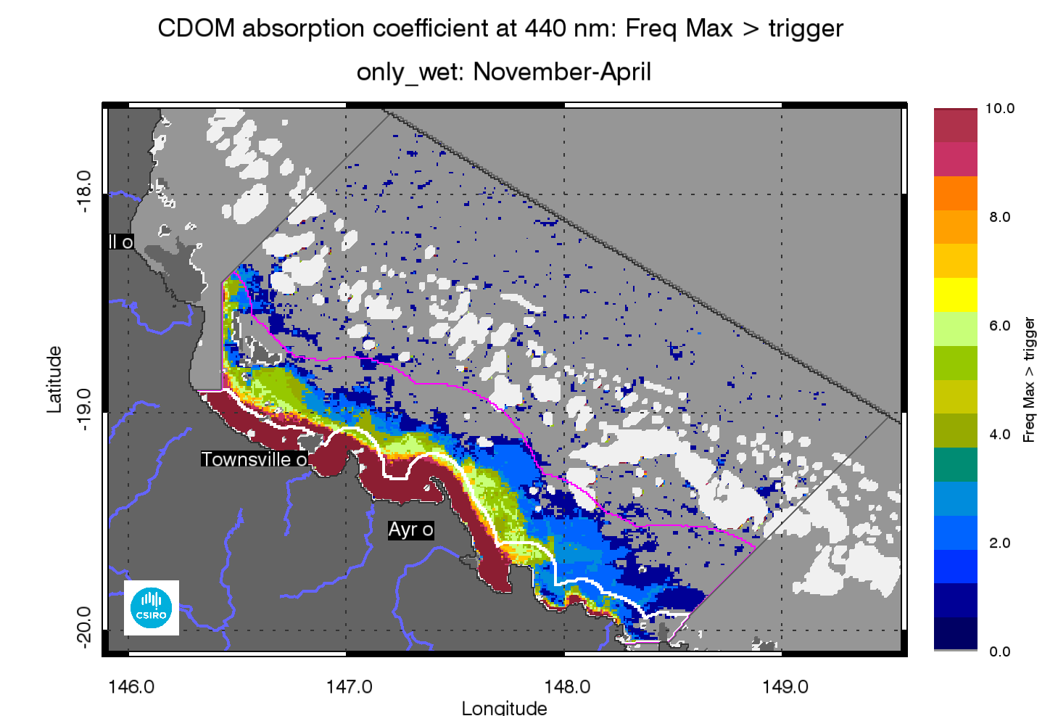
- Map of freshwater extent for the wet season for the Burdekin region. Superimposed seasonal maximum freshwater plume extents for the wet seasons between 2003 and 2013.

The annual mean maps for Chlorophyll-a and Total Suspended Solids.
The annual CHL mean maps for the Burdekin region (Figure 31Figure 43) show high CHL concentrations near the coast and in the estuary to lower concentrations towards the East. Mean CHL values were higher than 1.0 µg L-1for a coastal band ~15 km wide from Cape Upstart to Halifax Bay, and then ranged 0.3-0.6 µg L-1 in the Midshelf. The median CHL values in the offshore region in the reef matrix ranged between 0.15-0.25 µg L⁻¹.
The annual median maps of non-algal particulate matter (as a measure of TSS) (Figure 44) for the Wet Tropics region show a similar pattern with values higher than 5 mgL-1 only for a coastal band ~10 km wide from Cape Upstart to Halifax Bay. The number of image observations available for calculating the median values varies from 30 to 40 observations for the wet season and 40-70 for the dry season for each pixel location, as reported in section 7.1.

Assessment of the exceedance of water quality guidelines
The exceedance of the Guidelines was assessed for CHL and TSS retrieved from MODIS Aqua using CSIRO’s algorithm. For the Burdekin region the annual mean CHL values of exceeded the Guidelines threshold values for 71% of the Inshore Coastal area, 8% of the Midshelf and none of the Offshore areas (Table 14). The Exceedance maps for CHL show that the mean CHL values of exceeded the Guidelines thresholds over the whole year only in river mouths and embayments in the Inshore and Midshelf water bodies (Figure 43 Figure 45). This spatial pattern has been consistent for this region over the decade between 2003 and 2013, as shown by the map of frequency of CHL exceedance (Figure 47).
Over the whole year, exceedance of TSS Guideline values was recorded only in 34% of the Inshore, area (Table 14, Figure 44,Figure 46). The Exceedance maps for TSS show that the mean TSS values of exceeded the Guidelines thresholds over the whole year only in river mouths and embayments, as well as in the Offshore waters between the Midshelf to Offshore boundary and the reef matrix (Figure 44,Figure 46). This spatial pattern has been consistent for this region over the decade between 2003 and 2013, as shown by the map of frequency of TSS exceedance (Figure 48).
Maps and tables providing details for the seasonal exceedance in the wet and dry seasons are reported in section 7.2 (Table 24, Table 25, Figure 116, Figure 117, Figure 118, Figure 119, Figure 120, Figure 121, Figure 122, Figure 123)
- Summary of the annual exceedance maps from 01-May-2012 to 30-Apr-2013 for Chlorophyll-a and Total Suspended Solids for the Burdekin region. Surface Area is the surface area in square kilometres for each of the reporting water bodies for this region Number valid obs. is the number of pixels with valid observations (i.e. cloud-free and error-free pixels); Number total obs. provides the total number of observations; Mean> trigger and Median > trigger report the relative area for each water body where the mean or the median exceeded the WQ Guideline value.
 |  | 01-May-2012_30-Apr-2013 |  | Chlorophyll-a |  | Total Suspended Solids
Region | Surface Area | Number valid obs. | Number total obs. | Mean > trigger | Median > trigger | Mean > trigger | Median > trigger
Inshore | 4185 | 406418 | 2180385 | 71% | 71% | 41% | 22%
Midshelf | 11645 | 992523 | 6067045 | 8% | 7% | 0% | 0%
Offshore | 28030 | 1669774 | 14603630 | 0% | 0% | 0% | 0%

Assessment of the Paddock to Reef index
The marine water quality for this reporting year for the Burdekin region was scored as “moderate”, reflecting a “poor” score for P2R_CHL and “good” for P2R_TSS (Figure 42. The marine water quality index has been consistently “moderate” from 2002/03 to date. The component scores show opposite behaviours, with P2R_CHL being consistently “poor” with a decline from 2006/07 to 2010/11 and a small improvement in 2011/12 and 2012/2013, while P2R_TSS varied between scores of “moderate” and “good” in the reporting years.
Between 2002 and 2013 the GBR scores forP2R_WQI were poorly correlated with the estimated freshwater plume extent (R=-0.402, Figure 14, Figure 13, Table 8). While the component scores for Chlorophyll (P2R_CHL) were significantly correlated with the estimated freshwater plume extent (R=-0.614, p-0.04, Figure 12), P2R_TSS was poorly correlated (R=-0.255, Figure 15,Table 8). The P2R_CHL score seems to respond to the higher nutrient loads delivered from 2006/07 to 2010/11 to the Inshore water body by the higher freshwater discharges from the Burdekin River and the associated estimated freshwater plume extents, while also for this catchment the P2R_TSS score seems to be less sensitive to the wet season sediment delivery.

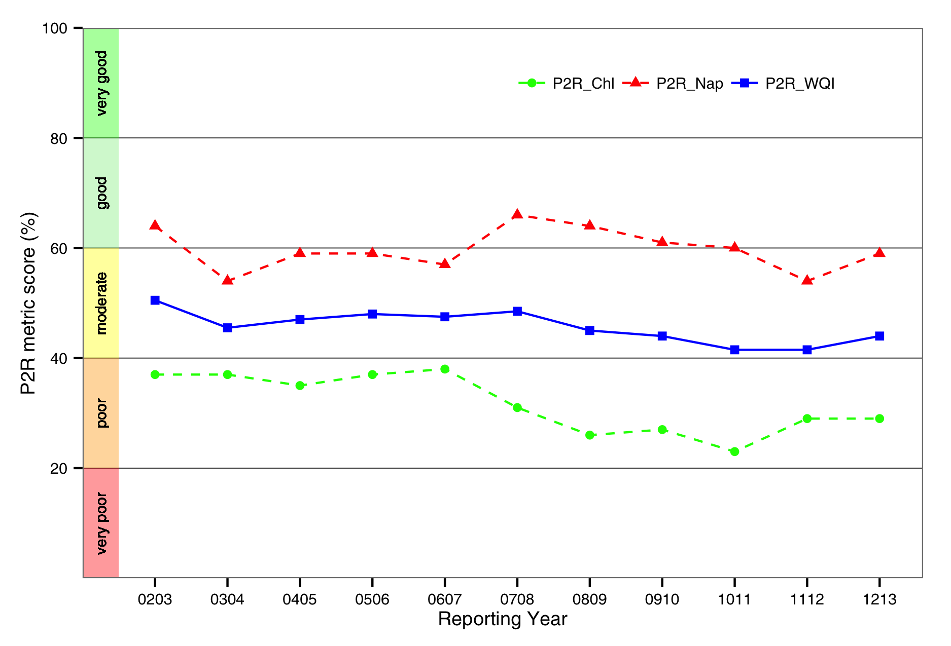
- Trends in the Paddock to Reef marine water quality index (P2R_WQI) and component scores (P2R_CHL and P2R_TSS) for the Burdekin region.

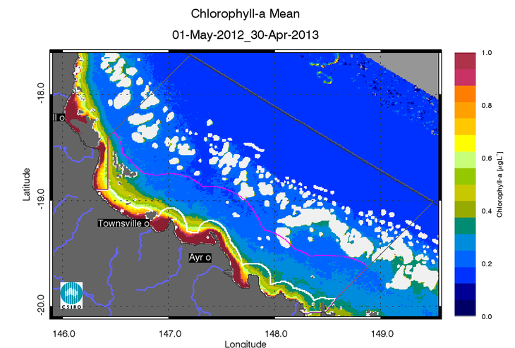
- Annual mean map for Chlorophyll-a for the Burdekin region for the reporting year 2012/13 (May 2012 –April 2013).
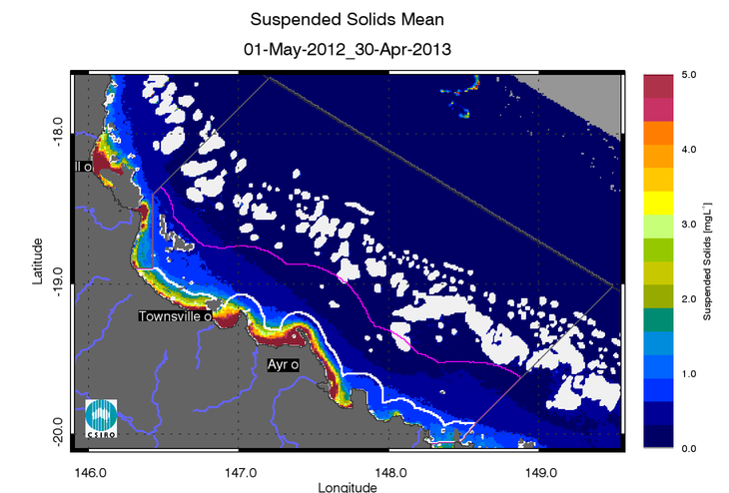
- Annual mean map for Non-algal particulate matter (NAP as a measure of TSS) for the Burdekin region for the reporting year 2012/13 (May 2012 –April 2013).

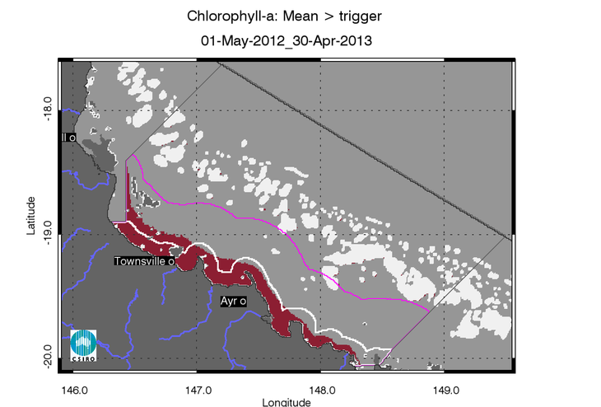
- Exceedance maps for the Burdekin region for the reporting year 2012/13 (May 2012 –April 2013). Chlorophyll-a exceedance map. The Guideline values for annual means of Chlorophyll–a are 0.45 µg L-1 for Inshore and Midshelf and 0.40 µg L-1 for Offshore

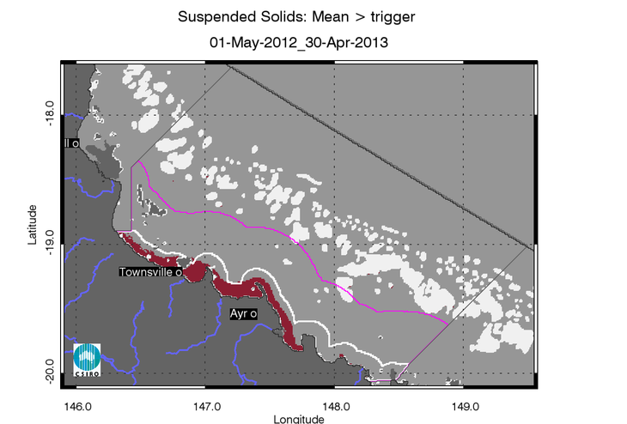
- Exceedance maps for the Burdekin region for the reporting year 2012/13 (May 2012 –April 2013). Non-algal particulate matter (NAP as a measure of TSS) exceedance map. The Guideline values for annual means of TSS are 2.0 mg L-1 for Inshore and Midshelf and 0.7 mg L-1 for Offshore

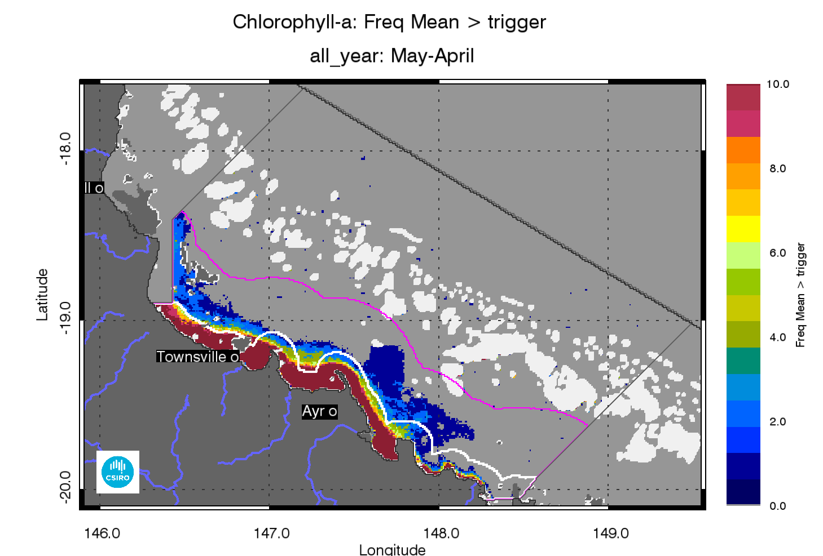
- Superimposed annual exceedance extents for Chlorophyll-a for the Burdekin region for the reporting years between 2002/03 and 2012/13.
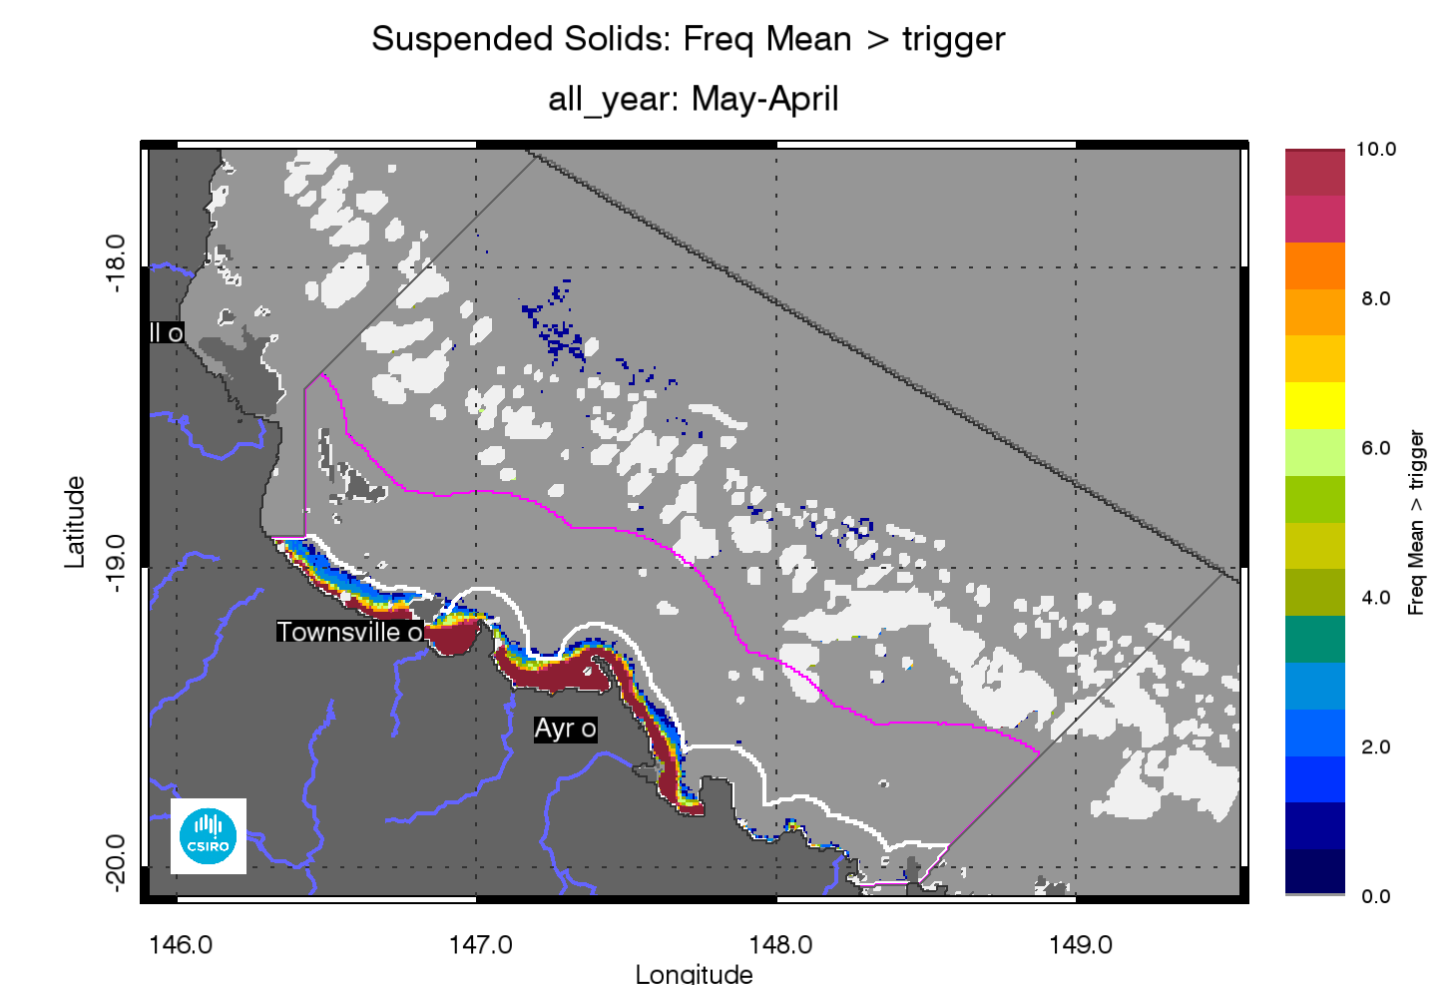
- Superimposed annual exceedance extents for Non-algal particulate matter (NAP as a measure of TSS) for the Burdekin region for the reporting years between 2002/03 and 2012/13.

Regional reports: Mackay Whitsunday region
The Mackay Whitsunday region is located in the central section of the GBR and comprises three major river catchments, the Proserpine, O’Connell (both flowing into Repulse Bay) and Pioneer catchments. The climate in this region is wet or mixed wet and dry and the catchment land use is dominated by agriculture such as grazing and cropping (mainly sugarcane on coastal plains), and minor urbanisation(Johnson et al. 2011). The adjacent coastal and inshore marine areas have a large number of high continental islands with well-developed fringing reefs.

Assessment of freshwater extent during the wet season
Figure 51reports the freshwater extent for wet season 2011/2012 (November 2011- April 2012) for the Mackay Whitsunday region. The freshwater extent was estimated by applying a threshold of 0.24 m⁻¹ for the CDOM seasonal maximum (Figure 50). For the Mackay-Whitsunday region the freshwater extent for the wet season 2012/13 (November 2011- April 2012) was 5202 km² (Figure 49). The freshwater extents are significantly correlated with the river discharge(R=0.628, p=0.034, Figure 49), although high CDOM values and associated estimated freshwater extents in the southern part on this reporting region are most likely due to the flood events occurring in the Fitzroy River and not in the Proserpine, O’Connell, Pioneer and Plane Rivers (Figure 50, Figure 51).
The map of frequency of salinity≤30 (Figure 52), shows that in all ten the wet seasons between 2003 and 2013 the freshwater extended into most of the in Inshore water body, while the Midshelf water body was affected by fresher waters several times, particularly in the Southern part of this reporting region. In this region the freshwater never reached the reef matrix as the matrix is ~ 80-100 km offshore. The presence of high CDOM absorption (~0.2m⁻¹) in mid and outer shelf reefs of this region (Figure 50,Figure 52), is most likely due autochthonous reef matrix CDOM production, as the reef matrix is not directly influenced by flood waters has already been by Schroeder et al.(2012).

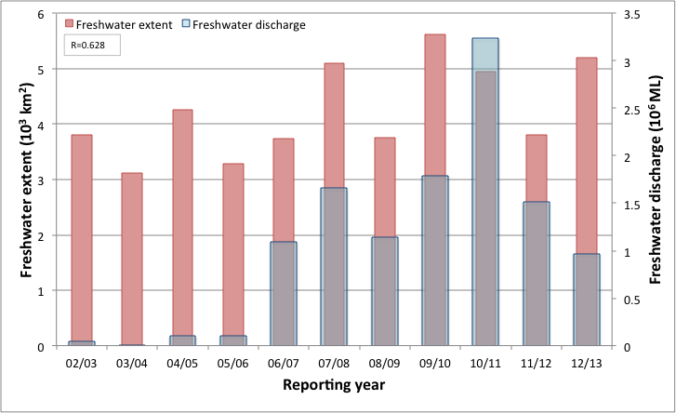
- Freshwater discharge and estimated freshwater extent for the Mackay Whitsunday region based on the CDOM maximum for the wet seasons.

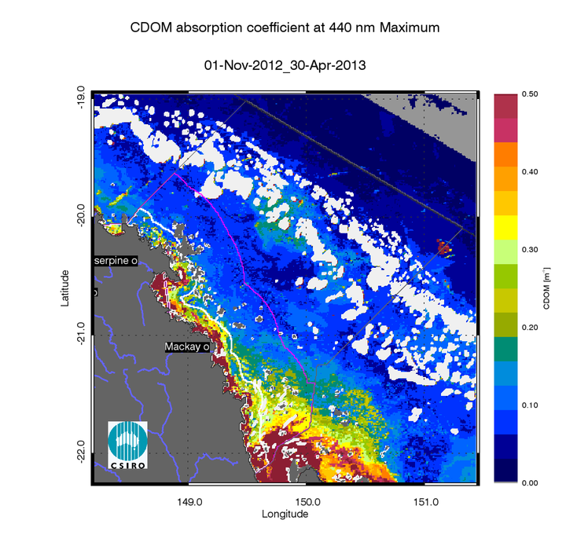
- Map of freshwater extent for the wet season for the Mackay Whitsunday region. Maximum value of CDOM for the wet season 2012/2013 (November 2012 - April 2013),
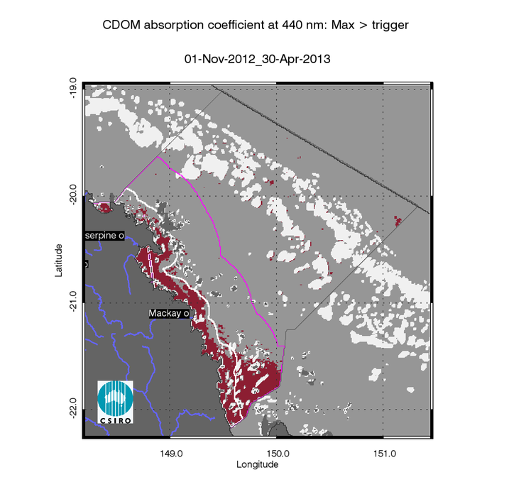
- Map of freshwater extent for the wet season for the Mackay Whitsunday region. Freshwater extent estimated with a threshold for the CDOM seasonal maximum of 0.24 m⁻¹.
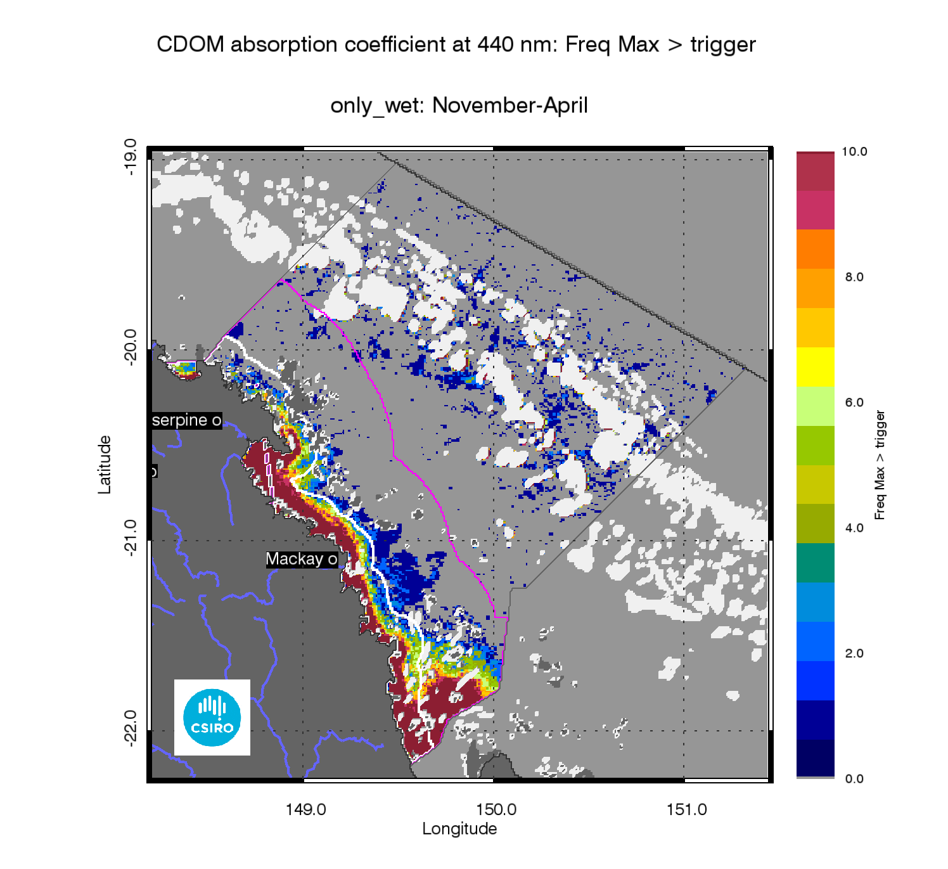
- Map of freshwater extent for the wet season for the Mackay Whitsunday region. Superimposed seasonal maximum freshwater plume extents for the wet seasons between 2003 and 2013.

The annual mean maps for Chlorophyll-a and Total Suspended Solids.
The annual CHL mean maps for the Mackay Whitsunday region (Figure 53) show high CHL concentrations near the coast and in the estuaries to lower concentrations towards the east. Mean CHL values of up-to 1.0µg L⁻¹ extended beyond the coastal to inshore boundary, and it ranged 0.3-0.6 µg L⁻¹ in the Midshelf. The median CHL values in the offshore region ranged between 0.15-0.25 µg L⁻¹.while in proximity of the mid and outer shelf reefs of this region CHL reached 0.3-0.4µg L⁻¹, most likely due autochthonous reef matrix primary production.
The annual mean maps of non-algal particulate matter (as a measure of TSS) (Figure 54) for the Mackay Whitsunday region show values higher than 3 mgL⁻¹ina coastal band, with higher values in front of only in front of the Proserpine, O’Connell, Pioneer and Plane Rivers mouths. The high concentrations shown in Broad Sound and Shoalwater Bay are likely to be overestimated. The accuracy of the retrieval from MODIS imagery in these shallow and turbid waters systems cannot be assessed, as there is no data available for parameterization and validation.
The number of image observations available for calculating the median values varies from 20 to 50 observations for the wet season and 40-70 for the dry season for each pixel location, as reported in section 7.1.

Assessment of the exceedance of water quality guidelines
The exceedance of the Guidelines was assessed for CHL and TSS retrieved from MODIS Aqua using CSIRO’s algorithm. For the Mackay Whitsunday region the annual mean CHL values of exceeded the Guidelines threshold values for 64% of the Inshore Coastal area, 10% of the Midshelf and 2% of the Offshore areas (Table 15). The Exceedance maps for CHL show that the mean CHL values of exceeded the Guidelines thresholds over the whole year most of the Inshore water body and in Midshelf water body around the Whitsundays(Figure 53, Figure 56). This spatial pattern has been consistent for this region over the decade between 2003 and 2013, as shown by the map of frequency of CHL exceedance (Figure 57).
Over the whole year, exceedance of TSS Guideline values was recorded in 39% of Inshore, 10% of Midshelf and 8% of Offshore areas (Table 15, Figure 54, Figure 56). The Exceedance maps for TSS show that the mean TSS values of exceeded the Guidelines thresholds over the whole year only in river mouths and embayments, as well as in the Offshore waters between the Midshelf to Offshore boundary and the reef matrix (Figure 54, Figure 56). This spatial pattern has been consistent for this region over the decade between 2003 and 2013,as shown by the map of frequency of TSS exceedance (Figure 25).
Maps and tables providing details for the seasonal exceedance in the wet and dry seasons are reported in section 7.2 (Table 26, Table 27, Figure 124, Figure 125, Figure 126, Figure 127, Figure 128, Figure 129, Figure 130, Figure 131)

- Summary of the annual exceedance maps from 01-May-2012 to 30-Apr-2013 for Chlorophyll-a and Total Suspended Solids for the Mackay Whitsunday region. Surface Area is the surface area in square kilometres for each of the reporting water bodies for this region Number valid obs. is the number of pixels with valid observations (i.e. cloud-free and error-free pixels); Number total obs. provides the total number of observations; Mean> trigger and Median > trigger report the relative area for each water body where the mean or the median exceeded the WQ Guideline value.
 |  | 01-May-2012_30-Apr-2013 |  | Chlorophyll-a |  | Total Suspended Solids
Region | Surface Area | Number valid obs. | Number total obs. | Mean > trigger | Median > trigger | Mean > trigger | Median > trigger
Inshore | 4798 | 441915 | 2499758 | 64% | 59% | 39% | 22%
Midshelf | 11901 | 1034642 | 6200421 | 10% | 9% | 10% | 7%
Offshore | 26702 | 1887319 | 13911742 | 2% | 2% | 8% | 3%

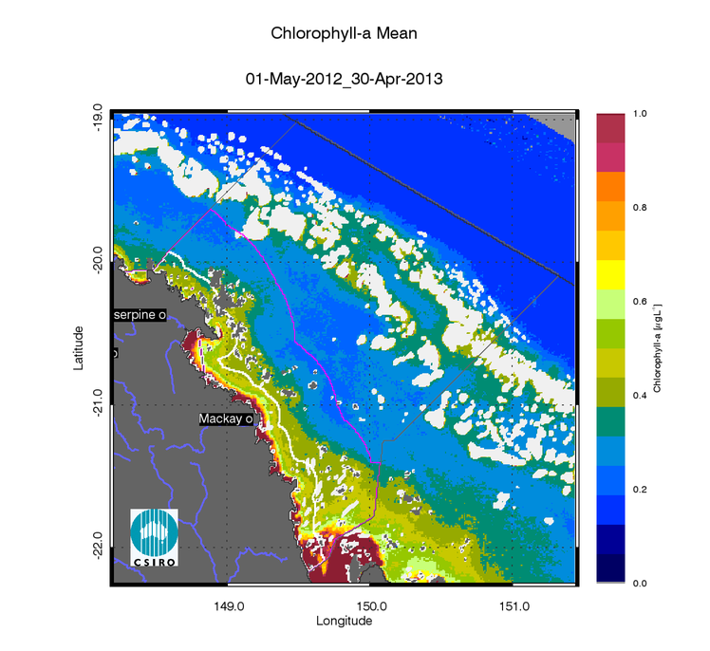
- Annual mean map for Chlorophyll-a for the Mackay Whitsunday region for the reporting year 2012/13 (May 2012 –April 2013).
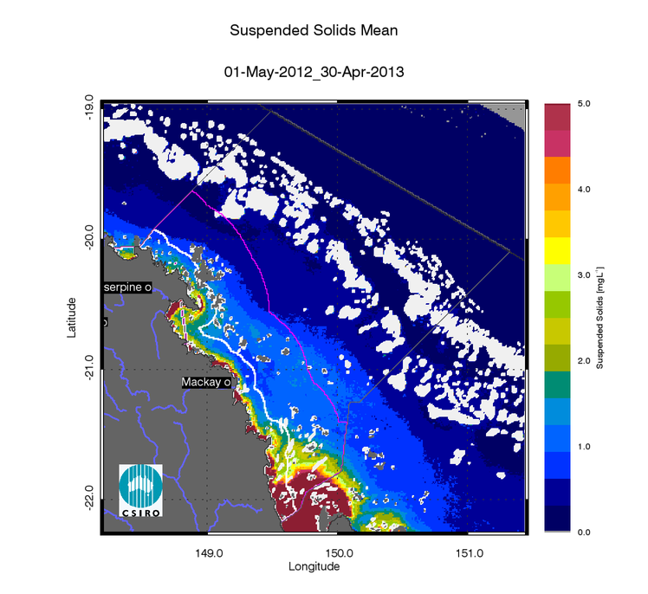
- Annual mean map for Non-algal particulate matter (NAP as a measure of TSS) for the Mackay Whitsunday region for the reporting year 2012/13 (May 2012 –April 2013).

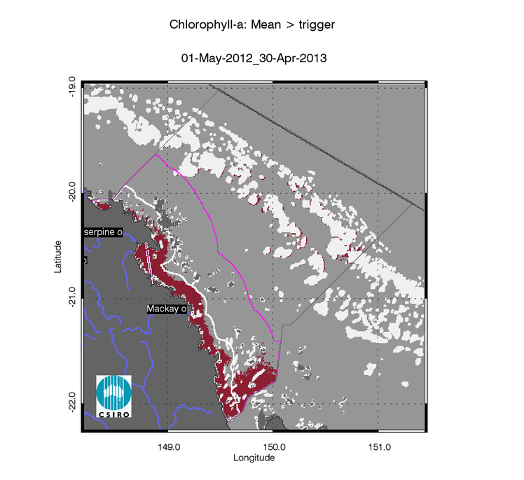
- Exceedance maps for the Mackay Whitsunday region for the reporting year 2012/13 (May 2012 –April 2013). Chlorophyll-a exceedance map. The Guideline values for annual means of Chlorophyll–a are 0.45 µg L-1 for Inshore and Midshelf and 0.40 µg L-1 for Offshore
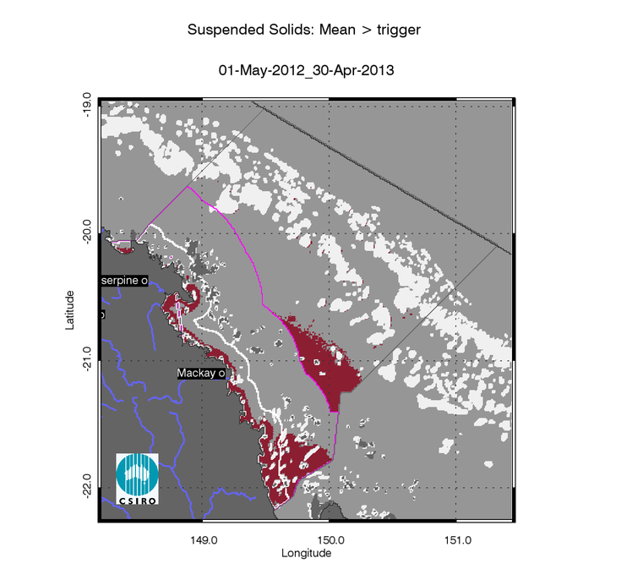
- Exceedance maps for the Mackay Whitsunday region for the reporting year 2012/13 (May 2012 –April 2013). Non-algal particulate matter (NAP as a measure of TSS) exceedance map. The Guideline values for annual means of TSS are 2.0 mg L-1 for Inshore and Midshelf and 0.7 mg L-1 for Offshore

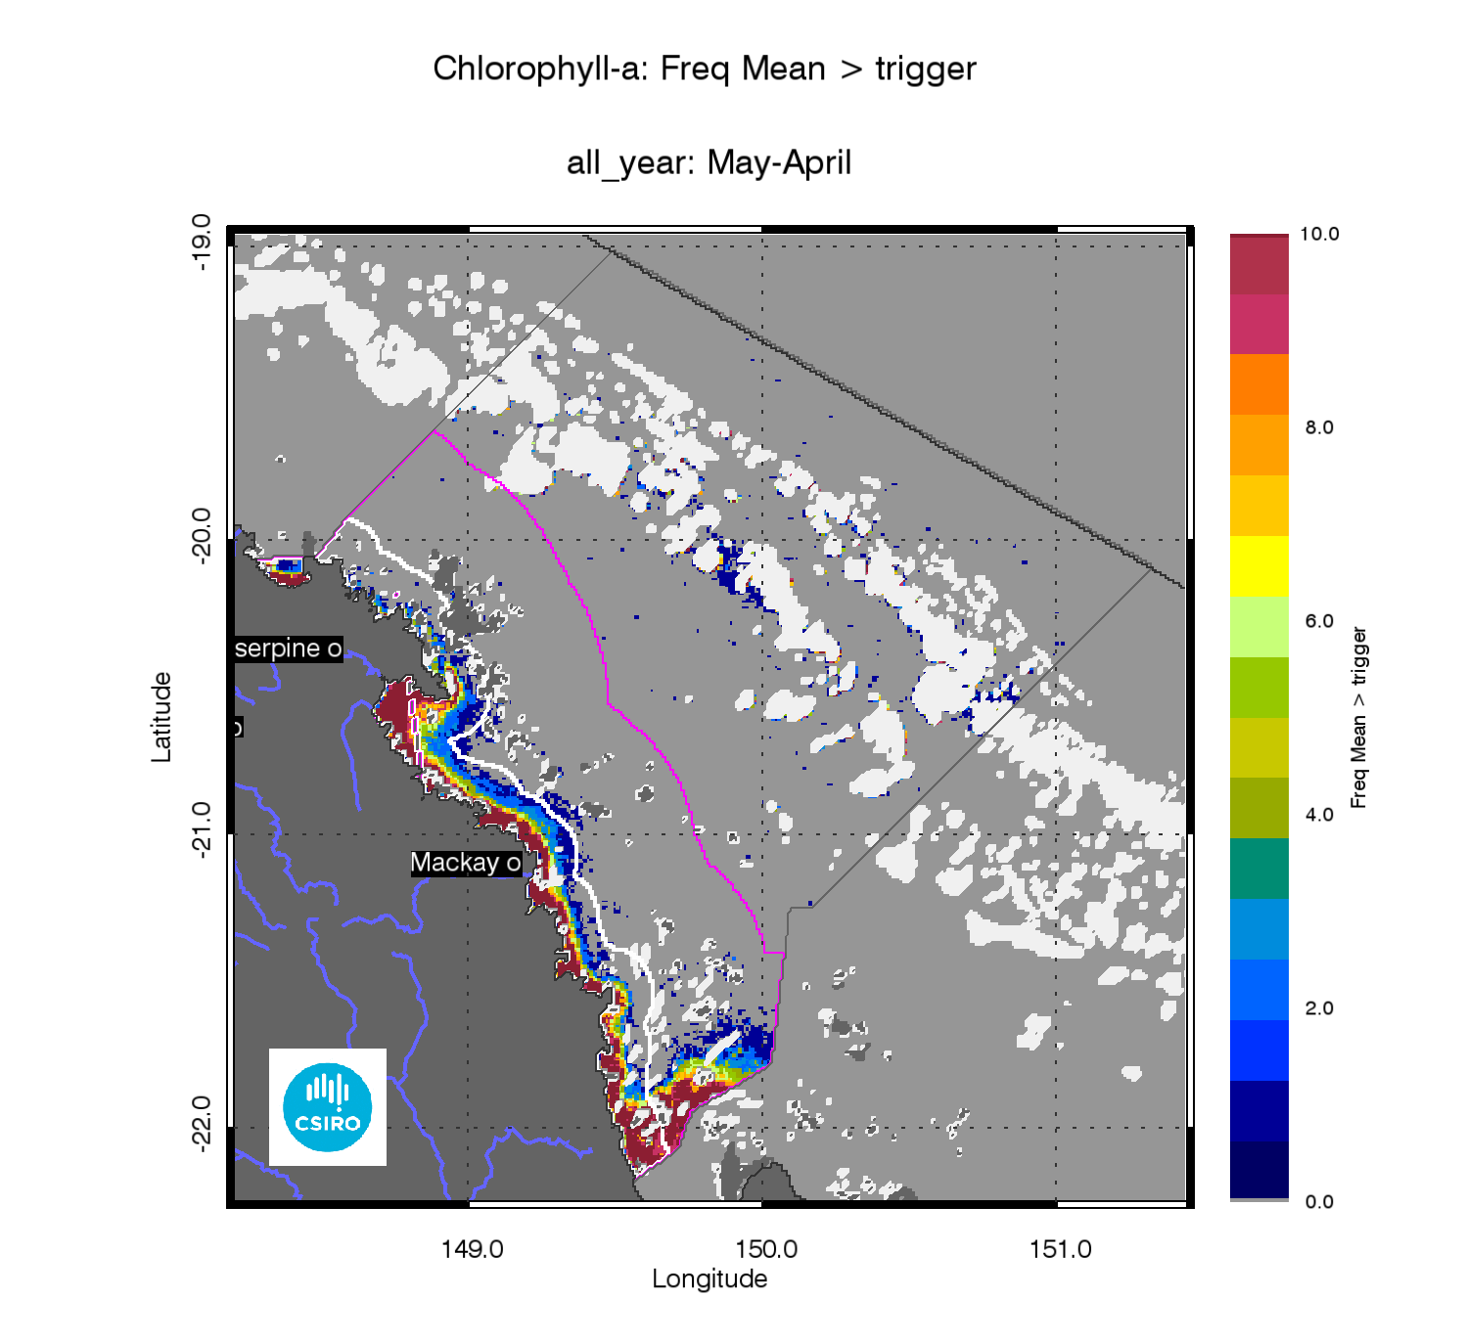
- Superimposed annual exceedance extents for Chlorophyll-a for the Mackay Whitsunday region for the reporting years between 2002/03 and 2012/13.
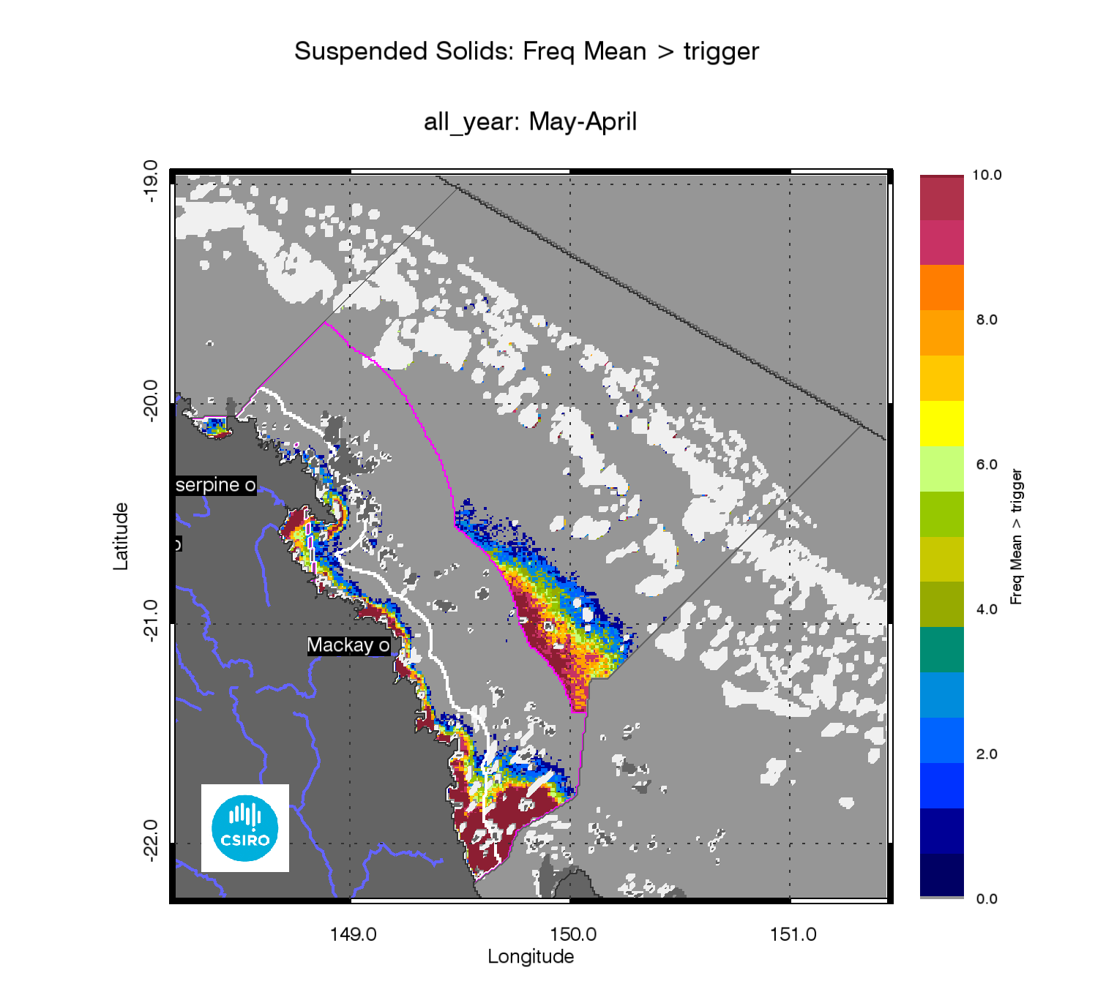
- Superimposed annual exceedance extents for Non-algal particulate matter (NAP as a measure of TSS) for the Mackay Whitsunday region for the reporting years between 2002/03 and 2012/13.

Assessment of the Paddock to Reef index
The marine water quality for this reporting year for the Mackay Whitsunday region was scored as “moderate”, reflecting a “poor” score for P2R_CHL and a “good score” for P2R_TSS (Figure 59).The marine water quality index has been oscillating between the “moderate” and “good” score band from the 2002/03 to 2009/10 reporting seasons, then reaching the lowest score in 2012/11. The P2R_CHL scores were “moderate” between the 2002/03 and the 2009/10 reporting seasons, while the P2R_TSS scores were “good” from 2002/03 to 2012/13 apart for 2010/11.
Between 2002 and 2013 the Mackay Whitsunday scores forP2R_WQI were moderately correlated with the estimated freshwater plume extent (R=-0.375, Figure 14Figure 13Table 8). In this region both component scores were poorly correlated with the estimated freshwater plume extent (P2R_CHL: R=-0.476, Figure 12; P2R_TSS: R=-0.127, Figure 15,Table 8).

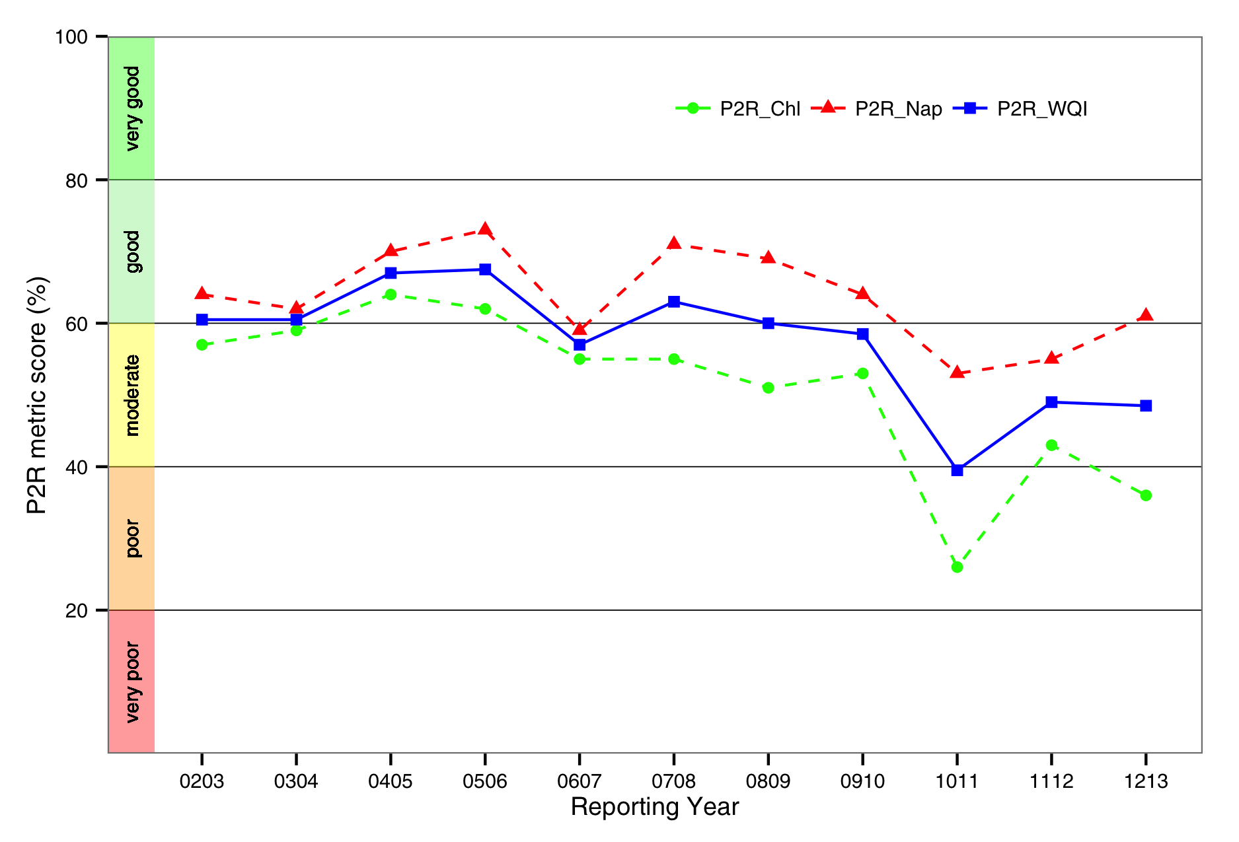
- Trends in the Paddock to Reef marine water quality index (P2R_WQI) and component scores (P2R_CHL and P2R_TSS) for the Mackay Whitsunday region.

Regional reports: Fitzroy region
The Fitzroy region is one of the two large dry tropical catchment regions in the GBR Region with cattle grazing as the primary land use (Brodie et al. 2003). Fluctuations in climate and cattle numbers greatly affect the state and nature of vegetation cover, and therefore, the susceptibility of soils to erosion, which leads to runoff of suspended sediments and associated nutrients(Johnson et al. 2011).The main river system influencing the region is the Fitzroy River. A strong gradient in water quality exists between the reefs in this region with increasing distance from both the coast and Fitzroy river mouth.
In this region, according to the proposed delineation (Figure 2), the Enclosed Coastal marine water body accounts for ~23% of the inshore waters used for P2R reporting and for most of the area in Keppel Bay, Port Curtis and in Broad Sound.

Assessment of freshwater extent during the wet season

Figure 62 reports the freshwater extent for wet season 2011/2012 (November 2011- April 2012) for the Fitzroy region. The freshwater extent was estimated by applying a threshold of 0.24 m⁻¹ for the CDOM seasonal maximum (Figure 61). For the Fitzroy region the freshwater extent for the wet season 2012/13 (November 2011- April 2012) was 12306 km2 (Figure 60). The freshwater extents are significantly correlated with the river discharge(R=0.839, p=0.001, Figure 60). This year the Fitzroy and Mary Burnett NRM regions recorded above-average summer rainfall and flood events associated with the remnants of tropical cyclone Oswald that tracked south-eastwards parallel to the coast and brought heavy rain. Hence, high CDOM values and associated estimated freshwater extent in the southern part on this reporting region are most likely due to also to a contribution by flood events occurring in Baffle Creek and other coastal streams in the Burnett Mary region (Figure 61Figure 62).
The map of frequency of salinity≤30 (Figure 63), shows that in all ten the wet seasons between 2003 and 2013 the freshwater extended into most of the in Inshore water body, while the Midshelf water body was affected by low salinity several times, particularly in the Southern part of this reporting region. In this region the freshwater never reached the reef matrix as the matrix is ~ 80-100 km offshore. The presence of high CDOM absorption (~0.2m⁻¹) in some locations in the mid and outer shelf reefs of this region (Figure 61Figure 62), is most likely due autochthonous reef matrix CDOM production and/or related to upwelling event South of the Swains, as the reef matrix is not directly influenced by flood waters has already observed by Schroeder et al.(2012).

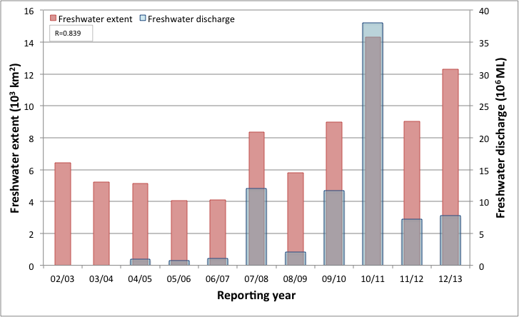
- Freshwater discharge and estimated freshwater extent for the Fitzroy region based on the CDOM maximum for the wet seasons.

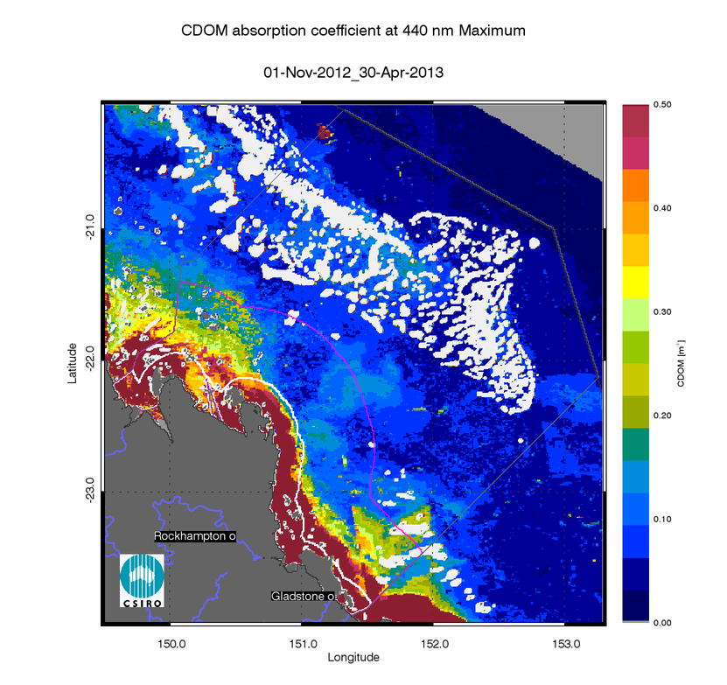
- Map of freshwater extent for the wet season for the Fitzroy region. Maximum value of CDOM for the wet season 2012/2013 (November 2012 - April 2013),
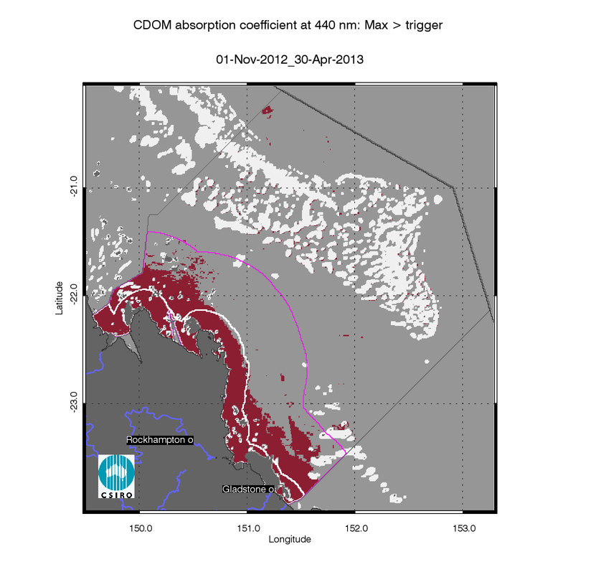
- Map of freshwater extent for the wet season for the Fitzroy region. Freshwater extent estimated with a threshold for the CDOM seasonal maximum of 0.24 m⁻¹.
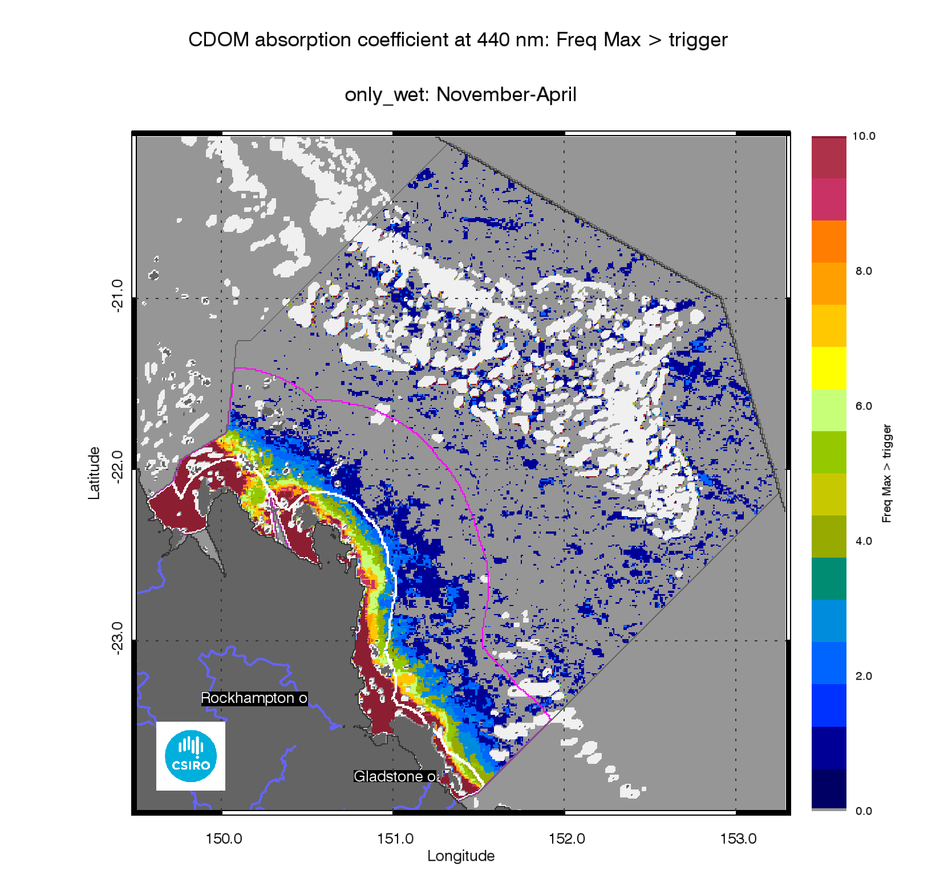
- Map of freshwater extent for the wet season for the Fitzroy region. Superimposed seasonal maximum freshwater plume extents for the wet seasons between 2003 and 2013.

The annual mean maps for Chlorophyll-a and Total Suspended Solids.
The annual CHL mean maps for the Fitzroy Estuary –Keppel Bay region (Figure 64) show high CHL concentrations near the coast and in the estuaries to lower concentrations towards the East. Mean CHL values of up-to 1.0µg L⁻¹ extended beyond the coastal to inshore boundary, and it ranged 0.3-0.6 µg L⁻¹ in the Midshelf. The mean CHL values in the offshore region ranged between 0.15-0.25 µg L⁻¹, while mean CHL values of chlorophyll-a to 0.5 µg L⁻¹extended as far as the Bunker group and values of ~ 0.3-0.4µg L⁻¹were observed in proximity of the mid and outer shelf reefs of the offshore area particularly in the Swain group.
The annual mean maps of non-algal particulate matter (as a measure of TSS) (Figure 65) show values higher than 3 mgL⁻¹ only for the area close to the river mouths. Towards the northeast of Shoalwater Bay and Broad Sound increased levels of non-algal particulate matter reach out further into the lagoon. High concentrations of NAP may be related to the strong tidal regime and re-suspension in the area.It is also likely that in less turbid waters bottom visibility may affects the accuracy of the retrieval for the shallow portion of these embayments. Care must be taken in interpreting the results for Shoalwater Bay and Broad Sound as the retrieval algorithm from the MODIS imagery was not parameterised nor validated for these waters.
The number of image observations available for calculating the median values varies from 20 to 40 observations for the wet season and 40-60 for the dry season for each pixel location, as reported in section 7.1.

Assessment of the exceedance of water quality guidelines
The exceedance of the Guidelines was assessed for CHL and TSS retrieved from MODIS Aqua using CSIRO’s algorithm. For the Fitzroy region the annual mean CHL values of exceeded the Guidelines threshold values for 92% of the Inshore Coastal area, 20% of the Midshelf and 1% of the Offshore areas (Table 16).The Exceedance maps for CHL show that the mean CHL values of exceeded the Guidelines thresholds over the whole year in a coastal band ~ 20 km wide, thus including most of the Inshore water body and in Midshelf water body in the Southern part of the region(Figure 64,Figure 66). This spatial pattern has been consistent for this region over the last few years, while in the first part of the decade between 2003 and 2013 the exceedance was mainly observed in Keppel Bay, Port Curtis and in Broad Sound, as shown by the map of frequency of CHL exceedance (Figure 68).
Over the whole year, exceedance of TSS Guideline values was recorded in 51% of Inshore, 4% of Midshelf and 2% of Offshore areas (Table 15, Figure 65, Figure 67), The Exceedance maps for TSS show that the mean TSS values of exceeded the Guidelines thresholds over the whole year only in river mouths and embayments, as well as in northern portion of the Offshore waters between the Midshelf to Offshore boundary and the reef matrix (Figure 65,Figure 67). This spatial pattern has been consistent for this region over the decade between 2003 and 2013, as shown by the map of frequency of TSS exceedance (Figure 25).
Maps and tables providing details for the seasonal exceedance in the wet and dry seasons are provided in section 7.2 (Table 29, Figure 132, Figure 133, Figure 134, Figure 135, Figure 136, Figure 137, Figure 138, Figure 139)

- Summary of the annual exceedance maps from 01-May-2012 to 30-Apr-2013 for Chlorophyll-a and Total Suspended Solids for the Fitzroy region. Surface Area is the surface area in square kilometres for each of the reporting water bodies for this region Number valid obs. is the number of pixels with valid observations (i.e. cloud-free and error-free pixels); Number total obs. provides the total number of observations; Mean> trigger and Median > trigger report the relative area for each water body where the mean or the median exceeded the WQ Guideline value.
 |  | 01-May-2012_30-Apr-2013 |  | Chlorophyll-a |  | Total Suspended Solids
Region | Surface Area | Number valid obs. | Number total obs. | Mean > trigger | Median > trigger | Mean > trigger | Median > trigger
Inshore | 6402 | 534305 | 3335442 | 92% | 85% | 51% | 41%
Midshelf | 19813 | 1685624 | 10322573 | 20% | 15% | 4% | 3%
Offshore | 52387 | 3825929 | 27273444 | 1% | 1% | 2% | 0%
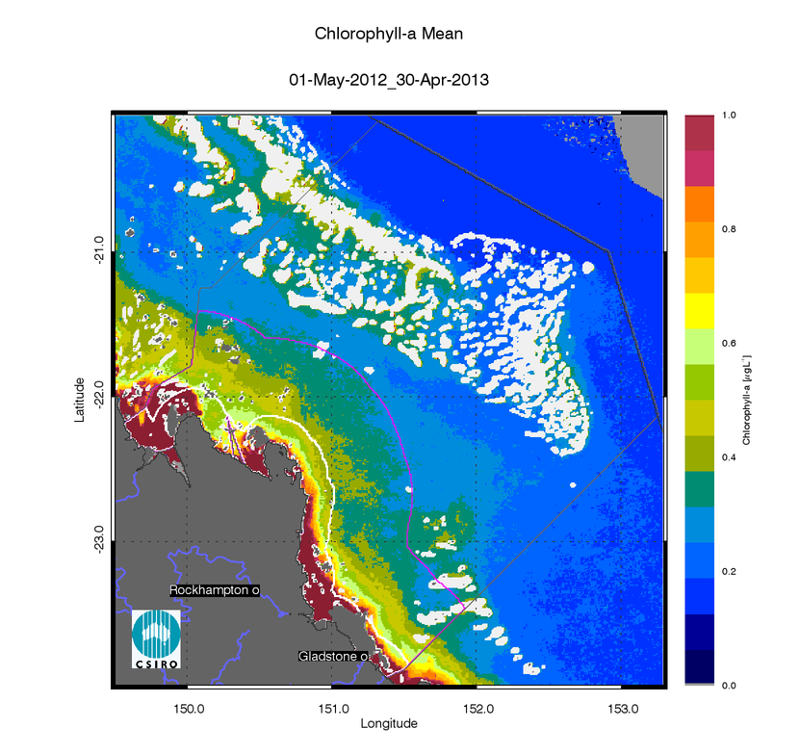
- Annual mean map for Chlorophyll-a for the Fitzroy region for the reporting year 2012/13 (May 2012 –April 2013).
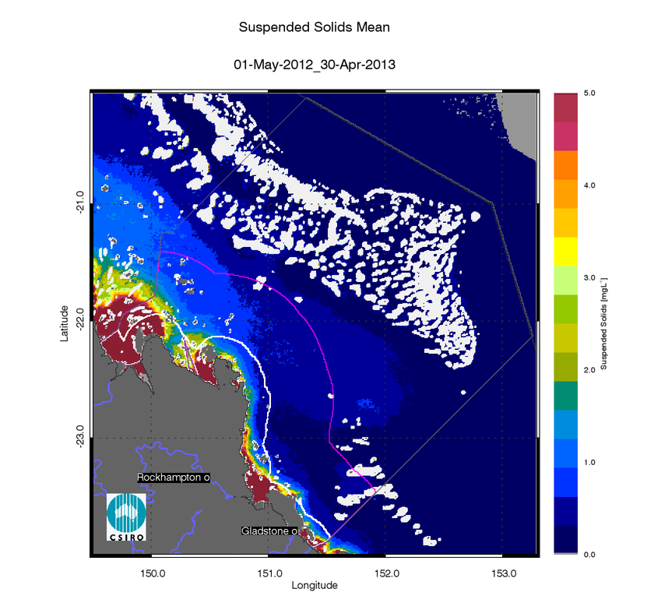
- Annual mean map for Non-algal particulate matter (NAP as a measure of TSS) for the Fitzroy region for the reporting year 2012/13 (May 2012 –April 2013).

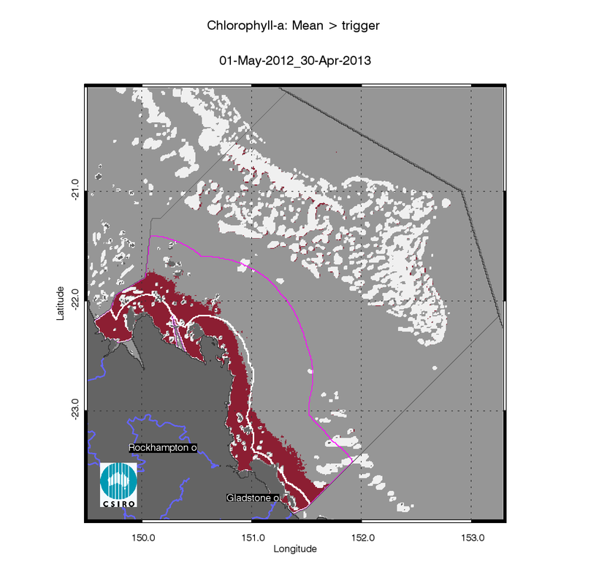
- Exceedance maps for the Fitzroy region for the reporting year 2012/13 (May 2012 –April 2013). Chlorophyll-a exceedance map. The Guideline values for annual means of Chlorophyll–a are 0.45 µg L-1 for Inshore and Midshelf and 0.40 µg L-1 for Offshore
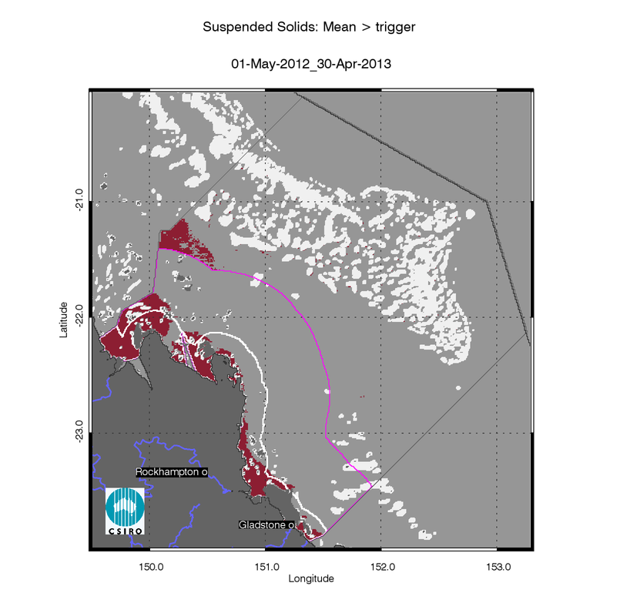
- Exceedance maps for the Fitzroy region for the reporting year 2012/13 (May 2012 –April 2013). Non-algal particulate matter (NAP as a measure of TSS) exceedance map. The Guideline values for annual means of TSS are 2.0 mg L-1 for Inshore and Midshelf and 0.7 mg L-1 for Offshore

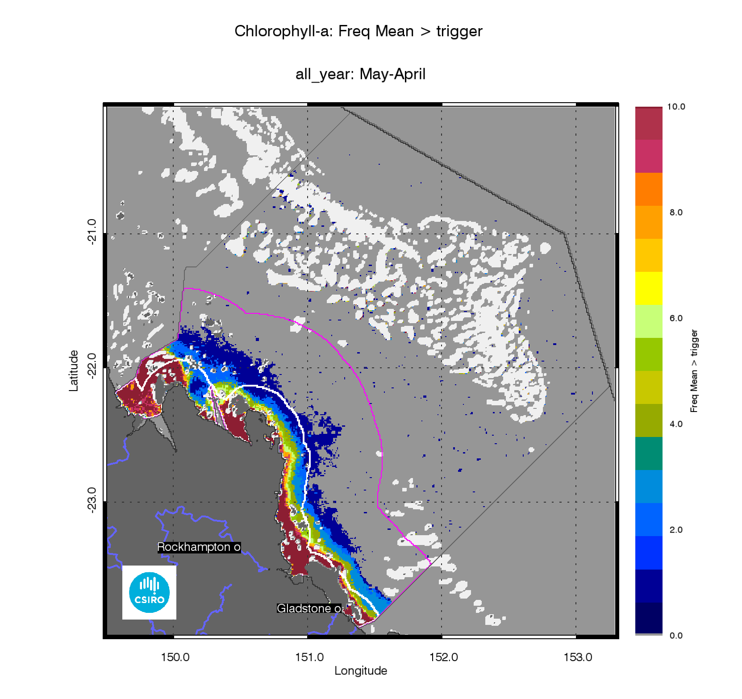
- Superimposed annual exceedance extents for Chlorophyll-a for the Fitzroy region for the reporting years between 2002/03 and 2012/13.
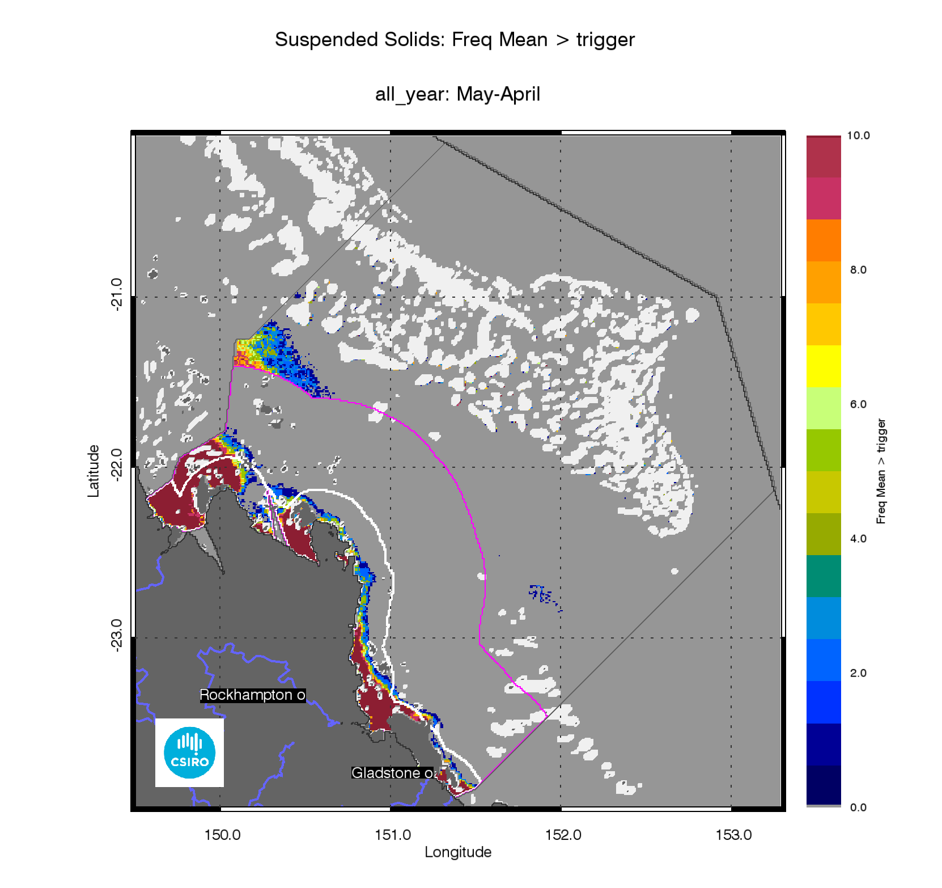
- Superimposed annual exceedance extents for Non-algal particulate matter (NAP as a measure of TSS) for the Fitzroy region for the reporting years between 2002/03 and 2012/13.

Assessment of the Paddock to Reef index
The marine water quality for this reporting year for the Fitzroy region was scored as “poor”, reflecting a “very poor” score for P2R_CHL and “moderate” for P2R_TSS (Figure 70). The marine water quality index and the component scores have been steadily declining from “moderate” since the 2002/03 to the 2009/10 reporting seasons to the “poor scores” of the last three years. Over the last decade the P2R_CHL score declined from “moderate” (2002/03 - 2007/08) to “poor” (2007/08 – 2009/20) and “very poor” in response to the large flood conditions of the Fitzroy river and the associated estimated freshwater plumes extending beyond Keppel Bay (Figure 70). Overall the P2R_TSS has been “moderate” for the whole decade, showing a decline since 2009/10.
The P2R_WQI score for the Fitzroy region were significantly highly correlated with the estimated freshwater plume extent (R=-0.950, p<0.001 (Figure 13Table 8). For this region both the component scores for Chlorophyll and Total Suspended Solids were significantly highly correlated with the estimated freshwater plume extent (P2R_CHL: R=-0.967, p<0.001, Figure 14; P2R_TSS: R=-0.728, p=0.010, Figure 15,Table 8). As for other regions the P2R_CHL score is likely incorporates a response to the nutrient loads delivered during the wet seasons form the GBR catchments to the Inshore water body, while for the Fitzroy region the P2R_TSS score seems to respond more sensitive to the wet season sediment delivery that occurs only with the large flood events and then the sediments are processed in the following dry seasons (Radke et al. 2010).

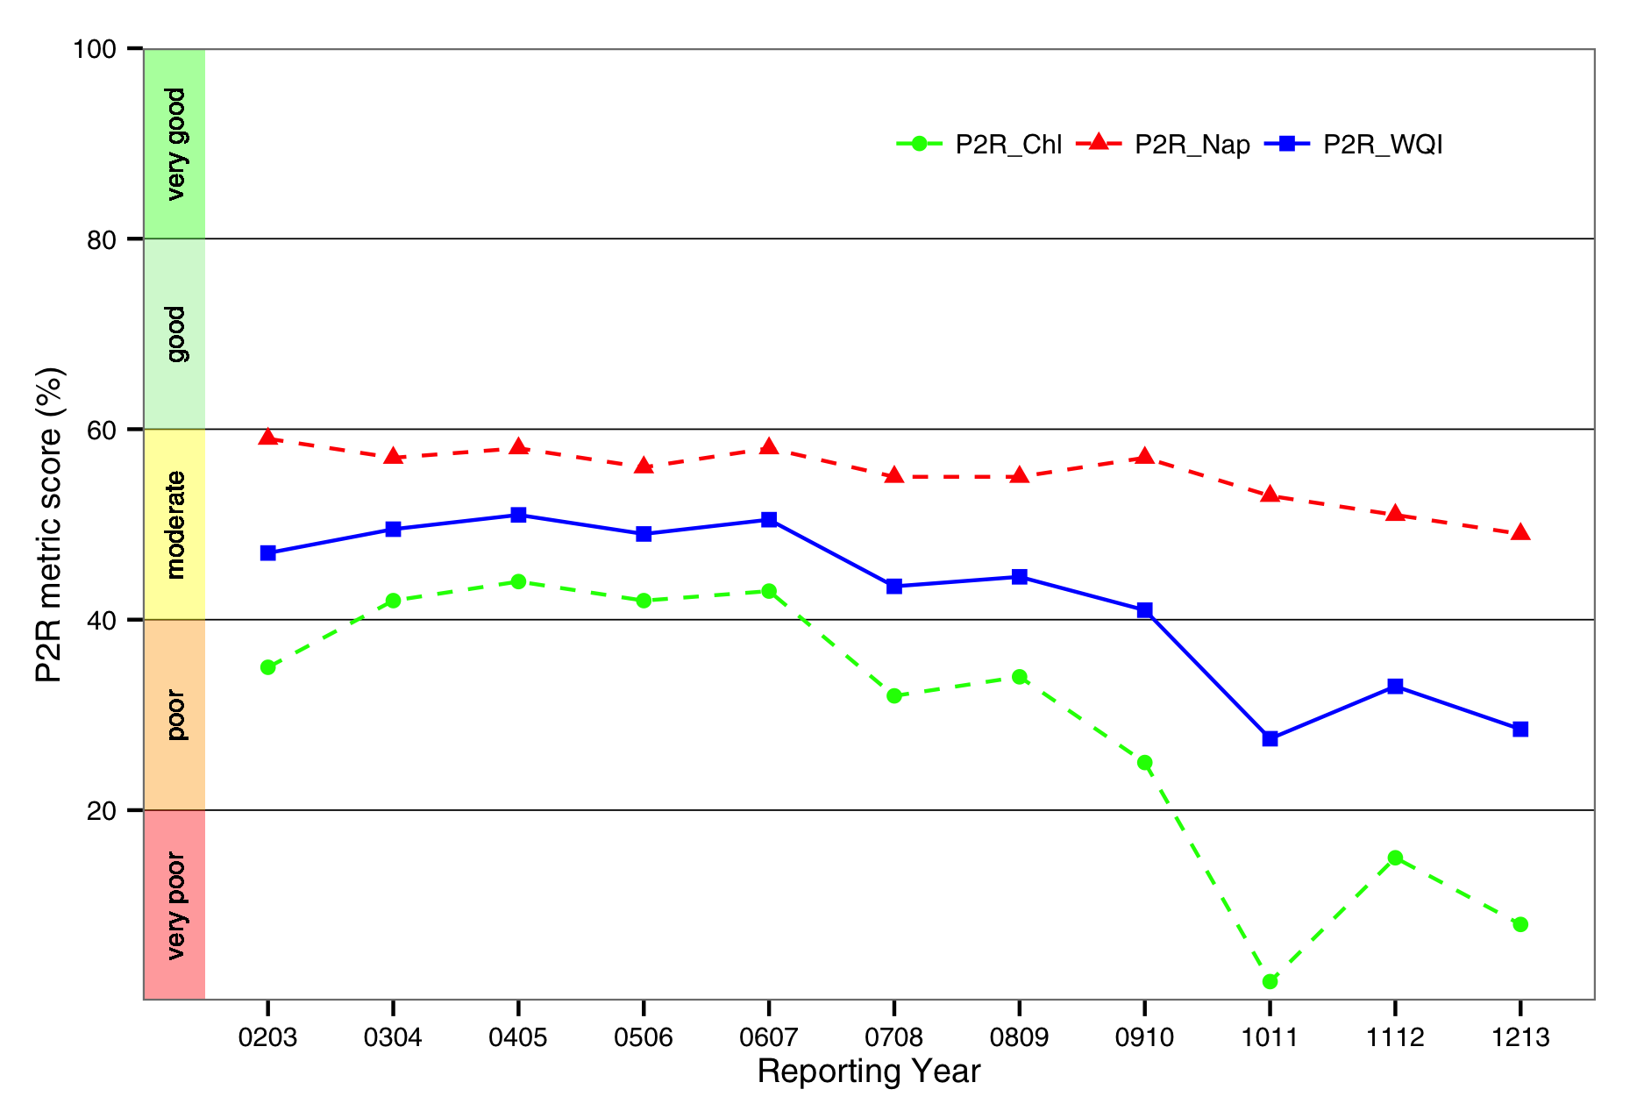
- Trends in the Paddock to Reef marine water quality index (P2R_WQI) and component scores (P2R_CHL and P2R_TSS) for the Fitzroy region.

Regional reports: Burnett Mary region
The Burnett Mary region is the southernmost in the GBR and is comprised of a number of catchments, though only the northernmost catchment, the Baffle Basin, is within the GBR. In this report, the estimate of freshwater extent and the assessment of compliance to the Guidelines using earth observation data are performed only for the GBR Marine Park section of the Burnett Mary NRM region. In this region, according to the proposed delineation (Figure 2), the Enclosed Coastal marine water body accounts for ~21% of the inshore waters used for P2R reporting. Caution should be used when interpreting the results for this region as limited field information was used for the parameterization and validation on the remote sensing retrievals.

Assessment of freshwater extent during the wet season
Figure 73reports the freshwater extent for wet season 2011/2012 (November 2011- April 2012) for the Mackay Whitsunday region. The freshwater extent was estimated by applying a threshold of 0.24 m⁻¹ for the CDOM seasonal maximum (Figure 72). For the Burnett Mary region the freshwater extent for the wet season 2012/13 (November 2011- April 2012) was 16869 km2 (Figure 71). For this region, the freshwater extents are poorly correlated with the river discharge(R=0.219,Figure 71) as the estimate of freshwater extent and the assessment of compliance to the Guidelines using earth observation data is performed only for the GBRMPA section of the NRM region. This year the Fitzroy and Mary Burnett NRM regions recorded above-average summer rainfall and flood events associated with the remnants of tropical cyclone Oswald that tracked south-eastwards parallel to the coast and brought heavy rain. The Burnett and Mary Rivers flooded in January and March reaching record peak and flow levels, This year’s large estimated freshwater extent may also be due to flows from Baffle Creek and the Calliope River that flow directly in the GBRMPA section of the Burnett Mary NRM region(Figure 71, Figure 73).
The map of frequency of salinity≤30 (Figure 74), shows that in all ten the wet seasons between 2003 and 2013 the freshwater extended into most of the in Inshore water body, while the Midshelf and Offshore water bodies were affected by low salinity waters only twice during the two largest freshwater extents of 2010/11 in 2012/13 (Figure 71). The speckles in the North-eastern portion of the Offshore waters are probably due to high CDOM related to upwelling events.
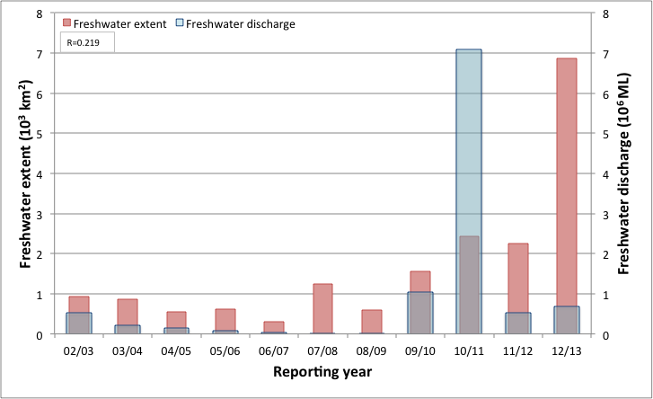
- Freshwater discharge and estimated freshwater extent for the Burnett Mary region based on the CDOM maximum for the wet seasons.

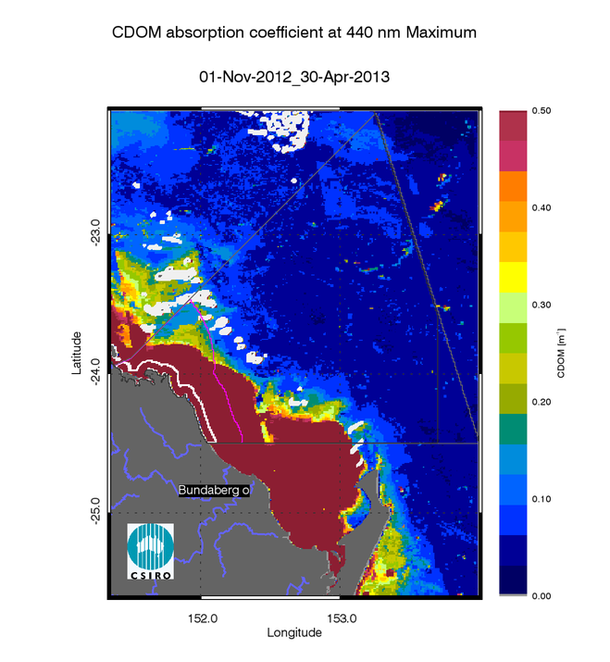
- Map of freshwater extent for the wet season for the Burnett Mary region. Maximum value of CDOM for the wet season 2012/2013 (November 2012 - April 2013),
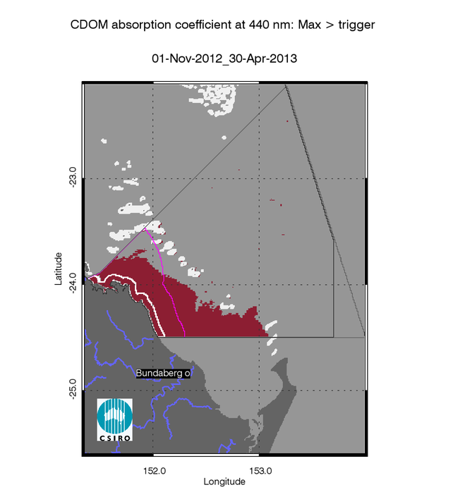
- Map of freshwater extent for the wet season for the Burnett Mary region. Freshwater extent estimated with a threshold for the CDOM seasonal maximum of 0.24 m⁻¹.
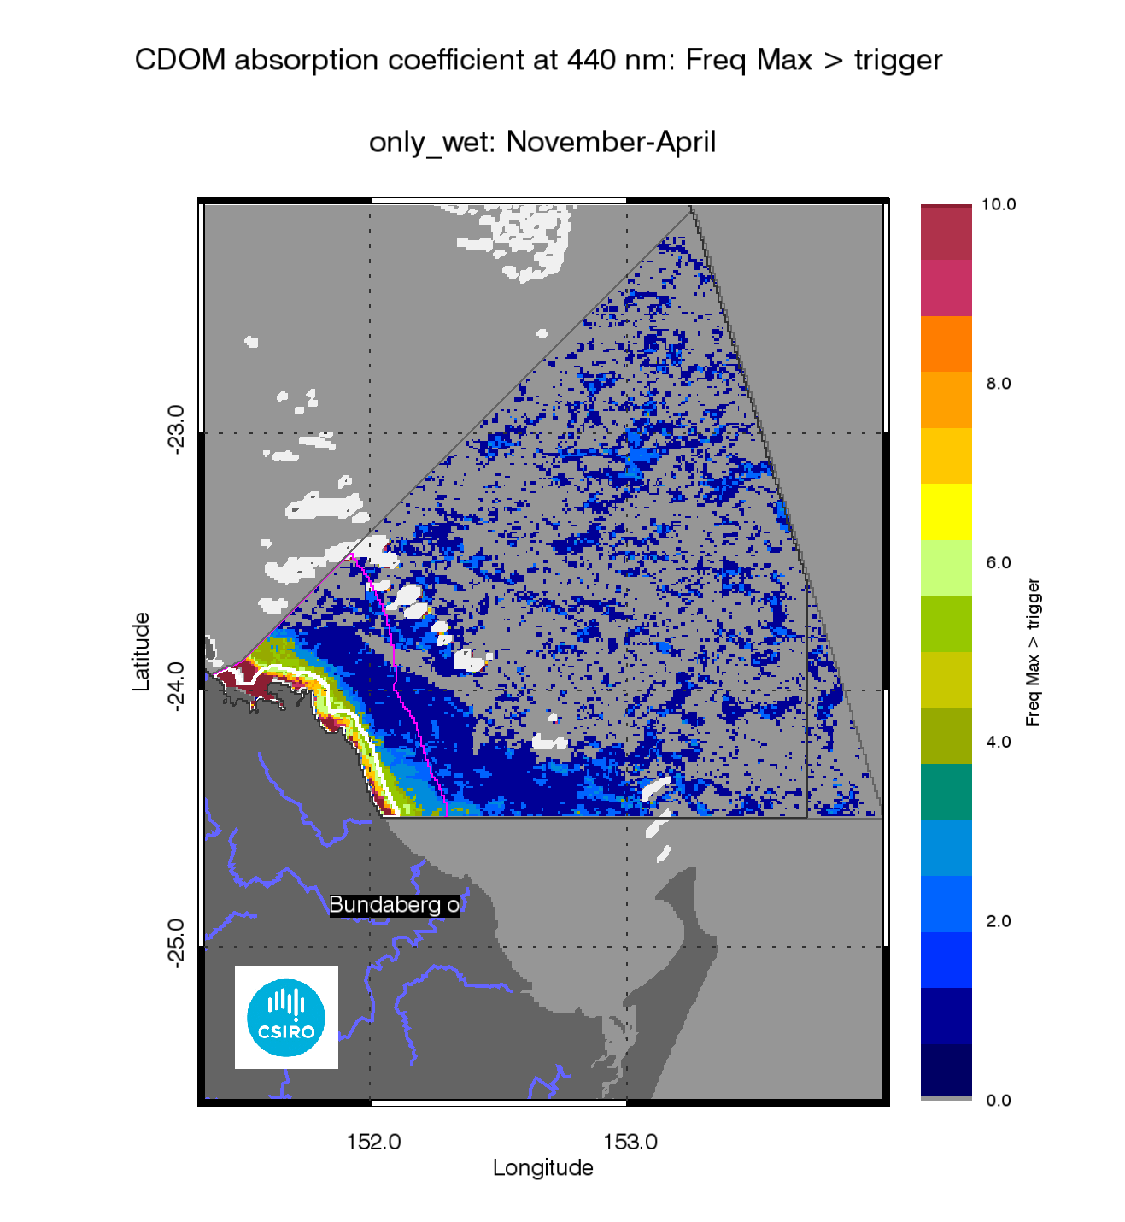
- Map of freshwater extent for the wet season for the Burnett Mary region. Superimposed seasonal maximum freshwater plume extents for the wet seasons between 2003 and 2013.

The annual mean maps for Chlorophyll-a and Total Suspended Solids.
The annual CHL mean maps for the Burnett Mary region (Figure 75) show high CHL concentrations near the coast and in the estuaries to lower concentrations towards the East. Mean CHL values of up-to 1.0µg L⁻¹ extended beyond the coastal to inshore boundary, and it ranged 0.3-0.6 µg L⁻¹ in the Midshelf. The mean CHL values in the offshore region ranged between 0.15-0.25 µg L⁻¹, while mean CHL values of chlorophyll-a to 0.5 µg L⁻¹extended as far as the Bunker group and values of ~ 0.3-0.4µg L⁻¹were observed in proximity of the mid and outer shelf reefs of the offshore area particularly in the Swain group.
The annual mean maps of non-algal particulate matter (as a measure of TSS) (Figure 76) show values higher than 3 mgL⁻¹ only in Port Curtis and in the area close to the river mouths. The high concentrations shown near Break sea Spit are likely to be overestimated. The accuracy of the retrieval from MODIS imagery in these shallow waters systems cannot be assessed, as there is no data available for parameterization and validation.
The number of image observations available for calculating the mean values varies from 20 to 30 observations for the wet season and at least 40-50 for the dry season for each pixel location, as reported in section 7.1.

Assessment of the exceedance of water quality guidelines
The exceedance of the Guidelines was assessed for CHL and TSS retrieved from MODIS Aqua using CSIRO’s algorithm. For the Burnett Mary region the annual mean CHL values of exceeded the Guidelines threshold values for 98% of the Inshore Coastal area, 46% of the Midshelf and 2% of the Offshore areas (Table 16). The Exceedance maps for CHL show that the mean CHL values of exceeded the Guidelines thresholds over the whole year in a coastal band ~ 20 km wide, thus including most of the Inshore water body and in Midshelf water body around the Northern part of the region (Figure 75, Figure 77). This spatial pattern has been consistent for this region over the last few years, while in the first part of the decade between 2003 and 2013 the exceedance was mainly observed in Port Curtis and at Baffle Creek mouth, as shown by the map of frequency of CHL exceedance (Figure 79).
Over the whole year, exceedance of TSS Guideline values was recorded in 28% of Inshore, 1% of Midshelf and 0% of Offshore areas (Table 15, Figure 76, Figure 78), The Exceedance maps for TSS show that the mean TSS values of exceeded the Guidelines thresholds over the whole year only in river mouths and embayments (Figure 76, Figure 78). This spatial pattern has been consistent for this region over the decade between 2003 and 2013, as shown by the map of frequency of TSS exceedance (Figure 80).
Maps and tables providing details for the seasonal exceedance in the wet and dry seasonsare reported in section 7.2 (Table 30, Table 31, Figure 140, Figure 141, Figure 142, Figure 143, Figure 144, Figure 145, Figure 146, Figure 147)

- Summary of the annual exceedance maps from 01-May-2012 to 30-Apr-2013 for Chlorophyll-a and Total Suspended Solids for the Burnett Mary region. Surface Area is the surface area in square kilometres for each of the reporting water bodies for this region Number valid obs. is the number of pixels with valid observations (i.e. cloud-free and error-free pixels); Number total obs. provides the total number of observations;Mean> trigger and Median > trigger report the relative area for each water body where the mean or the median exceeded the WQ Guideline value.
 |  | 01-May-2012_30-Apr-2013 |  | Chlorophyll-a |  | Total Suspended Solids
Region | Surface Area | Number valid obs. | Number total obs. | Mean > trigger | Median > trigger | Mean > trigger | Median > trigger
Inshore | 817 | 80791 | 425657 | 98% | 98% | 28% | 20%
Midshelf | 3677 | 363179 | 1915717 | 46% | 23% | 1% | 0%
Offshore | 36489 | 2317135 | 19006484 | 2% | 0% | 0% | 0%

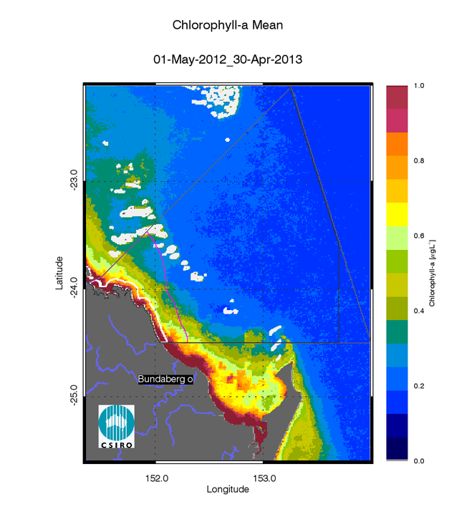
- Annual mean map for Chlorophyll-a for the Burnett Mary region for the reporting year 2012/13 (May 2012 –April 2013).
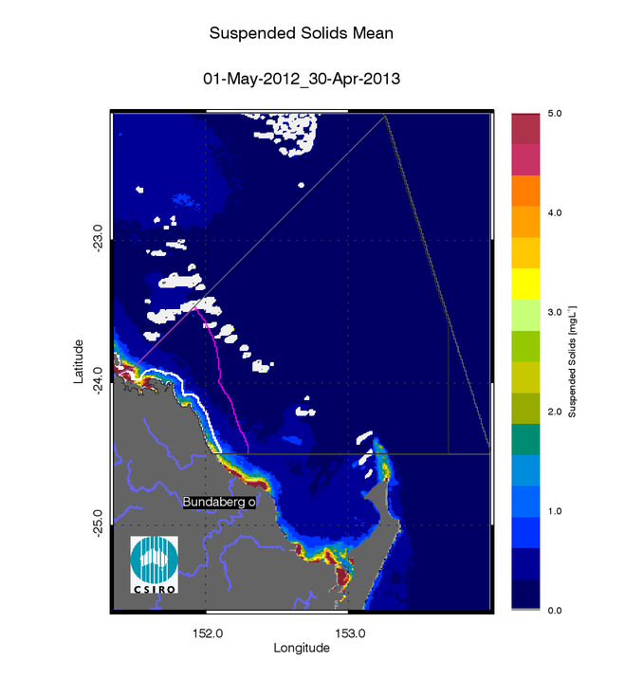
- Annual mean map for Non-algal particulate matter (NAP as a measure of TSS) for the Burnett Mary region for the reporting year 2012/13 (May 2012 –April 2013).

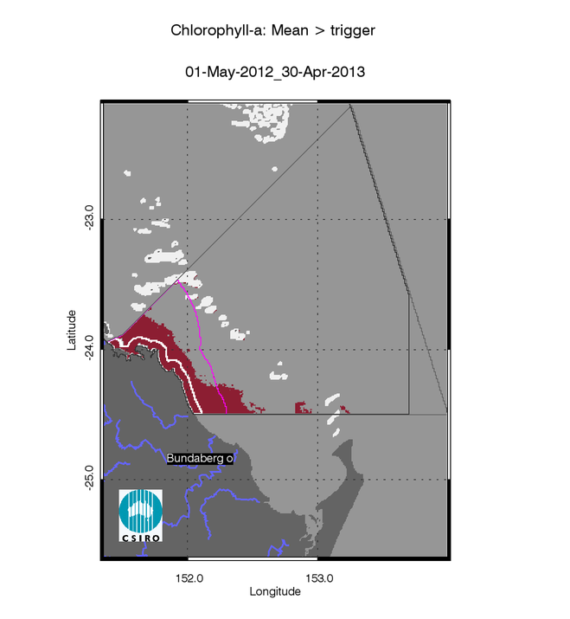
- Exceedance maps for the Burnett Mary region for the reporting year 2012/13 (May 2012 –April 2013). Chlorophyll-a exceedance map. The Guideline values for annual means of Chlorophyll–a are 0.45 µg L-1 for Inshore and Midshelf and 0.40 µg L-1 for Offshore
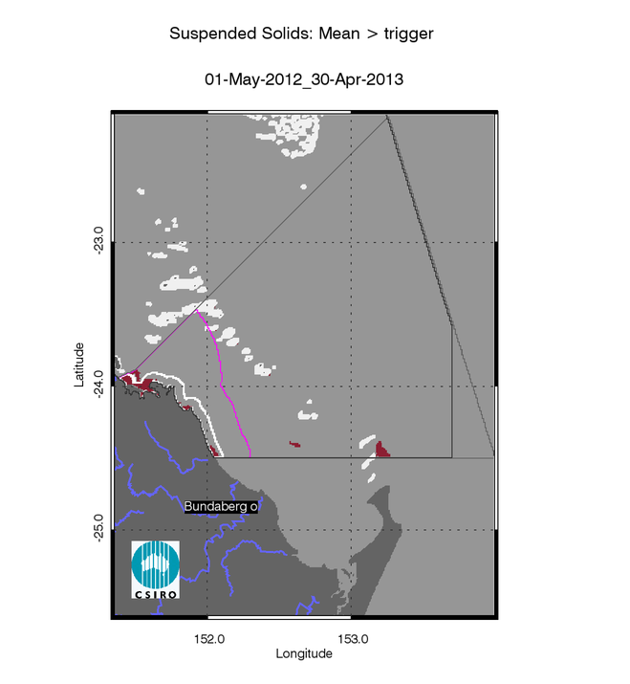
- Exceedance maps for the Burnett Mary region for the reporting year 2012/13 (May 2012 –April 2013). Non-algal particulate matter (NAP as a measure of TSS) exceedance map. The Guideline values for annual means of TSS are 2.0 mg L-1 for Inshore and Midshelf and 0.7 mg L-1 for Offshore

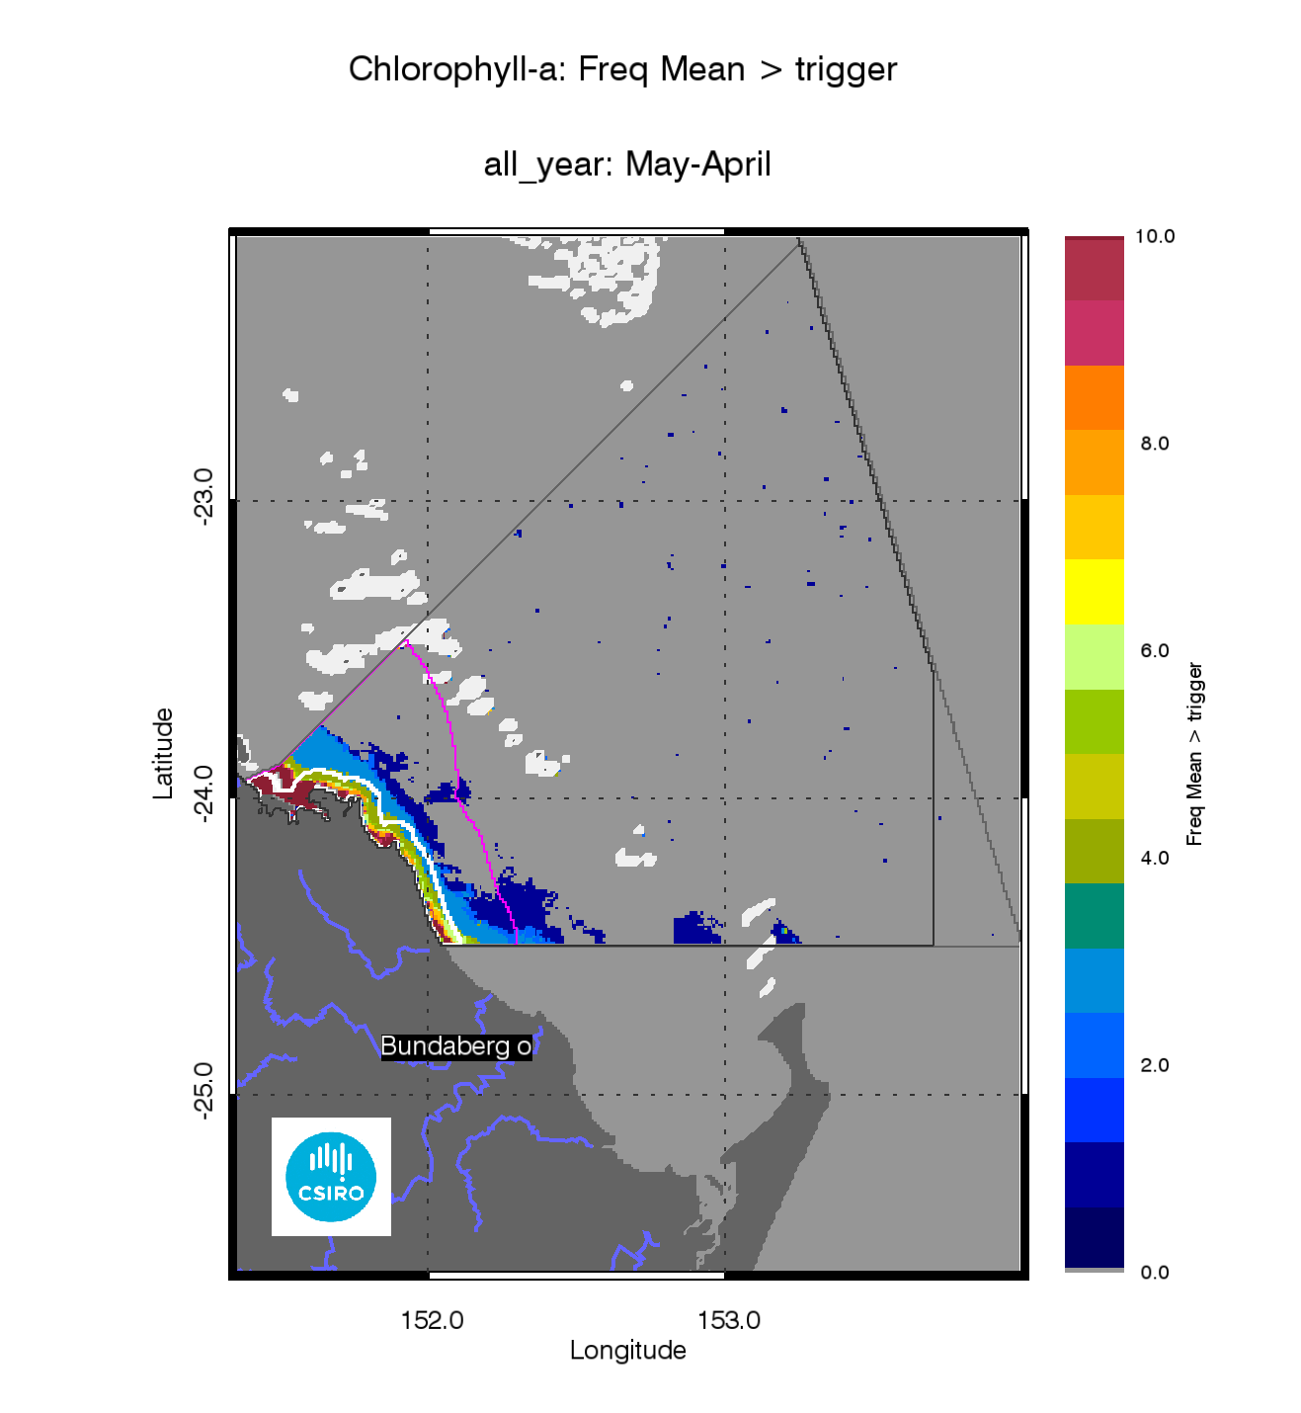
- Superimposed annual exceedance extents for Chlorophyll-a for the Burnett Mary region for the reporting years between 2002/03 and 2012/13.
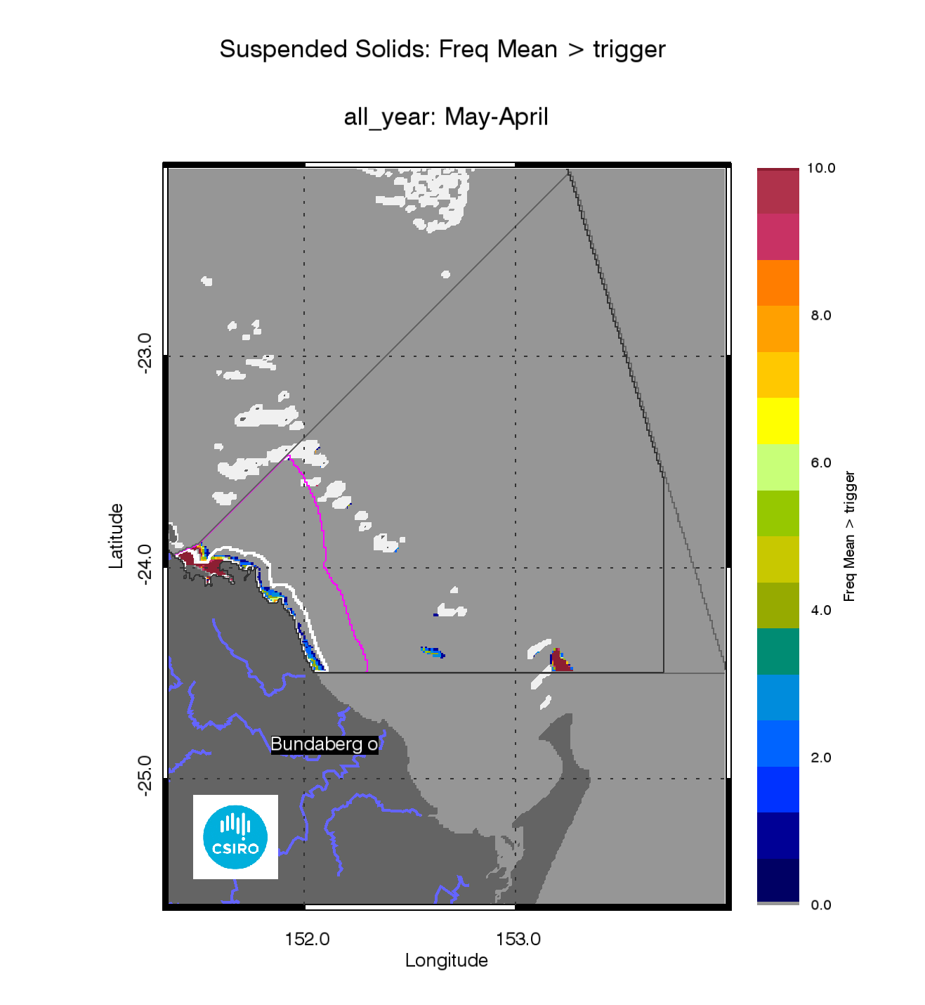
- Superimposed annual exceedance extents for Non-algal particulate matter (NAP as a measure of TSS) for the Burnett Mary region for the reporting years between 2002/03 and 2012/13.

Assessment of the Paddock to Reef index
The marine water quality for this reporting year for the Mary Burnett region was scored as “poor”, reflecting a “very poor” score for P2R_CHL and “good” for P2R_TSS (Figure 81). The marine water quality index and the component scores have been steadily declining from 2006/07, as the P2R_CHL scores declined from “moderate” to “very poor” in the last five years while the P2R_TSS scores were varied between “good” and“ very good” since the 2002/03 reporting season.
Between 2002 and 2013 the GBR scores forP2R_WQI were significantly correlated with the estimated freshwater plume extent (R=-0.767, p=0.004, Figure 14Figure 13Table 8). For this region both the component scores for Chlorophyll and Total Suspended Solids were significantly highly correlated with the estimated freshwater plume extent (P2R_CHL: R=-0.755, p=0.005, Figure 14; P2R_TSS: R=-0.813, p=0.001, Figure 15,Table 8). As for other regions the P2R_CHL score is likely incorporates a response to the nutrient loads delivered during the wet seasons form the GBR catchments to the Inshore water body, while for the Mary Burnett region the correlation for P2R_TSS score is related to the small decline in the score in last five years, corresponding to the high freshwater discharges from the Baffle Creek as well as the Burnett and Mary Rivers and the associated estimated freshwater plume extents of the last years.

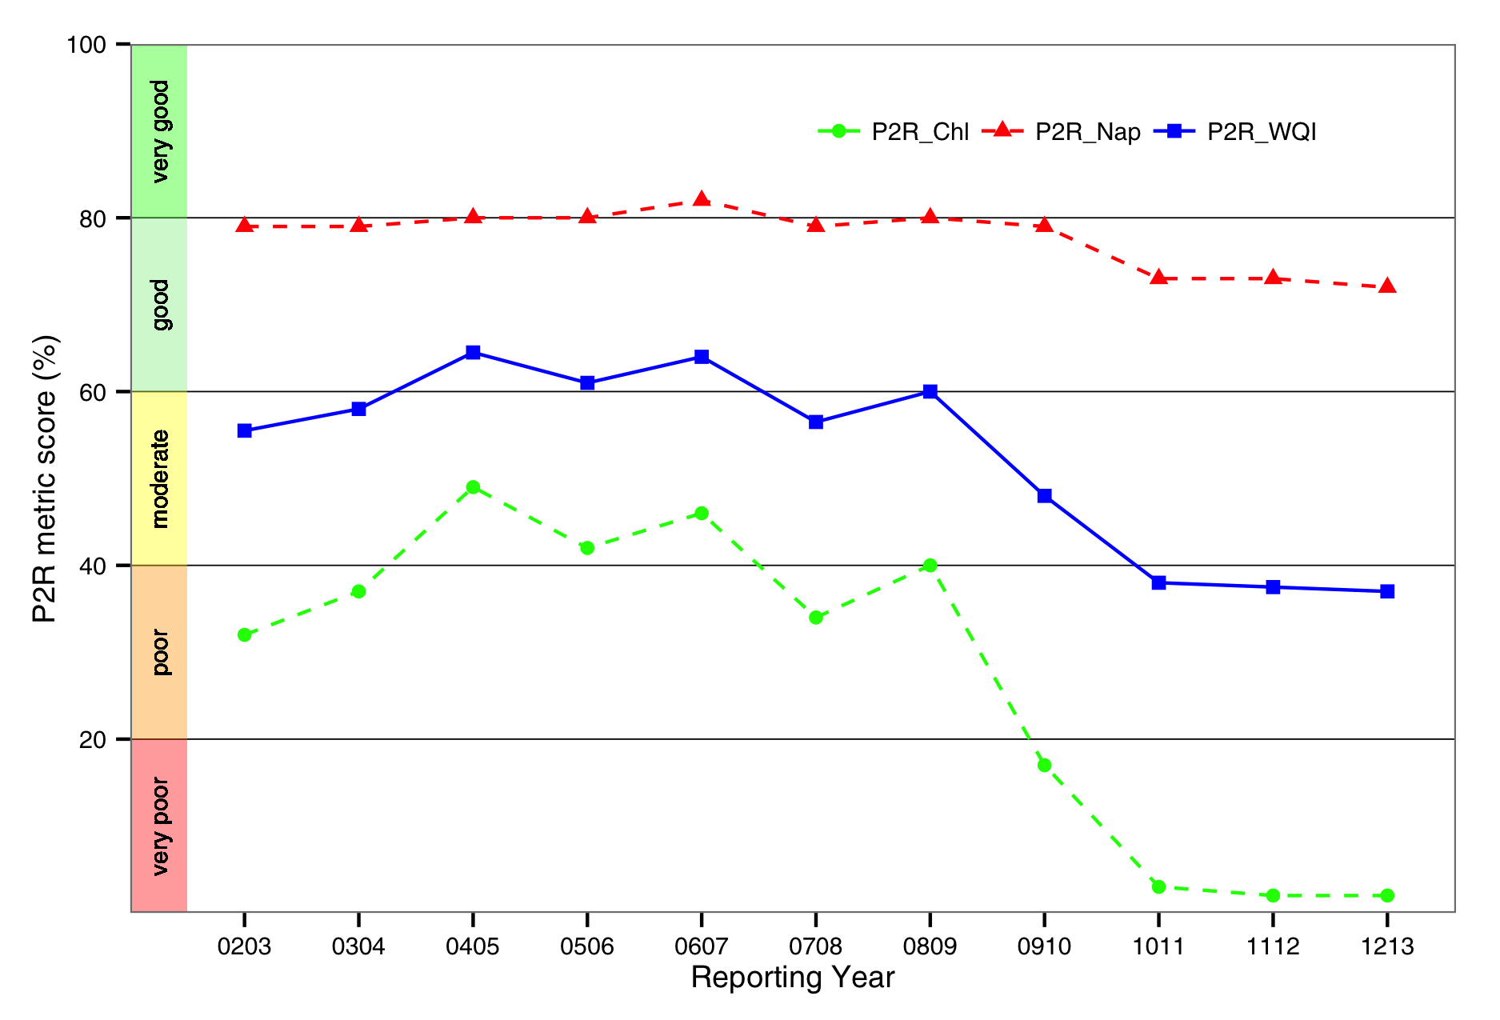
- Trends in the Paddock to Reef marine water quality index (P2R_WQI) and component scores (P2R_CHL and P2R_TSS) for the Burnett Mary region.

Conclusions and recommendations
A cornerstone of the GBRWQPP and the WQIPs is the setting of water quality objectives against which to assess the success of the actions taken under Reef Plan and Reef Rescue to mitigate the effects of nutrients and sediment from runoff and discharges. A key challenge is to detect and monitor the effect of the land management practices on the water quality in the GBR lagoon waters. In this system, the water quality is also influenced by the inter-annual weather variability induced by the El Niño-Southern Oscillation (ENSO) leading to large year to year variations in the distribution of rainfall events over the GBR catchments resulting in sediment laden river plumes and algal blooms.
The MMP aims are to document floods and the condition of inshore water quality to explain changes in the health of key inshore environments (coral reefs and seagrass). To address these important management questions water quality is monitored using three complementary approaches to collect data at various spatial (site, location, region, and whole GBR lagoon) and temporal (snapshot, daily, 10-minutely) scales: traditional direct water sampling from research vessels, in situ data loggers at a small number of selected inshore reef locations and remote sensing techniques. While data loggers provide detailed information on the local variability in water quality parameters, remote sensing observations provide extensive spatial coverage at 1 km resolution.
This report delivered management-relevant information of flood events and inshore water quality from remote sensing data to enable GBRMPA and other relevant management agencies to make more informed management decisions. MODIS ocean colour imagery was used to quantify for the GBR near-surface concentrations of key water quality variables: total suspended solids (TSS) as an indicator of water clarity, coloured dissolved organic matter (CDOM) as a tracer of terrestrial discharge of low salinity waters, and chlorophyll-a (CHL) as an indicator of phytoplankton biomass and a proxy for nutrient availability. At present, MODIS Aqua represents a time series (November 2002 – present) of water quality estimates with spatial coverage at 1 km resolution, nominally acquired on a daily basis (except overcast days) for the whole-of-GBR lagoon.
For this report the whole MODIS Aqua time series was processed by the eReefs pre-operational system for marine water quality assessment in the Great Barrier Reef by satellite ocean colour observations(King et al. 2014). To improve temporal stability of the time series of the MODIS Aqua aging sensor, the most recent updates in NASA’s software (SeaDAS version 7.0.2) was used, thus incorporating the improved knowledge of instrument temporal calibration. As such, all the results presented in this report supersede the previous reports. The comparison of MODIS Aqua retrievals of CHL, CDOM and NAP data to in situ data showed that the eReefs pre-operational ocean colour system is more accurate than NASA’s algorithms for GBR waters in the dry and wet seasons. The accuracy for the retrieval of CHL, CDOM and TSS with eReefs pre-operational system was 90%, 138% and 88%, respectively. The accuracy of the retrieval is likely to likely to be lower in shallow and turbid waters systems such as Princess Charlotte Bay, Broad Sound and Shoalwater Bay, as there is little or no data available for parameterization and validation.
Flood events in the wet season are the main delivery mechanism for nutrients, sediments and pesticides from the adjacent catchments into the Reef lagoon. The freshwater extent was estimated for each region from MODIS measurements within the wet season of each year by applying a threshold to maps of aggregated seasonal maximum CDOM concentrations. The CDOM absorption threshold used in this report was established by Schroeder et al. (2012) based a relationship between measurements of salinity and CDOM absorption. The high CDOM concentrations may also reflect other processes in occurring in near-shore waters, further work should also attempt to separate the plumes from non-plume effects.
The freshwater extent based on the CDOM maximum provides a conservative estimate of the extent as the flood plumes could have extended further in cloudy or overcast days and hence may not been captured with the satellite imagery. The estimated freshwater extent for the whole GBRWHA was significantly highly correlated to the total freshwater discharges (R=0.850, p=0.01),The freshwater extent for 2012/2013 was the second highest after the 2010-2011 wet season as observed with the MODIS time series. The estimated freshwater extent for 2012/2013 was larger than all previous reporting years in for the Burnett Mary region, while for Fitzroy, Wet Tropics and Cape York regions it was higher than the median extents observed with the MODIS time series. These results were consistent with the results of the qualitative and quantitative flood mapping approaches carried out in the flood plumes and extreme weather monitoring activities of the MMP (Devlin et al. 2012).
The marine water quality for this reporting year for the whole GBR was scored as “poor”, reflecting the two “poor” and two “moderate” scores for P2R_WQI in the four reporting regions that contribute the whole of GBR score (Table 7, the regional scores for Cape York and Burnett Mary are excluded from calculations of the overall GBR score for the metrics). The scores for the two component indicators for the whole GBR were “poor” for P2R_CHL and “moderate” for P2R_TSS, reflecting the “very poor” to “moderate” regional scores for P2R_CHL and “moderate” to “good” regional scores from P2R_TSS. The marine water quality index was similar to the reporting year 2011/12, higher than the reporting year 2010/11 and lower than for the previous reporting years for all regions, as well as the whole GBR, reflecting the high freshwater discharges from the GBR catchments in 2010/11 and 2012/13 and the associated estimated freshwater plume extent.
The GBR scores forP2R_WQI were significantly highly correlated with the estimated freshwater plume extent (R=-0.915, p<0.001 (Figure 14Figure 13Table 8). While the component scores for Chlorophyll (P2R_CHL) were significantly highly correlated with the estimated freshwater plume extent (R=-0.958, p<0.001, Figure 12), P2R_TSS was poorly correlated (R=-0.474, Figure 15,Table 8). Also four regional P2R_CHL scores (Wet Tropics, Burdekin, Fitzroy and Burnett Mary reporting regions) were significantly correlated (Table 8) indicating that the chlorophyll component score incorporates a strong response to the nutrient loads delivered during the wet seasons from the GBR catchments to the Inshore water body, while P2R_TSS score seems to be less sensitive to the wet season sediment delivery and more to dry season wind-driven re-suspension. Coupled hydro-dynamic, optical, sediment and biogeochemical modelling may provide a useful tool to disentangle the complex interactions between seasonal variability in precipitation, land use changes and their impacts on coastal water quality.
Large areas of TSS exceedance occurred in Offshore areas, particularly in Cape York, the Mackay-Whitsunday and Fitzroy reporting regions at the boundary between the Midshelf and Offshore waters. These large areas of exceedance of the mean annual TSS values may be due to either an over-estimate of the mean TSS concentrations in Offshore waters or to a low guideline threshold value for those waters as a consequence of a wrong delineation of the Offshore boundary. Future work should attempt to assess the accuracy of TSS and CHL retrieval from satellite data at a regional and seasonal scale, if enough validation data points become available. It is recommended to GBRMPA that, consistently with the adaptive monitoring paradigm (Lindenmayer and Likens 2009), a re-assessment of the Guidelines threshold values, the delineation of the reporting boundaries, as well as the regional and seasonal adjustments, is carried out as part of the Guidelines review cycle.
The Inshore water body includes the Open Coastal waters and the Enclosed coastal waters that have been delineated in the previous account for 15-30% of the Inshore water body in the NRM regions. As the guideline values for CHL and TSS for the Enclosed Coastal waters are higher than those for the Open Coastal water body, the relative area of non-compliance for the Inshore waters is over-estimated if the Enclosed waters delineation is not taken in account. Hence, It is recommended to GBRMPA that the proposed delineation of the Enclosed Coastal waters should be taken in consideration together with other data sources including the Queensland Wetlands 2009 data, depth contours, hydrodynamics and sources of freshwater input to the coast prior to selecting the final water body delineation for formal implementation in the Guidelines.
This study relies on data acquired by the MODIS Aqua sensor that is already several years beyond its intended lifetime. The sensor degradation affects the radiometric accuracy of the time series and this may in turn affect the accuracy of the retrieval of the optical properties and concentrations of the key water quality variables. Furthermore, there is the risk that it may no longer possible to rectify problems with the Aqua sensor degradation. Any sensor failure will require a switch to a different sensor and substantial retuning, recalibration and validation of the processing and analysis system (Steven et al. 2014).The recently launched US VIIRS sensor and the forthcoming OLCI instrument on the ESA Sentinel missions are intended to provide long-term data continuity. For the P2R MMP to realize this opportunity and capitalize on the recent progress for coastal water condition monitoring from space it is recommended to incorporate water quality data from both instruments.
This study has shown that remote sensing can be effectively used as a tool for collecting data to support the implementation of the monitoring activities outlined in the Guidelines. However, despite the undisputable advantages offered by satellite sensors, remote sensing relies on the collection of in situ data for the development and the validation of algorithms and models. Hence, the systematic collection of in situ data to be used for validation should be performed as an integral part of the marine water quality assessment in the GBR, particularly as transition to the VIIRS and OLCI data streams is likely to occur in the near future. This role could be fulfilled as part of a dedicated component of the P2R MMP routine direct water sampling from research vessels and fixed locations in which in situ measurements are carried out following remote sensing validation protocols.
The eReefs pre-operational ocean colour system is a demonstrator for an operational implementation that has been successfully deployed by the Bureau of Meteorology to deliver the marine water quality products via a web-based dashboard in near real time (http://www.bom.gov.au/marinewaterquality/). At the moment of writing it remains unclear whether the tailored temporal and spatial analysis for assessment of compliance to the guidelines and the estimate of the freshwater extent for the GBRWHA presented in this report will be also carried out by the same system.
Within the context of the eReefs GBR Information System partnership(Schiller et al. 2014, Steven et al. 2014), CSIRO is working to improve the characterisation of the water properties more widely in the GBR and to extend the support to new and forthcoming satellite sensors beyond MODIS Aqua:
- The parameterization of the remote sensing retrievals was mainly based on observations performed in coastal and lagoonal waters during the dry season between Keppel Bay and the Wet Tropics region. To fill this knowledge gap In January and March 2013 two fieldworks were carried out within the eReefs activities to characterize the wet season optical properties from Bowen to Princess Charlotte Bay. Optical data acquired during these fieldworks will form the basis of an extension of the algorithm parameterizations.
- The atmospheric correction parameterization is also being improved in highly turbid waters, also including a new capability to correct for the effects of sun glint from the ocean surface.
- The CSIRO algorithms are being adapted for VIIRS the new satellite sensor currently operated onboard the Suomi NPP satellite, which was launched in late 2011. This instrument is the first in a series to be flown over the next decade and potentially offers the continuity required to support an operational system.

References

Astoreca, R., V. Rousseau and C. Lancelot (2009). "Coloured dissolved organic matter (CDOM) in Southern North Sea waters: Optical characterization and possible origin." Estuarine, Coastal and Shelf Science85: 633–640.
Bailey, S. W. and P. J. Werdell (2006). "A multi-sensor approach for the on-orbit validation of ocean color satellite data products." Remote Sensing of Environment102(1-2): 12-23.
Blondeau-Patissier, D., V. E. Brando, K. Oubelkheir, A. G. Dekker, L. A. Clementson and P. Daniel (2009). "Bio-optical variability of the absorption and scattering properties of the Queensland inshore and reef waters, Australia." J. Geophys. Res.114.
Bowers, D. and H. L. Brett (2008). "The relationship between CDOM and salinity in estuaries: An analytical and graphical solution." Journal of Marine Systems73(1-2): 1-7.
Brando, V. E., A. G. Dekker, A. Marks, Y. Qin and K. Oubelkheir (2006). Chlorophyll and Suspended Sediment Assessment in a Macro-Tidal Tropical Estuary Adjacent to the Great Barrier Reef: Spatial and Temporal Assessment Using Remote Sensing. Indooroopilly, Qld, Australia, CRC for Coastal Zone, Estuary and Waterway Management: 114
Brando, V. E., A. G. Dekker, Y. J. Park and T. Schroeder (2012). "An adaptive semianalytical inversion of ocean colour radiometry in optically complex waters " Applied Optics51(15): 2808-2833.
Brando, V. E., A. G. Dekker, T. Schroeder, Y. J. Park, L. A. Clementson, A. Steven and D. Blondeau-Patissier (2008). Satellite retrieval of chlorophyll CDOM and NAP in optically complex waters using a semi-analytical inversion based on specific inherent optical properties. A case study for Great Barrier Reef coastal waters. Ocean Optics XIX, Barga, Italy.
Brando, V. E., T. Schroeder, D. Blondeau-Patissier, L. Clementson and A. G. Dekker (2011). Reef Rescue Marine Monitoring Program: Using remote sensing for GBR-wide water quality. Final Report for 2010/2011 Activities. Canberra, ACT, CSIRO Land & Water.
Brando, V. E., T. Schroeder and A. G. Dekker (2010). Reef Rescue Marine Monitoring Program: Using remote sensing for GBR-wide water quality. Final Report for 2008/2009 Activities. Canberra, ACT, CSIRO Land & Water.
Brando, V. E., T. Schroeder, A. G. Dekker and L. Clementson (2013). Reef Rescue Marine Monitoring Program: Using remote sensing for GBR-wide water quality. Final Report for 2011/2012 Activities. Canberra, ACT, CSIRO Land & Water.
Brando, V. E., T. Schroeder, A. G. Dekker and Y. J. Park (2010). Reef Rescue Marine Monitoring Program: Using remote sensing for GBR-wide water quality. Final Report for 2009/2010 Activities. Canberra, ACT, CSIRO Land & Water.
Brando, V. E., A. Steven, T. Schroeder, A. G. Dekker, Y. J. Park, P. Daniel and P. Ford (2010). Remote-sensing of GBR Waters to assist performance monitoring of Water Quality Improvement Plans in Far North Queensland. Final report for Department of the Environment and Water Heritage and the Arts. Canberra, ACT, CSIRO Land & Water.
Brodie, J., J. Binney, K. Fabricius, I. Gordon, O. Hoegh-Gouldberg, H. Hunter, P. O’Reagain, R. Pearson, M. Quirk, J. Thornton, I. Webster and S. Wilkinson (2008). Scientific consensus statement on water quality in the Great Barrier Reef., The State of Queensland (Department of the Premier and Cabinet).
Brodie, J., G. De'ath, M. Devlin, M. J. Furnas and M. Wright (2007). "Spatial and temporal patterns of near-surface chlorophyll a in the Great Barrier Reef lagoon." Marine and Freshwater Research58(4): 342–353.
Burrage, D. M., M. L. Heron, J. M. Hacker, J. L. Miller, T. C. Stieglitz, C. R. Steinberg and A. Prytz (2003). "Structure and influence of tropical river plumes in the Great Barrier Reef: application and performance of an airborne sea surface salinity mapping system." Remote Sensing of Environment85: : 204-220.
DERM (2009). Queensland Water Quality Guidelines, Version 3, Department of Environment and Resource Management.
Devlin, M., T. Schroeder, L. McKinna, J. Brodie, V. Brando and A. Dekker (2012). Monitoring and mapping of flood plumes in the Great Barrier Reef based on in-situ and remote sensing observations. Advances in Environmental Remote Sensing to Monitor Global Changes. N.-B. Chang: 148-188.
Devlin, M., A. Wenger, C. Petus, E. T. d. Silva, J. Debose and J. Alvarez-Romero (2012). Reef Rescue Marine Monitoring Program: Final report of JCU Activities 2011/12 - Flood Plumes and Extreme weather monitoring for the Great Barrier Reef Marine Park Authority.
Ferrari, G. M. and M. D. Dowell (1998). "CDOM absorption characteristics with relation to fluorescence and salinity in coastal areas of the southern Baltic Sea." Estuarine, Coastal and Shelf Science47(1): 91-105.
GBRMPA (2009). Water quality guidelines for the Great Barrier Reef Marine Park, Great Barrier Reef Marine Park Authority.
Hoge, F. E. and P. E. Lyon (1996). "Satellite retrieval of inherent optical properties by linear matrix inversion of oceanic radiance models - an analysis of model and radiance measurement errors." Journal of Geophysical Research-Oceans101(C7): 16631-16648.
Johnson, J. E., V. E. Brando, M. J. Devlin, L. McKenzie, S. Morris, B. Schaffelke, A. Thompson, J. Waterhouse and M. Waycott (2011). Reef Rescue Marine Monitoring Program: 2009/2010 Synthesis Report. Report prepared by the Reef and Rainforest Research Centre Consortium of monitoring providers for the Great Barrier Reef Marine Park Authority. Cairns, Reef and Rainforest Research Centre Limited.
Kennedy, K., T. Schroeder, M. Shaw, D. Haynes, S. Lewis , C. Bentley, C. Paxman, S. Carter , V. Brando, M. Bartkow and J. Mueller (2012). "Photosystem-II herbicides on the Great Barrier Reef- results from up to five years of monitoring and a preliminary comparison with remote sensing derived water quality parameters." Marine Pollution Bulletin65(4-9): 292-305.
King, E. A., T. Schroeder, V. E. Brando and K. Suber (2014). A Pre-operational System for Satellite Monitoring of Great Barrier Reef Marine Water Quality. eReefs Remote Sensing, Phase 1. Wealth from Oceans Flagship report.
Lindenmayer, D. B. and G. E. Likens (2009). "Adaptive monitoring: a new paradigm for long-term research and monitoring." Trends in ecology & evolution (Personal edition)24(9): 482-486.
Maritorena, S., D. A. Siegel and A. R. Peterson (2002). "Optimization of a semianalytical ocean color model for global-scale applications." Appl.Opt.41: 2705-2714.
Molleri, G. S. F., E. M. L. de M. Novo and M. Kampel (2010). "Space-time variability of the Amazon River plume based on satellite ocean color." Continental Shelf Research30(3-4): 342-352.
Oubelkheir, K., L. Clementson, I. Webster, P. Ford, A. G. Dekker, L. Radke and P. Daniel (2006). "Using inherent optical properties to investigate biogeochemical dynamics in a tropical macrotidal coastal system." J. Geophys. Res. (C Oceans)111(C07021): doi:10.1029/2005JC003113.
Qin, Y., A. G. Dekker, V. E. Brando and D. Blondeau-Patissier (2007). "Validity of SeaDAS water constituents retrieval algorithms in Australian tropical coastal waters." Geophys. Res. Letters34(l21603).
Radke, L., P. Ford, I. Webster, I. Atkinson, G. Douglas, K. Oubelkheir, J. Li, B. Robson and B. Brooke (2010). "Biogeochemical Zones Within a Macrotidal, Dry-Tropical Fluvial-Marine Transition Area: A Dry-Season Perspective." Aquatic Geochemistry16(1): 1-29.
RWQPP (2011). Great Barrier Reef First Report Card 2009 Baseline. Reef Water Quality Protection Plan, Reef Water Quality Protection Plan Secretariat,The State of Queensland.
RWQPP (2011). Reef Water Quality Protection Plan. First Report: 2009 Baseline, Reef Water Quality Protection Plan Secretariat,The State of Queensland.
RWQPP (2013). Great Barrier Reef Report Card 2010. Reef Water Quality Protection Plan, Reef Water Quality Protection Plan Secretariat,The State of Queensland.
RWQPP (2013). Great Barrier Reef Report Card 2011. Reef Water Quality Protection Plan, Reef Water Quality Protection Plan Secretariat,The State of Queensland.
Schaffelke, B., J. Carleton, J. Doyle, M. Furnas, K. Gunn, M. Skuza, M. Wright and I. Zagorskis (2011). Reef Rescue Marine Monitoring Program. Annual Report of AIMS Activities – Inshore water quality monitoring 2010/11. Townsville, Australian Institute of Marine Science.
Schaffelke, B., J. Carleton, I. Zagorskis, M. J. Furnas, M. Skuza, M. Wright, A. G. Dekker, D. Blondeau-Patissier and V. E. Brando (2006). Nearshore marine water quality monitoring. In: CRC Reef Consortium. Water Quality and Ecosystem Monitoring Programs–Reef Water Quality Protection Plan. Final Report August 2006 (revision November 2006). Townsville, CRC Reef Research: 105-170.
Schiller, A., M. Herzfeld, R. Brinkman and G. Stuart (2014). "Monitoring, Predicting, and Managing One of the Seven Natural Wonders of the World." Bull. Amer. Meteor. Soc95: 23-30.
Schroeder, T., I. Behnert, M. Schaale, J. Fischer and R. Doerffer (2007). "Atmospheric correction algorithm for MERIS above case-2 waters." International Journal of Remote Sensing28(7): 1469 - 1486.
Schroeder, T., V. E. Brando, N. R. C. Cherukuru, L. A. Clementson, D. Blondeau-Patissier, A. G. Dekker, M. Schaale and J. Fischer (2008). Remote sensing of apparent and inherent optical properties of Tasmanian coastal waters: application to MODIS data. Ocean Optics XIX, Barga, Italy.
Schroeder, T., M. J. Devlin, V. E. Brando, A. G. Dekker, J. E. Brodie, L. A. Clementson and L. McKinna (2012). "Inter-annual variability of wet season freshwater plume extent into the Great Barrier Reef lagoon based on satellite coastal ocean colour observations." Marine Pollution Bulletin65(4-9): 210-223.
Steven, A., V. Brando, A. Dekker, J. Hodge, B. Farthing, K. Mengersen, K. Oubelkheir and Y. Qin (2007). Remotely-Sensed Monitoring of Chlorophyll and Suspended Sediment in the Coastal Waters of the Wet Tropics Region: A demonstration project with national application. Canberra, ACT, CSIRO Land & Water: 141.
Steven, A. D. L., V. E. Brando, L. Clementson, A. G. Dekker, N. Hardman-Mountford, J. Hodge, Emlyn Jones, E. King and T. Schroeder (2014). Coastal Ocean Colour of Australian Waters: Progress and Outlook Oceans and Society: Blue Planet. Samy Djavidnia, V. Cheung, M. Ott and S. Seeyave, Cambridge Scholars Publishing: 122-129.
Weeks, S., P. J. Werdell, B. Schaffelke, M. Canto, Z. Lee, J. G. Wilding and G. C. Feldman (2012). "Satellite-Derived Photic Depth on the Great Barrier Reef: Spatio-Temporal Patterns of Water Clarity." Remote Sensing2012: 3781-3795.
Wooldridge, S., J. Brodie and M. Furnas (2006). "Exposure of inner-shelf reefs to nutrient enriched runoff entering the Great Barrier Reef Lagoon: Post-European changes and the design of water quality targets." Marine Pollution Bulletin52(11): 1467-1479.

APPENDIX A: Satellite data accuracy assessment
In this report, the water quality estimates from MODIS Aqua data for GBR Lagoon coastal waters are derived using two coupled physics-based inversion algorithms published in the peer review literature (Schroeder et al 2007, Brando et al, 2012). Within the eReefs GBR Information System partnership(Schiller et al. 2014),these research-grade algorithms were migrated from desktop computers into a mass-production environment deployed at a high performance computing facility to enable the operation of these systems at scale over large areas and decadal time series(King et al. 2014).
The eReefs pre-operational system for monitoring marine water quality for the GBR builds upon an IMOS-supported framework in which satellite imagery, from the NASA MODIS Aqua instrument, is processed to standard top-of-atmosphere products. CSIRO-developed algorithms are applied to correct for the effect of the atmosphere and retrieve estimates of concentrations of the in-water constituents, Chlorophyll, CDOM and suspended sediments. The algorithms’ theoretical basis and the implementation of the satellite data processing workflow of the eReefs a pre-operational ocean colour system are described in details in King et al. 2014.
This section will present an accuracy assessment of the water quality retrievals from satellite data. In the remote sensing literature validation refers to the independent verification of the physical measurements made by a sensor as well as of the derived geophysical variables. Validation allows for the verification and improvement of the algorithms used (e.g. for atmospheric correction and retrieval of water quality variables). To achieve this, conventional, ground-based observations are required using calibrated and traceable field instrumentation and associated methods(Bailey and Werdell 2006).

The validation data-base
The in situ data (ground observations) used for validation included over two thousand data points (mostly only chlorophyll) measured by 5 institutions. The validation database is based on several sources of in situ observations:
The GBR Long Term Monitoring Program (GBR-LTMP) dataset. The GBR- LTMP dataset includes Chlorophyll-a measurements going back as far as 1992 (thus including the start of the first contemporary ocean colour sensor SeaWiFS, launched in 1997). This monitoring program was designed to monitor water quality status at regional spatial scales (Brodie et al. 2007). The sampling stations for GBR-LTMP were situated some distance (~1-2 km) from the edge of nearby reefs to avoid confounding influences from biological activity on the reef itself(Brodie et al. 2007)Chlorophyll-a and phaeophytin concentrations were determined fluorometrically, and a suite of site variables (water depth, presence of Trichodesmium and weather conditions) was measured to aid interpretation of the Chlorophyll-a a data (Brodie et al. 2007).
CHL data from the Cairns transect collected by Miles Furnas and co-workers (AIMS) between 1988 and 2006.
TSS and CHL data collected by Britta Schaffelke and co-workers (AIMS) during MMP ambient water quality monitoring projects
CDOM, TSS and CHL data collected by Michelle Devlin and co-workers (JCU) during flood monitoring projects
CDOM, TSS and CHL data collected by CSIRO during several optical characterization projects.
CHL data collected at the IMOS National Reference Station moored at the Yongala wreck.
The measurement campaigns for GBR-LTMP, AIMS and ACTFR data sets were not designed for remote sensing validation purposes and thus the sampling protocols do not follow remote sensing validation guidelines (i.e. minimum distance of 5 km from land or islands, sampling time planned in function of satellite overpass, etc.). Hence during the matchup-analysis the number of available observation is dramatically reduced (Table 18).

Matchup analysis
The CHL, TSS (or NAP) and CDOM measurements of the combined validation database were used to assess the accuracy for the retrieval of these water quality variables as implemented in the eReefs pre-operational system for monitoring marine water quality with the up-to-date version of NASA’s processing software for MODIS imagery (SeaDAS v7.0.2, released in October 2013), and by the CSIRO ocean colour regionally parameterized algorithm (a-LMI version CLT4) coupled with the Artificial Neural Network atmospheric correction (ANN processor version 20120611).
For this comparison, we extracted from the remote sensing data the median value of the nine pixels (a square of 3x3 pixels) centred at the GPS location of the in situ measurements, for each available date. A minimum of five out of the nine pixels had to pass the quality control flags to count as a valid match-up. Further, only the measurements collected within ±3 hours of the satellite overpass were used in this analysis. Quality flags were checked and masks applied for land, glint, cloud, atmospheric correction failure, and for solar zenith and observer zenith above a maximum of 60 degree. The number of data points for this analysis is different between CSIRO and NASA algorithms as CSIRO’s atmospheric correction leads to a higher number of valid retrievals in turbid waters even if its internal quality control is more stringent than NASA’s standard correction (Table 18).
Algorithm performance was assessed using the statistical metrics of the Mean Absolute Percentage Error (MAPE), the Root Mean Squared Error (RMSE) and the bias.

Validation results
The in situ Chlorophyll-a data were used to evaluate the Chlorophyll-a retrievals by the LMI_CLT4 and three NASA algorithms (OC3, Clark and gsm01). The gsm01 (Maritorena et al. 2002) algorithm was shown to work relatively better in the widest range of CDOM and NAP concentrations for these coastal waters (Qin et al. 2007). Figure 82presents the results of the MODIS Aqua Chlorophyll-a retrieval comparison with in situ data in logarithmic scale. CSIRO’ a-LMI has lower MAPE, RMSE and bias than three NASA algorithms (Table 18). These results are consistent with the findings of the sensitivity analysis carried out for these coastal waters (Qin et al. 2007).
Thein situ TSS data were used to evaluate the NAP retrieval by CSIROS’s a-LMI and the TSS retrieval by the Clark algorithms, as it is the only one currently implemented in SeaDAS for the retrieval of TSS. Figure 82presents the matchup for MODIS Aqua TSS retrieval versus in situ data: a-LMI shows a lower bias and absolute error (RMSE) compared to the Clark algorithm when JCU flood monitoring data is excluded, as wet season extreme conditions proved to be more difficult for all algorithms (Table 19).
The in situ CDOM data were used to evaluate the CDOM retrieval by a-LMI and the QAA algorithms, as the QAA algorithm was shown to work relatively better than others for these coastal waters (Qin et al., 2007). Figure 82 presents the matchup for MODIS Aqua a_{CDOM}(443) retrieval vs. in situ data: the number of matchups is 18 for a_{CDOM}(443) and 27 for a_{dg}(443). QAA’s a_{dg}(443) overestimates CDOM in situ data as it provides an estimate of the absorption due to CDOM and NAP (Table 18).
It should be noted that most of this matchup analysis is based mainly on dry season observations, but the high concentrations of TSS and CHL measured in flood appear to skew the results (Figure 82). If the data points collected by JCU during flood monitoring are excluded from the validation statistics, the uncertainties were reduced significantly for a-LMI as well as NASA’s algorithms (Table 18vs. Table 19).
The comparison of MODIS Aqua retrievals of CHL, CDOM and NAP with in situ data showed that eReefs pre-operational Ocean Colour system for monitoring marine water quality for the GBR led to lower uncertainties than the NASA standard processing for the full MODIS Aqua time series that was reprocessed consistently with the latest SeaDAS version 7.0.2. The results of the matchup analysis for Chlorophyll-a, CDOM and TSS are consistent with the findings of the sensitivity analysis based on radiative transfer modelling that was carried out for these coastal waters (Qin et al., 2007).
The results of this matchup analysis are not directly comparable to those of previous reports(e.g. Brando et al 2013, King et al 2014) as the MODIS data was processed with different SeaDAS versions to improve temporal stability of the time series of the aging sensor. Whilst the uncertainty of CHL is similar to previous years, for this study CDOM and NAP were more uncertain for both the CSIRO and NASA algorithms than in the previous reports. This may be due to the larger number of ground observations available for the matchup analysis for TSS and CDOM for this study.

- Validation statistics for the measurements collected within±3 hours of the overpass.
Variable | Algorithm | N | RMSE | MAPE | Bias
Chlorophyll-a | OC3 | 381 | 1.70 | 184% | 0.66
Chlorophyll-a | Carder | 381 | 1.91 | 126% | 0.32
Chlorophyll-a | Clark | 381 | 1.24 | 164% | 0.50
Chlorophyll-a | GSM | 381 | 6.74 | 267% | 1.31
Chlorophyll-a | a-LMI | 464 | 0.86 | 90% | 0.12
TSS | Clark | 146 | 6.33 | 66% | -3.00
TSS (NAP) | a-LMI | 211 | 8.35 | 88% | -3.61
adg (CDOM + NAP) | QAA | 26 | 0.22 | 261% | 0.09
CDOM | a-LMI | 36 | 0.14 | 139% | 0.00

- Validation statistics for the measurements collected within±3 hours of the overpass. Statistics excluding the data points collected by ACTFR during flood monitoring projects are reported.
Variable | Algorithm | N | RMSE | MAPE | Bias
Chlorophyll-a | OC3 | 341 | 0.99 | 152% | 0.37
Chlorophyll-a | Carder | 341 | 0.88 | 89% | 0.05
Chlorophyll-a | Clark | 341 | 0.80 | 146% | 0.31
Chlorophyll-a | GSM | 341 | 3.99 | 204% | 0.74
Chlorophyll-a | a-LMI | 380 | 0.72 | 77% | 0.02
TSS | Clark | 111 | 4.07 | 66% | -1.71
TSS (NAP) | a-LMI | 133 | 3.17 | 94% | -0.53
adg (CDOM + NAP) | QAA | 25 | 0.22 | 270% | 0.10
CDOM | a-LMI | 29 | 0.12 | 153% | 0.05

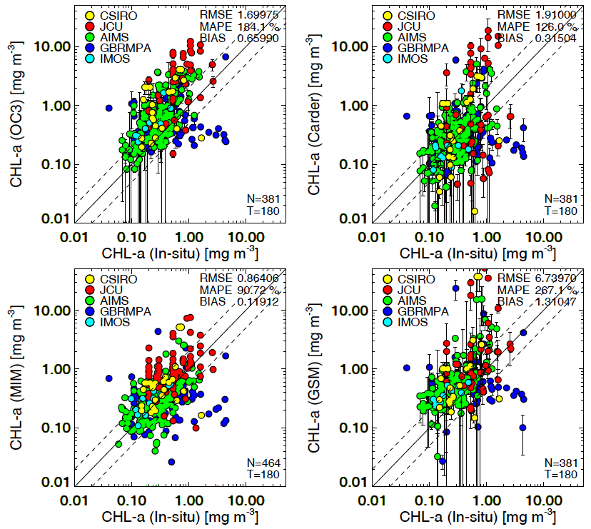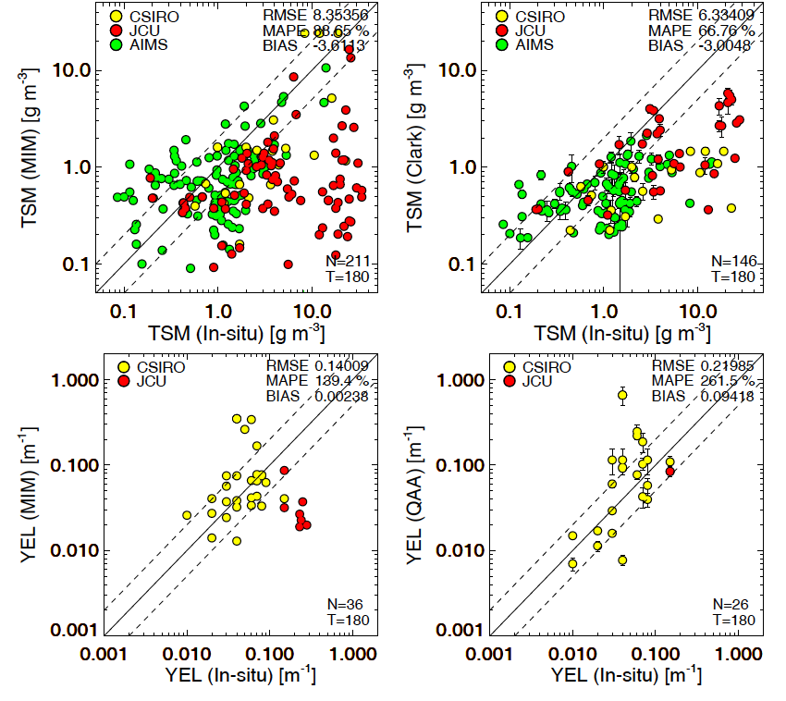
- MODIS Aqua retrievals versus in situ data. The dashed lines present an over or underestimate of 100%. Only the measurements collected within ±3 hours time difference to the overpass were plotted.

APPENDIX B: Additional satellite derived maps and tables

Data Availability for regional reports
The number of image observations per pixel location that were used in calculating the mean values for each season show number of observation vary from 30 to about 90, even if 150-170 images were available for each season to provide data for the dry season and the wet season depending on the reporting region.
The low number of observations is a result of the strict quality control criteria applied to the imagery: pixels with cloud or cloud shadow, low view and illumination angles (solar zenith and observer zenith higher than 60 degrees) were flagged and dismissed as were pixels where the atmospheric correction failed. For the identification of clouds, the default threshold value of 2.7% the Rayleigh-removed TOA reflectance at 869 nm was used. We also dismissed the pixels with a high error between modelled and measured spectra, which indicates that the underlying inversion model was not able to retrieve meaningful concentrations. These dismissals caused the dearth of pixels in the very near coastal areas. As a result of this stricter quality control implemented since the 2009/10 MMP report (Brando et al. 2010), the number of available observations for each pixel is lower than reported in previous reports (i.e. up to the 2008/09 MMP report Brando et al. 2010).
The number of available observations is substantially lower in the wet season than the dry season for all regions. This is due to higher cloud cover in the wet/monsoonal season. It is possible that the cloud cover introduces a bias in the sampling that could affect the estimate of the mean concentration or any other statistical summary of the data. The effect of cloud cover on the estimation of statistical parameters such as the mean and median needs to be investigated further using time series data from moored sensors or the output from biogeochemical models.

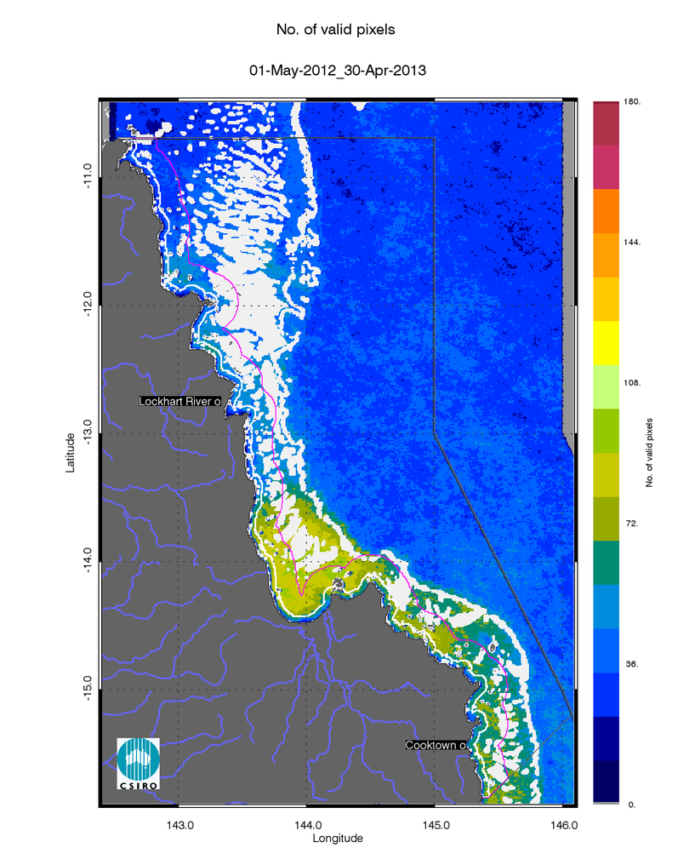
- Number of observations used to calculate all maps for the reporting year 2012/13 (May 2012 –April 2013) for the Cape York region.
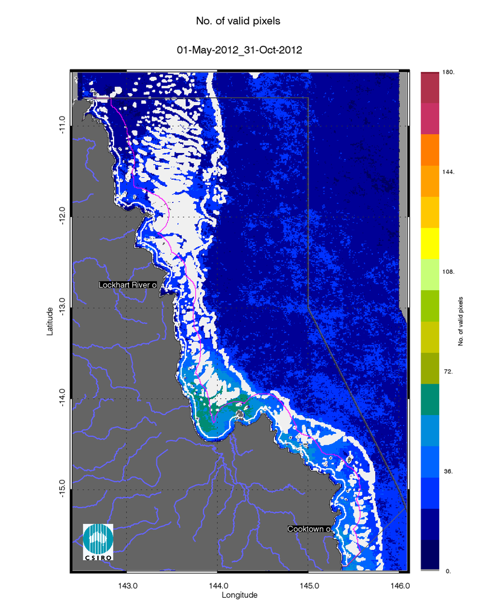
- Number of observations used to calculate all maps for the dry season 2012 (May - October) for the Cape York region.
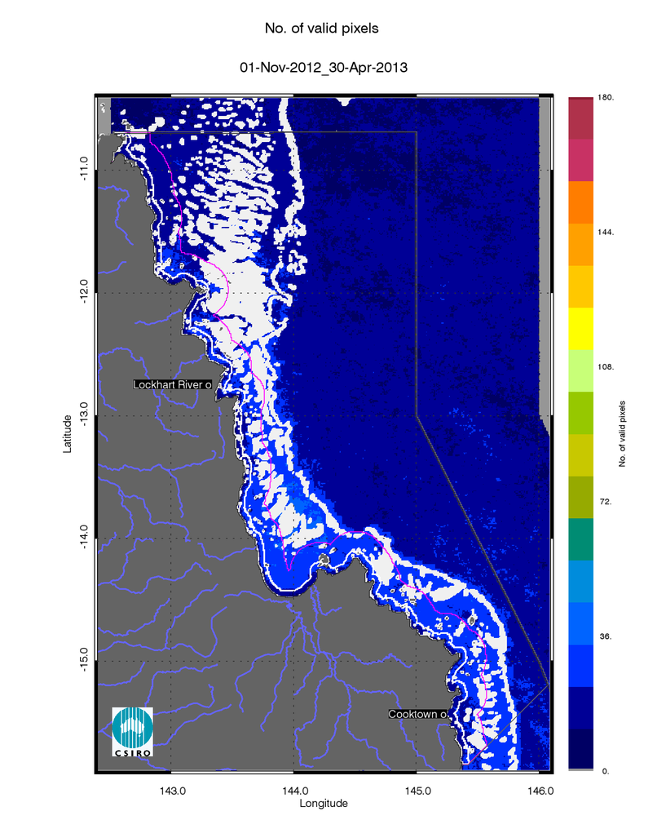
- Number of observations used to calculate all maps for the wet season 2012/20123 (November 2012 - April 2013) for the Cape York region.

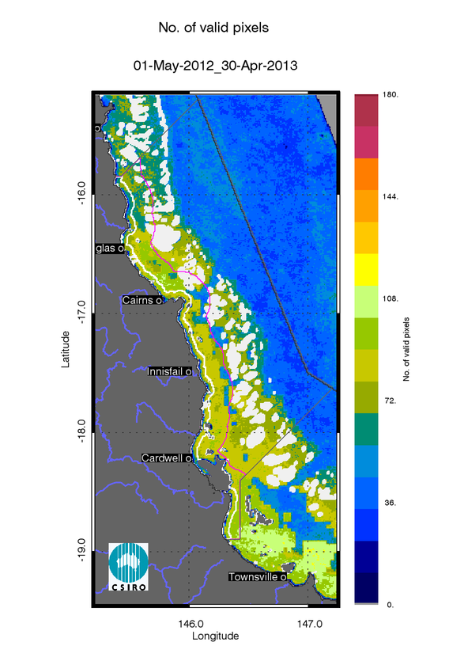
- Number of observations used to calculate all maps for the reporting year 2012/13 (May 2012 –April 2013) for the Wet Tropics region.
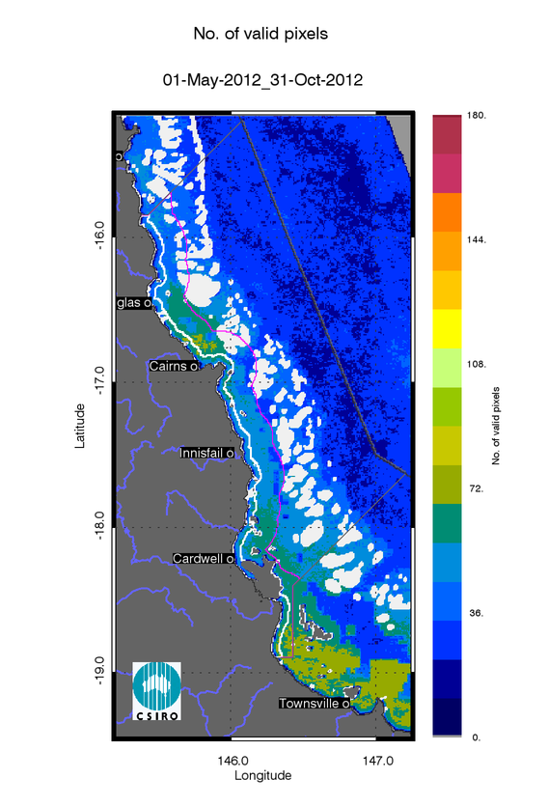
- Number of observations used to calculate all maps for the dry season 2012 (May - October) for the Wet Tropics region.
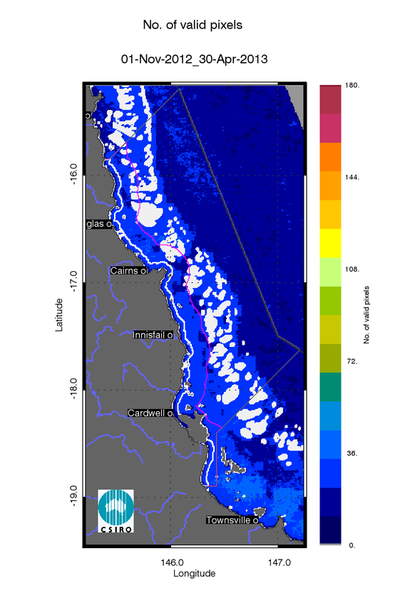
- Number of observations used to calculate all maps for the wet season 2012/20123 (November 2012 - April 2013) for the Wet Tropics region.

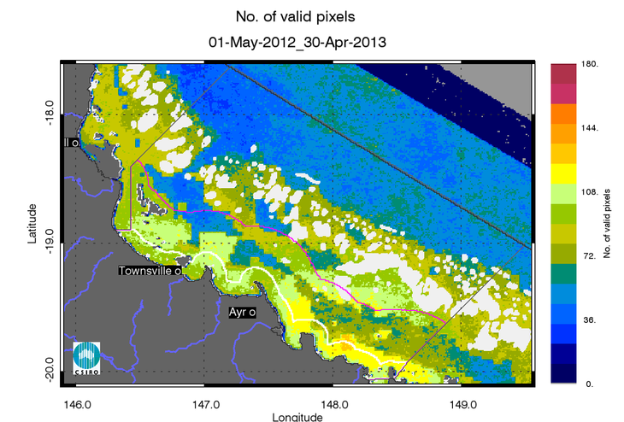
- Number of observations used to calculate all maps for the reporting year 2012/13 (May 2012 –April 2013) for the Burdekin region.
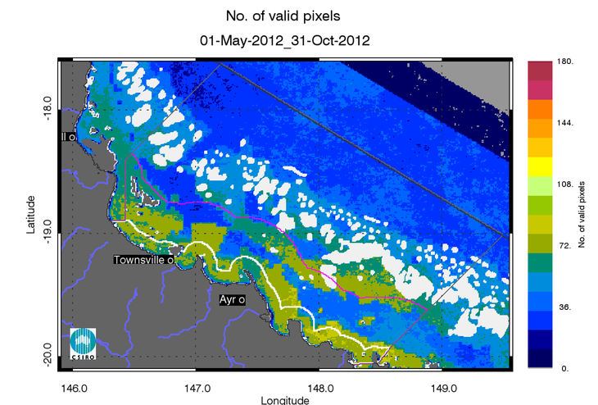
- Number of observations used to calculate all maps for the dry season 2012 (May - October) for the Burdekin region.
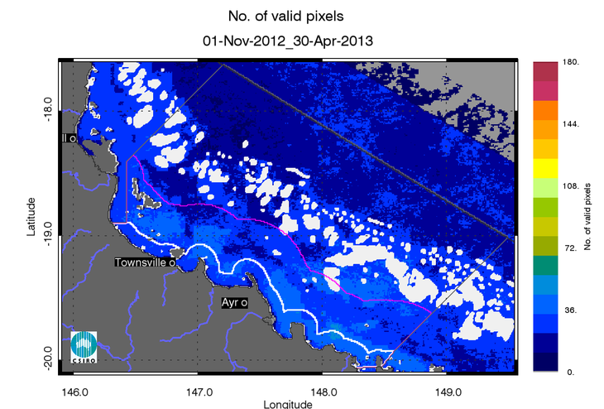
- Number of observations used to calculate all maps for the wet season 2012/20123 (November 2012 - April 2013) for the Burdekin region.

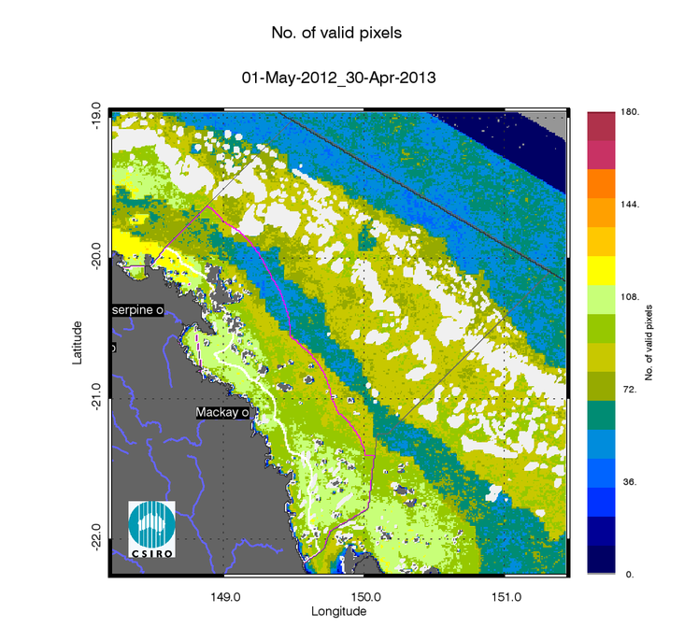
- Number of observations used to calculate all maps for the reporting year 2012/13 (May 2012 –April 2013) for the Mackay Whitsunday region.
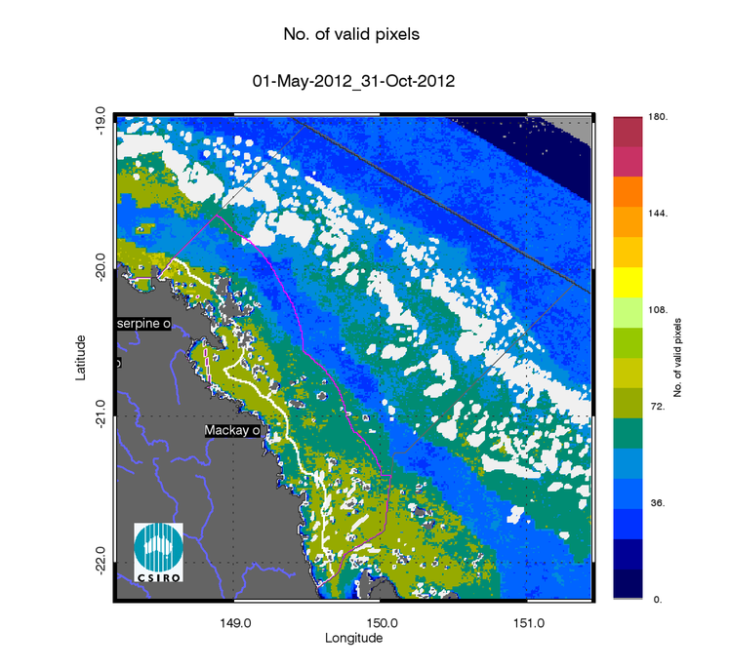
- Number of observations used to calculate all maps for the dry season 2012 (May - October) for the Mackay Whitsunday region.
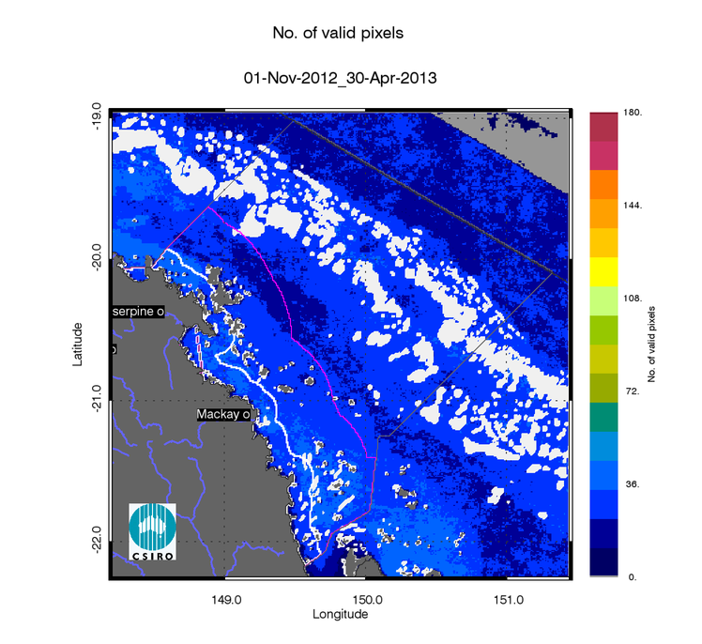
- Number of observations used to calculate all maps for the wet season 2012/20123 (November 2012 - April 2013) for the Mackay Whitsunday region.

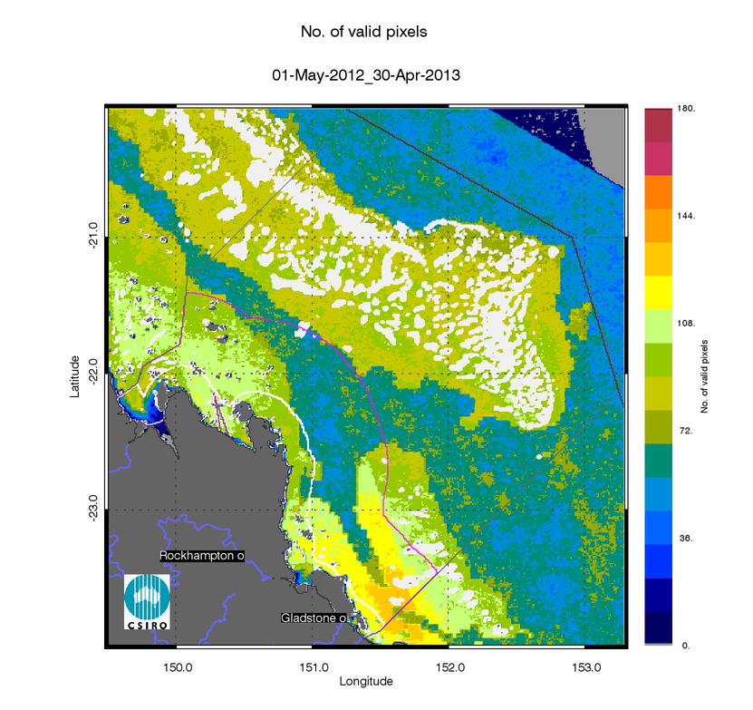
- Number of observations used to calculate all maps for the reporting year 2012/13 (May 2012 –April 2013) for the Fitzroy region.
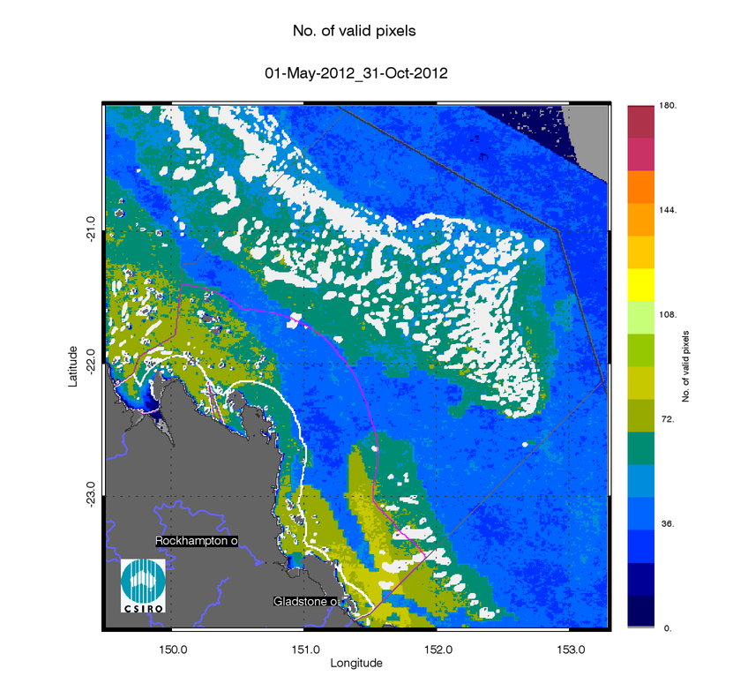
- Number of observations used to calculate all maps for the dry season 2012 (May - October) for the Fitzroy region.
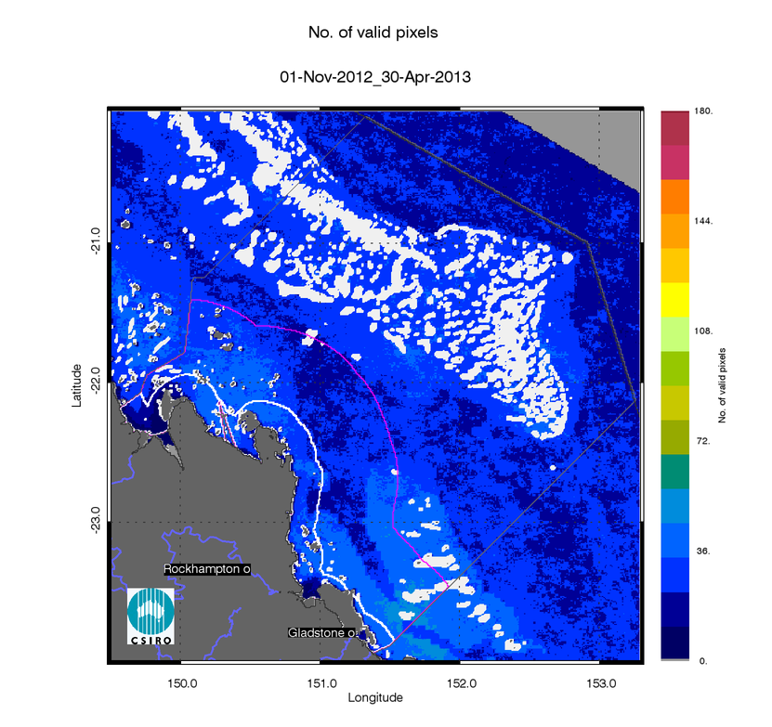
- Number of observations used to calculate all maps for the wet season 2012/20123 (November 2012 - April 2013) for the Fitzroy region.

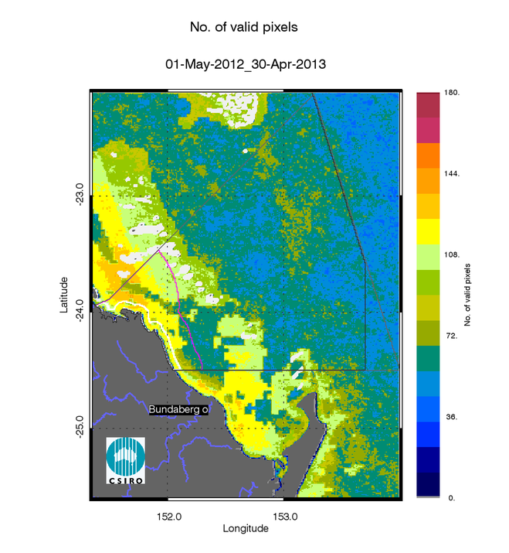
- Number of observations used to calculate all maps for the reporting year 2012/13 (May 2012 –April 2013) for the Burnett Mary region.
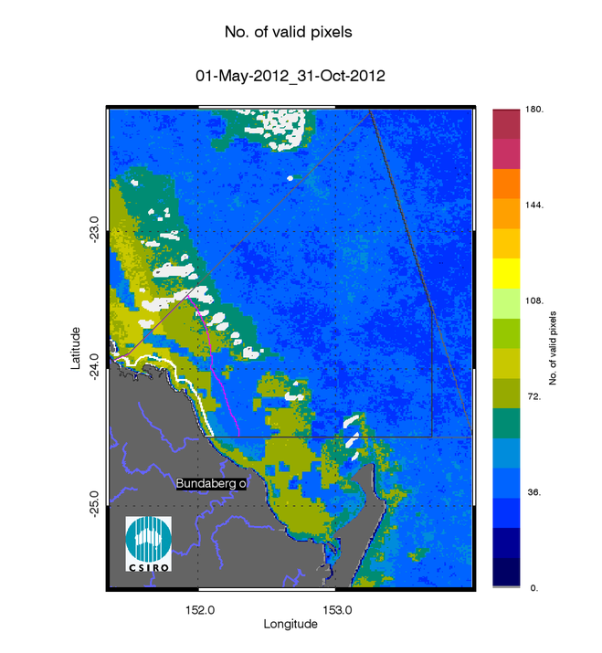
- Number of observations used to calculate all maps for the dry season 2012 (May - October) for the Burnett Mary region.
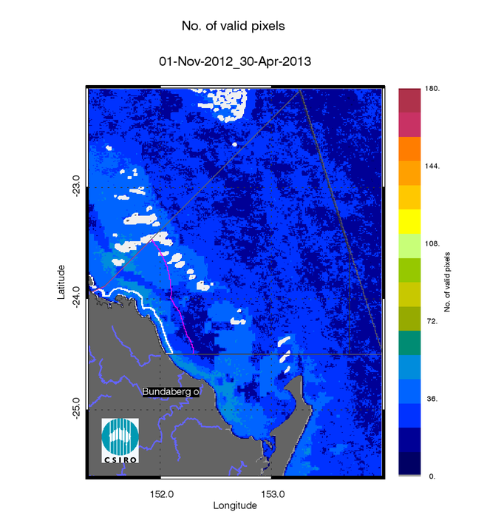
- Number of observations used to calculate all maps for the wet season 2012/2013 (November 2012 - April 2013) for the Burnett Mary region.

Seasonal Regional reports

Seasonal Regional reports: Cape York region

- Summary of the exceedance maps for Chlorophyll-a for the dry and wet season for the Cape York region.
 |  | 01-May-2012_31-Oct-2012 |  |  |  | 01-Nov-2012_30-Apr-2013
Region | Surface Area | Number valid obs. | Number total obs. | Mean > trigger | Median > trigger | Number valid obs. | Number total obs. | Mean > trigger | Median > trigger
Inshore | 4363 | 124338 | 1138743 | 93% | 92% | 75788 | 1134380 | 46% | 41%
Midshelf | 10686 | 389806 | 2789046 | 50% | 44% | 251982 | 2778360 | 8% | 4%
Offshore | 63092 | 1326953 | 16467012 | 4% | 3% | 992321 | 16403920 | 0% | 0%

- Summary of the exceedance maps for Non-algal particulate matter (NAP as a measure of TSS) for the dry and wet season for the Cape York region.
 |  | 01-May-2012_31-Oct-2012 |  |  |  | 01-Nov-2012_30-Apr-2013
Region | Surface Area | Number valid obs. | Number total obs. | Mean > trigger | Median > trigger | Number valid obs. | Number total obs. | Mean > trigger | Median > trigger
Inshore | 4363 | 124338 | 1138743 | 50% | 34% | 75788 | 1134380 | 17% | 10%
Midshelf | 10686 | 389806 | 2789046 | 13% | 5% | 251982 | 2778360 | 1% | 0%
Offshore | 63092 | 1326953 | 16467012 | 10% | 9% | 992321 | 16403920 | 2% | 1%

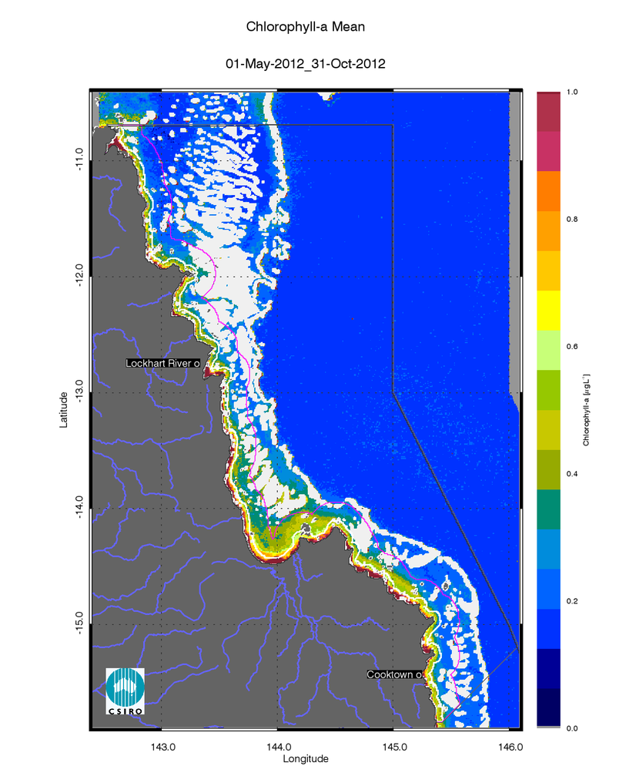
- Chlorophyll-a mean maps for the dry and wet season for the Cape York region. Mean for the dry season 2012 (May - October),
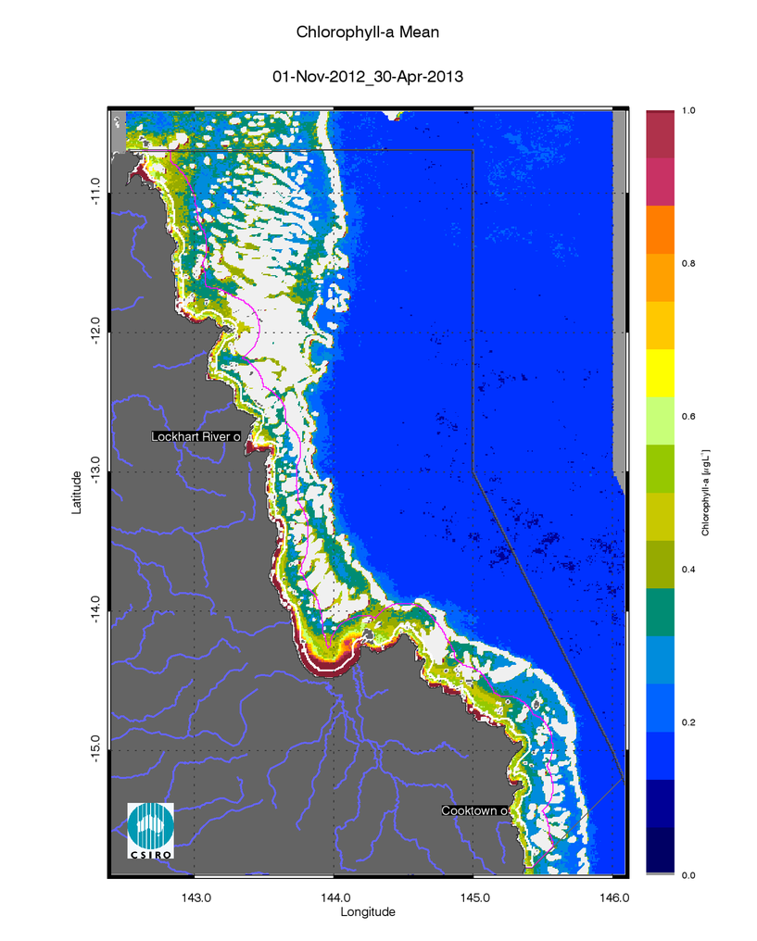
- Chlorophyll-a mean maps for the dry and wet season for the Cape York region. Mean for the wet season 2012/20123 (November 2012 - April 2013).

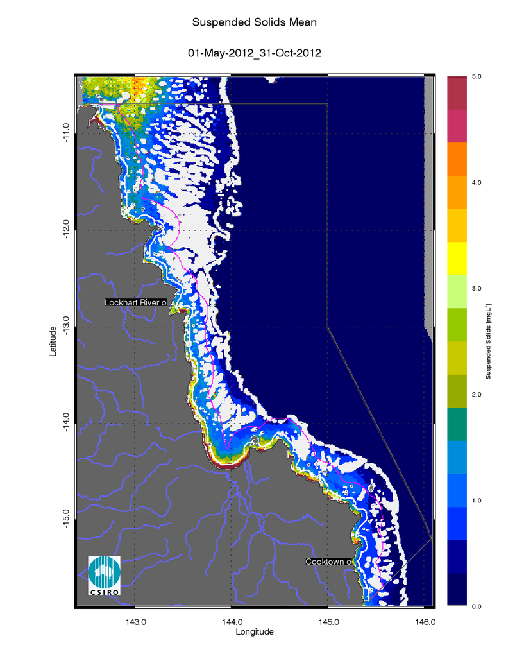
- Non-algal particulate matter (NAP as a measure of TSS)mean maps for the dry and wet season for the Cape York region. Mean for the dry season 2012 (May - October),
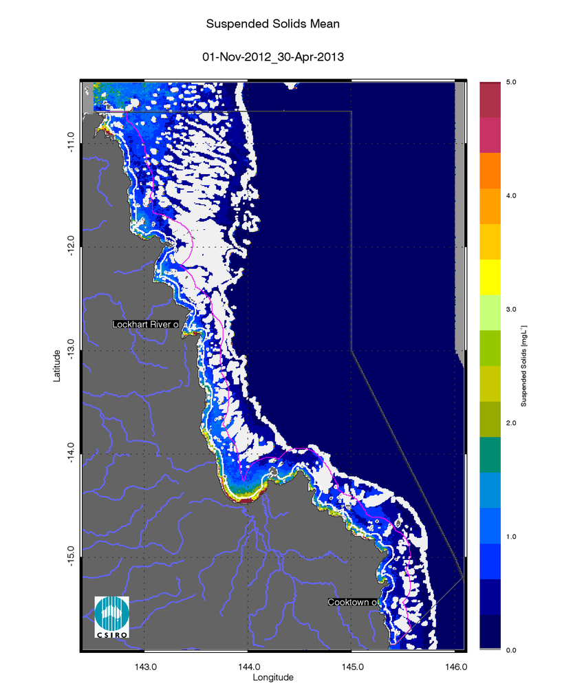

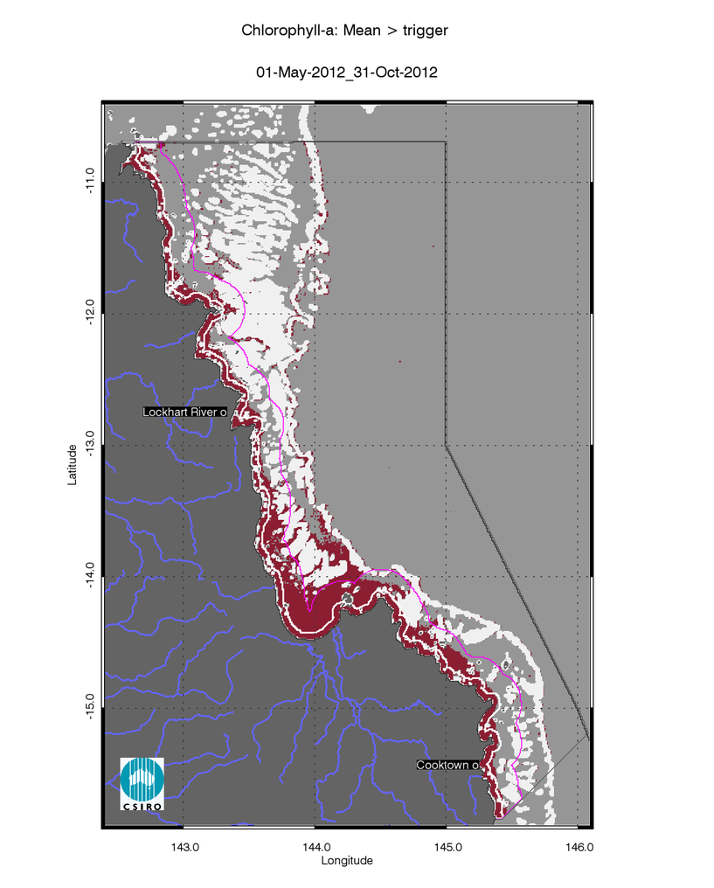
- Chlorophyll-a exceedance maps for the dry and wet season for the Cape York region. Exceedance for the dry season 2012 (May - October). The seasonally adjusted Guideline values for Chlorophyll–a for the dry season are 0.32 µg L-1 for Inshore and Midshelf and 0.28 µg L-1 for Offshore.
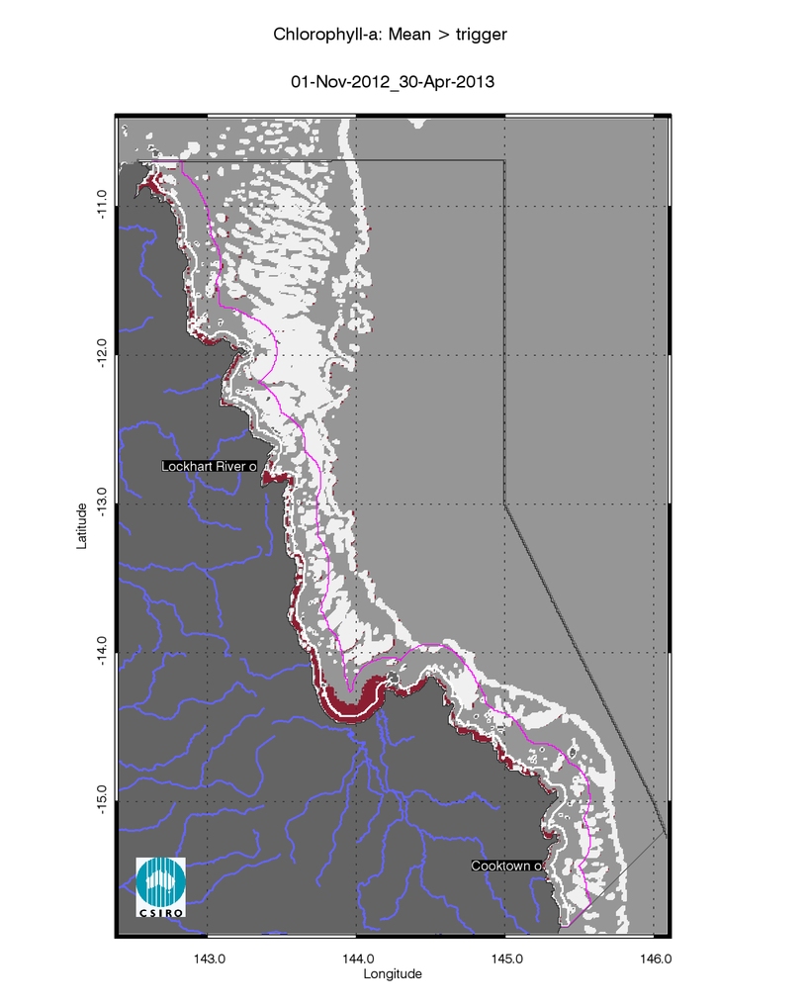
- Chlorophyll-a exceedance maps for the dry and wet season for the Cape York region. Exceedance for the wet season 2012/2013 (November 2012 - April 2013). The seasonally adjusted Guideline values for Chlorophyll–a for the wet season are 0.63 µg L-1 for Inshore and Midshelf and 0.56 µg L-1 for Offshore.

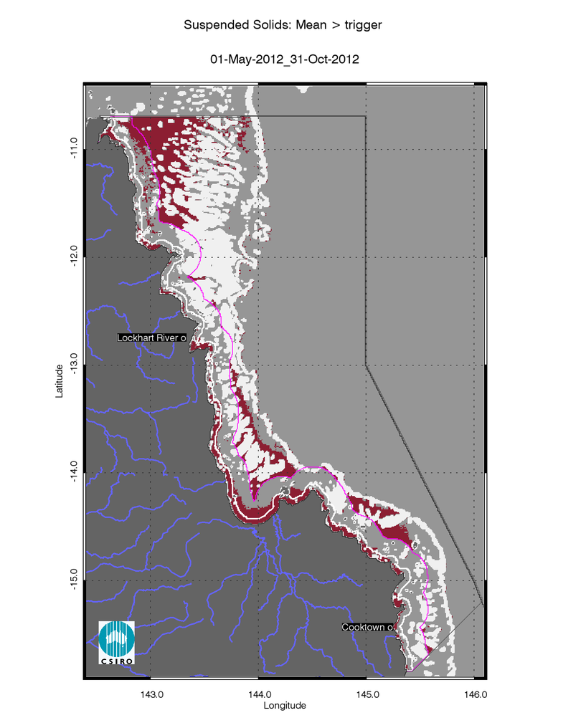
- Non-algal particulate matter (NAP as a measure of TSS) exceedance maps for the dry and wet season for the Cape York region. Exceedance for the dry season 2012 (May - October). The seasonally adjusted Guideline values for TSS for the dry season means are 1.6 mg L-1 for Inshore and Midshelf and 0.6 mg L-1 for Offshore.
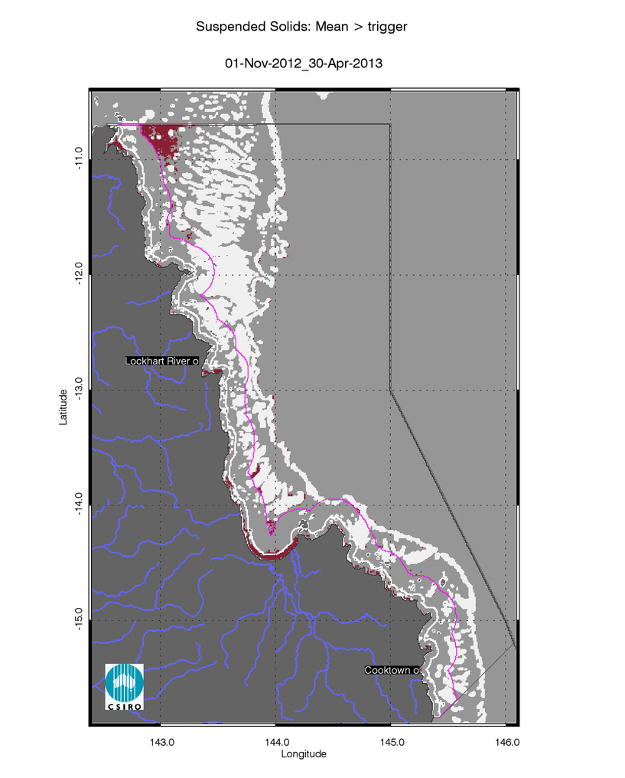
- Non-algal particulate matter (NAP as a measure of TSS) exceedance maps for the dry and wet season for the Cape York region. Exceedance for the wet season 2012/2013 (November 2012 - April 2013).The seasonally adjusted Guideline values for TSS for the wet season means are 2.4 mg L-1 for Inshore and Midshelf and 0.8 mg L-1 for Offshore.

Seasonal Regional reports: Wet Tropics region
- Summary of the exceedance maps for Chlorophyll-a for the dry and wet season for the Wet Tropics region.
 |  | 01-May-2012_31-Oct-2012 |  |  |  | 01-Nov-2012_30-Apr-2013
Region | Surface Area | Number valid obs. | Number total obs. | Mean > trigger | Median > trigger | Number valid obs. | Number total obs. | Mean > trigger | Median > trigger
Inshore | 2082 | 89953 | 543402 | 95% | 95% | 44489 | 541320 | 53% | 49%
Midshelf | 5940 | 305859 | 1550340 | 50% | 48% | 155098 | 1544400 | 11% | 9%
Offshore | 20028 | 619036 | 5227308 | 3% | 2% | 404811 | 5207280 | 0% | 0%

- Summary of the exceedance maps for Non-algal particulate matter (NAP as a measure of TSS) for the dry and wet season for the Wet Tropics region.
 |  | 01-May-2012_31-Oct-2012 |  |  |  | 01-Nov-2012_30-Apr-2013
Region | Surface Area | Number valid obs. | Number total obs. | Mean > trigger | Median > trigger | Number valid obs. | Number total obs. | Mean > trigger | Median > trigger
Inshore | 2082 | 89953 | 543402 | 54% | 31% | 44489 | 541320 | 20% | 9%
Midshelf | 5940 | 305859 | 1550340 | 6% | 3% | 155098 | 1544400 | 3% | 1%
Offshore | 20028 | 619036 | 5227308 | 2% | 1% | 404811 | 5207280 | 0% | 0%

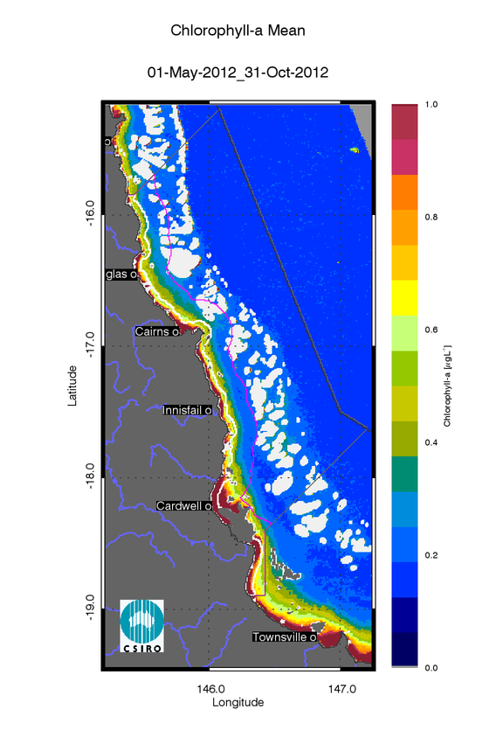
- Chlorophyll-a mean maps for the dry and wet season for the Wet Tropics region. Mean for the dry season 2012 (May - October),
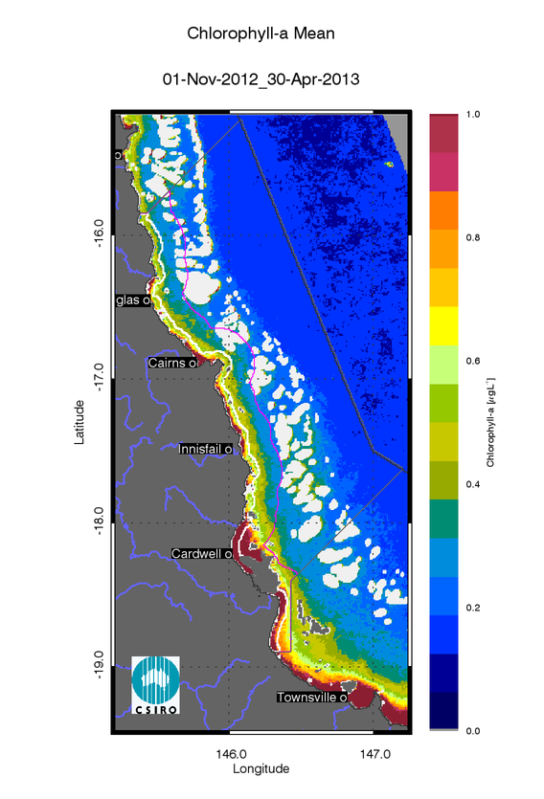
- Chlorophyll-a mean maps for the dry and wet season for the Wet Tropics region. Mean for the wet season 2012/20123 (November 2012 - April 2013).

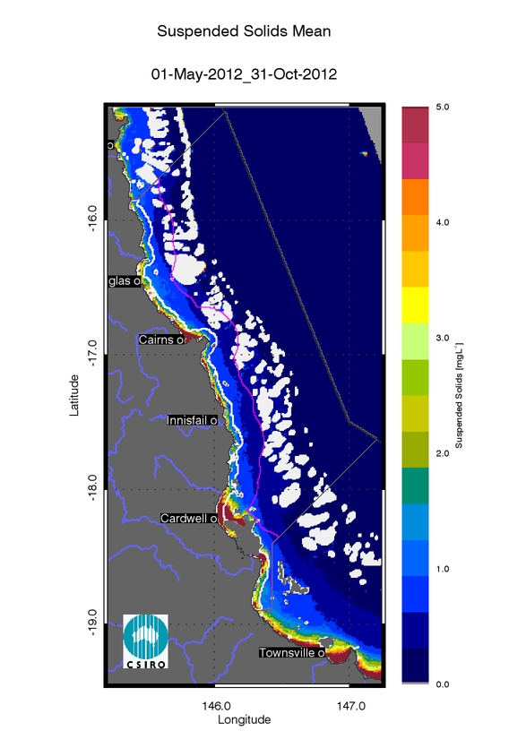
- Non-algal particulate matter (NAP as a measure of TSS) mean maps for the dry and wet season for the Wet Tropics region. Mean for the dry season 2012 (May - October),
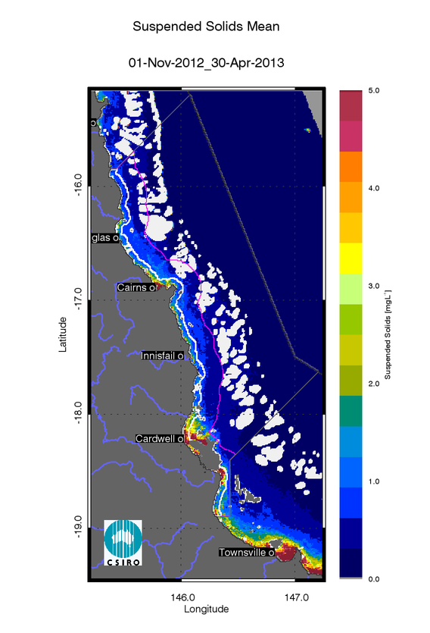
- Non-algal particulate matter (NAP as a measure of TSS) mean maps for the dry and wet season for the Wet Tropics region. Mean for the wet season 2012/20123 (November 2012 - April 2013).

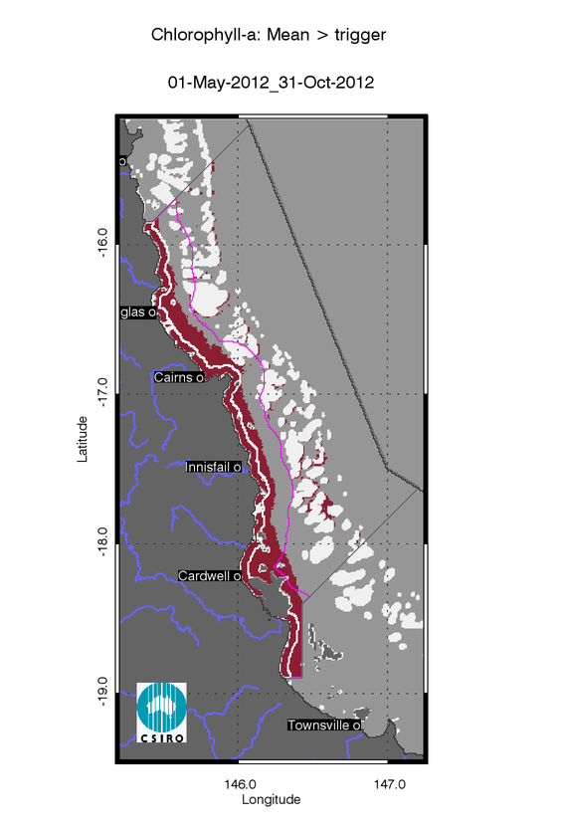
- Chlorophyll-a exceedance maps for the dry and wet season for the Wet Tropics region. Exceedance for the dry season 2012 (May - October). The seasonally adjusted Guideline values for Chlorophyll–a for the dry season are 0.32 µg L-1 for Inshore and Midshelf and 0.28 µg L-1 for Offshore.
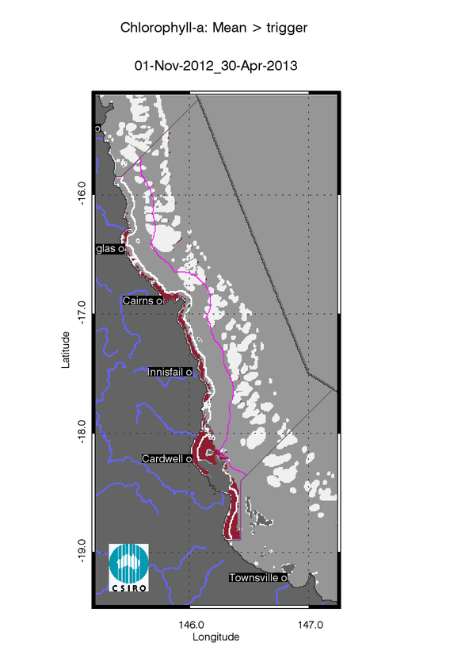
- Chlorophyll-a exceedance maps for the dry and wet season for the Wet Tropics region. Exceedance for the wet season 2012/2013 (November 2012 - April 2013). The seasonally adjusted Guideline values for Chlorophyll–a for the wet season are 0.63 µg L-1 for Inshore and Midshelf and 0.56 µg L-1 for Offshore.

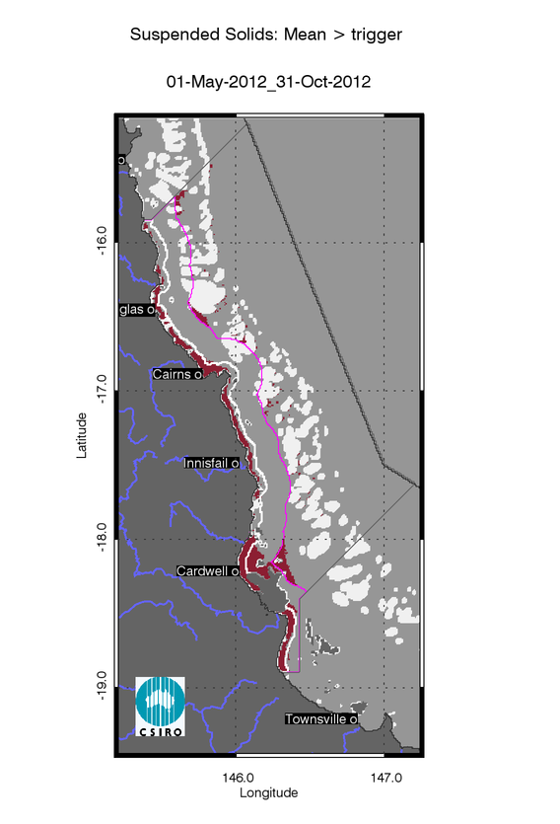
- Non-algal particulate matter (NAP as a measure of TSS) exceedance maps for the dry and wet season for the Wet Tropics region. Exceedance for the dry season 2012 (May - October). The seasonally adjusted Guideline values for TSS for the dry season means are 1.6 mg L-1 for Inshore and Midshelf and 0.6 mg L-1 for Offshore.
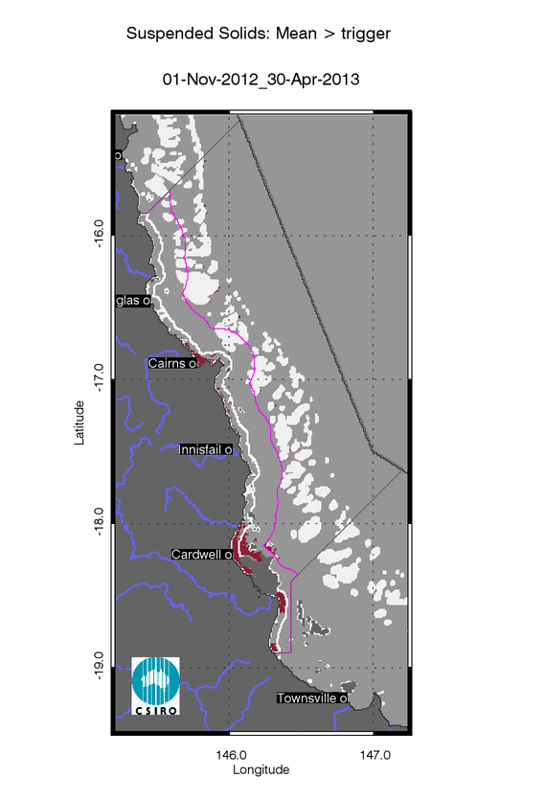
- Non-algal particulate matter (NAP as a measure of TSS) exceedance maps for the dry and wet season for the Wet Tropics region. Exceedance for the wet season 2012/2013 (November 2012 - April 2013).The seasonally adjusted Guideline values for TSS for the wet season means are 2.4 mg L-1 for Inshore and Midshelf and 0.8 mg L-1 for Offshore.

Regional reports: Burdekin region

- Summary of the exceedance maps for Chlorophyll-a for the dry and wet season for the Burdekin region.
 |  | 01-May-2012_31-Oct-2012 |  |  |  | 01-Nov-2012_30-Apr-2013
Region | Surface Area | Number valid obs. | Number total obs. | Mean > trigger | Median > trigger | Number valid obs. | Number total obs. | Mean > trigger | Median > trigger
Inshore | 4185 | 274746 | 1092285 | 85% | 84% | 131672 | 1088100 | 61% | 56%
Midshelf | 11645 | 649148 | 3039345 | 15% | 15% | 343375 | 3027700 | 2% | 1%
Offshore | 28030 | 1099552 | 7315830 | 1% | 1% | 570222 | 7287800 | 0% | 0%

- Summary of the exceedance maps for Non-algal particulate matter (NAP as a measure of TSS) for the dry and wet season for the Burdekin region.
 |  | 01-May-2012_31-Oct-2012 |  |  |  | 01-Nov-2012_30-Apr-2013
Region | Surface Area | Number valid obs. | Number total obs. | Mean > trigger | Median > trigger | Number valid obs. | Number total obs. | Mean > trigger | Median > trigger
Inshore | 4185 | 274746 | 1092285 | 47% | 31% | 131672 | 1088100 | 36% | 17%
Midshelf | 11645 | 649148 | 3039345 | 0% | 0% | 343375 | 3027700 | 0% | 0%
Offshore | 28030 | 1099552 | 7315830 | 0% | 0% | 570222 | 7287800 | 0% | 0%

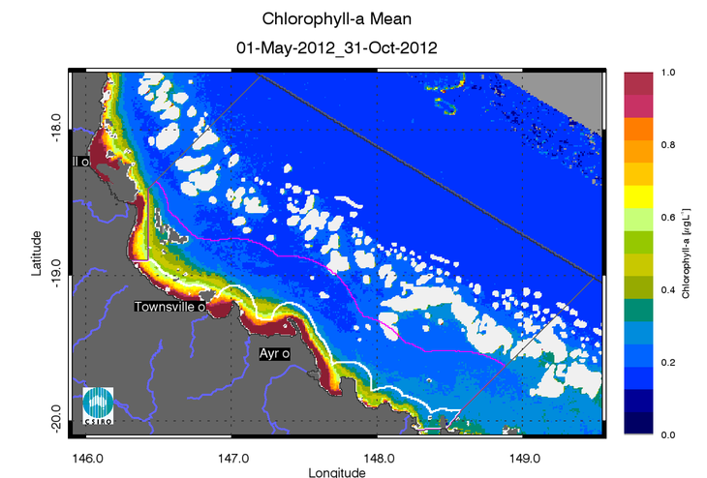
- Chlorophyll-a mean maps for the dry and wet season for the Burdekin region. Mean for the dry season 2012 (May - October),
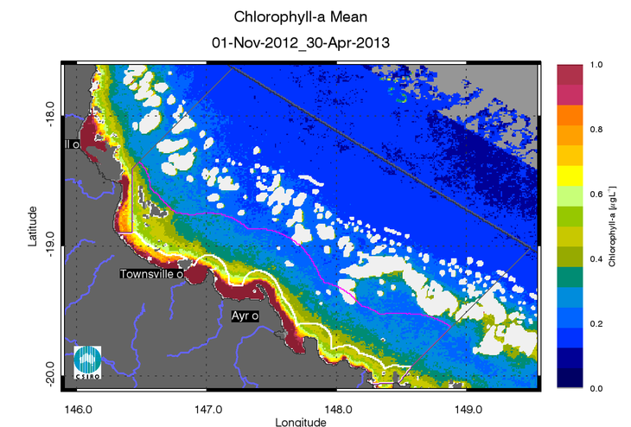
- Chlorophyll-a mean maps for the dry and wet season for the Burdekin region. Mean for the wet season 2012/20123 (November 2012 - April 2013).

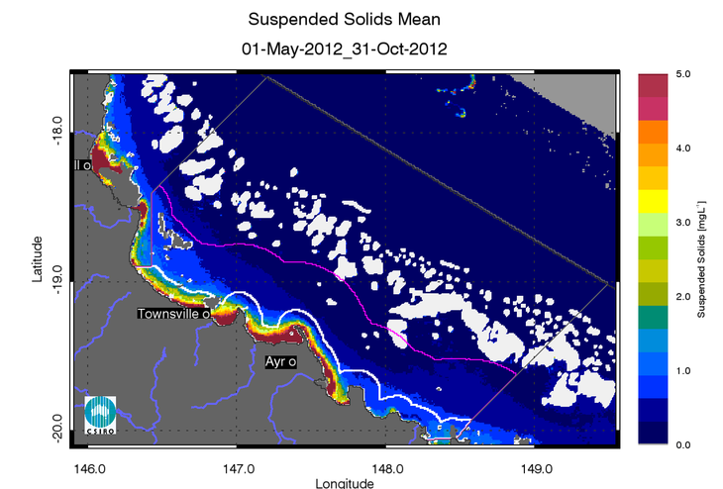
- Non-algal particulate matter (NAP as a measure of TSS)mean maps for the dry and wet season for the Burdekin region. Mean for the dry season 2012 (May - October),
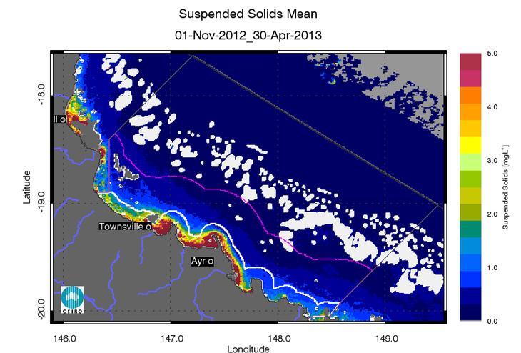
- Non-algal particulate matter (NAP as a measure of TSS)mean maps for the dry and wet season for the Burdekin region. Mean for the wet season 2012/20123 (November 2012 - April 2013).
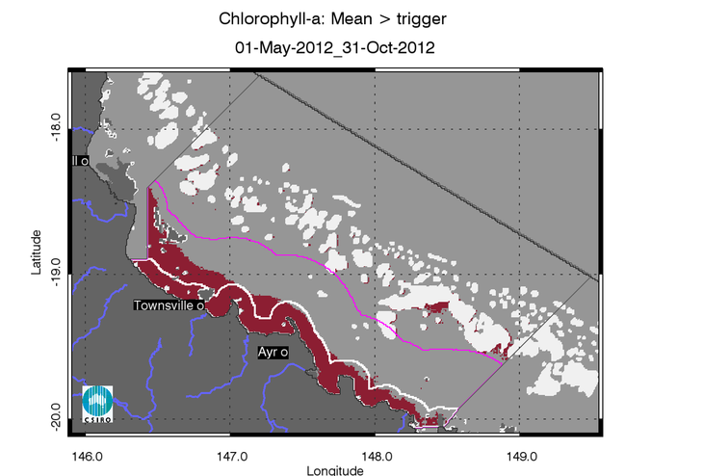
- Chlorophyll-a exceedance maps for the dry and wet season for the Burdekin region. Exceedance for the dry season 2012 (May - October). The seasonally adjusted Guideline values for Chlorophyll–a for the dry season are 0.32 µg L-1 for Inshore and Midshelf and 0.28 µg L-1 for Offshore.
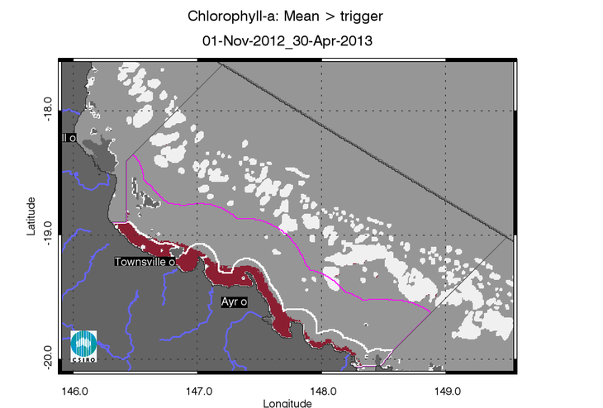
- Chlorophyll-a exceedance maps for the dry and wet season for the Burdekin region. Exceedance for the wet season 2012/2013 (November 2012 - April 2013). The seasonally adjusted Guideline values for Chlorophyll–a for the wet season are 0.63 µg L-1 for Inshore and Midshelf and 0.56 µg L-1 for Offshore.
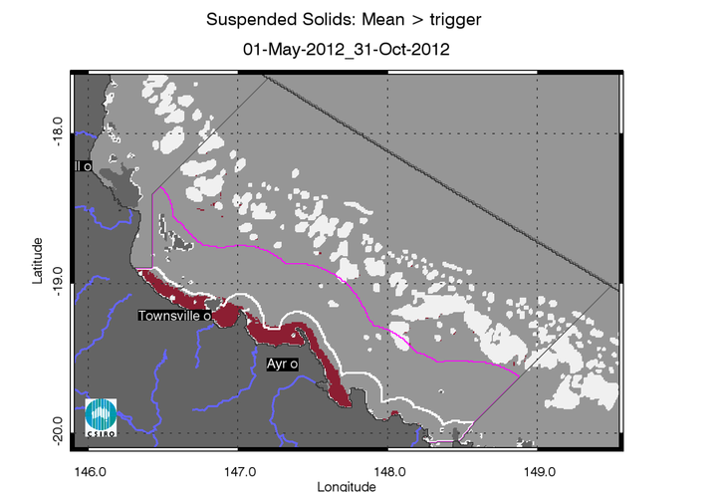
- Non-algal particulate matter (NAP as a measure of TSS) exceedance maps for the dry and wet season for the Burdekin region. Exceedance for the dry season 2012 (May - October). The seasonally adjusted Guideline values for TSS for the dry season means are 1.6 mg L-1 for Inshore and Midshelf and 0.6 mg L-1 for Offshore.
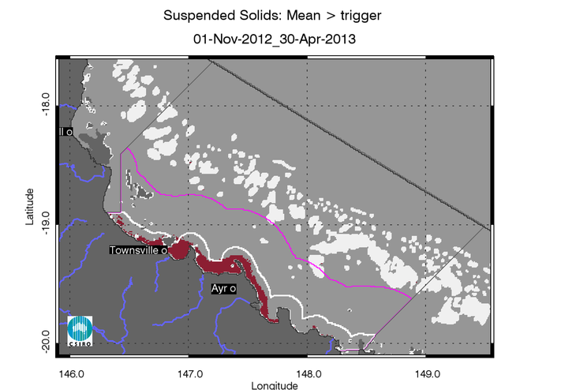
- Non-algal particulate matter (NAP as a measure of TSS) exceedance maps for the dry and wet season for the Burdekin region. Exceedance for the wet season 2012/2013 (November 2012 - April 2013).The seasonally adjusted Guideline values for TSS for the wet season means are 2.4 mg L-1 for Inshore and Midshelf and 0.8 mg L-1 for Offshore.

Regional reports: Mackay Whitsunday region

- Summary of the exceedance maps for Chlorophyll-a for the dry and wet season for the Mackay Whitsunday region.
 |  | 01-May-2012_31-Oct-2012 |  |  |  | 01-Nov-2012_30-Apr-2013
Region | Surface Area | Number valid obs. | Number total obs. | Mean > trigger | Median > trigger | Number valid obs. | Number total obs. | Mean > trigger | Median > trigger
Inshore | 4798 | 303342 | 1252278 | 95% | 92% | 138573 | 1247480 | 45% | 41%
Midshelf | 11901 | 708230 | 3106161 | 38% | 33% | 326412 | 3094260 | 4% | 2%
Offshore | 26702 | 1248118 | 6969222 | 28% | 27% | 639201 | 6942520 | 0% | 0%

- Summary of the exceedance maps for Non-algal particulate matter (NAP as a measure of TSS) for the dry and wet season for the Mackay Whitsunday region.
 |  | 01-May-2012_31-Oct-2012 |  |  |  | 01-Nov-2012_30-Apr-2013
Region | Surface Area | Number valid obs. | Number total obs. | Mean > trigger | Median > trigger | Number valid obs. | Number total obs. | Mean > trigger | Median > trigger
Inshore | 4798 | 303342 | 1252278 | 54% | 32% | 138573 | 1247480 | 31% | 16%
Midshelf | 11901 | 708230 | 3106161 | 11% | 9% | 326412 | 3094260 | 9% | 5%
Offshore | 26702 | 1248118 | 6969222 | 13% | 7% | 639201 | 6942520 | 5% | 1%

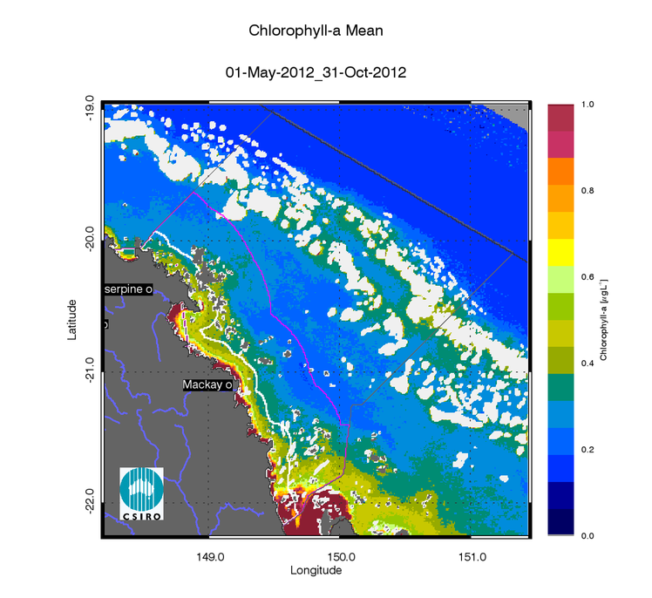
- Chlorophyll-a mean maps for the dry and wet season for the Mackay Whitsunday region. Mean for the dry season 2012 (May - October),
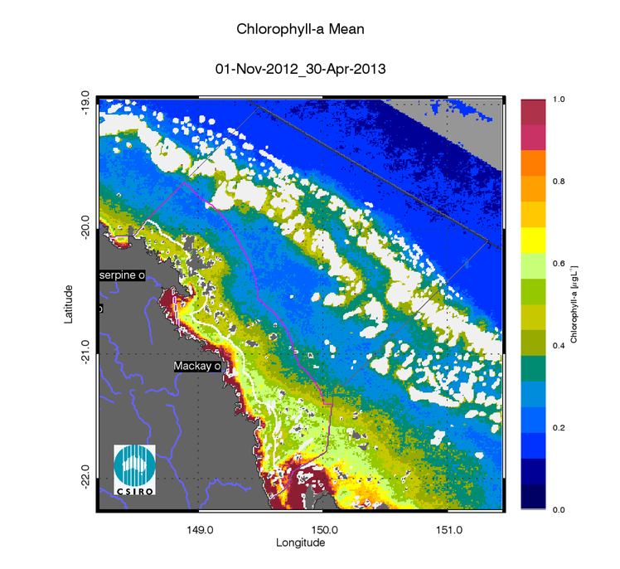
- Chlorophyll-a mean maps for the dry and wet season for the Mackay Whitsunday region. Mean for the wet season 2012/20123 (November 2012 - April 2013).

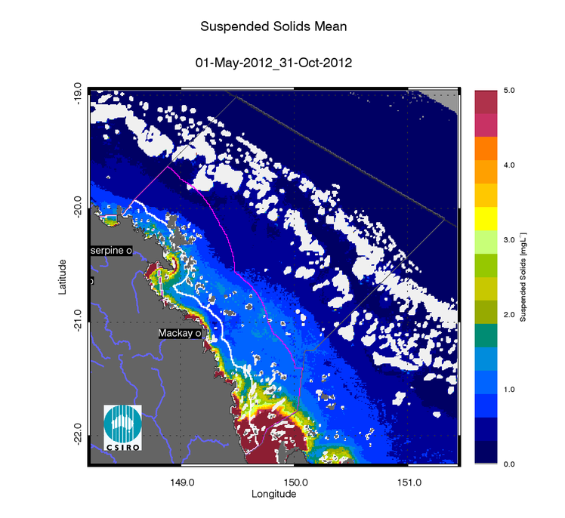
- Non-algal particulate matter (NAP as a measure of TSS) mean maps for the dry and wet season for the Mackay Whitsunday region. Mean for the dry season 2012 (May - October),
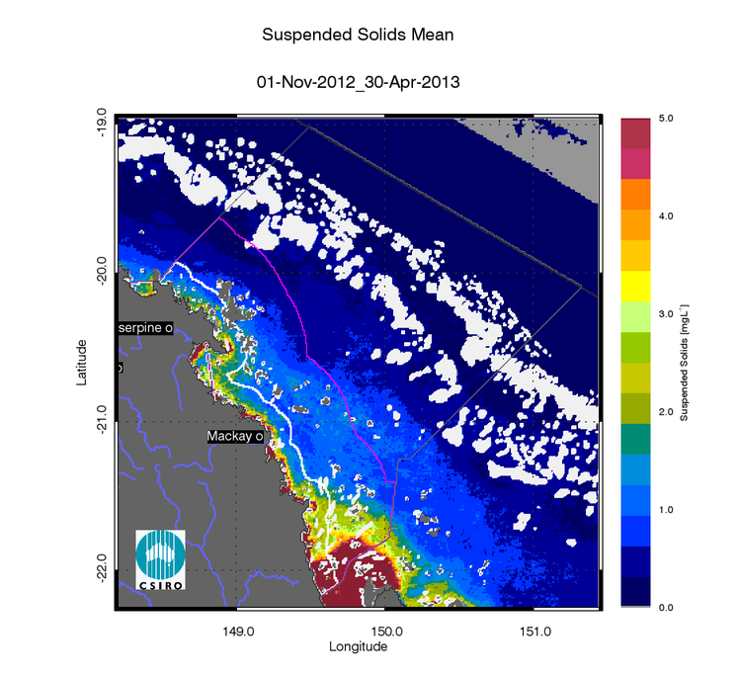
- Non-algal particulate matter (NAP as a measure of TSS) mean maps for the dry and wet season for the Mackay Whitsunday region. Mean for the wet season 2012/20123 (November 2012 - April 2013).
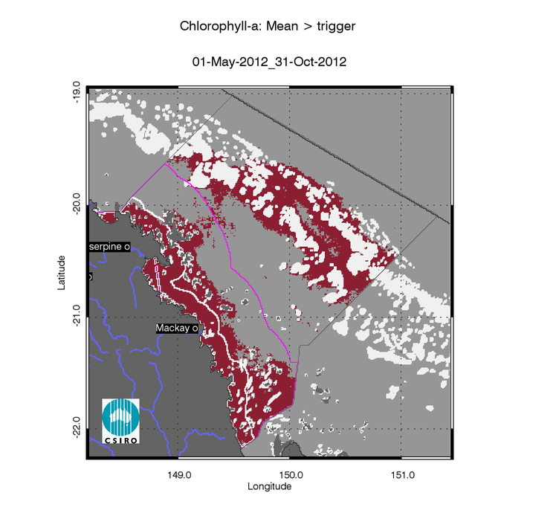
- Chlorophyll-a exceedance maps for the dry and wet season for the Mackay Whitsunday region. Exceedance for the dry season 2012 (May - October). The seasonally adjusted Guideline values for Chlorophyll–a for the dry season are 0.32 µg L-1 for Inshore and Midshelf and 0.28 µg L-1 for Offshore.
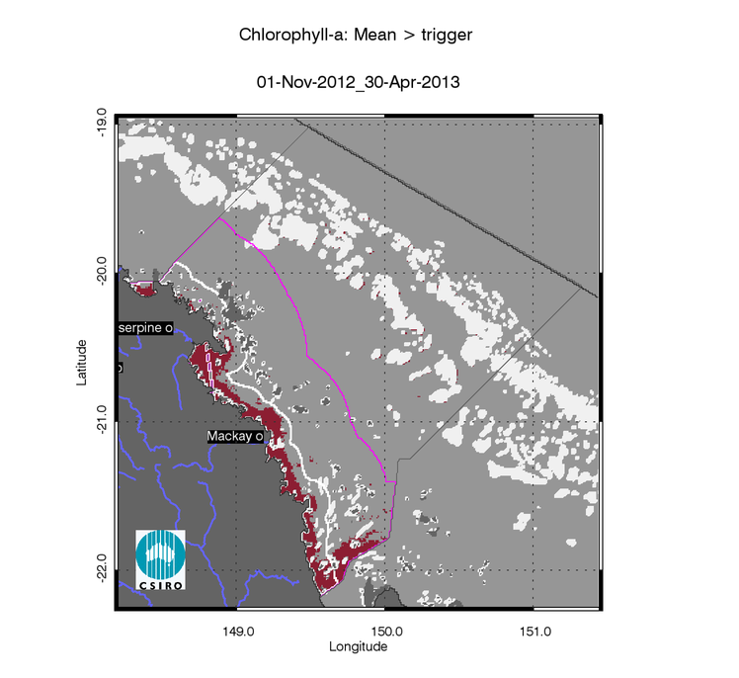
- Chlorophyll-a exceedance maps for the dry and wet season for the Mackay Whitsunday region. Exceedance for the wet season 2012/2013 (November 2012 - April 2013). The seasonally adjusted Guideline values for Chlorophyll–a for the wet season are 0.63 µg L-1 for Inshore and Midshelf and 0.56 µg L-1 for Offshore.

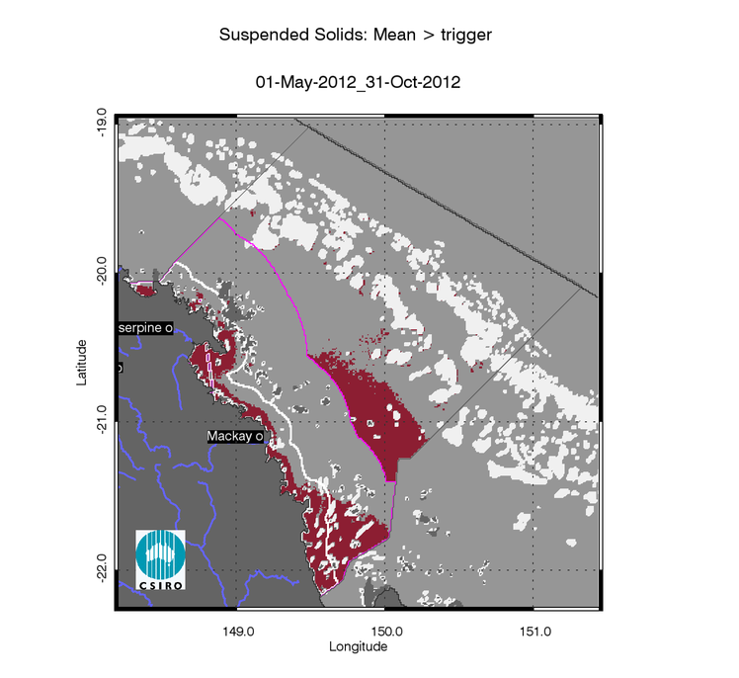
- Non-algal particulate matter (NAP as a measure of TSS) exceedance maps for the dry and wet season for the Mackay Whitsunday region. Exceedance for the dry season 2012 (May - October). The seasonally adjusted Guideline values for TSS for the dry season means are 1.6 mg L-1 for Inshore and Midshelf and 0.6 mg L-1 for Offshore.
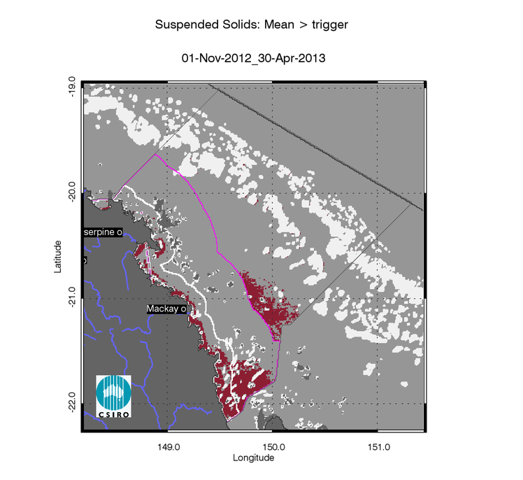
- Non-algal particulate matter (NAP as a measure of TSS) exceedance maps for the dry and wet season for the Mackay Whitsunday region. Exceedance for the wet season 2012/2013 (November 2012 - April 2013).The seasonally adjusted Guideline values for TSS for the wet season means are 2.4 mg L-1 for Inshore and Midshelf and 0.8 mg L-1 for Offshore.

Regional reports: Fitzroy region

Table 28Table 29Figure 132Figure 133Figure 134Figure 135Figure 136Figure 137Figure 138Figure 139

- Summary of the exceedance maps for Chlorophyll-a for the dry and wet season for the Fitzroy region.
 |  | 01-May-2012_31-Oct-2012 |  |  |  | 01-Nov-2012_30-Apr-2013
Region | Surface Area | Number valid obs. | Number total obs. | Mean > trigger | Median > trigger | Number valid obs. | Number total obs. | Mean > trigger | Median > trigger
Inshore | 6402 | 366474 | 1670922 | 97% | 94% | 167831 | 1664520 | 85% | 71%
Midshelf | 19813 | 1105912 | 5171193 | 63% | 52% | 579712 | 5151380 | 13% | 6%
Offshore | 52387 | 2502172 | 13673007 | 29% | 25% | 1323757 | 13620620 | 0% | 0%

- Summary of the exceedance maps for Non-algal particulate matter (NAP as a measure of TSS) for the dry and wet season for the Fitzroy region.
 |  | 01-May-2012_31-Oct-2012 |  |  |  | 01-Nov-2012_30-Apr-2013
Region | Surface Area | Number valid obs. | Number total obs. | Mean > trigger | Median > trigger | Number valid obs. | Number total obs. | Mean > trigger | Median > trigger
Inshore | 6402 | 366474 | 1670922 | 53% | 45% | 167831 | 1664520 | 55% | 40%
Midshelf | 19813 | 1105912 | 5171193 | 5% | 4% | 579712 | 5151380 | 3% | 2%
Offshore | 52387 | 2502172 | 13673007 | 5% | 1% | 1323757 | 13620620 | 1% | 0%

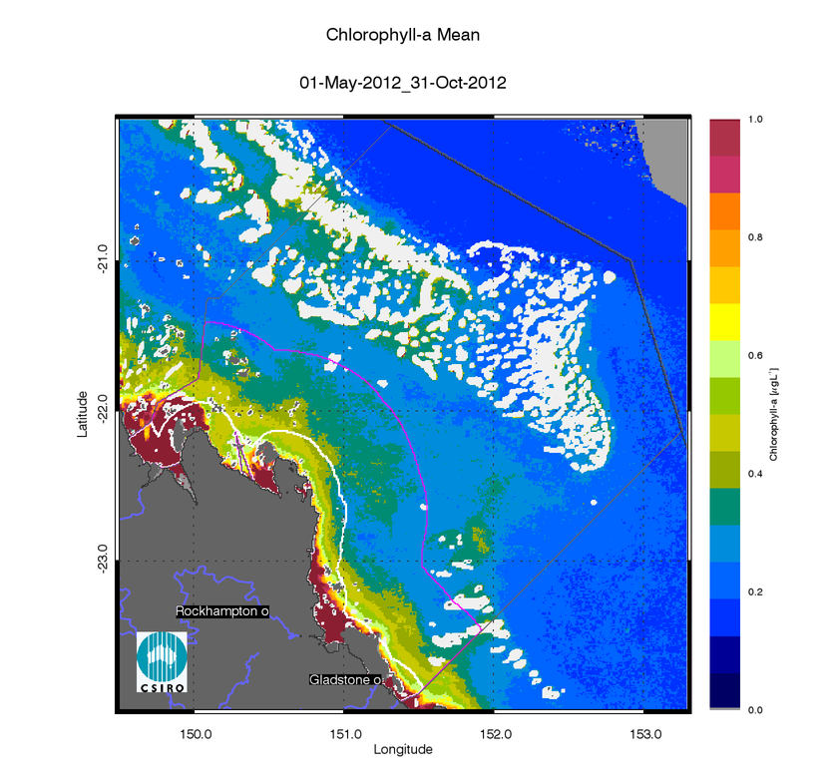
- Chlorophyll-a mean maps for the dry and wet season for the Fitzroy region. Mean for the dry season 2012 (May - October),
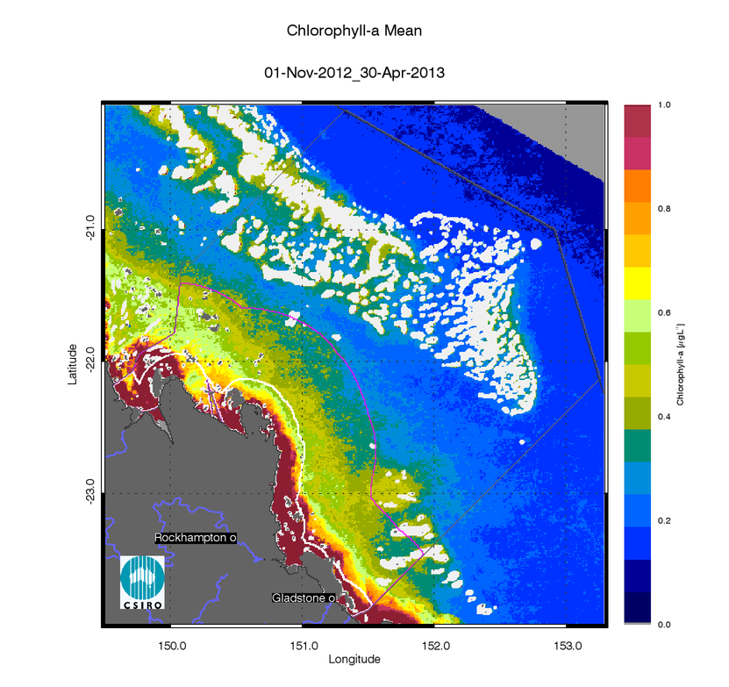
- Chlorophyll-a mean maps for the dry and wet season for the Fitzroy region. Mean for the wet season 2012/20123 (November 2012 - April 2013).

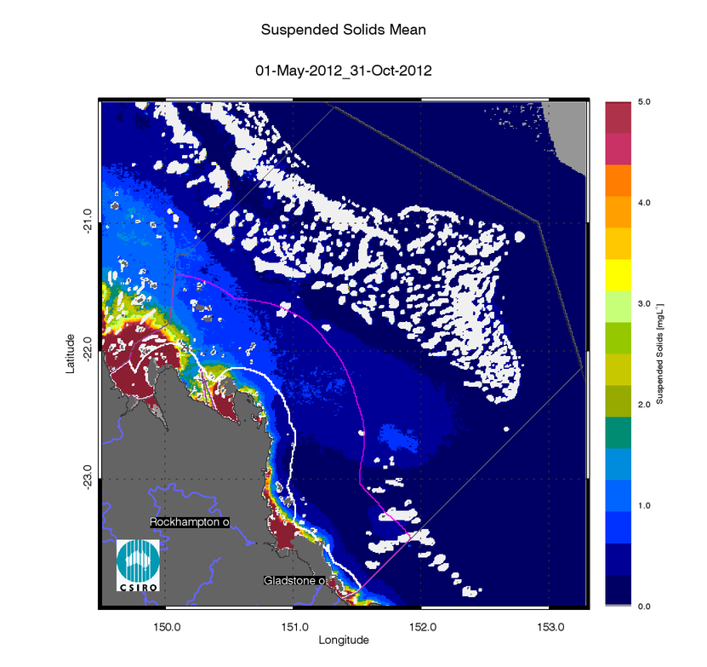
- Non-algal particulate matter (NAP as a measure of TSS) mean maps for the dry and wet season for the Fitzroy region. Mean for the dry season 2012 (May - October),
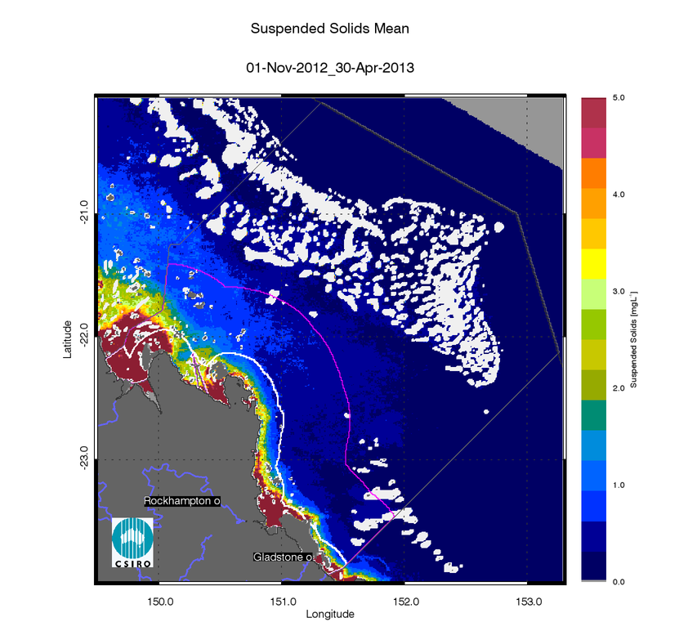
- Non-algal particulate matter (NAP as a measure of TSS) mean maps for the dry and wet season for the Fitzroy region. Mean for the wet season 2012/20123 (November 2012 - April 2013).

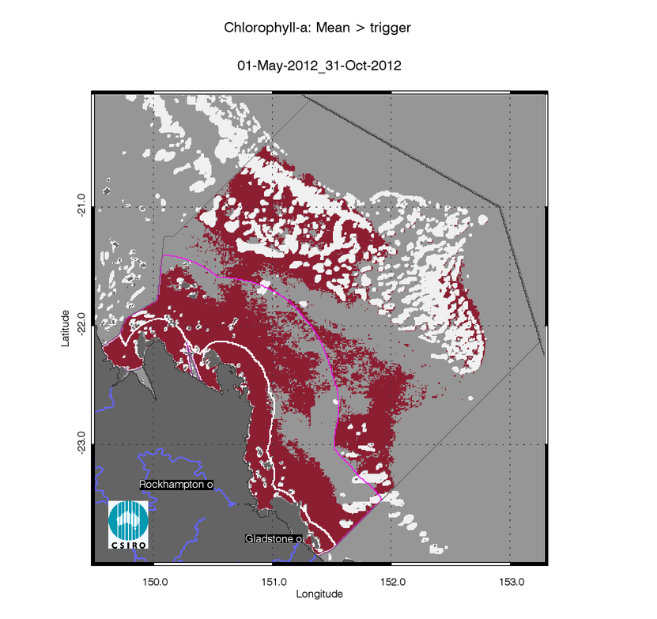
- Chlorophyll-a exceedance maps for the dry and wet season for the Fitzroy region. Exceedance for the dry season 2012 (May - October). The seasonally adjusted Guideline values for Chlorophyll–a for the dry season are 0.32 µg L-1 for Inshore and Midshelf and 0.28 µg L-1 for Offshore.
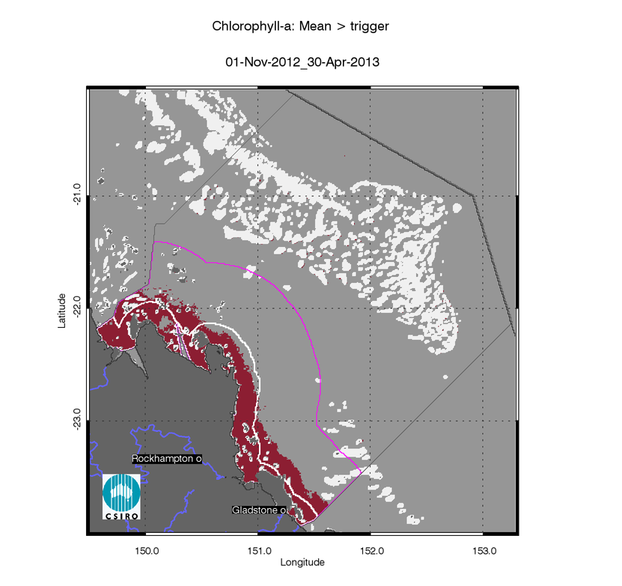
- Chlorophyll-a exceedance maps for the dry and wet season for the Fitzroy region. Exceedance for the wet season 2012/2013 (November 2012 - April 2013). The seasonally adjusted Guideline values for Chlorophyll–a for the wet season are 0.63 µg L-1 for Inshore and Midshelf and 0.56 µg L-1 for Offshore.

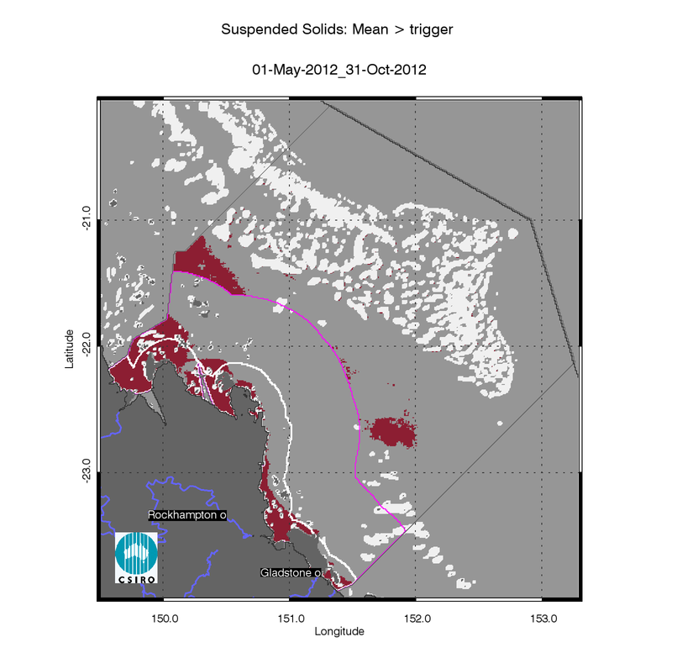
- Non-algal particulate matter (NAP as a measure of TSS) exceedance maps for the dry and wet season for the Fitzroy region. Exceedance for the dry season 2012 (May - October). The seasonally adjusted Guideline values for TSS for the dry season means are 1.6 mg L-1 for Inshore and Midshelf and 0.6 mg L-1 for Offshore.
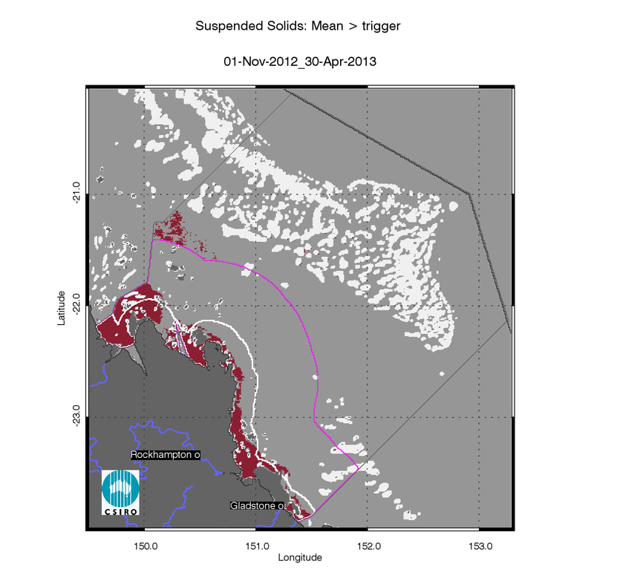
- Non-algal particulate matter (NAP as a measure of TSS) exceedance maps for the dry and wet season for the Fitzroy region. Exceedance for the wet season 2012/2013 (November 2012 - April 2013).The seasonally adjusted Guideline values for TSS for the wet season means are 2.4 mg L-1 for Inshore and Midshelf and 0.8 mg L-1 for Offshore.

Regional reports: Burnett Mary region

- Summary of the exceedance maps for Chlorophyll-a for the dry and wet season for the Burnett Mary region.
 |  | 01-May-2012_31-Oct-2012 |  |  |  | 01-Nov-2012_30-Apr-2013
Region | Surface Area | Number valid obs. | Number total obs. | Mean > trigger | Median > trigger | Number valid obs. | Number total obs. | Mean > trigger | Median > trigger
Inshore | 817 | 51562 | 213237 | 99% | 99% | 29229 | 212420 | 97% | 84%
Midshelf | 3677 | 230312 | 959697 | 68% | 52% | 132867 | 956020 | 41% | 7%
Offshore | 36489 | 1440211 | 9523629 | 3% | 3% | 876924 | 9487140 | 2% | 0%

- Summary of the exceedance maps for Non-algal particulate matter (NAP as a measure of TSS) for the dry and wet season for the Burnett Mary region.
 |  | 01-May-2012_31-Oct-2012 |  |  |  | 01-Nov-2012_30-Apr-2013
Region | Surface Area | Number valid obs. | Number total obs. | Mean > trigger | Median > trigger | Number valid obs. | Number total obs. | Mean > trigger | Median > trigger
Inshore | 817 | 51562 | 213237 | 27% | 21% | 29229 | 212420 | 36% | 21%
Midshelf | 3677 | 230312 | 959697 | 1% | 1% | 132867 | 956020 | 1% | 1%
Offshore | 36489 | 1440211 | 9523629 | 0% | 0% | 876924 | 9487140 | 0% | 0%

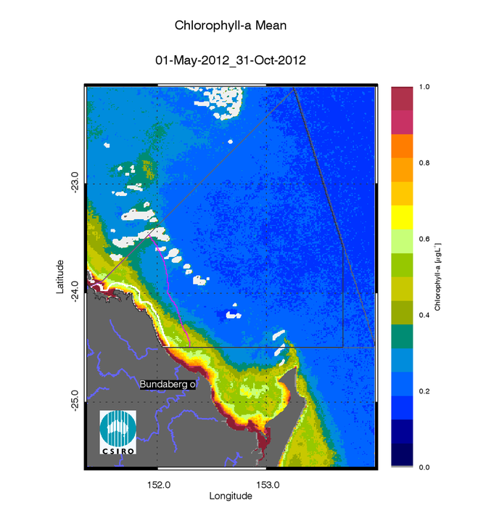
- Chlorophyll-a mean maps for the dry and wet season for the Burnett Mary region. Mean for the dry season 2012 (May - October),
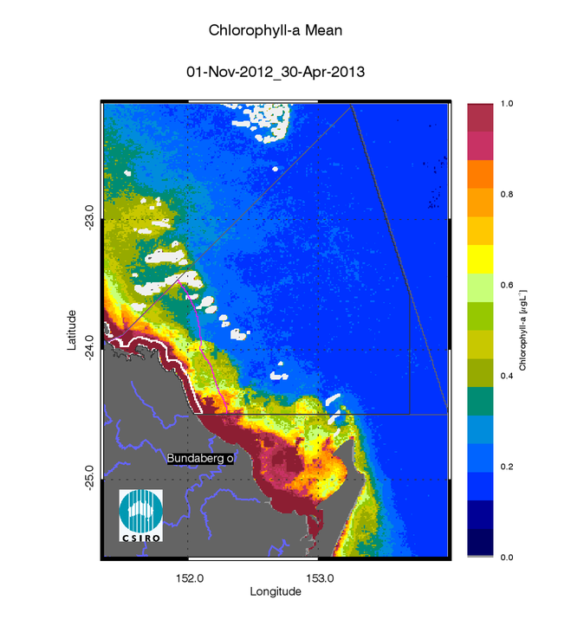
- Chlorophyll-a mean maps for the dry and wet season for the Burnett Mary region. Mean for the wet season 2012/20123 (November 2012 - April 2013).

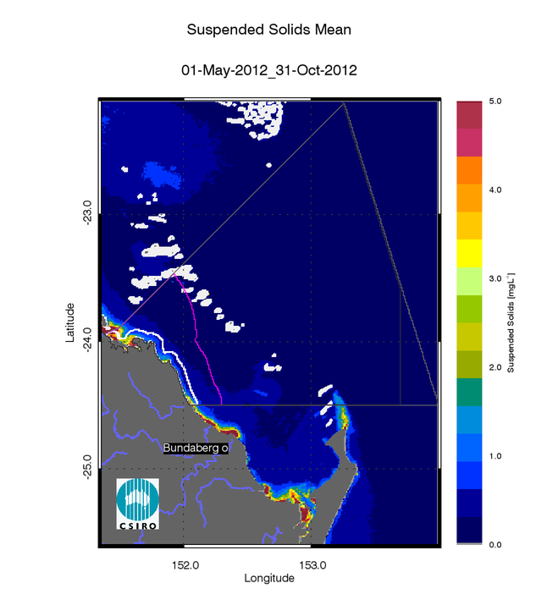
- Non-algal particulate matter (NAP as a measure of TSS) mean maps for the dry and wet season for the Burnett Mary region. Mean for the dry season 2012 (May - October),
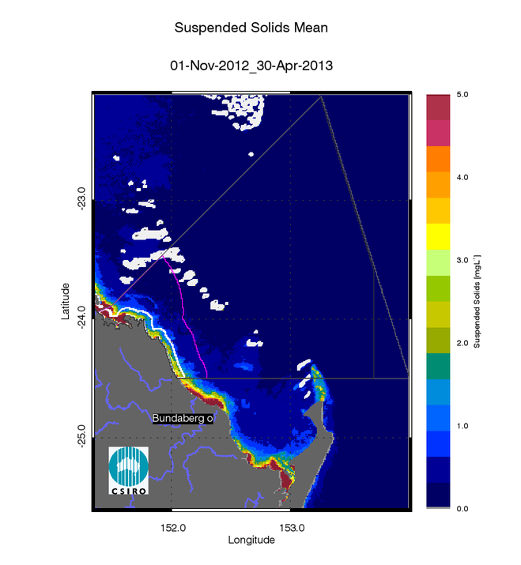
- Non-algal particulate matter (NAP as a measure of TSS) mean maps for the dry and wet season for the Burnett Mary region. Mean for the wet season 2012/20123 (November 2012 - April 2013).

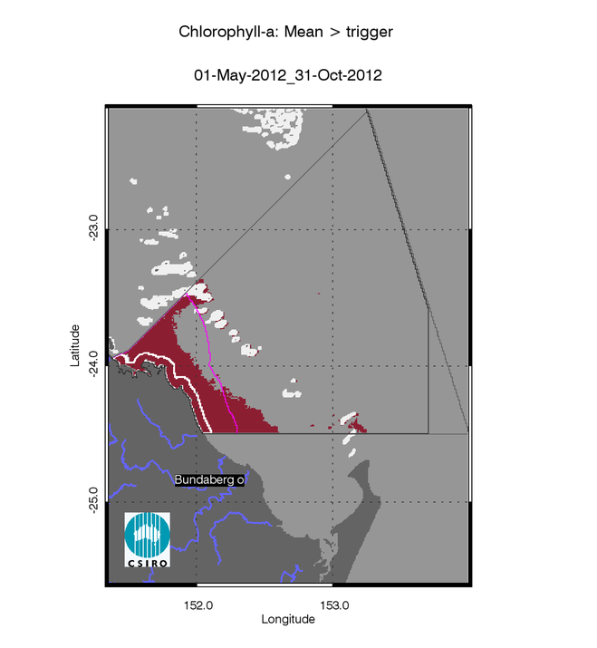
- Chlorophyll-a exceedance maps for the dry and wet season for the Burnett Mary region. Exceedance for the dry season 2012 (May - October). The seasonally adjusted Guideline values for Chlorophyll–a for the dry season are 0.32 µg L-1 for Inshore and Midshelf and 0.28 µg L-1 for Offshore.
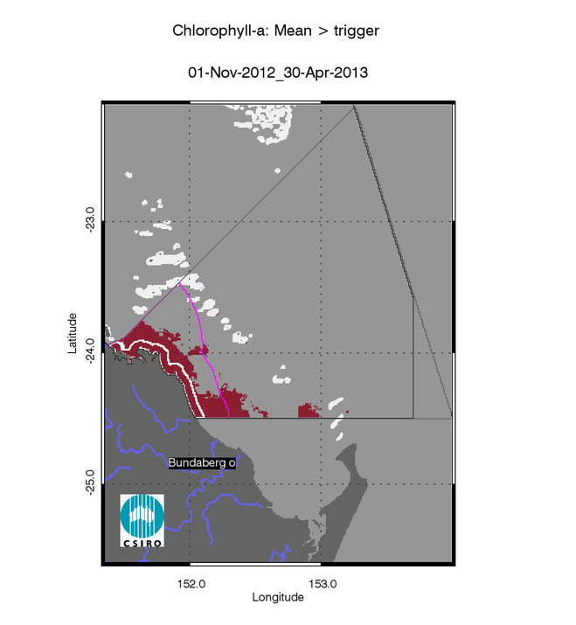
- Chlorophyll-a exceedance maps for the dry and wet season for the Burnett Mary region. Exceedance for the wet season 2012/2013 (November 2012 - April 2013). The seasonally adjusted Guideline values for Chlorophyll–a for the wet season are 0.63 µg L-1 for Inshore and Midshelf and 0.56 µg L-1 for Offshore.

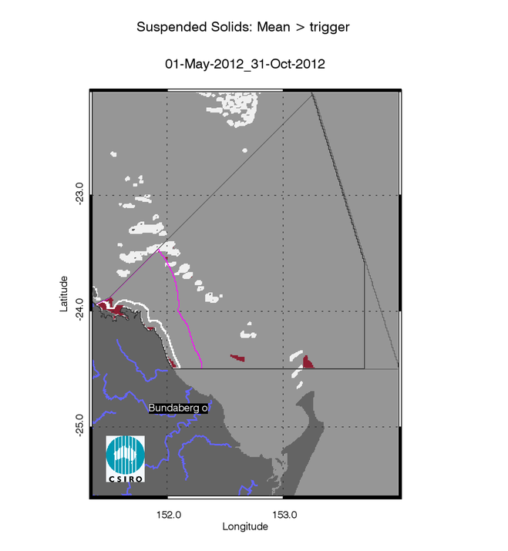
- Non-algal particulate matter (NAP as a measure of TSS) exceedance maps for the dry and wet season for the Burnett Mary region. Exceedance for the dry season 2012 (May - October). The seasonally adjusted Guideline values for TSS for the dry season means are 1.6 mg L-1 for Inshore and Midshelf and 0.6 mg L-1 for Offshore.
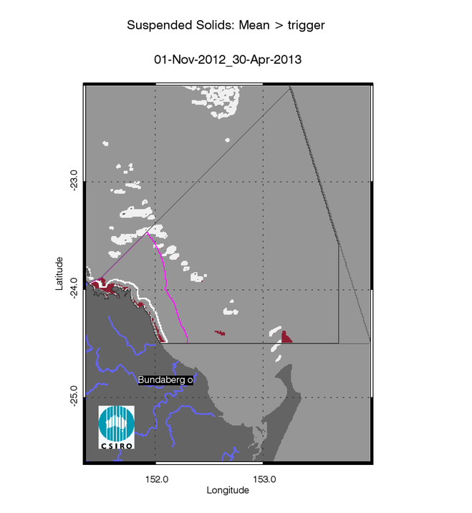
- Non-algal particulate matter (NAP as a measure of TSS) exceedance maps for the dry and wet season for the Burnett Mary region. Exceedance for the wet season 2012/2013 (November 2012 - April 2013).The seasonally adjusted Guideline values for TSS for the wet season means are 2.4 mg L-1 for Inshore and Midshelf and 0.8 mg L-1 for Offshore.

APPENDIX C: Summary of the exceedance of annual mean values from 2002/03 to date
For this report the whole MODIS Aqua time series was reprocessed with the most recent updates in NASA’s software (SeaDAS version 7.0.2), incorporating the improved knowledge of instrument temporal calibration to improve temporal stability of the time series of the MODIS Aqua aging sensor. In this appendix the REEG values for CHL and TSS (REEG_CHL, REEG_TSS) are presented within each reporting region as separate values for the Inshore Midshelf, and Offshore water bodies for all for all reporting periods from when MODIS-Aqua data is available (i.e. 2002/03 to present). All the results presented in this appendix supersede the exceedance assessments and the P2R scores presented previous reports.

- Summary of the exceedance of annual mean values of Chlorophyll-a and non-algal particulate matter (as a measure of Total Suspended Solids) for the reporting period 01-May-2002 - 30-Apr-2003 for the Inshore, Mid-shelf and Offshore water bodies (IS, MS, OS). Cells are shaded in gray when more than 50% of the area of the water body exceeds the Guideline value. * Caution should be used when interpreting the results for the Cape York and Burnett Mary regions as limited field information was used for the parameterization and validation on the remote sensing retrievals.
Location | Chlorophyll-a: Relative area (%) of the water body where the annual mean value exceeds the WQ Guideline value |  |  | Total Suspended Solids: Relative area (%) of the water body where the annual mean value exceeds the WQ Guideline value
0203 | IS | MS | OS | IS | MS | OS
Cape York* | 63% | 9% | 1% | 31% | 4% | 7%
Wet Tropics | 78% | 16% | 0% | 35% | 4% | 1%
Burdekin | 63% | 4% | 0% | 36% | 0% | 0%
Mackay Whitsunday | 43% | 6% | 5% | 36% | 9% | 12%
Fitzroy | 65% | 5% | 1% | 41% | 2% | 2%
Burnett Mary* | 68% | 3% | 0% | 21% | 0% | 0%

- Summary of the exceedance of annual mean values of Chlorophyll-a and non-algal particulate matter (as a measure of Total Suspended Solids) for the reporting period 01-May-2003 - 30-Apr-2004 for the Inshore, Mid-shelf and Offshore water bodies (IS, MS, OS). Cells are shaded in gray when more than 50% of the area of the water body exceeds the Guideline value. * Caution should be used when interpreting the results for the Cape York and Burnett Mary regions as limited field information was used for the parameterization and validation on the remote sensing retrievals.
Location | Chlorophyll-a: Relative area (%) of the water body where the annual mean value exceeds the WQ Guideline value |  |  | Total Suspended Solids: Relative area (%) of the water body where the annual mean value exceeds the WQ Guideline value
0304 | IS | MS | OS | IS | MS | OS
Cape York* | 72% | 14% | 1% | 51% | 7% | 6%
Wet Tropics | 86% | 23% | 1% | 56% | 7% | 1%
Burdekin | 63% | 5% | 0% | 46% | 0% | 0%
Mackay Whitsunday | 41% | 4% | 1% | 38% | 7% | 8%
Fitzroy | 58% | 4% | 1% | 43% | 2% | 2%
Burnett Mary* | 63% | 4% | 0% | 21% | 0% | 0%

- Summary of the exceedance of annual mean values of Chlorophyll-a and non-algal particulate matter (as a measure of Total Suspended Solids) for the reporting period 01-May-2004 - 30-Apr-2005 for the Inshore, Mid-shelf and Offshore water bodies (IS, MS, OS). Cells are shaded in gray when more than 50% of the area of the water body exceeds the Guideline value. * Caution should be used when interpreting the results for the Cape York and Burnett Mary regions as limited field information was used for the parameterization and validation on the remote sensing retrievals.
Location | Chlorophyll-a: Relative area (%) of the water body where the annual mean value exceeds the WQ Guideline value |  |  | Total Suspended Solids: Relative area (%) of the water body where the annual mean value exceeds the WQ Guideline value
0405 | IS | MS | OS | IS | MS | OS
Cape York* | 65% | 9% | 1% | 35% | 2% | 7%
Wet Tropics | 79% | 17% | 1% | 42% | 4% | 1%
Burdekin | 65% | 4% | 0% | 41% | 0% | 0%
Mackay Whitsunday | 36% | 5% | 1% | 30% | 7% | 9%
Fitzroy | 56% | 4% | 1% | 42% | 2% | 1%
Burnett Mary* | 51% | 3% | 0% | 20% | 1% | 0%

- Summary of the exceedance of annual mean values of Chlorophyll-a and non-algal particulate matter (as a measure of Total Suspended Solids) for the reporting period 01-May-2005 - 30-Apr-2006 for the Inshore, Mid-shelf and Offshore water bodies (IS, MS, OS). Cells are shaded in gray when more than 50% of the area of the water body exceeds the Guideline value. * Caution should be used when interpreting the results for the Cape York and Burnett Mary regions as limited field information was used for the parameterization and validation on the remote sensing retrievals.
Location | Chlorophyll-a: Relative area (%) of the water body where the annual mean value exceeds the WQ Guideline value |  |  | Total Suspended Solids: Relative area (%) of the water body where the annual mean value exceeds the WQ Guideline value
0506 | IS | MS | OS | IS | MS | OS
Cape York* | 81% | 20% | 1% | 35% | 3% | 6%
Wet Tropics | 82% | 17% | 1% | 42% | 4% | 1%
Burdekin | 63% | 3% | 0% | 41% | 0% | 0%
Mackay Whitsunday | 38% | 6% | 2% | 27% | 8% | 9%
Fitzroy | 58% | 4% | 1% | 44% | 3% | 1%
Burnett Mary* | 58% | 3% | 0% | 20% | 0% | 0%

- Summary of the exceedance of annual mean values of Chlorophyll-a and non-algal particulate matter (as a measure of Total Suspended Solids) for the reporting period 01-May-2006 - 30-Apr-2007 for the Inshore, Mid-shelf and Offshore water bodies (IS, MS, OS). Cells are shaded in gray when more than 50% of the area of the water body exceeds the Guideline value. * Caution should be used when interpreting the results for the Cape York and Burnett Mary regions as limited field information was used for the parameterization and validation on the remote sensing retrievals.
Location | Chlorophyll-a: Relative area (%) of the water body where the annual mean value exceeds the WQ Guideline value |  |  | Total Suspended Solids: Relative area (%) of the water body where the annual mean value exceeds the WQ Guideline value
0607 | IS | MS | OS | IS | MS | OS
Cape York* | 83% | 20% | 1% | 50% | 4% | 7%
Wet Tropics | 90% | 23% | 1% | 54% | 6% | 1%
Burdekin | 62% | 5% | 0% | 43% | 0% | 0%
Mackay Whitsunday | 45% | 6% | 1% | 41% | 8% | 7%
Fitzroy | 57% | 4% | 1% | 42% | 2% | 1%
Burnett Mary* | 54% | 3% | 0% | 18% | 0% | 0%

- Summary of the exceedance of annual mean values of Chlorophyll-a and non-algal particulate matter (as a measure of Total Suspended Solids) for the reporting period 01-May-2007 - 30-Apr-2008 for the Inshore, Mid-shelf and Offshore water bodies (IS, MS, OS). Cells are shaded in gray when more than 50% of the area of the water body exceeds the Guideline value. * Caution should be used when interpreting the results for the Cape York and Burnett Mary regions as limited field information was used for the parameterization and validation on the remote sensing retrievals.
Location | Chlorophyll-a: Relative area (%) of the water body where the annual mean value exceeds the WQ Guideline value |  |  | Total Suspended Solids: Relative area (%) of the water body where the annual mean value exceeds the WQ Guideline value
0708 | IS | MS | OS | IS | MS | OS
Cape York* | 71% | 14% | 1% | 31% | 1% | 5%
Wet Tropics | 81% | 19% | 1% | 33% | 3% | 1%
Burdekin | 69% | 6% | 0% | 34% | 0% | 0%
Mackay Whitsunday | 45% | 4% | 1% | 29% | 7% | 5%
Fitzroy | 68% | 5% | 1% | 45% | 2% | 1%
Burnett Mary* | 66% | 4% | 0% | 21% | 1% | 0%

- Summary of the exceedance of annual mean values of Chlorophyll-a and non-algal particulate matter (as a measure of Total Suspended Solids) for the reporting period 01-May-2008 - 30-Apr-2009 for the Inshore, Mid-shelf and Offshore water bodies (IS, MS, OS). Cells are shaded in gray when more than 50% of the area of the water body exceeds the Guideline value. * Caution should be used when interpreting the results for the Cape York and Burnett Mary regions as limited field information was used for the parameterization and validation on the remote sensing retrievals.
Location | Chlorophyll-a: Relative area (%) of the water body where the annual mean value exceeds the WQ Guideline value |  |  | Total Suspended Solids: Relative area (%) of the water body where the annual mean value exceeds the WQ Guideline value
0809 | IS | MS | OS | IS | MS | OS
Cape York* | 75% | 15% | 1% | 47% | 4% | 6%
Wet Tropics | 88% | 25% | 1% | 39% | 3% | 1%
Burdekin | 74% | 10% | 0% | 36% | 0% | 0%
Mackay Whitsunday | 49% | 7% | 1% | 31% | 9% | 8%
Fitzroy | 66% | 6% | 1% | 45% | 3% | 1%
Burnett Mary* | 60% | 4% | 0% | 20% | 1% | 0%

- Summary of the exceedance of annual mean values of Chlorophyll-a and non-algal particulate matter (as a measure of Total Suspended Solids) for the reporting period 01-May-2009 - 30-Apr-2010 for the Inshore, Mid-shelf and Offshore water bodies (IS, MS, OS). Cells are shaded in gray when more than 50% of the area of the water body exceeds the Guideline value. * Caution should be used when interpreting the results for the Cape York and Burnett Mary regions as limited field information was used for the parameterization and validation on the remote sensing retrievals.
Location | Chlorophyll-a: Relative area (%) of the water body where the annual mean value exceeds the WQ Guideline value |  |  | Total Suspended Solids: Relative area (%) of the water body where the annual mean value exceeds the WQ Guideline value
0910 | IS | MS | OS | IS | MS | OS
Cape York* | 69% | 13% | 1% | 33% | 2% | 7%
Wet Tropics | 85% | 23% | 1% | 39% | 4% | 1%
Burdekin | 73% | 7% | 0% | 39% | 0% | 0%
Mackay Whitsunday | 47% | 7% | 2% | 36% | 8% | 13%
Fitzroy | 75% | 7% | 2% | 43% | 3% | 3%
Burnett Mary* | 83% | 5% | 0% | 21% | 0% | 0%

- Summary of the exceedance of annual mean values of Chlorophyll-a and non-algal particulate matter (as a measure of Total Suspended Solids) for the reporting period 01-May-2010 - 30-Apr-2011 for the Inshore, Mid-shelf and Offshore water bodies (IS, MS, OS). Cells are shaded in gray when more than 50% of the area of the water body exceeds the Guideline value. * Caution should be used when interpreting the results for the Cape York and Burnett Mary regions as limited field information was used for the parameterization and validation on the remote sensing retrievals.
Location | Chlorophyll-a: Relative area (%) of the water body where the annual mean value exceeds the WQ Guideline value |  |  | Total Suspended Solids: Relative area (%) of the water body where the annual mean value exceeds the WQ Guideline value
1011 | IS | MS | OS | IS | MS | OS
Cape York* | 86% | 30% | 1% | 45% | 5% | 6%
Wet Tropics | 92% | 39% | 2% | 41% | 5% | 1%
Burdekin | 77% | 17% | 0% | 40% | 0% | 0%
Mackay Whitsunday | 74% | 15% | 1% | 47% | 7% | 7%
Fitzroy | 98% | 19% | 1% | 47% | 3% | 1%
Burnett Mary* | 97% | 17% | 0% | 27% | 1% | 0%

- Summary of the exceedance of annual mean values of Chlorophyll-a and non-algal particulate matter (as a measure of Total Suspended Solids) for the reporting period 01-May-2011 - 30-Apr-2012 for the Inshore, Mid-shelf and Offshore water bodies (IS, MS, OS). Cells are shaded in gray when more than 50% of the area of the water body exceeds the Guideline value. * Caution should be used when interpreting the results for the Cape York and Burnett Mary regions as limited field information was used for the parameterization and validation on the remote sensing retrievals.
Location | Chlorophyll-a: Relative area (%) of the water body where the annual mean value exceeds the WQ Guideline value |  |  | Total Suspended Solids: Relative area (%) of the water body where the annual mean value exceeds the WQ Guideline value
1112 | IS | MS | OS | IS | MS | OS
Cape York* | 81% | 16% | 1% | 39% | 1% | 5%
Wet Tropics | 91% | 33% | 1% | 49% | 8% | 1%
Burdekin | 71% | 12% | 0% | 46% | 0% | 0%
Mackay Whitsunday | 57% | 6% | 2% | 45% | 8% | 6%
Fitzroy | 85% | 9% | 1% | 49% | 3% | 1%
Burnett Mary* | 98% | 21% | 0% | 27% | 1% | 0%

- Summary of the exceedance of annual mean values of Chlorophyll-a and non-algal particulate matter (as a measure of Total Suspended Solids) for the reporting period 01-May-2012 - 30-Apr-2013 for the Inshore, Mid-shelf and Offshore water bodies (IS, MS, OS). Cells are shaded in gray when more than 50% of the area of the water body exceeds the Guideline value. * Caution should be used when interpreting the results for the Cape York and Burnett Mary regions as limited field information was used for the parameterization and validation on the remote sensing retrievals.
Location | Chlorophyll-a: Relative area (%) of the water body where the annual mean value exceeds the WQ Guideline value |  |  | Total Suspended Solids: Relative area (%) of the water body where the annual mean value exceeds the WQ Guideline value
1213 | IS | MS | OS | IS | MS | OS
Cape York* | 75% | 17% | 1% | 34% | 3% | 6%
Wet Tropics | 86% | 24% | 1% | 37% | 4% | 1%
Burdekin | 71% | 8% | 0% | 41% | 0% | 0%
Mackay Whitsunday | 64% | 10% | 2% | 39% | 10% | 8%
Fitzroy | 92% | 20% | 1% | 51% | 4% | 2%
Burnett Mary* | 98% | 46% | 2% | 28% | 1% | 0%

