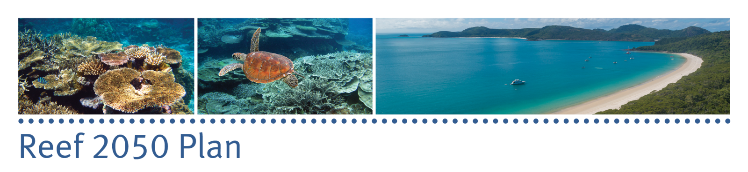
Reef 2050 Integrated Monitoring and Reporting Program
Communique
Steering group meeting three, 15 April 2016

The third Reef 2050 Integrated Monitoring and Reporting Program steering group meeting took place in Brisbane on 15 April 2015.
The monitoring program is the key mechanism to track the progress of the Australian and Queensland governments’ 35-year plan — the Reef 2050 Plan — to protect the Great Barrier Reef. It brings together monitoring, modelling and reporting activities across the Reef and its catchment and will enable timely and appropriate responses by Reef managers and partners to emerging risks and issues.
The steering group:
- Endorsed a proposal to undertake market research of end-user products to gain a better understanding of how stakeholders and partners use information on Great Barrier Reef health and management — this research will underpin the work of all working groups in designing and developing effective products for the integrated monitoring and reporting program for the Reef.
- Endorsed the approach for the implementation of program design work packages to ensure the Program delivers the required data for reporting on core indicators across the seven Reef 2050 Plan themes: ecosystem health; biodiversity; heritage; water quality; community benefits; economic benefits; governance.
- Discussed the monitoring to be funded by the Reef 2050 Integrated Monitoring and Reporting Program to fill monitoring gaps critical to the delivery of the Reef 2050 Plan.
- Provided guidance on the need to collect information once and use it many times across different scales.
- Received an update from the Program Design, Synthesis and Reporting and Data Management and Systems working groups on progress to date.
- Received an update on the activities of the Reef 2050 Independent Expert Panel and the Reef 2050 Advisory Committee.

The integration of monitoring and reporting across the Great Barrier Reef and adjacent catchments is fundamental to informing the actions required to protect and improve the Reef’s condition and to drive adaptive management.
The Program will not duplicate existing arrangements but coordinate and integrate existing modelling and reporting.
Reporting and future meetings
The next meeting of the steering group will be 29 July 2016.

