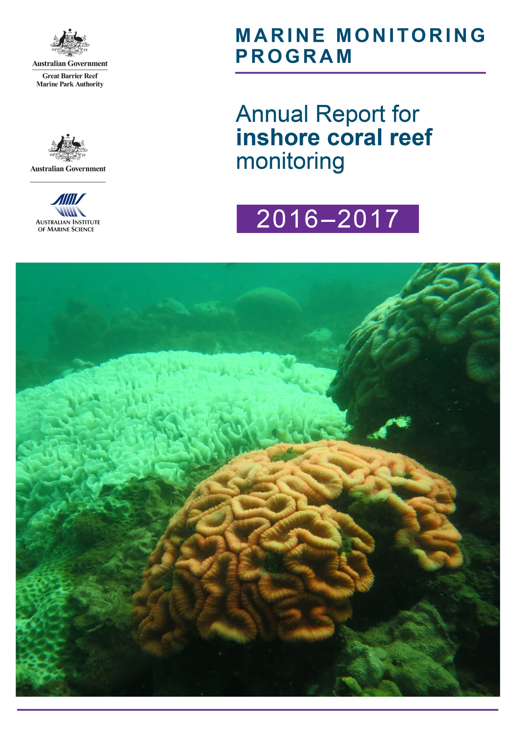

Marine Monitoring Program

Annual Report for inshore coral reef monitoring
2016 - 2017

Report prepared for the Great Barrier Reef Marine Park Authority
Angus Thompson, Paul Costello, Johnston Davidson,
Murray Logan, Greg Coleman, Kevin Gunn

Australian Institute of Marine Science
PMB No 3
Townsville MC Qld 4810
ISSN 2208-4118

This report should be cited as:
Thompson, A., Costello, P., Davidson, J., Logan, M., Coleman, G., Gunn, K. 2018, Marine Monitoring Program. Annual Report for inshore coral reef monitoring: 2016 – 2017, Great Barrier Reef Marine Park Authority, Townsville.148 pp.

Cover photo © AIMS 2017: Bleached corals on the reef-slope of Dunk Island May 2017.
Revision History: |  | Name | Date | Comments
1 | Prepared by: | Angus Thompson
1 | Approved by: | Britta Schaffelke | 24 January 2018
2 | Reviewed | External Reviewer | 24 April 2018
2 | Revised | Angus Thompson | 18 May 2018

© Commonwealth of Australia (Australian Institute of Marine Science (AIMS)) 2018
Published by the Great Barrier Reef Marine Park Authority
This document is licensed by the Commonwealth of Australia for use under a Creative Commons By Attribution 4.0 International licence with the exception of the Coat of Arms of the Commonwealth of Australia, the logo of the Great Barrier Reef Marine Park Authority and the Australian Institute of Marine Science, any other material protected by a trademark, content supplied by third parties and any photographs. For licence conditions see: http://creativecommons.org/licences/by/4.0


DISCLAIMER
While reasonable efforts have been made to ensure that the contents of this document are factually correct, AIMS does not make any representation or give any warranty regarding the accuracy, completeness, currency or suitability for any particular purpose of the information or statements contained in this document. To the extent permitted by law AIMS shall not be liable for any loss, damage, cost or expense that may be occasioned directly or indirectly through the use of or reliance on the contents of this document.

Contents
1 Executive Summary 1
2 Preface 5
3 Introduction 6
4 Methods 9
4.1 Sampling design 9
4.1.1 Site Selection 9
4.1.2 Depth Selection 11
4.1.3 Site marking 11
4.1.4 Sampling timing and frequency 11
4.3 Environmental pressures 13
4.3.1 Water quality 13
4.3.2 Sea temperature 14
4.3.3 River discharge 14
4.3.4 Sediment sampling 15
4.3.5 SCUBA search transects 15
4.4 Pressure presentation 17
4.5 Coral community sampling 18
4.5.1 Photo point intercept transects 18
4.5.2 Juvenile coral surveys 18
4.6 The Coral Index 19
4.6.1 Coral Cover metric 19
4.6.2 Macroalgae metric 21
4.6.3 Density of juvenile hard corals metric 22
4.6.4 Cover Change metric 23
4.6.5 Community Composition metric 24
4.6.6 Aggregating indicator scores to regional scale assessments 26
4.7 Coral reef data analysis and presentation 27
4.7.1 Variation in index and metric scores among Regions and depths 28
4.7.2 Variation in index and metric scores to gradients in water quality 28
4.7.3 Relationship between index and metric scores and temporal variability in environmental conditions 28
4.7.4 Temporal trends in coral index, indicators and measured water quality. 29
4.7.5 Analysis of change in index and metric scores 29
5 Results 30
5.1 Variation of coral index and indicator scores observed in 2017 30
5.1.1 Regional differences 30
5.1.2 Effect of depth 31
5.1.3 Response to environmental gradients 32
5.1.4 Influence of discharge and catchment loads 34
5.2 Regional condition of coral communities 36
5.2.1 Wet Tropics Region: Barron Daintree sub-region 36
5.2.2 Wet Tropics Region: Johnstone Russell-Mulgrave sub-region 40
5.2.3 Wet Tropics Region: Herbert Tully sub-region 44
5.2.4 Burdekin Region 48
5.2.5 Mackay Whitsunday Region 52
5.2.6 Fitzroy Region 56
6 Discussion 60
6.1 Pressures 60
6.1.1 Acute disturbances 60
6.1.2 Chronic conditions - water quality 61
6.2 Ecosystem State 62
6.2.1 Coral index 62
6.2.2 Coral cover 63
6.2.3 Rate of change in coral cover 64
6.2.4 Composition 64
6.2.5 Macroalgae 65
6.2.6 Juvenile density 66
6.3 Regional summaries 66
6.3.1 Wet Tropics 66
6.3.2 Burdekin 67
6.3.3 Mackay Whitsunday 68
6.3.4 Fitzroy 68
6.4 Conclusion 69
7 Case Study - Coral Bleaching 2017 71
7.1 Methods 71
7.2 Discussion of Results 72
7.3 Conclusion 74
8 Case Study – Selection of environmental covariates for reporting against coral index and indicator scores 79
8.1 Data sourced 79
9 Case Study – Inclusion of Reef Check Australia data into the Reef Report Card 84
9.1 Introduction 84
9.2 Methods 84
9.3 Discussion of results 85
9.4 Conclusion 88
10 Acknowledgments 90
11 References 90
12 Appendix 1: Additional Information 101
13 Appendix 2: Publications and presentations associated with the Program 2016-17 148

List of Figures and Tables
Figure 1 Regional Coral Index with contributing indicator scores. 4
Figure 2 Sampling locations of the MMP coral and water quality monitoring.. 10
Figure 3 Scoring diagram for the Coral Cover metric. 20
Figure 4 Scoring diagram for the Macroalgae metric. 21
Figure 5 Scoring diagram for the Juvenile metric. 22
Figure 6 Scoring diagram for Cover Change metric 24
Figure 7 Scoring diagram for Community Composition metric 25
Figure 8 Regional distributions of index and metric scores. 31
Figure 9 Coral index and metric score relationships to environmental conditions at 2 m depth. 32
Figure 10 Coral index and metric score relationships to environmental conditions at 5 m depth. 33
Figure 11 Relationship between the coral index and runoff from local catchments. 35
Figure 12 Barron Daintree sub-region environmental pressures. 38
Figure 13 Barron Daintree sub-region index and indicator trends. 39
Figure 14 Johnstone Russell-Mulgrave sub-region environmental pressures. 42
Figure 15 Johnstone Russell-Mulgrave sub-region index and indicator trends.. 43
Figure 16 Herbert Tully sub-region environmental pressures. 46
Figure 17 Herbert Tully sub-region index and indicator trends. 47
Figure 18 Burdekin Region environmental pressures. 50
Figure 19 Burdekin Region index and indicator trends. 51
Figure 20 Mackay Whitsunday Region environmental pressures. 54
Figure 21 Mackay Whitsunday Region index and indicator trends.. 55
Figure 22 Fitzroy Region environmental pressures. 58
Figure 23 Fitzroy Region index and indicator trends. 59
Figure 24 Composite map of surveyed corals across the 2016 and 2017 bleaching events. 72
Figure 25 Regional temperature anomalies from the 2005-2017. 76
Figure 26 Comparison of Coral Index and Coral cover metric. 86
Figure 27 Comparison of Coral cover trends. 87
Figure 28 Theoretical influence of sampling intensity on precision of coral cover estimates.. 88

Table 1 Sampling locations. 12
Table 2 Summary of climate and environmental data included in or considered in this report 16
Table 3 Information considered for disturbance categorisation 17
Table 4 Survey methods used by the MMP and LTMP to describe coral communities 18
Table 5 Threshold values for the assessment of coral reef condition and resilience indicators. 27
Table 6 Presentation of community condition 27
Table 7 Regional differences in index and metric scores. 30
Table 8 Influence of depth on index and metric scores. 31
Table 9 Relationship between changes in index scores and environmental conditions. 34
Table 10 Index and metric score comparisons in the Barren Daintree sub-region. 36
Table 11 Index and metric score comparisons in the Johnstone Russell-Mulgrave sub-region. 40
Table 12 Index and metric score comparisons in the Herbert Tully sub-region. 44
Table 13 Index and metric score comparisons in the Burdekin Region.
Table 14 Index and metric score comparisons in the Mackay Whitsunday Region. 52
Table 15 Index and metric score comparisons in the Fitzroy Region. Data compare the changes in scores between local maxima and minima in the index time-series. 56
Table 16 Degree Heating Days (DHD) for 2016 and 2017 MMP (sub) regions. 73
Table 17 Bleaching impacts at MMP reefs 2016– 17. 77
Table 18 Sensitivity of common coral genera to bleaching. 78
Table 19 Correlation between water-quality parameters available from eReefs Marine Water Quality Dashboard.. 81
Table 20 Correlation between water-quality parameters selected from eReefs Biogeochemical 4km model. 81
Table 21 Correlation between estimated mean exceedance of wet-season guideline values.. 82
Table 22 Correlation between water quality parameters estimated from niskin sampling 82
Table 23 Correlation between suspended sediment related parameter estimates. 82
Table 24 Correlation between Chlorophyll estimates.. 82
Table 25 Correlation between dissolved nutrient estimates. 83
Table 26 Correlation between particulate nutrient estimates 83

List of Figures and Tables – Appendices
Figure A1. 1 Barron Daintree sub-region benthic community composition. 113
Figure A1. 2 Johnstone Russell-Mulgrave sub-region benthic community composition. 114
Figure A1. 3 Herbert-Tully sub- region benthic community composition. 117
Figure A1. 4 Burdekin Region benthic community composition. 119
Figure A1. 5 Mackay Whitsunday Region benthic community composition. 123
Figure A1. 6 Fitzroy Region benthic community composition. 127
Figure A1. 7 Coral disease by year in each region. 129
Figure A1. 8 Tropical cyclone Debbie track. 141
Figure A1. 9 Temporal trends in water quality: Baron Daintree sub-region. 142
Figure A1. 10 Temporal trends in water quality: Johnstone Russell-Mulgrave sub-region. 143
Figure A1. 11 Temporal trends in water quality: Herbert Tully sub-region. 144
Figure A1. 12 Temporal trends in water quality: Burdekin region. 145
Figure A1. 13 Temporal trends in water quality: Mackay Whitsundays region. 146
Figure A1. 14 Temporal trends in water quality: Fitzroy region. 147

Table A1. 1 Thresholds for proportion of macroalgae in the algae communities 102
Table A1. 2 Eigenvalues for hard coral genera along constrained water quality axis 103
Table A1. 3 Annual freshwater discharge for the major Reef Catchments. 104
Table A1. 4 Disturbance records for each reef 105
Table A1. 5 Reef level coral index and metric scores 2017. 110
Table A1. 6 Environmental covariates for coral locations. 112
Table A1. 7 Percent cover of hard coral genera 2017. 130
Table A1. 8 Percent cover of soft coral families 2017. 134
Table A1. 9 Percent cover of Macroalgae groups 2017. 137

Glossary:
AIMS - Australian Institute of Marine Science
The Reef - Great Barrier Reef World Heritage Area
MMP- Marine Monitoring Program
LTMP – Long Term Monitoring Program
Reef Plan - Reef Water Quality Protection Plan
Reef 2050 Plan - Reef 2050 Long-Term Sustainability Plan
BOM - Bureau of Meteorology
JCU - James Cook University
GBRMPA – Great Barrier Reef Marine Park Authority
COTS – crown-of-thorns starfish

Executive summary
The Marine Monitoring Program (MMP) was established in 2005 to assess status and trends in ecosystem health and resilience indicators for the Great Barrier Reef (the Reef). The results of this monitoring program are integral to assessing the long-term effectiveness of the Reef Water Quality Protection Plan (Reef Plan) and are the basis for marine condition scores reported in the annual Great Barrier Reef Report Card and regional report cards. This report summarises coral reef benthic community results used to derive report card scores for 2017.
Report card scores are estimated at the scale of the four Natural Resource Management (NRM) regions and represent an index that aggregates over metric scores derived from five indicators; coral cover, hard coral community composition, macroalgae cover, juvenile coral density and the rate of coral cover increase. Data was derived from 32 reefs monitored at depths of two-metres and five-metres, and an additional nine inshore reefs were monitored at single depths by the Australian Institute of Marine Science’s Long Term Monitoring Program (LTMP) since 2005. The metric scores in a given year are based on the most recent observations from each of the monitored communities. The biennial sampling design of the program means that the scores for some reefs are carried forward from the previous year’s estimates. Interpretation of trends in the index and individual indicators was reliant on the consideration of environmental data collected at coral monitoring sites or sourced from the Australian Bureau of Meteorology, the Queensland Department of Natural Resources and Mines and the water quality subprogram of the MMP.
Conditions over the 2016–17 summer were severe, resulting in damage to coral communities in most areas of the Reef covered by this report. High summer water temperatures caused coral bleaching and subsequent mortality of corals in both the Wet Tropics and Burdekin regions, while tropical cyclone Debbie severely impacted reefs exposed to storm driven waves in the Whitsunday Group (noting that the full extent of these impacts are yet to be realised in index scores, as discussed below). Coral communities in the Fitzroy region were not severely impacted despite flooding of the Fitzroy River in the wake of tropical cyclone Debbie. Elevated numbers of coral-eating crown-of-thorns starfish (COTS) were restricted to reefs in the Johnstone Russell–Mulgrave sub-region of the Wet Tropics where they compounded losses attributed primarily to coral bleaching.
As a result of the impacts of the 2016–17 summer, coral index scores declined sharply in the Mackay–Whitsunday Region, declined slightly in the Wet Tropics Region and remained stable elsewhere. Declines were primarily due to the loss of corals resulting in declines in the coral cover metric that, in-turn, precipitated declines in community composition and juvenile metrics. The declines in the index were buffered by the sampling designs of the monitoring programs that resulted in index scores for the nine LTMP reefs and six of the MMP reefs being based on observations that pre-dated the 2017 summer disturbances. Improved scores for the coral change metric also moderated declines in index scores. The coral change metric is based on a running mean of observed changes in coral cover estimated during periods of recovery. Improved scores for this metric in 2017 reflected the strong recovery rates observed in the two-to-three years prior to the disturbances identified above.
The coral index for the Wet Tropics remains in the ‘moderate’ condition category, although has declined slightly from that observed in 2016 (Figure 1). The primary cause of the decline was high water temperatures resulting in coral bleaching over the 2016–17 summer. Compounding the impacts of coral bleaching was ongoing pressure from COTS at reefs in the Johnstone Russell–Mulgrave sub-region. Partly mitigating the influence of COTS, has been an active population control program with 14,990 individuals removed from the reefs reported herein over the five years prior to surveys in 2017. Within the region, although levels of bleaching were high in the Herbert Tully sub-region, the coral index continued to improve as rapid recovery of coral cover in recent years saw improvement in the coral change metric offset the decline in the index scores caused by a reduction in coral cover as a result of bleaching in 2017. In the Johnstone Russell–Mulgrave sub-region the index declined slightly from the ‘good’ categorisation in 2016 to ‘moderate’ in 2017. This decline was due primarily to reduced coral cover and density of juvenile corals as a result of bleaching, although ongoing presence of COTS at several reefs will have contributed to these declines. Generally high scores for the macroalgae and cover change metric, due to rapid increases in coral cover at reefs not harbouring COTS prior to the bleaching event, contributed to the maintenance of a moderate index score. In the Barron–Daintree sub-region the impacts of the bleaching event varied markedly between the two reefs surveyed after the event, although were sufficient to see a reversal of improving index scores since 2014. Most limiting to coral community condition in the Barron–Daintree sub-region in 2017 were low scores for macroalgae and juvenile coral metrics around Snapper Island suggesting a potential suppression of coral recruitment as a result of high nutrient availability.
Impacts of coral bleaching in the Burdekin region in 2017 interrupted improvements in the coral index over the period 2012 and 2016 (Figure 1). After controlling for the influence of acute disturbance events (in particular cyclones) the rate of improvement in index scores in this region has been inversely related to discharge from the region’s rivers. Increases in the coral index were driven by improving coral cover scores at both 2 m and 5 m depths and a gradual return of genera sensitive to water quality (improved composition scores). Although coral cover, increased through to 2016, the legacy of cumulative pressures in addition to losses incurred as a result of high water temperatures over the 2016–17 summer, sees the score for this indictor remaining poor. Persistently high cover of macroalgae on the reefs also continued to limit index scores. These reefs also had the highest chlorophyll a concentrations in the water column. Moderating the signal of the 2017 bleaching event in the index scores were improvements in the cover change metric, due to pre-bleaching recovery of coral cover, and the yet to be assessed impacts of the 2017 bleaching event at seven of the fifteen reef and depth combinations that contribute to the index.
The coral index in the Mackay–Whitsunday region declined sharply in 2017 as a result of the severe impact associated with cyclone Debbie. The impact of cyclone Debbie returned the index score to ‘moderate’, effectively negating improvements in the index since 2012 as reefs recovered from impacts attributed to cyclone Ului (Figure 1). Scores for coral cover and juvenile metrics were most immediately impacted, declining sharply in 2017 (Figure 1). Buffering further decline in the index in 2017 was the increasing coral cover through to 2016 that resulted in high coral cover scores being carried forward from the reefs last surveyed prior to cyclone Debbie. Improvement in the cover change score reflect improved rate of increase in coral cover in the years prior to cyclone Debbie. Finally, cyclone Debbie stripped macroalgae from Pine Island contributing to what is expected to be a temporary improvement in the macroalgae metric. Once the impacts of cyclone Debbie at the reefs not surveyed in 2017 have been assessed the full impact from the cyclone will be realised. The influence of prevailing environmental conditions such as high turbidity, nutrient availability and sedimentation, have clearly selected for coral species tolerant of those conditions. Marked differences in community composition between two-metre and five-metre depths at most reefs are indicative of the increasing selective pressures of light availability and accumulated sediments at the deeper sites. Future monitoring will show how these challenging environmental conditions influence the recovery of the communities at five metre depths..
The coral index in the Fitzroy region remained ‘poor’ in 2017. A combination of high water temperatures over 2016 and 2017 and potential pressures associated with flooding in 2017, have likely suppressed the recovery of coral communities from a low point reached in 2014 (Figure 1). The modest improvement in the index to 2017 predominantly reflects improvement in the cover change metric at both two-metre and five-metre, along with improved juvenile scores at 2 m depths, both are necessary precursors to future improvements in the index. Over the period 2006–14coral communities in the region were exposed to cumulative pressures associated with a series of acute disturbances and chronic effects of water quality, and is clearly reflected in the decline of the coral index through to 2014 (Figure 1). Two acute disturbances stand out, high water temperatures in 2006 bleached and killed corals resulting in an average reduction in coral cover of 16% across the region, subsequently coral cover was reduced by a similar amount in response to a major flood event in 2011. This flood predominantly affected the two-metre sites on reefs inshore of Great Keppel Island, where the majority of corals were killed as a result of exposure to low salinity waters. Elsewhere, increased levels of disease demonstrated a likely impact of reduced water quality during and following the flood. In the periods 2007–11and 2012–14recovery from these disturbance events was hampered by a series of storms and persistently high cover of macroalgae, low levels of coral recruitment and low rates of coral cover increase (Figure 1), all of which coincided with a period of high loads of land based material being delivered by the Fitzroy River.
Overall, it is apparent that the cumulative impact of tropical cyclones, outbreaks of COTS and a period of high discharge carrying increased loads of nutrients and sediments to the Reef resulted in declines in coral community condition over the period 2012–2014. Recovery from these impacts was observed as index scores improved through to 2016 before the interruption imposed across all regions by the impacts of high temperatures and tropical cyclone Debbie in 2017 (Figure 1).
Given the currently accepted predictions of climate change, which indicate the severity of disturbance events to coral reefs is projected to increase, it is essential that coral communities retain the ability to recover from inevitable disturbances to maintain a coral dominated state in the long-term. The coral index is formulated explicitly to emphasise coral communities’ recovery potential. As such, improvements in the index in all regions through to 2016 are an important demonstration of the resilience inherent in inshore coral communities under situations of low cumulative pressure. The strong impact of acute disturbances — such as cyclones, bleaching, and COTS outbreaks — on coral community state impose an unavoidable confounding between the influence of these pressures and those that can be attributed to water quality. By explicitly focusing on periods free from acute disturbance events we were able to demonstrate that incremental changes in the coral index, during periods when reefs should be recovering, were inversely related to discharge from local catchments in three of the four regions monitored. In combination with spatial analyses that demonstrated higher index scores where chlorophyll a levels were below guideline values, the temporal relationships between the recovery potential of coral communities and environmental conditions provides support for the primary premise of the Reef Water Quality Protection Plan (Reef Plan), that load reduction will have downstream environmental benefits for the Reef.
In addition to the effects of run-off on the condition of inshore reefs reported here, is that increased nutrient loads delivered to the Reef lagoon during major flood events have been linked to the initiation of COTS outbreaks. Although not typically prevalent on inshore reefs, elevated numbers of COTS in the Barron–Daintree and Johnstone–Russell–Mulgrave sub-regions in recent years mirror much larger populations observed offshore. In 2017, small numbers of COTS were observed at Fitzroy Island, High Island and the Frankland Group where a range of size-classes indicate ongoing recruitment. The densities of COTS observed were sufficient that as these individuals grow they are likely to result in future damage to coral communities.

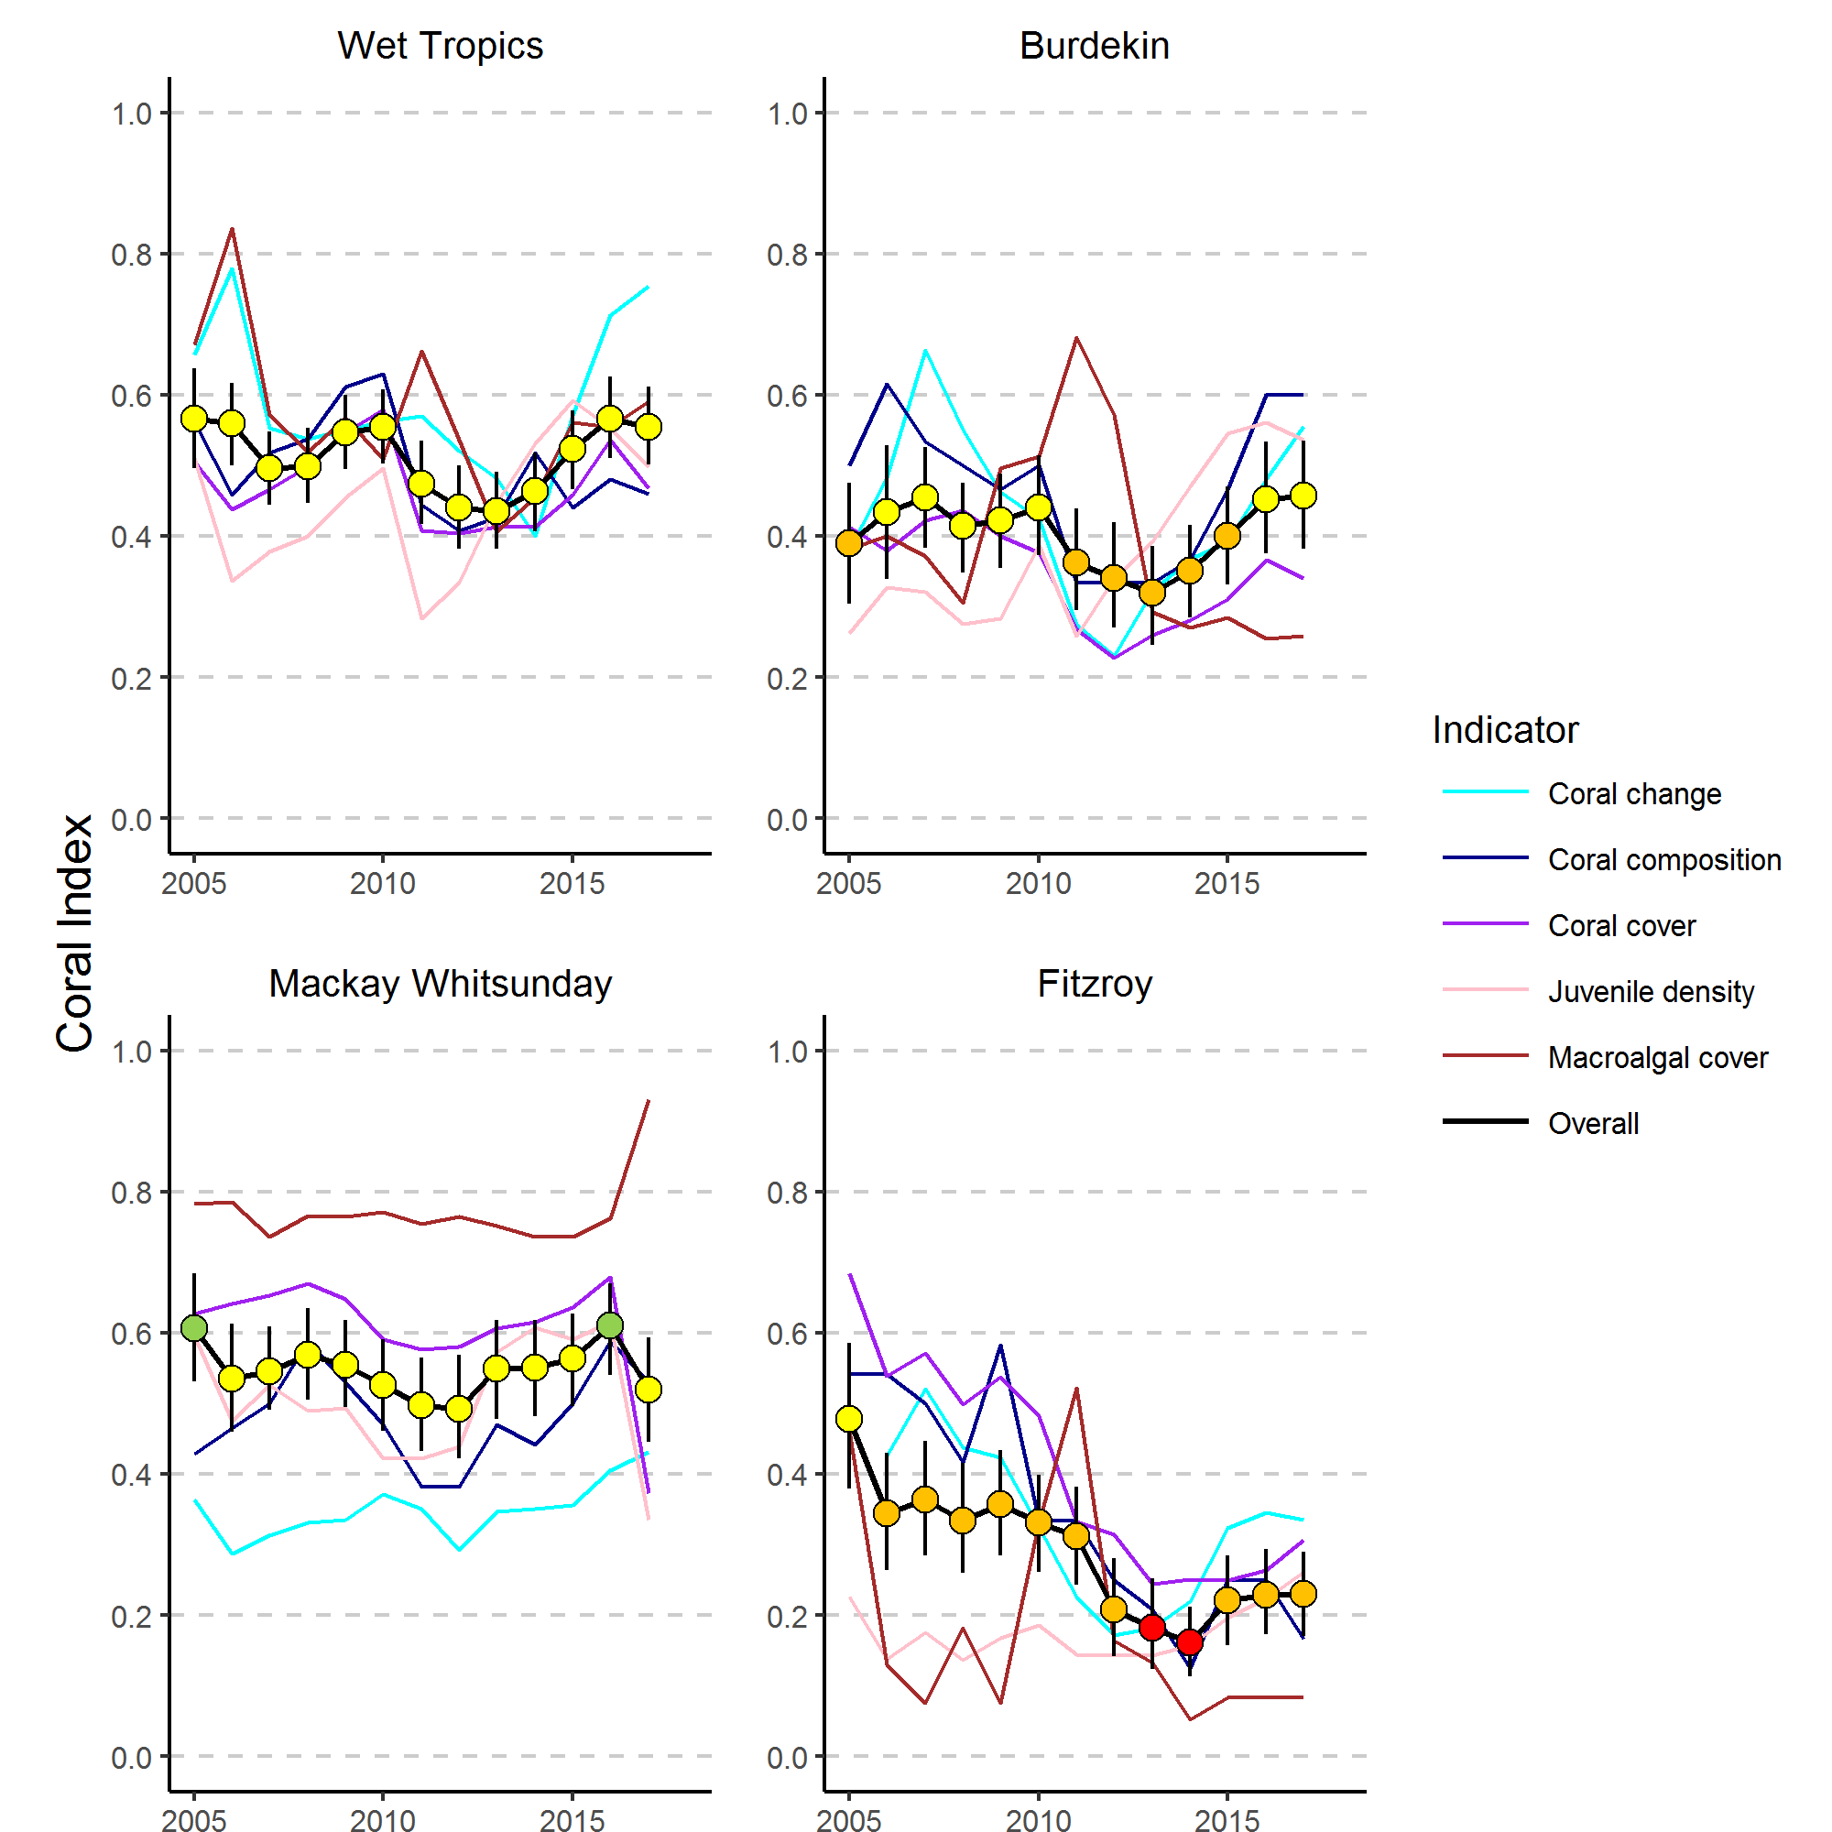

Figure 1 Regional Coral Index with contributing indicator scores.
The regional Coral Index is derived from the aggregate of metric scores for indicators of coral community health. Contributing indicators are described in section 4.7 of the methods.

Preface
Management of human pressures, such as enhanced nutrient run-off and overfishing, is vital to provide corals, and reef organisms in general, with the optimum conditions to cope with global stressors, such as climate change and ocean acidification (Bellwood et al. 2004, Marshall & Johnson 2007, Carpenter et al. 2008, Mora 2008, Hughes et al. 2010). The management of water quality remains a strategic priority for the Great Barrier Reef Marine Park Authority (GBRMPA) to ensure the long-term protection of the coastal and inshore ecosystems of the Reef (GBRMPA 2014 a, b). A key policy is the Reef Water Quality Protection Plan (Reef Plan; Anon. 2013), a component of the Reef 2050 Long-Term Sustainability Plan (Reef 2050 Plan; Commonwealth of Australia, 2015), which provides a framework for the integrated management of the Great Barrier Reef World Heritage Area.
The Marine Monitoring Program (MMP) was designed and developed by the GBRMPA in collaboration with science agencies and is currently funded by the Australian Government Reef Programme and co-funding from research partners. A summary of the MMP’s overall goals and objectives and a description of the sub-programs are available on the Marine Park Authority’s website and the e-atlas website. The MMP forms an integral part of the Paddock to Reef Integrated Monitoring, Modelling and Reporting Program, which is a key action of Reef Plan designed to evaluate the efficiency and effectiveness of implementation and report on progress towards Reef Plan goals and targets. A key output of the Paddock to Reef Program is an annual report card, including an assessment of Reef water quality and ecosystem condition, which is based on MMP information (www.reefplan.qld.gov.au).
The Australian Institute of Marine Science (AIMS) and GBRMPA entered into a partnership agreement to provide inshore coral reef monitoring under the MMP in 2017 and 2018. This monitoring is largely an extension of activities established under previous agreements covering 2005 to 2014. This report covers coral reef monitoring conducted by the MMP until August 2017 with inclusion of data from inshore reefs monitored by the AIMS Long-Term Monitoring Program (LTMP) from 2005 to 2016. In-keeping with the overarching objective of the MMP, to “Assess trends in ecosystem health and resilience indicators for the Great Barrier Reef in relation to water quality and its linkages to end-of-catchment loads”, key water quality results reported by (Waterhouse et al. 2018) are replicated here as required for interpretation.

Introduction
It is well documented that sediment and nutrient loads carried by land run-off into the coastal and inshore zones of the Great Barrier Reef World Heritage Area (the Reef) have increased since European settlement (e.g., Kroon et al. 2012, Waters et al. 2014). Ongoing concern that these increases were negatively impacting the Reef ecosystem triggered the formulation and subsequent updating of the Reef Water Quality Protection Plan (Reef Plan) for adjacent catchments (Anon. 2003, 2009, 2013). The Reef 2050 Plan includes the Reef Plan actions and initiatives to change land management practices to achieve improvement in downstream water quality of creeks and rivers. These actions and initiatives should, with time, lead to improved water quality in the coastal and inshore Reef that, in turn, support the ongoing health and resilience of the Great Barrier Reef (see Brodie et al. 2012a for a discussion of expected time lags in the ecosystem response).
Reef Plan can be considered in a Drivers-Pressures-States-Impacts-Responses (DPSIR) framework (Maxim et al. 2009, Rehr et al. 2012). Socio-economic factors are the drivers of human activities from local - within catchment, through to global scales. Human activities result in local scale pressures on downstream ecosystems such as increased exposure to sediments, nutrients and toxicants through to global pressures such as climate change. These pressures change the state of the Reef ecosystems. This state can then be interpreted in terms of impact on desirable ecosystem functioning or services that in turn can be used to inform decisions as to the need for response such as policy or regulatory actions to alleviate that impact.
To allow the full application of a DPSIR framework requires the monitoring of both pressures and states that should be reported, where possible, in terms of impacts so that appropriate management responses can be devised, or conversely, the outcomes of existing management strategies assessed. Reef Plan actions included the establishment of monitoring programs extending from the paddock to the Reef (Anon. 2011), to assess the effectiveness of Reef Plan's implementation. The MMP is an integral part of this monitoring, providing physicochemical and biological data to document the state of: coral reefs, seagrass beds, water quality and concentrations of pesticides in inshore areas of the Reef. The MMP additionally collates observations of extrinsic pressures such as sea temperature variability, occurrence of tropical cyclones, river discharge volumes and coral predator populations that must be considered in any assessment of water quality impacts on ecosystem state. Ultimately the state of marine waters and the ecosystems of the Reef will provide both a basis for assessing the success of Reef Plan and the necessity for future management strategies.
The coral reef component of the MMP is based on the general understanding that healthy and resilient coral communities exist in a dynamic equilibrium, with communities in a cycle of recovery punctuated by acute disturbance events. Common disturbances to inshore reefs include cyclones (often coinciding with flooding), thermal bleaching, and outbreaks of crown-of-thorns starfish (COTS), all of which can result in widespread mortality of corals (e.g. Sweatman et al. 2007, Osborne et al. 2011). The potential impact of elevated nutrients carried into the system as runoff may compound the influences of acute disturbances by: increasing the susceptibility of corals to disease (Bruno et al. 2003, Haapkylä et al. 2011, Weber et al. 2012, Vega Thurber et al. 2013), promoting outbreaks of COTS (Wooldridge & Brodie 2015) and increasing susceptibility to thermal stress (Wooldridge & Done 2004, Wiedenmann et al. 2013). Pollutants in runoff may also suppress the recovery process (Schaffelke et al. 2013). The replacement of corals lost to disturbance is reliant on both the recruitment of new colonies and regeneration of existing colonies from remaining tissue fragments (Smith 2008, Diaz-Pulido et al. 2009). Elevated concentrations of nutrients, agrochemicals, and turbidity can negatively affect reproduction in corals (reviewed by Fabricius 2005, van Dam et al. 2011, Erftemeijer et al. 2012). High rates of sediment deposition and accumulation on surfaces can affect larval settlement (Babcock & Smith 2002, Baird et al. 2003, Fabricius et al. 2003, Ricardo et al. 2017) and smother juvenile corals (Harrison & Wallace 1990, Rogers 1990, Fabricius & Wolanski 2000). In addition, macroalgae have higher abundance in areas with high water column chlorophyll concentrations, indicating higher nutrient availability (De’ath & Fabricius 2010, Petus et al. 2016). High macroalgal abundance may suppress reef resilience (e.g. Hughes et al. 2007, Cheal et al. 2010, Foster et al. 2008, but see Bruno et al. 2009) by increased competition for space or changing the microenvironment into which corals settle and grow (e.g. McCook et al. 2001, Hauri et al. 2010). Macroalgae have been documented to suppress fecundity (Foster et al. 2008), reduce recruitment of hard corals (Birrell et al. 2008b, Diaz-Pulido et al. 2010), diminish the capacity of growth among local coral communities (Fabricius 2005),and suppress coral recovery by altering microbial communities associated with corals (Morrow et al. 2012, Vega Thurber et al. 2012).
In addition to influences on the early life stages of corals, changes in water quality have been shown to increase incidence of coral disease: for example increased organic carbon concentrations promote coral diseases and mortality (Kline et al. 2006, Kuntz et al. 2005). The selective pressure of water quality on coral communities is clearly evident in changes in community composition along environmental gradients (De’ath & Fabricius 2010, Thompson et al. 2010, Uthicke et al. 2010, Fabricius et al. 2012). Corals derive energy in two ways, by feeding on ingested particles and planktonic organisms and from the photosynthesis of their symbiotic algae (zooxanthellae). The ability to compensate, by feeding, where there is a reduction in energy derived from photosynthesis, e.g. as a result of light attenuation in turbid waters (Bessell-Brown et al. 2017a), varies between species (Anthony 1999, Anthony & Fabricius 2000). Similarly, the energy required to shed sediment varies between species due to differences in the efficiencies of passive (largely depending on growth form) or active (such as mucus production) strategies for sediment removal (Rogers 1990, Stafford-Smith & Ormond 1992, Duckworth et al. 2017). At the same time, high nutrient levels may favour particle feeders such as sponges and heterotrophic soft corals which are potential space competitors of hard corals. The cumulative result of these processes is that the combination of environmental parameters at a given location will disproportionately favour some species and thus influence the community composition of coral reef benthos. This variability in corals’ tolerances to environmental pressures allows coral communities to occur in a wide range of environmental settings (e.g. Done 1982, Fabricius & De’ath 2001, DeVantier et al. 2006, De’ath & Fabricius 2010).
Coral reefs in the coastal and inshore zones of the Reef, which are often fringing reefs around continental islands, are subject to high turbidity due to frequent exposure to re-suspended sediment and episodic flood events. It is difficult to quantify the changes to coral reef communities caused by runoff of excess nutrients and sediments because of the lack of historical biological and environmental data that predate significant land use changes on the catchment. However, recent research has strengthened the evidence for causal relationships between water quality changes and the decline of some coral reefs and seagrass meadows in these zones (reviewed in Brodie et al. 2012b and Schaffelke et al. 2013, Clark et al. 2017).
Given that the benthic communities in inshore areas of the Reef show clear responses to gradients in turbidity, sedimentation rate and nutrient availability (van Woesik et al. 1999, Fabricius & De’ath 2001, Fabricius et al. 2005, Wismer et al. 2009, Uthicke et al. 2010, Fabricius et al. 2012), improved land management practices have the potential to reduce levels of chronic environmental stresses that impact coral reef communities. However, recent assessments raise the question whether these actions will be sufficient to ensure the resilience of the Reef ecosystems into the future (Bartley 2014a, b, Kroon et al. 2014). Nutrients, that sustain the biological productivity of the Reef, are supplied by a number of processes and sources such as upwelling of nutrient-enriched deep water from the Coral Sea and nitrogen fixation by bacteria (Furnas et al. 2011). However, land runoff is the largest source of new nutrients to the inshore Reef, especially during monsoonal flood events (Furnas et al. 2011). These nutrients augment the regional stocks of nutrients already stored in biomass or detritus (Furnas et al. 2011) which are continuously recycled to supply nutrients for marine plants and bacteria (Furnas et al. 2005, Furnas et al. 2011).
The complexity of interactions between benthic communities and environmental pressures makes it important to synthesize coral community condition in a way that relates to the pressures of interest. The Reef report card includes coral index scores to annually summarise condition of coral communities in inshore areas of the Reef. The purpose of this report is to provide the data, analyses and interpretation underpinning coral index scores included in the 2017 Reef report card.
In order to relate changes in the condition of coral reef communities to variations in local reef water quality, the coral component of the MMP has the overarching objective to “quantify the extent, frequency and intensity of acute and chronic impacts on the condition and trend of inshore coral reefs and their subsequent recovery”. The specific objectives are to monitor, assess and report:
- the condition and trend of Great Barrier Reef inshore coral reefs in relation to desired outcomes (expressed as coral index scores) along identified or expected gradients in water quality;
- the extent, frequency and intensity of acute and chronic impacts on the condition of Great Barrier Reef inshore coral reefs, including exposure to flood plumes sediments, nutrients and pesticides;
- the recovery in condition of Great Barrier Reef inshore coral reefs from acute and chronic impacts including exposure to flood plumes, sediments, nutrients and pesticides;
- trends in incidences of coral mortality attributed to coral disease, Crown of Thorns Starfish, Drupella, Cliona, physical damage and coral bleaching.

This report includes three case studies. During early 2017 high sea water temperatures caused severe bleaching to parts of the Reef. In contrast to the 2016 bleaching event, the 2017 event saw widespread bleaching of reefs monitored by the MMP in the Wet Tropics and Burdekin regions. A summary of the impacts of this event is included (section 7).
Secondly, essential to the overarching objectives of the MMP is the identification of key water quality covariates that influence benthic communities of inshore reefs. A detailed analysis of the available data and the response of ecosystem health and resilience indicators at both spatial and temporal scales is provided (section 8).
Finally, a key component of the Reef 2050 Plan is establishing the Reef 2050 Integrated Monitoring and Reporting Program (RIMReP) for the reef and its adjacent catchments. The intention behind RIMReP is to; “Coordinate, align and integrate existing programs to capitalise on investment, improve efficiency and avoid duplication”. In this interest, we provide an assessment of data collected under the citizen science program, ReefCheck Australia (RCA), and the potential for inclusion of the data in MMP reporting and the annual Great Barrier Reef Report Card (section 9)

Methods

4.1 Sampling design
Monitoring of inshore coral reef communities occurs at reefs adjacent to four of the six natural resource management (NRM) regions with catchments draining into the Reef: Wet Tropics, Burdekin, Mackay Whitsunday and Fitzroy. No reefs are included adjacent to Cape York due to logistic and occupational health and safety issues relating to diving in coastal waters in this region. Limited development of coral reefs in nearshore waters adjacent to the Burnett Mary NRM region precluded sampling there. Sub-regions were included in the Wet Tropics NRM to more closely align reefs with the combined catchments of; the Barron and Daintree rivers, the Johnstone and Russell-Mulgrave Rivers, and the Herbert and Tully rivers.

4.1.1 Site Selection
Initial selection of sites was jointly decided by an expert panel chaired by the GBRMPA. The selection was based upon two primary considerations:
- Within the Reef, strong gradients in water quality exist with distance from the coast and increasing distance from rivers, particularly in a northerly direction (Larcombe et al. 1995, Brinkman et al. 2011). The selection of reefs for inclusion in the sampling design was informed by the desire to include reefs spanning these gradients so as to facilitate the teasing out of water quality associated impacts.
- Sampling locations were selected where there was either an existing coral reef community or evidence (in the form of carbonate-based substratum) of past coral reef development. Exact locations were selected without prior investigation, once a section of reef had been identified that was of sufficient size to accommodate the sampling design a marker was deployed from the surface and transects established from this point.
In the Wet Tropics region, where few reefs exist in the inshore zone and well-developed reefs existed on more than one aspect of an island, separate reefs on windward and leeward aspects were included in the design. Coral reef communities can be quite different on windward compared to leeward reefs even though the surrounding water quality is relatively similar. Differences in wave and current regimes determine whether materials, e.g. sediments, fresh water, nutrients or toxins imported by flood events, accumulate or disperse and hence determine the exposure of benthic communities to environmental stresses. A list of the selected reefs is presented in Table 1 and the geographic locations are shown in Figure 2 and, in more detail, on maps within each (sub-) regional section of the results.
Since the program began in 2005 there have been two changes to the selection of reefs sampled. In 2005 and 2006 three mainland fringing reef locations were sampled along the Daintree coast. Concerns over increasing crocodile populations in this area led to the cessation of sampling at these locations. In 2015 a revision of the marine water quality monitoring component of the MMP resulted in modifications to the sampling design for water quality. This included a concentration of sampling effort along a gradient away from the Tully River mouth. To better match the water quality sampling to the coral reef sampling in the Tully-Herbert sub-region a new reef site was initiated at Bedarra and sampling at King Reef discontinued.
In addition to reefs monitored by the MMP data from inshore reefs monitored by the AIMS long-term monitoring program (LTMP) have been included in this report (Table 1, Figure 1). As the MMP sites at Middle Reef in the Burdekin region were co-located with LTMP sites this reef was also removed from the MMP sampling schedule in 2015.

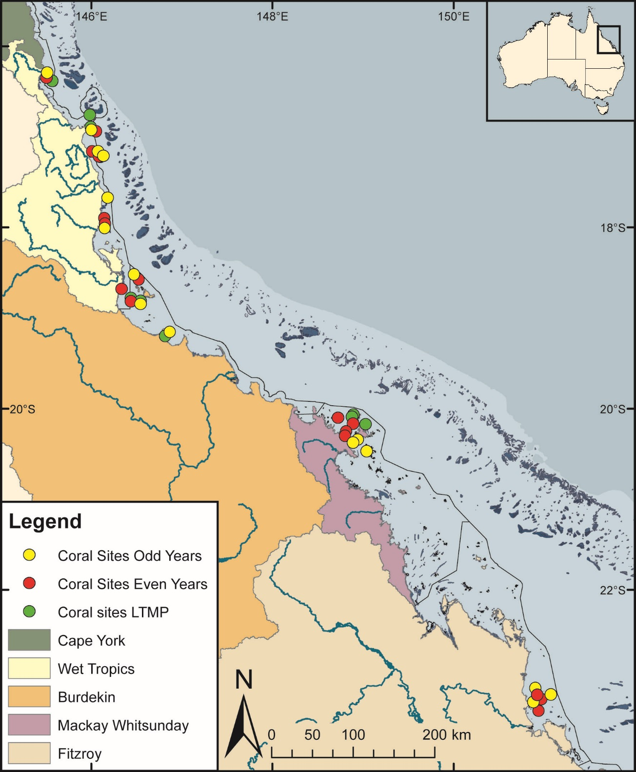
Figure 2 Sampling locations of the MMP coral and water quality monitoring. Table 1 (below) describes monitoring activities undertaken at each location. NRM Region boundaries are represented by coloured catchment areas.

4.1.2 Depth selection
Within the turbid inshore waters of the Reef the composition of coral communities varies strongly with depth as a result of differing exposure to pressures and disturbances (e.g. Sweatman et al. 2007). For the MMP transects were selected at two depths. The lower limit for the inshore coral surveys was selected at 5 m below datum, because coral communities rapidly diminish below this depth at many reefs. A shallower depth of 2 m below datum was selected as a compromise between a desire to sample the reef crest and logistical reasons, including the inability to use the photo technique in very shallow water and the potential for site markers creating a danger to navigation. The AIMS LTMP sites are not as consistently depth defined as those of the MMP with most sites set in the range of 5-7m below LAT. Middle Reef is the exception with sites there at approximately 3m below LAT.

4.1.3 Site marking
At each reef, two sites separated by at least 250 m were selected along a similar aspect. These sites are permanently marked with steel fence posts at the beginning of each of five 20 m transects and smaller (10 mm diameter) steel rods at the 10 m mark and the end of each transect. Compass bearings and measured distances record the transect path between these permanent markers. Transects were set initially by running two 60 m fibreglass tape measures out along the desired 5 m or 2 m depth contour. Digital depth gauges were used along with tide heights from the closest location included in ‘Seafarer Tides’ electronic tide charts produced by the Australian Hydrographic Service to set transects as close as possible to the desired depths of 5 m and 2 m below lowest astronomical tide (LAT). Consecutive 20 m transects were separated by 5 m. The position of the first picket of each site was recorded by GPS. Site directions and waypoints are stored electronically in AIMS databases.

4.1.4 Sampling timing and frequency
Coral reef surveys were undertaken predominantly over the months May-July as this allows the bulk of influences resulting from summer disturbances, such as cyclones and bleaching events, to be realised. Although the acute events occur over summer, the stress incurred can cause ongoing mortality for several months. The winter sampling also protects observers from potential risk from marine stingers over the summer months. The exception was Snapper Island where sampling occurred typically in the months August – October.
The frequency of survey has changed gradually over time due to budgetary constraints. In 2005 and 2006 all MMP reefs were surveyed. From 2007 through to 2014 a subset of reefs at which there were co-located water sampling sites, were classified as “core” reefs, and sampled annually. The remaining reefs were classified as “cycle” and sampled only in alternate years with half sampled in odd numbered years (i.e. 2009, 2011 & 2013) and the remainder in even numbered years. When an acute disturbance was suspected to have impacted cycle reefs during the preceding summer they were resurveyed irrespective of their odd or even year classification so as to gain the best estimate of the impact of the acute event and book-end the start of the recovery period. Further funding reductions necessitated the adoption of a biennial sampling cycle for all reefs, although a contingency for the out-of-phase resampling of reefs impacted by acute disturbance was maintained. In 2017 out-of-phase sampling was undertaken at most reefs in the Wet Tropics, Burdekin and Whitsunday regions to capture the impact of coral bleaching and cyclone Debbie. In total, nine out-of-phase reefs were surveyed across the four regions (Table 1).

Table 1 Sampling locations. Black dots mark reefs surveyed as per sampling design, the “+” symbol indicates reefs surveyed out of schedule to assess disturbance. At each reef surveys of juvenile coral densities, benthic cover estimates derived from photo point intercept transects and scuba searches for incidence of coral mortality are undertaken. WQ, indicates reefs at which water quality monitoring is undertaken, * indicates WQ was ceased in 2014, and ** indicates WQ was begun in 2015.shading indicated reefs discontinued by the MMP.
(Sub-) Region | Reef | Program | 2005 | 2006 | 2007 | 2008 | 2009 | 2010 | 2011 | 2012 | 2013 | 2014 | 2015 | 2016 | 2017
Barron Daintree | Cape Tribulation North | MMP | ● | ●
Barron Daintree | Cape Tribulation Mid | MMP | ● | ●
Barron Daintree | Cape Tribulation South | MMP | ● | ●
Barron Daintree | Snapper North (WQ) | MMP | ● | ● | ● | ● | ● | ● | ● | ● | ● | ● | ● | + | ●
Barron Daintree | Snapper South | MMP | ● | ● | ● | ● | ● | ● | ● | ● | ● | ● | ● | ● | +
Barron Daintree | Low Isles | LTMP | ● |  | ● |  | ● |  | ● |  | ● |  | ● |  | ●
Johnstone Russell-Mulgrave | Green | LTMP | ● |  | ● |  | ● |  | ● |  | ● |  | ● |  | ●
Johnstone Russell-Mulgrave | Fitzroy West | LTMP | ● |  | ● |  | ● |  | ● |  | ● |  | ● |  | ●
Johnstone Russell-Mulgrave | Fitzroy West (WQ) | MMP | ● | ● | ● | ● | ● | ● | ● | ● | ● | ● | ● | + | ●
Johnstone Russell-Mulgrave | Fitzroy East | MMP | ● | ● | + | ● |  | ● | + | ● |  | ● |  | ●
Johnstone Russell-Mulgrave | High East | MMP | ● | ● | ● |  | ● |  | ● |  | ● |  | ● | + | ●
Johnstone Russell-Mulgrave | High West (WQ) | MMP | ● | ● | ● | ● | ● | ● | ● | ● | ● | ● |  | ● | +
Johnstone Russell-Mulgrave | Frankland East | MMP | ● | ● | ● |  | ● |  | ● |  | ● |  | ● | + | ●
Johnstone Russell-Mulgrave | Frankland West (WQ) | MMP | ● | ● | ● | ● | ● | ● | ● | ● | ● | ● |  | ● | +
Tully | Barnards | MMP | ● | ● | ● |  | ● |  | ● |  | ● |  | ● |  | ●
Tully | King | MMP | ● | ● |  | ● |  | ● |  | ● |  | ●
Tully | Dunk North (WQ) | MMP | ● | ● | ● | ● | ● | ● | ● | ● | ● | ● |  | ● | +
Tully | Dunk South | MMP | ● | ● |  | ● |  | ● | + | ● |  | ● |  | ● | +
Tully | Bedarra | MMP |  |  |  |  |  |  |  |  |  |  | ● | ● | ●
Burdekin | Palms West (WQ) | MMP | ● | ● | ● | ● | ● | ● | ● | ● | ● | ● | ● | + | ●
Burdekin | Palms East | MMP | ● | ● |  | ● |  | ● | + | ● |  | ● |  | ●
Burdekin | Lady Elliot | MMP | ● | ● |  | ● |  | ● |  | ● |  | ● |  | ●
Burdekin | Pandora North | LTMP | ● |  | ● |  | ● |  | ● |  | ● |  | ● |  | ●
Burdekin | Pandora (WQ) | MMP | ● | ● | ● | ● | ● | ● | ● | ● | ● | ● |  | ● | +
Burdekin | Havannah North | LTMP | ● |  | ● |  | ● |  | ● |  | ● |  | ● |  | ●
Burdekin | Havannah | MMP | ● | ● | ● |  | ● |  | ● |  | ● |  | ● | + | ●
Burdekin | Middle Reef | LTMP | ● |  | ● |  | ● |  | ● |  | ●
Burdekin | Middle Reef | MMP | ● | ● | ● |  | ● |  | ● |  | ●
Burdekin | Magnetic (WQ) | MMP | ● | ● | ● | ● | ● | ● | ● | ● | ● | ● | ● | + | ●
Mackay Whitsunday | Langford | LTMP | ● |  | ● |  | ● |  | ● |  | ● |  | ● |  | ●
Mackay Whitsunday | Hayman | LTMP | ● |  | ● |  | ● |  | ● |  | ● |  | ● |  | ●
Mackay Whitsunday | Border | LTMP | ● |  | ● |  | ● |  | ● |  | ● |  | ● |  | ●
Mackay Whitsunday | Double Cone (WQ) | MMP | ● | ● | ● | ● | ● | ● | ● | ● | ● | ● |  | ● | +
Mackay Whitsunday | Hook | MMP | ● | ● |  | ● |  | ● |  | ● |  | ● |  | ●
Mackay Whitsunday | Daydream (WQ*) | MMP | ● | ● | ● | ● | ● | ● | ● | ● | ● | ● |  | ● | +
Mackay Whitsunday | Shute Harbour | MMP | ● | ● |  | ● |  | ● |  | ● |  | ● |  | ● | +
Mackay Whitsunday | Dent | MMP | ● | ● | ● |  | ● |  | ● |  | ● |  | ● |  | ●
Mackay Whitsunday | Pine (WQ) | MMP | ● | ● | ● | ● | ● | ● | ● | ● | ● | ● | ● |  | ●
Mackay Whitsunday | Seaforth (WQ**) | MMP | ● | ● | ● |  | ● |  | ● |  | ● |  | ● |  | ●
Fitzroy | North Keppel | MMP | ● | ● | ● |  | ● |  | ● |  | ● | + | ● |  | ●
Fitzroy | Middle | MMP | ● | ● |  | ● |  | ● |  | ● |  | ● | + | ●
Fitzroy | Barren (WQ) | MMP | ● | ● | ● | ● | ● | ● | ● | ● | ● | ● | ● |  | ●
Fitzroy | Keppels South (WQ) | MMP | ● | ● | ● | ● | ● | ● | ● | ● | ● | ● | ● | ● | +
Fitzroy | Pelican (WQ) | MMP | ● | ● | ● | ● | ● | ● | ● | ● | ● | ● | ● | ●
Fitzroy | Peak | MMP | ● | ● |  | ● |  | ● | + | ● |  | ● | + |  | ●

4.3 Environmental pressures
A range of environmental variables are incorporated into this report as a basis for interpreting spatial and temporal trends in coral communities. Methods are detailed for data collected by this component of the MMP, or when aggregation to the level used required substantial manipulation of the source data. The use and source of environmental covariates is summarised in Table 2.

4.3.1 Water quality
Estimates of non-algal particulate (NAP) concentration derived from the MODIS aqua satellite mounted sensor were downloaded from the Australian Bureau of Meteorology. As a covariate for analysis of spatial pattern and temporal variation in index scores, reef by year or mean reef level concentrations were estimated. For each monitoring location a square of nine 1 km² pixels were identified in closely adjacent waters from which daily medians were used to estimate monthly means that were aggregated to annual estimates, or reef level means over the period (2003 – 2017).
In previous reports from this project estimates of Chl a were also derived from algorithms applied to MODIS aqua imagrey². For this report, relative exposure to Chl a at each reef, in each year, was estimated based on the methods developed by the water quality component of the MMP (Waterhouse et al. 2018, Petus et al. 2016). In brief, MODIS aqua images were used to classify waters into one of six colour classes that range from those typical of primary (colour classes 1-4), secondary (class 5), or tertiary (class 6) river plumes. It is important to note that waters can be classified into these colour classes when not exposed to flood plumes as extra-plume processes, such as wind driven resuspension, may produce waters with similar spectral signatures. The lowest (most turbid and nutrient rich) colour class for a given pixel is recorded as the exposure of that pixel in a given week. Matching in situ sampling with the classified colour of the water at the date and location of the sample provided estimates of the mean concentration of water quality parameters for each colour class. The Chl a estimates in this report are expressed as the mean exposure to Chl a concentrations above wet-season guideline (GL) values (0.63ugL⁻¹) over the wet-season (December – April, inclusive) preceding annual coral surveys. For each colour class, exposure above GL levels was expressed as the product of the proportion of the wet season for which waters were classified as that colour class and the mean concentration of Chl a in that colour classes expressed as a deviation in ugL⁻¹ above GL levels. The sum of these exposures across colour classes 1-5 (colour class 6 mean Chl a concentration is below GL levels) provided an estimate of the mean exceedance of GL concentrations in ugL⁻¹ across the wet-season. Reef level means averaged the annual wet season exposures over the period 2003-2016. The same procedure was used to estimate concentrations of total suspended solids (TSS), particulate nitrogen (PN) and particulate phosphorous (PP).
As a background to regional maps of sampling locations, mean (2003-2016) Chl a and NAP concentrations were derived for all inshore waters using the same methods as described above and scaled to visually demonstrate concentrations relative to Guideline values (GBRMPA 2010).
Temporal trends in the Water Quality Index and associated parameters are provided for each NRM (sub-) region in the appendix of this report. For each parameter, except turbidity, data were collected by analysis of water sampled using niskin bottles at all MMP water quality monitoring sites. Estimates of turbidity and an additional data set for Chl a are also included and were derived from WET Labs ECO FLNTUSB Combination Fluorometer and Turbidity Sensors co-located with 5 m coral survey transects at a subset of reefs (Table 1). The data were analysed to generate trend predictions from thin-plate splines fitted via Generalised Additive Mixed Models (GAMM's). These models also incorporated seasonal cyclical cubic splines with sample location set as the random effect. These plots are reproduced from the companion 2017 annual MMP Water Quality Monitoring report (Waterhouse et al. 2018) in which detailed descriptions of water quality sampling methods can also be found.

4.3.2 Sea temperature
Temperature loggers were deployed at each coral monitoring reef at both 2 m and 5 m depths and routinely exchanged at the time of the coral surveys (i.e. every 12 or 24 months). Exceptions were Snapper South, Fitzroy East, High East, Franklands East, Dunk South, and Palms East where loggers were not deployed due to the proximity of those sites to the sites on the western or northern aspects of these same islands, where loggers were deployed. Initially Odyssey temperature loggers (http://www.odysseydatarecording.com/) were used prior to gradual change over to Sensus Ultra temperature loggers (http://reefnet.ca/products/sensus/), and now to the Vemco Minilog temperature loggers (https://vemco.com/products/minilog-ii-t/). The Odyssey loggers were set to take readings every 30 minutes. Both the Sensus and Vemco loggers take readings every 10 minutes. Loggers were calibrated against a certified reference thermometer after each deployment and were generally accurate to ± 0.2°C. Time series analyses were applied to temperature data over the period 2005-2017 to describe seasonal temperature climatology for each (sub-)region. Temperature data for each (sub-)region are plotted as anomalies, estimated as the mean difference between daily observations within a (sub-)region and the seasonal climatology. As a seasonal summary of temperature anomalies, the mean of summer season (December 1st to March 31st) degree heating day (DHD) estimates are included on temperature plots. DHD means were derived from pixels adjacent to each coral monitoring location downloaded from the Bureau of Meteorology satellite-based interactive website ReefTemp Next Generation. DHD values were calculated as the sum of daily positive deviations of mean temperature from the long-term seasonal average – a one degree exceedance for one day equates to one degree heating day. DHD values were based on 14 day IMOS climatology. In addition, DHD estimates based on in situ temperature records we estimated to compare against the satellite derived sea-surface estimates. For each (sub-)region all available in situ records over the period (2005-2015) were averaged to provide mean temperature estimates for each day in the time series. A mean temperature profile was then constructed as the mean temperature for each day of the year. The (sub-)region climatology was then estimated as the 14 day running mean of this mean temperature profile. DHD were accumulated as the positive anomalies from the mean climatology over the months December through March inclusive.

4.3.3 River discharge
Daily records of river discharge were obtained from Queensland Government Department of Natural Resources and Mines river gauge stations for the major rivers draining to the Reef. Within each (sub-)region a time-series of the combined discharge from the major gauged rivers were plotted. Total annual discharge for each water year, 1st October to 30th September, were also included along with a long-term median reference estimated over the period 1970-2000. These annual estimates include a correction factor applied to gauged discharges to account for ungauged areas of the catchment following (Waterhouse et al. 2018). Annual discharge and medians for individual rivers are tabulated in the appendix of this report. Total annual river discharge for each region was used as a covariate in analysis of change in coral index scores. For this analysis biennial changes in index scores were considered due to the underlying sampling design of the program. To match this sampling frequency, the mean of the total annual discharge from all rivers discharging into a given region for each two year period between 2006 and 2017 was calculated.

4.3.4 Sediment sampling
The proportion of sediments with grainsize < 63µm (clay and silt) in sediments from the reefs sites was used as a proxy for exposure to wave and tide mediated resuspension. These estimates were used as covariates in analysis of spatial distributions of index and indicator scores and also in analyses that determined reef level thresholds for macroalgae in previous reports. Grainsize distribution of sediments was estimated from samples collected from 5 m depth MMP sites at the time of coral sampling until 2014. At each site five 60 ml syringe tubes were used to collect cores of surface sediment from available deposits along the 120 m length of the site. The end of the syringe tube was cut away to produce a uniform cylinder. Sediment was collected by pushing the tube into the sediment being careful not to suck sediment and pore-water into the tube with the plunger. A rubber stopper was then inserted to trap the sediment plug. The surface centimetre of sediment was retained and grainsize distribution determined by a combination of sieving and laser analysis carried out by the School of Earth Sciences, James Cook University (2005-2009) and subsequently by Geoscience Australia. For LTMP sites the clay and silt content of sediments was estimated by interpolating between MMP reefs with similar exposure to the south east as the predominant direction of wave energy in the Reef. Estimated sediment composition was verified by visually checking images including sediment from photo transects against images from MMP reefs with similar exposure. For the new site at Bedarra sediment samples collected in 2015 were passed through a 63 µm sieve to estimate the clay and silt grain-sized proportion of the sample.

4.3.5 SCUBA search transects
SCUBA search transects document the incidence of disease and other agents of coral mortality and damage. Tracking of these agents of mortality is important, as declines in coral condition due to these agents are potentially associated with increased exposure to nutrients or turbidity (Morrow et al. 2012, Vega Thurber et al. 2013). The resulting data are used primarily for interpretive purposes and help to identify both acute events such as a high proportion of damaged corals following storms, high densities of coral predators, or periods of chronic stress as inferred from high levels of coral disease. This method follows closely the Standard Operation Procedure Number 9 of the LTMP (Miller et al. 2009). For each 20 m transect a search was conducted within a 2 m wide belt centred on the marked transect line. Within this this belt any colony exhibiting a scar (bare white skeleton) was identified to genus and the cause of the scar categorised as either; brown band disease, black band disease, white syndrome (a catch all for unspecified disease), Drupella – in which case the number of Drupella snails were recorded, crown-of-thorns starfish feeding scar, bleaching when the colony was bleached and partial mortality was occurring, and unknown when a cause could not be confidently assumed. In addition, the number of crown-of-thorns starfish and their size-class were counted and colonies being overgrown by sponges also recorded. Finally an 11 point scale was used to record the proportions of the coral community that were bleached or had been physically damaged - as indicated by toppled or broken colonies. The scale ranges from 0+ when individual colonies were bleached or damaged through the categories 1 to 5 when 1-10%, 11-30%, 31-50%, 50-75% and 75-100% of colonies affected. The categories 1 to 5 are further refined by inclusion of a –ve or +ve symbol when affected proportions are estimated as being in the lower or upper portion of the category. The physical damage category may include anchor as well as storm damage. The LTMP include these surveys over the full 50 m length of transects used in that program.

Table 2 Summary of climate and environmental data included in or considered in this report
 | Data range | Method | Usage | Data source
Climate
Cyclones | 1990 - 2017 | cyclone track mapping | cyclone disturbance categorisation | www.australiasevereweather.com
Riverine discharge | 1980 - 2017 | water gauging stations closest to river mouth, adjusted for ungauged area of catchment | regional discharge plots and table, covariate in analysis of temporal change in coral index | DNR, adjustment as tabulated by (Waterhouse et al. 2017)
Riverine Total N and Total P loads | 2006-2016 |  | covariate in analysis of temporal change in coral index | Data provided by the State of Queensland (Department of Science, Information Technology and Innovation) 2016
Environment at coral sites
Degree Heating days | 2006 - 2017 | remote sensing adjacent to coral sites | regional plots, bleaching disturbance categorisation | Bureau of Meteorology
Water temperature | 2005 - 2017 | in situ sensor at coral sites | regional plots, bleaching disturbance categorisation, in situ degree heating day estimates | MMP Inshore Coral monitoring
Chlorophyll a, Turbidity | 2006-2017 | in situ sensor and niskin samples at subset of coral sites | regional trend plots | MMP Water Quality (Waterhouse et al. 2018)
Chlorophyll a exposure | 2003-2016 | product of water colour classification derived from remote sensing and coupled niskin samples | mapping, covariate in analysis of spatial trends in index and indicator score | MMP Water Quality (Waterhouse et al. 2017)
Non-algal particulate (NAP) | 2003 - 2017 | remote sensing adjacent to coral sites | mapping, Macroalgae and Community Composition metric thresholds, case study | Bureau of Meteorology
Chlorophyll a, Kd490 | 2003 - 2017 | remote sensing adjacent to coral sites | case study, Macroalgae and Community Composition metric thresholds | Bureau of Meteorology
Sediment grain size | 2006 – 2017 | optical and sieve analysis of samples from coral sites | analysis covariate, Macroalgae metric thresholds | MMP Inshore Coral monitoring
Range of WQ variables | 2011-2016 | eReefs biogeochemical model | case study | eReefs download
TSS, PP, PN exposure | 2003-2016 | product of water colour classification derived from remote sensing and coupled niskin samples | case study | MMP Water Quality (Waterhouse et al. 2017)

4.4 Pressure presentation
The most tangible immediate effect of disturbances to coral communities is the loss of coral cover. A summary of disturbance history within each (sub-)region is presented as a bar plot of annual hard coral cover loss. The height of the bar represents the mean coral cover lost across all 2 m and 5 m sites within a region. Bars are segmented based on the proportion of loss attributed to different disturbance types. For each observation of hard coral cover at a reef and depth, the observation was categorised (Table 3) by any disturbance that had impacted the reef since the previous observation and the coral cover lost calculated as:
$$Loss= predicted- observed$$
$w$here; observed is the hard coral cover observed, and predicted was the coral cover predicted from the application of the coral growth models described for the Cover Change metric (section 4.7.4). The proportion of coral cover lost per region for each disturbance type is subsequently calculated as:

$$proportional Loss=(\frac{Loss}{∑{Loss}_{r}})$$
where; $∑{Loss}_{r}$ is the overall cover lost within each region . It is important to note that, for each loss attributed to a specific disturbance any cumulative impact of water quality is implicitly included. For reference among regions the y axis of each plot was scaled to the maximum mean hard coral cover loss observed across regions in a single year (22% loss of coral cover within the Tully region in 2011). Only observations from MMP reefs are included as reefs are revisited following expected disturbances irrespective of the underlying biennial sampling design.
Table 3 Information considered for disturbance categorisation
Bleaching | Consideration of in situ degree heating day estimates and reported observations of coral bleaching
COTS | SCUBA search revealing > 40 ha⁻¹ density of crown-of-thorns during present or previous survey of the reef
Disease | SCUBA search revealing above median incidence of coral disease during present or previous survey of the reef
Flood | Discharge from local rivers sufficient that reduced salinity at the reef sites can reasonably be inferred. An exception was classification of a flood effect in the Whitsundays region based on high levels of sediment deposition to corals. This classification has been retained for historical reasons and would not be classified as a flood effect under the current criteria
Storm | Observations of physical damage to corals during survey that can reasonably be attributable to a storm or cyclone event based nature of damage and the proximity of the reef to storm or cyclone paths.
Multiple | When a combination of the above occur
Chronic | In years that no acute disturbance was recorded a Loss was recorded when observed hard coral cover fell below the predicted cover and these losses classified as disturbance type ‘Chronic’. This categorisation will include the cumulative impacts of minor exposure to any of the above disturbances along with chronic environmental conditions. Importantly as estimates for each disturbance are a mean and the disturbance categorisation “Chronic” includes all non-disturbance observations any proportion of loss attributed to this category represents a mean under performance in rate of cover increase for reefs not subject to an acute disturbance.

4.5 Coral community sampling
Two sampling methodologies were used to describe the benthic communities of inshore coral reefs (Table 4).
Table 4 Survey methods used by the MMP and LTMP to describe coral communities
Survey Method | Information provided | Transect dimension
Survey Method | Information provided | MMP (20 m long transects) | LTMP (50 m long transects)
Photo point Intercept | Percentage covers of the substratum of major benthic habitat components. | Approximately 34cm belt along upslope side of transect sampled at 50 cm intervals from which 32 frames are sampled. | Approximately 34cm belt along upslope side of transect sampled at 1m intervals from which 40 frames are sampled.
Demography | Size structure and density of juvenile coral communities. | 34cm belt along the upslope side of transect. Size classes: 0-2 cm, 2-5 cm, 5-10 cm. | 34cm belt along the upslope side of the first 5 m of transect. Size class: 0-5 cm.

4.5.1 Photo point intercept transects
Estimates of the composition of benthic communities were derived from the identification of organisms on digital photographs taken along the permanently marked transects. The method followed closely the Standard Operation Procedure Number 10 of the AIMS Long-Term Monitoring Program (Jonker et al. 2008). In short, digital photographs were taken at 50 cm intervals along each 20 m transect. Estimations of cover of benthic community components were derived from the identification of the benthos lying beneath five fixed points digitally overlaid onto these images. A total of 32 images were randomly selected and analysed from each transect. Poor quality images were excluded and replaced by an image from those not originally randomly selected. The AIMS LTMP utilised longer 50 m transects sampled at 1m intervals from which 40 images were selected.
For the majority of hard and soft corals, identification to at least genus level was achieved. Identifications for each point were entered directly into a data entry front end to an Oracle-database, developed by AIMS. This system allows the recall of images and checking of any identified points.

4.5.2 Juvenile coral surveys
These surveys provide an estimate of the number of both hard and soft coral colonies that have successfully survived early life cycle stages culminating in settlement and growth through to visible juvenile corals. The number of juvenile coral colonies were counted along the permanently marked transects. In the first year of this program juvenile coral colonies were counted as part of a demographic survey that counted the number of all individuals falling into a broad range of size classes that intersected a 34 cm wide (data slate length) belt along the upslope side of the first 10 m of each 20 m marked transect. As the focus narrowed to just juvenile colonies, the number of size classes was reduced allowing an increase in the spatial coverage of sampling. From 2006 coral colonies less than 10 cm in diameter were counted within a belt 34 cm wide along the full length of each 20 m transect. Each colony was identified to genus and assigned to a size class of either, 0-2 cm, >2-5 cm, or >5-10 cm. Importantly, this method aims to record only those small colonies assessed as juveniles, i.e. which result from the settlement and subsequent survival and growth of coral larvae, and so does not include small coral colonies considered as resulting from fragmentation or partial mortality of larger colonies. In 2006 the LTMP also introduced juvenile surveys along the first 5 m of each transect and focused on the single size-class of 0-5 cm. In practice corals < 0.5 cm are unlikely to be recorded.

4.6 The Coral Index
Coral community condition is summarised as an index score that aggregates metric scores for five indicators of reef ecosystem state. The coral index score provides the coral component of the Reef report card. The indicators represent different processes that contribute to coral community resilience that are potentially influenced by water quality:
- coral cover as an indicator of corals ability to resist the cumulative environmental pressures to which they have been exposed,
- proportion of macroalgae in algal cover as an indicator of competition with corals,
- juvenile coral density as an indicator of the success of early life history stages in the replenishment of coral populations,
- rate at which coral cover increases as an indicator of the recovery potential of coral communities due to growth and
- community composition as an indicator of selective pressures imposed by the environmental conditions at a reef.
For each of these indicators a metric has been developed to allow scoring of observed condition on a consistent scale (0-1) that facilitates the aggregation of these scores into a single index used as a summary of coral community condition.
The coral index is formulated around the concept of community resilience. The underlying assumption is that a ‘resilient’ community should show clear signs of recovery after inevitable acute disturbances, such as cyclones and coral bleaching events, or, in the absence of disturbance, maintain a high cover of corals and successful recruitment processes. Five indicators of coral communities are included, each representing different processes that contribute to coral community resilience:
- coral cover as an indicator of corals’ ability to resist the cumulative environmental pressures to which they have been exposed,
- macroalgae cover as in indicator of competition with corals for light and space,
- juvenile coral density as in indicator of the success of early life history stages in the replenishment of coral populations,
- rate at which coral cover increases as an indicator of the recovery potential of coral communities due to growth and,
- community composition as an indicator of selective pressures.
To formulate the coral index from these five indicators required transformation of observed data into metrics on a common scale. The methods used to calculate metric scores for each of the five indicators, the aggregation of these metrics into coral index scores and the categorisation of these scores into report card grades are outlined below. Data for each indicator are derived from LTMP and MMP point intercept transects and juvenile coral belt transects. The coral index was revised for the 2015 Reef report card and a detailed description including the reasoning behind threshold selection and methods used for the calculation of the coral index can be found in Thompson et al. (2016). We point the reader to section 4.6.4 where a slight revision to methods used to estimate the Cover Change metric is described.

4.6.1 Coral Cover metric
High coral cover is a highly desirable state for coral reefs both in providing essential ecological goods and services related to habitat complexity but also from a purely aesthetic perspective with clear socio economic advantages. In terms of reef resilience, although low cover may be expected following severe disturbance events, high cover implies a degree of resistance to any chronic pressures influencing a reef. Also, high cover equates to a large brood-stock: a necessary link to recruitment and an indication of the potential for recovery of communities in the local area.
This metric scores reefs based on the level of coral cover derived from point intercept transects. For each reef the proportional cover of all hard (order Scleractinia) and soft (subclass Octocorallia) corals are combined into two groups, “HC” and “SC” respectively. The coral cover indicator is then calculated as;
${Coral cover}_{ij}$ = ${HC}_{ij}$ + ${SC}_{ij}$
Where $i$ = reef and $j$ = time.
The threshold values for scoring this metric were based on assessment of coral cover from LTMP data (from 1992), MMP data (from 2005) and surveys from Cape Flattery to the Keppel’s by Sea Research prior to 1998 (Ayling 1997) which identified a mean of >50% for combined coral cover on inshore reefs. Due to the unlikelihood of coral cover at a particular reef ever reaching 100% the threshold for this indicator (where the score is a maximum of 1) has been set at 75%. This value is considered to capture the plausible level of coral cover achievable on reefs within the inshore Reef and allows a natural break point for the categorisation of coral cover into the 5 reporting bands of the report card. Thus the scoring for the coral cover indicator is scaled linearly from zero when cover is 0% through to 1 when cover is at or above the threshold level of 75% (Figure 3)

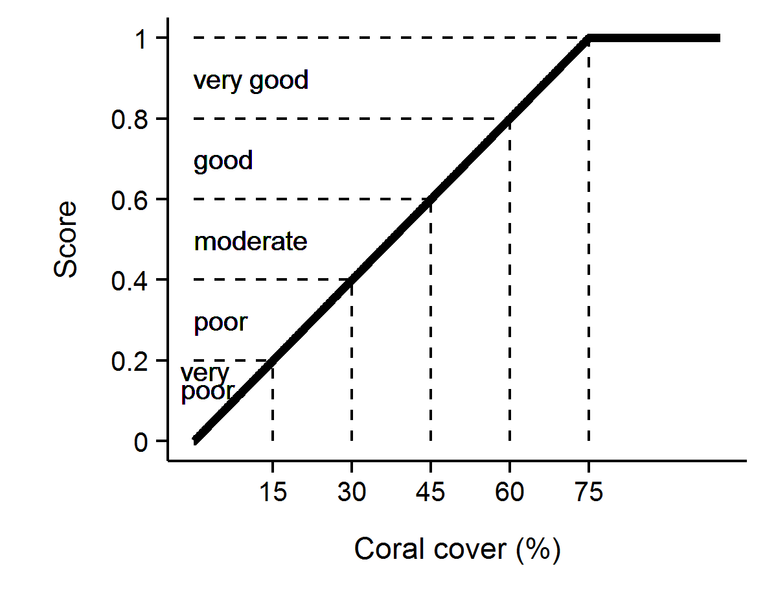
Figure 3 Scoring diagram for the Coral Cover metric. Numeric scores and associated condition classifications based on observed coral cover are presented.

4.6.2 Macroalgae metric
In contrast to coral cover, high cover of macroalgae on coral reefs is widely accepted as representing a degraded state. As opportunistic colonisers, macroalgae generally out-compete corals, recovering more quickly following physical disturbances. Macroalgae have been documented to suppress coral fecundity (Foster et al. 2008), reduce recruitment of hard corals (Birrell et al. 2008a, b, Diaz-Pulido et al. 2010) and diminish the capacity for growth among local coral communities (Fabricius 2005). The macroalgae metric considers the proportional representation of macroalgae in the algal community based on cover estimates derived from point intercept transects and is calculated as;
${MAproportion}_{ij}$ = ${MA}_{ij}$ / $A_{ij}$
Where $A$= percent cover of all algae, $i$ = reef, $j$ = time and $MA$ = percent cover of macroalgae.
For the purpose of calculating this metric, the collective term macroalgae defines a broad functional grouping that combines species clearly visible to the naked eye although excluding crustose coralline and fine filamentous or “turf” forms. In addition, as macroalgae show marked differences in abundance across the naturally steep gradient of environmental conditions within the inshore Reef, separate upper and lower thresholds were estimated for each reef and depth (Table A1. 1). The use of separate thresholds ensures the indicator is sensitive to changes likely to occur at a given reef. The thresholds for each reef were determined based on predicted MAproportion from Generalised Boosted Models (Ridgeway 2007) that included mean MAproportion over the period 2005-2014 as the response and long-term mean chlorophyll a concentration, suspended sediment concentration, and proportion of clay and silt sized grains in reefal sediments as covariates (Thompson et al. 2016). An additional consideration in setting the upper threshold for MAproportion was the ecological influence of macroalgae on other indicators of coral community condition. Regression tree analyses that included MAproportion as the predictor variable indicated reduced levels of the indicator metrics juvenile density, coral cover and the rate of change in coral cover at higher levels of MAproportion (Thompson et al. 2016). These thresholds for ecological impacts cap informed the setting of upper bounds of MAproportion across all reefs at 23% at 2 m and a 25% at 5 m. The upper bounds for any reefs with predicted MAproportion higher than these caps were reduced to the cap level.
Scores for Macroalgae metric were scaled linearly from 0 when MAproportion is at or above the upper threshold through to 1 when MAproportion is at or below the lower threshold (Figure 4).
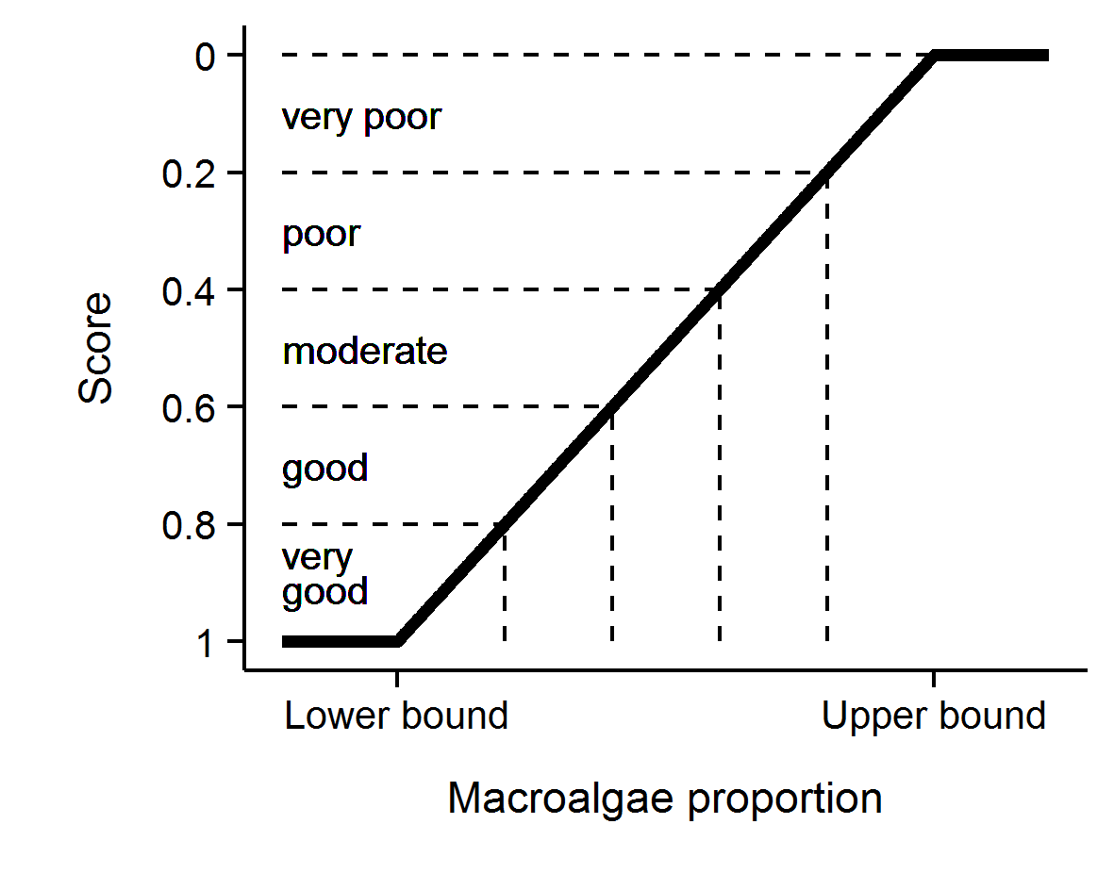
Figure 4 Scoring diagram for the Macroalgae metric. Upper and lower threshold values are reef and depth specific. Numeric scores and associated condition classifications are presented

4.6.3 Density of juvenile hard corals metric
For coral communities to recover rapidly from disturbance events requires adequate recruitment of new corals into the population. This metric scores the important recruitment process by targeting corals that have survived the early life stages. With the inclusion of LTMP data into the coral index, juvenile count data were subset to only include colonies up to 5 cm in diameter as this size class is common to both MMP and LTMP sampling. Counts of juvenile hard corals were converted to density per m² of space available to settlement as;
${Juvenile density}_{ij}$ = $J_{ij}$ / ${AS}_{ij}$
Where, $J$= count of juvenile colonies < 5 cm in diameter, $i$ = reef, $j$ = time and $AS$ = area of transect occupied by algae as estimated from the co-located photo point intercept transects.
Selection of thresholds for the scoring of this metric was based on the analysis of recovery outcomes for MMP and LTMP reefs up to 2014 (Thompson et al. 2016). From these time series a binomial model was fit to juvenile densities observed at times when coral cover was below 10% and categorised on the basis of recovery rate as being either below or above the predicted lower estimate of hard coral cover increase as estimated by the Cover Change indicator described below. This analysis identified a threshold of 4.6 juveniles per m⁻² beyond which the probability that coral cover would subsequently increase at predicted rates outweighed the probability of lower than predicted rates of recovery. Adding some weight to this result is that it was broadly consistent with the density of 6.3 juveniles per m⁻² in the wider size range <10 cm, necessary for recovery in the Seychelles (Graham et al. 2015). As the upper density of juvenile colonies is effectively unbounded, it was desirable to set an upper threshold for scoring purposes. The density at which the probability was > 80% for coral cover to recover at predicted rates was 13 juveniles per m⁻² and this density was chosen as the upper threshold. Based on this analysis, this metric was scored as follows; juvenile density was scaled linearly from 0 at a density of 0 through to 0.4 at a density of 4.6 colonies m⁻² then linearly through to a score of 1 when the density was 13 colonies per m⁻² or above (Figure 5).
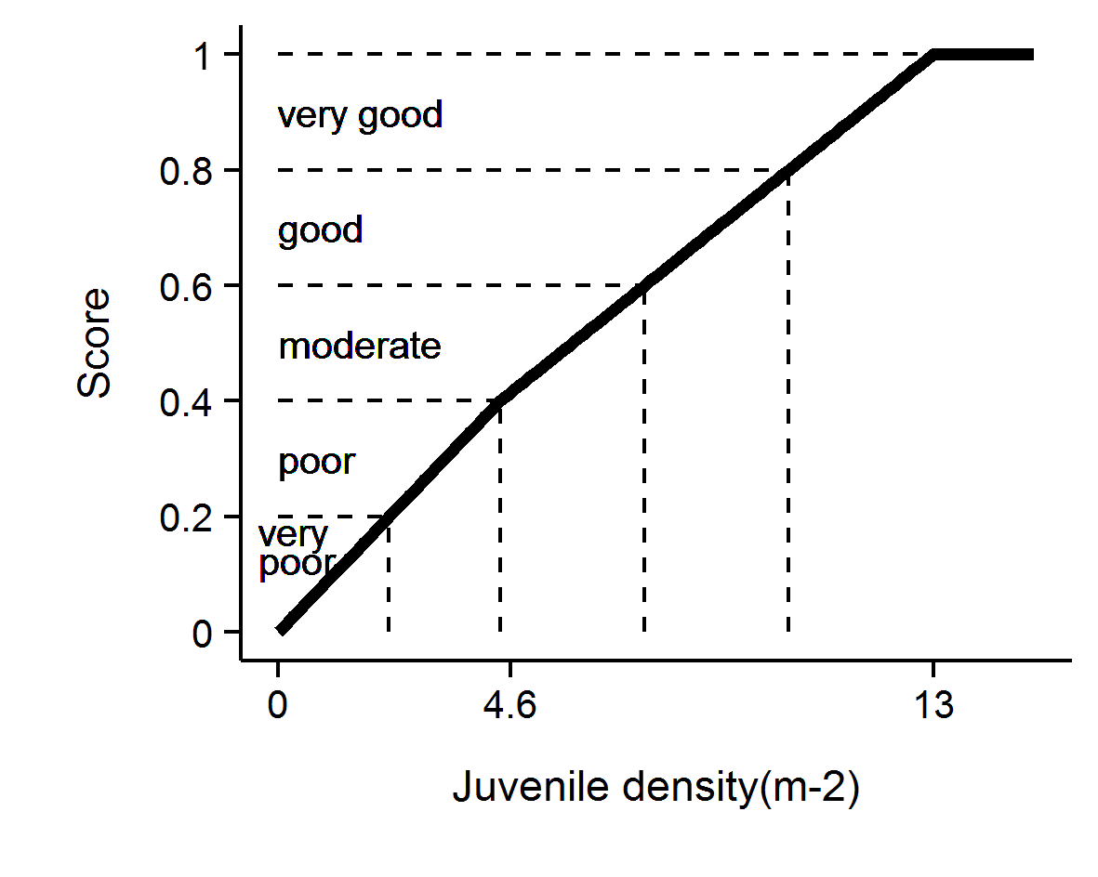
Figure 5 Scoring diagram for the Juvenile metric. Numeric scores and associated condition classifications are presented.

4.6.4 Cover Change metric
A second avenue for recovery of coral communities is the growth of corals during periods free from acute disturbance. Chronic pressures associated with water quality may suppress the rate that coral cover increases and indicate a lack of resilience. The change in coral cover indicator score is derived from the comparison of the observed change in coral cover between two visits and the change in cover predicted by Gompertz growth equations parameterised from time-series of coral cover available on inshore reefs up until 2007. Gompertz equations were parameterised separately for the fast growing corals of the family Acroporidae and the slower growing combined grouping of all other hard corals at each of 2 m and 5 m depths. Years in which disturbance events occurred at particular reefs preclude the estimation of this indicator as there is no expectation for increase in such situations. A Bayesian framework was used to permit propagation of uncertainty through the predictions of expected coral cover increase from the two separately predicted coral types.

$\ln\left({Acr}_{it}\right) \sim N(μ_{it},σ^{2})$
$μ_{it}=v{Acr}_{i}+\ln\left({Acr}_{it-1}\right)+\left(-\frac{v{Acr}_{i}}{\ln\left(estK_{i}\right)}\right)*ln⁡({Acr}_{it-1}+ {OthC}_{it-1}+ {Sc}_{it-1})$
$v{Acr}_{i}= α+ \sum_{j=0}^{J}{β_{j}{Region}_{i}}\sum_{k=0}^{K}{γ_{k}{Reef}_{i}}$
$α \sim N(0,{10}^{6})$
$β_{j} \sim N(0, σ_{Region}^{2})$
$γ_{k} \sim N(0, σ_{Reef}^{2})$
$σ^{2},σ_{Region}^{2},σ_{Reef}^{2}= U(0,100)$
$rAcr=v{\overline{A}cr}_{i}$

Where ${Acr}_{it},{OthC}_{it}$ and ${Sc}_{it}$ are the cover of Acroporidae coral, other hard coral and soft coral respectively at a given reef at time ($t$). $eskK$ is the community size at equilibrium (100) and $rAcr$ is the rate of increase (growth rate) in percent cover of Acroporidae coral. Varying effects of Region and Reef ($β_{j}$ and $Υ_{k}$ respectively) were also incorporated to account for spatial autocorrelation. Model coefficients associated with the intercept, Region and Reef ($α_{i}, β_{j}$ and $Υ_{k}$) all had weakly informative Gaussian priors, the latter two with model standard deviation). The overall rate of coral growth$rAcr$, constituted the mean of the individual posterior rates of increase for ${vAcr}_{i}$ .
As model predictions relate to annual changes in coral cover, observed cover was adjusted to an estimated annual change since the previous observation (${Acr}_{adj}$) prior to comparison to modelled estimates. Adjusted values, ${Acr}_{adj},$ where estimated as per the following formula
$${Acr}_{adj}={Acr}_{i-1}+({Acr}_{i}{-Acr}_{i-1})*(365/(days between samples)$$
Where cover declined no adjustment was made and ${Acr}_{adj}$ assumed ${Acr}_{i}$ .
Note, the above formulae apply to the family Acroporidae (Acr) and have the same form as those applied for Other Corals (OthC) if these terms are exchanged where they appear in the equations.
Gompertz models were fitted in a Bayesian framework to facilitate combining growth rates and associated uncertainties across models. A total of 20,000 MCMC sampling interactions across three chains with a warm up of 10,000 and thinned to every fifth observation resulted in well mixed samples from stable and converged posteriors (all rhat values less than 1.02).Model validation did not reveal any pattern in the residuals. Bayesian models were run in JAGS (Plummer 2003) via the R2jags package (Su & Yajima 2015) for R.
The posteriors of Acroporidae predicted cover and Other Coral predicted cover were combined into posterior predictions of total coral cover from which the mean, median and 95% Highest Probability Density (HPD) intervals were calculated.
As changes in coral cover from one year to the next are relatively small, and in light of the biennial sampling design, the indicator value is averaged over recovery periods (changes in cover not impacted by acute disturbance) for a four year period culminating in the reporting year.
To convert this indicator to a metric the following process was applied (Figure 6):
- If coral cover declined between surveys, a score of 0 was applied.
- If cover change was between 0 and the lower HPD interval of predicted total cover change, scores were scaled to between 0.1 when no change was observed through to 0.4 when change was equal to the lower interval of the predicted change.
- If cover change was within the upper and lower HPD intervals of the predicted change the score was scaled from 0.4 at the lower interval through to 0.6 at the upper interval.
- If cover change was greater than the upper HPD interval of predicted change and less than double the upper interval, scores where scaled from 0.6 at the upper interval to 0.9 at double the upper interval.
- If change was greater than double the upper HPD interval, a score of 1 was applied.

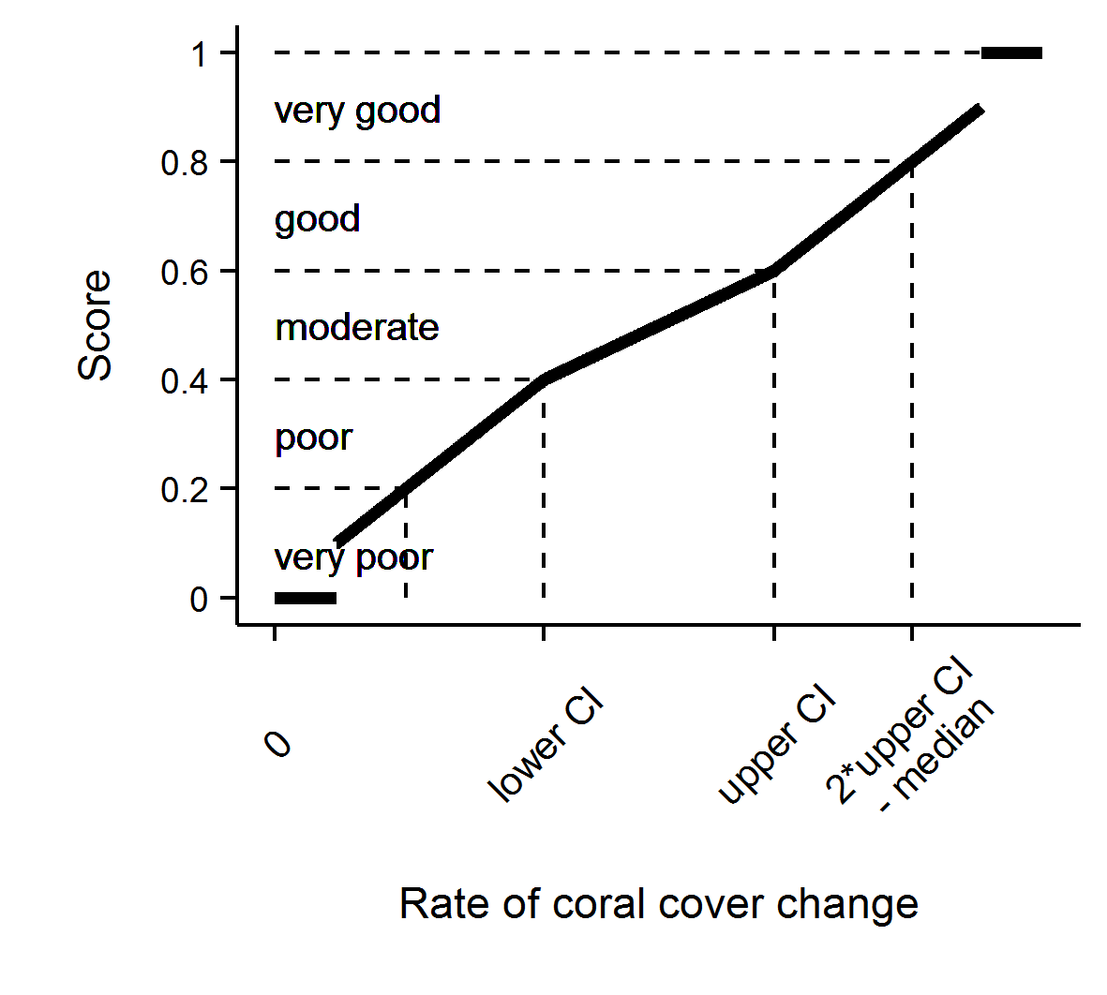
Figure 6 Scoring diagram for Cover Change metric

4.6.5 Community Composition metric
The coral communities monitored by the MMP vary considerably in the relative composition of coral species (Uthicke et al. 2010, Thompson et al. 2014b). As demonstrated by Uthicke et al. (2010) and Fabricius et al. (2012), some of this variability can be attributed to differences in environmental conditions between locations, which implies selection for certain species based on the environmental conditions experienced. Coral communities respond to environmental conditions in a variety of ways. Most noticeably they respond to acute shifts in conditions such as exposure to substantially reduced salinity (van Woesik 1991, Berkelmans et al. 2012), deviations from normal temperature (Hoegh-Guldberg 1999) or hydrodynamic conditions (cyclones); all of which result in reductions in coral cover as susceptible species are killed. In contrast, the increased loads of sediments and nutrients entering the Reef as a result of land use practices in the adjacent catchments (Waters et al. 2014) may include a combination of acute conditions associated with flood events and then chronic change in conditions as pollutants are cycled through the system. Chronic change in conditions, such as elevated turbidity or nutrient levels, could provide a longer period of selective pressures as environmental conditions disproportionately favour recruitment and survival of species tolerant to those conditions.
This metric compares the composition of hard coral communities at each reef to a baseline composition at that reef and interprets any observed change as being representative of communities expected under improved or worsened water quality. The basis of the metric is the scaling of cover for constituent genera (subset to life-forms for the abundant genera Acropora and Porites) by weightings that correspond to the distribution of each genus along a gradient of turbidity and Chl a concentration as determined by Canonical Analysis of Principal Coordinates (partial CAP; Anderson & Willis 2003) applied to MMP data (Thompson et al. 2014b, Table A1. 2) as:
$$C_{t}= \sum_{i=1}^{n}{H_{it}*G_{i}}$$
Where $C_{t}$ = the community composition location on along the water quality gradient at time $t$,
$H_{it}$ = the Hellinger transformed cover of genus $i$ at time $t$, and
$G_{i}$ = the score for genus $i$ taken from Table A1. 1.
Indicator metric scores are assigned based on the location of $C_{t}$ for the year of interest relative to a community specific baseline. The baseline for each community is bounded by the 95% confidence intervals about the mean $C_{t}$ from the first five years of observations of the community at each reef and depth. The scoring of the metric is categorical being 0.5 when $C_{t}$ falls within the 95% confidence intervals for the location, 1 if beyond the confidence interval in a direction toward communities representative of lower turbidity and Chl a concentrations, and 0 if beyond the confidence interval in the direction of communities representative of higher turbidity and Chl a concentrations (Figure 6).
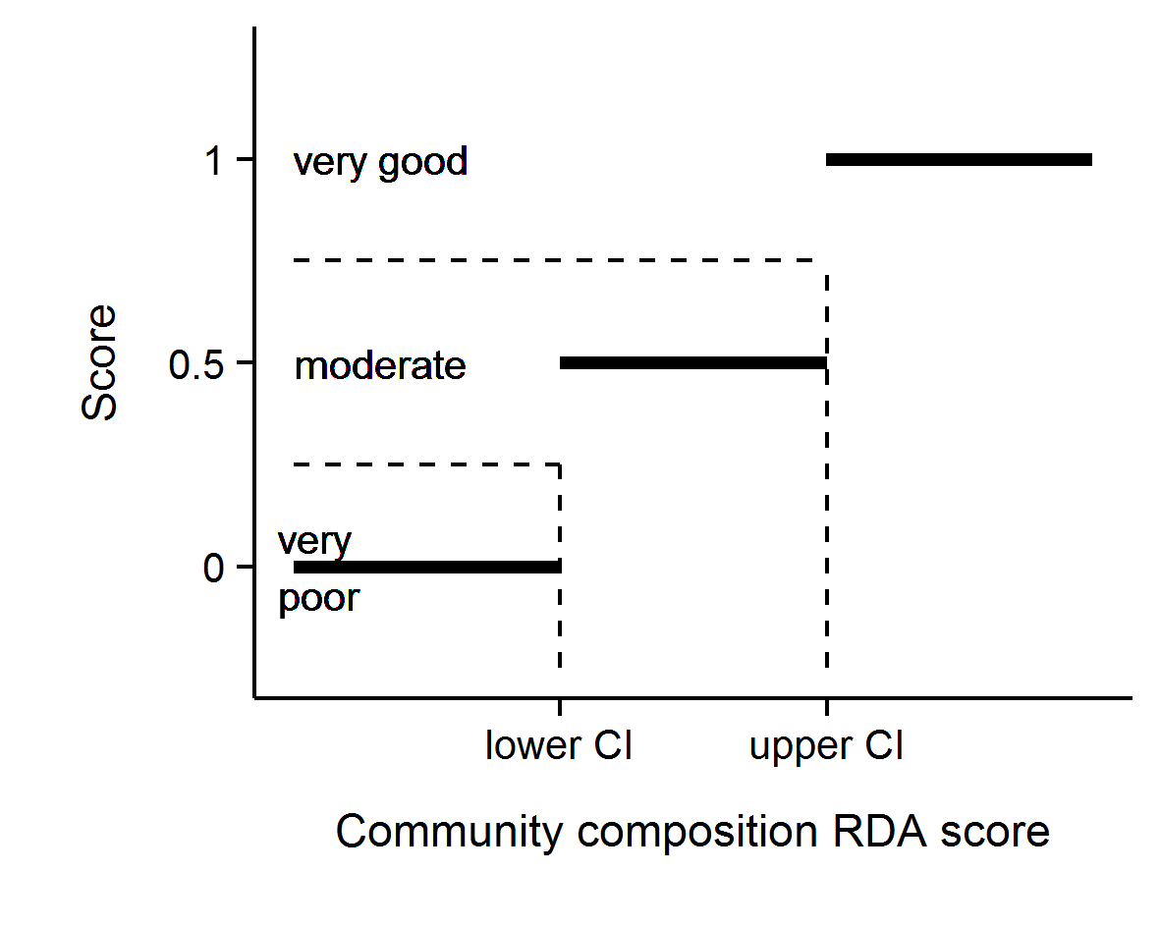
Figure 7 Scoring diagram for Community Composition metric

4.6.6 Aggregating indicator scores to regional scale assessments
In aggregating scores for various indicators into a single index uncertainty should be considered. The degree of uncertainty in an index score derived for any spatial scale of interest will include uncertainty across multiple levels: from basic observational error, the relevance of thresholds and then variation in scores for different indicators or communities being assessed.
In order to derive report card scores for regions that propagated uncertainty through the double hierarchical aggregation of indicators and then reefs, a bootstrapping method was adopted. Firstly, for each indicator a distribution of 10,000 observations was created by resampling (with replacement) from the observed scores for all reef and depth combinations within the Region. For the Wet Tropics where there are three sub-regions, an additional step involved the adding together the 10,000 strong distributions for each indicator from each sub-region and resampling the resulting distributions (with replacement) 10,000 times to derive a single 10,000 strong distribution for each indicator at the regional scale. Secondly these 5 resulting distributions (one for each indicator) were added together and collectively resampled 10,000 times (with replacement) to derive a single distribution comprising 10,000 scores. Importantly, the large number of resamples ensures that the distributions accurately reflect the underlying data distributions and yet comprise a known number of items independent of the original input sizes. This ensures that all inputs have equal weights and aggregations are not biased towards inputs with more data (for example, all reefs and sub-regions contribute equally to region level aggregations despite their being more reefs in some sub-regions than others).
The mean of the resulting distribution for the (sub-)region was taken as the coral health index score. Confidence intervals are typically based on estimates of precision (such as standard error) rather than variance. Precision is itself an estimate of repeatability - in the case of precision of a mean; it is an estimate of the variance of repeated means. Hence, we can estimate precision by repeatedly resampling from the distribution and each time calculating a mean. However, the more times the distribution is resampled, the more means are generated and thus the lower the variance of means.
To generate estimates of precision (and thus confidence intervals) appropriate for the scale of the sampling design, the bootstrapped distribution of 10,000 scores was resampled once for every original input metric score
Confidence intervals were calculated as the 2.5% and 97.5% quantiles of repeated means.
Lastly index scores were converted to qualitative assessments by converting to a five point rating and colour scheme with scores of:
- 0 to 0.2 were rated as ‘very poor’ and coloured red
- >0.2 to 0.4 were rated as ‘poor’ and coloured orange
- >0.4 to 0.6 were rated as ‘moderate’ and coloured yellow
- >0.6 to 0.8 were rated as ‘good’, and coloured light green
- >0.8 were rated as ‘very good’ and coloured dark green.

The indicators and the associated thresholds and scoring system utilised is summarised in Table 5. We note that the community composition indicator is likely to respond over longer time frames than the other indicators due to the inertia in community composition imposed by long lived coral species.

Table 5 Threshold values for the assessment of coral reef condition and resilience indicators.
Community attribute | Score | Thresholds
Combined hard and soft coral cover | Continuous between 0-1 | 1 at 75% cover or greater
Combined hard and soft coral cover | Continuous between 0-1 | 0 at zero cover
Rate of increase in hard coral cover (preceding 4 years) | 1 | Change > 2x upper 95% CI of predicted change
Rate of increase in hard coral cover (preceding 4 years) | Continuous between 0.6 and 0.9 | Change between upper 95% CI and 2x upper 95% CI
Rate of increase in hard coral cover (preceding 4 years) | Continuous between 0.4 and 0.6 | Change within 95% CI of the predicted change
Rate of increase in hard coral cover (preceding 4 years) | Continuous between 0.1 and 0.4 | Change between lower 95% CI and 2x lower 95% CI
Rate of increase in hard coral cover (preceding 4 years) | 0 | change < 2x lower 95% CI of predicted change
Proportion of algae cover classified as Macroalgae | Continuous between 0-1 | ≤ reef specific lower bound and ≥ reef specific upper bound
Density of hard coral juveniles (<5 cm diameter) | 1 | > 13 juveniles per m2 of available substrate
Density of hard coral juveniles (<5 cm diameter) | Continuous between 0.4 and 1 | 4.6 to 13 juveniles per m2 of available substrate
Density of hard coral juveniles (<5 cm diameter) | Continuous between 0 and 0.4 | 0 to 4.6 juveniles per m2 of available substrate
Composition of hard coral community | 1 | Beyond 95% CI of baseline condition in the direction of improved water quality
Composition of hard coral community | 0.5 | Within 95% Confidence intervals of baseline composition
Composition of hard coral community | 0 | Beyond 95% CI of baseline condition in the direction of declined water quality

4.7 Coral reef data analysis and presentation
The presentation of coral community condition is presented in four sections (Table 6).
Table 6 Presentation of community condition
Section | Scope | Scale | Covariates | Analyses/Presentation
1 | Trends in coral index and metric scores | Regional |  | Coral index derivation/ Observed trends
5.1.1 Regional differences 5.1.2 Effect of depth | Spatial variability in coral index and individual metric scores observed in 2017 | Inshore GBR | Region and Depth | Bayesian generalised regression models / Estimated effect
5.1.3 Response to environmental gradients |  | Inshore GBR | Chl a, Non-algal particulate concentration, sediment grainsize | Gradient boosted regression trees/ Predicted relationships
5.1.4 Influence of discharge and catchment loads | Temporal variability in coral index in relation to runoff | Regional | Regional riverine discharge, Total N and Total P loads, Chl a exposure, NAP concentration | Generalised Additive Models/ Predicted relationships
5.2 Regional condition of coral communities | Observed trends in coral index and individual indicators | Regional | Time | Linear mixed models/ Predicted regional trends and observed reef trends
Appendix 1: Additional Information | Trends in benthic community composition. | Reef/Depth |  | /Plots and Tables of observations
Appendix 1: Additional Information | Summaries of 2017 observations | Reef/Depth |  | /Observed values

4.7.1 Variation in index and metric scores among regions and depths
Spatial variation in index and metric scores where explored using Generalized Linear Multilevel models. For the index and each individual metric, separate models were fit that included either a single factor for region or the interaction between region and depth as covariates. The model for depth also included a random term for individual reefs. Data were modelled assuming a Beta response distribution to conform to score ranges between 0 and 1. For individual metrics, scores of 0 and 1 were observed requiring a minor transformation of the observed scores of the form ((Score*0.998) + 0.001) prior to analysis. Weekly informative normally distributed (mean 0, standard deviation 10) priors were applied to model parameters and Cauchy distributed (mean 0, standard deviation 1) priors were applied to random effects. A total of 5,000 Markov-chain Monte Carlo (MCMC) samples were collected for each of three chains with a thinning rate of 5. Mean difference among levels of covariates were reported based on 95% credible intervals predicted from posterior distributions of model parameters. All modelling was conducted using the BRM package in R (R Core Team, 2015).
The community composition metric is scored categorically and spatial differences in this metric were based on multinomial models

4.7.2 Variation in index and metric scores to gradients in water quality
Environmental drivers of variation in index and indicator scores in 2017 were explored via generalised linear models. Each combination of indicator score and depth were fit separately to the two water quality proxies Chl a and NAP. The index scores are bound by 0 and 1 and were scaled as (Score*0.998) + 0.001) prior to analysis to allow them to be modelled assuming a beta distribution. The exception was the composition metric that was modelled as probit regression due to the categorical response. For each combination of indicator score and water quality proxy the relationship was modelled with either a nonparametric smoothing term parameterised as a penalised beta spline applied to the water quality proxy, a simple linear relationship and a null, intercept only model. Evidence for a curvilinear, linear or no relationship between indicator scores and water quality proxies were inferred based on comparison between AICc estimates from the three models. Where relationships were indicated the predicted response was plotted. Generalised linear models were fit via the gamlss package (Stasinopoulos et al. 2017) while the probit model for Composition was fit with the polr function in the MASS package within the R Statistical and Graphical Environment (R Core Team 2017).

4.7.3 Relationship between index and metric scores and temporal variability in environmental conditions
The response of coral communities to variation in environmental conditions was assessed by comparing changes in index scores to: annual discharge and total N and P loads estimated from the adjacent catchments, exposure to above GL concentrations of Chl a over the wet season and NAP concentrations. For these analyses Generalised Additive Models (GAMs) were applied separately to results from each Region. The response variable was the biennial change in the index score (I) at a given reef (r) from one year (y) to the year (y+2). Biennial changes were considered due to the biennial sampling design of the program.
$$ΔI = I_{ry+2}– I_{ry}$$
Similarly the covariate in each model were summed over the two water years ending in the survey year (y+2). To reduce confounding between the response of the index to acute disturbances, observations of change in the index at reefs categorised as being influenced by an acute disturbance event in a given biennial period were excluded. In the first instance, GAMs allowed for the fitting of non-linear responses using natural splines; when these models did not support non-linear response, simple linear models were used. All GAM models were fit via the mgcv package (Wood 2011) and linear models were fit via the stats package within the R Statistical and Graphical Environment (R Core Team 2017).

4.7.4 Temporal trends in coral index, indicators and measured water quality.
A panel of plots provide temporal trends in the coral index and the five indicators on which the index is based. The derivation of annual coral index scores and associated confidence intervals is detailed in the following section (4.7).
For each of the five indicators that inform the coral index, temporal trends and their and 95% confidence intervals were derived from linear mixed effects models. Models for each indicator included a fixed effect for year and random effect for each Reef and depth combination. To account for the sampling design, that samples reefs on a biennial cycle, missing data were infilled with observations from the preceding year as is done for the estimation of annual index scores. Observed trends for individual reef and depth combinations (averaged over sites) are provided as grey lines. Trends in key water quality parameters are reproduced in the Appendix from the companion water quality report (Waterhouse et al. 2018) were detailed reporting of these data can be found. Generalized additive mixed models (GAMMs, Wood 2006) were fitted to the water quality variables separately for each NRM region. Trends in these data sets were modeled as thin-plate splines fitted via Generalised Additive Mixed Models (GAMM's). These models incorporated seasonal cyclical cubic splines with sample location set as the random effect. All analyses were carried out using the R statistical package (R Development Core Team 2011).
A more detailed summary of raw data for benthic cover and juvenile density at each reef and depth combination is presented as bar plots in Appendix 1. These additional plots breakdown cover and density of corals to the taxonomic level of Family. Genus level data for the current year only are included in table form, also in Appendix 1.

4.7.5 Analysis of change in index and metric scores
Differences in the index, or individual metric, scores were estimated between focal years identified as local maxima or minima within the time-series of the index scores within each (sub-)region. Confidence in the magnitude of these differences are expressed as a probability that the mean difference in scores was greater or less than zero. Probabilities were estimated based on the location of zero (no difference) within the posterior distribution (n=1000) estimated from the mean and standard deviation of observed differences in scores between focal years. Probabilities were estimated separately for communities at 2 m and 5 m depths.

Results
Results are presented in the following sequence. Firstly, spatial variability in communities in 2017 is related to regional differences, the depth of sampling sites and the location of reefs along water quality gradients. Secondly, changes in index scores in relation to discharge from catchments at a regional scale, and reef level water quality, are presented as a broad approximation of the influence of runoff on coral community resilience. Temporal trends in community attributes are then presented for each (sub-)region along with time-series of data relating to the primary pressures influencing coral communities. Finally, site-specific data and additional information tables are presented in Appendix 1 and may be referred to where specific detail is required.

5.1 Variation of coral index and indicator scores observed in 2017

5.1.1 Regional differences
In 2017 the coral index was lower in the Fitzroy region compared to the three remaining regions. Mean scores continue to remain low for all metrics in the Fitzroy region, particularly when compared to the Wet Tropics. Only the Composition metric scores were not significantly higher in the Wet Tropics compared to Fitzroy, although scores for this metric in the Fitzroy Region were lower than in both the Burdekin and Mackay Whitsunday regions (Table 7, Figure 8). Macroalgae scores in the Mackay Whitsunday region continue to be highest of the four regions and was the only metric differing between this region and the Burdekin. In addition to the Fitzroy region, Coral Cover scores in the Wet Tropics were also higher than the Whitsundays, where tropical cyclone Debbie has had a substantial impact. Cover Change metric scores were also higher in the Wet Tropics than the other three regions on the back of high rates of cover increase in the years preceding the 2017 bleaching event (Table 7, Figure 8).
Table 7 Regional differences in index and metric scores. Tabulated values represent the upper and lower 95% credible limits to the pair-wise comparison of scores between regions. Shading highlights where regional differences in scores were supported on the basis that the distribution of predicted differences excluded zero. Green shading indicates score were higher for the left-hand compared to right-hand region in the first column, red shading indicates higher scores for the right-hand region.
Regions | Index |  | Coral Cover |  | Macroalgae |  | Cover Change |  | Juvenile |  | Composition
 | l | u | l | u | l | u | l | u | l | u | l | u
Burdekin - Wet Tropics | -0.20 | 0.00 | -0.23 | 0.03 | -0.37 | 0.03 | -0.33 | 0.00 | -0.24 | 0.14 | -0.13 | 0.69
Mackay Whitsunday - Wet Tropics | -0.12 | 0.07 | -0.24 | -0.01 | 0.06 | 0.41 | -0.49 | -0.16 | -0.35 | 0.02 | -0.25 | 0.60
Fitzroy - Wet Tropics | -0.39 | -0.21 | -0.30 | -0.03 | -0.44 | -0.06 | -0.54 | -0.16 | -0.45 | -0.05 | -0.63 | 0.06
Mackay Whitsunday - Burdekin | -0.05 | 0.18 | -0.14 | 0.13 | 0.23 | 0.60 | -0.37 | 0.04 | -0.33 | 0.09 | -0.45 | 0.31
Fitzroy - Burdekin | -0.32 | -0.10 | -0.19 | 0.10 | -0.29 | 0.09 | -0.43 | 0.01 | -0.42 | 0.03 | -0.85 | -0.22
Fitzroy - Mackay Whitsunday | -0.38 | -0.16 | -0.18 | 0.12 | -0.67 | -0.31 | -0.23 | 0.20 | -0.30 | 0.13 | -0.78 | -0.12

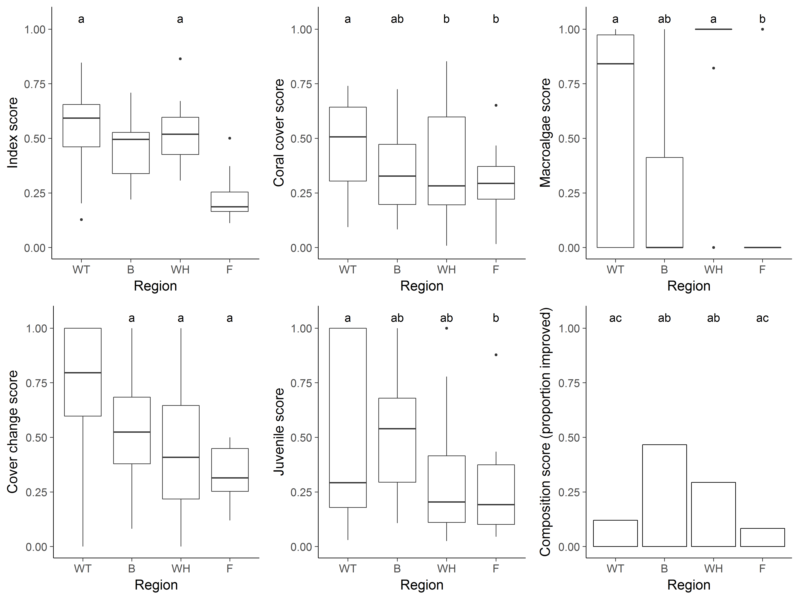
Figure 8 Regional distributions of index and metric scores. Boxplots show the median (bold horizontal line) 25th to 75th percentiles (box) and highest and lowest observations within 1.5 times the distance length of the box from the upper and lower box margins (vertical lines), observations beyond these values are represented as dots. For the composition score a bar chart represents the proportion of observations scored as improved (score = 1). Labels above bars or boxplot elements identify regions with statistically similar distributions.

5.1.2 Effect of depth
Index scores observed in 2017 did not differ consistently between 2 m and 5 m depths (Table 8). Of the individual indicator metrics the Juvenile scores were higher at 2 m than at 5m in both the Wet Tropics and Burdekin regions (Table 8).
Table 8 Influence of depth on index and metric scores. Tabulated values represent the upper (u) and lower (l) 95% credible limits to the pair-wise comparison of scores between 2 m and 5 m depths within each region. Shading highlights where depth differences in scores were supported on the basis that the distribution of predicted differences excluded zero. Green shading indicates scores were higher at 2 m depths, red shading indicates scores were higher at 5 m depth.
Regions | Index |  | Coral Cover |  | Macroalgae |  | Juvenile |  | Cover Change |  | Composition
 | l | u | l | u | l | u | l | u | l | u | l | u
Wet Tropics | -0.04 | 0.15 | -0.07 | 0.15 | -0.21 | 0.29 | 0.03 | 0.38 | -0.09 | 0.24
Burdekin | -0.07 | 0.20 | -0.08 | 0.22 | -0.36 | 0.25 | 0.08 | 0.50 | -0.33 | 0.25
Mackay Whitsunday | -0.07 | 0.20 | -0.04 | 0.25 | -0.19 | 0.27 | -0.09 | 0.34 | -0.44 | 0.10
Fitzroy | -0.17 | 0.08 | -0.04 | 0.25 | -0.34 | 0.19 | -0.28 | 0.15 | -0.32 | 0.29

5.1.3 Response to environmental gradients
Index scores in 2017 were inversely related to the long-term mean Chl a levels at both 2m and 5m depths (Figure 9a, Figure 10a) highlighting that exposure to above wet season Guideline Chl a concentrations has a negative influence on the condition of inshore reefs. Linear models applied separately to each metric demonstrate that at 2 m depth the Coral Cover and Macroalgae metrics (Figure 9b, d) declined as mean Chl a exceedance increased. At 5 m depth Macroalgae scores showed a similar decline as Chl a exceedance increased (Figure 10b). Also contributing to the decline in index scores with increasing Chl a concentrations at 5 m depth was a higher probability that, over the period of the MMP, coral community composition has shifted toward that expected in poorer water quality, although this relationship was weak as evidenced by the very low pseudo r-square value for the underlying model (Figure 10c). . In addition to a response to Chl a levels the Coral Cover metric showed a nonlinear relationship to NAP concentration. For the most part Coral Cover scores tend to decline at as mean NAP levels increase (Figure 9c). This relationship is not monotonic however, due to the relatively high Coral Cover score at Middle Reef in the Burdekin Region which is the only site where mean NAP concentrations of 3.4mgL⁻¹, exceed the mean of 2.3mgL⁻¹ observed at Peak Island in the Fitzroy Region.

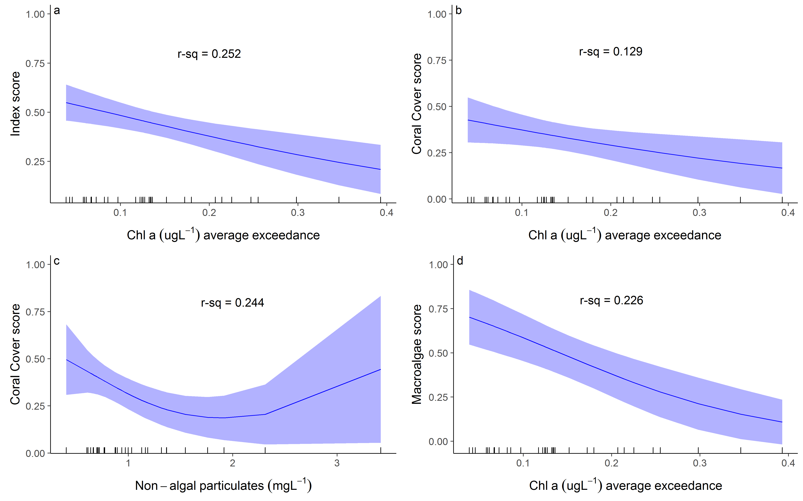
Figure 9 Coral index and metric score relationships to environmental conditions at 2 m depth sites. Only index or metric score and Chl a or NAP combinations for which AICc comparisons to a null model indicated a response are included. Plots present predicted relationship bounded by the 95% confidence intervals of the prediction. R-square values indicate the proportion of variability in scores explained by the predicted relationship.
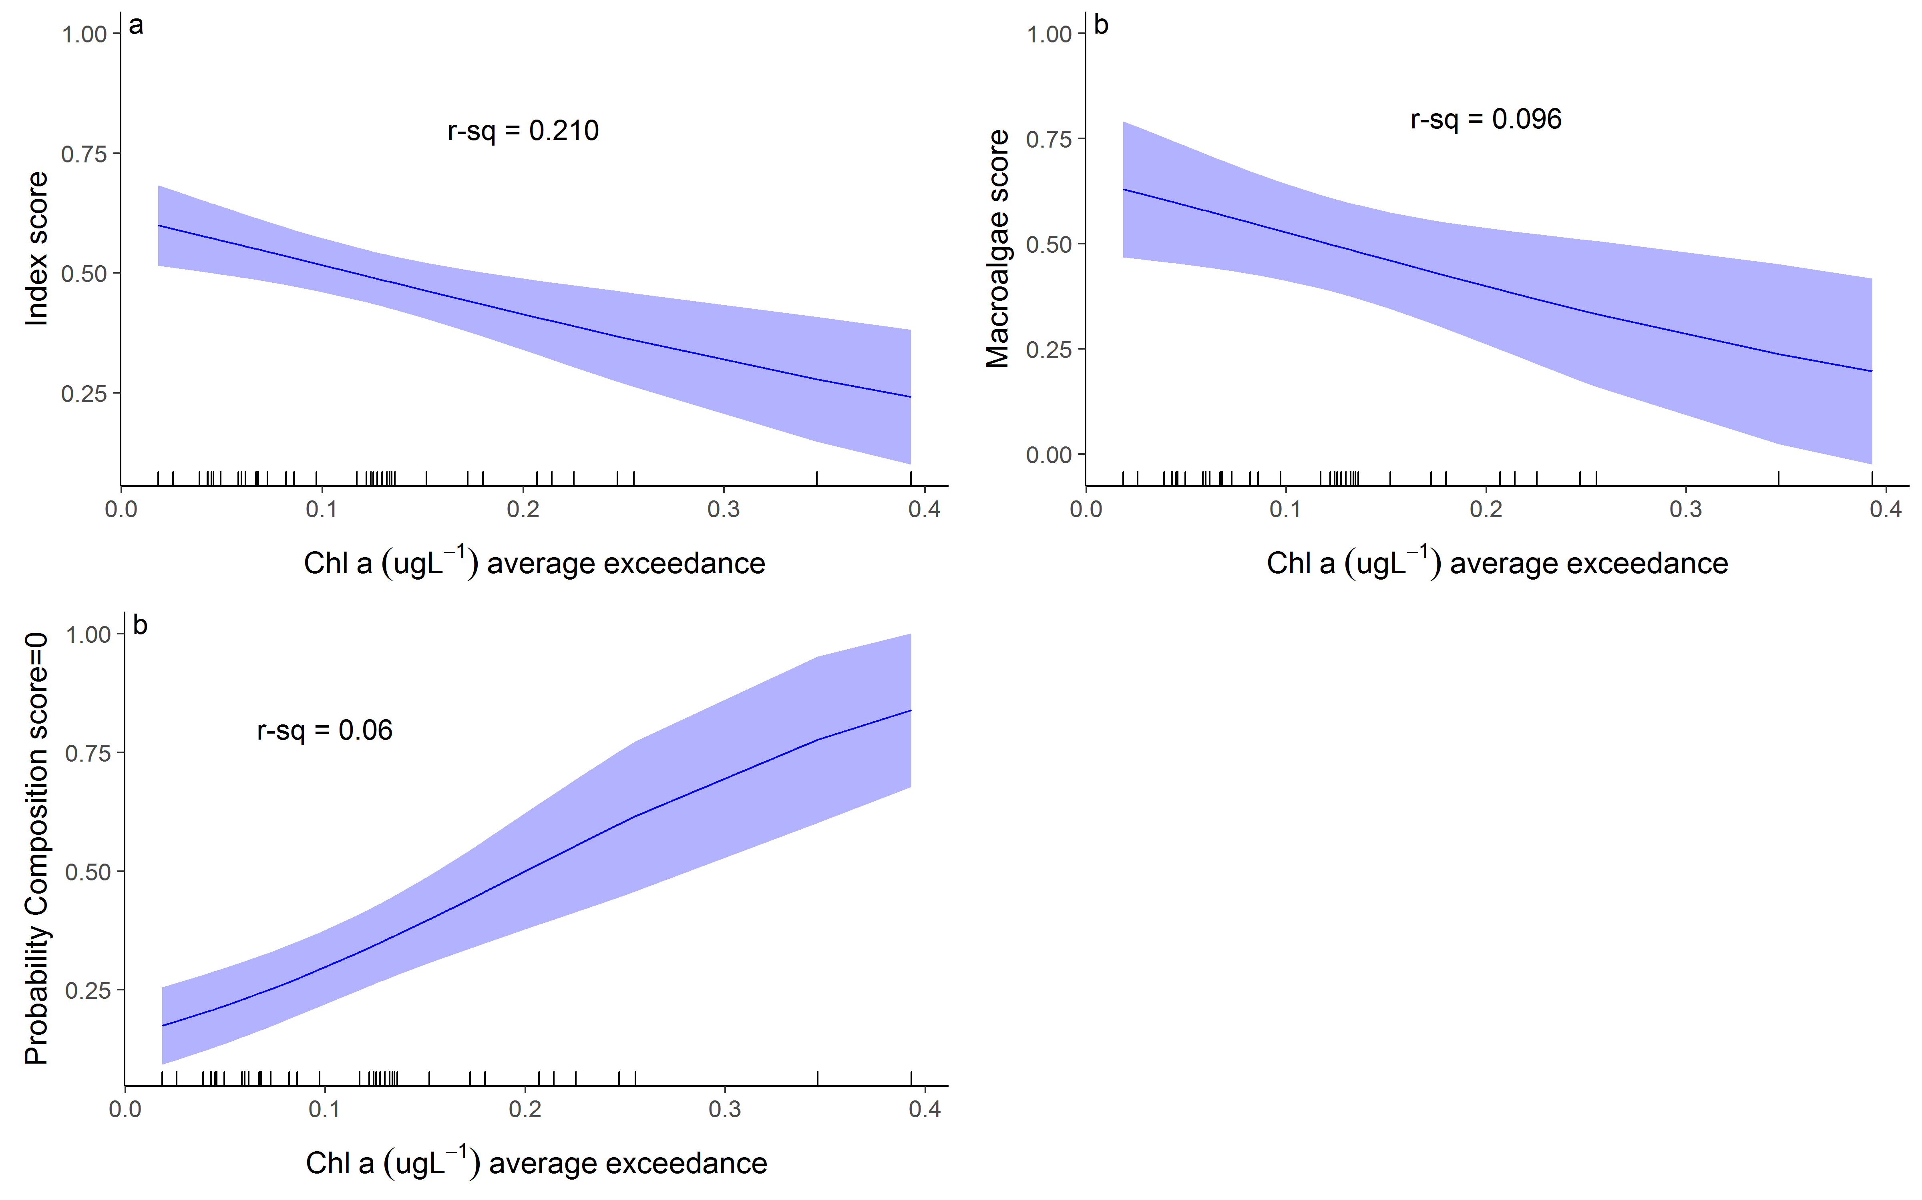
Figure 10 Coral index and metric score relationships to environmental conditions at 5 m depth sites. Only index or metric score and Chl a or NAP combinations for which AICc comparisons to a null model indicated a response are included. Plots present predicted relationship bounded by the 95% confidence intervals of the prediction. R-square values indicate the proportion of variability in scores explained by the predicted relationship.

5.1.4 Influence of discharge and catchment loads
During periods that reefs were not impacted by acute disturbances (cyclones, bleaching, COTS or direct exposure to low salinity floodwaters) biennial change in index scores were negatively related to discharge from the local catchments (Table 9, Figure 11). In both the Burdekin and Fitzroy regions monotonic declines in recovery, measured as biennial change in index scores, were associated with increasing discharge from the region’s catchments as well as increasing exposure to above GL values of Chl a over the summer period (Table 9). In each of the Burdekin, Fitzroy and Wet Tropics regions, loads of N and P captured variation in changes in index scores. Where these relationships were not monotonic the flexibility of the model applied would have contributed to the variance explained. In each case, predicted changes in the index were consistently positive at the lowest nutrient loads. The weakest relationship between index scores and environmental variables occurred in the Mackay Whitsunday region where there was marginal evidence for lower change in index scores during years of high discharge of high turbidity (Table 9).
Table 9 Relationship between changes in index scores and environmental conditions. Tabulated are the model R-square values for each combination of index score change within Regions and environmental covariates. Bold font indicates statistically supported (P-values<0.05) relationships were observed. These relationships were either monotonic higher increase in index scores at lower exposures to the environmental covariate (darker shading), Not monotonic with higher changes in index scores occurred at lower exposures (*), or not monotonic. Lighter shading indicates where monotonic declines in index change corresponded to increasing exposure although the relationship was only weakly supported (P-values between 0.05 and 0.1). Results for Total N and P are based on data provided by the State of Queensland (Department of Science, Information Technology and Innovation) 2016.
Region | Freshwater Discharge | Total N river load | Total P river load | Non algal particulates (reef) | Chlorophyll (reef)
Wet Tropics | 0.15 | 0.105 | 0.159* | 0.052 | 0.088
Burdekin | 0.167 | 0.249* | 0.248* | 0.026 | 0.153*
Mackay Whitsunday | 0.041 | 0.014 | 0.018 | 0.052 | 0.065
Fitzroy | 0.229 | 0.24 | 0.235 | 0.051 | 0.216

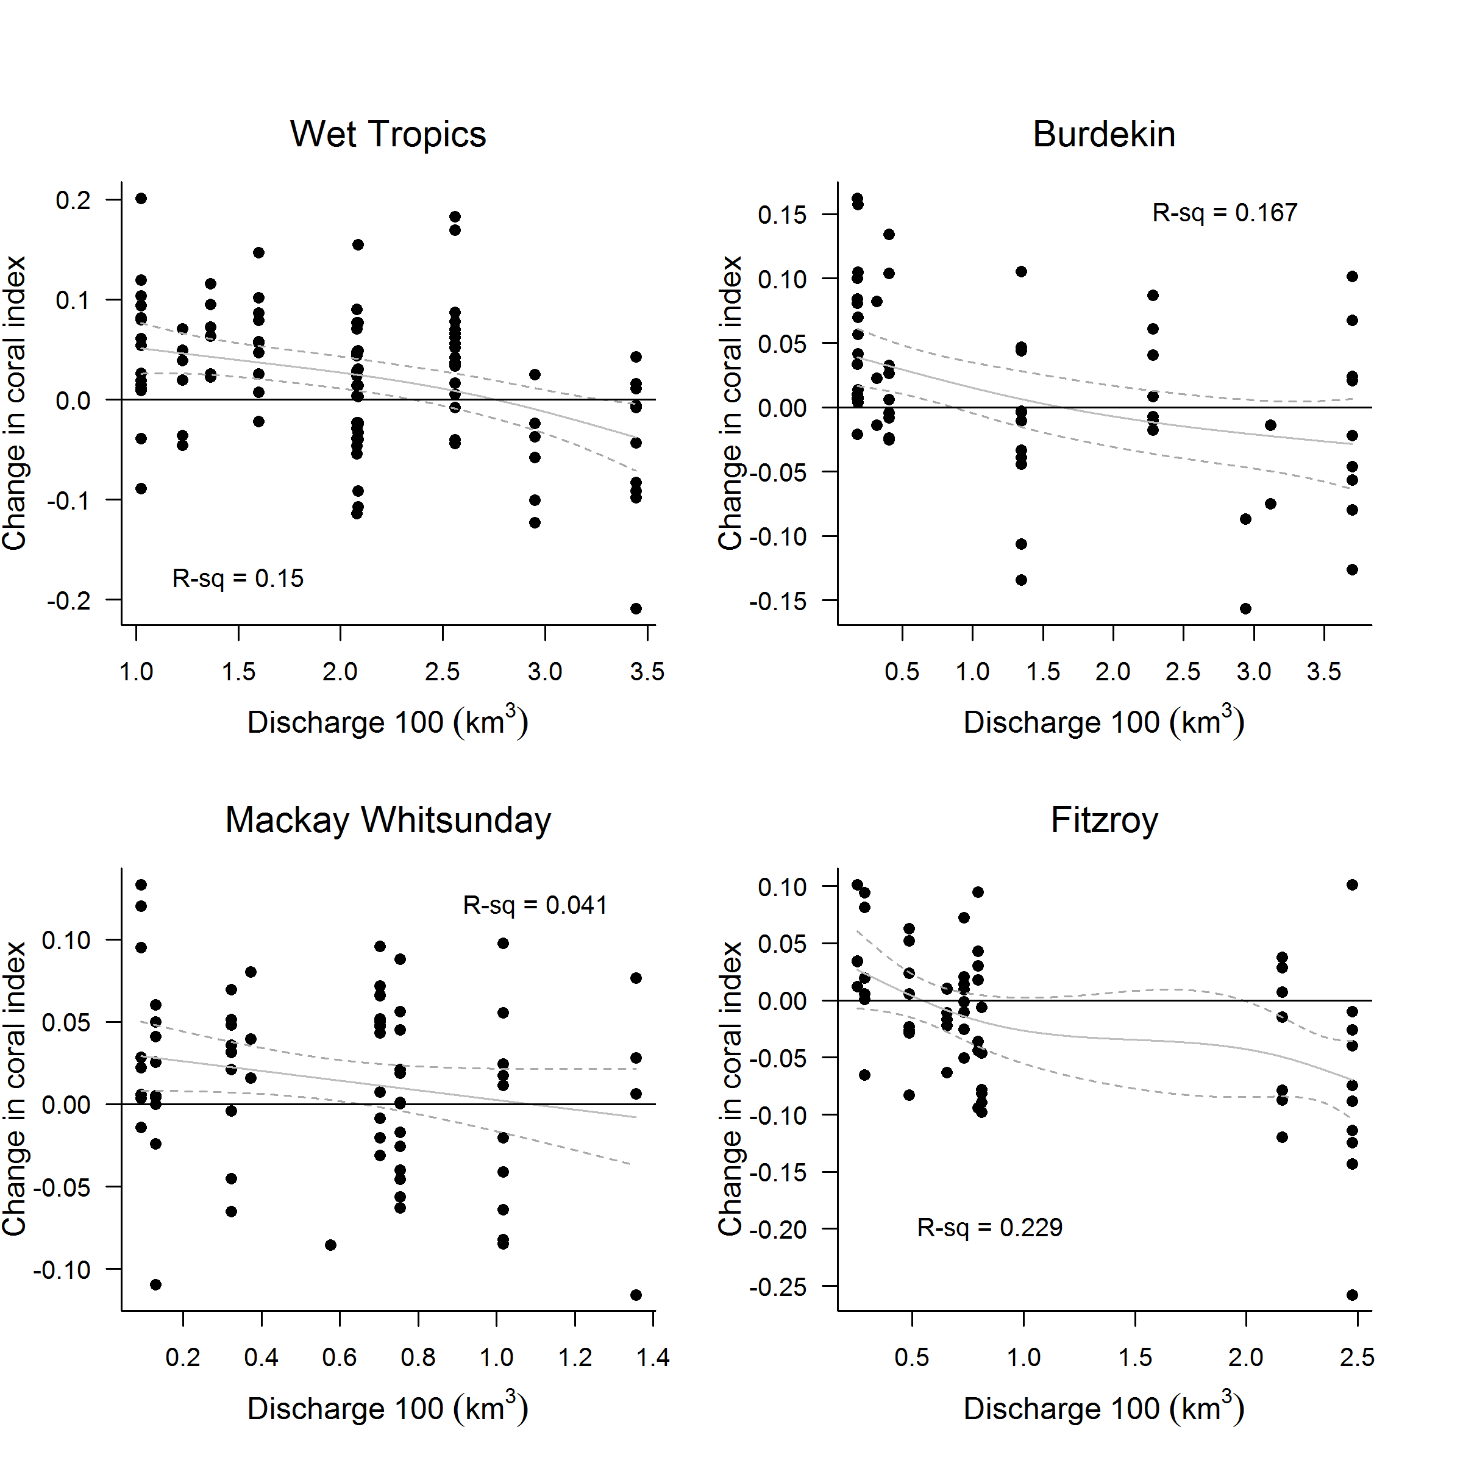
Figure 11 Relationship between the coral index and runoff from local catchments. Plotted points represent observed change in the index score at each reef and depth over a two year period. Observations following for which acute disturbances impacted communities in the period between samples were excluded. Discharge values represent the cumulative discharge from the region’s major rivers over the two year period corresponding to index changes. Trend lines represent the predicted change in index scores (solid line) and the 95% confidence intervals of the prediction (dash lines).

5.2 Regional condition of coral communities

5.2.1 Wet Tropics Region: Barron Daintree sub-region
The coral index remained categorised as ‘moderate’ in 2017 despite a slight decline. (Figure 12, Figure 13). Reduction in the index was most evident at 2 m depth sites where, with the exception of Macroalgae, all metrics showed an overall although inconsistent decline (Table 10). At 5 m depth changes in scores were less consistent, coral composition improved, whilst an increase in macroalgae at Snapper North saw this metric decline (Table 10, Figure A1. 1).
Table 10 Index and metric score comparisons in the Barren Daintree sub-region. Data compare the changes in scores between local maxima and minima in the index time-series. For the index, and each metric, the observed change in the sub-regional score and the probability that the change was greater or less than zero (no change) are presented. Shading is used as a visual aid to highlight the magnitude of the probability the score improved (blue shades) or declined (red shades). Probabilities are derived from the posterior distribution of observed score changes at each reef and depth.
Period | Depth | Index |  | Coral Cover |  | Macroalgae |  | Juvenile Coral |  | Cover Change |  | Composition
Period | Depth | Score | P | Score | P | Score | P | Score | P | Score | P | Score | P
2008 to 2014 | 2 | -0.21 | 0.89 | -0.37 | 0.71 | -0.17 | 0.75 | -0.42 | 0.92 | -0.62 | 0.98 | 0.50 | 1.00
2008 to 2014 | 5 | -0.26 | 0.82 | -0.12 | 0.59 | -0.43 | 0.80 | -0.04 | 0.59 | -0.21 | 0.71 | -0.50 | 1.00
2014 to 2016 | 2 | -0.03 | 0.68 | 0.08 | 0.98 | -0.13 | 0.76 | -0.03 | 0.60 | 0.44 | 1.00 | -0.50 | 0.74
2014 to 2016 | 5 | 0.14 | 0.71 | -0.02 | 0.55 | 0.33 | 0.74 | 0.01 | 0.56 | 0.38 | 0.80 | 0.00 | NA
2016 to 2017 | 2 | -0.05 | 0.82 | -0.02 | 0.68 | 0.05 | 0.76 | -0.03 | 1.00 | -0.04 | 0.79 | -0.25 | 0.76
2016 to 2017 | 5 | -0.03 | 0.58 | 0.00 | 0.51 | -0.32 | 0.74 | 0.06 | 0.62 | -0.06 | 0.70 | 0.17 | 0.70

The decline in the coral index was primarily due to high water temperatures (Figure 12c) that lead to coral bleaching in early 2017. The impacts from bleaching were most evident at Snapper North, where hard coral cover was 58% (2 m) and 37% (5 m) lower than model based projections from observations in 2016 (Figure 12e, Table A1. 4). Conversely, there were small increases in coral cover at Snapper South 2 m depth and at Low Isles (Figure A1. 1). Although the impacts of bleaching were not sufficient to be classified as an acute disturbance at Snapper South, lower than projected rates of increase in cover did contribute to a downturn in the Coral Change metric at that reef. In contrast, the rapid increase in hard coral cover at Low Isles from 21.6% in 2015 to 30.3% in December 2016 contributed to both an increase in the Coral Cover metric and continued maximum score for the Coral Change metric at that reef. As the December 2016 surveys of Low Isles preceded the ensuing bleaching event any impact of bleaching at that reefs remains unassessed, although likely to have been severe based on aerial surveys (Figure 24). Another possible effect of the bleaching event was minor reductions in density of juvenile corals at Snapper Island reefs (Figure 13d, Figure A1. 1). Prior to 2017 bleaching had not impacted the communities monitored in this region since 1998, when again, impacts were more severe at Snapper North than Sapper South (Table A1.1). Following the 201617 event, bleaching now accounts for 6% of observed coral cover losses since 2005 (Figure 12e).
The 2017 bleaching event interrupted the recovery in coral communities that had begun following a series of disturbances through to 2014 (Figures 12e, 13a, Table 10). Although the maximum index score occurred in 2008, scores remained in the ‘good’ range until 2011. The decline between 2011 and 2014 was initiated by a loss of coral cover due to disease (Figure A1. 7) that contributed to decline in the Cover Change metric through to 2014. There was also a marked increase in the cover of macroalgae at Snapper North in 2011 (peaks at 2 m and 5 m reefs, Figure 13c, Figure A1. 1). The continued increase, and persistence, of a high proportion of macroalgae in the algal community at 2 m depth, Snapper North, is consistent with the above guideline levels of Chl a typical of waters surrounding Snapper Island (Figure 12a). It is evident however, that the high proportion of macroalgae must also be influenced by additional processes as the similar water quality at Snapper South does not support similar algal communities.
At Snapper Island low densities of COTS were observed in 2012, pre-empting an outbreak in 2013 when densities reached 288 and 613 individuals per hectare at Snapper North and Snapper South respectively. This outbreak removed between 66% (Snapper North – 5 m depth) and 17% (Snapper South – 5 m depth) of the coral cover with the main losses occurring within the family Acroporidae (Figure A1. 1, Table A1. 4). By 2014, COTS numbers had substantially declined with no individuals recorded at Snapper North and densities reduced to 63 per hectare at Snapper South. No COTS have been observed at Snapper Island since 2015. Low Isles also has a history of COTS outbreaks that we attribute to the loss of 69% of hard coral cover over the period 1997-1999. More recently, COTS were observed in 2013 and 2015 and assumed to have been responsible for the 38% reduction in coral cover in that period (Figure 13b, Table A1. 4, Figure A1. 1). Physical impacts to these reefs were recorded following a severe storm in 2009 and, most significantly, Cyclone Ita in 2014 that removed 65% of the hard coral cover and almost eliminated soft corals form Snapper North (Figure 13b, Table A1. 4, Figure A1. 1). Damage was less severe at Snapper South, though both 2 m and 5 m depths lost a substantial amount of coral (Figure 13b, Table A1. 4, Figure A1. 1). In all, predation by COTS and damage from tropical cyclones and storms remain the most significant contributors to coral loss in this sub-region, accounting for 42% and 32% of the hard coral cover losses since 2005 (Figure 12e).
Despite variability in discharge (Figure 12d), and associated loads of nutrients and sediments delivered from adjacent catchments (Waterhouse et al. 2018), there have been no clear trends in regional water quality in the Barron Daintree sub-region (Figure A1. 9).

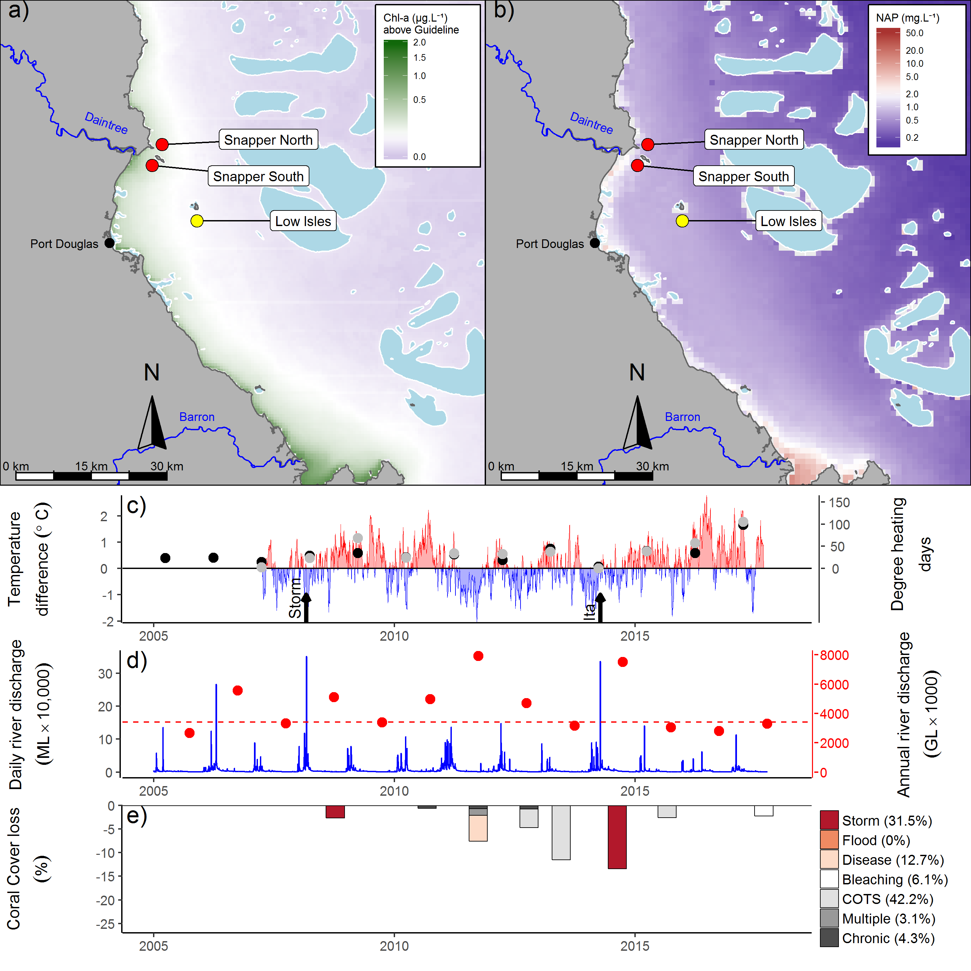
Figure 12 Barron Daintree sub-region environmental pressures. Maps show location of monitoring sites, red symbols MMP, yellow symbols LTMP along with a) mean chlorophyll a exceedance of wet season Guideline (0.63ugL⁻¹) and b) mean Non Algal Particulate concentrations. Water quality data are mean levels over the period 2003-2016 (Chl) and 2003-2017 (NAP). c) Seasonally adjusted temperature deviation, timing of cyclones and storms indicated by black arrows, accumulated degree heating days over the summer period (1st of December - 31st March) as reported by BoM (black symbols) and derived from in situ loggers (grey symbols) d) Combined daily (blue) and annual water year – October to September (red) discharge for the Daintree and Barron rivers, red dashed line represents long-term median discharge (1986-2016). e) break-down of hard coral cover loss by disturbance type; length of bars represent the mean loss of cover across all reefs (see methods section for further detail).

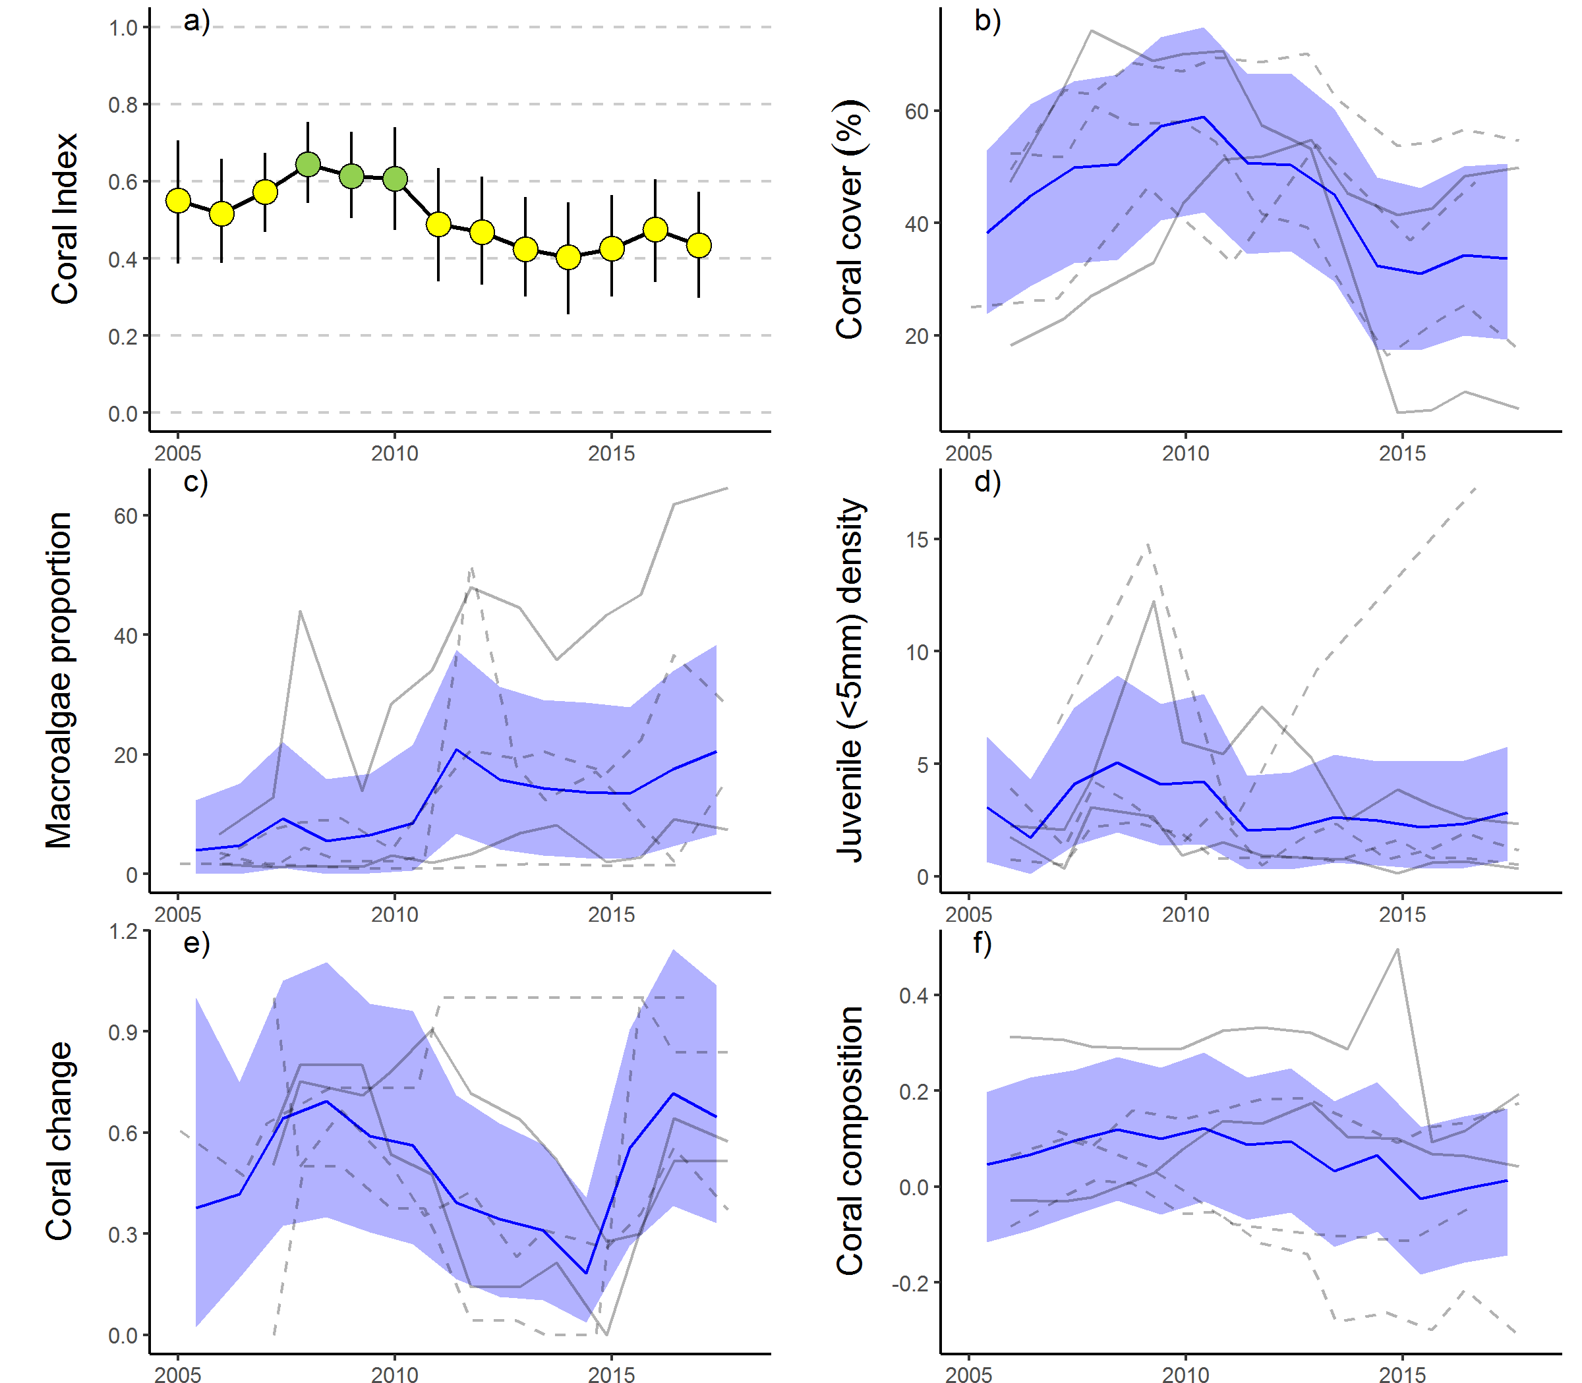
Figure 13 Barron Daintree sub-region index and indicator trends. a) Coral index, colour coding: dark green- ‘very good’; light green-‘good’; yellow – ‘moderate; orange – ‘poor’; red – ‘very poor’. b – f) trends in individual indicators, (blue lines) bound by 95% confidence intervals of those trends (shading), grey lines represent observed profiles at 5 m (dashed) and 2 m (solid) depths for individual reefs.

5.2.2 Wet Tropics Region: Johnstone Russell-Mulgrave sub-region
In 2017 the coral index declined to ‘moderate’ after reaching a ‘good’ classification in 2016 (Figure 15a). These declines are inconsistent among reefs (Table 11), especially at 5m depths where only five of the eight reefs monitored were visited post the 2017 summer. Coral cover declined across the region as did juvenile densities, resulting in decreased scores for both of these metrics, most notably at 2 m depth (Figure 15, Table 11). The influence of these declines on the coral index has been offset by a general improvement in the Cover Change metric. The Cover Change metric is assessed over non-disturbance years and the general improvement in this metric reflects rapid increases in cover observed prior to the 2017 bleaching event. Whilst scores for Macroalgae were generally good across the region, a sharp rise in the proportional cover of macroalgae at Franklands West ensured continued poor scores for the Macroalgae metric at this reef (Figure A1. 2, Table A1. 5). Here, the macroalgal community is dominated by red algae species (Table A1. 9) and this pattern does not clearly reflect poor water quality at this site as conditions are consistently better than those observed at High Island and comparable to those observed at Fitzroy Island where Macroalgae scores are higher (Figure 14a, b, Waterhouse et al. 2018).
Table 11 Index and metric score comparisons in the Johnstone Russell-Mulgrave sub-region. Data compare the changes in scores between local maxima and minima in the index time-series. For the index, and each metric, the observed change in the sub-regional score and the probability that the change was greater or less than zero (no change) are presented. Shading is used as a visual aid to highlight the magnitude of the probability the score improved (blue shades) or declined (red shades). Probabilities are derived from the posterior distribution of observed score changes at each reef and depth.
Period | Depth | Index |  | Coral Cover |  | Macroalgae |  | Juvenile |  | Cover Change |  | Composition
Period | Depth | Score | P | Score | P | Score | P | Score | P | Score | P | Score | P
2009 to 2012 | 2 | -0.21 | 0.92 | -0.24 | 0.85 | -0.21 | 0.70 | -0.12 | 0.82 | -0.22 | 0.71 | -0.25 | 0.73
2009 to 2012 | 5 | -0.13 | 0.78 | -0.14 | 0.86 | -0.04 | 0.55 | -0.12 | 0.83 | -0.10 | 0.61 | -0.25 | 0.71
2012 to 2016 | 2 | 0.20 | 0.92 | 0.29 | 0.93 | 0.04 | 0.55 | 0.07 | 0.91 | 0.27 | 0.66 | 0.33 | 0.80
2012 to 2016 | 5 | 0.06 | 0.72 | 0.14 | 0.75 | -0.10 | 0.74 | 0.16 | 0.83 | 0.22 | 0.71 | -0.06 | 0.52
2016 to 2017 | 2 | -0.06 | 0.76 | -0.18 | 0.90 | 0.09 | 0.66 | -0.11 | 0.84 | 0.09 | 0.74 | -0.17 | 0.74
2016 to 2017 | 5 | -0.01 | 0.53 | -0.10 | 0.81 | 0.06 | 0.66 | -0.06 | 0.78 | 0.10 | 0.77 | 0.00 | 0.50

The decline in the index, and in particular coral cover, resulted in response to the high water temperatures and ensuing coral bleaching over the 2016– 17 summer (Figure 14c). The impacts of the bleaching event were, however, variable among reefs with between 5% and 23% of the coral present in 2016 lost (Table 17). Colonies exhibiting bleaching included a range of genera, particularly Acropora, Pocillopora, and Montipora, and the soft corals Sinularia and Lobophytum. Overall, bleaching now contributes to 14.9% of coral lost in the region since 2005 (Figure 14c). Impacts of the bleaching event were not documented at three reefs: Fitzroy East was not surveyed in 2017, and surveys at Fitzroy West LTMP and Green preceded the bleaching event. It is likely that future surveys of these reefs will add to the overall impact attributed to the 2017 bleaching event.
The current condition of the reefs in this region also reflect past disturbance events. In 2011 the reefs in this region suffered their most severe setback (Figure 14e). Two consecutive cyclones, Tasha and Yasi, caused significant damage to coral communities at Franklands East, Franklands West and High East. At High West, loss of coral cover at 2 m depth following these cyclones was attributed to low salinity floodwaters (Table A1. 4, Figure A1. 2). In combination, these disturbances resulted in a sharp decline in the coral index in 2012 (Figure 15a). The effects of cyclones were further compounded by the increased prevalence of disease in 2011 (Figure A1. 7). Fitzroy Island, which had escaped serious damage from Tasha and Yasi, incurred the highest loss of coral as a result of disease. At Fitzroy East between 60% (2 m) and 42% (5 m) of the hard coral cover, predominantly Acropora, was lost as a result of disease (Figure A1. 2, Table A1. 4). While the cause of the marked increase in disease observed at Fitzroy Island in 2011 is unknown, it did coincide with high discharge from local rivers (Figure 14d). This observation was influential in the regional level association between change in index scores and discharge from local rivers (Figure 11).
Since 2012 COTS have been active in the area, and their feeding will have suppressed improvement in the Coral Cover metric over this period. Since monitoring began in 1992 two cycles of COTS outbreaks have impacted the reefs in this sub-region. Between 1996 and 2000 substantial loss of cover at Green, Fitzroy West LTMP and the Frankland Group was attributed to COTS (Table A1. 4). In 2012 and 2013 numbers of COTS were again increasing. In 2013 COTS had caused a 44% reduction of the hard coral cover compared to that observed in 2011 (Table A1. 4, Figure A1. 2). At both Fitzroy Island and Green Island reductions in hard coral cover through to 2015 was predominantly due to loss of Acroporidae (Figure A1. 2), attributed to COTS feeding. In contrast, although low numbers of COTS were observed at the Frankland Group and High Island between 2012 and 2015, there was little evidence of an impact to coral cover at these reefs. Helping to limit coral cover losses in the sub-region has been the removal of COTS by the Australian Government’s crown-of-thorns starfish management programme, which has removed 14,990 COTS from the reefs under survey between 2012 and the surveys in 2017. In 2017, numbers of COTS observed had greatly reduced compared to 2016. However juvenile and sub-adult COTS were still present on four reefs in this sub-region indicating their ongoing recruitment. The highest density of COTS were observed at Frankland West 2 m (150 ha⁻¹) and Frankland East 2 m (100 ha⁻¹). The effects of COTS predation on coral cover at the Frankland Group to 2017 is inseparable from the influences of coral bleaching. A concern is that the COTS will continue to impact coral cover and impede the recovery of these reefs.
Discharge from rivers in the sub-region were below median levels over the 2017 water-year. (Figure 14d). Despite the relatively low flows and associated loads of nutrients and sediments being discharged into the marine environment over the last two years, there have been no clear reductions in regional concentrations of measured water quality parameters (Figure A1. 10, Waterhouse et al. 2018).

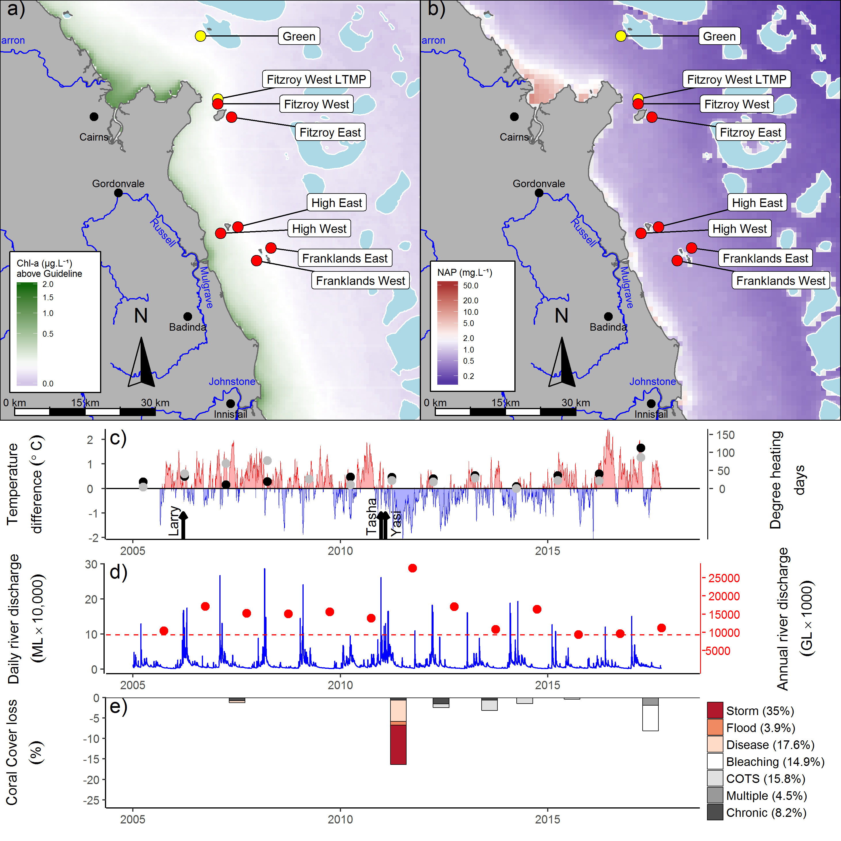
Figure 14 Johnstone Russell-Mulgrave sub-region environmental pressures. Maps show location of monitoring sites, red symbols MMP, yellow symbols LTMP along with a) mean chlorophyll a exceedance of wet season Guideline (0.63ugL⁻¹) and b) mean Non Algal Particulate concentrations. Water quality data are mean levels over the period 2003-2016 (Chl) and 2003-2017 (NAP). c) Seasonally adjusted temperature deviation, timing of cyclones and storms indicated by black arrows, accumulated degree heating days over the summer period (1st of December - 31st March) as reported by BoM (black symbols) and derived from in situ loggers (grey symbols) d) Combined daily (blue) and annual water year – October to September (red) discharge for the North Johnstone, South Johnstone, Russell and Mulgrave rivers, red dashed line represents long-term median discharge (1986-2016). e) break-down of hard coral cover loss by disturbance type; length of bars represent the mean loss of cover across all reefs (see methods section for further detail).

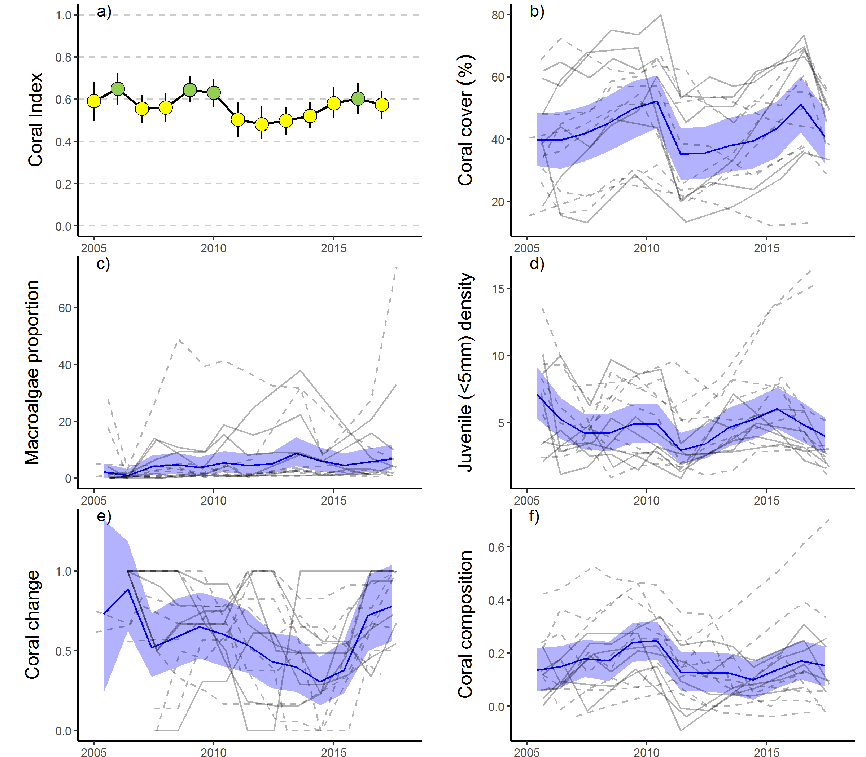

Figure 15 Johnstone Russell-Mulgrave sub-region index and indicator trends. a) Coral index, colour coding: dark green- ‘very good’; light green-‘good’; yellow – ‘moderate; orange – ‘poor’; red – ‘very poor’. b – f) trends in individual indicators, (blue lines) bound by 95% confidence intervals of those trends (shading), grey lines represent observed profiles at 5 m (dashed) and 2 m (solid) depths for individual reefs.

5.2.3 Wet Tropics Region: Herbert Tully sub-region
Coral communities continued to recover from the impacts of Tropical Cyclone Yasi with the coral index in the sub-region categorised as ‘moderate’, the highest it has been since monitoring began in 2005 (Table 12, Figure 17a). Between 2013 and 2017 all indicator metric scores improved, the most consistent improvements occurring in the Coral Cover, Coral Change and Composition metrics (Table 12). Improvement in the Composition metric indicates that recovering coral cover included increased cover of species sensitive to water quality, these taxa, largely Acropora were severely impacted by Cyclone Yasi (Figure A1. 3). Conversely, the small improvements in the Juvenile metric largely reflect increased abundance of Turbinaria (Family Dendrophylliidae, Figure A1. 3) a genus not considered sensitive to poor water quality. The Macroalgae metric showed strong improvements at 2 m depths, whilst the generally low proportion of macroalgae in the algal communities at the deeper sites (Figure 17e) limits room for improvement in this metric at 5 m depths.
As with other sub-regions in the Wet Tropics, reefs in this area were impacted by coral bleaching over the 2016/17 summer, contributing to 9.2 per cent of the total coral cover loss since 2005 (Figure 16e). Impacts from the bleaching were most evident at 2 m depths. The severe impact of bleaching occurred at Dunk South where cover in 2017 was 45 per cent lower than predicted, this contrasted with a slight increase in cover at 5m depth, although that increase was still 6 per cent lower than predicted (Table A1. 4). Despite the observed impacts of bleaching, the clear improvement in the index observed since 2013 demonstrates the propensity for recovery among the coral communities in this sub-region.
Table 12 Index and metric score comparisons in the Herbert Tully sub-region. Data compare the changes in scores between local maxima and minima in the index time-series. For the index, and each metric, the observed change in the sub-regional score and the probability that the change was greater or less than zero (no change) are presented. Shading is used as a visual aid to highlight the magnitude of the probability the score improved (blue shades) or declined (red shades). Probabilities are derived from the posterior distribution of observed score changes at each reef and depth.
Period | Depth | Index |  | Coral Cover |  | Macroalgae |  | Juvenile |  | Cover Change |  | Composition
Period | Depth | Score | P | Score | P | Score | P | Score | P | Score | P | Score | P
2008 to 2011 | 2 | 0.10 | 0.78 | -0.08 | 0.75 | 0.67 | 0.92 | -0.05 | 0.84 | 0.33 | 0.92 | -0.37 | 0.93
2008 to 2011 | 5 | 0.13 | 0.80 | -0.73 | 0.63 | 0.60 | 0.89 | -0.06 | 0.56 | 0.30 | 0.74 | -0.13 | 0.67
2011 to 2013 | 2 | -0.04 | 0.63 | 0.02 | 0.61 | -0.67 | 0.91 | 0.38 | 0.84 | 0.05 | 0.57 | 0 | NA
2011 to 2013 | 5 | -0.12 | 0.88 | 0.01 | 0.55 | -0.59 | 0.90 | 0.19 | 0.75 | -0.08 | 0.59 | -0.13 | 0.67
2013 to 2017 | 2 | 0.36 | 1.00 | 0.21 | 1.00 | 0.49 | 0.84 | 0.08 | 0.65 | 0.55 | 1.00 | 0.50 | 1.00
2013 to 2017 | 5 | 0.25 | 1.00 | 0.23 | 1.00 | 0.21 | 0.63 | 0.17 | 0.72 | 0.29 | 0.87 | 0.33 | 0.85

The trend in the coral index identifies distinct declines caused by damage attributed to Cyclone Larry in 2006 and Cyclone Yasi in 2011 followed by recovery in subsequent years (Figure 17a). The combined impacts of these cyclones account for 82.6% of the hard coral cover lost since 2005 (Figure 16e). Of note is that following each cyclone, in addition to an immediate reduction, was a lagged decline in the index scores (Figure 16a). This lagged response reflects temporary improvement in the Macroalgae metric in the first post cyclone survey (Figure 17e). During cyclones, macroalgae are striped from the substrate, temporarily reducing their abundance. Subsequent rapid colonisation of space as a result of reduced coral cover ensures reduced scores of Macroalgae compounding the impact on index scores resulting from immediate losses of coral (Figure 17e).
The coral sampling sites in this sub-region are primarily influenced by discharge from the Tully and Herbert rivers. As of 2015, monitoring of King was ceased in favour of a new location at Bedarra that was selected to coincide more closely with a revised sampling design for water quality monitoring. All the coral monitoring sites in this sub-region are situated in relatively clear (turbidity below the guideline), and nutrient rich (Chl a concentration in the wet season generally exceeding the guideline), waters (Figure 12b, Figure A1. 11). The combination of low turbidity and high nutrient availability is consistent with the prevalence of macroalgae observed in the shallow depths at most reefs (Figure 17c).
The result of relatively low discharge in recent years may explain concentrations of TSS, and nitrogen oxides dipping below guideline values since 2015 (Figure 16d, Figure A1. 11c, f). The in situ monitoring of both Turbidity and Chl a do not show similar declines (Figure A1. 11b, e).

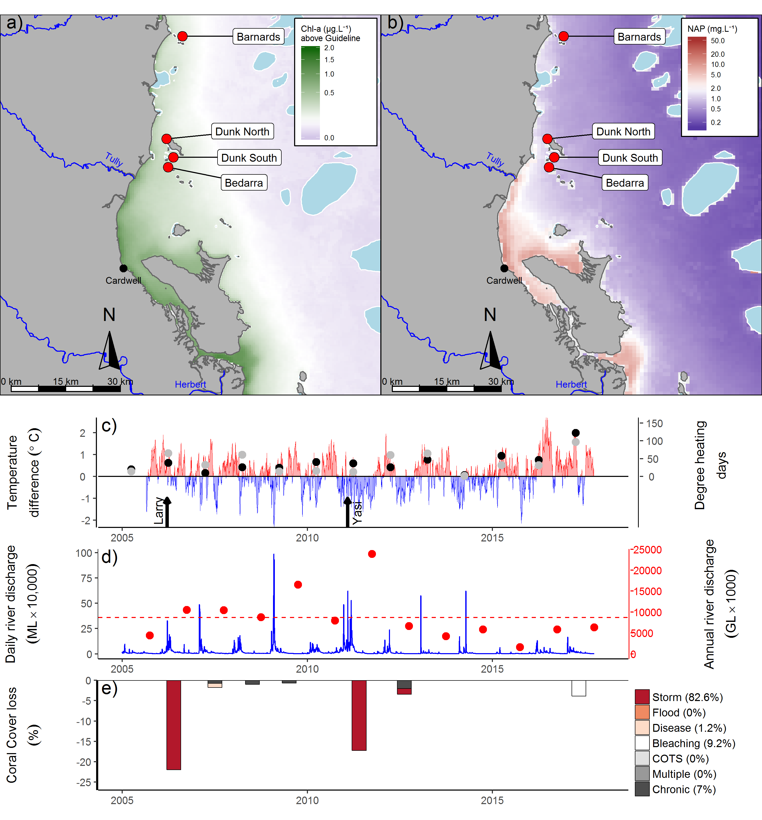
Figure 16 Herbert Tully sub-region environmental pressures.
Maps show location of monitoring sites, red symbols MMP, yellow symbols LTMP along with, a) mean chlorophyll a exceedance of wet season Guideline (0.63ugL⁻¹) and b) mean Non Algal Particulate concentrations. Water quality data are mean levels over the period 2003-2016 (Chl) and 2003-2017 (NAP). c) Seasonally adjusted temperature deviation, timing of cyclones and storms indicated by black arrows, accumulated degree heating days over the summer period (1st of December - 31st March) as reported by BoM (black symbols) and derived from in situ loggers (grey symbols) d) Combined daily (blue) and annual (red) discharge for the Herbert, Murray and Tully rivers, red dashed line represents long-term median discharge (1986-2016). e) break-down of hard coral cover loss by disturbance type; length of bars represent the mean loss of cover across all reefs (see methods section for further detail).

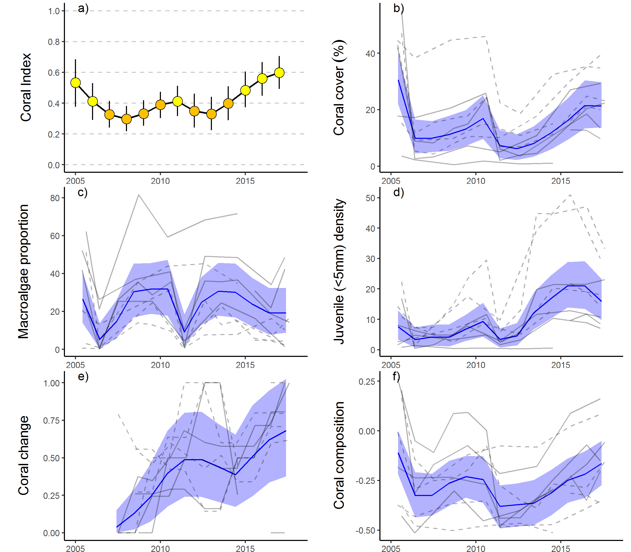

Figure 17 Herbert Tully sub-region index and indicator trends. a) Coral index, colour coding: dark green- ‘very good’; light green-‘good’; yellow – ‘moderate; orange – ‘poor’; red – ‘very poor’. b – f) trends in individual indicators, (blue lines) bound by 95% confidence intervals of those trends (shading), grey lines represent observed profiles at 5 m (dashed) and 2 m (solid) depths for individual reefs.
.

5.2.4 Burdekin region
The coral index in 2017 remains ‘moderate’ for the Burdekin region, maintaining the consistent improvements since 2013 (Table 13, Figure 19a). The Coral Cover metric and, at 5 m depths, the Cover Change and Juvenile metrics in 2017 were higher than observed in 2013 (Table 13, Figure 19d, e). Whilst inconsistent between reefs in the region, a general improvement in the Composition metric (Table 13) indicates that cover increase includes recovery of taxa sensitive to poor water quality, in particular Acroporidae (Figure A1. 4). The observed improvement in the coral index prior to 2017 coincides with a period free from acute disturbances (Figure 18c, e) and below median discharge from the regions rivers (Figure 18d). The Macroalgae metric continues to perform poorly in this region. The proportional cover of macroalgae has been variable with a low point recorded in 2009, the reason for this decline remains unexplained, and then again in 2011 following stripping of cover that occurred during Cyclone Yasi (Figure 19c). By 2012 macroalgae had re-established and, although variable among reefs, the proportional cover of macroalgae regionally has remained consistent through to 2017 (Figure 19c).
Table 13 Index and metric score comparisons in the Burdekin region. Data compare the changes in scores between local maxima and minima in the index time-series. For the index, and each metric, the observed change in the sub-regional score and the probability that the change was greater or less than zero (no change) are presented. Shading is used as a visual aid to highlight the magnitude of the probability the score improved (blue shades) or declined (red shades). Probabilities are derived from the posterior distribution of observed score changes at each reef and depth.
Period | Depth | Index |  | Coral Cover |  | Macroalgae |  | Juvenile |  | Cover Change |  | Composition
Period | Depth | Score | P | Score | P | Score | P | Score | P | Score | P | Score | P
2010 to 2013 | 2 | -0.08 | 0.68 | -0.16 | 0.74 | -0.17 | 0.69 | -0.04 | 0.55 | -0.05 | 0.54 | -0.07 | 0.56
2010 to 2013 | 5 | -0.15 | 0.86 | -0.17 | 0.89 | -0.26 | 0.81 | 0.04 | 0.60 | -0.15 | 0.79 | -0.25 | 0.69
2013 to 2017 | 2 | 0.09 | 0.80 | 0.10 | 0.93 | -0.07 | 0.55 | 0.02 | 0.53 | 0.14 | 0.63 | 0.25 | 0.69
2013 to 2017 | 5 | 0.20 | 0.87 | 0.11 | 0.97 | 0.01 | 0.50 | 0.24 | 0.73 | 0.32 | 0.91 | 0.31 | 0.69

The continued improvement in the coral index through to 2017 does, however, mask the impacts resulting from high water temperatures over the 2016/2017 summer (Table 17). Anomalously high temperatures over the 2016/17 summer led to widespread bleaching in the region for the first time since 2002 (Table A1. 4). Impacts from this event were most evident at 2 m depths, where coral cover declined at all reefs surveyed in 2017 with the exception of Pandora 5 m depth where coral cover increased marginally (Figure 19b, Figure A1. 4). Most affected was Havannah with proportional coral cover losses of 37% and 11% at 2 m and 5 m depths respectively (Figure A1. 4, Table A1. 4). The density of juvenile corals also declined slightly at most reefs surveyed in 2017 (Figure 19, Figure A1. 4). Both Havannah North and Pandora North were surveyed by the LTMP prior to the bleaching event with both coral cover and juvenile densities increasing at each reef, adding weight to bleaching as the primary cause of reductions seen elsewhere. Further limiting the influence of the bleaching event on the index was the rapid increase in coral cover that had occurred in the years preceding the bleaching event realised as in improved scores for the Coral Change metric in 2017. With only eight of the fifteen reefs in the region surveyed post the bleaching event it is likely the Coral Cover and Juvenile metrics do not capture the full impact of this event.
Declines in the index through to 2012 coincided with the combined influence of Cyclone Yasi and a period of very high discharge from the region’s rivers (Figure 18d, e). Since 2005, cyclones and storms have accounted for 50% of hard coral losses (Figure 18e). East-facing locations, such as Palms East and Lady Elliot (2 m), were particularly exposed to storm driven seas, and show the impacts of Cyclone Larry (2006) and Cyclone Yasi (2011) (Figure A1. 4, Table A1. 4). The lagged influence from Cyclone Yasi noted in 2012 (Figure 18e), is due to LTMP surveys post Yasi not occurring until that year. The last outbreak of COTS on the inshore reefs in this region occurred at Havannah in 2001. No COTS were observed during surveys in 2017 however on the mid shelf reefs in this region COTS numbers are in outbreak densities at some reefs (AIMS LTMP).
In addition to losses in coral cover attributed to Cyclone Yasi, the period 2009 to 2012 saw a reduction in the Coral Change metric (Table 13). Overall, low rates of increase in coral cover contributed to 31% of cover lost since 2005 (chronic pressures, Figure 18e). Although not categorised as a disease outbreak for the purpose of disturbance estimation, elevated levels of disease were observed from 2007 to 2009 (Figure A1. 7) and will have contributed to the chronic disturbances recorded over the period 2008 to 2010 (Figure 18e). Chronic pressures are assumed when there is no evidence for impacts associated with acute disturbances, and represent the cumulative impacts of environmental pressures that suppress the annual increments in cover increase that are the basis of the Coral Change scores. As Acropora and Montipora were the genera most infected by disease, the disproportional loss of these groups will have contributed to the decline in the Composition metric. The absence of chronic pressures recorded since 2014 coincides with the reduced runoff and nutrient loads from the adjacent catchment (Figure 18d, e)
The ten reefs monitored span a distinct gradient in water quality. The reefs closer to the coast: Middle, Magnetic, Lady Elliot and Pandora are more frequently exposed to high wet season Chl a concentrations than those further offshore (Figure 18a, Table A1. 6). The composition of coral communities vary in response their location along these environmental gradients (Figure 19f). Proportional cover of the families Acroporidae, Pocilloporidae and Poritidae (genus Porites) are high in clear waters, or at 2 m depths in more turbid settings, with other families including Agariciidae, Oculinidae, Pectiniidae and Poritidae (Genus Goniopora) becoming more prevalent as turbidity increases (Figure A1. 4). Higher exposure to Chl a also corresponds to a high proportion of macroalgae in the algal communities at Magnetic, Pandora, and Lady Elliot. The reefs at Havannah appear at the crossroad for conditions that support a high cover of brown macroalgae, in 2017 cover of the brown algae Lobophora persisted at 5 m depths, although there was a slight reduction in the cover of macroalgae compared to previous years (Figure A1. 4).
Improvement in the coral index between 2013 and 2016 coincided with low discharge, and corresponding relatively low loads of nutrients and sediments being delivered to the Reef (Figure 11, Figure 18d, Waterhouse et al. 2018). Although the coral community has demonstrated a capacity to recover under the conditions observed in recent years, there has been no clear improvement in measured attributes of water quality (Waterhouse et al. 2018, Figure A1. 12) limiting the ability to explicitly link improvement in the index scores to water quality drivers. It should be noted however, that changes to the sampling design of the water quality component of the MMP has generally increased sampling during the wet season and also incorporated monitoring sites closer to the rivers in recent years.

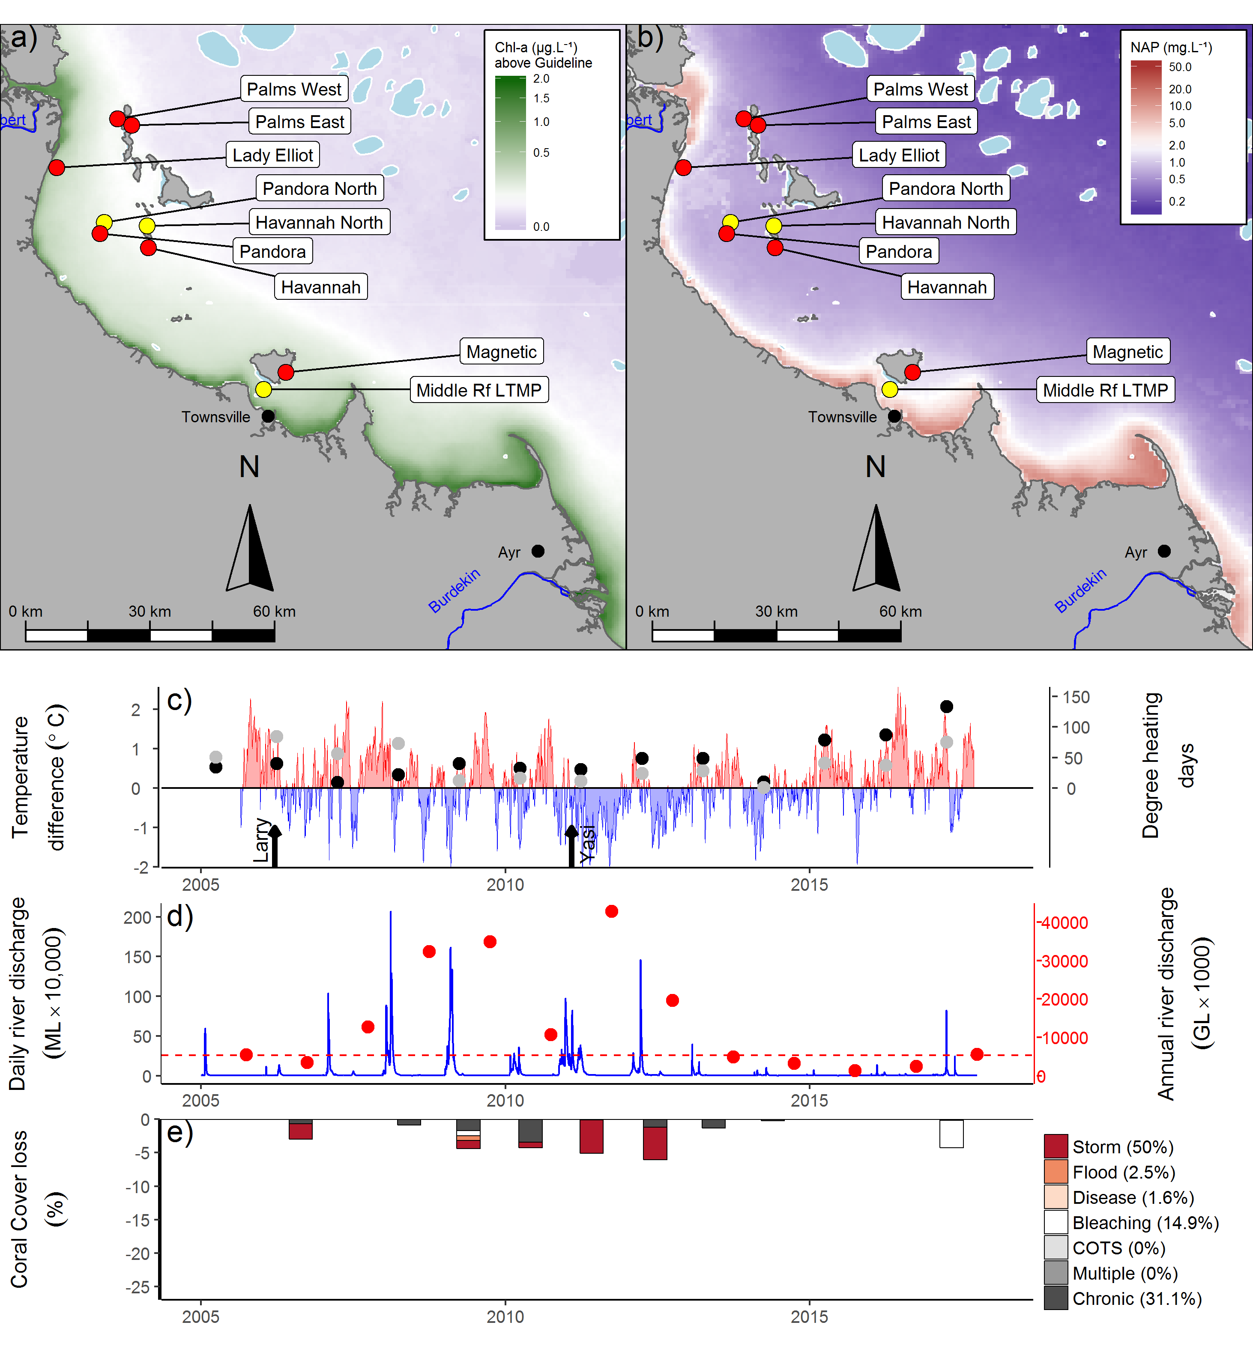
Figure 18 Burdekin Region environmental pressures. Maps show location of monitoring sites, red symbols MMP, yellow symbols LTMP along with a) mean chlorophyll a exceedance of wet season Guideline (0.63ugL⁻¹) and b) mean Non Algal Particulate concentrations. Water quality data are mean levels over the period 2003-2016 (Chl) and 2003-2017 (NAP). c) Seasonally adjusted temperature deviation, timing of cyclones and storms indicated by black arrows, accumulated degree heating days over the summer period (1st of December - 31st March) as reported by BoM (black symbols) and derived from in situ loggers (grey symbols) d) Combined daily (blue) and annual water year – October to September (red) discharge for the Black, Burdekin, Don and Haughton rivers, red dashed line represents long-term median discharge (1986-2016). e) break-down of hard coral cover loss by disturbance type; length of bars represent the mean loss of cover across all reefs (see methods section for further detail).

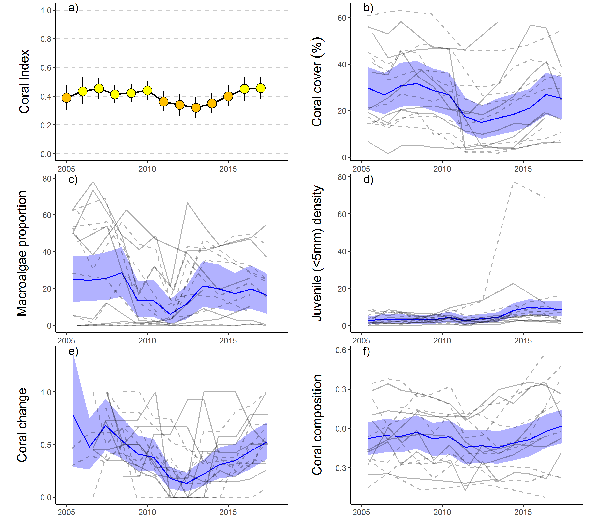
Figure 19 Burdekin Region index and indicator trends. a) Coral index, colour coding: dark green- ‘very good’; light green-‘good’; yellow – ‘moderate; orange – ‘poor’; red – ‘very poor’. b – f) trends in individual indicators, (blue lines) bound by 95% confidence intervals of those trends (shading), grey lines represent observed profiles at 5 m (dashed) and 2 m (solid) depths for individual reefs.

5.2.5 Mackay Whitsunday region
The coral index declined from a ‘good’ categorisation in 2016 to ‘moderate’ in 2017 (Figure 21a). This decline was driven by a substantial reduction in coral cover and juvenile densities as a result of tropical cyclone Debbie that impacted the area in late March 2017 (Figure 21b, d, Figure A1. 8). The full impact of the Cyclone on the coral communities, and so index score, is buffered by an increase in the Cover Change metric representing rapid increase in coral cover (predominantly branching Acropora) at Double Cone, Daydream and Shute Harbour in the years preceding the Cyclone (Figure A1. 5). Limiting a more severe response in index scores were the Coral Cover and Juvenile scores for reefs at which the most recent surveys predated the passage of cyclone Debbie. The Macroalgae score showed no consistent change between 2016 and 2017, largely due to most reefs having consistently high scores for this metric. Substantial reduction in the cover of macroalgae at Pine and Seaforth (5 m) did occur in 2017, likely as a result of stripping during the cyclone or as a response to high turbidity in the aftermath, with these reductions resulting in a shift from ‘good’ to ‘very good’ categorisation of this metric in 2017 (Table A1. 5).
The observed decline in Composition scores at 2 m depths reflects the substantial loss of Acropora across the region (Family Acroporidae, Figure A1. 5) as a result of cyclone Debbie. In general, marked differences in the composition of coral communities between 2 m and 5 m depths (Figure 21f, Figure A1. 5) are indicative of the steep gradient in environmental conditions that impose differing selective pressures on these communities. High turbidity at most of the MMP reef sites (Table A1. 6) in combination with the limited exposure to wave energy among the Whitsunday Islands, which results in accumulation of fine sediments, have combined to select for coral communities tolerant of these conditions. At 5 m depths there is a clear predominance of corals tolerant to low light and high rates of sedimentation (Oculinidae, Pectiniidae, Agariciidae, Poritidae (genus Goniopora)) compared to those at 2 m depths where Acroporidae and Poritidae (genus Porites) are most common (Figure A1. 5).
A high proportion of macroalgae is only recorded at Pine and Seaforth the two reefs with the highest long-term mean exposure to Chl a concentrations that exceed guideline values (Figure 20a, Figure A1. 5, Table A1. 6), suggesting nutrient availability plays a role in the prevalence of macroalgae at these reefs. Macroalgae cover declined sharply at both of these reefs in 2017 (Figure A1. 5). It is likely that these declines were a response to stripping of algae during the passage of cyclone Debbie, or additionally, low light conditions in the aftermath of the cyclone.
Table 14 Index and metric score comparisons in the Mackay Whitsunday Region. Data compare the changes in scores between local maxima and minima in the index time-series. For the index, and each metric, the observed change in the sub-regional score and the probability that the change was greater or less than zero (no change) are presented. Shading is used as a visual aid to highlight the magnitude of the probability the score improved (blue shades) or declined (red shades). Probabilities are derived from the posterior distribution of observed score changes at each reef and depth.
Period | Depth | Index |  | Coral Cover |  | Macroalgae |  | Juvenile |  | Cover Change |  | Composition
Period | Depth | Score | P | Score | P | Score | P | Score | P | Score | P | Score | P
2008 to 2012 | 2 | -0.07 | 0.78 | -0.07 | 0.91 | 0.00 | 0.00 | -0.08 | 0.80 | -0.05 | 0.62 | -0.14 | 0.70
2008 to 2012 | 5 | -0.08 | 0.79 | -0.10 | 0.86 | 0.00 | 0.64 | -0.03 | 0.58 | -0.03 | 0.52 | -0.25 | 0.83
2012 to 2016 | 2 | 0.16 | 0.99 | 0.15 | 0.95 | 0.00 | NA | 0.18 | 0.86 | 0.20 | 0.74 | 0.29 | 0.85
2012 to 2016 | 5 | 0.09 | 0.76 | 0.06 | 0.69 | -0.01 | 0.62 | 0.17 | 0.73 | 0.05 | 0.54 | 0.15 | 0.69
2016 to 2017 | 2 | -0.19 | 0.78 | -0.45 | 0.92 | 0.14 | 0.64 | -0.36 | 0.88 | 0.00 | 0.50 | -0.29 | 0.70
2016 to 2017 | 5 | -0.02 | 0.55 | -0.20 | 0.77 | 0.19 | 0.68 | -0.22 | 0.77 | 0.04 | 0.58 | 0.10 | 0.62

Prior to 2017, flooding in 2009 and Cyclone Ului in 2010 were the only acute disturbance events recorded since 2005 (Figure 20e) and will have contributed to the slight declines in the index through to 2012. While the impacts of Cyclone Ului were widespread, with the exception of Daydream (Table A1. 4), impacts to coral communities were relatively minor compared to those associated with cyclone Debbie (Figure 20e, Figure 21a). Considering the proportional loss of coral cover, the most severely impacted of the monitored reefs were: Daydream, where coral cover was reduced by 98% (2 m) and 90% (5 m), and Double Cone, where coral cover was reduced by 97 % (2 m) and 74% (5 m) (Figure A1. 5, Table A1. 4).
The water quality index for the Whitsundays region has shown a general decline from ‘moderate’ to ‘poor’ in 2017, influenced by increases in several variables, most notably, nitrogen oxides, suspended solids and Chl a (Figure A1. 13). Given the impacts of cyclone Debbie however it is not possible to link the current changes in the coral index to the changes in water quality within the region.
Following a period of below median discharge since 2014, rainfall associated with cyclone Debbie led to discharge from the adjacent catchments which exceeded median levels (Figure 20d). Whilst no direct impacts of flooding were evident during surveys in 2017, previous above median flows have been identified as influencing the coral index in this region. Over the period 2007 to 2013, annual discharge from the adjacent catchments was above median levels (Figure 20d), supplying elevated loads of nutrients and sediments (Turner et al. 2012, 2013, Wallace et al. 2014, 2015, Waterhouse et al. 2018). Although, there is no strong evidence for changes in measured marine water quality at that time (Figure A1. 13, Waterhouse et al. 2018), the onset of this increased runoff coincided with elevated incidence of coral disease (Figure A1. 7). Direct impacts due to flooding were recorded only in 2009 (Figure 20e), attributed primarily to the high loads of sediments observed on corals during surveys. The source of these sediments is not clear as the local rivers did not experience extreme flooding over the preceding summer (Figure 20d) although local heavy rainfall did result in a number of land-slides along the adjacent ranges.

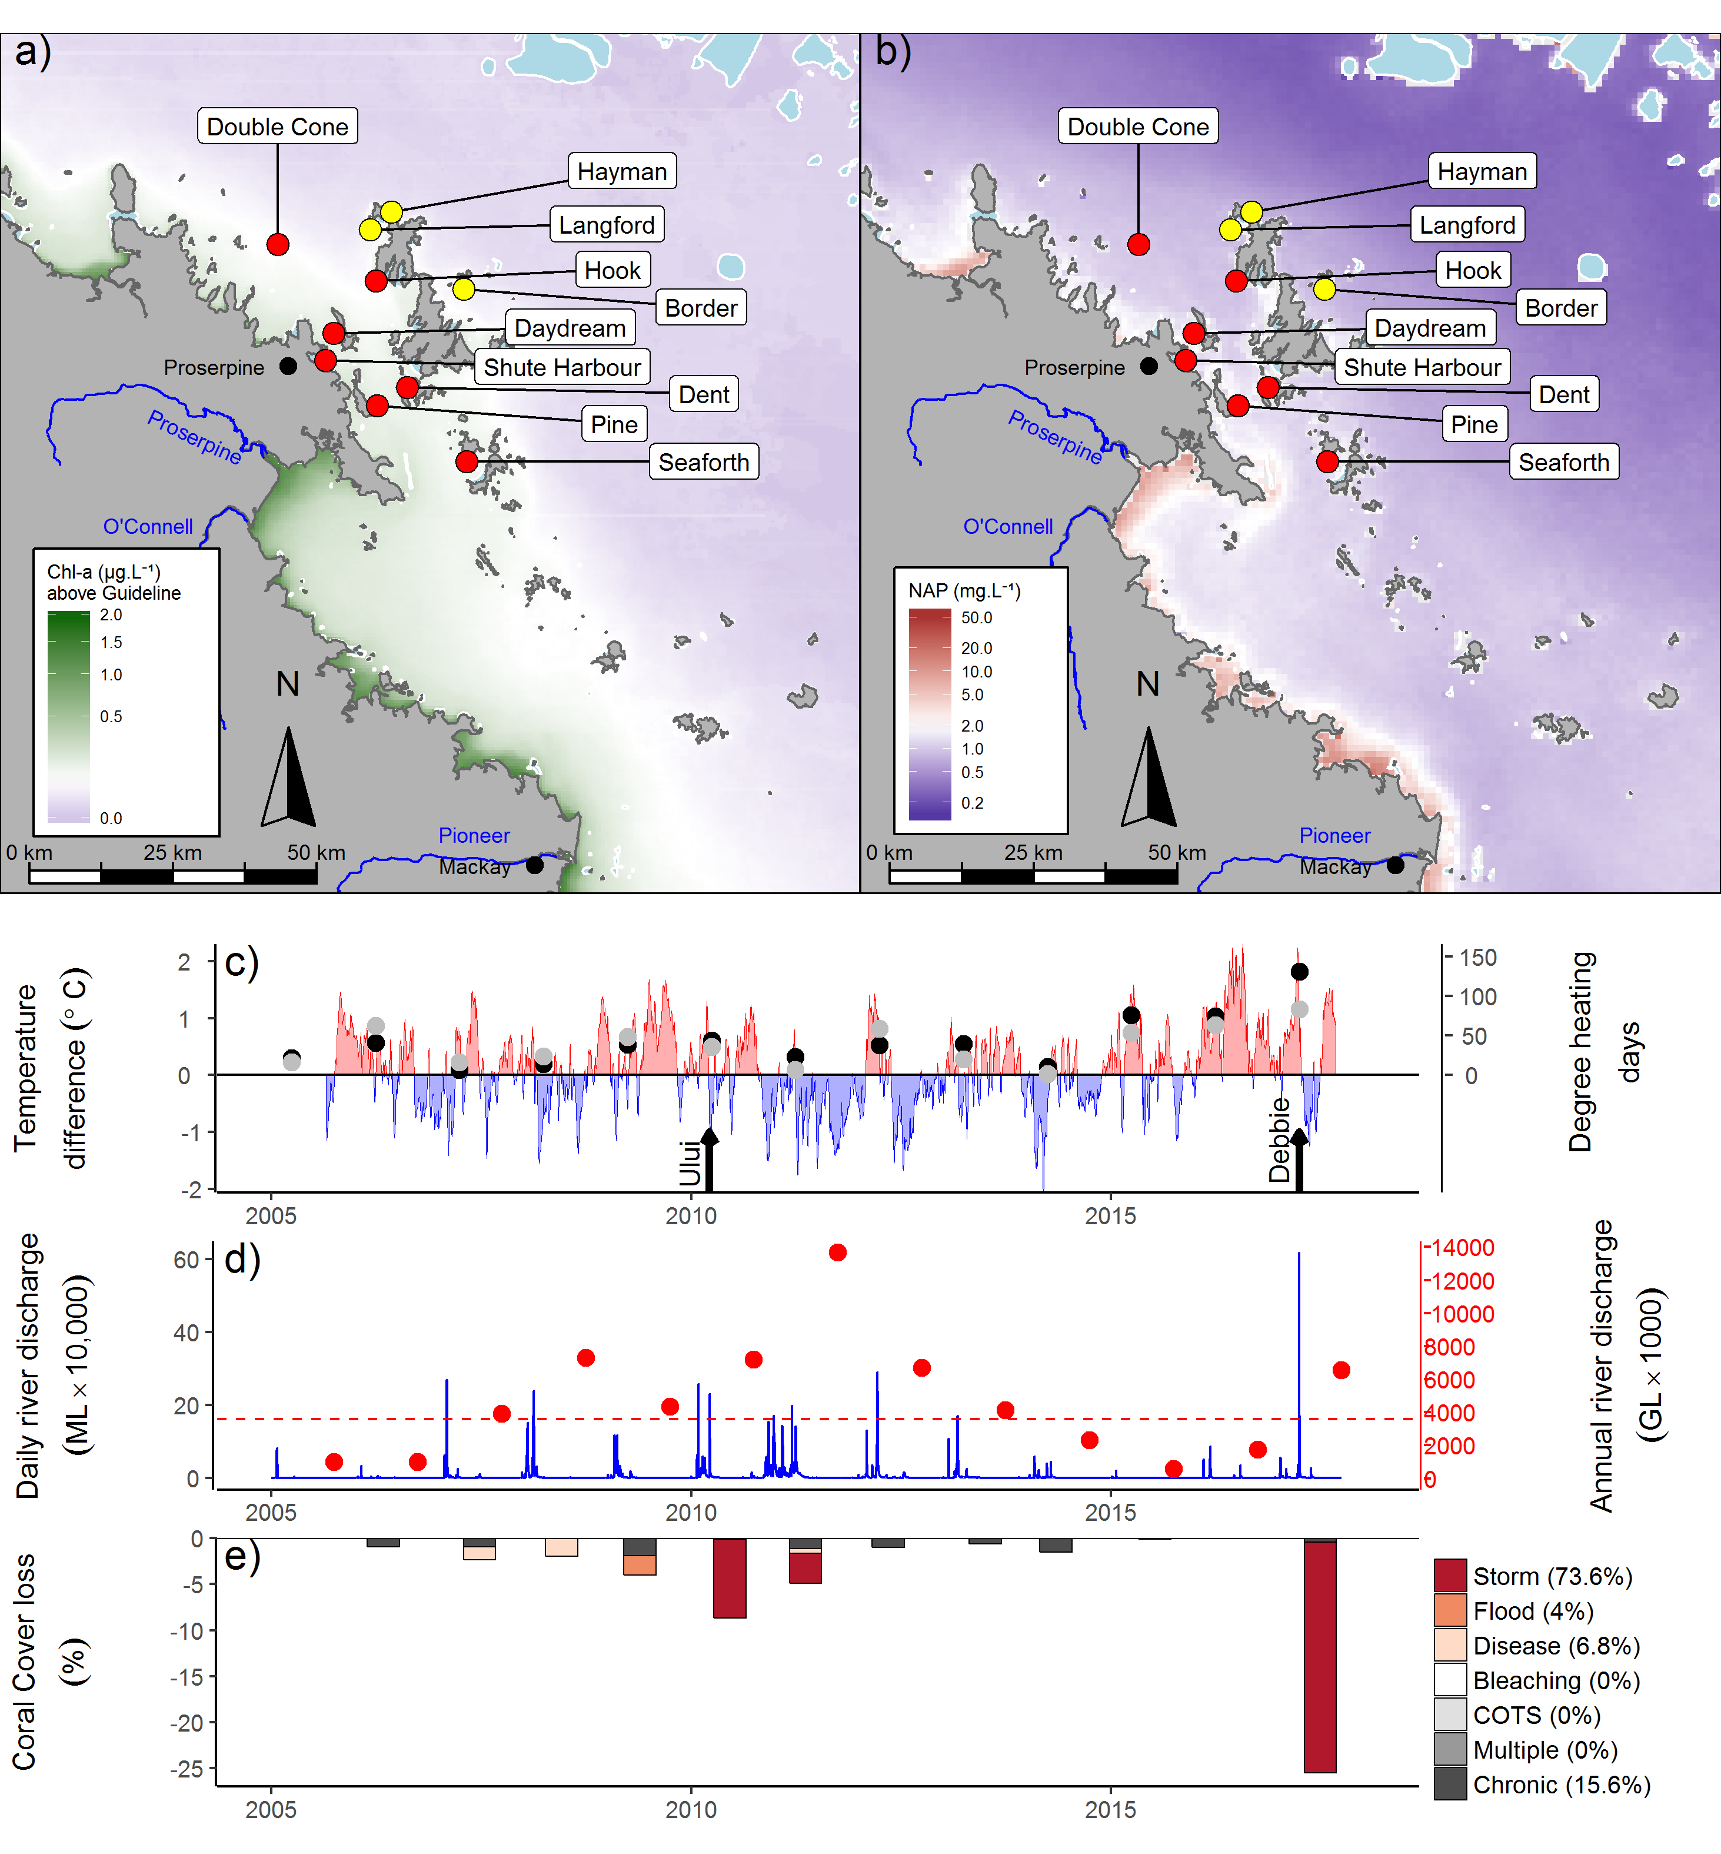
Figure 20 Mackay Whitsunday region environmental pressures. Maps show location of monitoring sites, red symbols MMP, yellow symbols LTMP along with a) mean chlorophyll a exceedance of wet season Guideline (0.63ugL⁻¹) and b) mean Non Algal Particulate concentrations. Water quality data are mean levels over the period 2003-2016 (Chl) and 2003-2017 (NAP). c) Seasonally adjusted temperature deviation, timing of cyclones and storms indicated by black arrows, accumulated degree heating days over the summer period (1st of December - 31st March) as reported by BoM (black symbols) and derived from in situ loggers (grey symbols) d) Combined daily (blue) and annual water year – October to September (red) discharge for the Carmila and Sandy creeks, Gregory, O’Connell and Pioneer rivers, red dashed line represents long-term median discharge (1986-2016). e) break-down of hard coral cover loss by disturbance type; length of bars represent the mean loss of cover across all reefs (see methods section for further detail).

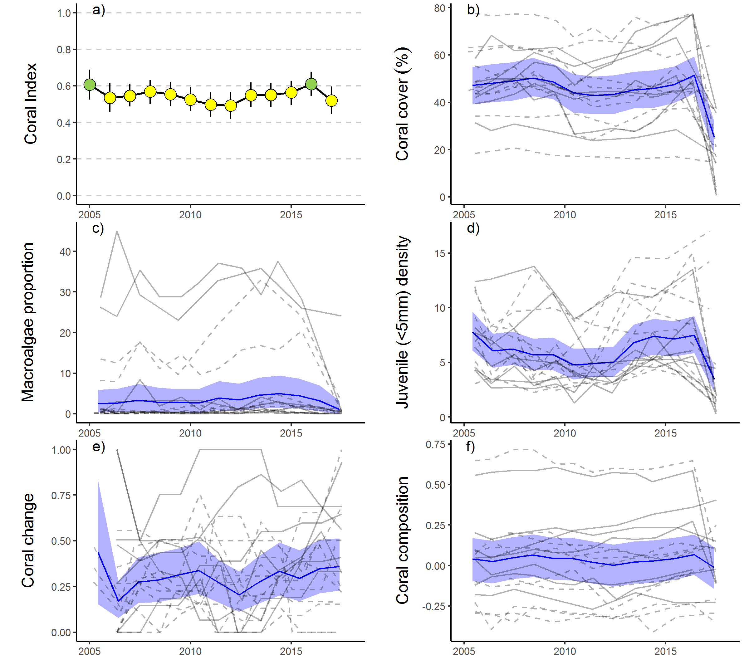
Figure 21 Mackay Whitsunday Region index and indicator trends. a) Coral index, colour coding: dark green- ‘very good’; light green-‘good’; yellow – ‘moderate; orange – ‘poor’; red – ‘very poor’. b – f) trends in individual indicators, (blue lines) bound by 95% confidence intervals of those trends (shading), grey lines represent observed profiles at 5 m (dashed) and 2 m (solid) depths for individual reefs.

5.2.6 Fitzroy region
In 2017 the coral index remained ‘poor’ for the third consecutive year, having improved from ‘very poor’ in 2014 (Table 15, Figure 23a). Improvement in the index score since 2014 was most evident at 2 m depth, where increases in the Juvenile and Coral Cover metrics were most consistent, and improvement in the Composition score at some reefs also contributed to the increase (Table 15). At 5 m depths Coral Cover and Juvenile metrics also increased and while Cover Change has improved since 2014, there was a downturn in the trend of this indicator in 2017 (Figure 23e, Table 15). The slight improvement in the coral index demonstrates reefs are recovering following an extended period of cumulative pressures associated with acute disturbances and high discharge from the adjacent catchment (Figure 22c-e, Figure 11). However, this recovery is slow as a result of ongoing pressures associated with high water temperatures in both 2016 and 2017 and a further flood of the Fitzroy River also in 2017. These ongoing pressures are keeping the Cover Change metric at moderate levels and, along with impacts associated with Cyclone Marcia in 2015, limiting improvement in the Coral Cover metric (Figure 22e, Figure 23b, e). A persistent high proportion of macroalgae amongst the algal community (Figure 23c) also limits improvement in the coral index. With the exception of Barren 2 m, all reef and depth combinations returned Macroalgae metric scores of zero in 2017 (Table A1. 5).
Temperature anomalies over the 2016/17 summer indicated the potential for coral bleaching to impact reefs in this region (Figure 22c). Observed bleaching however was minor, affecting individual colonies at the time of survey in May 2017. Similarly, discharge from the adjacent catchment was above median levels for the 2016/17 water year, however no direct impacts associated with flooding were observed. Whilst no direct impacts were observed during surveys, it is reasonable to assume that both high water temperatures and discharge from the Fitzroy River will impede recovery.
Table 15 Index and metric score comparisons in the Fitzroy Region. Data compare the changes in scores between local maxima and minima in the index time-series. For the index, and each metric, the observed change in the sub-regional score and the probability that the change was greater or less than zero (no change) are presented. Shading is used as a visual aid to highlight the magnitude of the probability the score improved (blue shades) or declined (red shades). Probabilities are derived from the posterior distribution of observed score changes at each reef and depth.
Period | Depth | Index |  | Coral Cover |  | Macroalgae |  | Juvenile |  | Cover Change |  | Composition
Period | Depth | Score | P | Score | P | Score | P | Score | P | Score | P | Score | P
2007 to 2014 | 2 | -0.25 | 0.92 | -0.36 | 0.85 | -0.05 | 0.68 | -0.06 | 0.59 | -0.41 | 0.88 | -0.42 | 0.98
2007 to 2014 | 5 | -0.15 | 0.93 | -0.28 | 0.94 | 0 | NA | 0.02 | 0.56 | 0.13 | 0.72 | -0.33 | 0.89
2014 to 2017 | 2 | 0.10 | 0.86 | 0.06 | 0.73 | 0.06 | 0.66 | 0.14 | 0.90 | 0.08 | 0.63 | 0.17 | 0.67
2014 to 2017 | 5 | 0.04 | 0.71 | 0.06 | 0.72 | 0.00 | NA | 0.07 | 0.73 | 0.15 | 0.85 | -0.08 | 0.64

Coral communities are monitored at six fringing reefs within Keppel Bay, situated along a distinct environmental gradient. Peak and Pelican are situated in relatively turbid and nutrient rich waters compared to reefs further offshore (Figure 22a, b). Keppels South, Middle and North Keppel are consistently exposed to Chl a concentrations that exceed Guidelines compared to Barren where Chl a levels are lower; these four reefs share reasonably low levels of total suspended solids (Figure 22a, b, Table A1. 6). These gradients in water quality are clearly reflected in the benthic communities. At Peak and Pelican benthic communities differ markedly between 2 m and 5 m depths (Figure A1. 6) illustrating the substantial attenuation of light as a result of high turbidity. The differences in community composition are evident in the baseline conditions for the Composition metric (Figure 23f). Pelican has a highly stratified environment, supporting slow growing, low-light tolerant corals at depth, and fast-growing Acroporidae in the shallows; although these shallow communities were killed and replaced by macroalgae as a result of exposure to freshwater during the 2011 floods of the Fitzroy River (Figure A1. 6). This loss of Acropora resulted in a marked reduction in Composition at this reef (Figure 23f). Since 2013 the gradual appearance of juvenile Acroporidae (Figure A1. 6) mark the beginning of a recovery of the coral community at the 2 m depth of Pelican. Closer to the Fitzroy River, Peak is defined by a low cover of corals, low density of juvenile corals, high cover of macroalgae (Figure A1. 6), and a lack of substantial reef development, suggesting that the environmental conditions at this location are marginal for most corals. In the less turbid waters at Keppels South, Middle Is, North Keppel, and Barren the coral communities are dominated Acroporidae (Figure A1. 6), principally, but not restricted to, the branching species Acropora intermedia and A. muricata.
The proximity to the Fitzroy River also influences the recovery dynamics of the reefs in this region. During inter disturbance periods, change in index scores across the region are negatively related to discharge from the Fitzroy River (Figure 11). This relationship corresponds to the higher levels of disease and the chronic pressures, implied by lower than expected rate of coral cover increase, especially over the period 2008-2013 (Figure 22e) when discharges where mostly well above median levels (Figure 22d). It should be noted here, that direct exposure to low salinity waters killed corals at 2 m depths at Peak and Pelican in 2008 and also Keppels South (2 m) in 2011.The influence of flooding, in combination with severe bleaching in 2006 and the repeated exposure storm driven waves in 2008, ex-TC Oswald 2013, ex-TC Dylan 2014 and Cyclone Marcia 2015 (Figure 22e) ensured the decline in condition of coral communities through to 2015 as described by the coral index (Figure 23a).
Prior to the commencement of the MMP in 2005, Queensland Parks and Wildlife Service monitoring of reefs in Keppel Bay from 1993-2003 recorded substantial loss of coral cover, and subsequent recovery following thermal bleaching events in 1998 and 2002 (Table A1. 4). Initial MMP surveys in 2005 documented moderate to high hard coral cover on all the Acropora-dominated reefs confirming the potential for recovery at these reefs. High water temperatures over the 2005 - 06 summer (Figure 22c) again caused severe bleaching and loss of coral cover (Figure 22e, Figure 23b). Coincident with the loss of coral was a rapid increase in the cover of the brown macroalgae Lobophora (Figure 23c, Diaz-Pulido et al. 2009) further contributed to the reduction in the coral index from ‘moderate’ to ‘poor’ (Figure 23a).
The 2011 flood event was the largest on record and exposed shallow coral communities to low salinity waters that caused widespread mortality of corals at the 2 m depths of Peak, Pelican and Keppels South (Table A1. 4). Flooding also pre-empted elevated levels of coral disease in 2008, 2010 and 2011 (Figure A1. 7).
Water quality monitoring (in-situ) has been discontinued in the Keppels region since 2014-2015. The final year of water quality sampling saw an improvement in the water quality index (Lønborg et al. 2015). Measured levels of Chl a, particulate nitrogen and particulate organic carbon showed a slight downturn at this time coinciding with a respite in flooding in the region since 2012 (Lønborg et al. 2015). Modelling of total suspended solids and dissolved inorganic nitrogen indicate substantially lower concentrations in the region from 2014 to 2016 compared to those associated with the high discharge years of 2010, 2011 and 2013 (Waterhouse et al. 2017).
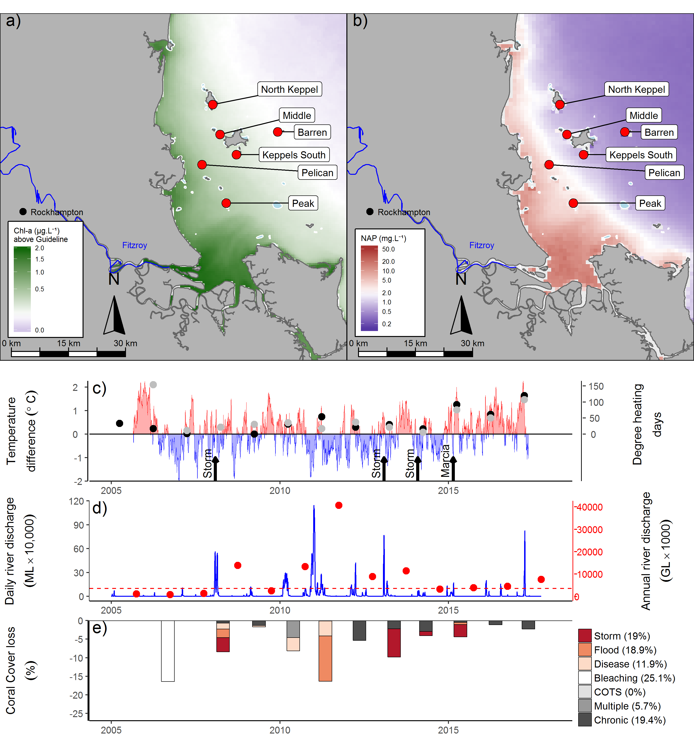
Figure 22 Fitzroy region environmental pressures.
Maps show location of monitoring sites, red symbols MMP, yellow symbols LTMP along with a) mean chlorophyll a exceedance of wet season Guideline (0.63ugL⁻¹) and b) mean Non Algal Particulate concentrations. Water quality data are mean levels over the period 2003-2016 (Chl) and 2003-2017 (NAP). c) Seasonally adjusted temperature deviation, timing of cyclones and storms indicated by black arrows, accumulated degree heating days over the summer period (1st of December - 31st March) as reported by BoM (black symbols) and derived from in situ loggers (grey symbols) d) Combined daily (blue) and annual water year – October to September (red) discharge for the Calliope and Fitzroy rivers and Waterpark Creek, red dashed line represents long-term median discharge (1986-2016). e) break-down of hard coral cover loss by disturbance type; length of bars represent the mean loss of cover across all reefs (see methods section for further detail).

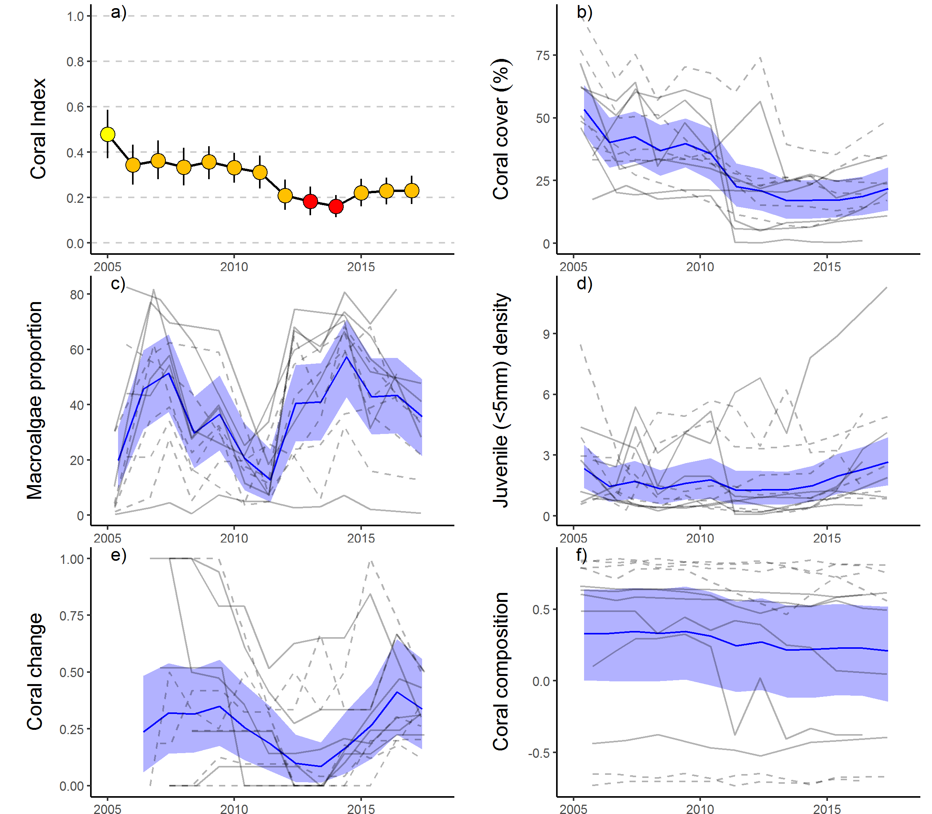
Figure 23 Fitzroy Region index and indicator trends. a) Coral index, colour coding: dark green- ‘very good’; light green-‘good’; yellow – ‘moderate; orange – ‘poor’; red – ‘very poor’. b – f) trends in individual indicators, (blue lines) bound by 95% confidence intervals of those trends (shading), grey lines represent observed profiles at 5 m (dashed) and 2 m (solid) depths for individual reefs.

Discussion
As naturally dynamic systems that alternate between impacts and periods of recovery (Connell 1978) it is critical for the persistence of coral communities that there is a long-term balance between disturbance and recovery processes. The primary focus of the MMP is the role of water quality in altering this balance leading to the long-term decline in coral communities. In this light, despite wide spread disturbances and substantial loss of coral cover in three of the four regions, the coral index has remained relatively stable in 2017. This stability is influenced by two attributes of the index that buffer against short term responses to acute disturbance events. Appropriately, the index includes consideration of the ability of coral communities to recover, via the Cover Change metric. As Cover Change scores are estimated from a running mean of recovery rates observed over the preceding four years, the high rates of recovery observed prior to the 2016/17 summer contribute to stable or increasing scores for this metric in all regions. Less desirable, is that the biennial sampling design of the program means that index scores are based on a combination of observations from reefs sampled that year and those carried forward from previous years. While additional surveys were undertaken in all regions to limit the influence of carried-forward scores on the index in 2017, some buffering of impact of the summer’s disturbance events on the index remains.
Results are discussed in terms of the Pressure, State and Impact components of a broader Driver-Pressure-State-Impact-Response (DPSIR) framework. This allows identification of some of the key pressures influencing coral community condition. In this context, there is a natural distinction between pressures that are beyond the realm of management under Reef Plan, such as acute disturbances associated with severe storms or bleaching events, and those related more tangibly to water quality, and as such, expected to be manageable.

6.1 Pressures

6.1.1 Acute disturbances
High water temperatures over the 2016-17 summer were widely reported as causing severe coral bleaching of the Reef for a second consecutive year (Hughes et al. 2018). On the inshore reefs monitored by the MMP an average of 10.5% of the hard coral cover in the Wet Tropics and Burdekin Regions was lost between surveys in 2016 and 2017. This figure should be considered a minimum estimate of the proportion of coral lost, as at the time of survey (May –August 2017) up to 66% (mean 14.4%) of the surviving corals were still bleached, suggesting possible further losses. The figure also compares cover to that observed at the time of last survey, mostly May-August 2016, and as such, does not account for the increase in cover that would have occurred between those surveys and the onset of bleaching in December 2016-January 2017. Chapter 8 provides a summary of the impacts to coral communities that occurred as a result of this bleaching event.
Tropical cyclone Debbie severely damaged coral communities in the Mackay Whitsunday Region. A mean of 60% of hard coral cover was lost from the reefs monitored, with losses in excess of 95% at 2m depths at Daydream and Double Cone. The storm made landfall, as a category 4 cyclone, near Airlie Beach on the 28th of March 2017 (Figure A1. 8) with sustained wind speeds of 195km/h (max 265 km/h) (www.bom.gov.au). Contributing to the damage incurred is that the geography of the island group provides areas that are usually protected from wave exposure in which relatively fragile coral communities have developed. The slow passage of the storm and direction of the winds ensured these fragile communities were exposed to damaging conditions over a prolonged period.
Moderate numbers of crown-of-thorns starfish (COTS) continue to occur at reefs in the Johnstone Russell-Mulgrave sub-region. The individuals observed represented a range of size classes including juveniles <15 cm in diameter indicating the recurrent recruitment of COTS. The concern is that as these individuals grow, they will cause ongoing loss of coral cover. COTS are recognised as a major contributor to loss of coral cover in mid-shelf areas of the Reef (Osborne et al. 2011, De’ath et al. 2012) with population outbreaks in 2017 recorded on reefs between Cairns and Townsville, as well as off Princess Charlotte Bay in the North and Mackay in the south (AIMS LTMP). The transport of coastal nutrients to the mid-shelf Reef remains the most plausible explanation for the promotion of COTS outbreaks as a result of human activities, potentially extending the influence of runoff to large tracts of the Reef and over long periods of time (Brodie et al. 2005, Fabricius et al. 2010, Furnas et al. 2013, Caballes & Pratchett 2014, Pratchett et al. 2014, Wooldridge & Brodie 2015).
The recent disturbances build on previous events that, since MMP surveys began in 2005, have resulted in clear reduction in coral cover across the regions, these include: thermal bleaching (Fitzroy Region – 2006, Wet Tropics and Burdekin Regions - 2017), Cyclone Larry (Wet Tropics and Burdekin Regions - 2006), Cyclone Ului (Whitsunday Region - 2010), Cyclone Tasha (Wet Tropics - 2011), Cyclone Yasi (Wet Tropics and Burdekin Regions - 2011), Cyclone Ita (Wet Tropics - 2014), Cyclone Marsha (Fitzroy Region - 2015), cyclone Debbie (Whitsunday Region – 2017), sub-cyclonic storms (Barron Daintree sub-region - 2009, Burdekin - 2009, Fitzroy - 2008, 2010, 2013), predation by COTS (Wet Tropics - 2012 to 2014) and exposure to low salinity flood waters (2 m depths, Fitzroy Region 2011). These disturbance events contribute strongly to the declines in the coral index scores in all regions. Acute pressures most directly influenced coral cover and contributed to between 63% (Fitzroy Region) and 92% (Herbert Tully sub-region) of the coral cover lost since 2005. These losses unavoidably translated into reductions in the scores for the Coral Cover metric and contribute to declines in overall reef condition assessments following severe disturbance events. Each of the remaining four indicator metrics have been formulated to limit responsiveness to acute pressures to focus, as directly as possible, on changes in condition that can be interpreted as resulting from changes in water quality.

6.1.2 Chronic conditions - water quality
Water quality is a summary term for a range of chemical and physical properties of marine waters that exert a fundamental influence on the processes governing coral community composition and condition. Water quality in the inshore Reef shows a strong gradient, improving with distance from the coast and major rivers. Variation in benthic communities on coral reefs along this gradient is evidence for the selective pressures imposed by water quality on coral reef communities (van Woesik & Done 1997, van Woesik et al. 1999, Fabricius et al. 2005, De’ath & Fabricius 2008, Uthicke et al. 2010, Fabricius et al. 2012), and also within individual reefs in response to localised hydrodynamic conditions and depth (Uthicke et al. 2010, Thompson et al. 2010, Browne et al. 2010). Such gradients are a natural part of the Reef ecosystem, albeit supported by lower levels of input of runoff-derived pollutants than presently occurs (Belperio & Searle 1988, Waters et al. 2014). The premise underpinning Reef Plan is that anthropogenic contaminant loads delivered by rivers create conditions which suppress the health and/or resilience of the Reefs ecosystems. It is the quantification of the compounding conditions along naturally occurring gradients, as a result of runoff, and any subsequent improvement under the Reef Plan, that is the core focus of the water quality monitoring component of the MMP (see separate report by Waterhouse et al. 2018).
For corals, the pressure relating to land management practices is the ‘state’ of marine water quality, which in turn is influenced by the pressure of contaminant loads entering marine waters as runoff. The MMP river plume monitoring (see Waterhouse et al. 2018) clearly shows that inshore reefs monitored by MMP and the LTMP are directly exposed to elevated loads of sediments and nutrients carried by flood plumes. Variability in loads delivered to the Reef (Joo et al. 2012, Turner et al. 2011, 2012, Wallace et al. 2014, 2015, Garzon-Garcia et al. 2015) has, however, not been closely linked to variability in marine water quality conditions as measured by the MMP in situ monitoring program. This is not unexpected given the complexity of nutrient cycling that occurs in marine waters, dilution of plumes, and the necessarily sparse sampling regime of the long-term water quality monitoring program. It is evident from marine water quality time-series, however, that the period of high discharge into the Reef (2008-2013) resulted in a general increase in turbidity, oxidised forms of dissolved nitrogen (NOx) and dissolved organic carbon (DOC) with levels beginning to decline again in 2015-2016 (Waterhouse et al. 2018). Lønborg et al. (2015) suggest that these observations indicate changes in the carbon and nutrient cycling processes in the Reef lagoon, although the detailed understanding of these processes remains elusive. Turbidity in the Reef lagoon is strongly influenced by variations in the inflow of particles from the catchment and resuspension by wind, currents and tides (Larcombe et al. 1995). The trends emerging from the MMP support other studies showing that the additional flux of fine sediment imported by rivers remains in the coastal zone for periods of months to years leading to chronically elevated turbidity (Wolanski et al. 2008, Lambrechts et al. 2010, Brodie et al. 2012a, Thompson et al. 2014a, Fabricius et al. 2013a, Fabricius et al. 2014, Fabricius et al. 2016). Any increase in turbidity associated with runoff will reduce the level of photosynthetically active radiation reaching the benthos - a primary energy source for corals and so a key factor limiting coral distribution (Cooper et al. 2007, Muir et al. 2015).

6.2 Ecosystem State

6.2.1 Coral index
In 2017 index scores were inversely related to the location of reefs along the gradient of exposure to above Guideline values of Chl a, over the wet season. Most influential in this result were the Coral Cover and Macroalgae metrics. These results indicate that where the availability of nutrients is sufficient to promote high Chl a, the proportion of large fleshy algae “macroalgae” in the benthic algal communities is enhanced and coral cover is diminished. This relationship has been maintained despite the influence of acute disturbance events that have the potential to obscure the chronic influences of water quality. In particular, the distribution of large brown macroalgae shows a strong relationship to environmental conditions of high nutrient availability, adequate light (prevalence is limited by turbidity at 5 m depths) and sufficient water movement to preclude the build-up of fine sediments on the substrate (Thompson et al. 2017). In terms of light availability and water movement, the preferred habitat for brown macroalgae overlaps strongly with that of some corals, and in particular the fast growing Acroporidae, highlighting the direct competition for space between these groups. The correspondence between high prevalence of macroalgae and Chl a concentrations implies that a reduction in the availability of nutrients, that promote high concentrations of Chl a in the water column, has the potential to shift the competitive relationship between macroalgae and coral back toward coral. In contrast to results from 2016, when there was evidence that communities had disproportionately shifted over the duration of the program to include a lower proportion of species susceptible to poor water quality in areas of relatively low exposure, this result was not evident in 2017. Unfortunately the species most susceptible to poor water quality (the Acropora) are also susceptible to the acute pressures imposed by thermal anomalies (Table 18) and storm damage that occurred in 2017, and this resulted in losses across the water quality gradient.
Index scores declined in all regions through to low points between 2012 and 2014, prior to improvements through to 2016 that demonstrated recovery was underway. Declines in the index reflect the cumulative influence of multiple acute disturbances that coincided with a period of high runoff and associated loads of contaminants entering the Reef from adjacent catchments. In contrast, improvement in index scores through to 2016 occurred during a period largely free from acute disturbance events and typified by low loads of contaminants entering the reef in runoff (Waterhouse et al. 2018).
To understand the influence of runoff on the rate of change in the index, which we consider as representative of community resilience, required explicitly focusing our analysis on observations that were not confounded by the impact of acute events (Flower et al. 2017), i.e. during recovery periods. In three of the four regions: Wet Tropics, Burdekin and Fitzroy, biennial changes in index scores during recovery periods demonstrate an inverse relationship to regional discharge. In both the Wet Tropics and Burdekin regions the relationship with discharge was supported by similar, although less linear, relationships to loads of total Nitrogen and total Phosphorous entering the Reef in runoff and variability in Chl a concentration around reefs. Although these results suggest a consistent direction of response, we are mindful that both the spatial and temporal responses of the index to water quality or discharge varied among reefs. This is not unexpected as index scores at any point in space or time will reflect the cumulative responses of the communities to: past disturbance events and chronic pressures, selective pressures imposed by ambient conditions, and stochasticity in the population dynamics of the diverse communities inhabiting these reefs. In combination, variable exposure to past events and location specific pressures are also likely to have selected for communities tolerant of those conditions. What this means, is that communities in different locations will be variously susceptible to exposure to runoff-related water quality pressures (e.g. Morgan et al. 2016). It is precisely the inability to accurately measure, or predict, the role of cumulative impacts across a diversity of exposures that suggests the use of biological indicators, such as the coral and seagrass (McKenzie et al. 2017) indices used by the MMP as tools to identify where, and when, environmental stress is occurring (Karr 2006, Crain et al. 2008).
The observed relationship between discharge and changes in coral index does, however, imply that the cumulative impacts of river-delivered contaminants suppress the resilience of coral communities. In general, the spatial and temporal variability in index scores presented in this report are consistent with well documented links between increased runoff and stress to corals (Bruno et al. 2003, Kline et al. 2006, Kuntz et al. 2005, Voss & Richardson 2006, Kaczmarsky & Richardson 2010, Haapkylä et al. 2011, 2013, Vega Thurber et al. 2013). That we did not observe a clear relationship between discharge and change in the index scores in the Mackay Whitsunday Region may be explained by the relatively low discharge but high tidal range in this region, compared to other regions, resulting in variability in corals exposure to water quality related pressures being less influenced by runoff. There was however a weak relationship between high turbidity and reduced improvement in the index. This response to turbidity is consistent with the clear response of communities to high turbidity within the region evidenced by the strong vertical differentiation in community composition at many of the reefs and a high representation of species tolerant to high turbidity at the 5m depths. Indeed, the selection for turbidity tolerance is likely to offer a degree of resistance to additional pressures imposed by variable runoff, a point raised by Morgan et al. (2016). Influential in the results for the Mackay Whitsunday Region were declines in the index that occurred in 2006 when discharge was low. While the 2006 declines remain unexplained, our estimation of relative temperature stress - based on in situ loggers rather than satellites, and expressed as degree heating days (available from the Bureau of Meteorology), implicate high summer temperatures as the likely stressor.
It should also be noted, that excluding changes in index scores influenced by acute events from our analysis may underestimate the influence of water quality on index scores. In addition to reducing capacity for recovery, degraded water quality may also increase the susceptibility of corals to acute disturbance events. Evidence from recent research into the interactions between water quality and temperature suggests that corals tolerance to heat stress is reduced by exposure to contaminants including nutrients, herbicides and suspended particulate matter (Wooldridge & Done 2004, Negri et al. 2011, Wiedenmann et al. 2013, Fabricius et al. 2013b, Wooldridge 2016, Bessell-Browne et al. 2017b). Similarly, increased susceptibility to disease may increase the loss of coral cover attributed to cyclones, floods, or COTS. With widespread bleaching events impacting the Reef in 2016 and 2017 (Figure 24, Hughes et al. 2017) the interaction between water quality conditions and temperature on the fate of corals remains an ongoing concern.

6.2.2 Coral cover
For corals to persist in a location they need to be able to survive extremes in environmental conditions but also maintain a competitive ability under ambient conditions. Although low scores for the coral cover metric often occur due to losses experienced as a result of acute disturbance, low cover, as a response to water quality pressures, can also be inferred from our analyses. In 2017, coral cover was higher at reefs with low Chl a levels. In addition, there are a number of reefs monitored at which coral cover has remained low rather than recovering during periods free from acute disturbance events. The majority of these reefs have had a persistent cover of macroalgae; an attribute of benthic communities linked to high Chl a levels. High turbidity or nutrient levels do not, however, preclude high cover of corals on inshore reefs. There is ample evidence from the data presented in this report along with other studies (e.g. Sweatman et al. 2007, Brown et al. 2010, Morgan et al. 2016) that reefs in highly turbid settings can support very high cover of species tolerant to those conditions. Despite claims for high diversity in turbid habitats based on aggregated diversity over a variety of microhabitats (Brown et al. 2010, Morgan et al. 2016), from sites that control for depth and exposure to wave energy, it is evident that as turbidity increases, high coral cover typically results from relatively few species tolerant of their local environment, particularly at deeper depths (De Vantier et al. 2006, Sweatman et al. 2007).

6.2.3 Rate of change in coral cover
The Coral Change metric assesses the rate of change in coral cover (growth) during years free from acute disturbances. An adequate rate of coral cover increase is essential to ensure the long-term balance between cover lost to disturbances and that regained under ambient conditions. Within regions the Coral Change metric scores are often highly variable. Such variability is likely due to a combination of both sampling error and real responses as communities are differentially exposed to pressures in both space and time. The formulation of this metric includes the averaging of estimates over a four year period so as to allow averaging over potential sampling error. Unfortunately the move to a biennial sampling and the multiple disturbances recorded over the life of the program mean that the scores representing a mean over a four year period may represent estimates derived from a single observation of cover change. It was partly to account for this that the program adopted a contingency sampling to ensure visitation of reefs following disturbances and so improve the data available from which to estimate scores for this metric. Ideally reefs would be sampled annually to maximise the observations available to updating scores for this metric. Differences between reefs or through time should be expected given the likelihood of variable exposure, but also susceptibility, of communities to pressures that suppress the rate at which coral cover increases.
The widespread disturbances influencing inshore reefs over the 2016/17 summer precluded the use of 2017 data to update scores for this metric and most reefs. Rather, scores represent the recovery demonstrated by coral communities in the 2 to 3 years prior to these disturbances. Scores for this indicator increased through to 2016, coincident with relatively low inputs from the catchments. The exception was the Johnstone Russell-Mulgrave sub-region where there was no improvement, a result potentially influenced by ongoing low densities of COTS on these reefs. Prior to this, Cover Change scores either declined, or remained stable, as index scores within each region declined to low points between 2012 and 2014; a period that coincided broadly with the period of high loads of sediments and nutrients entering the Reef (Joo et al. 2012, Turner et al. 2012, 2013, Wallace et al. 2014, 2015). During this period the most evident changes in marine water quality were increased concentration of dissolved oxides of nitrogen and dissolved inorganic carbon (Lønborg et al. 2015). Dissolved inorganic carbon constitutes the major carbon source for heterotrophic microbial growth in marine pelagic systems (e.g. Lønborg et al. 2011) and increases in DOC have been shown to promote microbial activity and coral diseases (Kline et al. 2006, Kuntz et al. 2005). In each region, we noted peaks in coral disease that corresponded to either the onset of flooding or, in the case of the Johnstone Russell-Mulgrave Region, flooding in catchments to the south. The conclusion that environmental conditions associated with increased loads of sediments and nutrients have been sufficiently stressful to corals to reduce growth rates, and/or induce disease in susceptible species, is consistent with previous observations linking nutrients and organic matter availability to higher incidence and severity of coral disease (Bruno et al. 2003, Haapkylä et al. 2011, Weber et al. 2012, Vega Thurber et al. 2013).

6.2.4 Composition
It is well documented that compositional differences in coral communities occur along environmental gradients (Done 1982, van Woesik & Done 1997, van Woesik et al. 1999, Fabricius et al. 2005, De’ath & Fabricius 2008, Browne et al. 2010, De’ath & Fabricius 2010, Thompson et al. 2010, Uthicke et al. 2010, Browne et al. 2012, Fabricius et al. 2012). The relationships between disease and altered environmental conditions, discussed above, demonstrates the dynamic nature of coral community selection occurring on inshore reefs. Sensitive species gain a foot-hold during relatively benign conditions only to be removed during periods when environmental conditions are beyond their tolerance. The coral community composition indicator has tended to track the trend in coral cover indicating the disproportionate loss, and subsequent recovery, of genera sensitive to water quality. The was however some evidence that the probability the scores for this metric in 2017 had declined relative to baseline conditions set in 2005-2008 was positively related to the long-term mean wet season exceedance of Chl a concentration at the reefs surveyed, suggesting either recovery is slightly retarded at this reefs or communities are in chronic decline.
The genus most susceptible to poor water quality is Acropora. As Acropora are generally fragile, thus particularly susceptible to loss of cover during cyclones (Fabricius et al. 2008), as well as sensitive to thermal bleaching (Marshal & Baird 2000), and a preferred prey group for COTS (Pratchett 2007), trends in the composition indicator cannot unambiguously be interpreted as representing a response to, and subsequent release from, water quality pressures alone. In 2017, it was only at 2m depths in the Barren Daintree and Johnstone Russell-Mulgrave sub-regions and Mackay Whitsunday Region that scores for this metric declined. Elsewhere, the impacts of bleaching and cyclone Debbie appear to have been largely indiscriminate in terms of impacts to corals categorised on their sensitivity to poor water quality. Over the longer term, however, there is evidence that the representation of Acropora on reefs in the Burdekin region has declined since the mid-20th century, possibly as a result of increased runoff from the adjacent catchments (Roff et al. 2013). This consideration makes the recent recovery of this group in the Burdekin Region, and lack of a disproportionate reduction as a result of bleaching in 2017, particularly positive as it demonstrates the capacity for these species to re-establish under the conditions experienced in recent years. As a genus including a high diversity of rapidly growing species, the Acropora are a key group for the rapid recovery of coral cover and maintenance of diversity on inshore reefs.

6.2.5 Macroalgae
Macroalgae generally benefit from increased nutrient availability due to runoff (e.g., Schaffelke et al. 2005) and, as coral competitors, supress both coral growth and juvenile settlement or survival (e.g., Tanner 1995, McCook et al. 2001, Birrell et al. 2005, 2008a, b). Clear relationships between Chl a concentrations, a proxy for nutrient availability, and the proportion of macroalgae link nutrient availability to reduced coral community resilience in inshore areas of the Reef. Unlike the coral indicators that are plausibly responsive to water quality extremes, the persistence of macroalgae during winter surveys may suggest that ambient water quality levels are also important for the maintenance of high macroalgal cover. While reef specific thresholds for macroalgae allow for increased abundance of macroalgae in response to naturally occurring gradients of water quality, their cover in 2017, where long-term Chl a concentrations exceed guideline levels, was often at levels likely to have detrimental influences on coral recruitment and growth.
It is important to note, that the relationship between high Chl a concentration and macroalgae cover is correlative only and does not necessarily indicate a direct cause-effect relationship between nutrient concentrations and pressures imposed by macroalgae. Chl a may be a proxy for environmental variables or ecological processes other than the direct availability of nutrients that influence macroalgae abundance. Wismer et al. (2009) demonstrate an inverse relationship between macroalgal cover and herbivore biomass and Cheal et al. (2013) link this relationship to water quality by demonstrating a decline in herbivorous fish populations with increasing turbidity. Importantly, the reduction in herbivore biomass noted by Cheal et al. (2013) occurred on the LTMP survey reefs included in this report and are among the reefs toward the better end of the strong water quality gradient in inshore waters. The higher turbidity at the majority of reefs surveyed under the MMP suggest even lower biomass of herbivorous fishes.
Grazing is a key process for the control of macroalgal blooms and research demonstrates the importance of the maintenance of herbivore populations to avoid a phase shift to a macroalgae dominated state (e.g. Hughes et al. 2007). Within the Burdekin region Hughes et al. (2007) demonstrated that dense macroalgal communities could be supported in the absence of grazing on a reef with generally low cover of fleshy macroalgae, partly divorcing macroalgae biomass from direct relationship to water-quality alone. The relative influences of herbivory and nutrients on coral reef macroalgae is undoubtedly complex and likely to “depend on the species, circumstances and life-history processes under consideration” (Diaz-Pulido & McCook 2003). Irrespective of the underlying mechanism that limits macroalgae on reefs with lower Chl a concentrations, our results demonstrate that the environmental conditions at sites where Chl a concentrations most frequently exceed summer guideline values also support macroalgal biomass at levels detrimental to coral community resilience.

6.2.6 Juvenile density
The effects of the 2017 bleaching event on juvenile corals was not severe. However, minor declines in the number of juveniles observed on most reefs in the Wet Tropics surveyed in 2017 contrasted consistent increases recorded at the LTMP reefs that were surveyed prior to the bleaching event. Observed declines in juvenile indicator scores in the Wet Tropics resulted due the compounding of reduced numbers of juveniles and increased availability of space, as a result of reduced coral cover, on the estimated density of juvenile corals. In the Herbert Tully sub-region, declining numbers of juveniles were observed, due largely to the moderation in the number of Turbinaria juveniles that had recruited strongly in recent years. In the Burdekin Region, neither the number of juvenile colonies, nor the scores for the Juvenile metric, varied substantially from those observed prior to the bleaching event.
In contrast, cyclone Debbie had a clear impact on juvenile corals with, numbers declining sharply in the Mackay Whitsunday Region in 2017. In combination with a severe loss of coral cover, and so increased spaced categorised as available to settlement, this reduction in juvenile abundance resulted in a clear decline in the Juvenile metric from being classified as ‘good’ 2016 to ‘poor’ in 2017. Juvenile density in the Fitzroy region remains low, although gradually increasing.
The early life history stages of corals are sensitive to a range of water quality parameters (Fabricius 2011). Direct effects of high concentrations of suspended sediments can reduce fertilisation (Ricardo et al. 2016) whereas the accumulation of sediments on the substrate can preclude larval settlement (Ricardo et al. 2017). In contrast, conditions that promote macroalgae are likely to have secondary effects on larval settlement and survival (Tanner 1995, McCook et al. 2001, Birrell et al. 2005, 2008a, b). That the density of juvenile corals does not correspond to observed gradients in water quality likely reflects the action of confounding influences, such as acute disturbances or variable connectivity to bloodstock populations. Disentangling such influences remains a challenge. As an example, shallow water corals in the inshore areas of the Fitzroy Region were killed by flooding in 2011 and subsequently replaced by macroalgae (Berkelmans et al. 2012, data herein), juvenile densities have remained very low ever since, but we cannot distinguish between the relative roles of reduced local bloodstock and high cover of macroalgae in the realised lack of coral recruitment.
It is also apparent that sensitivity of juvenile corals to environmental conditions likely varies among species. Some of the highest densities of Juvenile corals occur in the Herbert-Tully and Burdekin (sub-)regions on reefs were the genus Turbinaria recruits in vast numbers. As this genus was not well represented in the adult community prior to the successive cyclonic disturbances in 2006 and 2011, it is unclear whether this recruitment pattern is simply due to natural variability or indicates the selection for species more suited to the recent environmental conditions (Sofonia & Anthony 2008). The high density of juveniles clearly tolerant of poor water quality at some reefs confound the analysis in this report that compares total juvenile densities only. A possible solution would be the development of a metric that includes consideration of community composition in addition to abundance of juveniles, or focused on a group, such as, Acropora that is important for recovery of coral communities.

6.3 Regional summaries

6.3.1 Wet Tropics
Impacts from coral bleaching, and to a lesser degree COTS, prior to surveys in 2017 interrupted a period of improving coral index scores since a low point in 2013. Within the region, only the Herbert Tully sub-region, where recovery from the severe impacts of Cyclone Yasi is clearly occurring, continued to show improvement in the coral index. Within this sub-region, of the five metrics included in the coral index it was only Macroalgae at 5 m depth that had not improved through to 2017.
Impacts from thermal bleaching were widespread throughout the region, most notably in the Johnstone Russell – Mulgrave sub-region where there were clear declines in the Coral Cover metric at both 2 m and 5 m depths. In contrast, the Coral Cover metric in the Herbert-Tully sub-region continued to improve despite the impacts of beaching over the 2016/17 summer. In the Barron- Daintree sub-region, the loss of coral cover as a result of bleaching had little impact on the Coral Cover metric. It should be noted that due to timing of surveys, no impacts from bleaching were observed on any of the three reefs in the region monitored by the LTMP. It is reasonable to expect that subsequent surveys of these reefs may indeed show declines in coral cover resulting from this bleaching event, in turn affecting future assessment of the coral index.
Compounding the effects of the bleaching is the continued presence of COTS with this being the only region where the current outbreak of COTS has impacted inshore reefs. In 2017 COTS were again observed at Fitzroy, the Frankland Group and High, and contributed to coral losses observed in the Johnstone Russell – Mulgrave sub-region. Helping to mitigate the impact of COTS in this region has been the ongoing removal of COTS with 14,990 individuals removed from the monitoring reefs in this region prior to surveys in 2017. The observation of juvenile COTS at Fitzroy, the Frankland Group and High Island present the likelihood of further loss of corals as this cohort matures, suggesting ongoing benefit of population control to protect these valuable sites for tourism.
Importantly, despite the impacts of bleaching, regional mean hard coral cover remains at 27% and this, in conjunction with high scores for the Cover Change metric in recent years, provides hope for ongoing recovery.

6.3.2 Burdekin
The coral index for the Burdekin region remained stable with impacts associated with coral bleaching offset by recent high rates of increase in coral cover as reefs recovered from Cyclone Yasi. While the index has remained stable, declines in the Coral Cover and Juvenile metrics as a result of coral bleaching, halted the steady improvement in the index over the previous three years. It should be noted that across the region only 53% of sites were surveyed post the 2017 bleaching event, with two MMP reefs not surveyed and the three LTMP reefs surveyed prior to the event. As such, it is likely that the 2017 index score reflects an underestimate of the impacts to these coral communities and may decline further following future assessment.
Declines in juvenile density are of particular concern within the Burdekin Region. Historically, recovery from acute events, in particular coral bleaching, has been slow (Sweatman et al. 2007, Cheal et al. 2013). Observation of low coral settlement in this region (Thompson et al. 2013) and generally low densities of juvenile corals, suggest that slow recovery may, in part, reflect recruitment limitation. Preliminary hydrodynamic modelling (Luick et al. 2007, Connie 2.0) and differences in population genetics of corals (Mackenzie et al. 2004) both indicate limited connectivity between Halifax Bay and reefs further offshore. This isolation, coupled with the widespread loss of cover in 1998 and 2002, as a result of thermal bleaching (Berkelmans et al. 2004), may explain the low densities of juvenile colonies observed (Done et al. 2007, Sweatman et al. 2007). Exacerbating any supply-side limitation to coral recruitment is the persistently high cover of macroalgae at several reefs that is likely to further suppress recruitment success (Tanner 1995, McCook et al. 2001, Birrell et al. 2005, 2008a, b). Whilst macroalgae cover remains high, there were notable declines at both Pandora and Havannah which will potentially benefit recovery of these reefs.
Regionally, changes in the coral index demonstrate an inverse relationship to discharge from the regions rivers. It was not until 2014, a year into a period of below median discharges from the region’s rivers, that the average rates of hard coral cover increase began matching modelled expectations. In addition to generally low rates of cover increase, stress to corals during periods of high catchment input were observed as increased levels of disease in 2007-2009. Over that period discharge form the Region’s rivers were consistently above median levels, in contrast to the below median discharges of the preceding years. A moderate increase in disease was also noted in 2011, again following high catchment discharge. This expression of disease and downturn in the rate of cover increase also coincided with a shift in community composition at deeper sites toward communities tolerant of poor water quality. In combination, these results are consistent with the well documented link between increased runoff and stress in coral communities, expressed as increased levels of coral disease (Bruno et al. 2003, Kline et al. 2006, Kuntz et al. 2005, Voss & Richardson 2006, Kaczmarsky & Richardson 2010, Haapkylä et al. 2011, 2013, Vega Thurber et al. 2013). It is evident that the recovery of reefs in the Burdekin region is limited by catchment inputs suggesting that any future deterioration in water quality will likely have substantial impact on the recovery process.

6.3.3 Mackay Whitsunday
Impacts associated with tropical cyclone Debbie in 2017 resulted in a sharp decline in the coral index for the Mackay Whitsunday Region. Between 2016 and 2017 there were substantial reductions in both the Coral Cover and Juvenile metrics. Buffering the index decline are results from LTMP reefs and Hook Island that carry forward observations preceding the cyclone. There was also an improvement in the Macroalgae metric, that is likely to be temporary as macroalgae removed by the cyclone is expected to rapidly recolonise.
Environmental conditions at monitoring sites in this region are generally characterised by high rates of sedimentation and turbidity. In combination these conditions have imposed strong selective pressures on corals that is clearly illustrated by the marked differences in coral community composition between 2 m and 5m depths at most reefs, perversely, these conditions also limit the abundance of macroalgae (Thompson et al. 2014b). Despite the clear pressures imposed by the environmental conditions, the consistent improvement in the index from 2012 to 2016 reflects both the tolerance of coral communities to their environmental settings and the ability of these reefs to recover from disturbance events. Prior to 2017, the only other major disturbance event to impact this region since monitoring commenced in 1992 was cyclone Ului in 2010 which contributed to the decline in the index through to 2012. Improvement in the coral index post 2012 was largely due to rapid recovery of communities at 2 m depths where cover of the family Acroporidae rapidly increased. Whilst impacts of cyclone Ului were widespread they were substantially less severe than those incurred during cyclone Debbie.
The decline in the water quality index (Waterhouse et al. 2018, Figure A1. 13) captures anecdotal observations from commercial users suggesting high turbidity persisted for several months in the aftermath of cyclone Debbie. At the time of coral surveys (July 2017) turbidity was noticeably high and sedimentation to the substrate ongoing. Given past observations of low scores for the Cover Change metric, the unsuitable nature of the substrate for coral settlement (Ricardo et al. 2017) and the regionally reduced brood-stock, a slow recovery of coral communities at the worst impacted reefs appears likely. Where reefs were sheltered, thus less exposed to wave damage, surviving fragments will aid recovery.

6.3.4 Fitzroy
While the Coral Cover and Juvenile metrics continued to improve in 2017 the coral index remains ‘poor’. The current condition of reefs in the region reflects a decline following the cumulative impacts of thermal stress in 2006, a series of cyclones and storms, and flooding of the Fitzroy River that exposed corals to lethal low levels of salinity (Jones & Berkelmans 2014) and introduced high loads of nutrients and suspended sediments into Keppel Bay. Water temperatures where high over the both the 2015/16 and 2016/17 summers and while bleaching was observed (section 7.2, Kennedy 2018), acute impacts resulting in loss of coral cover were not recorded. The cumulative pressures associated with consecutive years of high temperature will have contributed to the limited recovery of coral communities over this period.
Flooding of the Fitzroy River impacts coral communities in two primary ways. Corals in shallow waters, and in particular those to the south of Great Keppel Island, have been repeatedly exposed to the low salinity plumes that kill the corals (van Woesik 1991, data herein, Jones & Berkelmans 2014). In addition, negative relationship between the rate of change in index scores and discharge from the Fitzroy River demonstrate the wider impact of major flood events on coral community condition within Keppel Bay. Of note were elevated levels of disease following major flood events supporting hypotheses that either reduced salinity (Haapkylä et al. 2011), or increased nutrient enrichment (Vega Thurber et al. 2013) were sufficiently stressful so as to facilitate coral disease. Reduction in light levels over extended periods of time as a result of higher turbidity from increased concentrations of suspended sediments as well as dense plankton blooms following floods, is another plausible explanation for reduced fitness of corals (Cooper et al. 2007) that may have supressed the recovery of coral cover.
Variation in the recovery of reefs following disturbances events further illustrates the role of water quality in supressing coral community resilience. Following coral bleaching in 2006, recovery of coral cover was inversely related to the persistence of macroalgae. At the three Acropora sp. dominated communities with high Chl a concentrations (Keppels South, Middle and North Keppel) macroalgae cover (predominantly Lobophora spp.) rapidly increased and persisted at high densities, whilst rates of change in coral cover remained low or coral cover continued to decline. In contrast, at Barren, where Chl a concentration is lower, the Lobophora bloom was less pronounced and recovery of the coral community clearly progressed. There is clear evidence that the abundance of macroalgae on the Reef is higher where Chl a concentrations (as a proxy for nutrients) are above the annual Guideline values for coastal and mid-shelf waters of 0.45µgL⁻¹ (De’ath & Fabricius 2008, Thompson et al. 2017). This suggests that the persistence of macroalgae is related to nutrient levels.
In contrast to persistent macroalgae, there has been a continued improvement in the Juvenile metric and a maintained rate of increase in coral cover; both key factors countering a long-term phase shift to macroalgae dominated states. Following the initial improvements observed in 2015, despite remaining ‘poor’, the coral index continues to indicate coral communities in the region are resilient when spared from acute disturbance events and high contaminant loads from the catchment (Garzon-Garcia et al. 2015).

6.4 Conclusion
The cumulative impacts of tropical cyclones and storms, feeding by COTS, and thermal stress, along with elevated loads of contaminants introduced to the Reef during periods of high discharges from adjacent catchments, resulted in clear declines in the condition of coral communities on inshore reefs through to 2012-2014. With the abatement of acute disturbances and lower loads of sediments and nutrients entering the Reef clear recovery was observed through to 2016. The combination of tropical cyclone Debbie and high summer temperatures, leading to coral bleaching, in 2017 interrupted this short period of recovery. The persistence of inshore coral communities will depend on the long-term balance between frequency and severity of acute pressures and the ability of corals to recover. Central to this balance is limiting the influence of chronic pressures that either suppress the recovery process or compound with acute events adding to the severity of community declines. It is the overarching goal of Reef plan to ensure that runoff entering the reef does not alter this balance. With a global trend for increasing frequency of thermally induced bleaching events (Hughes et al. 2018), corroborated by the back-to-back bleaching events impacting the GBR in 2016 and 2017 (section 7), the focus on supporting recovery in a climate of increasing disturbance is ever sharpening.
Disentangling the influence of runoff in observed declines in coral community condition, or the ability of communities to recover, remains difficult for two primary reasons. Firstly, coral’s threshold to the cumulative pressures associated with water quality are likely to be spatially variable because of the selection and acclimation of corals in response to location specific conditions. Secondly, extrinsic variability, along with low concentrations of many constituents of water quality, limits the ability to quantify additional pressures resulting from runoff at scales relevant to the communities monitored. In combination, these issues limit the ability to quantify critical thresholds for water quality that are appropriate to the diversity of coral communities found on inshore reefs. However, focusing on the response of the coral communities (as measured by differences in index scores) identifies both spatial and temporal responses of coral communities to variation in water quality. Spatially, results from this project demonstrate that macroalgae abundance is enhanced, to the detriment of corals, in areas of high nutrient availability. Temporally, the recovery of coral communities, assessed as rate of increase in index scores, also shows a negative relationship to river discharge and the corresponding loads of sediments and nutrients carried therein.
Although not strong, the consistent tendency for higher rates of improvement in the index when runoff is low suggests sensitivity of community recovery to contaminant concentrations in runoff. Given projections for increased severity and/or frequency of pressures as a result of climate change and human activities in general (Steffen et al. 2013, Halpern et al. 2015, Hughes et al. 2018), the importance of reducing local pressures (so as to reduce cumulative pressures and foster improved recovery) becomes increasingly essential to the long-term maintenance of these communities. The GBRMPA Strategic Assessment identified the cumulative impact of multiple pressures on coral ecosystems as a key knowledge gap and the management of these impacts as a major strategic challenge (GBRMPA 2014a). While the results presented here do not provide clear guidance in terms of load reductions required to improve coral condition in the inshore Reef they do support the premise of Reef Plan that the loads entering the reef, during high rainfall periods in particular, are reducing the resilience of these communities.

Case study - Coral Bleaching 2017
Following the record-breaking temperatures of 2016, sea surface temperatures on the GBR again exceeded long-term averages during January to March 2017, causing an unprecedented second consecutive year of bleaching. Patterns of bleaching intensity shifted from the northern reefs in 2016 to the central reefs in 2017 (Figure 24). While two previous widespread bleaching events have occurred on the GBR (1998, 2002), recovery had been possible during the cooler interval. Globally, this latest series of positive sea surface temperature anomalies began in mid-2014, continuing for three years driven by a severe El Niño / La Niña cycle. Termed the ‘Third Global Coral Bleaching Event’ by the National Oceanic and Atmospheric Administration (NOAA), it is considered to be the longest, most widespread and possibly the most damaging coral bleaching event on record (NOAA 2017). The collapse of the latest El Niño in mid-2016, followed by a brief swing towards a La Niña event, retained the above-average sea surface temperatures (often +2⁰C) for the GBR during the 2016 winter, giving momentum to the accumulation of heat-stress by the beginning of the 2017 summer (Figure 25).
This case study looks at the distribution of bleaching among reefs monitored by the MMP in 2017, with reference to the 2016 event.

7.1 Methods
Surveys in 2016 and 2017 were undertaken over the months May-September. Bleaching impact was assessed based on analysis of photo point-intercept-transects. The proportion of the coral community bleached at the time of survey was estimated from the classification of all of points falling on corals being classified as either ‘not bleached’, ‘partially bleached’ or ‘bleached white’. The proportion of corals bleached includes the sum of the partially bleached and bleached white categories. The loss of cover attributed to the bleaching event was estimated as difference in cover between the focal year’s survey and the previous year’s survey divided by the cover in the previous year’s survey. In a small number of cases the duration between focal surveys and previous year’s survey was two years due to the biennial sampling design of the MMP (Table 17). It should be noted that these estimates of proportional loss of cover are minimum estimates as do not consider increased cover in the period between previous survey and the onset of bleaching. The lack of correction for growth, as included in the estimates in the body of the report and summarised in Table A1. 4, allows consistency between genus level losses and total coral cover loss within this case study.
The likelihood of temperature stress was estimated by accumulation of positive temperature anomalies compared to long-term mean conditions over the austral summer (1st December to 31st March). Temperature anomalies were estimated as Degree Heating Days (DHD) where, exceedance of the long-term average of 1^{O}C, for one day, equates to 1 DHD. Two sources of DHD were used: estimates downloaded from ReefTemp Next Generation, a product of the Bureau of Meteorology, and estimates, based on in situ temperature loggers deployed at each the coral monitoring locations. The derivation of these DHD estimates is more fully documented in section 4.3.2 of this report.

7.2 Discussion of Results
Aerial surveys undertaken by the ARC Centre of Excellence at James Cook University (JCU) demonstrate the differing footprint of the 2016 and 2017 bleaching events. In 2016 the most severely bleached reefs were mostly north of Cairns, and largely exclusive of the inshore areas monitored by the MMP (Figure 24). In contrast, the most severely bleached reefs in 2017 extended further south and included reefs monitored by the MMP in the Wet Tropics and Burdekin Regions (Figure 24).
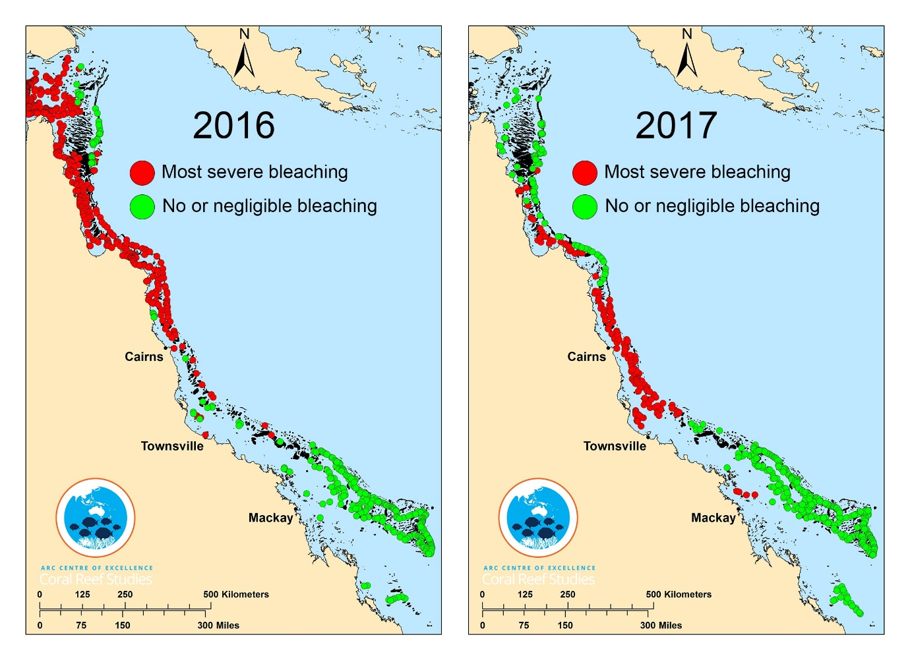
Figure 24 Composite map of surveyed corals across the 2016 and 2017 bleaching events. Only reefs at either end of the bleaching spectrum are shown: Red circles indicate reefs undergoing most severe bleaching (60% or more of corals visible to aerial surveys bleaching) Green circles indicate reefs with no or only minimal bleaching (10% or less of corals bleaching).Courtesy ARC Centre of Excellence Coral Reef Studies.

In Inshore areas monitored by the MMP both ReefTemp and in situ DHD estimates suggest temperature anomalies in 2016 were in the range 60 to 100 that would be expected to result in heat stress (Garde et al. 2014) but fell short of the > 100 DHD likely to cause severe bleaching (Table 16). In contrast, temperature anomalies were clearly higher in 2017, with severe bleaching expectations indicted for all Regions (Table 16). Cross-referencing with the in situ temperature logger data (Figure 25) shows daily anomalies were consistently higher, frequently in excess of 1⁰C, during the austral spring and summer of 2017 than for a similar period in 2016.
With the exception of the Barron Daintree sub-region, ReefTemp DHD estimates in recent years were consistently higher than those based on in situ data. This discrepancy may arise in two ways. The satellite derived ReefTemp estimates are confined to days with little cloud cover. Where clouds obscure an area sea-surface temperature estimates are infilled with the last valid observation for that location, potentially inflating estimates as cooling beneath clouds is not accounted for. The longer baseline period for ReefTemp may also have resulted in lower mean temperature profiles contributing to the baseline compared to the in situ observations that date back to 2005. Conversely, one possible explanation for the comparatively high estimates for the Barron Daintree sub-region is that they reflect local conditions that promote higher heating at the logger location (on the sheltered northern side of Snapper Island) than occurs in the deeper surrounding waters. Despite the inherent biases, both methods compare relatively well, tracking the rise and fall of DHD throughout the monitoring period (Figure 25). Marked deviations between the estimates do, however, occur. The most notable being in the Fitzroy Region during the 2005-2006 summer where a minimal anomaly was estimated by ReefTemp in contrast to that recorded in situ. The extensive bleaching and loss of coral cover in the Fitzroy Region in 2006 reflect the in situ observations (Figure 22c, Table A1.4, see also Diaz-Pulido et al. 2009). For each region, the ReefTemp DHD estimates in 2017 were the highest recorded over the 13 years of the MMP. In situ estimates showed highest DHD estimates in the Wet Tropics subregions and Mackay Whitsunday region, with 2017 estimates in the Burdekin and Fitzroy Region second only to those observed in 2006.
Table 16 Degree Heating Days (DHD) for 2016 and 2017 MMP (sub) regions. Estimates based on data downloaded from Bureau of Meteorology (ReefTemp) based on IMOS 14day mosaic baseline temperatures and In situ temperature loggers at the reef sites. Note that ReefTemp estimates for 2016 do not concur with those reported previously by this program due to adjustment of methodology applied by BoM.
 | DHD 2016 |  | DHD 2017
MMP (sub) region | ReefTemp | In situ | ReefTemp | In situ
Baron Daintree | 35 | 57 | 98 | 105
Russell Mulgrave | 40 | 21 | 112 | 86
Tully Herbert | 46 | 32 | 122 | 97
Burdekin | 87 | 37 | 133 | 75
Mackay Whitsundays | 74 | 63 | 131 | 83
Fitzroy Basin | 61 | 50 | 120 | 107

The greater temperature anomalies described by DHD estimates in 2017 compared to 2016, was reflected in the loss of coral and extent of bleaching observed. However, while coral bleaching was observed within all four NRM regions the impacts varied both among regions, between reefs in close proximity to each other, and between the 2 m and 5 m depth sites within reefs (Table 17). The most impacted reefs were in the Wet Tropics and Burdekin Regions.
In the Wet Tropics, the impacts varied markedly over small spatial scales. The most severely impacted reef was Snapper North where 41% of the coral cover at 2 m sites and 33% at 5 m sites was lost over the 2017 beaching event. These losses contrasted with increases in coral cover observed at Snapper South (Table 17). Within reefs, similar discrepancies were observed, at Dunk South, for example, the 2 m depth lost 31% of coral cover contrasting with a slight increase at 5 m depth. Overall, sixteen of the twenty-two reef and depth combinations surveyed in 2017 in the Wet Tropics recorded reduced coral cover compared to the previous survey. In contrast, only two of the twenty reef depth combinations surveyed in 2016 recorded a decline (Table 17), one of which is likely to have included impacts associated with crown-of-thorns starfish (Thompson et al. 2017). Of the twenty reef and depth combinations reefs surveyed in both 2016 and 2017 mean coral cover declined from 32.8% to 28.4% representing a loss of 13.3% of the Region’s coral.
In the Burdekin Region losses of coral cover in 2017 at 2 m depths were consistently higher than those at 5 m depths where cover increased at both Pandora and Magnetic (Table 17). Comparing the regional mean coral cover for reefs surveyed in both 2016 and 2017 reveals a loss of 12.8% of the Region’s corals, with the mean cover declining from 20.6 % to 18.0%.
The timing of surveys between May and September meant that the majority of mortality directly linked to lethal levels of heat stress will have been captured. The occurrence of bleached corals at the time of surveys (Table 17), especially those surveyed in early May: North Barnard, Dunk South and Bedarra in the Tully Daintree sub-region and all reefs in the Burdekin Region does, however, suggest the potential for subsequent losses prior to corals recovering. In early May, the mean proportion of bleached (though surviving) corals observed at 5 m (33%) was higher than at 2 m (23%), contrasting the higher losses of cover observed at 2 m depth compared to 5 m depth at each reef. This comparison points to the more lethal influence of the bleaching event in shallower waters, a result that may reflect either higher exposure to heat stress due to warmer surface waters, the protection offered by lower light intensity at greater depth (Gustafsson et al. 2014), or simply the differential tolerance as a result of differing taxonomic composition of communities. Despite the high level of bleaching observed in May at the 5 m depths it was noted that ongoing partial mortality was rare, suggesting that corals had either not yet exhausted stored energy reserves or were deriving energy through feeding; a capability demonstrated to improve survival and recovery following bleaching (Connolly et al. 2012). The fate of these bleached corals will become evident in subsequent surveys. In later surveys, late June through to early September, the proportion of corals bleached was markedly reduced suggesting effected corals had either died or recovered.
In addition to probable variability in thermal anomalies, difference among sites in the impact of the 2017 bleaching event is likely to have been influenced by the composition of the coral communities. The majority of reefs at which >20% of the cover was lost had communities dominated by Acroporidae (Table 17, Figure A1. 1-4). Of the 53 genera identified in photo-transects undertaken prior to the 2017 bleaching event, only five: Astreopora, Diploastrea, Moseleya, Podobacia, and Polyphyllia, showed no evidence of bleaching impact, with mean cover of these genera increasing and no colonies showing signs of bleaching during surveys in 2017. Many genera were rare prior to the 2017 bleaching event making estimates of susceptibility difficult as proportional changes can be high based on chance observation alone. Considering only the genera for which mean abundance was > 0.1%, a value achieved by ~ 50 point observations on photo-transects across the two regions, there were clear differences in susceptibility to the bleaching event (Table 18). The level of impact observed for the more common genera in 2017 (Table 17) was broadly consistent with observations reported by Marshall & Baird (2000), with the following notable exceptions. Cyphastrea and Psammocora were largely resistant to bleaching in 1998, contrasting observed declines over the 2017 bleaching event. Pocillopora was second only to plate Acropora and Isopora in the proportion of colonies dying in 1998 compared to 2017, when eleven genera had higher proportional losses in cover (Table 17). It remains difficult to interpret the variability in bleaching response within genera at different locations as interactions between: locational differences in exposure to thermal stress, other environmental variables, and site specific selection of species or genotypes (van Oppen et al. 2015) are all unknown. One remarkable observation during surveys in May was the response at Dunk South 5 m where, although cover had increased slightly from that observed in 2016, 66% of corals were bleached including individuals from 25 of the 33 genus recorded.
The passage of tropical cyclone Debbie severely damaged reefs in the Mackay Whitsunday Region, confounding the ability to assess bleaching impacts (see section 5.2.5). Compared to previous surveys reductions in coral cover ranged between 18.5% and 98.3%. Despite high DHD estimates for the Fitzroy Region there was little evidence for a strong bleaching response. Minor reductions in coral cover at the 5m depths of Peak and Keppels South contrasted increases in cover at all other locations. At the time of surveys in May, a low proportion of coral was bleached (<8% at any one reef). This result contrasts with the moderate bleaching, although little evidence for substantial mortality, reported over the 2016/17 summer (Kennedy et al. 2017), when temperatures were lower (Figure 25).

7.3 Conclusion
The combined impacts of the 2016 and 2017 bleaching events were not as severe on the inshore reefs monitored by the MMP as the single response to the 2016 event on reefs further offshore and to the north (Hughes et al. 2017). However, these events need to be considered in context of the cumulative pressures facing these reefs. The persistence of coral reefs requires a long-term balance between losses of coral as a result of disturbance events and subsequent recovery. The emerging pattern from the MMP is that the rate of coral recovery is higher during relatively low rainfall periods (section 5.1.4). Both the 2016 and 2017 bleaching events occurred in relatively dry years when coral communities were expected to be recovering from recent impacts of tropical cyclones and crown-of-thorns starfish. This interruption of the recovery process for inshore reefs has the potential to severely alter the balance between impacts to communities and their subsequent recovery. The addition of thermal anomalies as an acute disturbance to coral reefs is particularly concerning given evidence for a global increase in the frequency of these events (Hughes et al. 2018).
Cross-shelf aerial surveillance of the 2017 bleaching event documented extensive bleaching in the mid and outer-shelf areas of the Wet Tropics and Burdekin Regions. Our surveys through winter of 2017 demonstrated relatively moderate losses of cover on the inshore reefs. While the family Acroporidae accounted for a large proportion of the coral lost, we did not see substantial shifts in community composition. Where Acroporidae constituted a high proportion of the coral community, although losses were moderate, the surviving communities continued to include a high proportion of this group. This is not to say that individual species within the family were not disproportionately impacted. Importantly the impacts of bleaching demonstrated substantial variability over small spatial scales, such as observed at Snapper Island North compared with Snapper Island South, or between depths at several reefs. Such localised variability, indicates the importance of small scale processes that either vary exposure to thermal stress or have selected for communities with varying tolerances in the realised impact to communities. It is beyond the scope of this report to more fully explore the parameters conferring differential tolerance, however the data included herein could aid further investigations.
The losses observed in 2017 were comparable to those recorded in 1998 and 2002. In the Burdekin Region recovery from these previous bleaching events was relatively slow, potentially due to the reduced supply of larvae as a result of severe reductions in local populations of some species - in particular branching forms of Acropora (Done et al. 2007). These species were again susceptible to bleaching. Surviving colonies of branching Acropora were observed at all reefs where these species were preciously common potentially indicating the presence of tolerant genotypes that will contribute to future recovery.

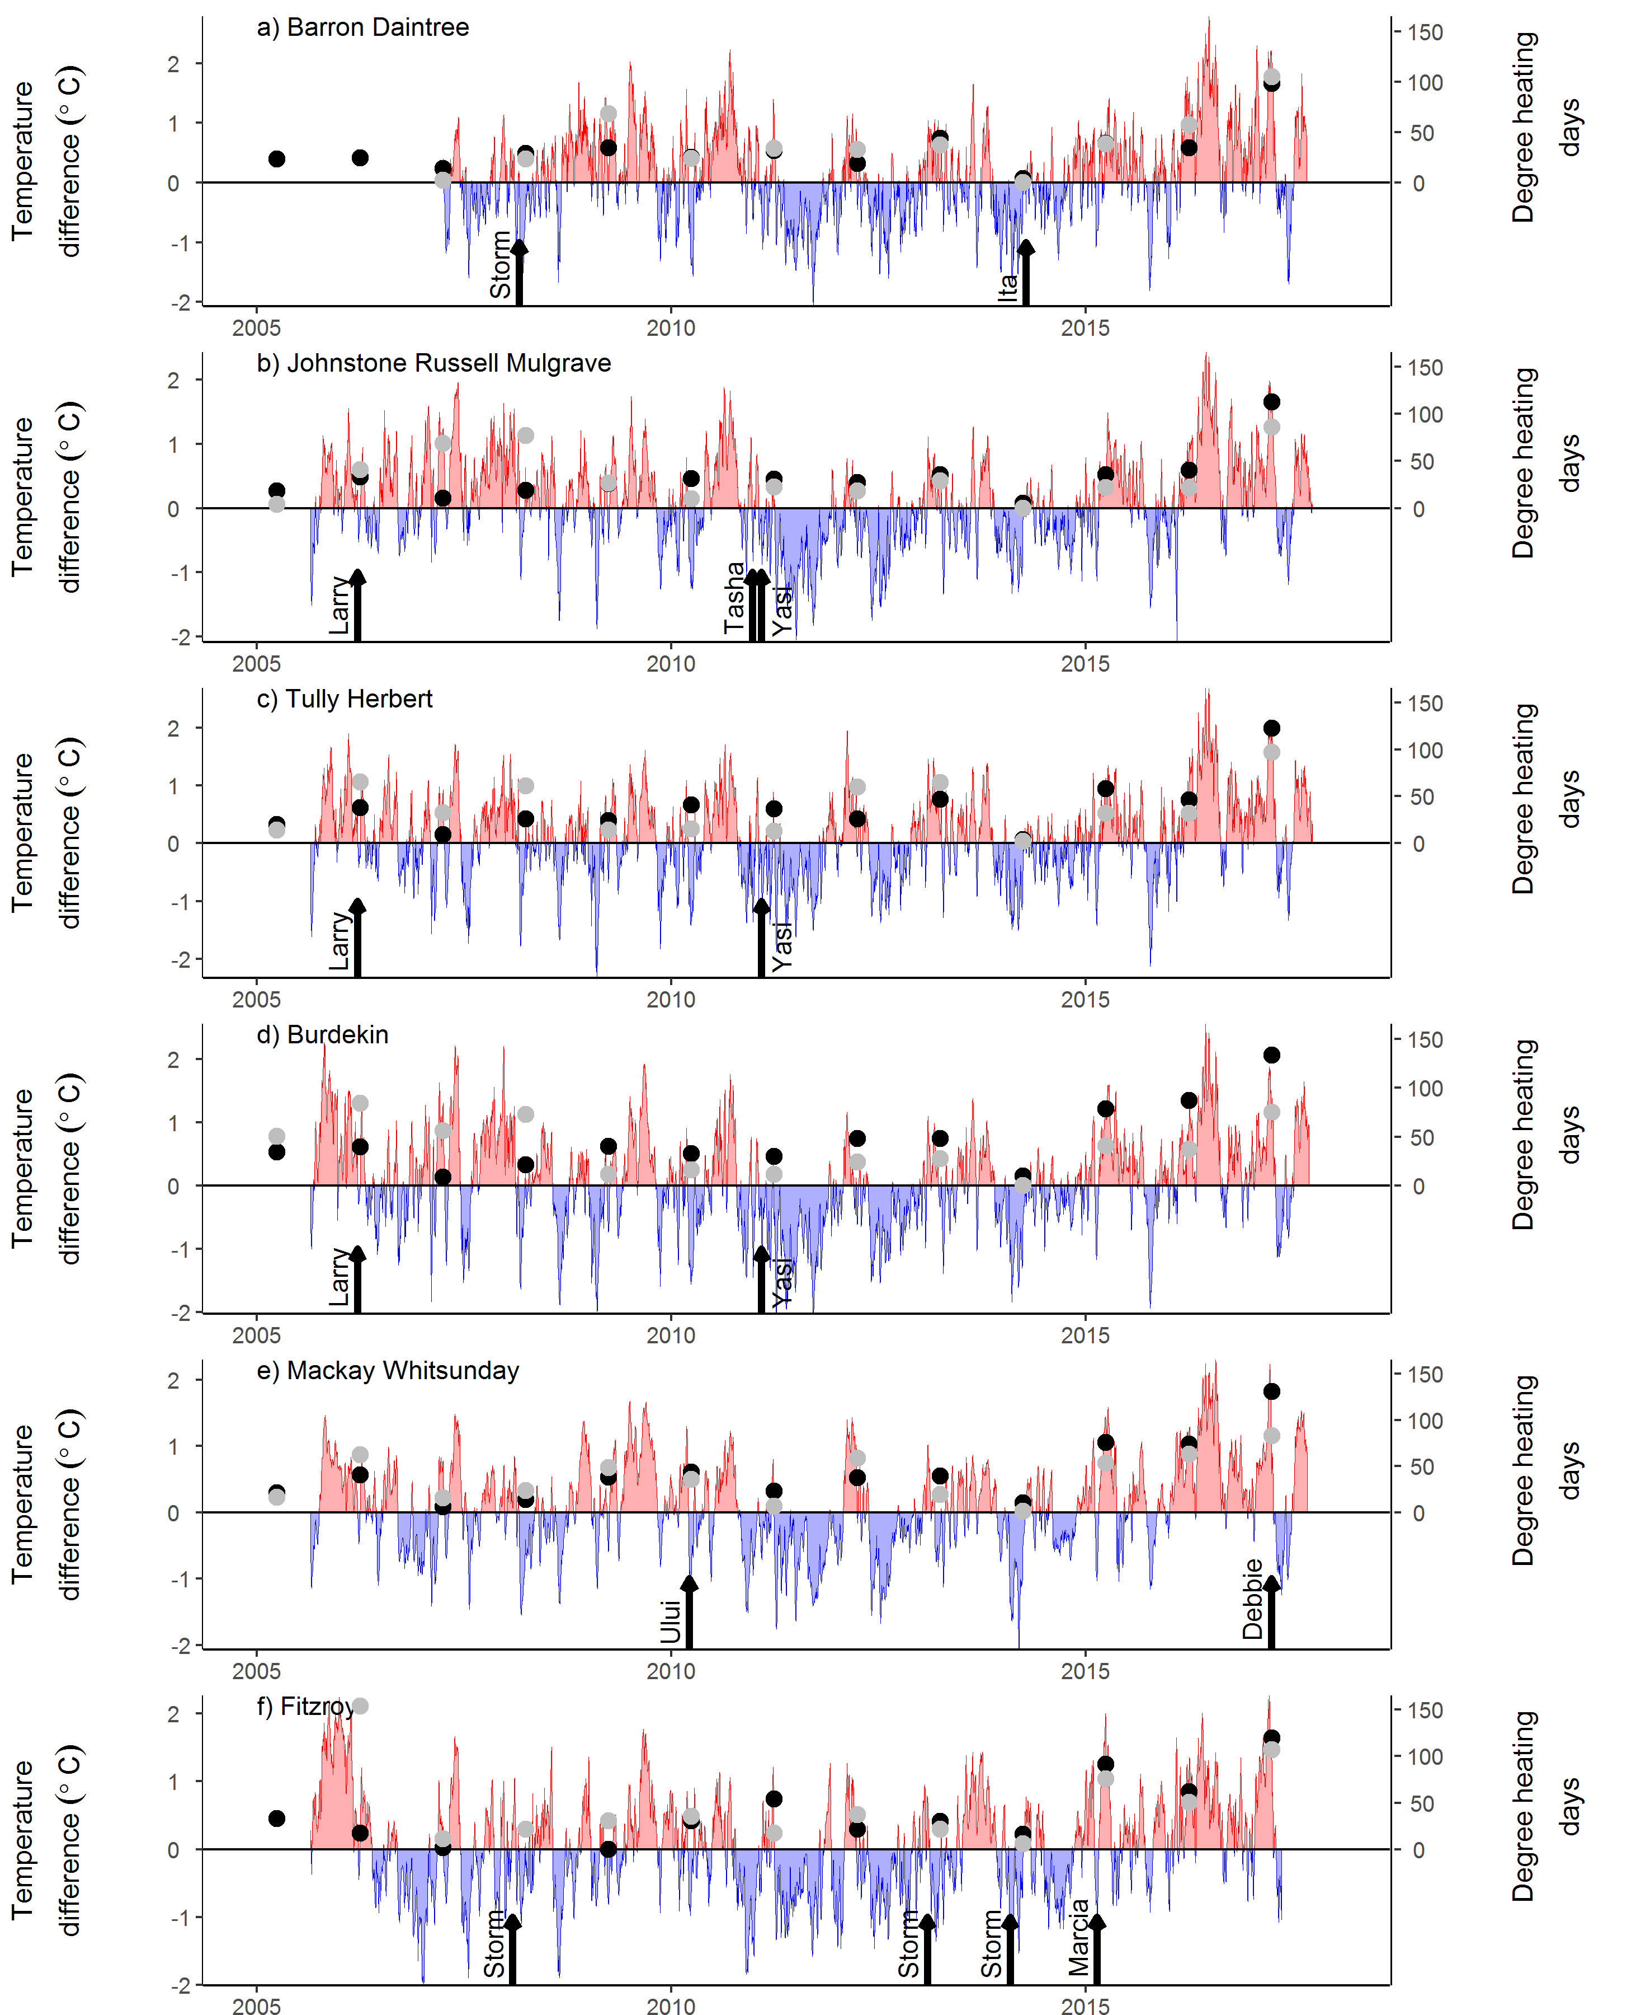
Figure 25 Regional temperature anomalies from the 2005-2017. Plotted are mean deviations from climatology described by temperature loggers deployed at reef sites in each (sub) region. DHD from ReefTemp (black dots) and In situ loggers (grey dots) align with the right axis. Event of Cyclones are marked by arrows.

Table 17 Bleaching impacts at MMP reefs 2016– 17. Proportion bleached indicates the proportion of hard corals in photo transects that were either partially bleached or totally whit at time of survey. The proportional change in total coral cover is recorded between the last two surveys for each reef in the MMP. Cases where the period between surveys was 2yr are denoted with *, all other periods are 1 year. Reefs not visited in 2016 are left blank. Declines in coral cover attributed to cyclone damage are donated by ^{TC}. All other coral declines are attributed to bleaching.

Region | Sub region | Reef | Depth | Survey Date 2017 | Proportion bleached at time of survey (%) |  | Proportional change in cover (%)
 |  |  |  |  | 2016 | 2017 | 2016 | 2017
Wet Tropics | Barron Daintree | Snapper North | 2 | 5-Sep | 0 | 0 | 62.9 | -41.2
Wet Tropics | Barron Daintree | Snapper North | 5 | 5-Sep | 1.7 | 12.0 | 13.4 | -32.9
Wet Tropics | Barron Daintree | Snapper South | 2 | 4-Sep | 0 | 0.4 | 12.9 | 6.8
Wet Tropics | Barron Daintree | Snapper South | 5 | 4-Sep | 0.4 | 0.3 | 5.6 | 0.3
Wet Tropics | Johnstone Russell-Mulgrave | Fitzroy West | 2 | 26-Jun | 0.9 | 2.5 | 8.6 | -17.5
Wet Tropics | Johnstone Russell-Mulgrave | Fitzroy West | 5 | 26-Jun | 0.3 | 4.4 | 13.9 | -20.6
Wet Tropics | Johnstone Russell-Mulgrave | Franklands East | 2 | 6-Aug | 0 | 0.4 | 32.1 | -5.9
Wet Tropics | Johnstone Russell-Mulgrave | Franklands East | 5 | 6-Aug | 0.7 | 4.4 | 10.9* | -23.4
Wet Tropics | Johnstone Russell-Mulgrave | Franklands West | 2 | 6-Aug | 0 | 1.1 | 25.4* | -14.8
Wet Tropics | Johnstone Russell-Mulgrave | Franklands West | 5 | 6-Aug | 0 | 0 | 32.0 | -18.4
Wet Tropics | Johnstone Russell-Mulgrave | High East | 2 | 25-Jun | 0.5 | 2.6 | 28.9 | -23.1
Wet Tropics | Johnstone Russell-Mulgrave | High East | 5 | 25-Jun | 0.7 | 7.3 | -2.7 | -5.4
Wet Tropics | Johnstone Russell-Mulgrave | High West | 2 | 25-Jun | 0.1 | 1.0 | 5.3* | -15.1
Wet Tropics | Johnstone Russell-Mulgrave | High West | 5 | 25-Jun | 0 | 1.2 | 28.1* | -22.9
Wet Tropics | Tully Herbert | Barnards | 2 | 2-May |  | 23.4 |  | 1.5*
Wet Tropics | Tully Herbert | Barnards | 5 | 2-May |  | 35.0 |  | 26.1*
Wet Tropics | Tully Herbert | Bedarra | 2 | 3-May | 2.6 | 22.9 | -5.3 | -21.9
Wet Tropics | Tully Herbert | Bedarra | 5 | 3-May | 0.4 | 26.7 | 22.8 | -2.6
Wet Tropics | Tully Herbert | Dunk North | 2 | 7-Aug | 0.3 | 1.7 | 112.9* | 3.1
Wet Tropics | Tully Herbert | Dunk North | 5 | 7-Aug | 0.7 | 0 | 71.6* | -5.9
Wet Tropics | Tully Herbert | Dunk South | 2 | 2-May | 0.7 | 6.8 | 70.1* | -30.8
Wet Tropics | Tully Herbert | Dunk South | 5 | 2-May | 1.2 | 66.1 | 7.8* | 0.6
Burdekin |  | Havannah | 2 | 9-May | 1.3 | 44.0 | -0.6 | -31.4
Burdekin |  | Havannah | 5 | 9-May | 0.9 | 27.6 | 32.4 | -2.8
Burdekin |  | Magnetic | 2 | 1-May | 0.3 | 0 | 33.3 | -15.2
Burdekin |  | Magnetic | 5 | 1May | 2.5 | 14.2 | 9.9 | 2.5
Burdekin |  | Palms West | 2 | 10-May | 11.2 | 55.2 | 20.3 | -24.7
Burdekin |  | Palms West | 5 | 10-May | 1.5 | 36.9 | 35.8 | -8.8
Burdekin |  | Pandora | 2 | 9-May | 0 | 9.9 | 85.1* | -9.0
Burdekin |  | Pandora | 5 | 9-May | 0.8 | 24.8 | 16.7* | 38.7
Mackay Whitsunday |  | Daydream | 2 | 6-Jul | 1.2 | 0 | 64.5 | -98.3
Mackay Whitsunday |  | Daydream | 5 | 6-Jul | 0 | 7.4 | 44.4 | -89.6
Mackay Whitsunday |  | Dent | 2 | 5-Jul |  | 0 |  | -45.6*^{TC}
Mackay Whitsunday |  | Dent | 5 | 5-Jul |  | 2.5 |  | -34.3* ^{TC}
Mackay Whitsunday |  | Double Cone | 2 | 30-Jun | 1.7 | 0 | 15.2* | -97.3 ^{TC}
Mackay Whitsunday |  | Double Cone | 5 | 30-Jun | 9.5 | 1.6 | 5.5* | -72.9 ^{TC}
Mackay Whitsunday |  | Pine | 2 | 5-Jul |  | 0 |  | -72.8* ^{TC}
Mackay Whitsunday |  | Pine | 5 | 5-Jul |  | 17.3 |  | -53.2* ^{TC}
Mackay Whitsunday |  | Seaforth | 2 | 29-Jun |  | 0 |  | -40.5* ^{TC}
Mackay Whitsunday |  | Seaforth | 5 | 29-Jun |  | 0.6 |  | -18.5* ^{TC}
Mackay Whitsunday |  | Shute Harbour | 2 | 6-Jul | 0.3 | 0.2 | 29.6* | -46.3 ^{TC}
Mackay Whitsunday |  | Shute Harbour | 5 | 6-Jul | 0 | 3.6 | 10.4* | -51.7 ^{TC}
Fitzroy |  | Barren | 2 | 14-May |  | 5.5 |  | 33.7*
Fitzroy |  | Barren | 5 | 14-May |  | 2.1 |  | 32.3*
Fitzroy |  | Keppels South | 2 | 14-May | 0.5 | 7.3 | 49.3 | 47.4
Fitzroy |  | Keppels South | 5 | 14-May | 0 | 4.2 | 16.6 | -4.3
Fitzroy |  | North Keppel | 2 | 15-May |  | 2.7 |  | 20.0*
Fitzroy |  | North Keppel | 5 | 15-May |  | 0.7 |  | 63.7*
Fitzroy |  | Peak | 2 | 17-May |  | 0.0 |  | 17.3*
Fitzroy |  | Peak | 5 | 17-May |  | 1.8 |  | -4.6*

Table 18 Sensitivity of common coral genera to bleaching. General included were had and average cover across all Wet Tropics and Burdekin reefs of >0.1% prior to or during 2017 surveys. Values for proportion bleached and proportional change in cover were estimated from phot transect data as described for total coral cover. Categorisation of bleaching susceptibility observed by Marshall & Baird (2000) are included for comparative purpose.
Genus | Average cover in 2017  (%) | Average cover from previous survey  (%) | Proportional change in cover  (%) | Proportion bleached  (%) | Susceptibility Marshall & Baird 2000
Seriatopora | 0.06 | 0.25 | -76.3 | 89.3 | Severe
Goniastrea | 0.11 | 0.21 | -48.0 | 19.0 | Moderate
Cyphastrea | 0.17 | 0.26 | -35.5 | 2.5 | Low
Favites | 0.24 | 0.34 | -29.5 | 25.1 | Moderate
Pachyseris | 0.75 | 1.03 | -27.6 | 33.8 | High
Lobophyllia | 0.21 | 0.29 | -27.5 | 15.1 | Moderate
Acropora | 6.19 | 8.24 | -24.8 | 19.7 | Mixed
Psammocora | 0.10 | 0.13 | -20.8 | 2.0 | Low
Merulina | 0.34 | 0.4 | -16.1 | 62.7 | High
Pavona | 0.13 | 0.16 | -16.8 | 12.8 | Mixed
Platygyra | 0.25 | 0.27 | -6.8 | 21.7 | Moderate
Pocillopora | 0.55 | 0.59 | -6.8 | 37.6 | Severe
Goniopora | 0.88 | 0.93 | -5.3 | 0.71 | Low
Porites | 8.78 | 9.05 | -3.0 | 2.1 | Moderate
Montipora | 3.38 | 3.46 | -2.5 | 11.4 | High
Caulastrea | 0.12 | 0.12 | -2.2 | 3.6 | n/a
Diploastrea | 0.17 | 0.16 | 1.3 | 0 | n/a
Echinopora | 0.38 | 0.37 | 2.8 | 16.4 | Moderate
Turbinaria | 0.8 | 0.77 | 3.7 | 2.3 | Low
Oxypora | 0.13 | 0.12 | 8.6 | 41.3 | Moderate
Favia | 0.46 | 0.42 | 10.3 | 34.3 | Moderate
Galaxea | 0.36 | 0.32 | 12.4 | 1.7 | Low
Mycedium | 0.11 | 0.09 | 25 | 52.7 | Mixed
Podabacia | 0.10 | 0.08 | 25 | 0 | n/a
Fungia | 0.18 | 0.12 | 49.7 | 19.0 | n/a

Case Study – Selection of environmental covariates for reporting against coral index and indicator scores
Reporting on coral community responses in relation to water quality pressures requires necessarily requires the derivation of appropriate estimates of environmental conditions that can be used as covariates in analyses of community responses. A problem facing the MMP is that water quality is only directly measured at less than half of the coral monitoring locations, and not at all in the Fitzroy Region, requiring the estimation of environmental conditions from alternate sources.
The purpose of this chapter is to assess available data with the view of identifying variables to serve as a proxy for the underlying spatial gradients of nutrient availability and turbidity along which the coral monitoring sites are dispersed, and secondly, variables that provide estimates of the temporal variability in the exposure of reefs to water quality pressures.
Spatially comprehensive water quality estimates for the inshore Reef are available from three sources.
- eReefs marine water quality http://www.bom.gov.au/marinewaterquality/ . Algorithms applied to satellite images provide estimates of several water quality parameters.
- eReefs biogeochemical model provides modelled estimates of a wide range of water quality parameters(https://research.csiro.au/ereefs/models/models-about/models-biogeochemistry/)
- The MMP (TropWater) estimates relative exposure to several water quality parameters based on the classification of water colour derived from satellite images and measured concentration of water quality parameters within each colour class of water (Waterhouse et al. 2017)
Each of the above estimates can be aggregated to provide spatial gradients among locations or temporal series within locations. In addition, temporal variability in the input of nutrients and sediments can be derived from discharge and river load monitoring undertaken by the Queensland government (https://water-monitoring.information.qld.gov.au/). These data, however, only allow relative loads among years to be considered at catchment rather than reef levels.

8.1 Data sourced
Algorithm derived estimates
Estimates of Chlorophyll a (Chl.BoM), non-algal particulate (NAP.BoM), coloured dissolved organic matter (CDOM.BoM) concentrations and the light extinction coefficient (kd490.BoM) derived from algorithms applied to data sourced from the MODIS aqua satellite-mounted sensor were downloaded from the Australian Bureau of Meteorology. For each reef at which coral communities are monitored, a set of nine 1 km² pixels were identified in adjacent open water and monthly mean concentrations downloaded for these pixels. Spatial gradients in water quality were estimated as the overall mean of monthly median values for individual pixel locations for each reef. Means for the wet season were restricted to include only the months November–April.
Water colour derived estimates
Relative exposure to Chlorophyll a (Chl.exp), total suspended solids (TSS.exp), particulate nitrogen (PN.exp) and particulate phosphorus (PP.exp) concentrations that were above wet season guideline levels (GBRMPA 2010) for each reef over the wet season months (December- April) were estimated based on methods developed by the water quality component of the MMP (Waterhouse et al. 2017, Petus et al. 2016). In brief, MODIS aqua images were used to classify waters into one of six colour classes that range from those typical of primary (colour classes 1-4), secondary (class 5), or tertiary (class 6) river plumes. It is important to note that waters can be classified in to these colour classes when not exposed to flood plumes, as extra plume processes such as wind driven resuspension, may produce waters with similar spectral signatures. The lowest (most turbid and nutrient rich) colour class for a given pixel was recorded as the exposure of that pixel in a given week. Matching in situ sampling with the classified colour of the water at the date and location of the sample provided estimates of mean concentration of water quality parameters for each colour class over the period 2003-2016. For each variable, the wet season exposure $E$ for each water quality variable j was estimated as:
$$E_{j}=\sum{f_{i}*(C_{ij}-{GL}_{j})}$$
Where:
$f_{i}$ is the proportion of the wet season that pixel was classified as the ith colour class,
$C_{ij}$ is the mean concentration of the jth water quality variable in the ith colour class and
${GL}_{j}$ is the wet season guideline value for the jth water quality variable.
Where the mean concentration of a water quality variable in a given colour class was below the Guideline value no exposure was included. Mean exposures for each reef and variable were the mean $E_{j}$ over the 2003-2016 wet season estimates.
Modelled estimates
Model output from the eReefs 4km grid size biogeochemical model (version gbr4_bgc_GBR4_H2p0_B2p0_Chyd_Dcrt) were downloaded from (http://dapds00.nci.org.au/thredds/catalog/fx3/gbr4_bgc_GBR4_H2p0_B2p0_Chyd_Dnrt). For each reef, monthly mean estimates for the period Dec-2010 to Oct-2016 were extracted from the pixel containing the waypoint used as the centre point of the nine 1km pixels used for the colour class and algorithm based estimates. The variables included were “Total Chlorophyll” (Chl.eR), a variable termed “Ecology Fine Inorganics” (EFI.eR) that estimates concentration of suspended sediments with particle size <30µm, “Dissolved Inorganic Nitrogen” (DIN.eR), “Dissolved Inorganic Phosphorus” (DIP.eR), “Total N” (TN.eR), “Total P” (TP.eR) and “Vertical Attenuation At 490nm” (Kd490.eR). Data were aggregated (mean) to produce mean water-year (October-September), and wet-season (December-April) estimates for each location.
Selection of the most appropriate variables to be used as covariates in analysis was informed by considering both the correlation between estimates from a given source, and then the consistency of estimated gradients to those directly measured at a subset of sites. Comparisons are based on spearman correlation coefficients.

Comparing water quality gradients estimated from Wet season or overall conditions.
Both the algorithm and eReefs modelled estimates can be aggregated to the level of annual estimates for each reef by including only wet season or all months. In both data sets, annual estimates at each reef based on estimates from the wet season only were highly correlated with those that included all months. For the parameters estimated by the eReefs model the least correlated was EFI with a correlation coefficient of 0.94. For the parameters estimated by the algorithms applied to MODIS imagery, the least correlated was NAP with a correlation coefficient of 0.94. For temporal analyses these results suggest there is little difference in the annual gradients described with or without dry season estimates. As any runoff derived impacts are most likely to occur during flood events, for temporal analyses it is appropriate to focus on conditions during the wet season.

Correlation between parameter estimates within each source.
The strong gradient in water quality among sites means that different WQ parameters are often correlated. Pragmatically, the correlation among variables suggest they are effectively proxies for one another, meaning that there is little added information content for models that include multiple correlated covariates. For linear models, collinearity among covariates renders the individual estimates for effects unreliable (Logan 2010). Comparing just the annual wet season estimates for the BoM algorithms suggest that CDOM.BoM, Chl.BoM and Kd490.BoM are all closely correlated (Table 19). While this correlation may well represent real levels of these parameters, it does limit their utility as separate covariates with which to explain variability in coral community responses. NAP.BoM is less correlated to CDOM.BoM and Chl.BoM, although is logically correlated to Kd490.BoM (Table 19).
Comparing estimates derived from the eReefs model understandably demonstrates correlation between Chl.eR concentration and nutrients: TN.eR, TP.eR, DIP.eR and to a lesser degree DIN.eR. Among nutrients the total fractions, TN.eR and TP.eR, are highly correlated as are the dissolved inorganic fractions DIN.eR and DIP.eR. Light attenuation, Kd490.eR, correlates with both EFI.eR and Chl.eR, while the later are not highly correlated with each other. The correlations among the eReefs parameters reflect the capturing in the model of the general understanding that Chl a is a proxy for nutrient availability and, in combination with suspended sediments (EFI), increases the attenuation of light.
The method for estimating water quality exposure based on water colour includes multiplication of the measured concentrations of water quality parameters by the frequency of exposure to each colour class. This multiplication by a constant, the frequency of exposure, dictates the highly correlated estimates among variables (Table 21). The higher correlation between the nutrient parameters and Chl a.exp compared to TSS.exp does, however, demonstrate the differing rate of reduction in exposure between colour classes with exposure to above guideline values declining more rapidly for TSS compared to Chl a.
Table 19 Correlation between water-quality parameters available from eReefs Marine Water Quality Dashboard. Data assessed were the mean concentrations for the period 2003-2016 for pixels adjacent to monitored reefs.
 | CDOM.BoM | Chl.BoM | Kd490.BoM
CDOM.BoM | 1
Chl.BoM | 0.948566 | 1
Kd490.BoM | 0.953245 | 0.908794 | 1
NAP.BoM | 0.812582 | 0.757309 | 0.944926

Table 20 Correlation between water-quality parameters selected from eReefs Biogeochemical 4km model. Data assessed were the mean concentrations for the period 2011-2016 for sites locations adjacent to monitored reefs.
 | Chl.eR | DIN.eR | DIP.eR | EFI.eR | Kd490.eR | TN.eR
Chl.eR | 1
DIN.eR | 0.606 | 1
DIP.eR | 0.700 | 0.931 | 1
EFI.eR | 0.625 | 0.442 | 0.383 | 1
Kd490.eR | 0.734 | 0.611 | 0.570 | 0.960 | 1
TN.eR | 0.812 | 0.704 | 0.808 | 0.505 | 0.620 | 1
TP.eR | 0.833 | 0.771 | 0.896 | 0.475 | 0.616 | 0.979

Table 21 Correlation between estimated mean exceedance of wet-season guideline values. Estimates based on colour class classification of waters during the wet-season and mean concentration of in situ samples from water colour classes. Data assessed were the mean exceedance of the period 2003-2016 for pixels adjacent to monitored reefs.
 | Chl.exp | PN.exp | PP.exp
Chl.exp | 1
PN.exp | 0.979 | 1
PP.exp | 0.983 | 0.991 | 1
TSS.exp | 0.940 | 0.900 | 0.935

The second consideration for comparison among sources of water quality estimates was how faithfully they represented the gradients observed in data from niskin samples. The following correlations compare reef means, aggregated over the time series available for the fourteen reefs for which there were niskin sampled estimates. The niskin samples were aggregated over all samples collected over the period 2005-2016. As a point of reference to the correlations represented above, the niskin samples also show higher correlation between Chl and TP than between Chl and either TN or TSS (Table 22) described by the Reefs model.
Table 22 Correlation between water quality parameters estimated from niskin sampling adjacent to monitored reefs
 | Chl.niskin | TSS.niskin | TN.niskin | TP.niskin
Chl.niskin | 1
TSS.niskin | 0.752 | 1
TN.niskin | 0.755 | 0.550 | 1
TP.niskin | 0.869 | 0.632 | 0.956 | 1

Comparing the suspended sediment related parameters from the various sources demonstrates the NAP.BoM estimates correspond more closely to the overall gradient observed in TSS.niskin and Secchi estimates than estimates derived from either exposure to water colour classes or the eReefs model (Table 23). For Chl, the gradient described by water colour class exposure was strongly correlated with that observed in Chl.niskin samples, and also similar to that described by the BoM algorithm (Table 24). There was minimal correlation between niskin sampled mean concentrations of dissolved nutrients and those estimated by the eReefs model (Table 25). Both Total N and Total P estimated by eReefs were correlated with Total P observed in niskin samples (Table 26).
Table 23 Correlation between suspended sediment related parameter estimates. Shading indicates the estimated variable that most closely correlated with the measured gradient.
 | Secchi | TSS.niskin | NAP.BoM | TSS.exp
Secchi | 1
TSS.niskin | -0.973 | 1
NAP.BoM | -0.940 | 0.923 | 1
TSS.exp | -0.621 | 0.648 | 0.719 | 1
EFI.eR | -0.632 | 0.615 | 0.593 | 0.225

Table 24 Correlation between Chlorophyll estimates. Shading indicates the estimated variable that most closely correlated with the measured gradient.
 | CHL.niskin | Chl.BoM.wet | Chl.BoM | Chl.exp | Chl.eR.wet | Chl.eR
CHL.niskin | 1
Chl.BoM.wet | 0.626 | 1
Chl.BoM | 0.648 | 0.973 | 1
Chl.exp | 0.851 | 0.890 | 0.923 | 1
Chl.eR.wet | 0.593 | 0.027 | 0.016 | 0.209 | 1
Chl.eR | 0.467 | -0.159 | -0.104 | 0.098 | 0.874 | 1

Table 25 Correlation between dissolved nutrient estimates.
 | DIP.niskin | DIN.niskin | DIN.eR
DIP.niskin | 1
DIN.niskin | 0.429 | 1
DIN.eR | 0.143 | 0.099 | 1
DIP.eR | 0.368 | 0.159 | 0.797

Table 26 Correlation between particulate nutrient estimates
 | TN.niskin | TP.niskin | TN.eR
TN.niskin | 1
TP.niskin | 0.835 | 1
TN.eR | 0.621 | 0.890 | 1
TP.eR | 0.610 | 0.890 | 0.984

From the above comparisons the following estimates were chosen as covariates representing differences in water quality among reefs and between years:
- Non-algal Particulate concentrations estimated by BoM algorithms were chosen as the covariate best estimating exposure to suspended sediments.
- Exposure to above guideline levels of Chl a, as estimated by colour class categorisation over the wet season, was chosen as a proxy for differing exposure to nutrients in general. This parameter best described observed gradients in Chl a and there was little evidence that the eReefs model, the only potential source for reef level nutrient estimates, captured variations that related to observed gradients in dissolved nutrient species.
- Total N and Total P estimated from the eReefs model were highly correlated, and together correlated to measured gradients in Total P. Also, as the eReefs model takes loads from the catchments as an input, Total P may be a useful parameter once the time-series of modelled estimates lengthens. In this report we have deferred to derived loads of nutrients from the regions catchments as a direct estimate of variability in nutrient loads coming from the catchments.
We stress that this assessment is only pertinent to the 4km grid size version of the eReefs model for which a reasonable time-series was available. It should be noted that the biogeochemical models have continued to evolve with a 1km grid size model that incorporates active assimilation of in situ observations now available. As the time-series from this newer product extends it is likely to provide improved estimates of water quality surrounding not only inshore, but all reefs.

Case Study – Inclusion of Reef Check Australia data into the Reef Report Card

9.1 Introduction
A key component of the Reef 2050 Plan is establishing the Reef 2050 Integrated Monitoring and Reporting Program (RIMReP) for the reef and its adjacent catchments. The intention behind RIMReP is to coordinate, align and integrate existing programs to capitalise on investment, improve efficiency and avoid duplication. One such existing program is Reef Check Australia (RCA), a not-for-profit, citizen science organisation whose primary purpose is to facilitate public participation in meaningful marine monitoring.
Launched in 2001, RCA has expanded over the last 16 years to include 60 key monitoring locations spread over the six NRM regions from Cape York to the Burnett-Mary. As a citizen science organisation, RCA relies on volunteers, who are trained in its methods before being allowed to undertake surveys. Volunteers may or may not have university training, and they undergo moderate levels of classroom and in-water training in identification and methodology.
Although considerable efforts are made using quality control measures including: standardised site selection, grouping similar species to avoid misidentification, field data verification and raw data revision, sampling error remains inherent in the data due to transect placement, depth and variability between observers. Done et al. 2017 provide a power analysis and simulation based on the RCA data and concluded that RCA benthic data are useful for providing Reef science and management stakeholders with indicators of ecological condition at relevant spatial scales. Further, several sites where there is sufficient data and continued monitoring can also provide data over temporal scales.
Here we conduct a similar analysis to that conducted by Done et al. (2017) with a specific focus on routinely monitored, inshore RCA monitoring sites and the potential for RCA data to be included in the MMP reporting and formulation of the Coral index.

9.2 Methods
In 2016 RCA volunteers conducted surveys on 17 inshore, mid-shelf and outer-shelf reefs in four NRM regions. Surveys were conducted at 44 GPS marked sites, across multiple habitats and zones within individual reefs. The methods used by RCA are derived from the Reef Check (RC) program, an internationally based citizen science program (Hodgson 1999). This involves a standard point intercept transect (PIT) sampling protocol from which data is collected on 10 standard benthic categories: live hard coral, recently dead hard coral, soft coral, fleshy seaweed, sponge, other benthos, rock, rubble, sand, and silt/clay. RCA does, however, further refine these categories to identify various growth forms of hard corals and key groups of algae. RCA sites are selected following a standardised protocol which requires a minimum of 80 m of continuous coral reef at a constant depth. At each site a 100m tape is laid along the reef at a designated depth. Typically this depth is at 3-6 m however it can range from 1 to 12 m across RCA monitoring locations. While efforts are made to ensure consistent placement of transects from year to year there are no permanent markers in place and precise placement and alignment of transects does vary between visits. Transects are sampled using the PIT method at 0.5 m intervals along 20 m sections of tape. Each section is separated by a 5 m gap to provide independent replicate transects within each site.
For the purpose of this study, RCA provided data for 12 inshore reef sites which are relevant to the MMP. Eight sites are located across five bays of Magnetic Island in the Burdekin region, two sites at Blue Pearl Bay, Hayman Island and two at the northern end of Daydream Island in the Mackay-Whitsunday Region. These data provide a potential increase in the spatial coverage of coral cover estimates within these two regions. Whilst there is clear benefit in increasing the spatial coverage of the MMP data, the inclusion of these data into the report card needs to be considered in light of two key issues, sampling error and on-going surveys of selected sites.

Coral cover estimates provided by RCA were formatted to be compatible with MMP estimates and incorporated into the methods used to derive scores for the report card index and Coral Cover metric (see section 4 of this report for details).
For coral cover, sampling error will include a combination of: random variability in the intersection of sampled points across the benthic community, differences in the % cover of the benthos beneath the transect line as a result of variability in the location of the line, and observer error or bias in identification of the benthos below selected sampling points. To help understand the theoretical limits to the precision of coral cover estimates based on currently used sampling intensity (number of points) we estimated the distribution of observed coral cover estimates about the true mean for sampling intensities used by the LTMP, MMP and Reef Check. Coral cover can be estimated as the proportion of points from a given survey that are classified as coral, as opposed to anything else. As such, it is possible to assume that coral cover is distributed according to a binomial distribution B($n,p$) where a given point in a survey of sample size$n$ is classified as coral as opposed to anything else according to probability $p$. Under this scenario, to illustrate the influence of the sample size $n$ on the precision of 95% confidence intervals for $p$, confidence intervals were calculated for coral cover estimates of 5, 10, 25 and 50 percent and for sampling intensities ranging from 0 to 3500 points. Confidence intervals were computed based on Normal approximations as follows:

$CI= \hat{p } ± 1.96* \sqrt{\frac{\hat{p } \left(1-\hat{p}\right)}{n}}$
We stress the simulation investigates only the precision of estimates as a function of intensity with which a site is sampled and does not account for additional bias that will result from the use of multiple observers or variation resulting from differing placement of transect lines in consecutive surveys.

9.3 Discussion of results
Comparison of the regional level index and Coral Cover metric scores demonstrates that the inclusion of the RCA data has negligible influence on either the coral cover metric or the coral index at a regional level (Figure 26). At a regional level, coral index scores reported by the MMP are derived from the mean of the scores derived from five separate metrics. Of the metric scores included in the coral index the RCA methods only allow the estimation of scores for the Coral Cover metric. Each metric score is the mean of the scores derived from each reef and depth combination monitored with the region (15 for the Burdekin and 17 for the Mackay Whitsunday Regions). The addition of RCA estimate for coral cover results in little change to the Coral Cover metric as the sites monitored by RCA have coral covers within the distribution of those already included in the program and constitute a minor increase in the number of indicator scores averaged to provide the regional level index score. The added number of sites does result in a slight reduction in confidence interval about the regional mean in any given year due to the increased number of sites from which the mean is estimated. This should not be confused with improving the ability to detect a trend. Trend detection relies on both the consistency of the response (either between sites if the interest is for a particular reef or between reefs if the interest is at the scale of the spread of the reefs considered) and the uncertainty in the sampling. The inherent sampling error arising from the intensity of sampling used by RCA will have obvious implications for detecting trends in cover at those reefs.
Closer examination of the trends in coral cover at individual reefs identifies marked differences between RCA reefs and MMP/LTMP reefs. This is most evident in the Burdekin region where RCA data indicated a sharp decline in coral cover at all RCA reefs in 2009 followed by variable trajectories of increase in subsequent years. This decrease is not reflected in the MMP data nor, to our knowledge, were there any obvious disturbances such as storms or thermal anomalies that could explain such consistent declines in cover across the range of reefs surveyed, raising the prospect that some form a bias may have influenced these results. It should also be noted here, that all RCA sites in the Burdekin Region are situated at Magnetic Island and the trends in coral cover show considerably higher variability than that observed at the MMP site Magnetic ( Figures 27 and A1).

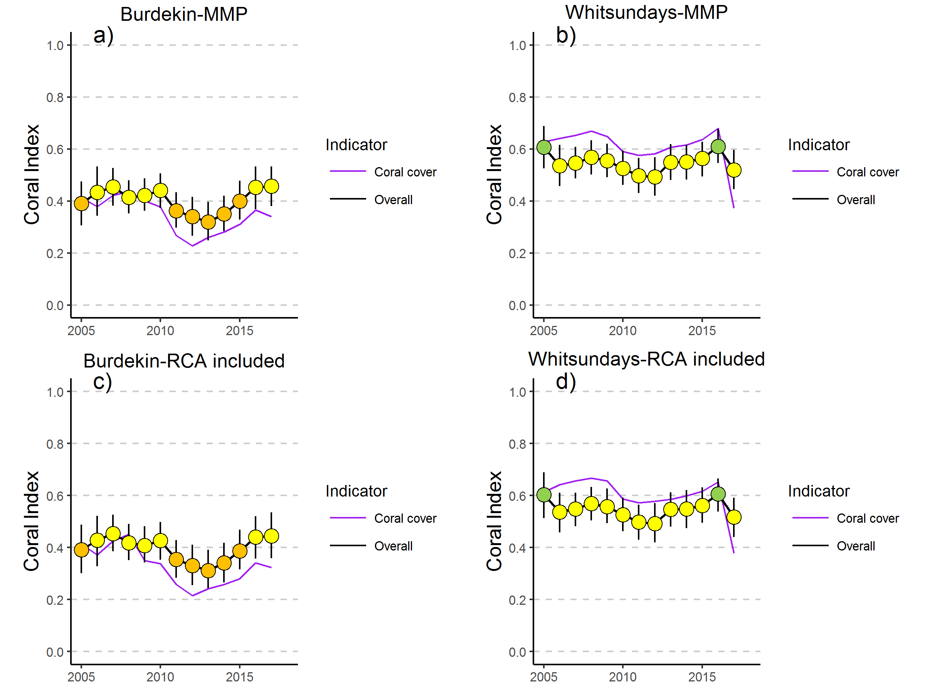
Figure 26 Comparison of Coral Index and Coral cover metric. Plots a) and b) show the trend in the coral index and Coral cover metric based on current data; c) and d) show the same trends with the RCA data included.

A further consideration is the grouping of RCA sites within the Burdekin region. In addition to the existing MMP and LTMP sites at Magnetic and Middle Reef, grouping of RCA sites within the Burdekin Region concentrates estimates for the Coral Cover metric into a small area of the Region, suggesting some form of area specific weighting may be considered.
The Cover Change metric effectively focusses on trend detection and is possible because the expected rate of increase in coral cover tends to exceed the inherent uncertainty in estimates stemming from the sampling design, particularly over a four year period which is the duration over which this metric is averaged. The low sampling intensity (Figure 28) and added errors likely incurred due to differences in placement of transects and different observers suggest the RCA surveys are not suitable for estimation of the Cover Change metric. The Cover Change metric is also reliant on identification, and exclusion, of changes in coral cover influenced by acute disturbance events. Such a categorisation again relies on precise estimates of coral cover so that losses can be appropriately identified and causation assigned.
The results presented in this report demonstrate that where existing monitoring is in place the inclusion of RCA data has no demonstrable influence on index scores primarily due to the low weights associated with individual observations on the overall index score. What we have not assessed is how any costs associated with including these data into reporting are offset by benefits resulting from increased spatial coverage or added interpretation of trends as a result of the information content in the additional observations collected during RCA monitoring. For example observations of disease could potentially help to identify periods of chronic stress, although again the veracity of these observations would need careful vetting and access to data in line with reporting deadlines considered.

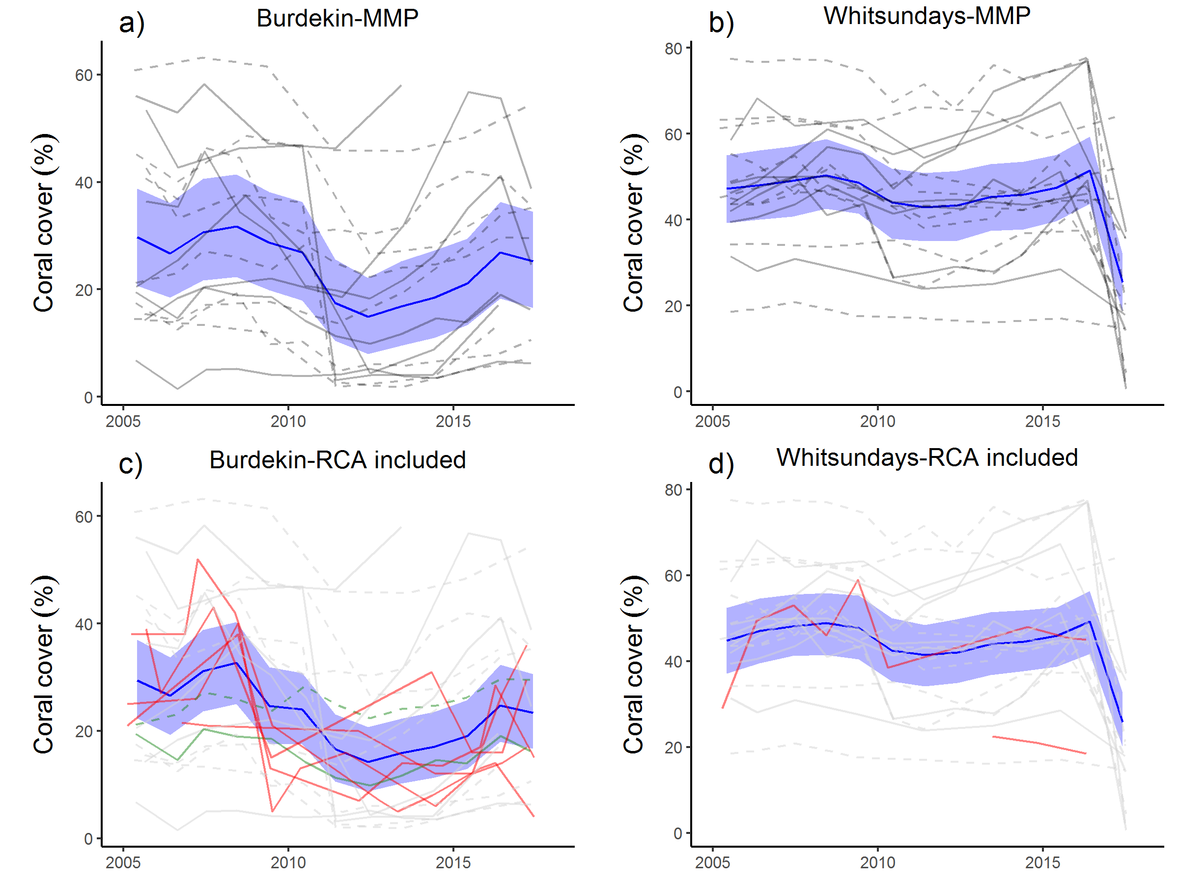
Figure 27 Comparison of Coral cover trends. Trends in the coral cover indicator, (blue lines) bound by 95% confidence intervals of those trends (shading), grey lines represent observed profiles for MMP reefs at 5 m (dashed) and 2 m (solid) depths. Red lines represent trends at RCA reefs, green lines in c) highlight trends at MMP reef Magnetic.

In situations where RCA data have a higher weight, due to a lack of coverage from more intensive programs, the variability in metric estimates derived from the less intensive sampling may be offset by inclusion of an adequate number of sites so that sampling errors are reduced. There is a clear improvement in the precision of the mean from RCA surveys that replicate surveys at three sites within a focal reef (Figure 28). What becomes important, then, is the commitment to continue monitoring, as removal or inclusion of sites (where there are few) will have a proportionally severe impact on mean scores.
What this report does not consider are the social benefits to be derived from the inclusion of data from the broader community of reef users into condition reporting. If there are desirable social benefits stemming from the inclusion of RCA data, these may outweigh the negligible impact the data have on the regional condition reporting.
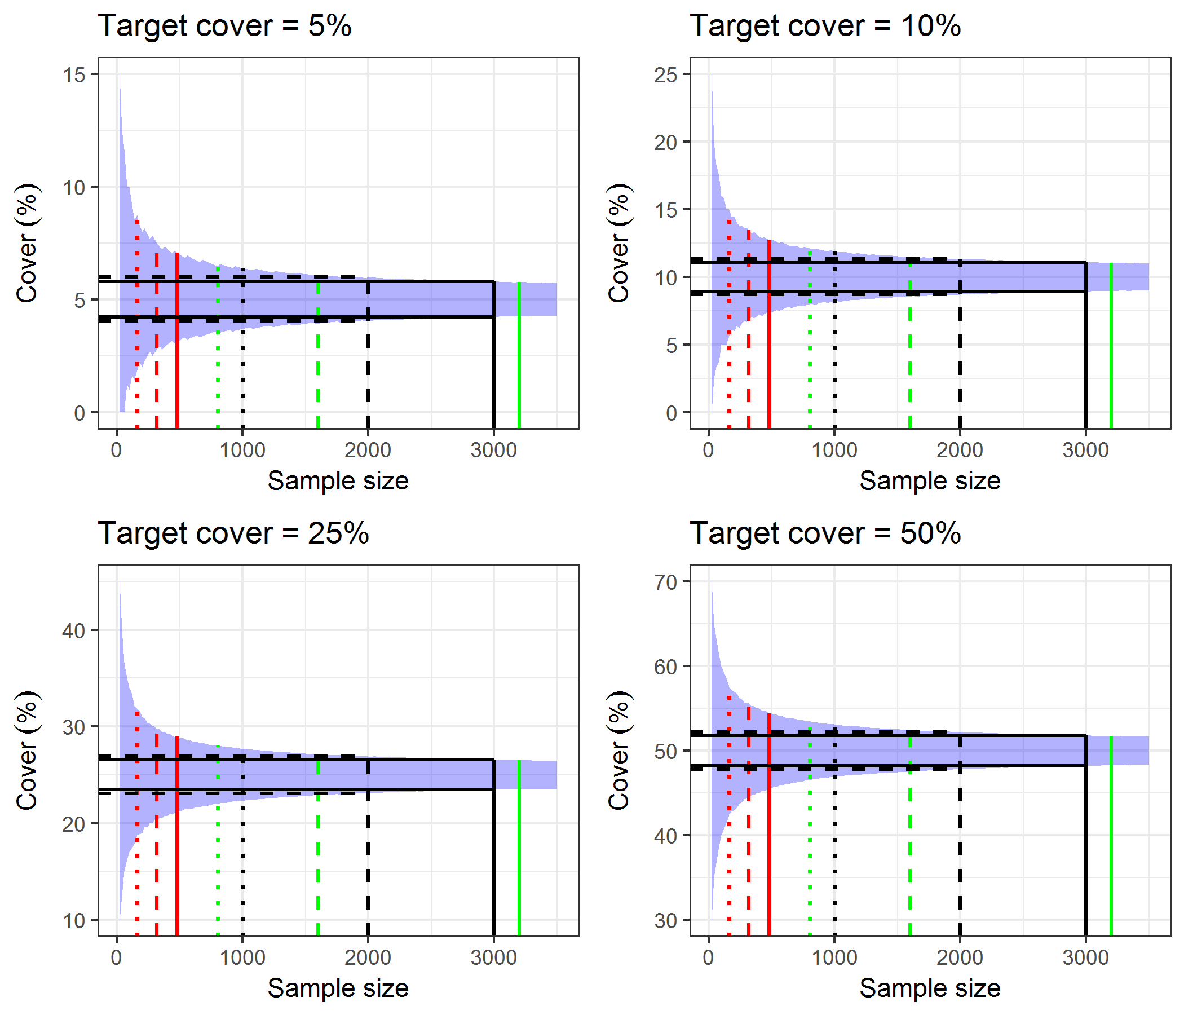
Figure 28 Theoretical influence of sampling intensity on precision of coral cover estimates. Blue area defines 95% confidence intervals based on sampling a binomial distribution. Reference lines indicate sampling intensity used by Reef Check (red), MMP (green) and LTMP (black) for one (dotted), two (dashed) and solid for three (Reef Check, LTMP) or four (MMP) sites within a reef. Confidence intervals for 2 and 3 sites at the rate sampled by the LTMP are extended to the y axis as a reference.

9.4 Conclusion
Prior to any decisions to include RCA data into MMP or RIMReP reporting there should be discussions focusing on sampling design aimed at improving the precision or utility of the data such as:
- timing of surveys,
- value of replicating sites within reefs,
- consistency of relocation of transects in consecutive surveys,
- explicit identification of disturbance events,
- data delivery and data storage protocols,
- data reporting,
- the commitment to ongoing sampling.
All of the above come at a cost of time for both RCA and RIMReP although should a sufficient number of sites be included, investment in automation of data ingest and reporting could provide long-term benefits. A further consideration that may improve the precision and therefore utility of RCA surveys for trend detection may lie in consideration of moving from a line intercept technique to a photo transect based survey. Deep learning techniques to be applied to the analysis of benthic image transects are currently in development. Such a shift would help to increase sampling intensity of the RCA transects and remove observer bias, while likely also reducing the time required to complete surveys. While this change may be unpalatable, given the legacy of RCA and ties to Reef Check, it is possible that this is the most productive way to incorporate the efforts of all involved.

Acknowledgments
We acknowledge the valuable contributions to data collection, sampling integrity and reporting of John Carlton, Stephen Neale and Damian Thomson over the first few years of the monitoring program. We thank Aaron Anderson, Joe Gioffre, Charlotte Johansson, Kate Osborne, Shawn Smith, Marcus Stowar and Irena Zagorskis for valuable field assistance over the years. We also thank Ed Butler, Terry Done, Johanna Johnson, Katherine Martin and a number of anonymous reviewers for their detailed reviews that improved the series of reports culminating in this current instalment.

References
Anderson MJ, Willis TJ (2003) Canonical analysis of principal coordinates: a useful method of constrained ordination for ecology. Ecology 84:511–525
Anon. (2003) Reef Water Quality Protection Plan for catchments adjacent to the Great Barrier Reef World Heritage Area. The State of Queensland and Commonwealth of Australia. Queensland Department of Premier and Cabinet, Brisbane. 43p
Anon. (2009) Reef Water Quality Protection Plan 2009. For the Great Barrier Reef World Heritage Area and adjacent catchments. The State of Queensland and Commonwealth of Australia. Queensland Department of the Premier and Cabinet, Brisbane. 30 pp.
Anon. (2011) Reef Water Quality Protection Plan. First Report 2009 Baseline. The State of Queensland and Commonwealth of Australia. Queensland Department of Premier and Cabinet, Brisbane. 140 pp. Available at www.reefplan.qld.gov.au
Anon. (2013) Reef Water Quality Protection Plan 2013.Securing the health and resilience of the Great Barrier Reef World Heritage Area and adjacent catchments. The State of Queensland. Reef Water Quality Protection Plan Secretariat, Brisbane. 34 p. Available at www.reefplan.qld.gov.au
Anthony KRN (1999) Coral suspension feeding on fine particulate matter. Journal of Experimental Marine Biology and Ecology 232:85-106
Anthony KRN, Fabricius KE (2000) Shifting roles of heterotrophy and autotrophy in coral energetics under varying turbidity. Journal of Experimental Marine Biology and Ecology 252:221-253
Ayling A (1997) The biological status of fringing reefs in the Great Barrier Reef world heritage area. Proceedings of the State of the Great Barrier Reef World Heritage Area Workshop pp. 109-113
Babcock RC, Smith L (2002) Effects of sedimentation on coral settlement and survivorship. In: Proceedings of the 9th International Coral Reef Symposium, Bali, Indonesia, 245–248
Baird AH, Babcock RC, Mundy CP (2003) Habitat selection by larvae influences the depth distribution of six common coral species. Marine Ecology Progress Series 252:289-293
Bartley R, Corfield JP, Hawdon AA, Kinsey-Henderson AE, Abbott BN, Wilkinson SN, Keen RJ (2014a) Can changes to pasture management reduce runoff and sediment loss to the Great Barrier Reef? The results of a 10-year study in the Burdekin catchment, Australia. The Rangeland Journal 36:67-84
Bartley R, Bainbridge ZT, Lewis SE, Kroon FJ, Wilkinson SN, Brodie JE, Silburn DM (2014b) Relating sediment impacts on coral reefs to watershed sources, processes and management: A review. Science of the Total Environment 468–469:1138-1153
Beeden, R.J., Turner, M.A., Dryden, J., Merida, F., Goudkamp, K., Malone, C., Marshall, P.A., Birtles, A. and Maynard, J.A. (2014), Rapid survey protocol that provides dynamic information on reef condition to managers of the Great Barrier Reef, Environmental Monitoring and Assessment 186(12): 8527-8540.
Belperio AP, Searle DE (1988) Terrigenous and carbonate sedimentation in the Great Barrier Reef province. In: J, D.L., H, R.H. (Eds.), Carbonate to Clastic Facies Changes. Developments in Sedimentology. Elsevier Science Publishers, Amsterdam, pp. 143–174
Bellwood DR, Hughes TP, Folke C, Nyströmm (2004) Confronting the coral reef crisis. Nature 429:827-833
Berkelmans R, De’ath G, Kininmonth S, Skirving WJ (2004) A comparison of the 1998 and 2002 coral bleaching events on the Great Barrier Reef: spatial correlation, patterns, and predictions. Coral reefs, 23(1):74-83
Berkelmans R, Jones A, Schaffelke B (2012) Salinity thresholds of Acropora spp. On the Great Barrier Reef. Coral Reefs 31:1103-1110
Bessell-Browne P, Negri AP, Fisher R, Clode PL, Jones R (2017a) Impacts of light limitation on corals and crustose coralline algae. Scientific Reports. doi:10.1038/s41598-017-11783-z
Bessell-Browne P, Negri AP, Fisher R, Clode PL, Jones R (2017b) Cumulative impacts: thermally bleached corals have reduced capacity to clear deposited sediment. Scientific Reports. doi:10.1038/s41598-017-02810-0
Birrell CL, McCook LJ, Willis BL (2005) Effects of algal turfs and sediment on coral settlement. Marine Pollution Bulletin 51:408-414
Birrell CL, McCook LJ, Willis BL, Diaz-Pulido GA (2008a) Effects of benthic algae on the replenishments of corals and the implications for the resilience of coral reefs. Oceanography and Marine Biology: An Annual Review 46:25-64
Birrell CL, McCook LJ, Willis BL, Harrington L (2008b) Chemical effects of macroalgae on larval settlement of the broadcast spawning coral Acropora millepora. Marine Ecology Progress Series 362:129-137
Brinkman R, Herzfeld M, Andrewartha J, Rizwi F, Steinberg C, Spagnol S (2011) Hydrodynamics at the whole of GBR scale. AIMS Final Project Report MTSRF Project 2.5i.1, June 2011. Report to Reef and Rainforest Research Centre. Australian Institute of Marine Science, Townsville. 42pp
Brodie J, Fabricius K, De’ath G, Okaji K (2005) Are increased nutrient inputs responsible for more outbreaks of crown-of-thorns starfish? An appraisal of the evidence. Marine Pollution Bulletin, 51(1):266-278
Brodie JE, Kroon FJ, Schaffelke B, Wolanski EC, Lewis SE, Devlin MJ, Bohnet IC, Bainbridge ZT, Waterhouse J, Davis AM (2012b) Terrestrial pollutant runoff to the Great Barrier Reef: An update of issues, priorities and management responses. Marine Pollution Bulletin 65:81-100
Brodie J, Wolanski E, Lewis S, Bainbridge Z (2012a) An assessment of residence times of land-sourced contaminants in the Great Barrier Reef lagoon and the implications for management and reef recovery. Marine Pollution Bulletin 65:267-279
Browne NK, Smithers SG, Perry CT (2010) Geomorphology and community structure of Middle Reef, central Great Barrier Reef, Australia: an inner-shelf turbid zone reef subject to episodic mortality events. Coral Reefs 29: 683-689
Browne NK, Smithers SG, Perry CT (2012) Coral reefs of the turbid inner-shelf of the Great Barrier Reef, Australia: An environmental and geomorphic perspective on the occurrence, composition and growth. Earth-Science Reviews 115:1-20
Bruno JF, Petes LE, Harvell CD, Hettinger A (2003) Nutrient enrichment can increase the severity of coral diseases. Ecology Letters 6:1056-1061
Bruno JF, Sweatman H, Precht WF, Selig ER, Schutte VGW (2009) Assessing evidence of phase shifts from coral to macroalgal dominance on coral reefs. Ecology 90:1478-1484
Caballes CF, Pratchett MS (2014) Reproductive biology and early life history of the crown-of-thorns starfish. In: Whitmore E (Ed) Echinoderms: ecology, habitats and reproductive biology. Nova Science Publishers, New York, NY, USA
Carpenter KE, Abrar M, Aeby G, Aronson RB, Banks S, Bruckner A, Chiriboga A, Cortes J, Delbeek JC, DeVantier L, Edgar GJ, Edwards AJ, Fenner D, Guzman HM, Hoeksema BW, Hodgson G, Johan O, Licuanan WY, Livingstone SR, Lovell ER, Moore JA, Obura DO, Ochavillo D, Polidoro BA, Precht WF, Quibilan MC, Reboton C, Richards ZT, Rogers AD, Sanciangco J, Sheppard A, Sheppard C, Smith J, Stuart S, Turak E, Veron JEN, Wallace C, Weil E, Wood E (2008) One-Third of Reef-Building Corals Face Elevated Extinction Risk from Climate Change and Local Impacts. Science 321:560-563
Cheal AJ, , Emslie M, MacNeil MA, Miller I, Sweatman H (2013) Spatial variation in the functional characteristics of herbivorous fish communities and the resilience of coral reefs. Ecological Applications 23:174-188
Cheal AJ, MacNeil MA, Cripps E, Emslie M, Jonker M, Schaffelke B, Sweatman H (2010) Coral-macroalgal phase shifts or reef resilience: links with diversity and functional roles of herbivorous fishes on the Great Barrier Reef. Coral Reefs 29:1005-1015
Clark, T. R., Roff, G., Zhao, J. X., Feng, Y. X., Done, T. J., McCook, L. J., & Pandolfi, J. M. (2017). U-Th dating reveals regional-scale decline of branching Acropora corals on the Great Barrier Reef over the past century. Proceedings of the National Academy of Sciences, 114(39), 10350-10355.
Connolly SR, Lopez-Yglesias MA, Anthony KRN (2012) Food availability promotes rapid recovery from thermal stress in scleractinian coral. Coral Reefs 31:952-960
Cooper TF, Uthicke S, Humphrey C, Fabricius KE (2007) Gradients in water column nutrients, sediment parameters, irradiance and coral reef development in the Whitsunday Region, central Great Barrier Reef. Estuarine, Coastal and Shelf Science 74:458-470Darnell R, Henderson B, Kroon FJ, Kuhnert P (2012) Statistical power of detecting trends in total suspended sediment loads to the Great Barrier Reef. Marine Pollution Bulletin 65:203-209
Crain CM, Kroeker K, Halpern BS (2008) Interactive and cumulative effects of multiple human stressors in marine systems. Ecology letters, 11(12), pp.1304-1315.
De'ath G, Fabricius KE (2008) Water Quality of the Great Barrier Reef: Distributions, Effects on Reef Biota and Trigger Values for the Protection of Ecosystem Health. Research Publication No. 89. Great Barrier Marine Park Authority, Townsville, p. 104p
De'ath G, Fabricius KE (2010) Water quality as a regional driver of coral biodiversity and macroalgae on the Great Barrier Reef. Ecological Applications 20:840–850
De’ath G, Fabricius KE, Sweatman H, Puotinen M (2012) The 27-year decline of coral cover on the Great Barrier Reef and its causes. Proceedings of the National Academy of Sciences 190(44):17995-17999
DeVantier L, De’ath G, Turak E, Done TJ, Fabricius KE (2006) Species richness and community structure of reef-building corals on the nearshore Great Barrier Reef. Coral Reef 25:329-340
Diaz-Pulido G, Harii S, McCook LJ, Hoegh-Guldberg O (2010) The impact of benthic algae on the settlement of a reef-building coral. Coral Reefs 29:203-208
Diaz-Pulido G, McCook LJ (2003) Relative roles of herbivory and nutrients in the recruitment of coral-reef seaweeds. Ecology 84:2026-2033
Diaz-Pulido G, McCook LJ, Dove S, Berkelmans R, Roff G, Kline DI, Weeks S, Evans RD, Williamson DH, Hoegh-Guldberg O (2009) Doom and Boom on a Resilient Reef: Climate Change, Algal Overgrowth and Coral Recovery. PLoS ONE 4(4): e5239
Done T, Turak E, Wakeford M, DeVantier L, McDonald A and Fisk D (2007) Decadal changes in turbid-water coral communities at Pandora Reef: loss of resilience or too soon to tell? Coral reefs 26:789–805
Done TJ (1982) Patterns in the distribution of coral communities across the central Great Barrier Reef. Coral Reefs 1:95-107
Done T, Roelfsema C, Harvey A, Schuller L, Hill J, Schläppy M, Lea A, Bauer-Civiello A, Loder J (2017) Reliability and utility of citizen science reef monitoring data collected by Reef Check Australia, 2002–2015. Marine Pollution Bulletin, vol. 117, issue 1-2 pp. 148-155
Duckworth A, Giofre N, Jones R (2017) Coral morphology and sedimentation. Marine Pollution Bulletin doi.org/10.1016/j.marpolbul.2017.08.036
Erftemeijer PLA, Reigl B, Hoeksema BW, Todd PA (2012) Environmental impacts of dredging and other sediment disturbances on corals: A review. Marine Pollution Bulletin 64:1737-1765
Fabricius KE (2005) Effects of terrestrial runoff on the ecology of corals and coral reefs: Review and synthesis. Marine Pollution Bulletin 50:125-146
Fabricius KE (2011) Factors determining the resilience of coral reefs to eutrophication: a review and conceptual model. In: Dubinsky Z, Stambler N (Eds) Coral Reefs: An Ecosystem in Transition, Springer Press, pp.493-506
Fabricius KE, Cooper TF, Humphrey C, Uthicke S, De’ath G, Davidson J, LeGrand H, Thompson A, Schaffelke B (2012) A bioindicator system for water quality on inshore coral reefs of the Great Barrier Reef. Marine Pollution Bulletin 65:320-332
Fabricius KE, Cseke S, Humphrey CA, De’ath G (2013b) Does trophic status enhance or reduce the thermal tolerance of scleractinian corals? A review, experiment and conceptual framework. PLoS ONE 8 e54399
Fabricius KE, De’ath G (2001) Biodiversity on the Great Barrier Reef: Large-scale patterns and turbidity-related local loss of soft coral taxa. In Wolanski E (Ed) Biological-Physical Links: Oceanographic processes on the Great Barrier Reef. CRC Press, Boca Raton
Fabricius KE, De’ath G, Humphrey C, Zagorskis I, Schaffelke B (2013a) Intra-annual variation in turbidity in response to terrestrial runoff on near-shore coral reefs of the Great Barrier Reef, Estuarine Coastal and Shelf Science 116:57-65
Fabricius KE, De’ath G, McCook L, Turak E, Williams DMcB (2005) Changes in algal, coral and fish assemblages along water quality gradients on the inshore Great Barrier Reef. Marine Pollution Bulletin 51:384-396
Fabricius KE, De’ath G, Puotinen MJ, Done T, Cooper TF, Burgess SC (2008) Disturbance gradients on inshore and offshore coral reefs caused by a severe tropical cyclone. Limnology and Oceanography 53(2): 690-704
Fabricius KE, Logan M, Weeks S, Brodie J (2014) Assessing inter- and intra-annual changes in water clarity in response to river run-off on the central Great Barrier Reef from 10 years of MODIS-Aqua data. Marine Pollution Bulletin 84:191-200
Fabricius KE, Logan M, Weeks SJ, Lewis SE, Brodie J (2016) Changes in water clarity in response to river discharges on the Great Barrier Reef continental shelf: 2002-2013. Estuarine Coastal and Shelf Science 173:A1-A15
Fabricius KE, Okaji K, De’ath G (2010) Three lines of evidence to link outbreaks of the crown-of-thorns seastar Acanthaster planci to the release of larval food limitation. Coral Reefs 29:593-605
Fabricius KE, Wild C, Wolanski E, Abele D (2003) Effects of transparent exopolymer particles and muddy terrigenous sediments on survival of hard coral recruits. Estuarine, Costal and Shelf Science 57:613-621
Fabricius KE, Wolanski E (2000) Rapid smothering of coral reef organisms by muddy marine snow. Estuarine, Costal and Shelf Science 50:115-120
Fabricius KE, Logan M, Weeks SJ, Lewis SE, Brodie J (2016) Changes in water clarity in response to river discharges on the Great Barrier Reef continental shelf: 2002-2013. Estuarine Coastal and Shelf Science
Foster NL, Box SJ, Mumby PJ (2008) Competitive effects of macroalgae on the fecundity of the reef-building coral Montastrea annularis. Marine Ecology Progress Series 367:143-152
Furnas M, Alongi D, McKinnon AD, Trott L, Skuzam (2011) Regional-scale nitrogen and phosphorus budgets for the northern (14°S) and central (17°S) Great Barrier Reef shelf ecosystem. Continental Shelf Research 31:1967-1990
Furnas M, Brinkman R, Fabricius K, Tonin H, Schaffelke B (2013) Linkages between river runoff, phytoplankton blooms and primary outbreaks of crown-of-thorns seastars in the Northern GBR. Chapter 3 in Waterhouse et al. Assessment of the relative risk of water quality to ecosystems of the Great Barrier Reef. Department of the Environment and Heritage Protection, Queensland Government, Brisbane
Furnas MJ, Mitchell AW, Skuza M, Brodie J (2005) In the other 90%: Phytoplankton responses to enhanced nutrient availability in the Great Barrier Reef lagoon. Marine Pollution Bulletin 51: 253-256
Garde LA, Spillman CM, Heron S, Beeden R (2014) ReefTemp Next Generation: A New Operational System for Monitoring Reef Thermal Stress, Journal of Operational Oceanography, 7:21-33
Garzon-Garcia A, Wallace R, Huggins R, Turner RDR, Smith RA, Orr D, Ferguson B, Gardiner R, Thomson B, Warne MStJ (2015) Total suspended solids, nutrient and pesticide loads (2013–2014) for rivers that discharge to the Great Barrier Reef – Great Barrier Reef Catchment Loads Monitoring Program. Department of Science, Information Technology and Innovation. Brisbane
Graham NAJ, Jennings S, MacNeil MA, Mouillot D, Wilson SK (2015) Predicting climate-driven regime shifts versus rebound potential in coral reefs. Nature 518(7537):94-97
Great Barrier Reef Marine Park Authority (2010) Water Quality Guidelines for the Great Barrier Reef Marine Park. Revised Edition 2010. Great Barrier Reef Marine Park Authority, Townsville. 100p
Great Barrier Reef Marine Park Authority (2014a) Great Barrier Reef Region Strategic Assessment. Great Barrier Reef Marine Park Authority, Townsville
Great Barrier Reef Marine Park Authority (2014b) Great Barrier Reef Outlook Report 2014, Great Barrier Reef Marine Park Authority, Townsville.
Great Barrier Reef Marine Park Authority (2016b) Interim report: 2016 coral bleaching event on the Great Barrier Reef, GBRMPA, Townsville.
Gustafsson MSM, Baird ME, Ralph PJ (2014) Modeling photoinhibition‐driven bleaching in Scleractinian coral as a function of light, temperature, and heterotrophy. Limnology and Oceanography, 59(2), 603-622.
Haapkylä J, Melbourne-Thomas J, Flavell M, Willis B (2013) Disease outbreaks, bleaching and a cyclone drive changes in coral assemblages on an inshore reef of the Great Barrier Reef. Coral Reefs 32:815-824
Haapkylä J, Unsworth R, Flavell M, Bourne D, Schaffelke B, Willis BL (2011) Seasonal rainfall and runoff promote coral disease on an inshore reef of the Great Barrier Reef, Australia. PLoS One. 6(2): e16893
Halpern BS, Frazier M, Potapenko J, Casey KS, Koenig K, Longo C, Stewart Lowndes J, Rockwood C, Selig ER, Selkoe KA, Walbridge S (2015) Spatial and temporal changes in cumulative human impacts on the world’s oceans. Nature Communications 6:7615 DOI:10.1038/ncomms8615
Harrison PL, Wallace CC (1990) Reproduction, dispersal and recruitment of Scleractinian corals. In Dubinsky Z (Ed) Ecosystems of the world 25: Coral Reefs. Elsevier, New York, pp 133-202
Hauri C, Fabricius K, Schaffelke B, Humphrey C (2010) Chemical and physical environmental conditions underneath mat- and canopy-forming macroalgae, and the effects on understory corals. PLoS ONE 5(9): e12685
Hoegh-Guldberg O (1999) Climate change, coral bleaching and the future of the world’s coral reefs. Marine and Freshwater Research 50:839-866
Hughes TP, Rodrigues MJ, Bellwood DR, Ceccarelli D, Hoegh-Guldberg O, McCook L, Moltschaniwskyj N, Pratchett MS, Steneck RS, Willis B (2007) Phase Shifts, Herbivory, and the Resilience of Coral Reefs to Climate Change. Current Biology 17:360-365
Hughes TP, Graham NAJ, Jackson JBC, Mumby PJ, Steneck RS (2010) Rising to the challenge of sustaining coral reef resilience. Trends in Ecology and Evolution 25(11):633-642
Hughes TP, Kerry JT, Alvarez-Noriega M, Alvarez-Romero JG, Anderson KD, Baird AH et al. (2017) Global warming and recurrent mass bleaching of corals. Nature 543 373:377 doi: 10.1038/nature21707
Hughes TP, Anderson KD, Connolly SR, Heron SF, Kerry JT, Lough JM, Baird AH, Baum JK, Berumen ML, Bridge TC, Claar DC, Eakin CM, Gilmour JP, Graham NAJ, Harrison H, Hobbs J-PA, Hoey AS, Hoogenboom M, Lowe RJ, McCulloch MT, Pandolfi JM, Pratchett M, Schoepf V, Torda G, Wilson SK (2018) Spatial and temporal patterns of mass bleaching of corals in the Anthropocene. Science 369 (6371): 80-83. DOI: 10.1126/science.aan8048
Jones AM, Berkelmans R (2014) Floodimpacts in Keppel Bay, Southern Great Barrier Reef in the aftermath of cyclonic rainfall. PLOS one doi:10.1371/journal.pone.0084739
Jonker M, Johns K, Osborne K (2008) Surveys of benthic reef communities using underwater digital photography and counts of juvenile corals. Long-term Monitoring of the Great Barrier Reef, Standard Operational Procedure Number 10, Australian Institute of Marine Science, Townsville
Joo M, Raymond MA, McNeil VH, Huggins R, Turner RD, Choy S (2012) Estimates of sediment and nutrient loads in 10 major catchments draining to the Great Barrier Reef during 2006–2009. Marine pollution bulletin, 65(4):150-166
Kaczmarsky L, Richardson LL (2010) Do elevated nutrients and organic carbon on Philippine reefs increase the prevalence of coral disease? Coral Reefs 30:253-257
Karr JR (2006) Seven foundations of biological monitoring and assessment. Biologia Ambientale 20(2):7-18
Kennedy EV, Ordonez A, Diaz-Pulido G (2018) Coral bleaching in the inshore Great Barrier Reef: a case study from the Keppel Islands. Marine and Freshwater Research 69:191-197
Kline DL, Kuntz NM, Breitbart M, Knowlton N, Rohwer F (2006) Role of elevated organic carbon levels and microbial activity in coral mortality. Marine Ecology Progress Series 314:119–125
Kroon FJ, Kuhnert PM, Henderson BL, Wilkinson SN, Kinsey-Henderson A, Abbott B, Brodie JE, Turner RDR (2012) River loads of suspended solids, nitrogen, phosphorus and herbicides delivered to the Great Barrier Reef lagoon. Marine Pollution Bulletin 65:167–181
Kroon FJ, Schaffelke B, Bartley R (2014) Informing policy to protect coastal coral reefs: Insight from a global review of reducing agricultural pollution to coastal ecosystems. Marine Pollution Bulletin 85:33-41
Kuntz N, Kline D, Sandin S, Rohwer F (2005) Pathologies and mortality rates caused by organic carbon and nutrient stressors in three Caribbean coral species. Marine Ecology Progress Series 294:173–180
Lambrechts J, Humphrey C, McKinna L, Gourge O, Fabricius KE, Mehta AJ, Lewis S, Wolanski E (2010) Importance of wave-induced bed liquefaction in the fine sediment budget of Cleveland Bay, Great Barrier Reef. Estuarine, Coastal and Shelf Science 89:154-162
Larcombe P, Ridd PV, Prytz A, Wilson B (1995) Factors controlling suspended sediment on inner-shelf coral reefs. Townsville, Australia. Coral Reefs 14:163-171
Lønborg C, Álvarez-Salgado XA, Martínez-Garcia S, Teira E (2011) Carbon cycling and bacterial growth efficiency in a coastal upwelling system (NW Iberian Peninsula). Aquatic Microbial Ecology 63:183-191
Lønborg C, Devlin M, Brinkman R, Costello P, da Silva E, Davidson J, Gunn K, Logan M, Petus C, Schaffelke B, Skuza M, Tonin H, Tracey D, Wrightm and Zagorskis I (2015) Reef Rescue Marine Monitoring Program. Annual Report of AIMS and JCU Activities 2014 to 2015– Inshore water quality monitoring. Report for the Great Barrier Reef Marine Park Authority. Australian Institute of Marine Science and JCU TropWATER, Townsville.168p
Luick JL, Mason L, Hardy T, Furnas MJ (2007) Circulation in the Great Barrier Reef Lagoon using numerical tracers and in situ data. Continental Shelf Research 27:757-778
McCook LJ, Jompa J, Diaz-Pulido G (2001) Competition between corals and algae on coral reefs: a review of evidence and mechanisms. Coral Reefs 19:400-417
Mackenzie JB, Munday PL, Willis BL, Miller DJ, Van Oppen MJH (2004) Unexpected patterns of genetic structuring among locations but not colour morphs in Acropora nasuta (Cnidaria; Scleractinia). Molecular Ecology 13(1):9-20
Mann, ME, Ramstorf S, Steinman BA, Tingley M, Miller SK (2016) The likelihood of recent record warmth, Scientific Reports 6: 19831. doi: 10.1038/srep19831
Marshall PA, Baird AH (2000) Bleaching of corals on the Great Barrier Reef: differential susceptibilities among taxa. Coral Reefs 19:155-163
Marshall PA, Johnson JE (2007) The Great Barrier Reef and climate change: vulnerability and management implications. In: Johnson JE, Marshall PA (Eds) Climate change and the Great Barrier Reef. Great Barrier Reef Marine Park Authority and the Australian Greenhouse Office, Australia, pp 774-801
Maxim L, Spangenberg JH, O’Connerm (2009) An analysis of risks for biodiversity under the DPSIR framework. Ecological Economics 69:12-23
Miller IR, Jonker M, Coleman G (2009) Crown-of-thorns seastars and coral surveys using the manta tow and SCUBA Search techniques. Long-term Monitoring of the Great Barrier Reef Standard Operational Procedure Number 9, Edition 3. Australian Institute of Marine Science, Townsville
Mora C (2008) A clear human footprint in the coral reefs of the Caribbean. Proceedings of the Royal Society B 275:767-773
Morgan KM, Perry CT, Smithers SG, Johnson JA, Daniell JJ (2016) Evidence of extensive reef development and high coral cover in nearshore environments: implications for understanding coral adaptation in turbid settings. Scientific Reports. 6:29616, DOI: 10.1038/srep29616
Morrow KM, Ritson-Williams R, Ross C, Liles MR, Paul VJ (2012) Macroalgal extracts induce bacterial assemblage shifts and sub lethal tissue stress in Caribbean corals. PLoS ONE 7(9):e44859
Muir PR, Wallace CC, Done T, Aguirre DJ (2015) Limited scope for latitudinal extension of reef corals. Science 348:1135-1138
Negri AP, Flores F, Röthig T, Uthicke S (2011) Herbicides increase the vulnerability of corals to rising sea surface temperature. Limnology and Oceanography 56:471-485
Osborne K, Dolman AM, Burgess SC, Johns KA (2011) Disturbance and the Dynamics of Coral Cover on the Great Barrier Reef (1995–2009). PLoS ONE 6:e17516
Petus C, Devlin M, Thompson A, McKenzie L, Teixeira da Silva E, Collier C, Tracey D, Martin K (2016) Estimating the Exposure of Coral Reefs and Seagrass Meadows to Land-Sourced Contaminants in River Flood Plumes of the Great Barrier Reef: Validating a Simple Satellite Risk Framework with Environmental Data. Remote Sensing 8(3):210
Martyn Plummer (2003). JAGS: A Program for Analysis of Bayesian Graphical Models Using Gibbs Sampling, Proceedings of the 3rd International Workshop on Distributed Statistical Computing (DSC 2003), March 20–22, Vienna, Austria. ISSN 1609-395X.
Pratchett MS (2007) Feeding preferences of Acanthastrea planci (Echinodermata: Asteroidea) under controlled conditions of food availability 1. Pacific Science 61(1): 113-120
Pratchett MS, Caballes CF, Rivera-Posada Ja, Sweatman HPA (2014) Limits to understanding and managing outbreaks of crown-of-thorns starfish (Acanthaster spp.) Oceanography and Marine Biology: An Annual Review 52:133-200
Puotinen M, Maynard JA, Beeden R, Radford B, Williams GJ (2016) A robust operational model for predicting where tropical cyclone waves damage coral reefs. Sci. Rep. 6, 26009; doi: 10.1038/srep26009
Rehr AP, Small MJ, Bradley P, Fisher WS, Vega A, Black K, Stockton T (2012) A decision support framework for science-based multi-stakeholder deliberation: A coral reef example. Environmental Assessment 50:1204-1218
Ricardo G, Jones, Negri A, Stocker R (2016) That sinking feeling: Suspended sediments can prevent the ascent of coral egg bundles. Scientific Reports. doi:10.1038/srep21567
Ricardo GF, Jones RJ, Nordborg M, Negri AP (2017) Settlement patterns of the coral Acropora millepora on sediment-laden surfaces. Science of The Total Environment doi.org/10.1016/j.scitotenv.2017.07.153
Ridgeway G (2007) Generalized boosted models: a guide to the gbm package, http://www.saedsayad.com/docs/gbm2.pdf
Rogers CS (1990) Responses of coral reefs and reef organisms to sedimentation. Marine Ecology progress Series 62:185-202
Schaffelke B, Anthony K, Blake J, Brodie J, Collier C, Devlin M, Fabricius K, Martin K, McKenzie L, Negri A, Ronan M, Thompson A, Warnem (2013) Supporting evidence to Scientific consensus statement: Land use impacts on Great Barrier Reef water quality and ecosystem condition. Chapter 1, Marine and Coastal ecosystem impacts, Reef Water Quality Protection Plan Secretariat, Brisbane. Available at: www.reefplan.qld.gov.au
Schaffelke B, Mellors J, Duke NC (2005) Water quality in the Great Barrier Reef region: responses of mangrove, seagrass and macroalgal communities. Marine Pollution Bulletin 51:279-296
Smith LD (2008) Resilience of coral communities on an isolated system of reefs following catastrophic mass-bleaching. Coral Reefs 27:197-205
Sofonia JJ, Anthony KRN (2008) High-sediment tolerance in the reef coral Turbinaria mesenterina from the inner Great Barrier Reef lagoon (Australia). Estuarine & Coastal Shelf Science 78: 748–752
Stafford-Smith MG, Ormond RFG (1992) Sediment-rejection Mechanisms of 42 Species of Australian Scleractinian Corals. Australian Journal of Marine and Freshwater Research 43:683-705
Stansinopoulos DM, Rigby RA, Heller G, Voudouris v, De Bastiani F (2017) Flexible regression and Smoothing: Using GAMLSS in R, Chapman and Hall/CRC.
Steffen W, Hughes L, Karoly, D (2013) The Critical Decade: Extreme Weather. Climate Commission Secretariat, Department of Industry, Innovation, Climate Change, Science, Research and Tertiary Education, Commonwealth of Australia, 63p
Sweatman H, Thompson A, Delean S, Davidson J, Neale S (2007) Status of inshore reefs of the Great Barrier Reef 2004. Australian Institute of Marine Science, Townsville
Tanner, J. E. (1995) Competition between scleractinian corals and macroalgae: an experimental investigation of coral growth, survival and reproduction. Journal of Experimental Marine Biology and Ecology 190(2): 151-168
Thompson A, Brando VE, Schaffelke B, Schroeder T (2014a) Coral community responses to declining water quality: Whitsunday Islands, Great Barrier Reef, Australia. Coral Reefs 33:923-938
Thompson A, Schaffelke B, De’ath G, Cripps E, Sweatman H (2010) Water Quality and Ecosystem Monitoring Program-Reef Water Quality Protection Plan. Synthesis and spatial analysis of inshore monitoring data 2005-08. Report to the Great Barrier Reef Marine Park Authority. Australian Institute of Marine Science, Townsville. 81p
Thompson A, Schaffelke B, Logan M, Costello P, Davidson J, Doyle J, Furnas M, Gunn K, Liddy M, Skuza M, Uthicke S, Wrightm and Zagorskis I (2013) Reef Rescue Marine Monitoring Program. Annual Report of AIMS Activities 2012 to 2013– Inshore water quality and coral reef monitoring. Report for the Great Barrier Reef Marine Park Authority. Australian Institute of Marine Science, Townsville. 182p
Thompson A, Lønborg C, Costello P, Davidson J, Logan M, Furnas M, Gunn K, Liddy M, Skuza M, Uthicke S, Wright M and Zagorskis I, Schaffelke B (2014b) Marine Monitoring Program: Annual Report of AIMS Activities 2013 to 2014– Inshore water quality and coral reef monitoring. Report for the Great Barrier Reef Marine Park Authority. Australian Institute of Marine Science 146p
Thompson A, Costello P, Davidson J, Logan M, Gunn K, Schaffelke B (2016) Marine Monitoring Program: Annual report for inshore coral reef monitoring. Report for the Great Barrier Reef Marine Park Authority. Australian Institute of Marine Science 133p
Thompson A, Costello P, Davidson J, Logan M, Coleman G, Gunn K, Schaffelke B (2017) Marine Monitoring Program: Annual Report for inshore coral reef monitoring: 2015 to 2016. Report for the Great Barrier Reef Marine Park Authority, Great Barrier Reef Marine Park Authority, Townsville. 133 pp
Turner RDR, Huggins R, Wallace R, Smith RA, Vardy S, Warne MStJ (2012) Sediment, nutrient, and pesticide loads: Great Barrier Reef Catchment Loads Monitoring Program 2009–2010. Department of Science, Information Technology, Innovation and the Arts, Brisbane
Turner RDR, Huggins R, Wallace R, Smith RA, Vardy S, Warne MStJ (2013) Total suspended solids, nutrient and pesticide loads (2010–2011) for rivers that discharge to the Great Barrier Reef: Great Barrier Reef Catchment Loads Monitoring Program 2010–2011. Department of Science, Information Technology, Innovation and the Arts, Brisbane.
Uthicke S, Thompson A, Schaffelke B (2010) Effectiveness of benthic foraminiferal and coral assemblages as water quality indicators on inshore reefs of the Great Barrier Reef, Australia. Coral Reefs 29:209-225
van Dam JW, Negri AP, Uthicke S, Muller JF (2011) Chemical pollution on coral reefs: exposure and ecological effects. In: Sanchez-Bayo F, van den Brink PJ, Mann RM (Eds.), Ecological Impact of Toxic Chemicals. Bentham Science Publishers Ltd.
van Woesik R (1991) Immediate impact of the January 1991 floods on the coral assemblages of the Keppel Islands. Research Publication No. 23, GBRMPA
van Woesik R, Done TJ (1997) Coral communities and reef growth in the southern Great Barrier Reef. Coral Reefs 16:103-115
van Woesik R, Tomascik T, Blake S (1999) Coral assemblages and physico-chemical characteristics of the Whitsunday Islands: evidence of recent community changes. Marine and Freshwater Research 50:427-440
Vega Thurber RL, Burkepile DE, Fuchs C, Shantz AA, McMinds R, Zaneveld JR (2013) Chronic nutrient enrichment increases prevalence and severity of coral disease and bleaching. Global Change Biology 2014 Feb; 20(2):544-54
Vega Thurber R, Burkepile DE, Correa AMS, Thurber AR, Shantz AA (2012) Macroalgae decrease growth and alter microbial community structure of the reef-building coral, Porites astreoides. PLoS ONE 7(9): e44246
Voss JD, Richardson LL (2006) Nutrient enrichment enhances black band disease progression in corals. Coral Reefs 25:569-576
Wallace R, Huggins R, Smith R, Turner R, Vardy S and Warne MStJ (2014) Total suspended solids, nutrient and pesticide loads (2011–2012) for rivers that discharge to the Great Barrier Reef – Great Barrier Reef Catchment Loads Monitoring Program 2011–2012. Department of Science, Information Technology, Innovation and the Arts. Brisbane
Wallace R, Huggins R, Smith RA, Turner RDR, Garzon-Garcia A and Warne MS J (2015) Total suspended solids, nutrient and pesticide loads (2012–2013) for rivers that discharge to the Great Barrier Reef – Great Barrier Reef Catchment Loads Monitoring Program 2012–2013. Department of Science, Information Technology and Innovation. Brisbane
Waterhouse J, Lønborg C, Brinkman R, Costello P, da Silva E, Davidson J, Gunn K, Lewis S, Logan M, Petus C, Schaffelke B, Skuza M, Tonin H, Tracey D, Wright M and Zagorskis I (2017) Marine Monitoring Program: Annual Report for inshore water quality monitoring, 2016-2017. Report for the Great Barrier Reef Marine Park Authority. Australian Institute of Marine Science and JCU TropWATER, Townsville
Waterhouse J, Lønborg C, Brinkman R, Costello P, da Silva E, Davidson J, Gunn K, Lewis S, Logan M, Petus C, Schaffelke B, Skuza M, Tonin H, Tracey D, Wright M and Zagorskis I (2018) Marine Monitoring Program: Annual Report for inshore water quality monitoring, 2015-2016. Report for the Great Barrier Reef Marine Park Authority. Australian Institute of Marine Science and JCU TropWATER, Townsville
Waters DK, Carroll C, Ellis R, Hateley L, McCloskey GL, Packett R, Dougall C, Fentie B (2014) Modelling reductions of pollutant loads due to improved management practices in the Great Barrier Reef catchments – Whole of GBR, Technical Report, Volume 1, Queensland Department of Natural Resources and Mines, Toowoomba, Queensland (ISBN: 978-1-7423-0999)
Weber M, de Beer D, Lott C, Polerecky L, Kohls K, Abed RMM, Ferdelman TG, Fabricius KE (2012) Mechanisms of damage to corals exposed to sedimentation. Proceedings of the National Academy of Sciences 109(24):E1558-E1567
Wiedenmann J, D'Angelo C, Smith EG, Hunt AN, Legiret FE, Postle AD, Achterberg EP (2013) Nutrient enrichment can increase the susceptibility of reef corals to bleaching. Nature Climate. Change 3:160-164
Wismer S, Hoey AS, Bellwood DR (2009) Cross-shelf benthic community structure on the Great Barrier Reef: relationships between macroalgal cover and herbivore biomass. Marine Ecology Progress Series 376:45-54
Wolanski E, Fabricius KE, Cooper TF, Humphrey C (2008) Wet season fine sediment dynamics on the inner shelf of the Great Barrier Reef. Estuarine, Coastal and Shelf Science 77:755-762
Wood SN (2006) Generalized Additive Models: An Introduction with R. Chapman & Hall/CRC
Wood SN (2011) Fast stable restricted maximum likelihood and marginal likelihood estimation of semiparametric generalized linear models. Journal of the Royal Statistical Society (B) 73(1):3-36
Wooldridge SA (2016) Excess seawater nutrients, enlarged algal symbiont densities and bleaching sensitive reef locations: 1. Identifying thresholds of concern for the Great Barrier Reef, Australia. Marine Pollution Bulletin http://dx.doi.org/10.1016/j.marpolbul.2016.04.054
Wooldridge S, Done T (2004) Learning to predict large-scale coral bleaching from past events: A Bayesian approach using remotely sensed data, in situ data, and environmental proxies. Coral Reefs 23:96–108
Wooldridge S, Brodie JE (2015) Environmental triggers for primary outbreaks of crown-of-thorns starfish on the Great Barrier Reef, Australia. Marine Pollution Bulletin. http://dx.doi.org/10.1016/j.marpollbul.2015.08.049
Su Y-S, Yajima M, (2015). R2jags: Using R to Run 'JAGS'. R package version 0.5-7.
https://CRAN.R-project.org/package=R2jags

Appendix 1: Additional Information

Table A1. 1 Thresholds for proportion of macroalgae in the algae communities
Reef | 2 m Depth |  | 5 m Depth |  |  | Reef | 2 m Depth |  | 5 m Depth
Reef | Upper | Lower | Upper | Lower |  | Reef | Upper | Lower | Upper | Lower
Barnards | 23 | 4.8 | 20.8 | 1.7 |  | Keppels South | 23 | 3.9 | 24 | 1.7
Barren | 13 | 3.7 | 12.6 | 1.6 |  | King | 23 | 6.2 | 24.8 | 1.8
Bedarra | 23 | 5.3 | 15.6 | 1.9 |  | Lady Elliot | 23 | 6.1 | 15.3 | 1.9
Border |  |  | 8.2 | 1.4 |  | Langford |  |  | 7.9 | 1.4
Daydream | 13.5 | 3.5 | 10.4 | 1.5 |  | Low Isles |  |  | 8.9 | 1.4
Dent | 11.6 | 3.5 | 10.2 | 1.5 |  | Magnetic | 23 | 6.4 | 19 | 2
Double Cone | 8.9 | 3.4 | 7.6 | 1.4 |  | Middle Rf | 21.9 | 5.5
Dunk North | 23 | 4.6 | 13.5 | 1.7 |  | Middle | 23 | 5.2 | 23 | 1.8
Dunk South | 23 | 5.3 | 15.6 | 1.9 |  | North Keppel | 23 | 5.1 | 22.6 | 1.8
Fitzroy East | 11.7 | 3.5 | 10 | 1.5 |  | Palms East | 12.2 | 3.6 | 10.5 | 1.5
Fitzroy West | 12.5 | 3.3 | 13.3 | 1.5 |  | Palms West | 12.8 | 3.4 | 17.5 | 1.5
Franklands East | 12.2 | 3.4 | 10.5 | 1.5 |  | Pandora North |  |  | 13.1 | 1.6
Franklands West | 11.4 | 3.4 | 15.8 | 1.5 |  | Pandora | 23 | 4.7 | 16.2 | 1.6
Green |  |  | 11.9 | 1.6 |  | Peak | 23 | 6.3 | 19.1 | 2
Havannah North |  |  | 21.7 | 1.5 |  | Pelican | 23 | 6.4 | 18.8 | 2
Havannah | 18.2 | 3.4 | 25 | 1.6 |  | Pine | 18.3 | 4.4 | 11.2 | 1.6
Hayman |  |  | 9.4 | 1.4 |  | Seaforth | 11.8 | 3.4 | 10.2 | 1.4
High East | 11.2 | 3.4 | 13 | 1.4 |  | Shute Harbour | 17.6 | 4.2 | 11.7 | 1.6
High West | 22.4 | 4.4 | 12.1 | 1.6 |  | Snapper North | 18.7 | 4.4 | 11.3 | 1.6
Hook | 9.3 | 3.4 | 8.1 | 1.4 |  | Snapper South | 23 | 4.4 | 13.1 | 1.6
Keppels South | 23 | 3.9 | 24 | 1.7

Table A1. 2 Eigenvalues for hard coral genera along constrained water quality axis. * indicates genera with both low cover (maximum < 0.5% on any reef) and limited distribution (present on < 25% of reefs).
Genus | 2 m | 5 m | Genus | 2 m | 5 m
Psammocora | -0.194 | -0.366 | Scolymia * | 0.001 | 0.000
Turbinaria | -0.279 | -0.307 | Ctenactis * | 0.016 | 0.001
Goniopora | -0.320 | -0.304 | Anacropora * |  | 0.001
Goniastrea | -0.115 | -0.278 | Physogyra | 0 | 0.001
Pachyseris | -0.077 | -0.235 | Cynarina * | -0.000 | 0.004
Favites | -0.096 | -0.230 | Sandalolitha* | 0.003 | 0.005
Alveopora | -0.076 | -0.221 | Montastrea | 0.019 | 0.005
Hydnophora | -0.047 | -0.213 | Fungia | 0.013 | 0.015
Cyphastrea | -0.386 | -0.193 | Encrusting Acropora | 0.048 | 0.015
Galaxea | -0.081 | -0.159 | Acanthastrea * | -0.014 | 0.017
Mycedium | -0.017 | -0.151 | Symphyllia | 0.034 | 0.018
Favia | -0.134 | -0.136 | Seriatopora | 0.05 | 0.027
Pectinia | -0.030 | -0.126 | Stylophora | 0.035 | 0.033
Podobacia | -0.025 | -0.122 | Oulophyllia | 0.02 | 0.037
Plesiastrea | -0.125 | -0.114 | Digitate Acropora | 0.034 | 0.039
Echinophyllia | -0.002 | -0.11 | Montipora | -0.131 | 0.045
Moseleya * | -0.058 | -0.091 | Leptastrea * | 0.022 | 0.048
Oxypora | -0.008 | -0.076 | Coeloseris | 0.052
Merulina | -0.01 | -0.073 | Bottlebrush Acropora | 0.153 | 0.070
Coscinaraea | -0.011 | -0.062 | Pocillopora | 0.058 | 0.074
Duncanopsammia * |  | -0.042 | Branching Porites | 0.059 | 0.075
Caulastrea | 0.007 | -0.041 | Leptoria | 0.054 | 0.077
Platygyra | 0.048 | -0.040 | Porites rus | 0.122 | 0.087
Herpolitha | -0.013 | -0.034 | Echinopora | 0.076 | 0.096
Lobophyllia | 0.018 | -0.034 | Massive Porites | -0.054 | 0.122
Pavona | -0.152 | -0.024 | Diploastrea | 0.003 | 0.173
Astreopora | 0.031 | -0.023 | Tabulate Acropora | 0.052 | 0.224
Euphyllia | -0.012 | -0.023 | Corymbose Acropora | 0.060 | 0.240
Leptoseris | -0.011 | -0.021 | Branching Acropora | 0.657 | 0.810
Palauastrea * | 0.002 | -0.021
Polyphyllia * | 0 | -0.020
Heliofungia | 0.015 | -0.007
Catalaphyllia * | -0.002 | -0.006
Stylocoeniella * | 0.004 | -0.006
Pseudosiderastrea * | -0.001 | -0.006
Gardineroseris * | -0.004
Submassive Porites | -0.047 | -0.005
Submassive Acropora | 0.043 | -0.004
Halomitra * |  | -0.002
Plerogyra | 0.002 | -0.001
Lithophyllon* |  | -0.001
Tubastrea* | 0.005 | -0.000

Table A1. 3 Annual freshwater discharge for the major Reef Catchments. Values represented as proportional to the median (1986-2016). Flows corrected for ungauged area of catchments as per Waterhouse et al. 2017. Levels of exceedance of median flow expressed as multiples of median flow: Yellow = 1.5-1.9, Orange = 2.0-2.9, Red = 3.0 and above
Region | River | Median | 2001 | 2002 | 2003 | 2004 | 2005 | 2006 | 2007 | 2008 | 2009 | 2010 | 2011 | 2012 | 2013 | 2014 | 2015 | 2016 | 2017
Wet Tropics | Daintree River | 1722934 | 1.4 | 0.1 | 0.2 | 2.0 | 0.7 | 1.7 | 1.0 | 1.2 | 0.9 | 1.7 | 2.3 | 1.4 | 1.0 | 3.0 | 1.1 | 0.9 | 1.1
Wet Tropics | Mossman River | 1207012 | 1.2 | 0.5 | 0.7 | 1.4 | 0.9 | 1.5 | 1.0 | 1.1 | 0.9 | 1.3 | 1.7 | 1.3 | 1.0 | 1.6 | 0.7 | 1.0 | 0.9
Wet Tropics | Barron River | 526686 | 1.8 | 0.3 | 0.2 | 2.0 | 0.8 | 1.6 | 0.9 | 3.4 | 1.6 | 1.0 | 4.0 | 1.6 | 0.6 | 1.3 | 0.7 | 0.3 | 0.5
Wet Tropics | Russell - Mulgrave River | 4457940 | 1.1 | 0.3 | 0.5 | 1.3 | 0.8 | 1.2 | 1.1 | 1.1 | 1.0 | 1.1 | 1.8 | 1.3 | 0.8 | 1.2 | 0.7 | 0.7 | 0.7
Wet Tropics | Johnstone River | 4743915 | 1.1 | 0.4 | 0.4 | 1.0 | 0.8 | 1.2 | 1.1 | 1.0 | 1.1 | 1.0 | 2.0 | 1.1 | 0.8 | 1.1 | 0.6 | 0.7 | 1.7
Wet Tropics | Tully River | 3536054 | 1.2 | 0.4 | 0.5 | 1.1 | 0.7 | 1.2 | 1.3 | 1.1 | 1.2 | 1.0 | 2.1 | 1.0 | 0.9 | 1.2 | 0.8 | 0.8 | NA
Wet Tropics | Murray River | 1227888 | 1.3 | 0.4 | 0.2 | 1.0 | 0.3 | 1.4 | 1.1 | 1.0 | 1.5 | 0.8 | 3.5 | 1.7 | 0.8 | 1.2 | 0.3 | 0.8 | 0.8
Wet Tropics | Herbert River | 3556376 | 1.4 | 0.3 | 0.2 | 1.0 | 0.4 | 1.2 | 1.2 | 1.0 | 2.9 | 1.0 | 3.5 | 1.3 | 0.9 | 1.2 | 0.3 | 0.5 | 0.6
Burdekin | Black River | 228629 | 1.9 | 0.7 | 0.2 | 0.8 | 0.5 | 1.0 | 2.5 | 3.2 | 5.4 | 2.7 | 6.2 | 3.3 | 0.8 | 1.8 | 0.1 | 0.6 | NA
Burdekin | Ross River | 445106 | 0.6 | 0.9 | 0.2 | 1.1 | 0.4 | 0.8 | 2.6 | 3.1 | 4.5 | 2.8 | 4.7 | 3.0 | 0.6 | 2.6 | 0.0 | 0.0 | NA
Burdekin | Haughton River | 553292 | 1.0 | 0.6 | 0.3 | 0.7 | 1.0 | 1.2 | 2.4 | 3.3 | 4.6 | 2.1 | 4.4 | 3.2 | 0.9 | 1.0 | 0.2 | 0.5 | 0.6
Burdekin | Burdekin River | 4406780 | 2.0 | 1.0 | 0.5 | 0.3 | 1.0 | 0.5 | 2.2 | 6.2 | 6.7 | 1.8 | 7.9 | 3.5 | 0.8 | 0.3 | 0.2 | 0.4 | 0.9
Burdekin | Don River | 342257 | 0.8 | 0.4 | 0.5 | 0.6 | 1.1 | 0.4 | 1.8 | 5.0 | 2.7 | 1.6 | 9.2 | 2.3 | 1.7 | 0.9 | 0.5 | 0.3 | 2.7
Mackay Whitsunday | Proserpine | 887771 | 1.3 | 0.7 | 0.2 | 0.2 | 0.7 | 0.8 | 1.6 | 2.3 | 1.7 | 2.9 | 5.2 | 2.4 | 1.0 | 0.8 | 0.2 | 0.4 | 1.2
Mackay Whitsunday | O’Connell River | 796718 | 1.3 | 0.7 | 0.2 | 0.2 | 0.7 | 0.8 | 1.6 | 2.3 | 1.7 | 2.9 | 5.2 | 2.4 | 1.0 | 0.8 | 0.2 | 0.4 | 1.9
Mackay Whitsunday | Pioneer River | 776984 | 1.0 | 0.3 | 0.2 | 0.1 | 0.3 | 0.1 | 1.3 | 1.9 | 1.3 | 2.0 | 4.7 | 2.0 | 1.5 | 0.8 | 2.6 | 0.8 | 1.7
Mackay Whitsunday | Plane Creek | 1052831 | 1.4 | 0.7 | 0.4 | 0.1 | 0.5 | 0.0 | 1.2 | 2.7 | 1.4 | 2.8 | 4.6 | 2.7 | 1.9 | 0.7 | 0.2 | 0.8 | 2.6
Fitzroy | Water Park Creek | 563267 | 0.6 | 0.2 | 1.0 | 0.1 | 0.4 | 0.2 | 0.5 | 2.5 | 1.0 | 2.8 | 4.8 | 1.5 | 5.2 | 2.9 | 2.0 | 1.8 | 2.6
Fitzroy | Fitzroy River | 2852307 | 1.1 | 0.2 | 0.9 | 0.5 | 0.3 | 0.2 | 0.4 | 4.4 | 0.7 | 4.1 | 13.3 | 2.8 | 3.0 | 0.6 | 0.9 | 1.3 | 2.2
Fitzroy | Calliope River | 152965 | 1.0 | 0.1 | 3.2 | 1.2 | 0.2 | 0.1 | 0.0 | 2.1 | 0.9 | 3.4 | 6.5 | 2.3 | 10.2 | 1.9 | 3.1 | 1.0 | NA
Table A1. 4 Disturbance records for each reef. Tabulated losses of coral cover are calculated using the methods described in section 4.4 of this report and represent the proportion of hard coral lost compared to projected cover based on previous observations as opposed to reduction in observed cover that does not account for expected increase in cover as a result of growth between surveys. * represent cases where bleaching was the likely primary cause of loss although other factors likely contributed, ** bleaching likely however impact confounded by other severe disturbance. Bleaching events that occurred beyond the span of available time-series indicated by n/a.
Sub-Region | Reef | Bleaching |  |  | Other recorded disturbances
Sub-Region | Reef | 1998 | 2002 | 2017 | Other recorded disturbances
Barron  Daintree | Snapper North | 0.92 (19%) | 0.95 (Nil) | 58% (2m) 38%t (5m) | Flood 1996 (20%), Cyclone Rona 1999 (74%), Storm 2009 (14% at 2 m 8% at 5 m),Disease 2011 (21% at 2 m, 27% at 5 m), COTS 2012-2013 (78% at 2 m, 66% at 5 m), Cyclone Ita 12th April 2014 (90% at 2 m, 50% at 5 m) – possible flood associated and COTS 2014
Barron  Daintree | Snapper South | 0.92 (Nil) | 0.95 (Nil) |  | Flood 1996 (87%), Flood 2004 (32%), COTS 2013 (26% at 2 m, 17% at 5 m), Cyclone Ita April 12th 2014 (18% at 2 m, 22% at 5 m)
Barron  Daintree | Low Islets |  |  | n/a | COTS 1997-1999 (69%), Multiple disturbances (Cyclone Rona, crown-of-thorns) 1999-2000 (61%), Multiple disturbances (Cyclone Yasi, bleaching and disease) 2009-2011 (23%), COTS 2013-2015(38%)
Johnstone  Russell-Mulgrave | Fitzroy East | 0.92 | 0.95 | n/a | Cyclone Felicity 1989 (75% manta tow data), Disease 2010 (15% at 2 m, 5% at 5 m), Disease 2011 (60% at 2 m, 42% at 5 m), COTS: 2012 (12% at 5m), 2014 (27% at 2 m, 48% at 5 m)
Johnstone  Russell-Mulgrave | Fitzroy West | 0.92 (13%) | 0.95(15%) | 21% (2m) 24% (5m) | COTS 1999-2000 (78%), Cyclone Hamish 2009 (stalled recovery trajectory),  Disease 2011 (42% at 2 m, 17% at 5 m), COTS: 2012 (13% at 5 m), 2013 (32% at 2 m,36% at 5 m), 2014(5% at 2 m),
Johnstone  Russell-Mulgrave | Fitzroy West LTMP | 12% |  | n/a | COTS and continued bleaching 2000 (80%), COTS: 2013 (6%), 2014-15(46%)
Johnstone  Russell-Mulgrave | Franklands East | 0.92 (43%) | 0.80 (Nil) | 22% (2m) 30%* (5m) | Unknown although likely COTS 2000 (68%) Cyclone Larry 2006 (64% at 2 m , 50% at 5 m), Disease 2007-2008 (35% at 2 m), Cyclone Tasha/Yasi 2011 (61% at 2 m, 41% at 5 m), Bleaching 2017 (22% at 2m), 2017* COTS likely to have contributed
Johnstone  Russell-Mulgrave | Franklands West | 0.93 (44%) | 0.80 (Nil) | 17%* (2m) 21% (5m) | Unknown although likely COTS 2000 (35%) Cyclone Tasha/Yasi 2011 (35% at 2 m), 2017* COTS likely to have contributed
Johnstone  Russell-Mulgrave | High East | 0.93 | 0.80 | 27% (2m) 11%* (5m) | Cyclone Tasha/Yasi 2011 (81% at 2 m, 58% at 5 m), 2017* COTS likely to have contributed
Johnstone  Russell-Mulgrave | High West | 0.93 | 0.80 | 18% (2m) 27% (5m) | Cyclone Larry 2006 (25% at 5 m), Flood/Bleaching 2009(11% at 2 m), Storm 2011 (21% at 2 m, 35% at 5 m)
Johnstone  Russell-Mulgrave | Green |  |  | n/a | COTS: 1994 (21%), 1997 (55%), 2011-2013 (44%), 2014-2015 (47%)

Table A1. 4 continued
Sub-Region | Reef | Bleaching |  |  | Other recorded disturbances
Sub-Region | Reef | 1998 | 2002 | 2017 | Other recorded disturbances
Tully - Herbert | Barnards | 0.93 | 0.80 | 17% (2m) | Cyclone Larry 2006 (95% at 2 m 87% at 5 m), Cyclone Yasi 2011 (53% at 2 m, 24% at 5 m)
Tully - Herbert | King Reef | 0.93 | 0.85 | n/a | Cyclone Larry 2006 (56% at 2 m,50% at 5 m), Cyclone Yasi 2011 (71% at 2 m, 37% at 5 m)
Tully - Herbert | Dunk North | 0.93 | 0.80 | 18% (2m) 16% (5m) | Cyclone Larry 2006 (81% at 2 m , 71% at 5 m), Disease 2007 (34% at 2 m), Cyclone Yasi 2011 (93% at 2 m, 75% at 5 m)
Tully - Herbert | Dunk South | 0.93 | 0.85 | 45% (2m) 6% (5m) | Cyclone Larry 2006 (23% at 2 m , 19% at 5 m), Cyclone Yasi 2011 (79% at 2 m, 56% at 5 m)
Tully - Herbert | Bedarra | n/a | n/a | 36% (2m) 10% (5m)

Table A1. 4 continued
Region | Reef | Bleaching |  |  | Other recorded disturbances
Region | Reef | 1998 | 2002 | 2017 | Other recorded disturbances
Burdekin | Palms East | 0.93 | 0.80 | n/a | Cyclone Larry 2006 (23% at 2 m, 39% at 5 m), Cyclone Yasi 2011 (83% at 2m and at 5 m)
Burdekin | Palms West | 0.92 (83%) | 0.80 | 30% (2m) 15% (5m) | Unknown 1995-1997 although possibly Cyclone Justin (32%) , Cyclone Larry 2006 (15% at 2 m),  Storm 2010 (68% at 2 m)
Burdekin | Lady Elliott Reef | 0.93 | 0.85 | n/a | Cyclone Yasi 2011 (86% at 2 m, 45% at 5 m)
Burdekin | Pandora Reef | 0.93 (21%) | 0.85 (2%) | 33% (2m) | Cyclone Tessie 2000 (9%), Cyclone Larry 2006 (80% at 2 m, 34% at 5 m), Storm 2009 (37% at 2 m, 56% at 5 m), Cyclone Yasi 2011 (30% at 2 m, 57% at 5 m)
Burdekin | Pandora North | 11% |  | n/a | Cyclone Yasi 2011 (25%)
Burdekin | Havannah | 0.93 | 0.95 | 37% (2m) 11% (5m) | Combination of Cyclone Tessie and Crown-of-thorns 1999-2001 (66%) Cyclone Yasi 2011 (35% at 2 m, 34% at 5 m), Disease 2016 (9% at 2m)
Burdekin | Havannah North | 49% | 21% | n/a | Cyclone Tessie 2000 (54%), 2001 COTS (44%) Cyclone Yasi 2011 (69%)
Burdekin | Middle Reef LTMP | (7%) | (12%) | n/a | Flood 2009 (20%)
Burdekin | Magnetic | 0.93 (24%) | 0.95 (37%) | 32% (2m) | Cyclone Joy 1990 (13%), Bleaching 1993 (10%), Cyclone Tessie 2000 (18%), Cyclone Larry 2006 (39% at 2 m, 5% at 5 m), Cyclone Yasi and Flood/Bleaching 2011 (39% at 2 m, 20% at 5 m)

Table A1. 4 continued
Region | Reef | Bleaching |  |  | Other recorded disturbances
Region | Reef | 1998 | 2002 | 2017 | Other recorded disturbances
Mackay Whitsunday | Hook | 0.57 | 1 | n/a | Coral Bleaching Jan 2006, probable although not observed as we did not visit region at time of event. Same for other reefs in region, cyclone Ului 2010 (31% at 2 m,17% at 5 m)
Mackay Whitsunday | Dent | 0.57 (32%) | 0.95 | ** | Disease 2007(17% at 2 and at 5 m), cyclone Ului 2010 most likely although reef not surveyed in that year (21% at 2m, 27% at 5 m), cyclone Debbie 2017 (48% at 2m, 38% at 5m)
Mackay Whitsunday | Seaforth | 0.57 | 0.95 | ** | Flood 2009 (16% at 2 m,, 22% at 5 m), cyclone Debbie 2017 (45% at 2m, 26% at 5m)
Mackay Whitsunday | Double Cone | 0.57 | 1 | ** | Flood 2009( 13% at 2 m), Cyclone Ului 2010 (26% at 2 m, 12% at 5 m), cyclone Debbie 2017 (97% at 2m, 74% at 5m)
Mackay Whitsunday | Daydream | 0.31 (44%) | 1 | ** | Disease 2008 (26% at 2 m, 20% at 5 m), cyclone Ului 2010 (47% at 2 m, 46% at 5 m), cyclone Debbie 2017 (98% at 2m, 90% at 5m)
Mackay Whitsunday | Shute Harbour | 0.57 | 1 | ** | Cyclone Ului 2010 (8% at 2 m), cyclone Debbie 2017 (48% at 2m, 55% at 5m)
Mackay Whitsunday | Pine | 0.31 | 1 | ** | Flood 2009(14% at 2 and at 5 m), cyclone Ului 2010 (13% at 2 m, 10% at 5 m), Disease 2011(15% at 5 m), cyclone Debbie 2017 (74% at 2m, 56% at 5m)
Mackay Whitsunday | Hayman |  |  | n/a | Cyclone Ului 2010 (36%)
Mackay Whitsunday | Langford |  |  | n/a
Mackay Whitsunday | Border |  | (11%) | n/a

Table A1. 4 continued
Region | Reef | Bleaching |  |  | Other recorded disturbances
Region | Reef | 1998 | 2002 | 2006 | Other recorded disturbances
Fitzroy | Barren | 1 | 1 | (25%, 2 m ) (30%, 5 m) | Storm Feb 2008 (43% at 2 m, 24% at 5 m), Storm Feb 2010 plus disease (25% at 2 m,8% at 5 m),  Storm Feb 2013 (51% at 2 m, 48% at 5 m) ), Storm Feb 2014 (18% at 2 m and at 5 m), Cyclone Marcia 2015 (45% at 2 m, 20% at 5 m)
Fitzroy | North Keppel | 1 (15%) | 0.89 (36%) | (61%, 2 m) (41% , 5 m) | Storm Feb 2010 possible although not observed as site not surveyed that year. 2011 ongoing disease (26% at 2 m and 54% at 5 m)
Fitzroy | Middle Is | 1 (56%) | 1 (Nil) | (61%, 2 m) (38%, 5 m) | Storm Feb 2010 plus disease (29% at 2 m, 42% at 5 m) Cyclone Marcia 2015 (30% at 2 m, 32% at 5 m)
Fitzroy | Keppels South | 1 (6%) | 1 (26%) | (27%, 2 m) (28%, 5 m) | Flood 2008 and associated disease (14% at 2 m, 15% at 5m), Disease 2010 (12% at 2 m 22% at 5 m), Flood 2011 and associated disease (85% at 2 m, 23% at 5m)
Fitzroy | Pelican | 1 | 1 | 17%, 5 m | Flood /Storm 2008 (29% at 2 m, 7% at 5 m), Disease 2009 (13% at 5 m), Disease 2010 (28% at 2 m),  Flood 2011 (99%at 2 m, 32% at 5 m), Cyclone Marcia 2015 (65% at 2m, 35% at 5 m)
Fitzroy | Peak | 1 | 1 |  | Flood 2008 (28% at 2 m), Flood 2011 (70% at 2 m, 27% at 5 m)
Note: As direct observations of impact were limited during the wide spread bleaching events of 1998 and 2002 tabulated values for these years are the estimated probability that each reef would have experienced a coral bleaching event as calculated using a Bayesian Network model (Wooldridge & Done 2004). The network model allows information about site-specific physical variables (e.g. water quality, mixing strength, thermal history, wave regime) to be combined with satellite-derived estimates of sea surface temperature (SST) in order to provide a probability (= strength of belief) that a given coral community in a given patch of ocean would have experienced a coral bleaching event. Higher probabilities indicate a greater strength of belief in both the likelihood of a bleaching event and the severity of that event. Where impact was observed the proportional reduction in coral cover is included. For all other disturbances listed the proportional reductions in cover are based on direct observation.

Table A1. 5 Reef level coral index and metric scores 2017. Coral index and (sub-)regional metric scores are colour coded by condition categories: red = very poor, orange = poor, yellow = moderate, light green = good and dark green = very good
Region | Reef | Depth | Coral Cover | Juvenile | Macroalgae | Coral Change | Composition | Coral index
Daintree | Low Isles | 5 | 0.63 | 1.00 | 0.98 | 1.00 | 0.50 | 0.82
Daintree | Snapper North | 2 | 0.09 | 0.03 | 0.00 | 0.51 | 0.00 | 0.13
Daintree | Snapper North | 5 | 0.23 | 0.10 | 0.00 | 0.84 | 0.00 | 0.23
Daintree | Snapper South | 2 | 0.66 | 0.20 | 0.84 | 0.57 | 0.50 | 0.56
Daintree | Snapper South | 5 | 0.73 | 0.05 | 0.00 | 0.37 | 1.00 | 0.43
Report Card Score - Moderate |  |  | 0.47 | 0.28 | 0.36 | 0.66 | 0.40 | 0.43
Johnstone Russell-Mulgrave | Green | 5 | 0.18 | 1.00 | 0.59 | 0.74 | 0.50 | 0.60
Johnstone Russell-Mulgrave | Fitzroy East | 2 | 0.48 | 0.29 | 1.00 | 1.00 | 0.50 | 0.66
Johnstone Russell-Mulgrave | Fitzroy East | 5 | 0.51 | 0.49 | 0.97 | 1.00 | 0.00 | 0.59
Johnstone Russell-Mulgrave | Fitzroy West | 2 | 0.61 | 0.23 | 1.00 | 0.94 | 0.50 | 0.65
Johnstone Russell-Mulgrave | Fitzroy West | 5 | 0.51 | 0.44 | 0.96 | 0.50 | 0.00 | 0.48
Johnstone Russell-Mulgrave | Fitzroy West LTMP | 5 | 0.58 | 1.00 | 1.00 | 0.35 | 0.50 | 0.69
Johnstone Russell-Mulgrave | Franklands East | 2 | 0.44 | 0.26 | 0.94 | 0.55 | 0.50 | 0.54
Johnstone Russell-Mulgrave | Franklands East | 5 | 0.51 | 0.19 | 0.48 | 1.00 | 1.00 | 0.64
Johnstone Russell-Mulgrave | Franklands West | 2 | 0.66 | 0.15 | 0.00 | 0.67 | 0.50 | 0.40
Johnstone Russell-Mulgrave | Franklands West | 5 | 0.73 | 0.08 | 0.00 | 1.00 | 0.50 | 0.46
Johnstone Russell-Mulgrave | High East | 2 | 0.67 | 0.14 | 0.85 | 1.00 | 0.50 | 0.63
Johnstone Russell-Mulgrave | High East | 5 | 0.69 | 0.22 | 1.00 | 1.00 | 0.50 | 0.68
Johnstone Russell-Mulgrave | High West | 2 | 0.74 | 0.17 | 0.69 | 0.73 | 0.50 | 0.57
Johnstone Russell-Mulgrave | High West | 5 | 0.38 | 0.29 | 1.00 | 0.64 | 0.00 | 0.46
Report Card Score - Moderate |  |  | 0.55 | 0.35 | 0.75 | 0.79 | 0.43 | 0.57
Tully | Barnards | 2 | 0.39 | 0.84 | 1.00 | 1.00 | 1.00 | 0.85
Tully | Barnards | 5 | 0.52 | 1.00 | 0.87 | 0.80 | 0.50 | 0.74
Tully | Dunk North | 2 | 0.30 | 1.00 | 0.47 | 1.00 | 0.50 | 0.65
Tully | Dunk North | 5 | 0.31 | 1.00 | 0.00 | 0.62 | 0.50 | 0.49
Tully | Dunk South | 2 | 0.18 | 0.57 | 0.00 | 0.81 | 0.50 | 0.41
Tully | Dunk South | 5 | 0.46 | 1.00 | 0.39 | 0.71 | 0.50 | 0.61
Tully | Bedarra | 2 | 0.13 | 0.68 | 0.00 | 0.00 | NA | 0.20
Tully | Bedarra | 5 | 0.27 | 1.00 | 0.92 | 1.00 | NA | 0.80
Report Card Score – Moderate |  |  | 0.32 | 0.89 | 0.46 | 0.74 | 0.58 | 0.59
Burdekin | Palms East | 2 | 0.23 | 0.53 | 0.21 | 0.50 | 1.00 | 0.49
Burdekin | Palms East | 5 | 0.18 | 0.65 | 0.00 | 0.69 | 1.00 | 0.50
Burdekin | Palms West | 2 | 0.33 | 0.18 | 1.00 | 1.00 | 0.00 | 0.50
Burdekin | Palms West | 5 | 0.48 | 0.40 | 1.00 | 0.67 | 1.00 | 0.71
Burdekin | Havannah North | 5 | 0.09 | 1.00 | 0.00 | 0.59 | 1.00 | 0.54
Burdekin | Havannah | 2 | 0.52 | 0.11 | 1.00 | 0.50 | 1.00 | 0.63
Burdekin | Havannah | 5 | 0.47 | 0.33 | 0.00 | 1.00 | 1.00 | 0.56
Burdekin | Pandora | 2 | 0.08 | 0.26 | 0.00 | 0.26 | 0.50 | 0.22
Burdekin | Pandora | 5 | 0.14 | 0.65 | 0.05 | 0.54 | 1.00 | 0.48
Burdekin | Pandora North | 5 | 0.73 | 0.59 | 0.00 | 0.08 | 0.00 | 0.28
Burdekin | Lady Elliot | 2 | 0.26 | 0.93 | 0.00 | 0.79 | 0.50 | 0.50
Burdekin | Lady Elliot | 5 | 0.47 | 1.00 | 0.61 | 0.51 | 0.00 | 0.52
Burdekin | Magnetic | 2 | 0.22 | 0.18 | 0.00 | 0.31 | 0.50 | 0.24
Burdekin | Magnetic | 5 | 0.39 | 0.71 | 0.00 | 0.34 | 0.00 | 0.29
Burdekin | Middle Rf LTMP | 2 | 0.52 | 0.54 | 0.00 | NA | 0.50 | 0.39
Report Card Score – Moderate |  |  | 0.34 | 0.54 | 0.26 | 0.56 | 0.60 | 0.46

Table A1. 5 continued
Region | Reef | Depth | Coral cover | Juvenile | Macroalgae | Coral change | Composition | Coral index
Mackay Whitsunday | Hayman | 5 | 0.69 | 1.00 | 1.00 | 0.16 | 0.50 | 0.67
Mackay Whitsunday | Langford | 5 | 0.60 | 0.78 | 1.00 | 0.00 | 0.50 | 0.58
Mackay Whitsunday | Border | 5 | 0.85 | 1.00 | 1.00 | 0.47 | 1.00 | 0.86
Mackay Whitsunday | Hook | 2 | 0.61 | 0.51 | 1.00 | 0.33 | 0.50 | 0.59
Mackay Whitsunday | Hook | 5 | 0.64 | 0.30 | 1.00 | 0.15 | 0.50 | 0.52
Mackay Whitsunday | Double cone | 2 | 0.03 | 0.03 | 1.00 | 0.56 | 0.00 | 0.32
Mackay Whitsunday | Double cone | 5 | 0.28 | 0.11 | 1.00 | 0.24 | 0.50 | 0.43
Mackay Whitsunday | Daydream | 2 | 0.01 | 0.04 | 1.00 | 0.93 | 0.00 | 0.40
Mackay Whitsunday | Daydream | 5 | 0.06 | 0.11 | 1.00 | 0.69 | 0.00 | 0.37
Mackay Whitsunday | Dent | 2 | 0.47 | 0.10 | 1.00 | 0.65 | 0.00 | 0.44
Mackay Whitsunday | Dent | 5 | 0.48 | 0.14 | 1.00 | 1.00 | 0.50 | 0.62
Mackay Whitsunday | Shute Harbour | 2 | 0.50 | 0.17 | 1.00 | 0.69 | 1.00 | 0.67
Mackay Whitsunday | Shute Harbour | 5 | 0.23 | 0.25 | 1.00 | 0.50 | 1.00 | 0.60
Mackay Whitsunday | Pine | 2 | 0.19 | 0.16 | 1.00 | 0.33 | 1.00 | 0.53
Mackay Whitsunday | Pine | 5 | 0.27 | 0.20 | 1.00 | 0.22 | 0.50 | 0.44
Mackay Whitsunday | Seaforth | 2 | 0.24 | 0.39 | 0.00 | 0.41 | 0.50 | 0.31
Mackay Whitsunday | Seaforth | 5 | 0.20 | 0.42 | 0.82 | 0.00 | 1.00 | 0.49
Report Card Score – Moderate |  |  | 0.37 | 0.34 | 0.93 | 0.43 | 0.53 | 0.52
Fitzroy | Barren | 2 | 0.33 | 0.88 | 1.00 | 0.30 | 0.00 | 0.50
Fitzroy | Barren | 5 | 0.65 | 0.07 | 0.00 | 0.50 | 0.00 | 0.24
Fitzroy | North Keppel | 2 | 0.47 | 0.08 | 0.00 | 0.32 | 1.00 | 0.37
Fitzroy | North Keppel | 5 | 0.23 | 0.11 | 0.00 | 0.36 | 0.00 | 0.14
Fitzroy | Middle | 2 | 0.35 | 0.23 | 0.00 | 0.22 | 0.00 | 0.16
Fitzroy | Middle | 5 | 0.20 | 0.43 | 0.00 | 0.20 | 0.00 | 0.17
Fitzroy | Keppels South | 2 | 0.27 | 0.36 | 0.00 | 0.31 | 0.00 | 0.19
Fitzroy | Keppels South | 5 | 0.45 | 0.22 | 0.00 | 0.26 | 0.00 | 0.19
Fitzroy | Pelican | 2 | 0.02 | 0.05 | 0.00 | 0.50 | 0.00 | 0.11
Fitzroy | Pelican | 5 | 0.26 | 0.12 | 0.00 | 0.50 | 0.00 | 0.18
Fitzroy | Peak | 2 | 0.15 | 0.17 | 0.00 | 0.43 | 0.50 | 0.25
Fitzroy | Peak | 5 | 0.32 | 0.42 | 0.00 | 0.12 | 0.50 | 0.27
Report Card Score – Poor |  |  | 0.31 | 0.26 | 0.08 | 0.34 | 0.17 | 0.23

Table A1. 6 Environmental covariates for coral locations. For chlorophyll a (Chl a) and Non algal particulates (Nap) a square of nine 1km square pixels was selected adjacent to each reef location. From these pixels the mean concentrations for NAP over the period 2005-2017 were downloaded from the Bureau of Meteorology, Marine Water Quality Dashboard. For Chl a mean exceedance of wet season guideline concentrations (0.63ugL⁻¹) were estimated for the period 2003-2016 based on exposure to colour classified waters and measured Chl a concentrations as described in the method section of this report. Clay and silt is the mean proportion of sediments from reef sites with grainsize < 63um. Within (sub-) regions, reefs are ordered by Chl a concentration.
(sub) Region | Reef | Chl a  Exposure  (µgL⁻¹) | Nap  (mgL⁻¹) | Clay and silt (%)
Barron Daintree | Low Isles | 0.049 | 0.850 | 7.5
Barron Daintree | Snapper North | 0.124 | 0.898 | 40.462
Barron Daintree | Snapper South | 0.136 | 0.975 | 11.154
Johnstone Russell-Mulgrave | Fitzroy East | 0.039 | 0.617 | 1.653
Johnstone Russell-Mulgrave | Franklands East | 0.046 | 0.645 | 3.236
Johnstone Russell-Mulgrave | Green | 0.043 | 0.524 | 6.5
Johnstone Russell-Mulgrave | Franklands West | 0.068 | 0.673 | 31.268
Johnstone Russell-Mulgrave | High East | 0.067 | 0.709 | 1.349
Johnstone Russell-Mulgrave | Fitzroy West | 0.062 | 0.668 | 9.302
Johnstone Russell-Mulgrave | High West | 0.134 | 0.880 | 12.758
Herbert Tully | Barnards | 0.127 | 0.708 | 6.101
Herbert Tully | Dunk North | 0.187 | 0.880 | 12.321
Herbert Tully | Dunk South | 0.207 | 0.933 | 12.146
Herbert Tully | Bedarra | 0.247 | 1.033 | 42.275
Burdekin | Palms East | 0.043 | 0.603 | 0.48
Burdekin | Havannah North | 0.068 | 0.694 | 7.1
Burdekin | Palms West | 0.086 | 0.668 | 5.59
Burdekin | Havannah | 0.082 | 0.700 | 7.049
Burdekin | Pandora | 0.125 | 0.768 | 4.141
Burdekin | Pandora North North | 0.130 | 0.780 | 46
Burdekin | Magnetic | 0.225 | 1.921 | 9.963
Burdekin | Lady Elliot | 0.255 | 1.195 | 14.474
Burdekin | Middle Rf | 0.298 | 3.422 | 51.539
Mackay Whitsunday | Hayman | 0.018 | 0.732 | 8
Mackay Whitsunday | Langford | 0.026 | 0.847 | 46
Mackay Whitsunday | Border | 0.045 | 0.977 | 12.5
Mackay Whitsunday | Hook | 0.060 | 0.995 | 35.636
Mackay Whitsunday | Double Cone | 0.073 | 1.121 | 36.103
Mackay Whitsunday | Seaforth | 0.097 | 1.151 | 37.121
Mackay Whitsunday | Dent | 0.117 | 1.292 | 53.768
Mackay Whitsunday | Daydream | 0.122 | 1.339 | 72.426
Mackay Whitsunday | Shute Harbour | 0.132 | 1.336 | 53.872
Mackay Whitsunday | Pine | 0.135 | 1.510 | 60.969
Fitzroy | Barren | 0.058 | 0.408 | 4.236
Fitzroy | Middle | 0.152 | 0.764 | 4.766
Fitzroy | North Keppel | 0.172 | 0.714 | 21.317
Fitzroy | Keppels South | 0.214 | 0.698 | 9.785
Fitzroy | Peak | 0.346 | 2.224 | 9.532
Fitzroy | Pelican | 0.393 | 1.729 | 2.125

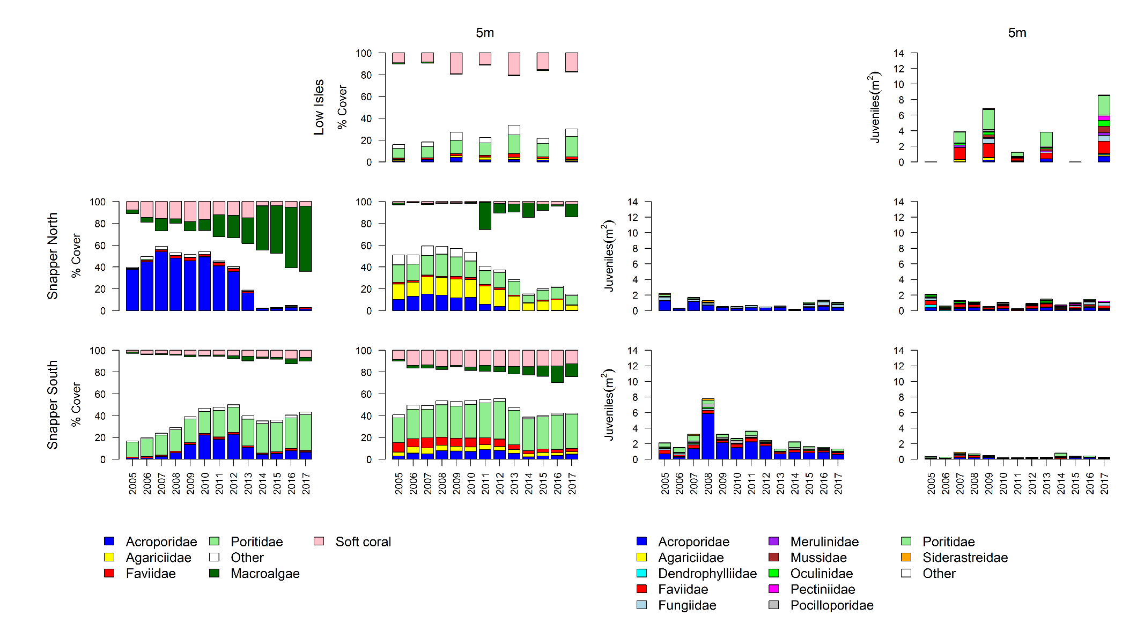
Figure A1. 1 Barron Daintree sub-region benthic community composition. Cover estimates are separated into regionally abundant hard coral families and the total cover for soft corals and macroalgae (hanging). Juvenile density estimates are for regionally abundant hard coral families. Separate legends relevant groupings for cover and juvenile density estimates are located beneath the relevant plots.

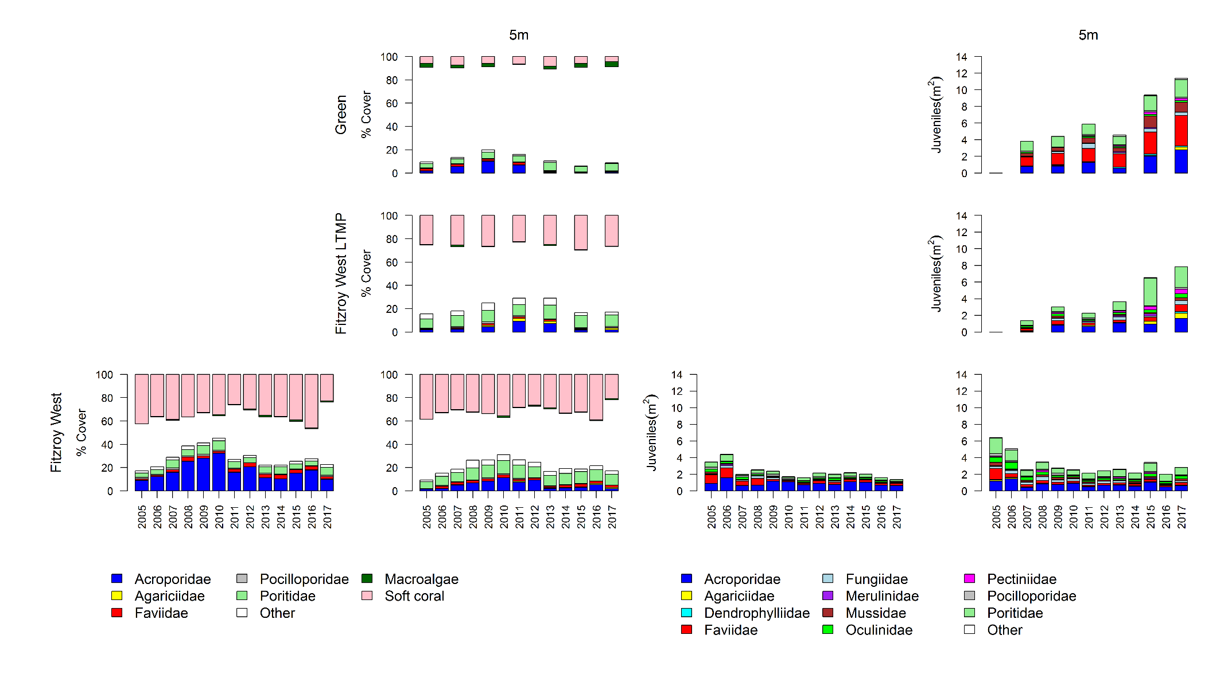
Figure A1. 2 Johnstone Russell-Mulgrave sub-region benthic community composition. Cover estimates are separated into regionally abundant hard coral families and the total cover for soft corals and macroalgae (hanging). Juvenile density estimates are for regionally abundant hard coral families. Separate legends relevant groupings for cover and juvenile density estimates are located beneath the relevant plots.

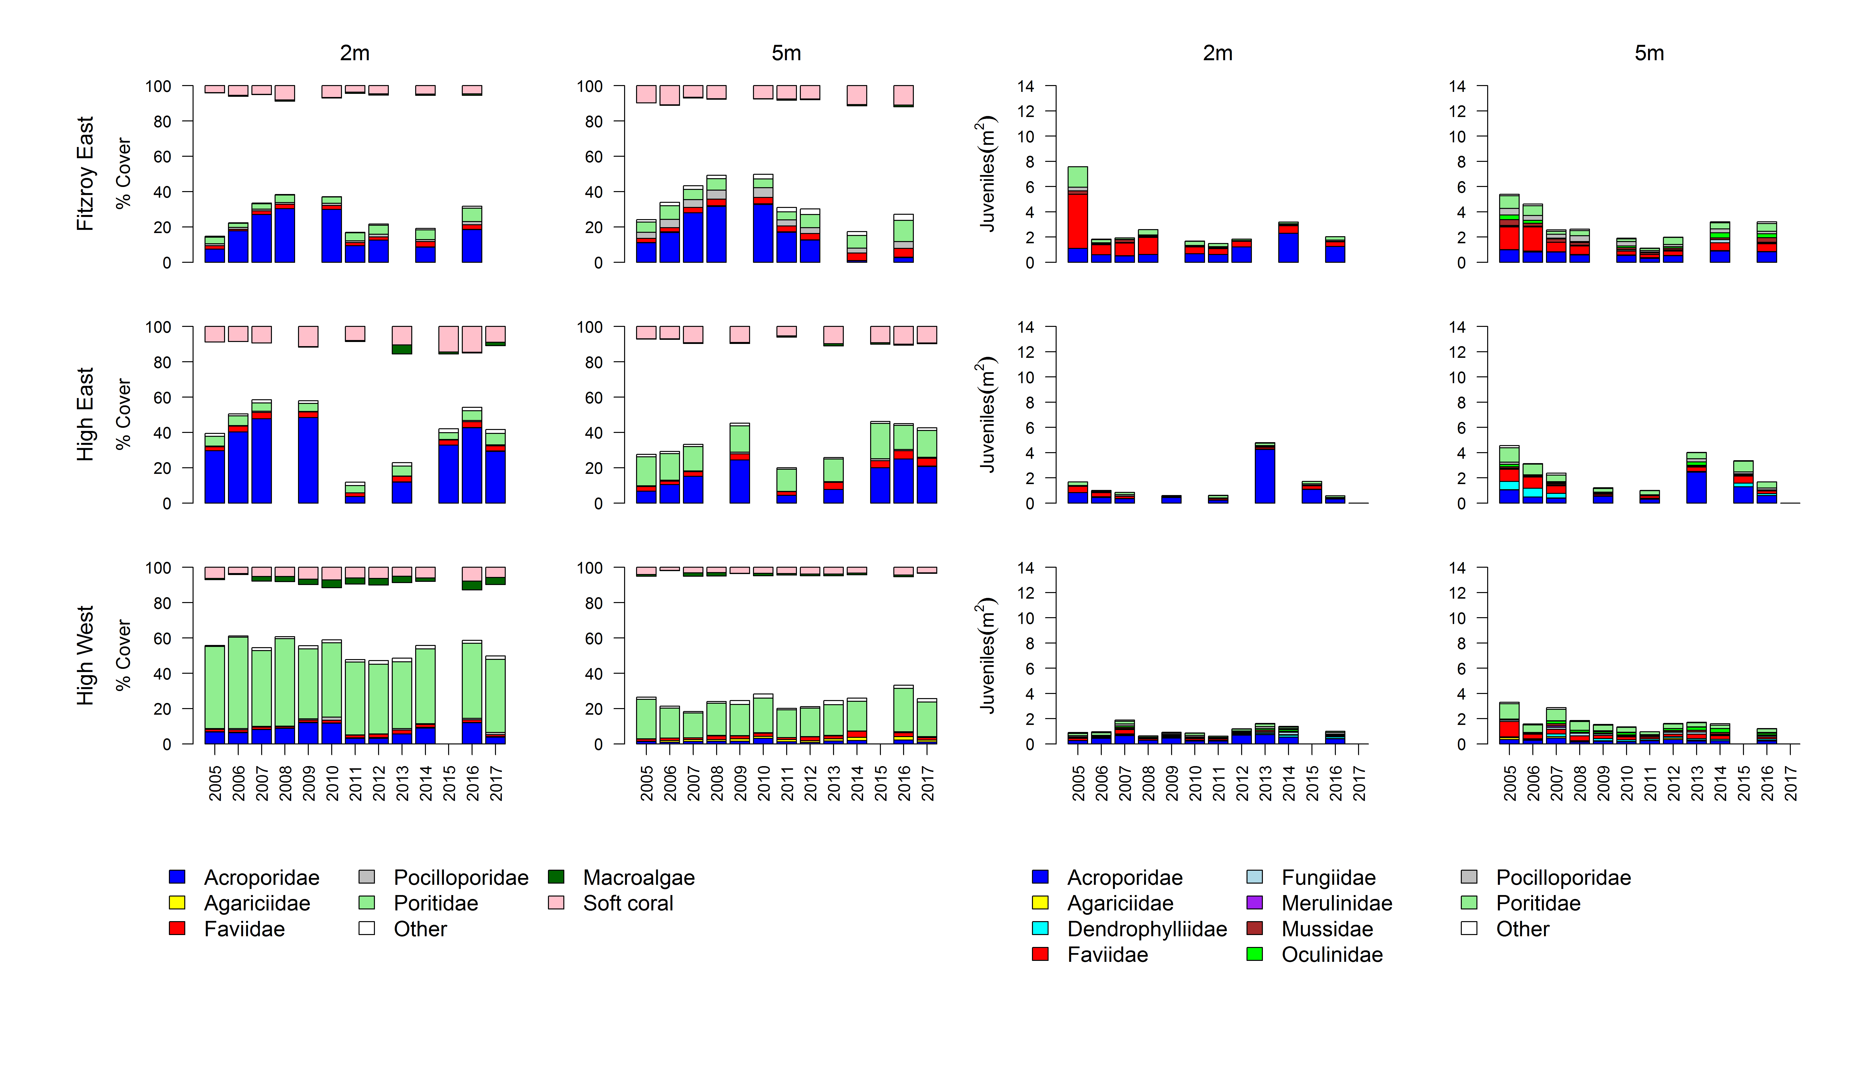
Figure A1. 2 continued

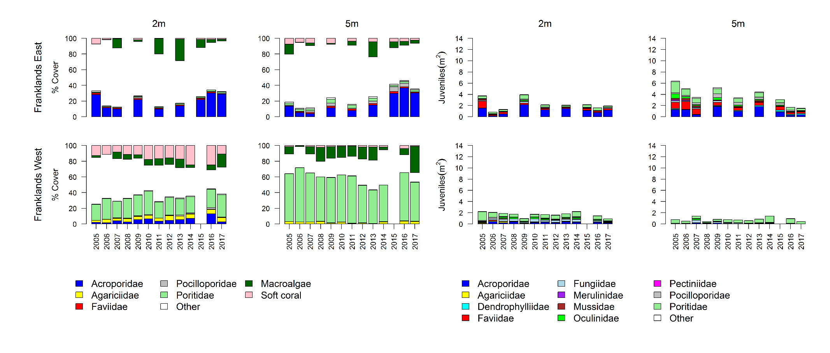
Figure A1. 2 continued

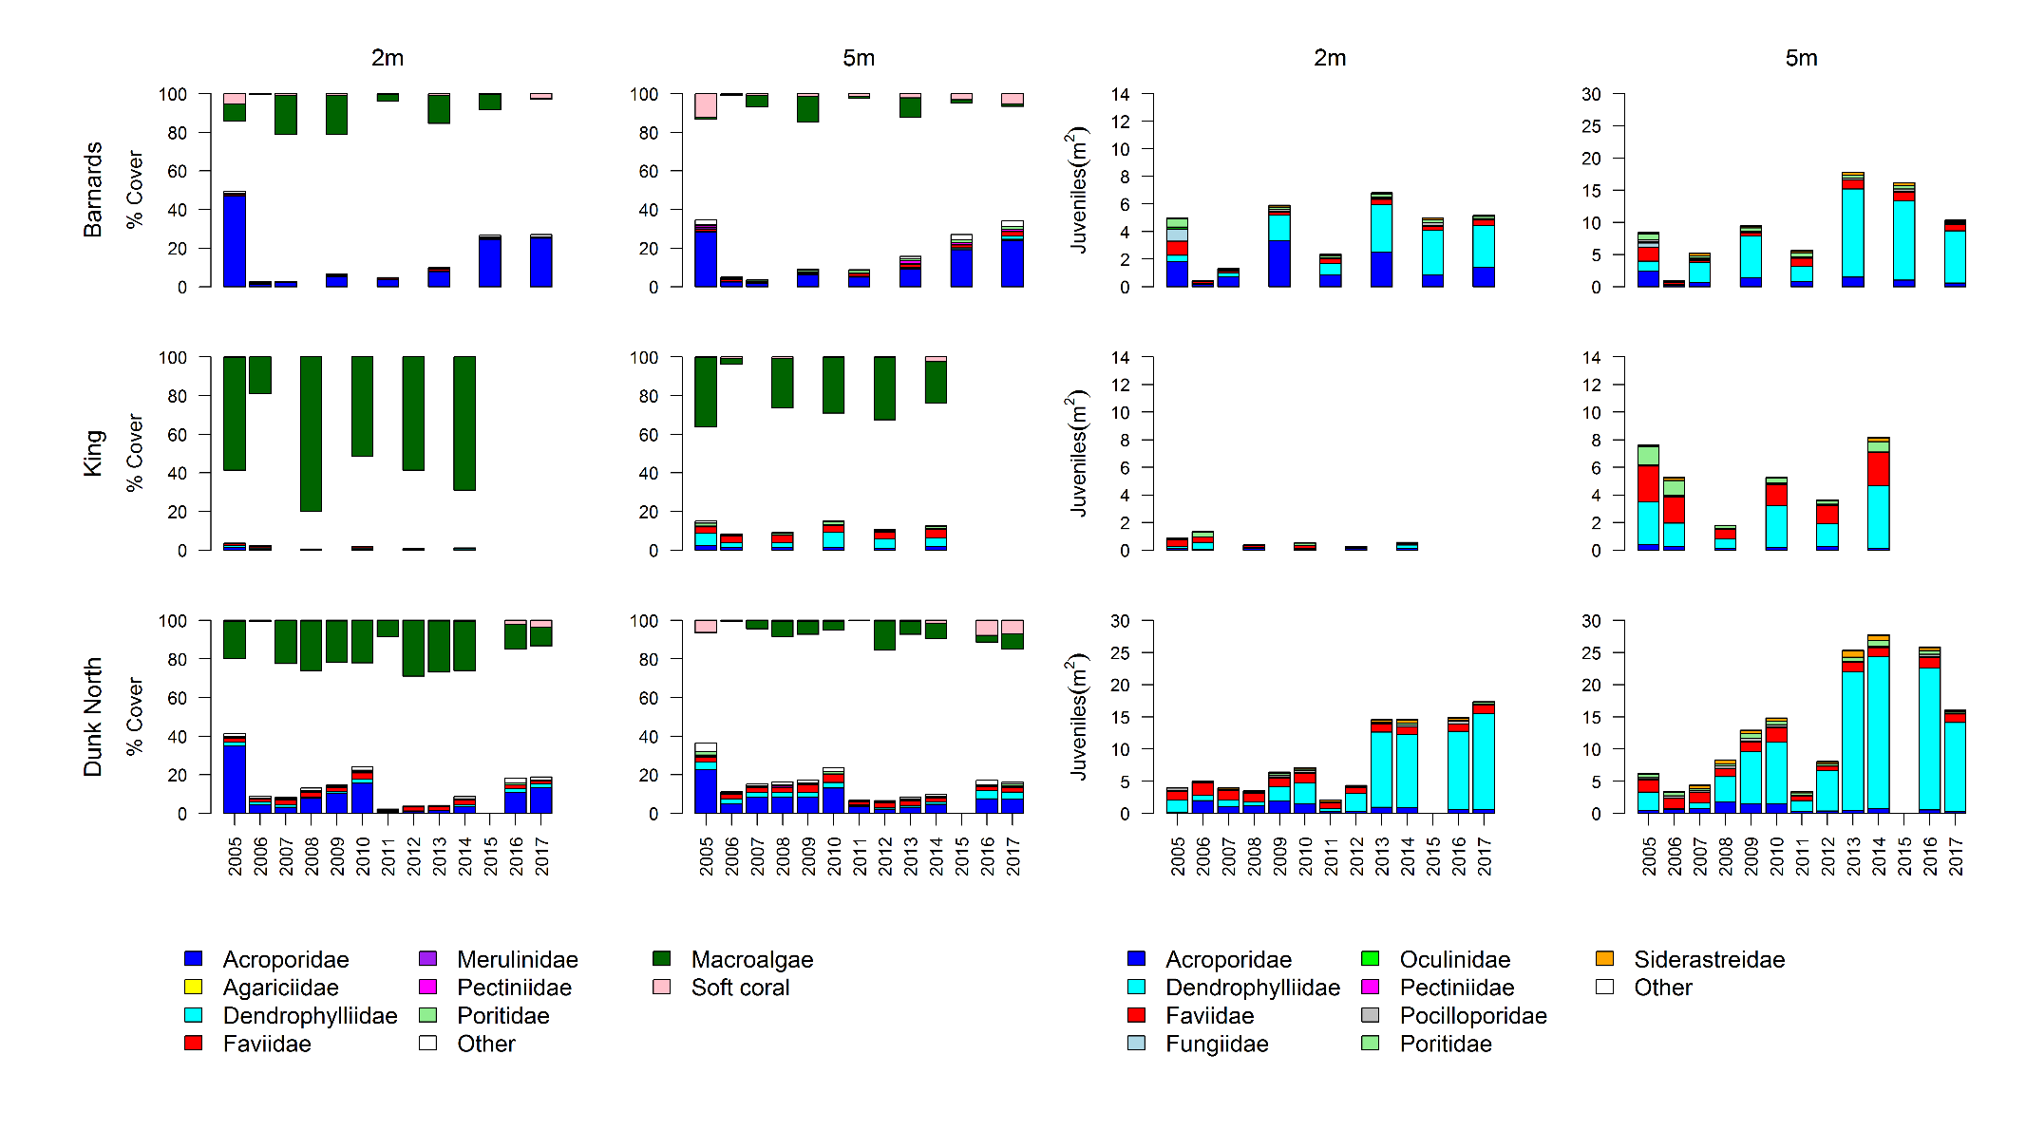
Figure A1. 3 Herbert-Tully sub- region benthic community composition. Cover estimates are separated into regionally abundant hard coral families and the total cover for soft corals and macroalgae (hanging). Juvenile density estimates are for regionally abundant hard coral families. Separate legends with relevant groupings for cover and juvenile density estimates are located beneath the respective plots.

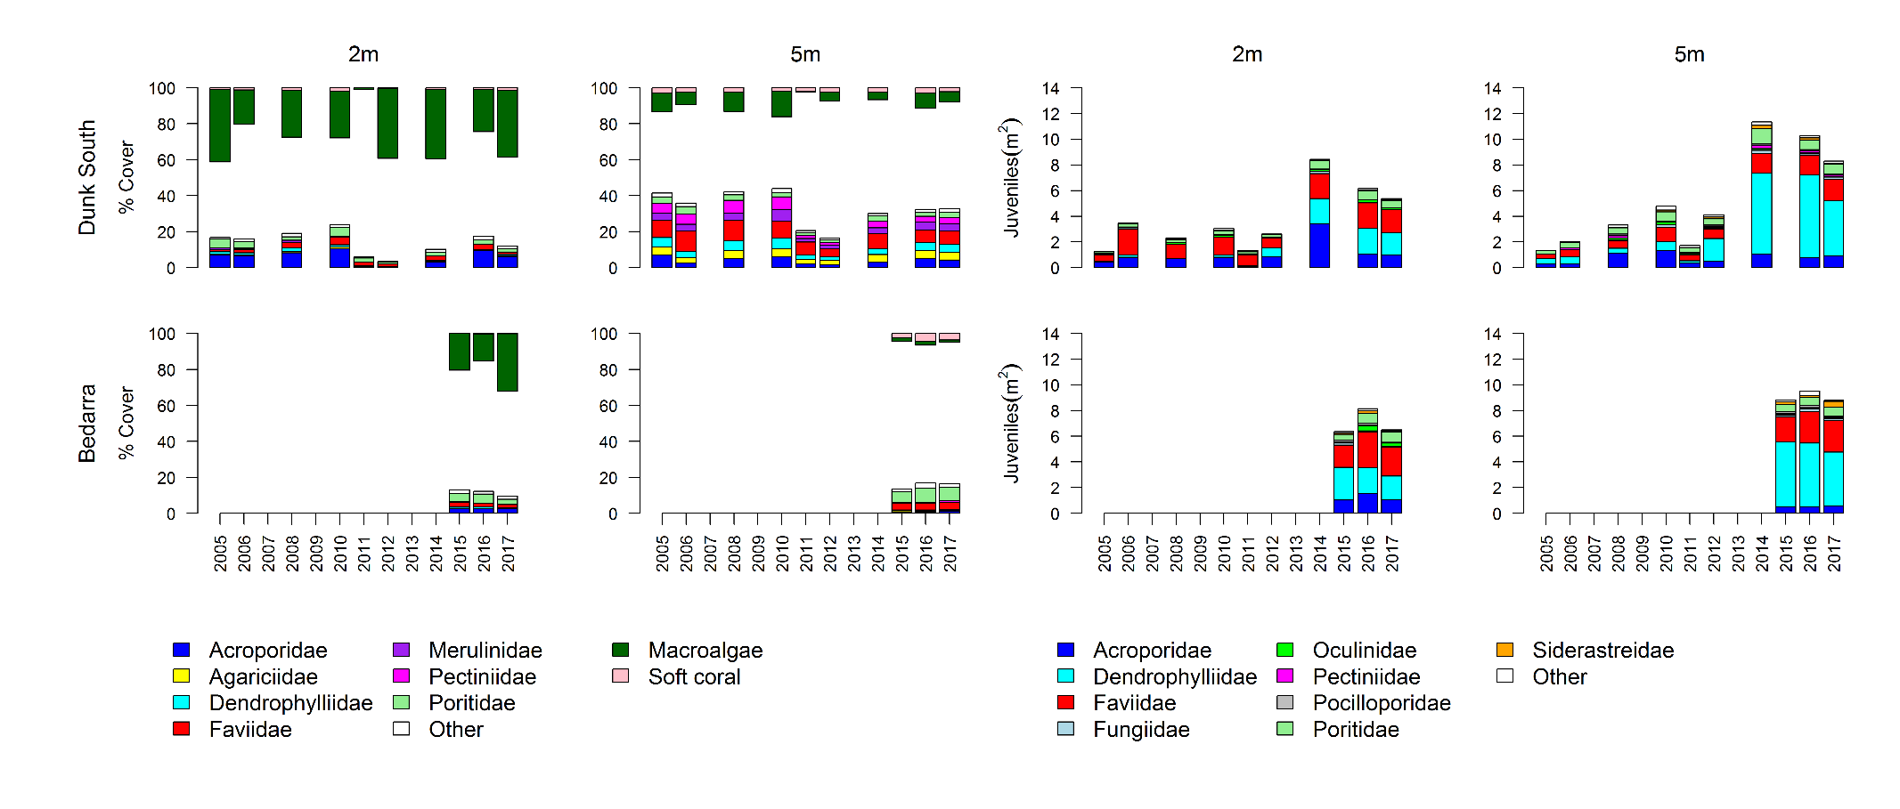
Figure A1. 3 continued

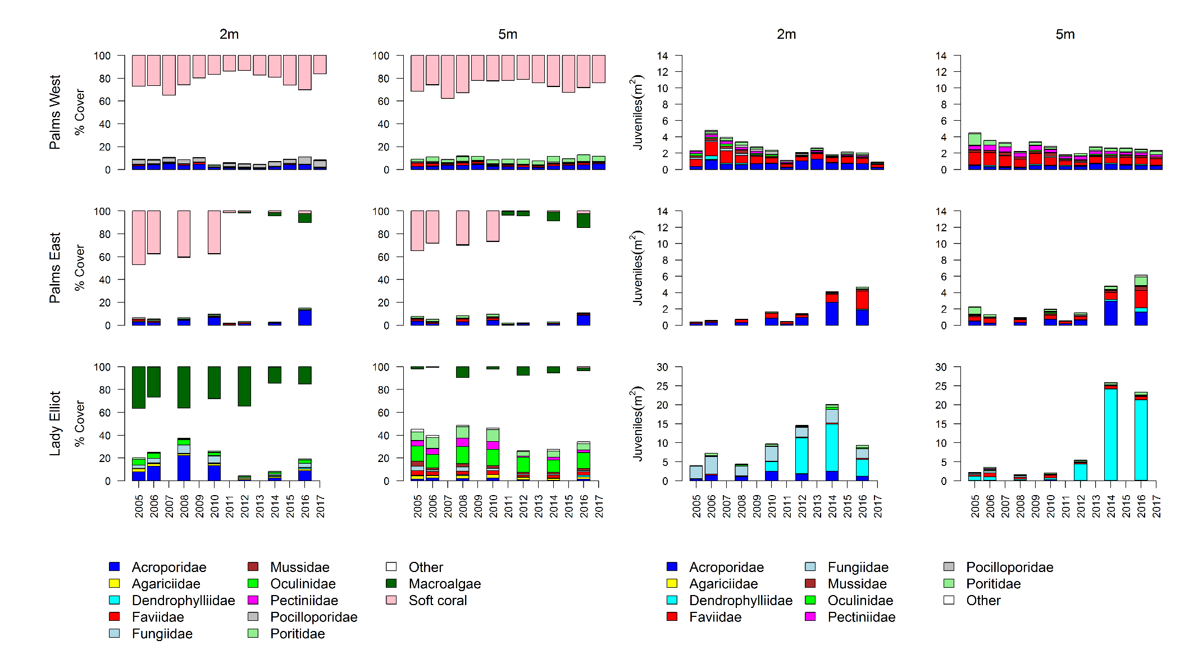
Figure A1. 4 Burdekin Region benthic community composition. Cover estimates are separated into regionally abundant hard coral families and the total cover for soft corals and macroalgae (hanging). Juvenile density estimates are for regionally abundant hard coral families. Separate legends with relevant groupings for cover and juvenile density estimates are located beneath the respective plots.

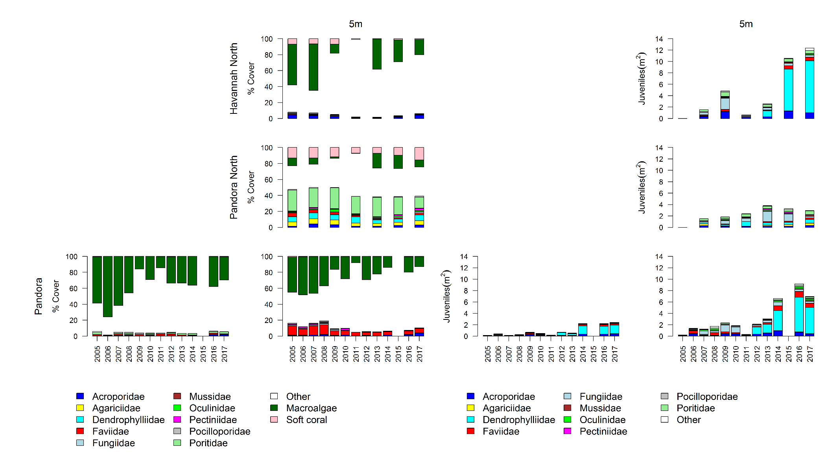
Figure A1. 4 continued

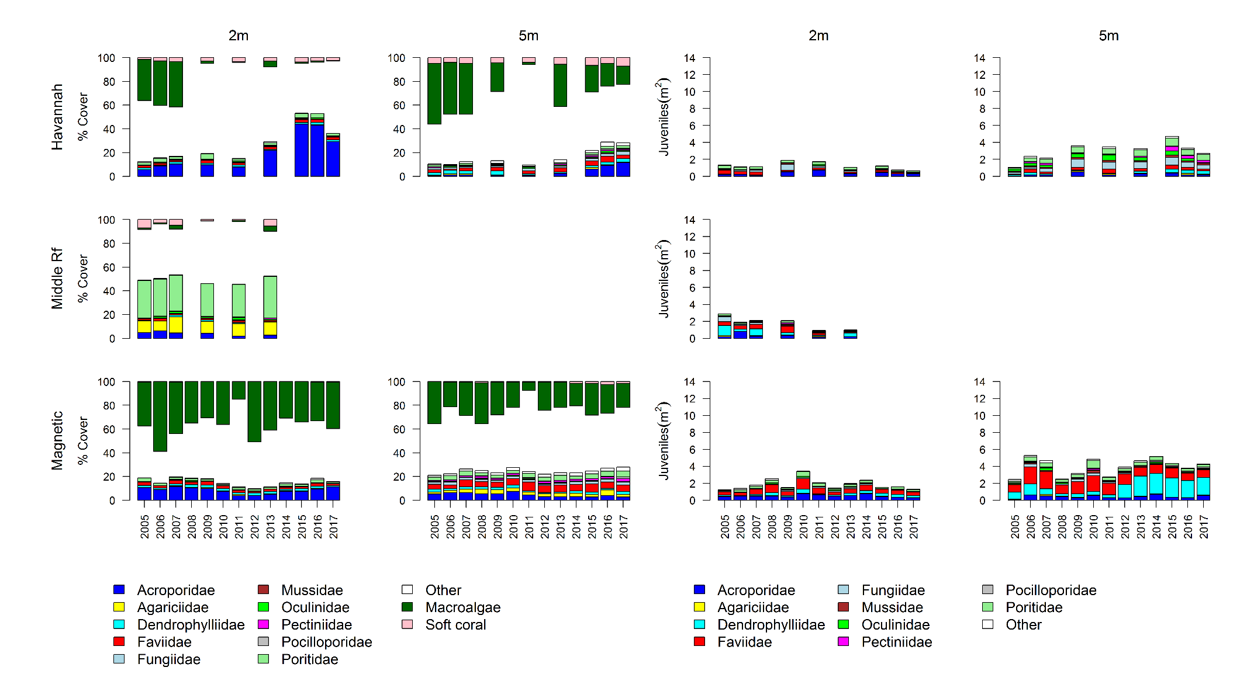
Figure A1. 4 continued

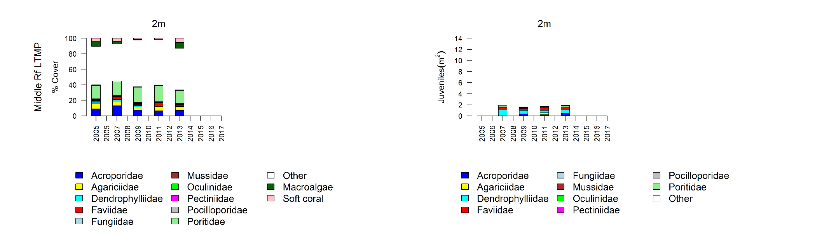
Figure A1. 4 continued

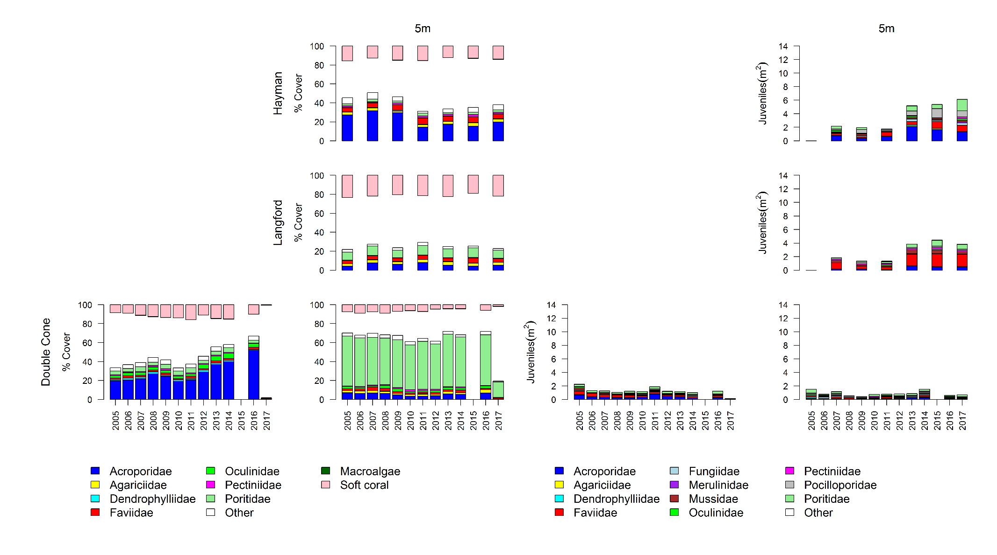
Figure A1. 5 Mackay Whitsunday Region benthic community composition.
Cover estimates are separated into regionally abundant hard coral families and the total cover for soft corals and macroalgae (hanging). Juvenile density estimates are for regionally abundant hard coral families. Separate legends with relevant groupings for cover and juvenile density estimates are located beneath the respective plots.

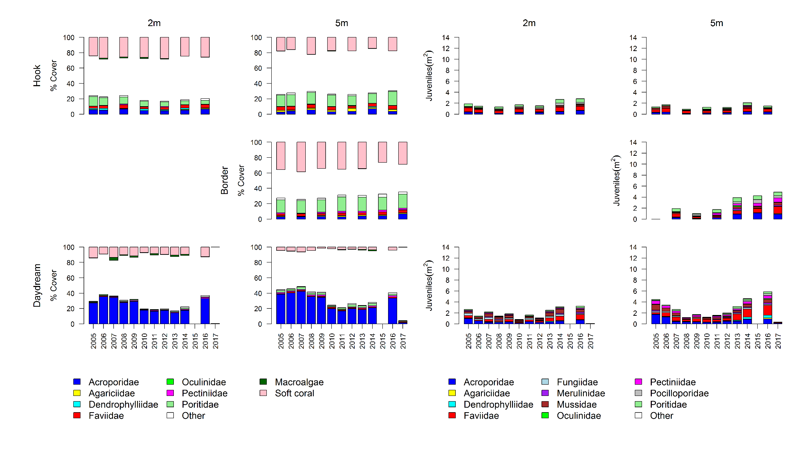
Figure A1. 5 continued

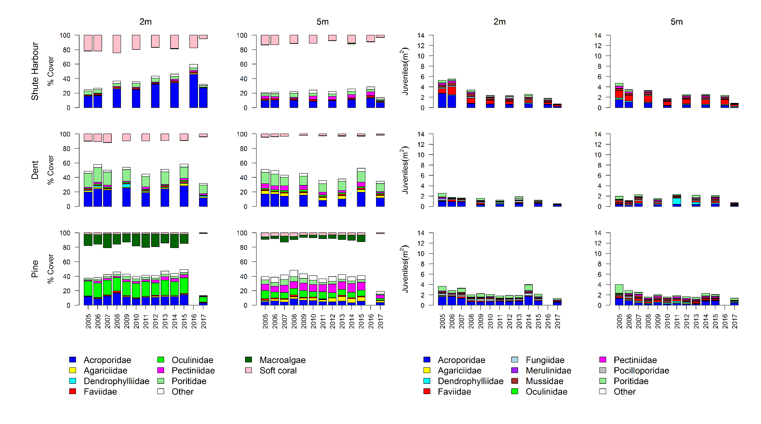
Figure A1. 5 continued

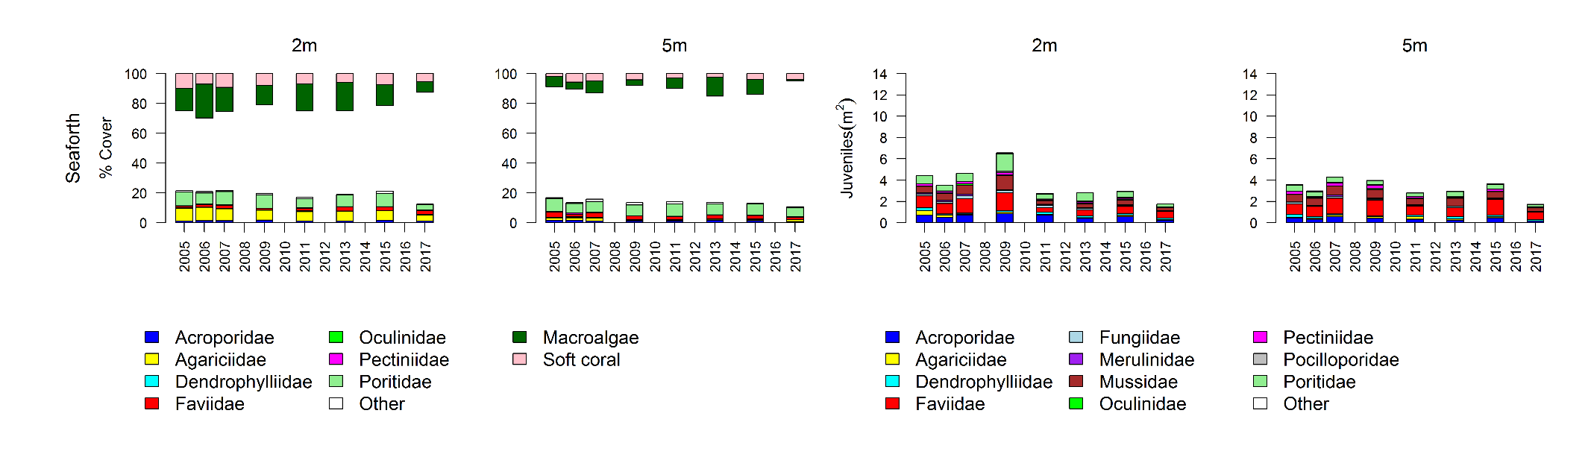
Figure A1. 5 continued

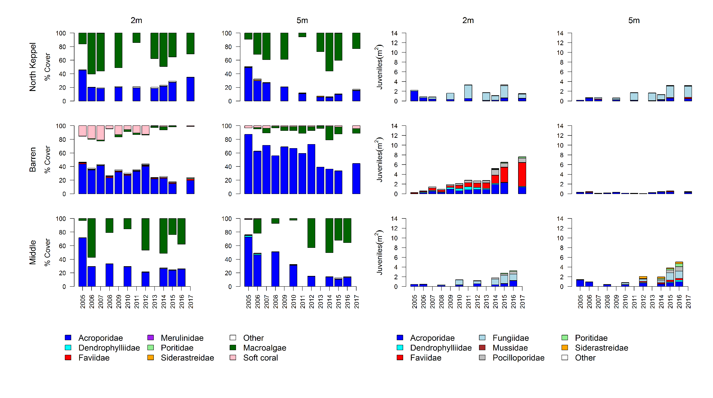
Figure A1. 6 Fitzroy Region benthic community composition. Cover estimates are separated into regionally abundant hard coral families and the total cover for soft corals and macroalgae (hanging). Juvenile density estimates are for regionally abundant hard coral families. Separate legends with relevant groupings for cover and juvenile density estimates are located beneath the respective plots.

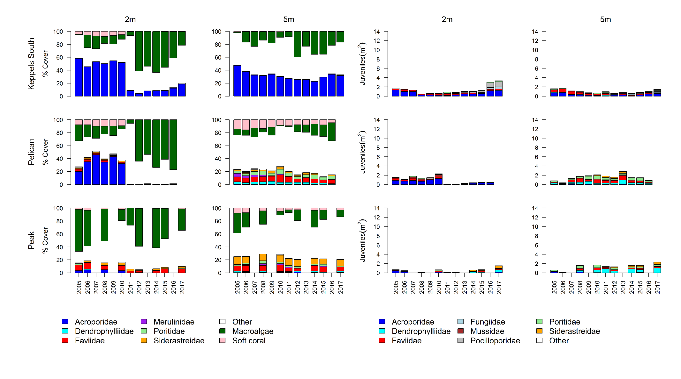
Figure A1. 6 continued

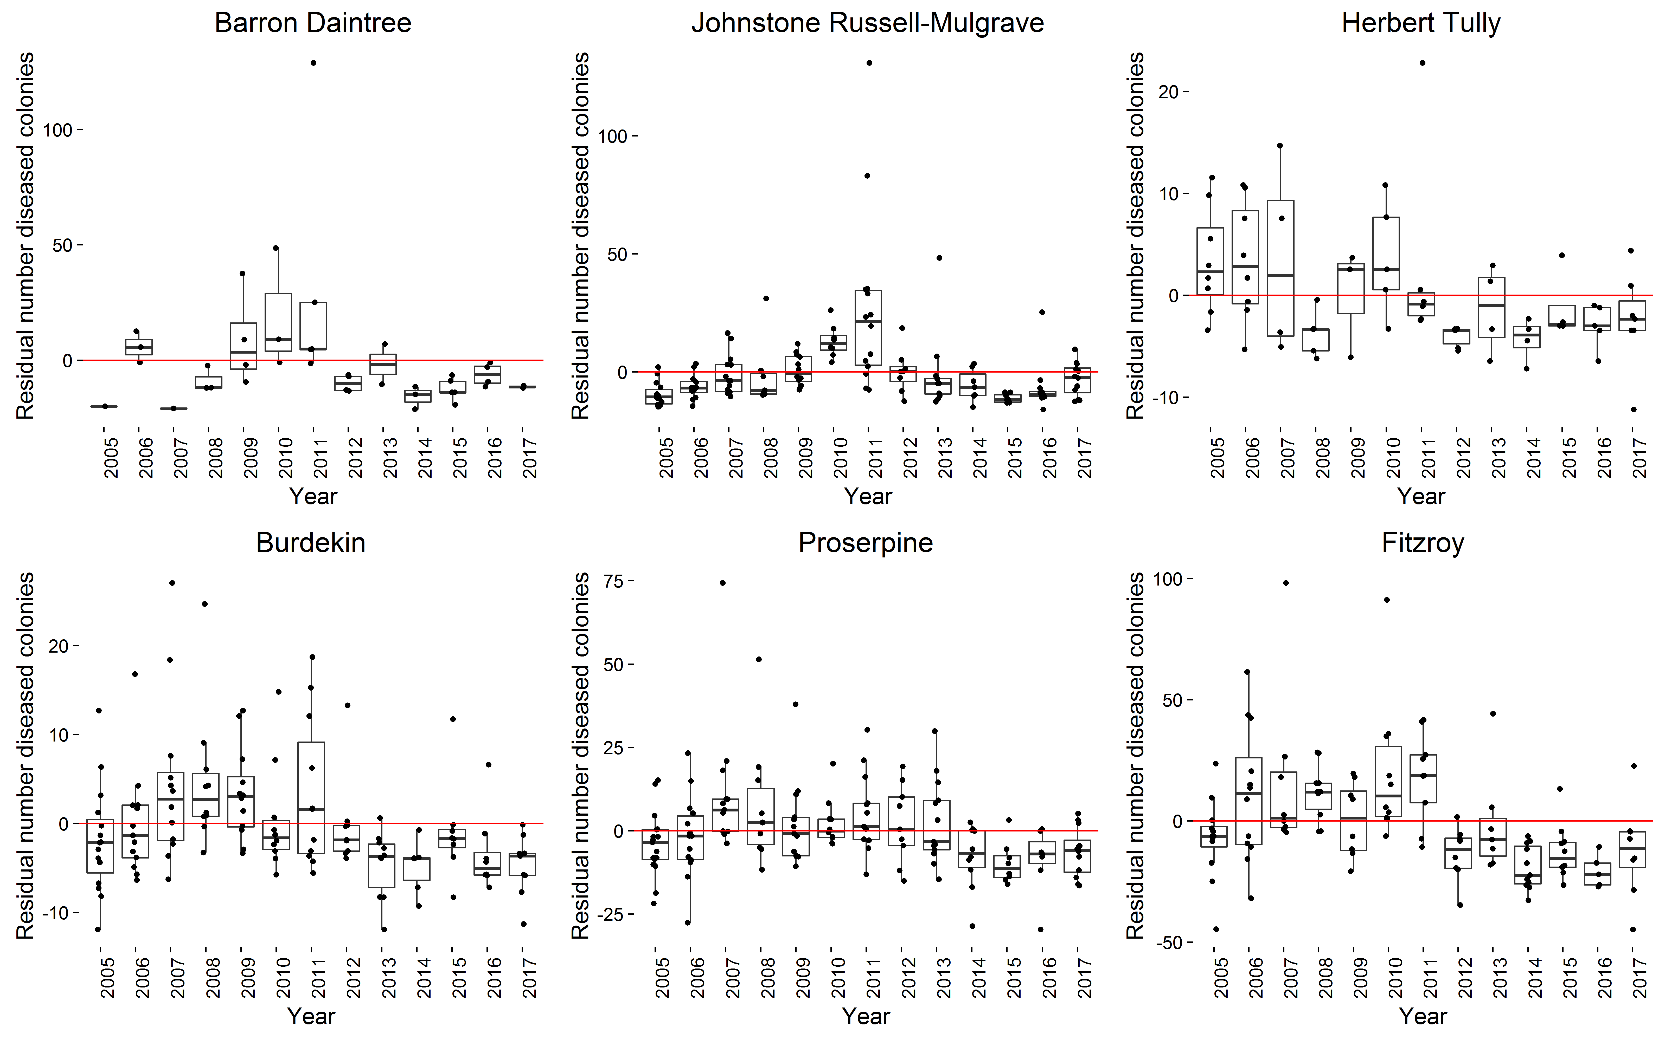
Figure A1. 7 Coral disease by year in each region. Boxplots include the number of coral colonies suffering ongoing mortality attributed to either disease, sedimentation or ‘unknown causes’ for each reef, depth and year. Data are standardised to the reef and depth mean across years.

Table A1. 7 Percent cover of hard coral genera 2017. Genera for which cover did not exceeded 1% on at least one reef or were unidentified to genus level are grouped as “other”.
subregion | Reef | Depth | Acropora | Alveopora | Caulastrea | Cyphastrea | Diploastrea | Echinophyllia | Echinopora | Favia | Favites | Fungia | Galaxea | Goniastrea | Goniopra | Isopora | Lobophyllia | Merulina | Montipora | Mycedium | Oxypora | Pachyseris | Pavona | Pectinia | Platygyra | Plesiastrea | Pocillopora | Podobacia | Porites | Psammocora | Seriatopora | Symphyllia | Turbanaria | Other
Daintree | Snapper North | 2 | 1.08 |  |  |  |  |  | 1.04 |  |  | 0.08 |  |  | 0.04 |  | 0.17 |  | 0.08 |  |  |  |  |  |  |  |  |  | 0.25 |  |  |  |  | 0.04
Daintree | Snapper North | 5 | 0.25 |  | 0.31 |  |  |  |  | 0.06 | 0.06 | 0.25 | 0.44 | 0.06 | 5.44 | 0.06 |  |  |  |  |  | 3.31 | 0.50 | 0.06 | 0.06 |  | 0.25 | 0.19 | 2.81 |  |  |  |  | 1.00
Daintree | Snapper South | 2 | 3.58 |  |  | 0.21 |  |  |  | 0.04 | 0.21 |  | 1.83 | 0.54 | 0.08 |  |  |  | 2.92 |  |  |  | 0.29 |  | 0.17 |  | 0.33 |  | 32.67 | 0.21 |  | 0.04 | 0.13 | 0.13
Daintree | Snapper South | 5 | 4.36 |  | 2.86 |  |  |  |  |  |  |  | 0.13 |  | 2.00 |  | 0.06 |  | 0.31 |  |  | 2.31 | 0.06 |  |  |  |  |  | 29.40 | 0.44 |  |  | 0.25 | 0.19
Daintree | Low Isles | 5 | 0.27 |  | 0.07 | 0.03 | 0.43 |  | 1.13 | 0.13 | 0.17 | 0.23 | 3.33 | 0.10 | 0.10 |  | 1.23 | 0.33 | 0.67 |  | 0.03 | 1.17 | 0.13 | 0.10 | 0.07 | 0.03 | 0.10 | 0.07 | 18.73 | 0.17 | 0.10 | 0.03 | 0.07 | 1.27
Johnstone | Green | 5 | 0.67 |  |  |  | 0.03 |  |  | 0.27 | 0.03 |  | 0.07 | 0.10 | 0.10 |  | 0.30 | 0.03 | 0.23 |  |  | 0.10 |  |  | 0.07 |  |  |  | 6.27 | 0.03 |  |  | 0.03 | 0.40
Johnstone | Fitzroy West LTMP | 5 | 0.43 |  |  |  |  |  | 0.10 | 0.10 |  | 0.20 | 0.53 |  | 0.07 |  | 0.73 | 0.10 | 1.33 | 0.13 | 0.17 | 1.47 |  | 0.17 | 0.13 |  | 0.27 |  | 9.70 |  | 0.17 | 0.03 | 0.03 | 1.37
Johnstone | Fitzroy East | 2 | 11.25 |  |  | 0.06 |  |  | 0.06 | 0.38 | 0.44 |  |  | 0.63 | 0.25 |  | 0.13 |  | 6.94 |  |  |  | 0.19 |  | 0.56 |  | 1.75 |  | 7.44 |  |  | 0.44 |  | 1.25
Johnstone | Fitzroy East | 5 | 2.19 |  | 0.06 | 0.06 | 0.63 |  | 1.94 | 0.56 | 0.25 | 0.06 | 1.81 | 0.25 | 0.25 |  | 0.44 |  | 0.25 | 0.06 |  | 0.25 | 0.06 | 0.06 | 0.44 |  | 3.81 |  | 11.75 | 0.25 |  |  | 0.19 | 1.56
Johnstone | Fitzroy West | 2 | 7.50 |  |  |  | 1.06 |  | 0.63 | 0.25 |  | 0.38 | 0.81 | 0.06 | 0.56 |  | 0.56 | 0.31 | 2.56 |  | 0.06 |  | 0.06 |  | 0.06 |  | 1.00 |  | 6.31 | 0.06 |  |  | 0.19 | 0.31
Johnstone | Fitzroy West | 5 | 0.81 |  | 0.19 |  | 0.94 |  | 0.25 | 0.13 | 0.06 | 0.13 | 0.69 | 0.06 | 0.38 |  | 1.13 | 0.13 | 1.25 | 0.19 |  | 1.00 |  |  | 0.19 |  |  |  | 9.06 | 0.13 |  |  |  | 0.44
Johnstone | Franklands East | 2 | 11.75 |  |  | 0.06 |  |  | 0.25 | 0.13 |  | 0.06 | 0.06 | 0.19 |  | 0.25 | 0.06 |  | 16.56 |  |  |  |  |  |  |  | 0.75 |  | 1.69 | 0.06 |  | 0.06 |  | 0.25
Johnstone | Franklands East | 5 | 27.06 |  |  | 0.25 |  |  | 0.19 |  |  | 0.19 | 0.50 |  | 0.25 |  | 0.13 | 0.19 | 3.13 |  |  |  |  | 0.19 | 0.19 |  | 0.25 |  | 2.25 |  |  |  | 0.06 | 0.63
Johnstone | Franklands West | 2 | 2.75 |  |  |  |  |  | 0.19 |  |  | 0.25 | 0.31 |  | 1.75 |  |  |  |  |  | 0.06 | 5.25 |  |  |  |  | 0.44 |  | 26.63 | 0.13 | 0.19 | 0.06 |  | 0.19
Johnstone | Franklands West | 5 |  |  |  |  |  |  | 0.50 |  |  |  | 0.13 |  |  |  |  |  |  |  |  | 3.00 |  |  |  |  | 0.13 |  | 49.31 |  | 0.06 |  |  | 0.31
Johnstone | High East | 2 | 21.13 |  |  | 0.06 | 0.06 |  | 0.88 | 0.38 | 0.25 |  | 0.19 | 0.44 | 0.19 |  | 0.25 | 0.06 | 8.13 |  |  |  | 0.25 |  | 0.56 |  | 0.50 |  | 6.38 |  |  | 1.13 | 0.44 | 0.38
Johnstone | High East | 5 | 12.00 |  |  | 0.38 |  |  | 2.44 | 0.13 | 0.31 |  | 0.44 | 0.38 | 0.44 |  | 0.06 |  | 8.56 |  |  | 0.13 | 0.13 |  | 0.50 |  | 0.50 | 0.56 | 14.69 | 0.31 |  |  | 0.13 | 0.50
Johnstone | High West | 2 | 3.31 |  |  |  |  |  | 0.50 | 0.06 | 0.13 | 0.19 | 0.81 | 0.13 | 2.56 |  | 0.31 | 0.25 | 0.56 |  |  |  | 0.25 |  | 0.06 |  | 1.25 | 0.13 | 38.75 |  |  | 0.13 |  | 0.44
Johnstone | High West | 5 | 0.69 |  |  | 0.06 |  |  | 0.13 | 0.44 | 0.44 | 0.38 | 0.69 |  | 3.63 |  | 0.19 |  | 0.25 | 0.06 | 0.13 | 0.13 | 0.88 |  | 0.13 |  | 0.44 |  | 15.97 | 0.06 |  |  |  | 0.94
Tully | Barnards | 2 | 16.13 | 0.06 |  | 0.06 |  |  |  | 0.13 | 0.06 |  |  |  |  |  |  | 0.06 | 8.94 |  |  |  |  |  | 0.19 |  | 0.63 |  | 0.06 | 0.31 |  | 0.06 | 0.19 | 0.06
Tully | Barnards | 5 | 12.19 |  |  | 0.38 |  |  | 0.69 | 0.44 | 0.13 | 0.25 |  | 0.06 | 0.38 |  | 0.31 | 0.19 | 11.75 | 0.13 | 0.69 | 0.31 | 0.25 |  | 0.31 |  | 1.13 | 0.06 | 1.13 | 0.13 | 0.69 |  | 1.75 | 0.81
Tully | Dunk North | 2 | 9.31 |  |  | 0.38 |  |  | 0.25 |  | 0.38 |  | 0.25 | 0.13 | 0.13 |  | 0.06 |  | 3.88 |  |  |  |  |  |  |  | 0.94 |  | 0.50 | 0.13 |  |  | 2.31 | 0.31
Tully | Dunk North | 5 | 3.00 | 0.13 |  | 0.38 |  |  | 0.06 | 0.44 | 0.38 |  |  | 0.06 | 0.06 |  | 0.13 |  | 3.69 | 0.13 | 0.38 |  |  |  | 0.88 |  | 0.38 |  | 1.00 | 0.13 |  |  | 3.69 | 1.19
Tully | Dunk South | 2 | 4.19 |  |  | 0.75 |  |  |  | 0.19 | 0.38 |  | 0.75 |  | 0.13 |  | 0.19 |  | 1.63 |  |  |  | 0.63 |  |  |  |  |  | 1.88 | 0.44 |  |  | 0.75 | 0.13
Tully | Dunk South | 5 | 1.63 |  | 0.06 | 0.38 |  |  | 0.50 | 3.75 | 1.00 | 0.06 | 0.19 | 0.31 | 0.44 |  | 0.13 | 4.00 | 2.38 | 1.69 | 0.88 | 3.75 | 0.25 | 0.56 | 0.69 |  | 0.63 | 0.13 | 2.69 |  | 0.50 |  | 4.69 | 1.38
Tully | Bedarra | 2 | 1.88 |  |  | 0.50 |  |  | 0.19 | 0.31 | 0.38 | 0.13 | 0.44 | 0.13 | 0.31 |  | 0.63 |  | 0.69 |  | 0.06 |  |  |  | 0.13 |  | 0.44 | 0.06 | 2.44 |  |  |  | 0.63 | 0.25
Tully | Bedarra | 5 | 0.19 |  |  | 0.06 |  |  |  | 2.88 | 0.25 | 0.06 | 0.06 | 0.19 | 3.69 |  | 1.19 | 0.13 | 0.88 | 0.75 |  | 0.31 |  | 0.19 | 0.19 | 0.06 | 0.06 | 0.19 | 3.63 |  | 0.19 |  | 0.56 | 0.69
Burdekin | Palms East | 2 | 12.06 |  |  | 0.19 |  |  | 0.06 |  |  |  |  | 0.19 |  |  |  |  | 0.94 |  |  |  |  |  |  |  |  |  | 1.00 |  |  | 0.06 |  | 0.31
Burdekin | Palms East | 5 | 7.38 |  |  | 0.06 |  |  |  |  | 0.63 |  | 0.06 | 0.06 |  |  |  |  | 1.19 |  |  |  |  |  |  |  | 0.38 |  | 0.88 |  |  |  |  | 0.25
Burdekin | Palms West | 2 | 1.00 |  |  |  |  |  | 0.19 |  | 0.25 |  | 0.06 | 0.06 | 0.06 |  |  | 0.13 | 0.31 |  |  | 0.13 |  |  |  |  | 5.13 |  | 0.50 |  |  |  |  | 0.56
Burdekin | Palms West | 5 | 4.00 |  |  | 0.13 | 0.25 |  | 0.13 | 0.06 | 0.13 |  | 0.06 |  | 0.50 |  | 0.13 |  | 0.81 | 0.06 | 0.06 |  | 0.06 | 0.13 |  |  | 0.44 |  | 4.13 |  | 0.06 |  | 0.06 | 0.50
Burdekin | Havannah North | 5 | 2.97 |  |  | 0.07 |  | 0.10 |  |  |  | 0.07 | 0.27 | 0.07 | 0.03 |  |  | 0.27 | 0.93 |  |  |  |  |  |  |  | 0.13 | 0.03 | 0.30 |  |  |  | 0.17 | 0.70
Burdekin | Havannah | 2 | 19.56 |  |  |  |  |  | 1.00 | 0.06 |  | 0.13 | 0.38 | 0.25 | 0.06 | 1.94 | 0.19 | 0.06 | 7.56 |  |  |  | 0.19 | 0.06 | 0.81 |  | 0.25 |  | 1.94 | 0.06 | 0.06 |  | 1.56 | 0.13
Burdekin | Havannah | 5 | 8.19 |  | 0.06 | 0.31 |  |  | 1.19 | 0.81 | 0.25 | 2.44 | 0.88 | 0.06 | 0.13 | 0.13 | 0.13 | 1.75 | 2.94 |  | 0.50 | 0.31 |  | 0.38 | 0.13 |  | 0.13 |  | 2.06 | 0.44 |  |  | 3.25 | 1.63
Burdekin | Pandora North | 5 | 1.27 | 1.10 | 0.50 | 0.03 |  | 1.00 | 0.83 | 0.37 | 0.10 | 0.23 | 1.40 | 0.07 | 10.73 | 0.30 | 0.30 | 0.77 | 1.40 | 0.77 | 0.07 | 4.53 | 0.13 | 0.63 | 0.13 |  | 0.27 | 0.30 | 2.03 |  | 0.03 |  | 7.03 | 2.70
Burdekin | Pandora | 2 | 1.44 |  |  | 0.06 |  |  |  |  | 0.25 |  |  |  | 0.06 |  |  | 0.13 | 0.63 |  |  |  |  |  | 0.13 | 0.31 | 0.06 |  | 2.31 |  |  |  | 0.13 | 0.19
Burdekin | Pandora | 5 | 3.00 |  |  | 0.19 | 2.69 |  |  | 1.13 | 0.31 | 0.06 | 0.38 | 0.13 |  |  |  | 0.13 | 0.94 |  |  | 0.19 |  |  | 0.50 |  |  |  |  | 0.06 |  |  |  | 0.63
Burdekin | Lady Elliot | 2 | 4.88 |  |  | 0.13 |  |  |  | 0.06 |  | 3.50 | 2.63 |  | 0.13 |  |  |  | 3.94 |  |  |  | 1.56 |  |  |  |  | 0.13 | 0.75 | 0.13 |  |  | 1.25 | 0.25
Burdekin | Lady Elliot | 5 | 0.75 | 0.38 |  | 0.31 |  |  |  | 0.88 | 0.50 |  | 14.13 | 0.69 | 2.38 |  | 1.63 | 0.38 | 0.56 | 0.50 | 0.75 | 1.94 |  | 0.88 |  |  |  | 1.00 | 2.81 | 0.56 |  |  | 1.81 | 1.38
Burdekin | Middle Reef LTMP | 2 | 1.47 |  |  | 0.07 |  |  | 0.07 | 0.91 | 0.10 | 0.03 | 0.13 | 0.07 | 15.38 | 0.23 | 0.24 | 0.47 | 5.54 | 0.07 | 0.20 | 4.27 | 0.13 | 0.41 | 0.24 |  | 0.13 | 0.23 | 1.31 |  |  | 0.03 | 0.37 | 1.21
Burdekin | Magnetic | 2 | 2.81 |  |  | 0.31 |  |  | 0.25 | 0.06 | 0.31 |  | 0.19 |  | 0.06 |  |  | 0.13 | 8.31 |  | 0.06 | 0.19 | 0.13 |  |  | 0.25 |  |  | 1.25 |  |  |  | 0.81 | 0.56
Burdekin | Magnetic | 5 | 1.06 |  |  | 0.19 |  |  |  | 2.00 | 1.31 | 0.25 | 0.25 |  | 3.19 |  | 0.25 | 2.44 | 1.63 | 0.44 | 1.06 | 2.06 |  | 1.13 | 1.63 | 0.19 | 0.56 | 1.81 | 1.81 |  |  |  | 2.50 | 2.06
Proserpine | Hayman | 5 | 6.71 |  |  | 0.10 | 1.87 | 0.30 | 1.17 | 0.70 | 0.33 | 0.13 | 0.47 | 0.53 | 0.27 | 0.03 | 0.73 | 1.27 | 12.98 | 0.33 | 0.17 | 2.74 | 0.27 | 0.63 | 0.23 |  | 0.37 | 0.10 | 2.17 |  | 1.93 | 0.03 | 0.30 | 1.14
Proserpine | Langford | 5 | 4.07 | 0.13 |  | 0.07 | 0.33 | 0.03 | 1.90 | 0.90 | 0.23 |  | 0.07 | 0.20 | 6.07 |  | 0.63 |  | 0.93 | 0.03 |  | 0.33 | 2.50 | 0.20 | 0.20 |  | 0.47 |  | 2.20 |  | 0.20 |  | 0.23 | 0.87
Proserpine | Border | 5 | 5.13 | 0.37 |  | 0.03 | 0.43 | 0.60 | 0.67 | 0.90 | 0.27 | 0.17 | 0.20 | 0.27 | 13.00 | 0.07 | 0.87 | 0.27 | 1.43 | 0.43 | 0.10 | 0.70 | 0.47 | 1.07 | 0.40 |  | 0.20 |  | 4.87 |  | 0.70 |  | 0.27 | 1.37
Proserpine | Hook | 2 | 3.38 |  |  | 0.13 | 1.38 |  | 0.69 | 0.56 | 0.75 |  |  | 0.44 | 0.25 |  | 0.44 | 0.25 | 3.00 | 0.25 | 0.06 | 0.81 | 0.06 | 0.25 | 0.19 |  | 0.50 |  | 4.76 |  |  |  | 0.69 | 1.38
Proserpine | Hook | 5 | 1.63 | 0.13 |  | 0.06 | 0.44 |  | 0.19 | 1.06 | 1.44 | 0.06 |  | 0.25 | 3.25 |  | 0.63 |  | 1.94 |  |  | 0.88 | 1.75 | 0.13 | 0.31 |  | 0.06 |  | 14.81 |  |  |  | 0.31 | 1.31
Proserpine | Double Cone | 2 | 0.06 |  |  |  |  |  | 0.44 | 0.06 | 0.13 |  |  | 0.13 | 0.06 |  | 0.06 | 0.06 | 0.06 |  |  | 0.06 |  |  |  |  |  |  | 0.44 |  |  |  | 0.13 | 0.13
Proserpine | Double Cone | 5 | 0.19 | 0.25 |  | 0.06 |  |  | 0.50 | 0.06 |  |  | 0.63 | 0.31 | 14.69 |  | 0.75 | 0.13 | 0.13 |  |  | 0.31 |  |  |  |  |  | 0.19 | 1.25 |  |  |  |  | 0.06
Proserpine | Daydream | 2 |  |  |  |  |  |  |  |  |  |  |  |  |  |  |  |  | 0.25 |  |  |  |  |  |  |  |  |  | 0.25 |  |  |  |  | 0.13
Proserpine | Daydream | 5 | 0.13 |  |  |  |  |  | 0.56 | 0.06 | 0.50 |  |  |  |  |  | 0.25 |  | 1.38 |  |  | 0.25 |  |  | 0.19 |  | 0.06 |  | 0.75 |  |  |  |  | 0.13
Proserpine | Dent | 2 | 11.31 |  |  |  |  |  | 0.44 | 0.13 | 0.19 |  | 0.38 |  | 4.88 |  | 1.50 | 0.56 | 0.19 |  | 0.44 |  | 1.63 | 1.50 |  |  | 0.06 |  | 6.75 | 0.19 | 0.06 |  | 1.44 | 0.19
Proserpine | Dent | 5 | 10.81 |  |  | 0.06 |  |  | 0.06 | 0.50 | 0.06 |  | 1.56 | 0.06 | 10.19 |  | 0.50 | 1.31 | 0.69 | 0.19 | 0.94 | 2.81 | 0.06 | 0.81 | 0.31 |  | 0.25 | 0.25 | 1.06 |  |  |  | 0.38 | 1.75
Proserpine | Shute Harbour | 2 | 23.00 |  |  |  |  |  |  | 0.06 |  | 0.13 |  | 0.06 | 2.00 |  | 0.50 | 0.44 | 3.94 |  | 0.06 |  | 0.50 | 0.31 |  |  | 0.13 |  | 0.56 |  |  |  |  | 0.44
Proserpine | Shute Harbour | 5 | 5.69 |  | 0.06 |  |  |  |  | 0.06 |  |  |  |  | 1.94 |  | 1.63 | 0.13 | 1.63 |  | 0.56 | 0.88 | 0.06 | 0.25 | 0.19 |  |  | 0.06 | 0.06 |  |  |  | 0.25 | 0.31
Proserpine | Pine | 2 | 1.56 |  |  |  |  |  | 0.06 | 0.13 | 0.13 | 0.13 | 7.31 | 0.25 |  |  | 0.13 | 0.06 | 1.44 | 0.13 | 0.50 | 0.63 |  | 0.06 |  |  | 0.19 |  | 0.63 |  |  |  |  | 0.06
Proserpine | Pine | 5 | 1.63 |  |  | 0.06 |  |  |  | 0.06 |  |  | 2.63 |  | 1.13 |  | 1.56 | 0.06 | 2.06 | 0.69 | 0.56 | 2.44 |  | 3.13 |  |  |  | 1.00 | 0.19 |  |  |  | 0.19 | 1.81
Proserpine | Seaforth | 2 | 1.06 | 0.13 |  | 0.06 |  |  | 0.06 | 0.44 | 1.19 | 0.06 | 0.06 | 0.25 | 0.38 |  | 0.25 |  |  | 0.06 |  |  | 4.06 |  |  |  | 0.06 |  | 3.25 |  |  |  | 0.31 | 0.81
Proserpine | Seaforth | 5 | 0.44 |  | 0.06 |  | 0.63 |  |  | 0.38 | 0.31 | 0.13 | 0.06 |  | 5.06 |  | 0.38 |  | 0.19 |  |  |  | 1.06 |  | 0.31 |  | 0.13 |  | 0.94 |  |  |  | 0.13 | 0.56
Fitzroy | Barren | 2 | 9.00 |  |  | 0.19 |  |  |  |  | 0.38 |  |  | 0.19 |  | 3.06 |  |  | 7.44 |  |  |  | 0.63 |  | 0.44 |  | 0.19 |  | 0.69 | 0.19 |  |  |  | 1.44
Fitzroy | Barren | 5 | 40.69 |  |  |  |  |  |  |  |  |  |  |  |  |  |  |  | 3.69 |  |  |  |  |  |  |  |  |  | 0.06
Fitzroy | North Keppel | 2 | 33.38 |  |  |  |  |  |  |  |  | 0.38 |  |  |  |  |  |  | 1.25 |  |  |  |  |  |  |  | 0.06
Fitzroy | North Keppel | 5 | 12.75 |  |  |  |  |  |  |  | 0.06 | 1.13 |  |  |  |  |  |  | 2.25 | 0.13 |  |  |  |  | 0.25 |  |  |  |  | 0.63
Fitzroy | Middle | 2 | 24.02 |  |  |  |  |  |  |  |  | 0.31 |  |  |  |  |  |  | 1.38 |  |  |  |  |  | 0.13 |  | 0.13 |  |  |  |  |  |  | 0.06
Fitzroy | Middle | 5 | 11.90 |  |  |  |  |  |  |  |  | 0.13 |  |  |  |  |  |  | 1.13 |  |  |  |  |  |  |  | 0.88 |  | 0.13 |  |  |  | 0.25 | 0.13
Fitzroy | Keppels South | 2 | 15.19 |  |  | 0.13 |  |  |  |  |  | 0.06 |  |  |  |  |  |  | 3.13 |  |  |  |  |  | 0.13 |  | 1.06 |  | 0.06 |  |  |  |  | 0.06
Fitzroy | Keppels South | 5 | 29.69 |  |  | 0.25 |  |  |  |  | 0.06 | 0.13 |  |  |  |  |  |  | 1.63 |  |  |  |  |  |  |  | 0.63 |  | 0.06 |  |  |  | 0.25 | 0.44
Fitzroy | Pelican | 2 | 0.06 |  |  | 0.25 |  |  |  | 0.13 |  |  |  |  |  |  |  |  |  |  |  |  |  |  |  | 0.13 |  |  | 0.31 | 0.31
Fitzroy | Pelican | 5 |  | 3.75 |  | 0.13 |  |  |  | 0.31 | 3.25 |  |  | 1.38 | 1.19 |  | 0.38 |  |  |  |  |  |  |  | 0.44 | 0.75 |  |  | 0.06 | 1.44 |  |  | 1.19 | 0.81
Fitzroy | Peak | 2 |  | 0.06 |  | 0.75 |  |  |  |  | 0.81 |  |  |  | 0.13 |  |  |  |  |  |  |  |  |  |  | 4.75 |  |  | 0.94 | 2.13 |  |  | 0.06 | 0.13
Fitzroy | Peak | 5 |  | 0.19 |  | 1.13 |  |  |  | 0.38 | 2.06 |  |  | 1.44 | 0.69 |  |  |  | 0.38 |  |  |  |  |  |  | 1.50 |  |  | 0.50 | 9.50 |  |  | 2.25 | 0.63

Table A1. 8 Percent cover of soft coral families 2017.
Families for which cover did not exceeded 0.25% on at least one reef or corals not identified to family level are grouped to ‘Other’.
subregion | Reef | Depth | Alcyoniidae | Anthothelidae | Briareidae | Clavulariinae | Heliporidae | Neptheidae | Xeniidae | Gorgoniidae like | Other
Daintree | Snapper North | 2 | 0.01 |  | 2.29 | 0.92
Daintree | Snapper North | 5 |  |  | 0.56 | 0.03 |  |  | 0.26
Daintree | Snapper South | 2 | 0.40 |  | 1.13 | 0.02 | 2.17
Daintree | Snapper South | 5 |  |  | 7.73 |  | 4.42 |  |  |  | 0.19
Daintree | Low Isles | 5 | 0.97 |  | 8.70 | 0.03 | 0.03 |  |  | 0.17 | 0.20
Johnstone | Green | 5 | 0.52 |  |  |  |  | 0.02 | 0.01 |  | 0.13
Johnstone | Fitzroy West LTMP | 5 | 3.20 |  | 0.33 | 0.05 |  | 0.01 |  | 0.03 | 0.08
Johnstone | Fitzroy East | 2 | 0.35 |  | 1.06 | 0.09 |  | 0.06
Johnstone | Fitzroy East | 5 | 0.48 |  | 5.69 | 0.28 |  | 0.10 | 0.01
Johnstone | Fitzroy West | 2 | 2.70 |  | 1.06
Johnstone | Fitzroy West | 5 | 2.57 |  | 0.31
Johnstone | Franklands East | 2 | 0.08 |  | 0.19 | 0.06 |  |  | 0.03 |  | 0.03
Johnstone | Franklands East | 5 | 0.21 |  | 0.81 | 0.06
Johnstone | Franklands West | 2 | 0.54 |  |  | 3.25 |  | 0.02
Johnstone | Franklands West | 5 | 0.12 |  |  | 0.09
Johnstone | High East | 2 | 0.41 |  | 5.56 | 0.03
Johnstone | High East | 5 | 0.02 |  | 9.06 | 0.03
Johnstone | High West | 2 | 0.46 |  | 0.06 |  | 1.94
Johnstone | High West | 5 | 0.13 |  | 1.31 |  | 0.75 |  |  | 0.06
Tully | Barnards | 2 | 0.18 |  | 0.50 |  |  |  | 0.06
Tully | Barnards | 5 | 0.20 | 0.06 | 2.94 | 0.03 |  |  | 0.07
Tully | Dunk North | 2 | 0.38 |  | 0.06 |  |  |  | 0.05
Tully | Dunk North | 5 | 0.19 |  | 0.19 |  |  |  | 0.63 | 1.06
Tully | Dunk South | 2 | 0.04 |  | 0.69 | 0.25
Tully | Dunk South | 5 | 0.05 |  | 1.81
Tully | Bedarra | 2 | 0.02 |  |  |  |  |  | 0.01
Tully | Bedarra | 5 | 0.13 | 0.13 | 2.25 |  |  |  | 0.04
Burdekin | Palms East | 2 | 0.28
Burdekin | Palms East | 5 | 0.31
Burdekin | Palms West | 2 | 1.27 |  | 0.38 | 0.56 |  | 0.50
Burdekin | Palms West | 5 | 2.07 |  | 3.88 | 0.28 |  | 0.31 |  | 0.19
Burdekin | Havannah | 5 | 0.09 |  | 1.88
Burdekin | Havannah | 2 | 0.05 |  | 6.75
Burdekin | Havannah North | 5 | 0.04 |  | 0.43 | 0.08 |  |  |  |  | 0.03
Burdekin | Pandora North | 5 | 0.33 |  | 7.10 | 2.48 |  |  |  |  | 0.68
Burdekin | Pandora | 2 | 0.07
Burdekin | Pandora | 5 | 0.01 |  |  | 0.09 |  |  |  |  | 0.06
Burdekin | Lady Elliot | 2 | 0.02
Burdekin | Lady Elliot | 5 | 0.12 |  |  |  |  | 0.01
Burdekin | Magnetic | 2 | 0.06 |  | 0.06
Burdekin | Magnetic | 5 | 0.19 |  | 0.13 |  |  | 0.01
Burdekin | Middle Reef LTMP | 2 | 0.48 |  |  |  |  | 0.01 |  | 1.23 | 0.40
Proserpine | Hayman | 5 | 1.48 |  | 1.43 |  |  | 0.04 | 0.02 | 0.03 | 0.07
Proserpine | Langford | 5 | 2.68 |  | 0.23 |  |  | 0.01 | 0.01 | 0.07 | 0.08
Proserpine | Border | 5 | 3.52 |  | 0.20 |  |  | 0.02 | 0.01 | 0.03 | 0.10
Proserpine | Hook | 2 | 3.04 |  | 1.44 |  |  | 0.01
Proserpine | Hook | 5 | 2.12 |  | 0.31 |  |  | 0.01 |  | 0.13
Proserpine | Double Cone | 2 | 0.03 |  | 0.19
Proserpine | Double Cone | 5 | 0.13 |  | 0.69
Proserpine | Daydream | 2
Proserpine | Daydream | 5 | 0.02
Proserpine | Dent | 2 | 0.12 |  | 2.81
Proserpine | Dent | 5 | 0.07 |  | 0.56 |  |  | 0.01
Proserpine | Shute Harbour | 2 | 0.63
Proserpine | Shute Harbour | 5 | 0.39 |  |  |  |  | 0.01
Proserpine | Pine | 2 | 0.06 |  | 0.31
Proserpine | Pine | 5 | 0.07 |  | 0.38 |  |  | 0.01 |  | 0.06
Proserpine | Seaforth | 2 | 0.62 | 0.06 | 0.31 |  |  |  | 0.01
Proserpine | Seaforth | 5 | 0.15 | 0.44 | 2.25 |  |  |  |  |  | 0.06
Fitzroy | Barren | 2 | 0.02 |  |  |  |  |  | 0.07
Fitzroy | Barren | 5 |  |  |  |  |  |  | 0.63
Fitzroy | North Keppel | 2
Fitzroy | North Keppel | 5 | 0.01
Fitzroy | Middle | 2
Fitzroy | Middle | 5 | 0.03
Fitzroy | Keppels South | 2 | 0.06
Fitzroy | Keppels South | 5 |  |  |  |  |  |  | 0.04
Fitzroy | Pelican | 2
Fitzroy | Pelican | 5 | 0.34 | 0.44 |  |  |  | 0.01 | 0.07 | 0.75 | 0.06
Fitzroy | Peak | 2 | 0.07 | 0.56 |  | 0.03 |  |  |  | 0.06
Fitzroy | Peak | 5 | 0.11 | 0.31 |  | 0.06 |  | 0.03 |  | 1.31 | 0.25

Table A1. 9 Percent cover of Macroalgae groups 2017.
Genera for which cover exceeded 0.5% on at least one reef are included, rare or unidentified genera are grouped to ‘Other within major classes of Macroalgae’.
subregion | Reef | Depth | Rhodophyta (red algae) |  |  |  |  | Chlorophyta (green algae) |  |  | Phaeophyta (brown algae)
subregion | Reef | Depth | Hypnea | Peyssonnelia | Calcareous | Asparagopsis | Other | Caulerpa | Halimeda | Other | Stypopodium | Padina | Dictyota | Dictyopteris | Lobophora | Sargassum | Other
Daintree | Snapper North | 2 | 2.08 |  | 3.00 | 9.54 | 19.75 | 0.38 | 3.13 | 0.13 |  | 0.04 | 20.67 |  |  |  | 1.13
Daintree | Snapper North | 5 |  |  | 0.06 | 0.50 | 0.13 |  | 0.13 |  |  | 0.06 | 10.81
Daintree | Snapper South | 2 | 1.04 |  | 0.79 |  | 1.25 |  |  | 0.25 |  |  | 0.13
Daintree | Snapper South | 5 | 0.81 | 0.06 | 2.37 |  | 3.68 |  |  | 0.13 |  |  | 4.76 |  |  |  | 0.06
Daintree | Low Isles | 5 |  | 0.07 |  |  | 0.17 |  | 0.03 | 0.07 |  |  |  |  |  |  | 0.07
Johnstone | Green | 5 |  |  |  |  | 4.70 |  | 2.70 | 0.05 |  | 1.00 |  |  |  |  | 0.20
Johnstone | Fitzroy West LTMP | 5 |  |  |  | 0.30 | 0.20 |  | 0.30
Johnstone | Fitzroy East | 2 |  | 0.13 |  |  | 0.63 |  |  | 0.19
Johnstone | Fitzroy East | 5 |  | 0.44 |  |  | 0.56
Johnstone | Fitzroy West | 2 | 0.38 | 0.06 | 0.13 |  | 0.38 |  |  |  |  |  |  |  |  |  | 0.06
Johnstone | Fitzroy West | 5 | 0.31 | 0.25 |  |  | 0.38 |  |  | 0.06
Johnstone | Franklands East | 2 | 0.50 |  | 0.06 |  | 0.63 | 0.13 |  | 0.06 |  |  | 1.00
Johnstone | Franklands East | 5 |  |  | 1.25 |  | 1.50 |  |  | 0.13 |  |  | 0.75
Johnstone | Franklands West | 2 | 1.00 | 0.13 | 5.63 |  | 5.56 | 0.19 | 0.25 | 0.13 |  |  | 3.81 |  |  |  | 0.06
Johnstone | Franklands West | 5 |  |  | 10.69 |  | 19.50 | 0.56 | 1.06 | 0.19 |  | 0.06 | 1.44
Johnstone | High East | 2 | 1.44 |  |  |  | 0.50 |  |  | 0.06
Johnstone | High East | 5 | 0.25 | 0.06 |  |  | 0.13
Johnstone | High West | 2 | 2.44 |  | 0.06 |  | 1.50 |  |  | 0.13
Johnstone | High West | 5 |  | 0.06 | 0.06 |  | 0.13
Tully | Barnards | 2 |  | 0.13 |  |  | 0.38 |  |  |  |  |  | 0.19
Tully | Barnards | 5 |  | 0.19 | 0.31 | 0.13 | 0.44 |  |  | 0.13 |  |  | 0.13 |  | 0.06
Tully | Dunk North | 2 |  | 0.13 | 0.31 |  | 1.19 | 0.06 |  | 0.38 |  |  | 1.63 | 0.06 | 0.56 | 4.00 | 1.38
Tully | Dunk North | 5 |  | 0.19 | 0.13 |  | 0.19 | 0.06 |  | 0.13 |  |  | 6.56 |  | 0.44 | 0.06 | 0.06
Tully | Dunk South | 2 |  | 0.44 | 0.50 |  | 0.25 |  |  |  |  | 0.06 | 0.81 |  | 2.63 | 31.38 | 1.13
Tully | Dunk South | 5 |  | 0.25 | 0.06 |  | 0.50 |  |  |  |  |  |  |  | 4.25 | 0.38 | 0.19
Tully | Bedarra | 2 | 0.31 | 0.44 | 1.00 |  | 0.13 |  | 0.06 |  |  | 0.19 | 2.00 |  | 0.50 | 26.94 | 0.38
Tully | Bedarra | 5 |  | 0.19 | 0.06 |  | 0.06 |  |  |  |  |  |  |  | 0.56 | 0.06 | 0.13
Burdekin | Palms East | 2 |  |  |  |  | 0.19 | 7.25 |  | 0.06 |  |  | 0.25 |  |  |  | 0.06
Burdekin | Palms East | 5 |  |  |  |  | 0.31 | 11.50 |  |  |  |  | 0.13
Burdekin | Palms West | 2 |  |  |  |  |  |  |  | 0.06
Burdekin | Palms West | 5 |  |  | 0.06
Burdekin | Havannah | 2 |  | 0.06 |  |  |  | 0.13 |  | 0.06
Burdekin | Havannah | 5 |  |  | 0.13 |  | 0.13 |  |  | 0.06 |  |  | 2.13 |  | 10.94 | 1.50 | 0.56
Burdekin | Havannah North | 5 |  |  | 0.15 |  | 3.40 | 0.60 | 0.30 | 2.85 |  | 0.20 | 0.55 |  | 17.90 | 9.05 | 1.35
Burdekin | Pandora North | 5 |  |  | 0.20 |  | 3.20 |  |  |  |  |  | 1.50 |  | 18.30 | 2.90 | 0.30
Burdekin | Pandora | 2 |  | 0.19 |  |  | 0.13 | 0.06 |  |  |  | 0.06 | 1.31 | 2.25 | 1.81 | 18.44 | 4.63
Burdekin | Pandora | 5 |  | 0.25 |  | 0.19 | 0.19 |  |  |  |  |  | 3.88 | 0.06 | 3.81 | 3.94 | 0.25
Burdekin | Lady Elliot | 2 | 3.94 | 2.31 | 0.25 |  | 2.94 | 0.06 |  | 0.06 |  | 0.25 | 4.56 |  |  | 0.31 | 0.25
Burdekin | Lady Elliot | 5 |  | 1.00 | 0.44 |  | 0.63 |  |  |  |  |  | 0.31
Burdekin | Magnetic | 2 |  | 0.19 | 0.19 |  | 0.44 |  |  |  |  |  | 1.75 |  | 6.69 | 28.81 | 1.06
Burdekin | Magnetic | 5 |  | 0.56 | 1.06 |  | 1.00 |  |  |  |  |  | 1.75 |  | 1.31 | 13.81 | 0.63
Burdekin | Middle Reef LTMP | 2 |  | 0.55 | 0.10 | 1.25 | 0.65 |  |  |  |  | 0.35 | 2.51 |  | 2.81 | 1.32 | 0.51
Proserpine | Hayman | 5 |  |  |  |  | 0.50 |  |  |  |  |  |  |  | 0.30
Proserpine | Langford | 5
Proserpine | Border | 5 |  |  |  |  | 0.10
Proserpine | Hook | 2 |  |  |  |  | 0.13 | 0.06
Proserpine | Hook | 5
Proserpine | Double Cone | 2
Proserpine | Double Cone | 5 |  | 0.13 |  |  |  |  |  |  |  |  |  |  |  |  | 0.06
Proserpine | Daydream | 2 |  |  |  |  |  |  |  |  |  |  |  |  |  |  | 0.06
Proserpine | Daydream | 5 |  |  |  |  | 0.19
Proserpine | Dent | 2 |  |  | 0.06 |  | 0.19 |  |  |  |  |  |  |  |  |  | 0.06
Proserpine | Dent | 5 |  | 0.25 | 0.13 |  | 0.06 |  |  |  |  |  |  |  |  | 0.06
Proserpine | Shute Harbour | 2 |  |  | 0.06
Proserpine | Shute Harbour | 5 |  |  |  |  | 0.13 |  |  |  |  |  |  |  |  |  | 0.06
Proserpine | Pine | 2 |  | 0.06 |  |  | 0.25 |  |  |  |  |  |  |  |  | 0.06
Proserpine | Pine | 5 |  | 0.06 |  |  | 0.13 |  |  |  |  |  |  |  |  |  | 0.06
Proserpine | Seaforth | 2 | 0.19 |  | 0.19 |  | 0.56 |  |  |  |  | 0.25 | 1.50 |  | 0.38 | 1.94 | 2.19
Proserpine | Seaforth | 5 |  |  | 0.19 |  | 0.13 |  |  |  |  |  | 0.13 |  | 0.25 | 0.13
Fitzroy | Barren | 2 |  | 0.44 |  |  | 0.13
Fitzroy | Barren | 5 |  | 0.50 |  |  | 4.94 |  |  |  |  |  |  |  | 1.06
Fitzroy | North Keppel | 2 |  | 1.44 |  |  | 0.13 |  |  |  |  |  | 0.13 |  | 29.00 |  | 0.06
Fitzroy | North Keppel | 5 |  | 2.31 |  |  | 0.19 |  |  |  |  |  |  |  | 20.56 |  | 0.06
Fitzroy | Middle | 2 |  | 2.75 |  |  | 1.38 |  |  |  |  |  |  |  | 28.27 | 5.00 | 0.38
Fitzroy | Middle | 5 |  | 4.00 |  |  | 4.26 |  |  |  |  | 0.13 | 0.50 |  | 22.02 | 3.25 | 1.00
Fitzroy | Keppels South | 2 |  | 5.19 |  |  | 0.75 |  |  |  |  |  | 0.25 |  | 14.63 | 0.06 | 0.06
Fitzroy | Keppels South | 5 |  | 2.69 |  |  | 0.25 |  |  |  |  |  | 0.19 |  | 13.38
Fitzroy | Pelican | 2 |  | 0.25 | 3.13 |  | 11.75 |  |  | 0.13 | 0.56 | 0.19 | 6.13 | 1.00 | 9.25 | 40.88 | 3.69
Fitzroy | Pelican | 5 |  | 0.31 | 0.81 |  | 5.38 |  |  | 0.13 |  | 0.19 | 3.06 | 0.06 | 11.63 | 3.31 | 3.06
Fitzroy | Peak | 2 |  | 2.00 | 1.00 | 0.13 | 16.38 |  | 1.44 |  |  |  | 0.06 |  | 2.31 | 7.38 | 2.75
Fitzroy | Peak | 5 |  | 1.50 | 0.06 |  | 8.00 |  | 0.31 |  |  |  |  |  | 0.13 |  | 0.19

Figure A1. 8 Tropical Cyclone Debbie track. Modelled exposure of GBR reefs to: A- maximum wind speeds of various strengths, B- gale force or higher winds (17 m/s), and C- the potential for very rough seas (characterised by 4m significant wave heights). Vulnerable colonies on reefs located in the very rough sea state zone (D) are likely to have been catastrophically damaged. Source: Marji Puotinen, AIMS-Perth. See Puotinen et al 2016 (https://www.ncbi.nlm.nih.gov/pmc/articles/PMC4868967/) for a detailed explanation of methods.

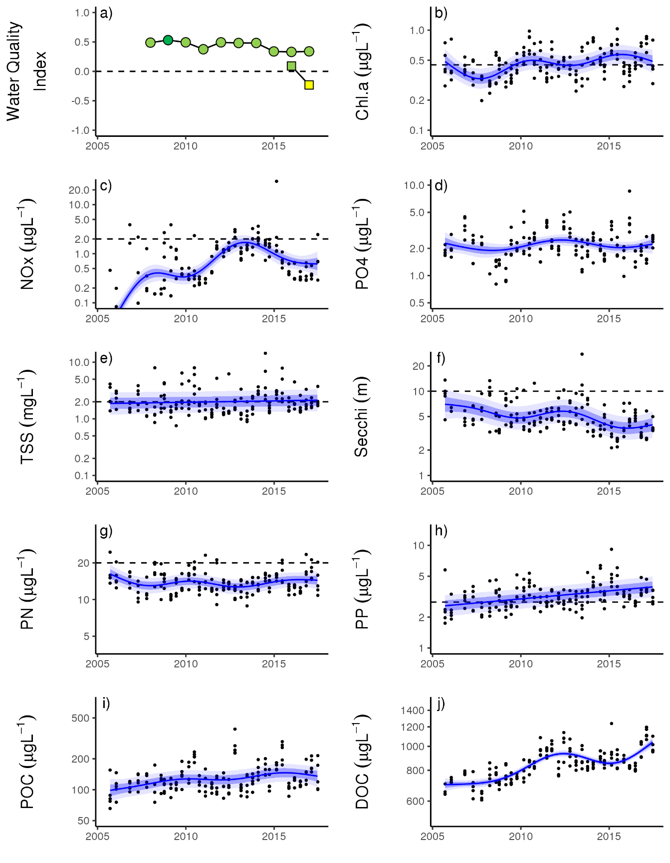
Figure A1. 9 Temporal trends in water quality: Baron Daintree sub-region. a) water quality index, b) chlorophyll a, c) nitrate/nitrite, d) Phosphate, e) total suspended solids, f) secchi depth, g) particulate nitrogen, h) particulate phosphorus, i) particulate organic carbon and j) dissolved organic carbon. Water quality index colour coding: dark green- ‘very good’; light green-‘good’; yellow – ‘moderate; orange – ‘poor’; red – ‘very poor’. The water quality index is the aggregate of variables plotted in b, c, e - h and calculated as described in Waterhouse et al. (2018). Trends in PO4, POC and DOC values are plotted here (d, I, j); threshold levels have yet to be established. Trends in manually sampled water quality variables are represented by blue lines with blue shaded areas defining 95% confidence intervals of those trends, black dots represent observed data. Dashed reference lines indicate guideline values (GBRMPA 2010). Extract from Waterhouse et al. (2018).

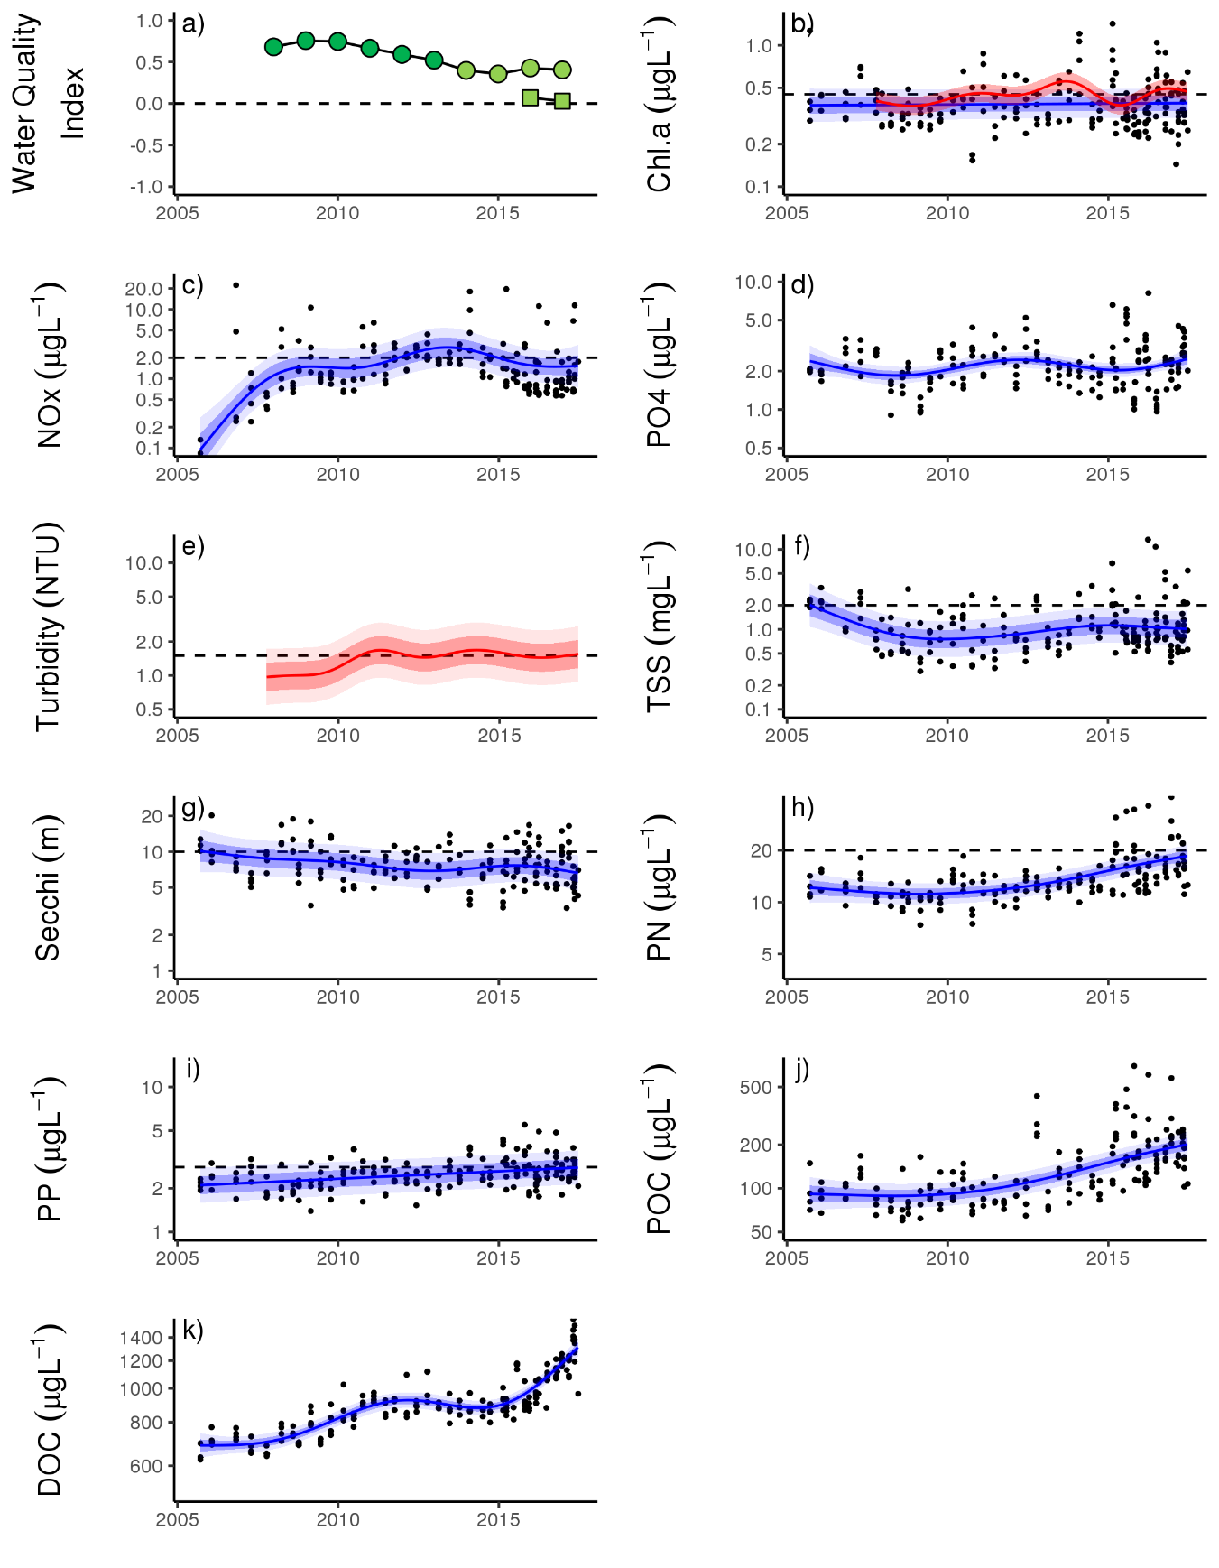
Figure A1. 10 Temporal trends in water quality: Johnstone Russell-Mulgrave sub-region. a) water quality index, b) chlorophyll a, c) nitrate/nitrite, d) Phosphate e) turbidity, f) total suspended solids, g) secchi depth, h) particulate nitrogen, i) particulate phosphorus j) , particulate organic carbon and k) dissolved organic carbon. Water quality index colour coding: dark green- ‘very good’; light green-‘good’; yellow – ‘moderate; orange – ‘poor’; red – ‘very poor’. The water quality index is the aggregate of variables plotted in b, c, f - i and calculated as described in Waterhouse et al. (2018). Trends in PO4, POC and DOC values are plotted here (d, j, k); threshold levels have yet to be established. Trends in manually sampled water quality variables are represented by blue lines with blue shaded areas defining 95% confidence intervals of those trends, black dots represent observed data. Trends of records from ECO FLNTUSB instruments (b, e) are represented in red, individual records are not displayed. Dashed reference lines indicate guideline values (GBRMPA 2010). Extract from Waterhouse et al. (2018).

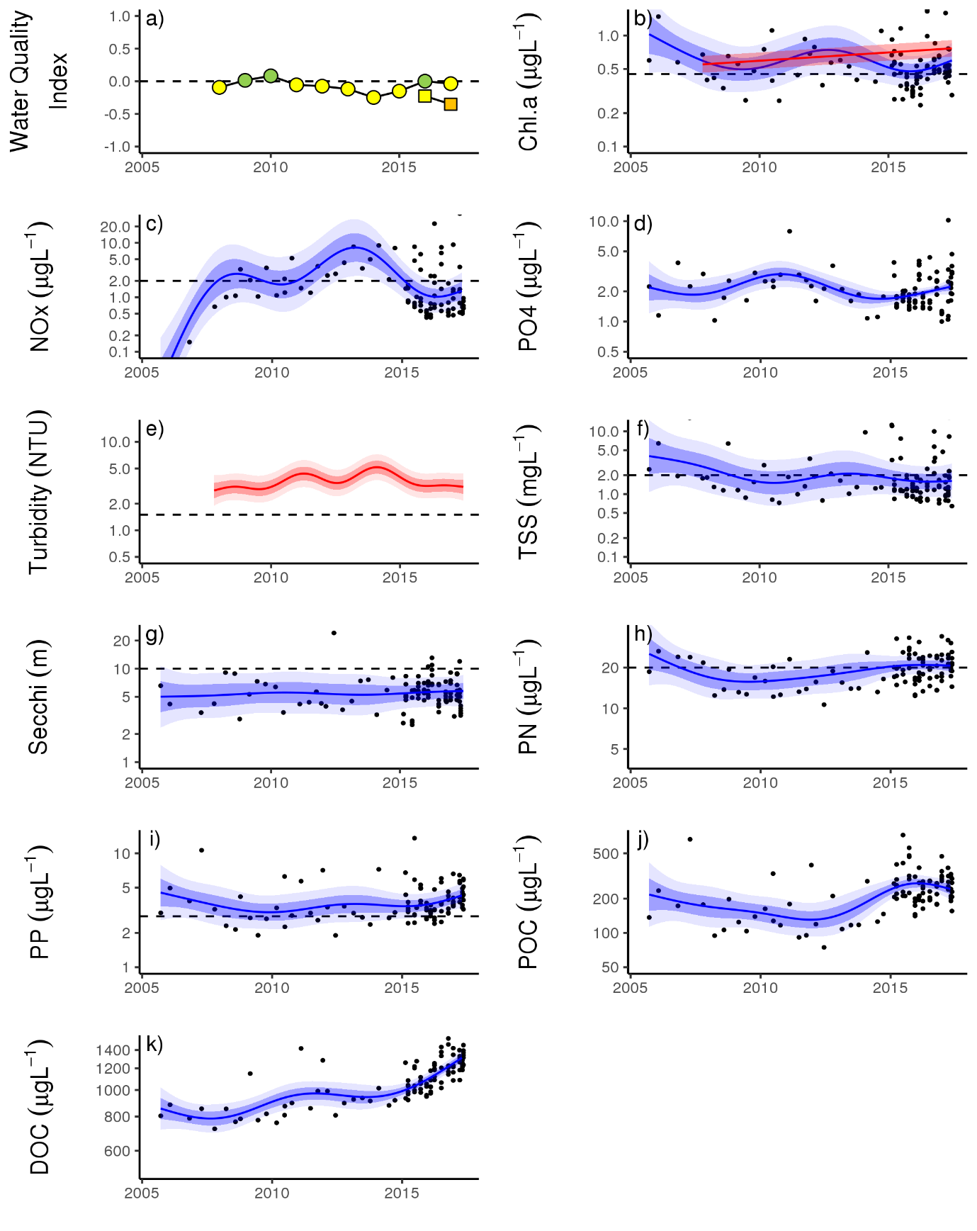
Figure A1. 11 Temporal trends in water quality: Herbert Tully sub-region.
a) water quality index, b) chlorophyll a, c) nitrate/nitrite, d) Phosphate e) turbidity, f) total suspended solids, g) secchi depth, h) particulate nitrogen, i) particulate phosphorus j) , particulate organic carbon and k) dissolved organic carbon. Water quality index colour coding: dark green- ‘very good’; light green-‘good’; yellow – ‘moderate; orange – ‘poor’; red – ‘very poor’. The water quality index is the aggregate of variables plotted in b - i and calculated as described in Waterhouse et al. (2018).Trends in PO4, POC and DOC values are plotted here (d, j, k); threshold levels have yet to be established. Trends in manually sampled water quality variables are represented by blue lines with blue shaded areas defining 95% confidence intervals of those trends, black dots represent observed data. Trends of records from ECO FLNTUSB instruments (b, e) are represented in red, individual records are not displayed. Dashed reference lines indicate guideline values (GBRMPA 2010). Extract from Waterhouse et al. (2018).

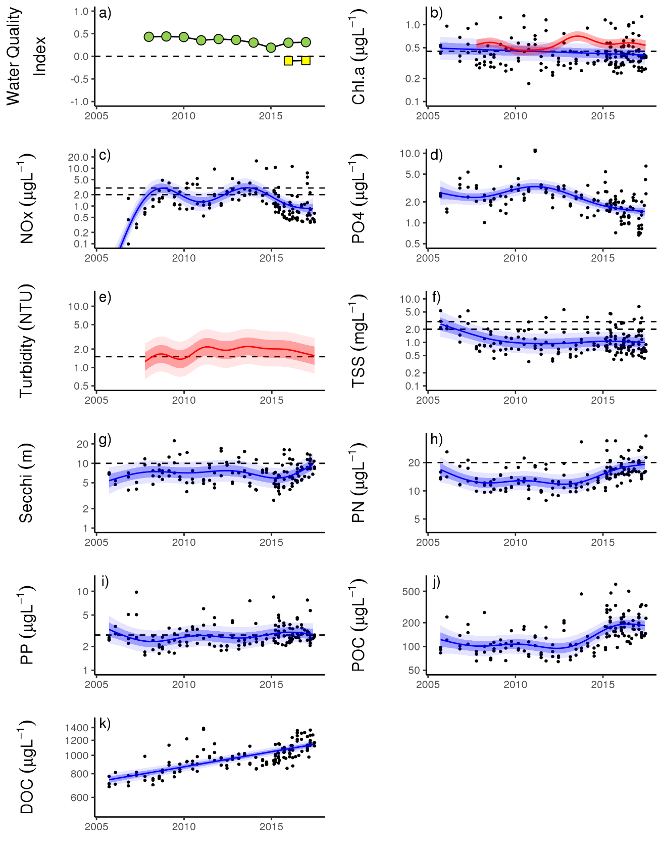
Figure A1. 12 Temporal trends in water quality: Burdekin region.
a) water quality index, b) chlorophyll a, c) nitrate/nitrite, d) Phosphate e) turbidity, f) total suspended solids, g) secchi depth, h) particulate nitrogen, i) particulate phosphorus j) , particulate organic carbon and k) dissolved organic carbon. Water quality index colour coding: dark green- ‘very good’; light green-‘good’; yellow – ‘moderate; orange – ‘poor’; red – ‘very poor’. The water quality index is the aggregate of variables plotted in b - i and calculated as described in Waterhouse et al. (2018).Trends in PO4, POC and DOC values are plotted here (d, j, k); threshold levels have yet to be established. Trends in manually sampled water quality variables are represented by blue lines with blue shaded areas defining 95% confidence intervals of those trends, black dots represent observed data. Trends of records from ECO FLNTUSB instruments (b, e) are represented in red, individual records are not displayed. Dashed reference lines indicate guideline values (GBRMPA 2010). Extract from Waterhouse et al. (2018).

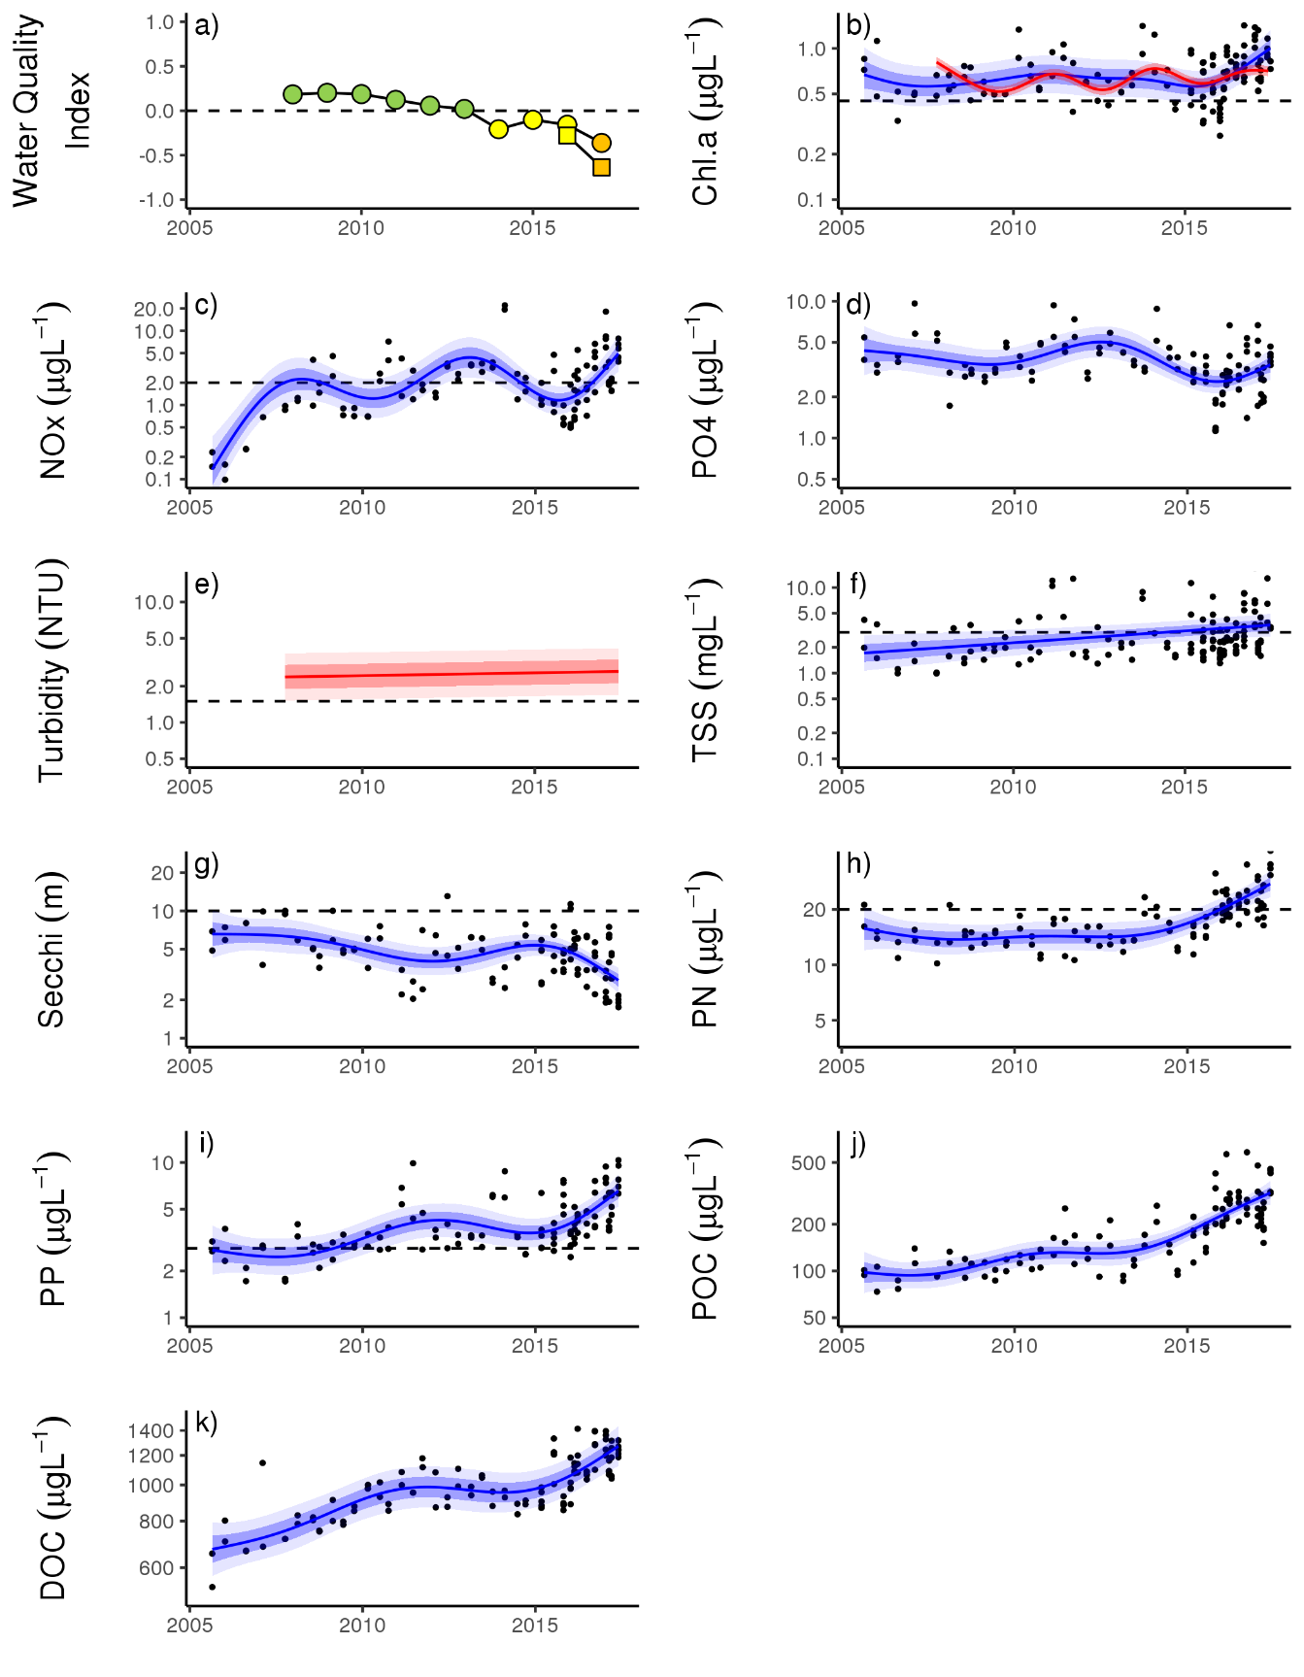
Figure A1. 13 Temporal trends in water quality: Mackay Whitsundays region. a) water quality index, b) chlorophyll a, c) nitrate/nitrite, d) Phosphate e) turbidity, f) total suspended solids, g) secchi depth, h) particulate nitrogen, i) particulate phosphorus j) , particulate organic carbon and k) dissolved organic carbon. Water quality index colour coding: dark green- ‘very good’; light green-‘good’; yellow – ‘moderate; orange – ‘poor’; red – ‘very poor’. The water quality index is the aggregate of variables plotted in b - i and calculated as described in Waterhouse et al. (2018).Trends in PO4, POC and DOC values are plotted here (d, j, k); threshold levels have yet to be established. Trends in manually sampled water quality variables are represented by blue lines with blue shaded areas defining 95% confidence intervals of those trends, black dots represent observed data. Trends of records from ECO FLNTUSB instruments (b, e) are represented in red, individual records are not displayed. Dashed reference lines indicate guideline values (GBRMPA 2010). Extract from Waterhouse et al. (2018).

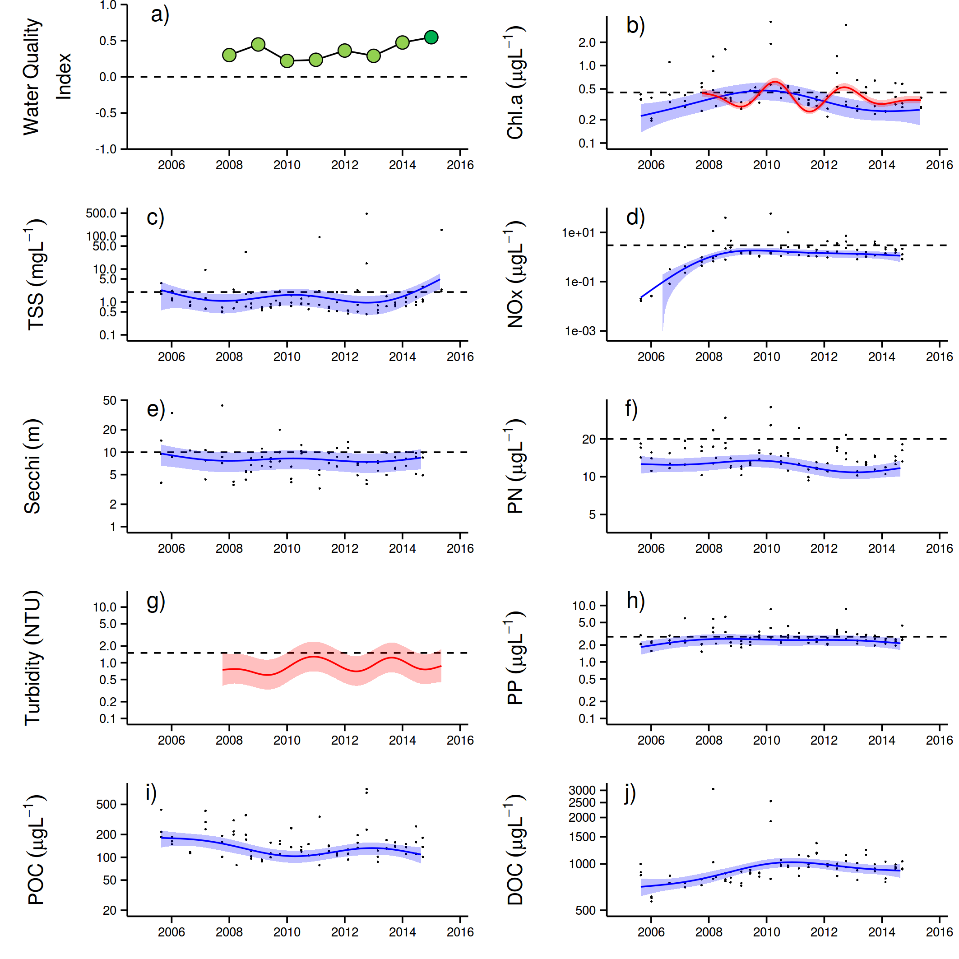
Figure A1. 14 Temporal trends in water quality: Fitzroy region.
a) water quality index, b) chlorophyll a, c) total suspended solids, d) nitrate/nitrite, e) secchi depth, f) particulate nitrogen, g) turbidity, h) particulate phosphorus, i) particulate organic carbon and j) dissolved organic carbon. Water quality index colour coding: dark green- ‘very good’; light green-‘good’; yellow – ‘moderate; orange – ‘poor’; red – ‘very poor’. The water quality index is the aggregate of variables plotted in b - h and calculated as described in Waterhouse et al. (2018). Trends in POC and DOC values are plotted here (I, j); threshold levels have yet to be established. Trends in manually sampled water quality variables are represented by blue lines with blue shaded areas defining 95% confidence intervals of those trends, black dots represent observed data. Trends of records from ECO FLNTUSB instruments (b, g) are represented in red, individual records are not displayed. Dashed reference lines indicate guideline values (GBRMPA 2010). Extract from Waterhouse et al. (2018).

Appendix 2: Publications and presentations associated with the Program 2016-17
Ramsby BD, Hoogenboom MO, Whalan S, Webster NS, Thompson A. A (2017) Decadal analysis of bioeroding sponge cover on the inshore Great Barrier Reef. Scientific Reports 7. doi: 10.1038/s41598-017-02196-z

Australian Government crown-of-thorns starfish management program data supplied by Great Barrier Reef Marine Park Authority, Eye on the Reef.
Marine water quality indices produced by the Australian Bureau of Meteorology as a contribution to eReefs - a collaboration between the Great Barrier Reef Foundation, Australian Government, Bureau of Meteorology, Commonwealth Scientific and Industrial Research Organisation, Australian Institute of Marine Science and the Queensland Government. Data are acquired from NASA spacecraft. http://www.bom.gov.au/marinewaterquality/. Although the confidence in individual estimates of Chl a in turbid inshore waters is low the time averaged conditions do describe gradient that correspond to differences in benthic communities.
. ReefTemp Next Generation was developed through the Centre for Australian Weather and Climate Research (CAWCR) – a partnership between CSIRO and the Bureau of Meteorology (Garde et al. 2014).
Australian Government crown-of-thorns starfish management programme data supplied by Great Barrier Reef Marine Park Authority, Eye on the Reef.
Connie 2.0, CSIRO Connectivity Interface, CSIRO connie2
Marine water quality indices produced by the Australian Bureau of Meteorology as a contribution to eReefs - a collaboration between the Great Barrier Reef Foundation, Australian Government, Bureau of Meteorology, Commonwealth Scientific and Industrial Research Organisation, Australian Institute of Marine Science and the Queensland Government. Data are acquired from NASA spacecraft. http://www.bom.gov.au/marinewaterquality/. Although the confidence in individual estimates of Chl a in turbid inshore waters is low the time averaged conditions do describe gradient that correspond to differences in benthic communities.

