Reef Rescue Marine Monitoring Program:
Assessment of Terrestrial Run-off Entering the Reef and Inshore Marine Water Quality Monitoring using Earth Observation data

Final Report for 2010/11 Activities

Vittorio E. Brando, David Blondeau-Patissier, Thomas Schroeder, Arnold G. Dekker, Lesley Clementson

CSIRO Land & Water
September 2011

Enquiries should be addressed to:
Dr. Vittorio Brando
Environmental Earth Observation Programme
CSIRO Land & Water
GPO Box 1666
Canberra ACT 2601 AUSTRALIA
e-mail: vittorio.brando@csiro.au

Copyright and Disclaimer
© 2011 CSIRO To the extent permitted by law, all rights are reserved and no part of this publication covered by copyright may be reproduced or copied in any form or by any means except with the written permission of CSIRO.

Important Disclaimer
CSIRO advises that the information contained in this publication comprises general statements based on scientific research. The reader is advised and needs to be aware that such information may be incomplete or unable to be used in any specific situation. No reliance or actions must therefore be made on that information without seeking prior expert professional, scientific and technical advice. To the extent permitted by law, CSIRO (including its employees and consultants) excludes all liability to any person for any consequences, including but not limited to all losses, damages, costs, expenses and any other compensation, arising directly or indirectly from using this publication (in part or in whole) and any information or material contained in it.

CONTENTS
Executive summary 21
Acknowledgments 24
1 Introduction 25
2 METHODS 28
2.1 Regionally valid retrieval of water quality parameters from satellite imagery 28
2.2 Management relevant remote sensing products to monitor water quality in GBR 29
2.2.1 Water quality maps 29
2.2.2 Estimate of freshwater extent 30
2.2.3 Evaluation of compliance to guidelines 31
2.2.4 Calculating metrics for the P2R reporting for marine water quality 33
2.2.5 Guide to interpreting the maps 35
3 Novel ways to report on Phytoplankton dynamics: A case study of the Burdekin region. 36
3.1 Objective of this study 36
3.2 Data and methods 37
3.2.1 Data availability and preparation 37
3.2.2 The choice of the median Chlorophyll-a value as a metric for this analysis 39
3.2.3 Computation of anomalies and climatology 40
3.2.4 The clustering of the water masses 40
3.2.5 Exploring the time-space variability using latitude-time (Hovmöller) plots 40
3.2.6 Computation of phenology 41
3.2.7 Interpretation and limitations 42
3.3 Describing the Burdekin system from a multi-year dataset 42
3.3.1 Monthly climatology of the MODIS Chlorophyll-a product in the Burdekin region 46
3.3.2 Clustering the water masses of the Burdekin region in relation to their Chlorophyll-a concentrations 50
3.3.3 Latitude-time plots 51
3.3.3.1 Quantity of pixels used for the computation of the latitude-time plots 51
3.3.3.2 Spatial and temporal variability in Chlorophyll-a 54
3.3.4 Time-series of pixel counts greater than the seasonal Chlorophyll-a median 59
3.4 Summary 59
4 Results and discussion 61
4.1 Great Barrier Reef wide summary 61
4.1.1 Assessment of freshwater extent during the wet season 61
4.1.2 Assessment of the exceedance of water quality guidelines 66
4.2 Regional reports: Cape York region 74
4.2.1 Assessment of freshwater extent during the wet season 74
4.2.2 The wet and dry season median maps for Chlorophyll-a and Total Suspended Solids. 74
4.2.3 Assessment of the marine water quality index and the exceedance of water quality guidelines 75
4.3 Regional reports: Wet Tropics region 88
4.3.1 Assessment of freshwater extent during the wet season 88
4.3.2 The wet and dry season median maps for Chlorophyll-a and Total Suspended Solids. 89
4.3.3 Assessment of the marine water quality index and the exceedance of water quality guidelines 89
4.4 Regional reports: Burdekin region 103
4.4.1 Assessment of freshwater extent during the wet season 103
4.4.2 The wet and dry season median maps for chlorophyll-a and Total Suspended Solids. 104
4.4.3 Assessment of the marine water quality index and the exceedance of water quality guidelines 104
4.5 Regional reports: Mackay Whitsunday region 117
4.5.1 Assessment of freshwater extent during the wet season 117
4.5.2 The wet and dry season median maps for Chlorophyll-a and Total Suspended Solids. 118
4.5.3 Assessment of the marine water quality index and the exceedance of water quality guidelines 118
4.6 Regional reports: Fitzroy Region 131
4.6.1 Assessment of freshwater extent during the wet season 131
4.6.2 The wet and dry season median maps for Chlorophyll-a and Total Suspended Solids. 131
4.6.3 Assessment of the marine water quality index and the exceedance of water quality guidelines 132
4.7 Regional reports: Burnett Mary region 145
4.7.1 Assessment of freshwater extent during the wet season 145
4.7.2 The wet and dry season median maps for Chlorophyll-a and Total Suspended Solids. 146
4.7.3 Assessment of the marine water quality index and the exceedance of water quality guidelines 146
5 Conclusion and recomMendations 162
6 References 166
Appendix 1 Details of algorithm theoretical basis for the regionally valid retrieval of water quality from satellite imagery 170
6.1 Regionally valid retrieval of water quality parameters from satellite imagery 170
6.2 Atmospheric correction 170
6.2.1 Artificial neural network atmospheric correction algorithm development 171
6.2.2 Artificial neural network atmospheric correction algorithm validation and application 172
6.3 Optical water quality retrieval 175
6.3.1 IOP and concentrations retrieval - LMI 175
6.3.2 Parameterization of LMI 177
6.4 Algorithm validation 180
Appendix 2. List of scientific publications, scientific presentations and community seminars arising from the monitoring program 185
Journal Papers 185
Book Chapters 185
Conference Papers 185
Conference presentations 185
Appendix 3. median maps of water clarity expressed as Secchi Depth 188
Appendix 4. Summary of the exceedance of annual mean values from 2002/03 195

List of Tables
Table 1 List of acronyms used in this report. 26
Table 2 Trigger values from the Great Barrier Reef Marine Park Authority Water Quality Guidelines (GBRMPA 2009). Guideline values for the assessment of the annual mean values. *: Geographical adjustment: Wet Tropics/Central Coast (see Figure 2). 32
Table 3 Trigger values from the Great Barrier Reef Marine Park Authority Water Quality Guidelines (GBRMPA 2009). Seasonally adjusted Guideline values for the assessment of seasonal mean values in dry/wet seasons. 32
Table 4 Summary statistics (in µg L⁻¹) for the MODIS daily Chlorophyll-a dataset used in this case study 39
Table 5 Average percentage of the available observations on which the computation of the Hovmöller plots is based for each cluster 54
Table 6. Summary of the exceedance of annual mean values of Chlorophyll-a and non-algal particulate matter (as a measure of Total Suspended Solids) for this reporting period (1 May 2010 – 30 April 2011) for the Open Coastal, Mid-shelf and Offshore water bodies. Cells are shaded in gray when more than 50% of the area of the water body exceeds the Guideline value * Caution should be used when interpreting the results for the Cape York and Burnett Mary regions as limited field information was used for the parameterization and validation on the remote sensing retrievals. 72
Table 7. Summary of the exceedance of mean annual Chlorophyll-a and non-algal particulate matter (as a measure of Total Suspended Solids) for the previous reporting period (1 May 2009 – 30 April 2010) for the Open Coastal, Mid-shelf and Offshore water bodies. Cells are shaded in gray when more than 50% of the area of the water body exceeds the Guideline value * Caution should be used when interpreting the results for the Cape York and Burnett Mary regions as limited field information was used for the parameterization and validation on the remote sensing retrievals. 72
Table 8. Paddock to Reef marine water quality index (P2R_WQI) and component scores (P2R_CHL and P2R_TSS) for this reporting period (1 May 2010 – 30 April 2011). Cells are shaded to reflect the colour coding of the P2R reporting scheme from red to green in steps of 20%.* Caution should be used when interpreting the results for the Cape York and Burnett Mary regions as limited field information was used for the parameterization and validation on the remote sensing retrievals. 73
Table 9. Paddock to Reef marine water quality index (P2R_WQI) and component scores (P2R_CHL and P2R_TSS) for the previous reporting period (1 May 2009 – 30 April 2010). Cells are shaded to reflect the colour coding of the P2R reporting scheme from red to green in steps of 20%.* Caution should be used when interpreting the results for the Cape York and Burnett Mary regions as limited field information was used for the parameterization and validation on the remote sensing retrievals. 73
Table 10 Summary of the annual exceedance maps for Chlorophyll-a and Total Suspended Solids for the Cape York region. "Surface Area" is the surface area in square kilometres for each of the three reporting water bodies for this region: (OC: Open Coastal, MS: Midshelf, OS: Offshore), “Number valid obs." is the number of pixels with valid observations (i.e. cloud-free and error-free pixels), "Number total obs." provides the total number of observations, "Mean > trigger" and "Median > trigger" report the relative area for each water body where the mean or the median exceeded the trigger value. 77
Table 11 Summary of the exceedance maps for Chlorophyll-a for the dry and wet season for the Cape York region (Figure 44, Figure 45). Column and row labels are described in the legend of Table 10. 77
Table 12 Summary of the exceedance maps for Non-algal particulate matter (NAP as a measure of TSS) for the dry and wet season for the Cape York region (Figure 46, Figure 47). Column and row labels are described in the legend of Table 10. 77
Table 13. Summary of Chlorophyll-a exceedance for the dry and wet season for the Cape York region. “Number valid obs." is the number of pixels with valid observations (i.e. cloud-free and error-free pixels) for each of the three reporting water bodies for this region: (OC: Open Coastal, MS: Midshelf, OS: Offshore), "Number total obs." provides the total number of observations. Mean and median are presented in red and bold if they exceed the trigger value in the Guidelines. The seasonally adjusted Guideline values for Chlorophyll –a for the dry/wet season are 0.32/0.63 µg L⁻¹ for Open Coastal and Midshelf and 0.28/0.56 µg L⁻¹ for Offshore. 78
Table 14 Summary of Non-algal particulate matter (NAP as a measure of TSS) exceedance for the dry and wet season for the Cape York region. Column and row labels are described in the legend of Table 13. Mean and median are presented in red and bold if they exceed the trigger value in the Guidelines. The seasonally adjusted Guideline values for TSS for the dry/wet season means are 1.6/2.4 mg L⁻¹ for Open Coastal and Midshelf and 0.6/0.8 mg L⁻¹ for Offshore. 78
Table 15 Summary of the annual exceedance maps for Chlorophyll-a and Total Suspended Solids for the Wet Tropics region. "Surface Area" is the surface area in square kilometres for each of the three reporting water bodies for this region: (OC: Open Coastal, MS: Midshelf, OS: Offshore), “Number valid obs." is the number of pixels with valid observations (i.e. cloud-free and error-free pixels), "Number total obs." provides the total number of observations, "Mean > trigger" and "Median > trigger" report the relative area for each water body where the mean or the median exceeded the trigger value. 92
Table 16 Summary of the exceedance maps for Chlorophyll-a for the dry and wet season for the Wet Tropics region (Figure 55, Figure 56). Column and row labels are described in the legend of Table 15. 92
Table 17 Summary of the exceedance maps for Non-algal particulate matter (NAP as a measure of TSS) for the dry and wet season for the Wet Tropics region (Figure 57, Figure 58). Column and row labels are described in the legend of Table 15. 92
Table 18. Summary of Chlorophyll-a exceedance for the dry and wet season for the Wet Tropics region. "Surface Area" is the surface area in square kilometres for each of the three reporting water bodies for this region: (OC: Open Coastal, MS: Midshelf, OS: Offshore), “Number valid obs." is the number of pixels with valid observations (i.e. cloud-free and error-free pixels), "Number total obs." provides the total number of observations. Mean and median are presented in red and bold if they exceed the trigger value in the Guidelines. The seasonally adjusted Guideline values for Chlorophyll –a for the dry/wet season are 0.32/0.63 µg L⁻¹ for Open Coastal and Midshelf and 0.28/0.56 µg L⁻¹ for Offshore. 93
Table 19 Summary of Non-algal particulate matter (NAP as a measure of TSS) exceedance for the dry and wet season for the Wet Tropics region. Column and row labels are described in the legend Table 18. Mean and median are presented in red and bold if they exceed the trigger value in the Guidelines. The seasonally adjusted Guideline values for TSS for the dry/wet season means are 1.6/2.4 mg L⁻¹ for Open Coastal and Midshelf and 0.6/0.8 mg L⁻¹ for Offshore. 93
Table 20 Summary of the annual exceedance maps for Chlorophyll-a and Total Suspended Solids for the Burdekin region. "Surface Area" is the surface area in square kilometres for each of the three reporting water bodies for this region: (OC: Open Coastal, MS: Midshelf, OS: Offshore), “Number valid obs." is the number of pixels with valid observations (i.e. cloud-free and error-free pixels), "Number total obs." provides the total number of observations, "Mean > trigger" and "Median > trigger" report the relative area for each water body where the mean or the median exceeded the trigger value. 106
Table 21 Summary of the exceedance maps for Chlorophyll-a for the dry and wet season for the Burdekin region (Figure 66, Figure 67). Column and row labels are described in the legend of Table 20. 106
Table 22 Summary of the exceedance maps for Non-algal particulate matter (NAP as a measure of TSS) for the dry and wet season for the Burdekin region (Figure 68, Figure 69). Column and row labels are described in the legend of Table 20. 106
Table 23. Summary of Chlorophyll-a exceedance for the dry and wet season for the Burdekin region. “Number valid obs." is the number of pixels with valid observations (i.e. cloud-free and error-free pixels) for each of the three reporting water bodies for this region: (OC: Open Coastal, MS: Midshelf, OS: Offshore), "Number total obs." provides the total number of observations. Mean and median are presented in red and bold if they exceed the trigger value in the Guidelines. The seasonally adjusted Guideline values for Chlorophyll–a for the dry/wet season are 0.32/0.63 µg L⁻¹ for Open Coastal and Midshelf and 0.28/0.56 µg L⁻¹ for Offshore. 107
Table 24 Summary of Non-algal particulate matter (NAP as a measure of TSS) exceedance for the dry and wet season for the Burdekin region. Column and row labels are described in the legend Table 23. Mean and median are presented in red and bold if they exceed the trigger value in the Guidelines. The seasonally adjusted Guideline values for TSS for the dry/wet season means are 1.6/2.4 mg L⁻¹ for Open Coastal and Midshelf and 0.6/0.8 mg L⁻¹ for Offshore. 107
Table 25 Summary of the annual exceedance maps for Chlorophyll-a and Total Suspended Solids for the Mackay-Whitsunday region. "Surface Area" is the surface area in square kilometres for each of the three reporting water bodies for this region: (OC: Open Coastal, MS: Midshelf, OS: Offshore), “Number valid obs." is the number of pixels with valid observations (i.e. cloud-free and error-free pixels), "Number total obs." provides the total number of observations, "Mean > trigger" and "Median > trigger" report the relative area for each water body where the mean or the median exceeded the trigger value. 120
Table 26. Summary of the exceedance maps for Chlorophyll-a for the dry and wet season for the Mackay Whitsunday region (Figure 77, Figure 78). Column and row labels are described in the legend of Table 25. 120
Table 27. Summary of the exceedance maps for Non-algal particulate matter (NAP as a measure of TSS) for the dry and wet season for the Mackay Whitsunday region (Figure 79, Figure 80). Column and row labels are described in the legend of Table 25. 120
Table 28. Summary of Chlorophyll-a exceedance for the dry and wet season for the Mackay Whitsunday region. “Number valid obs." is the number of pixels with valid observations (i.e. cloud-free and error-free pixels) for each of the three reporting water bodies for this region: (OC: Open Coastal, MS: Midshelf, OS: Offshore), "Number total obs." provides the total number of observations. Mean and median are presented in red and bold if they exceed the trigger value in the Guidelines. The seasonally adjusted Guideline values for Chlorophyll-a for the dry/wet season are 0.32/0.63 µg L⁻¹ for Open Coastal and Midshelf and 0.28/0.56 µg L⁻¹ for Offshore. 121
Table 29. Summary of Non-algal particulate matter (NAP as a measure of TSS) exceedance for the dry and wet season for the Mackay Whitsunday region. Column and row labels are described in the legend Table 23. Mean and median are presented in red and bold if they exceed the trigger value in the Guidelines. The seasonally adjusted Guideline values for TSS for the dry/wet season means are 1.6/2.4 mg L⁻¹ for Open Coastal and Midshelf and 0.6/0.8 mg L⁻¹ for Offshore. 121
Table 30 Summary of the annual exceedance maps for Chlorophyll-a and Total Suspended Solids for the Fitzroy region. "Surface Area" is the surface area in square kilometres for each of the three reporting water bodies for this region: (OC: Open Coastal, MS: Midshelf, OS: Offshore), “Number valid obs." is the number of pixels with valid observations (i.e. cloud-free and error-free pixels), "Number total obs." provides the total number of observations, "Mean > trigger" and "Median > trigger" report the relative area for each water body where the mean or the median exceeded the trigger value. 134
Table 31 Summary of the exceedance maps for Chlorophyll-a for the dry and wet season for the Fitzroy region (Figure 88, Figure 89). Column and row labels are described in the legend of Table 30. 134
Table 32 Summary of the exceedance maps for Non-algal particulate matter (NAP as a measure of TSS) for the dry and wet season for the Fitzroy region (, Figure 90, Figure 91). ). Column and row labels are described in the legend of Table 30. 134
Table 33. Summary of Chlorophyll-a exceedance for the dry and wet season for the Fitzroy region. “Number valid obs." is the number of pixels with valid observations (i.e. cloud-free and error-free pixels) for each of the three reporting water bodies for this region: (OC: Open Coastal, MS: Midshelf, OS: Offshore), "Number total obs." provides the total number of observations. Mean and median are presented in red and bold if they exceed the trigger value in the Guidelines. The seasonally adjusted Guideline values for Chlorophyll-a for the dry/wet season are 0.32/0.63 µg L⁻¹ for Open Coastal and Midshelf and 0.28/0.56 µg L⁻¹ for Offshore. 135
Table 34 Summary of Non-algal particulate matter (NAP as a measure of TSS) exceedance for the dry and wet season for the Fitzroy region. Column and row labels are described in the legend of Table 33. Mean and median are presented in red and bold if they exceed the trigger value in the Guidelines. The seasonally adjusted Guideline values for TSS for the dry/wet season means are 1.6/2.4 mg L⁻¹ for Open Coastal and Midshelf and 0.6/0.8 mg L⁻¹ for Offshore. 135
Table 35 Summary of the annual exceedance maps for Chlorophyll-a and Total Suspended Solids for the Mary-Burnett region. "Surface Area" is the surface area in square kilometres for each of the three reporting water bodies for this region: (OC: Open Coastal, MS: Midshelf, OS: Offshore), “Number valid obs." is the number of pixels with valid observations (i.e. cloud-free and error-free pixels), "Number total obs." provides the total number of observations, "Mean > trigger" and "Median > trigger" report the relative area for each water body where the mean or the median exceeded the trigger value. 150
Table 36 Summary of the exceedance maps for Chlorophyll-a for the dry and wet season for the Burnett Mary region (Figure 99, Figure 100). Column and row labels are described in the legend of Table 35. 150
Table 37 Summary of the exceedance maps for Non-algal particulate matter (NAP as a measure of TSS) for the dry and wet season for the Burnett Mary region (Figure 101, Figure 102). Column and row labels are described in the legend of Table 35. 150
Table 38. Summary of Chlorophyll-a exceedance for the dry and wet season for the Burnett Mary region. “Number valid obs." is the number of pixels with valid observations (i.e. cloud-free and error-free pixels) for each of the three reporting water bodies for this region: (OC: Open Coastal, MS: Midshelf, OS: Offshore), "Number total obs." provides the total number of observations. Mean and median are presented in red and bold if they exceed the trigger value in the Guidelines. The seasonally adjusted Guideline values for Chlorophyll-a for the dry/wet season are 0.32/0.63 µg L⁻¹ for Open Coastal and Midshelf and 0.28/0.56 µg L⁻¹ for Offshore. 151
Table 39 Summary of Non-algal particulate matter (NAP as a measure of TSS) exceedance for the dry and wet season for the Burnett Mary region. Column and row labels are described in the legend of Table 38. Mean and median are presented in red and bold if they exceed the trigger value in the Guidelines. The seasonally adjusted Guideline values for TSS for the dry/wet season means are 1.6/2.4 mg L⁻¹ for Open Coastal and Midshelf and 0.6/0.8 mg L⁻¹ for Offshore. 151
Table 40 The final centroids identifying the most representative SIOP sets that were used in the regional algorithm parameterization of LMI_CLU4. 178
Table 41 Validation statistics for the measurements collected with 3 hours of the overpass. RMSE is the root mean square error, MAPE the mean absolute percentage error. 181
Table 42. Summary of the exceedance of mean annual Chlorophyll-a and non-algal particulate matter (as a measure of Total Suspended Solids) for the 2002/03 reporting period (1 May 2002 – 30 April 2003) for the Open Coastal, Mid-shelf and Offshore water bodies. Cells are shaded in gray when more than 50% of the area of the water body exceeds the Guideline value. * Caution should be used when interpreting the results for the Cape York and Burnett Mary regions as limited field information was used for the parameterization and validation on the remote sensing retrievals. 195
Table 43. Summary of the exceedance of mean annual Chlorophyll-a and non-algal particulate matter (as a measure of Total Suspended Solids) for the 2003/04 reporting period (1 May 2003 – 30 April 2004) for the Open Coastal, Mid-shelf and Offshore water bodies. Cells are shaded in gray when more than 50% of the area of the water body exceeds the Guideline value. * Caution should be used when interpreting the results for the Cape York and Burnett Mary regions as limited field information was used for the parameterization and validation on the remote sensing retrievals. 195
Table 44. Summary of the exceedance of mean annual Chlorophyll-a and non-algal particulate matter (as a measure of Total Suspended Solids) for the 2004/05 reporting period (1 May 2004 – 30 April 2005) for the Open Coastal, Mid-shelf and Offshore water bodies. Cells are shaded in gray when more than 50% of the area of the water body exceeds the Guideline value.* Caution should be used when interpreting the results for the Cape York and Burnett Mary regions as limited field information was used for the parameterization and validation on the remote sensing retrievals. 196
Table 45. Summary of the exceedance of mean annual Chlorophyll-a and non-algal particulate matter (as a measure of Total Suspended Solids) for the 2005/16 reporting period (1 May 2005 – 30 April 2006) for the Open Coastal, Mid-shelf and Offshore water bodies. Cells are shaded in gray when more than 50% of the area of the water body exceeds the Guideline value.* Caution should be used when interpreting the results for the Cape York and Burnett Mary regions as limited field information was used for the parameterization and validation on the remote sensing retrievals. 197
Table 46. Summary of the exceedance of mean annual Chlorophyll-a and non-algal particulate matter (as a measure of Total Suspended Solids) for the 2006/07 reporting period (1 May 2006 – 30 April 2007) for the Open Coastal, Mid-shelf and Offshore water bodies. Cells are shaded in gray when more than 50% of the area of the water body exceeds the Guideline value. * Caution should be used when interpreting the results for the Cape York and Burnett Mary regions as limited field information was used for the parameterization and validation on the remote sensing retrievals. 197
Table 47. Summary of the exceedance of mean annual Chlorophyll-a and non-algal particulate matter (as a measure of Total Suspended Solids) for the 2007/08 reporting period (1 May 2007 – 30 April 2008) for the Open Coastal, Mid-shelf and Offshore water bodies. Cells are shaded in gray when more than 50% of the area of the water body exceeds the Guideline value.* Caution should be used when interpreting the results for the Cape York and Burnett Mary regions as limited field information was used for the parameterization and validation on the remote sensing retrievals. 198
Table 48. Summary of the exceedance of mean annual Chlorophyll-a and non-algal particulate matter (as a measure of Total Suspended Solids) for the 2008/09 reporting period (1 May 2008 – 30 April 2009) for the Open Coastal, Mid-shelf and Offshore water bodies. Cells are shaded in gray when more than 50% of the area of the water body exceeds the Guideline value.* Caution should be used when interpreting the results for the Cape York and Burnett Mary regions as limited field information was used for the parameterization and validation on the remote sensing retrievals. 198
Table 49. Summary of the exceedance of mean annual Chlorophyll-a and non-algal particulate matter (as a measure of Total Suspended Solids) for the 2009/10 reporting period (1 May 2009 – 30 April 2010) for the Open Coastal, Mid-shelf and Offshore water bodies. Cells are shaded in gray when more than 50% of the area of the water body exceeds the Guideline value.* Caution should be used when interpreting the results for the Cape York and Burnett Mary regions as limited field information was used for the parameterization and validation on the remote sensing retrievals. 199
Table 50. Summary of the exceedance of annual mean values of Chlorophyll-a and non-algal particulate matter (as a measure of Total Suspended Solids) for the 2010/11 reporting period (1 May 2010 – 30 April 2011) for the Open Coastal, Mid-shelf and Offshore water bodies. Cells are shaded in gray when more than 50% of the area of the water body exceeds the Guideline value.* Caution should be used when interpreting the results for the Cape York and Burnett Mary regions as limited field information was used for the parameterization and validation on the remote sensing retrievals. 199

List of Figures
Figure 1. Linear regression of concurrent in situ CDOM absorption (443 nm) and salinity measurements. Modified from Figure 4 of Schroeder et al. (2012). 31
Figure 2. Regional and cross shelf boundaries defined by GBRMPA for the MMP 2008/09 reporting. 34
Figure 3. The Burdekin region as seen from space (credits: NASA). 37
Figure 4 Satellite-data availability for the MODIS-Aqua sensor between 4 November 2002 and 30 April 2011 for the Burdekin region (top). Note the difference between the dry (middle) and wet (bottom) season months. 38
Figure 5 Histograms of log-transformed Chlorophyll-a for (a) the whole dataset (N=2781), (b) the dry season months (N=1310) and (c) the wet season months (N=1471). 39
Figure 6 Illustration of the K-means clustering technique (modified from Wikipedia). 40
Figure 7 Schematic representation of the computation of a Hovmöller diagram for the Oligotrophic lagoon. 41
Figure 8 Multi-annual (2002-2011) Chlorophyll-a median concentration map. 43
Figure 9 Multi-annual (2002-2011) Chlorophyll-a interquartile range concentration map. 43
Figure 10 Multi-annual (2002-2011) Chlorophyll-a median concentration maps for the dry (top) and wet (bottom) season months. Note the change of colour scale to 0-1 µg.L⁻¹. 44
Figure 11 Multi-annual (2002-2011) Chlorophyll-a interquartile range maps for the dry (top) and wet (bottom) season months. 45
Figure 12 Percentage difference between the multi-annual wet and dry median Chlorophyll-a maps. 46
Figure 13 Yearly seasonal Chlorophyll-a median and percentage difference maps. Maps that are red-crossed indicate that the computation was not possible due to missing months. 47
Figure 14 Standardized anomaly monthly Chlorophyll-a maps (dimensionless). Wet season months are in bold italic. 49
Figure 15 K-means clustering results based on 12 multi-annual, monthly median Chlorophyll-a concentration fields. The NRM 2010 zoning is overlayed (thick black lines). 50
Figure 16 K-means clustering results as per Figure 15 but for (left) CDOM and (right) NAP concentration fields. 51
Figure 17 Hovmöller diagrams of the percentage of pixels used for the computation of the median for (top) the nearshore and coastal waters clusters and (bottom) the coastal waters cluster. 52
Figure 18 Hovmöller diagram of the percentage of pixels used for the computation of the median for the midshelf waters cluster. 53
Figure 19 Hovmöller diagram of the percentage of pixels used for the computation of the median for the oligotrophic lagoonal waters cluster. 53
Figure 20 Hovmöller diagram of the percentage of pixels used for the computation of the median for the reef waters cluster. 54
Figure 21 Hovmöller diagrams of Chlorophyll-a for (top) the merged nearshore and coastal waters clusters, (bottom) the coastal waters cluster only. 55
Figure 22 Hovmöller diagram of Chlorophyll-a for the midshelf waters cluster. Note the change of scale. 56
Figure 23 Hovmöller diagram of Chlorophyll-a for the oligotrophic lagoonal waters cluster. 56
Figure 24 Hovmöller diagram of Chlorophyll-a for the reef waters cluster. 57
Figure 25 A 6-day sequence of MODIS daily images showing the development of a bloom one month following cyclone Hamish (1-6 April 2009). Daily MODIS LMI-Chlorophyll-a are shown on the left, while deviations from the wet season multi-annual medians are shown in the right column. The black arrow shows the approximate area of change in CHL during this period. In the left column the land and reef masks are shown in dark grey and white respectively, while the light grey represent missing data due to cloud cover (see 2.2.4). In the right column grey represent the land, islands and reef masks while data outside the GBRWHA boundaries are shown in white (see 3.2.1). 58
Figure 26 Time-series of the monthly average counts of CHL pixels that are above the seasonal median for (a) the nearshore waters cluster, (b) the coastal waters cluster, (c) the merged nearshore-coastal waters cluster, (d) the midshelf waters cluster, (e) the lagoonal waters cluster and (f) the reef waters cluster. The dashed, blue curve represents the annual cycle computed by a Levenberg-Marquardt least-squares regression fitting. Grey polygons are the wet season months. Insets display the location and size of the clusters for each time-series. 60
Figure 27. Comparison of fresh water discharge for 2010/2011 compared to 2008/2009, 2009/2010 and the long term median for each reporting region of the GBRWHA. Data are aggregated to the reporting regions from table A1-3 of (Schaffelke et al. 2011) presenting data supplied by the Queensland Department of the Environment and Resource Management for each river. Long-term medians were estimated from annual total flows (October to October), long-term medians are not available for the Cape York and Burnett Mary regions (Schaffelke et al. 2011). 62
Figure 28. Track and Intensity Information for Severe Tropical Cyclone Yasi (Bureau of Meteorology). 62
Figure 29. Rain rates subsequent to TC Yasi landfall. Radar image for 3 February 2011 3:10 AM. (Bureau of Meteorology) 63
Figure 30. Overview of the freshwater extent for the wet season 2010/2011 (November 2010- April 2011) for the whole Great Barrier Reef World Heritage Area. Detailed maps for each region are presented in the regional reporting sections (Figure 39, Figure 50, Figure 61, Figure 72, Figure 83, Figure 94). Pixels are mapped in dark red when the CDOM seasonal maximum values for the year exceed the threshold of 0.24 m⁻¹. 64
Figure 31. Total freshwater discharge and total estimated freshwater extent for the whole GBRWHA based on the CDOM maximum for the wet seasons. 65
Figure 32. Comparison of estimated freshwater extent based on the CDOM maximum for the wet seasons 2008/2009 (November 2008- April 2009) and 2009/2010 (November 2009 - April 2010) and 2010/2011 (November 2010- April 2011) for each reporting region of GBRWHA. 65
Figure 33. Map of the Chlorophyll-a annual median values for the 2010/2011 reporting period (May 2010 – April 2011) for the whole of the Great Barrier Reef World Heritage Area. The Guideline values for annual means of Chlorophyll –a are 0.45 µg L-1 for Open Coastal and Midshelf and 0.40 µg L⁻¹ for Offshore. 68
Figure 34. Map of annual median values of non-algal particulate matter (as a measure of Total Suspended Solids) for the 2010/2011 reporting period (May 2010 – April 2011) for the whole of the Great Barrier Reef World Heritage Area. The Guideline values for annual means of Total Suspended Solids are 2.0 mg L⁻¹for Open Coastal and Midshelf and 0.7 mg L⁻¹ for Offshore. 69
Figure 35. Collation of the exceedance maps of mean annual Chlorophyll-a for the 2010/2011 reporting period (May 2010 – April 2011) for the whole of the Great Barrier Reef World Heritage Area. Pixels are mapped in dark red when mean values for the year exceed the thresholds. Detailed maps are reported in the regional reporting sections (Figure 43, Figure 54, Figure 65, Figure 76, Figure 87 and Figure 98). 70
Figure 36. Collation of the exceedance maps of mean annual Total Suspended Solids for the 2010/2011 reporting period (May 2010 – April 2011) for the whole of the Great Barrier Reef World Heritage Area. Pixels are mapped in dark red when mean values for the year exceed the thresholds. Detailed maps are reported in the regional reporting sections (Figure 43, Figure 54, Figure 65, Figure 76, Figure 87 and Figure 98). 71
Figure 37. Freshwater discharge and estimated freshwater extent for the Cape York region based on the CDOM maximum for the wet seasons. 75
Figure 38. Paddock to Reef marine water quality index (P2R_WQI) and component scores (P2R_CHL and P2R_TSS) for the Cape York region based on the assessment of exceedance to the Guidelines. 76
Figure 39. Map of freshwater extent for the wet season for the Cape York region. The first map presents the maximum value of CDOM for the wet season 2010/2011 (November 2010- April 2011), while the second map presents freshwater extent estimated with a threshold for the CDOM seasonal maximum of 0.24 m⁻¹. 79
Figure 40. Chlorophyll-a median maps for the dry and wet season for the Cape York region. The first map presents the median for the dry season 2010 (May - October), while the second map presents the median for the wet season 2010/2011 (November 2010- April 2011). 80
Figure 41. Non-algal particulate matter (NAP as a measure of TSS) median maps for the dry and wet season for the Cape York region. The first map presents the median for the dry season 2010 (May - October), while the second map presents the median for the wet season 2010/2011 (November 2010- April 2011). 81
Figure 42. Number of observations used to calculate the median maps (Figure 40 - Figure 41) for the dry and wet season for the Cape York region. The first map presents the number of observations available for analysis in the dry season 2010 (May - October), while the second map presents the number of observations available for analysis in the wet season 2010/2011 (November 2010- April 2011). 82
Figure 43. Exceedance maps for the Cape York region for the whole year (May 2010 –April 2011). The first map presents the Chlorophyll-a exceedance map, while the second map presents the Non-algal particulate matter (NAP as a measure of TSS) exceedance map. The Guideline values for annual means of Chlorophyll–a are 0.45 µg L⁻¹ for Open Coastal and Midshelf and 0.40 µg L⁻¹ for Offshore, while for TSS are 2.0 and 0.7 mg L⁻¹. 83
Figure 44. Chlorophyll-a exceedance maps for the dry and wet season for the Cape York region. The first map presents the exceedance for the dry season 2010 (May - October), while the second map presents the exceedance for the wet season 2010/2011 (November 2010- April 2011). The seasonally adjusted Guideline values for Chlorophyll–a for the dry/wet season are 0.32/0.63 µg L-1 for Open Coastal and Midshelf and 0.28/0.56 µg L-1 for Offshore. 84
Figure 45. Chlorophyll-a exceedance frequency maps for the dry and wet season for the Cape York region. The first map presents the exceedance frequency for the dry season 2010 (May - October), while the second map presents the exceedance frequency for the wet season 2010/2011 (November 2010- April 2011). The seasonally adjusted Guideline values for Chlorophyll –a for the dry/wet season are 0.32/0.63 µg L⁻¹ for Open Coastal and Midshelf and 0.28/0.56 µg L⁻¹ for Offshore. 85
Figure 46. Non-algal particulate matter (NAP as a measure of TSS) exceedance maps for the dry and wet season for the Cape York. The first map presents the exceedance for the dry season 2010 (May - October), while the second map presents the exceedance for the wet season 2010/2011 (November 2010- April 2011). The seasonally adjusted Guideline values for TSS for the dry/wet season means are 1.6/2.4 mg L⁻¹ for Open Coastal and Midshelf and 0.6/0.8 mg L⁻¹ for Offshore. 86
Figure 47. Non-algal particulate matter (NAP as a measure of TSS) exceedance frequency maps for the dry and wet season for the Cape York region. The first map presents the exceedance frequency for the dry season 2010 (May - October), while the second map presents the exceedance frequency for the wet season 2010/2011 (November 2010- April 2011). The seasonally adjusted Guideline values for TSS for the dry/wet season means are 1.6/2.4 mg L⁻¹ for Open Coastal and Midshelf and 0.6/0.8 mg L⁻¹ for Offshore. 87
Figure 48. Freshwater discharge and estimated freshwater extent for the Wet Tropics region based on the CDOM maximum for the wet seasons. 88
Figure 49. Paddock to Reef marine water quality index (P2R_WQI) and component scores (P2R_CHL and P2R_TSS) for the Wet Tropics region based on the assessment of exceedance to the Guidelines. 90
Figure 50. Map of freshwater extent for the wet season for the Wet Tropics region. The first map presents the maximum value of CDOM for the wet season 2010/2011 (November 2010- April 2011), while the second map presents freshwater extent estimated with a threshold for the CDOM seasonal maximum of 0.24 m⁻¹. 94
Figure 51. Chlorophyll-a median maps for the dry and wet season for the Wet Tropics region. The first map presents the median for the dry season 2010 (May - October), while the second map presents the median for the wet season 2010/2011 (November 2010- April 2011). 95
Figure 52. Non-algal particulate matter (NAP as a measure of TSS) median maps for the dry and wet season for the Wet Tropics region. The first map presents the median for the dry season 2010 (May - October), while the second map presents the median for the wet season 2010/2011 (November 2010- April 2011). 96
Figure 53. Number of observations used to calculate the median maps (Figure 51 - Figure 52) for the dry and wet season for the Wet Tropics region. The first map presents the number of observations available for analysis in the dry season 2010 (May - October), while the second map presents the number of observations available for analysis in the wet season 2010/2011 (November 2010- April 2011). 97
Figure 54. Exceedance maps for the Wet Tropics region for the whole year (May 2010 – April 2011). The first map presents the Chlorophyll-a exceedance map, while the second map presents the non-algal particulate matter (NAP as a measure of TSS) exceedance map. The Guideline values for annual means of Chlorophyll–a are 0.45 µg L⁻¹ for Open Coastal and Midshelf and 0.40 µg L⁻¹ for Offshore, while for TSS are 2.0 and 0.7 mg L⁻¹. 98
Figure 55. Chlorophyll-a exceedance maps for the dry and wet season for the Wet Tropics region. The first map presents the exceedance for the dry season 2010 (May - October), while the second map presents the exceedance for the wet season 2010/2011 (November 2010- April 2011). The seasonally adjusted Guideline values for Chlorophyll –a for the dry/wet season are 0.32/0.63 µg L⁻¹ for Open Coastal and Midshelf and 0.28/0.56 µg L⁻¹ for Offshore. 99
Figure 56. Chlorophyll-a exceedance frequency maps for the dry and wet season for the Wet Tropics region. The first map presents the exceedance frequency for the dry season 2010 (May - October), while the second map presents the exceedance frequency for the wet season 2010/2011 (November 2010- April 2011). The seasonally adjusted Guideline values for Chlorophyll –a for the dry/wet season are 0.32/0.63 µg L⁻¹ for Open Coastal and Midshelf and 0.28/0.56 µg L⁻¹ for Offshore. 100
Figure 57. Non-algal particulate matter (NAP as a measure of TSS) exceedance maps for the dry and wet season for the Wet Tropics region. The first map presents the exceedance for the dry season 2010 (May - October), while the second map presents the exceedance for the wet season 2010/2011 (November 2010- April 2011). The seasonally adjusted Guideline values for TSS for the dry/wet season means are 1.6/2.4 mg L⁻¹ for Open Coastal and Midshelf and 0.6/0.8 mg L⁻¹ for Offshore. 101
Figure 58. Non-algal particulate matter (NAP as a measure of TSS) exceedance frequency maps for the dry and wet season for the Wet Tropics region. The first map presents the exceedance frequency for the dry season 2010 (May - October), while the second map presents the exceedance frequency for the wet season 2010/2011 (November 2010- April 2011). The seasonally adjusted Guideline values for TSS for the dry/wet season means are 1.6/2.4 mg L⁻¹ for Open Coastal and Midshelf and 0.6/0.8 mg L⁻¹ for Offshore. 102
Figure 59. Freshwater discharge and estimated freshwater extent for the Burdekin region based on the CDOM maximum for the wet seasons. 103
Figure 60. Paddock to Reef marine water quality index (P2R_WQI) and component scores (P2R_CHL and P2R_TSS) for the Burdekin region based on the assessment of exceedance to the Guidelines. 105
Figure 61. Map of freshwater extent for the wet season for the Burdekin region. The first map presents the maximum value of CDOM for the wet season 2010/2011 (November 2010- April 2011), while the second map presents freshwater extent estimated with a threshold for the CDOM seasonal maximum of 0.24 m⁻¹. 108
Figure 62. Chlorophyll-a median maps for the dry and wet season for the Burdekin region. The first map presents the median for the dry season 2010 (May - October), while the second map presents the median for the wet season 2010/2011 (November 2010- April 2011). The seasonally adjusted Guideline values for Chlorophyll–a for the dry/wet season are 0.32/0.63 µg L⁻¹ for Open Coastal and Midshelf and 0.28/0.56 µg L⁻¹ for Offshore. 109
Figure 63. Non-algal particulate matter (NAP as a measure of TSS) median maps for the dry and wet season for the Burdekin region. The first map presents the median for the dry season 2010 (May - October), while the second map presents the median for the wet season 2010/2011 (November 2010- April 2011). 110
Figure 64. Number of observations used to calculate the median maps (Figure 62 - Figure 63) for the dry and wet season for the Burdekin region. The first map presents the number of observations available for analysis in the dry season 2010 (May - October), while the second map presents the number of observations available for analysis in the wet season 2010/2011 (November 2010- April 2011). 111
Figure 65. Exceedance maps for the Burdekin region for the whole year (May 2010 –April 2011). The first map presents the Chlorophyll-a exceedance map, while the second map presents the Non-algal particulate matter (NAP as a measure of TSS) exceedance map. The Guideline values for annual means of Chlorophyll–a are 0.45 µg L⁻¹ for Open Coastal and Midshelf and 0.40 µg L⁻¹ for Offshore, while for TSS are 2.0 and 0.7 mg L⁻¹. 112
Figure 66. Chlorophyll-a exceedance maps for the dry and wet season for the Burdekin region. The first map presents the exceedance for the dry season 2010 (May - October), while the second map presents the exceedance for the wet season 2010/2011 (November 2010- April 2011). The seasonally adjusted Guideline values for Chlorophyll –a for the dry/wet season are 0.32/0.63 µg L⁻¹ for Open Coastal and Midshelf and 0.28/0.56 µg L⁻¹ for Offshore. 113
Figure 67. Chlorophyll-a exceedance frequency maps for the dry and wet season for the Burdekin region. The first map presents the exceedance frequency for the dry season 2010 (May - October), while the second map presents the exceedance frequency for the wet season 2010/2011 (November 2010- April 2011). The seasonally adjusted Guideline values for Chlorophyll–a for the dry/wet season are 0.32/0.63 µg L⁻¹ for Open Coastal and Midshelf and 0.28/0.56 µg L⁻¹ for Offshore. 114
Figure 68. Non-algal particulate matter (NAP as a measure of TSS) exceedance maps for the dry and wet season for the Burdekin region. The first map presents the exceedance for the dry season 2010 (May - October), while the second map presents the exceedance for the wet season 2010/2011 (November 2010- April 2011). The seasonally adjusted Guideline values for TSS for the dry/wet season means are 1.6/2.4 mg L⁻¹ for Open Coastal and Midshelf and 0.6/0.8 mg L⁻¹ for Offshore. 115
Figure 69. Non-algal particulate matter (NAP as a measure of TSS) exceedance frequency maps for the dry and wet season for the Burdekin region. The first map presents the exceedance frequency for the dry season 2010 (May - October), while the second map presents the exceedance frequency for the wet season 2010/2011 (November 2010- April 2011). 116
Figure 70. Freshwater discharge and estimated freshwater extent for the Mackay Whitsunday region based on the CDOM maximum for the wet seasons. 117
Figure 71. Paddock to Reef marine water quality index (P2R_WQI) and component scores (P2R_CHL and P2R_TSS) for the Mackay Whitsunday region based on the assessment of exceedance to the Guidelines. 119
Figure 72. Map of freshwater extent for the wet season for the Mackay Whitsunday region. The first map presents the maximum value of CDOM for the wet season 2010/2011 (November 2010- April 2011), while the second map presents freshwater extent estimated with a threshold for the CDOM seasonal maximum of 0.24 m⁻¹. 122
Figure 73. Chlorophyll-a median maps for the dry and wet season for the Mackay Whitsunday region. The first map presents the median for the dry season 2010 (May - October), while the second map presents the median for the wet season 2010/2011 (November 2010- April 2011). The seasonally adjusted Guideline values for Chlorophyll-a for the dry/wet season are 0.32/0.63 µg L⁻¹ for Open Coastal and Midshelf and 0.28/0.56 µg L⁻¹ for Offshore. 123
Figure 74. Non-algal particulate matter (NAP as a measure of TSS) median maps for the dry and wet season for the Mackay Whitsunday region. The first map presents the median for the dry season 2010 (May - October), while the second map presents the median for the wet season 2010/2011 (November 2010- April 2011). 124
Figure 75. Number of observations used to calculate the median maps (Figure 73 - Figure 74) for the dry and wet season for the Mackay Whitsunday region. The first map presents the number of observations available for analysis in the dry season 2010 (May - October), while the second map presents the number of observations available for analysis in the wet season 2010/2011 (November 2010- April 2011). 125
Figure 76. Exceedance maps for the Mackay Whitsunday region for the whole year (May 2010 –April 2011). The first map presents the exceedance map, while the second map presents the Non-algal particulate matter (NAP as a measure of TSS) exceedance map. The Guideline values for annual means of Chlorophyll-a are 0.45 µg L⁻¹ for Open Coastal and Midshelf and 0.40 µg L⁻¹ for Offshore, while for TSS are 2.0 and 0.7 mg L⁻¹. 126
Figure 77. Chlorophyll-a exceedance maps for the dry and wet season for the Mackay Whitsunday region. The first map presents the exceedance for the dry season 2010 (May - October), while the second map presents the exceedance for the wet season 2010/2011 (November 2010- April 2011). The seasonally adjusted Guideline values for Chlorophyll-a for the dry/wet season are 0.32/0.63 µg L⁻¹ for Open Coastal and Midshelf and 0.28/0.56 µg L⁻¹ for Offshore. 127
Figure 78. Chlorophyll-a exceedance frequency maps for the dry and wet season for the Mackay Whitsunday region. The first map presents the exceedance frequency for the dry season 2010 (May - October), while the second map presents the exceedance frequency for the wet season 2010/2011 (November 2010- April 2011). The seasonally adjusted Guideline values for Chlorophyll-a for the dry/wet season are 0.32/0.63 µg L⁻¹ for Open Coastal and Midshelf and 0.28/0.56 µg L⁻¹ for Offshore. 128
Figure 79. Non-algal particulate matter (NAP as a measure of TSS) exceedance maps for the dry and wet season for the Mackay Whitsunday region. The first map presents the exceedance for the dry season 2010 (May - October), while the second map presents the exceedance for the wet season 2010/2011 (November 2010- April 2011). 129
Figure 80. Non-algal particulate matter (NAP as a measure of TSS) exceedance frequency maps for the dry and wet season for the Mackay Whitsunday region. The first map presents the exceedance frequency for the dry season 2010 (May - October), while the second map presents the exceedance frequency for the wet season 2010/2011 (November 2010- April 2011). 130
Figure 81. Freshwater discharge and estimated freshwater extent for the Fitzroy region based on the CDOM maximum for the wet seasons. Freshwater discharge was nil in 2002/2003 ad 2003/2004 wet seasons, 132
Figure 82. Paddock to Reef marine water quality index (P2R_WQI) and component scores (P2R_CHL and P2R_TSS) for the Fitzroy region based on the assessment of exceedance to the Guidelines. 133
Figure 83. Map of freshwater extent for the wet season for the Fitzroy region. The first map presents the maximum value of CDOM for the wet season 2010/2011 (November 2010- April 2011), while the second map presents freshwater extent estimated with a threshold for the CDOM seasonal maximum of 0.24 m⁻¹. 136
Figure 84. Chlorophyll-a median maps for the dry and wet season for the Fitzroy region. The first map presents the median for the dry season 2010 (May - October), while the second map presents the median for the wet season 2010/2011 (November 2010- April 2011). 137
Figure 85. Non-algal particulate matter (NAP as a measure of TSS) median maps for the dry and wet season for the Fitzroy region. The first map presents the median for the dry season 2010 (May - October), while the second map presents the median for the wet season 2010/2011 (November 2010- April 2011). 138
Figure 86. Number of observations used to calculate the median maps (Figure 84 - Figure 85) for the dry and wet season for the Fitzroy region. The first map presents the number of observations available for analysis in the dry season 2010 (May - October), while the second map presents the number of observations available for analysis in the wet season 2010/2011 (November 2010- April 2011). 139
Figure 87. Exceedance maps for the Fitzroy region for the whole year (May 2010 –April 2011). The first map presents the Chlorophyll-a exceedance map, while the second map presents the Non-algal particulate matter (NAP as a measure of TSS) exceedance map. The Guideline values for annual means of Chlorophyll-a are 0.45 µg L⁻¹ for Open Coastal and Midshelf and 0.40 µg L⁻¹ for Offshore, while for TSS are 2.0 and 0.7 mg L⁻¹. 140
Figure 88. Chlorophyll-a exceedance maps for the dry and wet season for the Fitzroy region. The first map presents the exceedance for the dry season 2010 (May - October), while the second map presents the exceedance for the wet season 2010/2011 (November 2010- April 2011). The seasonally adjusted Guideline values for Chlorophyll-a for the dry/wet season are 0.32/0.63 µg L⁻¹ for Open Coastal and Midshelf and 0.28/0.56 µg L⁻¹ for Offshore. 141
Figure 89. Chlorophyll-a exceedance frequency maps for the dry and wet season for the Fitzroy region. Top: exceedance frequency for the dry season 2010 (May - October); bottom: exceedance frequency for the wet season 2010/2011 (November 2010- April 2011). The seasonally adjusted Guideline values for Chlorophyll-a for the dry/wet season are 0.32/0.63 µg L⁻¹ for Open Coastal and Midshelf and 0.28/0.56 µg L⁻¹ for Offshore. 142
Figure 90. Non-algal particulate matter (NAP as a measure of TSS) exceedance maps for the dry and wet season for the Fitzroy region. Top: exceedance for the dry season 2010 (May - October); bottom: exceedance for the wet season 2010/2011 (November 2010- April 2011). The seasonally adjusted Guideline values for TSS for the dry/wet season means are 1.6/2.4 mg L⁻¹ for Open Coastal and Midshelf and 0.6/0.8 mg L⁻¹ for Offshore. 143
Figure 91. Non-algal particulate matter (NAP as a measure of TSS) exceedance frequency maps for the dry and wet season for the Fitzroy region. Top: exceedance frequency for the dry season 2010 (May - October); bottom: exceedance frequency for the wet season 2010/2011 (November 2010- April 2011). The seasonally adjusted Guideline values for TSS for the dry/wet season means are 1.6/2.4 mg L⁻¹ for Open Coastal and Midshelf and 0.6/0.8 mg L⁻¹ for Offshore. 144
Figure 92. Freshwater discharge and estimated freshwater extent for the Cape York region based on the CDOM maximum for the wet seasons. 145
Figure 93. Paddock to Reef marine water quality index (P2R_WQI) and component scores (P2R_CHL and P2R_TSS) for the Mary Burnett region based on the assessment of exceedance to the Guidelines. 149
Figure 94. Map of freshwater extent for the wet season for Burnett Mary region. The first map presents the maximum value of CDOM for the wet season 2010/2011 (November 2010- April 2011), while the second map presents freshwater extent estimated with a threshold for the CDOM seasonal maximum of 0.24 m⁻¹. 153
Figure 95. Chlorophyll-a median maps for the dry and wet season for the Burnett Mary region. The first map presents the median for the dry season 2010 (May - October), while the second map presents the median for the wet season 2010/2011 (November 2010- April 2011). 154
Figure 96. Non-algal particulate matter (NAP as a measure of TSS) median maps for the dry and wet season for the Burnett Mary region. The first map presents the median for the dry season 2010 (May - October), while the second map presents the median for the wet season 2010/2011 (November 2010- April 2011). 155
Figure 97. Number of observations used to calculate the median maps (Figure 95 - Figure 96) for the dry and wet season for the Burnett Mary region. The first map presents the number of observations available for analysis in the dry season 2010 (May - October), while the second map presents the number of observations available for analysis in the wet season 2010/2011 (November 2010- April 2011). 156
Figure 98. Exceedance maps for the Burnett Mary region for the whole year (May 2009 –April 2010). The first map presents the Chlorophyll-a exceedance map, while the second map presents the Non-algal particulate matter (NAP as a measure of TSS) exceedance map. The Guideline values for annual means of Chlorophyll-a are 0.45 µg L⁻¹ for Open Coastal and Midshelf and 0.40 µg L⁻¹ for Offshore, while for TSS are 2.0 and 0.7 mg L⁻¹. 157
Figure 99. Chlorophyll-a exceedance maps for the dry and wet season for the Burnett Mary region. The first map presents the exceedance for the dry season 2010 (May - October), while the second map presents the exceedance for the wet season 2010/2011 (November 2010- April 2011). The seasonally adjusted Guideline values for Chlorophyll –a for the dry/wet season are 0.32/0.63 µg L⁻¹ for Open Coastal and Midshelf and 0.28/0.56 µg L⁻¹ for Offshore. 158
Figure 100. Chlorophyll-a exceedance frequency maps for the dry and wet season for the Burnett Mary region. The first map presents the exceedance frequency for the dry season 2010 (May - October), while the second map presents the exceedance frequency for the wet season 2010/2011 (November 2010- April 2011). The seasonally adjusted Guideline values for Chlorophyll-a for the dry/wet season are 0.32/0.63 µg L⁻¹ for Open Coastal and Midshelf and 0.28/0.56 µg L⁻¹ for Offshore. 159
Figure 101. Non-algal particulate matter (NAP as a measure of TSS) exceedance maps for the dry and wet season for the Burnett Mary region. The first map presents the exceedance for the dry season 2010 (May - October), while the second map presents the exceedance for the wet season 2010/2011 (November 2010- April 2011). The seasonally adjusted Guideline values for TSS for the dry/wet season means are 1.6/2.4 mg L⁻¹ for Open Coastal and Midshelf and 0.6/0.8 mg L⁻¹ for Offshore. 160
Figure 102. Non-algal particulate matter (NAP as a measure of TSS) exceedance frequency maps for the dry and wet season for the Burnett Mary region. The first map presents the exceedance frequency for the dry season 2010 (May - October), while the second map presents the exceedance frequency for the wet season 2010/2011 (November 2010- April 2011). The seasonally adjusted Guideline values for TSS for the dry/wet season means are 1.6/2.4 mg L⁻¹ for Open Coastal and Midshelf and 0.6/0.8 mg L⁻¹ for Offshore. 161
Figure 103 Atmospheric correction failure: negative reflectances retrieved by NASA algorithm for the Mackay – Whitsundays, QLD – 22 February 2008. Red areas are the pixels with negative values, i.e. where the NASA’s atmospheric correction algorithm failed for the visible spectral range (A) and the visible and NIR spectral range (B). 171
Figure 104: Scatter plots of the median reflectances of the MODIS Level2 product (left) and the proposed ANN atmospheric correction (right) compared to 31 in-situ reflectance measurements collected by GKSS, MUMM and CSIRO. 173
Figure 105: By comparison with in-situ reflectance measurements derived spectral slopes of RMSE (left) and MAPE (right) for the MODIS standard Level2 product generated with SeaDAS v5.1.1 (blue) and the proposed ANN algorithm (red). 173
Figure 106: Comparison of SeaDAS v5.1.1 and ANN derived reflectance spectra for a MODIS Aqua scene acquired on 22 February 2008. 174
Figure 107 Spatial distribution of the reflectance at 412 nm as derived by the ANN algorithm and NASA standard algorithm from a MODIS Aqua scene acquired on 22 February 2008 (black areas=masked pixels). 174
Figure 108. Conceptual diagram of the Linear Matrix Inversion approach adopted for the retrieval of Chlorophyll-a and IOPs from MODIS Aqua data. 176
Figure 109 a_{phy}* spectra for LMI inversion in the parameterization for 2006 MMP report 179
Figure 110. a_{phy}* spectra for LMI inversion in the 2008 MMP version of the parameterization (LMI_CLU4). Note different scale range for Y axis. 179
Figure 111: MODIS Aqua Chlorophyll-a retrieval versus in situ data. Only the measurements collected within ±3 hours time difference to the overpass were plotted. Number of matchups is 108 for LMI and 110 for gsm01. 182
Figure 112: MODIS Aqua TSS retrieval versus in situ data. Only the measurements collected within ±3 hours time difference to the overpass were plotted. Number of matchups is 24 for LMI and 33 for Clark. 183
Figure 113: MODIS Aqua a_{CDOM} (443) and a_{dg}(443) retrievals versus in situ data. Only the measurements collected within ±3 hours time difference to the overpass were plotted. Number of matchups is 18 for LMI and 27 QAA. 184
Figure 114. Secchi Depth (as estimate of water clarity) median maps for the dry and wet season for the Cape York region. The first map presents the median for the dry season 2010 (May - October), while the second map presents the median for the wet season 2010/2011 (November 2010- April 2011). 189
Figure 115. Secchi Depth (as estimate of water clarity) median maps for the dry and wet season for the Wet Tropics region. The first map presents the median for the dry season 2010 (May - October), while the second map presents the median for the wet season 2010/2011 (November 2010- April 2011). 190
Figure 116. Secchi Depth (as estimate of water clarity) median maps for the dry and wet season for the Burdekin region. The first map presents the median for the dry season 2010 (May - October), while the second map presents the median for the wet season 2010/2011 (November 2010- April 2011). 191
Figure 117. Secchi Depth (as estimate of water clarity) median maps for the dry and wet season for the Mackay Whitsunday region. The first map presents the median for the dry season 2010 (May - October), while the second map presents the median for the wet season 2010/2011 (November 2010- April 2011). 192
Figure 118. Secchi Depth (as estimate of water clarity) median maps for the dry and wet season for the Fitzroy region. The first map presents the median for the dry season 2010 (May - October), while the second map presents the median for the wet season 2010/2011 (November 2010- April 2011). 193
Figure 119. Secchi Depth (as estimate of water clarity) median maps for the dry and wet season for the Burnett Mary region. The first map presents the median for the dry season 2010 (May - October), while the second map presents the median for the wet season 2010/2011 (November 2010- April 2011). 194

Executive summary
Given the size and variability of conditions within the Great Barrier Reef (GBR) catchments and receiving waters, monitoring the water quality in the GBR lagoon waters is challenging. In situ monitoring data tends to be sparse in both space and time and as a result, remote sensing is now recognised as a suitable and cost-effective technique for the large-scale monitoring of coastal water quality. It is a particularly attractive alternative because it provides synoptic views of the spatial distribution of concentrations of chlorophyll-a (CHL) and total suspended solids (TSS), as well as the water clarity and the absorption by coloured dissolved organic matter (CDOM) of near-surface water. The daily frequency of satellite sensors improves our ability to identify patterns of spatial variation over scales of hundreds of meters to hundreds of kilometres and temporal scales of days to years. Yet, management-relevant products from remote sensing data that provide information beyond that of simple concentration maps are needed by management agencies.
Data collected by MODIS Aqua provide a time series from November 2002 to present of water quality estimates with spatial coverage at 1 km resolution for the whole-of-GBR lagoon, nominally on a daily basis (except overcast days). The water quality estimates were retrieved from the MODIS Aqua time series using two coupled physics-based inversion algorithms developed to accurately retrieve water quality parameters for the optically complex waters of the GBR lagoon (Brando et al. 2012; Brando et al. 2008a; Brando et al. 2010a; Brando et al. 2010c; Schroeder et al. 2008; Schroeder et al. 2012). This was necessary because CHL concentrations retrieved with the MODIS standard algorithms provided by NASA are up to two-fold inaccurate in GBR waters (Qin et al., 2007), while CSIRO’s regionally parameterised algorithms account for the significant variation in concentrations of CDOM and TSS and achieve more accurate retrievals (Brando et al. 2010a; Brando et al. 2010c).
The results for the six reporting regions are presented as wet and dry season maps of median values of CHL, and TSS. Also presented are maps indicating the number of valid observations (i.e. cloud-free and error-free) used for calculating the median values.
The number of available observations is significantly lower in the wet season than the dry season for all regions. This is due to the higher cloud cover in the monsoonal season. It is possible that the cloud cover introduces a bias in the sampling that could affect the estimate of the median and mean concentration or any other statistical summary of the data. The effect of cloud cover on the estimate of statistical parameters such as the mean and median needs further investigation using time series data from moored sensors or the output from biogeochemical models.
The freshwater plume extent into the GBR lagoon during the wet season was estimated from MODIS measurements by applying a threshold to maps of aggregated seasonal maximum CDOM absorption. The freshwater extent based on the CDOM maximum provides a conservative estimate of the extent as the flood plumes could have extended further in cloudy or overcast days and hence not been captured with the satellite imagery. The extent and inter-annual variability of freshwater plumes in the lagoon were found to be highly positively correlated with river flow data from stream gauges (R²=0.881). The estimated freshwater extent for 2010/11 was the largest since 2002/03 for all regions except the Mackay Whitsunday region, reflecting flow conditions two to five times above median levels for most of the catchments in the GBR. For this study a CDOM absorption threshold was established based on the relationship between measurements of salinity and CDOM absorption (Schroeder et al. 2012) as proposed for the North and Baltic Seas (Astoreca et al. 2009; Ferrari and Dowell 1998). As high CDOM concentrations may also reflect other processes occurring in near-shore waters, further work should attempt to separate the “plumes” from non-plume effects (Schroeder et al. 2012).
The Great Barrier Reef Marine Park Authority (GBRMPA) released specific Water Quality Guidelines for the Marine Park in 2009 (hereafter called the Guidelines). These Guidelines provide triggers for management action where exceedance occurs and threshold levels for analysis of current condition as well as trend monitoring. The exceedance of the Guidelines was assessed for two water quality variables that can be retrieved from remote sensing: CHL and TSS retrieved from MODIS Aqua using CSIRO’s algorithms.
The exceedance assessment results evaluated for CHL and TSS were presented as maps of exceedance of the Guidelines, i.e. when mean values for the year (and seasons) exceed the thresholds, as well as the Exceedance Frequency that provides the number of days where the concentration exceeded the threshold divided by the number of days with (error-free) data for that period. The spatial patterns in exceedance were a function of the coastal to offshore gradients that can be observed in the median maps as well as the different trigger values between the Midshelf and Offshore areas
The large flows that occurred in 2010/11 through the Great Barrier Reef catchments provided a large influx of sediments, nitrogen and phosphorus to coastal waters, which in turn led to a boost in phytoplankton productivity and secondary production. The marine water quality for this reporting year for the whole GBR was scored as “poor”, reflecting the “poor” score for the Paddock to Reef marine water quality index for most reporting regions (only the Burnett Mary scored as “moderate”). The scores for the two component indicators for the whole GBR were “very poor” for CHL and “moderate” for TSS, reflecting the “very poor” to “poor” regional scores for CHL and “very poor” to “good” regional scores from TSS. The marine water quality index was lower than for the previous reporting years for all regions, as well as the whole GBR.
The two component indicators of the marine water quality index are based on the spatial extent of non-compliance in the Open Coastal water body. The Open Coastal water body includes also all the Enclosed coastal waters which have not been delineated by GBRMPA. As the guideline values for CHL and TSS for the Enclosed Coastal waters are higher than those for the Open Coastal water body, the relative area of non-compliance for the Open Coastal is likely to be over-estimated, leading to a possible under-estimate of the scores for the Paddock to Reef marine water quality index and the the two component indicators. It is recommended to GBRMPA to delineate the Enclosed Coastal water body to improve the estimates of the spatial extent of non-compliance and the Paddock to Reef marine water quality index. The data used in this report could be re-examined to provide a consistent assessment of the exceedance of the Guidelines for past reporting years as well as future years.
The MMP water quality monitoring uses three complementary approaches to collect data at various spatial (site, location, region, and whole GBR lagoon) and temporal (snapshot, daily, 10-minutely) scales: traditional direct water sampling from research vessels, in situ data loggers at a small number of selected inshore reef locations and remote sensing techniques. While data loggers provide detailed information on the local variability in water quality parameters, remote sensing observations provide extensive spatial coverage at 1 km resolution. The comparison of the remote sensing based results with other MMP components like the site-specific inshore water quality monitoring shows some level of disagreement in the assessment of Guideline exceedance, mainly due to the differences in the temporal and spatial scales of the data collection. Given the spatial and temporal complexity of the data, a separate research project carried out with Reef Rescue Research and Development funding for 2011 - 2013 will develop an integrated assessment and reporting framework for a comprehensive and more easily interpretable assessment of GBR water quality. This will enable these datasets to meet the requirements of the reasonable assurance statements and the monitoring and modelling strategies for the Paddock to Reef reporting.

Acknowledgments
Funding for this study was provided by the Reef Rescue Marine Monitoring Program and by the CSIRO Wealth from Oceans research flagship program. We are grateful to Melissa Dobbie and Erin Hestir for reviewing this report.

Introduction
Water quality is a key issue for the health of the Great Barrier Reef (GBR), catchments and for the communities, industries and ecosystems that rely on good water quality in North Queensland.
The Great Barrier Reef Water Quality Protection Plan (GBRWQPP) was released by the Australian and Queensland Governments in October 2003 with the ultimate goal to ‘halt and reverse the decline in water quality entering the reef within 10 years’. The Reef Plan Marine Monitoring Program (now Reef Rescue Marine Monitoring Program, MMP hereafter) was established to assess the health of key marine ecosystems (inshore coral reefs and seagrasses), the condition of water quality in the inshore GBR lagoon and water quality of water masses entering the Great Barrier Reef during the wet season. The MMP is currently funded under the Australian Government’s Reef Rescue initiative and is managed directly by the Great Barrier Reef Marine Park Authority (GBRMPA).
This report describes the activities carried out under the projects “Reef Rescue Marine Monitoring Program – Assessment of Terrestrial Run-off Entering the Reef" and “Reef Rescue Marine Monitoring Program – Inshore Marine Water Quality Monitoring".
The underlying activity for both projects is the acquisition, processing with regionally-valid algorithms, validation and transmission of geo-corrected MODIS ocean colour imagery. MODIS ocean colour imagery was used to quantify near-surface concentrations of total suspended solids (TSS, all abbreviations and acronyms of this report are summarized in Table 1), coloured dissolved organic matter (CDOM) and chlorophyll-a (CHL) for the GBR.
Key objectives of the two projects are to:
- Report on algorithm development to detect trends and anomalies in the data based on long-term datasets, and how techniques have improved integration with in situ monitoring data;
- Provide summary images derived from MODIS data for TSS, CHL and CDOM within the inshore and offshore areas during the wet and dry seasons;
- Assess the temporal and spatial variation in the extent of available 2010/11 river flood plumes across the 6 GBR natural resources management ( NRM ) regions; and
- Contribute to the Paddock to Reef (P2R) reporting by assessing the exceedance of water quality guidelines for two of the water quality variables that can be retrieved from remote sensing, namely CHL and TSS retrieved from MODIS Aqua using CSIRO’s algorithms.

Table 1 List of acronyms used in this report.
AIMS | Australian Institute for Marine Science
ANN | Artificial Neural Network
CDOM | Coloured Dissolved Organic Matter
CHL | Chlorophyll
DAAC | Distributed Active Archive Centre (NASA)
EF | Exceedance frequency, calculated as the ratio of the number of days where the concentration exceeded the threshold to the number of days with (error-free) data for that period.
EG | Exceedance of the Guidelines, determined by comparing the mean values for the year (and seasons) to the appropriate Guideline thresholds
ESA | European Space Agency
GBR | Great Barrier Reef
GBRWHA | Great Barrier Reef World Heritage Area
GBRMPA | Great Barrier Reef Marine Park Authority
IOCCG | International Ocean Colour Coordinating Group
LMI | Linear Matrix Inversion
MODIS | MODerate resolution Imaging Spectrometer (operated by NASA) sensors
MODIS-Terra | Launched in 1999 – a nominal 10:30 equatorial overpass time
MODIS-Aqua | Launched in 2002– a nominal 13:30 equatorial overpass time
MERIS | Medium Resolution Imaging Spectrometer (operated by ESA); a nominal overpass time of ca 10:00 AM
NASA | National Aeronautics and Space Administration
NAP | Non algal particulate matter
NRM | Natural Resource Management
OCR | Ocean Colour Radiometry
P2R | Paddock to Reef
P2R_CHL | Paddock to Reef indicator for marine water quality, based on the Relative extent of exceedance of the Guidelines for Chlorophyll
P2R_TSS | Paddock to Reef indicator for marine water quality, based on the Relative extent of exceedance of the Guidelines for Chlorophyll
P2R_WQI | Paddock to Reef marine water quality index, calculated for as the average value of the metric scores for the two component indicators, i.e. P2R_WQI=(P2R_CHL+P2R_TSS)/2
REEF50 | Relative extent of exceedance frequency greater than 0.50, i.e. when the median values are used for the assessment of the Guidelines.t
REEG | Relative extent of exceedance of the Guidelines, i.e. when the mean values are used for the assessment of the Guidelines.
RT | Radiative transfer
SA | Semi analytic
SeaDAS | SeaWiFS Data Analysis System
SeaWiFS | Sea-viewing Wide Field-of-view Sensor (Launched in 1997) a nominal overpass time of ca 12:00 AM
TSS | Total Suspended Solids
WQIP | Water Quality Improvement Plan

METHODS
Given the size and variability of conditions within the GBR catchments, monitoring the water quality in the GBR lagoon waters is challenging. The MMP water quality monitoring uses three complementary approaches to collect data at various spatial (site, location, region, and whole GBR lagoon) and temporal (snapshot, daily, 10-minutely) scales: traditional direct water sampling from research vessels, in situ data loggers at a small number of selected inshore reef locations and satellite based remote sensing. While data loggers provide detailed information on the local variability in water quality parameters, remote sensing observations provide extensive spatial coverage at 1 km resolution.
Remote sensing is a suitable and cost-effective technique for monitoring of coastal water quality, because it provides synoptic views of the spatial distribution of CHL, CDOM and TSS concentrations, and water clarity of near-surface water. The data generated from regular daily satellite acquisition of the GBR region should help to identify patterns of spatial variation over scales of hundreds of meters to hundreds of kilometres and temporal scales of days to years. Management-relevant products from remote sensing data that provide information beyond that of a simple concentrations map are needed by management agencies to make more informed decisions.

Regionally valid retrieval of water quality parameters from satellite imagery
Based on studies conducted in the Fitzroy River estuary (Brando et al. 2006; Oubelkheir et al. 2006) and the Mossman Daintree coastal waters (Steven et al. 2007), it has been demonstrated that the NASA standard global Ocean Colour algorithms are inaccurate in nearshore GBR waters (Qin et al. 2007). Subsequently there has been considerable effort in developing regionally appropriate algorithms for these optically complex GBR waters. Studies commissioned by GBRMPA on water quality monitoring (Schaffelke et al. 2006) and optical characterisation of coastal waters (Blondeau-Patissier et al. 2009) have also been undertaken and contribute to the development of regionally appropriate algorithms using a semi-analytical physics-based approach parameterised and validated with local measurements (Brando et al. 2010a; Brando et al. 2010c).
In this work we coupled two physics-based inversion algorithms to improve the accuracy of water quality estimates from MODIS Aqua data in GBR Lagoon coastal waters. Firstly, an atmospheric correction algorithm based on inverse modelling of radiative transfer simulations and Artificial Neural Network (ANN) inversion is used to derive the remote sensing reflectance at mean sea level (Schroeder et al. 2007; Schroeder et al. 2008). Then, the inherent optical properties and the concentrations of the optically active constituents, namely CHL, non-algal particulate matter (NAP, as a measure of TSS) and CDOM, were retrieved using an enhancement of the Linear Matrix Inversion (LMI, Hoge and Lyon 1996) that incorporates regional and seasonal knowledge of specific Inherent Optical Properties (Brando et al. 2012; Brando et al. 2008a; Schroeder et al. 2012).
The comparison of MODIS Aqua retrievals of CHL, CDOM and NAP data to in situ data showed that the regional algorithm coupled with the ANN atmospheric correction is more accurate than NASA’s algorithms for GBR waters. The accuracy for the retrieval of CHL, CDOM and TSS with the coupled physics-based inversion algorithms was 58%, 57% and 66%, respectively. The parameterization and validation on the remote sensing retrievals was mainly based on observations performed in coastal and lagoonal waters during the dry season between Keppel Bay and the Wet Tropics region. The accuracy of the retrieval is likely to likely to be lower in shallow and turbid waters systems such as Princess Charlotte Bay, Broad Sound and Shoalwater Bay, as there is no data available for parameterization and validation. Details on the algorithm’s theoretical basis, parameterization and validation are provided in Appendix 1.

Management relevant remote sensing products to monitor water quality in GBR
If environmental managers are to take full advantage of remote-sensing capabilities then products that translate remotely-sensed scenes into useful information for managers are required. From daily remote sensing data, it is possible to produce a number of derived products suited to the specific needs of end-users or to particular geographic regions. Maps are the most common product and depending on user requirements, any number of variables or derived indices and attributes can be mapped over specified spatial aggregations and/or over timescales ranging from days to years. A prime example of management-relevant products are those providing water quality compliance information for environmental reporting (Brando et al. 2010c).
This section will provide details on the methods used to generate all the maps and tables of the main body of the report (section 4). Section 3 will explore novel methods for the analysis the seasonal and inter-annual variability in satellite-derived surface CHL concentrations, to better characterise the biological response to the environmental forcing occurring in the GBR, using the Burdekin region as case study.

Water quality maps
In this report, seasonal median maps for CHL and TSS are presented for each reporting region. The seasonal median values for the wet and dry seasons were calculated for each pixel in the region from the valid (i.e. cloud-free and error-free) daily observations. Seasonal maps that indicate the number of valid observations (i.e. cloud-free and error-free) used for calculating the median values are also presented. The wet and dry season median maps of water clarity expressed as Secchi Depth are presented as a demonstration product in Appendix 3. This product is still in a development phase and should be validated using the water quality data sets used in recent studies on the spatial and temporal patterns of water quality of the GBR (De’ath 2007; De’ath and Fabricius 2008).
The number of image observations per pixel location that were used in calculating the median values for each season show values vary from 30 to about 90, even if 150-170 images were available for each season to provide data for the 2010 dry season and the 2010/11 wet season depending on the reporting region. The low number of observations is a result of the strict quality control criteria applied to the imagery: pixels with cloud or cloud shadow, low view and illumination angles (solar zenith and observer zenith higher than 60 degrees) were flagged and dismissed as were pixels where the atmospheric correction failed. For the identification of clouds, the default threshold value of 2.7% the Rayleigh-removed TOA reflectance at 869 nm was used. We also dismissed the pixels with a high error between modelled and measured spectra, which indicates that the underlying inversion model was not able to retrieve meaningful concentrations. These dismissals caused the dearth of pixels in the very near coastal areas. As a result of this stricter quality control implemented since the 2009/10 MMP report (Brando et al. 2010b), the number of available observations for each pixel is lower than reported in previous reports (i.e. up to the 2008/09 MMP report Brando et al. 2010a).
The number of available observations is significantly lower in the wet season than the dry season for all regions. This is due to higher cloud cover in the wet/monsoonal season. It is possible that the cloud cover introduces a bias in the sampling that could affect the estimate of the median and mean concentration or any other statistical summary of the data. The effect of cloud cover on the estimation of statistical parameters such as the mean and median needs to be investigated further using time series data from moored sensors or the output from biogeochemical models.

Estimate of freshwater extent
Riverine freshwater plumes connect the land with the receiving coastal and marine waters and are the major transport mechanism for nutrients, sediments and pollutants into the GBR lagoon. The extent and duration of freshwater plumes can have significant implications for the health of marine ecosystems such as seagrasses and coral reefs. Low salinity runoff waters may transport natural and anthropogenic contaminants into the sea, and can directly stress marine ecosystems that are adapted to higher salinity levels (Burrage et al. 2003). Concentrations of riverine pollutants have been attributed to the specific land use of the catchments and positive correlations have been reported between river-discharged material and water quality of the GBR receiving waters (Brodie et al. 2008; Kennedy et al. 2012).
The dynamics of a flood plume as it moves freshwater from the river mouth into the marine environment can be described in terms of the hydrodynamic and chemical behaviour. At first flood plumes contain elevated concentrations of sediments (and associated nutrients and contaminants). Later, when particulate matter falls out of the plume waters the plume is characterised mainly by the presence of the dissolved materials and the associated nutrients (Devlin et al. 2011) .
In freshwater plumes, CDOM concentrations are high and are largely derived from terrestrial sources, making CDOM a useful tracer of terrestrial discharge of low salinity waters. Negative correlations between CDOM and sea surface salinity have been established from in-situ data in several studies (Astoreca et al. 2009; Bowers and Brett 2008; Ferrari and Dowell 1998; Molleri et al. 2010). In this report we use CDOM as a surrogate for salinity to estimate low salinity waters indirectly from MODIS ocean colour observations for the entire GBR region as detailed in Schroeder et al. (2012). Based on a linear regression of 250 GBR-wide concurrent in-situ CDOM and salinity measurements a relationship was used to establish a cut-off threshold of CDOM absorption at 443nm of 0.24 m⁻¹ corresponding to a salinity of 30±4 PSU (Figure 1) (Schroeder et al. 2012). The freshwater extent for the wet season can be estimated by applying the threshold for freshwater mapping (0.24 m⁻¹ ⇔ 30±4 salinity) to the maximum CDOM values for the wet season.
The remote sensing algorithms adopted in this study cannot differentiate between the sources of CDOM, which for this aim are assumed to be mainly influenced by flood waters during the wet seasons. As a consequence any estimated freshwater extent is potentially biased by additional supratidal, intertidal and subtidal and oceanic CDOM sources such as bacterial degradation of phytoplankton, mangroves, sea grass beds, coral reef and benthic organisms living in the sediment (Schroeder et al. 2012 and references therein). However, the CDOM production of these additional non-runoff related sources is usually much lower than the applied CDOM absorption threshold of 0.24 m⁻¹ at 443 nm (Schroeder et al. 2012).
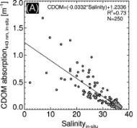
Figure 1. Linear regression of concurrent in situ CDOM absorption (443 nm) and salinity measurements. Modified from Figure 4 of Schroeder et al. (2012).
Unusually high CDOM absorption was observed from remote sensing by Schroeder et al. (2012) for the mid and outer shelf reefs of the Mackay and Fitzroy NRM regions, which are not directly influenced by flood waters. In these regions remotely-sensed CDOM absorption was observed to vary between 0.15 and 0.2 m⁻¹ at 443 nm and further in-situ measurements are needed to understand these high values in off-shore waters. The conservative CDOM threshold for freshwater mapping (0.24 m⁻¹ ⇔ 30±4 salinity) enables to separate the autochthonous reef matrix CDOM production from the estimate of freshwater plume extent for the wet season.
Shallow coastal embayment, where turbidity is dominated by tidal resuspension of bottom sediments composed of terrigenous mud in the near-shore areas are also regions where CDOM may not be attributed solely to terrestrial runoff. The freshwater extents estimated for these regions are potentially overestimated if no rivers empty directly into these embayments, e.g. Broad Sound. For this region an along-shore transport of northward directed freshwater from the Fitzroy River is observed in years of high discharge only (Schroeder et al. 2012).

Evaluation of compliance to guidelines
In addition to the median concentration maps, the exceedance of water quality guidelines was assessed for CHL and TSS retrieved from MODIS Aqua imagery using CSIRO’s algorithm. The exceedance could also be evaluated for the Secchi Depth imagery when accuracy of this retrieval is assessed with a match-up analysis of in situ data recently made available by AIMS.
A set of water quality guideline values and objectives was released in 2009 by federal and state legislation for the GBR, with an effort to avoid inconsistency in the regions of overlap. Version 3 of the Queensland Water Quality Guidelines (DERM 2009) was released to promote regionally and locally relevant guideline water quality values for Queensland coastal waters which extend up to 3 nautical miles offshore. Regionally-specific environmental values and objectives have been set in the GBR catchments in the P2R program and in some specific areas through the development of Water Quality Improvement Plans (WQIPs). GBRMPA released the Water Quality Guidelines for the Marine Park (hereafter called the Guidelines) in 2009 and identified five types of water bodies: the Enclosed Coastal waters, the Open Coastal waters, the Midshelf waters, the Offshore waters, and the Coral Sea (GBRMPA 2009). Much of the Great Barrier Reef Marine Park lies beyond Queensland state waters but there is an area of overlap within the inshore coastal waters for which protocols have been agreed. Namely, Queensland guidelines are to be adopted for all waters inshore of and within the Enclosed Coastal zone. Offshore from the Enclosed Coastal zone and within waters of the GBR Marine Park, the Guidelines will apply, even if the boundary of the Enclosed Coastal zone lies inside the three nautical mile zone (DERM 2009).
Figure 2 reports the regional and cross shelf boundaries defined by GBRMPA for the MMP 2008/09 reporting and used for this study. These boundaries were delineated by implementing in a GIS environment the "Approximate water body delineations of the Open Coastal, Midshelf and Offshore marine water bodies in the six NRM regions" (Table 1, GBRMPA 2009). The Enclosed Coastal waters were not delineated, as according to GBRMPA they are likely to be a small area, especially in the context of GBR-wide water bodies (Hugh Yorkstone, pers. comm. 10 Aug 2010).
Table 2 Trigger values from the Great Barrier Reef Marine Park Authority Water Quality Guidelines (GBRMPA 2009). Guideline values for the assessment of the annual mean values. *: Geographical adjustment: Wet Tropics/Central Coast (see Figure 2).
 | Water body
Parameter | Enclosed Coastal | Open Coastal | Midshelf | Offshore
Chlorophyll-a (µg L⁻¹) | 2.0 | 0.45 | 0.45 | 0.40
Secchi Depth (m) | 1.0/1.5* | 10 | 10 | 17
Total Suspended Solids (mg L⁻¹) | 5.0/15* | 2.0 | 2.0 | 0.7
Table 3 Trigger values from the Great Barrier Reef Marine Park Authority Water Quality Guidelines (GBRMPA 2009). Seasonally adjusted Guideline values for the assessment of seasonal mean values in dry/wet seasons.
 | Water body
Parameter | Enclosed Coastal | Open Coastal | Midshelf | Offshore
Chlorophyll-a (µg L⁻¹) | 2.0 | 0.32/0.63 | 0.32/0.63 | 0.28/0.56
Secchi Depth (m) | 1.0/1.5 | 10 | 10 | 17
Total Suspended Solids (mg L⁻¹) | 5.0/15 | 1.6/2.4 | 1.6/2.4 | 0.6/0.8
The methods used in this study to evaluate compliance were originally developed to provide a demonstration of the use of remotely-sensed data in the assessment of exceedance of the Guidelines (Brando et al. 2010c). These methods were then implemented in the 2008/09 and 2009/10 MMP reports (Brando et al. 2010a; Brando et al. 2010b) to contribute to the indicators and metrics for the P2R reporting for marine water quality (RWQPP 2011a; RWQPP 2011b).
Compliance to the Guidelines for CHL and TSS are presented as maps illustrating the exceedance of the Guidelines (EG) and the exceedance frequency (EF). EG is determined by comparing the mean values for the year (and seasons) to the appropriate Guideline thresholds, while EF is calculated as the ratio of the number of days where the concentration exceeded the threshold to the number of days with (error-free) data for that period. EF values higher than 0.50 indicate the median concentrations for the year (and seasons) exceeded the Guideline thresholds. The Guideline trigger values used as threshold levels for the analysis of exceedance are reported in Table 2 (annual means) and Table 3 (seasonal means). The maps are accompanied by tables summarising the exceedance results for each variable and each reporting region. The summary of the exceedance extent in each map provides the relative surface area where mean or median concentration exceeded the trigger values for the year (or seasons), expressed as relative area (%) of the water body. In this report these two quantities will be referred to as REEG (relative extent of exceedance of the Guidelines, i.e. when the mean is used for the assessment) and REEF50 (relative extent of exceedance frequency greater than 0.50, i.e. when the median is used for the assessment). The summary of exceedance is also provided for each water body for each season by computing the mean and median concentrations from all valid observations independently of the spatial location, along with the EF for that period.
The summaries of the exceedance results are based on a large number of observations (ranging from hundreds of thousands of valid observations for the Open Coastal waters in the wet season to millions of valid observations for the Offshore area in the dry season). Further work in designing a combined assessment of exceedance/compliance over more water quality variables will provide a higher degree of confidence in these results. This will in turn ensure these datasets meet the requirements of the reasonable assurance statements and the monitoring and modelling strategies for the P2R program in each of the NRM regions.

Calculating metrics for the P2R reporting for marine water quality
The metrics for the P2R reporting for marine water quality are based on the assessment of the exceedance of water quality guidelines for Chlorophyll-a and Total Suspended Solid (RWQPP 2011a; RWQPP 2011b). In P2R reporting, the two indicators for marine water quality are based on the summary of the exceedance of annual mean values of Chlorophyll-a and non-algal particulate matter (as a measure of Total Suspended Solids) for each reporting period. Hence the indicator data are REEG values for each of the six reporting regions. While in this report, the REEG values for CHL and TSS (REEG_CHL, REEG_TSS) are presented within each reporting region as separate values for the Open Coastal, Midshelf, and Offshore water bodies, only the REEG values for the Coastal water body are considered for the metric calculations (RWQPP 2011a; RWQPP 2011b).
Consistently with the marine water quality P2R reporting scheme, in this report the metric scores are expressed the percent area that does NOT exceed the Guidelines value for the inshore water body, hence the REEG values are simply subtracted from 100% to calculate the metric score (i.e. P2R_CHL=100- REEG_CHL and P2R_TSS=100- REEG_TSS). The rationale for this metric calculation method is to provide consistency with other P2R metrics, as all final metrics are standardized to a range from 0 to 100 such that zero is the lowest score and 100 is the highest , i.e. ranging from the worst to the best possible environmental condition (RWQPP 2011a; RWQPP 2011b).
The overall GBR score is calculated by linearly combining the regional scores weighting them by the relative contribution to the GBR. The area weighting is used to prevent overweighting of scores from reporting regions that represent a small area in relation to the total area of GBR. As limited field information was used for the parameterization and validation on the remote sensing retrievals for these two regions (see section 2.1 and Appendix 1), the regional scores for Cape York and Burnett Mary are excluded from the area weighting calculations (RWQPP 2011a; RWQPP 2011b). The four reporting regions (Wet Tropics, Burdekin, Mackay Whitsunday, Fitzroy) contribute 13%, 21% ,27% and 39% to the overall GBR score for each metric (RWQPP 2011a; RWQPP 2011b).
The P2R marine water quality index (P2R_WQI) is then calculated for each region, as well for the whole GBR, as the average value of the metric scores for the two component indicators, i.e. P2R_WQI=(P2R_CHL+P2R_TSS)/2 (RWQPP 2011a; RWQPP 2011b).
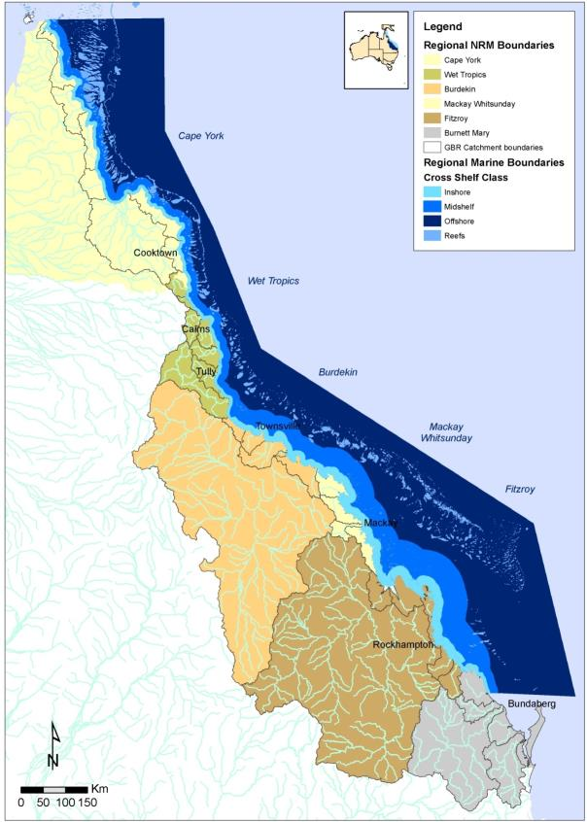
Figure 2. Regional and cross shelf boundaries defined by GBRMPA for the MMP 2008/09 reporting.

The estimate of the P2R_WQI and the metric scores for the two component indicators (P2R_CHL and P2R_TSS) does not include an assessment of associated uncertainty. Such assessment would account for the uncertainty associated with the retrieval of CHL and TSS from MODIS data with the coupled physics-based inversion algorithms (58% and 66%, respectively). A viable option for this assessment is the method proposed by Schroeder et al. (2012) to assess the uncertainty associated to the estimates of freshwater extent. Schroeder et al. (2012) accounted for the uncertainty associated with the retrieval of CDOM when setting the CDOM thresholds. Future work will extend this method to also assess the uncertainty associated to the two component indicators of the marine water quality index from the spatial extent of non-compliance in the Open Coastal water body.

Guide to interpreting the maps
All maps presented in section 4 have a consistent presentation: land is represented as dark gray; the coastal boundary is based on a standard coastline vector; main rivers are represented by blue lines; and coral reefs including a 1 km buffer zone (to avoid mixed land or reef and water pixels) are depicted as white. The maps of mean, median or maximum values will present data for all the pixels in the bounding box, while the maps of freshwater extent for the wet season, exceedance of the Guidelines and EF present data only for the reporting region of interest. The areas outside the reporting region are depicted in light gray.
Several boundary lines are overlayed onto the maps to enable the identification of water bodies identified by the Guidelines (Open Coastal, Midshelf, and Offshore). The boundaries for the reporting region are presented in each map as defined by GBRMPA in accordance with the NRM boundaries for the catchment and marine extensions (Figure 2). The cross shelf boundaries were defined by GBRMPA to implement the Guidelines: the thick white line defines the Open Coastal waters; the thick pink line separates the Midshelf from the Offshore waters while the thick gray line to the East in all images represents the limit of the marine park.
In the maps of freshwater extent for the wet season, pixels in the reporting region of interest are mapped in dark red when the maximum values for the wet season exceed the CDOM threshold for freshwater mapping (0.24 m⁻¹ ⇔ 30±4 salinity). The surface area (km²) of the freshwater plume extent in the wet season for each region can then be estimated by tallying the number of the 1 km² pixels exceeding the CDOM threshold in each map.
In the maps of EG, pixels in the reporting region of interest are mapped in dark red when the annual (and seasonal) mean concentrations exceed the appropriate thresholds reported in Table 2 and Table 3. Pixels are mapped in light gray if they did not exceed the thresholds. The maps of EF report in a continuous colour scale the EF values ranging from 0-0.50 so that the pixels are mapped in dark red (EF>= 0.50) when the annual (and seasonal) median concentrations exceed the thresholds. The spatial patterns in the exceedance maps are a function of the coastal to offshore gradients that can be observed in the median maps of CHL and TSS as well as changes in thresholds between the Midshelf and Offshore areas. Hence most often the exceedance in the Offshore areas is present in clusters to the East of the thick pink line delineating the ‘Offshore’ waters.

Novel ways to report on Phytoplankton dynamics: A case study of the Burdekin region.

Objective of this study
Ocean surface processes occur at different time and spatial scales. Algal blooms in particular are transient, naturally-occurring phenomena that are central to the structure and functioning of the marine food web. The monitoring of algal bloom events in coastal waters, from the timing and frequency of their occurrence to their spatial distribution, has become increasingly important because of the growing environmental pressure on coastal ecosystems. At the bottom of the food chain, phytoplankton provides a particularly sensitive indication of marine ecosystem health.
In the GBR waters, phytoplankton growth is primarily limited by the availability of nutrients and may show sudden increases as a response to river flood plumes containing large amounts of sediments, nutrients and other dissolved and particulate organic matter (Furnas 2003). The Burdekin has one of the largest catchments (130,000 km²) of the GBR and, together with the Fitzroy, discharges up to 70% of this organic and inorganic material into the lagoon (Raupach et al. 2006). Located in the dry tropics, the rainfall patterns for the Burdekin region are mainly seasonal and can reach up to 2,200 mm/year, causing land-to-coast runoffs (Figure 27) that flush terrestrially-sourced organic and inorganic material into the lagoon during the wet season. Despite the closest reefs being less than 60 km from the Burdekin River mouth (Figure 3), much of the runoff impacts on the water quality are often observed further North along the shore, sometimes 400 km away from the river mouth. This is caused by the northward drift of the Burdekin plume, which has been modelled (King et al. 2002) and documented as being often restricted to the shallow nearshore coastal band (Devlin et al. 2008). This inshore restriction of the river plume is mainly due to the predominantly south-easterly winds, bathymetry and strong tidal energy that characterise the Burdekin region (Furnas 2003). During lighter wind events however, plume waters, which are low in salinity and carrying nutrients and pesticides, can spread over most of the shelf and affect the mid- and outer- reefs (Devlin et al. 2008; Devlin and Schaeffelke 2009; McCulloch et al. 2003).
In summary, the impact of flood plumes on the GBR ecosystem results from decreasing concentrations in pollutants with distance from the river mouth, where most of the larger particles are initially deposited. If the sedimentation occurs close to a reef, it can severely reduce coral growth and survival (Hutchings et al. 2008; Hutchings 2000). The nutrients and organic matter fractions, as well as the fine sediment, are dispersed via resuspension and currents, releasing bio-available nutrients that can stimulate phytoplankton blooms (Prange et al. 2009) .
This section of the report aims to explore methods for the analysis of the seasonal and inter-annual variability in satellite-derived surface CHL concentrations in order to better characterise the biological response to the environmental forcing occurring in the Burdekin region. The methods and findings presented in this section will complement the existing reporting on the GBR (section 4). The techniques described in this section are solely applied to CHL, but can also be used for other satellite-derived water quality parameters, such as CDOM, NAP, light attenuation coefficients or SST.

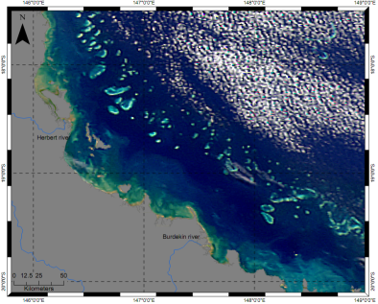
Figure 3. The Burdekin region as seen from space (credits: NASA).
The key objectives of this section are twofold:
To determine the temporal and spatial distribution of phytoplankton biomass in the Burdekin using satellite-derived CHL from daily MODIS-Aqua data acquired between the 4th November 2002 and 30th April 2011, and
To identify areas and years with CHL anomalies that might require further investigation for future work.

Data and methods

Data availability and preparation
The MODIS dataset used in this study spans 10.5 years and is composed of 2781 daily images, with 1310 and 1471 images acquired during the dry and wet season, respectively. For the study region, the grid extends from 145.9°-149.5° East and 17.6°-20.1° South with a resolution of 0.009°. The strict quality control criteria detailed in section 2.2.1 was applied to the imagery. More pixels were flagged and dismissed during the wet season months (November to April; Figure 4) compared to dry season months due to more frequent cloud cover. There is a shore-to-reef decreasing gradient in the number of pixels available. The coastal waters south of 18.80° South have the most data available. For the purpose of this case study, the boundaries of the Burdekin region do not correspond to those defined by GBRMPA and used in Section 4 of the report but rather extend further east and north (see Figure 15).
In this case study, all the maps cover the same spatial extent. The graphical layout differs from the maps presented in Section 4 (see details in section 2.2.4): the land, islands and reefs are represented with the same tone of grey while the areas outside the GBRWHA boundaries are shown in white or black depending on the colour scale of each figure.

Figure 4 Satellite-data availability for the MODIS-Aqua sensor between 4 November 2002 and 30 April 2011 for the Burdekin region (top). Note the difference between the dry (middle) and wet (bottom) season months.

The choice of the median Chlorophyll-a value as a metric for this analysis
The global distribution of CHL in the ocean is often considered log-normal (Campbell 1995), but this is not always the case (Banse and English 1994). For this dataset, the CHL concentrations remained positively skewed after taking a logarithmic transformation (Figure 5); therefore we performed our analyses on the untransformed data. Given the skewness of the raw data, the median CHL concentrations were found to be a more representative summary than the arithmetic mean (Table 4). The interquartile range (IQR) will be used as a measure of spread, a more robust alternative to the standard deviation, in particular when the median is computed instead of the mean.
Table 4 Summary statistics (in µg L⁻¹) for the MODIS daily Chlorophyll-a dataset used in this case study
Dataset (Total number of available pixels) | Min-Max | Mean (std) | Median (IQR) | Mode
Whole (23830575) | 0.001-13.82 | 0.36 (0.37) | 0.31 (0.21) | 0.32
Dry season months (14801386) | 0.001-13.24 | 0.36 (0.34) | 0.32 (0.20) | 0.21
Wet season months (9029189) | 0.001-13.82 | 0.36 (0.42) | 0.27 (0.22) | 0.22

Figure 5 Histograms of log-transformed Chlorophyll-a for (a) the whole dataset (N=2781), (b) the dry season months (N=1310) and (c) the wet season months (N=1471).

Computation of anomalies and climatology
Standardized anomaly maps of CHL were used to characterize the monthly dynamics of phytoplankton biomass in the Burdekin region. Derived from the multi-annual monthly means and standard deviation maps for the years 2002-2011, a standardized anomaly map for a particular month can be computed as follows:
Standardized anomaly for pixel (i,j)=
where i,j denotes the longitude, latitude position of a pixel, is the multi-monthly mean, is the multi-annual mean, and is the multi-annual standard deviation.

The clustering of the water masses
The Burdekin is a very dynamic region with a high variability in CHL across the shelf (Devlin and Schaeffelke 2009). To better characterise the system, biogeographical zones within which CHL concentrations display similar magnitude over time and space were statistically defined using the K-means clustering technique (Wilks 2006). This unsupervised, non-hierarchical clustering approach groups pixels into a user-defined number of clusters k, usually determined from trial or expert knowledge (Wilks 2006). The K-means algorithm recalculates the group means of each cluster k through an iterative process and reassigns each pixel value until it reaches the minimum squared Euclidean distance with respect to the new means (Figure 6).
For this study, the K-means classification was based on twelve multi-annual monthly median CHL maps of the study region. We constrained the clustering to a maximum number of 8 classes determined from a maximum number of 20 iterations and a change threshold of 5%. A post-classification technique was performed on the initial clustering results in order to reallocate isolated pixels to a class belonging to the majority of the pixels comprised in a 3x3 pixel kernel.

Figure 6 Illustration of the K-means clustering technique (modified from Wikipedia).

Exploring the time-space variability using latitude-time (Hovmöller) plots
Hovmöller diagrams are latitude (or longitude)-time plots that allow for a synoptic characterisation of the changes occurring for a specific parameter over time and space. In this case study, we will present Hovmöller diagrams for each of the biogeographical zones resulting from the K-means clustering. This enabled more meaningful latitude-time plots to be created, because most of the variability in CHL would be otherwise captured by the nearshore waters where CHL concentrations are the highest. A description of the processing steps is illustrated in Figure 7 for the cluster of the Oligotrophic lagoon. Median CHL values for each 0.1° latitude bin, for a period of 6 days and all longitudes were used to compute the latitude-time plots for each cluster. The 6-day period allows for an appreciation of the phytoplankton phenology in response to river plumes and nutrients delivery, while the use of monthly periods might blur the signal and not capture the short term CHL variability through time and space. A latitudinal axis was chosen due to the natural orientation of the study region.
Figure 7 Schematic representation of the computation of a Hovmöller diagram for the Oligotrophic lagoon.

Computation of phenology
To further examine the change in CHL over the years in comparison to the multi-annual seasonal median (Figure 10), time-series of monthly average counts of CHL pixels that are above the multi-annual threshold were computed for the five clusters (Figure 15).
Relative pixel counts_{(k,t)} (%)=
where i,j is the position of the pixel, k is the cluster, N_{k} is the number of pixels that compose a specific cluster, CHL_{i,j,t} are the estimated CHL concentrations for a pixel with at a time (t) and seasonalmedian(CHL_{i,j,s}) is the median CHL concentration of this pixel during the dry or wet season depending on the month of the daily image analysed. I takes the value of 1 if the observation CHL_{i,j,t} is higher than the seasonal median, otherwise I is set to 0.

Interpretation and limitations
The remotely-sensed surface phytoplankton pigment concentration is highly correlated to the total pigment concentration found in the water column; however the two quantities are not identical. For instance, many studies have shown that this difference can be attributed to error in ship/satellite co-location, error in pigment measurements or calculation, and the effect of the bio-optical variability on algorithm performance (Balch et al. 1989; Chavez 1995). It is important to note that the Burdekin coastal and lagoonal waters are in great parts considered optically complex (Blondeau-Patissier et al. 2009), therefore a regionally valid CHL algorithm such as the one adopted in this study is needed. For this study, the temporal and spatial gradient in phytoplankton biomass, considered as an indicator of phytoplankton dynamics in the marine waters surrounding the Burdekin, will be more relevant than the absolute CHL values.

Describing the Burdekin system from a multi-year dataset
The multi-annual median and IQR CHL maps are shown in Figure 8 and Figure 9, respectively. A longitudinal gradient in CHL, decreasing from the nearshore waters (>2.0 µg L⁻¹) to the reef (<0.4 µg L⁻¹), can be observed. Typically, the waters surrounding the mouths of the Burdekin and Herbert rivers showed the highest CHL median values (>2.0 µg L⁻¹) with the most variability (stdev >1.5 µg L⁻¹) for this region (Figure 3; Figure 8; Figure 9). The remaining waters along the coastline of the study region have a median CHL value of ~1.0 µg L⁻¹ and an IQR of ~1.0 µg L⁻¹. Offshore, the median CHL is typically 0.4 µg L⁻¹ with an IQR of ~ 0.2 µg L⁻¹. This is in accordance with the ambient CHL concentration of ~0.4 µg L⁻¹ reported in the literature (Wooldridge et al. 2006) and the trigger values set by GBRMPA (Table 2 and Table 3).
The longitudinal decreasing CHL gradient from the nearshore to the reef waters is more pronounced during the wet season in comparison to the dry months (Figure 10; Figure 11), with an average percentage difference of ~10 % in median CHL for the nearshore coastal waters between the two seasons (Figure 12). The waters further offshore however can have CHL median values up to 50% higher during the dry season. This latter observation is particularly true for the waters north of the Burdekin river mouth. These significant seasonal changes in CHL concentrations show the seasonal and spatial impacts of the Burdekin freshwater discharges on the lagoonal waters. The 0.4-0.5 µg L⁻¹ CHL median interval is spatially larger during the dry season (Figure 10) as it extends further offshore.

Figure 8 Multi-annual (2002-2011) Chlorophyll-a median concentration map.
Figure 9 Multi-annual (2002-2011) Chlorophyll-a interquartile range concentration map.

Figure 10 Multi-annual (2002-2011) Chlorophyll-a median concentration maps for the dry (top) and wet (bottom) season months. Note the change of colour scale to 0-1 µg.L⁻¹.
Figure 11 Multi-annual (2002-2011) Chlorophyll-a interquartile range maps for the dry (top) and wet (bottom) season months.
Figure 12 Percentage difference between the multi-annual wet and dry median Chlorophyll-a maps.

Monthly climatology of the MODIS Chlorophyll-a product in the Burdekin region
Yearly seasonal variations in CHL median and relative percentage difference maps are shown in Figure 13 for the years 2002-2011. The percentage difference maps between seasons of a same year were computed as per Figure 12 .
An increase in CHL median concentrations for the wet seasons of the years 2007 to 2011 is evident in comparison to previous years, in particular in the nearshore coastal waters. During the rainfall of January-February 2007, the Burdekin region was the most affected, while in January-March 2008 both the Burdekin and Fitzroy experienced major flooding. Also, the impacts of the tropical cyclone Hamish in March 2009 have likely produced an enhanced biological response during the dry season of that year. Most of the relative difference between seasonal maps of a same year is observed along the shore, in particular near the Burdekin and Herbert river mouths. The year 2008/09 had the strongest percentage difference between the two seasons, with the dry season concentrations increasing up to 85% in comparison to the wet season of the same year (evident through much blue in maps). Higher CHL concentrations were observed in the entire lagoon during the dry season of that year, a striking difference in comparison to previous years as the lagoonal waters showed generally little change between seasons. The summer of 2009/10 was characterised by a major wet season with heavy rain between November 2009 and March 2010. This is evident in the map of seasonal differences for the summer of 2009/10 in which we can much higher difference (>40%) in comparison to the previous years.
Figure 13 Yearly seasonal Chlorophyll-a median and percentage difference maps. Maps that are red-crossed indicate that the computation was not possible due to missing months.
The standard anomaly maps of CHL were arbitrarily scaled between -2 and 2 (Figure 14) to reveal the changes in CHL for the waters surrounding the Burdekin. Warmer colours (red) indicate regions with an increased CHL, while cooler colours (blue) show regions of lower CHL in comparison to their multiannual mean. These anomaly maps enable a better appreciation of the temporal and spatial dynamics of the CHL field, a statistical technique that is particularly adequate for data subject to seasonal variations (Wilks 2006).
The GBR waters are naturally depleted in nutrients most of the year (Furnas 2003). As a result, the lagoonal waters are poor in phytoplankton biomass from September to January with CHL concentrations lower than their multiannual concentration means in most of the study region. The remaining of the year, the build up in nutrients in the water column resulting from the land-to-shore freshwater runoffs between February and April triggers a progressive cross-shelf increase in phytoplankton biomass, with a northward direction (Figure 14). In July and August, the outer portion of the lagoon is the only region that exhibits CHL concentrations higher than its multiannual concentration mean.

Figure 14 Standardized anomaly monthly Chlorophyll-a maps (dimensionless). Wet season months are in bold italic.

Clustering the water masses of the Burdekin region in relation to their Chlorophyll-a concentrations
The K-means clustering of the Burdekin waters (Section 3.2.4) resulted in five biogeographical clusters: nearshore, coastal, midshelf, lagoon and reef waters. Each of these clusters is distinctive in terms of the area covered and the magnitude in CHL concentrations (Figure 15). Their spatial extent and size are distinctively different, with the nearshore cluster being only limited to four narrow areas along the shore. For this reason, the nearshore cluster was merged with the coastal cluster to allow for a closer inspection in the Hovmöller diagrams. However, a separate analysis of the nearshore cluster offers the opportunity of evaluating how a delineation of the Enclosed Coastal water body would affect the estimate of median values for the GBR coastal waters. The lagoon cluster is the largest in the Burdekin region and extends to both the north and south extremities of the study region.
The delineation of the five biogeographical clusters is rather different from the water bodies delineation based on the Guidelines (Figure 2), as they were derived using different water quality variables. The five clusters resulting from the K-means clustering presented in this case study (Figure 15) were defined to partition the study region according to its CHL content in order to present the CHL dynamics in the Burdekin using Hovmöller diagrams. These clusters will not be used, and will not be referred to, in section 4 of this report. When the K-means clustering analysis is applied to other water quality variables than CHL, such as CDOM or NAP, different biogeographical zones are created (Figure 16). These two latter clustering results will be neither used, nor interpreted, in the present study but could be explored in future work, particularly for the delineation of the Enclosed Coastal water body for the assessment of exceedance to the Guidelines.

Figure 15 K-means clustering results based on 12 multi-annual, monthly median Chlorophyll-a concentration fields. The NRM 2010 zoning is overlayed (thick black lines).
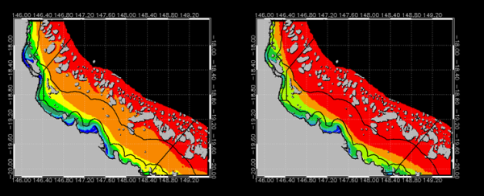
Figure 16 K-means clustering results as per Figure 15 but for (left) CDOM and (right) NAP concentration fields.

Latitude-time plots
In this section we present and discuss the results obtained for the latitude-time plots of CHL for the study region.

Quantity of pixels used for the computation of the latitude-time plots
The quality assessment of the CHL Hovmöller diagrams (i.e. the quantity of observations used to compute the CHL median for each latitude bin) is based on the ratio between the number of valid observations for a 6-day period and the total number of observations that represents a specific cluster. Table 4 presents the number of good quality observations used for the computation of the Hovmöller diagrams for each of the 5 clusters. The average percentage of available observations is the lowest for the reef waters cluster (20%, Table 5), mainly because of its shape and its limited latitudinal axis spanning 2.1 degrees (namely 17.6°-19.7° South; Figure 15, Figure 20).
All Hovmöller diagrams (Figure 17 to Figure 20) exhibit patterns of low percentages of available pixels during the wet season months because of the limitation of ocean colour remote sensing to detect through cloud cover, which is recurrent at that time of the year. The quantity of pixels used for the merged nearshore-coastal cluster and midshelf waters cluster (Figure 17-Figure 18) are very similar. However the lagoon cluster (Figure 19) and reef waters cluster (Figure 20) show a lower percentage of (valid) observations being used for the computation of the CHL Hovmöller diagrams (Table 4). This typically reflects the spatial distribution of the number of available observations presented in Figure 4. The thin band of nearshore-coastal waters south of 18.80° has also relatively fewer good quality observations (~30% during the dry season) in comparison to the coastal and midshelf clusters (Figure 4). The Hovmöller diagrams presented below indicate that the longest, most consistent set of data was available during the four-month period spanning June-September 2009 across most of the study region for the five clusters.

Figure 17 Hovmöller diagrams of the percentage of pixels used for the computation of the median for (top) the nearshore and coastal waters clusters and (bottom) the coastal waters cluster.

Figure 18 Hovmöller diagram of the percentage of pixels used for the computation of the median for the midshelf waters cluster.

Figure 19 Hovmöller diagram of the percentage of pixels used for the computation of the median for the oligotrophic lagoonal waters cluster.

Figure 20 Hovmöller diagram of the percentage of pixels used for the computation of the median for the reef waters cluster.
Table 5 Average percentage of the available observations on which the computation of the Hovmöller plots is based for each cluster
Cluster | N | Mean (%)
Merged nearshore-coastal waters | 9404 | 26
Coastal waters | 9361 | 28
Midshelf waters | 9933 | 28
Lagoon waters | 10203 | 23
Reef waters | 7780 | 20

Spatial and temporal variability in Chlorophyll-a
The Hovmöller diagrams for the CHL concentrations are shown in Figure 21 to Figure 24. Seasonal patterns, characterized by increasing CHL between March and August can be observed in all diagrams. The patterns are more complex for the nearshore and coastal waters. The magnitude of the CHL signal decreases from the shore to the reef waters, as observed previously (Figure 8).
A striking difference in the CHL signal is observed in Figure 20 with high CHL concentrations (>1 µg L⁻¹) occurring more frequently at approximate latitudes 18.20° and 19.50°. The former would correspond to the enclosed waters of Rockingham Bay, while the latter corresponds to the receiving waters of the Burdekin River. This indicates how important it is to consider the effect of the inclusion of the nearshore waters cluster when analysing this region, particularly for assessing compliance to the Guidelines.

Figure 21 Hovmöller diagrams of Chlorophyll-a for (top) the merged nearshore and coastal waters clusters, (bottom) the coastal waters cluster only.

Figure 22 Hovmöller diagram of Chlorophyll-a for the midshelf waters cluster. Note the change of scale.

Figure 23 Hovmöller diagram of Chlorophyll-a for the oligotrophic lagoonal waters cluster.
Figure 24 Hovmöller diagram of Chlorophyll-a for the reef waters cluster.
The midshelf waters cluster (Figure 22) is very dynamic in phytoplankton biomass in comparison to the lagoon (Figure 23) and reef waters (Figure 24) clusters. The midshelf waters cluster is essentially a transition zone between the nearshore and coastal water masses that are higher in nutrients (due to the influence of the shore, land runoffs, shallow bathymetry, and resuspension), and the lagoon and reef water masses that are typically oligotrophic. Discharges of freshwater from the land, mainly following wet seasons’ heavy rainfall, reach various parts of the (oligotrophic) lagoon and reef waters depending on the intensities of these events, the currents, as well as the wind speed and its direction. The effect of these river plumes are evident through the increase in CHL fields between 2007 and 2011 during which flooding, resulting from heavy rainfalls (or cyclones), enriched the waters surrounding the Burdekin (as well as the rest of the GBR) in nutrients during the wet season months. In 2011 in particular, river plumes from the Burdekin and other adjacent rivers discharged large quantity of material within the inner shelf of the GBR (Figure 27 and Figure 30), likely resulting in the increase CHL concentrations from December 2010 onwards.
In comparison to the nearshore and coastal waters, where more frequent pulses in CHL occur throughout the year, a single seasonal cycle remains for the lagoonal and reef waters clusters (Figure 23, Figure 24). This latter cluster exhibits an increased CHL signal for the year 2009, likely resulting from the severe weather conditions that developed during cyclone Hamish. This cyclone was exceptional because of its southeast track parallel to the coast, hence covering the entire GBR and resulting in above average rainfall between January and February 2009 for large parts of north and central Queensland. Figure 25 shows a 6-day sequence of daily CHL between the 1st and 6th April 2009 and its deviation from the multi-annual wet season median. This period of time has been chosen because it is exactly one month after the cyclone event and above seasonal CHL levels can be observed in the study region as a response to the cyclone as seen on Figure 24. An “above-normal” biological response in the reef waters cluster is likely to have occurred again during the 2011 dry season following Cyclone Yasi. However the time span of the dataset used for the present analysis, ending on 30th April 2011, does not allow for the testing of this assumption.
Figure 25 A 6-day sequence of MODIS daily images showing the development of a bloom one month following cyclone Hamish (1-6 April 2009). Daily MODIS LMI-Chlorophyll-a are shown on the left, while deviations from the wet season multi-annual medians are shown in the right column. The black arrow shows the approximate area of change in CHL during this period. In the left column the land and reef masks are shown in dark grey and white respectively, while the light grey represent missing data due to cloud cover (see 2.2.4). In the right column grey represent the land, islands and reef masks while data outside the GBRWHA boundaries are shown in white (see 3.2.1).

Time-series of pixel counts greater than the seasonal Chlorophyll-a median
The daily time-series was used to compute the monthly averages shown in Figure 26. A higher (>40%) number of pixels with concentrations above the seasonal median occur mostly at the beginning of the dry season (May-June), as a result of the build up of nutrients in the water column and the increased amount of light penetrating the water surface. These high occurrences however tend (1) to decrease from the shore to the reef (Figure 26 a,f) and (2) to increase with the years for all clusters, though some minor differences can be noted. For instance, the wet season of the year 2005 shows a higher frequency of above-normal seasonal CHL concentrations for the nearshore, coastal and midshelf clusters, while this trend is not observed for the three other clusters, located further away from the shore. Additionally, the dry season of the year 2009 is characterised by a higher frequency of such events for all clusters, likely a result of Cyclone Hamish that hit the whole GBR between the 4th and 10th March 2009. A similar scenario should occur for the 2011 dry season as a result of cyclone Yasi.

Summary
The results obtained from this case study have showcased methods to provide insights into the temporal and spatial dynamics of phytoplankton biomass in the GBR region from a long time series of CHL satellite data. In this analysis, two main techniques were used for the characterisation of the Burdekin region: monthly and yearly climatology maps, and latitude-time plots of CHL fields.
The key conclusions from this analysis were the following:
The Burdekin region is a complex system with a strong variability in optical properties and concentrations due to very dynamic nearshore waters,
The biological response to events such as seasonal flood plumes occurs mostly between February and July, peaking in April-May,
There is a cross-shelf increase phytoplankton biomass during those 6 months,
Most of the CHL variability was found along the shoreline, mostly north of the Burdekin River,
The years 2007/8-2010 showed stronger increase in CHL concentrations during the dry season in comparison to other years as a result of heavy rainfall,
The CHL signal is more complex in the nearshore and coastal waters (i.e., several peaks and throughs), while mainly seasonal in the lagoonal and reef waters clusters,
The dry season of the year 2010 displayed the strongest departure from multi-annual dry season conditions.
In the Latitude-time plot, large differences in the CHL signal were observed when the coastal waters cluster was compared to merged nearshore-coastal cluster for Rockingham Bay, quantifying the effects of a delineation the Enclosed Coastal water body on the estimate of median values for the GBR coastal waters.
Please note that the five clusters resulting from the K-means clustering presented in this case study (Figure 15) will not be used, and will not be referred to, in the next sections of this report.
Figure 26 Time-series of the monthly average counts of CHL pixels that are above the seasonal median for (a) the nearshore waters cluster, (b) the coastal waters cluster, (c) the merged nearshore-coastal waters cluster, (d) the midshelf waters cluster, (e) the lagoonal waters cluster and (f) the reef waters cluster. The dashed, blue curve represents the annual cycle computed by a Levenberg-Marquardt least-squares regression fitting. Grey polygons are the wet season months. Insets display the location and size of the clusters for each time-series.

Results and discussion
This section will provide an overview of the satellite- based monitoring results - for the whole Great Barrier Reef World Heritage Area (GBRWHA) followed by a detailed regional report for each of the six reporting regions. For each region the wet season freshwater extent was estimated from CDOM maps is correlated with the river discharges. The wet and dry season median maps are presented for CHL and TSS (as NAP) as well as the maps that show the number of valid observations (i.e. cloud-free and error free image pixels) used for calculating the median values. In addition to the median maps, the exceedance of the Guidelines was assessed for CHL and TSS over the whole year and the wet and dry seasons.

Great Barrier Reef wide summary

Assessment of freshwater extent during the wet season
Wet season flood plume movements across Great Barrier Reef marine waters are a consequence of the volume and duration of river (flood) flows, wind direction and velocity, as well as the local marine currents and tidal dynamics.
Freshwater discharge from the Great Barrier Reef catchment in 2010/11 was more than five times the annual median flow, with the flow in the Burdekin more than five times above the median values and the freshwater discharge for the Fitzroy River thirteen times above the long term median flow (Schaffelke et al. 2011). The freshwater discharge for the Fitzroy River was the largest since records began in 1964 as almost 30 million Megalitres of water flowed into Keppel Bay between 21 November 2010 and 6 February 2011, slightly larger than the 1991 floods and three times flows of the 2007/08 and 2009/10 wet seasons (Figure 27).The Burdekin River flows were ~1.2 times the discharge of the 2008/09 wet season (Figure 27). The flow conditions in the Daintree and Barron Rivers were more than twice above median levels (Figure 27). The freshwater discharge for the Herbert, Proserpine, O’Connell, and Pioneer Rivers were more than three times above median flows (Figure 27). The Burnett and Mary Rivers flooded over December and January reaching record peak and flow levels (Schaffelke et al. 2011).
Following the December –January floods in Southern Queensland, the Queensland coast was also affected by the impact of the Category 5 Tropical Cyclone Yasi in February 2011. TC Yasi made landfall on the southern tropical coast near Mission Beach between midnight and 1am early on 3 February 2011. TC Yasi maintained a strong core with damaging winds and heavy rain, tracking westwards across northern Queensland (Figure 28). The largest rainfall totals were near and to the south of the cyclone in the area between Cairns and Ayr and were generally in the order of 200-300mm in the 24 hours to 9am 3 February 2011 causing some flooding (Figure 29).

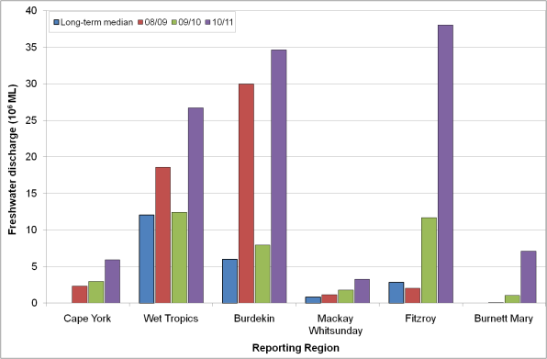
Figure 27. Comparison of fresh water discharge for 2010/2011 compared to 2008/2009, 2009/2010 and the long term median for each reporting region of the GBRWHA. Data are aggregated to the reporting regions from table A1-3 of (Schaffelke et al. 2011) presenting data supplied by the Queensland Department of the Environment and Resource Management for each river. Long-term medians were estimated from annual total flows (October to October), long-term medians are not available for the Cape York and Burnett Mary regions (Schaffelke et al. 2011).
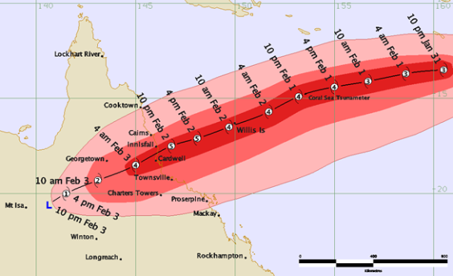
Figure 28. Track and Intensity Information for Severe Tropical Cyclone Yasi (Bureau of Meteorology).
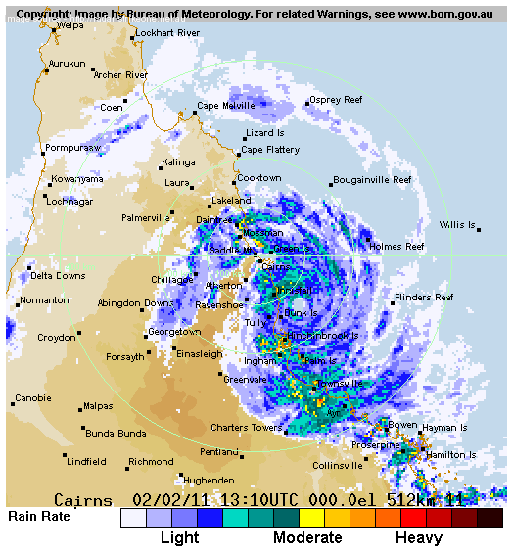
Figure 29. Rain rates subsequent to TC Yasi landfall. Radar image for 3 February 2011 3:10 AM. (Bureau of Meteorology)
Figure 30 provides an overview of the freshwater extent for wet season 2010/2011 (November 2010- April 2011) for the whole GBRWHA. The freshwater extent was estimated by applying a threshold of 0.24 m⁻¹ for the CDOM seasonal maximum. Detailed maps for each region are presented in the regional reporting sections (Figure 39, Figure 50, Figure 61, Figure 72, Figure 83, Figure 94). Flood plumes extended across inshore waters of the southern and northern Great Barrier Reef, but had a more limited influence on far northern Great Barrier Reef waters. The freshwater extent based on the CDOM maximum provides a conservative estimate of the extent as the flood plumes could have extended further in cloudy or overcast days and hence may not been captured with the satellite imagery. The estimated freshwater extent for the whole GBRWHA was highly correlated to the total freshwater discharges (R²=0.882, Figure 31), the freshwater extent for 2010/2011 was the largest observed with the MODIS time series. The estimated freshwater extent for 2010/2011 was larger than in 2008/2009 for all regions and larger than in 2009/2010 for all regions except the Mackay Whitsunday where it was comparable (Figure 32). These high estimates of freshwater extent reflect the flow conditions 2-5 times above median levels for all regions (Figure 27).
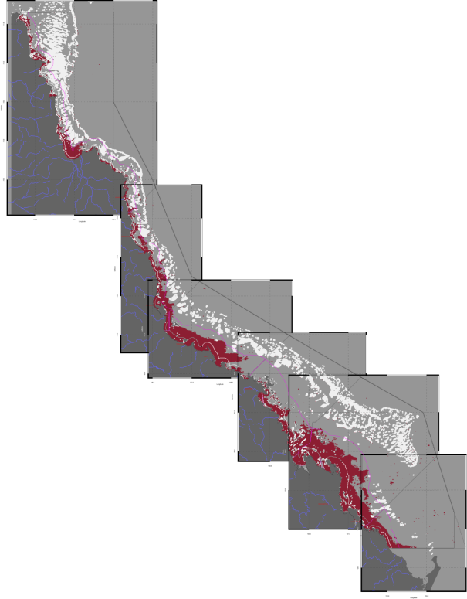
Figure 30. Overview of the freshwater extent for the wet season 2010/2011 (November 2010- April 2011) for the whole Great Barrier Reef World Heritage Area. Detailed maps for each region are presented in the regional reporting sections (Figure 39, Figure 50, Figure 61, Figure 72, Figure 83, Figure 94). Pixels are mapped in dark red when the CDOM seasonal maximum values for the year exceed the threshold of 0.24 m⁻¹.
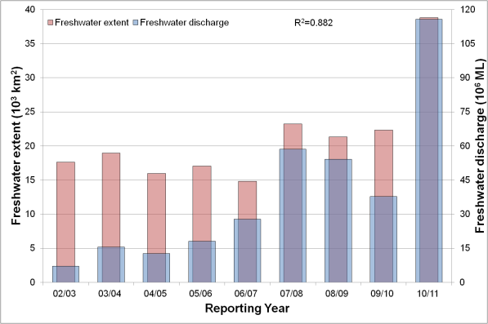
Figure 31. Total freshwater discharge and total estimated freshwater extent for the whole GBRWHA based on the CDOM maximum for the wet seasons.
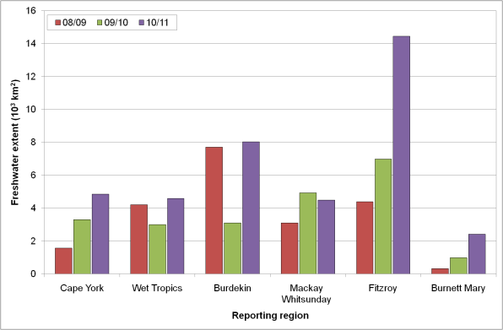
Figure 32. Comparison of estimated freshwater extent based on the CDOM maximum for the wet seasons 2008/2009 (November 2008- April 2009) and 2009/2010 (November 2009 - April 2010) and 2010/2011 (November 2010- April 2011) for each reporting region of GBRWHA.

Assessment of the exceedance of water quality guidelines
The annual median values maps for CHL an TSS for 2010/2011 (1 May 2010 – 30 April 2011) for the whole GBRWHA are presented in Figure 33 and Figure 34. A coastal to offshore gradient in CHL and TSS concentration can be observed, with the inshore waters in the Wet Tropics and Burdekin Regions having elevated concentrations of CHL and TSS over the monitoring period (Figure 33 and Figure 34). The Guideline annual threshold values for CHL are 0.45 µg L⁻¹ for Open Coastal and Midshelf and 0.40 µg L⁻¹ for Offshore , while for TSS are 2.0 mg L⁻¹for Open Coastal and Midshelf and 0.7 mg L⁻¹ for Offshore. Detailed maps for the wet and dry season for each region are presented in the regional reporting sections.
Figure 35 and Figure 36 show the map of EG (i.e. exceedance of the mean annual values) for CHL and TSS for the 2010/11 reporting period (1 May 2010 – 30 April 2011) for the whole GBRWHA. For all reporting regions the Open Coastal water body shows high areas of CHL EG (REEG_CHL = 71-97% of relative area of the water body, Table 6). These values were higher than the two previous reporting periods (56-83 % for 2009/10,Table 7 and 51-84% for 2008/09) reflecting the large flow conditions in most of the catchments in the GBR and associated freshwater extent in all reporting regions (Figure 27 and Figure 32). For all reporting regions the Open Coastal water body shows higher areas of TSS EG (REEG_TSS=21-84% of relative area of the water body, Table 6) than in the previous reporting year(REEG_TSS=12-69 % for 2009/10,Table 7). Large areas of TSS EG occurred also in Offshore areas, particularly in the Mackay-Whitsunday and Fitzroy reporting regions, consistently with the previous reporting years. These large areas of exceedance of the mean annual TSS values may be due to an over-estimate of the mean TSS concentrations in Offshore waters or to a low guideline threshold value. Also, exceedance of the Guidelines in these offshore waters may not be directly related to the land influence on these waters as for large portions of the Offshore areas other oceanographic processes, e.g. upwelling events, influence the TSS concentrations during the year (Brodie et al. 2008; Wooldridge et al. 2006).
For Figure 33 and all subsequent CHL maps the median values were presented instead of the mean values because in section 3 it was found to be more representative than the arithmetic mean, being closer to the modal values (Table 4, Figure 5). For all the regional reporting the exceedance to both the mean and median values are reported as maps as well as tables. For sake of simplicity and to adhere to the letter of the Guidelines, in Figure 35, Figure 36, Table 6 and Table 7 only the exceedance to mean values of CHL and TSS are reported. These values are then used to calculate the P2R marine water quality index (P2R_WQI) and the metric scores for the two component indicators, i.e. P2R_CHL and P2R_TSS (Table 8, Table 9), following the method outlined in section 2.2.4.
The marine water quality for this reporting year for the whole GBR was scored as “poor”, reflecting the “poor” score for P2R_WQI for most reporting regions (only the Burnett Mary scored as “moderate”, Table 8). The scores for the two component indicators for the whole GBR were “very poor” for P2R_CHL and “moderate” for P2R_TSS, reflecting the “very poor” to “poor” regional scores for P2R_CHL and “very poor” to “good” regional scores from P2R_TSS. The marine water quality index was lower than for the previous reporting year (Table 9) for all regions, as well as the whole GBR, reflecting the high freshwater discharges from the GBR catchments in 2010/11 and the associated estimated freshwater plume extent (Figure 32).
The assessment of the P2R marine water quality index and the exceedance of the Guidelines is described in detail in the regional reporting sections with maps and tables summarising the exceedance results for CHL and TSS.
In this study the Open Coastal water body includes also all the Enclosed Coastal waters which have not been delineated by GBRMPA. As the guideline values for CHL and TSS for the Enclosed Coastal waters are higher than those for the Open Coastal water body (Table 2 and Table 3), the relative area of non-compliance for the Open Coastal is likely to be over-estimated leading to an over-estimate of the metric scores for the two component indicators and the P2R marine water quality index. Figure 21 presented the effects of a possible delineation the Enclosed Coastal water body on the estimate of median values for CHL, where large differences were identified for Rockingham Bay.

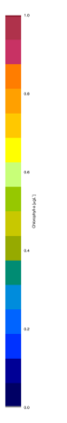
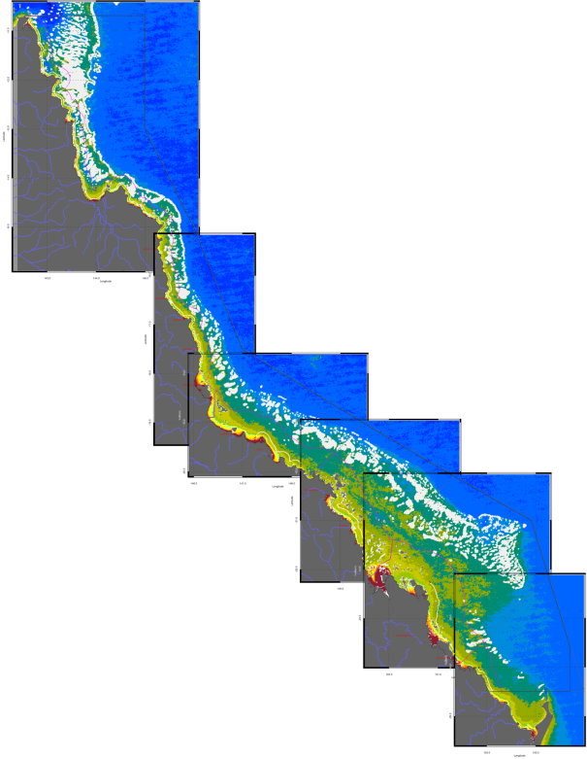
Figure 33. Map of the Chlorophyll-a annual median values for the 2010/2011 reporting period (May 2010 – April 2011) for the whole of the Great Barrier Reef World Heritage Area. The Guideline values for annual means of Chlorophyll –a are 0.45 µg L-1 for Open Coastal and Midshelf and 0.40 µg L⁻¹ for Offshore.

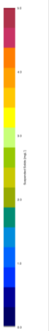
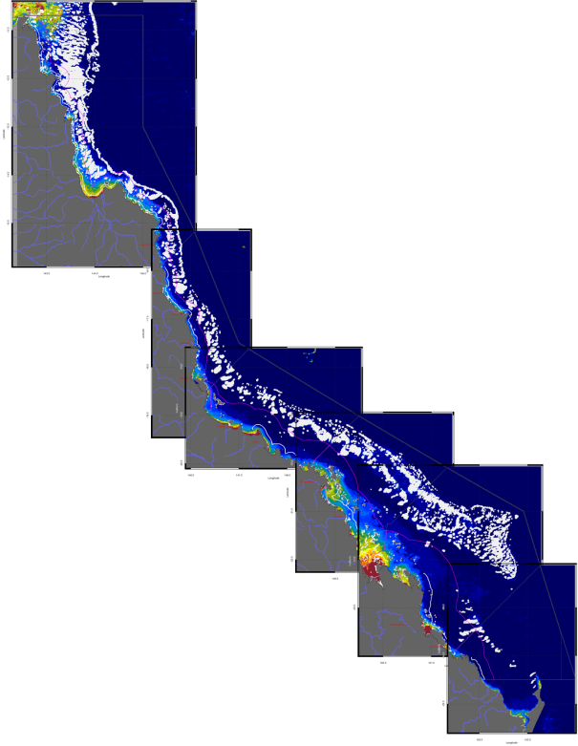
Figure 34. Map of annual median values of non-algal particulate matter (as a measure of Total Suspended Solids) for the 2010/2011 reporting period (May 2010 – April 2011) for the whole of the Great Barrier Reef World Heritage Area. The Guideline values for annual means of Total Suspended Solids are 2.0 mg L⁻¹for Open Coastal and Midshelf and 0.7 mg L⁻¹ for Offshore.
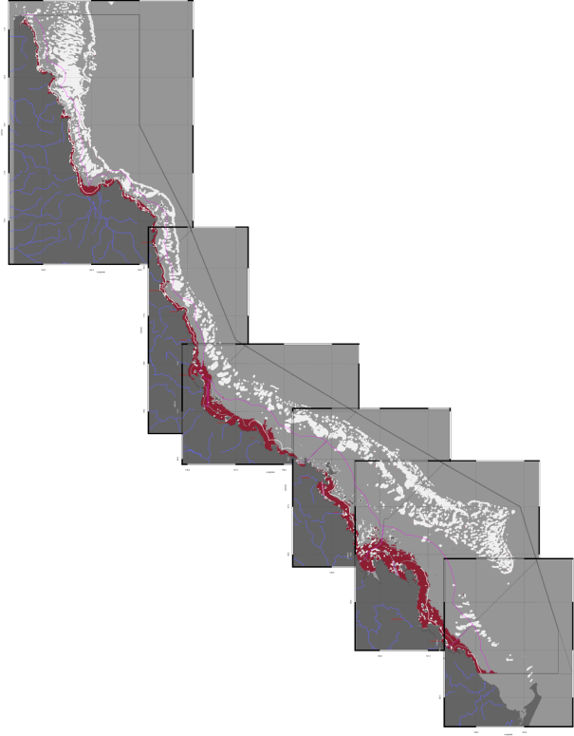
Figure 35. Collation of the exceedance maps of mean annual Chlorophyll-a for the 2010/2011 reporting period (May 2010 – April 2011) for the whole of the Great Barrier Reef World Heritage Area. Pixels are mapped in dark red when mean values for the year exceed the thresholds. Detailed maps are reported in the regional reporting sections (Figure 43, Figure 54, Figure 65, Figure 76, Figure 87 and Figure 98).

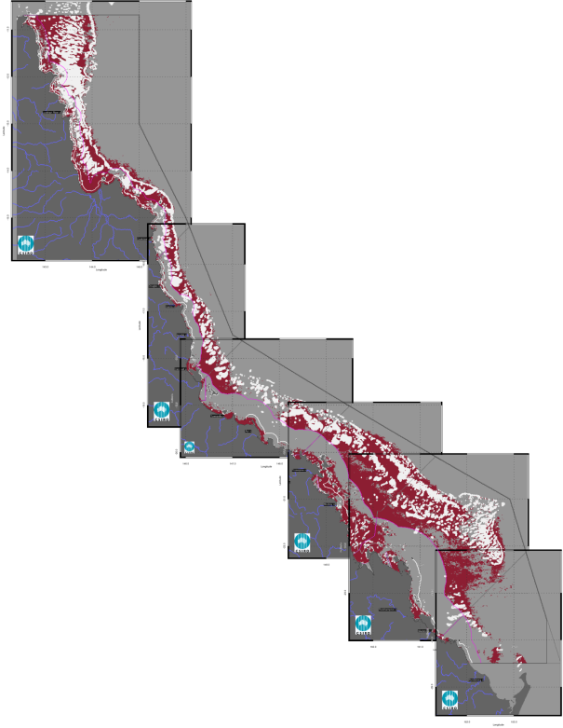
Figure 36. Collation of the exceedance maps of mean annual Total Suspended Solids for the 2010/2011 reporting period (May 2010 – April 2011) for the whole of the Great Barrier Reef World Heritage Area. Pixels are mapped in dark red when mean values for the year exceed the thresholds. Detailed maps are reported in the regional reporting sections (Figure 43, Figure 54, Figure 65, Figure 76, Figure 87 and Figure 98).

Table 6. Summary of the exceedance of annual mean values of Chlorophyll-a and non-algal particulate matter (as a measure of Total Suspended Solids) for this reporting period (1 May 2010 – 30 April 2011) for the Open Coastal, Mid-shelf and Offshore water bodies. Cells are shaded in gray when more than 50% of the area of the water body exceeds the Guideline value * Caution should be used when interpreting the results for the Cape York and Burnett Mary regions as limited field information was used for the parameterization and validation on the remote sensing retrievals.
 | Chlorophyll-a: Relative area (%) of the water body where the annual mean value exceeds the WQ Guideline value |  |  | Total Suspended Solids: Relative area (%) of the water body where the annual mean value exceeds the WQ Guideline value
 | Open Coastal | Mid-shelf | Offshore | Open Coastal | Mid-shelf | Offshore
Cape York* | 73 | 13 | 0 | 58 | 57 | 21
Wet Tropics | 93 | 31 | 2 | 30 | 6 | 30
Burdekin | 77 | 18 | 0 | 43 | 0 | 19
Mackay Whitsunday | 71 | 9 | 0 | 84 | 41 | 65
Fitzroy | 97 | 19 | 0 | 49 | 8 | 47
Burnett Mary * | 96 | 15 | 0 | 21 | 0 | 4

Table 7. Summary of the exceedance of mean annual Chlorophyll-a and non-algal particulate matter (as a measure of Total Suspended Solids) for the previous reporting period (1 May 2009 – 30 April 2010) for the Open Coastal, Mid-shelf and Offshore water bodies. Cells are shaded in gray when more than 50% of the area of the water body exceeds the Guideline value * Caution should be used when interpreting the results for the Cape York and Burnett Mary regions as limited field information was used for the parameterization and validation on the remote sensing retrievals.
 | Chlorophyll-a: Relative area (%) of the water body where the annual mean value exceeds the WQ Guideline value |  |  | Total Suspended Solids: Relative area (%) of the water body where the annual mean value exceeds the WQ Guideline value
 | Open Coastal | Mid-shelf | Offshore | Open Coastal | Mid-shelf | Offshore
Cape York* | 56 | 4 | 0 | 45 | 44 | 26
Wet Tropics | 81 | 16 | 0 | 23 | 3 | 30
Burdekin | 65 | 2 | 0 | 39 | 0 | 30
Mackay Whitsunday | 32 | 3 | 0 | 69 | 40 | 64
Fitzroy | 66 | 5 | 0 | 43 | 7 | 50
Burnett Mary * | 83 | 4 | 0 | 12 | 0 | 48
Table 8. Paddock to Reef marine water quality index (P2R_WQI) and component scores (P2R_CHL and P2R_TSS) for this reporting period (1 May 2010 – 30 April 2011). Cells are shaded to reflect the colour coding of the P2R reporting scheme from red to green in steps of 20%.* Caution should be used when interpreting the results for the Cape York and Burnett Mary regions as limited field information was used for the parameterization and validation on the remote sensing retrievals.
 | P2R_CHL | P2R_TSS | P2R_WQI
Cape York* | Poor (27) | Moderate (42) | Poor (35)
Wet Tropics | Very poor (7) | Good (70) | Poor (39)
Burdekin | Poor (23) | Moderate (57) | Poor (40)
Mackay Whitsunday | Poor (29) | Very poor (16) | Poor(23)
Fitzroy | Very poor (3) | Moderate (51) | Poor (27)
Burnett Mary * | Very poor (4) | Good (79) | Moderate (42)
GBR | Very poor (15) | Moderate (45) | Poor (30)

Table 9. Paddock to Reef marine water quality index (P2R_WQI) and component scores (P2R_CHL and P2R_TSS) for the previous reporting period (1 May 2009 – 30 April 2010). Cells are shaded to reflect the colour coding of the P2R reporting scheme from red to green in steps of 20%.* Caution should be used when interpreting the results for the Cape York and Burnett Mary regions as limited field information was used for the parameterization and validation on the remote sensing retrievals.
 | P2R_CHL | P2R_TSS | P2R_WQI
Cape York* | Moderate (44) | Moderate (55 | Moderate (50)
Wet Tropics | Very Poor (19) | Good (77) | Moderate (48)
Burdekin | Poor (35) | Good (61) | Moderate (48)
Mackay Whitsunday | Good (68) | Poor (31) | Moderate (50)
Fitzroy | Poor (34) | Moderate (57) | Moderate (46)
Burnett Mary * | Very poor (16) | Very good (88) | Moderate (52)
GBR | Moderate (42) | Moderate (53) | Moderate (47)

Regional reports: Cape York region
Cape York Peninsula is the northernmost extremity of Australia. From its tip at Cape York it extends southward in Queensland for about 800km, widening to its base, which spans 650km from Cairns in the east to the Gilbert River in the west. The largest rivers in the Cape flow into the Gulf of Carpentaria, however there are several large catchments that drain into the GBR. The region has a monsoonal climate with distinct wet and dry seasons with mean annual rainfall ranging from 1715mm in the Starke region to 2159mm near the Lockhart River airport. Most rain falls between December and April (Johnson et al. 2011). The Cape is an area of exceptional conservation value and has cultural value of great significance to both Indigenous and non-Indigenous communities. The majority of the land is relatively undeveloped, therefore water entering the lagoon is perceived to be of a high quality (Johnson et al. 2011).
This system is characterized by shallow and turbid waters (e.g. in Princess Charlotte Bay) and a relatively narrow coastal water body. The Open Coastal marine water body approximate delineation in the Guidelines for this NRM region is only 6 km from shore (Table 1 at page 12 of GBRMPA 2009). Caution should be used when interpreting the results for this region as limited field information was used for the parameterization and validation on the remote sensing retrievals.

Assessment of freshwater extent during the wet season
Figure 39 reports the freshwater extent for wet season 2010/2011 (November 2010- April 2011) for the Cape York region. The freshwater extent was estimated by applying a threshold of 0.24 m⁻¹ for the CDOM seasonal maximum. For the Cape York region the freshwater extent in 2010/2011 was the largest since 2002/2003 (4847 km² ) and comparable with the wet season 2005/2006 (4825 km² ,Figure 37). The annual flow data for the Normanby River for this year was the highest since the current record started in 2006/07.

The wet and dry season median maps for Chlorophyll-a and Total Suspended Solids.
The wet and dry season CHL median maps of (Figure 40) for the Cape York region show high CHL levels near the coast and in the estuary to lower concentrations towards the East. Median CHL values of 0.5 gL⁻¹ extended beyond the coastal to inshore boundary for both seasons. The median values in the Offshore region in the reef matrix ranged from ~0.15-0.5 gL⁻¹.
The wet and dry season median maps of NAP (as a measure of TSS) (Figure 41) show values higher than 5 mg/L in Princess Charlotte Bay in both seasons.
The maps in Figure 42 depict the number of observations available for calculating the median values for each season on each pixel in the map. The maps show that this amount varies from 15 to 30 observations (out of 180) for the wet season and about 50 (out of 180) for the dry season for each pixel location.
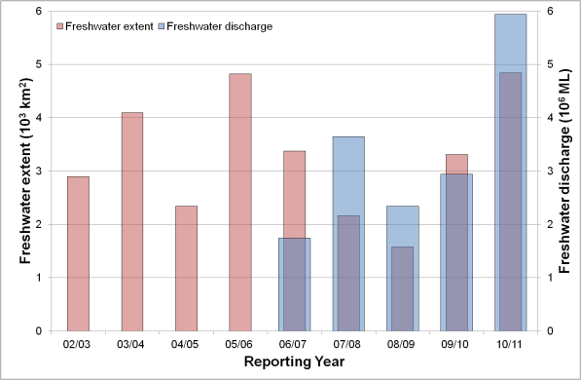
Figure 37. Freshwater discharge and estimated freshwater extent for the Cape York region based on the CDOM maximum for the wet seasons.

Assessment of the marine water quality index and the exceedance of water quality guidelines
The marine water quality for this reporting year for the Cape York region was scored as “poor”, reflecting a “poor” score for P2R_CHL and “moderate” for P2R_TSS (Figure 38). The marine water quality index and the component scores have been oscillating between “poor” and “moderate” since the 2003/04 reporting season, showing no clear correlation with the high freshwater discharges from the Cape York catchments and the associated estimated freshwater plume extents (Figure 37).
The exceedance of the Guidelines was assessed for CHL and TSS retrieved from MODIS Aqua using CSIRO’s algorithm. For the Cape York region the annual mean CHL values of exceeded the Guidelines threshold values (0.45 µg/L) for 73% percent of the Open Coastal area, 13% of the Midshelf and none of the Offshore areas (Figure 43, Table 10). The mean CHL values of exceeded the Guidelines thresholds for 95% of the Open Coastal area in the dry season and 45% in the wet season. In the dry season CHL exceeded the Guidelines for 79% of the Midshelf and 17% of the Offshore areas (Figure 44, Table 11). Similar exceedance values were obtained if the median was used for the assessment (i.e. when EF was higher than 0.50, Figure 45, Table 11). The EG maps for CHL show that the mean CHL values of exceeded the Guidelines thresholds in the wet season and over the whole year only in river mouths and embayments (Figure 43, Figure 44). In the dry season the mean CHL values exceed in most of the reef matrix and Offshore waters (Figure 44), while the EF ranged between 10-25 %, indicating that median CHL values did not exceed the Guidelines (Figure 45).
Figure 38. Paddock to Reef marine water quality index (P2R_WQI) and component scores (P2R_CHL and P2R_TSS) for the Cape York region based on the assessment of exceedance to the Guidelines.
Over the whole year, exceedance of TSS Guideline values was recorded in 58% of Open Coastal, 57% of Midshelf and 21% of Offshore areas (Figure 43, Table 10). The mean values of TSS exceeded the Guidelines values for 76 % of the Open Coastal Area in the dry season and 20 % in the wet season, in the dry season the mean values of TSS also exceeded the Guidelines for 74 % of the Midshelf and 26% of the Offshore area. Almost no exceedance was recorded for the Midshelf and Offshore areas in both seasons if the median was used for the assessment, while the exceedance of the median values for the Open Coastal area were significantly lower than those for the mean values (45% for the dry season and 9% for the wet season, Figure 47, and Table 12).
Table 13 and Table 14 report the summary of exceedance for both variables, providing mean and median concentrations computed on all the valid observations for each water body for each season independently of the location, along with the EF for that period. These metrics are based on a high number of observations (ranging from 45 thousands valid observations for Open Coastal area in the wet season to almost 1 million for the Offshore area in the dry season). According to these metrics both the mean and the median values of Chlorophyll-a exceeded the Guidelines values for the Open Coastal area in both seasons, while the mean values of TSS exceeded the Guidelines values for the Open Coastal area and Offshore area in both seasons.
The mean and median values for the TSS concentration differed substantially: the mean values were ~ 2-3 times higher than medians. The median values for the dry season (1.78 and 1.00 mg/L ) are consistent with the long term mean annual values for Open Coastal and Midshelf waters in Cape York reported by De’ath and Fabricius (2008) (De’ath and Fabricius 2008) (2.24 and 1.39 mg/L SS, respectively) and the median values reported for the previous dry season (1.48 and 1.27 mg/L ) (Brando et al. 2010b).

Table 10 Summary of the annual exceedance maps for Chlorophyll-a and Total Suspended Solids for the Cape York region. "Surface Area" is the surface area in square kilometres for each of the three reporting water bodies for this region: (OC: Open Coastal, MS: Midshelf, OS: Offshore), “Number valid obs." is the number of pixels with valid observations (i.e. cloud-free and error-free pixels), "Number total obs." provides the total number of observations, "Mean > trigger" and "Median > trigger" report the relative area for each water body where the mean or the median exceeded the trigger value.
 |  | 01-May-2009 - 30-Apr-2010 |  | Chlorophyll-a |  | Total Suspended Solids
 | Surface Area | Number valid obs. | Number total obs. | Mean > trigger | Median > trigger | Mean > trigger | Median > trigger
OC | 4295 | 130464 | 1211190 | 73% | 72% | 58% | 20%
MS | 10544 | 428911 | 2973408 | 13% | 10% | 57% | 6%
OS | 62344 | 1805873 | 17581008 | 0% | 0% | 21% | 5%

Table 11 Summary of the exceedance maps for Chlorophyll-a for the dry and wet season for the Cape York region (Figure 44, Figure 45). Column and row labels are described in the legend of Table 10.
 |  | 01-May-2010 - 31-Oct-2010 |  |  |  | 01-Nov-2010 - 30-Apr-2011
 | Surface Area | Number valid obs. | Number total obs. | Mean > trigger | Median > trigger | Number valid obs. | Number total obs. | Mean > trigger | Median > trigger
OC | 4295 | 85171 | 566940 | 95% | 95% | 45293 | 644250 | 45% | 42%
MS | 10544 | 274721 | 1391808 | 70% | 79% | 154190 | 1581600 | 7% | 5%
OS | 62344 | 958556 | 8229408 | 17% | 17% | 847317 | 9351600 | 0% | 0%

Table 12 Summary of the exceedance maps for Non-algal particulate matter (NAP as a measure of TSS) for the dry and wet season for the Cape York region (Figure 46, Figure 47). Column and row labels are described in the legend of Table 10.
 |  | 01-May-2010 - 31-Oct-2010 |  |  |  | 01-Nov-2010 - 30-Apr-2011
 | Surface Area | Number valid obs. | Number total obs. | Mean > trigger | Median > trigger | Number valid obs. | Number total obs. | Mean > trigger | Median > trigger
OC | 4295 | 85171 | 566940 | 76% | 45% | 45293 | 644250 | 20% | 9%
MS | 10544 | 274721 | 1391808 | 74% | 26% | 154190 | 1581600 | 29% | 7%
OS | 62344 | 958556 | 8229408 | 20% | 5% | 847317 | 9351600 | 24% | 6%

Table 13. Summary of Chlorophyll-a exceedance for the dry and wet season for the Cape York region. “Number valid obs." is the number of pixels with valid observations (i.e. cloud-free and error-free pixels) for each of the three reporting water bodies for this region: (OC: Open Coastal, MS: Midshelf, OS: Offshore), "Number total obs." provides the total number of observations. Mean and median are presented in red and bold if they exceed the trigger value in the Guidelines. The seasonally adjusted Guideline values for Chlorophyll –a for the dry/wet season are 0.32/0.63 µg L⁻¹ for Open Coastal and Midshelf and 0.28/0.56 µg L⁻¹ for Offshore.
 | 01-May-2010 - 31-Oct-2010 |  |  |  |  | 01-Nov-2010 - 30-Apr-2011
 | Number valid obs. | Number total obs. | Mean | Median | EF | Number valid obs. | Number total obs. | Mean | Median | EF
OC | 85171 | 566940 | 0.68 | 0.50 | 88% | 45293 | 644250 | 0.78 | 0.56 | 41%
MS | 274721 | 1391808 | 0.35 | 0.37 | 62% | 154190 | 1581600 | 0.46 | 0.39 | 15%
OS | 958556 | 8229408 | 0.24 | 0.22 | 27% | 847317 | 9351600 | 0.25 | 0.22 | 1%

Table 14 Summary of Non-algal particulate matter (NAP as a measure of TSS) exceedance for the dry and wet season for the Cape York region. Column and row labels are described in the legend of Table 13. Mean and median are presented in red and bold if they exceed the trigger value in the Guidelines. The seasonally adjusted Guideline values for TSS for the dry/wet season means are 1.6/2.4 mg L⁻¹ for Open Coastal and Midshelf and 0.6/0.8 mg L⁻¹ for Offshore.
 | 01-May-2010 - 31-Oct-2010 |  |  |  |  | 01-Nov-2010 - 30-Apr-2011
 | Number valid obs. | Number total obs. | Mean | Median | EF | Number valid obs. | Number total obs. | Mean | Median | EF
OC | 85171 | 566940 | 3.41 | 1.78 | 54% | 45293 | 644250 | 2.05 | 1.00 | 19%
MS | 274721 | 1391808 | 2.99 | 1.18 | 42% | 154190 | 1581600 | 2.24 | 0.91 | 29%
OS | 958556 | 8229408 | 0.61 | 0.15 | 22% | 847317 | 9351600 | 0.77 | 0.22 | 21%

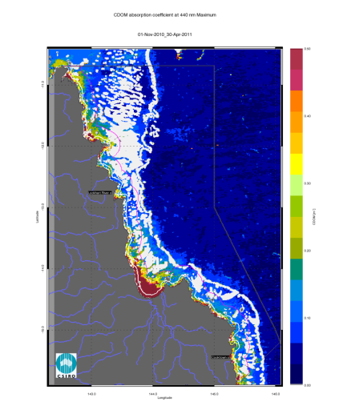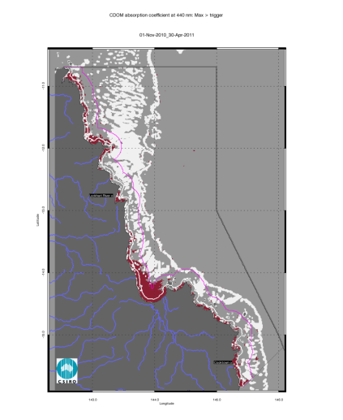
Figure 39. Map of freshwater extent for the wet season for the Cape York region. The first map presents the maximum value of CDOM for the wet season 2010/2011 (November 2010- April 2011), while the second map presents freshwater extent estimated with a threshold for the CDOM seasonal maximum of 0.24 m⁻¹.
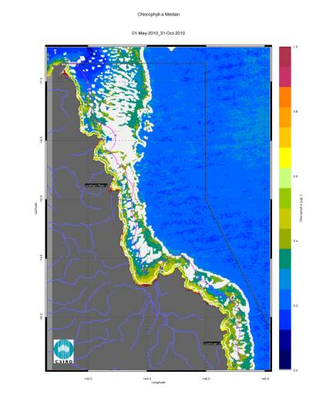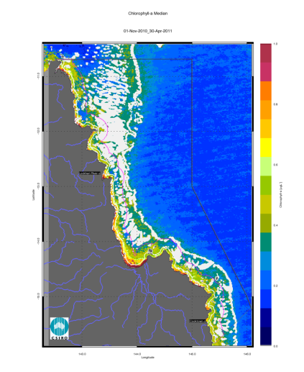
Figure 40. Chlorophyll-a median maps for the dry and wet season for the Cape York region. The first map presents the median for the dry season 2010 (May - October), while the second map presents the median for the wet season 2010/2011 (November 2010- April 2011).
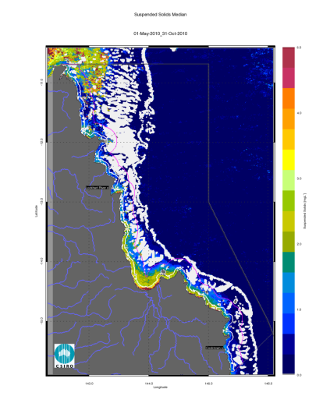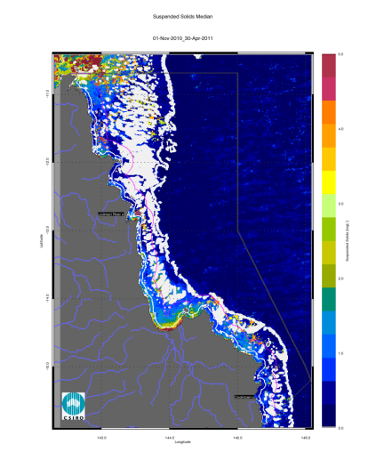
Figure 41. Non-algal particulate matter (NAP as a measure of TSS) median maps for the dry and wet season for the Cape York region. The first map presents the median for the dry season 2010 (May - October), while the second map presents the median for the wet season 2010/2011 (November 2010- April 2011).

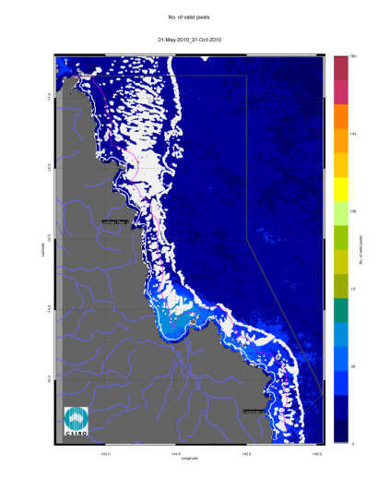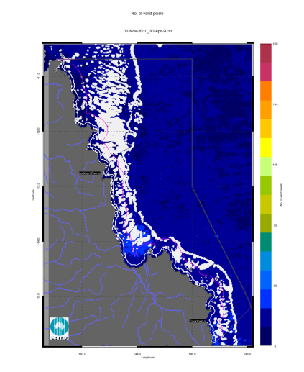
Figure 42. Number of observations used to calculate the median maps (Figure 40 - Figure 41) for the dry and wet season for the Cape York region. The first map presents the number of observations available for analysis in the dry season 2010 (May - October), while the second map presents the number of observations available for analysis in the wet season 2010/2011 (November 2010- April 2011).
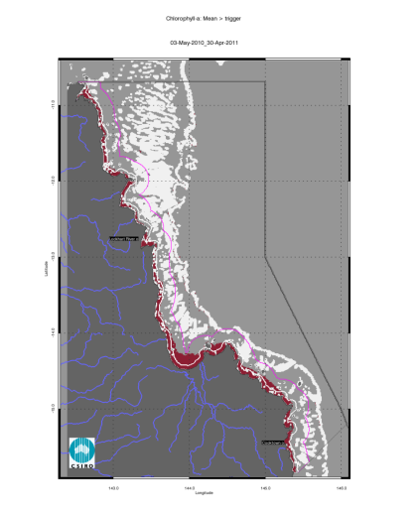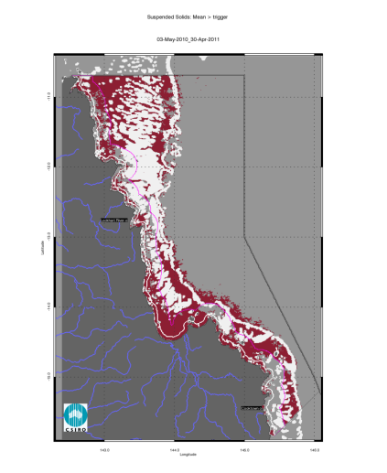
Figure 43. Exceedance maps for the Cape York region for the whole year (May 2010 –April 2011). The first map presents the Chlorophyll-a exceedance map, while the second map presents the Non-algal particulate matter (NAP as a measure of TSS) exceedance map. The Guideline values for annual means of Chlorophyll–a are 0.45 µg L⁻¹ for Open Coastal and Midshelf and 0.40 µg L⁻¹ for Offshore, while for TSS are 2.0 and 0.7 mg L⁻¹.
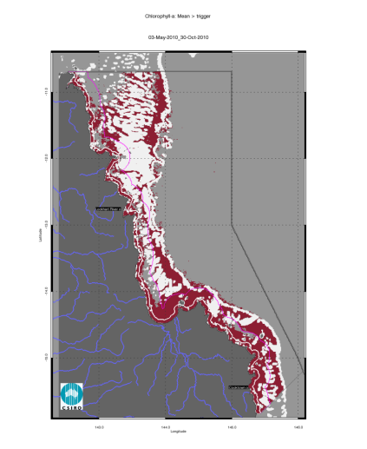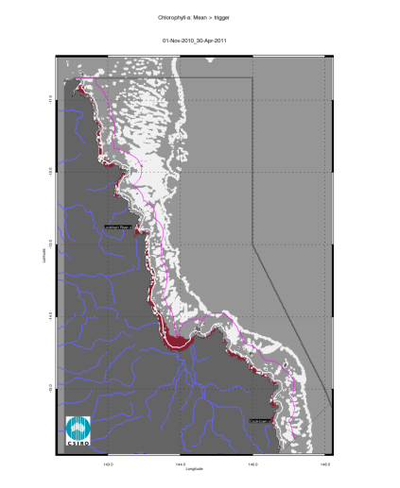
Figure 44. Chlorophyll-a exceedance maps for the dry and wet season for the Cape York region. The first map presents the exceedance for the dry season 2010 (May - October), while the second map presents the exceedance for the wet season 2010/2011 (November 2010- April 2011). The seasonally adjusted Guideline values for Chlorophyll–a for the dry/wet season are 0.32/0.63 µg L-1 for Open Coastal and Midshelf and 0.28/0.56 µg L-1 for Offshore.
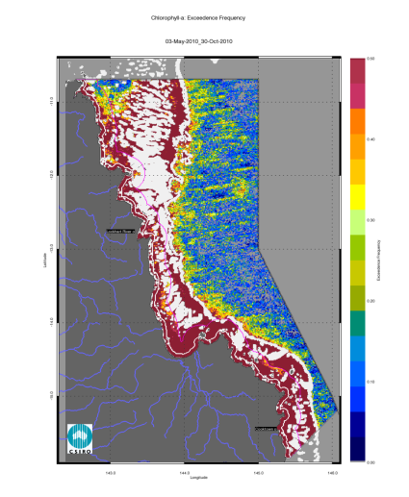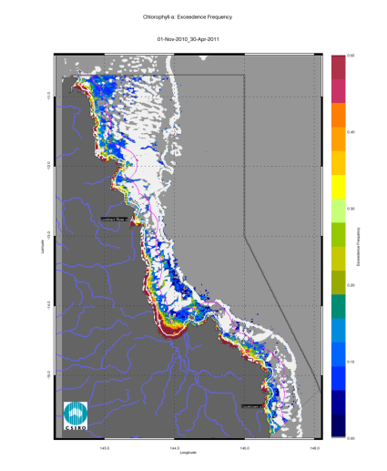
Figure 45. Chlorophyll-a exceedance frequency maps for the dry and wet season for the Cape York region. The first map presents the exceedance frequency for the dry season 2010 (May - October), while the second map presents the exceedance frequency for the wet season 2010/2011 (November 2010- April 2011). The seasonally adjusted Guideline values for Chlorophyll –a for the dry/wet season are 0.32/0.63 µg L⁻¹ for Open Coastal and Midshelf and 0.28/0.56 µg L⁻¹ for Offshore.
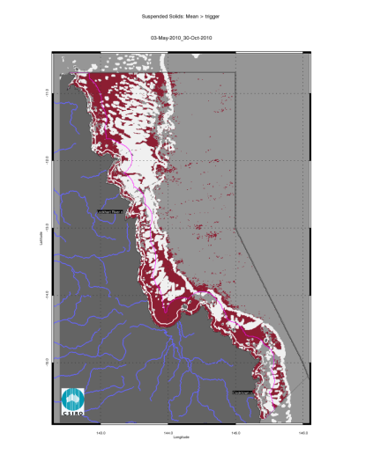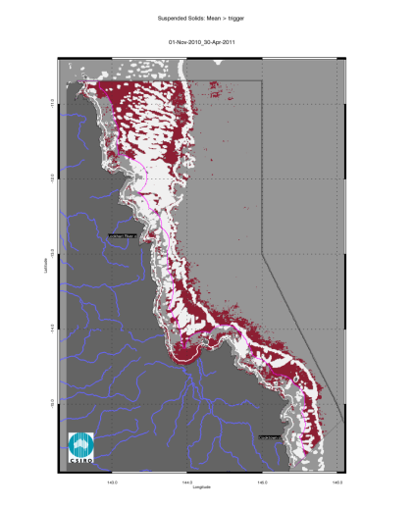
Figure 46. Non-algal particulate matter (NAP as a measure of TSS) exceedance maps for the dry and wet season for the Cape York. The first map presents the exceedance for the dry season 2010 (May - October), while the second map presents the exceedance for the wet season 2010/2011 (November 2010- April 2011). The seasonally adjusted Guideline values for TSS for the dry/wet season means are 1.6/2.4 mg L⁻¹ for Open Coastal and Midshelf and 0.6/0.8 mg L⁻¹ for Offshore.
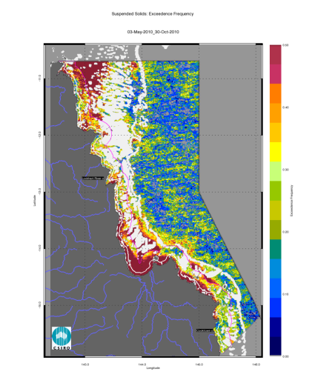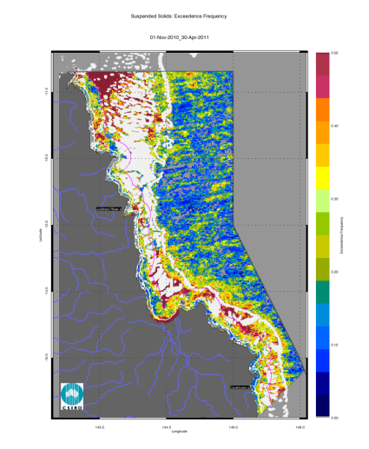
Figure 47. Non-algal particulate matter (NAP as a measure of TSS) exceedance frequency maps for the dry and wet season for the Cape York region. The first map presents the exceedance frequency for the dry season 2010 (May - October), while the second map presents the exceedance frequency for the wet season 2010/2011 (November 2010- April 2011). The seasonally adjusted Guideline values for TSS for the dry/wet season means are 1.6/2.4 mg L⁻¹ for Open Coastal and Midshelf and 0.6/0.8 mg L⁻¹ for Offshore.

Regional reports: Wet Tropics region
Land use practices within the wet tropics catchment include primary production such as sugar cane and banana farming, dairying, beef, cropping and tropical horticulture. Other uses within the region include fisheries, mining, and tourism (Johnson et al. 2011). Declining water quality, due to sedimentation combined with other forms of pollutants, the disturbance of acid sulphate soils, and point source pollution have been identified as a major concern to the health of coastal and marine ecosystems. Major environmental controls on GBR water quality in the wet tropics include pulsed terrigenous runoff, salinity and temperature extremes (Johnson et al. 2011).

Assessment of freshwater extent during the wet season
Figure 50 reports the freshwater extent for wet season 2010/2011 (November 2010- April 2011) for the Wet Tropics region. The freshwater extent was estimated by applying a threshold of 0.24 m⁻¹ for the CDOM seasonal maximum. For the Wet Tropics region the freshwater extent for the wet season 2010/2011 (November 2010- April 2011) was 4593 km², the highest since 2002/2003, slightly higher than the 4209 km² of the wet season 2008/2009 (Figure 48). The freshwater extent was well correlated with the freshwater discharge (R²=0.610, Figure 48): the flow conditions in the Daintree and Barron Rivers were more than twice above median levels while the freshwater discharge for the Herbert was more than three times above median flows (Figure 27). A lower freshwater extent in 2009/10 (2999 km²) was due to the to the flow conditions in the Russell, Johnstone, Tully and Herbert Rivers below median levels (0.6 – 0.8 times median levels, Figure 27). The Wet Tropics region was affected the impact of the Category 5 Tropical Cyclone Yasi in February 2011 and associated flooding.
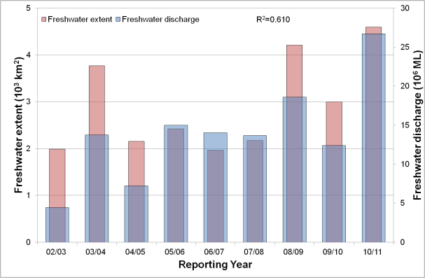
Figure 48. Freshwater discharge and estimated freshwater extent for the Wet Tropics region based on the CDOM maximum for the wet seasons.
The estimated freshwater extended in the Midshelf water bodies reaching the reef matrix to the East of port Douglas and Innisfail (Figure 50). The high concentration of CDOM in these areas is patchy and it provides conservative estimate of the freshwater extent as flood plumes could have extended further in cloudy or overcast days and hence may not been captured with the satellite imagery.
Some of the CDOM and freshwater extent reported for this region (Figure 50), in particular to the East of the Herbert River and Hinchinbrook Island where CDOM absorption were higher than 0.50 m⁻¹ are probably associated with the Burdekin River flows and discharge that were more than five times above the median values. Also some of the discharge due to the Herbert River is possibly accounted for in the Burdekin Region. These difficulties in clearly associating the sources of freshwater discharge with the estimated freshwater extent are due to local hydrodynamics, as well as the nature of the marine boundaries for the reporting regions.

The wet and dry season median maps for Chlorophyll-a and Total Suspended Solids.
The wet and dry season CHL median maps of (Figure 51) for the Wet Tropics region show high CHL concentrations near the coast and in the estuary to lower concentrations towards the East. Median CHL values of up-to 0.5 gL⁻¹ extended beyond the coastal to inshore boundary for the dry season, while the wet season showed values up to 1.0 gL⁻¹ beyond the coastal to inshore boundary and ranges of 0.4-0.6 gL⁻¹ in the Midshelf. The median CHL values in the offshore region in the reef matrix ranged between 0.15-0.25 gL⁻¹.
The wet and dry season median maps of non-algal particulate matter (as a measure of TSS) (Figure 52) for the Wet Tropics region show values higher than 3 mgL⁻¹ in Rockingham Bay and Halifax Bay.
The number of image observations available for calculating the median values varies from 20 to 30 observations for the wet season and 40-50 for the dry season for each pixel location (Figure 53) .

Assessment of the marine water quality index and the exceedance of water quality guidelines
The marine water quality for this reporting year for the Wet Tropics region was scored as “poor”, reflecting a “very poor” score for P2R_CHL and “good” for P2R_TSS (Figure 49). The marine water quality index has been oscillating between “poor” and “moderate” since the 2003/04 reporting season. The component scores show opposite behaviours, with P2R_CHL showing a decline from “poor” to very poor for 2003/04 to-date, while P2R_TSS showing an increase in scores from “moderate” in 2004/05 – 2006/07 to “good” for the last four reporting years. The P2R_CHL scores seem to respond to the higher freshwater discharges in the last four years and the associated estimated freshwater plume extents (Figure 48).
The annual mean CHL values exceeded the guideline value (0.45 gL⁻¹) for 93% of the Open Coastal area, 31% of the Midshelf and 2% of the Offshore areas (Figure 54, Table 15). The spatial patterns in EG are affected by the coastal to offshore gradients that can be observed in the median maps (Figure 51, Figure 52) and by the changes in trigger values between the Midshelf and Offshore areas. The mean CHL values of exceeded the Guidelines values for 99% of the Open Coastal area in the dry season and 63 % in the wet season, in correspondence to the river mouths: Mossman –Daintree, Barron, Russell-Mulgrave, Johnstone, Tully, Murray and Herbert rivers and Hinchinbrook Channel (Figure 55). In the dry season CHL exceeded the Guidelines for 99 % of the Midshelf and 32% of the Offshore areas mainly waters within and around the reef matrix (Figure 55, Table 16). Similar exceedance values were retrieved if the median was used for the assessment (i.e. when EF values were higher than 0.50 in Figure 56, Table 15, Table 16).
The annual REEG for TSS extend to 30% of the Open Coastal, 6% of the Midshelf and 30% of Offshore areas (Figure 54, Table 15). The seasonal mean TSS values exceeded the Guidelines values for 59% of the Open Coastal Area in the dry season and 16 % in the wet season, in the dry season the mean values of TSS also exceeded the Guidelines for 22 % of the Midshelf and 25% of the Offshore area. The exceedance for the annual mean, as well as in the seasonally adjusted mean values of TSS in the Offshore water body occurred consistently between the Midshelf to Offshore boundary and the whole Reef Matrix, due to the steep change in Guidelines trigger values across the Midshelf to Offshore boundary (from 2.0 to 0.7 mg L⁻¹ for the annual means and from 1.6/2.4 to 0.6/0.8 mg L⁻¹ for the seasonally adjusted values, Table 2 and Table 3)
Almost no exceedance was recorded for the Midshelf and Offshore areas in both seasons and over the year if the median was used for the assessment (REEF50), while the exceedance of the median values for the Open Coastal area were significantly lower than those for the mean values (8% for the whole year, 23% for the dry season and 6% for the wet season, Figure 58, and Table 17).

Figure 49. Paddock to Reef marine water quality index (P2R_WQI) and component scores (P2R_CHL and P2R_TSS) for the Wet Tropics region based on the assessment of exceedance to the Guidelines.

Table 18 and Table 19 report the summary of exceedance for both variables, providing mean and median concentrations computed on all the valid observations for each water body for each season, along with the EF for that period. These metrics are based on a high number of observations (ranging from 35 thousand valid observations for Open Coastal area in the wet season to over 460 thousand for the Offshore area in the dry season). According to these metrics both the mean and the median CHL values exceeded the Guidelines values for the Open Coastal area in both seasons and in Midshelf for the dry season, while the mean TSS values exceeded the Guidelines values only for the Open Coastal area in the dry season. The mean and median values for the TSS concentration differed substantially (for all water bodies and seasons). The mean values were ~ 2-3 times higher than medians.

Table 15 Summary of the annual exceedance maps for Chlorophyll-a and Total Suspended Solids for the Wet Tropics region. "Surface Area" is the surface area in square kilometres for each of the three reporting water bodies for this region: (OC: Open Coastal, MS: Midshelf, OS: Offshore), “Number valid obs." is the number of pixels with valid observations (i.e. cloud-free and error-free pixels), "Number total obs." provides the total number of observations, "Mean > trigger" and "Median > trigger" report the relative area for each water body where the mean or the median exceeded the trigger value.
 |  | 01-May-2009 - 30-Apr-2010 |  | Chlorophyll-a |  | Total Suspended Solids
 | Surface Area | Number valid obs. | Number total obs. | Mean > trigger | Median > trigger | Mean > trigger | Median > trigger
OC | 2044 | 96460 | 647948 | 93% | 93% | 30% | 8%
MS | 5859 | 313498 | 1857303 | 31% | 27% | 6% | 0%
OS | 19906 | 808707 | 6310202 | 2% | 2% | 30% | 0%

Table 16 Summary of the exceedance maps for Chlorophyll-a for the dry and wet season for the Wet Tropics region (Figure 55, Figure 56). Column and row labels are described in the legend of Table 15.
 |  | 01-May-2010 - 31-Oct-2010 |  |  |  | 01-Nov-2010 - 30-Apr-2011
 | Surface Area | Number valid obs. | Number total obs. | Mean > trigger | Median > trigger | Number valid obs. | Number total obs. | Mean > trigger | Median > trigger
OC | 2044 | 60736 | 314776 | 99% | 99% | 35724 | 333172 | 63% | 59%
MS | 5859 | 189256 | 902286 | 99% | 99% | 124242 | 955017 | 19% | 18%
OS | 19906 | 461824 | 3065524 | 32% | 31% | 346883 | 3244678 | 1% | 1%

Table 17 Summary of the exceedance maps for Non-algal particulate matter (NAP as a measure of TSS) for the dry and wet season for the Wet Tropics region (Figure 57, Figure 58). Column and row labels are described in the legend of Table 15.
 |  | 01-May-2010 - 31-Oct-2010 |  |  |  | 01-Nov-2010 - 30-Apr-2011
 | Surface Area | Number valid obs. | Number total obs. | Mean > trigger | Median > trigger | Number valid obs. | Number total obs. | Mean > trigger | Median > trigger
OC | 2044 | 60736 | 314776 | 59% | 23% | 35724 | 333172 | 16% | 6%
MS | 5859 | 189256 | 902286 | 22% | 2% | 124242 | 955017 | 5% | 1%
OS | 19906 | 461824 | 3065524 | 25% | 0% | 346883 | 3244678 | 34% | 2%

Table 18. Summary of Chlorophyll-a exceedance for the dry and wet season for the Wet Tropics region. "Surface Area" is the surface area in square kilometres for each of the three reporting water bodies for this region: (OC: Open Coastal, MS: Midshelf, OS: Offshore), “Number valid obs." is the number of pixels with valid observations (i.e. cloud-free and error-free pixels), "Number total obs." provides the total number of observations. Mean and median are presented in red and bold if they exceed the trigger value in the Guidelines. The seasonally adjusted Guideline values for Chlorophyll –a for the dry/wet season are 0.32/0.63 µg L⁻¹ for Open Coastal and Midshelf and 0.28/0.56 µg L⁻¹ for Offshore.
 | 01-May-2010 - 31-Oct-2010 |  |  |  |  | 01-Nov-2010 - 30-Apr-2011
 | Number valid obs. | Number total obs. | Mean | Median | EF | Number valid obs. | Number total obs. | Mean | Median | EF
OC | 60736 | 314776 | 0.74 | 0.58 | 94% | 35724 | 333172 | 0.97 | 0.69 | 57%
MS | 189256 | 902286 | 0.41 | 0.41 | 74% | 124242 | 955017 | 0.55 | 0.49 | 27%
OS | 461824 | 3065524 | 0.26 | 0.24 | 38% | 346883 | 3244678 | 0.27 | 0.23 | 2%

Table 19 Summary of Non-algal particulate matter (NAP as a measure of TSS) exceedance for the dry and wet season for the Wet Tropics region. Column and row labels are described in the legend Table 18. Mean and median are presented in red and bold if they exceed the trigger value in the Guidelines. The seasonally adjusted Guideline values for TSS for the dry/wet season means are 1.6/2.4 mg L⁻¹ for Open Coastal and Midshelf and 0.6/0.8 mg L⁻¹ for Offshore.
 | 01-May-2010 - 31-Oct-2010 |  |  |  |  | 01-Nov-2010 - 30-Apr-2011
 | Number valid obs. | Number total obs. | Mean | Median | EF | Number valid obs. | Number total obs. | Mean | Median | EF
OC | 60736 | 314776 | 2.11 | 1.23 | 35% | 35724 | 333172 | 1.60 | 0.70 | 15%
MS | 189256 | 902286 | 1.36 | 0.51 | 23% | 124242 | 955017 | 1.47 | 0.53 | 19%
OS | 461824 | 3065524 | 0.46 | 0.11 | 17% | 346883 | 3244678 | 0.79 | 0.24 | 23%

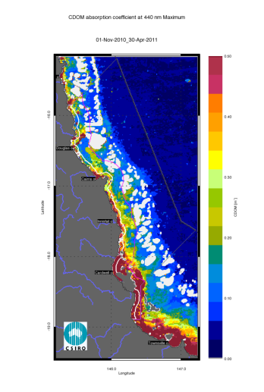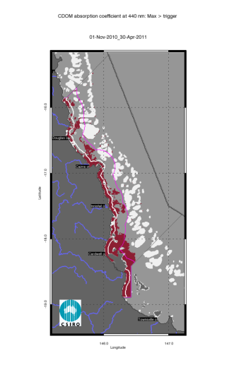
Figure 50. Map of freshwater extent for the wet season for the Wet Tropics region. The first map presents the maximum value of CDOM for the wet season 2010/2011 (November 2010- April 2011), while the second map presents freshwater extent estimated with a threshold for the CDOM seasonal maximum of 0.24 m⁻¹.
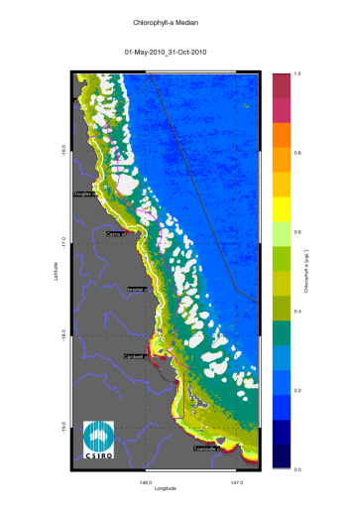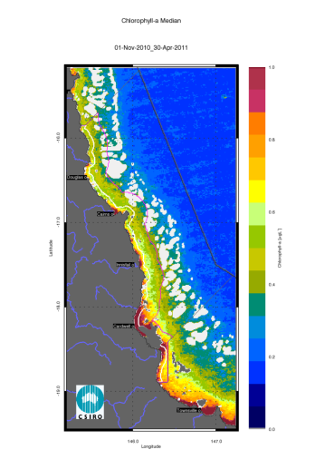
Figure 51. Chlorophyll-a median maps for the dry and wet season for the Wet Tropics region. The first map presents the median for the dry season 2010 (May - October), while the second map presents the median for the wet season 2010/2011 (November 2010- April 2011).
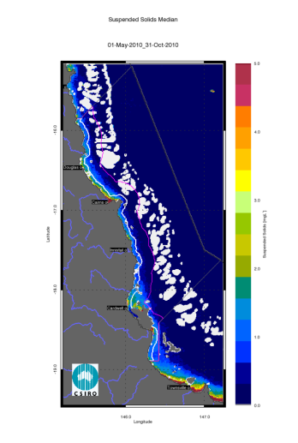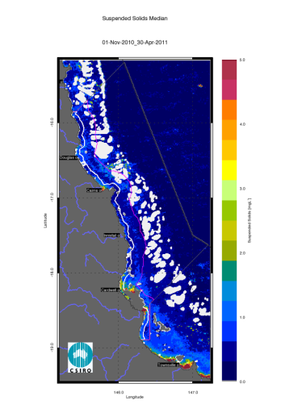
Figure 52. Non-algal particulate matter (NAP as a measure of TSS) median maps for the dry and wet season for the Wet Tropics region. The first map presents the median for the dry season 2010 (May - October), while the second map presents the median for the wet season 2010/2011 (November 2010- April 2011).
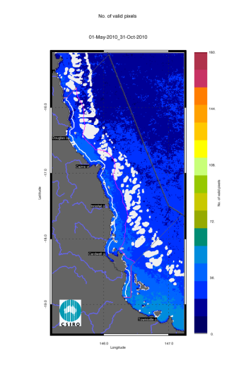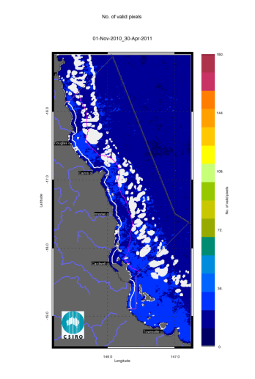
Figure 53. Number of observations used to calculate the median maps (Figure 51 - Figure 52) for the dry and wet season for the Wet Tropics region. The first map presents the number of observations available for analysis in the dry season 2010 (May - October), while the second map presents the number of observations available for analysis in the wet season 2010/2011 (November 2010- April 2011).
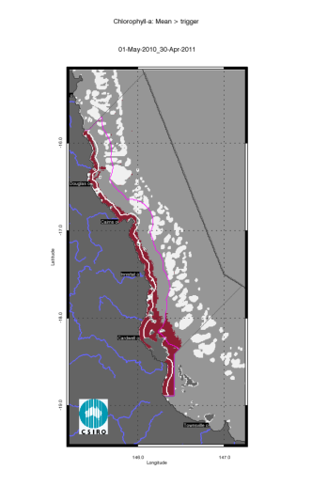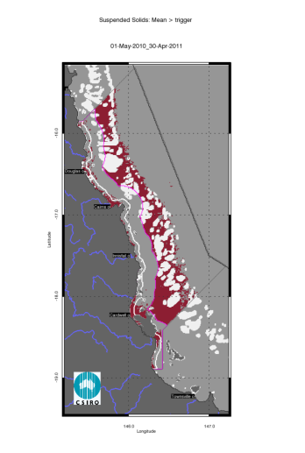
Figure 54. Exceedance maps for the Wet Tropics region for the whole year (May 2010 – April 2011). The first map presents the Chlorophyll-a exceedance map, while the second map presents the non-algal particulate matter (NAP as a measure of TSS) exceedance map. The Guideline values for annual means of Chlorophyll–a are 0.45 µg L⁻¹ for Open Coastal and Midshelf and 0.40 µg L⁻¹ for Offshore, while for TSS are 2.0 and 0.7 mg L⁻¹.
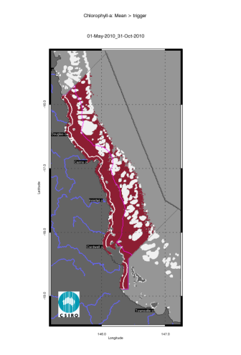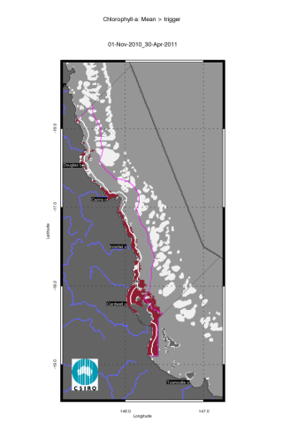
Figure 55. Chlorophyll-a exceedance maps for the dry and wet season for the Wet Tropics region. The first map presents the exceedance for the dry season 2010 (May - October), while the second map presents the exceedance for the wet season 2010/2011 (November 2010- April 2011). The seasonally adjusted Guideline values for Chlorophyll –a for the dry/wet season are 0.32/0.63 µg L⁻¹ for Open Coastal and Midshelf and 0.28/0.56 µg L⁻¹ for Offshore.
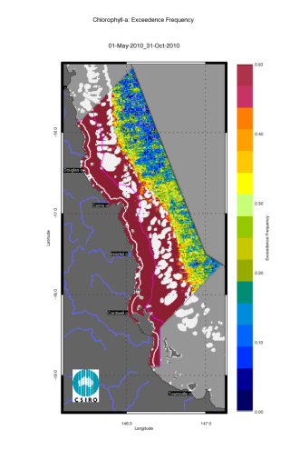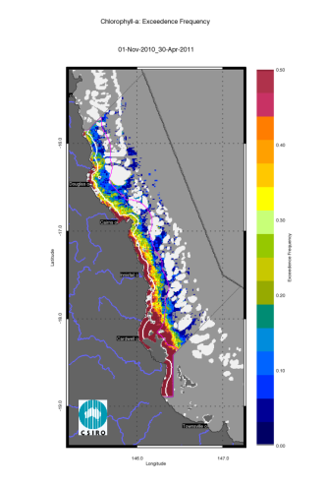
Figure 56. Chlorophyll-a exceedance frequency maps for the dry and wet season for the Wet Tropics region. The first map presents the exceedance frequency for the dry season 2010 (May - October), while the second map presents the exceedance frequency for the wet season 2010/2011 (November 2010- April 2011). The seasonally adjusted Guideline values for Chlorophyll –a for the dry/wet season are 0.32/0.63 µg L⁻¹ for Open Coastal and Midshelf and 0.28/0.56 µg L⁻¹ for Offshore.
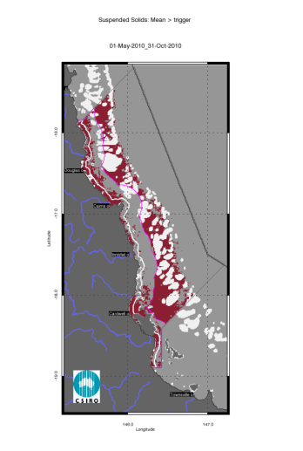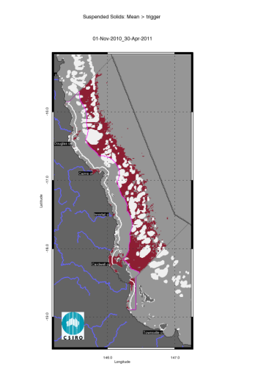
Figure 57. Non-algal particulate matter (NAP as a measure of TSS) exceedance maps for the dry and wet season for the Wet Tropics region. The first map presents the exceedance for the dry season 2010 (May - October), while the second map presents the exceedance for the wet season 2010/2011 (November 2010- April 2011). The seasonally adjusted Guideline values for TSS for the dry/wet season means are 1.6/2.4 mg L⁻¹ for Open Coastal and Midshelf and 0.6/0.8 mg L⁻¹ for Offshore.
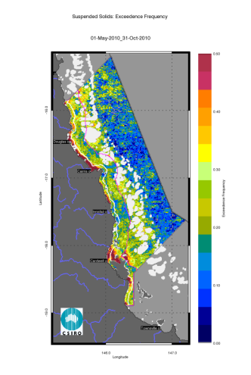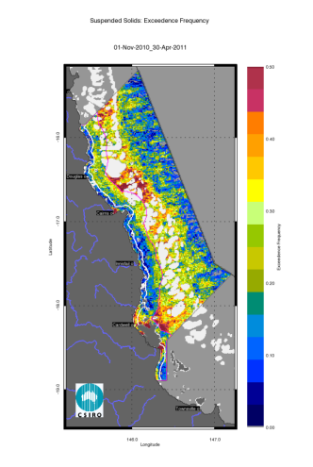
Figure 58. Non-algal particulate matter (NAP as a measure of TSS) exceedance frequency maps for the dry and wet season for the Wet Tropics region. The first map presents the exceedance frequency for the dry season 2010 (May - October), while the second map presents the exceedance frequency for the wet season 2010/2011 (November 2010- April 2011). The seasonally adjusted Guideline values for TSS for the dry/wet season means are 1.6/2.4 mg L⁻¹ for Open Coastal and Midshelf and 0.6/0.8 mg L⁻¹ for Offshore.

Regional reports: Burdekin region
The Burdekin Dry Tropics region includes an aggregation of the Black, Burdekin, Don, Haughton and Ross River catchments and includes several smaller coastal catchments, all of which empty into the GBR lagoon. Because of its geographical location, rainfall in the region is lower than other regions within tropical Queensland, though there is considerable variation year to year with 75% of the annual rainfall received during December to March (Johnson et al. 2011).

Assessment of freshwater extent during the wet season
Figure 61 reports the freshwater extent for wet season 2010/2011 (November 2010- April 2011) for the Burdekin region. The freshwater extent was estimated by applying a threshold of 0.24 m⁻¹ for the CDOM seasonal maximum. For the Burdekin region the freshwater extent for the wet season 2010/2011 (November 2010- April 2011) was 8034 km² while in the wet season 2008/2009 was 7718 km² (Figure 59). The freshwater extent was highly correlated with the freshwater discharge (R²=0.885, Figure 59): in 2009/10 a lower extent (3099 km²) reflected the freshwater discharge from the Burdekin River that was sightly above the median values (~1.3) while the flows for the current year and the 2008/2009 were more than five times the annual median flow( Figure 27). The Burdekin region was also affected by TC Yasi strong winds, large rainfalls and associated flooding (Figure 29)

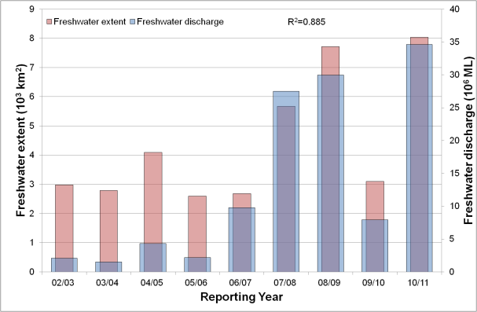
Figure 59. Freshwater discharge and estimated freshwater extent for the Burdekin region based on the CDOM maximum for the wet seasons.

The wet and dry season median maps for chlorophyll-a and Total Suspended Solids.
The wet and dry season CHL median maps of (Figure 62) for the Burdekin region show high CHL concentrations near the coast and in the estuary to lower concentrations towards the East. Median CHL values up to 0.5 gL⁻¹ extended beyond the coastal to inshore boundary for both seasons. The wet season values were higher than 1.0 gL⁻¹ for a coastal band ~10 km wide from Cape Upstart to Halifax Bay. The median values in the Offshore region in the reef matrix ranged from ~0.15-0.25 gL⁻¹.
The wet and dry season median maps of non-algal particulate matter (as a measure of Total Suspended Solids) show a similar pattern, with values higher than 1.5 mgL⁻¹ in all the open Coastal area in the wet season (Figure 63). The maps in Figure 64 depict the number of image observations available for calculating the median values for each season. This amount varies from 30 to 40 observations for the wet season and about 90 for the dry season for each pixel location.

Assessment of the marine water quality index and the exceedance of water quality guidelines
The marine water quality for this reporting year for the Burdekin region was scored as “poor”, reflecting a “poor” score for P2R_CHL and “moderate” for P2R_TSS (Figure 60). The marine water quality index has been showing a slow improvement from “poor” in 2003/04-2008/09 to moderate in 2009/10. The component scores show opposite behaviours, with P2R_CHL showing a decline from “moderate” in 2003/04 – 2006/07 to “poor” in 2007/08 to-date, while P2R_TSS showing an increase in scores from “vey poor”/“poor” in 2003/04 – 2006/07 to “moderate”/“good” for the last four reporting years. The P2R_CHL scores seem to respond to the higher freshwater discharges from the Burdekin River in the last four years and the associated estimated freshwater plume extents (Figure 59).
The annual mean CHL values exceeded the guideline value (0.45 g/L) in 77% of the Open Coastal area and 18% of the Midshelf areas (Figure 65,Table 20). The mean CHL concentrations exceeded the Guidelines values for 98% of the Open Coastal Area in the dry season and 69 % in the wet season. In the dry season CHL also exceeded the Guidelines for 97 % of the Midshelf and 39% of the Offshore areas (Figure 66, Table 21). Similar exceedance values were retrieved if the median was used for the assessment (i.e. when EF was higher than 0.50 in Figure 67, Table 21).
The mean values of TSS exceeded the Guidelines values for 62% of the Open Coastal area in the dry season and 34 % in the wet season, small exceedance levels were recorded for Midshelf for both seasons (4-5%) while the for Offshore area exceedance of 16 and 27 % were estimated for the dry and wet seasons respectively (Figure 68 and Table 22). The annual EG for TSS were recorded in 43% of the Open Coastal and 19% of Offshore areas (Figure 65, Table 20). No exceedance was recorded for the Midshelf and Offshore areas in both seasons if the median was used for the assessment, while the exceedance of the median values for the Open Coastal Area were significantly lower (31% for the dry season and 15% for the wet season, Figure 69, and Table 22).

Figure 60. Paddock to Reef marine water quality index (P2R_WQI) and component scores (P2R_CHL and P2R_TSS) for the Burdekin region based on the assessment of exceedance to the Guidelines.

Table 23 and Table 24 report the Summary of exceedance for both variables, providing mean and median concentrations computed on all the valid observations for each water body for each season, along with the EF for that period. These metrics are based on a high number of observations (ranging from 85 thousands valid observations for Open Coastal in the wet season to over 750 thousands for the Offshore are in the dry season). According to these metrics both the mean and the median CHL values of exceeded the Guidelines values for the Open Coastal area in both seasons and for the Midshelf in the dry season only. For TSS only the mean values in the Open Coastal area in the dry season exceeded the trigger value. The mean and median values for the TSS concentration differed substantially (for all water bodies and seasons). The mean values were ~ 2-3 times higher than medians.

Table 20 Summary of the annual exceedance maps for Chlorophyll-a and Total Suspended Solids for the Burdekin region. "Surface Area" is the surface area in square kilometres for each of the three reporting water bodies for this region: (OC: Open Coastal, MS: Midshelf, OS: Offshore), “Number valid obs." is the number of pixels with valid observations (i.e. cloud-free and error-free pixels), "Number total obs." provides the total number of observations, "Mean > trigger" and "Median > trigger" report the relative area for each water body where the mean or the median exceeded the trigger value.
 |  | 01-May-2009 - 30-Apr-2010 |  | Chlorophyll-a |  | Total Suspended Solids
 | Surface Area | Number valid obs. | Number total obs. | Mean > trigger | Median > trigger | Mean > trigger | Median > trigger
OC | 3971 | 267643 | 1282633 | 77% | 72% | 43% | 19%
MS | 11065 | 724676 | 3573995 | 18% | 11% | 0% | 0%
OS | 26560 | 1201629 | 8578880 | 0% | 0% | 19% | 0%

Table 21 Summary of the exceedance maps for Chlorophyll-a for the dry and wet season for the Burdekin region (Figure 66, Figure 67). Column and row labels are described in the legend of Table 20.
 |  | 01-May-2010 - 31-Oct-2010 |  |  |  | 01-Nov-2010 - 30-Apr-2011
 | Surface Area | Number valid obs. | Number total obs. | Mean > trigger | Median > trigger | Number valid obs. | Number total obs. | Mean > trigger | Median > trigger
OC | 3971 | 182028 | 615505 | 98% | 98% | 85615 | 667128 | 69% | 68%
MS | 11065 | 473488 | 1715075 | 97% | 99% | 251188 | 1858920 | 15% | 12%
OS | 26560 | 751286 | 4116800 | 39% | 37% | 450343 | 4462080 | 0% | 0%

Table 22 Summary of the exceedance maps for Non-algal particulate matter (NAP as a measure of TSS) for the dry and wet season for the Burdekin region (Figure 68, Figure 69). Column and row labels are described in the legend of Table 20.
 |  | 01-May-2010 - 31-Oct-2010 |  |  |  | 01-Nov-2010 - 30-Apr-2011
 | Surface Area | Number valid obs. | Number total obs. | Mean > trigger | Median > trigger | Number valid obs. | Number total obs. | Mean > trigger | Median > trigger
OC | 3971 | 182028 | 615505 | 62% | 31% | 85615 | 667128 | 34% | 15%
MS | 11065 | 473488 | 1715075 | 5% | 0% | 251188 | 1858920 | 4% | 0%
OS | 26560 | 751286 | 4116800 | 16% | 0% | 450343 | 4462080 | 27% | 1%

Table 23. Summary of Chlorophyll-a exceedance for the dry and wet season for the Burdekin region. “Number valid obs." is the number of pixels with valid observations (i.e. cloud-free and error-free pixels) for each of the three reporting water bodies for this region: (OC: Open Coastal, MS: Midshelf, OS: Offshore), "Number total obs." provides the total number of observations. Mean and median are presented in red and bold if they exceed the trigger value in the Guidelines. The seasonally adjusted Guideline values for Chlorophyll–a for the dry/wet season are 0.32/0.63 µg L⁻¹ for Open Coastal and Midshelf and 0.28/0.56 µg L⁻¹ for Offshore.
 | 01-May-2010 - 31-Oct-2010 |  |  |  |  | 01-Nov-2010 - 30-Apr-2011
 | Number valid obs. | Number total obs. | Mean | Median | EF | Number valid obs. | Number total obs. | Mean | Median | EF
OC | 182028 | 615505 | 0.68 | 0.50 | 88% | 85615 | 667128 | 1.05 | 0.70 | 59%
MS | 473488 | 1715075 | 0.36 | 0.37 | 71% | 251188 | 1858920 | 0.47 | 0.41 | 18%
OS | 751286 | 4116800 | 0.27 | 0.26 | 43% | 450343 | 4462080 | 0.25 | 0.22 | 0%

Table 24 Summary of Non-algal particulate matter (NAP as a measure of TSS) exceedance for the dry and wet season for the Burdekin region. Column and row labels are described in the legend Table 23. Mean and median are presented in red and bold if they exceed the trigger value in the Guidelines. The seasonally adjusted Guideline values for TSS for the dry/wet season means are 1.6/2.4 mg L⁻¹ for Open Coastal and Midshelf and 0.6/0.8 mg L⁻¹ for Offshore.
 | 01-May-2010 - 31-Oct-2010 |  |  |  |  | 01-Nov-2010 - 30-Apr-2011
 | Number valid obs. | Number total obs. | Mean | Median | EF | Number valid obs. | Number total obs. | Mean | Median | EF
OC | 182028 | 615505 | 2.37 | 1.19 | 37% | 85615 | 667128 | 2.50 | 1.11 | 24%
MS | 473488 | 1715075 | 0.87 | 0.23 | 16% | 251188 | 1858920 | 1.48 | 0.52 | 24%
OS | 751286 | 4116800 | 0.37 | 0.10 | 15% | 450343 | 4462080 | 0.70 | 0.17 | 22%

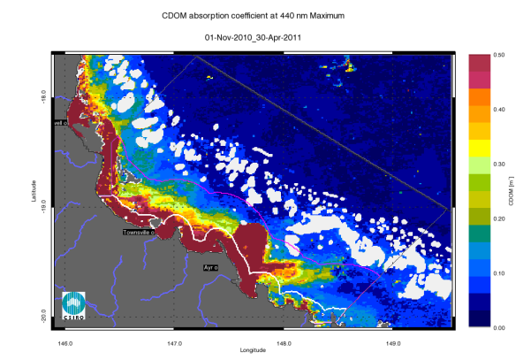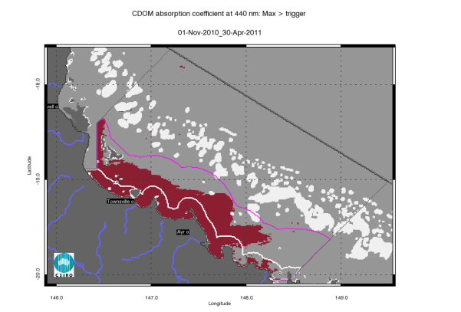
Figure 61. Map of freshwater extent for the wet season for the Burdekin region. The first map presents the maximum value of CDOM for the wet season 2010/2011 (November 2010- April 2011), while the second map presents freshwater extent estimated with a threshold for the CDOM seasonal maximum of 0.24 m⁻¹.

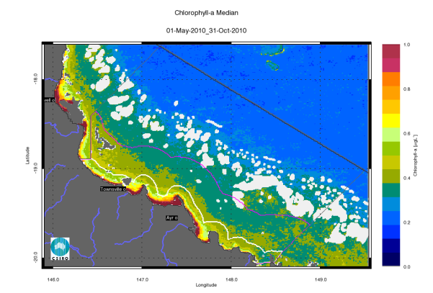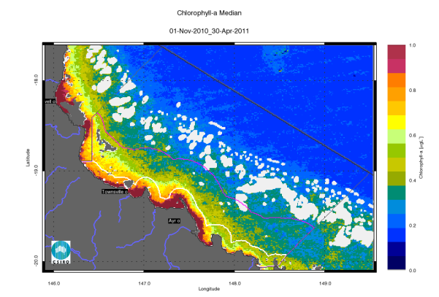
Figure 62. Chlorophyll-a median maps for the dry and wet season for the Burdekin region. The first map presents the median for the dry season 2010 (May - October), while the second map presents the median for the wet season 2010/2011 (November 2010- April 2011). The seasonally adjusted Guideline values for Chlorophyll–a for the dry/wet season are 0.32/0.63 µg L⁻¹ for Open Coastal and Midshelf and 0.28/0.56 µg L⁻¹ for Offshore.

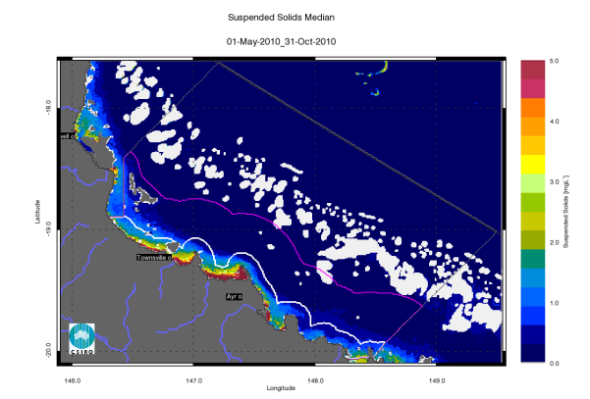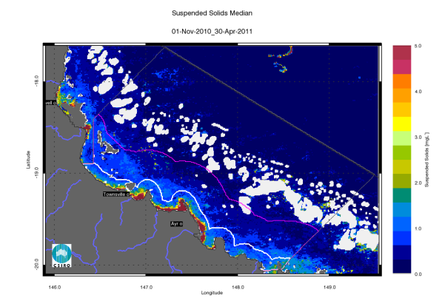
Figure 63. Non-algal particulate matter (NAP as a measure of TSS) median maps for the dry and wet season for the Burdekin region. The first map presents the median for the dry season 2010 (May - October), while the second map presents the median for the wet season 2010/2011 (November 2010- April 2011).

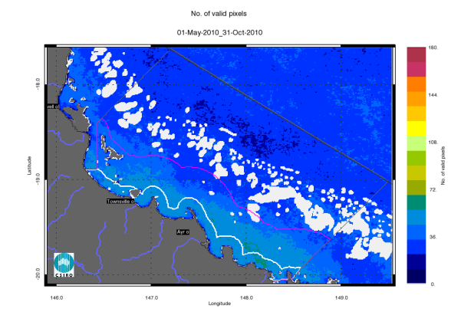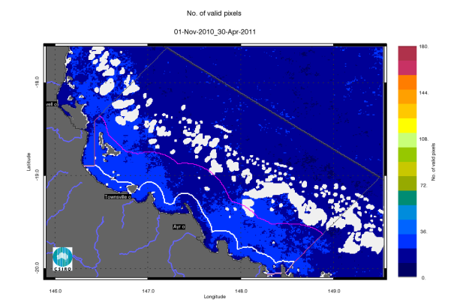
Figure 64. Number of observations used to calculate the median maps (Figure 62 - Figure 63) for the dry and wet season for the Burdekin region. The first map presents the number of observations available for analysis in the dry season 2010 (May - October), while the second map presents the number of observations available for analysis in the wet season 2010/2011 (November 2010- April 2011).
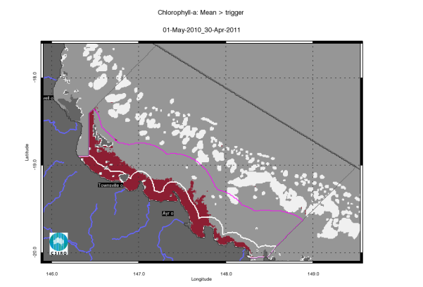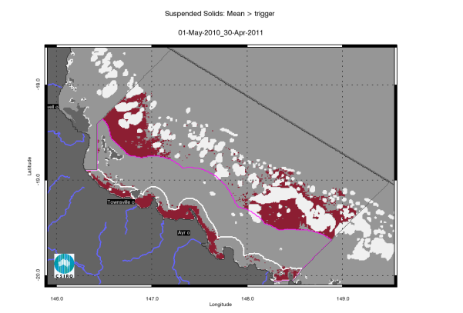
Figure 65. Exceedance maps for the Burdekin region for the whole year (May 2010 –April 2011). The first map presents the Chlorophyll-a exceedance map, while the second map presents the Non-algal particulate matter (NAP as a measure of TSS) exceedance map. The Guideline values for annual means of Chlorophyll–a are 0.45 µg L⁻¹ for Open Coastal and Midshelf and 0.40 µg L⁻¹ for Offshore, while for TSS are 2.0 and 0.7 mg L⁻¹.
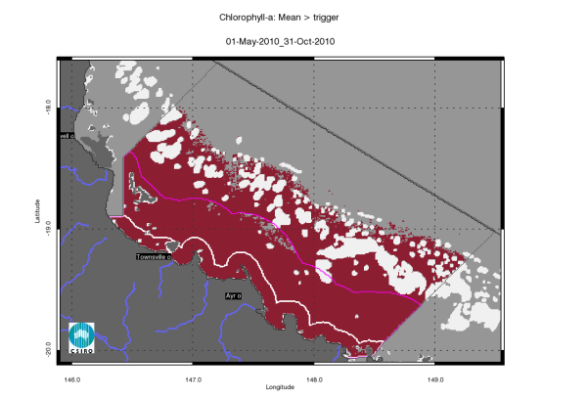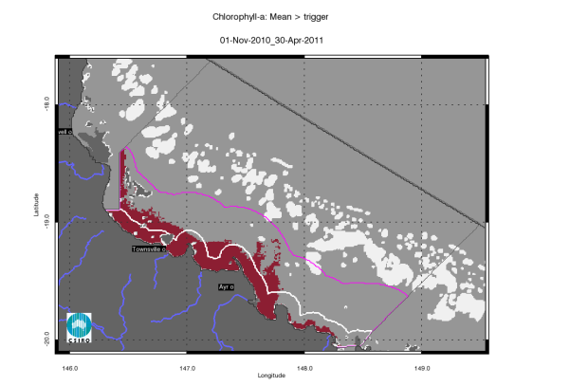
Figure 66. Chlorophyll-a exceedance maps for the dry and wet season for the Burdekin region. The first map presents the exceedance for the dry season 2010 (May - October), while the second map presents the exceedance for the wet season 2010/2011 (November 2010- April 2011). The seasonally adjusted Guideline values for Chlorophyll –a for the dry/wet season are 0.32/0.63 µg L⁻¹ for Open Coastal and Midshelf and 0.28/0.56 µg L⁻¹ for Offshore.
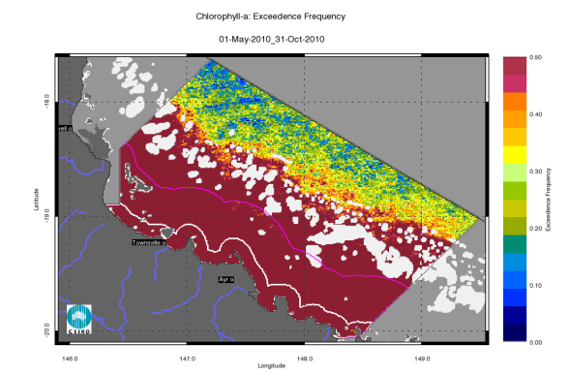
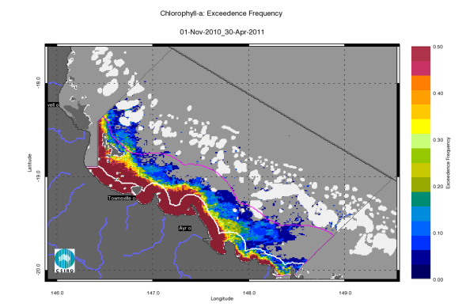
Figure 67. Chlorophyll-a exceedance frequency maps for the dry and wet season for the Burdekin region. The first map presents the exceedance frequency for the dry season 2010 (May - October), while the second map presents the exceedance frequency for the wet season 2010/2011 (November 2010- April 2011). The seasonally adjusted Guideline values for Chlorophyll–a for the dry/wet season are 0.32/0.63 µg L⁻¹ for Open Coastal and Midshelf and 0.28/0.56 µg L⁻¹ for Offshore.
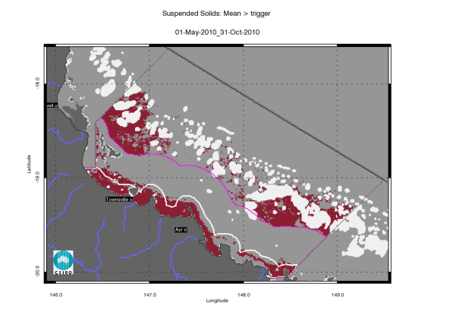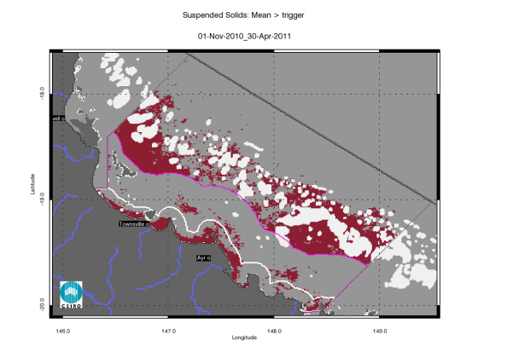
Figure 68. Non-algal particulate matter (NAP as a measure of TSS) exceedance maps for the dry and wet season for the Burdekin region. The first map presents the exceedance for the dry season 2010 (May - October), while the second map presents the exceedance for the wet season 2010/2011 (November 2010- April 2011). The seasonally adjusted Guideline values for TSS for the dry/wet season means are 1.6/2.4 mg L⁻¹ for Open Coastal and Midshelf and 0.6/0.8 mg L⁻¹ for Offshore.
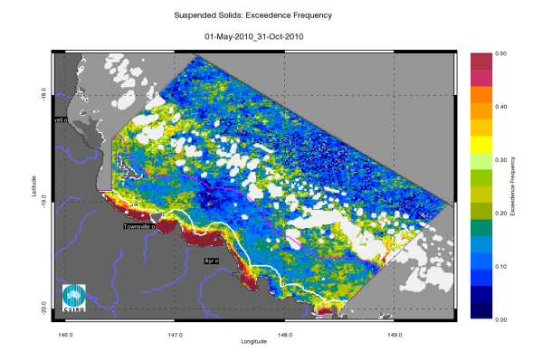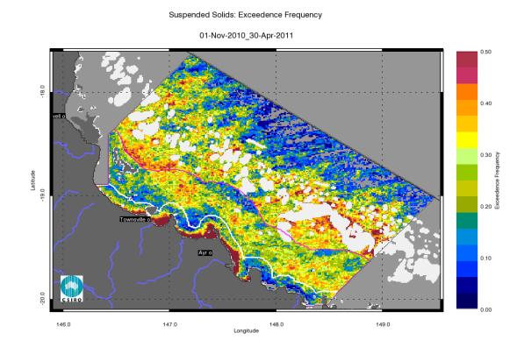
Figure 69. Non-algal particulate matter (NAP as a measure of TSS) exceedance frequency maps for the dry and wet season for the Burdekin region. The first map presents the exceedance frequency for the dry season 2010 (May - October), while the second map presents the exceedance frequency for the wet season 2010/2011 (November 2010- April 2011).

Regional reports: Mackay Whitsunday region
The Mackay Whitsunday Region is located in the central section of the GBR and comprises three major river catchments, the Proserpine, O’Connell (both flowing into Repulse Bay) and Pioneer catchments. The climate in this region is wet or mixed wet and dry and the catchment land use is dominated by agriculture such as grazing and cropping (mainly sugarcane on coastal plains), and minor urbanisation (Johnson et al. 2011). The adjacent coastal and inshore marine areas have a large number of high continental islands with well-developed fringing reefs.

Assessment of freshwater extent during the wet season
Figure 72 reports the freshwater extent for wet season 2010/2011 (November 2010- April 2011) for the Mackay Whitsunday region. The freshwater extent was estimated by applying a threshold of 0.24 m⁻¹ for the CDOM seasonal maximum. For the Mackay-Whitsunday region the freshwater extent for the wet season 2010/2011 (November 2010- April 2011) was 4484 km², 4940km² for 2009/10 while in the wet season 2008/2009 was 3105 km² (Figure 70). The larger freshwater extents for 2010/2011 and 2009/10 correlates with a freshwater discharge for the Proserpine, O’Connell, Pioneer and Plane Rivers above median flows for both years (R²=0.591, Figure 70, Figure 27). High CDOM values and associated estimated freshwater extent in the Southern part on this reporting region are most likely due to the large flood event that occurred in January 2011 in the Fitzroy River.
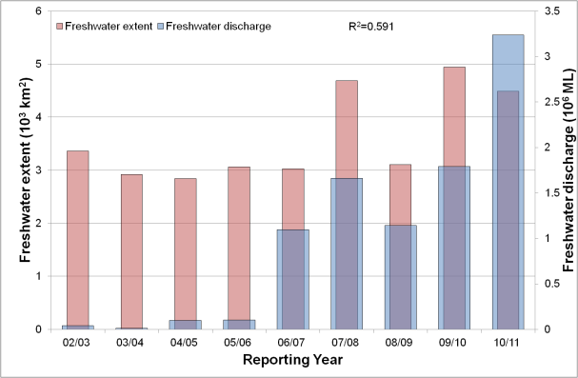
Figure 70. Freshwater discharge and estimated freshwater extent for the Mackay Whitsunday region based on the CDOM maximum for the wet seasons.

The wet and dry season median maps for Chlorophyll-a and Total Suspended Solids.
The wet and dry season CHL median maps (Figure 73) for the Mackay Whitsunday region show high CHL median concentrations near the coast and in the estuary to lower concentrations towards the East. Median CHL values ranging from 0.4 to 0.5 gL⁻¹ extended beyond the coastal to inshore boundary for both seasons. The median values in the Offshore region in the reef matrix ranged from ~0.15-0.25 gL⁻¹. In the Midshelf and Offshore areas a ~50 km wide band of waters on the western side of the reef matrix showed higher values in the dry season (~0.4 gL⁻¹) than in the wet season (~0.3 gL⁻¹). This is most likely due to the effects of the wet seasons occurring in May/June as shown in the anomaly analysis carried out in section 3 for the Burdekin Region (Figure 14).
The wet and dry season median NAP maps (as a measure of Total Suspended Solids) (Figure 74) for the Mackay Whitsunday region show a coastal band ~5-10 km wide with values higher than 1.5-2.0 mgL⁻¹ in the dry season and 2.5-3.0 mgL⁻¹ in wet season. The high concentrations shown in Broad Sound and Shoalwater Bay are likely to be overestimated. The accuracy of the retrieval from MODIS imagery in these shallow and turbid waters systems cannot be assessed as there is no data available for parameterization and validation. The number of observations per each location available for calculating the median values varies from 30 to 40 observations for the wet season and about 50-70 for the dry season for each pixel location (Figure 75).

Assessment of the marine water quality index and the exceedance of water quality guidelines
The marine water quality for this reporting year for the Mackay Whitsunday region was scored as “poor”, reflecting a “poor” score for P2R_CHL and “very poor” for P2R_TSS (Figure 71). The marine water quality index has been oscillating between “poor” and “moderate” since the 2002/03 reporting season. The P2R_CHL scores were “good” between the 2003/04 and the 2009/10 reporting seasons, while the P2R_TSS scores were “very poor” from 2002/03 and the 2008/09. For the Mackay Whitsunday region, there was no clear correlation between the marine water quality index or the component scores with the freshwater discharges from the Proserpine, O’Connell and Pioneer catchments and the associated estimated freshwater plume extents (Figure 70).
For the Mackay Whitsunday region the annual mean CHL values exceeded the guideline value (0.45 gL⁻¹) for 71% of the Open Coastal area and 9% of the Midshelf areas (Figure 76, Table 25). The mean CHL values exceeded the Guidelines values for 99% of the Open Coastal area in the dry season and 44 % in the wet season. The mean CHL values exceeded the Guidelines in the wet season only in a ~5-km wide coastal band extending to ~10 km, corresponding to the river mouths of Proserpine, O’Connell, Pioneer and Plane Rivers. In the dry season EG for CHL was observed for 98 % of the Midshelf and 68% of the Offshore areas (Figure 77, Table 26). Similar exceedance values were retrieved if the median was used for the assessment (i.e. for EF > 0.50 in Figure 78, Table 25, Table 26).

Figure 71. Paddock to Reef marine water quality index (P2R_WQI) and component scores (P2R_CHL and P2R_TSS) for the Mackay Whitsunday region based on the assessment of exceedance to the Guidelines.

The mean values of TSS exceeded the Guidelines values for 59 % of the Open Coastal area in the dry season and 69 % in the wet season, for 55% of the Midshelf in the dry season and for 29% in the wet season, and 67% of the Offshore area in the dry season and for 62% in the wet season. The estimated exceedance for the all areas was significantly lower for the median values that those for the mean values (Figure 80, and Table 27). Over the whole year, EG was recorded for TSS in 84% of the Open Coastal, 41% of the Midshelf and 65% of Offshore areas (Figure 76, Table 25). The spatial patterns in exceedance were affected by the coastal to offshore gradients that can be observed in the median maps (Figure 73, Figure 74) and by the steep changes in trigger values between the Midshelf and Offshore areas (Table 2 and Table 3).
Table 28 and Table 29 report the Summary of exceedance for both variables, providing mean and median concentrations computed on all the valid observations for each water body for each season, along with the EFEF for that period. These metrics are based on a high number of observations (ranging from 90 thousand valid observations for Open Coastal area in the wet season to over 1.1 million for the Offshore area in the dry season). According to these metrics both the mean and the median CHL values exceeded the Guidelines values for the Open Coastal area in both seasons, while the mean TSS concentrations exceeded the Guidelines values for the Open Coastal area and Offshore area in both seasons. The mean and median values for the TSS concentration differed substantially (for all water bodies and seasons). The mean values were ~ 2-3 times higher than medians.

Table 25 Summary of the annual exceedance maps for Chlorophyll-a and Total Suspended Solids for the Mackay-Whitsunday region. "Surface Area" is the surface area in square kilometres for each of the three reporting water bodies for this region: (OC: Open Coastal, MS: Midshelf, OS: Offshore), “Number valid obs." is the number of pixels with valid observations (i.e. cloud-free and error-free pixels), "Number total obs." provides the total number of observations, "Mean > trigger" and "Median > trigger" report the relative area for each water body where the mean or the median exceeded the trigger value.
 |  | 01-May-2009 - 30-Apr-2010 |  | Chlorophyll-a |  | Total Suspended Solids
 | Surface Area | Number valid obs. | Number total obs. | Mean > trigger | Median > trigger | Mean > trigger | Median > trigger
OC | 4576 | 308970 | 1560416 | 71% | 69% | 84% | 31%
MS | 11389 | 719656 | 3883649 | 9% | 8% | 41% | 9%
OS | 25580 | 1328277 | 8722780 | 0% | 1% | 65% | 1%

Table 26. Summary of the exceedance maps for Chlorophyll-a for the dry and wet season for the Mackay Whitsunday region (Figure 77, Figure 78). Column and row labels are described in the legend of Table 25.
 |  | 01-May-2010 - 31-Oct-2010 |  |  |  | 01-Nov-2010 - 30-Apr-2011
 | Surface Area | Number valid obs. | Number total obs. | Mean > trigger | Median > trigger | Number valid obs. | Number total obs. | Mean > trigger | Median > trigger
OC | 4576 | 210280 | 741312 | 99% | 99% | 98690 | 819104 | 44% | 35%
MS | 11389 | 479203 | 1845018 | 90% | 98% | 240453 | 2038631 | 3% | 2%
OS | 25580 | 894087 | 4143960 | 71% | 68% | 434190 | 4578820 | 0% | 0%

Table 27. Summary of the exceedance maps for Non-algal particulate matter (NAP as a measure of TSS) for the dry and wet season for the Mackay Whitsunday region (Figure 79, Figure 80). Column and row labels are described in the legend of Table 25.
 |  | 01-May-2010 - 31-Oct-2010 |  |  |  | 01-Nov-2010 - 30-Apr-2011
 | Surface Area | Number valid obs. | Number total obs. | Mean > trigger | Median > trigger | Number valid obs. | Number total obs. | Mean > trigger | Median > trigger
OC | 4576 | 210280 | 741312 | 91% | 59% | 98690 | 819104 | 69% | 28%
MS | 11389 | 479203 | 1845018 | 55% | 16% | 240453 | 2038631 | 29% | 9%
OS | 25580 | 894087 | 4143960 | 62% | 3% | 434190 | 4578820 | 67% | 14%

Table 28. Summary of Chlorophyll-a exceedance for the dry and wet season for the Mackay Whitsunday region. “Number valid obs." is the number of pixels with valid observations (i.e. cloud-free and error-free pixels) for each of the three reporting water bodies for this region: (OC: Open Coastal, MS: Midshelf, OS: Offshore), "Number total obs." provides the total number of observations. Mean and median are presented in red and bold if they exceed the trigger value in the Guidelines. The seasonally adjusted Guideline values for Chlorophyll-a for the dry/wet season are 0.32/0.63 µg L⁻¹ for Open Coastal and Midshelf and 0.28/0.56 µg L⁻¹ for Offshore.
 | 01-May-2010 - 31-Oct-2010 |  |  |  |  | 01-Nov-2010 - 30-Apr-2011
 | Number valid obs. | Number total obs. | Mean | Median | EF | Number valid obs. | Number total obs. | Mean | Median | EF
OC | 210280 | 741312 | 0.54 | 0.46 | 83% | 98690 | 819104 | 0.75 | 0.58 | 40%
MS | 479203 | 1845018 | 0.37 | 0.39 | 69% | 240453 | 2038631 | 0.45 | 0.44 | 14%
OS | 894087 | 4143960 | 0.32 | 0.32 | 59% | 434190 | 4578820 | 0.29 | 0.25 | 0%

Table 29. Summary of Non-algal particulate matter (NAP as a measure of TSS) exceedance for the dry and wet season for the Mackay Whitsunday region. Column and row labels are described in the legend Table 23. Mean and median are presented in red and bold if they exceed the trigger value in the Guidelines. The seasonally adjusted Guideline values for TSS for the dry/wet season means are 1.6/2.4 mg L⁻¹ for Open Coastal and Midshelf and 0.6/0.8 mg L⁻¹ for Offshore.
 | 01-May-2010 - 31-Oct-2010 |  |  |  |  | 01-Nov-2010 - 30-Apr-2011
 | Number valid obs. | Number total obs. | Mean | Median | EF | Number valid obs. | Number total obs. | Mean | Median | EF
OC | 210280 | 741312 | 3.40 | 1.78 | 56% | 98690 | 819104 | 3.57 | 1.89 | 35%
MS | 479203 | 1845018 | 2.33 | 0.84 | 34% | 240453 | 2038631 | 2.47 | 1.28 | 28%
OS | 894087 | 4143960 | 0.76 | 0.25 | 27% | 434190 | 4578820 | 1.28 | 0.34 | 32%

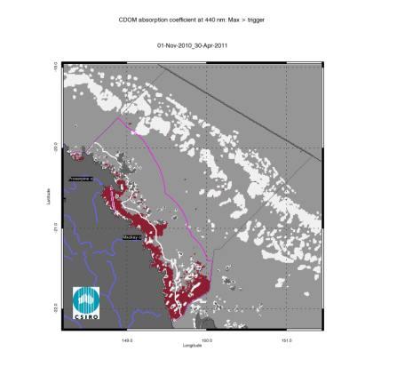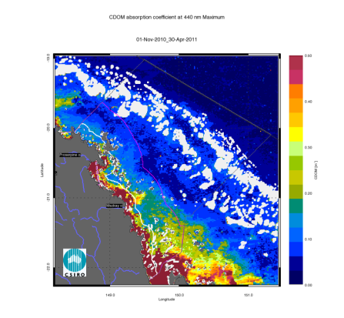
Figure 72. Map of freshwater extent for the wet season for the Mackay Whitsunday region. The first map presents the maximum value of CDOM for the wet season 2010/2011 (November 2010- April 2011), while the second map presents freshwater extent estimated with a threshold for the CDOM seasonal maximum of 0.24 m⁻¹.
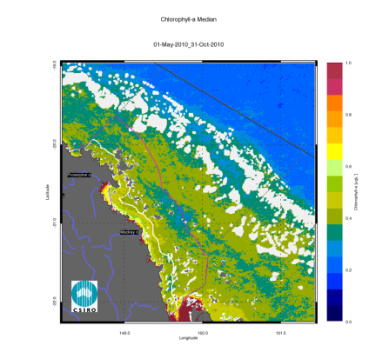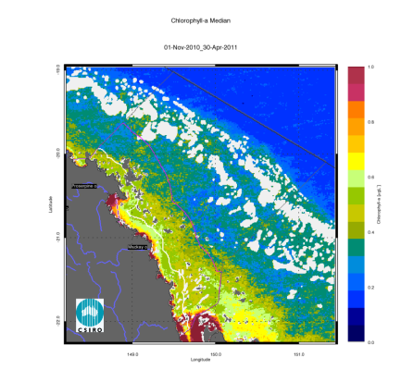
Figure 73. Chlorophyll-a median maps for the dry and wet season for the Mackay Whitsunday region. The first map presents the median for the dry season 2010 (May - October), while the second map presents the median for the wet season 2010/2011 (November 2010- April 2011). The seasonally adjusted Guideline values for Chlorophyll-a for the dry/wet season are 0.32/0.63 µg L⁻¹ for Open Coastal and Midshelf and 0.28/0.56 µg L⁻¹ for Offshore.

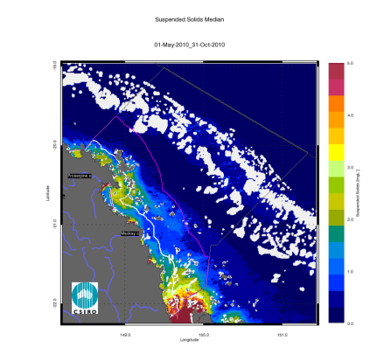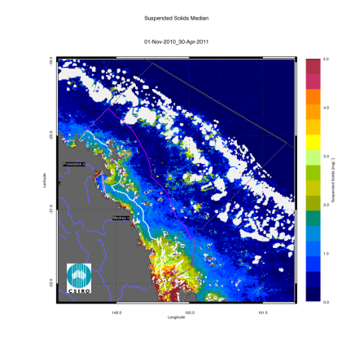
Figure 74. Non-algal particulate matter (NAP as a measure of TSS) median maps for the dry and wet season for the Mackay Whitsunday region. The first map presents the median for the dry season 2010 (May - October), while the second map presents the median for the wet season 2010/2011 (November 2010- April 2011).
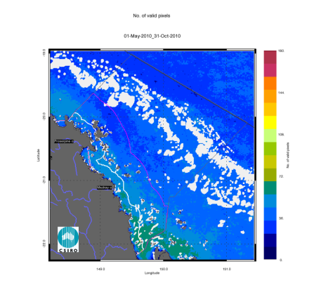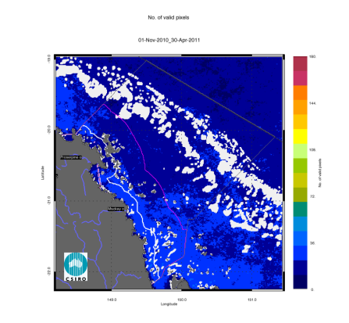
Figure 75. Number of observations used to calculate the median maps (Figure 73 - Figure 74) for the dry and wet season for the Mackay Whitsunday region. The first map presents the number of observations available for analysis in the dry season 2010 (May - October), while the second map presents the number of observations available for analysis in the wet season 2010/2011 (November 2010- April 2011).
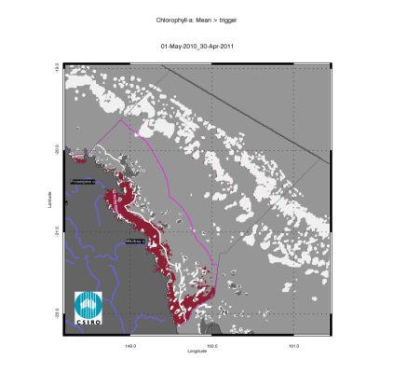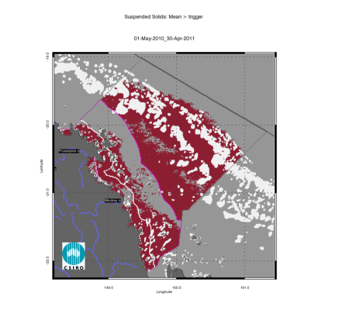
Figure 76. Exceedance maps for the Mackay Whitsunday region for the whole year (May 2010 –April 2011). The first map presents the exceedance map, while the second map presents the Non-algal particulate matter (NAP as a measure of TSS) exceedance map. The Guideline values for annual means of Chlorophyll-a are 0.45 µg L⁻¹ for Open Coastal and Midshelf and 0.40 µg L⁻¹ for Offshore, while for TSS are 2.0 and 0.7 mg L⁻¹.
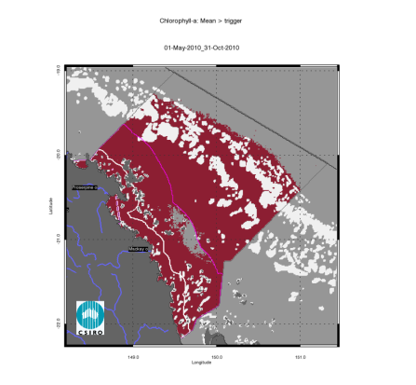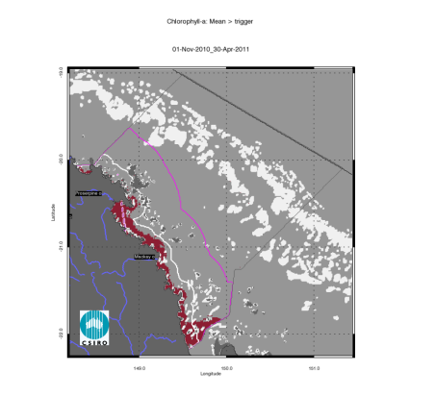
Figure 77. Chlorophyll-a exceedance maps for the dry and wet season for the Mackay Whitsunday region. The first map presents the exceedance for the dry season 2010 (May - October), while the second map presents the exceedance for the wet season 2010/2011 (November 2010- April 2011). The seasonally adjusted Guideline values for Chlorophyll-a for the dry/wet season are 0.32/0.63 µg L⁻¹ for Open Coastal and Midshelf and 0.28/0.56 µg L⁻¹ for Offshore.
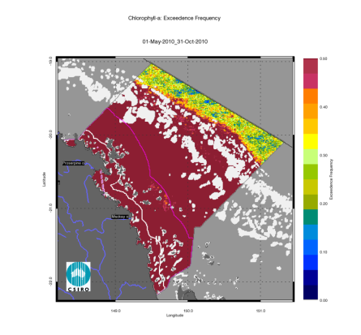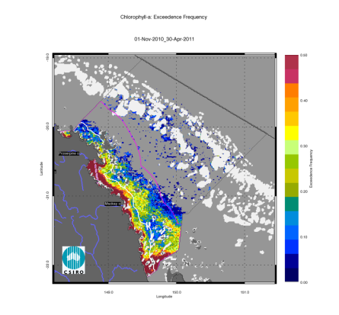
Figure 78. Chlorophyll-a exceedance frequency maps for the dry and wet season for the Mackay Whitsunday region. The first map presents the exceedance frequency for the dry season 2010 (May - October), while the second map presents the exceedance frequency for the wet season 2010/2011 (November 2010- April 2011). The seasonally adjusted Guideline values for Chlorophyll-a for the dry/wet season are 0.32/0.63 µg L⁻¹ for Open Coastal and Midshelf and 0.28/0.56 µg L⁻¹ for Offshore.
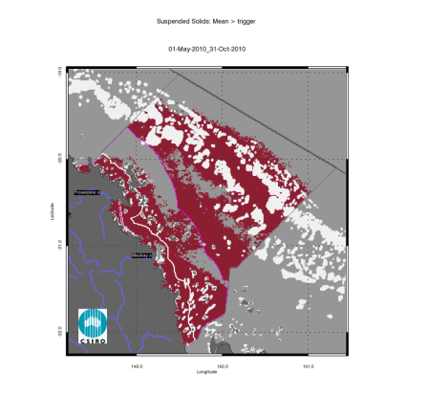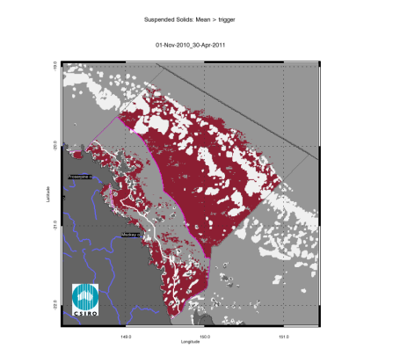
Figure 79. Non-algal particulate matter (NAP as a measure of TSS) exceedance maps for the dry and wet season for the Mackay Whitsunday region. The first map presents the exceedance for the dry season 2010 (May - October), while the second map presents the exceedance for the wet season 2010/2011 (November 2010- April 2011).
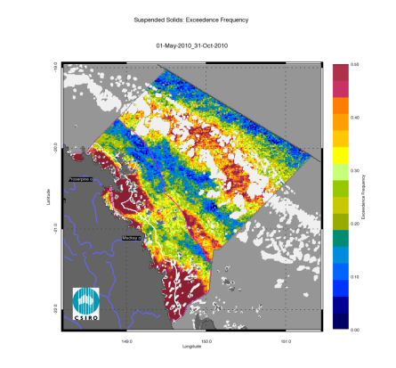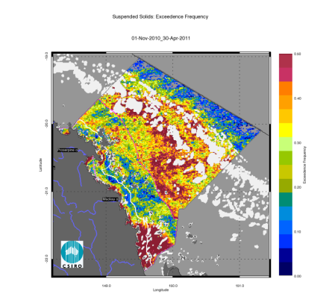
Figure 80. Non-algal particulate matter (NAP as a measure of TSS) exceedance frequency maps for the dry and wet season for the Mackay Whitsunday region. The first map presents the exceedance frequency for the dry season 2010 (May - October), while the second map presents the exceedance frequency for the wet season 2010/2011 (November 2010- April 2011).

Regional reports: Fitzroy Region
The Fitzroy Region is one of the two large dry tropical catchment regions in the GBR Region with cattle grazing as the primary land use (Brodie et al. 2003). Fluctuations in climate and cattle numbers greatly affect the state and nature of vegetation cover, and therefore, the susceptibility of soils to erosion, which leads to runoff of suspended sediments and associated nutrients (Johnson et al. 2011). The main river system influencing the region is the Fitzroy River. A strong gradient in water quality exists between the reefs in this region with increasing distance from both the coast and Fitzroy river mouth.

Assessment of freshwater extent during the wet season
This year’s flood event in the Fitzroy River was the largest since detailed flow records began in 1964. Almost 30 million Megalitres of water flowed into Keppel Bay between 21 November 2010 and 6 February 2011, with flows peaking at over 13,000 cubic metres per second. This year’s freshwater discharge was slightly larger than the 1991 floods and three times flows of the 2007/08 and 2009/10 wet seasons (Figure 27).The freshwater extent estimated by applying a threshold of 0.24 m⁻¹ for the CDOM seasonal maximum for the wet season 2010/2011 (November 2010- April 2011) shows the influence of freshwater had extended at least 80 km north of the mouth of the Fitzroy River and almost as far to the east (Figure 83). These results are consistent with observations carried out during a research voyage two weeks after the peak flows past Rockhampton (B. Robson, CSIRO, pers. comm.). The estimated freshwater extent for the whole was highly correlated to the total freshwater discharges (R²=0.882, Figure 81): the estimated freshwater extent was 14451 km², 6984 km² for the wet season 2009/10, while in the wet season 2007/08 was 7328 km² (Figure 81). High CDOM values and associated estimated freshwater extent in the southern part on this reporting region are most likely due to also to a contribution by the large flood event that occurred in December 2010/January 2011 in the Mary and Burnett Rivers.

The wet and dry season median maps for Chlorophyll-a and Total Suspended Solids.
The wet and dry season median CHL maps (Figure 84) for the Fitzroy Estuary –Keppel Bay region show high CHL near the coast and in the estuary to lower concentrations towards the east. Median CHL values of chlorophyll-a to 0.5 gL⁻¹ extended as far as the Bunker group for both seasons. Median values of ~ 0.3 gL⁻¹ were observed in the offshore area particularly in the Swain group.
The wet and dry season median NAP maps (as a measure of TSS) (Figure 85) show values higher than 3 mgL⁻¹ for a coastal band ~10 km wide, up to 50 km north of the river mouth for the wet season, while during the dry season values were higher than 3.0 mgL⁻¹ only for the area close to the river mouth. Towards the northeast of Shoalwater Bay and Broad Sound increased levels of non-algal particulate matter reach out further into the lagoon. High concentrations of NAP may be related to the strong tidal regime and re-suspension in the area. It is also likely that bottom visibility affects the accuracy of the retrieval for the shallow portion of these embayments. Care must be taken in interpreting the results for Shoalwater Bay and Broad Sound as the retrieval algorithm from the MODIS imagery was not parameterised nor validated for these waters
The maps in Figure 86 present the number of observations available for calculating the median values for each season. This amount varies from 30 to about 50 for each season for each pixel location.

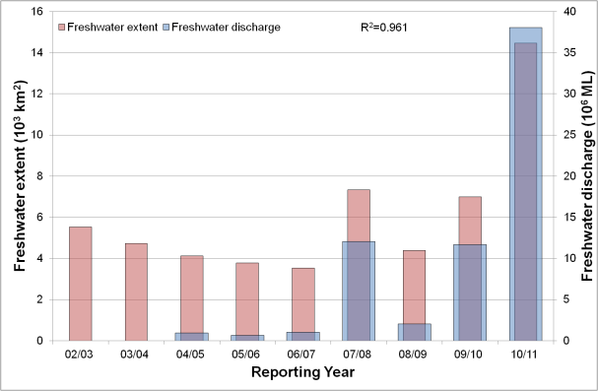
Figure 81. Freshwater discharge and estimated freshwater extent for the Fitzroy region based on the CDOM maximum for the wet seasons. Freshwater discharge was nil in 2002/2003 ad 2003/2004 wet seasons,

Assessment of the marine water quality index and the exceedance of water quality guidelines
The marine water quality for this reporting year for the Fitzroy region was scored as “poor”, reflecting a “very poor” score for P2R_CHL and “moderate” for P2R_TSS (Figure 82). The marine water quality index and the component scores have been steady as “moderate” since the 2002/03 to the 2008/09 reporting seasons. In the last two reporting years the P2R_CHL score declined to “poor” and “very poor” in response to the large flood conditions of the Fitzroy river and the associated estimated freshwater plumes extending beyond Keppel Bay (Figure 81, Figure 83).
For the Fitzroy region the annual mean CHL values exceeded the guideline value (0.45 gL⁻¹) for 97% of the Open Coastal area and 19% of the Midshelf area (Figure 87, Table 30). The seasonal mean CHL values exceeded the Guidelines values for 99% of the Open Coastal Area in the dry season and 89% in the wet season. In the dry season CHL also exceeded the Guidelines for 99 % of the Midshelf and 73% of the Offshore areas (Figure 88, Table 31). Similar exceedance values were retrieved if the median was used for the assessment ( i.e. when EF >0.50 in Figure 89, Table 30, Table 31). The seasonal mean values of TSS exceeded the Guidelines values for 55% of the Open Coastal Area in the dry season and 47 % in the wet season, for 57 % for the Offshore areas in the dry season and 45 % in the wet season (Figure 90 and Table 32). Over the whole year, exceedance of TSS Guideline values was recorded in 49% of the Open Coastal, 8% of the Midshelf and 47% of Offshore areas (Figure 87, Table 30). In the seasonal EF maps (Figure 91), low exceedance was recorded for the Midshelf and Offshore areas in both seasons if the median was used for the assessment, while the exceedance of the median values for the Open Coastal Area where significantly lower (38% for the dry season and 35% for the wet season, Figure 91, and Table 32) when compared to exceedance of the mean.
Figure 82. Paddock to Reef marine water quality index (P2R_WQI) and component scores (P2R_CHL and P2R_TSS) for the Fitzroy region based on the assessment of exceedance to the Guidelines.

As observed for other reporting regions, the spatial patterns in exceedance for both variables for the mean values (54, Figure 88, Figure 90) and the median values (Figure 89 and Figure 91 ) are affected by the coastal to offshore gradients that can be observed in the median maps (Figure 84, Figure 85) and by the steep changes in trigger values between the Midshelf and Offshore areas.
Table 33 and Table 34 report the summary of exceedance for both variables, providing mean and median concentrations computed on all the valid observations for each water body for each season, along with the EF for that period. These metrics are based on a high number of observations (ranging from 130 thousands valid observations for Open Coastal in the wet season to almost 2 million for the Offshore area in the dry season). According to these metrics both the mean and the median CHL values exceeded the Guidelines values for the all three water bodies in the dry season and in the Open Coastal area in the wet season. The mean and median values for the TSS concentration differed substantially (Table 34) for all regions and seasons. The mean values were ~ 2-3 times higher than medians. Only the mean values of TSS exceeded the Guidelines values for the Open Coastal areas for both seasons.

Table 30 Summary of the annual exceedance maps for Chlorophyll-a and Total Suspended Solids for the Fitzroy region. "Surface Area" is the surface area in square kilometres for each of the three reporting water bodies for this region: (OC: Open Coastal, MS: Midshelf, OS: Offshore), “Number valid obs." is the number of pixels with valid observations (i.e. cloud-free and error-free pixels), "Number total obs." provides the total number of observations, "Mean > trigger" and "Median > trigger" report the relative area for each water body where the mean or the median exceeded the trigger value.
 |  | 01-May-2009 - 30-Apr-2010 |  | Chlorophyll-a |  | Total Suspended Solids
 | Surface Area | Number valid obs. | Number total obs. | Mean > trigger | Median > trigger | Mean > trigger | Median > trigger
OC | 5919 | 401411 | 2036136 | 97% | 80% | 49% | 34%
MS | 18421 | 1314386 | 6336824 | 19% | 9% | 8% | 2%
OS | 48664 | 2921285 | 16740416 | 0% | 0% | 47% | 0%

Table 31 Summary of the exceedance maps for Chlorophyll-a for the dry and wet season for the Fitzroy region (Figure 88, Figure 89). Column and row labels are described in the legend of Table 30.
 |  | 01-May-2010 - 31-Oct-2010 |  |  |  | 01-Nov-2010 - 30-Apr-2011
 | Surface Area | Number valid obs. | Number total obs. | Mean > trigger | Median > trigger | Number valid obs. | Number total obs. | Mean > trigger | Median > trigger
OC | 5919 | 269173 | 964797 | 99% | 99% | 132238 | 1071339 | 89% | 79%
MS | 18421 | 871055 | 3002623 | 99% | 99% | 443331 | 3334201 | 15% | 10%
OS | 48664 | 1966434 | 7932232 | 73% | 68% | 954851 | 8808184 | 0% | 0%

Table 32 Summary of the exceedance maps for Non-algal particulate matter (NAP as a measure of TSS) for the dry and wet season for the Fitzroy region (, Figure 90, Figure 91). ). Column and row labels are described in the legend of Table 30.
 |  | 01-May-2010 - 31-Oct-2010 |  |  |  | 01-Nov-2010 - 30-Apr-2011
 | Surface Area | Number valid obs. | Number total obs. | Mean > trigger | Median > trigger | Number valid obs. | Number total obs. | Mean > trigger | Median > trigger
OC | 5919 | 269173 | 964797 | 55% | 38% | 132238 | 1071339 | 47% | 35%
MS | 18421 | 871055 | 3002623 | 14% | 3% | 443331 | 3334201 | 6% | 2%
OS | 48664 | 1966434 | 7932232 | 57% | 0% | 954851 | 8808184 | 45% | 1%

Table 33. Summary of Chlorophyll-a exceedance for the dry and wet season for the Fitzroy region. “Number valid obs." is the number of pixels with valid observations (i.e. cloud-free and error-free pixels) for each of the three reporting water bodies for this region: (OC: Open Coastal, MS: Midshelf, OS: Offshore), "Number total obs." provides the total number of observations. Mean and median are presented in red and bold if they exceed the trigger value in the Guidelines. The seasonally adjusted Guideline values for Chlorophyll-a for the dry/wet season are 0.32/0.63 µg L⁻¹ for Open Coastal and Midshelf and 0.28/0.56 µg L⁻¹ for Offshore.
 | 01-May-2010 - 31-Oct-2010 |  |  |  |  | 01-Nov-2010 - 30-Apr-2011
 | Number valid obs. | Number total obs. | Mean | Median | EF | Number valid obs. | Number total obs. | Mean | Median | EF
OC | 269173 | 964797 | 0.84 | 0.49 | 90% | 132238 | 1071339 | 1.24 | 0.75 | 67%
MS | 871055 | 3002623 | 0.38 | 0.38 | 73% | 443331 | 3334201 | 0.51 | 0.45 | 22%
OS | 1966434 | 7932232 | 0.32 | 0.33 | 60% | 954851 | 8808184 | 0.29 | 0.26 | 1%

Table 34 Summary of Non-algal particulate matter (NAP as a measure of TSS) exceedance for the dry and wet season for the Fitzroy region. Column and row labels are described in the legend of Table 33. Mean and median are presented in red and bold if they exceed the trigger value in the Guidelines. The seasonally adjusted Guideline values for TSS for the dry/wet season means are 1.6/2.4 mg L⁻¹ for Open Coastal and Midshelf and 0.6/0.8 mg L⁻¹ for Offshore.
 | 01-May-2010 - 31-Oct-2010 |  |  |  |  | 01-Nov-2010 - 30-Apr-2011
 | Number valid obs. | Number total obs. | Mean | Median | EF | Number valid obs. | Number total obs. | Mean | Median | EF
OC | 269173 | 964797 | 3.13 | 1.23 | 43% | 132238 | 1071339 | 3.14 | 1.60 | 34%
MS | 871055 | 3002623 | 1.12 | 0.26 | 19% | 443331 | 3334201 | 1.56 | 0.61 | 21%
OS | 1966434 | 7932232 | 0.64 | 0.21 | 23% | 954851 | 8808184 | 0.84 | 0.24 | 26%

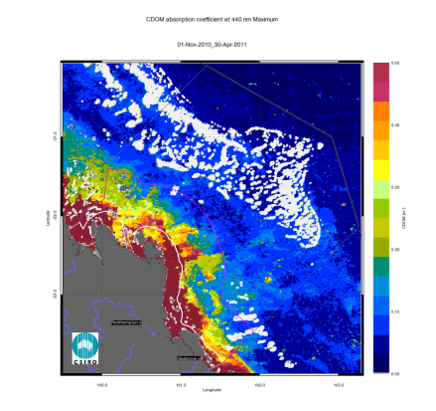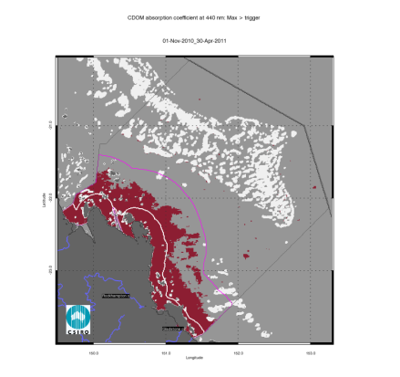
Figure 83. Map of freshwater extent for the wet season for the Fitzroy region. The first map presents the maximum value of CDOM for the wet season 2010/2011 (November 2010- April 2011), while the second map presents freshwater extent estimated with a threshold for the CDOM seasonal maximum of 0.24 m⁻¹.
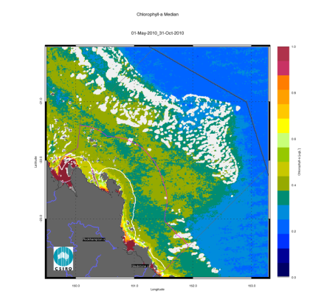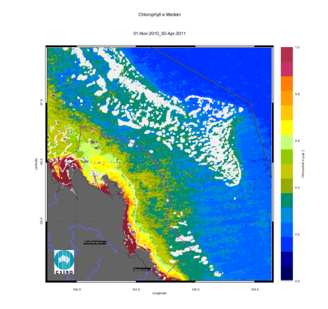
Figure 84. Chlorophyll-a median maps for the dry and wet season for the Fitzroy region. The first map presents the median for the dry season 2010 (May - October), while the second map presents the median for the wet season 2010/2011 (November 2010- April 2011).
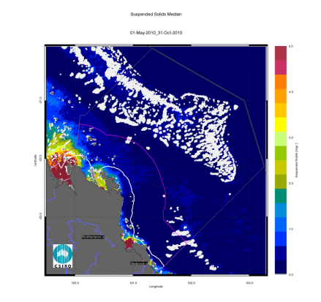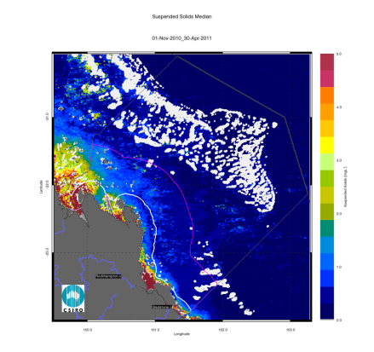
Figure 85. Non-algal particulate matter (NAP as a measure of TSS) median maps for the dry and wet season for the Fitzroy region. The first map presents the median for the dry season 2010 (May - October), while the second map presents the median for the wet season 2010/2011 (November 2010- April 2011).
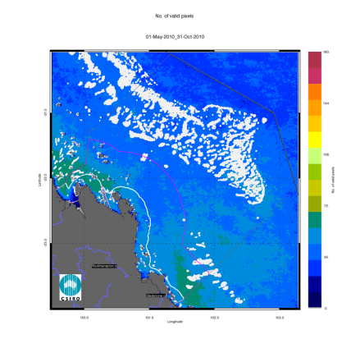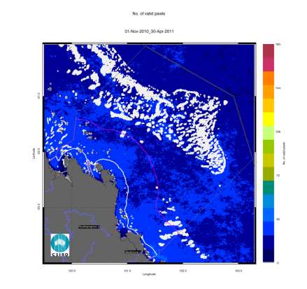
Figure 86. Number of observations used to calculate the median maps (Figure 84 - Figure 85) for the dry and wet season for the Fitzroy region. The first map presents the number of observations available for analysis in the dry season 2010 (May - October), while the second map presents the number of observations available for analysis in the wet season 2010/2011 (November 2010- April 2011).
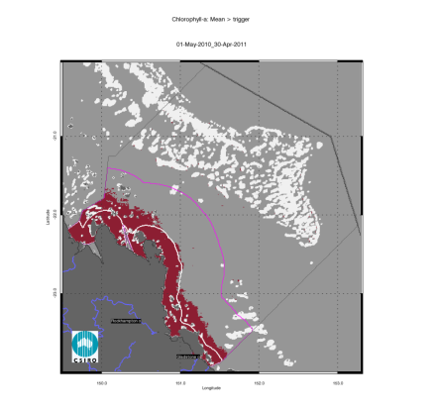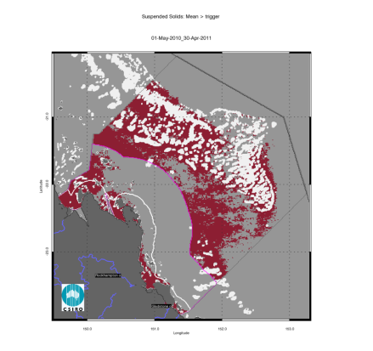
Figure 87. Exceedance maps for the Fitzroy region for the whole year (May 2010 –April 2011). The first map presents the Chlorophyll-a exceedance map, while the second map presents the Non-algal particulate matter (NAP as a measure of TSS) exceedance map. The Guideline values for annual means of Chlorophyll-a are 0.45 µg L⁻¹ for Open Coastal and Midshelf and 0.40 µg L⁻¹ for Offshore, while for TSS are 2.0 and 0.7 mg L⁻¹.
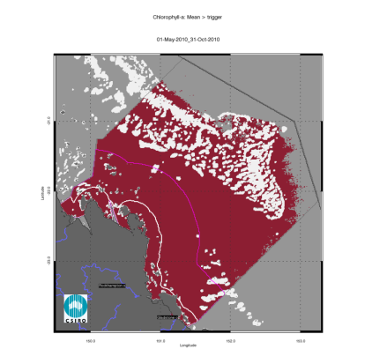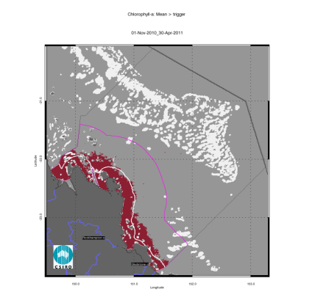
Figure 88. Chlorophyll-a exceedance maps for the dry and wet season for the Fitzroy region. The first map presents the exceedance for the dry season 2010 (May - October), while the second map presents the exceedance for the wet season 2010/2011 (November 2010- April 2011). The seasonally adjusted Guideline values for Chlorophyll-a for the dry/wet season are 0.32/0.63 µg L⁻¹ for Open Coastal and Midshelf and 0.28/0.56 µg L⁻¹ for Offshore.
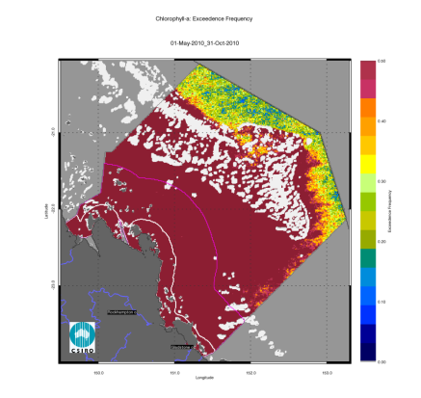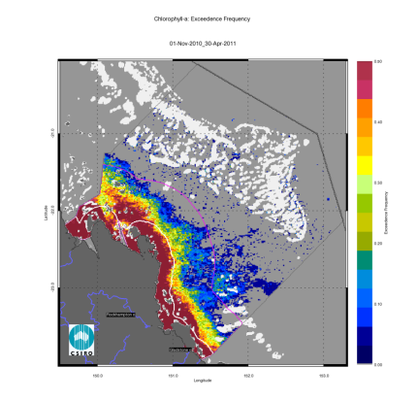
Figure 89. Chlorophyll-a exceedance frequency maps for the dry and wet season for the Fitzroy region. Top: exceedance frequency for the dry season 2010 (May - October); bottom: exceedance frequency for the wet season 2010/2011 (November 2010- April 2011). The seasonally adjusted Guideline values for Chlorophyll-a for the dry/wet season are 0.32/0.63 µg L⁻¹ for Open Coastal and Midshelf and 0.28/0.56 µg L⁻¹ for Offshore.
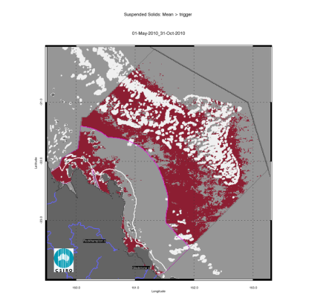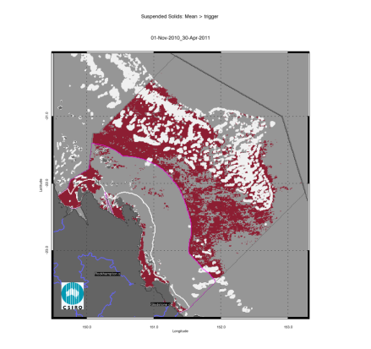
Figure 90. Non-algal particulate matter (NAP as a measure of TSS) exceedance maps for the dry and wet season for the Fitzroy region. Top: exceedance for the dry season 2010 (May - October); bottom: exceedance for the wet season 2010/2011 (November 2010- April 2011). The seasonally adjusted Guideline values for TSS for the dry/wet season means are 1.6/2.4 mg L⁻¹ for Open Coastal and Midshelf and 0.6/0.8 mg L⁻¹ for Offshore.
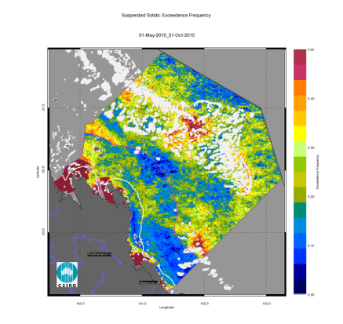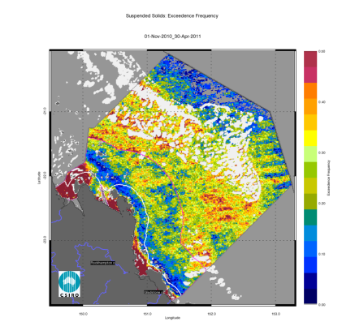
Figure 91. Non-algal particulate matter (NAP as a measure of TSS) exceedance frequency maps for the dry and wet season for the Fitzroy region. Top: exceedance frequency for the dry season 2010 (May - October); bottom: exceedance frequency for the wet season 2010/2011 (November 2010- April 2011). The seasonally adjusted Guideline values for TSS for the dry/wet season means are 1.6/2.4 mg L⁻¹ for Open Coastal and Midshelf and 0.6/0.8 mg L⁻¹ for Offshore.

Regional reports: Burnett Mary region
The Burnett Mary region is the southernmost in the GBR and is comprised of a number of catchments, though only the northernmost catchment, the Baffle Basin, is within the GBR. In this report, the estimate of freshwater extent and the assessment of compliance to the Guidelines using earth observation data is performed only for the GBRMPA section of the Burnett Mary NRM region.
Caution should be used when interpreting the results for this region as limited field information was used for the parameterization and validation on the remote sensing retrievals.

Assessment of freshwater extent during the wet season
Figure 94 reports the freshwater extent for wet season 2010/2011 (November 2010- April 2011) for the Burnett Mary region. The freshwater extent was estimated by applying a threshold of 0.24 m⁻¹ for the CDOM seasonal maximum. For the Burnett Mary region the freshwater extent for the wet season 2010/2011 (November 2010- April 2011) was 2410 km² , 985 km² for the wet season 20/09, while in the wet season 2008/09 was 335 km² (Figure 92). The high estimated freshwater extent for the last two year correlates with the record peak and flow levels recorded for Burnett and Mary Rivers floods over December 2010 and January 2011 and the large freshwater discharges of 2009/10 (Figure 27, Figure 92).
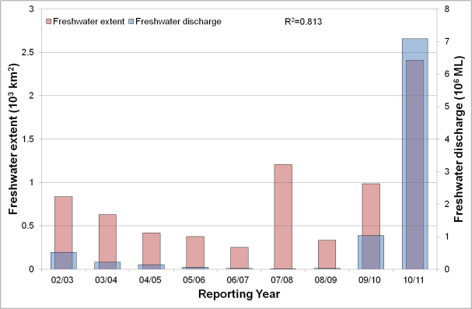
Figure 92. Freshwater discharge and estimated freshwater extent for the Cape York region based on the CDOM maximum for the wet seasons.

The wet and dry season median maps for Chlorophyll-a and Total Suspended Solids.
Both seasonal median CHL maps (Figure 95) for the Burnett Mary region show high CHL near the coast and in the estuary to lower concentrations towards the East. Median CHL values to 0.5 gL⁻¹ extended to the Offshore region reaching the Capricorn Bunker group. The wet and dry season median maps of NAP (Figure 96) for the Burnett Mary region show values higher than 2 mgL⁻¹ in the dry season and higher than 4 mgL⁻¹ in correspondence with river mouths. The high concentrations shown near Breaksea Spit are likely to be overestimated. The accuracy of the retrieval from MODIS imagery in these shallow waters systems cannot be assessed as there is no data available for parameterization and validation.
The maps in Figure 97 depict the number of observations per pixel location available for calculating the median values for each season. The maps show that this amount varies from 30 to 50 observations for both seasons for each pixel location.

Assessment of the marine water quality index and the exceedance of water quality guidelines
The marine water quality for this reporting year for the Mary Burnett region was scored as “moderate”, reflecting a “very poor” score for P2R_CHL and “good” for P2R_TSS (Figure 93). The marine water quality index and the component score have been steadily declining from 2006/07, as the P2R_CHL scores declined from “good” to “very poor” in the last five years while the P2R_TSS scores were “very good” since the 2003/04 reporting season. The “very poor” score for the P2R_CHL in the last two reporting seasons is likely to be a response to the high freshwater discharges from the Burnett and Mary Rivers and the associated estimated freshwater plume extents of the last two years (Figure 92).
For the Burnett Mary region the annual mean CHL values exceeded the guideline values (0.45 µg/L) for 96% percent of the Open Coastal area and 15% of the Midshelf area, while exceedance of TSS guideline values were recorded in 21% of the Open Coastal, none of the Midshelf and 4% of Offshore areas (Figure 98, Table 35).
The mean CHL values the Guidelines values for 97% of the Open Coastal area in the dry season and 96 % in the wet season. The dry season EG for CHL occurred in 99 % of the Midshelf and 29% of the Offshore areas (Figure 99, Table 36). Similar exceedance extents were retrieved for EF >0.50, i.e. if the median was used for the assessment (Figure 100, Table 35, Table 36). The mean values of TSS exceeded the Guidelines values for 15 % of the Open Coastal area in the dry season and for 26% in the wet season. No exceedance was estimated for TSS in the Midshelf area, while for the Offshore area a REEG of 24% was recorded in the dry season (Figure 102 , and Table 37).
Similarly to the other reporting regions, the estimated exceedance for TSS for all areas was significantly lower for the median values that those for the mean values (Figure 102 and Table 37). Also the spatial patterns in exceedance for both variables (Figure 97. Number of observations used to calculate the median maps (Figure 95 - Figure 96) for the dry and wet season for the Burnett Mary region. The first map presents the number of observations available for analysis in the dry season 2010 (May - October), while the second map presents the number of observations available for analysis in the wet season 2010/2011 (November 2010- April 2011).
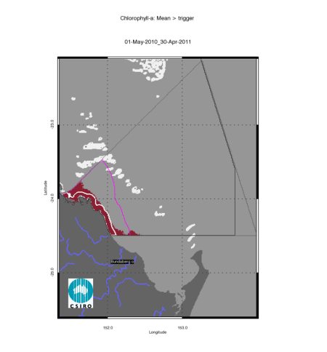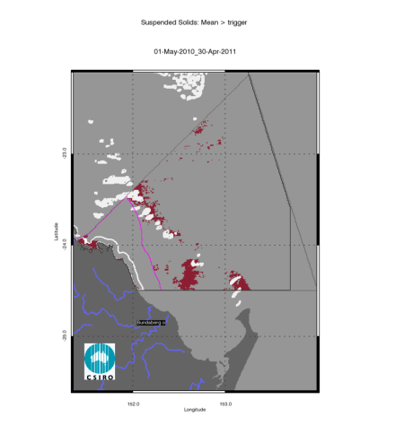
Figure 98- Figure 100) were affected by the coastal to offshore gradients observed in the median maps (Figure 95, Figure 96) and by the steep changes in trigger values between the Midshelf and Offshore areas.

Figure 93. Paddock to Reef marine water quality index (P2R_WQI) and component scores (P2R_CHL and P2R_TSS) for the Mary Burnett region based on the assessment of exceedance to the Guidelines.
Table 38 and Table 39 report the summary of exceedance for both variables , providing mean and median concentrations computed on all the valid observations for each water body for each season, along with the EFEF for that period. These metrics are based on a high number of observations (ranging from 17 thousands valid observations for Open Coastal area in the wet season to over 1.4 million for the Offshore area in the dry season). According to these metrics both the mean and the median CHL values exceeded the Guidelines values for the Open Coastal area in both seasons, and for the Midshelf in the dry season, while no exceedance were estimated for the mean TSS values. As observed for all the reporting regions the mean and median values for the TSS concentration differed substantially (for all areas and seasons). The mean values were ~ 2-3 times higher than medians.

Table 35 Summary of the annual exceedance maps for Chlorophyll-a and Total Suspended Solids for the Mary-Burnett region. "Surface Area" is the surface area in square kilometres for each of the three reporting water bodies for this region: (OC: Open Coastal, MS: Midshelf, OS: Offshore), “Number valid obs." is the number of pixels with valid observations (i.e. cloud-free and error-free pixels), "Number total obs." provides the total number of observations, "Mean > trigger" and "Median > trigger" report the relative area for each water body where the mean or the median exceeded the trigger value.
 |  | 01-May-2009 - 30-Apr-2010 |  | Chlorophyll-a |  | Total Suspended Solids
 | Surface Area | Number valid obs. | Number total obs. | Mean > trigger | Median > trigger | Mean > trigger | Median > trigger
OC | 753 | 53921 | 246231 | 96% | 71% | 21% | 1%
MS | 3401 | 277883 | 1112127 | 15% | 5% | 0% | 0%
OS | 33928 | 2119091 | 11094456 | 0% | 0% | 4% | 0%

Table 36 Summary of the exceedance maps for Chlorophyll-a for the dry and wet season for the Burnett Mary region (Figure 99, Figure 100). Column and row labels are described in the legend of Table 35.
 |  | 01-May-2010 - 31-Oct-2010 |  |  |  | 01-Nov-2010 - 30-Apr-2011
 | Surface Area | Number valid obs. | Number total obs. | Mean > trigger | Median > trigger | Number valid obs. | Number total obs. | Mean > trigger | Median > trigger
OC | 753 | 36323 | 116715 | 97% | 97% | 17598 | 129516 | 96% | 89%
MS | 3401 | 186706 | 527155 | 99% | 100% | 91177 | 584972 | 13% | 8%
OS | 33928 | 1418207 | 5258840 | 29% | 20% | 700884 | 5835616 | 0% | 0%

Table 37 Summary of the exceedance maps for Non-algal particulate matter (NAP as a measure of TSS) for the dry and wet season for the Burnett Mary region (Figure 101, Figure 102). Column and row labels are described in the legend of Table 35.
 |  | 01-May-2010 - 31-Oct-2010 |  |  |  | 01-Nov-2010 - 30-Apr-2011
 | Surface Area | Number valid obs. | Number total obs. | Mean > trigger | Median > trigger | Number valid obs. | Number total obs. | Mean > trigger | Median > trigger
OC | 753 | 36323 | 116715 | 15% | 1% | 17598 | 129516 | 26% | 18%
MS | 3401 | 186706 | 527155 | 0% | 0% | 91177 | 584972 | 1% | 0%
OS | 33928 | 1418207 | 5258840 | 24% | 0% | 700884 | 5835616 | 6% | 0%

Table 38. Summary of Chlorophyll-a exceedance for the dry and wet season for the Burnett Mary region. “Number valid obs." is the number of pixels with valid observations (i.e. cloud-free and error-free pixels) for each of the three reporting water bodies for this region: (OC: Open Coastal, MS: Midshelf, OS: Offshore), "Number total obs." provides the total number of observations. Mean and median are presented in red and bold if they exceed the trigger value in the Guidelines. The seasonally adjusted Guideline values for Chlorophyll-a for the dry/wet season are 0.32/0.63 µg L⁻¹ for Open Coastal and Midshelf and 0.28/0.56 µg L⁻¹ for Offshore.
 | 01-May-2010 - 31-Oct-2010 |  |  |  |  | 01-Nov-2010 - 30-Apr-2011
 | Number valid obs. | Number total obs. | Mean | Median | EF | Number valid obs. | Number total obs. | Mean | Median | EF
OC | 36323 | 116715 | 0.55 | 0.45 | 94% | 17598 | 129516 | 1.22 | 0.81 | 77%
MS | 186706 | 527155 | 0.36 | 0.36 | 78% | 91177 | 584972 | 0.46 | 0.39 | 15%
OS | 1418207 | 5258840 | 0.28 | 0.26 | 40% | 700884 | 5835616 | 0.25 | 0.23 | 0%

Table 39 Summary of Non-algal particulate matter (NAP as a measure of TSS) exceedance for the dry and wet season for the Burnett Mary region. Column and row labels are described in the legend of Table 38. Mean and median are presented in red and bold if they exceed the trigger value in the Guidelines. The seasonally adjusted Guideline values for TSS for the dry/wet season means are 1.6/2.4 mg L⁻¹ for Open Coastal and Midshelf and 0.6/0.8 mg L⁻¹ for Offshore.
 | 01-May-2010 - 31-Oct-2010 |  |  |  |  | 01-Nov-2010 - 30-Apr-2011
 | Number valid obs. | Number total obs. | Mean | Median | EF | Number valid obs. | Number total obs. | Mean | Median | EF
OC | 36323 | 116715 | 0.83 | 0.25 | 12% | 17598 | 129516 | 2.03 | 0.92 | 21%
MS | 186706 | 527155 | 0.43 | 0.13 | 8% | 91177 | 584972 | 0.92 | 0.33 | 16%
OS | 1418207 | 5258840 | 0.49 | 0.15 | 24% | 700884 | 5835616 | 0.52 | 0.14 | 20%

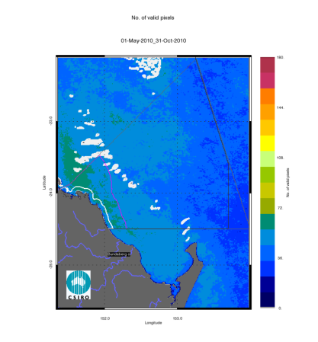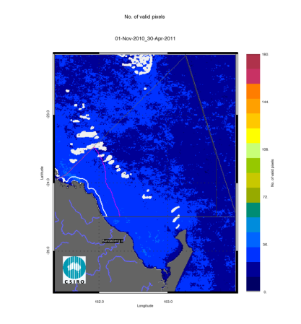
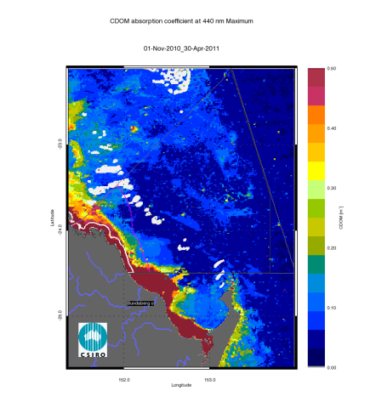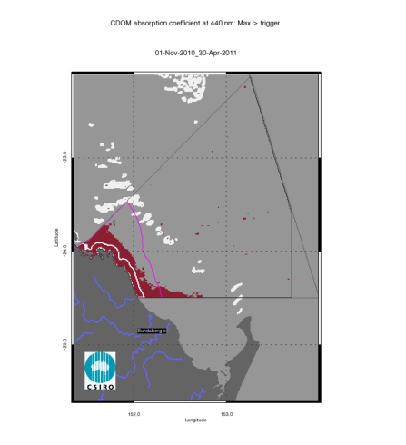
Figure 94. Map of freshwater extent for the wet season for Burnett Mary region. The first map presents the maximum value of CDOM for the wet season 2010/2011 (November 2010- April 2011), while the second map presents freshwater extent estimated with a threshold for the CDOM seasonal maximum of 0.24 m⁻¹.
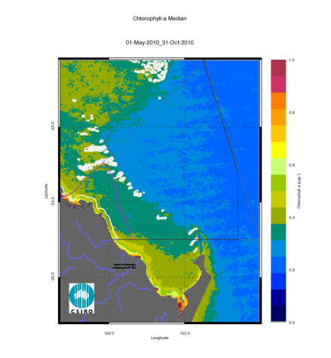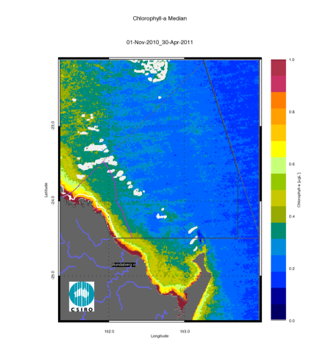
Figure 95. Chlorophyll-a median maps for the dry and wet season for the Burnett Mary region. The first map presents the median for the dry season 2010 (May - October), while the second map presents the median for the wet season 2010/2011 (November 2010- April 2011).
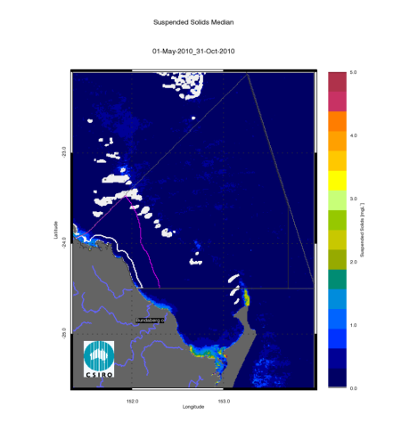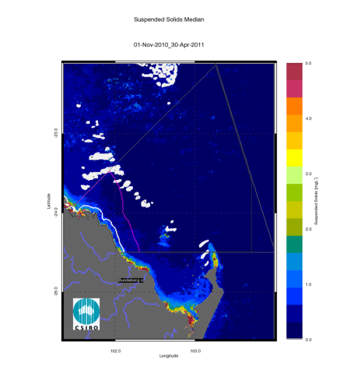
Figure 96. Non-algal particulate matter (NAP as a measure of TSS) median maps for the dry and wet season for the Burnett Mary region. The first map presents the median for the dry season 2010 (May - October), while the second map presents the median for the wet season 2010/2011 (November 2010- April 2011).
Figure 97. Number of observations used to calculate the median maps (Figure 95 - Figure 96) for the dry and wet season for the Burnett Mary region. The first map presents the number of observations available for analysis in the dry season 2010 (May - October), while the second map presents the number of observations available for analysis in the wet season 2010/2011 (November 2010- April 2011).
Figure 98. Exceedance maps for the Burnett Mary region for the whole year (May 2009 –April 2010). The first map presents the Chlorophyll-a exceedance map, while the second map presents the Non-algal particulate matter (NAP as a measure of TSS) exceedance map. The Guideline values for annual means of Chlorophyll-a are 0.45 µg L⁻¹ for Open Coastal and Midshelf and 0.40 µg L⁻¹ for Offshore, while for TSS are 2.0 and 0.7 mg L⁻¹.
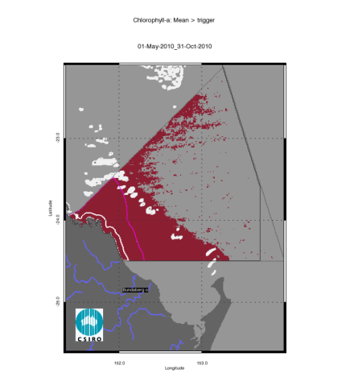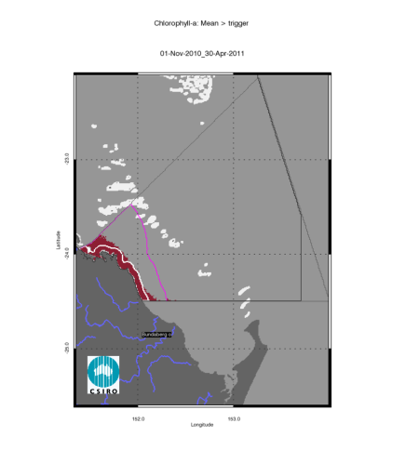
Figure 99. Chlorophyll-a exceedance maps for the dry and wet season for the Burnett Mary region. The first map presents the exceedance for the dry season 2010 (May - October), while the second map presents the exceedance for the wet season 2010/2011 (November 2010- April 2011). The seasonally adjusted Guideline values for Chlorophyll –a for the dry/wet season are 0.32/0.63 µg L⁻¹ for Open Coastal and Midshelf and 0.28/0.56 µg L⁻¹ for Offshore.
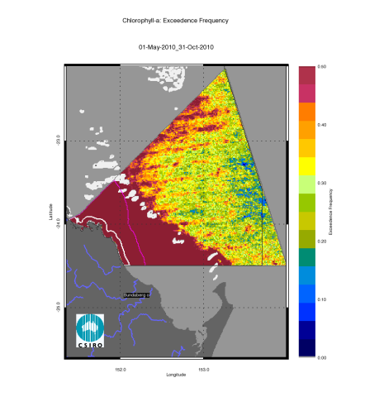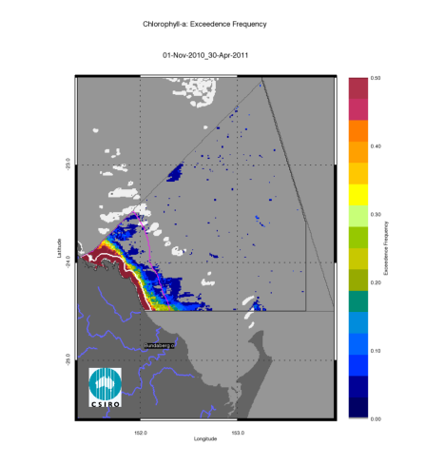
Figure 100. Chlorophyll-a exceedance frequency maps for the dry and wet season for the Burnett Mary region. The first map presents the exceedance frequency for the dry season 2010 (May - October), while the second map presents the exceedance frequency for the wet season 2010/2011 (November 2010- April 2011). The seasonally adjusted Guideline values for Chlorophyll-a for the dry/wet season are 0.32/0.63 µg L⁻¹ for Open Coastal and Midshelf and 0.28/0.56 µg L⁻¹ for Offshore.
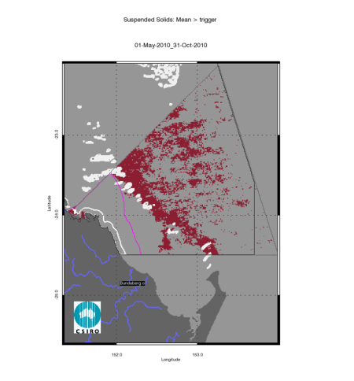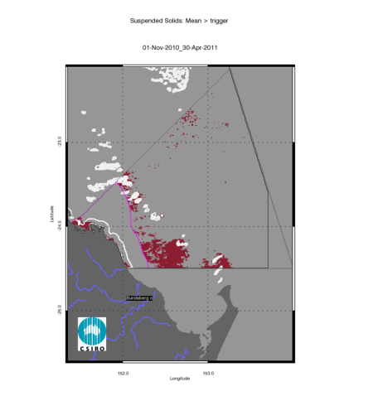
Figure 101. Non-algal particulate matter (NAP as a measure of TSS) exceedance maps for the dry and wet season for the Burnett Mary region. The first map presents the exceedance for the dry season 2010 (May - October), while the second map presents the exceedance for the wet season 2010/2011 (November 2010- April 2011). The seasonally adjusted Guideline values for TSS for the dry/wet season means are 1.6/2.4 mg L⁻¹ for Open Coastal and Midshelf and 0.6/0.8 mg L⁻¹ for Offshore.

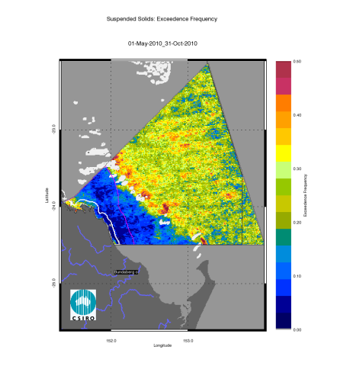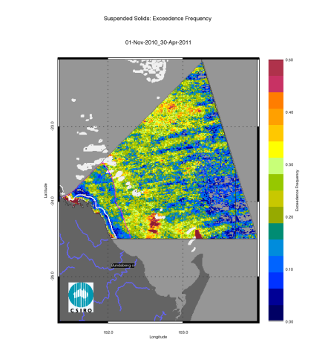
Figure 102. Non-algal particulate matter (NAP as a measure of TSS) exceedance frequency maps for the dry and wet season for the Burnett Mary region. The first map presents the exceedance frequency for the dry season 2010 (May - October), while the second map presents the exceedance frequency for the wet season 2010/2011 (November 2010- April 2011). The seasonally adjusted Guideline values for TSS for the dry/wet season means are 1.6/2.4 mg L⁻¹ for Open Coastal and Midshelf and 0.6/0.8 mg L⁻¹ for Offshore.

Conclusion and recomMendations
A cornerstone of the GBRWQPP and the WQIPs is the setting of water quality objectives against which to assess the success of the actions taken under Reef Rescue to mitigate the effects of nutrients and sediment from runoff and discharges. A key challenge is to detect and monitor the effect of the land management practices on the water quality in the GBR lagoon waters. In this system, the water quality is also influenced by the inter-annual weather variability induced by the El Niño-Southern Oscillation (ENSO) leading to large year to year variations in the distribution of rainfall events over the GBR catchments resulting in sediment laden river plumes and algal blooms.
Remote sensing is a suitable and cost-effective technique for the large-scale monitoring of coastal water quality because it provides synoptic views of the spatial distribution of several variables (CHL, CDOM and TSS and water clarity of near-surface water). At present, MODIS Aqua represents a time series (November 2002 – present) of water quality estimates with spatial coverage at 1 km resolution, nominally acquired on a daily basis (except overcast days) for the whole-of-GBR lagoon. The water quality estimates were retrieved from the MODIS Aqua time series using two coupled physics-based inversion algorithms developed to accurately retrieve water quality parameters for the optically complex waters of the GBR lagoon. This was necessary because CHL concentrations retrieved with the MODIS standard algorithms provided by NASA are inaccurate up two-fold in GBR waters (Qin et al., 2007), while regionally parameterised algorithms account for the significant variation in concentrations of CDOM and TSS and achieve more accurate retrievals.
The comparison of MODIS Aqua retrievals of CHL, CDOM and NAP with in situ data showed that the regional algorithm coupled with the ANN atmospheric correction is more accurate than NASA’s algorithms for GBR waters. The accuracy for the retrieval of CHL, CDOM and TSS with the coupled physics-based inversion algorithms was 58%, 57% and 66%, respectively. The parameterization and validation on the remote sensing retrievals was mainly based on observations performed in coastal and lagoonal waters during the dry season between Keppel Bay and the Wet Tropics. The accuracy of the retrieval is likely to be lower in shallow and turbid water systems such as Princess Charlotte Bay, Broad Sound and Shoalwater Bay where there was no data available for parameterization and validation. The Secchi Depth product is still in a development phase and should be validated using the water quality data sets used in recent studies on the spatial and temporal patterns of water quality of the Great Barrier Reef (De’ath 2007; De’ath and Fabricius 2008).
This report delivered management-relevant products from remote sensing data that provide information beyond that of a simple concentrations map to enable the relevant management agencies to make more informed management decisions.
The freshwater extent was estimated for each region from MODIS measurements within the wet season of each year by applying a threshold to maps of aggregated seasonal maximum CDOM concentrations. For this study a CDOM absorption threshold was established based a relationship between measurements of salinity and CDOM absorption (Schroeder et al. 2012) as proposed for the North and Baltic Seas (Astoreca et al. 2009; Ferrari and Dowell 1998). The high CDOM concentrations may also reflect other processes in occurring in near-shore waters, further work should also attempt to separate the plumes from non-plume effects.
The freshwater extent based on the CDOM maximum provides a conservative estimate of the extent as the flood plumes could have extended further in cloudy or overcast days and hence may not been captured with the satellite imagery. However as the proposed method is biased by cloud cover and quality flagging of erroneous pixels, the most comprehensive way of assessing freshwater extent into the GBR will be a combination of in-situ sampling and satellite observations (augmented by aerial surveys where and when feasible). The extent and inter-annual variability of freshwater plumes in the Great Barrier Reef lagoon was found to be highly correlated with river flow data from stream gauges (R²=0.881). The estimated freshwater extent for 2010//11 was the largest since 2002/03 for all regions except the Mackay Whitsunday, reflecting flow conditions two to five times above median levels for most of the catchments in the GBR.
The Guidelines provide triggers for management action where exceedance occurs and threshold levels for analysis of current condition as well as trend monitoring. The exceedance assessment results evaluated for CHL and TSS were presented a as maps illustrating the exceedance of the Guidelines (EG) and the exceedance frequency (EF). The spatial patterns in EG and EF were function of the coastal to offshore gradients that can be observed in the median maps and of the steep changes in trigger values between the Midshelf and Offshore areas.
The large flows that occurred in 2010/11 through the Great Barrier Reef catchments provided a large influx of sediments, nitrogen and phosphorus to coastal waters, which in turn led to a boost in phytoplankton productivity and secondary production. The marine water quality for this reporting year for the whole GBR was scored as “poor”, reflecting the “poor” score for P2R_WQI for most reporting regions (only the Burnett Mary scored as “moderate”). The scores for the two component indicators for the whole GBR were “very poor” for P2R_CHL and “moderate” for P2R_TSS, reflecting the “very poor” to “poor” regional scores for P2R_CHL and “very poor” to “good” regional scores from P2R_TSS. The marine water quality index was lower than for the previous reporting years for all regions, as well as the whole GBR. For all reporting regions the REEG values for CHL in Open Coastal waters (71-97% of relative area of the water body) were higher than the two previous reporting periods (56-83 % for 2009/10 and 51-84% for 2008/09). Also TSS REEG values were higher than in the previous reporting year (21-84% of relative area of the water body in 2010/11 compared to 12-69 % for 2009/10).The higher REEG rates in CHL and TSS (and the derived low scores for P2R_CHL and P2R_TSS) reflected the large flow conditions in most of the catchments in the GBR and associated freshwater extent in all reporting regions. The Open Coastal water body includes also all the Enclosed coastal waters which have not been delineated by GBRMPA. As the guideline values for CHL and TSS for the Enclosed Coastal waters are higher than those for the Open Coastal water body, the relative area of non-compliance for the Open Coastal is likely to be over-estimated, leading to a possible under-estimate of P2R_CHL, P2R_TSS and P2R_WQI scores. This report included a case study on the Burdekin region where large differences in the CHL signal were observed when the Open Coastal waters was compared to merged nearshore-coastal water, thus quantifying the effects of a delineation the Enclosed Coastal water body on the estimate of median values for the Burdekin coastal waters. It is recommended to GBRMPA to delineate the Enclosed Coastal water body. The data used in this report will still be available and could be re-examined for consistency across both baseline reporting year as well as future out years.
Consistently with previous reporting years, large areas of TSS exceedance occurred in Offshore areas, particularly in the Mackay-Whitsunday and Fitzroy reporting regions. These large areas of exceedance of the mean annual TSS values may be due to either an over-estimate of the mean TSS concentrations in Offshore waters or to a low guideline threshold value. Future work should attempt to assess the accuracy of TSS and CHL retrieval from satellite data at a regional and seasonal scale, if enough validation data points become available. It is recommended to GBRMPA that, consistently with the adaptive monitoring paradigm (Lindenmayer and Likens 2009), a re-assessment of the Guidelines threshold values, as well as the regional and seasonal adjustments, is carried out as part of the Guidelines review cycle.
The number of available observations was significantly lower in the wet season than the dry season in all regions. This was mainly due to the higher cloud cover and aerosol concentration in the wet season. It is possible that cloud cover introduces a bias in the sampling if the remote sensing imagery does not effectively capture the extreme values in concentrations of CHL and TSS during and following flood events. The estimate of the mean values for the wet season, and to a lesser extent for the whole year, are more likely to be affected than the estimate of the median values by the "non-sampling" of the higher values due to cloud cover. In an attempt to address this issue, in this report the exceedance of the Guidelines for CHL and TSS was evaluated by comparing the mean as well as the median values of the variables to the appropriate seasonal and regional values, even if the mean values are identified in the Guidelines. Also, the effect of calculating a mean value for a given location based on 6-8 samples in a year or 100-200 values is quite different from a statistical sampling design perspective, as the distribution of the effective sampling due to the cloud cover may bias the estimate of mean values. These implementation issues should be included by GBRMPA in the scope of a review of the Guidelines.
Given the size and variability of conditions within the GBR, monitoring and assessment to meet these requirements is challenging. The MMP water quality monitoring uses three complementary approaches to collect data at various spatial (site, location, region, and whole GBR lagoon) and temporal (snapshot, daily, 10-minutely) scales: traditional direct water sampling from research vessels, in situ data loggers at a small number of selected inshore reef locations and remote sensing techniques. While data loggers provide detailed information on the local variability in water quality parameters, remote sensing observations provide extensive spatial coverage at 1 km resolution.
Comparison of the remote sensing based water quality monitoring with other MMP components like the site-specific inshore water quality monitoring shows some level of disagreement for regions, mainly due to the differences in the temporal and spatial scales of the data collection. The interim water quality index proposed in Schaffelke et al. (2011) provides a detailed, albeit site-specific, assessment of inshore water quality for twenty fixed sampling locations across the Open Coastal and Midshelf water bodies in the GBRWHA. The interim water quality index (Schaffelke et al. 2011) suggest a higher rate of compliance than the remote sensing based assessment of this study. For example, the site-specific assessments for the Wet Tropics Region found that all sites were within the CHL Guidelines when assessed with logger data and only two sites exceeded guidelines values when using water samples data (Schaffelke et al. 2011), while the EG results of this report show that the annual mean values of CHL were above the guideline in 93% of the area of the Open Coastal and 31% of the Midshelf water body in the 2010/11. In the Fitzroy region the site-specific assessments show that for the Open Coastal water body both sites exceeded CHL guidelines values for logger and water samples data and the only site in the Midshelf water body was compliant to the Guidelines (Schaffelke et al. 2011). These results appear in close agreement with the remote sensing based estimates for this region of 97 % and 19% of the area of EG for the Open Coastal and the Midshelf water body respectively.
Given the spatial and temporal complexity of the water quality in the GBR lagoon, the development of an integrated assessment and reporting framework is needed to provide a comprehensive and more easily interpretable assessment of GBR water quality. A separate research project carried out with Reef Rescue Research and Development funding for 2011-13 will further develop the exceedance/compliance metrics and identify how to combine the assessment over more variables to provide a high degree of confidence in these results. This will enable these datasets to meet the requirements of the reasonable assurance statements and the monitoring and modelling strategies for the Paddock to Reef reporting.
This report included a case study on the Burdekin region, showcasing how the spatial and temporal density of the MODIS Aqua data set allowed us description of the spatial and temporal patterns in water quality across the GBR lagoon. These patterns include short-term responses in water quality related to meteorological and hydrological variables, such as rainfall and flow discharges, as well as longer-term responses to anthropogenic impacts such as land management practices and policy driven changes. Separating the variability attributed to the ENSO-induced inter-annual weather variability from the anthropogenic factors is probably the central challenge to monitoring the condition of the GBR and of assessing the effectiveness of remediation measures. However, as the length of the data record grows, it will become easier to separate these sources of variability so that additional information can be obtained about the effects of land management practices and policy initiatives on water quality in the GBR lagoon and outer waters. Future work to achieve these results would include:
- Improving the accuracy of chlorophyll-a detection in the wet season in the outer lagoon and reef matrix for both sensors. This will be based on a re-analysis of existing optical data sets for dry and wet season, combined with the data collected at the Integrated Marine Observing System (IMOS) facilities, namely the Lucinda Jetty Coastal Observatory and the National Reference Station moored at the Yongala wreck.
- Assessing the value for remote sensing validation of CHL data from GBROOS/IMOS underway sampling, and from the AIMS/MMP autonomous water quality loggers and moorings.
- Characterizing the detection limits for each of the water quality variables (CHL, TSS, CDOM and water clarity) for environmental conditions ranging from high flow turbid river plumes to dry season wind-driven resuspension to outer reef blue waters.
Some of these activities will be carried out in 2012 and 2013 as part of the e-reefs project. E-reefs will be a joint-venture between CSIRO, AIMS and BoM with an aim of integrating the observation and modelling efforts in the GBR lagoon waters.

References
Astoreca, R., V. Rousseau and C. Lancelot (2009). "Coloured dissolved organic matter (CDOM) in Southern North Sea waters: Optical characterization and possible origin." Estuarine, Coastal and Shelf Science 85: 633–640.
Balch, W. M., R. W. Eppley and M. R. Abbott (1989). "Remote sensing of primary production -- 2. A semi-analytical algorithm based on pigments, temperature and light." Deep-Sea Research 36(8): 1201-1217.
Banse, K. and D. C. English (1994). "Seasonality of Coastal Zone Color Scanner phytoplankton pigment in the offshore oceans." Journal of Geophysical Research 99(C4): 7323– 7345.
Blondeau-Patissier, D., V. E. Brando, K. Oubelkheir, A. G. Dekker, L. A. Clementson and P. Daniel (2009). "Bio-optical variability of the absorption and scattering properties of the Queensland inshore and reef waters, Australia." J. Geophys. Res. 114.
Bowers, D. and H. L. Brett (2008). "The relationship between CDOM and salinity in estuaries: An analytical and graphical solution." Journal of Marine Systems 73(1-2): 1-7.
Brando, V. E. and A. G. Dekker (2003). "Satellite hyperspectral remote sensing for estimating estuarine and coastal water quality." IEEE Trans.Geosci.Remote Sens. 41(6): 1378-1387.
Brando, V. E., A. G. Dekker, A. Marks, Y. Qin and K. Oubelkheir (2006). Chlorophyll and Suspended Sediment Assessment in a Macro-Tidal Tropical Estuary Adjacent to the Great Barrier Reef: Spatial and Temporal Assessment Using Remote Sensing. Indooroopilly, Qld, Australia, CRC for Coastal Zone, Estuary and Waterway Management: 114
Brando, V. E., A. G. Dekker, Y. J. Park and T. Schroeder (2012). "An adaptive semianalytical inversion of ocean colour radiometry in optically complex waters " Applied Optics (in press, manuscript id 157714).
Brando, V. E., A. G. Dekker, T. Schroeder, Y. J. Park, L. A. Clementson, A. Steven and D. Blondeau-Patissier (2008a). Satellite retrieval of chlorophyll CDOM and NAP in optically complex waters using a semi-analytical inversion based on specific inherent optical properties. A case study for Great Barrier Reef coastal waters. Ocean Optics XIX, Barga, Italy.
Brando, V. E., Y. Qin, A. G. Dekker and D. Blondeau-Patissier (2007). "Satellite retrieval of chlorophyll CDOM and NAP in optically complex waters: a specific inherent optical properties based semianalytical inversion." Applied Optics.
Brando, V. E., T. Schroeder and A. G. Dekker (2010a). Reef Rescue Marine Monitoring Program: Using remote sensing for GBR-wide water quality. Final Report for 2008/2009 Activities. Canberra, ACT, CSIRO Land & Water.
Brando, V. E., T. Schroeder, A. G. Dekker and D. Blondeau-Patissier (2008b). MTSRF Project 3.7.9 – Remote Sensing of GBR wide water quality: RWQPP Marine Monitoring Program. Canberra, ACT, CSIRO Land & Water.
Brando, V. E., T. Schroeder, A. G. Dekker and Y. J. Park (2010b). Reef Rescue Marine Monitoring Program: Using remote sensing for GBR-wide water quality. Final Report for 2009/2010 Activities. Canberra, ACT, CSIRO Land & Water.
Brando, V. E., A. Steven, T. Schroeder, A. G. Dekker, Y. J. Park, P. Daniel and P. Ford (2010c). Remote-sensing of GBR Waters to assist performance monitoring of Water Quality Improvement Plans in Far North Queensland. Final report for Department of the Environment and Water Heritage and the Arts. Canberra, ACT, CSIRO Land & Water.
Brodie, J., J. Binney, K. Fabricius, I. Gordon, O. Hoegh-Gouldberg, H. Hunter, P. O’Reagain, R. Pearson, M. Quirk, J. Thornton, I. Webster and S. Wilkinson (2008). Scientific consensus statement on water quality in the Great Barrier Reef., The State of Queensland (Department of the Premier and Cabinet).
Brodie, J., G. De'ath, M. Devlin, M. J. Furnas and M. Wright (2007). "Spatial and temporal patterns of near-surface chlorophyll a in the Great Barrier Reef lagoon." Marine and Freshwater Research 58(4): 342–353.
Burrage, D. M., M. L. Heron, J. M. Hacker, J. L. Miller, T. C. Stieglitz, C. R. Steinberg and A. Prytz (2003). "Structure and influence of tropical river plumes in the Great Barrier Reef: application and performance of an airborne sea surface salinity mapping system." Remote Sensing of Environment 85: : 204-220.
Campbell, J. W. (1995). "The lognormal distribution as a model for bio-optical variability in the sea." Journal of Geophysical Research 100(C7): 13237-13254.
Carder, K. L., F. R. Chen, Z. Lee, S. K. Hawes and J. P. Cannizzaro (2003). MODIS Algorithm Theoretical Basis Document ATBD 19: 67pp.
Chavez, F. P. (1995). "A comparison of ship and satellite chlorophyll from California and Peru." Journal of Geophysical Research 100(C12): 24855-24862.
De’ath, G. (2007). The spatial, temporal and structural composition of water quality of the Great Barrier Reef, and indicators of water quality and mapping risk. Townsville, Australian Institute of Marine Science: 104.
De’ath, G. and K. Fabricius (2008). Water quality of the Great Barrier Reef: distributions, effects on reef biota and trigger values for the protection of ecosystem health. Final report to the Great Barrier Reef Marine Park Authority. Townsville, Australian Institute of Marine Science: 104.
DERM (2009). Queensland Water Quality Guidelines, Version 3, Department of Environment and Resource Management.
Devlin, M., T. Schroeder, L. McKinna, J. Brodie, V. Brando and A. Dekker (2011). Monitoring and mapping of flood plumes in the Great Barrier Reef based on in-situ and remote sensing observations. Advances in Environmental Remote Sensing to Monitor Global Changes. N.-B. Chang. in press.
Devlin, M. J., J. E. Brodie, Z. T. Bainbridge and S. E. Lewis (2008). Flood plumes in the GBR – The Burdekin and Fitzroy flood plumes (2007/08): Case studies for Marine Monitoring Program. Reef and Rainforest Research Centre, James Cook University: 63.
Devlin, M. J. and B. Schaeffelke (2009). "Spatial extent of riverine flood plumes and exposure of marine ecosystems in the Tully coastal region, Great Barrier Reef." Marine and Freshwater Research 60(11): 1109-1122.
Fell, F. and J. Fischer (2001). "Numerical simulation of the light field in the atmosphere-ocean system using the matrix-operator method." Journal of Quantitative Spectroscopy and Radiative Transfer 69: 351–388.
Ferrari, G. M. and M. D. Dowell (1998). "CDOM absorption characteristics with relation to fluorescence and salinity in coastal areas of the southern Baltic Sea." Estuarine, Coastal and Shelf Science 47(1): 91-105.
Fischer, J. and H. Grassl (1984). "Radiative transfer in an atmosphere-ocean system: an azimuthally dependent matrix-operator approach." Appl.Opt. 7(23): 1032-1039.
Furnas, M. (2003). Catchments and Corals: Terrestrial runoff to the Great Barrier Reef. Townsville, Aus., CRC/AIMS.
GBRMPA (2009). Water quality guidelines for the Great Barrier Reef Marine Park, Great Barrier Reef Marine Park Authority.
Giardino, C., V. E. Brando, A. G. Dekker, N. Strömbeck and G. Candiani (2007). "Assessment of water quality in Lake Garda (Italy) using Hyperion." Remote Sensing of Environment 109(2): 183-195.
Gordon, H. R., O. B. Brown, R. Evans, J. Brown, R. C. Smith, K. S. Baker and D. C. Clark (1988). "A semianalytical model of ocean colour." J.Geophys.Res. 93(D9): 10909.
Hoge, F. E. and P. E. Lyon (1996). "Satellite retrieval of inherent optical properties by linear matrix inversion of oceanic radiance models - an analysis of model and radiance measurement errors." Journal of Geophysical Research-Oceans 101(C7): 16631-16648.
Hoogenboom, H. J., A. G. Dekker and J. F. De Haan (1998). "Retrieval of chlorophyll and suspended matter in inland waters from CASI data by matrix inversion." Canadian Journal of Remote Sensing 24(2): 144-152.
Hornik, K., M. Stinchombe and H. White (1989). "Multilayer feed-forward networks are universal approximators." Neural Networks 2: 359–366.
Hutchings, P., M. Kingsford and O. Hoegh-Guldberg (2008). The Great Barrier Reef: Biology, Environment and Management, CSIRO.
Hutchings, P. H. D. (2000). "Sources, fates and consequences of pollutants in the Great Barrier Reef." Marine Polltuin Bulletin 41(7-12): 265-266.
Johnson, J. E., V. E. Brando, M. J. Devlin, L. McKenzie, S. Morris, B. Schaffelke, A. Thompson, J. Waterhouse and M. Waycott (2011). Reef Rescue Marine Monitoring Program: 2009/2010 Synthesis Report. Report prepared by the Reef and Rainforest Research Centre Consortium of monitoring providers for the Great Barrier Reef Marine Park Authority. Cairns, Reef and Rainforest Research Centre Limited.
Kennedy, K., T. Schroeder, M. Shaw, D. Haynes, S. Lewis , C. Bentley, C. Paxman, S. Carter , V. Brando, M. Bartkow and J. Mueller (2012). "Photosystem-II herbicides on the Great Barrier Reef- results from up to five years of monitoring and a preliminary comparison with remote sensing derived water quality parameters." Marine Pollution Bulletin (in press).
King, B., F. McAllister and T. Done (2002). Modelling the impact of the Burdekin Herbert, Tully and Johnstone River plumes on the Central Great Barrier Reef. Townsville (QLD,Australia), CRC Reef Research Centre.
Lindenmayer, D. B. and G. E. Likens (2009). "Adaptive monitoring: a new paradigm for long-term research and monitoring." Trends in ecology & evolution (Personal edition) 24(9): 482-486.
Lyon, P. and F. Hoge (2006). The Linear Matrix Inversion Algorithm. IOCCG Report Number 5. Remote Sensing of Inherent Optical Properties: Fundamentals, Tests of Algorithms, and Applications. Z. Lee. Dartmouth, Canada, IOCCG. 5: 49-56.
Maritorena, S., D. A. Siegel and A. R. Peterson (2002). "Optimization of a semianalytical ocean color model for global-scale applications." Appl.Opt. 41: 2705-2714.
McCulloch, M., C. Pailles, P. Moody and C. E. Martin (2003). "Tracing the source of sediment and phosphorus into the Great Barrier Reef lagoon." Earth and Planetary Science Letters 210: 249-258.
Molleri, G. S. F., E. M. L. de M. Novo and M. Kampel (2010). "Space-time variability of the Amazon River plume based on satellite ocean color." Continental Shelf Research 30(3-4): 342-352.
Oubelkheir, K., L. Clementson, I. Webster, P. Ford, A. G. Dekker, L. Radke and P. Daniel (2006). "Using inherent optical properties to investigate biogeochemical dynamics in a tropical macrotidal coastal system." J. Geophys. Res. (C Oceans) 111(C07021): doi:10.1029/2005JC003113.
Prange, J., J. E. Johnson and S. Morris (2009). Reef Water Quality Protection Plan Marine Monitoring Program 2007/2008 Summary Report. Reef and Rainforest Research Centre Consortium of monitoring providers, Great Barrier Reef Marine Park Authority
Reef and Rainforest Research Centre: 128.
Qin, Y., A. G. Dekker, V. E. Brando and D. Blondeau-Patissier (2007). "Validity of SeaDAS water constituents retrieval algorithms in Australian tropical coastal waters." Geophys. Res. Letters 34(l21603).
Raupach, M. R., B. Schoettker, P. R. Briggs, J. L. Lovell, E. A. King, K. Oubelkeir, A. Marks, V. E. Brando, G. Byrne, D. A. Dyce, A. G. Dekker, D. J. Barrett and J. Brodie (2006). Use of earth observation to assess land condition and sediment delivery in Great Barrier Reef catchments: a feasibility study Country Flagship. Report for the Great Barrier Reef Catchments Theme of Water for a Healthy Country Flagship: 118 pp.
RWQPP (2011a). Great Barrier Reef First Report Card 2009 Baseline. Reef Water Quality Protection Plan, Reef Water Quality Protection Plan Secretariat,The State of Queensland.
RWQPP (2011b). Reef Water Quality Protection Plan. First Report: 2009 Baseline, Reef Water Quality Protection Plan Secretariat,The State of Queensland.
Schaffelke, B., J. Carleton, J. Doyle, M. Furnas, K. Gunn, M. Skuza, M. Wright and I. Zagorskis (2011). Reef Rescue Marine Monitoring Program. Annual Report of AIMS Activities – Inshore water quality monitoring 2010/11. Townsville, Australian Institute of Marine Science.
Schaffelke, B., J. Carleton, I. Zagorskis, M. J. Furnas, M. Skuza, M. Wright, A. G. Dekker, D. Blondeau-Patissier and V. E. Brando (2006). Nearshore marine water quality monitoring. In: CRC Reef Consortium. Water Quality and Ecosystem Monitoring Programs–Reef Water Quality Protection Plan. Final Report August 2006 (revision November 2006). Townsville, CRC Reef Research: 105-170.
Schroeder, T., I. Behnert, M. Schaale, J. Fischer and R. Doerffer (2007). "Atmospheric correction algorithm for MERIS above case-2 waters." International Journal of Remote Sensing 28(7): 1469 - 1486.
Schroeder, T., V. E. Brando, N. R. C. Cherukuru, L. A. Clementson, D. Blondeau-Patissier, A. G. Dekker, M. Schaale and J. Fischer (2008). Remote sensing of apparent and inherent optical properties of Tasmanian coastal waters: application to MODIS data. Ocean Optics XIX, Barga, Italy.
Schroeder, T., M. J. Devlin, V. E. Brando, A. G. Dekker, J. E. Brodie, L. A. Clementson and L. McKinna (2012). "Inter-annual variability of wet season freshwater plume extent into the Great Barrier Reef lagoon based on satellite coastal ocean colour observations." Marine Pollution Bulletin (in press).
Steven, A., V. Brando, A. Dekker, J. Hodge, B. Farthing, K. Mengersen, K. Oubelkheir and Y. Qin (2007). Remotely-Sensed Monitoring of Chlorophyll and Suspended Sediment in the Coastal Waters of the Wet Tropics Region: A demonstration project with national application. Canberra, ACT, CSIRO Land & Water: 141.
Tilstone, G. H., G. F. Moore, K. Sorensen, R. Doerffer, R. Rottgers, K. G. Ruddick and R. Pasterkamp (2004). "Protocols for the validation of MERIS products in Case 2 waters." European Space Agency.
Wang, P., E. S. Boss and C. Roesler (2005). "Uncertainties of inherent optical properties obtained from semianalytical inversions of ocean color." Applied Optics 44(19): 4074-4085.
Wilks, D. S. (2006). Statistical Methods in the Atmospheric Sciences, Elsevier.
Wooldridge, S., J. Brodie and M. Furnas (2006). "Exposure of inner-shelf reefs to nutrient enriched runoff entering the Great Barrier Reef Lagoon: Post-European changes and the design of water quality targets." Marine Pollution Bulletin 52(11): 1467-1479.

Appendix 1 Details of algorithm theoretical basis for the regionally valid retrieval of water quality from satellite imagery

Regionally valid retrieval of water quality parameters from satellite imagery
Based on studies conducted in the Fitzroy Estuary (Brando et al. 2006; Oubelkheir et al. 2006) and the Mossman –Daintree (Steven et al. 2007), it has been demonstrated that the NASA standard global Ocean Colour algorithms are inaccurate in nearshore GBR waters (Qin et al. 2007). Subsequently, there has been considerable effort in developing regionally appropriate algorithms for these optically complex GBR waters. Studies commissioned by GBRMPA on water quality monitoring (Schaffelke et al. 2006) and optical characterisation of coastal waters (Blondeau-Patissier et al. 2009) have also been undertaken and contributed to the development of regionally appropriate algorithms using a semi-analytical physics-based approach parameterised and validated with local measurements.
In this work we coupled two physics-based inversion algorithms with the objective to improve the accuracy of CHL and IOP estimates from MODIS Aqua data in GBR Lagoon coastal waters. In a first step, an atmospheric correction algorithm based on inverse modelling of radiative transfer simulations and Artificial Neural Network (ANN) inversion derives the remote sensing reflectance at mean sea level (Schroeder et al. 2008). Then, the inherent optical properties and the concentrations of the optically active constituents (CHL, NAP and CDOM) are estimated using an enhancement of the Linear Matrix Inversion (LMI, Hoge and Lyon 1996) that incorporates regional and seasonal knowledge of specific IOPs (Brando et al. 2012; Brando et al. 2008a; Schroeder et al. 2012).

Atmospheric correction
The application of NASA’s atmospheric correction algorithm as implemented in SeaDAS v5.1.1 systematically retrieves unrealistic negative water-leaving radiances for the Great Barrier Reef coastal waters in the visible and NIR bands (Figure 103). Thus, a first step for accurate CHL, NAP and CDOM retrievals in Great Barrier Reef coastal waters was to develop a new atmospheric correction algorithm. Our new MODIS atmospheric correction algorithm was developed by inverse modelling of radiative transfer (RT) calculations within a coupled ocean–atmosphere system by utilizing an artificial neural network (ANN) technique.

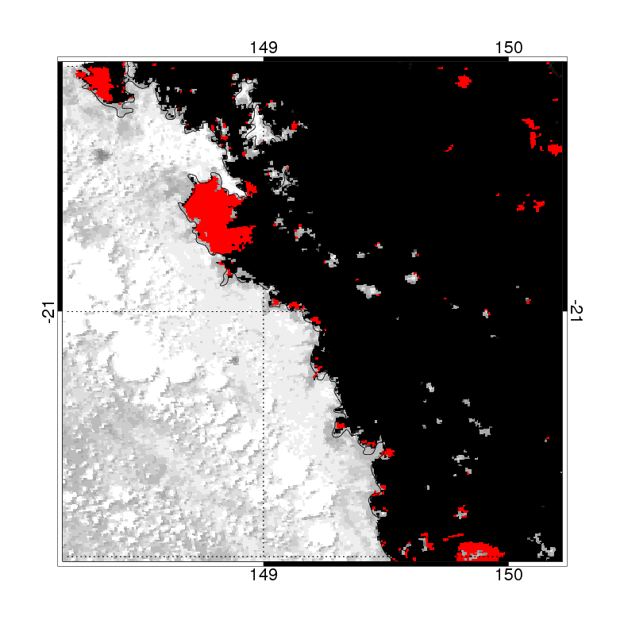 | 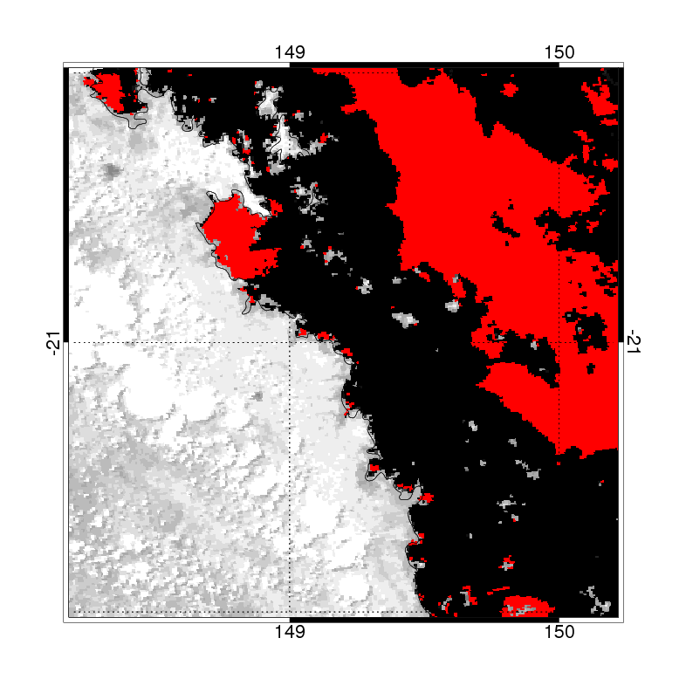
Pixels with negative values in the 412 – 678 nm spectral range | Pixels with negative values in the 412 – 748 nm spectral range
Figure 103 Atmospheric correction failure: negative reflectances retrieved by NASA algorithm for the Mackay – Whitsundays, QLD – 22 February 2008. Red areas are the pixels with negative values, i.e. where the NASA’s atmospheric correction algorithm failed for the visible spectral range (A) and the visible and NIR spectral range (B).

Artificial neural network atmospheric correction algorithm development
Our new MODIS atmospheric correction algorithm was developed by inverse modelling of radiative transfer (RT) calculations within a coupled ocean–atmosphere system by utilizing an artificial neural network (ANN) technique. The algorithm was implemented similar to an approach developed by Schroeder et al (2007) for MERIS, but with a different inverse model capable of generating more complex network architectures (Schroeder et al. 2008). Within this model-based approach, ANNs were found to be well suited models to deal with the optically-complex coastal waters because multilayer feed-forward networks with nonlinear transfer functions, as implemented in this work, are known as universal function approximators (Hornik et al. 1989).
By utilizing an established and validated radiative transfer code as a forward model (Fell and Fischer 2001; Fischer and Grassl 1984) , a large data base of azimuthally resolved upward radiances in the MODIS channels at the Bottom-Of-Atmosphere (BOA) and at the Top-Of-Atmosphere (TOA) was generated for a variety of sun and observing geometries as well as different types of atmospheric and oceanic constituents. Various ANNs serving as inverse models were trained under a supervised learning procedure by applying a non-linear optimisation routine on the basis of a randomly selected data subset of 100.000 spectra taken from the simulated data base. A detailed description of all inputs to the RT model can be found in Schroeder et al (2007).
In total, 138 different networks were trained on the basis of the simulated subset by applying different scaling and noise levels to the inputs as well as having the option of outputting additional aerosol optical thickness data. The learning was stopped for all networks after 1.000 iterations with the full subset of 100.000 simulated vectors. A single input vector contains the complete MODIS TOA reflectance spectrum of the bands 8-16, the sun and observing geometry and the surface pressure. The associated output vector consists of the reflectance spectrum at mean sea level (MSL) for the MODIS bands 8-15 (412-748 nm) with the output option of additional aerosol optical thickness data.
At the end of the training phase the accuracy of each network was accessed by inverting „real-world“ MODIS data and comparing the outputs against in-situ data. Therefore, a match-up database was compiled containing in-situ above water reflectance measurements collected by the GKSS Institute for Coastal Research and the Management Unit of the North Sea Mathematical Models (MUMM) during various MERIS Cal/Val field campaigns in North Sea turbid waters and by CSIRO in coastal waters of the Great Barrier Reef. The reflectances were measured according to the REVAMP protocols (Tilstone et al. 2004) using Trios RAMSES and SIMBADA spectrometers. The match-up criteria selected within this work was to allow a maximum time difference of ±60 min to the satellite over pass with all match-up area pixels not flagged by LAND, CLOUD/ICE or HIGHGLINT. From more than hundred in-situ spectra 31 finally met these criteria and were selected with their associated satellite data as match-up data set.

Artificial neural network atmospheric correction algorithm validation and application
The best overall performance was achieved by a 3-layer network with 20 neurons for the hidden layer using PCA for input spectra decorrelation and AOTs as additional outputs. Figure 104 shows the scatter plots of the in-situ reflectance measurements against the median reflectance values derived from the SeaDAS v5.1.1 atmospheric correction output and the values obtained from the ANN correction scheme. We found a lower RMSE of 0.0035, a lower BIAS of 0.0015 and a higher correlation of 0.98 for the proposed ANN algorithm compared to the SeaDAS output, which had an overall RMSE of 0.0058 with a BIAS of 0.0029 and a correlation of 0.95. At four stations in North Sea turbid waters SeaDAS atmospheric correction retrieved negative reflectances at 412 nm from the match-up data (Figure 104). The error bars in Figure 104 indicate the simple standard deviation of the reflectances within the 3 x 3 pixel match-up area and of the in-situ measurements.
The spectral errors show the largest differences in the blue part of the spectrum for both algorithms (Figure 105), where the SeaDAS atmospherically corrected data resulted in a mean absolute percentage error (MAPE) of up to 48% compared to 19% for the ANN algorithm.

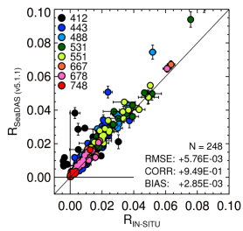 | 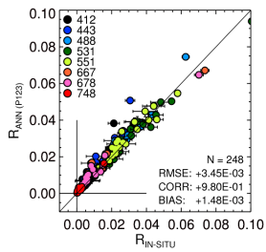
Figure 104: Scatter plots of the median reflectances of the MODIS Level2 product (left) and the proposed ANN atmospheric correction (right) compared to 31 in-situ reflectance measurements collected by GKSS, MUMM and CSIRO.
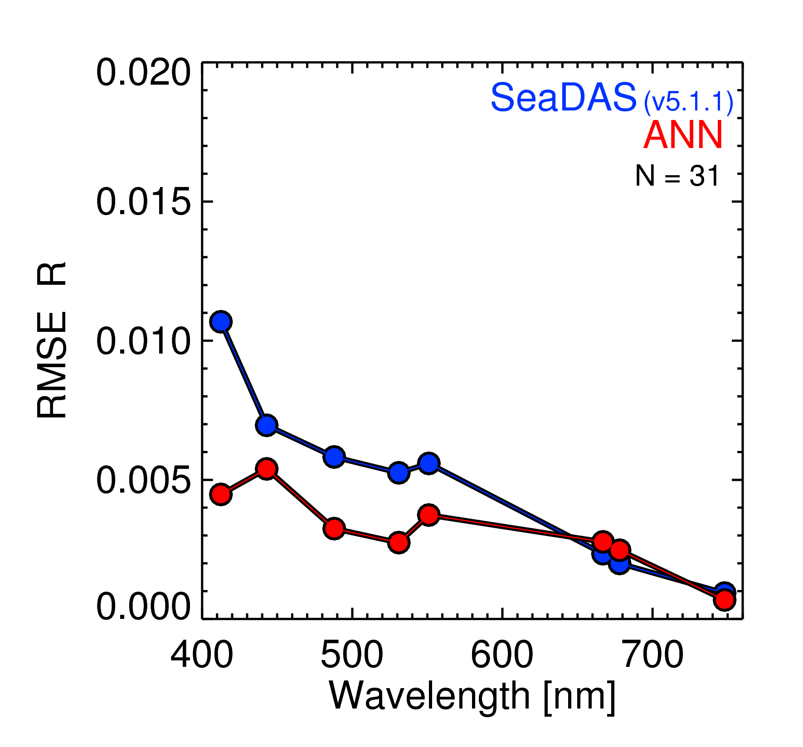 | 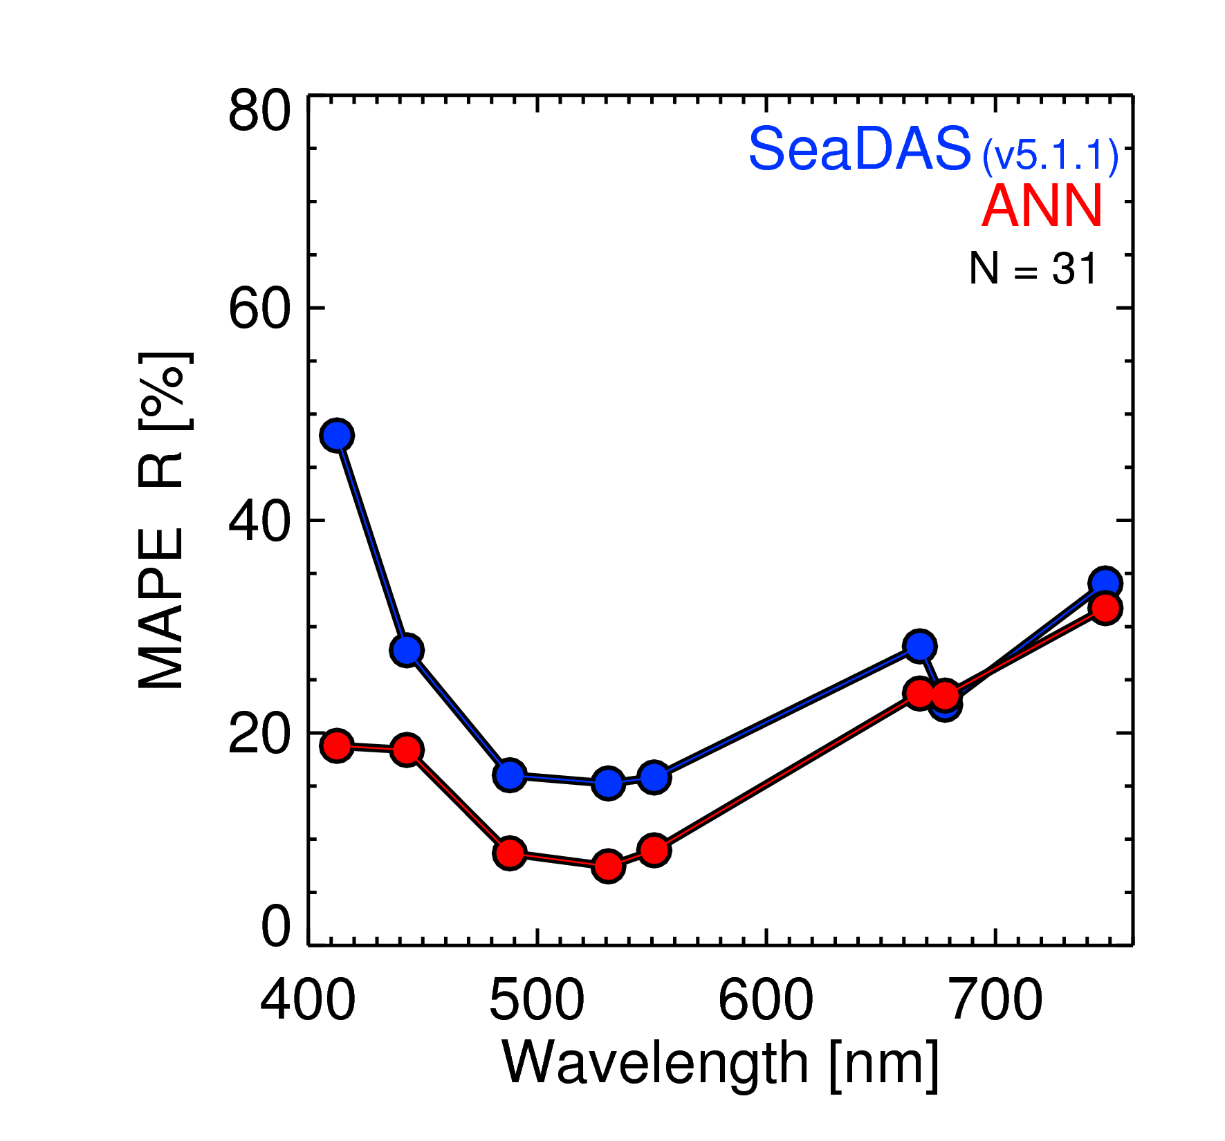
Figure 105: By comparison with in-situ reflectance measurements derived spectral slopes of RMSE (left) and MAPE (right) for the MODIS standard Level2 product generated with SeaDAS v5.1.1 (blue) and the proposed ANN algorithm (red).
The performance of the ANN algorithm is demonstrated and illustrated by comparing selected reflectance spectra with the reflectance output of SeaDAS v5.1.1 for a MODIS Aqua scene acquired on 22 February 2008 covering the Mackay – Whitsundays (Figure 106). Spectra from off-shore areas are in good agreement, while SeaDAS fails for most of the near-shore coastal areas by retrieving negative spectra.
To further illustrate the performance of the proposed ANN algorithm we shows map of the derived spatial reflectance distribution (Figure 107) for a MODIS Aqua scene acquired on 22 February 2008 covering the Mackay – Whitsundays coastal waters for the wavelengths 412 in comparison with the NASA’s atmospheric correction algorithm Higher TSS and CDOM concentrations can be associated with the near coastal waters of Repulse Bay causing negative reflectance values at 412 nm.

Figure 106: Comparison of SeaDAS v5.1.1 and ANN derived reflectance spectra for a MODIS Aqua scene acquired on 22 February 2008.

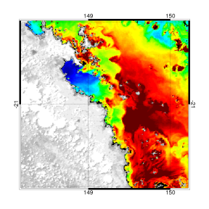  ANN atmospheric correction  Reflectance at 412 nm | 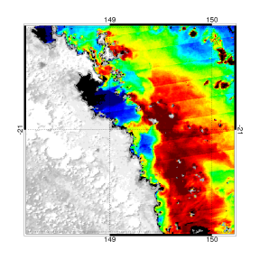  NASA standard atmospheric correction  Reflectance at 412 nm
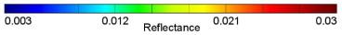
Figure 107 Spatial distribution of the reflectance at 412 nm as derived by the ANN algorithm and NASA standard algorithm from a MODIS Aqua scene acquired on 22 February 2008 (black areas=masked pixels).
The proposed atmospheric correction scheme provides a significant improvement in accuracy for the retrieval of reflectance data from MODIS Terra/Aqua measurements. From match-up analysis within coastal waters an overall mean absolute percentage error of 17.5% within the spectral range of 412-748 nm was derived. Compared to NASA’s standard atmospheric correction implemented in SeaDAS v5.1.1., the proposed neural network approach showed a significant improvement in accuracy, especially in the blue part of the spectrum.
Future work for the validation of the atmospheric correction scheme will rely on the matchup analysis of the normalized water-leaving radiances data-stream acquired on a daily basis at the Lucinda Jetty Coastal Observatory (LJCO).

Optical water quality retrieval
In previous years CSIRO’s Environmental Earth Observation Group assessed the performance for the local conditions of coastal GBR waters of the seven NASA global CHL algorithms implemented in SeaDAS. The accuracy of CHL retrieval for the seven empirical and semi-analytical algorithms generally degraded rapidly with increasing CDOM and NAP concentrations (Qin et al. 2007). The level of disagreement is at least twofold for CHL concentrations above 2 µg L⁻¹. The gsm01 (Maritorena et al. 2002) algorithm was shown to work relatively better in the widest range of CDOM and NAP concentrations, while the Carder (Carder et al. 2003) algorithm has the highest accuracy for low CDOM and NAP concentrations. For the retrieval of bulk IOP, Qin et al.(2007) found that the three semi-analytical algorithms Carder, gsm01 and QAA seem unable to break down the total absorption coefficient, a, into its components, a_{ph} (phytoplankton) and a_{dg} (CDOM + NAP). This is probably because the three algorithms used a_{dg} slopes (QAA: 0.015, gsm01: 0.0206 and Carder: 0.0225) that are different than the values of and found in the GBR coastal waters. (Brando et al. 2008a) have shown that considerable differences in optical properties and concentrations are found between the dry and wet season for the GBR lagoonal waters.

IOP and concentrations retrieval - LMI
To improve the accuracy of CHL, CDOM, NAP and IOP estimates from MODIS Aqua data in GBR Lagoon coastal waters, in this project an enhancement of the Linear Matrix Inversion (LMI, Hoge and Lyon 1996) was used to incorporate regional and seasonal knowledge of variability in the specific inherent optical properties for concentration, specific light absorption and scattering encountered in GBR coastal waters. The algorithm estimates simultaneously the concentration of chlorophyll-a, total suspended sediment, CDOM and the water clarity expressed both as vertical attenuation coefficient (K_{d}) and as Secchi depth (Brando et al. 2012).
LMI has been already successfully applied to retrieve the concentrations of the optically active constituents in inland and coastal waters with hyperspectral data (Brando and Dekker 2003; Giardino et al. 2007; Hoogenboom et al. 1998). This algorithm was adapted to MODIS for the Fitzroy River Estuary Keppel Bay (southern GBR) (Brando et al. 2006; Brando et al. 2007) and applied to the MODIS Aqua data for the whole GBRWHA (Brando et al. 2006; Schaffelke et al. 2006).The LMI method as outlined here uses the below-water remote sensing reflectance spectrum of the eight MODIS bands 8-15 (412-748 nm) as input to a semi-analytical model developed by Gordon et al. (1988) to simultaneously derive the three optically active constituents in an algebraic manner.
One of the major weaknesses of the LMI is the difficulty of parameterising a stable spectral shape for each SIOP to reflect the natural variability (Lyon and Hoge 2006). To overcome this, Wang et al. (2005) made use of an over-determined system (3x4, λ=410, 440, 490 and 550 nm) to explore the observed range of variability of the IOP shape factors. In this study, to incorporate regional knowledge of specific IOPs, the imagery inversion was performed while varying the SIOP shape parameters through a series of unique combinations of the shape parameters, i.e. SIOP sets. Each SIOP set correspond to a complete set of SIOP shape parameters (,,,,, ,, ) as they were measured concurrently at a single station during a cruise. With this approach, no a priori assumptions are made on the locations of specific water types in the satellite imagery and unnatural combinations of the shape factors are avoided. The SIOP set, the IOPs and concentrations values associated with the best optical closure are retained for each pixel and used for the output maps (Figure 108).
The optical closure is measured with, the relative Root Means Square Error between the input remote sensing reflectance and the inverse-forward simulated reflectance calculated for each input spectrum. provides a level of confidence of water quality parameter estimates. If the value of exceeds a threshold, or if the retrieved concentrations are negative, or if one or more of the spectral bands of the image gives anomalous values (perhaps due to sun glint or some atmospheric haze etc.) then the pixel is flagged as not mapped.
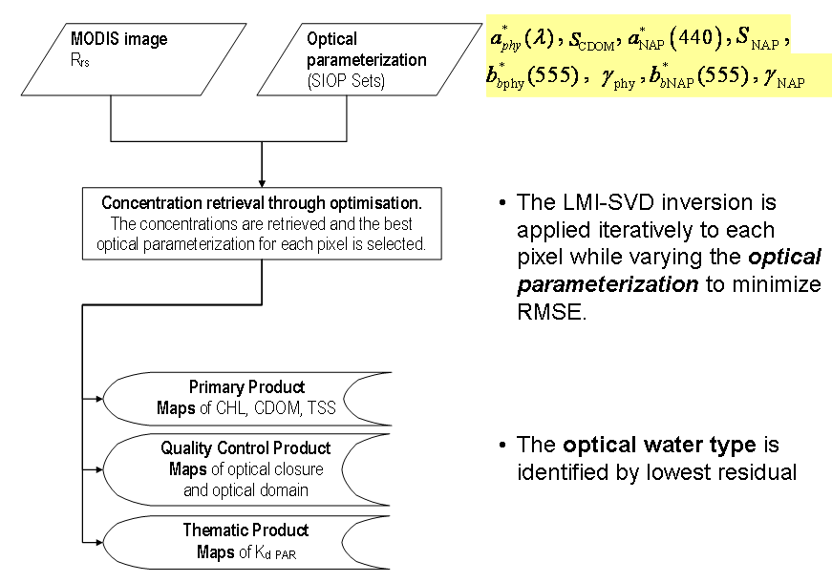
Figure 108. Conceptual diagram of the Linear Matrix Inversion approach adopted for the retrieval of Chlorophyll-a and IOPs from MODIS Aqua data.

Parameterization of LMI
The MMP 2006 report (Appendix 1 pages A40- A-57, Schaffelke et al. 2006) details how the most relevant SIOP sets of the GRBWHA were selected through a rigorous QA/QC and subsequent statistical analysis of the in situ datasets over the period 2002-2005 to adequately represented the full range of SIOPs measured from Cape Tribulation down to Port Curtis.
Subsequently, in the 2008 MMP report (Brando et al. 2008b), two adjustments were made to the original parameterization: ( 1) the value of was fixed for all sites to 0.0006 m⁻¹; (2) the spectrum was fixed to one value for the whole GBRWHA. This version of the LMI parameterization was labelled LMI_CLU4.
In 2009, a full re-analysis of the a_{phy}* spectra for the GBR was performed to overcome the contamination in the UV-blue and NIR ends of the spectra by residual non algal particulate absorption that occurred in the 2006 and 2008 parameterizations (Figure 109 and Figure 110, respectively). Table 40 reports the values needed to parameterize LMI algorithm to estimate simultaneously the concentration of Chlorophyll-a, total suspended sediment, CDOM and expressed both as vertical attenuation coefficient (K_{d}) and as Secchi Depth (Brando et al. 2010a).
A new statistical analysis comprehensive of Hierarchical Clustering, Principal Component Analysis and Multi-Dimensional Scaling, should be performed to incorporate the new optical characterizations carried out after 2006, in particular the flood waters of the Fitzroy River in Keppel Bay (February 2008) and the wet season sampling of the wet tropics (April 2008).

Table 40 The final centroids identifying the most representative SIOP sets that were used in the regional algorithm parameterization of LMI_CLU4.
Cluster | Site | bb_phy_slope | Bb_phy_555nm | a_cdom_slope | a_tr_slope | a_tr_440nm | bb_tr_slope | bb_tr_555nm
1 | AS05_WQN026 | 0.6649 | 0.0006 | 0.0336 | 0.0115 | 0.0188 | 0.6649 | 0.0064
2 | MD 7D | 0.7735 | 0.0006 | 0.0171 | 0.0119 | 0.0401 | 0.7735 | 0.0084
3 | FK30 | 0.9882 | 0.0006 | 0.0146 | 0.0136 | 0.0391 | 0.9882 | 0.0452
4 | FK35 | 0.421 | 0.0006 | 0.0116 | 0.0099 | 0.0281 | 0.421 | 0.0063
5 | FK2-30 | 0.6065 | 0.0006 | 0.0181 | 0.0148 | 0.0271 | 0.6065 | 0.0128
6 | FK2-23 | 0.8579 | 0.0006 | 0.0192 | 0.0118 | 0.0438 | 0.8579 | 0.0145
7 | AA05_WQS008 | 0.7859 | 0.0006 | 0.012 | 0.011 | 0.0029 | 0.7859 | 0.001
8 | MD 15D | 0.8393 | 0.0006 | 0.0144 | 0.0115 | 0.0266 | 0.8393 | 0.008
9 | AA05_WQS015 | 0.6003 | 0.0006 | 0.0105 | 0.0119 | 0.0057 | 0.6003 | 0.0028
10 | AO02_SAT0021 | 1.3086 | 0.0006 | 0.0145 | 0.0124 | 0.0118 | 1.3086 | 0.0049

Figure 109 a_{phy}* spectra for LMI inversion in the parameterization for 2006 MMP report

Figure 110. a_{phy}* spectra for LMI inversion in the 2008 MMP version of the parameterization (LMI_CLU4). Note different scale range for Y axis.

Algorithm validation
In the remote sensing literature validation refers to the independent verification of the physical measurements made by a sensor as well as of the derived geophysical variables. Validation allows for the verification and improvement of the algorithms used (e.g. for atmospheric correction and retrieval of water quality variables). To achieve this, conventional, ground-based observations are required using calibrated and traceable field instrumentation and associated methods.
In previous MMP reports, we used for validation the GBR Long Term Monitoring Program (GBR-LTMP) dataset. The GBR- LTMP dataset includes Chlorophyll-a measurements going back as far as 1992 (thus including the start of the first contemporary ocean colour sensor SeaWiFS, launched in 1997). This monitoring program was designed to monitor water quality status at regional spatial scales (Brodie et al. 2007). The sampling stations for GBR-LTMP were situated some distance (~1-2 km) from the edge of nearby reefs to avoid confounding influences from biological activity on the reef itself (Brodie et al. 2007) Chlorophyll-a and phaeophytin concentrations were determined fluorometrically, and a suite of site variables (water depth, presence of Trichodesmium and weather conditions) was measured to aid interpretation of the Chlorophyll-a a data (Brodie et al. 2007).
In this study, CHL data from the Cairns transect collected by Miles Furnas and co-workers (AIMS) between 1988 and 2006 as well as data collected by ACTFR during flood monitoring projects and data collected by CSIRO during the optical characterization projects were added to the validation database. The match-up data base included 1787 data points measured by 4 institutions. The measurement campaigns for GBR-LTMP, AIMS and ACTFR data sets were not designed for remote sensing validation purposes and thus the sampling protocols do not follow remote sensing validation guidelines (e-g minimum distance of 5 km from land or islands, HPLC estimate of CHL, collection within 3 hour from overpass, etc.).
The CHL, TSS (or NAP) and CDOM measurements of the combined validation database were used to validate the retrieval of these water quality variables as retrieved with the algorithms implemented in SeaDAS, NASA’s processing software for MODIS imagery, and by the regionally parameterized algorithm (LMI_CLU4) coupled with the Artificial Neural Network atmospheric correction. For this comparison, we extracted from the remote sensing data the average value of the nine pixels (a square of 3x3 pixels) centred at the GPS location of the in situ measurements, for each available date. Only those measurements collected within ±3 hours of the satellite overpass were used in this analysis. Quality flags were checked and masks applied for land, glint, cloud, atmospheric correction failure and for solar zenith and observer zenith above a maximum of 60 degree.
The in situ Chlorophyll-a data were used to evaluate the Chlorophyll-a retrievals by the LMI_CLU4 and gsm01 algorithms, as the gsm01 (Maritorena et al. 2002) algorithm was shown to work relatively better in the widest range of CDOM and NAP concentrations for these coastal waters (Qin et al. 2007). Figure 111 presents the results of the MODIS Aqua Chlorophyll-a retrieval comparison with in situ data in logarithmic scale. LMI and gsm01 have a similar RMSE, and LMI has lower MAPE (Table 2). These results are consistent with the findings of the sensitivity analysis carried out for these coastal waters (Qin et al. 2007).
The in situ TSS data were used to evaluate the TSS retrieval by LMI_CLU4 and the Clark algorithms, as it is the only one currently implemented in SEADAS for the retrieval of TSS. Figure 11 presents the matchup for MODIS Aqua TSS retrieval versus in situ data. Only the measurements collected with 3 hours of the overpass were plotted. Although with a limited number of matching measurements (24 for LMI and 33 for NASA's Clark algorithm) LMI shows a lower bias and MAPE that Clarks algorithm (Table 2).
The in situ CDOM data were used to evaluate the CDOM retrieval by LMI_CLU4 and the QAA algorithms, as the QAA algorithm was shown to work relatively better than others for these coastal waters (Qin et al., 2007). Figure 113 presents the matchup for MODIS Aqua a_{CDOM} (443) retrieval vs. in situ data. Only the measurements collected with 3 hours of the overpass were plotted. The number of matchups is 18 for a_{CDOM} (443) and 27 for a_{dg} (443). QAA’s a_{dg} (443) overestimates CDOM in situ data as it provides an estimate of the absorption due to CDOM and NAP (Table 41).
The comparison of MODIS Aqua retrievals of CHL, CDOM and NAP with in situ data showed that revised parameterization of regional algorithm coupled with the Artificial Neural Network atmospheric correction led to an improvement in accuracy since the previous report. The results of the matchup analysis for Chlorophyll-a, CDOM and TSS are consistent with the findings of the sensitivity analysis based on radiative transfer modelling that was carried out for these coastal waters (Qin et al., 2007).
To strengthen the validation of remote sensing data, the validation database should be extended to include water quality data sets used in recent studies on the spatial and temporal patterns of water quality of the Great Barrier Reef (De’ath 2007; De’ath and Fabricius 2008). The Secchi Depth database would allow a direct validation the Secchi Depth estimated from remote sensing data.
It should be noted that most of this matchup analysis is based mainly on dry season observations, and so it is currently not possible to assess whether the retrieval of water quality variables for the wet season estimates have the same level of accuracy or not. In 2010 CSIRO has been commissioning the Lucinda Jetty Coastal Observatory (LJCO), with the support of Australia's Integrated Marine Observing System (IMOS). The LJCO data streams aim to increase the number of satellite versus in situ match-ups assessment of normalized water-leaving radiances, water inherent optical properties and aerosol optical properties for the GBR. In preparation for the passage of TC Yasi the data stream from LJCO has been interrupted as the whole observatory was evacuated. Due to the extensive damages to the site measurements will be re started in 2012. Also the data collected at the IMOS National Reference Station moored at the Yongala wreck will provide further data to extend the match-up database for the validation of the retrieval of bio-optical and biogeochemical quantities.
Table 41 Validation statistics for the measurements collected with 3 hours of the overpass. RMSE is the root mean square error, MAPE the mean absolute percentage error.
Variable | Algorithm | N | RMSE | MAPE | Bias
Chlorophyll-a | LMI | 108 | 0.79446 | 58.49% | -0.1496
Chlorophyll-a | GSM | 110 | 0.82066 | 89.50% | -0.0572
TSS (NAP) | LMI | 24 | 5.62293 | 57.29% | -2.3648
TSS | Clark | 38 | 7.55040 | 61.33% | -4.2467
CDOM | LMI | 18 | 0.05709 | 66.88% | -0.0007
a_{dg} (CDOM + NAP) | QAA | 27 | 0.15944 | 216.2% | 0.07921

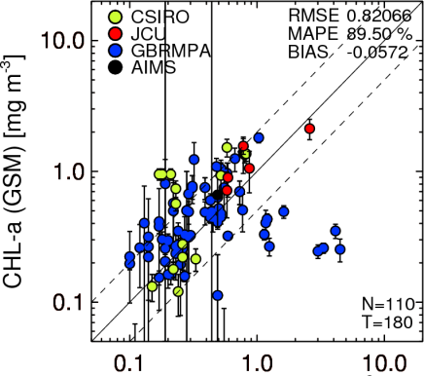
Figure 111: MODIS Aqua Chlorophyll-a retrieval versus in situ data. Only the measurements collected within ±3 hours time difference to the overpass were plotted. Number of matchups is 108 for LMI and 110 for gsm01.

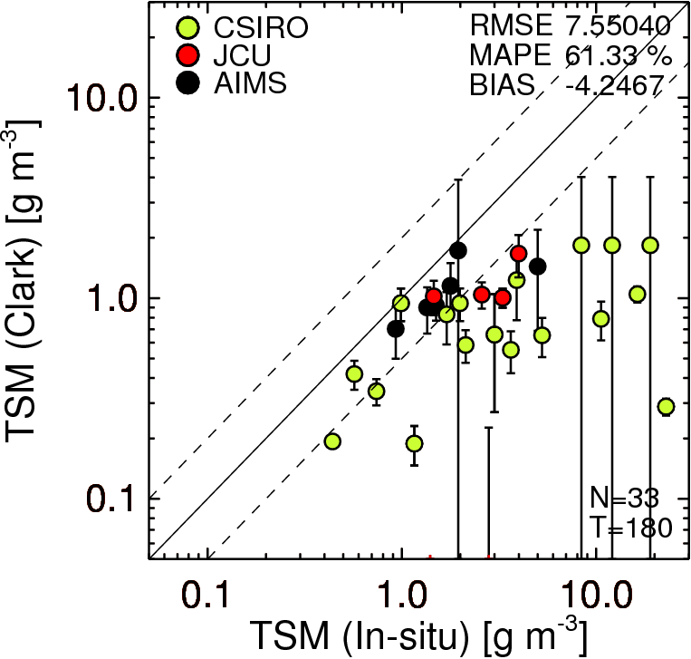
Figure 112: MODIS Aqua TSS retrieval versus in situ data. Only the measurements collected within ±3 hours time difference to the overpass were plotted. Number of matchups is 24 for LMI and 33 for Clark.

Figure 113: MODIS Aqua a_{CDOM} (443) and a_{dg}(443) retrievals versus in situ data. Only the measurements collected within ±3 hours time difference to the overpass were plotted. Number of matchups is 18 for LMI and 27 QAA.

Appendix 2. List of scientific publications, scientific presentations and community seminars arising from the monitoring program

Journal Papers
Brando, V. E., A. G. Dekker, Y. J. Park, and T. Schroeder, "An adaptive semi-analytical inversion of ocean colour radiometry in optically complex waters " Applied Optics (accepted)(2011).
Schroeder T., Devlin M., Brando V.E., Dekker A.G., Brodie J.E., Clementson L.A., and McKinna L.; (2011), Inter-annual variability of wet season freshwater extent into the Great Barrier Reef lagoon based on satellite coastal ocean colour observations; Marine Pollution Bulletin (In revision).
Kennedy K., Schroeder T., Shaw M., Haynes D., Lewis S., Bentley C., Paxman C., Carter S., Brando V., Bartkow M., Hearn L., Mueller J.F.; (2011), Long-term monitoring of photosystem-II herbicides on the Great Barrier Reef – trends and correlation to remotely sensed water quality, Marine Pollution Bulletin (In revision).

Book Chapters
Devlin, M., T. Schroeder, L. McKinna, J. Brodie, V. Brando and A. Dekker (in press). Monitoring and mapping of flood plumes in the Great Barrier Reef based on in-situ and remote sensing observations. Advances in Environmental Remote Sensing to Monitor Global Changes. N.-B. Chang.

Conference Papers
Blondeau-Patissier, D., V,E. Brando, A.G. Dekker, S.R. Phinn, S.J. Weeks, T. Schroeder, Y.J. Park, 2010, Phytoplankton response to episodic events and long-term trends in the Great Barrier Reef lagoonal waters: towards a regional characterisation. Proceedings of Ocean Optics Conference XX 2010

Conference presentations
Brando V, T. Schroeder; A. Dekker; B. Schaffelke; M. Devlin, Spatial and Temporal Assessment of Exceedance of Water Quality Guidelines for the Great Barrier Reef Lagoon using Remote Sensing Data ISRSE34 Sydney
Clementson, Lesley Brando, Vittorio, Keen, Rex & Daniel, Paul, The Lucinda Jetty Coastal Observatory – an example of a single point observation site, AMSA 2011, Fremantle.
Devlin, M., McKinna, L., Schroeder, T., Schaffelke, B., Brando, V., Brodie, J., (2010), Exposure to riverine plumes in the Great Barrier Reef. Risk assessment by mapping plume extent and composition using remote sensing, In Proceedings of the 2010 International conference on Challenges in Environmental Science & Engineering, 26 Sep – 01 Oct 2010, Cairns, Australia.
Kennedy K, Schroeder T, Bentley C, Chue K-L, Paxman C, Thai P, Brando V, Dekker A, Mueller J F, Combining passive sampling (PSII herbicides) and remote sensing (water quality) data on the Great Barrier Reef, (2011), Presented in Proccedings of the: SETAC Europe 21st Annual Meeting, Milano, Italy, 15-19 May 2011.
Kennedy, K., Paxman, C., Dunn, A., Schroeder, T., Brando, V., Dekker, A., Mueller, J., (2010), Trends of diuron and other PSII herbicides on the GBR - a comparison with remote sensing data, In Proceedings of the 2010 International conference on Challenges in Environmental Science & Engineering, 26 Sep – 01 Oct 2010, Cairns, Australia.
Schaffelke, B, M. Devlin, Brando V, T. Schroeder. From measurements to metrics: a case for the development of an improved reporting system for tropical marine water quality, Proceedings of the 2010 International conference on Challenges in Environmental Science & Engineering, 26 Sep – 01 Oct 2010, Cairns, Australia.
Schroeder, T., Devlin, M., Brando, V., Dekker, A., and Brodie, J., (2010), Mapping the inter-annual variability of freshwater plume extent in the Great Barrier Reef from ocean colour observations, In Proceedings of the 2010 International conference on Challenges in Environmental Science & Engineering, 26 Sep – 01 Oct 2010, Cairns, Australia.

Appendix 3. median maps of water clarity expressed as Secchi Depth
The Secchi Depth product is still in development phase and an assessment of accuracy of the retrieval is still on-going at the time of closing this report. The Secchi Depth retrieval will be validated using the water quality data sets that were used in recent studies on the spatial and temporal patterns of water quality of the Great Barrier Reef (De’ath 2007; De’ath and Fabricius 2008) and were made available by AIMS.
The wet and dry season median maps of water clarity expressed as Secchi Depth (Figure 114) for the Cape York region show similar patterns as the Chlorophyll-a (Figure 40), coloured dissolved organic matter and non-algal particulate matter distribution (Figure 41). The wet and dry season median maps of water clarity expressed as Secchi Depth (Figure 115) for the Wet Tropics region show similar gross patterns to the maps of Chlorophyll-a (Figure 51), coloured dissolved organic matter and NAP distribution (Figure 52) with low values Rockingham Bay and Halifax Bay. For the wet season median Secchi Depth lower than 4 metres were observed in the Midshelf.
The wet and dry season median maps of water clarity expressed as Secchi Depth (Figure 116) for the Burdekin region show similar gross patterns as for the Chlorophyll-a (Figure 62), coloured dissolved organic matter and non-algal particulate matter distribution (Figure 63). The wet and dry season median maps of water clarity expressed as Secchi Depth (Figure 117) for the Mackay Whitsunday region show similar gross patterns as for the Chlorophyll-a(Figure 73), coloured dissolved organic matter and non-algal particulate matter distribution (Figure 74), showing values lower than ~3.5-4.0 m in a coastal band ~5-10 km wide in the dry season that extended to ~15-20 km in wet season. The low Secchi Depths shown in Broad Sound and Shoalwater Bay are likely to be overestimated.
The wet and dry season median maps of water clarity expressed as Secchi Depth (Figure 118) for the Fitzroy region show similar gross patterns as for the Chlorophyll-a (Figure 84), coloured dissolved organic matter and non-algal particulate matter distribution (Figure 85) showing values lower than ~3.5-4.0 m in a coastal band ~5-10 km wide in the dry season that extended to ~25-30 km in wet season. The wet and dry season median maps of water clarity expressed as Secchi Depth (Figure 119) for the Burnett Mary region show how similar gross patterns as for the Chlorophyll-a (Figure 95), coloured dissolved organic matter and non-algal particulate matter distribution (Figure 96). Values lower than ~3.5-4.0 m extended in a coastal band ~5-10 km wide in the dry season and ~25-30 km in wet season showing values lower than 1.5 m in correspondence of the river mouths. The low Secchi Depth values near Breaksea Spit are likely to be overestimated.
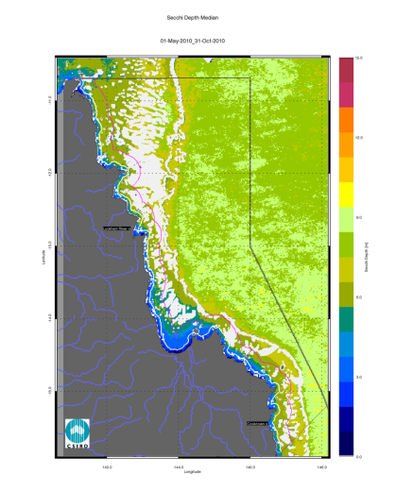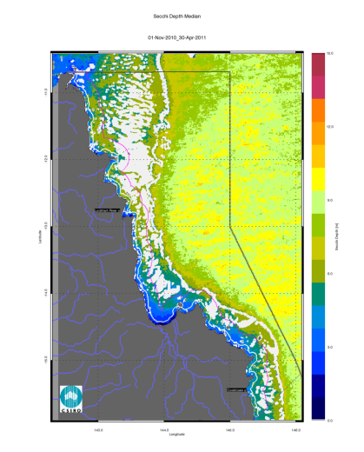
Figure 114. Secchi Depth (as estimate of water clarity) median maps for the dry and wet season for the Cape York region. The first map presents the median for the dry season 2010 (May - October), while the second map presents the median for the wet season 2010/2011 (November 2010- April 2011).
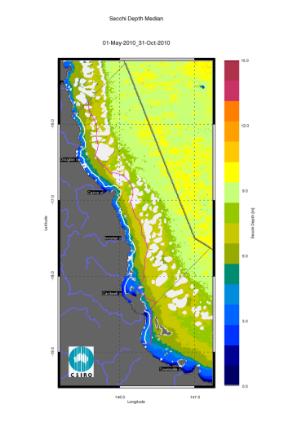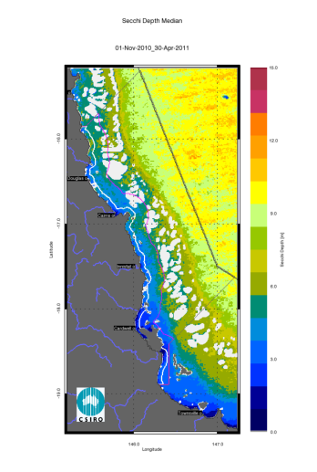
Figure 115. Secchi Depth (as estimate of water clarity) median maps for the dry and wet season for the Wet Tropics region. The first map presents the median for the dry season 2010 (May - October), while the second map presents the median for the wet season 2010/2011 (November 2010- April 2011).

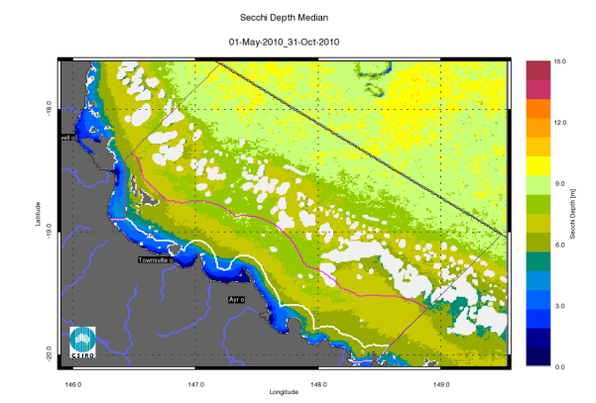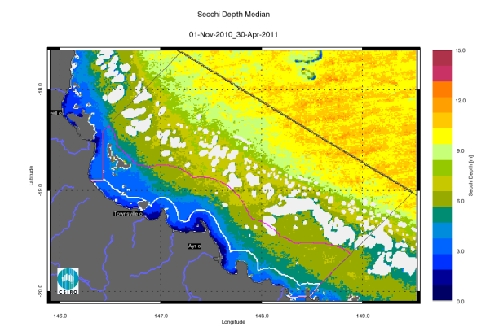
Figure 116. Secchi Depth (as estimate of water clarity) median maps for the dry and wet season for the Burdekin region. The first map presents the median for the dry season 2010 (May - October), while the second map presents the median for the wet season 2010/2011 (November 2010- April 2011).
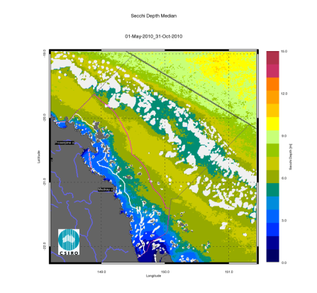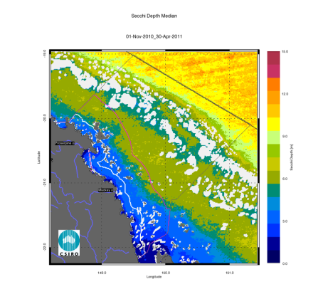
Figure 117. Secchi Depth (as estimate of water clarity) median maps for the dry and wet season for the Mackay Whitsunday region. The first map presents the median for the dry season 2010 (May - October), while the second map presents the median for the wet season 2010/2011 (November 2010- April 2011).

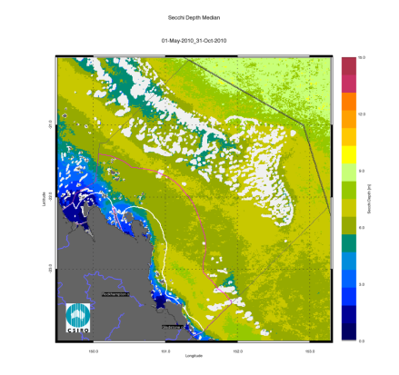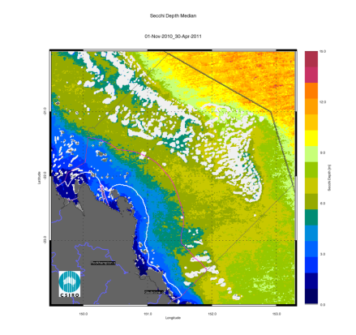
Figure 118. Secchi Depth (as estimate of water clarity) median maps for the dry and wet season for the Fitzroy region. The first map presents the median for the dry season 2010 (May - October), while the second map presents the median for the wet season 2010/2011 (November 2010- April 2011).
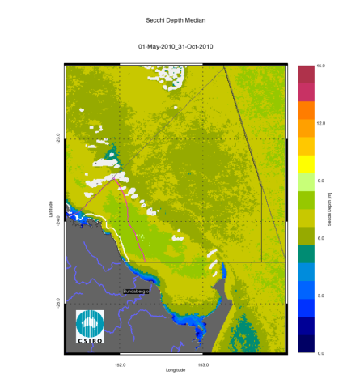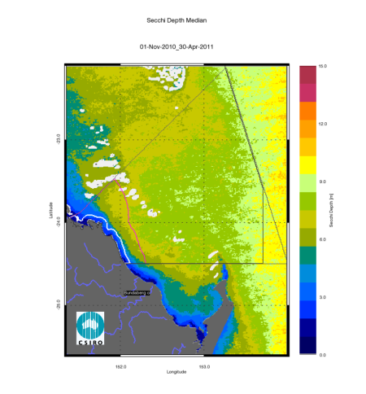
Figure 119. Secchi Depth (as estimate of water clarity) median maps for the dry and wet season for the Burnett Mary region. The first map presents the median for the dry season 2010 (May - October), while the second map presents the median for the wet season 2010/2011 (November 2010- April 2011).

Appendix 4. Summary of the exceedance of annual mean values from 2002/03
This appendix provides the summary of the exceedance of mean annual Chlorophyll-a and non-algal particulate matter (as a measure of Total Suspended Solids) values for all reporting periods from when MODIs AQUA data is available (i.e. 2002/03 to present)
Table 42. Summary of the exceedance of mean annual Chlorophyll-a and non-algal particulate matter (as a measure of Total Suspended Solids) for the 2002/03 reporting period (1 May 2002 – 30 April 2003) for the Open Coastal, Mid-shelf and Offshore water bodies. Cells are shaded in gray when more than 50% of the area of the water body exceeds the Guideline value. * Caution should be used when interpreting the results for the Cape York and Burnett Mary regions as limited field information was used for the parameterization and validation on the remote sensing retrievals.
 | Chlorophyll-a: Relative area (%) of the water body where the annual mean value exceeds the WQ Guideline value |  |  | Total Suspended Solids: Relative area (%) of the water body where the annual mean value exceeds the WQ Guideline value
2002/03 | Open Coastal | Mid-shelf | Offshore | Open Coastal | Mid-shelf | Offshore
Cape York* | 28 | 0 | 0 | 51 | 44 | 12
Wet Tropics | 34 | 4 | 0 | 32 | 15 | 8
Burdekin | 35 | 0 | 0 | 71 | 9 | 2
Mackay Whitsunday | 17 | 1 | 0 | 96 | 39 | 52
Fitzroy | 42 | 1 | 0 | 58 | 12 | 19
Burnett Mary * | 29 | 0 | 0 | 25 | 2 | 1

Table 43. Summary of the exceedance of mean annual Chlorophyll-a and non-algal particulate matter (as a measure of Total Suspended Solids) for the 2003/04 reporting period (1 May 2003 – 30 April 2004) for the Open Coastal, Mid-shelf and Offshore water bodies. Cells are shaded in gray when more than 50% of the area of the water body exceeds the Guideline value. * Caution should be used when interpreting the results for the Cape York and Burnett Mary regions as limited field information was used for the parameterization and validation on the remote sensing retrievals.
2003/2004 | Chlorophyll-a: Relative area (%) of the water body where the annual mean value exceeds the WQ Guideline value |  |  | Total Suspended Solids: Relative area (%) of the water body where the annual mean value exceeds the WQ Guideline value
 | Open Coastal | Mid-shelf | Offshore | Open Coastal | Mid-shelf | Offshore
Cape York* | 60 | 6 | 0 | 81 | 77 | 13
Wet Tropics | 74 | 11 | 0 | 80 | 30 | 9
Burdekin | 57 | 1 | 0 | 84 | 10 | 0
Mackay Whitsunday | 28 | 2 | 0 | 95 | 46 | 28
Fitzroy | 51 | 2 | 0 | 57 | 11 | 13
Burnett Mary * | 56 | 3 | 0 | 17 | 0 | 0
Table 44. Summary of the exceedance of mean annual Chlorophyll-a and non-algal particulate matter (as a measure of Total Suspended Solids) for the 2004/05 reporting period (1 May 2004 – 30 April 2005) for the Open Coastal, Mid-shelf and Offshore water bodies. Cells are shaded in gray when more than 50% of the area of the water body exceeds the Guideline value.* Caution should be used when interpreting the results for the Cape York and Burnett Mary regions as limited field information was used for the parameterization and validation on the remote sensing retrievals.
2004/2005 | Chlorophyll-a: Relative area (%) of the water body where the annual mean value exceeds the WQ Guideline value |  |  | Total Suspended Solids: Relative area (%) of the water body where the annual mean value exceeds the WQ Guideline value
 | Open Coastal | Mid-shelf | Offshore | Open Coastal | Mid-shelf | Offshore
Cape York* | 57 | 4 | 0 | 67 | 76 | 13
Wet Tropics | 74 | 11 | 0 | 49 | 23 | 6
Burdekin | 59 | 1 | 0 | 82 | 12 | 1
Mackay Whitsunday | 22 | 1 | 0 | 92 | 40 | 32
Fitzroy | 47 | 2 | 0 | 57 | 14 | 15
Burnett Mary * | 36 | 1 | 0 | 11 | 1 | 0

Table 45. Summary of the exceedance of mean annual Chlorophyll-a and non-algal particulate matter (as a measure of Total Suspended Solids) for the 2005/16 reporting period (1 May 2005 – 30 April 2006) for the Open Coastal, Mid-shelf and Offshore water bodies. Cells are shaded in gray when more than 50% of the area of the water body exceeds the Guideline value.* Caution should be used when interpreting the results for the Cape York and Burnett Mary regions as limited field information was used for the parameterization and validation on the remote sensing retrievals.
2005/2006 | Chlorophyll-a: Relative area (%) of the water body where the annual mean value exceeds the WQ Guideline value |  |  | Total Suspended Solids: Relative area (%) of the water body where the annual mean value exceeds the WQ Guideline value
 | Open Coastal | Mid-shelf | Offshore | Open Coastal | Mid-shelf | Offshore
Cape York* | 70 | 11 | 0 | 53 | 55 | 12
Wet Tropics | 78 | 11 | 0 | 50 | 20 | 5
Burdekin | 57 | 1 | 0 | 78 | 11 | 1
Mackay Whitsunday | 25 | 4 | 0 | 89 | 39 | 46
Fitzroy | 51 | 3 | 0 | 57 | 14 | 24
Burnett Mary * | 39 | 1 | 0 | 13 | 1 | 0
Table 46. Summary of the exceedance of mean annual Chlorophyll-a and non-algal particulate matter (as a measure of Total Suspended Solids) for the 2006/07 reporting period (1 May 2006 – 30 April 2007) for the Open Coastal, Mid-shelf and Offshore water bodies. Cells are shaded in gray when more than 50% of the area of the water body exceeds the Guideline value. * Caution should be used when interpreting the results for the Cape York and Burnett Mary regions as limited field information was used for the parameterization and validation on the remote sensing retrievals.
2006/2007 | Chlorophyll-a: Relative area (%) of the water body where the annual mean value exceeds the WQ Guideline value |  |  | Total Suspended Solids: Relative area (%) of the water body where the annual mean value exceeds the WQ Guideline value
 | Open Coastal | Mid-shelf | Offshore | Open Coastal | Mid-shelf | Offshore
Cape York* | 68 | 7 | 0 | 75 | 63 | 15
Wet Tropics | 85 | 13 | 0 | 59 | 24 | 11
Burdekin | 56 | 1 | 0 | 74 | 8 | 2
Mackay Whitsunday | 31 | 3 | 0 | 95 | 31 | 57
Fitzroy | 51 | 3 | 0 | 59 | 9 | 22
Burnett Mary * | 36 | 1 | 0 | 18 | 2 | 0
Table 47. Summary of the exceedance of mean annual Chlorophyll-a and non-algal particulate matter (as a measure of Total Suspended Solids) for the 2007/08 reporting period (1 May 2007 – 30 April 2008) for the Open Coastal, Mid-shelf and Offshore water bodies. Cells are shaded in gray when more than 50% of the area of the water body exceeds the Guideline value.* Caution should be used when interpreting the results for the Cape York and Burnett Mary regions as limited field information was used for the parameterization and validation on the remote sensing retrievals.
2007/2008 | Chlorophyll-a: Relative area (%) of the water body where the annual mean value exceeds the WQ Guideline value |  |  | Total Suspended Solids: Relative area (%) of the water body where the annual mean value exceeds the WQ Guideline value
 | Open Coastal | Mid-shelf | Offshore | Open Coastal | Mid-shelf | Offshore
Cape York* | 56 | 4 | 0 | 51 | 40 | 14
Wet Tropics | 70 | 10 | 0 | 32 | 12 | 5
Burdekin | 64 | 2 | 0 | 56 | 4 | 0
Mackay Whitsunday | 37 | 2 | 0 | 87 | 45 | 41
Fitzroy | 60 | 3 | 0 | 56 | 8 | 14
Burnett Mary * | 61 | 3 | 0 | 15 | 0 | 0
Table 48. Summary of the exceedance of mean annual Chlorophyll-a and non-algal particulate matter (as a measure of Total Suspended Solids) for the 2008/09 reporting period (1 May 2008 – 30 April 2009) for the Open Coastal, Mid-shelf and Offshore water bodies. Cells are shaded in gray when more than 50% of the area of the water body exceeds the Guideline value.* Caution should be used when interpreting the results for the Cape York and Burnett Mary regions as limited field information was used for the parameterization and validation on the remote sensing retrievals.
2008/2009 | Chlorophyll-a: Relative area (%) of the water body where the annual mean value exceeds the WQ Guideline value |  |  | Total Suspended Solids: Relative area (%) of the water body where the annual mean value exceeds the WQ Guideline value
 | Open Coastal | Mid-shelf | Offshore | Open Coastal | Mid-shelf | Offshore
Cape York* | 61 | 5 | 0 | 71 | 61 | 17
Wet Tropics | 84 | 15 | 0 | 40 | 9 | 13
Burdekin | 67 | 3 | 0 | 54 | 2 | 4
Mackay Whitsunday | 33 | 2 | 0 | 84 | 42 | 63
Fitzroy | 55 | 3 | 0 | 53 | 11 | 40
Burnett Mary * | 51 | 4 | 0 | 10 | 0 | 1

Table 49. Summary of the exceedance of mean annual Chlorophyll-a and non-algal particulate matter (as a measure of Total Suspended Solids) for the 2009/10 reporting period (1 May 2009 – 30 April 2010) for the Open Coastal, Mid-shelf and Offshore water bodies. Cells are shaded in gray when more than 50% of the area of the water body exceeds the Guideline value.* Caution should be used when interpreting the results for the Cape York and Burnett Mary regions as limited field information was used for the parameterization and validation on the remote sensing retrievals.
 | Chlorophyll-a: Relative area (%) of the water body where the annual mean value exceeds the WQ Guideline value |  |  | Total Suspended Solids: Relative area (%) of the water body where the annual mean value exceeds the WQ Guideline value
 | Open Coastal | Mid-shelf | Offshore | Open Coastal | Mid-shelf | Offshore
Cape York* | 56 | 4 | 0 | 45 | 44 | 26
Wet Tropics | 81 | 16 | 0 | 23 | 3 | 30
Burdekin | 65 | 2 | 0 | 39 | 0 | 30
Mackay Whitsunday | 32 | 3 | 0 | 69 | 40 | 64
Fitzroy | 66 | 5 | 0 | 43 | 7 | 50
Burnett Mary * | 83 | 4 | 0 | 12 | 0 | 48
Table 50. Summary of the exceedance of annual mean values of Chlorophyll-a and non-algal particulate matter (as a measure of Total Suspended Solids) for the 2010/11 reporting period (1 May 2010 – 30 April 2011) for the Open Coastal, Mid-shelf and Offshore water bodies. Cells are shaded in gray when more than 50% of the area of the water body exceeds the Guideline value.* Caution should be used when interpreting the results for the Cape York and Burnett Mary regions as limited field information was used for the parameterization and validation on the remote sensing retrievals.
 | Chlorophyll-a: Relative area (%) of the water body where the annual mean value exceeds the WQ Guideline value |  |  | Total Suspended Solids: Relative area (%) of the water body where the annual mean value exceeds the WQ Guideline value
 | Open Coastal | Mid-shelf | Offshore | Open Coastal | Mid-shelf | Offshore
Cape York* | 73 | 13 | 0 | 58 | 57 | 21
Wet Tropics | 93 | 31 | 2 | 30 | 6 | 30
Burdekin | 77 | 18 | 0 | 43 | 0 | 19
Mackay Whitsunday | 71 | 9 | 0 | 84 | 41 | 65
Fitzroy | 97 | 19 | 0 | 49 | 8 | 47
Burnett Mary * | 96 | 15 | 0 | 21 | 0 | 4

