Annual Report
for
Inshore water quality
and
coral reef
monitoring
MARINE MONITORING PROGRAM
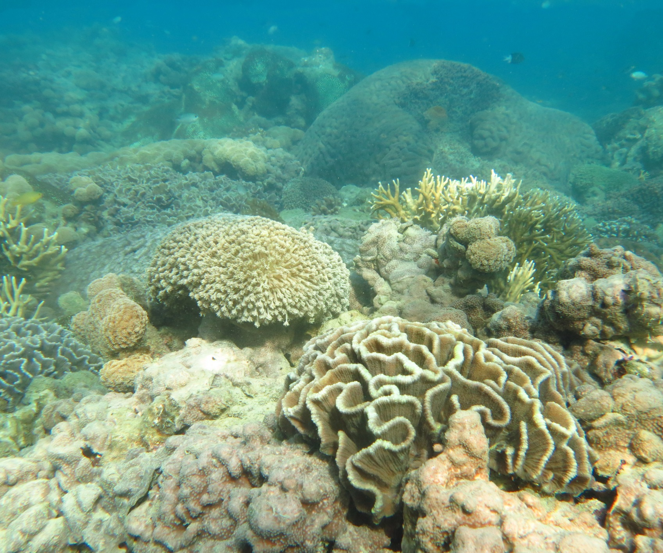

Authors - Angus Thompson, Christian Lønborg, Paul Costello, Johnston Davidson, Murray Logan, Miles Furnas, Kevin Gunn, Michelle Liddy, Michele Skuza, Sven Uthicke, Margaret Wright, Irena Zagorskis, Britta Schaffelke

2 0 1 3 - 2 0 1 4

Marine Monitoring Program

Inshore Water Quality and Coral Reef Monitoring
Annual Report of AIMS Activities 2013 to 2014

Angus Thompson, Christian Lønborg, Paul Costello, Johnston Davidson,
Murray Logan, Miles Furnas, Kevin Gunn, Michelle Liddy, Michele Skuza,
Sven Uthicke, Margaret Wright, Irena Zagorskis, Britta Schaffelke

December 2014

Australian Institute of Marine Science
PMB No 3
Townsville MC Qld 4810
This report should be cited as:
Thompson A, Lønborg C, Logan M, Costello P, Davidson J, Furnas M, Gunn K, Liddy M, Skuza M, Uthicke S, Wright M, Zagorskis I, and Schaffelke B (2014) Marine Monitoring Program. Annual Report of AIMS Activities 2013 to 2014– Inshore water quality and coral reef monitoring. Report for the Great Barrier Reef Marine Park Authority. Australian Institute of Marine Science, Townsville.160 pp.
© Copyright Australian Institute of Marine Science (AIMS) 2014
All rights are reserved and no part of this document may be reproduced, stored or copied in any form or by any means whatsoever except with the prior written permission of AIMS.
DISCLAIMER
While reasonable efforts have been made to ensure that the contents of this document are factually correct, AIMS does not make any representation or give any warranty regarding the accuracy, completeness, currency or suitability for any particular purpose of the information or statements contained in this document. To the extent permitted by law AIMS shall not be liable for any loss, damage, cost or expense that may be occasioned directly or indirectly through the use of or reliance on the contents of this document.

Contents
List of Figures and Tables iii
List of Figures and Tables-Appendices iv
Executive Summary 1
Methods 1
Trends in key ecosystem health indicators 1
Conclusions 4
Preface 7
1. Introduction 8
2. Methods summary 11
2.1 Sampling design 11
2.2 Sampling methods 12
2.2.1 Water quality monitoring 13
2.2.2 Sea temperature monitoring 14
2.2.3 Sediment quality monitoring 14
2.2.4 Foraminifera monitoring 14
2.2.5 Benthic community sampling 14
2.3 Data analyses 15
2.4 Water type classifications 15
3. Results and discussion 16
3.1 Regional reports 17
3.1.1 Wet Tropics Region: Barron Daintree sub-region 17
3.1.2 Wet Tropics Region: Johnstone Russell-Mulgrave sub-region 23
3.1.3 Wet Tropics Region: Herbert Tully sub-region 29
3.1.4 Burdekin Region 34
3.1.5 Mackay Whitsunday Region 40
3.1.6 Fitzroy Region 46
3.2 Case study: Potential coral community composition metric for inclusion into the
coral health index 52
4. Conclusions 65
Acknowledgments 70
5. References 71
Appendix 1: Material and Methods 83
A1.1 Water quality monitoring methods 84
A1.1.1 Direct water sample collection, preparation and analyses 84
A1.1.2 Autonomous Water Quality Loggers 85
A1.2 Water quality data analysis and presentation 86
A1.2.1 Comparison with trigger values from the GBR Water Quality Guidelines 86
A1.2.2 Summary statistics and data presentation 87
A1.2.3 Interim site-specific water quality index 88
A1.2.4 Sea temperature monitoring 90
A1.3 Coral reef monitoring methods 91
A1.3.1 Coral community sampling design 91
A1.3.2 Coral community sampling methods 92
A1.3.3 Foraminiferal sampling 93
A1.3.4 Assessment of Foraminiferal community condition 93
A1.3.5 Sediment sampling 94
A1.3.6 Coral reef data analysis and presentation 94
A1.3.7 Assessment of coral community condition 95
Appendix 2: Additional Information 99
Appendix 3: QAQC Information 153
Method performance and QAQC information for water quality monitoring activities 154
Limits of detection 154
Precision 155
Accuracy 155
Procedural blanks 156
Validation of ECO FLNTUSB instrument data 157
Method performance and QAQC information for coral monitoring activities 159
Appendix 4: Scientific publications and presentations associated with the
Program 2013-14 160

List of Figures and Tables
Figure 1 Ecosystem health indicators. 2
Figure 2 Sampling locations of the MMP coral and water quality monitoring. 12
Figure 3 MMP sampling sites in the Barron Daintree sub-region. 17
Figure 4 Combined discharge for the Barron and Daintree Rivers. 18
Figure 5 Sea temperature for the Barron Daintree sub-region. 18
Figure 6 Temporal trends in Water Quality for the Barron-Daintree sub-region. 21
Figure 7 Coral reef community and sediment quality trends in the Barron Daintree sub-region 22
Figure 8 MMP sampling sites in the Johnstone Russell-Mulgrave sub-region.. 23
Figure 9 Combined discharge for the North and South Johnstone, Russell and Mulgrave rivers. 24
Figure 10 Sea temperatures for the Johnstone Russell-Mulgrave sub-region. 24
Figure 11 Temporal trends in Water Quality for the Johnstone Russell-Mulgrave sub-region. 27
Figure 12 Coral reef community and sediment quality trends in the Johnstone Russell-Mulgrave sub-region. 28
Figure 13 MMP sampling sites in the Herbert Tully sub-region.. 29
Figure 14 Combined discharge for Tully and Herbert Rivers. 30
Figure 15 Sea temperature for the Herbert-Tully sub-region. 30
Figure 16 Temporal trends in water quality for the Herbert-Tully sub-region. 32
Figure 17 Coral reef community and sediment quality trends in the Herbert-Tully sub-region. 33
Figure 18 MMP sampling sites in the Burdekin NRM Region.. 34
Figure 19 Discharge for the Burdekin River.. 35
Figure 20 Sea temperature for the Burdekin region. 35
Figure 21 Temporal trends in water quality for the Burdekin region. 38
Figure 22 Coral reef community and sediment quality trends in the Burdekin region. 39
Figure 23 MMP sampling sites in the Mackay Whitsunday NRM Region.. 40
Figure 24 Combined discharge for the O'Connell, Proserpine and Pioneer Rivers. 41
Figure 25 Sea temperature for the Mackay Whitsunday region. 41
Figure 26 Temporal trends in water quality for the Mackay Whitsunday region. 44
Figure 27 Coral reef community and sediment quality trends in the Mackay Whitsunday region. 45
Figure 28 MMP sampling sites in the Fitzroy NRM Region. 46
Figure 29 Discharge for the Fitzroy River.. 47
Figure 30 Sea temperatures for the Fitzroy region. 47
Figure 31 Water quality trends in the Fitzroy region.. 50
Figure 32 Coral reef community and sediment quality trends in the Fitzroy region. 51
Figure 33 Coral community compositions relative to water quality gradients. 58
Figure 34 Temporal trends in coral community composition index 62

Table 1 Report card metric scores for coral and foraminifera communities through time within each sub-region 6
Table 2 Sampling locations of the MMP coral and water quality monitoring. 13
Table 3 Relationship between community composition of hard corals, regions and sediment composition. 55
Table 4 Relationship between community composition of hard corals, water quality and sediment composition. . 56
Table 5 Genus group scores along constrained water quality axis at each depth. 57

List of Figures and Tables-Appendices
Appendix 1: Material and Methods
Table A1-1 Trigger values from the Water Quality Guidelines . 87
Table A1-2 Summary of sampling methods applied in the MMP inshore coral reef monitoring. 93
Table A1-3 Threshold values for the assessment of coral reef condition and resilience 97

Appendix 2: Additional Information
Figure A2- 1 Time series of daily means of chlorophyll (green line) and turbidity (red line) collected by ECO FLNTUSB instruments. 116
Figure A2- 2 Seasonal trends in water quality variables in reporting (sub-)regions. 121
Figure A2- 3 Long-term trends in dissolved organic carbon (DOC). 122
Figure A2- 4 Cover of major benthic groups and density of hard coral juveniles at each depth for reefs in the Daintree sub-region. 134
Figure A2- 5 Cover of major benthic groups and density of hard coral juveniles at each depth for reefs in the Johnstone sub-region. 135
Figure A2- 6 Cover of major benthic groups and density of hard coral juveniles at each depth for reefs in the Tully sub- region. 137
Figure A2- 7 Cover of major benthic groups and density of hard coral juveniles at each depth for reefs in the Burdekin region. 139
Figure A2- 8 Cover of major benthic groups and density of hard coral juveniles at each depth for reefs in the Mackay Whitsunday region. 142
Figure A2- 9 Cover of major benthic groups and density of hard coral juveniles at each depth for reefs in the Fitzroy region. 145
Figure A2- 10 Incidence of coral mortality. 147
Figure A2- 11 Coral community composition index for the Wet Tropics region. 148
Figure A2- 12 Coral community composition index for the Burdekin region. 149
Figure A2- 13 Coral community composition index for the Mackay/ Whitsundays region. 150
Figure A2- 14 Coral community composition index in the Fitzroy region reefs. 151
Figure A2- 15 Rate of coral cover change indicator estimates 152

Table A2- 1 Annual freshwater discharge for the major Reef Catchments 100
Table A2- 2 Summary statistics for direct water sampling data from inshore lagoon sites from August 2005-June 2014 101
Table A2- 3 Summary of turbidity (NTU) data from ECO FLNTUSB instruments at 14 inshore reef sites 113
Table A2- 4 Interim water quality index for each water quality sampling location 123
Table A2- 5 Disturbance histories for coral monitoring locations. 130
Table A2- 6 Report card metric assessments for benthic communities at each reef and depth based on 2014 condition. 132

Appendix 3: QAQC Information
Figure A3-1 Match-up of instrument readings of turbidity from field deployments of WET Labs Eco FLNTUSB Combination Fluorometer and Turbidity Sensors with values from standard laboratory analysis of concurrently collected water samples. 157
Figure A3-2 Match-up of instrument readings of chlorophyll fluorescence from field deployments of WET Labs Eco FLNTUSB Combination Fluorometer and Turbidity Sensors. 158

Table A3-1 Limit of detection (LOD) for analyses of marine water quality parameters. 154
Table A3-2 Summary of coefficients of variation (CV, in %) of replicate measurements (N) of a standard or reference material. 155
Table A3-3 Summary of average recovery of known analyte concentrations. 155
Table A3-4 Summary of average Z-scores of replicate measurements (N) of a standard or reference material. 156
Table A3-5 Comparison of instrument readings of wet filter blanks to actual sample readings 157

Executive Summary
The management of water quality remains an essential requirement to ensure the long-term protection of the coastal and inshore ecosystems of the Great Barrier Reef (the Reef). The land management initiatives under the Australian and Queensland Government's Reef Water Quality Protection Plan (Reef Plan) are key tools to improve the water quality entering the GBR with the goal “To ensure that by 2020 the quality of water entering the reef from broadscale land use has no detrimental impact on the health and resilience of the Great Barrier Reef.” This report summarises the results of water quality and coral reef monitoring activities, carried out by the Australian Institute of Marine Science as part of the Reef 2050 Plan Marine Monitoring Program (MMP) from 2005 to 2014.

Methods
The objective of the MMP is to assess trends in ecosystem health and resilience indicators for the Great Barrier Reef in relation to water quality and its linkages to end-of-catchment loads. The sampling design for the inshore water quality and coral reef monitoring components was selected for the detection of change in benthic communities on inshore reefs in response to changes in water quality parameters. Within each of four Natural Resource Management (NRM) regions: Wet Tropics (comprising three sub-regions), Burdekin, Mackay Whitsunday and Fitzroy, sites were selected along a gradient of exposure to runoff to ensure coverage of communities occupying a range of environmental conditions.

Reefs were designated as either ‘core’ or ‘cycle’ reefs. At the 14 core reefs, detailed manual and instrumental water sampling was undertaken as well as annual surveys of reef status, foraminifera communities, and sediment quality. The 18 cycle reefs are visited every other year for surveys of reef status and the monitoring of sediment quality. Originally, cycle reefs were sampled each year (2005 and 2006), however, the sampling design was altered in 2007 as a result of fiscal limitations. Sampling cycle reefs in alternate years was a cost-effective solution to maintaining the spatial coverage of the program. Sampling of the six open water stations along the long-term ‘Cairns Transect’ was also continued for the implicit value of the continuous long term data set it provides.

Trends in key ecosystem health indicators
In this report we provide temporal trends of water quality indicators, together with trends in sediment quality and coral reef condition indicators. The water and sediment quality around inshore reefs declines in response to increased river flows, which are used here as a proxy for river loads of sediments, nutrients and pollutants. Changing environmental conditions have clear impacts on the resilience of these inshore coral reef communities.

The general trends of key ecosystem health indicators, summarised as report card indices, are presented at the scale of geographic regions (corresponding to the four NRM regions) to give a general overview of major changes in the water quality and benthic community composition at inshore coral reefs along sections of the northern, central and southern Reef (Figure 1).

The water quality index has maintained ‘good’ index scores throughout the program in the Wet Tropics Region. It is pertinent to note at this point that the regional water quality index is currently based on a selected set of variables for which GBR water quality guidelines are available. The index does provide a valid estimation of water quality condition, however, it is important to emphasise that a more comprehensive index would encompass a much wider range of variables and more sampling sites in a region to cover a wider range of conditions along environmental gradients. For example, the index does not reflect the marked increases measured in organic carbon and NO_{X} over the monitoring period from 2005-2014.

Developing such a WQ index will be a time consuming and challenging task, as the processes controlling the changing WQ are poorly understood. Future process-oriented field studies and detailed statistical analysis will therefore be needed to resolve and understand these changes before a more reliable and comprehensive WQ index can be developed.

The 2014 assessment of the coral health index for the Wet Tropics is ‘moderate’ and represents an improvement from the ‘poor’ assessments over the previous three years. The improved assessment reflects recovery of community condition in both the Johnstone Russell-Mulgrave and Herbert Tully sub-regions where the rate of coral cover increase has improved, the cover of macroalgae has declined and the density of juvenile corals has increased (Table 1) following a period of multiple stressors.

In both the Barron-Daintree and Johnstone Russell-Mulgrave sub-regions there were high levels of coral disease in 2010 and 2011 followed by outbreaks of crown-of-thorns seastars (COTS), both stressors with potential links to poor water quality. Physical damage occurred during the passage of tropical cyclones at most reefs with the cyclones Larry (2006), Tasha (2010), Yasi (2011) and Ita (2014) variously reducing coral cover at reefs across the region. In tandem with the loss of coral cover was an increase in the cover of macroalgae, particularly at those reefs situated closer to the coast or on the sheltered sides of islands where exposure to pollutants is greatest. There was, however, some indication that this increase had stabilised, if not reversed, on many reefs in 2014. The proliferation of macroalgae indicates that, despite regionally good assessments, water quality at some sites is sufficiently poor to foster macroalgal blooms.
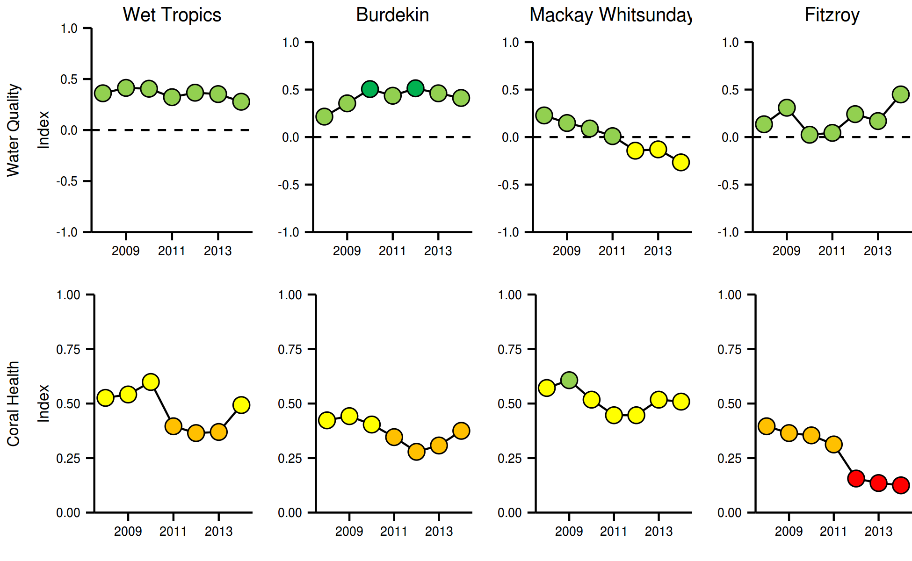
Figure 1 Ecosystem health indicators. The water quality index aggregates scores for four indicators: concentrations of particulate nitrogen and phosphorus, chlorophyll and a combined water clarity indicator (suspended solids, turbidity and Secchi depth), relative to Guideline values (GBRMPA 2010). The coral health index aggregates the attributes: cover of corals, cover of macroalgae, density of juvenile corals and the rate of coral cover increase. Red= very poor, orange= poor, yellow= moderate, light green= good, dark green= very good. Detailed derivation of scores can be found in Appendix 1.2.3 and Appendix tables A2-3 and A2-5.

The settlement and growth of juvenile corals is a key component of coral community recovery from disturbance. Regionally, the density of juveniles had declined to a low point in 2012. The reverse of this decline with increasing densities of juvenile corals in 2013 and 2014 contributed to the improvement of the coral health index and indicates the recovery potential of these reefs. Some caution around this reversal in the trend is warranted as the increase is primarily due to just one genus of coral, Turbinaria, a genus typically associated with turbid or nutrient-rich environments. At some reefs there has been an increase in the density of the genus Acropora, a genus more typically occurring in cleaner waters and so it will be informative to document how the juvenile community responds should NOx or dissolved organic carbon concentrations return to levels observed prior to the recent period of high rainfall.

Within the Wet Tropics, the lower variation in annual discharge of local rivers means that the direct response of coral communities to extremes in water quality may not be as clear as those observed in response to flood events of the larger and more variable discharge of rivers to the south. However, of concern in this region are the larger, GBR-scale implications of poor water quality, such as proposed links between COTS outbreaks and run-off derived nutrients. The current outbreak of adult COTS in this region strongly coincides with the onset of heavier river discharge to the inshore waters from 2007 onwards.

The overall condition of the water quality in the Burdekin Region showed initial improvements at the start of the monitoring program and has remained stable over the last several years with continuous overall index scores of ‘good’ or ‘very good’ since 2008. There has, however, been a noticeable increase in the organic carbon, NO_{X} and turbidity levels, which is not reflected in the index scores. Despite the ‘good’ or ‘very good’ water quality index scores, regionally low coral cover as a result of wide spread disturbances coupled with slow rates of coral recovery and low densities of juvenile corals result in the continued ‘poor’ rating of the coral health index (Table 1). The recent upward trend in the coral health index does, however, indicate some improvement in the condition of coral communities from the low point reached in 2012 following damage caused by Cyclone Yasi and several years of the Burdekin River flooding. The slight improvement in the index represents an increase in the density of juvenile corals and improved rate of coral recovery with coral cover beginning to increase at some reefs.

Historically, inshore reefs in the Burdekin Region have demonstrated low recovery potential following widespread loss of corals. This low recovery potential appears linked to a combination of water quality-related pressures and limited connectivity between these reefs and coral communities further offshore. Suppression of coral community health as a result of poor water quality is indicated by observations of high levels of coral disease and subsequent mortality that coincided with the change from a period of low flow years of the Burdekin to consecutive years of flooding. The availability of nutrients is also indicated by persistently high cover of macroalgae on four of the five reefs with the poorest water quality. The indication that reefs in this region have limited connectivity to reefs further offshore potentially limits larval supply to these reefs when local coral cover is reduced. In combination with potentially limited larval supply, the consequences of poor water quality for the recovery of coral communities in this region are potentially magnified.

Water quality in the Mackay Whitsunday Region has steadily declined over the course of the MMP monitoring and continues to score a ‘moderate’ rating for the third consecutive year. As indicated by the increased concentrations of organic carbon and NO_{X} and of turbidity levels, this decline most likely reflects the impacts of above-median river flows in this region from 2007 onwards, along with the likely exposure to runoff from the neighbouring large catchments of the Burdekin and Fitzroy rivers.

In contrast to declines in water quality, the coral health index maintained a ‘moderate’ score. The positive attributes of moderate to high coral cover coupled with regionally low cover of macroalgae balanced the low rate of coral cover increases (Table 1). The influence of prevailing environmental conditions such as high turbidity, nutrient availability and sedimentation have clearly selected for coral species tolerant of those conditions and this, in combination with a lack of recent severe disturbance events, explains the relatively high and stable coral cover in this region despite declines in water quality. The ongoing selection for corals tolerant to the declining water quality in the region is evidenced by increased levels of coral disease and declines in the density of juvenile corals, both of which coincided with declining water quality. Recent increases in both coral cover and juvenile density observed in 2013 and 2014 further indicate the tolerance of the coral communities to the region’s impaired water quality. What remains largely untested in this region is how resilient these communities will be if exposed to a severe disturbance event. The slow rate of coral cover increase in this region suggests recovery from disturbance may be slow.

The overall condition of the water quality in the Fitzroy Region has fluctuated over the course of the MMP monitoring, more or less following the discharge pattern of the Fitzroy River, but still maintained an overall index score of ‘good’. There has, however, been a noticeable increase in the organic carbon, NO_{X} and turbidity levels, which is not reflected in the index scores. The influence of flooding on the water quality within the region has contributed to the continued decline in coral reef condition to the ‘very poor’ rating attained following the record floods of 2011. The 2011 flood had a severe impact on reefs inshore of Great Keppel Island by killing the majority of corals to depths of at least 2m below low tide, with negligible recovery from this event to date. Elsewhere, the resilience of coral communities was compromised by a persistent bloom of macroalgae and occasional high levels of disease since high water temperatures in 2006 bleached and killed corals across the region. In addition, the density of juvenile corals has been consistently low across the entire region. This may in part be linked to the high cover of macroalgae. Both the prevalence of disease and persistence of high macroalgae cover provide a clear indication that the water quality surrounding these reefs is inhibiting the coral communities and has contributed to the declines in the coral heath index (Table 1).

FORAM index-based assessments of the reef condition reinforce observations from previous years of a substantial shift in community composition from those observed in 2005-2007. In all regions, values of the FORAM index declined to a ‘very poor’ rating as the abundance of autotrophic species, which favour high light and low nutrient environments, declined relative to the abundance of heterotrophic species, which are typically associated with lower light conditions and fine sediments high in organic matter. The consistency of this decline strongly implies an increase in fine sediments and/or nutrients in all regions over the period 2009- 2014. This interpretation is supported by observed increases in the concentrations of dissolved organic carbon, NO_{x,} and in turbidity levels in the water column and nitrogen levels in reefal sediments. The concurrent change in foraminiferal community composition, declines in coral community condition and declines in water quality combine to demonstrate that ecosystem responses coinciding with elevated levels of runoff are consistent across a range of benthic organisms.

Conclusions
After ten years of monitoring it is evident that large-scale changes in the water quality have taken place, with the data clearly showing large increases in the concentrations of dissolved organic carbon, NO_{x} and in turbidity levels in all regions. These findings show that the mechanisms controlling the carbon and nutrient cycle in the Reef lagoon have undergone dramatic changes. The coincidence of these changes with a period of elevated runoff as a result of high rainfall implies the responsiveness of these fundamental cycles to terrestrial inputs.

The steady decline of the FORAM index on most reefs is a strong indication that the observed changes in water and sediment quality represent a shift in environmental conditions that were sufficient to alter the composition of foraminifera communities.

In contrast to the relatively short life span of foraminifera, corals are long-lived and their community composition and dynamics reflects the cumulative result of selective pressures over longer time frames. Interactions between environmental variables, other organisms, and the effects of past disturbances events are all likely to influence the state of a coral community at any point in space and time. The general responses of coral reef communities to water quality are relatively well understood and contribute to differences in the composition of key organisms along environmental gradients in the inshore Reef. In addition, corals are subject to acute disturbance events such as cyclones, crown-of-thorns seastar (COTS) outbreaks and thermal bleaching events. The potential role of poor water quality in suppressing the resistance to, or recovery from, these disturbances is a critical factor determining the resilience of coral communities on inshore reefs. We interpret the recent declines in our assessments of coral community health to reflect a combination of acute disturbances and environmental limitations to coral community resilience. Collectively, changes in resilience indicators (cover of macroalgae, juvenile density, rate of coral cover increase), were broadly similar along regions and across environmental gradients and declined to low levels following a prolonged period of high runoff to the Reef lagoon. This consistent response affecting a diversity of taxonomic groups demonstrates the importance and the broad ‘footprint’ of runoff within the inshore Reef lagoon. The improvements in the coral health index in 2014 that coincided with a return to lower levels of runoff in most regions provide encouragement that coral communities are responsive to reduced loads of contaminants in runoff and, hence, support the continued efforts of Reef Plan.

Recent research into the interactions between water quality and climate change suggests that the tolerance to heat stress and ocean acidification of corals and foraminifera is reduced by exposure to contaminants including nutrients, herbicides and suspended particulate matter. The initiation of COTS outbreaks have also been linked to increased nutrient loads delivered to the Reef lagoon during major flood events. With the prediction that he severity of disturbance events is projected to increase as a result of climate change, any increase in susceptibility to these disturbances as a result of local stressors will compound the pressures imposed on sensitive species and potentially lead to profound changes in coral community composition. At present, there is a limited understanding of the cumulative impacts of these multiple pressures. The 2014 GBRMPA Strategic Assessment and Outlook reports identified this as a key knowledge gap and the management of these impacts as a key strategic challenge. The evidence summarised in the recent Reef Plan Scientific Consensus Statement “indicates that a reduction in catchment pollutant loads is essential to halt and reverse further decline in the Reef ecosystem condition at a time of rapidly warming climate and ocean acidification.” Continued monitoring of the coastal and inshore Reef lagoon is fundamental to determine and track long-term trends in the condition of marine water quality and ecosystem health and to identify the ecosystem responses to management actions and interventions, for example those under Reef Plan.

Table 1 Report card metric scores for coral and foraminifera communities through time within each sub-region

Region |  | 2008 | 2009 | 2010 | 2011 | 2012 | 2013 | 2014
Daintree | Coral cover | 0.88 | 0.88 | 1.00 | 0.88 | 0.88 | 0.63 | 0.63
Daintree | Macroalgae | 1.00 | 0.88 | 0.88 | 0.50 | 0.50 | 0.50 | 0.50
Daintree | Juvenile coral | 0.63 | 0.25 | 0.50 | 0.25 | 0.13 | 0.00 | 0.00
Daintree | Cover change | 0.88 | 0.50 | 0.38 | 0.25 | 0.12 | 0.0 | 0.00
Daintree | Report Card Score | 0.84 | 0.63 | 0.69 | 0.47 | 0.41 | 0.28 | 0.28
Johnstone Russell-Mulgrave | Coral cover | 0.67 | 0.79 | 0.83 | 0.46 | 0.54 | 0.58 | 0.63
Johnstone Russell-Mulgrave | Macroalgae | 0.83 | 0.96 | 0.92 | 0.79 | 0.75 | 0.71 | 0.83
Johnstone Russell-Mulgrave | Juvenile coral | 0.50 | 0.46 | 0.42 | 0.13 | 0.13 | 0.21 | 0.29
Johnstone Russell-Mulgrave | Cover change | 0.54 | 0.50 | 0.67 | 0.29 | 0.21 | 0.21 | 0.55
Johnstone Russell-Mulgrave | Report Card Score | 0.64 | 0.68 | 0.71 | 0.42 | 0.41 | 0.43 | 0.58
Johnstone Russell-Mulgrave | FORAM index |  |  | 0.17 | 0.00 | 0.00 | 0.00 | 0.00
Herbert Tully | Coral cover | 0.06 | 0.06 | 0.13 | 0.00 | 0.00 | 0.00 | 0.06
Herbert Tully | Macroalgae | 0.19 | 0.19 | 0.25 | 0.69 | 0.31 | 0.25 | 0.31
Herbert Tully | Juvenile coral | 0.31 | 0.56 | 0.75 | 0.25 | 0.38 | 0.63 | 0.88
Herbert Tully | Cover change | 0.25 | 0.38 | 0.44 | 0.38 | 0.38 | 0.38 | 0.44
Herbert Tully | Report Card Score | 0.20 | 0.30 | 0.39 | 0.33 | 0.27 | 0.31 | 0.42
Herbert Tully | FORAM index |  |  | 0.00 | 0.50 | 0.00 | 0.00 | 0.00
Burdekin | Coral cover | 0.35 | 0.27 | 0.27 | 0.19 | 0.12 | 0.19 | 0.23
Burdekin | Macroalgae | 0.42 | 0.50 | 0.54 | 0.77 | 0.58 | 0.50 | 0.58
Burdekin | Juvenile coral | 0.35 | 0.35 | 0.46 | 0.15 | 0.19 | 0.35 | 0.42
Burdekin | Cover change | 0.58 | 0.65 | 0.34 | 0.27 | 0.23 | 0.19 | 0.27
Burdekin | Report Card Score | 0.42 | 0.44 | 0.40 | 0.35 | 0.28 | 0.31 | 0.38
Burdekin | FORAM index |  |  | 0.17 | 0.00 | 0.00 | 0.00 | 0.00
Mackay Whitsunday | Coral cover | 0.71 | 0.68 | 0.57 | 0.54 | 0.57 | 0.61 | 0.61
Mackay Whitsunday | Macroalgae | 0.86 | 0.93 | 0.89 | 0.82 | 0.82 | 0.82 | 0.79
Mackay Whitsunday | Juvenile coral | 0.57 | 0.61 | 0.39 | 0.29 | 0.29 | 0.43 | 0.46
Mackay Whitsunday | Cover change | 0.14 | 0.21 | 0.21 | 0.14 | 0.11 | 0.21 | 0.18
Mackay Whitsunday | Report Card Score | 0.57 | 0.61 | 0.52 | 0.45 | 0.45 | 0.52 | 0.51
Mackay Whitsunday | FORAM index |  |  | 0.33 | 0.33 | 0.17 | 0.00 | 0.17
Fitzroy | Coral cover | 0.54 | 0.54 | 0.46 | 0.29 | 0.21 | 0.13 | 0.17
Fitzroy | Macroalgae | 0.38 | 0.29 | 0.54 | 0.67 | 0.29 | 0.21 | 0.08
Fitzroy | Juvenile coral | 0.04 | 0.08 | 0.13 | 0.08 | 0.08 | 0.04 | 0.08
Fitzroy | Cover change | 0.62 | 0.54 | 0.29 | 0.21 | 0.04 | 0.17 | 0.17
Fitzroy | Report Card Score | 0.40 | 0.36 | 0.35 | 0.31 | 0.16 | 0.14 | 0.13
Fitzroy | FORAM index |  |  | 0.50 | 0.25 | 0.25 | 0.25 | 0.00

Preface
Management of human pressures on regional and local scales, such as enhanced nutrient runoff and overfishing, is vital to provide corals and reef organisms with the optimum conditions to cope with global stressors, such as climate change and ocean acidification (Bellwood et al. 2004, Marshall and Johnson 2007, Carpenter et al. 2008, Mora 2008, Hughes et al. 2010). The management of water quality remains a strategic priority for the Great Barrier Reef Marine Park Authority (GBRMPA) to ensure the long-term protection of the coastal and inshore ecosystems of the Reef (GBRMPA 2014 a, b). A key management tool is the Reef Water Quality Protection Plan (Reef Plan; Anon 2013), with the actions being delivered through the Reef 2050 Plan. The Reef 2050 Plan includes the Reef Trust, to which the Australian Government has committed continued funding to protect the Reef through improvements to the quality of water flowing into the Reef lagoon, and the Reef 2050 Long Term Sustainability Plan, which provides a framework for the integrated management of the GBRWHA.

The Marine Monitoring Program (MMP), formerly known as the Reef Plan MMP, was designed and developed by the GBRMPA in collaboration with science agencies and is currently funded by the Reef 2050 Plan. A summary of the MMP’s overall goals and objectives and a description of the sub-programs are available at http://www.gbrmpa.gov.au/managing-the-reef/how-the-reefs-managed/reef-2050-marine-monitoring-program and http://e-atlas.org.au/rrmmp. The MMP forms an integral part of the Paddock to Reef Integrated Monitoring, Modelling and Reporting Program, which is a key action of Reef Plan and is designed to evaluate the efficiency and effectiveness of implementation and report on progress towards the Reef 2050 Plan goals and targets. A key output of the Paddock to Reef Program is an annual report card, including an assessment of Reef water quality and ecosystem condition to which the MMP contributes assessments and information. The first Annual Reef Plan Report Card for 2009 (Anon. 2011), serves as a baseline for future assessments, and report cards for 2010, 2011 and 2012/13 have since been released (available at www.reefplan.qld.gov.au).

The Australian Institute of Marine Science (AIMS) and the GBRMPA entered into a co-investment agreement in February 2014 to provide monitoring activities under the MMP from 2013 to 2014. The AIMS monitoring activities in the current contract period of the MMP are largely an extension of activities established under a previous arrangements from 2005 to 2012 and are grouped into two components:

- Inshore Marine Water Quality Monitoring
- Inshore Coral Reef Monitoring

As in the previous year, this report combines the results of the AIMS Water Quality and Coral Reef Monitoring into an integrated report. This better reflects the monitoring design, which is based on co-location of sampling sites, and the overarching objective of the MMP to:
“Assess trends in ecosystem health and resilience indicators for the Great Barrier Reef in relation to water quality and its linkages to end-of-catchment loads”
An objective that in turn allows the ongoing progress toward Reef 2050 Plan’s single long-term goal for the marine environment that is,
“To ensure that by 2020 the quality of water entering the reef from broadscale land use has no detrimental impact on the health and resilience of the Great Barrier Reef.”

This report covers monitoring conducted from December 2013 to November 2014 for the coral reef monitoring, and May 2013 to June 2014 for the water quality monitoring activities, with inclusion of data from previous MMP monitoring since 2005.

1. Introduction
Coastal areas around the world are under increasing pressure from human population growth, intensifying land use and urban and industrial development. As a result, increased loads of suspended sediment, nutrients and pollutants, such as pesticides and other chemicals, invariably enter coastal waters and may lead to a decline in estuarine and coastal marine water quality.

It is well documented that sediment and nutrient loads carried by land runoff into the coastal and inshore zones of the Great Barrier Reef (Reef) have increased since European settlement (e.g., Kroon et al. 2012; Waters et al. 2014). Nutrients to sustain the biological productivity of the Reef are supplied by a number of processes and sources such as upwelling of nutrient-enriched deep water from the Coral Sea and nitrogen fixation by (cyano-) bacteria (Furnas et al. 2011). However, land runoff is the largest source of new nutrients to the inshore Reef (ibid.), especially during monsoonal flood events. These nutrients augment the regional stocks of nutrients already stored in biomass or detritus (Furnas et al. 2011) which are continuously recycled to supply nutrients for marine plants and bacteria (Furnas et al. 2005, Furnas et al. 2011). Reflecting differences in inputs and transport, water quality parameters in the Reef vary along cross-shelf, seasonal and latitudinal gradients (Brodie et al. 2007, De’ath and Fabricius 2008, Schaffelke et al. 2012a).

Coral reef communities also vary in response to environmental conditions such as light availability, sedimentation and hydrodynamics and occur in a wide range of environmental settings (e.g. Done 1982, Fabricius and De’ath 2001a, DeVantier et al. 2006, De’ath and Fabricius 2010). Coral reefs in the coastal and inshore zones of the Reef, which are often fringing reefs around continental islands, are located in shallow, and generally more turbid, waters than reefs further offshore due to frequent exposure to re-suspended sediment and episodic flood events. It is difficult to quantify the changes to coral reef communities caused by runoff of excess nutrients and sediments because of the lack of historical biological and environmental data that predate significant land use changes on the catchment. However, recent research has strengthened the evidence for causal relationships between water quality changes and the decline of some coral reefs and seagrass meadows in these zones (reviewed in Brodie et al. 2012a and Schaffelke et al. 2013).

Concern about these negative effects of land runoff triggered the formulation of the Reef Water Quality Protection Plan (Reef Plan) for catchments adjacent to the GBR World Heritage Area by the Australian and Queensland governments (Anon. 2003; 2009). Reef Plan was revised and recently updated (Anon. 2013). The current Reef 2050 Plan actions and initiatives aim to improve land management practices that are expected to result in measurable positive changes in the downstream water quality of creeks and rivers. These actions and initiatives should, with time, also lead to improved water quality in the coastal and inshore Reef (see Brodie et al. 2012b for a discussion of expected time lags in the ecosystem response). Given that the benthic communities on inshore reefs of the Reef show clear responses to gradients in water quality, especially of water turbidity, sedimentation rate and nutrient availability (De’ath and Fabricius 2010, Thompson et al. 2010, Uthicke et al. 2010, Fabricius et al. 2012), improved land management practices have the potential to reduce levels of chronic environmental stresses that impact on coral reef communities. However, recent assessments raise the question whether these actions will be sufficient to ensure the resilience of the Reef ecosystems into the future (Bartley 2014a,b; Kroon et al. 2014).

Reef Plan actions also include the establishment of monitoring programs extending from the paddock to the Reef (Anon. 2010), to assess the effectiveness of the Reef Plan's implementation, which are predominantly funded by the Australian Government’s Reef 2050 Plan. The MMP is an integral part of this monitoring providing reliable physicochemical and biological data to investigate the effects of changes in inputs from the Reef catchments on marine water quality and the condition of inshore ecosystems.

The information gathered under the current MMP inshore water quality sampling program has improved our understanding of the spatial distribution and temporal variability of water quality in the coastal and inshore Reef. This includes detailed information about the site-specific state of water quality around inshore coral reefs (this report), detailed information about water quality in flood plumes (separate report by JCU, Devlin et al. 2014 in prep.) and information about herbicide levels in the inshore Reef (separate report by UQ, Gallen et al. 2014).

The MMP inshore coral reef monitoring focuses on key condition attributes that indicate whether reef communities are self-perpetuating and ‘resilient’, i.e., able to recover from disturbance. Common disturbances to inshore reefs include cyclones (often associated with flooding), thermal bleaching, and outbreaks of crown-of-thorns starfish, all of which can result in widespread mortality of corals (e.g. Sweatman et al. 2007). Recovery from such events is reliant on both the recruitment of new colonies and regeneration of existing colonies from remaining tissue fragments (Smith 2008, Diaz-Pulido et al. 2009). Previous studies have shown that elevated concentrations of nutrients, agrichemicals, and turbidity can negatively affect reproduction in corals (reviewed by Fabricius 2005, van Dam et al. 2011 Erftemeijer et al. 2012) and increased organic carbon concentrations can promote coral diseases and mortality (Kline et al. 2006, Kuntz et al. 2005).
Furthermore, high rates of sediment deposition and accumulation on surfaces can affect larval settlement (Babcock and Smith 2002, Baird et al. 2003, Fabricius et al. 2003) and smother juvenile corals (Harrison and Wallace 1990, Rogers 1990, Fabricius and Wolanski 2000). Any of these water quality-related pressures on the early life stages of corals have the potential to suppress the resilience of communities reliant on recruitment for recovery. Suppression of recovery may lead to long-term degradation of reefs as extended recovery time increases the likelihood that further disturbances will occur before recovery is complete (McCook et al. 2001b). For this reason, the MMP included estimates of the density and composition of juvenile coral communities to identify areas of the inshore Reef where there are declines or improvements in this key life history processes.

In addition to influences on the early life stages of corals, the position of a reef along environmental gradients can influence the health and hence, distribution of mature colonies. In very general terms, community composition changes along environmental gradients due to the differential abilities of species to derive sufficient energy for growth in a given environmental setting. Corals derive energy in two ways, by feeding on ingested particles and plankton organisms and from the photosynthesis of their symbiotic algae (zooxanthellae). The ability to compensate by feeding where there is a reduction in energy derived from photosynthesis, e.g. as a result of light attenuation in turbid waters, varies between species (Anthony 1999, Anthony and Fabricius 2000). Similarly, the energy required to shed sediments varies between species due to differences in the efficiencies of passive (largely depending on growth form) or active (such as mucus production) strategies for sediment removal (Rogers 1990, Stafford-Smith and Ormond 1992). At the same time, high nutrient levels may favour particle feeders such as sponges and heterotrophic soft corals which are potential space competitors of hard corals. In addition, macroalgae have higher abundance in areas with high water column chlorophyll concentrations, indicating higher nutrient availability (De’ath and Fabricius 2010). High macroalgal abundance may suppress reef resilience (e.g. Hughes et al. 2007, Cheal et al. 2010; Foster et al. 2008; but see Bruno et al. 2009) by increased competition for space or changing the microenvironment for corals to settle and grow in (e.g. McCook et al. 2001a, Hauri et al. 2010). Macroalgae have been documented to suppress fecundity (Foster et al. 2008), reduce recruitment of hard corals (Birrell et al. 2008b, Diaz-Pulido et al. 2010), diminish the capacity of growth among local coral communities (Fabricius 2005),and suppress coral recovery by altering microbial communities associated with corals (Morrow et al. 2012, Vega Thurber et al. 2012).The result is that the combination of environmental parameters at a given location will disproportionately favour some species and thus influence the community composition of coral reef benthos. Documenting and monitoring change in the absolute and relative cover of coral reef communities is an important component of the MMP as our expectations for the rate of recovery from disturbances will differ based on the community composition (Thompson and Dolman 2010).

It is important to note, however, that coral colonies exhibit a degree of plasticity in both their physiology (e.g. Falkowski et al. 1990 and Anthony and Fabricius 2000), and morphology (reviewed by Todd 2008) which allows them, within limits, to adapt to their environmental setting. This plasticity has the potential to decouple the relationship between benthic communities and their environmental setting, especially in locations that have been spared major disturbance. In effect, stands of large (typically old) colonies may represent relics of communities that recruited and survived under conditions different to those occurring today. The response of the coral reef community to chronic changes in environmental conditions may be delayed until a severe disturbance resets the community (through mortality of the relic community components) with subsequent recovery of species suited to the current conditions.

In recognition of the potential lagged response of coral communities to changing conditions, monitoring of benthic foraminifera communities was added to the suite of biological indicators as an indicator of environmental change that appears to respond faster and more specifically to changes in water quality (Uthicke and Nobes 2008, Uthicke and Altenrath 2010, Uthicke et al. 2010).

In order to relate inshore coral reef community health to variations in local reef water quality, this component of the MMP has three key objectives:

- To quantify temporal and spatial variation in the status of inshore coral reef communities in relation to local water quality changes;
- To assess temporal and spatial trends in marine water quality in inshore areas of the Reef lagoon;
- Provide an integrated assessment of water quality and inshore coral community condition allowing the reporting of progress toward Reef 2050 Plan goals.

2. Methods summary
In the following an overview is given of the sampling design and indicators collected. More details of the data collection, preparation and analytical methods are in Appendix 1 and in a separate QAQC report, updated annually (GBRMPA 2014c), which covers, the objectives and principles of analyses, step-by-step sample analysis procedures, instrument performance, data management and quality control measures.

2.1 Sampling design
The key goal of the MMP inshore water quality and coral reef monitoring components is to accurately quantify temporal and spatial variation in inshore coral reef community condition and relate this variation to differences in local reef water quality. To facilitate the identification of relationships between the composition and resilience of benthic communities and their environmental conditions it is essential that the environmental setting of each monitoring location is adequately described, to this end:

- Water temperature is continuously monitored at all locations to identify instances of thermal stress;
- Assessments of the grain size distribution and nutrient content of sediments were added in 2006/07 as indicators for the accumulation of fine sediments and/or nutrients and to infer the general hydrodynamic setting of sites;
- The water quality monitoring sites are matched to the core coral reef monitoring locations.

The sampling design was selected for the detection of change in benthic communities on inshore reefs in response to improvements in water quality parameters associated with specific (sub-) regions. Within each (sub-)region sites were selected along a gradient of exposure to runoff, largely determined as increasing distance from a river mouth in a northerly direction to reflect the predominantly northward flow of surface water forced by the prevailing south-easterly winds (Larcombe et al. 1995, Brinkman et al. 2011). Sub-regions were included in the Wet Tropics region as in this region sites were selected along gradients extending from the combined catchments of; the Barron and Daintree rivers, the Johnstone and Russell-Mulgrave Rivers, and the Herbert and Tully rivers.

Reefs within each of four Natural Resource Management (NRM) regions were designated as either ‘core’ or ‘cycle’ reefs (Figure 2, Table 1). At core reefs, detailed manual and instrumental water sampling was undertaken as well as annual surveys of reef status including the monitoring of coral recruitment, the FORAM index, and sediment quality. Cycle reefs were visited every other year for surveys of reef status including the monitoring of sediment quality. Sampling of the six open water stations of the long-term ‘AIMS Cairns Transect’ was also continued (Figure 2, Table 1). The sampling design of the Cairns Transect was changed in 2008/09 when only six of the original eleven sites were continued, after a statistical analysis indicated that this reduced number of stations would provide enough information for a robust time series analysis.

Coral reef surveys were undertaken predominantly over the months May-July. Water sampling was conducted three times a year with sampling nominally in February, in June/July and then again in September/October.

2.2 Sampling methods
This section provides a brief overview of sampling undertaken. Detailed descriptions of methodologies can be found as Appendix 1.

Figure 2 Sampling locations of the MMP coral and water quality monitoring. Table 1 describes monitoring activities undertaken at each location. NRM Region boundaries are represented by coloured catchment areas.

Table 2 Sampling locations of the MMP coral and water quality monitoring.
At ‘Core reefs’: coral communities, sediment composition, seawater temperature and benthic foraminifera assemblage composition are monitored annually; water quality is monitored by both grab samples and water quality loggers. At ‘Cycle reefs’: coral communities, sediment composition and seawater temperature are monitored in either odd or even years. At ‘Cairns water quality transect’ sites only grab sampling of water quality is undertaken. Locations within the ‘midshelf’ water body (GBRMPA 2010) are underlined.

NRM region | Sub-Regions | Core reefs | Cycle reefs |  | Cairns water quality transect
NRM region | Sub-Regions | Core reefs | Odd years | Even Years | Cairns water quality transect
Wet Tropics | Barron, Daintree | Snapper North | Snapper South* | Snapper South* | Cape Tribulation
Wet Tropics | Barron, Daintree |  |  |  | Port Douglas
Wet Tropics | Barron, Daintree |  |  |  | Double
Wet Tropics | Barron, Daintree |  |  |  | Green
Wet Tropics | Barron, Daintree |  |  |  | Yorkey's Knob
Wet Tropics | Barron, Daintree |  |  |  | Fairlead Buoy
Wet Tropics | Johnstone, Russell-Mulgrave | Fitzroy West | High East | Fitzroy East
Wet Tropics | Johnstone, Russell-Mulgrave | High West | Franklands East
Wet Tropics | Johnstone, Russell-Mulgrave | Franklands West
Wet Tropics | Herbert, Tully | Dunk North | Barnards | King Reef
Wet Tropics | Herbert, Tully |  |  | Dunk South
Burdekin |  | Palms West | Havannah | Palms East
 |  | Pandora Reef | Middle Reef | Lady Elliot Reef
 |  | Magnetic
Mackay Whitsunday |  | Double Cone | Dent | Shute Harbour
 |  | Daydream | Seaforth | Hook
 |  | Pine
Fitzroy |  | Barren | North Keppel | Peak
 |  | Pelican |  | Middle
 |  | Keppels South
* No temperature monitoring at Snapper South and surveyed in both odd and even years.

2.2.1 Water quality monitoring
At each of the 20 sampling locations, vertical profiles of water temperature, salinity, chlorophyll, and turbidity were measured with a Conductivity Temperature Depth profiler (CTD). The CTD casts are used to characterise the water column and identify how well mixed the water column is and record any stratification. Immediately following the CTD cast, discrete water samples were collected with Niskin bottles. Samples were collected from the surface, 1m from the seabed and, where the water depth exceeded 15m, from mid-water. In addition to the ship-based sampling, water samples were also collected by diver-operated Niskin bottle sampling, close to the autonomous water quality instruments (see below).Sub-samples taken from the Niskin bottles were analysed for the following species of dissolved and particulate nutrients and carbon:
- ammonium= NH₄,
- nitrite= NO₂,
- nitrate= NO₃,
- phosphate/filterable reactive phosphorus= PO₄,
- silicate/filterable reactive silicon= Si(OH)₄,
- dissolved organic nitrogen= DON,
- dissolved organic phosphorus= DOP,
- dissolved organic carbon= DOC,
- particulate organic nitrogen= PN,
- particulate phosphorus= PP,
- particulate organic carbon= POC.
(note that +/- signs identifying the charge of the nutrient ions were omitted for brevity).

Continuous in situ measurements of chlorophyll fluorescence and turbidity were perform at the 14 core reefs using WET Labs ECO FLNTUSB Combination Fluorometer and Turbidity Sensors, deployed at 5m at the start of coral survey transects.

2.2.2 Sea temperature monitoring
Temperature loggers were deployed at, or in close proximity to, each coral survey location at both 2m and 5m depths and routinely exchanged at the time of the coral surveys (i.e. every 12 or 24 months).

2.2.3 Sediment quality monitoring
Sediment samples were collected from all reefs visited for analysis of grain size and of the proportion of inorganic carbon, organic carbon and total nitrogen.

2.2.4 Foraminifera monitoring
The composition of foraminiferal assemblages was estimated from surface sediment samples collected at the 14 core coral monitoring sites. Species composition of foraminifera was determined using a dissection microscope following Nobes and Uthicke (2008). Data are presented as a FORAM index (Hallock et al. 2003) based on the relative proportions of species classified as either symbiont-bearing, opportunistic, or heterotrophic, a method that has been used as an indicator of coral reef water quality in Florida and the Caribbean Sea (Hallock et al. 2003) and successfully tested on GBR reefs (Uthicke and Nobes 2008, Uthicke et al. 2010). Detail of the methods used for the calculation of the FORAM index is presented in Appendix, A1.3.4.

2.2.5 Benthic community sampling
To account for spatial heterogeneity of benthic communities within reefs, two sites were selected at each survey reef. During a pilot study to the current monitoring program (Sweatman et al. 2007), marked differences were found in community structure and exposure to perturbations with depth; hence sampling within sites was stratified by depth. Within each site and depth, fine scale spatial variability was accounted for by the use of five replicate transects. Four separate sampling methods were used to describe the benthic communities of inshore coral reefs, as outlined below. These were each conducted along the fixed transects.

Benthic composition
The photo point intercept (PPI) method was used to gain estimates of the composition of the benthic communities. The method followed closely the Standard Operation Procedure Number 10 of the AIMS Long-Term Monitoring Program (Jonker et al. 2008).

Juvenile coral surveys
These surveys aimed to provide an estimate of the number of both hard and soft coral colonies that were successfully recruiting and surviving early post-settlement pressures. Importantly, this method aims to record only those small colonies (<10 cm) assessed as juveniles, i.e. which result from the settlement and subsequent survival and growth of coral larvae, and does not include small coral colonies considered as resulting from fragmentation or partial mortality of larger colonies.

Scuba search transects
Scuba search transects document the incidence of disease and other agents of coral mortality and damage. Tracking of these agents of mortality is important, because declines in coral condition due to these agents are potentially associated with changes in water quality. This method follows closely the Standard Operation Procedure Number 9 of the AIMS Long-Term Monitoring Program (Miller et al. 2009).

2.3 Data analyses
In this report results are presented to reveal temporal changes in coral community attributes and key environmental variables. Generalized additive mixed effects models were fitted to community attributes and environmental variables for each NRM region, or sub-region to identify the presence and consistency of trends. More detailed description of statistical methods and data summaries can be found in Appendix 1.2.

Water quality data were summarised as a simple water quality index, which is based on comparisons with existing water quality guidelines (DERM 2009,GBRMPA 2010), to generate an overall assessment of water quality at each of the 20 water quality sampling locations (14 core reef locations, 6 open water sites of the Cairns Water Quality Transect). Detail of the methods used for the calculation of the water quality index is presented in Appendix, A1.2.3.

The coral reef community indicators were summarised into a coral reef condition index, which is also used in the Reef Plan Report Card. This index was based on a combination of indicators of the current condition (cover of corals and macroalgae) and of the potential to recover from disturbance (rate of coral cover increase and density of juvenile corals). The underlying assumption is that a ‘healthy’ community should show clear signs of recovery after inevitable acute disturbances, such as cyclones and coral bleaching events, or, in the absence of disturbance, maintain a high cover of corals and successful larval recruitment and survival of juveniles. Detail of the methods used for the calculation of the coral index is presented in Appendix, A1.3.7.

2.4 Water type classifications
Within each section of the results region maps include an overlay of river plume exposure. These estimates were supplied by Dr Michelle Devlin of the Centre for Tropical Water and Aquatic Ecosystem Research, Catchment to Reef Research Group, James Cook University. These exposure maps represent the proportion of time within the wet season (December to April, over the years 2007 to 2012 inclusive) during which the optical properties of the water were consistent with those classified as either “primary” or “secondary” water masses in GBR flood plumes as described by Devlin et al. (2012). Flood plumes are grouped into primary and secondary plumes, based on water-quality characteristics (TSS, CDOM and chl a). The primary flood plume is characterised by higher levels of mean TSS (approx. 23 vs. 14 mg l⁻¹) and CDOM (0.36 vs. 0.26 m⁻¹) and lower chl a (1.1 vs. 1.4 µg l⁻¹ ) values (Devlin et al. 2012). The plume types therefore represent different degrees of coral exposure to stressors such as decreased light availability and smothering by high sedimentation. In brief, the estimates of exposure were derived following the methodology of Alvarez Romero et al. (2013) wherein water type was classified on the basis of two ocean-colour products (nLw667 and adg443, see Alvarez Romero et al. 2013 for further detail) applied to data derived from the satellite-mounted Moderate Resolution Imaging spectroradiometer (MODIS) Aqua sensor.

3. Results and discussion
This section provides detailed trend analysis of key water quality constituents, other environmental drivers, and reef condition indicators within each region. For the Wet Tropics Region, data are presented for sub-regions corresponding to major catchments.

Specifically, the information provided here is focused on identification and interpretation of temporal trends observed in the environmental and community attributes monitored. For each region the following information is included and discussed:
- A figure including a map of the water quality and benthic community monitoring locations with an overlay derived from satellite imagery that categorises the long-term exposure of the area to flood plumes.
- A figure providing time-series of environmental pressures, i.e. the discharge from local rivers, sea temperature, and the timing of tropical cyclones that influenced the region. This figure is presented to allow the reader to visualise the major climatic drivers of environmental variability that influence water quality and benthic communities.
- A figure providing regional trends in key water quality parameters and the resultant trend in the water quality index.
- A figure providing regional trends in the Foram index, sediment composition, the coral health index, and the coral reef community data from which the Coral index is derived.

Site-specific data and additional information tables are presented in Appendix 2 (referred to by Figure and Table numbers prefixed “A2”) and may be referred to where specific detail is required. These more detailed data summaries include:
- Table A2-1. Annual freshwater discharge for the major Reef Catchments relative to long term medians
- Table A2-2, Summary statistics for each direct water sampling variable from each monitoring location.
- Table A2-3, Annual summaries of WET Labs ECO FLNTUSB Combination Fluorometer and Turbidity Sensor derived turbidity for each monitoring location.
- Table A2-4. Time series of the water quality index for each location
- Table A2-5 Chronology of disturbance to coral communities at each monitoring location.
- Table A2-6 Report card metric scores for coral communities at each monitoring location.
- Figure A2-1, Time-series of temperature, Chlorophyll a and turbidity derived from WET Labs ECO FLNTUSB Combination Fluorometer and Turbidity Sensors.
- Figure A2-2, a panel of seasonal trends in water quality variables allowing inter-regional comparison.
- Figure A2-3, Long term trends in concentrations of dissolved organic carbon (DOC) for each (sub-)region.
- Figure A2- to A2-9, Time series of coral community composition for both cover and juvenile observations for each reporting region.
- Figure A2-10, Time series of incidence of coral mortality in each reporting region.
- Figure A2-11 to A2-14, Time series of coral community compositional change scores for each reef
- Figure A2-15, Time series of the rate of change in coral cover indicator

3.1 Regional reports

3.1.1 Wet Tropics Region: Barron Daintree sub-region
The Barron Daintree sub-region has a high proportion of forest and National Park areas, particularly within the Daintree catchment, with the primary agricultural land use being grazing (Brodie et al. 2003, GBRMPA 2012). The sampling sites in this sub-region are influenced by the discharge from the Daintree and Barron rivers, and, to a lesser extent, the Mossman River and other rivers south of the sub-region.

Snapper Island lies 4km from the mouth of the Daintree River (Figure 3). Here two reefs, Snapper North and Snapper South are sampled annually for coral reef condition assessments and there is a water quality sampling location co-located with Snapper North. This sub-region also contains the six open water sites of the ‘Cairns long-term water quality transect’.

Most of the sampling locations in this region are frequently exposed to secondary plume-type waters (Figure 3, definitions of exposure categories in caption). Two Cairns transect sites in Trinity Inlet are exposed to secondary plume-type waters most days during the wet season, while the two locations in the midshelf water body (Green and Double, Table 1) are rarely exposed to secondary plume-type waters.

Over the period 2006 to 2012, annual discharge for both the Daintree and Barron rivers has been at, or slightly above, median levels in most years with major floods of the Barron River in 2008 and again in 2011 when the Daintree River also flooded (Figure 4, Table A2-1). The 2011 floods were the highest flows recorded for the Barron over the last 14 years (Table A2-1). Discharge levels in the Daintree for 2014 were three times the long-term median, the highest in the past 14 years, and were strongly influenced by Cyclone Ita. (Figure 4, Table A2-1).

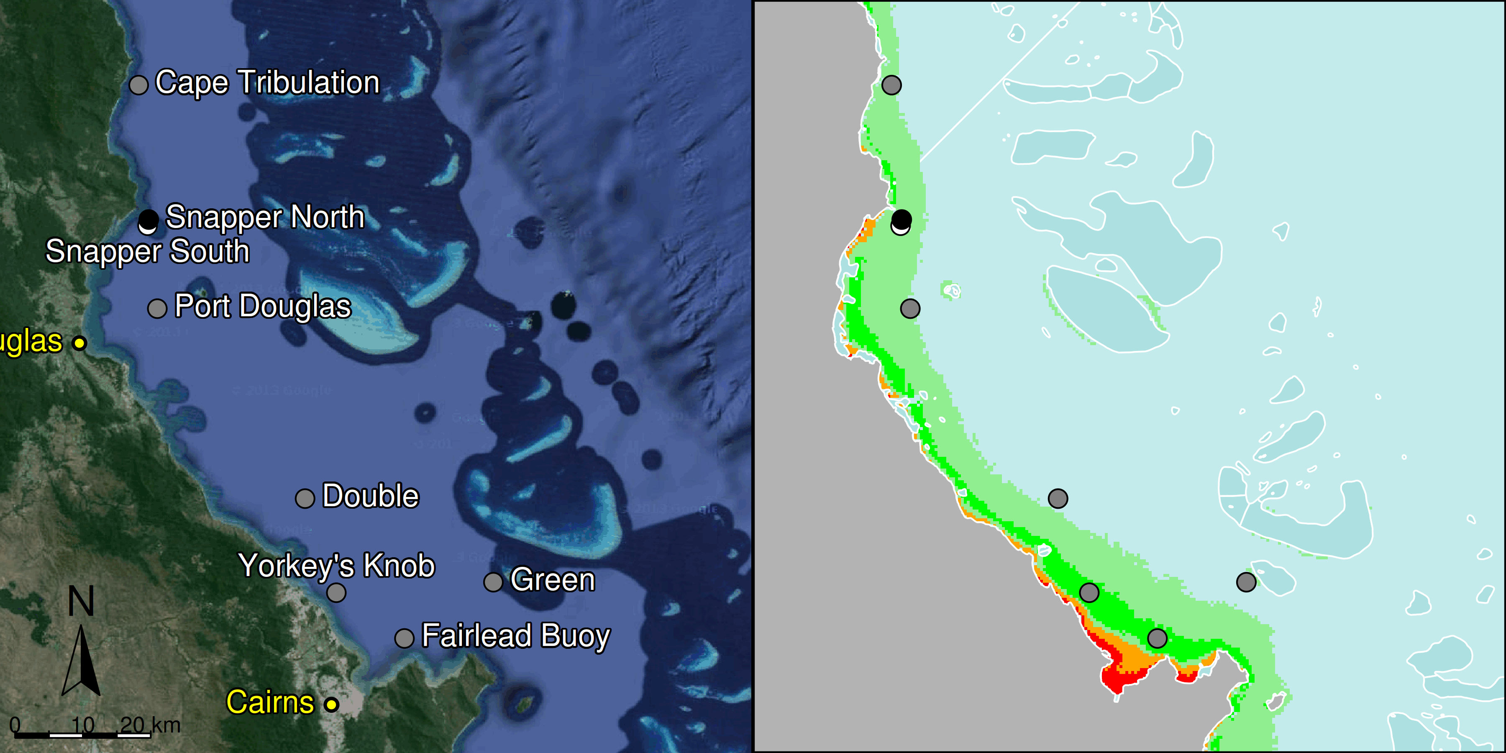

Figure 3 MMP sampling sites in the Barron Daintree sub-region. Black symbols are water quality and core reef sampling locations and white symbols are cycle reef locations. Gradients of exposure to flood plume water types (Álvarez-Romero et al. 2013) during the wet season (December to March) are represented as areas exposed to primary plume-type waters most days (> 67% of days during the wet season, red shading) or frequently (33% - 67% of wet season days, orange shading), and areas exposed to secondary plume-type waters most days (>67% of wet season days, solid green shading), frequently (33% - 67% of wet season days, transparent green shading) or rarely (< 33% of wet season days, light blue shading).

From 2005 to 2014, two acute disturbances had an impact on these locations; a storm event (possibly associated with Cyclone Hamish in March 2009), and Cyclone Ita (2014). Both caused physical damage to corals at Snapper North, (Figure 4, Figure A2-4, Table A2-5).

Temperature records showed periods of above or below long-term average temperatures, however, no extreme temperature events have been recorded that would have led to coral bleaching (Figure 5).

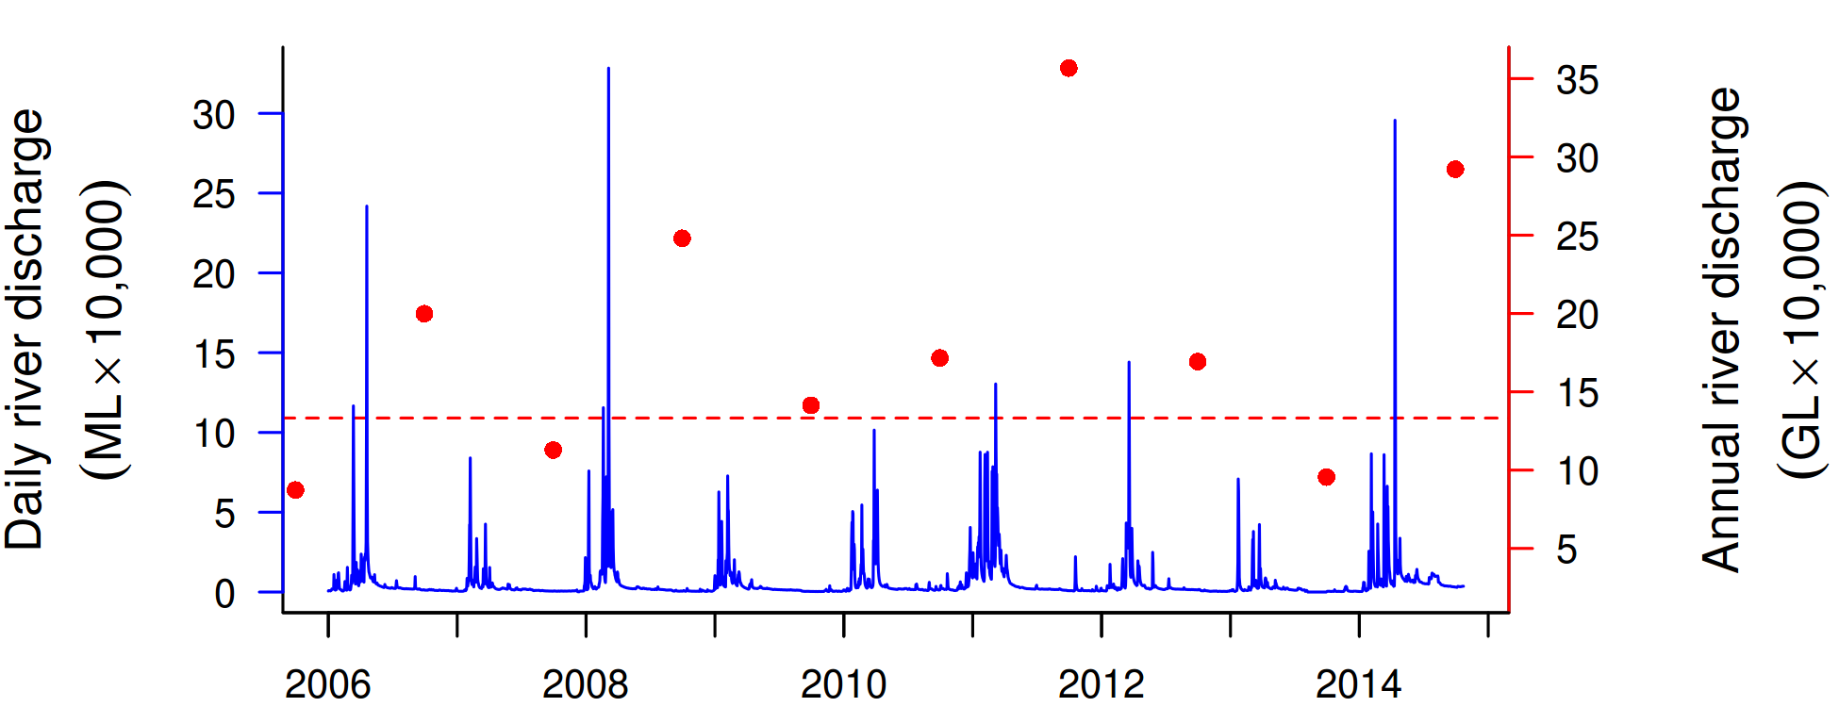
Figure 4 Combined discharge for the Barron and Daintree Rivers. Daily (blue) and annual (October to September, red) discharge shown. Red dashed line represents long-term median of the combined annual discharge.

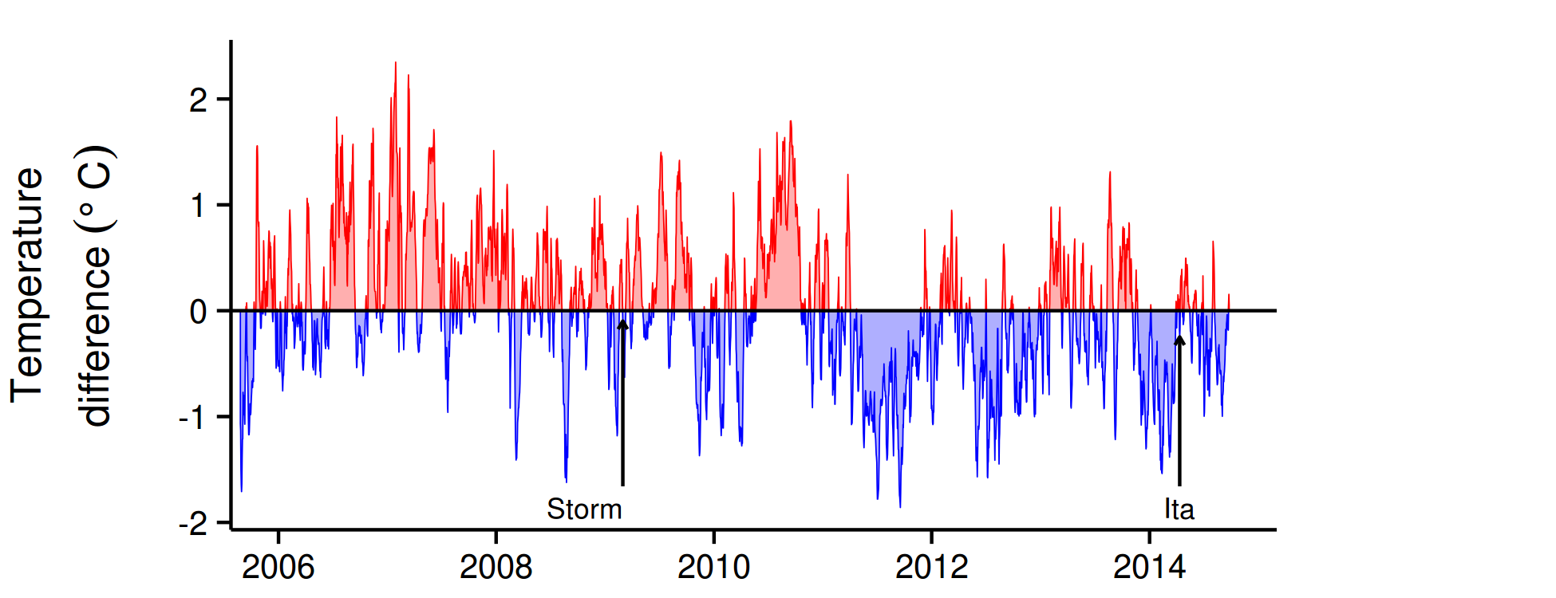
Figure 5 Sea temperature for the Barron Daintree sub-region. Red and blue regions signify periods of above and below seasonal average.

The water quality index in this sub-region remained ‘good’, although declined slightly since 2009 (Figure 6a). Concentrations of chlorophyll a (chl a), suspended solids (SS) and particulate nitrogen (PN) were high at the beginning of the MMP sampling in 2005-06, then declined, and increased again after the major Barron River floods in 2008 (Figure 6b,c,f). Highest concentrations of chl a, PN, SS and particulate phosphorus (PP) were observed in 2013-14, with the predicted overall trend-line for chl a, PP and SS exceeding water quality guidelines (guideline) (GBRMPA 2010). Secchi depth did until 2013 only show minor variations, but a decrease was seen in 2013-2014 (Figure 6e).

The concentrations of dissolved oxidised nitrogen (NO_{x}) steadily increased over the course of the monitoring program, with the overall trend-line approaching the guideline value in 2013 where it remains during the wet season of 2013-14 (Figure 6d). The nitrogen content of sediments at the reef sites has also increased, indicating a widespread change in nitrogen levels within this sub-region (Figure 7g). The concentrations of dissolved organic carbon (DOC) steadily increased over the course of the monitoring period with levels approaching a stable level during the wet season of 2012 – 2013 (Figure A2-3).

High-frequency instrumental chlorophyll (chl) and turbidity values were from only one location, Snapper North. The chl trend-line showed more pronounced fluctuations than the regional trend, which summarised a number of manual sampling locations along gradients of water quality, with values above the guideline in the wet seasons from 2010 to 2014 (Figure 6). The trend-line of the instrumental turbidity was consistently above the guideline, and generally, has continued to increase over the monitoring period (Figure 6g). This location has very variable turbidity, mostly influenced by wind-driven resuspension of sediments. The suspended solids (SS) and turbidity (NTU) showed different temporal trends (Figure 6c and g), which is to be expected as these indicators are derived by two different methods. While SS is measured as dry mass of particles on a filter (0.4 µm poresize), turbidity is measured by optical instruments as total light absorption and scattering. The SS does therefore not account for material passing the filter (e.g. colloidal particles) or the optical properties of particles at a certain location (e.g. influenced by the mineralogy of the adjacent catchment), both of which will influence the in-situ turbidity (Bowers et al. 2011). The difference in trends between these measures therefore indicates that the size spectrum/composition of the optical active fraction has changed over the monitoring period.

At the location-specific level, Fairlead Buoy and Yorkey’s Knob, which are close to the coast and more frequently exposed to flood plume water types (Figure 6), exceed the guideline for many variables, while the midshelf locations Double and Green were generally compliant (see Table A2-2 for detailed data).

Two reefs, Snapper North and Snapper South are sampled annually in this sub-region (Figure 3). Prior to MMP surveys in 2005, these reefs were monitored annually by Sea Research from 1995 (Ayling and Ayling 2005). The location of Snapper Island exposes corals to low salinity waters during flood events with high rates of mortality recorded at Snapper South 2m depth as a result of flooding in 1996 and then again in 2004 (Ayling and Ayling 2005). While not monitored at that time, anecdotal evidence suggests the deeper 5m sites were below the impact of these flood events. The coral communities at Snapper North were less damaged by these floods, though they did suffer substantial reductions in cover caused by coral bleaching in 1998 and then Cyclone Rona in 1999 (Ayling and Ayling 2005). Following each of these events coral cover began to increase demonstrating the resilience of these communities (Sweatman et al. 2007, Table A2-5).

This capacity to recover is also evident in the observations presented here with coral cover increasing over the period 2005 to 2007 at all locations (Figure 7d, Figure A2-4) and contributes to the initial ‘very good’ assessment of the coral health index in 2008. Since this initial assessment the coral health index has progressively declined to a ‘poor’ rating in 2014 (Figure 7b). The decline in the coral health index represents the culmination of several processes, beginning with the onset of a period of ‘wetter’ wet seasons from 2008 to 2012, followed by high incidence of disease in 2009-10, then a COTS outbreak from 2012-2013, with intermittent disturbances such as a severe storm (2009) and cyclone (Ita 2014). In 2012 small numbers of small (generally <20cm diameter) crown-of-thorns seastars (COTS) were observed. By 2013 the numbers (288 per hectare at Snapper North, 613 per hectare at Snapper South) and size (most >25cm diameter) of COTS had increased and these coral predators were clearly causing substantial damage to coral communities, and in particular, reducing the cover of the family Acroporidae in the shallows of Snapper North (Figure A2-4).

In 2014, coral cover at Snapper North had been severely reduced (Figure A2-4) with clear evidence for physical disturbance as a result of exposure to waves generated by Cyclone Ita. No COTS were observed in 2014 though given their abundance in 2013 at least some of the reduction in cover will have been due to COTS feeding. In contrast at Snapper South, COTS were still present in 2014 though at a reduced density (63 per hectare). No physical damage was noted at Snapper South and so it can be reasonably assumed the observed loss in coral cover (Figure A2-4) was caused by COTS. The density of juvenile corals has generally declined throughout the Snapper Island reefs, with the exception of the 2m depth at Snapper South where Acroporidae, Poritidae and Pocilloporidae are the common families recruiting (Figure A2-4).

In compensation for the loss of coral as a result of disease, COTS, and Cyclone Ita, was a rapid increase in the cover of macroalgae at Snapper North (Figure 7f, Figure A2-4), predominantly the genus Asparagopsis. As a group, red macroalgae has been shown to inhibit coral growth by both direct shading and also by causing changes to the chemical microenvironment of the surrounding water (Hauri et al. 2010). By contrast, at Snapper South the macroalgal cover further declined (Figure A2-4). The rather exposed orientation of Snapper South may preclude long-term development of extensive cover of macroalgae.

In parallel to the decline in the coral health index was a substantial decline in the FORAM index through to a value below 4 in 2013 before improving in 2014 (Figure 7a). In the Caribbean, FORAM index values of between 2 and 4 reflect environmental conditions that are marginal for coral reef growth (Hallock et al. 2003). This result remains largely unexplained as it would be expected that the flooding of the Daintree River (Figure 4), ongoing high turbidity and NO_{x} (Figure 6 d, g) and increase in sediment nitrogen (Figure 7 g) in 2014 would not have provided an environment conducive for an improvement in the FORAM index.

In summary, the coral communities at Snapper Island have been exposed to a series of disturbances at a range of intensities and temporal scales. These reefs have a history of strong recovery and, with the continuing ‘good’ rating for water quality, similar resilience maybe expected. That said, the very low level of coral remaining at Snapper North, and the continued presence of COTS at Snapper South, suggests that recovery may be slow and reliant on the supply of coral larvae from other reefs in the vicinity, many of which are likely to have had similar exposure to either COTS or cyclone Ita.

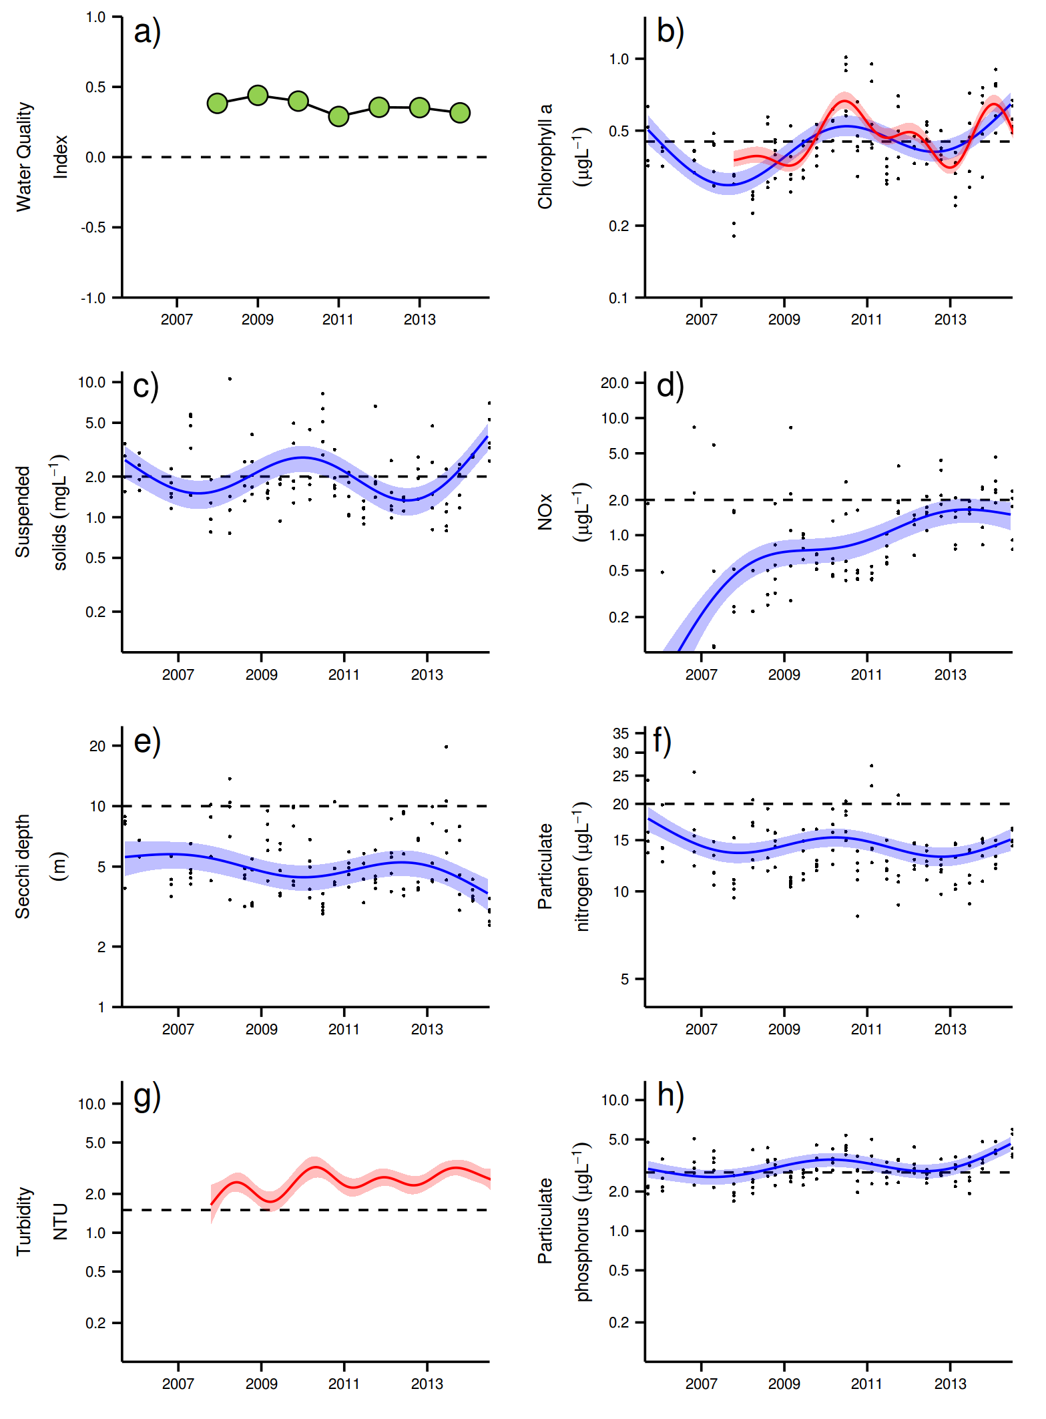
Figure 6 Temporal trends in Water Quality for the Barron-Daintree sub-region. a) water quality index, b) chlorophyll a, c) total suspended solids, d) nitrate/nitrite, e) secchi depth, f) particulate nitrogen, g) turbidity and h) particulate phosphorus Water quality index colour coding: dark green- ‘very good’; light green-‘good’; yellow – ‘moderate; orange – ‘poor’; red – ‘very poor’. The water quality index is the aggregate of variables plotted in with the exception of NO_{x} and calculated as described in Appendix 1.2.3. Trends in manually sampled water quality variables are represented by blue lines with blue shaded areas defining 95% confidence intervals of those trends, black dots represent observed data. Trends of records from ECO FLNTUSB instruments are represented in red, individual records are not displayed. Dashed reference lines indicate guideline values.

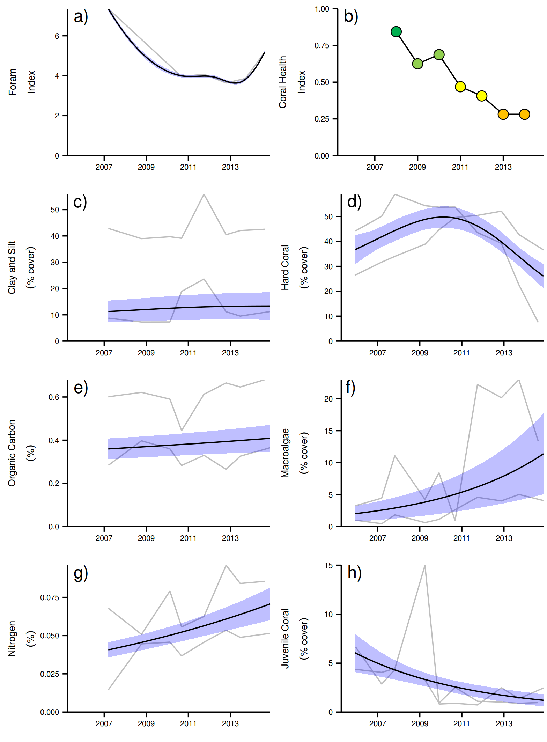
Figure 7 Coral reef community and sediment quality trends in the Barron Daintree sub-region.
Coral health index colour coding: dark green- ‘very good’; light green-‘good’; yellow – ‘moderate; orange – ‘poor’; red – ‘very poor’. Coral index is calculated from variables plotted in d, f, h, along with the derived estimate of “rate of cover increase” as described in Appendix 1.3.7.Trends in Foram index, sediment and benthic community variables are represented by blue lines with blue shaded areas defining 95% confidence intervals of those trends, grey lines represent observed profiles averaged over depths at individual reefs.

3.1.2 Wet Tropics Region: Johnstone Russell-Mulgrave sub-region
The catchments within this sub-region have a high proportion of upland National Park and forest, while 20% have been modified for sugar production on the coastal flat. There is also a significant area used for grazing within the Johnstone catchment (Brodie et al. 2003). The inshore reefs adjacent to these catchments are influenced by the discharge from the Russell-Mulgrave and Johnstone rivers, and to a lesser extent, by other rivers south of the sub-region, such as the Burdekin (Furnas et al. 2013).

Six reefs are sampled for coral reef condition assessments in this sub-region. Three are also water quality sampling locations, co-located with the annually monitored core reefs (Figure 8). Of the sampling locations in this region that are located in the open coastal water body (see Table 1), Fitzroy and High are frequently exposed to secondary plume-type waters during the wet season, while the Franklands are located in the midshelf water body and rarely exposed to secondary plume-type water (Figure 8).

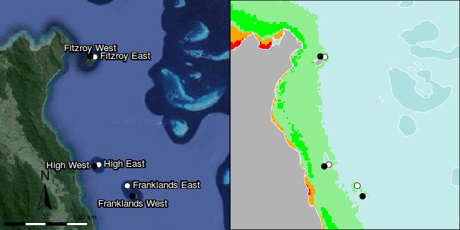

Figure 8 MMP sampling sites in the Johnstone Russell-Mulgrave sub-region. Black symbols are water quality and core reef sampling locations and white symbols are cycle reef locations. Gradients of exposure to flood plume water types (Álvarez-Romero et al. 2013) during the wet season (December to March) are represented as areas exposed to primary plume-type waters most days (> 67% of days during the wet season, red shading) or frequently (33% - 67% of wet season days, orange shading), and areas exposed to secondary plume-type waters most days (>67% of wet season days, solid green shading), frequently (33% - 67% of wet season days, transparent green shading) or rarely (< 33% of wet season days, light blue shading).

Over the period 2006 to 2014, annual discharge for both the Russell-Mulgrave and Johnstone rivers was at, or slightly above, median levels in most years with major floods in 2011 (Figure 9, Table A2-1).

Tropical cyclones Larry in 2006, Tasha in late 2010 and Yasi in 2011 (Figure 10) caused reductions in coral cover predominantly on the eastern sides of the islands (Figure A2-5, Table A2-5). In 2014 TC Ita tracked inland and parallel to the coastal margin as a category 1 cyclone: Minor storm damage was observed at Fitzroy East.

Temperature records since 2005 reveal no periods of extreme temperatures that would have led to coral bleaching (Figure 10). Temperatures were consistently low in 2011, although no effect on coral communities was evident during the winter surveys of that year.
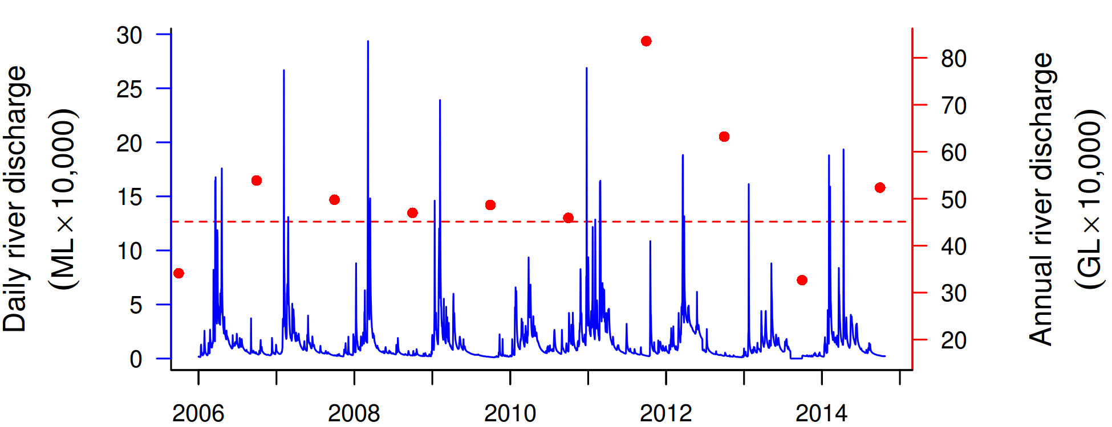
Figure 9 Combined discharge for the North and South Johnstone, Russell and Mulgrave rivers.
Daily (blue) and annual (October to September, red) discharge shown. Red dashed line represents the long-term median of the combined annual discharge.
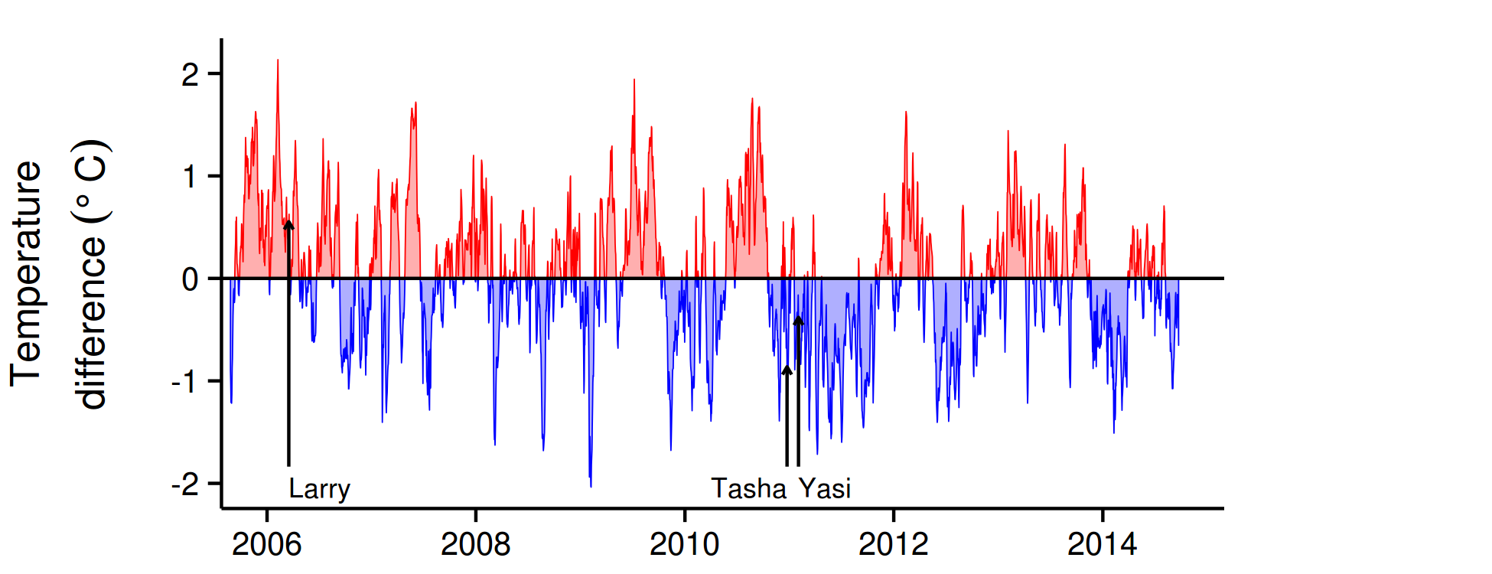
Figure 10 Sea temperatures for the Johnstone Russell-Mulgrave sub-region. Red and blue regions signify periods of above and below seasonal average.

The water quality index at the coral reef sampling locations in this sub-region remained relatively stable maintaining scores of ‘good’ for the last two years (Figure 11a). Concentrations of chlorophyll a (chl a), suspended solids (SS), particulate nitrogen (PN) and particulate phosphorus (PP) were close to guideline levels at the beginning of the MMP sampling in 2005-06, then declined, prior to slight increases during the major flood period in 2011 with a continued increase until 2014 (Figure 11b,c,f,h). The predicted overall trend line for chl a was at or above the guideline from 2011 onwards; the trend lines for SS and PP approach the guideline in 2014, while PN was below (Figure 11). Secchi depth has shown a decline since the beginning of the monitoring program reaching a new low in 2014 with levels noncompliant with the guideline (Figure 11e). The concentrations of dissolved oxidised nitrogen (NO_{x}) have steadily increased over time approaching the QLD guideline in 2012 where it has remained since (Figure 11d).

The clay-silt and nitrogen content of the sediments at the coral reef sites was also elevated during 2011-12, with peaks that correspond to the high discharge from local rivers (Figure 9) and the likely influence of redistributed sediments following TC Yasi (Figure 12c, g). The concentrations of dissolved organic carbon (DOC) have shown a steep increase over the course of the monitoring period with levels continuing to increase in 2014 (Figure A2-3).

Instrumental chlorophyll (chl) and turbidity records show more pronounced fluctuations than the manual sampling data (Figure 11b,g). The chl trend line exceed the guideline during the wet season 2011-12 and again in 2013-2014, while the turbidity showed increasing level which are still below the guideline values (Figure 11b, g).

The suspended solids (SS) and turbidity (NTU) again in this region showed different temporal trends (Figure 9c and g). While SS is measured as dry mass on a filter (0.4 µm pore size), turbidity is measured by the loggers as total light absorption and scattering. The SS does not, therefore, account for material passing the filter and also doesn’t measure the particle optical properties; simply, the nature of the measurements is different (Bowers et al. 2011). The difference in trends between these measures, therefore, indicates that the size spectrum/composition of the optical active particle fraction has changed over the monitoring period.

The ‘good’ and increasing values of the coral index up to 2010 (Figure 12b) demonstrate that water quality in the region was not strongly limiting coral communities. Prior to the commencement of MMP monitoring in 2005, surveys conducted by AIMS and Sea Research indicated that coral communities at Fitzroy Island and the Frankland Group were in a state of recovery following impacts attributed to predation by the crown-of-thorns seastar (COTS) and coral bleaching (Sweatman et al. 2007, Ayling and Ayling 2005). Since 2005, Cyclone Larry in 2006 caused substantial loss of cover at Franklands East (Figure A2-5). Up until 2010 the ‘good’ and increasing assessment of the coral health index reflected the recovery from, or resistance to these past disturbance events.

The sharp decline in the coral health index after 2010 (Figure 12b) was due to reductions in coral cover caused by cyclones Tasha and Yasi and compounded by feeding of COTS at Fitzroy Island sites. These losses of coral cover along with already declining numbers of juvenile corals (Figure 15h) resulted in a decline in the juvenile density metric (Table 1). The rate of coral cover increase has also been low since 2011 (Figure A2-15), with only High East and Franklands East showing positive signs of recovery between 2011 and 2013 (Figure A2-5).

In 2014 the coral communities in this sub-region were again assessed to be in moderate condition though were clearly improving from previous years (Figure 12b). Scores for all four metrics included in the index had increased. Most notable were the cover change metric that improved from a poor rating in 2013 to a moderate rating in 2014 (Table 1, Figure A2-15) and the reduction in macroalgae cover at Franklands West that improved the macroalgae metric score to ‘very good’ (Tables A2-6, 1).

It should be noted however that the ongoing presence of COTS at Fitzroy Island in 2014 precluded the estimation of the cover change metric at those sites. The density of COTS at Fitzroy West (300 per hectare in 2012), have been reduced by regularly culls under the Australian Government funded crown-of-thorns seastar management program program to 38 per hectare in 2014. Similar declines were observed at Fitzroy East. Despite this decline, their continued presence continues to reduce coral cover. Estimates of COTS at Frankland West have risen four-fold since 2013; from 25 per hectare to 100 per hectare in 2014. The individuals observed in 2014 where all juveniles and located deep within stands of coral suggesting this may be a serious underestimate of the actual density of COTS present and so a potential for further coral loss in coming years.

At High West and Frankland West communities have high proportions of the family Poritidae (Figure A2-5). This group is typically more tolerant to both water quality and other disturbances impacting reefs than the Acroporidae present at other locations. The coral change metric applies a different growth rate expectation to Acroporidae than other slower growing corals which is why the rate of change score improved while regional coral cover did not.

Over the last two years a gradual reversal of previous declines in juvenile abundance has emerged (Figure 12h), particularly among the Acroporidae at the windward reefs of High, Fitzroy and Frankland East (Figure A2-4).

The sampling of foraminifera occurs at the western sides of the reefs sampled in this sub-region. These sites are relatively sheltered from wave action which predisposes them to the accumulation of fine-grained sediments (Wolanski et al. 2005). The decline in the FORAM index is consistent with the observed changes in sediment composition toward higher proportions of clay -silt sized particles and higher nitrogen content (Figures 12: c, g): conditions known to favour heterotrophic species (Uthicke et al. 2010). The slight increase in the proportion of clay-silt sized particles in sediments and declines in the FORAM index observed in 2010 coincided with increasing turbidity recorded at these locations (Figure 11g) but preceded both cyclone Yasi and high flows of local rivers. While sediment trap deployments over the period of cyclone Yasi and subsequent flooding clearly demonstrate the mobilisation of sediments corresponding to these events (Thompson et al. 2012) the increase in turbidity and change in sediment composition preceding these events suggest that these changed environmental conditions could be a delayed response to flooding of the more distant Herbert or Burdekin Rivers in 2009. Of note is that levels of coral disease also increased in 2010 (Figure A2-10), further indicating a shift in environmental conditions that preceded local runoff events.

The 2014 results indicate the potential for coral communities to recover from disturbance events. The differences between the East and West locations on the reefs in this sub-region highlight the need to consider the hydrodynamic setting of each location when assessing the possible influences of runoff. On the wave-exposed Eastern reefs, coral communities have a high proportion of the fast-growing family Acroporidae and have shown a clear ability to recover from disturbance events (Figure A2-5). However, these communities are susceptible to predation by COTS and even the ongoing presence of these seastars poses a substantial risk to the coral cover at both Fitzroy Island and The Frankland Group. Links between COTS and elevated nutrient levels resulting from large flood events have been proposed (Brodie et al. 2008, Fabricius et al. 2010) and given the severity of disturbance these seastars impart on the Reef in general (Osborne et al. 2011, De’ath et al. 2012), further research into the role of water quality plays in promoting such outbreaks is justified. In contrast, while the more sheltered reefs of High West and Franklands West have been less susceptible to acute disturbance the rate of recovery of these communities is naturally slow. The rapid response of the FORAM index provides evidence for the selective pressures attributed to environmental fluctuations at these more sheltered locations.

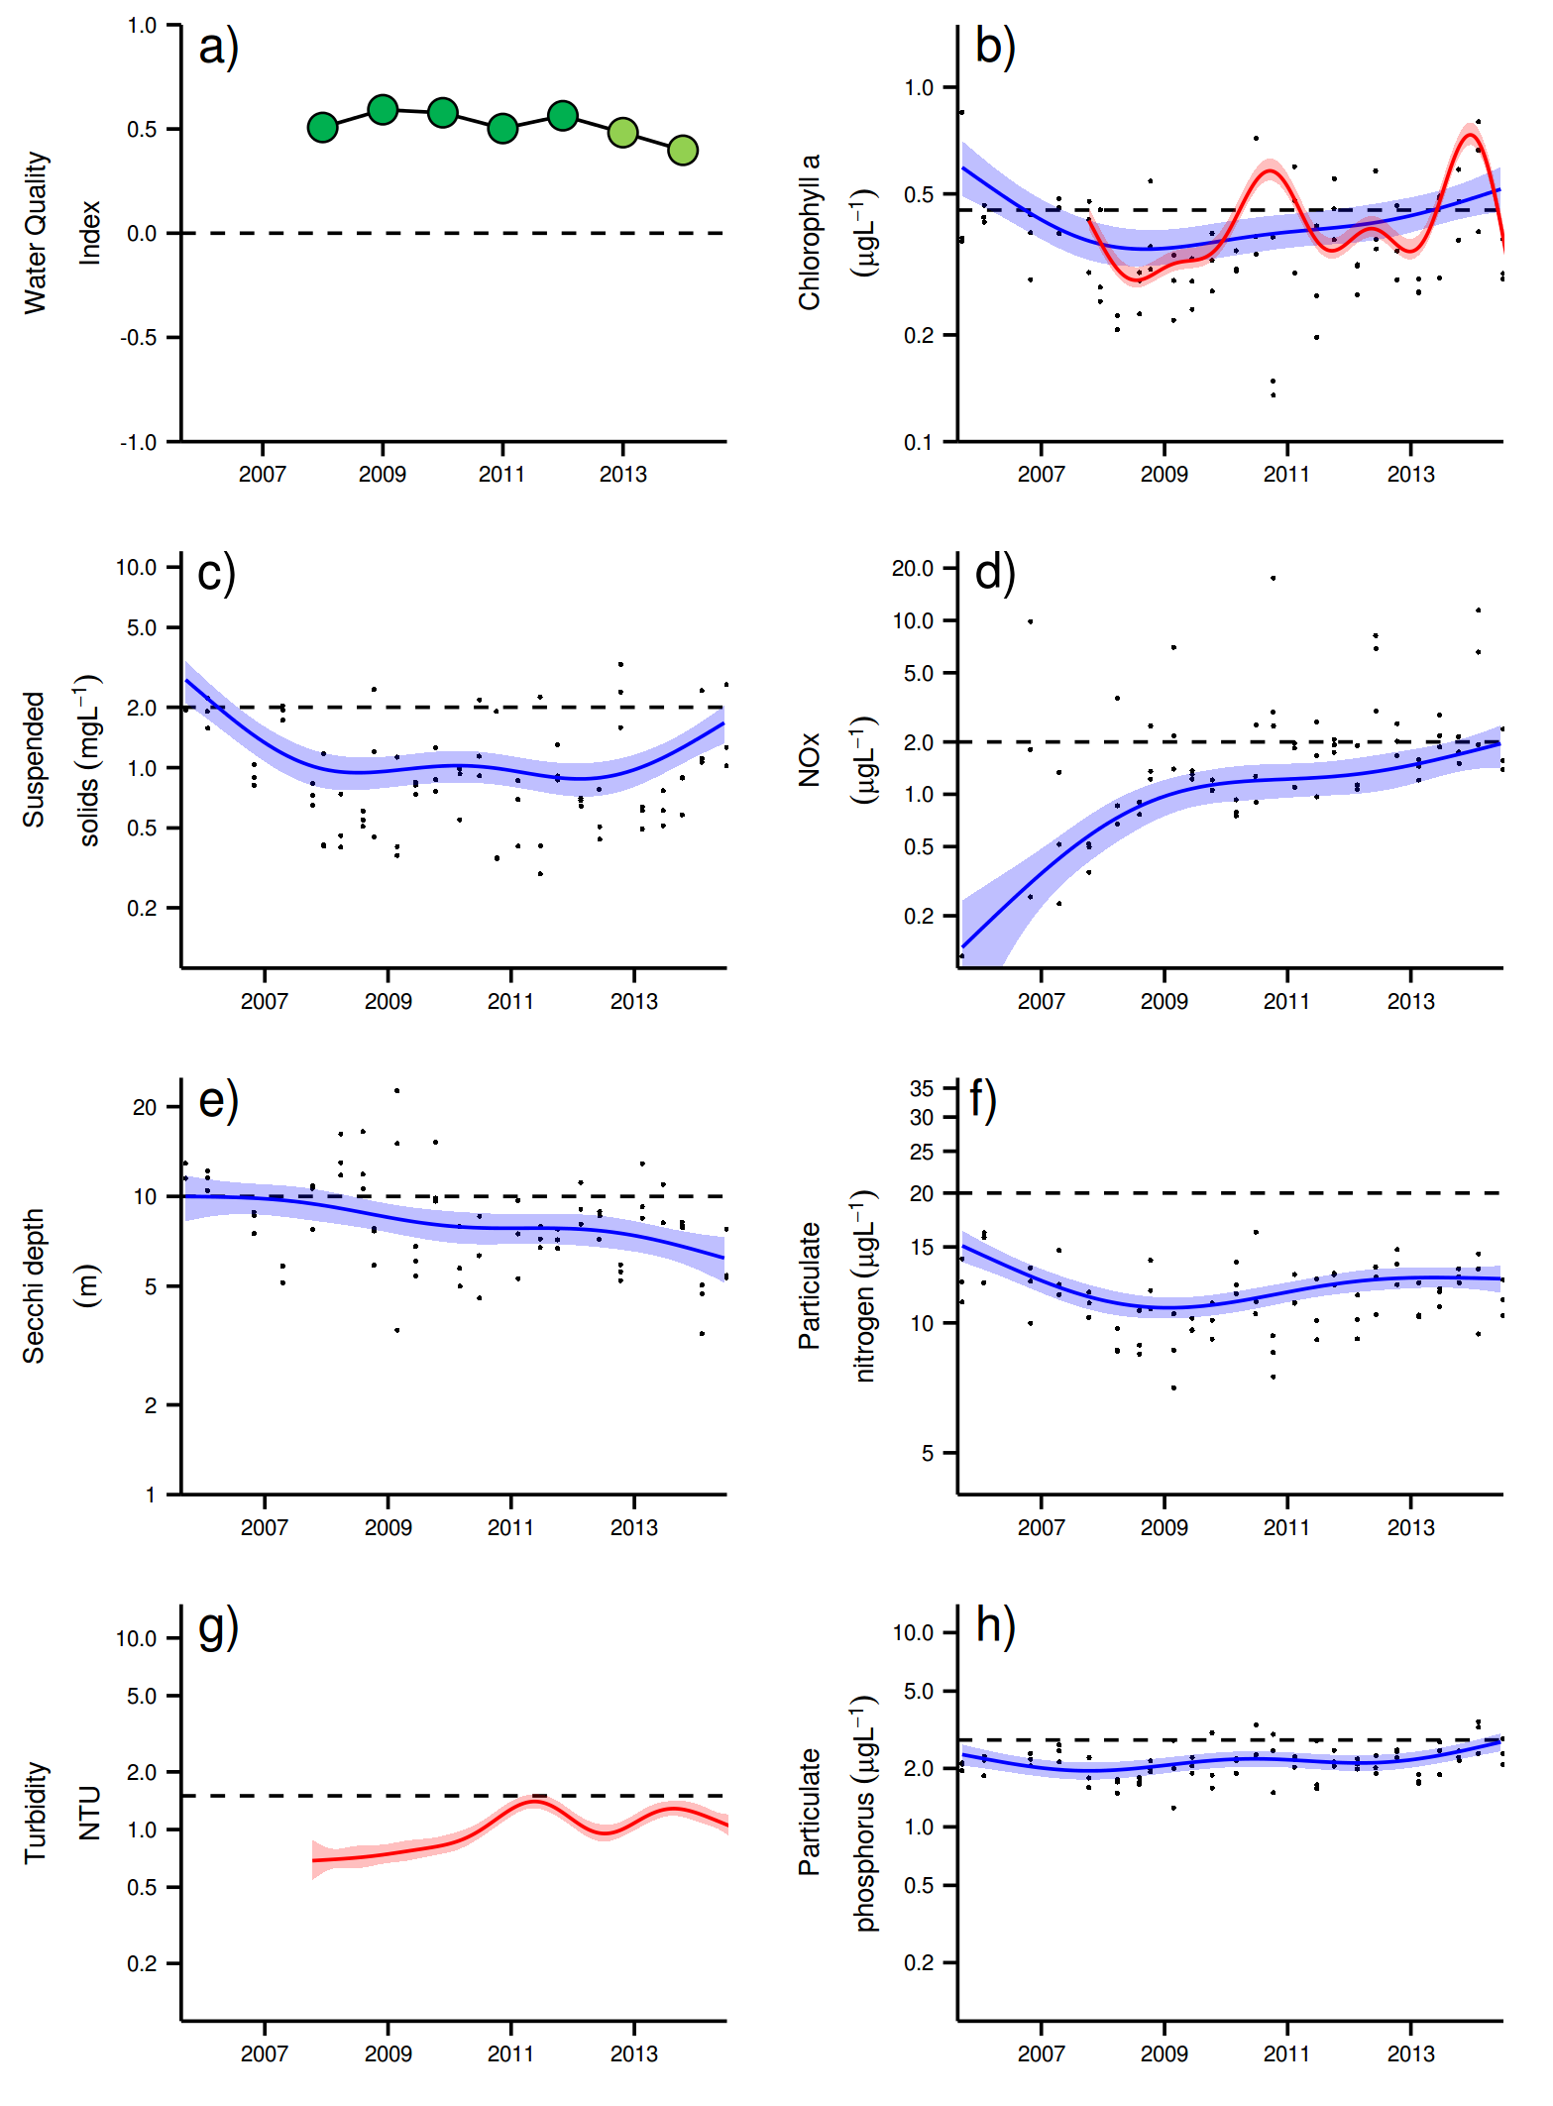
Figure 11 Temporal trends in Water Quality for the Johnstone Russell-Mulgrave sub-region. a) water quality index, b) chlorophyll a, c) total suspended solids, d) nitrate/nitrite, e) secchi depth, f) particulate nitrogen, g) turbidity and h) particulate phosphorus Water quality index colour coding: dark green- ‘very good’; light green-‘good’; yellow – ‘moderate; orange – ‘poor’; red – ‘very poor’. The water quality index is the aggregate of variables plotted in with the exception of NO_{x} and calculated as described in Appendix 1.2.3. Trends in manually sampled water quality variables are represented by blue lines with blue shaded areas defining 95% confidence intervals of those trends, black dots represent observed data. Trends of records from ECO FLNTUSB instruments are represented in red, individual records are not displayed. Dashed reference lines indicate guideline values.
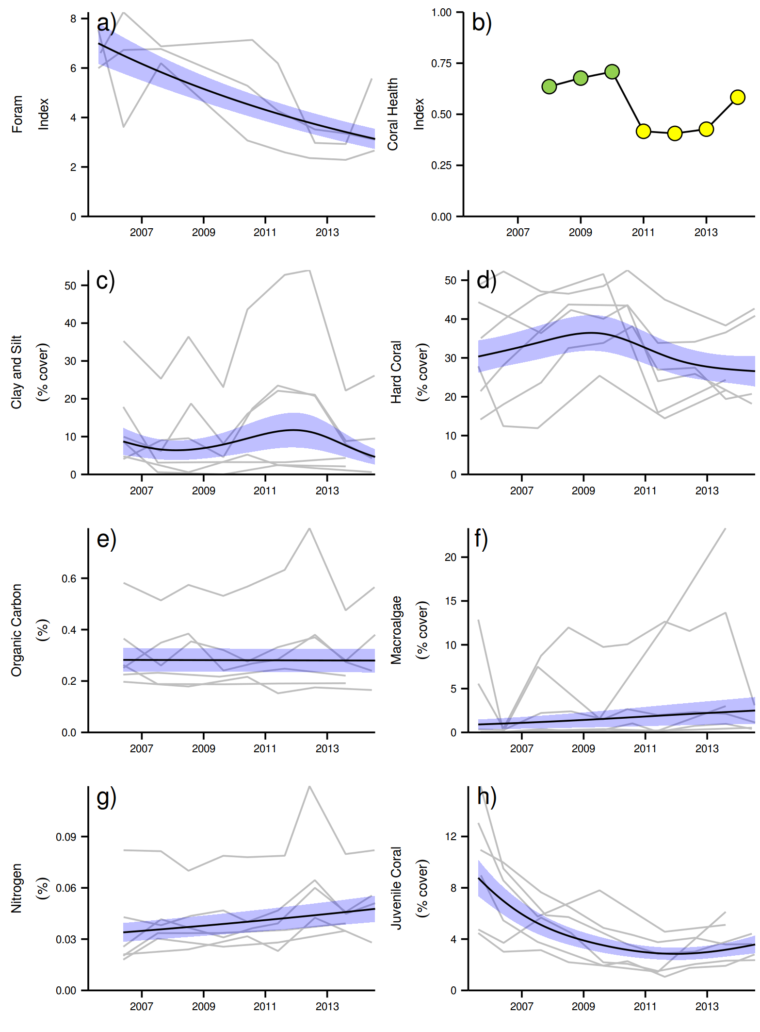
Figure 12 Coral reef community and sediment quality trends in the Johnstone Russell-Mulgrave sub-region.
Coral health index colour coding: dark green- ‘very good’; light green-‘good’; yellow – ‘moderate; orange – ‘poor’; red – ‘very poor’. Coral index is calculated from variables plotted in d, f, h, along with the derived estimate of “rate of cover increase” as described in Appendix 1.3.7.Trends in Foram index, sediment and benthic community variables are represented by blue lines with blue shaded areas defining 95% confidence intervals of those trends, grey lines represent observed profiles averaged over depths at individual reefs.

3.1.3 Wet Tropics Region: Herbert Tully sub-region
The Tully catchment has a high proportion of forest and National Park areas while the predominant land use in the Herbert catchment is grazing. Around 10% of the sub-regional area is used for sugar production, especially in the lower catchment areas (Brodie et al. 2003, GBRMPA 2012).

The sampling sites in this sub-region are influenced by the discharge from the Tully and Herbert rivers, and, to a lesser extent, by the Burdekin River (Furnas et al. 2013). Four reefs are sampled for coral reef condition assessments in this sub-region, there is one water quality sampling location co-located with the coral site at Dunk North (Figure 13). Dunk Island is exposed to secondary plume-type waters on most days during the wet season, while the other two reefs are frequently exposed to this water type (Figure 13).

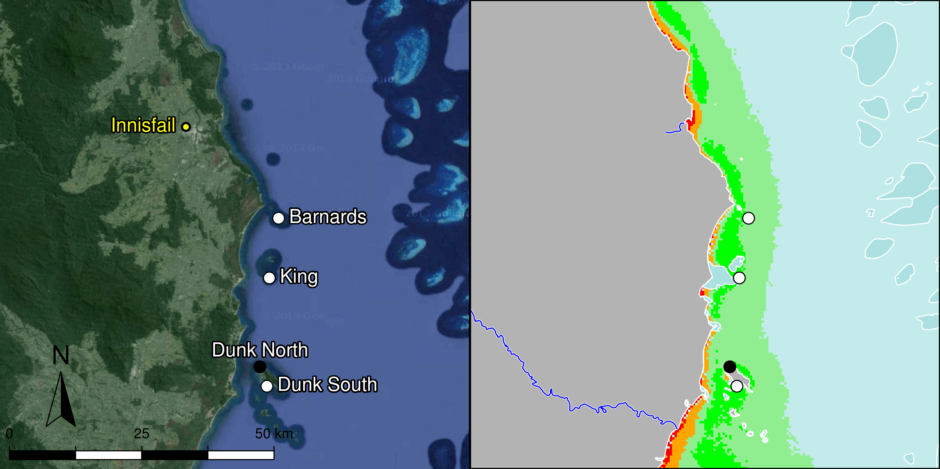
Figure 13 MMP sampling sites in the Herbert Tully sub-region. Black symbols are water quality and core reef sampling locations and white symbols are cycle reef locations. Gradients of exposure to flood plume water types (Álvarez-Romero et al. 2013) during the wet season (December to March) are represented as areas exposed to primary plume-type waters most days (> 67% of days during the wet season, red shading) or frequently (33% - 67% of wet season days, orange shading), and areas exposed to secondary plume-type waters most days (>67% of wet season days, solid green shading), frequently (33% - 67% of wet season days, transparent green shading) or rarely (< 33% of wet season days, light blue shading).

Over the period 2006 to 2012, annual discharge for both the Tully and Herbert rivers (Figure 14) has been at, or slightly above, median levels in most years with major floods of the Tully River in 2011 and of the Herbert River in 2009 and 2011 (Appendix Table A2-1).

Discharge in 2013 was below the long-term median (Figure 14); discharge data for 2014 were incomplete at time of writing. Tropical cyclones Larry in 2006 and Yasi in 2011 (Figure 15), had significant negative impacts on coral cover on the reefs in this sub-region (Figure A2-6, Table A2-5).

Temperature records since 2005 do not reveal any prolonged exposure to high temperatures that would have resulted in coral bleaching (Figure 15).
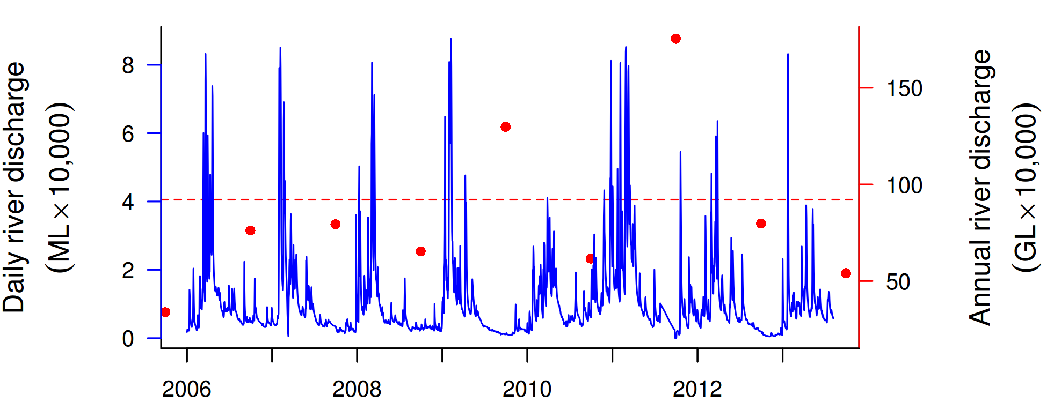
Figure 14 Combined discharge for Tully and Herbert Rivers. Daily (blue) and annual (October to September, red) discharge shown. Red dashed line represents the long-term median of the combined annual discharge.
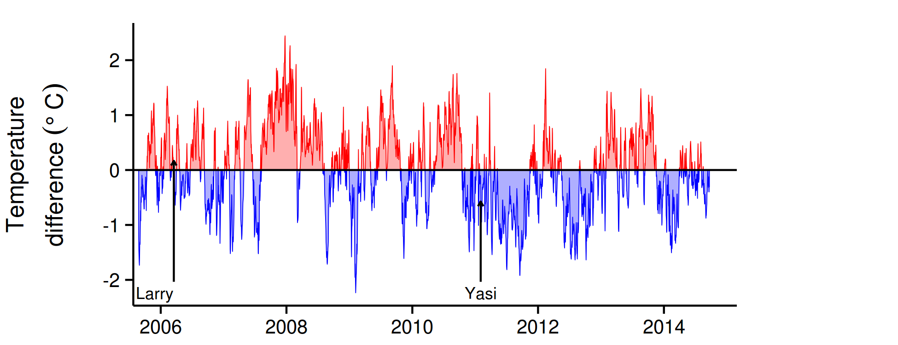
Figure 15 Sea temperature for the Herbert-Tully sub-region. Red and blue regions signify periods of above and below the long term seasonal average.

The water quality index has been stable over the past six years, maintaining a ‘moderate’ rating (Figure 16a). Trends in concentrations of chlorophyll a (chl a), particulate nitrogen (PN) and particulate phosphorus (PP) showed distinct cycles, with periods of high values in 2006-07, 2011-12 and 2013-14 (Figure 16b,f,h), coinciding with the beginning of the relatively “wet” period with at or above median flows. Trend-lines for PP were almost entirely above water quality guidelines (guideline) until 2014, while chl a trend-lines exceeded or was near the guideline in the beginning of the monitoring and again from 2010 onwards (Figure 16b, h). Concentrations of suspended solids (SS) were generally above guideline values throughout the program, decreasing until 2013 but with an upward trend in 2014 (Figure 16c).

The concentrations of dissolved oxidised nitrogen (NO_{x}) showed increasing concentrations that exceeded the guideline from 2011 onwards (Figure 16d). Secchi depth remained relatively stable with at a long-term average of about 5m, which is non-compliant with the guideline (Figure 16e). The concentrations of dissolved organic carbon (DOC) increased until 2012, after which the concentrations have slightly declined (Figure A2-3).

The instrumental Chlorophyll (chl) and turbidity records showed more pronounced fluctuations than the manual sampling data (Figure 16b,g). The trend-lines of chl showed distinct maxima above the guideline during the wet seasons of 2011 and 2014 (Figure 16b). The turbidity showed overall levels around twice the guideline levels, steadily increasing over the course of the monitoring period with peak levels in 2011-2012 and 2014 (Figure 16g). The turbidity at Dunk North was generally very variable (see Appendix 2 Figure A2-1), mostly driven by sediment resuspension from the surrounding shallow seabed.

The SS and turbidity (NTU) showed different temporal trends (Figure 16c and g), which is mainly due to that they measure different properties, as described above (see e.g. Johnstone, Russell-Mulgrave sub-region). This difference in trends indicates that the size spectrum/composition of the optical active particle fraction has changed over the monitoring period.

The clay-silt content of the sediments at Dunk North had been higher than at other reef locations in this sub-region (Figure 17c, highest grey line) but declined over 2013 and 2014 corresponding to the decrease in the Tully River discharge. On a sub-regional level the proportion of clay-silt sized particles in sediments was generally high in the period 2010-2012, while sediment nitrogen content has steadily increased (Figure 17c, g). These changes in sediment composition are also manifested in the FORAM index at Dunk North which continues to decline in 2014 (Figure 17a)

In 2006, Cyclone Larry severely damaged the coral reefs in this sub-region, in particular the Barnards and Dunk North. In 2011, Cyclone Yasi again damaged the reefs in this sub-region, resulting in low cover on all reefs in 2011 through to 2013, with slow recovery only now becoming apparent in 2014 (Figure 20d, Figure A2-6). This regionally low cover of corals has influenced the poor values of the coral health index since first assessed in 2008 (Table A2-6, 1).

The coral health index has improved from ‘poor’ to ‘moderate’ (Figure 17b). This improvement predominantly reflects the increased density of juvenile corals observed in 2014. This rise is predominantly driven by large numbers of Turbinaria sp (family Dendrophylliidae) at all four reefs. That Turbinaria did not constitute a substantial part of hard coral communities prior to the recent disturbance events (Figure A2-6) along with this genus’ apparent tolerance of low water quality (Section 3.2) suggest this increase in juvenile density does not necessarily imply a response to improved environmental conditions. In contrast, the strong recruitment of Acroporidae at Dunk South (Figure A2-6), a taxon favouring better water quality (Section 3.2), is a biological indication for an improvement of environmental conditions at this location.

Dunk South is a particularly interesting location in this sub-region as the coral communities appear strongly influenced by poor water quality. The persistently high cover of macroalgae in the shallow areas is indicative of high nutrient availability, while substantial change in composition of the coral communities between the 2 m and 5 m depths is indicative of high turbidity. The coral community at 5 m includes taxa that are relatively tolerant of high turbidity (Figure 33b, Chapter 3.2). Dunk South is more directly exposed to the influences of runoff than other reefs in the region due to the proximity to local rivers (Figure 13), and so the recovery evident in 2014 is particularly encouraging. In addition to the improvement in juvenile densities, the indicators coral cover and the rate of increase in hard coral cover improved slightly to 2014 and at Dunk North and Barnards (Figure A2-15, Table A2-6, Figure 17h) the recovery of Acroporidae cover is now underway. It is only at King Reef that recovery of coral cover is not advancing at an expected rate, based on the cover and composition of the community present (TableA2-6).

Persistent high macroalgae cover in the region reflects the ongoing availability of nutrients. A primary consideration for the setting of guideline values for nutrients was that exceedance of these levels, as occurs in this region, corresponded to higher cover of macroalgae (De’ath and Fabricius 2008, 2010). The cover of macroalgae was high on most reefs prior to Cyclone Larry, was temporarily reduced as a consequence of cyclones Larry and Yasi, and quickly increased to similar or higher levels in subsequent years (Figure 17f, Figure A2-4). This high and persistent cover of macroalgae decreased the coral health index in this region (Tables A2-6, 1).

The FORAM index measured at Dunk North has stabilised around the low point reached in 2012, indicating that water quality has not markedly improved over the last few years.

In summary, the reefs of the Tully Herbert sub-region continue to be subject to water quality stress as evidenced by the continued high cover of macroalgae and low FORAM index. The coral communities are however demonstrating the potential to recover from the consecutive disturbances of TC Larry and TC Yasi. The coral health index achieved a ‘moderate’ level for the first time in 2014, reflecting high juvenile densities and moderate rates of cover increase on most reefs (Figure 17h, A2-15).

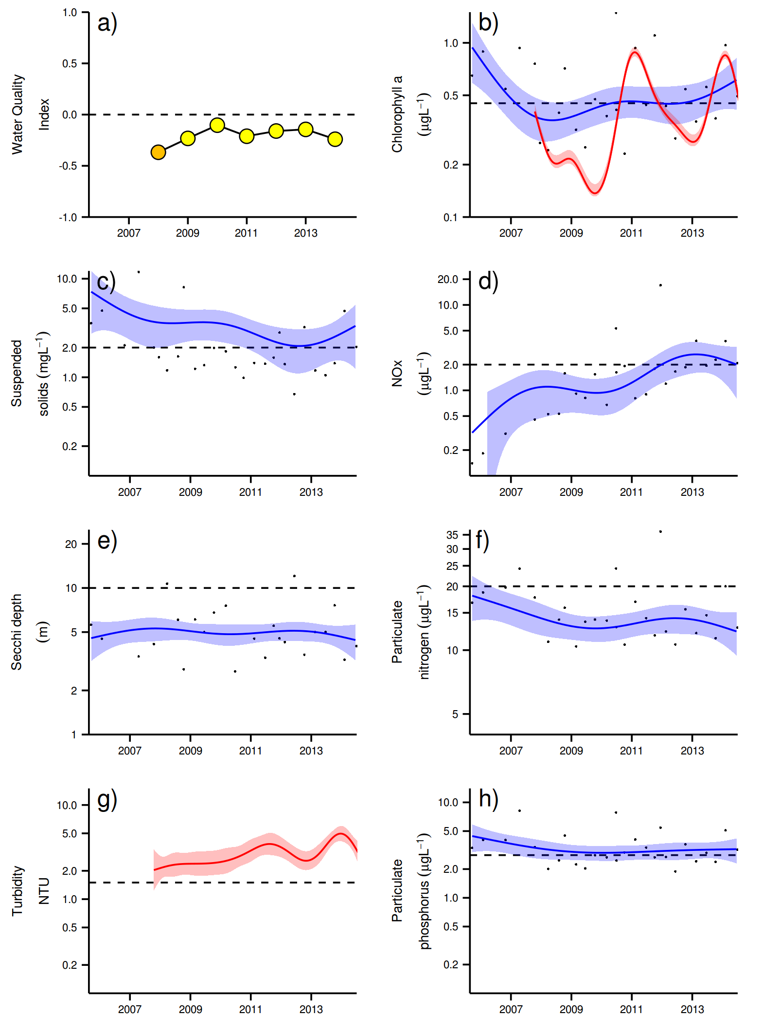
Figure 16 Temporal trends in water quality for the Herbert-Tully sub-region. a) water quality index, b) chlorophyll a, c) total suspended solids, d) nitrate/nitrite, e) secchi depth, f) particulate nitrogen, g) turbidity and h) particulate phosphorus Water quality index colour coding: dark green- ‘very good’; light green-‘good’; yellow – ‘moderate; orange – ‘poor’; red – ‘very poor’. The water quality index is the aggregate of variables plotted in with the exception of NO_{x} and calculated as described in Appendix 1.2.3. Trends in manually sampled water quality variables are represented by blue lines with blue shaded areas defining 95% confidence intervals of those trends, black dots represent observed data. Trends of records from ECO FLNTUSB instruments are represented in red, individual records are not displayed. Dashed reference lines indicate guideline values.
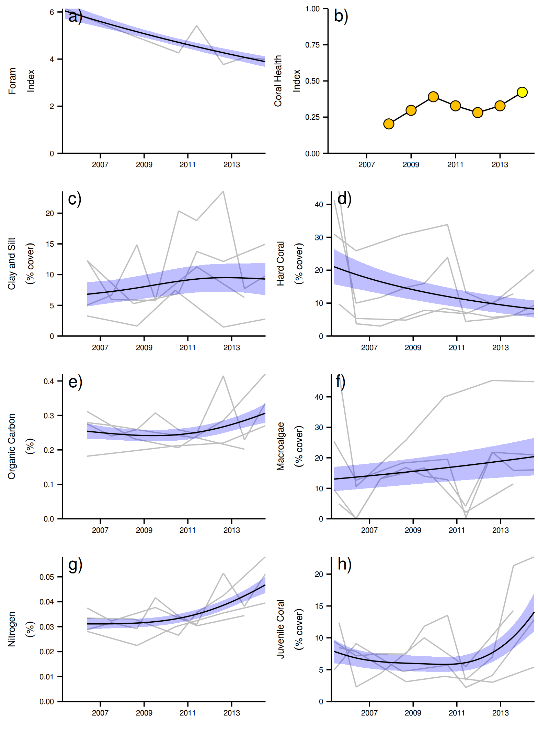
Figure 17 Coral reef community and sediment quality trends in the Herbert-Tully sub-region.
Coral health index colour coding: dark green- ‘very good’; light green-‘good’; yellow – ‘moderate; orange – ‘poor’; red – ‘very poor’. Coral index is calculated from variables plotted in d, f, h, along with the derived estimate of “rate of cover increase” as described in Appendix 1.3.7.Trends in Foram index, sediment and benthic community variables are represented by blue lines with blue shaded areas defining 95% confidence intervals of those trends, grey lines represent observed profiles averaged over depths at individual reefs.

3.1.4 Burdekin Region

The Burdekin Region is one of the two large dry tropical catchment regions adjacent to the Reef, with cattle grazing as the primary land use on over 95% of the catchment area (Brodie et al. 2003, GBRMPA 2012). There is also extensive irrigated planting of sugarcane on the floodplains of the Burdekin and Haughton rivers. Fluctuations in climate and cattle numbers greatly affect the state and nature of vegetation cover, and, therefore, the susceptibility of soils to erosion and off-site transport of suspended sediments and associated nutrients.

Seven reefs are sampled for coral reef condition assessments in this region, with three water quality sampling locations co-located with the annually-monitored core reefs (Figure 18). The monitoring locations are located along gradients away from the Burdekin River mouth and from the coast, that coincide with a gradient in water quality (Figure 18); there are no well-developed reefs closer to the Burdekin River than Magnetic Island, over 100km north from the mouth of the Burdekin River. Havannah, Pandora and the Palm Group are located in the midshelf water body (GBRMPA 2010, Table 1).

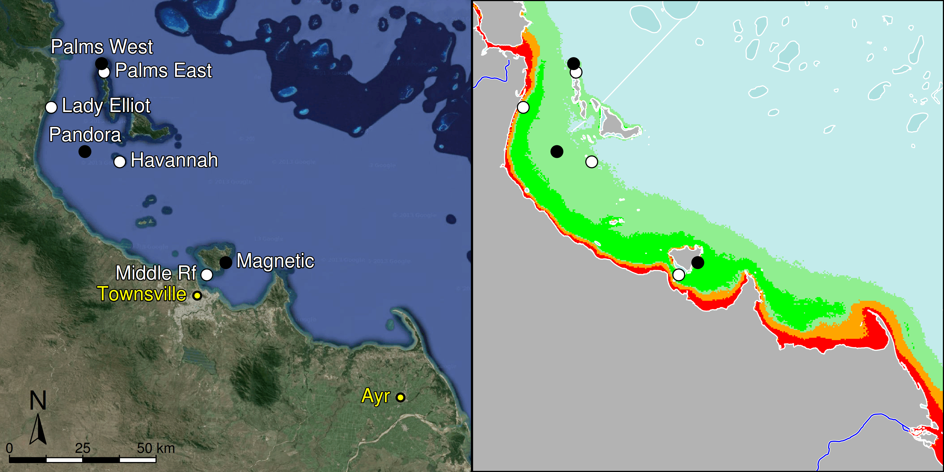

Figure 18 MMP sampling sites in the Burdekin NRM Region. Black symbols are water quality and core reef sampling locations and white symbols are cycle reef locations. Gradients of exposure to flood plume water types (Álvarez-Romero et al. 2013) during the wet season (December to March) are represented as areas exposed to primary plume-type waters most days (> 67% of days during the wet season, red shading) or frequently (33% - 67% of wet season days, orange shading), and areas exposed to secondary plume-type waters most days (>67% of wet season days, solid green shading), frequently (33% - 67% of wet season days, transparent green shading) or rarely (< 33% of wet season days, light blue shading).

Over the period 2007 to 2012, annual discharge from the Burdekin River was above median levels (Figure 19). The 2011 flood was the third largest on record, at almost six times the long-term median discharge (Table A2-1). Long-term weather patterns now appear to be entering another cycle of ‘drier’ wet seasons. Discharge from the Burdekin River was well below the long-term median in both 2013 and 2014 as the El Niño–Southern Oscillation (ENSO) continued to remain neutral.

The monitoring locations were variously disturbed by tropical cyclones Larry in 2006, Olga in 2010 and Yasi in 2011 (Figure 20), all of which caused reductions in coral cover at some reefs (Figure 22d, Table A2-5, Figure A2-6). There was no detectable damage caused to these reefs by TC Dylan that passed to the south of the region in late January 2014, or by ex-TC Ita that tracked southward through the region with sustained wind speeds of around 40kts.

Temperature records since 2005 continue to reveal no extreme temperature events that would be expected to cause coral bleaching (Figure 20).

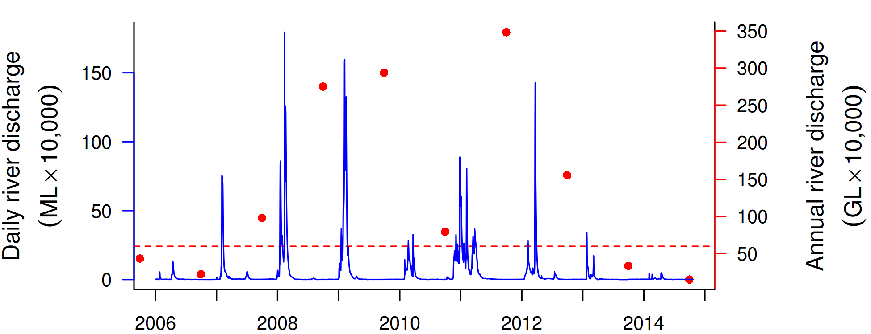
Figure 19 Discharge for the Burdekin River. Daily (blue) and annual (October to September, red) discharge shown. Red dashed line represents the long-term median annual discharge.

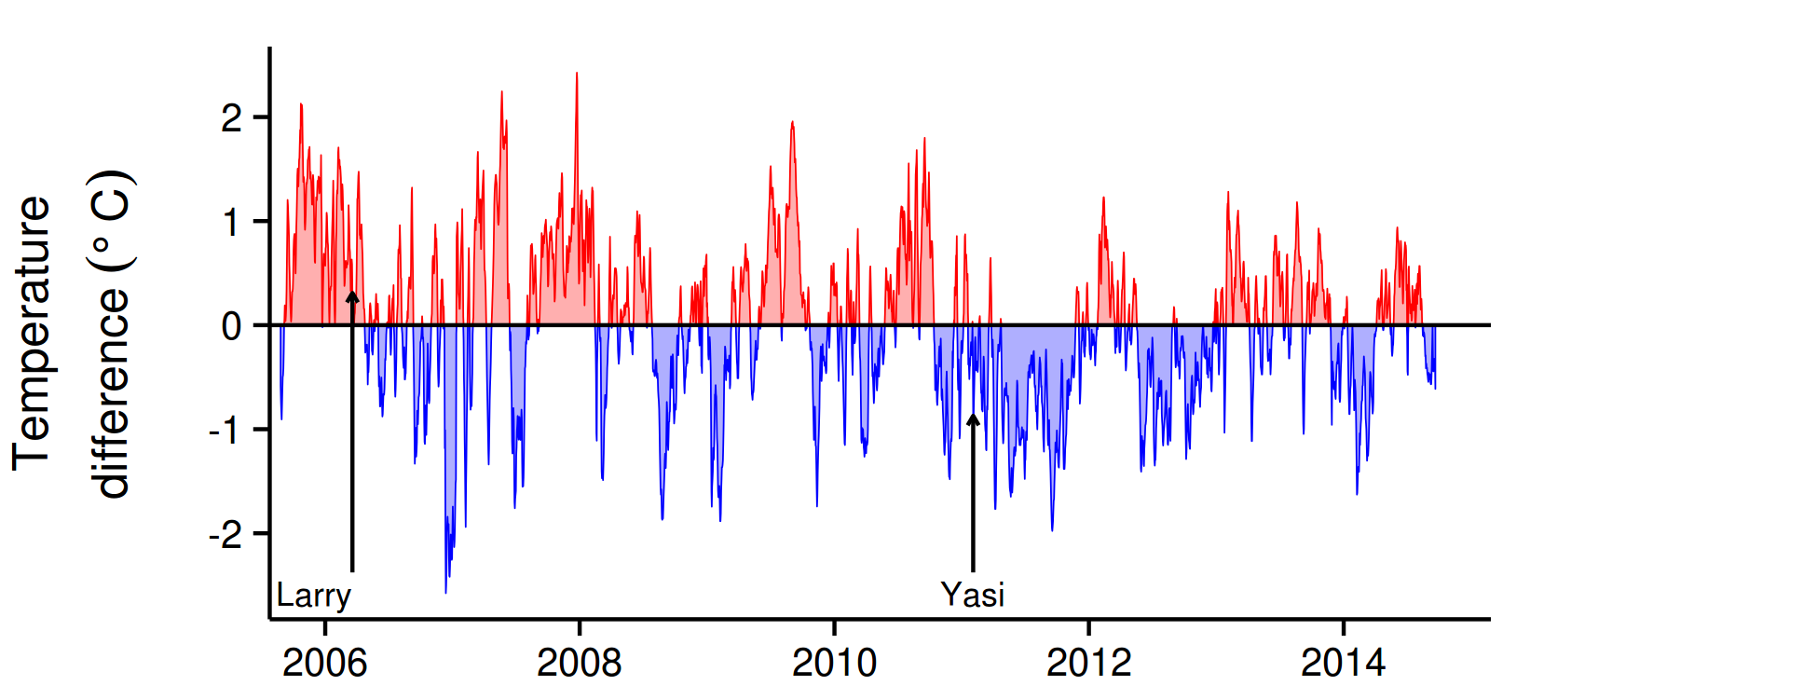
Figure 20 Sea temperature for the Burdekin region. Red and blue regions signify periods of above and below the long term seasonal average.

The water quality index in this region has been relatively stable over the past four years, oscillating between ‘good’ and ‘very good’ ratings (Figure 21a). Trends in concentrations of chlorophyll a (chl a), suspended solids (SS), particulate nitrogen (PN) and particulate phosphorus (PP) declined slightly over the course of the program, with a period of slightly increased values in the latter three variables around 2011-12 (Figure 21b, c, f, h), likely influenced by Cyclone Yasi and extreme flooding of the Burdekin and local rivers in 2011 (Figures 19, 20 and Table A2-1).

From 2007 onwards, the overall trend-lines for chl a, SS, PN and PP were below water quality guidelines (GBRMPA 2010). Secchi depth remained relatively stable at around 7 m, but still non-compliant with the guideline values (Figure 21e). The concentrations of dissolved oxidised nitrogen (NO_{x}) increased sharply after the first major flood event in 2008 and have since remained at levels close to or above the guideline (Figure 21d). The concentrations of dissolved organic carbon (DOC) increased until 2011, and then slightly decreased (Figure A2-3).

Instrumental chlorophyll (chl) and turbidity records showed more pronounced fluctuations than the manual sampling data (Figure 21b, g).The trend-lines of chl showed distinct maxima above the guideline during the wet seasons of 2008-09, 2011-12 and 2013-14 (Figure 21b). The turbidity record increased over the monitoring period with maxima above the guideline in 2011, 2013 and 2014 (Figure 21g). The SS and turbidity data showed different temporal trends, with SS decreasing and turbidity increasing, indicating that the size spectrum/composition of the optical active particle fraction has changed over the monitoring period.

The grain size distribution and organic carbon content has changed little (Figure 22c, e). However, the sediment nitrogen content increased since the large floods of 2011 (Figure 21c,e,g). Over the monitoring period, the FORAM index has declined considerably (Figure 21a), signifying a shift in the foraminiferal community composition from autotrophic to heterotrophic dominance. This shift indicates a likely response to the increase in organic carbon and nutrients seen during the monitoring period, both in the water column and the sediment, which can lead to reduced growth of autotrophic foraminifera (Uthicke et al 2010 and . 2012b, Figure 22d). While the recent drier years of 2013 and 2014 have resulted in a stabilisation and signs of a recovery among the autotrophic foraminifera communities at Pandora and Palms West, the combined FORAM index for all three core reefs in the region (Table A2-6) is still low, continuing the ‘very poor’ rating for FORAM community condition in this region (Table 1).

Since reaching a low point in 2012 the coral health index has remained ‘poor’. However, the upward trend in the index reflect the increasing densities of juvenile corals and marginal recovery of coral cover at some reefs (Figure 22b,d,f, Table 1). Overall, the recovery from past disturbance events has been limited.

Hydrodynamic modelling (Luick et al. 2007, Connie 2.0) and differences in population genetics of corals (Mackenzie et al. 2004) indicates limited connectivity between Halifax Bay and reefs further offshore. This isolation, coupled with widespread loss of cover as occurred in 1998 and 2002 as a result of thermal bleaching (Berkelmans et al. 2004, Sweatman et al. 2007, Table A2-5) may explain the typically low densities of juvenile colonies and then slow rate of cover increase observed in this region (Done et al. 2007, Sweatman et al. 2007, Figure A2-15, Table 1). In late 2010, we recorded a strong settlement pulse of Acropora to settlement tiles that followed the gradual increase in cover of Acropora within the region, potentially indicating the release from chronic brood-stock limitation, or that atypical currents provided greater connectivity to more distant brood-stock in that year (see case study in Thompson et al 2013). Irrespective of the source of these Acropora larvae, their survival and progression into juvenile size classes was not apparent in the survey data from 2011 (Figure A2-7), with the proviso that the 2011 survey followed the disturbance caused by TC Yasi and associated extreme flooding. It is encouraging that juvenile densities had increased in 2014 (Figure 22h) to the point of improving the regional score for that metric (Table A2-6). However, on closer examination, it is the rapid increase in abundance of Turbinaria sp. (family Dendrophylliidae) at Lady Elliot Reef that has driven the index upwards (Figure A2-7, Figure 24b). Turbinaria are turbidity-tolerant corals, and so the increase in the density of juveniles of this genus cannot be taken as a response to improved water quality. There was a slight increase in the density of Acroporidae juveniles at Palms East; an encouraging sign that community recovery is underway following the scouring of that site by TC Yasi in 2011.

The cover of macroalgae increases with the availability of nutrients (De’ath and Fabricius 2008, 2010). As opportunistic colonisers, macroalgae out-compete corals, recovering more quickly following physical disturbances. In order to consolidate their presence within the reef habitat, macroalgae have been documented to suppress coral fecundity (Foster et al. 2008), reduce recruitment of hard corals (Birrell et al. 2008b, Diaz-Pulido et al. 2010), diminish the capacity of growth among local coral communities (Fabricius 2005), and suppress coral recovery by altering coral associated microbial communities (Morrow et al. 2012, Vega Thurber et al. 2012). Macroalgae cover was regionally high following the first flood of the Burdekin River in 2007, and has generally declined since (Figure 22f). Low cover in 2011 was the result of removal during TC Yasi. The declines in cover of Macroalgae will have at least partially released their downward pressure on coral settlement and survival (Birrell et al 2008 a, b).

The composition of coral communities vary in response to environmental gradients, with water clarity and exposure to sedimentation widely acknowledged as key parameters. Within the Burdekin region there is a shift from communities dominated by the families Acroporidae, Pocilloporidae and Poritidae (genus Porites) in clearer waters through to communities dominated by families such as Agariciidae, Oculinidae, Pectiniidae and Poritidae (Genus Goniopora) in more turbid and sheltered settings (Figure A2-7). In addition to selecting for different community types, the environmental setting of these reefs has also resulted in differential exposure to disturbances. The orientation of the reef differentially exposes corals to physical damage by cyclone-driven waves, while differences in community composition result in differential impact of bleaching events as susceptibility to thermal stress varies among species (Marshall and Baird 2000). The communities dominated by Acroporidae at Palms East, and Palms West (2m) and Lady Elliot (2m) have been most damaged by cyclones and bleaching events and in 2014 share very low coral cover (Figure A2-7). The exception is Havannah where the Acroporidae at 2m was sheltered from Cyclone Yasi and cover has since increased. Conversely, the relatively sheltered communities at Middle Reef and at the 5m depth at Lady Elliot Reef maintain a moderate coral cover due to being sheltered from recent cyclones and having a high representation of slow growing species that are relatively resistant to physical disturbance, thermal stress, and high turbidity.

Recent palaeo-ecological evidence suggests that present-day coral assemblages in the Burdekin Region are the result of a shifted baseline from dominant arborescent Acropora to a remnant community of sparse Acropora and/or dominant non-Acropora species (Roff et al. 2013). An implied cause of this change is the sustained decline in water quality resulting from the expansion of agriculture in the catchment. Exposed to increased chronic stress the once ubiquitous suite of arborescent Acropora species were no longer able to recover from recurring impacts of cyclones and floodwaters, suffering a systematic collapse between 1920 and 1955. In the context of Roff et al. (2013), the current Acropora assemblages on inshore reefs represent fragile communities exposed to poor water quality, with low resistance and resilience, and an uncertain future. This interpretation is supported by our observations of increased levels of disease in 2007-2009 (Figure A2-10) that coincided with increased discharge of the Burdekin River (Table A2-1, Figure 19) and increases in NO_{x} concentrations in the regions’ waters (Figure 21d), suggesting the ongoing selection for benthic communities tolerant of the elevated levels of pollutants delivered in flood plumes. Nutrient enrichment has been suggested as increasing the incidence of coral disease (Vega Thurber et al. 2013). There has been a notable reduction in coral disease observed over the past two years, in tandem with a decline in Burdekin River discharge to below median levels.

In summary, the ‘good’ water quality index for the Burdekin Region suggests a supportive environment for the continued recovery and resilience of coral communities, at least at some reefs. Historically, recovery in this region has been slow, potentially because of a lack of larval supply due to locally depleted populations. Although recent gains in the coral health index indicate that recovery is underway, much longer periods free from disturbance may be required for substantial recovery to occur. Any water quality-related pressures that reduce the recovery potential may have a disproportionate influence in this region as they would compound the effect of low connectivity.

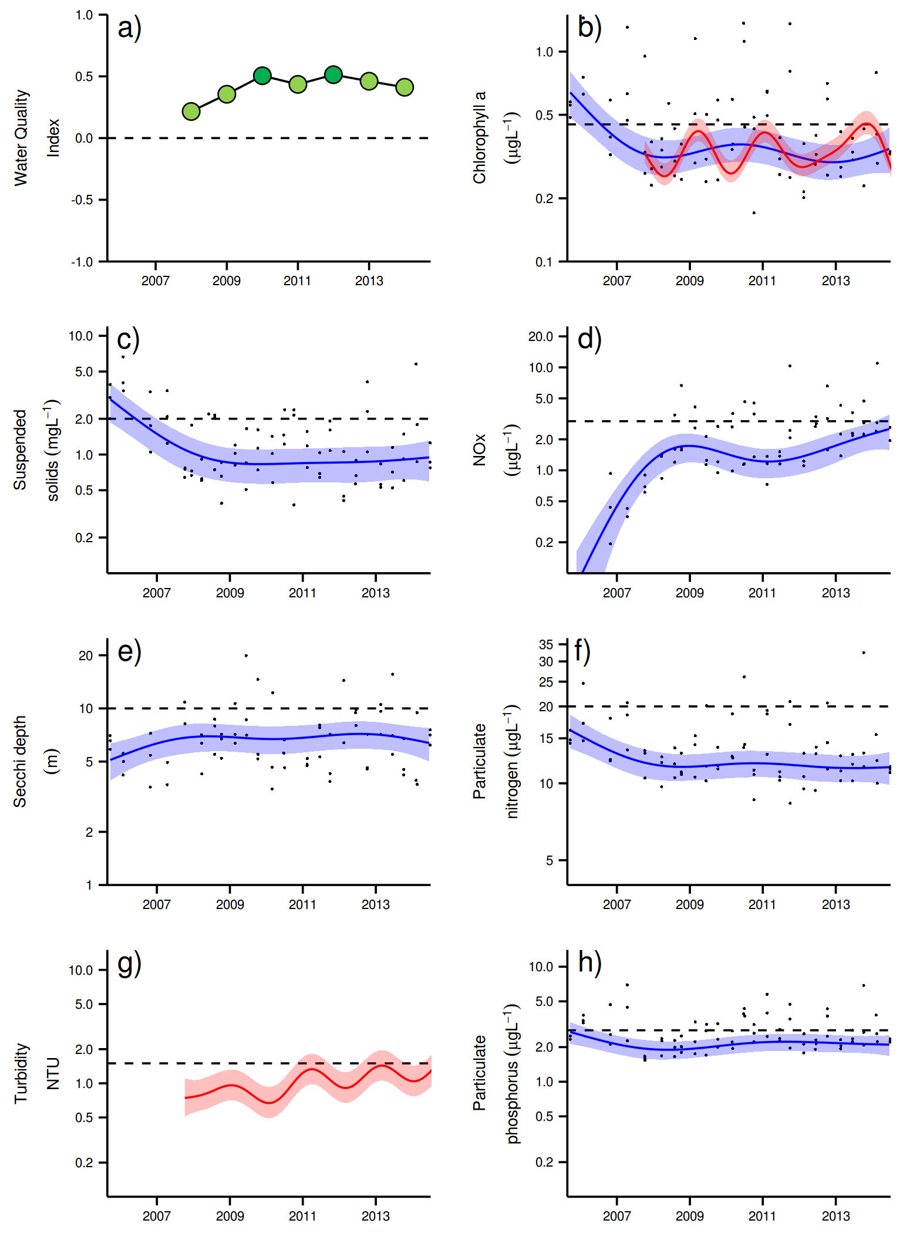
Figure 21 Temporal trends in water quality for the Burdekin region. a) water quality index, b) chlorophyll a, c) total suspended solids, d) nitrate/nitrite, e) secchi depth, f) particulate nitrogen, g) turbidity and h) particulate phosphorus Water quality index colour coding: dark green- ‘very good’; light green-‘good’; yellow – ‘moderate; orange – ‘poor’; red – ‘very poor’. The water quality index is the aggregate of variables plotted in with the exception of NO_{x} and calculated as described in Appendix 1.2.3. Trends in manually sampled water quality variables are represented by blue lines with blue shaded areas defining 95% confidence intervals of those trends, black dots represent observed data. Trends of records from ECO FLNTUSB instruments are represented in red, individual records are not displayed. Dashed reference lines indicate guideline values.
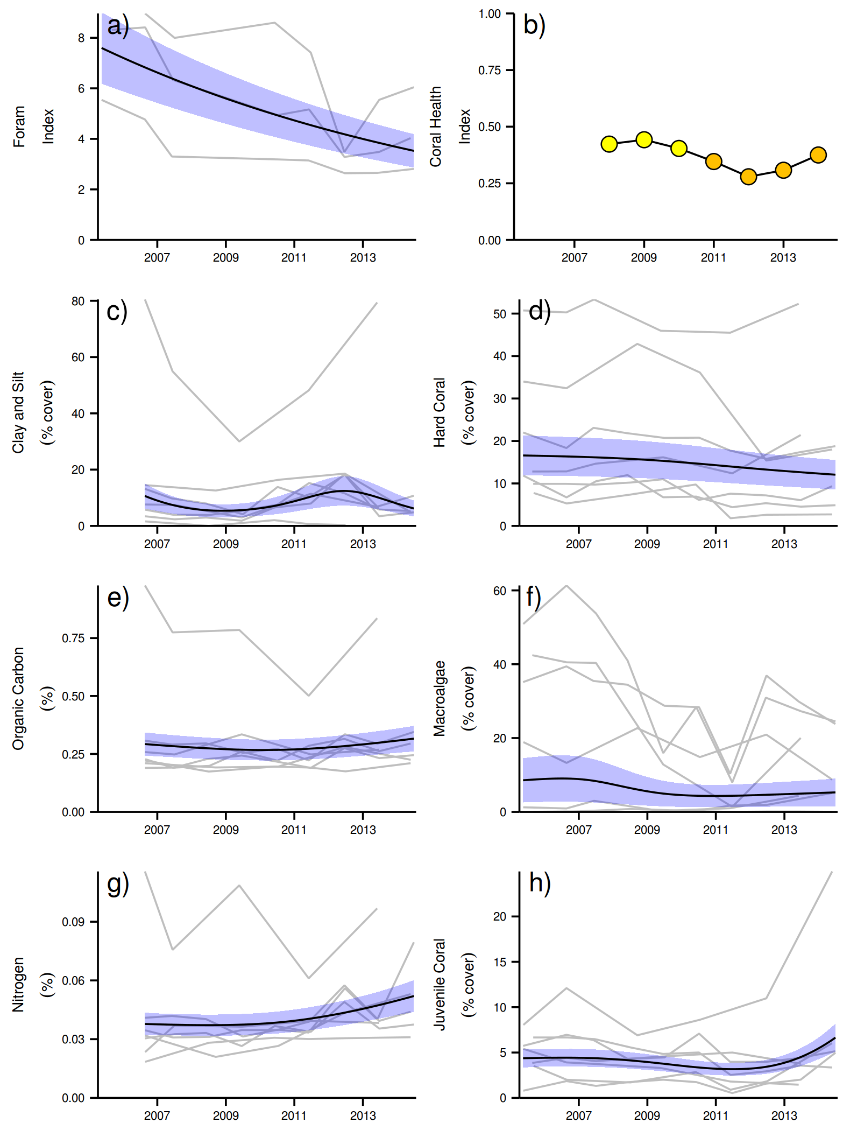

Figure 22 Coral reef community and sediment quality trends in the Burdekin region.
Coral health index colour coding: dark green- ‘very good’; light green-‘good’; yellow – ‘moderate; orange – ‘poor’; red – ‘very poor’. Coral index is calculated from variables plotted in d, f, h, along with the derived estimate of “rate of cover increase” as described in Appendix 1.3.7.Trends in Foram index, sediment and benthic community variables are represented by blue lines with blue shaded areas defining 95% confidence intervals of those trends, grey lines represent observed profiles averaged over depths at individual reefs.

3.1.5 Mackay Whitsunday Region
The Mackay Whitsunday Region is located in the central section of the Reef and comprises four major river catchments, the Proserpine, O’Connell, Pioneer and Plane catchments that enter the sea to the south of the monitoring locations. The region is also potentially influenced by runoff from the Burdekin and Fitzroy rivers during extreme events or through longer-term transport and mixing. The climate in this region is wet or mixed wet and dry tropical with the catchment land use dominated by agriculture broadly divided into grazing in the upper catchments and sugarcane cultivation on the coastal plains (Brodie et al. 2003, GBRMPA 2012). In addition, there are expanding urban areas along the coast.

Seven reefs are sampled for coral reef condition assessments in this Region, all located in the Whitsunday Islands, a group of high continental islands that is a major tourist destination. Tidal range in this region can exceed four metres, which is greater than in most other inshore areas of the Reef. The monitoring locations are located along gradients away from the Proserpine and O’Connell river mouths and away from the coast with four reefs sampled in the inner Whitsundays and three in the outer Whitsundays, separated by a relatively deep channel (Figure 23). Three water quality sampling locations are co-located with the annually monitored core reefs in the inner Whitsundays.

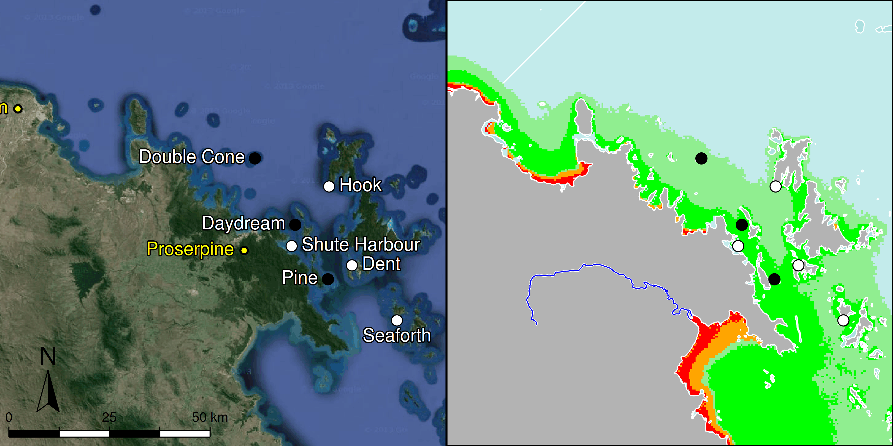

Figure 23 MMP sampling sites in the Mackay Whitsunday NRM Region. Black symbols are water quality and core reef sampling locations and white symbols are cycle reef locations. Gradients of exposure to flood plume water types (Álvarez-Romero et al. 2013) during the wet season (December to March) are represented as areas exposed to primary plume-type waters most days (> 67% of days during the wet season, red shading) or frequently (33% - 67% of wet season days, orange shading), and areas exposed to secondary plume-type waters most days (>67% of wet season days, solid green shading), frequently (33% - 67% of wet season days, transparent green shading) or rarely (< 33% of wet season days, light blue shading).

Over the period 2007 to 2013, annual discharge from the Proserpine, O’Connell and Pioneer rivers was above median levels (Figure 24, Table A2-1). Extreme floods (> 3x median) were recorded for the O’Connell River in 2011, the Pioneer River in 2008 and 2010 to 2013, and the Proserpine River each year 2008-2013 (Table A2-1). The 2011 flood was the largest on record for the Proserpine River and the third largest for the O’Connell River. Annual discharge for 2014 was below long-term median flows for both the Proserpine and O’Connell rivers, and 1.4 times the long-term median for the Pioneer River discharge (Table A2-1).

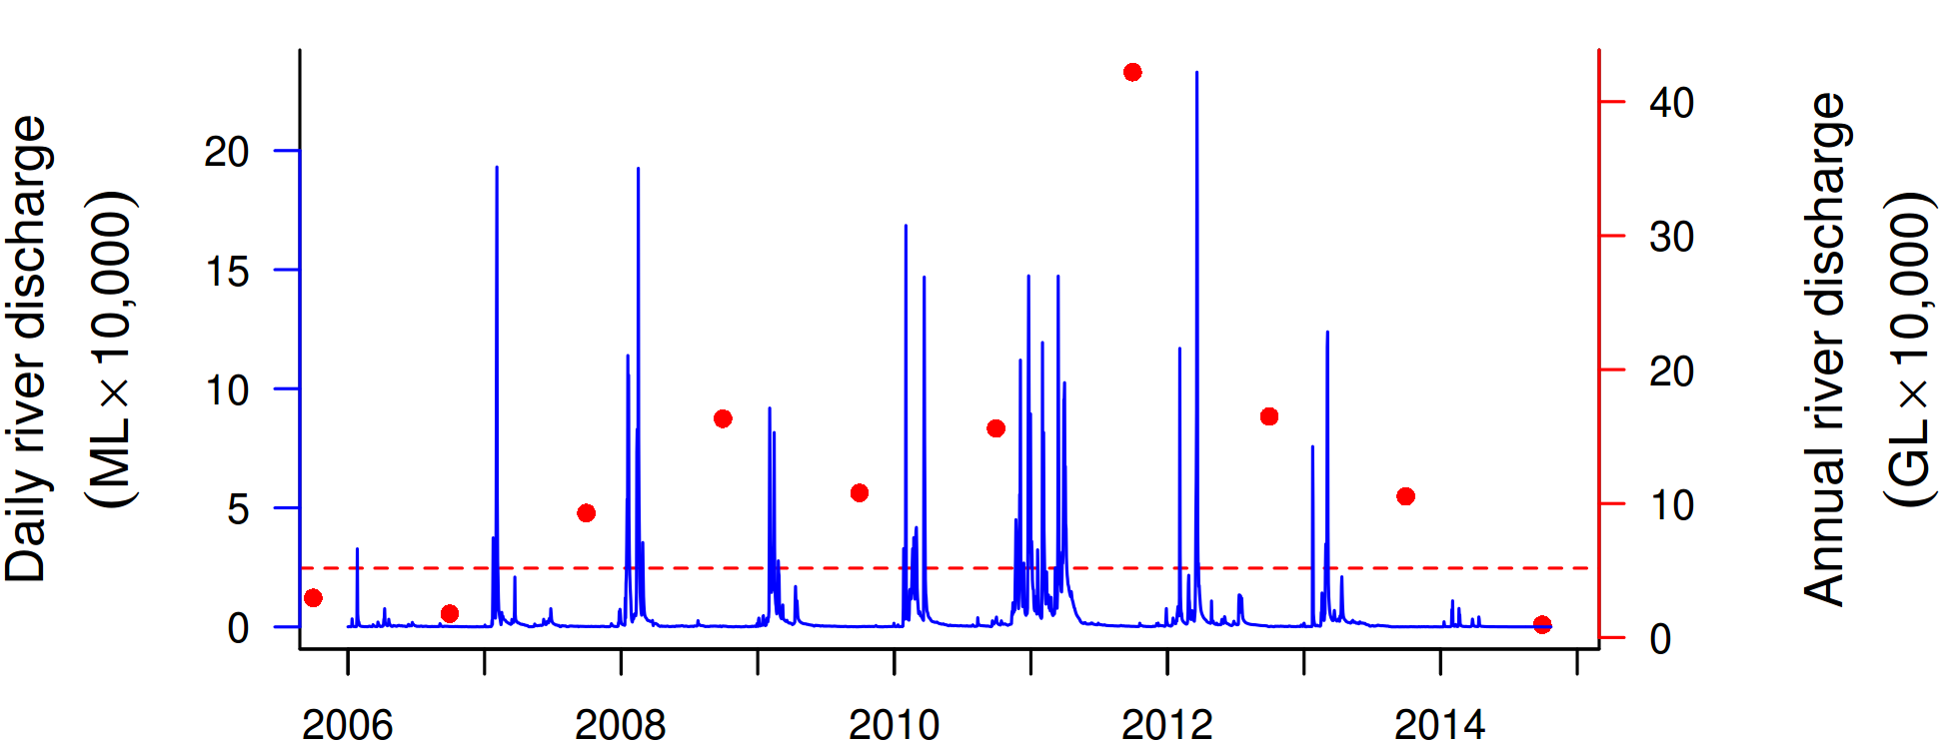
Figure 24 Combined discharge for the O'Connell, Proserpine and Pioneer Rivers. Daily (blue) and annual (October to September, red) discharge shown. Red dashed line represents the long-term median of the combined annual discharges.

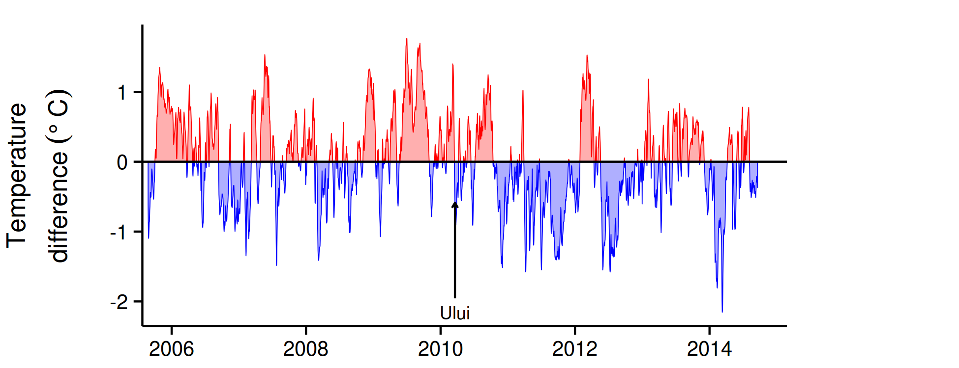
Figure 25 Sea temperature for the Mackay Whitsunday region. Red and blue regions signify periods of above and below the long term seasonal average.

The water quality index in this sub-region has declined since 2008 to the current ‘moderate’ rating (Figure 26a). Trends in concentrations of chlorophyll a (chl a), suspended solids (SS) and particulate phosphorus (PP) have increased since 2008 coincident with sustained high or extreme flows of the adjacent rivers. The concentrations of chl a were generally above water quality guidelines (guideline) from 2010 to 2014, while SS and PP rose above guideline values from 2011(Figure 26b,c,h),. The overall trend for particulate nitrogen (PN) was stable (Figure 26f). Secchi depth has declined steadily by about 50% since 2008 remaining on levels non-compliant with the guideline (Figure 26e). The concentrations of dissolved oxidised nitrogen (NO_{x}) increased sharply after the first above-median river flows in 2007 and has since increased further with the trend-line reaching above guideline values since 2013 (Figure 26d). The concentrations of dissolved organic carbon (DOC) increased steadily until 2012, and then slightly decreased (Figure A2-3).

Instrumental chlorophyll (chl) records showed more pronounced fluctuations but generally followed the same trend as the manual sampling data (Figure 26b, g). The trend-line of the instrumental turbidity record was above the guideline for most of the monitoring period, with an upward trend from 2012; this broadly mirrors the increase in SS to above guideline levels in 2009 and corresponding decline in Secchi depth, with all three indicators of water “clarity” continuing to not comply with the guideline (Figure 26c, e, g). This is especially the case for Pine and Daydream (Tables A2-2 to A2-4, Figure A2-1 j, k) that are more frequently exposed to flood plumes (Figure 23). The reef sediments in this region have the highest proportion of clay and silt-sized particles, organic carbon and nitrogen of all sampling regions. Whilst levels of organic carbon levels plateaued in recent years, the levels of clay/silt and nitrogen continued to increase despite reduced discharge from the regions rivers since 2012 (Figure 23, Figure 27 e, g). This highlights the need to consider residence times and lag effects when assessing responses of coral communities to changes in terrestrial inputs.

There are limited historical time-series data available for the coral communities in the inner Whitsundays (Sweatman et al. 2007). The largest widespread disturbances in recent history were coral bleaching events in 1998 and 2002, which most likely affected the reefs monitored by this program (Table A2-5). Observations from Dent Is and Daydream Is suggest an approximate 40% reduction in coral cover during 1998, while observations from AIMS LTMP monitoring sites at reefs in the outer Whitsunday Group record no obvious impact in 1998 and only marginal reductions in 2002 (Sweatman et al. 2007). Temperature records since 2005 show no extreme temperature events that would have led to coral bleaching (Figure 28). Since monitoring began in 2005, Cyclone Ului in 2010 has been the only acute disturbance to coral communities with impacts largely restricted to Daydream and Double Cone (Figure A2-8, Table A2-5).

Despite the continued decline of water quality in the region, the coral health index remains ‘moderate’ for 2014 (Figure 27b). This is primarily due to the low macroalgal and moderate to high coral cover on most reefs(Figure 27d,f), attributes which compensate for slow rates of coral cover increase (Figure A2-15) in the calculation of the health index.

High coral cover on these reefs appears to be the result of both the low incidence of recent disturbance events but also the predominance of species tolerant of the high turbidity and nutrient levels in this region (Figure A2-8). The selective pressure associated with high turbidity and high rates of sedimentation (Thompson et al. 2012), have clearly influenced the composition of both adult and juvenile coral as well as foraminiferal communities. Marked differences in composition of coral communities between 2m and 5m (Figure A2-8) indicate a steep gradient in environmental conditions, most likely due to high water turbidity. Whilst the coral community composition varies between reefs, there is a clear predominance of corals tolerant of low light and high rates of sedimentation at 5m (e.g. families Oculinidae, Pectinidae, genus Goniopora) compared to the 2 m depth where Acroporidae and Porites are most represented (Figure A2-8, see also Section 3.2 and Thompson et al 2014). Where Acropora had established at 5m depths, cover was reduced by Cyclone Ului in 2010 although cover had been in slow decline since 2007 when high incidence of disease was noted (Figure A2-10). The connection between physiochemical aspects of terrestrial runoff and disease prevalence (Bruno et al. 2003, Kaczmarsky and Richardson 2010, Haapkylä et al. 2011, 2013, Vega Thurber et al. 2013) is consistent with our observations.

The cover of macroalgae has remained stable and low throughout the region. Only Pine and Seaforth maintain significant macroalgal cover (Figure A2-8). These reefs are closest to the rivers influencing the region. Water quality data from Pine shows that many water quality variables consistently exceeded the guideline (Tables A2-2 to A2-4). Turbidity and chlorophyll concentrations are lower at Daydream Is, albeit still mostly exceeded the guideline. However, macroalgal cover has not increased here in recent years despite the availability of substratum for colonisation following Cyclone Ului. It is not certain what has inhibited increased macroalgal cover at Daydream. One possible explanation is a difference in grazing pressure. Herbivory has been demonstrated as critically important for the maintenance of reefs in a coral-dominated state (Hughes et al. 2007), and postulated to offer resilience to conditions that may otherwise support a shift to algal dominance (Cheal et al. 2013). At Daydream, we consistently see higher numbers of the grazing urchin Diadema sp. than at Pine. High turbidity in combination with high rates of sedimentation are also likely limiting the capacity of macroalgae to proliferate on these reefs, especially at the deeper 5 m sites.

In 2014 there were slight increases in the number of juvenile corals on several reefs, representing a reversal of the declines observed through to 2012. However, the scoring for this indicator is biased in this region as a result of the high levels of silt deposited on the substrate. Juvenile density is corrected for area of available substrate, i.e. the proportion of the transect occupied by algae. Where sediment builds up on the substrate, that sediment is scored and so reduces the area of algae, inflating the estimate of juvenile density. This is an artefact of the metric that is under review.

Over the last year the FORAM index has consistently declined (Figure 27 a), reflecting changes in water quality and coral health indices. Values in the Mackay Whitsunday Region are the lowest from all regions, with values approaching 2, indicating that the community nearly exclusively consists of heterotrophic species thriving under low light, and increased sediment organic carbon. In the Caribbean, FORAM index values of between 2 and 4 reflect environmental conditions that are marginal for coral reef growth (Hallock et al. 2003). Also in contrast to other regions, there is currently no noticeable increase, with the possible exception of Double Cone.

A recent study of sediment cores from the Whitsunday area showed clear shifts in foraminiferal assemblages at Daydream, Double Cone, and Dent from a composition of relatively high proportions of autotrophic species over several thousand years to increasing proportions of heterotrophic species and, hence, a decline in the FORAM index post European settlement (Uthicke et al. 2012a). The recently observed changes in the assemblage composition and decline in the FORAM index to the currently very low values (Figure 27a) indicate the ongoing selective pressures of recently experienced environmental conditions. However, FORAM index values described here are within the ranges of historically observed levels from sediment cores discussed in Uthicke et al. 2012a. Consistent with the steep decline in the water quality index, possible reasons for declines in the FORAM index are reduced light availability for photosynthetic species and increased nutrient supply favouring heterotrophic species (Uthicke and Altenrath 2010, Reymond et al. 2011, Uthicke et al. 2012b).

Overall, the influence of prevailing environmental conditions such as high turbidity, nutrient availability and sedimentation have clearly selected for coral species tolerant of those conditions. What is uncertain is the resilience of these communities if they were subject to an acute disturbance event. The slow rate of coral cover increase in this region (Table 1, Figure A2-15) suggests recovery from fragments may be slow. At the same time, while the density of juvenile corals is presently moderate, there is a lack of suitable substratum for recruitment due to an accumulation of silt deposits on reefs in this area. This accumulation, along with the continuing decline in water quality, may suggest a high residence time for contaminants introduced in runoff.

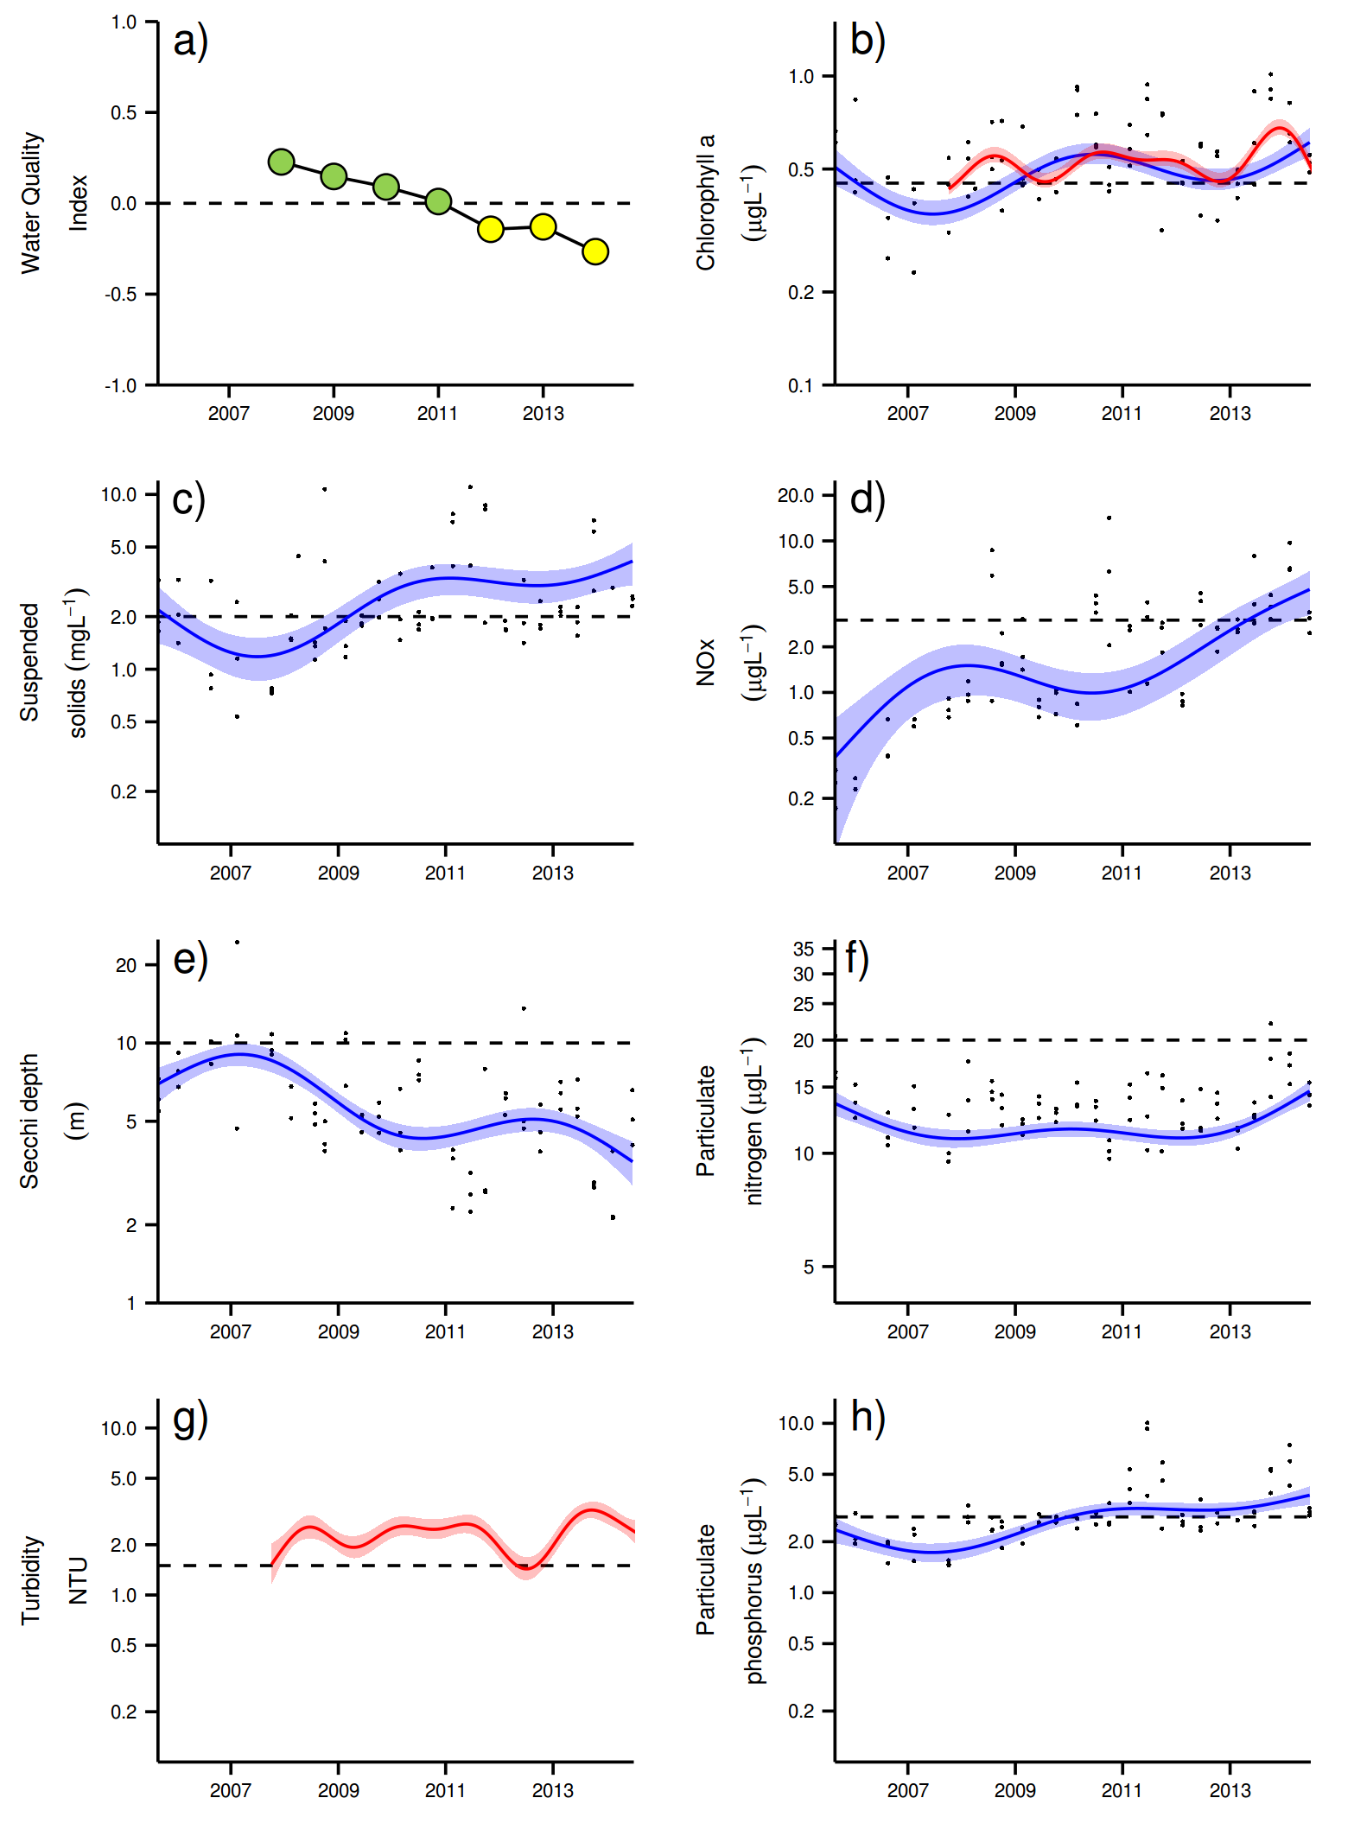
Figure 26 Temporal trends in water quality for the Mackay Whitsunday region. a) water quality index, b) chlorophyll a, c) total suspended solids, d) nitrate/nitrite, e) secchi depth, f) particulate nitrogen, g) turbidity and h) particulate phosphorus Water quality index colour coding: dark green- ‘very good’; light green-‘good’; yellow – ‘moderate; orange – ‘poor’; red – ‘very poor’. The water quality index is the aggregate of variables plotted in with the exception of NO_{x} and calculated as described in Appendix 1.2.3. Trends in manually sampled water quality variables are represented by blue lines with blue shaded areas defining 95% confidence intervals of those trends, black dots represent observed data. Trends of records from ECO FLNTUSB instruments are represented in red, individual records are not displayed. Dashed reference lines indicate guideline values.

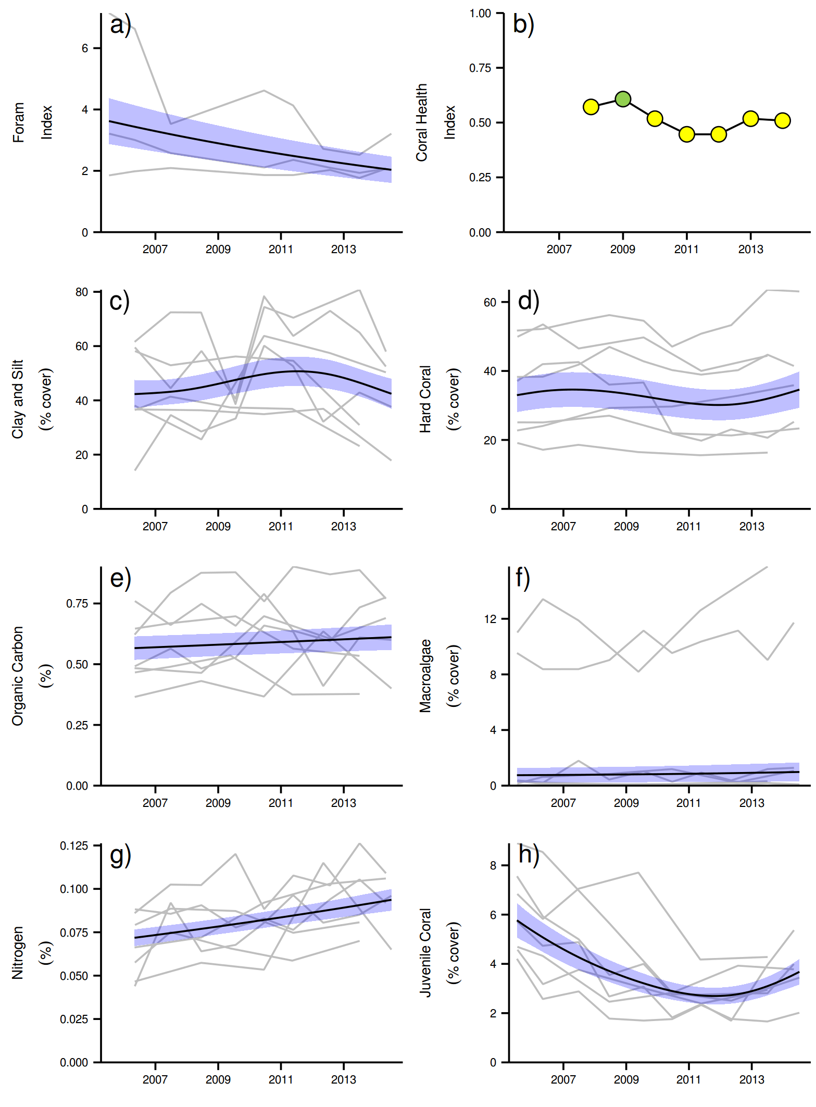
Figure 27 Coral reef community and sediment quality trends in the Mackay Whitsunday region.
Coral health index colour coding: dark green- ‘very good’; light green-‘good’; yellow – ‘moderate; orange – ‘poor’; red – ‘very poor’. Coral index is calculated from variables plotted in d, f, h, along with the derived estimate of “rate of cover increase” as described in Appendix 1.3.7.Trends in Foram index, sediment and benthic community variables are represented by blue lines with blue shaded areas defining 95% confidence intervals of those trends, grey lines represent observed profiles averaged over depths at individual reefs.

3.1.6 Fitzroy Region
The Fitzroy NRM Region has the largest catchment area draining into the Reef. The climate is dry tropical with highly variable rainfall, high evaporation rates and prolonged dry periods, followed by infrequent major floods. By area, cattle grazing is the primary land use in the catchment (Brodie et al. 2003, GBRMPA 2012) and the initial clearing of vegetation for this purpose marked a significant change in the sources and increase in quantity of sediment exported by the Fitzroy River (Hughes et al 2009). Intensive cultivation of food crops also contribute to the sediment load in the Fitzroy River (Hughes et al 2009). Fluctuations in climate, cattle numbers and farming can greatly affect the state and nature of vegetation cover, and therefore, the susceptibility of soils to erosion which leads runoff of suspended sediments and nutrients.

Six reefs are sampled for coral reef condition assessments in this region. These fringing reefs are formed around continental islands in Keppel Bay, many of which are used extensively for recreational and tourism activities. The monitoring locations are located along gradients away from the Fitzroy River mouth and away from the coast (Figure 28). Three water quality sampling locations are co-located with the annually monitored core reefs.
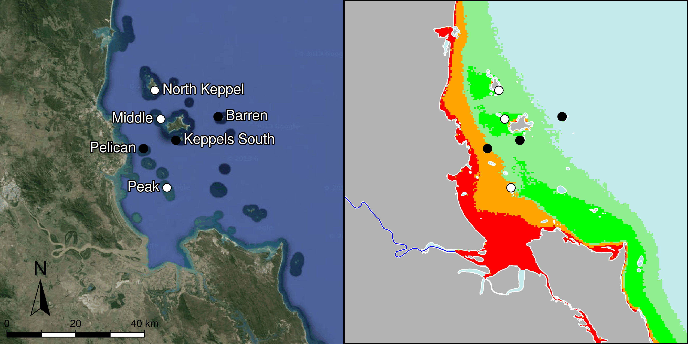

Figure 28 MMP sampling sites in the Fitzroy NRM Region.
Black symbols are water quality and core reef sampling locations, white symbols are cycle reef locations, grey symbols are the six open water sites of the AIMS Cairns Transect. Gradients of exposure to flood plume water types (Álvarez-Romero et al. 2013) during the wet season (December to March) are represented as areas exposed to primary plume-type waters most days (> 67% of days during the wet season, red shading) or frequently (33% - 67% of wet season days, orange shading), and areas exposed to secondary plume-type waters most days (>67% of wet season days, solid green shading), frequently (33% - 67% of wet season days, transparent green shading) or rarely (< 33% of wet season days, light blue shading).
The location of reefs along water-quality gradients away from the Fitzroy River influences both the composition and dynamics of benthic communities. Peak and Pelican are situated in relatively turbid and nutrient-rich waters compared to the reefs further offshore (Figure 28, Tables A2-2 to A2-4). At these reefs benthic communities differ markedly between the 2m and 5m depths (Figure A2-9), illustrating the substantial differences in light conditions due to attenuation by high turbidity. Although water quality is not measured at Peak Is, the low coral cover, low density of juvenile corals, high cover of macroalgae, along with a lack of substantial reef development suggest that the environmental conditions at this location are marginal for most corals (Figure A2-9). Further offshore, reefs become dominated by the family Acroporidae (mostly the branching species Acropora intermedia and A. muricata) at both 2m and 5m (Figure A2-9).

Since 2008 the Fitzroy NRM region has experienced a period of intense flooding with annual discharge of the Fitzroy River exceeding the long-term median in 2008, 2010-2013 with the 2011 event being the largest on record (Figure 29, Table A2-1). During the 2011, reduced salinity was the likely cause of the widespread mortality of corals at the 2m depths of Peak, Pelican, Keppels South (Figure A2-9, Table A2-5, see also Berkelmans et al. 2012). Annual discharge of the Fitzroy River in 2014 was below the long-term median for the first time since 2009 (Figure 29).

Temperature records highlight a period of prolonged high temperatures over the summer of 2005-2006 that led to widespread bleaching of the coral communities, since this there has been no extreme temperature events that would be expected to cause coral bleaching (Figure 30).

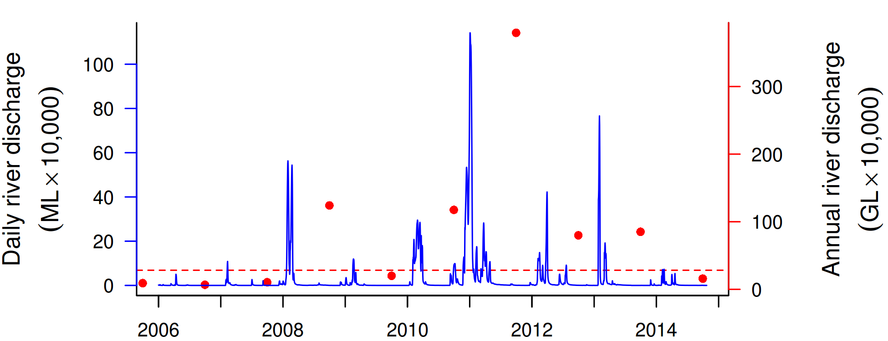
Figure 29 Discharge for the Fitzroy River. Daily (blue) and annual (October to September, red) discharge shown. Red dashed line represents the long-term median annual discharge.
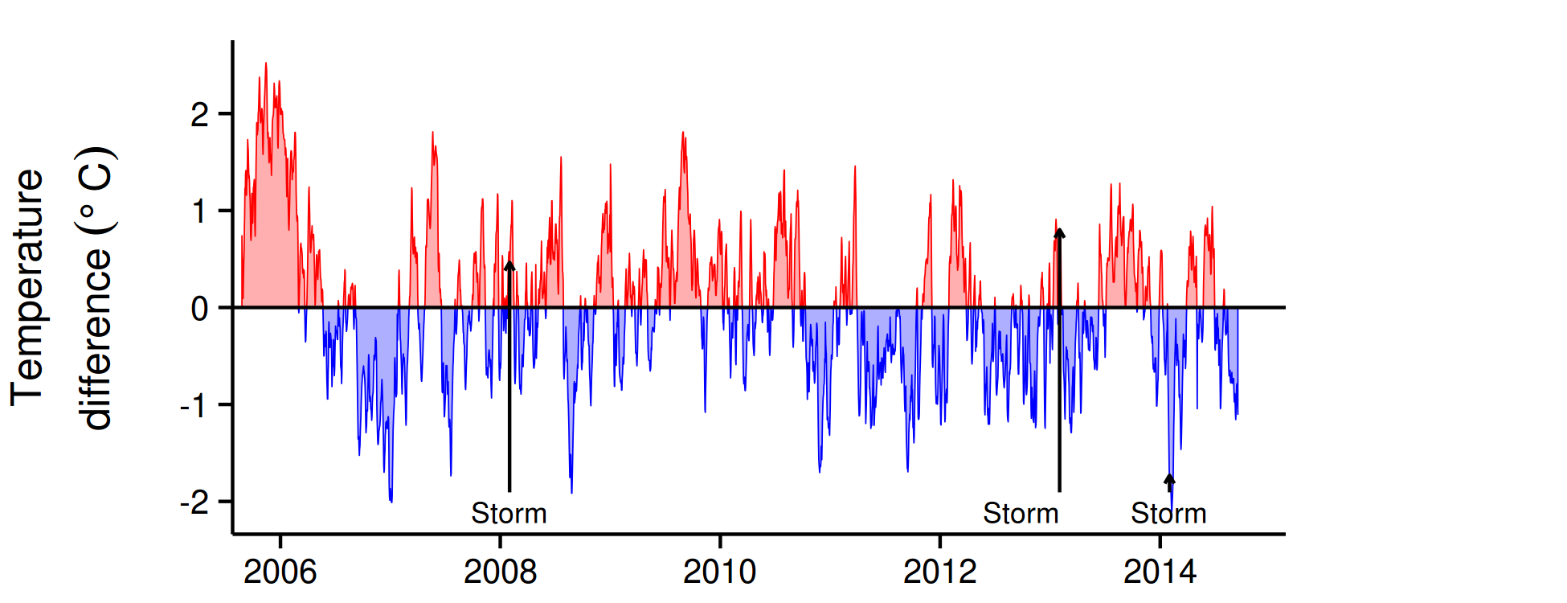
Figure 30 Sea temperatures for the Fitzroy region. Red and blue regions signify periods of above and below the long term seasonal average.

The water quality index in this region maintained a rating of ‘good’, while showing fluctuations that coincided with the major floods in 2008, and 2012-13 (Figure 31a). Trends in concentrations of chlorophyll a (chl a) and suspended solids (SS) declined, after a period of high values in 2009-11 and 2012-13, respectively (Figure 31b, c). Particulate nitrogen (PN) and particulate phosphorus (PP) changed less but also show a slightly declining trend (Figure 31f, h). Except for chl a and Secchi depth, the overall trend-lines for all indicators complied with the Water Quality Guidelines for the Great Barrier Reef Marine Park (guideline). Secchi depth remained relatively stable at around 7 m, but was non-compliant with the guideline (Figure 24e). The concentrations of dissolved oxidised nitrogen (NO_{x}) increased sharply after the first major flood event in 2008 and have since remained at levels close to or above the guideline (Figure 31d). The concentrations of dissolved organic carbon (DOC) increased steadily until about 2011, and then slightly decreased (Figure A2-3).

Instrumental chlorophyll (chl) and turbidity records showed more pronounced fluctuations than the manual sampling data (Figure 31b, g). The trend lines of chl showed distinct maxima above the guideline during the wet seasons of 2010 and 2013 (Figure 31b). The reason for these higher levels during 2010 and 2013 are uncertain, as no clear link was found with delivery of nutrients from e.g. flood events. . The turbidity record slightly increased over the monitoring period with higher levels in 2008, 2010-12, 2013 and 2014, albeit the regional trend-line remained below the guideline (Figure 31g). The SS and turbidity (NTU) showed different temporal trends, with SS decreasing and turbidity increasing. This indicates that the size spectrum/composition of the optical active particle fraction has changed over the monitoring period.

The ongoing “very poor” rating for coral communities in this region (Figure 32b, Table 1) reflected the combination of direct and indirect influences of recent floods and disturbances associated with high temperatures in 2006 and a series of severe storms in 2008, 2010, 2013 and 2014 (Figure 30, Table A2-5). While it is expected that coral communities will be occasionally impacted by acute disturbance events such as storms, freshwater inundation and, with warming oceans, thermal extremes, it is the potential for poor water quality to either compound the effects of such events or supress the rate that communities recover that is of primary interest to the MMP.

Prior to the commencement of the MMP in 2005, Queensland Parks and Wildlife Service monitoring of reefs in Keppel Bay from 1993-2003 recorded substantial losses of coral cover as a result of thermal bleaching events in 1998 and 2002 (Table A2-5). Importantly, these surveys also demonstrated the resilience of the corals to these events, with coral cover clearly increasing in subsequent years (Sweatman et al. 2007). Initial MMP surveys in 2005 documented moderate to high hard coral cover on all the Acropora-dominated reefs confirming this recovery. In 2005-06, high sea surface temperatures (Figure 30) again led to a severe bleaching event resulting in marked reductions in coral cover, in particular Acroporidae, and a resultant bloom of the brown macroalgae Lobophora variegata (Figures 32d and A2-8, see also Diaz-Pulido et al. 2009). Evidence for recovery following the 2006 bleaching event was inversely related to the persistence of macroalgal communities (especially on reefs dominated by L. variegata). At the three reefs often exposed to a secondary plume water type (Keppels South, Middle and North Keppel), macroalgal cover remained high and rates of change in coral cover have remained low or cover has continued to decline (Figure A2-9, A2-15, Table 1). In contrast at Barren Is, which is rarely exposed to flood plumes and has consistently lower levels of all water quality variables (Tables A2-2 to A2-4), the bloom of L. variegata was less pronounced and ephemeral, and recovery of the coral community clearly progressed in 2007 (Figure A2-9).
In addition to potentially facilitating the persistence of macroalgae within the Keppel Group, flooding of the Fitzroy River also appears to have directly stressed the corals across the region. The incidence of coral disease has shown distinct maxima, the first was associated with the coral bleaching event in 2006, subsequent high levels of disease in 2008, 2010 and 2011 followed extreme flood events (Figure A2-10, Table A2-1). The consistent pattern of high incidence of disease amongst coral communities following each of the recent floods supports the hypothesis that increased organic matter availability, reduced salinity (Haapkylä et al. 2011), and increased nutrient enrichment (Vega Thurber et al. 2013) facilitate coral disease. Reduction in light levels over extended periods of time as a result of higher turbidity from increasing concentrations of suspended sediments as well as dense plankton blooms is another plausible explanation for reduced fitness of corals (Cooper et al. 2008).

Low and declining densities of juvenile corals further contribute to the ongoing ‘very poor’ assessment of the coral health index (Figure 32h). Most notable are the extremely low densities at 2m depths at Peak and Pelican where almost all juveniles were killed by flood waters in 2011 (Figure A2-9). At most other reefs, juvenile densities have been consistently low following the loss of corals and increase in macroalgae in 2006. While Birrell et al. (2008b) found that the presence of L. variegata promoted the settlement of Acropora coral, this contradicts reports from the Caribbean (Kuffner et al. 2006 ) and the general literature indicating that macroalgae suppress coral recruitment via a range of physical and chemical mechanisms (e.g. Birrell et al. 2008a). Juvenile corals are also likely to be susceptible to the same chronic environmental conditions that led to disease of larger colonies, as discussed above.

Declines in the FORAM index are relatively minor compared to other regions (Figure 32a), although do imply a change in environmental conditions consistent with the observed increases in organic content and the proportion of clay and silt grainsized particles in sediments and NO_{x} in the water column (Figures 32c,e,g and 31d). In 2014, improvements in the index values were apparent at Barren Is and Keppels South the two sites furthest along the water quality gradient. As with other regions these changes are demonstrating that the sediment dynamics and foraminiferal communities on inshore reefs respond to riverine inputs.

In summary, the ‘very poor’ assessment of the coral health index comes after a period of repeated flooding and contrasts recovery of coral cover following previous bleaching events during periods with low river flows. Light reduction as a result of turbidity, increased nutrient supply, along with lower salinity, are all mechanisms that reduce coral fitness or contribute to higher rates of disease in corals (e.g. Fabricius 2005, Voss and Richardson 2006, Haapkylä et al. 2011). In the event of a return to lower flows, the rate at which the current suppression of resilience is reversed will help to assess the longer term impacts of runoff on the ecology of the reefs in this region. However, given the highly variable flow of the Fitzroy River, periods of low rainfall, which in this catchment may reduce vegetation cover and so increase the potential for erosion and mobilisation of catchment soils, will inevitably be followed by large flood events carrying this available material into coastal waters.
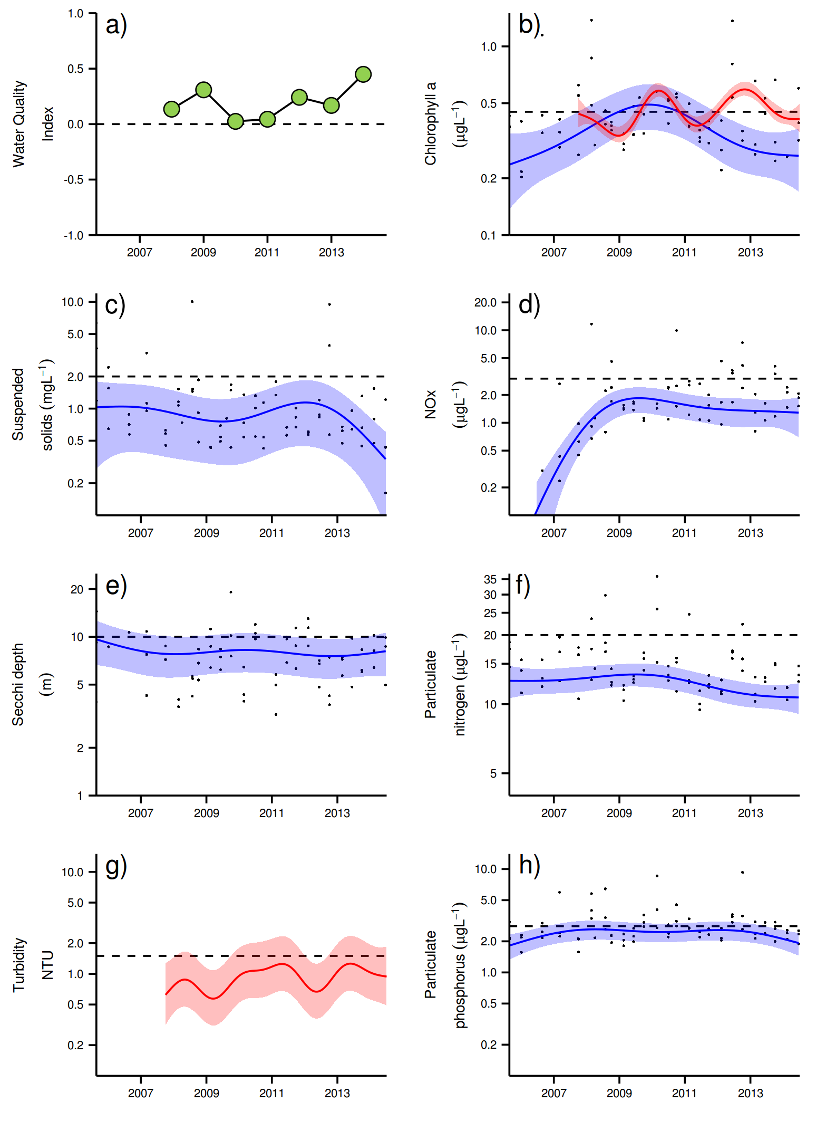
Figure 31 Water quality trends in the Fitzroy region. a) water quality index, b) chlorophyll a, c) total suspended solids, d) nitrate/nitrite, e) secchi depth, f) particulate nitrogen, g) turbidity and h) particulate phosphorus. Water quality index colour coding: dark green- ‘very good’, light green-‘good’, yellow – ‘moderate’, orange – ‘poor’, red – ‘very poor’. The water quality index is the aggregate of variables plotted in with the exception of NO_{x} and calculated as described in Appendix 1.2.3. Trends in manually sampled water quality variables are represented by blue lines with blue shaded areas defining 95% confidence intervals of those trends, black dots represent observed data. Trends of records from ECO FLNTUSB instruments are represented in red, individual records are not displayed. Dashed reference lines indicate guideline values.
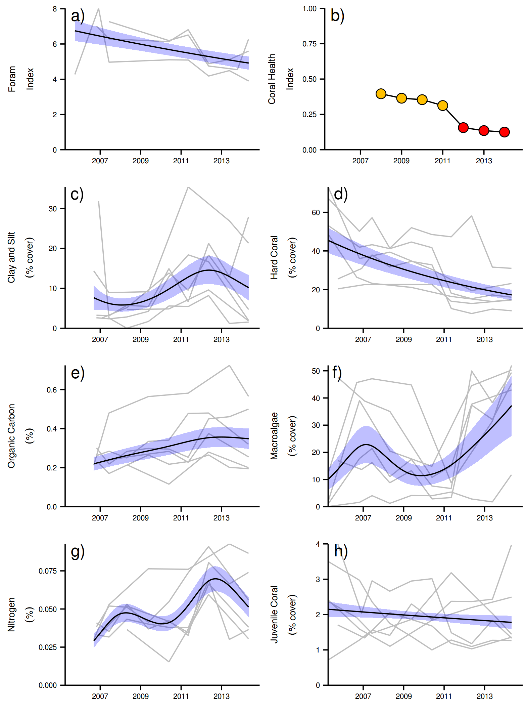
Figure 32 Coral reef community and sediment quality trends in the Fitzroy region.
Coral health index colour coding: dark green- ‘very good’, light green-‘good’, yellow – ‘moderate’, orange – ‘poor’, red – ‘very poor’. Coral index is calculated from variables plotted in d, f, h, along with the derived estimate of “rate of cover increase” as described in Appendix 1.3.7.Trends in Foram index, sediment and benthic community variables are represented by blue lines with blue shaded areas defining 95% confidence intervals of those trends, grey lines represent observed profiles averaged over depths at individual reefs.

3.2 Case study: Potential coral community composition metric for inclusion into the coral health index

Scope

This case study presents a potential additional metric to be included into the existing multimetric coral health index used to derive coral community report card scores. The purpose of the new metric is to assess observed changes in coral community composition that are consistent with predicted changes along a water quality gradient. The resulting metric, its benefits, and limitations are discussed.

Introduction

Biological assessments are an evaluation of biological responses as a means of inferring the environmental conditions of a place (Karr and Chu, 1999). As a tool of both ecologists and managers, biological assessments are particularly useful as the biological responses measured can indicate the cumulative response to multiple pressures over a range of spatial or temporal scales without the need to fully identify or enumerate the underlying mechanisms or parameters (Karr 2006). As discussed by Bradley et al. (2010) biological assessments should be based on a range of indicators that each focus on separate scales of influence or modes of response. The aggregation of multiple indicators into a “multimetric index” provides a broad basis for the assessment of biological integrity while also producing a single “score” for reporting purposes.

Due to the inference ascribed to biological assessments it is important that each indicator included in a multimetric index be carefully selected and tested to ensure it is both relevant to the purpose of the index and can be feasibly implemented in a manner able to detect differences in the response (Jameson et al. 2001). In the coral reef context the purpose of biological assessments are generally to assess the integrity of communities influenced by human imposed stressors such as local increases in nutrients and sediments (Jameson et al. 2001, Fisher et al 2008, Cooper et al. 2009, Fabricius et al. 2012) or global issues such as resilience to climate change (McClanahan et al 2012). In each of the studies listed above the authors have tested a range of biological attributes and identified those most relevant as potential indicators to be used in a multimetric index. None have taken ensuing steps of applying any required adjustments for differences in habitats, converting observed levels of the attributes into metric scores and finally combining scores into a multimetric index score to inform assessment and reporting (Bradley et al. 2010).

The underlying premise of Reef Plan is that land use practices adjacent to the Reef have resulted in increased loads of contaminants in the form of sediments, nutrients and pesticides into the waters of the Reef and this has resulted in a concomitant reduction in water quality. The goal of Reef Plan is to implement changes in land use practices that will “ensure that by 2020 the quality of water entering the reef from broad-scale land use has no detrimental impact on the health and resilience of the Great Barrier Reef” (Anon 2013). This goal sets the purpose of the Reef Plan multimetric index for coral communities as one of assessing communities for improvements consistent with expectations under reduced water quality pressure. At present, the multimetric index used for the reporting of coral community condition by the MMP focuses on four metrics: the density of juvenile corals, the combined cover of hard and soft coral, the cover of macroalgae and the rate of coral cover change (Section A1.3.7 of this report). For consistency, this index has remained largely unchanged since first introduced in 2009. With the increased knowledge gained since the inception of the MMP coral monitoring component in 2004 it is recognised that the current index could be improved and it is intended that the updating of the index occurs during 2015. This case study presents the first stage in the revision process by investigating the potential for a coral community composition-based metric.

The coral communities monitored by the Marine Monitoring Program (MMP) vary considerably in the relative composition of coral species (Uthicke et al. 2010, Section A-2 of this report). As demonstrated by Uthicke et al. (2010) some of this variability can be attributed to differences in environmental conditions between locations and implies selection for certain species based on the environmental conditions experienced. Coral communities respond to environmental conditions in two ways. Most noticeably they respond to acute shifts in conditions such as exposure to substantially reduced salinity (van Woesik 1991, Berkelmans et al. 2012), deviations from normal temperature (Hoegh-Guldberg 1999) or even hydrodynamic conditions (cyclones); all of which result in reductions in coral cover as susceptible species are killed. In contrast, the increased loads of sediments and nutrients entering the Reef as result of land use practices in the adjacent catchments (Waters et al. 2014) may include a combination of acute conditions associated with flood events and then chronic change in conditions as pollutants are cycled through the system. Chronic change in conditions could provide a longer period of selective pressures as environmental conditions shift beyond individual corals tolerances.

Under the effects of chronically changing conditions it is plausible that communities presently observed are the result of the gradual shift in species composition as sensitive species have been continually selected against as environmental conditions declined. It is with this concept in mind that we here analyse the first ten years of MMP monitoring data to: (a) explain variation in hard coral community composition that can be related to differences in water quality and (b) demonstrate how such variation can be used to develop a metric which enables the assessment of observed changes in coral community composition in terms of a response to changed water quality.

The concept

The metric for assessing change in coral community composition was derived in the following way:
- A water quality gradient explaining variation in coral community composition was determined from satellite derived turbidity and chlorophyll estimates adjacent to coral monitoring locations.
- Coral group scores along that water quality gradient were estimated by applying a Canonical Analyses of Principal Coordinates to MMP coral community data.
- The predicted location of a community along the water quality gradient was determined by the scaling of observed coral group cover by the relevant coral groups scores.
- Variation in the predicted location of a community along the gradient was estimated form six observation of a community over a 5-7 year period - beginning in 2005, to serve as bounds for a community-specific baseline.
- The predicted location of a community along the gradient was assessed relative to the bounds of the reef-specific baseline and any deviation beyond those bounds was scored based on the direction of change along the gradient.
- Scores for individual reefs were aggregated to the spatial scale of interest.

Distribution of corals along a water quality gradient
The coral community observed in any given location will be the result of processes interacting over a range of temporal scales. As this step of the process is aimed at deriving our best estimate of the distribution of coral groups along a water quality gradient we first aggregated data from annual observations at each reef and depth (2 m or 5 m below lowest astronomic tide datum) to derive a time averaged community composition for each reef and depth. This was done as a way of integrating variation in processes such as recruitment, but also the influence of acute events.

The coral data used were aggregated from % cover estimates from MMP photo point transects (Appendix 1.3 for detailed sampling methods). For each combination of reef and depth, the mean percent cover of corals aggregated over the years 2005-2013 was estimated for each genus of hard coral. For the genus Acropora, cover estimates were further divided into major growth forms: Branching, Bottlebrush, Corymbose, Digitate, Encrusting, Sub-massive and Tabulate. For the genus Porites, cover estimates were divided in to the growth forms: Branching, Massive, Sub-massive and the species P. rus (sub-genus Synaraea). The genus Barabattoia was grouped with Favia as we were not confident in consistent differentiation of these genera.

Environmental data available for all reef sites were:
- Satellite derived chlorophyll (Chl) and total suspended solids (TSS) for the period 2002-2012. The concentration estimates for these parameters were supplied by CSIRO. A regionally-adapted, physics-based ocean colour algorithm (Brando et al. 2012; Schroeder et al. 2007, 2012) was used to derive daily means for a cluster of nine, 1 km² pixels adjacent to each coral monitoring site. For the present analysis, the median and 90th percentiles of all observations from each reef were calculated.
- Satellite data were also used to estimate the exposure of each coral monitoring location to waters classified as being exposed to either, primary, secondary or tertiary plume type water (Alvarez-Romero et al. 2013). The plume exposure data used for analysis were the total number of days each reef was exposed to each water type over the wet season (December to March) in the years 2007-2012.
- Sediment samples collected at each reef were analysed for grain-size composition, organic carbon and nitrogen content (Appendix 1.3.5). For analysis, mean sediment compositions for each reef where estimated as the average proportion of sediments in samples with grain-size less than 63 µm (classified in to the Wentworth size classes: clay, very fine silt, fine silt, medium silt and course silt) along with organic carbon and nitrogen content for samples collected between 2007 and 2013. A principal components analysis (PCA) of these data demonstrated high correlation between these variables: the first principle component preserved 96.1% of the variation in grain-size and nutrient content of the sediments between locations. Scores along this first principle coordinate were used as a summary of sediment composition for each reef. Reefs with high scores on this principle component have high proportions of fine-grained particles and nutrients, compared to reefs with low scores, and can be interpreted as areas prone to sediment accumulation rather than resuspension.

Environmental drivers of community composition

The primary objective of the analysis of community composition was to identify differences in communities that corresponded to environmental and spatial gradients, in particular water quality. Within the turbid near-shore waters of the Reef key environmental variables such as light and sedimentation vary with water depth; for this reason we analysed data from 2 m and 5 m depths separately.

Prior to analysis, the coral community data was Hellinger-standardised. This standardisation divides the square root of the cover for each genus by the sum of square root covers for all genera at that reef (Legendre and Gallagher 2001). Hellinger-standardisation has the dual effect of down-weighting the influence of abundant species and focusing the analysis on relative cover (composition) rather than cover. The focus on relative cover was pursued as absolute cover can change dramatically as a result of acute disturbance and so mask influence of chronic exposure to selective pressures that are of primary interest here. The square root transformation reduces the weighting of abundant groups, allowing the less abundant genera to also influence the model. Augmenting the influence of less abundant groups is important as, at some reefs, cover can be dominated by a few groups that have proven resistant to conditions over time; down-weighting these groups allows the potential for less abundant and potentially more responsive groups to inform the model. This intentional focus on the proportional cover among genus groups has a particular advantage in temporal series of communities in that fluctuations in cover due to disturbance events bear less weight than do shifts in comparative abundance among the groups present.

All analyses are based on Bray-Curtis distances a measure of community similarity, a measure proven appropriate for community data such as the MMP coral reef monitoring data (Bray and Curtis 1957).

The correlation between community composition and environmental or spatial (Regional) gradients was investigated by fitting the full range of available explanatory variables to an unconstrained principle coordinates analysis (PCoA; Legendre and Legendre 1998) of the transformed coral group data. The ‘significance’ of the relationship between each explanatory variable and the community ordination was assessed by permutation of the environmental variables as a way of initial screening for correspondence between communities and the available explanatory variables: non- significant (P>0.05) variables where not considered further.

For both 2 m and 5 m depths this initial screening identified regional differences in composition of coral communities, with the Fitzroy Region separating on the primary axis of the constrained ordinations (Table 3). In addition, the communities at 2m varied along a gradient of sediment composition that was closely aligned with the second principal axis of the unconstrained analysis (Table 3).

Table 3 Relationship between community composition of hard corals, regions and sediment composition.
Scores on the 1st and 2nd axis of the principle coordinates analysis along with goodness of fit (r2) and permuted estimates of significance (P) are presented.
Explanatory variable | 2m Depth |  |  |  |  | 5 m Depth
Explanatory variable | 1st | 2nd | r² | P |  | 1st | 2nd | r² | P
Sediment Composition | -0.015 | -1.0 | 0.64 | 0.001 |  | 0.194 | 0.981 | 0.13 | 0.144
Region
Wet Tropics | -0.172 | 0.131 | 0.47 | 0.001 |  | -0.155 | 0.310 | 0.39 | 0.002
Burdekin | -0.334 | 0.120 | 0.47 | 0.001 |  | -0.337 | -0.190 | 0.39 | 0.002
Mackay / Whitsunday | -0.139 | -0.698 | 0.47 | 0.001 |  | -0.222 | 0.101 | 0.39 | 0.002
Fitzroy | 0.896 | 0.413 | 0.47 | 0.001 |  | 0.907 | -0.549 | 0.39 | 0.002

In order to more explicitly focus on the influence of the various water quality variables on coral community composition, the spatial effect of ‘Region’ and, for 2m communities, hydrodynamic conditions (sediment composition) were accounted for by applying a partial (PCoA) that first accounted for variation attributable to different Regions and sediment compositions (2m only). For both the 2 m and 5 m communities, median and 90th percentile values for both Chl a and TSS correlated with community composition; and at 5 m depth exposure to primary plume type waters also correlated with community composition (Table 4). The similar locations along the first and second axis of the partial (PCoA) for those water quality variables that correlate to coral community composition (Table 4) indicate these variables correspond to variation in community composition in very similar ways. To derive a single water quality variable, principal components analyses (PCA) were applied to the variables indicated as being significant in Table 4, and the resulting site scores for each reef along the first principle component was extracted. These PCA scores provide a single water quality gradient that describes increasing median and 90th percentiles for both Chl and TSS concentrations along with increasing exposure to primary plume type waters (5m only). The first principle component preserved 86.8% (2m) and 74.6% (5m) of the variance in correlated water quality variables.

Table 4 Relationship between community composition of hard corals, water quality and sediment composition. Scores on the 1st and 2nd axis of the partial principle coordinates analysis along with goodness of fit (r2) and permuted estimates of significance (P) are presented.
Explanatory variable | 2m Depth |  |  |  |  | 5 m Depth
Explanatory variable | 1st | 2nd | r² | P |  | 1st | 2nd | r² | P
Median Chl | -0971 | 0.238 | 0.21 | 0.034 |  | -0.910 | -0.421 | 0.26 | 0.016
90th Percentile Chl | -0.976 | 0.217 | 0.36 | 0.002 |  | -0.917 | -0.399 | 0.54 | 0.001
Median TSS | -0.981 | 0.196 | 0.28 | 0.011 |  | -0.851 | -0.524 | 0.39 | 0.002
90th Percentile TSS | -0.975 | 0.221 | 0.42 | 0.001 |  | -0.891 | -0.455 | 0.60 | 0.001
Primary plumes | -0.926 | 0.378 | 0.15 | 0.099 |  | -0.927 | -0.374 | 0.26 | 0.018
Secondary plumes | -0.411 | 0.911 | 0.05 | 0.484 |  | -0.769 | 0.639 | 0.08 | 0.338
Tertiary plumes | -0.996 | 0.086 | 0.03 | 0.623 |  | -0.996 | -0.093 | 0.16 | 0.100
Sediment composition |  |  |  |  |  | 0.702 | -0.712 | 0.08 | 0.31

Coral group scores along water quality gradient

The water quality gradient described by the scores along the first principal component of the water quality variables described above were used as the explanatory variable in a partial Canonical Analyses of Principal Coordinates (partial CAP; Anderson and Willis 2003). From this partial CAP analysis, the consistency and direction of response for each genus group to the water quality gradient was extracted as the genus group scores along the constrained axis (Table 5, Oksanen et al 2013). For the 2 m depth, the constrained axis of the partial CAP explained 13.3% of the variation in community compositions once the effects of Region and hydrodynamic environment (sediment composition) had been accounted for, compared to the 19% explained at 5 m depth (Figure 32). The biplots of the partial CAP’s (Figure 32) provide a visual description of the relationship between coral genus groups and water quality.

The genus Acropora stands out as the genus with the most consistently high representation in communities with higher values along the water quality gradient (positive genus scores). In contrast the genera Psammocora, Goniopora, Goniastrea, Pachyseris, Favites, Alveopora and Hydnophora were all shown to be proportionally more abundant on reefs with poorer water-quality. Of note was that a high proportion of genus groups showed little evidence for a consistent relationship with the water quality gradient with low absolute scores against the constrained axis (Table 5). For those genus groups that were rare, both in terms of cover at any particular reef but also absent from a high proportion of reefs (Table 5), little information existed within our data set to assess distribution along the water quality gradient.

Table 5 Genus group scores along constrained water quality axis at each depth. * indicates genus group with both low cover (maximum < 0.5% on any reef) and limited distribution (present on < 25% of reefs).
Genus | 2 m | 5 m | Genus | 2 m | 5 m
Psammocora | -0.194 | -0.366 | Scolymia * | 0.001 | 0.000
Turbinaria | -0.279 | -0.307 | Ctenactis * | 0.016 | 0.001
Goniopora | -0.320 | -0.304 | Anacropora * |  | 0.001
Goniastrea | -0.115 | -0.278 | Physogyra | 0 | 0.001
Pachyseris | -0.077 | -0.235 | Cynarina * | -0.000 | 0.004
Favites | -0.096 | -0.230 | Sandalolitha* | 0.003 | 0.005
Alveopora | -0.076 | -0.221 | Montastrea | 0.019 | 0.005
Hydnophora | -0.047 | -0.213 | Fungia | 0.013 | 0.015
Cyphastrea | -0.386 | -0.193 | Encrusting Acropora | 0.048 | 0.015
Galaxea | -0.081 | -0.159 | Acanthastrea * | -0.014 | 0.017
Mycedium | -0.017 | -0.151 | Symphyllia | 0.034 | 0.018
Favia | -0.134 | -0.136 | Seriatopora | 0.05 | 0.027
Pectinia | -0.030 | -0.126 | Stylophora | 0.035 | 0.033
Podobacia | -0.025 | -0.122 | Oulophyllia | 0.02 | 0.037
Plesiastrea | -0.125 | -0.114 | Digitate Acropora | 0.034 | 0.039
Echinophyllia | -0.002 | -0.11 | Montipora | -0.131 | 0.045
Moseleya * | -0.058 | -0.091 | Leptastrea * | 0.022 | 0.048
Oxypora | -0.008 | -0.076 | Coeloseris | 0.052
Merulina | -0.01 | -0.073 | Bottlebrush Acropora | 0.153 | 0.070
Coscinaraea | -0.011 | -0.062 | Pocillopora | 0.058 | 0.074
Duncanopsammia * |  | -0.042 | Branching Porites | 0.059 | 0.075
Caulastrea | 0.007 | -0.041 | Leptoria | 0.054 | 0.077
Platygyra | 0.048 | -0.040 | Porites rus | 0.122 | 0.087
Herpolitha | -0.013 | -0.034 | Echinopora | 0.076 | 0.096
Lobophyllia | 0.018 | -0.034 | Massive Porites | -0.054 | 0.122
Pavona | -0.152 | -0.024 | Diploastrea | 0.003 | 0.173
Astreopora | 0.031 | -0.023 | Tabulate Acropora | 0.052 | 0.224
Euphyllia | -0.012 | -0.023 | Corymbose Acropora | 0.060 | 0.240
Leptoseris | -0.011 | -0.021 | Branching Acropora | 0.657 | 0.810
Palauastrea * | 0.002 | -0.021
Polyphyllia * | 0 | -0.020
Heliofungia | 0.015 | -0.007
Catalaphyllia * | -0.002 | -0.006
Stylocoeniella * | 0.004 | -0.006
Pseudosiderastrea * | -0.001 | -0.006
Gardineroseris * | -0.004
Submassive Porites | -0.047 | -0.005
Submassive Acropora | 0.043 | -0.004
Halomitra * |  | -0.002
Plerogyra | 0.002 | -0.001
Lithophyllon* |  | -0.001
Tubastrea* | 0.005 | -0.000
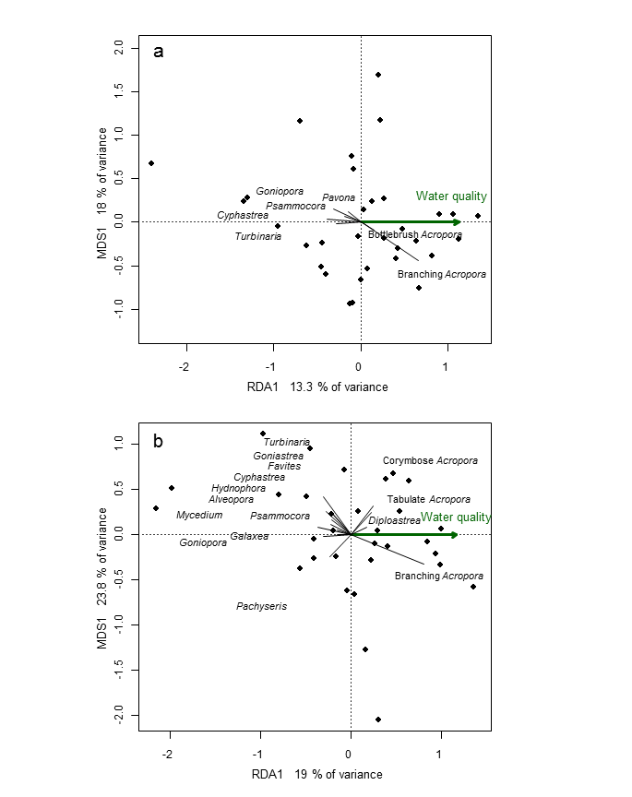
Figure 33 Coral community compositions relative to water quality gradients. Partial Canonical Analyses of Principal Coordinate Biplots for communities at a, 2 m, and b, 5 m depths. Genus group vectors are only displayed for those groups with a score of at least +/- 0.15 against the constrained axis are included. The green arrow indicates increasing water quality along the constrained axis.

Derivation of a coral community composition metric

The genus scores along the single derived water quality variable (Table 5) can be used to scale the cover estimates from any reef or year to predict the location of the community along the water quality gradient, based on the relative cover of genus groups. It is this scaling of observed compositional data relative to the combined water quality variable that is at the core of the metric we develop here. A key feature of this scaling is that the strength and direction of correspondence with the water quality gradient is preserved for all coral genera present.

Derivation of a coral community composition baseline

To determine a change in community composition we first needed a baseline condition against which to assess any observed change. To do this we considered the coral communities at each reef to be the end product of a unique combination of selective processes including, but not limited to, differing disturbance histories, location-specific environmental conditions, and a degree of stochasticity in recruitment as a result of the differing connectivity to viable broodstock. Given this view of communities it was inappropriate to attempt to apply a single community composition as a baseline. Rather, we chose to consider the community composition present during the first five observations (=years) of the MMP as our baseline composition for each reef with variability within this period setting confidence intervals beyond which communities are deemed to have changed.

The selection of number of observations from which to estimate confidence intervals was informed by our observation that using only four resulted in confidence intervals that were sufficiently wide so as to make the indicator insensitive as communities rarely deviated beyond those confidence bounds. The use of five observations improved the sensitivity. We did not use six observations as this would have included the entire data series available for approximately half the reefs. We acknowledge that should this indicator be operationalised the formal plotting of sensitivity v some further efforts should by applied to some reefs and allowed , while six observations the first six years of the program resultdue to this being the maximum number of observations consistently available across the dataset due to need to include enough observations to capture variability in communities as a result of sampling error and short-term variability but also to allow enough degrees of freedom for the estimation of moderate confidence intervals. The inclusion of five observations was trialled though resulted in an insensitive indicator as communities rarely deviated beyond the wider confidence intervals. Six was the maximum number of observations consistently available across the data set. trailed this entailed:
- First applying a Hellinger transformation to annual estimates of group cover at each reef and then scaling the transformed data by the genus group scores presented in Table 5. The sum of these scaled cover estimates returns a reefs score along our derived water quality gradient for each reef.
- The mean and 95% confidence interval of these reef scores from the first six surveys of each reef provide the bounds of the baseline composition of communities relative to the derived water quality gradient. Any observation falling outside these confidence intervals can be directly assessed as representing a change in composition toward a community expected in either improved or further degraded conditions.
Time series of the community scores against the water quality gradient are presented graphically in Appendix 2 (Figures A2-11 to A2-14). Key points to note from these figures are:
- The scaled community data differ between reefs and depths within reefs reflecting the differing communities present.
- The width of the confidence intervals vary between communities as a result of the temporal variability observed within the scaled communities over the first six observations. Wide confidence intervals in the Wet Tropics and Burdekin Regions in particular reflect the influence of major disturbance associated with Cyclone Larry and, for cycle reefs, Cyclone Yasi during the baseline period.
- The method may become biased toward the extremes of community compositions as reefs with very high cover of Acropora have limited scope for improvement. Similarly, reefs with high cover of groups associated with poor water quality may have little scope for decline.

Scoring of a coral community composition metric

For the purpose of consistency with the scoring of other metrics reported in the existing MMP multimetric index for coral community condition, and to allow the effective averaging of reef scores to regional or larger spatial scales, a three point scale was used to score reefs. If the scaled community composition at a site was:
- Beyond the lower confidence interval for that reef then the score was 0
- Within the confidence intervals the score was 0.5
- Beyond the upper confidence interval the score was 1
The mean of the compositional scores for each reef can be determined at any spatial scale of interest. Here we have averaged scores to the level of individual (sub-)regions to allow comparison with the other metrics reported in the body of this report (Figure 34). For consistency with current reporting of the coral health multimetric index we have colour coded (sub-)regional scores on a five point scale that is a proportion of the maximum mean score of 1 that would result when all reefs have hard coral compositions that are beyond confidence intervals and indicative of improved water quality. Colour codes based on proportion of maximum scores are:
- Red, <20%
- Orange, 20% to <40%
- Yellow, 40% to <60%
- Light green, 60% to <80%
- Dark green, 80% and above.
Time series of coral community composition metric scores demonstrate the sensitivity of the metric to the degree of compositional change observed over the last decade. Notable in both the Johnstone and Tully sub-regions are steep declines in the metric in 2011 that coincide with a loss of coral as a result of Cyclone Yasi (compare Figures 12d, 17d). A similar decline in 2006 in the Tully region was the result of damage to coral communities caused by Cyclone Larry (Figure 17d). A similarly steep decline in the metric occurred in the Daintree sub-region in 2013 when Snapper Island was experiencing an active outbreak of crown-of-thorns seastars (Figure 7d). In the Fitzroy region, flooding in early 2012 contributed to the ongoing decline in the metric by removing the Acropora-dominated community at 2m depths at both Pelican and Keppels South (Figure A2-9).

These clear responses to acute disturbance aside, the general declines in the community composition metric in the Burdekin, Proserpine and Fitzroy (prior to 2013) regions broadly coincide with the period of high rainfall and associated runoff in these regions.

Although the declines in the metric almost certainly reflect changes to community composition in response to disturbance events it is possible that increasing levels of NO_{x}, turbidity (see Regional report in 3.1) and dissolved organic carbon (Figure A2-3) also contributed to these declines.

In both the Wet Tropics and Burdekin regions the metric has been responsive to the compositional changes in communities as the coral communities begin to recover from the multiple acute and chronic disturbances over recent years.

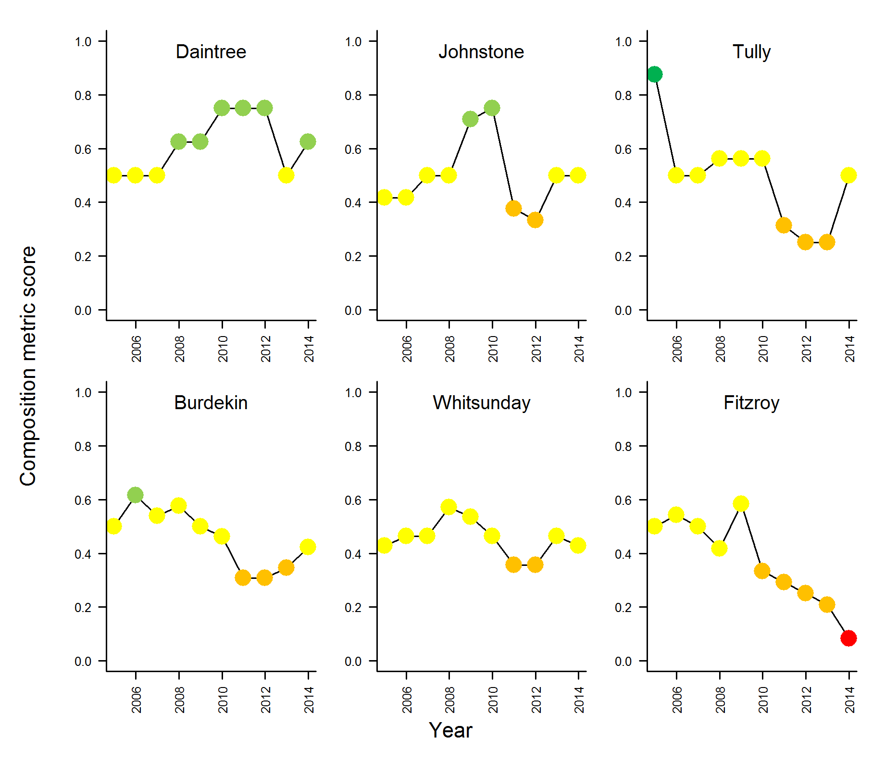
Figure 34 Times series of coral community composition metric scores for each (sub-)Region. Circles represent metric scores averaged to each (sub-)Region,
‘Red’ = < 20%,’Orange’= 20 - <40%, ‘Yellow’ = 40 - <60%, ’Light Green’ = 60 - <80%, ‘Dark Green’ = > 80%.

Discussion

The metric developed here provides a way of assessing changes in hard coral community composition in terms of the cumulative response to water quality over unspecified time frames. There are two primary issues that must be realised when considering this metric for future MMP reporting: Firstly our ability to describe water quality in a way relevant to the selective processes governing coral community composition, and the confounding of strictly water quality-related pressures with other processes and disturbances that are constantly interacting and altering coral community composition at any particular location.

The derivation of biological indicators is used to infer the response of communities to environmental pressures that are in themselves difficult, if not impossible, measure. In terms of coral community composition the premise is that the communities observed will reflect the cumulative response to selective processes operating over multiple time frames and multiple pressures. At the core of the metric described here is the quantification of this response as genus scores along our derived water quality gradient. The only water quality data available that allowed the quantification of conditions at each reef was derived from MODIS imagery. In each case the derived estimates of water quality (chlorophyll a (Chl a), total suspended solids (TSS), exposure to plume type waters) provide relative differences among reefs but the detailed biological responses of the coral taxa at our sampling locations to these measures are unquantified. The assumption being made is that differences in these data represent an adequate proxy for any water quality component that may directly result in selection of individual colonies at a location. We can gain some confidence that the water quality gradient we described is in some way reflective of any unmeasured stressors in the high degree of correlation between the measure of Chl and TSS and the unconstrained community observations. Despite the naivety of the water quality data available we were able to explain 13.3% at 2 m depth and 19% at 5 m depth of the variation in the average composition of coral communities and identify genus groups that varied along the mean differences in water quality within the inshore Reef. Although these levels of explained variation may seem low we consider that in light of the acute effects of other disturbance events and natural stochasticity of population dynamics, it may be unreasonable to expect much greater levels of explained variation. That said, the use of more accurate or relevant measures of water quality may enhance the sensitivity of this approach.

In several regions the influence of acute disturbance events was clearly observed to alter the composition of communities reported by this metric. This is not ideal, as a highly desirable trait of biological indicators is that they are able to discriminate anthropogenic changes from natural variation (Karr and Chu 1999). The confounding of acute disturbance and potential water quality related pressures was largely due to the genus Acropora being most susceptible to water quality in our study but also widely regarded as being particularly susceptible to a range of other disturbances including high or low temperature, low salinity, cyclones, crown-of-thorns, and disease (GBR examples include, Marshall and Baird 2000, Berkelmans et al. 2012, van Woesik et al. 1996, Pratchett 2007, Willis et al. 2004). For GBR inshore reefs, change in the cover of Acroporidae has been shown to account for approximately three quarters of the variation in coral cover (Sweatman et al. 2007). This sensitivity of Acropora to a wide range of disturbances unavoidably confounds the interpretation of results of this metric but also the use of Acropora cover or the ratio of Acropora cover to other corals as an indicator of water quality stress, as proposed by Fabricius et al. (2012). Despite this confounding between acute and chronic influences on coral community composition we consider the use of the mean composition over a 10-year period of observations will help to mediate over the influences of acute events in our estimation of genus group scores along the water quality gradient. The short-term fluctuations in the composition in response to disturbance events could potentially be similarly mediated by considering a rolling mean composition for the assessment of change relative to baseline conditions.

A key property of the metric we developed here is the inclusion of all hard coral genera recorded from our survey locations. The reefs monitored span a steep gradient of water quality that, in combination with substantial variation in disturbance histories, has resulted in a diversity of community compositions. The ability of this metric to integrate over a range of genus groups has distinct advantages over any single genus metric or a ratio between certain genera, as inevitably some communities will be naturally lacking in those groups, and so the indicator would be insensitive or inappropriate. Importantly, the weighting of change in any genus group is based on the consistency and magnitude of that group’s relationship to the underlying water quality gradient. Equally important is that as coral cover is effectively pre-emptive: the occupation of space by one group excludes the presence of another, and the composition of a community must be viewed as a subset of the compositions that could occur. A unique feature of the weighting of genus scores along the water quality gradient is that species turnover will only alter the predicted location along the gradient where species with higher or lower scores replace those lost, replacement with comparable species will not alter the scoring.

In comparing the genus group scores derived here to the few taxa considered by Fabricius et al. (2012) there is concurrence for Acropora and Porites being positively associated with better water quality and Turbinaria negatively associated. In contrast, Fabricius et al. (2012) report both Lobophyllia and Pectinia to be positively associated with water quality, while we found the opposite relationship for both genera at 5 m depth and Pectinia at 2 m depth. Discrepancies such as these highlight the importance of including as many observations as possible in correlative analyses, both for the response but also the environmental conditionals to avoid such inconsistencies. The present study includes more than twice the number of locations and means of cover and water quality variables over a decadal time frame to determine the distributional relationships along the water quality gradient.
The scoring of the metric for each reef was done in a manner to be consistent with other metrics currently used in the MMP coral health multimetric index. The use of only three categories can result in substantial shifts in scores at individual reefs, e.g. 0 to 0.5 or 0.5 to 1, when community compositions are close to confidence intervals. With the relatively few reefs in each region such highly weighted though minor actual changes have the capacity to add unnecessary variability in regional level time series of the metric. For longer time series where a shifting baseline is possible the present scoring system may become insensitive as more reefs move away from their baseline condition. The use of additional categories based on increasing distance beyond confidence intervals may provide a more natural weighting of scores and serve to stabilise both this new metric but also other metrics currently used by this project. A further consideration for scoring of this metric is that some reefs with high representation of the genus groups positively associated with water quality have limited scope for improvement. It could be argued that these reefs should be scored in a positive rather than neutral light. An adjustment to scoring could be based on a decision informed by the location of the upper confidence bound along the water quality gradient beyond which communities are assigned a positive score reflecting the limited influence of water quality on the observed community.

Conclusion

Although the metric as described has proven sensitive to both declines and improvements of coral communities that would be expected as a response to changes in WQ, there is clear confounding with the acute disturbances of cyclones, floods, crown-of-thorns starfish and thermal stress. While it is likely that the coincidence of these disturbance events with a period of high runoff and increasing availability of biologically available nutrients such as dissolved organic carbon and dissolved organic nitrogen (Figure A2-3) has compounded the impacts of disturbance events, the metric as it stands cannot differentiate between the causes of compositional change.

The metric still has practical value, as short-term fluctuations in Acropora are an important attribute of coral community dynamics on the Reef and can typically be attributed to disturbance events (Osborne et al. 2011), allowing the interpretation of the metric to account for such events. For reefs monitored by the MMP it is the long-term shifts in communities that are perhaps most important and this metric should will allow any such changes to be identified. This metric could be a useful addition to the indicators currently reported by the MMP as it assesses an attribute of the coral community not assessed by other metrics and so increases the basis of community-wide assessments. A potential option to reduce the sensitivity of the metric to acute events would be to implement a rolling mean of annual composition observations so as to reduce the influence of such events.

4. Conclusions
Local environmental conditions, such as water quality, clearly influence the benthic communities found on coastal and inshore reefs of the Great Barrier Reef (Reef). Collectively, these reefs differ markedly from those found in clearer, offshore waters (e.g. Done 1982, Wismer et al. 2009, De’ath and Fabricius 2010). Within the inshore zone, coral reef communities vary along steep environmental gradients that occur with distance from the coast and from major rivers (van Woesik and Done 1997, van Woesik et al. 1999, Fabricius et al. 2005, De’ath and Fabricius 2008, Uthicke et al. 2010, Fabricius et al. 2012), but also within individual reefs in response to localised hydrodynamic conditions (Uthicke et al. 2010, Thompson et al. 2010, Browne et al. 2010). The premise underpinning Reef 2050 Plan is that contaminant loads delivered by rivers sufficiently alter the environmental conditions in inshore waters of the Reef to suppress ecological resilience.

In this report for the MMP, we provide temporal trends of water quality indicators in the Reef, together with trends in sediment quality and coral reef condition indicators. The water and sediment quality around inshore reefs changed in response to the magnitude of river flows - used here as a proxy for river loads of sediments, nutrients and pollutants. These changed environmental conditions had clear impacts on the resilience of inshore coral reef communities.

Long-term changes in water quality

Water quality in the inshore Reef shows clear gradients away from river mouths, with higher levels of most indicators close to the coast, and is influenced over short time periods by flood events and sediment resuspension, and over longer time periods by a complex interplay of physical forcing and biological transformation processes (see Schaffelke et al. 2013 and references therein). Such gradients and processes are a natural part of the Reef ecosystem, albeit under far lower levels of input of runoff-derived pollutants than at present. An analysis of five years of MMP water quality data showed significant variability (Schaffelke et al. 2012a). Most variation was explained by temporal factors (seasons, years and river flow), highlighting the extremely variable climate of coral reef systems, with regional aspects (such as latitude, land use on adjacent catchments, proximity to rivers and resuspension) explaining a smaller, albeit significant, amount of the variation. It is the quantification of the compounding conditions along naturally occurring gradients as a result of runoff and any subsequent improvement under the Reef 2050 Plan that is the core focus of the water quality monitoring component of the MMP.

Turbidity, the “cloudiness” of seawater is caused by millions of suspended particles (e.g. clay and organic matter) and controls both sunlight absorption and scattering. Since European settlement, the Reef lagoon has received increased sediment and nutrient loads from the catchment (Belperio and Searle 1988; Kroon et al. 2012; Waters et al. 2014). The general increase measured in turbidity over the monitoring period suggests that the water transparency has decreased, thereby reducing the light available for plankton and coral symbiont growth, but also presumably increasing the flux of particles settling to the sediment. Turbidity is recognised as influencing settlement preferences of coral larvae, but also coral health in general (Mundy and Babcock 1998, Baird et al. 2003, Rogers 1979, Pollock et al. 2014, Schaffelke et al. 2013) and is thereby an important factor in governing coral community composition.

There was a general increase in the proportions of fine-grained particles, nutrients and organic carbon in sediments at the reefs sites in all regions, though this result is likely to underestimate the changes occurring at the more turbid and sheltered locations. Reefs in relatively clear waters that are exposed to wave-driven resuspension are less likely to accumulate fine sediments than reefs in more turbid waters or in sheltered locations, reducing the sensitivity of our analyses to detect regional trends in sediment characteristics as a response to increased turbidity. Reefs in the Mackay Whitsunday Region, Middle Reef in the Burdekin Region and Snapper North in the Wet Tropics Region are subjected to high levels of turbidity, have sediments with high proportions of fine-grained particles, nutrients and organic carbon, and are hence considered to be predisposed to the detrimental impacts of sedimentation. In the Fitzroy Region, the sediment quality indicators showed marked increases after the recent major floods, especially at sites close to the coast.

Turbidity in the Reef lagoon is strongly influenced by variations in the inflow of particles from the catchment and resuspension by wind, currents and tides. It is becoming increasingly apparent that the additional flux of fine sediment imported by rivers remains in the coastal zone for periods of months to years leading to chronically elevated turbidity and rates of sedimentation (Wolanski et al. 2008, Lambrechts et al. 2010, Brodie et al. 2012b, Thompson et al. 2012, Fabricius et al. 2013a, Fabricius et al. 2014). While the turbidity loggers showed increased levels over the monitoring period the same was not evident for concentrations of suspended solids. This is likely linked with the difference in methods. While the suspended solids are measured as dry mass of particles on a filter (0.4 µm pore-size), the turbidity measured by the optical instruments is the total light absorption and scattering. The difference in trends of these two estimates of turbidity suggests that the size spectrum/composition of the material has changed over the monitoring period with the material passing a 0.4 µm filtered (e.g. colloidal particles) having a larger role in determining the underwater light climate (Bowers and Binding 2006).
Plankton biomass production in the Reef is considered to be limited by the availability of nitrogen. An increase in readily available dissolved nitrogen (NO_{x}) concentrations, as found over the monitoring period, is therefore unexpected. This has two likely causes: either the plankton community is obtaining enough nitrogen from other sources (e.g. ammonium) or their growth is limited by other factors than nitrogen (e.g. light). The increases in turbidity (discussed above), suggest that less light is available for plankton growth which could cause a light-limited situation whereby the plankton community is not able to use the extra NO_{x} for biomass growth. As this NO_{x} is not used within the coastal area it will be exported to the adjacent ocean, where it could fuel plankton production. It is the transport of coastal nutrients to the midshelf Reef that has been implicated in the initiation of COTS outbreaks (Brodie et al. 2005, Fabricius et al. 2010). These seastar outbreaks are a major contributor to loss of coral cover on the Reef (Osborne et al. 2011, De’ath et al. 2012).

Over the monitoring period, an increase in the dissolved organic carbon (DOC) concentrations was found in all regions. DOC constitutes the major carbon source for heterotrophic microbial growth in marine pelagic systems (e.g. Lønborg et al. 2011) and increases in DOC have previously been shown to promote microbial activity and coral diseases (Kline et al. 2006, Kuntz et al. 2005). Increases in DOC as found here could have several probable, though not necessarily mutually exclusive, explanations: either the coral and plankton community have increased primary production or they are directing more of their production towards DOC release or there is an enhanced export from the catchment area.

A large fraction of DOC present in the Reef is derived from marine primary producers and any increases in plankton community production would result in elevated DOC concentrations. As time series measurements of primary production are not available for the Reef, we cannot assess if changes in the productivity could explain the increased DOC concentrations. Plankton communities have been shown to increase their DOC production in response to environmental stress (e.g. changing light and nutrient conditions) and changes in the plankton community structure (e.g. Thornton 2014, Church et al. 2002). As more nitrogen is available for growth (measured increase in NO_{X} concentrations) and phosphate is present at non-limiting levels, it suggests that nutrient stress is unlikely to cause the increased DOC levels. Our observations of increased turbidity suggest that less light is available for primary production and a lower microbial DOC production would therefore be expected, indicating that increased productivity is an unlikely explanation for the elevated concentrations. Previous studies have also found that increased DOC levels could be associated with changes in the plankton community driven by climate variability (e.g. increased temperature) (Church et al. 2002). As no data available on the plankton community composition over the MMP period, we are not able to assess possible changes in the community composition as causing the measured increase in DOC concentration.
Globally it has been recognized that DOC loads from catchments to coastal waters increased over the last decades, which has been linked with changing land-use (e.g. land clearing),precipitation patterns/chemistry and increased temperature (Lennon et al. 2013, Reader et al. 2014). Unfortunately there are no data available on the DOC loads from rivers draining into the Reef lagoon, and we cannot quantify whether these changed over the monitoring period.

After ten years of monitoring it is evident that large scale changes in the water quality of the Reef lagoon have taken place, with the data clearly showing increases in the levels of key parameters (organic carbon, NO_{x} and turbidity) in all regions (Figure 2-2A, 2-3A). These findings show that the mechanisms controlling the carbon and nutrient cycle in the Reef lagoon have undergone dramatic changes.

Ecological response of coral reef communities to changed environmental conditions

The steady decline of the FORAM index observed until 2013 on most reefs, and the levelling off in 2014, is a strong indication that our observations of changed water quality and sediment characteristics represent a shift in environmental conditions sufficient to alter foraminiferal assemblages. The recent changes in the foraminiferal assemblages of the inshore Reef are consistent with responses linked to declines in light availability and increased sediment nutrient concentrations (Uthicke and Nobes 2008, Uthicke and Altenrath 2010, Reymond et al. 2011, Uthicke et al. 2012b). Increases in dissolved inorganic nitrogen (DIN: broadly equivalent to NO_{x} reported here) in the water column seem to be detrimental to symbiont-bearing foraminifera (Reymond et al. 2012). Increased DIN explained a higher amount of variation of reduced calcification in two foraminiferal species in the Whitsunday area than reduced light conditions (Uthicke and Altenrath 2010). Experimental studies also showed reduced growth and increased mortality under elevated DIN (Reymond et al. 2011, Uthicke et al. 2012b). The susceptibility of foraminifera to the effects of runoff has been previously demonstrated in the Whitsunday Region, where sediment cores revealed foraminiferal assemblages that had been historically persistent underwent marked changes that coincided with the onset of anthropogenic changes within the catchment starting ~150 years ago (Tager et al. 2010, Uthicke et al. 2012a). Similarly, the FORAM index at Christmas Island was reduced after human settlement: the largest changes observed where human population density was high (Carilli and Walsh 2012). The changes in the foraminiferal assemblages of the inshore Reef indicate the ongoing and widespread selective pressures consistent with observed increases in turbidity and NO_{x} within the water column and changes in the sediment grain-size composition and nitrogen content.

The general responses of coral reef communities to water quality are relatively well understood (recently reviewed in Schaffelke et al. 2013) and contribute to the compositional differences that occur along environmental gradients in the inshore Reef (Done 1982, van Woesik and Done 1997, van Woesik et al. 1999, Fabricius et al. 2005, De’ath and Fabricius 2008, Browne et al. 2010, De’ath and Fabricius 2010, Thompson et al. 2010, Uthicke et al. 2010, Browne et al. 2012, Fabricius et al. 2012). Simplistically, species that are tolerant to the environmental pressures at a given location are likely to be more abundant compared to less-tolerant species. However, the processes shaping biological communities are complex due to interactions between environmental variables, other organisms and the effects of past disturbances. In contrast to the relatively short life span of foraminifera, corals are long lived and so coral community composition naturally reflects the cumulative result of selective pressures over longer time frames.

For corals to persist in a location requires that they are able to survive extremes in environmental conditions but also maintain a competitive ability during periods of more moderate conditions. In addition, corals are subject to acute disturbance events such as cyclones and thermal bleaching events as well as out breaks of coral predators such as crown-of-thorns seastar (COTS). Since MMP surveys began in 2005, substantial loss of coral cover occurred as a result of: thermal bleaching (Fitzroy Region 2006), Cyclone Larry (Wet Tropics and Burdekin regions 2006), Cyclone Ului (Whitsunday Region 2010), Cyclone Tasha (Wet Tropics 2011), Cyclone Yasi (Wet Tropics and Burdekin regions 2011), Cyclone Ita (Wet Tropics 2014), sub-cyclonic storms ( Barron Daintree sub-region 2009, Burdekin 2009, Fitzroy 2008, 2010, 2013), predation by COTS (Wet Tropics 2012-2014) and exposure to low salinity flood waters ( 2m depths, Fitzroy Region in 2011). While these impacts per se do not constitute a loss of resilience they will unavoidably influence each of the coral health indicators used to assess coral communities: most notably coral cover. Coral cover is included as a metric in our coral health index both as an indicator of the availability of brood-stock and as direct evidence that coral communities can be maintained when exposed to the environmental conditions of the location. Considering the frequency and severity of the disturbances listed above allows the following interpretation of the contribution of water quality to changes in the coral health index:

- Firstly, the rate at which coral cover increases during periods free of disturbance is important if coral cover is to be maintained in the long-term and at regional scales. The indicator for rate of cover change has shown general declines in most regions. These declines in rate of cover increase coincide broadly with increases in NO_{x}, turbidity and DOC that in turn appear to demonstrate an integration of flood-delivered sediments and nutrients. In each region we noted peaks in coral disease that corresponded to either the onset of flooding, or, in the case of the Johnstone Russell-Mulgrave region, changed water quality that preceded flooding in that catchment but corresponded with flooding in catchments to the south. These results suggest that environmental conditions associated with increased loads of sediments and nutrients have been sufficiently stressful to corals to reduce growth rates and/or induce disease in susceptible species. Links between higher availability of nutrients and organic matter and higher incidence and severity of coral disease have been demonstrated in several studies (Bruno et al. 2003, Haapkylä et al. 2011, Vega Thurber et al. 2013).

- Secondly, macroalgae generally benefit from increased nutrient availability due to runoff (e.g., Schaffelke et al. 2005) and, as coral competitors, supress both coral growth and juvenile settlement or survival (e.g., Tanner 1995, McCook et al. 2001a, Birrell et al. 2005, 2008). High cover of macroalgae has been recorded at 19 of the 32 reefs monitored. Of these 19 reefs, Barren in the Fitzroy Region had an ephemeral, post-disturbance macroalgal bloom after a coral bleaching event in 2006. This bloom was not sustained, potentially due to the better water quality compared to nearby reefs where similar post-bleaching blooms persisted. Persistent high cover of macroalgae has also largely disappeared at the 2m depth of Havannah, which is the reef in the Burdekin region with the least exposure to plume-type waters and generally better water quality than the sites that maintain high cover of macroalgae in that region. The decline in the macroalgae resilience indicator is due to the disproportionate number of reefs at which macroalgae have become established compared to those where cover has declined.

- Finally, the density of juvenile corals declined in all regions over the period, with high runoff with lowest densities observed between 2011 and 2013 in all six (sub-)regions. The early life history stages of corals are sensitive to a range of water quality parameters that vary in response to runoff (see Fabricius 2011 for a synthesis). We now have documented declines in the number of juvenile corals at reefs exposed to a wide range of water quality conditions, which indicates that the causes of these declines are not clearly linked to a single environmental threshold. Rather, the stressors influencing larval settlement and/or subsequent survival are likely to vary across environmental gradients. Confounding direct links between water quality and coral recruitment will be secondary influences of water quality, such as the presence/absence of persistent macroalgal communities which limit coral recruitment, as well as factors like reduced brood-stock due to disturbance events that are not linked to water quality.
In 2013-2014, the indicator score for the density of juvenile corals had improved in four of the six (sub) regions, coinciding with return to lower flows from adjacent catchments. No improvement was observed in the Barron Daintree sub-region, where a COTS outbreak and Cyclone Ita had substantial impacts in recent years. Nor was there any improvement in the Fitzroy Region where a high cover of macroalgae has persisted at most reefs. In the Herbert Tully sub-region, the increase in juvenile density was predominantly due to very high numbers of the genus Turbinaria. As this genus was not well represented in the adult community prior to the successive cyclonic disturbances in 2006 and 2011, it is unclear whether this recruitment pattern is simply due to natural variability or indicates the selection for species more suited to the recent environmental conditions than to those previously present. Although less extreme, the genus Turbinaria has also recruited in higher proportions to several of the more turbid water reefs in the adjacent Burdekin Region.

The widespread decline in coral reef condition demonstrates the sensitivity of inshore coral communities to elevated loads of contaminants introduced by runoff. The effects were common in all regions, across environmental gradients and affecting diversity of taxonomic groups, which makes the identification of individual areas most at risk to the effects of runoff a challenging task. Once pollutants reach the Reef lagoon, mixing and far-field transport makes it difficult to separate the effects of different catchment sources (but see Furnas et al. 2013). Because coral communities are the result of selection influenced by the local long-term environmental conditions their responses are expected to be site-specific and exposure-dependent (see e.g. McCook et al. 2001b).

In addition to reducing the ability to recover from disturbance, degraded water quality potentially increases the susceptibility of corals to disturbance. Evidence from recent research into the interactions between water quality and climate change suggests that the tolerance to heat stress of corals and foraminifera is reduced by exposure to contaminants including nutrients, herbicides and suspended particulate matter (Negri et al. 2011, Wiedenmann et al. 2013, Uthicke et al. 2012b, Fabricius et al. 2013b). The amount and variability of rainfall has significantly increased in northern Australia over the past 100 years (Lough 2011) and the severity of disturbance events is projected to increase as a result of climate change (Steffen et al. 2013). Any increase in susceptibility to these disturbances as a result of local stressors will compound the pressures imposed on sensitive species and potentially lead to profound changes in coral communities for Reef inshore communities. Similarly, the current evidence suggests that COTS outbreaks are linked to increased nutrient loads delivered to the Reef lagoon, and so extends the influence of runoff to large tracts of the Reef, beyond the area immediately exposed to flood waters (Fabricius et al. 2010, Caballes and Pratchett 2014). At present, there is a limited understanding of the cumulative impacts of these multiple pressures. The GBRMPA Strategic Assessment identified this as a key knowledge gap and the management of these impacts as a major strategic challenge (GBRMPA 2014a).

In summary, our results clearly identify that the runoff associated with recent flood events has been sufficient to alter environmental conditions within the inshore Reef. The location of sampling sites along underlying environmental gradients and adjacent to different catchments influences the exposure to the various components of runoff. Large changes in environmental variables such as water quality can influence the resilience of reef communities, for example by supporting a sustained high cover of macroalgae. However, it is increasingly apparent that, within a location, stress to coral communities is more likely a response of sensitive species to acute changes in environmental conditions rather than chronic change in ambient conditions to which the species present are clearly tolerant. This is because the community composition at a location has been selected for by the long-term environmental conditions at that site. Environmental degradation is operating over several time scales with short-term fluctuations continuously selecting for or against certain species, a process illustrated by the increase in coral disease we saw following flood events and increasing turbidity and NO_{x} and DOC concentrations. In the long term, this may lead to selection of species both competitively superior during ambient conditions and tolerant to environmental extremes.

If environmental conditions further deteriorate or become more variable, the coral reef species capable of persisting into the future may be an ever diminishing subset of the regional species pool (Devantier et al. 2006) or lead to specialist communities able to persist in environmental extremes or high variability (Browne et al. 2012). In contrast, the ongoing selection for species tolerant of the environmental conditions at a given location imposes a degree of inertia into the communities that will limit the potential for rapid response to subtly improved conditions. This inertia linked to both the occupation of space by tolerant species limiting the settlement of previously excluded species but also the limitation of larvae due to limited brood-stock of sensitive species. The case study presented here is one potential way of identifying subtle changes in the coral community composition as the effects of Reef Plan become apparent.

The coral health index presented in this report is the coral reef component of the Reef Plan Report card. A key indicator of the coral health index is the density of juvenile corals. As it has been applied, the density of juvenile corals is corrected for the availability of suitable settlement substratum, to not penalise observations of low abundance of juveniles in situations where coral cover is very high or substantial areas are soft sediments, both of which exclude juvenile coral from settling. We have observed that the large flood events in recent years led to the accumulation of fine sediments on reefs in sheltered locations, which resulted in covering reefal substrate with fine sediment (silt), which changes the categorisation of substratum from some form of algae to silt. As silt is classified as ‘not available space’, and algae is classified as ‘available space’, this results in the values of the indicator of juvenile density increasing with increasing smothering of substrates, thus masking the likely negative effect of sediment accumulation on juvenile numbers. In retrospect, we consider that future assessments of juvenile density should correct only for coral cover. Indeed it is AIMS and GBRMPA’s intention that in light of data collected during the MMP to date a full revision of the coral health index be undertaken, including potential application of the new coral community composition metric, to improve our ability to assess the condition of these communities.
In summary, after ten years of monitoring, large-scale changes are evident in water quality in the Reef lagoon. Our observations show significant increases in the organic carbon, NO_{X} and turbidity levels in all regions. These findings demonstrate that the mechanisms controlling the carbon and nutrient cycles in the Reef lagoon have undergone dramatic changes, which calls for a more in-depth analysis of the factors influencing Reef water quality and how the observed changes will affect the resilience of inshore coral reef communities.

Acknowledgments
We thank Aaron Anderson, Joe Gioffre, Charlotte Johansson, Shawn Smith, Marcus Stowar and Kate Osborne for valuable field assistance over the years. We also thank Ed Butler, Terry Done, Johanna Johnson, Katherine Martin and a number of anonymous reviewers for their detailed reviews that improved the previous reports on which this current instalment builds. Finally we acknowledge the valuable contributions to data collection, sampling integrity and reporting of John Carlton, Stephen Neale and Damian Thomson over the first few years of the monitoring program and staff at Geoscience Australia for grain size analysis of sediment samples.

5. References
Álvarez-Romero JG, Devlin MJ, Teixeira da Silva E, Petus C, Ban N, Pressey RJ, Kool J, Roberts S, Cerdeira WA, Brodie J (2013) A novel approach to model exposure of coastal-marine ecosystems to riverine flood plumes based on remote sensing techniques. J Environ Manage 119:194–207
Anderson MJ, Willis TJ (2003) Canonical analysis of principal coordinates: a useful method of constrained ordination for ecology. Ecology 84, 511–525.
Anon. (1997) Directory of Autoanalyser Methods, Bran and Luebbe GmbH, Norderstedt, Germany.
Anon (2003) Reef Water Quality Protection Plan for catchments adjacent to the Great Barrier Reef World Heritage Area. The State of Queensland and Commonwealth of Australia. Queensland Department of Premier and Cabinet, Brisbane. 43 pp
Anon. (2009) Reef Water Quality Protection Plan 2009. For the Great Barrier Reef World Heritage Area and adjacent catchments. The State of Queensland and Commonwealth of Australia. Queensland Department of the Premier and Cabinet, Brisbane. 30 pp.
Anon. (2010) Paddock to Reef Integrated Monitoring, Modelling and Reporting Program Design (DRAFT). Version 12 February 2010. The State of Queensland, Queensland Department of the Premier and Cabinet, Brisbane. 93 p.
Anon. (2011) Reef Water Quality Protection Plan. First Report 2009 Baseline. The State of Queensland and Commonwealth of Australia. Queensland Department of Premier and Cabinet, Brisbane. 140 pp. Available at www.reefplan.qld.gov.au
Anon. (2013) Reef Water Quality Protection Plan 2013.Securing the health and resilience of the Great Barrier Reef World Heritage Area and adjacent catchments. The State of Queensland. Reef Water Quality Protection Plan Secretariat, Brisbane. 34 p. Available at www.reefplan.qld.gov.au
Anthony KRN (1999) Coral suspension feeding on fine particulate matter. Journal of Experimental Marine Biology and Ecology 232:85-106
Anthony KRN, Fabricius KE (2000) Shifting roles of heterotrophy and autotrophy in coral energetics under varying turbidity. Journal of Experimental Marine Biology and Ecology 252:221-253
Ayling AM, Ayling AL (2005) The dynamics of Cairns and Central section fringing reefs: 2005 Unpublished report submitted to the Great Barrier Reef Marine Park Authority, Townsville
Babcock RC (1988) Fine-scale spatial and temporal patterns in coral settlement. In: Proceedings of the 6th International Coral Reef Symposium, Australia, Vol. 2:625-634
Babcock RC, Smith L (2002) Effects of sedimentation on coral settlement and survivorship. In: Proceedings of the 9th International Coral Reef Symposium, Bali, Indonesia, 245–248
Bainbridge ZT, Wolanski E, Álvarez-Romero JG, Lewis SE, Brodie JE (2012) Fine sediment and nutrient dynamics related to particle size and floc formation in a Burdekin River flood plume, Australia. Marine Pollution Bulletin 65: 236-248
Baird AH, Babcock RC, Mundy CP (2003) Habitat selection by larvae influences the depth distribution of six common coral species. Marine Ecology Progress Series 252:289-293
Baird AH, Guest JR, Willis BL (2009) Systematic and Biogeographical Patterns in the Reproductive Biology of Scleractinian Corals. doi:10.1146/annurev.ecolsys.110308.120220
Baird AH, Marshall PA (2002) Mortality, growth and reproduction in scleractinian corals following bleaching on the Great Barrier Reef. Marine Ecology Progress Series 237:133-141Bartley R, Bainbridge ZT, Lewis SE, Kroon FJ, Wilkinson SN, Brodie JE, Silburn DM (2014) Relating sediment impacts on coral reefs to watershed sources, processes and management: A review. Science of The Total Environment 468–469:1138-1153
Bartley R, Corfield JP, Hawdon AA, Kinsey-Henderson AE, Abbott BN, Wilkinson SN, Keen RJ (2014) Can changes to pasture management reduce runoff and sediment loss to the Great Barrier Reef? The results of a 10-year study in the Burdekin catchment, Australia. The Rangeland Journal 36:67-84
Bartley R, Bainbridge ZT, Lewis SE, Kroon FJ, Wilkinson SN, Brodie JE, Silburn DM (2014) Relating sediment impacts on coral reefs to watershed sources, processes and management: A review. Science of the Total Environment 468–469:1138-1153
Belperio AP, Searle DE (1988) Terrigenous and carbonate sedimentation in the Great Barrier Reef province. In: J, D.L., H, R.H. (Eds.), Carbonate to Clastic Facies Changes. Developments in Sedimentology. Elsevier Science Publishers, Amsterdam, pp. 143–174.
Bellwood DR, Hughes TP, Folke C, Nyström M (2004) Confronting the coral reef crisis. Nature 429:827-833
Berkelmans R, De’ath G, Kininmonth S, Skirving WJ (2004) A comparison of the 1998 and 2002 coral bleaching events on the Great Barrier Reef: spatial correlation, patterns, and predictions. Coral reefs, 23(1), 74-83.
Berkelmans R, Jones A, Schaffelke B (2012) Salinity thresholds of Acropora spp. On the Great Barrier Reef. Coral Reefs 31:1103-1110
Birrell CL, McCook LJ, Willis BL (2005) Effects of algal turfs and sediment on coral settlement. Marine Pollution Bulletin 51:408-414
Birrell CL, McCook LJ, Willis BL, Diaz-Pulido GA (2008a) Effects of benthic algae on the replenishments of corals and the implications for the resilience of coral reefs. Oceanography and Marine Biology: An Annual Review 46:25-64
Birrell CL, McCook LJ, Willis BL, Harrington L (2008b) Chemical effects of macroalgae on larval settlement of the broadcast spawning coral Acropora millepora. Marine Ecology Progress Series 362:129-137
Boyer J, Fourqurean J, Jones R (1999) Seasonal and long-term trends in the water quality of Florida Bay (1989–1997). Estuaries and Coasts 22:417-430
Bowers DG, Binding CE (2006) Optical properties of mineral suspended particles in the sea: a review and synthesis. Estuarine, Coastal and Shelf Science 67: 219-230
Bowers DG, Braithwaite KM, Nimmo-Smith WAM, Graham GW (2011) Optical efficiency of flocs in shelf seas and estuaries. Estuarine, Coastal and Shelf Science 91: 341-350
Bradley P, Fore LS, Fisher W, Davis W (2010) Coral reef biological criteria: using the Clean Water Act to protect a national treasure. US Environmental Protection Agency
Brando VE, Blondeau-Patissier D, Schroeder T, Dekker AG, Clementson L (2011) Reef Rescue Marine Monitoring Program: Assessment of terrestrial run-off entering the Reef and inshore marine water quality monitoring using earth observation data. Final Report for 2010/11 Activities. CSIRO, Canberra. 201pp
Brando VE, Dekker AG, Park YJ, Schroeder T (2012) Adaptive semi-analytical inversion of ocean color radiometry in optically complex waters. Applied Optics 51:2808-2833
Brando VE, Devlin MJ, Dobbie M, McNeil A, Schaffelke B, Schroeder T (2013) Developing integrated assessment metrics for reporting of water quality in the Great Barrier Reef lagoon. Report to the Reef Rescue Water Quality Research & Development Program. Reef and Rainforest Research Centre Limited, Cairns. 53pp
Bray JR and Curtis JT (1957) An ordination of the upland forest communities of southern Wisconsin. Ecological Monographs 27:325-349
Brinkman R, Herzfeld M, Andrewartha J, Rizwi F, Steinberg C, Spagnol S (2011) Hydrodynamics at the whole of GBR scale. AIMS Final Project Report MTSRF Project 2.5i.1, June 2011. Report to Reef and Rainforest Research Centre. Australian Institute of Marine Science, Townsville. 42 pp
Brodie J, Binney J, Fabricius K, Gordon I, Hoegh-Guldberg O, Hunter H, O’Reagain P, Pearson R, Quirk M, Thorburn P, Waterhouse J, Webster I, Wilkinson S (2008) Synthesis of evidence to support the Scientific Consensus Statement on Water Quality in the Great Barrier Reef. The State of Queensland (Department of the Premier and Cabinet). Published by the Reef Water Quality Protection Plan Secretariat, Brisbane. 59pp
Brodie J, De’ath G, Devlin M, Furnas MJ, Wright M (2007) Spatial and temporal patterns of near-surface chlorophyll a in the Great Barrier Reef lagoon. Marine and Freshwater Research 58: 342-353
Brodie J, Fabricius K, De’ath G, Okaji K (2005) Are increased nutrient inputs responsible for more outbreaks of crown-of-thorns starfish? An appraisal of the evidence. Marine Pollution Bulletin, 51(1), 266-278
Brodie JE, Kroon FJ, Schaffelke B, Wolanski EC, Lewis SE, Devlin MJ, Bohnet IC, Bainbridge ZT, Waterhouse J, Davis AM (2012a) Terrestrial pollutant runoff to the Great Barrier Reef: An update of issues, priorities and management responses. Marine Pollution Bulletin 65: 81-100
Brodie J, Wolanski E, Lewis S, Bainbridge Z (2012b) An assessment of residence times of land-sourced contaminants in the Great Barrier Reef lagoon and the implications for management and reef recovery. Marine Pollution Bulletin 65: 267-279
Brodie JE, McKergow LA, Prosser IP, Furnas MJ, Hughes AO, Hunter H (2003) Sources of sediment and nutrient exports to the Great Barrier Reef World Heritage Area. Australian Centre for Marine and Tropical Freshwater Research Report No. 03/11. James Cook University, Townsville
Browne NK, Smithers SG, Perry CT (2010) Geomorphology and community structure of Middle Reef, central Great Barrier Reef, Australia: an inner-shelf turbid zone reef subject to episodic mortality events. Coral Reefs 29: 683-689
Browne NK, Smithers SG, Perry CT (2012) Coral reefs of the turbid inner-shelf of the Great Barrier Reef, Australia: An environmental and geomorphic perspective on the occurrence, composition and growth. Earth-Science Reviews 115:1-20
Bruno JF, Petes LE, Harvell CD, Hettinger A (2003) Nutrient enrichment can increase the severity of coral diseases. Ecology Letters 6:1056-1061
Bruno JF, Sweatman H, Precht WF, Selig ER, Schutte VGW (2009) Assessing evidence of phase shifts from coral to macroalgal dominance on coral reefs. Ecology 90:1478-1484
Caballes CF, Pratchett MS (2014) Reproductive biology and early life history of the crown-of-thorns starfish. In: Whitmore E (ed) Echinoderms: ecology, habitats and reproductive biology. Nova Science Publishers, New York, NY, USA
Carilli, J, Walsh S (2012). Benthic foraminiferal assemblages from Kiritimati (Christmas) Island indicate human-mediated nutrification has occurred over the scale of decades. Marine Ecology Progress Series 456:87-99
Carpenter KE, Abrar M, Aeby G, Aronson RB, Banks S, Bruckner A, Chiriboga A, Cortes J, Delbeek JC, DeVantier L, Edgar GJ, Edwards AJ, Fenner D, Guzman HM, Hoeksema BW, Hodgson G, Johan O, Licuanan WY, Livingstone SR, Lovell ER, Moore JA, Obura DO, Ochavillo D, Polidoro BA, Precht WF, Quibilan MC, Reboton C, Richards ZT, Rogers AD, Sanciangco J, Sheppard A, Sheppard C, Smith J, Stuart S, Turak E, Veron JEN, Wallace C, Weil E, Wood E (2008) One-Third of Reef-Building Corals Face Elevated Extinction Risk from Climate Change and Local Impacts. Science 321:560-563
Cheal AJ, , Emslie M, MacNeil MA, Miller I, Sweatman H (2013) Spatial variation in the functional characteristics of herbivorous fish communities and the resilience of coral reefs Ecological Applications, 23:174–188
Cheal AJ, MacNeil MA, Cripps E, Emslie M, Jonker M, Schaffelke B, Sweatman H (2010) Coral-macroalgal phase shifts or reef resilience: links with diversity and functional roles of herbivorous fishes on the Great Barrier Reef. Coral Reefs 29:1005-1015
Church MJ, Ducklow HW, Karl DM (2002) Multiyear increases in dissolved organic matter inventories a Station ALOHA in the North Pacific Subtropical Gyre. Limnology and Oceanography 47:1-10
Cooper TF, Gilmour JP, Fabricius KE (2009) Bioindicators of changes in water quality on coral reefs: review and recommendations for monitoring programmes. Coral Reefs 28:589-606
Cooper TF, Ridd PV, Ulstrup KE, Humphrey C, Slivkoff M, Fabricius KE (2008) Temporal dynamics in coral bioindicators for water quality on coastal coral reefs of the Great Barrier Reef. Marine and Freshwater Research 59:703-716
Cooper TF, Uthicke S, Humphrey C, Fabricius KE (2007) Gradients in water column nutrients, sediment parameters, irradiance and coral reef development in the Whitsunday Region, central Great Barrier Reef. Estuarine, Coastal and Shelf Science 74:458-470Darnell R, Henderson B, Kroon FJ, Kuhnert P (2012) Statistical power of detecting trends in total suspended sediment loads to the Great Barrier Reef. Marine Pollution Bulletin 65:203-209
De'ath G, Fabricius KE (2008) Water Quality of the Great Barrier Reef: Distributions, Effects on Reef Biota and Trigger Values for the Protection of Ecosystem Health. Research Publication No. 89. Great Barrier Marine Park Authority, Townsville, p. 104p
De'ath G, Fabricius KE (2010) Water quality as a regional driver of coral biodiversity and macroalgae on the Great Barrier Reef. Ecological Applications 20:840–850
De’ath G, Fabricius KE, Sweatman H, Puotinen M (2012) The 27-year decline of coral cover on the Great Barrier Reef and its causes. Proceedings of the National Academy of Sciences 190(44):17995-17999
Dennis B, Taper ML (1994) Density dependence in time series observations of natural populations: estimation and testing. Ecological Monographs 64:205-224
Department of Environment and Resource Management (2009) Queensland Water Quality Guidelines, Version 3. 167 p. Available at www.derm.qld.gov.au. ISBN 978-0-9806986-0-2
DeVantier L, De’ath G, Turak E, Done TJ, Fabricius KE (2006) Species richness and community structure of reef-building corals on the nearshore Great Barrier Reef. Coral Reef 25:329-340
Devlin M, McKinna LW, Álvarez-Romero J, Petus C, Abott B, Harkness P, Brodie J (2012) Mapping the pollutants in surface plume waters in the Great Barrier Reef, Australia. Marine Pollution Bulletin 65:224:235
Diaz-Pulido G, Harii S, McCook LJ, Hoegh-Guldberg O (2010) The impact of benthic algae on the settlement of a reef-building coral. Coral Reefs 29:203-208
Diaz-Pulido G, McCook LJ, Dove S, Berkelmans R, Roff G, Kline DI, Weeks S, Evans RD, Williamson DH, Hoegh-Guldberg O (2009) Doom and Boom on a Resilient Reef: Climate Change, Algal Overgrowth and Coral Recovery. PLoS ONE 4(4): e5239
Done T, Turak E, Wakeford M, DeVantier L, McDonald A and Fisk D (2007) Decadal changes in turbid-water coral communities at Pandora Reef: loss of resilience or too soon to tell? Coral reefs 26:789–805
Done TJ (1982) Patterns in the distribution of coral communities across the central Great Barrier Reef. Coral Reefs 1:95-107
Erftemeijer PLA, Reigl B, Hoeksema BW, Todd PA (2012) Environmental impacts of dredging and other sediment disturbances on corals: A review. Marine Pollution Bulletin 64:1737-1765
Fabricius KE (2005) Effects of terrestrial runoff on the ecology of corals and coral reefs: Review and synthesis. Marine Pollution Bulletin 50:125-146
Fabricius KE (2011) Factors determining the resilience of coral reefs to eutrophication: a review and conceptual model. In: Dubinsky Z, Stambler N (eds) Coral Reefs: An Ecosystem in Transition, Springer Press, pp 493-506
Fabricius KE, Cooper TF, Humphrey C, Uthicke S, De’ath G, Davidson J, LeGrand H, Thompson A, Schaffelke B (2012) A bioindicator system for water quality on inshore coral reefs of the Great Barrier Reef. Marine Pollution Bulletin 65:320-332
Fabricius KE, Cseke S, Humphrey CA, De’ath G (2013b) Does trophic status enhance or reduce the thermal tolerance of scleractinian corals? A review, experiment and conceptual framework. PLoS ONE 8 e54399
Fabricius KE, De’ath G (2001a) Biodiversity on the Great Barrier Reef: Large-scale patterns and turbidity-related local loss of soft coral taxa. In Wolanski E (ed) Biological-Physical Links: Oceanographic processes on the Great Barrier Reef. CRC Press, Boca Raton
Fabricius KE, De’ath G, Humphrey C, Zagorskis I, Schaffelke B (2013a) Intra-annual variation in turbidity in response to terrestrial runoff on near-shore coral reefs of the Great Barrier Reef, Estuarine Coastal and Shelf Science 116:57-65
Fabricius KE, De’ath G, McCook L, Turak E, Williams DMcB (2005) Changes in algal, coral and fish assemblages along water quality gradients on the inshore Great Barrier Reef. Marine Pollution Bulletin 51:384-396
Fabricius KE, Logan M, Weeks S, Brodie J (2014) Assessing inter- and intra-annual changes in water clarity in response to river run-off on the central Great Barrier Reef from 10 years of MODIS-Aqua data. Marine Pollution Bulletin 84:191-200
Fabricius KE, Okaji K, De’ath G (2010) Three lines of evidence to link outbreaks of the crown-of-thorns seastar Acanthaster planci to the release of larval food limitation. Coral Reefs 29:593-605
Fabricius KE, Wild C, Wolanski E, Abele D (2003) Effects of transparent exopolymer particles and muddy terrigenous sediments on survival of hard coral recruits. Estuarine, Costal and Shelf Science 57:613-621
Fabricius KE, Wolanski E (2000) Rapid smothering of coral reef organisms by muddy marine snow. Estuarine, Costal and Shelf Science 50:115-120
Falkowski PG, Jokiel PL, Kinzie RA (1990) Irradiance and corals. In Dubinsky Z (ed) Ecosystems of the world 25: Coral Reefs. Elsevier, New York, pp 89-107
Fisher WS, Fore LS, Hutchins A, Quarles RL, Campbell JG, LoBue C, Davies WS (2008) Evaluationof stony coral indicators for coral reef management. Marine Pollution Bulletin 65:320-332
Foster NL, Box SJ, Mumby PJ (2008) Competitive effects of macroalgae on the fecundity of the reef-building coral Montastrea annularis. Marine Ecology Progress Series 367:143-152
Furnas M, Alongi D, McKinnon AD, Trott L, Skuza M (2011) Regional-scale nitrogen and phosphorus budgets for the northern (14°S) and central (17°S) Great Barrier Reef shelf ecosystem. Continental Shelf Research 31:1967-1990
Furnas M, Brinkman R, Fabricius K, Tonin H, Schaffelke B (2013) Linkages between river runoff, phytoplankton blooms and primary outbreaks of crown-of-thorns seastars in the Northern GBR. Chapter 3 in Waterhouse et al. Assessment of the relative risk of water quality to ecosystems of the Great Barrier Reef. Department of the Environment and Heritage Protection, Queensland Government, Brisbane
Furnas MJ, Mitchell AW, Skuza M (1995) Nitrogen and Phosphorus Budgets for the Central Great Barrier Reef Shelf. Research Publication No. 36. Great Barrier Reef Marine Park Authority, Townsville.
Furnas MJ, Mitchell AW, Skuza M, Brodie J (2005) In the other 90%: Phytoplankton responses to enhanced nutrient availability in the Great Barrier Reef lagoon. Marine Pollution Bulletin 51: 253-256
Gallen C, Devlin M, Thompson K, Paxman C, Mueller J (2014) Pesticide monitoring in inshore waters of the Great Barrier Reef using both time-integrated and event monitoring techniques (2013-2014). The University of Queensland, The National Research Centre for Environmental Toxicology (Entox).
Great Barrier Reef Marine Park Authority (2010) Water Quality Guidelines for the Great Barrier Reef Marine Park. Revised Edition 2010. Great Barrier Reef Marine Park Authority, Townsville. 100p
Great Barrier Reef Marine Park Authority (2012) Informing the outlook for Great Barrier Reef coastal ecosystems. Great Barrier Reef Marine Park Authority, Townsville
Great Barrier Reef Marine Park Authority (2014a) Great Barrier Reef Region Strategic Assessment. Great Barrier Reef Marine Park Authority, Townsville
Great Barrier Reef Marine Park Authority (2014b) Great Barrier Reef Outlook Report 2014, Great Barrier Reef Marine Park Authority, Townsville.
Great Barrier Reef Marine Park Authority (2014c) Reef Rescue Marine Monitoring Program quality assurance and quality control manual. Great Barrier Reef Marine Park Authority, Townsville.
Haapkyla J, Melbourne-Thomas J, Flavell M, Willis B (2013) Disease outbreaks, bleaching and a cyclone drive changes in coral assemblages on an inshore reef of the Great Barrier Reef. Coral Reefs 32:815-824
Haapkylä J, Unsworth R, Flavell M, Bourne D, Schaffelke B, Willis BL (2011) Seasonal rainfall and runoff promote coral disease on an inshore reef of the Great Barrier Reef, Australia. PLoS One. 6(2): e16893
Hallock P (1981) Algal Symbiosis: a mathematical analysis. Marine Biology 62:249–155
Hallock P, Lidz BH, Cockey-Burkhard EM, Donnelly KB (2003) Foraminifera as bioindicators in coral reef assessment and monitoring: the FORAM index. Environmental Monitoring and Assessment 81: 221-238
Harrison PL, Wallace CC (1990) Reproduction, dispersal and recruitment of Scleractinian corals. In Dubinsky Z (ed) Ecosystems of the world 25: Coral Reefs. Elsevier, New York, pp 133-202
Hauri C, Fabricius K, Schaffelke B, Humphrey C (2010) Chemical and physical environmental conditions underneath mat- and canopy-forming macroalgae, and the effects on understory corals. PLoS ONE 5(9): e12685
Holmes RM, Aminot A, Kérouel R, Hooker BA, Peterson BJ (1999) A simple and precise method for measuring ammonium in marine and freshwater ecosystems. Can. J. Fish. Aquat. Sci. 56: 1801-1808
Hoegh-Guldberg O (1999) Climate change, coral bleaching and the future of the world’s coral reefs. Marine and Freshwater Research 50:839-866
Hughes AO , Olley JM , Croke JC , McKergow LA (2009) Sediment source changes over the last 250 years in a dry-tropical catchment, central Queensland, Australia. Geomorphology 104, 262–265
Hughes TP, Graham NAJ, Jackson JBC, Mumby PJ, Steneck RS (2010) Rising to the challenge of sustaining coral reef resilience. Trends in Ecology and Evolution 25(11):633-642
Hughes TP, Rodrigues MJ, Bellwood DR, Ceccarelli D, Hoegh-Guldberg O, McCook L, Moltschaniwskyj N, Pratchett MS, Steneck RS, Willis B (2007) Phase Shifts, Herbivory, and the Resilience of Coral Reefs to Climate Change. Current Biology 17:360-365
Ives AR, Dennis B, Cottingham KL, Carpenter SR (2003) Estimating community stability and ecological interactions from time series data. Ecological Monographs 73:301-330
Jameson SC, Erdmann MV, Karr JR, Potts WK (2001) Charting a course toward diagnostic monitoring: A continuing review of coral reef attributes and research strategy for creating coral reef indexes of biotic integrity. Bulletin of Marine Science, 69:701-744
Jeffrey SW, Humphrey GF (1975) New spectrophotometric equations for determining chlorophylls a,b,b₁ and c₂ in higher plants, algae and natural phytoplankton. Biochemie und Physiologie der Pflanzen 167: 191-194
Jonker M, Johns K, Osborne K (2008) Surveys of benthic reef communities using underwater digital photography and counts of juvenile corals. Long-term Monitoring of the Great Barrier Reef, Standard Operational Procedure Number 10, Australian Institute of Marine Science, Townsville
Kaczmarsky L, Richardson LL (2010) Do elevated nutrients and organic carbon on Philippine reefs increase the prevalence of coral disease? Coral Reefs 30:253-257
Karr JR, Chu EW (1999) Restoring life in running waters: Better biological monitoring. Island Press Washington DC, 206p
Karr JR (2006) Seven foundations of biological monitoring and assessment. Biologia Ambientale 20(2):7-18
Kline DL, Kuntz NM, Breitbart M, Knowlton N, Rohwer F (2006) Role of elevated organic carbon levels and microbial activity in coral mortality. Marine Ecology Progress Series 314: 119–125
Kroon FJ, Kuhnert PM, Henderson BL, Wilkinson SN, Kinsey-Henderson A, Abbott B, Brodie JE, Turner RDR (2012) River loads of suspended solids, nitrogen, phosphorus and herbicides delivered to the Great Barrier Reef lagoon. Marine Pollution Bulletin 65:167–181
Kroon FJ, Schaffelke B, Bartley R (2014) Informing policy to protect coastal coral reefs: Insight from a global review of reducing agricultural pollution to coastal ecosystems. Marine Pollution Bulletin 85:33-41
Kuffner IB, Walters LJ, Becerro MA, Paul VJ, Ritson-Williams R, Beach KS (2006) Inhibition of coral recruitment by macroalgae and cyanobacteria. Marine Ecology Progress Series 323:107-117
Kuntz N, Kline D, Sandin S, Rohwer F (2005) Pathologies and mortality rates caused by organic carbon and nutrient stressors in three Caribbean coral species. Marine Ecology Progress Series 294:173–180
Lambrechts J, Humphrey C, McKinna L, Gourge O, Fabricius KE, Mehta AJ, Lewis S, Wolanski E (2010) Importance of wave-induced bed liquefaction in the fine sediment budget of Cleveland Bay, Great Barrier Reef. Estuarine, Coastal and Shelf Science 89:154-162
Larcombe P, Ridd PV, Prytz A, Wilson B (1995) Factors controlling suspended sediment on inner-shelf coral reefs. Townsville, Australia. Coral Reefs 14:163-171
Legendre P, Gallagher ED (2001) Ecologically meaningful transformations for ordination of species data, Oecologia 129:271-280
Legendre P, Legendre L (1998) Numerical ecology, 2nd English edition, Elsevier, Amsterdam
Lennon JT, Hamilton SK, Muscarella ME, Grandy AS, Wickings K, Jones SE (2013). A source of terrestrial organic carbon to investigate the browning of aquatic ecosystems. PLoS ONE 8: e75771. doi:10.1371/journal.pone.0075771
Lønborg C, Álvarez-Salgado XA, Martínez-Garcia S, Teira E (2011) Carbon cycling and bacterial growth efficiency in a coastal upwelling system (NW Iberian Peninsula). Aquatic Microbial Ecology 63, 183-191.
Lough JM (2011) Great Barrier Reef coral luminescence reveals rainfall variability over northeastern Australia since the 17th century. Paleoceanography 26 doi:10.1029/2010PA002050
Luick JL, Mason L, Hardy T, Furnas MJ (2007) Circulation in the Great Barrier Reef Lagoon using numerical tracers and in situ data. Continental Shelf Research 27:757-778
Mackenzie JB, Munday PL, Willis BL, Miller DJ, Van Oppen MJH (2004) Unexpected patterns of genetic structuring among locations but not colour morphs in Acropora nasuta (Cnidaria; Scleractinia). Molecular Ecology 13(1):9-20
Marshall PA, Baird AH (2000) Bleaching of corals on the Great Barrier Reef: differential susceptibilities among taxa. Coral Reefs 19:155-163
Marshall PA, Johnson JE (2007) The Great Barrier Reef and climate change: vulnerability and management implications. In: Johnson JE, Marshall PA (eds) Climate change and the Great Barrier Reef. Great Barrier Reef Marine Park Authority and the Australian Greenhouse Office, Australia, pp 774-801
McClanahan TR, Donner SD, Maynard JA, MacNeil MA, Graham NA, Maina J, Baker AC, Alemu JB, Beger M, Campbell SJ, Darling ES, Eakin CM, Heron SF, Jupiter SD, Lundquist CJ, McLeod E, Mumby PJ, Paddack MJ, Selig ER, van Woesik, R (2012) Prioritizing key resilience indicators to support coral reef management in a changing climate. PLoS ONE 7(8): e42884.
McCook LJ, Jompa J, Diaz-Pulido G (2001a) Competition between corals and algae on coral reefs: a review of evidence and mechanisms. Coral Reefs 19:400-417
McCook LJ, Wolanski EJ, Spagnol SB (2001b) Modelling and visualising interactions between natural disturbances and eutrophication as causes of coral reef degradation. Chapter 8, In: Wolanski EJ, Oceanographic Processes of Coral Reefs: Physical and Biological Links in the Great Barrier Reef. CRC press
Miller IR, Jonker M, Coleman G (2009) Crown-of-thorns seastars and coral surveys using the manta tow and SCUBA Search techniques. Long-term Monitoring of the Great Barrier Reef Standard Operational Procedure Number 9, Edition 3. Australian Institute of Marine Science, Townsville
Mora C (2008) A clear human footprint in the coral reefs of the Caribbean. Proceedings of the Royal Society B 275: 767-773
Morrow KM, Ritson-Williams R, Ross C, Liles MR, Paul VJ (2012) Macroalgal extracts induce bacterial assemblage shifts and sublethal tissue stress in Caribbean corals. PLoS ONE 7(9):e44859
Mundy CN, Babcock RC (1998) Role of light intensity and spectral quality in coral settlement: implications for depth-dependent settlement? Journal of Experimental Marine Biology and Ecology, 223(2), 235-255
Negri AP, Flores F, Röthig T, Uthicke S (2011) Herbicides increase the vulnerability of corals to rising sea surface temperature. Limnology and Oceanography 56: 471-485
Nobes K, Uthicke S (2008) Benthic Foraminifera of the Great Barrier Reef: A guide to species potentially useful as Water Quality Indicators. Report to the Marine and Tropical Sciences Research Facility. Reef and Rainforest Research Centre Limited, Cairns (44pp.). Available at: http://www.rrrc.org.au/publications/downloads/371-AIMS-Nobes-et-al-2008-Benthic-Foraminifera-of-the-GBR.pdf
Oksanen J, Guillaume Blanchet F, Kindt R, Legendre P, Minchin PR, O’Hara RB, Simpson GL, Solymos P, Stevens MHH, Wagner H (2013) vegan: community ecology package. R package version 2.0-8. http://CRAN.R-project.org/package=vegan
Osborne K, Dolman AM, Burgess SC, Johns KA (2011) Disturbance and the Dynamics of Coral Cover on the Great Barrier Reef (1995–2009). PLoS ONE 6:e17516
Parsons TR, Maita Y, Lalli CM (1984) A Manual of Chemical and Biological Methods for Seawater Analysis. Oxford, Pergamon Press
Pinheiro JC, Bates DM (2000) Mixed-Effects Models in S and S-PLUS, Statistics and Computing Series, Springer-Verlag, New York, NY
Pollock FJ, Lamb JB, Field SN, Heron SF, Schaffelke B, Shedrawi G, Bourne DG, Willis B L (2014) Sediment and turbidity associated with offshore dredging increase coral disease prevalence on nearby reefs. PLoS ONE9(7): e102498
Pratchett MS (2007) Feeding preferences of Acanthastrea planci (Echinodermata: Asteroidea) under controlled conditions of food availability 1. Pacific Science 61(1): 113-120
R Development Core Team (2013). R: A language and environment for statistical computing. R Foundation for Statistical Computing, Vienna, Austria
Reader HE, Stedmon CA, Kritzberg ES (2014) Seasonal contribution of terrestrial organic matter and biological oxygen demand to the Baltic Sea from three contrasting river catchments. Biogeosciences 11: 3409-3419
Reymond CE, Uthicke S, Pandolfi JM (2011) Inhibited growth in the photosymbiont-bearing foraminifer Marginopora vertebralis from the nearshore Great Barrier Reef, Australia. Marine Ecology Progress Series 435:97-109
Roff G, Clark TR, Reymond CE, Zhao J-x, Feng Y, McCook LJ, Done TJ, Pandolfi JM (2013) Palaeoecological evidence of a historical collapse of corals at Pelorus Island, inshore Great Barrier Reef, following European settlement. Proceedings of the Royal Society B 280 1750 20122100; doi:10.1098/rspb.2012.2100
Rogers CS (1979) The effect of shading on coral reef structure and function. Journal of Experimental Marine Biology and Ecology 41(3):269-288
Rogers CS (1990) Responses of coral reefs and reef organisms to sedimentation. Marine Ecology progress Series 62:185-202
Ryle VD, Mueller HR, Gentien P (1981) Automated analysis of nutrients in tropical sea waters. AIMS Technical Bulletin, Oceanography Series No. 3, Australian Institute of Marine Science, Townsville. 24 p
Schaffelke B, Anthony K, Blake J, Brodie J, Collier C, Devlin M, Fabricius K, Martin K, McKenzie L, Negri A, Ronan M, Thompson A, Warne M (2013). Supporting evidence to Scientific consensus statement: Land use impacts on Great Barrier Reef water quality and ecosystem condition. Chapter 1, Marine and Coastal ecosystem impacts, Reef Water Quality Protection Plan Secretariat, Brisbane. Available at: www.reefplan.qld.gov.au
Schaffelke B, Carleton J, Costello P, Davidson J, Doyle J, Furnas M, Gunn K, Skuza M, Wright M, Zagorskis I (2012b) Reef Rescue Marine Monitoring Program. Final Report of AIMS Activities 2011/12– Inshore Water Quality Monitoring. Report for the Great Barrier Reef Marine Park Authority. Australian Institute of Marine Science, Townsville 94p
Schaffelke B, Carleton J, Doyle J, Furnas M, Gunn K, Skuza M, Wright M, Zagorskis I (2010) Reef Rescue Marine Monitoring Program. Annual Report of AIMS Activities – Inshore water quality monitoring 2009/10. Report for Reef and Rainforest Research Centre. Australian Institute of Marine Science, Townsville. 81p
Schaffelke B, Carleton J, Doyle J, Furnas M, Gunn K, Skuza M, Wright M, Zagorskis I (2011) Reef Rescue Marine Monitoring Program. Final Report of AIMS Activities 2010/11– Inshore Water Quality Monitoring. Report for the Great Barrier Reef Marine Park Authority. Australian Institute of Marine Science, Townsville. 83p
Schaffelke B, Carleton J, Skuza M, Zagorskis I, Furnas MJ (2012a) Water quality in the inshore Great Barrier Reef lagoon: Implications for long-term monitoring and management. Marine Pollution Bulletin 65: 249-260. DOI: 10.1016/j.marpolbul.2011.10.031
Schaffelke B, Mellors J, Duke NC (2005) Water quality in the Great Barrier Reef region: responses of mangrove, seagrass and macroalgal communities. Marine Pollution Bulletin 51:279-296
Schaffelke B, Thompson A, Carleton J, Cripps E, Davidson J, Doyle J, Furnas M, Gunn K, Neale S, Skuza M, Uthicke S, Wright M, Zagorskis I (2008) Water Quality and Ecosystem Monitoring Programme – Reef Water Quality Protection Plan. Final Report August 2008. Report to the Great Barrier Reef Marine Park Authority. Australian Institute of Marine Science, Townsville. 153p
Schaffelke B, Thompson A, Carleton J, Davidson J, Doyle J, Furnas M, Gunn K, Skuza M, Wright M, Zagorskis I (2009) Reef Rescue Marine Monitoring Program. Final Report of AIMS Activities 2008/09. Report for Reef and Rainforest Research Centre. Australian Institute of Marine Science, Townsville. 146p
Schaffelke B, Thompson A, Carleton J, De’ath G, Doyle J, Feather G, Furnas M, Neale S, Skuza M, Thomson D, Sweatman H, Wright M, Zagorskis I (2007) Water Quality and Ecosystem Monitoring Programme – Reef Water Quality Protection Plan. Final Report to GBRMPA. Australian Institute of Marine Science, Townsville. 197p
Schroeder T, Behnert I, Schaale M, Fishcer J, Doerffer R (2007) Atmospheric correction algorithm for MERIS above case-2 waters. International Journal of Remote Sensing, 28:1469-1486
Schroeder T, Devlin M, Brando V, Dekker AG, Brodie JE, Clementson LA, McKinna L (2012) Inter-annual variability of wet season freshwater extent into the Great Barrier reef lagoon based on satellite coastal ocean colour observations. Marine Pollution Bulletin 65: 210-223
Smith LD (2008) Resilience of coral communities on an isolated system of reefs following catastrophic mass-bleaching. Coral Reefs 27:197-205
Stafford-Smith MG, Ormond RFG (1992) Sediment-rejection Mechanisms of 42 Species of Australian Scleractinian Corals. Australian Journal of Marine and Freshwater Research 43:683-705
Steffen W, Hughes L, Karoly, D (2013) The Critical Decade: Extreme Weather. Climate Commission Secretariat, Department of Industry, Innovation, Climate Change, Science, Research and Tertiary Education, Commonwealth of Australia, 63p
Sweatman H, Thompson A, Delean S, Davidson J, Neale S (2007) Status of inshore reefs of the Great Barrier Reef 2004. Australian Institute of Marine Science, Townsville
Szmant AM (2002) Nutrient enrichment on coral reefs: Is it a major cause of coral reef decline? Estuaries 25: 743-766
Tager D, Webster JM, Potts DC, Renema W, Braga JC, Pandolfi JM (2010) Community dynamics of Pleistocene coral reefs during alternative climatic regimes. Ecology 91:191-200
Tanner, J. E. (1995). Competition between scleractinian corals and macroalgae: an experimental investigation of coral growth, survival and reproduction. Journal of Experimental Marine Biology and Ecology 190(2): 151-168
Thornton DCO (2014) Dissolved organic matter (DOM) release by phytoplankton in the contemporary and future ocean European Journal of Phycology 49: 20-46.
Thompson A, Brando VE, Schaffelke B, Schroeder T (2014) Coral community responses to declining water quality: Whitsunday Islands, Great Barrier Reef, Australia. Coral Reefs 33:923-938
Thompson A, Costello P, Davidson J, Logan M, Schaffelke B, Takahashi M, Uthicke S (2012) Reef Rescue Marine Monitoring Program. Final Report of AIMS Activities 2011 Inshore coral reef monitoring. Report for Great Barrier Reef Marine Park Authority. Australian Institute of Marine Science, Townsville
Thompson A, Dolman A (2010) Coral bleaching: one disturbance too many for inshore reefs of the Great Barrier Reef. Coral Reefs 29:637-648
Thompson A, Schaffelke B, De’ath G, Cripps E, Sweatman H (2010) Water Quality and Ecosystem Monitoring Programme-Reef Water Quality Protection Plan. Synthesis and spatial analysis of inshore monitoring data 2005-08. Report to the Great Barrier Reef Marine Park Authority. Australian Institute of Marine Science, Townsville. 81p
Thompson A, Schaffelke B, Logan M, Costello P, Davidson J, Doyle J, Furnas M, Gunn K, Liddy M, Skuza M, Uthicke S, Wright M and Zagorskis I (2013) Reef Rescue Marine Monitoring Program. Annual Report of AIMS Activities 2012 to 2013– Inshore water quality and coral reef monitoring. Report for the Great Barrier Reef Marine Park Authority. Australian Institute of Marine Science, Townsville. 182 pp.
Todd PA (2008) Morphological plasticity in Scleractinian corals. Biological Reviews 83:315-337
Uthicke S, Altenrath C (2010) Water column nutrients control growth and C : N ratios of symbiont-bearing benthic foraminifera on the Great Barrier Reef, Australia. Limnology and Oceanography 55:1681-1669
Uthicke S, Nobes K (2008) Benthic foraminifera as ecological indicators for water quality on the Great Barrier Reef. Estuarine, Coastal and Shelf Science 78:763-773
Uthicke S, Patel F, Ditchburn R (2012a) Elevated land runoff after European settlement perturbs persistent foraminiferal assemblages on the Great Barrier Reef. Ecology 93:111-121
Uthicke S, Thompson A, Schaffelke B (2010) Effectiveness of benthic foraminiferal and coral assemblages as water quality indicators on inshore reefs of the Great Barrier Reef, Australia. Coral Reefs 29:209-225
Uthicke S, Vogel N, Doyle J, Schmidt C, Humphrey C (2012b) Interactive effects of climate change and eutrophication on the dinoflagellate bearing benthic foraminifera Marginopora vertebralis. Coral Reefs 31:401-414
Valderrama JC (1981) The simultaneous analysis of total nitrogen and total phosphorus in natural waters. Marine Chemistry 10: 109-122
van Dam JW, Negri AP, Uthicke S, Muller JF (2011) Chemical pollution on coral reefs: exposure and ecological effects. In: Sanchez-Bayo F, van den Brink PJ, Mann RM (Eds.), Ecological Impact of Toxic Chemicals. Bentham Science Publishers Ltd.
Van Woesik R (1991) Immediate impact of the January 1991 floods on the coral assemblages of the Keppel Islands. Research Publication No. 23, GBRMPA
Van Woesik R, De Vantier LM, Glazebrook JS (1996) Effects of cyclone Joy on nearshore coral communities of the Great Barrier Reef. Oceanographic Literature Review 43(7).
van Woesik R, Done TJ (1997) Coral communities and reef growth in the southern Great Barrier Reef. Coral Reefs 16:103-115
van Woesik R, Tomascik T, Blake S (1999) Coral assemblages and physico-chemical characteristics of the Whitsunday Islands: evidence of recent community changes. Marine and Freshwater Research 50:427-440
Vega Thurber R, Burkepile DE, Correa AMS, Thurber AR, Shantz AA (2012) Macroalgae decrease growth and alter microbial community structure of the reef-building coral, Porites astreoides. PLoS ONE 7(9): e44246
Voss JD, Richardson LL (2006) Nutrient enrichment enhances black band disease progression in corals. Coral Reefs 25:569-576
Waters, DK, Carroll, C, Ellis, R, Hateley, L, McCloskey, GL, Packett, R, Dougall, C, Fentie, 2014, Modelling reductions of pollutant loads due to improved management practices in the Great Barrier Reef catchments – Whole of GBR, Technical Report, Volume 1, Queensland Department of Natural Resources and Mines, Toowoomba, Queensland (ISBN: 978-1-7423-0999).

Wiedenmann J, D'Angelo C, Smith EG, Hunt AN, Legiret FE, Postle AD, Achterberg EP (2013) Nutrient enrichment can increase the susceptibility of reef corals to bleaching. Nature Climate. Change 3:160-164
Willis BL, Page CA, Dinsdale EA (2004) Coral disease on the Great Barrier Reef. In Coral health and disease (pp. 69-104). Springer Berlin Heidelberg.
Wismer S, Hoey AS, Bellwood DR (2009) Cross-shelf benthic community structure on the Great Barrier Reef: relationships between macroalgal cover and herbivore biomass. Marine Ecology Progress Series 376:45-54
Wolanski E, Fabricius KE, Cooper TF, Humphrey C (2008) Wet season fine sediment dynamics on the inner shelf of the Great Barrier Reef. Estuarine, Coastal and Shelf Science 77:755-762
Wolanski E, Fabricius KE, Spagnol S, Brinkman R (2005) Fine sediment budget on an inner-shelf coral-fringed island, Great Barrier Reef of Australia. Estuarine, Coastal and Shelf Science 65:153-158
Wood SN (2006) Generalized Additive Models: An Introduction with R. Chapman & Hall/CRC
Wood SN (2011) Fast stable restricted maximum likelihood and marginal likelihood estimation of semiparametric generalized linear models. Journal of the Royal Statistical Society (B) 73(1):3-36
Wooldridge S, Done T (2004) Learning to predict large-scale coral bleaching from past events: A Bayesian approach using remotely sensed data, in-situ data, and environmental proxies. Coral Reefs 23:96–108
Wright S, Jeffrey S (2006) Pigment Markers for Phytoplankton Production. In: The Handbook of Environmental Chemistry, Volume 2N/2006. Springer, Berlin Heidelberg, p 71-104
Yordanova EK, Hohenegger J (2002) Taphonomy of larger Foraminifera: relationships between living individuals and empty tests on flat reef slopes (Sesoko Island, Japan). Facies 46:169-204

Appendix 1: Material and Methods

A1.1 Water quality monitoring methods

A1.1.1 Direct water sample collection, preparation and analyses
At each of the 20 water quality monitoring locations (Figure 4, Table 2 in main report text), vertical profiles of water temperature and salinity were measured with a Conductivity Temperature Depth profiler (CTD) (Sea-Bird Electronics SBE25 or SBE19) to characterise the water column, e.g. to identify and record any stratification. The CTD was fitted with a fluorometer (WET Labs) and a beam transmissometer (Sea Tech, 25cm, 660nm) for concurrent chlorophyll and turbidity measurements. CTD data are not reported here but were used for the interpretation of water sample results.

Immediately following the CTD cast, discrete water samples were collected from two to three depths through the water column with Niskin bottles. Sub-samples taken from the Niskin bottles were analysed for the following species of dissolved and particulate nutrients and carbon:

- ammonium= NH₄,
- nitrite= NO₂,
- nitrate= NO₃,
- phosphate/filterable reactive phosphorus= PO₄,
- silicate/filterable reactive silicon= Si(OH)₄,
- Total dissolved nitrogen= TDN,
- Total dissolved phosphorus= TDP,
- dissolved organic carbon= DOC,
- particulate organic nitrogen= PN,
- particulate phosphorus= PP,
- particulate organic carbon= POC.

(note that +/- signs identifying the charge of the nutrient ions were omitted for brevity).

Subsamples were also taken for analyses of suspended solids (SS) and chlorophyll a and for laboratory salinity measurements using a Portasal Model 8410A Salinometer. Temperatures were measured with reversing thermometers from at least 2 depths.
In addition to the ship-based sampling, water samples were collected by diver-operated Niskin bottle sampling close to the autonomous water quality instruments (see below) to provide validation data for the instrumental data. These water samples were processed in the same way as the ship-based samples.

The sub-samples for dissolved nutrients were immediately hand-filtered through a 0.45-µm filter cartridge (Sartorius Mini Sart N) into acid-washed (10% HCl) screw-cap plastic test tubes and stored frozen (-18ºC) until later analysis ashore. Separate samples for DOC analysis were filtered, acidified with 100 μL of AR-grade HCl and stored at 4ºC until analysis. Separate sub-samples for Si(OH)₄ were filtered and stored at room temperature until analysis.

Dissolved Inorganic nutrients (NH₄, NO₂, NO₃, PO₄, Si(OH)₄) concentrations were determined by standard wet chemical methods (Ryle et al. 1981) implemented on a segmented flow analyser (Anon. 1997) after return to the AIMS laboratories. NO₂ + NO₃, is reported as NO_{x} (oxidised nitrogen). Analyses of total dissolved nutrients (TDN and TDP) were carried out using persulphate digestion of water samples (Valderrama 1981), which are then analysed for inorganic nutrients, as above.

To avoid potential contamination during transport and storage, analysis of ammonium concentrations in triplicate subsamples per Niskin bottle were also immediately carried out on board the vessel using a fluorometric method based on the reaction of ortho-phthal-dialdehyde (OPA) with ammonium (Holmes et al. 1999). These samples were analysed on fresh unfiltered seawater samples using specially cleaned glassware; AIMS experience shows that the risk of contaminating ammonium samples by filtration, transport and storage is high. If available, the NH₄ values measured at sea were used for the calculation of DIN.

Dissolved organic carbon (DOC) concentrations were measured by high temperature combustion (680ºC) using a Shimadzu TOC-5000A carbon analyser. Prior to analysis, CO₂ remaining in the acidified sample water was removed by sparging with O₂ carrier gas.

The sub-samples for chlorophyll a and particulate matter determinations were collected by vacuum filtration on pre-combusted glass-fibre filters (Whatman GF/F). Filters were wrapped in pre-combusted aluminium foil envelopes and stored at -18ºC until analyses.

Chlorophyll a concentrations were measured fluorometrically using a Turner Designs 10AU fluorometer after grinding the filters in 90% acetone (Parsons et al. 1984). The fluorometer was calibrated against chlorophyll a extracts from log-phase diatom cultures. The extract chlorophyll a concentrations were determined spectrophotometrically using the wavelengths and equation specified by Jeffrey and Humphrey (1975).

The particulate organic carbon content (POC) of material collected on filters was determined by high temperature combustion (950ºC) using a Shimadzu TOC-V carbon analyser fitted with a SSM-5000A solid sample module. Filters containing sampled material were placed in pre-combusted (950ºC) ceramic sample boats. Inorganic C on the filters (e.g. CaCO₃) was removed by acidification of the sample with 2M hydrochloric acid. The filter was then introduced into the sample oven (950ºC), purged of atmospheric CO₂ and the remaining organic carbon was then combusted in an oxygen stream and quantified by IRGA. The analyses were standardised using certified reference materials (e.g. MESS-1).

Particulate nitrogen (PN) was determined by high-temperature combustion of filtered particulate matter on glass-fibre filters using an ANTEK 9000 NS nitrogen analyser (Furnas et al. 1995). The analyser was calibrated using AR Grade EDTA for the standard curve and marine sediment BCSS-1 as a control standard.

Particulate phosphorus (PP) was determined spectrophotometrically as inorganic P (PO₄: Parsons et al. 1984) after digesting the particulate matter in 5% potassium persulphate (Furnas et al. 1995). The method was standardised using orthophosphoric acid and dissolved sugar phosphates as the primary standards.

Sub-samples for suspended solids (SS) were collected on pre-weighed 0.4 µm polycarbonate filters. SS concentrations were determined gravimetrically from the difference in weight between loaded and unloaded 0.4 µm polycarbonate filters (47 mm diameter, GE Water & Process Technologies) after the filters had been dried overnight at 60ºC.

Details about method performance and QAQC procedures are given in Appendix 3.

A1.1.2 Autonomous Water Quality Loggers
Instrumental water quality monitoring at the 14 core reefs (Figure 5, Table 2 in main report text) was undertaken using WET Labs ECO FLNTUSB Combination Fluorometer and Turbidity Sensors. These were deployed at 5m below LAT at the start of coral survey transects. The ECO FLNTUSB Combination instruments were deployed year round and perform simultaneous in situ measurements of chlorophyll fluorescence, turbidity and temperature.

The fluorometer monitors chlorophyll concentration by directly measuring the amount of chlorophyll fluorescence emission, using LEDs (centred at 455 nm and modulated at 1 kHz) as the excitation source. The fluorometer measures fluorescence from a number of chlorophyll pigments and their degradation products which are collectively referred to as “chlorophyll”, in contrast to data from the direct water sampling which specifically measures “chlorophyll a”. Optical interference, and hence an overestimation of the true “chlorophyll” concentration, can occur if fluorescent compounds in dissolved organic matter are abundant (Wright and Jeffrey 2006), for example in waters affected by flood plumes (see also Appendix 2). Throughout this report the instrument data are referred to as “chlorophyll”, in contrast to data from the direct water sampling which measures specifically “chlorophyll a”. A blue interference filter is used to reject the small amount of red light emitted by the LEDs. The light from the sources enters the water at an angle of approximately 55–60 degrees with respect to the end face of the unit. The red fluorescence emitted (683 nm) is detected by a silicon photodiode positioned where the acceptance angle forms a 140-degree intersection with the source beam. A red interference filter discriminates against the scattered excitation light.

Turbidity is measured simultaneously by detecting the scattered light from a red (700 nm) LED at 140 degrees to the same detector used for fluorescence. The instruments were used in ‘logging’ mode and recorded a data point every 10 minutes for each of the three parameters, which was a mean of 50 instantaneous readings.

Pre- and post-deployment checks of each instrument included measurements of the maximum fluorescence response, the dark count (instrument response with no external fluorescence, essentially the ‘zero’ point) and of a dilution series of a 4000 NTU Formazin turbidity standard in a custom-made calibration chamber (see Schaffelke et al. 2007 for details on the calibration procedure). After retrieval from the field locations, the instruments were cleaned and data downloaded and converted from raw instrumental records into actual measurement units (µg L⁻¹ for chlorophyll fluorescence, NTU for turbidity, ºC for temperature) according to standard procedures by the manufacturer. Deployment information and all raw and converted instrumental records were stored in an Oracle-based data management system developed by AIMS. Records are quality-checked using a time-series data editing software (WISKI©-TV, Kisters). Instrumental data were validated by comparison with chlorophyll and suspended solid concentration obtained by analyses of water samples collected close to the instruments, which was carried out at each change-over (see Appendix 2).

A1.2 Water quality data analysis and presentation

A1.2.1 Comparison with trigger values from the GBR Water Quality Guidelines
The Water Quality Guidelines for the Great Barrier Reef Marine Park (GBRMPA 2010) provides a useful framework to interpret the water quality values obtained at the twenty sampling locations and to identify areas/locations with potential water quality issues (Table A1-1) gives a summary of the Guidelines for seven water quality variables in four cross-shelf water bodies. The MMP inshore monitoring locations are mostly located in the Open coastal water body, with four sites (Franklands West, Palms West, Pandora and Barren) located in the Midshelf water body, which has the same Guidelines trigger values.

The relevant trigger values from Queensland Water Quality Guidelines (DERM 2009) are used in the GBR Guidelines for the enclosed coastal water body (Table A1- 1). The Queensland guidelines also identify trigger values for dissolved inorganic nutrients in marine waters. At present, trigger values for dissolved inorganic nutrients are not defined for the Reef as in the Reef lagoon dissolved inorganic nutrients are rapidly cycled through uptake and release by biota and are variable on very small spatial and temporal scales (Furnas et al. 2005, 2011). Due to this high variability their concentrations did not show as clear spatial patterns (De'ath 2007) or correlations with coral reef attributes as the other water quality parameters that were included in the Guidelines and are considered to integrate nutrient availability over time (De’ath and Fabricius 2008; 2010).

Table A1- 1 Trigger values from the Water Quality Guidelines for the Great Barrier Reef Marine Park (GBRMPA 2010) and the Queensland Water Quality Guidelines (DERM 2009).
 |  | Enclosed coastal^{Qld} |  | Open coastal |  | Midshelf |  | Offshore
Parameter | Unit | Wet Tropics | Central Coast | Wet Tropics | Central Coast | Wet Tropics | Central Coast | Wet Tropics | Central Coast
Chlorophyll a | μg L⁻¹ | 2.0 | 2.0 | 0.45 | 0.45 | 0.45 | 0.45 | 0.40 | 0.40
Particulate nitrogen | μg L⁻¹ | n/a | n/a | 20.0 | 20.0 | 20.0 | 20.0 | 17.0 | 17.0
Particulate phosphorus | μg L⁻¹ | n/a | n/a | 2.8 | 2.8 | 2.8 | 2.8 | 1.9 | 1.9
Suspended solids | mg L⁻¹ | n/a | 15.0 | 2.0 | 2.0 | 2.0 | 2.0 | 0.7 | 0.7
Turbidity | NTU | 10.0 | 6.0 | 1.5* | 1.5* | 1.5* | 1.5* | <1^{Qld} | <1^{Qld}
Secchi | m | 1.0 | 1.5 | 10.0 | 10.0 | 10.0 | 10.0 | 17.0 | 17.0
NO_{x}^{Qld} | μg L⁻¹ | 10.0 | 3.0 | 2.0 | 3.0 | 2.0 | 2.0 | 2.0 | 2.0
PO₄^{Qld} | μg L⁻¹ | 5.0 | 6.0 | 4.0 | 6.0 | 4.0 | 6.0 | 4.0 | 5.0
* The turbidity trigger value for opens coastal and midshelf water bodies (1.5 NTU) was derived for the MMP reporting by transforming the suspended solids trigger value in the Guidelines (2 mg L⁻¹) using an equation based on a comparison between direct water samples and instrumental turbidity readings (see Appendix 3 and Schaffelke et al. 2009).

A1.2.2 Summary statistics and data presentation
Values for water quality parameters at each monitoring location were calculated as depth-weighted means by trapezoidal integration of the data from discrete sampling depths. This included the samples collected by divers directly above the reef surface and the depth-profile station collected from the research vessel. Summary statistics for each of the 20 locations over all sampling years of these depth-weighted mean values are presented as tables in Appendix 2. Concentrations were compared to Guideline trigger values (guideline, GBRMPA 2010, DERM 2009) for the following water quality constituents: chlorophyll a, particulate nitrogen (PN), particulate phosphorus (PP), suspended solids (SS), Secchi depth, oxidised nitrogen (NO_{x}) and phosphate (PO4).

Daily averages of the chlorophyll fluorescence and turbidity levels measured by the ECO FLNTUSB instruments at each of 14 core locations are presented as line graphs in Appendix 2 (Figure A2-1). Annual means and medians of turbidity were also calculated for each site based on the DERM “water year” (01 October to 30 September) and compared with the guideline.

In the main report, temporal trends are reported for selected key water quality variables (chlorophyll, SS, Secchi depth, turbidity, NO_{x}, PN, PP) on a region or sub-region level. The Wet Tropics NRM region was subdivided into three sub-regions to reflect the different catchments influencing part of the Region: Barron Daintree sub-region, Johnstone Russell-Mulgrave sub-region and Herbert Tully sub-region. The Burdekin, Mackay Whitsunday and Fitzroy NRM regions were reported on the regional levels (using the marine boundaries of each NRM region, as provided by the GBRMPA).

Generalized additive mixed effects models (GAMMs; Wood 2006) were used to decompose the irregularly spaced time series into its trend cycles (long-term) and periodic (seasonal) components. GAMMs are an extension of additive models (which allow flexible modelling of non-linear relationships by incorporating penalized regression spline types of smoothing functions into the estimation process), in which the degree of smoothing of each smooth term (and by extension, the estimated degrees of freedom of each smoother) is treated as a random effect and thus estimable via its variance as with other effects in a mixed modelling structure (Wood 2006).

For each water quality indicator within each (sub-)region, the indicator was modelled against a thin-plate smoother for date and a cyclical cubic regression spline (maximum of 5 knots) for month of the year. Spatial and temporal autocorrelation in the residuals was addressed by including sampling locations as a random effect and imposing a first order continuous-time auto-regressive correlation structure (Pinheiro and Bates, 2000). The seasonal components are graphically represented in Appendix 2 (Figure A2-2).

Water quality measurements are likely to be influenced by the physical conditions at the time of sampling. For water parameters that are sampled infrequently, variations in these physical conditions can add substantial noise to the data that can reduce detection and confidence in the underlying temporal signals. In particular, wind (waves) and tidal movements have demonstrable effects on turbidity. It is possible to incorporate these (and potentially other) relatively short-term influences into statistical models so as to condition (or standardize) the data for their effects. However, for models that incorporate splines operating over multiple time scales (long-term and annual) that are themselves substantially greater than these short term influences, such short-term influences are unlikely to have much (if any) influence on the long-term trends (unless the short-term influences have drifted over time - for which there is no evidence). Indeed, models both with and without wind and tidal influences for turbidity yielded essentially identical long-term trends and confidence bounds. Furthermore, the more complex generalized additive models had fewer degrees of freedom available to the main temporal smoothers, thereby potentially reducing the sensitivity of these smoothers. Consequently, only simpler models were applied.

Similar temporal trends were explored for FLNTU Chlorophyl-a and turbidity (NTU) data. Specifically, GAMMs incorporating thin-plate splines for long-term trends, cyclical cubic splines for seasonal trends, continuous first order autoregressive structure and random effects of reef were fitted to combined niskin and FLNTU data (and also secchi depth for turbidity) with data points weighted inversely proportional to the number of samples of each type. Again, models conditioned on wind and tidal influences were not used for the reasons outlined above. Moreover, the huge sample size over an extended time period would itself effectively condition on short-term varying physical conditions.
All GAMMs were fitted using the mgcv (Wood 2006; Wood 2011) package in R 3.0.1 (R Development Core Team, 2013).

A1.2.3 Interim site-specific water quality index
In the current Paddock to Reef Report Cards (e.g., Anon. 2013), water quality assessments are based only on the MMP broad-scale monitoring using ocean colour remote sensing imagery that covers a larger area than the 20 fixed sampling locations reported here (Brando et al. 2011). A recent project completed a proof-of-concept for an integrated assessment framework for the reporting of Reef water quality using a spatio-temporal statistical process model that combines all MMP water quality data and discussed reasons for differences between the different measurement approaches (manual sampling, in situ data loggers, remote sensing; Brando et al. 2013). However, for this report, the focus is on interpreting coral reef condition and trends in conjunction with site-specific water quality, which is well described by the instrumental monitoring of turbidity and chlorophyll and by the parallel manual sampling that connects the instrumental measurements to the broader suite of variables (nutrients, dissolved and suspended organic matter, suspended particulates etc.) that influence the health, productivity and resilience of coral reefs. The application of remote sensing data will remain useful to assess the broader water quality in the inshore Reef lagoon.

We developed a simple water quality index to generate an overall assessment of water quality at each of the 20 water quality sampling locations (14 inshore reef locations with FLNTUSB instruments, 6 open water sites of the Cairns Water Quality Transect). The index is based on all available data to June 2013 using four-year running means as a compromise between having sufficient data for the assessment and the ability to show trends. The index is different to that reported in Schaffelke et al. (2012b) as we now include a scaling step that moves beyond a simple binary compliance vs non-compliance assessment. The index aggregates scores given to four indicators, in comparison with the GBR Water Quality Guidelines (GBRMPA 2010). The six indicators, comprising four indicator groups were:

- Suspended solids concentration, SS, in water samples; Secchi depth; and turbidity measurements by FLNTUSB instruments, where available.
- Chlorophyll a (Chl a) concentration in water samples;
- Particulate nitrogen (PN) concentrations in water samples;
- Particulate phosphorus (PP) concentrations in water samples.

The six individual indicators are a subset of the comprehensive suite of water quality variables measured in the MMP inshore water quality program. They have been selected because Guideline trigger values (guideline, GBRMPA 2010) are available for these measures and they can be considered as relatively robust indicators, integrating a number of bio-physical processes. Suspended solids, turbidity and Secchi depth are indicators for the clarity of the water, which is influenced by a number of oceanographic factors, such as wind, waves and tides as well as by suspended solids carried into the coastal zone by rivers (Fabricius et al., 2013). Chlorophyll a concentration is widely used as proxies for phytoplankton biomass as a measure of the productivity of a system or its eutrophication status and is thought to indicate nutrient availability (Brodie et al. 2007). Particulate nutrients (PN, PP) are a useful indicator for nutrient stocks in the water column (predominantly bound in phytoplankton and detritus as well as adsorbed to fine sediment particles) but are less affected by small-scale variability in space and time than dissolved nutrients (Furnas et al. 2005, Furnas et al. 2011). Indicators for which only Queensland guideline were available (NO_{x}, PO4) were not included in the indicator selection for the index. The Queensland guideline values are very high compared to the values measured in the MMP and, hence, a score based on the compliance with the Queensland guideline would not properly reflect the significant changes that we observed over the course of the monitoring (especially in the long-term time series of the Cairns water quality transect) as almost all values are below the Queensland guidelines. In essence, as most scores for NO_{x} and PO4 would be compliant, their inclusion in the index would ‘dilute’ the other indicator scores better reflect changes in water quality as the GBRMPA guideline have been specifically developed for coral reefs and the frequency distributions of indicator values generally encompass the guideline (data not shown).

Steps in the calculation of the index:
- Calculate four mean values for each of the six indicators (i.e. all values from 2005-08, 2006-09, 2007-10, 2008-11, 2009-12, 2010-13 and 2011-14 respectively).
- Calculate indicator scores as the proportional deviations (ratios) of these running mean values (V) from the associated guideline as the difference of binary logarithms (log2 n) of values and guidelines (GL). For indicators where non-compliance is defined as values being higher than the guidelines this is calculated as:
Indicator scores = log₂(GL/V), For indicators where non-compliance is defined as values being lower than the guidelines (e.g. Secchi depth) this is calculated as:
Indicator scores = log₂(V/GL) - Binary logarithm transformations are useful for exploring data on powers of 2 scales and thus are ideal for generating ratios of two numbers in a manner that will be symmetrical around 0. A ratio of 0 indicates a running mean that is the same as its guideline and ratios of -1 and 1, respectively, signify a doubling and a halving compared to the guideline. Hence, ratios < 0 signify running means that did not comply with the guideline and ratios >0 means that complied with the guideline.
- Ratios exceeding -1 or 1 were capped to bind the water quality index to the range from -1 to 1, such that all indicators were on the same scale (and thus ensure all averaging was unweighted).
- A combined turbidity indicator score was generated by averaging the individual scores for Secchi, SS and turbidity (where available).
- The water quality index for each site per four year period was calculated by averaging the indicator scores of PP, PN, Chla and the combined turbidity indicator. For plotting and tabulating, four year periods were associated with the final year of the sequence and thus represent the water quality up to that year.
- In accordance with other Reef Report Card indicators (see Anon. 2011), the water quality index scores (ranging from -1 to 1) were converted to a “traffic light” colour scheme for reporting whereby:
  - <-0.66 to -1 equates to “very poor” and is coloured red
  - < -0.33to -0.66 equates to “poor” and is coloured orange
  - < 0 to -0.33 equates to “moderate” and is coloured yellow
  - >0 to 0.5 equates to “good”, and is coloured light green
  - >0.5 to 1 equates to “very good” and is coloured dark green.
- For the regional or sub-regional summaries, the index scores of all sampling locations within a (sub-)region were averaged and converted into the colour scheme as above.

The aggregated scores for each region or sub-region are in the main report, while site-specific indices for all years are in Appendix 2 (Table A2-4).

A1.2.4 Sea temperature monitoring
Temperature loggers were deployed at each coral monitoring reef at both 2m and 5m depths and routinely exchanged at the time of the coral surveys (i.e. every 12 or 24 months). Exceptions were Snapper South, Fitzroy East, High East, Franklands East, Dunk South, and Palms East where loggers were not deployed due to the proximity of those deployed on the western or northern aspects of these same islands. Initially Odyssey temperature loggers (http://www.odysseydatarecording.com/) were used prior to gradual change over to Sensus Ultra temperature loggers (http://reefnet.ca/products/sensus/). The Odyssey loggers were set to take readings every 30 minutes. The Sensus loggers were set to take readings every 10 minutes. Loggers were calibrated against a certified reference thermometer after each deployment and were generally accurate to ± 0.2°C.
To represent temperature data records from each retrieved logger within a (sub) region where averaged to derive a mean daily temperature estimate. Time series analyses were applied to these estimates and deviations from the seasonal trend plotted. This presentation of the data allows the easy visualisation of a-seasonally high or low temperatures and so the identification of periods likely to have resulted in thermal stress to coral communities.

A1.3 Coral reef monitoring methods

A1.3.1 Coral community sampling design

Site Selection

The reefs monitored were selected by the GBRMPA, using advice from expert working groups. The selection of reefs was based upon two primary considerations:

- Sampling locations in each catchment of interest were spread along a perceived gradient of influence away from a priority river;
- Sampling locations were selected where there was either an existing coral reef community or evidence (in the form of carbonate-based substratum) of past coral reef development. Exact locations were selected without prior investigation, once a section of reef had been identified that was of sufficient size to accommodate our sampling design a marker was deployed from the surface and transects established from this point.

In the Wet Tropics region, where well-developed reefs existed on more than one aspect of an island, two reefs were included in the design. Coral reef communities can be quite different on windward compared to leeward reefs even though the surrounding water quality is relatively similar. Differences in wave and current regimes determine whether materials, e.g. sediments, fresh water, nutrients or toxins imported by flood events, accumulate or disperse and hence determine the exposure of benthic communities to environmental stresses. A list of the selected reefs is presented in Table 2 and the geographic locations are shown in Figure 2 of the main report, and also indicated on maps within each (sub-)regional section. Reefs within each section are designated as either ‘core’ in which case coral community monitoring occurs annually and included the settlement tile component (see below). At ‘core’ reefs sites are co-located with water quality monitoring locations. The remaining coral monitoring sites are classified as ‘cycle’ and monitored biannually in either odd or even years (Table 2, Figure 2). In 2005 and 2006 all reefs were surveyed, in addition some cycle reefs were revisited out of cycle to document the damage incurred during disturbance events: Table 2, captures the sampling conducted.

During the first two years of sampling, some fine tuning of the sampling design occurred. In 2005 and 2006 three mainland fringing reef locations were sampled along the Daintree coast. Concerns over increasing crocodile populations in this area led to the cessation of sampling at these locations. The sites at which coral settlement tiles were deployed changed over the first few years as a focus shifted from fine scale process to inter-regional comparisons (Table A1-4). In 2013 the settlement title component was removed from the program completely.

Depth Selection

From observations of a number of inshore reefs undertaken by AIMS in 2004 (Sweatman et al. 2007), marked differences in community structure and exposure to perturbations with depth were noted. The lower limit for the inshore coral surveys was selected at 5m below datum, because coral communities rapidly diminish below this depth at many reefs; 2m below datum was selected as the ‘shallow’ depth as this allowed surveys of the reef crest. Shallower depths were considered but discounted for logistical reasons, including the inability to use the photo technique in very shallow water, site markers creating a danger to navigation and difficulty in locating a depth contour on very shallow sloping substrata typical of reef flats.

Site marking

At each reef (Table 2 in main report), sites were permanently marked with steel fence posts at the beginning of each of five 20m transects and smaller (10mm diameter) steel rods at the 10m mark and the end of each transect. Compass bearings and measured distances record the transect path between these permanent markers. Transects were set initially by running two 60m fibreglass tape measures out along the desired 5m or 2m depth contour. Digital depth gauges were used along with tide heights from the closest location included in ‘Seafarer Tides’ electronic tide charts produced by the Australian Hydrographic Service to set transects as close as possible to the desired depths of 5m and 2m below lowest astronomical tide (LAT). Consecutive 20m transects were separated by 5m. The position of the first picket of each site was recorded by GPS.

A1.3.2 Coral community sampling methods

Four separate sampling methodologies were used to describe the benthic communities of inshore coral reefs (Table A1-2).

Photo point intercept transects

Estimates of the composition of the benthic communities were derived from the identification of organisms on digital photographs taken along the permanently marked transects. The method followed closely the Standard Operation Procedure Number 10 of the AIMS Long-Term Monitoring Program (Jonker et al. 2008). In short, digital photographs were taken at 50cm intervals along each 20m transect. Estimations of cover of benthic community components are derived from the identification of the benthos lying beneath five fixed points digitally overlaid onto these images. At total of 32 images are analysed from each transect. For the majority of hard and soft corals, identification to at least genus level is achieved. Identifications for each point are entered directly into a data entry front end to an Oracle-database, developed by AIMS. This system allows the recall of images and checking of any identified points.

Juvenile coral surveys

The number of juvenile coral colonies were counted along the permanently marked transects. In 2005 and 2006 these juvenile coral colonies were counted as part of a demographic survey that counted the number of all individuals falling into a broad range of size classes that intersected a 34cm wide belt along the first 10m of each 20m transect. As the focus narrowed to just juvenile colonies, the number of size classes was reduced allowing an increase in the spatial coverage of sampling. From 2007 coral colonies less than 10cm in diameter were counted along the full length of each 20m transect within a belt 34cm wide (data slate length) positioned on the upslope side of the marked transect line. Each colony was identified to genus and assigned to a size class of either, 0-2cm, >2-5cm, or >5-10cm. Importantly, this method aims to record only those small colonies assessed as juveniles, i.e. which result from the settlement and subsequent survival and growth of coral larvae, and so does not include small coral colonies considered as resulting from fragmentation or partial mortality of larger colonies.

Scuba search transects

Scuba search transects document the incidence of disease and other agents of coral mortality and damage. Tracking of these agents of mortality is important, because declines in coral condition due to these agents are potentially associated with changes in water quality. This method follows closely the Standard Operation Procedure Number 9 of the AIMS Long-Term Monitoring Program (Miller et al. 2009). For each 20m transect a search was conducted within a 2m wide belt centred on the marked transect line for any recent scars, bleaching, disease or damage to coral colonies. An additional category not included in the standard procedure was physical damage. This was recorded on the same 5 point scale as coral bleaching and describes the proportion of the coral community that has been physically damaged, as indicated by toppled or broken colonies. This category may include anchor as well as storm damage.

Table A1- 2 Summary of sampling methods applied in the MMP inshore coral reef monitoring.

Survey Method | Information provided | Transect coverage | Spatial coverage
Photo point Intercept | Percentage covers of the substratum of major benthic habitat components. | Approximately 34cm belt along upslope side of transect from which 160 points were sampled. | Full sampling design
Demography | Size structure and density of juvenile (<10cm) coral communities. | 34cm belt along the upslope side of transect. | Full sampling design
Scuba search | Incidence of factors causing coral mortality | 2m belt centred on transect | Full sampling design
Sediment sampling | Grain size distribution and the chemical content of nitrogen, organic carbon and inorganic carbon.  Community composition of foraminifera | Sampled from available sediment deposits within the general area of transects. | 5m depth only  Forams on 14 core reefs

A1.3.3 Foraminiferal sampling
The composition of foraminiferal assemblages were estimated from a subset of surface sediment samples collected from the 5m depths at the 14 core coral monitoring sites (see Table 2). Sediments were washed with freshwater over a 63 μm sieve to remove small particles. After drying (>24 h, 60°C), haphazard subsamples of the sediment were taken and, using a dissection microscope, all foraminifera present collected. This procedure was repeated until about 200 foraminifera specimens were collected from each sample. Only intact specimens showing no sign of weathering were collected. Samples thus defined are a good representation of the present day biocoenosis (Yordanova and Hohenegger 2002), although not all specimens may have been alive during the time of sampling. Species composition of foraminifera was determined in microfossil slides under a dissection microscope following Nobes and Uthicke (2008).

A1.3.4 Assessment of Foraminiferal community condition
The FORAM index (Hallock et al. 2003) summarises foraminiferal assemblages based on the relative proportions of species classified as either symbiont-bearing, opportunistic or heterotrophic and has been used as an indicator of coral reef water quality in Florida and the Caribbean Sea (Hallock et al. 2003). In general, a decline in the FORAM index indicates an increase in the relative abundance of heterotrophic species. Symbiotic relationships with algae are advantageous to foraminifera in clean coral reef waters low in dissolved inorganic nutrients and particulate food sources, whereas heterotrophy becomes advantageous in areas of higher turbidity and higher availability of particulate nutrients (Hallock 1981). The FORAM index has been successfully tested on GBR reefs and corresponded well to water quality variables (Uthicke and Nobes 2008, Uthicke et al. 2010).

To calculate the FORAM Index foraminifera are grouped into three groups: 1) Symbiont-bearing, 2) Opportunistic and 3) Other small (or heterotrophic).

The proportion of each functional group is then calculated as:

- Proportion symbiont-bearing = P_{S}= N_{S}/T

- Proportion opportunistic = P_{O}= N_{O}/T

- Proportion heterotrophic = P_{h}= N_{h}/T

Where N_{x} = number of foraminifera in the respective group, T= total number of foraminifera in each sample.

The FORAM index is then calculated as FI = 10P_{s} + P_{o} + 2P_{h}

Thus, a maximum value of 10 is attained for samples containing only symbiont bearing taxa, and a minimum of 2 if only heterotrophic taxa are present.

Assemblages at each reef were assessed relative to their deviation from baseline observations over the period 2005-2007 as the assemblage composition is expected to vary between reefs due to the underlying differences in the ambient environmental conditions. The baseline was calculated as the average of the FORAM index (sensu Hallock et al. 2003) calculated from observations in each year during the period 2005-2007 for each reef. For each reef, subsequent observations scored positive if the FORAM index exceeded the baseline mean by more than one standard deviation of the mean, neutral if observed values were within one standard deviation of the mean, and negative if values were more than one standard deviation below the baseline mean. Other calculations and the application of the colour scheme were as described above for the assessment of coral reef communities.

A1.3.5 Sediment sampling
Sediment samples were collected from all reefs visited for analysis of grain size and of the proportion of inorganic carbon, organic carbon and total nitrogen. At each 5m deep site 60ml syringe tubes were used to collect cores of surface sediment from available deposits along the 120m length of the site. On the boat, the excess sediment was removed to leave 10mm in each syringe, which represented the top centimetre of surface sediment. This sediment was transferred to a sample jar, yielding a pooled sediment sample. Another four cores were collected in the same way to yield a pooled sample for analysis of foraminiferal assemblage composition. The sample jars were stored in an ice box with ice packs to minimise bacterial decomposition and volatilisation of the organic compounds until transferred to a freezer on the night of collection and kept frozen until analysis.

The sediment samples were defrosted and each sample well mixed before being sub-sampled (approximately 50% removed) to a second labelled sample jar for grain-size analysis. The remaining material was dried, ground and analysed for the composition of organic carbon, inorganic carbon, and nitrogen.Grain size fractions were estimated by sieving two size fractions (1.0 -1.4mm, >2.0mm) from each sample followed by MALVERN laser analysis of smaller fractions (<1.0mm). Sieving and laser analysis was carried out by the School of Earth Sciences, James Cook University for samples collected in 2005-2009 and subsequently by Geoscience Australia. .

Total carbon (combined inorganic carbon and organic carbon) was determined by combustion of dried and ground samples using a LECO Truspec analyser. Organic carbon and total nitrogen were measured using a Shimadzu TOC-V Analyser with a Total Nitrogen unit and a Solid Sample Module after acidification of the sediment with 2M hydrochloric acid. The inorganic carbon component was calculated as the difference between total carbon and organic carbon values. In purely reef-derived sediments (CaCO₃) the inorganic carbon component will be12% of the sample, values lower than this can be interpreted as including higher proportions of non-reefal, terrigenous material.

A1.3.6 Coral reef data analysis and presentation
Previous MMP reports presented comprehensive statistical analyses of spatial patterns in the inshore coral reef data and identified both regional differences in community attributes as well as the relationships between both univariate and multivariate community attributes and key environmental parameters such as water column particulates and sediment quality (Schaffelke et al. 2008, Thompson et al. 2010a). Statistical analysis of spatial relationships between coral communities and their environmental setting are not repeated here.

In this report results are presented to reveal temporal changes in coral community attributes and key environmental variables. Generalized additive mixed models (GAMMs, Wood 2006) were fitted to community attributes and environmental variables separately for each NRM region. The analyses were carried out using the R statistical package (R_Development_Core_Team 2011). In these analyses we were interested in identifying the presence and consistency of trends. To this end, observations for each variable were averaged to the reef level for each year and individual reefs treated as random factors. To allow flexibility in their form, trends are modelled as natural cubic splines. A log link function was used as we were explicitly interested in identifying the consistency of proportional changes in a given variable among reefs, acknowledging that the absolute levels of that variable may differ between reefs.

The results of these analyses are graphically presented in a consistent format for both, environmental variables and biological variables: Predicted trends were plotted as bold blue lines, the confidence intervals of these trends delimited by blue shading; the observed trends at each survey reef were plotted in the background as thin grey lines. A point to note is that in some instances it appears that the predicted trends are slightly offset to the observed changes, which is due to the inclusion in the analysis of both core reefs (sampled every year) and cycle reefs (sampled every other year). Changes occurring on cycle reefs more than a year preceding the survey will be perceived as having occurred in the survey year.

A1.3.7 Assessment of coral community condition
As expected, coral communities show clear relationships to local environmental conditions, however, these relationships do not easily translate into an assessment of the “health” of these communities as gradients in both environmental condition and community composition may naturally occur. The assessment of coral community condition presented here considers the levels of key community attributes that may each indicate the potential of coral communities to recover from inevitable disturbances. The attributes assessed were: coral cover, macroalgae cover, the rate of coral cover increase, and the density of juvenile hard corals. Thompson et al. (2010b) presented a baseline assessment of coral community condition based on data collected between 2005 and 2009, which was included in the First Report of the Paddock to Reef Integrated Monitoring, Modelling and Reporting Program (Anon. 2011).

Subsequent to this baseline assessment, the estimation of coral community condition was revised with the view to enhancing the sensitivity of the assessment to change. In short, the period over which the metric based on rates of increase in cover of hard corals was restricted to three years and coral settlement was removed as a metric due to high inter-annual variability the causes of which remain unresolved. The 2010 MMP inshore coral monitoring report used this revised assessment protocol (Thompson et al. 2011). The rationale for, and calculation of, the four metrics used to generate the regional condition scores are outlined below.

Combined cover of hard corals and soft corals

For coral communities, the underlying assumption for resilience is that recruitment and subsequent growth of colonies is sufficient to compensate for losses resulting from the combination of acute disturbances and chronic environmental limitations. High abundance, expressed as proportional cover of the substratum, can be interpreted as an indication of resilience as the corals are clearly adapted to the ambient environmental conditions. Also, high cover equates to a large brood-stock, a necessary link to recruitment and an indication of the potential for recovery of communities in the local area. The selection of critical values (“decision rules” in Table 5) for cover from which to derive community condition scores (Table 5) were largely subjective, however, approximate the lower, central and upper thirds of cover data observed in 2005 for the monitored communities. Setting reference points at these baseline levels will reveal relative changes in cover through time, and allows comparisons of this indicator at the regional level.

Rate of increase in cover of hard corals

While high coral cover can justifiably be considered a positive indicator of community condition, the reverse is not necessarily true of low cover. Low cover may occur following acute disturbance and, hence, may not be a direct reflection of the community’s resilience to underlying environmental conditions. For this reason, in addition to considering the actual level of coral cover (as per above) we also assess the rate at which coral cover increases as a direct measure of recovery potential. The assessment of rates of cover increase is possible as rates of change in coral cover on inshore reefs have been modelled (Thompson and Dolman 2010); allowing estimations of expected increases in cover for communities of varying composition to be compared against observed changes. In brief, the model used observations of annual change in benthic cover derived from 47 near-shore reefs sampled over the period 1987-2007 to parameterise a multi-species form of the Gompertz growth equation (Dennis and Taper 1994; Ives et al. 2003). The model returned estimates of growth rates for three coral groups; soft corals, hard corals of the family Acroporidae and hard corals of all other families. Importantly, growth rate estimates for each coral group are dependent on the cover of all coral groups and also the cover of macroalgae which in combination represent potential space competitors. It should be noted that the model projections of future coral cover on GBR inshore reefs indicate a long-term decline (Thompson and Dolman 2010) if disturbances, especially bleaching events, would occur with the same frequency and severity as in the recent past. For this reason, only increases in cover that exceeded the upper 95% confidence interval of the change predicted by the model were considered positive, while observations falling within the upper and lower confidence intervals of the change in cover predicted by the model were scored as neutral and those not meeting the lower confidence interval of the predicted change were scored as negative (Error! Reference source not found.3). Initially the rate of change was averaged over the years 2005-2009 as a baseline estimate for this metric (Thompson et al. 2010b, Anon. 2011), subsequently, the period over which the rate of change was averaged was reduced to three years of observations including in the most recent. The averageing over three years of estimates is done to reduce the influence of sampling error in coral cover estimates which may inflate or reduce estimates of rate of increase between any two data points. Years in which disturbance events occurred at particular reefs were not included in the three year average as there could be no expected rate of cover increase. Furthermore, on the rare occasions that consecutive disturbances occurred over three years at a given location this metric is not assessed.

Cover of macroalgae

Macroalgal recruitment, growth and biomass are controlled by a number of environmental factors such as the availability of suitable substratum, sufficient nutrients and light, and rates of herbivory (Schaffelke et al. 2005). Abundant fleshy macroalgae on coral reefs are considered to be a consequence and, mostly, not a cause of coral mortality (McCook et al. 2001a, Szmant 2002). However, high macroalgal abundance may suppress reef resilience (e.g., Hughes et al. 2007, Foster et al. 2008, Cheal et al. 2010; but see Bruno et al. 2009) by increased competition for space or changing the microenvironment for corals to settle and grow in (e.g. McCook et al. 2001a, Hauri et al. 2010). On the Reef, high macroalgal cover correlates with high concentrations of chlorophyll, a proxy for nutrient availability (De’ath and Fabricius 2010). Once established, macroalgae pre-empt or compete with corals for space that might otherwise be available for coral growth or recruitment (e.g. Box and Mumby 2007, Hughes et al. 2007). However, as the interactions between corals and algae are complex, likely species-specific and, mostly, un-quantified (McCook et al. 2001a), it is difficult to determine realistic thresholds of macroalgal cover from which to infer impacts to the resilience of coral communities. Similar to the assessment of coral cover, we have decided on subjective thresholds based on the distribution of observed macroalgal cover data (Error! Reference source not found.3). These thresholds clearly identify, and score positively, reefs at which cover of large fleshy algae is low and unlikely to be influencing coral resilience. Conversely, the distinction between moderate and high levels of macroalgal cover score negatively those reefs at which cover of macroalgae is high or has rapidly increased and where there is a high likelihood of increased coral-algal competition. For the purpose of this metric macroalgae are considered as those species of the families, Rhodophyta, Phaeophyta and Chlorophyta excluding crustose coralline algae and species with a short “hair-like” filamentous growth form, collectively considered as turfs.

Density of juvenile hard corals

Recruitment is an important process for the resilience of coral communities. The abundance of juvenile corals provides an indication of the scope for recovery of populations following disturbance or of those exposed to chronic environmental pressures. Juvenile colonies have been shown to be disproportionately susceptible to the effects of poor water quality (Fabricius 2005), which makes them an important indicator to monitor. However, as the quantification of the density of juvenile corals is a relatively new addition to monitoring studies on the Reef there is little quantitative information about adequate densities of juveniles to ensure the resilience of coral communities. At present, we can only assess juvenile densities in relative terms among reefs or over time. The number of juvenile colonies observed along fixed area transects may also be biased due to the different proportions of substratum available for coral recruitment. For example, live coral cover effectively reduces the space available for settlement, as do sandy or silty substrata onto which corals are unlikely to settle. To create a comparative estimate of juvenile colonies between reefs, the numbers of recruits per square metre were converted to standardised recruit densities per square metre of ‘available substratum’ by considering only the proportion of the substratum that was occupied by turf algae, and hence potentially available to coral recruitment. Based on current knowledge, there is no adequate description of what density of juveniles would represent a resilient coral community. In the interim, we have opted to set the densities observed over all reefs during the first five years of survey as a baseline against which future change can be assessed (Error! Reference source not found.3).

Table A1- 3 Threshold values for the assessment of coral reef condition and resilience

Community attribute | Assessment category | Decision rule
Combined hard and soft coral cover | + | > 50%
Combined hard and soft coral cover | neutral | between 25% and 50%
Combined hard and soft coral cover | - | < 25%
Rate of increase in hard coral cover (preceding 3 years) | + | above upper confidence interval of model-predicted change
Rate of increase in hard coral cover (preceding 3 years) | neutral | within confidence intervals of model-predicted change
Rate of increase in hard coral cover (preceding 3 years) | - | below lower confidence interval of model-predicted change
Macroalgae cover | + | < 5%
Macroalgae cover | neutral | stable between 5-15%
Macroalgae cover | - | > 15%
Density of hard coral juveniles | + | > 10.5 juvenile colonies per m² of available substratum (2m depth), or  > 13 juvenile colonies per m² of available substratum (5m depth)
Density of hard coral juveniles | neutral | - between 7 and 10.5 juvenile colonies per m² of available substratum (2m depth), or  - between 7 and 13 juvenile colonies per m² of available substratum (5m depth)
Density of hard coral juveniles | - | < 7 juvenile colonies per m² of available substratum
Settlement of coral spat* | + | > 70 recruits per tile
Settlement of coral spat* | neutral | between 30 and 70 recruits per tile
Settlement of coral spat* | - | < 30 recruits per tile
. *Settlement of coral spat is not considered in regional assessments.

Aggregating indicator scores to regional-scale assessments

The assessment of coral communities based on the above indicators is made at the scale of individual depths at each reef. Regional assessments are derived by aggregating over scores for each indicator and reef/depth combination. At the reef by depth level, observations for each indicator were scored on a three point scale of negative, neutral or positive as per rules detailed above and summarised in Error! Reference source not found.. To aggregate indicator scores to (sub)regional level the assessments for each indicator were converted to numeric scores whereby: positive = 1, neutral = 0.5, and negative = 0. These numeric scores were averaged for each indicator to derive an indicator score and these score averaged to derive the regional score these indicator and regional scores range between 0 and 1. Lastly scores were converted to qualitative assessments by converting to a five point rating and colour scheme: Scores of

- 0 to 0.2 were rated as ‘very poor’ and coloured red
- >0.2 to 0.4 were rated as ‘poor’ and coloured orange
- >0.4 to 0.6 were rated as ‘moderate’ and coloured yellow
- >0.6 to 0.8 were rated as ‘good’, and coloured light green
- >0.8 were rated as ‘very good’ and coloured dark green.

Appendix 2: Additional Information

Table A2- 1 Annual freshwater discharge for the major Reef Catchments

Values for each water year (October to September) represent the proportional discharge relative to long-term medians for each river (in ML). Median discharges were estimated from available long-term time series and included data up until 2000; years with 40 or more daily flow estimates missing were excluded. Colours highlight years for which flow was 1.5 to 2 times the median (yellow), 2 to 3 times the median (orange), or more than three times the median (red). *** Indicates years for which >15% of daily flow estimates were not available, ** similarly indicate years for which >15% of daily flow was not available but these missing records are likely have been zero flow and so annual flow estimates are valid, whereas an * indicates that between 5% and 15% of daily observations were missing. Discharge data were supplied by the Queensland Department of Natural Resources and Mines (gauging station codes given after river names).

Region | River | Median discharge (ML) | 2001 | 2002 | 2003 | 2004 | 2005 | 2006 | 2007 | 2008 | 2009 | 2010 | 2011 | 2012 | 2013 | 2014
Wet Tropics | Daintree (108002A) | 727,872 | 1.4* | 0.1*** | 0.2 | 2.0 | 0.7 | 1.7 | 1.0 | 1.2 | 0.9 | 1.7 | 2.3 | 1.3 | 0.9 | 3.2
Wet Tropics | Barron (110001D) | 604,729 | 1.4 | 0.3 | 0.2 | 1.6 | 0.6 | 1.2 | 0.7 | 2.7 | 1.3 | 0.8 | 3.2 | 1.3 | 0.5 | 1
Wet Tropics | Mulgrave (111007A) | 751,149 | 1.0*** | 0.2 | 0.4 | 1.5 | 0.6*** | 1.2 | 1.0 | 1.3 | 1.0 | 1.0 | 2.0 | 1.4 | 0.7 | 1.2
Wet Tropics | Russell (111101D) | 1,193,577 | 1.0 | 0.4 | 0.5 | 1.1 | 0.8 | 1.1 | 1.1 | 0.9 | 1.0 | 1.1 | 1.4 | 1.1 | 0.7 | 1.1
Wet Tropics | North Johnstone (112004A) | 1,746,102 | 1.2 | 0.4 | 0.5 | 1.3 | 0.8 | 1.2 | 1.2 | 1.1 | 1.1 | 1.0 | 2.0 | 1.7 | 0.8 | 1.2
Wet Tropics | South Johnstone (112101B) | 820,304 | 1.0* | 0.4 | 0.4 | 0.5 | 0.7 | 1.2 | 1.1 | 1.0 | 1.2 | 0.9 | 1.9 | 1.1 | 0.6 | 1
Wet Tropics | Tully (113006A) | 3,074,666 | 1.2 | 0.4 | 0.5 | 1.1 | 0.7 | 1.2 | 1.3 | 1.0 | 1.2 | 1.0 | 2.0 | 1.2 | 0.8
Wet Tropics | Herbert (116001E/F) | 3,067,947 | 1.5 | 0.3 | 0.2 | 1.1 | 0.4 | 1.3 | 1.3 | 1.1 | 3.1 | 1.0 | 3.7 | 1.4 | 0.9 | 1.3
Burdekin | Burdekin (120006B) | 5,982,681 | 1.5 | 0.7 | 0.3 | 0.3 | 0.7 | 0.4 | 1.6 | 4.6 | 4.9 | 1.3 | 5.8 | 2.6 | 0.6 | 0.2
Mackay Whitsunday | Proserpine (122005A) | 17,140 | 0.8 | 1.2 | 1.1 | 0.6 | 1.4 | 1.2 | 2.6 | 4.5 | 3.8 | 3.1 | 20.2 | 3.0 | 2.2 | 0.2
Mackay Whitsunday | O'Connell (124001B) | 145,351 | 1.0 | 0.6 | 0.2* | 0.2*** | 0.5 | 0.6 | 1.2 | 1.8 | 1.3 | 2.3 | 4.0 | 2.0 | 0.7 | 0.6
Mackay Whitsunday | Pioneer (125007A) | 355,228 | 2.0 | 0.6 | 0.3 | 0.1 | 0.6 | 0.2 | 2.0 | 3.7 | 2.3 | 3.3 | 9.2 | 3.7 | 2.6 | 1.4
Fitzroy | Fitzroy (130005A) | 2,827,222 | 1.1 | 0.2 | 0.9** | 0.5** | 0.3* | 0.2 | 0.4 | 4.4 | 0.7 | 4.2 | 13.4 | 2.8 | 3.0 | 0.6

Table A2- 2a Summary statistics for direct water sampling data from inshore lagoon sites from August 2005-June 2014

N= number of sampling occasions. Data are in mg L-1 for suspended solids (SS) and m for Secchi depth. All other parameters are in µg L-1 (see main report for abbreviations). Long-term averages that exceed available water quality guidelines (DERM 2009, GBRMPA 2010) are shaded in red.

Region | Site |  | Chl a (μgL⁻¹) | DIN (μgL⁻¹) | DOC (μgL⁻¹) | DON (μgL⁻¹) | DOP (μgL⁻¹) | NOx (μgL⁻¹) | PN (μgL⁻¹) | PO4 (μgL⁻¹) | POC (μgL⁻¹) | PP (μgL⁻¹) | Secchi (m) | SS (mgL⁻¹)
Wet Tropics | Cape Tribulation | N | 24 | 24 | 24 | 24 | 24 | 24 | 24 | 24 | 24 | 24 | 24 | 24
Wet Tropics | Cape Tribulation | Mean | 0.4 | 1.57 | 818.71 | 76.12 | 4.79 | 0.75 | 12.5 | 2.58 | 111.16 | 2.75 | 7.01 | 1.52
Wet Tropics | Cape Tribulation | Median | 0.39 | 1.52 | 825.82 | 80.92 | 4.32 | 0.64 | 12 | 2.68 | 103.42 | 2.54 | 6.5 | 1.27
Wet Tropics | Cape Tribulation | 5th | 0.23 | 0.57 | 609.39 | 43.98 | 1.44 | 0.01 | 9.38 | 0.36 | 77.11 | 1.93 | 3.52 | 0.61
Wet Tropics | Cape Tribulation | 20th | 0.27 | 0.6 | 713.21 | 58.54 | 2.37 | 0.23 | 10.23 | 1.56 | 89.21 | 2.03 | 5 | 0.75
Wet Tropics | Cape Tribulation | 80th | 0.52 | 1.82 | 904.12 | 92.4 | 6.05 | 1.28 | 14.31 | 3.34 | 131.02 | 3.37 | 9.9 | 1.86
Wet Tropics | Cape Tribulation | 95th | 0.71 | 2.69 | 987.4 | 106.13 | 8.16 | 1.54 | 18.7 | 3.66 | 179.22 | 4.1 | 11 | 3.07
Wet Tropics | Cape Tribulation | Guideline | 0.45 | 4 |  |  |  | 2 | 20 |  |  | 2.8 | 10 | 2
Wet Tropics | Snapper North | N | 23 | 23 | 23 | 23 | 23 | 23 | 23 | 23 | 23 | 23 | 23 | 23
Wet Tropics | Snapper North | Mean | 0.36 | 3.32 | 842.98 | 80.32 | 3.67 | 2.53 | 11.71 | 2.89 | 106.54 | 2.34 | 5.75 | 1.3
Wet Tropics | Snapper North | Median | 0.31 | 2.84 | 811.2 | 83.69 | 3.29 | 1.87 | 10.85 | 3.13 | 95.88 | 2.32 | 5.5 | 1.22
Wet Tropics | Snapper North | 5th | 0.21 | 1.01 | 678.05 | 44.7 | 1.73 | 0.11 | 7.68 | 0.92 | 58.31 | 1.27 | 3.05 | 0.46
Wet Tropics | Snapper North | 20th | 0.26 | 1.47 | 761.15 | 62.71 | 2.3 | 1.13 | 9.67 | 1.88 | 76.16 | 1.79 | 4 | 0.85
Wet Tropics | Snapper North | 80th | 0.47 | 5.04 | 942.43 | 94.49 | 4.9 | 4.23 | 13.28 | 3.56 | 137.68 | 2.96 | 7.4 | 1.64
Wet Tropics | Snapper North | 95th | 0.53 | 6.95 | 1075.43 | 114.46 | 6.75 | 6 | 18.59 | 4.89 | 174.78 | 3.24 | 9 | 2.44
Wet Tropics | Snapper North | Guideline | 0.45 | 4 |  |  |  | 2 | 20 |  |  | 2.8 | 10 | 2
Wet Tropics | Port Douglas | N | 25 | 25 | 25 | 25 | 25 | 25 | 25 | 25 | 25 | 25 | 25 | 25
Wet Tropics | Port Douglas | Mean | 0.37 | 1.08 | 801.71 | 72.49 | 4.19 | 0.65 | 12.52 | 2.37 | 102.01 | 2.47 | 6.66 | 1.39
Wet Tropics | Port Douglas | Median | 0.34 | 0.9 | 774.63 | 71.43 | 3.16 | 0.5 | 12.11 | 2.28 | 98.61 | 2.39 | 6 | 1.26
Wet Tropics | Port Douglas | 5th | 0.23 | 0.17 | 624.44 | 36.63 | 1.8 | 0.01 | 9.23 | 0.58 | 66.01 | 1.48 | 3.6 | 0.65
Wet Tropics | Port Douglas | 20th | 0.25 | 0.61 | 728.5 | 52.3 | 2.15 | 0.13 | 10.52 | 1.59 | 81.88 | 2.15 | 4.9 | 0.89
Wet Tropics | Port Douglas | 80th | 0.42 | 1.47 | 882.25 | 95.22 | 4.97 | 1.19 | 14.28 | 3.3 | 121.54 | 3.01 | 9 | 1.87
Wet Tropics | Port Douglas | 95th | 0.67 | 1.83 | 981.5 | 118.97 | 7.27 | 1.58 | 17.22 | 3.71 | 149.91 | 3.53 | 10.8 | 2.23
Wet Tropics | Port Douglas | Guideline | 0.45 | 4 |  |  |  | 2 | 20 |  |  | 2.8 | 10 | 2
Wet Tropics | Double | N | 24 | 24 | 24 | 24 | 24 | 24 | 24 | 24 | 24 | 24 | 24 | 24
Wet Tropics | Double | Mean | 0.39 | 1.13 | 808.53 | 74.95 | 4.84 | 0.7 | 11.48 | 2.12 | 101.61 | 2.33 | 7.59 | 1.23
Wet Tropics | Double | Median | 0.35 | 0.67 | 775.02 | 75.5 | 3.84 | 0.29 | 11.57 | 2.05 | 98.69 | 2.29 | 7 | 1.14
Wet Tropics | Double | 5th | 0.21 | 0.07 | 671.35 | 38.79 | 2.36 | 0.01 | 8.08 | 0.34 | 61.57 | 1.49 | 3.5 | 0.51
Wet Tropics | Double | 20th | 0.28 | 0.23 | 719.01 | 59 | 2.94 | 0.01 | 9.71 | 1.13 | 74.39 | 1.93 | 4.2 | 0.91
Wet Tropics | Double | 80th | 0.5 | 1.82 | 922.8 | 91.12 | 5.67 | 1.27 | 13.08 | 3.3 | 115.03 | 2.78 | 10 | 1.38
Wet Tropics | Double | 95th | 0.6 | 2.83 | 994.1 | 104.77 | 8.45 | 2.12 | 13.96 | 4.05 | 156.03 | 3.25 | 13.95 | 2.11
Wet Tropics | Double | Guideline | 0.45 | 7 |  |  |  | 3 | 20 |  |  | 2.8 | 10 | 2

Table A2-2a Continued

Region | Site |  | Chl a (μgL⁻¹) | DIN (μgL⁻¹) | DOC (μgL⁻¹) | DON (μgL⁻¹) | DOP (μgL⁻¹) | NOx (μgL⁻¹) | PN (μgL⁻¹) | PO4 (μgL⁻¹) | POC (μgL⁻¹) | PP (μgL⁻¹) | Secchi (m) | SS (mgL⁻¹)
Wet Tropics | Green | N | 25 | 25 | 25 | 25 | 25 | 25 | 25 | 25 | 25 | 25 | 25 | 25
Wet Tropics | Green | Mean | 0.28 | 1.62 | 783.29 | 75.04 | 5.17 | 0.97 | 9.64 | 2.2 | 75.25 | 1.6 | 12.6 | 0.44
Wet Tropics | Green | Median | 0.23 | 1.47 | 802.12 | 80 | 4.15 | 0.71 | 9.43 | 2.04 | 72.84 | 1.49 | 12.5 | 0.37
Wet Tropics | Green | 5th | 0.13 | 0.35 | 588.29 | 42.11 | 2.23 | 0.08 | 7.29 | 1.15 | 46.27 | 0.91 | 6 | 0.1
Wet Tropics | Green | 20th | 0.14 | 0.58 | 700.19 | 56.15 | 2.52 | 0.38 | 8.04 | 1.55 | 54.68 | 1.1 | 8.8 | 0.17
Wet Tropics | Green | 80th | 0.35 | 2.28 | 870.25 | 94.43 | 7.35 | 1.67 | 11.04 | 2.84 | 88.69 | 2.01 | 16 | 0.75
Wet Tropics | Green | 95th | 0.62 | 3.94 | 932.12 | 104.51 | 9.49 | 2.22 | 12.42 | 3.53 | 117.59 | 2.42 | 18.8 | 1
Wet Tropics | Green | Guideline | 0.45 | 7 |  |  |  | 3 | 20 |  |  | 2.8 | 10 | 2
Wet Tropics | Yorkey's Knob | N | 25 | 25 | 25 | 25 | 25 | 25 | 25 | 25 | 25 | 25 | 25 | 25
Wet Tropics | Yorkey's Knob | Mean | 0.58 | 1.4 | 824.75 | 74.82 | 5.21 | 0.85 | 16.03 | 2.15 | 147.41 | 3.9 | 3.84 | 2.95
Wet Tropics | Yorkey's Knob | Median | 0.55 | 1.04 | 789.18 | 79.57 | 3.84 | 0.51 | 15.55 | 1.91 | 147.28 | 3.82 | 3 | 2.38
Wet Tropics | Yorkey's Knob | 5th | 0.32 | 0.18 | 626.11 | 36.68 | 1.9 | 0.01 | 11.95 | 0.63 | 108.09 | 2.79 | 2 | 1.31
Wet Tropics | Yorkey's Knob | 20th | 0.44 | 0.62 | 734.65 | 54.04 | 2.73 | 0.2 | 13.38 | 1.18 | 111.76 | 3.11 | 2.5 | 1.91
Wet Tropics | Yorkey's Knob | 80th | 0.72 | 1.87 | 935.21 | 93.72 | 6.71 | 1.45 | 18.19 | 3.26 | 168.08 | 4.41 | 5.2 | 4.31
Wet Tropics | Yorkey's Knob | 95th | 1.03 | 2.93 | 1015.16 | 105.48 | 10.87 | 2.55 | 21.48 | 3.99 | 232.92 | 5.46 | 6.9 | 5.63
Wet Tropics | Yorkey's Knob | Guideline | 0.45 | 4 |  |  |  | 2 | 20 |  |  | 2.8 | 10 | 2
Wet Tropics | Fairlead Buoy | N | 25 | 25 | 25 | 25 | 25 | 25 | 25 | 25 | 25 | 25 | 25 | 25
Wet Tropics | Fairlead Buoy | Mean | 0.55 | 1.29 | 834.27 | 76.32 | 5.08 | 0.69 | 16.22 | 2.15 | 167.57 | 4.35 | 3.58 | 3.9
Wet Tropics | Fairlead Buoy | Median | 0.49 | 1.1 | 858.06 | 77.89 | 3.76 | 0.31 | 16.6 | 2.3 | 150.69 | 4.21 | 3 | 2.87
Wet Tropics | Fairlead Buoy | 5th | 0.31 | 0.4 | 640.16 | 37.04 | 1.49 | 0.01 | 11.12 | 0.48 | 102.14 | 2.41 | 1.79 | 0.71
Wet Tropics | Fairlead Buoy | 20th | 0.38 | 0.56 | 737.67 | 56.46 | 2.91 | 0.01 | 13.86 | 1.11 | 120.78 | 3.01 | 2.34 | 1.8
Wet Tropics | Fairlead Buoy | 80th | 0.69 | 2.12 | 924.29 | 92.29 | 6.26 | 1.39 | 18.45 | 2.92 | 230.46 | 5.19 | 4.5 | 5.66
Wet Tropics | Fairlead Buoy | 95th | 0.99 | 2.6 | 1011.97 | 105.96 | 10.12 | 1.79 | 21.55 | 3.99 | 266.39 | 7 | 7.62 | 10.46
Wet Tropics | Fairlead Buoy | Guideline | 0.45 | 7 |  |  |  | 3 | 20 |  |  | 2.8 | 10 | 2

Table A2-2a Continued
Region | Site |  | Chl a (μgL⁻¹) | DIN (μgL⁻¹) | DOC (μgL⁻¹) | DON (μgL⁻¹) | DOP (μgL⁻¹) | NOx (μgL⁻¹) | PN (μgL⁻¹) | PO4 (μgL⁻¹) | POC (μgL⁻¹) | PP (μgL⁻¹) | Secchi (m) | SS (mgL⁻¹)
Wet Tropics | Fitzroy West | N | 26 | 26 | 26 | 26 | 26 | 26 | 26 | 26 | 26 | 26 | 26 | 26
Wet Tropics | Fitzroy West | Mean | 0.32 | 3.07 | 789.31 | 73.5 | 5.09 | 1.96 | 10.78 | 2.42 | 91.92 | 1.94 | 8.71 | 0.91
Wet Tropics | Fitzroy West | Median | 0.33 | 2.18 | 811.35 | 72.36 | 4.22 | 1.78 | 10.61 | 2.5 | 84.87 | 1.83 | 8.5 | 0.9
Wet Tropics | Fitzroy West | 5th | 0.14 | 0.67 | 599.96 | 39.01 | 1.42 | 0.07 | 7.14 | 0.73 | 57.32 | 1.28 | 5.01 | 0.27
Wet Tropics | Fitzroy West | 20th | 0.2 | 1.16 | 675.76 | 56.9 | 2.09 | 0.52 | 9.12 | 1.44 | 64.86 | 1.56 | 7 | 0.55
Wet Tropics | Fitzroy West | 80th | 0.41 | 4.04 | 869.18 | 90.85 | 6.39 | 2.44 | 12.31 | 3.34 | 107.76 | 2.38 | 10.4 | 1.18
Wet Tropics | Fitzroy West | 95th | 0.49 | 8.58 | 914.67 | 107.26 | 8.11 | 6.46 | 15.03 | 4.16 | 141.35 | 2.7 | 12.85 | 1.82
Wet Tropics | Fitzroy West | Guideline | 0.45 | 4 |  |  |  | 2 | 20 |  |  | 2.8 | 10 | 2
Wet Tropics | High West | N | 26 | 26 | 26 | 26 | 26 | 26 | 26 | 26 | 26 | 26 | 26 | 26
Wet Tropics | High West | Mean | 0.46 | 3.03 | 836.83 | 76.5 | 4.99 | 1.91 | 12.41 | 2.28 | 110.35 | 2.62 | 6.5 | 1.24
Wet Tropics | High West | Median | 0.38 | 2.38 | 839.33 | 79.26 | 4.59 | 1.51 | 12.17 | 2.27 | 95.07 | 2.45 | 6.25 | 0.97
Wet Tropics | High West | 5th | 0.25 | 0.73 | 636.03 | 46.4 | 2.16 | 0.15 | 8.48 | 1.1 | 68.69 | 1.77 | 2.15 | 0.34
Wet Tropics | High West | 20th | 0.29 | 1.49 | 719.82 | 54.98 | 2.42 | 0.53 | 10.35 | 1.45 | 79.89 | 2.13 | 4 | 0.62
Wet Tropics | High West | 80th | 0.74 | 3.95 | 942.31 | 93.08 | 6.66 | 2.69 | 15.24 | 3.05 | 140.01 | 3 | 9.4 | 1.89
Wet Tropics | High West | 95th | 0.96 | 5.94 | 1050.54 | 104.39 | 7.53 | 4.93 | 17.05 | 3.22 | 175.24 | 3.91 | 11.85 | 2.58
Wet Tropics | High West | Guideline | 0.45 | 4 |  |  |  | 2 | 20 |  |  | 2.8 | 10 | 2
Wet Tropics | Franklands West | N | 26 | 26 | 26 | 26 | 26 | 26 | 26 | 26 | 26 | 26 | 26 | 26
Wet Tropics | Franklands West | Mean | 0.36 | 1.9 | 789.5 | 75.17 | 4.77 | 1.2 | 11.16 | 2.25 | 88.12 | 2.01 | 9.52 | 0.72
Wet Tropics | Franklands West | Median | 0.32 | 1.82 | 833.08 | 76.98 | 3.97 | 0.93 | 10.76 | 2.55 | 83.11 | 2.07 | 9 | 0.59
Wet Tropics | Franklands West | 5th | 0.18 | 0.86 | 646.56 | 44.99 | 1.26 | 0.09 | 7.86 | 0.85 | 56.13 | 1.23 | 5.05 | 0.16
Wet Tropics | Franklands West | 20th | 0.22 | 1.01 | 707.81 | 62.56 | 2.85 | 0.61 | 9.33 | 1.32 | 68.16 | 1.53 | 6.1 | 0.36
Wet Tropics | Franklands West | 80th | 0.42 | 2.58 | 866.11 | 89.46 | 6.7 | 2.09 | 13.4 | 3.04 | 101.96 | 2.35 | 12.8 | 1.06
Wet Tropics | Franklands West | 95th | 0.71 | 2.92 | 884.44 | 107.71 | 9.19 | 2.47 | 14.97 | 3.25 | 161.62 | 2.72 | 13 | 1.74
Wet Tropics | Franklands West | Guideline | 0.45 | 7 |  |  |  | 3 | 20 |  |  | 2.8 | 10 | 2
Wet Tropics | Dunk North | N | 28 | 28 | 28 | 28 | 28 | 28 | 28 | 28 | 28 | 28 | 28 | 28
Wet Tropics | Dunk North | Mean | 0.56 | 2.61 | 888.52 | 79.62 | 4.93 | 1.73 | 15.36 | 2.18 | 144.89 | 3.37 | 4.95 | 2.38
Wet Tropics | Dunk North | Median | 0.41 | 2.01 | 865.68 | 76.02 | 4.36 | 1.25 | 13.67 | 2.39 | 112.56 | 2.88 | 4.75 | 1.36
Wet Tropics | Dunk North | 5th | 0.19 | 0.35 | 710.8 | 45.17 | 2.1 | 0.01 | 9.49 | 0.67 | 72.78 | 1.77 | 2.15 | 0.58
Wet Tropics | Dunk North | 20th | 0.3 | 1.12 | 746.59 | 65.78 | 2.3 | 0.27 | 11.37 | 1.26 | 90.93 | 2.27 | 3.12 | 1.13
Wet Tropics | Dunk North | 80th | 0.75 | 3.13 | 984.52 | 96.15 | 6.44 | 1.84 | 19.5 | 2.91 | 166.48 | 4.44 | 6.2 | 2.43
Wet Tropics | Dunk North | 95th | 1.48 | 7.6 | 1190.58 | 110.04 | 8.99 | 5.52 | 24.71 | 3.29 | 275.07 | 6.09 | 8.7 | 8.3
Wet Tropics | Dunk North | Guideline | 0.45 | 4 |  |  |  | 2 | 20 |  |  | 2.8 | 10 | 2

Table A2-2a Continued
Region | Site |  | Chl a (μgL⁻¹) | DIN (μgL⁻¹) | DOC (μgL⁻¹) | DON (μgL⁻¹) | DOP (μgL⁻¹) | NOx (μgL⁻¹) | PN (μgL⁻¹) | PO4 (μgL⁻¹) | POC (μgL⁻¹) | PP (μgL⁻¹) | Secchi (m) | SS (mgL⁻¹)
Burdekin | Palms West | N | 26 | 26 | 26 | 26 | 26 | 26 | 26 | 26 | 26 | 26 | 26 | 26
Burdekin | Palms West | Mean | 0.4 | 2.67 | 806.01 | 75.43 | 5.42 | 1.44 | 11.54 | 2.51 | 90.57 | 2.11 | 8.54 | 0.84
Burdekin | Palms West | Median | 0.32 | 1.65 | 826.75 | 75.42 | 5.19 | 1.06 | 10.96 | 2.6 | 91.82 | 2.01 | 8.5 | 0.67
Burdekin | Palms West | 5th | 0.16 | 0.63 | 649.11 | 33.66 | 1.79 | 0.03 | 8.05 | 0.8 | 52.29 | 1.31 | 4.15 | 0.2
Burdekin | Palms West | 20th | 0.19 | 1.14 | 709.43 | 59.38 | 2.78 | 0.39 | 9.09 | 1.36 | 61.28 | 1.53 | 6.7 | 0.4
Burdekin | Palms West | 80th | 0.69 | 2.93 | 894.96 | 93.75 | 6.29 | 1.85 | 14.83 | 3.1 | 118.49 | 2.57 | 9.3 | 1.1
Burdekin | Palms West | 95th | 0.82 | 8.93 | 950.2 | 101.53 | 7.13 | 2.54 | 17.04 | 3.85 | 132.29 | 3.35 | 14.7 | 2.02
Burdekin | Palms West | Guideline | 0.45 | 7 |  |  |  | 3 | 20 |  |  | 2.8 | 10 | 2
Burdekin | Pandora | N | 26 | 26 | 26 | 26 | 26 | 26 | 26 | 26 | 26 | 26 | 26 | 26
Burdekin | Pandora | Mean | 0.36 | 3.06 | 845.08 | 80.22 | 4.91 | 1.95 | 12.27 | 2.76 | 105.04 | 2.41 | 7.52 | 1.11
Burdekin | Pandora | Median | 0.3 | 2.62 | 825.98 | 80.76 | 4.45 | 1.54 | 11.28 | 2.59 | 95.85 | 2.13 | 7 | 0.86
Burdekin | Pandora | 5th | 0.14 | 0.56 | 663.42 | 41.41 | 1.05 | 0.01 | 9.22 | 1.07 | 68.1 | 1.67 | 4.05 | 0.14
Burdekin | Pandora | 20th | 0.25 | 1.47 | 740.06 | 69.55 | 2.03 | 0.54 | 9.93 | 1.88 | 80.68 | 1.76 | 4.7 | 0.48
Burdekin | Pandora | 80th | 0.46 | 5.08 | 945.69 | 95.75 | 6.94 | 3.52 | 15.16 | 3.41 | 135.97 | 2.96 | 9.8 | 1.4
Burdekin | Pandora | 95th | 0.76 | 6.77 | 1028.07 | 104.5 | 8.12 | 4.85 | 18.23 | 4.12 | 158.03 | 3.95 | 11.9 | 2.76
Burdekin | Pandora | Guideline | 0.45 | 7 |  |  |  | 3 | 20 |  |  | 2.8 | 10 | 2
Burdekin | Magnetic | N | 28 | 28 | 28 | 28 | 28 | 28 | 28 | 28 | 28 | 28 | 28 | 28
Burdekin | Magnetic | Mean | 0.62 | 5.01 | 916.36 | 83.7 | 5.13 | 3.13 | 16.85 | 3.45 | 155.19 | 3.67 | 4.49 | 2.39
Burdekin | Magnetic | Median | 0.54 | 3.18 | 873.64 | 90.45 | 4.67 | 2 | 16 | 3.29 | 147.94 | 3.49 | 4 | 1.58
Burdekin | Magnetic | 5th | 0.24 | 0.79 | 706.88 | 41.49 | 0.95 | 0.03 | 11.14 | 1.38 | 73.31 | 1.76 | 2 | 0.53
Burdekin | Magnetic | 20th | 0.31 | 1.42 | 758.91 | 69 | 3.01 | 0.59 | 12.53 | 2.56 | 102.02 | 2.4 | 2.65 | 0.8
Burdekin | Magnetic | 80th | 0.86 | 9.05 | 1005.42 | 102.33 | 7.39 | 5.07 | 19.06 | 4.36 | 195.63 | 4.43 | 6.2 | 3.22
Burdekin | Magnetic | 95th | 1.2 | 11.58 | 1245.08 | 105.28 | 9.05 | 8.97 | 29.02 | 5.26 | 283.84 | 6.74 | 8.27 | 4.91
Burdekin | Magnetic | Guideline | 0.45 | 7 |  |  |  | 3 | 20 |  |  | 2.8 | 10 | 2
Mackay Whitsunday | Double Cone | N | 26 | 26 | 26 | 26 | 26 | 26 | 26 | 26 | 26 | 26 | 26 | 26
Mackay Whitsunday | Double Cone | Mean | 0.5 | 2.83 | 801.65 | 75.1 | 4.87 | 1.58 | 13.14 | 3.24 | 114.74 | 2.62 | 6.26 | 1.68
Mackay Whitsunday | Double Cone | Median | 0.45 | 1.86 | 833.59 | 75.29 | 4.04 | 1.02 | 12.48 | 3.24 | 112.57 | 2.45 | 6 | 1.4
Mackay Whitsunday | Double Cone | 5th | 0.19 | 0.84 | 595.81 | 44.91 | 1.97 | 0.03 | 8.8 | 1.82 | 76.71 | 1.32 | 3.1 | 0.49
Mackay Whitsunday | Double Cone | 20th | 0.31 | 1.04 | 661.38 | 57.87 | 3.01 | 0.47 | 11 | 2.09 | 85.45 | 1.91 | 4.4 | 0.96
Mackay Whitsunday | Double Cone | 80th | 0.59 | 3.26 | 938.21 | 82.68 | 5.25 | 1.91 | 15.76 | 4.09 | 133.34 | 3.06 | 7 | 2.24
Mackay Whitsunday | Double Cone | 95th | 1 | 8.93 | 1004.87 | 118.61 | 10.38 | 4.15 | 19.64 | 5.03 | 164.85 | 4.48 | 10.95 | 3.99
Mackay Whitsunday | Double Cone | Guideline | 0.45 | 7 |  |  |  | 3 | 20 |  |  | 2.8 | 10 | 2

Table A2-2a Continued
Region | Site |  | Chl a (μgL⁻¹) | DIN (μgL⁻¹) | DOC (μgL⁻¹) | DON (μgL⁻¹) | DOP (μgL⁻¹) | NOx (μgL⁻¹) | PN (μgL⁻¹) | PO4 (μgL⁻¹) | POC (μgL⁻¹) | PP (μgL⁻¹) | Secchi (m) | SS (mgL⁻¹)
Mackay Whitsunday | Daydream | N | 25 | 25 | 25 | 25 | 25 | 25 | 25 | 25 | 25 | 25 | 25 | 25
Mackay Whitsunday | Daydream | Mean | 0.58 | 4.22 | 800.88 | 80.65 | 5.38 | 2.51 | 13.39 | 3.56 | 120.32 | 2.99 | 5.65 | 2.71
Mackay Whitsunday | Daydream | Median | 0.57 | 2.63 | 841.09 | 83.51 | 4.03 | 1.68 | 13.68 | 3.52 | 101.28 | 2.7 | 4.5 | 1.84
Mackay Whitsunday | Daydream | 5th | 0.26 | 0.98 | 585.17 | 50.78 | 1.77 | 0.02 | 9.28 | 1.61 | 75.24 | 1.74 | 2 | 0.77
Mackay Whitsunday | Daydream | 20th | 0.43 | 1.69 | 704.92 | 65.84 | 3.35 | 0.53 | 11.05 | 2.42 | 83.67 | 2.13 | 3.5 | 1.46
Mackay Whitsunday | Daydream | 80th | 0.73 | 4.02 | 906.65 | 93.5 | 6.17 | 2.54 | 14.72 | 4.71 | 142.28 | 3.27 | 7.5 | 3.36
Mackay Whitsunday | Daydream | 95th | 0.92 | 11.74 | 940.07 | 107.07 | 11.59 | 6.55 | 17.56 | 5.57 | 255.04 | 6.2 | 9.85 | 7.28
Mackay Whitsunday | Daydream | Guideline | 0.45 | 7 |  |  |  | 3 | 20 |  |  | 2.8 | 10 | 2
Mackay Whitsunday | Pine | N | 25 | 25 | 25 | 25 | 25 | 25 | 25 | 25 | 25 | 25 | 25 | 25
Mackay Whitsunday | Pine | Mean | 0.6 | 6.38 | 814.36 | 85.25 | 4.86 | 3.82 | 13.76 | 4.09 | 119.22 | 3.28 | 4.95 | 3.58
Mackay Whitsunday | Pine | Median | 0.55 | 3.56 | 799.58 | 83.5 | 4.02 | 1.69 | 13.44 | 3.82 | 109.28 | 2.87 | 5 | 2.4
Mackay Whitsunday | Pine | 5th | 0.4 | 0.78 | 602.57 | 57.28 | 1.45 | 0.15 | 9.77 | 2.22 | 69.47 | 1.85 | 1.5 | 1.11
Mackay Whitsunday | Pine | 20th | 0.46 | 1.57 | 731.71 | 70.59 | 3.27 | 0.49 | 11.69 | 2.63 | 88.43 | 2.31 | 2.7 | 1.55
Mackay Whitsunday | Pine | 80th | 0.75 | 8.94 | 918.84 | 98.19 | 6.07 | 4.76 | 16.6 | 5.66 | 145.81 | 3.76 | 7 | 4.81
Mackay Whitsunday | Pine | 95th | 0.85 | 25.05 | 996.45 | 118.22 | 8.52 | 17.79 | 18 | 6.69 | 189.12 | 6.54 | 8.9 | 10.22
Mackay Whitsunday | Pine | Guideline | 0.45 | 7 |  |  |  | 3 | 20 |  |  | 2.8 | 10 | 2
Fitzroy | Barren | N | 24 | 24 | 24 | 24 | 24 | 24 | 24 | 24 | 24 | 24 | 24 | 24
Fitzroy | Barren | Mean | 0.34 | 2.62 | 852.15 | 83.84 | 5.45 | 1.53 | 12.71 | 2.36 | 144.21 | 2.05 | 11.75 | 0.4
Fitzroy | Barren | Median | 0.25 | 2.21 | 872.42 | 82.06 | 4.78 | 1.42 | 11.86 | 2.36 | 106.32 | 1.84 | 12 | 0.37
Fitzroy | Barren | 5th | 0.14 | 0.45 | 640.7 | 59.23 | 2.26 | 0.01 | 8.46 | 0.72 | 67.37 | 1.25 | 7 | 0.04
Fitzroy | Barren | 20th | 0.18 | 1.4 | 719.65 | 65.27 | 3.06 | 0.64 | 9.88 | 1.61 | 79.04 | 1.48 | 9 | 0.14
Fitzroy | Barren | 80th | 0.44 | 3.26 | 937.7 | 95.73 | 6.33 | 2.42 | 15.41 | 3.17 | 164.8 | 2.8 | 15 | 0.62
Fitzroy | Barren | 95th | 0.82 | 5.96 | 989.74 | 106.77 | 10.39 | 3.32 | 18.41 | 3.93 | 351.88 | 3.24 | 17 | 0.95
Fitzroy | Barren | Guideline | 0.45 | 7 |  |  |  | 3 | 20 |  |  | 2.8 | 10 | 2
Fitzroy | Keppels South | N | 26 | 26 | 26 | 26 | 26 | 26 | 26 | 26 | 26 | 26 | 26 | 26
Fitzroy | Keppels South | Mean | 0.55 | 2.61 | 928.64 | 83.33 | 5.1 | 1.46 | 13.97 | 3.24 | 157.94 | 2.65 | 9.39 | 0.74
Fitzroy | Keppels South | Median | 0.3 | 2.19 | 859.47 | 83.94 | 4.2 | 1.25 | 12.49 | 2.53 | 122.23 | 2.49 | 9.5 | 0.46
Fitzroy | Keppels South | 5th | 0.19 | 0.23 | 672.67 | 59.96 | 1.52 | 0.01 | 8.17 | 0.8 | 67.5 | 1.39 | 3.15 | 0.23
Fitzroy | Keppels South | 20th | 0.22 | 1.61 | 733.31 | 66.22 | 2.13 | 0.36 | 10.31 | 1.59 | 91.01 | 1.6 | 7.2 | 0.28
Fitzroy | Keppels South | 80th | 0.66 | 3.93 | 1086.47 | 96.73 | 6.4 | 1.9 | 15.98 | 3.11 | 170.67 | 3.22 | 11.6 | 1.43
Fitzroy | Keppels South | 95th | 1.48 | 5.83 | 1202.86 | 107.56 | 10.7 | 3.8 | 21.83 | 7.16 | 333.17 | 4.96 | 14.8 | 1.7
Fitzroy | Keppels South | Guideline | 0.45 | 7 |  |  |  | 3 | 20 |  |  | 2.8 | 10 | 2
Fitzroy | Pelican | N | 26 | 26 | 26 | 26 | 26 | 26 | 26 | 26 | 26 | 26 | 26 | 26
Fitzroy | Pelican | Mean | 0.8 | 4.26 | 1065.02 | 90.69 | 5.33 | 2.82 | 18.17 | 6.05 | 218.95 | 4.32 | 4.09 | 3.79
Fitzroy | Pelican | Median | 0.52 | 1.84 | 963.65 | 86.77 | 4.44 | 1.26 | 15.77 | 4.24 | 158.65 | 3.37 | 3 | 2.2
Fitzroy | Pelican | 5th | 0.24 | 0.74 | 713.48 | 63.7 | 1.88 | 0.07 | 10.55 | 1.63 | 77.76 | 2.15 | 1.05 | 0.62
Fitzroy | Pelican | 20th | 0.26 | 1.07 | 793.12 | 73.54 | 2.38 | 0.44 | 12.36 | 2.56 | 115.26 | 2.39 | 1.7 | 0.87
Fitzroy | Pelican | 80th | 0.96 | 7.05 | 1197.01 | 102.94 | 7.55 | 4.66 | 21.61 | 5.69 | 242.45 | 5.66 | 5.8 | 3.78
Fitzroy | Pelican | 95th | 2.61 | 12.61 | 2088.45 | 127.63 | 10.33 | 9.07 | 36.94 | 25.29 | 443.21 | 10.06 | 9.9 | 13.28
Fitzroy | Pelican | Guideline | 0.45 | 7 |  |  |  | 3 | 20 |  |  | 2.8 | 10 | 2

Table A2- 2b Summary statistics for direct water sampling data from inshore lagoon sites from 2013-2014. N= number of sampling occasions. Data are in mg L-1 for suspended solids (SS) and m for Secchi depth. All other parameters are in µg L-1 (see main report for abbreviations. Averages or medians that exceed available water quality guidelines (DERM 2009, GBRMPA 2010) are shaded in red.
Region | Site |  | Chl a (μgL⁻¹) | DIN (μgL⁻¹) | DOC (μgL⁻¹) | DON (μgL⁻¹) | DOP (μgL⁻¹) | NOx (μgL⁻¹) | PN (μgL⁻¹) | PO4 (μgL⁻¹) | POC (μgL⁻¹) | PP (μgL⁻¹) | Secchi (m) | SS (mgL⁻¹)
Wet Tropics | Cape Tribulation | N | 3 | 3 | 3 | 3 | 3 | 3 | 3 | 3 | 3 | 3 | 3 | 3
Wet Tropics | Cape Tribulation | Mean | 0.41 | 3.02 | 869.12 | 61.74 | 3.85 | 1.35 | 12.25 | 2.33 | 118.11 | 4.13 | 5.83 | 2.66
Wet Tropics | Cape Tribulation | Median | 0.49 | 1.54 | 878.47 | 52.65 | 4.31 | 1.38 | 12.05 | 2.46 | 110.00 | 4.11 | 5.00 | 1.88
Wet Tropics | Cape Tribulation | 5th | 0.24 | 0.93 | 796.33 | 51.94 | 1.64 | 0.68 | 9.60 | 1.80 | 81.88 | 3.38 | 3.20 | 0.84
Wet Tropics | Cape Tribulation | 20th | 0.32 | 1.13 | 823.71 | 52.17 | 2.53 | 0.91 | 10.42 | 2.02 | 91.25 | 3.63 | 3.80 | 1.19
Wet Tropics | Cape Tribulation | 80th | 0.51 | 4.60 | 916.39 | 69.49 | 5.27 | 1.79 | 14.04 | 2.67 | 143.35 | 4.63 | 7.70 | 3.97
Wet Tropics | Cape Tribulation | 95th | 0.52 | 6.13 | 935.36 | 77.91 | 5.74 | 2.00 | 15.03 | 2.77 | 160.03 | 4.89 | 9.05 | 5.02
Wet Tropics | Cape Tribulation | Guideline | 0.45 | 4.00 |  |  |  | 2.00 | 20.00 |  |  | 2.80 | 10.00 | 2.00
Wet Tropics | Snapper North | N | 3 | 3 | 3 | 3 | 3 | 3 | 3 | 3 | 3 | 3 | 3 | 3
Wet Tropics | Snapper North | Mean | 0.50 | 2.67 | 880.28 | 70.98 | 4.15 | 2.30 | 12.86 | 2.45 | 133.25 | 2.81 | 4.17 | 1.89
Wet Tropics | Snapper North | Median | 0.51 | 1.29 | 852.70 | 72.85 | 3.81 | 1.26 | 12.56 | 2.42 | 143.57 | 2.94 | 4.50 | 1.68
Wet Tropics | Snapper North | 5th | 0.46 | 1.21 | 803.21 | 55.70 | 3.78 | 1.14 | 12.38 | 1.67 | 105.22 | 2.54 | 3.15 | 1.54
Wet Tropics | Snapper North | 20th | 0.48 | 1.24 | 819.71 | 61.42 | 3.79 | 1.18 | 12.44 | 1.92 | 118.00 | 2.68 | 3.60 | 1.59
Wet Tropics | Snapper North | 80th | 0.52 | 3.82 | 935.33 | 80.91 | 4.43 | 3.22 | 13.23 | 2.98 | 150.55 | 2.96 | 4.80 | 2.16
Wet Tropics | Snapper North | 95th | 0.53 | 5.09 | 976.64 | 84.94 | 4.74 | 4.20 | 13.56 | 3.26 | 154.05 | 2.97 | 4.95 | 2.39
Wet Tropics | Snapper North | Guideline | 0.45 | 4.00 |  |  |  | 2.00 | 20.00 |  |  | 2.80 | 10.00 | 2.00
Wet Tropics | Port Douglas | N | 3 | 3 | 3 | 3 | 3 | 3 | 3 | 3 | 3 | 3 | 3 | 3
Wet Tropics | Port Douglas | Mean | 0.46 | 2.22 | 839.33 | 60.15 | 3.47 | 1.34 | 13.18 | 2.74 | 115.27 | 3.00 | 5.50 | 1.51
Wet Tropics | Port Douglas | Median | 0.36 | 1.85 | 853.83 | 61.32 | 3.59 | 1.59 | 13.68 | 3.12 | 121.05 | 2.99 | 4.50 | 1.67
Wet Tropics | Port Douglas | 5th | 0.34 | 1.00 | 791.98 | 53.95 | 2.62 | 0.87 | 11.92 | 2.00 | 102.86 | 2.44 | 4.05 | 1.07
Wet Tropics | Port Douglas | 20th | 0.35 | 1.28 | 812.60 | 56.41 | 2.94 | 1.11 | 12.51 | 2.37 | 108.93 | 2.62 | 4.20 | 1.27
Wet Tropics | Port Douglas | 80th | 0.56 | 3.09 | 868.97 | 64.13 | 4.02 | 1.63 | 13.95 | 3.18 | 122.77 | 3.37 | 6.60 | 1.79
Wet Tropics | Port Douglas | 95th | 0.66 | 3.71 | 876.54 | 65.54 | 4.24 | 1.65 | 14.09 | 3.21 | 123.63 | 3.56 | 7.65 | 1.85
Wet Tropics | Port Douglas | Guideline | 0.45 | 4.00 |  |  |  | 2.00 | 20.00 |  |  | 2.80 | 10.00 | 2.00

Table A2-2b Continued
Region | Site |  | Chl a (μgL⁻¹) | DIN (μgL⁻¹) | DOC (μgL⁻¹) | DON (μgL⁻¹) | DOP (μgL⁻¹) | NOx (μgL⁻¹) | PN (μgL⁻¹) | PO4 (μgL⁻¹) | POC (μgL⁻¹) | PP (μgL⁻¹) | Secchi (m) | SS (mgL⁻¹)
Wet Tropics | Double | N | 3 | 3 | 3 | 3 | 3 | 3 | 3 | 3 | 3 | 3 | 3 | 3
Wet Tropics | Double | Mean | 0.50 | 3.11 | 869.23 | 65.13 | 4.69 | 2.09 | 12.21 | 2.40 | 106.01 | 2.71 | 5.50 | 1.51
Wet Tropics | Double | Median | 0.41 | 2.85 | 843.69 | 64.98 | 4.27 | 2.16 | 11.38 | 2.04 | 108.44 | 2.54 | 4.00 | 1.72
Wet Tropics | Double | 5th | 0.36 | 1.94 | 826.50 | 55.57 | 3.86 | 1.66 | 11.28 | 1.91 | 92.87 | 2.16 | 3.10 | 1.05
Wet Tropics | Double | 20th | 0.37 | 2.24 | 832.23 | 58.71 | 4.00 | 1.83 | 11.32 | 1.95 | 98.06 | 2.28 | 3.40 | 1.27
Wet Tropics | Double | 80th | 0.60 | 3.93 | 901.12 | 71.53 | 5.30 | 2.37 | 12.94 | 2.77 | 114.44 | 3.09 | 7.30 | 1.79
Wet Tropics | Double | 95th | 0.70 | 4.46 | 929.83 | 74.80 | 5.81 | 2.47 | 13.73 | 3.13 | 117.45 | 3.37 | 8.95 | 1.83
Wet Tropics | Double | Guideline | 0.45 | 7 |  |  |  | 3 | 20 |  |  | 2.8 | 10 | 2
Wet Tropics | Green | N | 3 | 3 | 3 | 3 | 3 | 3 | 3 | 3 | 3 | 3 | 3 | 3
Wet Tropics | Green | Mean | 0.35 | 2.77 | 789.78 | 64.13 | 6.57 | 1.87 | 9.87 | 1.94 | 77.34 | 1.73 | 8.83 | 0.55
Wet Tropics | Green | Median | 0.19 | 2.10 | 790.17 | 63.28 | 6.98 | 1.76 | 9.86 | 1.57 | 73.37 | 1.37 | 8.00 | 0.66
Wet Tropics | Green | 5th | 0.14 | 1.71 | 764.09 | 62.49 | 5.08 | 1.57 | 8.46 | 1.48 | 50.71 | 1.27 | 4.85 | 0.23
Wet Tropics | Green | 20th | 0.16 | 1.84 | 772.79 | 62.75 | 5.71 | 1.63 | 8.93 | 1.51 | 58.26 | 1.30 | 5.90 | 0.37
Wet Tropics | Green | 80th | 0.50 | 3.57 | 806.86 | 65.34 | 7.51 | 2.08 | 10.80 | 2.30 | 95.61 | 2.09 | 11.60 | 0.75
Wet Tropics | Green | 95th | 0.66 | 4.30 | 815.20 | 66.36 | 7.77 | 2.24 | 11.27 | 2.67 | 106.74 | 2.46 | 13.40 | 0.80
Wet Tropics | Green | Guideline | 0.45 | 7.00 |  |  |  | 3.00 | 20.00 |  |  | 2.80 | 10.00 | 2.00
Wet Tropics | Yorkey's Knob | N | 3 | 3 | 3 | 3 | 3 | 3 | 3 | 3 | 3 | 3 | 3 | 3
Wet Tropics | Yorkey's Knob | Mean | 0.79 | 3.18 | 856.15 | 55.59 | 5.18 | 2.25 | 15.76 | 2.13 | 181.96 | 4.91 | 2.50 | 4.26
Wet Tropics | Yorkey's Knob | Median | 0.71 | 2.37 | 897.06 | 55.20 | 5.27 | 2.14 | 16.56 | 1.91 | 186.02 | 4.85 | 2.00 | 3.72
Wet Tropics | Yorkey's Knob | 5th | 0.58 | 2.04 | 785.98 | 42.54 | 4.67 | 1.64 | 13.91 | 1.64 | 168.85 | 4.44 | 2.00 | 3.43
Wet Tropics | Yorkey's Knob | 20th | 0.63 | 2.15 | 823.01 | 46.76 | 4.87 | 1.81 | 14.79 | 1.73 | 174.57 | 4.58 | 2.00 | 3.53
Wet Tropics | Yorkey's Knob | 80th | 0.94 | 4.05 | 897.47 | 64.35 | 5.50 | 2.67 | 16.89 | 2.48 | 190.16 | 5.24 | 2.90 | 4.88
Wet Tropics | Yorkey's Knob | 95th | 1.05 | 4.90 | 897.67 | 68.92 | 5.62 | 2.94 | 17.05 | 2.77 | 192.22 | 5.43 | 3.35 | 5.46
Wet Tropics | Yorkey's Knob | Guideline | 0.45 | 4 |  |  |  | 2 | 20 |  |  | 2.8 | 10 | 2

Table A2-2b Continued
Region | Site |  | Chl a (μgL⁻¹) | DIN (μgL⁻¹) | DOC (μgL⁻¹) | DON (μgL⁻¹) | DOP (μgL⁻¹) | NOx (μgL⁻¹) | PN (μgL⁻¹) | PO4 (μgL⁻¹) | POC (μgL⁻¹) | PP (μgL⁻¹) | Secchi (m) | SS (mgL⁻¹)
Wet Tropics | Fairlead Buoy | N | 3 | 3 | 3 | 3 | 3 | 3 | 3 | 3 | 3 | 3 | 3 | 3
Wet Tropics | Fairlead Buoy | Mean | 0.80 | 2.43 | 839.05 | 66.74 | 6.29 | 1.66 | 16.97 | 1.89 | 225.54 | 6.11 | 2.17 | 6.72
Wet Tropics | Fairlead Buoy | Median | 0.71 | 2.12 | 858.06 | 71.69 | 6.16 | 1.67 | 16.89 | 2.30 | 240.34 | 5.46 | 2.50 | 4.66
Wet Tropics | Fairlead Buoy | 5th | 0.60 | 2.12 | 768.42 | 45.76 | 5.62 | 1.52 | 14.56 | 0.93 | 178.71 | 4.67 | 1.60 | 4.61
Wet Tropics | Fairlead Buoy | 20th | 0.63 | 2.12 | 798.30 | 54.40 | 5.80 | 1.57 | 15.34 | 1.39 | 199.25 | 4.93 | 1.90 | 4.62
Wet Tropics | Fairlead Buoy | 80th | 0.95 | 2.67 | 883.59 | 80.06 | 6.76 | 1.76 | 18.59 | 2.47 | 254.78 | 7.16 | 2.50 | 8.40
Wet Tropics | Fairlead Buoy | 95th | 1.08 | 2.95 | 896.36 | 84.25 | 7.06 | 1.81 | 19.44 | 2.56 | 262.00 | 8.00 | 2.50 | 10.27
Wet Tropics | Fairlead Buoy | Guideline | 0.45 | 7 |  |  |  | 3 | 20 |  |  | 2.8 | 10 | 2
Wet Tropics | Fitzroy West | N | 3 | 3 | 3 | 3 | 3 | 3 | 3 | 3 | 3 | 3 | 3 | 3
Wet Tropics | Fitzroy West | Mean | 0.33 | 4.90 | 825.82 | 64.81 | 5.45 | 3.59 | 10.30 | 2.25 | 94.38 | 2.01 | 7.20 | 0.94
Wet Tropics | Fitzroy West | Median | 0.32 | 2.46 | 819.08 | 70.55 | 4.73 | 2.00 | 10.31 | 2.12 | 84.87 | 1.85 | 8.00 | 1.01
Wet Tropics | Fitzroy West | 5th | 0.21 | 1.50 | 810.40 | 51.80 | 4.70 | 1.77 | 9.75 | 1.39 | 84.21 | 1.65 | 5.39 | 0.72
Wet Tropics | Fitzroy West | 20th | 0.25 | 1.82 | 813.29 | 58.05 | 4.71 | 1.84 | 9.94 | 1.63 | 84.43 | 1.72 | 6.26 | 0.82
Wet Tropics | Fitzroy West | 80th | 0.41 | 7.50 | 837.00 | 72.73 | 6.05 | 5.02 | 10.66 | 2.85 | 102.42 | 2.27 | 8.30 | 1.07
Wet Tropics | Fitzroy West | 95th | 0.46 | 10.01 | 845.96 | 73.81 | 6.71 | 6.52 | 10.84 | 3.21 | 111.19 | 2.48 | 8.45 | 1.10
Wet Tropics | Fitzroy West | Guideline | 0.45 | 4 |  |  |  | 2 | 20 |  |  | 2.8 | 10 | 2
Wet Tropics | High West | N | 3 | 3 | 3 | 3 | 3 | 3 | 3 | 3 | 3 | 3 | 3 | 3
Wet Tropics | High West | Mean | 0.55 | 6.09 | 916.36 | 64.31 | 6.44 | 3.68 | 12.43 | 1.90 | 128.31 | 3.12 | 4.33 | 1.74
Wet Tropics | High West | Median | 0.37 | 2.38 | 942.21 | 65.97 | 6.67 | 1.51 | 11.27 | 1.73 | 111.66 | 2.49 | 4.50 | 1.70
Wet Tropics | High West | 5th | 0.27 | 0.92 | 825.56 | 49.24 | 5.83 | 0.67 | 10.48 | 1.67 | 96.73 | 2.21 | 2.25 | 0.98
Wet Tropics | High West | 20th | 0.30 | 1.41 | 864.44 | 54.82 | 6.11 | 0.95 | 10.74 | 1.69 | 101.70 | 2.31 | 3.00 | 1.22
Wet Tropics | High West | 80th | 0.76 | 10.03 | 973.45 | 74.12 | 6.82 | 5.98 | 13.89 | 2.08 | 151.58 | 3.81 | 5.70 | 2.24
Wet Tropics | High West | 95th | 0.95 | 13.85 | 989.07 | 78.20 | 6.90 | 8.21 | 15.20 | 2.26 | 171.55 | 4.47 | 6.30 | 2.51
Wet Tropics | High West | Guideline | 0.45 | 4 |  |  |  | 2 | 20 |  |  | 2.8 | 10 | 2

Table A2-2b Continued
Region | Site |  | Chl a (μgL⁻¹) | DIN (μgL⁻¹) | DOC (μgL⁻¹) | DON (μgL⁻¹) | DOP (μgL⁻¹) | NOx (μgL⁻¹) | PN (μgL⁻¹) | PO4 (μgL⁻¹) | POC (μgL⁻¹) | PP (μgL⁻¹) | Secchi (m) | SS (mgL⁻¹)
Wet Tropics | Franklands West | N | 3 | 3 | 3 | 3 | 3 | 3 | 3 | 3 | 3 | 3 | 3 | 3
Wet Tropics | Franklands West | Mean | 0.48 | 2.11 | 855.23 | 80.87 | 5.66 | 1.63 | 12.68 | 1.89 | 120.62 | 2.54 | 6.67 | 1.05
Wet Tropics | Franklands West | Median | 0.30 | 2.60 | 858.16 | 83.93 | 5.37 | 2.04 | 11.76 | 2.29 | 104.81 | 2.35 | 6.00 | 0.89
Wet Tropics | Franklands West | 5th | 0.24 | 1.14 | 849.36 | 69.68 | 5.14 | 0.82 | 10.85 | 0.98 | 87.26 | 1.84 | 5.10 | 0.36
Wet Tropics | Franklands West | 20th | 0.26 | 1.63 | 852.30 | 74.43 | 5.21 | 1.23 | 11.16 | 1.42 | 93.11 | 2.01 | 5.40 | 0.53
Wet Tropics | Franklands West | 80th | 0.67 | 2.69 | 858.74 | 87.93 | 6.05 | 2.11 | 14.02 | 2.45 | 144.97 | 3.04 | 7.80 | 1.54
Wet Tropics | Franklands West | 95th | 0.85 | 2.74 | 859.04 | 89.93 | 6.39 | 2.14 | 15.14 | 2.52 | 165.05 | 3.38 | 8.70 | 1.86
Wet Tropics | Franklands West | Guideline | 0.45 | 7 |  |  |  | 3 | 20 |  |  | 2.8 | 10 | 2
Wet Tropics | Dunk North | N | 3 | 3 | 3 | 3 | 3 | 3 | 3 | 3 | 3 | 3 | 3 | 3
Wet Tropics | Dunk North | Mean | 0.69 | 3.58 | 916.38 | 76.89 | 6.08 | 2.81 | 14.73 | 1.25 | 146.24 | 3.56 | 4.67 | 2.42
Wet Tropics | Dunk North | Median | 0.30 | 2.07 | 890.43 | 76.18 | 6.13 | 1.90 | 10.76 | 1.11 | 102.95 | 2.65 | 4.00 | 2.38
Wet Tropics | Dunk North | 5th | 0.22 | 2.02 | 831.70 | 62.94 | 5.17 | 1.60 | 10.16 | 0.81 | 87.95 | 1.89 | 3.10 | 1.08
Wet Tropics | Dunk North | 20th | 0.25 | 2.04 | 851.28 | 67.35 | 5.49 | 1.70 | 10.36 | 0.91 | 92.95 | 2.14 | 3.40 | 1.52
Wet Tropics | Dunk North | 80th | 1.06 | 4.83 | 976.29 | 86.29 | 6.68 | 3.73 | 18.30 | 1.56 | 190.87 | 4.79 | 5.80 | 3.31
Wet Tropics | Dunk North | 95th | 1.43 | 6.20 | 1019.22 | 91.35 | 6.96 | 4.65 | 22.07 | 1.78 | 234.83 | 5.86 | 6.70 | 3.78
Wet Tropics | Dunk North | Guideline | 0.45 | 4 |  |  |  | 2 | 20 |  |  | 2.8 | 10 | 2
Burdekin | Palms West | N | 3 | 3 | 3 | 3 | 3 | 3 | 3 | 3 | 3 | 3 | 3 | 3
Burdekin | Palms West | Mean | 0.41 | 4.61 | 865.33 | 64.70 | 6.14 | 2.04 | 11.28 | 1.50 | 84.57 | 2.20 | 7.33 | 0.89
Burdekin | Palms West | Median | 0.23 | 2.88 | 849.12 | 59.41 | 6.02 | 2.39 | 9.94 | 1.23 | 77.12 | 1.63 | 8.50 | 0.40
Burdekin | Palms West | 5th | 0.16 | 1.60 | 799.62 | 59.29 | 5.28 | 1.40 | 9.03 | 0.82 | 49.59 | 1.55 | 4.45 | 0.30
Burdekin | Palms West | 20th | 0.18 | 2.03 | 816.12 | 59.33 | 5.53 | 1.73 | 9.33 | 0.96 | 58.77 | 1.58 | 5.80 | 0.33
Burdekin | Palms West | 80th | 0.60 | 6.84 | 911.29 | 69.02 | 6.72 | 2.42 | 12.97 | 1.98 | 108.89 | 2.71 | 9.10 | 1.35
Burdekin | Palms West | 95th | 0.78 | 8.82 | 942.37 | 73.82 | 7.07 | 2.44 | 14.48 | 2.36 | 124.78 | 3.25 | 9.40 | 1.82
Burdekin | Palms West | Guideline | 0.45 | 7 |  |  |  | 3 | 20 |  |  | 2.8 | 10 | 2

Table A2-2b Continued
Region | Site |  | Chl a (μgL⁻¹) | DIN (μgL⁻¹) | DOC (μgL⁻¹) | DON (μgL⁻¹) | DOP (μgL⁻¹) | NOx (μgL⁻¹) | PN (μgL⁻¹) | PO4 (μgL⁻¹) | POC (μgL⁻¹) | PP (μgL⁻¹) | Secchi (m) | SS (mgL⁻¹)
Burdekin | Pandora | N | 3 | 3 | 3 | 3 | 3 | 3 | 3 | 3 | 3 | 3 | 3 | 3
Burdekin | Pandora | Mean | 0.33 | 4.92 | 846.51 | 80.92 | 5.88 | 3.25 | 11.47 | 2.17 | 95.74 | 2.32 | 7.17 | 0.92
Burdekin | Pandora | Median | 0.33 | 5.81 | 847.62 | 79.52 | 5.85 | 3.82 | 11.98 | 2.46 | 98.46 | 2.46 | 7.00 | 0.89
Burdekin | Pandora | 5th | 0.22 | 2.45 | 820.99 | 72.62 | 4.15 | 1.76 | 9.92 | 1.56 | 70.22 | 1.75 | 4.75 | 0.75
Burdekin | Pandora | 20th | 0.26 | 3.57 | 829.87 | 74.92 | 4.72 | 2.45 | 10.61 | 1.86 | 79.63 | 1.99 | 5.50 | 0.80
Burdekin | Pandora | 80th | 0.40 | 6.44 | 863.37 | 86.64 | 7.03 | 4.17 | 12.44 | 2.54 | 112.40 | 2.68 | 8.80 | 1.04
Burdekin | Pandora | 95th | 0.44 | 6.76 | 871.24 | 90.20 | 7.61 | 4.35 | 12.67 | 2.57 | 119.36 | 2.78 | 9.70 | 1.11
Burdekin | Pandora | Guideline | 0.45 | 7 |  |  |  | 3 | 20 |  |  | 2.8 | 10 | 2
Burdekin | Magnetic | N | 3 | 3 | 3 | 3 | 3 | 3 | 3 | 3 | 3 | 3 | 3 | 3
Burdekin | Magnetic | Mean | 0.71 | 8.63 | 949.15 | 94.80 | 7.70 | 6.02 | 18.56 | 2.48 | 205.29 | 4.31 | 3.17 | 1.98
Burdekin | Magnetic | Median | 0.49 | 3.18 | 903.02 | 94.80 | 7.70 | 2.93 | 13.45 | 2.90 | 141.48 | 3.52 | 2.50 | 1.58
Burdekin | Magnetic | 5th | 0.35 | 1.85 | 868.43 | 86.05 | 6.34 | 1.34 | 12.37 | 1.43 | 113.14 | 2.51 | 2.05 | 1.33
Burdekin | Magnetic | 20th | 0.39 | 2.29 | 879.96 | 88.97 | 6.79 | 1.87 | 12.73 | 1.92 | 122.59 | 2.85 | 2.20 | 1.41
Burdekin | Magnetic | 80th | 0.98 | 13.88 | 1009.11 | 100.64 | 8.61 | 9.55 | 23.36 | 3.13 | 275.23 | 5.61 | 4.00 | 2.48
Burdekin | Magnetic | 95th | 1.22 | 19.23 | 1062.15 | 103.56 | 9.06 | 12.86 | 28.31 | 3.25 | 342.11 | 6.66 | 4.75 | 2.93
Burdekin | Magnetic | Guideline | 0.45 | 7 |  |  |  | 3 | 20 |  |  | 2.8 | 10 | 2
Mackay Whitsunday | Double Cone | N | 3 | 3 | 3 | 3 | 3 | 3 | 3 | 3 | 3 | 3 | 3 | 3
Mackay Whitsunday | Double Cone | Mean | 0.74 | 5.04 | 838.57 | 73.27 | 4.18 | 4.24 | 17.66 | 3.25 | 161.69 | 3.87 | 3.83 | 2.66
Mackay Whitsunday | Double Cone | Median | 0.76 | 2.19 | 852.10 | 71.92 | 4.04 | 2.00 | 20.14 | 3.67 | 169.53 | 4.49 | 4.00 | 2.08
Mackay Whitsunday | Double Cone | 5th | 0.48 | 1.37 | 765.13 | 65.63 | 3.41 | 0.72 | 13.25 | 2.09 | 115.77 | 2.65 | 2.65 | 1.59
Mackay Whitsunday | Double Cone | 20th | 0.57 | 1.64 | 794.12 | 67.73 | 3.62 | 1.15 | 15.55 | 2.62 | 133.69 | 3.27 | 3.10 | 1.76
Mackay Whitsunday | Double Cone | 80th | 0.91 | 7.88 | 885.72 | 78.54 | 4.72 | 6.88 | 20.27 | 3.96 | 191.25 | 4.60 | 4.60 | 3.45
Mackay Whitsunday | Double Cone | 95th | 0.99 | 10.72 | 902.53 | 81.85 | 5.05 | 9.33 | 20.34 | 4.11 | 202.12 | 4.65 | 4.90 | 4.14
Mackay Whitsunday | Double Cone | Guideline | 0.45 | 7 |  |  |  | 3 | 20 |  |  | 2.8 | 10 | 2

Table A2-2b Continued
Region | Site |  | Chl a (μgL⁻¹) | DIN (μgL⁻¹) | DOC (μgL⁻¹) | DON (μgL⁻¹) | DOP (μgL⁻¹) | NOx (μgL⁻¹) | PN (μgL⁻¹) | PO4 (μgL⁻¹) | POC (μgL⁻¹) | PP (μgL⁻¹) | Secchi (m) | SS (mgL⁻¹)
Mackay Whitsunday | Daydream | N | 3 | 3 | 3 | 3 | 3 | 3 | 3 | 3 | 3 | 3 | 3 | 3
Mackay Whitsunday | Daydream | Mean | 0.69 | 10.35 | 857.93 | 81.65 | 4.64 | 7.42 | 15.62 | 4.00 | 168.62 | 4.54 | 2.67 | 5.16
Mackay Whitsunday | Daydream | Median | 0.76 | 3.71 | 841.09 | 82.45 | 3.61 | 1.87 | 13.92 | 4.91 | 136.68 | 3.72 | 2.50 | 2.84
Mackay Whitsunday | Daydream | 5th | 0.44 | 2.91 | 830.35 | 78.39 | 3.60 | 1.80 | 11.74 | 1.95 | 95.42 | 2.56 | 1.60 | 2.36
Mackay Whitsunday | Daydream | 20th | 0.55 | 3.18 | 833.93 | 79.74 | 3.60 | 1.82 | 12.47 | 2.93 | 109.17 | 2.95 | 1.90 | 2.52
Mackay Whitsunday | Daydream | 80th | 0.84 | 16.19 | 878.56 | 83.72 | 5.48 | 11.91 | 18.44 | 5.25 | 221.68 | 5.97 | 3.40 | 7.34
Mackay Whitsunday | Daydream | 95th | 0.89 | 22.43 | 897.30 | 84.36 | 6.41 | 16.93 | 20.70 | 5.42 | 264.18 | 7.09 | 3.85 | 9.59
Mackay Whitsunday | Daydream | Guideline | 0.45 | 7 |  |  |  | 3 | 20 |  |  | 2.8 | 10 | 2
Mackay Whitsunday | Pine | N | 3 | 3 | 3 | 3 | 3 | 3 | 3 | 3 | 3 | 3 | 3 | 3
Mackay Whitsunday | Pine | Mean | 0.68 | 11.22 | 826.44 | 80.94 | 4.10 | 8.95 | 16.30 | 4.88 | 168.22 | 4.96 | 3.17 | 6.76
Mackay Whitsunday | Pine | Median | 0.73 | 4.59 | 818.57 | 78.24 | 4.02 | 3.28 | 17.28 | 5.81 | 143.94 | 5.11 | 2.50 | 7.10
Mackay Whitsunday | Pine | 5th | 0.48 | 4.08 | 786.81 | 68.51 | 2.72 | 3.25 | 13.96 | 2.86 | 125.54 | 3.18 | 1.60 | 2.71
Mackay Whitsunday | Pine | 20th | 0.57 | 4.25 | 797.40 | 71.75 | 3.16 | 3.26 | 15.07 | 3.84 | 131.67 | 3.82 | 1.90 | 4.17
Mackay Whitsunday | Pine | 80th | 0.81 | 16.87 | 853.90 | 89.58 | 5.02 | 13.51 | 17.74 | 6.10 | 199.90 | 6.13 | 4.30 | 9.41
Mackay Whitsunday | Pine | 95th | 0.84 | 23.00 | 871.57 | 95.25 | 5.52 | 18.63 | 17.97 | 6.24 | 227.88 | 6.64 | 5.20 | 10.57
Mackay Whitsunday | Pine | Guideline | 0.45 | 7 |  |  |  | 3 | 20 |  |  | 2.8 | 10 | 2
Fitzroy | Barren | N | 3 | 3 | 3 | 3 | 3 | 3 | 3 | 3 | 3 | 3 | 3 | 3
Fitzroy | Barren | Mean | 0.29 | 2.79 | 896.50 | 78.10 | 6.28 | 2.18 | 12.01 | 1.98 | 110.65 | 1.94 | 12.33 | 0.31
Fitzroy | Barren | Median | 0.28 | 3.26 | 926.99 | 78.66 | 5.74 | 2.59 | 11.60 | 1.93 | 104.62 | 1.87 | 12.50 | 0.37
Fitzroy | Barren | 5th | 0.22 | 1.58 | 826.05 | 72.77 | 5.39 | 1.28 | 10.20 | 0.89 | 83.68 | 1.27 | 9.80 | 0.05
Fitzroy | Barren | 20th | 0.24 | 2.14 | 859.70 | 74.73 | 5.51 | 1.72 | 10.67 | 1.24 | 90.66 | 1.47 | 10.70 | 0.16
Fitzroy | Barren | 80th | 0.33 | 3.54 | 939.40 | 81.57 | 6.94 | 2.73 | 13.28 | 2.72 | 129.44 | 2.40 | 14.00 | 0.47
Fitzroy | Barren | 95th | 0.36 | 3.68 | 945.61 | 83.03 | 7.54 | 2.80 | 14.12 | 3.12 | 141.84 | 2.67 | 14.75 | 0.53
Fitzroy | Barren | Guideline | 0.45 | 7 |  |  |  | 3 | 20 |  |  | 2.8 | 10 | 2
Table A2-2b Continued
Region | Site |  | Chl a (μgL⁻¹) | DIN (μgL⁻¹) | DOC (μgL⁻¹) | DON (μgL⁻¹) | DOP (μgL⁻¹) | NOx (μgL⁻¹) | PN (μgL⁻¹) | PO4 (μgL⁻¹) | POC (μgL⁻¹) | PP (μgL⁻¹) | Secchi (m) | SS (mgL⁻¹)
Fitzroy | Keppels South | N | 3 | 3 | 3 | 3 | 3 | 3 | 3 | 3 | 3 | 3 | 3 | 3
Fitzroy | Keppels South | Mean | 0.35 | 2.84 | 880.49 | 76.79 | 5.43 | 2.01 | 13.41 | 1.59 | 157.61 | 2.47 | 9.17 | 0.65
Fitzroy | Keppels South | Median | 0.26 | 2.51 | 887.93 | 76.78 | 4.77 | 1.89 | 12.50 | 1.46 | 128.57 | 2.08 | 8.50 | 0.37
Fitzroy | Keppels South | 5th | 0.24 | 2.11 | 853.54 | 69.64 | 4.43 | 1.31 | 11.97 | 0.84 | 124.88 | 2.04 | 8.05 | 0.27
Fitzroy | Keppels South | 20th | 0.25 | 2.25 | 865.00 | 72.02 | 4.54 | 1.50 | 12.15 | 1.05 | 126.11 | 2.06 | 8.20 | 0.31
Fitzroy | Keppels South | 80th | 0.44 | 3.36 | 897.47 | 81.57 | 6.18 | 2.49 | 14.49 | 2.11 | 183.31 | 2.80 | 10.00 | 0.94
Fitzroy | Keppels South | 95th | 0.52 | 3.78 | 902.23 | 83.96 | 6.89 | 2.80 | 15.49 | 2.43 | 210.67 | 3.16 | 10.75 | 1.22
Fitzroy | Keppels South | Guideline | 0.45 | 7 |  |  |  | 3 | 20 |  |  | 2.8 | 10 | 2
Fitzroy | Pelican | N | 3 | 3 | 3 | 3 | 3 | 3 | 3 | 3 | 3 | 3 | 3 | 3
Fitzroy | Pelican | Mean | 0.53 | 3.53 | 1032.35 | 82.37 | 5.48 | 2.57 | 14.15 | 2.91 | 197.91 | 3.28 | 3.50 | 2.01
Fitzroy | Pelican | Median | 0.59 | 2.02 | 958.77 | 85.13 | 4.30 | 1.41 | 12.91 | 2.67 | 212.31 | 3.00 | 3.00 | 2.36
Fitzroy | Pelican | 5th | 0.27 | 1.56 | 911.82 | 75.51 | 4.05 | 1.37 | 12.51 | 2.66 | 146.29 | 2.45 | 2.55 | 1.14
Fitzroy | Pelican | 20th | 0.38 | 1.72 | 927.47 | 78.72 | 4.13 | 1.39 | 12.64 | 2.66 | 168.30 | 2.63 | 2.70 | 1.55
Fitzroy | Pelican | 80th | 0.69 | 5.04 | 1122.52 | 86.57 | 6.60 | 3.52 | 15.42 | 3.11 | 230.39 | 3.88 | 4.20 | 2.55
Fitzroy | Pelican | 95th | 0.74 | 6.55 | 1204.39 | 87.29 | 7.75 | 4.57 | 16.67 | 3.33 | 239.43 | 4.31 | 4.80 | 2.64
Fitzroy | Pelican | Guideline | 0.45 | 7 |  |  |  | 3 | 20 |  |  | 2.8 | 10 | 2

Table A2- 3 Summary of turbidity (NTU) data from ECO FLNTUSB instruments at 14 inshore reef sites

N= number of daily means in the annual time series (October to September); SE= standard error; “% d> trigger” refers to the percentage of days within the annual record with mean values above the trigger values in the GBRMPA Water Quality Guidelines for the Great Barrier Reef Marine Park (GBRMPA 2010). Red shading highlights the annual means that are above the trigger value. The turbidity trigger value (1.5 NTU) was derived by transforming the suspended solids trigger value in the Guidelines (2 mg L-1) using an equation based on a comparison between direct water samples and instrumental turbidity readings (see Appendix 2). “% d> 5 NTU” refers to the percentage of days above 5 NTU, a threshold suggested by Cooper et al. (2007, 2008) above which hard corals are likely to experience photo-physiological stress

 |  | Oct2007 - Sept2008 |  |  |  |  |  | Oct2008 - Sept2009 |  |  |  |  |  | Oct2009 - Sept2010
Region | Reef | N | Annual Mean | SE | Annual Median | %d > Trigger | %d > 5 Trigger | N | Annual Mean | SE | Annual Median | %d > Trigger | %d > 5 Trigger | N | Annual Mean | SE | Annual Median | %d > Trigger | %d > 5 Trigger
Wet Tropics | Snapper North | 353 | 2.20 | 0.12 | 1.38 | 46 | 8 | 365 | 1.87 | 0.12 | 1.26 | 37 | 6 | 197 | 3.21 | 0.23 | 1.90 | 59 | 21
Wet Tropics | Fitzroy West | 249 | 0.85 | 0.05 | 0.70 | 6 | 1 | 173 | 0.89 | 0.10 | 0.70 | 6 | 1 | 356 | 0.88 | 0.05 | 0.67 | 9 | 1
Wet Tropics | High West | 356 | 0.81 | 0.03 | 0.67 | 6 | 1 | 365 | 0.84 | 0.03 | 0.69 | 8 | 0 | 365 | 1.20 | 0.07 | 0.78 | 18 | 3
Wet Tropics | Franklands West | 357 | 0.49 | 0.01 | 0.42 | 2 | 0 | 365 | 0.63 | 0.02 | 0.54 | 4 | 0 | 352 | 0.71 | 0.03 | 0.52 | 6 | 1
Wet Tropics | Dunk North | 277 | 2.17 | 0.16 | 1.06 | 36 | 13 | 244 | 2.34 | 0.20 | 1.19 | 38 | 9 | 130 | 3.09 | 0.31 | 1.39 | 47 | 18
Burdekin | Palms West | 258 | 0.50 | 0.01 | 0.48 | 0 | 0 | 365 | 0.74 | 0.04 | 0.56 | 7 | 1 | 363 | 0.60 | 0.03 | 0.52 | 2 | 1
Burdekin | Pandora | 358 | 0.96 | 0.04 | 0.71 | 13 | 1 | 365 | 1.17 | 0.14 | 0.74 | 10 | 2 | 365 | 1.10 | 0.05 | 0.85 | 17 | 1
Burdekin | Magnetic | 266 | 2.07 | 0.17 | 1.09 | 35 | 9 | 365 | 2.33 | 0.24 | 1.31 | 42 | 8 | 291 | 1.79 | 0.09 | 1.26 | 41 | 5
Mackay Whitsunday | Double Cone | 199 | 1.15 | 0.07 | 0.84 | 17 | 2 | 273 | 1.42 | 0.07 | 0.99 | 30 | 2 | 360 | 1.74 | 0.09 | 1.19 | 40 | 2
Mackay Whitsunday | Daydream | 359 | 2.01 | 0.10 | 1.40 | 45 | 8 | 365 | 1.99 | 0.08 | 1.48 | 49 | 7 | 365 | 2.42 | 0.11 | 1.82 | 59 | 9
Mackay Whitsunday | Pine | 296 | 3.12 | 0.18 | 2.20 | 68 | 15 | 289 | 3.12 | 0.17 | 2.18 | 66 | 18 | 258 | 3.50 | 0.28 | 1.80 | 62 | 17
Fitzroy | Barren | 364 | 0.37 | 0.02 | 0.25 | 2 | 0 | 333 | 0.46 | 0.03 | 0.25 | 6 | 0 | 221 | 0.47 | 0.05 | 0.27 | 4 | 1
Fitzroy | Keppels South | 362 | 0.88 | 0.06 | 0.41 | 17 | 1 | 142 | 0.89 | 0.09 | 0.46 | 11 | 1 | 365 | 1.26 | 0.15 | 0.53 | 17 | 4
Fitzroy | Pelican | 363 | 5.08 | 0.36 | 2.15 | 55 | 33 | 363 | 3.42 | 0.24 | 1.21 | 44 | 22 | 365 | 5.50 | 0.50 | 1.60 | 52 | 28

Table A2-3 Continued
 |  | Oct 2010 – Sept 2011 |  |  |  |  |  | Oct 2011 – Sept 2012 |  |  |  |  |  | Oct 2012 – Sept 2013
Region | Reef | N | Annual Mean | SE | Annual Median | %d > Trigger | %d > 5 Trigger | N | Annual Mean | SE | Annual Median | %d > Trigger | %d > 5 Trigger | N | Annual Mean | SE | Annual Median | %d > Trigger | %d > 5 Trigger
Wet Tropics | Snapper North | 365 | 2.46 | 0.18 | 1.40 | 44 | 10 | 366 | 2.40 | 0.17 | 1.24 | 38 | 10 | 365 | 2.98 | 0.22 | 1.33 | 44 | 15
Wet Tropics | Fitzroy West | 365 | 1.26 | 0.12 | 0.74 | 16 | 4 | 274 | 1.21 | 0.08 | 0.78 | 17 | 3 | 267 | 1.08 | 0.12 | 0.76 | 8 | 1
Wet Tropics | High West | 365 | 1.56 | 0.15 | 0.82 | 21 | 5 | 366 | 1.08 | 0.08 | 0.64 | 14 | 2 | 365 | 1.55 | 0.10 | 0.93 | 24 | 5
Wet Tropics | Franklands West | 365 | 1.14 | 0.15 | 0.54 | 13 | 4 | 366 | 0.88 | 0.07 | 0.54 | 9 | 2 | 365 | 0.96 | 0.06 | 0.67 | 12 | 1
Wet Tropics | Dunk North | 229 | 3.32 | 0.39 | 1.36 | 44 | 17 | 220 | 2.91 | 0.26 | 1.17 | 40 | 17 | 285 | 3.67 | 0.29 | 1.26 | 41 | 23
Burdekin | Palms West | 263 | 1.17 | 0.21 | 0.68 | 17 | 1 | 366 | 0.69 | 0.03 | 0.60 | 4 | 0 | 365 | 0.90 | 0.06 | 0.60 | 7 | 2
Burdekin | Pandora | 365 | 1.70 | 0.23 | 0.89 | 25 | 6 | 366 | 1.31 | 0.10 | 0.88 | 17 | 3 | 365 | 1.60 | 0.09 | 1.07 | 24 | 7
Burdekin | Magnetic | 365 | 2.79 | 0.30 | 1.48 | 49 | 11 | 366 | 2.30 | 0.15 | 1.37 | 44 | 9 | 365 | 4.00 | 0.42 | 1.92 | 65 | 15
Mackay Whitsunday | Double Cone | 332 | 1.47 | 0.05 | 1.27 | 39 | 1 | 366 | 1.31 | 0.04 | 1.05 | 28 | 0 | 365 | 1.75 | 0.07 | 1.31 | 41 | 2
Mackay Whitsunday | Daydream | 365 | 2.56 | 0.10 | 2.04 | 67 | 8 | 366 | 1.73 | 0.06 | 1.43 | 46 | 2 | 314 | 2.75 | 0.11 | 2.19 | 65 | 13
Mackay Whitsunday | Pine | 336 | 3.34 | 0.13 | 2.72 | 82 | 18 | 231 | 2.20 | 0.08 | 1.92 | 66 | 4 | 365 | 3.21 | 0.13 | 2.42 | 71 | 18
Fitzroy | Barren | 246 | 0.39 | 0.02 | 0.24 | 2 | 0 | 366 | 0.24 | 0.01 | 0.17 | 0 | 0 | 365 | 0.75 | 0.07 | 0.28 | 13 | 1
Fitzroy | Keppels South | 365 | 1.25 | 0.07 | 0.66 | 26 | 2 | 366 | 0.70 | 0.03 | 0.49 | 10 | 0 | 365 | 1.27 | 0.12 | 0.56 | 25 | 2
Fitzroy | Pelican | 226 | 6.75 | 0.60 | 2.10 | 58 | 36 | 366 | 4.76 | 0.29 | 2.26 | 61 | 33 | 289 | 5.92 | 0.48 | 2.19 | 57 | 37

Table A2-3 Continued
 |  | Oct 2013 – Sept 2014
Region | Reef | N | Annual Mean | SE | Annual Median | %d > Trigger | %d > 5 Trigger
Wet Tropics | Snapper North | 360 | 2.62 | 0.22 | 1.34 | 44 | 11
Wet Tropics | Fitzroy West | 348 | 1.13 | 0.09 | 0.74 | 13 | 2
Wet Tropics | High West | 213 | 1.27 | 0.14 | 0.77 | 16 | 3
Wet Tropics | Franklands West | 358 | 0.97 | 0.07 | 0.61 | 10 | 1
Wet Tropics | Dunk North | 357 | 3.94 | 0.26 | 1.76 | 56 | 23
Burdekin | Palms West | 356 | 0.73 | 0.04 | 0.59 | 4 | 1
Burdekin | Pandora | 278 | 1.72 | 0.10 | 1.14 | 31 | 6
Burdekin | Magnetic | 355 | 2.86 | 0.13 | 2.04 | 67 | 14
Mackay Whitsunday | Double Cone | 354 | 1.78 | 0.09 | 1.36 | 45 | 3
Mackay Whitsunday | Daydream | 353 | 2.57 | 0.14 | 1.81 | 60 | 8
Mackay Whitsunday | Pine | 353 | 3.84 | 0.25 | 2.61 | 76 | 23
Fitzroy | Barren | 352 | 0.45 | 0.05 | 0.27 | 3 | 1
Fitzroy | Keppels South | 351 | 1.65 | 0.22 | 0.63 | 21 | 4
Fitzroy | Pelican | 351 | 6.01 | 0.50 | 2.31 | 63 | 32

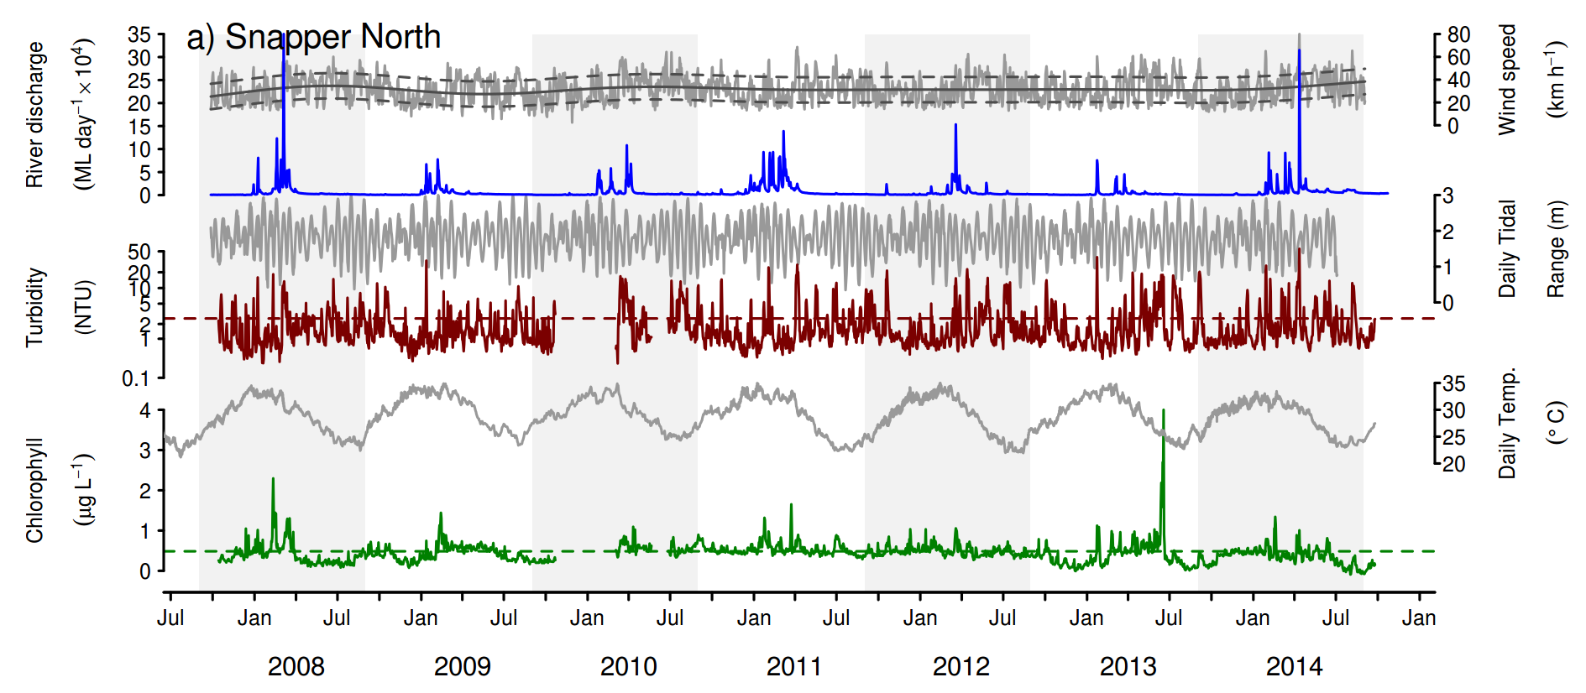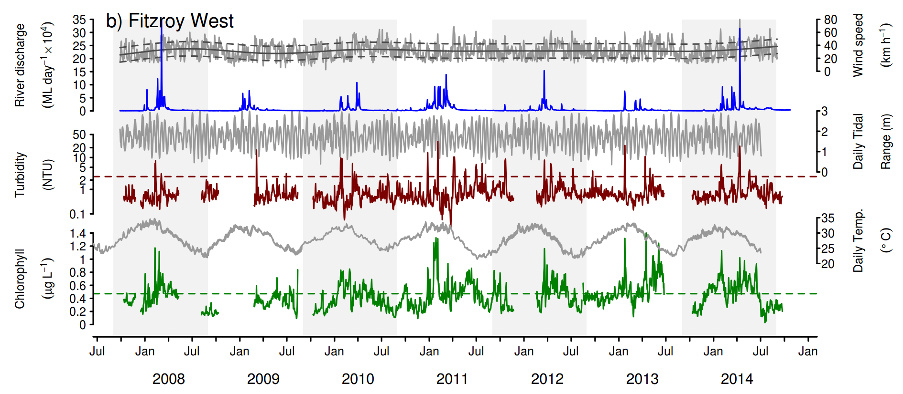
Figure A2- 1 Time series of daily means of chlorophyll (green line) and turbidity (red line) collected by ECO FLNTUSB instruments.
Additional panels represent daily discharge from nearest rivers (blue line) and daily wind speeds (grey line,) from the nearest weather stations. Horizontal green and red lines are the GBR Water Quality Guidelines values (GBRMPA 2010). Turbidity trigger value (red line, 1.5 NTU) was derived by transforming the suspended solids trigger value (see Schaffelke et al. 2009). Plots a-n represent locations of FLNTUUSB instruments; a) Snapper North, b) Fitzroy West, c) High West, d) Franklands West, e) Dunk North, f) Palms West, g) Pandora, h) Magnetic, i) Double Cone, j) Daydream, k) Pine, l) Barren, m) Keppels South,
n) Pelican.

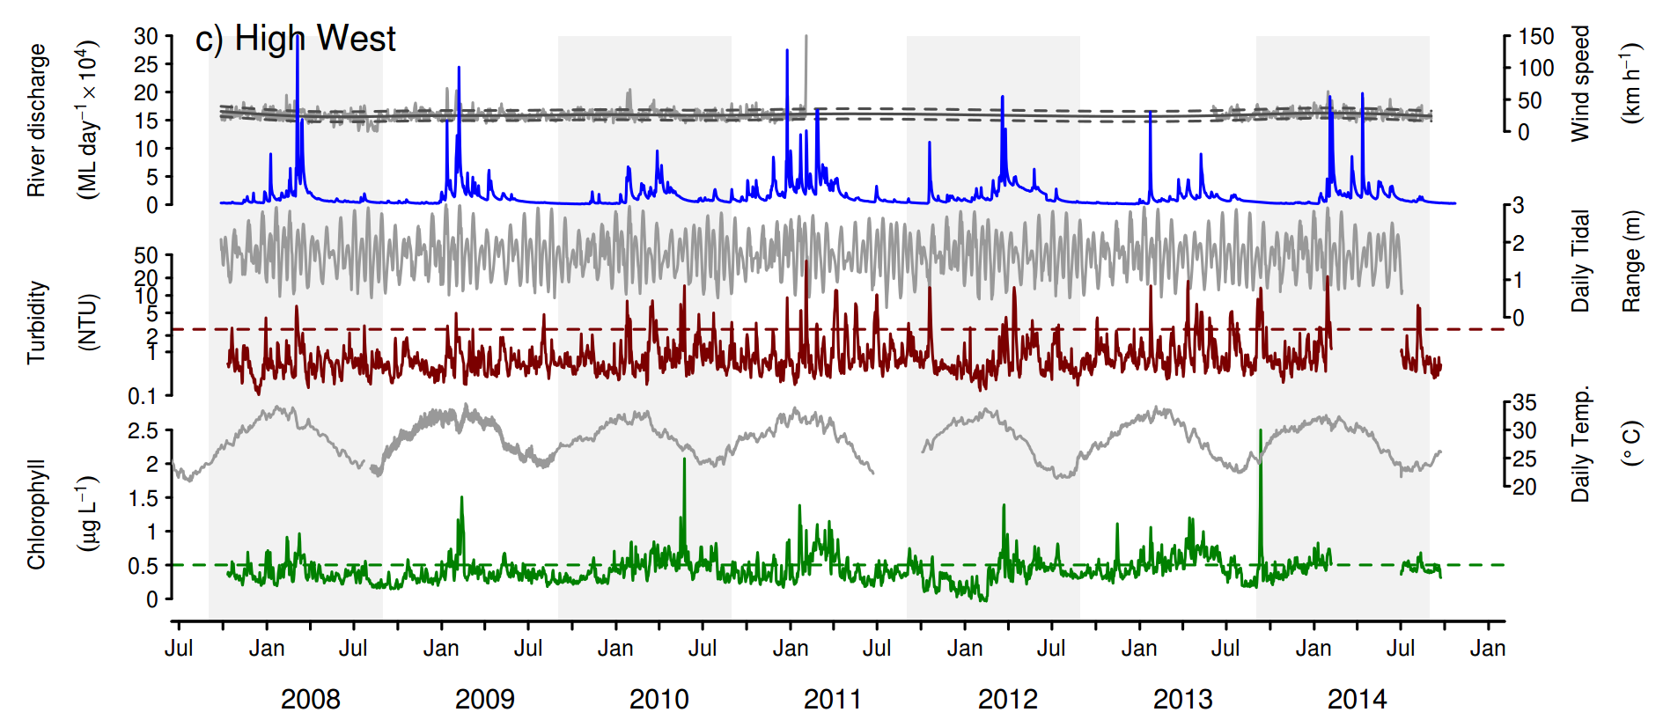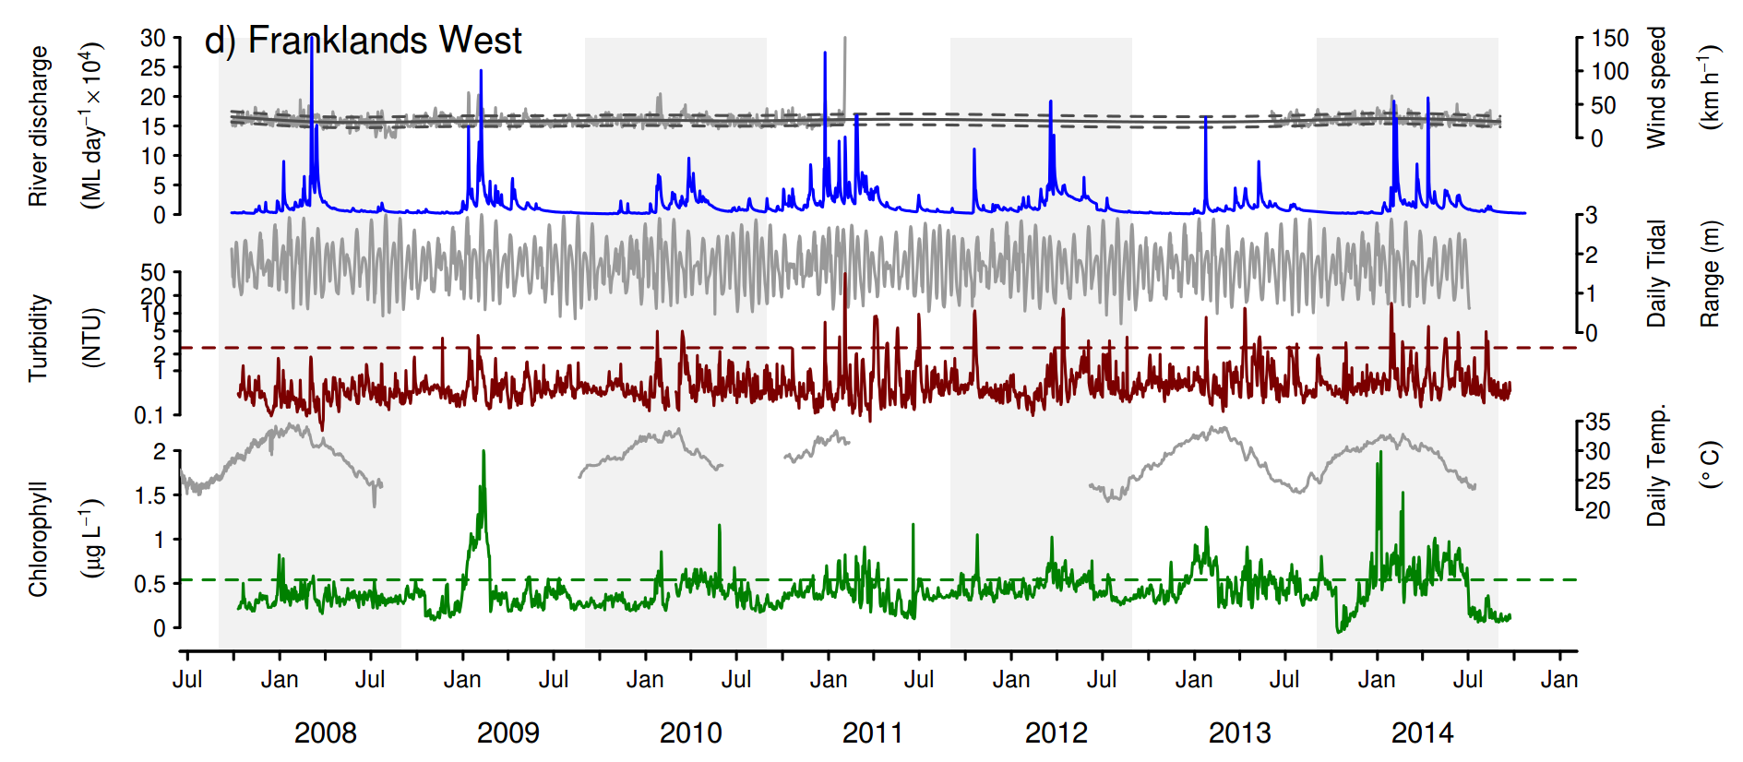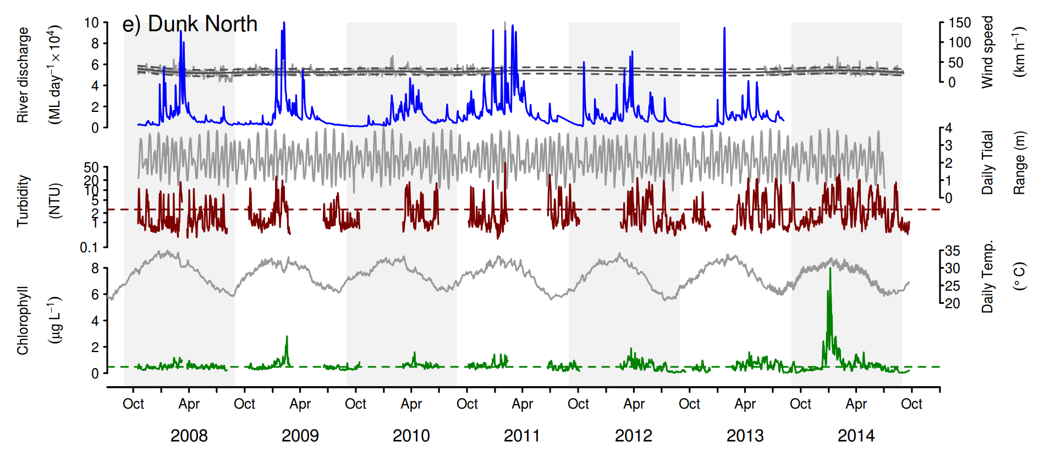
Figure A2-1 Continued - c) High West, d) Franklands West, e) Dunk North

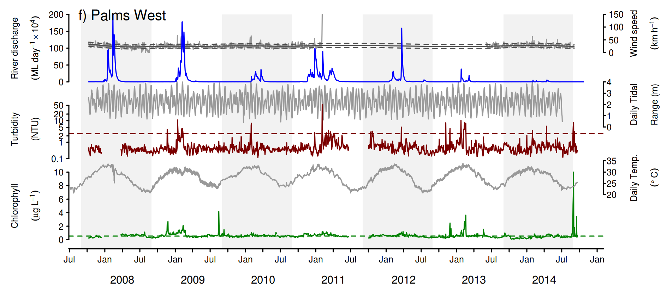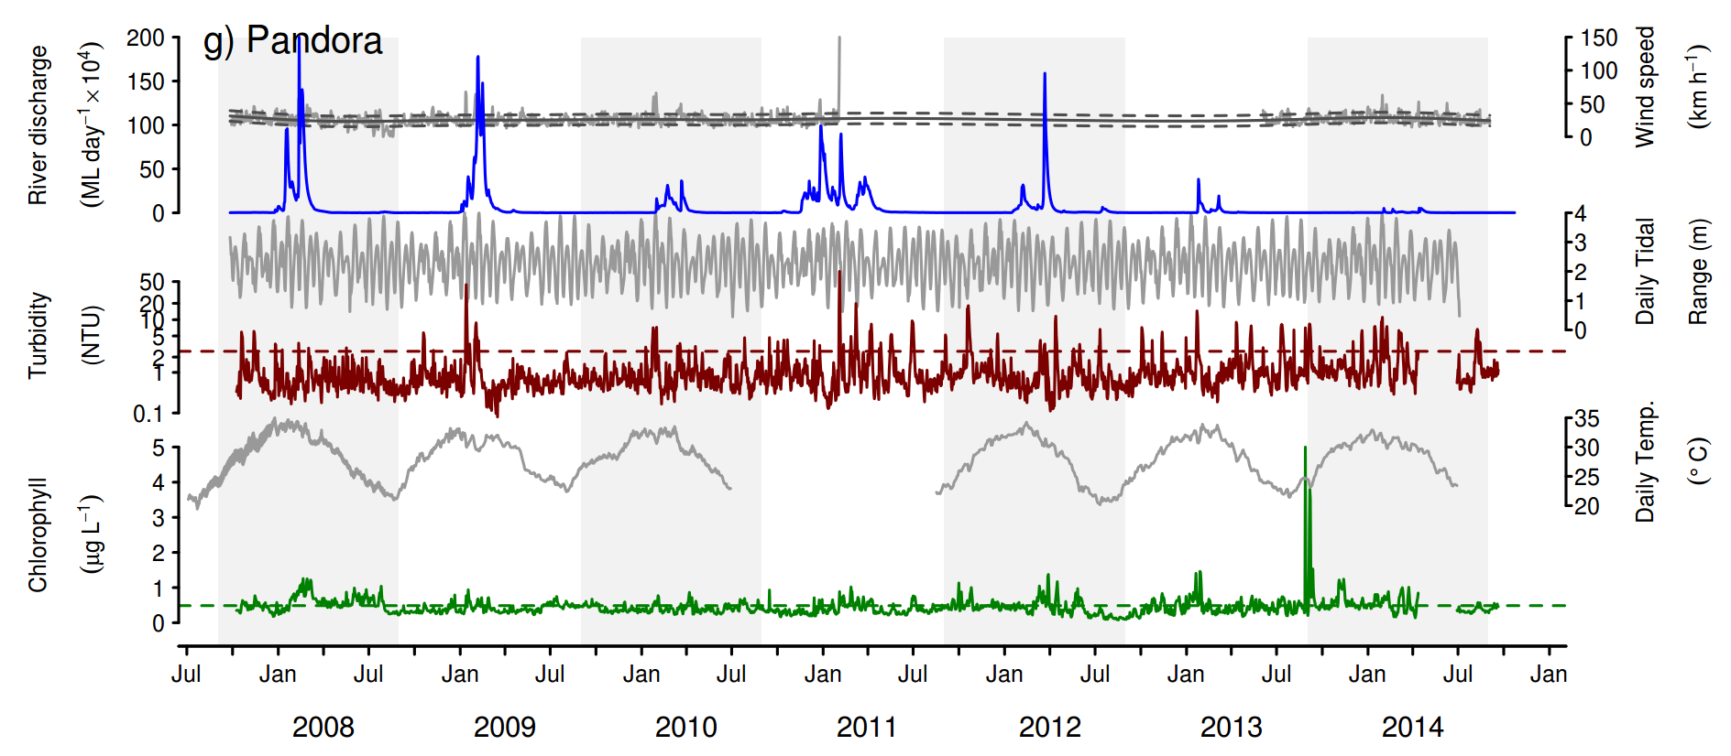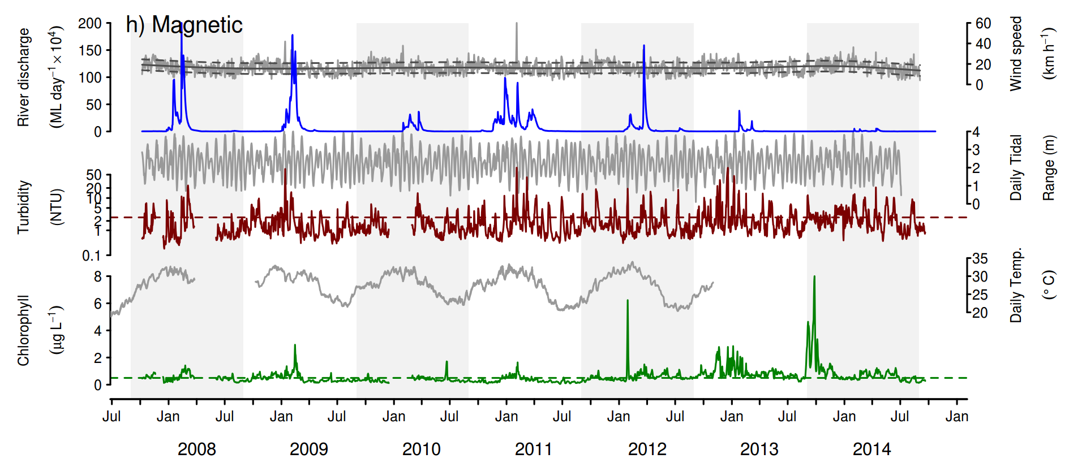

Figure A2-1 Continued - f) Palms West, g) Pandora, h) Magnetic

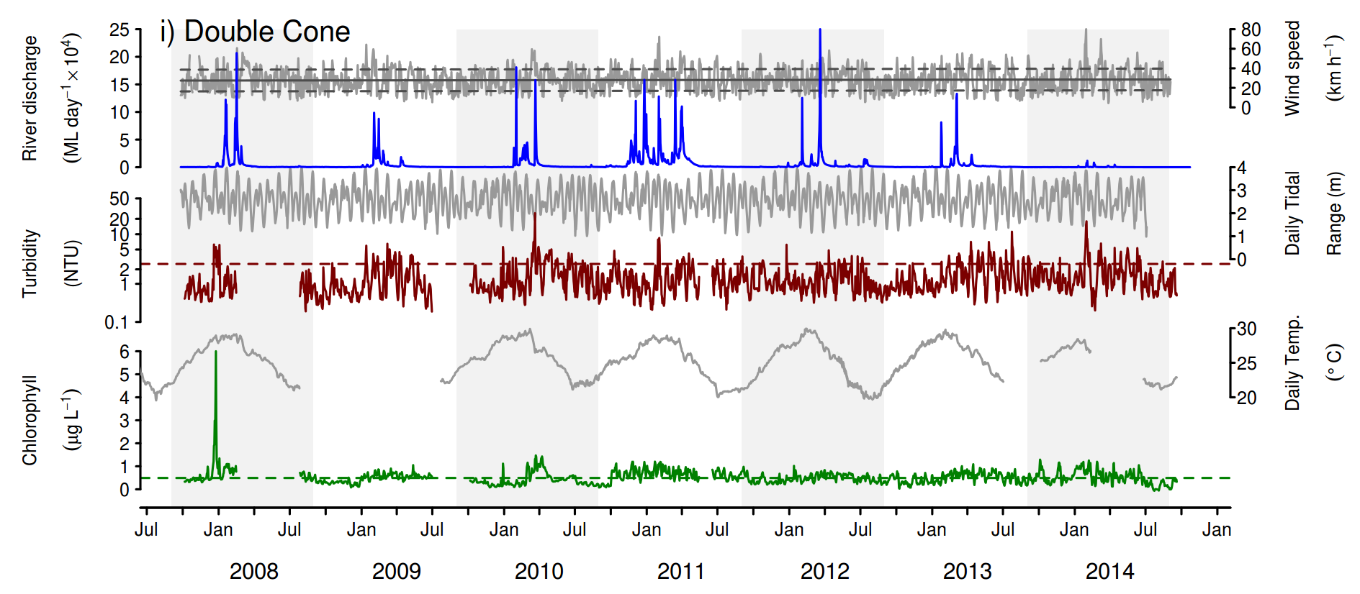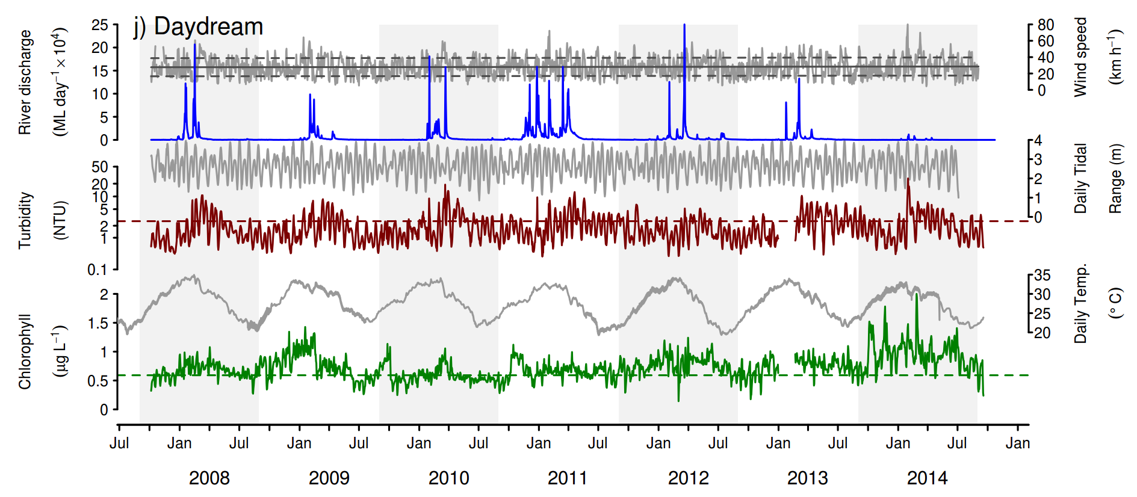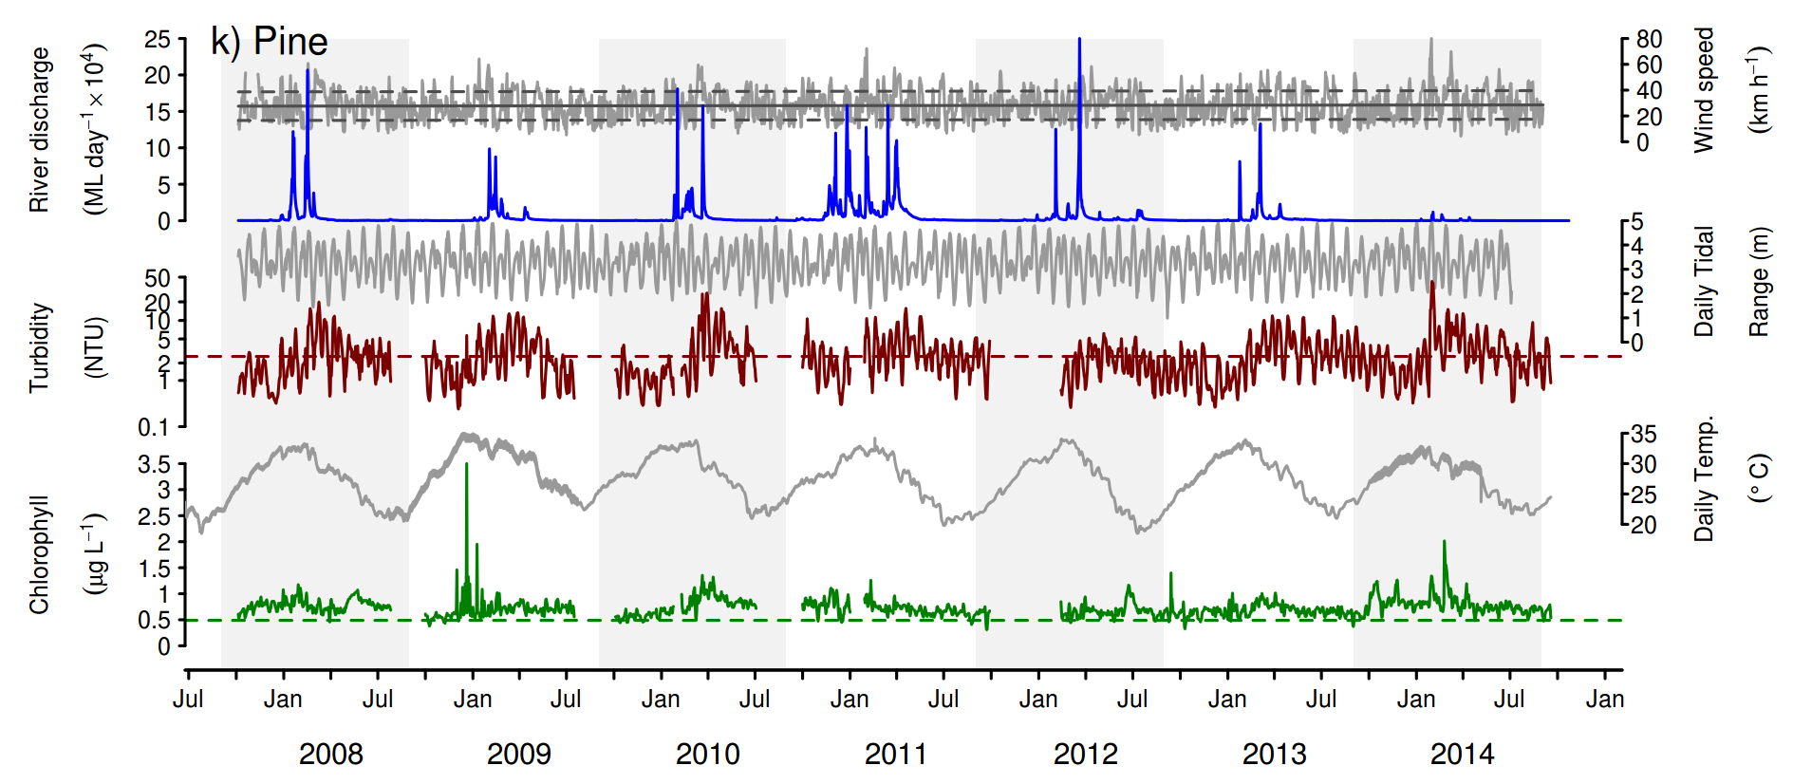

Figure A2-1 Continued - i) Double Cone, j) Daydream Is, k) Pine

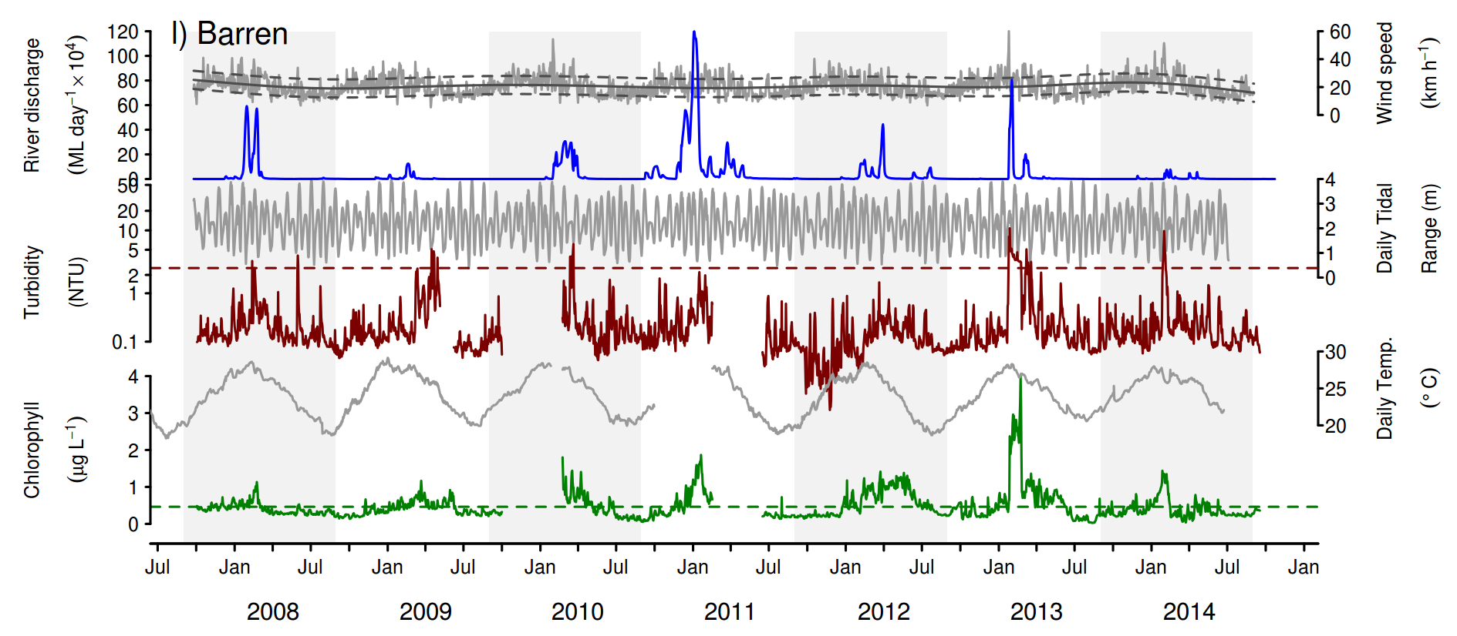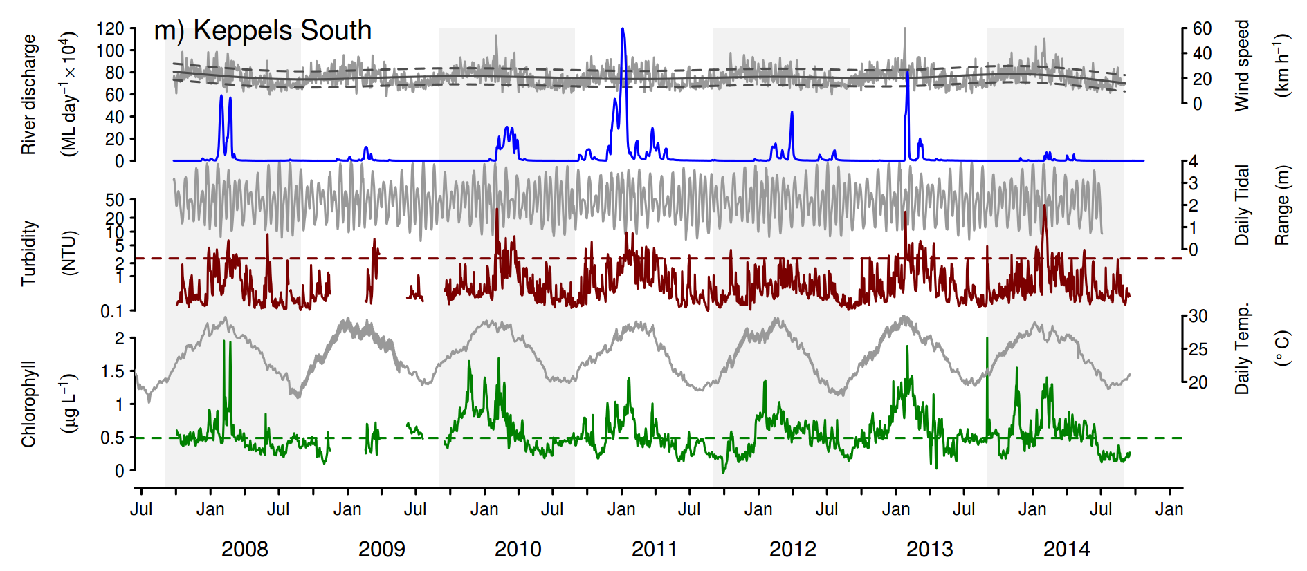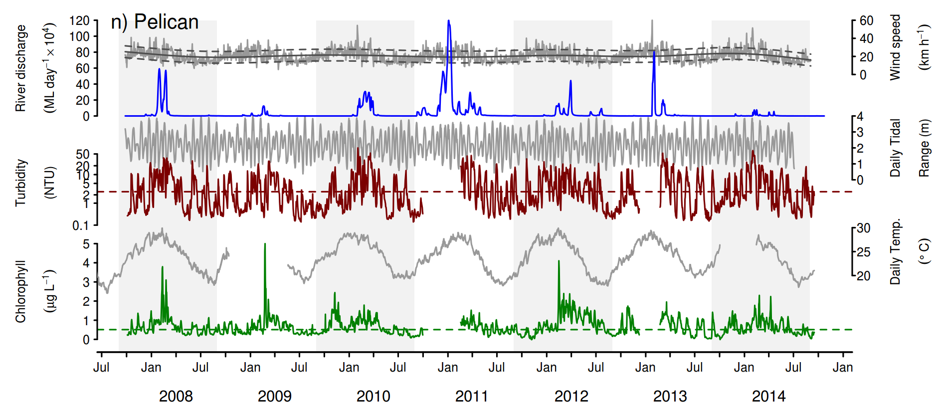

Figure A2-1 Continued - l) Barren , m) Keppels South, n) Pelican
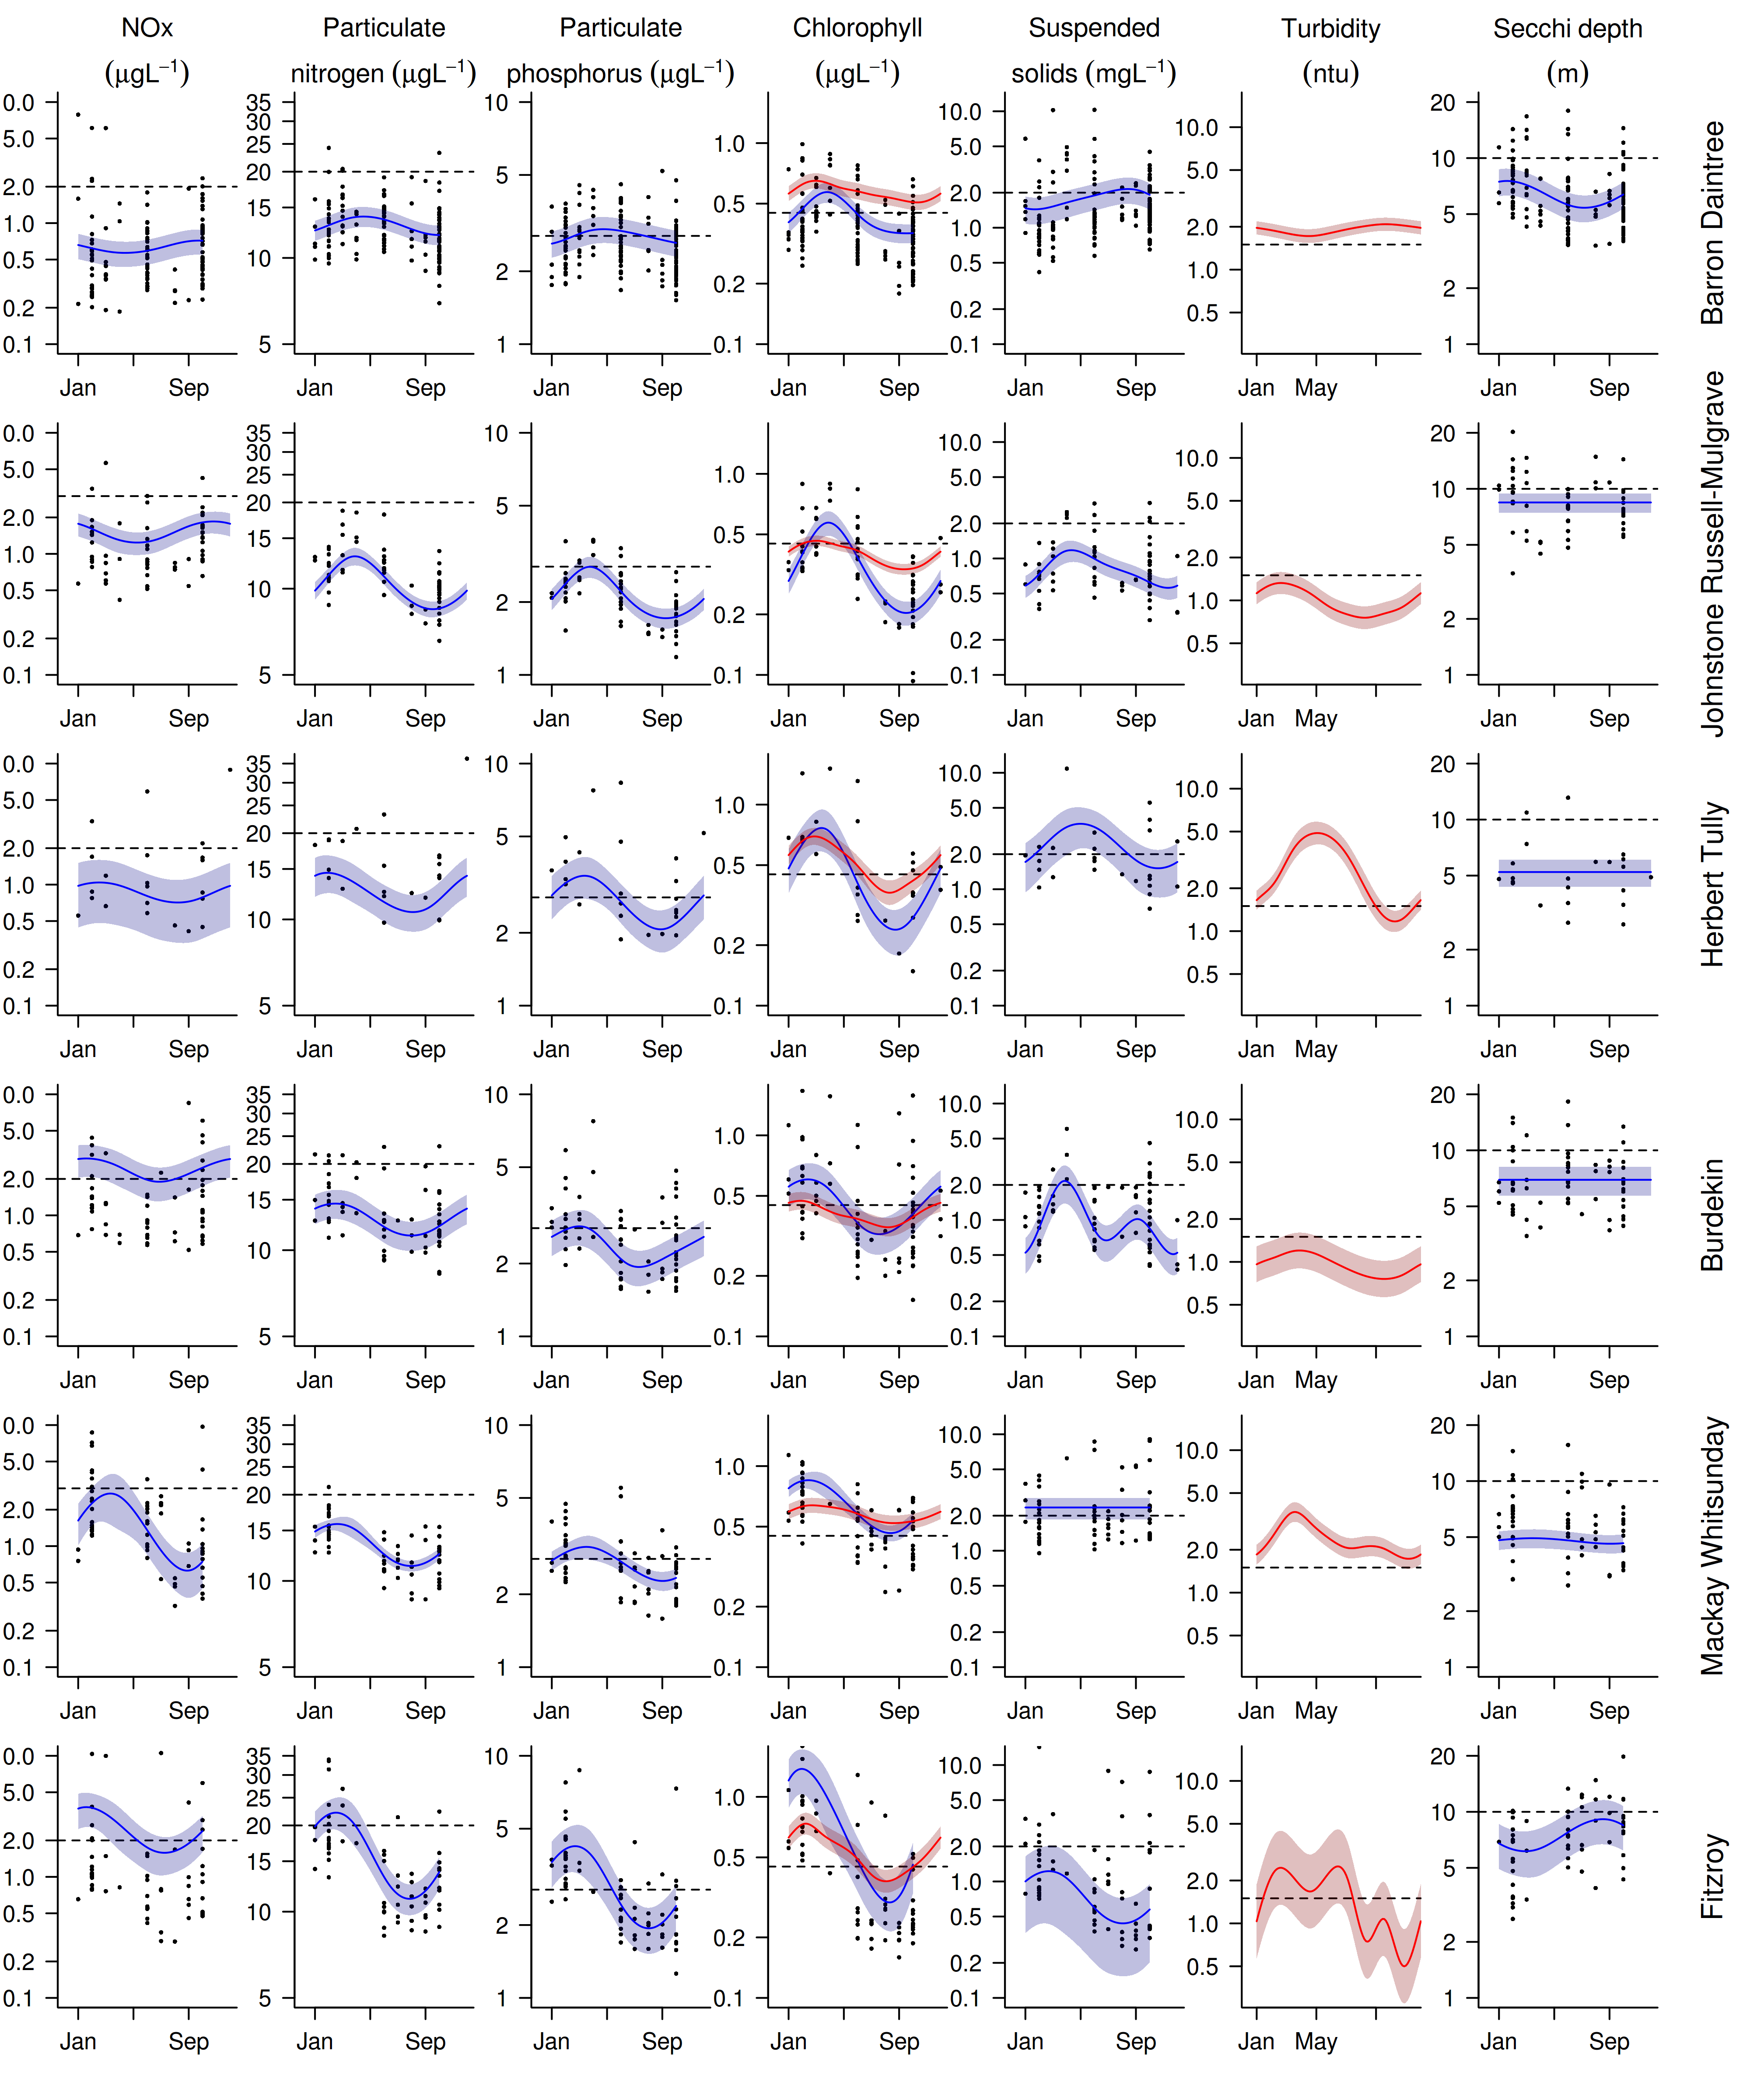
Figure A2- 2 Seasonal trends in water quality variables in reporting (sub-)regions.
Trends in manually sampled water quality variables are represented by blue lines with blue shaded areas defining 95% confidence intervals of those trends, black dots represent observed data. Trends of records from ECO FLNTUSB instruments are represented in red, individual records are not displayed.

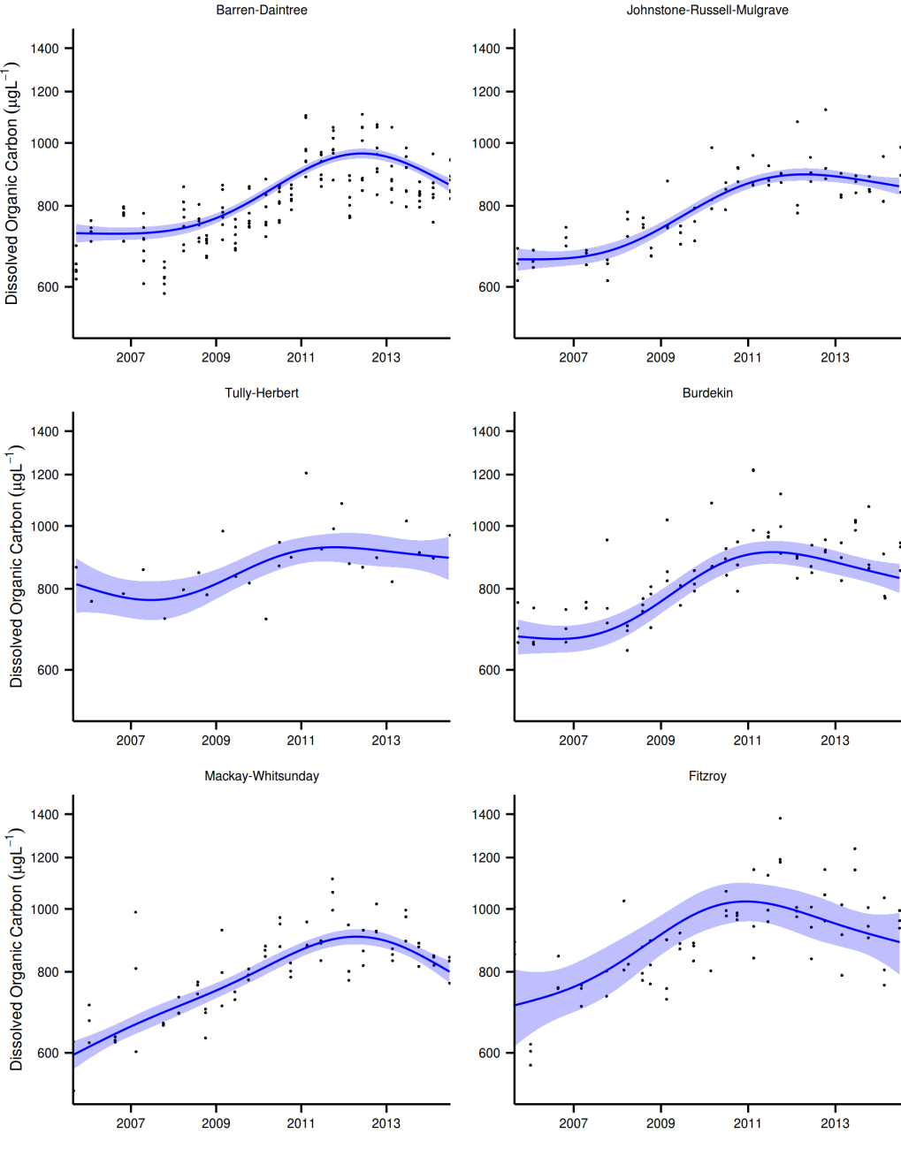

Figure A2- 3 Long-term trends in dissolved organic carbon (DOC).
Figures are partial GAMM plots of trends in DOC concentrations for the six MMP (sub-)regions. Trends in DOC are represented by thin blue lines with blue shaded areas defining 95% confidence intervals of those trends; black dots represent observed data points.

Table A2- 4 Interim water quality index for each water quality sampling location
Summary of four-year running means and calculation of the index, see Appendix 1.2.3 for details on index calculation. Data range = from start of the program (2005 for direct water sampling data or 2007 for water quality instruments) to September of each respective year (June for 2012). Red shaded cells are running means that did not comply with the GBRMPA Water Quality Guidelines for the Great Barrier Reef Marine Park (GBRMPA 2010). The scores for suspended solids, turbidity and Secchi depth were averaged for a “combined turbidity score”. The sum of these combined scores and the scores for PN, PP and chlorophyll yielded a total score per site. This total score was converted into a percentage rating and colour-coded (see Section 2.2. for details). Empty cells indicate data not available.
 |  | Depth-weighed means |  |  |  |  |  | Indicator scores
Reef | Date range | PN | PP | Chl a | SS | Secchi | Turbidity | PN | PP | Chl a | SS | Secchi | Turbidity | Combined Turbidity | Total score | Scaled score
Cape Tribulation | 2003-2006 | 0.87 | 0.06 | 0.31 | 1.9 | 10 |  | 0.71 | 0.62 | 0.54 | 0.07 | 0 |  | 0.07 | 1.94 | 0.49
Cape Tribulation | 2004-2007 | 0.84 | 0.06 | 0.29 | 1.57 | 10 |  | 0.77 | 0.58 | 0.61 | 0.35 | 0 |  | 0.35 | 2.31 | 0.58
Cape Tribulation | 2005-2008 | 0.9 | 0.08 | 0.33 | 1.79 | 7.5 |  | 0.67 | 0.18 | 0.43 | 0.16 | -0.42 |  | 0.16 | 1.44 | 0.36
Cape Tribulation | 2006-2009 | 0.88 | 0.08 | 0.33 | 1.65 | 6.63 |  | 0.69 | 0.23 | 0.45 | 0.28 | -0.59 |  | 0.28 | 1.65 | 0.41
Cape Tribulation | 2007-2010 | 0.9 | 0.08 | 0.39 | 1.44 | 6.72 |  | 0.67 | 0.1 | 0.22 | 0.48 | -0.57 |  | 0.48 | 1.47 | 0.37
Cape Tribulation | 2008-2011 | 0.98 | 0.09 | 0.46 | 1.54 | 6.3 |  | 0.54 | -0.02 | -0.02 | 0.37 | -0.67 |  | 0.37 | 0.88 | 0.22
Cape Tribulation | 2009-2012 | 0.93 | 0.09 | 0.44 | 1.22 | 6.39 |  | 0.63 | 0.07 | 0.05 | 0.72 | -0.65 |  | 0.72 | 1.47 | 0.37
Cape Tribulation | 2010-2013 | 0.91 | 0.09 | 0.45 | 1.23 | 7.17 |  | 0.64 | 0.06 | 0.01 | 0.7 | -0.48 |  | 0.7 | 1.41 | 0.35
Cape Tribulation | 2011-2014 | 0.88 | 0.09 | 0.42 | 1.19 | 7.29 |  | 0.7 | -0.02 | 0.1 | 0.75 | -0.46 |  | 0.75 | 1.54 | 0.39
Snapper North | 2004-2007 | 1.36 | 0.1 | 0.29 | 1.58 | 4 |  | 0.07 | -0.21 | 0.63 | 0.34 | -1 |  | 0.34 | 0.82 | 0.21
Snapper North | 2005-2008 | 0.86 | 0.08 | 0.31 | 1.24 | 6.75 | 2.09 | 0.74 | 0.22 | 0.56 | 0.69 | -0.57 | -0.48 | 0.11 | 1.62 | 0.41
Snapper North | 2006-2009 | 0.81 | 0.07 | 0.29 | 1.2 | 6.43 | 2.1 | 0.81 | 0.3 | 0.62 | 0.74 | -0.64 | -0.48 | 0.13 | 1.87 | 0.47
Snapper North | 2007-2010 | 0.84 | 0.07 | 0.31 | 1.12 | 6.8 | 2.2 | 0.76 | 0.3 | 0.53 | 0.83 | -0.56 | -0.55 | 0.14 | 1.72 | 0.43
Snapper North | 2008-2011 | 0.82 | 0.07 | 0.36 | 1.27 | 6.45 | 2.29 | 0.79 | 0.31 | 0.31 | 0.66 | -0.63 | -0.61 | 0.03 | 1.44 | 0.36
Snapper North | 2009-2012 | 0.84 | 0.07 | 0.36 | 1.25 | 5.64 | 2.34 | 0.76 | 0.28 | 0.31 | 0.68 | -0.83 | -0.64 | 0.02 | 1.37 | 0.34
Snapper North | 2010-2013 | 0.83 | 0.07 | 0.36 | 1.25 | 5.73 | 2.44 | 0.79 | 0.32 | 0.32 | 0.67 | -0.8 | -0.7 | -0.01 | 1.41 | 0.35
Snapper North | 2011-2014 | 0.82 | 0.08 | 0.4 | 1.35 | 5.05 | 2.67 | 0.8 | 0.26 | 0.19 | 0.56 | -0.99 | -0.83 | -0.13 | 1.11 | 0.28
Port Douglas | 2003-2006 | 1.09 | 0.06 | 0.29 | 1.68 | 9.5 |  | 0.39 | 0.52 | 0.65 | 0.25 | -0.07 |  | 0.25 | 1.81 | 0.45
Port Douglas | 2004-2007 | 1.07 | 0.07 | 0.28 | 1.57 | 8.67 |  | 0.42 | 0.42 | 0.67 | 0.35 | -0.21 |  | 0.35 | 1.85 | 0.46
Port Douglas | 2005-2008 | 0.92 | 0.06 | 0.28 | 1.38 | 8.5 |  | 0.64 | 0.5 | 0.69 | 0.54 | -0.23 |  | 0.54 | 2.36 | 0.59
Port Douglas | 2006-2009 | 0.9 | 0.07 | 0.28 | 1.36 | 7.89 |  | 0.66 | 0.39 | 0.69 | 0.56 | -0.34 |  | 0.56 | 2.31 | 0.58
Port Douglas | 2007-2010 | 0.9 | 0.07 | 0.32 | 1.23 | 7.2 |  | 0.67 | 0.27 | 0.49 | 0.7 | -0.47 |  | 0.7 | 2.13 | 0.53
Port Douglas | 2008-2011 | 0.89 | 0.08 | 0.36 | 1.23 | 6.71 |  | 0.68 | 0.22 | 0.32 | 0.7 | -0.58 |  | 0.7 | 1.91 | 0.48
Port Douglas | 2009-2012 | 0.89 | 0.08 | 0.38 | 1.31 | 6.12 |  | 0.68 | 0.13 | 0.26 | 0.61 | -0.71 |  | 0.61 | 1.68 | 0.42
Port Douglas | 2010-2013 | 0.87 | 0.08 | 0.4 | 1.35 | 6.17 |  | 0.72 | 0.14 | 0.19 | 0.56 | -0.7 |  | 0.56 | 1.6 | 0.4
Port Douglas | 2011-2014 | 0.85 | 0.09 | 0.42 | 1.43 | 5.96 |  | 0.75 | 0.08 | 0.09 | 0.49 | -0.75 |  | 0.49 | 1.41 | 0.35

Table A2-4 Continued: Wet Tropics Region

 |  | Depth-weighed means |  |  |  |  |  | Indicator scores
Reef | Date range | PN | PP | Chl a | SS | Secchi | Turbidity | PN | PP | Chl a | SS | Secchi | Turbidity | Combined Turbidity | Total score | Scaled score
Double | 2003-2006 | 0.91 | 0.05 | 0.37 | 1.38 | 14 |  | 0.65 | 0.92 | 0.28 | 0.54 | 0.49 |  | 0.54 | 2.38 | 0.6
Double | 2004-2007 | 0.93 | 0.06 | 0.36 | 1.33 | 9.5 |  | 0.62 | 0.65 | 0.31 | 0.59 | -0.07 |  | 0.59 | 2.18 | 0.54
Double | 2005-2008 | 0.91 | 0.06 | 0.35 | 1.18 | 11 |  | 0.66 | 0.53 | 0.38 | 0.76 | 0.14 |  | 0.76 | 2.33 | 0.58
Double | 2006-2009 | 0.81 | 0.06 | 0.32 | 1.19 | 9.5 |  | 0.82 | 0.51 | 0.5 | 0.75 | -0.07 |  | 0.75 | 2.57 | 0.64
Double | 2007-2010 | 0.8 | 0.07 | 0.32 | 1.16 | 8.67 |  | 0.83 | 0.36 | 0.51 | 0.79 | -0.21 |  | 0.79 | 2.49 | 0.62
Double | 2008-2011 | 0.81 | 0.07 | 0.37 | 1.16 | 8.09 |  | 0.82 | 0.3 | 0.3 | 0.79 | -0.31 |  | 0.79 | 2.21 | 0.55
Double | 2009-2012 | 0.79 | 0.08 | 0.38 | 1.14 | 7.12 |  | 0.86 | 0.26 | 0.25 | 0.81 | -0.49 |  | 0.81 | 2.18 | 0.54
Double | 2010-2013 | 0.81 | 0.08 | 0.39 | 1.21 | 7 |  | 0.83 | 0.2 | 0.21 | 0.73 | -0.51 |  | 0.73 | 1.96 | 0.49
Double | 2011-2014 | 0.8 | 0.08 | 0.44 | 1.2 | 6.62 |  | 0.83 | 0.13 | 0.04 | 0.74 | -0.59 |  | 0.74 | 1.74 | 0.43
Green | 2003-2006 | 0.62 | 0.05 | 0.19 | 1.12 | 22 |  | 1 | 0.88 | 1 | 0.84 | 1 |  | 0.84 | 3.72 | 0.93
Green | 2004-2007 | 0.61 | 0.04 | 0.17 | 0.88 | 19.33 |  | 1 | 1 | 1 | 1 | 0.95 |  | 1 | 4 | 1
Green | 2005-2008 | 0.67 | 0.05 | 0.25 | 0.74 | 15.83 |  | 1 | 0.84 | 0.87 | 1 | 0.66 |  | 1 | 3.71 | 0.93
Green | 2006-2009 | 0.64 | 0.05 | 0.22 | 0.56 | 15.33 |  | 1 | 0.95 | 1 | 1 | 0.62 |  | 1 | 3.95 | 0.99
Green | 2007-2010 | 0.67 | 0.05 | 0.23 | 0.33 | 13.7 |  | 1 | 0.94 | 0.95 | 1 | 0.45 |  | 1 | 3.89 | 0.97
Green | 2008-2011 | 0.7 | 0.05 | 0.28 | 0.34 | 12.67 |  | 1 | 0.77 | 0.67 | 1 | 0.34 |  | 1 | 3.44 | 0.86
Green | 2009-2012 | 0.68 | 0.05 | 0.28 | 0.3 | 12.38 |  | 1 | 0.77 | 0.66 | 1 | 0.31 |  | 1 | 3.43 | 0.86
Green | 2010-2013 | 0.71 | 0.05 | 0.29 | 0.35 | 11.46 |  | 1 | 0.76 | 0.64 | 1 | 0.2 |  | 1 | 3.4 | 0.85
Green | 2011-2014 | 0.72 | 0.06 | 0.33 | 0.4 | 10.5 |  | 1 | 0.69 | 0.44 | 1 | 0.07 |  | 1 | 3.12 | 0.78
Yorkey's Knob | 2003-2006 | 1.48 | 0.14 | 0.59 | 4.26 | 3.5 |  | -0.05 | -0.6 | -0.4 | -1 | -1 |  | -1 | -2.06 | -0.51
Yorkey's Knob | 2004-2007 | 1.35 | 0.13 | 0.55 | 3.6 | 3.33 |  | 0.09 | -0.51 | -0.28 | -0.85 | -1 |  | -0.85 | -1.56 | -0.39
Yorkey's Knob | 2005-2008 | 1.25 | 0.12 | 0.5 | 2.81 | 4.17 |  | 0.19 | -0.35 | -0.16 | -0.49 | -1 |  | -0.49 | -0.81 | -0.2
Yorkey's Knob | 2006-2009 | 1.22 | 0.12 | 0.52 | 2.91 | 4 |  | 0.23 | -0.41 | -0.2 | -0.54 | -1 |  | -0.54 | -0.92 | -0.23
Yorkey's Knob | 2007-2010 | 1.1 | 0.12 | 0.52 | 2.73 | 3.75 |  | 0.38 | -0.4 | -0.21 | -0.45 | -1 |  | -0.45 | -0.67 | -0.17
Yorkey's Knob | 2008-2011 | 1.12 | 0.12 | 0.58 | 3.06 | 3.96 |  | 0.35 | -0.43 | -0.36 | -0.61 | -1 |  | -0.61 | -1.06 | -0.26
Yorkey's Knob | 2009-2012 | 1.15 | 0.13 | 0.62 | 3.06 | 3.67 |  | 0.32 | -0.51 | -0.46 | -0.62 | -1 |  | -0.62 | -1.27 | -0.32
Yorkey's Knob | 2010-2013 | 1.12 | 0.12 | 0.6 | 2.75 | 3.96 |  | 0.36 | -0.46 | -0.41 | -0.46 | -1 |  | -0.46 | -0.97 | -0.24
Yorkey's Knob | 2011-2014 | 1.12 | 0.13 | 0.64 | 2.66 | 4.12 |  | 0.35 | -0.47 | -0.5 | -0.41 | -1 |  | -0.41 | -1.03 | -0.26

Table A2-4 Continued: Wet Tropics Region

 |  | Depth-weighed means |  |  |  |  |  | Indicator scores
Reef | Date range | PN | PP | Chl a | SS | Secchi | Turbidity | PN | PP | Chl a | SS | Secchi | Turbidity | Combined Turbidity | Total score | Scaled score
Fairlead Buoy | 2003-2006 | 1.15 | 0.09 | 0.47 | 2.68 | 5.5 |  | 0.32 | 0.06 | -0.06 | -0.42 | -0.86 |  | -0.42 | -0.1 | -0.03
Fairlead Buoy | 2004-2007 | 1.17 | 0.11 | 0.44 | 2.75 | 3.75 |  | 0.28 | -0.23 | 0.02 | -0.46 | -1 |  | -0.46 | -0.39 | -0.1
Fairlead Buoy | 2005-2008 | 1.17 | 0.11 | 0.47 | 2.7 | 4.5 |  | 0.29 | -0.3 | -0.06 | -0.43 | -1 |  | -0.43 | -0.5 | -0.13
Fairlead Buoy | 2006-2009 | 1.12 | 0.12 | 0.47 | 3.1 | 4.06 |  | 0.35 | -0.4 | -0.06 | -0.63 | -1 |  | -0.63 | -0.74 | -0.19
Fairlead Buoy | 2007-2010 | 1.14 | 0.14 | 0.49 | 3.82 | 3.65 |  | 0.32 | -0.62 | -0.14 | -0.93 | -1 |  | -0.93 | -1.37 | -0.34
Fairlead Buoy | 2008-2011 | 1.16 | 0.14 | 0.55 | 4.46 | 3.69 |  | 0.3 | -0.68 | -0.3 | -1 | -1 |  | -1 | -1.68 | -0.42
Fairlead Buoy | 2009-2012 | 1.18 | 0.15 | 0.56 | 4.42 | 3.35 |  | 0.27 | -0.72 | -0.31 | -1 | -1 |  | -1 | -1.75 | -0.44
Fairlead Buoy | 2010-2013 | 1.21 | 0.15 | 0.56 | 4.06 | 3.24 |  | 0.24 | -0.7 | -0.31 | -1 | -1 |  | -1 | -1.78 | -0.44
Fairlead Buoy | 2011-2014 | 1.15 | 0.14 | 0.6 | 3.6 | 3.53 |  | 0.31 | -0.63 | -0.41 | -0.85 | -1 |  | -0.85 | -1.57 | -0.39
Fitzroy West | 2003-2006 | 0.82 | 0.05 | 0.4 | 1.59 | 11.5 |  | 0.79 | 0.81 | 0.16 | 0.33 | 0.2 |  | 0.33 | 2.09 | 0.52
Fitzroy West | 2004-2007 | 0.81 | 0.05 | 0.35 | 1.26 | 10.67 |  | 0.82 | 0.75 | 0.35 | 0.67 | 0.09 |  | 0.67 | 2.59 | 0.65
Fitzroy West | 2005-2008 | 0.82 | 0.06 | 0.37 | 1.16 | 9.67 | 0.84 | 0.8 | 0.49 | 0.29 | 0.79 | -0.05 | 0.84 | 0.82 | 2.4 | 0.6
Fitzroy West | 2006-2009 | 0.74 | 0.06 | 0.32 | 1.02 | 10.11 | 0.88 | 0.94 | 0.59 | 0.48 | 0.97 | 0.02 | 0.77 | 0.87 | 2.87 | 0.72
Fitzroy West | 2007-2010 | 0.74 | 0.06 | 0.31 | 0.92 | 8.95 | 0.88 | 0.94 | 0.53 | 0.54 | 1 | -0.16 | 0.77 | 0.88 | 2.9 | 0.72
Fitzroy West | 2008-2011 | 0.74 | 0.06 | 0.3 | 0.85 | 9.05 | 0.94 | 0.94 | 0.53 | 0.59 | 1 | -0.14 | 0.67 | 0.83 | 2.9 | 0.72
Fitzroy West | 2009-2012 | 0.75 | 0.06 | 0.28 | 0.85 | 8.77 | 1.05 | 0.93 | 0.57 | 0.66 | 1 | -0.19 | 0.51 | 0.75 | 2.91 | 0.73
Fitzroy West | 2010-2013 | 0.79 | 0.06 | 0.3 | 0.84 | 8 | 1.08 | 0.86 | 0.52 | 0.58 | 1 | -0.32 | 0.48 | 0.74 | 2.7 | 0.68
Fitzroy West | 2011-2014 | 0.79 | 0.07 | 0.33 | 0.78 | 8.05 | 1.15 | 0.86 | 0.47 | 0.46 | 1 | -0.31 | 0.39 | 0.69 | 2.49 | 0.62
High West | 2003-2006 | 0.99 | 0.08 | 0.41 | 2.22 | 10.25 |  | 0.53 | 0.22 | 0.14 | -0.15 | 0.04 |  | -0.15 | 0.75 | 0.19
High West | 2004-2007 | 0.93 | 0.08 | 0.37 | 1.83 | 8.83 |  | 0.62 | 0.26 | 0.26 | 0.13 | -0.18 |  | 0.13 | 1.27 | 0.32
High West | 2005-2008 | 0.97 | 0.08 | 0.47 | 1.45 | 8.58 | 0.88 | 0.56 | 0.16 | -0.07 | 0.46 | -0.22 | 0.77 | 0.62 | 1.27 | 0.32
High West | 2006-2009 | 0.91 | 0.08 | 0.45 | 1.33 | 7.89 | 0.82 | 0.66 | 0.15 | 0 | 0.59 | -0.34 | 0.87 | 0.73 | 1.54 | 0.38
High West | 2007-2010 | 0.87 | 0.08 | 0.45 | 1.13 | 7 | 0.89 | 0.71 | 0.13 | -0.01 | 0.83 | -0.51 | 0.75 | 0.79 | 1.62 | 0.41
High West | 2008-2011 | 0.88 | 0.09 | 0.48 | 1.15 | 6.45 | 1.06 | 0.7 | 0.03 | -0.1 | 0.8 | -0.63 | 0.51 | 0.65 | 1.29 | 0.32
High West | 2009-2012 | 0.83 | 0.09 | 0.44 | 1.04 | 6 | 1.14 | 0.79 | 0.08 | 0.04 | 0.95 | -0.74 | 0.4 | 0.67 | 1.59 | 0.4
High West | 2010-2013 | 0.87 | 0.08 | 0.46 | 1.1 | 5.77 | 1.23 | 0.71 | 0.11 | -0.04 | 0.86 | -0.79 | 0.28 | 0.57 | 1.35 | 0.34
High West | 2011-2014 | 0.89 | 0.09 | 0.5 | 1.15 | 5.55 | 1.38 | 0.68 | 0.04 | -0.15 | 0.8 | -0.85 | 0.12 | 0.46 | 1.02 | 0.26

Table A2-4 Continued: Wet Tropics Region

 |  | Depth-weighed means |  |  |  |  |  | Indicator scores
Reef | Date range | PN | PP | Chl a | SS | Secchi | Turbidity | PN | PP | Chl a | SS | Secchi | Turbidity | Combined Turbidity | Total score | Scaled score
Franklands West | 2003-2006 | 0.86 | 0.06 | 0.31 | 1.23 | 13 |  | 0.74 | 0.67 | 0.56 | 0.7 | 0.38 |  | 0.7 | 2.66 | 0.67
Franklands West | 2004-2007 | 0.77 | 0.06 | 0.26 | 1.01 | 11.5 |  | 0.9 | 0.71 | 0.78 | 0.99 | 0.2 |  | 0.99 | 3.37 | 0.84
Franklands West | 2005-2008 | 0.8 | 0.06 | 0.35 | 0.89 | 10.4 | 0.45 | 0.83 | 0.58 | 0.38 | 1 | 0.06 | 1 | 1 | 2.79 | 0.7
Franklands West | 2006-2009 | 0.74 | 0.05 | 0.31 | 0.7 | 11.25 | 0.55 | 0.94 | 0.73 | 0.54 | 1 | 0.17 | 1 | 1 | 3.2 | 0.8
Franklands West | 2007-2010 | 0.75 | 0.06 | 0.32 | 0.59 | 10.35 | 0.6 | 0.93 | 0.6 | 0.47 | 1 | 0.05 | 1 | 1 | 3 | 0.75
Franklands West | 2008-2011 | 0.76 | 0.06 | 0.37 | 0.67 | 9.91 | 0.71 | 0.91 | 0.52 | 0.3 | 1 | -0.01 | 1 | 1 | 2.73 | 0.68
Franklands West | 2009-2012 | 0.73 | 0.06 | 0.33 | 0.56 | 9.86 | 0.8 | 0.97 | 0.54 | 0.46 | 1 | -0.02 | 0.9 | 0.95 | 2.92 | 0.73
Franklands West | 2010-2013 | 0.8 | 0.07 | 0.35 | 0.66 | 9.05 | 0.88 | 0.83 | 0.43 | 0.36 | 1 | -0.14 | 0.76 | 0.88 | 2.51 | 0.63
Franklands West | 2011-2014 | 0.82 | 0.07 | 0.4 | 0.66 | 8.7 | 0.96 | 0.79 | 0.37 | 0.17 | 1 | -0.2 | 0.65 | 0.82 | 2.16 | 0.54
Dunk North | 2003-2006 | 1.28 | 0.11 | 0.72 | 3.22 | 5 |  | 0.16 | -0.31 | -0.68 | -0.69 | -1 |  | -0.69 | -1.52 | -0.38
Dunk North | 2004-2007 | 1.28 | 0.11 | 0.6 | 2.58 | 5 |  | 0.16 | -0.28 | -0.41 | -0.37 | -1 |  | -0.37 | -0.9 | -0.23
Dunk North | 2005-2008 | 1.28 | 0.13 | 0.64 | 3.11 | 5.2 | 2.24 | 0.16 | -0.52 | -0.5 | -0.64 | -0.94 | -0.58 | -0.61 | -1.47 | -0.37
Dunk North | 2006-2009 | 1.15 | 0.12 | 0.56 | 2.77 | 5 | 2.39 | 0.31 | -0.35 | -0.32 | -0.47 | -1 | -0.67 | -0.57 | -0.93 | -0.23
Dunk North | 2007-2010 | 1.08 | 0.11 | 0.49 | 2.39 | 5.39 | 2.37 | 0.4 | -0.23 | -0.13 | -0.25 | -0.89 | -0.66 | -0.46 | -0.41 | -0.1
Dunk North | 2008-2011 | 1.07 | 0.11 | 0.56 | 2.87 | 5 | 2.48 | 0.42 | -0.32 | -0.32 | -0.52 | -1 | -0.73 | -0.62 | -0.84 | -0.21
Dunk North | 2009-2012 | 1.08 | 0.11 | 0.54 | 2.33 | 4.68 | 2.79 | 0.4 | -0.23 | -0.26 | -0.22 | -1 | -0.89 | -0.56 | -0.64 | -0.16
Dunk North | 2010-2013 | 1.08 | 0.1 | 0.54 | 2.16 | 4.99 | 2.86 | 0.4 | -0.21 | -0.25 | -0.11 | -1 | -0.93 | -0.52 | -0.58 | -0.14
Dunk North | 2011-2014 | 1.11 | 0.11 | 0.61 | 2.25 | 4.7 | 3.54 | 0.37 | -0.31 | -0.44 | -0.17 | -1 | -1 | -0.58 | -0.96 | -0.24

Table A2-4 Continued: Burdekin Region

 |  | Depth-weighed means |  |  |  |  |  | Indicator scores
Reef | Date range | PN | PP | Chl a | SS | Secchi | Turbidity | PN | PP | Chl a | SS | Secchi | Turbidity | Combined Turbidity | Total score | Scaled score
Palms West | 2003-2006 | 1.01 | 0.07 | 0.5 | 2.18 | 7.75 |  | 0.5 | 0.31 | -0.16 | -0.12 | -0.37 |  | -0.12 | 0.53 | 0.13
Palms West | 2004-2007 | 0.92 | 0.07 | 0.41 | 1.61 | 8.17 |  | 0.63 | 0.44 | 0.13 | 0.31 | -0.29 |  | 0.31 | 1.51 | 0.38
Palms West | 2005-2008 | 0.86 | 0.06 | 0.4 | 1.16 | 7.7 | 0.54 | 0.74 | 0.48 | 0.16 | 0.78 | -0.38 | 1 | 0.89 | 2.27 | 0.57
Palms West | 2006-2009 | 0.83 | 0.06 | 0.42 | 1 | 8.19 | 0.67 | 0.79 | 0.51 | 0.1 | 1 | -0.29 | 1 | 1 | 2.39 | 0.6
Palms West | 2007-2010 | 0.84 | 0.06 | 0.4 | 0.75 | 8.56 | 0.65 | 0.77 | 0.51 | 0.17 | 1 | -0.23 | 1 | 1 | 2.44 | 0.61
Palms West | 2008-2011 | 0.86 | 0.07 | 0.46 | 0.82 | 8.05 | 0.74 | 0.73 | 0.31 | -0.03 | 1 | -0.31 | 1 | 1 | 2.01 | 0.5
Palms West | 2009-2012 | 0.83 | 0.07 | 0.44 | 0.78 | 8.18 | 0.77 | 0.79 | 0.31 | 0.03 | 1 | -0.29 | 0.97 | 0.98 | 2.11 | 0.53
Palms West | 2010-2013 | 0.84 | 0.07 | 0.4 | 0.75 | 8.45 | 0.81 | 0.77 | 0.32 | 0.16 | 1 | -0.24 | 0.89 | 0.94 | 2.2 | 0.55
Palms West | 2011-2014 | 0.8 | 0.07 | 0.41 | 0.74 | 8.59 | 0.81 | 0.84 | 0.31 | 0.15 | 1 | -0.22 | 0.88 | 0.94 | 2.25 | 0.56
Pandora | 2003-2006 | 0.96 | 0.08 | 0.57 | 2.74 | 5.5 |  | 0.58 | 0.12 | -0.34 | -0.46 | -0.86 |  | -0.46 | -0.1 | -0.02
Pandora | 2004-2007 | 0.9 | 0.08 | 0.48 | 2.29 | 5.67 |  | 0.66 | 0.16 | -0.08 | -0.2 | -0.82 |  | -0.2 | 0.55 | 0.14
Pandora | 2005-2008 | 0.95 | 0.09 | 0.46 | 2.01 | 6 | 1.1 | 0.59 | 0.08 | -0.03 | -0.01 | -0.74 | 0.45 | 0.22 | 0.86 | 0.22
Pandora | 2006-2009 | 0.89 | 0.08 | 0.41 | 1.65 | 6.81 | 1.14 | 0.69 | 0.25 | 0.15 | 0.27 | -0.55 | 0.39 | 0.33 | 1.42 | 0.36
Pandora | 2007-2010 | 0.84 | 0.07 | 0.35 | 1.24 | 7.89 | 1.09 | 0.76 | 0.32 | 0.36 | 0.69 | -0.34 | 0.47 | 0.58 | 2.02 | 0.51
Pandora | 2008-2011 | 0.9 | 0.08 | 0.37 | 1.09 | 7.75 | 1.23 | 0.67 | 0.21 | 0.28 | 0.88 | -0.37 | 0.29 | 0.58 | 1.74 | 0.44
Pandora | 2009-2012 | 0.86 | 0.08 | 0.33 | 0.73 | 8.27 | 1.3 | 0.73 | 0.26 | 0.46 | 1 | -0.27 | 0.2 | 0.6 | 2.05 | 0.51
Pandora | 2010-2013 | 0.9 | 0.08 | 0.34 | 0.73 | 8.27 | 1.33 | 0.67 | 0.16 | 0.42 | 1 | -0.27 | 0.18 | 0.59 | 1.84 | 0.46
Pandora | 2011-2014 | 0.91 | 0.08 | 0.34 | 0.74 | 7.64 | 1.52 | 0.66 | 0.11 | 0.39 | 1 | -0.39 | -0.02 | 0.49 | 1.65 | 0.41
Magnetic | 2003-2006 | 1.79 | 0.13 | 1.28 | 3.5 | 4 |  | -0.32 | -0.58 | -1 | -0.81 | -1 |  | -0.81 | -2.71 | -0.68
Magnetic | 2004-2007 | 1.7 | 0.15 | 1.09 | 4.07 | 3.33 |  | -0.25 | -0.74 | -1 | -1 | -1 |  | -1 | -2.99 | -0.75
Magnetic | 2005-2008 | 1.5 | 0.15 | 0.85 | 4 | 4 | 2.72 | -0.07 | -0.7 | -0.91 | -1 | -1 | -0.86 | -0.93 | -2.61 | -0.65
Magnetic | 2006-2009 | 1.38 | 0.13 | 0.73 | 3.21 | 4.28 | 2.51 | 0.05 | -0.52 | -0.7 | -0.68 | -1 | -0.75 | -0.71 | -1.89 | -0.47
Magnetic | 2007-2010 | 1.22 | 0.12 | 0.58 | 2.78 | 4.7 | 2.21 | 0.23 | -0.41 | -0.37 | -0.47 | -1 | -0.56 | -0.52 | -1.06 | -0.27
Magnetic | 2008-2011 | 1.16 | 0.12 | 0.58 | 2.5 | 4.68 | 2.33 | 0.3 | -0.36 | -0.38 | -0.32 | -1 | -0.64 | -0.48 | -0.92 | -0.23
Magnetic | 2009-2012 | 1.11 | 0.11 | 0.53 | 1.84 | 4.86 | 2.29 | 0.37 | -0.22 | -0.23 | 0.12 | -1 | -0.61 | -0.25 | -0.32 | -0.08
Magnetic | 2010-2013 | 1.07 | 0.11 | 0.52 | 1.85 | 4.98 | 2.64 | 0.42 | -0.27 | -0.21 | 0.11 | -1 | -0.82 | -0.35 | -0.41 | -0.1
Magnetic | 2011-2014 | 1.12 | 0.12 | 0.57 | 1.91 | 4.34 | 2.87 | 0.35 | -0.39 | -0.35 | 0.07 | -1 | -0.94 | -0.44 | -0.82 | -0.21

Table A2-4 Continued: Mackay Whitsunday Region

 |  | Depth-weighed means |  |  |  |  |  | Indicator scores
Reef | Date range | PN | PP | Chl a | SS | Secchi | Turbidity | PN | PP | Chl a | SS | Secchi | Turbidity | Combined Turbidity | Total score | Scaled score
Double Cone | 2003-2006 | 1.05 | 0.09 | 0.69 | 2.18 | 6.25 |  | 0.45 | 0.07 | -0.62 | -0.12 | -0.68 |  | -0.12 | -0.22 | -0.05
Double Cone | 2004-2007 | 0.92 | 0.07 | 0.5 | 1.41 | 7.83 |  | 0.63 | 0.34 | -0.17 | 0.51 | -0.35 |  | 0.51 | 1.31 | 0.33
Double Cone | 2005-2008 | 0.92 | 0.07 | 0.49 | 1.34 | 8.3 | 1.28 | 0.63 | 0.38 | -0.14 | 0.58 | -0.27 | 0.23 | 0.4 | 1.28 | 0.32
Double Cone | 2006-2009 | 0.92 | 0.07 | 0.47 | 1.3 | 7.44 | 1.31 | 0.64 | 0.4 | -0.07 | 0.62 | -0.43 | 0.2 | 0.41 | 1.39 | 0.35
Double Cone | 2007-2010 | 0.91 | 0.07 | 0.46 | 1.26 | 6.94 | 1.41 | 0.65 | 0.37 | -0.03 | 0.66 | -0.53 | 0.09 | 0.38 | 1.38 | 0.34
Double Cone | 2008-2011 | 0.94 | 0.08 | 0.51 | 1.78 | 6.25 | 1.49 | 0.61 | 0.14 | -0.17 | 0.17 | -0.68 | 0.01 | 0.09 | 0.67 | 0.17
Double Cone | 2009-2012 | 0.91 | 0.09 | 0.49 | 1.89 | 5.5 | 1.48 | 0.65 | 0.06 | -0.13 | 0.08 | -0.86 | 0.02 | 0.05 | 0.64 | 0.16
Double Cone | 2010-2013 | 0.89 | 0.09 | 0.47 | 1.84 | 6 | 1.49 | 0.69 | 0.03 | -0.07 | 0.12 | -0.74 | 0.01 | 0.06 | 0.71 | 0.18
Double Cone | 2011-2014 | 0.95 | 0.1 | 0.51 | 2 | 5.82 | 1.6 | 0.59 | -0.11 | -0.17 | 0 | -0.78 | -0.09 | -0.05 | 0.26 | 0.07
Daydream | 2003-2006 | 1.13 | 0.07 | 0.53 | 1.86 | 7.5 |  | 0.34 | 0.31 | -0.23 | 0.1 | -0.42 |  | 0.1 | 0.52 | 0.13
Daydream | 2004-2007 | 1.04 | 0.06 | 0.39 | 1.65 | 10.75 |  | 0.46 | 0.48 | 0.22 | 0.28 | 0.1 |  | 0.28 | 1.44 | 0.36
Daydream | 2005-2008 | 1 | 0.07 | 0.42 | 1.54 | 9.42 | 2.27 | 0.51 | 0.43 | 0.08 | 0.38 | -0.09 | -0.6 | -0.11 | 0.91 | 0.23
Daydream | 2006-2009 | 0.98 | 0.07 | 0.49 | 1.84 | 8.17 | 2.13 | 0.54 | 0.36 | -0.11 | 0.12 | -0.29 | -0.5 | -0.19 | 0.59 | 0.15
Daydream | 2007-2010 | 0.94 | 0.08 | 0.55 | 1.96 | 7.2 | 2.08 | 0.6 | 0.27 | -0.28 | 0.03 | -0.47 | -0.47 | -0.22 | 0.36 | 0.09
Daydream | 2008-2011 | 0.91 | 0.08 | 0.6 | 2.16 | 5.4 | 2.16 | 0.65 | 0.12 | -0.42 | -0.11 | -0.89 | -0.52 | -0.32 | 0.04 | 0.01
Daydream | 2009-2012 | 0.91 | 0.1 | 0.63 | 3.03 | 4.59 | 2.18 | 0.64 | -0.17 | -0.47 | -0.6 | -1 | -0.54 | -0.57 | -0.57 | -0.14
Daydream | 2010-2013 | 0.9 | 0.1 | 0.62 | 2.84 | 4.41 | 2.18 | 0.66 | -0.21 | -0.45 | -0.51 | -1 | -0.54 | -0.52 | -0.52 | -0.13
Daydream | 2011-2014 | 0.95 | 0.12 | 0.64 | 3.5 | 4.05 | 2.42 | 0.59 | -0.4 | -0.5 | -0.81 | -1 | -0.69 | -0.75 | -1.06 | -0.27
Pine | 2003-2006 | 1.11 | 0.07 | 0.52 | 2.09 | 7.25 |  | 0.36 | 0.29 | -0.22 | -0.07 | -0.46 |  | -0.07 | 0.37 | 0.09
Pine | 2004-2007 | 1.03 | 0.07 | 0.5 | 1.99 | 6.38 |  | 0.48 | 0.28 | -0.16 | 0 | -0.65 |  | 0 | 0.61 | 0.15
Pine | 2005-2008 | 1.03 | 0.08 | 0.54 | 1.78 | 6.9 | 3.24 | 0.48 | 0.22 | -0.26 | 0.16 | -0.54 | -1 | -0.42 | 0.02 | 0.01
Pine | 2006-2009 | 1 | 0.08 | 0.56 | 1.99 | 6.44 | 3.25 | 0.52 | 0.21 | -0.3 | 0.01 | -0.64 | -1 | -0.49 | -0.07 | -0.02
Pine | 2007-2010 | 0.97 | 0.08 | 0.58 | 2.08 | 5.89 | 3.09 | 0.55 | 0.15 | -0.37 | -0.06 | -0.76 | -1 | -0.53 | -0.19 | -0.05
Pine | 2008-2011 | 0.95 | 0.09 | 0.6 | 2.57 | 5.61 | 3.23 | 0.59 | -0.03 | -0.41 | -0.36 | -0.83 | -1 | -0.68 | -0.53 | -0.13
Pine | 2009-2012 | 0.94 | 0.11 | 0.62 | 3.84 | 4.61 | 3.2 | 0.6 | -0.26 | -0.47 | -0.94 | -1 | -1 | -0.97 | -1.1 | -0.27
Pine | 2010-2013 | 0.95 | 0.11 | 0.61 | 4.05 | 4.34 | 2.95 | 0.59 | -0.34 | -0.45 | -1 | -1 | -0.98 | -0.99 | -1.18 | -0.29
Pine | 2011-2014 | 0.97 | 0.13 | 0.64 | 5.19 | 3.7 | 3.34 | 0.56 | -0.55 | -0.51 | -1 | -1 | -1 | -1 | -1.5 | -0.38

Table A2-4 Continued: Fitzroy Region

 |  | Depth-weighed means |  |  |  |  |  | Indicator scores
Reef | Date range | PN | PP | Chl a | SS | Secchi | Turbidity | PN | PP | Chl a | SS | Secchi | Turbidity | Combined Turbidity | Total score | Scaled score
Barren | 2003-2006 | 1.03 | 0.06 | 0.18 | 1.01 | 2.2 |  | 0.47 | 0.67 | 1 | 0.98 | -1 |  | 0.98 | 3.12 | 0.78
Barren | 2004-2007 | 1.06 | 0.06 | 0.24 | 0.74 | 11.07 |  | 0.43 | 0.59 | 0.88 | 1 | 0.15 |  | 1 | 2.9 | 0.73
Barren | 2005-2008 | 1.05 | 0.07 | 0.33 | 0.65 | 11.8 | 0.44 | 0.44 | 0.46 | 0.47 | 1 | 0.24 | 1 | 1 | 2.36 | 0.59
Barren | 2006-2009 | 0.99 | 0.06 | 0.3 | 0.56 | 11.17 | 0.4 | 0.53 | 0.5 | 0.58 | 1 | 0.16 | 1 | 1 | 2.61 | 0.65
Barren | 2007-2010 | 0.98 | 0.07 | 0.37 | 0.42 | 12.56 | 0.45 | 0.55 | 0.43 | 0.3 | 1 | 0.33 | 1 | 1 | 2.27 | 0.57
Barren | 2008-2011 | 0.9 | 0.07 | 0.36 | 0.42 | 11.78 | 0.44 | 0.67 | 0.43 | 0.32 | 1 | 0.24 | 1 | 1 | 2.43 | 0.61
Barren | 2009-2012 | 0.85 | 0.06 | 0.32 | 0.34 | 12.09 | 0.38 | 0.76 | 0.49 | 0.48 | 1 | 0.27 | 1 | 1 | 2.72 | 0.68
Barren | 2010-2013 | 0.86 | 0.07 | 0.37 | 0.31 | 11.95 | 0.49 | 0.73 | 0.4 | 0.27 | 1 | 0.26 | 1 | 1 | 2.4 | 0.6
Barren | 2011-2014 | 0.84 | 0.07 | 0.35 | 0.32 | 11.65 | 0.46 | 0.76 | 0.38 | 0.38 | 1 | 0.22 | 1 | 1 | 2.53 | 0.63
Keppels South | 2003-2006 | 1.03 | 0.07 | 0.48 | 1.29 | 14.25 |  | 0.47 | 0.45 | -0.09 | 0.63 | 0.51 |  | 0.63 | 1.47 | 0.37
Keppels South | 2004-2007 | 0.96 | 0.07 | 0.5 | 1.08 | 12.17 |  | 0.58 | 0.31 | -0.14 | 0.9 | 0.28 |  | 0.9 | 1.64 | 0.41
Keppels South | 2005-2008 | 1.08 | 0.09 | 0.69 | 1.05 | 9.8 | 1.14 | 0.4 | 0.09 | -0.61 | 0.93 | -0.03 | 0.39 | 0.66 | 0.54 | 0.13
Keppels South | 2006-2009 | 1.02 | 0.08 | 0.56 | 0.82 | 9.75 | 0.93 | 0.48 | 0.23 | -0.32 | 1 | -0.04 | 0.69 | 0.84 | 1.24 | 0.31
Keppels South | 2007-2010 | 1.14 | 0.1 | 0.79 | 0.71 | 7.94 | 1.15 | 0.32 | -0.11 | -0.81 | 1 | -0.33 | 0.39 | 0.69 | 0.1 | 0.02
Keppels South | 2008-2011 | 1.12 | 0.1 | 0.75 | 0.76 | 8.1 | 1.19 | 0.35 | -0.11 | -0.73 | 1 | -0.3 | 0.34 | 0.67 | 0.18 | 0.04
Keppels South | 2009-2012 | 0.99 | 0.09 | 0.58 | 0.62 | 9.68 | 1.06 | 0.53 | 0.05 | -0.36 | 1 | -0.05 | 0.5 | 0.75 | 0.97 | 0.24
Keppels South | 2010-2013 | 1.01 | 0.09 | 0.61 | 0.73 | 8.95 | 1.16 | 0.5 | -0.07 | -0.44 | 1 | -0.16 | 0.38 | 0.69 | 0.67 | 0.17
Keppels South | 2011-2014 | 0.88 | 0.08 | 0.37 | 0.72 | 9.55 | 1.19 | 0.7 | 0.17 | 0.27 | 1 | -0.07 | 0.33 | 0.66 | 1.8 | 0.45
Pelican | 2003-2006 | 1.03 | 0.08 | 0.39 | 2.2 | 8 |  | 0.47 | 0.2 | 0.21 | -0.14 | -0.32 |  | -0.14 | 0.74 | 0.19
Pelican | 2004-2007 | 1.28 | 0.14 | 0.49 | 4.91 | 5.83 |  | 0.16 | -0.68 | -0.11 | -1 | -0.78 |  | -1 | -1.63 | -0.41
Pelican | 2005-2008 | 1.43 | 0.16 | 0.81 | 4.32 | 6.1 | 7.09 | 0 | -0.8 | -0.85 | -1 | -0.71 | -1 | -1 | -2.64 | -0.66
Pelican | 2006-2009 | 1.36 | 0.15 | 0.75 | 4.1 | 4.81 | 5.08 | 0.07 | -0.71 | -0.73 | -1 | -1 | -1 | -1 | -2.37 | -0.59
Pelican | 2007-2010 | 1.5 | 0.16 | 1.02 | 3.72 | 4.06 | 5.12 | -0.07 | -0.83 | -1 | -0.89 | -1 | -1 | -0.95 | -2.85 | -0.71
Pelican | 2008-2011 | 1.5 | 0.15 | 1.03 | 4.34 | 4.25 | 5.22 | -0.07 | -0.7 | -1 | -1 | -1 | -1 | -1 | -2.76 | -0.69
Pelican | 2009-2012 | 1.32 | 0.13 | 0.83 | 3.78 | 3.91 | 4.93 | 0.12 | -0.52 | -0.88 | -0.92 | -1 | -1 | -0.96 | -2.24 | -0.56
Pelican | 2010-2013 | 1.34 | 0.14 | 0.93 | 4.06 | 3.86 | 5.32 | 0.09 | -0.65 | -1 | -1 | -1 | -1 | -1 | -2.57 | -0.64
Pelican | 2011-2014 | 1.19 | 0.13 | 0.68 | 4.23 | 3.55 | 5.6 | 0.27 | -0.56 | -0.59 | -1 | -1 | -1 | -1 | -1.88 | -0.47

Table A2- 5 Disturbance histories for coral monitoring locations.
For coral bleaching, decimal fractions indicate the probability of occurrence at this site (see table footnote). Percentages in brackets are the observed proportional loss of hard coral cover for a given disturbance at that reef.

Region | Catchment | Reef | Bleaching |  |  | Other recorded disturbances
Region | Catchment | Reef | 1998 | 2002 | 2006
Wet Tropics | Barron  Daintree | Snapper North | 0.92 (19%) | 0.95 (Nil) |  | Flood 1996 (20%), Cyclone Rona 1999 (74%), Storm , Mar 2009 (14% at 2m, 5% at 5m),  Disease 2011 (16% at 2m, 24% at 5m), crown-of-thorns 2012 (10% at 2m, 8% at 5m), crown-of-thorns 2013 (54% at 2m, 24% at 5m), Cyclone Ita 12th April 2014 (87% at 2m, 46% at 5m) – possible flood associated and crown-of-thorns 2014
Wet Tropics | Barron  Daintree | Snapper South | 0.92 (Nil) | 0.95 (Nil) |  | Flood 1996 (87%), Flood 2004 (32%), crown-of-thorns 2013 (20% at 2m, 15% at 5m), flood April 12th 2014, crown-of-thorns 2014 (11% at 2m, 18% at 5m)
Wet Tropics | Johnstone  Russell-Mulgrave | Fitzroy East | 0.92 | 0.95 |  | Cyclone Felicity 1989 (75% manta tow data), Disease 2011 (54% at 2m, 38% at 5m), crown-of-thorns 2012 (3% at 5m), Cyclone Ita 12th April 2014 and crown-of-thorns (12% at 2m, 43% at 5m)
Wet Tropics | Johnstone  Russell-Mulgrave | Fitzroy West | 0.92 (13%) | 0.95(15%) |  | Crown-of-thorns 1999-2000 (78%), Cyclone Hamish 2009 (stalled recovery trajectory),  Disease 2011 (40% at 2m, 14% at 5m), crown-of-thorns 2012 (7% at 5m), crown-of-thorns 2013 (27% at 2m,32% at 5m),
Wet Tropics | Johnstone  Russell-Mulgrave | Franklands East | 0.92 (43%) | 0.80 (Nil) |  | Unknown though likely crown-of-thorns 2000 (68%) Cyclone Larry 2006 (60% at 2m , 46% at 5m),  Cyclone Tasha/Yasi 2011 (51% at 2 m, 35% at 5m), Cyclone Ita 2014 and crown-of-thorns (11% at 2m,,42% at 5m)
Wet Tropics | Johnstone  Russell-Mulgrave | Franklands West | 0.93 (44%) | 0.80 (Nil) |  | Unknown though likely crown-of-thorns 2000 (35%) Cyclone Tasha/Yasi 2011 (33% at 2m)
Wet Tropics | Johnstone  Russell-Mulgrave | High East | 0.93 | 0.80 |  | Cyclone Tasha/Yasi 2011 (80% at 2m, 56% at 5m)
Wet Tropics | Johnstone  Russell-Mulgrave | High West | 0.93 | 0.80 |  | Cyclone Larry 2006 (25% at 5m), Flood/Bleaching 2011 (19% at 2m, 29% at 5m)
Wet Tropics | Herbert  Tully | Barnards | 0.93 | 0.80 |  | Cyclone Larry 2006 (95% at 2m , 86% at 5m), Cyclone Yasi 2011 (26% at 2m)
Wet Tropics | Herbert  Tully | King Reef | 0.93 | 0.85 |  | Cyclone Larry 2006 (35% at 2m, 47% at 5m)
Wet Tropics | Herbert  Tully | Dunk North | 0.93 | 0.80 |  | Cyclone Larry 2006 (80% at 2m , 71% at 5m), Cyclone Yasi 2011 (91% at 2m, 71% at 5m)
Wet Tropics | Herbert  Tully | Dunk South | 0.93 | 0.85 |  | Cyclone Larry 2006 (12% at 2m , 18% at 5m), Cyclone Yasi 2011 (75% at 2m, 53% at 5m)

Note: As direct observations of impact were limited during the wide spread bleaching events of 1998 and 2002 tabulated values for these years are the estimated probability that each reef would have experienced a coral bleaching event as calculated using a Bayesian Network model (Wooldridge and Done 2004). The network model allows information about site-specific physical variables (e.g. water quality, mixing strength, thermal history, wave regime) to be combined with satellite-derived estimates of sea surface temperature (SST) in order to provide a probability (= strength of belief) that a given coral community in a given patch of ocean would have experienced a coral bleaching event. Higher probabilities indicate a greater strength of belief in both the likelihood of a bleaching event and the severity of that event. Where impact was observed the proportional reduction in coral cover is included. For all other disturbances listed the proportional reductions in cover are based on direct observation.
Table A2-5: continued.

Region | Catchment | Reef | Bleaching |  |  | Other recorded disturbances
Region | Catchment | Reef | 1998 | 2002 | 2006
Burdekin | Burdekin | Palms East | 0.93 | 0.80 |  | Cyclone Larry 2006 (22% at 2m, 40% at 5m), Cyclone Yasi 2011 (81% at 2m, 82% at 5m)
Burdekin | Burdekin | Palms West | 0.92 (83%) | 0.80 |  | Unknown 1995-7 though possibly Cyclone Justin (32%) , Cyclone Larry 2006 (16% at 2m), Flood 2010 (63% at 2m, 27% at 5m)
Burdekin | Burdekin | Lady Elliott Reef | 0.93 | 0.85
Burdekin | Burdekin | Pandora Reef | 0.93 (21%) | 0.85 (2%) |  | Cyclone Tessie 2000 (9%), Cyclone Larry 2006 (78% at 2m, 30% at 5m), Storm 2009 (16% at 2m, 51% at 5m), Cyclone Yasi 2011 (50% at 5m)
Burdekin | Burdekin | Havannah | 0.93 (49%) | 0.95 (21%) |  | Combination of Cyclone Tessie and Crown-of-thorns 1999-2001 (66%)
Burdekin | Burdekin | Middle Reef | 0.93 (4%) | 0.95 (12%) |  | Cyclone Tessie 2000 (10%) , Flood/Beaching 2009 (14%),
Burdekin | Burdekin | Magnetic | 0.93 (24%) | 0.95 (37%) |  | Cyclone Joy 1990 (13%), Bleaching 1993 (10%), Cyclone Tessie 2000 (18%), Cyclone Larry 2006 (31% at 2m, 4% at 5m), Flood/Bleaching 2009 (2% at 2m, 7% at 5m), Flood 2010 (24% at 2m)  Cyclone Yasi and Flood/Bleaching 2011 (20% at 2m, 12% at 5m)
Mackay Whitsunday | Proserpine | Hook | 0.57 | 1 |  | Coral Bleaching Jan 2006, probable though not observed we did not visit region at time of event. Same for other reefs in region, Cyclone Ului 2010 (27% at 2m, 12% at 5m)
Mackay Whitsunday | Proserpine | Dent | 0.57 (crest 32%) | 0.95 |  | Cyclone Ului 2010 most likely although reef not surveyed in that year (17% at 2m, 22% at 5m)
Mackay Whitsunday | Proserpine | Seaforth | 0.57 | 0.95
Mackay Whitsunday | Proserpine | Double Cone | 0.57 | 1 |  | Cyclone Ului 2010 (21% at 2m, 10% at 5m)
Mackay Whitsunday | Proserpine | Daydream | 0.31 (crest 44%) | 1 |  | Cyclone Ului 2010 (40% at 2m, 41% at 5m)
Mackay Whitsunday | Proserpine | Shute Harbour | 0.57 | 1 |  | Cyclone Ului 2010 (3% at 2m)
Mackay Whitsunday | Proserpine | Pine | 0.31 | 1 |  | Cyclone Ului 2010 (7% at 2m, 5% at 5m)
Fitzroy | Fitzroy | Barren | 1 | 1 | (22%, 2m ) (33%, 5m) | Storm Feb 2008 (38% at 2m, 21% at 5m), Storm Feb 2010 plus disease (14% at 2m), Storm Feb 2013 (45% at 2m, 46% at 5m) ), Storm Feb 2014 (7% at 5m)
Fitzroy | Fitzroy | North Keppel | 1 (15%) | 0.89 (36%) | (60%, 2m) (42% , 5m) | Storm Feb 2010 possible though not observed as site not surveyed that year. 2011 ongoing disease (44% at 5m) possibly associated with flood.
Fitzroy | Fitzroy | Middle Is | 1 (56%) | 1 (Nil) | (62%, 2m) (39%, 5m) | Storm Feb 2010 plus disease (12% at 2m, 37% at 5m)
Fitzroy | Fitzroy | Keppels South | 1 (6%) | 1 (26%) | (24%, 2m) (26%, 5m) | Flood 2008 (6% at 2m, 2% at 5m),Flood 2011 (83% at 2m, 12% at 5m)
Fitzroy | Fitzroy | Pelican | 1 | 1 | 17%, 5m | Flood /Storm 2008 (23% at 2m, 2% at 5m), Flood/Storm 2010 (20% at 2m), Flood 2011 (99%at 2m, 29% at 5m)
Fitzroy | Fitzroy | Peak | 1 | 1 |  | Flood 2008 (17% at 2m), Flood 2011 (65% at 2m, 22% at 5m)

Table A2- 6 Report card metric assessments for benthic communities at each reef and depth based on 2014 condition.

Region | Reef | depth | Coral cover | Macro- algae | Juvenile corals | Cover change |  | FORAM index
Daintree | Snapper North | 2 | neutral | - | - | -
Daintree | Snapper North | 5 | neutral | neutral | - | -
Daintree | Snapper South | 2 | neutral | + | - | -
Daintree | Snapper South | 5 | + | neutral | - | -
Report Card Score - Poor |  |  | 0.63 | 0.50 | 0 | 0
Johnstone Russell-Mulgrave | Fitzroy East | 2 | - | + | neutral | neutral
Johnstone Russell-Mulgrave | Fitzroy East | 5 | neutral | + | - | NA
Johnstone Russell-Mulgrave | Franklands East | 2 | - | - | - | neutral
Johnstone Russell-Mulgrave | Franklands East | 5 | neutral | - | neutral | neutral
Johnstone Russell-Mulgrave | Fitzroy West | 2 | + | + | neutral | neutral
Johnstone Russell-Mulgrave | Fitzroy West | 5 | + | + | neutral | NA |  | -
Johnstone Russell-Mulgrave | Franklands West | 2 | + | + | neutral | +
Johnstone Russell-Mulgrave | Franklands West | 5 | + | + | - | - |  | -
Johnstone Russell-Mulgrave | High East | 2 | neutral | + | neutral | +
Johnstone Russell-Mulgrave | High East | 5 | neutral | + | neutral | neutral
Johnstone Russell-Mulgrave | High West | 2 | + | + | - | neutral
Johnstone Russell-Mulgrave | High West | 5 | neutral | + | - | neutral |  | -
Report Card Score - Moderate |  |  | 0.63 | 0.83 | 0.29 | 0.55 |  | 0
Herbert Tully | Barnards | 2 | - | neutral | + | neutral
Herbert Tully | Barnards | 5 | - | neutral | + | neutral
Herbert Tully | King | 2 | - | - | - | -
Herbert Tully | King | 5 | - | - | + | -
Herbert Tully | Dunk North | 2 | - | - | + | +
Herbert Tully | Dunk North | 5 | - | neutral | + | neutral |  | -
Herbert Tully | Dunk South | 2 | - | - | + | neutral
Herbert Tully | Dunk South | 5 | neutral | + | + | neutral
Report Card Score - Poor |  |  | 0.06 | 0.31 | 0.88 | 0.44 |  | 0
Burdekin | Palms East | 2 | - | + | - | neutral
Burdekin | Palms East | 5 | - | neutral | neutral | -
Burdekin | Palms West | 2 | neutral | + | - | neutral
Burdekin | Palms West | 5 | neutral | + | neutral | neutral |  | -
Burdekin | Havannah | 2 | neutral | + | - | neutral
Burdekin | Havannah | 5 | - | - | neutral | -
Burdekin | Pandora | 2 | - | - | - | -
Burdekin | Pandora | 5 | - | neutral | neutral | neutral |  | -
Burdekin | Lady Elliot | 2 | - | neutral | + | -
Burdekin | Lady Elliot | 5 | neutral | + | + | -
Burdekin | Magnetic | 2 | - | - | - | neutral
Burdekin | Magnetic | 5 | - | - | + | - |  | -
Burdekin | Middle Rf | 2 | + | + | neutral | neutral
Report Card Score - Poor |  |  | 0.23 | 0.58 | 0.42 | 0.27 |  | 0

Table A2- 6 continued.

Region | Reef | depth | Coral cover | Macro- algae | Juvenile corals | Cover change |  | FORAM index
Mackay Whitsunday | Double Cone | 2 | + | + | neutral | +
Mackay Whitsunday | Double Cone | 5 | + | + | neutral | - |  | -
Mackay Whitsunday | Hook | 2 | neutral | + | neutral | -
Mackay Whitsunday | Hook | 5 | neutral | + | - | -
Mackay Whitsunday | Daydream | 2 | neutral | + | neutral | neutral
Mackay Whitsunday | Daydream | 5 | neutral | + | neutral | neutral |  | -
Mackay Whitsunday | Dent | 2 | + | + | neutral | -
Mackay Whitsunday | Dent | 5 | neutral | + | - | -
Mackay Whitsunday | Shute harbour | 2 | + | + | + | neutral
Mackay Whitsunday | Shute harbour | 5 | neutral | + | + | -
Mackay Whitsunday | Pine | 2 | neutral | - | neutral | -
Mackay Whitsunday | Pine | 5 | neutral | neutral | - | - |  | neutral
Mackay Whitsunday | Seaforth | 2 | neutral | - | neutral | -
Mackay Whitsunday | Seaforth | 5 | - | neutral | neutral | -
Report Card Score - Moderate |  |  | 0.61 | 0.79 | 0.46 | 0.18 |  | 0.83
Fitzroy | Barren | 2 | neutral | + | + | neutral
Fitzroy | Barren | 5 | neutral | - | - | +
Fitzroy | Middle | 2 | neutral | - | - | -
Fitzroy | Middle | 5 | - | - | - | -
Fitzroy | North Keppel | 2 | - | - | - | -
Fitzroy | North Keppel | 5 | - | - | - | -
Fitzroy | Keppels South | 2 | - | - | - | -
Fitzroy | Keppels South | 5 | - | - | - | - |  | -
Fitzroy | Pelican | 2 | - | - | - | neutral
Fitzroy | Pelican | 5 | - | - | - | - |  | -
Fitzroy | Peak | 2 | - | - | - | -
Fitzroy | Peak | 5 | neutral | - | - | -
Report Card Score - Very Poor |  |  | 0.17 | 0.08 | 0.08 | 0.17 |  | 0

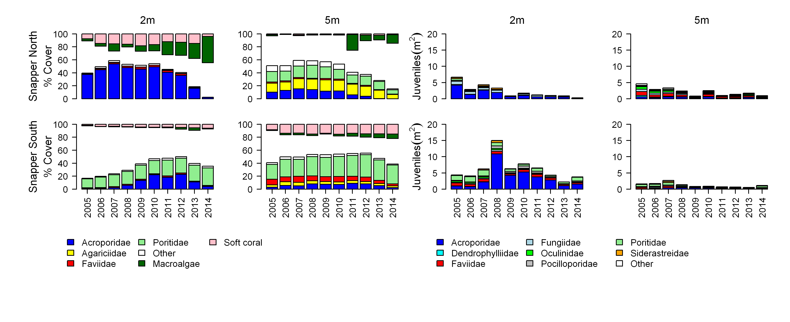
Figure A2- 4 Cover of major benthic groups and density of hard coral juveniles at each depth for reefs in the Daintree sub-region.
Cover estimates are separated into regionally abundant hard coral families and the total cover for soft corals and macroalgae (hanging). Juvenile density estimates are for regionally abundant hard coral families. Separate legends relevant groupings for cover and juvenile density estimates are located beneath the relevant plots.

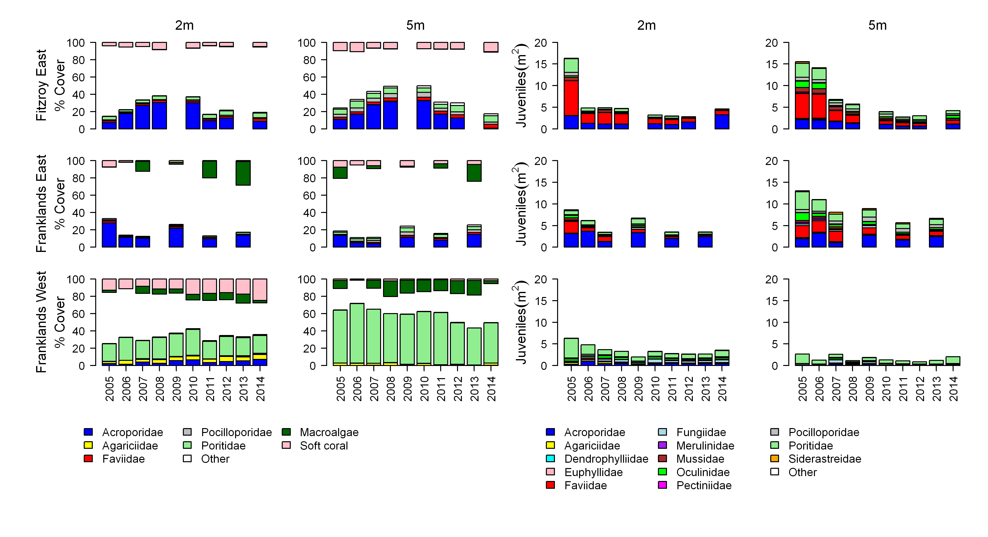
Figure A2- 5 Cover of major benthic groups and density of hard coral juveniles at each depth for reefs in the Johnstone sub-region.
Cover estimates are separated into regionally abundant hard coral families and the total cover for soft corals and macroalgae (hanging). Juvenile density estimates are for regionally abundant hard coral families. Separate legends relevant groupings for cover and juvenile density estimates are located beneath the relevant plots.

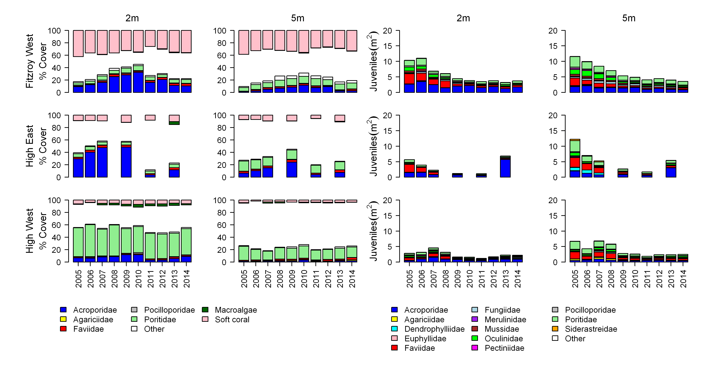
Figure A2-5 Continued.

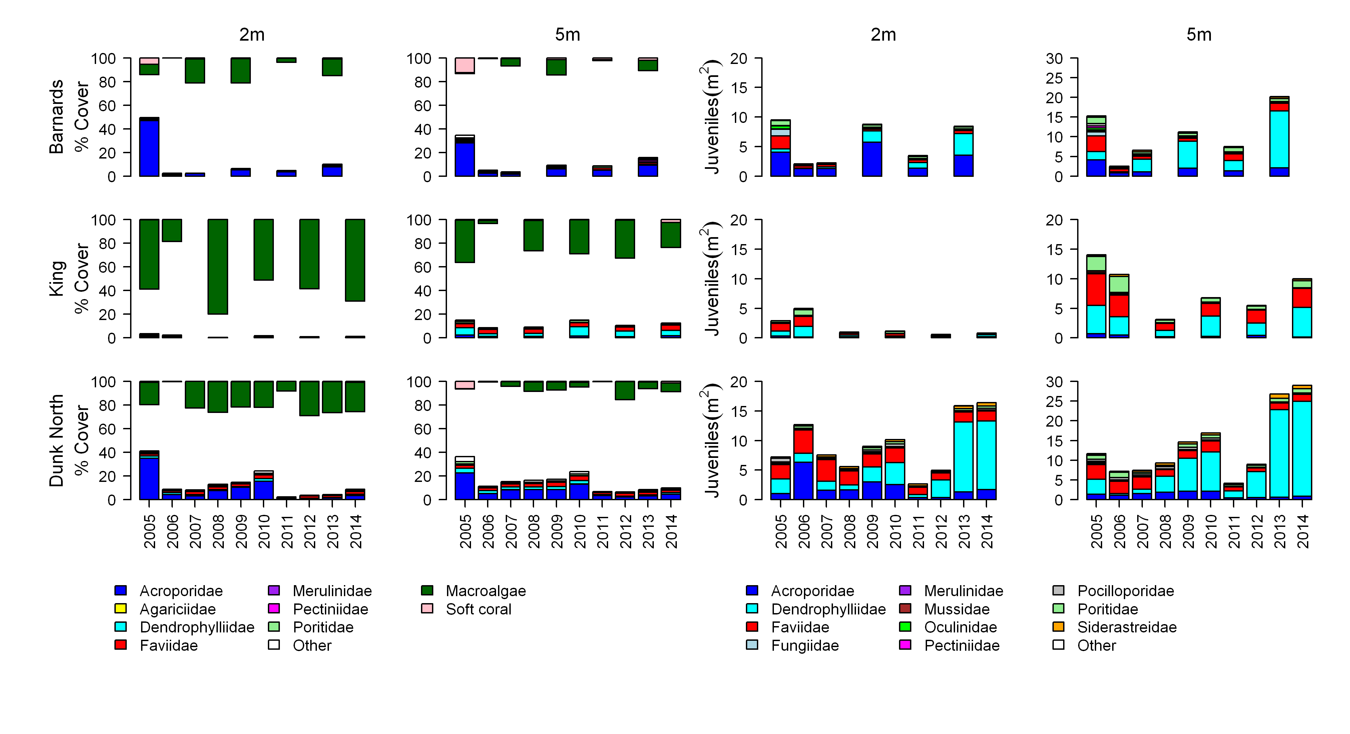
Figure A2- 6 Cover of major benthic groups and density of hard coral juveniles at each depth for reefs in the Tully sub- region.
Cover estimates are separated into regionally abundant hard coral families and the total cover for soft corals and macroalgae (hanging). Juvenile density estimates are for regionally abundant hard coral families. Separate legends with relevant groupings for cover and juvenile density estimates are located beneath the respective plots.

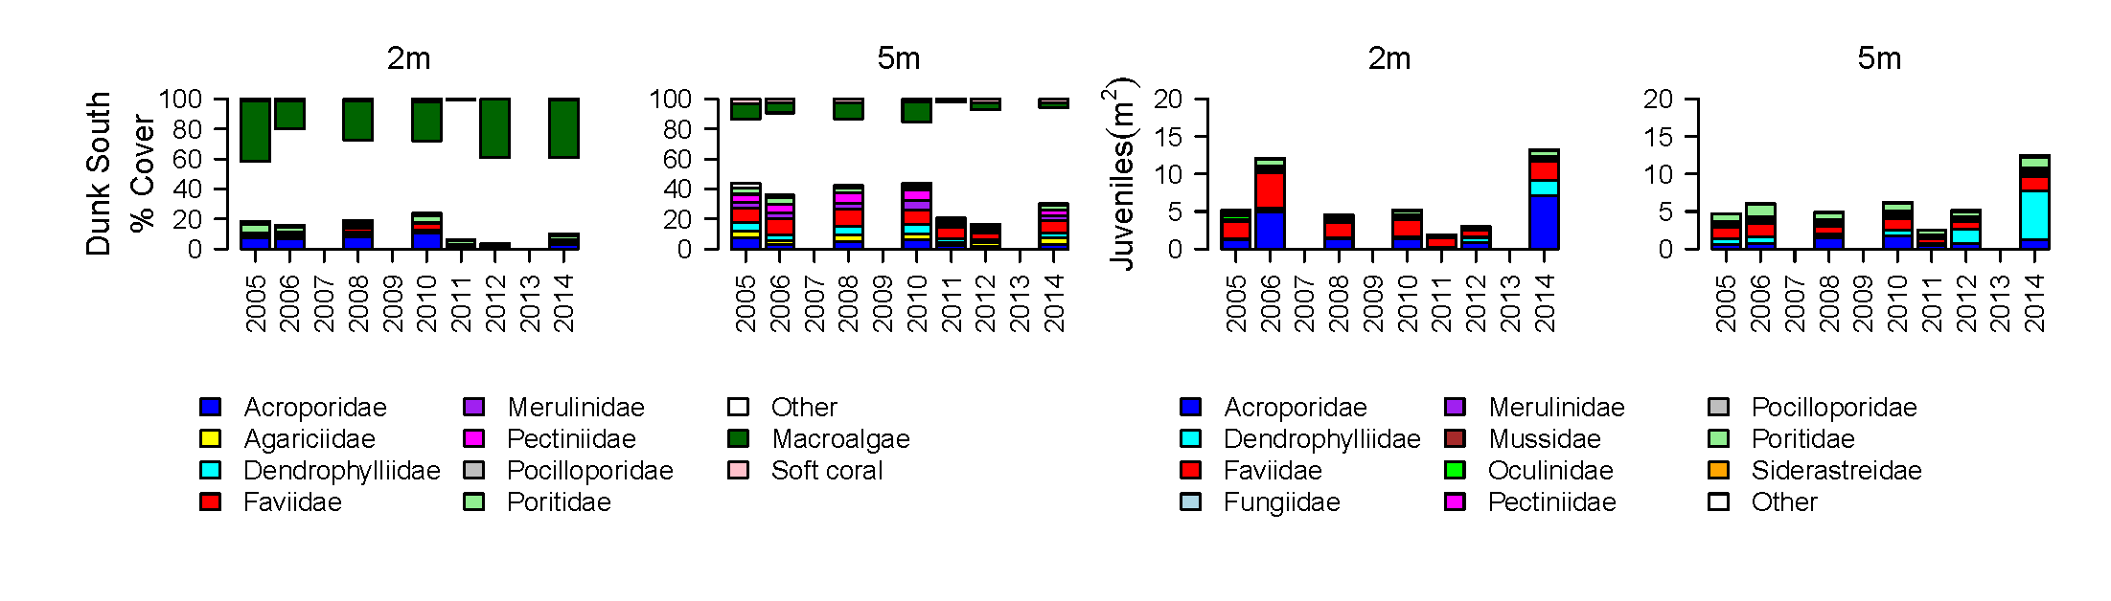
Figure A2-6 continued.

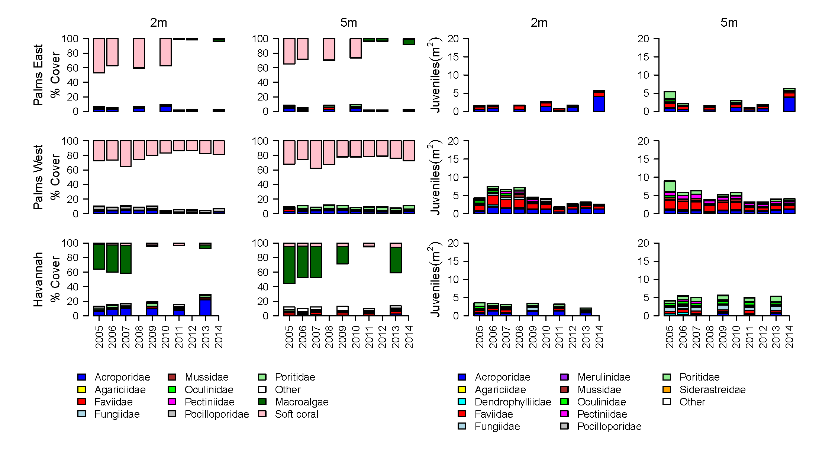
Figure A2- 7 Cover of major benthic groups and density of hard coral juveniles at each depth for reefs in the Burdekin region.
Cover estimates are separated into regionally abundant hard coral families and the total cover for soft corals and macroalgae (hanging). Juvenile density estimates are for regionally abundant hard coral families. Separate legends with relevant groupings for cover and juvenile density estimates are located beneath the respective plots.

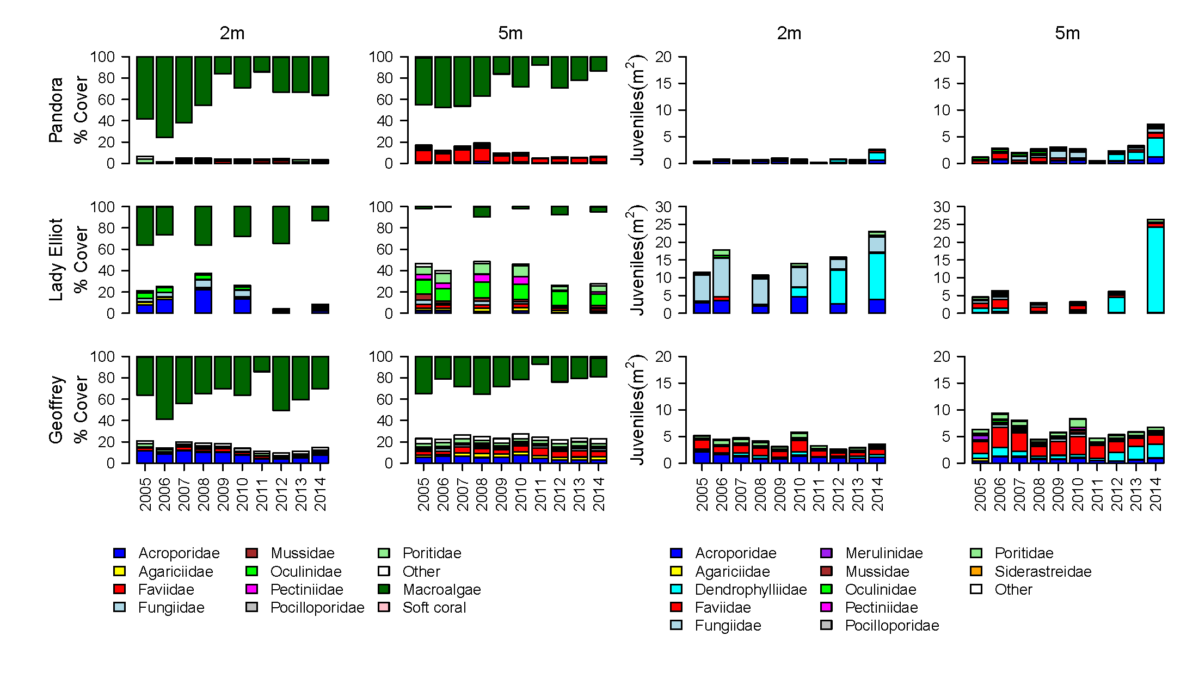
Figure A2-7 continued.

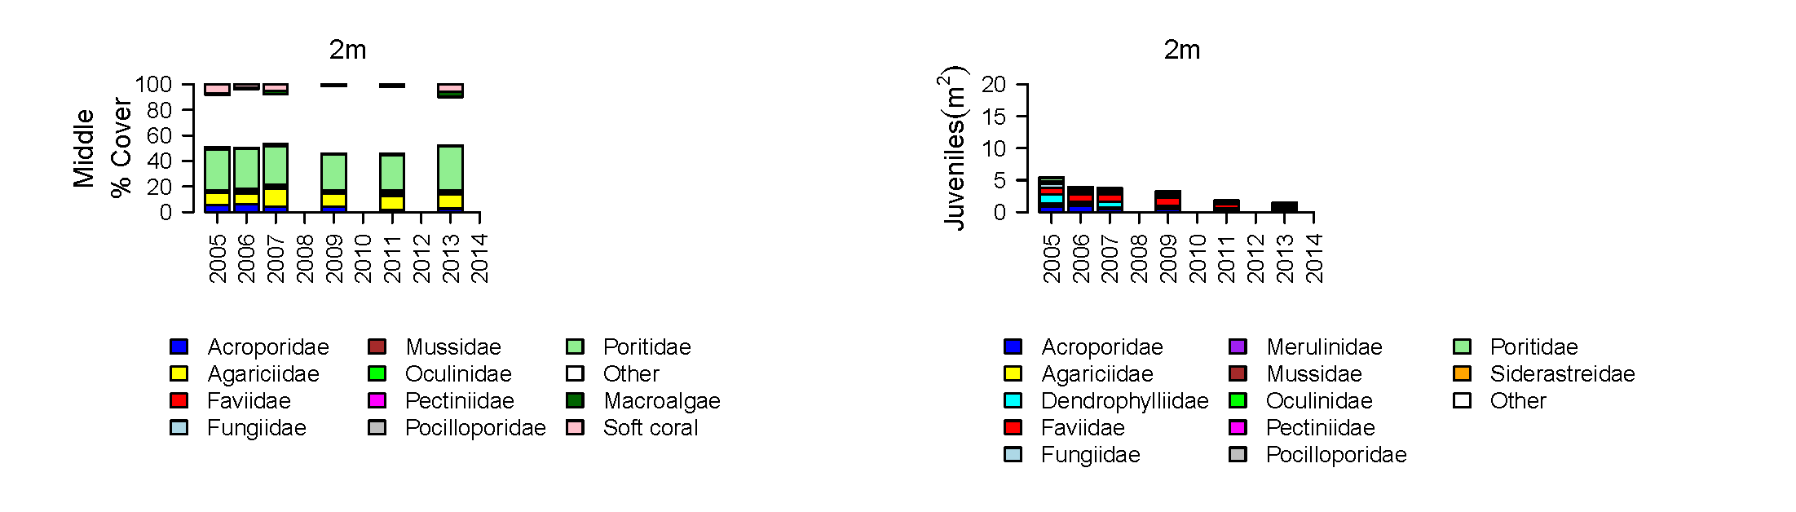
Figure A2-7 continued.

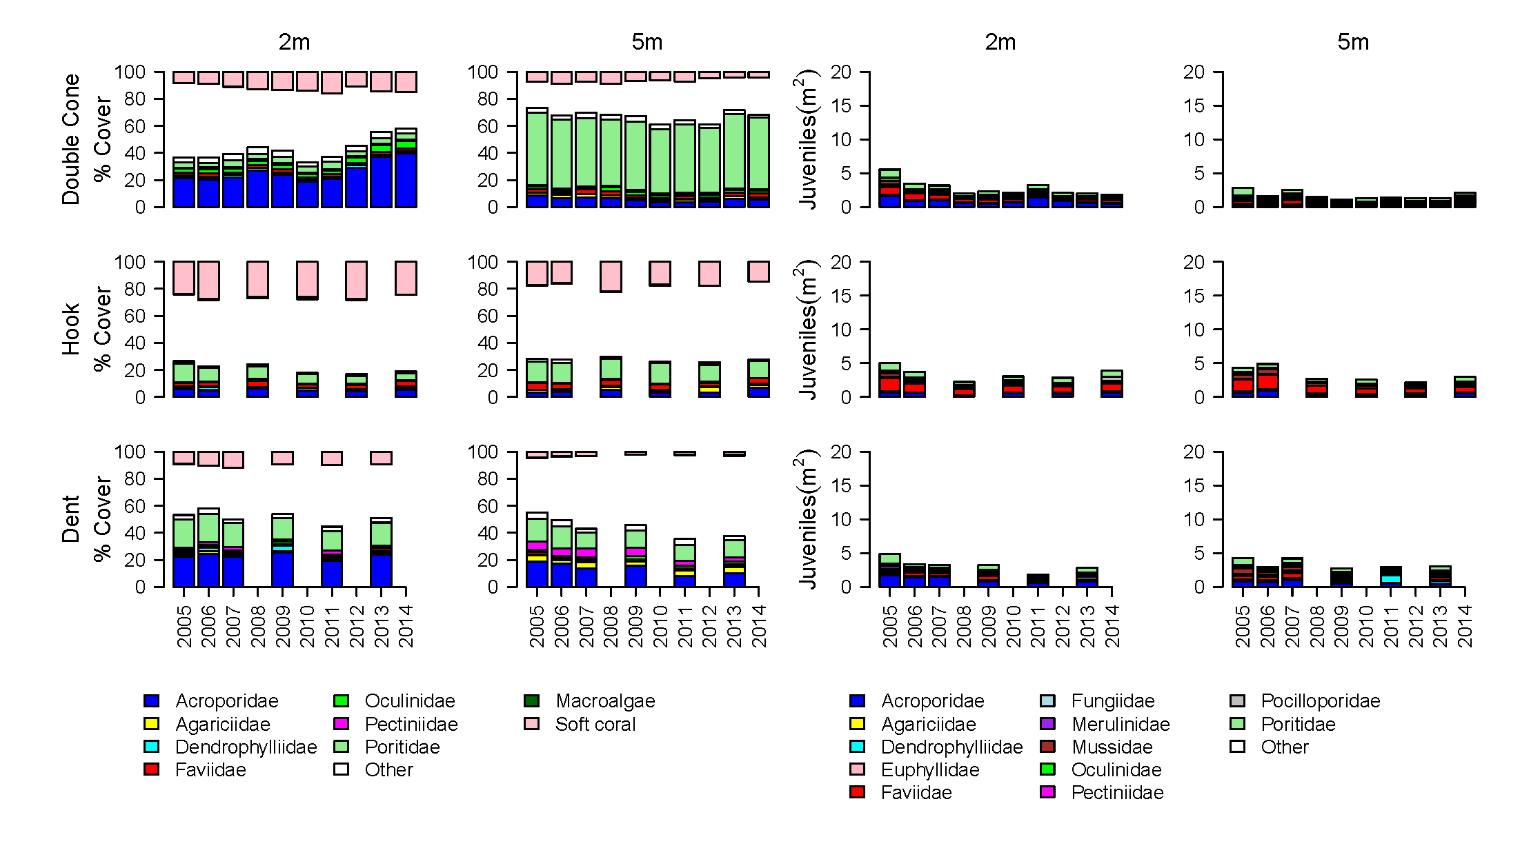
Figure A2- 8 Cover of major benthic groups and density of hard coral juveniles at each depth for reefs in the Mackay Whitsunday region.
Cover estimates are separated into regionally abundant hard coral families and the total cover for soft corals and macroalgae (hanging). Juvenile density estimates are for regionally abundant hard coral families. Separate legends with relevant groupings for cover and juvenile density estimates are located beneath the respective plots.

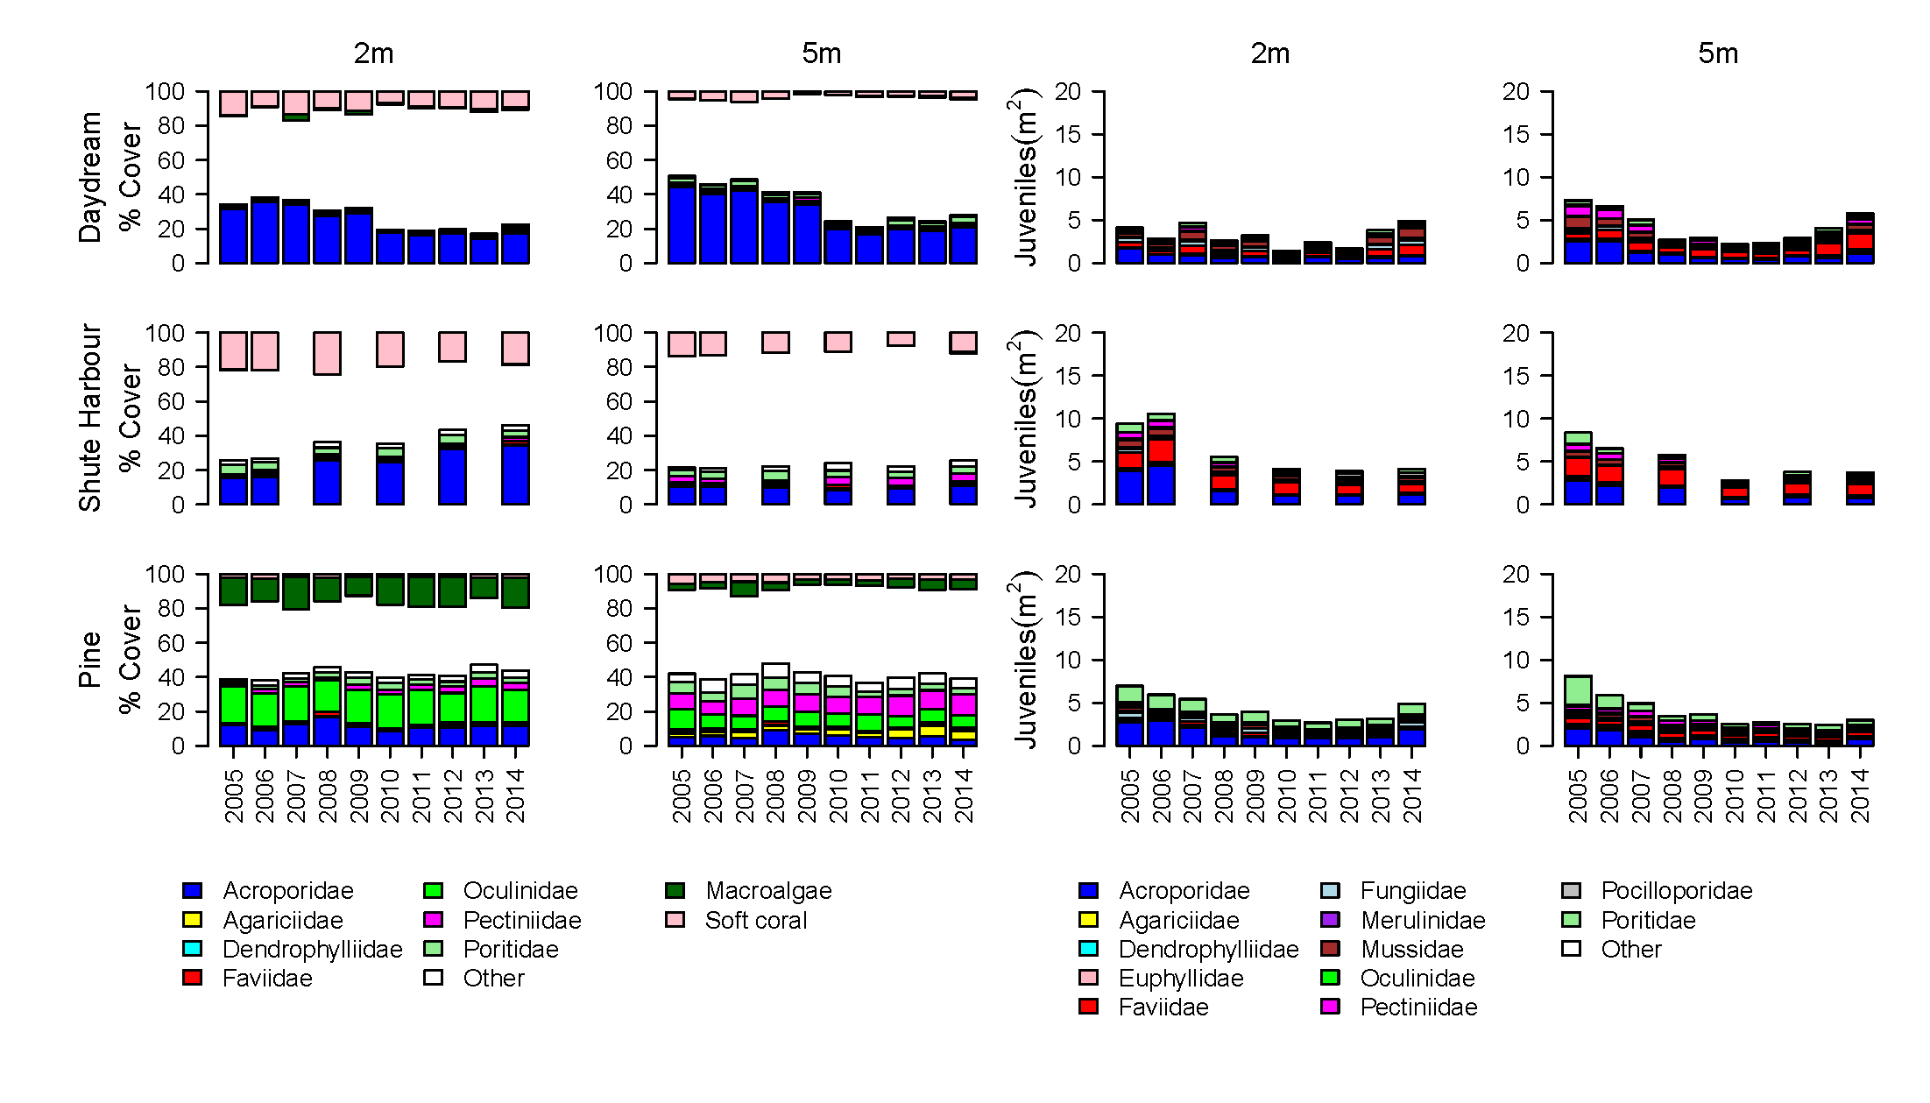
Figure A2-8 continued.

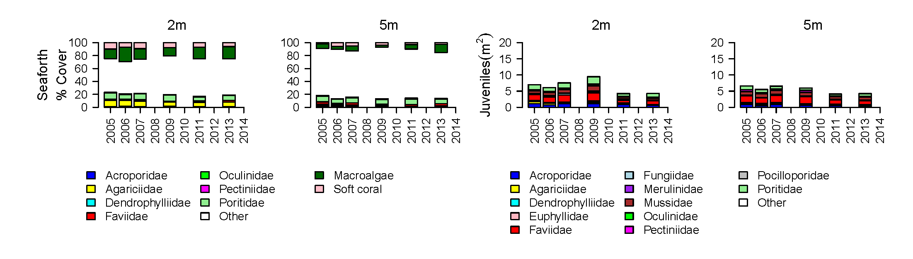
Figure A2-8 continued.

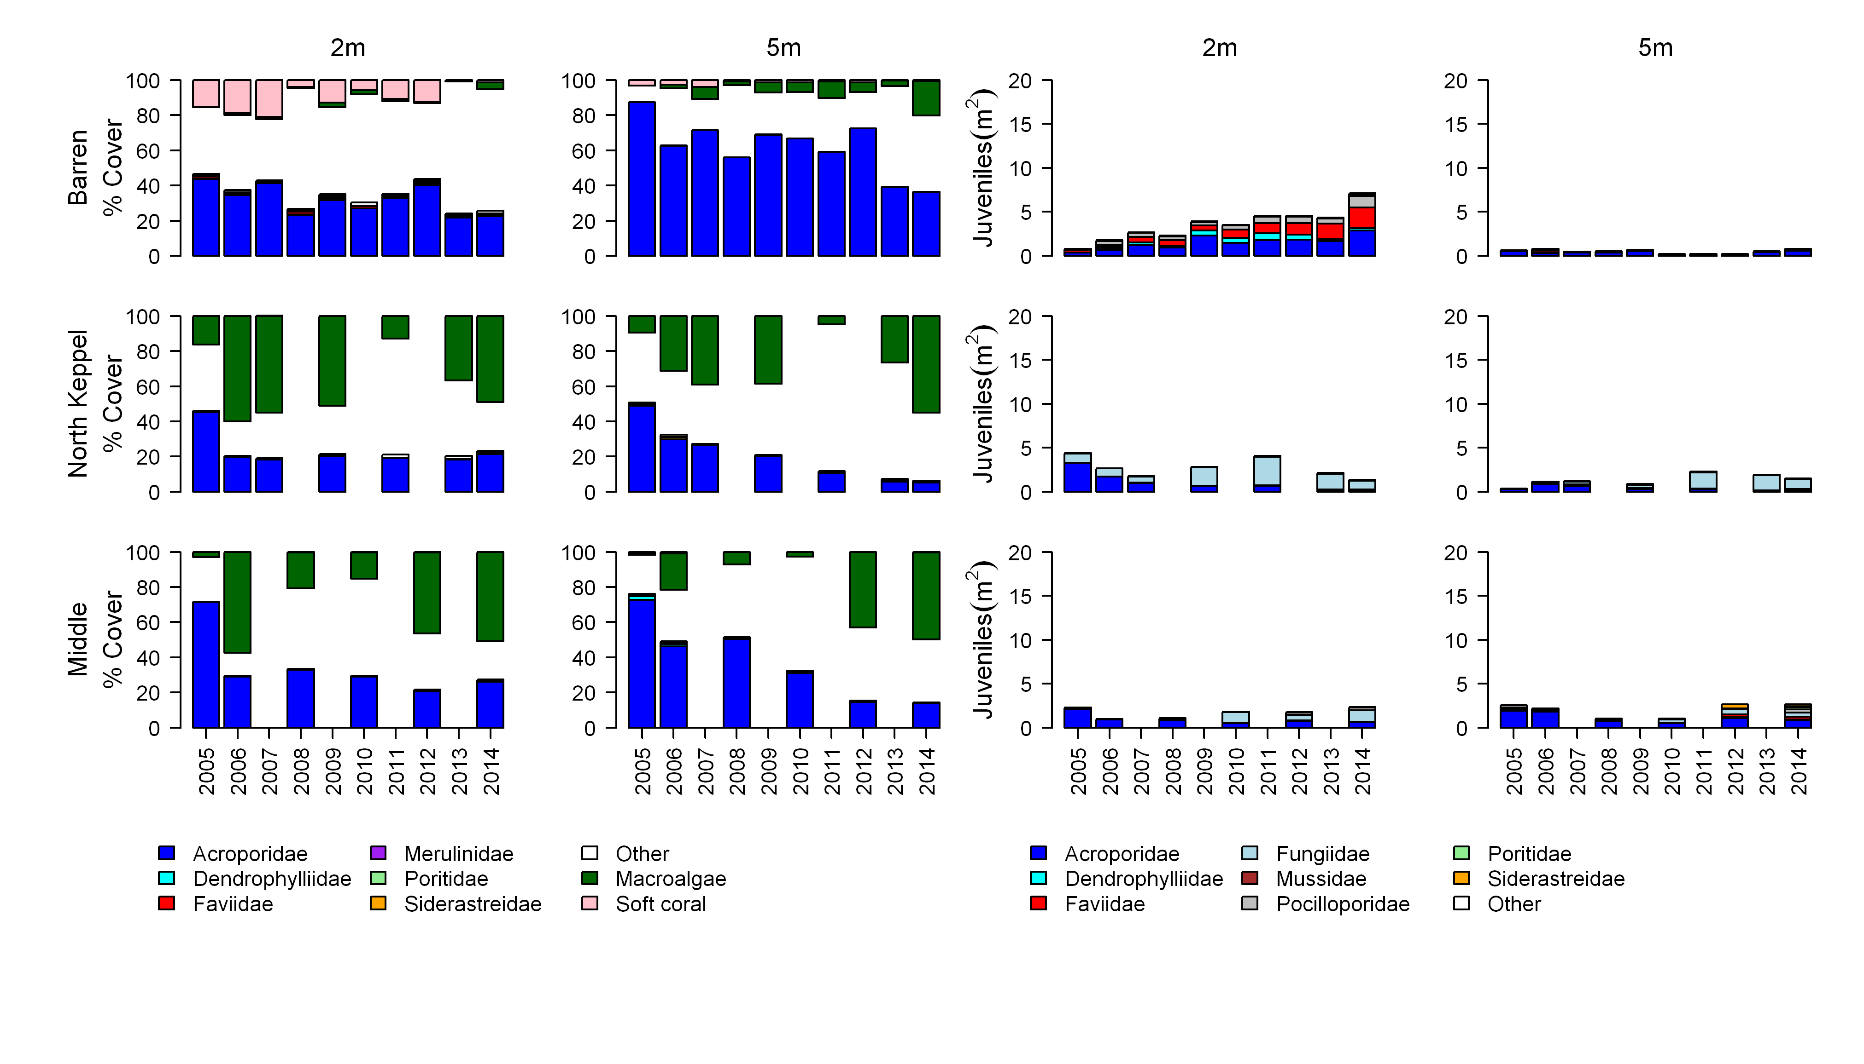
Figure A2- 9 Cover of major benthic groups and density of hard coral juveniles at each depth for reefs in the Fitzroy region.
Cover estimates are separated into regionally abundant hard coral families and the total cover for soft corals and macroalgae (hanging). Juvenile density estimates are for regionally abundant hard coral families. Separate legends with relevant groupings for cover and juvenile density estimates are located beneath the respective plots.

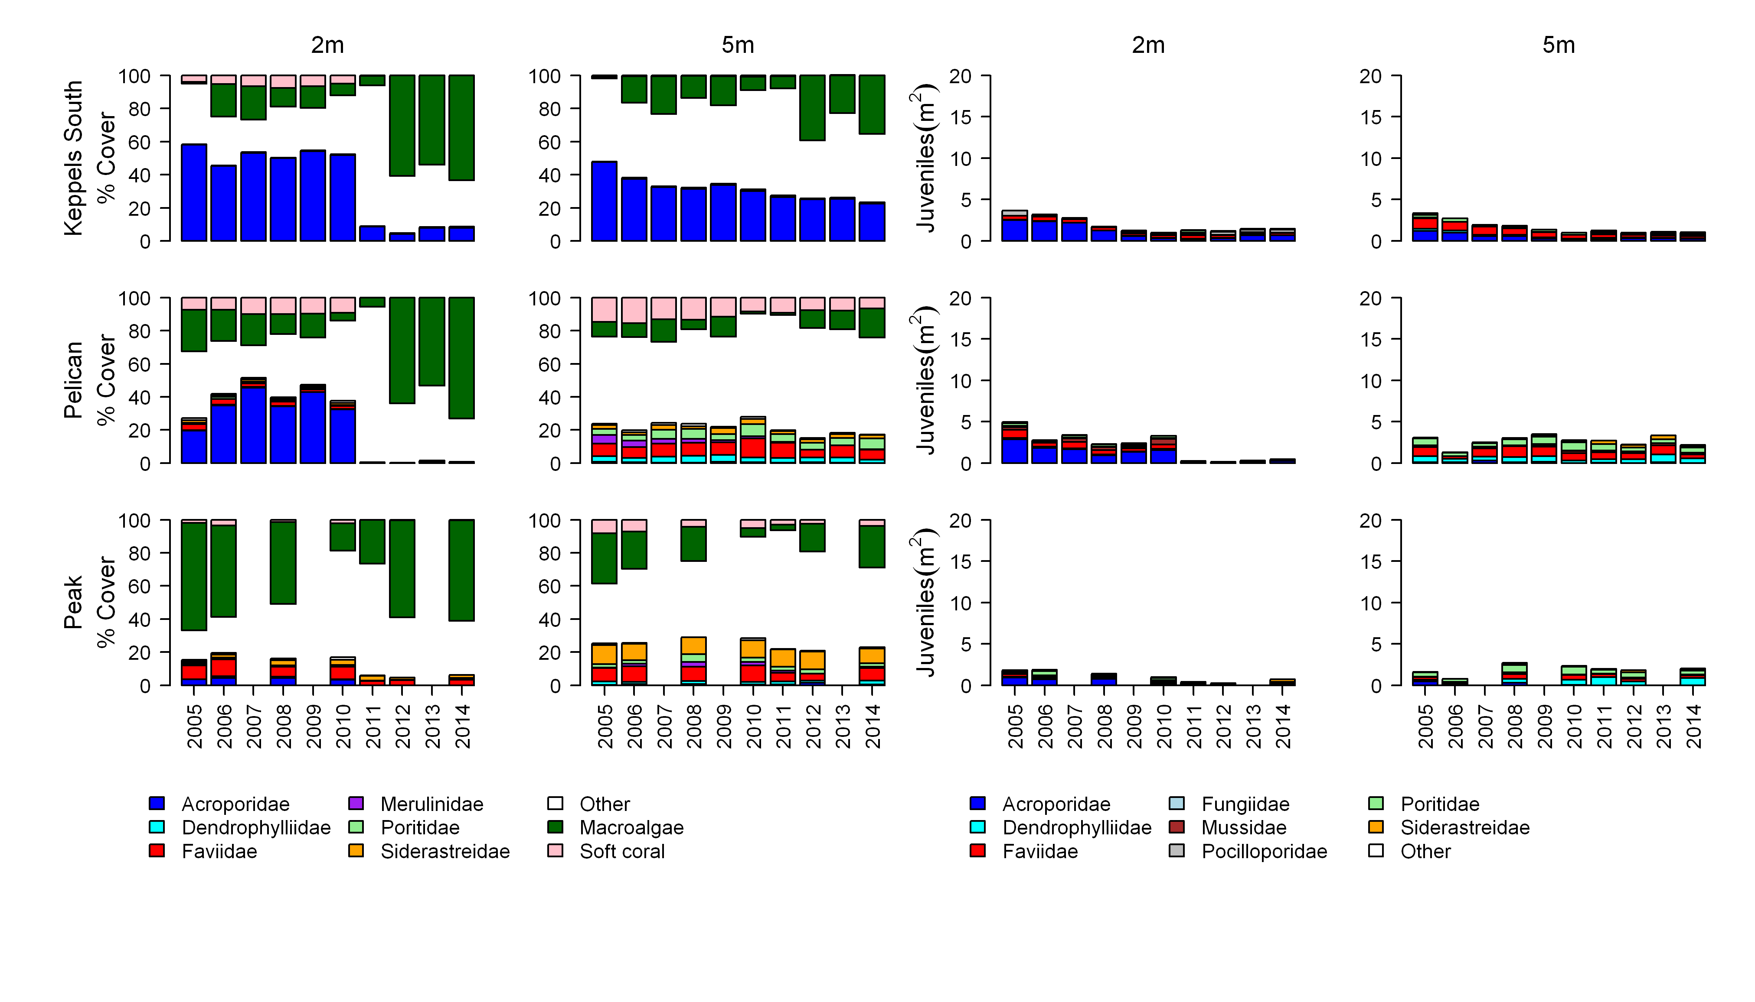Figure A2-9 continued.

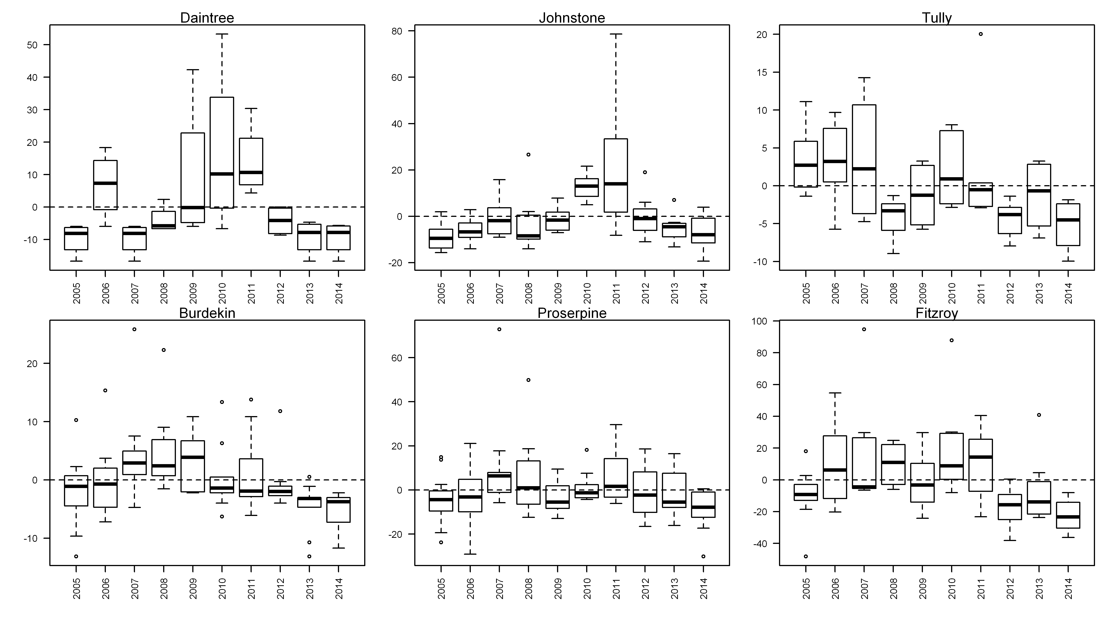
Figure A2- 10 Incidence of coral mortality.
Boxplots include the number of coral colonies suffering ongoing mortality attributed to either disease, sedimentation or ‘unknown causes’ for each reef, depth and year standardised to the reef and depth mean across years.

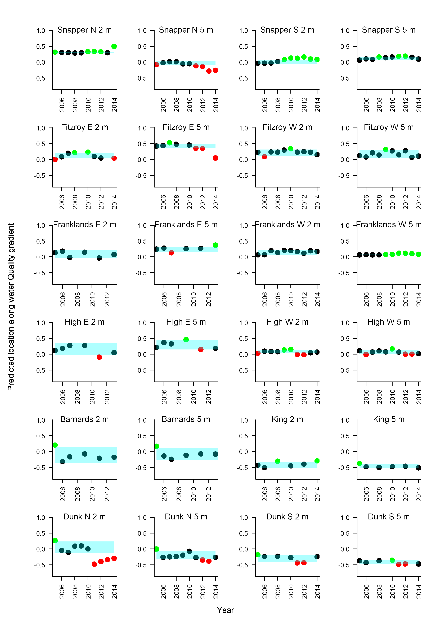
Figure A2- 11 Coral community composition index for the Wet Tropics region.
Plots show the scores for the community composition metric through time at 2m and 5m depths for individual reefs. Markers indicate the position of the coral community at each reef and depth relative to the predicted location along a water quality location and the 95% confidence intervals of this estimation (Blue shading). Green = above 95% confidence intervals, Black = within 95% confidence intervals, red = below 95% confidence intervals
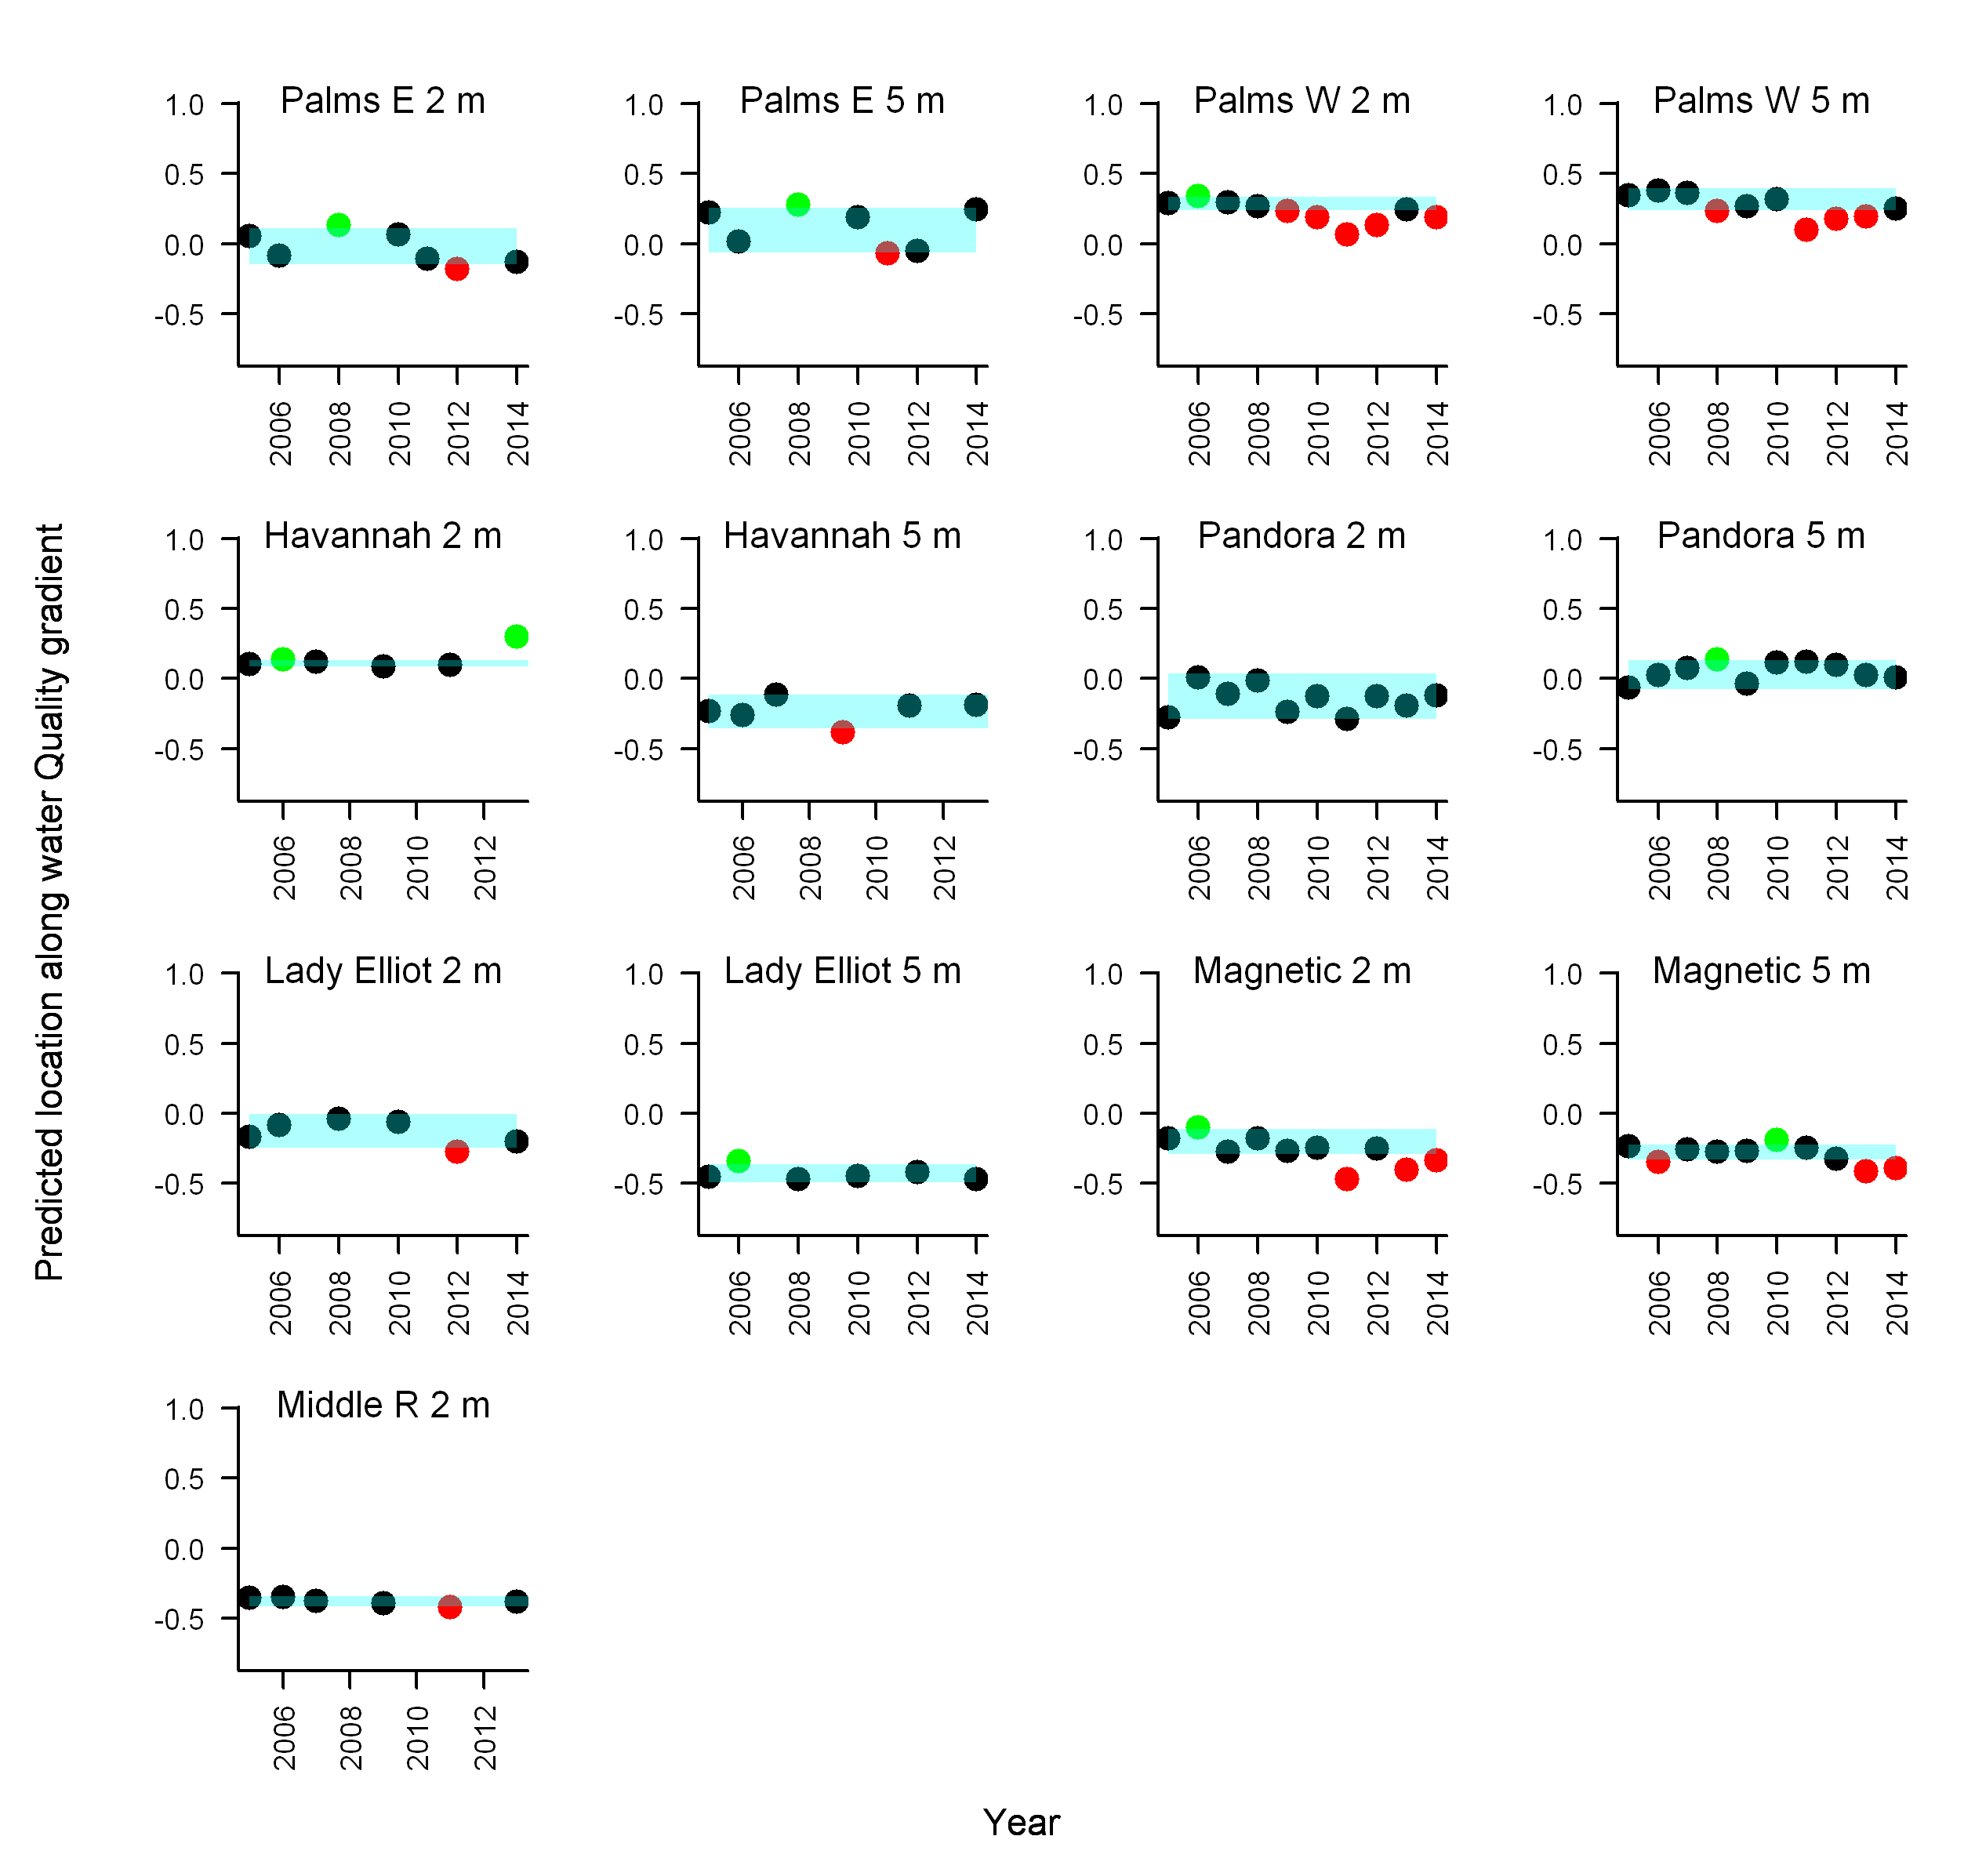
Figure A2- 12 Coral community composition index for the Burdekin region.
Plots show the scores for the community composition metric through time at 2m and 5m depths for individual reefs. Markers indicate the position of the coral community at each reef and depth relative to the predicted location along a water quality location and the 95% confidence intervals of this estimation (Blue shading). Green = above 95% confidence intervals, Black = within 95% confidence intervals, red = below 95% confidence intervals

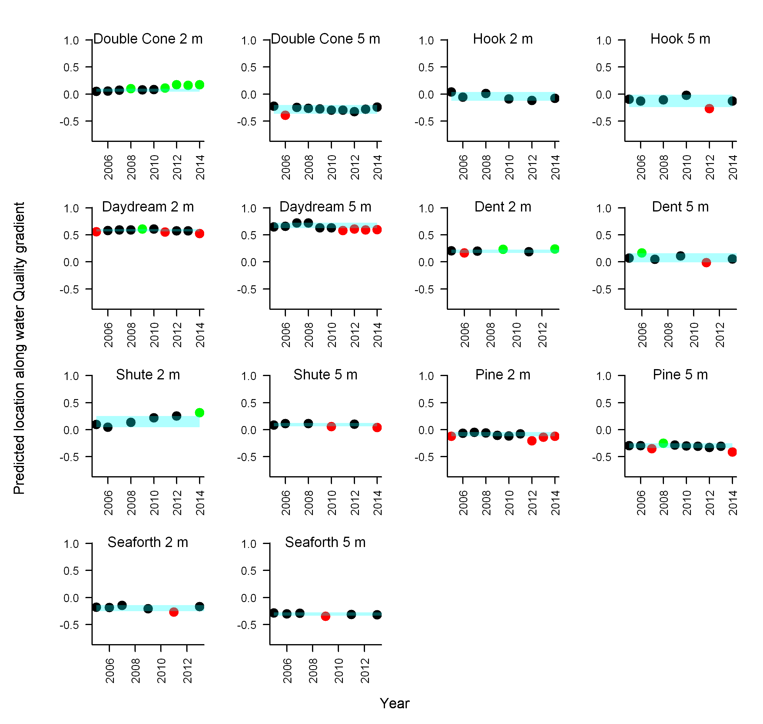
Figure A2- 13 Coral community composition index for the Mackay/ Whitsundays region.
Plots show the scores for the community composition metric through time at 2m and 5m depths for individual reefs. Markers indicate the position of the coral community at each reef and depth relative to the predicted location along a water quality location and the 95% confidence intervals of this estimation (Blue shading). Green = above 95% confidence intervals, Black = within 95% confidence intervals, red = below 95% confidence intervals.

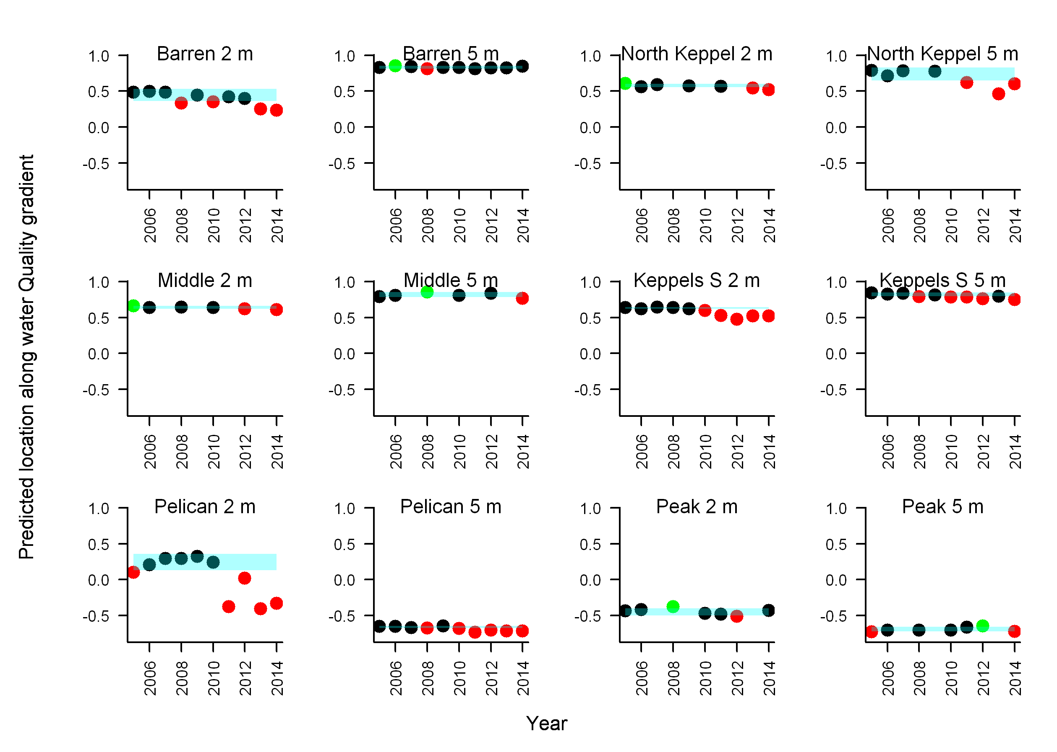
Figure A2- 14 Coral community composition index in the Fitzroy region reefs.
Plots show the scores for the community composition metric through time at 2m and 5m depths for individual reefs. Markers indicate the position of the coral community at each reef and depth relative to the predicted location along a water quality location and the 95% confidence intervals of this estimation (Blue shading). Green = above 95% confidence intervals, Black = within 95% confidence intervals, red = below 95% confidence intervals.

Figure A2- 15 Rate of coral cover change indicator estimates
Plots show the deviation in observed coral cover as a deviation from the lower (grey) and upper (white) model predicted coral cover. For each year the observations within the boxes represent the mean deviations over the past three years at each reef and depth monitored. Deviations that are below the lower confidence interval of the prediction return an indicator score of 0 - these observations will be below the zero reference line in grey boxes. Deviations that are above the upper confidence interval of the predicted cover return an indicator score of 1 - these observations will be above the zero reference line in white boxes. All other observations that are both above the reference line in grey boxes or below the reference line in white boxes, represent observations within the confidence intervals of the predicted change in coral cover and return an indicator score of 0.5.

Appendix 3: QAQC Information

Method performance and QAQC information for water quality monitoring activities

Information pertaining to quality control and assurance generally includes the assessment of the limit of detection (LOD), measurements of accuracy (e.g. using reference materials to assess recovery of known amount of analyte) and precision (the repeated analyses of the same concentration of analyte to check for reproducibility).

Limits of detection
Limit of Detection (LOD) or detection limit, is the lowest concentration level that can be determined to be statistically different from a blank (99% confidence). LOD of water quality parameters sampled under the MMP are summarised below:

Table A3- 1Limit of detection (LOD) for analyses of marine water quality parameters.

Parameter (analyte) | LOD
NO2 | 0.14 - 0.28 µg L⁻¹*
NO3+ NO2 | 0.42 - 0.56 µg L⁻¹*
NH4 | 0.70 - 0.84 µg L⁻¹*
NH4 by OPA | 0.14 µg L⁻¹
TDN | 0.42 – 0.56 µg L⁻¹*
PN | 1.0 µg filter⁻¹
PO4 | 0.62 – 0.93 µg L⁻¹*
TDP | 0.62 – 1.24 µg L⁻¹*
PP | 0.09 µg L⁻¹
Si | 1.4 – 1.96 µg L⁻¹*
DOC | 0.1 mg L⁻¹
POC | 1.0 µg filter⁻¹
Chlorophyll a | 0.004 µg L⁻¹
SS | 0.15 mg filter⁻¹
Salinity | 0.03 PSU
*LOD for analysis of dissolved nutrients is estimated for each individual analytical batch, the range given is the range of LODs from batches analysed with samples collected in 2012/13.

Precision
The variation between results for replicate analyses of standards or reference material is used as a measure for the precision of an analysis. Reproducibility of samples was generally within a CV of 20%, with the majority of analyses delivering precision of results within 10% (
)

Table A3- 2 Summary of coefficients of variation (CV, in %) of replicate measurements (N) of a standard or reference material.

Parameter (analyte) | CV (%) | N
NO2 | 3-39* | 4-6
NO3+ NO2 | 1-12* | 4-6
NH4 | 4-24* | 4-6
TDN | 5-9* | 4-6
PN | 4-6 | 6-24
PO4 | 2-30* | 4-6
TDP | 3-29* | 4-6
PP | 2 | 6
Si | 1-7* | 4-6
DOC | 2-4* | 42-49
POC | 5-8** | 8-26
Chlorophyll a | 1.6 | 22
SS | n/a***
Salinity | <0.1 | 2-5

*Precision for analysis of dissolved nutrients is estimated for each individual analytical batch, the range given is the range of CVs from batches analysed with samples collected in 2012/13.
** two different reference materials used in each batch
***n/a= no suitable standard material available for analysis of this parameter

Accuracy
Analytical accuracy is measured as the recovery (in %) of a known concentration of a certified reference material or analyte standard (where no suitable reference material is available, e.g. for PP), which is usually analysed interspersed between samples in each analytical run. The recovery of known amounts of reference material is expected to be within 90-110% (i.e. the percent difference should be ≤ 20%) of their expected (certified) value for results to be considered accurate. The accuracy of analytical results for PN, PP, POC, chlorophyll, SS and salinity was generally within this limit (Error! Reference source not found.). Analytical results for PP are adjusted using a batch-specific recovery factor that is determined with each sample batch.

Table A3- 3 Summary of average recovery of known analyte concentrations.

Parameter (analyte) | Average recovery (%) | N
PN | 101-102 | 6-24
PP | 89* | 6
POC | 97-108 | 57
Chlorophyll a | 103 | 22
SS | n/a**
Salinity | 100 | 4
*PP: data are adjusted using a batch-specific efficiency factor (recovery)
**n/a= no suitable reference material available for analysis of this parameter

The accuracy of analytical results for dissolved nutrients is being assessed using z-scores of the results returned from analysis of NLLNCT certified reference material (National Low-Level Nutrient Collaborative Trials, run every year by the Queensland Health Forensic and Scientific Services, QHFSS- AIMS is a formal participant of these trials). According to the NLLNCT instructions, accuracy is deemed good if results are within 1 z-score and satisfactory if results are within 2 z-scores. In each analytical batch, two bottles with different concentrations were analysed. In 2012/13 we used bottles #5 and #7 from Round 17 of the NLLNCT. For both the #5 bottle (lower concentrations) and the #7 bottle (higher concentrations) all nutrient analyses z-scores were within 1 z-score (Error! Reference source not found.) and, hence, accuracy was deemed good. To assure that the monitoring results were accurate, additional QAQC samples were included in all batches (e.g. in-house reference seawater that allows for batch to batch comparison, added nutrient spikes) which usually return acceptable results.

Table A3- 4 Summary of average Z-scores of replicate measurements (N) of a standard or reference material.
Accuracy of analysis of dissolved nutrients is estimated for each individual analytical batch, the range given is the range of average Z-scores from batches analysed with samples collected in 2012/13.

Parameter (analyte) | Z-score for  bottle #5 * | Z-score for  bottle #7 * | N
NOx | -0.57 to -0.29 | -0.82 to 0.78 | 3
NH4 | -0.47 to 0.15 | -0.41 to -0.21 | 3
TDN | -0.50 to 0.42 | -0.38 to 0.56 | 3
PO4 | -0.43 to 0.54 | 0 to 1.01 | 3
TDP | -0.09 to 0.47 | 0.02 to 0.56 | 3
Si | -0.97 to 0.50 | -0.4 to 0.04 | 3
* NLLNCT reference samples round 17, bottles #5 and #7 analysed with samples collected in 2012/13.

Procedural blanks
Wet filter blanks (filter placed on filtration unit and wetted with filtered seawater, then further handled like samples) were prepared during the on-board sample preparation to measure contamination during the preparation procedure for PN, PP, POC and chlorophyll. The instrument readings (or actual readings, in case of chlorophyll) from these filters were compared to instrument readings from actual water samples. On average, the wet filter blank values were below 5% of the measured values for PN and below 2% of the measured values for chlorophyll a (Chl) (Error! Reference source not found.) and we conclude that contamination due to handling was minimal.

Wet filter blanks (as well as filter blanks using pre-combusted filters) for PP and POC generally returned measureable readings, which indicates that the filter material contains phosphorus and organic carbon. The blank values are relatively constant and were subtracted from sample results to adjust for the inherent filter component.

Wet filter blanks for SS analysis (filter placed on filtration unit and wetted with filtered seawater, rinsed with distilled water, then further handled like samples) were prepared during the on-board sample preparation. The mean weight difference of these filter blanks (final weight - initial filter weight) was 0.00008 g (n=30). This value indicated the average amount of remnant salt in the filters (“salt blank”). The salt blank was about 5% of the average sample filter weight (Error! Reference source not found.). This value was included in the calculation of the amount of suspended solids per litre of water by subtraction from the sample filter weight differences.

Table A3- 5 Comparison of instrument readings of wet filter blanks to actual sample readings

 | PP  (absorbance readings) | PN  (instrument readings) | Chl  (µg L⁻¹) | SS  (mg filter⁻¹) | POC  (µg filter⁻¹)
Average of blank readings | 0.012 | 2214 | 0.006 | 0.08 | 7.75
N of blank readings | 26 | 20 | 14 | 30 | 20
Average of sample readings | 0.090 | 52961 | 0.29 | 1.48 | 28.3
N of sample readings | 466 | 495 | 492 | 496 | 469
Average of blanks as % of average sample readings | 13.2% | 4.9% | 1.5% | 5.1% | 27.4%

Validation by alternative methods

Validation of ECO FLNTUSB instrument data
Direct water samples were collected and analysed (see Appendix 1- Materials and Methods for details) for comparison to instrument data acquired at the time of manual sampling.

Turbidity was validated against suspended solids concentrations in the water column. While the turbidity loggers measure the total light absorption and scattering, are suspended solids a measure of the particle dry mass on a filter (0.4 µm pore-size). The relationship between optically measured turbidity and total suspended solids analysed on filters was good (Error! Reference source not found.), and the linear equation [SS (mgL⁻¹)] = 1.3 x FLNTUSB Turbidity (NTU)] has been used for conversion between these two variables. The equation has been the same in last three year’s estimates (Schaffelke et al. 2009, 2010, 2011). Though these relationships are valid it should be remembered that the two variables are measures of two different things which do not necessarily co-vary.

Using this equation, the SS trigger value in the Guidelines of 2.0 mg L⁻¹ (GBRMPA 2010) translates into a turbidity trigger value of 1.5 NTU.

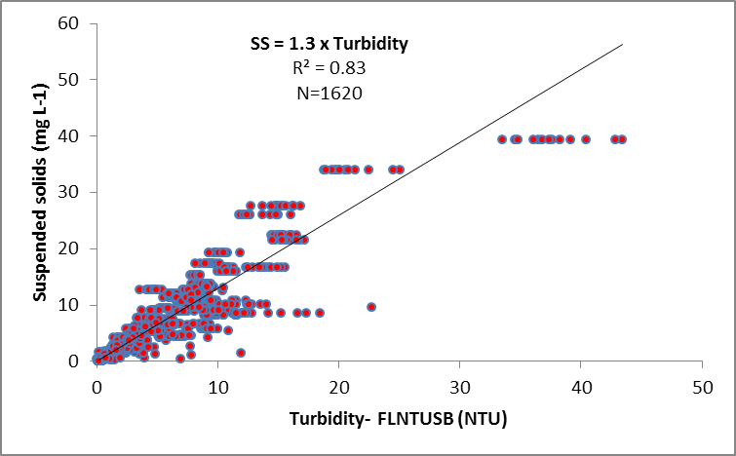
Figure A3- 1 Match-up of instrument readings of turbidity from field deployments of WET Labs Eco FLNTUSB Combination Fluorometer and Turbidity Sensors with values from standard laboratory analysis of concurrently collected water samples.

Logger-derived chlorophyll concentrations from fluorescence measurements are also correlated with manual chlorophyll values from validation samples; however, the relationship exhibited a higher degree of variability. The lower degree of correlation is due to the smaller absolute range of chlorophyll concentration variability, the inherent spatial variability (patchiness) of chlorophyll in the environment and unresolved instrumental issues with the chlorophyll sensor. Longer-term matchups showed that the two data streams produce similar temporal trends. The limitations and application of the EcoFLNTUSB instruments in the MMP were discussed in detail in Thompson et al. (2013).

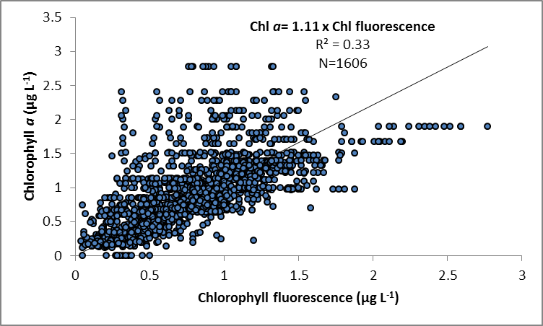
Figure A3- 2 Match-up of instrument readings of chlorophyll fluorescence from field deployments of WET Labs Eco FLNTUSB Combination Fluorometer and Turbidity Sensors with values from standard laboratory analysis of chlorophyll a in concurrently collected water samples.

Method performance and QAQC information for coral monitoring activities

Photo point intercept transects. The QA/QC for the estimation of cover of benthic communities has two components. The sampling strategy which uses permanently marked transects ensures estimates are derived from the same area of substratum each year to minimise possible sampling error. The second component is to ensure the consistency of identification of community components from digital photo images. All points are double-checked by a single observer on completion of analysis each year. This double-checking has now been done for all digital still photograph images in the database. All hard corals, soft corals and macroalgae were identified to at least genus level where image quality allowed. Other benthic groups were also checked and consistency in differentiation achieved.

Juvenile coral belt transects. Two observers collected juvenile coral count data in 2013. Data from Snapper Is was supplied by Sea Research. The Sea Research observer, Tony Ayling, is the most experienced individual in Australia in surveying the benthic communities of inshore coral reefs. Like the AIMS observers, his taxonomic skills are complete at genus level and he used the same field protocols, pre-printed datasheets and data entry programs as AIMS observers. Prior to commencement of surveys observer standardisation for Tony Ayling included detailed discussion and demonstration of methodologies with the AIMS team. While we are confident that limited bias was introduced as a result of his participation, as the focus of the program is for temporal comparisons any bias between Tony Ayling and AIMS observers will not manifest in temporal comparisons at Snapper Is. All other reefs were surveyed by an experienced AIMS staff member. It must be acknowledged however that for some of the smallest size class <2cm identification to genus is impossible in the field, though for the most part this is the case for relatively rare taxa for which reference to nearby larger individuals cannot be made. All data are entered into the database and rechecked against field data sheets.

Appendix 4: Scientific publications and
presentations associated with the Program 2013-14

Publications

Fabricius KE, De’ath G, Humphrey C, Zagorskis I, Schaffelke B (2013) Intra-annual variation in turbidity in response to terrestrial runoff on near-shore coral reefs of the Great Barrier Reef. Estuarine, Coastal and Shelf Science 116: 57-65
Furnas M, Schaffelke B, McKinnon AD (2014) Selective evidence of eutrophication in the Great Barrier Reef: Comment on Bell et al. (2014). Ambio 43(3): 377-378
Thompson A, Brando VE, Schaffelke B, Schroeder T (2014) Coral community responses to declining water quality: Whitsunday Islands, Great Barrier Reef, Australia. Coral Reefs 33:923-938
Uthicke S, Furnas M, Lønborg C (2014) Coral Reefs on the Edge? Carbon Chemistry on Inshore Reefs of the Great Barrier Reef. PLoS ONE 9(10): e109092
Presentations:

None in this year

http://www.environment.gov.au/marine/gbr/reef2050
Connie 2.0, CSIRO Connectivity Interface, http://www.csiro.au/connie2/

