
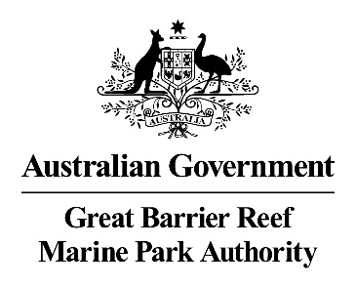

Stewardship for the
Great Barrier Reef:
A review of concepts and definitions of stewardship for the Great Barrier Reef.

Dyer, M¹., Newlands, M²., Bradshaw, E³., and Hernandez,S.^{1,2}
¹Great Barrier Reef Marine Park Authority, Townsville, Queensland
² School of Social Science, James Cook University, Queensland
³ Monash University, Victoria.

© Commonwealth of Australia 2021
Published by the Great Barrier Reef Marine Park Authority
ISBN 9780648753179

The Great Barrier Reef Marine Park Authority acknowledges the continuing sea country management and custodianship of the Great Barrier Reef by Aboriginal and Torres Strait Islander Traditional Owners whose rich cultures, heritage values, enduring connections and shared efforts protect the Reef for future generations.

This document is licensed for use under a Creative Commons By Attribution 4.0 International licence with the exception of the Coat of Arms of the Commonwealth of Australia, the logos of the Great Barrier Reef Marine Park Authority and James Cook University, any other material protected by a trademark, content supplied by third parties and any photographs. Read licence conditions.

This report should be cited as:
Dyer, M., Newlands, M., Bradshaw, E., and Hernandez, S. (2020) Stewardship in the Great Barrier Reef: A review of concepts and definitions of stewardship in the Great Barrier Reef applied to Reef health, Great Barrier Reef Marine Park Authority, Townsville (42pp).

Acknowledgement: This work was undertaken by the Great Barrier Reef Marine Park Authority and James Cook University, School of Social Science.
We’d like to express our thanks to the Great Barrier Reef Foundation for their collaboration and feedback on this project. We would also like to thank Great Barrier Reef Marine Park Authority staff and our external reviewers for their review and feedback.
Disclaimer: While all efforts have been made to verify facts, the Great Barrier Reef Marine Park Authority takes no responsibility for the accuracy of information supplied in this publication.
Aboriginal and Torres Strait Islander readers are advised this publication may contain names and images of deceased persons.

Front cover image: The Whitsundays. © Commonwealth of Australia (GBRMPA), photographer: Chris Jones.

Comments and questions regarding this document are welcome and should be addressed to:
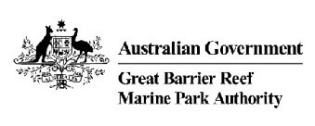
Great Barrier Reef Marine Park Authority
280 Flinders Street
(PO Box 1379)
Townsville QLD 4810, Australia

Phone: (07) 4750 0700
Fax: (07) 4772 6093
Email: info@gbrmpa.gov.au
www.gbrmpa.gov.au

Executive summary
The Great Barrier Reef (the Reef) and its outstanding universal value is core to Australia’s identity (Goldberg et al. 2018). However, threats to the health and values of the Reef are multiple, cumulative and increasing (Great Barrier Reef Outlook Report 2019). The Reef is protected and managed using a range of statutory and non-statutory instruments. Stewardship activities form part of these non-statutory activities, leveraging partnerships between community members, government agencies, stakeholders and Traditional Owners. The concept of stewardship is promoted as a way to achieve human-environment harmony, and to mitigate, avoid and repair some threats to Reef health and values.
In this report, we identify and describe the use of ‘stewardship’ in academic and some grey literature for the Reef. We found that stewardship in the Reef describes action, education, values, engagement, communication, conservation, protection and sustainable use programs and activities. It is applied at different social scales – from individuals, social groups, communities, organisations to governments; as well as spatial scales from bioregion to national borders and global imaginings. It is often used within the context of applied projects which have demonstrable and measurable objectives, but similarly is used to describe activities that lead to or enable applied projects or are assumed to eventually do so.
Our report found that this broad range of activities labelled ‘stewardship’ did not match formal definitions in which stewardship is often defined very narrowly as ‘action’. Therefore, a gap exists between concept and intention regarding what is meant by the term stewardship. This report proposes a definition of stewardship that includes three components encompassing activities designed to engender stewardship thinking, to build capacity for stewardship as well as stewardship as action. In order to understand the broader range of activities occurring that are already being labelled stewardship in the Reef, we suggest a typology which allows activities to be evaluated in their own right – that is, their success in achieving their stewardship purpose rather than against an assumed link to an environmental outcome for which there is no evidence. The purpose of this definition and typology is to enable articulation and then evaluation of stewardship activities against their purpose and ultimately against the larger goal of improved Reef health values.

Key findings

- There is no Great Barrier Reef specific conceptual framework and typology of stewardship.
- Stewardship as a concept for the Reef is applied to on-ground action, as well as motivational and capacity components of stewardship programs. In particular communication is linked to outreach and behaviour change.
- Stewardship is described in the literature with three interrelated components that are often considered separately: (1.) Motivations, plus (2.) Capacity, plus (3.) Action.
- Within the Reef specific document set, stewardship was viewed as a management tool by which environmental outcomes can be achieved. This management focus for stewardship is stronger in the Great Barrier Reef literature than in the non-Reef literature on stewardship.
- The link between stewardship activities that seek to influence motivation, build capacity and on-the-ground action and environmental outcomes are mostly hypothesised or assumed and rarely established empirically.
- There is a suggested disconnect between social research and natural research outcomes for stewardship.

Contents

Executive summary 2
Key findings 3
Section 1: Introduction 6
Report context 6
Report objectives 7
Out of scope 7
Limitations 7
General background 8
Stewardship background in the Great Barrier Reef Marine Park and World Heritage Area 9
Section 2: A thematic approach to understanding stewardship in the Great Barrier Reef. 11
Methods: 11
Step 1A: Systematic review of academic literature 11
Step 1B: Review grey literature 12
Step 2: Thematic analysis in Nvivo 12 plus 13
Results 14
Section 3: Discussion 17
Definition of stewardship 18
Conceptual framework of stewardship purpose in the Great Barrier Reef 18
Conclusion 21
Remaining questions 21
Literature cited 22
Appendix 1: A selective overview of the history of environmental stewardship. 24
Global to local stewardship instruments and conventions 24
Global environmental stewardship 24
Ownership and stewardship of the seas 25
Governments and environmental stewardship 25
Non-governmental organisations (NGOs) and environmental stewardship 26
Private sector and environmental stewardship 26
Appendix 2: Marine stewardship in a global context 28
Appendix 3: Summary of literature review 30
Step 1: Literature review 30
Step 1A: Systematic review academic literature 30
Step 1B: Review grey literature 31
Relationship between themes 37
Thematic diversity within document characteristics 37
Results 39

Figures
Figure 1: Schematic representation of methods used in this report. This schematic shows the links and reasoning between creating a typology for stewardship activities. 11
Figure 2: Great Barrier Reef Marine Park Authority annual reports and the number of times the word ‘stewardship’ is mentioned. Note 1978 to 1994 presented as one data point with zero mentions. 17
Figure 3: Stewardship defined through three components – motivations, capacity and action – equals stewardship. 18
Figure 4: Bennett et al. (2018) analytical framework for local environmental stewardship 19
Figure 5: Conceptual framework and typology for stewardship efforts in the Great Barrier Reef 20

Tables
Table 1: Inclusion and exclusion criteria for academic literature included in the systematic review. 12
Table 2: Uncleaned search terms and returns per term after removing duplicates across all databases 12
Table 3: Inclusion and exclusion criteria for grey literature included in the review. 13

Section 1: Introduction

Report context
The impetus for this report came from two related sources. First, an informal initial scan of materials – academic and grey (peer and non-peer reviewed) literature – relating to stewardship for the Great Barrier Reef (the Reef). The scan revealed a dearth of evaluation or outcome linked information, coupled with frequency of use of the word ‘stewardship’ in the Reef context. This was backed by anecdotal evidence amongst peers that the term stewardship seemed to be used to refer loosely to a variety of things to do with people and Reef. The second related incentive for the report was a desire to be able to evaluate the social and environmental outcomes of all these things being called stewardship. We hypothesise that applying the term stewardship broadly and loosely makes stewardship outcomes difficult to evaluate.

Previous work in this area, outside of the Reef specific literature, has drawn similar conclusions. Bennett et al (2017) developed a detailed local environmental stewardship framework in which stewardship was strictly defined as ‘actions’, with other components that supported, enabled or created capacity for stewardship. They concluded:

…there is an array of external interventions that target different leverage points to promote and facilitate environmental stewardship. Yet it is often unclear the extent to which these different programs, policies or market mechanisms are effective at enhancing stewardship outcomes (p. 12).

Bennett et al’s. (2017) review of local environmental stewardship found that, ‘many of the interventions focus not on promoting specific actions but rather on stewardship supporting activities’ (Bennett et al. 2017: p. 11). Further they found that:

…all stewardship interventions should be considered a work in progress, which require continual monitoring, evaluation and adaptation. The effectiveness of these different interventions and leverage points needs to be better understood and tested empirically, to understand whether they are actually supporting or undermining local stewardship efforts.

Our rationale for this report is to begin to address these issues by building on previous frameworks, in particular Bennett et al. (2017) and apply them to a Reef context.
This report aims to understand: What is stewardship for the Great Barrier Reef? We see this as a necessary foundational step in clarifying what stewardship is and what it does for the Great Barrier Reef. We conducted a systematic literature review of Reef specific peer reviewed academic literature, supplemented with a small subset of grey literature. From the results we formulate a suggested definition of stewardship consisting of three inter-related parts. Using this definition we then propose a typology of stewardship as a way of categorising the different components of stewardship to enable more distinct evaluation efforts.

Report objectives
Our objectives are:
- Identify the conceptual underpinnings of the term stewardship in and outside the Reef context
- Understand and describe the context of how the term stewardship is used in the Reef
- Provide a conceptual framework and typology for stewardship efforts in the Reef.

Out of scope
We do not conduct an audit of all Reef activities, projects and programs under the label stewardship. We are more concerned here with how to define and classify stewardship to lead towards evaluation, management effectiveness and Reef health.
Any evaluative process is beyond the scope of this project. We do not further the evaluation of a stewardship program and the tools required to monitor and evaluate data collection. While we recognise the necessity of doing this, we argue that it cannot be done until there is agreement about how stewardship is defined and what it encompasses and who is enacting what. We do not attempt to identify key actors/groups/organisations in the Reef relevant to stewardship programs.
Great Barrier Reef Traditional Owners have clearly articulated the necessity of Traditional Owner ontological foundations for Sea Country management for many decades. Indigenous-based and Sea Country related stewardship was excluded from our final dataset. Our recommendation for Traditional Owner stewardship is in line with their articulated aspirations for a Traditional Owner-led process building on previous extensive work by Traditional Owners in the Reef Region. We excluded Indigenous-based and Sea Country related stewardship to avoid imposing western scientific conceptions of stewardship over Indigenous ontology of Traditional Owner relationships with Sea Country.

Limitations
- The review of the literature regarding stewardship was restricted to Reef specific literature related to Reef health. For example, if literature referred to activity in the Reef catchment, but was not specifically about Reef health outcomes, then it was excluded. A general broader selective review of general literature on stewardship was undertaken for context and comparison, but not included in the analysis in order to form a picture of Reef specific stewardship literature. Further work could broaden the scope to include the many activities taking place in the catchment and broader Region.
- The review of grey literature in this report is limited — this is due to narrowly applied review parameters. A broader review of the grey literature is needed in the future.
- Articles were included in review only if they used the term stewardship. Other terms may have been used that encompassed the concepts described as stewardship but did not use the label, have not been included. The rationale for this exclusion is our interest in how the term stewardship is being used.
- Scale: We do not address issues of scale, either social or environmental. While addressing issues of socio-environmental scale is beyond the scope of this report, this seems a logical next step in this work.

General background
Stewardship is claimed as a method for engaging actors across all dimensions of environmental use to improve overall social-ecological system health (Millennium Declaration; Trombulak & Baldwin 2010). The dictionary definition of stewardship is: ‘the conducting, supervising, or managing of something especially: the careful and responsible management of something entrusted to one’s care’. Increasing bodies of evidence substantiate that the manner of human interaction with the natural world is causing ecosystem degradation with ultimate negative effects on human well-being. This has catalysed the emergence of ecological and conservation science which seeks to understand and follow the connections between changes in different parts of ecosystems, including, at the largest scale, the earth’s biosphere (for example: Rockstrom et al. 2009; Steffen et al. 2015; O’Neill et al. 2018). The dominance of human causes of this change has given rise to labelling the earth’s current geological era as the ‘Anthropocene’ – a geological epoch defined by significant change to the planet’s biosphere functions as a result of human activity (Crutzen 2006; Steffen et al. 2007; Lewis & Maslin 2015). Consequently, the health of the biosphere depends on changing human patterns of environmental use.

The Great Barrier Reef Outlook Report 2019 concluded that climate change ‘is escalating and is the most significant threat to the region’s long-term outlook’ (v). The report states that global action to mitigate climate change will support local management actions. Such an effort requires a shift in attitude to human interaction with the environment on a global scale.

Modern-day concepts of environmental stewardship broadly encompass fostering human-nature relationships that are healthy for people and the environment. Environmental stewardship is advocated in the Millennium Declaration as ‘a role every morally decent person ought to adopt towards nature…without specific appointment, [or] remuneration’ (paraphrased in Welchman 2012: p. 5). The United Nations Environment programme mission is ‘to provide leadership and encourage partnership in caring for the environment by inspiring, informing, and enabling nations and peoples to improve their quality of life without compromising that of future generations’.
Conceptually, environmental stewardship seeks to harmonise human-nature relationships. Environmental stewardship activities are claimed to shift negative environmental attitudes by elevating and promoting a sense of care and responsibility for environmental values (Trombulak & Baldwin 2010).
While there are some variations on notions of environmental stewardship, most share common concepts:
- Preserving instrumental environmental services for human use
- Preserving non-instrumental use value also – spiritual, historical, cultural, scientific, aesthetic
- Intergenerational equity – balance of future generation rights and current use
- Voluntary action.
In general, these concepts of stewardship align to two broad goals:
1. Nature conservation
For example: ‘Restoration and preservation of habitats and ecosystems as ends in themselves, irrespective of economic and social consequences.’ (Gray 2007: pp. 786-787)
2. Sustainable development
For example: ‘The aim of a sustainable stewardship is to maintain an ecosystem capable of providing a range of ecosystem services now and in the future’. (Scharin et al. 2016) And, that:
...views protection of habitats and ecosystems as a means towards the fulfilment of economic and social objectives laid down by society; nature protected to maintain ecosystem services. (Gray 2007: p. 787)
Some stewardship conceptual frameworks combine both theoretical definitions. For example, Bennett et al. (2018) propose the following definition for local environmental stewardship:
The actions taken by individuals, groups or networks of actors, with various motivations and levels of capacity, to protect, care for or responsibly use the environment in pursuit of environmental and/or social outcomes in diverse social–ecological contexts.
Bennett et al. (2018) include both conservation and sustainable use and limit the definition of stewardship to actions only. Their list of activities which can be considered stewardship include:
- Creating protected areas
- Replanting trees
- Limiting harvests
- Reducing harmful activities or pollution
- Creating community gardens
- Restoring degraded areas
- Purchasing more sustainable products.
All stewardship frameworks we found make a distinction between stewardship as a concept – an ethic of caring for the environment and stewardship action. Yet in our literature review, we found very few definitions of stewardship. Instead, there seemed to be some fuzziness between stewardship as a concept and stewardship as action. We explore this further in the results section.

Stewardship background in the Great Barrier Reef Marine Park and World Heritage Area
The Great Barrier Reef (the Reef) was declared a World Heritage Area in 1981 because of its ‘Outstanding Universal Value’. This recognised the Reef as being one of the most remarkable places on earth. Natural and heritage values are given formal protection through Australia’s legal system. The Marine Park is governed by the Great Barrier Marine Park Act (1975). The main objective of the Great Barrier Reef Marine Park Act is to: ‘provide for the long term protection and conservation of the environment, biodiversity and heritage values of the Region’. The other objectives of the Great Barrier Reef Marine Park Act (listed below), are subject to this first object of the Act. Therefore, these secondary objectives are only to be pursued so far as they are consistent with ‘long term protection and conservation of environment, biodiversity and heritage’ of the Great Barrier Reef Region. Other objectives of the Great Barrier Reef Marine Park Act are:
- Ecologically sustainable use, including:
    - Public enjoyment and appreciation
    - Public education and understanding
    - Recreational, economic and cultural activities
    - Research
- Encourage engagement in the protection and management of the Great Barrier Reef Region
- Meet Australia’s World Heritage responsibilities.
The Great Barrier Reef Marine Park Act is administered by a Commonwealth regulatory statutory authority, the Great Barrier Reef Marine Park Authority (the Authority). The Reef 2050 Long-term Sustainability Plan is the Australian and Queensland government’s overarching framework for protecting and managing the Great Barrier Reef to 2050. The Reef 2050 Plan’s 2018, Good Practice Management for the Great Barrier Reef and Net Benefit Policy provide principles around how to achieve positive, collective approaches to improving the health of Great Barrier Reef values. These provide the broader policy context in which stewardship can operate to achieve outcomes. The Net benefit policy specifically refers to stewardship as one of these tools.

There are many active stewardship programs for Reef protection. For example, the Authority’s Reef Guardians program which ‘recognises the good environmental work undertaken by communities and industries to protect the Great Barrier Reef and works closely with those who use and rely on the Great Barrier Reef’, or its catchment. The Authority also has Local Marine Advisory Committees running since 1999, which ‘enable local communities to have effective input into managing the Marine Park and provide a community forum for interest groups, government and the community to discuss issues around marine resources, to help build a healthier and more resilient Reef’. As well as partnership programs like Master Reef Guides designed to inform and engage people in loving the Reef. These are just some examples of stewardship focused programs for the Reef. There are many more. We do not undertake to list them comprehensively in this report. The Great Barrier Reef Foundation (2020) Community Reef Stewardship Desktop Audit Report – Stage I and II have started this audit work.

Section 2: A thematic approach to understanding stewardship in the Great Barrier Reef.
Our approach to understanding stewardship in the Reef began with a systematic review of Reef-specific stewardship literature and an analysis of a sample of grey literature that met a set of predefined characteristics. Methods for this study are outlined here with details presented in Appendix 3.

Methods:
We followed a two-stage process to develop tools for classifying and evaluating concepts and definitions of stewardship in the Reef academic and grey literature (Figure 1).
Step 1: Document sourcing
  - A systematic review of academic (i.e. published, peer-reviewed) literature
  - Snow-ball collation of grey (i.e. published, but not necessarily peer-reviewed) literature

Step 2: Qualitative thematic analysis
We used the results of this analysis to understand the use of the term stewardship within the context of the Reef and develop a typology of stewardship efforts.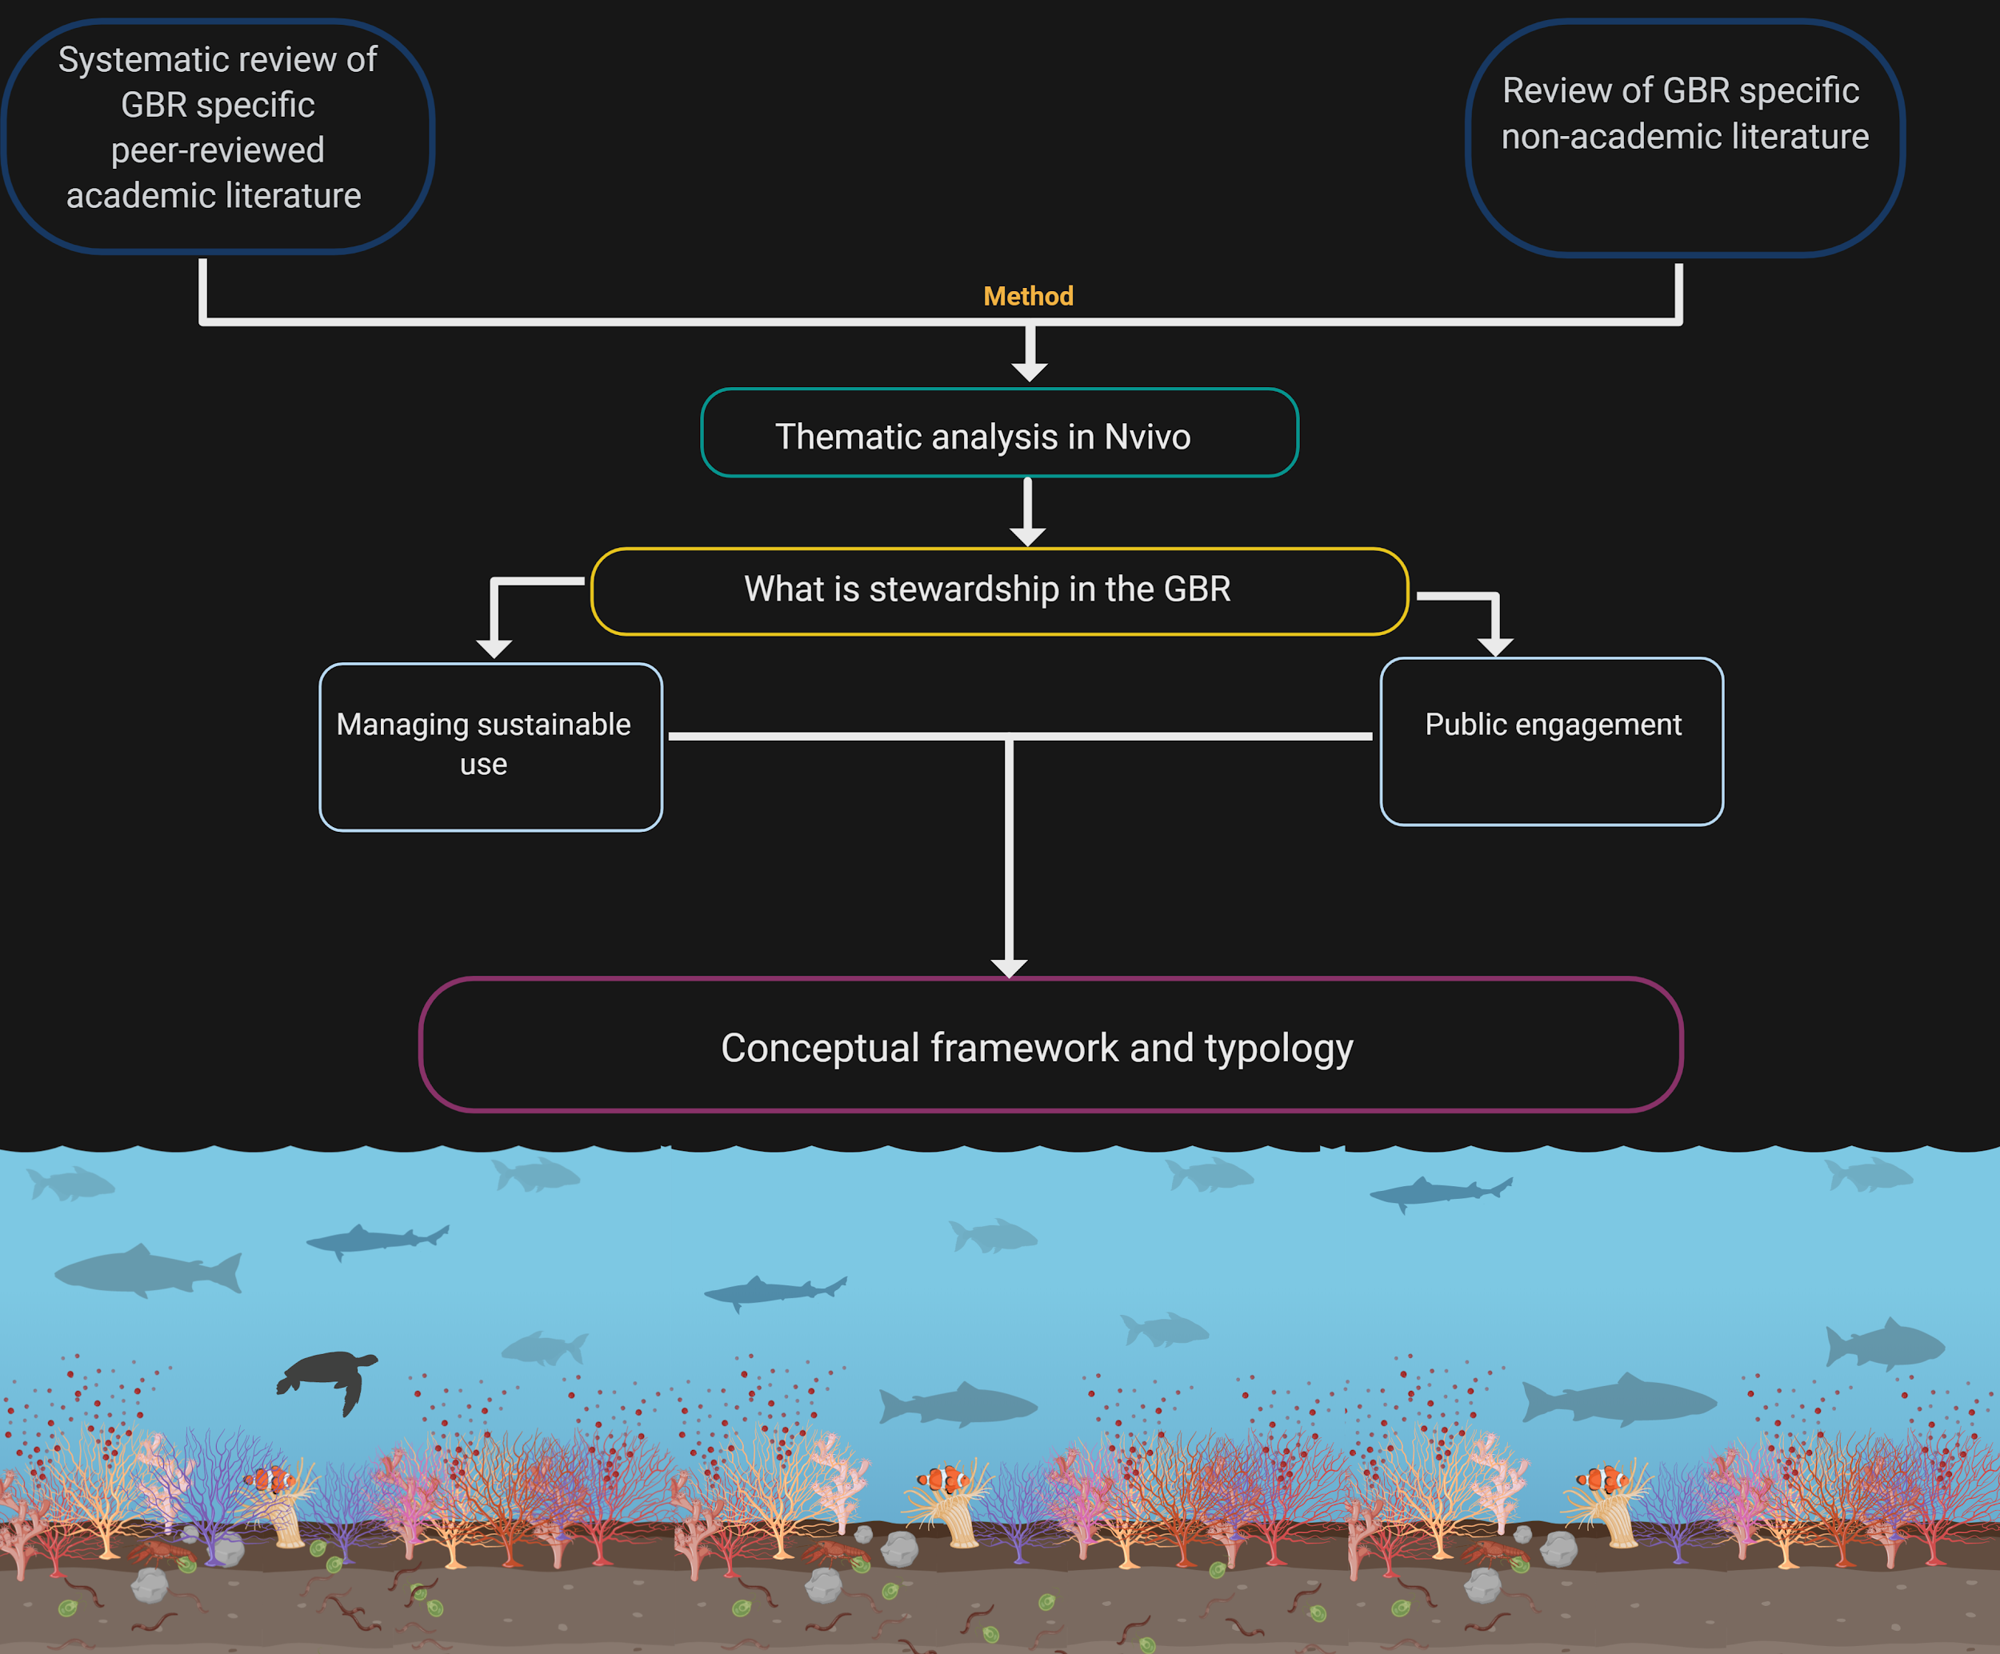
Figure 1: Schematic representation of methods used in this report. This schematic shows the links and reasoning between creating a typology for stewardship activities.

Step 1A: Systematic review of academic literature
We systematically reviewed the academic literature relating to stewardship in the Reef. In February 2020, we searched the Web of Science, Scopus and ProQuest online databases for articles published between 2010 and 2019. Specific inclusion and exclusion search criteria and search terms included in Table 1 and Table 2.
We classified literature as Reef specific when the stated purpose of the stewardship being described was Reef specific and for the purpose of Reef health. This included water quality directly related to Reef health outcomes. This means that land-based activities are included, but only if their purpose is explicitly Reef health. Other stewardship activities occurring in the catchment for other ecosystem component health, for example soil fertility, or animal habitat protection, were not included. We also excluded the body of literature relating to fisheries and stewardship, usually labelled ‘marine stewardship’ and mostly relates to commercial fisheries Marine Stewardship Council certification (for more details see Appendix 1).

Table 1: Inclusion and exclusion criteria for academic literature included in the systematic review.
Inclusion | Exclusion
Published from 1 Jan 2010 – 31 Dec 2019  Great Barrier Reef specific  Stewardship activities (even if they occur on land) must be concerned with marine/ocean or sea health  Term stewardship used | Published prior to 2010  Marine generally – not Great Barrier Reef specific  Stewardship activities are land-based and not directly about Reef health  No stewardship label/language/term usage  Stewardship activities are Indigenous-based / Sea Country  Marine Stewardship Council certification

Table 2: Uncleaned search terms and returns per term after removing duplicates across all databases
Search term | Results
“Ecosystem stewardship” AND marine | 46
Stewardship AND “Great Barrier Reef” | 27
Stewardship AND marine | 141
Marine environments sustainable stewardship | 5
Ocean AND stewardship | 25
Stewardship AND human dimensions | 2
TOTAL | 246

Following this return, we excluded non-ecological topics, including chemistry, engineering, and food science, and non-English language. Indigenous-based and Sea Country related stewardship was also excluded from our final dataset. Final cleaning removed articles with the term stewardship but no actual stewardship content and/or non-Reef specific stewardship. Following these exclusions, 13 academic articles were included in our final analysis and migrated into NVivo for thematic analysis.

Step 1B: Review grey literature
We identified an initial list of 24 grey literature articles. We then applied the inclusion and exclusion criteria described in Table 3 to exclude ill-fitting documents. Our inclusion criteria were documents that were Reef specific, had a conceptual notion, not necessarily applied approach, government documents from Reef related institutions, non-government reports and within the time frame of 2010 to 2019. Similar to our exclusion criteria for academic journal articles we excluded government related brochures, fisheries, Indigenous, and grant guidelines. This returned five grey literature articles for analysis.
We conclude the following concern with the small sample size: while there is a lot of grey literature that uses the word stewardship, many of these are brochures, program guidelines, activity descriptions and grant guidelines. These were not included in our dataset because they gave no conceptual frameworks, methods for program evaluation, or reporting on the outcomes of their stewardship activities. That is, reported activities or programs that might include what we define as stewardship but were not substantive, were excluded. These are worthy of follow up study but are out of scope for this report. Detailed summaries for the initial literature sweep are available in Appendix 2.
Table 3: Inclusion and exclusion criteria for grey literature included in the review.
Inclusion | Exclusion
Published from Jan 1 2010 – 31 Dec 2019 | Published prior to 2010
Government documents, non-government organisation reports, websites | Academic journal articles, government-related brochures, fisheries only, Indigenous literature, and grant and call for paper literature.
Great Barrier Reef specific | Marine generally – not Great Barrier Reef specific
Stewardship activities (even if they occur on land) must be concerned with marine/ocean or seas health. | Stewardship activities are land-based and not directly about Reef health
Term stewardship used | No stewardship label/language/term usage

Step 2: Thematic analysis in Nvivo 12 plus
We used a document analysis procedure in NVivo 12.0, qualitative analysis software (Bazeley & Jackson 2013). To allow us to compare documents, we categorised literature according to relevant characteristics and then themes. Literature was attributed grey or academic, review or original research (academic only) and for both academic and grey whether stewardship was defined.
All literature was thematically coded. Thematic analysis is an iterative process by which an initial thematic set is developed inductively as themes emerge from the literature and deductively, pre-defined themes being tested for. Phrases or sentences are assigned codes in the text of the document set. Coding is refined with reflection and development as more literature is coded. Articles were coded thematically for stewardship: focus, concepts, theoretical basis, descriptive content, methodology, actors, spatial scale and social scale. There were 60 initial themes identified (see Appendix 3) which were then consolidated into 11 final thematic categories: activity, behaviour, governance, communication, methodology, research, industry, social, place, theory, and nature. These final 11 themes were decided inductively by higher order grouping of the initial 60 themes. We explore these themes in relation to the document characteristics described above (Appendix 3) and use this analysis to inform our recommendations (Discussion).

Results
We identified 18 documents for use in our analysis, 13 academic articles and five grey literature. This small document set reflects the published academic literature and the available grey literature that conceptually deal with stewardship in the Reef with a Reef health focus. We discuss below definitions of stewardship – the formal statement of the meaning of the word and concepts of stewardship – the abstract idea or general notion or belief of what something is about.
Defining stewardship
Most of the articles in our document set did not define stewardship, that is, they did not state what the word stewardship means. Three academic articles and one grey literature article defined stewardship.
The grey literature paper with a definition provided a two part definition:
Values and attributes:
Stewardship refers to the values held by individuals, communities, corporations and government organisations, as well as the actions of those bodies. (Myers et al. 2012)
And how those values and attitudes translate to actions:
Stewardship is the actions taken by individuals, groups or networks, with various motivations and levels of capacity, to protect, care for or responsibly use the environment in pursuit of environmental or social outcomes in diverse social-ecological contexts. (Myers et al. 2012)
Only three academic articles clearly articulated a definition of stewardship. Of those that did, the definitions were about the relationship between attitudes and conservation. For example:
Stewardship is shared responsibility towards protecting the quality of the marine environment… Stewardship refers to not only the values held by individuals, communities, corporations and government organisations; but the actions carried out by those bodies. (Liburd 2017)

Further, that stewardship is the:
…caring and loyal devotion to an organisation, institution, or social group. The concept of stewardship thus puts emphasis on the people involved in conservation efforts, their personal values and dynamic interrelation. (Liburd 2017)
Concepts of stewardship
We identified three categories of stewardship conceptualisation (what stewardship is about): 1. Conservation 2. Sustainable use 3. Combination of conservation and sustainable use. Our dataset contained sources that viewed stewardship in all three of these conceptual approaches.
Stewardship concept | Grey | Academic
Nature conservation | 4 | 7
Sustainable use | 1 | 0
Both | 0 | 5

Five of the 13 academic articles use stewardship to mean a combination of nature conservation and sustainable use. These ‘combination concept’ articles also contained sub-themes such as well-being, partnerships, individuals, policies, programs, and tourism. The top most frequently five coded themes for scientific conservation concept articles were: management, the Great Barrier Reef Marine Park Authority, education, community, climate change and activity. This means that these articles see stewardship as about conservation of nature and are focussed on management and outreach. In our dataset no academic articles use stewardship within the concept of only sustainable use of natural resources. However, this is most likely due to the deliberate exclusion of sustainable fishing from our dataset, which is its most frequent use in the Great Barrier Reef.
Four grey literature papers conceptually use stewardship as conservation. Thematically these papers emphasised activities for conservation and also concepts related to attitudes, behaviours, education, communication and engagement.

Relationships between themes
We explored the similarity between themes across the entire document set using Pearson’s correlation coefficient (diagram in Appendix 4). This is a statistical measure which determines the association between variables of interest. The most commonly related themes were methodology and activity, and also communication and behaviour. This finding relates to document focus. That is, articles describing activities were concerned with methodology – how those activities were carried out. While articles concerned with communication were concerned with outreach and behaviour change. From a thematic analysis perspective, these results show that different literature is focussing on different components but everything is being called stewardship.
It is interesting to note that there is a negative correlation coefficient between the words ‘nature’ and ‘social’. A negative correlation means that one variable increases whenever the other decreases. In this context, whenever the term ‘nature’ was used within our sample, the term ‘social’ was less abundant. This points to a possible disconnect between social research and natural research outcomes for stewardship. This reflects a broader disciplinary disconnect between the social and natural sciences. We do not explore this here but note that this as an area for further work concerning social-ecological outcomes for Reef health.
Half the literature set, academic and grey combined, describe results that are environmental outcomes. These outcomes include: improving coral cover, monitoring the spread of coral disease, coral bleaching or invasive species, and contributing to the baseline knowledge of an area by assessing its biological and ecological composition. This finding should be read in conjunction with the result that in the academic document set, 85 per cent of articles were coded with the theme management and 69 per cent with the Great Barrier Reef Marine Park Authority. That is, within the Great Barrier Reef specific document set, stewardship was viewed as a management tool by which environmental outcomes are achieved. This is perhaps unsurprising given the management and regulation context of the Reef.
While half the literature set described environmental outcomes only three articles contained program logic linking the stewardship activity to the environmental outcome. We note this lack because the management activities coded within our document set were typically what Bennett et al. (2018) describe as indirect stewardship activities:
Supporting activities might include activities such as environmental education of resource users or youth (Stern et al. 2008; Tidball and Krasny 2011), the transmission of traditional ecological knowledge (Bussey et al. 2016; Reo et al. 2017), network building activities (Alexander et al. 2015; Blythe et al. 2017), environmental governance or policy reforms (Gelcich et al. 2010), systems of rewards and punishments (Ostrom 1990; Hauzer et al. 2013), and academic or participatory monitoring and research (Shirk et al. 2012; Silva and Krasny 2016).
A characteristic of what Bennett et al. (2018) term indirect stewardship is the difficulty of attributing causality to environmental outcomes. For instance, a question for managers of stewardship activities might be: If increased coral cover is the environmental outcome sought as a result of a social-environmental network building, what is the link between this activity and an eventual increase in coral cover? That is, how does the stewardship activity cause the desired environmental outcome?
Great Barrier Reef Marine Park Authority Annual Reports search for stewardship
The term stewardship was first used in the Great Barrier Reef Marine Park Authority’s annual reporting in 1995 (Figure 2). These results were generated using word search Authority annual reports 1976–2019 using NVivo v.12, qualitative analysis software. The annual reports were downloaded from both the Great Barrier Reef Marine Park Authority e-library and the Australian National Library database, Trove.
The first use of the term stewardship in the Authority’s annual reports is in 1995–96 in Ian McPhail’s chairperson’s report: ‘It will take continued hard work to remind the national community that Australia has stewardship of a unique natural wonder and a highly diverse system, and it will require constant vigilance to ensure that this awesome work of nature is available for future generations’ (p. 2. italics added). The next annual report to use the term stewardship is 2002–03 in regard to $3.197 million contribution by the tourism industry to the management of the Great Barrier Reef through ‘maintaining moorings, R & M, COTS,
log books for CRC Reef, industry organisation membership, permit bonds, TRRAC meetings’ (p. 7).
The 2003–04 report has the first mention of stewardship connected to community partnerships as well as tourism. The term stewardship continuously appears in the annual reports after this time referencing community engagement, education, fisher activity, the tourism industry and increasing stewardship program activity – particularly Reef Guardians Councils and Schools. In the 2012–13 report stewardship emerges for the first time as an Authority objective in its own right: ‘Objective 3: Foster stewardship by engaging, educating and inspiring people through the care and management of the Marine Park’. Stewardship is seen as one in a suite of tools to build Reef resilience: ‘Measures to build the resilience of the Reef include engaging with communities and industry to raise awareness of climate change risks, vulnerability and resilience, and encourage local stewardship actions that can help the Great Barrier Reef ecosystem cope with climate change’ (p.10). Then in 2013–14 the Authority structure changed to form a new branch for Strategic Policy and Reef Stewardship. This branch has since been renamed. Authority organisational structure titles at different tiers have changed over the years with stewardship appearing and disappearing at times.

Figure 2: Great Barrier Reef Marine Park Authority annual reports and the number of times the word ‘stewardship’ is mentioned. Note 1978 to 1994 presented as one data point with zero mentions.
A search of Great Barrier Reef Marine Park Authority’s e-library for the term stewardship in September 2020 returned one item published between 2000 and 2009 and 13 items between 2010 and 2019. A search of the Great Barrier Reef Marine Park Authority website for the term stewardship in September 2020 returned 1480 hits. While there is some duplication of materials in different formats in both searches, this suggests a sharp increase in the currency of the term and possibly its use in the management of the Reef. These findings only measure the amount of time the word ‘stewardship’ is used. Factors other than an increase in programs or greater impact of the concept can cause an increase in the use of the term – such as style of the writer. Therefore, while this type of word search is not conclusive evidence of type, quality, variety or amount of stewardship activities by the Authority, it is at least an interesting measure of the use of the term and its waxing or waning popularity.
Comparison with non- Great Barrier Reef literature
In our initial broad sweep of literature we tested if Great Barrier Reef based literature differed significantly in its reflections of stewardship when compared to marine stewardship outside the Great Barrier Reef (non- Great Barrier Reef). Auto coding in NVivo for non- Great Barrier Reef literature reveals that stewardship in the Great Barrier Reef has a strong management focus. Whereas, stewardship in the non- Great Barrier Reef literature tends to have more conservation and ecosystem preservation tone. Our analysis showed that there was a sharper focus on the biophysical and ecosystem services in non- Great Barrier Reef literature, with management registering 18 per cent (see Table A4-2 in Appendix 4). We hypothesise that this suggests that stewardship within the Great Barrier Reef is used as a vehicle for engagement and compliance with management directives and policy.
Thematic analysis of our Great Barrier Reef specific document set also showed management has a high profile. This is unsurprising given the complex and well developed management of the Great Barrier Reef, the objectives of the Act, national and state jurisdictions and the overlapping World Heritage Area.

Section 3: Discussion
This review of Reef specific stewardship concepts shows that stewardship has increasingly been used as a management tool for Reef. However, while there are variable definitions and conceptualisations of stewardship in the Reef context they are often not clearly defined or they are defined but in terms that do not match the actual stewardship activities occurring. We found that stewardship as a conceptual label is used in the Reef to refer to three main types of activities. These are activities aimed to create or strengthen motivation for caring for Reef health, capacity to care for Reef health, and support for actions for Reef health. Our review showed a gap in understanding of two key relationships:
1. The relationships between these different components of stewardship. That is, how is motivation for stewardship related to, or causal in capacity for stewardship and then in taking stewardship action?
2. The relationship between these components of stewardship and desired Reef health outcomes. That is, where is the empirical evidence that stewardship activities are achieving the desired Reef health outcome?
The review also shows a disconnection between social outcomes and ecological outcomes for stewardship. The Pearson’s coefficient showed that when literature emphasised ecological aspects there was a corresponding decline in discussion of social aspects and vice versa. We posit that a lack of clarity in components of stewardship and how they are related, as per the gaps described above, has led to lost opportunities for evaluating and understanding causal links between components of stewardship and their social-ecological outcomes for the Reef.

Definition of stewardship
Based on the findings of this Great Barrier Reef specific literature review, we offer a three component definition of stewardship as: motivations linked by capacity to actions of responsibility for the natural world (Figure 3). Motivations include ethics, values and attitudes as the moral principles that underlie the doing of stewardship. Motivations therefore includes the intrinsic or extrinsic reasons people come to a position of moral conduct with the environment. Action is the doing of stewardship – action for environmental health that takes place according to ethical principles. Capacity turns motivations into action. In order to engage in stewardship action one must have motivation and capacity which includes knowledge, skills, funding and infrastructure.

Figure 3: Stewardship defined through three components – motivations, capacity and action – equals stewardship.
The premise for this definition is that motivations, capacity and action are dynamic components of stewardship necessary for a stewardship outcome. We have not tested the overlap or causal links between components, but hypothesise that there is a strong indication of its existence — because stewardship action without motivation or capacity would be accidental, and therefore, by definition, not stewardship action.

Conceptual framework of stewardship purpose in the
Great Barrier Reef
In a non-Reef specific context, Bennett et al. (2018) provide a conceptual framework and an analytical framework to understand local environmental stewardship defined as actions. Their focus is on components of stewardship activity: the context in which they happen, the actors that do them, elements of actor motivation and capacity, then type of action and social and ecological outcomes. The purpose of their frameworks is to facilitate understanding of what can enable or constrain stewardship actions and the possibility of understanding the connections between the different components of their analytical framework.
In Bennett et al.’s. (2018) model only actions are considered stewardship, while efforts that fall into motivations and capacity are regarded as indirect stewardship. Factors and context that support and enable stewardship action and outcomes are labelled leverage points and interventions. Their conceptual framework has five components: 1. Context 2. Motivations 3. Actors 4. Capacity and 5. Action. These components are bounded by social-ecological context and change and are seen to act together for local environmental stewardship actions to produce ecological and social stewardship outcomes (Figure 4).
In their analytical framework, they provide a comprehensive series of components for each element of their conceptual framework. They draw connections between parts and describe specific components as leverage points. Their framework enables a nuanced differentiation of each component and is accompanied by detailed tables of definitions.

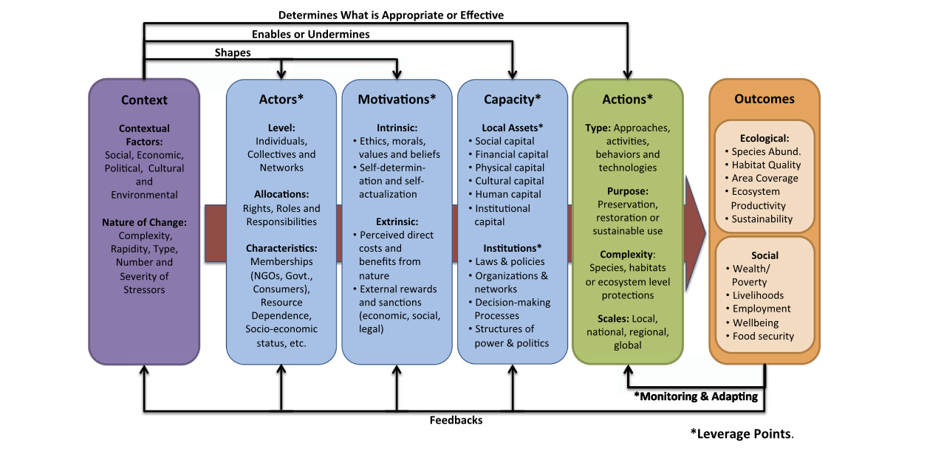
Figure 4: Bennett et al. (2018) analytical framework for local environmental stewardship
In this report we adopt the Bennett et al. (2018) conceptual and analytical frameworks with minor adaptations for our Reef specific findings. First, we broaden the definition of stewardship from strictly ‘actions’ to other components of stewardship efforts that in the Bennett framework are labelled supporting stewardship as action, or as intervention or leverage points for stewardship as action.
While this may seem a minor point, we hypothesise that one of the reasons there is so little focus on outcomes of activities labelled stewardship is this disjuncture between a definition of stewardship only as action and a plethora of stewardship efforts that are not ‘action’. Rather, much of this activity fits into categories of motivations and capacity as in our three component definition: Motivation plus capacity plus action equals stewardship.
Actors do not disappear in our reconceptualisation, but are in each component of the definition. We agree and adopt the Bennett et al. (2018) categorisation of actors. We add that the agency or organisation conducting a stewardship program is an actor worthy of consideration in the same way as the target actors of the stewardship program.
Further we offer a way to classify stewardship efforts. A typology is a way of classifying – literally – what type of thing is this? Following the stewardship definition with three components the typology is intended to guide understanding of how stewardship efforts align with each of the three components.
The typology of stewardship purpose has been created by cross-referencing, clustering and comparing definitional components with coding outcomes in our Reef specific dataset. This produces a bespoke Reef typology of stewardship. This does not encompass all stewardship efforts definitively for all time in the Great Barrier Reef. Rather there is an overlap between categories, and it is expected that innovation and greater understanding over time will expand this range of efforts within and between categories (Figure 5).
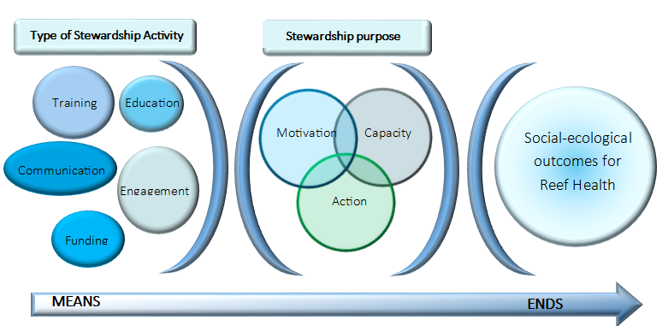
Figure 5: Conceptual framework and typology for stewardship efforts in the Great Barrier Reef
Our conceptual framework and typology of stewardship sits along a spectrum of stewardship means and ends. In this context, ends refers to outcomes protecting Reef values, both social and ecological. We see means as encompassing the full spectrum of stewardship activities described by our three component definition. The point of this conceptual shift is to enable articulation and a means, ultimately, of measuring movement towards stewardship outcomes.
We aim to broaden understanding of causal links between the purpose of stewardship activities and the targeted socio-ecological outcome. That is, if the purpose of a stewardship activity is to educate people about threats to the Reef, the desired stewardship outcome may be increased motivation to protect the Reef. However, change in motivation without translation to observable action is very difficult to measure. It also raises the question of: what good is a change in motivation if it does not result in a desired action? Even so, our Reef specific review showed that what we categorise as motivation is being labelled ‘stewardship’. Therefore, in order to understand the broader range of activities occurring that are already being labelled stewardship in the Reef we suggest a typology which allows activities to be evaluated in their own right – that is, their success in achieving their stewardship purpose rather than against an assumed link to an environmental outcome for which there is no evidence.
The motivation component of stewardship does not have an easily drawn causal link to action and change in environmental outcomes for the Reef. There is a growing body of research on this issue. For example, Plummer et al. (2017) investigate the relationship of participation, collaboration and learning pathways to positive social-ecological outcomes. They seek to understand implications for stewardship in environmental management and governance. Similarly, Hofman et al. (2020) review the connection between programs and strategies on the Reef to educate visitors about environmental issues and subsequent uptake of suggested conservation behaviours. This line of inquiry is clearly necessary to evaluate social-ecological outcomes of stewardship programs and suggested for further research in a Reef specific context.

Conclusion
In this report, we identify and describe the use of stewardship in academic and some grey literature for the Reef. We found that stewardship in the Reef is often used within the context of applied projects which have demonstrable and measurable objectives, but similarly is used to describe activities that lead to or enable applied projects or are assumed to eventually do so. To align the definition of stewardship with the variety of activities it is used to label we propose a three component definition of stewardship: 1. Motivations, plus 2. Capacity, plus 3. Action.

Using thematic analysis of Reef specific literature to identify the relationship between the most common concepts in academic and grey literature, we propose a typology by which future stewardship activities can be classified. The purpose of this definition and typology is to enable articulation and then evaluation of stewardship activities against their purpose and ultimately against the larger goal of improved Reef health values.

Remaining questions
This project has identified further outstanding questions that we only provide hypotheses for in this work:
- What is the causal link between stewardship motivation and stewardship action?
- How do we measure if a stewardship activity that aims to influence attitudes and cultivate stewardship motivation is successful?
- What is the connection between education and awareness about environmental issues and changed behaviour or direct action towards better human-environment relationships?
Such questions are not unique to this work but are pressing questions for changing the trajectory of human-caused climate change and continued human-biosphere health.

Literature cited
Bazeley P, Jackson K 2013. Qualitative data analysis with NVivo. SAGE publications limited.
Bennett NJ, Whitty TS, Finkbeiner E, Pittman J, Bassett H, Gelcich S, Allison EH. 2018. Environmental stewardship: a conceptual review and analytical framework. Environmental Management 61:597-614.
Chapin III FS, Kofinas GP, Folke C, Chapin MC 2009. Principles of ecosystem stewardship: resilience-based natural resource management in a changing world. Springer Science & Business Media.
Crutzen, P. J. (2006). The “anthropocene”. In Earth system science in the anthropocene (pp. 13-18). Springer, Berlin, Heidelberg.
Goldberg JA, Marshall NA, Birtles A, Case P, Curnock MI, Gurney GG. 2018. On the relationship between attitudes and environmental behaviors of key Great Barrier Reef user groups. Ecology and Society 23.
Gray, T. S., & Hatchard, J. (2007). Environmental stewardship as a new form of fisheries governance. ICES Journal of Marine Science, 64(4), 786-792.
Harrison, P. (2006). Having dominion: Genesis and the mastery of nature. In R. J. Berry (Ed.), Environmental stewardship: Critical perspectives – Past and present (pp. 17-31). London: T&T Clark.
Hofman, K., Karen Hughes & Gabrielle Walters (2020): Effective conservation behaviours for protecting marine environments: the views of the experts, Journal of Sustainable Tourism. https://doi.org/10.1080/09669582.2020.1741597
Lewis, S. L., & Maslin, M. A. (2015). Defining the anthropocene. Nature, 519(7542), 171-180.
Morrison T, Adger WN, Brown K, Lemos MC, Huitema D, Phelps J, Evans L, Cohen P, Song A, Turner R. 2019. The black box of power in polycentric environmental governance. Global Environmental Change 57:101934.
Morrison TH. 2017. Evolving polycentric governance of the Great Barrier Reef. Proceedings of the National Academy of Sciences 114:E3013-E3021.
O’Neill, D. W., Fanning, A. L., Lamb, W. F., & Steinberger, J. K. (2018). A good life for all within planetary boundaries. Nature sustainability, 1(2), 88-95.
Plummer, R., Dzyundzyak, A., Baird, J., Bodin, Ö., Armitage, D., & Schultz, L. (2017). How do environmental governance processes shape evaluation of outcomes by stakeholders? A causal pathways approach. PloS one, 12(9), e0185375.
Rockström, J., Steffen, W., Noone, K., Persson, Å., Chapin III, F. S., Lambin, E., ... & Nykvist, B. (2009). Planetary boundaries: exploring the safe operating space for humanity. Ecology and society, 14(2).
Scharin H, Ericsdotter S, Elliott M, Turner RK, Niiranen S, Blenckner T, Hyytiäinen K, Ahlvik L, Ahtiainen H, Artell J. 2016. Processes for the sustainable stewardship of marine environments. Ecological Economics 128:55-67.
Steffen, W., Richardson, K., Rockström, J., Cornell, S. E., Fetzer, I., Bennett, E. M., ... & Folke, C. (2015). Planetary boundaries: Guiding human development on a changing planet. Science, 347(6223).
Steffen, W., Crutzen, P. J., & McNeill, J. R. (2007). The Anthropocene: are humans now overwhelming the great forces of nature. AMBIO: A Journal of the Human Environment, 36(8), 614-621.
Steinberg PE 2001. The social construction of the ocean. Cambridge University Press.
Trombulak SC, Baldwin RF. 2010. Introduction: creating a context for landscape-scale conservation planning. Pages 1-15. Landscape-scale conservation planning. Springer.
Welchman, J. (2012). A defence of environmental stewardship. Environmental Values, 297-316.
White, L. (1967). The historical roots of our ecological crisis. Science, 1203-1207. doi:10.1126/science.155.3767.1203. PMID 17847526

Appendices

Appendix 1: A selective overview of the history of environmental stewardship.

Global to local stewardship instruments and conventions

Global environmental stewardship
Academics claim that the concept of environmental stewardship originated in the King James Bible (White 1967; Harrison 2006; Welchman 2012) more specifically in the Book of Genesis. The Book of Genesis in chapter 1:28 ‘Be fruitful and multiply and fill the earth and subdue it, and have dominion over the fish of the sea and over the birds of the heavens and over every living thing that moves on the earth’. In the early modern period, these passages were used as biblical justifications for material exploitation of nature. Francis Bacon (1561–1626) in promoting mastery of the natural world to ‘extend “the narrow limits of man’s [sic] dominion over the universe” to their ‘promised bounds’ (Harrison 2006: p. 24). Others in this company promoted the mastery of nature for use in ‘the Services of a Humane life’ (Glanville quoted in Harrison 2006: p, 24). Under Luther and Calvin, the Book of Genesis passages about dominion meant changing the land through agriculture for human use (p. 25).
The evolution of global environmental stewardship concepts occurs in the context of growing human populations and the rise of capitalist economic and political economy. At a global level, the changed geo-political landscape after WWII and division of nations into first, second and third world categories, saw the beginning of the current era of internationally convened ‘issues’. The establishment of the United Nations General Assembly in the aftermath of World War II coordinated cooperation of nation states in addressing these, including the formal integration of stewardship as an ecological instruments within global environmental governance.

Governance frameworks are provided by the United Nations Sustainability Goals and Agenda 21, Convention of Biological Diversity (CBD), United Nations Convention of Law of the Sea (UNCLOS) and United Nations Millennium Declaration. Providing oversight and guidance are the International Union for the Conservation of Nature (IUCN) and United Nations Environment Program (UNEP). IUCN (est. 1948) is the world’s oldest and largest global environmental organisation coordinating scientific and governance efforts for environmental conservation. The United Nations Environment Program (UNEP) was founded in 1972. It situates itself as, ‘the leading global environment authority that sets the global environmental agenda, promotes the coherent implementation of the environmental dimension of sustainable development within the United Nations system, and serves as an authoritative advocate for the global environment’. IUCN and UNEP play a role in supporting the CBD and Agenda 21 conventions and declarations

UN Agenda 21 (1992) recognised ‘product stewardship’ defined as a guiding principle whereby – ‘Industry should apply adequate standards of operation in all countries in order not to damage human health and the environment’ (UN Agenda 21: clause 19.8, p. 226). The UN Convention on Biological Diversity (CBD), came into force in 1993, with 12 principles to protect biological diversity. The CBD states: ‘Ecosystems, species and genetic resources should be used for the benefit of humans, but in a way that does not lead to the decline of biodiversity.’ The CBD was initially convened by the UNEP in response to human caused extinction of earthly non-human species. In 2021 the CBD is under review in light of climate change impacts. In 2000 the United Nations Millennium Declaration (2000) framed environmental stewardship as an ethical imperative: ‘we resolve therefore to adopt in all our environmental actions a new ethic of conservation and stewardship’, which also references the CBD (Declaration 23). The word ‘ethic’ here is important and refers to the morals of ‘decent conduct with the natural world’ (Welchman 2012: p. 3). Interestingly the United Nations Sustainable Development Goals don’t explicitly link to stewardship actions.

There are many more international instruments and mechanisms than it is possible to mention here. This brief recount of main conventions and policy instruments still currently in force demonstrates the momentum and global adoption of concepts of stewardship.

Ownership and stewardship of the seas
Stewardship in a marine-specific context originates in debates around the protection of land, and by extension the marine environment closest to shore (Steinberg 2001). These interpretations occurred in tandem with the rise of modern science in the 17th century and stewardship in this sense was predominantly about the health of nature for direct human use. Today’s marine stewardship has its origins in the early days of the Roman and Greek empires. Marine stewardship can be traced back to Roman times (~27 BC to 476 AD) when marine environs became significant trade routes. Although not a space to be conquered, or possessed, the sea was seen as an area in which states could legitimately be ‘stewarding its bounty’ (Steinberg 2001: p. 61).
From the 14th to the mid-20th century the ocean going technology and power of nations determined the extent to which they attempted to assert their right to control ocean routes and resources. Corresponding with the development of oceanic trade routes over the centuries, oceans shifted from frontiers to commodities. In 1982 The United Nations Convention of the Law of the Sea (article 77, paragraph 1), stated: ‘the coastal State exercises over the continental shelf sovereign rights for the purpose of exploring it and exploiting its natural resources’. Stewardship is not mentioned in the United Nations Convention of the Law of the Sea.
While marine stewardship may have begun as a sense of guardianship — a mutual agreement between states in ‘stewarding its bounty’ — its meaning in this context has shifted to global economics based models closely tied to state and international relations, governance and globalisation. Marine stewardship in this historical context has less to do with protecting and preserving ecosystem function and is more about control of ocean resources and ocean as territory.

Governments and environmental stewardship

Government involvement in environmental stewardship is found both in management practices and enabling and supporting stewardship programs for example through funding. This may be through grants for stewardship activities (Welchman 2012: pp. 6-7). Governmental environmental stewardship can also be in the formal protection of ‘wilderness’ (i.e. rivers, estuaries, coastlines and species) using conservation areas such as national parks (Welchman 2012: p. 3). It should be noted that national parks predate international mechanisms described above and popular environmental movements described below by a century — Yellowstone National Park was established in the United States in 1872. The world’s first marine national park came into effect with the establishment of the Great Barrier Reef Marine Park in 1975.

Ocean protection is slightly different, to terrestrial management, due to the different territorial claims over land and sea. Marine Protected Areas (MPA) encompass a wide range of governance arrangements; from small scale customary tenure arrangements such as in the Pacific, to the complex multi-nation arrangements in the Antarctic. Protective mechanisms are similarly diverse. For example the Great Barrier Reef Marine Park Zoning Plan 2003 protects 33.3 per cent of the Marine Park area through ‘green zones’ which prohibit extractive industries, including recreational fishing and collecting, and has other zones with different levels of protection for the whole Marine Park.

Non-governmental organisations (NGOs) and environmental stewardship

In tandem with the emergence of global environmental instruments there was a rise of the environmental NGOs and ecojustice movements of the 1970s. The first Earth day in 1971 signalled a shift in awareness around conservation, and environmental stewardship. In this period many environmental NGOs emerged – such as Greenpeace (1971) and World Wide Fund for Nature (1961). Some stewardship action examples from this era include The Green Belt Movement founded by Professor Wangari Maathai in 1977 in Kenya, replanting trees for water, soil and livelihood health; The Sea Shepherd Conservation Society founded by Paul Watson and others in 1977 protecting ocean animals from hunting and exploitation. These types of organisations are too numerous to list and range from global to myriad specific and local community movements like the Peterson Creek Group in the small town of Yungaburra, North Queensland, rehabilitating their waterways and protecting animal habitats for platypus and tree kangaroos and other species.

Private sector and environmental stewardship
Global non-government organisations have joined these efforts through attempts at voluntary commercial regulation. The Forest Stewardship Council (1993) and the Marine Stewardship Council (1997) are NGOs formed to encourage voluntary compliance with ‘sustainable commercial use’ of forest and marine resources respectively.
These councils established principles and criteria for labelling forest and marine products with ‘sustainability’ certification based on the practices used from harvest through to supply chains. For example, the Marine Stewardship Council sets up a ‘virtuous cycle’ for fisheries, setting guidelines for fishing practice and catch through to handling. The rationale is that more products branded with FSC or MSC certification would create a feedback loop of supply and increased demand for ‘sustainable’ products by allowing consumers to participate in stewardship through their consumption decisions. See Case Study: Marine Stewardship and Sustainability.
Case study: Marine stewardship and sustainability
The term marine stewardship can refer to the Marine Stewardship Council (MSC), where encouraging consumers to select sustainable fisheries is the main objective. The Marine Stewardship Council is an international non-profit organisation launched in 1997 whose mission is to ‘end overfishing and restore fish stocks for future generations’. Their vision is ‘of the world’s oceans teeming with life, and seafood supplies safeguarded for this and future generations’ (Figure 2).
MSC approach claims to set up a ‘virtuous circle’ with six components:
- Fisheries meet the MSC standard – certified as sustainable
- Retailers and restaurants choose MSC sustainable seafood
- Traceable supply chain created by MSC label
- Consumers prefer MSC seafood
- Market demand for MSC seafood increases
- More fisheries volunteer to be assessed for MSC standard
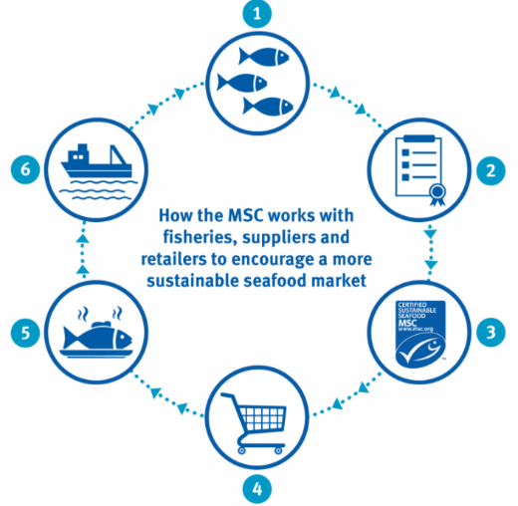
Figure 2: The six stages of the virtuous circle of the Marine Stewardship Council.
The MSC has enjoyed major global success. Among other achievements, since 1997 MSC has had pledges from major global retail outlets including Sainsbury’s, Ikea, Iglo group and Findus to sell 100 per cent MSC products. In 2007 the Netherlands was the first country to pledge purchasing and selling 100 per cent MSC certified seafood. As of 2017 more than 25,000 products had MSC certification. The MSC and their processes are not without their critics, with some analysts claiming that the certification process is insufficiently robust or that more broadly such market mechanisms have limited vale for environmental outcomes (for some discussion see Ponte 2012; Christina et al. 2013; Martin et al. 2012; Nick 2017). Despite these criticisms, the MSC enables consumers to actively contribute to companies with methods of natural resource harvest which align with their values.

Appendix 2: Marine stewardship in a global context
Marine stewardship specifically has similar roots but slightly different evolution due to the nature of the land-sea divide and human movement across the sea. According to Steinberg (2001), marine stewardship can be traced back to Roman times (~27 BC to 476 AD). During Roman times marine environs became significant trade routes, and although not a space to be conquered, or possessed, the sea was seen as an area in which states could legitimately be ‘stewarding its bounty (Steinberg 2001: p. 61).
Mainly focusing on the Mediterranean Sea, Steinberg (2001: p. 61) notes that:
…while Mediterranean societies did not construct ocean-space as a claimable set of places or as an extension of the land, neither did they construct ocean-space as an extra-social space immune from state power.
Therefore in this context, stewardship was not about possession of the ocean, like territory is possession of the land, but did become an extension or ‘exclusive domain of a land-based state’ (Steinberg 2001: p. 61). Corresponding with the development of oceanic trade routes over the centuries, oceans shifted from frontiers to commodities. With commodification comes a need for social regulations and laws (Steinberg 2001: p.125).
Opposing historical views over rules of sea ownership can be seen in competing academic publications by Dutch scholar Hugo Grotius’ 1608 publication Mare Liberum (The Open Seas) and English scholar John Selden’s 1635 Mare Clausum (The Closed Seas). As their book titles suggest, one view saw the ocean as a global resource of ‘open seas’ and the other attempted to assert territorial control with ‘closed seas’. In 1702 the Dutch scholar Cornelius van Bynkershoek proposed the three nautical mile limit of territorial control over the ocean by nations – three nautical miles from the coastline – seen as amenable to boundary enforcement and a forebear of many nation’s current maritime boundaries. This three nautical miles limit applies to the Great Barrier Reef, and marks the point between Australian and Queensland government jurisdiction.
The ocean as a claimable resource area was formalised with the adoption of the United States Presidential proclamation No 2667 (the Truman Proclamation) – made by United States President Harry Truman in the immediate aftermath of World War II. The Proclamation (1945) signals a key development in the international law of the sea, as it was the first to declare that coastal states have the rights over offshore resources that are distinctive from the territorial sea (coastal waters to 12 nautical miles). The Proclamation was succeeded by the Geneva Convention on the Law of the Seas (1958) which explores governance and rights of the seabed, and the inclusion of exclusive economic zones (EEZ).
EEZ implications for marine stewardship brings the addition of the Seldenian (of John Selden, The Closed Seas), element of state stewardship. The Seldenian element is the agreement that states the need to ensure access through EEZ and access to ports as a ‘right of passage must be respected and the marine life and natural resources on the continental shelf come under the jurisdiction of coastal states’ (Zacharias 2014: p. 282 cited in Davis, 2015). Then in 1982, The United Nations Convention of the Law of the Sea (article 77, paragraph 1), stated: ‘the coastal State exercises over the continental shelf sovereign rights for the purpose of exploring it and exploiting its natural resources’. Stewardship is not mentioned in the United Nations Convention of the Law of the Sea.

Appendix 3: Summary of literature review
This section summarises the technical details of both literature sweep (i.e. an initial finding with generic inclusion criteria, and a second sweep after refining inclusion criteria).

Step 1: Literature review

Step 1A: Systematic review academic literature
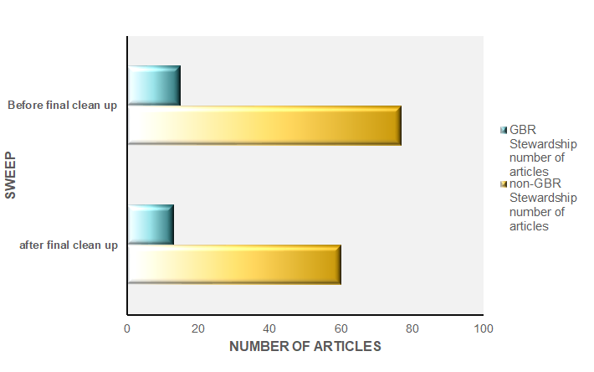
Figure A3-1: Summary of the number of documents relevant to each literature sweep.
We excluded articles which were not specific to the Reef (n=60). Fifteen academic articles were included in our final analysis (i.e. migrated into NVivo for thematic analysis). We note that there was a clear upward trend in the number of articles containing the term ‘stewardship’ through time, both within and outside the Reef.

Step 1B: Review grey literature
This section contains supplementary information regarding the results of our thematic analysis.
We found that the majority of literature (both grey and academic) discuss stewardship within the context of conservation and the preservation of natural environments. None of the academic literature singularly discuss stewardship within the context of sustainable use of ecosystem services, but five articles (38.4 per cent) discuss stewardship as a combination of conservation and sustainable use. This shows that stewardship within the Reef is conceptualised as a people centred approach (Table A3-3).
Table A3-3 Document attribute summary.
Attribute | Percent Grey | Percent Academic
Defines stewardship | 40 | 15.4
Scientific field of study | NA
Article type
Original Research | NA | 84.6
Review article | NA | 15.4
Government document | 40 | NA
Report | 40 | NA
Webpage | 20 | NA
Field
Social science | NA | 69.2
Biophysical science | NA | 7.6
Natural science | NA | 7.6
Research scale
National | 0 | 30.7
Regional | 80 | 23.0
International | 0 | 7.6
Multi-scale | 0 | 15.3
Local | 20 | 15.3
Definition of stewardship
Conservation | 80 | 53.8
Sustainable use | 20 | 0
Combination | 0 | 38.6

Search terms were created in order to capture the most relevant articles focusing on Great Barrier Reef stewardship. The databases selected each had unique Boolean search terms in order to further provide more relevant results. We used a combination of search terms with required Boolean style depending on the database. Search term details in Table A3-4 and Table A3-5 below.
Table A3-4: Boolean search terms used per database
 | ProQuest | Scopus | Web of Science
Stewardship AND “great barrier reef” | Stewardship AND “Great Barrier Reef” | TITLE-ABS-KEY(Stewardship AND “Great Barrier Reef”) | TS=(Stewardship AND “Great Barrier Reef”)
“Ecosystem stewardship” marine | “Ecosystem Stewardship” Marine | TITLE-ABS-KEY(“ecosystem stewardship” marine) | TS=(“ecosystem stewardship” marine)
Stewardship AND marine | Stewardship AND Marine | TITLE-ABS-KEY(Stewardship AND Marine) | TS=(Stewardship) AND marine)
Marine environments sustainable stewardship | Marine AND environments AND sustainable AND stewardship | TITLE-ABS-KEY(Marine AND environments AND sustainable AND stewardship) | TS=(Marine environments sustainable stewardship)
Ocean and stewardship | Ocean AND stewardship | TITLE-ABS-KEY(Ocean AND stewardship) | TS=(Ocean AND stewardship)
Stewardship AND human dimensions | Stewardship AND human dimensions | TITLE-ABS-KEY(Stewardship AND human dimensions) | TS=(Stewardship AND human dimensions)

Table A3-5: Date, search terms and databases per database.
Date of search | Search terms | Number of results
Proquest
05/02/2020 | Stewardship AND “Great Barrier Reef” | 27
05/02/2020 | “Ecosystem Stewardship” Marine | 9
05/02/2020  06/02/2020 | Stewardship AND Marine | 591
05/02/2020 | Marine AND environments AND sustainable AND stewardship | 91
05/02/2020  06/02/2020 | Ocean AND stewardship | 319
05/02/2020  06/02/2020 | Stewardship AND human dimensions | 55
Total |  | 482
Scopus
05/02/2020 | TITLE-ABS-KEY(Stewardship AND “Great Barrier Reef”) | 12
05/02/2020 | TITLE-ABS-KEY(“ecosystem stewardship” marine) | 6
05/02/2020  06/02/2020 | TITLE-ABS-KEY(Stewardship AND Marine) | 322
05/02/2020  06/02/2020 | TITLE-ABS-KEY(Marine AND environments AND sustainable AND stewardship) | 33
05/02/2020  06/02/2020 | TITLE-ABS-KEY(Ocean AND stewardship) | 161
05/02/2020 | TITLE-ABS-KEY(Stewardship AND human dimensions) | 42
Total |  | 385
Web of Science
05/02/2020 | TS=(Stewardship AND “Great Barrier Reef”) | 21
05/02/2020 | TS=(“ecosystem stewardship” marine) | 10
05/02/2020  06/02/2020 | TS=(Stewardship) AND marine) | 786
05/02/2020 | TS=(Marine environments sustainable stewardship) | 35
05/02/2020 | TS=(Ocean AND stewardship) | 827
05/02/2020 | TS=(Stewardship AND human dimensions) | 129
Total |  | 360

Appendix 4: Results of the literature review
After gathering the appropriate literature sample, we commenced our initial thematic coding (Table A4-1). As thematic coding constitutes an iterative process, this initial list was consolidated into 11 final thematic categories: activity, behaviour, governance, communication, methodology, research, industry, social, place, theory, and nature.
Table A4-1: Definitions of the themes identified in the initial thematic coding in NVivo.
Theme | Definition
activity | The condition in which things are happening or being done
attachment | An affection, fondness, or sympathy for someone or something.
attitudes | Feelings towards an issue
behaviour | How someone conducts oneself
citizen | A legally recognised subject or national of a state or commonwealth either native or naturalised aka a person
climate | The weather conditions prevailing in an area in general or over a long period
climate change | As defined by the Intergovernmental Panel on Climate Change (IPCC) fifth report. Climate change refers to a change in the state of the climate that can be identified (e.g., by using statistical tests) by changes in the mean and/or the variability of its properties and that persists for an extended period, typically decades or longer.  Climate change may be due to natural internal processes or external forcing such as modulations of the solar cycles, volcanic eruptions and persistent anthropogenic changes in the composition of the atmosphere or in land use.
communication | A means of sharing information and knowledge
community | A group of people living in the same place or having a particular characteristic in common
conservation | Conservation is also the protection of plants, animals, and natural areas, esp. from the damaging effects of human activity:
cumulative pressures | Relating to the compounding effects of multiple stressors
decision-making | The processes guiding or actions undertaken to decide something especially with a group of people
definitions | A formal reference to a specific term
dependence | The quality or state of being influenced or determined by or subject to another
development | The process of converting relatively pristine environments into modified areas for human use
ecological | Of or relating to the science of ecology – ecology as a branch of biology
ecosystem-based management | Ecosystem-based management is an environmental management approach that recognizes the full array of interactions within an ecosystem, including humans, rather than considering single issues, species, or ecosystem services in isolation.
ecosystems | A dynamic combination of plant, animal and micro-organism communities and their non-living environment (e.g. soil, water and the climatic regime) interacting as a functional unit. Examples of types of ecosystems include forests, wetlands, grasslands and tundra.
education | The knowledge and development resulting from the process of being educated
engagement | Emotional involvement or commitment
Great Barrier Reef Marine Park Authority | The Great Barrier Reef Marine Park Authority (the Authority) is a non-corporate Commonwealth entity and operates as a statutory agency under the Great Barrier Reef Marine Park Act 1975 (Marine Park Act). The Authority sits within the Australian Government Environment and Energy Portfolio and reports to the Minister for the Environment. The Authority is responsible for managing one of the world’s premier natural resources, the Great Barrier Reef Marine Park (the Marine Park).
gender | Gender refers to the socially constructed characteristics of women and men, such as norms, roles, and relationships of and between groups of women and men. It varies from society to society and can be changed.
global | Of, relating to, or involving the entire world
governance | The rules and processes of a system
government | An elected group of people with legitimate authority to govern a country or state.
heritage | Value of a place includes the place’s natural and cultural Environment having aesthetic, historical, scientific or social significance, or other significance, for current and future generations of Australians.
human capital | The knowledge, skills, competencies and other attributes embodied in individuals or groups of individuals acquired during their life and used to produce goods, services or ideas in market circumstances
identity | Who a person is, or the qualities of a person or group that make them different from others
Indigenous | An Aboriginal or Torres Strait Islander is a person of Aboriginal or Torres Strait Islander descent who identifies as an Aboriginal or Torres Strait Islander and is accepted as such by the community in which he [or she] lives OR Membership of the Indigenous people depends on biological descent from the Indigenous people and on mutual recognition of a particular person’s membership by that person and by the elders or other persons enjoying traditional authority among those people.
individual | A single person or thing, especially when compared to the group or set to which they belong
industry | The companies and activities involved in the process of producing goods for sale, especially in a factory or particular area
influence | The power to affect people or things, or a person or thing that is able to do this
integrated | With two or more things combined to become more effective
leadership | A set of characteristics that make a good leader
local | As characterised by or relating to position in space: having a definite spatial form or location
management | The process of dealing with, governing or controlling things or people.
methodology | A system of methods (methods is defined as a particular procedure for accomplishing or approaching something especially a systematic or established one)
monitoring | The repeated and systematic collection of data on environmental and socio-economic variables through time.
national | Belonging to or maintained by the Australian Government and defined by a constitution
nature | Non-human (the phenomena of the physical world including plants animals and landscapes or other features and products of the earth as opposed to humans or human creations)
non-local | Transcending local geographic boundaries
participation | The action of taking part or sharing in something
partnership | A relationship resembling a legal partnership and usually involving close cooperation between parties having specified and joint rights and responsibilities
place | A position or site occupied or available for occupancy or marked by some distinguishing feature
policy | A high-level overall plan embracing the general goals and acceptable procedures especially of a governmental body
program | A plan or system under which action may be taken toward a goal
protection | The act of protecting: the state of being protected
research | A studious inquiry or examination especially: investigation or experimentation aimed at the discovery and interpretation of facts, revision of accepted theories or laws in the light of new facts, or practical application of such new or revised theories or laws
resilience | The natural capacity to withstand and recover from disturbances is collectively referred to as ‘resilience’ (Holling 1973; Carpenter et al. 2001; Walker et al. 2002), often described as the maintenance or return to a stable state (Nystrom et al. 2008).
Resilience (environmental) | The capacity of an organism, species, ecosystem or social group to resist and recover from disturbances while still retaining the same function, structure, integrity and feedbacks. Resilience (sensitivity and adaptive capacity) describes the likely response of an organism, species or ecosystem to exposure to a disturbance. The concept is dynamic and is closely related to vulnerability.
risk | The possibility of something happening that impacts on objectives. It is the chance to either make a gain or a loss and is measured in terms of likelihood and consequence. (Australian Standard for Risk Assessment (AS/NZS ISO 31000:2009).
social | Of or relating to human society, the interaction of the individual and the group, or the welfare of human beings as members of society
social resilience | Ability to cope with threats, learn from them, and the ability of a social system to respond and recover from adjust to future crises
sustainable | Activities that meet the needs of the present without having a negative impact on future generations. A concept associated with sustainability is triple bottom line accounting, taking into account environmental, social and economic costs.
theory | A plausible or scientifically acceptable general principle or body of principles offered to explain phenomena
tourism | The practice of travelling for recreation
Trust | A willingness to accept vulnerability based upon positive expectations of the intentions or behaviours of another”
valuing | Those aspects of an environment that make it of significance
well-being | The combination of economic prosperity, community liveability and environmental integrity, which is determined by the quality, quantity, distribution, use and preservation of economic, human, social and natural capital.

Relationship between themes
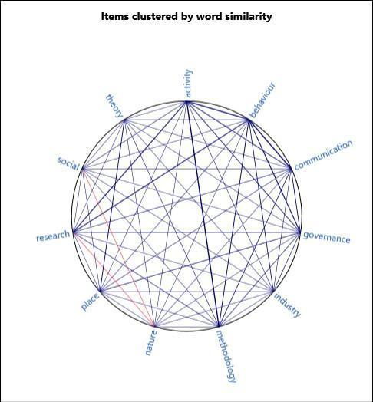
Figure A4-1: Pearson’s correlation coefficient measuring similarity between themes. Thicker lines indicate a higher correlation coefficient. Red lines show a negative correlation coefficient.

Thematic diversity within document characteristics
The academic literature contained more thematic diversity than the grey literature (non-peer reviewed) which only contained six of the eleven final themes (54 per cent). Themes which were unique to academic literature were: industry, nature, place, social and theory.
Our dataset contained sources that viewed stewardship in all three of our conceptual approaches: nature conservation, sustainable use or a combination of both. The nature conservation approach was found in the grey and academic literature: nature conservation (grey: n=4, academic: n=7) or the sustainable use of natural resources (grey: n=1, academic n=0), or a combination of both (grey: n=0, academic: n=5). Within the academic literature, stewardship literature related to conservation and protection, and discussed concepts such as management, communities and activities. Likewise, the most common theme in the grey literature was also activities in relation to conservation and protection. The grey literature, however, equally emphasised concepts related to attitudes, behaviours, education, communication and engagement. In contrast, academic literature which focused on a combination of sustainable use and conservation also contained sub-themes such as well-being, partnerships, individuals, policies, programs, and tourism. These themes did not appear in conservation focused academic literature.
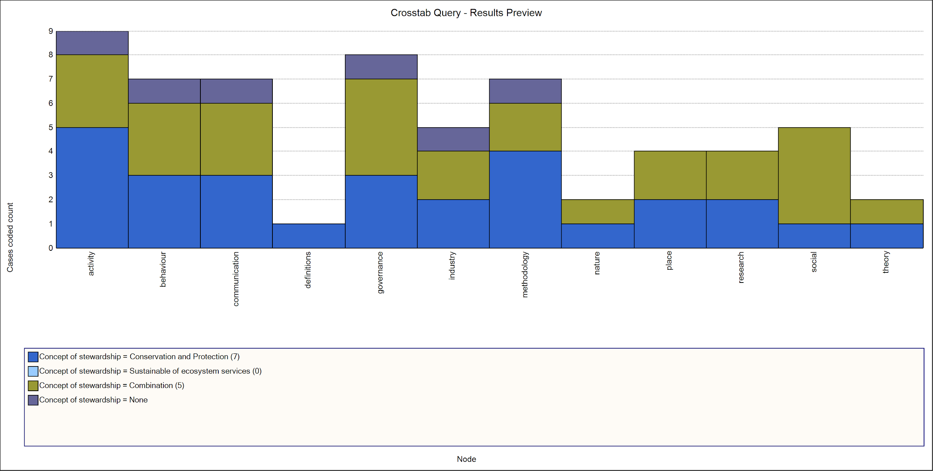
Figure A3-4: Number of academic articles and their definition of stewardship categorised by themes.
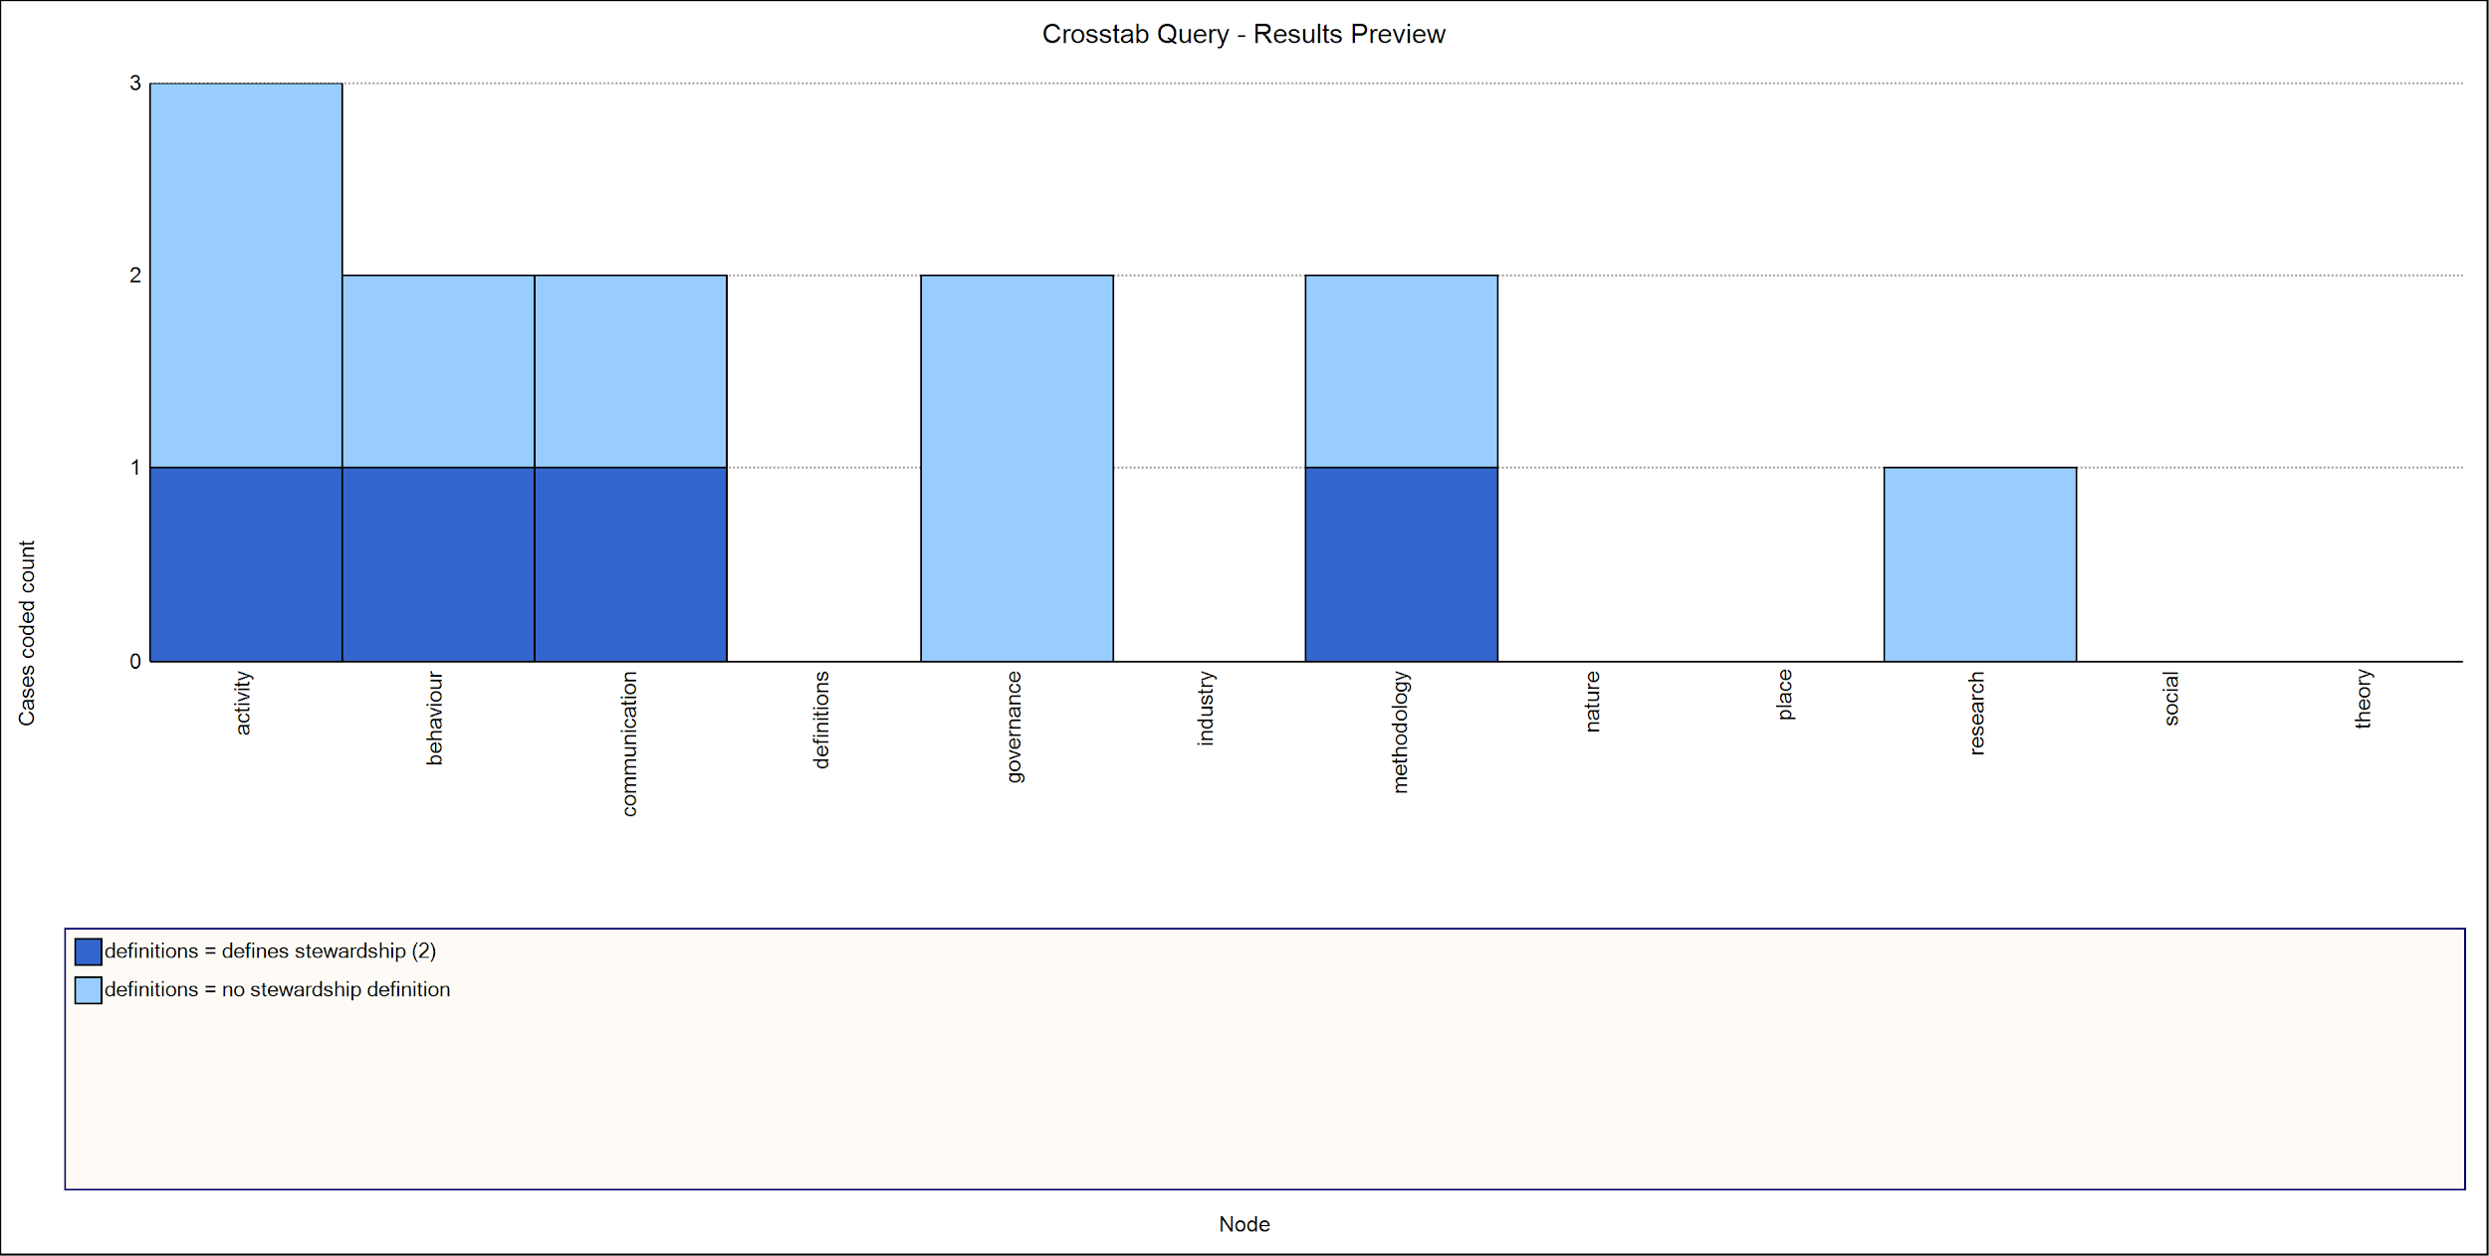
Figure A3-5: Number of grey literature articles and their definition of stewardship categorised by themes.

Results
Comparison with non- Great Barrier Reef literature
One research aim was to test whether or not the Great Barrier Reef literature differed significantly in its reflections of stewardship when compared to the marine park stewardship outside of the Great Barrier Reef (non- Great Barrier Reef). Autocoding in NVivo 12 plus for non- Great Barrier Reef literature reveals that stewardship in the Great Barrier Reef has a strong management focus. Whereas, stewardship in the non- Great Barrier Reef literature tends to have more conservation and ecosystem preservation tone than management. The table below (A4-2) identifies the synonyms connected to stewardship in non- Great Barrier Reef literature. The table shows that there’s a stronger focus on the biophysical and ecosystem service in non- Great Barrier Reef literature, with management registering 18 per cent. Therefore, this research suggests that stewardship within the Great Barrier Reef is used as a vehicle to get people to engage and comply with management directives and policy.
Table A4-2: Major and nested themes identified using auto-coding in NVivo of non- Great Barrier Reef literature.
Major theme | Nested themes | Percent occurrence within the sample (n=1125)
Marine | Management | 18
Conservation |  | 5
Sustainable | Fishing, fisheries, community, Change, ocean | 22
Science | Systems, use, areas, approaches, ecological development, impacts, species, governance, research, studies, outcomes, coral, Reef, data knowledge, activities, programs | 38
Effective | Processes, efforts, environment, biodiversity  environmental stewardship, values, services, tools, strategies, practices, scale, production | 17

A Google search for “stewardship AND Great Barrier Reef” returns 802,000 returns. Search performed 25/08/2020
For example see: Dale, A., George, M., Hill, R. and Fraser, D. (2016) Traditional Owners and Sea Country in the Southern Great Barrier Reef – Which Way Forward?. Report to the National Environmental Science Programme. Reef and Rainforest Research Centre Limited, Cairns (50pp.). Jarvis, D., Hill, R., Buissereth, R., Moran, C., Taibot, L., Bullio, R., Grant, C., Dale, A. P., Deshong, S., Fraser, D., Gooch, M., Hale, L., Mann, M., Singleton, G., Wren, L. 2019, Strong peoples - Strong country Indigenous heritage monitoring framework: Summary report, Great Barrier Reef Marine Park Authority, Townsville. Traditional Owners of the Great Barrier Reef: The Next Generation of Reef 2050 Actions, Commonwealth of Australia 2018. (https://www.environment.gov.au/system/files/resources/7b495328-8097-4aab-84aa-67b2a9e789fb/files/reef-2050-traditional-owner-aspirations-report.pdf)
Merriam Webster dictionary definition for 'stewardship'.
Document analysis systematically reviews and evaluates printed or electronic material. Its purpose is to examine and interpret qualitative information to elicit meaning and gain empirical understanding. This analysis entails finding, selecting, and synthesising information (in this case, textual) contained in the documents. This yields data which can be organised into thematic categories and case studies.
Snowball collation is where existing literature leads to further relevant literature – gathering as it rolls like a snowball.
Typologies are ways of organising things into types – like with like for a defined purpose. For different purposes things could be grouped together differently. Understanding typologies can reveal the available methodologies of systems classification to help decision-makers in selecting more appropriate management styles for different systems.
Our method was informed by methods used by Bennett and Roth (2015,2018) and Bunce (2015), Bayraktarov et al (2016) and is used to compile empirical evidence and develop a typology (Bennett & Roth, 2015).
Note: This article was published after the systematic literature review for our report was completed and was not included in the dataset.
later revised to “developed” and “developing” and “least developed”
See the United Nations Environment Programme web page
The Convention on Biological Diversity (CBD) is an international legally-binding treaty with three main goals: conservation of biodiversity; sustainable use of biodiversity; fair and equitable sharing of the benefits arising from the use of genetic resources. Its overall objective is to encourage actions, which will lead to a sustainable future. View more on UN conventions.
While often ascribed negative connotations in an environmental context the word exploit means ‘make full use of and derive benefit from’. The other definition of exploit – not intended here is to ‘make use of in a way considered unfair’.
For more information see Gissibl, Bernhard, Sabine Höhler, and Patrick Kupper. Towards a global history of national parks. na, 2012.
View some other ocean examples.
See the Truman Proclamation and the Rule of Law, at the Rule of Law Education Centre website
While often ascribed negative connotations in an environmental context the word exploit means “make full use of and derive benefit from”. The other definition of exploit – not intended here is to “make use of in a way considered unfair”.

