Review of the catchment processes relevant to the Great Barrier Reef region

A report prepared on May 31 2013 for the Great Barrier Reef Marine Park Authority by:
Joshua Larsen, Javier Leon, Chris McGrath, and Ralph Trancoso

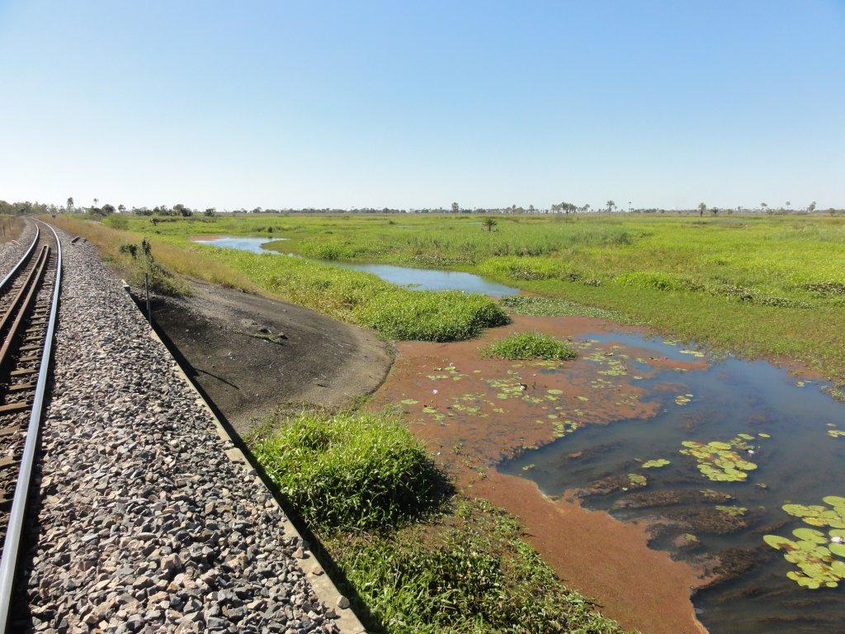

Page intentionally left blank for printing double-sided.

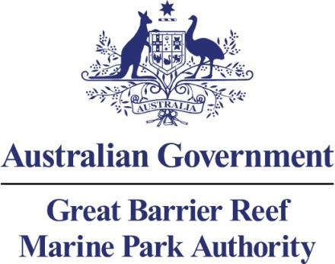

Review of the catchment processes relevant to the Great Barrier Reef region
A report prepared on 31 May 2013 for the Great Barrier Reef Marine Park Authority by:
Joshua Larsen, Javier Leon, Chris McGrath, and Ralph Trancoso

© Commonwealth of Australia 2013

Published by the Great Barrier Reef Marine Park Authority 2013

This work is copyright. You may download, display, print and reproduce this material in unaltered form only (appropriately acknowledging this source) for your personal, non-commercial use or use within your organisation. Apart from any use as permitted under the Copyright Act 1968, all other rights are reserved.

Disclaimer
The views and opinions expressed in this publication are those of the authors and do not necessarily reflect those of the contributors, the Australian Government or the Minister for Sustainability, Environment, Water, Population and Communities.

While reasonable efforts have been made to ensure that the contents of this publication are factually correct, the Australian Government does not accept responsibility for the accuracy or completeness of the contents, and shall not be liable for any loss or damage that may be occasioned directly or indirectly through the use of, or reliance on, the contents of this publication.

National Library of Australia Cataloguing-in-Publication entry
Review of the catchment processes relevant to the Great Barrier Reef region / Joshua Larsen, Javier Leon, Chris McGrath, and Ralph Trancoso.
ISBN 9781922126221 (ebook)
Ecosystem management--Queensland--Great Barrier Reef.
Ecosystem health--Queensland--Great Barrier Reef.
Natural resources management areas--Queensland—Great Barrier Reef.
Great Barrier Reef (Qld.)--Management.
Great Barrier Reef Marine Park Authority.
577.5109943

This publication should be cited as:
Larsen, J., Leon, J., McGrath, C., Trancoso, R. 2013, Review of the catchment processes relevant to the Great Barrier Reef region, GBRMPA, Townsville.

Cover photo: The Queensland North Coast railway line crossing Barratta Creek near Brandon. Photo by Donna-marie Audas.



Requests and enquiries concerning reproduction and rights should be addressed to:

Great Barrier Reef Marine Park Authority
2-68 Flinders Street (PO Box 1379)
Townsville QLD 4810, Australia

Phone: (07) 4750 0700
Fax: (07) 4772 6093
Email: info@gbrmpa.gov.au

www.gbrmpa.gov.au
Table of Contents
Executive summary 1
Potential management actions: 1
List of terminology 2
Introduction 4
Background 4
Catchment overview and climate 5
Upper catchment 9
Slope 9
Streamflow 11
Key limits to understanding in the upper catchments 12
Lower catchment 16
Slope 17
Streamflow 18
Key limits to understanding in the lower catchments 20
Hydrological inter-dependence in catchment processes 21
Climatic change 21
Topographic changes 22
Vegetation change 23
Erosion 28
Nutrients 28
Key limits to understanding the hydrological inter-dependence between vegetation, erosion, and nutrients 31
Summary of management mechanisms 32
Statutory instruments, including water resource plans and permits 32
Legacy, cumulative and indirect impacts 35
Key limitations to current review of legislation 36
Potential management actions 36
References 38
APPENDIX A – Author profiles 44
Appendix B. Coastal Ecosystem Assement Framework (CAEF) ecosystem service capacity summary 45

Executive summary
The hydrological processes within catchments set the backbone of all ecological functions and water quality outcomes. These catchment ecosystems and water quality outcomes in turn are in direct connection with the health of the marine environment to which they drain, and have therefore been of increasing concern for the long term health of the Great Barrier Reef World Heritage Area (World Heritage Area) and the Great Barrier Reef Marine Park (Marine Park).
This review provides an overview of the relevant hydrological and biogeochemical processes within the Great Barrier Reef catchments, and the important interactions between them from the upper to lower catchment areas. The upper catchment provides all the hydrological services which generate runoff and partition the water balance, setting the tone for the total amount water available downstream and its quality. The lower catchment channel and floodplain network is essentially a buffer between the upper catchment processes and the ocean, and significant alterations to this system also means changes in buffering dynamics, which are critical to understand if catchment impacts on the marine environment are to be properly understood and managed.
This review highlights the great number of studies which have contributed to the understanding of the climate, hydrology, and associated processes such as vegetation dependence, catchment erosion, and nutrient dynamics within the Great Barrier Reef catchments. It also collates and analyses some missing aspects of the hydrology between all the Great Barrier Reef catchments. In so doing, it also provides a summary of the key knowledge gaps, which can serve as a guide to further research.
The key theme emerging from the majority of these knowledge gaps is a general under appreciation of the importance of catchment hydrology in driving many of the ecosystem health and service outcomes relevant to the Great Barrier Reef. At its core, this is because many of the catchment ecosystem services have a strong inter-dependence on some aspect of catchment hydrology (for example, water balance and tree water use, nutrient export and overland flow and groundwater recharge). Nonetheless, the review also highlights the many research tools that have already been developed to investigate these dependencies, and therefore a research strategy to address these critical gaps is easily developed. These are contained within the key actions detailed below.

Potential management actions:
Based on the key knowledge gaps identified in this review, actions that could be taken include:
- A thorough scientific assessment of the hydrological processes within the Great Barrier Reef catchment areas be carried out, including: the seasonal to annual water balances, streamflow and hydrograph characteristics, the role of land-use in runoff processes, ground and surface water interactions from the hillslopes to the lower floodplains, overland flow extent and floodplain inundation frequencies, the role of in-stream storages (dams and weirs) in the catchment hydrology, and the dependence of event scale variability on various synoptic processes (for example, cyclones). This last point should also highlight the role of the synoptic processes in driving the large hydrological variability observed within the Great Barrier Reef catchments.
- An analysis of climatic and streamflow trends within the Great Barrier Reef catchments, including statistical tests for non-stationarity.
- An analysis of the sensitivity of streamflow to other changes in the catchment water and energy balances especially precipitation and vegetation, and the feedbacks between them.
- A detailed analysis of the overland flow (floodplain) transport pathways where nutrient addition is of primary concern, including their inundation, flow hydraulics, infiltration, changes in water quality, and the subsequent return flow to river channels or the coast. This would also consider the relation of these processes to the river channel hydrograph, and the relative contribution of return flow from floodplains to flood plumes which ultimately reach the Marine Park.
- A comprehensive study on the coupling between nutrient kinetics and the hydrological transport processes in the landscape. This would include key biogeochemical kinetic factors (organic matter, dissolved oxygen, microbial processing), the role of event and seasonal hydrology in nutrient export, and how this links with the surface, hyporheic zone, and groundwater exchanges and flow paths.
- Finally, for long term management effectiveness, establish a robust monitoring network, preferably where streamflow records are already continuously monitored, that would determine surface, groundwater and hyporheic zone water exchanges, continuously monitor key kinetic determinants of nutrient concentrations (organic matter fluorescence, dissolved oxygen), and serve as locations for surface water and groundwater sampling. This could also serve as an addition to the existing Marine Monitoring Network.
Each of these actions provides the critical information necessary to understand how catchment processes impact on the World Heritage Area and the Marine Park. However, they also proceed in a logical independent order: with actions 1 – 3 enabling areas of critical hydrological function within the World Heritage Area and the Marine Park to be effectively identified, and actions 4 – 5 enabling areas of critical biogeochemical function to be identified. If these can be achieved in combination, then it is possible to establish areas requiring further investigation as an immediate priority for reef protection, and which would therefore be the target of action 6. Additionally, action 6 could be implemented as a part of the existing Paddock to Reef Integrated Monitoring, Modelling and Reporting Program^{1,2}, and would value add considerably to the capacity of this Program.

List of terminology
Discharge: is the volume rate of water flow, including any suspended solids, dissolved chemical species and/or biologic material, which is transported through a given cross-sectional area.³
Headwaters: the tributary streams of a river in the area in which it rises
Runoff: is the water flow that occurs when the soil is infiltrated to full capacity and excess water from rain, meltwater, or other sources flows over the land. This is the primary agent in water erosion.⁴
Precipitation: is a major component of the water cycle, and is responsible for depositing most of the fresh water on the planet. All liquid or solid phase aqueous particles that originate in the atmosphere and fall to the earth's surface. The amount, usually expressed in millimetres or inches of liquid water depth, of the water substance that has fallen at a given point over a specified period of time.⁵
Runoff coefficient: is a coefficient relating the amount of runoff to the amount of precipitation received. It represents the integrated effects of infiltration, evaporation, retention, and interception, all of which affect the volume of runoff.⁶
Baseflow: is an important genetic component of streamflow, which comes from groundwater storage or other delayed sources (shallow subsurface storage, lakes, melting glaciers, etc.). Through most of the dry season of the year, the streamflow discharge is composed entirely of baseflow. In a wet season, discharge is made up of baseflow and quickflow, which represents the direct catchment response to rainfall events.⁷
Overbank: is the type of alluvial geological deposit or sediment that is deposited on the flood plain of a river. Because it occurs outside the main channel, away from faster flow, the deposit tends to be fine-grained, being formed by vertical accretion.⁸

Introduction

Background
The Great Barrier Reef is a World Heritage Area coral reef renowned for its marine biodiversity which is estimated to have a current day value of AU$ 51.4 billion.⁹ These ecosystems have developed on a coastline that delivered low nutrient concentrations and suspended sediment.^{10,11} Since European settlement, the annual load of nutrients and suspended sediment exported from the coastal catchments flowing to the reef are estimated to have increased between 5-9 times.¹² The increases in nutrients, particularly nitrogen and phosphorus, have been attributed to farming practices which occur on ~80 per cent of the coastal catchment area adjacent to the Great Barrier Reef.¹³ Likewise, increased suspended sediment concentrations have been linked with changes in land use, with the actual increases strongly dependant on the type of change.¹⁴ In combination, these changes in catchment water quality have caused a decline in health of coral ecosystems in the Marine Park. In response to this, the Reef Water Quality Protection Plan was developed and released in 2003, followed by a scientific consensus statement in 2008¹⁵, and finally a revised Reef Water Quality Protection Plan in response to the consensus statement in 2009, all with the aim to halt and reverse this decline in catchment water quality¹⁶. This reversal has a specific target of at least a 50 per cent reduction in 2009 nutrient and sediment loads being exported from these catchments by 2013.¹ Critically, the new Great Barrier Reef Outlook Report 2009¹⁷ has acknowledged that many of the threats to the long term health of the Marine Park are not within the marine environment itself, and are instead highly dependent on the processes operating within all the basins draining to the World Heritage Area and Marine Park along its considerable coastal length.
Despite this recognition of the importance of catchment processes in determining the long term health of the World Heritage Area, and the large number of studies examining annual nutrient and sediment loads, there has been comparatively little work examining the role of the actual catchment hydrological and biogeochemical processes which ultimately determine this export. This review also occurs in the context of the recently released Coastal Ecosystem Assessment Framework¹⁸ which highlights the importance of coastal ecosystems as a bridge between marine and terrestrial environments. In the context of Coastal Ecosystem Assessment Framework, coastal ecosystems include the breadth of ecological functions, including hydrological, that occur within the catchments draining to the World Heritage Area. Specifically, the Coastal Ecosystem Assessment Framework has identified 13 natural ecosystems within the Great Barrier Reef catchments and a range of physical, biogeochemical and biological services that are provided to the Marine Park.¹⁹ Although the Coastal Ecosystem Assessment Framework lists hydrology (recharge/discharge) as the first process, it is important to note that all subsequent processes listed in this framework (physical, biogeochemical, and biological) are dependant or linked in some way to the catchment hydrology. This is because catchment hydrology interacts with all landscape functions, including biogeochemical, ecological, and anthropogenic, as an agent of both transport and biogeochemical reactions. Therefore, the events that cause erosion and deposition in a catchment will also export nutrients, inundate floodplains and provide fish breeding habitat, and infiltrate into soil water stores to be used by forests and grasslands through transpiration. Although we may measure each of these processes separately, there is in fact a wide range of interdependence between them, and the more we understand and quantify this, the better we will ultimately manage the catchment and its basins, the World Heritage Area and the Marine Park.

Catchment overview and climate
This review aims to provide a conceptual guide to the hydrological processes relevant to consider in these catchments, and how these vary from the upper to the lower catchment. This distinction is in part because there is a large transition in the catchment processes between these upper and lower (for example, flow concentration in the upper catchment, and flow dispersion and diversion in the lower catchment), and also because they are important in different ways to the overall ecosystem health of the World Heritage Area and Marine Park. The basins draining to the World Heritage Area occupy a large portion of the Queensland coastline, spanning a large latitudinal and climatic gradient (Figure 1). Of the total land area draining to the World Heritage Area (~425,000 km²), 78 per cent is dominated by the four largest basins, the Fitzroy, Burdekin, Burnett, and Normanby River basins, and 64 per cent is dominated by the Fitzroy and Burdekin alone. This produces a stark differentiation in the size of basins draining to the World Heritage Area (Figure 2), with the majority of basins being of small size (>10,000 km²) and occupying a narrow zone between the coast and the dividing range (Figure 1). Drainage beyond the dividing range is almost exclusively carried out by the four larger basins listed above.
Rainfall within the Great Barrier Reef catchment is generally highly seasonal in timing (wet and dry seasons), with the proportion of early to late wet season rainfall decreasing with increasing total rainfall, and also latitude²⁰ (Figure 3). In terms of broad climatic trends, some longer term analyses have shown that rainfall over the eastern coastal region has declined since the 1950s, where the largest drying exceeds 50 mm per decade.²¹ Specific to the Great Barrier Reef catchments, there is a strong latitudinal (north-south) gradient in mean annual rainfall, which controls 18 per cent of the mean annual rainfall variance. After this, elevation explains 6 per cent of mean annual rainfall variance, and distance from the Great Dividing Range 4 per cent. The coastal zone is clearly the area with the highest rainfall averages, and interestingly the western divides of the larger basins have the lowest mean annual rainfall, which is a very unusual basin characteristic (rainfall is typically highest in the headwaters) (Figure 4). The highest coastal zone of high mean annual rainfall is also the area where the coastal plain is narrowest, and where both the Great Dividing Range and the high escarpment slopes are virtually at the ocean (~Cairns). The areas of high coastal rainfall also experience a greater proportion of annual rainfall during the summer (wet season) months with decreasing latitude.²² Given the large variation in mean annual rainfall within basins, as well as the large variation between basins, more work on the drivers of this variation (for example, ENSO, cyclone frequency and location) are clearly needed in order to properly understand the climatic drivers of the hydrology. In addition, little is known about rainfall intensity and its distribution within the basins, and is also an area for further investigation.

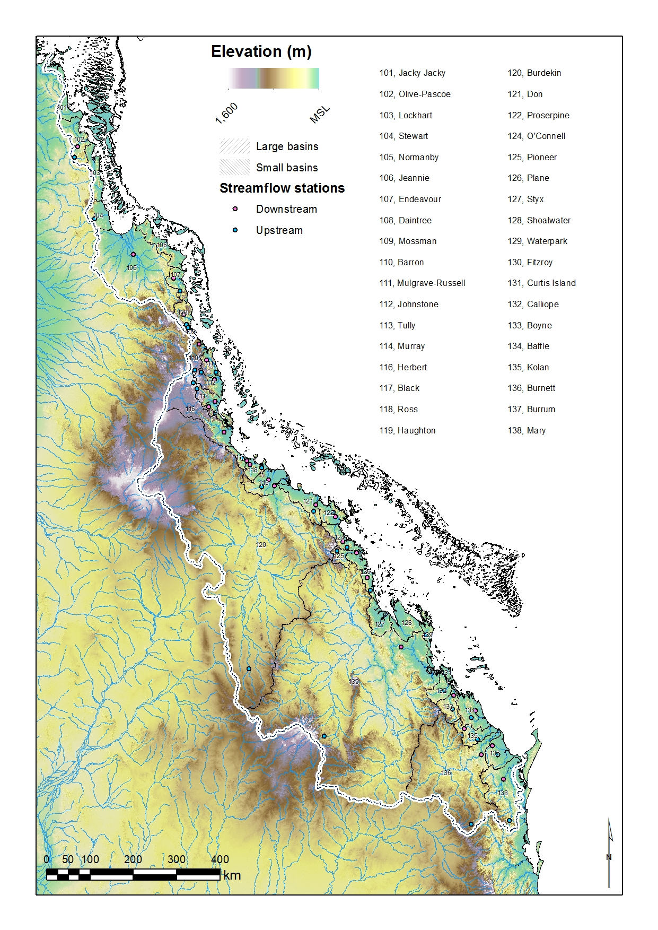
Figure 1. DEM of the catchments draining to the Great Barrier Reef, catchment names, areas, and stream networks. The Qld government gauging stations used (upstream and downstream) as streamflow examples in this report are also shown.
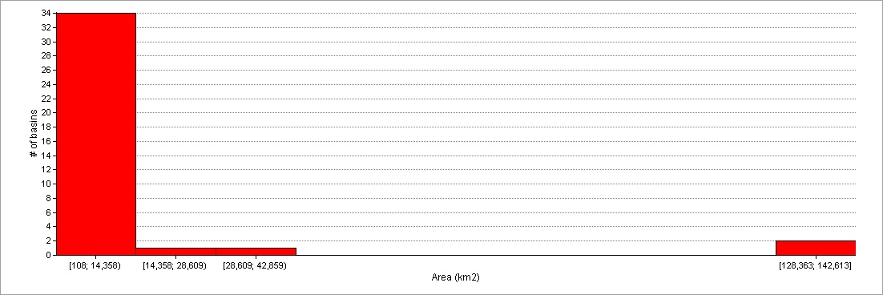
Figure 2. Histogram of catchment areas for catchments draining to the Great Barrier Reef.

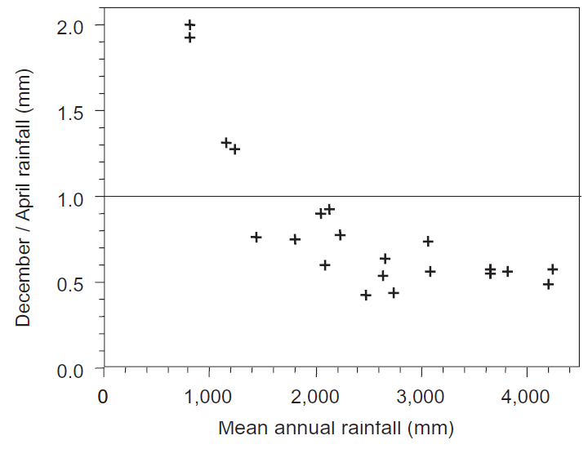
Figure 3. Mean annual rainfall in the Great Barrier Reef catchments as a proportion of early (December) and late (April) wet season rainfall.²⁰

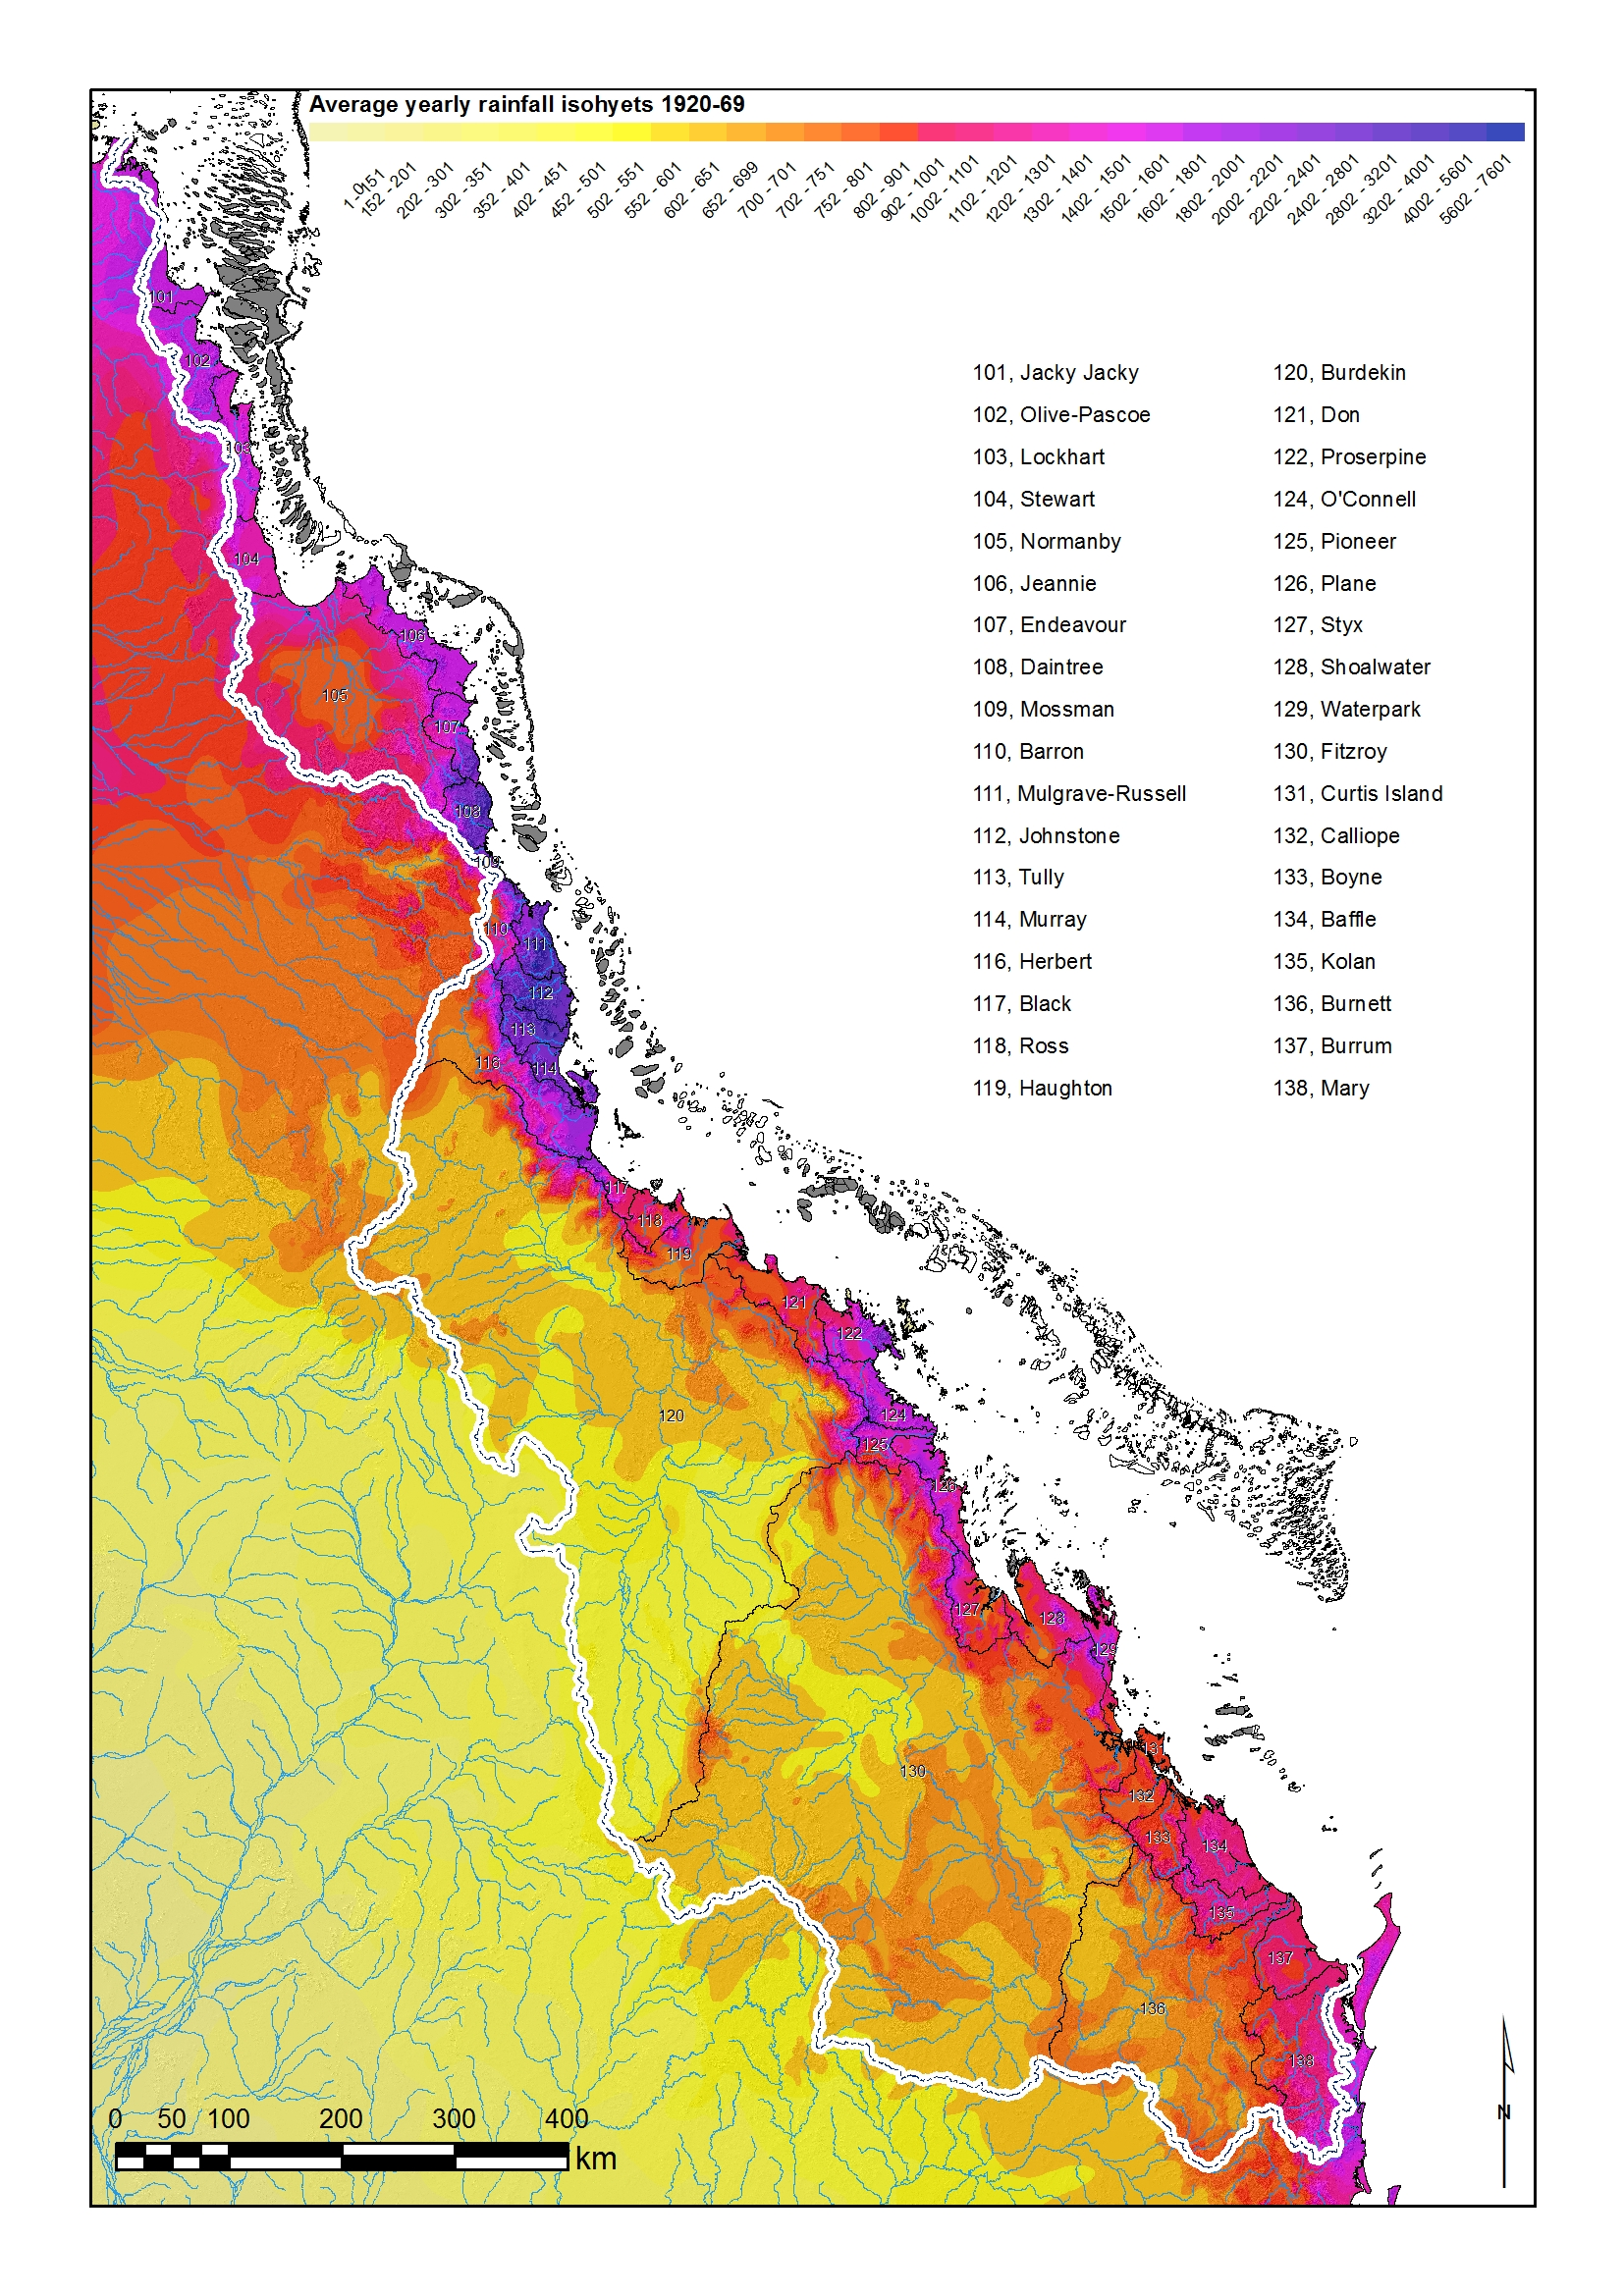
Figure 4. Mean annual rainfall (mm/yr) within the catchments draining to the Great Barrier Reef.

Upper catchment
The upper catchment is defined here as those areas of catchments responsible for net flow convergence into surface channels. The upper catchment, or headwaters, are typically characterised by a higher density stream network of low order channels in comparison to the mid and lower reaches of a catchment. Hydrologically, this region is the where the majority of runoff in a catchment is generated through a variety of rainfall runoff-processes (Figure 6). This is also the region where the water balance is the most dynamic, with large variations in soil moisture stores (on which the forest vegetation is dependant) and water tables providing baseflow to the stream network in highly seasonal climates. The importance of upper catchment water storage and release as baseflow during the dry season has been acknowledged for the most northern of the Great Barrier Reef catchments²³, but as yet this component of the water balance remains almost completely unknown for the majority of Great Barrier Reef catchments. Given this role in generating runoff and partitioning the water balance, the importance of understanding hydrological processes within the headwaters of catchments cannot be understated. Some specific examples of the most important hydrological processes include: subsurface and surface runoff generation on hillslopes²⁴, hillslope – riparian interactions and buffering²⁵, ground and surface water interaction in confined alluvial valleys²⁶, the timing and magnitude of vegetation water use²⁷, and flow pathways through soils, weathered and unweathered bedrock.^{28,29} In addition to this hydrological function, the moisture content and physical transport of water within the soils and rocks of the upper catchment also set the background for downstream water quality, including salinity, nutrients, and sediment loads.³⁰

Slope
We calculated catchment slope angles from the 1-second (approximately 30 m spatial resolution) smoothed digital elevation model derived from the Shuttle Radar Topography Mission (SRTM) data.³¹ Slope angle and length are critical parameters in the conversion of rainfall to runoff within catchments. In the headwater regions of the larger catchments, there are obvious topographic features within the landscape (Figure 1), however this does not necessarily translate to the steeper slopes (Figure 5). In fact the watershed perimeters of the four largest basins are dominated by remarkably low slope terrain (Figure 5). Instead, within these basins the key slope features (i.e.: steeper slopes) occur at the eastern edge of the basins. This has important implications for runoff generation in these large catchments, since these high slope areas are also in the higher mean rainfall zones of the catchment, and yet only drain a very small part of the total catchment area. Many of the smaller coastal catchments have steep slopes in their headwaters, where the Great Dividing Range forms an important mountain front zone critical for catchment processes (for example, Wilson & Guan 2004³²). The slope at this divide is however highly variable, with a significant reduction in catchment headwaters in the far northern catchments (Figure 5).
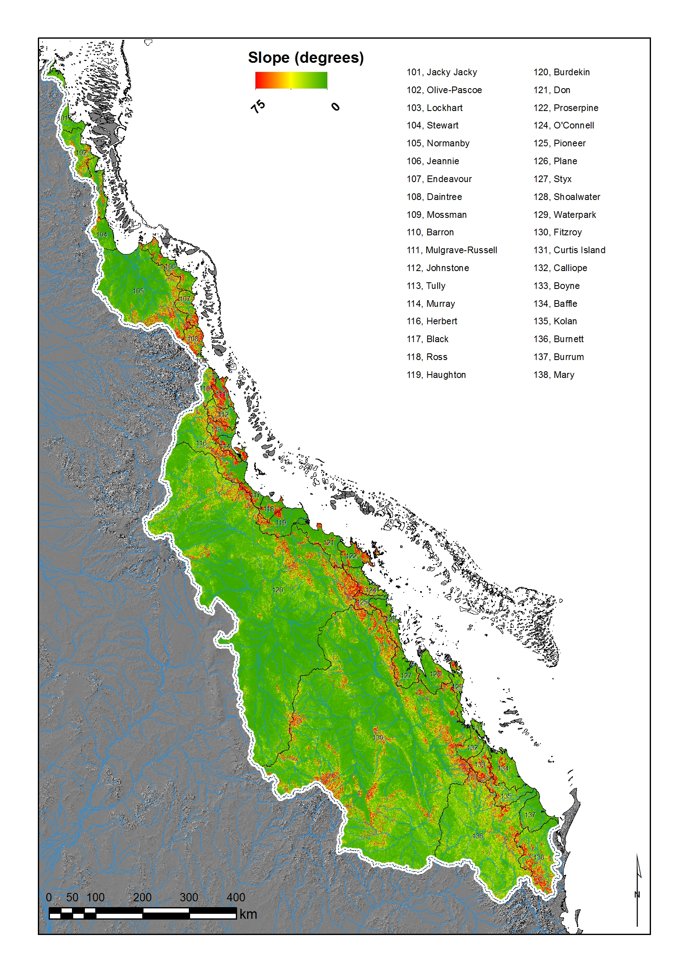
Figure 5 DEM derived slope (degrees) for the catchments draining to the Great Barrier Reef

Streamflow
We obtained average monthly and annual stream flow data from the Qld watershed database, from this, 24 Great Barrier Reef catchments had sufficient data to compare discharge, area, rainfall, and slope. As with rainfall, the discharge across all the catchments is highly seasonal, with increasing proportions of streamflow occurring during the summer (wet season) months with decreasing latitude. The inter-annual streamflow variability generally matches the rainfall variability: increasing from north to south (Figure 7). However, this variability is actually lowest in the small coastal catchments north of Cairns with very high annual rainfall, such as the Tully and Johnstone²⁰ (Figure 7). Peak flows are generally December – April, with the large catchments more towards the early to mid-summer timing. Despite the pronounced seasonality in streamflow, some catchments, such as the Barron, Mary, Johnstone, Mulgrave, Daintree, Mossman, and Tully are able to maintain reasonable flows (baseflow) throughout the dry season as measured at the most downstream location. Others, such as the Herbert and Pioneer, only have this capacity within the upper catchment areas. The northern most catchments of the Great Barrier Reef have been recognised as having variable baseflow contributions.²³ Large catchments in this region such as the headwaters of the Normanby receive substantial baseflow, however in other smaller catchments (i.e. Stewart and Olive-Pascoe) the very high rainfall and low catchment storage capacity results in much smaller baseflow contributions.^{23,33} However, for the majority of the catchments within the Great Barrier Reef, the full variability and importance of baseflow contributions to streamflow remains largely unknown.
Interestingly, the very high discharges of the largest catchments (Burdekin, Fitzroy, Burnett, and Normanby) are driven almost entirely by a comparatively small area with high slopes and high rainfall at the north eastern edge of the watersheds (Figures 8 & 9). This means that the majority of the headwater areas contribute very little to the total water flux at the catchment mouth, and rely on a comparatively small area for determining the overall catchment hydrology (Figures 8 and 9). Nonetheless, there is still a trend (not significant) towards higher annual discharges with increasing catchment area (Figure 10), suggesting these north eastern segments of the catchment which drive streamflow are still sufficiently large enough that this relationship with annual discharge can develop. In contrast, mean annual runoff decreases with increasing catchment area (Figure 10), reflecting in part the decreasing efficiency of converting rainfall to runoff in the larger catchments, but also the increasing aerial extent of low runoff areas in the four largest catchments.
The catchment efficiency in converting rainfall to runoff at annual timescales is captured by the runoff coefficient (runoff/rainfall).⁶ In general, the runoff coefficient for Great Barrier Reef catchments increases with increasing precipitation, with three distinct groups emerging within this (Figure 11). These groups are in part the result of slope effects, with the moderate rainfall – low runoff coefficient catchments generally having low mean slopes (group 1), and the high rainfall – high runoff coefficient catchments generally having higher mean slopes (group 2) (Figure 11). However, group 3 catchments, which have moderate rainfall and a high runoff coefficient, only have moderate slopes, suggesting factors other than slope angle are required to explain the high runoff co-efficient in these catchments (for example, slope length, soil and bedrock distribution, vegetation, land use, artificial water storages, etc).
Flooding is a major component of the hydrology in the Great Barrier Reef catchments, partly because of the highly seasonal rainfall, but also because of their susceptibility to tropical cyclone incursions.²² This results in high flood variability, particularly in the large catchments, and the smaller catchments south of the Fitzroy.³⁴ However, catchments north of the Burdekin tend to have low flood variability because of their already very high rainfall and runoff, therefore additional events have comparatively less effect on their flood variability.³⁴ Because of their larger area, the Fitzroy and Burdekin catchments are particularly sensitive to the large rainfall footprints of tropical cyclones, resulting in very infrequent intense hydrological activity in their upper catchments.

Key limits to understanding in the upper catchments
- Synoptic controls on rainfall variability within and between catchments, as well as the distributed effects of ENSO
- The dominant catchment drivers of streamflow and streamflow variability, including variability in runoff generation, and key flow paths
- Runoff generation pathways, riparian-hillslope buffering, and surface-groundwater interactions in headwater regions critical to the catchment hydrology
- Seasonal and annual water balances, natural catchment storage, baseflow contributions, and vegetation water use
- The effect of artificial storages (i.e. dams and weirs) on flow regime, floods, and the water balance.

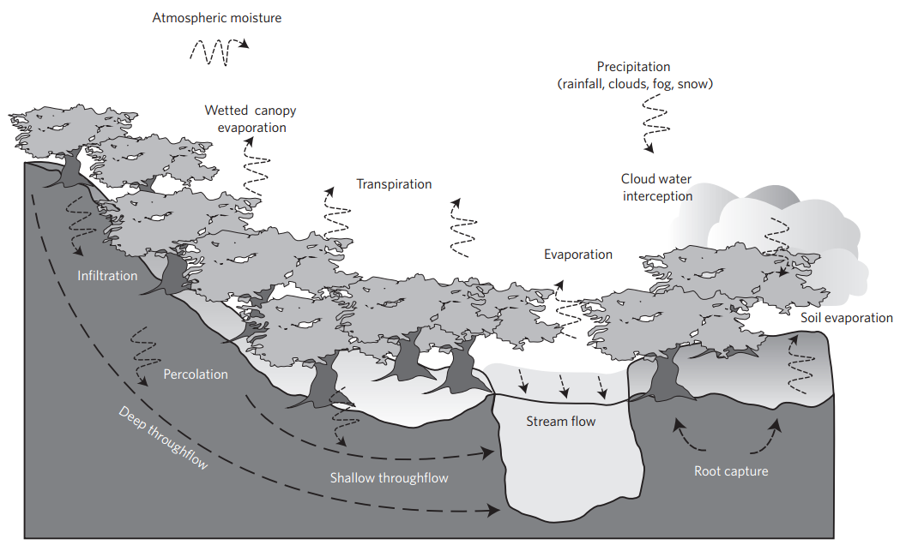
Figure 6. The dominant hydrological pathways within the upper catchment ³⁵.
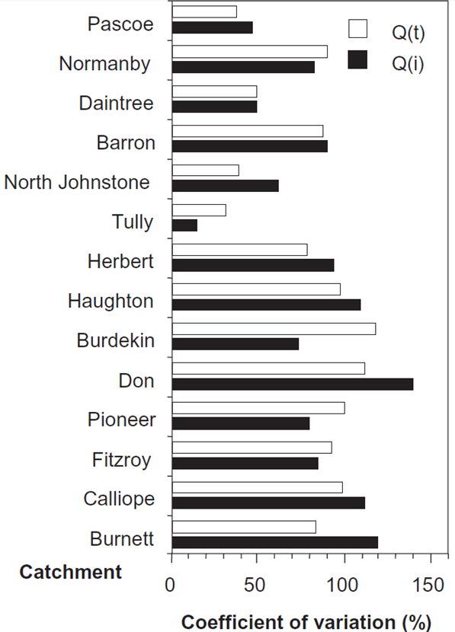
Figure 7. Variability of annual discharge as annual totals (Qt) and annual maximum flows (Qi) for catchments in the Great Barrier Reef arranged south to north.²⁰
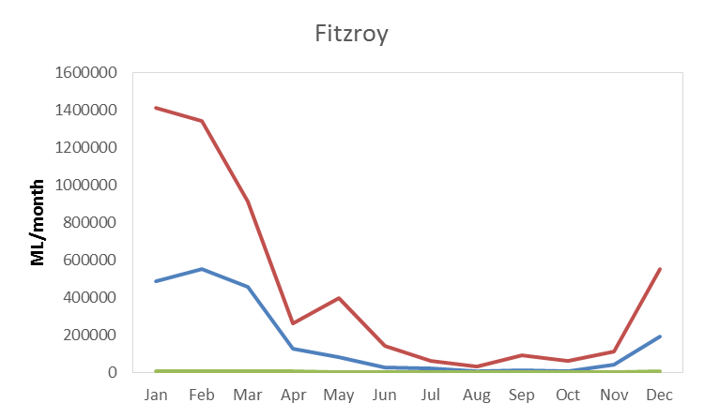
Figure 8 Distribution of mean monthly discharge in the Fitzroy River catchment, with upstream (green), north-eastern reach (blue) and downstream (red) gauge records shown. Downstream discharge (red) is determined mainly by the small north-eastern area of the catchment (blue) rather than the remaining headwaters (green).

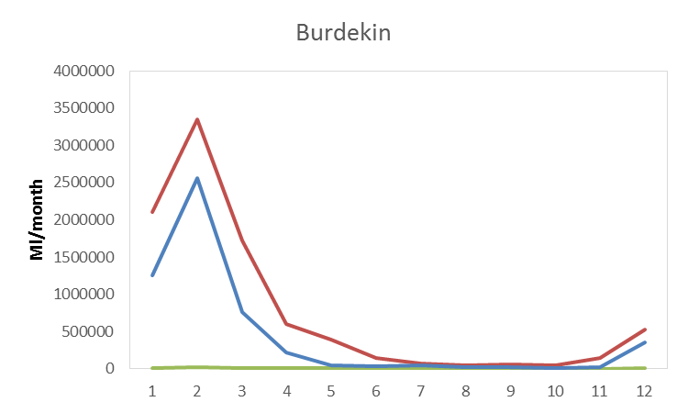
Figure 9 Distribution of mean monthly discharge in the Burdekin River catchment, with upstream (green), north-eastern reach (blue) and downstream (red) gauge records shown. Downstream discharge (red) is determined mainly by the small north-eastern area of the catchment (blue) rather than the remaining headwaters (green).

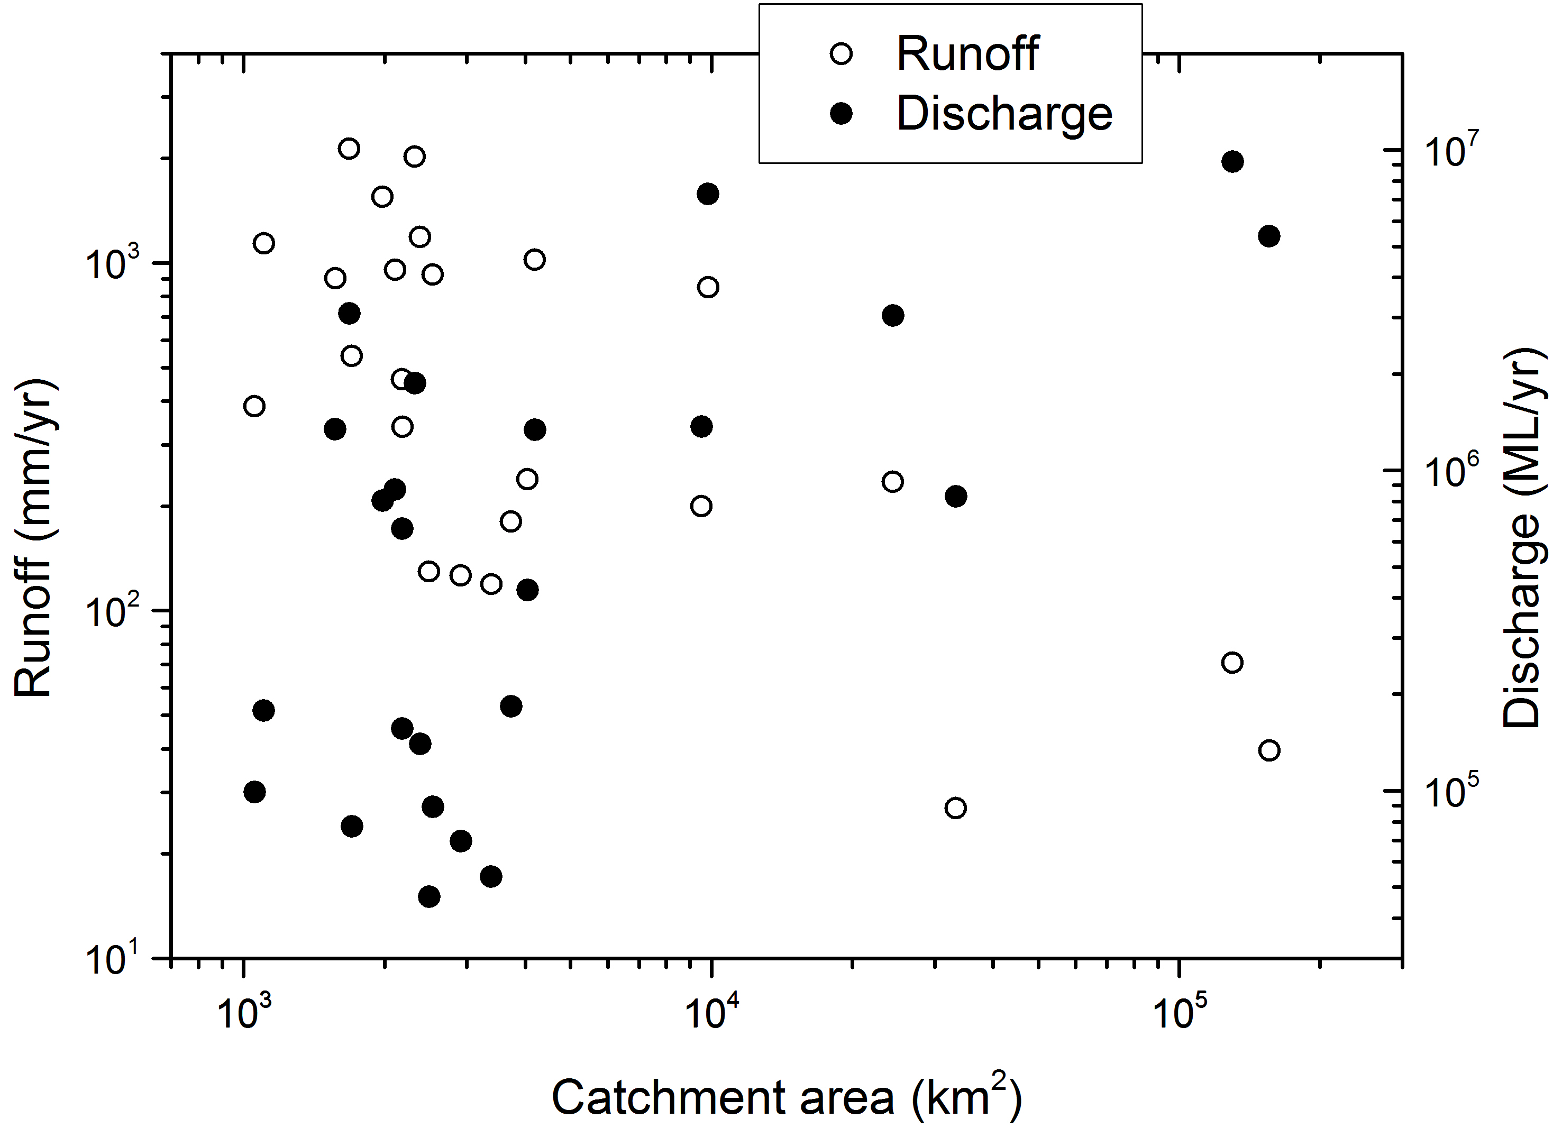
Figure 10. Annual runoff and discharge variations with catchment area. Discharge tends to increase with catchment area, while runoff tends to decrease with increasing catchment area in the Great Barrier Reef catchments.
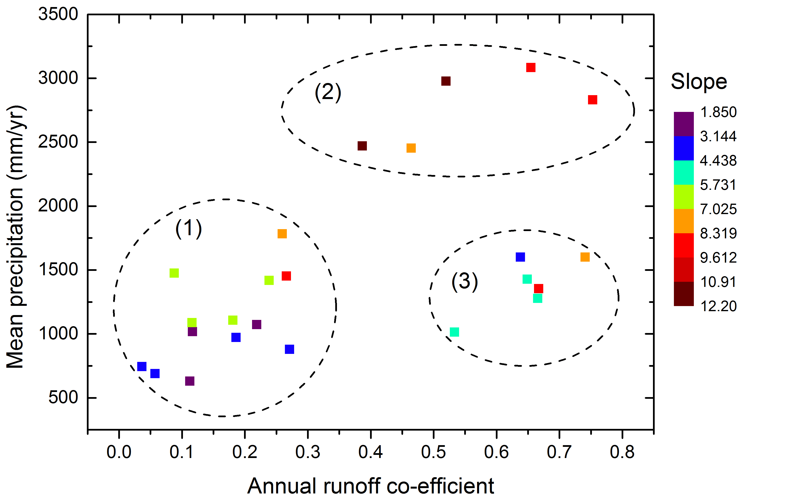
Figure 11. Mean annual precipitation and runoff co-efficient for Great Barrier Reef catchments, showing three distinct groups: 1. Low to moderate precipitation and low runoff co-efficient, 2. High precipitation and high runoff co-efficient, and 3. Moderate rainfall and high runoff co-efficient. Mean catchment slopes are generally lower for group 1, moderate for group 3, and highest in group 2.

Lower catchment
The lower catchment is defined here as the downstream areas where slope is typically very low, and surface flow is divergent, creating floodplains and distributary channel networks before interacting with the coastal environment. Some important hydrological differences in comparison to the upper catchment are: a dominantly alluvial setting, less variable and generally shallower water tables, and overbank flow which may connect floodplains, wetlands and other standing water bodies. In the absence of overland flow, these surface water bodies may also be hydrologically connected via groundwater. Given the lower slope and water table gradients in comparison to the upper catchment, the travel time of surface and subsurface water flow paths can be much longer over the same distance. This difference may be small for surface flows, especially during floods, however during flow recession storage processes in the lower catchment are primarily within riverbanks, river beds, and shallow aquifers, all of which increase travel water times considerably.³⁶
A key feature of lower catchment hydrology is floodplain inundation due to overbank flow, the frequency and extent of which is not yet quantified for Great Barrier Reef catchments. This overland flow provides freshwater ecosystem habitat, and can also recharges shallow aquifers to a much greater extent than is achievable via the river channels. The ions, nutrients, and sediment carried from the upper catchment are naturally redistributed via overbank flow across floodplains, and therefore drive ecosystem metabolism and productivity, and also determine water quality. Human modification within lower catchments is often extensive, and in terms of surface hydrology the primary impacts are on channel flow and processes, as well as overbank flow diversion and retention. In terms of subsurface hydrology, or groundwater, the impacts are often extensive. These can include aquifer depletion due to pumping³⁷, rising groundwater levels due to yearly irrigation³³, and changes in groundwater quality due to infiltration of nutrients as well as altered freshwater-saltwater dynamics at the coastal boundary.³⁸ The lower catchment channel and floodplain network is essentially a buffer between the upper catchment processes and the ocean, and significant alterations to this system also means changes in buffering dynamics, which are critical to understand if catchment impacts on the marine environment are to be properly understood and managed.

Slope
The slopes of the lower catchment sections are typically low, and dominated by floodplains. However, the extent of these floodplains is highly variable, and many of the smaller catchments have some topographic relief within the lower catchment that restricts floodplain development and overbank flows (Figure 5).
Given the accuracy limitations of the digital elevation models used here (vertical root mean square errors between 6-10 m³¹), it is not possible to determine the inundation extents. Higher resolution data such as LiDAR is required for the lower catchments so that accurate elevation information for flow barriers (bund walls, levees, etc.) and drainage channels (natural and artificial) can be properly accounted for in any future flow routing analysis. Nonetheless, it is possible to differentiate some important trends in slope between the upper and lower catchments that is relevant to the hydrology. Using the vector ruggedness measure (a measure of the topographic complexity in a landscape, rugged to smooth), which ultimately determines the path of water and the ease with which it can travel, we find that the upper and lower catchment areas are well separated by this metric (Figure 12). In addition, an increase in the size of lower catchment areas also tends to lead to lower roughness, which will also suggests that flood routing will vary with lower catchment size.
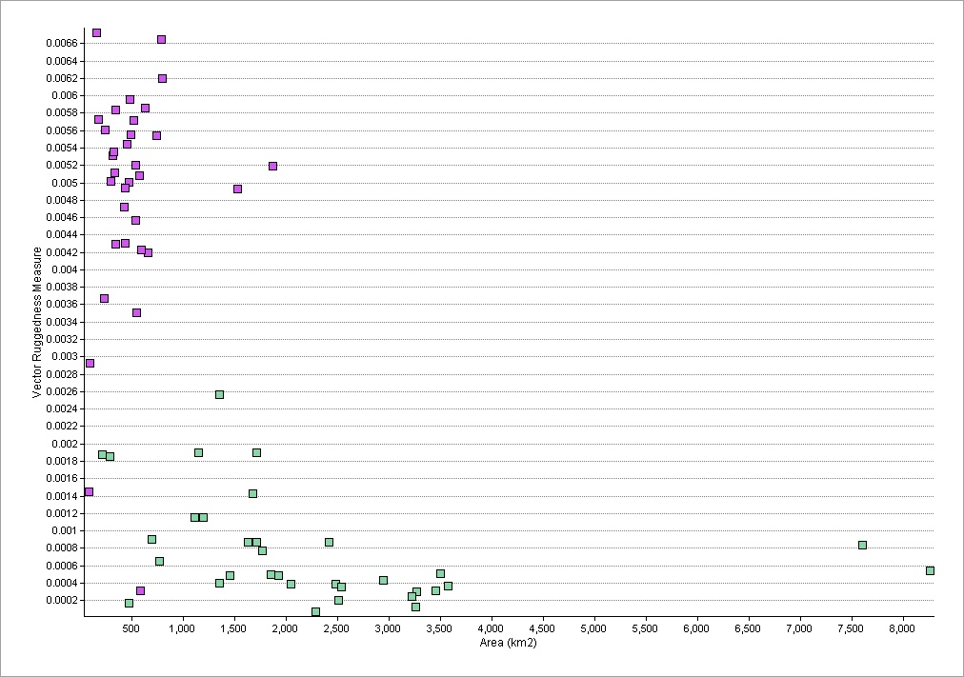
Figure 12. Mean catchment roughness (terrain complexity) vs catchment area for the lower (green circles) and upper (purple circles) catchment areas. The four largest basins (Fitzroy, Burdekin, Burnett, and Normandy) are excluded.

Streamflow
Overbank flow during flood events has been identified as crucial to sediment and nutrient export to the Great Barrier Reef.^{39,40} However, the hydrological mechanism for this is not immediately obvious. Flow depths on floodplains are usually small and velocities slow compared to the channel, moreover, their low slopes mean runoff generation is not effective even when the rainfall is very high.⁴¹ Therefore, the principle mechanism of effective delivery to the Great Barrier Reef must be via overbank flows leaching and re-suspending floodplain nutrients and sediments, with a portion of this flow re-directed back to the main channel so that it can be entrained within the flood plume and thus reach the reef lagoons in high concentrations. This flow pathway for overbank flow has not been demonstrated or investigated in detail within Great Barrier Reef catchments, although Wallace et al.^{40,42} show that overbank flow does carry a significant load, and will increase the load estimates for nutrients and sediment if the entirety of this flow was able to be entrained within the flood plume entering the ocean. Understanding the overbank flow dynamics and pathways is therefore crucial to understanding how nutrients and sediment are delivered to the reef during flood events. If for example, the majority of overbank flow does not re-enter the channel until the flood is receding, then any additional nutrients or sediment carried within this return flow will not be able to contribute to the main flood plume, and therefore will be highly dispersed upon entry to the marine environment. However, the fate of nutrients and sediment within return flow from floodplains during flow recession may include a significant storage component within the channel itself, and therefore be available for transport within the next flow event. This would constitute a potentially large lag between entrainment during overbank flow and subsequent delivery to the Great Barrier Reef lagoons, and is therefore another crucial knowledge gap. Additionally, floodplains are large areas of potential hydrological storage and infiltration, which can be in the form of wetlands and lakes (seasonal or permanent), or as transient soil moisture and deep drainage (aquifer recharge). Thorburn et al.⁴¹ has identified deep drainage (aquifer recharge) as a large component of the water balance on agricultural fields (floodplains) in some Great Barrier Reef catchments based on model mass balance. However, no actual measurements are available from anywhere in the Great Barrier Reef to determine the rates of deep drainage (aquifer recharge) and how they vary with flooding, vegetation, etc. Moreover, the shallow aquifer response and flow path of recharge events is also completely unknown, therefore the degree of hydrological connection (and rate of exchange) between the lower catchment channels, and the floodplain aquifers (beyond providing baseflow during the dry season⁴³) also remains a critical knowledge gap.
The problem of accounting for hydrological storage includes both natural (discussed above) and human induced processes. Land-use change, artificial barriers, and drainage channel construction are all common on the floodplains of the Great Barrier Reef, and all affect overland flow and storage in different ways. The extent and transport capacity of artificial drainage networks is important to understand since they may provide additional flow to main channels, or more commonly, decrease the soil moisture storage within floodplains themselves via increased drainage. Their potential impact on groundwater recharge and dynamics is unknown, since they may decrease recharge across the floodplain area they drain if they reduce surface flow and ponding, but may also increase recharge locally below the artificial drainage channels depending on their permeability. Alternatively, they may also have no detectable impact. Of particular concern is the large extent of artificial flow barriers, or bunds, which were originally developed in order expand grazing pasture (ponded pasture) and exclude saltwater or tidal intrusions (Figure 13).⁴⁴ Depending on the mapping technique and classification used, the extent of natural wetlands has not changed significantly following European arrival⁴⁴, or if artificial wetlands such as ponded pastures are included, there has been a large increase.¹⁸ This distinction between natural and artificial wetlands in the lower catchments is important because they can have different hydrological drivers and functions. A government report examined three catchments within the Great Barrier Reef and mapped 16,000 ha of ponded pasture, which is a substantial modification to overland flow processes and the natural tidal range.⁴⁵ The impact of ponded pasture is expected to vary depending on their location, height and management, however it is difficult to fully assess potential impacts given that basic mapping and elevation data is not available. Although these structures block overland flow and create artificial wetlands due to backwater effects, many of them are seasonal and therefore may not develop adverse water quality effects. On the other hand, permanent ponded pasture, effectively permanent wetlands, can develop anoxic conditions depending on ecosystem metabolism, nutrient, and oxygen supply. This remains restricted unless large flow events can overtop the bund wall and transport a large volume of anoxic water to downstream rivers and estuaries.^{46,47} This process has been demonstrated to result in large fish kills, particularly in the lower Burdekin catchment.^{46,47} The full extent of this risk within Great Barrier Reef catchments is not well known, and information on the hydraulics of these structures, as well as controlling kinetic factors (for example, rate of oxygen supply, metabolism, carbon and nutrient supply), are all required if the ecosystem impacts are to be properly managed and predicted.
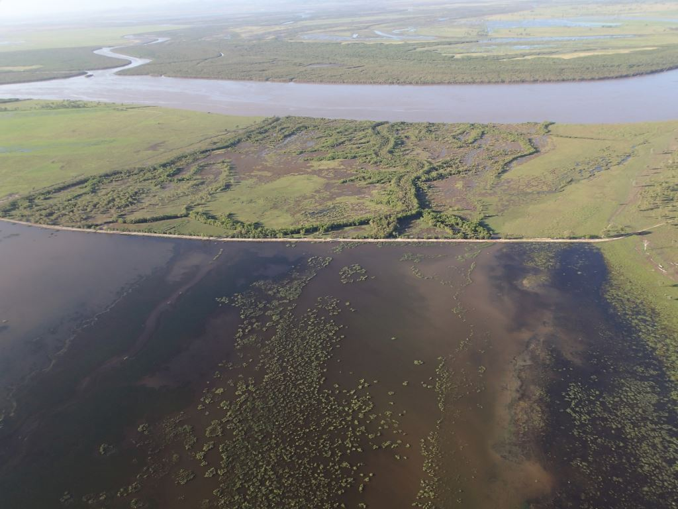
Figure 13: An example of overland flow retention by ponded pasture bund walls on northern bank of the mouth of Fitzroy River. Photograph by Jim Tait (2013)

Key limits to understanding in the lower catchments
- Overland flow pathways and processes, timing and location of return flow to the channels
- Soil moisture storage, infiltration, and groundwater dynamics in response to overland flow
- Spatial and temporal rates of exchange between channels and floodplain aquifers
- Surface / groundwater interactions, including seawater intrusion and coastal dynamics, and human impacts
- Accurate mapping and digital elevation model construction of floodplain drainage and flow diversion/retention structures
- Seasonality of ponded pasture, and factors (hydrologic and kinetic) contributing to the development of anoxic conditions, risk of anoxic water release
- Impact and influence of permanent ponded pastures on the freshwater – seawater ground and surface water dynamics

Hydrological inter-dependence in catchment processes

Climatic change
The potential for increased global temperatures due to greenhouse gas emissions to impact on the climate within Great Barrier Reef catchments is difficult to assess given the large degree of natural variations, as well as the large climatic difference between the catchments from south to north. In terms of hydrology, the most relevant impacts are in terms of precipitation, and any changes to the ENSO regime, or cyclone frequency, would have obvious impacts on catchment hydrology. There are however, important feedbacks between changes in the water and energy balances, and vegetation, which are critical to determine in order to fully assess any impacts on catchment hydrology (Figure 14). Given that the water and energy balance in northern Australia is already dominated by excess energy (greater potential evaporation than precipitation)²³, the most relevant changes will be in precipitation and water available for streamflow (excess water in Figure 14). This in turn, has implications for all downstream processes, including overland flow, and groundwater sustainability.⁴⁸ If climatic forcing in the water and energy balances do change beyond the current range of natural variability, then quantitatively assessing this impact on catchment hydrology is critical if water resources are to be effectively managed. A common approach in this regard is to use a Budyko style framework (for example, Roderick &Farquhar 2011⁴⁹), which provides a simple method to assess changes in water available for streamflow due to changes in the water and energy balance. This framework does not explicitly consider feedbacks with vegetation, or any land-atmosphere coupling that may cause additional changes to climatic forcings, which may be particularly pronounced in tropical climates.^{50,51} However, it is possible to conceptually evaluate these feedbacks and then re-examine the changes in hydrology for a given set of feedback scenarios. Alternatively, fully coupled regional atmosphere and catchment surface-groundwater models are only now becoming available (for example, ParFlow), and given sufficient resources is an alternative method with which to investigate these changes.
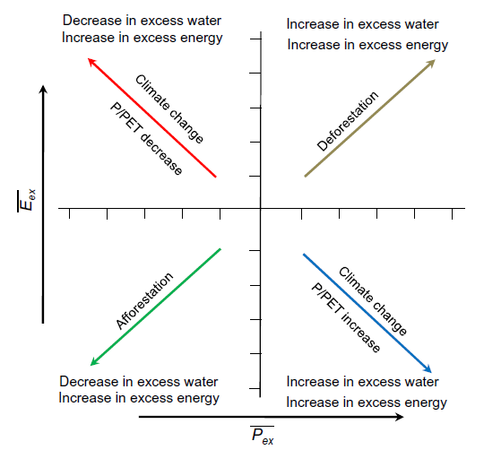
Figure 14. Catchment water balance and streamflow (excess water) responses to changes in vegetation and climate.

Topographic changes
There have been considerable modifications to the morphology of the landscape though human activity, however these are manifest most noticeably on the hydrology where this impact is large relative to the surrounding landscape. Therefore, in combination with any vegetation changes discussed below, road and other levelling activities in the upper catchment areas are likely to reduce roughness, and decrease runoff event travel times. In contrast, within the lower catchment areas modifications are typically in the form of increased artificial drainages and levee construction on existing channels. The development of artificial drainage lowers the immediate water table to an extent dependant on the permeability, the rate of recharge, and the geometry of the drainage channels. These channels also convey water to trunk streams more rapidly than would otherwise occur during overland flow, and may impact on the flow hydraulics of these rivers during events depending on the degree of connectivity and the timing and magnitude of their contribution. Lastly, levee construction in order to restrict overbank flow and contain more flood water within existing channels has the obvious effect of transferring a larger volume of water further downstream at a faster rate than would otherwise occur. This will increase flood heights and overbank inundation extent downstream, and also results in quicker transmission of flood waves. Both these impacts can be determined from detailed downstream hydrograph analysis, provided the data from these areas is available.

Vegetation change
Changes in coastal ecosystem structure, function, and biodiversity have been widespread following European impact in the Great Barrier Reef catchments.¹² In terms of hydrology, vegetation provides two important functions:
- As a landscape roughness element, which affects overland flow on hillslopes, and within channel and overbank flow (floodplains)
- As a biological ‘pump’ of water back to the atmosphere via evapotranspiration.
An important determinant of river bank stability, including erosion during event and potential slumping following an event, is riparian vegetation. Riparian vegetation also creates aquatic habitat, and can serve as biogeochemical buffers in the landscape⁵², however the importance of these services provided by vegetation within Great Barrier Reef catchments is unknown. Recent estimates suggest 77.6 per cent of the riparian zone within all Great Barrier Reef catchments remains forested, and with a further 19.8 per cent non-forested but with high ground cover⁴⁴, suggesting many of these services may be intact, but still requires investigation. Much of the original vegetation in both the large catchments, as well as the floodplains of many of the lower catchments have been removed, and is now subject to agricultural use (Figure 15). The effect of vegetation removal on floodplains flow hydraulics is unclear, and should vary between catchments because of very catchment specific flood routing behaviour. Although it is clear that the overbank flow roughness would generally be reduced following vegetation removal, the consequences for floodplains is not straightforward, since they alternate naturally between being erosive and depositional, with poorly understood thresholds between the two. Additionally, the actual response depends heavily on the replacement vegetation, and high stand density sugar cane at full growth can have a substantial roughness impact, perhaps greater than the original native vegetation. In contrast, reduction of hydraulic roughness within channels due to vegetation removal is likely to have more straightforward impacts, with the existing hydraulics enhanced under these conditions until feedbacks increase or reduce sediment supply, at which point the channel will need to adjust its morphology to the new hydraulic regime. In many cases relevant to Great Barrier Reef catchments, the feedback is an increased (bedload) sediment supply, and the lower channel roughness will likely result in an adjustment to a wider and shallower channel. If in-channel storage structures such as dams and weirs trap a significant fraction of the bedload sediment budget, then the channel response immediately downstream may be the opposite (narrower and deeper channel).
The second important function of catchment vegetation is within the water and energy balance, which has been gathering increasing global research attention.^{35,53} This is primarily because transpiration of vegetation is the primary connection between the water, energy, and carbon cycles, since it is central to land-atmosphere coupling, as well as the amount of water available for streamflow and freshwater ecosystems. In tropical regions, this coupling can be particularly strong, and the flow of moisture through the surface and subsurface, back to the atmosphere via trees, and then in turn influencing local climate is an emerging scientific issue that is poorly understood.³⁵ Therefore, any changes in climate also have important feedbacks with vegetation, however vegetation changes can also occur independently of climate due to land use change, with each having distinct effects on catchment hydrology (Figure 14). A widely recognised hydrological impact of vegetation (tree) clearance is an increase in the water available as streamflow due to the reduction in transpiration.⁵⁴ This effect can be particularly pronounced in tropical wetlands, whose extent may be expanded as a result of increased water availability in the surrounding catchment³⁵ (Figure 16). However, because of the importance of natural climate variations in driving the overall hydrology, the effects of vegetation clearance on surface hydrology can be difficult to determine. In the climatically variable headwaters of the Fitzroy and Burdekin catchments, Peña-Arancibia et al. (2012)⁵⁵ could find little effect of forest clearing on the overall water balance, with most of the changes in streamflow attributable to concurrent changes in rainfall (ENSO). However, there was some evidence for an increase in peak flows, and a decrease in low flows as a result of vegetation loss⁵⁵, which highlights the need to further investigate the complex response of water balances to climate and vegetation change. In terms of tree water use in Great Barrier Reef catchments, McJannet et al⁵⁶ observed that the evapotranspiration of natural vegetation in the wet tropical areas is controlled by local forest characteristics such as stem density, tree size distribution and sapwood area. Although small in number, large trees contributed to a large proportion of forest evapotranspiration. Hence, removal of such trees through selective logging or cyclone damage could have a significant impact on forest transpiration and water yield in the region.
One parameter that connects the hydraulic and water balance effects of vegetation is the runoff co-efficient, a measure of how efficiently rainfall is converted to runoff, and can be influenced by both the water balance (soil moisture) and surface roughness. Peña-Arancibia et al. (2012)⁵⁵ found that wetter years (due to La Nina) in the upper Burdekin and Fitzroy resulted in higher runoff coefficients, presumably as a result of the higher soil moisture antecedent conditions. In terms of vegetation effects, we find that at low runoff co-efficient values there is a positive trend with increasing remnant catchment vegetation fraction (and the opposite for non-remnant), and that this relationship breaks down at higher (> 0.5) runoff co-efficient values (Figure 17). The reason for this relationship at low runoff co-efficient values could be due to the effect of vegetation re-growth in non-remnant areas, which is known to have higher transpiration demands than remnant vegetation^{57,58}, and could result in drier antecedent conditions and therefore decrease the runoff coefficients for these Great Barrier Reef catchments. However, this analysis requires further investigation, and to use all available data and not just annual averages. Nonetheless, it does highlight the importance of vegetation in controlling water balances in the Great Barrier Reef catchments. The lack of relationship between runoff coefficients and remnant or non-remnant catchment vegetation fraction at high runoff coefficients is likely because of the higher rainfall in these catchments diminishing the importance of vegetation water use in controlling runoff (Figure 17).
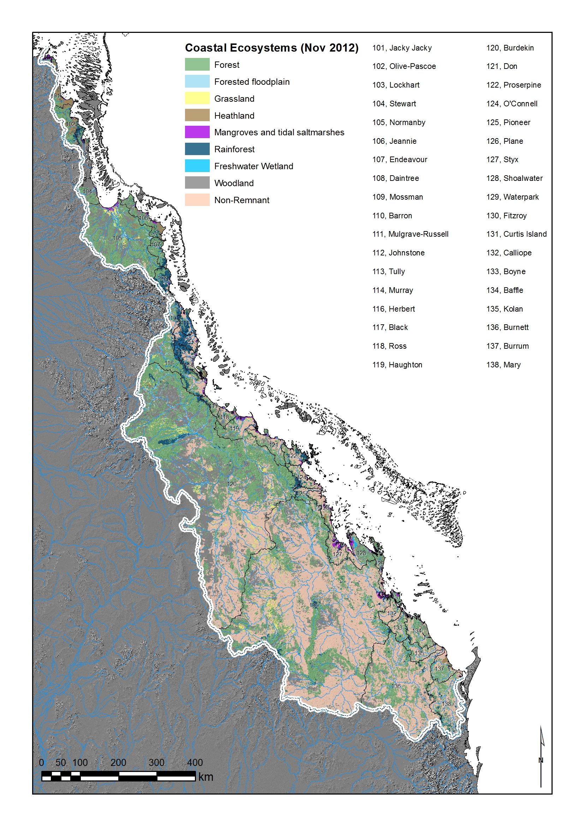
Figure 15. Current extent of coastal ecosystems and vegetation within the Great Barrier Reef catchments.
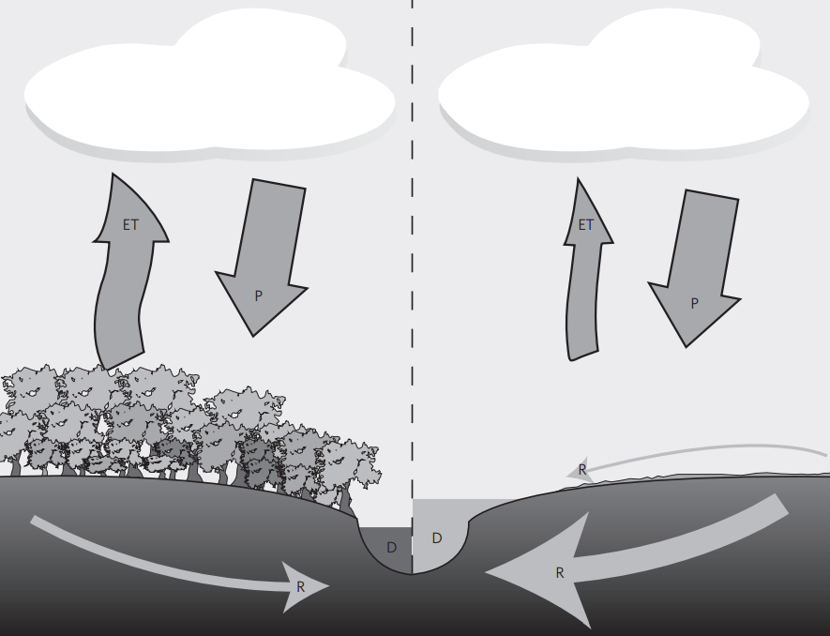
Figure 16. Remnant vegetation in catchment (left) has a high transpiration component relative to the same catchment following vegetation clearing (right). The net effect on the water balance is typically through an increase in surface water availability, which can be provided to streams, wetlands, and lakes.³⁵

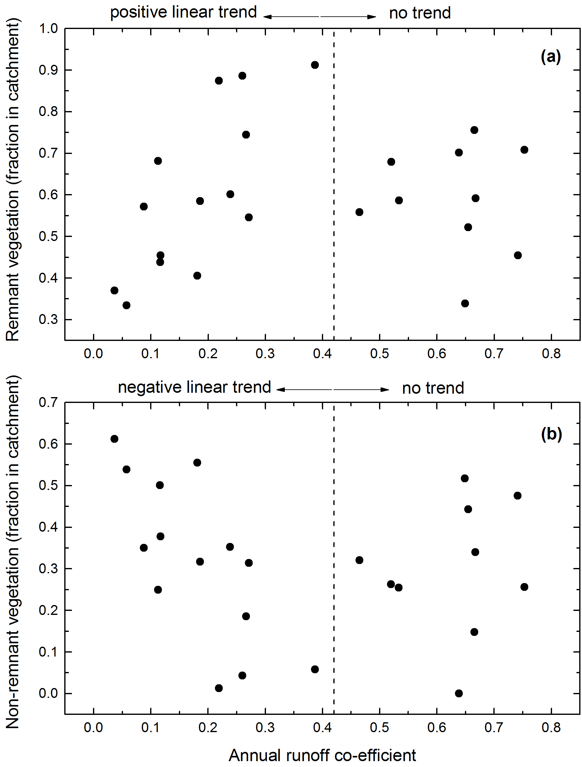
Figure 17. Annual runoff coefficients for catchments draining to the Great Barrier Reef plotted against (a) remnant catchment vegetation, and (b) non-remnant catchment vegetation. In both cases, the vegetation extent is normalised by catchment area. Remnant vegetation is calculated as the sum of forest, rainforest, and woodland vegetation extents for each catchment in Figure 12.

Erosion
There has been substantial concern that European land use change has resulted in higher catchment erosion rates¹², of which the finer sediment is able to be exported well beyond the river mouths and out to the Great Barrier Reef lagoons where they can impede light penetration and coral growth. Many of these river plumes have been examined in detail, and they generally originate from the three largest catchments (Burdekin, Fitzroy, and Burnett) during extreme rainfall and runoff events (for example, cyclones). Although the largest sediment loads emanate from these largest catchments, this is perhaps not surprising given their disproportionately large areas relative to the remainder draining to the reef. In fact, when normalised by catchment area these large catchments have the lowest proportion of sediment yield⁵⁹, suggesting that it may be difficult to significantly reduce sediment loads from these catchments given that the load is driven mainly by the very high discharges rather than erosion rates. Nonetheless, it has proven difficult to determine the internal catchment processes responsible for these large sediment loads, owing primarily to a lack of data. This has been addressed in a number of ways, the first was the development of SedNet, a catchment sediment transport model, which has been widely applied within Great Barrier Reef catchments.⁶⁰ Since SedNet, a number of researchers have attempted to validate the modelled erosion rates and sources, with mixed results.^{61,62} Recently, Wilkinson et al.⁶³ have highlighted the need to focus on gully systems as the major source of fine sediment, as it seems sheet erosion from slopes is not as important as was first thought. Areas where sheet erosion is significant is usually because of the presence of dispersive (sodic) soils, and can be relevant on the lower slopes of headwater areas in the Fitzroy and Burdekin catchments.⁶² In these situations, vegetation cover is critical, and the 50 per cent vegetation cover target within current plans⁶⁴ may not be sufficient since it does not take into account the difference between concentration and load.⁶³ The sediment export to the reef is strongly dependant on event scale processes as well as the seasonal water balance, which influences both vegetation cover and transport capacity. Not all catchments in the Great Barrier Reef are likely to have gully development and/or sodic hillslope soils as sources of fine sediment being exported to the reef. However, as discussed previously, the removal of riparian vegetation results in lower river bank stability. This process has been found to be important in the Daintree catchment⁶², and is likely to be the dominant mechanism of increased sediment supply in catchments with an absence of gully activity. Whatever the exact source of sediment being eroded, they are dependant to a large degree on feedbacks between catchment vegetation and hydrology, and therefore any changes to these feedbacks will have consequences for sediment export to the reef.⁶⁵

Nutrients
The land clearing of lower catchment areas and replacement by agricultural land use has also greatly increased fertiliser application, which in turn has been linked to increases in nutrient concentrations in runoff.¹⁰ Export of nutrients (N and P) is of concern to the Great Barrier Reef because of potential eutrophic effects within the lagoons, which impacts on coral growth. Sources of nutrients to the Great Barrier Reef include those contained in freshwater runoff from catchments draining to the reef, as well as oceanic upwelling, and nitrogen fixation.^{66,67} As a result, The Reef Water Quality Protection Plan was developed with the aim to reverse this decline in water quality entering the Great Barrier Reef lagoon, and has set water quality targets for 2013 and 2020. These targets are set for baseline pollutant loads, defined as the ‘flow-corrected’ anthropogenic load at the end of catchment.¹² This basically means the aim is to reduce nutrient loads by the difference between pre-European and post-European load conditions, which is more or less ~50 per cent of current loads in most catchments.
The most recent load estimates are derived on an annual basis, and use both actual monitoring data as well as statistically interpolated data.¹² In addition to this, there have been many studies that have conducted on an event basis, which have been critical for establishing the role of flood events in nutrient export from Great Barrier Reef catchments (for example Mitchell et al. 1997⁶⁸). There have also been studies that have not considered the role of hydrology in nutrient export, perhaps the most significant of these is Bramley and Roth (2002)⁶⁹, which concluded that areas with a higher proportion of upstream agricultural land use also had higher nutrient concentrations. Streamflow conditions provide a first order control on nutrient concentrations because of transport (advection) and dilution and dispersion effects, therefore studies which derive conclusions on the basis of concentration data alone (as opposed to load) do not necessarily provide useful information on nutrient export and cycling processes. Nevertheless, given the amount of data now available for Great Barrier Reef catchments there is clearly scope for a large data compilation that investigates the fundamental relationships between catchment hydrology, and nutrient export processes. This would allow greater understanding of the coupling between the water and nitrogen balances, and a more quantitative understanding of agricultural impacts, as has been achieved in other large agricultural basins (for example, Raymond et al. 2012⁷⁰).
At a more fundamental level, it is also important to consider catchments as a reactive transport process, and not simply a straight delivery from hillslopes and fields to channels and then the ocean. These reactive transport dynamics have been well studied within agricultural settings (for example, Thorburn et al. 2011⁴¹), however these concepts have not been applied to the main river channel networks and aquifers of Great Barrier Reef catchments with very different transport dynamics. For example, interactions between the river, aquifers, the river bed (hyporheic flow), and biotic metabolism and production are known to be critical determinants in the fate of nutrients, which can be easily modified by the dynamic redox chemistry in these areas (for example, Triska et al. 1993⁷¹) (Figure 18). Rivers and their hyporheic zone can therefore be zones of both net nitrification and denitrification alternately along a reach, depending on the dynamics of these different transport and kinetic processes⁷², which are critical to identify if the export dynamics of nutrients (particularly nitrogen) are to be properly understood. River networks also loose nitrogen to the atmosphere (denitrification), and the timing and rate of this loss has been shown to be strongly coupled to the seasonal catchment hydrology⁷³, a process not currently accounted for in the management of riverine nutrient export from Great Barrier Reef catchments. Furthermore, studies of nutrient dynamics on agricultural fields have demonstrated the importance of the flux of nitrate potentially entering soil moisture storage and groundwater⁴¹, and yet there is virtually no understanding of the subsequent flow path of this groundwater within any of the Great Barrier Reef catchments.
Finally, the coupling between hydrology, bioitic processes (metabolism and production) and nutrient kinetics means that the current trend of considering inorganic, organic, and particulate nutrient concentrations as separate entities (for example, Kroon et al. 2012¹²) is very misleading in terms of the export dynamics. There is a strong interdependence between all these concentrations, therefore total budgets (particularly of nitrogen) need to consider the speciation of nutrients as an interchangeable spectrum rather than as discrete populations (Figure 19). In the case of nitrogen, particulate N, which presumably refers to ammonium sorbed to sediment particles is itself dependant on the supply and kinetics of nitrate (inorganic N), which is in turn dependant on the redox state through organic matter processing rates (organic N) and oxygen supply, etc. (Figure 19). Therefore, it is the interaction of geochemical processes such as sorption, in concert with hydrologic transport and biotic assimilation and transformation, which regulates the concentration and composition of nitrogen in rivers.⁷⁴ All these processes are of extremely high relevance to the catchments draining to the Great Barrier Reef, and remain largely unaccounted for.
Figure 18. The main biotic processes (respiration and production) determining the redox state of rivers and the hyporheic zone. This situation refers to a supply of oxic hyporheic water (supplied from regional groundwater flow) interacting with water reduced in transit from the river through the river bed. In many cases for Great Barrier Reef catchments, the channel may also interact with reduced groundwater. ⁷¹
Figure 19. Conceptual model linking the major biogeochemical and transport process concerning nitrogen in freshwater environments. ⁷⁴

Key limits to understanding the hydrological inter-dependence between vegetation, erosion, and nutrients
- Interactions between the water and energy balances, including vegetation, and their sensitivity to change
- The dominant feedbacks within changes to climate, vegetation, and catchment hydrology
- Moisture cycling between the land and atmosphere across the large north-south climatic gradients
- The importance of upper catchment gully processes in the sediment exported from Great Barrier Reef catchments
- The pathway and reaction kinetics of nutrients between channels, overland flow, unsaturated flow, groundwater, and hyporheic zones
- An investigation of the limiting kinetic factors to the nutrient dynamics, including carbon supply, oxygen supply and demand, microbial processing rates, as well as their temporal changes and variation with hydrology.
- Seasonal and event scale assessments of the full riverine nitrogen and phosphorus cycles, including losses to the atmosphere
- The biotic, geochemical, and transport processes which control the export of the different measured nutrient fractions (inorganic, organic, and particulate).

Summary of management mechanisms

Statutory instruments, including water resource plans and permits
The Water Act 2000 (Qld) (the Water Act) provides the major framework for the planning, allocation and use of surface water and groundwater in Queensland and the Great Barrier Reef catchment. It regulates major water impoundments (such as dams and weirs) and extraction through pumping for irrigation and other uses. The Water Act provides a system of interrelated plans, licences and permits for the regulation of in-stream (watercourses, lakes and springs) and overland water flow and groundwater. These include:
- water resource plans (WRP) – these are the most important plans for water management in Queensland. They are prepared through a consultative process generally on a catchment-by-catchment basis and seek to balance water allocations and environmental flows;
- water use plans – these are prepared for areas at risk of land or water degradation;
- land and water management plans – these are prepared before irrigation is undertaken; and
- resource operations plans (ROP) – these provide practical operational details of the implementation of a water resource plan in an area over which resource operations licenses and water allocations, water licences and water permits may be granted.
WRPs and ROPs exist for many catchments in the State including the Fitzroy River and Burdekin River (Figure 20). For example, in the Baffle Basin at the southern end of the GBRWHA, the relevant WRP and the ROP, respectively, are the Water Resource (Baffle Creek Basin) Plan 2010 and Baffle Creek Basin Resource Operations Plan 2011.
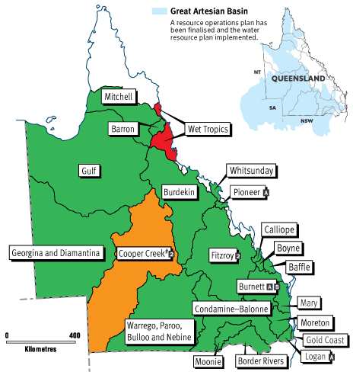 | Key  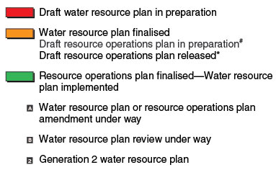

Figure 20. status of water resource planning in Queensland as at 27 June 2012. Source: Qld Govt
The Water Act also controls water use and activities that may impact on water resources. It:
- prohibits without a permit quarrying or placing fill in a watercourse, lake or spring (sections 266 and 814)
- regulates special works (such as water course diversion or reclamation works), dams, creation and management of irrigation areas and water supply and drainage
- prohibits unapproved diversion of water and construction of facilities for supply, drainage or flood mitigation
- regulates development in declared catchment areas that may impact on water quality in major water storages, in particular subdivision of land and sewage disposal
- regulates development of ‘referable dams’
- provides for the regulation of water and sewerage services and the establishment of water authorities.
The Water Act is partially integrated into IDAS of the Sustainable Planning Act 2009 (Qld) (SPA). For extraction of water from a watercourse and other matters regulated under the Water Act, other than for mining or petroleum extraction, a person requires:
- A water entitlement, water allocation, water licence or water permit. Applications for resource entitlements are assessed against relevant criteria in the Water Act and relevant water resource plan and resource operations plan (if any)
- A development permit for use of water that is assessable development under the SPA.
The Sustainable Planning Regulation makes some development involving taking or interfering with water assessable or self-assessable development. This includes, amongst other things:
- All work in a watercourse, lake or spring that involves taking or interfering with water (for example, a pump, gravity diversion, stream redirection, weir or dam)
- All artesian bores anywhere in the State, no matter what their use.
An owner of land adjoining a watercourse, lake or spring may take water for stock or domestic purposes but this is subject to self-assessment under the SPA and Water Act.
Use of surface and groundwater for mining, and petroleum and coal seam gas (CSG) extraction is exempt development under SPA. These activities are regulated by the Mineral Resources Act 1989 (Qld), Petroleum and Gas (Production and Safety) Act 2004 (Qld) (PGPS Act) and Environmental Protection Act 1994 (Qld). CSG companies have unlimited rights to extract groundwater under section 185 of the PGPS Act.
The Wild Rivers Act 2005 (Qld) also allows for declarations of wild rivers in which additional constraints are placed on water extraction. In practice, these declarations have been limited.
Water pollution is regulated principally at a State level under the Environmental Protection Act 1994 (Qld). That Act includes in Chapter 4A a number of measures to reduce the impact of agricultural activities in some Great Barrier Reef catchments on the quality of water entering the GBRWHA and to contribute to achieving the targets about water quality improvement for the reef under agreements between the State and the Commonwealth.
Significant changes to State laws and policies are currently underway that will have impacts on water resources. The Vegetation Management Framework Amendment Act 2013 (Qld), assented on 23 May 2013, amends the vegetation clearing controls created under the Vegetation Management Act 1999 (Qld) (VMA) and SPA. The changes remove the previous ban on broadscale clearing remnant vegetation for agriculture if the proposed clearing is for cropping or irrigated pastures. The ban on clearing for non-irrigated pastures remains at this stage.
In addition, the amendments remove the controls on clearing of high value regrowth on freehold land other than in the “regrowth watercourse area” which is defined as “an area located within 50m of a watercourse located in the Burdekin, Mackay Whitsunday or Wet Tropics catchments identified on the vegetation management watercourse map.” Catchments outside these areas, such as the Baffle Basin, are not included in the definition of “regrowth watercourse area” and, consequently, are subject to the new changes.
A related change is that the recently enacted Land, Water and Other Legislation Act 2013 (Qld) removed the protection of riparian (in-stream) vegetation from section 814 of the Water Act. That removes restrictions on clearing that are otherwise allowed under the VMA/SPA regime, including high value regrowth vegetation.
At a Commonwealth level, the Environment Protection and Biodiversity Conservation Act 1999 (Cth) (EPBC Act) is the principal regulatory system for controlling new development, including development that may impact on water resources in the Great Barrier Reef catchment. The EPBC Act protects matters of national environmental significance, which include the world heritage values of the Great Barrier Reef World Heritage Area, the Great Barrier Reef Marine Park, listed threatened species, migratory species, and Ramsar wetlands. A new water trigger controlling major mines and coal seam gas development impacting on water resources was before the Senate at the time of writing.
While the EPBC Act creates an important level of Commonwealth oversight and has occasionally stopped major projects that would have impacted on the ecosystem services of the GBRWHA and the Great Barrier Reef catchment, its role should not be overstated and the importance of State level laws, particularly for controlling cumulative impacts of water resource use, must be recognised.
Note that the Water Act 2007 (Cth) has no specific application to water use in the Great Barrier Reef catchment. It provides for the management of the water resources of the Murray-Darling Basin, including in South-Western Queensland, but not in the Great Barrier Reef catchment.

Legacy, cumulative and indirect impacts
It is important to realise that the planning and management frameworks for water resources created by the State and Commonwealth laws summarised in the previous section principally regulate new activities and development. The legacy of past development, such as an existing dam or weir, tends to become a fixed part of the “status quo” forming a background of impacts or condition of the environment. For example, the EPBC Act has little influence or control over the legacy impacts of things that were constructed 40 or 50 years ago. Sections 43A and 43B of the EPBC Act exempt from requiring approval under the Act, development and activities that were fully approved or an existing lawful use at the commencement of the Act on 16 July 2000.
While water use is an ongoing activity that can vary enormously in different seasons and climatic conditions, historical use levels tend to become viewed as “water rights”. Restrictions on historic water use levels can be very controversial, although in periods of drought strict controls on water use are more readily accepted by landholders and the community.
The cumulative and indirect impacts of water infrastructure and water use are (at least in theory) addressed through the planning and development assessment processes outlined in previous section.
A principal objective of the planning hierarchy in the Water Act is to provide for sustainable use of the State’s water resources. The planning hierarchy of WRPs, ROPs and water licences inherently deal with cumulative impacts of water use. How well (or how poorly) these water use planning processes address cumulative and indirect impacts is ultimately a question of implementation.
The EPBC Act does not provide as comprehensive planning framework for water as State laws. The EPBC Act does contain some planning elements, such as the designation of protected areas such as World Heritage properties and Ramsar Wetlands, as well as the strategic assessment process that is currently being applied to coastal development in the Great Barrier Reef catchment. While important, these elements are not intended to be comprehensive or to replace the need for comprehensive State planning.
The EPBC Act also deals with cumulative and indirect impacts to an extent in the assessment of actions impacting on matters of national environmental significance. The cumulative impacts of other development on a matter protected under the Act are part of the context of the impacts of an action that must be considered in assessing whether the action will have a “significant impact”.⁷⁵ For example, when assessing a proposed dam to supply water for irrigated agriculture to downstream farmers under the EPBC Act, the cumulative and indirect impacts of the use of the water by the farmers and the water pollution that they might generate must be considered (McGrath 2005: 34). In 2006 a Federal Court decision stopped the original proposal for a major dam on the Dawson River, the Nathan Dam, which was linked to a proposed major expansion of irrigated cotton downstream of the dam in the Great Barrier Reef catchment.

Key limitations to current review of legislation
- A limitation of the findings of this study is that it has not examined closely any of the Water Resource Plans (WRPs) or Resource Operation Plans (ROPs) applying in the GBR catchment to evaluate how likely they are to maintain the ecosystem services of the catchment to the GBR. Such an examination was beyond the scope of this study as the instructions for it specified that it was not to evaluate existing policies.

Potential management actions
Based on the key knowledge gaps identified at each stage of this review, actions that could be taken include:
- A thorough scientific assessment of the hydrological processes within the Great Barrier Reef catchment areas be carried out, including: the seasonal to annual water balances, streamflow and hydrograph characteristics, the role of land-use in runoff processes, ground and surface water interactions from the hillslopes to the lower floodplains, overland flow extent and floodplain inundation frequencies, the role of in-stream storages (dams and weirs) in the catchment hydrology, and the dependence of event scale variability on various synoptic processes (for example, cyclones). This last point should also highlight the role of the synoptic processes in driving the large hydrological variability observed within the Great Barrier Reef catchments.
- An analysis of climatic and streamflow trends within the Great Barrier Reef catchments, including statistical tests for non-stationarity.
- An analysis of the sensitivity of streamflow to other changes in the catchment water and energy balances, especially precipitation and vegetation, and the feedbacks between them.
- A detailed analysis of the overland flow (floodplain) transport pathways where nutrient addition is of primary concern, including their inundation, flow hydraulics, infiltration, changes in water quality, and the subsequent return flow to river channels or the coast. This would also consider the relation of these processes to the river channel hydrograph, and the relative contribution of return flow from floodplains to flood plumes which ultimately reach the reef.
- A comprehensive study on the coupling between nutrient kinetics and the hydrological transport processes in the landscape. This would include key biogeochemical kinetic factors (organic matter, dissolved oxygen, microbial processing), the role of event and seasonal hydrology in nutrient export, and how this links with the surface, hyporheic zone, and groundwater exchanges and flow paths.
- Finally, for long term management effectiveness, establish a robust monitoring network, preferably where streamflow records are already continuously monitored, that would determine surface, groundwater and hyporheic zone water exchanges, continuously monitor key kinetic determinants of nutrient concentrations (organic matter fluorescence, dissolved oxygen), and serve as locations for surface water and groundwater sampling. This could also serve as an addition to the existing reef monitoring network.
Each of these actions provides the information necessary to understand how catchment processes impact on the Great Barrier Reef. However, they also proceed in a logical independent order: with actions 1 – 3 enabling areas of critical hydrological function within the Great Barrier Reef to be effectively identified, and actions 4 – 5 enabling areas of critical biogeochemical function to be identified. If these could be achieved in combination, then it is possible to establish areas requiring further investigation as an immediate priority for reef protection, and which would therefore be the target of action 6. Additionally, action 6 could be implemented as a part of the existing Paddock to Reef Integrated Monitoring, Modelling and Reporting Program^{1,2}, and would value add considerably to the capacity of this program.

References
1. Carroll, C., Waters, D., Vardy, S., Silburn, D.M., Attard, S., Thorburn, P.J., Davis, A.M., Halpin, N., Schmidt, M. and Wilson, B. 2012, A Paddock to reef monitoring and modelling framework for the Great Barrier reef: Paddock and catchment component, Marine Pollution Bulletin 65 (4-9): 136-149.
2. Smith, R., Middlebrook, R., Turner, R., Huggins, R., Vardy, S. and Warne, M. 2012, Large-scale pesticide monitoring across Great Barrier Reef catchments–Paddock to Reef Integrated Monitoring, Modelling and Reporting Program, Marine Pollution Bulletin 65 (4-9): 117-127.
3. Buchanan, T.J. and Somers, W.P. 1969, Discharge measurements at gaging stations, US Government Printing Office Washington, DC.
4. Beven, K. 2004, Robert E. Horton's perceptual model of infiltration processes, Hydrological Processes 18(17): 3447-3460.
5. American Meteorological Society Precipitation - AMS Glossary, American Meteorological Society, viewed 30/06/2013, <http://glossary.ametsoc.org/wiki/Precipitation>.
6. Urban Drainage and Flood Control District 2007, Volume 1, Chapter 5: Runoff, in Drainage Criteria Manual V.1 edn, Urban Drainage and Flood Control District, pp. RO-8, viewed 30/06/2013, <http://www.udfcd.org/downloads/down_critmanual_volI.htm>.
7. Smakhtin, V. 2001, Low flow hydrology: a review, Journal of hydrology 240(3): 147-186.
8. Pizzuto, J.E. 1987, Sediment diffusion during overbank flows, Sedimentology 34(2): 301-317.
9. Oxford Economics 2009, Valuing the effects of Great Barrier Reef bleaching, Great Barrier Reef Foundation, Newstead.
10. Furnas, M. and Mitchell, A. 2001, Runoff of terrestrial sediment and nutrients into the Great Barrier Reef World Heritage Area, in Oceanographic processes of coral reefs, ed. E. Wolanski, CRC Press, Townsville.
11. Brodie, J.E., Kroon, F.J., Schaffelke, B., Wolanski, E.C., Lewis, S.E., Devlin, M.J., Bohnet, I.C., Bainbridge, Z.T., Waterhouse, J. and Davis, A.M. 2012, Terrestrial pollutant runoff to the Great Barrier Reef: an update of issues, priorities and management responses, Marine Pollution Bulletin 65: 81-100.
12. Kroon, F.J., Kuhnert, P.M., Henderson, B.L., Wilkinson, S.N., Kinsey-Henderson, A., Abbott, B., Brodie, J.E. and Turner, R.D.R. 2012, River loads of suspended solids, nitrogen, phosphorus and herbicides delivered to the Great Barrier Reef lagoon, Marine Pollution Bulletin 65(4-9): 167-181.
13. Haynes, D. and Michalek-Wagner, K. 2000, Water quality in the Great Barrier Reef World Heritage Area: past perspectives, current issues and new research directions, Marine Pollution Bulletin 41(7): 428 - 434.
14. Bartley, R., Speirs, W.J., Ellis, T.W. and Waters, D.K. 2012, A review of sediment and nutrient concentration data from Australia for use in catchment water quality models, Marine Pollution Bulletin 64(4): 101-116.
15. Brodie, J.E., Binney, J., Fabricius, K., Gordon, I., Hoegh-Guldberg, O., Hunter, H., O’Reagain, P., Pearson, R., Quirk, M., Thorburn, P., Waterhouse, J., Webster, I. and Wilkinson, S. 2008, Synthesis of evidence to support the Scientific Consensus Statement on water quality in the Great Barrier Reef, Reef Water Quality Protection Plan Secretariat, Queensland Department of the Premier and Cabinet, Brisbane.
16. Department of Premier and Cabinet 2009, Reef Water Quality Protection Plan 2009 for the Great Barrier Reef World Heritage Area and adjacent catchments, Reef Water Quality Protection Plan Secretariat, Department of Premier and Cabinet, Brisbane.
17. Great Barrier Reef Marine Park Authority 2009, Great Barrier Reef Outlook Report 2009, Great Barrier Reef Marine Park Authority, Townsville.
18. Great Barrier Reef Marine Park Authority 2012a, Great Barrier Reef Coastal Ecosystems Assessment Framework, Great Barrier Reef Marine Park Authority, Townsville.
19. Great Barrier Reef Marine Park Authority 2012b, Informing the outlook for Great Barrier Reef coastal ecosystems, Great Barrier Reef Marine Park Authority, Townsville.
20. Neil, D.T., Orpin, A.R., Ridd, P.V. and Yu, B. 2002, Sediment yield and impacts from river catchments to the Great Barrier Reef Lagoon, Marine and Freshwater Research 53(4): 733-752.
21. CSIRO and Bureau of Meteorology Climate Change in Australia - Temperature, Rainfall, Humidity, Sea surface Temperature, Wind speed, Potential evapotranspiration, Downward solar radiation, viewed 30/06/2013, <http://www.climatechangeinaustralia.com.au/>.
22. Holper, P.N. 2011, Climate change, science information paper (electronic resource): Australian rainfall: past, present and future, CSIRO and Bureau of Meteorology, Canberra, ACT.
23. CSIRO 2009, Water in the Northern North-East Coast Drainage Division. A report to the Australian Government from the CSIRO Northern Australia Sustainable Yields Project. CSIRO Water for a Healthy Country Flagship, Australia, viewed 30/06/2013, <http://www.csiro.au/Portals/Publications/Research--Reports/Northern-North-East-Coast-Drainage-Division-Report-NASY.aspx>.
24. Weiler, M. and McDonnell, J. 2007, Conceptualizing lateral preferential flow and flow networks and simulating the effects on gauged and ungauged hillslopes, Water Resources Research 43(3): W03403.
25. Jencso, K.G., McGlynn, B.L., Gooseff, M.N., Bencala, K.E. and Wondzell, S.M. 2010, Hillslope hydrologic connectivity controls riparian groundwater turnover: Implications of catchment structure for riparian buffering and stream water sources, Water Resources Research 46(10).
26. McGlynn, B.L., McDonnell, J.J., Seibert, J. and Kendall, C. 2004, Scale effects on headwater catchment runoff timing, flow sources, and groundwater‐streamflow relations, Water Resources Research 40(7).
27. Brooks, J.R., Barnard, H.R., Coulombe, R. and McDonnell, J.J. 2009, Ecohydrologic separation of water between trees and streams in a Mediterranean climate, Nature Geoscience 3(2): 100-104.
28. Salve, R., Rempe, D.M. and Dietrich, W.E. 2012, Rain, rock moisture dynamics, and the rapid response of perched groundwater in weathered, fractured argillite underlying a steep hillslope, Water Resources Research 48(11).
29. Beven, K. and Germann, P. 2013, Macropores and water flow in soils revisited, Water Resources Research.
30. McClain, M.E., Boyer, E.W., Dent, C.L., Gergel, S.E., Grimm, N.B., Groffman, P.M., Hart, S.C., Harvey, J.W., Johnston, C.A. and Mayorga, E. 2003, Biogeochemical hot spots and hot moments at the interface of terrestrial and aquatic ecosystems, Ecosystems 6(4): 301-312.
31. Gallant, J.C., Dowling, T.I., Read, A.M., Wilson, N., Tickle, P.andInskeep, C. 2011, 1 second SRTM derived digital elevation models user guide, Geoscience Australia, Canberra, ACT.
32. Wilson, J.L. and Guan, H. 2004, Mountain-Block Hydrology and Mountain-Front Recharge, Groundwater recharge in a desert environment: the southwestern United States: 113-137.
33. Petheram, C., McMahon, T.A. and Peel, M.C. 2008, Flow characteristics of rivers in northern Australia: implications for development, Journal of Hydrology 357(1): 93-111.
34. Rustomji, P., Bennett, N. and Chiew, F. 2009, Flood variability east of Australia’s great dividing range, Journal of Hydrology 374(3): 196-208.
35. Wohl, E., Barros, A., Brunsell, N., Chappell, N.A., Coe, M., Giambelluca, T., Goldsmith, S., Harmon, R., Hendrickx, J.M. and Juvik, J. 2012, The hydrology of the humid tropics, Nature Climate Change 2(9): 655-662.
36. Sawyer, A.H. and Cardenas, M.B. 2009, Hyporheic flow and residence time distributions in heterogeneous cross-bedded sediment, Water Resources Research 45(8).
37. McMahon, G., Arunakumaren, N. and Bajracharya, K. 2002, Estimation of the groundwater budget of the Burdekin River Delta aquifer, North Queensland, in Balancing the groundwater budget, paper presented at the International Groundwater Conference, Darwin, eds. Anonymous , CSIRO, Townsville.
38. Lenahan, M.J. and Bristow, K.L. 2010, Understanding sub-surface solute distributions and salinization mechanisms in a tropical coastal floodplain groundwater system, Journal of Hydrology 390(3-4): 131-142.
39. Brodie, J., McKergow, L.A., Prosser, I.P., Furnas, M., Hughes, A.O. and Hunter, H. 2003, Sources of sediment and nutrient exports to the Great Barrier Reef World Heritage Area, James Cook University, Townsville.
40. Wallace, J., Stewart, L., Hawdon, A. and Keen, R. 2008, The role of coastal floodplains in generating sediment and nutrient fluxes to the Great Barrier Reef lagoon in Australia, Ecohydrology & Hydrobiology 8(2): 183-194.
41. Thorburn, P.J., Biggs, J.S., Attard, S.J. and Kemei, J. 2011, Environmental impacts of irrigated sugarcane production: nitrogen lost through runoff and leaching, Agriculture, Ecosystems & Environment 144(1): 1-12.
42. Wallace, J., Karim, F. and Wilkinson, S. 2012, Assessing the potential underestimation of sediment and nutrient loads to the Great Barrier Reef lagoon during floods, Marine Pollution Bulletin 65(4): 194-202.
43. Cook, P.G., Stieglitz, T. and Clark, J. 2004, Groundwater discharge from the Burdekin floodplain aquifer, North Queensland. CSIRO Land and Water Technical Report No. 26/04. C.S.I.R.O., Queensland.
44. Department of Premier and Cabinet, State of Queensland 2011, Great Barrier Reef First Report Card (2009 Baseline), Reef Water Quality Protection Plan, Reef Water Quality Protection Plan Secretariat, Brisbane.
45. Hyland, S. 2002, An investigation of the impacts of ponded pastures on barramundi and other finfish populations in tropical coastal wetlands, Department of Primary Industries, Queensland.
46. Veitch, V., Tait, J. and Burrows, D. 2008, Fish passage connectivity issues Lower Sheep Station Creek: dry and wet season investigation of water quality and fish assemblages, Australian Centre for Tropical and Freshwater Research, Townsville, Qld.
47. Carter, J., Tait, J., Kapitzke, R. and Corfield, J. 2007, Burdekin Dry Tropics NRM region fish passage study, Alluvium Consulting, Townsville, QLD, Australia.
48. Ferguson, G. and Gleeson, T. 2012, Vulnerability of coastal aquifers to groundwater use and climate change, Nature Climate Change 2(5): 342-345.
49. Roderick, M.L. and Farquhar, G.D. 2011, A simple framework for relating variations in runoff to variations in climatic conditions and catchment properties, Water Resources Research 47(12).
50. Foley, J.A., Costa, M.H., Delire, C., Ramankutty, N. and Snyder, P. 2003, Green surprise? How terrestrial ecosystems could affect earth's climate, Frontiers in Ecology and the Environment 1(1): 38-44.
51. Malhi, Y., Roberts, J.T., Betts, R.A., Killeen, T.J., Li, W. and Nobre, C.A. 2008, Climate change, deforestation, and the fate of the Amazon, Science 319(5860): 169-172.
52. Tabacchi, E., Correll, D.L., Hauer, R., Pinay, G., Planty-Tabacchi, A. and Wissmar, R.C. 1998, Development, maintenance and role of riparian vegetation in the river landscape, Freshwater Biology 40(3): 497-516.
53. Jasechko, S., Sharp, Z.D., Gibson, J.J., Birks, S.J., Yi, Y. and Fawcett, P.J. 2013, Terrestrial water fluxes dominated by transpiration, Nature.
54. Zhang, L., Dawes, W. and Walker, G. 2001, Response of mean annual evapotranspiration to vegetation changes at catchment scale, Water Resources Research 37(3): 701-708.
55. Peña-Arancibia, J.L., van Dijk, A.I., Guerschman, J.P., Mulligan, M., Bruijnzeel, L.A. and McVicar, T.R. 2012, Detecting changes in streamflow after partial woodland clearing in two large catchments in the seasonal tropics, Journal of Hydrology 416: 60-71.
56. McJannet, D., Fitch, P., Disher, M. and Wallace, J. 2007, Measurements of transpiration in four tropical rainforest types of north Queensland, Australia, Hydrological Processes 21(26): 3549-3564.
57. Giambelluca, T.W. 2002, Hydrology of altered tropical forest, Hydrological Processes 16(8): 1665-1669.
58. Brown, A.E., Zhang, L., McMahon, T.A., Western, A.W. and Vertessy, R.A. 2005, A review of paired catchment studies for determining changes in water yield resulting from alterations in vegetation, Journal of hydrology 310(1): 28-61.
59. Joo, M., Raymond, M.A.A., McNeil, V.H., Huggins, R., Turner, R.D.R. and Choy, S. 2012, Estimates of sediment and nutrient loads in 10 major catchments drinaing to the Great Barrier Reef during 2006-2009, Marine Pollution Bulletin 65: 150-166.
60. Prosser, I., Hughes, A., Rustomji, P., Young, W. and Moran, C. 2001, Assessment of river sediment budgets for the National Land and Water Resources Audit. CSIRO Land and Water Technical Report 15/01, Canberra.
61. Hughes, A.O. and Croke, J.C. 2011, Validation of a spatially distributed erosion and sediment yield model (SedNet) with empirically derived data from a catchment adjacent to the Great Barrier Reef Lagoon, Marine and Freshwater Research 62(8): 962-973.
62. Bartley, R., Roth, C.H., Ludwig, J., McJannet, D., Liedloff, A., Corfield, J., Hawdon, A. and Abbott, B. 2006, Runoff and erosion from Australia's tropical semi-arid rangelands: influence of ground cover for differing space and time scales, Hydrological Processes 20: 3317-333.
63. Wilkinson, S.N., Hancock, G.J., Bartley, R., Hawdon, A.A. and Keen, R.J. 2012, Using sediment tracing to assess processes and spatial patterns of erosion in grazed rangelands, Burdekin River basin, Australia, Agriculture, Ecosystems & Environment.
64. The State of Queensland (Department of Premier and Cabinet) 2012, Reef Water Quality Protection Plan, Queensland Government, viewed 30/06/2013, <http://www.reefplan.qld.gov.au/index.aspx> .
65. Maina, J., de Moel, H., Zinke, J., Madin, J., McClanahan, T. and Vermaat, J.E. 2013, Human deforestation outweighs future climate change impacts of sedimentation on coral reefs, Nature communications 4.
66. Furnas, M.J., Mitchell, A. and Skuza, M. 1997, Shelf scale nitrogen and phosphorus budgets for the Central Great Barrier Reef (16 - 19 S), in Proceedings from the 8th International Coral Reef Symposium, Panama, 24-29 June 1996, eds. H. A. Lessios and I. G. Macintyre. , Smithsonian Tropical Marine Research Institute, Balboa, Republic of Panama.
67. Devlin, M.J. and Brodie, J. 2005, Terrestrial discharge into the Great Barrier Reef lagoon: nutrient behaviour in coastal waters, Marine Pollution Bulletin 51(1-4): 9-22.
68. Mitchell, A. and Bramley, R. 1997, Export of nutrients and suspended sediment from the Herbert River catchment during a flood event associated with cyclone Sadie. Workshop Series. Great Barrier Reef Marine Park Authority: No. 22, pp9-16).
69. Bramley, R.G.V. and Roth, C.H. 2002, Land use impact on water quality in an intensively managed catchment in the Australian humid tropics, Marine and Freshwater Research 53: 931-940.
70. Raymond, P.A., David, M.B. and Saiers, J.E. 2012, The impact of fertilization and hydrology on nitrate fluxes from Mississippi watersheds, Current Opinion in Environmental Sustainability 4(2): 212-218.
71. Triska, F.J., Duff, J.H. and Avanzino, R.J. 1993, The role of water exchange between a stream channel and its hyporheic zone in nitrogen cycling at the terrestrial—aquatic interface, in Nutrient Dynamics and Retention in Land/Water Ecotones of Lowland, Temperate Lakes and Rivers Springer, pp. 167-184.
72. Zarnetske, J.P., Haggerty, R., Wondzell, S.M., Bokil, V.A. and González‐Pinzón, R. 2012, Coupled transport and reaction kinetics control the nitrate source‐sink function of hyporheic zones, Water Resources Research 48(11).
73. Alexander, R.B., Böhlke, J.K., Boyer, E.W., David, M.B., Harvey, J.W., Mulholland, P.J., Seitzinger, S.P., Tobias, C.R., Tonitto, C. and Wollheim, W.M. 2009, Dynamic modeling of nitrogen losses in river networks unravels the coupled effects of hydrological and biogeochemical processes, Biogeochemistry 93(1-2): 91-116.
74. Triska, F.J., Jackman, A.P., Duff, J.H. and Avanzino, R.J. 1994, Ammonium sorption to channel and riparian sediments: a transient storage pool for dissolved inorganic nitrogen, Biogeochemistry 26(2): 67-83.
75. McGrath, C. 2004, Key Concepts of the Environment Protection and Biodiversity Conservation Act 1999 (Cth), Environmental and Planning Law Journal 22: 20-39.

APPENDIX A – Author profiles

Dr Josh Larsen is a lecturer in hydrology at GPEM. He holds a BSc (Hons) and PhD. He has broad research interests across hydrology, biogeochemistry, climate, and landscapes, both present and past. His publications include: Cendón, et al. 2010. Freshwater recharge into a shallow saline groundwater system, Cooper Creek floodplain, Queensland, Australia. Journal of Hydrology. 392, 150-163, Larsen, J.R. 2011. Was evaporation lower during the Last Glacial Maximum? Quaternary Australasia. 28(1), 11-13.
Dr Javier Leon is a research fellow at the Global Change Institute and GPEM. He holds a BA, MSc and PhD. He is a geographer specializing in coastal geomorphology and geospatial techniques (GIS and remote sensing). His publications include: Leon, J. X., & Woodroffe, C. D. (2013). Morphological characterisation of reef types in Torres Strait and an assessment of their carbonate production. Marine Geology, 338(0), 64-75. doi: http://dx.doi.org/10.1016/j.margeo.2012.12.009; and Leon, J. X., & Cohen, T. J. (2012). An improved bathymetric model for the modern and palaeo Lake Eyre. Geomorphology, 173-174, 69-79. doi: 10.1016/j.geomorph.2012.05.029.
Dr Chris McGrath is a senior lecturer (environmental regulation) at GPEM. He holds a BSc, LLB, LLM and PhD. From 2000-2010 he practiced in Brisbane as a barrister specialising in environmental regulation. He has published extensively on environmental law and policy in Queensland. His publications include: McGrath C (2010), Does Environmental Law Work? How to Evaluate the Effectiveness of an Environmental Legal System (Lambert Academic Publishing, Saarbrücken); and McGrath C (2011), Synopsis of the Queensland Environmental Legal System (5th ed, Environmental Law Publishing, Brisbane).
Mr Ralph Trancoso is a PhD candidate in GPEM School. He is Forest Engineer, Master of Tropical Rainforest and Master of Applied Geosciences. He previously worked for Brazilian government, private companies and as a consultant in GIS, remote sensing and hydrology. His publications include Trancoso, R. et al. (2010) Deforestation and conservation in major watersheds of the Brazilian Amazon. Environmental Conservation, v.36, p. 277-288. And Cuartas, L. A. et al. (2012) Distributed hydrological modeling of a micro-scale rainforest watershed in Amazonia: Model evaluation and advances in calibration using the new HAND terrain model. Journal of Hydrology, v.462-463, p.15-27

Appendix B. Coastal Ecosystem Assessment Framework (CEAF) ecosystem service capacity summary
Table 1: CEAF Identified Capacity of natural and modified coastal ecosystems to provide ecological services for the GBR
Process | Ecological Service | Forests & woodlands | Rainforests | F/W wetlands | Grasslands | Heathland | Forest floodplains | Estuaries | Coastline | Seagrass | Reef & Shoals | Lagoon floor | Water column | Groundwater Ecosystems | Irrigated agriculture | Non-irrigated agriculture | Dams & Weirs | Urban | Mining – operational o/cut | Forestry Plantation | Extensive agriculture | Ponded pastures
Physical processes- transport & mobilisation
Recharge/Discharge | Detains water |  |  | H |  |  |  | MH |  |  |  |  |  | ₁ | M |  |  | L | M |  | H
Recharge/Discharge | Flood mitigation |  |  |  | L |  | H | M |  |  |  |  |  |  | N |  |  | L | X |  | X
Recharge/Discharge | Connects ecosystems |  |  | H |  |  | H |  |  |  |  |  |  | H | L |  |  | L | N |  | L
Recharge/Discharge | Regulates water flow (groundwater, overland flows) | MH | H | H | L |  |  | MH |  |  | H | L |  | H | M |  |  | L | L |  | M
Sedimentation/ erosion | Traps sediment | MH | MH | H | L |  |  | H |  | M | M | MH | ML | N | M₄ |  |  | L | M |  | H
Sedimentation/ erosion | Stabilises sediment from erosion | MH | M |  | L |  |  |  | H | M |  |  |  |  | M₄ |  |  | H | N |  | H
Sedimentation/ erosion | Assimilates sediment | MH | H | H |  |  |  |  |  |  |  |  |  |  | M |  |  | L | N |  | H
Sedimentation/ erosion | Is a source of sediment | MH |  | M |  |  |  |  |  |  |  |  |  |  | L |  |  | L₁₁ | M |  | L
Deposition & mobilisation processes | Particulate deposition & transport (sed/nutr/chem. etc) |  |  | H |  |  |  |  |  |  |  |  |  | ₂ | L |  |  | L | L |  | H
Deposition & mobilisation processes | Material deposition & transport (debris, DOM, rock etc) |  |  | H |  |  |  |  |  |  |  |  |  |  | L |  |  | L | L |  | L
Deposition & mobilisation processes | Transports material for coastal processes |  |  | H |  |  |  |  |  |  |  |  |  |  | N |  |  | M | L
Biogeochemical Processes – energy & nutrient dynamics
Production | Primary production | M | H | H |  |  |  | H |  | H |  |  | H | N |  |  |  |  |  |  | M
Production | Secondary production |  |  |  |  |  |  | H |  | H |  |  |  | ₃ |  |  |  |  |  |  | H
Nutrient cycling (N, P) | Detains water, regulates flow of nutrients |  |  | H |  |  |  |  |  |  |  |  |  |  |  |  |  |  |  |  | M₁₃
Nutrient cycling (N, P) | Source of (N,P) | M | H |  |  |  |  | H | L | M |  |  |  |  |  |  |  |  |  |  | M
Nutrient cycling (N, P) | Cycles and uptakes nutrients |  |  | MH |  |  |  | H | L | M | L | H | H |  |  |  |  |  |  |  | H
Nutrient cycling (N, P) | Regulates nutrient supply to the reef | M | H | M |  |  | H | H | L | M |  |  |  |  |  |  |  |  |  |  | H
Carbon cycling | Carbon source |  | H | H |  |  |  | H | L | M |  |  |  |  |  |  |  |  |  |  | M
Carbon cycling | Sequesters carbon |  |  | H |  |  |  | H | L | M |  | H | L |  |  |  |  |  |  |  | MH
Carbon cycling | Cycles carbon | H | H |  |  |  |  | H | L | M | L | H | H |  |  |  |  |  |  |  | H
Decomposition | Source of Dissolved Organic Matter |  | H | H |  |  |  | H |  |  |  |  |  |  |  |  |  |  |  |  | L₁₄
Oxidation-reduction | Biochar source | H |  |  |  |  |  |  |  |  |  |  |  |  |  |  |  |  |  |  | X
Oxidation-reduction | Oxygenates water |  |  |  |  |  |  |  | L |  |  | H | H | N |  |  |  |  |  |  | L
Oxidation-reduction | Oxygenates sediments |  |  |  |  |  |  |  | L | M |  |  |  | N |  |  |  |  |  |  | ₁₅
Regulation processes | pH regulation |  |  | H |  |  |  |  |  | M |  |  |  |  |  |  |  |  |  |  | ₁₅
Regulation processes | PASS management |  |  | H |  |  |  | H |  |  |  |  |  |  |  |  |  |  |  |  | L
Regulation processes | Salinity regulation |  |  |  |  |  |  |  |  |  |  |  |  |  |  |  |  |  |  |  | ₁₅
Regulation processes | Hardness regulation |  |  | H |  |  |  |  |  |  |  |  |  |  |  |  |  |  |  |  | ₁₅
Regulation processes | Regulates temperature |  | ML |  |  |  |  |  |  |  |  |  |  |  |  |  |  |  |  |  | L₁₆
Chemicals/heavy metal modification | Biogeochemically modifies chemicals/heavy metals |  |  | H |  |  |  |  |  | M | L |  |  |  |  |  |  |  |  |  | X₁₇
Chemicals/heavy metal modification | Flocculates heavy metals |  |  | H |  |  |  |  |  |  |  |  |  |  |  |  |  |  |  |  | L
Biological processes (processes that maintain animal/plant populations)
Survival/reproduction | Habitat/refugia for aquatic species with reef connections |  |  | H |  |  |  | H | H |  | H | M | L | N | L₅ | L₅ | L₈ | L₁₂ | N | N | L | M₁₈
Survival/reproduction | Habitat for terrestrial spp with connections to the reef |  |  | H |  |  |  |  |  |  | H |  |  | N | L | L | H₉ | L | N | N | L | L₁₉
Survival/reproduction | Food source |  |  |  |  |  | H |  |  | H |  |  |  | N | N | N | M | L | N | L | M | L
Survival/reproduction | Habitat for ecologically important animals |  |  |  |  |  |  | H | L | H | H |  |  |  | N | N | L₁₀ | N | N | N | M | L₁₉
Dispersal/ migration/ regeneration | Replenishment of ecosystems – colonisation (source/sink) |  |  | H |  |  |  | H | M | H | H |  |  | N | N | N | L | N | N | N | M | L₂₀
Dispersal/ migration/ regeneration | Pathway for migratory fish |  |  | H |  |  |  |  |  |  |  |  |  | - | N₆ | N₆ | L₈ | N | N | N | ₁₅ | L₂₁
Pollination |  |  |  |  |  |  |  |  |  |  |  |  |  | - | L₇ | L₇ | N |  | N
Recruitment | Habitat contributes significantly to recruitment |  |  | H |  |  | H | H | H | H | H |  |  |  | N | N | L | N | N | N | M | N
Capacity of natural and modified coastal ecosystems to provide ecological services for the GBR.
H – High capacity for this system to provide this service, M – medium capacity for this system to provide this service, L- low capacity for this system to provide this service, N – No capacity for this system to provide this service, X- Not applicable, ✓– service is provided but capacity unknown. Boxes with no data indicate a lack of information available. Note that the capacity shown for modified systems assumes periods of low hydrological flow. End-notes 1 – Capacity depends on hydraulic characteristics of the aquifer (porosity, permeability, storativity); 2- particulate transport occurs sometimes in subterranean systems; 3- secondary production is variable; 4- dependent upon crop cycle; 5- Habitat for crocodiles and turtles; 6- especially in channels, but is dependent on water quality; 7- depends upon crop; 8- only where fish passage mechanisms exist; 9- especially water & shorebirds; 10- particularly aquatic species (though may lack connectivity); 11- refers to new developments; 12- impoundments, ornamental lakes and stormwater channels; 13- hoof compaction of soil increases runoff; 14- particulate Organic Carbon is high, Dissolved is Low; 15- unchanged from natural ecosystem capacity; 16- relates more to extent of vegetation clearance of riparian zone; 17- contaminant; 18 – in the dry season amongst Hymenachne; 19- particularly for birds; 20- sink biologically as species move into areas but reduced water quality can affect badly; 21- subject to water quality and grazing regime

See http://www.nrm.qld.gov.au/wrp/catchments.html
See http://www.nrm.qld.gov.au/wrp/catchments.html
See http://www.ehp.qld.gov.au/wildrivers/ for further information.
Minister for the Environment and Heritage v QCC (2004) 139 FCR 24 (the Nathan Dam Case). See http://www.envlaw.com.au/nathan.html

