Marine Monitoring Program Results for 2013-2014

Summary Report

Background
Declining water quality is one of the major threats affecting the inshore Great Barrier Reef (Reef). The Marine Monitoring Program (MMP) forms part of the Reef Plan Paddock to Reef Integrated Monitoring, Modelling and Reporting Program. The MMP was established in 2005 to monitor key components of the Reef’s inshore environment including water quality, seagrass and coral reefs. Land use activities in urban and rural areas can contribute to declining water quality. Reducing loads of sediment, nutrient and pesticides entering the Reef lagoon through improved land management practices will increase the natural resilience of the Reef to other impacts.

Snapshot of the Inshore Reef
Inshore coral reefs
Overall, inshore coral reefs remained in a poor state. However, there were some improvements in coral condition since the low point reached in 2011-2012 following a series of cyclones and flood events. In most regions the coral health indicators for coral cover, the rate of coral recovery and the density for juvenile corals have all increased. The exceptions were coral communities in the Fitzroy region where condition had continued to decline. Outbreaks of crown-of-thorns starfish (COTs) at some reefs in the Wet Tropics region are an ongoing concern.

Seagrass meadows
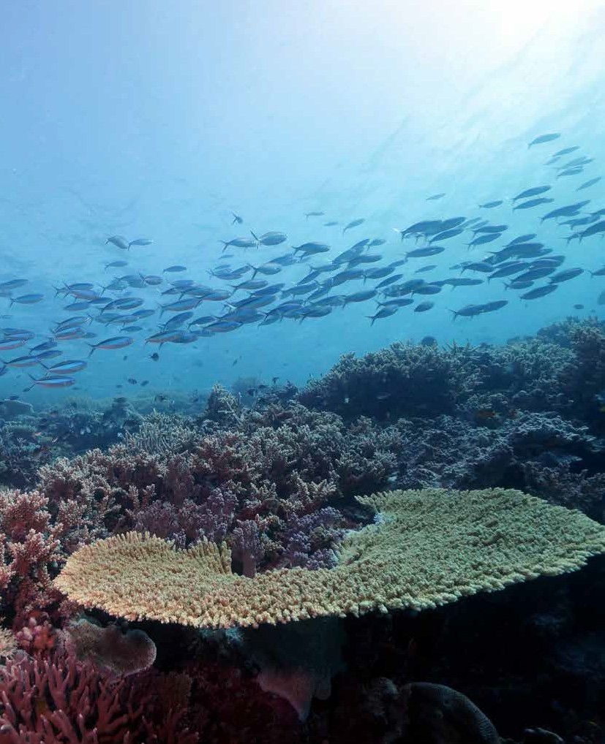

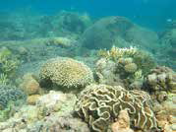

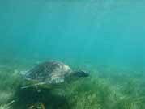















The majority of inshore seagrass meadows across the Reef showed evidence of recovery from previous disturbances, with the greatest improvement in abundance in the Burdekin region. Seed banks and reproductive effort also improved at coastal and estuarine sites; however, they remained poor at subtidal reef sites suggesting low capacity to recover from additional disturbances. The rate of dugong and turtle strandings has reduced back to levels prior to its peak in 2010/2011, however there was an increase in turtle standings in the Rockhampton region.

Inshore coral reef
(© Australian Institute of Marine Science)

Subtidal seagrass meadows at Green Island
(© James Cook University)

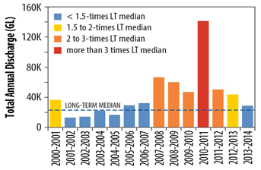

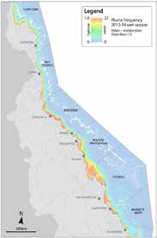

Marine Monitoring Program Results for 2013-2014 - Summary Report

Inshore water quality
This is the eighth consecutive year that the flows of water from some major rivers were above their long-term annual median. The Barren Daintree subregion had the highest level of discharge in 14 years. Water quality in the Reef had been gradually improving since the record flood events of 2010-2011. The overall poor score for water quality reflected the cumulative impact of these larger than normal flows over multiple years and continual resuspension of finer sediment from wind and wave action. Concentrations of suspended sediments and chlorophyll frequently exceeded the Water Quality Guidelines for the Great Barrier Reef Marine Park (GBRMP Guidelines) in 2013-2014, particularly in the inshore areas of Burdekin and Burnett Mary Regions, respectively.
Pesticides
A wide range of photosystem II (PSII) herbicides, other pesticides and industrial chemicals were frequently detected at pesticide monitoring sites in 2013-2014 using passive sampling techniques. Biologically relevant concentrations of PSII herbicides (Category 4) were present in the wet season at one of the 12 routinely monitored sites, in the Mackay Whitsundays region. Grab samples taken from flood waters from the Russell Mulgrave, Tully and Herbert rivers in the Wet Tropics region also had concentrations of PSII herbicides (Categories 2 to 4) that suppress photosynthesis in marine species. This was mostly attributed to the presence of diuron. However, none of the pesticides detected were at concentrations that exceeded the GBRMP Guidelines
Disturbances
In the summer of 2013-2014, rainfall was low to average and there were few floods in the Reef catchment. However, two cyclones made landfall in 2014: cyclones Dylan and Ita. Cyclone Ita was the most intense cyclone and heavy rainfall associated with the event caused flooding in the northern region from the Daintree, Mulgrave, Haughton and Herbert rivers. There were minor impacts on coral reefs and seagrass meadows in the Cairns-Cooktown region due to the winds from Cyclone Ita and the turbid waters of the flood plumes. In 2011, Cyclone Yasi made landfall near Cardwell and was one of the largest and most powerful cyclones (Category 5) to affect Queensland since records began. Inshore coral reef and seagrass ecosystems are still recovering from the impacts of Cyclone Yasi.

Total flow discharged into the Reef lagoon for 2000-2001 to 2013-2014. River flow is calculated from the sum of 35 river systems. Dashed line denotes the long-term median (1970 to 2000).
Mean frequency of river plume waters (colour classes 1-5) in the Great Barrier Reef for the 2013-2014 wet season. River plume frequency maps illustrate the movement of riverine waters, but do not provide information on the composition of the water and its
constituents. The river plume frequency
is calculated as the number of weeks within a wet season (22 weeks across Dec- April) that a given area was exposed to river plume waters.











Regional Results
Cape York | Seagrass | The declines in abundance and reproductive effort following cyclone Yasi have stabilised or improved at the regional level, driven largely by changes at southern sites. Seagrass abundances at northern Cape York sites have remained relatively stable since monitoring began in 2012. There was a small improvement in leaf nutrient content, while epiphyte covers have gradually increased.
Wet Tropics | Water quality | Site-specific water quality was rated as either good or very good at eight of the eleven sites in the region, three of which are located in the mid-shelf water body. The three sites closest to river mouths that drained from highly developed catchments had moderate to poor water quality. At these sites, concentrations of chlorophyll a exceeded the GBRMPA Guidelines, while particulate phosphorus and total suspended solids approached the GBRMPA Guidelines.
 | Pesticides | The most frequently detected herbicides included diuron, atrazine and hexazinone. There were no concentrations of herbicides detected that exceeded the GBRMP Guidelines. However, two grab samples collected from the Tully and Russell Mulgrave river mouths during flood conditions had concentrations of diuron and metolachlor that exceeded the Interim Working Levels of the Australian and New Zealand Environment and Conservation Council (ANZECC) Guidelines and the Agriculture and Resource Management Council of Australia and New Zealand (ARMCANZ) Guidelines.
 | Seagrass | Seagrass abundances have improved slightly across the region since declining in the years leading up to Cyclone Yasi in 2011. Low abundance coupled with very low reproductive effort indicates meadows are still in the early stages of recovery. Epiphyte cover increased even though leaf nutrient content decreased.
 | Coral | In the Barren Daintree subregion, coral cover has remained low since 2011 due to repeated cyclones and the ongoing presence of COTs. COTs also had a negative impact on coral cover in the Johnstone Russell Mulgrave subregion, although coral health increased overall. In the Herbert Tully subregion, the recovery of coral cover remained slow and macroalgae cover remained high.
Burdekin | Water quality | Site-specific water quality was very good and good at Pelorus and Pandora reefs, respectively. It was moderate at Magnetic Island, as concentrations of some water quality parameters exceeded the GBRMP Guidelines.
 | Pesticides | The most frequently detected herbicides included atrazine and its breakdown products, and diuron. There were no concentrations of herbicides detected that exceeded the GBRMP Guidelines.
 | Seagrass | Seagrass abundance, reproductive effort and seed banks have started to recover from the impacts of Cyclone Yasi in 2011 and recovery trajectories are the fastest in this region. Leaf nutrient content improved, while epiphyte cover had increased.
 | Coral | Coral communities are showing early signs of recovery from a long history of repeated disturbances. At most reefs coral cover increased over the last year, as with the densities of juvenile corals. Although the cover of magroalgae is still relatively high on several reefs, there was an overall decline in macroalgae across the region, which further improves the recovery potential of these reefs.
Mackay Whitsunday | Water quality | Site specific water quality was good at Double Cone Island, moderate at Daydream Island and poor at Pine Island. Total suspended solids, Secchi depth and turbidity exceeded the GBRMP Guidelines at all sites.
 | Pesticides | The most frequently detected herbicides were diuron, atrazine and tebuthiuron. There were no concentrations of herbicides detected that exceeded the GBRMP Guidelines; however, biologically relevant concentrations of PSII herbicides (Category 4) were present at Sarina Inlet in the wet season.
 | Seagrass | There were improvements in seagrass cover, reproductive effort and leaf nutrient content across the region. However, seed banks remained low indicating seagrasses are still in a vulnerable state to further disturbances. Epiphyte cover remained high.
 | Coral | The combination of relatively high coral cover, increasing densities of juvenile corals and low abundance of macroalgae saw the condition of coral communities rated as moderate.
Fitzroy | Water  quality | Site-specific water quality was very good at Barren Island, good at Humpy Island, and poor at Pelican Island, reflecting a gradient away from river influence. Concentrations of some water quality parameters at Pelican Island exceeded the GBRMP Guidelines.
 | Pesticides | The most frequently detected herbicides were atrazine, diuron and tebuthiuron. There were no concentrations of herbicides detected that exceeded the GBRMP Guidelines.
 | Seagrass | Seagrass cover and reproductive effort continued to decline across the region, reflecting the legacy of repeated environmental disturbances here. However, seed banks improved and the level of epiphytes declined.
 | Coral | The combination of low densities of juvenile corals, low coral cover, low rate of coral cover increase and high cover of macroalgae demonstrates that coral communities have not recovered from the impacts of repeated and intense flooding, extreme temperatures and severe storms.
Burnett Mary | Seagrass | Seagrass cover has stabilised since declining in 2011, but remained very low. Reproductive effort is also very low, while seed banks had improved. Epiphyte cover increased even though there was an improvement in leaf nutrient content.
Conclusion
Further Information
For more information please refer to our partners 2013-2014 monitoring reports, available through GBRMPA website:
- Water quality and coral monitoring
- Seagrass monitoring
- Pesticides monitoring
- Wet season and extreme weather monitoring
Inshore seagrass meadows and coral reefs remain in a vulnerable state across the Reef and may have low capacity to recover from future environmental disturbances. The chronic stress of ongoing poor water quality from sediment, nutrient and pesticide loads carried by rivers to the Reef lagoon amplifies the impacts of acute disturbances on Reef ecosystems and suppresses their recovery from such events.
Although preventing acute disturbances such as cyclones or floods is beyond our control, ongoing effort to reduce the sediment, nutrient and pesticide loads will have a positive effect on Reef health. Through improved land management practices, reductions in loads will alleviate the chronic factors suppressing the recovery of many inshore areas and improve the resilience of these ecosystems to disturbances.
Adaptive management guided by monitoring, evaluation and reporting programs that shares information across partners and drives improved practices is our best means of achieving long-term Great Barrier Reef health and resilience outcomes.

This project is supported by the Great Barrier Reef Marine Park Authority, Australian Institute of Marine Science, James Cook University and University of Queensland, through funding from the Australian Government Reef Programme.
© Commonwealth of Australia 2015. Published by the Great Barrier Reef Marine Park Authority.
ISBN 978-1-922126-72-6

