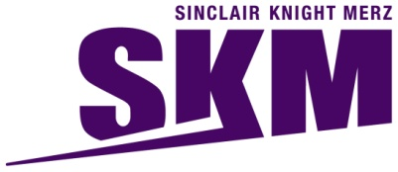


Improved Dredge Material Management for the Great Barrier Reef Region

APPENDIX E
Modelling Sediment Migration from Current and Hypothetical Alternative Placement Sites

Sinclair Knight Merz Pty Ltd (SKM)

Asia-Pacific Applied Science Associates (APASA)

Revision 2.5
12 July 2013

© Commonwealth of Australia 2013
Published by the Great Barrier Reef Marine Park Authority 2013

ISBN 978 1 922126 14 6 (ebook)

This work is copyright. You may download, display, print and reproduce this material in unaltered form only (appropriately acknowledging this source) for your personal, non-commercial use or use within your organisation. Apart from any use as permitted under the Copyright Act 1968, all other rights are reserved.

Disclaimer
The views and opinions expressed in this publication are those of the authors and do not necessarily reflect those of the Australian Government or the Minister for Sustainability, Environment, Water, Population and Communities.

While reasonable efforts have been made to ensure that the contents of this publication are factually correct, the Australian Government does not accept responsibility for the accuracy or completeness of the contents, and shall not be liable for any loss or damage that may be occasioned directly or indirectly through the use of, or reliance on, the contents of this publication.

National Library of Australia Cataloguing-in-Publication entry

Sinclair Knight Merz (Firm).

Improved dredge material management for the Great Barrier Reef Region / Sinclair Knight Merz Pty Ltd (SKM); Asia-Pacific Applied Science Associates (APASA).

ISBN 978 1 922126 14 6 (ebook)

Dredging spoil--Environmental aspects--Queensland--Great Barrier Reef.
Dredging spoil--Queensland--Great Barrier Reef--Management.
Spoil banks--Environmental aspects--Queensland--Great Barrier Reef.
Spoil banks--Queensland--Great Barrier Reef--Management.
Dredging--Environmental aspects--Queensland--Great Barrier Reef.
Dredging--Risk management--Queensland--Great Barrier Reef.
Water quality management--Queensland--Great Barrier Reef.
Hydrodynamic receptors.

Asia-Pacific Applied Science Associates.
Great Barrier Reef Marine Park Authority.

363.7284

This publication should be cited as:
SKM 2013, Improved dredge material management for the Great Barrier Reef Region, Great Barrier Reef Marine Park Authority, Townsville.

Acknowledgement
This report was supported with funding from the Department of Sustainability, Environment, Water, Population, and Communities through the Sustainable Regional Development Program.


Requests and enquiries concerning reproduction and rights should be addressed to:

Great Barrier Reef Marine Park Authority
2-68 Flinders Street (PO Box 1379)
Townsville QLD 4810, Australia

Phone: (07) 4750 0700
Fax: (07) 4772 6093
Email: info@gbrmpa.gov.au
www.gbrmpa.gov.au
Document history and status
Revision | Date issued | Author(s) | Reviewed by | Approved by | Date approved | Revision type
Prelim | 06/12/12 | Dr S Zigic  Dr R Dunn | Dr S Zigic  Dr R Dunn | Dr S Zigic | 06/12/12 | Preliminary draft for SKM review
0 | 06/12/12 | Dr S Zigic  Dr R Dunn | Dr M Huber | Dr M Huber | 6/12/12 | Draft Final Issued to GBRMPA
1 | 11/04/13 | Dr S Zigic  Dr R Dunn | D Smith  Dr M Huber | Dr M Huber | 11/04/13 | Revised draft for SKM review
1.1 | 12/04/13 | Dr S Zigic  Dr R Dunn | Dr M Huber | Dr M Huber | 12/04/13 | Revised draft final issued to GBRMPA
2 | 04/06/13 | Dr S Zigic  Dr R Dunn | Dr M Huber | Dr M Huber | 04/06/13 | Final
2.1 | 26/06/13 | Dr S Zigic  Dr R Dunn | Dr M Huber | M Yeates | 26/6/13 | Revised Final
2.2 | 27/06/13 | Dr S Zigic  Dr R Dunn | M Yeates | M Yeates | 27/6/13 | Revised Final
2.3 | 28/06/13 | Dr S Zigic  Dr R Dunn | M Yeates | M Yeates | 28/6/13 | Revised Final
2.4 | 04/07/13 | Dr S Zigic  Dr R Dunn | M Yeates | M Yeates | 04/07/13 | Revised Final
2.5 | 12/07/13 | Dr S Zigic  Dr R Dunn | M Yeates | M Yeates | 12/07/13 | Revised Final

Contents
Acronyms xi
glossary xii
Acknowledgments xvi
RELIANCE STATEMENT xvii
Summary 1
Port of Gladstone 3
Rosslyn Bay State Boat Harbour 4
Port of Hay Point 4
Port of Abbot Point 5
Port of Townsville 5
Port of Cairns 6
Introduction 7
Background 7
Purpose 8
Study Locations 10
Methods 19
Modelling of Currents 19
Representing the Effects of Tides and Local Winds 22
Performance of Tidal Current and Local Wind Model 23
Representing the Influence of the Large-Scale Currents 28
Performance of Combined Tide, Local Wind and Large-scale Current Model 32
Modelling of Wave Conditions 41
Performance of the Wave Model 44
Material Placement Scenarios 50
Port of Gladstone 50
Rosslyn Bay State Boat Harbour 51
Port of Hay Point 51
Port of Abbot Point 51
Port of Townsville 51
Port of Cairns 51
Description of the Sediment Plume Model 51
Presentation of Results 57
Results 59
Port of Gladstone 61
Results During the Material Placement Operations 61
Results at the End of the 12-Month Modelling Period 74
Rosslyn Bay State Boat Harbour 78
Results During the Material Placement Operations 78
Results at the End of the 12-Month Modelling Period 91
Port of Hay Point 95
Results during the Material Placement Operations 95
Results at the End of the 12-Month Modelling Period 110
Port of Abbot Point 114
Results during the Material Placement Operations 114
Results at the End of the 12-Month Modelling Period 130
Port of Townsville 134
Results During the Material Placement Operations 134
Results at the End of the 12-Month Modelling Period 147
Port of Cairns 151
Results During the Material Placement Operations 151
Results at the End of the 12-Month Modelling Period 165
Benefits of This Study 169
Model Assumptions and Limitations 170
Hydrodynamics 170
Sediment Plume and Migration Modelling 174
Relative Influence of Terrestrial and Dredging Sediment Inputs 175
Knowledge Gaps and Further Research 181
Modelling Sensitivity Analysis 181
Inter-annual Variability 181
Sediment Resuspension and Consolidation 182
Ambient Background 182
Incorporation of Large-Scale Currents 182
Shallow Water Processes 182
Presentation and Interpretation of Modelling Results 183
Direct Sediment Resuspension and Consolidation Studies 183
Improved Understanding of Operational Mitigation Measures 184
Conclusion 185
References 186

FIGURES
Figure 1. Locations of Model Cases 1–3 for the Port of Gladstone study area. Three hypothetical model case locations were identified as it was recognised that the current placement site has limited capacity. 13
Figure 2. Locations of Model Case 1, Model Case 2 and the current material placement site for Rosslyn Bay State Boat Harbour study area. 14
Figure 3. Locations of Model Case 1, Model Case 2 and the current material placement site Port of Hay Point study area. 15
Figure 4. Locations of Model Case 1, Model Case 2 and the current material placement site for Port of Abbot Point study area. 16
Figure 5. Locations of Model Case 1, Model Case 2 and the current material placement site for Port of Townsville study area. 17
Figure 6. Locations of Model Case 1, Model Case 2 and the current material placement site for Port of Cairns study area. 18
Figure 7. Map showing the broadly divided zones that coincide with water depth (Belperio 1983). Subdivision of the inner shelf is from 0-20 m water depth, a middle shelf, from 20-40 m and outer shelf, from 40-90 m water depth. All blue areas highlight inter-reefal seabed environments within the Marine Park, and reefs are shown in black (Source: Mathews et al. 2007). 20
Figure 8. Mean currents modelled for strong south-east winds (left image) and during calm weather days (right image) from April to August 1981 (Source: Brinkman et al. 2001). 21
Figure 9. Extent of the southern, central and northern Reef model grids used to replicate the effects from tides and local wind driven flows. 23
Figure 10. Locations of the nine tide stations from which observed data were used to assess if the model was accurately predicting tides within the Region. 25
Figure 11. Comparisons between the NTF observed (green line) and HYDROMAP predicted (blue line) water elevations at Gladstone (upper image), Rosslyn Bay (middle image) and Hay Point (lower image), 1-30 November 2011. 27
Figure 12. Comparisons between the NTF observed (green line) and HYDROMAP predicted (blue line) water elevations at Abbot Point (upper image), Townsville (middle image) and Cairns (lower image), 1-30 November 2011. 27
Figure 13. Comparisons between the NTF observed (green line) and HYDROMAP predicted (blue line) water elevations at Cooktown (upper image), Pipon Island (middle image) and Night Island (lower image), 1-30 November 2011. 28
Figure 14. Monthly values of the Southern Oscillation Index (SOI) 2004-2011. Sustained positive values indicate La Niña conditions, while sustained negative values indicate El Niño conditions (Source: Australian Bureau of Meteorology 2012). 30
Figure 15. Surface large scale current rose diagrams for an El Niño (2004), La Niña (2011) and neutral (2007) conditions. The diagrams were generated using data offshore from the current material placement sites at the five ports. 31
Figure 16. Locations of the instruments used to measure currents throughout the water column adjacent to the Townsville and Hay Point current material placement sites during January and November 2011, respectively, and Palm Passage during February-March 2011. 33
Figure 17. Comparison between the measured (green line) and model predicted (blue line) surface current speeds (top image), U current component (middle image) and V current component (bottom image) adjacent to the Current Hay Point material placement site (1-30 November 2011). 35
Figure 18. Comparison between the measured (green line) and HYCOM + HYDROMAP predicted (blue line) bottom current speeds (top image), bottom U current component (middle image) and bottom V current component (bottom image) adjacent to the Current Hay Point material placement site (1-30 November 2011). 36
Figure 19. Comparison between the measured (green line) and HYCOM + HYDROMAP predicted (blue line) surface current speeds (top image), surface U current component (middle image) and surface V current component (bottom image) adjacent to the Townsville current material placement site (1-29 January 2011). 37
Figure 20. Comparison between the measured (green line) and HYCOM + HYDROMAP predicted (blue line) bottom current speeds (top image), bottom U current component (middle image) and bottom V current component (bottom image) adjacent to the Townsville current material placement site (1-29 January 2011). 38
Figure 21. Comparison between the measured (green line) and HYCOM + HYDROMAP predicted (blue line) current speeds (top image), U current component (middle image) and V current component (bottom image) at a water depth 58 m above the seafloor at Palm Passage (10 February-17 March 2011). 39
Figure 22. Comparison between the measured (green line) and HYCOM + HYDROMAP predicted (blue line) current speeds (top image), U current component (middle image) and V current component (bottom image) at a water depth 44 m above the seafloor at Palm Passage (10 February-17 March 2011). 40
Figure 23. Extent of the southern Reef wave model grid. The sizes of the individual triangles represent the varying mesh resolution and the colour coding of each individual triangle represents the water depth (m). 42
Figure 24. Extent of the southern central Reef wave model grid. The sizes of the individual triangles represent the varying mesh resolution and the colour coding of each individual triangle represents the water depth (m). 42
Figure 25. Extent of the northern central Reef wave model grid. The sizes of the individual triangles represent the varying mesh resolution and the colour coding of each individual triangle represents the water depth (m). 43
Figure 26. Extent of the northern Reef wave model grid. The sizes of the individual triangles represent the varying mesh resolution and the colour coding of each individual triangle represents the water depth (m). 43
Figure 27. Locations of the five Waverider buoys used to measure wave climate by the Department of Environment and Heritage Protection and used to compare to the predicted wave height, period and directional datasets. 45
Figure 28. Comparison of measured (green) and predicted (blue) of significant wave heights (top image), peak wave periods (middle image) and peak wave directions (bottom image) at Gladstone during January-March 2011. The histograms provide an inter-comparison of the frequency distributions. 46
Figure 29. Comparison of measured (green) and predicted (blue) of significant wave heights (top image), peak wave periods (middle image) and peak wave directions (bottom image) at Emu Park during January - March 2011. The histograms provide an inter-comparison of the frequency distributions. 47
Figure 30. Comparison of measured (green) and predicted (blue) of significant wave heights (top image), peak wave periods (middle image) and peak wave directions (bottom image) at Mackay during January-March 2011. The histograms provide an inter-comparison of the frequency distributions. 48
Figure 31. Comparison of measured (green) and predicted (blue) of significant wave heights (top image), peak wave periods (middle image) and peak wave directions (bottom image) at Townsville during January-February 2011.The histograms provide an inter-comparison of the frequency distributions. 49
Figure 32. Comparison of measured (green) and predicted (blue) of significant wave heights (top image), peak wave periods (middle image) and peak wave directions (bottom image) at Cairns during January 2011. The histograms provide an inter-comparison of the frequency distributions. Note that the Waverider buoy at Cairns is non-directional (i.e. does not record wave direction). 50
Figure 33. Conceptual diagram showing the descent of sediments released from a hopper barge and then spreading radially outward across the seabed as a dense plume (Source: ASA 2004). 55
Figure 34. Imaginary zoomed-in view of a section of the model grid. The number in each cell represents the per cent of time during the model run each cell experiences a TSS concentration of 5 mg/L. The blue line shows the 50th percentile contour for 5mg/L TSS. 58
Figure 35. Presentation of the imaginary results in Figure 34 as a shaded area. Areas in the darker blue area experience 5 mg/L TSS more than 50 per cent of the time, those in the light blue area less than 50 per cent of the time. 58
Figure 36. Gladstone: dredging period (133 days) TSS distribution, Model Case 1 - 95th percentile. 62
Figure 37. Gladstone: dredging period (133 days) TSS distribution, Model Case 2 - 95th percentile. 63
Figure 38. Gladstone: dredging period (133 days) TSS distribution, Model Case 3 - 95th percentile. 64
Figure 39. Gladstone: dredging period (133 days) sedimentation rate, Model Case 1 - 50th percentile. 65
Figure 40. Gladstone: dredging period (133 days) sedimentation rate, Model Case 1 - 95th percentile. 66
Figure 41. Gladstone: dredging period (133 days) sedimentation rate, Model Case 2 - 50th percentile. 67
Figure 42. Gladstone: dredging period (133 days) sedimentation rate, Model Case 2 - 95th percentile. 68
Figure 43. Gladstone: dredging period (133 days) sedimentation rate, Model Case 3 - 50th percentile. 69
Figure 44. Gladstone: dredging period (133 days) sedimentation rate, Model Case 3 - 95th percentile. 70
Figure 45. Gladstone: dredging period (133 days) total sedimentation and bottom thickness, Model Case 1. 71
Figure 46. Gladstone: dredging period (133 days) total sedimentation and bottom thickness, Model Case 2. 72
Figure 47. Gladstone: dredging period (133 days) total sedimentation and bottom thickness, Model Case 3. 73
Figure 48. Gladstone: Mean bottom thicknesses across the material placement sites during the campaign. Results are based on the relocation of 6,000,000 m³ of material over 133 days (three releases per day of 15,000 m³). 74
Figure 49. Gladstone: long-term (12 months) total sedimentation and bottom thickness, Model Case 1. 75
Figure 50. Gladstone: long-term (12 months) total sedimentation and bottom thickness, Model Case 2. 76
Figure 51. Gladstone: long-term (12 months) total sedimentation and bottom thickness, Model Case 3. 77
Figure 52. Rosslyn Bay: dredging period (90 days) TSS distribution, Model Case 1 - 100th percentile. 79
Figure 53. Rosslyn Bay: dredging period (90 days) TSS distribution, Model Case 2 - 100th percentile. 80
Figure 54. Rosslyn Bay: dredging period (90 days) TSS distribution, current site - 100th percentile. 81
Figure 55: Rosslyn Bay: dredging period (90 days) sedimentation rate, Model Case 1 - 50th percentile. 82
Figure 56. Rosslyn Bay: dredging period (90 days) sedimentation rate, Model Case 1 - 95th percentile. 83
Figure 57. Rosslyn Bay: dredging period (90 days) sedimentation rate, Model Case 2 - 50th percentile. 84
Figure 58. Rosslyn Bay: dredging period (90 days) sedimentation rate, Model Case 2 - 95th percentile. 85
Figure 59. Rosslyn Bay: dredging period (90 days) sedimentation rate, current site - 50th percentile. 86
Figure 60. Rosslyn Bay: dredging period (90 days) sedimentation rate, current site - 95th percentile. 87
Figure 61. Rosslyn Bay: dredging period (90 days) total sedimentation and bottom thickness, Model Case 1. 88
Figure 62. Rosslyn Bay: dredging period (90 days) total sedimentation and bottom thickness, Model Case 2. 89
Figure 63. Dredging period (90 days) total sedimentation and bottom thickness, Model Case 3. 90
Figure 64. Rosslyn Bay: Mean bottom thicknesses across the material placement sites. Results are based on the relocation of 40,000 m³ of material, over 90 days (one release per day of 400 m³). 91
Figure 65. Rosslyn Bay: long-term (12 months) total sedimentation and bottom thickness, Model Case 1. 92
Figure 66. Rosslyn Bay: long-term (12 months) total sedimentation and bottom thickness, Model Case 2. 93
Figure 67. Rosslyn Bay: long-term (12 months) total sedimentation and bottom thickness, current site. 94
Figure 68. Hay Point: dredging period (155 days) TSS distribution, Model Case 1 - 95th percentile. 96
Figure 69. Hay Point: dredging period (155 days) TSS distribution, Model Case 2 - 50th percentile. 97
Figure 70. Hay Point: dredging period (155 days) TSS distribution, Model Case 2 - 95th percentile. 98
Figure 71. Hay Point: dredging period (155 days) TSS distribution, current site - 50th percentile. 99
Figure 72. Hay Point: dredging period (155 days) TSS distribution, current site - 95th percentile. 100
Figure 73. Hay Point: dredging period (155 days) sedimentation rate, Model Case 1 - 50th percentile. 101
Figure 74. Hay Point: dredging period (155 days) sedimentation rate, Model Case 1 - 95th percentile. 102
Figure 75. Hay Point: dredging period (155 days) sedimentation rate, Model Case 2 - 50th percentile. 103
Figure 76. Hay Point: dredging period (155 days) sedimentation rate, Model Case 2 - 95th percentile. 104
Figure 77. Hay Point: dredging period (155 days) sedimentation rate, current site - 50th percentile. 105
Figure 78. Hay Point: dredging period (155 days) sedimentation rate, current site - 95th percentile. 106
Figure 79. Hay Point: dredging period (155 days) total sedimentation and bottom thickness, Model Case 1. 107
Figure 80. Hay Point: dredging period (155 days) total sedimentation and bottom thickness, Model Case 2. 108
Figure 81. Hay Point: dredging period (155 days) total sedimentation and bottom thickness, current site. 109
Figure 82. Hay Point: Mean bottom thicknesses across the material placement sites. Results are based on the relocation of 8,500,000 m³ over 155 days (five releases per day of 11,000 m³). 110
Figure 83. Hay Point: long-term (12 months) total sedimentation and bottom thickness, Model Case 1. 111
Figure 84. Hay Point: long-term (12 months) total sedimentation and bottom thickness, Model Case 2. 112
Figure 85. Hay Point: long-term (12 months) total sedimentation and bottom thickness, current site. 113
Figure 86. Abbot Point: dredging period (56 days) TSS distribution, Model Case 1 - 50th percentile. 115
Figure 87. Abbot Point: dredging period (56 days) TSS distribution, Model Case 1 - 95th percentile. 116
Figure 88. Abbot Point: dredging period (56 days) TSS distribution, Model Case 2 - 50th percentile. 117
Figure 89. Abbot Point: dredging period (56 days) TSS distribution, Model Case 2 - 95th percentile. 118
Figure 90. Abbot Point: dredging period (56 days) TSS distribution, current site - 50th percentile. 119
Figure 91. Abbot Point: dredging period (56 days) TSS distribution, current site - 95th percentile. 120
Figure 92. Abbot Point: dredging period (56 days) sedimentation rate, Model Case 1 - 50th percentile. 121
Figure 93. Abbot Point: dredging period (56 days) sedimentation rate, Model Case 1 - 95th percentile. 122
Figure 94. Abbot Point: dredging period (56 days) sedimentation rate, Model Case 2 - 50th percentile. 123
Figure 95. Abbot Point: dredging period (56 days) sedimentation rate, Model Case 2 - 95th percentile. 124
Figure 96. Abbot Point: dredging period (56 days) sedimentation rate, current site - 50th percentile. 125
Figure 97. Abbot Point: dredging period (56 days) sedimentation rate, current site - 95th percentile. 126
Figure 98. Abbot Point: dredging period (56 days) total sedimentation and bottom thickness, Model Case 1. 127
Figure 99. Abbot Point: dredging period (56 days) total sedimentation and bottom thickness, Model Case 2. 128
Figure 100. Abbot Point: dredging period (56 days) total sedimentation and bottom thickness, current site. 129
Figure 101. Abbot Point: Mean bottom thicknesses across the material placement sites. Results are based on the relocation of 3,500,000 m³ over 56days (six releases per day of 10,500 m³). 130
Figure 102. Abbot Point: long-term (12 months) total sedimentation and bottom thickness, Model Case 1. 131
Figure 103. Abbot Point: long-term (12 months) total sedimentation and bottom thickness, Model Case 2. 132
Figure 104. Abbot Point: long-term (12 months) total sedimentation and bottom thickness, current site. 133
Figure 105. Townsville: dredging period (45 days) TSS distribution, Model Case 1 - 100th percentile. 135
Figure 106. Townsville: dredging period (45 days) TSS distribution, Model Case 2 - 100th percentile. 136
Figure 107. Townsville: dredging period (45 days) TSS distribution, current site - 100th percentile. 137
Figure 108. Townsville: dredging period (45 days) sedimentation rate, Model Case 1 - 50th percentile. 138
Figure 109. Townsville: dredging period (45 days) sedimentation rate, Model Case 1 - 95th percentile. 139
Figure 110. Townsville: dredging period (45 days) sedimentation rate, Model Case 2 - 50th percentile. 140
Figure 111. Townsville: dredging period (45 days) sedimentation rate, Model Case 2 - 95th percentile. 141
Figure 112. Townsville: dredging period (45 days) sedimentation rate, current site - 50th percentile. 142
Figure 113. Townsville: dredging period (45 days) sedimentation rate, current site - 95th percentile. 143
Figure 114. Townsville: dredging period (45 days) total sedimentation and bottom thickness, Model Case 1. 144
Figure 115. Townsville: dredging period (45 days) total sedimentation and bottom thickness, Model Case 2. 145
Figure 116. Townsville: dredging period (45 days) total sedimentation and bottom thickness, current site. 146
Figure 117. Townsville: Mean bottom thicknesses across the material placement sites. Results are based on the relocation of 400,000 m³ of material, over 45 days (four releases per day of 2,231 m³). 147
Figure 118. Townsville: long-term (12 months) total sedimentation and bottom thickness, Model Case 1. 148
Figure 119. Townsville: long-term (12 months) total sedimentation and bottom thickness, Model Case 2. 149
Figure 120. Townsville: long-term (12 months) total sedimentation and bottom thickness, current site. 150
Figure 121. Cairns: dredging period (38 days) TSS distribution, Model Case 1 - 95th percentile. 152
Figure 122. Cairns: dredging period (38 days) TSS distribution, Model Case 2 - 95th percentile. 153
Figure 123. Cairns: dredging period (38 days) TSS distribution, current site - 50th percentile. 154
Figure 124. Cairns: dredging period (38 days) TSS distribution, current site - 95th percentile. 155
Figure 125. Cairns: dredging period (38 days) sedimentation rate, Model Case 1 - 50th percentile. 156
Figure 126. Cairns: dredging period (38 days) sedimentation rate, Model Case 1 - 95th percentile. 157
Figure 127. Cairns: dredging period (38 days) sedimentation rate, Model Case 2 - 50th percentile. 158
Figure 128. Cairns: dredging period (38 days) sedimentation rate, Model Case 2 - 95th percentile. 159
Figure 129. Cairns: dredging period (38 days) sedimentation rate, current site - 50th percentile. 160
Figure 130. Cairns: dredging period (38 days) sedimentation rate, current site - 95th percentile. 161
Figure 131. Cairns: dredging period (38 days) total sedimentation and bottom thickness, Model Case 1. 162
Figure 132. Cairns: dredging period (38 days) total sedimentation and bottom thickness, Model Case 2. 163
Figure 133. Cairns: dredging period (38 days) total sedimentation and bottom thickness, current site. 164
Figure 134. Cairns: Mean bottom thicknesses across the material placement sites. Results are based on the relocation of 580,000 m³ over 38 days (11 releases per day of 1381 m³). 165
Figure 135. Cairns: long-term (12 months) total sedimentation and bottom thickness, Model Case 1. 166
Figure 136. Cairns: long-term (12 months) total sedimentation and bottom thickness, Model Case 2. 167
Figure 137. Cairns: long-term (12 months) total sedimentation and bottom thickness, current site. 168
Figure 138. Snapshot of predicted current fields with (top) and without (bottom) including large-scale current forcing in the Gladstone study area. The high current speeds south of Gladstone reflect forcing by tides and waves. The high current speeds to the north in the top figure reflect the influence of the large-scale currents; the decrease in current speeds near shore in the top panel results from the cut-off in applying large-scale current forcing at the 10 m depth contour. 171
Figure 139. Total sedimentation and bottom thickness at day 30 of the Abbot Point placement scenario at the current placement site, including large-scale current forcing. 172
Figure 140. Total sedimentation and bottom thickness at day 30 of the Abbot Point placement scenario at the current placement site, without large-scale current forcing. 173

Tables
Table 1. Summary of the six study locations used as part of the modelling assessment. 11
Table 2. Comparison between the NTF observed and HYDROMAP predicted water elevations at Gladstone, Rosslyn Bay and Hay Point from 1-30 November 2011. 26
Table 3. Comparison between the NTF observed and HYDROMAP predicted water elevations at Abbot Point, Townsville and Cairns from 1-30 November 2011. 26
Table 4. Comparison between the NTF observed and HYDROMAP predicted water elevations at Cooktown, Pipon Island and Night Island from 1-30 November 2011. 26
Table 5. Comparison between the measured and HYCOM + HYDROMAP predicted surface and bottom current speeds adjacent to the Port of Hay Point material placement site from 1-30 November 2011. 34
Table 6. Comparison between the measured and HYCOM + HYDROMAP predicted surface and bottom current speeds adjacent to the Port of Townsville material placement site from 1-29 January 2011. 34
Table 7. Comparison between the measured and HYCOM + HYDROMAP predicted current speeds, 58 m and 44 m above the seafloor, at Palm Passage from 10 February-17 March 2011. 34
Table 8. Particle sediment particle size classes and minimum settling velocities* applied by DREDGEMAP. 53
Table 9. Summary of the input data used for the material placement scenarios to model. 56
Table 10. Estimated TSS inputs (kt) from ten major river catchments. 176
Table 11.Volumes and dry mass of dredged material envisioned over 25 years at the six locations. 180

Acronyms
ADCP | Acoustic Doppler Current Profiler
APASA | Asia–Pacific Applied Science Associates
ASA | Applied Science Associates
BOM | Bureau of Meteorology
CSIRO | Commonwealth Scientific and Industrial Research Organisation
DSEWPaC | Department of Sustainability, Environment, Water, Population and Communities
EAC | East Australian Current
EIA | Environmental Impact Assessment
GBRMPA | Great Barrier Reef Marine Park Authority
GFS | Global Forecast System
GODAE | Global Ocean Data Assimilation Experiment
HYCOM | HYbrid Coordinate Ocean Model
LAT | Lowest Astronomical tide
LISST | Laser In Situ Scattering and Transmissometry
MAE | Mean absolute error
NASA | United States National Aeronautics and Space Administration
NCEP | National Centre for Environmental Prediction
NOAA | National Oceanographic and Atmospheric Association
NTF | National Tidal Facility
Reef | Great Barrier Reef
SKM | Sinclair Knight Merz
SOI | Southern Oscillation Index
TSHD | Trailer Suction Hopper Dredge
TSS | Total Suspended Solid
WW3 | WAVEWATCH III

glossary
Bathymetry The study of underwater depth of ocean floors. Bathymetric (or hydrographic) charts are typically produced to support safety of surface or sub-surface navigation, and usually show seafloor relief or terrain as contour lines (called depth contours or isobaths) and selected depths (soundings), and typically also provide surface navigational information.
Bed-shear stress Forces exerted by the ocean on bed sediments (at rest). When bed shear stress exceeds the critical shear stress for the bed sediments, the sediments will become transported by the ocean.
Bottom Thickness Within this report sediment bottom thickness is used to describe the thickness or height of sediment on the seafloor, according to the depositional load. The predicted bottom thickness is reported in mm and was derived from the composition of the placed material and predicted total sedimentation.
Clumping When sediment particles form a clustered mass, or lump of sediment.
Cumulative impacts Impacts resulting from the effects of one or more impacts, and the interactions between those impacts, added to other past, present, and reasonably foreseeable future pressures.
Cutter-section dredger A cutter-suction dredger's suction tube has a cutting mechanism at the suction inlet. The cutting mechanism loosens the bed material and transports it to the suction mouth. The dredged material is usually sucked up by a wear-resistant centrifugal pump and discharged either through a pipe line or to a barge. Cutter-suction dredgers are most often used in geological areas consisting of hard surface materials (for example gravel deposits or surface bedrock) where a standard suction dredger would be ineffective. In recent years, dredgers with more powerful cutters have been built in order to excavate harder rock without the need for blasting.
Dredge footprint A designated area or areas where dredging operations of bottom sediments are proposed to, or will, occur.
Dredging- Capital Dredging for navigation, to create new or enlarge existing channel, port, marina and boat harbour areas. Dredging for engineering purposes, to create trenches for pipes, cables, immersed tube tunnels, to remove material unsuitable for foundations and to remove overburden for aggregate.
Dredging- Maintenance Dredging to ensure that previously dredged channels, berths or construction works are maintained at their designated dimensions.
Entrainment Where suspended sediment is carried along by a current.
Flocculation The process of sediments forming naturally or by the addition of flocculants larger aggregates, agglomeration or clusters of sediment particles.
Hydrodynamics The movement (dynamics) of water due to the action of tides, waves, winds and other influences.
Hydrodynamic models Hydrodynamic models are generated by computer softwares. A two-dimensional hydrodynamic model, although useful in many situations, is limited to depth-averaged equations and therefore unable to resolve stratification or vertical gradients. A three-dimensional model can determine the vertical distribution of currents. It provides the most complete solution for any hydrodynamic system including the formulation for the effects of bottom shear stress and surface wind shear stress. A 3D hydrodynamic model is highly recommended as best practice because it provides realistic simulation of the marine environment.
Hydrographic The physical and chemical features of the oceans.
Land reclamation When material is used to convert subtidal areas to dry land. Reclamation involves filling, raising and protecting an area that is otherwise periodically or permanently submerged. Land reclamation may also involve constructing perimeter walls or enclosures to limit erosion using dredge rock.
Littoral sediment Sediment that is derived from the intertidal (littoral) coastal zone.
Parametric spectral inputs Using directional spectra (both speed and direction) wave and wind data for modelling wave conditions.
Predictive modelling Used to model predicted sediment plume dispersion based on location-specific threshold values of TSS and sedimentation rate.
Scavenging when chemical elements in the ocean are rapidly sorbed onto sinking particles and removed to the sediments. The concentrations of scavenged elements generally decrease with time. External processes will markedly change the concentration of these elements because inputs or outputs are large relative to rates of mixing.
Sedimentation Sedimentation occurs as the suspended sediments, contributing to predicted TSS concentrations, settle onto the seafloor. In this report, sedimentation rate is reported as milligrams (of sediment) per square centimetre (area) per day (time); mg/cm²/d. The sedimentation rate was calculated using the difference between mean hourly sedimentation from one day to the next within each model grid cell. Greater rates of sedimentation reveal areas where there is a greater tendency of sediments to be deposited from the overlaying water onto the receiving seafloor beneath. Sediments tend to undergo multiple cycles of resuspension and further sedimentation according to the prevailing hydrodynamic conditions, before ultimately coming to rest in an environment where there is insufficient energy for further remobilisation. Plots of sedimentation rates illustrate regions influenced by sediments in transit and not necessarily the ultimate fate of the dredge spoil.
Sedimentation rate (mg/cm²/d) The amount of sediment depositing or accumulating on the ocean floor per unit time, in milligrams per square centimetre per day.
Sediment consolidation is important in cohesive sediment transport. Primary consolidation is caused by the self-weight of sediment, as well as the deposition of additional materials. Primary consolidation begins when the self-weight of the sediment exceeds the seepage force induced by the upward flow of pore water from the underlying sediment. Primary consolidation ends when the seepage force has completely dissipated. Secondary consolidation is caused by the plastic deformation of the seabed under a constant overburden. It begins during the primary consolidation and may last for weeks or months.
Sediment plume spatial extents For this project spatial extents of sediment plumes associated with dredge material placement are modelled and expressed as median (50th percentile) and 95th percentile contours of a range of values of TSS (mg/L) and sedimentation rate (mg/cm²/d).
Median (50th percentile) contours represent “average” conditions, for example a 5 mg/L TSS median contour shows locations where 5 mg/L is predicted to occur 50 per cent of the time during the modelling period. Areas enclosed by the contour are predicted to experience TSS concentrations ≥ 5 mg/L more than half the time. Areas outside the contour are predicted to experience 5 mg/L TSS less than half the time during the modelling period.
The 95th percentile contours represent conditions 5 per cent of the time. For example, areas outside the 95th percentile contour for 10 mg/cm²/d sedimentation rate are predicted to experience sedimentation of this intensity less than 5 per cent of the time during the dredge material placement campaign.
Sedimentation rate (mg/cm²/d). The amount of sediment depositing or accumulating on the ocean floor per unit time, in milligrams per square centimetre per day.
Sediment transport The movement of solid particles (sediment), typically due to a combination of the force of gravity acting on the sediment, and the movement of the fluid in which the sediment is entrained. Sediment transport is affected by a range of oceanographic factors including waves, currents and tides.
Sediment transport rate For this project sediment transport rates were calculated using a hydrodynamic model applying the influences of large-scale current model predictions, tides and local winds. The influences of these variables on hydrodynamics and sediment transport were incorporated into the model by including vectors (the direction or course followed).
Sensitive Receptors (sensitive marine environmental receptors) Certain key reef marine organisms, habitats and communities are sensitive to dredging and at-sea dredge material placement activities. Coral reefs, seagrass, macroalgal and macroinvertebrate communities are ‘sensitive receptors’ that occur within the vicinity of Great Barrier Reef Region ports. Impacts can result from both direct effects, for example burial by dredge material and indirect effects such as reductions in light availability to corals or seagrasses due to elevated suspended sediment concentrations in the water column. Reduced health of these sensitive receptors could negatively impact on the world heritage values of the Great Barrier Reef.
Shoaling The bottom effect which influences the height of waves moving from deep to shallow water.
Surface current roses A diagrammatic representation of the proportion and rate range (in metres/second) of daily current records flowing to a given direction.
Total Suspended Solids (TSS) (mg/L) As the sediment is released into the water column, the model calculates the Total Suspended Solids (TSS) concentration, which is a measure of the mass of fine particles suspended in the water column. Higher TSS concentrations occur when more sediment is present in the water. In this report, the maximum predicted concentration occurring throughout the water column in any given grid cell at any time, i.e. maximum TSS concentration, is reported. Additionally, TSS concentrations are presented as milligrams (of sediment) per litre (of water); mg/L. In the case of this assessment, higher TSS concentrations inherently occur at the location where dredged material is initially deposited at the material placement sites.
Total sedimentation (mg/cm²) Total sedimentation refers to the mass of suspended solids (mg) that have settled onto a given area of the seafloor (cm²). In this report, total sedimentation (mg/cm²) is reported as milligrams (of sediment) per square centimetre (area). Reported total sedimentation values do not include a temporal component and are reflective only for the reporting time/instance (like a snap-shot in time).
Turbidity Turbidity is a measure of the degree to which the water loses its transparency due to the presence of suspended particulates. The more total suspended solids in the water, the higher the turbidity. There are various parameters influencing the cloudiness of the water. Some of these are: sediments, phytoplankton, resuspended sediments from the bottom, waste discharge, algae growth and urban runoff.
Turbidity is measured in NTU: Nephelometric Turbidity Units using a nephelometer, which measures the intensity of light scattered at 90 degrees as a beam of light passes through a water sample.
Wave-induced liquefaction is an important factor for analysing the seabed and designing marine structures. As waves propagate and fluctuate over the ocean surface, energy is carried within the medium of the water particles. This energy could be transmitted to the seabed, which results in the complex mechanisms of marine sediment stability and behaviour and significantly affects the stability of the seabed.
White-capping coefficient The coefficient for determining the rate of white-capping dissipation used to appropriately represent the energy loss due to white-capping. White-capping or top breaking is steepness-induced wave-breaking, which occurs in water depths where the wave height becomes too large compared to the wavelength.
Wind forcing (wind load) The speed of the wind or wind velocity acts as pressure when it meets with a structure. The intensity of that pressure is the wind load. Wind load (force) is calculated with the general formula:
Windload (force) = Area x Wind Pressure x drag coefficient.

Acknowledgments
Department of Sustainability, Environment, Water, Population and Communities (DSEWPaC) for funding the research contained in this report and the Great Barrier Reef Marine Part Authority is gratefully acknowledged for commissioning and defining the scope of the work. We would also like to thank all of the attendees at the risk assessment workshops held between 9-16 October 2012 for the six study locations (Port of Cairns, Port of Townsville, Port of Abbot Point, Port of Hay Point, Port of Gladstone and Rosslyn Bay State Boat Harbour) for their input, provision of data and prompt feedback. We would like to provide additional thanks to BMT WBM and the Australian Institute of Marine Science staff for providing current measurements used in this assessment.

RELIANCE STATEMENT
This report has been prepared pursuant to the Contract between Sinclair Knight Merz Pty Limited (SKM) and the Great Barrier Reef Marine Park Authority (the Client) dated 18 September 2012 as varied on 21 November 2012, 14 March 2013 and 17 June 2013 (the Contract). The scope of this report and associated services performed by SKM was developed with the Client to meet the specific needs of the project.
In preparing this report, SKM has relied upon, and presumed accurate, information (or confirmation of the absence thereof) provided by the Client and/or other sources including port authorities. Except as otherwise stated in the report, SKM has not attempted to verify the accuracy or completeness of such information. If the information relied upon by SKM as at the date of issue of this report is subsequently determined to be false, inaccurate or incomplete, then it is possible that the accuracy of SKM’s observations and conclusions expressed in this report may be affected.
SKM warrant that it has prepared this report in accordance with the usual care and thoroughness of the consulting profession, by reference to applicable standards, guidelines, procedures and practices and information sourced at the date of issue of this report. No other warranty or guarantee, whether expressed or implied, is made as to the data, observations, and findings expressed in this report, to the extent permitted by law except as provided for in the Contract between SKM and the Client.
SKM strongly recommends that this report should be read in full and no excerpts be interpreted as representative of the findings. Except as provided for in the Contract, no responsibility is accepted by SKM for use of any part of this report in any other context.
This report has been prepared on behalf of, SKM’s Client, and is subject to, and issued in accordance with, the provisions of the Contract between SKM and the Client. SKM accepts no liability or responsibility whatsoever for any use of, or reliance upon, this report by any third party but this does not affect the obligation on SKM to indemnify the Client in accordance with the terms of the Contract.

Summary
The Australian and Queensland Governments have agreed to undertake a comprehensive strategic assessment to identify, plan for, and manage risks within the Great Barrier Reef World Heritage Area (World Heritage Area) and adjacent coastal zone. The comprehensive strategic assessment comprises two elements. One is the Great Barrier Reef Coastal Zone Strategic Assessment, being undertaken by the Queensland Government. The other is the Great Barrier Reef Region Strategic Assessment being led by the Great Barrier Reef Marine Park Authority (GBRMPA). The comprehensive strategic assessment considers direct, indirect and cumulative impacts of actions on matters of national environmental significance as defined by the Environment Protection and Biodiversity Conservation Act 1999, the effectiveness of existing environmental management arrangements, and the need for improved management strategies.
Sinclair Knight Merz (SKM) and Asia-Pacific Applied Science Associates (APASA) were commissioned to complete the ‘Improved Dredge Material Management for the Great Barrier Reef Region’ project, which encompasses three tasks:
- Task 1. Conduct a literature review and cost analysis that synthesises the available literature on the environmental and financial costs associated with land-based re-use and land-based disposal options for dredge material at six study locations (Port of Gladstone, Rosslyn Bay State Boat Harbour, the Port of Hay Point, the Port of Abbot Point, the Port of Townsville, and the Port of Cairns)
- Task 2. Develop a generic water quality monitoring framework that can be applied to any dredge material disposal site
- Task 3. Identify potential alternative dredge material placement areas within 50 km of the six locations based on environmental, economic, operational, and social considerations and hydrodynamic modelling. Model the migration of dredged sediments when placed at existing and alternative material placement sites and compare the risks to environmental values.

This report presents the findings of a sub-task of Task 3: modelling total suspended solids (TSS) plumes and the migration of dredged sediments during placement (not dredging) operations and over 12 months when placed at existing and hypothetical alternative placement sites (referred to as Model Cases). The findings of this research will be used in a subsequent report ‘Sensitive Receptor Risk Assessment of Alternative and Current Dredge Material Placement Sites’ to assess the potential relative benefits and risks associated with the placement of dredged material at alternative and current material placement sites. The objectives of this study were to assess the relative merits (if any) of dredge material placement at other sites.
The sediment plume modelling was based on relevant hypothetical placement scenarios (i.e. dredged material volumes based on capital or maintenance material characteristics, duration and dredging equipment) established in cooperation with port operators but do not represent specific, past or proposed, dredging campaigns. This study is a direct side-by-side comparison between alternative sites; as such it was necessary to model the same frequency of dredge material placement at each site at each location. It is acknowledged that this could not occur in practice, as several of the alternatives assessed are at much greater distances from the dredge area than the existing locations. This is an acknowledged limitation of the study but serves to achieve the stated objective of a direct comparison between sites.
The research was based entirely on existing information and data available to SKM and APASA. No field surveys of the existing environment were undertaken to support the results of this study. This research is not an Environmental Impact Assessment (EIA) of a specific dredging project, nor does it replace EIAs that have been conducted for previous and currently proposed projects.
A key finding of this research was the existence of inter-annual variation of large-scale currents across all five major ports, which in turn would influence sediment migration patterns. The surface currents for the neutral (2007) and La Niña (2011) years were generally stronger and flowing towards the west-north-west, while in 2004 (El Niño conditions) the currents were weaker and more variable. The strongest currents occurred during 2011, coinciding with stronger wind events. The presence of this inter-annual variation in oceanographic conditions can be the cause of differences found in dredge plume footprints between models. The extent of the dredge plume footprint is dependent on what kind of year (neutral, La Niña or El Niño) the modellers have chosen to model. In this case, as a precautionary approach, 2011 was selected as the year as the year upon which to base the modelling because it was the most energetic year of the eight-year data set assessed, therefore the model outputs provide an upper bound (credible maximum) that dredge sediments could travel.
It should be noted that this research is the first to incorporate the combined influence of waves, tides, local winds and large-scale currents when modelling the movement of dredge material over 12 months at multiple locations. Large-scale currents are not usually incorporated when modelling the fate of material placement and there is some debate as to the influence of large-scale currents in inshore areas of the Great Barrier Reef (the Reef). Like any research, it has limitations and has identified areas for further research. As part of the further research, it would necessary to model the travel of dredged sediment during multiple years (i.e. El Niño, La Niña and neutral years) while holding other parameters constant. As it is not known what kind of oceanographic conditions will occur at the time of the dredging it is important to predict what would happen to the dredge plume during different types of years (i.e. El Niño, La Niña and neutral). This would highlight the differences in dredge plume footprints as a result of inter-annual variation and provide upper and lower bounds for the dredge plume footprints and greater certainty in predicted extents.
The main results and recommendations that stem from this report are:
- The use of large-scale currents in modelling dredge plumes in the Reef is important and their use is advocated in the ‘Guidelines to hydrodynamic modelling for dredging projects’ produced by the GBRMPA (2012).
- The use of large-scale currents has highlighted that dredge material may travel longer distances, through constant resuspension from the material placement site than previously appreciated.
- There is considerable inter-annual variability of large-scale currents in the Reef, which could influence sediment migration patterns. The surface currents for the neutral (2007) and La Niña (2011) years were generally stronger and flowing towards the west-north-west, while in 2004 (El Niño conditions) the currents were weaker and more variable. The strongest currents occurred during 2011, coinciding with stronger wind events. Therefore, as a precautionary approach, data from 2011 were selected for use in this study, as it was the most energetic year and provided an upper bound that dredge sediments would travel.
- Offshore sites may not necessarily be more retentive than inshore sites. The use of alternative placement sites needs to be assessed on a case-by-case basis depending on the sensitive receptors which may be affected.
- The production of guidelines for environmental impact predictions by regulators would enhance clarity and confidence for industry and consultants.

Like any study, this study had a number of limitations. For example, the model did not take into account the consolidation of dredge material on the bottom, which gives an upper bound for subsequent resuspension and migration. Furthermore, the project scope precluded interactions and comparisons between dredge material and ambient material. Additional modelling that incorporates ambient resuspension would provide valuable insight into the relative contributions of dredge material and other sources of sediment in the Great Barrier Reef Region (the Region) such as riverine inputs, and their subsequent migration. This would be a direct contribution to improved capabilities for cumulative impact assessment. Consideration of the effects of local-scale, shallow-water wave action around reefs and coastlines and resultant sediment resuspension, and tidal pumping and trapping of fine sediments into estuaries and mangroves, was beyond the scope of the study. Finally, the influence of large-scale currents was combined onto the same grid as the tide and local wind currents through vector addition within every grid cell from the 10 m contour outward. There is debate on whether this is an over-estimate in the forcing. To further quantify this approach, recommended future work would involve using large-scale current model predictions as boundary conditions for the tide and local wind current model.
The maps provided in this report were produced to enhance understanding of the sometimes subtle differences between dredge material placement at alternative sites. This does not necessarily imply that large amounts of sediment will be found at these sites; in fact, in some cases the amount of total sedimentation is so small that it might not be possible to measure. This was done purely to tease out a comparison between sites. The modelling provided in this report, and the associated maps, are a first step in understanding the potential patterns of sediment migration under a variety of hypothetical material placement scenarios. The maps show the geographical extent of where the sediment may migrate to, but do not necessarily imply ecological significance. This report should be read in conjunction with the ‘Sensitive Receptor Risk Assessment of Alternate and Current Dredge Material Placement Sites’, which describes in more detail the ecological relevance of the thresholds that were selected for the TSS, sedimentation rate and benthic deposition maps. The use of 100th percentile TSS value in the case of Rosslyn Bay State Boat Harbour and Port of Townsville was done purely to allow for comparisons between the alternate model cases and current site at these study locations.
The maps and results of this study should not be taken out of the context of the objective for which they were produced. They do not replace the need for detailed EISs, nor can the results be extrapolated to other dredge scenarios, remembering that what was modelled was specific for each port. This means, for example, that the modelled scenario for Townsville, which involved the placement of 400,000 m³ of maintenance material, cannot be extrapolated to a 10 million m³ capital dredging and placement campaign. That would require a project-specific EIS and may have substantially different results to those depicted in this report.
The modelling results for the six study locations showed:

Port of Gladstone
- The modelling predicted that TSS plumes migrated to the north-west for all of the model case sites.
- For 95 per cent of the time during the material placement operation the TSS concentrations did not exceed 25 mg/L. Results for Model Cases 1 and 2 show the 10–24 mg/L contour extended up to 3 km and 10 km north–west, from the material placement sites, respectively. Two isolated regions with concentrations of 10–24 mg/L were predicted 2 km and 10 km to the north–west from Model Case 3.
- The 95th percentile results showed that the sedimentation rate contours were widespread. The sedimentation rates of 100 mg/cm²/d and greater for Model Cases 1-3 included areas east of Curtis Island, Rundle, Hummocky and Keppel Islands and also 10 km north-west from the material placement sites. The highest sedimentation rate (≥ 250 mg/cm²/d) was within the boundary of the material placement sites.
- At the end of the 19-week campaign, the mean thickness across Model Case 3 was greater (101 mm) than compared to Model Case 1 and 2 (~96 mm). Therefore, the results indicated that Model Case 1 was more retentive than the offshore sites (Model Cases 2 and 3).
- At the end of 12 months, total sedimentation of ≥ 0.97 mm was predicted at the eastern extent of Curtis Island and around Rundle Island, and 5 km from the material placement sites for Model Cases 1 and 2. Results for Model Case 3 showed increased total sedimentation along the same regions but also included Hummocky Island and Keppel Islands.

Rosslyn Bay State Boat Harbour
- The modelling predicted that TSS plumes migrated to the north-north-west for the model cases and material placement sites. TSS concentrations were predicted to remain below 5 mg/L 95 per cent of the time for all three material placement simulations.
- The distribution of predicted sedimentation rates was very similar for Model Cases 1, 2 and current material placement site. The highest sedimentation rate (25–49 mg/cm²/d) were limited to within a 1 km from the material placement sites.
- The predicted mean increase in bottom thickness across the material placements sites at day 90 was greater at the current material placement site, indicating that it retained more sediment (~19 mm) than Model Cases 1 and 2 (13 mm and 11 mm, respectively). Therefore the results indicated that current site is more retentive than the offshore sites (Model Cases 2 and 3).
- The modelling predicted that at the end of 12 months total sedimentation of 100 mg/cm² or greater (or bottom thickness of 1.11 mm or greater) was confined to within 1 km from the material placement sites.

Port of Hay Point
- Modelled TSS plumes migrated to the north-north-west for the Model Cases and current material placement sites. Based on the 95th percentile, predicted concentrations did not exceed 9 mg/L for Model Cases 1. For Model Case 2, the 95th percentile results showed concentrations between 10-24 mg/L or lower were predicted to be confined to within the boundary of the material placement site. In comparison, the 10-24 mg/L TSS concentrations were predicted to extend up to 13 km north-north-west from the current material placement site.
- The 95th percentile sedimentation rate results for Model Case 1, indicated that rates of 100 mg/cm²/d or greater occurred south of Carlisle, Brampton and St Bees Islands and the perimeter of the material placement site. Model Case 2 showed sedimentation rate of 100 mg/cm²/d or greater south of Carlisle and Brampton Islands and around the boundary of the material placement site. The results for the current site revealed isolated regions of 100 mg/cm²/d or greater (above background) near the southern coastline of Brampton Island, a region approximately 10 km in a north-north-west direction and around the perimeter of the material placement site.
- The mean bottom thickness at the end of the 155-day campaign was highest at the current material placement site (98 mm) compared to Mode Case 2 (96 mm) and Model Case 1 (89 mm). These results indicate that the current material placement site was more retentive.
- Modelling at the end of the 12 months predicted that for Model Cases 1 and 2 the higher total sedimentation levels (≥ 100 mg/ cm², equivalent to ≥ 1.02 mm) were confined to within 1 km from the material placement sites. Depositional values of ≥ 250 mg/ cm² (≥ 2.56 mm) were predicted to extend approximately 2-4 km in all directions from the current material placement site.

Port of Abbot Point
- The 95th percentile analysis predicted that for the current site TSS concentrations above 50 mg/L extended approximately 2.5 km west-north-west. Concentrations between 10-24 mg/L were predicted to extend up to 15 km from the current placement site. In contrast, modelling predicted smaller plumes of lower concentration (less than 25 mg/L) for Model Cases 1 and Case 2. Concentrations between 10-24 mg/L were predicted to extend up to 10 km north-west from the boundary.
- There were considerable differences in the sedimentation rate contours between the existing material placement site and the two model case sites based on the 95th percentile analysis. For Model Cases 1 and 2, rates of sedimentation of 100 mg/cm²/d or greater were predicted around the material placement sites. In contrast, the results for the current material placement site showed elevated sedimentation rates around the site, as well as along the coast near Cape Upstart and adjacent to Alva.
- The current material placement site was predicted to retain the greatest average thickness at the end of the 56-day period (330 mm) compared to Model Case 1 (110 mm) and Model Case 2 (165 mm). The current material placement site was predicted to be more retentive than the other model cases.
- At the end of the 12 months, predicted higher total sedimentation levels (≥ 100 mg/cm², equivalent to ≥ 0.97 mm) were within 5-10 km from the current material placement site.

Port of Townsville
- The TSS plumes were predicted to mainly disperse in a north-west direction for all three modelled material placement sites.
- The predicted TSS concentrations were 5 mg/L for 95 per cent of the time for all three material placement sites. In order to compare the alternative sites the 100th percentile was shown in the results.
- Fifty per cent of the time sedimentation rates did not exceed 24 mg/cm²/d for all three sites. Based on the 95th percentile analysis, the elevated rates of sedimentation of 100 mg/cm²/d or more were confined to the material placement sites.
- The results indicated very small increases in mean thicknesses across the material placement sites by day 45 (between 1.7 mm to 2.1 mm). All three sites were predicted to be similarly dispersive.
- Modelling results at the end of the 12 months indicated that higher total sedimentation levels (≥ 100 mg/cm², equivalent to ≥ 0.97 mm) were confined within the material placement sites.

Port of Cairns
- Predicted TSS plumes migrated to the north-west for all of the model case sites. There were no concentrations greater than 9 mg/L predicted for Model Cases 1 and 2, in the 95th percentile analysis. Results for the current material placement site revealed that the 10-24 mg/L contour extended approximately 2 km north-west of the material placement site.
- For Model Cases 1 and 2, the 95th percentile analysis showed elevated rates of sedimentation (100 mg/cm²/d or more) in the immediate vicinity of the material placement site, along the Penguin Channel at Cape Kimberley and at Snapper Island. In comparison, use of the current material placement site was predicted to result in smaller areas of elevated rates of sedimentation (100 mg/cm²/d or more) along the Penguin Channel at Cape Kimberley north-west of the placement site.
- The results indicated that the mean thickness across the current material placement site (8 mm) was approximately 2 mm greater than the mean thickness increases at Model Cases 1 and 2 at day 38. The current site was thus predicted to be more retentive than the offshore alternate areas.
- Modelling results at the end of the 12 months indicated for all three sites the higher total sedimentation levels (≥ 100 mg/cm², equivalent to ≥ 0.97 mm) were confined to within 2.5 km from the material placement sites.

Finally, a comparison of the results at the completion of the material placement period and after 12 months from commencement of placement for all model cases showed that the predicted extent of the total sedimentation areas was significantly reduced, due to continuing sediment resuspension and sediment transport in a northward direction, beyond the model extent.

Introduction

Background
The Australian and Queensland governments have agreed to undertake a comprehensive strategic assessment to identify, plan for, and manage risks within the Great Barrier Reef Marine Park (Marine Park), Great Barrier Reef World Heritage Area (World Heritage Area) and adjacent coastal zone. This assessment is in part a response to the World Heritage Committee’s request for Australia to undertake a strategic assessment of future developments that could impact on the Reef’s values, and to enable long-term planning for sustainable development (World Heritage Committee June 2011). The comprehensive strategic assessment comprises two elements. One is the Great Barrier Reef Coastal Zone Strategic Assessment, being undertaken by the Queensland Government. The other is the Great Barrier Reef Region Strategic Assessment being led by the Great Barrier Reef Marine Park Authority (GBRMPA). The comprehensive strategic assessment considers direct, indirect and cumulative impacts on matters of national environmental significance, as defined by the Environment Protection and Biodiversity Conservation Act 1999, from existing, planned and potential future coastal development activities including those associated with increased shipping and port infrastructure development. The strategic assessment also considers the effectiveness of existing environmental management arrangements and the need for improved management strategies.
Queensland’s mining and resource sectors are currently in a phase of significant planned expansion, with a number of new or expanded export facilities proposed along the Queensland coast to meet the future needs of the sector. Port expansions have also been proposed to meet the growing needs of the tourism, naval and other economic sectors in general. Port expansions involve significant works within and adjacent to the World Heritage Area and its adjacent coastal zone. Such expansions often involve significant capital dredging to create new or deeper shipping channels and/or berth areas. Similarly, the regular maintenance dredging for maintaining safe access for ships into ports is another consideration in the management of the Region.
The GBRMPA commissioned Sinclair Knight Merz (SKM) and Asia-Pacific Applied Science Associates (APASA) to complete the ‘Improved Dredge Material Management for the Great Barrier Reef Region’ project. The research is funded under the Australian Government’s Sustainable Regional Development program, which aims to secure a sustainable future for Australia’s high-growth regional areas through regional sustainability planning and strategic assessments. The study encompasses three key tasks:
- Task 1. Undertake a literature review and cost-benefit analysis that synthesises the available literature on the environmental and financial costs associated with land-based re-use and land-based disposal options for dredge material at six study locations (Port of Gladstone, Rosslyn Bay State Boat Harbour, the Port of Hay Point, the Port of Abbot Point, the Port of Townsville, and the Port of Cairns)
- Task 2. Develop a generic water quality monitoring framework that can be applied to any dredge material disposal site
- Task 3. Model the bed shear stress for 12 Queensland trading ports (map 1) and identify 13 potential alternative dredge material placement areas within 50 km of the six locations based on environmental, economic, operational, and social considerations and hydrodynamic modelling. Model the migration of dredged sediments over 12 months when placed at existing and alternative material placement sites and compare the risks to environmental values.

Purpose
The following report is a sub-task of the third task of the project, and included modelling the placement of dredge material at existing and hypothetical alternative placement sites under an assumed scenario for each of the six locations. The modelling is based on the most relevant type of dredging (i.e. capital or maintenance), dredged material volumes and characteristics, dredging campaign season and duration, and dredging equipment. The hypothetical scenarios were established in cooperation with the port operators at the six study locations and do not represent specific, past or proposed, dredging campaigns.
The purpose of this component was to predict the spatial distribution of total suspended solids (TSS), sedimentation rate, and total sedimentation and bottom thickness resulting from placement of dredge material at the existing and alternate placement sites in the six locations. Model results are presented for the duration of the most relevant hypothetical scenarios in addition to a 12-month period (inclusive of the hypothetical scenarios). The 12-month results provide insight into the predicted long-term sediment migration patterns. The desktop research was based entirely on existing regional-specific dredging information and data available to SKM and APASA. No field surveys of the existing environment were undertaken to support the results of this research. Two of the project’s technical reports titled ‘Modelling of Bed Shear-Stress in the Vicinity of Queensland Trading Ports in the Great Barrier Reef Region’ and ‘Identification of Alternative Sites for the Placement of Dredge Material at Sea’ (SKM APASA 2013a; SKM APASA 2013b) have informed this report. The findings of this research will be used in a subsequent report, “Sensitive Receptor Risk Assessment of Alternative and Current Dredge Material Placement Sites”, to compare the potential benefits and risks associated with placement of dredge material at alternative and current material placement sites.
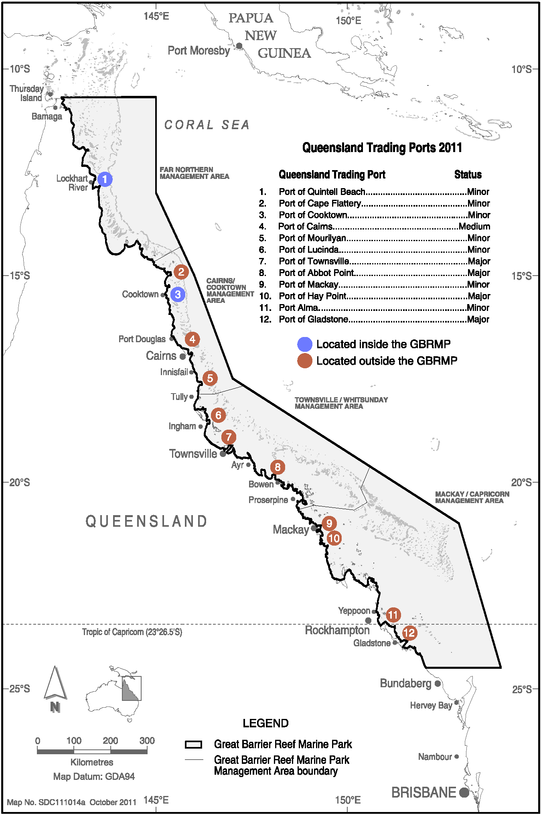
Map 1. Locations of the 12 Queensland trading ports within the Region for which maps of the bed shear-stress were created to identify the stability of sediments and hence, whether locations are likely to be dispersive or non-dispersive for dredged sediments. (Map courtesy of the Great Barrier Reef Marine Park Authority 2012 ©).

Study Locations
The placement of dredge material at each location was modelled for the current material placement site as well as two hypothetical alternative material placement sites (designated Model Case 1 and Model Case 2), with the exception of Port of Gladstone, where three alternative model cases were modelled. This was because the existing placement site has limited capacity for dredge material beyond that expected to be generated by already approved projects (SKM APASA 2013b).
Table 1 provides a summary of the modelled dredge material placement sites. Figure 1 to figure 6 show the locations of the current material placement sites and Model Cases for the six study locations.

Table 1. Summary of the six study locations used as part of the modelling assessment.
Study Area | Model Cases | Description | Location Map
Port of Gladstone | Model Case 1 | Model Case 1 is positioned 10 km north-east of the entrance to Gladstone port channel in an approximate water depth of 23 m | See figure 1
Port of Gladstone | Model Case 2 | Model Case 2 is positioned 17 km north-west of the entrance of Gladstone within a water depth of approximately 20 m | See figure 1
Port of Gladstone | Model Case 3 | Model Case 3 is located 29 km north-west of the Port of Gladstone channel entrance in approximately 23 m of water | See figure 1
Rosslyn Bay State Boat Harbour | Model Case 1 | Model Case 1 lies 4 km east of the Boat Harbour and approximately 750 m east of the current material placement site, which places it outside, but immediately adjacent to the boundary of the Conservation Park Zone | See figure 2
Rosslyn Bay State Boat Harbour | Model Case 2 | Model Case 2 is positioned 6 km north-east offshore of the State Boat Harbour and approximately 2 km (in an easterly direction) to the boundary of the Conservation Park Zone | See figure 2
Rosslyn Bay State Boat Harbour | Current material placement site | The current material placement site is located approximately 750 m west of Model Case 1 | See figure 2
Port of Hay Point | Model Case 1 | Model Case 1 is positioned 25 km north-north-east of the Port of Hay Point in an approximate water depth of 20 m | See figure 3
Port of Hay Point | Model Case 2 | Model Case 2 is located 20 km north-east of the Port of Hay Point in a water depth of 23 m | See figure 3
Port of Hay Point | Current material placement site | The current material placement site is located within an approximate water depth of 12 m | See figure 3
Port of Abbot Point | Model Case 1 | Model Case 1 is positioned 15 km north-west of the Port of Abbot Point | See figure 4
Port of Abbot Point | Model Case 2 | Model Case 2 is positioned 13 km north-east of the Port of Abbot Point | See figure 4
Port of Abbot Point | Current material placement site | The current material placement site is positioned approximately 10 km south-east and 13 km south-west of Model Case 1 and 2, respectively | See figure 4
Port of Townsville | Model Case 1 | Model Case 1 is positioned 24 km north-east of the Port of Townsville in an approximate water depth of 24 m | See figure 5
Port of Townsville | Model Case 2 | Model Case 2 lies 24 km north-west of the Port of Townsville (straight-line distance, the navigation route around Magnetic Island is considerably further) in a water depth of approximately 22 m | See figure 5
Port of Townsville | Current material placement site | The current material placement site is located < 10 km from Magnetic Island in a water depth of 11 m | See figure 5
Port of Cairns | Model Case 1 | Model Case 1 is positioned 20 km north-north-east of the Port of Cairns and is distant from sensitive receptors, such as reefs, and has a low probability of having deep water seagrass. The water depth is approximately 18 m | See figure 6
Port of Cairns | Model Case 2 | Model Case 2 is positioned 32 km north-north-east of the port in an approximate water depth of 18 m | See figure 6
Port of Cairns | Current material placement site | The current material placement site is located approximately 4 km south of Model Site 1 in a water depth of 11 m | See figure 6

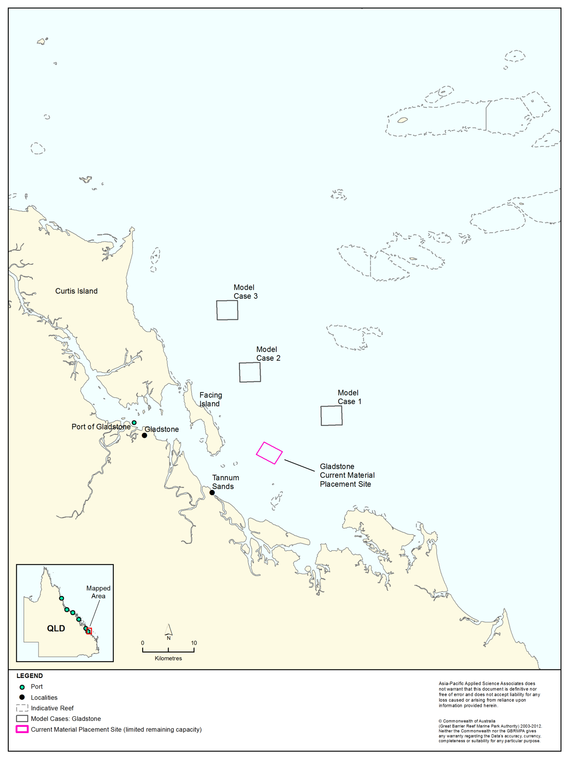
Figure 1. Locations of Model Cases 1–3 for the Port of Gladstone study area. Three hypothetical model case locations were identified as it was recognised that the current placement site has limited capacity.
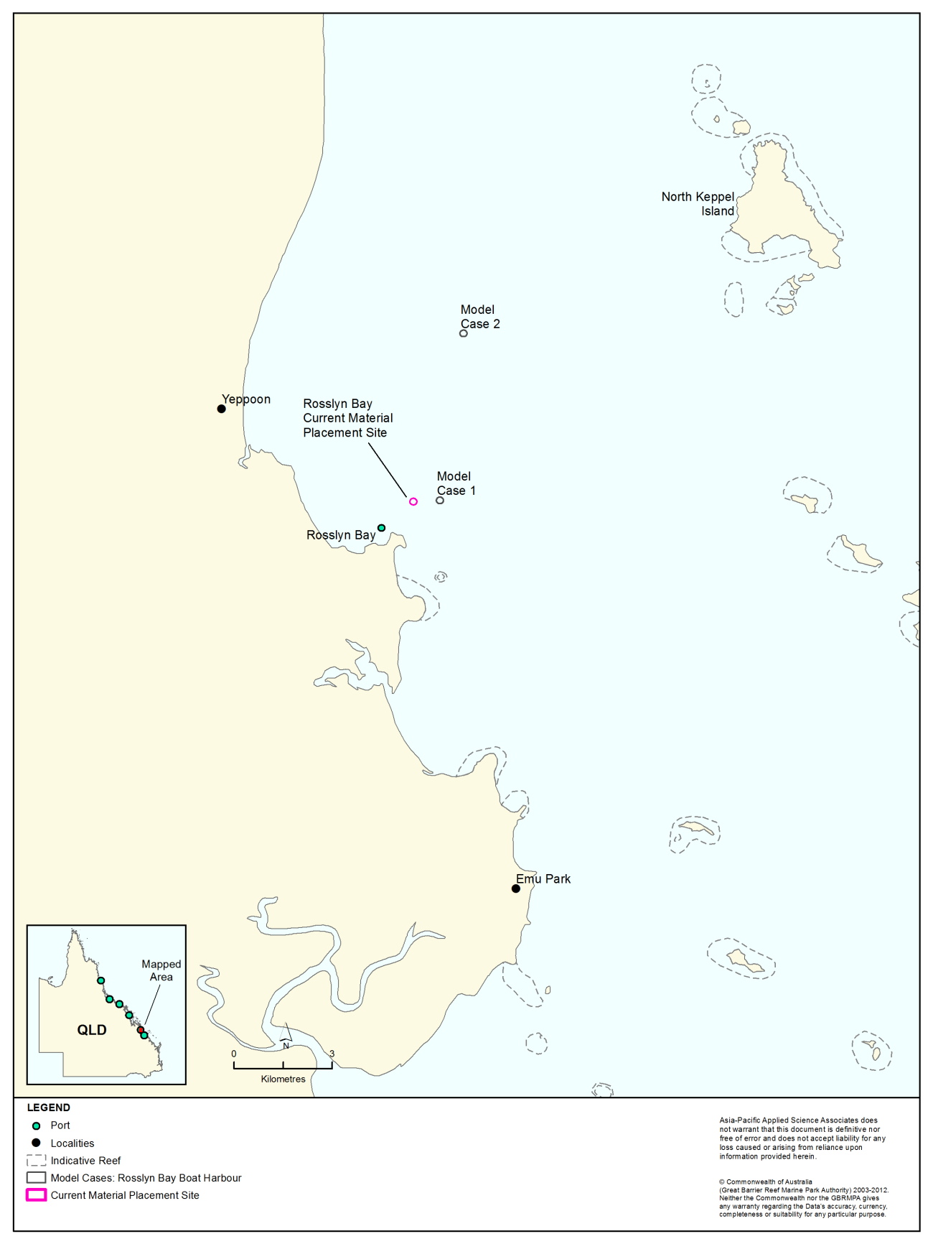
Figure 2. Locations of Model Case 1, Model Case 2 and the current material placement site for Rosslyn Bay State Boat Harbour study area.
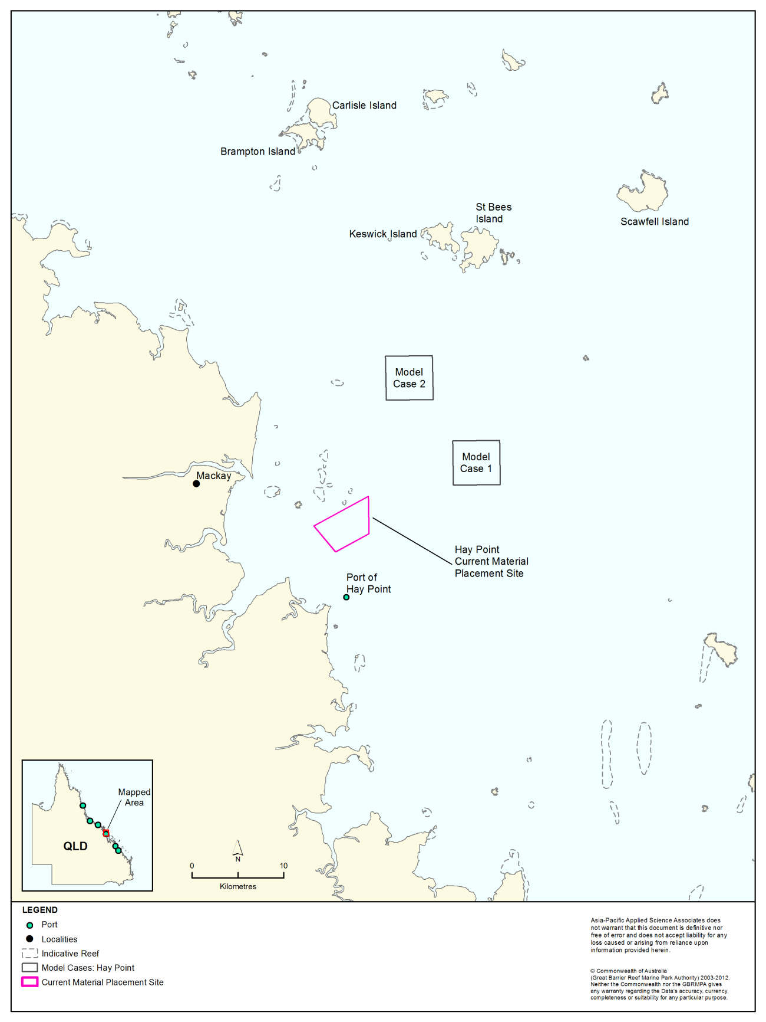
Figure 3. Locations of Model Case 1, Model Case 2 and the current material placement site Port of Hay Point study area.
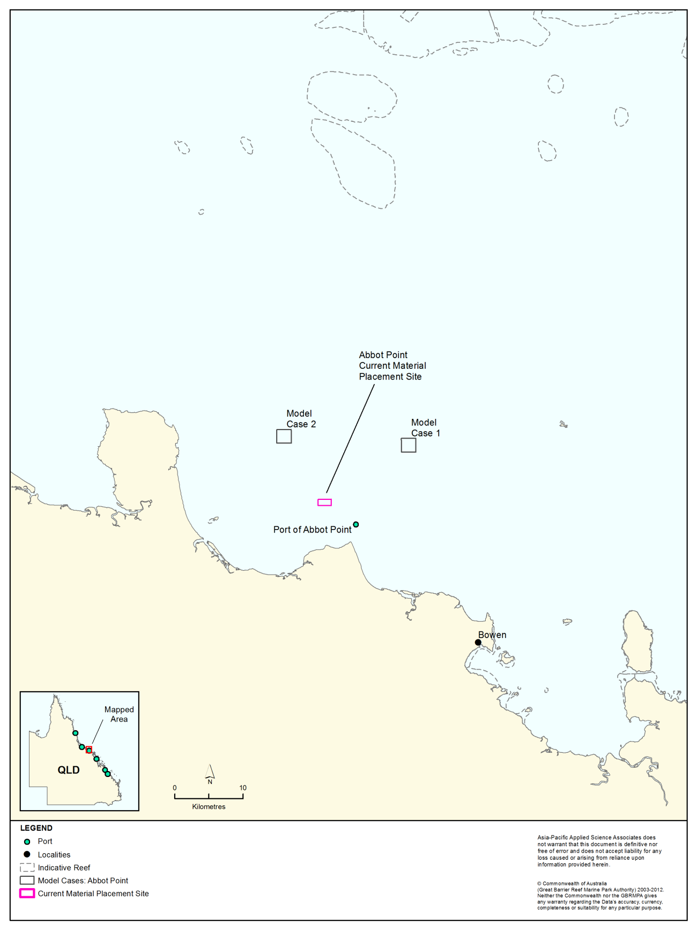
Figure 4. Locations of Model Case 1, Model Case 2 and the current material placement site for Port of Abbot Point study area.
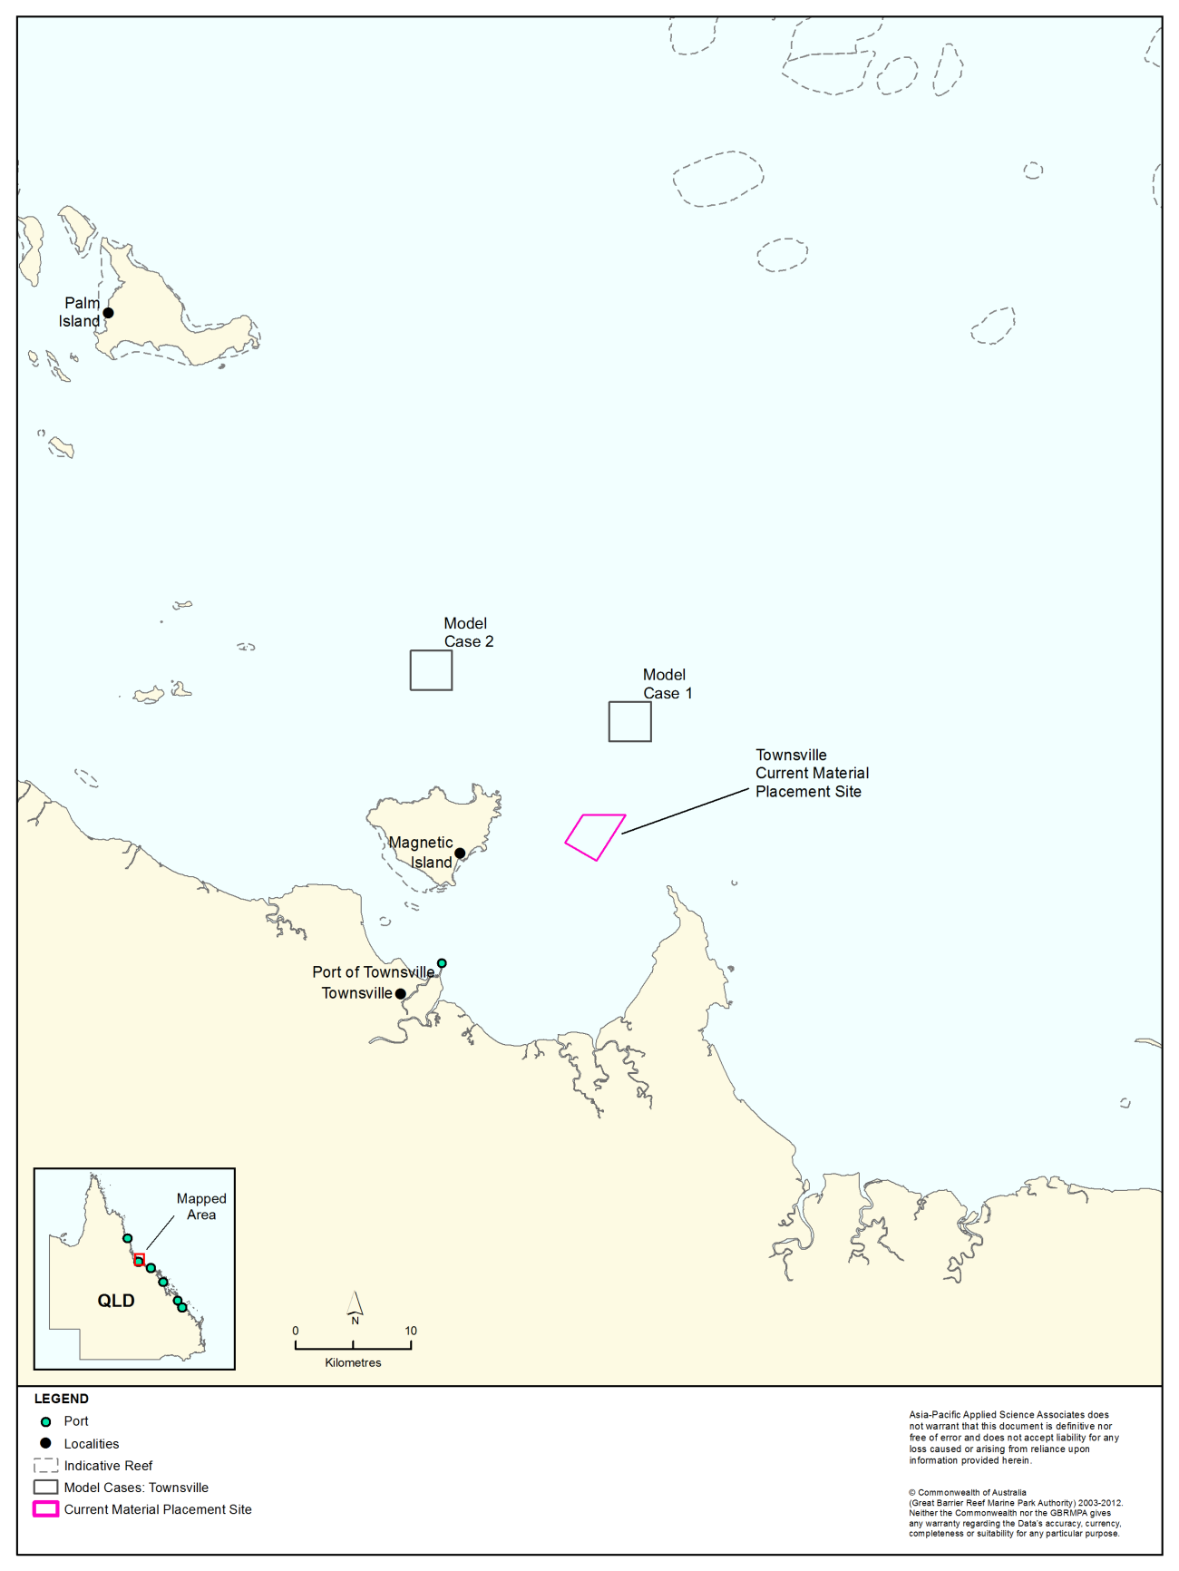
Figure 5. Locations of Model Case 1, Model Case 2 and the current material placement site for Port of Townsville study area.
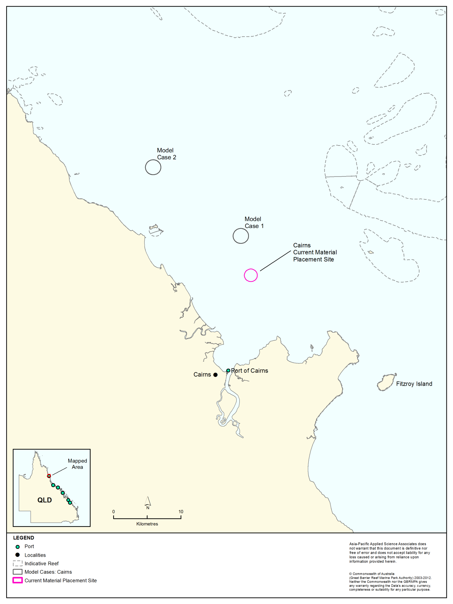
Figure 6. Locations of Model Case 1, Model Case 2 and the current material placement site for Port of Cairns study area.

Methods
As part of this research, the following tasks were performed:
- Identify inter-annual conditions spanning strong El Niño, La Niña and neutral years between 2004 and 2011; and compare the surface current data for each of the years to verify which was the most energetic
- Combine the effects from tides and local wind driven flows with the influence of large-scale currents
- Model the wave climate for the same period as the current data
- Establish with the representatives from the six study locations the most appropriate scenarios (i.e. capital or maintenance dredging operation)
- Simulate placement operations and long-term sediment migration from the alternate Model Cases and the current material placement sites
- Analyse the period during the dredge material placement period and generate percentile plots for predicted TSS concentrations and sedimentation rates for each material placement site and study location
- Generate plots illustrating total sedimentation and equivalent bottom thickness for each material placement site and study location at the end of the dredge material placement period
- Analyse the results at the end of the 12 months and generate plots illustrating total sedimentation and equivalent bottom thickness for each material placement site and study location.

Modelling of Currents
The Reef is broadly divided into three distinct sedimentary zones that coincide with water depth (Belperio 1983; Belperio & Searle 1988), namely: 1) an inner shelf zone from 0-20 m; 2) a middle shelf zone from 20-40 m; and 3) an outer shelf zone from 40-90 m (see figure 7). It is well-documented that the water circulation and oceanographic processes on the Reef are influenced by the interaction of 1) tides and local winds, 2) wind-driven currents (predominant south-east trade winds) and 3) large-scale currents and inflow of water from the Coral Sea (Wolanski 1994; Lambeck et al. 1998; Brinkman et al. 2001; Lambrechts et al. 2010). Wolanski (1994) describes the important processes influencing the oceanography of the Region and details that net current forcing can be variably influenced by the tides and winds, wind-driven currents, and oceanic currents, each operating on differing time scales.
Tidal velocities have been shown to range between < 0.35 m/s in open (i.e. un-rimmed) parts of the Reef shelf to 1.5 m/s within complex reef/island environments (e.g. Torres Strait and also Capricorn Group; Harris et al. 2000). The tidal signal across the Reef is both diurnal and semidiurnal with a range of generally ~2 m. In the northern section of the Reef, the tides are relatively weak and run parallel to the coast inshore. In the central section of the Reef, tidal currents are strong and flow in a cross-shelf direction (King & Wolanski 1996). Additionally, in the southern section, the tides are very strong during spring tides and flow alongshore (Griffin et al. 1987). Localised winds are also influential in the hydrology of the coastal Reef waters, influencing flow on short-time high frequency scales (i.e. hourly).
The south-east trade winds push the Reef waters northward which generates along-shore currents in the inner and middle Reef shelf (Lambeck et al. 1998). They are generally constant over the entire Reef and dominate inter-reefal circulation between May and October. Figure 8 shows modelled mean currents during strong south-east winter winds and then during calm weather period (Brinkman et al. 2001). The trade winds counter any south-directed tidal flows and maintain a well-mixed water column (Pickard et al. 1977; Wolanski 1994; Lambeck & Woolfe 2000; Hemer et al. 2004). Southward movement of the Intertropical and South Pacific Convergence Zones between November and April weakens the pervasive effects of the trade winds. During November and April, north and north-west winds are associated with the monsoon season and are weaker and more variable (Maxwell & Swinchatt 1970; Pickard et al. 1977; Wolanski 1994). This results in alternating northward and southward current movement (Wolanski & Thomson 1984).

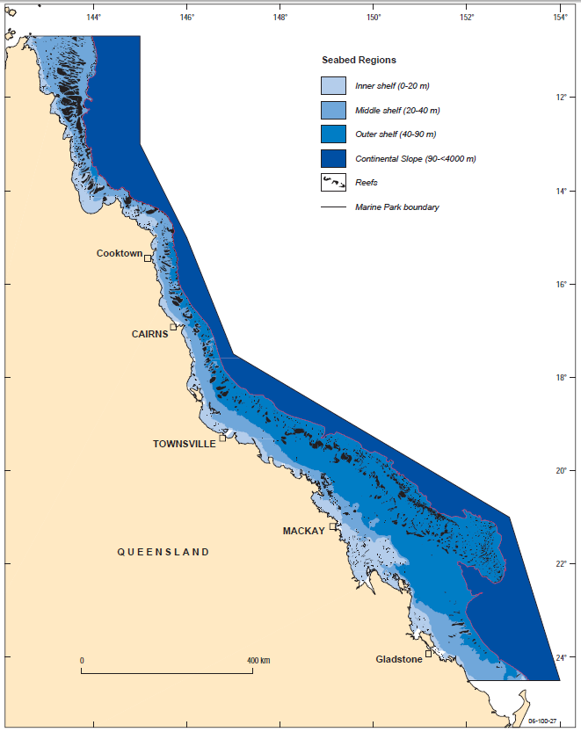
Figure 7. Map showing the broadly divided zones that coincide with water depth (Belperio 1983). Subdivision of the inner shelf is from 0-20 m water depth, a middle shelf, from 20-40 m and outer shelf, from 40-90 m water depth. All blue areas highlight inter-reefal seabed environments within the Marine Park, and reefs are shown in black (Source: Mathews et al. 2007).
Offshore of the Reef are deep-water currents that result from the South Equatorial Current flowing onto the continental shelf, where it splits into northward and southward arms as it approaches the north-east Australian shelf. The southern arm is often trapped against the continental slope, to form the East Australian Current (EAC). The northern arm flows along the shelf edge offshore of the northern Reef to form a semi-closed cyclonic eddy in the Coral Sea, centred in the Gulf of Papua (Wolanski 1994).
While the EAC influences the net drifts along the Reef shelf, its influence near the coast is weaker and non-existent in the enclosed bays and estuaries along the coast (King & Wolanski 1992). More importantly, the prevailing south-east trade winds (which can be moderate to strong during the months of May to October) often halt the deep water drift currents on the shelf and particularly in shallow waters for even weak south-east winds. Due to the persistence of these south-east trade winds, a strong northward drift within the near coastal waters develops and can be seen in the littoral sediment profiling of inshore waters (inferred from longshore variation of sediment composition along the 10 m isobath; Lambeck & Woolfe 2000). Indeed, during the passing of Tropical Cyclone Hamish in 2009, the currents inshore in Cleveland Bay off Townsville were measured to flow alongshore northward at a velocity peaking at 0.7 m/s (Lambrechts et al. 2010).
A summary of the methodology used to account for the influence of tides, local winds and large-scale current forcing is discussed in the next sections.

Figure 8. Mean currents modelled for strong south-east winds (left image) and during calm weather days (right image) from April to August 1981 (Source: Brinkman et al. 2001).

Representing the Effects of Tides and Local Winds
The effect of tides and local winds were replicated using a three-dimensional barotropic model (HYDROMAP). This hydrodynamic model, as described by Isaji & Spaulding (1984), is a three-dimensional model that uses continuous profiles to represent the velocity, temperature, and salinity in the vertical structure. The basis of the model is formed by the three-dimensional conservation equations in spherical coordinates for water mass, density, and momentum with Boussinesq and hydrostatic assumptions. HYDROMAP has been widely applied to studies of hydrodynamic circulation and the fate of hydrocarbon spills and discharges on the Australian Northwest Shelf and over the Timor Sea for several years. Satisfactory validation of the model algorithms have been demonstrated in multiple comparisons against current measurements and drogue tracks at many sites. The model is the hydrodynamic engine used by the Australian Maritime Safety Authority Search and Rescue, Maritime New Zealand, Australian Federal and State Water Police Units and the Solomon Islands Rescue Coordination Centre.
The search and rescue (SAR) and police agencies test the datasets and the success rates have been described by AMSA as 19 out of 20. In blind SAR trials performed for Queensland Police the model predicted 10 out of 10 trajectories accurately. Furthermore, the hydrodynamic model has been used during the Montara oil spill in Timor Sea, in addition to the Shen Neng oil spill and the Pacific Adventurer oil spill, which occurred in Queensland waters.
Dr Eric Wolanski, an independent reviewer of the modelling consulted by the GBRMPA, is considered an expert in the field of oceanographic and sediment dynamics, and he has assessed HYDROMAP as “3D, robust and proven”.
The effects of tides and local winds were replicated using a nested grid. The nested gridding approach was used to allow for the currents within 50 km of each location to be represented at a much higher solution (700 m). This was essential to resolve nearby reefs, complex passages through the islands and coastal flows. Beyond the 50 km extent, the grid spacing grew larger and on the outer shelf and Coral Sea the resolution was increased to ~11 km (see figure 9).
The 700 m resolution is similar to or better than other peer-reviewed models of the Region. For example, modelling by Andutta et al. (2011) had variable resolution from 300 m to several kilometres. Luick et al. (2007) and King & Wolanski (1992, 1996) demonstrated that grid dimensions of 2 km or less were sufficient to resolve shelf-scale features within the Central Section of the Reef. Due to the vast extent of the study region (approximately 1,500 km north to south), the authors acknowledge that the datasets created would not be to the standard of a detailed Environmental Impact Assessment.
Three overlapping grids were generated for the southern, central and northern parts of the Region (see figure 9). The extent of each grid was carefully chosen to accommodate for: a) dramatic changes in depth; and b) effects from the numerous reefs and continental islands. The intent of overlapping the grids was to ensure that the boundaries were set far enough away to minimise numerical artefacts to the ports of interest.
The depths in the model were based on a compilation of the latest hydrographic charts and digital elevation data sourced from Geoscience Australia.
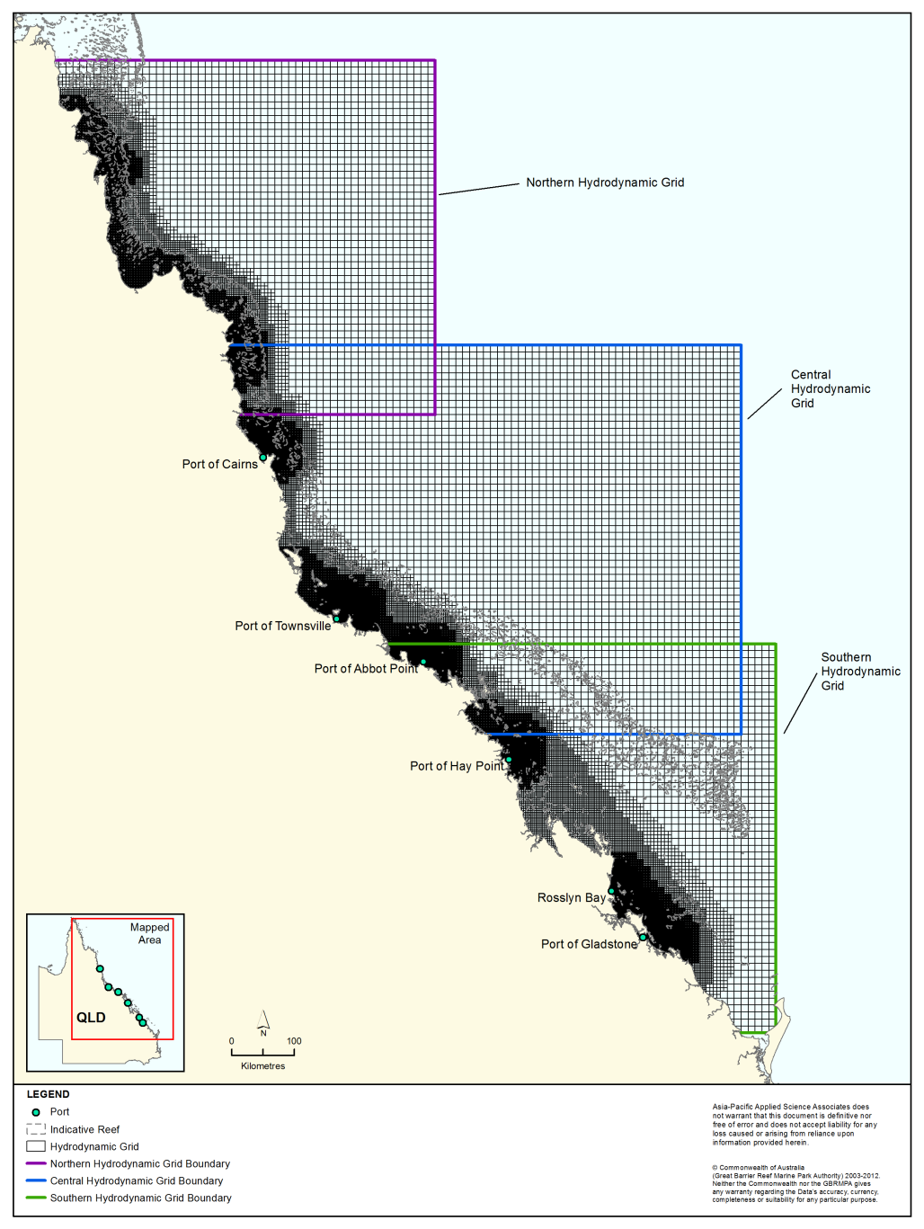
Figure 9. Extent of the southern, central and northern Reef model grids used to replicate the effects from tides and local wind driven flows.

Performance of Tidal Current and Local Wind Model
Data from satellite measurements (Topex/Poseidon global tidal database TPX07.1) were used to duplicate the tides along the southern, eastern and northern ocean boundaries of the HYDROMAP modelling grids. The data is from long-term measurements collected by the Topex/Poseidon satellites over a 13-year period (1992-2005), during which time the satellites orbited the planet approximately 62,000 times. The dataset has a resolution of 0.25 degrees (465 m) globally, and is produced and quality controlled by the United States National Aeronautics and Space Administration (NASA; Fu et al. 1994). The satellites were equipped with two highly accurate altimeters, capable of taking sea level measurements at an accuracy of less than 5 cm (Fu et al. 1994; NASA/Jet Propulsion Laboratory 2013a; 2013b). The Topex/Poseidon tidal data has been widely used by the scientific community, being the subject of more than 2,100 research publications (e.g. Andersen 1995; Ludicone et al. 1998; Matsumoto et al. 2000; Kostianoy et al. 2003; Yaremchuk & Tangdong 2004; Qiu & Chen 2010). The Topex/Poseidon tidal data are considered suitably accurate for this assessment.
Each open boundary grid was assigned phase and amplitude data for the eight largest and most significant tidal constituents for the area (M₂, S₂, K₁, O₁, N₂, P₁, K₂, and Q₁) and spatially interpolated across the cells. The HYDROMAP model used this data to calculate the relative elevation of the ocean along the boundaries and hence propagation of the tide into the domains. The vertical viscosity and bottom friction values selected were based on a previous study for the Gladstone region (APASA 2012).
To ensure HYDROMAP was accurately predicting tides as they propagate past the numerous reefs and continental islands, the predicted water elevations were compared to observed data by the National Tidal Facility (NTF) at nine tide stations (see figure 10) along the Queensland coastline over a randomly selected month within 2011 (1 to 30 November 2011, see figure 11 to figure 13). The comparisons show that HYDROMAP accurately reproduced the phase and amplitudes throughout the spring and neap tidal cycles at all nine tide stations, across the model domains, including the inequalities in the semidiurnal and mixed phase tidal patterns.
Table 2 to table 4 provide summaries of the comparisons between the NTF observed and HYDROMAP predicted water elevations between 1-30 November 2011 at the nine NTF stations (Gladstone, Rosslyn Bay, Hay Point, Abbot Point, Townsville, Cairns, Cooktown, Pipon Island and Night Island; see figure 10).
The tables show the maximum, average and minimum predicted water elevations are comparable to the measured water elevations at all nine stations.
The mean absolute error (MAE) was used as a metric to compare the average error (or difference) between the observed and HYDROMAP predicted water elevations at each of the nine tide stations shown in figure 10.
The MAE was determined as: $MAE=\frac{1}{n}\sum_{i=1}^{n}{|{HYDROMAP Predicted}_{i}-}observed_{i}|$
The mean absolute error (MAE) values are presented in table 2 to table 4 and ranged from 0.07 m (Cairns) to 0.49 m (Hay Point).

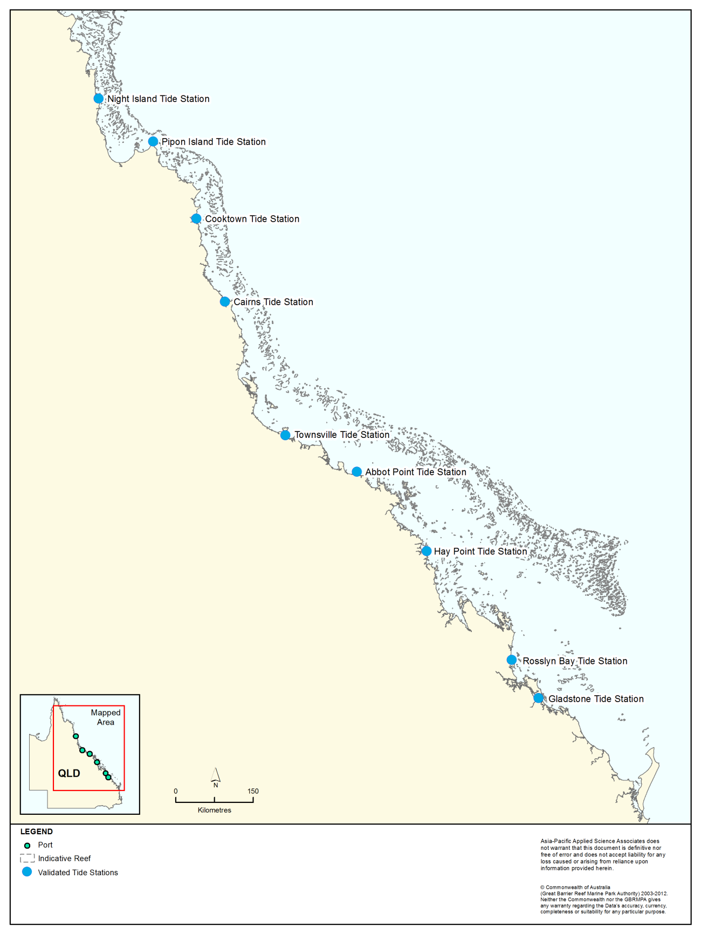
Figure 10. Locations of the nine tide stations from which observed data were used to assess if the model was accurately predicting tides within the Region.

Table 2. Comparison between the NTF observed and HYDROMAP predicted water elevations at Gladstone, Rosslyn Bay and Hay Point from 1-30 November 2011.
Water elevation(m LAT*) | Gladstone |  | Rosslyn Bay |  | Hay Point
Water elevation(m LAT*) | Observed | Predicted | Observed | Predicted | Observed | Predicted
Maximum | 4.65 | 4.37 | 4.78 | 4.89 | 6.68 | 6.06
Mean | 2.34 | 2.38 | 2.42 | 2.46 | 3.37 | 3.43
Minimum | 0.37 | 0.61 | 0.43 | 0.19 | 0.45 | 0.90
Mean absolute error (m) | 0.12 |  | 0.28 |  | 0.49
* Lowest astronomical tide

Table 3. Comparison between the NTF observed and HYDROMAP predicted water elevations at Abbot Point, Townsville and Cairns from 1-30 November 2011.
Water elevation(m LAT*) | Abbot Point |  | Townsville |  | Cairns
Water elevation(m LAT*) | Observed | Predicted | Observed | Predicted | Observed | Predicted
Maximum | 3.27 | 3.18 | 3.72 | 3.73 | 3.05 | 3.00
Mean | 1.69 | 1.73 | 1.94 | 2.00 | 1.70 | 1.72
Minimum | 0.22 | 0.29 | 0.27 | 0.23 | 0.26 | 0.39
Mean absolute error (m) | 0.22 |  | 0.11 |  | 0.07
* Lowest astronomical tide

Table 4. Comparison between the NTF observed and HYDROMAP predicted water elevations at Cooktown, Pipon Island and Night Island from 1-30 November 2011.
Water elevation(m LAT*) | Cooktown |  | Pipon Island |  | Night Island
Water elevation(m LAT*) | Observed | Predicted | Observed | Predicted | Observed | Predicted
Maximum | 2.77 | 2.80 | 2.71 | 2.72 | 2.75 | 2.69
Mean | 1.49 | 1.55 | 1.48 | 1.51 | 1.50 | 1.51
Minimum | 0.20 | 0.25 | 0.53 | 0.23 | 0.44 | 0.27
Mean absolute error (m) | 0.08 |  | 0.17 |  | 0.15
* Lowest astronomical tide
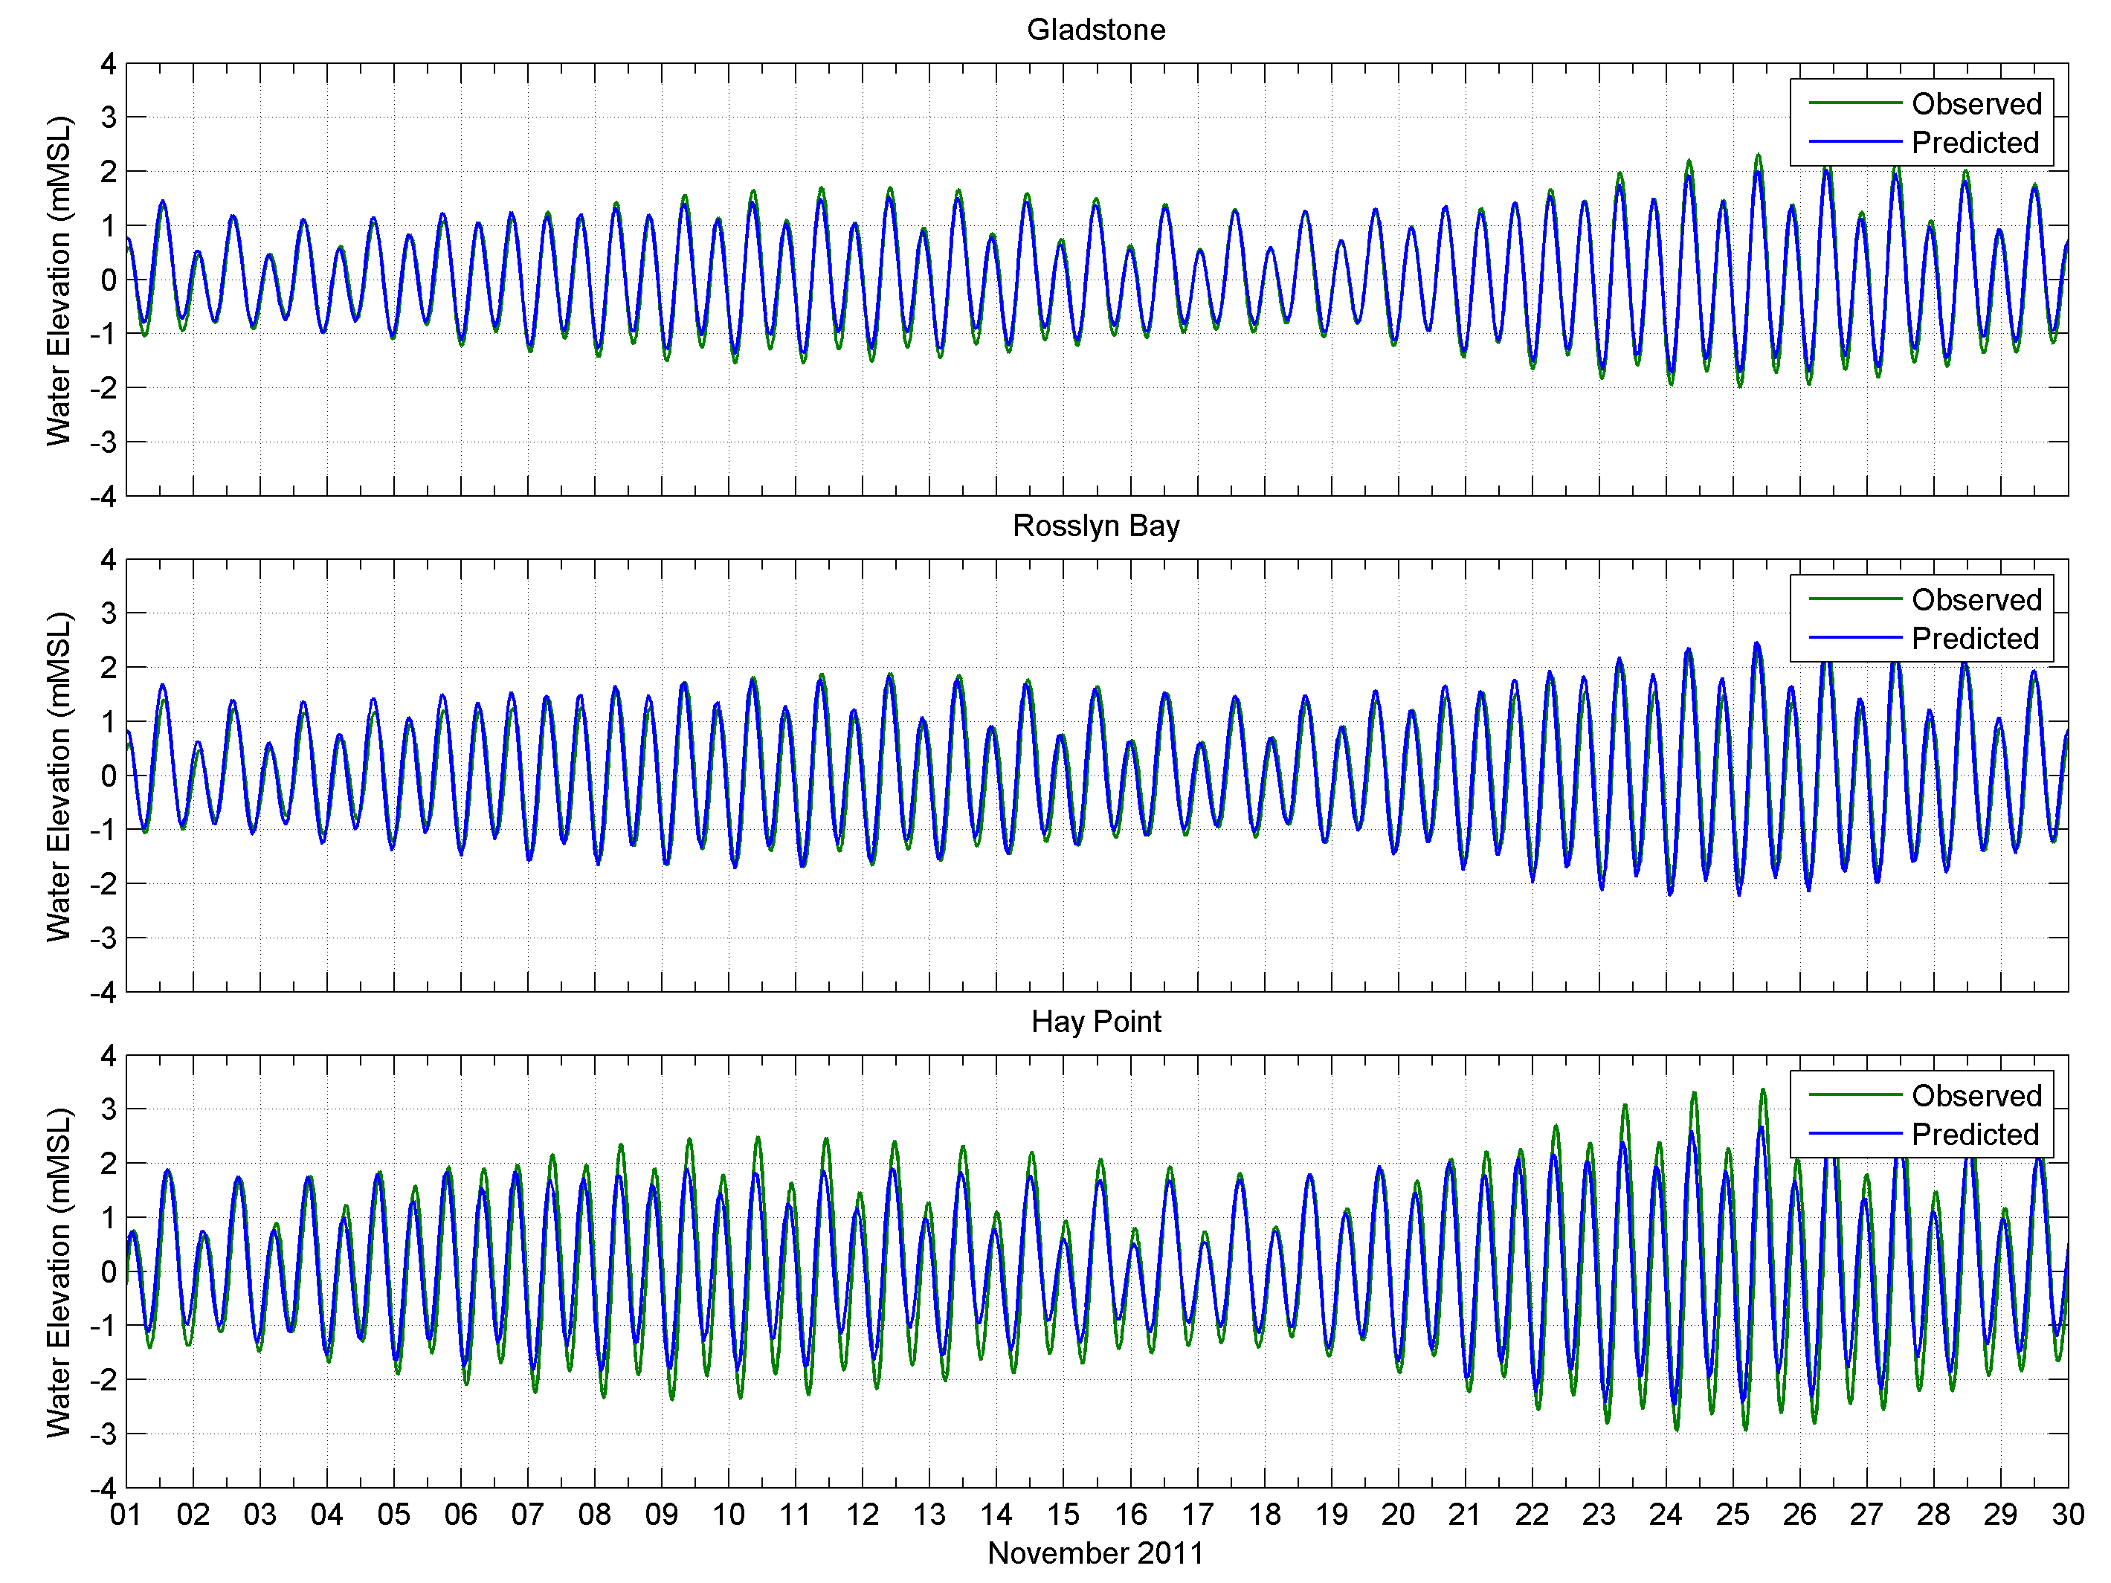
Figure 11. Comparisons between the NTF observed (green line) and HYDROMAP predicted (blue line) water elevations at Gladstone (upper image), Rosslyn Bay (middle image) and Hay Point (lower image), 1-30 November 2011.
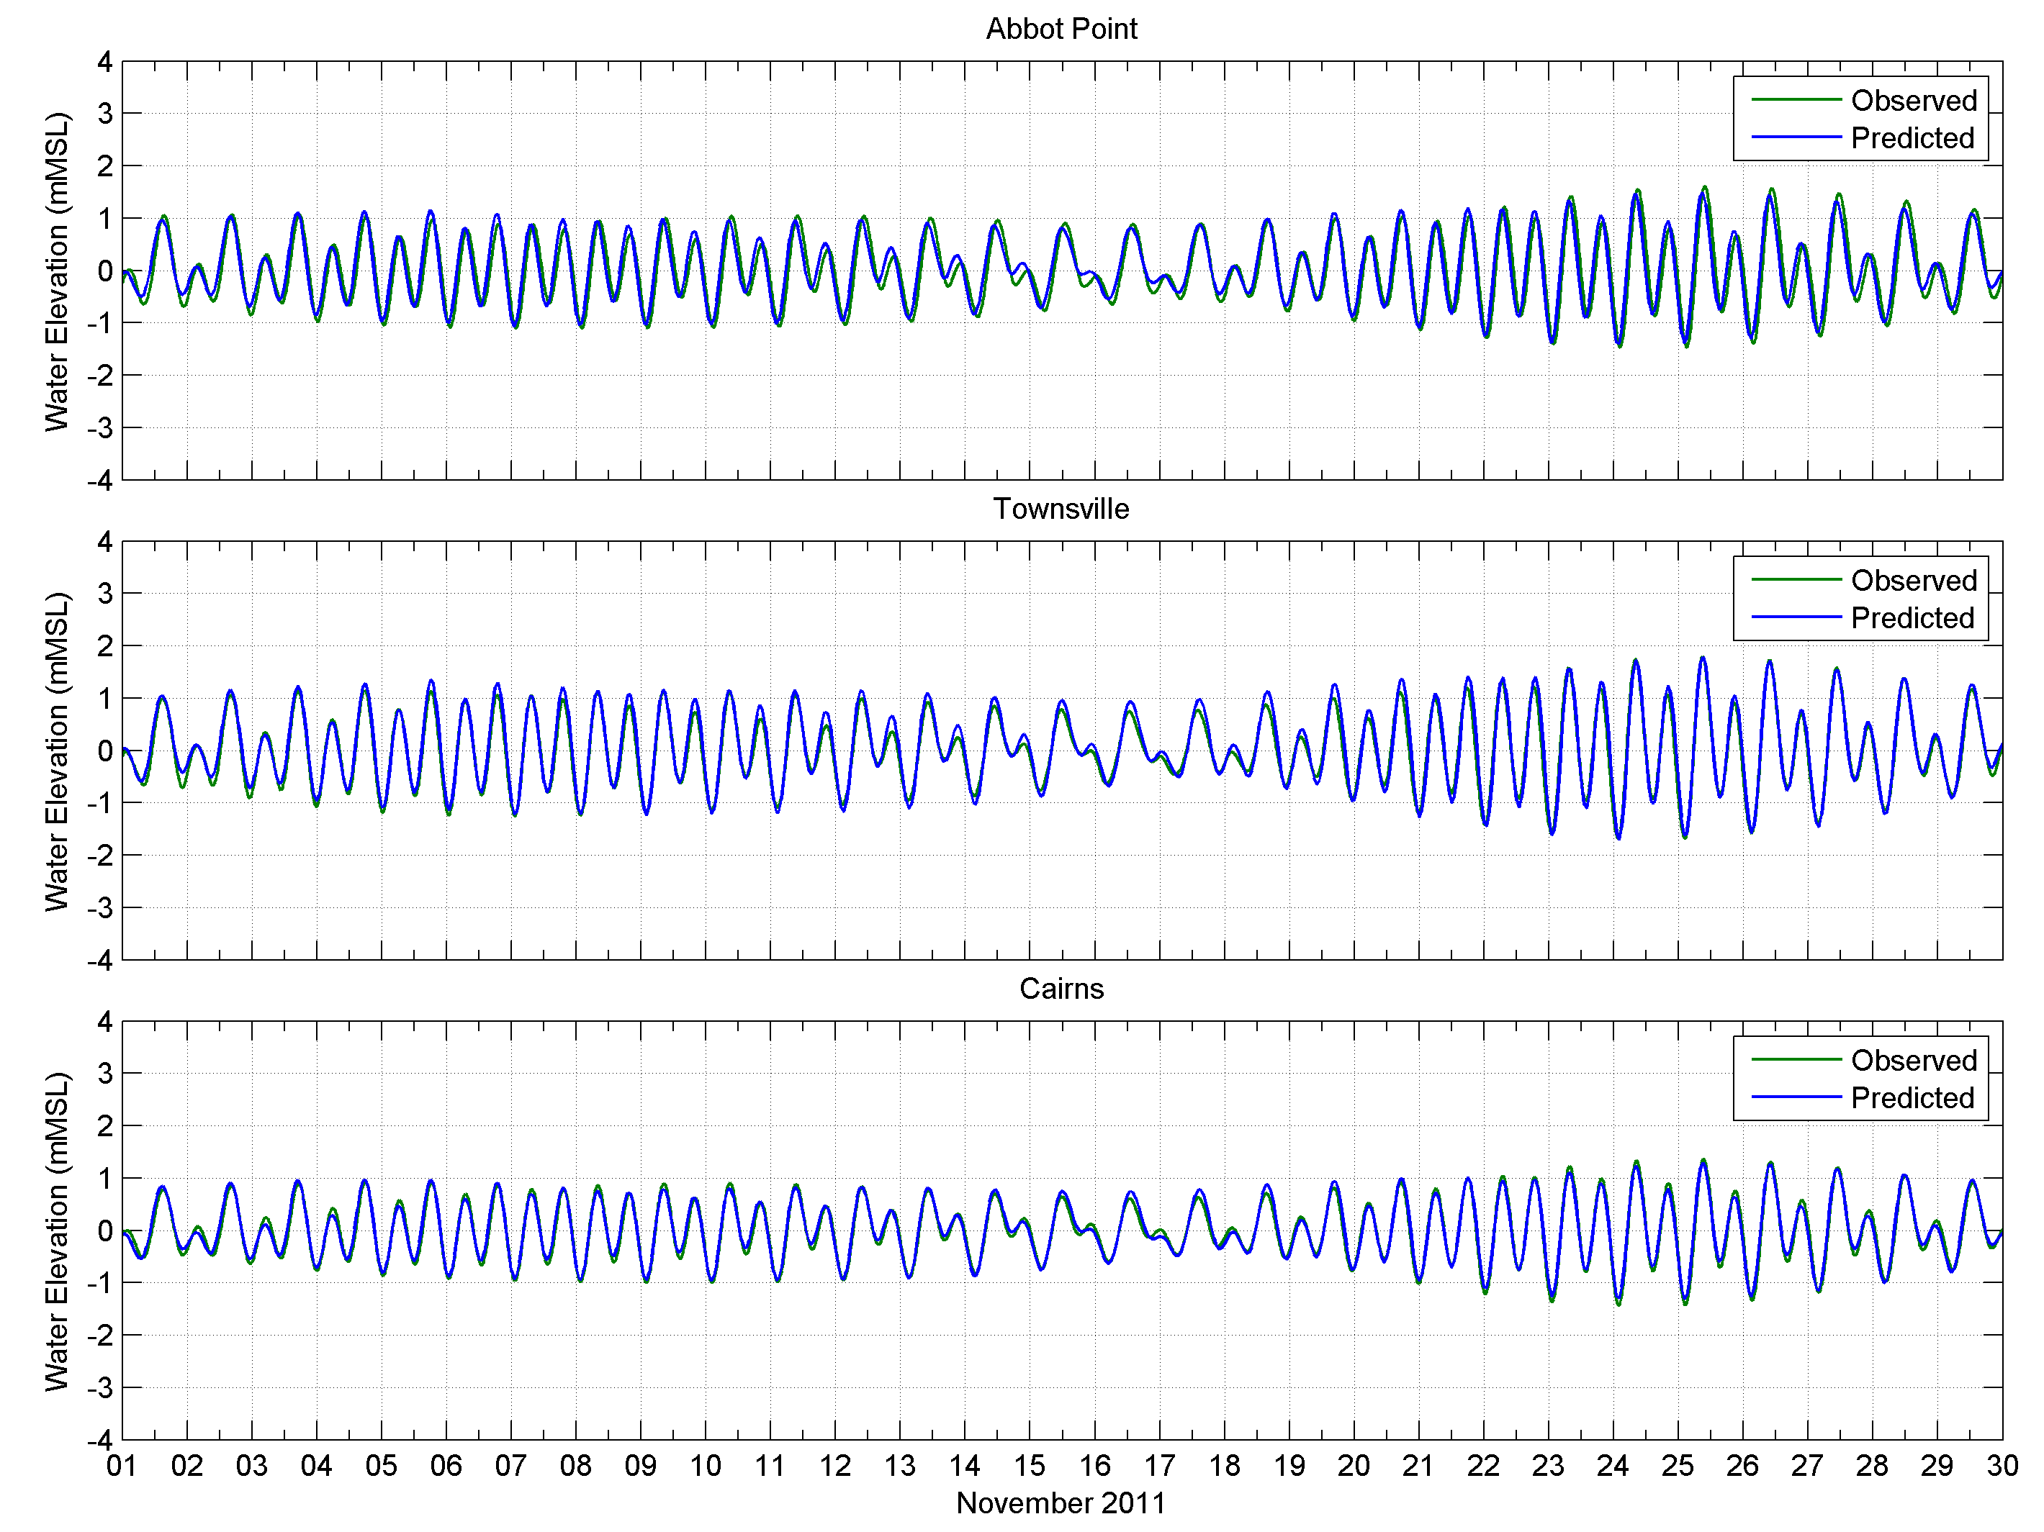
Figure 12. Comparisons between the NTF observed (green line) and HYDROMAP predicted (blue line) water elevations at Abbot Point (upper image), Townsville (middle image) and Cairns (lower image), 1-30 November 2011.
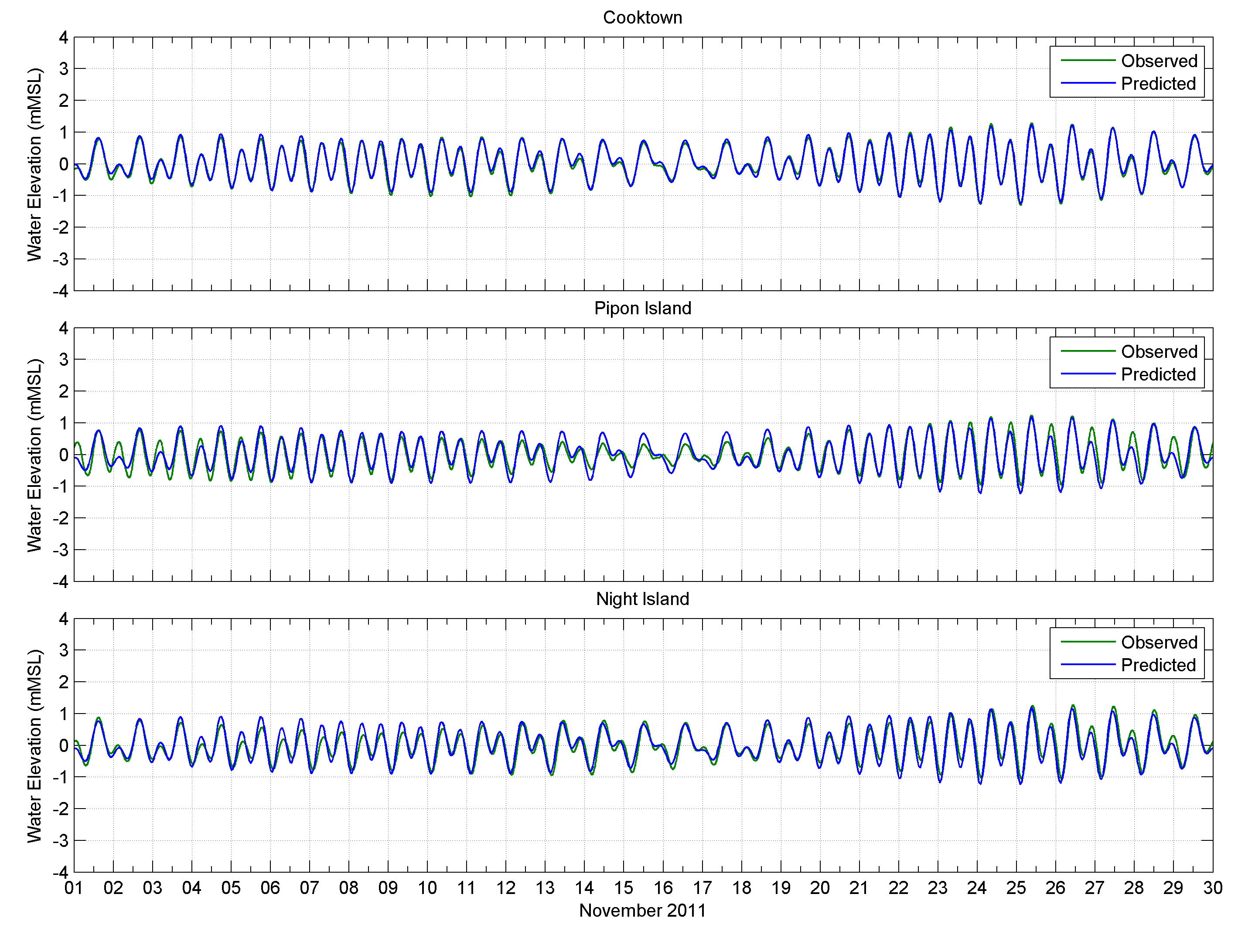
Figure 13. Comparisons between the NTF observed (green line) and HYDROMAP predicted (blue line) water elevations at Cooktown (upper image), Pipon Island (middle image) and Night Island (lower image), 1-30 November 2011.

To account for the effects of local winds, measurements at stations along the coastline by the Bureau of Meteorology (BOM) were combined with offshore data sourced from the atmospheric model, Global Forecast System (GFS). GFS is a global numerical atmospheric model operated by the National Oceanographic and Atmospheric Association (NOAA), which uses near-real time observations to self-correct the predictions. The data is available at three hourly time steps for stations spaced ~55 km apart. Data from 2011 were extracted for the same extent as grids used to replicate the effects from tides and local wind driven flows. The vertical viscosity and bottom friction values selected were based on a previous study for the Port of Gladstone region (APASA 2012).

Representing the Influence of the Large-Scale Currents
The large-scale currents were represented by the output from a third-party three-dimensional ocean model HYCOM (HYbrid Coordinate Ocean Model; Wallcraft et al. 2003; Chassignet et al. 2009) over the extents of the southern, central and northern Reef model grids (see figure 9). HYCOM is operated by the HYCOM Consortium, and sponsored by the Global Ocean Data Assimilation Experiment (GODAE). It uses an array of measured data as input to understand what the current state of the water body is, including time-varying observations of sea-surface height, sea-surface temperature and in situ temperature and salinity measurements (Chassignet et al. 2009), and then uses numerical modelling to understand how the sea-state evolves between the measurement points. The model is three-dimensional and has a resolution of approximately 8.25 km horizontally over the region. Hence, the data provides estimates of meso-scale circulation, with horizontal resolution suitable to resolve eddies of approximately 20 km in diameter, as well as connecting stream currents of similar spatial scale. HYCOM provides a comprehensive dataset spanning decades, with increasing data quality over more recent years through the increased availability of ocean observations from satellite and sensor data. Data between 2004 and 2011 (inclusive) were targeted for this research.
The HYCOM model data was selected for this research because it has been found to better reproduce flows adjacent to the Queensland ports when compared with the Commonwealth Scientific and Industrial Research Organisation (CSIRO) BRAN 2.1 ocean model based on dataset comparisons undertaken by APASA.
It is well known that oceanographic conditions fluctuate from one year to the next. Therefore, to assist in selecting a representative year between 2004 and 2011 for the research, the Southern Oscillation Index (SOI) was used to identify inter-annual trends (Australian Bureau of Meteorology 2012). The SOI broadly defines neutral, El Niño (strongly negative SOI) and La Niña (strongly positive SOI) conditions based on differences in the surface air-pressure between Tahiti on the eastern side of the Pacific Ocean and Darwin (Australia), on the western side (Rasmusson & Wallace 1983; Philander 1990). El Niño episodes are usually accompanied by sustained warming of the central and eastern tropical Pacific Ocean and a decrease in the strength of the Pacific trade winds. La Niña episodes are usually associated with converse trends (i.e. increase in strength of the Pacific trade winds).
Figure 14 shows the SOI monthly values from 2004 to 2011 (corresponding to the HYCOM dataset targeted for assessment). Based on the SOI, 2011 is considered a strong La Niña year, 2004 a moderate El Niño year and 2007 a mixed (neutral) year.
To compare the variability in surface current speeds and directions between the years (i.e. 2004, 2007 and 2011), current rose diagrams were generated using data offshore from the current material placement sites for the five ports (see figure 15).
Each diagram provides an understanding of the speed, frequency and direction of currents, over each year:
Current speed — speed is divided into segments of different colour, ranging from 0 to greater than 1 m/s. Speed intervals of 0.2 m/s are used. The length of each coloured segment is relative to the proportion of currents flowing within the corresponding speed and direction
Frequency — each of the rings on the diagram corresponds to a percentage (proportion) of time that currents were flowing in a certain direction at a given speed
Direction — each diagram shows currents flowing towards particular directions, with north at the top of the diagram.
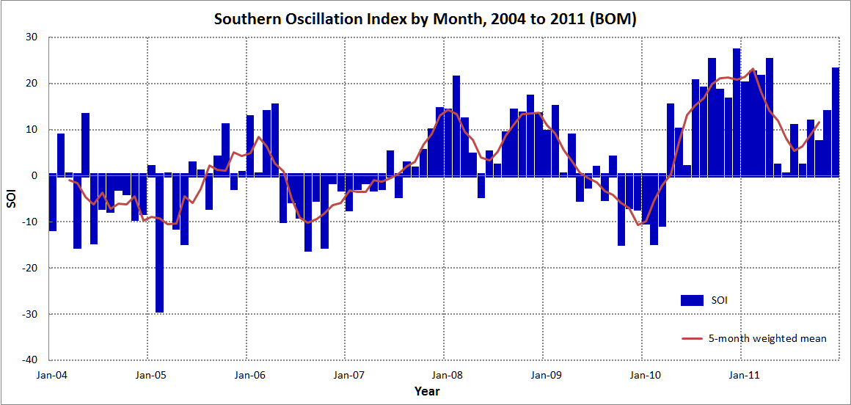
Figure 14. Monthly values of the Southern Oscillation Index (SOI) 2004-2011. Sustained positive values indicate La Niña conditions, while sustained negative values indicate El Niño conditions (Source: Australian Bureau of Meteorology 2012).
The current rose diagrams show that for all five ports, the surface currents were flowing towards the west-north-west for the neutral (2007) and La Niña (2011) years. The weakest and most variable currents were during the El Niño conditions of 2004. The strongest currents occurred during 2011, coinciding with strong wind events. Therefore, 2011 was selected to be the representative year on the basis that it was the most energetic and give the upper bound of the likely resuspension and long-range sediment transport of dredged sediments. In addition, the currents during 2011 were directed toward a greater number of nearby sensitive receptors.
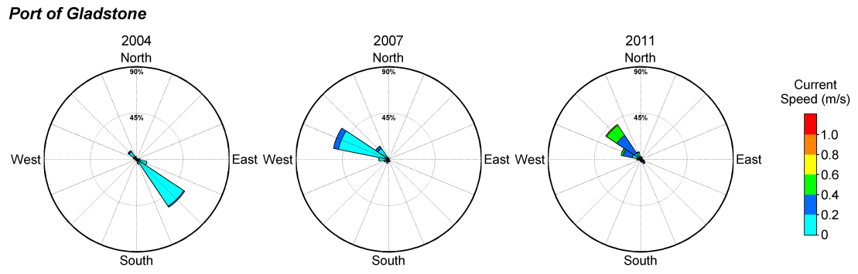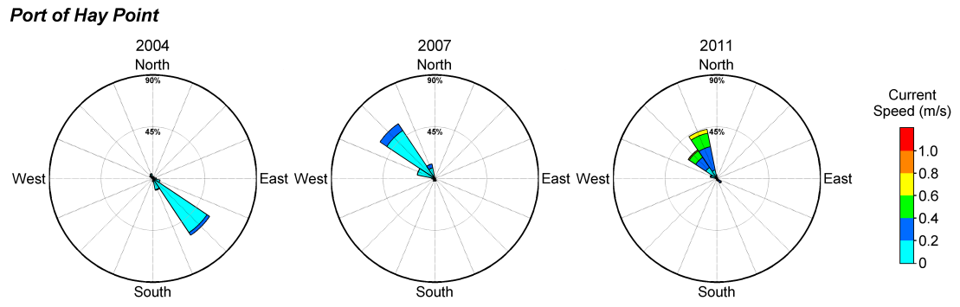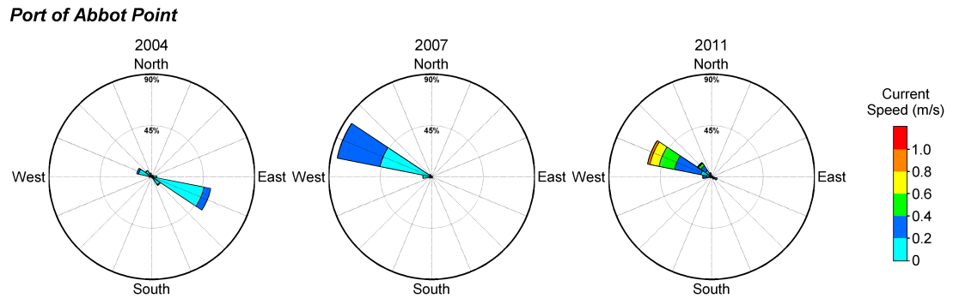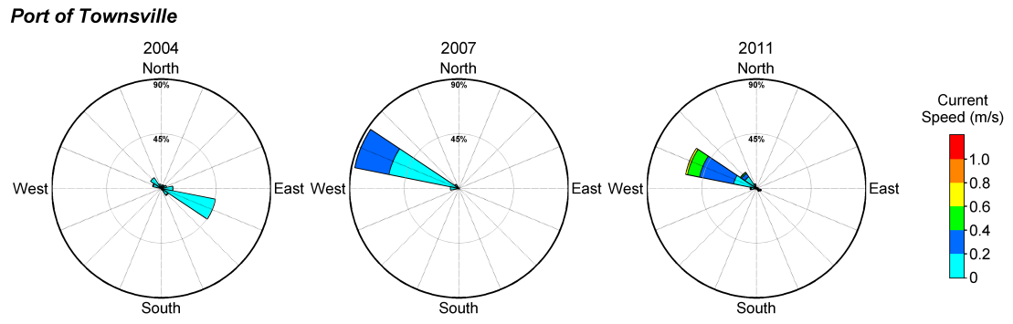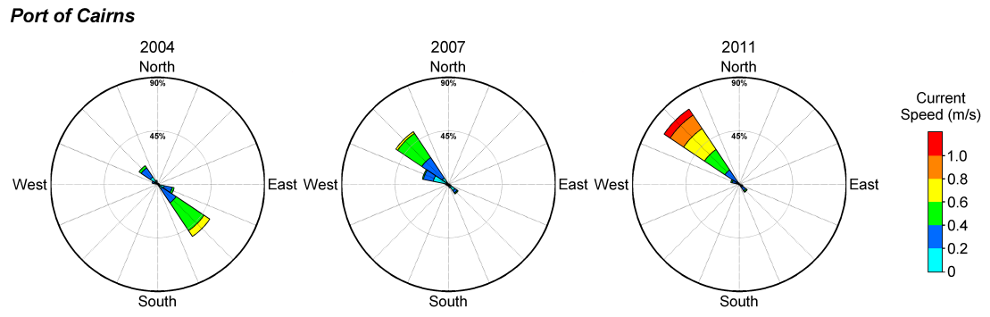
Figure 15. Surface large scale current rose diagrams for an El Niño (2004), La Niña (2011) and neutral (2007) conditions. The diagrams were generated using data offshore from the current material placement sites at the five ports.

Performance of Combined Tide, Local Wind and Large-scale Current Model
This research was the first to incorporate the combined influence of tides, local winds and large-scale currents in modelling the movement of dredge material over 12 months at multiple locations within the Region.
Based on findings of Lambeck & Woolfe (2000), who found evidence for pervasive northward sediment transport along the 10 m depth contour, the HYCOM currents were combined with the predicted HYDROMAP currents at every grid cell in water depths of 10 m or greater. As such, the HYCOM data was spatially-interpolated onto HYDROMAP grids (see figure 9), which were of finer resolution (i.e. 700 m) within 50 km from the study areas.
To confirm its suitability, the generated data was compared to measurements at three locations, Hay Point (November 2011), Townsville (January 2011), and a site ~110 km north-north-east offshore of Townsville (Palm Passage (February-March 2011)). The currents were measured using seafloor-mounted Acoustic Doppler Current Profilers (ADCPs). The locations of the ADCPs are shown in figure 16.
Direct comparisons between the HYCOM + HYDROMAP model-predicted and ADCP measured currents (speed and direction) were performed for the surface and bottom water layers. Depths of water at the measurement sites were 11.5 m Lowest Astronomical Tide (LAT) and 14.5 m LAT at Hay Point and Townsville, respectively.
Figure 17 to figure 20 show the ADCP measured and HYCOM + HYDROMAP (model) predicted current speeds and U (east-west) and V (north-south) current components for the surface and bottom water layers at Hay Point and Townsville, respectively. Positive and negative U components represent eastern and western flow, respectively, and positive and negative V components represent northern and southern flow, respectively. Directionality relates to the direction the currents flow toward.
In general, the plots show there is a good agreement between the model-predicted and measured surface and bottom current speeds. Though, at times there is a tendency for the model to predict stronger currents in a north-westerly direction for longer durations than the measured data.
The Townsville data indicated persistently strong surface currents between 9-16 and 21-24 January 2011. This would be attributable to sustained south-easterly trade winds and the tidal variations being less significant. Of greater importance for the research is the close comparison between the measured and predicted U and V current component for the bottom layer at both sites, as these would have a larger influence on the transportation of sediments that are mobilized from the seabed.
The agreement between the measured and model predicted surface and bottom currents at the Port of Hay Point and the Port of Townsville are provided in tabulated form (table 5 and table 6 respectively). Both tables illustrate that the maximum, average and minimum predicted current speeds are comparable to the measured currents at the two locations. Measured surface current speeds at Hay Point reached a maximum of 0.59 m/s compared with 0.53 m/s for the predicted current speed (table 5). The bottom maximum measured and predicted currents were 0.31 m/s and 0.26 m/s, respectively. At Townsville, the measured surface currents peaked at 0.99 m/s with the model results indicating a maximum speed of 1.12 m/s. The average measured and predicted bottom currents speeds were near identical (0.10 m/s and 0.11 m/s, respectively). Additionally, table 7 shows a comparison between the measured and HYCOM + HYDROMAP model-predicted currents, 58 m and 44 m above the seafloor, at Palm Passage from 10 February-17 March 2011.
Figure 21 and figure 22 show the comparisons between the ADCP measured and HYCOM + HYDROMAP model-predicted current speeds and U (east-west) and V (north-south) current components at 58 m above the seafloor and 44 m above the seafloor, respectively, at Palm Passage (see figure 16). Comparisons show a good agreement between the measured and model predicted current speeds and current components for both layers. The good agreement indicates that the combined dataset is appropriately representing the water circulation in deeper waters.

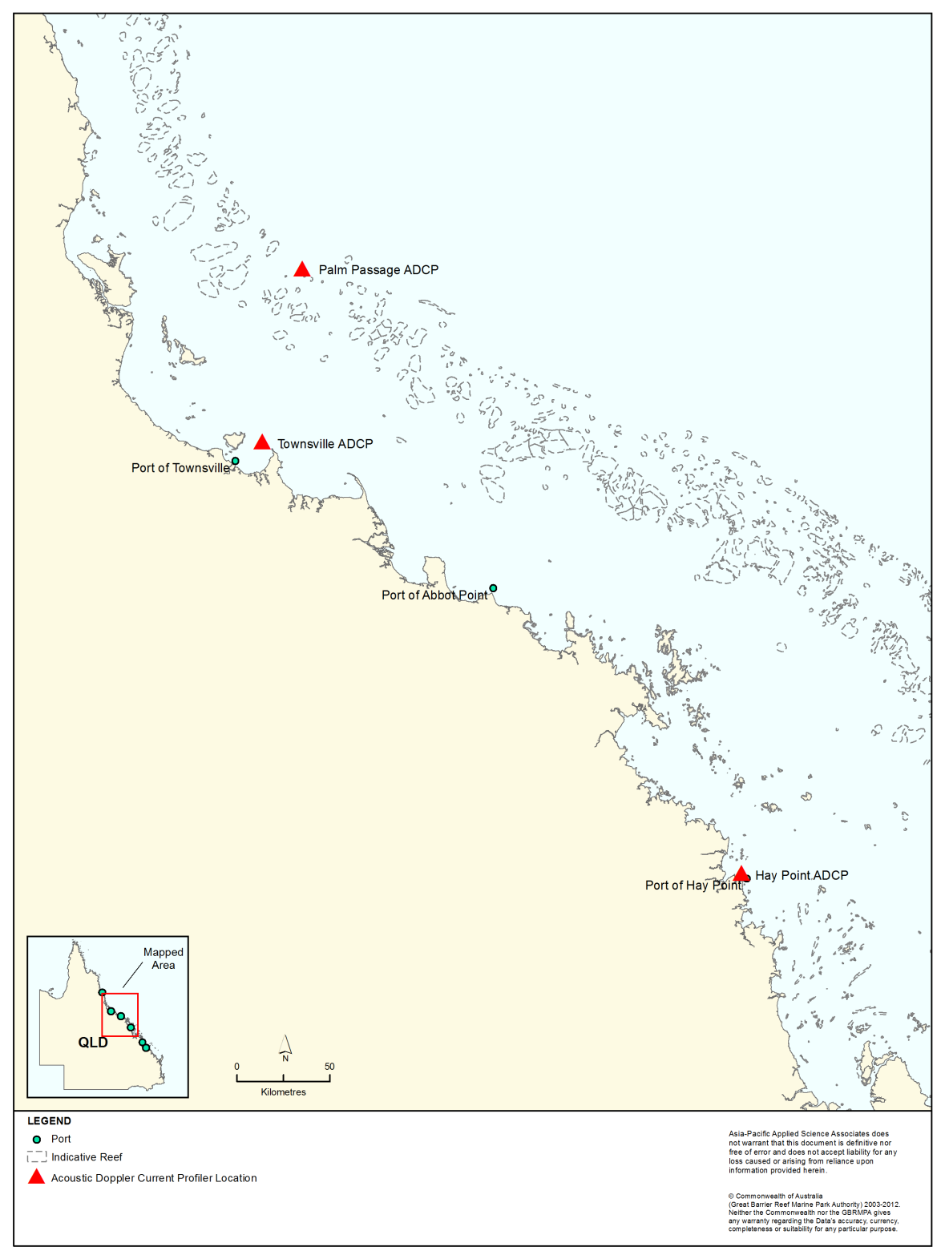
Figure 16. Locations of the instruments used to measure currents throughout the water column adjacent to the Townsville and Hay Point current material placement sites during January and November 2011, respectively, and Palm Passage during February-March 2011.

Table 5. Comparison between the measured and HYCOM + HYDROMAP predicted surface and bottom current speeds adjacent to the Port of Hay Point material placement site from 1-30 November 2011.
 | Surface current speed (m/s) |  | Bottom current speed (m/s)
 | Measured | Predicted | Measured | Predicted
Maximum | 0.59 | 0.53 | 0.31 | 0.26
Mean | 0.30 | 0.30 | 0.15 | 0.17
Minimum | 0.10 | 0.08 | 0.05 | 0.06
Mean absolute error (MAE) | 0.07 |  | 0.04
* Lowest astronomical tide

Table 6. Comparison between the measured and HYCOM + HYDROMAP predicted surface and bottom current speeds adjacent to the Port of Townsville material placement site from 1-29 January 2011.
 | Surface current speed (m/s) |  | Bottom current speed (m/s)
 | Measured | Predicted | Measured | Predicted
Maximum | 0.99 | 1.12 | 0.43 | 0.27
Mean | 0.25 | 0.35 | 0.10 | 0.11
Minimum | 0.00 | 0.01 | 0.01 | 0.00
Mean absolute error (MAE) | 0.16 |  | 0.04
* Lowest astronomical tide

Table 7. Comparison between the measured and HYCOM + HYDROMAP predicted current speeds, 58 m and 44 m above the seafloor, at Palm Passage from 10 February-17 March 2011.
 | 58 m above seafloor current speed (m/s) |  | 44 m above seafloor current speed (m/s)
 | Measured | Predicted | Measured | Predicted
Maximum | 1.32 | 0.94 | 0.65 | 0.46
Mean | 0.23 | 0.33 | 0.21 | 0.21
Minimum | 0.00 | 0.01 | 0.00 | 0.01
Mean absolute error (MAE) | 0.15 |  | 0.11
* Lowest astronomical tide
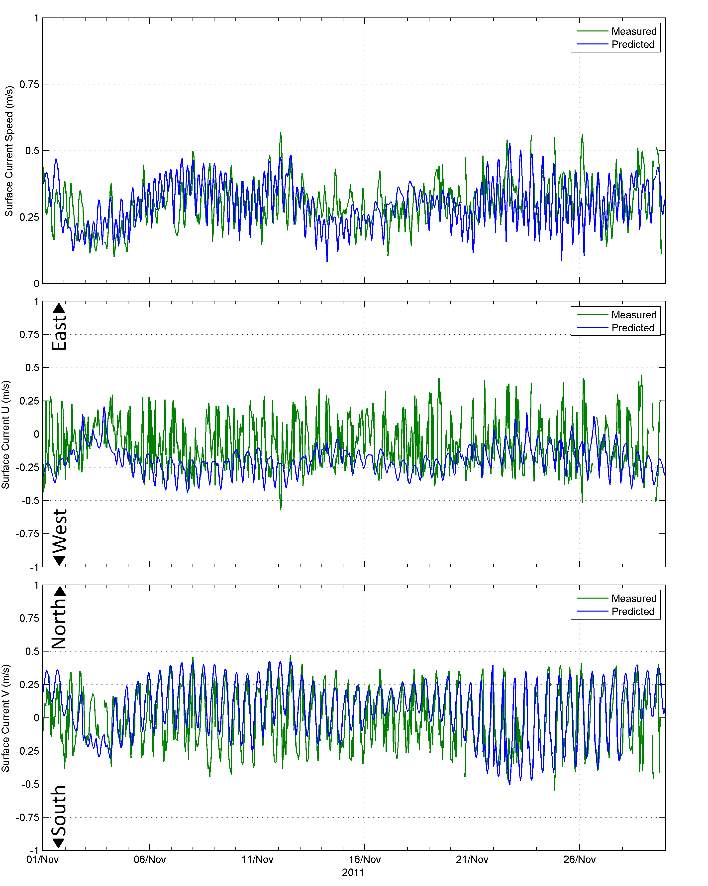
Figure 17. Comparison between the measured (green line) and model predicted (blue line) surface current speeds (top image), U current component (middle image) and V current component (bottom image) adjacent to the Current Hay Point material placement site (1-30 November 2011).
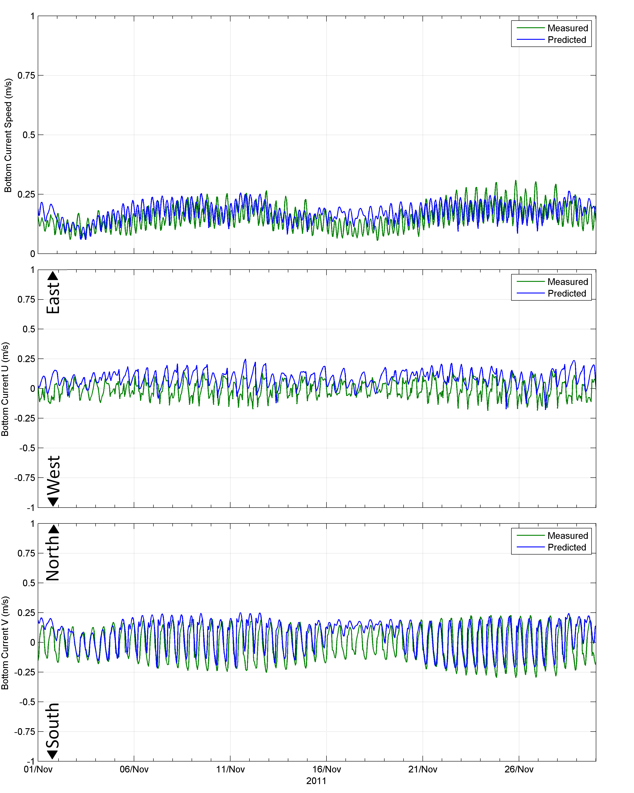
Figure 18. Comparison between the measured (green line) and HYCOM + HYDROMAP predicted (blue line) bottom current speeds (top image), bottom U current component (middle image) and bottom V current component (bottom image) adjacent to the Current Hay Point material placement site (1-30 November 2011).
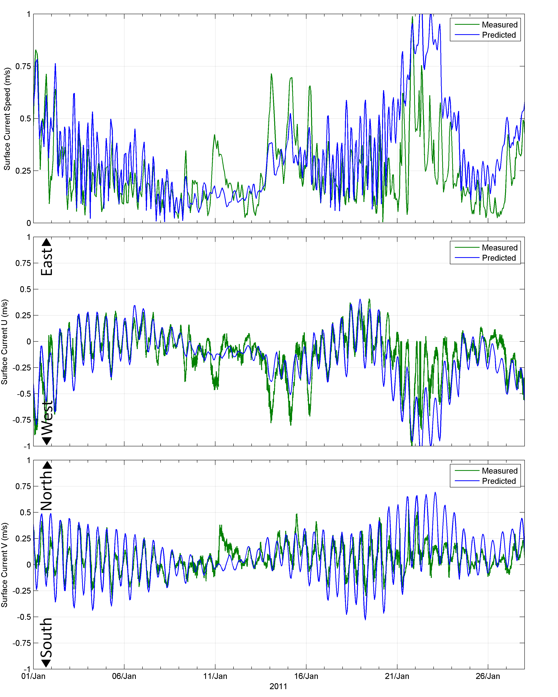
Figure 19. Comparison between the measured (green line) and HYCOM + HYDROMAP predicted (blue line) surface current speeds (top image), surface U current component (middle image) and surface V current component (bottom image) adjacent to the Townsville current material placement site (1-29 January 2011).
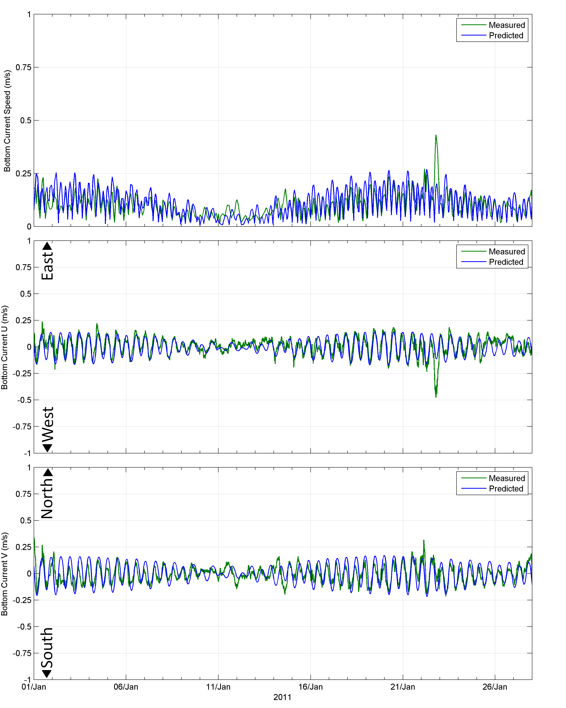
Figure 20. Comparison between the measured (green line) and HYCOM + HYDROMAP predicted (blue line) bottom current speeds (top image), bottom U current component (middle image) and bottom V current component (bottom image) adjacent to the Townsville current material placement site (1-29 January 2011).

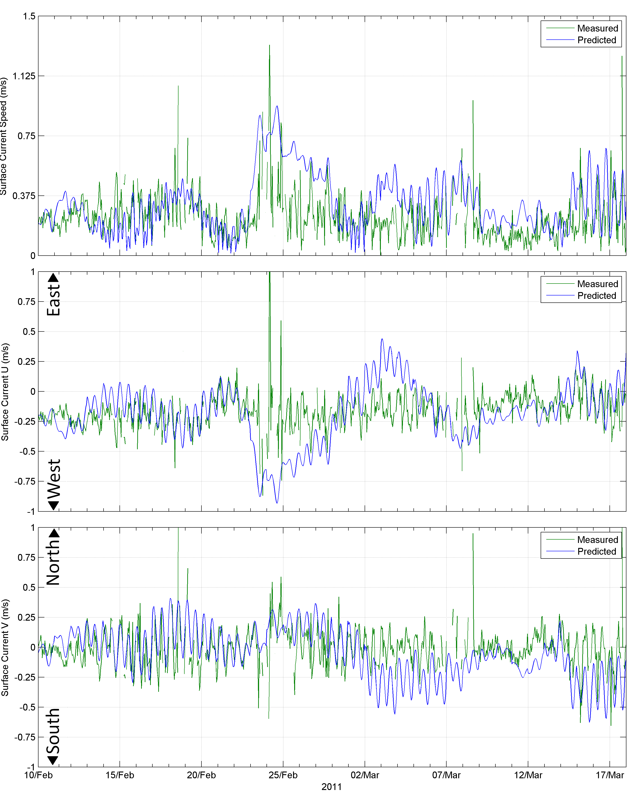
Figure 21. Comparison between the measured (green line) and HYCOM + HYDROMAP predicted (blue line) current speeds (top image), U current component (middle image) and V current component (bottom image) at a water depth 58 m above the seafloor at Palm Passage (10 February-17 March 2011).
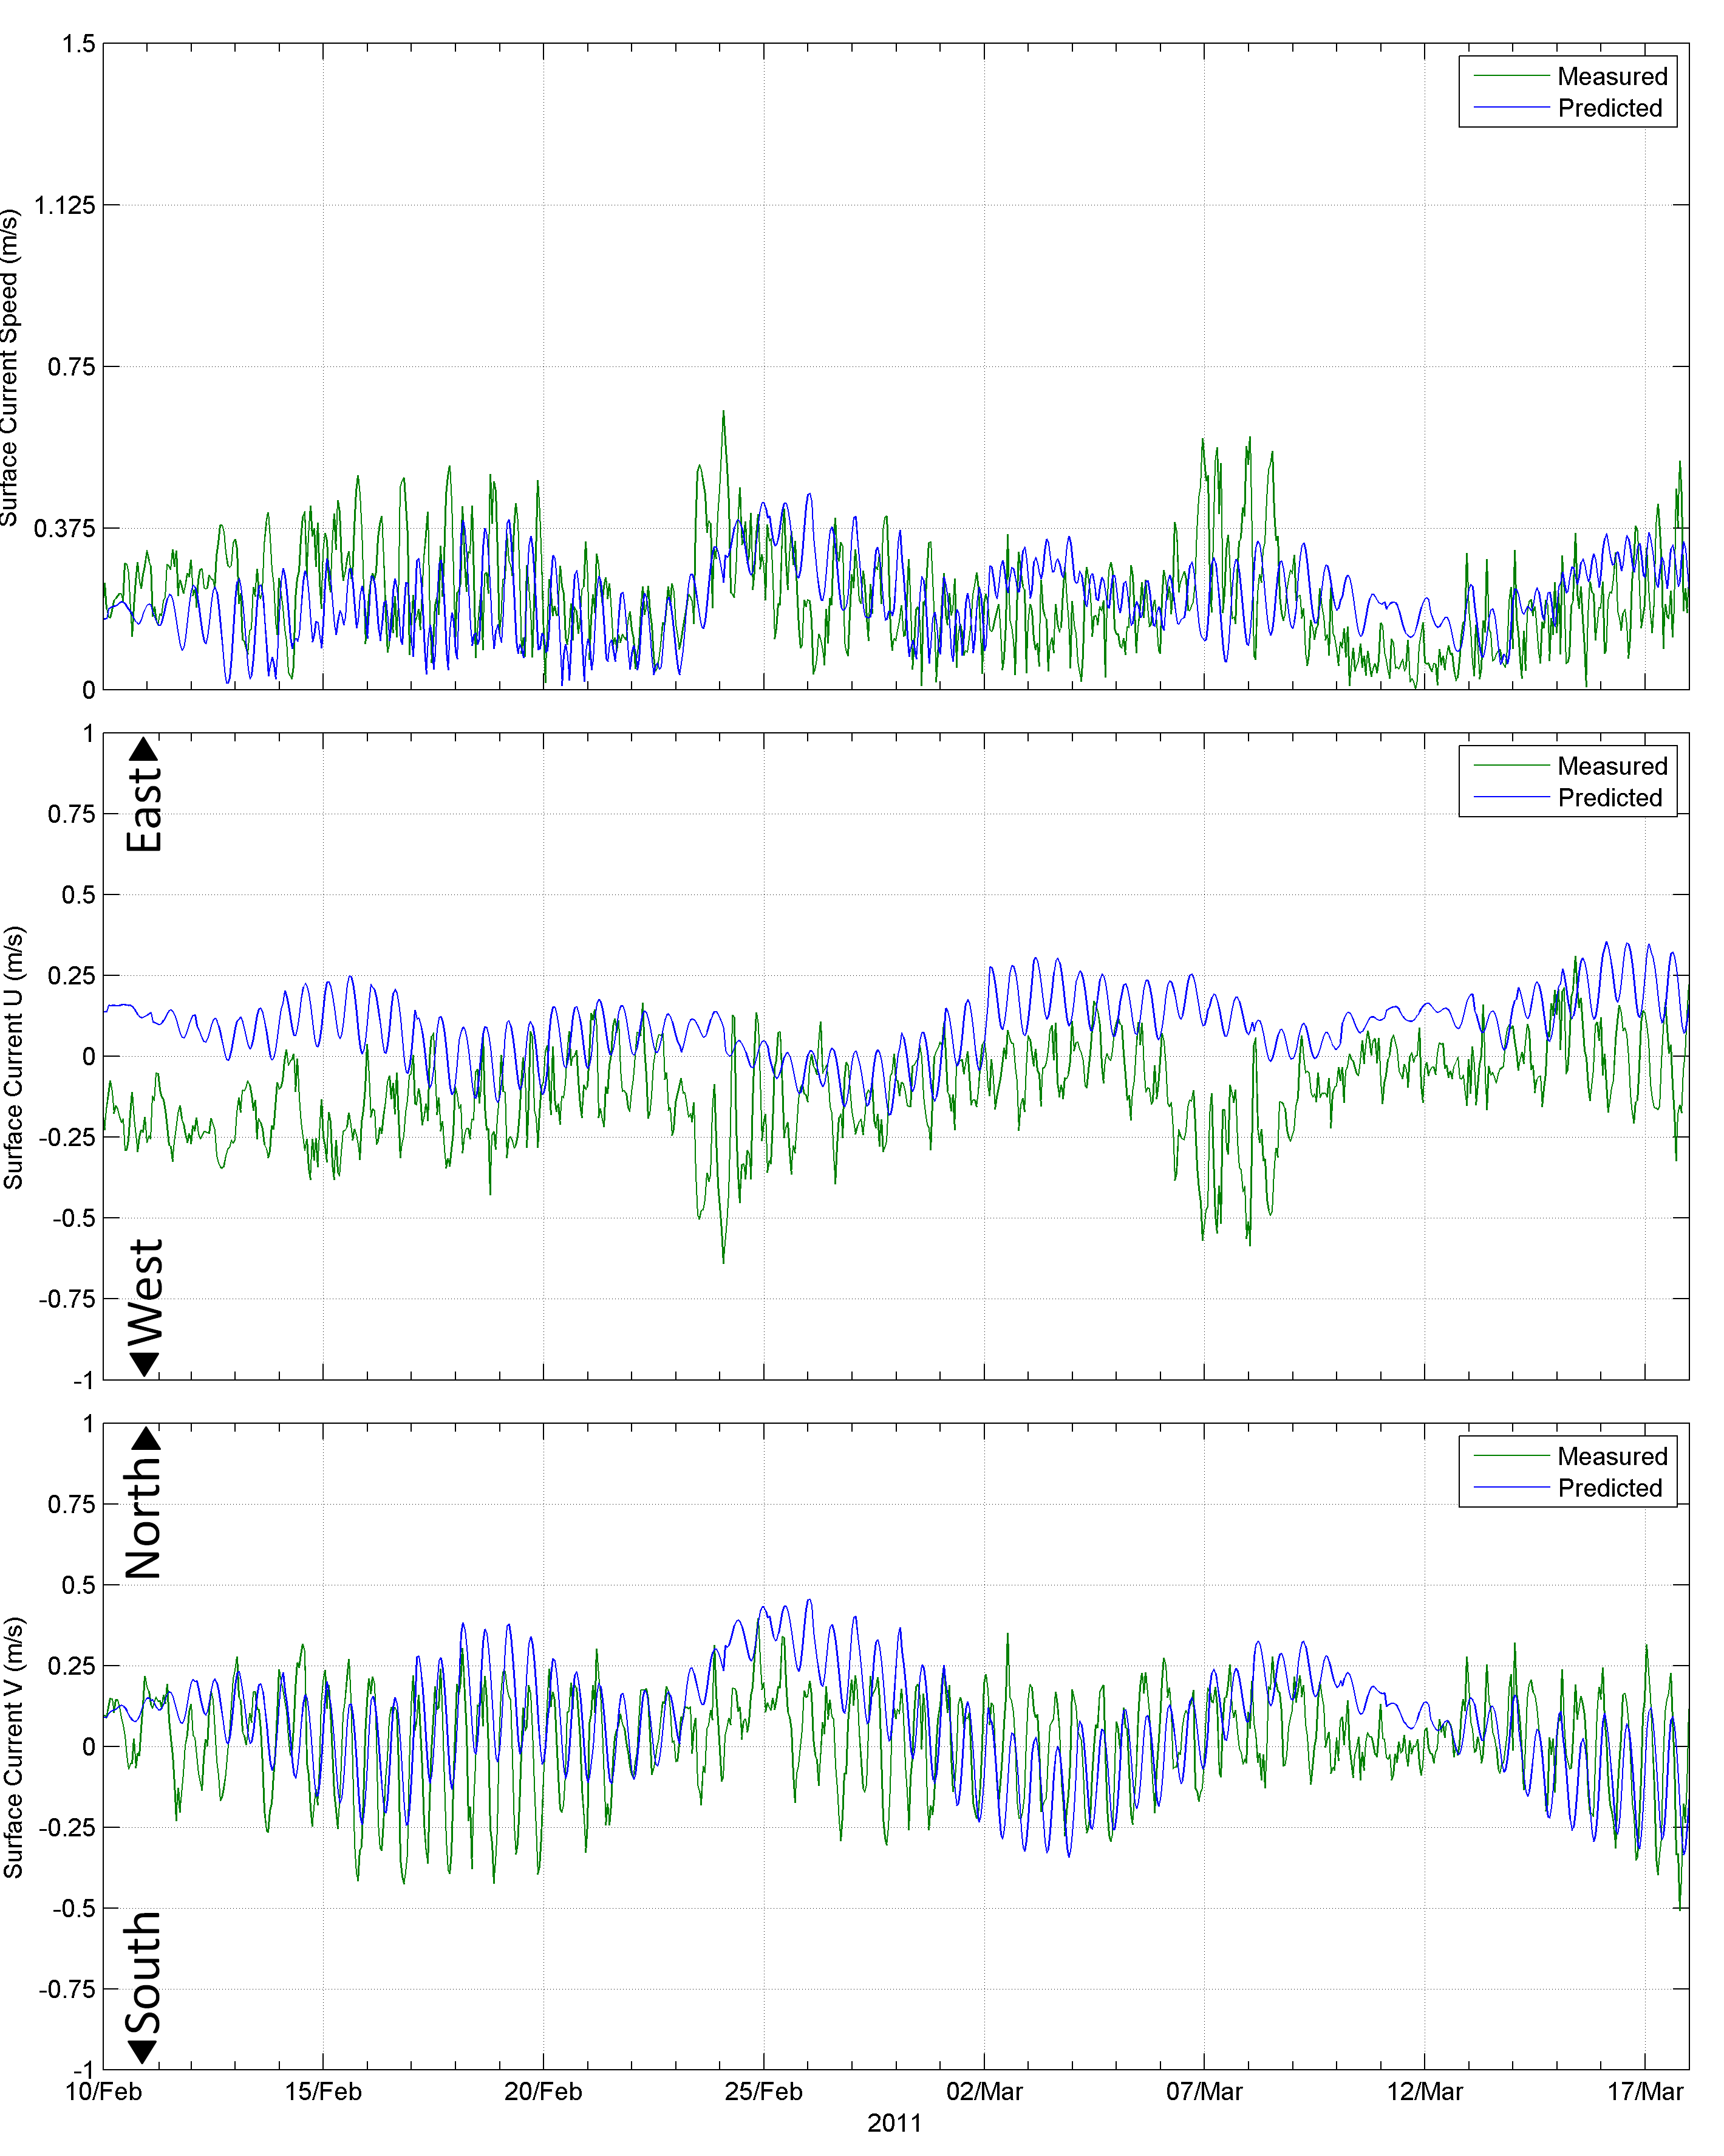
Figure 22. Comparison between the measured (green line) and HYCOM + HYDROMAP predicted (blue line) current speeds (top image), U current component (middle image) and V current component (bottom image) at a water depth 44 m above the seafloor at Palm Passage (10 February-17 March 2011).

Modelling of Wave Conditions
The wave climate was reproduced using a spectral phase-averaging wave model, SWAN, developed by the Delft University of Technology (Booij et al. 1996, 1999; Holthuijsen et al. 1997). The model is a third-generation model based on the energy balance equation (Holthuijsen et al. 1997; Booij et al. 1999; Young 1999).
The SWAN model includes algorithms for the following wave propagation processes: propagation through geographic space, refraction due to bottom and current variations, shoaling due to bottom and current variations, blocking and reflections by opposing currents, and transmission through or blockage by obstacles. The model also accounts for the dissipation effects due to white-capping, bottom friction and wave breaking as well as non-linear wave-wave interactions. The model is fully spectral (in all directions and frequencies) and computes the evolution of wind waves in coastal regions with shallow water depths and ambient currents.
Four overlapping model grids were generated encompassing the southern, south-central, north-central, and northern parts of the Region. The extents and water depth within each of the model grids are shown in figure 23 to figure 26. In order to meet the project brief, which included coverage of a 50 km radius surrounding the 12 Queensland trading ports, it was necessary to set the boundaries of the southern Reef and southern central Reef model domains up to 600 km east of the mainland, which is well beyond the shelf break and into the Coral Sea. Higher spatial resolution (~700 m) was defined within 50 km of the ports to better represent local variations.
Active offshore boundary conditions were assigned to the southern, eastern and northern boundaries of each model domain. Parametric spectral inputs (offshore boundary condition) were generated using a standard JONSWAP spectrum (Hasselmann et al. 1973). The wave parameters that govern the spectral shape of the JONSWAP spectrum applied at the open boundary are significant wave height (H_{s}), peak wave period (T_{p}), peak wave direction (Dir) and the directional spreading of waves (i.e. how ‘focussed’ the swell conditions are).
Regionally-specific boundary conditions were defined using deep-water wave parameters obtained from the National Centre for Environmental Prediction (NCEP/NOAA) WAVEWATCH III (WW3) global wave model (Chu et al. 2004; Tolman 2009). Hind-cast wave data is available on a 3-hour time step over a global ocean grid; 77°S to 77°N with a longitude x latitude resolution of 1.25 x 1°. Care was taken to test the boundaries to avoid the propagation of any errors into the area of interest.
To account for the wind effects, hourly measured winds by BOM at stations along the mainland coastline were combined with reanalysed data sourced from the GFS model for stations spaced 125 km apart. For each grid, up to 20 wind stations were used to represent the regional wind patterns, and thus influences on the wave climate. The depths in the model were based on a compilation of the latest hydrographic charts and digital elevation data sourced from Geoscience Australia.
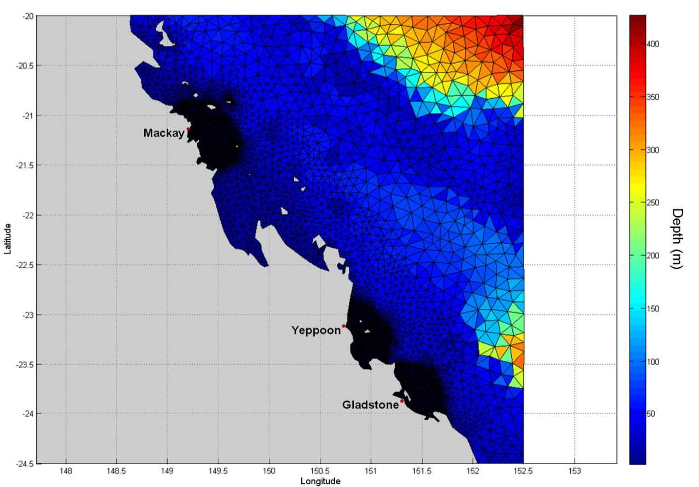
Figure 23. Extent of the southern Reef wave model grid. The sizes of the individual triangles represent the varying mesh resolution and the colour coding of each individual triangle represents the water depth (m).
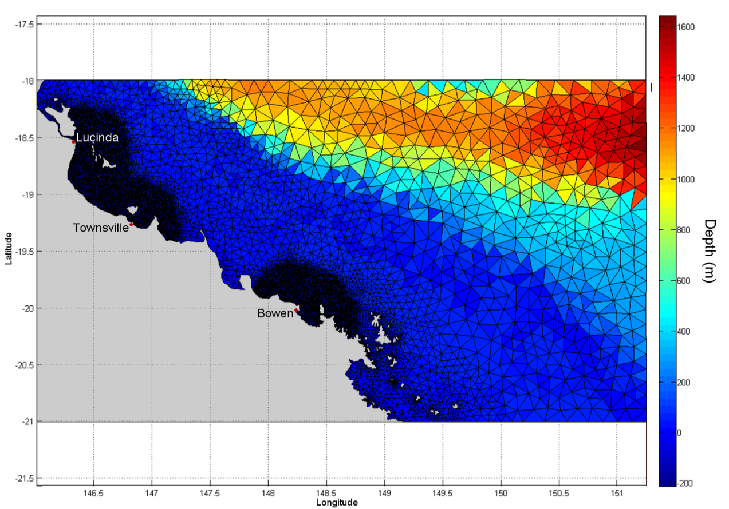
Figure 24. Extent of the southern central Reef wave model grid. The sizes of the individual triangles represent the varying mesh resolution and the colour coding of each individual triangle represents the water depth (m).
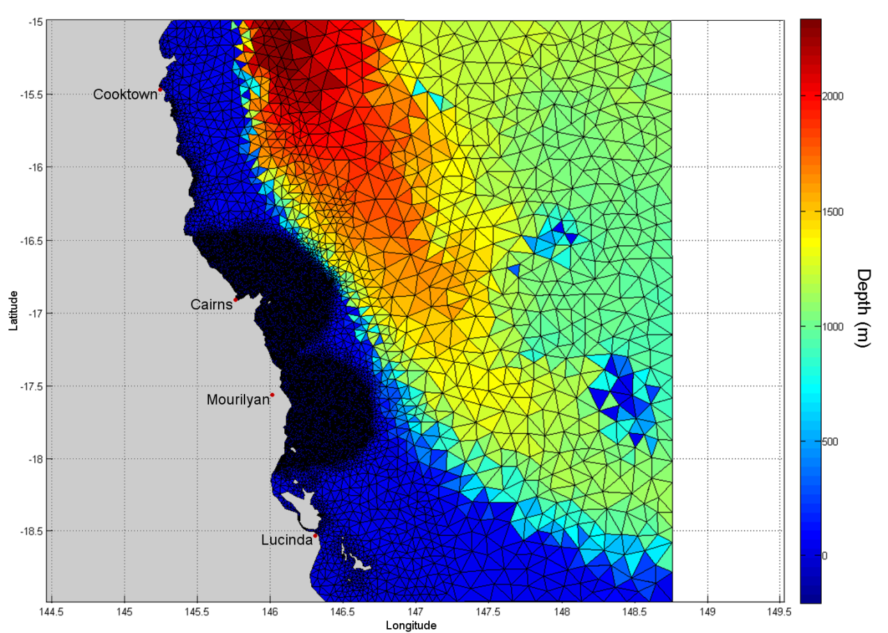
Figure 25. Extent of the northern central Reef wave model grid. The sizes of the individual triangles represent the varying mesh resolution and the colour coding of each individual triangle represents the water depth (m).
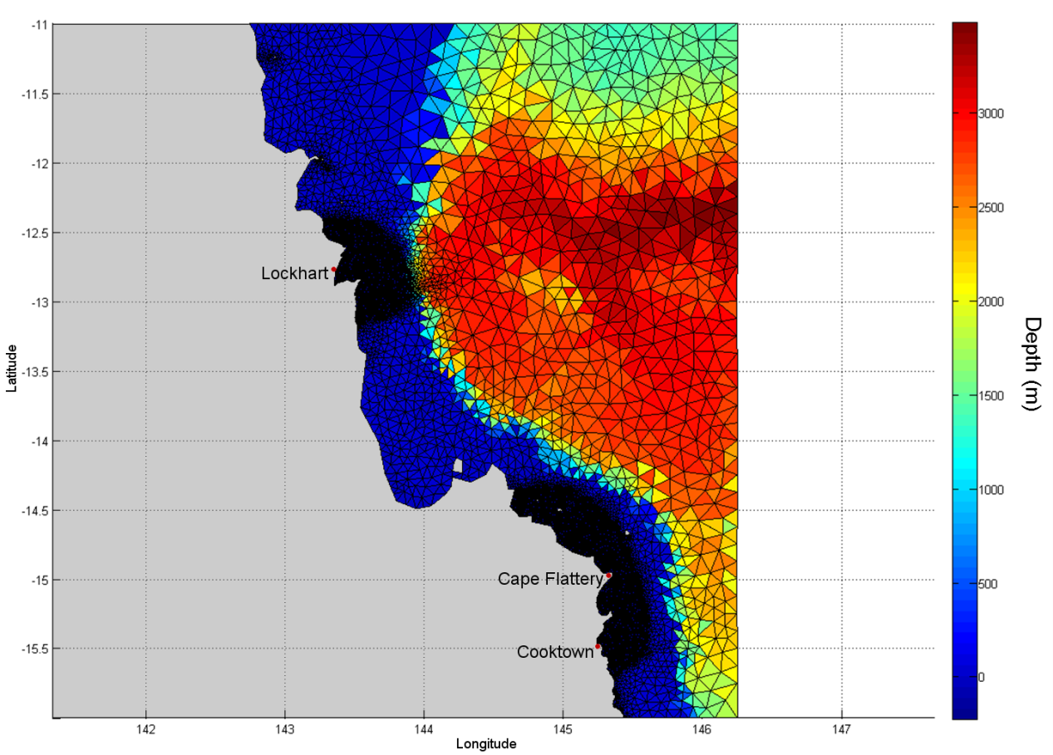
Figure 26. Extent of the northern Reef wave model grid. The sizes of the individual triangles represent the varying mesh resolution and the colour coding of each individual triangle represents the water depth (m).

Performance of the Wave Model
A series of simulations were run during the calibration phase to determine which of the physical parameters and formulations (e.g. bottom friction, white-capping coefficients, etc.) best represented the regional wave climate. The calibrated results was compared against measured data collected at five Waverider buoy locations (Gladstone, Emu Park, Mackay, Townsville and Cairns; see figure 27) maintained by the Department of Environment and Heritage Protection (as part of the Waverider system) between January and March 2011. Note that the Waverider buoy at Cairns is non-directional (i.e. does not record wave direction) and therefore only significant wave heights and peak wave period are shown.
Figure 28 to figure 32 show comparisons between the measured and predicted wave height, period and direction as both (i) time series plots and (ii) histograms for the five locations.
The comparisons show that the model was capable of reproducing the wave period and direction at all five locations and the change in wave heights at Gladstone and Cairns. However, the change in wave heights for the other three Waverider buoy locations (Emu Park, Mackay and Townsville) were less accurate.
As the domains were set beyond the shelf break to meet the study objective (50 km radius from each site), the wave energy in the model was reduced at certain sites due to shallow-water processes (e.g. surge from shoaling waves, surf). Usually, for project-based EIAs and research studies domains are set inside of the reef (10-30 km from the coastline), at a finer scale to account for the local shallow water processes.

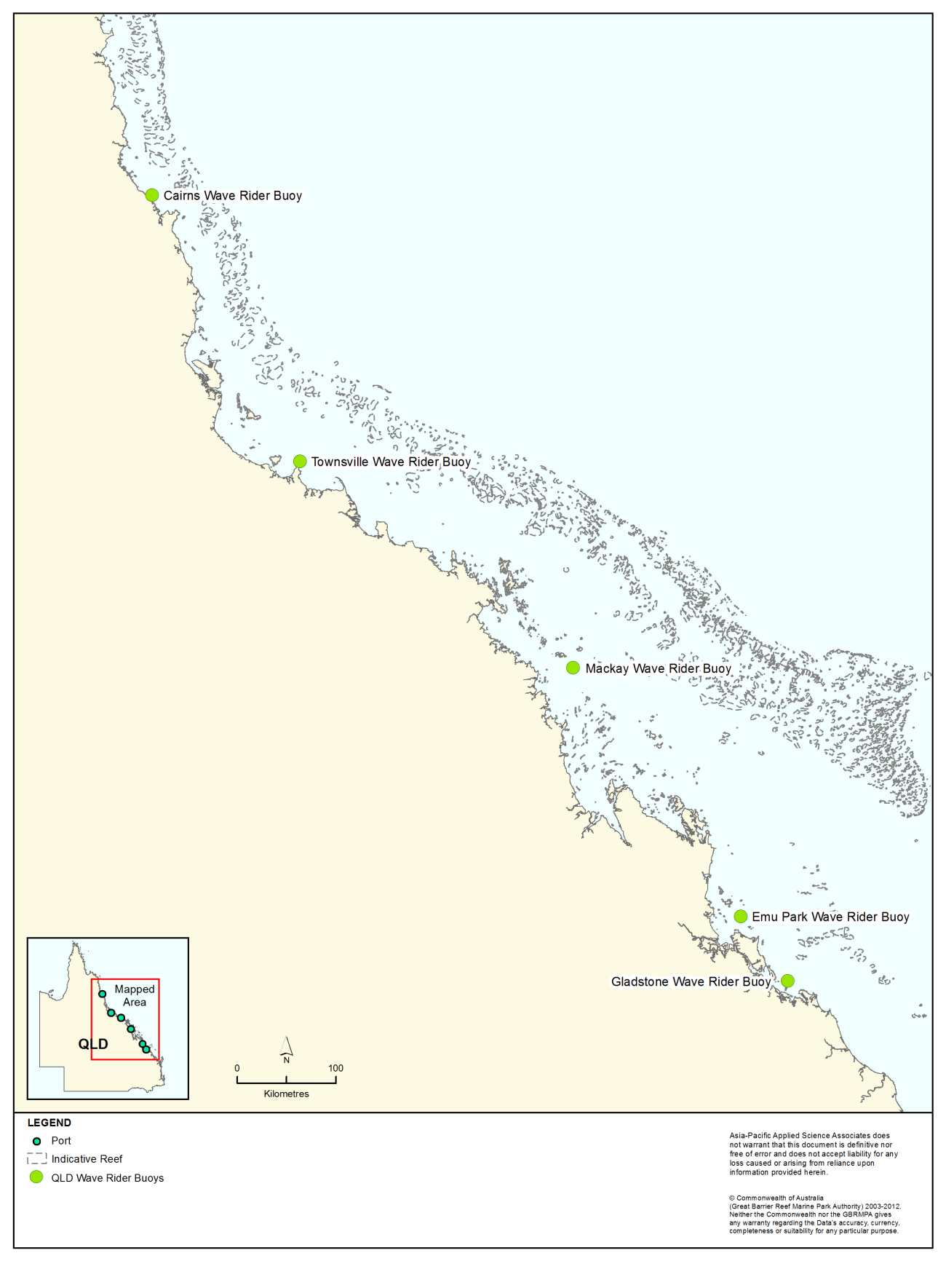
Figure 27. Locations of the five Waverider buoys used to measure wave climate by the Department of Environment and Heritage Protection and used to compare to the predicted wave height, period and directional datasets.

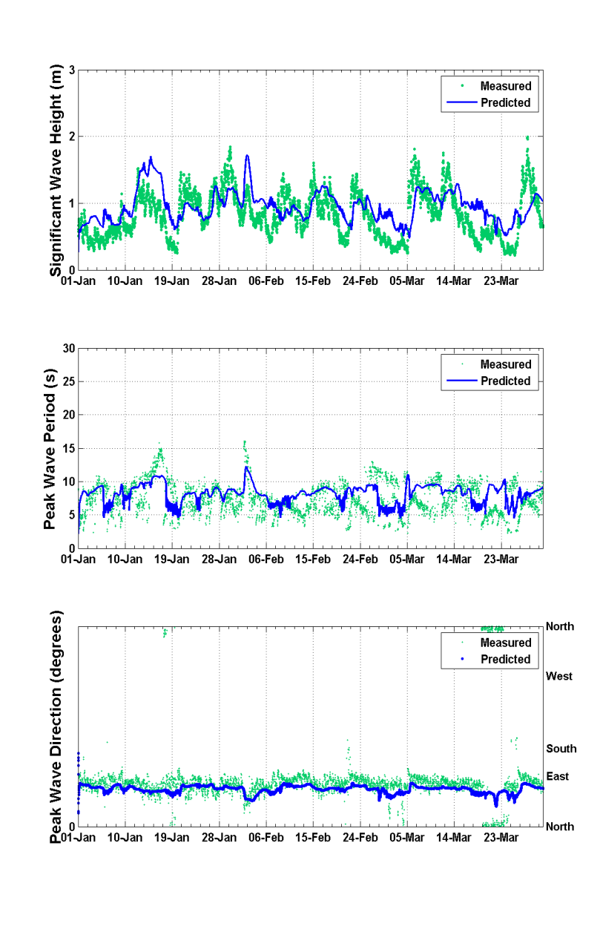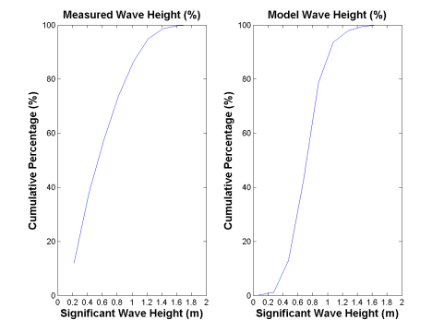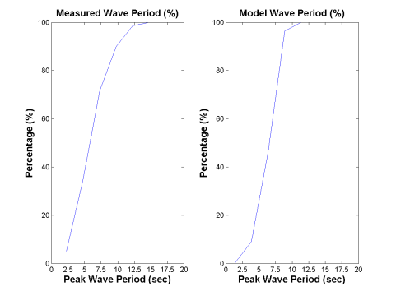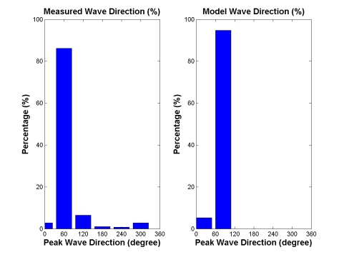
Figure 28. Comparison of measured (green) and predicted (blue) of significant wave heights (top image), peak wave periods (middle image) and peak wave directions (bottom image) at Gladstone during January-March 2011. The histograms provide an inter-comparison of the frequency distributions.

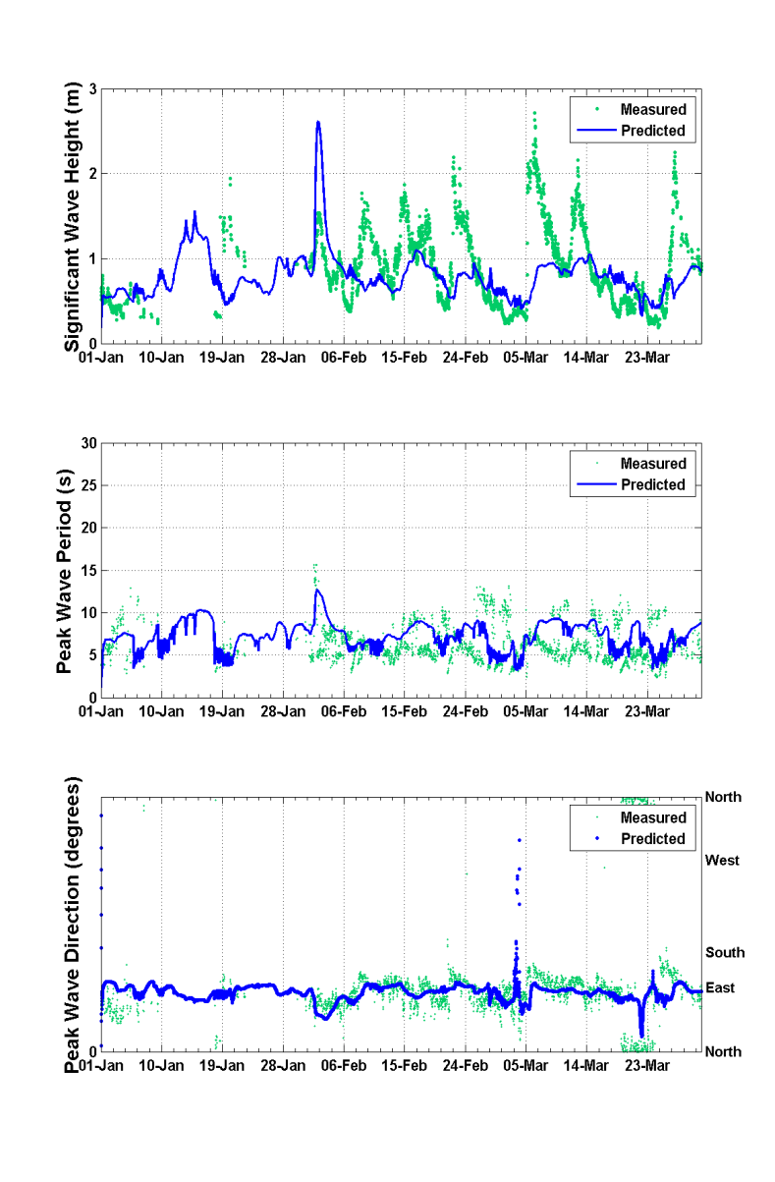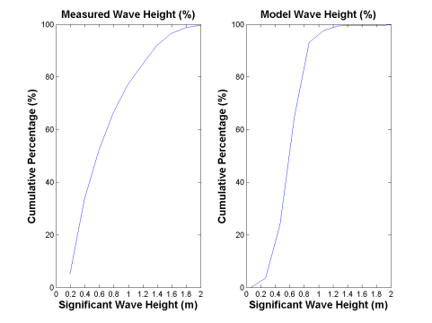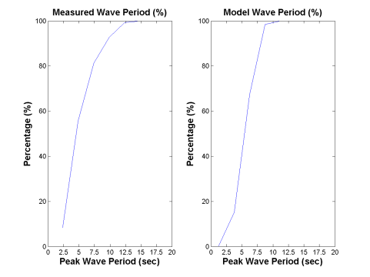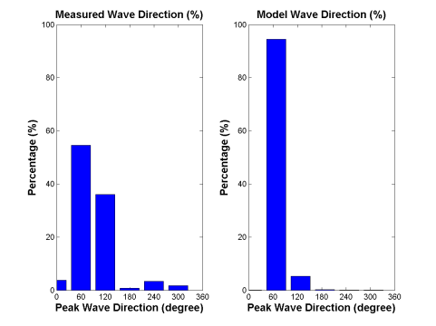

Figure 29. Comparison of measured (green) and predicted (blue) of significant wave heights (top image), peak wave periods (middle image) and peak wave directions (bottom image) at Emu Park during January - March 2011. The histograms provide an inter-comparison of the frequency distributions.

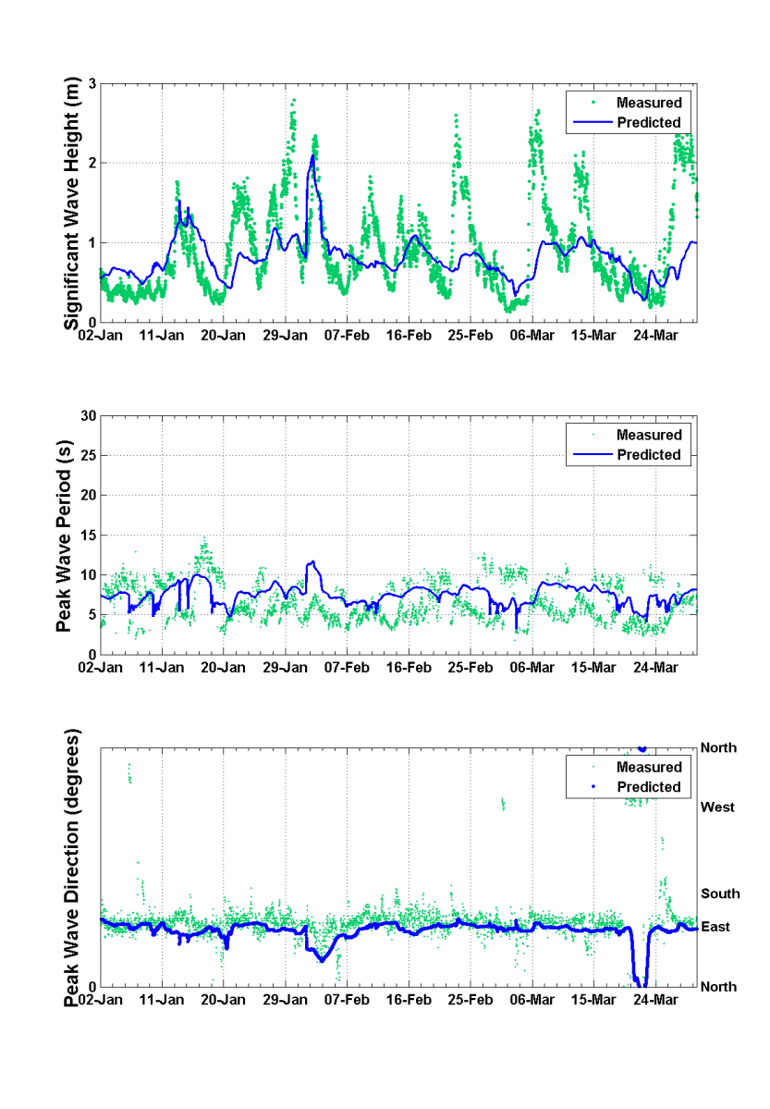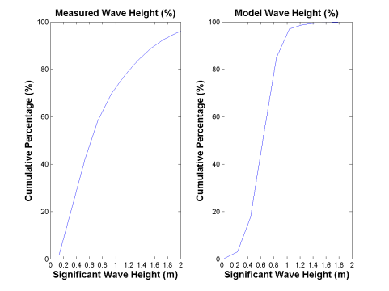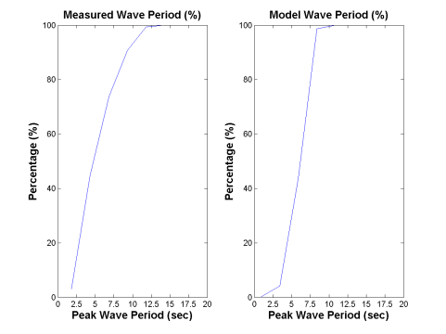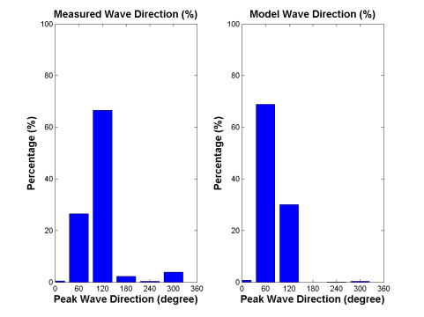
Figure 30. Comparison of measured (green) and predicted (blue) of significant wave heights (top image), peak wave periods (middle image) and peak wave directions (bottom image) at Mackay during January-March 2011. The histograms provide an inter-comparison of the frequency distributions.

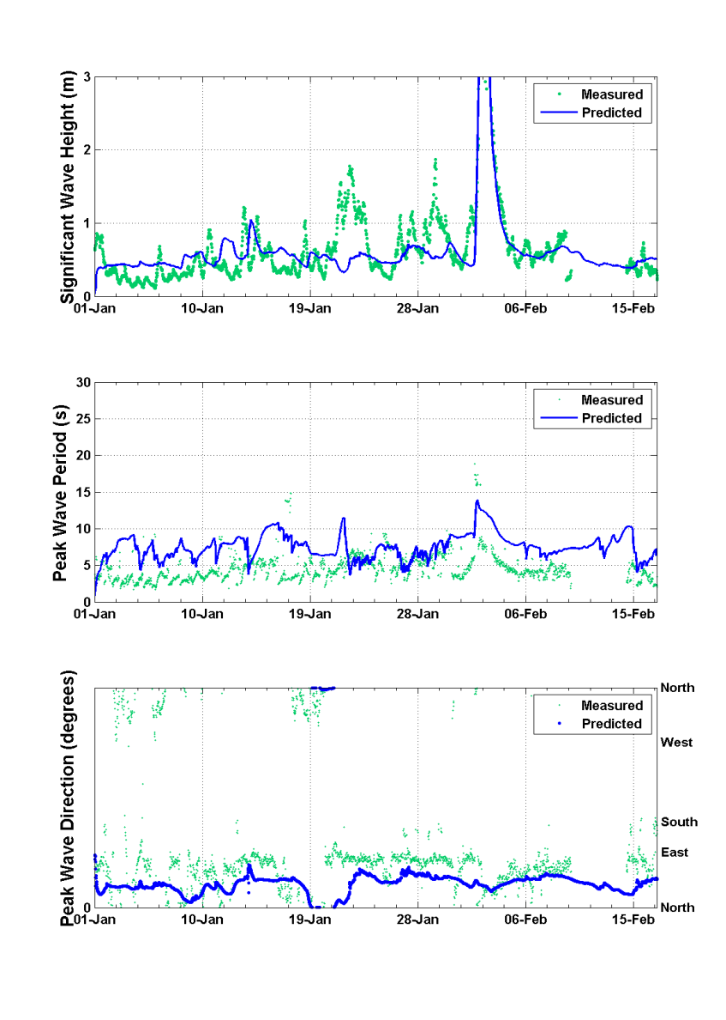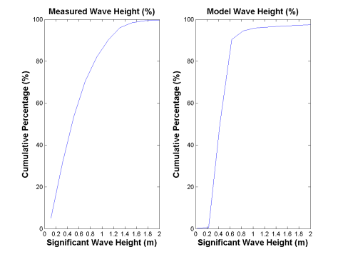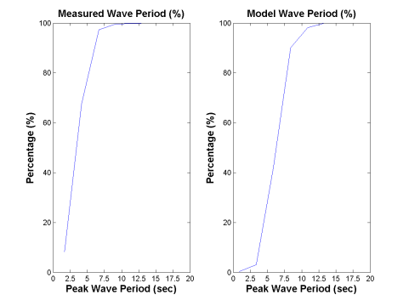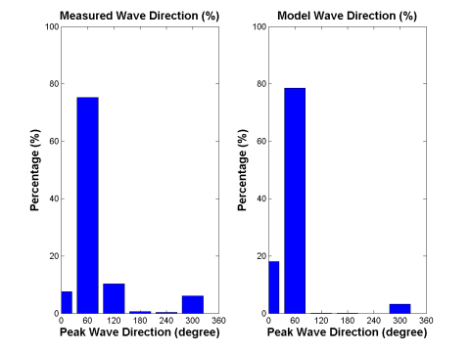
Figure 31. Comparison of measured (green) and predicted (blue) of significant wave heights (top image), peak wave periods (middle image) and peak wave directions (bottom image) at Townsville during January-February 2011.The histograms provide an inter-comparison of the frequency distributions.

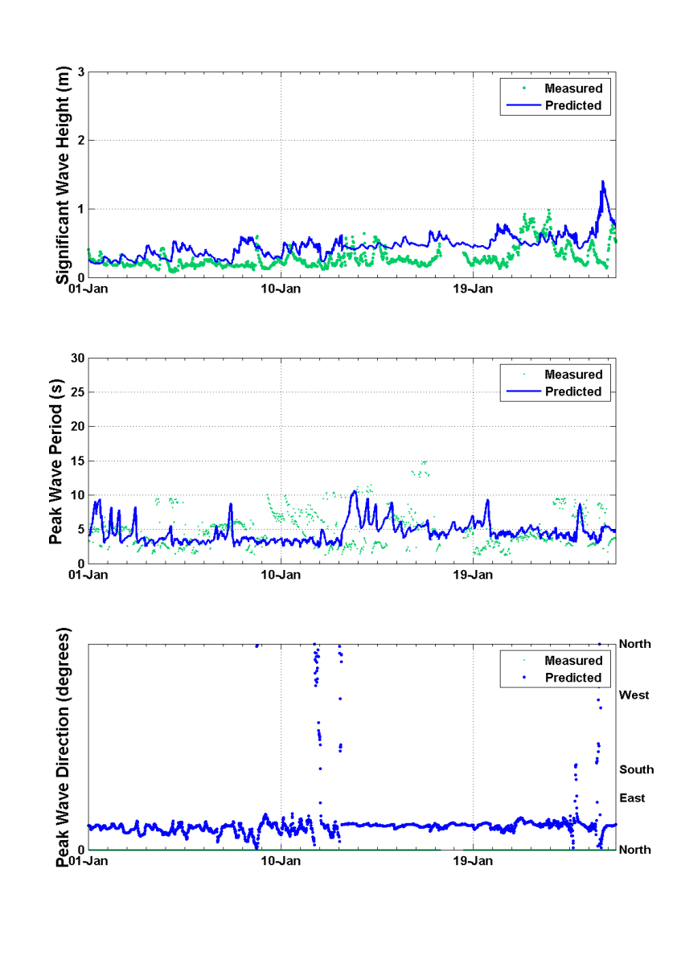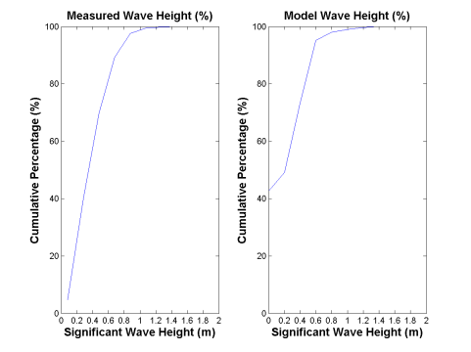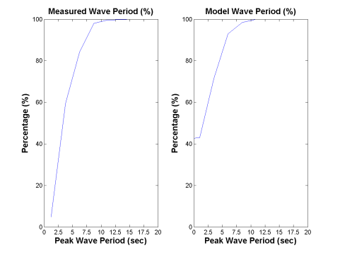
Figure 32. Comparison of measured (green) and predicted (blue) of significant wave heights (top image), peak wave periods (middle image) and peak wave directions (bottom image) at Cairns during January 2011. The histograms provide an inter-comparison of the frequency distributions. Note that the Waverider buoy at Cairns is non-directional (i.e. does not record wave direction).

Material Placement Scenarios
SKM and APASA conducted a series of workshops between 9-16 October 2012 with representatives from each of the six study locations to establish the most relevant scenarios to be modelled and included in this assessment (e.g. whether the material was generated by capital or maintenance dredging, anticipated volumes, etc. from a long-term (25-year) perspective. It must be emphasised that chosen modelled scenarios used during this assessment, do not represent specific projects, actual or proposed.
The below text provides background information and a brief summary.

Port of Gladstone
Future proposals at the Port of Gladstone include significant capital expansion and as such it was concluded that a major capital dredging campaign is the most relevant scenario. The modelling scenario adopted for Gladstone was 6,000,000 m³ of dredged material relocated over a continuous 19 week period.

Rosslyn Bay State Boat Harbour
There are no current plans for capital expansion of Rosslyn Bay State Boat Harbour. Maintenance dredging is typically conducted every three to four years, with the volume of dredged material averaging 30,000 m³. Although considerably larger volumes may need to be dredged following major events such as floods and cyclones. The chosen scenario modelled included 40,000 m³ of material being relocated continuously over a 13 week period.

Port of Hay Point
Current planning for the Port of Hay Point indicates expected requirements of approximately 20,000,000 m³ of capital dredging, with approximately 1,000,000 m³ of maintenance dredging every three years. North Queensland Bulk Ports Corporation, the port operator, informed SKM APASA that a campaign would likely involve some 13,000,000 m³ of dredged material over 46 weeks of dredging spread across two dredging seasons. The dredging season at Hay Point is typically constrained to the months of April to September to avoid the turtle nesting and hatching seasons. The model scenario adopted for this assessment assumed 8,500,000 m³ of material to be relocated over a continuous 22 week period.

Port of Abbot Point
The scenario modelled during this assessment represents a capital dredging operation of 3,500,000 m³ of material over a continuous 8 week period, based on current plans for expansion.

Port of Townsville
Several expansion projects at the Port of Townsville are in various stages of the development and approvals process, however long-term opportunities for further expansion are limited. Therefore, from a strategic perspective, modelling of maintenance dredging is most relevant. The scenario modelled as part of this assessment included 400,000 m³ of material relocated over a continuous 6 week maintenance dredging campaign.

Port of Cairns
The Port of Cairns is in the advanced stages of planning for capital expansion to accommodate larger cruise ships. Further capital expansion at the Port of Cairns is constrained by the available port land, so from a long-term strategic perspective the most relevant modelling scenario is for maintenance dredging, taking into account potential increases in maintenance dredging requirements that may result from the development of a cruise ship terminal. The scenario modelled during this assessment included a maintenance dredging campaign of 580,000 m³ over a continuous 5 week period.

Description of the Sediment Plume Model
The research used a three-dimensional suspended sediment plume model, DREDGEMAP. This model is an enhancement of the SSFATE model developed by Applied Science Associates (ASA) in collaboration with the United States Army Corps of Engineers (Johnson & Pachure 1999; Howlett et al. 2000; Johnson et al. 2000; ASA 2004; Swanson et al. 2004).
APASA has used the model for multiple dredging investigations over the past decade, ranging from maintenance operations (e.g. Nelson Harbour in New Zealand and Cockburn Sound in Western Australia) to very large capital development projects involving millions of tonnes of sediment spanning up to six years (e.g. the Pluto shipping channel and berth, Mermaid Sound in Western Australia; Port Hedland Outer Harbour in Western Australia; and the Icthys shipping channel and berth at Darwin Harbour in the Northern Territory). The DREDGEMAP model has also recently been used for dredging and offshore placement campaigns for Queensland Gas Company’s operations in Port Curtis, Gladstone and within the Fitzroy River delta and Keppel Bay (Port Alma, Queensland) for Xstrata Coal Queensland.
DREDGEMAP has been validated in Australia and Queensland including:
- Freemantle Port Outer Harbour Study dredging and placement operations where it was validated against measurements for a large cutter suction dredging operation involving dredging and discharge from onshore reclamation area. Calibration and validation against cutter head and tailwater generated turbidity.
- Woodside Pluto Dampier dredge operations where the model was calibrated and validated to large and medium scale TSHD operations over broad spatial scales. They used boat based, fixed and satellite based TSS measurements in the validation.
- Queensland Gas Company Narrows dredging operation in Port Curtis Gladstone.
- The model was used to hindcast the ambient suspended sediment concentrations within Port Curtis over six months and compared well with actual surface measurements from permanent water quality monitoring sites.
Table 8 summarises the size ranges and minimum sinking rates for each of the particle classes employed in DREDGEMAP. The model represents the sediment sizes and mass using Lagrangian particles. Each particle is allocated an equal proportion of the mass (e.g. 1/1000th of the total release if 1000 particles are used) and are released during placement of dredge material at every computational time-step. Each “packet” consists of 25 particles that represent the 5 sediment classes, (clay, fine silt, coarse silt, fine sand, and coarse sand) and vertical distributions. The model then predicts the transport, dispersion and settling using a random-walk procedure. The focus of the model is on the far-field (i.e. immediately beyond the initial release jet) processes affecting the fate of suspended sediment.
Settling of mixtures of particles is a complex process due to interaction of the different size classes, some of which tend to be cohesive and thus clump together to form larger particles that have different settling velocities than would be expected from their individual sizes. Enhanced settlement velocities due to flocculation and scavenging are particularly important for clay and fine-silt sized particles (Teeter 1998, Swanson et al. 2004) and these processes are implemented in DREDGEMAP, and thus have been incorporated into the current research project. The model employs five material classes based on sediment particle sizes. The classes are biased towards the finer materials, as these are typically the most dispersive and are responsible for the greatest turbidity increases in the water column.
Horizontal transport, sinking and turbulence-induced rise of each particle is modelled independently at each time step. Minimum settling velocities are calculated using Stokes equations, based on the size and density of the particle. However, settling velocities of finer classes (representing clay and silt-sized particles) are increased based on the local concentration of the same and larger particles, to account for clumping and entrainment. Deposition (i.e. the process whereby particles move from being in suspension to being settled on the seabed) is calculated as a probability function of the prevailing bottom stress, local sediment concentration and size class. Sediment that is deposited may subsequently be resuspended into the lower water column if critical levels of bottom stress are exceeded. Mixing of re-suspended sediment into higher levels of the water column will be a dynamic balance between estimates of the settling velocity and vertical mixing induced by turbulence (as specified by vertical mixing coefficients).
The model employs the van Rijn resuspension method (van Rijn 1989). This method calculates a constantly varying critical threshold for resuspension, based on the median of the local particle-size distribution for settled material. In this way, the model accounts for interactions between different particle sizes. For example, finer sediments will tend to be armoured from resuspension in the presence of coarser material. Swanson et al. (2007) has previously summarised the justification and use for this approach.

Table 8. Particle sediment particle size classes and minimum settling velocities* applied by DREDGEMAP.
Sediment particle size class | Size range (µm) | Minimum settling velocity (m/s)
Clay | 0-7 | 0.0008
Fine Silt | 8-35 | 0.0023
Coarse Silt | 36-74 | 0.0038
Fine Sand | 75-130 | 0.0106
Coarse Sand | > 130 | 0.10
* Note: minimum settling velocities are varied from these minima, based on local concentrations of sediment particles.

The DREDGEMAP model inputs each of the six study locations included:
- Yearlong currents and waves
- Mass of dry solids
- Density of dry solids
- Sediment size distributions for the five size classes
- Placement methodology including the number of releases per day, duration of each release and the depth of release
- Commencement month and duration of placement campaign.

To directly compare the results between the three material placement sites at each study area, the model inputs (excluding geographical location) remained constant according to the established material placement scenarios. It is acknowledged that in reality the material placement frequency would differ due to varying distances from the dredge area to the material placement sites associated with each of the study sites, thus potentially influencing the predicted model results.
A summary of the input data for each of the six study locations is shown in table 9.
For all of the six locations a trailer suction hopper dredge (TSHD) was assumed to be the dredging equipment used for both dredging and placement of sediments. At the completion of the dredging process, the TSHD will sail to the material placement site and on arrival it will open its bottom doors and discharge the dredged spoil. The TSHD will either be stationary or sailing slowly during the placement process. For this assessment it was assumed that the TSHD will continue to sail during the placement process and randomly dispose the sediment over the material placement sites, spreading the material over large areas. This is contrast to the placement of material in a gridded pattern to spread it across the placement site, or concentrated in mounds. The approximate time needed for placement ranged from two minutes for Rosslyn Bay State Boat Harbour to 35 minutes for Port of Townsville. Once the placement is finished, the TSHD will close its doors and sail back to the dredging area. The modelling included the elapsed time and duration of each release.
Previous observations during dredge material placement from hopper vessels (e.g. Gordon 1974; Swanson et al. 2004; Wolanski et al. 1992; Dankers 2002) have shown that there is an initial rapid descent of solids, with the heavier sediments tending to entrain lighter particles, followed by a billowing of lighter components back into the water column after contact with the seabed (see figure 33). Generally, a small proportion (~5-10 per cent) of the lighter sediments will remain suspended. As such, a high portion (73 per cent during maintenance campaigns and 94 per cent during capital campaigns) of the sediments was released in the water column three metres above the seabed as part of the modelling assessment. The remaining percentage of released material was partitioned through the water column at the release locations, with the highest release point in the water column dictated by the release depth.
As previously mentioned the model represents the total mass of sediments suspended using Lagrangian particles. The total number of suspended particles released per operation varied according to the number of releases and duration of operation (see table 9) (Gladstone = 997,500 particles; Rosslyn Bay = 112,500 particles; Hay Point = 968,750 particles; Abbot Point = 420,000; Townsville = 900,000 particles; Cairns = 522,500 particles).
During the material relocation operations, modelling of the sediment migration was conducted using a 200 m x 200 m grid. At the completion of the operations, the long-term sediment migration simulations were "hot-started" (i.e. using starting conditions from the end of the operational period) and modelled using a grid cell size of 700 m x 700 m. The greater cell size was used to create a larger model domain to accommodate the larger distances travelled by migrating resuspended sediments over the longer model duration.
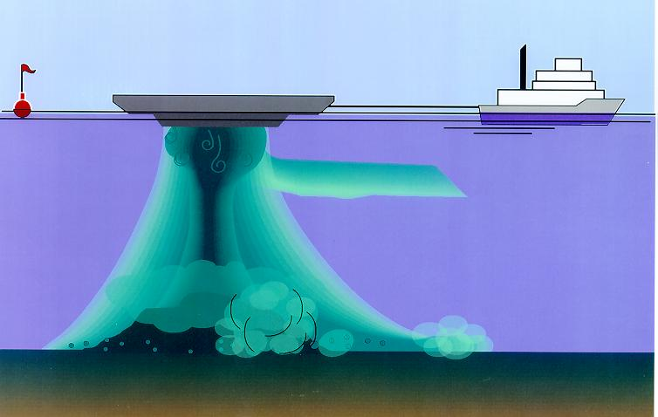
Figure 33. Conceptual diagram showing the descent of sediments released from a hopper barge and then spreading radially outward across the seabed as a dense plume (Source: ASA 2004).

Table 9. Summary of the input data used for the material placement scenarios to model.
Port |  | Gladstone | Rosslyn Bay | Hay Point | Abbot Point | Townsville | Cairns
Dredging campaign |  | Capital | Maintenance | Capital | Capital | Maintenance | Maintenance
Sediment size (µm) and distribution (%) | Clays (< 7) | 5 | 37 | 15 | 27 | 60 | 25
Sediment size (µm) and distribution (%) | Fine silts (7-35) | 5 | 13 | 10 | 3 | 11 | 26
Sediment size (µm) and distribution (%) | Coarse silts (35-75) | 30 | 15 | 10 | 9 | 11 | 38
Sediment size (µm) and distribution (%) | Fine sands (75-130) | 30 | 25 | 10 | 11 | 13 | 3
Sediment size (µm) and distribution (%) | Coarse sands (> 130) | 30 | 10 | 55 | 50 | 5 | 8
Volume of relocated in situ material (m³ of solids) |  | 6,000,000 | 40,000 | 8,500,000 | 3,500,000 | 400,000 | 580,000
Estimated dry solids (tonnes) |  | 4,800,000 | 28,000 | 6,800,000 | 2,800,000 | 280,000 | 406,000
Type of placement vessel |  | Trailer Suction Hopper Dredger | Trailer Suction Hopper Dredger | Trailer Suction Hopper Dredger | Trailer Suction Hopper Dredger | Trailer Suction Hopper Dredger | Trailer Suction Hopper Dredger
Depth of release below the water surface (m) |  | 11 | 2 | 10 | 10 | 5 | 5
Hopper load (m³ of solids) |  | 15,000 | 400 | 11,000 | 10,500 | 2231 | 1381
Time required to empty vessel (minutes) |  | 20 | 2 | 13 | 13 | 35 | 8
Number of releases per day |  | 3 | 1 | 5 | 6 | 4 | 11
Total number of releases |  | 400 | 100 | 773 | 333 | 179 | 420
Total number of days (assuming continuous operations) |  | 133 | 90 | 155 | 56 | 45 | 38
Total number of weeks (assuming continuous operations) |  | 19 | 13 | 22 | 8 | 6 | 5
Disposal commencement |  | March | March | April | June | September | August

Presentation of Results
The modelling predicted "above background" TSS, sedimentation rate, and total sedimentation, meaning that dredge material is considered in isolation from ambient conditions.
The modelling results are presented as maps showing the frequency of occurrence as percentiles, of specified levels of TSS and sedimentation rate that occurred during the dredge material placement period. Percentiles of TSS and sedimentation rate are not presented for the 12-month period because the model predicted that the lowest values presented for the dredging period would not occur either 50 per cent or 5 per cent of the time over the 12 months.
Additionally, total sedimentation and bottom thickness maps are presented for single points in time, at the end of the specified dredge material placement scenario and at the end of 12 months after commencement of the modelled placement.
SKM and APASA have found during the course of the study that in some cases the presentation of results can be difficult to interpret. Perhaps the best analogy for the presentation of the percentile results is the depth contours on a nautical chart, on which contours of given depths are drawn around individual depth soundings. In the case of the model results, the model predicts how frequently, as a percentage of time, a given condition will occur in each cell of the model grid during the modelling period. Figure 34 presents an imaginary portion of the model grid, zoomed in to a close-up view. The number in each of the model cells is the per cent of the time during the model run that the condition being represented - say for example 5 mg/L TSS - occurs. Using these data, a contour line can be drawn representing the boundary at which 5 mg/L occurred 50 per cent of the time in the model output. Areas on one side of the line, down and to the right in this imaginary example, experienced 5 mg/L TSS less than 50 per cent of the time and areas on the other side of the line experienced this condition more than 50 per cent of the time. The blue line is thus the 50th percentile contour for 5 mg/L TSS. Similarly, 95th percentile contours represent the boundary of areas that experience a given water quality condition either more or less than 5 per cent of the time, i.e. 95 per cent of the time TSS or sedimentation is less than the contoured value.
In this report, areas affected by given levels of TSS or sedimentation are presented as shaded areas. The boundary of each shaded area corresponds to a contour line produced as described above. Figure 35 shows the imaginary example in figure 34 presented as a shaded area; the contour in figure 34 represents the boundary of the shaded area.
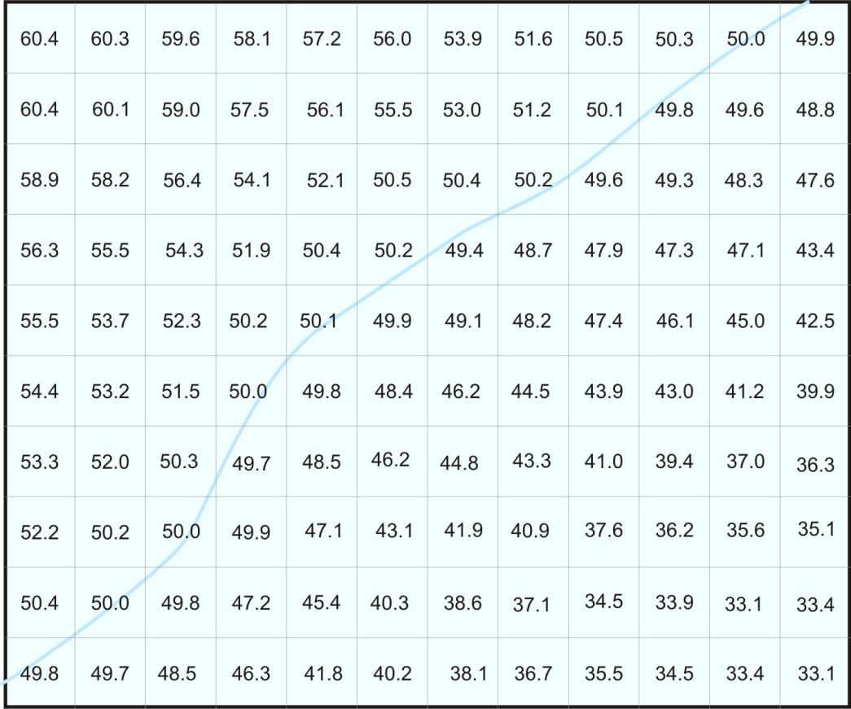
Figure 34. Imaginary zoomed-in view of a section of the model grid. The number in each cell represents the per cent of time during the model run each cell experiences a TSS concentration of 5 mg/L. The blue line shows the 50th percentile contour for 5mg/L TSS.

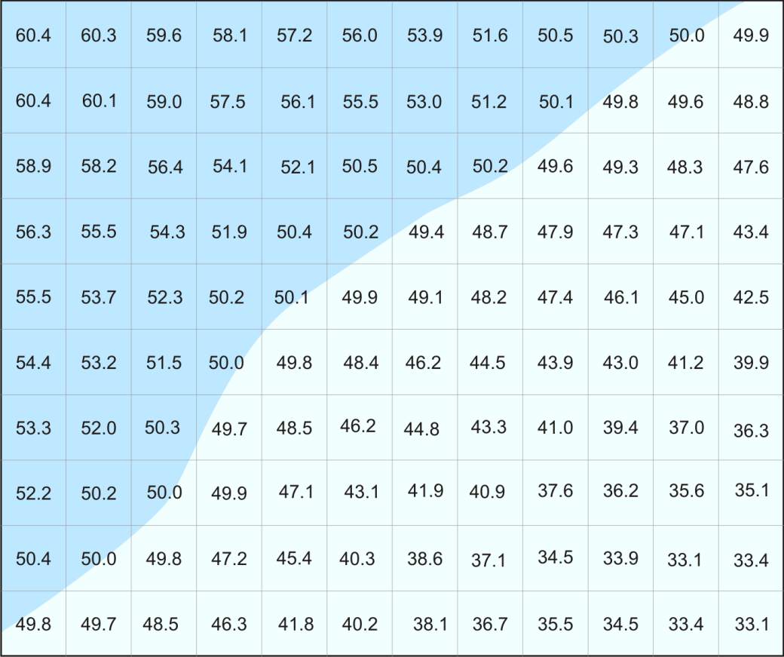
Figure 35. Presentation of the imaginary results in Figure 34 as a shaded area. Areas in the darker blue area experience 5 mg/L TSS more than 50 per cent of the time, those in the light blue area less than 50 per cent of the time.

Results
Model results are presented below as two sub-sections for each of the six study locations:
- For the duration of the material placement operations
- At the end of the 12 months.

The following spatial and time-series plots have been produced for the duration of the material placement operations:
- 50th and 95th percentile TSS concentrations (mg/L). In the event that the TSS concentrations were below the threshold of 5 mg/L for both 50 per cent and 95 per cent of the time, the 100th percentile (or maximum) results were reported in order to provide for comparisons among the alternative placement sites. These contours provide conservative results.
- The 50th and 95th percentile sedimentation rate (mg/cm²/d). The 50th percentile plots reveal the regions where reported values are equal to or below the shown value (i.e. 5 mg/cm²/d) 50 per cent of the time, while the 95th percentile plots reveal the regions where reported values are equal to or below the shown value 95 per cent of the time.
- Time-series of predicted average bottom thicknesses (mm) across the material placement sites for the six study locations from the start till the end of the material placement operations.
- The predicted total sedimentation (mg/cm²) and equivalent bottom thicknesses (mm) at the completion of the material placement operations period.

As described in 'Presentation of Results', p. 57, the 50th and 95th percentile contours illustrate areas that experience the value being contoured 50 per cent and 5 per cent of the time, respectively. The 100th percentile represents the area over which a given value occurred during any one-hour step over the entire model run.
Spatial plots of the predicted total sedimentation (mg/cm²) and bottom thickness (mm) at the end of the modelled placement scenarios and 12-months after the commencement of material placement (long-term assessment) are also presented in this report.
Based on the 50th and 95th percentile analysis, TSS concentrations did not exceed 5 mg/L nor did sedimentation rates exceed 5 mg/cm²/ for 5 per cent of the time, and thus not 50 per cent of the time, over the 12 months following commencement of material placement. Therefore, contour maps for TSS and sedimentation rate over the 12-month modelling period are not presented in this report.
In this report sediment bottom thickness is used to describe the thickness of sediment deposited on the seafloor, including on organisms living there. The predicted bottom thickness is reported in mm and was derived from the location-specific composition of the placed material and predicted total sedimentation.
The maps provided in the following sections were produced to enhance understanding of the sometimes subtle differences between dredge material placement at alternative sites. This does not necessarily imply that large amounts of sediment will be found at these sites, in fact, in some cases the amount of total sedimentaton is so small that it might not even be possible to measure. This was done purely to tease out a comparison between sites. The modelling provided in this report, and the associated maps, are a first step in determining the determining the potential spatial scale of dredge material migration after placement. The maps show the geographical extent of where the sediment may migrate to, but do not necessarily imply ecological significance. This report should be read in conjunction with the ‘Sensitive Receptor Risk Assessment of Alternate and Current Dredge Material Placement Sites’ which describes in more detail the ecological relevance of the thresholds that were selected for the TSS, sedimentation rate and benthic deposition maps. The use of the 100th percentile TSS value in the case of Rosslyn Bay and Port of Townsville was done purely to allow for comparisons between the alternate model cases and current site at these study locations, respectively.
The maps and results of this study should not be taken out of the context of the objective for which they were produced. They do not replace the need for detailed EISs, nor can the results be extrapolated to other dredge scenarios, remembering that what was modelled was specific for each port. This means, for example, that the modelled scenario for Townsville, which involved the placement of 400,000 m³ of maintenance material cannot be extrapolated to a 10 million m³ capital dredging and placement campaign. That would require a project-specific EIS and may have substantially different results to those depicted in this report.

Port of Gladstone

Results During the Material Placement Operations
For the Port of Gladstone a capital dredging campaign was modelled which consisted of 6,000,000 m³ of dredged material relocated over 19 weeks, commencing in March. Modelling comprised three releases per day (15,000 m³/release), each release lasting 20 minutes. The assumed dredged material consisted of mainly fine and coarse sands (60 per cent).
Figure 36 to figure 38 show the predicted 95th percentile TSS concentrations during the material placement operations for Model Cases 1-3. There were no predicted TSS concentrations above 5 mg/L for 50 per cent of the time for Model Cases 1-3. This is due to the small number of releases per day (three in total) and the strong currents transporting the sediment far too rapidly to allow the cells to be triggered above the minimum reporting threshold concentration (≥ 5 mg/L).
The modelling showed sediment plumes migrating to the north-west direction for all of the model case sites and did not exceed 24 mg/L, 95 per cent of the time. For Model Cases 1 and 2 the 10-24 mg/L contours were predicted to extend up to 3 km and 10 km north-west from the material placement sites (see figure 36 and figure 37). The Model Case 3 results show two isolated regions with concentrations of 10-24 mg/L; 2 km and 10 km from the north-west corner of the material placement site (see figure 38).
Figure 39 to figure 44 show 50th and 95th percentile sedimentation rate plots, produced during the material placement operations for Model Cases 1-3, respectively.
For 50 per cent of the time, the results for Model Cases 1 showed the sedimentation rates were between 5-99 mg/cm²/d and Model Cases 2-3 were between 5-49mg/cm²/d.
The 95th percentile results showed that the sedimentation rate contours were widespread. The sedimentation rates of 100 mg/cm²/d and greater for Model Cases 1-3 included areas east of Curtis Island, Rundle, Hummocky and Keppel Islands and also 10 km north-west from the material placement sites. The highest sedimentation rate (≥ 250 mg/cm²/d) was within the boundary of the material placement sites.
Figure 45 to figure 47 illustrate the predicted total sedimentation and bottom sediment thickness at the completion of the material placement operations (day 133) for Model Case 1-3.
Figure 48 compares the mean bottom thickness increase across the three material placement sites during the 133 day placement campaign. The results indicate Model Case 3 was marginally more retentive at the end of the 133 day simulation (101 mm) compared to Model Case 1 and 2 (~96 mm).

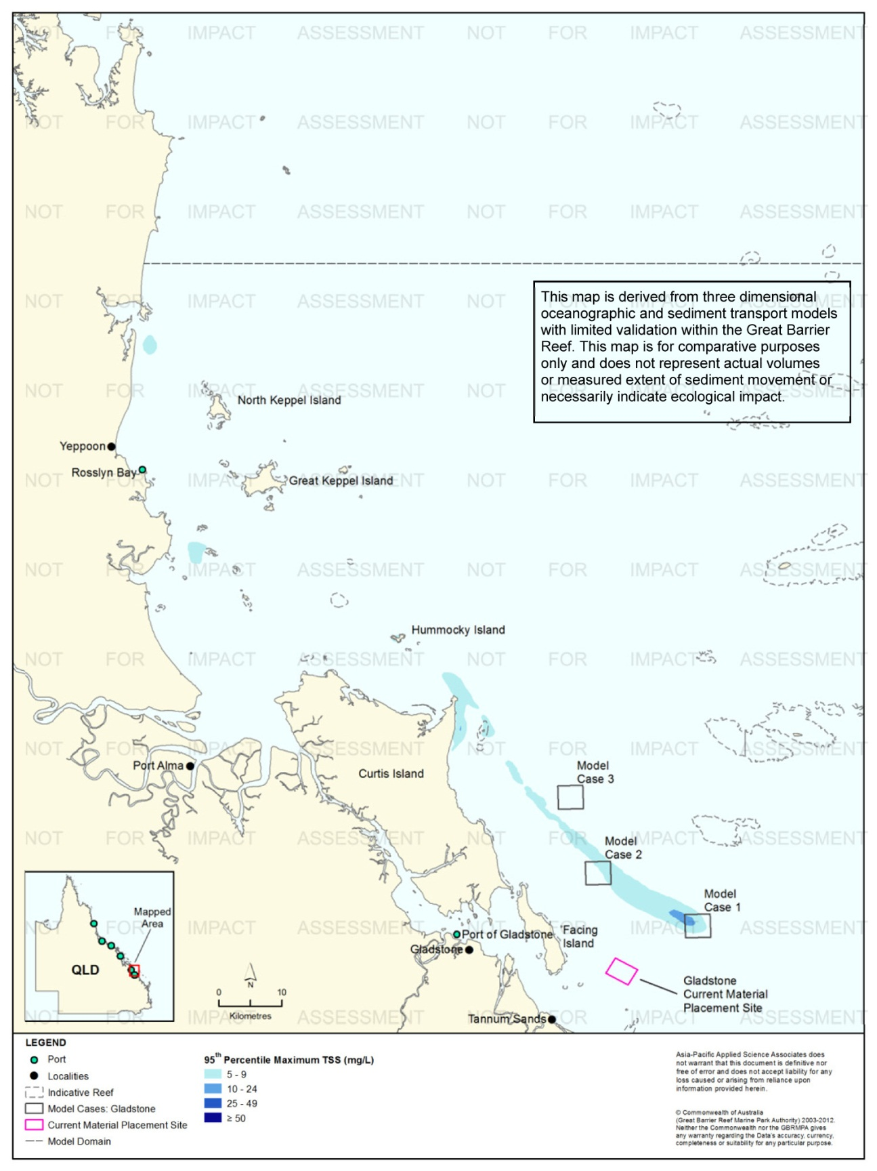
Figure 36. Gladstone: dredging period (133 days) TSS distribution, Model Case 1 - 95th percentile.
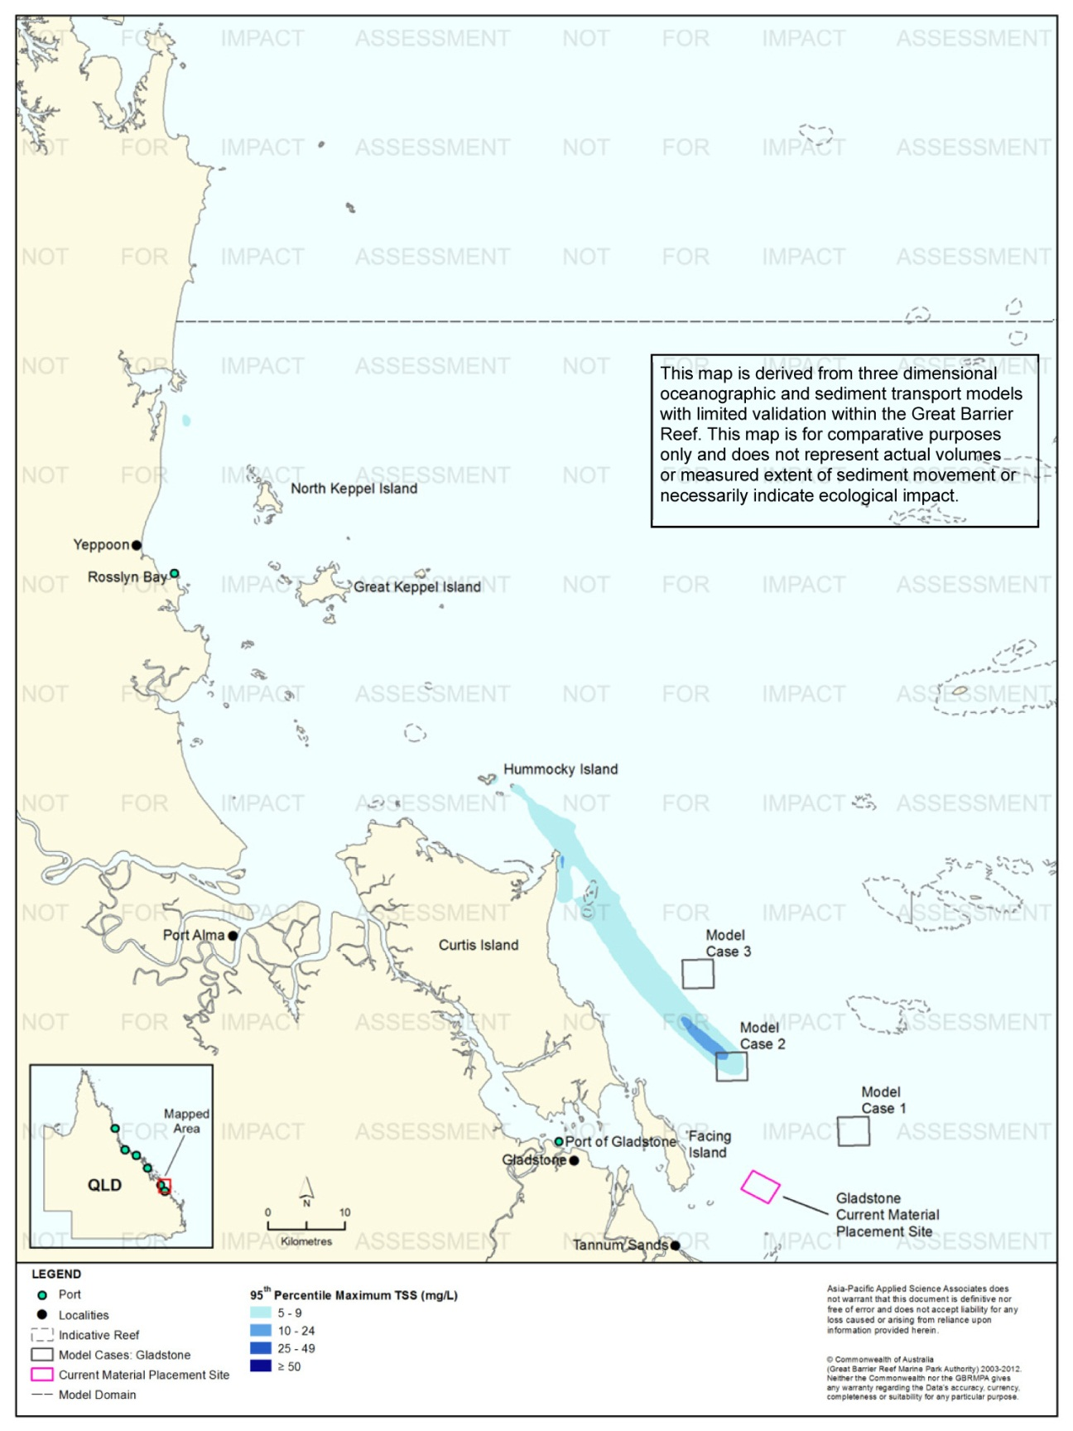
Figure 37. Gladstone: dredging period (133 days) TSS distribution, Model Case 2 - 95th percentile.

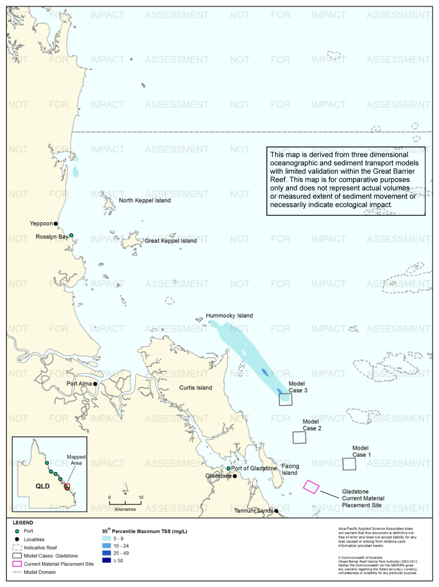
Figure 38. Gladstone: dredging period (133 days) TSS distribution, Model Case 3 - 95th percentile.
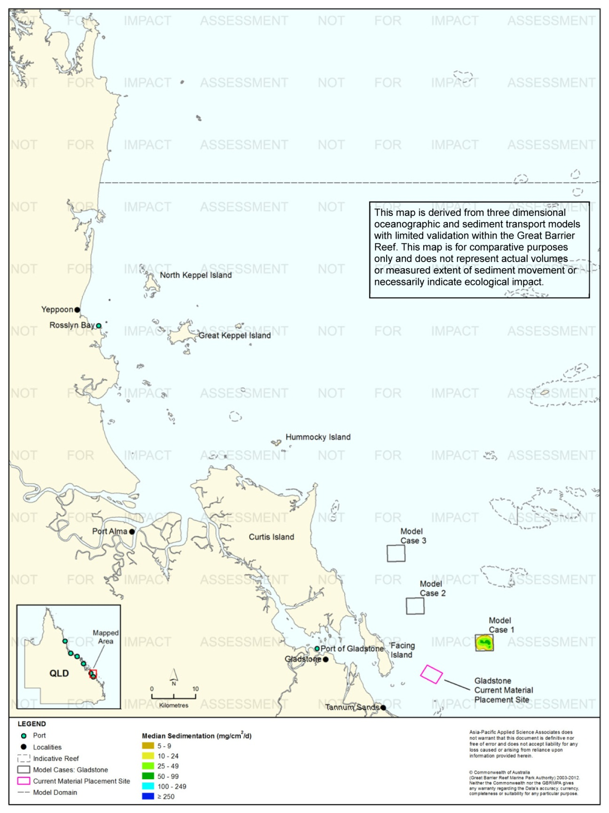
Figure 39. Gladstone: dredging period (133 days) sedimentation rate, Model Case 1 - 50th percentile.
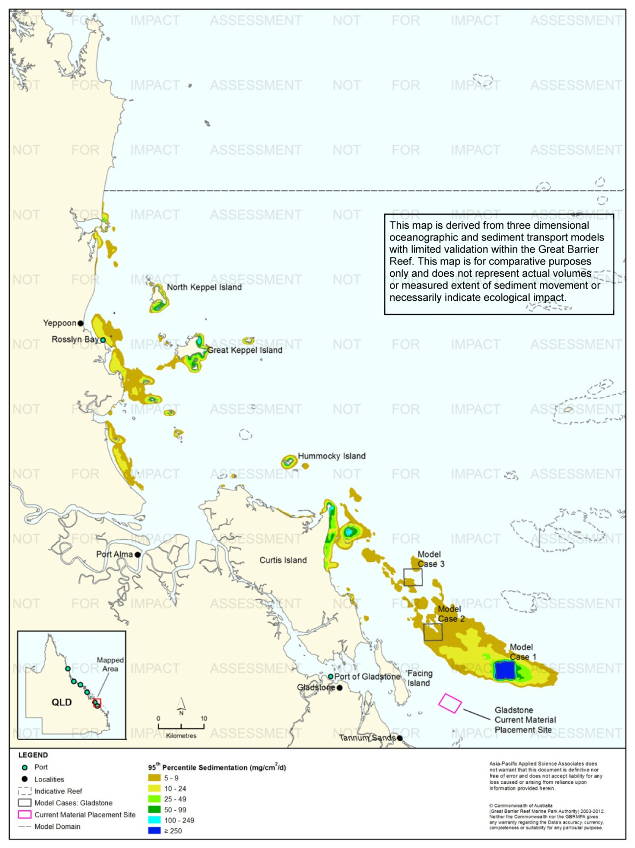
Figure 40. Gladstone: dredging period (133 days) sedimentation rate, Model Case 1 - 95th percentile.
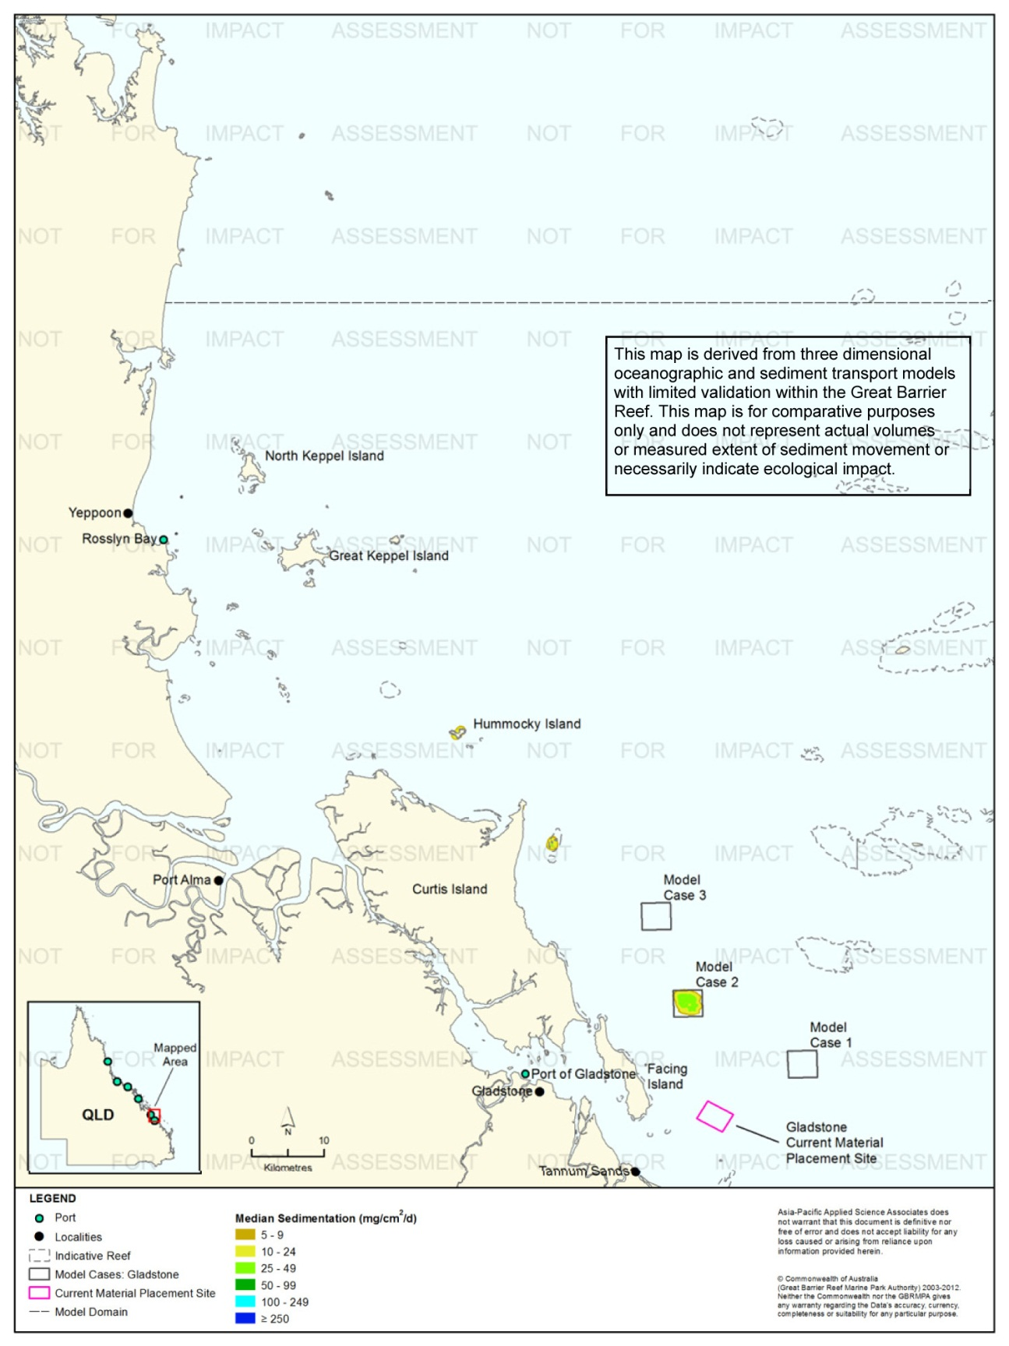
Figure 41. Gladstone: dredging period (133 days) sedimentation rate, Model Case 2 - 50th percentile.
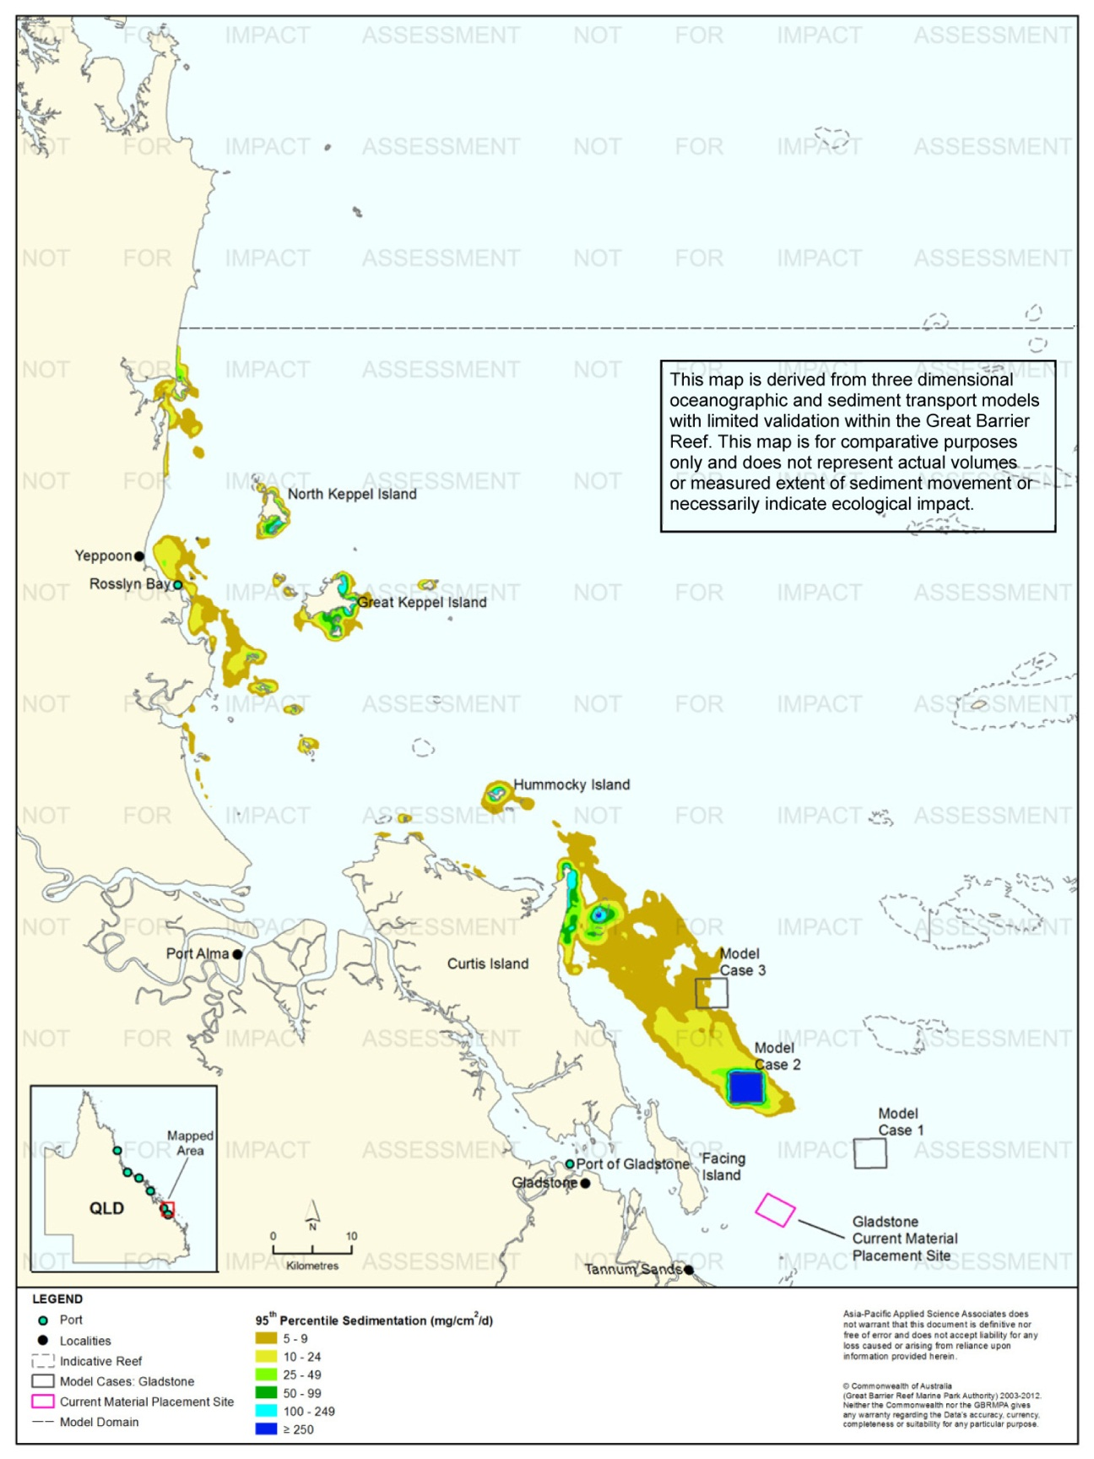
Figure 42. Gladstone: dredging period (133 days) sedimentation rate, Model Case 2 - 95th percentile.

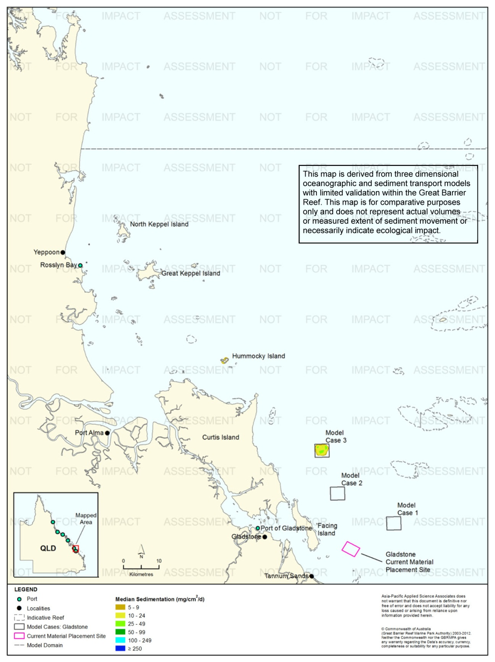
Figure 43. Gladstone: dredging period (133 days) sedimentation rate, Model Case 3 - 50th percentile.
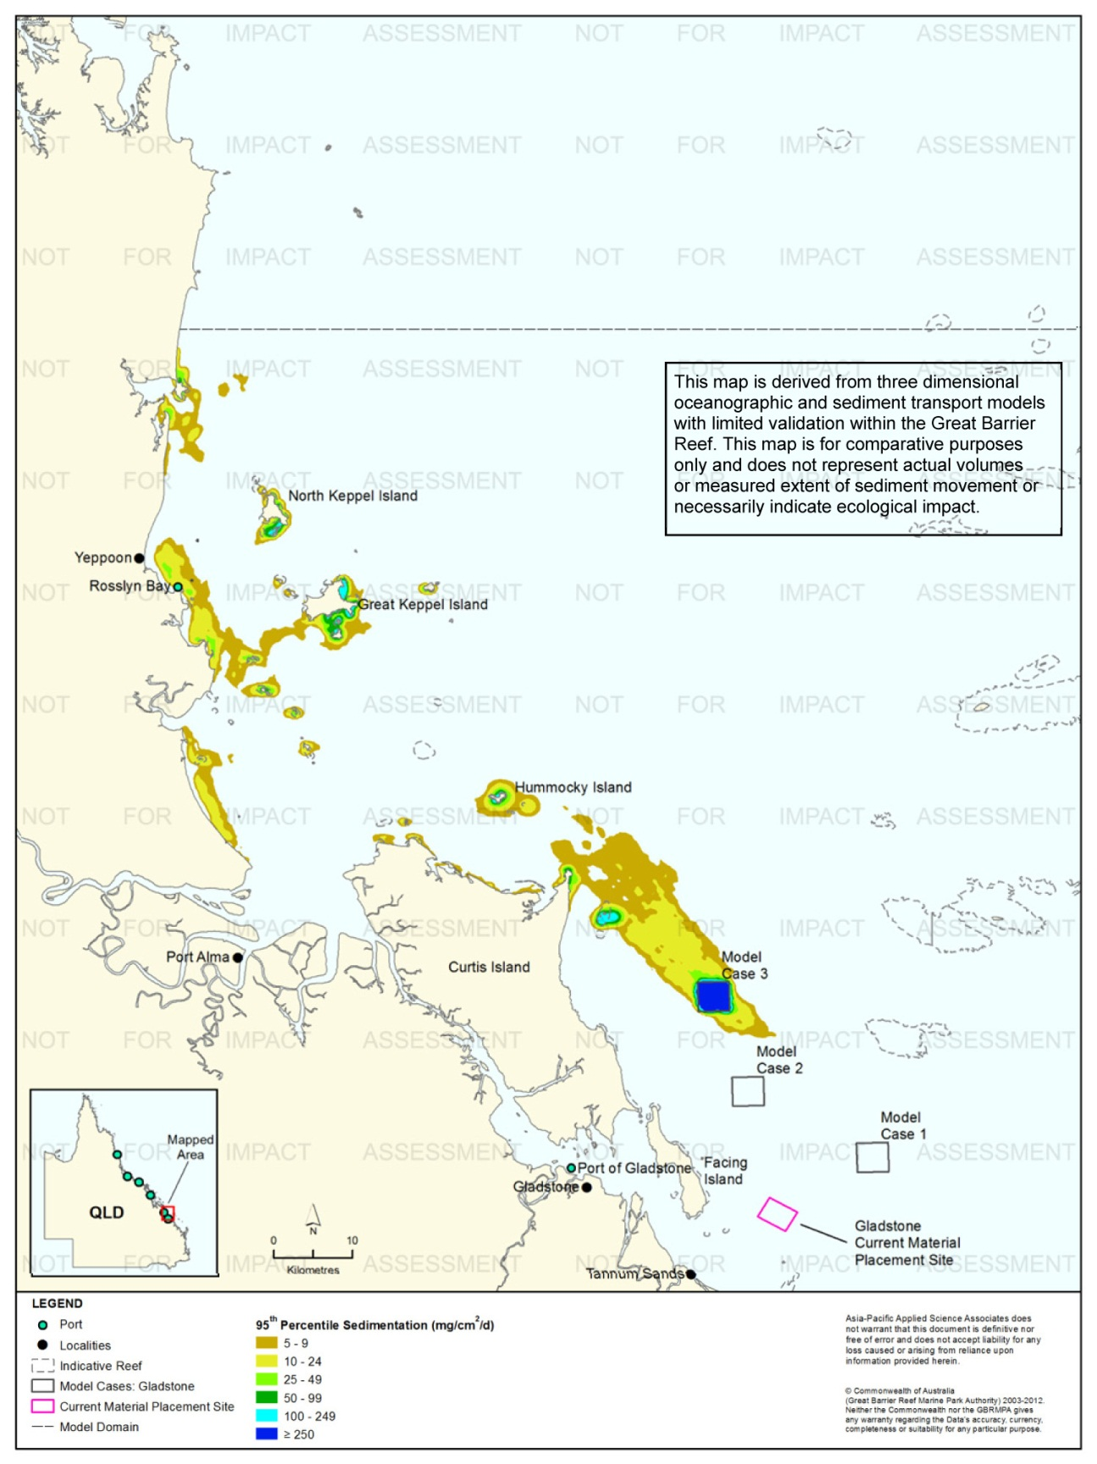
Figure 44. Gladstone: dredging period (133 days) sedimentation rate, Model Case 3 - 95th percentile.
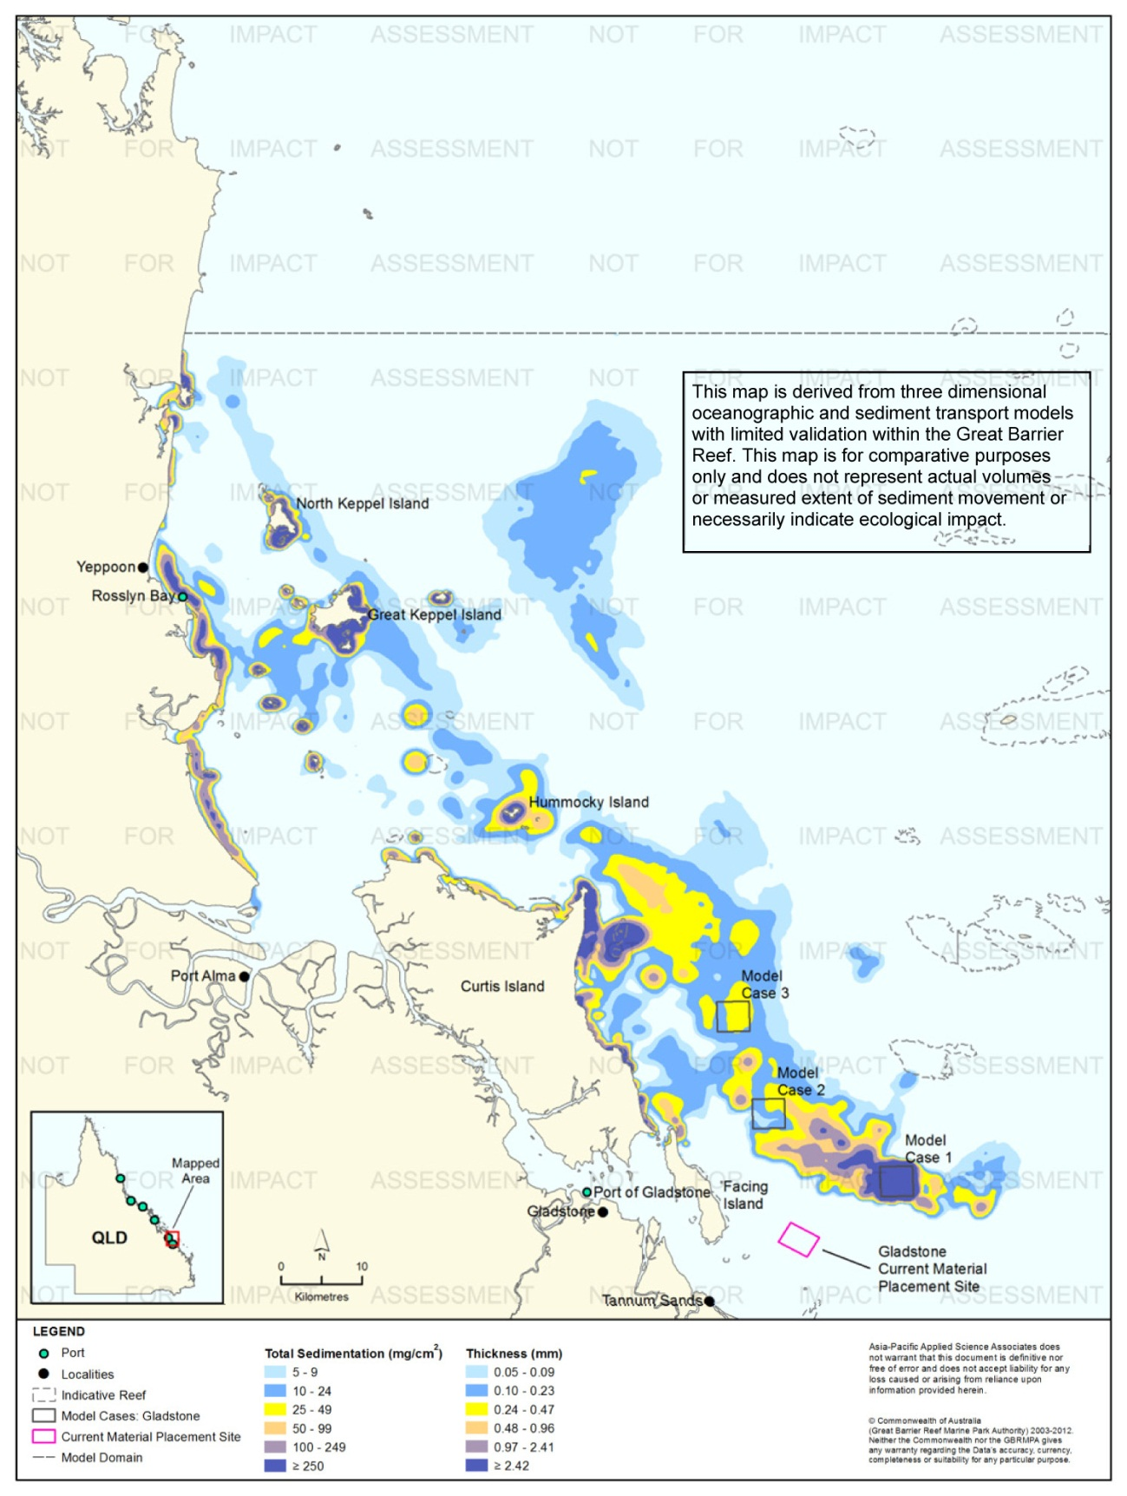
Figure 45. Gladstone: dredging period (133 days) total sedimentation and bottom thickness, Model Case 1.
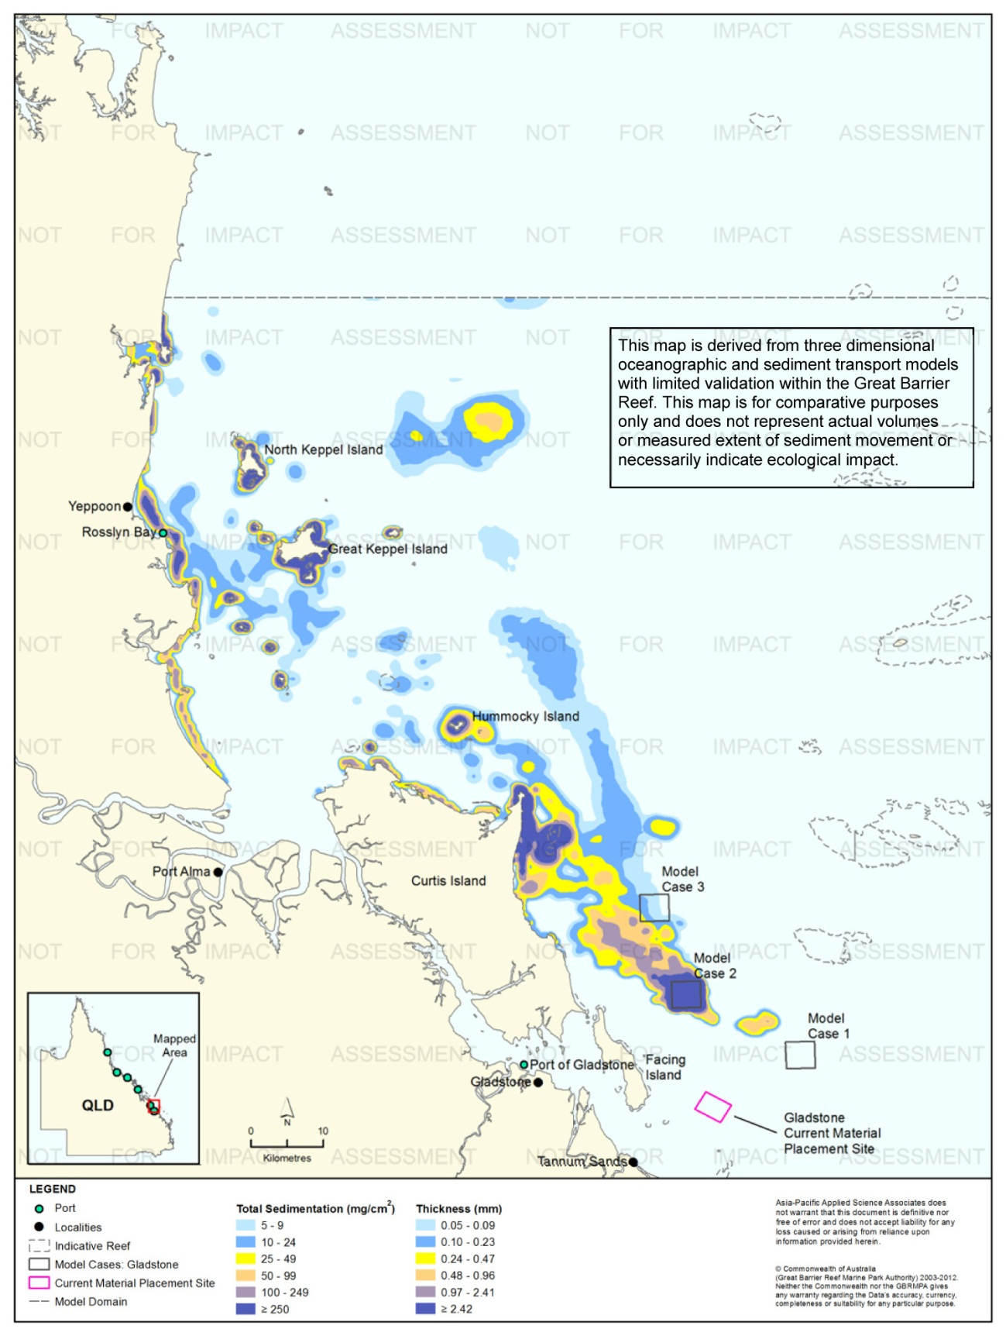
Figure 46. Gladstone: dredging period (133 days) total sedimentation and bottom thickness, Model Case 2.
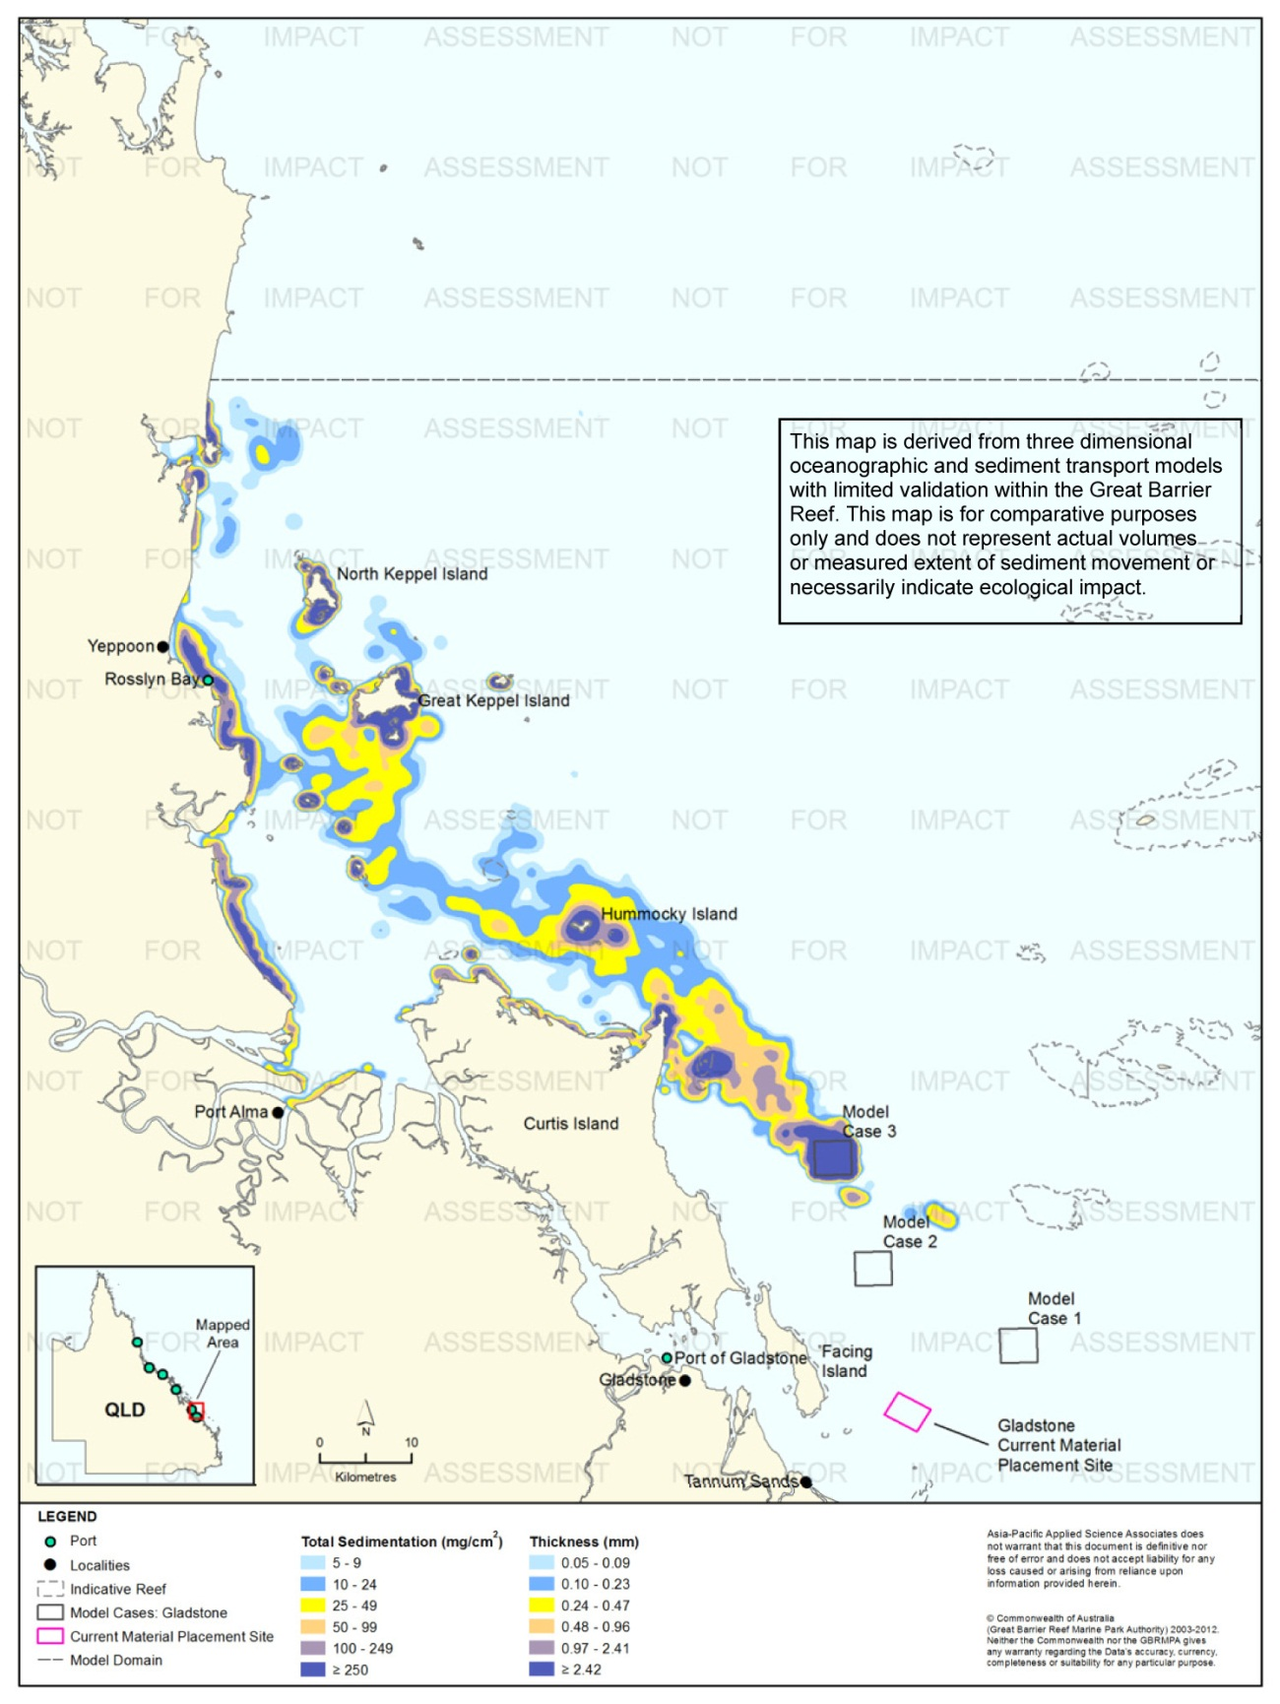
Figure 47. Gladstone: dredging period (133 days) total sedimentation and bottom thickness, Model Case 3.

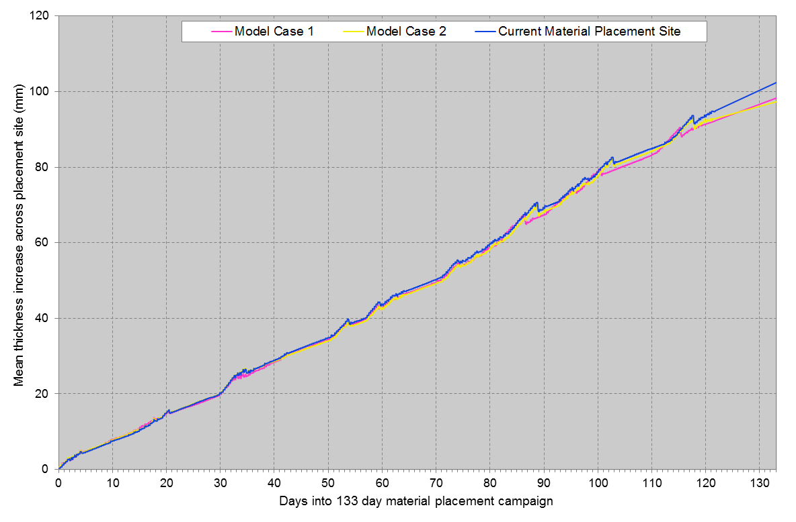
Figure 48. Gladstone: Mean bottom thicknesses across the material placement sites during the campaign. Results are based on the relocation of 6,000,000 m³ of material over 133 days (three releases per day of 15,000 m³).

Results at the End of the 12-Month Modelling Period
Figure 49 to figure 51 illustrate the predicted total sedimentation and bottom thickness at the end of the 12 months for Model Cases 1-3, Port of Gladstone study location.
In general, total sedimentation levels were predicted to occur in a north-west direction from Model Cases 1-3. For Model Cases 1 and 2, higher total sedimentation levels (≥ 100 mg/cm², equivalent to ≥ 0.97 mm) were positioned 5 km from the material placement sites in addition to the eastern extent of Curtis Island and around Rundle Island. Model Case 3 results revealed the same regions of coverage by predicted higher total sedimentation levels (≥ 100 mg/cm², equivalent to ≥ 0.97 mm) as Model Case 1-2, in addition to the inclusion of Hummocky Island and Keppel Islands.
A comparison between the total sedimentation results at the completion of the material placement period and at 12 months for Model Case 1 and Model Case 2 revealed a reduction over time in the extent and level of total sedimentation and bottom thickness in offshore areas, due to sediment resuspension events. The differences for Model Case 2 and 3 showed increased total sedimentation to the north-west along the mainland north of Yeppoon, as a result of material shifting northward along the coastline from Port Alma to Yeppoon.

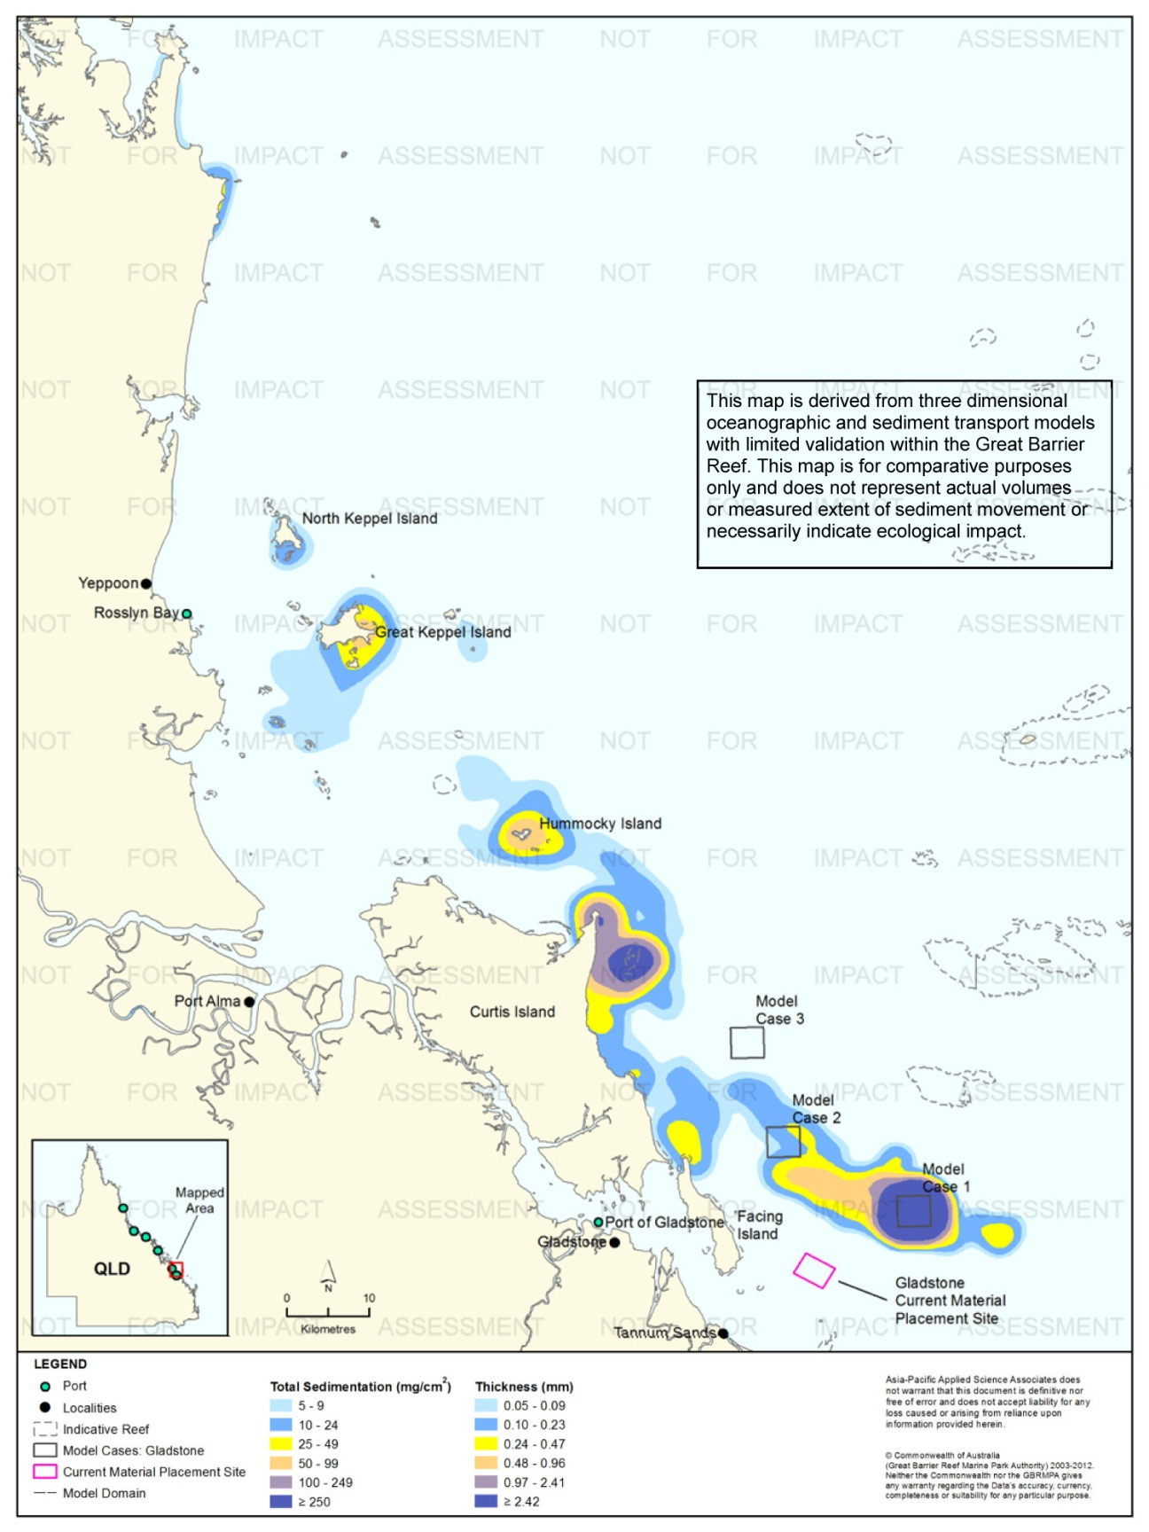
Figure 49. Gladstone: long-term (12 months) total sedimentation and bottom thickness, Model Case 1.

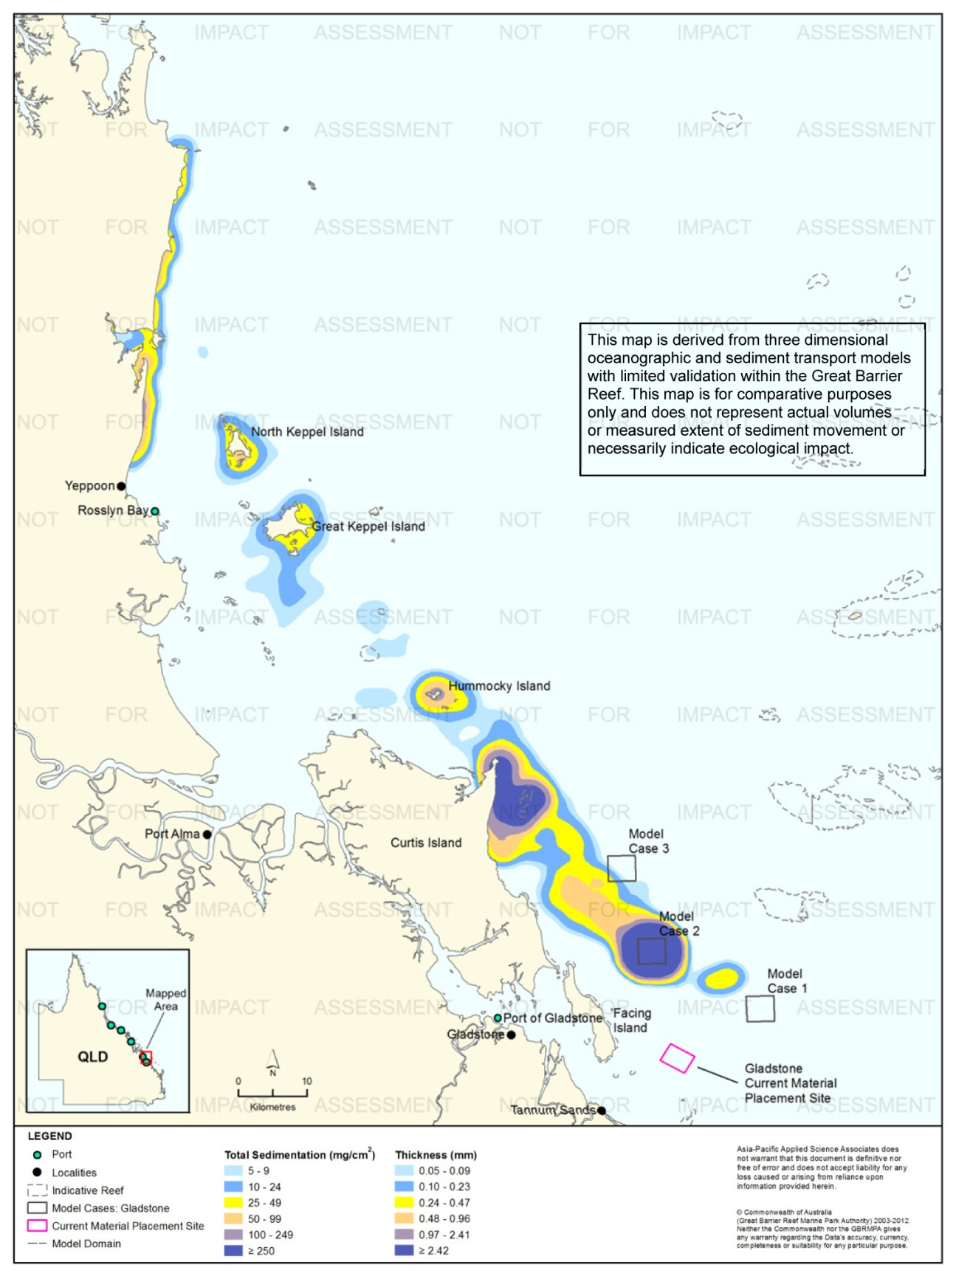
Figure 50. Gladstone: long-term (12 months) total sedimentation and bottom thickness, Model Case 2.
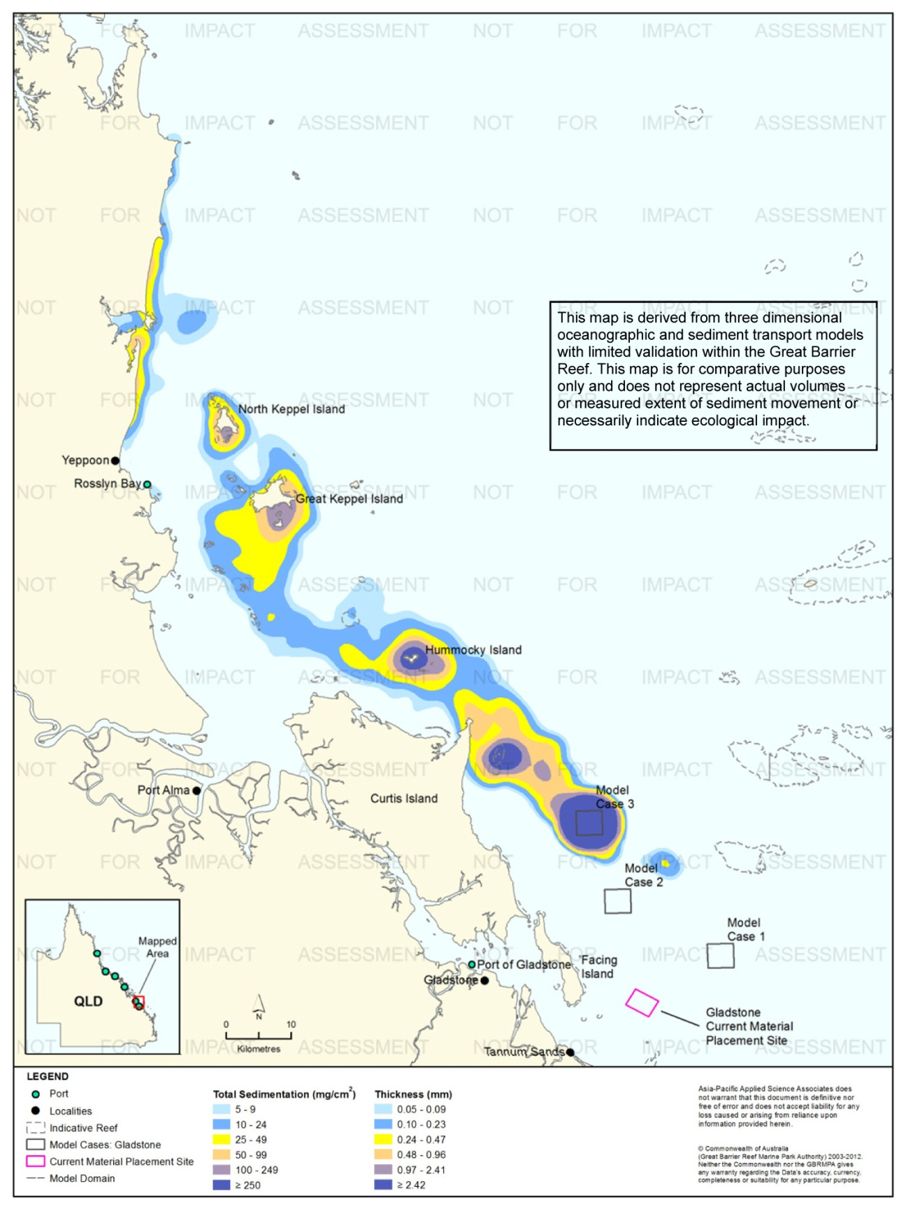
Figure 51. Gladstone: long-term (12 months) total sedimentation and bottom thickness, Model Case 3.

Rosslyn Bay State Boat Harbour

Results During the Material Placement Operations
For Rosslyn Bay State Boat Harbour a maintenance campaign was modelled, with 40,000 m³ of material relocated over 13 weeks (one release per day of 400 m³), commencing in March. The sediment distribution was described as 50 per cent clay and fine silt.
The TSS concentrations were predicted to remain below 5 mg/L, 95 per cent of the time for all three material placement simulations. Due to the small number of releases per day, (one per day) and low volume of material placed each day. Therefore, the 100th percentile (i.e. maximum value in each cell) plots are presented for comparison between the material placement sites (see figure 52 to figure 54). The 100th percentile contours provide extremely conservative results.
In general, the modelling showed the sediment plume moving in a north-west direction from the placement sites. For Model Case 1 the concentrations were always below 25 mg/L. Concentrations ranging between 10-24 mg/L extended 1.3 km north-west (see figure 52). The results for Model Case 2 showed TSS concentrations would be up to 49 mg/L adjacent to the material placement site. Concentrations between 10-24 mg/L were predicted 5 km north-north-west (see figure 53). The modelling results for the current material placement site showed that the concentrations would not exceed 9 mg/L.
Figure 55 to figure 60 present the predicted sedimentation rate (equalled or below) experienced 50 per cent and 95 per cent of the time for Model Cases 1-2 and the current material placement site. The distribution was very similar across the three placement sites with sedimentation rates of up to 49 mg/cm²/d limited to within a 1 km from the material placement sites.
Figure 61 to figure 63 illustrate the predicted total sedimentation and bottom sediment thickness at the completion of the material placement operations.
Figure 64 shows the mean increase in bottom thickness across the three material placements sites during the 90 day simulations. The results indicate that the current material placement site was more retentive at day 90 (~19 mm) compared to Model Case 1 and Model Case 2 (13 mm and 11 mm, respectively).

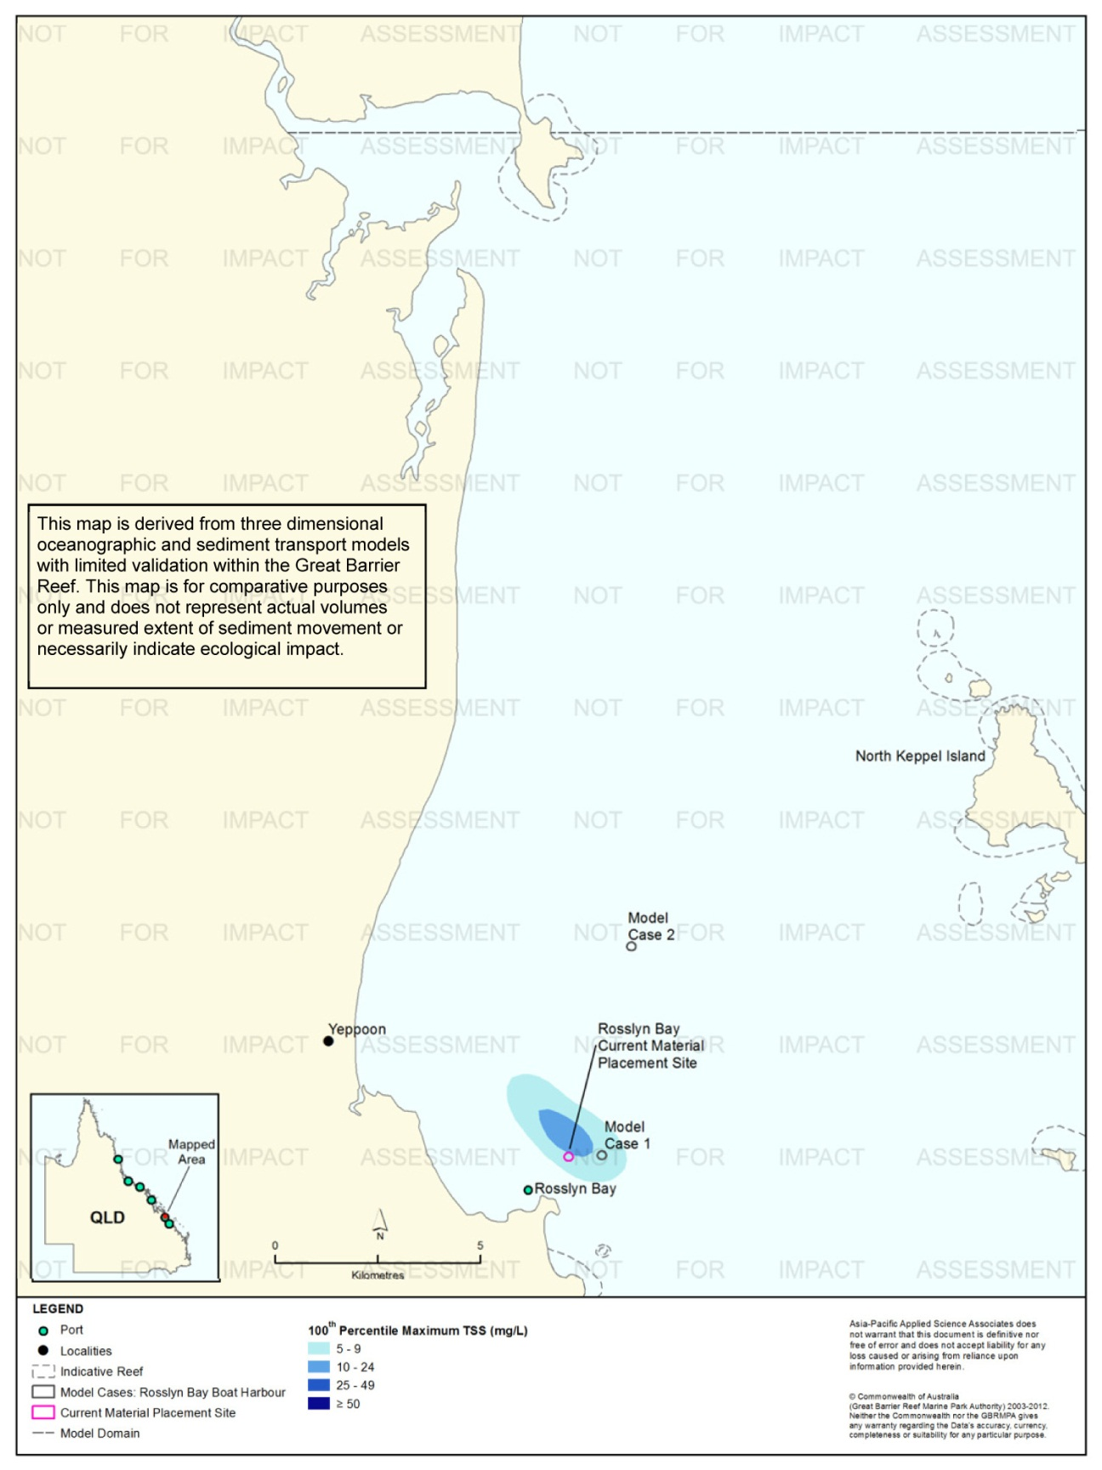
Figure 52. Rosslyn Bay: dredging period (90 days) TSS distribution, Model Case 1 - 100th percentile.

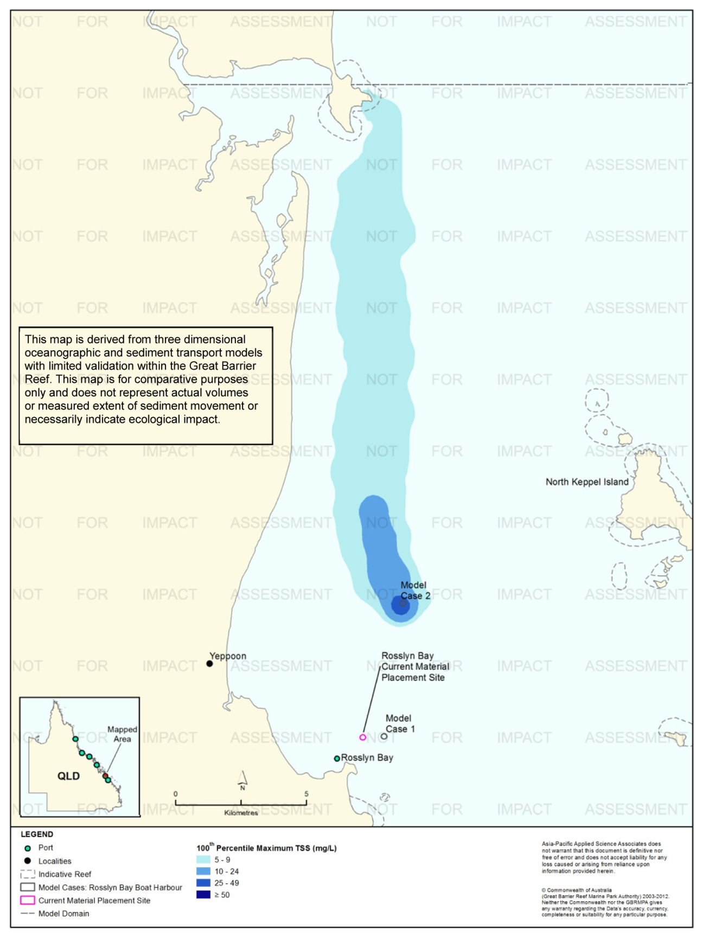
Figure 53. Rosslyn Bay: dredging period (90 days) TSS distribution, Model Case 2 - 100th percentile.

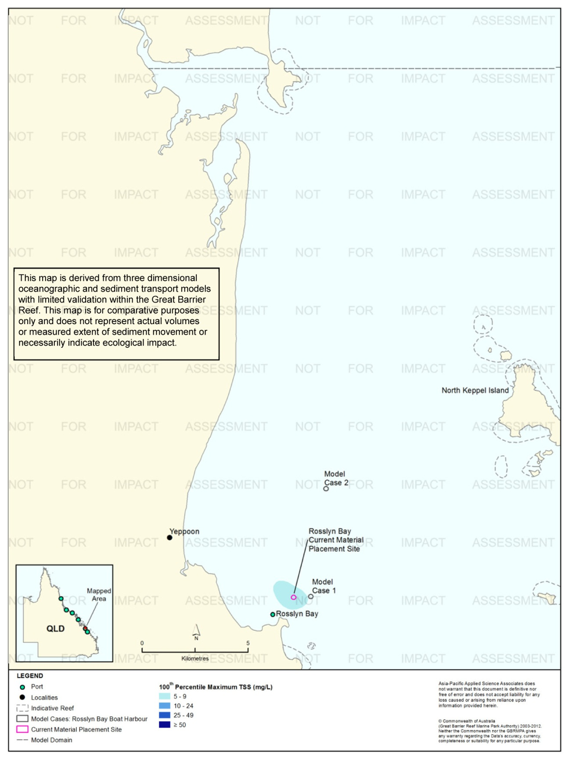
Figure 54. Rosslyn Bay: dredging period (90 days) TSS distribution, current site - 100th percentile.

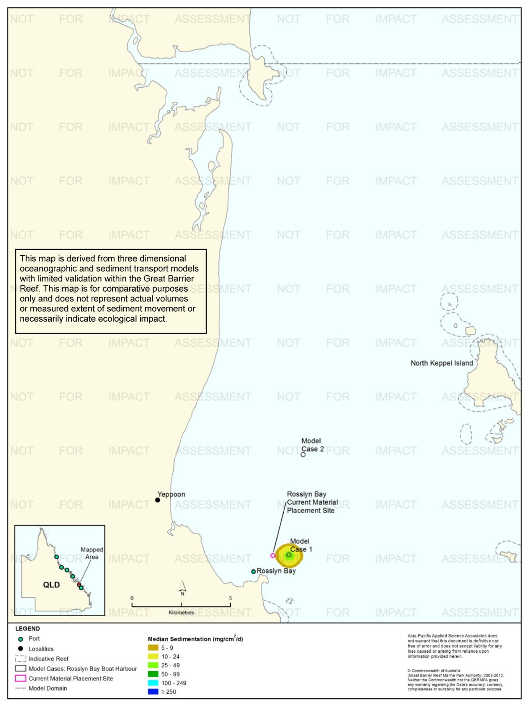
Figure 55: Rosslyn Bay: dredging period (90 days) sedimentation rate, Model Case 1 - 50th percentile.
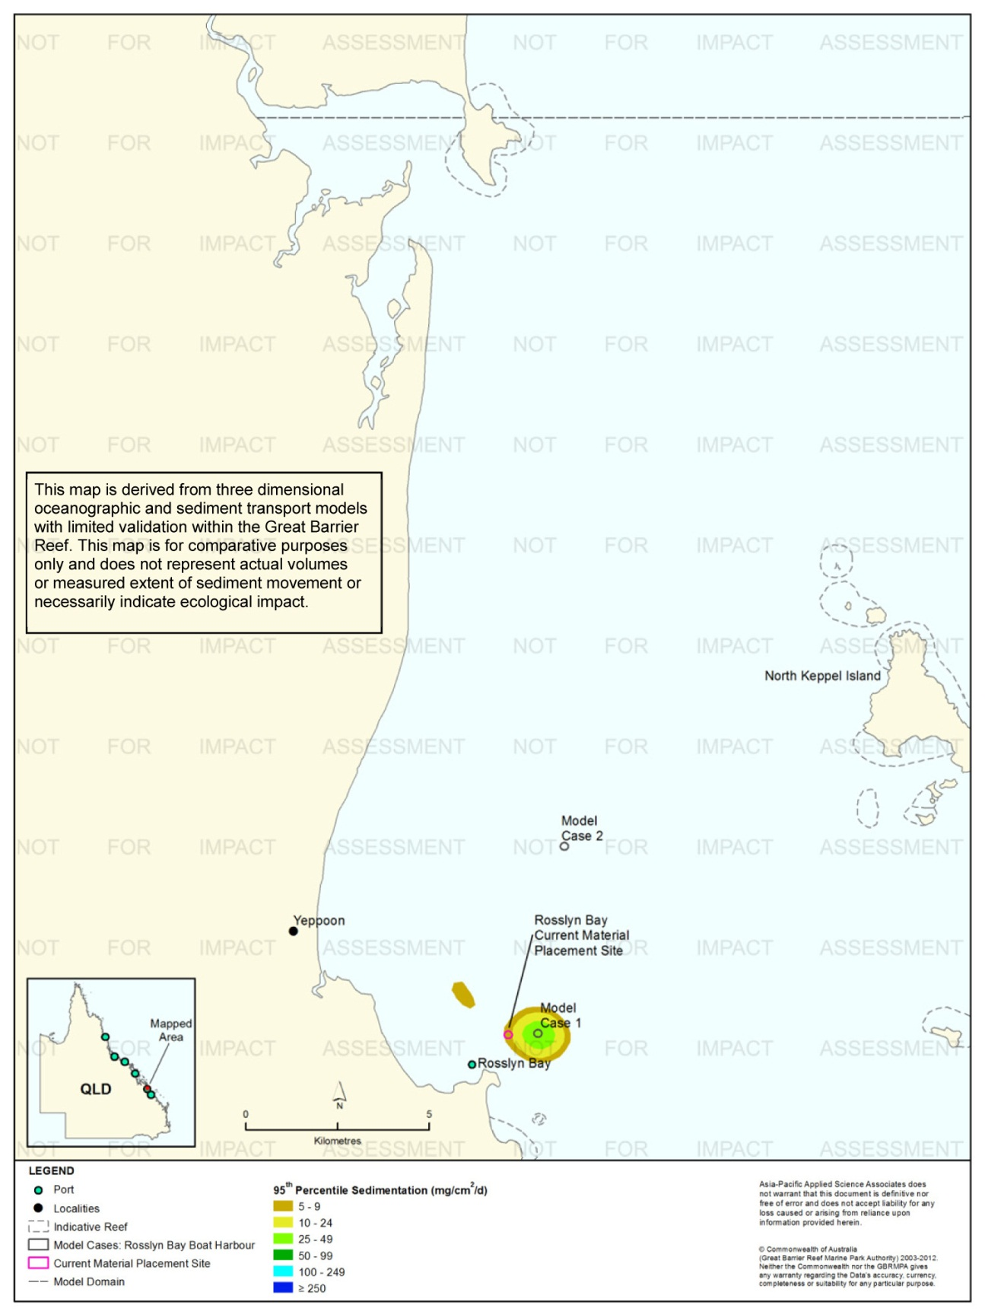
Figure 56. Rosslyn Bay: dredging period (90 days) sedimentation rate, Model Case 1 - 95th percentile.
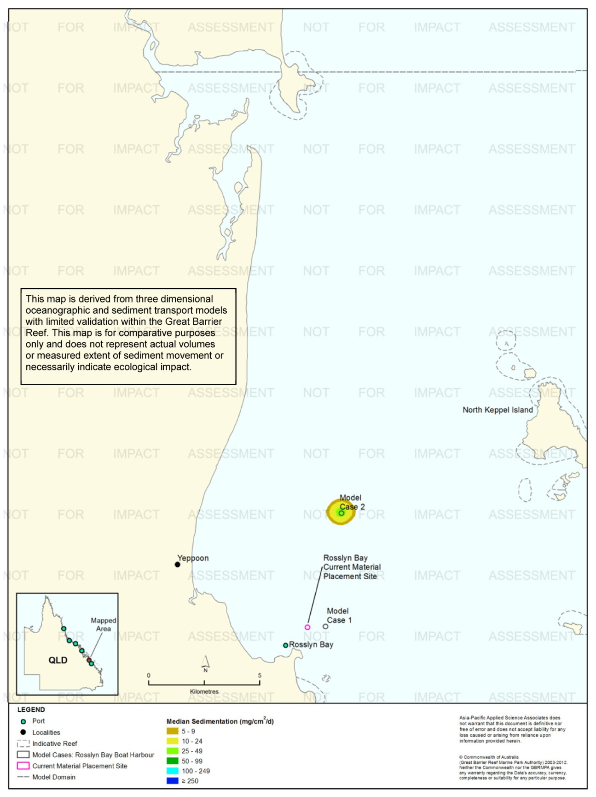
Figure 57. Rosslyn Bay: dredging period (90 days) sedimentation rate, Model Case 2 - 50th percentile.
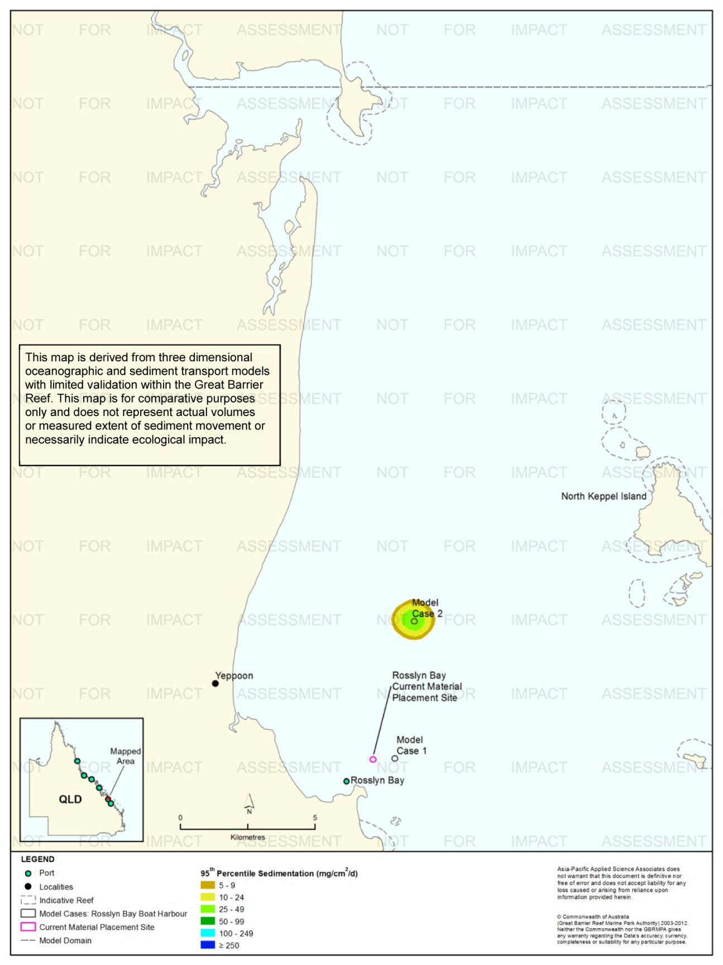
Figure 58. Rosslyn Bay: dredging period (90 days) sedimentation rate, Model Case 2 - 95th percentile.
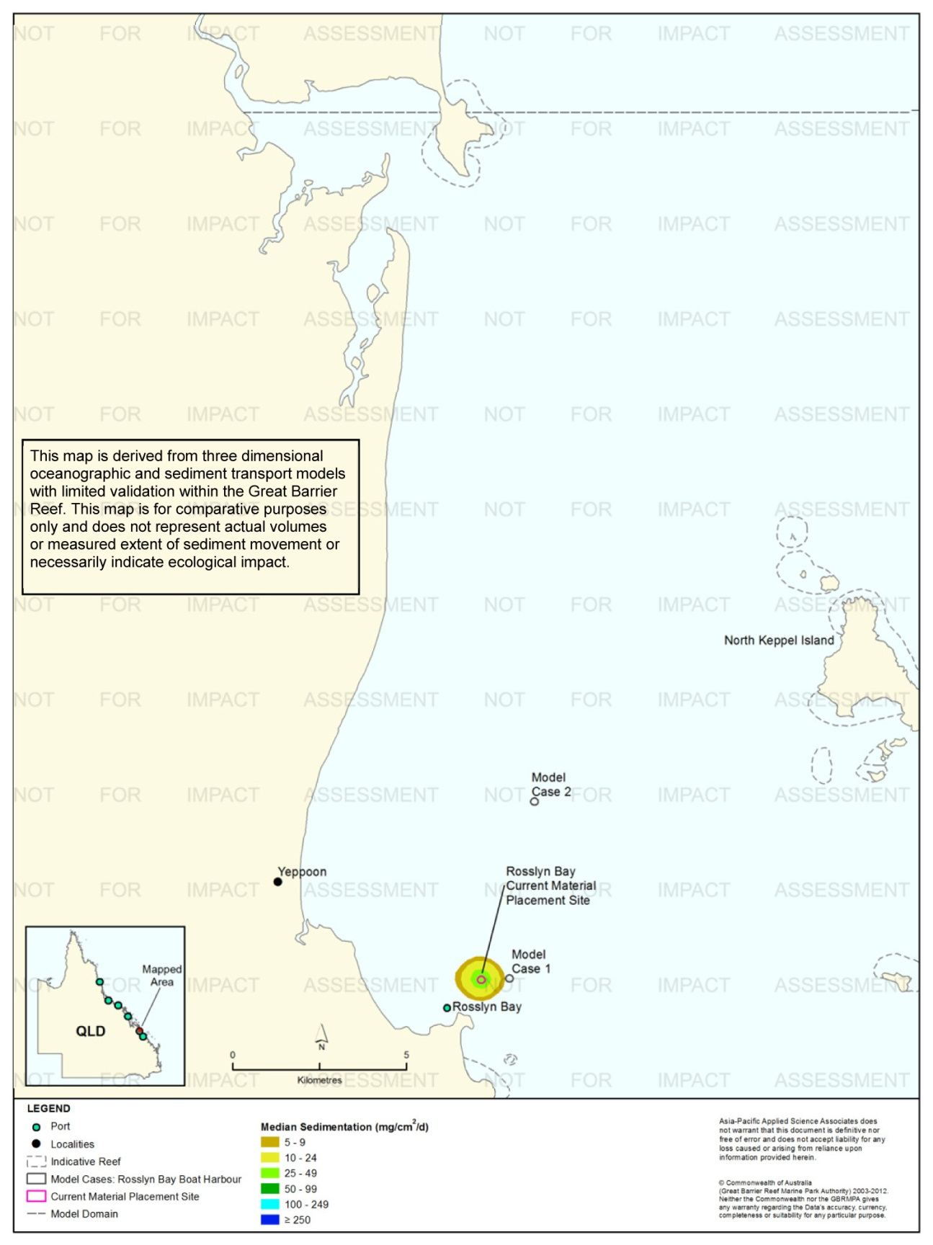
Figure 59. Rosslyn Bay: dredging period (90 days) sedimentation rate, current site - 50th percentile.
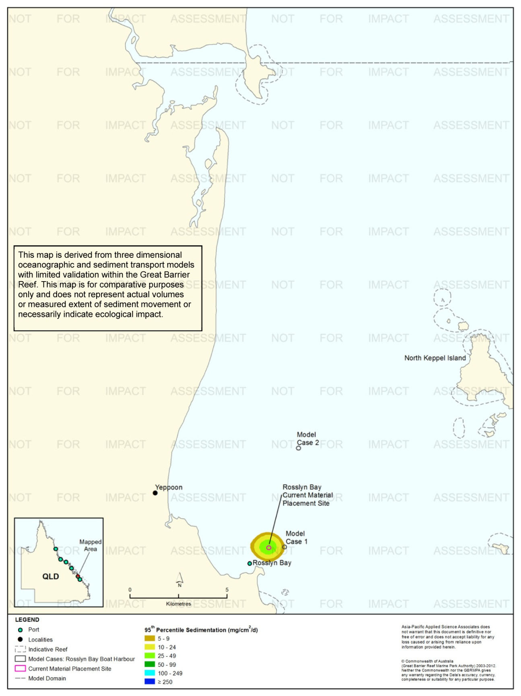
Figure 60. Rosslyn Bay: dredging period (90 days) sedimentation rate, current site - 95th percentile.
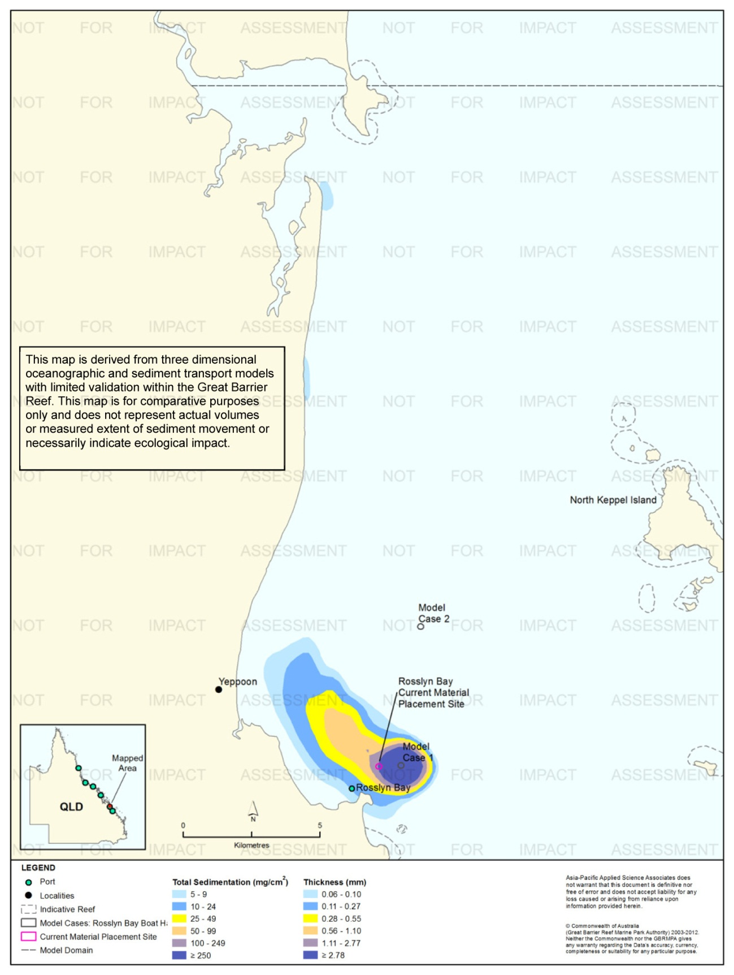
Figure 61. Rosslyn Bay: dredging period (90 days) total sedimentation and bottom thickness, Model Case 1.
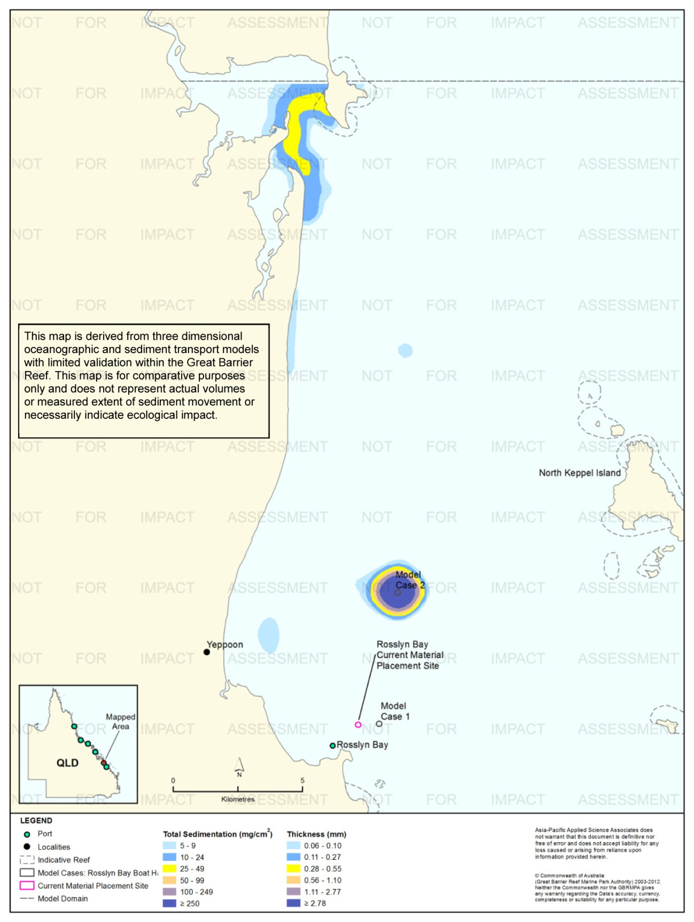
Figure 62. Rosslyn Bay: dredging period (90 days) total sedimentation and bottom thickness, Model Case 2.
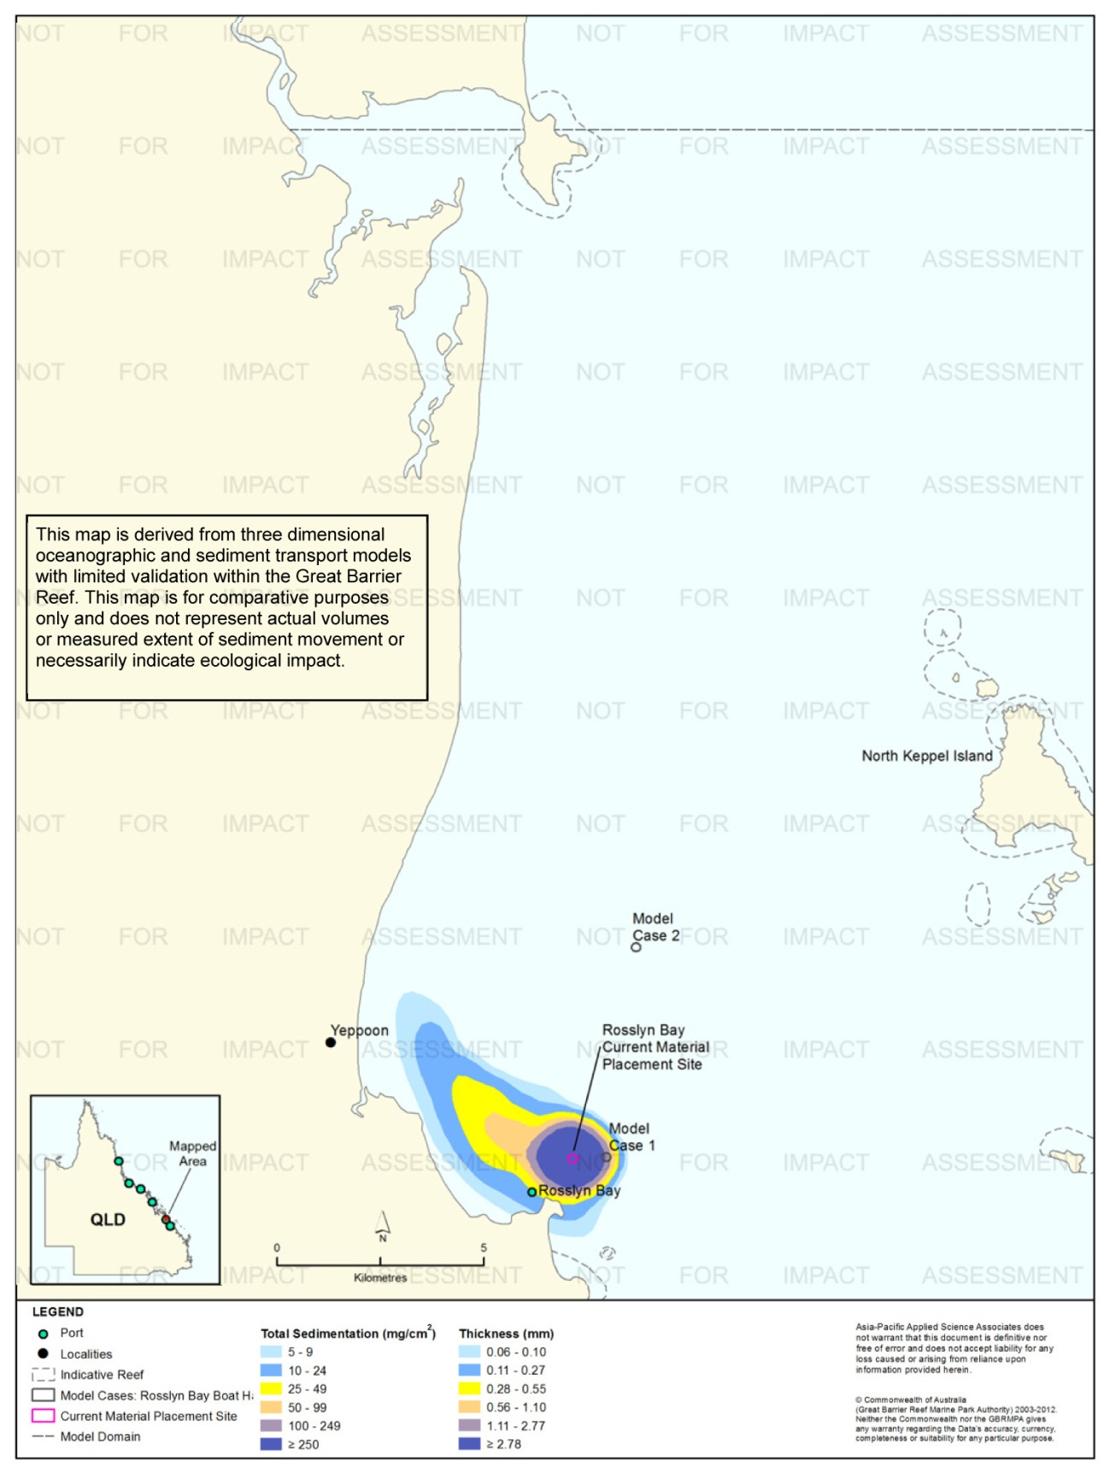
Figure 63. Dredging period (90 days) total sedimentation and bottom thickness, Model Case 3.
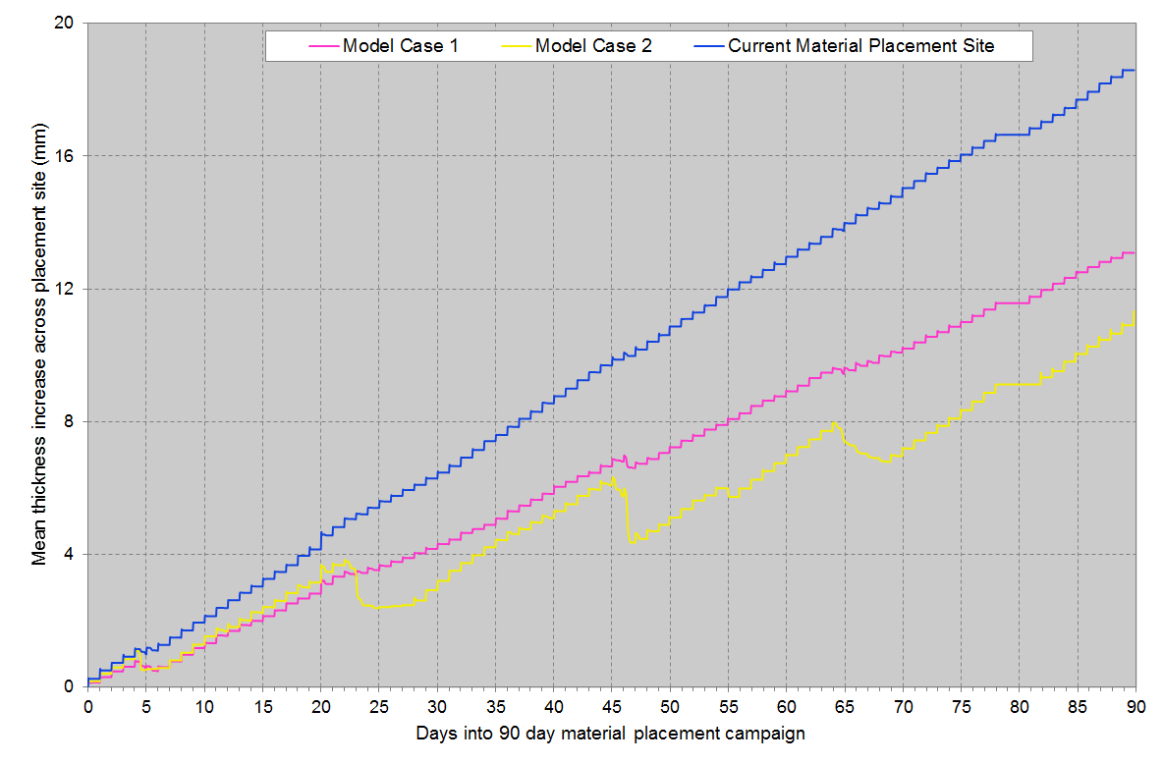
Figure 64. Rosslyn Bay: Mean bottom thicknesses across the material placement sites. Results are based on the relocation of 40,000 m³ of material, over 90 days (one release per day of 400 m³).

Results at the End of the 12-Month Modelling Period
Figure 65 to figure 67 show the predicted total sedimentation and bottom thickness at the end of the 12 months from the start of the material placement operations for Model Case 1 and Model Case 2 and the current material placement site.
Modelling indicated that the predicted total sedimentation loads of 100 mg/cm² or greater (or bottom thickness of 1.11 mm or greater) were confined to within 1 km from the material placement sites.
A comparison between the results at the completion of the material placement period and at 12 months for all sites revealed a decrease in total sedimentation over time in areas beyond the material placement sites. Additionally, at the end of 12 months, the contours were predicted to extended further north from the placement sites (up to at Water Park Point Headland and Corio Bay) as the sediments were continually resuspended and mobilised northward under the influence of the northward-flowing currents.

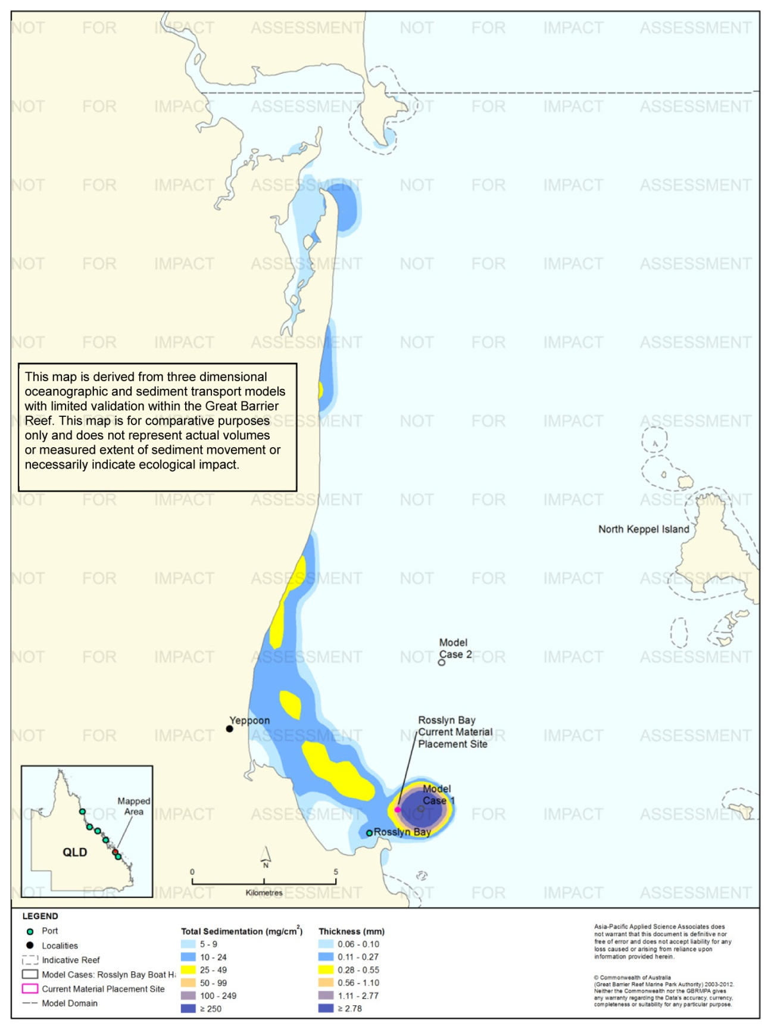
Figure 65. Rosslyn Bay: long-term (12 months) total sedimentation and bottom thickness, Model Case 1.
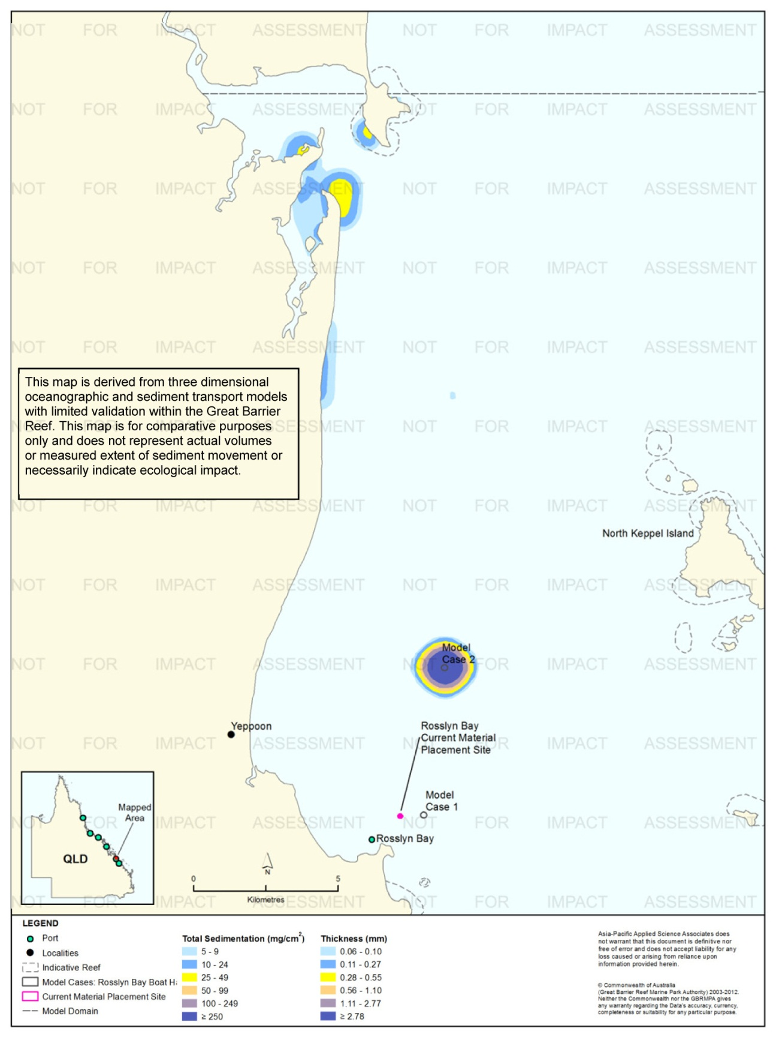
Figure 66. Rosslyn Bay: long-term (12 months) total sedimentation and bottom thickness, Model Case 2.
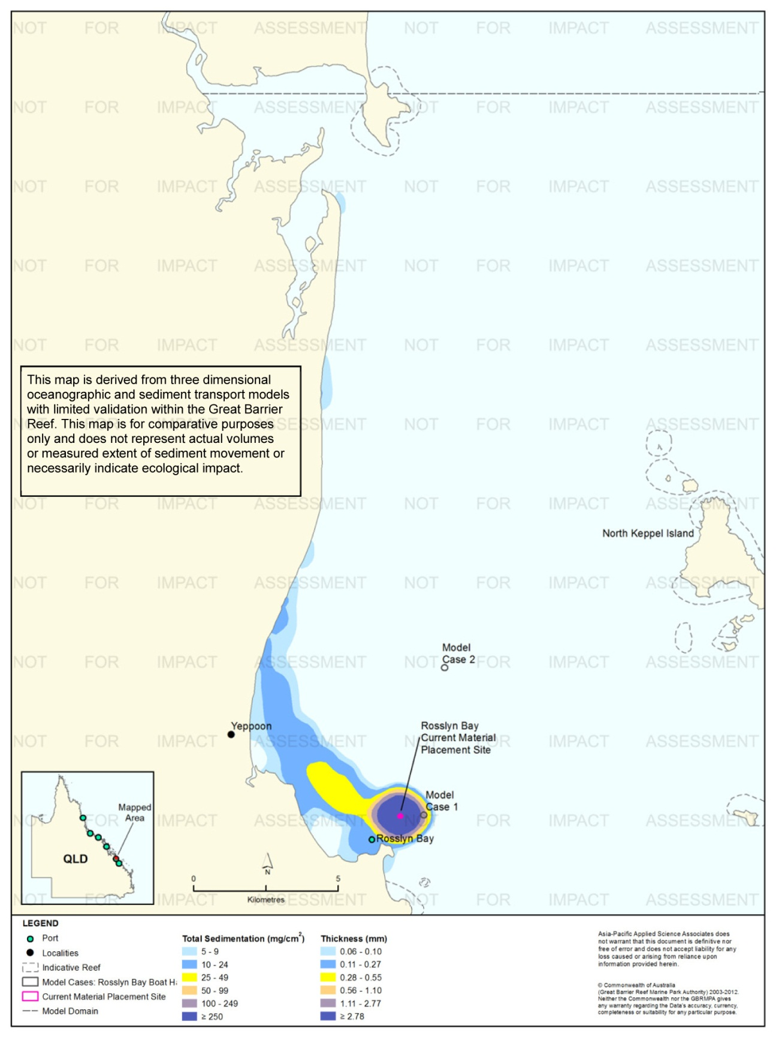
Figure 67. Rosslyn Bay: long-term (12 months) total sedimentation and bottom thickness, current site.

Port of Hay Point

Results during the Material Placement Operations
For the Port of Hay Point a capital dredging campaign was modelled which consisted of 8,500,000 m³ of dredged material relocated over 22 weeks, commencing in April. Modelling comprised five releases per day (11,000 m³/release), each release lasting 13 minutes. The relocated material had a high proportion of fine and coarse sand (65 per cent).
Figure 68 to figure 72 show the 50th or 95th percentile of TSS concentrations for Model Cases 1-2 and the current material placement site. Note, no 50th percentile concentrations greater than 5 mg/L were predicted for Model Case 1.
The 95th percentile contours show a general pattern of sediment plume dispersion toward the north-north-west for all three material placement sites. Based on the 95th percentile, predicted TSS concentrations did not exceed 9 mg/L for Model Cases 1 (see figure 68). The results for Model Case 2 showed that for 95 per cent of the time, the concentrations between 10-24 mg/L or lower were predicted to be confined to within the boundary of the material placement site (see figure 70). In comparison, the 10-24 mg/L TSS concentrations were predicted to extend up to 13km north-north-west from the current material placement site (see figure 72).
Figure 73 to figure 78 show the 50th and 95th percentile values of sediment rates for the three material placement sites. For Model Case 1 elevated rates of sedimentation of 100 mg/cm²/d or greater included areas south of Carlisle, Brampton and St Bees Island and the perimeter of the material placement site. Similar to Model Case 1, the results for Model Case 2, showed elevated rates of sedimentation (100 mg/cm²/d or greater) south of Carlisle and Brampton Islands and around to the boundary of the material placement site (see figure 76). The analysis for the current material placement site revealed isolated regions with elevated sedimentation rates of 100 mg/cm²/d or greater (above background) approximately 10 km in a north-north-west direction (figure 78), surrounding the site and southern coastline of Brampton Island.
Figure 79 to figure 81 illustrate the predicted total sedimentation and bottom sediment thickness at the completion of the material placement operations for Model Case 1-3, Port of Hay Point study location. For all three material placement locations, the predicted total sedimentation and bottom sediment thickness were predicted to extend beyond the extent of the model domain, north-north-west of the material placement sites, in the vicinity of the Repulse Islands. Thus indicating the extent of the predicted total sedimentation would disperse further afield had the model domain been extended.
The extent of the model domain was deemed sufficient in determining the predicted TSS concentrations and sedimentation rates based on the percentile analysis results (50th and 95th percentiles).
Figure 82 compares the mean bottom thicknesses across the three material placement sites during the 155 day campaigns. The results indicate a relatively consistent increase at each of the placement sites with the current material placement site and Mode Case 2 predicted to build up higher (98 mm and 96 mm, respectively) than Model Case 1 (89 mm).

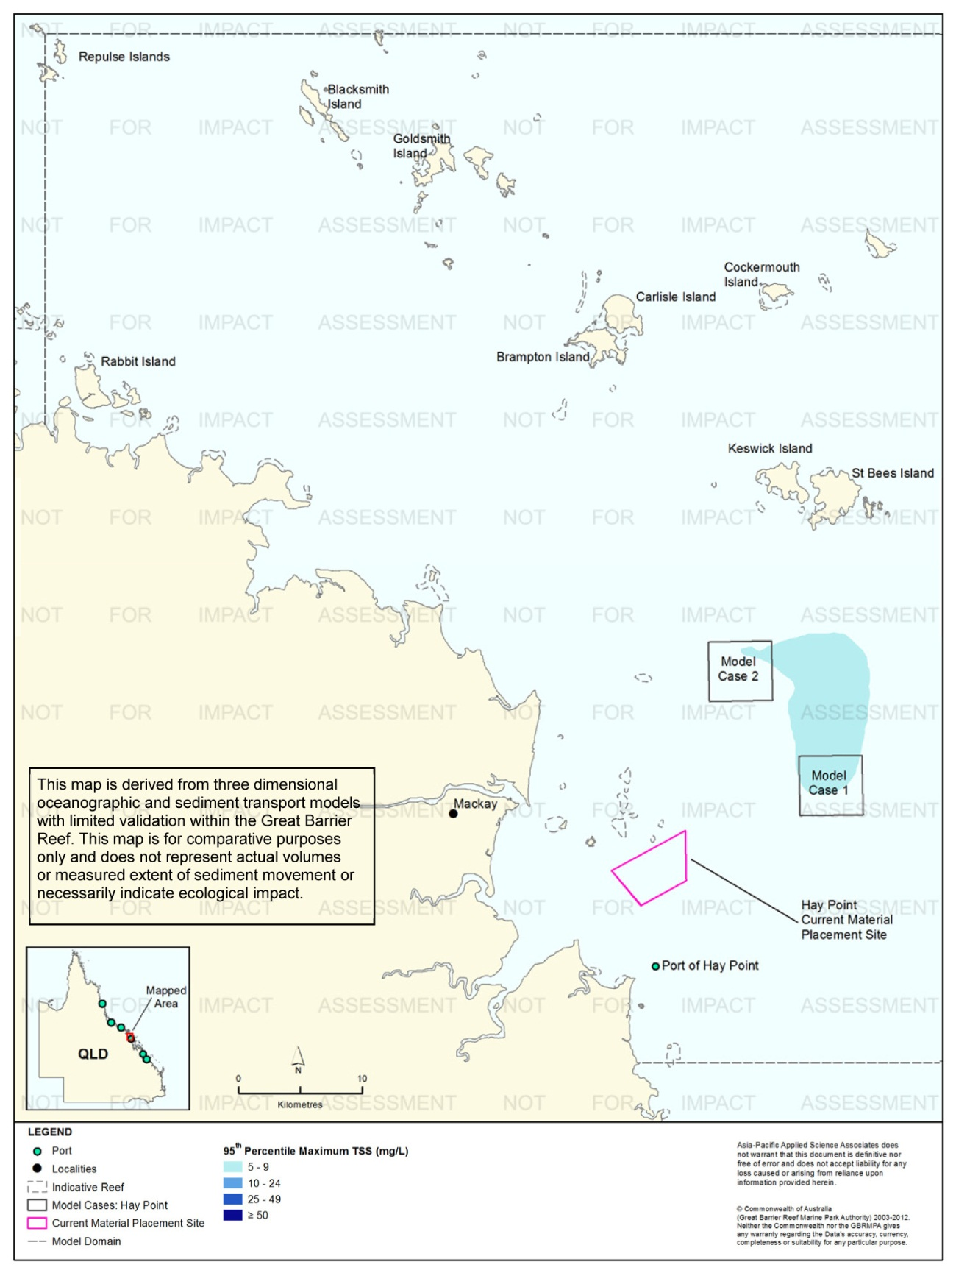
Figure 68. Hay Point: dredging period (155 days) TSS distribution, Model Case 1 - 95th percentile.
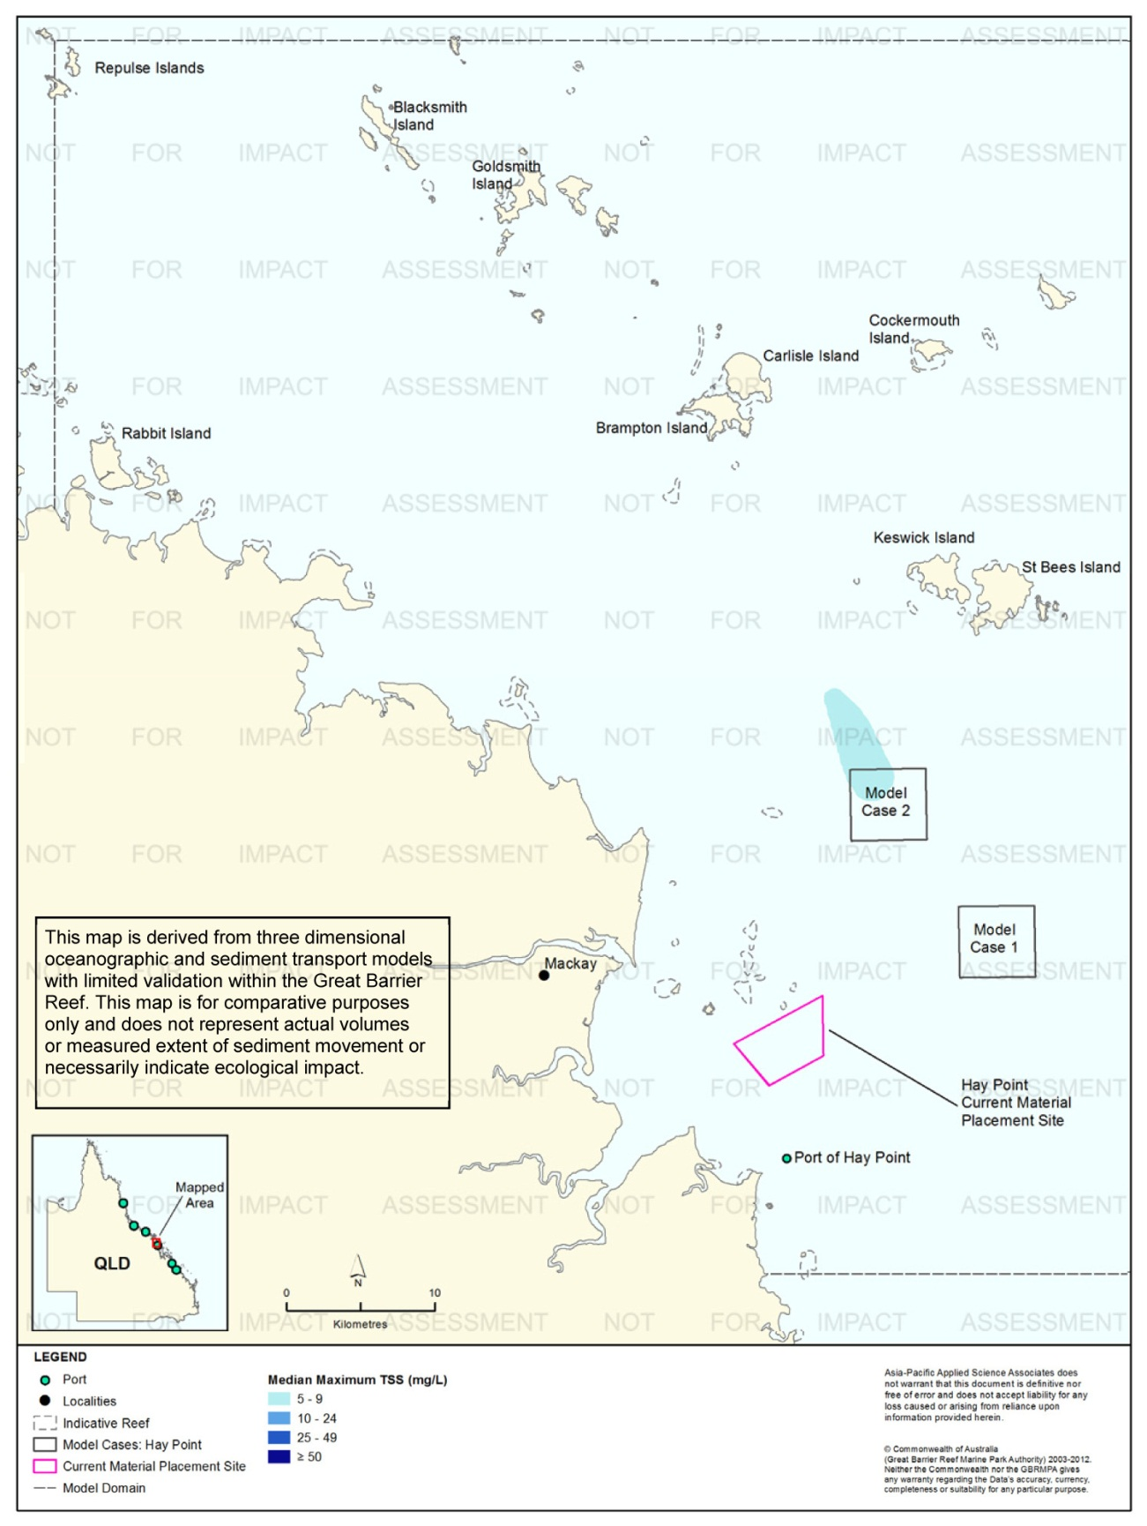
Figure 69. Hay Point: dredging period (155 days) TSS distribution, Model Case 2 - 50th percentile.

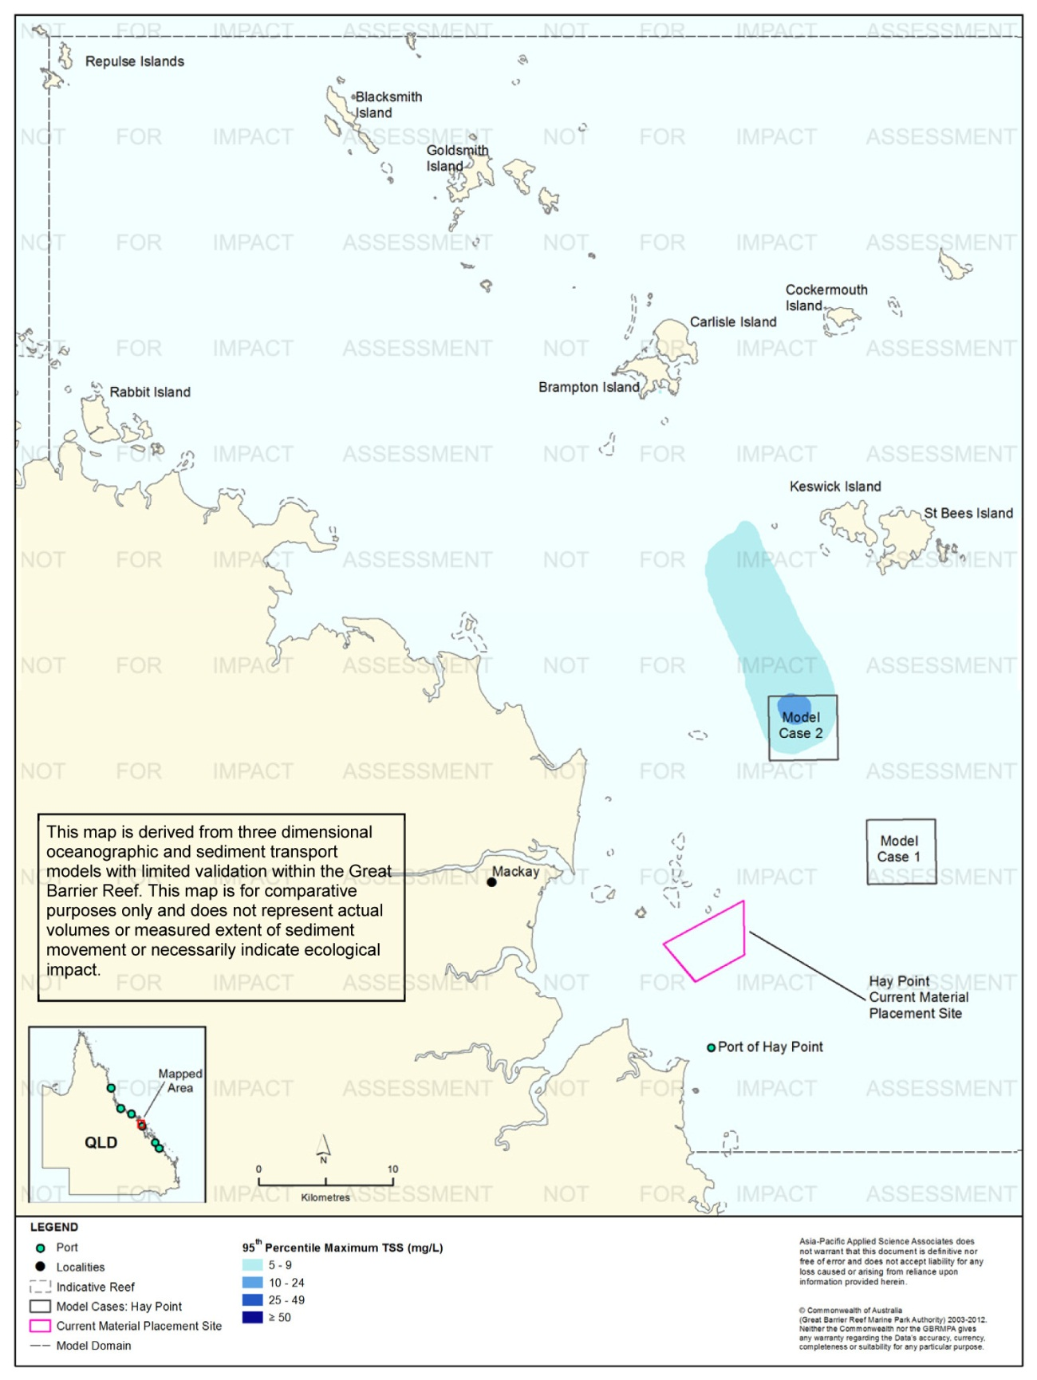
Figure 70. Hay Point: dredging period (155 days) TSS distribution, Model Case 2 - 95th percentile.
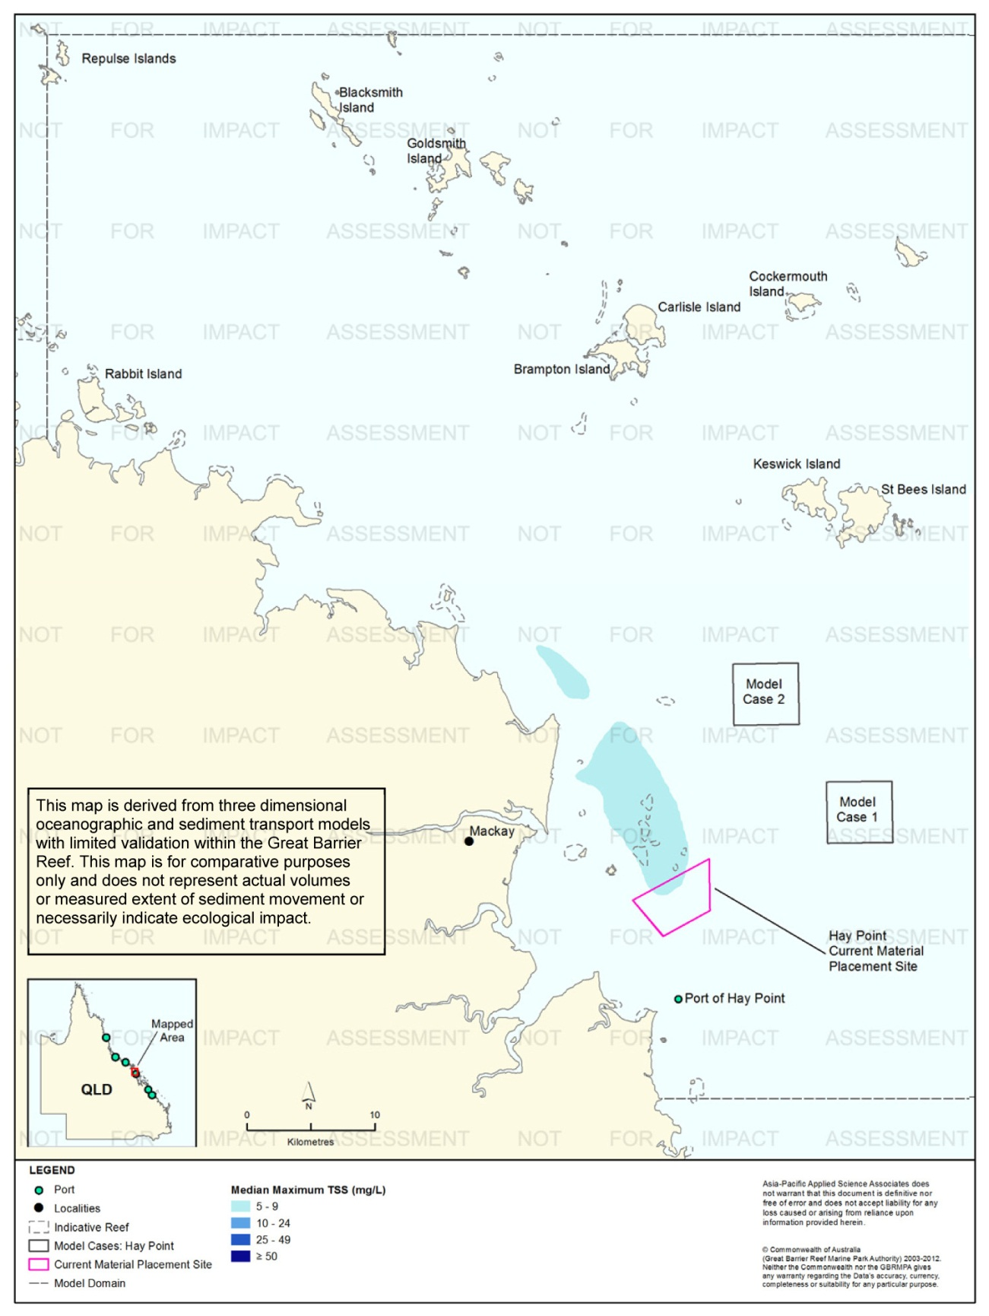
Figure 71. Hay Point: dredging period (155 days) TSS distribution, current site - 50th percentile.

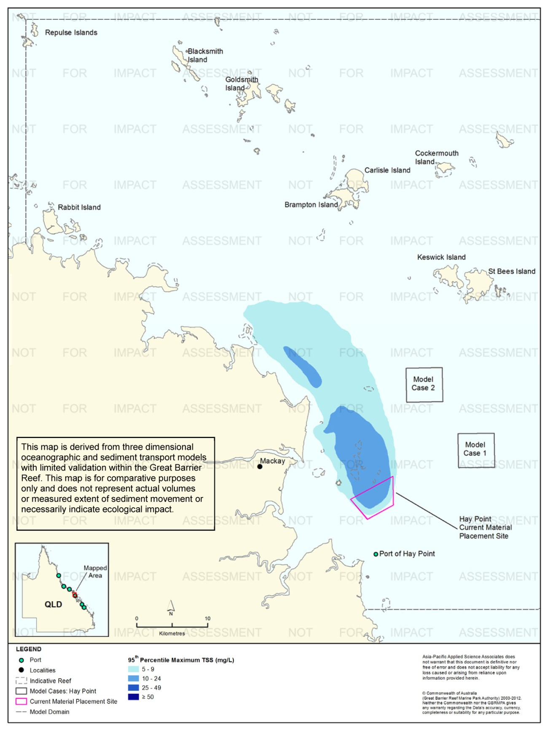
Figure 72. Hay Point: dredging period (155 days) TSS distribution, current site - 95th percentile.
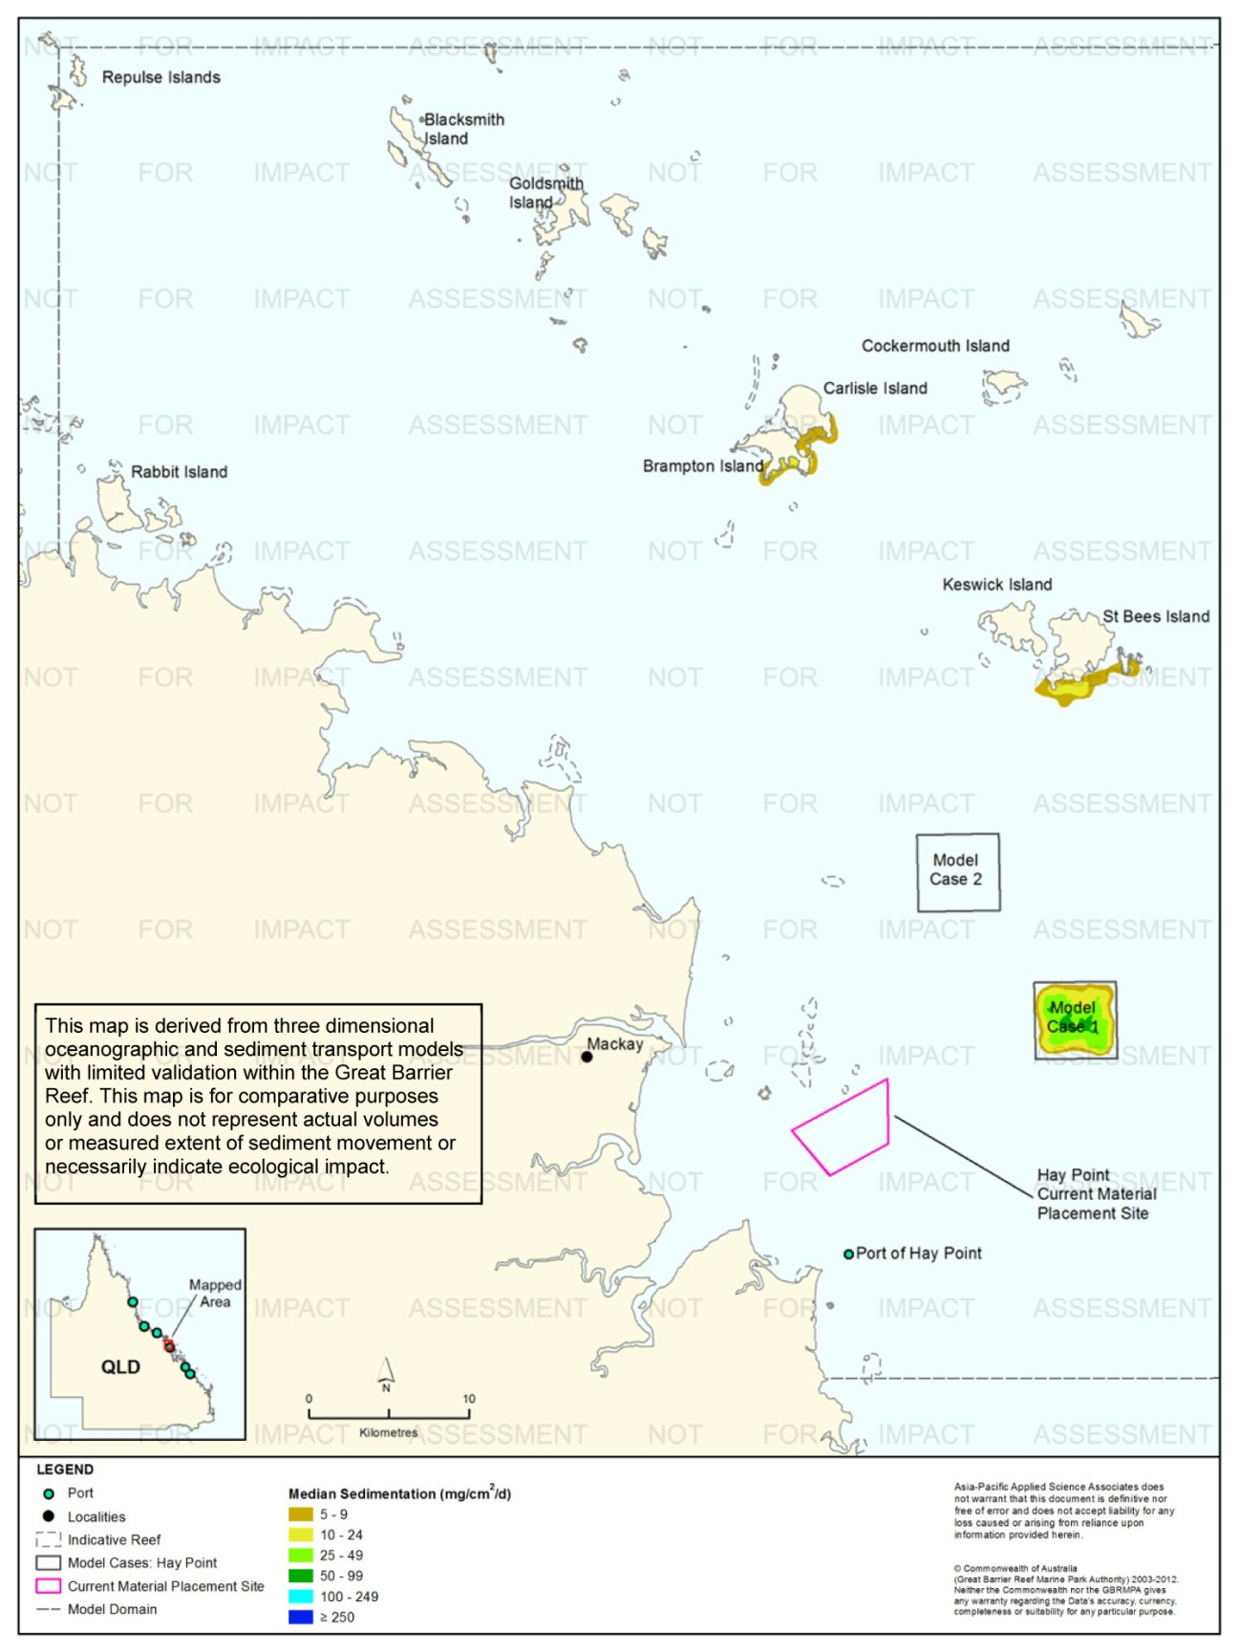
Figure 73. Hay Point: dredging period (155 days) sedimentation rate, Model Case 1 - 50th percentile.

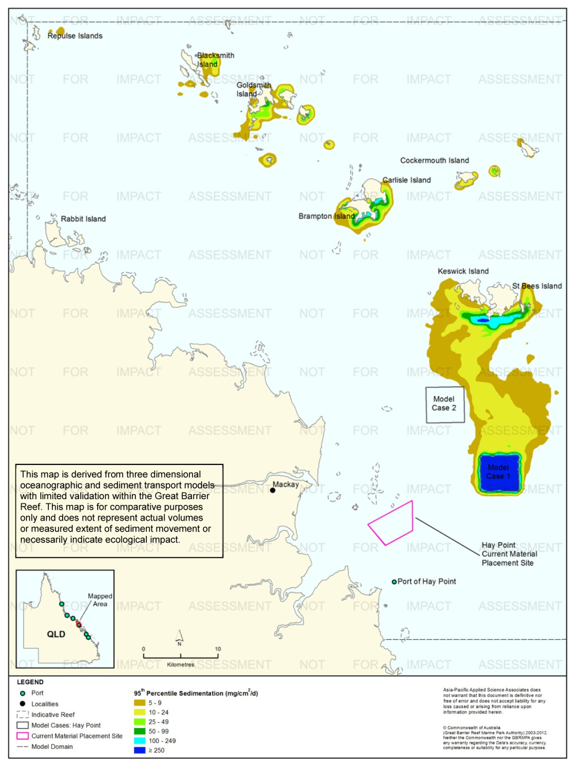
Figure 74. Hay Point: dredging period (155 days) sedimentation rate, Model Case 1 - 95th percentile.

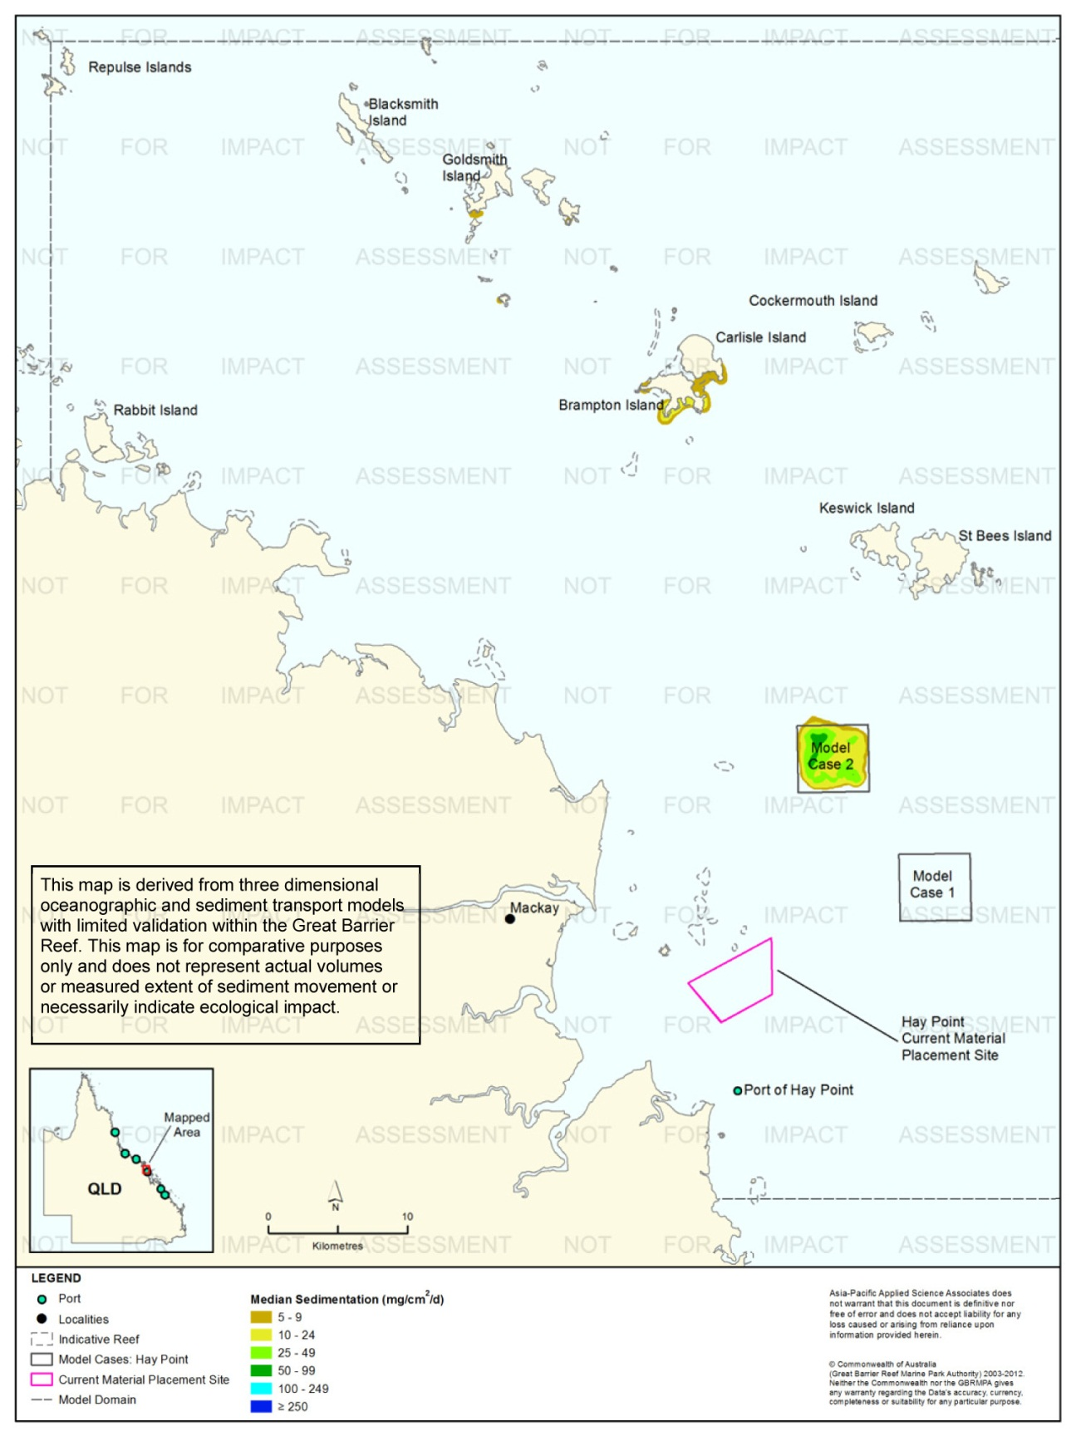
Figure 75. Hay Point: dredging period (155 days) sedimentation rate, Model Case 2 - 50th percentile.
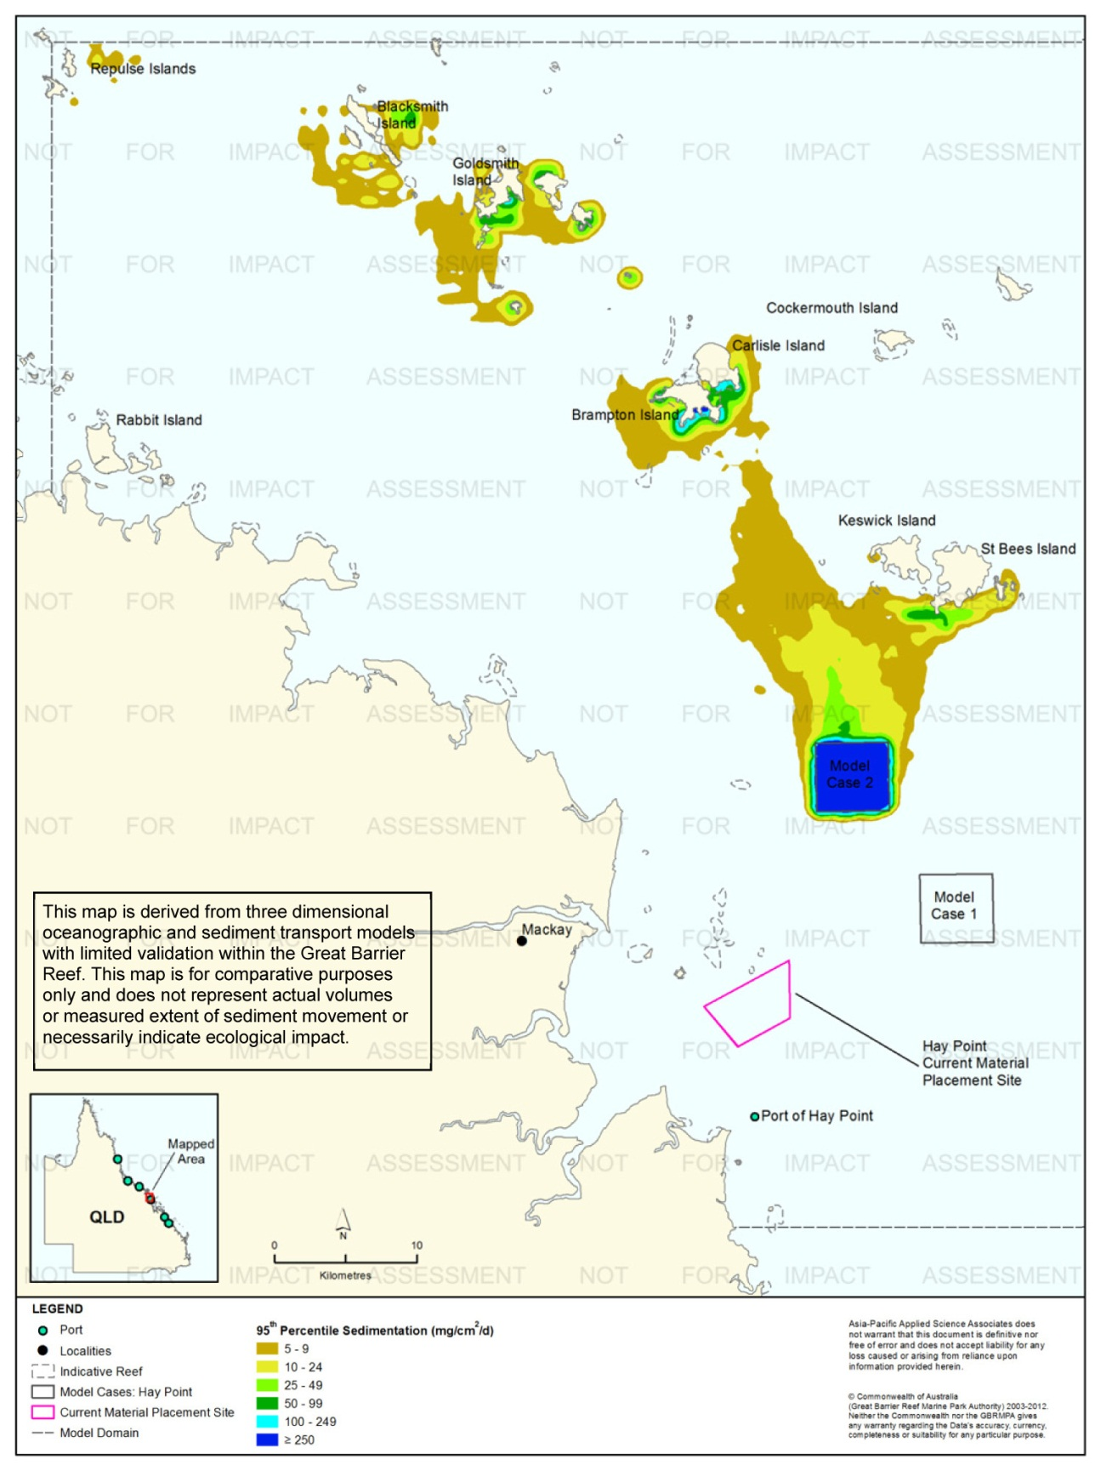
Figure 76. Hay Point: dredging period (155 days) sedimentation rate, Model Case 2 - 95th percentile.
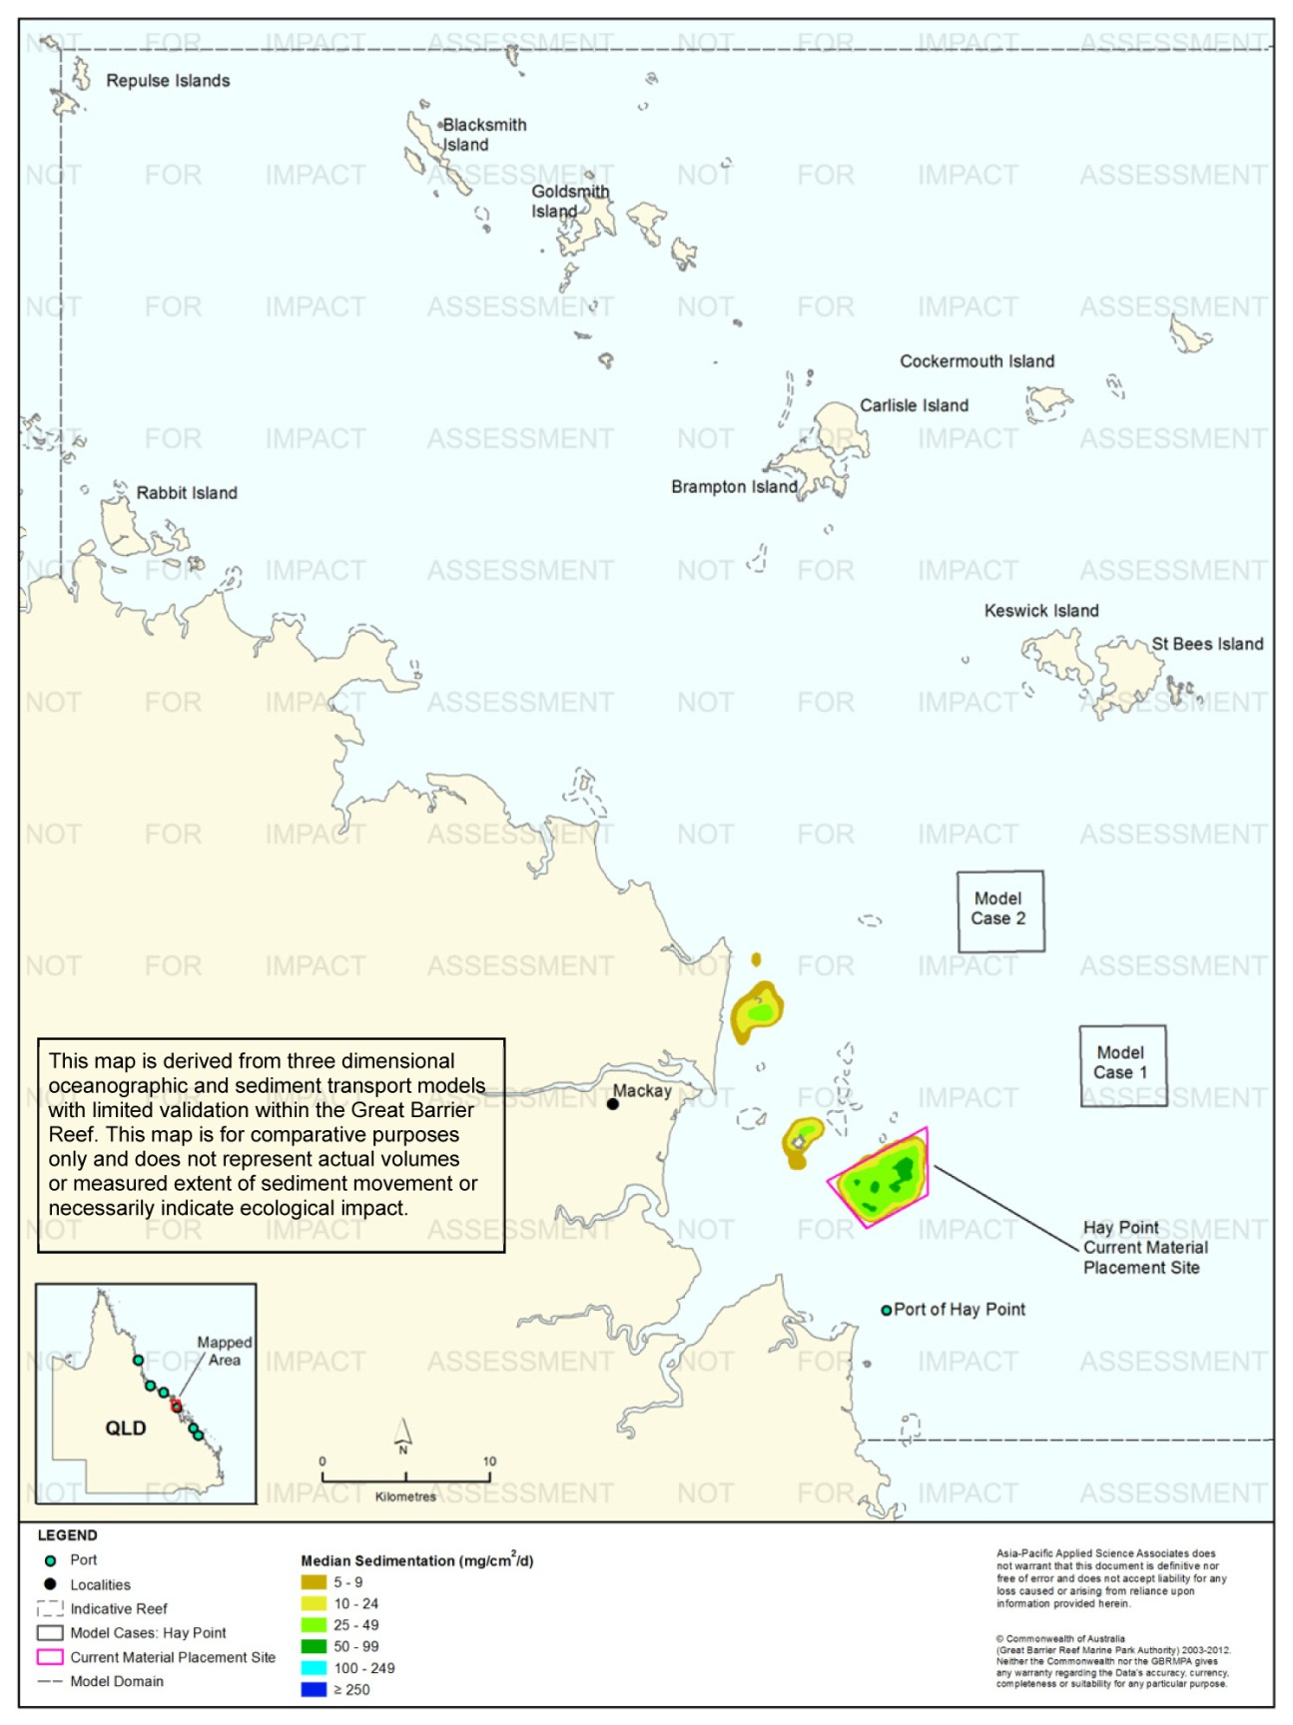
Figure 77. Hay Point: dredging period (155 days) sedimentation rate, current site - 50th percentile.
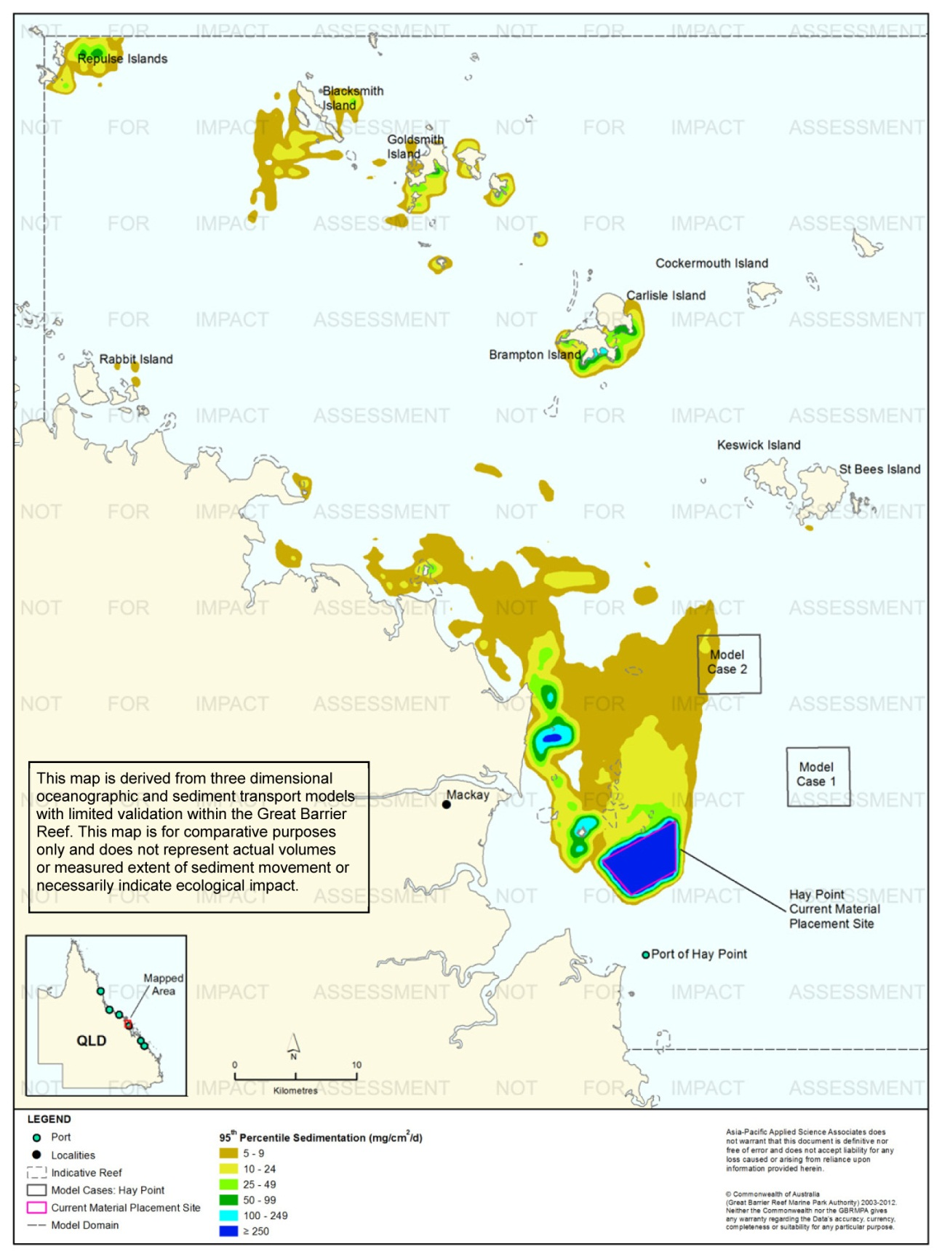
Figure 78. Hay Point: dredging period (155 days) sedimentation rate, current site - 95th percentile.
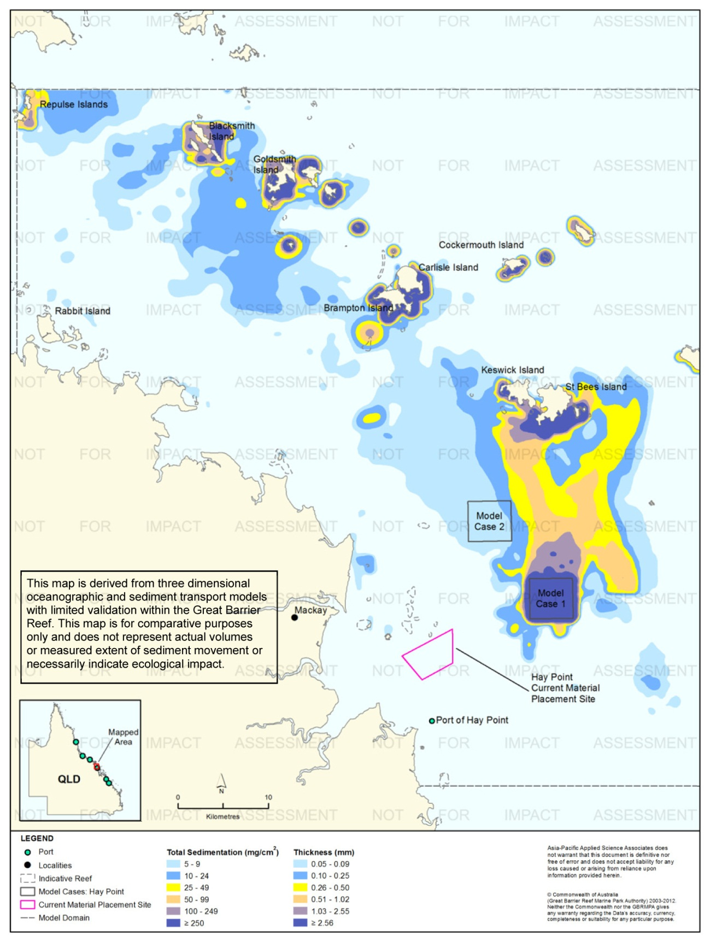
Figure 79. Hay Point: dredging period (155 days) total sedimentation and bottom thickness, Model Case 1.
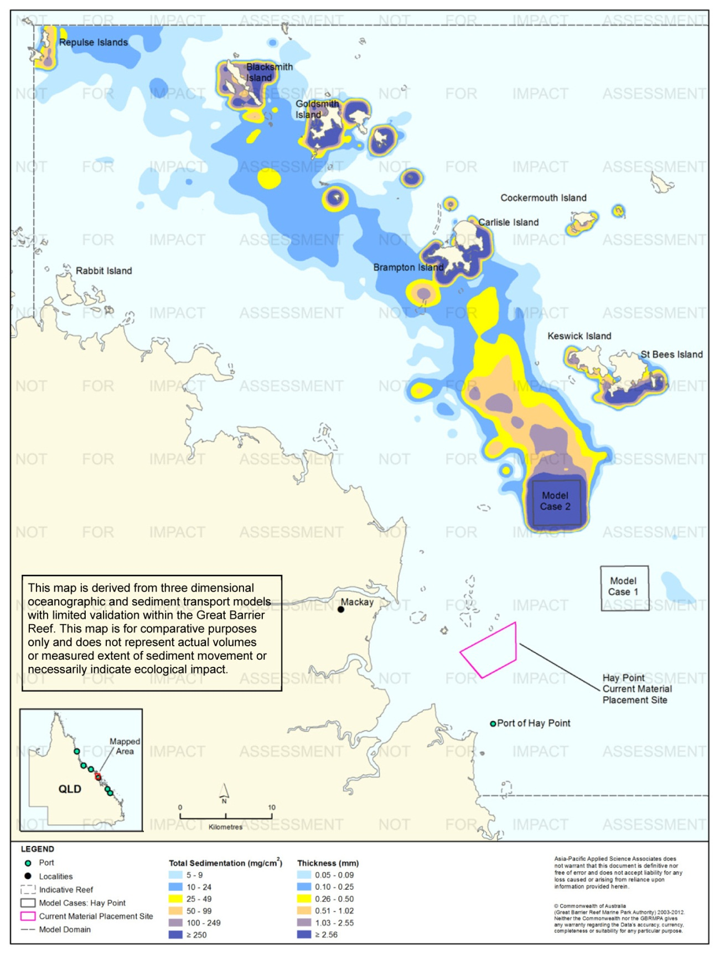
Figure 80. Hay Point: dredging period (155 days) total sedimentation and bottom thickness, Model Case 2.
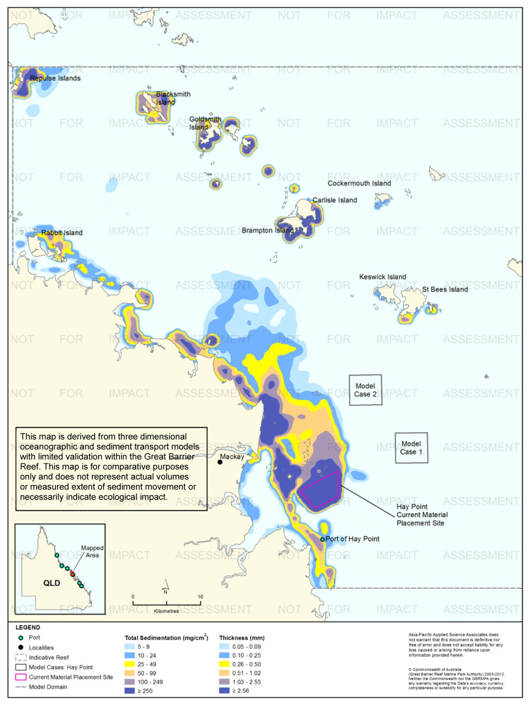
Figure 81. Hay Point: dredging period (155 days) total sedimentation and bottom thickness, current site.

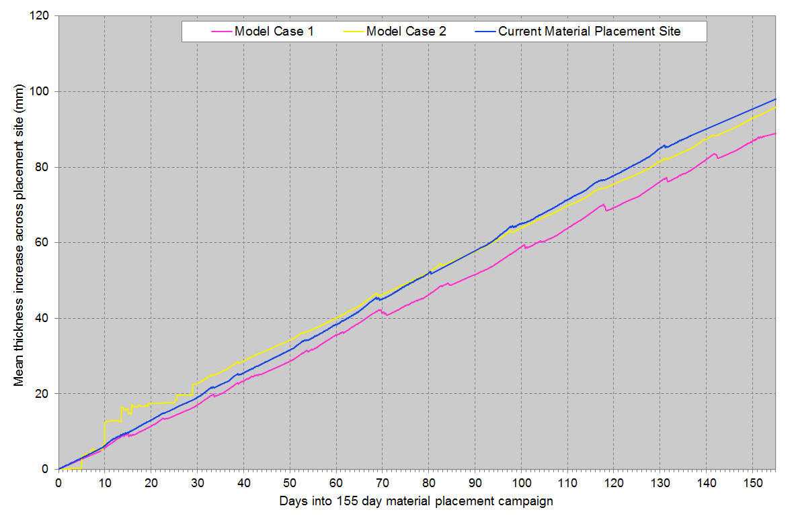
Figure 82. Hay Point: Mean bottom thicknesses across the material placement sites. Results are based on the relocation of 8,500,000 m³ over 155 days (five releases per day of 11,000 m³).

Results at the End of the 12-Month Modelling Period
Figure 83 to figure 85 illustrate the predicted total sedimentation and bottom sediment thickness at the end of the 12 months for Model Case 1 and Model Case 2, and the current material placement site, Port of Hay Point study location.
Modelling results at the end of the 12 months indicated substantial differences in the total sedimentation contours between the existing material placement site and the two model case sites. For Model Cases 1-2 the higher total sedimentation levels (≥ 100 mg/cm², equivalent to ≥ 1.03 mm) were confined to within 1 km from the material placement sites. The total sedimentation contours for the existing placement site show widespread total sedimentation of 100 mg/cm² or more along the coast in a north-west direction to a distance of 60 km. Depositional values of ≥ 250 mg/cm² (≥ 2.56 mm) were predicted to extend approximately 2-4 km in all directions from the current material placement site.
Major differences were observed when comparing the results at the end of the placement period and 12 months for all material placement sites. Due to the influence of the northward currents, sediments were predicted to resuspended and remobilise to levels below the reporting threshold (i.e. 5 mg/cm²) and beyond the model boundary for Model Cases 1 and 2. As a result at the end of the 12-month period, total sedimentation above 5 mg/cm² was restricted to the material placement sites. A comparison of the results for the current material placement site revealed a reduction in the extent and level in offshore areas due to sediment resuspension events. Additionally, there was increased total sedimentation to the north-west (Repulse Islands to Shutehaven) along the mainland as a result of material shifting northward along the coastline.

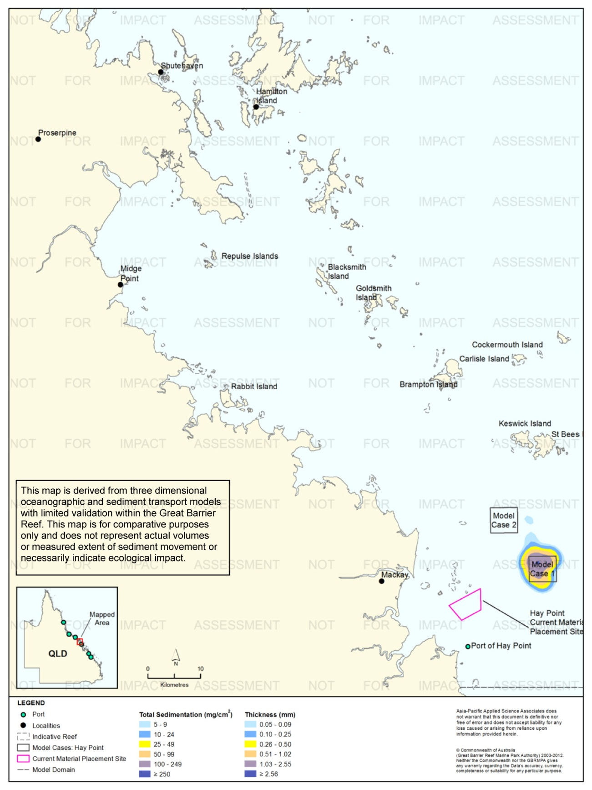
Figure 83. Hay Point: long-term (12 months) total sedimentation and bottom thickness, Model Case 1.
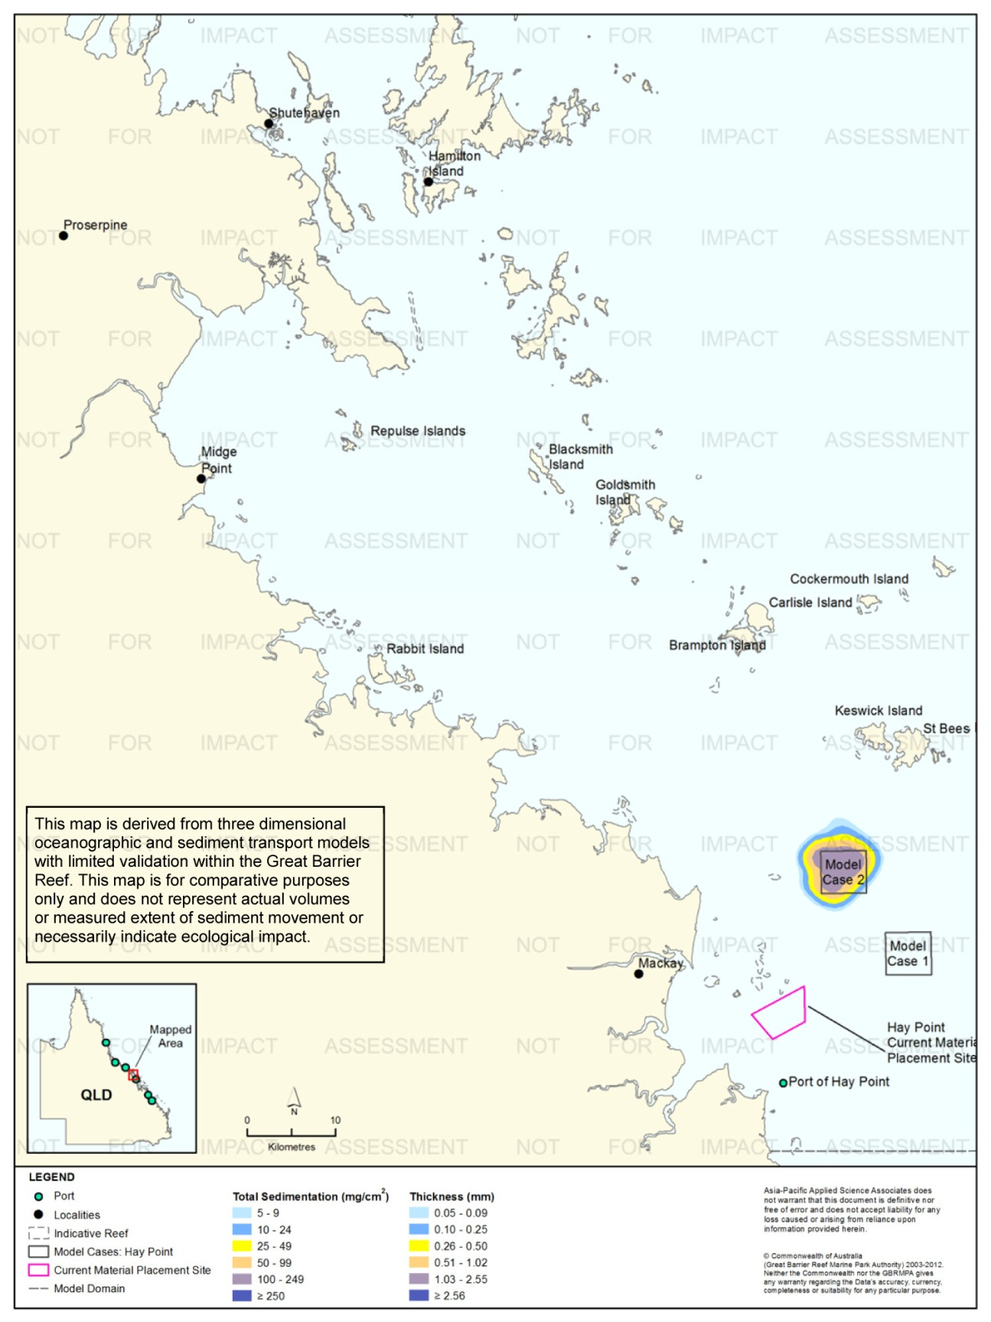
Figure 84. Hay Point: long-term (12 months) total sedimentation and bottom thickness, Model Case 2.
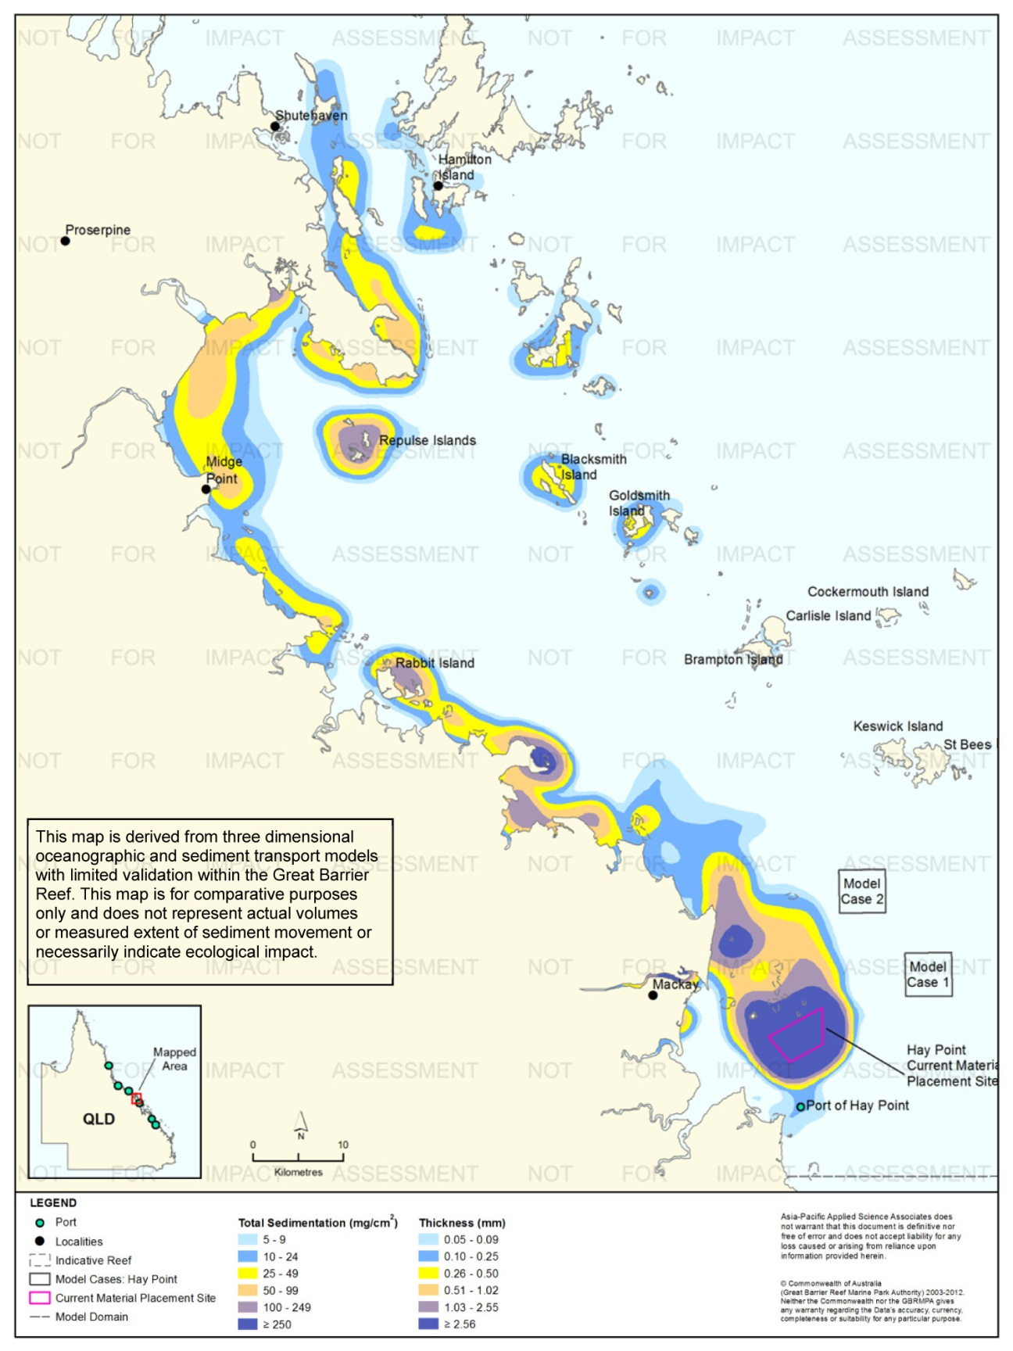
Figure 85. Hay Point: long-term (12 months) total sedimentation and bottom thickness, current site.

Port of Abbot Point

Results during the Material Placement Operations
For the Port of Abbot Point a capital dredging campaign was modelled which consisted of 3,500,000 m³ of dredged material relocated over eight weeks, commencing in June. Modelling consisted of six releases per day (10,500 m³/release), each release lasting 13 minutes. The relocated material was described as containing a 61 per cent of fine and coarse sand.
Figure 86 to figure 91 show the 50th and 95th percentile of TSS concentrations resulting from the material placement operations at Model Cases 1 and 2, and the current material placement site, respectively.
The general direction of the modelled suspended sediment plumes was to the west-north-west for all three material placement sites. The 95th percentile analysis indicated that at the current site concentrations above 50 mg/L extended approximately 2.5 km west-north-west. Concentrations between 10-24 mg/L were predicted to extend up to 15 km from the current placement site. In contrast, modelling showed smaller plumes of lower concentration (less than 25 mg/L) for Model Cases 1 and Case 2. Concentrations between 10-24 mg/L were predicted to extend up to 10 km north-west from the boundary.
Figure 92 to figure 97 show the 50th and 95th percentile of sediment rates resulting from the material placement operations at Model Cases 1-2 and the current material placement site. There were considerable differences in the sedimentation rate contours between the existing material placement site and the two model case sites based on the 95th percentile analysis. For Model Cases 1 and 2 elevated rates of sedimentation of 100 mg/cm²/d or greater encompassed areas around the perimeter of the material placement sites. In contrast, the results for the current material placement site showed elevated sedimentation rates around the site, as well as along the coast near Cape Upstart and adjacent to Alva, ~80 km west-north-west from the placement operation sites.
Figure 98 to figure 100 illustrate the predicted total sedimentation and bottom sediment thickness at the completion of the material placement operations for Model Case 1-3, Port of Abbot Point study location.
Figure 101 compares the thicknesses across the three material placement sites during the 56 day material placement campaigns. The results indicate the current material placement site was predicted to retain the greatest mean thickness at the end of the 56 day period (330 mm) compared to Model Case 1 (110 mm) and Model Case 2 (165 mm).
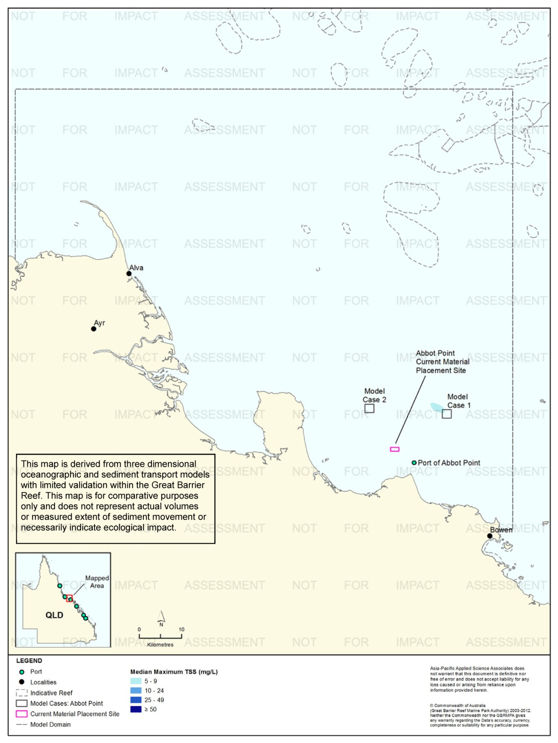
Figure 86. Abbot Point: dredging period (56 days) TSS distribution, Model Case 1 - 50th percentile.
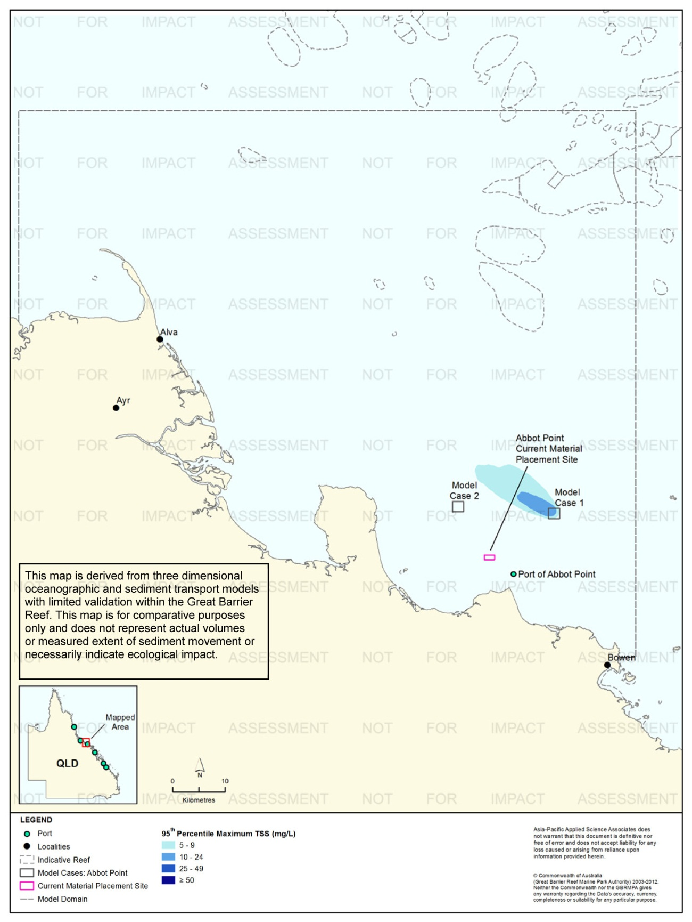
Figure 87. Abbot Point: dredging period (56 days) TSS distribution, Model Case 1 - 95th percentile.
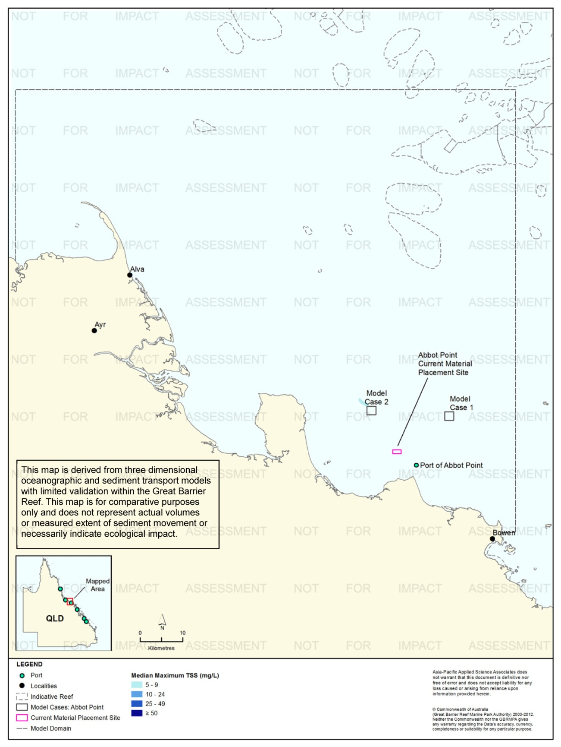
Figure 88. Abbot Point: dredging period (56 days) TSS distribution, Model Case 2 - 50th percentile.

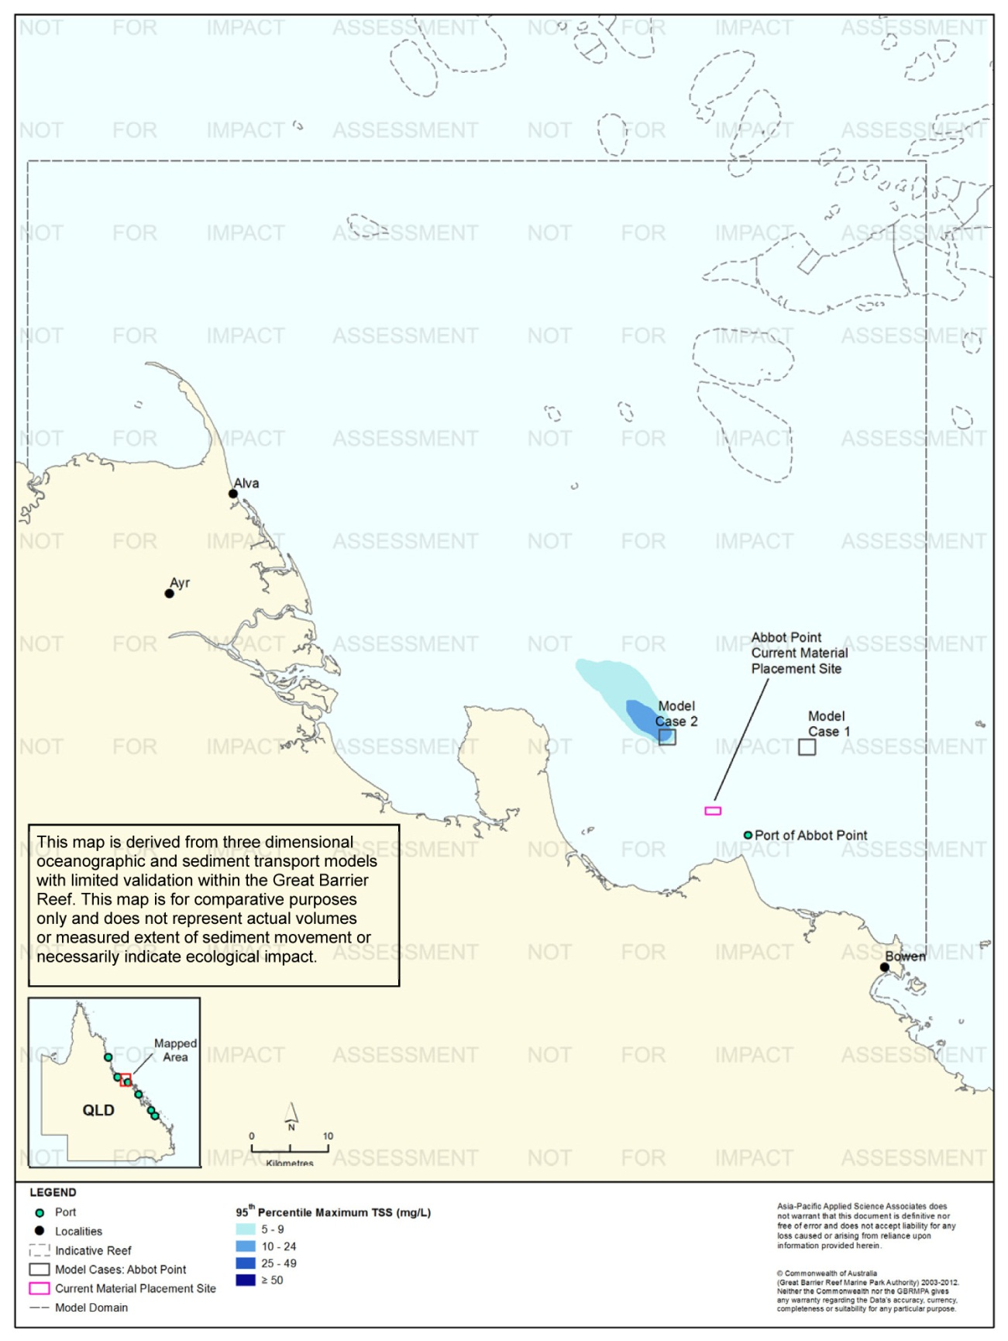
Figure 89. Abbot Point: dredging period (56 days) TSS distribution, Model Case 2 - 95th percentile.

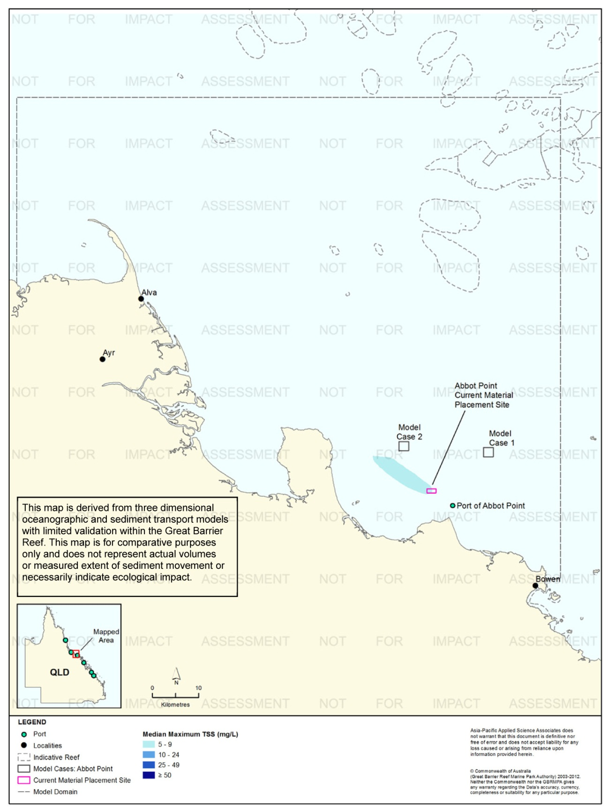
Figure 90. Abbot Point: dredging period (56 days) TSS distribution, current site - 50th percentile.

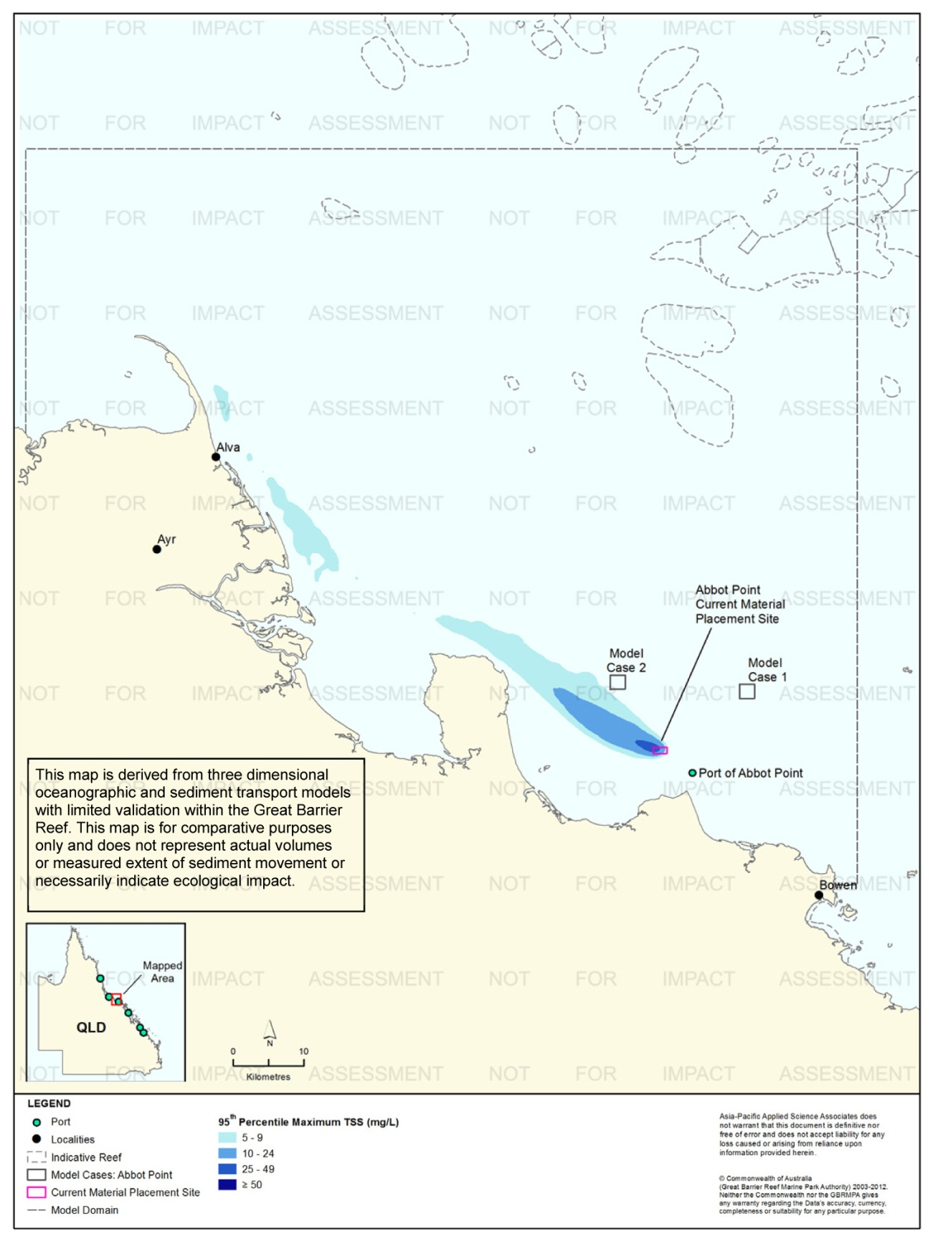
Figure 91. Abbot Point: dredging period (56 days) TSS distribution, current site - 95th percentile.

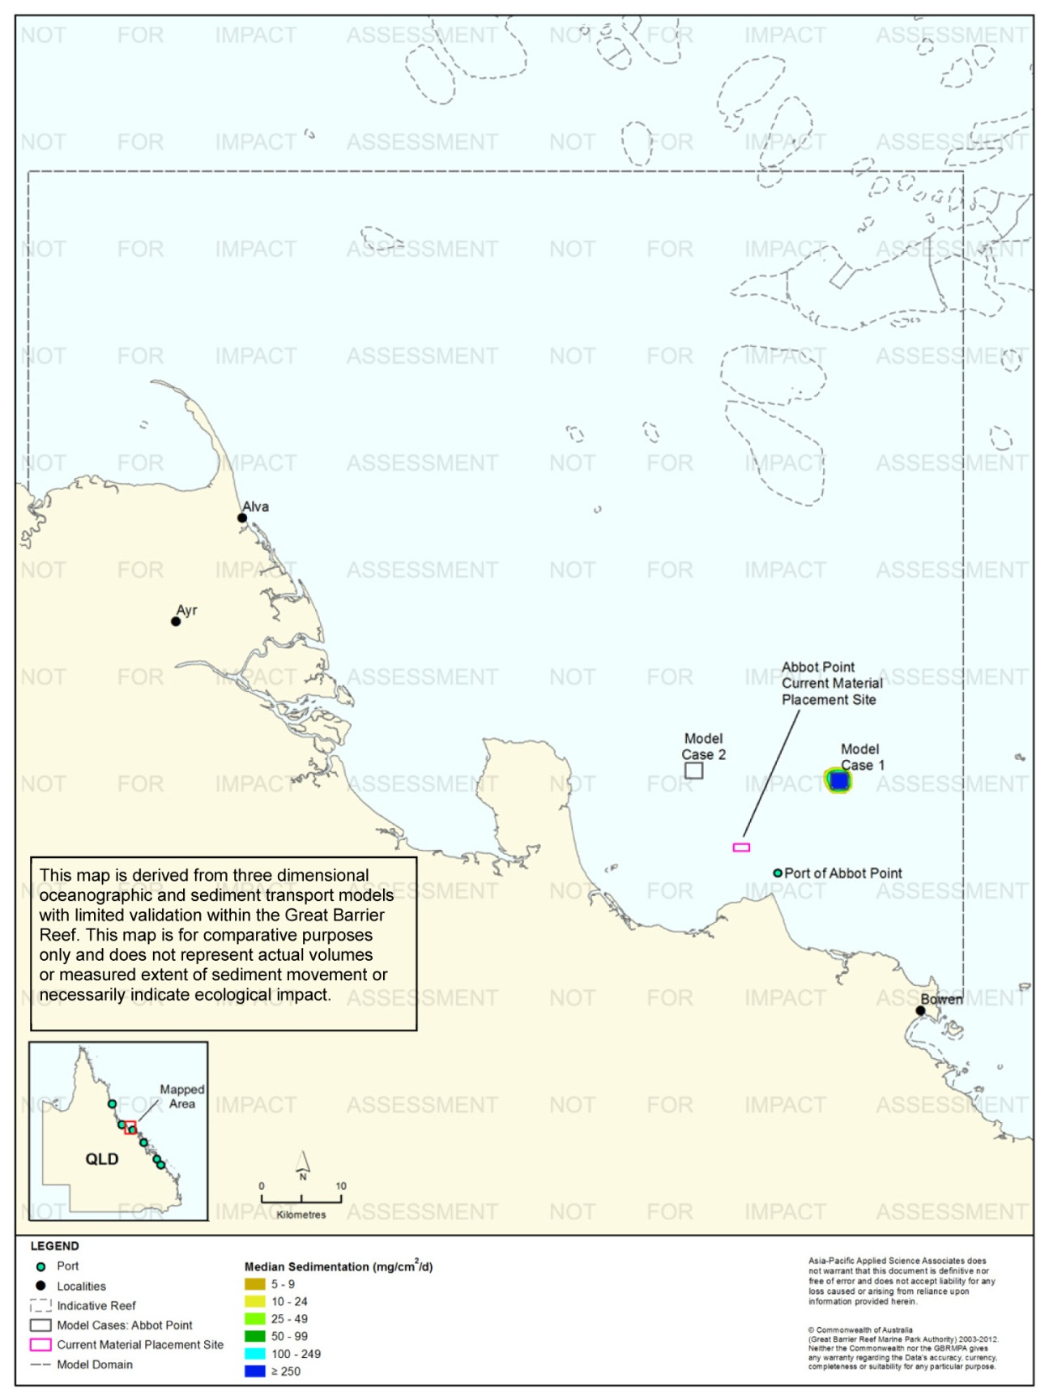
Figure 92. Abbot Point: dredging period (56 days) sedimentation rate, Model Case 1 - 50th percentile.
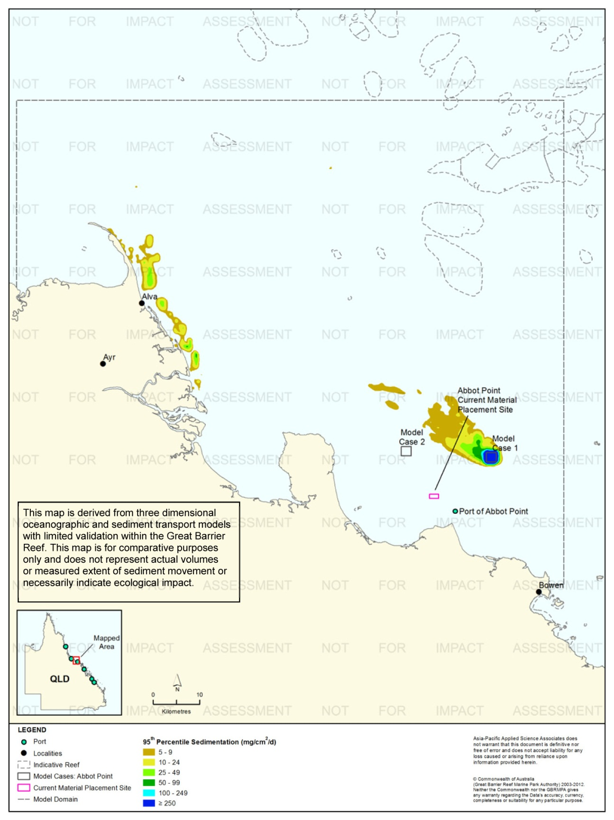
Figure 93. Abbot Point: dredging period (56 days) sedimentation rate, Model Case 1 - 95th percentile.
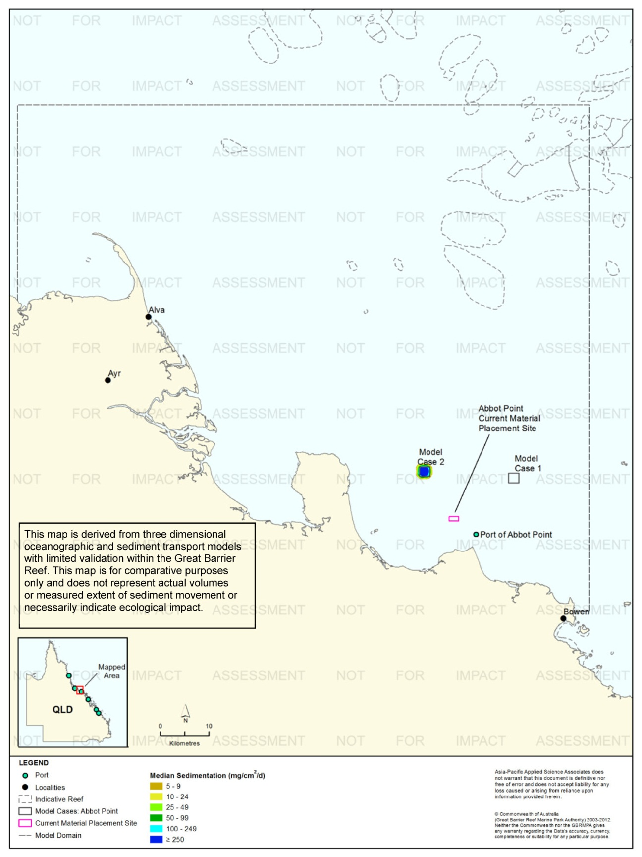
Figure 94. Abbot Point: dredging period (56 days) sedimentation rate, Model Case 2 - 50th percentile.

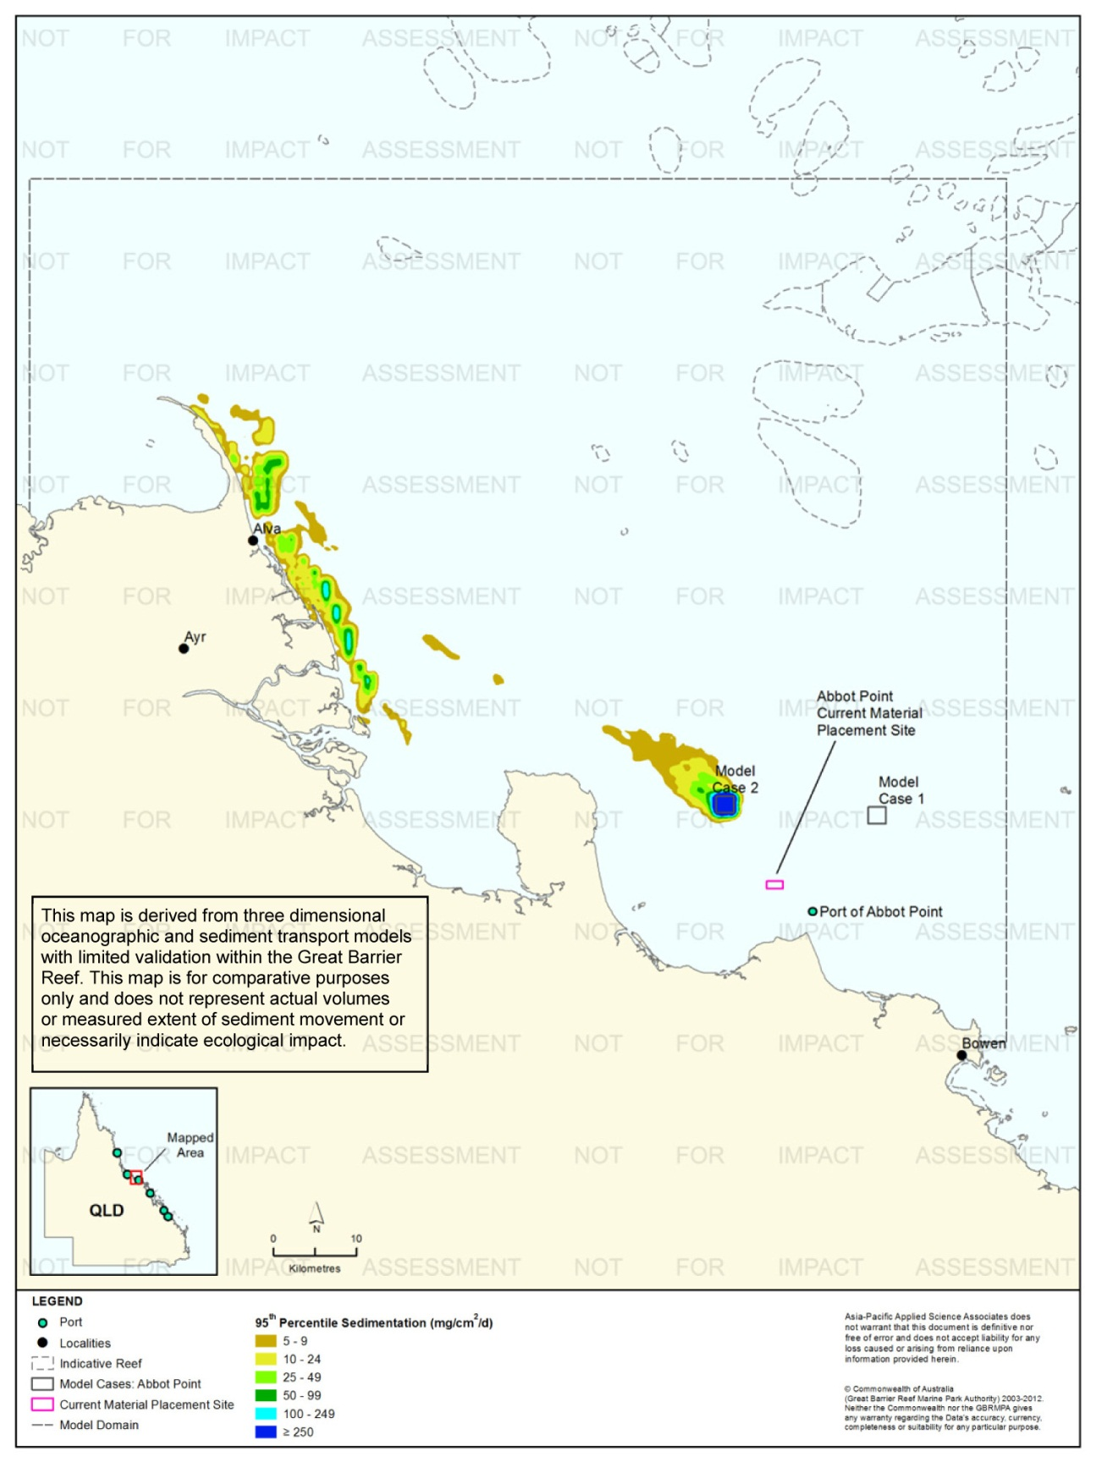
Figure 95. Abbot Point: dredging period (56 days) sedimentation rate, Model Case 2 - 95th percentile.
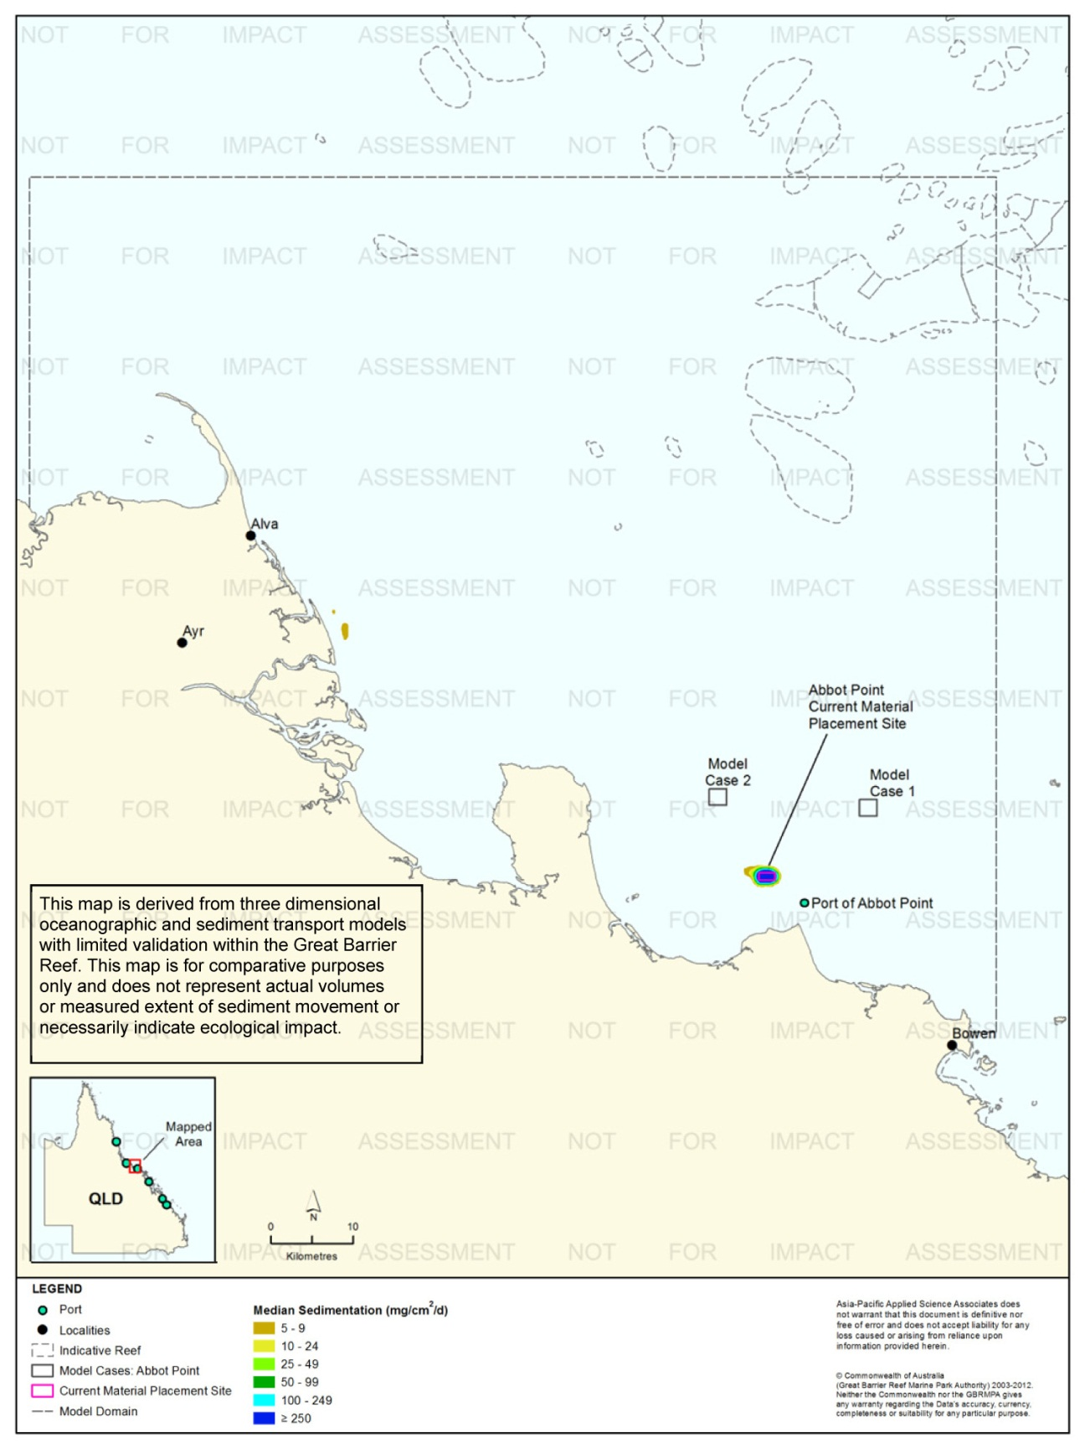
Figure 96. Abbot Point: dredging period (56 days) sedimentation rate, current site - 50th percentile.

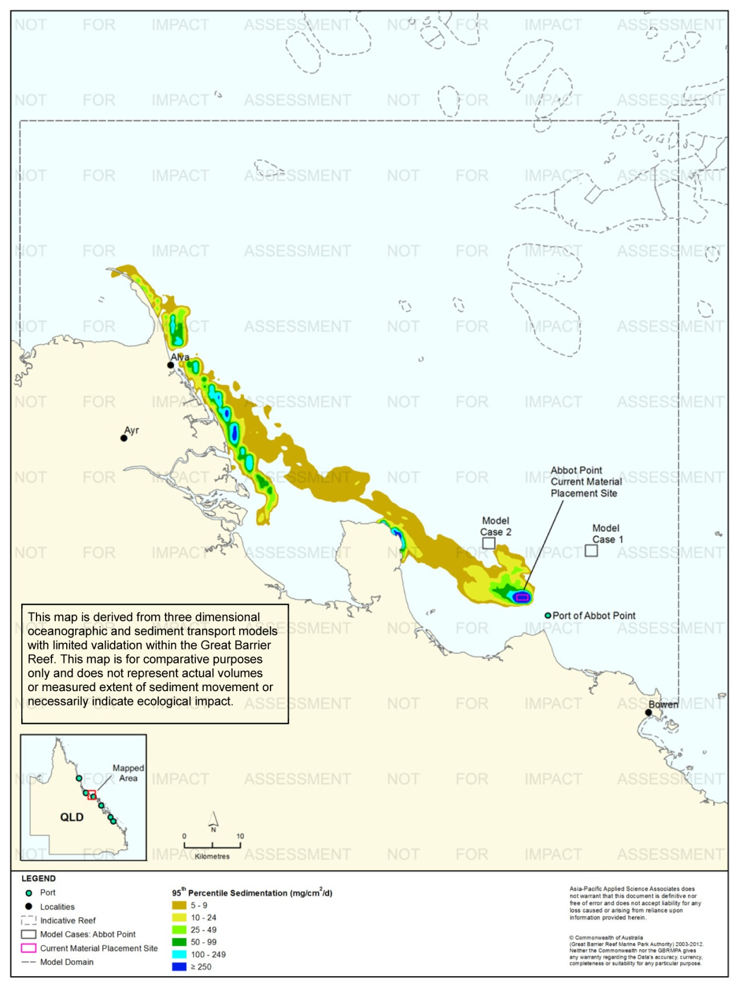
Figure 97. Abbot Point: dredging period (56 days) sedimentation rate, current site - 95th percentile.
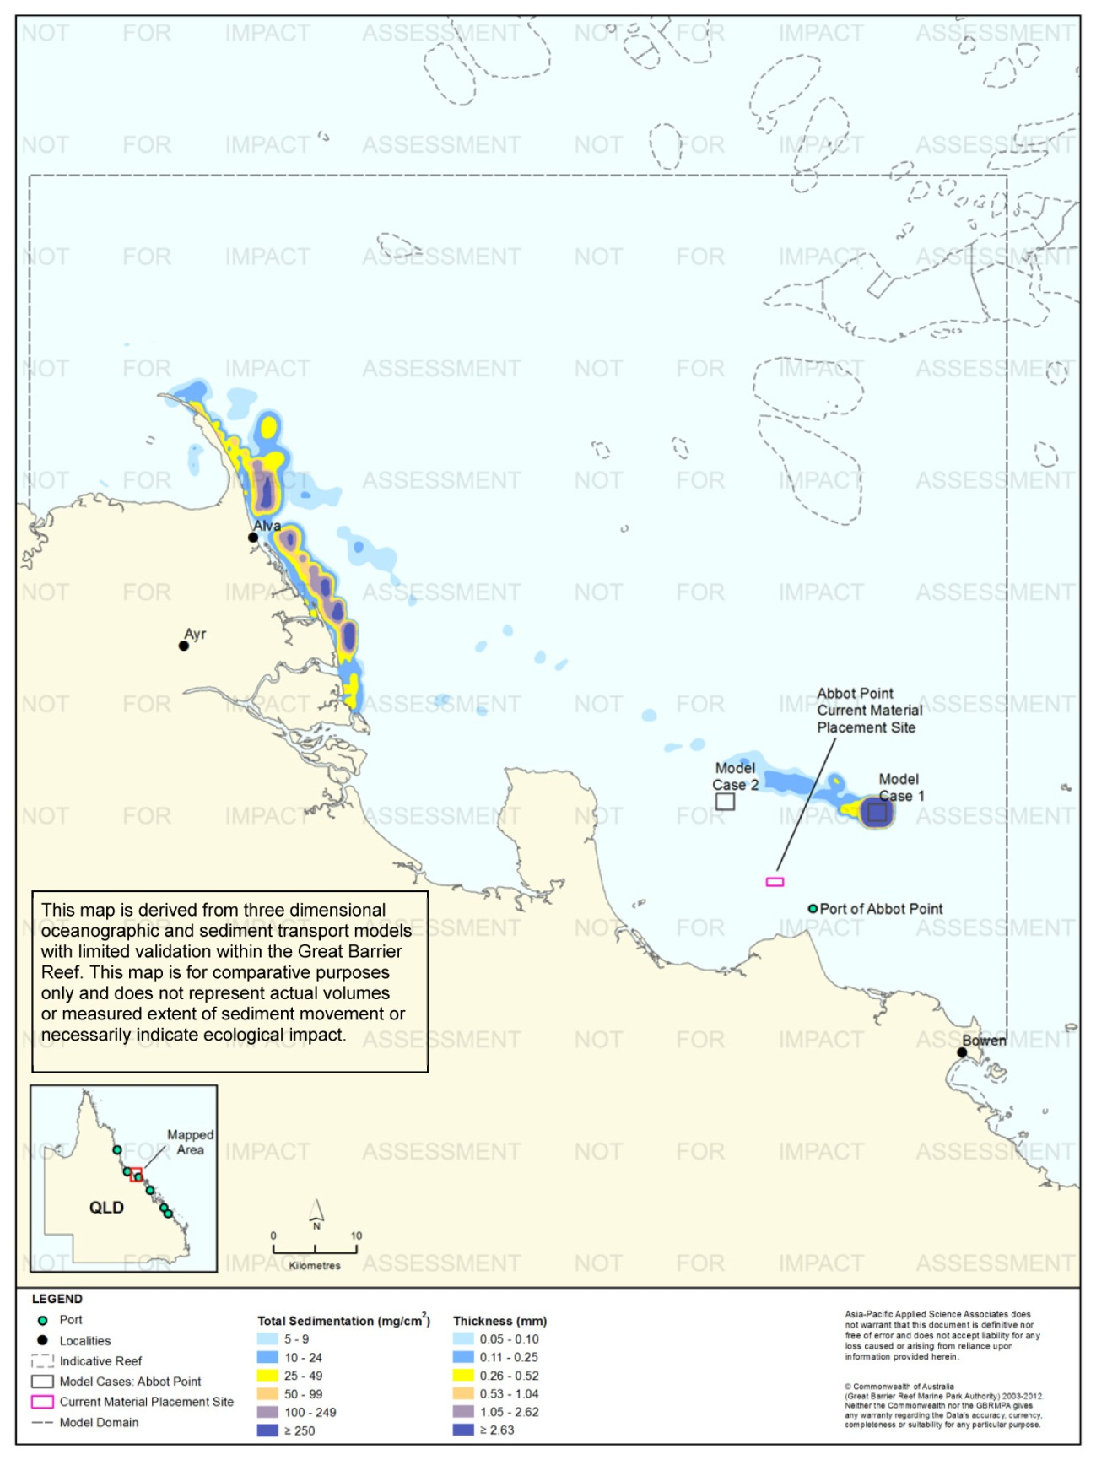
Figure 98. Abbot Point: dredging period (56 days) total sedimentation and bottom thickness, Model Case 1.
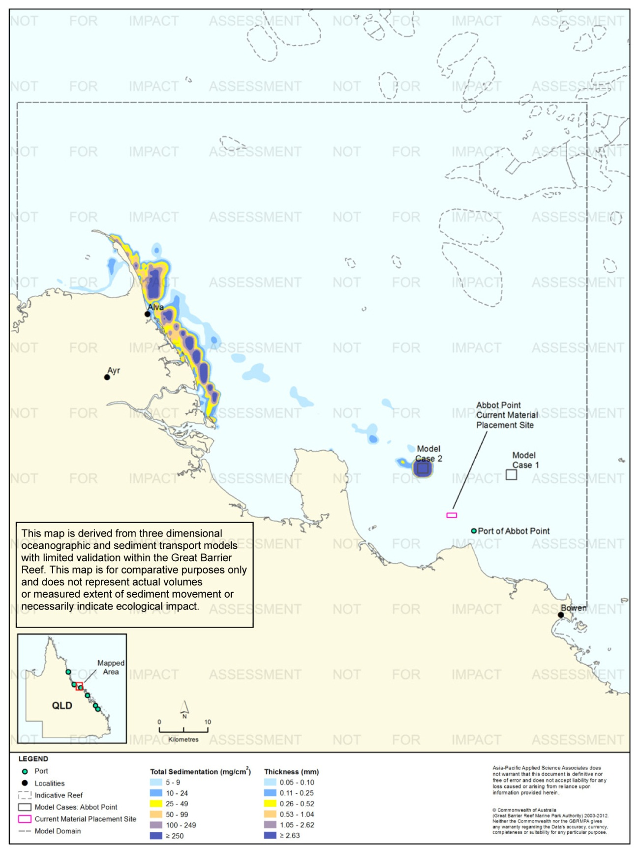
Figure 99. Abbot Point: dredging period (56 days) total sedimentation and bottom thickness, Model Case 2.
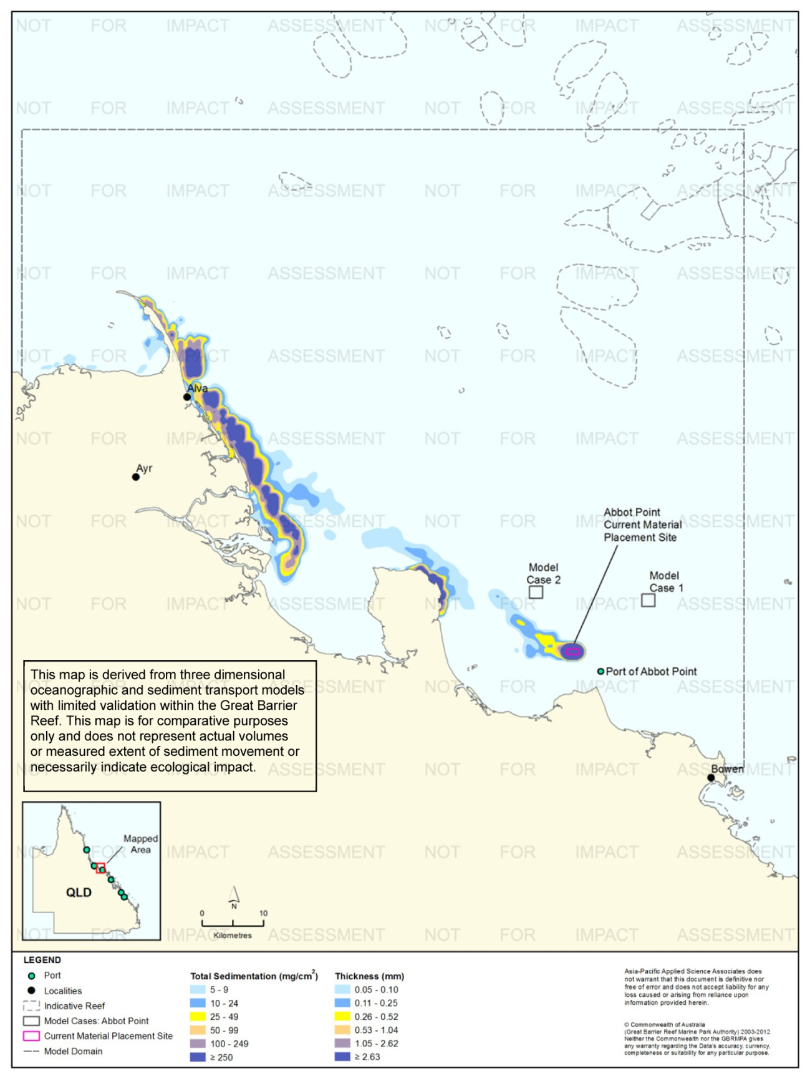
Figure 100. Abbot Point: dredging period (56 days) total sedimentation and bottom thickness, current site.
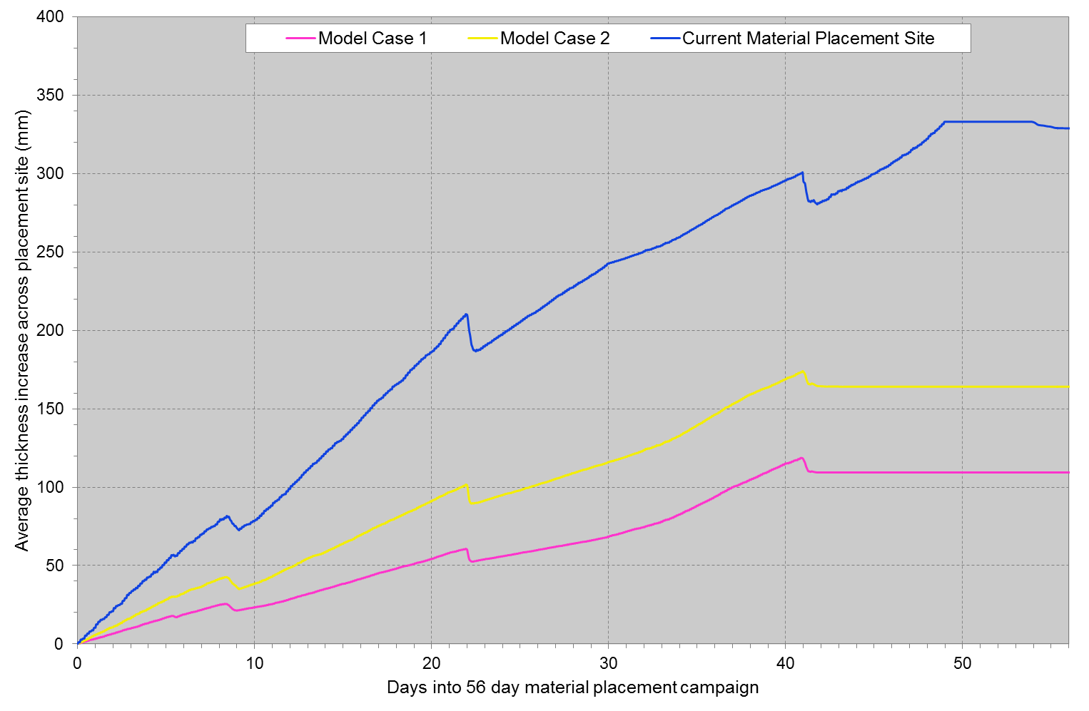
Figure 101. Abbot Point: Mean bottom thicknesses across the material placement sites. Results are based on the relocation of 3,500,000 m³ over 56days (six releases per day of 10,500 m³).

Results at the End of the 12-Month Modelling Period
Figure 102 to figure 104 illustrate the predicted total sedimentation and bottom sediment thickness at the end of 12 months for Model Cases 1 and 2, and the current material placement site, Port of Abbot Point study location.
Modelling results at the end of 12 months indicated similar results for Model Cases 1 and 2, and the Abbot Point current material placement site. In each instance, the higher total sedimentation levels (≥ 100 mg/cm², equivalent to ≥ 1.05 mm) were within 5-10 km from the material placement sites associated with each model simulation.
A comparison between the results at the completion of the material placement period and after 12 months for all sites indicates that the spatial distributions of areas of elevated total sedimentation were similar for all three material placement sites, although levels were significantly reduced along the coastline (from ≥ 250 mg/cm² to < 100 mg/cm²). The reduction in total sedimentation along the coastline adjacent to Alva, Ayr and Cape Bowling Green between the end of the placement campaign and after 12 months is due to continuing sediment resuspension and northerly sediment transport beyond the model extent.
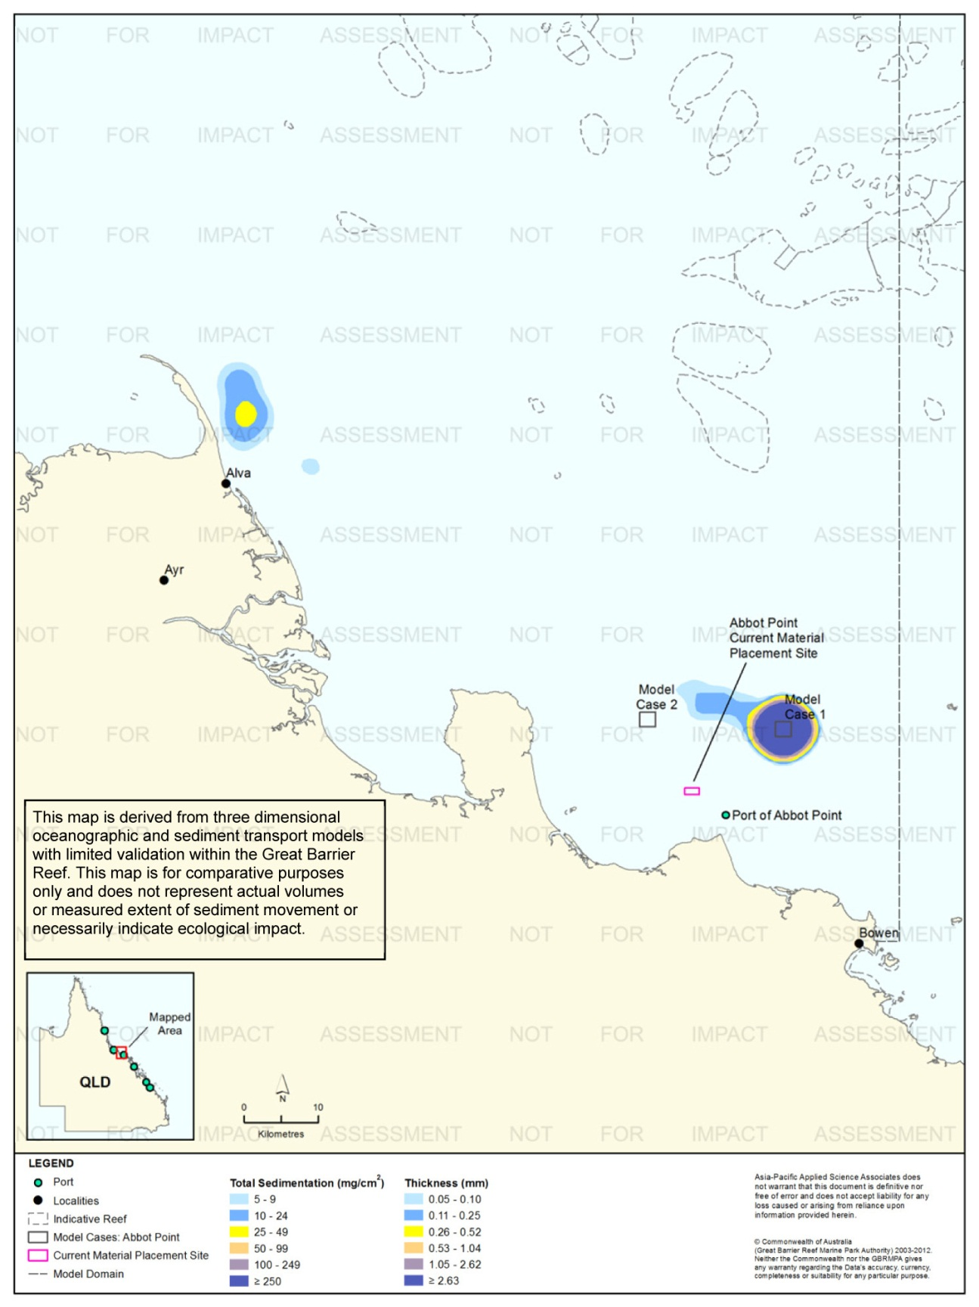
Figure 102. Abbot Point: long-term (12 months) total sedimentation and bottom thickness, Model Case 1.
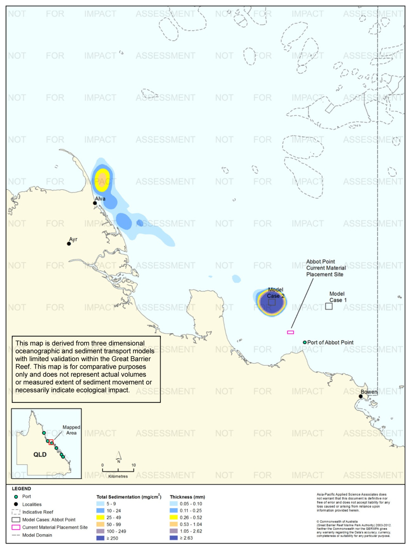
Figure 103. Abbot Point: long-term (12 months) total sedimentation and bottom thickness, Model Case 2.
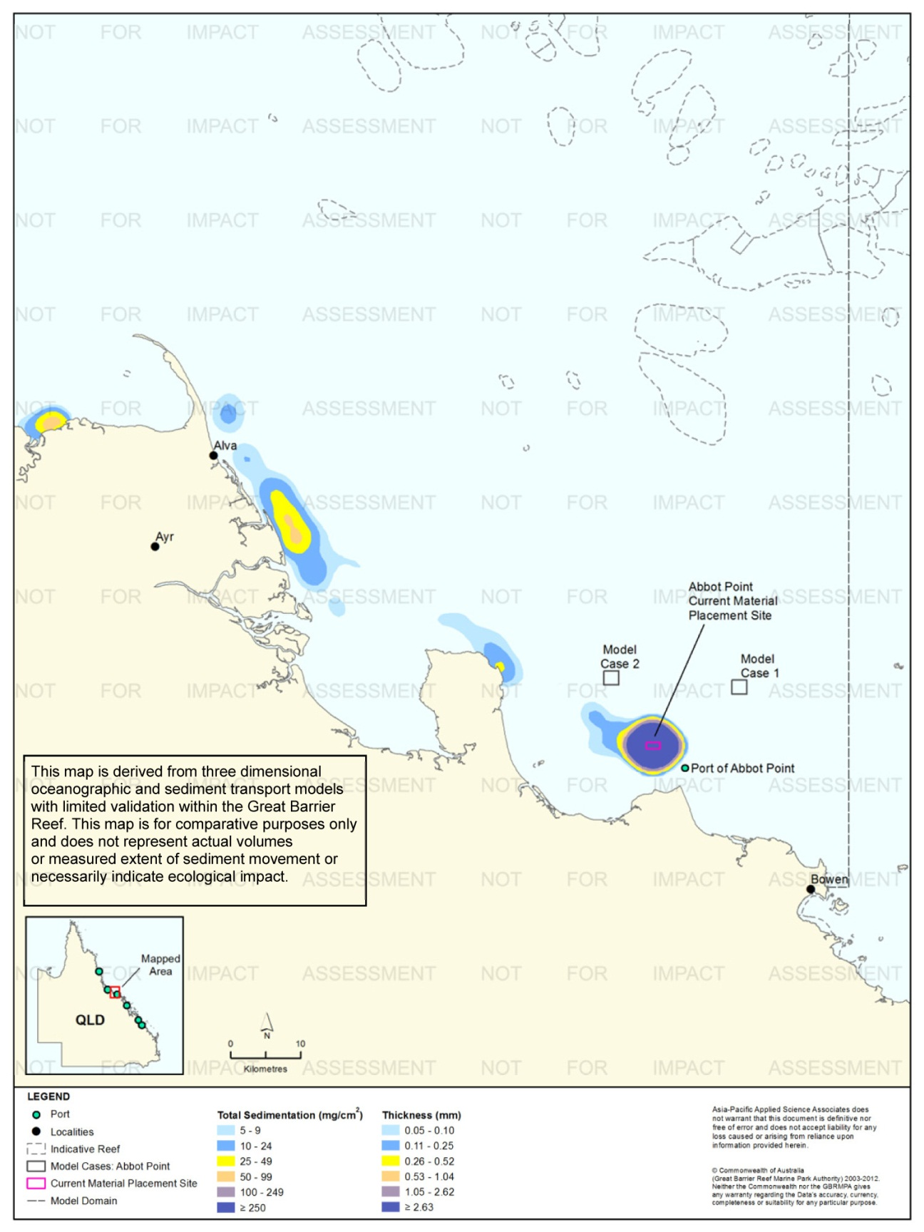
Figure 104. Abbot Point: long-term (12 months) total sedimentation and bottom thickness, current site.

Port of Townsville

Results During the Material Placement Operations
For the Port of Townsville a maintenance dredging campaign was modelled which consisted of 400,000 m³ of dredged material relocated over six weeks, commencing in September was modelled. Modelling consisted of four releases per day (2,231 m³/release), each release lasting 35 minutes over six weeks. The dredged material consisted of a 71 per cent, clay and fine silts.
The modelling predicted TSS concentrations would remain equal to or below 5 mg/L, 95 per cent of the time for all three material placement sites. Therefore, for comparisons, Figure 105 to figure 107 show the 100th percentile concentrations for Model Cases 1-2 and the current material placement site. The contours thus provide the extremely conservative results.
The suspended sediment plumes were predicted to mainly disperse in a north-west direction for all three modelled material placement sites, with sediments placed at the current site also predicted to migrate in a south-east direction.
Based on the 100th percentile analysis all three sites showed that concentrations between 10-24 mg/L were predicted to the north-west and alongside Magnetic Island to the northern grid extent, just south of Lucinda. Additionally, waters adjacent Palm Island and Havannah Island to the north and Cleveland Bay in the south are also predicted to experience TSS concentrations of up to 10-24 mg/L. Isolated regions were also predicted to encounter concentrations of 25-49 mg/L during the material placement operations. The results for the current material placement site exhibited concentrations of ≥ 50 mg/L within the vicinity of the placement site, nearby Magnetic Island and in Cleveland Bay (see figure 107).
Figure 108 to figure 113 presents the 50th and 95th percentile of sedimentation rates for the three sites. Fifty per cent of the time, the sedimentation rates did not exceed 24 mg/cm²/d for all three sites. Based on the 95th percentile analysis, the elevated rates of sedimentation of 100 mg/cm²/d or more were confined to the material placement sites.
Figure 114 to figure 116 illustrate the predicted total sedimentation and bottom thicknesses at the completion of the material placement operations (day 45) for the three sites.
Figure 117 compares the mean thickness increase across the material placement sites over the 45 day material placement operation. The results indicate that all three sites were characterised by very small increases in predicted thicknesses by day 45, between 1.7 mm to 2.1 mm.
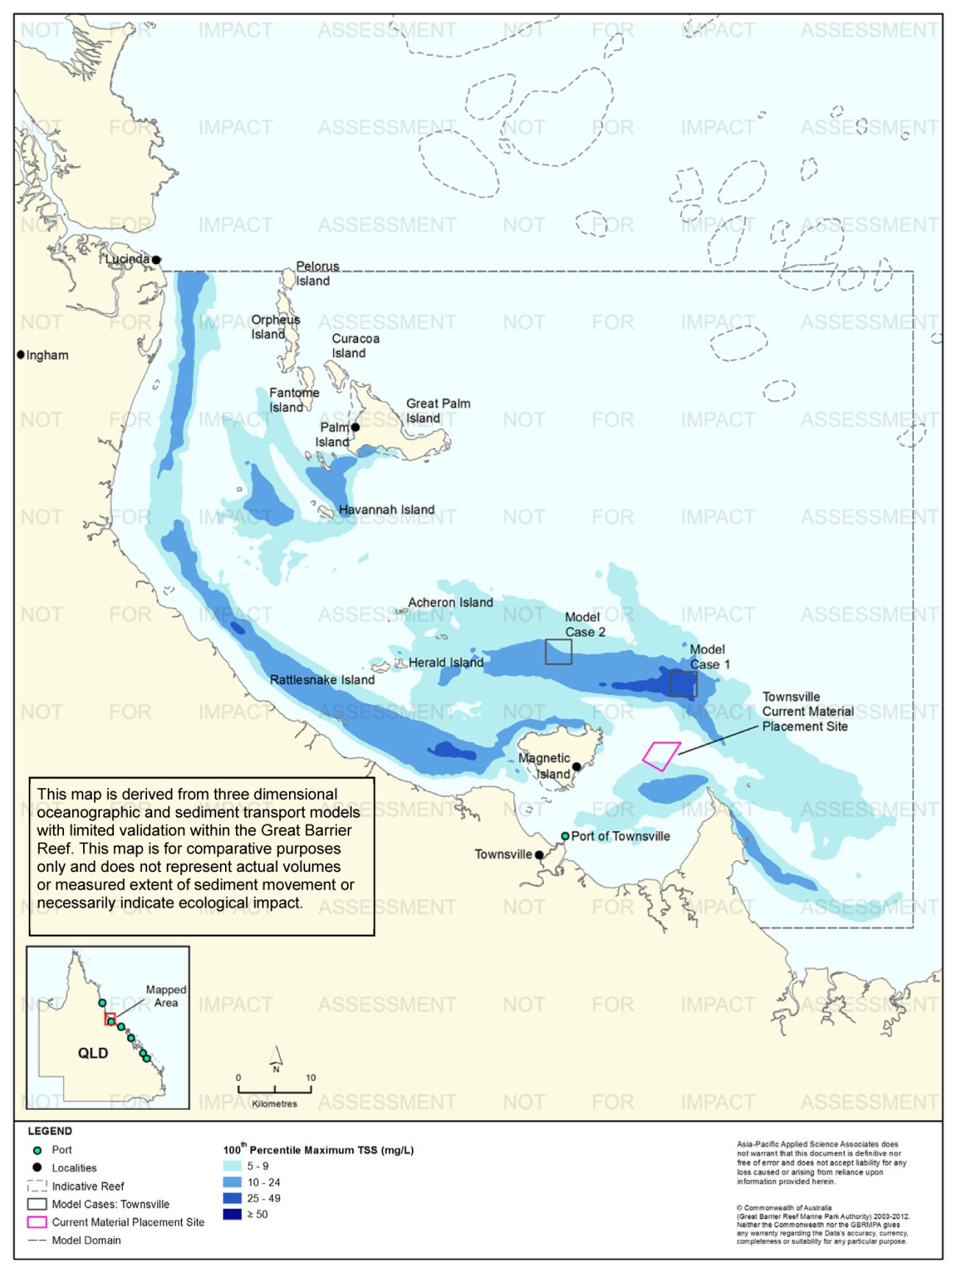
Figure 105. Townsville: dredging period (45 days) TSS distribution, Model Case 1 - 100th percentile.
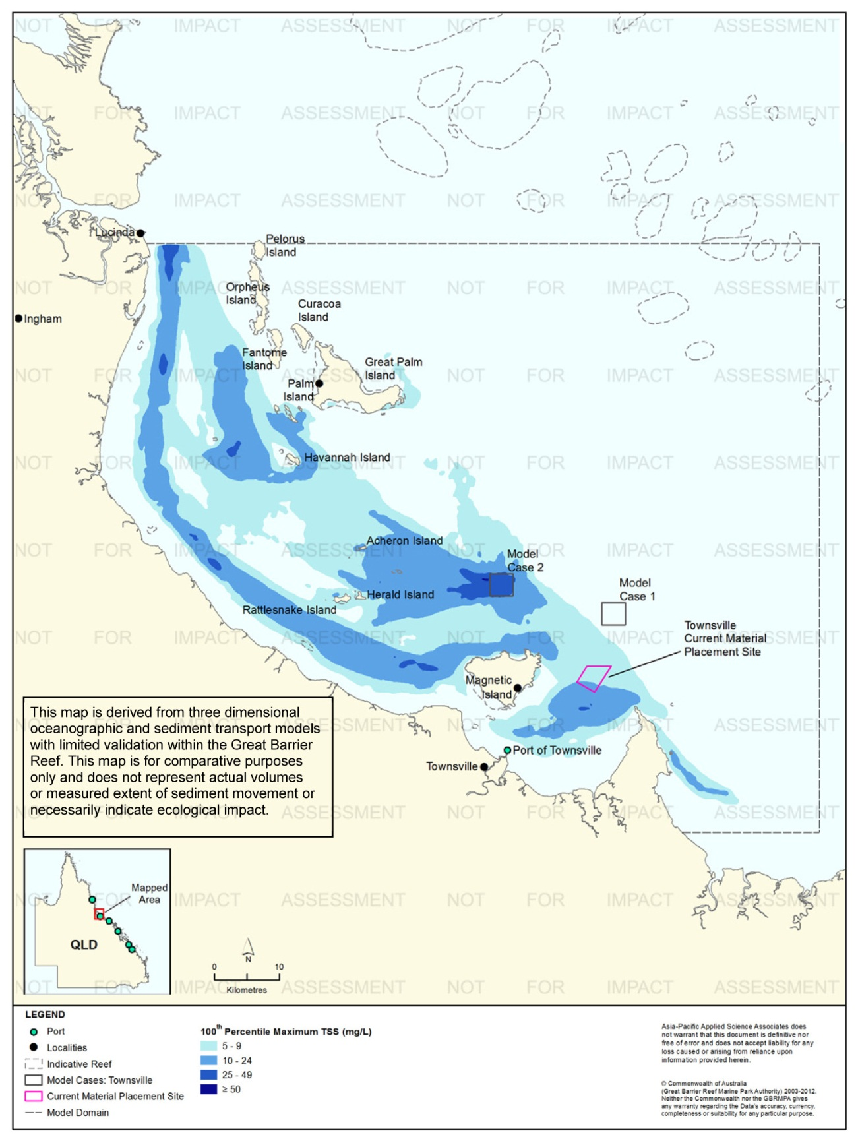
Figure 106. Townsville: dredging period (45 days) TSS distribution, Model Case 2 - 100th percentile.

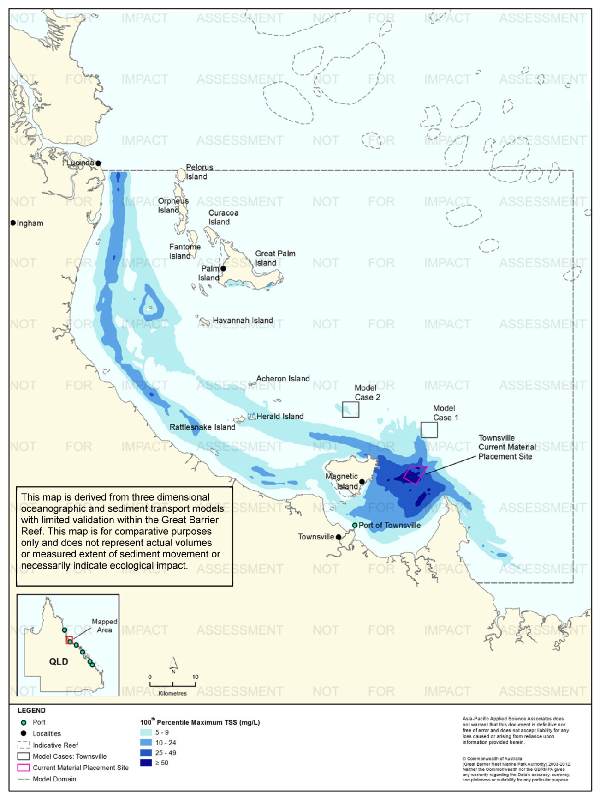
Figure 107. Townsville: dredging period (45 days) TSS distribution, current site - 100th percentile.

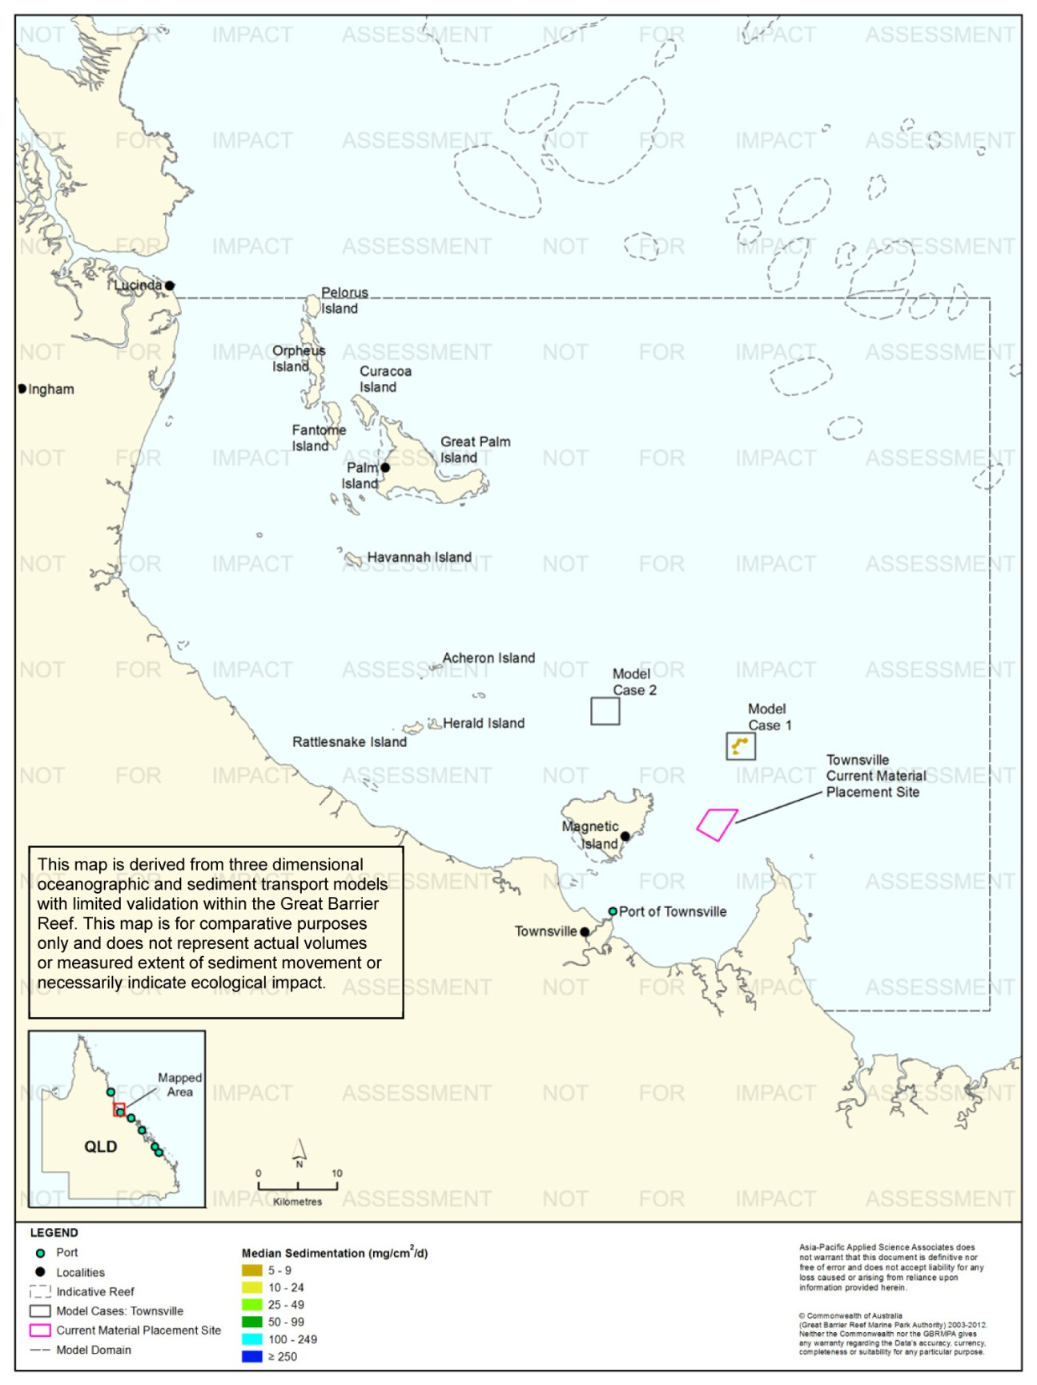
Figure 108. Townsville: dredging period (45 days) sedimentation rate, Model Case 1 - 50th percentile.
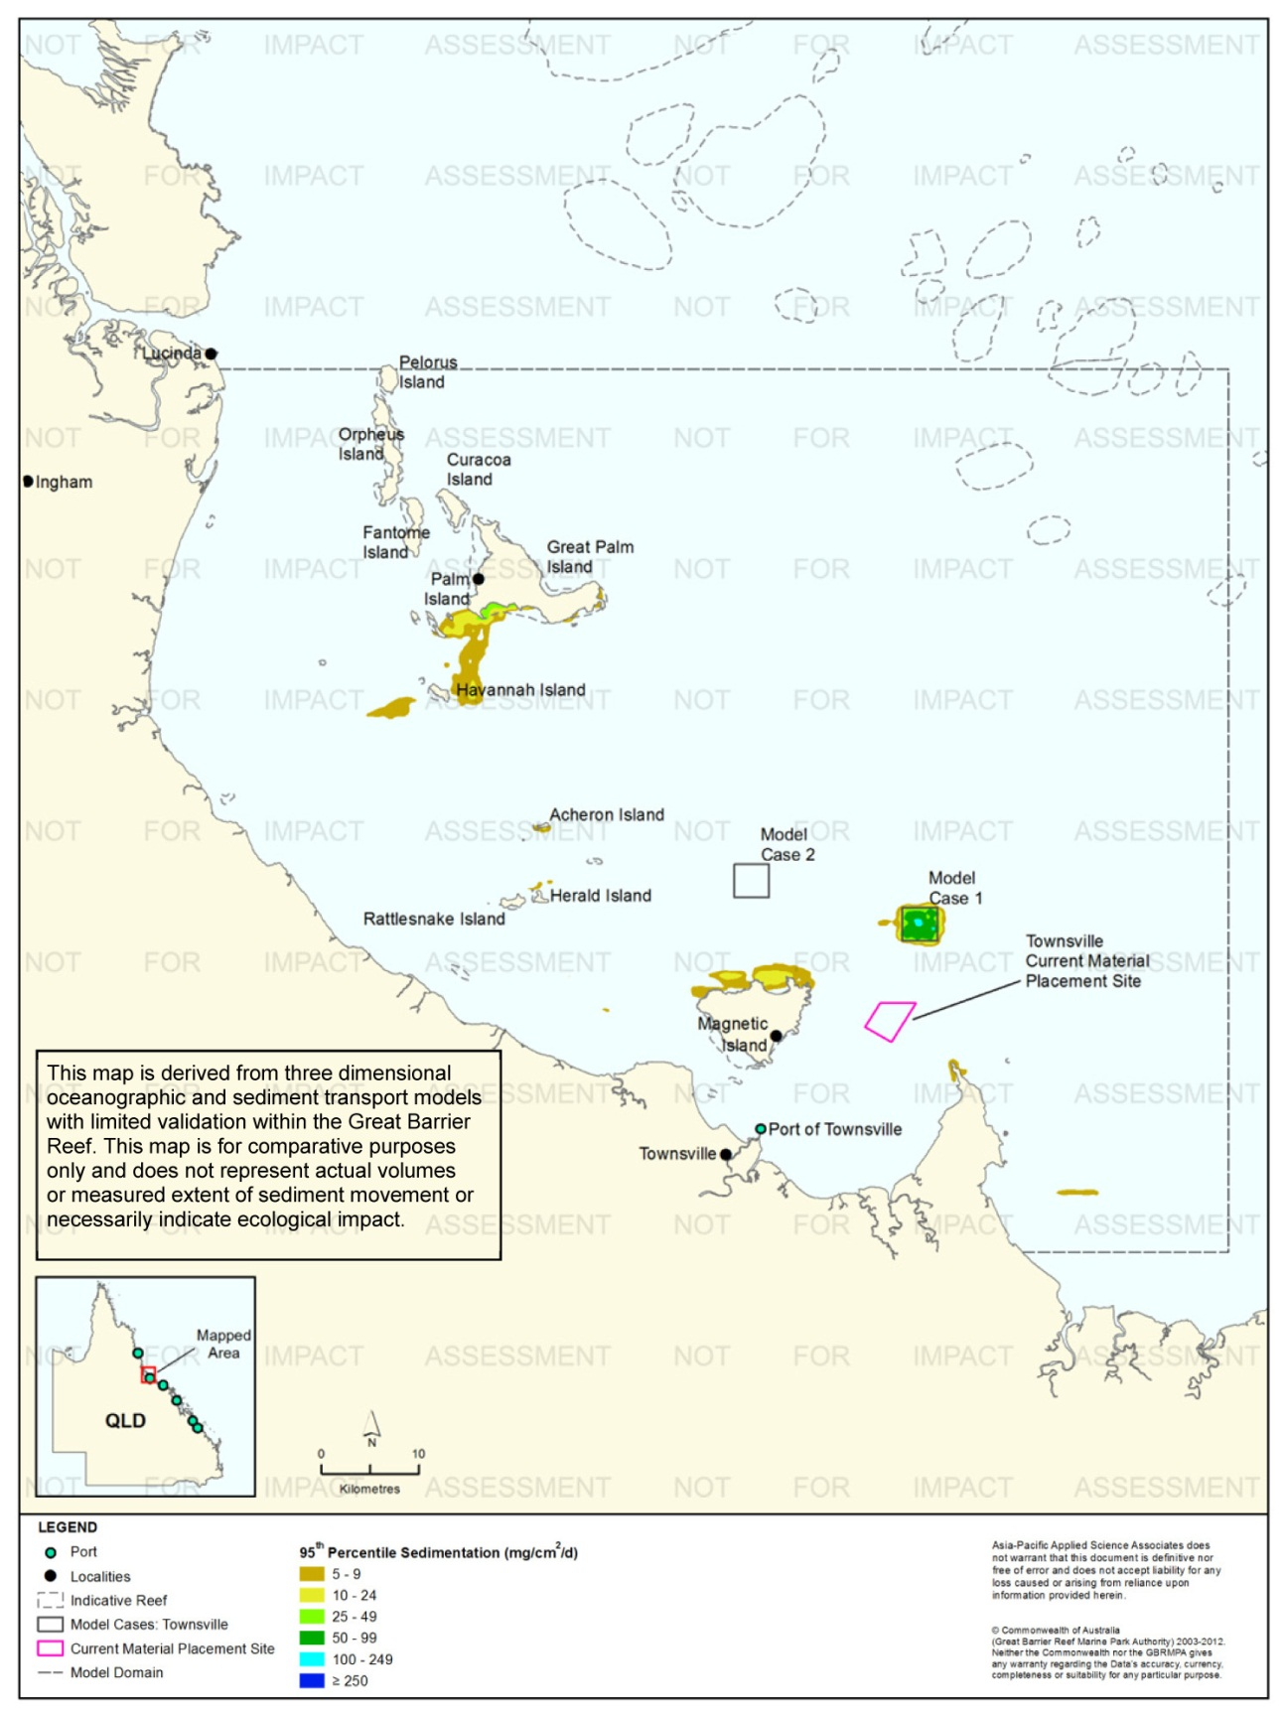
Figure 109. Townsville: dredging period (45 days) sedimentation rate, Model Case 1 - 95th percentile.

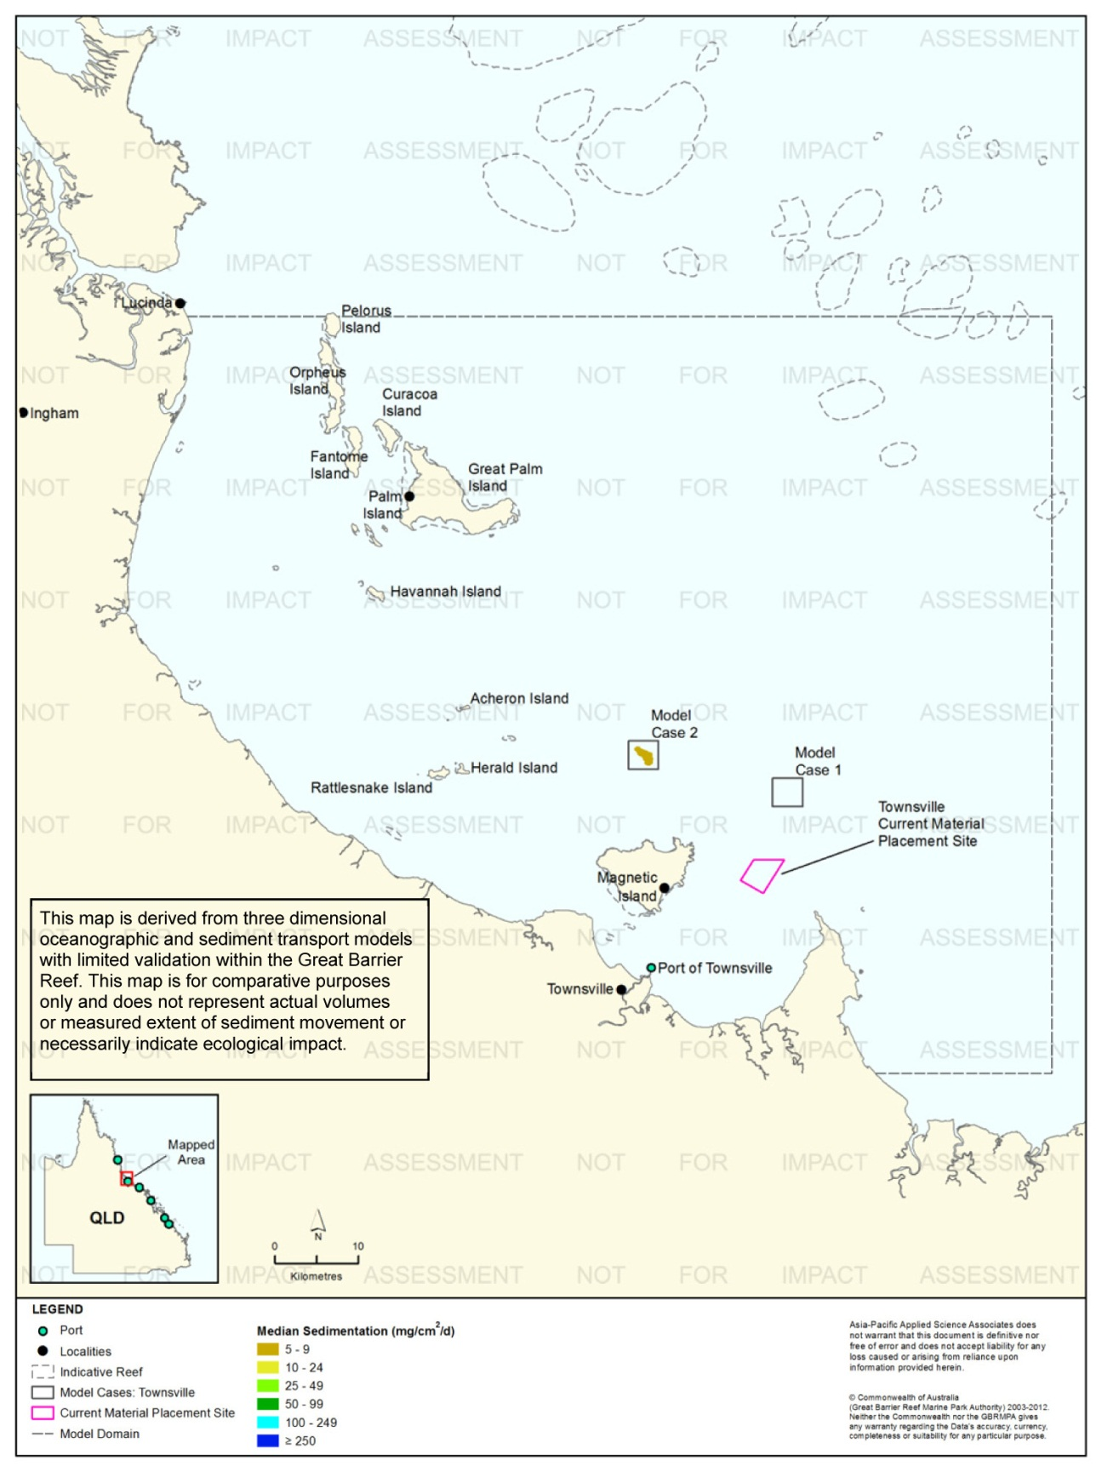
Figure 110. Townsville: dredging period (45 days) sedimentation rate, Model Case 2 - 50th percentile.
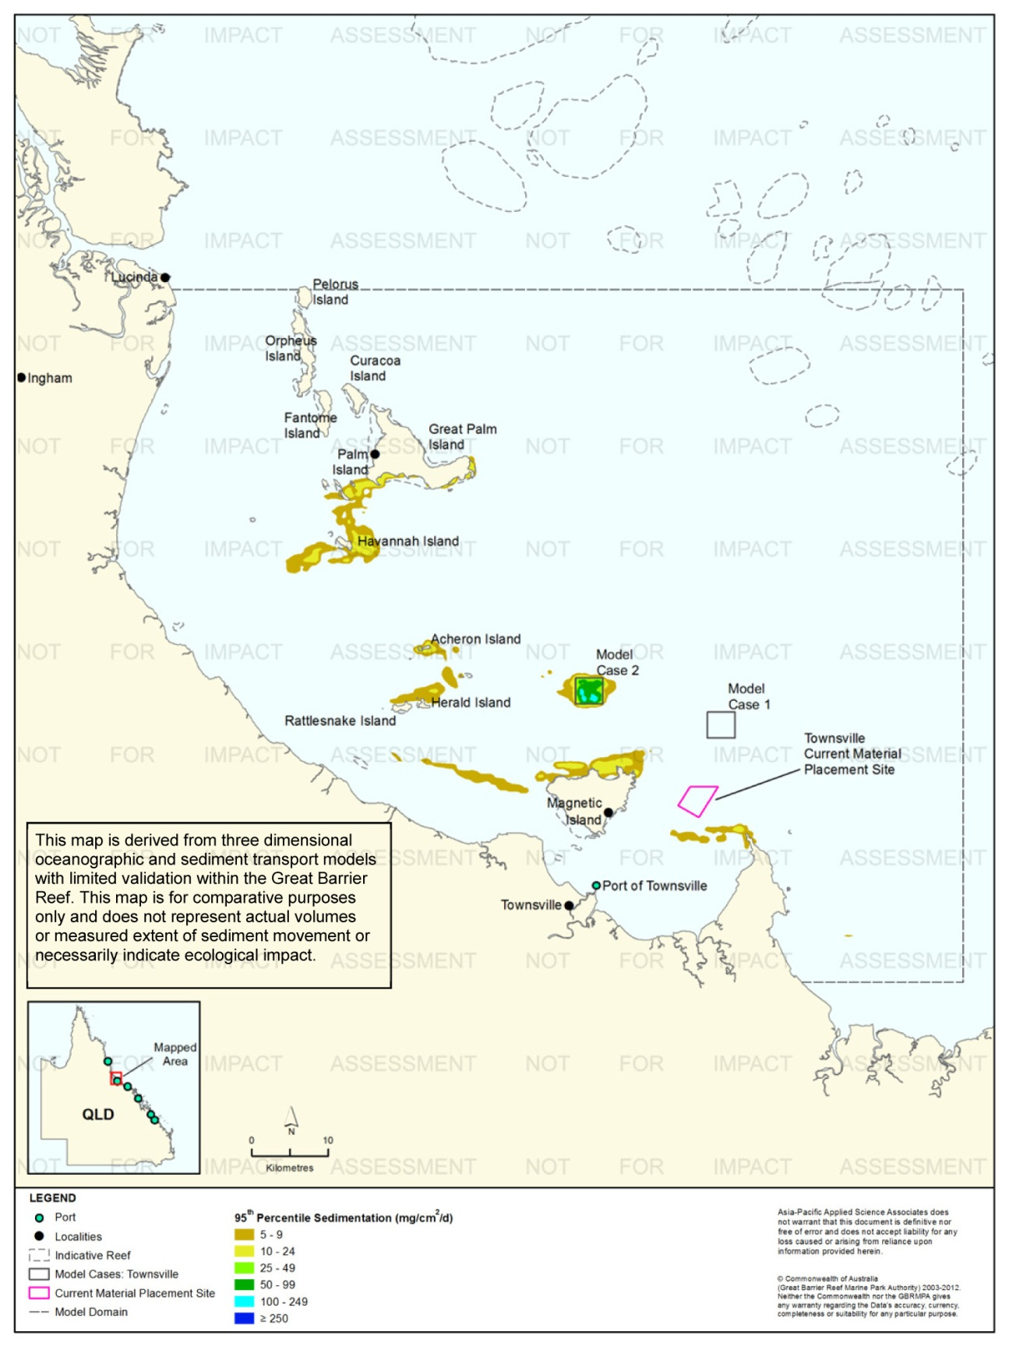
Figure 111. Townsville: dredging period (45 days) sedimentation rate, Model Case 2 - 95th percentile.
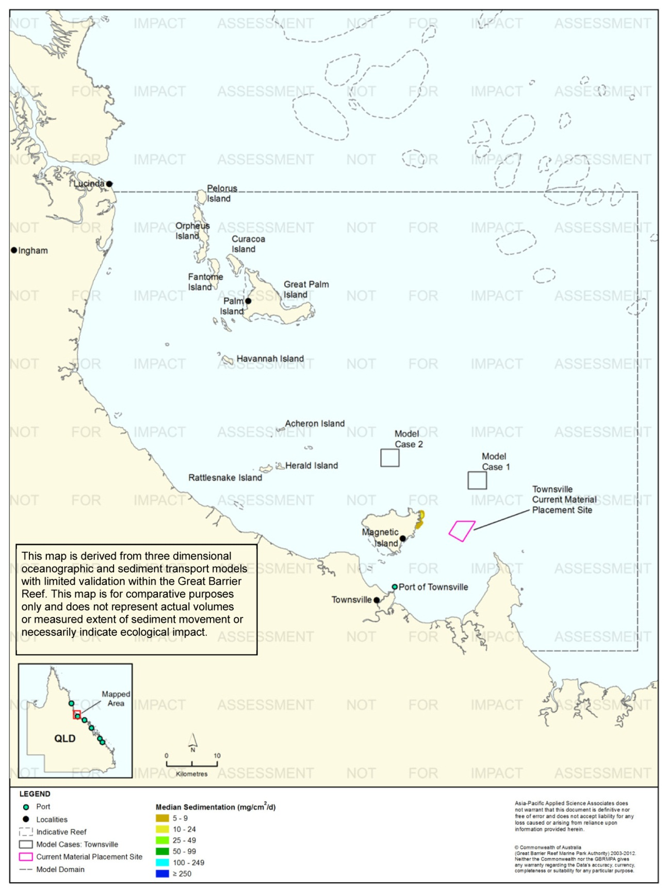
Figure 112. Townsville: dredging period (45 days) sedimentation rate, current site - 50th percentile.
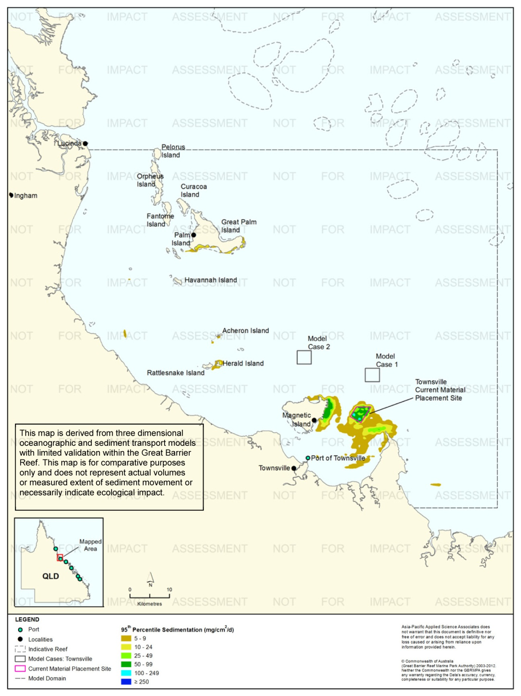
Figure 113. Townsville: dredging period (45 days) sedimentation rate, current site - 95th percentile.
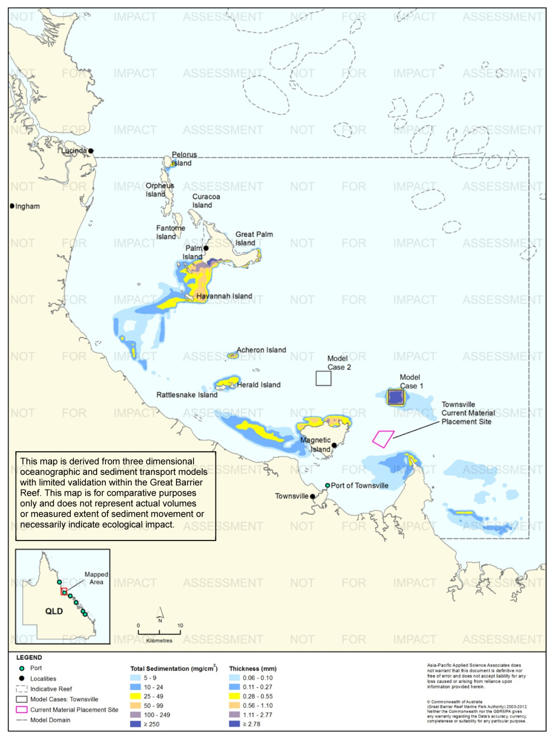
Figure 114. Townsville: dredging period (45 days) total sedimentation and bottom thickness, Model Case 1.

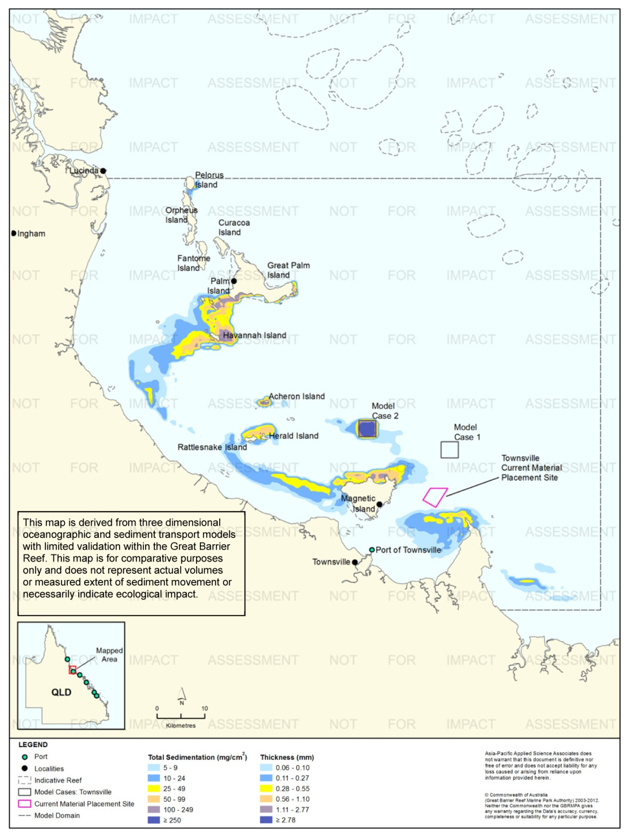
Figure 115. Townsville: dredging period (45 days) total sedimentation and bottom thickness, Model Case 2.

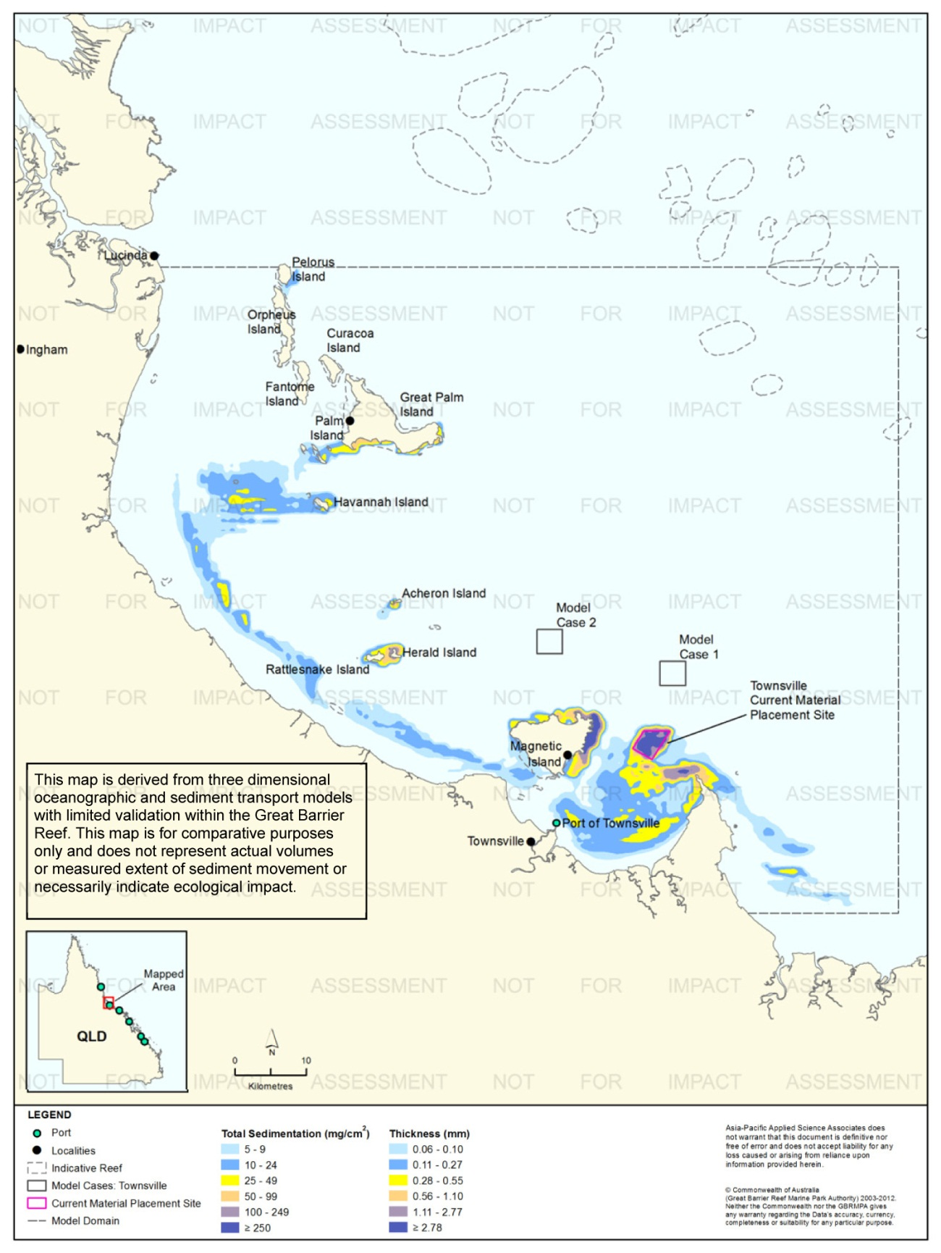
Figure 116. Townsville: dredging period (45 days) total sedimentation and bottom thickness, current site.

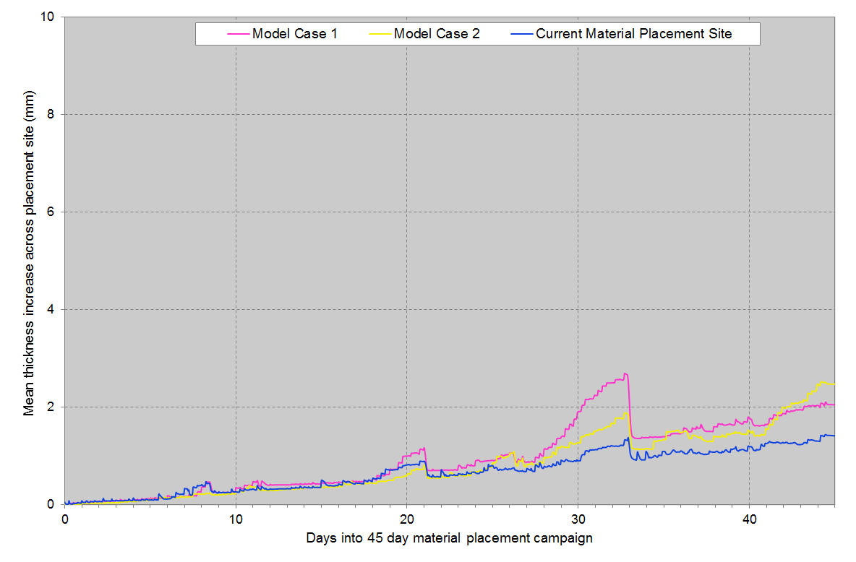
Figure 117. Townsville: Mean bottom thicknesses across the material placement sites. Results are based on the relocation of 400,000 m³ of material, over 45 days (four releases per day of 2231 m³).

Results at the End of the 12-Month Modelling Period
Figure 118 to figure 120 illustrate the predicted total sedimentation and bottom sediment thickness at the end of the 12 months for Model Case 1 and Model Case 2, and the current material placement site, Port of Townsville study location.
Modelling results at the end of the 12 months indicated that for all three sites, the higher total sedimentation levels (≥100 mg/cm², equivalent to ≥1.11 mm) were confined within the material placement sites.
The differences between total sedimentation at the end of the material placement operations and after 12 months were similar for Model Case 1 and Model Case 2. For both model cases, the total sedimentation levels were confined to the vicinity of the material placement sites. The reduction in the extent and level in offshore areas was due to sediment resuspension events. A comparison of the total sedimentation levels for the current material placement site showed reduction in the extent and level in offshore areas and low levels (< 25 mg/cm²) at the southern extent of Hinchinbrook Island and between Ingham and Lucinda.

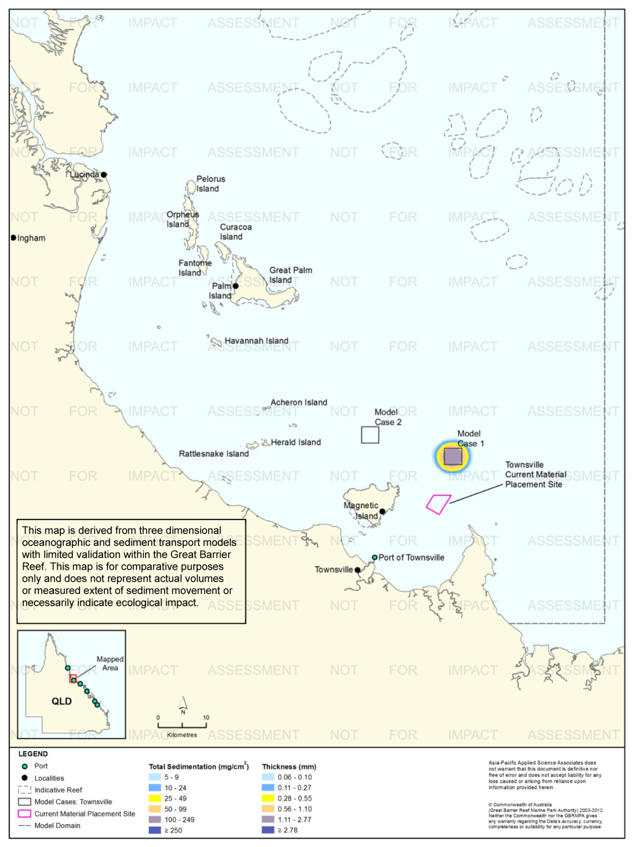
Figure 118. Townsville: long-term (12 months) total sedimentation and bottom thickness, Model Case 1.
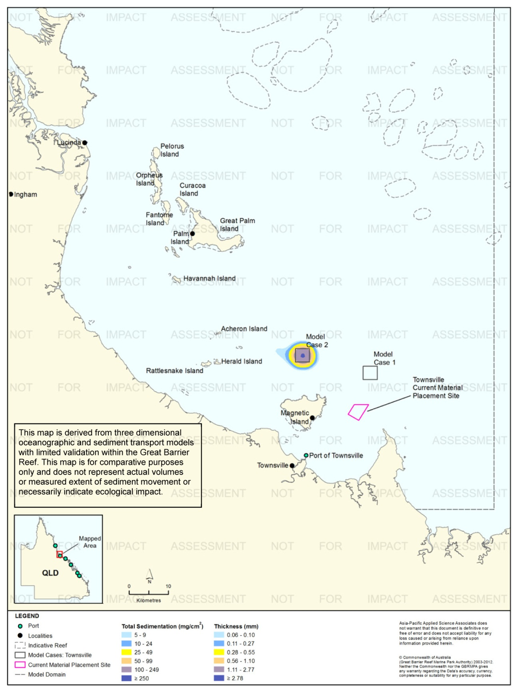
Figure 119. Townsville: long-term (12 months) total sedimentation and bottom thickness, Model Case 2.
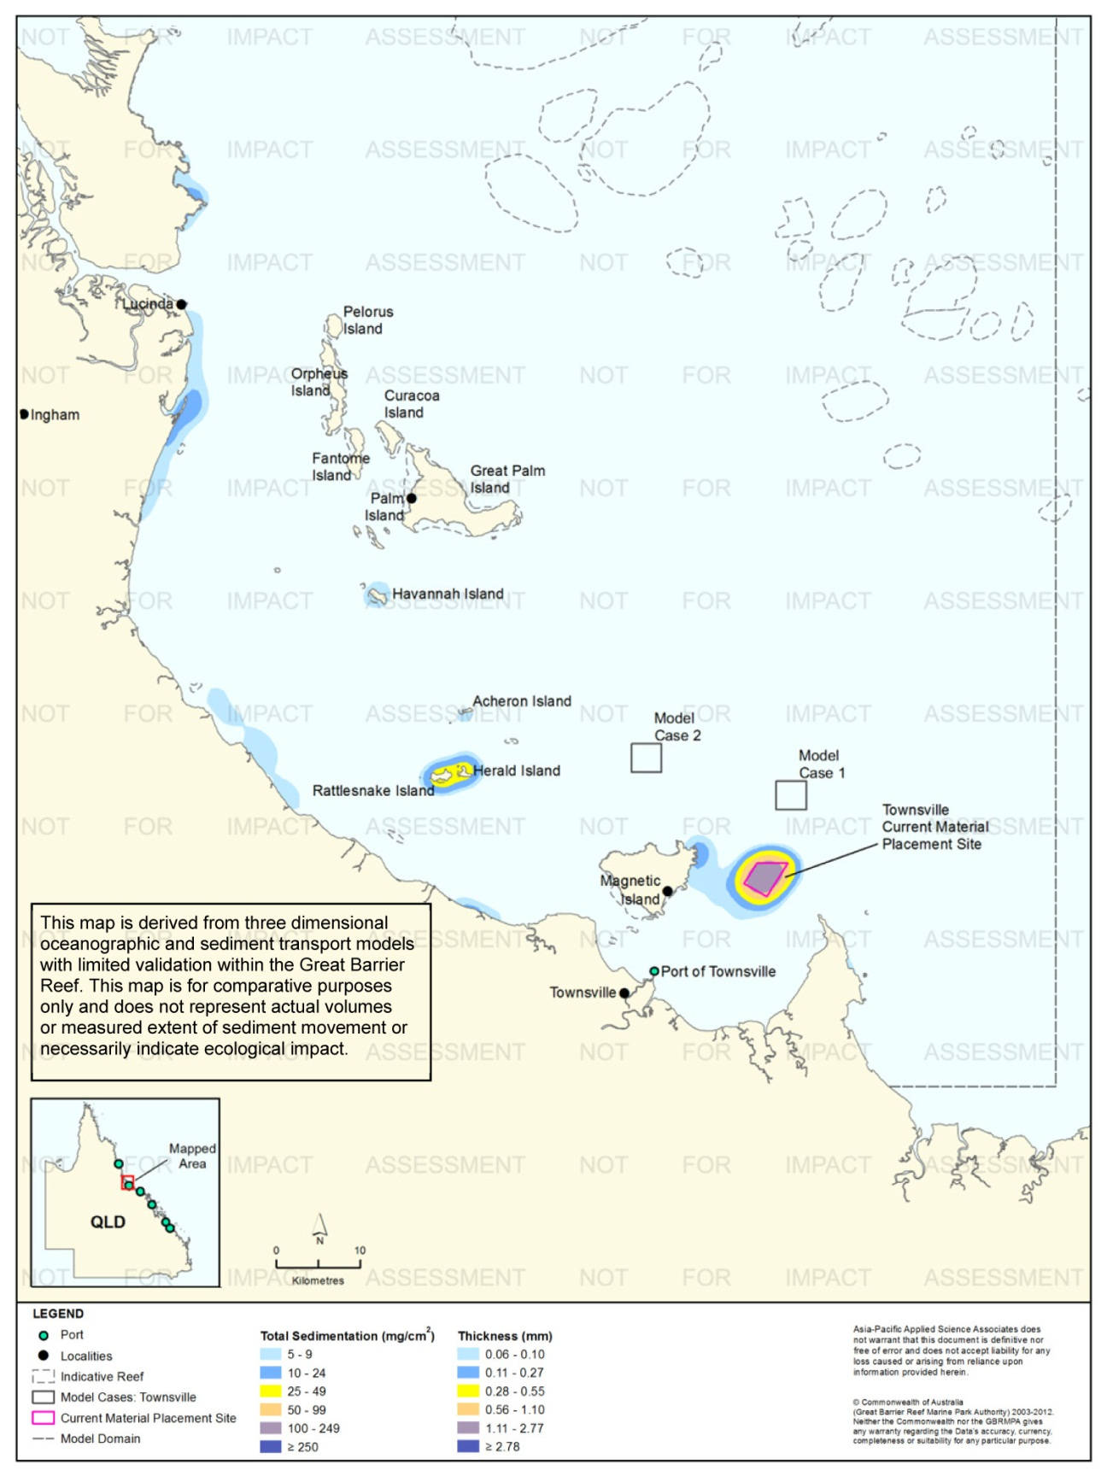
Figure 120. Townsville: long-term (12 months) total sedimentation and bottom thickness, current site.

Port of Cairns

Results During the Material Placement Operations
For the Port of Cairns a maintenance dredging campaign was modelled which consisted of 580,000 m³ of dredged material relocated over five weeks, commencing in August. There were 11 releases each day, with each release consisting of 1381 m³ and lasting eight minutes each in duration. The dredged material comprised 51 per cent of clay and fine silts.
Figure 121 to figure 124 show percentile plots for the predicted TSS concentrations for Model Cases 1-2 and the current material placement site for the Port of Cairns. Note, no 50th percentile concentrations greater than 5 mg/L were predicted for Model Case 1 and Model Case 2.
The TSS modelling predicted sediment plumes to disperse in a north-west direction for all of the three material placement sites. There were no concentrations greater than 9 mg/L predicted for Model Cases 1 and 2, on the basis of the 95th percentile analysis. Results for the current material placement site revealed that the 10-24 mg/L contour extended approximately 2 km north-west of the material placement site.
Figure 125 to figure 130 show the 50th and 95th percentile of sedimentation rates for the three sites. For Model Case 1 and Model Case 2 the 95th percentile analysis showed elevated rates of sedimentation (100 mg/cm²/d or more) in the immediate vicinity of the material placement site, along the Penguin Channel at Cape Kimberley and at Snapper Island. In comparison to Model Cases 1-2, the current material placement site was predicted to have smaller areas of elevated rates of sedimentation (100 mg/cm²/d or more) along the Penguin Channel at Cape Kimberley north-west of the placement site. Additional areas predicted to be influenced by 95th percentile sedimentation rates of ≥100 mg/cm²/d included areas south-east of Double Island and in the immediate vicinity of the material placement site.
Figure 131 to figure 133 illustrate the predicted total sedimentation and bottom sediment thickness at the completion of the material placement operations.
Figure 134 compares the mean thickness increase over 38 days across the material placement sites. The results indicate that the current site is more retentive and increased by an average of approximately 8 mm over the 38 day placement operations, approximately 2 mm greater than the average thickness increases at Model Case 1 and Model Case 2.
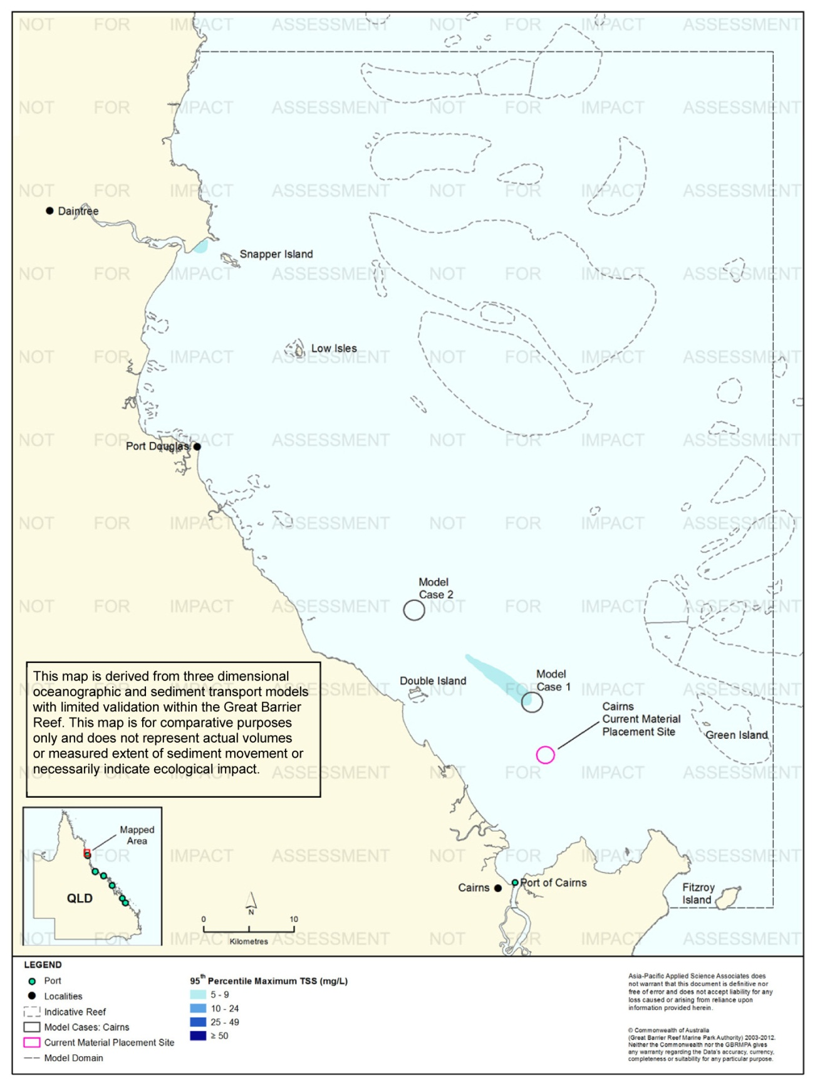
Figure 121. Cairns: dredging period (38 days) TSS distribution, Model Case 1 - 95th percentile.

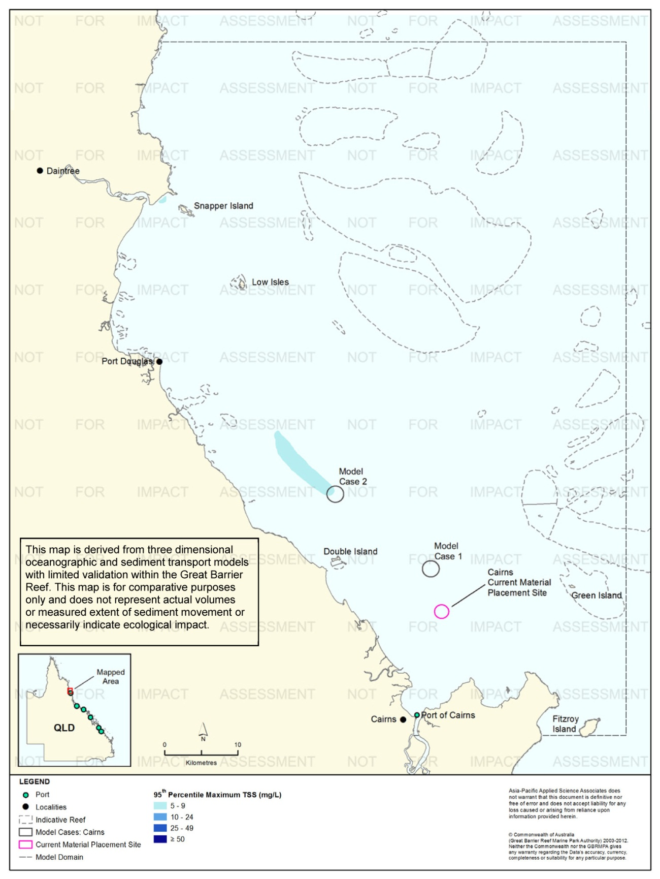
Figure 122. Cairns: dredging period (38 days) TSS distribution, Model Case 2 - 95th percentile.
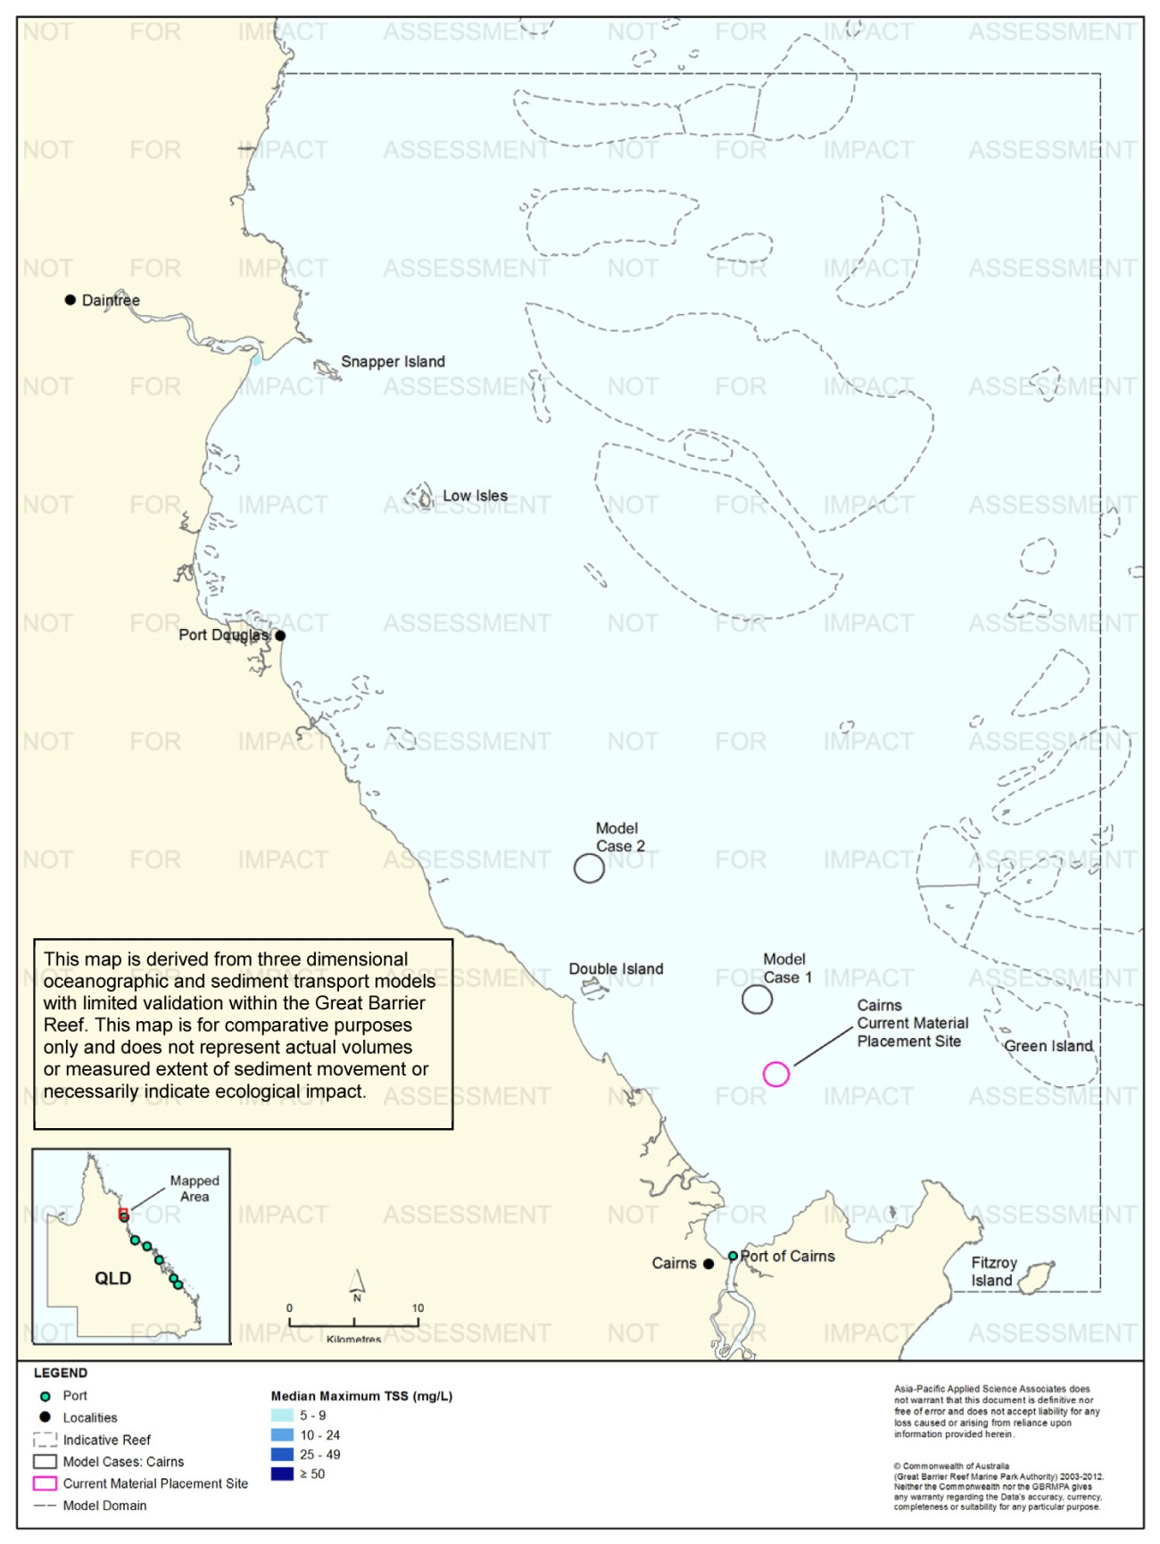
Figure 123. Cairns: dredging period (38 days) TSS distribution, current site - 50th percentile.
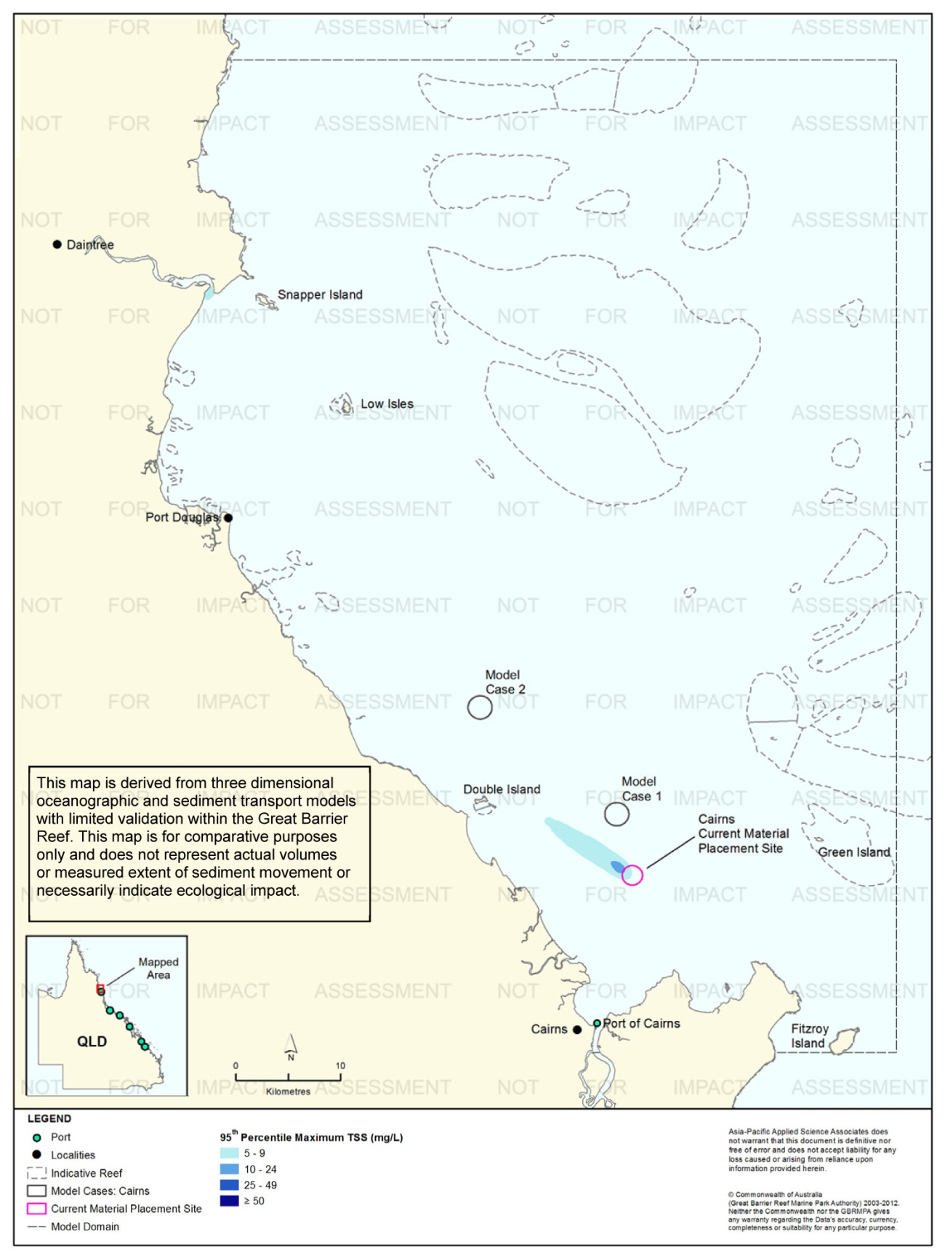
Figure 124. Cairns: dredging period (38 days) TSS distribution, current site - 95th percentile.
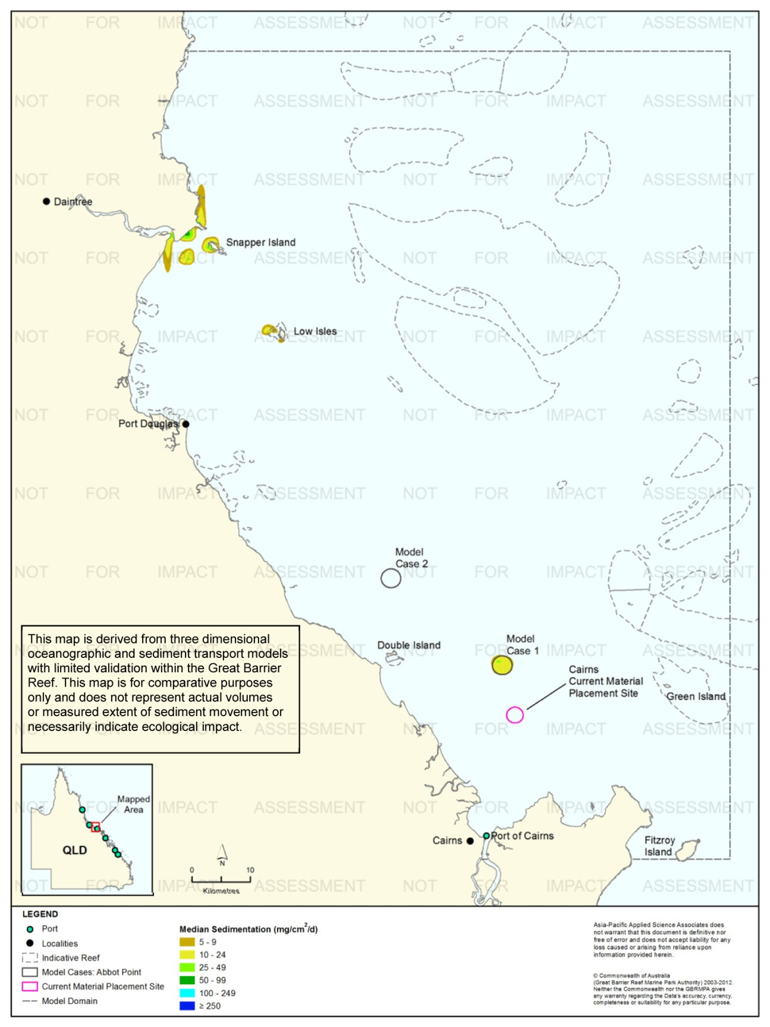
Figure 125. Cairns: dredging period (38 days) sedimentation rate, Model Case 1 - 50th percentile.
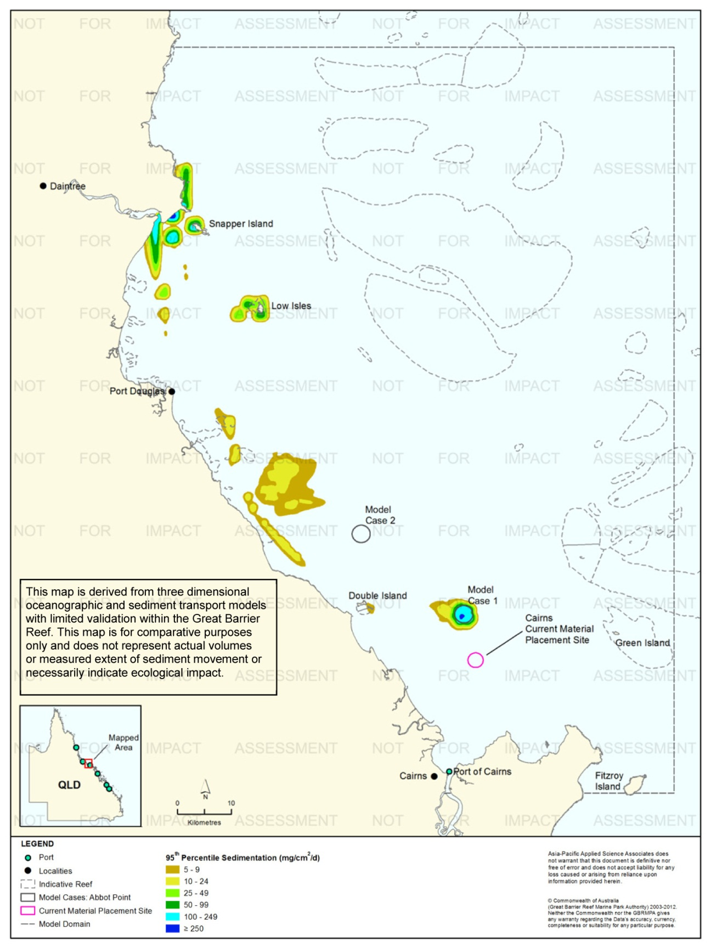
Figure 126. Cairns: dredging period (38 days) sedimentation rate, Model Case 1 - 95th percentile.

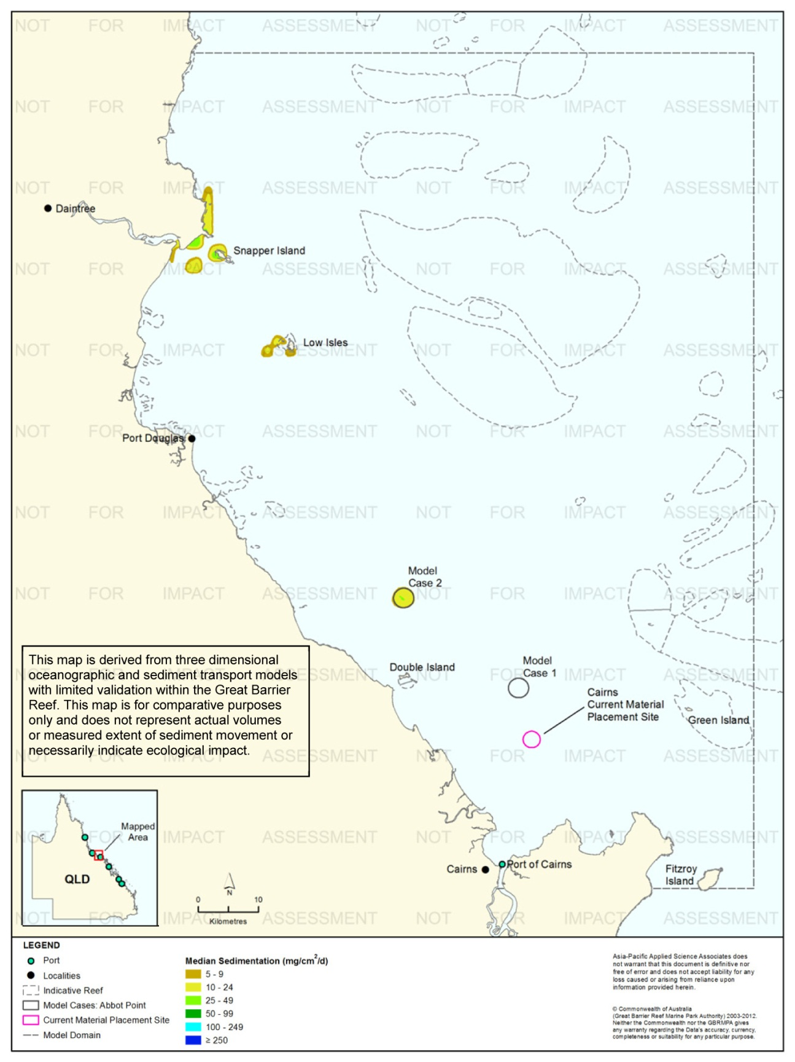
Figure 127. Cairns: dredging period (38 days) sedimentation rate, Model Case 2 - 50th percentile.
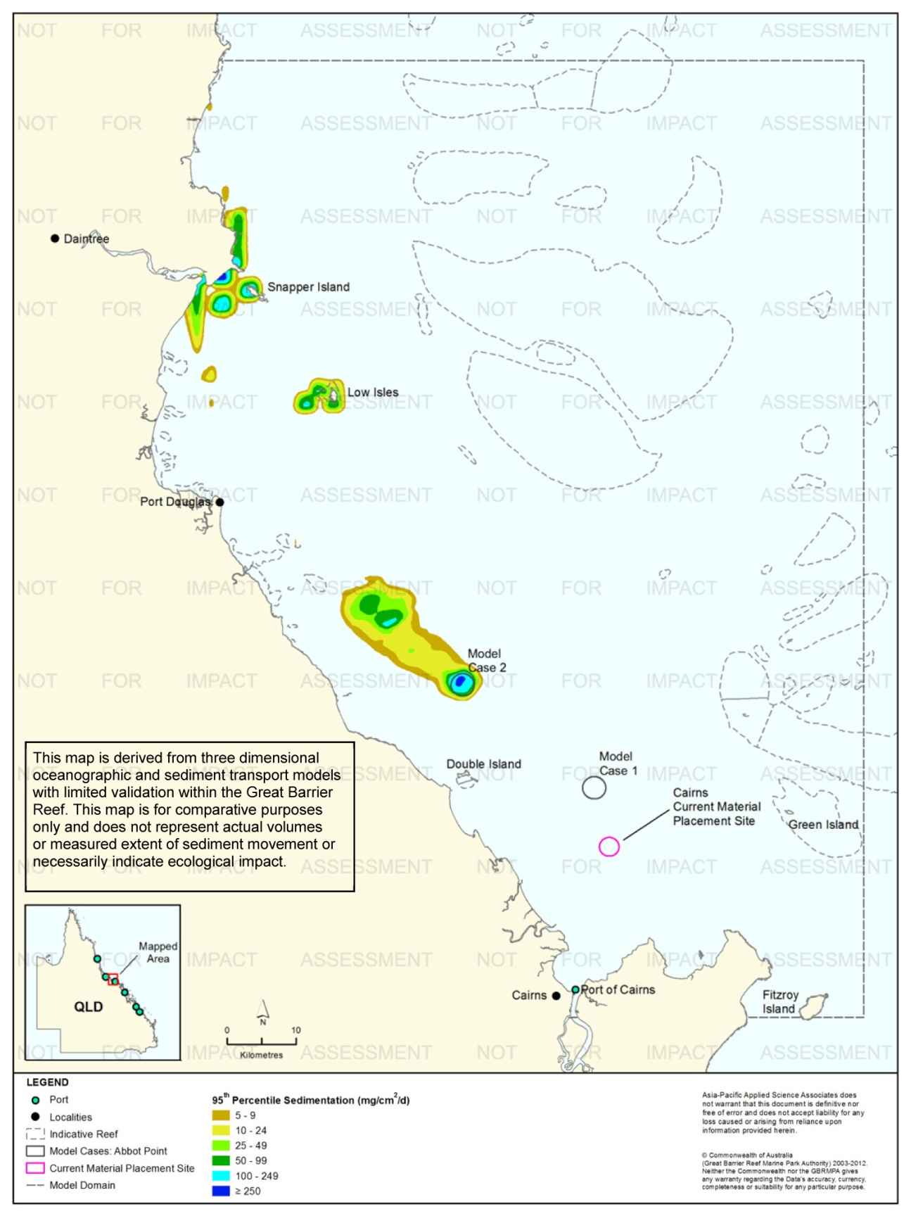
Figure 128. Cairns: dredging period (38 days) sedimentation rate, Model Case 2 - 95th percentile.
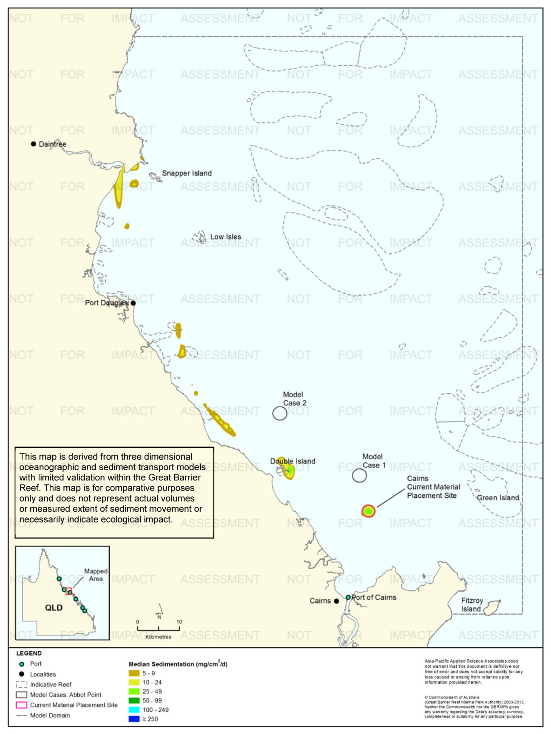
Figure 129. Cairns: dredging period (38 days) sedimentation rate, current site - 50th percentile.

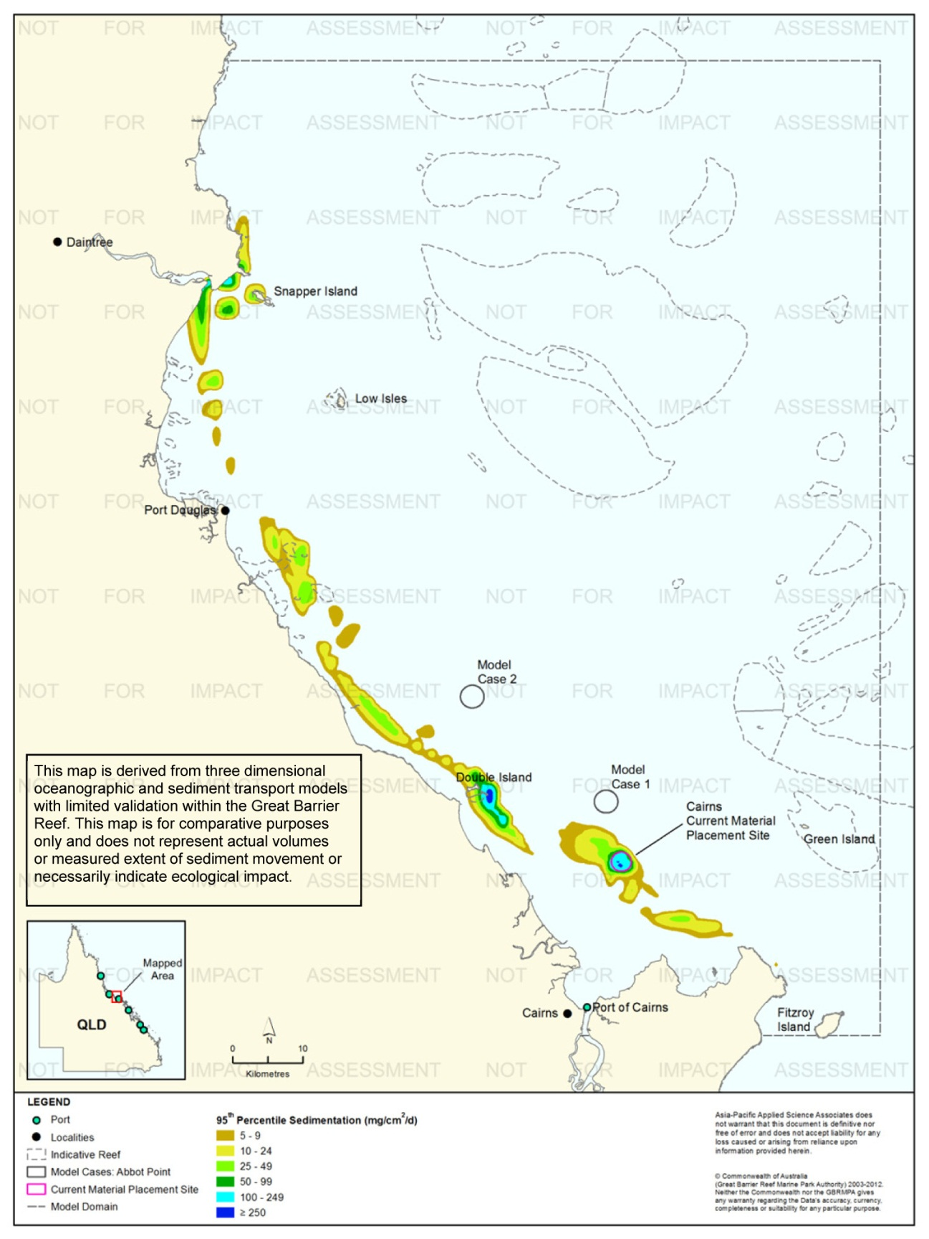
Figure 130. Cairns: dredging period (38 days) sedimentation rate, current site - 95th percentile.
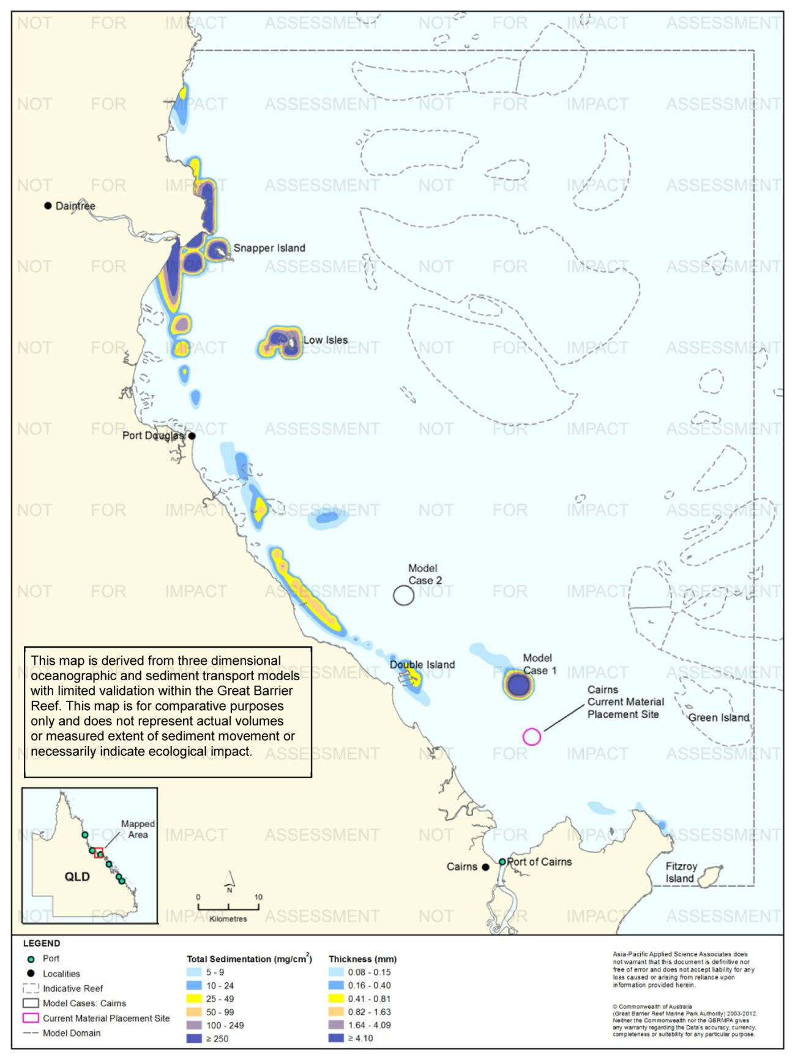
Figure 131. Cairns: dredging period (38 days) total sedimentation and bottom thickness, Model Case 1.
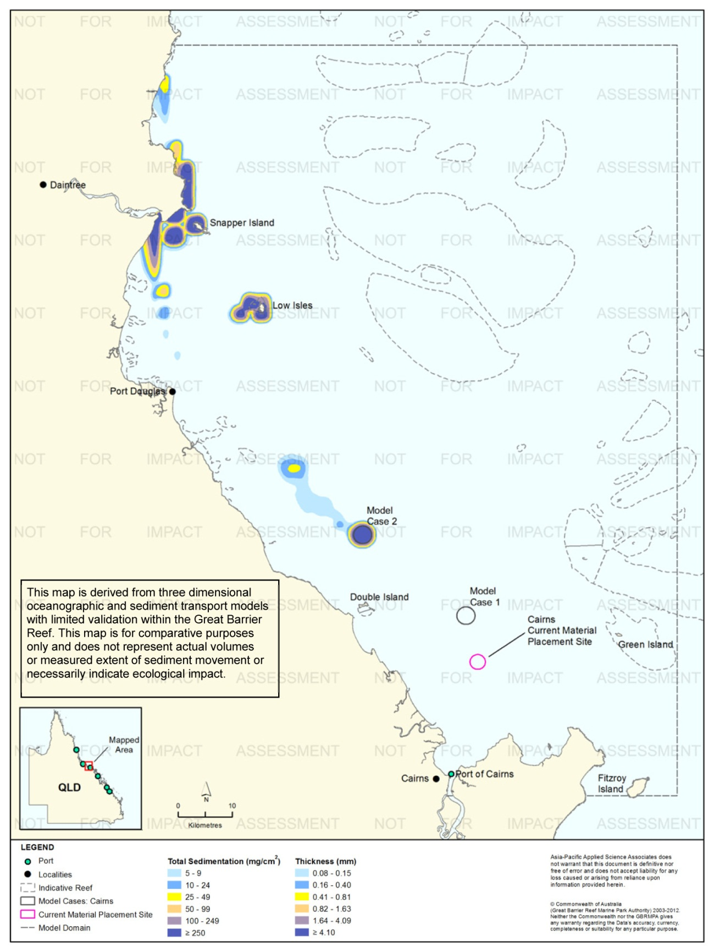
Figure 132. Cairns: dredging period (38 days) total sedimentation and bottom thickness, Model Case 2.
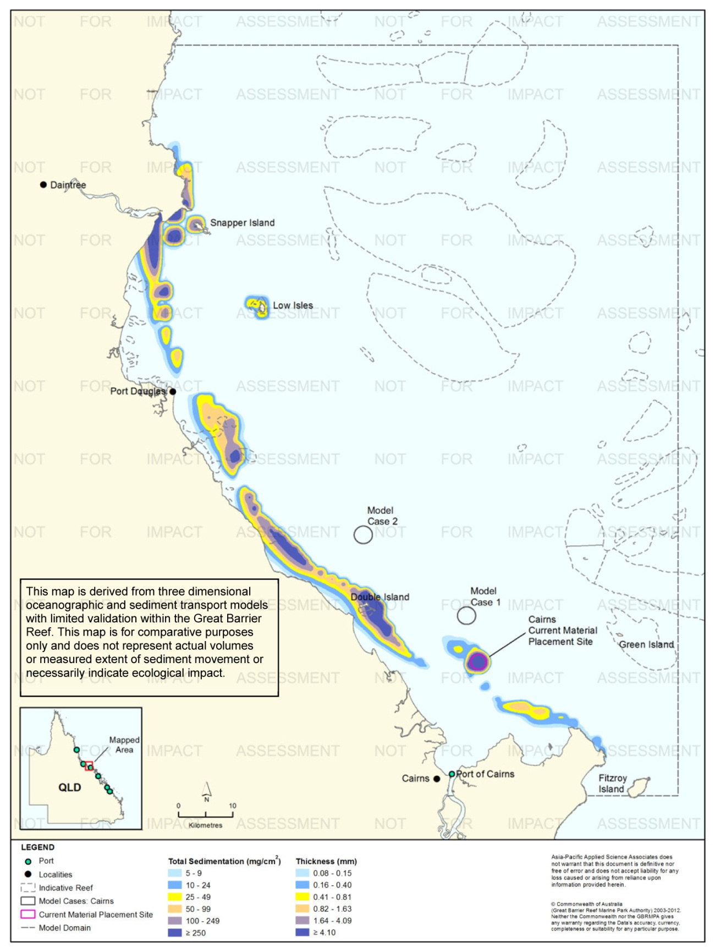
Figure 133. Cairns: dredging period (38 days) total sedimentation and bottom thickness, current site.

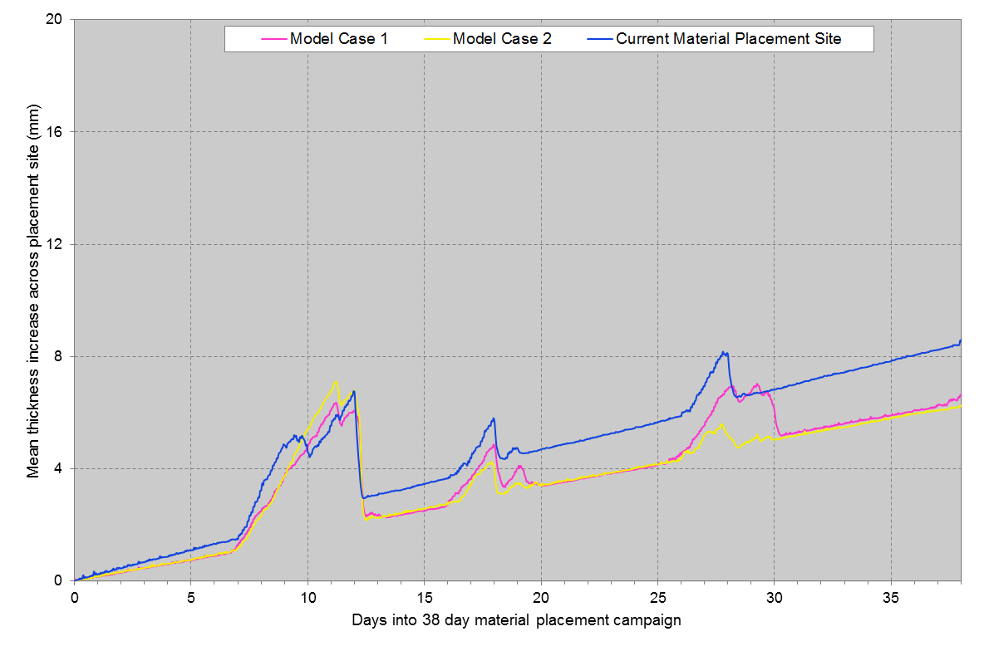
Figure 134. Cairns: Mean bottom thicknesses across the material placement sites. Results are based on the relocation of 580,000 m³ over 38 days (11 releases per day of 1381 m³).

Results at the End of the 12-Month Modelling Period
Figure 135 to figure 137 illustrate the predicted total sedimentation and bottom sediment thickness above background at the end of the 12 months for Model Case 1 and Model Case 2, and the current material placement site, Port of Cairns study location.
Modelling results at the end of the 12 months indicated that for all three sites, the higher total sedimentation levels (≥ 100 mg/cm², equivalent to ≥ 1.64 mm) were confined to within 2.5 km from the material placement sites.
Differences in total sedimentation levels between the completion of the material placement period and end of 12-months showed a reduction in the extent and levels (from ≥ 250 mg/cm² to < 25 mg/cm²) in areas along the coastline between Cairns and north of Snapper Island due to continuing sediment resuspension events and northward transport of sediments.

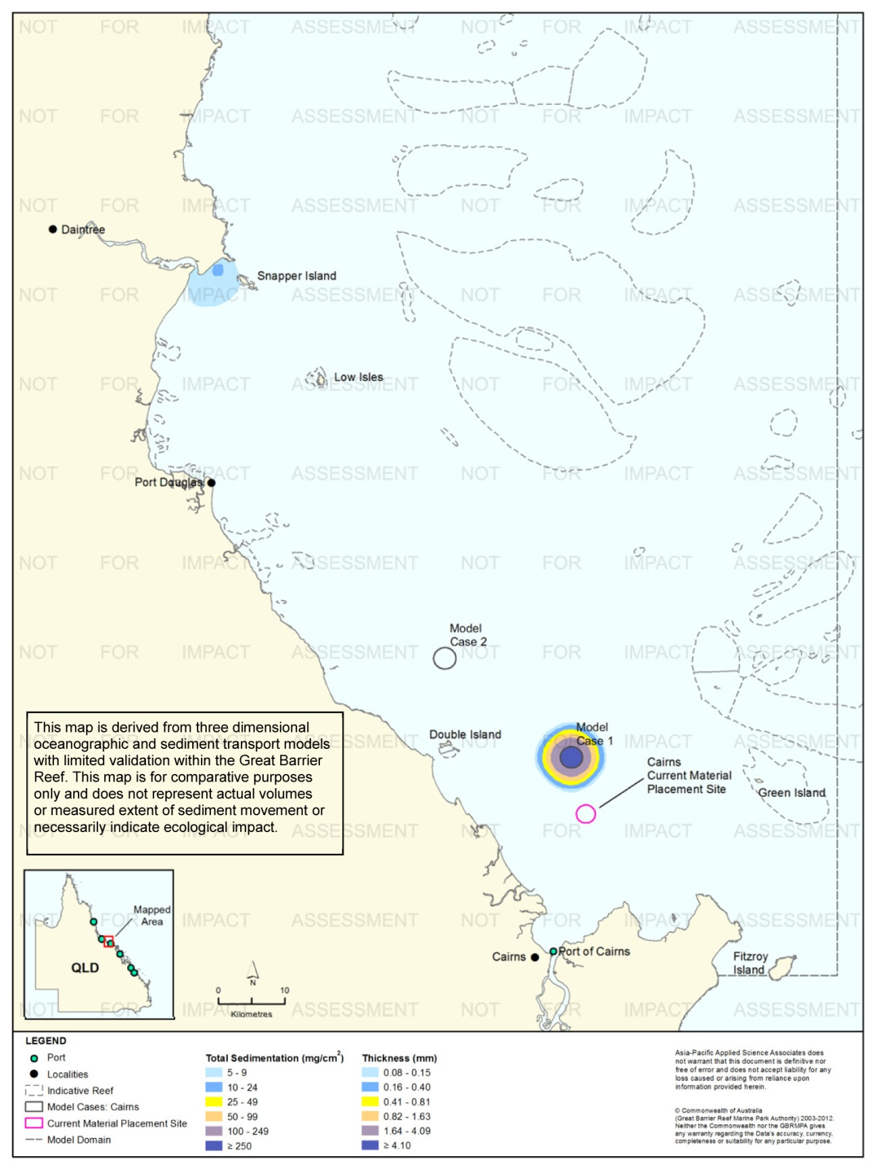
Figure 135. Cairns: long-term (12 months) total sedimentation and bottom thickness, Model Case 1.
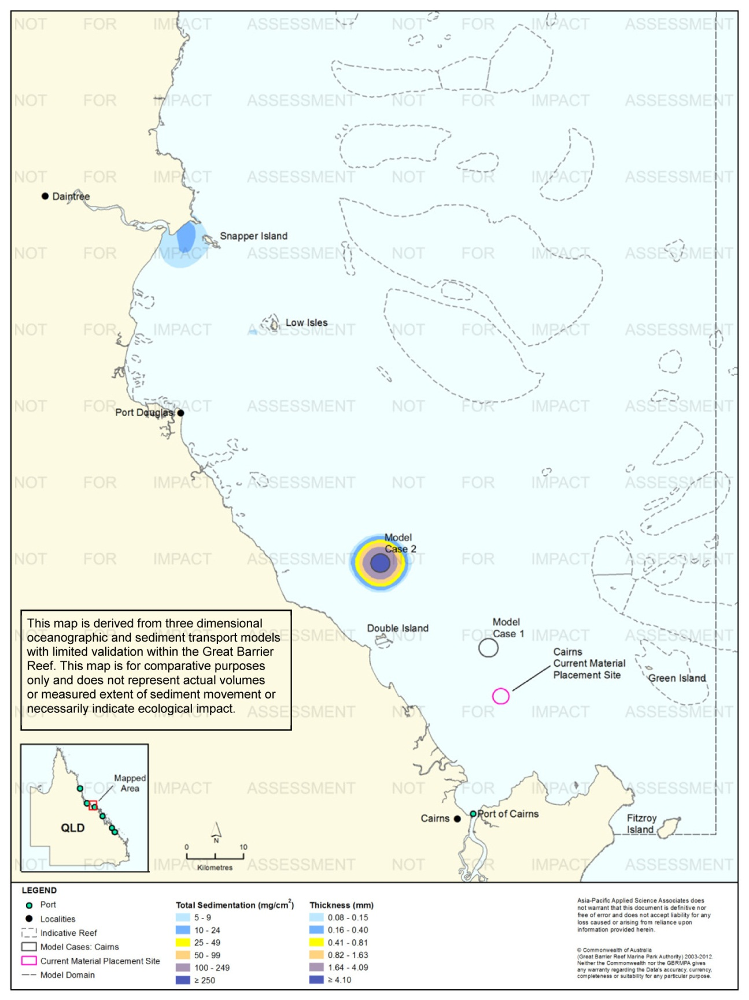
Figure 136. Cairns: long-term (12 months) total sedimentation and bottom thickness, Model Case 2.
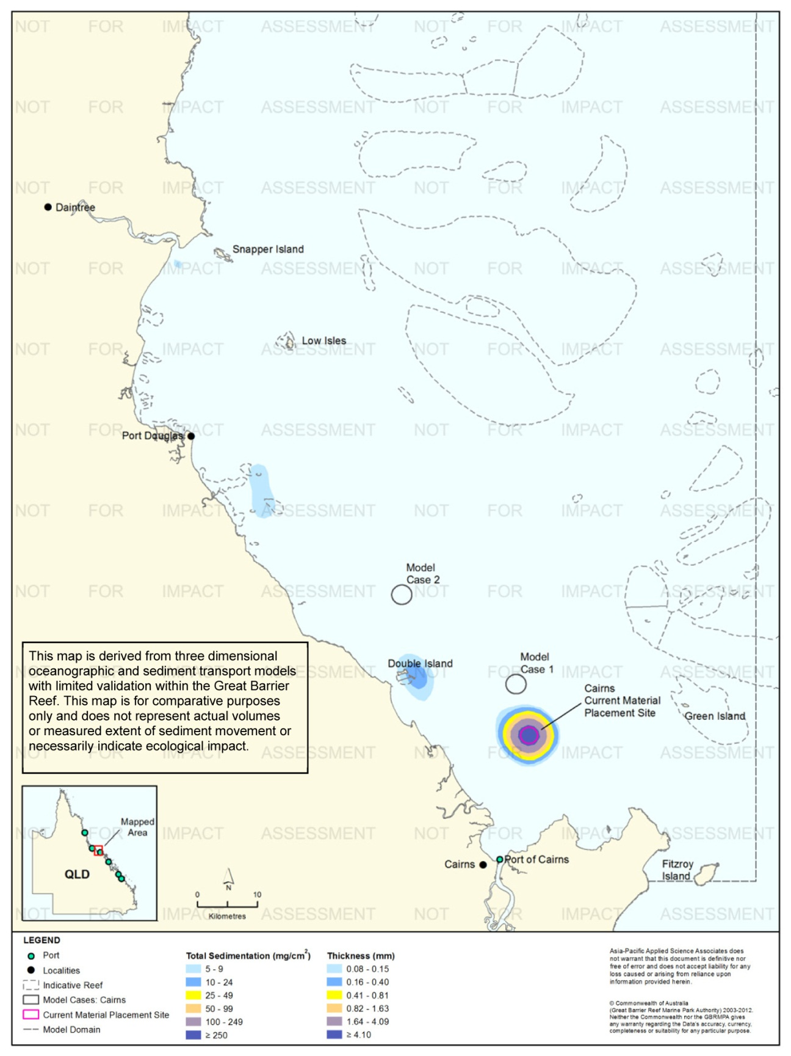
Figure 137. Cairns: long-term (12 months) total sedimentation and bottom thickness, current site.

Benefits of This Study
The purpose of the 'Improved Dredge Material Management for the Great Barrier Reef Region' study is to support a strategic, long-term approach for improved management of dredge material in the Region. The study provides tools for decision making regarding dredge material placement at the six study locations.
The most important benefit of study is that it has characterised the implications of placing dredge material in alternative, indicative locations. The focus of the study is on comparing alternatives, not on predictions regarding specific individual sites. In this sense, the study constitutes a screening-level “sensitivity analysis” of the relative merits, if any, of potential alternative placement areas. The study serves as a tool to guide the selection and assessment of options for ocean placement of dredge material; it does not and should not be interpreted as recommending specific sites.
The study is explicitly not intended to provide a comprehensive EIA of specific, individual dredging projects at a level of rigour and detail commensurate with best-practice management appropriate for the iconic status of the World Heritage Area. Therefore, the results should not be interpreted as concrete predictions of environmental impact from dredge material placement at specific sites, for specific projects, or upon specific receptors.
The primary objective of the modelling component of the study, the subject of this report, was to provide insight into how placement of material at alternative locations would affect the subsequent dispersal of dredge material, using a consistent modelling approach applied over large spatial and temporal scales. This research is the first to incorporate the combined influence of waves, tides, local winds and large-scale currents in modelling the movement of dredge material in the long term (12 months) at multiple locations within the Region. It has provided new insight into the potential temporal and spatial scales of dredge material dispersal in the Reef lagoon.
The modelling is based on hypothetical scenarios in terms of type of dredging (capital or maintenance), dredged material volumes and characteristics, dredging campaign season and duration, and dredging equipment that are most relevant to each study area. These scenarios were developed in cooperation with the port operators and the GBRMPA and are considered to be most relevant to long-term port development envisioned at each location. They do not represent specific past or proposed dredging campaigns.
This research gives decision makers better understanding of the maximum credible excursions that sediment may travel when placed at potential alternative sites, using a consistent modelling approach applied over large spatial and temporal scales. The results are not intended to be or replace the need for in-depth, project-specific EIAs.
Dr Eric Wolanski, independent reviewer to the GBRMPA stated “for probably the first time in the history of modelling the fate of dredged sediment in the GBR, the authors did model the long-term fate of fine sediment after initial settling near the dump sites i.e. they attempted to answer the question where does the sediment ultimately go?”

Model Assumptions and Limitations
As previously noted, this study is the first to incorporate both large-scale ocean currents and 12-month modelling of sediment migration at the scale of the entire Region. This ambitious undertaking required the adoption of various simplifying assumptions in order to complete the research within the allocated timeframe. Where there was uncertainty the assumptions are generally conservative, that is, lead to "maximum credible" predictions of sediment mobility. This research, like any pilot research, has certain assumptions and limitations, and raises questions requiring further developments and research.

Hydrodynamics
Incorporating the influence of large-scale currents in the model significantly increased the current speeds flowing to the north-north-west (figure 138). As a result, predictions of the spatial extent of sedimentation were dramatically different in simulations conducted with and without the influence of the large scale currents (figure 139 and figure 140). Hydrodynamic studies have shown that large-scale currents have a significant effect on circulation in the Reef lagoon (Brinkman et al. 2001; Lambrechts et al. 2008; Webster et al. 2007; Wolanski 1994).
As a conservative approach, 2011 was selected as the year upon which to base the modelling because it was the most energetic year of the eight-year data set assessed, therefore the model outputs provide an upper bound (credible maximum) that dredge sediments could travel. It should be noted, however, that cyclonic conditions were not incorporated in the modelling.
The HYCOM large-scale current predictions were combined onto the same grid as the HYDROMAP current predictions through vector addition within every grid cell of the hydrodynamic model grid from the 10 m contour outward. An internal investigation of modelling results with and without the influence of local winds found there was no double-forcing of surface hydrodynamics. To further quantify this approach, future work would involve using the HYCOM large-scale current model predictions as boundary conditions for the tidal and local wind model, so that it is at the same spatial (700 m) and temporal (hourly) resolution as the tide and local wind model (see ‘Incorporation of Large-Scale Currents’, page 182). This approach would also assess the influence of large-scale currents in depths less than 10 m and whether the approach adopted in this study may over-estimate sediment transport.
The HYDROMAP model was calibrated to water levels and found to be in good agreement, and observed elevations (average error for water levels at Cairns was 0.07 m which has a maximum elevation of 3.05 m and 0.49 m at Hay Point which has a maximum elevation of 6.68 m). Due to time constraints it was not possible to calibrate the combined tide, local wind and large-scale current forcing and optimise the fit of model outputs to measured data. When the combined HYCOM and HYDROMAP data has been compared to available current measurements at three locations (Townsville, Hay Point and Palm Passage) it was found to compare well (see table 5 and table 7). To achieve greater confidence in the combined currents, measured data in other areas should be compared.
The model resolution within 50 km from the six study sites (~700 m) is comparable, if not better, than other models used for the Reef.
Consideration of the effects of local-scale, shallow-water wave action around reefs and coastlines and resultant sediment resuspension, and tidal pumping and trapping of fine sediments into estuaries and mangroves was beyond the scope of this study. These processes are known to be important in governing nearshore turbidity and sedimentation (Alongi & McKinnon 2005; Furukowa & Wolanski 1996; Webster et al. 2007; Wolanski et al. 1997, 2005). High predicted sedimentation in nearshore areas needs to be interpreted in this context, which means that in shallow water the model may overestimate sedimentation. Again it is emphasised that the primary benefit of the study is the comparison of the broad implications of placement at relative sites, rather than assessment of local-scale impacts of placement at individual alternative sites.
However, consideration of local-scale effects is required for a port- and project-specific EIS.
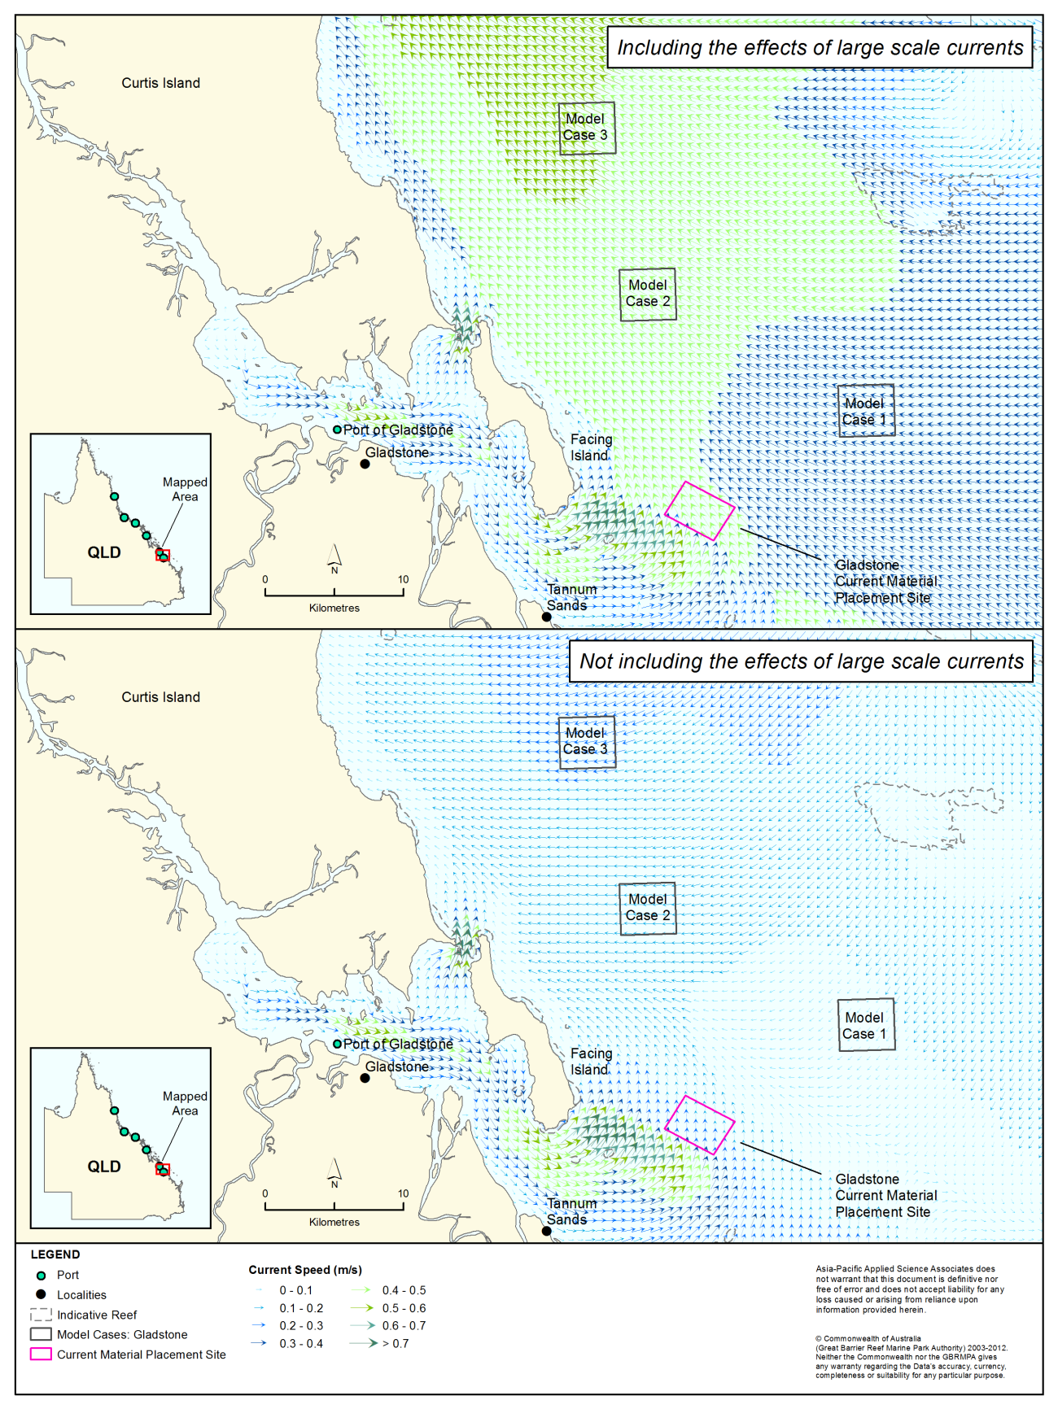
Figure 138. Snapshot of predicted current fields with (top) and without (bottom) including large-scale current forcing in the Gladstone study area. The high current speeds south of Gladstone reflect forcing by tides and waves. The high current speeds to the north in the top figure reflect the influence of the large-scale currents; the decrease in current speeds near shore in the top panel results from the cut-off in applying large-scale current forcing at the 10 m depth contour.
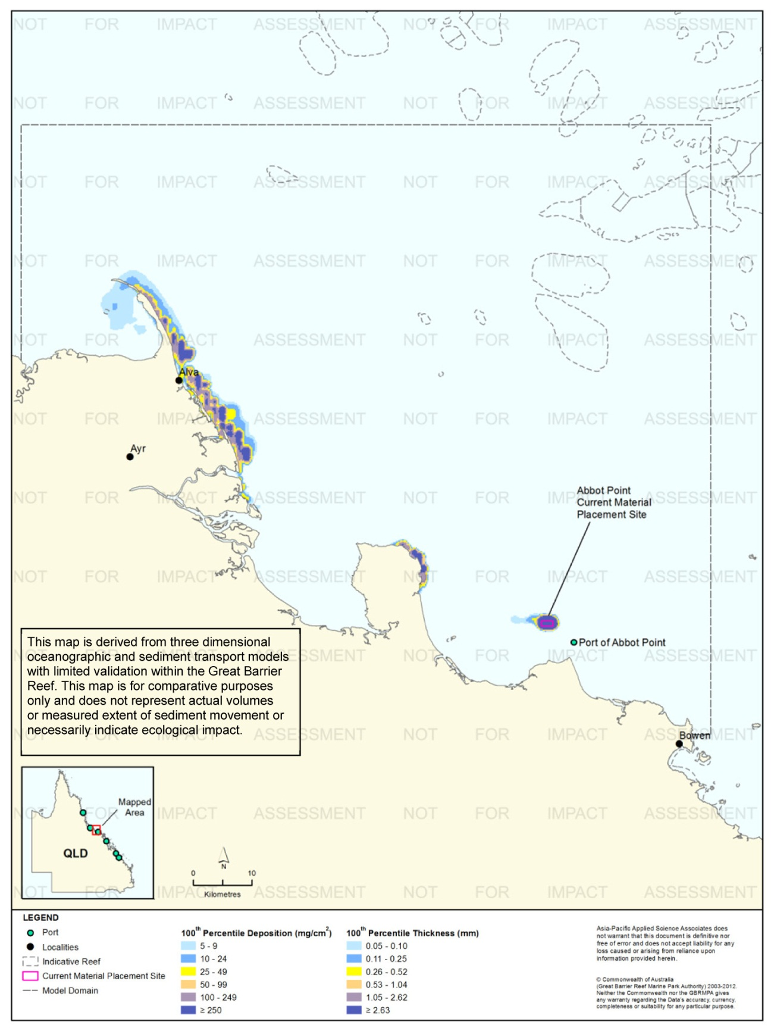
Figure 139. Total sedimentation and bottom thickness at day 30 of the Abbot Point placement scenario at the current placement site, including large-scale current forcing.

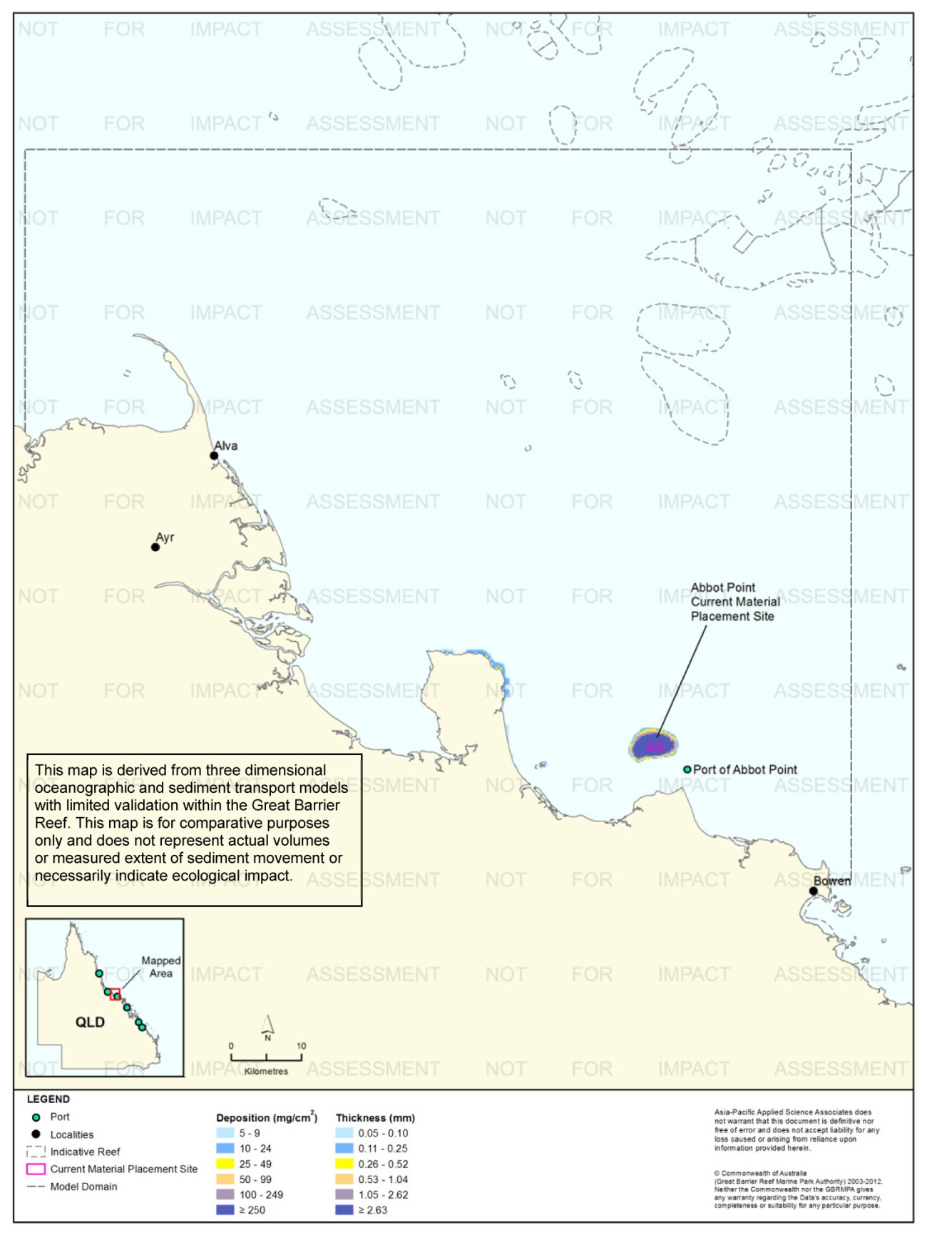
Figure 140. Total sedimentation and bottom thickness at day 30 of the Abbot Point placement scenario at the current placement site, without large-scale current forcing.

Sediment Plume and Migration Modelling
This is also only the second study to model dredged material migration in the Region for 12 months after the commencement of dredged material placement. In the first, BMT WBM (2012) predicted dredged material migration from the current placement site at Rosslyn Bay extended beyond the boundary of the local modelling domain used in the study. The present study also indicates the potential for dredge material to move long distances after placement; the larger spatial scale of the model domains used herein provides a better indication of the patterns of long-term sediment migration, but even so modelled migration extends beyond the model domains in some cases.
The sediment plume modelling assumed that the dredged material was released randomly over the defined material placement sites, spreading it over a large area. In reality, dredged material placement will differ for the six locations and between projects. Material may be placed in a grid pattern to spread it across the placement site, or concentrated in a mound. Individual releases of dredged material may occur while the dredge or barge is stationary or underway, and if underway moving in a straight line or turning. The placement methodology will affect the thickness and spatial extent of dredge material on the bottom immediately after release, and hence its subsequent resuspension. Accounting for such port-specific operations was beyond the scope of this study. Consideration of placement methodology at a level required for a port- and project-specific EIS offers opportunities for mitigation of sediment-related impacts from dredge material placement. Navigational considerations, hydrodynamic and habitat effects of altered bathymetry, and other factors also need to be considered in designing the placement methodology.
During the material relocation period, the sediment plume was calculated on a 200 m x 200 m horizontal resolution, which limited the ability to assess the very near thickness accumulation of sediments on the material placement site. Therefore, the thickness of sediment deposits immediately over the material placement site will be higher for actual projects than predicted by the modelling herein. Again, the model represents “maximum credible” scenarios for dredge material migration from the placement site. The assumption of random placement over the entire placement site is significant in this regard, as armouring, which occurs when winnowing of fine material from the sediment surface leave a layer of coarse material that protects underlying fines from being resuspended, will be less important for thin, widely distributed layers of dredge material than for less extensive, thicker layers.
Many site-specific factors were included in this research, including the use of localised datasets of currents, waves, bathymetry, and sediment particle sizes in addition to information describing the volumes and operational characteristics at each of the six study locations. However, the consolidation of the dredge material after placement and wave-induced fluidization processes have been omitted, as calculating site-specific values was beyond the scope of this study.
DREDGEMAP was used to simulate the transport of sediments for this project. DREDGEMAP is an enhancement of the publicly available SSFATE model developed by the United States Army Corps of Engineers. Values employed by the model for sediment deposition, sediment resuspension and sediment settling velocities are all based on peer reviewed-literature (van Rijn 1989; Soulsby 1998; Soulsby & Whitehouse 1997; Teeter 1998).
Enhanced settlement rates due to flocculation and scavenging are particularly important for clay and fine-silt sized particles (Swanson et al. 2004) and these processes have been implemented in DREDGEMAP based on previous United States Army Corps of Engineers studies (Teeter 1998).
The model assumed that dredge material on the bottom remains unconsolidated, that is, there is no allowance for the compaction of material over time. This gives an upper bound for subsequent sediment resuspension and migration. Consolidation will in fact occur and will reduce sediment resuspension. There is insufficient information on the rates of consolidation of dredge material to credibly quantify it in the modelling.
Finally, the modelling did not set any operational limits on material placement, which was assumed to continue regardless of weather. In actuality, material placement will be constrained by strong winds and waves, conditions in which sediment mobility will be greatest.

Relative Influence of Terrestrial and Dredging Sediment Inputs
The modelling has predicted "above background" TSS and sedimentation, meaning that dredge material is considered in isolation from ambient conditions. This inherently assumes that the effects of dredge material placement are simply additive to whatever ambient levels exist at any point in time. This is a standard approach often used in modelling of dredge material placement and a necessary assumption in the scope of this study.
Understanding of ambient background has important implications. If background TSS or sedimentation are already at or near levels that cause ecosystem stress, it is possible that relatively small increases above background could increase stress and therefore cumulative impacts. Conversely, if the above-background contribution from dredge material is small relative to ambient background, then it could be difficult to measure any incremental increase attributable to dredging. In terms of a better understanding of the model predictions, an important aspect of the "above background" assumption may be with regard to dredge material resuspension, which is the primary driver of the long-range migration predicted by the model. As described above, the modelling incorporates the effects of armouring, which refers to the winnowing away of fine material from the sediment surface, leaving a surface layer of relatively coarse material that tends to protect underlying fines from being resuspended.
It is impossible to make like-for-like comparisons of river inputs of sediment to potential mobilisation of sediments by dredge material placement (and it is important to recognise that the scope of this study was restricted to material placement and not dredging itself). Nonetheless, it is instructive to consider long-term quantities of dredge material in the context of riverine inputs. It is also critically important to recognise that TSS inputs from rivers are estimated to have increased more than five-fold since pre-European times (Kroon et al. 2009).
Table 10 shows recent estimates of TSS inputs, in kilotonnes (kt) of dry mass, from the 10 major catchments draining into the study area by Joo et al. (2012) and Kroon et al. (2009, 2012). Using the estimates of Kroon et al. (2012), these 10 catchments account for 72 per cent of current (i.e. post-European) TSS inputs to the Reef lagoon. Joo et al. (2012) did not estimate total inputs to the lagoon but instead focused on these 10 catchments because they have been identified as priority catchments for ReefPlan (Carroll et al. 2012).
Joo et al. (2012) derived their estimates from end-of-river monitoring of TSS concentrations over three years (2006/07, 2007/08 and 2008/09), coupled with modelling. The estimates of Kroon et al. (2009, 2012) were based on available estimates of river inputs, including monitoring data, and catchment modelling. Kroon et al. (2012) provide refined estimates for six catchments (Pioneer, Burdekin, Herbert, Tully, Johnstone and Barron) using additional monitoring data and model corrections. Kroon et al. (2012) present estimated inputs on the basis of annual means, while Joo et al. (2012) present estimates for the three individual years. For comparison, Table 10 shows the mean over the three years of Joo et al.’s (2012) estimates, as well as the range, as an indication of inter-annual variability.
There are substantial differences in predicted TSS inputs from individual rivers, which are likely to result from differences in methodology, and the years of monitoring data used in deriving the estimates. The very low TSS input estimates for the Burnett River by Joo et al. (2012), for example, reflect the absence of a high-flow event during the monitoring period used in that study. There are additional uncertainties in these estimates, including the possibility of significant TSS inputs from over-bank flows during floods that are not captured in monitoring data (Darnell et al. 2012; Wallace et al. 2012). Nonetheless, they represent a useful context for considering river inputs of sediment in relation to dredge material quantities.

Table 10. Estimated TSS inputs (kt) from ten major river catchments.
 | Joo et al. (2012) |  | Kroon et al. (2009, 2012)
River | Range 2006/07 - 2008/09 | Annual Mean | Annual Mean Total
Burnett¹ | 0-5 | 2 | 1400
Fitzroy¹ | 320-4751 | 1825 | 4100
Pioneer | 111-255 | 174 | 50
O’Connell¹ | 24-121 | 65 | 630
Burdekin | 6503-12,700 | 9606 | 4000
Herbert | 220-1888 | 815 | 380
Tully | 88-116 | 106 | 92
Johnstone | 132-241 | 178 | 320
Barron | 30-397 | 197 | 100
Normanby¹ | 59-211 | 125 | 1100
Totals | n/a | 13,093 | 12,172
1: Kroon et al. estimate is from Kroon et al. (2009) rather than Kroon et al. (2012)
Table 11 shows estimates of projected quantities of proposed dredge material placement at the six locations over 25 years as determined in this study, in terms of both in situ volumes of material, the quantity used in dredging approvals, and dry mass, the quantity comparable to the river input estimates and that used for sediment plume and migration modelling. The estimates in table 11 were derived as follows:
- The total estimated 25-year dredging volumes were developed in consultation with the port authorities as described in SKM APASA (2013b). The anticipated volume of capital dredging, originally estimated at 25,000,000 m³, has subsequently been reduced to 20,000,000 m³,which is reflected in table 6
- For most of the six locations the estimates of capital versus maintenance dredging volumes were also developed through consultation with the port authorities. For Gladstone, the long-term maintenance dredging requirement was based on BMT WBM (2009) and the capital dredging requirement determined by subtraction
- The conversion from in situ volumes to dry mass was calculated using a factor of 1 m³ = 0.8 t for capital dredging and 1 m³ = 0.7 t for maintenance dredging; these factors were developed from geotechnical data and dredging records in consultation with the port authorities. The dry mass per tonne for the in situ (that is, material on the seabed before dredging) is a function of the water content of the combined sediment/water mixture in situ and the density of the dry sediment. The masses in tonnes are converted into kilotonnes in table 11 for comparison with table 10
- Since the total volumes in table 11 represent different proportions of capital and maintenance dredging, with different conversion factors to dry mass, total volumes were not converted into dry mass. Instead, the total dry mass of dredge material relocation over 25 years can be determined from the sum of capital and maintenance dredging dry mass estimates.
A high-level comparison of table 10 and table 11 indicates that the estimated annual dry mass of dredge material from the six locations (4933 kt/y, the sum of the annual dry masses from capital and maintenance dredging) represents about 40 per cent of the total estimated terrestrial sediment input from the ten major catchments.
In this regard, it is important to differentiate capital from maintenance dredging. Maintenance dredging represents the relocation of material that is already mobile in the ambient sedimentary regime and has been trapped in areas that are already dredged. Thus, relocation of material from maintenance dredging does not represent a new input of sediment to the lagoon. If only capital dredging is considered, bulk sediment inputs from dredge material relocation reduce to about 30 per cent of river inputs to the lagoon, averaged over 25 years.
Capital dredging material is dominated by relatively coarse material (sand and coarser), whereas TSS input from rivers is dominated by fine clay and silt. More than 70 per cent of TSS in Burdekin River flood plumes, for example, consists of clay and fine silt < 16 µm (Amos et al. 2004; Bainbridge et al. 2012). By contrast, in the three capital dredging scenarios developed for this study (Gladstone, Hay Point, Abbot Point), sands > 75 µm constituted more than 60 per cent of the material, and fine material < 35 µm less than 30 per cent. Finer sediments are more mobile than coarser material, setting aside the consolidation of sediment on the bottom as was assumed in this study. Perhaps more importantly, fine sediments generally have the greatest impacts on corals and seagrasses (Erftemeijer & Lewis 2006; Falwoski et al. 1990; Piniak 2007; Weber et al. 2006). Using the approximation that 70 per cent of river sediment inputs are fine sediments, compared to about 30 per cent of capital dredging material inputs, mean annual inputs of fine sediment from relocation of capital dredging material at the six locations represent around 11-12 per cent of mean annual inputs of fine sediments from the 10 major rivers, and 8-9 per cent of total inputs to the Reef if it is considered that the 10 catchments represent 72 per cent of total inputs.
Long-term averages are not necessarily an appropriate context for considering dredge material relocation relative to the river inputs, because impacts can potentially occur from individual dredging campaigns that do not correspond to long-term averages. This is particularly true for capital dredging projects involving the relocation of large amounts of material over a relatively short period (one or two years) of time. In addition to 25-year means, table 11 shows indicative volumes and dry masses of solids that might be relocated by dredging in a given year. The indicative capital dredging campaigns in table 11 reflect the modelled scenarios for Gladstone, Hay Point, and Abbot Point. The indicative campaign for Cairns reflects the proposed Cairns Shipping Development Project, and that for Townsville reflects Stage 2 of the proposed Port Expansion Project. Inspection of table 11 indicates that, on time scales of one or a few years, major dredging projects can indeed mobilise fine sediments in comparable quantities to river inputs.
It must also be recognised that inputs at the scale of the entire Reef lagoon will not reflect relative inputs of sediment from dredge material relocation and rivers at the scale of the six locations, nor are annual inputs necessarily relevant given the strong seasonality of river inputs. Detailed review of regional and seasonal patterns of river inputs relative to dredge material placement is beyond the scope of this study.
This high-level comparison of the amounts of material potentially mobilised by dredging with river inputs provides useful context, but is not directly relevant if turbidity and sedimentation in the Region are not controlled by sediment inputs. For the purpose of determining catchment management targets to reduce TSS concentrations in the lagoon, it has been assumed that lagoon TSS concentrations are directly proportional to river inputs (Brodie et al. 2009; Kroon 2012). There are differing views, however, on the extent to which TSS and turbidity on the Reef are controlled by sediment inputs rather than resuspension of ambient sediment. Both Brodie et al. (2009) and Kroon (2012) acknowledge considerable uncertainty in this regard. There is evidence that turbidity regimes on the reef are driven primarily by sediment resuspension (Lambrechts et al. 2010; Larcombe et al, 1995; Larcombe & Woolfe 1999; Orpin et al. 1999; Orpin & Ridd 2012; Webster & Ford 2010). If so, then new sediment inputs from dredge material placement would not be expected to directly affect TSS or turbidity regimes appreciably. Amos et al. (2004) and Fabricius et al. (2013), however, present evidence that turbidity is indeed limited by the supply of new sediment inputs.
As noted by Brodie et al. (2009), however, even if sediment inputs do not directly control TSS and turbidity in the Reef lagoon, they could indirectly increase turbidity by depositing surface layers of sediment that are more easily resuspended than more consolidated ambient sediments. Placement of dredge material could have a similar effect and make dredge material more susceptible to resuspension than it was prior to dredging. This again points to the desirability of better understanding post-disposal consolidation.
Another factor that could lead to changes in turbidity regimes even if they are not directly controlled by sediment inputs is that placement of dredge material may move sediment from one sedimentary regime to another. The inner shelf is dominated by a wedge of terrestrial sediment, out to around the 20 m depth contour in the south and middle Reef, tending to narrow to about the 10 m contour in the north (Belpario 1983; Lambeck & Woolfe 2000; Mathews et al. 2007). Placement of dredge material beyond this zone moves predominantly terrestrial sediments to the middle shelf, which is more dominated by sediment of marine origin and has a different sediment transport regime. This should be considered in detailed EIAs of proposed dredge material placement projects not only with regard to turbidity but also to other ecological implications of placing terrigenous sediment in environments further offshore.
To the extent that turbidity regimes on the reef are driven not by sediment inputs, but rather by sediment resuspension, then the appropriate comparison would be the amount of dredge material mobilised against the quantity of ambient sediment available for resuspension. This study made no attempt to quantify those relative amounts, and all model outputs are "above back ground". Thus, resuspension of ambient sediment from the seabed is taken to be zero, and interactions between particles of dredge material and ambient sediment are not taken into account. In reality, resuspension events will mix dredge material with ambient sediment, and deposition will tend to bury the dredge material, reducing its availability for subsequent resuspension. Again, the modelling presents maximum credible predictions of dredge material migration. The need for further consideration of ambient sediment resuspension is discussed in ‘Ambient ’ page 182.

Table 11.Volumes and dry mass of dredged material envisioned over 25 years at the six locations.
Location | Units | Total (25 years) | Total capital (25 years) | Capital - mean per year | Indicative Capital campaign | Total Maintenance (25 years) | Maintenance - mean per year | Typical maintenance dredging interval (years) | Indicative maintenance campaign
Gladstone | Volume (m³) | 80,000,000 | 72,500,000 | 2,900,000 | 6,000,000 | 7,500,000 | 300,000 | 1 | 300,000
Gladstone | Dry Mass (kt) | n/a | 58,000 | 2320 | 4800 | 5250 | 210 | 1 | 210
Rosslyn Bay | Volume (m³) | 250,000 | 0 | 0 | 0 | 250,000 | 10,000 | 3 | 30,000
Rosslyn Bay | Dry Mass (kt) | n/a | 0 | 0 | 0 | 175 | 7 | 3 | 21
Hay Point | Volume (m³) | 28,000,000 | 20,000,000 | 800,000 | 8,500,000 | 8,000,000 | 320,000 | 3 | 960,000
Hay Point | Dry Mass (kt) | n/a | 20,000 | 640 | 6800 | 5600 | 224 | 3 | 672
Abbot Point | Volume (m³) | 8,500,000 | 3,500,000 | 140,000 | 3,500,000 | 5,000,000 | 200,000 | 5 | 1,000,000
Abbot Point | Dry Mass (kt) | n/a | 2800 | 112 | 2800 | 3500 | 140 | 5 | 700
Townsville | Volume (m³) | 24,000,000 | 6,900,000 | 276,000 | 3,500,000 | 17,100,000 | 684,000 | 1 | 684,000
Townsville | Dry Mass (kt) | n/a | 5520 | 221 | 2800 | 11,970 | 479 | 1 | 479
Cairns | Volume (m³) | 20,000,000 | 5,000,000 | 200,000 | 5,000,000 | 15,000,000 | 600,000 | 1 | 600,000
Cairns | Dry Mass (kt) | n/a | 4000 | 160 | 4000 | 10,500 | 420 | 1 | 420
Total for six locations | Volume (m³) | 165,750,000 | 107,900,000 | 4,516,000 | 26,500,000 | 52,850,000 | 2,114,000 | n/a | 3,574,000
Total for six locations | Dry Mass (kt) | n/a | 90,320 | 3,453 | 21,200 | 36,995 | 1,480 | n/a | 2,502

Knowledge Gaps and Further Research
This study clearly indicates that dredge material placed at sea has the potential to migrate on greater spatial and temporal scales than has previously been appreciated. The study has also produced the unexpected result that, when large-scale currents are incorporated, bed shear-stress and resultant significant sediment resuspension and migration may be higher in deeper waters offshore of the currently used dredge material placement sites. These results point to a number of key knowledge gaps and research areas in relation to developing improved management strategies for dredge material in the Region.

Modelling Sensitivity Analysis
The study has been particularly ambitious not only in including large-scale currents in modelling dredge material migration over 12 months, but in doing so at the scale of the entire Region, with bed shear-stress modelling for 12 Queensland ports and more detailed dredge material modelling for the six main study areas. Completing these tasks within the scope of the study necessarily required a number of simplifying assumptions, as described above.
In principle it would be possible to further develop and refine the model at the Regional scale. Modelling will never be perfect, and it may be better to invest in more strategic water quality and ecological impact monitoring, or research on receptor sensitivities, improved methods for water quality monitoring or rapid detection of ecological stress, research on the effectiveness of potential mitigation measures, or studies of cumulative impact and ecosystem resilience.
At this stage, however, SKM and APASA's view is that further research on modelling of dredge material transport, in particular investigating the sensitivity of the model developed in this study to the identified assumptions, is a priority for further developing management strategies. This could be done by varying the key parameter assumptions for one or a few selected model cases to determine the extent to which the changes in each assumed parameter affect the model predictions. The results would be invaluable in developing improved models so as to provide the best possible predictive assessment of dredge material movement in the World Heritage Area. Model sensitivity analysis would also help set priorities for field and laboratory research, by identifying which parameters are most critical to quantify. Perhaps most importantly, the results are needed to help clarify the range of variability and uncertainty in model predictions of dredge material migration. An understanding of this range is needed to guide the development of a strategic approach to water quality and ecological monitoring at the Regional scale. For example, in selecting sites for long-term strategic monitoring, it is important to understand how much the spatial pattern of sediment movement might vary from year to year.

Inter-annual Variability
The modelling in this study used wind, wave, tide and current data from 2011. In developing the model, data from the years 2004 to 2011 were examined. The year 2011 was selected because it was the most energetic conditions that is, the highest current speeds, of the eight years examined. This provides an upper bound for sediment transport, in other words ‘maximum credible’ predictions of dredge material migration. The year 2011 was also a strong La Niña year. It would be useful to understand how representative the results of the study are with respect to less-energetic conditions, and to fluctuations in the El Niño-Southern Oscillation cycle, that is, whether the predicted distance and direction of dredge material migration also hold true in El Niño or neutral years. This could be assessed by using data from other years to drive the model while holding other parameters constant.

Sediment Resuspension and Consolidation
Determination of site-specific estimates of critical shear-stresses for resuspension of particles of different sizes was beyond the scope of the study, and resuspension was modelled using uniform estimates based on accepted published values. The estimates for resuspension (i.e. erosion) were selected based on available literature. Additional model runs varying the assumed 'resuspensibility' of sediments once settled on the bottom would elucidate the sensitivity of the model predictions to this parameter.

Similarly, as described in '
Sediment Plume and Migration Modelling', p. 174, the model did not take into account the consolidation of dredge material on the bottom after initial release. This gives an upper bound for subsequent resuspension and migration. Again the importance of this assumption, and thus the priority of studies to quantify the rate of consolidation and its effect on sediment resuspension, could be tested through model runs that assume varying rates of consolidation while holding other parameters constant.

Ambient Background
As described in ‘Relative Influence of Terrestrial and Dredging Sediment Inputs’ page 175, the modelling has predicted "above background" TSS and sedimentation, a standard approach but with important implications.
Additional modelling that incorporates the resuspension of ambient sediments as well as riverine inputs of suspended sediments valuable insight into the relative contributions of dredge material and other sources of sediment in the Region, and their subsequent migration. This would be a direct contribution to improved capabilities for cumulative impact assessment.

Incorporation of Large-Scale Currents
The modelling in this study incorporated the influence of large-scale currents on sediment transport through a process of vector addition (see 'Hydrodynamics', p. 170). To better understand the significance of this approach, future work could apply the HYCOM (large-scale current model) predictions as boundary conditions to the tidal and local winds model, so that the models are at the same spatial (700 m) and temporal (hourly) resolution. This approach would also verify the influence of large-scale currents in water depths less than 10 m and whether the approach adopted in this research may be an over-estimate of the dredge plume footprints.

Shallow Water Processes
The scope of the project did not permit the inclusion of shallow water processes on sedimentation, specifically shallow waves (e.g. surge from shoaling waves, surf), or tidal pumping of sediment into mangroves and estuaries. For the main purpose of this study, comparison of the relative outcomes of placing material in different locations as opposed to predicting impacts on specific receptors, this is not a critical assumption. Detailed environmental impact assessment, on the other hand, would need to consider these important local shallow water processes. For example, the relatively high sedimentation predicted on the exposed windward sides of islands and reefs do not take these processes into account and are unlikely to be realistic.
SKM and APASA's view is that the technical requirements to link models of detailed shallow water processes to large-scale processes are not justified in the context of strategic consideration of improved management arrangements for dredge material, and that other research areas have higher priority. Modelling for predictive impact assessment for specific individual projects, however, needs to take shallow-water processes into account.

Presentation and Interpretation of Modelling Results
As noted in 'Presentation of Results', page 57, model results presented as maps of percentiles of occurrence of various TSS concentrations and sedimentation rates can be somewhat difficult to understand and interpret. SKM and APASA believe it would be beneficial to initiate a process to address questions such as: a) What is the best way to represent model output? b) What should be industry standards or what is considered best practice when reporting modelling results? c) How should the technical/regulatory community interpret modelling results?

Direct Sediment Resuspension and Consolidation Studies
The model predictions of relatively high bed shear-stress and resultant significant sediment resuspension in deeper waters offshore of the currently used sites are an unexpected result of the study. Studies of sediment resuspension in the Reef that were not directly related to dredge material have tended to indicate that sediment resuspension is relatively uncommon below a depth of about 20 m (e.g. Larcombe & Woolfe, 1999; Orpin et al. 1999, 2004; Wolanski et al. 2005). Wolanski et al. (2005), for example, found that sediment resuspension during storms did not extend below a depth of 12 m on the windward side of an inner-shelf island, or below 5.5 m on the leeward side.
Previous direct studies of sediment resuspension have tended to focus on inshore areas, rather than the mid-shelf lagoon, where the present study predicts a strong influence of large-scale currents on bed shear-stress and potential sediment resuspension. Model sensitivity analysis would provide insight into whether the resuspension assumptions of the model used in this study have a critical effect on predicted sediment migration. If so, field measurements of bed shear-stress and/or sediment resuspension would significantly improve understanding of the implications of offshore dredge material placement in relation to the present study’s results. Useful information may already be available, including Acoustic Doppler Current Profile (ADCP) current data collected for hydrodynamic modelling in EISs for proposed dredging and material placement projects. ADCP data can be used to derive current speeds from the movement of particles in the water column, and can be processed to aid estimates of sediment resuspension. Depending on the results of this “data mining” exercise, additional work could involve deploying ADCP and LISST (Laser In Situ Scattering and Transmissometry) instruments at more strategic locations to measure currents and sediment resuspension.
Measurements of resuspension of ambient sediment from the seabed, however, may not be representative of resuspension of dredge material after placement, for example because of differences in particle size distribution or because ambient sediments are more consolidated (compacted) than dredge material, especially when newly placed. Consolidation increases the bed shear-stress required to resuspend sediments. As noted by SKM APASA (2013a, 2013b) in relation to maintenance dredging, placement of dredge material has the potential to increase suspended sediment concentrations and sediment mobility, even if not representing a new sediment input to the lagoon, by making the sediment more susceptible to resuspension. Additional studies such as that by Wolanski et al. (1992), assessing consolidation and resuspension through field studies of suspended solids concentrations in relation to winds and currents coupled with laboratory experiments, would be useful in refining the model predictions of the present study. It is also possible to directly monitor consolidation, and changes in particle size distribution due to winnowing of fine surface material, with advanced techniques such as sediment profile imagery (SPI). Measurements of sediment consolidation and its effects on resuspension are also needed to inform modelling of the relative resuspension of dredge material and ambient seabed sediments.

Improved Understanding of Operational Mitigation Measures
The model in this study assumed material was released randomly over the sites during the dredging campaign scenarios. Operational measures during dredge material placement have the potential to reduce loss of dredge material from a placement site, and thus potential effects of material migration from the site. For example, placing material from a given dredging campaign over a small part of a long-term placement site to form a thick layer of material, as opposed to spreading a thin layer over an entire disposal site, would be expected to reduce migration from the site. Placement of material in the up-current portion of a placement site as a function of current conditions, so that the current does not carry material outside the placement site, might also reduce sediment migration. Further modelling and/or direct studies of sediment consolidation and resuspension in relation to placement methodology would provide improved understanding of the potential effectiveness of such measures.
Navigational considerations, hydrodynamic and habitat effects of altered bathymetry, and other factors also need to be considered in designing the placement methodology. Port- and project-specific EISs would be required to identify and assess specific operational mitigation measures.

Conclusion
This study investigated the migration of dredged sediments during placement operations (not dredging) and over 12 months when placed at existing and hypothetical alternative placement sites (referred to as Model Cases) at six study locations. The sediment plume modelling was based on relevant hypothetical placement scenarios (i.e. dredged material volumes based on capital or maintenance material, sediment characteristics, duration and dredging equipment) established in cooperation with port operators but do not represent specific, past or proposed, dredging campaigns. This research is not an EIA of a specific dredging project, nor does it replace EIAs that have been conducted for previous and currently proposed projects.
The main results and recommendations that stem from this report are:
- The use of large-scale currents in modelling dredge plumes in the Reef is important and their use is advocated in the ‘Guidelines to hydrodynamic modelling for dredging projects’ produced by the GBRMPA (2012).
- The use of large-scale currents has highlighted that dredge material has the potential to travel longer distances from the material placement site through constant resuspension and transport, than previously appreciated.
- There is considerable inter-annual variability of large-scale currents in the Reef, which could influence sediment migration patterns. The surface currents for the neutral (2007) and La Niña (2011) years were generally stronger and flowing towards the west-north-west, while in 2004 (El Niño conditions) the currents were weaker and more variable. The strongest currents occurred during 2011, coinciding with stronger wind events. Therefore, as a precautionary approach, data from 2011 was selected for use in this study, as it was the most energetic year and provided an upper bound that dredge sediments would travel.
- Offshore sites may not necessarily be more retentive than inshore sites. The use of alternative placement sites needs to be assessed on a case-by-case basis depending on the sensitive receptors which may be affected.
- The production of guidelines for environmental impact predictions by regulators would enhance clarity and confidence for industry and consultants.
It is acknowledged that the study had a number of limitations, and it is anticipated that further research will continue to contribute to improved management of dredge material in the Region.

References
Alongi, D.M. & McKinnon, A.D. 2005, ‘The cycling and fate of terrestrially-derived sediments and nutrients in the coastal zone of the Great Barrier Reef shelf’, Marine Pollution Bulletin, 51(1), 239–252.
Amos, K.J., Alexander, J., Horn, A., Pocock, G.D. & Fielding, C.R. 2004, ‘Supply limited sediment transport in a high‐discharge event of the tropical Burdekin River, North Queensland, Australia’, Sedimentology, 51, 145–162.
Andersen, O.B. 1995, ‘Global ocean tides from ERS 1 and TOPEX/POSEIDON altimetry’, Journal of Geophysical Research: Oceans, 100(C12), 25249–25259.
Andutta, F.P., Ridd, P.V. & Wolanski, E. 2011, ‘Dynamics of a hypersaline coastal waters in the Great Barrier Reef’, Estuarine, Coastal and Shelf Science, 94, 299–305.
Applied Science Associates (ASA), 2004, SSFATE user manual. Asia-Pacific Applied Science Associates, Rhode Island.
APASA 2012b Narrows Crossing and Western basin Cumulative Dredge Plume Modelling. Report for QGC 22nd May 2012.
Australian Bureau of Meteorology. 2012, ‘The Southern Oscillation Index’, Available from: <http://www.bom.gov.au/climate/glossary/soi.shtml>
Bainbridge, Z.T., Wolanski, E., Álvarez-Romero, J.G., Lewis, S.E., Brodie, J.E. 2012, ‘Fine sediment and nutrient dynamics related to particle size and floc formation in a Burdekin River flood plume, Australia’, Marine Pollution Bulletin, 65(4), 236–248.
Belperio, A.P. 1983, ‘Terrigenous sedimentation in the central Great Barrier Reef lagoon; a model from the Burdekin region’, BMR Journal of Australian Geology and Geophysics,8, 179–190.
Belperio, A.P. & Searle, D.E. 1988, ‘Terrigenous and carbonate sedimentation in the Great Barrier Reef Province’, pp. 143–174 in Carbonate-clastic transitions, eds L.J. Doyle and H.H. Roberts, Elsevier, Netherlands.
Brodie, J., Lewism S., Bainbridge, Z., Mitchell, A., Waterhouse, J. & Kroon, F. 2009, ‘Target setting for pollutant discharge management of rivers in the Great Barrier Reef catchment area’, Marine and Freshwater Research, 60, 1141-1149.
BMT WBM. 2012, Port of Gladstone Offshore Disposal Monitoring Program, July 2012, BMT WMB, Brisbane.
Booij, N., Holthuijsen, L.H. & Ris.R.C. 1996, ‘The “SWAN" wave model for shallow water’, pp. 668–676 in Proceedings Coastal Engineering Conference, American Society of Civil Engineers.
Booij, N., Ris, R.C. & Holthuijsen, L.H. 1999, ‘A third-generation wave model for coastal regions: 1. Model description and validation’, Journal of Geophysical Research, 104, 7649–7666.
Brinkman, R., Wolanski, E., Deleersnijder, E., McAllister, F. & Skirving, W. 2001, ‘Oceanic inflow from the Coral Sea into the Great Barrier Reef’, Estuarine, Coastal and Shelf Science, 54, 655–668.
Carroll, C., Waters, D., Vardy, S., Silburn, D., Attard, S., Thorburn, P., Davis, A., Halpin, N., Schmidt, M., Wilson, B., & Clark, A. 2012, ‘A paddock to reef monitoring and modelling framework for the Great Barrier Reef: Paddock and Catchment component', Marine Pollution Bulletin, 65, 136-149.
Cahill, M.L. & Middleton, J.H. 1993, ‘Wind-forced motion on the Northern Great Barrier Reef’, Journal of Physical Oceanography, 23, 1176–1191.
Chassignet, E.P., Hurlburt, H.E., Metzger, E.J., Smedstad, O.M., Cummings, J.A., Halliwell, G.R., Bleck, R., Baraille, R., Wallcraft, A.J., Lozano, C., Tolman, H.L., Srinivasan, A., Hankin, S., Cornillon, P., Weisberg, R., Barth, A., He, R., Werner, F. & Wilkin, J. 2009, ‘US GODAE Global Ocean Prediction with the Hybrid Coordinate Ocean Model (HYCMOM)’, Oceanography, 22, 64–75.
Chu, P.C., Qi, Y., Chen, Y., Shi, P. & Mao, Q. 2004, ‘South China Sea Wind-Wave Characteristics. Part I: Validation of Wavewatch–III Using TOPEX/Poseidon Data’, Journal of Atmospheric and Oceanic Technology, 21, 1718–1733.
Dankers, P.J.T. 2002, The behaviour of fines released due to dredging—a literature review, Delft, The Netherlands: Hydraulic Engineering Section, Faculty of Civil Engineering and Geosciences, Delft University 59.
Darnell, R., Henderson, B., Kroon, F.J. & Kuhnert, P. 2012, ‘Statistical power of detecting trends in total suspended sediment loads to the Great Barrier Reef’, Marine Pollution Bulletin, 65, 203–209.
Erftemeijer, P. L. A., Robin-Lewis, R. R. 2006, ‘Environmental impacts of dredging on seagrass: A review’, Marine Pollution Bulletin, 52, 1553-1572.
Fabricius, K., De’ath, G., Humphrey, C., Zagorskis, I., & Schaffelke, B. 2013. ‘Intra-annual variation in turbidity in response to terrestrial runoff at near-shore coral reefs of the Great Barrier Reef’, Estuarine and Coastal Shelf Science, 116, 57–65.
Falkowski, P. G., Jokiel, P. L., Kinzie, R.A. 1990, 'Irradiance and corals, pp 89-107 in Ecosystems of the World 25: Coral Reefs, ed Z. Dubinsky, Elsevier, Amsterdam.
Fu, L.L., Christensen, E.J., Yamarone, C.A., Lefebvre, M., Menard, Y., Dorrer, M. & Escudier, P. 1994, ‘TOPEX/POSIEDON mission overview’, Journal of Geophysical Research: Oceans, 99(C12), 24369–24381.
Furukawa, K., & Wolanski, E. 1996, ‘Sedimentation in Mangrove Forests’, Mangroves and Salt Marshes, 1(1), 3–10.
Gordon, R.B. 1974, ‘Dispersion of dredge spoil dumped in near-shore waters’, Estuarine and Coastal Marine Science, 2, 349–356.
Great Barrier Reef Marine Park Authority. 2012, The use of Hydrodynamic Numerical Modelling for Dredging Projects in the Great Barrier Reef Marine Park, Australian Government.
Griffin, D.A., Middleton, J.H., & Bode, L. 1987, ‘The tidal and longer-period circulation of Capricornia, Southern Great Barrier Reef’, Australian Journal of Marine and Freshwater Research, 38, 461–474.
Harris, P.T., Smith, R., Anderson, O., Coleman, R. & Greenslade, D. 2000, GEOMAT – Modelling of continental shelf sediment mobility in support of Australia's Regional Marine Planning process, Geoscience Australia, Australia.
Hasselmann, K., Barnett, T.P., Bouws, E., Carlson, H., Cartwright, D.E., Enke, K., Ewing, J.A., Gienapp, H., Hasselmann, D.E., Kruseman, P., Meerburg, A., Müller, P., Olbers, D.J., Richter, K., Sell, W., Walden, H. 1973, Measurements of wind-wave growth and swell decay during the joint North Sea Wave Project (JONSWAP), Deutsches Hydrographisches Institut, Hamburg.
Hemer, M.A., Harris, P.T., Coleman, R. & Hunter, J. 2004, ‘Sediment mobility due to currents and waves in the Torres Strait–Gulf of Papua region’, Continental Shelf Research, 24, 2297–2316.
Holthuijsen, L.H., Booij, N., Ris, R., Andorka Gal, J.H. & de Jong, J.C.M. 1997, ‘A verification of the third-generation wave model "SWAN" along the southern North Sea coast’, pp. 49–63 in Proceedings of the 3rd International Symposium on Ocean Wave Measurement and Analysis, WAVES '97, American Society of Civil Engineers.
Howlett, E., Galagan, C., Clausner, J. & Johnson, B. 2000, ‘Dredgemap: A GIS–based Dredging Model System’, in Proceedings of Oceans 2000 MTS/IEEE Conference, Rhode Island.
Isaji, T. & Spaulding, M. 1984, ‘A Model of the Tidally Induced Residual Circulation in the Gulf of Maine and Georges Bank’, Journal of Physical Oceanography, Notes and Correspondence, 1119–1126.
Johnson, B. H. & Pachure, T.M. 1999, Estimating Dredging Sediment Resuspension Sources. No. DOER–E6, Army Engineer Waterways Experiment Station, Engineer Research and Development Center, Mississippi.
Johnson, B.H., Andersen, E., Isaji, T., Teeter, A.M., Clarke, D.G. 2000, Description of the SSFATE numerical modeling system. No. ERDC-TN-DOER-E10.Army Engineer Waterways Experiment Station, Engineer Research and Development Center, Mississippi.
Joo, M., Raymond, M.A., McNeil, V.H., Huggins, R., Turner, R.D. & Choy, S. 2012, ‘Estimates of sediment and nutrient loads in 10 major catchments draining to the Great Barrier Reef during 2006–2009’, Marine Pollution Bulletin, 65(4), 150–166.
King, B. & Wolanski, E. 1992, ‘Coastal dynamics along a rugged coastline’.pp 577–598 in Dynamics and exchanges in estuaries and the coastal zone, ed. D. Prandle, Coastal and Estuarine Studies, Volume 40, American Geophysical Union, New York.
King, B. & Wolanski, E. 1996, ‘Tidal mixing in the Central Great Barrier Reef’, Journal of Marine Systems, 9, 187–202.
Kostianoy, A.G., Ginzburg, A.I. ,Lebedev, S.A., Frankignoulle, M. & Delille, B. 2003, ‘Fronts and mesoscale variability in the southern Indian Ocean as inferred from the TOPEX/POSEIDON and ERS-2 Altimetry data’, Oceanology, 43, 632–642.
Kroon, F., Kuhnert, P., Henderson, B., Henderson, A., Turner, R., Huggins, R., Wilkinson, S., Abbott, B., Broadies, J. & Joo, M. 2009, Baseline pollutant loads to the Great Barrier Reef, Commonwealth Scientific and Industrial Research Organisation.
Kroon, F.J., Kuhnert, P.M., Henderson, B.L., Wilkinson, S.N., Kinsey-Henderson, A., Abbott, B., Brodie, J.E. & Turner, R.D.R. 2012, ‘River loads of suspended solids, nitrogen, phosphorus and herbicides delivered to the Great Barrier Reef lagoon’ , Marine Pollution Bulletin, 65, 167–181.
Lambeck, A., Woolfe, K.J. & Larcombe, P. 1998, ‘Petrographic evidence for northward directed bedload transport on the inner Great Barrier Reef shelf’, Geological Society of Australia, 49, 258.
Lambeck, A. & Woolfe, K.J. 2000, ‘Composition and textural variability along the 10 m isobath, Great Barrier Reef: evidence for pervasive northward sediment transport’, Australian Journal of Earth Sciences, 47, 327–335.
Lambrechts, J., Hanert, E., Deleersnijder, E., Bernard, P.-E., Legat, V., Remacle, J.-F. & Wolanski, E. 2008, ’A multi-scale model of the hydrodynamics of the whole Great Barrier Reef’, Estuarine, Coastal and Shelf Science, 79, 143–151.
Lambrechts, J., Humphrey, C., McKinna, L., Gourge, O., Fabricius, K.E., Mehta, A.J., Lewis, S. & Wolanski, E. 2010, ‘Importance of wave-induced bed liquefaction in the fine sediment budget of Cleveland Bay, Great Barrier Reef’, Estuarine, Coastal and Shelf Science, 89, 154–162.
Larcombe, P., Ridd, P. V., Prytz, A. & Wilson, B. 1995, ‘Factors controlling suspended sediment on inner-shelf coral reefs, Townsville, Australia’ , Coral Reefs, 14, 163–171.
Larcombe, P. & Woolfe, K.J. 1999, ‘Increased sediment supply to the Great Barrier Reef will not increase sediment accumulation at most coral reefs’, Coral Reefs, 18, 163-169.
Ludicone, D., Santoleri, R., Marullo, S. & Gerosa, P. 1998, ‘Sea level variability and surface eddy statistics in the Mediterranean Sea from TOPEX/POSEIDON data’, Journal of Geophysical Research, 103, 2995–3011.
Mathews, E., Heap, A., & Woods, M. 2007, Inter-reefal Seabed Sediments and Geomorphology of the Great Barrier Reef, a Spatial Analysis, Geoscience Australia, Canberra.
Matsumoto, K., Takanezawa, T., & Ooe, M. 2000, ‘Ocean tide models developed by assimilating TOPEX/POSEIDON altimeter data into hydrodynamical model: A global model and a regional model around Japan’, Journal of Oceanography, 56(5), 567–581.
Maxwell, W.G.H. & Swinchatt, J.P. 1970, ‘Great Barrier Reef; regional variation in a terrigenous-carbonate province’, Geological Society of America Bulletin, 81, 691–724.
National Aeronautics and Space Administration/Jet Propulsion Laboratory. 2013a, ‘TOPEX/Poseidon Fact Sheet’, Available from: <https://sealevel.jpl.nasa.gov/missions/topex/topexfactsheet/>
National Aeronautics and Space Administration/Jet Propulsion Laboratory. 2013b, ‘TOPEX/Poseidon’, Available from: <https://sealevel.jpl.nasa.gov/missions/topex/>
Orpin, A.R., Ridd, P.V. & Stewart, L.K. 1999, ‘Assessment of the relative importance of major sediment-transport mechanisms in the central Great Barrier Reef lagoon’, Australian Journal of Earth Sciences, 46, 883–896.
Orpin, A.R., Brunskill, G.J., Zagorskis, I. & Woolfe, K.J. 2004. ‘Patterns of mixed siliciclastic–carbonate sedimentation adjacent to a large dry-tropics river on the central Great Barrier Reef shelf, Australia’, Australian Journal of Earth Sciences, 51, 665–683.
Pickard, G.L., Donguy, J. R., Henin, C. & Rougerie, F. 1977, ‘A review of the physical oceanography of the Great Barrier Reef and Western Coral Sea’, Canberra, Australian Government Publishing Service.
Piniak, G. A. 2007, ‘Effects of two sediment types on the fluorescence yield of two Hawaiian scleractinian corals’. Marine Environmental Research’ 64, 456–468.
Philander, S.G. 1990, El Niño, La Niña, and the Southern Oscillation, Academic Press, San Diego, California.
Qiu, B. & Chen, S. 2010, ‘Eddy-mean flow interaction in the decadally modulating Kuroshio Extension system’, Deep-Sea Research II, 57, 1098–1110.
Rasmusson, E.M. & Wallace, J.M, 1983, ‘Meteorological aspects of the El Niño/southern oscillation’, Science, 222(4629,) 1195–1202.
SKM APASA 2013a, ‘Improved dredge material management for the Great Barrier Reef Region. Modelling of bed shear-stress in the vicinity of Queensland trading ports in the Great Barrier Reef Region: report to Great Barrier Reef Marine Park Authority’, Unpublished report.
SKM APASA 2013b, ‘Improved dredge material management for the Great Barrier Reef Region. Identification of alternative sites for the placement of dredge material at sea: report to Great Barrier Reef Marine Park Authority’, Unpublished report.
Soulsby, R.L. 1998, Dynamics of Marine Sands. Thomas Telford, England.
Soulsby, R.L. & Whitehouse, R.J.S.W. 1997, ‘Threshold of sediment motion in coastal environments’ pp. 149–154 Prosolution
ceedings Pacific Coasts and Ports ’97, Christchurch, University of Canterbury.
Swanson, J., Isaji, T., Clarke, D. & Dickerson, C. 2004, ‘Simulations of dredging and dredged material disposal operations in Chesapeake Bay, Maryland and Saint Andrew Bay, Florida’, in Proceedings of the 36th TAMU Dredging Seminar, WEDA XXIV, Florida.
Swanson, J.C., Isaji, T. & Galagan, C. 2007, ‘Modeling the ultimate transport and fate of dredge-induced suspended sediment transport and deposition’, in Proceedings of Wodcon 2007, Lake Buena Vista, Florida.
Teeter, A.M. 1998, ‘Cohesive sediment modelling using multiple grain classes, Part 1: settling and deposition’, in Proceedings of INTERCOH 98Coastal and Estuaries Fine sediment Transport: Processes and Applications, Elsevier, Amsterdam.
Tolman, H.L. 2009, ‘User manual and system documentation of WAVEWATCH III version 3.14’, National Oceanic and Atmospheric Administration (National Centers for Environmental Prediction), Maryland.
Townsville Port Authority & Sinclair Knight Merz. 1995, ‘Townsville Port Authority long term dredge spoil disposal strategies : phase III : report dump site characterisation fluorescent tracer study’, Sinclair Knight Merz, Spring Hill.
van Rijn, L.C. 1989, Sediment Transport by Currents and Waves(Rep. H461), Delft Hydraulics Laboratory, Delft, The Netherlands.
Wallace, J., Karim, F. & Wilkinson, S. 2012, ‘Assessing the potential underestimation of sediment and nutrient loads to the Great Barrier Reef lagoon during floods’, Marine Pollution Bulletin, 65, 194–202.
Wallcraft, A., Carroll, S.N., Kelly, K.A. & Rushing, K.V. 2003, ‘Hybrid Coordinate Ocean Model (HYCOM), version 2.1 User’s Guide’, Available from <http://www.panoramix.rsmas.miami.edu/hycom/documentation.html>.
Weber, M., Lott, C., & Fabricus, K. E. 2006, ‘Sedimentation stress in a scleractinian coral exposed to terrestrial and marine sediments and contrasting physical, organic and geochemical properties’, Journal of Experimental Marine Biology and Ecology, 336, 18-32.
Webster, I., Brinkman, R., Parslow, J., Prange, J., Steven, A. & Waterhouse, J. 2007, Review and gap analysis of receiving-water water quality modelling in the Great Barrier Reef, Commonwealth Scientific and Industrial Research Organisation, Canberra.
Webster, I.T. & Ford, P.W. 2010, Delivery, deposition and redistribution of fine sediments within macrotidal Fitzroy Estuary/Keppel Bay: southern Great Barrier Reef, Australia’ , Continental Shelf Research, 30, 793–805.
Wolanski, E. 1994, Oceanographic Processes of the Great Barrier Reef, CRC Press, Boca Raton, Florida.
Wolanski, E. & Thomson, R.E. 1984, ‘Wind-driven circulation on the northern Great Barrier Reef continental shelf in Summer’, Estuarine, Coastal and Shelf Science, 18, 271–289.
Wolanski, E., Gibbs, R., Ridd, P., & Mehta, A. 1992, ‘Settling of ocean-dumped dredged material, Townsville, Australia’, Estuarine, Coastal and Shelf Science, 35, 473–489.
Wolanski, E., Fabricius, K., Spagnol, S., Brinkman, R. 2005, ‘Fine sediment budget on an inner-shelf coral-fringed island, Great Barrier Reef of Australia’, Estuarine, Coastal and Shelf Science, 65, 153–158.
Wolanski, E., Spagnol, S. & Lim, E.B. 1997, ‘The importance of mangrove flocs in sheltering seagrass in turbid coastal waters’, Mangroves and Salt Marshes, 1, 187–191.
Yaremchuk, M. & Tangdong, Q. 2004, ‘Seasonal Variability of the Large-Scale Currents near the Coast of the Philippines’, Journal of Physical Oceanography, 34, 844–855.
Young, I.R. 1999, Wind generated ocean waves, Elsevier, Amsterdam.

