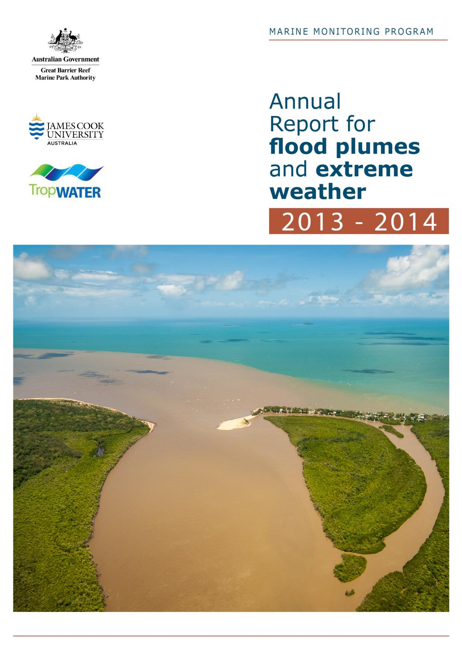
Authors - Michelle Devlin, Eduardo Teixeira da Silva, Caroline Petus, Dieter Tracey

Marine Monitoring Program - Annual Report for flood plumes and extreme weather 2013-2014
– Final Report –

A Report for the Great Barrier Reef Marine Park Authority

Report No. 15/63

2015
Prepared by Michelle Devlin^{1,2}, Eduardo Teixeira da Silva¹, Caroline Petus¹, Dieter Tracey¹
¹TropWATER, James Cook University
²CEFAS, Lowestoft, UK

Centre for Tropical Water & Aquatic Ecosystem Research
(TropWATER)
James Cook University
Townsville
Phone: (07) 4781 4262
Email: TropWATER@jcu.edu.au
Web: www.jcu.edu.au/tropwater/


© James Cook University 2017
Published by the Great Barrier Reef Marine Park Authority
ISBN 978 09953731 43

Marine Monitoring Program: Annual report for flood plumes and extreme weather 2013-2014 is licensed for use under a Creative Commons By Attribution 4.0 International licence with the exception of the Coat of Arms of the Commonwealth of Australia, the logos of the Great Barrier Reef Marine Park Authority, James Cook University and TropWATER, any other material protected by a trademark, content supplied by third parties and any photographs. For licence conditions see: http://creativecommons.org/licences/by/4.0


This publication should be cited as:
Devlin, M. da Silva, E.T., Petus, C., Tracey, D. 2017, Marine Monitoring Program: Annual report for flood plumes and extreme weather 2013-2014. Tropical Water & Aquatic Ecosystem Research (TropWATER) Publication. Report No 15/63. Great Barrier Reef Marine Park Authority, Townsville, Australia. 102 pp.

A catalogue record for this publication is available from the National Library of Australia

Cover photograph courtesy of: Turbid river plume emerging from the Russell-Mulgrave river mouth following several days of heavy rainfall © Dieter Tracey

This publication has been compiled by the Centre for Tropical Water & Aquatic Ecosystem Research (TropWATER), James Cook University.

Disclaimer
While reasonable efforts have been made to ensure that the contents of this document are factually correct, James Cook University do not make any representation or give any warranty regarding the accuracy, completeness, currency or suitability for any particular purpose of the information or statements contained in this document. To the extent permitted by law James Cook University shall not be liable for any loss, damage, cost or expense that may be occasioned directly or indirectly through the use of or reliance on the contents of this document.

Comments and questions regarding this document are welcome and should be addressed to:
Centre for Tropical Water & Aquatic Ecosystem Research (TropWATER)
James Cook University
tropwater@jcu.edu.au

This project is supported by the Great Barrier Reef Marine Park Authority through funding from the Australian Government Reef Program, the Reef 2050 Integrated Monitoring, and Reporting Program and James Cook University.

TABLE OF CONTENTS
LIST OF FIGURES vi
LIST OF TABLES ix
Acronyms and Abbreviations xii
About this Report xiii
Acknowledgments xiv
1. Executive summary 15
1.1. Scope of report 15
1.2. Characteristics of the 2013-2014 wet season 15
1.3. In-Situ Water Quality 15
1.4. Mapping of river plumes 18
1.5. Future outputs for representing river plume influence 22
2. Introduction 24
2.1. Marine Monitoring Program 24
2.2. In-situ Water Quality monitoring 26
2.3. Mapping of river plumes 27
3. Characteristics of the 2013-2014 wet season 28
3.1. Wet Season conditions 28
3.2. Extent of river plumes, 2013-2014 wet season 30
3.2.1. Tropical cyclone Ita 31
4. In-situ Water Quality 35
4.1. Sampling design, 2013-2014 35
4.2. Methods 38
4.2.1. Water sampling, 2013-2014 38
4.2.2. Data analysis - Spatial 39
4.2.3. Data analysis – Temporal 39
4.2.4. Data analysis – Load dispersion maps 40
4.3. Results 43
4.3.1. Data analysis - Spatial 43
4.3.2. Data analysis – Temporal 53
4.3.3. Data analysis – Load dispersion maps, DIN 60
4.3.4. Data analysis – Load dispersion maps, TSS 63
5. Mapping of river plumes 66
5.1. Methodology 66
5.1.1. Introduction to remote sensing products 66
5.1.2. GBR river plume and plume water type maps 67
5.1.3. “Potential risk” maps 70
5.1.4. Exposure of GBR ecosystems to river plumes 74
5.2. Results 76
5.2.1. Plume frequency maps, 2013-2014 76
5.2.2. Water quality concentrations in river plumes 81
5.2.3. Potential river plume risk maps, 2013-2014 82
5.2.4. Mapping of potential risk from river plume exposure in 2013-2014 85
5.2.4.1. Coral reefs 85
5.2.4.2. Coastal seagrasses 85
5.2.4.3. Offshore seagrasses 87
5.2.4.4. Total seagrasses 87
5.2.5. Potential river plume risk maps, 2007 to 2014 88
6. Discussion and conclusions 93
6.1. The 2013-2014 wet season 93
6.2. Towards the production of river plume risk maps for the GBR ecosystems 94
6.3. Inter-annual and averaged (8-year) trends in the GBR 95
7. Future developments 96
8. References 98

LIST OF FIGURES
Figure 1-1: Total suspended solids (TSS) in ton/km² over the GBR lagoon due to the passage of ex-TC Ita. Contour line indicates TSS equals to 50 ton/km² (as a point of reference only). 17
Figure 1-2: Risk matrix in function of the magnitude and the likelihood of the river plume risk. Risk categories (I, II, III, IV, V); modified from Petus et al. (2014b). 20
Figure 2-1: The Great Barrier Reef Marine Park (light grey, Queensland, Australia), major marine ecosystems (coral reefs and seagrass beds), Natural Resource Management regions and marine portions (delineated by dark grey lines) of the NRM regions and major rivers. 25
Figure 3-1: Long-term total hydrological year discharge (c.a., Oct-1 to Sep-30) for the main GBR Rivers (Source: DNRM, http://watermonitoring.dnrm.qld.gov.au/host.htm). 28
Figure 3-2: a) NASA’s Aqua true colour satellite images of Ex-tropical Cyclone Ita (11 April 2014). NASA image courtesy Jeff Schmaltz, LANCE/EOSDIS MODIS Rapid Response Team at NASA GSFC. b) Tropical Rainfall Measuring Mission satellite (TRMM) satellite rainfall map covers Tropical Cyclone Ita's track from 1 to 14 April 2014. Highest isolated rainfall was estimated around 400 mm/15.7 inches west of both Ingham and Townsville, Queensland. Ita's locations at 0600 UTC are shown overlaid in white. Image Credit: SSAI/NASA/JAXA, Hal Pierce. 31
Figure 3-3: NASA’s Aqua true colour satellite images of flooded coastal waters following Ex-tropical Cyclone Ita (14 April 2014). 32
Figure 3-4: Digitised River plumes along the Wet Tropic coastline (Daintree River to Herbert River) in 14 April 2014. Primary (sediment-dominated waters), Secondary (productive waters) and Tertiary (offshore) plume waters are indicated in orange, green and yellow, respectively. 33
Figure 3-5: NASA’s Aqua true colour satellite images of flooded coastal waters in the Tully-Herbert region following Tropical Cyclone Ita (14 and 15 April 2014). 33
Figure 3-6: NASA’s Aqua true colour satellite images of Queensland coastal waters on 20 April 2014. 34
Figure 4-1: Location of the Marine Monitoring Sites sampled in the 2013-2014 wet season under the MMP terrestrial discharge program. Site locations for the three regions (Russell-Mulgrave, Tully and Herbert) are identified by colours (see legend). 36
Figure 4-2: Total daily discharge (megalitres/day) for the (a) Normanby, (b) Russell-Mulgrave, (c) Tully and (d) Herbert rivers for the 2013-2014 wet season (Source: DNRM, http://watermonitoring.dnrm.qld.gov.au/host.htm). Dots indicate the sampling dates, and lines indicate the deployment period for the pesticides passive samplers at the Tully River (different colours for each deployment period). Over the second passive sampler deployment (green line), an ‘event’ deployment (blue line, short duration) took place to register the first after highest peak discharge in the wet season. 37
Figure 4-3: Total annual discharge (ML, megalitres), calculated from 1 November to 30 April 2014, for the (a) Normanby, (b) Russell-Mulgrave, (c) Tully and (d) Herbert rivers from the 2000-2001 to 2013-2014 wet season (Source: DNRM, http://watermonitoring.dnrm.qld.gov.au/host.htm). 38
Figure 4-4: Relationship between river discharge (ML) and distance (km) between river mouth and the outer edge of tracer plume. Dashed lines stand for CI 95%. Red dot stands for point excluded from the regression model. 42
Figure 4-5a: (i) Sites are colour coded to identify location on maps, (ii) date of sampling relative to river flow over wet season, and (iii) mixing plots for DIN in the Tully and Russell-Mulgrave regions for 2013-14. Freshwater end were estimated from all samples collected at salinity < 5 in each region. 46
Figure 4-6: GAMM analysis for light attenuation coefficient (Kd, /m, left column), coloured dissolved organic matter (CDOM, /m, mid column) and total suspended solids (TSS, mg/L, right column) collected from December 2005 to April 2014 (inclusive). First four plots in each column are for the partial effect plots and last pot is the temporal analysis (see text for explanation). Shade area stands for ±1 SE and rubs on x-axis stand for data density. 57
Figure 4-7: GAMM analysis for chlorophyll-a (Chl-a, µg/L, left column), particulate nitrogen (PN, µM, mid column) and dissolved inorganic nitrogen (DIN, µM, right column) collected from December 2005 to April 2014 (inclusive). First four plots in each column are for the partial effect plots and last pot is the temporal analysis. Shade area stands for ±1 SE and rubs on x-axis stand for data density. 58
Figure 4-8: GAMM analysis for particulate phosphorous (PP, µM, left column), dissolved inorganic phosphorus (DIP, µM, mid column) and silica (Si, µM, right column) collected from December 2005 to April 2014 (inclusive). First four plots in each column are for the partial effect plots and last pot is the temporal analysis (see text for explanation). Shade area stands for ±1 SE and rubs on x-axis stand for data density. 59
Figure 4-9: In-situ dissolved inorganic nitrogen concentration (DIN, µM) sampled over 12 wet seasons (c.a., December to April inclusive) from 2002/03 to 2013/14 per colour class. Boxplot presents the mean (dark black line), ±1 SD (rectangle) and maximum-minimum value (vertical lines). Nudge was applied to data on x-axis for better data visualisation. 60
Figure 4-10: Dissolved inorganic nitrogen yield (DIN, kg/km²) over the GBR lagoon in 2013-2014 water year (c.a., 1 October 2013 to 30 September 2014). ‘Max.’ stands for the highest pollutant yield, named rivers are those with load data available, grey lines are the NRM limits, and dashed black line stands for contour line for DIN yield equals to 10 kg/km². 62
Figure 4-11: Regression model adjusted to the in-situ total suspended solids concentration (TSS, mg/L) sampled over 12 wet seasons (c.a., December to April inclusive) from 2002/03 to 2013/14 per colour class. Dashed lines stand for CI 95%, red dots are outliers and nudge was applied to data on x-axis for better visualisation. 63
Figure 4-12: Total suspended solids (TSS) in tons/km² over the GBR lagoon due to the passage of ex-Tropical Cyclone Ita, April 2014. Contour line indicates TSS equals to 50 ton/km² as a point of reference only. 65
Figure 5-1: Remote sensing products designed in order to model the risk of GBR ecosystems due to river plumes during the wet season. 66
Figure 5-2: Conceptual scheme of the risk framework proposed in Petus et al. (2014a). 72
Figure 5-3: Risk matrix in function of the magnitude and the likelihood of the river plume risk. Risk categories I, II, III, IV (modified from Petus et al., 2014b). 72
Figure 5-4: Theoretical example of the production of an annual risk map and the results for 2 pixels (P1 and P2) in the GBR, their classification, and final risk classification. 73
Figure 5-5: Marine boundaries used for the GBR Marine Park (a), each NRM region and the coral reefs ecosystems. Coral Reef and NRM layers derived from: GBRMPA, 2013, GBR feature shapefiles and enlargements around (b) the Tully-Herbert Rivers and (c) the Burdekin river. 75
Figure 5-6: Marine boundaries used for the GBR Marine Park (a), each NRM region and the coral reefs ecosystems. NRM layers derived from: GBRMPA, 2013, GBR feature shapefiles and seagrass layers from DAFF, Feb. 2013. Spatial distribution of seagrass is a historical layer from all meadows examined between 1984 and 2008 (see reports at: http://www.seagrasswatch. 75
Figure 5-7: 2013-2014 plume frequency map: full plume extent in the GBR. The scale is normalised between 0 and 1, where 1 is equivalent to 22 weeks (full wet season). 77
Figure 5-8: 2013-2014 plume frequency map: Full plume extent across each NRM region. The scale is as per Figure 5-7 and is normalised between 0 and 1, where 1 is equivalent to 22 weeks (full wet season). 78
Figure 5-9: 2013-2014 plume frequency map: Plume water types (P: Primary, S: Secondary, T; Tertiary) in the GBR. The scale is normalised between 0 and 1, where 1 is equivalent to 22 weeks (full wet season). 79
Figure 5-10: 2013-2014 frequency map:, plume water types (P: Primary, S: Secondary, T; Tertiary) across NRM regions. The scale is as per Figure 5-9 and is normalised between 0 and 1, where 1 is equivalent to 22 weeks (full wet season). 80
Figure 5-11: 2013-2014 GBR potential river plume risk map. The risk classes are shown in the legend. 83
Figure 5-12: 2013-2014 potential river plume risk in the GBR NRM regions. 84
Figure 5-13: relationships between the total GBR areas exposed to the highest potential risk categories (II, III and IV) to river plume and the total GBR wet season river discharge. R² calculated without considering data of 2011-12 and 2013-2014. 90
Figure 5-14: Multi-annual (2007-2013) “potential” river plume risk maps of (a) the GBR; (b) the Tully Herbert region and (c) the Burdekin region. Maps have been smoothed twice with a 4 pixel majority filter (ArcGIS). 91
Figure 5-15: Multi-annual (2007-2014) areas (km²) of a) coral reefs, b) total seagrass, c) coastal seagrass and d) deepwater seagrass exposed to potential risk categories III and IV. 92

LIST OF TABLES
Table 1-1: Summary of the sampling effort carried out in the 2013-2014 wet season campaign by NRM, presenting the number of field trips per river/transect, sites sampled and the sampling period. Number in brackets stand to those sites that also had pesticides and phytoplankton sampling. 16
Table 1-2: List of all parameters collected in the MMP wet season water quality program. 17
Table 1-3: Total sediment discharged by the major Wet Tropics' rivers due to the 19-day passage of ex-Tropical Cyclone Ita and its mass contribution to each NRM region. 18
Table 1-4: Characteristics of remote sensed products developed partly through MMP funding described against management outcomes. 19
Table 1-5: Mean and standard deviation (±) WQ data across plume water type (P: Primary, S: Secondary, T: Tertiary) and in the ambient marine waters (M). 19
Table 2-1: Description of outputs related to the aims of the MMP wet season monitoring program. 26
Table 3-1: Long term river discharge (ML) statistics of GBR rivers for the 2012-2014 hydrological year (c.a., Oct-1 to Sep-30), compared against the previous three hydrological years, and long-term (LT) medians, means and standard deviations (SD). Colours indicate levels above the long-term median: yellow for 1.5 to 2 times; orange for 2 to 3 times, and red for greater than 3 times. Long term statistics were calculated based on a hydrological year taking into account measurements from 1915 to 2000. (Data source: DNRM). Discharge for Tully at Euramo station (113006A) for the dry season was estimated as 3.5941 times the Tully discharge at Gorge National Park station (113015A), based on a long-term discharge comparison for flows < 20,000 ML/day (r-sq = 0.802). 29
Table 3-2: The 75th and 95th percentile flow (ML/day) for the major GBR rivers (based on flow between 1970 to 2000 obtained from DNRM). 30
Table 4-1: Summary of the sampling effort carried out in the 2013-2014 wet season campaign by NRM, presenting the number of field trips per River/transect, sites sampled and the sampling period. Number in brackets stand the those sites that also had pesticides and phytoplankton sampling. 35
Table 4-2: Summary of chemical and biological parameters sampled for the MMP flood plume monitoring. 38
Table 4-3: Summary of statistical analysis techniques exploring spatial variation applied to the WQ parameters sampled within the wet 2012-2013 wet season. 39
Table 4-4: Summary of transects that were completed and including in this report during the 2013-2014 wet season under the MMP program. Minimum (min), maximum (max), mean, standard deviation (SD) and the number of samples are calculated over multiple sites and multiple dates within each river plume water surface and are provided as a guidance of the range of values within each sampling transect. 43
Table 4-5: Spearman’s rank correlation coefficients for the parameters from the Tully sites sampled more than 20 times in the Wet Tropics in the 2013-2014 wet season. All highlighted values are significant at p < 0.01 and represent a correlation >0.6 or <-0.6. Parameters listed in the table are 5-day average discharge (Disch.), distance between the river mouth and the sampling site Dist.), surface salinity (Sal.), surface water temperature (Temp.), TSS, Chl-a TN, PN, DIN, TP, PP, DIP and Si. 52
Table 4-6: Spearman’s rank correlation coefficients for the parameters from the Russell-Mulgrave sites sampled more than 20 times in the Wet Tropics in the 2013-2014 wet season. All highlighted values are significant at p < 0.01 and represent a correlation >0.6 or <-0.6. Parameters listed in the table are 5-day average discharge (Disch.), distance between the river mouth and the sampling site (Dist), salinity, temperature, TSS, Chl-a TN, PN, DIN, TP, PP, DIP and Si. 53
Table 4-7: Spearman’s rank correlation coefficients from the four most frequent sampled transects over the GBR (2006 – 2014). Values stand for correlation coefficient between the total wet season river discharge (Table 3-6) and the WQ parameters: TSS, Chl-a), TN, TDN, DIN, TP, TDP, DIP, PN, PP. Highlighted values have correlation > 0.6 or <-0.6 and are significant at p < 0.01. 54
Table 4-8: Spearman’s rank correlation coefficients from the four most frequent sampled transects over the GBR wide in the last 9 wet seasons. Values stand for correlation coefficient between salinity and the WQ parameters: TSS, Chl-a), TN, TDN, DIN, TP, TDP, DIP, PN, PP. Highlighted values have correlation > 0.6 or <-0.6 and are significant at p < 0.01. 54
Table 4-9: Statistical summary of the multiple regression analysis. Number of data points, the general model r-squared and its p-value for each WQ component are shown in the left site of the table. The p-value and the percentage of contribution to the total r-squared for each predictor from the relative importance (number in brackets) are in the right side of the table. WQ components are sorted by general model r-squared, and numbers in bold stand for predictors not included in the GAMM analysis. 56
Table 4-10: Summary of the ANOVA mode fitted to in-situ DIN concentrations (mean ± 1 SD, in µM), sampled over 12 wet seasons (c.a., December to April inclusive) from 2002/03 to 2013/14, within each colour class (n stands for the number of observations after excluding outliers). 60
Table 4-11: Total annual end-of-catchment dissolved inorganic nitrogen load (DIN, ton), the total wet season discharge (mega-litres, ML), the plume extent as predicted from Equation 2 and the maximum model-predicted DIN yield at the river mouth (kg/km²). 62
Table 4-12: DIN yield (kg/km²) contribution from (donor) to (receptor) at the vicinities of the river mouth of three catchments in the Wet Tropics NRM region. The main diagonal represents DIN yield at the donor river mouth and other cells are its contribution as yield and as percentage (number in brackets) from the yield at the donor mouth. 63
Table 4-13: Summary of the in-situ TSS concentrations (mean ± 1 SD, in mg/L), sampled over 12 wet seasons (c.a., December to April inclusive) from 2002/03 to 2013/14, within each colour class (n stands for the number of observations after excluding outliers). 64
Table 4-14: Total sediment discharged by the major Wet Tropics' rivers due to the 19-day passage of ex-Tropical Cyclone Ita and its mass contribution to each NRM region. 64
Table 5-1: Remote sensing products developed through MMP funding and management outcomes 67
Table 5-2: Plume water types as described in e.g., Devlin et al. (2012a), Álvarez-Romero et al. (2013) and Petus et al (2014b) and detailing the water quality and optical properties (e.g., Clarke et al.,1970; Morel and Prieur, 1977; Froidefond et al., 2002; McClain, 2009), and the mean TSS, Chl-a and Kd(PAR) which define the plume characteristics within each plume type concentrations (modified from Devlin et al., 2013b). 69
Table 5-3: Frequency categories used to categorise the multi-annual maps of frequency of occurrence of plume water types (TC and L2 methods). 73
Table 5-4: mean and standard deviation (±) GBR-whole scale WQ data per plume water type (P: Primary, S: Secondary, T: Tertiary) and in the ambient marine waters (M), and Kruskal-Wallis analysis for the difference in WQ among water types. Significance code: *: p<0.05 and ns: non-significant. 81
Table 5-5: Areas (km²) and percentage (%) of the GBR lagoon exposed to different categories of river plume frequency and river plume-related risk within the GBR and each NRM. Surface areas south of the GBR marine park boundary (Hervey Bay) are not included. 86
Table 5-6: Areas (km²) and percentage (%) of the coral reefs exposed to different categories of river plume frequency and river plume-related risk within the GBR and each NRM. Surface areas south of the GBR marine park boundary (Hervey Bay) are not included. 86
Table 5-7: Areas (km²) and percentage (%) of coastal, deepwater and total (surveyed + deepwater modelled) seagrass exposed to different categories of river plume frequency and river plume-related risk within the GBR and each NRM. Surface areas south of the GBR marine park boundary (Hervey Bay) are not included. 87
Table 5-8: Inter-annual (2006-2007 to 2013-2014) areas (km²) and percentage (%) of the GBR under potential risk from river plume exposure and total GBR wet season river discharge. Surface areas south of the GBR marine park boundary (Hervey Bay) are included. 89

Acronyms and Abbreviations
AIMS Australian Institute of Marine Science
CDOM Coloured Dissolved Organic Matter
Chl-a Chlorophyll-a
CSIRO Commonwealth Scientific and Industrial Research Organisation
DNRM Queensland Department of Natural Resources and Mines
DIN Dissolved inorganic nitrogen
DIP Dissolved inorganic phosphorus
EnTox National Research Centre for Environmental Toxicology, University of Queensland
GBR Great Barrier Reef
GBRMPA Great Barrier Reef Marine Park Authority
JCU James Cook University
Kd(PAR) Underwater light attenuation coefficient in the Photosynthetically Active Radiation
ML Mega-litres
NASA National Aeronautics and Space Administration
NRM Natural Resource Management
NTU Nephelometric Turbidity Units
OAC’s Optically active components
PN Particulate Nitrogen
PP Particulate Phosphorous
PSII herbicide Photosystem II inhibiting herbicide
PSII-HEq PSII – Herbicide Equivalent
PSU Practical Salinity Unity
QLD Queensland
SE Standard Error
TSS Total suspended solids

About this Report
This report provides a synthesis of the key findings of research conducted on water quality collected through the 2013/2014 wet season s in the Great Barrier Reef and is designed to update the previous reports submitted under the Marine Monitoring Program. The report was commissioned and supported by Government funding under the Australian Government Reef Programme and managed by the Great Barrier Reef Marine Park Authority.

Acknowledgments
We acknowledge the Australian Government funding under the Australian Government Reef Programme and specifically thank the Great Barrier Reef Marine Park Authority (GBRMPA) and Department of the Environment for financial and technical support under this program. We acknowledge the efforts of Katherine Martin and Carol Marshall in overall program management. We thank all the amazing people involved in our field work and all who have helped us through sampling of in some very extreme conditions. We particularly thank Jason Shearer and Bec Rowlands from Mission Beach Charters who have been involved in our long term sampling of the Tully and Russell-Mulgrave marine waters, and who have been a key part of our program for over ten years. Thanks to all the other MMP providers from JCU, AIMS and UQ; it’s a great team of people to be a part of and thanks for all the good discussions. Thank you to the TropWATER laboratory that have analysed thousands of samples for us. Thank you to CSIRO, particularly Thomas Schroeder and Vittorio Brando, who have provided advice and data for our ocean colour map. Thanks to the Bureau of Meteorology for the implementation of the WQ dashboard where we can now access remote sensed data. Finally, thank you to a great team of people at TropWATER James Cook University, particularly the Catchment to Reef Research Group, a small but wonderful team of people.

Executive summary

Scope of report
The Australian Government Reef Programme Marine Monitoring Program (herein referred to as the MMP) undertaken in the Great Barrier Reef (GBR) lagoon assesses the long-term effectiveness of the Australian and Queensland Government’s Reef Water Quality Protection Plan and the Australian Government Reef Programme initiative. The MMP was established in 2005 to help assess the long-term status and health of GBR ecosystems and is a critical component in the assessment of regional water quality as land management practices are improved across GBR catchments. The program forms an integral part of the Reef Plan Paddock to Reef Integrated Monitoring, Modelling and Reporting Program. This report details the sampling that has taken place under the MMP component related to terrestrial runoff to the GBR for the 2013-2014 sampling year, led by James Cook University (JCU). The sampling in the 2013-2014 wet season was carried out in conjunction with CSIRO and the eReefs program which allowed us to sample with increased frequency over much larger spatial scales.
The main objective of wet season monitoring under the MMP is to describe water quality (WQ) concentrations within wet season conditions, characterise the spatial and temporal variability of WQ conditions associated with flood plumes, and produce maps of river plumes and models that summarise land-sourced contaminant transport. Ultimately, the integration of all these methods in a single risk assessment framework would provide a baseline to evaluate the susceptibility of GBR key ecosystems to river plume/pollutants exposure i.e., to model the risk of GBR ecosystem due to exposure to river plumes and acute water quality conditions. Investigation of the latter component commenced in this reporting period.

Characteristics of the 2013-2014 wet season
The wet season 2014 was characterised by neutral (neither El Niño nor La Niña) climatic conditions, and tropical cyclone activity for the 2013-2014 wet season was similar to average activity in Queensland. After a late start to the wet season, Queensland’s NRM regions experienced two minor flood events around the 26 January 2014 to 17 February 2014, and around 19 March 2014 to 6 April 2014. This was followed by a more significant flood event under the influence of Tropical Cyclone Ita which developed in the northern GBR in mid-April 2014. Cyclone Ita became a Category 5 severe tropical cyclone early on 11 April 2014, and winds were estimated to have reached 215 km/h (130 mph). The storm weakened before making landfall near Cape Flattery as a Category 4 later on 11 April 2014. The greatest impact from cyclone Ita resulted from heavy rains, with many areas receiving up to 300 mm in 24 hours. Cardwell reported 307 mm of rain in 24 hours, while in Tully 312 mm of rain fell over two days, causing moderate flooding in both towns. In Bowen, 110 mm fell in one-hour, triggering a flash flood through the town’s main street. Cooktown received 198 mm of rain over a three-day span. The Daintree, Mulgrave, Haughton, and Herbert rivers all experienced major flooding. Townsville reported 214 mm of rain and wind gusts of up to 93 km/h (58 mph) causing only minor damage.

In-Situ Water Quality
Sampling of flood plumes was successfully conducted during the 2013-2014 wet season in the Cape York and Wet Tropics Natural Resource Management (NRM) regions. A total of 154 sites were visited in the 2013-2014 wet season with 9 sampled in the Cape York and 145 in the Wet Tropics (Table 1-1). The data from sites sampled in the Wet Tropics NRM region is described in this report, with data collected in Cape York analysed and reported in a stand-alone report (Howley et al., 2015).
Field sampling within water associated with the formation and transport of river flood plumes included the collection of water samples listed in Table 1-2. Terminology for each parameter is listed in this table and will be used for the remainder of the report. Some parameters listed in Table 1-2 are not reported in this report, including phytoplankton, due to limited number of samples, and PSII herbicides which are reported in detail in Gallen et al. (2014).
Sampling campaigns were carried out in areas under the influence of the Tully and Russell-Mulgrave Rivers (Wet Tropics NRM region). Over the period of the passage of the Ex-tropical Cyclone Ita, extra samples were taken in the waters of the Normanby River (Cape York NRM region) and the Herbert River (Wet Tropics NRM region).
Table 1-1: Summary of the sampling effort carried out in the 2013-2014 wet season campaign by NRM, presenting the number of field trips per river/transect, sites sampled and the sampling period. Number in brackets stand to those sites that also had pesticides and phytoplankton sampling.
 | Rivers
Sample Date | Russell-Mulgrave | Tully | Herbert | Normanby
2013-11-08 |  | 9 (3)
2013-11-20 |  | 8 (4)
2013-11-21 | 10 (3)
2013-12-04 |  | 8 (4)
2013-12-05 | 10 (3)
2013-12-22 |  | 8 (4)
2013-12-23 | 9 (3)
2014-02-05 |  | 8 (4)
2014-02-06 | 10 (3)
2014-02-19 |  | 8 (4)
2014-02-20 | 10 (3)
2014-03-04 |  | 1 (0)
2014-03-24 |  | 8 (4)
2014-03-25 | 10 (3)
2014-04-16 |  | 9 (4) |  | 1 (1)
2014-04-17 | 9 (2)
2014-04-18 |  |  | 10 (4) | 8 (8)
total | 68 (20) | 67 (31) | 10 (4) | 9 (9)

Table 1-2: List of all parameters collected in the MMP wet season water quality program.
Condition | Parameter | Terminology | Units of Measure
Physico-chemical | Salinity | Salinity | PSU
 | Temperature | Temperature | Celsius degree
 | Dissolved Oxygen | DO | mg/L
Turbidity | Total Suspended Sediment | TSS | mg/L
 | Light Attenuation | Kd(PAR) | m⁻¹
 | Coloured Dissolved Organic Matter | CDOM | m⁻¹
Nutrients | Ammonia as N | NH₄⁺ | µM
 | Nitrate | N0₃⁻ | µM
 | Nitrite | NO₂⁻ | µM
 | Dissolved Inorganic Nitrogen | DIN | µM
 | Dissolved Inorganic Phosphate | DIP | µM
 | Particulate Phosphorous | PP | µM
 | Particulate Nitrogen | PN | µM
 | Silica | Si | µM
Productivity | Chlorophyll-a | Chl-a | µg/L
 | Phytoplankton counts | Phyto | Cells/L
Pesticides | Photosystem II inhibiting herbicide | PSII herbicides | ng/L
Using a modified version of the dispersion model for end-of-catchment DIN loads (Álvarez-Romero et al. 2013; da Silva et al., in prep.) and the sediment load data from Great Barrier Reef Catchment Load Monitoring Program, we modelled the dispersion of sediment associated with the passage of the Ex-Tropical Cyclone Ita over a 19-day period in April 2014 to show the extent of influence of the river plume and TSS surface loading. Sediment dispersion over the GBR and its contribution to each NRM region is presented in Figure 1-1 and Table 1-3, respectively. This indicates that a large proportion of the load was derived from the Herbert River which is consistent with previous understanding (e.g. Hateley et al. 2014).
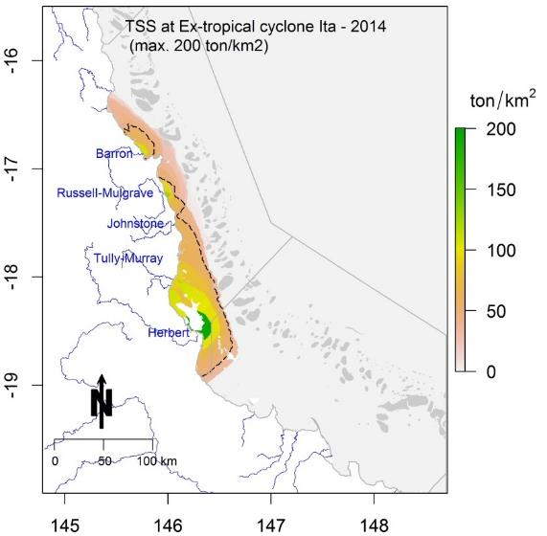
Figure 1-1: Total suspended solids (TSS) in ton/km² over the GBR lagoon due to the passage of ex-TC Ita. Contour line indicates TSS equals to 50 ton/km² (as a point of reference only).
Table 1-3: Total sediment discharged by the major Wet Tropics' rivers due to the 19-day passage of ex-Tropical Cyclone Ita and its mass contribution to each NRM region.
Wet Tropics' rivers | Sediment sourced (ton) | NRM regions | Sediment delivered (ton)
Barron | 47,000 | Cape York | -
Russel-Mulgrave | 77,000 | Wet Tropics | 491,148
Johnstone | 7,100 | Burdekin | 74,343
Tully-Murray | 26,000 | Mackay - Whitsunday | -
Herbert | 410,000 | Fitzroy | -
 |  | Burnett-Mary | -

Analysis of spatial variation was performed on Tully and Russell-Mulgrave samples across all WQ parameters, considering the factors of salinity, distance and 5-day average flow. The outputs of a Spearman’s rank correlation analysis on co-factors for rivers sampled more than 20 times in the 2013-2014 wet season identified variables which are positively or negatively correlated with each other, including:
- Salinity in the Tully and Herbert is correlated with most of the forms of nitrogen and phosphorus, excluding the dissolved forms.
- River discharge correlates with DIN and Si for the Tully River samples and with TP for the Herbert.
- Distance did not presented any significant correlation, indicating that linear dilution processes are not occurring in these regions.
- Dissolved nutrients are not strongly correlated with any factor, indicating that both coastal hydrodynamic, biological processes and dilution are influencing the transport and uptake of the WQ parameters in these regions. Note that these processes are examined over the whole of the wet season and individual events over single dates show a greater correlation with distance and salinity.
Temporal trends on the wet season WQ parameters collected in surface waters throughout the GBR from 2004 to 2014 under the MMP were investigated using Generalised Additive Mixed Models (GAMM). The following parameters were analysed: TSS, Chl-a, light attenuation coefficient (Kd(PAR)), coloured dissolved organic matter (CDOM), DIN, DIP, PN and PP. In the GAMM analysis, time (i.e., Sample Date) was used as fixed effect, i.e., the variable that influences the mean of the observations. River discharge, distance between the sampling site and the nearest river mouth, and surface salinity were used as random effects, i.e., what influences the variance of the observations. For most of the WQ parameters analysed, the best model was obtained by using all variables, i.e., salinity, discharge and distance as random effects. For Chl-a the best model was obtained using salinity only, and for PN, salinity and discharge were used as random effects.

Mapping of river plumes
Numerous studies have shown that nutrient enrichment, turbidity, sedimentation and pesticides all affect the resilience of the GBR ecosystems, degrading coral reefs and seagrass beds at local and regional scales. The main objective of the remote sensing component of the wet season monitoring under the MMP is to produce maps of the estimated extent of river plumes, generate models that summarise land-sourced contaminant transport, describe WQ concentrations within wet season conditions, and to integrate all these methods in single risk assessment framework to evaluate the susceptibility of GBR key ecosystems to the river plume/pollutants exposure.
Different remote sensing products and datasets (with spatial resolution of 1 km x 1 km or 500 m x 500 m) have been developed through the current and previous MMP reporting periods at different geographical and temporal scales (Table 1-4). Note that any results obtained in the Cape York NRM region should be considered with care, since Cape York is a shallow and optically complex environment and the true colour method hasn’t been fully validated in this region.
Three different water types (Primary, Secondary, Tertiary) have been characterised by a WQ gradient across the GBR river plumes and have been described from the inshore to the offshore boundaries of river plumes. Each plume water type is associated with above-natural pollutant concentrations and different concentrations of land-sourced pollutants and light levels. Concentrations of TSS, CDOM and light levels in flood plumes decrease across plume water types i.e., from Primary to Tertiary water types, as described in Table 1-5.
Table 1-4: Characteristics of remote sensed products developed partly through MMP funding described against management outcomes.
Product | Management outcome | Spatial and temporal resolution
River plume maps | Illustrate the movement of riverine waters, but do not provide information on the composition of the water and WQ constituents | - Whole-GBR; NRM, river  - Daily, weekly and seasonal or multi-seasonal (frequency of occurrence)
Plume water type maps | Plume water types are associated with different levels and combination of pollutants and, in combination with in-situ WQ information, provide a broad scale approach to reporting contaminant concentrations in the GBR marine environment. | - Whole-GBR; NRM, river  - Daily, weekly and seasonal or multi-seasonal (frequency of occurrence)
Load maps of land-sourced pollutants (TSS and DIN) | The load mapping exercise, allows us to further understand the movements of pollutants which are carried within the river plume waters. | - Whole-GBR; NRM, river  - seasonal or multi-seasonal
Potential river plume risk maps | Preliminary product aiming to evaluate the ecological risk of GBR ecosystems from river plume exposure | - Whole-GBR; NRM, river  - Daily, weekly and seasonal or multi-seasonal (frequency of occurrence)
Exposure assessment of the coral reefs and seagrass beds | Assess the exposure of key GBR ecosystems to plume exposure and potential risk from the river plume exposure.  Expressed simply as the area (km²) and percentage (%) of coral reefs and seagrass meadows exposed  Assume that historical reef and coral shapefiles can be used to assess the coral and seagrass location (stable over the years) | Whole-GBR; NRM; ecosystem
Table 1-5: Mean and standard deviation (±) WQ data across plume water type (P: Primary, S: Secondary, T: Tertiary) and in the ambient marine waters (M).
 | Mean ± stdv
 | P | S | T | M
Temp | 28.87 ± 1.42 | 28.67 ± 1.33 | 29.18 ± 1.24 | 28.25 ± 0.51
Sal | 24.44 ± 9.19 | 30.27 ± 6.28 | 32.44 ± 4.70 | 32.86 ± 1.72
Depth | 13.77 ± 15.62 | 17.08 ± 15.62 | 21.30 ± 6.39 | 25.00 ± 11.31
Kd(PAR) | 0.78 ± 0.64 | 0.36 ± 0.27 | 0.20 ± 0.26 | NA
TSS | 19.68 ± 38.22 | 8.44 ± 8.21 | 8.37 ± 8.29 | 2.61 ± 1.99
DIN | 3.33 ± 3.03 | 1.87 ± 1.99 | 1.68 ± 2.23 | 1.90 ± 1.03
DIP | 0.45 ± 0.50 | 0.28 ± 0.24 | 0.24 ± 0.18 | 0.17 ± 0.14

These wet season plume water type maps were generated for the 2013-2014 wet season. An inshore to offshore spatial pattern was present, with coastal areas experiencing the highest frequency of occurrence of Primary plume waters and offshore areas less frequently exposed to plume waters and, when exposed, more frequently reached by the Tertiary plume waters. Differences also exist between NRM regions. For example, coastal waters off the Burdekin region were more often exposed to Primary plume waters (i.e., sediment dominated water type), than coastal waters off the Wet Tropics region. Conversely, marine areas occasionally to frequently exposed to Secondary and Tertiary water types were more extended in the Wet Tropics region than in the Burdekin region. These results are in agreement with current knowledge as high TSS concentrations have been mainly linked to grazing activities in the Dry Tropics and particularly the Burdekin region (e.g. Waterhouse et al. 2012; Waters et al., 2014); while occurrence of coastal waters with elevated concentrations of dissolved inorganic nitrogen (DIN) has been linked to fertilised agriculture (predominantly sugarcane) in the Wet Tropics region (e.g. Waterhouse et al. 2012; Waters et al. 2014).
Tropical Cyclone Ita resulted in heavy rainfall between 11 and 14 April 2014, and caused flooding in many areas of north-eastern Queensland. On 14 April 2014, river plumes up to 70 km wide extended from the Mossman River and interconnected plume waters from the Wet Tropics Rivers. Secondary and Tertiary plume water types reached the midshelf reefs in the Wet Tropics region north of the Tully River. Satellite images suggest that sediments settled rapidly and turbidity levels dropped after the passage of the cyclonic system.
A satellite product, ‘potential river plume risk mapping’, was also developed based on the WQ characteristics of the GBR plume water types (Table 1-5), the simplified framework published in Petus et al.(2014b) and the risk matrix below (Figure 1-2). The risk matrix represents the concept that the concentration and duration of exposure to land-sourced contaminant co-determine the severity of an ecosystem response to the contaminant exposure (GBRMPA, 2010). This risk matrix assumes that potential risk level for GBR ecosystems can be ranked in four qualitative categories (I, II, III, IV) determined by the combination of the magnitude (mapped through the Primary, Secondary, Tertiary water type classes) and the likelihood (mapped through the frequency of occurrence of Primary, Secondary, Tertiary water type classes) of the river plume risk. This assumption is based on the ecological risk increasing with increased pollutant concentrations (magnitude) and increased exposure (frequency).
Figure 1-2: Risk matrix in function of the magnitude and the likelihood of the river plume risk. Risk categories (I, II, III, IV, V); modified from Petus et al. (2014b).
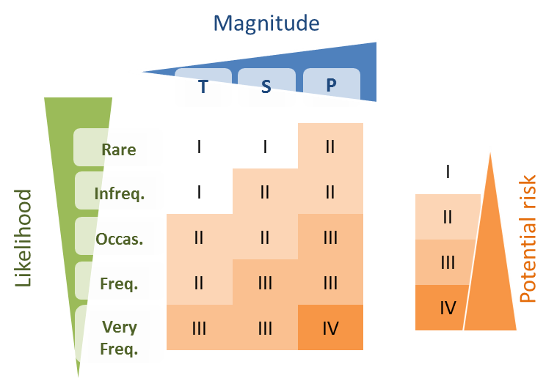
This framework is still theoretical and the term ‘potential’ risk from plume exposure is used as risk maps haven’t been yet validated against ecological health data to confirm the ecological consequences of the risk, i.e., the risk ranking (I to IV) given a combination of magnitude and likelihood is, at this stage, theoretical (Petus et al., 2016). Recent work on the correlations between frequency of true colour and seagrass decline (Petus et al., 2014) has shown that a decline in seagrass meadow area and biomass is positively linked to high occurrence of turbid water masses mapped through MODIS imagery.
Annual potential risk maps from river plume exposure were produced from 2006-2007 to 2013-2014 and GBR areas exposed to potential risk from river plume exposure were calculated and compared to the wet season GBR river discharge. Surface areas of the GBR exposed to the potential risk categories II, III and IV ranged from 81,830 km² in 2011-2012 to 121,024 km² in 2010-2011 and 123,789 km² in 2013-2014. There was a trend toward an increase of surface areas of the GBR (in km²) exposed to the highest potential risk from river plume exposure (II, III and IV) and the wet season GBR river discharge, but 2011-2012 and 2013-2014 were both outliers of the relationship. Greater availability of satellite information due to less frequent cloud cover in 2013-2014 could have resulted in mapping of relatively higher frequency of river plumes during this wet season.
From the 2013-2014 plume frequency maps and potential risk map, it was estimated that:
- The total GBR area exposed to river plume waters was 182,952 km² i.e., 52% of the GBR.
- The NRM areas exposed to river plumes ranged from 11,680 km² (31 %) in the Burnett-Mary to 53,893 km² (56 %) in Cape York and 42,587 km² (49%) in the Fitzroy region. Areas in the highest potential risk categories (III and IV) from the river plumes were much lower with 26,550 km² (8 %) of the GBR, 656 km² (2%) of the Burnett-Mary and 4,013 km² (4 %) and 7,687 km² (9%) in the Cape York and Fitzroy regions, respectively.
- GBR coral reefs were most exposed to the lowest categories of potential river plume risk (I and II), while GBR coastal seagrass beds were most exposed to the medium categories of potential river plume risk (II and III). Offshore seagrass exposure categories were more variable but the offshore seagrass beds were generally most exposed to the lowest categories of potential river plume risk (I and II).
- About 20% (Fitzroy and Mackay-Whitsundays regions) to 90% (Cape York and Wet Tropics regions) of the coral reefs in each NRM region were exposed to river plumes. Mackay-Whitsundays and Fitzroy reefs experienced the highest potential risk (category III) from river plume exposure (203 km² or 6% and 124 km² or 3 %, respectively). Less than 1% of reefs were exposed to the potential risk category IV.
- Eighty three percent (Wet Tropics) to 100% (Cape York) of the coastal seagrass beds in each NRM region were exposed to river plumes. Cape York, Burdekin and Fitzroy reefs experienced the highest potential risk (category III and IV) from river plume exposure (1,228 km² or 50%, 530 km² or 85% and 236 km² or 95 %, respectively).
- Almost 100% of offshores seagrasses areas were exposed to river plumes in all regions, except in the Burnett-Mary (79% or 4,979 km²). Note that seagrass meadows in Hervey Bay (outside of the GBR southern boundary) were not included in the risk analysis. Offshore seagrasses of the Fitzroy and Mackay-Whitsundays regions had the highest potential risk from river plume exposure (282 km² or 7% and 122 km² or 55 %, respectively, under risk categories III).
- The Cape York (1,405 km² or 12%), Burdekin (530 km² or 9%) and Fitzroy (518 km² or 9%) regions had the largest total seagrass areas estimated under risk categories III and IV from river plume exposure. However, the Mackay-Whitsundays had the highest percentage of total seagrass in these categories (73% corresponding to 328 km²).
A multiannual potential risk map was calculated by selecting the majority risk value/pixels from the inter-annual risk maps produced. Recalculating individual wet season risk maps to a long-term (8-year) map is useful to describe where potential risk conditions from river plume are regularly encountered. From this multi-annual composite map, it was estimated that:
- Coral reef areas exposed to potential risk categories III and IV were greater in Mackay-Whitsunday > Fitzroy > Wet Tropics > Burdekin > Burnett-Mary NRM regions.
- Total seagrass areas exposed to potential risk categories III and IV were greater in Fitzroy > Burdekin > Mackay-Whitsunday > Wet Tropics > Burnett-Mary NRM regions.
These results are similar to the results obtained by Brodie et al. (2013) who assessed the relative risk of pollutants to GBR ecosystems using a comprehensive combination of qualitative and semi-quantitative WQ information about the influence of individual catchments in the 6 NRM regions on coral reefs and seagrass ecosystems.
This illustrates the potential of using the Primary, Secondary, Tertiary plume water type classification scheme to simply estimate combined WQ stressors in plume waters and thus simply model the risk of cumulative effects of pollutants in river plumes at different spatial and temporal scales.

Future outputs for representing river plume influence
Recent progress has been made to develop accurate regional algorithms for the GBR region (Brando et al., 2008; Brando et al., 2010a; Brando et al., 2010b; Schroeder et al., 2007) that provide better retrieval in optically complex coastal waters. Using these algorithms to map Chl-a concentrations in the near future will be instrumental in more accurate mapping of river plume waters using the Level-2 method. MODIS images calibrated into accurate water quality metrics would allow production of compliance maps assessed against ecological thresholds.
Further comparisons between remote sensing-derived products and in situ WQ data acquired in the future MMP monitoring years will be undertaken.
One step further toward the evaluation of the susceptibility of GBR key ecosystems to the river plume/pollutants exposure is to compare predicted pollutant concentration in river plumes to published ecological threshold values for consequences and effects and combine this information with measures of ecosystem responses (growth rates, diversity, mortality) to refine the thresholds of the simplified risk framework.
Future risk models should incorporate the potential of cumulative impacts from multiple pollutants in river plume waters and the susceptibility of specific ecosystems (seagrass or coral reefs) should be taken into account. This exercise is, however, challenging because the response of GBR ecosystems to an amount and/or duration of exposure to land-sourced contaminants (respectively or combined) in river plume waters are often unknown at a regional or ecosystem level.
We are currently testing and revisiting the simplified river plume risk framework for the GBR presented in Petus et al. (2014b). This work aims to compare the vulnerability of areas (or ecosystems) predicted in the risk model as of potential risk with monitored cases of ecosystem health decline. This study will use multi-annual WQ data, seagrass abundance data and percent cover of macroalgae (used as index of declining coral biodiversity) as well as published ecological thresholds for land-sourced contaminants (e.g., Brodie et al. 2013).
Further developments of our remote sensing methods to map the dispersion of land-based pollutants (e.g., TSS, DIN, pesticides) delivered by rivers to the GBR waters include:
- The increase of the spatial resolution of WQ data used to calculate the spatially distributed DIN and TSS maps and re-run the model with the annual loads from the Source Catchments modelling for all of the 35 GBR catchments.
- Further development on the load maps is being progressed through a combination of increased number of samples over annual cycles (i.e., not constrained to the wet season only), and by increasing the number of rivers with monitored loads.

Introduction

Marine Monitoring Program
The Marine Monitoring Program (herein referred to as the MMP) undertaken in the Great Barrier Reef (GBR) lagoon assesses the long-term effectiveness of the Australian and Queensland Government’s Reef Water Quality Protection Plan (Reef Plan) and the Australian Government’s Reef Programme initiative. The MMP was established in 2005 to help assess the long-term status and health of GBR ecosystems and is a critical component in the assessment of regional water quality as land management practices are improved across GBR catchments. The program forms an integral part of the Reef Plan Paddock to Reef Integrated Monitoring, Modelling and Reporting Program (P2R program) supported through Reef Plan and Australian Government Reef Programme initiatives. The wet season monitoring program is part of the water quality monitoring program under the MMP, which includes baseline, ambient and event sampling (Johnson et al., 2011; Martin et al., 2014). This monitoring is run in partnership with the other MMP programs including water quality (Bentley et al., 2012; Brando et al., 2008; Brando et al., 2010a; Johnson et al., 2011; Kennedy et al., 2012; Schaffelke et al., 2012), coral monitoring and seagrass monitoring (McKenzie et al., 2014; McKenzie et al., 2012; Thompson et al., 2013).
Water quality in the GBR is influenced by an array of factors including diffuse source land-based runoff, point source pollution, and extreme weather conditions. Monitoring the impacts of land based runoff into the GBR is undertaken within the wet season monitoring program under the MMP, which targets sampling of the wet season and high flow events to characterise the input of terrestrially sourced pollutants delivered through river discharge to the GBR (Devlin et al., 2012; Devlin et al., 2013; Johnson et al., 2011).
This program, through in-situ water quality sampling and remote sensed data identifies and maps the risk and exposure of GBR ecosystems to anthropogenic water quality influences (e.g., nutrients, sediments and pesticides). River flood plumes are important pathway for terrestrial materials entering the sea, and a dominant source of coastal pollutants. Spatial and temporal maps of the river plume extent, frequency of occurrence and duration of exposure provides information in the development of river plume risk models. These models identify plume-affected areas that may experience acute or chronic exposure to contaminants delivered by river discharge. Knowledge of the areas and ecosystems that are most likely to be impacted by changing water quality helps focus our understanding on what type of ecological impacts are occurring and to better inform marine, coastal and catchment management.
Due to the large size of the GBR Marine Park (350,000 km²), the short-term nature and variability of runoff events (hours to weeks) and the often difficult weather conditions associated with floods, it is difficult and expensive to launch and coordinate comprehensive runoff plume water quality sampling campaigns across a large section of the GBR (Devlin et al., 2001). Wet season water quality data is measured through a combination of in-situ water quality measurements taken at peak and post flow conditions in targeted catchments throughout the wet season. River plume extent, frequency and duration are also measured and mapped through the use of remote sensing products, and more recently, the development of hydrodynamic models.
The GBR is the most extensive reef system in the world and comprises over 2,900 km² of coral reefs. It also comprises over 43,000 km² of seagrass meadows (Figure 2-1). Thirty major rivers drain into the GBR, all of which vary considerably in length, catchment area, and flow frequency and intensity. Rivers discharging into the GBR lagoon are the main land-based source of pollutants (i.e., sediments, nutrients and pesticides) of the GBR. The actual distribution and movement of the individual pollutants varies considerably between the Wet and Dry Tropics rivers (Devlin et al., 2011; Devlin et al., 2013).
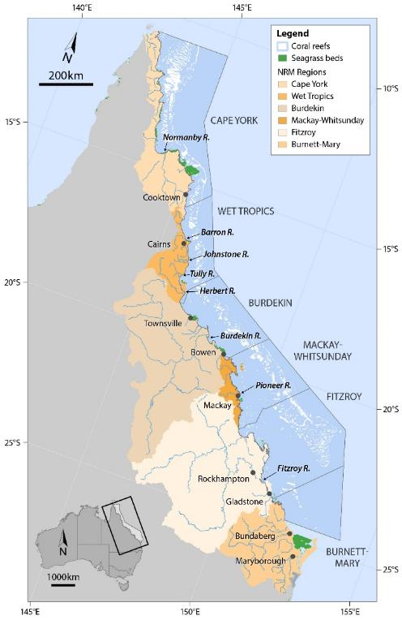
The GBR river plumes are driven by high river flow conditions, which occur during the monsoonal season and are typically associated with the passage of cyclones or low pressure systems, i.e., from about December to April (Devlin and Brodie, 2005). Wet Tropics catchments, located between Townsville and Cooktown, have frequent storm and runoff events in generally short, steep catchments that have more direct and frequent linkages to coastal environments. In the Dry Tropics catchments, the major flow events may occur at intervals of years, with long lag times for the transport of material through these large catchments (Brodie et al., 2009).

Figure 2-1: The Great Barrier Reef Marine Park (light grey, Queensland, Australia), major marine ecosystems (coral reefs and seagrass beds), Natural Resource Management regions and marine portions (delineated by dark grey lines) of the NRM regions and major rivers.
The GBR catchment has been divided into six large areas defined as Natural Resource Management (NRM) regions (Figure 2-1), each defined by a set of land use/cover, biophysical and socio-economic characteristics. The Cape York region is largely undeveloped and is considered to have the least impact on GBR ecosystems from existing land-based activities. In contrast, the Wet Tropics, Burdekin, Mackay-Whitsunday, Fitzroy and Burnett-Mary regions are characterised by more extensive agricultural land uses including sugarcane, grazing, bananas and other horticulture, cropping, mining and urban development, and contribute to discharge of sediments, nutrients and pesticides to the GBR during the wet season.
Occurrence of coastal waters with elevated concentrations of dissolved inorganic nitrogen (DIN) has been linked to fertilised agriculture (predominantly sugarcane) in the Wet Tropics region, while high TSS concentrations are mainly linked to grazing activities in the Dry Tropics and in particular the Burdekin catchment (Brodie et al., 2008; Brodie et al., 2012; Brodie et al., 2013; Brodie and Waterhouse, 2012; Joo et al., 2012; Kroon, 2012; Maughan and Brodie, 2009; Waterhouse et al., 2012).

In-situ Water Quality monitoring
The three main facets of the marine wet season monitoring program are in-situ data, collected in the field, remotely sensed data, and integration of both in-situ and remote sensed data. Data from the flood monitoring feeds into the validation of existing models and the development of regionally based remote sensing algorithms (Brando et al., 2008; Brando et al., 2010b; Brando et al., 2009). Water quality collected in flood plume waters is targeted at measuring the conditions during first flush and high flow event situations to identify the duration and extent of altered water quality conditions (Table 2-1). Data collected under the MMP is also being tested for the improvement of the P2R water quality metric and ongoing P2R program reporting.
Table 2-1: Description of outputs related to the aims of the MMP wet season monitoring program.
Aim | Description
Assessment of the transport and mixing processes of nutrients, suspended sediment and pesticides | Delivered through water quality monitoring in flood plumes. Measurement of water quality parameters presented against salinity gradients for each catchment and each sampling event to describe the their transport and mixing process they are subjected to.
Estimation of the extent and exposure of flood plumes to reefs and seagrass beds | Delivered through the spatial mapping of plume extent and frequency. True colour images are processed to plume maps. Weekly plume maps are then used to estimate the extent and frequency key GBR ecosystems are exposed to them. Additional remote sensing products (e.g., water quality algorithms such as chlorophyll-a, CDOM and TSS) are also used to estimate river plume occurrence on these ecosystems.
Understanding the anthropogenic impact to the water quality conditions by the incorporation and synthesis of monitoring data into GBR wide through the development of hydrodynamic models, the MMP and Paddock to Reef reporting. | Synthesis and reporting of flood plume water quality data and exposure mapping into the MMP. Further work on the integration and reporting of water quality data collected under this sub-program and the long-term water quality sub-program is currently being investigated by JCU, CSIRO and AIMS researchers through Australian Government Reef Programme

The priority catchments targeted for intensive sampling (i.e., Russell-Mulgrave and Tully) were chosen based on the risk analysis reported in (Brodie et al., 2013), and additional samples were taken from sites from the Cape York region and the Herbert during the passage of Ex-tropical cyclone Ita. The Tully River catchment is also the ideal location to assess the long-term effectiveness of Reef Plan as data can be collected every year as it is the wettest catchment in Australia. Repeated sampling in the Tully also adds value to the long-term data set collected in this region from 1994 to 2012 (Devlin and Schaffelke, 2009). The wet season in 2013-2014, as with 2012-2013, was characterised by many smaller episodic flows but no extended large flow associated with a cyclonic period. Heavy and consistent rain also continued in the Wet Tropics region later in the wet season, peaking in late March. This report summarises the data collected in the 2013-2014 wet season and presented as part of a longer term data set collected under the MMP between 2004 and 2014.

Mapping of river plumes
Remote sensing imagery has become a useful and operational assessment tool in the monitoring of river flood plumes (hereafter river plumes) in the GBR. Combined with in situ WQ sampling the use of remote sensing is a valid and practical way to estimate both the extent and frequency of river plume exposure on GBR ecosystems. Ocean colour imagery provides synoptic-scale information regarding the movement and composition of river plumes. Thus, in the past six years, remote sensing imagery combined with in situ sampling of river plumes has provided an essential source of data related to the movement and composition of river plumes in GBR waters (e.g., Bainbridge et al., 2012; Brodie et al., 2010; Devlin et al.; 2012a, b; Schroeder et al., 2012).
Our efforts to improve remote sensing methods are continuing. As part of the last MMP in 2012-13 (Devlin et al., 2015), a number of important and innovative developments were undertaken to improve our capacity to identify and monitor the exposure of GBR ecosystems to river plumes and anthropogenic WQ influences, using remote sensing data. These steps included:
- The development of a semi-automated qualitative method to delineate river plumes (full extent) and river plume water types (Primary, Secondary, and Tertiary) using two types of Moderate Resolution Imaging Spectroradiometer (MODIS) imagery: (i) true color (TC) data (Álvarez-Romero et al., 2013; Devlin et al., 2013a) and (ii) MODIS Level 2 (L2; i.e., geophysical) data and WQ thresholds (Devlin et al., 2013a). Outputs from both methods were compared in Devlin et al. (2015), and the report concluded that TC-derived remote sensing product should be used rather than L2-derived products, because accurate and validated bio-optical algorithms for the GBR where still in development.
- The development of an innovative satellite method to map the discharge and dispersal of TSS and DIN in the coastal/marine environment (Álvarez-Romero et al., 2013). This method incorporated TC-derived products and spatially distributed load data to produce TSS and DIN load maps (previously called exposure maps in Álvarez-Romero et al., 2013) from 2007 to 2011 (2012 and 2013 load data were not yet available at the time of this report). Maps produced from this method are referred as “load maps”.
- The exploration of the potential of using MODIS images to produce potential risk maps from river plume exposure for GBR reef and seagrass ecosystems following theories published in Petus et al., (2014b) . The term ‘potential’ was used as the simplified risk framework proposed was not validated against ecological health data. The need to refine the scoring system of the risk framework based on information on long term WQ in and across river plumes, as well as measured health impacts on ecosystem health during high flow periods was underlined in Devlin et al. (in press).
Our efforts to improve remote sensing methods are continuing and this MMP report in 2013-2014 builds on methods and framework developed in the 2012-2013 report. Our efforts have focused on improving and fully automating the production of pollutants load maps (TSS, DIN) (Álvarez-Romero et al., 2013), and improving our capacity to monitor the exposure of GBR ecosystems to risk from river plumes exposure using the using remote sensing products developed. We mainly worked toward a better understanding of the averaged WQ concentrations across the plume water types in this period.

Characteristics of the 2013-2014 wet season

Wet Season conditions
The wet season 2014 was characterised by neutral (neither El Niño nor La Niña) climatic conditions and tropical cyclone activity for the 2013-2014 wet season was near average the typical cyclone season activity of Queensland. After a late start to the wet season, Queensland’s NRM regions experienced two minor flood events around the 26 January to 17 February and around 19 March to 6 April 2014 as well as a more important flood event under the influence of Tropical Cyclone Ita which developed in the northern GBR in mid-April 2014. Cyclone Ita reached Category 5 severe tropical cyclone early on 11 April 2014 and winds were estimated to have reached 215 km/h (130 mph). The storm weakened before making landfall near Cape Flattery as a Category 4 cyclone later on 11 April 2014. The greatest impact from Ita resulted from heavy rains, with many areas receiving up to 300 mm in 24 hours. Cardwell reported 307 mm of rain in 24 hours, while in Tully 312 mm of rain fell over two days, causing moderate flooding in both towns. In Bowen, 110 mm fell in one-hour, triggering a flash flood through the town’s main street. Cooktown received 198 mm of rain over a three-day span. The Daintree, Mulgrave, Haughton, and Herbert rivers all experienced major flooding. Townsville reported 214 mm of rain and wind gusts of up to 93 km/h (58 mph) causing only minor damage.
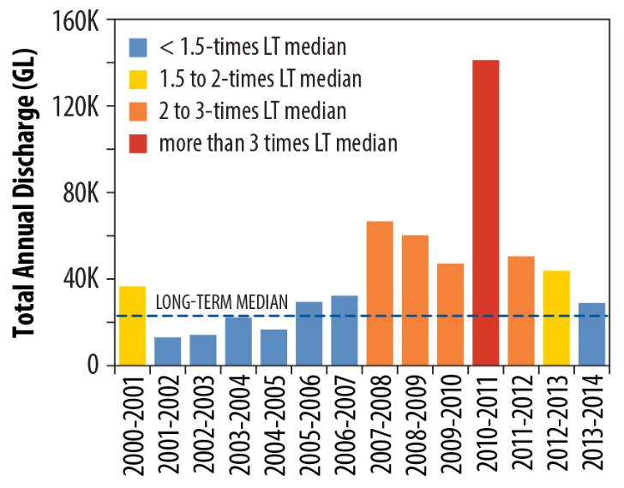
This sampling period was also characterised by a late wet season start (mid-January) and many moderate episodic flows. The passage of Ex-tropical cyclone Ita produced an increased signal on the flow records for the Normanby, Russell-Mulgrave and Herbert Rivers, but it did not imprint a strong signal on the Tully River discharge records. Overall, the GBR Rivers discharge was not characterised by intense floods such as that which occurred in 2010-2011, placing the 2013-2014 wet season in the 6th smallest discharges (approximately 23×10⁶ megalitres) over the last 14 years. The total wet season flow (c.a., from 1 Nov 2013 to 30 Apr 2014) shows that river discharge into the GBR has returned to the levels experienced in the period between 2000 and 2007 (Figure 3-1).

Figure 3-1: Long-term total hydrological year discharge (c.a., Oct-1 to Sep-30) for the main GBR Rivers (Source: DNRM, http://watermonitoring.dnrm.qld.gov.au/host.htm).
The passage of Ex-tropical Cyclone Ita led to moderate flows in the Wet Tropics in what was otherwise a relatively low flow year, which was associated with moderate to high TSS loads being dispersed into the GBR lagoon in the Wet Tropics NRM region, particularly out of the Herbert River. The passage of Ex-tropical cyclone Ita produced an increased signal on the flow records for the Normanby, Russell-Mulgrave and Herbert Rivers, but it did not affect the Tully River discharge records. The Daintree River was the only main river that experienced discharge exceeding >2 times the long-term median (Table 3-1).

Table 3-1: Long term river discharge (ML) statistics of GBR rivers for the 2012-2014 hydrological year (c.a., Oct-1 to Sep-30), compared against the previous three hydrological years, and long-term (LT) medians, means and standard deviations (SD). Colours indicate levels above the long-term median: yellow for 1.5 to 2 times; orange for 2 to 3 times, and red for greater than 3 times. Long term statistics were calculated based on a hydrological year taking into account measurements from 1915 to 2000. (Data source: DNRM). Discharge for Tully at Euramo station (113006A) for the dry season was estimated as 3.5941 times the Tully discharge at Gorge National Park station (113015A), based on a long-term discharge comparison for flows < 20,000 ML/day (r-sq = 0.802).
NRM region | River | LT median | 2009 - 2010 | 2010 - 2011 | 2011 - 2012 | 2012 - 2013 | 2013 - 2014
Cape York | Pascoe | 1,252,975 | 1,534,694 | 1,972,999 | 758,509 | 827,844 | 1,579,514
Cape York | Stewart | 217,473 | 188,528 | 376,009 | 106,219 | 90,233 | 226,168
Cape York | Normanby | - | 2,945,850 | 5,964,886 | 1,148,416 | 1,822,230 | 2,662,977
Cape York | Annan | 276,538 | 407,257 | 550,403 | 331,370 | 196,441 | 303,382
Wet Tropics | Daintree | 727,872 | 1,216,318 | 1,640,196 | 998,710 | 695,126 | 2,140,426
Wet Tropics | Barron | 529,091 | 500,233 | 1,927,091 | 774,595 | 298,418 | 603,606
Wet Tropics | Mulgrave | 728,917 | 773,158 | 1,568,750 | 1,083,093 | 570,415 | 928,259
Wet Tropics | Russell | 995,142 | 1,298,963 | 1,719,880 | 1,290,488 | 900,360 | 1,330,357
Wet Tropics | North Johnstone | 1,764,742 | 1,826,418 | 3,541,632 | 2,023,900 | 1,478,270 | 2,158,945
Wet Tropics | South Johnstone | 850,463 | 728,626 | 1,612,187 | 941,983 | 588,407 | 843,019
Wet Tropics | Tully | 2,944,018 | 2,984,477 | 6,202,306 | 2,854,247 | 2,784,906 | 3,602,080
Wet Tropics | Herbert | 3,041,440 | 3,162,356 | 11,448,794 | 4,131,993 | 2,899,822 | 3,892,370
Burdekin | Burdekin | 5,312,986 | 7,946,435 | 34,834,316 | 15,568,159 | 3,424,572 | 1,458,772
Burdekin | Don | 51,243 | 144,481 | 847,617 | 216,956 | 156,322 | 87,600
Mackay Whitsunday | Proserpine | 14,632 | 52,304 | 346,248 | 51,927 | 37,520 | 3,542
Mackay Whitsunday | Oconnell | 150,788 | 327,627 | 587,525 | 278,370 | 109,167 | 92,362
Mackay Whitsunday | Pioneer | 355,584 | 1,432,244 | 3,300,383 | 1,425,167 | 1,057,156 | 577,559
Mackay Whitsunday | Sandy | 117,856 | 375,904 | 616,569 | 365,988 | 249,863 | 94,562
Mackay Whitsunday | Carmila | 33,158 | 96,228 | 87,644 | 57,656 | 45,044 | 26,256
Fitzroy | Fitzroy | 3,071,435 | 11,755,415 | 37,942,149 | 7,993,273 | 8,530,491 | 1,578,610
Burnett-Mary | Burnett | 282,151 | 1,022,820 | 8,565,016 | 584,670 | 6,892,312 | 198,261
Burnett-Mary | Mary | 696,590 | 1,926,194 | 6,227,933 | 3,100,196 | 5,467,371 | 424,723

The lower 2013-2014 wet season discharge for the main GBR rivers is also evident when it is compared against the long-term mean discharge for each river. For example, the Daintree River in the north of the Wet Tropics was the only main river experienced discharge exceeding >2 folds the long-term median (Table 3-1). This high discharge was a result of the passage of the Ex-tropical cyclone Ita in mid-April 2014, contributing to a total wet season flow of 1.4×10⁶ ML. All the other major rivers in the GBR did not exceed 1.5 times their long-term median discharge. Exceptions were observed to the Don River in the Burdekin region and the Pioneer River in the Mackay-Whitsundays region, with total wet season discharge of 8.1×10⁴ ML and 4.2×10⁵ ML, respectively.
The summary of the plume events computed as the number of days in which flow exceeded a long-term 75th and 95th percentile is shown in Table 3-2. Overall the majority of the main rivers in the GBR exhibited daily flow exceeded 95th percentile, but this number was low vary from null to two weeks. Exception was observed for the Daintree River which exhibited 27 days of 178 days with flow record above the 95th percentile, which was mainly associated with the passage of the Ex-tropical cyclone Ita.
Table 3-2: The 75th and 95th percentile flow (ML/day) for the major GBR rivers (based on flow between 1970 to 2000 obtained from DNRM).
Region | River | 75th %ile (ML/day) | 95th %ile (ML/day) | No days exceed 75th %ile | No days exceed 95th %ile
Cape York | Pascoe | 8,262 | 29,620 | 46 (in 173) | 11 (in 173)
Cape York | Stewart | 1,185 | 5,909 | 34 (in 173) | 5 (in 173)
Cape York | Normanby* | - | - | - | -
Cape York | Annan | 1,298 | 5,435 | 49 (in 148) | 2 (in 148)
Wet Tropics | Daintree | 3,855 | 12,859 | 69 (in 178) | 27 (in 178)
Wet Tropics | Barron | 2,444 | 15,311 | 22 (in 181) | 4 (in 181)
Wet Tropics | Mulgrave | 3,070 | 10,512 | 64 (in 181) | 9 (in 181)
Wet Tropics | Russell | 4,242 | 17,238 | 65 (in 181) | 9 (in 181)
Wet Tropics | N Johnstone | 7,906 | 23,945 | 54 (in 181) | 11 (in 181)
Wet Tropics | S Johnstone | 3,534 | 10,589 | 45 (in 180) | 6 (in 180)
Wet Tropics | Tully | 13,560 | 44,087 | 57 (in 180) | 13 (in 180)
Wet Tropics | Herbert | 14,620 | 81,910 | 38 (in 181) | 7 (in 181)
Burdekin | Burdekin | 17,789 | 190,403 | 13 (in 181) | 0 (in 181)
Burdekin | Don | 101 | 2,992 | 33 (in 181) | 4 (in 181)
Mackay-Whitsunday | Proserpine | 54 | 437 | 41 (in 181) | 6 (in 181)
Mackay-Whitsunday | Oconnell | 417 | 3,842 | 32 (in 181) | 6 (in 181)
Mackay-Whitsunday | Pioneer | 1,138 | 10,634 | 86 (in 181) | 7 (in 181)
Mackay-Whitsunday | Sandy | 150 | 3,370 | 57 (in 181) | 7 (in 181)
Mackay-Whitsunday | Carmila | 84 | 857 | 31 (in 181) | 4 (in 181)
Fitzroy | Fitzroy | 8,434 | 120,756 | 42 (in 181) | 0 (in 181)
Burnett-Mary | Burnett | 786 | 5,326 | 79 (in 181) | 0 (in 181)
Burnett-Mary | Mary | 1,746 | 14,284 | 25 (in 181) | 7 (in 181)

Extent of river plumes, 2013-2014 wet season
The wet season 2014 was characterised by neutral (neither El Niño nor La Niña) climatic conditions and tropical cyclone activity for the 2012-2013 wet season was near average the typical cyclone season activity of Queensland. After a late start to the wet season, there were two minor flood events around 26 January to 17 February 2014 and around 19 March to 6 April 2014, as well as a more important under flood event under the influence of Tropical Cyclone Ita which crossed the northern GBR coast on 11 April 2014.

Tropical cyclone Ita
The MODIS true colour images below illustrates river plumes associated with Ex-tropical cyclone Ita, which came ashore in northeastern Queensland on 11 April 2014 as a powerful Category 4 cyclone and re-emerged in the Coral Sea on 14 April 2014 (Figure 3-2).
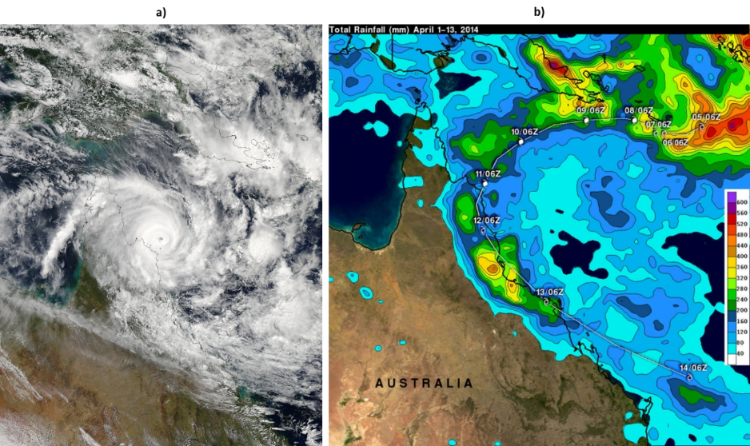
Figure 3-2: a) NASA’s Aqua true colour satellite images of Ex-tropical Cyclone Ita (11 April 2014). NASA image courtesy Jeff Schmaltz, LANCE/EOSDIS MODIS Rapid Response Team at NASA GSFC. b) Tropical Rainfall Measuring Mission satellite (TRMM) satellite rainfall map covers Tropical Cyclone Ita's track from 1 to 14 April 2014. Highest isolated rainfall was estimated around 400 mm/15.7 inches west of both Ingham and Townsville, Queensland. Ita's locations at 0600 UTC are shown overlaid in white. Image Credit: SSAI/NASA/JAXA, Hal Pierce.
Tropical Cyclone Ita dropped heavy rainfall as it moved southward between 11 and 14 April 2014, and caused flooding in many areas of northeastern Queensland. On 14 April 2014, river plumes were large (up to 70 km wide in front of the Mossman River) and interconnected with Wet Tropics rivers (Figure 3-4). The spatial extent of the plumes show secondary and tertiary plume water types reached the reef in the wet tropics, north of the Tully River. The satellite image of Tully and Herbert coastal waters acquired on 15 April 2014 suggests that sediments settled rapidly and turbidity levels dropped after the passage of the cyclonic system. On 20 April 2014, turbidity levels were reduced at the river estuary mouths though green (secondary/productive) waters were still visible, particularly along the Burdekin region coastline (Figure 3-6).
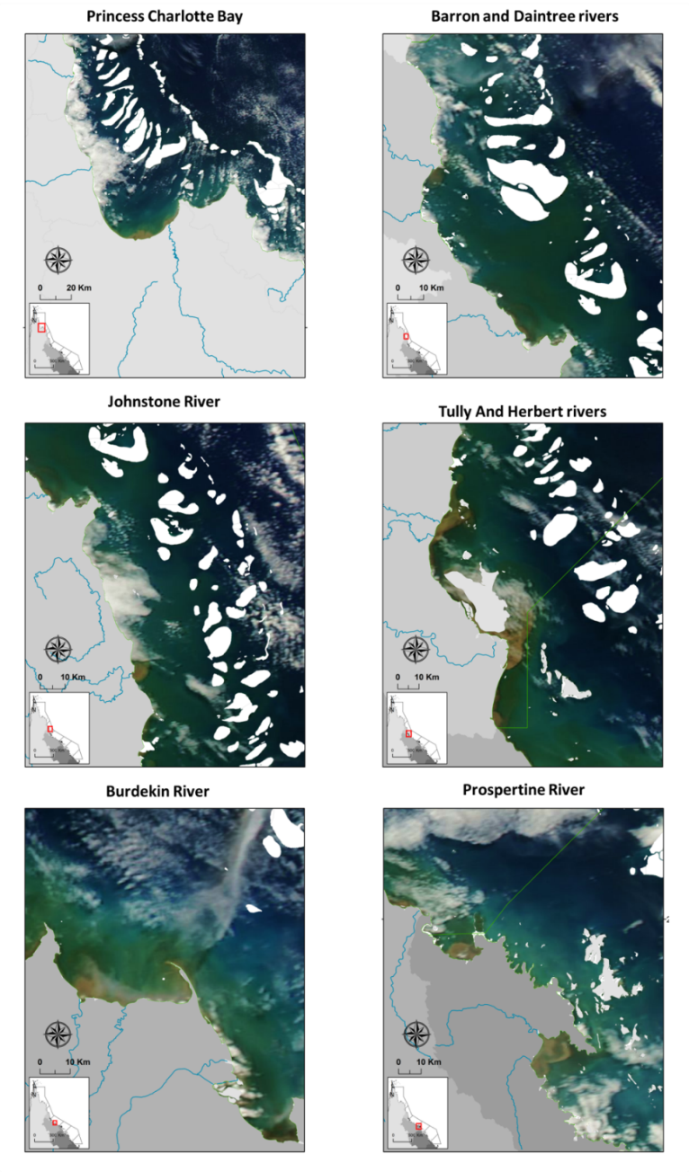
Figure 3-3: NASA’s Aqua true colour satellite images of flooded coastal waters following Ex-tropical Cyclone Ita (14 April 2014).
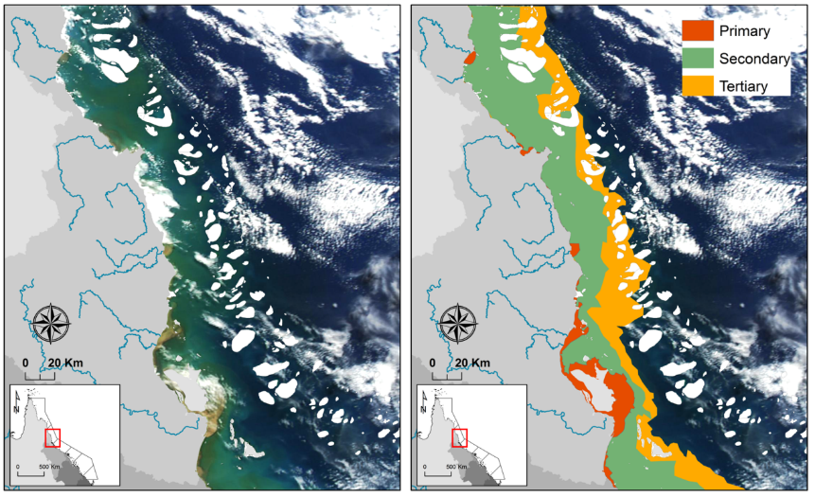
Figure 3-4: Digitised River plumes along the Wet Tropic coastline (Daintree River to Herbert River) in 14 April 2014. Primary (sediment-dominated waters), Secondary (productive waters) and Tertiary (offshore) plume waters are indicated in orange, green and yellow, respectively.
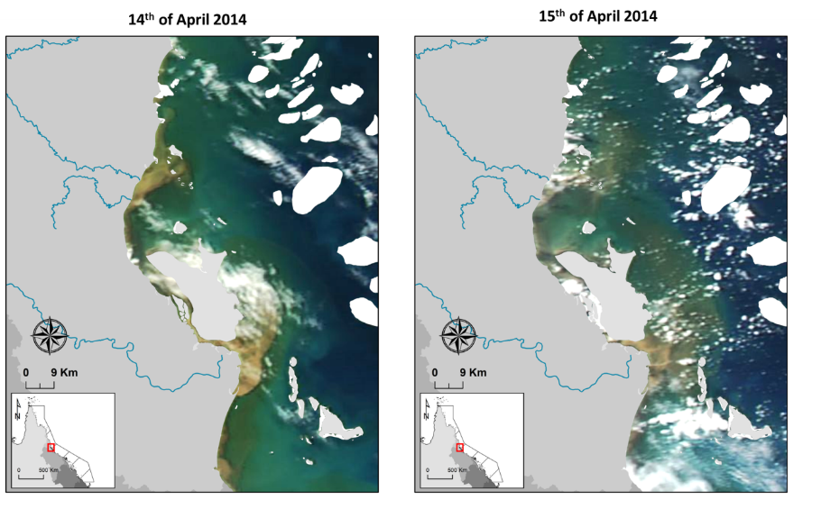
Figure 3-5: NASA’s Aqua true colour satellite images of flooded coastal waters in the Tully-Herbert region following Tropical Cyclone Ita (14 and 15 April 2014).

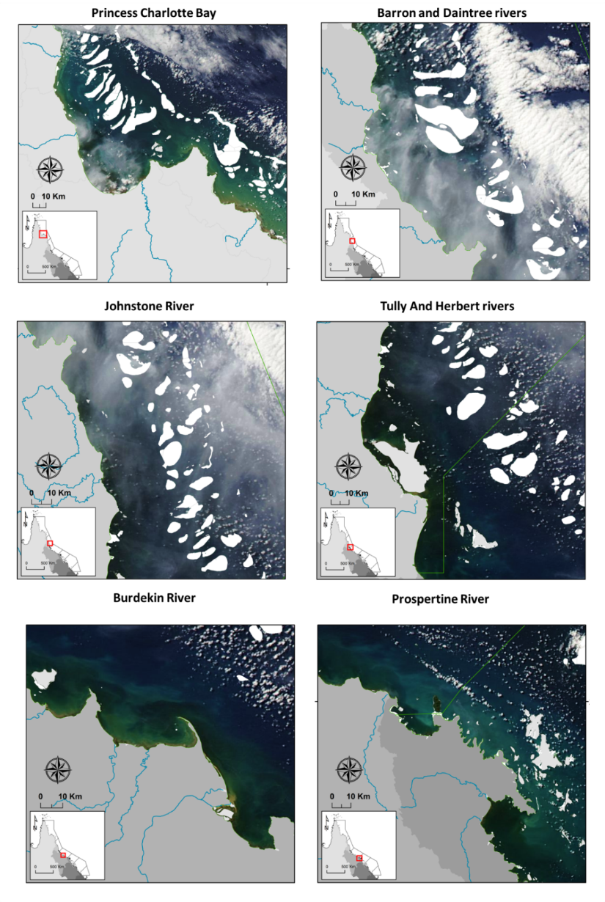
Figure 3-6: NASA’s Aqua true colour satellite images of Queensland coastal waters on 20 April 2014.

In-situ Water Quality

Sampling design, 2013-2014
As a result of the sampling effort applied in the 2013-2014 wet season, a total of 154 WQ samples, 64 phytoplankton samples and 64 pesticides grab samples were taken over six months, from 8 November 2013 to 18 April 2014. The super sites in the Russell-Mulgrave region and in the Tully region were visited 7 and 9 time, respectively. Sites in the Herbert and Normanby regions were visited once, being the Normanby sites split in two sampling days (Table 4-1).
Pesticides were also monitored in the Tully and Russell-Mulgrave regions using passive sampler devices. These devices were deployed at four sites in the Tully marine area and at one site in the Russell-Mulgrave marine area. They were deployed under two regimes: (i) long-term deployment to capture an integrated pesticides concentration when rivers were experience low to moderate flow condition, and (ii) short-term deployment to capture event flow condition. Summary of the passive samplers’ deployment time frame is presented in Gallen et al. (2014).
Table 4-1: Summary of the sampling effort carried out in the 2013-2014 wet season campaign by NRM, presenting the number of field trips per River/transect, sites sampled and the sampling period. Number in brackets stand the those sites that also had pesticides and phytoplankton sampling.
 | Rivers
Sample Date | Russell-Mulgrave | Tully | Herbert | Normanby
2013-11-08 |  | 9 (3)
2013-11-20 |  | 8 (4)
2013-11-21 | 10 (3)
2013-12-04 |  | 8 (4)
2013-12-05 | 10 (3)
2013-12-22 |  | 8 (4)
2013-12-23 | 9 (3)
2014-02-05 |  | 8 (4)
2014-02-06 | 10 (3)
2014-02-19 |  | 8 (4)
2014-02-20 | 10 (3)
2014-03-04 |  | 1 (0)
2014-03-24 |  | 8 (4)
2014-03-25 | 10 (3)
2014-04-16 |  | 9 (4) |  | 1 (1)
2014-04-17 | 9 (2)
2014-04-18 |  |  | 10 (4) | 8 (8)
total | 68 (20) | 67 (31) | 10 (4) | 9 (9)

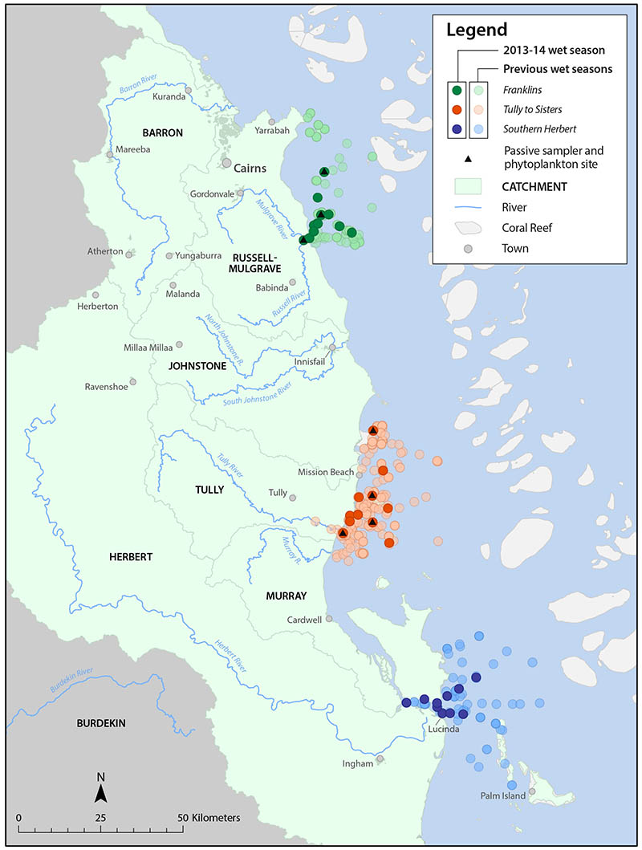
Figure 4-1: Location of the Marine Monitoring Sites sampled in the 2013-2014 wet season under the MMP terrestrial discharge program. Site locations for the three regions (Russell-Mulgrave, Tully and Herbert) are identified by colours (see legend).

Sites within the Wet Tropics region extended from the south of Palm Island to the north of the Russell-Mulgrave mouth (Figure 4-1). Sampling dates covered the period between 8 November 2013 to 18 April 2014, where three major flood events were sampled (Figure 4-2). Flow rates in 2013-2014 presented the 6th highest total annual discharge within the last 13 years for the whole GBR but total flow presented very differently for the separate regions (Figure 4-3).
The sampling in Cape York region was aimed at registering the passage of the Ex-tropical cyclone Ita. Sampling sites were visited on 16 and 18 April 2014 over a transect running from the Normanby River mouth to the Kennedy River mouth (total of 46 km, Figure 4-1). These samples occurred at the highest discharge recorded for the Normanby River for this wet season (175,857 ML, Figure 4-2a). The station gauge at the Normanby River starts operating in 2005, since then the 2013-2014 wet season presented the 5th highest discharge (c.a., from 1 Nov 2013 to 30 Apr 2014) over the last 9 years of data (Figure 4-3a).
A total of 9 sites were sampled once over two sampling days. Additionally 9 pesticides grab samples and 9 phytoplankton samples were collected in the area in this wet season. They add up to the previous two years of pesticides and phytoplankton samples in the Cape York region and this data is summarised as part of a Cape York report (Bentley et al., 2015) and a preliminary analysis of the phytoplankton community during wet season conditions (Devlin et al., 2014). No pesticide passive samplers were deployed in the Cape York region.
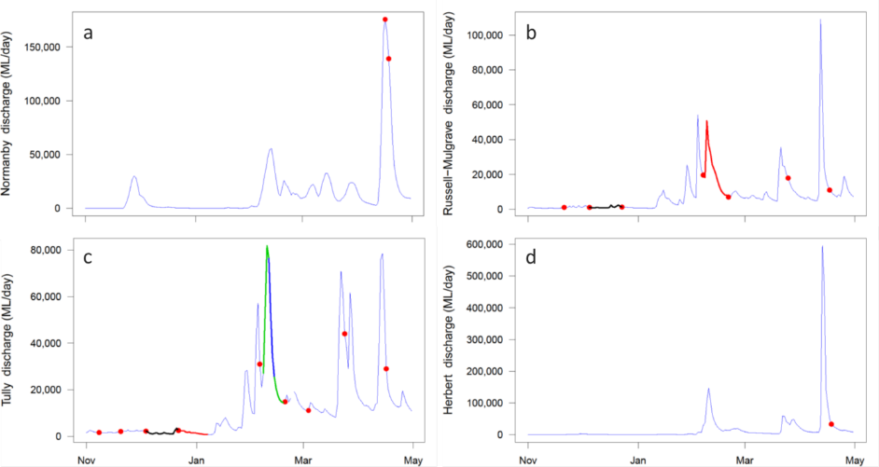
Figure 4-2: Total daily discharge (megalitres/day) for the (a) Normanby, (b) Russell-Mulgrave, (c) Tully and (d) Herbert rivers for the 2013-2014 wet season (Source: DNRM, http://watermonitoring.dnrm.qld.gov.au/host.htm). Dots indicate the sampling dates, and lines indicate the deployment period for the pesticides passive samplers at the Tully River (different colours for each deployment period). Over the second passive sampler deployment (green line), an ‘event’ deployment (blue line, short duration) took place to register the first after highest peak discharge in the wet season.

Sites were sampled several times from November 2013 to April 2014, whereas the Herbert region was sampled only to capture the passage of the Ex-tropical cyclone Ita in mid-April (Figure 4-1). The Russell-Mulgrave region was sampled 68 times over a transect that runs from the Russell-Mulgrave River mouth to the Frankland Island group (total of 44 km). The Tully region was sampled 67 times in total over a transect that runs from the Tully Mouth to the Sisters Reef (total of 76 km), and the Herbert region was sampled 10 times over a transect that runs from the Hinchinbrook Channel to north (total of 43 km), and the Normanby region was sampled 9 times over a transect that runs from the Normanby River to the Kennedy River (total 82 km).
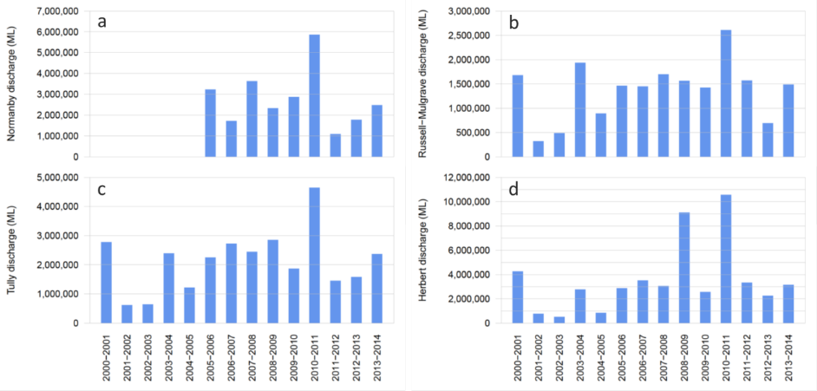

Figure 4-3: Total annual discharge (ML, megalitres), calculated from 1 November to 30 April 2014, for the (a) Normanby, (b) Russell-Mulgrave, (c) Tully and (d) Herbert rivers from the 2000-2001 to 2013-2014 wet season (Source: DNRM, http://watermonitoring.dnrm.qld.gov.au/host.htm).

Methods

Water sampling, 2013-2014
Water Quality for the 2013-2014 wet season is discussed for the Wet Tropics sampling, which includes the sites more often sampled over this wet season. The WQ parameters analysed included the surface samples (within the first 50 cm) of TSS, Chl-a, CDOM, DIN, DIP, PN, PP, salinity, temperature and Kd(PAR). For full details of field and laboratory methods, refer to the MMP QA/QC manual (Anon, 2013, 2014). Depth profiling was undertaken using a CTD from Sea-Bird Electronics (SBE-19Plus) equipped with sensors for temperature, salinity, depth and light. The CTD profiler was kept at the water surface for 3 minutes for sensors stabilization before starting downcast. CTD data reported herein represents surface salinity and surface water temperature, calculated as an average of readings between 0.3 m and 0.7 m below the water surface, after visual removal of outliers corresponding to the 3 minutes stabilization period. Underwater light extinction coefficient (Kd, m⁻¹) was calculated using the Lambert-Beer equation on the CTD light profile with a summary of the parameters collected in the program provided in Table 4-2.
Table 4-2: Summary of chemical and biological parameters sampled for the MMP flood plume monitoring.
Condition | Parameter | Terminology | Units of Measure
Physico-chemical | Salinity | Salinity | PSU
 | Temperature | Temperature | Celsius degree
 | Dissolved Oxygen | DO | mg/L
Turbidity | Total Suspended Sediment | TSS | mg/L
 | Light Attenuation | Kd(PAR) | m⁻¹
 | Coloured Dissolved Organic Matter | CDOM | m⁻¹
Nutrients | Ammonia as N | NH₄⁺ | µM
 | Nitrate | N0₃⁻ | µM
 | Nitrite | NO₂⁻ | µM
 | Dissolved Inorganic Nitrogen | DIN | µM
 | Dissolved Inorganic Phosphate | DIP | µM
 | Particulate Phosphorous | PP | µM
 | Particulate Nitrogen | PN | µM
 | Silica | Si | µM
Productivity | Chlorophyll-a | Chl-a | µg/L
 | Phytoplankton counts* | Phyto | Cells/L
Pesticides | Photosystem II inhibiting herbicide* | PSII herbicides | ng/L
* Not sampled at all sites.

Data analysis - Spatial
Two strategies were adopted in order to analyse the sampled data. Firstly, mixing plots were produced for each WQ parameter grouped by sampling events for the main sampled rivers (i.e., rivers with more than 20 samples: Tully and Russell-Mulgrave). Secondly, a correlation table was produced comparing each water quality parameter, grouped by river, against each other and also two supporting parameters (i.e., distance and discharge). Correlations were calculated using the Spearman's rank correlation coefficient because the majority of the variables did not present normal distribution (Table 4-3).
Table 4-3: Summary of statistical analysis techniques exploring spatial variation applied to the WQ parameters sampled within the wet 2012-2013 wet season.
Statistical approach | Data set used and method | Potential outcome
Mixing plots | 2013-2014 WQ data grouped by sampling events against salinity. Lower salinity point taken by average NRM value < 5 PSU. | Scatter plots identifying superficial mixing profiles and WQ parameter reduction from a potential freshwater value.
Correlation table | The Spearman's rank correlation was computed for all 2013-2014 WQ and also distance and river discharge. | Define correlated WQ parameters between WQ condition and with river discharge and distance.

Data analysis – Temporal
Two strategies were used to investigate the link between river discharge and the WQ parameters sampled at the GBR surface waters over the last 9 wet seasons under the MMP (data sampled form December 2005 to April 2014, inclusive). Firstly, regional correlation between WQ parameters against river discharge and salinity were determined by the Spearman's rank correlation coefficient. A non-parametric correlation was selected because the data set did not presented normal distribution even after data transformation. Secondly, temporal trend in the WQ parameters GBR wide were investigated using Generalised Additive Mixed Models (GAMM, Crawley, 2007) in R language (R Development Core Team, 2015).
When comparing multi-annual data sets for temporal variation, it is important to consider that differences can be imposed on temporal trends due to inter-annual environmental changes and to differences in the sampling frequency rate and/or in the size of the covered sampling area. Therefore, in order to identify possible linkage between river discharge and the WQ parameters at regional scale, we select transects that were sampled more than 3 times from the WQ parameters over the last 9 wet seasons. For this analysis we constrain the list of WQ parameters to light attenuation coefficient (Kd), coloured dissolved organic matter (CDOM), TSS, Chl-a, PN, DIN, PP, DIP and Si, which are the main WQ components driving corals and seagrass communities in the Great Barrier Reef ecosystems (Brodie et al., 2013). Four transects fitted the selection criteria (i.e., Frankland Island group, Tully to Sisters, Burdekin to Palm Island and Fitzroy to Keppels), which covered 3 NRM regions: Wet Tropics, Burdekin and Fitzroy.
For the investigation of temporal trends on the WQ components the data set was constrained to the Central and Southern GBR regions because of their better temporal and spatial coverage. The same set of WQ parameters presented above were investigated by the GAMM, which was performed in two steps. Firstly, a multiple regression analysis using non-parametric smoothers in a Generalised Additive Model (GAM, R Development Core Team, 2015) was performed to choose a set of predictors that best explain each WQ component. Mean of 5-days river discharge, distance between the sampling site and the nearest river mouth, and surface salinity were used as predictors in the multiple regression analyses. In order to select the most appropriated smooth terms (or predictors) residual maximum likelihood (REML) method was applied. This method uses a likelihood function calculated from a transformed set of data, so that irrelevant predictors have no effect in the model (R Development Core Team, 2015). This method is similar to a stepwise regression analysis but where one uses, in this case, cubic spline to fit each predictor rather than a straight line. In order to investigate among the predictors those more influential in the GAM analysis, the relative importance analysis (Grömping, 2006) was performed.
Secondly, the set of predictors selected from the multiple regression analysis was used in a GAMM to investigate temporal trends in each WQ component. In these temporal trend models, time (i.e., Sample Date) was used as fixed effect, which is the variable that influences the mean of the WQ component, and the other selected predictors were used as random effects, i.e., what influences the variance of the WQ component.

Data analysis – Load dispersion maps
An ocean colour based model was developed to estimate the superficial dispersion of dissolved inorganic nitrogen (DIN,${NH}_{4}^{+}+{NO}_{2}^{-}+{NO}_{3}^{-}$) delivered by river plumes to the GBR coastal waters was developed (da Silva et al, in prep). This model, built on Álvarez-Romero et al. (2013), combines in-situ data form the Marine Monitoring Program (MMP), Moderate Resolution Imaging Spectroradiometer (MODIS, satellite imagery) and end-of-catchments DIN loads from the main GBR watershed. In the model, loads provide the amount of DIN delivered along the GBR; the in-situ data provides the DIN mass variation as river plume moves away from the river mouth, and the satellite imagery provides the direction and intensity DIN mass is dispersed over the GBR lagoon. This model produces map of the dispersion of land-sourced DIN discharged by the GBR rivers and express it as mass per area.
The main modifications applied to the method presented in Álvarez-Romero et al. (2013) were: The qualitative assessment of pollutant dispersion in river plumes was replaced by a relationship between in-situ DIN concentration and the six plume water types. Second, the DIN load was dispersed over the whole plume domain proportionally to the in-situ DIN concentration measured within the first 0.5 m depth. Third, the DIN dispersion was not constrained to the maximum plume extent, but to a potential maximum annual plume extent from a hydrodynamic model simulation (Luick et al., 2007). And fourth, the cost-distance function used in Álvarez-Romero et al. (2013) to represent the individual river plume area was replaced by the path-distance function, also available in ArcMap Spatial Analyst (ESRI 2010).
The path-distance function allows applying a main direction to the plume movement, whereas in the cost distance it moves evenly in all directions. On the computation of the path-distance, the reciprocal of the plume frequency per wet season, the coordinates of the river mouth and a surface raster indicating the plume main direction of propagation were taken into account. The path-distance function produced one modelled plume per river (ocean colour plume map), with values staring from zero at the river mouth (source of the pollutant) and increasing up to the maximum annual plume extent. These modelled plumes preserve the information of the shape of the mode of the colour class in the plume maps and the main direction of plume propagation. To account for the prevailing wind direction in the wet season and Coriolis’ effect on water mass movement, the direction of plume propagation was set as 315˚ Azimuth.
DIN dispersion maps were produced in three steps: First, DIN concentrations measured within the river flood plume waters were matched up to each six colour classes of the river plume maps. The match-ups were done at weekly basis, which is the smallest temporal resolution of the river plume maps (Álvarez-Romero et al., 2013). Data match-ups were performed using extract in raster package (Hijmans et al., 2015) with bilinear interpolation method in R 3.1, which interpolates from the values of the four nearest raster cells (R Development Core Team, 2015). Outliers on in-situ DIN data were identified within each colour class as concentrations greater than 1.5 times the interquartile range either above the third quartile or below the first quartile (Crawley, 2007). No outliers were excluded form colour class 1, assuming that a large variability can occur in this class due to its proximity to the source. Only data sampled at flood regimes (c.a., flow exceeding the 75th percentile of daily long-term wet season flow, from 1970 to 2000) were used in the match-ups, as they are more likely to better represent the biogeochemical and transport processes when most of the DIN delivered by rivers may suffer after discharged to the GBR waters.
Secondly, due to the categorical nature of the plume colour classes, an ANOVA model was fitted to the data to describe the relationship between pollutant and colour class. Natural log-transformation was applied to the pollutant concentrations to conform to linear regression assumptions.
Third, the DIN dispersion map was defined as a simple recalculation of the ocean colour plume map by accounting for the relationship between in-situ data and plume colour classes. To do that, the discharge-distance relationship (see below) was used to define the ocean colour plume outer edge (i.e., Pd_{max}), which was used to produce a recalculated ocean colour plume (OCP_{recalc}) as indicated below:
${OCP}_{recalc}=1+\frac{OCP}{{{Pd}_{max}}/5}$. (Eq. 1)
In this equation, '1' changes the lowest value of the ocean colour plume at the river mouth from 0 to 1 (i.e., the first colour class), and '5' adjusts the quotient OCP/PD_{max} to result in a OCP_{recalc} equals to 6 at the outer edge of the plume (i.e., when OCP = Pd_{max}, which corresponds to colour class 6). Thus, the recalculated ocean colour plume (OCP_{recalc}) has values varying from 1 at the river mouth to 6 at the edge of the plume, and keeps increasing over the raster domain. Then the DIN dispersion map was obtained by changing the values in the recalculated ocean colour plume map according to the DIN function (DIN vs colour class maps).
In order to calculate the dispersion of DIN load it is critical the definition of the edge of each river plume. To that end, a highly resolved hydrodynamic model (eReefs) was use to estimate the area of river plume influence by mapping the dispersion of virtual tracers realised from each river mouth. This approach is currently under development (Wolff et al., 2014), where the river plume influence was defined as the area where tracer concentration was equivalent to salinity 36 which corresponds to at least 5% hydrodynamic model simulation time (c.a., form December to April, inclusive). The maximum plume extent was set as a maximum distance between the river mouth and the edge of the plume influence area. Equation 3 presents the discharge-distance relationship, which was used to determine the maximum extent of the ocean colour plumes (Dist, km) as a function of the total wet season river discharge (Disch, in mega-litters, ML).
$Dist=-2.720∙{10}^{-13}∙{Disch}^{2}+2.028∙{10}^{-5}∙Disch+58.84$ (Eq. 2)

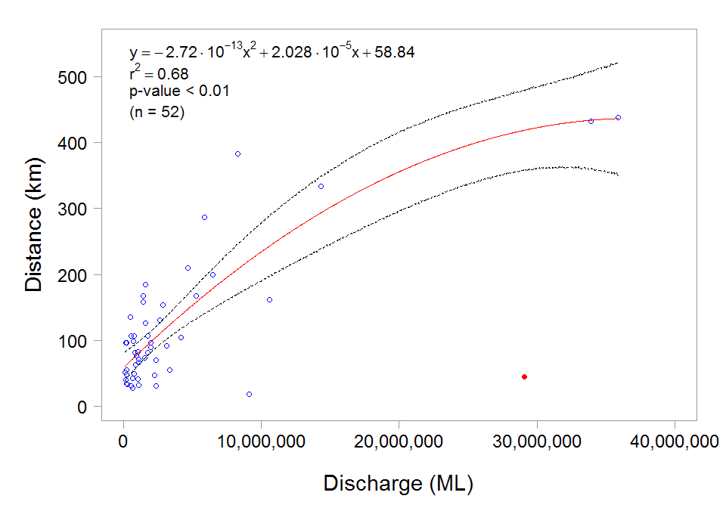
Figure 4-4: Relationship between river discharge (ML) and distance (km) between river mouth and the outer edge of tracer plume. Dashed lines stand for CI 95%. Red dot stands for point excluded from the regression model.

In order to distribute the end-of-catchment DIN loads over the GBR waters, the DIN dispersion map for each river was normalised by dividing each cell-raster value by the sum of all the values in the raster. This resulted in an annual normalised DIN dispersion map (no unity) for each river, in which the sum of the cell-raster values is equal to one. Therefore, by multiplying the DIN load of each river by its normalised DIN dispersion map and accounting for the cell-raster size (500 × 500 m²), a map for the spatial DIN yield in kg/km² was constructed. DIN yield maps were calculated for each river per year, and annual composite maps were produced by the sum of all river DIN yield maps within each year.
In this report we also present a map for TSS distribution over the period of influence for Ex-tropical cyclone Ita. TSS loads were obtained from the Great Barrier Reef Catchments Loads Monitoring Program for the main rivers in the Wet Tropics, the main area affected by the passage of the Ex-tropical cyclone Ita (i.e., the Barron, Russell-Mulgrave, Johnstone, Tully and Herbert rivers). The model used for TSS was exactly the same used for DIN except that a relationship between TSS in the six-colour class was used instead.

Results

Data analysis - Spatial
Two transects in the Wet Tropics region are included in the spatial analysis (Tully and Russell-Mulgrave, Table 4-5). Total suspended solids (TSS) ranged between 1.0 – 21 mg/L, with the highest value sampled at the Tully mouth on 24-03-2014, Chl-a ranged between 0.20 – 4.86 µg/L, and in 64% of the sampled sites, it was above the (annual) water quality guideline (i.e., 0.45 µg/L, GBRMPA, 2009). The highest Chl-a value was observed in secondary waters between High Island and Fitzroy Island (approximately 40km from the Russell-Mulgrave river mouth), under the influence of phytoplankton enriched waters. The minimum values for DIN ranged from 0.36 – 0.86 µM and minimum DIP values ranged from 0.03 – 0.06 µM. The maximum values for DIN ranged from 17.6 µM (RM) to 19.6 µM (Tully) and maximum DIP values ranged from 0.74 µM (RM) to 0.29 µM (Tully). The highest value of DIN (19.6 µM) was recorded at Tully River mouth on 05-02-2014 at a salinity of 0.4 and under a 5-days average discharge of 30,000 ML/d (higher than the 95th percentile, 28,441 ML/d, Table 2-2), suggesting a strong continental contribution of DIN during flood conditions.
Table 4-4: Summary of transects that were completed and including in this report during the 2013-2014 wet season under the MMP program. Minimum (min), maximum (max), mean, standard deviation (SD) and the number of samples are calculated over multiple sites and multiple dates within each river plume water surface and are provided as a guidance of the range of values within each sampling transect.
Parameters | Stats. | Russell-Mulgrave | Tully
Temperature (˚C) | Min. | 24.00 | 19.50
Temperature (˚C) | Max. | 30.30 | 29.50
Temperature (˚C) | Mean | 27.77 | 27.61
Temperature (˚C) | SD | 1.33 | 1.39
Temperature (˚C) | Count | 67 | 65
Salinity (PSU) | Min. | 0.10 | 0.10
Salinity (PSU) | Max. | 36.10 | 36.60
Salinity (PSU) | Mean | 27.04 | 29.80
Salinity (PSU) | SD | 11.98 | 9.45
Salinity (PSU) | Count | 68 | 65
Underwater Light Extinction Coefficient (/m) | Min. | 0.11 | 0.17
Underwater Light Extinction Coefficient (/m) | Max. | 1.97 | 2.46
Underwater Light Extinction Coefficient (/m) | Mean | 0.38 | 0.65
Underwater Light Extinction Coefficient (/m) | SD | 0.37 | 0.53
Underwater Light Extinction Coefficient (/m) | Count | 67 | 56
Coloured Dissolved Organic Matter (/m) | Min. | 0.05 | 0.03
Coloured Dissolved Organic Matter (/m) | Max. | 1.61 | 2.83
Coloured Dissolved Organic Matter (/m) | Mean | 0.48 | 0.53
Coloured Dissolved Organic Matter (/m) | SD | 0.38 | 0.51
Coloured Dissolved Organic Matter (/m) | Count | 68 | 65
Total Suspended Solids (mg/L) | Min. | 1.00 | 1.40
Total Suspended Solids (mg/L) | Max. | 14.00 | 21.00
Total Suspended Solids (mg/L) | Mean | 5.46 | 7.02
Total Suspended Solids (mg/L) | SD | 2.72 | 4.75
Total Suspended Solids (mg/L) | Count | 68 | 64
Chlorophyll-a (µg/L) | Min. | 0.20 | 0.20
Chlorophyll-a (µg/L) | Max. | 4.86 | 2.41
Chlorophyll-a (µg/L) | Mean | 0.75 | 0.96
Chlorophyll-a (µg/L) | SD | 0.81 | 0.59
Chlorophyll-a (µg/L) | Count | 68 | 65
Total Nitrogen (µM) | Min. | 0.36 | 0.57
Total Nitrogen (µM) | Max. | 17.63 | 19.63
Total Nitrogen (µM) | Mean | 3.02 | 2.08
Total Nitrogen (µM) | SD | 3.52 | 2.97
Total Nitrogen (µM) | Count | 58 | 56
Total Phosphorus (µM) | Min. | 0.03 | 0.06
Total Phosphorus (µM) | Max. | 0.74 | 0.29
Total Phosphorus (µM) | Mean | 0.14 | 0.14
Total Phosphorus (µM) | SD | 0.10 | 0.06
Total Phosphorus (µM) | Count | 59 | 57
Dissolved Inorganic Nitrogen (µM) | Min. | 6.00 | 4.78
Dissolved Inorganic Nitrogen (µM) | Max. | 34.98 | 35.70
Dissolved Inorganic Nitrogen (µM) | Mean | 12.88 | 13.11
Dissolved Inorganic Nitrogen (µM) | SD | 4.99 | 5.05
Dissolved Inorganic Nitrogen (µM) | Count | 57 | 57
Dissolved Inorganic Phosphorus (µM) | Min. | 0.16 | 0.23
Dissolved Inorganic Phosphorus (µM) | Max. | 0.97 | 1.29
Dissolved Inorganic Phosphorus (µM) | Mean | 0.34 | 0.38
Dissolved Inorganic Phosphorus (µM) | SD | 0.17 | 0.19
Dissolved Inorganic Phosphorus (µM) | Count | 59 | 57
Particulate Nitrogen (µM) | Min. | 0.14 | 0.21
Particulate Nitrogen (µM) | Max. | 16.28 | 12.28
Particulate Nitrogen (µM) | Mean | 1.91 | 2.44
Particulate Nitrogen (µM) | SD | 2.60 | 2.42
Particulate Nitrogen (µM) | Count | 56 | 56
Particulate Phosphorus (µM) | Min. | 0.00 | 0.00
Particulate Phosphorus (µM) | Max. | 0.61 | 0.90
Particulate Phosphorus (µM) | Mean | 0.10 | 0.13
Particulate Phosphorus (µM) | SD | 0.13 | 0.17
Particulate Phosphorus (µM) | Count | 59 | 57
Silica (µM) | Min. | 1.71 | 1.24
Silica (µM) | Max. | 177.95 | 154.56
Silica (µM) | Mean | 31.18 | 19.14
Silica (µM) | SD | 44.16 | 33.63
Silica (µM) | Count | 49 | 49

It is difficult to compare and contrast data across one sampling period in wet season conditions due to the high variability of the water quality data in response to river flow and prevailing weather conditions. The concentrations of water quality parameters in plumes are directly related to the degree of mixing between the fresh and salt water. If the changes in concentration result only from the dilution associated with mixing, the constituents are said to behave conservatively. One of the most useful techniques available for interpreting mixing processes is to examine whether data is consistent with conservative behaviour. This is undertaken by testing the linearity of the relationship between the concentration of the water quality parameter and an index of conservative mixing. In applying this technique, salinity is usually used as an index of conservative mixing (Devlin et al., 2001). Salinity mixing plots for the data collected in the 2013-2014 wet season at the Tully and Russell-Mulgrave sites (two sampled rivers with sufficient sampling points) at each sampling event are presented for DIN (Figure 4-5a), DIP (Figure 4-5b), Kd(PAR) (Figure 4-5c), TSS (Figure 4-5d), Chl-a (Figure 4-5e) and CDOM (Figure 4-5f).
Tully and Russell-Mulgrave exhibited some typical mixing plots with reduction of WQ parameters as moving away from the source (i.e., river mouth). Clearer patterns were always observed for WQ parameters when sites were sampled after some peak discharge. Examples are the DIN and DIP concentrations that generally follow a conservative mixing process, diluting in a linear pattern in relation to the salinity concentrations (Figs. 4-4a, 4-4b). Source and end concentrations are variable between catchment and as a result, there are different slopes to the lines in relation to catchment.
TSS, DIN, DIP, CDOM and Kd (PAR) all show some linearity through the salinity ranges, however both rivers show spikes in the mid-range salinities that may be more influenced by (i) the resuspension or mixing of plume waters in high wind conditions or the transition from dilution processes controlling concentrations to physical and biological processes influencing the nutrient, CDOM and sediment concentration and thus influencing the light attenuation.
In contrast, the Chl-a concentrations are variable, particularly in the Tully, where concentrations stay elevated into the mid and high salinity ranges, supporting the formation of secondary plumes in less turbid waters. For the Russell-Mulgrave, show a large peak in Chl-a concentration at up to 40km away from the river mouth.
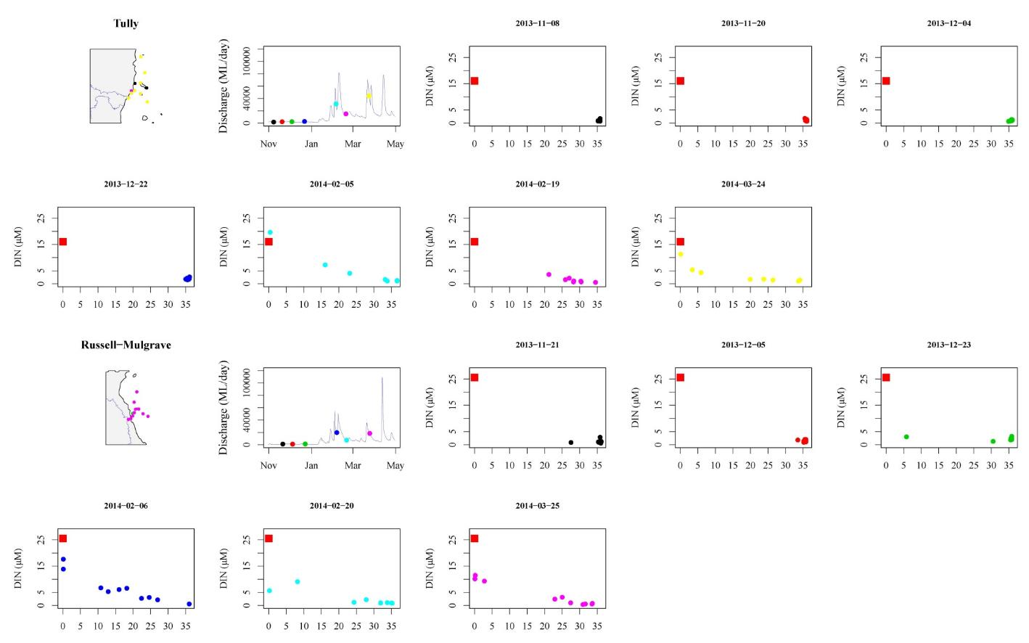
Figure 4-5a: (i) Sites are colour coded to identify location on maps, (ii) date of sampling relative to river flow over wet season, and (iii) mixing plots for DIN in the Tully and Russell-Mulgrave regions for 2013-14. Freshwater end were estimated from all samples collected at salinity < 5 in each region.

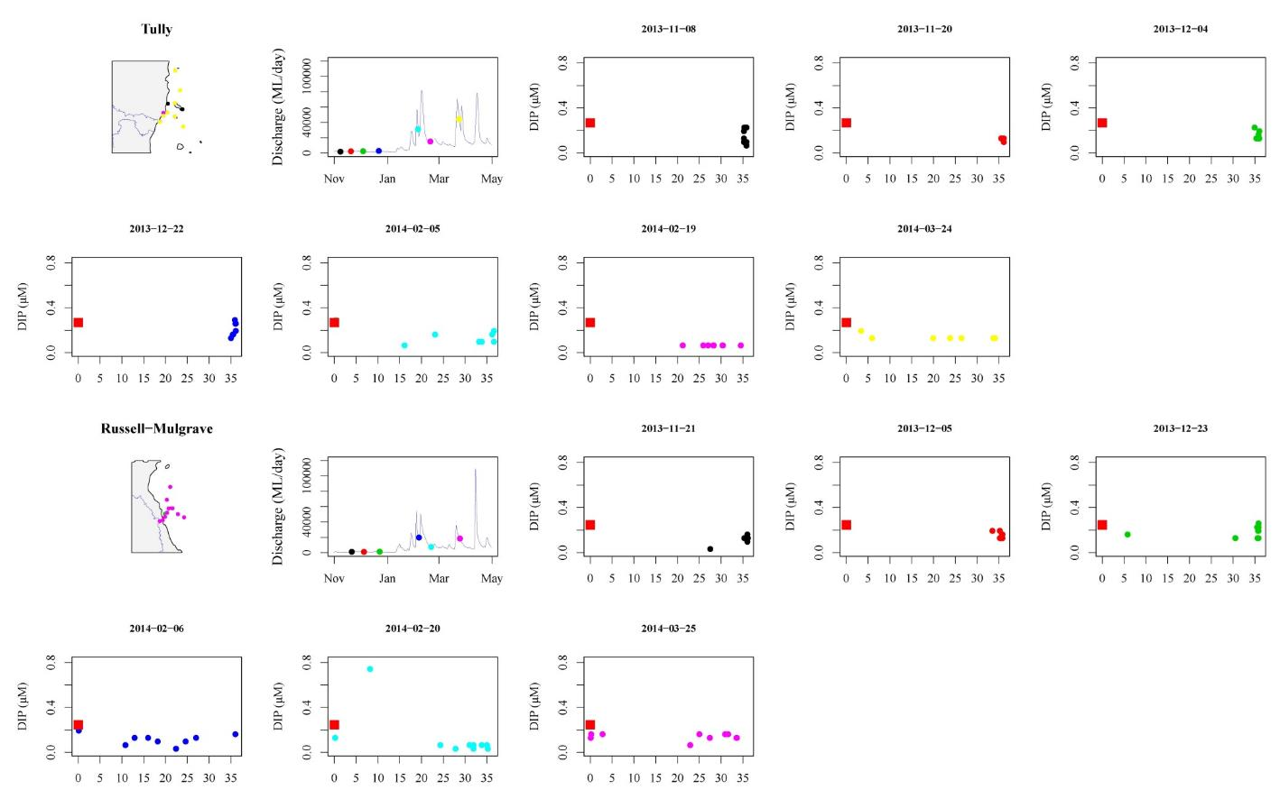
Figure 4-5b: (i) Sites are colour coded to identify location on maps, (ii) date of sampling relative to river flow over wet season, and (iii) mixing plots for DIP in the Tully and Russell-Mulgrave regions for 2013-14. Freshwater end were estimated from all samples collected at salinity < 5 in each region.

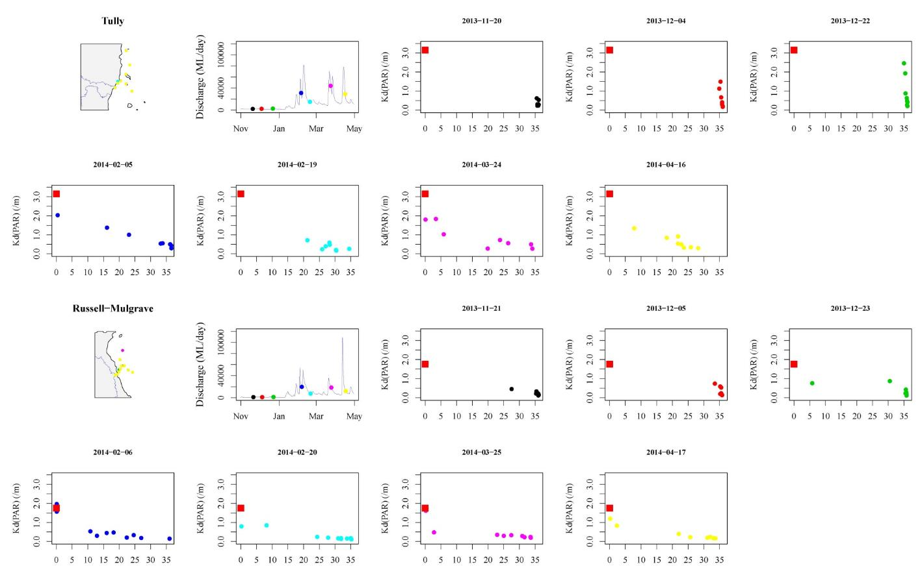
Figure 4-5c: (i) Sites are colour coded to identify location on maps, (ii) date of sampling relative to river flow over wet season, and (iii) mixing plots for Kd(PAR) in the Tully and Russell-Mulgrave regions for 2013-14. Freshwater end were estimated from all samples collected at salinity < 5 in each region.

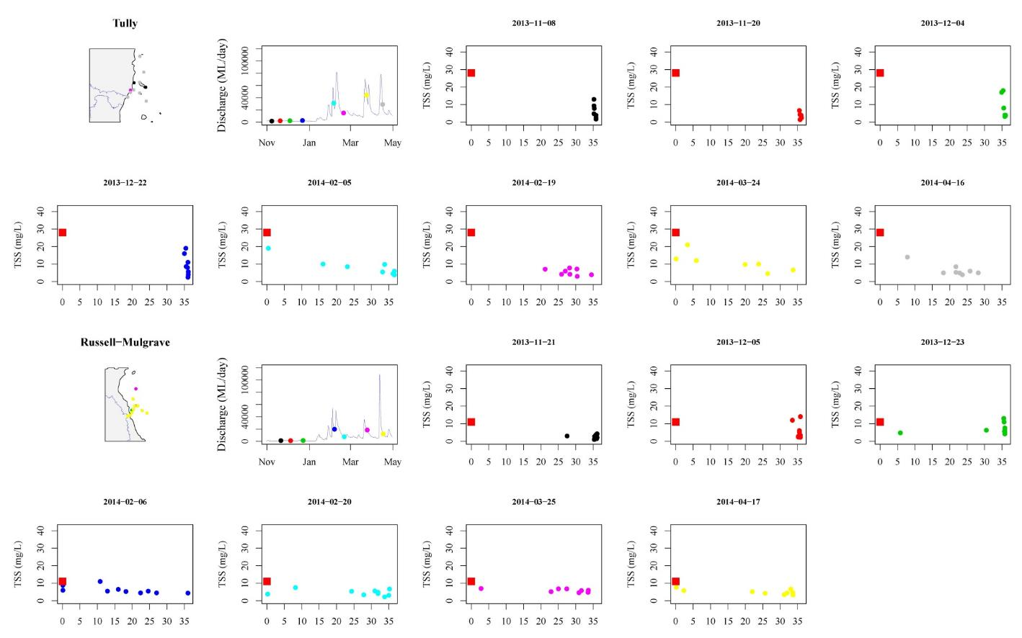
Figure 4-5d: (i) Sites are colour coded to identify location on maps, (ii) date of sampling relative to river flow over wet season, and (iii) mixing plots for TSS in the Tully and Russell-Mulgrave regions for 2013-14. Freshwater end were estimated from all samples collected at salinity < 5.

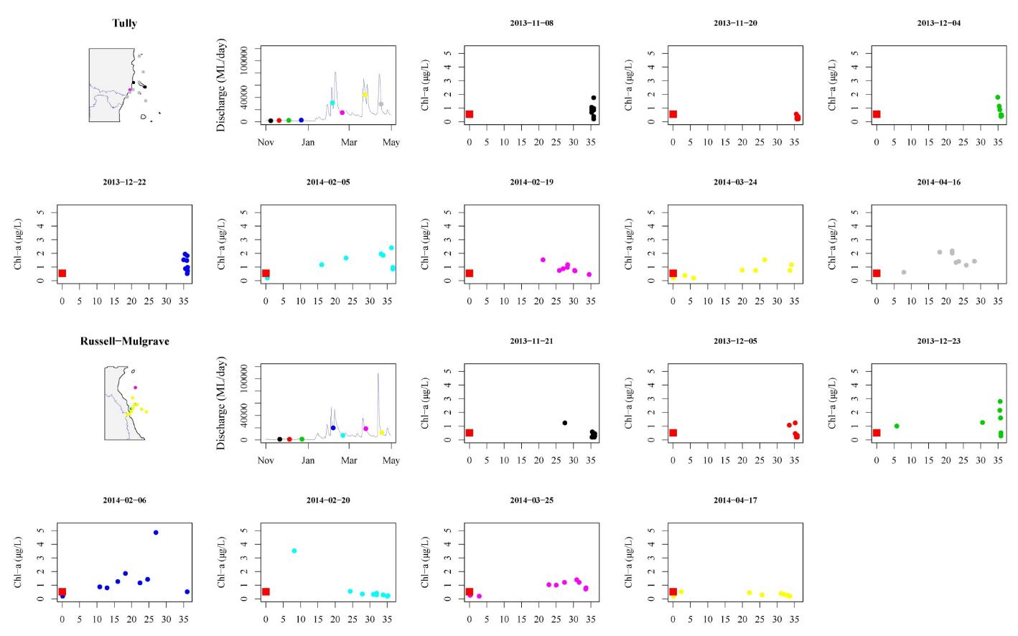
Figure 4-5e: (i) Sites are colour coded to identify location on maps, (ii) date of sampling relative to river flow over wet season, and (iii) mixing plots for Chl-a in the Tully and Russell-Mulgrave regions for 2013-14. Freshwater end were estimated from all samples collected at salinity < 5 in each region.

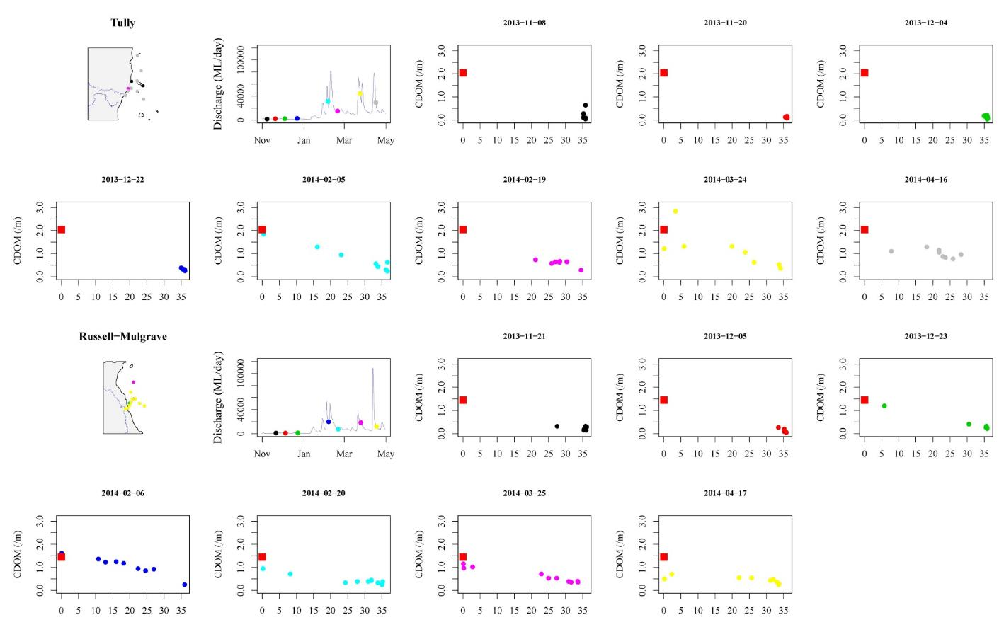
Figure 4-5f: (i) Sites are colour coded to identify location on maps, (ii) date of sampling relative to river flow over wet season, and (iii) mixing plots for CDOM in the Tully and Russell-Mulgrave regions for 2013-14. Freshwater end were estimated from all samples collected at salinity < 5 in each region..

The Spearman’s rank correlation coefficient analysis identified few significant high correlations (> 0.60 or < -0.60 with p < 0.01) for the WQ parameters sampled in the Wet Tropics, particularly for sites in the Tully marine region. (Table 4-5). Salinity was positively correlated with Si showing some consistence of the dilution process as its main driver over the wet season sampling. Significant correlations were also identified for the Tully between different forms of the same nutrient (e.g., TN and PN, r = 0.67) and between TP and TSS (r = 0.66). Russell-Mulgrave sites (Table 4-6) presented more cases with higher correlation between their WQ parameters compared to the Tully sites. For example, Si, salinity and temperature were all correlated against discharge. Temperature, Si and PP were correlated against salinity, showing the importance of the flow and mixing process driving these WQ parameters (i.e., Si and PP). As expected, PP and TP were correlated (r = 0.80) for both Tully and Russell-Mulgrave, showing PP as the main component of TP. The high and more frequent correlations observed for the Russell-Mulgrave data can be associated to the fact that Tully sites also are affected by the Murray River, whereas sites influenced by the Russell-Mulgrave do not, generally, experience other river discharge. The embayment configuration of the Tully area, compared to the more open coast in the Russell-Mulgrave area, may restrict flushing in the Tully area. Therefore, water quality across the Russell-Mulgrave sites have a lower residence time, and therefore may be more driven by physical than biological process.
Table 4-5: Spearman’s rank correlation coefficients for the parameters from the Tully sites sampled more than 20 times in the Wet Tropics in the 2013-2014 wet season. All highlighted values are significant at p < 0.01 and represent a correlation >0.6 or <-0.6. Parameters listed in the table are 5-day average discharge (Disch.), distance between the river mouth and the sampling site Dist.), surface salinity (Sal.), surface water temperature (Temp.), TSS, Chl-a TN, PN, DIN, TP, PP, DIP and Si.

 | Disch. | Dist. | Sal. | Temp. | TSS | Chl-a | TN | PN | DIN | TP | PP | DIP | Si
Disch. | 1 | 0.01 | -0.59 | -0.43 | 0.45 | 0.29 | -0.03 | -0.03 | 0.53 | 0.19 | 0.24 | 0.01 | 0.44
Dist. | 0.01 | 1 | 0.33 | 0.11 | -0.57 | -0.05 | -0.38 | -0.45 | -0.25 | -0.54 | -0.39 | -0.03 | -0.37
Sal. | -0.59 | 0.33 | 1 | 0.56 | -0.55 | -0.21 | -0.49 | -0.40 | -0.29 | -0.35 | -0.39 | 0.24 | -0.80
Temp. | -0.43 | 0.11 | 0.56 | 1 | -0.13 | 0.03 | -0.03 | 0.01 | -0.29 | 0.14 | -0.08 | 0.09 | -0.62
TSS | 0.45 | -0.57 | -0.55 | -0.13 | 1 | 0.32 | 0.14 | 0.29 | 0.39 | 0.66 | 0.56 | 0.26 | 0.60
Chl-a | 0.29 | -0.05 | -0.21 | 0.03 | 0.32 | 1 | -0.33 | -0.01 | 0.11 | 0.14 | -0.04 | -0.04 | 0.20
TN | -0.03 | -0.38 | -0.49 | -0.03 | 0.14 | -0.33 | 1 | 0.67 | -0.09 | 0.38 | 0.35 | -0.27 | 0.11
PN | -0.03 | -0.45 | -0.40 | 0.01 | 0.29 | -0.01 | 0.67 | 1 | -0.07 | 0.42 | 0.32 | -0.17 | 0.31
DIN | 0.53 | -0.25 | -0.29 | -0.29 | 0.39 | 0.11 | -0.09 | -0.07 | 1 | 0.19 | 0.12 | 0.26 | 0.33
TP | 0.19 | -0.54 | -0.35 | 0.14 | 0.66 | 0.14 | 0.38 | 0.42 | 0.19 | 1 | 0.70 | 0.10 | 0.27
PP | 0.24 | -0.39 | -0.39 | -0.08 | 0.56 | -0.04 | 0.35 | 0.32 | 0.12 | 0.70 | 1 | 0.17 | 0.35
DIP | 0.01 | -0.03 | 0.24 | 0.09 | 0.26 | -0.04 | -0.27 | -0.17 | 0.26 | 0.10 | 0.17 | 1 | 0.01
Si | 0.44 | -0.37 | -0.80 | -0.62 | 0.60 | 0.20 | 0.11 | 0.31 | 0.33 | 0.27 | 0.35 | 0.01 | 1

Table 4-6: Spearman’s rank correlation coefficients for the parameters from the Russell-Mulgrave sites sampled more than 20 times in the Wet Tropics in the 2013-2014 wet season. All highlighted values are significant at p < 0.01 and represent a correlation >0.6 or <-0.6. Parameters listed in the table are 5-day average discharge (Disch.), distance between the river mouth and the sampling site (Dist), salinity, temperature, TSS, Chl-a TN, PN, DIN, TP, PP, DIP and Si.
 | Disch. | Dist. | Sal. | Temp. | TSS | Chl-a | TN | PN | DIN | TP | PP | DIP | Si
Disch. | 1 | 0.02 | -0.69 | -0.65 | 0.38 | 0.28 | -0.02 | -0.05 | 0.33 | 0.34 | 0.40 | -0.13 | 0.62
Dist. | 0.02 | 1 | 0.53 | 0.15 | -0.26 | -0.15 | -0.53 | -0.21 | -0.44 | -0.55 | -0.56 | -0.15 | -0.52
Sal. | -0.69 | 0.53 | 1 | 0.63 | -0.42 | -0.26 | -0.34 | -0.01 | -0.51 | -0.60 | -0.63 | 0.12 | -0.93
Temp. | -0.65 | 0.15 | 0.63 | 1 | -0.43 | -0.16 | -0.01 | 0.25 | -0.46 | -0.16 | -0.31 | -0.36 | -0.59
TSS | 0.38 | -0.26 | -0.42 | -0.43 | 1 | 0.27 | -0.08 | -0.01 | 0.44 | 0.34 | 0.29 | 0.28 | 0.41
Chl-a | 0.28 | -0.15 | -0.26 | -0.16 | 0.27 | 1 | -0.32 | -0.19 | 0.07 | 0.13 | 0.19 | 0.08 | 0.34
TN | -0.02 | -0.53 | -0.34 | -0.01 | -0.08 | -0.32 | 1 | 0.51 | 0.31 | 0.43 | 0.42 | -0.12 | 0.33
PN | -0.05 | -0.21 | -0.01 | 0.25 | -0.01 | -0.19 | 0.51 | 1 | 0.23 | 0.19 | 0.19 | -0.03 | 0.02
DIN | 0.33 | -0.44 | -0.51 | -0.46 | 0.44 | 0.07 | 0.31 | 0.23 | 1 | 0.50 | 0.58 | 0.26 | 0.45
TP | 0.34 | -0.55 | -0.60 | -0.16 | 0.34 | 0.13 | 0.43 | 0.19 | 0.50 | 1 | 0.80 | -0.01 | 0.48
PP | 0.40 | -0.56 | -0.63 | -0.31 | 0.29 | 0.19 | 0.42 | 0.19 | 0.58 | 0.80 | 1 | 0.00 | 0.56
DIP | -0.13 | -0.15 | 0.12 | -0.36 | 0.28 | 0.08 | -0.12 | -0.03 | 0.26 | -0.01 | 0.00 | 1 | -0.14
Si | 0.62 | -0.52 | -0.93 | -0.59 | 0.41 | 0.34 | 0.33 | 0.02 | 0.45 | 0.48 | 0.56 | -0.14 | 1

Data analysis – Temporal
The results of Spearman rank correlation from the four most frequent sampled transects over the GBR in the last 9 wet seasons (Tully, Franklands Burdekin, Fitzroy) show more conclusive correlations than compared to single year correlations (Table 4-5, Table 4-6). All WQ parameters in the four most frequently sampled transects were tested against 5-day mean river discharge (Table 4-7) and salinity (Table 4-8).
CDOM was positively correlated with discharge for sites within the Burdekin and Fitzroy regions. Si was positively correlated with discharge for Tully and Russell-Mulgrave (Frankland Island group) regions. TN and TP were positively correlated with discharge for Fitzroy and Burdekin respectively (Table 4-7).
Significant correlations were more evident against salinity for all regions. CDOM was negatively correlated with salinity for all regions, again illustrating its ability as a proxy for salinity and other WQ components with conservative mixing behavior. Si, with exception of Burdekin, was significantly correlated against salinity. Particulate and dissolved nutrients, with exception of PN, were all significantly correlated with salinity for the Burdekin highlighting the importance of the Burdekin river in large flow as a significant mechanism for the movement of anthropogenic nutrients.

Table 4-7: Spearman’s rank correlation coefficients from the four most frequent sampled transects over the GBR (2006 – 2014). Values stand for correlation coefficient between the total wet season river discharge (Table 3-6) and the WQ parameters: TSS, Chl-a), TN, TDN, DIN, TP, TDP, DIP, PN, PP. Highlighted values have correlation > 0.6 or <-0.6 and are significant at p < 0.01.
 | Tully to Sisters | Frankland Group | Burdekin to Palm Island | Fitzroy to Keppels
CDOM | 0.566 | 0.563 | 0.795 | 0.760
Chl-a | 0.312 | 0.278 | 0.011 | 0.260
Kd | 0.245 | 0.175 | 0.055 | NA
TSS | -0.151 | 0.150 | 0.155 | 0.163
Si | 0.698 | 0.678 | -0.436 | 0.378
TN | 0.032 | -0.157 | 0.589 | 0.604
DIN | 0.293 | 0.492 | 0.555 | 0.553
TP | 0.152 | 0.419 | 0.663 | 0.403
DIP | 0.006 | 0.211 | 0.474 | -0.045
PN | 0.039 | 0.012 | 0.188 | 0.406
PP | 0.109 | 0.385 | 0.632 | 0.285

Table 4-8: Spearman’s rank correlation coefficients from the four most frequent sampled transects over the GBR wide in the last 9 wet seasons. Values stand for correlation coefficient between salinity and the WQ parameters: TSS, Chl-a), TN, TDN, DIN, TP, TDP, DIP, PN, PP. Highlighted values have correlation > 0.6 or <-0.6 and are significant at p < 0.01.
Sal | Tully to Sisters | Frankland Group | Burdekin to Palm Island | Fitzroy to Keppels
CDOM | -0.672 | -0.710 | -0.768 | -0.903
Chl-a | -0.278 | -0.295 | -0.062 | -0.447
Kd | -0.388 | -0.579 | -0.372 | 1.000
TSS | -0.036 | -0.289 | -0.413 | 0.366
Si | -0.899 | -0.946 | -0.584 | -0.915
TN | -0.240 | -0.168 | -0.754 | -0.714
DIN | -0.492 | -0.614 | -0.711 | -0.599
TP | -0.330 | -0.562 | -0.836 | -0.524
DIP | -0.155 | -0.141 | -0.640 | 0.186
PN | 0.015 | 0.001 | -0.365 | -0.455
PP | -0.063 | -0.555 | -0.706 | -0.345

The result of the temporal GAMM analysis for each WQ component is presented as a set of 4 plots, vertically distributed (Figure 4-6 to Figure 4-8). The first three plots in each column are the partial effect plots from the multiple regression analysis. These plots show the behavior of the WQ component against each predictor individually (i.e., either (i) surface salinity or (ii) distance or (iii) river discharge) when the other two predictors are kept constant. The last plot represents the temporal variation of each WQ component when the selected predictors (i.e., those that did not present as a straight line in the partial plots) were used as random effects in the GAMM analysis.
The temporal variation for most WQ components (data set 2006-2014) was best modelled by using all predictors (i.e., salinity, river discharge and distance) as random effects. Exceptions occurred for chlorophyll-a and PN that were modelled with the exclusion of the predictor “distance”, which presented as a straight line parallel to x-axis in the partial effect plots (Figure 4-7, first two plots in the second row). Discharge was also excluded from chlorophyll-a (Figure 4-7, first plot in the third row). Moreover, no temporal variation was identified for CDOM (Figure 4-6, bottom-mid plot), which presented an r-squared < 0, suggesting that a straight line parallel to the x-axis explain the behavior of CDOM better than the fitted models. All the other WQ components exhibited significant temporal trends although the fitted models explain < 10% of the data variability with the exception of DIP (r-sq = 0.37, Figure 4-8, bottom-mid plot). For DIN and DIP, there is a clear reduction in concentration values after 2012, which was preceded by an increase in concentrations in 2010-2011 wet season, related to an extreme wet season and the passage of the Ex-tropical cyclone Yasi in January-February 2011. The same trend was observed for light attenuation, suggesting turbid waters related to the extreme wet season influenced light attenuation in and beyond the 2011-2012 wet season. Patterns in the chlorophyll-a data show a similar pattern with peak in 2010-2011, but the wider error bars make it difficult to draw any longer term conclusions about the temporal trends. The WQ components TSS, PN and PP all show a general trend with reducing values throughout the analysed period. However, these overall temporal trends, particularly with PN and PP will be influenced by the opposing drivers with decreasing PN related to salinity and increasing PN related to distance. For example, the increase in PN over distance is related to the uptake of DIN into biological systems, increasing the PN concentrations. Thus, temporal patterns in PN and PP will be quite difficult to resolve and require increased scrutiny of the data through the wet and dry season.
The partial effect plots (Figure 4-10 to Figure 4-8, first 3 plots in each column) provide useful insights on the behaviour of each WQ component against the predictors. Surface salinity was a significant predictor for all the WQ components (Table 4-9). As a general trend all the WQ components drop off quickly as salinity increases and stabilised through the mid salinity ranges, although the range depends on the WQ component (Figure 4-6 to Figure 4-8, plots in the top row). Different patterns are observed for chlorophyll-a and DIP. Chlorophyll-a exhibits a peak of concentration around salinity 15 ppt (Figure 4-7), and PN increases centration in salinity > 30 ppt (Figure 4-7).
In relation to distance, as would be expected, most of the WQ components reduce as the plume water moves away from the river mouth (Figure 4-6 to Figure 4-8, plots in the second row). The point of the lowest concentration is also variable depending on the WQ component, ranging from as close as 20 km from the river mouth (e.g., Kd, Figure 4-10) up to 100 km or more such as for DIN (Figure 4-6). However, caution must be taken when looking at data > 100 km far from the coast due to the reduced number of data points, which results in wider error bars. For example, distance does not present a significant pattern for PP, PN and Chl-a (Table 4-9), although only chlorophyll-a and PN were not included as predictor in the GAMM analysis as they were excluded in the predictor selection in the GAM analysis (Figure 4-7, fitted model is parallel to x-axis). DIP exhibits an inverted pattern, increasing its concentration as water moves far from the river mouth (Figure 4-8).
Most of the WQ components respond to river discharge, where the highest discharge corresponds to the highest concentration (Figure 4-6 to Figure 4-8, plots in the third row), up to a maximum value where discharge is no longer influential. An exception to this pattern is exhibited by Si (Figure 4-9), where, after a maximum peak that occurs at relatively low discharges (> 50,000 ML), the constituent presents decreasing concentrations. Again caution must be taken when looking at data sampled under high river discharge due to the reduced number of data points, which results in wider error bars. For example, river discharge does not present a significant pattern for Kd and Chl-a (Table 4-9), although only chlorophyll-a did not include discharge as a predictor in the GAMM analysis.
The WQ components better explained by the selected predictors (i.e., among salinity, river discharge and distance) were Si, CDOM and DIN, where the variability in these water quality parameters were explained in > 59%. Chlorophyll-a has the smallest measure of variability explained (<5%) by the predictors. Among the predictors, salinity has, on average, the highest contribution to the general r-squared, and is, during the wet season, the most influential parameter in the analysis of variability for the WQ components, followed by discharge and distance.
Table 4-9: Statistical summary of the multiple regression analysis. Number of data points, the general model r-squared and its p-value for each WQ component are shown in the left site of the table. The p-value and the percentage of contribution to the total r-squared for each predictor from the relative importance (number in brackets) are in the right side of the table. WQ components are sorted by general model r-squared, and numbers in bold stand for predictors not included in the GAMM analysis.
WQ component | multiple regression model |  |  |  | p-value of each predictor (% of r-sq. contribution)
WQ component | Data size | r-sq. | p-value |  | Salinity | Distance | Discharge
Si | 263 | 0.78 | < 0.01 |  | < 0.01 (89.6) | < 0.01 (5.6) | < 0.01 (4.8)
CDOM | 731 | 0.61 | < 0.01 |  | < 0.01 (61.2) | < 0.01 (5.9) | < 0.01 (33)
DIN | 812 | 0.59 | < 0.01 |  | < 0.01 (82.4) | < 0.01 (1.4) | < 0.01 (16.2)
Kd | 478 | 0.34 | < 0.01 |  | < 0.01 (77.3) | < 0.01 (20.2) | 0.25 (2.6)
TSS | 882 | 0.34 | < 0.01 |  | < 0.01 (46.4) | < 0.01 (3.6) | < 0.01 (50.1)
PP | 835 | 0.32 | < 0.01 |  | < 0.01 (61.5) | 0.08 (1.3) | < 0.01 (37.3)
PN | 813 | 0.24 | < 0.01 |  | < 0.01 (72.4) | 0.98 (0.7) | < 0.01 (26.9)
DIP | 892 | 0.11 | < 0.01 |  | < 0.01 (26.9) | < 0.01 (26.8) | < 0.01 (46.3)
Chl-a | 1011 | 0.05 | < 0.01 |  | < 0.01 (96.8) | 1 (0.8) | 0.97 (2.4)
mean | 746.3 | 0.4 |  |  | (68.3) | (7.4) | (24.4)
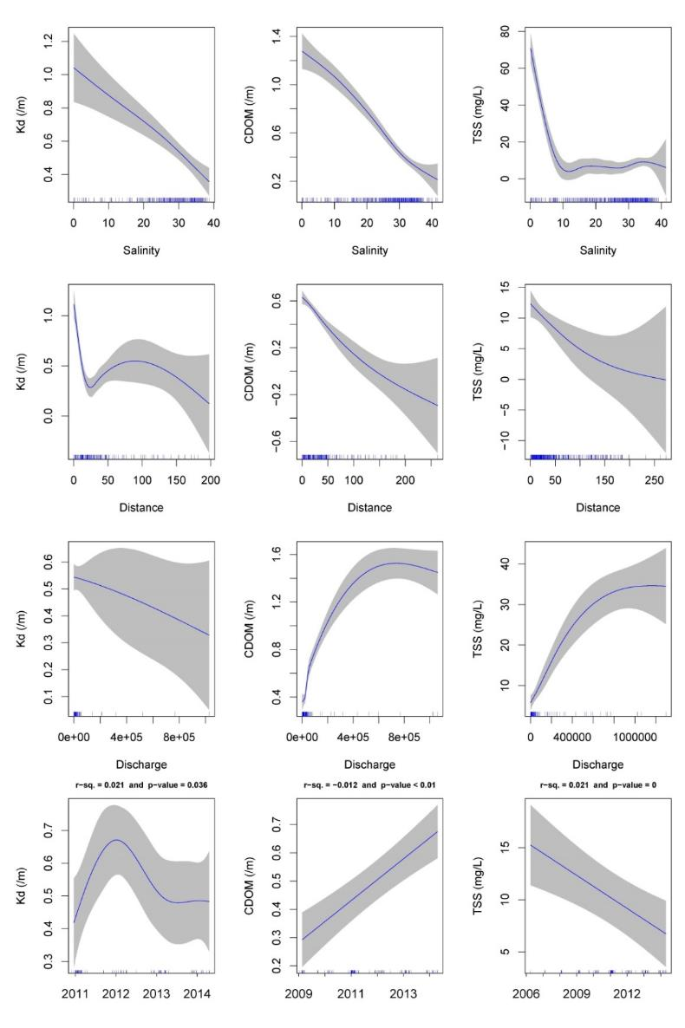
Figure 4-6: GAMM analysis for light attenuation coefficient (Kd, /m, left column), coloured dissolved organic matter (CDOM, /m, mid column) and total suspended solids (TSS, mg/L, right column) collected from December 2005 to April 2014 (inclusive). First four plots in each column are for the partial effect plots and last pot is the temporal analysis (see text for explanation). Shade area stands for ±1 SE and rubs on x-axis stand for data density.
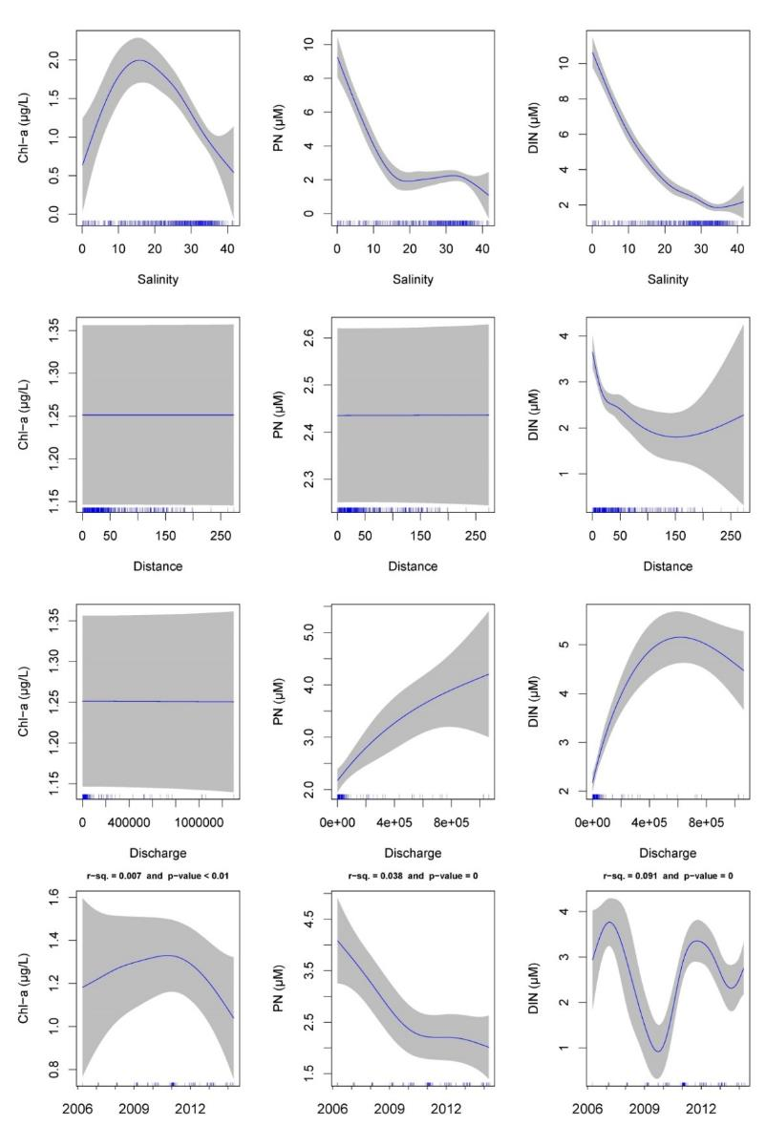
Figure 4-7: GAMM analysis for chlorophyll-a (Chl-a, µg/L, left column), particulate nitrogen (PN, µM, mid column) and dissolved inorganic nitrogen (DIN, µM, right column) collected from December 2005 to April 2014 (inclusive). First four plots in each column are for the partial effect plots and last pot is the temporal analysis. Shade area stands for ±1 SE and rubs on x-axis stand for data density.
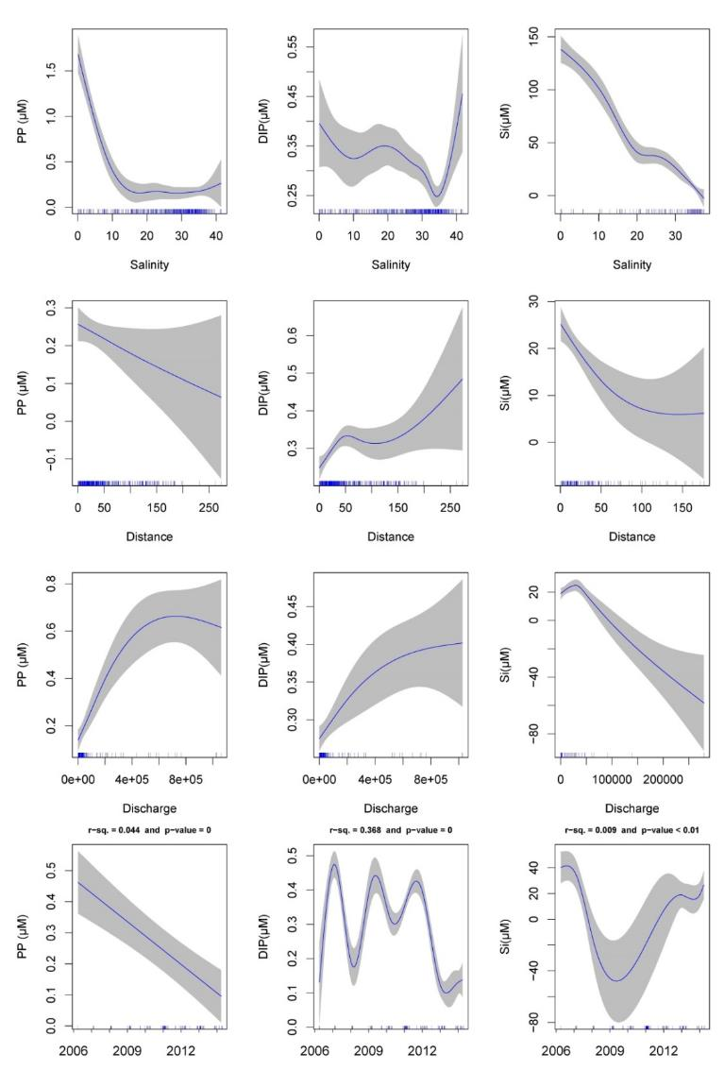
Figure 4-8: GAMM analysis for particulate phosphorous (PP, µM, left column), dissolved inorganic phosphorus (DIP, µM, mid column) and silica (Si, µM, right column) collected from December 2005 to April 2014 (inclusive). First four plots in each column are for the partial effect plots and last pot is the temporal analysis (see text for explanation). Shade area stands for ±1 SE and rubs on x-axis stand for data density.

Data analysis – Load dispersion maps, DIN
After excluding outliers, a total of 403 match-ups were extracted for DIN measured in flood plume waters over 12 wet seasons (c.a., December to April, inclusive) form 2002-2003 to 2013-2014 under flow exceeding the 75th percentile of long-term flow from 1970 to 2000. A summary of the in-situ DIN concentration per colour class is presented in Figure 4-9 and Table 4-10. The development of a generic GBR wide model for pollutant dispersion required all data to be taken into consideration, accounting thus for all possible environmental variability, in time (12 years of data) and space (whole GBR). Variability is likely to occur among different rivers, mainly in function of differences in their biogeochemical processes. Due to the lack of robust data set for several rivers GBR wide, we opted for using a generic model for the whole GBR. Further work is continuing on the development of regionally specific pollutant load models.
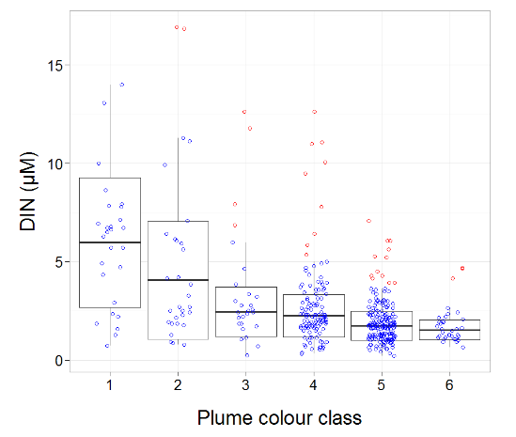
Figure 4-9: In-situ dissolved inorganic nitrogen concentration (DIN, µM) sampled over 12 wet seasons (c.a., December to April inclusive) from 2002/03 to 2013/14 per colour class. Boxplot presents the mean (dark black line), ±1 SD (rectangle) and maximum-minimum value (vertical lines). Nudge was applied to data on x-axis for better data visualisation.

Table 4-10: Summary of the ANOVA mode fitted to in-situ DIN concentrations (mean ± 1 SD, in µM), sampled over 12 wet seasons (c.a., December to April inclusive) from 2002/03 to 2013/14, within each colour class (n stands for the number of observations after excluding outliers).
Plume water type | DIN (µM, mean ±1 SE)
model stats | Adj.r-sq = 0.31, p < 0.01
1 | 5.14 ± 0.07 (n = 27)
2 | 3.35 ± 0.1 (n = 28)
3 | 2.24 ± 0.1 (n = 23)
4 | 2.08 ± 0.08 (n = 112)
5 | 1.65 ± 0.07 (n = 182)
6 | 1.48 ± 0.09 (n = 31)
A colour class 7 was attributed to the DIN model, because it represents an annual load dispersion integration, so it was assumed it would be constrained to a potential maximum annual plume extent (c.a., 800 km), which was derived from a hydrodynamic model simulation (Luick et al., 2007). Due to the lack of consistent data sampled at out of the plume area influence (i.e., colour class 6), a coefficient was attribute to colour class 7 c.a. the 10th percentile of DIN measurements taken in colour class 6 (1.071 µM). DIN behaviour against six colour classes reflects the nature of this pollutant, with reducing concentrations moving far from its source, mainly due to dispersion and biological uptake (Figure 4-9). Dissolved organic nitrogen has presented a conservative behaviour in the GBR waters up to salinity 20-25 ppt (Devlin and Brodie, 2005). However, salinity in plume colour-class 2 is 21.0 ± 9.9 ppt (mean ± 1 SD), so the conservative behaviour is taken over by an exponential decay when DIN is considered over the whole plume extent. After classes 2-3, the plume waters experience reduction on TSS and consequent underwater light increasing, favouring primary production and DIN consumption (Devlin et al., 2012a, 2012b; Devlin and Brodie, 2005). Therefore, the equation used to describe the dispersion of DIN through the river plume account for those processes, representing thus the potential for DIN reaches areas in the GBR. Other processes that may affect DIN concentrations in plume waters can be nitrogen fixation by (cyano-) bacteria and upwelling of nutrient-enriched deep water from the Coral Sea (Furnas et al., 2011). However, land runoff is the largest source of new nutrients to the inshore GBR, especially during monsoonal flood events (Furnas et al., 2011). Moreover, upwelling intrusions are spatially restricted to the Central GBR subsurface waters (Berkelmans et al., 2010), and therefore not captured by the superficial in-situ DIN sampled data. Nitrogen fixation is likely to happened across the whole plume area, adding equally to the measured in-situ DIN, and not affecting the general behaviour depicted in the DIN function. Otherwise if intense fixation due to Trichodesmium blooms could result in high localised DIN concentration, the outlier removal applied to the data set would likely remove this effect.
A 2013-2014 map for the dispersion of land-sourced DIN (c.a.,${NH}_{4}^{+}+{NO}_{2}^{-}+{NO}_{3}^{-}$) over the GBR lagoon (yield, kg/km²) is presented in Figure 4-10. We could not compare this map with those maps presented in the previous MMP report for two reasons: (a) loads used in previous maps, which cover the period between 2002 to 2013 were upscale for the whole catchment (see Lewis et al., 2014), and (b) a larger number of rivers were available in Lewis et al. (2014), than those reported by Government load monitoring data.
The highest model-predicted DIN yield was observed at the vicinities of the Pioneer River. The Pioneer River exhibited the fourth largest load (260 ton), but due to its reduce area of plume influence (c.a., plume extent of 69 km), resulted in high DIN yield at its mouth (Table 4-11 and Figure 4-10gqz). This is in agreement with previous observations about plumes in the GBR, where the larger river discharger, the larger river plume (e.g., Álvarez-Romero et al., 2013; Brodie et al., 2012; Devlin et al., 2012a, 2012b), and as a consequence lower yields are resulted. The contour line DIN equals to 10 kg/km² illustrates how far DIN can reach the GBR lagoon. A yield of 10 kg/km² was arbitrarily selected. Regardless how far the model-predicted DIN export can reach, DIN yields drop off relatively quickly, normally being halved in the first 25-35 km far from the river mouth (c.a., parallel to the coast).

Table 4-11: Total annual end-of-catchment dissolved inorganic nitrogen load (DIN, ton), the total wet season discharge (mega-litres, ML), the plume extent as predicted from Equation 2 and the maximum model-predicted DIN yield at the river mouth (kg/km²).
River | DIN load (ton) | Wet Season discharge (ML) | Plume outer edge (km) | Max. yield at river mouth (kg/km²)
Barron | 33 | 435,098 | 68 | 3
Johnstone | 460 | 1,945,598 | 97 | 34
Tully | 640 | 2,378,541 | 106 | 46
Herbert | 760 | 3,212,676 | 121 | 56
Haughton | 129 | 229,562 | 63 | 12
Burdekin | 130 | 1,162,570 | 82 | 11
O'Connell | 45 | 86,110 | 61 | 2
Pioneer | 260 | 503,558 | 69 | 14
Plane | 50 | 88,778 | 61 | 3
Fitzroy | 150 | 1,501,365 | 89 | 8
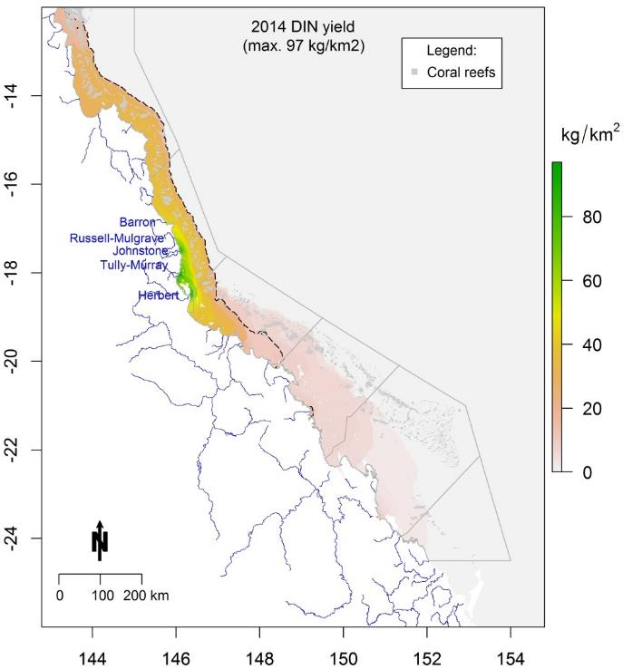
Figure 4-10: Dissolved inorganic nitrogen yield (DIN, kg/km²) over the GBR lagoon in 2013-2014 water year (c.a., 1 October 2013 to 30 September 2014). ‘Max.’ stands for the highest pollutant yield, named rivers are those with load data available, grey lines are the NRM limits, and dashed black line stands for contour line for DIN yield equals to 10 kg/km².
Two primary factors influence the load distribution: (a) the size of the plume area and, (b) the north west preferential transport direction imposed to the plume movement, which makes the DIN influence extend further along the main plume axis. A close look at the individual plume of DIN dispersion for the Hebert, Tully and Johnstone rivers shows that the northwards DIN transference can contribute to increased DIN yields in areas with reduced loads. Table 4-12 presents DIN yield (kg/km²) at the vicinities of the mouth of these three rivers due to their own 'DIN plumes' and also their contribution to each others river mouth. These results indicate that the northward plume movement can take 45% and 34% of the Hebert River DIN load to the Tully and Johnstone rivers, respectively. The southward movement is less intense, for example Johnstone River contributes about 21% to the DIN yields at the Tully and Hebert river mouths. These results indicate that the northward plume transport has the potential to increase the pollutant load impact in zones that do not contribute high pollutant load.
Table 4-12: DIN yield (kg/km²) contribution from (donor) to (receptor) at the vicinities of the river mouth of three catchments in the Wet Tropics NRM region. The main diagonal represents DIN yield at the donor river mouth and other cells are its contribution as yield and as percentage (number in brackets) from the yield at the donor mouth.
 |  | Receptor
 |  | Hebert | Tully | Johnstone
Donor | Hebert | 56 | 25 (45%) | 19 (34%)
Donor | Tully | 9 (20%) | 46 | 19 (41%)
Donor | Johnstone | 7 (21%) | 7 (21%) | 34

Data analysis – Load dispersion maps, TSS
After excluding outliers, a total of 439 match-ups were extracted for TSS measured in flood plume waters over 12 wet seasons (c.a., December to April, inclusive) form 2002-2003 to 2013-2014 under flow exceeding the 75th percentile of long-term flow from 1970 to 2000. A summary of the in-situ TSS concentration per colour class is presented in Figure 4-11 and Table 4-13.

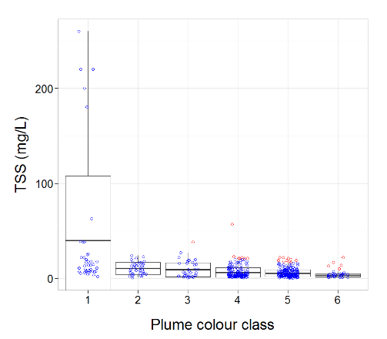
Figure 4-11: Regression model adjusted to the in-situ total suspended solids concentration (TSS, mg/L) sampled over 12 wet seasons (c.a., December to April inclusive) from 2002/03 to 2013/14 per colour class. Dashed lines stand for CI 95%, red dots are outliers and nudge was applied to data on x-axis for better visualisation.
Table 4-13: Summary of the in-situ TSS concentrations (mean ± 1 SD, in mg/L), sampled over 12 wet seasons (c.a., December to April inclusive) from 2002/03 to 2013/14, within each colour class (n stands for the number of observations after excluding outliers).
Plume water type | TSS (mg/L, mean ±1 SE)
model stats | Adj.r-sq = 0.23, p < 0.02
1 | 16.95 ± 1.13 (n = 41)
2 | 8.53 ± 1.2 (n = 37)
3 | 6.17 ± 1.2 (n = 33)
4 | 4.71 ± 1.15 (n = 133)
5 | 4.43 ± 1.15 (n = 168)
6 | 2.97 ± 1.22 (n = 27)

A colour class 7 was not attributed to the TSS model because it rerepsents two-week load dispersion, so it was assumed that it would be constrained to the plume outer edge. TSS is deposited faster mainly within classes 1 to 2 and then seems to become stable. The faster reduction in TSS is due to sedimentation, with the heavier particles settling out of suspension. However, it is possible for the smaller particles to move further, resulting in TSS been detected in plume colour class 6. There is also the additional source of TSS due to resuspension caused by wind and waves, therefore, the equation used to describe the movement of TSS through the river plume accounts for these process.
As described in Section 3.2.1, the passage of Cyclone Ita led to moderate flows in the Wet Tropics rivers in what was otherwise a relatively low flow year. This led to moderate to high TSS loads being dispersed into the GBR lagoon in the Wet Tropics NRM region, particularly out of the Herbert River. The passage of Ex-tropical cyclone Ita produced an increased signal on the flow records for the Normanby, Russell-Mulgrave and Herbert Rivers, but it did not strongly influence the Tully River discharge. The Daintree was the only main river that had discharge exceeding >2 times the long-term median.
Using the method described above, and the sediment load data from Great Barrier Reef Catchment Load Monitoring Program, the dispersion of sediment associated with the passage of the Ex-Tropical Cyclone Ita was modelled over a 19-day period in April 2014 to show the extent of influence of the river plume and TSS surface loading in this event. Sediment dispersion over the GBR and its contribution to each NRM region is presented in Table 4-14 and Figure 4-12. This indicates that a large proportion of the load was derived from the Herbert River which is consistent with previous understanding (e.g. Hateley et al. 2014).
Table 4-14: Total sediment discharged by the major Wet Tropics' rivers due to the 19-day passage of ex-Tropical Cyclone Ita and its mass contribution to each NRM region.
Wet Tropics' rivers | Sediment sourced (ton) | NRM regions | Sediment delivered (ton)
Barron | 47,000 | Cape York | -
Russel-Mulgrave | 77,000 | Wet Tropics | 491,148
Johnstone | 7,100 | Burdekin | 74,343
Tully-Murray | 26,000 | Mackay - Whitsunday | -
Herbert | 410,000 | Fitzroy | -
 |  | Burnett-Mary | -

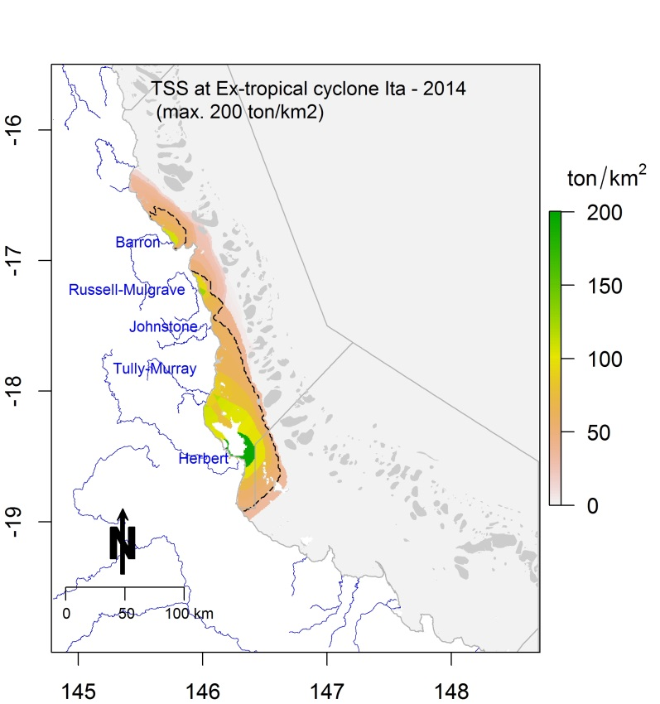
Figure 4-12: Total suspended solids (TSS) in tons/km² over the GBR lagoon due to the passage of ex-Tropical Cyclone Ita, April 2014. Contour line indicates TSS equals to 50 ton/km² as a point of reference only.

Mapping of river plumes

Methodology

Introduction to remote sensing products
The level of exposure of GBR ecosystems (including the coral reefs and seagrass meadows) to river plumes and land-sourced contaminants is spatially and temporally dependent of the different land-uses in the GBR catchments, the local transports of contaminants, and the distance of respective ecosystems to the river mouths (Brodie et al., 2013). Understanding the exposure of the GBR ecosystems and resulting changes in ecosystem health conditions is important to facilitate management of the GBR to respond to anthropogenic pressures under a changing climate. The main objective of the remote sensing component of the wet season monitoring under the MMP is to produce maps of river plumes, models that summarise land-sourced contaminants transport, describe water quality concentrations within wet season conditions, and to integrate all these methods to evaluate the susceptibility of GBR key ecosystems to the river plume/pollutants exposure i.e. to model the risk of GBR ecosystem due to exposure to river plumes (Figure 5-1).

Figure 5-1: Remote sensing products designed in order to model the risk of GBR ecosystems due to river plumes during the wet season.

Spatial and temporal resolutions as well as management outcomes of each remote sensing product developed through MMP funding is summarised in Table 5-1. Integrating these outputs maps into annual and long-term (multi-annual) composite maps provide simple overviews of surface and ecosystem exposure over time.
Table 5-1: Remote sensing products developed through MMP funding and management outcomes
Product | Management outcome | Spatial and temporal resolution
River plume maps | Illustrate the movement of riverine waters, but do not provide information on the composition of the water and WQ constituents | - Whole-GBR; NRM, river  - Daily, weekly and seasonal or multi-seasonal (frequency of occurrence)
Plume water type maps | Plume water types are associated with different levels and combination of pollutants and, in combination with in-situ WQ information, provide a broad scale approach to reporting contaminant concentrations in the GBR marine environment. | - Whole-GBR; NRM, river  - Daily, weekly and seasonal or multi-seasonal (frequency of occurrence)
Load maps of land-sourced pollutants (TSS and DIN)* | The load mapping exercise, allows us to further understand the movements of pollutants which are carried within the river plume waters. | - Whole-GBR; NRM, river  - seasonal or multi-seasonal
Potential river plume risk maps (in development) | Preliminary product aiming to evaluate the ecological risk of GBR ecosystems from river plume exposure | - Whole-GBR; NRM, river  - Daily, weekly and seasonal or multi-seasonal (frequency of occurrence)
Exposure Assessment of the coral reefs and seagrass beds | - Assess the exposure of key GBR ecosystems to plume exposure and potential risk from the river plume exposure.  - Expressed simply as the area (km²) and percentage (%) of coral reefs and seagrass meadows exposed  - Assume that historical reef and coral shapefiles can be used to assess the coral and seagrass location (stable over the years) | Whole-GBR; NRM; ecosystem
*results presented in Water Quality section.

GBR river plume and plume water type maps
Following recommendations from the previous MMP report, we chose to map marine areas exposed to river plumes using MODIS true colour (TC) images and the TC method extensively presented in Álvarez-Romero et al. (2013), and used in Devlin et al. (2013) and Petus et al. (2014b). The TC method is based on classification of spectrally enhanced quasi-true colour MODIS images (Álvarez-Romero et al., 2013). This method exploits the differences in colour between the turbid river plumes and the marine ambient water, and between respective water type inside the river plumes (Álvarez-Romero et al., 2013), and is described below.
Supervised classification using spectral signatures
Daily MODIS Level-0 data are acquired from the NASA Ocean Colour website (http://oceancolour.gsfc.nasa.gov) and converted into true colour images with a spatial resolution of about 500 ×500 m using SeaWiFS Data Analysis System (SeaDAS; Baith et al., 2001). The true-colour images are then spectrally enhanced (from red-green-blue to hue-saturation-intensity colour system) and classified to six colour categories through a supervised classification using spectral signatures from plume water in the GBR. The six colour classes are further reclassified into three flood plume water types (primary, secondary, tertiary) corresponding to the three water types defined by e.g., Devlin and Schaffelke (2009) and Devlin et al. (2012a).
Production of weekly Plume water type maps
Three distinct plume water types have been described within GBR river plumes (from the inshore to the offshore boundary of river plumes). They are characterised by varying salinity levels, spectral properties, colour, and WQ concentrations summarised in Table 5-2 (Devlin et al. 2012a, Álvarez-Romero et al. 2013 and Petus et al. 2014b).
The sediment-dominated waters or primary water type are defined as corresponding to colour classes 1 to 4 of Álvarez-Romero et al. (2013). The Chl-a-dominated waters or secondary water type are defined as corresponding to the bluish-green waters (i.e., colour class 5 from Álvarez-Romero et al. 2013) and the tertiary water type is defined as corresponding to the colour class 6 of Álvarez-Romero et al. (2013). The full extent of the plume is defined as the combination of the Primary; Secondary and Tertiary plume water surfaces, described below and in Table 5-2.
- The Primary water type presents very high turbidity, low salinity (0 to 10; Devlin et al., 2010), and very high values of CDOM and Total Suspended Sediment (TSS). Turbidity levels limit light penetration in Primary waters, inhibiting primary production and limiting Chl-a concentration.
- The Secondary water type is characterised by intermediate salinity, elevated CDOM concentrations, and reduced TSS due to sedimentation (Bainbridge et al., 2012). In this water type (middle salinity range: 10 to 25; Devlin et al., 2010), the phytoplankton growth is prompted by the increased light (due to lower TSS) and high nutrient availability delivered by the river plume.
- The Tertiary water type occupies the external region of the river plume. It exhibits no or low TSS associated with the river plume, and above-ambient concentrations of Chl-a and CDOM. This water type can be described as being the transition between Secondary water and marine ambient water, and present salinity lower than the marine waters (typically defined by salinity ≥ 35; e.g., Pinet, 2000).
This supervised classification was used to classify 9 years of daily MODIS images (from December 2003 to April 2014 and focused on the summer wet season i.e., December to April inclusive). Weekly plume water composites were then created to minimise the image area contaminated by dense cloud cover and intense sun glint (Álvarez-Romero et al. 2013).

Table 5-2: Plume water types as described in e.g., Devlin et al. (2012a), Álvarez-Romero et al. (2013) and Petus et al (2014b) and detailing the water quality and optical properties (e.g., Clarke et al.,1970; Morel and Prieur, 1977; Froidefond et al., 2002; McClain, 2009), and the mean TSS, Chl-a and Kd(PAR) which define the plume characteristics within each plume type concentrations (modified from Devlin et al., 2013b).
Colour classes | Type | Description | Colour properties | Mean concentrations (Devlin et al., 2013)
1 to 4 | Primary | Sediment-dominated waters: characterised by high values of CDOM and TSS, with TSS concentrations dropping out rapidly as the heavier particulate material flocculates and settles to the sea floor (Devlin and Brodie, 2005; Brodie and Waterhouse, 2009). Turbidity levels limit the light (K_{d}PAR) in these low salinity waters, inhibiting production and limiting Chl-a concentrations. | Greenish-brown to beige waters: Sediment particles are highly reflective in the red to infra-red wavelengths of the light spectrum. Sediment-dominated waters have a distinctive brown/beige colour, depending upon the concentration and mineral composition of the sediments. | TSS: 36.8±5.5 mg L⁻¹  Chl-a: 0.98 ± 0.2 μg L⁻¹ Kd(PAR): 0.73 ± 0.54 m⁻¹
5 | Secondary | Chlorophyll-a-dominated waters: characterised by aelevated CDOM with reduced TSS due to sedimentation. In this region, the increased light in comparison to primary water type condition (but still under marine ambient conditions) and nutrient availability prompt phytoplankton growth measured by elevated Chl-a concentrations. | Bluish-green waters: Due to this green pigment, chlorophyll /phytoplankton preferentially absorb the red and blue portions of the light spectrum (for photosynthesis) and reflect green light. Chl-a-dominated waters will appear from blue-green to green, depending upon the type and density of the phytoplankton population. | TSS:8.9 ± 18.1 mg l⁻¹  Chl-a: 1.3 ± 0.6 μg L⁻¹  Kd(PAR): 0.39 ± 0.20 m⁻¹
6 | Tertiary | CDOM-dominated waters: offshore region of the plume that exhibits no or low TSS that has originated from the flood plume and above ambient concentrations of Chl-a and CDOM. This region can be described as being the transition between secondary water type and marine ambient conditions. | Dark yellow waters: CDOM are highly absorbing in the blue spectral domain. CDOM-dominated waters have a distinctive dark yellow colour. | TSS:2.9 ± 3.2 mg l⁻¹ Chl-a: 0.7 ± 0.3 μg L⁻¹ Kd(PAR): 0.24 ± 0.02 m⁻¹
Full extent of the plume = Primary + Secondary + Tertiary

Production of annual and multi-annual plume water type maps
Weekly composites are overlaid in ArcGIS (i.e., presence/absence of Primary/Secondary/Tertiary water type) and normalised, to compute annual normalised frequency maps of occurrence of Primary water type (hereafter annual Primary/Secondary/Tertiary frequency maps). Pixel (or cell) values of these maps range from 1 to 22 (normalised value of 0.45 – 1) ; with a value of 22 meaning that ‘this’ pixel has been exposed 22 weeks out of 22 week of ‘this’ years’ wet season (December to April 2003 to 2014) to ‘this’ plume water type (Primary or secondary or Tertiary). Finally, annual Primary/Secondary/Tertiary water frequency maps are overlayed in ArcGIS to create multi-annual (2003-2014) normalised frequency composites of occurrence of Primary water types (hereafter multi-annual Primary/Secondary/Tertiary frequency maps).
Water quality concentrations in plume water types
Additional information on plume water quality can then be extracted from these plume and plume water type maps by reporting the characteristics of the corresponding in-situ wet season water quality data with the colour class or plume water type frequency values. Several land-sourced pollutants are investigated through match-ups between in-situ data and the six plume colour class maps, including the DIN, DIP, TSS, Chl-a, Kd and CDOM. Comparisons between weekly plume water composites (Primary, Secondary, and Tertiary,) and in-situ physical and water quality measurements collected during the wet seasons 2007 to 2013 as part of the MMP were performed. In-situ values were assigned to weekly Primary, Secondary or Tertiary water type based on their location. Mean values and standard deviations were calculated and are shown in Table 5-2.

“Potential risk” maps
The river plume maps and plume water type maps can be overlaid with information on the presence or distribution of ‘contamination receptors’, i.e., GBR ecosystems susceptible to the land-sourced contaminants. This method can help identify ecosystems which may experience acute or chronic high exposure to contaminants in river plumes (exposure assessment) and thus, help evaluating the susceptibility of GBR ecosystems to land-sourced contaminants. For example, Petus et al., (2014b) mapped the occurrence of turbid water masses in Cleveland Bay (Burdekin marine region, GBR) in each wet season between 2007 and 2011 and compared the results to monitored seagrass biomasses and areas. This analysis, realised though the production of plume frequency maps, correlated with seagrass health measurements, which included the change in the area of seagrass and composition. The correlation indicated that the decline in seagrass meadow area and biomass were positively linked to high occurrence of turbid water masses and confirmed the impact that decreased clarity can have on seagrass health in the GBR
Petus et al. (2014a) proposed that time series of MODIS plume water type maps could help progressing toward the production of river plume risk maps for the GBR by clustering water masses with different concentrations and proportions of land-sourced contaminants and, thus, by mapping ‘potential’ risk areas in the marine environment. They proposed a framework to produce river plume risk maps for seagrass and coral ecosystems based on a simplified risk matrix assuming that ecological responses will increase linearly with the pollutant concentrations and frequency of river plume exposure (Figure 5-3). This framework used MODIS Level-2 satellite data processed by the NASA algorithms implemented in the SeaWiFS Data Analysis System (SeaDAS, Baith et al., 2001). MODIS data were used to characterise external boundaries of river plumes and different water types or aggregation of water types, within GBR river plumes using supervised classification of the MODIS Level 2 data and a combination of CDOM, Chl-a and TSS (estimated from two remote sensing proxies) threshold values. In last year report and this report, it was decided to work with river plume products derived from MODIS true color satellite data data (Álvarez-Romero et al. (2013)) instead of the L2 to progress the risk framework proposed in Petus et al. (2014a).
Theories behind the production of River plume risk maps for the GBR ecosystems are described in Petus et al. (2014b) and summarised briefly here. Measuring the magnitude of the river plume risk to coral reefs and seagrass beds can be challenging because of the combination of different stressors in river plume waters. Devlin et al. (2012b) underscored the need to develop risk models that incorporate the cumulative effects of pollutants. Elevated levels of turbidity, which limits light penetration, and reduce the amount of light available for seagrass photosynthesis, are described as the primary cause of seagrass loss (Mckenzie et al. 2012; Collier et al. 2012a, b). Coral biodiversity also declines as a function of increasing turbidity throughout the GBR (De’ath and Fabricius 2010) and reef development ceases at depths where light is below 6- 8% of surface irradiance (Cooper et al. 2007; Titlyanov and Latypov 1991). Furthermore, more than 90% of the land-sourced nutrients enter the GBR lagoon during high flow periods (Brodie et al., 2012; Mitchell et al., 2005). A linear decrease of DIN concentrations across river plumes (from the coast to offshore i.e., from Primary to Tertiary water types) have been described by Álvarez-Romero et al. (2013). Photosystem II inhibiting herbicides (PSII herbicides) at elevated concentrations have also been traced during the wet season in river plumes from catchments to the GBR lagoon (Davis et al., 2008). It was demonstrated by Kennedy et al. (2012) and Lewis et al. (2009) that the concentrations of PSII herbicides on the GBR typically exhibit a linear decline across the salinity gradient (i.e., from Primary to Tertiary water types).
As an approximation, Petus et al., (2014b) assumed that the magnitude of risk for the GBR seagrass beds and coral reefs from river plume exposure will increase from the Tertiary waters to the Primary core of river plumes. Classification of surface waters into Primary, Secondary, and Tertiary water types can thus provide a mechanism to cluster cumulative WQ stressors into three (ecologically relevant) broad categories of risk magnitude. At the multi-annual scale, the changes in the frequency of occurrence of these surface water types help understanding the likelihood of the different categories of risk magnitude. Producing annual maps of frequency of Primary, Secondary, and Tertiary water types in the GBR lagoon summarise thus the combined likelihood and magnitude of the river plume risk over a defined time period. In combination with ecosystem maps, it can serve as the basis to assess potential ecological consequences imposed by different levels and frequency of exposure to land-sourced contaminants in river plume (i.e., magnitude of risk).
Thus, in summary, the risk of a particular ecosystem (e.g., in the GBR, seagrass meadows or coral reefs) to be affected by a particular stressor (in this case land-sourced pollutants associated with river plumes) can be assessed by evaluating (Figure 5-2):
- The likelihood of the risk, i.e., how likely a particular stressor is to happen. This can be estimated by calculating the frequency of occurrence of river plumes or specific plume water type;
- The magnitude of the risk, i.e., in river plume risk analysis, the intensity quantified as concentration, level or load of pollutant discharge through the river plume; and
- The ecological consequences of the risk, i.e., the extent of the ecological impact for a particular ecosystem given a combination of magnitude and likelihood of occurrence of the stressor.
In the GBR river plume risk framework, the ‘risk’ corresponds to an exposure to land-sourced pollutants concentrated in river plume waters (Figure 5-2). In this report we focused on the TSS, the DIN, the DIP and Diuron concentrations, as well as on the light levels (K_{d}(PAR)) measured in plume waters. ‘The magnitude of the risk’ correspond to the intensity quantified as concentration, level or load of pollutant discharged through the river plume (Figure 5-2) and mapped through the Primary, Secondary, Tertiary plume water types. The ‘likelihood of the risk’ can be estimated by calculating the frequency of occurrence of river plumes or specific plume water type. The potential risk from river plume exposure for GBR ecosystems is finally ranked (I to IV) assuming that ecological consequences will increase linearly with the pollutant concentrations and frequency of river plume exposure (Figure 5-3).
Figure 5-2: Conceptual scheme of the risk framework proposed in Petus et al. (2014a).
Figure 5-3: Risk matrix in function of the magnitude and the likelihood of the river plume risk. Risk categories I, II, III, IV (modified from Petus et al., 2014b).
The annual Primary, Secondary and Tertiary frequency maps (produced through methods described in section 5.1.2) are grouped into frequency levels or likelihood levels (rare to very frequent) based on a “Natural Break (or Jenks)” classification (Table 5-3) in order to produce annual likelihood maps. Jenks is a statistical procedure, embedded in ArcGIS as one of the basic classification schemes, that analyses the distribution of values in the data and finds the most evident breaks in it (i.e., the steep or marked breaks; Cromley and Mrozinski, 1997).
Table 5-3: Frequency categories used to categorise the multi-annual maps of frequency of occurrence of plume water types (TC and L2 methods).
Likelihood | Rare | Infrequent | Occasional | Frequent | Very frequent
Frequency: number of weeks per wet seasons [normalised value] | 1-4  [> 0 – 0.2] | >4 – 8  [> 0.2 – 0.4] | >8 – 13  [> 0.4 – 0.6] | >13 – 17  [> 0.6 – 0.8] | >17 – 22  [> 0.8 – 1.0]

An annual “potential” risk maps were produced for the wet season 2013-2014. Each 2013-2014 frequency map (Primary, Secondary and Tertiary) is attributed a “potential” risk level (I to IV) using the simplified risk matrix (Figure 5-3).The three reclassified water type maps are finally combined to create an annual river plume risk map. The maximum risk category value of each cell/likelihood map is selected to keep the highest potential risk level (Figure 5-4). A four-pixel majority filter is used to smooth the final maps. The term ‘potential’ is used as risk maps haven’t been yet validated against ecological health data to confirm the ecological consequences of the risk, i.e., the risk ranking in Figure 5-4 (I, II, III, IV) given a combination of magnitude and likelihood is, at this stage, theoretical.

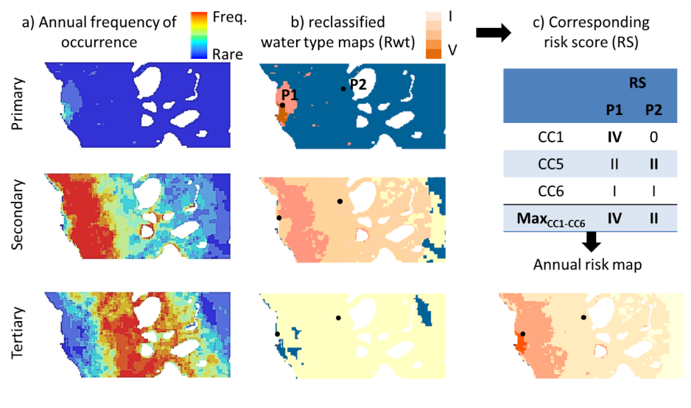
Figure 5-4: Theoretical example of the production of an annual risk map and the results for 2 pixels (P1 and P2) in the GBR, their classification, and final risk classification.

Exposure of GBR ecosystems to river plumes
A risk does not exist unless (i) the stressor has the inherent ability to cause one or more adverse effects, and (ii) it co-occurs or comes into contact with an ecological component (i.e., organisms, populations, communities, or ecosystems; US EPA, 1998) susceptible to the stressor. Ecological consequences of the risk will primarily be a function of the presence/absence of GBR ecosystems subjected to different occurrence and magnitude of risk (i.e. potential risk score). Community characteristics such as the sensitivity and resilience of particular seagrass or coral communities, including the resilience associated with their natural levels of exposure to pollutants, are additional parameters that must be considered when scoring the risk from river plume exposure. However, the consequence of the exposure of species is complicated by the influence of the combined stressors and additional external influences including weather and climate conditions and the ecological significance of pollutant concentrations are mostly unknown at a regional or species level (Brodie et al., 2013).
In this report we simply describe the area (km²) and percentage (%) of coral reefs and seagrass meadows exposed to river plume and to different categories of potential risk from river plume exposure. Areas of GBR waters within each marine NRM region exposed to different categories of river plume and river plume risk are also reported in recognition of other important habitats and populations that exist in these areas (Brodie et al., 2013).
Figure 5-5 and Figure 5-6 present the marine boundaries used for the GBR Marine Park, each NRM region and the seagrass and coral reefs ecosystems. We assumed in this study that the shapefile can be used as a representation of the actual seagrass distribution. Spatial distribution of the deepwater seagrass is a statistically modelled probability of seagrass presence (using generalised additive models (GAMs) with binomial error and smoothed terms in relative distance across and along the GBR) in GBRWHA waters >15m depth, based on ground-truthing of each data point. For details on approach, see Coles et al. (2009).
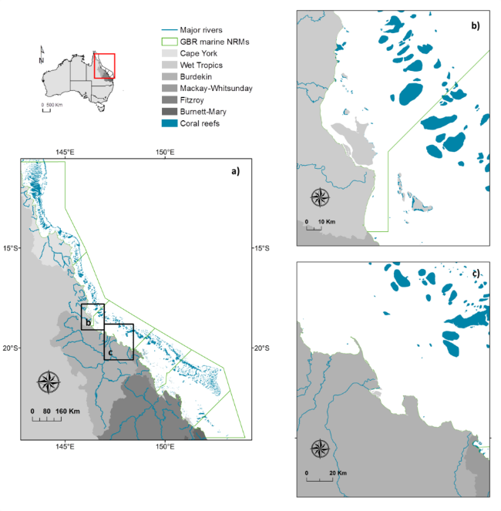
Figure 5-5: Marine boundaries used for the GBR Marine Park (a), each NRM region and the coral reefs ecosystems. Coral Reef and NRM layers derived from: GBRMPA, 2013, GBR feature shapefiles and enlargements around (b) the Tully-Herbert Rivers and (c) the Burdekin river.

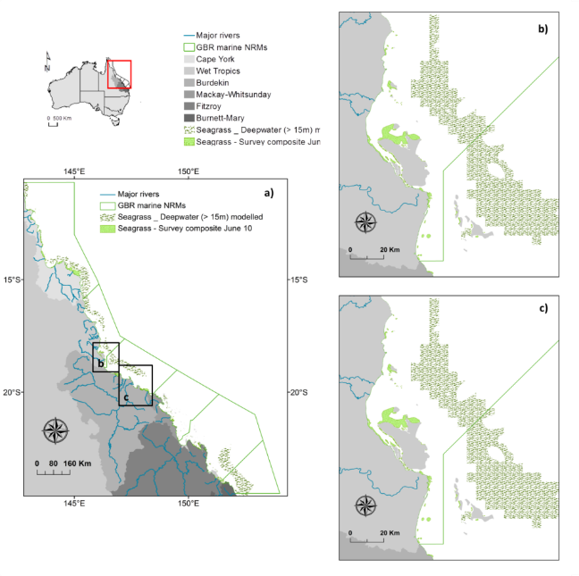

Figure 5-6: Marine boundaries used for the GBR Marine Park (a), each NRM region and the coral reefs ecosystems. NRM layers derived from: GBRMPA, 2013, GBR feature shapefiles and seagrass layers from DAFF, Feb. 2013. Spatial distribution of seagrass is a historical layer from all meadows examined between 1984 and 2008 (see reports at: http://www.seagrasswatch.org/meg.html

Results

Plume frequency maps, 2013-2014
The annual frequency maps illustrate GBR marine areas affected by river plume waters as well as the spatial distribution and frequencies of occurrence of the three GBR plume water types (Primary, Secondary, and Tertiary) during the wet season 2013-2014 (Figure 5-7 to Figure 5-9). Enlargements around the regions of the GBR are presented in Figure 5-8 to Figure 5-10. Note that this mapping exercise only identifies the surface river plume waters and plume water types and is not identifying scale or extent of impact on GBR ecosystems.
The plume water type maps provide information on the type/composition of river plume (through the Primary, Secondary, and Tertiary water type classification) and on the frequency of occurrence (or likelihood) of these plume water types. These maps illustrate a well-documented inshore to offshore spatial pattern (e.g., Devlin et al., 2015), with coastal areas experiencing the highest frequency of occurrence of Primary plume waters and offshore areas less frequently exposed to plume and, when exposed, more frequently reached by the tertiary water type of river plumes.

Figure 5-7: 2013-2014 plume frequency map: full plume extent in the GBR. The scale is normalised between 0 and 1, where 1 is equivalent to 22 weeks (full wet season).

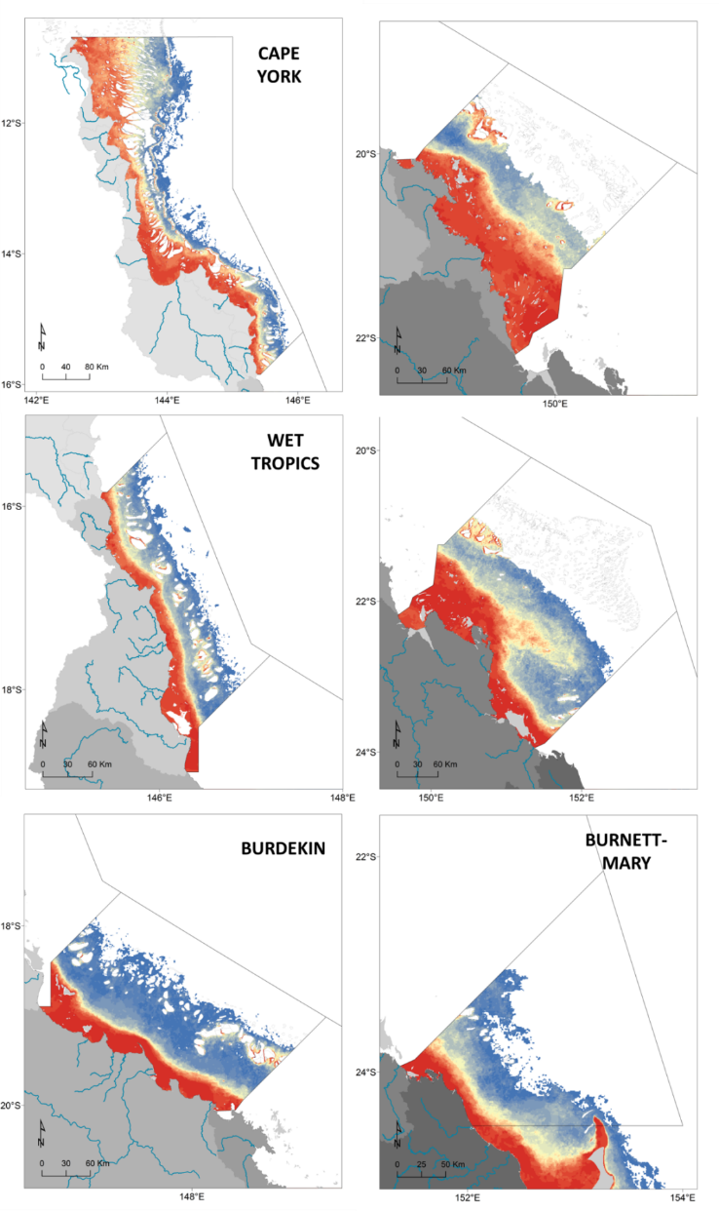
Figure 5-8: 2013-2014 plume frequency map: Full plume extent across each NRM region. The scale is as per Figure 5-7 and is normalised between 0 and 1, where 1 is equivalent to 22 weeks (full wet season).

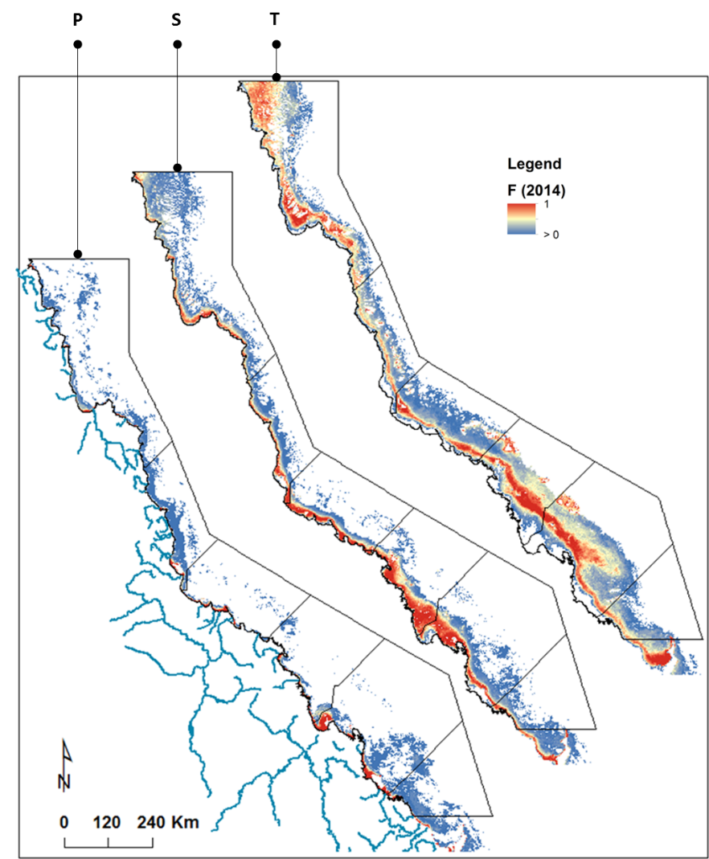

Figure 5-9: 2013-2014 plume frequency map: Plume water types (P: Primary, S: Secondary, T; Tertiary) in the GBR. The scale is normalised between 0 and 1, where 1 is equivalent to 22 weeks (full wet season).

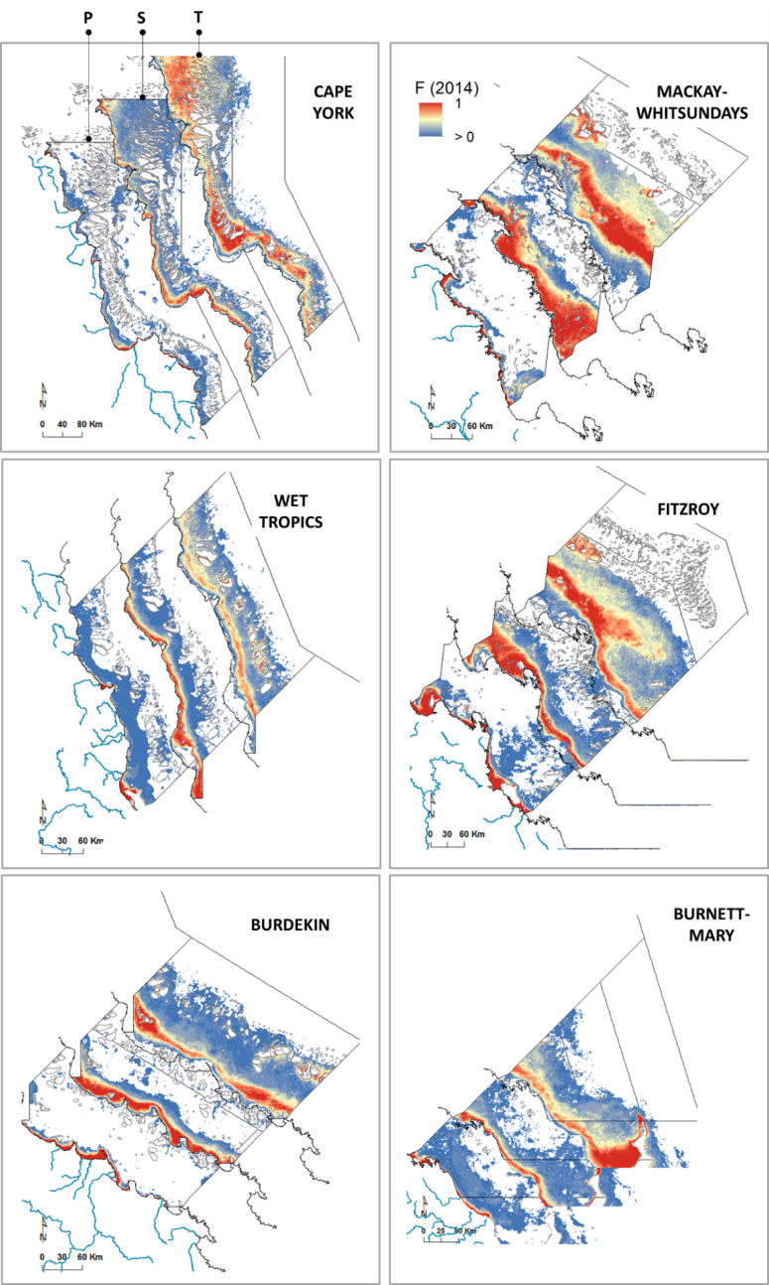
Figure 5-10: 2013-2014 frequency map:, plume water types (P: Primary, S: Secondary, T; Tertiary) across NRM regions. The scale is as per Figure 5-9 and is normalised between 0 and 1, where 1 is equivalent to 22 weeks (full wet season).

Water quality concentrations in river plumes
Comparisons between weekly plume water type composites and in-situ physical and water quality measurements collected during the wet seasons 2007 to 2013 as part of the GBR Marine Monitoring Program were performed. The mean WQ concentration (± standard deviation) calculated across plume water types and in the marine ambient waters are summarised in Table 5-4. The Temperature, Salinity and local depth are also reported.
Table 5-4: mean and standard deviation (±) GBR-whole scale WQ data per plume water type (P: Primary, S: Secondary, T: Tertiary) and in the ambient marine waters (M), and Kruskal-Wallis analysis for the difference in WQ among water types. Significance code: *: p<0.05 and ns: non-significant.
 | mean |  |  |  | ± |  |  |  | KW
 | P | S | T | M | P | S | T | M | KW
Temp (⁰C) | 28.87 | 28.67 | 29.18 | 28.25 | 1.42 | 1.33 | 1.24 | 0.51 | *
Sal | 24.44 | 30.27 | 32.44 | 32.86 | 9.19 | 6.28 | 4.70 | 1.72 | *
Depth (m) | 13.77 | 17.08 | 21.30 | 25.00 | 15.62 | 15.62 | 6.39 | 11.31 | *
Kd(PAR) | 0.78 | 0.36 | 0.20 | NA | 0.64 | 0.27 | 0.26 |  | *
CDOM (m⁻¹) | 0.89 | 0.36 | 0.25 | 1.82 | 1.00 | 0.49 | 0.26 | NA | *
TSS (mg L⁻¹) | 19.68 | 8.44 | 8.37 | 2.61 | 38.22 | 8.21 | 8.29 | 1.99 | *
Chl (µg L⁻¹) | 1.93 | 0.88 | 0.50 | 0.38 | 2.73 | 0.88 | 0.61 | 0.93 | *
Diuron (ng/L) | 95.42 | 45.37 | 0.00 | 15.00 | 312.68 | 78.53 | 0.00 | 21.21 | *
DIN (µM) | 3.33 | 1.87 | 1.68 | 1.90 | 3.03 | 1.99 | 2.23 | 1.03 | *
DIP (µM) | 0.45 | 0.28 | 0.24 | 0.17 | 0.50 | 0.24 | 0.18 | 0.14 | *
TN (µM) | 19.83 | 11.60 | 9.12 | 16.75 | 13.54 | 7.02 | 5.16 | 6.90 | *
TP (µM) | 1.03 | 0.59 | 0.45 | 0.38 | 0.87 | 0.36 | 0.27 | 0.29 | *
PN (µM) | 4.87 | 1.94 | 1.82 | 1.96 | 5.76 | 2.28 | 2.02 | 1.60 | *
PP (µM) | 0.41 | 0.16 | 0.11 | 0.10 | 0.71 | 0.17 | 0.12 | 0.06 | *
TDN (µM) | 14.28 | 9.54 | 7.34 | 14.79 | 8.79 | 5.89 | 4.18 | 6.47 | *
TDP (µM) | 0.68 | 0.43 | 0.35 | 0.28 | 0.56 | 0.30 | 0.24 | 0.31 | *
SI (µM) | 49.11 | 15.19 | 7.60 | 1.66 | 56.50 | 24.89 | 11.11 | 0.00 | *
PN_TN (µM) | 0.22 | 0.15 | 0.14 | 0.12 | 0.16 | 0.13 | 0.14 | 0.10 | *

Decreased mean salinity and depth values from the Tertiary to the Primary water type confirmed the spatial distribution of the plume water type i.e., a relative offshore location for the tertiary water type in comparison to inshore distribution for the Primary water type (Table 5-4 and Figure 5-9). Most of WQ parameters including Kd(PAR), TSS, DIN and DIP, followed published trends i.e., increasing values from the Tertiary; to the Secondary; to the Primary plume water type. Lewis et al. (2009) reported that the concentrations of PSII herbicides on the GBR typically exhibit a linear decline across the salinity gradient (i.e., from Primary to Tertiary water types). Diuron values followed expected trends with Diuron in Primary and Secondary respectively of 95.42 ± 312.68 ng/L; and 45.37 ± 78.53 ng/L. All samples measured in tertiary plume waters presented non detectible Diuron concentrations. Note that the Diuron concentrations present the highest variability around the mean of all sampled WQ parameters. The TSS and DIP concentrations were higher in plume waters than in the marine ambient waters. Note nevertheless that a very limited number of samples are available outside of the plume waters.
These results confirmed that concentrations of combined pollutants in plume waters increase from the Tertiary waters to the Primary core of river plumes and that mapping plume water types help clustering WQ stressors into three broad categories. If the magnitude of the risk from river plume is simply expressed as pollutant concentrations in plume waters, thus the magnitude of the potential risk from plume exposure increase from the tertiary to the primary water type, as assumed in the simplified risk framework (Figure 5-3).
While Table 5-2 reported higher chlorophyll-a concentration in the secondary water type in comparison to the Primary water type, updated multi-annual Chl-a concentrations at the GBR-whole scale, showed higher mean Chl-a concentrations in the Primary than the secondary water type, with mean values of 1.93 ± 2.73 µg L⁻¹ (Primary) and 0.88 ± 0.88 µg L⁻¹ (secondary) (Table 5-4). Devlin et al. (2013), reported a peak of Chl-a concentration in samples located in transition zones between the Primary and Secondary water types (i.e. in areas exposed 50% of time to Primary and 50% of time to Secondary plume water types) and suggested that Chl-a peaks were driven by a reduction in both TSS and KdPAR values as well as regular nutrients inputs. Further analyses are requested to validate this theory.

Potential river plume risk maps, 2013-2014
Figure 5-11 and Figure 5-12 present potential river plume risk maps of the wet season 2013-2014. Coastal areas experience the highest frequency of occurrence of Primary plume waters (Figure 5-9 and Figure 5-10) and thus coastal ecosystems are most potentially exposed to the highest categories of risk (III and IV). Inversely, offshore areas are less frequently exposed to plume and, when exposed, get more likely reached by the tertiary water type of river plumes. Thus, offshore ecosystems are most potentially exposed to lower river plume risk categories. Near shore ecosystems are located in transitional zones seeing an alternation of plume water types and frequencies. Their level of exposure to a potential risk from river plume exposures is more variable.
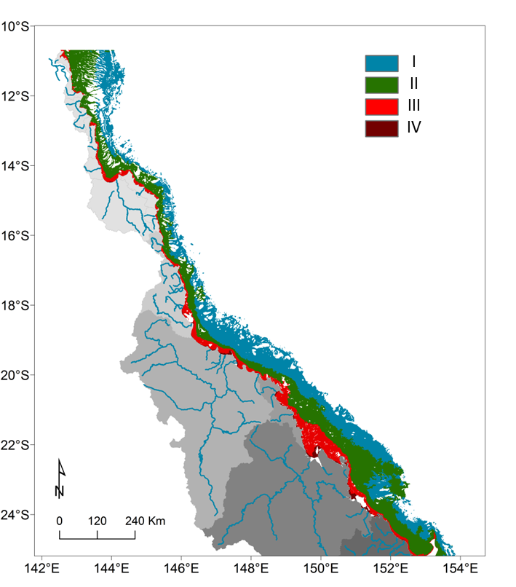
Figure 5-11: 2013-2014 GBR potential river plume risk map. The risk classes are shown in the legend.

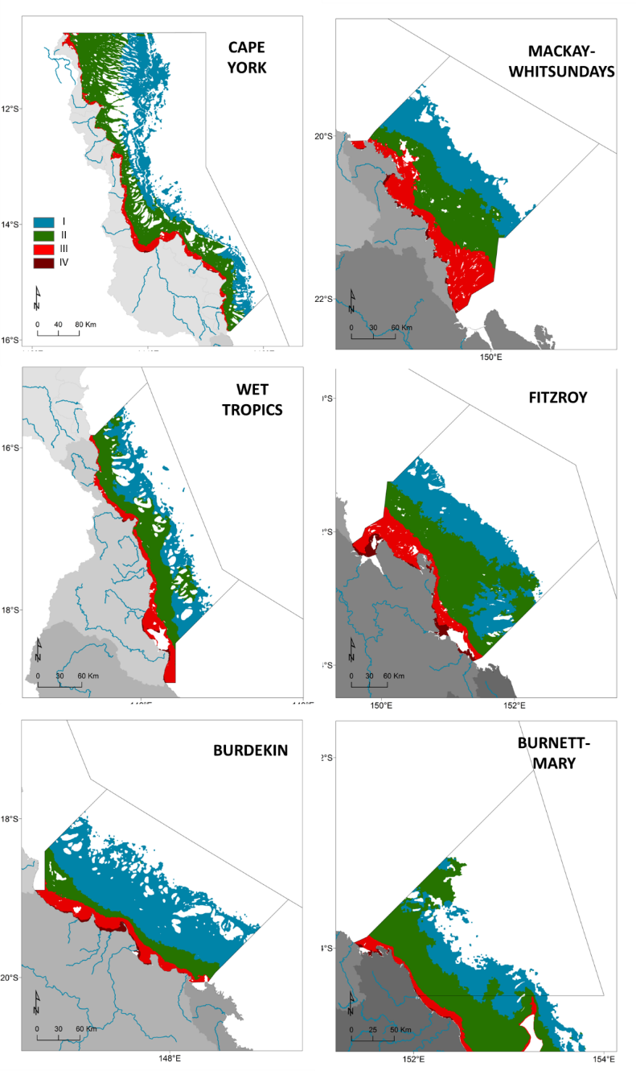
Figure 5-12: 2013-2014 potential river plume risk in the GBR NRM regions.

Mapping of potential risk from river plume exposure in 2013-2014
The 2013-2014 frequency maps (full extent and plume water types: Figure 5-7 to Figure 5-10) extrapolated to potential risk maps were then used to assess the exposure of the GBR ecosystems to river plume exposure during the 2013-2014 wet season (Table 5-5, Table 5-6 and Table 5-7).
Note that:
- Any results obtained in the Cape York NRM should be considered with care. Cape York is a shallow and optically complex environment where the TC method hasn’t been fully validated.
- Only surface areas inside the GBR marine boundaries are reported below.
The total GBR area exposed to river plume waters was 182,952 km² i.e., 52% of the GBR (Table 5-5). NRM areas exposed to river plume ranged from 11,680 km² (31 %) in the Burnett-Mary NRM to 53,893 km² (56 %) in Cape York NRM and 42,587 km² (49%) in the Fitzroy NRM. However, the actual areas under the highest potential risk categories (III and IV) from the river plumes were much lower with 26,550 km² (8 %) of the GBR, 656 (2%) of the Burnett-Mary and 4,013 km² (4 %) and 7,687 km² (9%) in the Cape York and Fitzroy NRM regions, respectively.
Table 5-6 and Table 5-7 present the areas (km²) and percentage (%) of coral reefs and seagrass beds (coastal, deep and total (coastal + deep)) exposed to different categories of potential river plume risk within each NRM. Coral reefs and seagrass beds exhibit a wide range of exposure (areas, % and categories of risk). In 2013-2014, GBR coral reefs were most exposed to the lowest categories of potential river plume risk (I and II) and GBR coastal seagrass beds were most exposed to the medium categories of potential river plume risk (II and III) . Offshore seagrass exposure categories were more variable but the offshore seagrass beds were generally most exposed to the lowest categories of potential river plume risk (I and II).

Coral reefs
The modelling indicates that 16,057 km² (i.e., 67%) of the GBR coral reefs were exposed to river plumes during the wet season 2013-2014, with most of them under the lowest potential risk categories (I and II) from river plume exposure(I: 8,634 km² (36%) and II: 6,921 km² (29%)). The largest areas (in km²) of coral reefs exposed to river plumes were located in the Cape York (9,482 km² or 92%), Burdekin (2,623 km² or 98%) and Wet Tropics (2,113 km² or 87%). It is the coral reefs of the Mackay-Whitsundays and Fitzroy NRM regions that experienced the highest potential risk (category III) from river plume exposure (203 km² or 6% and 124 km² or 3 %, respectively), but nearly no reefs were exposed to the potential risk category IV (<1% of the GBR reefs).

Coastal seagrasses
3,723 km² (i.e., 98%) of the GBR coastal seagrasses were exposed to river plumes, with most of them under the potential risk categories II and III from the river plume exposure (II: 1,261 km² (33%) and III: 2,084 km² (55%)).

Largest areas (in km²) of coastal seagrasses exposed to river plumes were located in the Cape York (2,433 km² or 100%), Burdekin (607 km² or 88%), Fitzroy (238 km² or 96%). Coastal seagrasses of the Cape York NRM experienced the highest potential risk from river plume exposure (1,228 km² or 50% of coastal seagrasses exposed to potential risk categories III and IV), followed by the Burdekin and Fitzroy NRM regions (530 km² or 85% and 236 km² or 95 %, respectively).

Table 5-5: Areas (km²) and percentage (%) of the GBR lagoon exposed to different categories of river plume frequency and river plume-related risk within the GBR and each NRM. Surface areas south of the GBR marine park boundary (Hervey Bay) are not included.
 |  |  | Risk category |  |  |  | TOT exposed | TOT non exposed
NRM |  | Tot | I | II | III | IV | TOT exposed | TOT non exposed
GBR | area | 34,8753 | 80,158 | 76,244 | 24,083 | 2,467 | 182,952 | 165,801
GBR | % | 100% | 23% | 22% | 7% | 1% | 52% | 48%
Cape York | area | 96,316 | 21,359 | 28,391 | 4,013 | 130 | 53,893 | 42,423
Cape York | % | 100% | 22% | 29% | 4% | 0% | 56% | 44%
Wet Tropics | area | 31,949 | 7,608 | 8,554 | 2,572 | 130 | 18,864 | 13,085
Wet Tropics | % | 100% | 24% | 27% | 8% | 0% | 59% | 41%
Burdekin | area | 46,967 | 21,468 | 4,767 | 3,149 | 448 | 29,833 | 17,134
Burdekin | % | 100% | 46% | 10% | 7% | 1% | 64% | 36%
Mackay-Whitsundays | area | 48,949 | 8,916 | 9,415 | 7,514 | 250 | 26,095 | 22,854
Mackay-Whitsundays | % | 100% | 18% | 19% | 15% | 1% | 53% | 47%
Fitzroy | area | 86,860 | 16,101 | 18,800 | 6,266 | 1,421 | 42,587 | 44,273
Fitzroy | % | 100% | 19% | 22% | 7% | 2% | 49% | 51%
Burnett-Mary | area | 37,712 | 4,706 | 6,317 | 569 | 87 | 11,680 | 26,032
Burnett-Mary | % | 100% | 12% | 17% | 2% | 0% | 31% | 69%

Table 5-6: Areas (km²) and percentage (%) of the coral reefs exposed to different categories of river plume frequency and river plume-related risk within the GBR and each NRM. Surface areas south of the GBR marine park boundary (Hervey Bay) are not included.
 |  |  | Risk category |  |  |  | TOT exposed | TOT non exposed
Coral reefs |  | Tot | I | II | III | IV | TOT exposed | TOT non exposed
GBR | area | 24,075 | 8,634 | 6,921 | 467 | 34 | 16,057 | 8,018
GBR | % | 100% | 36% | 29% | 2% | 0% | 67% | 33%
Cape York | area | 10,332 | 3,722 | 5,666 | 90 | 3 | 9,482 | 851
Cape York | % | 100% | 36% | 55% | 1% | 0% | 92% | 8%
Wet Tropics | area | 2,418 | 1,165 | 919 | 29 | 0 | 2,113 | 305
Wet Tropics | % | 100% | 48% | 38% | 1% | 0% | 87% | 13%
Burdekin | area | 2,966 | 2,557 | 47 | 18 | 0 | 2,623 | 343
Burdekin | % | 100% | 86% | 2% | 1% | 0% | 88% | 12%
Mackay- | area | 3,196 | 412 | 65 | 203 | 1 | 681 | 2,514
Whitsundays | % | 100% | 13% | 2% | 6% | 0% | 21% | 79%
Fitzroy | area | 4,880 | 636 | 185 | 124 | 30 | 975 | 3,905
Fitzroy | % | 100% | 13% | 4% | 3% | 1% | 20% | 80%
Burnett-Mary | area | 284 | 141 | 39 | 3 | 0 | 183 | 101.0
Burnett-Mary | % | 100% | 50% | 14% | 1% | 0% | 64% | 36%

Offshore seagrasses
It is estimated that 30,100 km² (i.e., 95%) of the GBR offshore seagrasses were exposed to river plumes, with most of them under the lowest potential risk categories (I and II) from the river plume exposure (I: 15,013 km² (47%) and II: 14,477 km² (46%)). In all NRM regions, nearly 100% of offshores seagrasses areas were exposed to river plumes, except in the Burnett-Mary were meadows exposed were about 79% (4,979 km²) out of the total local meadows. Note that seagrass meadows in Hervey Bay (outside of the GBR southern boundary) were not included in the risk analysis. Offshore seagrasses of the Fitzroy and Mackay-Whitsundays NRM experienced the highest potential risk from river plume exposure (282 km² or 7% and 122 km² or 55 %, respectively, under the potential risk category III).

Total seagrasses
Finally it is the Cape York (1,404 km² or 12%), Burdekin (530 km² or 9%) and Fitzroy (519 km² or 9%) NRM regions that had the largest total seagrass were estimated under the highest potential risk categories (III and IV) from river plume exposure. However it is in the Mackay-Whitsundays that the highest percentage (73% corresponding to 328 km²) was recorded.

Table 5-7: Areas (km²) and percentage (%) of coastal, deepwater and total (surveyed + deepwater modelled) seagrass exposed to different categories of river plume frequency and river plume-related risk within the GBR and each NRM. Surface areas south of the GBR marine park boundary (Hervey Bay) are not included.
 |  |  | Risk category |  |  |  | TOT exposed | TOT non exposed
Seagrass surveyed |  | Tot | I | II | III | IV | TOT exposed | TOT non exposed
GBR | area | 3,814 | 33 | 1,261 | 2,084 | 344 | 3,723 | 92
GBR | % | 100% | 1% | 33% | 55% | 9% | 98% | 2%
Cape York | area | 2,438 | 33 | 1,172 | 1,172 | 56 | 2,433 | 5
Cape York | % | 100% | 1% | 48% | 48% | 2% | 100% | 0%
Wet Tropics | area | 204 | 0 | 6 | 129 | 35 | 170 | 34
Wet Tropics | % | 100% | 0% | 3% | 63% | 17% | 83% | 17%
Burdekin | area | 621 | 1 | 76 | 429 | 101 | 607 | 15
Burdekin | % | 100% | 0% | 12% | 69% | 16% | 98% | 2%
Mackay-Whitsundays | area | 231 | 0 | 5 | 172 | 34 | 211 | 19
Mackay-Whitsundays | % | 100% | 0% | 2% | 75% | 15% | 92% | 8%
Fitzroy | area | 247 | 0 | 2 | 139 | 97 | 238 | 9
Fitzroy | % | 100% | 0% | 1% | 56% | 39% | 96% | 4%
Burnett-Mary | area | 74 | 0 | 0 | 43 | 21 | 64 | 10
Burnett-Mary | % | 100% | 0% | 0% | 58% | 29% | 87% | 13%
 |  |  | Risk category |  |  |  | TOT exposed | TOT non exposed
Seagrass deepwater modelled |  | Tot | I | II | III | IV | TOT exposed | TOT non exposed
GBR | area | 31632 | 15,013 | 14,477 | 610 | 0 | 30,100 | 1,532
GBR | % | 100% | 47% | 46% | 2% | 0% | 95% | 5%
Cape York | area | 9,459 | 1,980 | 7,213 | 177 | 0 | 9,370 | 89
Cape York | % | 100% | 21% | 76% | 2% | 0% | 99% | 1%
Wet Tropics | area | 4,661 | 2,018 | 2,482 | 12 | 0 | 4,512 | 149
Wet Tropics | % | 100% | 43% | 53% | 0% | 0% | 97% | 3%
Burdekin | area | 5,459 | 5,379 | 80 | 0 | 0 | 5,459 | -22
Burdekin | % | 100% | 99% | 1% | 0% | 0% | 100% | 0%
Mackay-Whitsundays | area | 220 | 0 | 98 | 122 | 0 | 220 | 1
Mackay-Whitsundays | % | 100% | 0% | 44% | 55% | 0% | 100% | 0%
Fitzroy | area | 5,560 | 2,970 | 2,307 | 282 | 0 | 5,560 | -6
Fitzroy | % | 100% | 53% | 42% | 5% | 0% | 100% | 0%
Burnett-Mary | area | 6,301 | 2,666 | 2,296 | 17 | 0 | 4,979 | 1321
Burnett-Mary | % | 100% | 42% | 36% | 0% | 0% | 79% | 21%
 |  |  | Risk category |  |  |  | TOT exposed | TOT non exposed
Seagrass total |  | Tot | I | II | III | IV | TOT exposed | TOT non exposed
GBR | area | 35447 | 15,046 | 15,738 | 2,695 | 344 | 33,823 | 1,624
GBR | % | 100% | 42% | 44% | 8% | 1% | 95% | 5%
Cape York | area | 11,896 | 2,013 | 8,385 | 1,348 | 56 | 11,803 | 94
Cape York | % | 100% | 17% | 70% | 11% | 0% | 99% | 1%
Wet Tropics | area | 4,865 | 2,018 | 2,488 | 141 | 35 | 4,682 | 184
Wet Tropics | % | 100% | 41% | 51% | 3% | 1% | 96% | 4%
Burdekin | area | 6,066 | 5,380 | 156 | 429 | 101 | 6,066 | -8
Burdekin | % | 100% | 89% | 3% | 7% | 2% | 100% | 0%
Mackay-Whitsundays | area | 451 | 0 | 103 | 294 | 34 | 431 | 20
Mackay-Whitsundays | % | 100% | 0% | 23% | 65% | 8% | 96% | 4%
Fitzroy | area | 5,801 | 2,970 | 2,310 | 422 | 97 | 5,798 | 3
Fitzroy | % | 100% | 51% | 40% | 7% | 2% | 100% | 0%
Burnett-Mary | area | 6,374 | 2,666 | 2,296 | 60 | 21 | 5,043 | 1331
Burnett-Mary | % | 100% | 42% | 36% | 1% | 0% | 79% | 21%

Potential river plume risk maps, 2007 to 2014
Annual potential risk maps from river plume exposure were produced from 2006-2007 to 2013-2014 and GBR areas exposed to potential risk from river plume exposure were calculated and compared to the wet season GBR river discharge (Table 5-8 and Figure 5-13). Note that surface areas in Hervey Bay (south of the GBR southern boundary) were included in this risk analysis. Surface areas of the GBR exposed to river plumes ranged from 151,819 km² in 2011-2012 to 245,342 km² in 2008-2009.

Table 5-8: Inter-annual (2006-2007 to 2013-2014) areas (km²) and percentage (%) of the GBR under potential risk from river plume exposure and total GBR wet season river discharge. Surface areas south of the GBR marine park boundary (Hervey Bay) are included.
 | Potential risk categories (Area, km²) |  |  |  | TOT exp. | Wet season riv. Disch.
Wet season | I | II | III | IV | (km²) | (ML)
2006-07 | 90,691 | 74,212 | 22,513 | 1,509 | 188,926 | 26,732,469
2007-08 | 102,441 | 83,834 | 25,589 | 1,467 | 213,331 | 63,446,575
2008-09 | 123,729 | 95,895 | 24,378 | 1,340 | 245,342 | 57,263,692
2009-10 | 117,155 | 75,110 | 25,932 | 1,543 | 219,739 | 41,168,334
2010-11 | 87,512 | 91,209 | 27,678 | 2,137 | 208,536 | 131,918,382
2011-12 | 69,989 | 57,893 | 22,365 | 1,572 | 151,819 | 42,024,682
2012-13 | 84,563 | 83,016 | 28,934 | 1,995 | 198,508 | 38,258,850
2013-2014 | 83,535 | 93,080 | 27,408 | 3,302 | 207,325 | 23,031,353

When only considering surface areas of the GBR exposed to the highest potential risk categories from river plumes exposure (II, III and IV), areas ranged from 81,830 km² in 2011-2012 to 121,024 km² in 2010-2011 and 123,789 km in 2013-2014. There was a trend toward an increase of surface areas of the GBR (in km²) exposed to the highest potential risk from river plume exposure (II, III and IV) and the wet season GBR river discharge (Figure 5-13a), but 2011-2012 and 2013-2014 were both outliers of the relationship (Figure 5-13b). A greater availability of satellite information due to a less frequent cloud cover in 2013-2014 could have resulted in mapping relatively higher frequency of occurrence of river plume during this wet season.
A multiannual potential risk composite map was calculated by selecting the majority risk value/pixels from the inter-annual risk maps produced . Recalculating individual wet season risk maps to a long-term (8-year) map is useful to describe where potential risk conditions from river plume are regularly encountered.

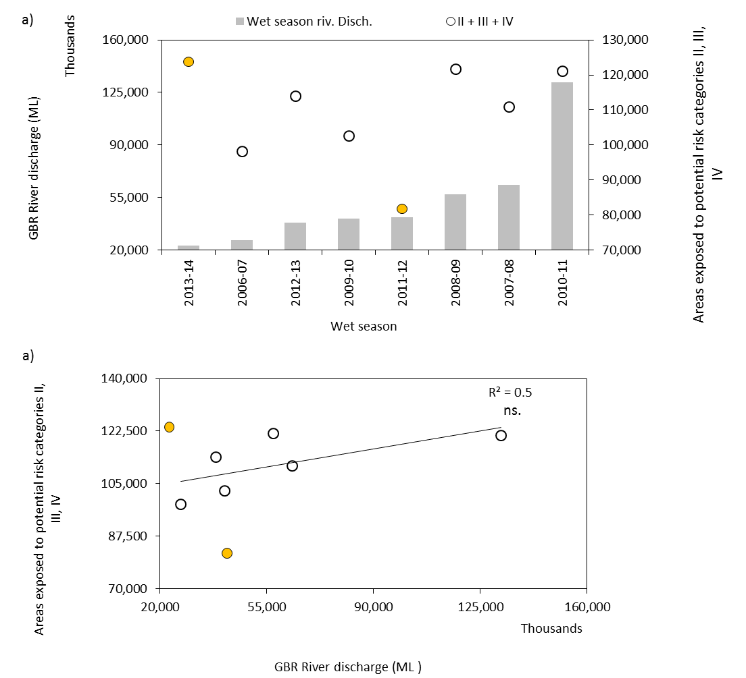
Figure 5-13: relationships between the total GBR areas exposed to the highest potential risk categories (II, III and IV) to river plume and the total GBR wet season river discharge. R² calculated without considering data of 2011-12 and 2013-2014.

. 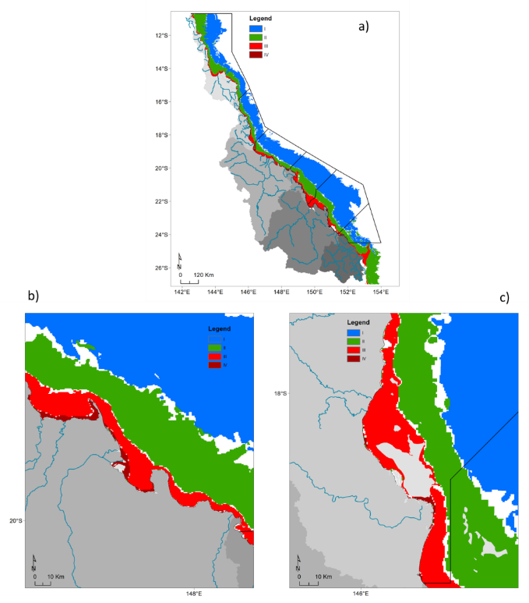
Figure 5-14: Multi-annual (2007-2013) “potential” river plume risk maps of (a) the GBR; (b) the Tully Herbert region and (c) the Burdekin region. Maps have been smoothed twice with a 4 pixel majority filter (ArcGIS).
As observed on the 2013-2014 risk maps, an inshore to offshore spatial pattern was present, with inshore areas within ~ 20 km of the coast experiencing high frequency of Primary waters and thus highest potential risk from river plume water (as Primary waters are the most concentrated in land-sourced pollutants), and offshore areas experiencing highest/lowest frequency of Tertiary/Primary plume water types and thus lowest potential risk from river plume exposure (as Tertiary waters are the less concentrated in land-sourced pollutants). Total areas exposed to river plumes extended about 150 km offshore of the Herbert River mouth and 230 km offshore of the Burdekin River mouth (if measured along a NE/SW strait line from both estuary mouths)
Using the mean multi-annual (2007-2014) surface areas (in km²) of coral and seagrass beds under the highest potential risk categories (III and IV) from plume exposure (and without considering Cape York) were calculated (Figure 5-15):
- Coral reef areas under potential risk categories III and IV were greater in Mackay-Whitsunday > Fitzroy > Wet Tropics > Burdekin > Burnett-Mary NRM regions.
- Total seagrass areas under potential risk categories III and IV greater in Fitzroy > Burdekin > Mackay-Whitsunday > Wet Tropics > Burnett-Mary NRM regions.

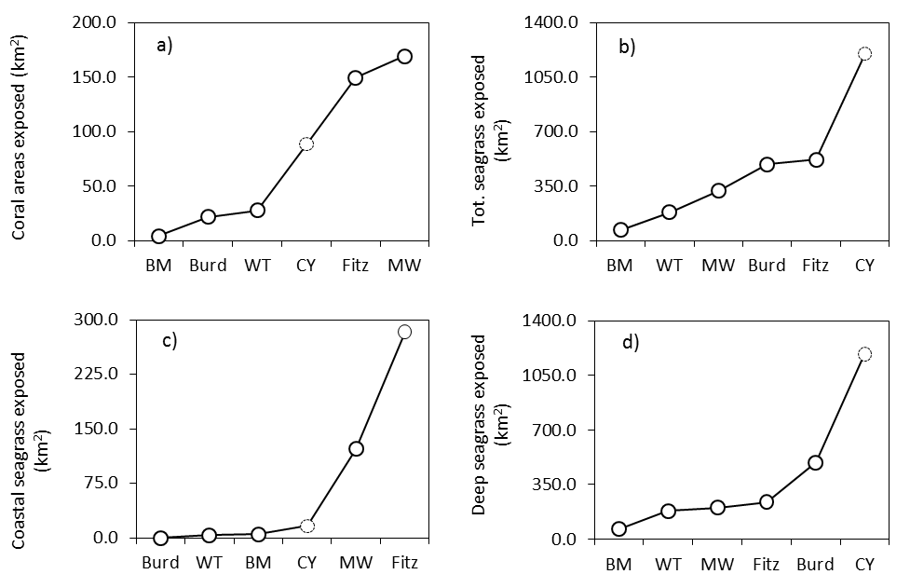
Figure 5-15: Multi-annual (2007-2014) areas (km²) of a) coral reefs, b) total seagrass, c) coastal seagrass and d) deepwater seagrass exposed to potential risk categories III and IV.

Discussion and conclusions

The 2013-2014 wet season
The wet season 2014 was characterised by neutral (neither El Niño nor La Niña) climatic conditions and tropical cyclone activity for the 2013-2014 wet season was near average the typical cyclone season activity of Queensland. After a late start to the wet season, Queensland’s NRM regions experienced two minor flood events around 26 January 2014 to 17 February 2014 and around 19 March 2014 to 6 April 2014, as well as a more important under flood event under the influence of Tropical Cyclone Ita which developed in the northern GBR in mid-April 2014.
Tropical Cyclone Ita resulted in heavy rainfall as it moved southward between 11 and 14 April 2014 and caused flooding in many areas of northeastern Queensland. On14 April 2014 river plumes were large (up to 70 km wide in Front of the Mossman River) and interconnected in the Wet Tropics. Secondary and Tertiary plume water types reached the reef in the wet tropics, north of the Tully River. The satellite image of Tully and Herbert coastal waters acquired on the 15 April 2014suggests that sediments settled rapidly and turbidity levels dropped after the passage of the cyclonic system.
Outcomes of the temporal analysis shows the Tully has only Si correlating significantly with river discharge. PP. For Russell-Mulgrave, TN, DIN and PN were significantly correlated with discharge. The dissolved nutrients were not significant for the Burdekin, but TN, TP, PN and PP all correlated strongly. The Fitzroy river discharge correlates with all the nitrogen species, including TN, DIN and PN. For most of the WQ parameters analysed, the best temporal model was obtained by using all variables, i.e., salinity, flow, distance, River and water type as random effects. For light extinction, the best model was obtained using salinity, distance and water type only, and for Chl-a, distance was used as a single random effect to produce the best model. The low r-squared indicates that in general the models do not explain much of the data variability, although they capture the general temporal trend of the data (all-significant at p < 0.05). For Chl-a, DIN and DIP, one can see a clear reduction in values after 2013, which was precede by an increasing in concentrations in 2010-11 wet season, corresponding to the Ex-Tropical Cyclone Yasi passage in January-February, 2011. Interesting to note that the same trend was observed for light attenuation, suggesting clear waters in 2010-11 wet season. As a general trend the majority of the parameters show reducing values towards the end of the analysed period, except for CDOM and DIP, which all show increasing values from 2013-2014 wet season onwards.
The river plume and plume water type frequency maps illustrate GBR marine areas affected by river plume waters and inform on the type/composition of river plume through the Primary, Secondary, and Tertiary water type classification. They also inform on the frequency of occurrence of these plume water types during the wet season 2013-2014. These maps are in agreement with previous year’s reports and showed an inshore to offshore spatial pattern, with coastal areas experiencing the highest frequency of occurrence of Primary plume waters and offshore areas less frequently exposed to plume and, when exposed, more frequently reached by the Tertiary water type of river plumes. Note that any results obtained in the Cape York NRM should be considered with care. Cape York is a shallow and optically complex environment where the true colour method hasn’t been fully validated.
A general inshore to offshore spatial pattern is present in the potential risk maps from plume exposure of the 2013-2014 wet season, with inshore areas and ecosystems within 10 to 30 km of the coast, including the coastal (surveyed seagrass) exposed to the medium categories of potential river plume risk (II and III), and offshore areas and ecosystems, including the offshore seagrass and coral reef, estimated at lower risk from river plume water (potential river plume risk categories I and II). From the 2013-2014 plume frequency maps and potential risk map, it was estimated that the total GBR area exposed to river plume waters was 18,2952 km² i.e., 52% of the GBR. NRM areas exposed to river plume ranged from 11,680 km² (31 %) in the Burnett-Mary NRM to 53,893 km² (56 %) in Cape York NRM and 42,587 km² (49%) in the Fitzroy NRM. Areas under the highest potential risk categories (III and IV) from the river plumes were, however, much lower with 26,550 km2 (8 %) of the GBR, 656 (2%) of the Burnett-Mary and 4,013 km² (4 %) and 7,687 km² (9%) in the Cape York and Fitzroy NRM regions, respectively.
About twenty percent (Fitzroy and Mackay-Whitsundays NRM regions) to 90% (Cape York and Wet Tropics NRM regions) of the coral reefs were exposed to river plumes. The Mackay-Whitsundays and Fitzroy reefs experienced the highest potential risk (category III) from river plume exposure (203 km² or 6% and 124 or 3 %, respectively), but nearly no reefs were exposed to the potential risk category IV (<1% of the GBR reefs). Eighty three percent (Wet Tropics NRM) to 100% (Cape York NRM) of the coastal seagrass beds were exposed to river plumes. The Cape York, Burdekin and Fitzroy reefs experienced the highest potential risk (category III and IV) from river plume exposure (1228 km² or 50%, 530 km² or 85% and 236 km² or 95 %, respectively). Nearly 100% of offshores seagrasses areas were exposed to river plumes in all NRM, except in the Burnett-Mary were meadows exposed were about 79% (4,979 km²) out of the total local meadows. Offshore seagrasses of the Fitzroy and Mackay-Whitsundays NRM experienced the highest potential risk from river plume exposure (282 km² or 7% and 122 km²or 55 %, respectively, under risk categories III). Finally, the Cape York (1405 km2 or 12%), Burdekin (530 km² or 9%) and Fitzroy (518 km² or 9%) NRM regions had the largest total seagrass areas estimated under risk categories III and IV from river plume exposure. However it is in the Mackay-Whitsundays that the highest percentage (73% corresponding to 328 km²) was recorded.
River plume models help mapping areas which may experience acute or chronic high exposure to river plumes and associated land-sourced pollutants, including sediments, nutrients and pesticides. Knowledge of the areas and the type of ecosystem that is the most likely to be impacted by degraded WQ through river plume exposure help focus our understanding on what type of ecological impacts are occurring to those ecosystems and help marine, coastal and catchment management. As part of our efforts for the MMP in 2013-2014, we have undertaken a number of important steps to improve our capacity to identify and monitor the level of exposure of GBR coral reefs and seagrass meadows to river plumes and land-sourced contaminants during the wet season. These steps include the application of innovative remote sensing methods, the production of synoptic maps describing the spatial and temporal movements of GBR river plumes. We also improved our understanding of the potential of using MODIS-derived products to assess the risk of GBR ecosystems from river plume exposure.
It should nevertheless be emphasised the mapping of exposure and water types; and thus of the final river plume risk; is depend on the availability of MODIS images. Number of MODIS cloud free images available for a specific study area is, in general, inversely proportional to the local river discharge conditions (Petus et al., 2014). Strong river discharge rates are associated with stormy/cyclonic conditions and characterised by high rainfall rates and high cloud coverage. This cloud contamination prevents ocean colour observations (TC method allow to map river plumes and plume water types only under light cloud cover) and to map GBR River plumes through MODIS images. Inversely, a greater availability of satellite information due to a less frequent cloud cover can results in mapping relatively higher frequency of occurrence of river plume.

Towards the production of river plume risk maps for the GBR ecosystems
A simplified risk framework was proposed in Petus et al. (2014b) and used in the last year MMP report to produce potential risk maps (seasonal) for the GBR ecosystems from river plume exposure. The term ‘potential’ was used as the simplified risk framework proposed was not validated against ecological health data and the need to refine the scoring system of the risk framework based on information on long term WQ in and across river plumes, as well as measured health impacts on ecosystem health during high flow periods was underlined in Devlin et al. (in Press). In this year report we have mainly worked toward a better understanding of the averaged WQ concentrations across the plume water types.
Comparisons between weekly plume water type composites and in-situ physical and water quality measurements collected during the wet seasons 2007 to 2013 as part of the GBR Marine Monitoring Program were performed and the mean WQ concentration (± standard deviation) calculated across plume water types and in the marine ambient. Results showed that:
- Most of WQ parameters including Kd(PAR), TSS DIN and DIP, followed published trends i.e., increasing values from the Tertiary; to the Secondary; to the Primary plume water type.
- The TSS and DIP concentrations were higher in plume waters than in the marine ambient waters (very limited number of samples).
- If the magnitude of the risk from river plume is simply expressed as pollutant concentrations in plume waters, the magnitude of the potential risk from plume exposure increase from the tertiary to the primary water type, as assumed in the simplified risk framework.

Inter-annual and averaged (8-year) trends in the GBR
Annual potential risk maps from river plume exposure were produced from 2006-07 to 2013-2014 and GBR areas exposed to potential risk from river plume exposure were calculated and compared to the wet season GBR river discharge. Surface areas of the GBR exposed to the highest potential risk categories from river plumes exposure (II, III and IV), areas ranged from 81,830 km² in 2011-2012 to 121,024 km² in 2010-2011 and 123,789 km² in 2013-2014. There was a trend toward an increase of surface areas of the GBR (in km²) exposed to the highest potential risk from river plume exposure (II, III and IV) and the wet season GBR river discharge, but 2011-12 and 2013-2014 were both outliers of the relationship. A greater availability of satellite information due to a less frequent cloud cover in 2013-2014 could have resulted in mapping relatively higher frequency of occurrence of river plume during this wet season.
Multiannual potential risk map was calculated by electing the majority risk value/pixels from the inter-annual risk maps produced Recalculating individual wet season risk maps to a long-term (8-year) map is useful to describe where potential risk conditions from river plume are regularly encountered. From this multi-annual composite map, it was estimated that:
- Coral reef areas under potential risk categories III and IV were greater in Mackay-Whitsunday > Fitzroy > Wet Tropics > Burdekin > Burnett-Mary NRM regions.
- Total seagrass areas under potential risk categories III and IV greater in Fitzroy > Burdekin > Mackay-Whitsunday > Wet Tropics > Burnett-Mary NRM regions.

Future developments
The MMP was established in 2005 to help assess the long-term status and health of GBR ecosystems and is a critical component assessing regional water quality changes as land management practices improve across GBR catchments. The program forms an integral part of the P2R program.
From 2014-2015, the water quality program will integrate into one combined program with wet season sampling, ambient and pesticide monitoring programs. The new water quality program will include ambient and wet season monitoring provided by researchers from James Cook University (JCU), Australian Institute of Marine Science (AIMS) and University of Queensland (UQ). These monitoring programs will provide a comprehensive data set that will further characterise the temporal and spatial variability of coastal water quality in the GBR.
Four focus areas, including Tully, Russell-Mulgrave, Mackay-Whitsundays and Burdekin will be sampled over pre-determined sites through the wet and dry seasons.
Further developments include improvements of our remote sensing methods to map river plumes, plume water types and the river plume risk:
- Further development of accurate regional algorithms for the GBR region (Brando et al., 2012; Schroeder et al., 2012), that provide better retrieval in optically complex coastal waters. Using these algorithms to map Chl-a concentrations in near future will be instrumental in more accurate mapping of river plume waters using the Level-2 method and more particularly of the productive Secondary waters. MODIS images calibrated into relevant water quality metrics (e.g. TSM, Chl-a, Dissolved Organic Matters concentrations, light attenuation) using accurate algorithms would allow producing produce compliance maps to ecological threshold and describing thresholds of acceptable WQ changes as well as their respective extent, frequency and duration for ecological management purposes.
- Further comparisons between remote sensing -derived products and in situ WQ data acquired over the next MMP monitoring years will be undertaken.
- One step further toward the evaluation of the susceptibility of GBR key ecosystems to the river plume/pollutants exposure is to compare predicted pollutant concentration in river plumes to published ecological threshold values for consequences and effects and combine this information with measures of ecosystem responses (such as growth rates, diversity, mortality) to refine the thresholds of the simplified risk framework. So far the risk is expressed as four qualitative categories (I, II, III, IV), with ecosystems under category IV being at a highest potential risk from river plume exposure than ecosystems exposed to category I. The risk ranking assumes that ecosystem responses will increase linearly with pollutant concentrations and frequency of exposure to the pollutant concentrations. Ideally, future risk models should incorporate the potential of cumulative impacts from multiple pollutants in river plume waters and the susceptibility of specific ecosystems (seagrass or coral reefs) should be taken into account. This exercise is, however, challenging because the response of GBR ecosystems to an amount and/or duration of exposure to land-sourced contaminants (respectively or combined) in river plume waters are often unknown at a regional or ecosystem level. Work is in progress (Petus et al., in prep) to test and revisit this simplified river plume risk framework of the GBR. Using GIS, objectives are to compare the risk model's predicted vulnerable (under risk) areas/ecosystems with monitored cases of ecosystem health decline refine the thresholds of the simplified risk framework. This study will use multi-annual WQ data, seagrass abundance data and percent cover of macroalgae (used as index od declined coral biodiversity) all collected under MMP funding as well as published ecological thresholds for land-sourced contaminants (e.g., Brodie et al.,2013).
Further developments of our remote sensing methods to map loads of pollutants (TSS, DIN and pesticides) include:
- The Increase of the spatial resolution of WQ data used to calculate the spatially distributed DIN and TSS maps. In this present form, the true colour method uses annual loads of TSS and DIN from seven major rivers draining into four selected NRMs to calculate their proportional contribution to the total pollutant load. Increasing the spatial resolution of these data would improve the precision of the mapping. Work is also currently undertaken to re-run the model with the annual loads from the Source Catchments modelling for all of the 35 GBR catchments. This requires establishment of dispersal relationships for the additional rivers and require non-negligible processing time and effort to automate processing steps as much as possible.
- The production annual load maps of Photosystem II inhibiting herbicides (PSII herbicides). The approach for modelling exposure to DIN (i.e., assuming conservative mixing) will be used for PSII. However, further investigation will be necessary to adjust the dispersal relationships i.e., relationship between PSII concentrations and color classes (see Figure 3 of Álvarez-Romero et al., 2013) to calculate the annual cost surface for PSII.
- Updates on the loading maps will be made available as the load data is update from all rivers in the GBR.

References
Álvarez-Romero, J.G., Devlin, M., Teixeira da Silva, E., Petus, C., Ban, N.C., Pressey, R.L., Kool, J., Roberts, J.J., Cerdeira-Estrada, S., Wenger, A.S., Brodie, J., 2013. A novel approach to model exposure of coastal-marine ecosystems to riverine flood plumes based on remote sensing techniques. Journal of environmental management 119, 194-207.
Anon, 2013. Reef rescue marine monitoring program quality assurance and quality control manual. 2010/11, in: Authority, G.B.R.M.P. (Ed.), GBRMPA, Townsville.
Anon, 2014. Reef rescue marine monitoring program quality assurance and quality control manual. 2013/14, in: Authority, G.B.R.M.P. (Ed.), GBRMPA, Townsville.
Bentley, C., Devlin, M., Paxman, C., Chue, K.L., Mueller, J.F., 2012. Pesticide monitoring in inshore waters of the Great Barrier Reef using both time-integrated and event monitoring techniques (2011 - 2012). University of Queensland, Marine Monitoring Program - Pesticides.
Berkelmans, R., Weeks, S.J., Steinberg, C.R., 2010. Upwelling linked to warm summers and bleaching on the Great Barrier Reef. Limnol. Oceanogr. 55, 2634–2644. doi:10.4319/lo.2010.55.6.2634
Brando, V., Schroeder, T., Dekker, A., Park, Y., 2008. Reef rescue marine monitoring program: using remote sensing for GBR wide water quality. Final Report for.
Brando, V., Schroeder, T., Dekker, A., Park, Y., 2010a. Reef Rescue Marine Monitoring Program: Using Remote Sensing for GBR Wide Water Quality: Final Report for 2009/10 Activities. CSIRO Land & Water.
Brando, V., Steven, A., Schroeder, T., Dekker, A., Park, Y., Daniel, P., Ford, P., 2010b. Remote-sensing of GBR Waters to assist performance monitoring of Water Quality Improvement Plans in Far North Queensland. Final report for Department of the Environment and Water Heritage and the Arts. Canberra, ACT. CSIRO Land & Water, Canberra, ACT, p. 88.
Brando, V.E., Anstee, J.M., Wettle, M., Dekker, A.G., Phinn, S.R., Roelfsema, C., 2009. A physics based retrieval and quality assessment of bathymetry from suboptimal hyperspectral data. Remote Sensing of Environment 113, 755-770.
Brodie, J., Binney, J., Fabricius, K., Gordon, I., Hoegh-Guldberg, O., Hunter, H., O’Reagain, P., Pearson, R., Quirk, M., Thorburn, P., 2008. Synthesis of evidence to support the scientific consensus statement on water quality in the Great Barrier Reef. The State of Queensland (Department of Premier and Cabinet), Brisbane.
Brodie, J., Burford, M., Davis, A., da Silva, E., Devlin, M., Furnas, M., Kroon, F., Lewis, S., Lønborg, C., O’Brien, D., Schaffelke, B., 2014. The relative risks to water quality from particulate nitrogen discharged from rivers to the Great Barrier Reef in comparison to other forms of nitrogen. . TropWATER Report 14/31. October 2014, 81.
Brodie, J., Kroon, F., Schaffelke, B., Wolanski, E., Lewis, S., Devlin, M., Bohnet, I., Bainbridge, Z., Waterhouse, J., Davis, A., 2012. Terrestrial pollutant runoff to the Great Barrier Reef: an update of issues, priorities and management responses. Marine pollution bulletin 65, 81-100.
Brodie, J., Lewis, S., Bainbridge, Z., Mitchell, A., Waterhouse, J., Kroon, F., 2009. Target setting for pollutant discharge management of rivers in the Great Barrier Reef catchment area. Marine and Freshwater Research 60, 1141-1149.
Brodie, J., Waterhouse, J., 2012. A critical review of environmental management of the ‘not so Great’Barrier Reef. Estuarine, Coastal and Shelf Science 104, 1-22.
Brodie, J., Waterhouse, J., Schaffelke, B., Furnas, M., Maynard, J., Collier, C., Lewis, S., Warne, M., Fabricius, K., Devlin, M., McKenzie, L., Yorkston, H., Randall, L., Bennett, J., Brando, V. 2013b. Scientific Consensus Statement. Chapter 3: Relative risks to the Great Barrier Reef from degraded water quality The State of Queensland. Published by the Reef Water Quality Protection Plan Secretariat, July 2013. http://www.reefplan.qld.gov.au/about/scientific-consensus-statement/water-quality-risks.aspx
Crawley, M.J., 2007. The R Book. John Wiley & Sons, Ltd, Imperial College London at Silwood Park, UK.
Da Silva, E., Devlin, M., Wenger, A., Petus, C., 2013. Burnett-‐Mary Wet Season 2012-‐2013: Water Quality Data Sampling, Analysis and Comparison against Wet Season 2010-‐2011 data, Centre for Tropical Water & Aquatic Ecosystems Research (TropWater) Publications. JCU, James Cook University, Townsville, p. 31.
Devlin, M., McKinna, L., Álvarez-Romero, J.G., Petus, C., Abott, B., Harkness, P., Brodie, J., 2012a. Mapping the pollutants in surface riverine flood plume waters in the Great Barrier Reef, Australia. Mar. Pollut. Bull., The Catchment to Reef Continuum: Case studies from the Great Barrier Reef 65, 224–235. doi:10.1016/j.marpolbul.2012.03.001
Devlin, M., Schaffelke, B., 2009. Spatial extent of riverine flood plumes and exposure of marine ecosystems in the Tully coastal region, Great Barrier Reef. Marine and Freshwater Research 60, 1109-1122.
Devlin, M., Schroeder, T., McKinna, L., Brodie, J., Brando, V., Dekker, A., 2011. Monitoring and mapping of flood plumes in the Great Barrier Reef based on in-situ and remote sensing observations. Advances in Environmental Remote Sensing to Monitor Global Changes, CRC Press, Boca Raton.
Devlin, M., Waterhouse, J., Taylor, J., Brodie, J., 2001. Flood plumes in the Great Barrier Reef: spatial and temporal patterns in composition and distribution. Great Barrier Reef Marine Park Authority.
Devlin, M., Wenger, A., Da Silva, E., Alvarez Romero, J.G., Waterhouse, J., McKenzie, L., 2012. Extreme weather conditions in the Great Barrier Reef: Drivers of change?
Devlin, M.J., Álvarez-Romero, J., da Silva, E.T., DeBose, J., Petus, C., Wenger, A., 2013. Reef Rescue Marine Monitoring Program. Final report of JCU activities 2011/12 – Flood plumes and extreme weather monitoring for the Great Barrier Reef Marine Park Authority. James Cook University, Townsville.
Devlin, M.J., Brodie, J., 2005. Terrestrial discharge into the Great Barrier Reef Lagoon: nutrient behavior in coastal waters. Marine pollution bulletin 51, 9-22.
Furnas, M., Alongi, D., McKinnon, D., Trott, L., Skuza, M., 2011. Regional-scale nitrogen and phosphorus budgets for the northern (14°S) and central (17°S) Great Barrier Reef shelf ecosystem. Cont. Shelf Res. 31, 1967–1990. doi:10.1016/j.csr.2011.09.007
Gallen, C., Devlin, M., Paxman, C., Banks, A., Mueller, J. (2013) Pesticide monitoring in inshore waters of the Great Barrier Reef using both time-integrated and event monitoring techniques (2012 - 2013). The University of Queensland, The National Research Centre for Environmental Toxicology (Entox).
Geyer, W., Hill, P., Kineke, G., 2004. The transport, transformation and dispersal of sediment by buoyant coastal flows. Continental Shelf Research 24, 927-949.
Grömping, G., 2006. Relative Importance for Linear Regression in R: The Package relaimpo. J. Stat. Softw. 17, 1–17.
Hateley, L.R., Ellis, R., Shaw, M., Waters, D., Carroll, C. 2014. Modelling reductions of pollutant loads due to improved management practices in the Great Barrier Reef catchments – Wet Tropics NRM region, Technical Report, Volume 3, Queensland Department of Natural Resources and Mines, Cairns, QLD (ISBN: 978-0-7345-0441-8).
Hijmans, R.J., Etten, J. van, Mattiuzzi, M., Sumner, M., Greenberg, J.A., Lamigueiro, O.P., Bevan, A., Racine, E.B., Shortridge, A., 2015. raster: Geographic Data Analysis and Modeling.
Howley, C., Devlin, M.J. Petus, C., da Silva, E., Tracey, D. 2015. Water Quality in Princess Charoltte Bay Flood plumes: 2012- 2014. Report to the Great Barrier Reef Marine Park Authority Marine Monitoring Programme. TropWater Report.
Johnson, J., Brando, V., Devlin, M., McKenzie, L., Morris, S., Schaffelke, B., Thompson, A., Waterhouse, J., Waycott, M., 2011. Reef rescue marine monitoring program: 2009/2010 synthesis report. Reef and Rainforest Research Centre.
Joo, M., Raymond, M.A., McNeil, V.H., Huggins, R., Turner, R.D., Choy, S., 2012. Estimates of sediment and nutrient loads in 10 major catchments draining to the Great Barrier Reef during 2006–2009. Marine pollution bulletin 65, 150-166.
Kennedy, K., Devlin, M., Bentley, C., Lee-Chue, K., Paxman, C., Carter, S., Lewis, S.E., Brodie, J., Guy, E., Vardy, S., 2012. The influence of a season of extreme wet weather events on exposure of the World Heritage Area Great Barrier Reef to pesticides. Marine pollution bulletin 64, 1495-1507.
Kroon, F.J., 2012. Towards ecologically relevant targets for river pollutant loads to the Great Barrier Reef. Marine pollution bulletin 65, 261-266.
Lewis, S.E., Brodie, J.E., Endo, G., Lough, J., Furnas, M., Bainbridge, Z.T., 2014. Synthesizing historical land use change, fertiliser and pesticide usage and pollutant load data in the regulated catchments to quantify baseline and changing loads exported to the Great Barrier Reef. (No. 14/2014), TropWATER Report. James Cook University, Townsville, AU.
Luick, J.L., Mason, L., Hardy, T., Furnas, M.J., 2007. Circulation in the Great Barrier Reef Lagoon using numerical tracers and in situ data. Cont. Shelf Res. 27, 757–778. doi:10.1016/j.csr.2006.11.020
Martin, K., McKenzie, L.J., Thompson, A., Muller, J., Bentley, C., Paxman, C., Collier, C., Waycott, M., Brando, V., Devlin, M., Schaffelke, B., 2014. Reef Rescue Marine Monitoring Program synthesis report. 2010-2011, A report to the Great Barrier Reef Marine Park Authority., GBRMPA, Townsville.
Maughan, M., Brodie, J., 2009. Reef exposure to river-borne contaminants: a spatial model. Marine and Freshwater Research 60, 1132-1140.
McKenzie, L., Collier, C., Waycott, M., 2014. Reef Rescue Marine Monitoring Program: Inshore Seagrass, Annual Report for the sampling period 1st July 2011–31st May 2012.
McKenzie, L., Collier, C., Waycott, M., Unsworth, R., Yoshida, R., Smith, N., 2012. Monitoring inshore seagrasses of the GBR and responses to water quality.
Petus C., Devlin, M., Thompson, A., McKenzie, L., Teixeira da Silva, E., collier, C., Tracey, D., Martin, K., (2016). Estimating the exposure of coral reefs and seagrass meadows to land-sourced contaminants in river flood plumes of the Great Barrier Reef: validating a simple satellite risk framework with Environmental Data. Remote Sensing.
Petus, C., Collier, C., Devlin, M., Rasheed, M., McKenna, S., 2014b. Using MODIS data for understanding changes in seagrass meadow health: A case study in the Great Barrier Reef (Australia). Marine environmental research 98, 68-85.
Petus, C., Teixeira da Silva,E., Devlin, M., Wenger, A.,Álvarez-Romero, J. G. 2014a. Using MODIS data for mapping of water types within river plumes in the Great Barrier Reef, Australia: towards the production of river plume risk maps for reef and seagrass ecosystems. Journal of Environmental Management 137: 163-177.
Petus, C., Teixeira da Silva,E., Devlin, M., Wenger, A.,Álvarez-Romero, J. G. 2014b. Using MODIS data for mapping of water types within river plumes in the Great Barrier Reef, Australia: towards the production of river plume risk maps for reef and seagrass ecosystems. Journal of Environmental Management 137: 163-177.
R Development Core Team, 2015. R: a language and environment for statistical computing [WWW Document]. GBIF.ORG. URL http://www.gbif.org/resource/81287 (accessed 5.20.15).
Schaffelke, B., Carleton, J., Skuza, M., Zagorskis, I., Furnas, M.J., 2012. Water quality in the inshore Great Barrier Reef lagoon: Implications for long-term monitoring and management. Marine pollution bulletin 65, 249-260.
Schroeder, T., Behnert, I., Schaale, M., Fischer, J., Doerffer, R., 2007. Atmospheric correction algorithm for MERIS above case‐2 waters. International Journal of Remote Sensing 28, 1469-1486.
Thompson, A., Schaffelke, B., Logan, M., Costello, P., Davidson, J., Doyle, J., Furnas, M., Gunn, K., Liddy, M., Skuza, M., 2013. Reef Rescue Marine Monitoring Program: Annual Report of AIMS Activities 2012 to 2013, Inshore water quality and coral reef monitoring.
Waterhouse, J., Brodie, J., Lewis, S., Mitchell, A., 2012. Quantifying the sources of pollutants in the Great Barrier Reef catchments and the relative risk to reef ecosystems. Marine pollution bulletin 65, 394-406.
Waters, D.K., Carroll, C., Ellis, R., Hateley, L., McCloskey, J., Packett, R., Dougall, C., Fentie, B. 2014. Modelling reductions of pollutant loads due to improved management practices in the Great Barrier Reef Catchments – Whole of GBR, Volume 1. Department of Natural Resources and Mines. Technical Report (ISBN: 978-1-7423-0999).
Wolanski, E., Jones, M., 1981. Physical properties of Great Barrier Reef lagoon waters near Townsville. I. Effects of Burdekin River floods. Marine and Freshwater Research 32, 305-319.
Wolanski, E., Van Senden, D., 1983. Mixing of Burdekin river flood waters in the Great Barrier Reef. Marine and Freshwater Research 34, 49-63.
Wolff, N., Devlin, M., da Silva, E.T., Brinkman, R., Petus, C., Tracey, D., Tonin, H., Stephen, L., Mumby, P., Anthony, K., 2014. Impacts of terrestrial runoff on the vulnerability of the Great Barrier Reef., in: The 22nd Ocean Optics Conference. Portland, ME.
Wood, S. N. (2006). Low‐Rank Scale‐Invariant Tensor Product Smooths for Generalized Additive Mixed Models. Biometrics, 62(4), 1025-1036.

