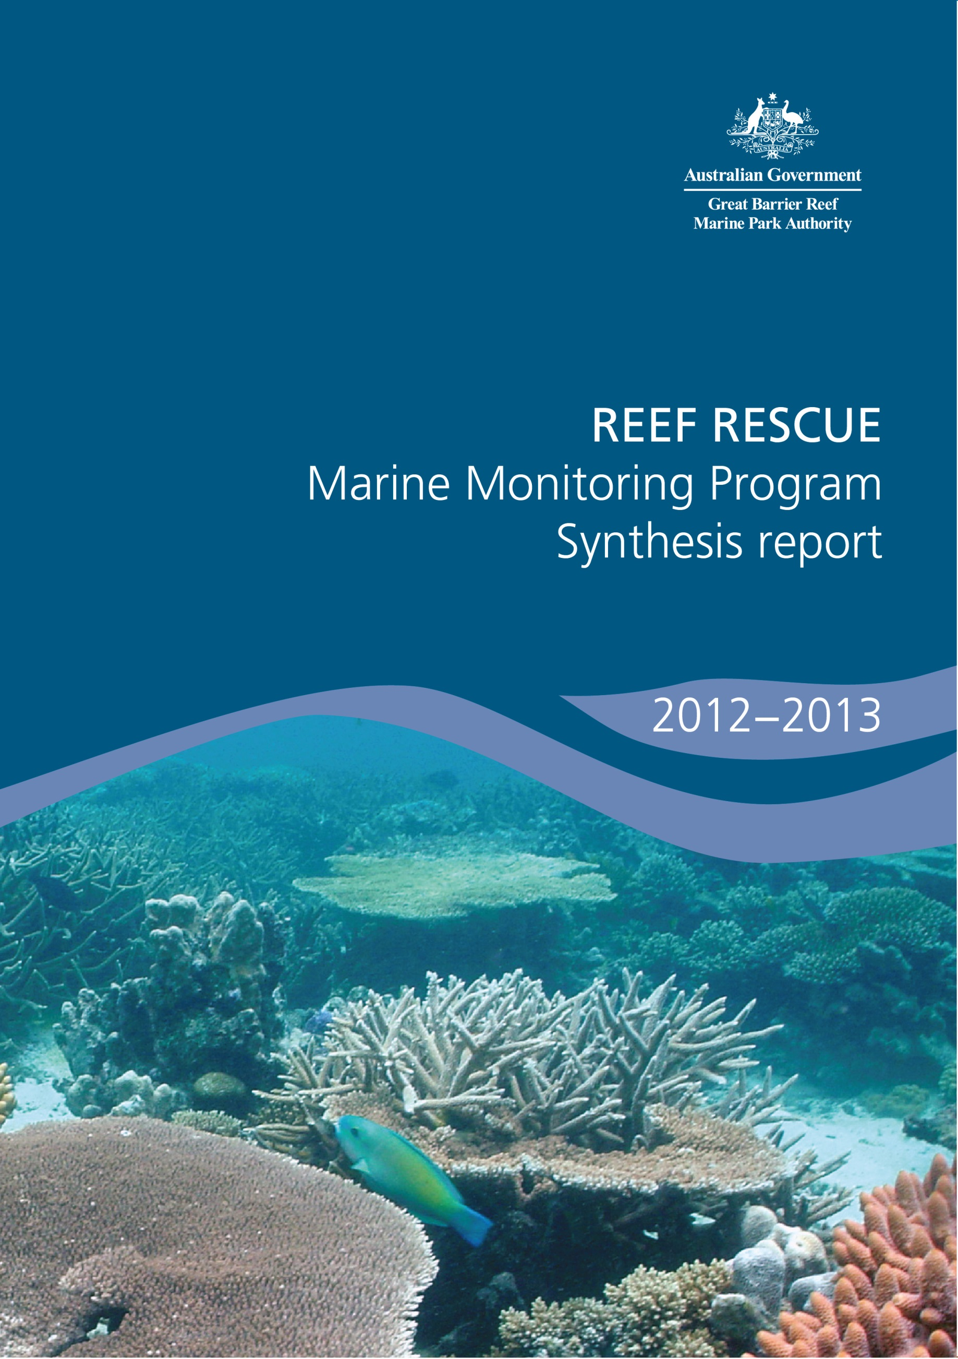

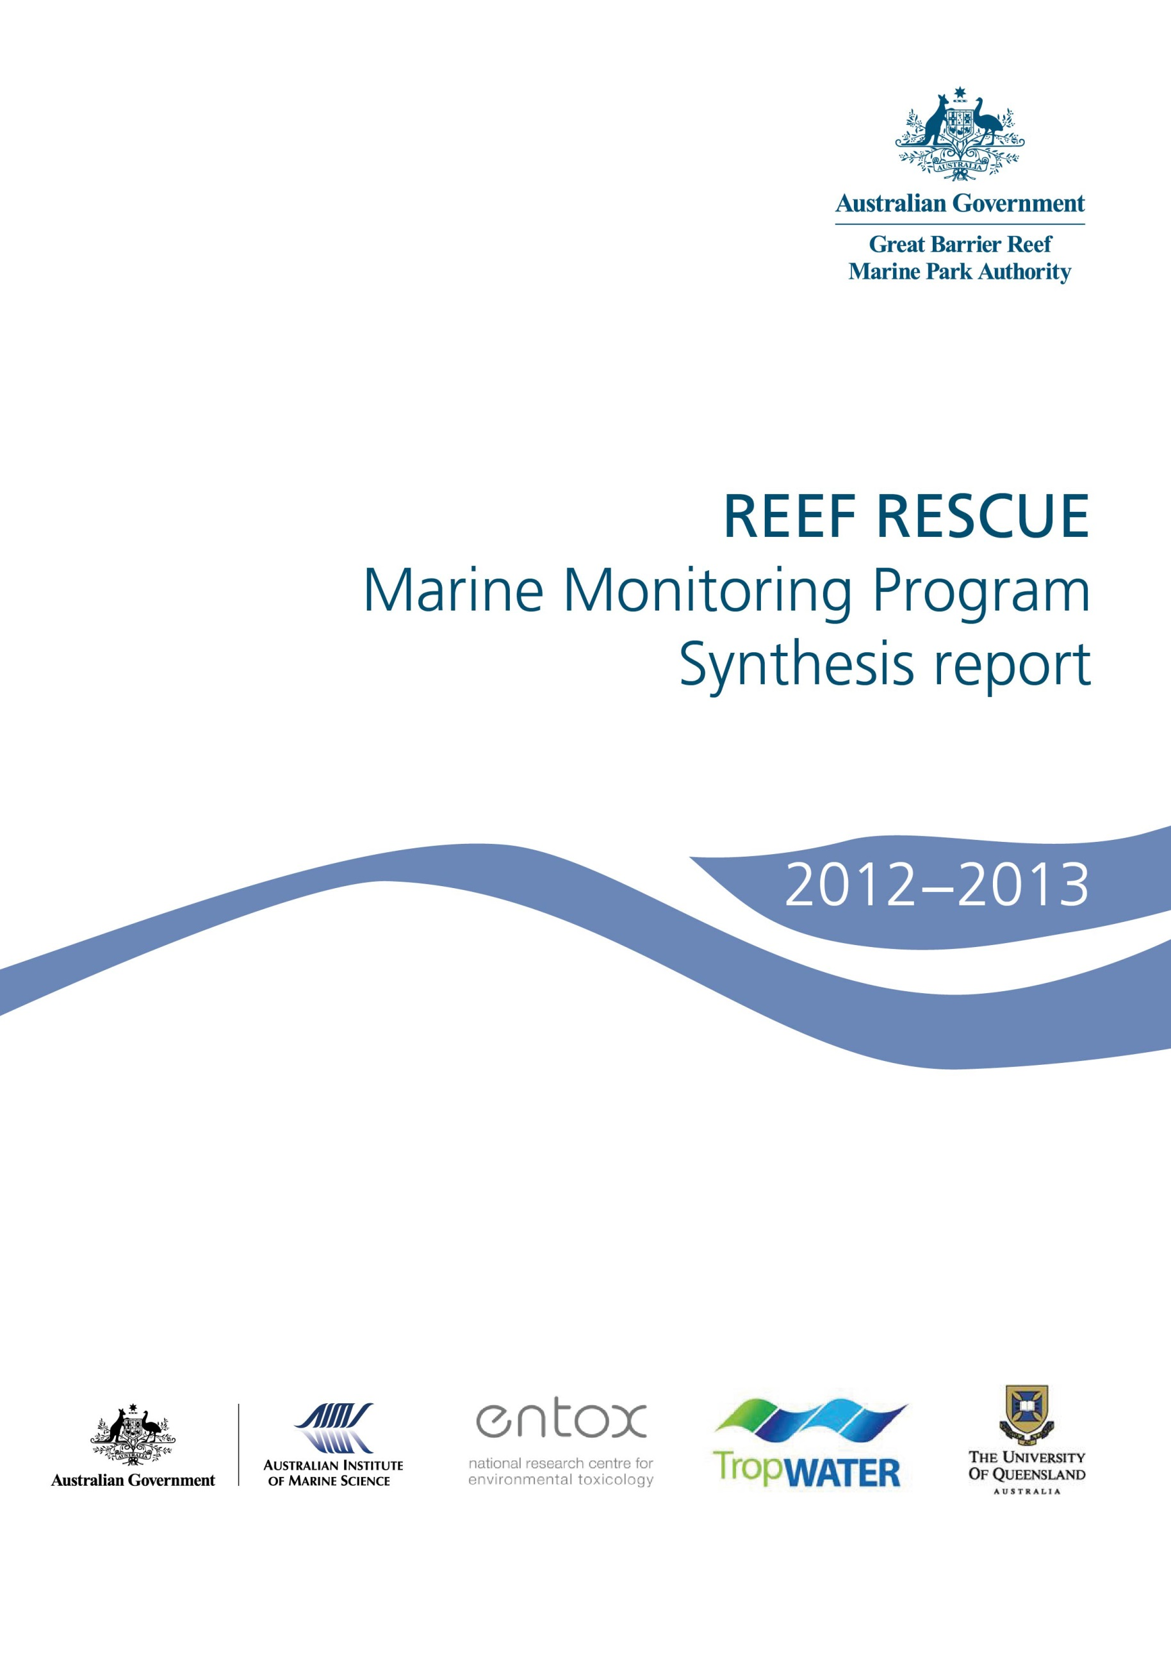
© Commonwealth of Australia 2014
Published by the Great Barrier Reef Marine Park Authority
ISSN 2200 4084
ISBN 978 1 922126 55 9 (ebook; pdf)
This work is copyright. Apart from any use as permitted under the Copyright Act 1968,
no part may be reproduced by any process without the prior written permission of the
Great Barrier Reef Marine Park Authority.
The Great Barrier Reef Marine Park Authority gratefully acknowledges the contributions of the MMP providers and their institutions to the Marine Monitoring Program Synthesis Report 2012-2013.
This publication should be cited as:
Martin, KC., Marshall, C., Thompson, A., McKenzie, L.J., Muller, J., Bentley, C., Paxman, C., Collier, C., Waycott, M., Brando, V. and Schaffelke, B. 2014, Reef Rescue Marine Monitoring Program synthesis report. 2012-2013, GBRMPA, Townsville.
Requests and inquiries concerning reproduction and rights should be addressed to:
Director, Communication and Parliamentary
2-68 Flinders Street
PO Box 1379
TOWNSVILLE QLD 4810
Australia
Phone: (07) 4750 0700
Fax: (07) 4772 6093
info@gbrmpa.gov.au

Comments and inquiries on this document are welcome and should be addressed to:
Director, Reef 2050
info@gbrmpa.gov.au
www.gbrmpa.gov.au

Table of Contents
1. Introduction 7
1.1 The Great Barrier Reef 7
1.2 Threats from poor land management practices 7
1.3 Disturbances affecting the Great Barrier Reef 8
1.3.1 Catchment runoff 9
1.3.2 Floods 9
1.3.3 Cyclones 11
1.3.4. Crown-of-thorns starfish 13
1.3.5 Elevated sea surface temperatures 14
1.3.6. Influence of climate change 16
2. Methods 17
2.1 The Marine Monitoring Program 17
2.1.1 Inshore water quality 17
2.1.2 Flood plume dynamics 17
2.1.3 Seagrass status 18
2.1.4 Coral reef status 19
2.2 Synthesis and integration of data and information 20
2.2.1 Inshore Great Barrier Reef and regional scores 20
2.2.2 Site-specific assessments 21
3. Results 23
3.1 The Great Barrier Reef Region 23
3.1.1 Summary results 23
3.1.3 Water quality condition and trend 24
3.1.4 Pesticides 25
3.1.5 Seagrass condition and trend 28
3.1.6 Coral condition and trend 30
3.2 Cape York 33
3.2.1 Summary results 33
3.2.2 Water quality condition and trend 34
3.2.3 Seagrass condition and trend 35
3.3 Wet Tropics 37
3.3.1 Summary results 37
3.3.2 Water quality condition and trend 39
3.3.3 Seagrass condition and trend 42
3.3.4 Coral condition and trend 44
3.4 Burdekin 51
3.4.1 Summary results 51
3.4.2 Water quality condition and trend 53
3.4.3 Seagrass condition and trend 56
3.4.4 Coral condition and trend 58
3.5 Mackay Whitsunday 62
3.5.1 Summary results 62
3.5.2 Water quality condition and trend 63
3.5.3 Seagrass condition and trend 66
3.5.4 Coral condition and trend 67
3.6 Fitzroy 72
3.6.1 Summary results 72
3.6.2 Water quality condition and trend 74
3.6.3 Seagrass condition and trend 77
3.6.4 Coral condition and trend 79
3.7 Burnett Mary 82
3.7.1 Summary results 82
3.7.2 Water quality condition and trend 83
3.7.3 Seagrass condition and trend 83
4. Summary 85
References 87

List of Figures
Figure 1: All Category 4/5 Cyclones that have affected the Great Barrier Reef from 2005 to 2013 with the zones of influence (wind categories) differentially shaded. 12
Figure 2: Crown-of-thorns starfish outbreaks since 1998-2013. 13
Figure 3: Water temperature as degree heating days and areas where coral bleaching occurred during 2012-2013. 15
Figure 4: Satellite images (MODIS-Aqua) of the inshore Fitzroy region of the Great Barrier Reef during normal (low) flow conditions in November 2009 (a) and flood conditions in March and April (b, c, d). 18
Figure 5: Seagrass monitoring on the Great Barrier Reef (Image: L. McKenzie, Queensland Government). 19
Figure 6: Coral reefs being monitored on the Great Barrier Reef. (Image: AIMS). 19
Figure 7: The overall condition of the inshore Great Barrier Reef in 2012-2013 including water quality, seagrass and coral reefs. 23
Figure 8: Trend in the water quality index from 2005-2006 to 2012-2013 for the Great Barrier Reef. 24
Figure 9: Maximum PS-II herbicide equivalent concentrations at all sites monitored in the Great Barrier Reef from 2008-2009 to 2012-2013. 26
Figure 10: Maximum concentrations of each individual herbicide at routine monitoring sites from the commencement of sampling to 2012-2013. 27
Figure 11: Trend in seagrass condition from 2005-2006 to 2012-2013. 28
Figure 12: Trends in the abundance (% cover ± Standard Error) of inshore seagrass meadows at reef, coastal and estuarine sites since 1999. 29
Figure 13: Median tissue nutrient concentrations (±Standard Error) in seagrass leaves for each habitat type (species pooled) over the entire monitoring program. 30
Figure 14: Trend in coral condition from 2007-2008 to 2012-2013. 31
Figure 15: A) variation in the cover of hard corals, B) cover of macroalgae, C) and density of hard coral juveniles in the inshore Wet Tropics, Burdekin, Mackay Whitsunday and Fitzroy regions from 2005 to 2013. 32
Figure 16: The condition of water quality and ecosystem health (seagrass and corals) in 2012-2013 across the inshore Cape York region. 33
Figure 17: Trend in the water quality index from 2005-2006 to 2012-2013 for the inshore Cape York region. 34
Figure 18: Trend in seagrass condition from 2005-2006 to 2012-2013. 35
Figure 19: Trend in seagrass abundance (% cover ± Standard Error) at the inshore intertidal fringing reef habitat at Archer Point. 36
Figure 20: The condition of water quality and ecosystem health (seagrass and corals) in 2012-2013 across the inshore Wet Tropics region. 37
Figure 21: Trend in the water quality index from 2005-2006 to 2012-2013 in the inshore Wet Tropics region. 39
Figure 22: Water quality and pesticide scores for PS-II herbicides at fixed monitoring sites in the Wet Tropics. 40
Figure 23: Trends in average PS-II herbicide equivalent concentrations at each sampling site in the Wet Tropics according to season. 41
Figure 24: Trend in seagrass condition from 2005-2006 to 2012-2013 in the Wet Tropics. 42
Figure 25: Trend in seagrass abundance (% cover) at inshore intertidal coastal habitats (left. Yule Point and right. Lugger Bay) in the wet tropics. 43
Figure 26: Trend in seagrass abundance (% cover ± Standard Error) at inshore intertidal coastal habitats (Yule Point and Lugger Bay) and reef habitat intertidal and subtidal meadows (left and right respectively): a-b) Low Isles; c-d) Green Island; e-f) Dunk Island 44
Figure 27: Trend in coral condition from 2007-2008 to 2012-2013 in the Wet Tropics. 45
Figure 28: Cover of major benthic groups and levels of key environmental parameters: Daintree sub-region, inshore Wet Tropics Region. 46
Figure 29: Cover of major benthic groups and density of hard coral juveniles at each depth for reefs in the Johnstone sub-region. 48
Figure 30: Cover of major benthic groups and density of hard coral juveniles at each depth for reefs in the Tully sub- region. 50
Figure 31: The condition of water quality and ecosystem health (seagrass and corals) in 2012-2013 across the inshore Burdekin region. 51
Figure 32: Trend in the water quality index from 2005-2006 to 2012-2013 in the inshore Burdekin region. 53
Figure 33: Water quality and pesticide scores for PS-II herbicides at fixed monitoring sites in the Burdekin. 54
Figure 34: Trends in average PS-II herbicide equivalent concentrations at each sampling site in the Burdekin according to season. 55
Figure 35: Trend in seagrass condition from 2005-2006 to 2012-2013 in the Burdekin. 56
Figure 36: Changes in mean seagrass abundance (% cover ±Standard Error) at coastal intertidal (a, b), reef intertidal (c) and reef subtidal (d) meadows in the inshore Burdekin region from 2001 to 2013. 57
Figure 37: Trend in coral condition from 2007-2008 to 2012-2013 in the Burdekin. 58
Figure 38: Cover of major benthic groups and density of hard coral juveniles at each depth for reefs in the inshore Burdekin region. 61
Figure 39: The condition of water quality and ecosystem health (seagrass and corals) in 2012-2013 across the inshore Mackay Whitsunday region. 62
Figure 40: Trend in the water quality index from 2005-2006 to 2012-2013 in the inshore Mackay Whitsunday region. 63
Figure 41: Water quality and pesticide scores for PS-II herbicides at fixed monitoring sites in the Mackay Whitsundays. 64
Figure 42: Trends in average PS-II herbicide equivalent concentrations at each sampling site in the Mackay Whitsundays according to season. 65
Figure 43: Trend in seagrass condition from 2005-2006 to 2012-2013 in the Mackay Whitsundays. 66
Figure 44: Changes in seagrass abundance (% cover ±Standard Error) at a). coastal, b). estuarine, nd c). reef meadows in the inshore Mackay Whitsunday region from 1999 to 2013. 67
Figure 45: Trend in coral condition from 2007-2008 to 2012-2013 in the Mackay Whitsundays. 68
Figure 46: Cover of major benthic groups and density of hard coral juveniles at each depth for reefs in the inshore Mackay Whitsunday region. 71
Figure 47: The condition of water quality and ecosystem health (seagrass and corals) in 2012-2013 across the inshore Fitzroy region. 72
Figure 48: Trend in the water quality index from 2005-2006 to 2012-2013 in the inshore Fitzroy region. 74
Figure 49: Water quality and pesticide scores for PS-II herbicides at fixed monitoring sites in the Fitzroy. 75
Figure 50: Trends in average PS-II herbicide equivalent concentrations at the sampling site in the Fitzroy according to season. 76
Figure 51: Trend in seagrass condition from 2005-2006 to 2012-2013 in the Fitzroy. 77
Figure 52: Changes in seagrass abundance (% cover ±Standard Error) in a) estuarine (Gladstone Harbour, b). coastal (Shoalwater Bay) and c). reef (Great Keppel Island) meadows in the inshore Fitzroy NRM region from 2001 to 2013. 78
Figure 53: Trend in coral condition from 2007-2008 to 2012-2013 in the inshore Fitzroy Region. 79
Figure 54: Cover of major benthic groups and density of hard coral juveniles at each depth for reefs in the inshore Fitzroy region. 81
Figure 55: The condition of water quality and ecosystem health (seagrass and corals) in 2012-2013 across the inshore Burnett Mary region. 82
Figure 56: Trend in the water quality index from 2005-2006 to 2012-2013 in the inshore Burnett Mary region. 83
Figure 57: Trend in seagrass condition from 2005-2006 to 2012-2013 in the inshore Burnett Mary Region. 84
Figure 58: Changes in seagrass abundance (% cover ±Standard Error) at estuarine meadows in inshore Burnett Mary region from 1999 to 2013. 84

List of Tables
Table 1: Annual freshwater discharge (October to September) for the major rivers of each region in the Great Barrier Reef relative to the long-term median discharge. 10
Table 2: The five categories of the PS-II Herbicide Equivalent Index used in the regional section of the report. 22
Table 3: Relative area (per cent) of the inshore, mid-shelf and offshore waterbodies of each region where the annual mean value for chlorophyll a and total suspended solids from remote sensing data exceeded the Water Quality Guidelines from 1 May 2012 to 30 April 2013. 25

Introduction

The Great Barrier Reef
The Great Barrier Reef is renowned internationally for its ecological importance and beauty. It is the largest and best known coral reef ecosystem in the world, extending more than 2,300 kilometres along the Queensland coast and covering an area of 350,000 square kilometres. It comprises more than 2,900 coral reefs, as well as extensive seagrass meadows, mangrove forests and diverse seafloor habitats. It is a World Heritage Area and protected within the Great Barrier Reef Marine Park in recognition of its diverse, unique and universal values. The Great Barrier Reef is also critical for the prosperity of Australia, contributing about $5.5 billion annually to the Australian economy.¹
The Great Barrier Reef is home to thousands of species, including corals and other invertebrates, bony fish, sharks, rays, marine mammals, marine turtles, sea snakes and seabirds, as well as a wide variety of other animals, algae and marine plants.¹ The high biodiversity of the region is nationally and internationally important for the continued survival of many species, particularly species of conservation concern such as dugongs, whales, dolphins, sharks and marine turtles. It is this biodiversity that builds such a remarkable ecosystem and supports human use of the Great Barrier Reef.
The Great Barrier Reef remains one of the most healthy and well managed coral reef ecosystems in the world.¹ However, there is no room for complacency as the future health and resilience of the Great Barrier Reef remains under threat from a range of factors including climate change, pollutants from the catchments and expanding coastal development. Effective management and strategic investment in improving water quality will mitigate some of the short-term impacts of climate change through enhancing the resilience of the Great Barrier Reef. The long-term health of the Great Barrier Reef depends on the integrity of its ecological processes and its capacity to recover from anthropogenic and natural disturbance.

Threats from poor land management practices
The Great Barrier Reef receives runoff from 35 major catchments which drain 424,000 square kilometres of coastal Queensland. The Great Barrier Reef Region is relatively sparsely populated; however, there have been extensive changes in land-use since European settlement in areas adjacent to the coast.^{2,3} Increasing pressure from human activities continues to have an adverse impact on the quality of water entering the Great Barrier Reef lagoon, particularly during the wet season, even though some progress has been made in addressing this issue through Reef Plan.⁴ Flood waters deliver nutrient and sediment loads to the Great Barrier Reef well above natural levels and many times higher than those found in non-flood waters.⁵ Pesticides, which are manufactured chemicals with no natural level, are detected year-round in Great Barrier Reef waters.⁶ The main source of excess nutrients, fine sediments and pesticides from Great Barrier Reef catchments is diffuse-source pollution from agriculture.⁴

Disturbances affecting the Great Barrier Reef
The health and resilience of the Great Barrier Reef is affected by a range of short-term acute and longer term chronic disturbances, including:
- Catchment runoff
- Floods
- Cyclones
- Crown-of-thorns starfish outbreaks
- Elevated sea surface temperatures.
A resilient coral community has high rates of recruitment and growth that compensate for loss and damage resulting from the combination of acute disturbances (such as cyclones) and chronic environmental stressors (for example poor water quality). Over time, chronic stress may decrease the resilience of the Great Barrier Reef ecosystem by slowing or inhibiting recovery from acute disturbances. The impact of disturbances on the Great Barrier Reef depends on their frequency, duration and severity, as well as the overall state of health of the ecosystem.^{7,8} Multiple acute disturbances in close succession generally have a combined negative effect on the resilience of the Great Barrier Reef that is greater than the effect of each disturbance in isolation. Importantly, reducing one stress will often help the ecosystem recover from or resist the impact of other pressures. For example, improving water quality is expected to improve the resilience of corals to the effects of climate change.
Between 2006 and 2012, repeated disturbances had a considerable and widespread impact on water quality and ecosystem status of the inshore area, as was seen by the near loss of some seagrass communities following the cyclones and floods of 2011. There are signs of recovery at some locations now, after a couple of years of less extreme weather events. However, marine ecosystem health remains in a vulnerable condition and it may take many years for complex communities to re-establish.
The Great Barrier Reef Strategic Assessment Report⁹ and Outlook Report¹⁰ concluded that the overall outlook for the Great Barrier Reef is ‘poor’, and that the health of the reef ecosystem is declining in inshore areas south of Cooktown. For example, coral cover on mid-shelf reefs along the developed coast of the central and southern Great Barrier Reef has declined to less than 50 per cent of what it was in 1985, while coral cover in the northern Great Barrier Reef has not shown the same consistent downward trend.¹¹ Outbreaks of the coral-eating crown-of-thorns starfish are one of the main causes of the decline in coral cover Great Barrier Reef-wide, and evidence of a link between outbreaks and the level of nutrients in flood waters has greatly strengthened. ^{12,13}
The inshore region of the Great Barrier Reef is at highest risk from degraded water quality and its flow-on effects¹⁴, and represents approximately eight per cent of the Marine Park. Inshore seagrass and coral reef ecosystems support significant ecological communities and the inshore region is the area most utilised by recreational visitors, commercial tourism operators and some commercial fisheries. Current management arrangements are having a positive effect on water quality; however, it will take time and a continued effort of improving land management practices for the marine ecosystem to recover and return to good health.

Catchment runoff
Great Barrier Reef ecosystems and the adjacent catchments are part of a dynamic, interconnected system and the relationship between land use, water quality and ecosystem health indicators (for example, coral cover and seagrass abundance) are relatively well understood. Nutrient enrichment, turbidity, sedimentation and pesticides all affect the resilience of the Great Barrier Reef, degrading coral reefs and seagrass meadows at local and regional scales (reviewed in Brodie et al., 2012¹⁵; Schaffelke et al, 2013⁴). Pollutants may also interact to have a combined negative effect on Great Barrier Reef resilience that is greater than the effect of each pollutant in isolation. For example, the reduced light and excess nutrients found in turbid flood plumes combine to increase the level of stress on seagrasses^{16,17}, and differences in tolerance between species of coral to nutrient enrichment and sedimentation can lead to tissue death and changes in community composition.^{7,18,19} Since 2009 there has been a steady decline in loads of the key pollutants entering the Great Barrier Reef lagoon. However, a sustained and greater effort will be needed to achieve the Reef Plan goal of no detrimental impact on the health and resilience of the Great Barrier Reef.

Floods
In the summer of 2012-2013, ex-Tropical Cyclone Oswald delivered above average rainfall to the entire Great Barrier Reef catchment. This system tracked down the coast causing the flooding of many rivers from Cairns to Bundaberg. All rivers from the Fitzroy in Rockhampton to around Maryborough showed moderate to major flooding, and severe flooding occurred in the Burnett catchment. The Calliope, Boyne and Burnett Rivers also had above median discharge in 2012-2013. The southern third of the Marine Park (from the Whitsunday Islands to Seventeen Seventy) in particular was exposed to a large volume of low salinity flood waters, which is likely to have contributed to localised coral bleaching and mortality on shallow, inshore reefs in the area. In addition to large volumes of freshwater, wet season floods deliver the majority of annual loads of nutrients, sediments and pesticides to the Great Barrier Reef lagoon (Table 1).

Table 1: Annual freshwater discharge (October to September) for the major rivers of each region in the Great Barrier Reef relative to the long-term median discharge.
Median discharges were estimated from available long-term time series supplied by the Queensland Department of Environment and Resource Management and included data up to 2000, with the exception of the Burnett, Pioneer and Normanby Rivers where the mean of available data has been used. Colours highlight those years for which flow exceeded the median by 150-200 per cent (yellow), 200-300 per cent (dark orange), and more than 300 per cent (red).
Region | River | Median discharge (ML) | 2000-01 | 2001-02 | 2002-03 | 2003-04 | 2004-05 | 2005-06 | 2006-07 | 2007-08 | 2008-09 | 2009-10 | 2010-11 | 2011-12 | 2012-13
Cape York | Normanby | 3,323,657 | 0.0 | 0.0 | 0.0 | 0.0 | 0.0 | 0.0 | 0.5 | 1.1 | 0.7 | 0.9 | 1.8 | 0.3 | 0.5
Wet Tropics | Daintree | 727,872 | 1.4 | 0.0 | 0.2 | 2.0 | 0.7 | 1.7 | 1.0 | 1.2 | 0.0 | 1.7 | 2.2 | 1.3 | 0.9
Wet Tropics | Barron | 604,729 | 1.2 | 0.3 | 0.2 | 1.6 | 0.6 | 1.2 | 0.7 | 2.7 | 1.3 | 0.8 | 3.0 | 1.3 | 0.5
Wet Tropics | Mulgrave | 751,149 | 0.0 | 0.2 | 0.4 | 1.5 | 0.0 | 1.2 | 1.0 | 1.2 | 0.9 | 0.9 | 1.8 | 1.4 | 0.7
Wet Tropics | Russell | 983,693 | 1.0 | 0.4 | 0.6 | 1.4 | 1.0 | 1.3 | 1.3 | 1.1 | 1.1 | 1.2 | 1.7 | 1.1 | 0.7
Wet Tropics | North Johnstone | 1,732,555 | 1.2 | 0.4 | 0.5 | 1.3 | 0.8 | 1.2 | 1.2 | 1.1 | 1.1 | 1.1 | 1.9 | 1.7 | 0.8
Wet Tropics | South Johnstone | 830,984 | 1.0 | 0.4 | 0.4 | 0.0 | 0.7 | 1.2 | 1.1 | 1.0 | 1.2 | 0.9 | 1.9 | 1.1 | 0.6
Wet Tropics | Tully | 3,056,169 | 1.2 | 0.4 | 0.5 | 1.1 | 0.7 | 1.2 | 1.3 | 1.0 | 1.2 | 1.0 | 1.4 | 1.2 | 0.8
Wet Tropics | Herbert | 3,067,947 | 1.5 | 0.3 | 0.2 | 1.1 | 0.4 | 1.3 | 1.3 | 1.1 | 3.1 | 1.0 | 3.6 | 1.4 | 0.9
Burdekin | Burdekin | 6,093,360 | 1.5 | 0.7 | 0.3 | 0.2 | 0.7 | 0.4 | 1.6 | 4.5 | 4.9 | 1.3 | 5.7 | 2.6 | 0.6
Mackay Whitsunday | Proserpine | 17,140 | 0.8 | 1.2 | 1.1 | 0.6 | 1.4 | 1.2 | 2.6 | 4.5 | 3.8 | 3.1 | 20.3 | 3.0 | 2.2
Mackay Whitsunday | O’Connell | 205,286 | 1.0 | 0.4 | 0.1 | 0.0 | 0.4 | 0.4 | 0.8 | 1.1 | 0.8 | 1.5 | 2.8 | 2.0 | 0.7
Mackay Whitsunday | Pioneer | 1,375,894 | 0.0 | 0.0 | 0.0 | 0.0 | 0.0 | 0.0 | 0.6 | 1.0 | 0.7 | 1.0 | 1.7 | 3.7 | 2.6
Fitzroy | Fitzroy | 2,754,600 | 1.1 | 0.2 | 0.0 | 0.0 | 0.3 | 0.2 | 0.4 | 4.4 | 0.7 | 4.2 | 13.8 | 2.8 | 3.0
Burnett Mary | Burnett | 924,486 | 0.0 | 0.1 | 0.6 | 0.2 | 0.1 | 0.1 | 0.0 | 0.0 | 0.0 | 1.1 | 2.6 | 0.0 | 0.0

Cyclones
The most significant impacts from cyclones to the Great Barrier Reef during 2012-2013 were associated with the Category 1 Cyclone Oswald, largely after it was downgraded to a significant rain depression. The Great Barrier Reef Marine Park Authority’s Eye on the Reef monitoring network recorded some damage to reefs from Cairns to the Capricorn Bunker Group following ex-Tropical Cyclone Oswald, which traversed down the Great Barrier Reef from north to south between 23 and 29 January 2013. The high winds and heavy rainfall associated with this event had the greatest effect on coral reefs and seagrass meadows in southern inshore areas. These effects included physical damage from waves, as well as exposure to low salinity, high sediments and turbidity from flood plumes (Section 1.3.2).
Since 2005, many areas of the Great Barrier Reef, especially the inshore area, have been affected by significant cyclonic activity, including very destructive Category 4 or above cyclones (Figure 1). In 2010-2011, three tropical cyclones crossed the Great Barrier Reef. Cyclone Tasha (Category 1) crossed the coast near Innisfail, bringing significant and widespread rain which caused large-scale flooding in the Burnett, Fitzroy and Burdekin Rivers. Cyclone Anthony (Category 2) passed through the Burdekin region and was closely followed by Cyclone Yasi (Category 5) which crossed the coast near Cardwell in early February 2011. About 13 per cent of the Great Barrier Reef, from Cairns to Townsville, was exposed to Yasi's destructive or very destructive winds. The affected area represents a 300 kilometre stretch of the 2400 km-long Great Barrier Reef; however the influence of Yasi extended beyond the destructive wind band with damage also occurring south of Townsville.
The combined paths of these cyclones have exposed 80 per cent of the Marine Park to gale force winds or above. Most of the affected reefs were outside the inshore area, which is a relatively small proportion of the whole Marine Park (7.8 per cent). Recent estimates attribute 48 per cent of total coral mortality recorded between 1985 and 2012 to cyclones and storms.¹¹ There has been no extensive survey of the impacts on seagrass communities but some work after cyclone Yasi and anecdotal evidence suggests that cyclones play a significant role in the redistribution of marine sediments and can scour the seafloor, removing benthic communities such as seagrasses, including deep water seagrass meadows http://www.gbrmpa.gov.au/__data/assets/pdf_file/0016/14308/GBRMPA-ExtremeWeatherAndtheGBR-2010-11.pdf. The combination of cyclones and extensive flooding resulted in significant seagrass loss in monitored inshore areas¹⁷ including a much broader loss in the southern part of the Great Barrier Reef and led to high mortality in adult dugong and turtle populations http://www.gbrmpa.gov.au/managing-the-reef/extreme-weather/dugong-and-turtle-strandings.
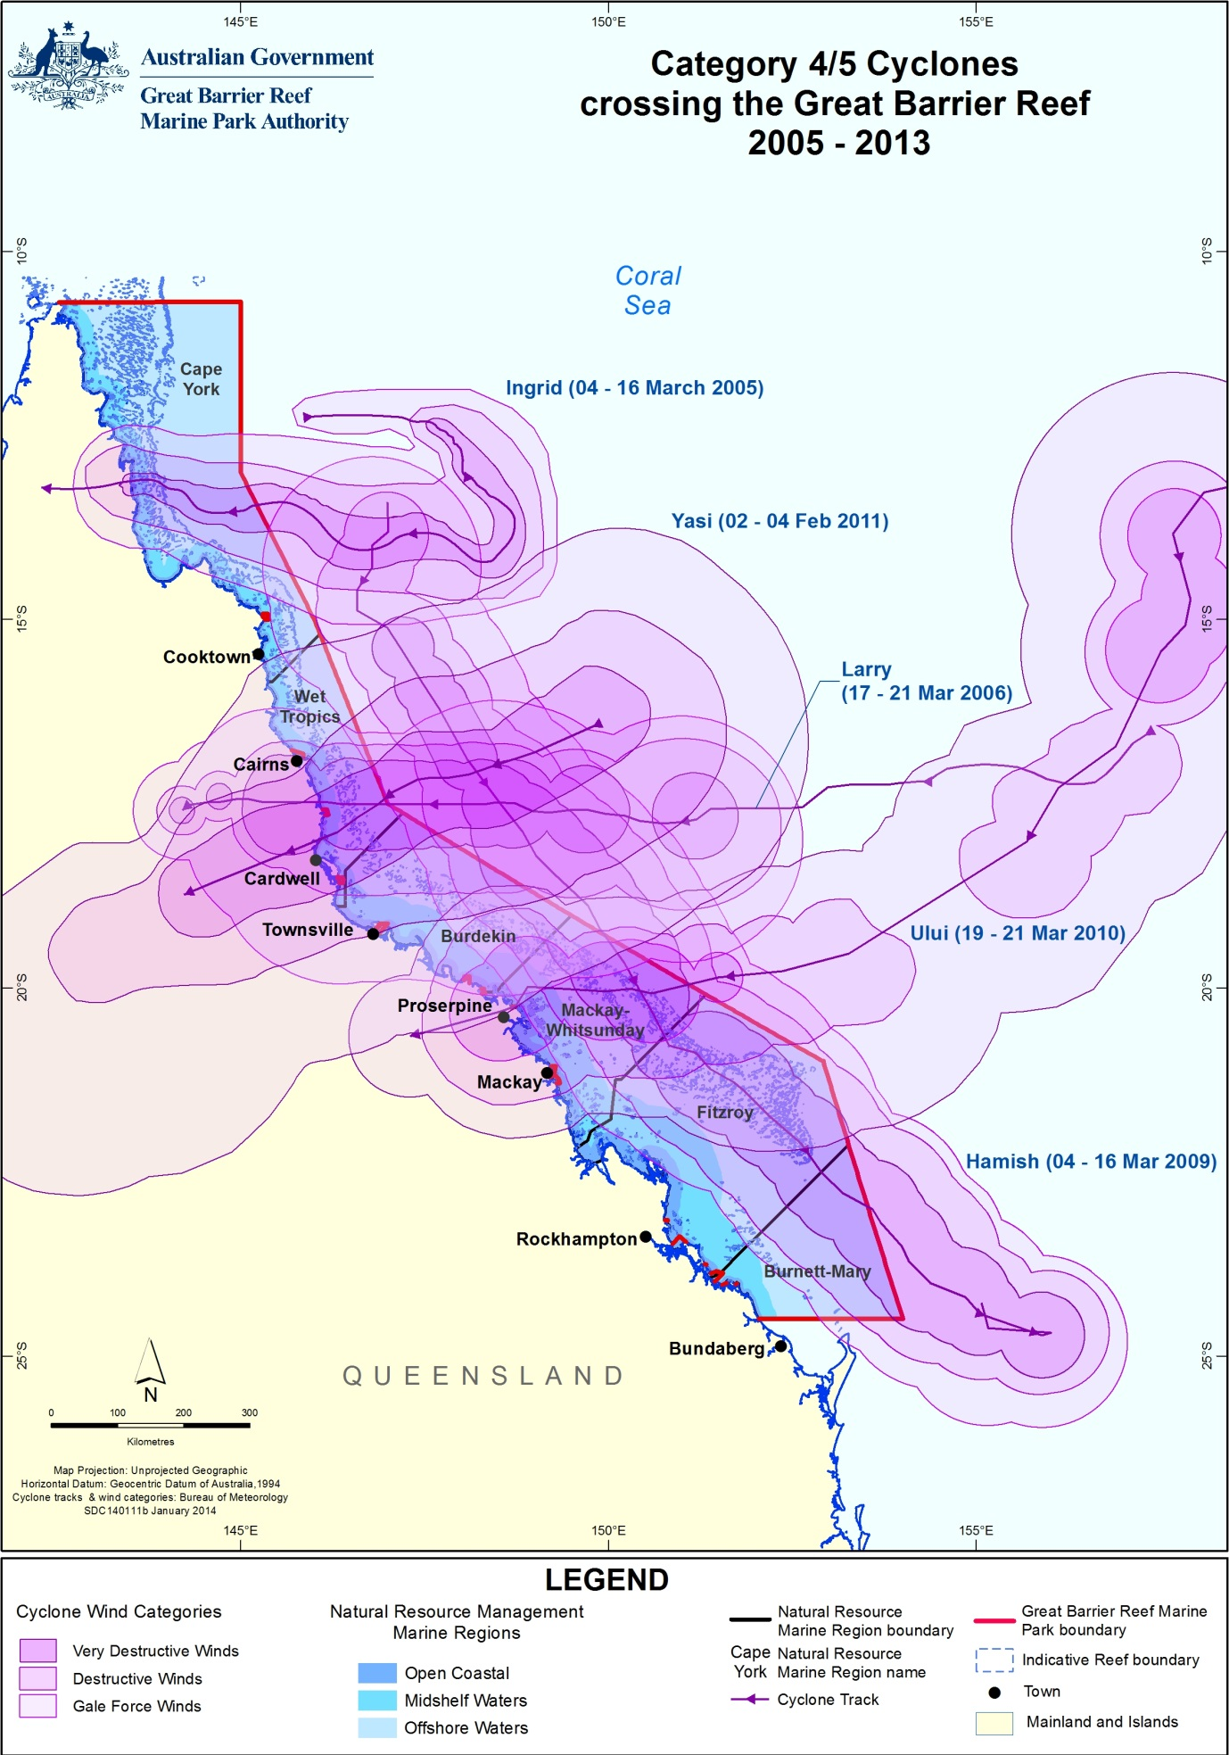
Figure 1: All Category 4/5 Cyclones that have affected the Great Barrier Reef from 2005 to 2013 with the zones of influence (wind categories) differentially shaded.

Crown-of-thorns starfish
Crown-of-thorns starfish have had a major impact on the Great Barrier Reef with a recent analysis of long-term monitoring data showing the starfish has been responsible for 42 per cent of coral cover loss since 1985.¹¹ Most outbreaks occur on mid-shelf reefs, beginning along the narrow northern shelf between Cairns and Lizard Island (the ‘initiation zone’) and then moving to southern reefs as larvae are transported by the East Australian Current. The Swains reefs in the Fitzroy region have had low-level chronic infestations throughout most of the past three decades, which is explained by the high density of coral and the regional oceanography (Figure 2).
An active outbreak of crown-of-thorns starfish occurs when densities are such that the starfish consume coral tissue faster than the corals can grow. This is generally considered to be densities greater than about 15 starfish per hectare when coral cover is moderate to high.²⁰ However, many of the inshore and mid-shelf reefs that were affected by multiple severe weather events in recent years have lower coral cover and therefore reduced capacity to cope with these levels of starfish.
Google Earth shows recent crown-of-thorns starfish densities http://e-atlas.org.au/content/large-scale-manta-tow-surveys-densities-crown-thorns-starfish-and-benthic-cover-aims-ltmp.
Figure 2: Crown-of-thorns starfish outbreaks since 1998-2013.
There are four documented outbreaks of crown-of-thorns starfish in the Great Barrier Reef since the 1960s, with the latest ongoing outbreak commencing in 2011-2012. In 2012-2013, crown-of-thorns starfish were observed in 37 per cent of surveys conducted through the Eye on the Reef monitoring network and recorded at outbreak densities on 30 per cent of reefs in the Australian Institute of Marine Science (AIMS) Long Term Monitoring Program. Densities in the ‘initiation zone’ were at the highest levels since 1986.²¹ The onset of the current outbreak is believed to be the result of poor water quality entering the Reef following the floods and severe weather events in 2009 to 2011.^{12,22}
The Australian Government is committed to protecting coral cover at high value tourism sites from crown-of-thorns starfish through a diver injection control program. The control program has been underway since 2012 and is a collaborative effort between government, tourist operators including the Association of Marine Park Tourism Operators, researchers and volunteers. Monitoring will ascertain whether coral cover and diversity can be maintained at these sites.

Elevated sea surface temperatures
Coral bleaching across the Great Barrier Reef in 2012-2013 was generally low to moderate, though a single instance of a high level of impact was observed in the Mackay Whitsunday region. Most of the bleached areas were in the Wet Tropics and the Mackay Whitsunday regions.¹⁰ Over the summer, the accumulated heat stress was between 20 and 40 degree heating days on average (Figure 3).
Coral bleaching commonly occurs when accumulated temperature stress, measured as degree heating days over the summer months, exceeds a threshold of about 60-100 degree heating days.²³ In the last 50 years, an increase in the long-term average temperature of Great Barrier Reef waters is narrowing the gap between a regular summer and a coral bleaching season. For example, the frequency of mass bleaching events has increased over the last two decades, corresponding to higher seawater temperatures.^{24,25} Major coral bleaching events caused by unusually warm water temperatures have been recorded in the Marine Park in 1998, 2002 and to a lesser extent in 2006, and have caused substantial loss of coral cover.¹¹ Prolonged exposure to elevated seawater temperatures may increase the susceptibility of corals to disease.²⁶
Degree heating days is a measure of only one potential stress. Coral bleaching may also occur in response to other stressors, such as exposure to low salinity flood waters and certain chemicals, and is probably often due to a combination of events.
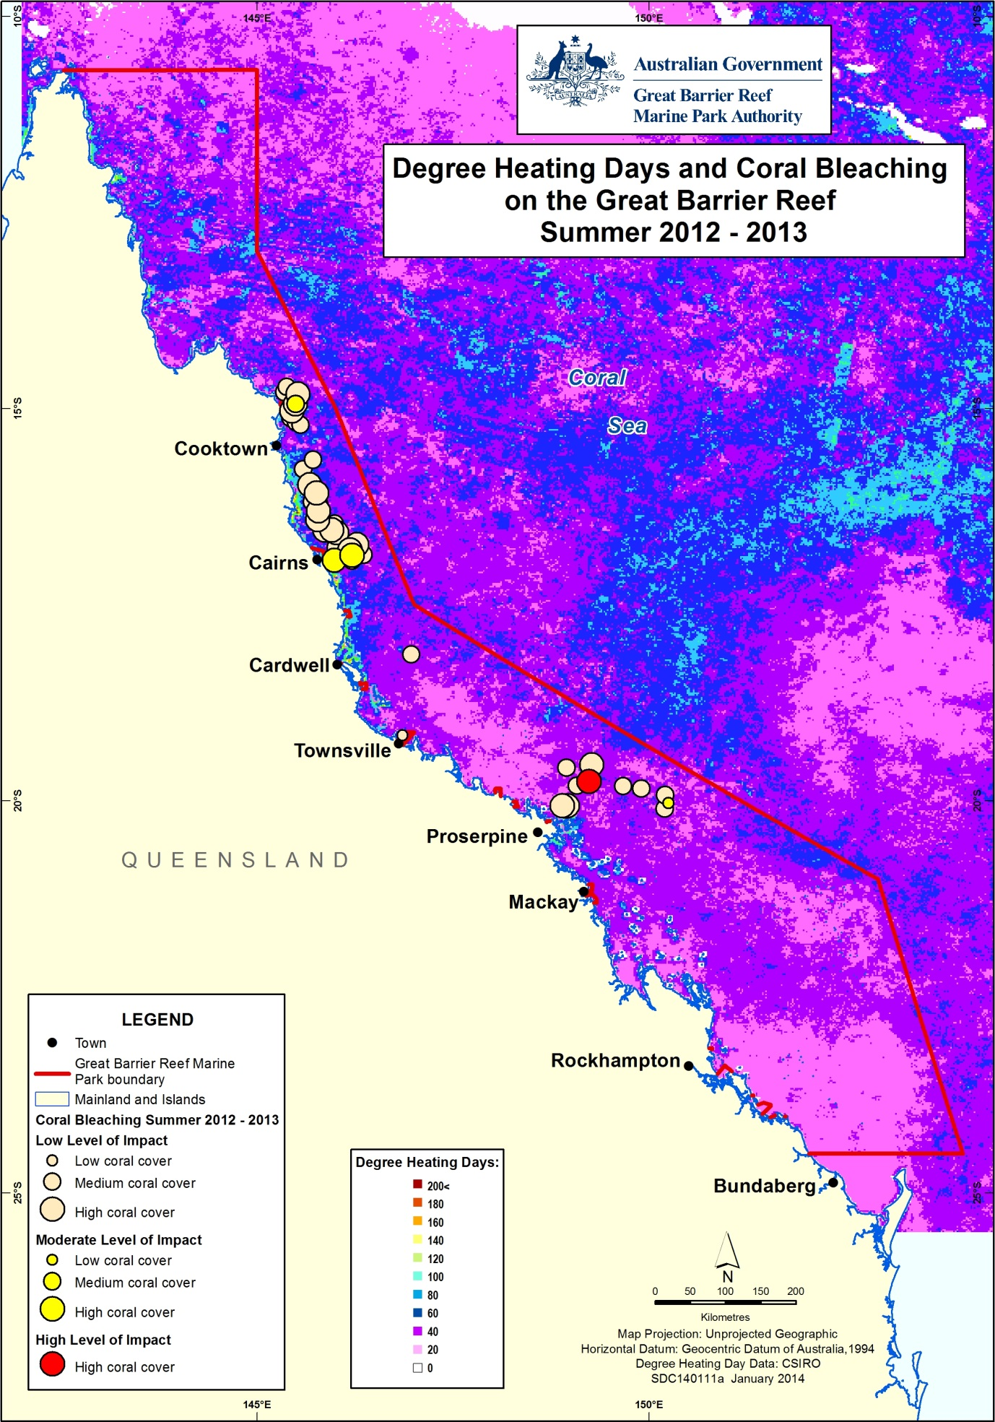
Figure 3: Water temperature as degree heating days and areas where coral bleaching occurred during 2012-2013.

Influence of climate change
The intensity of disturbances to the Great Barrier Reef is set to increase under future climate change scenarios.²⁷ The average annual seawater temperature on the Great Barrier Reef is likely to rise by one to three degrees Celsius by 2100.²⁸ It is also predicted that Reef waters will become more acidic, sea levels will continue to rise, patterns of ocean circulation will change and weather events will become more extreme.²⁸ The extent and persistence of damage to the Great Barrier Reef will largely depend on the rate and magnitude of change in the world’s climate and on the resilience of the Reef ecosystem.¹ This has important implications for the future management of the Great Barrier Reef and run-off entering the Great Barrier Reef lagoon. For example, modelling suggests that the upper thermal bleaching limit of corals is affected by exposure to dissolved inorganic nitrogen and that reducing the output of dissolved inorganic nitrogen may lower bleaching thresholds and enhance the resilience of inshore corals.²⁹
The future is not easily forecast, but there is strong evidence that halting and reversing the decline of water quality in the Great Barrier Reef lagoon will increase the natural resilience of reef ecosystems to these future challenges.

2. Methods

2.1 The Marine Monitoring Program
The Marine Monitoring Program (MMP) assesses water quality and the long-term health of key marine ecosystems (inshore coral reefs and seagrasses) in the inshore Great Barrier Reef lagoon. The four elements of the Program are outlined below.
More information about the MMP is available from the agency website (http://www.gbrmpa.gov.au/about-the-reef/how-the-reefs-managed/reef-rescue-marine-monitoring-program).

2.1.1 Inshore water quality
Monitoring includes the measurement of concentrations of nutrients (nitrogen and phosphorus), chlorophyll a, suspended solids (water turbidity) and pesticides. Techniques used to monitor water quality include satellite remote sensing, automated data loggers, and collection of water samples from research vessels for standard laboratory analysis. Passive samplers are used to measure the concentration of pesticides in the water column over time.^{30,31}

2.1.2 Flood plume dynamics
The majority of the annual pollutant load to the Great Barrier Reef is delivered by flood events in the wet season.³² Monitoring of water quality during flood events and the wet season includes measuring salinity, concentrations of nutrients, chlorophyll a, suspended solids (water turbidity) and pesticides. The movement of the flood plume across inshore waters of the Great Barrier Reef is assessed using images from aerial flyovers and remote sensing (Figure 4).
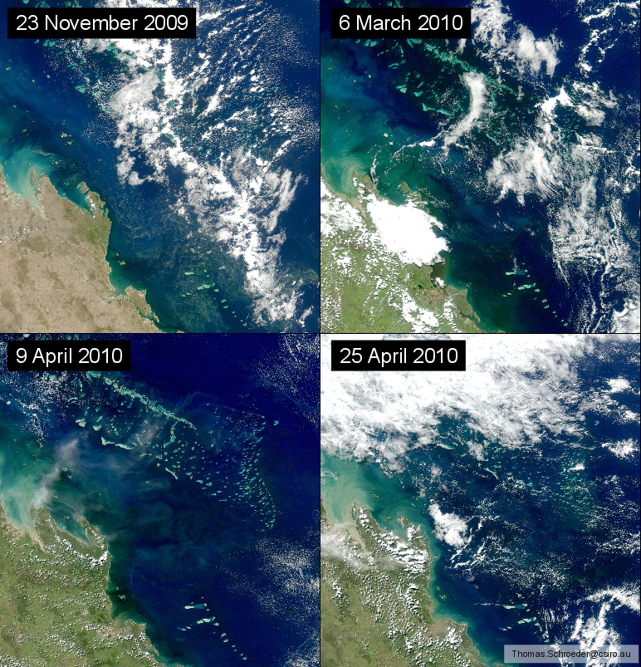
a
d
c
b
Figure 4: Satellite images (MODIS-Aqua) of the inshore Fitzroy region of the Great Barrier Reef during normal (low) flow conditions in November 2009 (a) and flood conditions in March and April (b, c, d).
The discharge from the Fitzroy River was more than four times the annual median flow and images b-d show large plumes of dissolved and suspended material in the coastal waters.

2.1.3 Seagrass status
Monitoring temporal and spatial variation in the status of intertidal seagrass meadows in relation to changes in local water quality is essential in evaluating long-term ecosystem health.
Monitoring includes an assessment of seagrass abundance and reproductive effort, which provides an indication of the health of seagrass meadows and their capacity to regenerate following disturbances. Tissue nutrient composition is assessed in the laboratory as an indicator of nutrient enrichment.
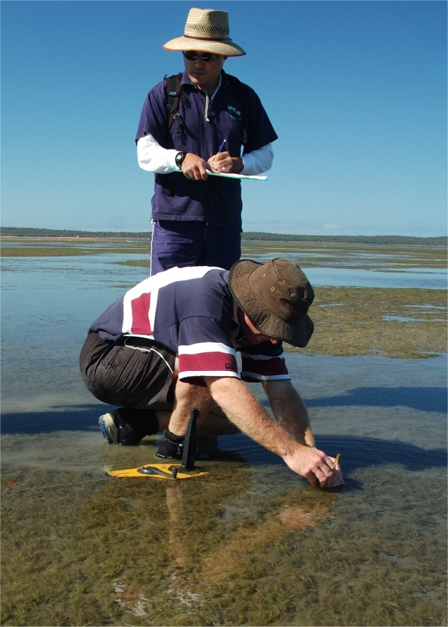
Figure 5: Seagrass monitoring on the Great Barrier Reef (Image: L. McKenzie, Queensland Government).

2.1.4 Coral reef status
Monitoring temporal and spatial variation in the status of inshore coral reef communities in relation to changes in local water quality is essential in evaluating long-term ecosystem health.
Monitoring covers a comprehensive set of community attributes including the assessment of hard and soft coral cover, number of hard coral juvenile colonies, macroalgae cover, and the rate of change in coral cover as an indication of recovery potential of the reef following a disturbance.³³ Comprehensive water quality measurements are also collected at many of the coral reef sites.
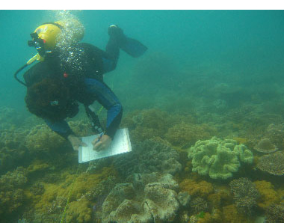
Figure 6: Coral reefs being monitored on the Great Barrier Reef. (Image: AIMS).
The marine environment in the inshore Cape York region is relatively pristine compared with other regions. However, the region is under increasing pressure from development and likely associated impacts on water quality in the region mean that Cape York is a high priority area for increasing monitoring efforts. No coral monitoring occurs in the inshore Cape York region under the MMP, though some sites are monitored in the southern section as part of the AIMS Long Term Monitoring Program.

2.2 Synthesis and integration of data and information
The Report Card provides assessment scores for inshore water quality and inshore seagrass and coral condition for the inshore Great Barrier Reef and regional scales. All scoring methods are currently under review and will be improved for the next report card.
A sub-set of indicators is used to assess and report on water quality, seagrass and coral condition. These indicators are scored on a five-point scale (very good, good, moderate, poor, very poor) and aggregated into a score that describes the overall status of the inshore Great Barrier Reef and each individual region.
An overview of the methods used to calculate the inshore Great Barrier Reef and regional scores is available from the MMP Quality Assurance and Quality Control Manual (http://elibrary.gbrmpa.gov.au/jspui/handle/11017/2797).

2.2.1 Inshore Great Barrier Reef and regional scores

Water quality
Near-surface concentrations of chlorophyll a and total suspended solids from remotely sensed images are used to assess and report on inshore water quality. Chlorophyll a is a measure of phytoplankton biomass that is related to the amount of available nutrients in the water column and therefore the productivity of the system. Total suspended solids are a measure of all other particulate matter in the water column. These two parameters are measured against their relevant Great Barrier Reef Marine Park Water Quality Guidelines³ (Water Quality Guidelines) trigger values as the proportion of the water body³ that exceeds the Guideline annual trigger value. The metric score is then calculated as 100 minus the relative area of the water body where the annual mean value exceeds the Water Quality Guidelines.³ It should be recognised that the accuracy of these estimates from satellites is limited in the inshore Cape York and Burnett Mary regions by the availability of on-ground data for validation. Consequently, these inshore regions were excluded from overall assessments of Great Barrier Reef water quality and reef condition.
In 2011-2012, major improvements in the remote sensing method mean that historical data is no longer directly comparable, so trends in water quality scores have been reprocessed using the new algorithm.

Seagrass
Abundance, reproductive effort and nutrient status are used to assess and report on inshore seagrass condition. Seagrass abundance includes assessment of percent cover determined in reference to the Seagrass Abundance Guidelines.³⁴ For example, if median abundance is at or above the 50th percentile, the condition is considered ‘good’. Reproductive effort is based on the average number of reproductive structures on an area basis and provides an indication of the capacity for recovery following disturbances. The nutrient status of seagrass is based on the ratio of carbon to nitrogen in leaf tissue and reflects the level of nutrients in the surrounding waters. The number of seagrass sites in Cape York does not adequately reflect the variability of seagrass habitats in the inshore region and were excluded from overall assessments of Great Barrier Reef seagrass and reef condition.

Corals
Coral cover, coral cover change, juvenile density and macroalgae cover are used to assess and report on inshore coral reef condition. Coral cover is a measure of the abundance of hard and soft corals, and indicates the capacity of coral to persist under the current environmental conditions and to recover from disturbances by estimating the availability of adult broodstock. Coral change is a measure of the change in hard coral cover from the preceding three years compared with modelled predictions and is an indicator of the balance between disturbance and recovery. A healthy and resilient coral reef is expected to show an increase in coral cover during periods free from disturbances. Coral change can only be reported from 2007-2008, because three years of data need to be available to run the model for comparisons. Juvenile density is a measure of the abundance of hard coral juveniles and is an indicator of the potential of the community to recover from disturbances or stress. Macroalgal cover is a measure of the abundance of large, fleshy algae. A low score for macroalgae (poor or very poor) means macroalgal cover is high, which is indicative of poor water quality. Conversely, a high score for macroalgae (good or very good) means cover is low. High macroalgae cover, once established, reduces the recovery of corals by denying them space and production of chemical deterrents.

2.2.2 Site-specific assessments
To complement the inshore Great Barrier Reef and regional water quality scores, the Report Card provides additional, site-specific information on water quality and detected pesticides.

Water quality
To complement the broad-scale assessment of water quality from remotely sensed images used in the report card, site-specific water quality data are also reported using an interim water quality index, based on the monitoring data and expert opinion.

The index aggregates scores for four indicators of water quality parameters (turbidity/water clarity, chlorophyll a, and concentrations of particulate nitrogen and phosphorus) relative to the Water Quality Guidelines³, using four-year running means to give an overall rating for each of the fixed sampling sites. Decision rules for the water quality index are outlined in more detail in Thompson et al. 2013³⁵ (http://www.gbrmpa.gov.au/resources-and-publications/publications/annual-reef-rescue-marine-monitoring-science-report).

Pesticides
Pesticides are monitored using two methods: grab samples of pesticides are collected in flood plumes during the wet season and passive samplers are used to provide an integrated assessment of pesticide concentrations over time in wet and dry seasons.^{30,31} The most frequently detected pesticides in inshore waters include those herbicides that inhibit the photosynthetic pathway (PS-II) of plants in an additive manner: diuron, atrazine, hexazinone, simazine and tebuthiuron.^{36,37,38,39,40} These PS-II herbicides may also have a negative impact on non-target organisms such as algae, corals and seagrass.^{41,42,43}
An index has been developed using PS-II herbicide equivalent concentrations to assess the potential combined toxicity of these pesticides relative to the Water Quality Guidelines.³ The PS-II herbicide equivalent concentration incorporates the relative potency and abundance of individual PS-II herbicides compared with a reference PS-II herbicide, diuron. For reporting purposes, the index has five categories: concentrations detected at the lowest Category 5 levels are not expected to have an impact on seagrass or coral, while the highest Category 1 levels correspond to the Guideline for diuron set for the protection of 99 per cent of species (Table 2) (http://www.gbrmpa.gov.au/about-the-reef/how-the-reefs-managed/water-quality-in-the-great-barrier-reef/water-quality-guidelines-for-the-great-barrier-reef).
Table 2: The five categories of the PS-II Herbicide Equivalent Index used in the regional section of the report.
Scientific studies have shown that concentrations of diuron Category 4 or above can negatively affect photosynthesis in non-target organisms such as microalgae, corals and seagrass
Category | Concentration (ng.L⁻¹) | Description
5 | PS-II-HEq ≤ 10 | No published scientific papers that demonstrate any effects on plants or animals based on toxicity or a reduction in photosynthesis. The upper limit of this category is also the detection limit for pesticide concentrations determined in field collected water samples
4 | PS-II-HEq > 10  ≤ 50 | Published scientific observations of reduced photosynthesis for two diatoms.
3 | PS-II-HEq > 50  < 250 | Published scientific observations of reduced photosynthesis for two seagrass species and three diatoms.
2 | PS-II-HEq ≥ 250  ≤ 900 | Published scientific observations of reduced photosynthesis for three coral species.
1 | PS-II-HEq > 900 | Published scientific papers that demonstrate effects on the growth and death of aquatic plants and animals exposed to the pesticide. This concentration represents a level at which 99 per cent of tropical marine plants and animals are protected, using diuron as the reference chemical.
For categories 2 – 4:
- The published scientific papers indicate that this reduction in photosynthesis is reversible when the organism is no longer exposed to the pesticide
- Detecting a pesticide at these concentrations does not necessarily mean that there will be an ecological effect on the plants and animals present
- These categories have been included as they indicate an additional level of stress that plants and animals may be exposed to in the Marine Park. In combination with a range of other stressors (for example sediment, temperature, salinity, pH, storm damage, and elevated nutrient concentrations) the ability of these plant and animal species to recover from impacts may be reduced.
Classifying the data into Index categories provides an indication of the extent and frequency of exposure to PS-II herbicides at a given site (and the potential consequences for marine organisms). The PS-II herbicide equivalent concentrations are calculated from diuron, hexazinone, atrazine and its breakdown products, tebuthiuron, ametryn, prometryn, simazine, metolachlor, terbutryn, flumeturon and imidacloprid, all of which are used to control weeds and other plant species in the Great Barrier Reef catchment and are regularly found in the Marine Park. Note that reference to pesticides in the report includes herbicides, insecticides and other chemicals used to treat pest or weed species.

3. Results

3.1 The Great Barrier Reef Region
Figure 7: The overall condition of the inshore Great Barrier Reef in 2012-2013 including water quality, seagrass and coral reefs.

3.1.1 Summary results
- The condition of the inshore Great Barrier Reef (similar to other reefs world-wide) has declined significantly over the last 150 years.
- The overall condition of the Great Barrier Reef in 2012-2013 remained poor (Figure 7). The individual water quality, seagrass and coral indicators that comprise the overall condition assessment for the Great Barrier Reef were spatially and temporally variable and is important to refer to the regional sections for detailed information.
- Inshore water quality was poor overall in 2012-2013 and varied from poor to moderate depending regionally differences in land use activities. The overall concentrations of chlorophyll a and total suspended solids were rated poor and moderate, respectively (Figure 7). There was a slight improvement in water quality since the record flood events in 2010-2011.
- Pesticides were detected at all sites in 2012-2013 with high variability in the profiles and concentrations between regions and seasons. The most frequently detected herbicides in inshore waters were those that combine to inhibit PS-II in plants (such as, diuron (heavily used in the sugarcane industry), atrazine, hexazinone, simazine and tebuthiuron. Biologically relevant concentrations of herbicides (Category 4 and above) were present in eight of the 12 routinely monitored sites in the inshore Wet Tropics, Burdekin and Mackay Whitsundays regions. Tebuthiuron (used in the grazing industry) was the only pesticide that exceeded the Water Quality Guidelines³, at a monitoring site on North Keppel Island in the Fitzroy region.
- Inshore seagrass meadows improved from very poor to poor condition overall in 2012-2013. Seagrass abundance and reproductive effort improved to poor in 2012-2013, while nutrient status remained consistently poor. However, there are differences between inshore habitats and regions over time.
- Inshore coral reefs remained in a poor condition overall in 2012-2013. Coral cover, the density of hard coral juveniles and the rate of change in coral cover were poor in 2012-2013 overall, and the level of cover from competing macroalgae was moderate.

3.1.3 Water quality condition and trend
Inshore water quality (assessed by remote sensing of chlorophyll a and suspended solids) remained poor in 2012-2013 (Figure 8), which reflected freshwater discharge that was more than five times the annual median flow for the inshore Great Barrier Reef Region. Concentrations of chlorophyll a and total suspended solids were rated poor and moderate, respectively, however, there were differences between regions over time (refer to regional sections).
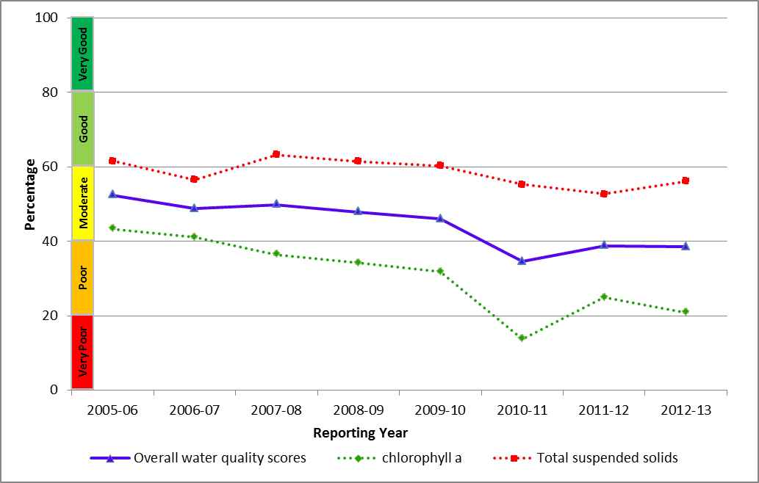
Figure 8: Trend in the water quality index from 2005-2006 to 2012-2013 for the Great Barrier Reef.
In 2012-2013, remote sensing of water quality showed a clear gradient of declining water quality from offshore areas more distant from terrestrial inputs, to inshore areas more frequently exposed to flood waters. The inshore area of all regions had annual mean chlorophyll a concentrations that exceeded the Water Quality Guidelines³, with some areas approaching close to 100 per cent exceedance (shaded areas; Table 3).⁹ While some exceedance of the Water Quality Guidelines³ is expected during the wet season, these high concentrations are indicative of high nutrient loading from the catchments.
Concentrations of suspended sediments also exceeded the Water Quality Guidelines³ during the year for both years, particularly in the inshore Fitzroy region, which reflects continual input from repeated flooding in recent years and re-suspension of finer sediment particles by wind and wave action.
It should be noted that the remote sensing data in the following sections for Cape York and the Burnett Mary regions is not validated with field data as is the case in the other regions. However, site specific assessment and water quality are conducted in the other four regions at 20 fixed referential sites (see methods section for more detail). This data provides for a richer description of water quality in the regional summaries.
Table 3: Relative area (per cent) of the inshore, mid-shelf and offshore waterbodies of each region where the annual mean value for chlorophyll a and total suspended solids from remote sensing data exceeded the Water Quality Guidelines from 1 May 2012 to 30 April 2013.
The confidence in water quality assessments is indicated by the relative number of valid observations used to calculate the values, where a higher number provides greater confidence in the results. Cells are shaded in grey where values exceeded the Water Quality Guidelines by more than 50%. Caution must be applied in interpreting the results for the inshore Cape York and Burnett Mary Regions, as well as the offshore water body, because there has been limited field validation for these regions.
Region | Number of valid observations |  |  | Chlorophyll  exceedance  (per cent) |  |  | Total suspended solids exceedance  (per cent)
Region | Inshore | Mid-shelf | Offshore | Inshore | Mid-shelf | Offshore | Inshore | Mid-shelf | Offshore
Cape York | <500,000 | 500,000-1,000,000 | >2,000,000 | 75 | 17 | 1 | 34 | 3 | 6
Wet Tropics | <500,000 | <500,000 | 500,000-1,000,000 | 86 | 24 | 1 | 37 | 4 | 1
Burdekin | <500,000 | 500,000-1,000,000 | 1,000,000-2,000,000 | 71 | 8 | 0 | 41 | 0 | 0
Mackay Whitsunday | <500,000 | 500,000-1,000,000 | 1,000,000-2,000,000 | 64 | 10 | 2 | 39 | 10 | 8
Fitzroy | <500,000 | 1,000,000-2,000,000 | >2,000,000 | 92 | 20 | 1 | 51 | 4 | 2
Burnett Mary | <500,000 | <500,000 | 1,000,000-2,000,000 | 98 | 46 | 2 | 28 | 1 | 0

3.1.4 Pesticides
Herbicides were detected at all sites in 2012-2013 with high variability in the profiles and concentrations between inshore regions and seasons. Elevated PS-II herbicide equivalent concentrations generally coincided with periods of high flow from the major rivers during the wet season and there was a positive relationship between increasing discharge and risk of exposure. Biological relevant concentrations of PS-II herbicides (Category 4 to 3) were present in eight of the 12 routine monitoring sites in the inshore Wet Tropics, Burdekin and Mackay Whitsundays regions. However, the highest PS-II herbicide equivalent concentrations (Category 3) detected in 2012-2013 in the inshore Mackay Whitsundays region at sites with seagrass meadows and inshore coral reefs nearby.
The most prevalent pesticide detected across the Great Barrier Reef in 2012-2013 was diuron (heavily used in the sugarcane industry), which was the main contributor to the PS-II herbicide equivalent index (Figure 9). Diuron was detected at the majority of sites in the inshore Wet Tropics, Burdekin and Mackay Whitsunday regions and in greater abundance than in 2011-2012, with average increases of 2.2, 3.7 and 12 times, respectively. Atrazine, tebuthiuron and hexazinone were also frequently detected. Tebuthiuron was the only PS-II herbicide that exceeded the Water Quality Guidelines³, at a routine monitoring site at North Keppel Island in the Fitzroy region. Tebuthiuron is used in the grazing industry, and is typically found at elevated concentrations in this region due to the high proportion of land used for grazing activities. A range of other pesticides were detected, including terbutryn, galaxolie and the insecticide imidacloprid.
Figure 9: Maximum PS-II herbicide equivalent concentrations at all sites monitored in the Great Barrier Reef from 2008-2009 to 2012-2013.
None of the grab samples collected in flood plumes during the wet season contained levels of individual pesticides that met or exceeded the Water Quality Guidelines (Figure 10).³ However, flood waters from the Tully, Herbert, Burdekin and Mary rivers had concentrations of PS-II herbicides (Category 3 and 4) that suppress photosynthesis in marine species, mostly attributed to the presence of diuron.
Herbicide equivalent concentrations provide a single reporting parameter for PS-II herbicides with a similar mode of action; however, they may obscure differences in the abundance of individual herbicides detected in different regions because they also consider the potency of each herbicide relative to a reference herbicide, diuron. For example, a herbicide detected at a high concentration may have a low potency (with respect to the reference diuron) and thus the contribution to the overall PS-II inhibition is very small. The types of pesticides detected in each region are often related to the land management activities in adjacent catchments.
Figure 10: Maximum concentrations of each individual herbicide at routine monitoring sites from the commencement of sampling to 2012-2013.

3.1.5 Seagrass condition and trend
The overall condition of Great Barrier Reef inshore seagrass meadows in 2012-2013 increased from very poor to poor (Figure 11). Seagrass abundance and reproductive effort were poor in 2012-2013, while nutrient status remained poor. However, there are differences between inshore habitats and regions over time (refer to regional sections).
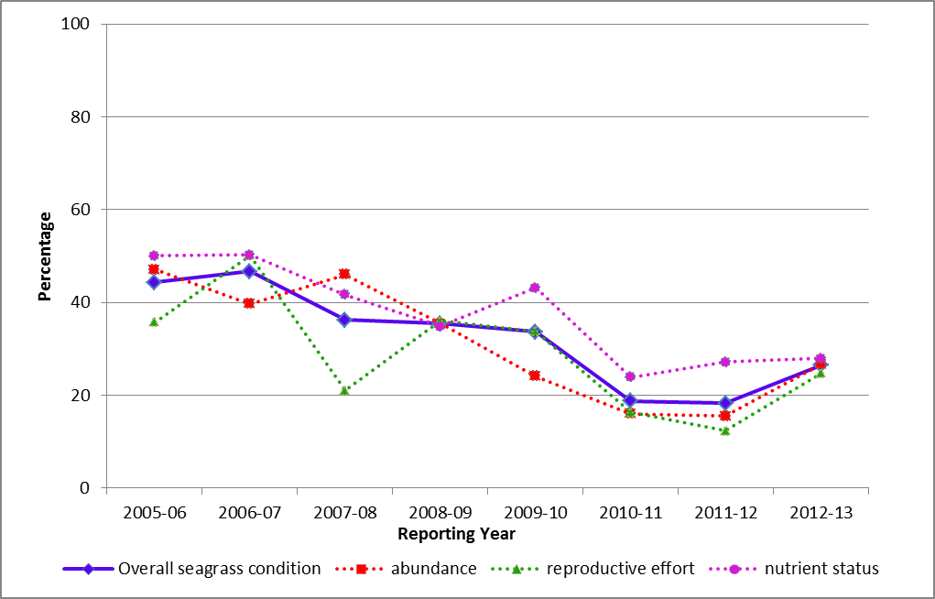
Figure 11: Trend in seagrass condition from 2005-2006 to 2012-2013.

In the inshore Wet Tropics, Mackay Whitsundays and Burnett Mary regions abundance remained very poor due to the continuation of a number of stressors such as above median discharges from adjacent river systems. Seagrass in these inshore regions also had very poor reproductive effort, which may affect the capacity of local meadows to recover from previous environmental disturbances. Consistently poor nutrient content of seagrass tissue above biological thresholds (Figure 13) across all habitats reflects the cumulative impact of poor water quality. At sites in the inshore Burdekin and Mackay Whitsunday regions, interactions between low light and elevated nutrients had a negative impact on the survival of seagrass meadows. Overall, the resilience of seagrass meadows in the Great Barrier Reef is variable due to spatial and temporal variation in abundance, nutrient loads and production of reproductive structures.
Seagrass abundance differed according to habitat type (Figure 12). The greatest fluctuations occurred in estuarine habitats, most often in response to prevailing climatic conditions but also with localised weather events such as pulses of nutrient-rich, sediment-laden flood waters and cyclonic activity. Seagrass abundance in coastal habitats has been relatively stable over the past decade; however, there are signs of a continual decline since 2009. Abundance at inshore reef and subtidal habitats has been in a constant state of decline since monitoring began in 2005-2006. However, there appears to be some localised signs of recovery in 2012-2013. Recovery was mainly of fast-growing pioneer species and it may take many years for meadows to fully recover their more complex foundational community structure. The impact of the slow recovery of seagrass communities on populations of the iconic dugong and turtle remain variable. The significantly increased rate of strandings of dugongs and turtles, seen immediately after the 2011 floods, has now returned to ‘normal’ for dugongs (though from a much lower population base). However, the rate of loss in turtles (more sedentary in their behaviour) remained higher than the historical stranding rates prior to 2011 (http://www.gbrmpa.gov.au/managing-the-reef/extreme-weather/dugong-and-turtle-strandings). Further information on seagrass abundance is presented in the regional sections.
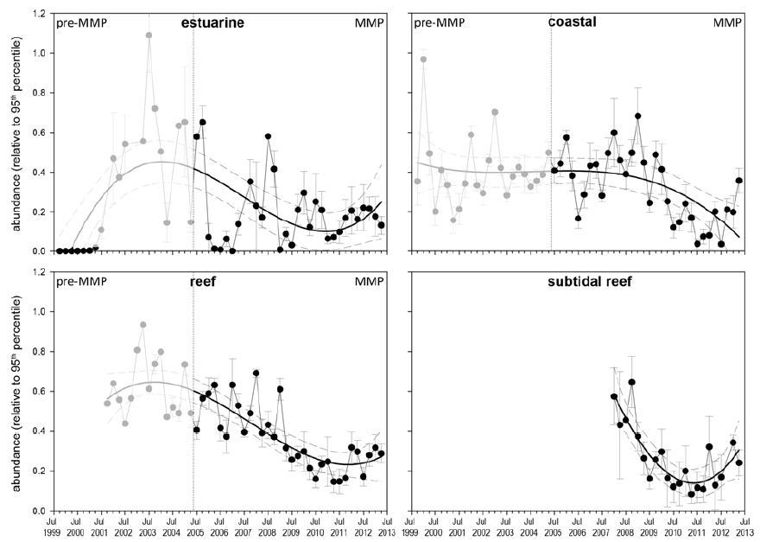
Figure 12: Trends in the abundance (% cover ± Standard Error) of inshore seagrass meadows at reef, coastal and estuarine sites since 1999.
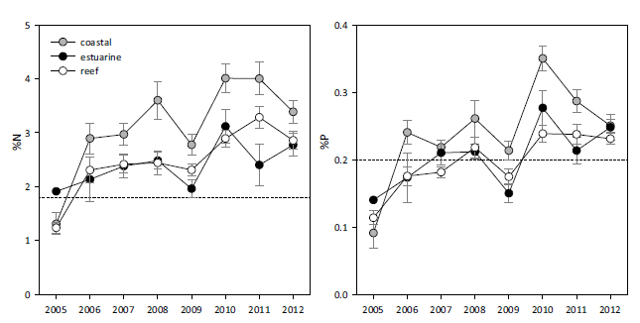
Figure 13: Median tissue nutrient concentrations (±Standard Error) in seagrass leaves for each habitat type (species pooled) over the entire monitoring program.
Dashed lines indicate global median values of 1.8% and 0.2% for tissue nitrogen and phosphorus, respectively⁴⁴ Long-term increases in the nutrient content of seagrass tissue above biological thresholds reflect local declines in water quality in some inshore regions.

3.1.6 Coral condition and trend
Inshore coral reefs remained in poor condition overall in 2012-2013, and the level of cover from competing macroalgae was moderate (Figure 14). The density of hard coral juveniles and the rate of change in coral cover were poor in 2012-2013. However, there are differences between inshore regions over time (refer to regional sections).

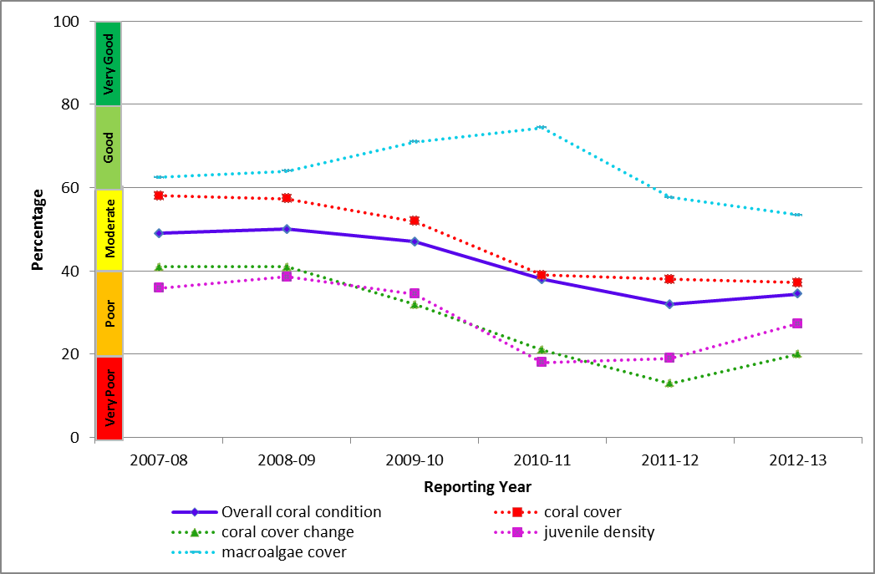
Figure 14: Trend in coral condition from 2007-2008 to 2012-2013.
In 2012-2013, Great Barrier Reef coral cover declined to the lowest point since surveys began in 2005, due to a combination of impacts associated with tropical cyclones, outbreaks of crown-of-thorns starfish, broad-scale flooding and coral disease. In several inshore regions, the incidence of coral disease was related to the discharge from local rivers. The associated increase in turbidity and the proportion of fine-grained sediments is likely to have had a negative impact on coral recruitment and growth by smothering and limiting the amount of available light (Figure 15). Macroalgae, which competes with the coral for space and can supress recovery, was at its worst level overall in 2012-2013, reflecting localised poor water quality (Figure 15). The density of juveniles and the rate of change in coral cover increased marginally in 2012-2013 and were rated as poor overall, up from very poor in 2011-2012 (Figure 15). However, in general, the low levels of coral cover coupled with low densities of juveniles may indicate a lack of resilience of coral communities at many inshore reefs. The combination of acute disturbances and elevated stress from poor water quality are driving changes in the composition and condition of inshore reefs.
While coral data collection began in 2005, the coral trend is calculated as the average rate of increase in coral cover over the preceding three years, so graphing the trend began in 2007/08. Further information on the cover of hard corals, macroalgae and density of hard coral juveniles is shown in the relevant regional sections.
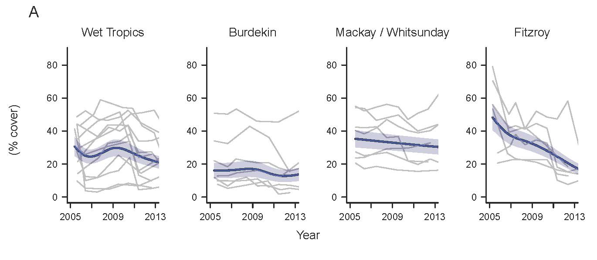
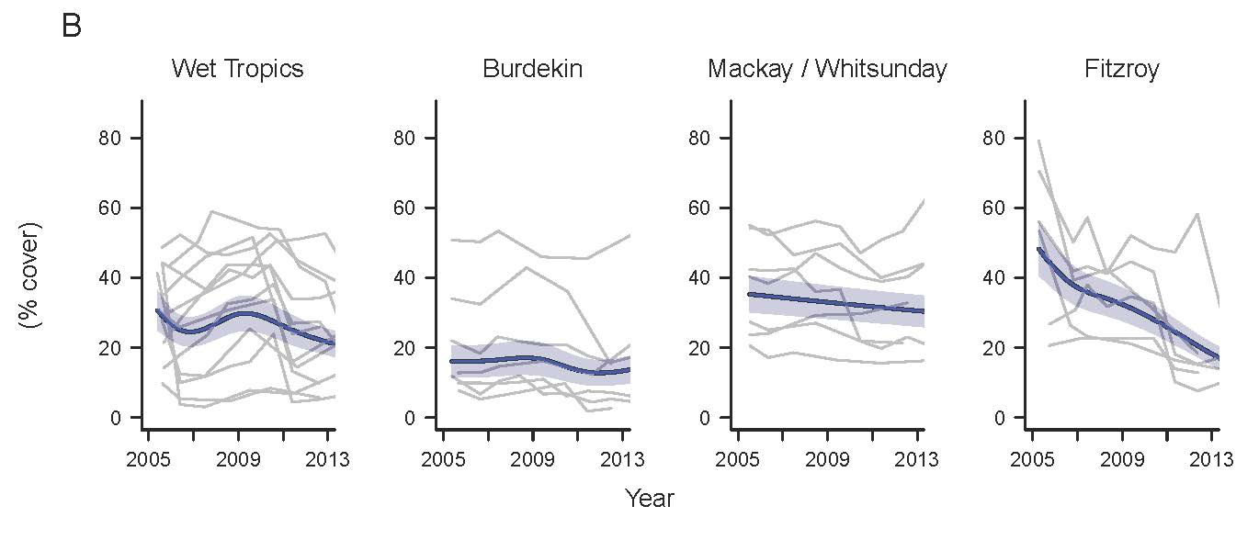
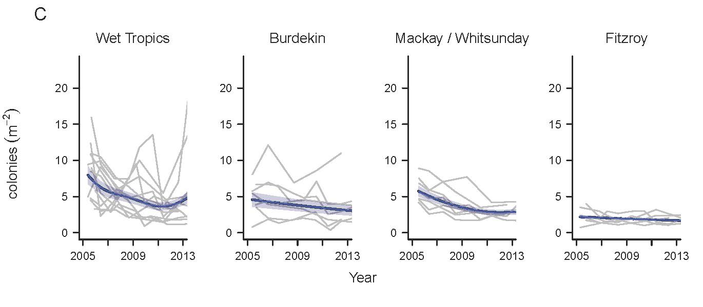
Figure 15: A) variation in the cover of hard corals, B) cover of macroalgae, C) and density of hard coral juveniles in the inshore Wet Tropics, Burdekin, Mackay Whitsunday and Fitzroy regions from 2005 to 2013.
Bold blue curve represents predicted regional trend and blue shaded areas are the 95% confidence intervals. Grey lines show observed trends for each reef. Data are averages from core reefs at 2 m and 5 m depths +/- standard error. Only reefs sampled in all years were included to ensure consistency between annual averages.

3.2 Cape York
Figure 16: The condition of water quality and ecosystem health (seagrass and corals) in 2012-2013 across the inshore Cape York region.

3.2.1 Summary results
- Cape York’s marine condition was moderate in 2012-2013. Inshore water quality was moderate, and the one southern seagrass bed monitored was in poor condition in 2012-2013 (Figure 16). No coral monitoring occurs in the inshore waters of Cape York region under the MMP; however some sites monitored in the southern section by AIMS indicated that coral communities in Cape York were in relatively good condition
- Inshore water quality for the region has varied from moderate to poor since 2005-2006. Chlorophyll a and total suspended solids were poor and good, respectively, in 2012-2013.
- No routine monitoring of pesticides occurred in 2012-2013.
- Seagrass abundance was poor, however, reproductive effort was moderate, which indicates communities may have a relatively high potential for recovery from environmental disturbances compared to seagrass in other inshore regions. Nutrient ratios of seagrass tissue were poor, reflecting local water quality conditions.
- The marine environment in the inshore Cape York region is relatively pristine compared with other regions. However, increasing pressure from development and the associated impacts on water quality in the region mean that Cape York is a high priority for intensifying monitoring efforts.
- There is no comprehensive, ongoing in situ water quality monitoring in the inshore Cape York region. Estimates of chlorophyll a and total suspended solids are derived from remote sensing only, which requires further field validation and hence estimates have relatively low reliability compared with those for other regions. As such, Cape York water quality data was not used in overall assessments of Great Barrier Reef water quality and Great Barrier Reef health. In 2012-2013, researchers completed an intensive field campaign in Princess Charlotte Bay to address this issue.

3.2.2 Water quality condition and trend
Inshore water quality in Cape York region, as determined by remote sensing, water quality is rated as moderate overall in 2012-2013 and has oscillated between good and moderate ratings since 2005-2006 (Figure 17). The two water quality indicators used to determine this overall rating, chlorophyll a and total suspended solids, have also varied similarly over time and were poor and good, respectively, in 2012-2013.
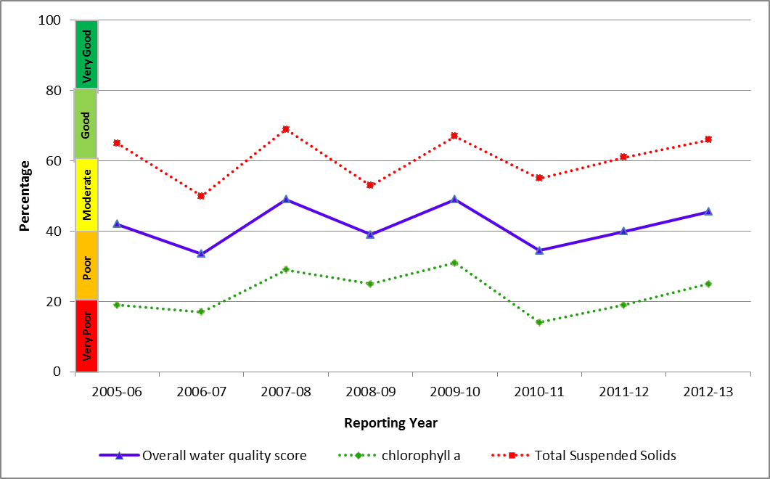
Figure 17: Trend in the water quality index from 2005-2006 to 2012-2013 for the inshore Cape York region.
In 2010-2011, the differences between scores increased and chlorophyll a scored consistently lower than suspended solids. Chlorophyll a was rated as poor in 2012-2013. Concentrations of chlorophyll a exceeded Water Quality Guidelines³ for 93 per cent of the inshore area in the dry season in 2012-2013. However, in the wet season, the Water Quality Guidelines³ were exceeded for 46 per cent of the inshore area, mainly around river mouths and bays. Total suspended solids were rated as good in 2012-2013. Concentrations exceeded the Water Quality Guidelines³ for 50 and 17 per cent of the inshore area in the dry and wet seasons, respectively.
No routine monitoring of pesticides occurred in 2012-2013.

3.2.3 Seagrass condition and trend
Overall seagrass condition in the inshore Cape York region improved from very poor in 2011-2012 to poor in 2012-2013 and has been highly variable since 2005/2006 (Figure 18). This is due to the assessment being based on only one sampling site, a complex and highly variable environment, and the effect of significant rain events and cyclones on seagrass abundance and reproductive effort. Although additional monitoring sites were established across the inshore Cape York region in 2012-2013, for the purpose of consistency and interpretation of long-term trends the new sites have been excluded from the Report Card. As the pre-existing long-term monitoring sites do not adequately capture the spatial variability of the region, Cape York seagrass data was not used in the inshore Great Barrier Reef assessment of seagrass condition.
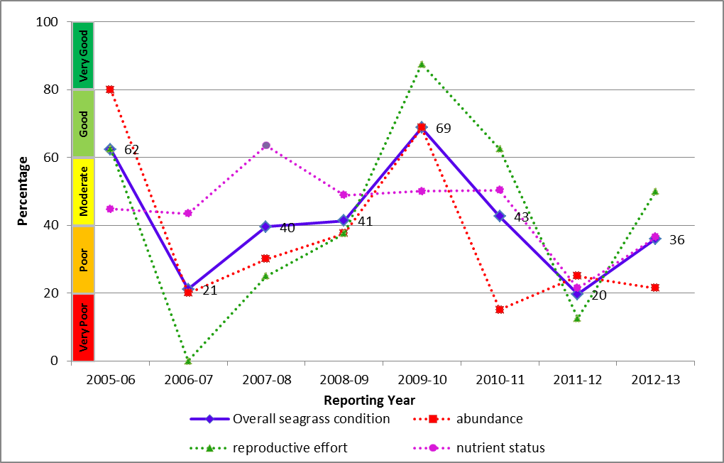
Figure 18: Trend in seagrass condition from 2005-2006 to 2012-2013.
Seagrass was monitored at one fringing reef location in the southern part of the Cape York region (Archer Point) which supports a diverse range of species. The environment is characterised by fluctuating temperature and salinity, and the growth of seagrass is primarily influenced by physical disturbance from waves and swell and associated sediment movement. Seagrass abundance was poor in 2012-2013 (Figure 19). Reproductive effort improved substantially from very poor in 2011-2012 to moderate in 2012-2013, indicating communities may have a relatively high potential for recovery from environmental disturbances compared with seagrass in other inshore regions. Nutrient ratios of seagrass tissue were again rated as poor in 2012-2013, reflecting local water quality conditions.
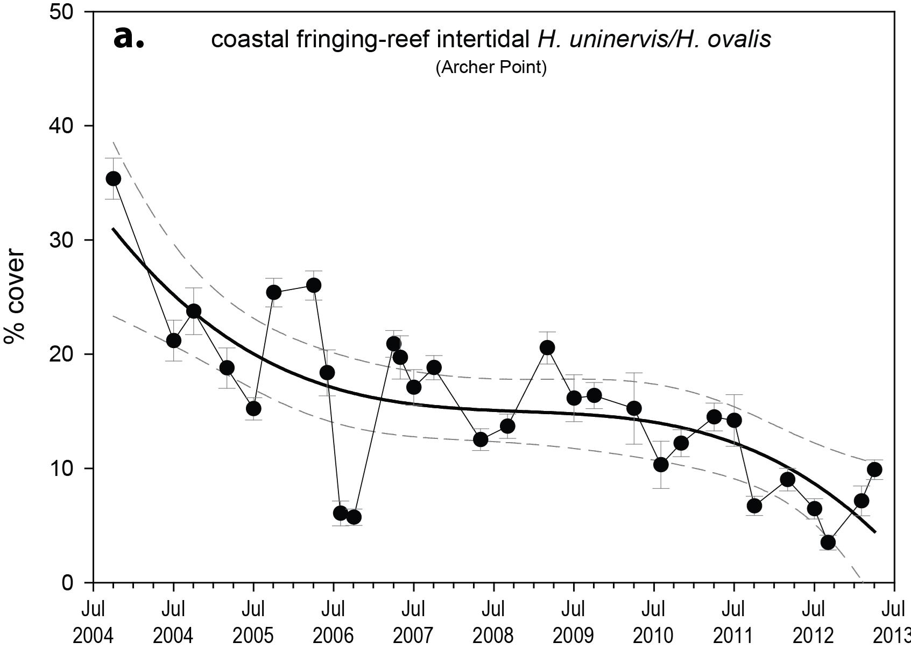
Figure 19: Trend in seagrass abundance (% cover ± Standard Error) at the inshore intertidal fringing reef habitat at Archer Point.

3.3 Wet Tropics
Figure 20: The condition of water quality and ecosystem health (seagrass and corals) in 2012-2013 across the inshore Wet Tropics region.

3.3.1 Summary results
- Overall marine health in the Wet Tropics was poor in 2012-2013. Inshore water quality and coral reefs remained in poor condition, and seagrass meadows were in very poor condition in 2012-2013 (Figure 20).
- Inshore water quality in the region, as determined by remote sensing, was poor overall in 2012-2013, and has been rated at this level since 2008-2009. The poor score for water quality is composed of very different ratings for chlorophyll a and total suspended solids, which were very poor and good, respectively. Site-specific assessments of water quality showed a gradient of increasing water quality from the inshore to the mid-shelf area, with eight out of 11 sites in good or very good condition.
- A range of herbicides was detected including diuron, atrazine (and its breakdwo nproducts), hexazinone, simazine and tebuthiuron. The PS-II herbicide equivalent index, which considers the relative potency and abundance of each PS-II herbicide, showed that herbicides were present at biologically relevant concentrations at Green, Fitzroy and Normanby Islands (Category 4). The highest concentrations of herbicides were detected in flood waters near the mouth of the Tully and Herbert River (Category 3).
- Inshore seagrass meadows remained in a very poor overall condition, and have generally been rated poor since 2005-2006. Seagrass abundance and reproductive effort remained very poor in both coastal and reef habitats. Leaf tissue nutrient ratios were poor overall. High nutrient levels are most likely a reflection of local water quality.
- The overall condition of inshore coral reefs in the region was poor in 2012-2013. Inshore reefs in the area declined to poor in Barron Daintree, remained in moderate condition in the Johnstone Russell-Mulgrave, and remained in poor condition in the Herbert Tully. The ongoing legacy impacts on coral cover from Cyclone Yasi in 2011, such as an increase in macroalgae cover in southern sites and the continuation of region-wide declines in the density of juvenile corals, suggest that rapid recovery of coral reefs in this region is unlikely.

3.3.2 Water quality condition and trend
Inshore water quality (assessed by remote sensing of chlorophyll a and suspended solids) in the inshore Wet Tropics region remained poor in 2012-2013. Scores for chlorophyll a were consistently worse than those for suspended sediment in all monitoring years (Figure 21).
Chlorophyll a was rated as very poor in 2012-2013, with concentrations exceeding the Water Quality Guidelines³ for 95 and 53 per cent of the inshore area, in the dry and wet season, respectively. Total suspended solids were rated as good in 2012-2013; however, concentrations exceeded the Water Quality Guidelines³ for 54 and 20 per cent of the inshore area in the dry and wet seasons, respectively.
Water quality across the region showed a clear gradient of declining water quality from offshore areas to inshore areas more frequently exposed to flood waters.
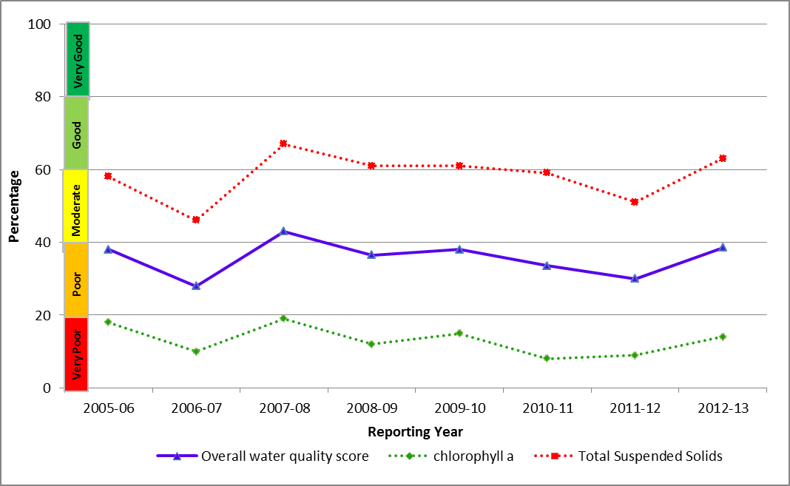
Figure 21: Trend in the water quality index from 2005-2006 to 2012-2013 in the inshore Wet Tropics region.
The onshore-offshore gradient was supported by long-term assessments of specific sites, with variability between sites reflecting local hydrodynamic conditions and biophysical processes. Site-specific water quality was rated as either good or very good at eight out of 11 sites in the region, three of which are located in the mid-shelf water body (Figure 22). However, water quality at the three sites close to river mouths draining from highly developed catchments was rated as moderate or poor due to high concentrations of particulate phosphorus, chlorophyll a and turbidity/water clarity that exceeded the Water Quality Guidelines³ in 2012-2013. These water quality scores are a long-term integrative assessment based on four indicators of water quality relative to the Water Quality Guidelines.³
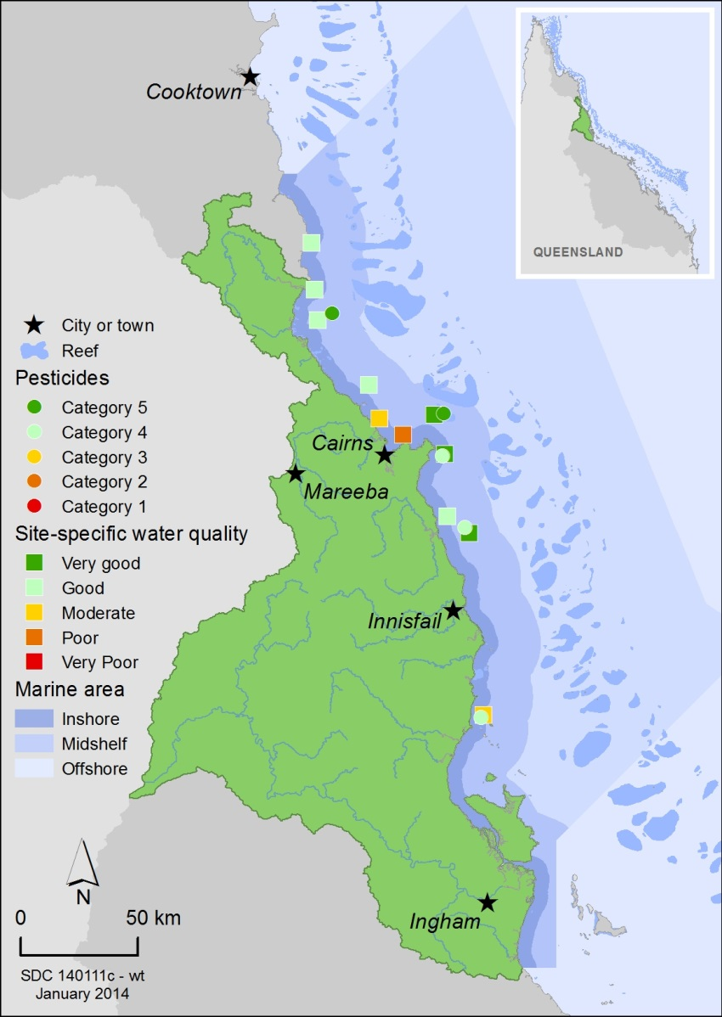
Figure 22: Water quality and pesticide scores for PS-II herbicides at fixed monitoring sites in the Wet Tropics.
The water quality scores are a long-term integrative assessment based on four indicators of water quality relative to the Water Quality Guidelines.³ The pesticide scores reflect the PS-II Herbicide Equivalent Index categories for maximum equivalent concentrations at each site. These concentrations integrate the relative potency and abundance of each PS-II herbicide to give the PS-II Herbicide Equivalent Index.
Concentrations of PS-II herbicides were above those known to affect photosynthesis in diatoms (Category 4) at Fitzroy, Normanby and Dunk Islands (Figure 23). The highest PS-II herbicide equivalent concentration in flood waters (Category 3) was detected in grab samples collected near the Tully River mouth following a flow event, and lower concentrations (Category 4) were detected in flood waters from the Herbert River. The range of pesticides detected in the inshore Wet Tropics region in 2012-2013 included diuron, atrazine (and its breakdown products), hexazinone, simazine, tebuthiuron, metolachlor, terbutryn, ametryn, galaxolide, imidacloprid and imazapic. Diuron was present at the highest concentrations. When compared with 2011-2012, diuron and atrazine were detected in greater abundance, by average factors of 2.2 and 8.4, respectively.
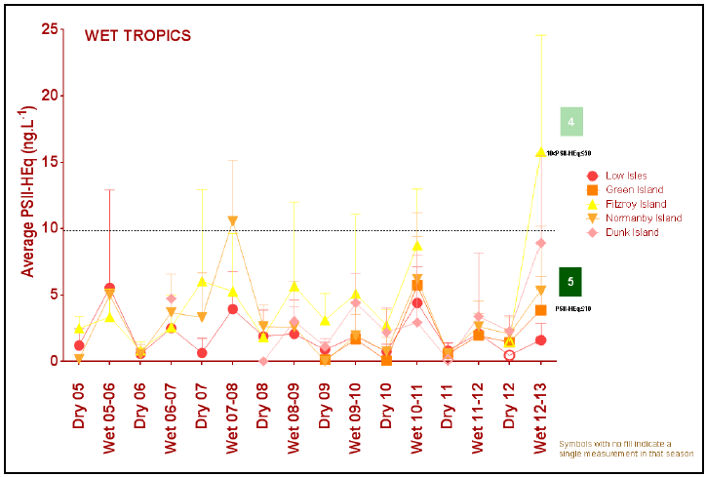
Figure 23: Trends in average PS-II herbicide equivalent concentrations at each sampling site in the Wet Tropics according to season.
High concentrations generally coincided with periods of high flow from the major rivers in the wet season compared to the dry season. Symbols with no fill indicate values with low reliability based on less than 30 per cent of the maximum number of deployments.

3.3.3 Seagrass condition and trend
The overall condition of inshore seagrass in the Wet Tropics region was very poor in 2012-2013, and has generally been poor since 2005-2006 (Figure 24). This assessment is a product of complex interactions between the three indicators of seagrass condition: abundance, reproductive effort and nutrient status, which are highly variable between years and habitats. However, monitoring results indicated minor increases in abundance in some inshore areas and if environmental conditions remain favourable, abundance is expected to increase further and seagrass communities may become re-established over time.
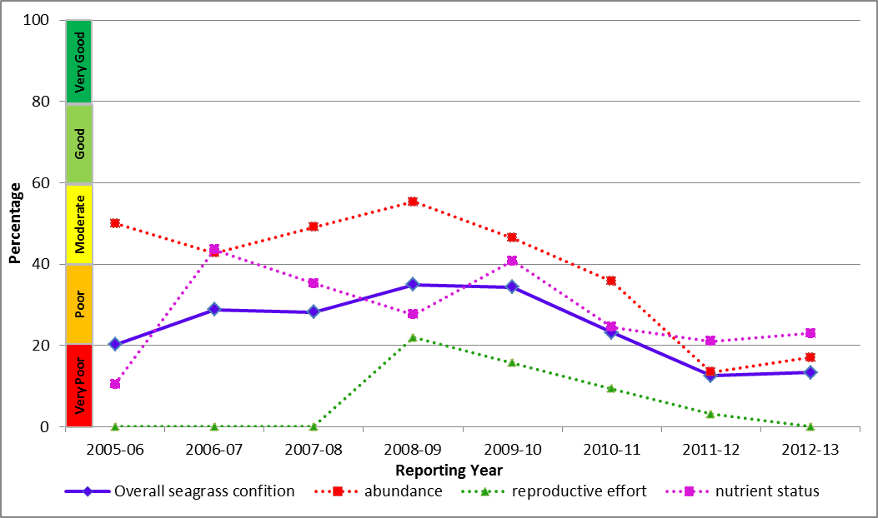
Figure 24: Trend in seagrass condition from 2005-2006 to 2012-2013 in the Wet Tropics.
Dominant influences on seagrass communities in the inshore Wet Tropics region include elevated temperatures, seasonal run-off and disturbance from wave action and associated sediment movement. The abundance of inshore seagrass in both coastal and reef habitats in the Wet Tropics remained very poor overall (Figure 25 and Figure 26), although there were localised increases in the abundance of fast-growing pioneer species at some sites. Reproductive effort across the inshore region remained very poor in 2012-2013 and there was little evidence of recovery of meadows that were directly affected by Cyclone Yasi in 2010-2011. The very low abundance coupled with very low reproductive effort of seagrass in the inshore region indicates that meadows will be at risk from further impacts and will take many years to fully recover even if conditions were optimum. Leaf tissue nutrient ratios were rated poor overall, indicative of poor water quality reported above.

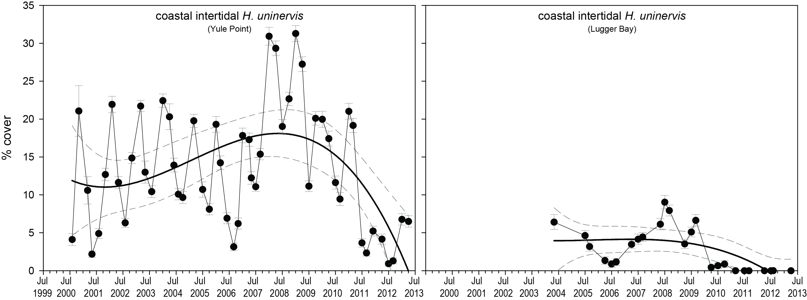
Figure 25: Trend in seagrass abundance (% cover) at inshore intertidal coastal habitats (left. Yule Point and right. Lugger Bay) in the wet tropics.
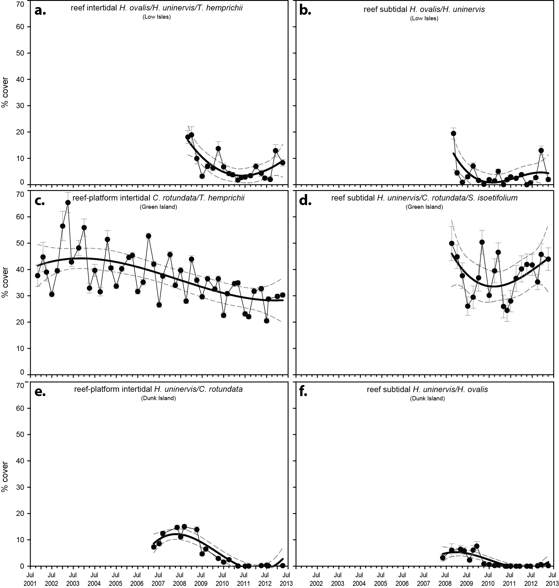
Figure 26: Trend in seagrass abundance (% cover ± Standard Error) at inshore intertidal coastal habitats (Yule Point and Lugger Bay) and reef habitat intertidal and subtidal meadows (left and right respectively): a-b) Low Isles; c-d) Green Island; e-f) Dunk Island

3.3.4 Coral condition and trend
The overall condition of inshore coral reefs in the Wet Tropics was poor in 2012-2013, and the underlying scores decreased markedly from 2009-2010 (Figure 27). In the northern Wet Tropics, coral reef communities declined to poor condition in the Barron Daintree area and remained in moderate condition in the Johnstone Russell-Mulgrave area, while those in the more southerly Herbert Tully area remained in poor condition.
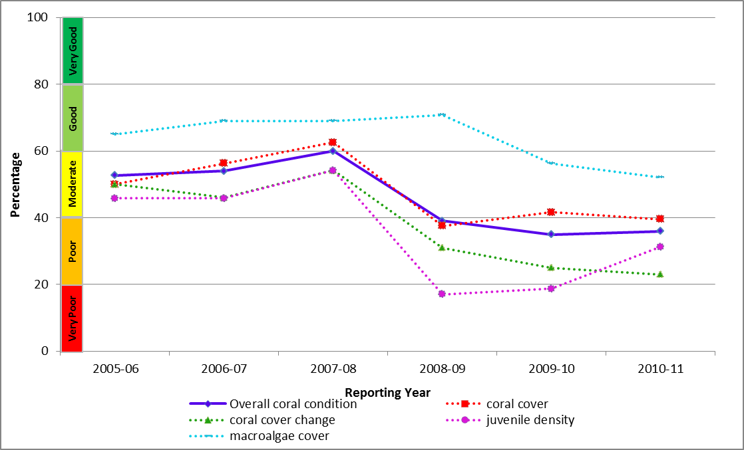
Figure 27: Trend in coral condition from 2007-2008 to 2012-2013 in the Wet Tropics.
In the more northerly reefs of the Barron-Daintree and Johnson Russell-Mulgrave areas, high levels of coral disease in 2010 and 2011 resulted in slow rates of coral cover increase that, in combination with an increase in crown-of-thorns starfish outbreaks, resulted in an overall reduction in coral cover in 2012-2013 (Figure 28 and Figure 29). The density of juvenile corals also declined to low levels in these sub-regions. Coral cover remained poor in southerly reefs in the Herbert Tully area, following the severe reductions caused by Cyclone Yasi in 2011 and Cyclone Larry in 2006 (Figure 30). However, an increase in the number of juvenile corals in 2012-2013 indicates some level of recovery. The cover of macroalgae increased across all sub-regions, which contributed to the overall poor condition assessment of reefs in the Wet Tropics.
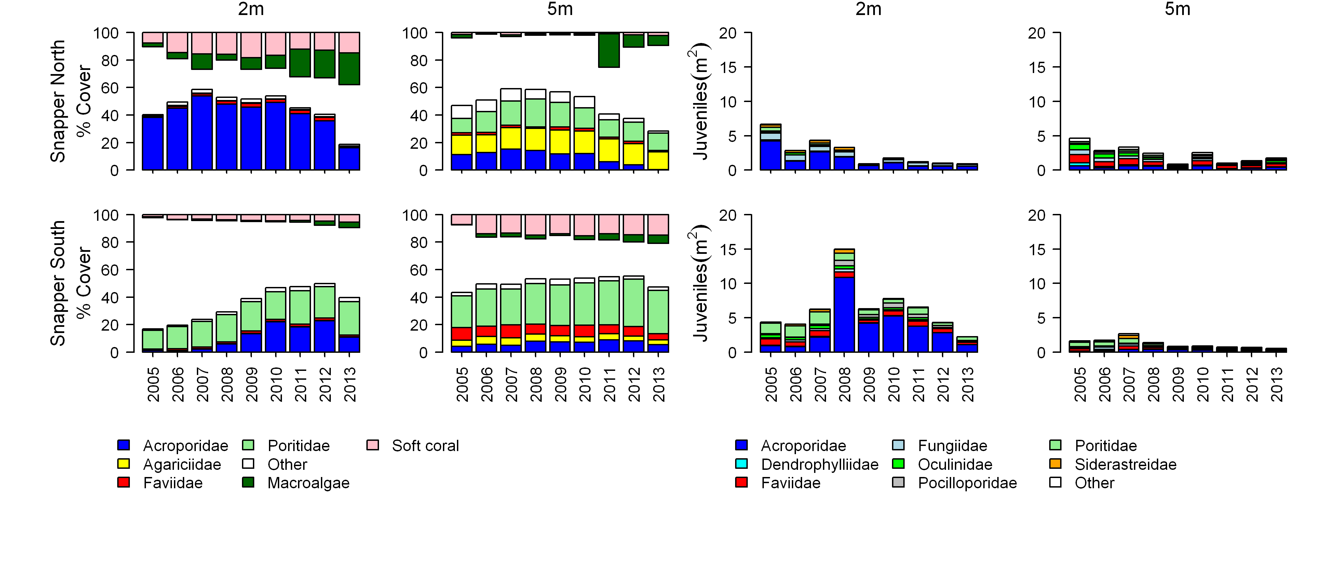
Figure 28: Cover of major benthic groups and levels of key environmental parameters: Daintree sub-region, inshore Wet Tropics Region.
Cover estimates are separated into regionally abundant hard coral families and the total cover for soft corals and macroalgae (hanging). Juvenile density estimates are for regionally abundant hard coral families. Separate legends relevant groupings for cover and juvenile density estimates are located beneath the relevant plots.

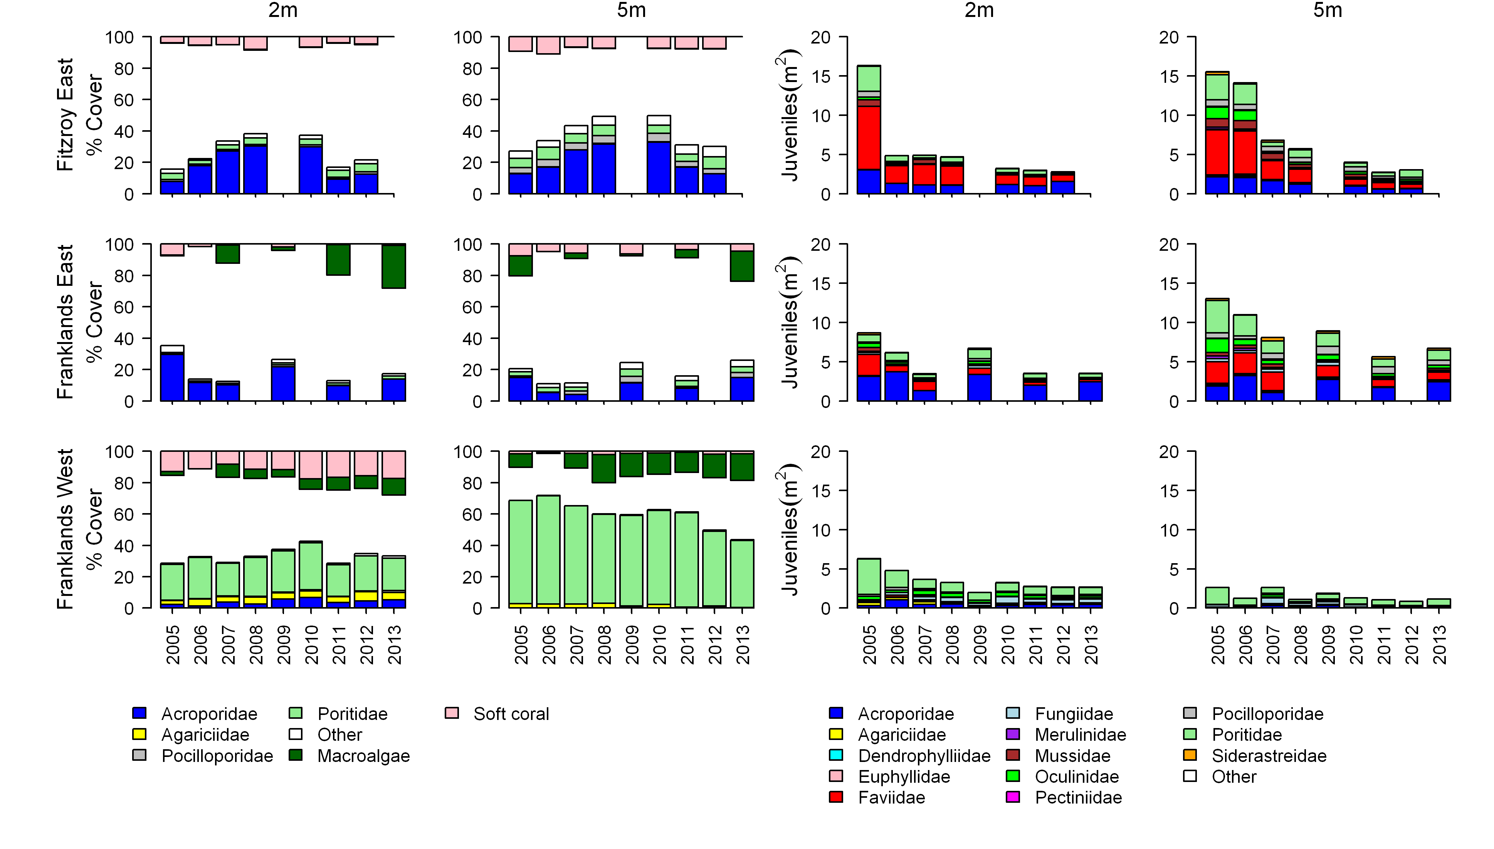
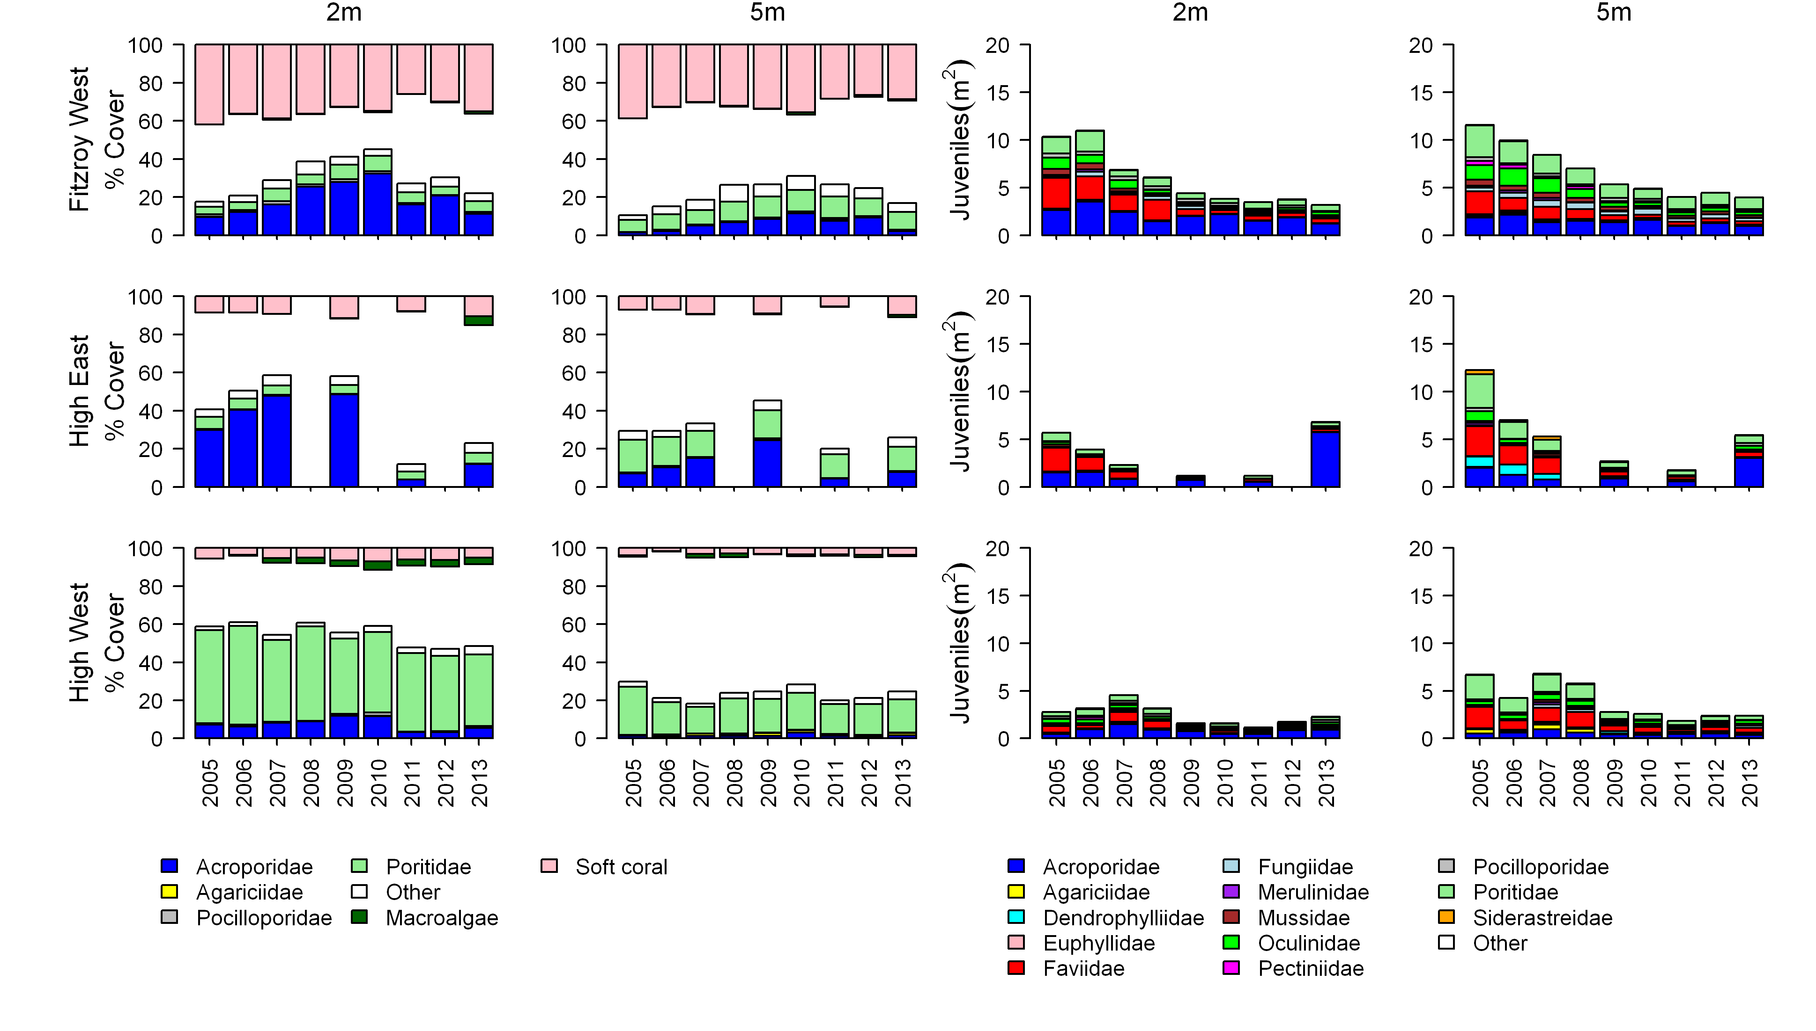
Figure 29: Cover of major benthic groups and density of hard coral juveniles at each depth for reefs in the Johnstone sub-region.
Cover estimates are separated into regionally abundant hard coral families and the total cover for soft corals and macroalgae (hanging). Juvenile density estimates are for regionally abundant hard coral families. Separate legends relevant groupings for cover and juvenile density estimates are located beneath the relevant plots.
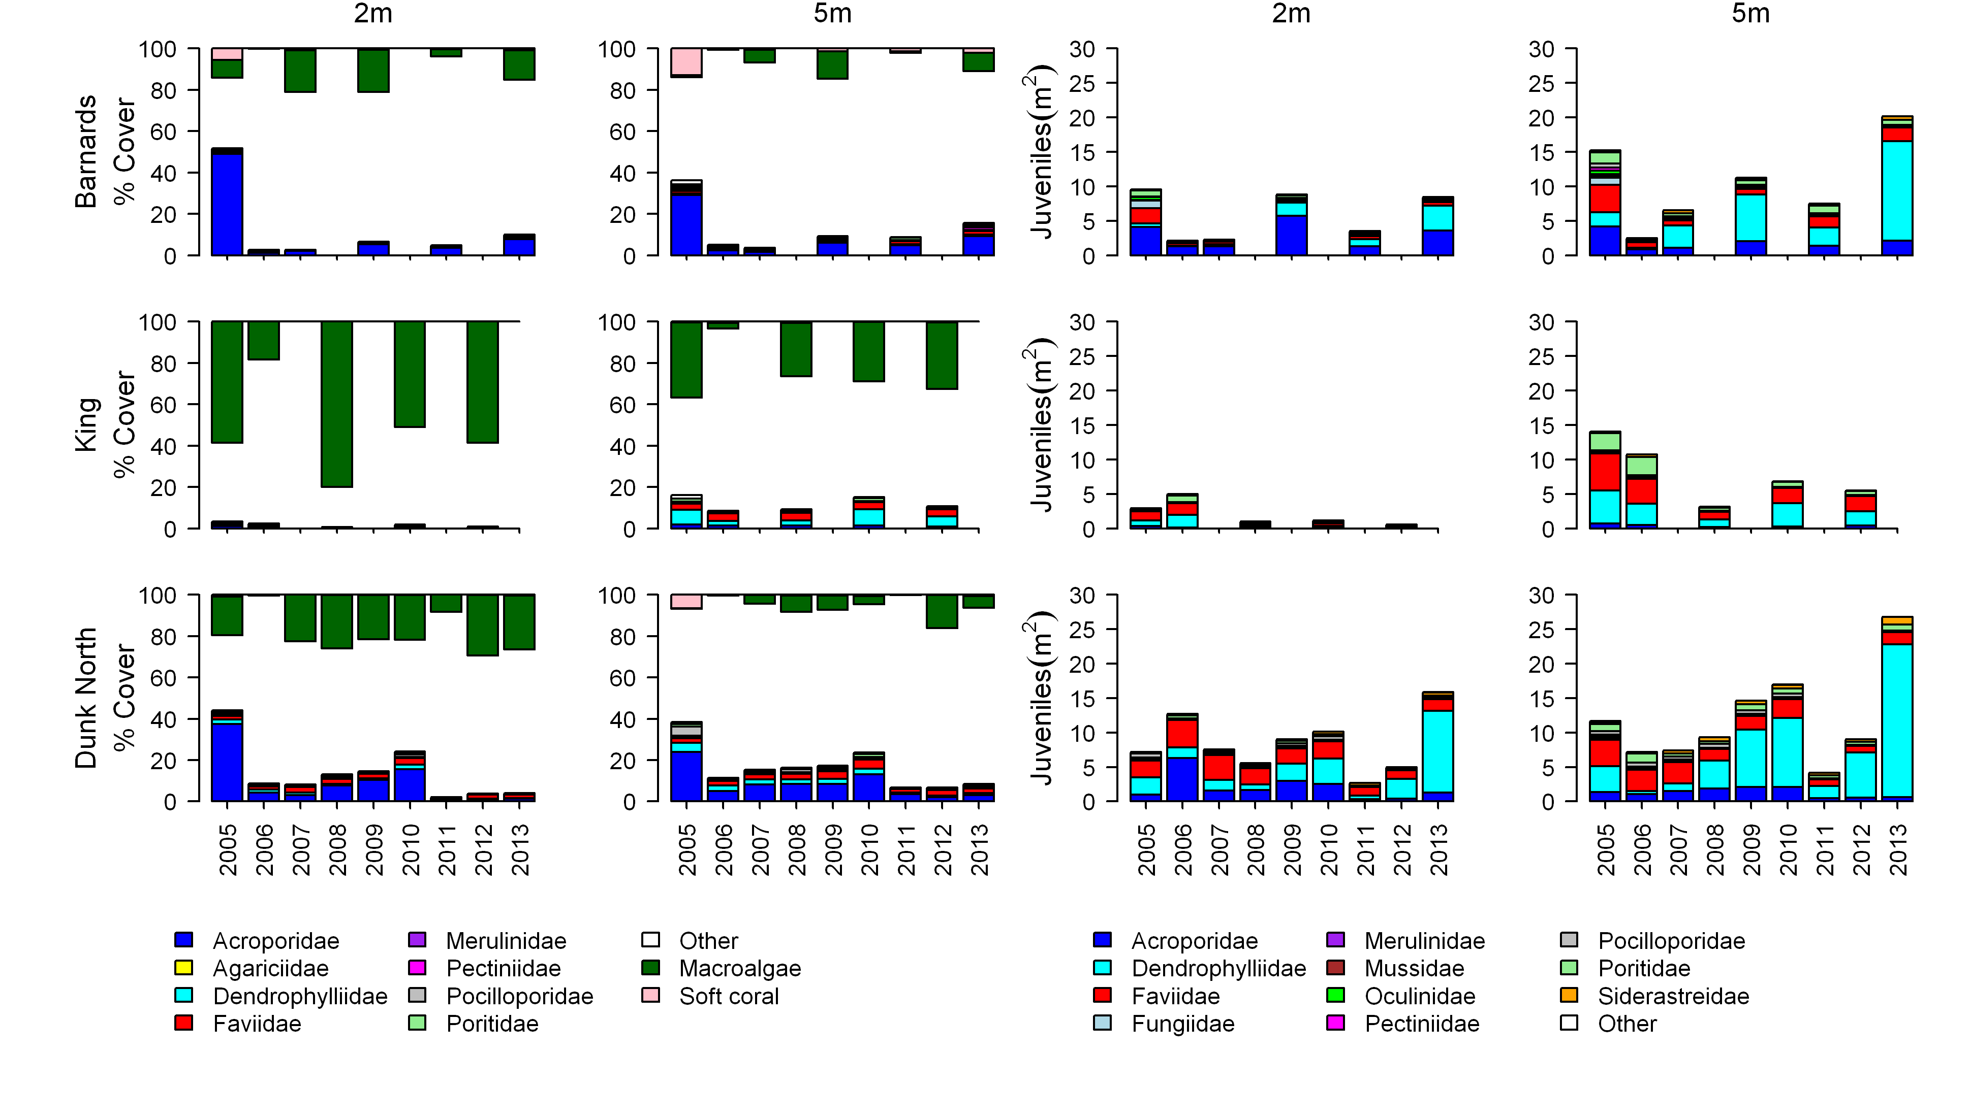
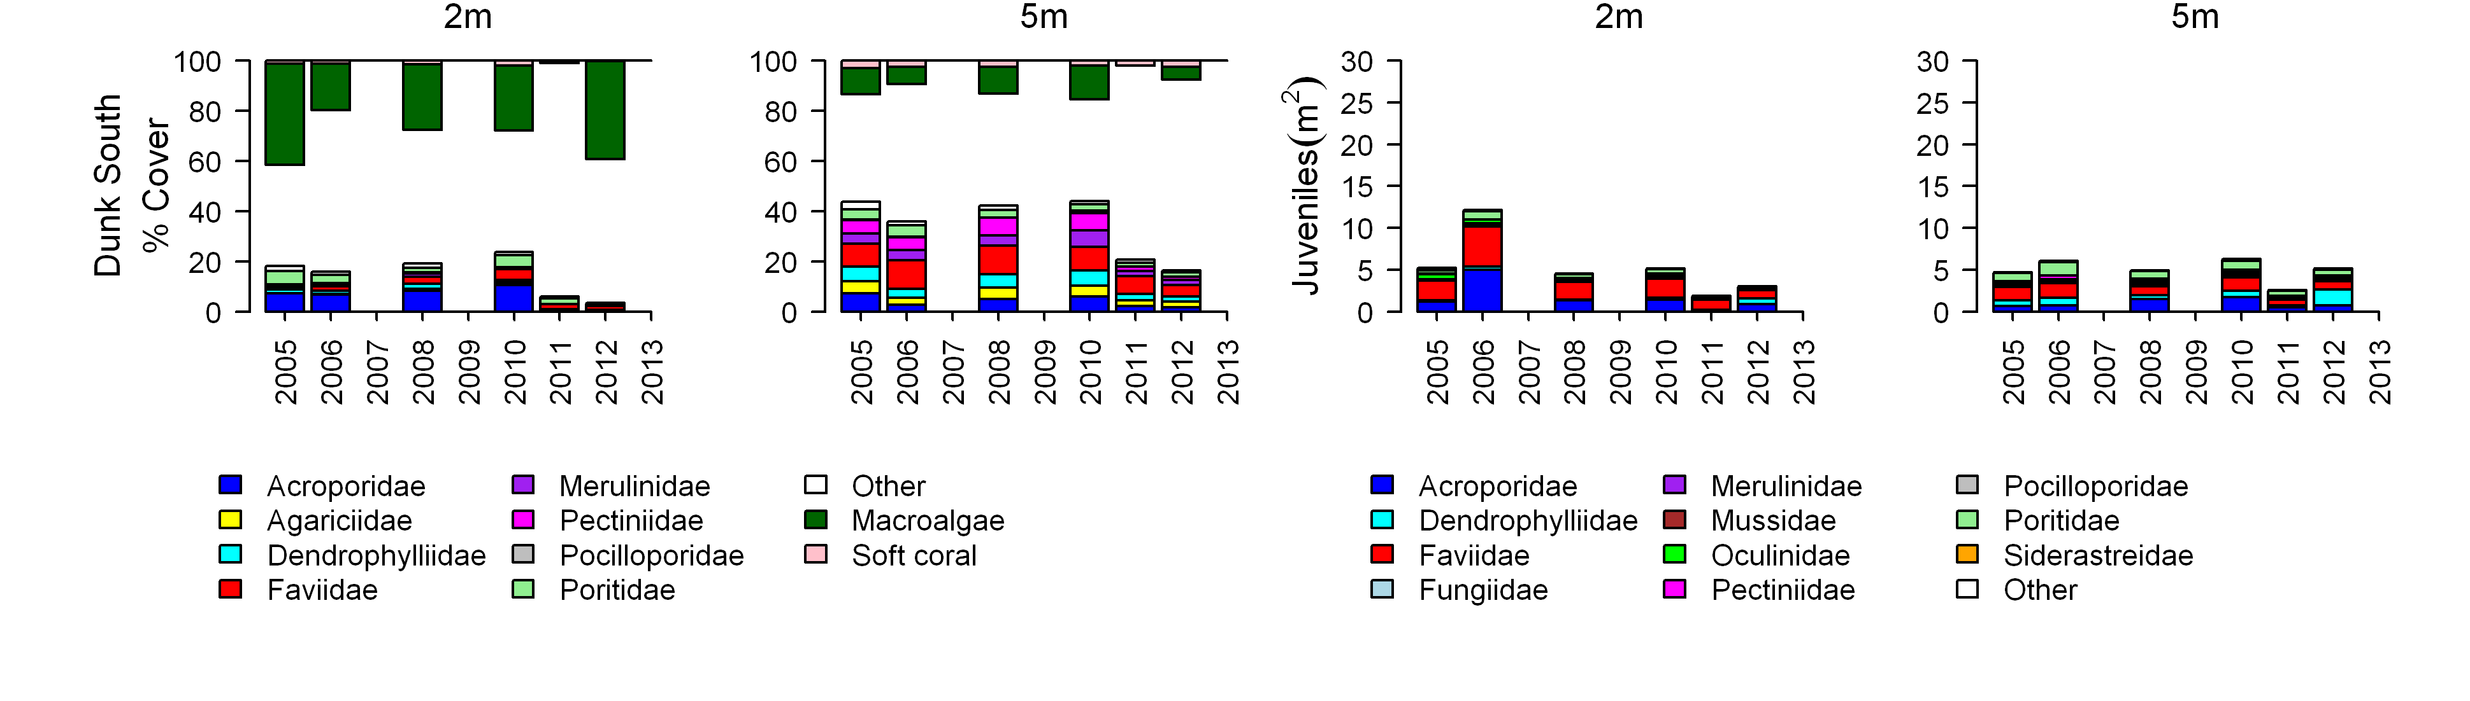
Figure 30: Cover of major benthic groups and density of hard coral juveniles at each depth for reefs in the Tully sub- region.
Cover estimates are separated into regionally abundant hard coral families and the total cover for soft corals and macroalgae (hanging). Juvenile density estimates are for regionally abundant hard coral families. Separate legends with relevant groupings for cover and juvenile density estimates are located beneath the respective plots.

3.4 Burdekin
Figure 31: The condition of water quality and ecosystem health (seagrass and corals) in 2012-2013 across the inshore Burdekin region.

3.4.1 Summary results
- Overall marine health in the inshore Burdekin region was poor in 2012-2013. Inshore water quality was moderate overall, and inshore seagrass meadows and coral reefs were both in poor condition (Figure 31).
- Inshore water quality for the region, as determined by remote sensing, has been consistently moderate since 2005-2006. Concentrations of total suspended solids and chlorophyll a were again rated as moderate and poor, respectively, in 2012-2013. Site-specific assessment of water quality showed a gradient of increasing water quality from the inshore to the mid-shelf area, with poor water quality at Magnetic Island and good water quality at the two mid-shelf sites.
- A range of pesticides was detected in the inshore Burdekin region including atrazine and its breakdown products, diuron, hexazinone, simazine, tebuthiuron, metolachlor, terbutryn, ametryn and imidacloprid. In 2012-2013, concentrations of PS-II herbicides at Orpheus and Magnetic Islands increased from 2011-2012 levels to be above those known to affect photosynthesis in diatoms (Category 4) and this level was maintained at Cape Cleveland.
- Inshore seagrass meadows remained in very poor overall condition, having progressively declined from good in 2005-2006. However, seagrass abundance improved to poor in 2012-2013 and was at its highest level for the last four years. Reproductive effort had also improved to moderate. The nutrient content of seagrass tissue was poor in coastal and reef habitats and indicates nutrient enrichment of surrounding waters.
- Inshore coral reefs remained in poor condition, reflecting very poor coral cover, low densities of juvenile colonies and inherently low rates of increase in coral cover during periods free from acute disturbances. Macroalgae cover has been persistently high on several reefs.

3.4.2 Water quality condition and trend
Inshore water quality (assessed by remote sensing of chlorophyll a and suspended solids) in the Burdekin region remained moderate in 2012-2013 and the underlying scores for the two water quality indicators chlorophyll a and suspended solids were poor and moderate, respectively (Figure 32).
In 2012-2013, concentrations of data exceeded the Water Quality Guidelines³ for 85 and 61 per cent of the inshore area in the dry and wet season, respectively. Concentrations of total suspended solids exceeded the Water Quality Guidelines³ for 47 and 36 per cent of the inshore area in the dry and wet seasons, respectively.
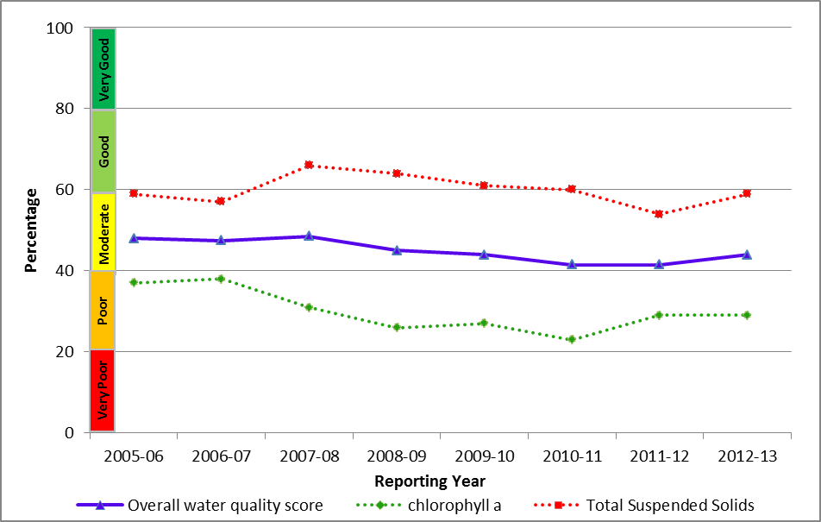
Figure 32: Trend in the water quality index from 2005-2006 to 2012-2013 in the inshore Burdekin region.
Water quality across the region showed a clear gradient of decreasing water quality from offshore areas to the inshore areas more frequently exposed to flood waters. This onshore-offshore gradient was supported by long-term assessments of water quality at specific sites, with variability between sites reflecting local hydrodynamic conditions and biophysical processes.
Site-specific water quality was good and very good at the two mid-shelf sites and moderate at Magnetic Island in the inshore region (Figure 33). The water quality index in this inshore region has been stable over the past four years, with a period of slight increases in suspended solids, particulate nitrogen and particulate phosphorus in 2012-2013. The water quality scores are a long-term integrative assessment based on four indicators of water quality relative to the Water Quality Guidelines.³
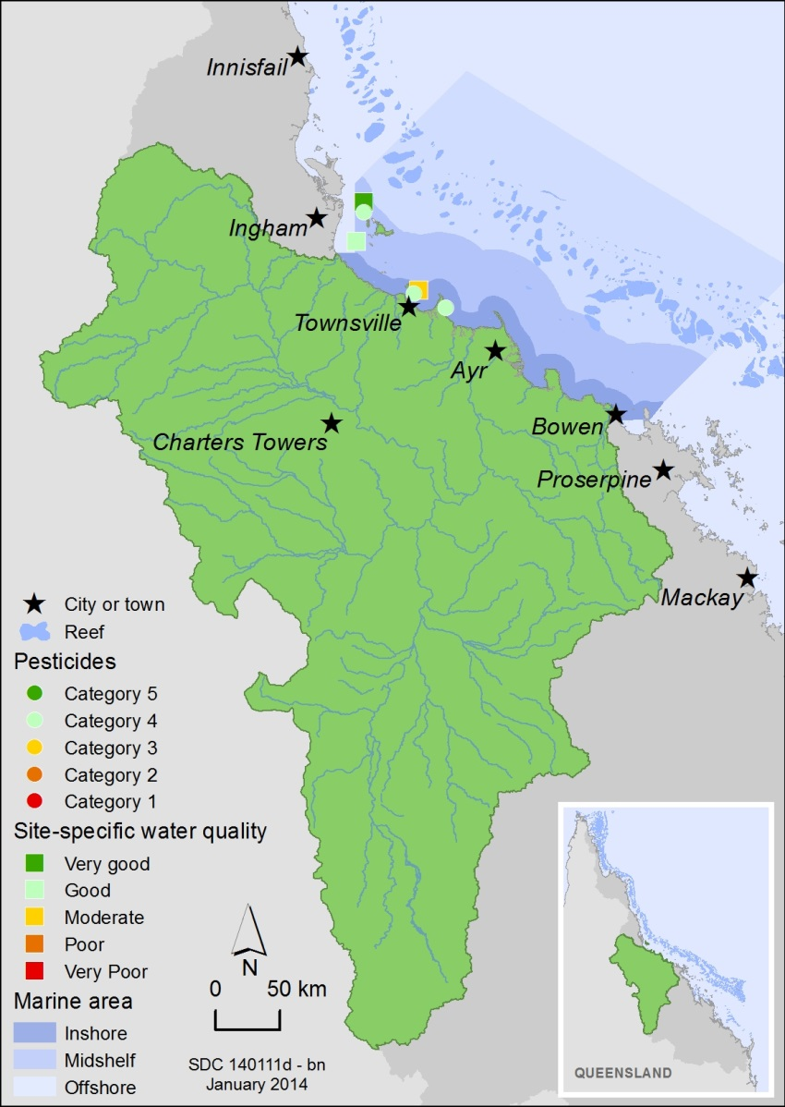
Figure 33: Water quality and pesticide scores for PS-II herbicides at fixed monitoring sites in the Burdekin.
The water quality scores are a long-term integrative assessment based on four indicators of water quality relative to the Water Quality Guidelines.3 The pesticide scores reflect the PS-II Herbicide Equivalent Index categories for maximum equivalent concentrations at each site. These concentrations integrate the relative potency and abundance of each PS-II herbicide to give the PS-II Herbicide Equivalent Index.
In 2012-2013, concentrations of PS-II herbicides increased from 2011-2012 levels to be above those known to affect photosynthesis in diatoms (Category 4) at Orpheus and Magnetic Islands and maintained this level at Cape Cleveland (Figure 34). The highest PS-II herbicide equivalent concentrations (Category 3) were detected in grab samples of flood waters near Palm Island, approximately 36 kilometres from the mouth of Ross River and 130 kilometres from the mouth of the Burdekin River.
A range of pesticides was detected in the inshore Burdekin region including atrazine and its breakdown products, diuron, hexazinone, simazine, tebuthiuron, metolachlor, terbutryn, ametryn and imidacloprid. Routine monitoring showed spatial variability in the abundance of pesticides, with atrazine concentrations typically exceeding diuron concentrations at Cape Cleveland, while at Magnetic and Orpheus Islands, diuron was present at higher concentrations.
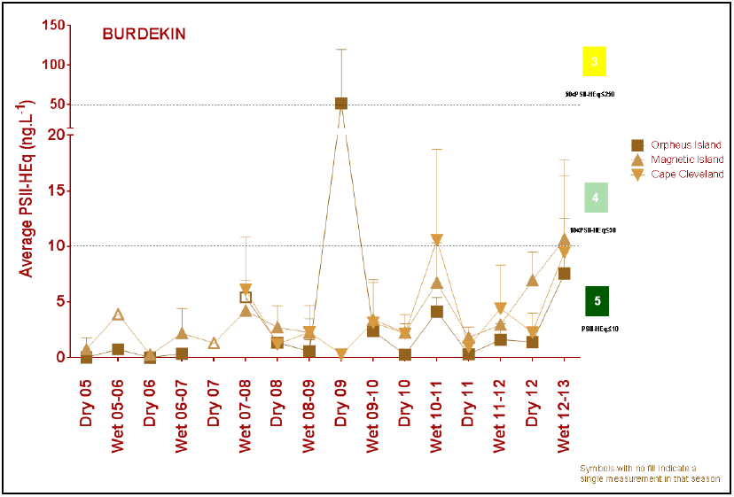
Figure 34: Trends in average PS-II herbicide equivalent concentrations at each sampling site in the Burdekin according to season.
High concentrations generally coincided with periods of high flow from the major rivers in the wet season compared to the dry season. Symbols with no fill indicate values with low reliability based on less than 30 per cent of the maximum number of deployments.

3.4.3 Seagrass condition and trend
The overall condition of inshore seagrass in the Burdekin region improved from very poor in 2011-2012 to poor in 2012-2013 (Figure 35). The improvement in condition was largely a result of increases in abundance and reproductive effort, indicating localised recovery from Cyclone Yasi.
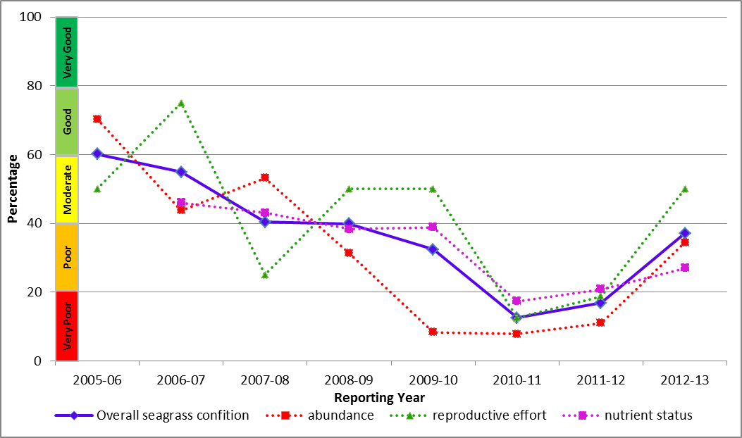
Figure 35: Trend in seagrass condition from 2005-2006 to 2012-2013 in the Burdekin.
Seagrass monitoring was conducted in coastal and reef habitats primarily influenced by wind-driven turbidity and pulsed delivery of nutrients and sediment. Seagrass abundance across the inshore region improved from very poor in 2011-2012 to poor in 2012-2013 and was at its highest level in four years (Figure 36). Reproductive effort also improved from very poor in 2011-2012 to moderate in 2012-2013, suggesting improved capacity to recover from future disturbances. The nutrient content of seagrass tissue was poor and indicated nutrient enrichment in coastal and reef habitats, which reflected local water quality conditions.

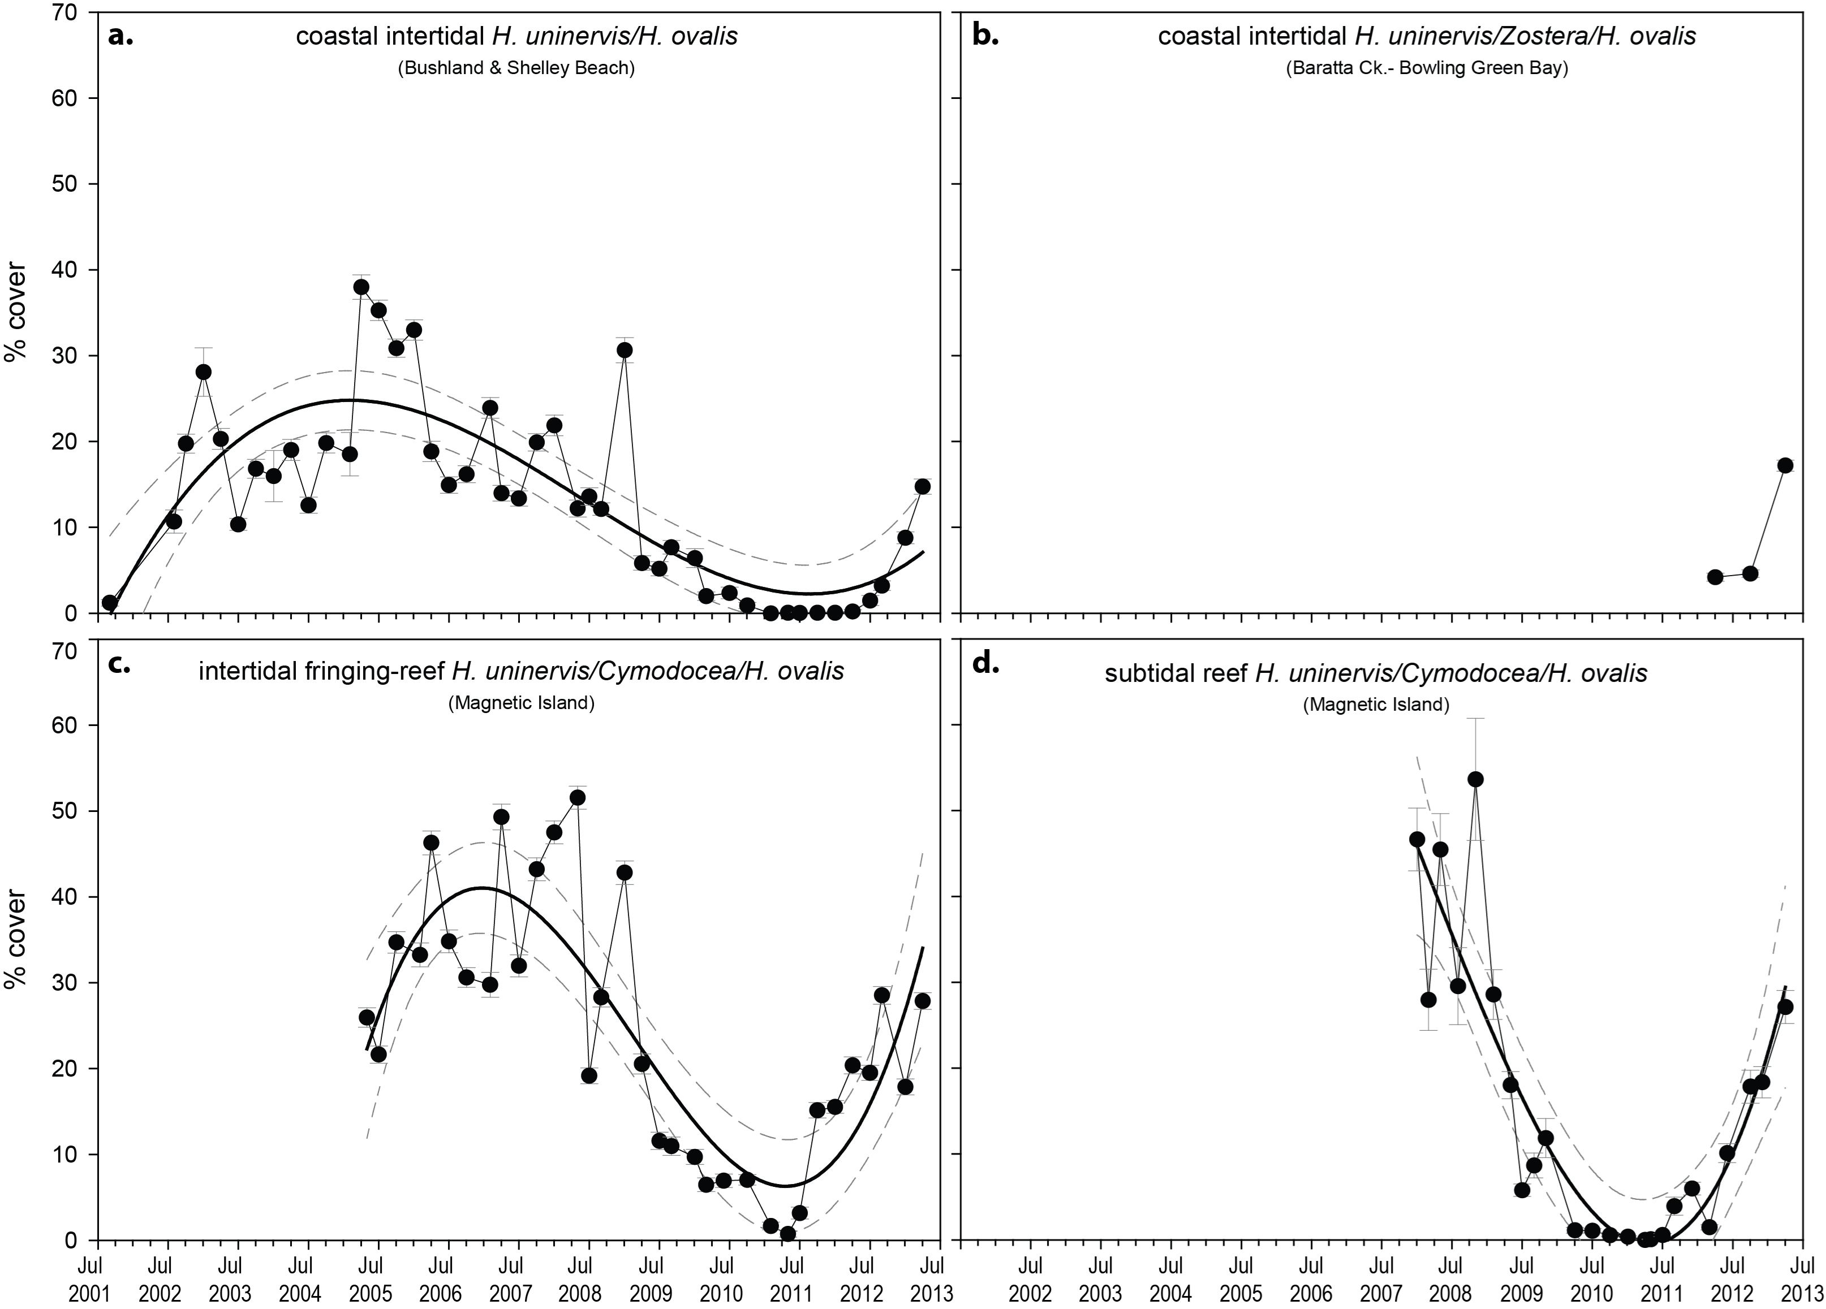
Figure 36: Changes in mean seagrass abundance (% cover ±Standard Error) at coastal intertidal (a, b), reef intertidal (c) and reef subtidal (d) meadows in the inshore Burdekin region from 2001 to 2013.

3.4.4 Coral condition and trend
The overall condition of inshore coral reefs in the Burdekin remained poor in 2012-2013, gradually declining from moderate since 2007-2008 (Figure 37).
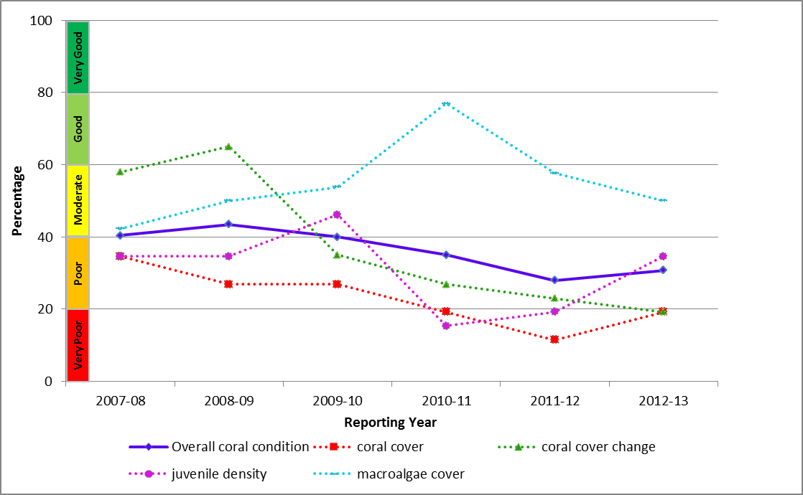
Figure 37: Trend in coral condition from 2007-2008 to 2012-2013 in the Burdekin.
Coral cover across the inshore Burdekin region remained very poor and had not recovered from the impact of coral bleaching in 1998 and 2002, and cyclones Larry (2006) and Yasi (2010) (Figure 38). In addition to the direct influence of these events on coral cover, it appears that the loss of corals has been sufficiently severe to substantially limit the supply of larvae and hence the rate at which coral communities can recover. Numbers of juveniles increased from very poor in 2011-2012 to poor in 2012-2013. However, relatively high levels of macroalgae and disease coinciding with periods of above-median discharge from the Burdekin River indicate that environmental conditions may be compounding the effects of previous disturbances and suppressing the recovery of coral communities.
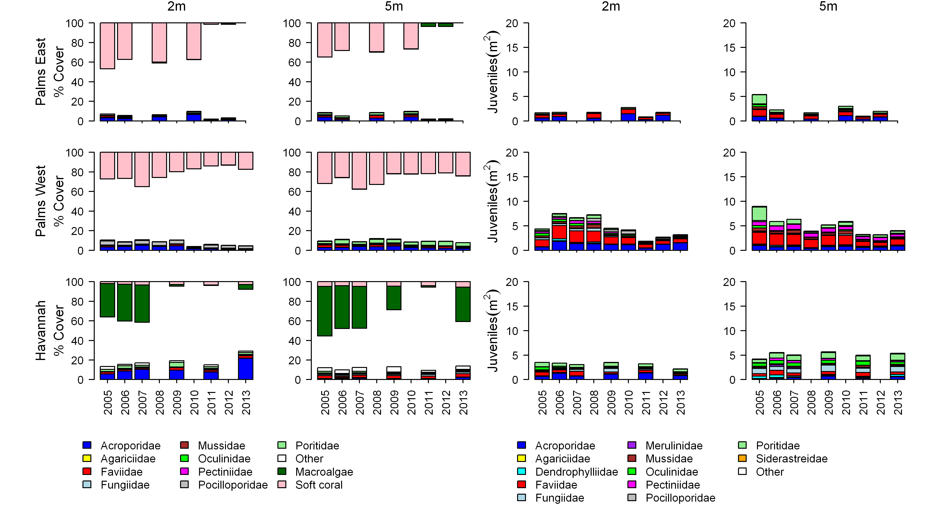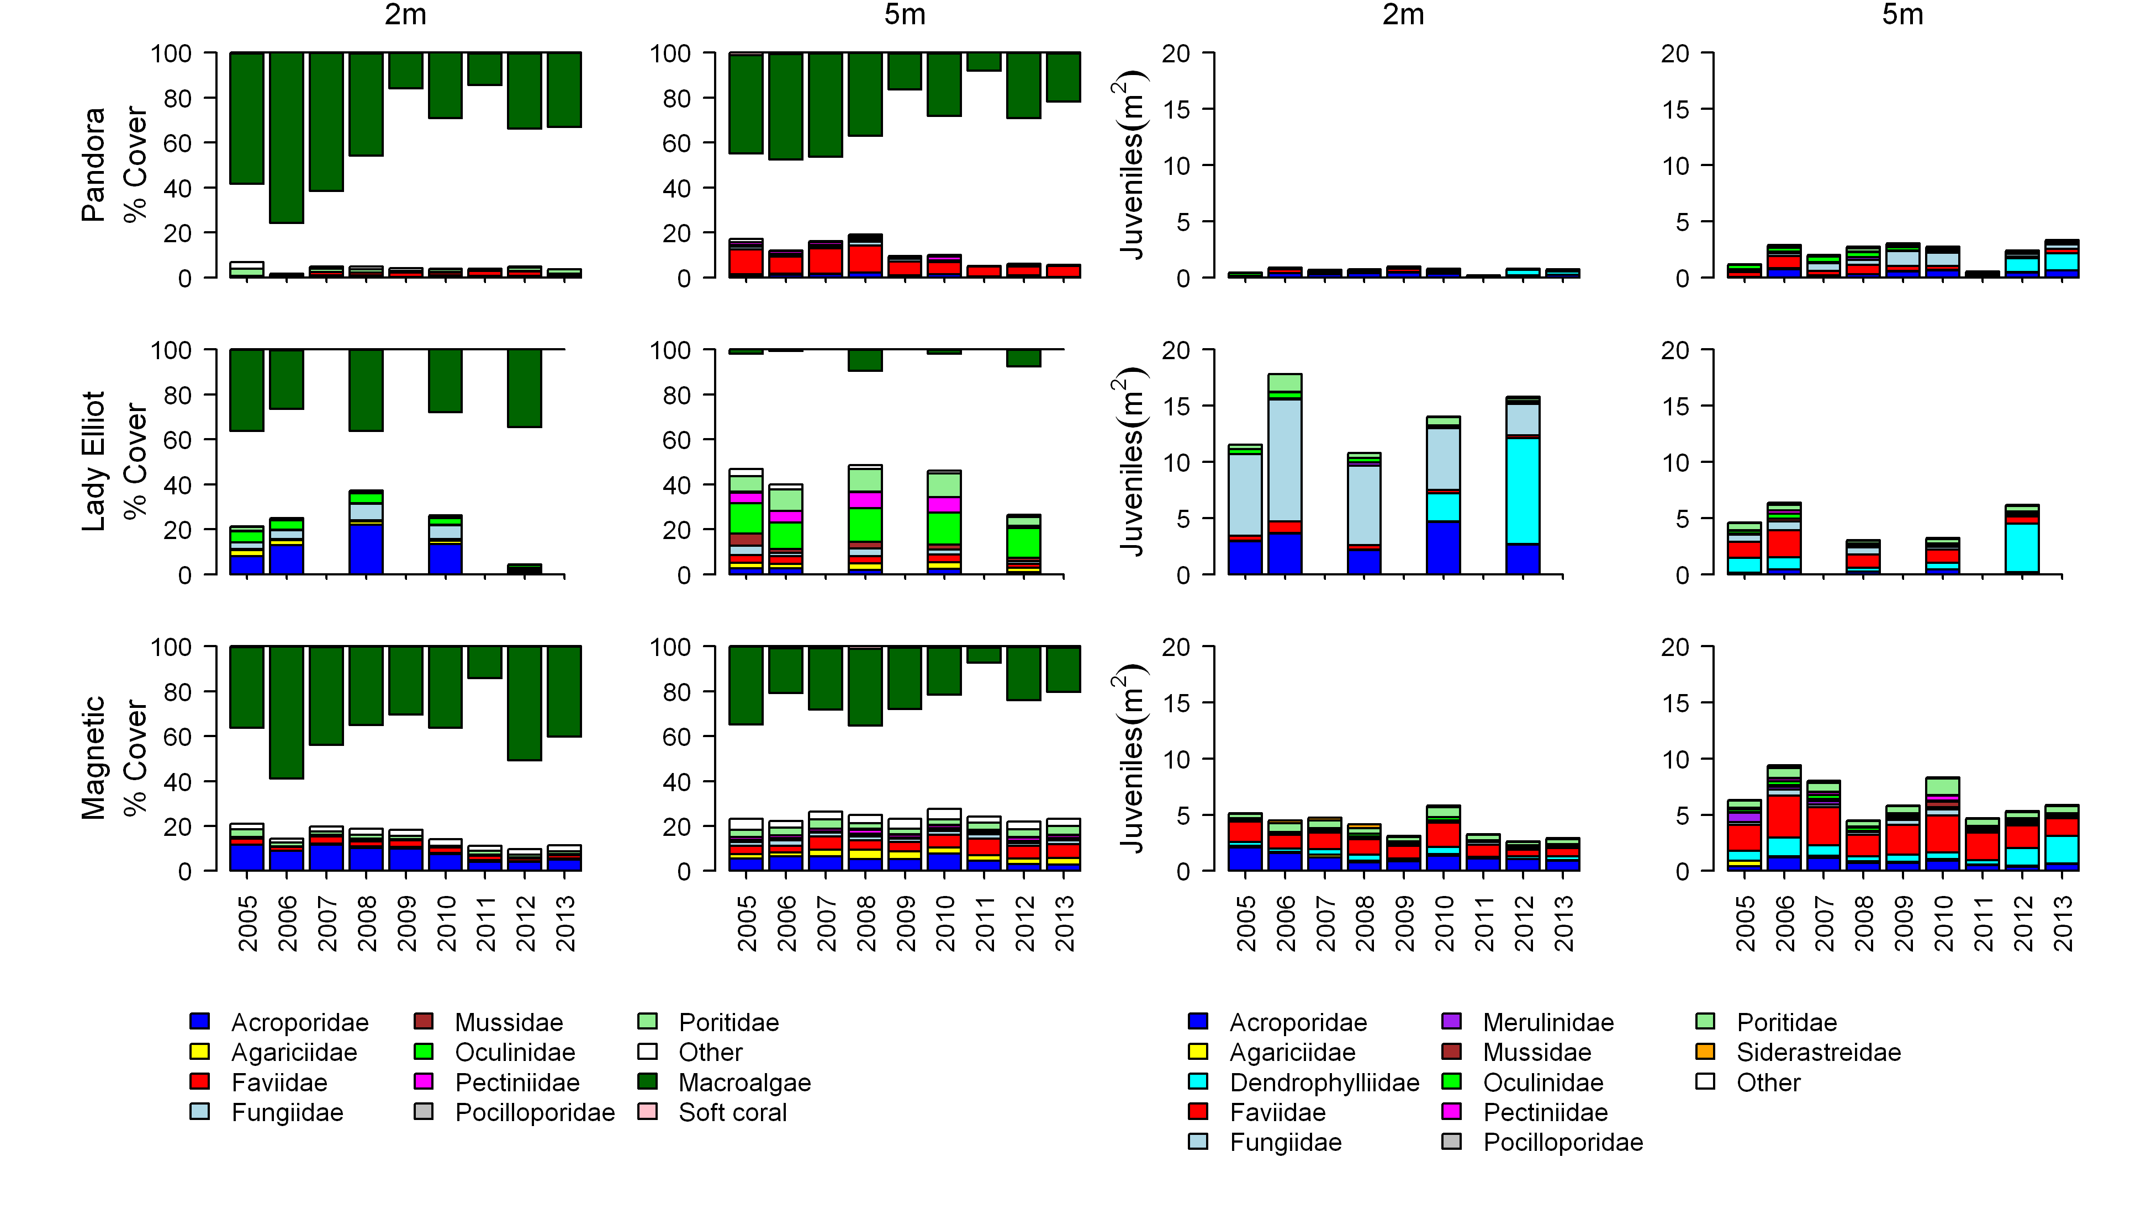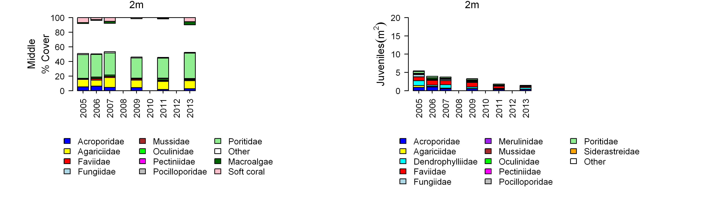
Figure 38: Cover of major benthic groups and density of hard coral juveniles at each depth for reefs in the inshore Burdekin region.
Cover estimates are separated into regionally abundant hard coral families and the total cover for soft corals and macroalgae (hanging). Juvenile density estimates are for regionally abundant hard coral families. Separate legends with relevant groupings for cover and juvenile density estimates are located beneath the respective plots.

3.5 Mackay Whitsunday
Figure 39: The condition of water quality and ecosystem health (seagrass and corals) in 2012-2013 across the inshore Mackay Whitsunday region.

3.5.1 Summary results
- Overall marine health in the inshore Mackay Whitsunday region was poor in 2012-2013. Inshore water quality was moderate overall, and inshore seagrass meadows and coral reefs were in very poor and moderate condition, respectively (Figure 39).
- Inshore water quality for the region, as determined by remote sensing, was moderate overall. Concentrations of total suspended solids and chlorophyll a were good and poor respectively in 2012-2013. Site specific water quality for the inshore region was moderate at Pine and Daydream Islands, and good at Double Cone Island, reflecting poorer water quality close to river mouths.
- A range of pesticides was detected including atrazine and its breakdown products, diuron, hexazinone, simazine, tebuthiuron, metolachlor, terbutryn, ametryn, simazine, galaxolide and imidacloprid. Diuron was present at the highest concentrations at Sarina Inlet. The PS-II herbicide equivalent index, which considers the relative potency and abundance of each PS-II herbicide, showed that herbicides were present at biologically relevant concentrations at two sites in the Mackay Whitsundays (Category 3 and 4).
- Inshore seagrass meadows had declined to a very poor state since 2005-2006. At all locations (coastal, estuarine and fringing reef), seagrass abundance, reproductive effort and nutrient status were rated as very poor.
- Inshore coral reefs remained in moderate condition. Coral cover, density of juveniles and change in coral cover all improved in 2012-2013. Since Cylone Ului in 2010, there continued to be slow rates of increase in hard coral cover and moderate numbers of juveniles, which have been low for several years.

3.5.2 Water quality condition and trend
Inshore water quality (assessed by remote sensing of chlorophyll a and suspended solids) improved from the poor result in 2010-2011 and was moderate in 2012-2013 (Figure 40). However, chlorophyll a declined from moderate in 2011-2012 to poor in 2012-2013. Concentrations exceeded the Water Quality Guidelines³ for 95 and 45 per cent of the inshore area, in the dry and wet season. Total suspended solids were rated as good in 2012-2013, with concentrations exceeding the Water Quality Guidelines³ for 54 and 31 per cent of the inshore area, in the dry and wet season, respectively.
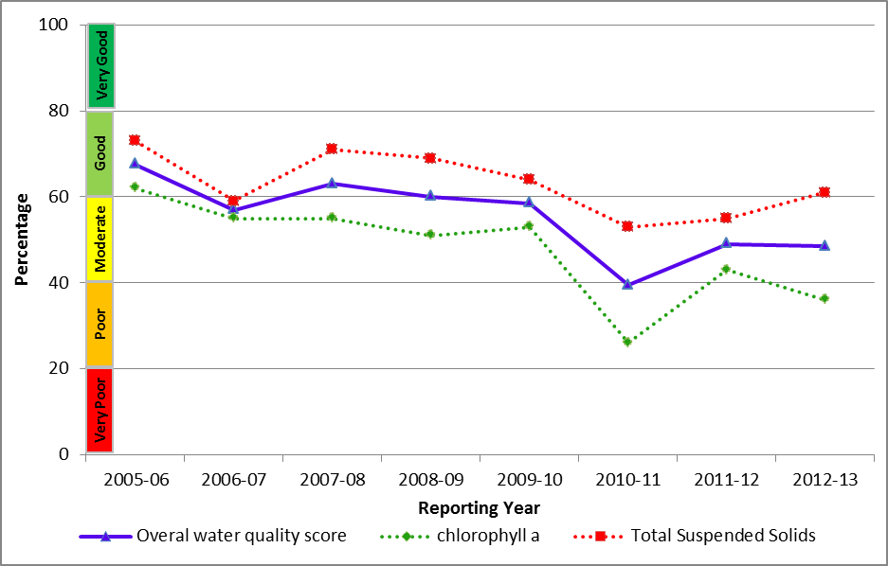
Figure 40: Trend in the water quality index from 2005-2006 to 2012-2013 in the inshore Mackay Whitsunday region.
Water quality across the region showed a clear gradient of declining water quality from offshore areas to inshore areas more frequently exposed to flood waters. This gradient was supported by long-term assessments of water quality at specific sites with variability between sites reflecting local hydrodynamic conditions and biophysical processes.
Site-specific water quality was moderate at Daydream and Pine Islands and good at Double Cone Island in 2012-2013. All three indicators of water clarity – suspended solids, Secchi depth and turbidity – exceeded the Water Quality Guidelines³ in 2012-2013, especially at Pine and Daydream Islands, which are more frequently exposed to flood plumes. The water quality scores are a long-term integrative assessment based on four indicators of water quality relative to the Water Quality Guidelines.³
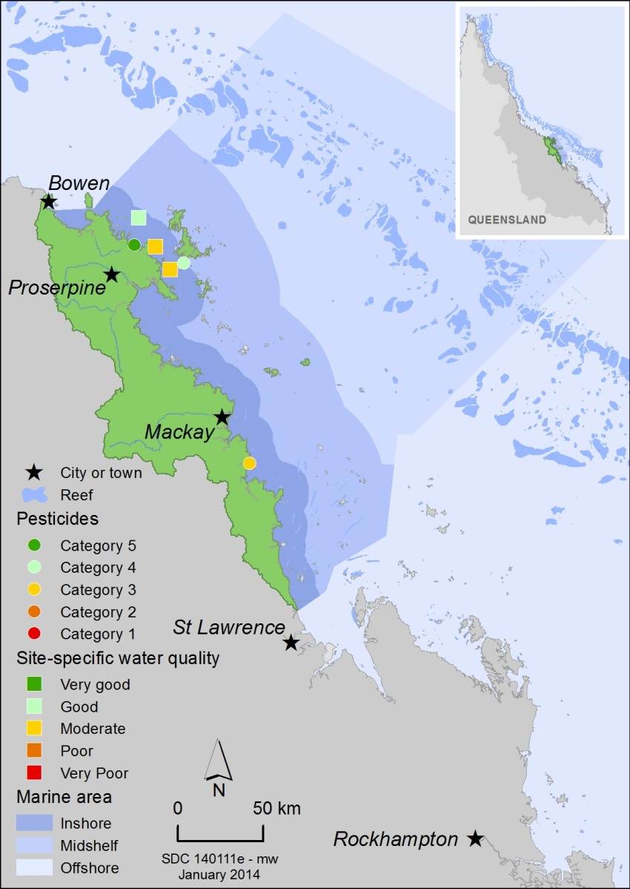
Figure 41: Water quality and pesticide scores for PS-II herbicides at fixed monitoring sites in the Mackay Whitsundays.
The water quality scores are a long-term integrative assessment based on four indicators of water quality relative to the Water Quality Guidelines.³ The pesticide scores reflect the PS-II Herbicide Equivalent Index categories for maximum equivalent concentrations at each site. These concentrations .integrate the relative potency and abundance of each PS-II herbicide to give the PS-II Herbicide Equivalent Index.
A range of pesticides was detected in the inshore Mackay Whitsunday region including atrazine and its breakdown products, diuron, hexazinone, simazine, tebuthiuron, metolachlor, terbutryn, ametryn, simazine, galaxolide and imidacloprid. Concentrations of PS-II herbicides were above those known to affect photosynthesis in diatoms (Category 4) at the Outer Whitsunday site and above those known to affect seagrass (Category 3) at Sarina Inlet (Figure 42). Sarina Inlet generally had the highest concentrations of most PS-II herbicides particularly diuron compared with all other sites in the Reef, which reflected the proximity of the site to flows from Plane Creek.⁴⁵
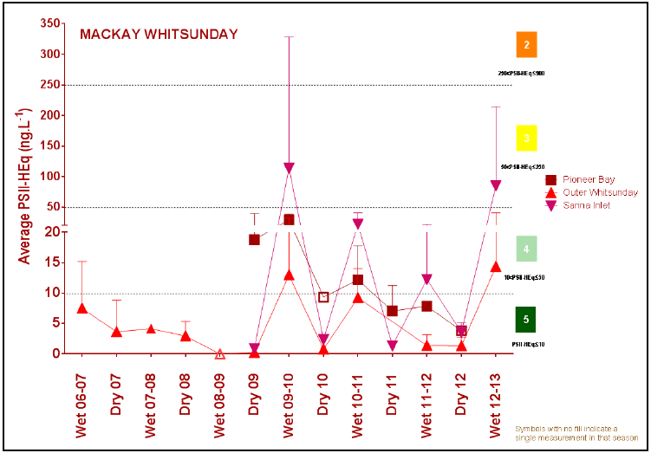
Figure 42: Trends in average PS-II herbicide equivalent concentrations at each sampling site in the Mackay Whitsundays according to season.
High concentrations generally coincided with periods of high flow from the major rivers in the wet season compared to the dry season. Symbols with no fill indicate values with low reliability based on less than 30 per cent of the maximum number of deployments.

3.5.3 Seagrass condition and trend
The overall condition of inshore seagrass in the Mackay Whitsunday region remained very poor in 2012-2013, having progressively declined since monitoring began in 2005-2006 (Figure 43). The very poor rating for seagrass overall is a result of very poor abundance, reproductive effort and increased nutrient enrichment of seagrass tissue across all habitats.
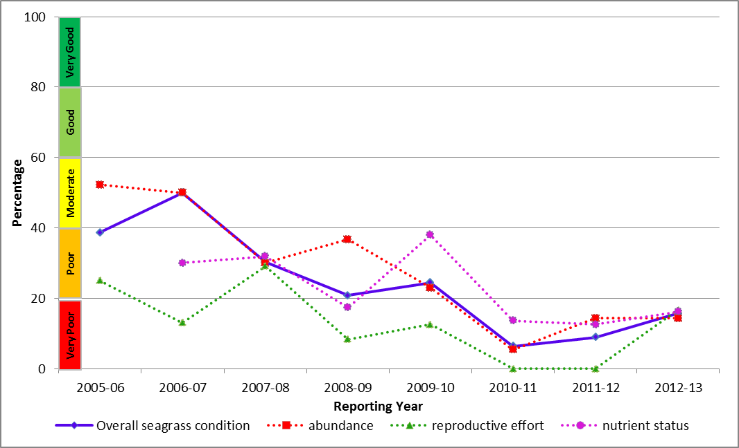
Figure 43: Trend in seagrass condition from 2005-2006 to 2012-2013 in the Mackay Whitsundays.
Seagrass meadows were monitored at coastal, estuarine and fringing reef locations in the inshore Mackay Whitsunday region (Pioneer Bay, Sarina Inlet and Hamilton Island, respectively) (Figure 44). Key environmental drivers of seagrass communities in this inshore region include a high tidal range, exposure at very low tides and variable catchment run-off. There were modest increases in abundance and reproductive effort at some sites. However, the very poor nutrient status of seagrass tissue reflected local water quality conditions and together with the very poor rating of other indicators of seagrass condition raises concerns about the ability of local seagrass meadows to recover from previous environmental disturbances.
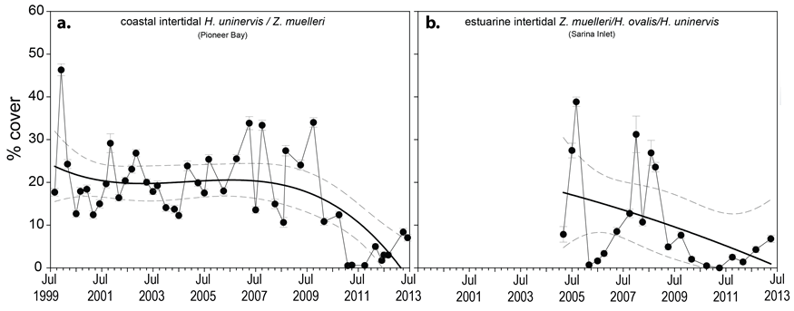
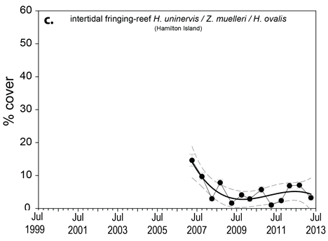
Figure 44: Changes in seagrass abundance (% cover ±Standard Error) at a). coastal, b). estuarine, nd c). reef meadows in the inshore Mackay Whitsunday region from 1999 to 2013.

3.5.4 Coral condition and trend
The overall condition of inshore coral reefs in the Mackay Whitsunday region was moderate in 2012-2013, and has remained moderate since monitoring began in 2007-2008 (Figure 45).
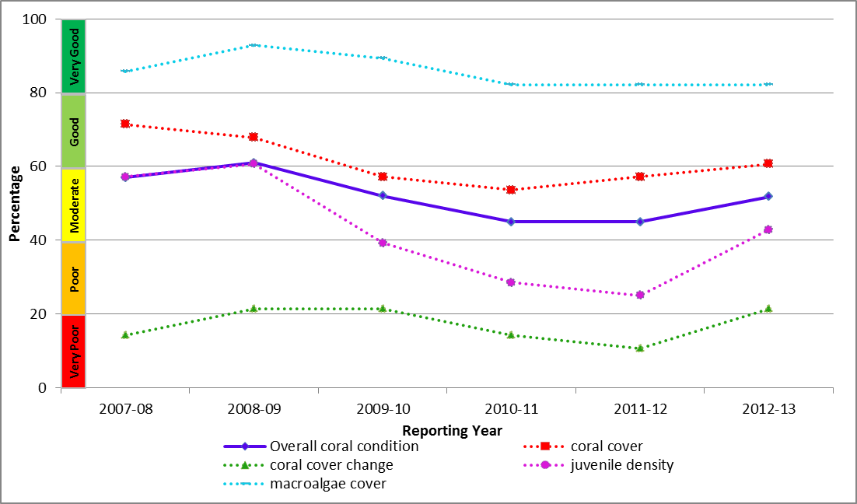
Figure 45: Trend in coral condition from 2007-2008 to 2012-2013 in the Mackay Whitsundays.
Coral cover, the density of juveniles and change in coral cover all improved in 2012-2013 compared with 2011-2012 (Figure 46). Macroalgae cover remained very good. However, the positive indicators of coral condition such as low macroalgae cover and good coral cover were balanced against slow rates of increase in hard coral cover since Cyclone Ului in 2010 and moderate numbers of juveniles, resulting in the overall condition assessment of moderate.
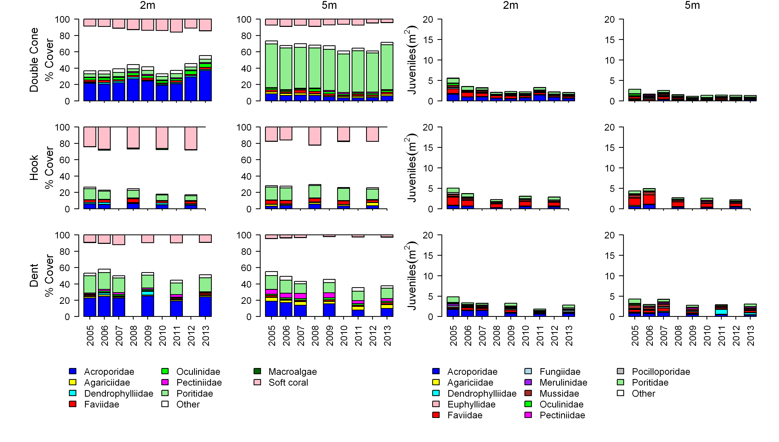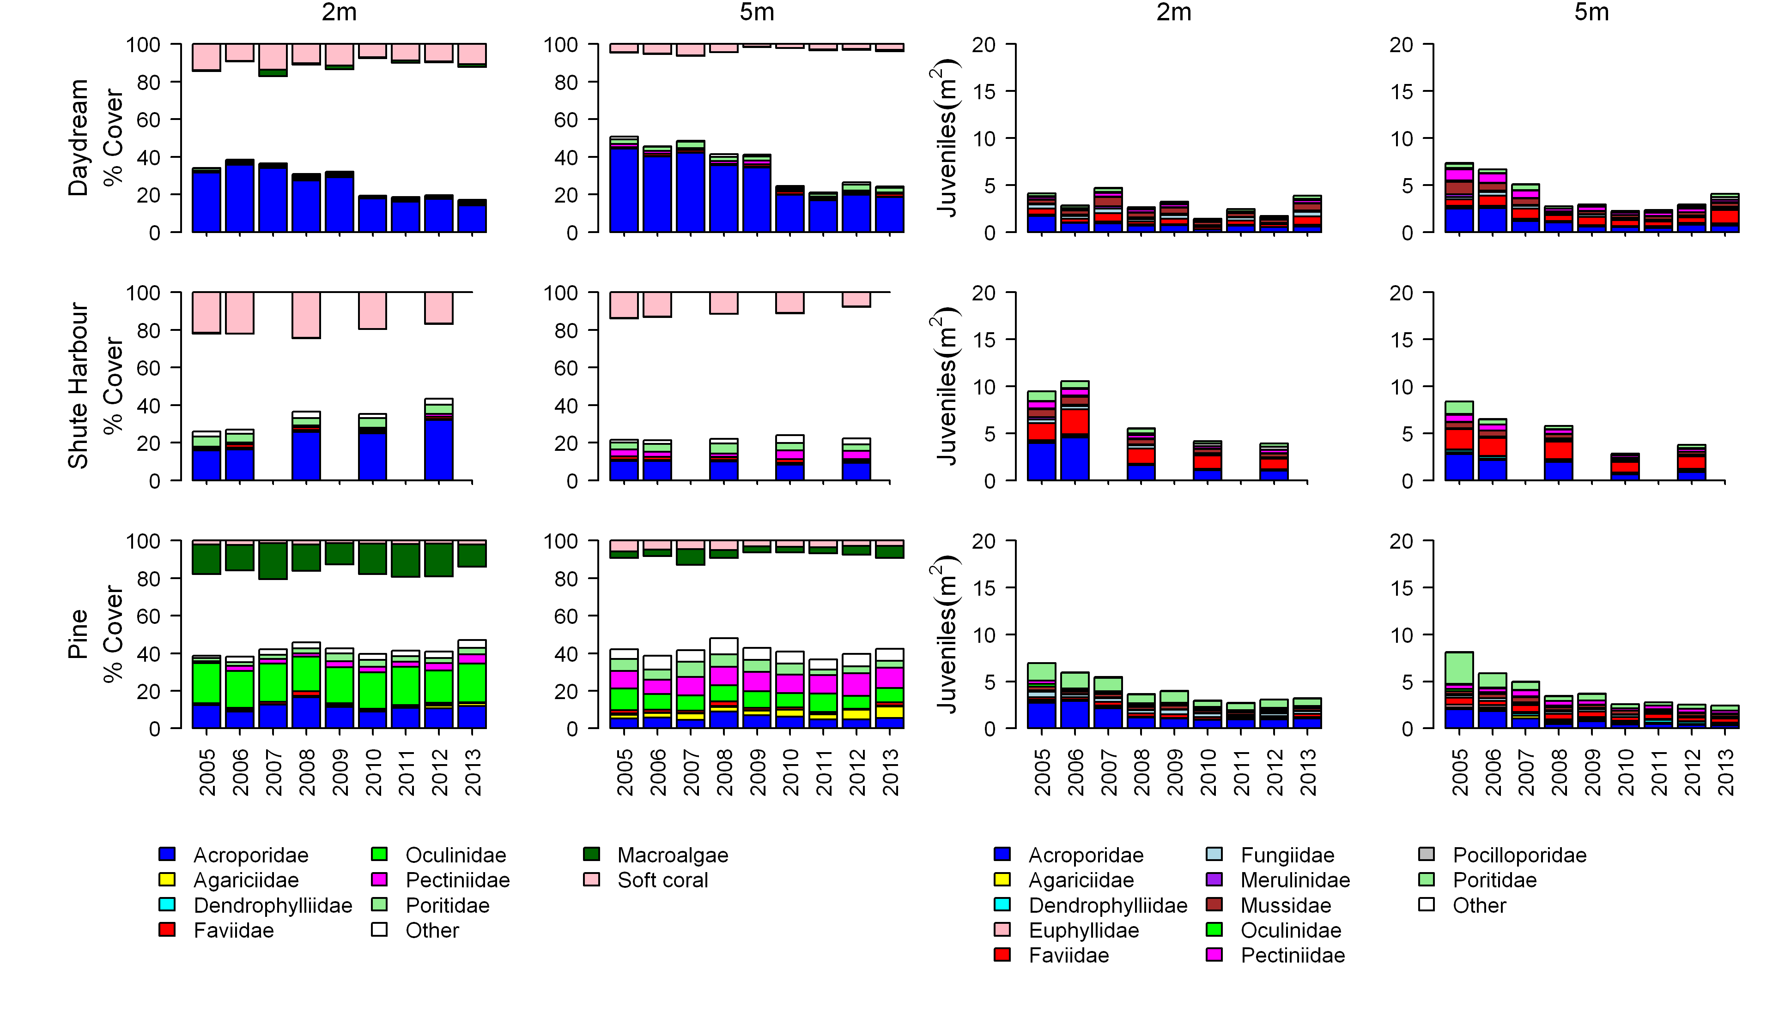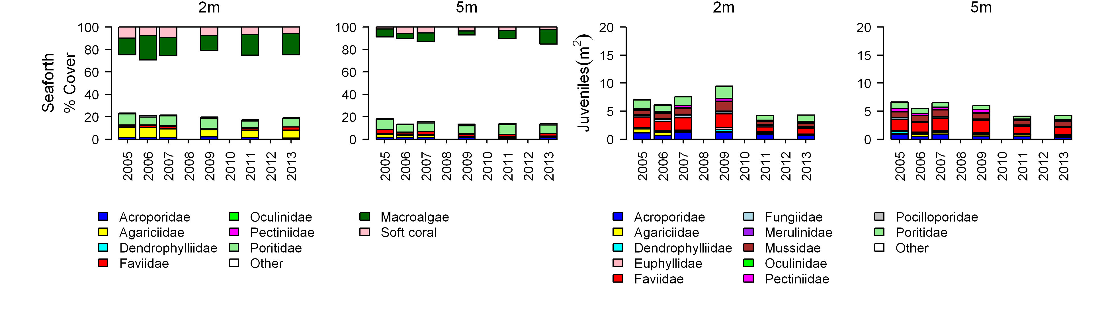

Figure 46: Cover of major benthic groups and density of hard coral juveniles at each depth for reefs in the inshore Mackay Whitsunday region.
Cover estimates are separated into regionally abundant hard coral families and the total cover for soft corals and macroalgae (hanging). Juvenile density estimates are for regionally abundant hard coral families. Separate legends with relevant groupings for cover and juvenile density estimates are located beneath the respective plots.

3.6 Fitzroy
Figure 47: The condition of water quality and ecosystem health (seagrass and corals) in 2012-2013 across the inshore Fitzroy region.

3.6.1 Summary results
- Overall marine health in the inshore Fitzroy region was poor in 2012-2013. Inshore water quality and inshore seagrass meadows were poor overall, and coral reefs were in a very poor condition (Figure 47).
- Inshore water quality for the region, as determined by remote sensing, remained poor in 2012-2013. Concentrations of chlorophyll a and suspended solids were very poor and moderate, respectively. Site specific assessments of water quality showed a clear gradient of improving water quality from inshore areas more frequently exposed to flood waters to offshore areas, with water quality poor at Pelican Island, good at Humpy Island and very good at Barren Island.
- A range of pesticides was detected including atrazine and its breakdown products, diuron, hexazinone, simazine, ametryn, simazine, prometryn, metolachlor and tebuthiuron. Only tebuthiuron exceeded the Water Quality Guidelines³ and the ANZECC and the ARMANZ Interim Working Level for marine waters. The PS-II Herbicide Equivalent Index, which considers the relative potency and abundance of each PS-II herbicide, indicated that herbicides were present at concentrations below which no published PS-II inhibition effects have been observed (Category 5).
- Inshore seagrass meadows remained in poor condition overall. Seagrass abundance was rated poor across all habitats. Reproductive effort was very poor, suggesting a low capacity to recover from disturbance. The nutrient content of seagrass tissue varied according to habitat type, but was moderate overall.
- Inshore coral reefs declined to very poor in 2012-2013. The rate of change in coral cover and density of juveniles were both very poor, while macroalgae remained poor. The influence of repeated flood events on water quality in the Fitzroy region has contributed to the decline in coral reef condition. The very poor and poor scores for all community attributes may have implications for the resilience of coral reefs in the inshore region.

3.6.2 Water quality condition and trend
Inshore water quality (assessed by remote sensing of chlorophyll a and suspended solids) in the Fitzroy region remained poor in 2012-2013 (Figure 48). Changes to inshore water quality since 2009-2010 have been driven by relatively larger fluctuations in chlorophyll a compared to total suspended solids.
Chlorophyll a was rated as very poor in 2012-2013, with concentrations exceeding the Water Quality Guidelines³ for 97 and 85 per cent on the inshore area in the dry and wet season, respectively. Total suspended solids were rated as moderate in 2012-2013. However, concentrations exceeded the Water Quality Guidelines³ for 53 and 55 per cent of the inshore area in the dry and wet season, respectively.
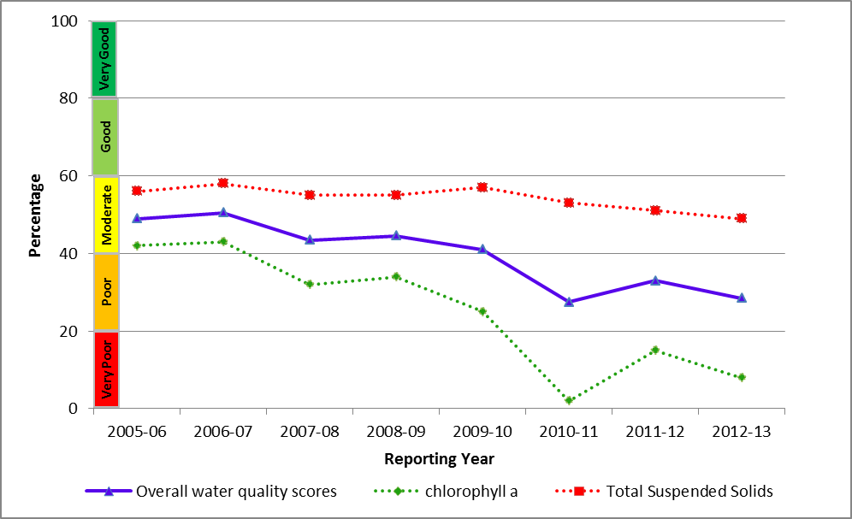
Figure 48: Trend in the water quality index from 2005-2006 to 2012-2013 in the inshore Fitzroy region.
Water quality across the region showed a clear gradient of declining water quality from offshore areas to inshore areas more frequently exposed to flood waters. This gradient was supported by long-term assessments of water quality at specific sites, with variability between sites reflecting local hydrodynamic conditions and biophysical processes.
Site-specific water quality was poor at Pelican Island, good at Humpy Island and very good at Barren Island, respectively, reflecting increasing distance away from river influence (Figure 49). At Pelican Island, the Water Quality Guidelines³ were generally exceeded for all variables in 2012-2013 except for particulate nitrogen. The water quality scores are a long-term integrative assessment based on four indicators of water quality relative to the Water Quality Guidelines.³
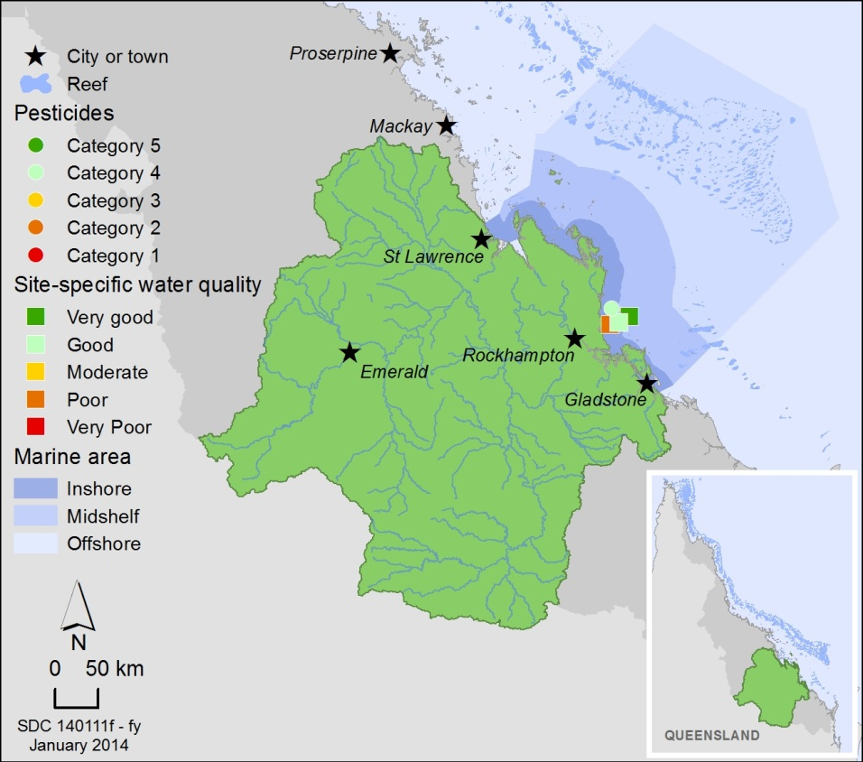
Figure 49: Water quality and pesticide scores for PS-II herbicides at fixed monitoring sites in the Fitzroy.
The water quality scores are a long-term integrative assessment based on four indicators of water quality relative to the Water Quality Guidelines.³ The pesticide scores reflect the PS-II Herbicide Equivalent Index categories for maximum equivalent concentrations at each site. These concentrations.integrate the relative potency and abundance of each PS-II herbicide to give the PS-II Herbicide Equivalent Index.
A range of pesticides was detected in the inshore Fitzroy region including atrazine and its breakdown products, diuron, hexazinone, simazine, ametryn, simazine, prometryn, metolachlor and tebuthiuron. Concentrations of PS-II herbicides were above those known to affect photosynthesis in diatoms (Category 4) at North Keppel Island (Figure 50). However, when the concentration of individual pesticides was examined at North Keppel Island, only tebuthiuron exceeded the Water Quality Guidelines³ and the ANZECC and ARMCANZ Interim Working Level for marine waters.
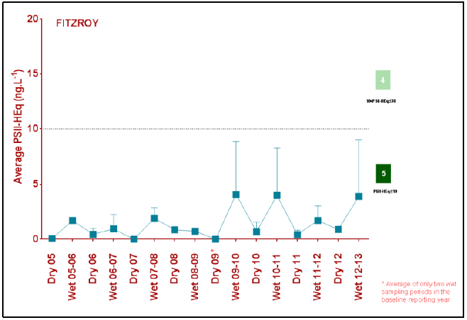
Figure 50: Trends in average PS-II herbicide equivalent concentrations at the sampling site in the Fitzroy according to season.
High concentrations generally coincided with periods of high flow from the major rivers in the wet season compared to the dry season.

3.6.3 Seagrass condition and trend
The condition of inshore seagrass in the Fitzroy region remained poor in 2012-2013 (Figure 51), driven largely by a decline in seagrass reproduction to very poor.
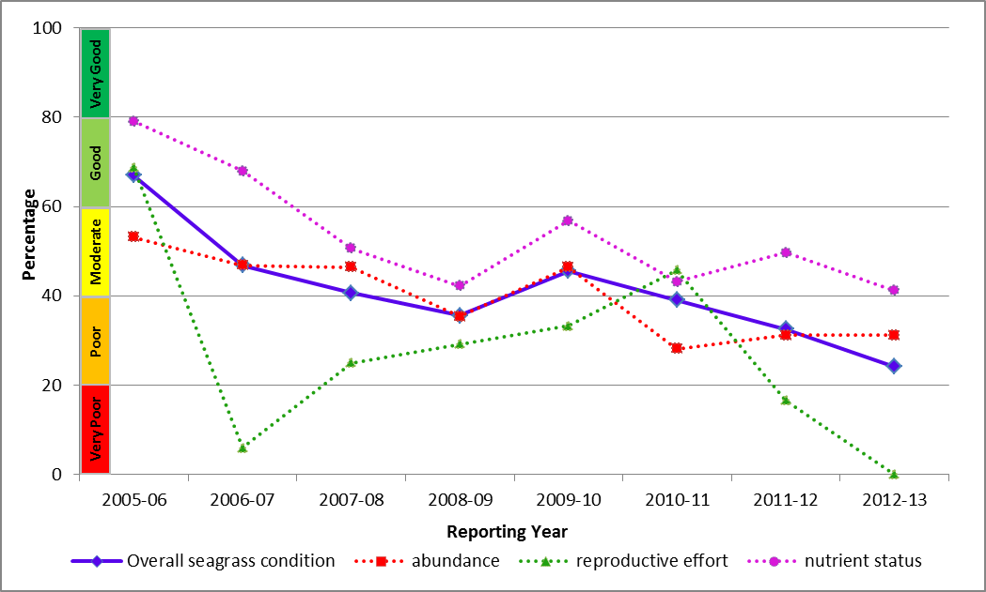
Figure 51: Trend in seagrass condition from 2005-2006 to 2012-2013 in the Fitzroy.
Seagrass meadows were monitored at coastal, estuarine and fringing reef locations in the inshore Fitzroy region. Key environmental drivers in the inshore region include exposure at very low tide and high turbidity. Seagrass abundance remained relatively stable across habitats and was rated poor overall in 2012-2013 (Figure 52). Reproductive effort was very poor, suggesting a low capacity to recover from disturbance. The nutrient status of seagrass tissue was moderate overall and variations between habitats reflected differences in nutrient and light availability.
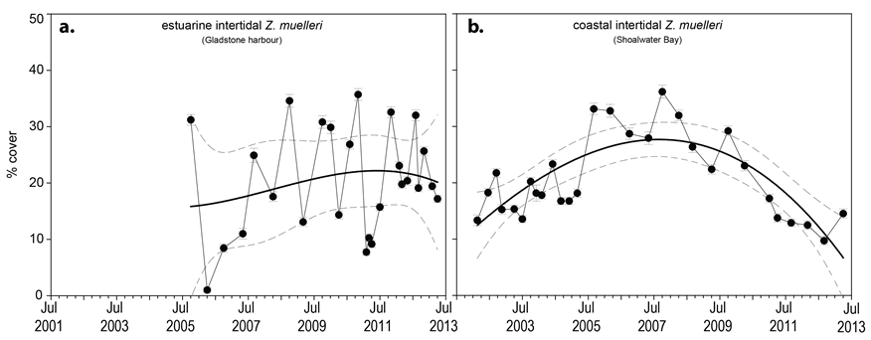
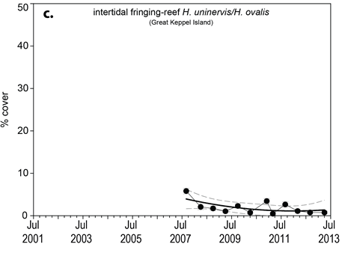
Figure 52: Changes in seagrass abundance (% cover ±Standard Error) in a) estuarine (Gladstone Harbour, b). coastal (Shoalwater Bay) and c). reef (Great Keppel Island) meadows in the inshore Fitzroy NRM region from 2001 to 2013.

3.6.4 Coral condition and trend
The overall condition of inshore coral reefs in the Fitzroy region was very poor in 2012-2013 (Figure 53). The influence of flooding on water quality has contributed to the decline in coral reef condition.
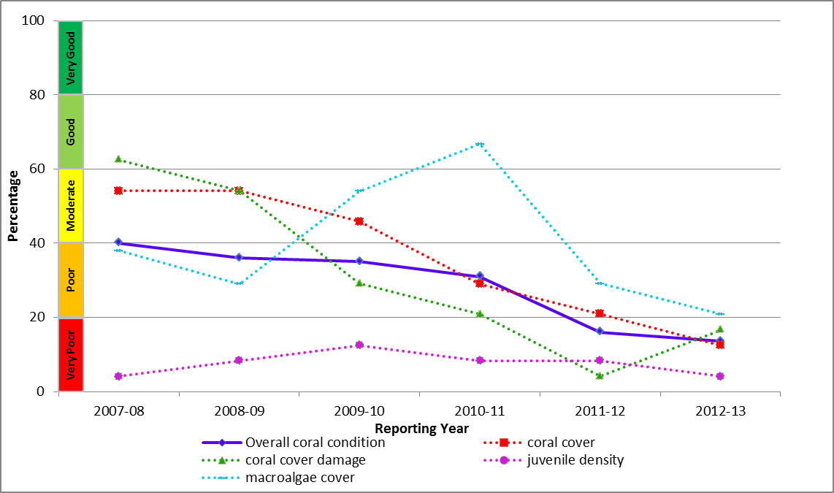
Figure 53: Trend in coral condition from 2007-2008 to 2012-2013 in the inshore Fitzroy Region.
Coral cover declined to very poor across the inshore Fitzroy region in 2012-2013 (Figure 54). The rate of change in coral cover and the density of juveniles were both very poor, while macroalge remained poor. Exposure to low salinity flood waters from the Fitzroy River in 2011 caused a marked reduction in coral cover and juvenile densities down to at least two metres depth on reefs inshore of Great Keppel Island. Elsewhere recovery from coral bleaching in 2006 and periodic storms has been compromised by a persistent bloom of macroalgae, high levels of disease and low densities of juvenile corals, all linked to the influence of flooding.
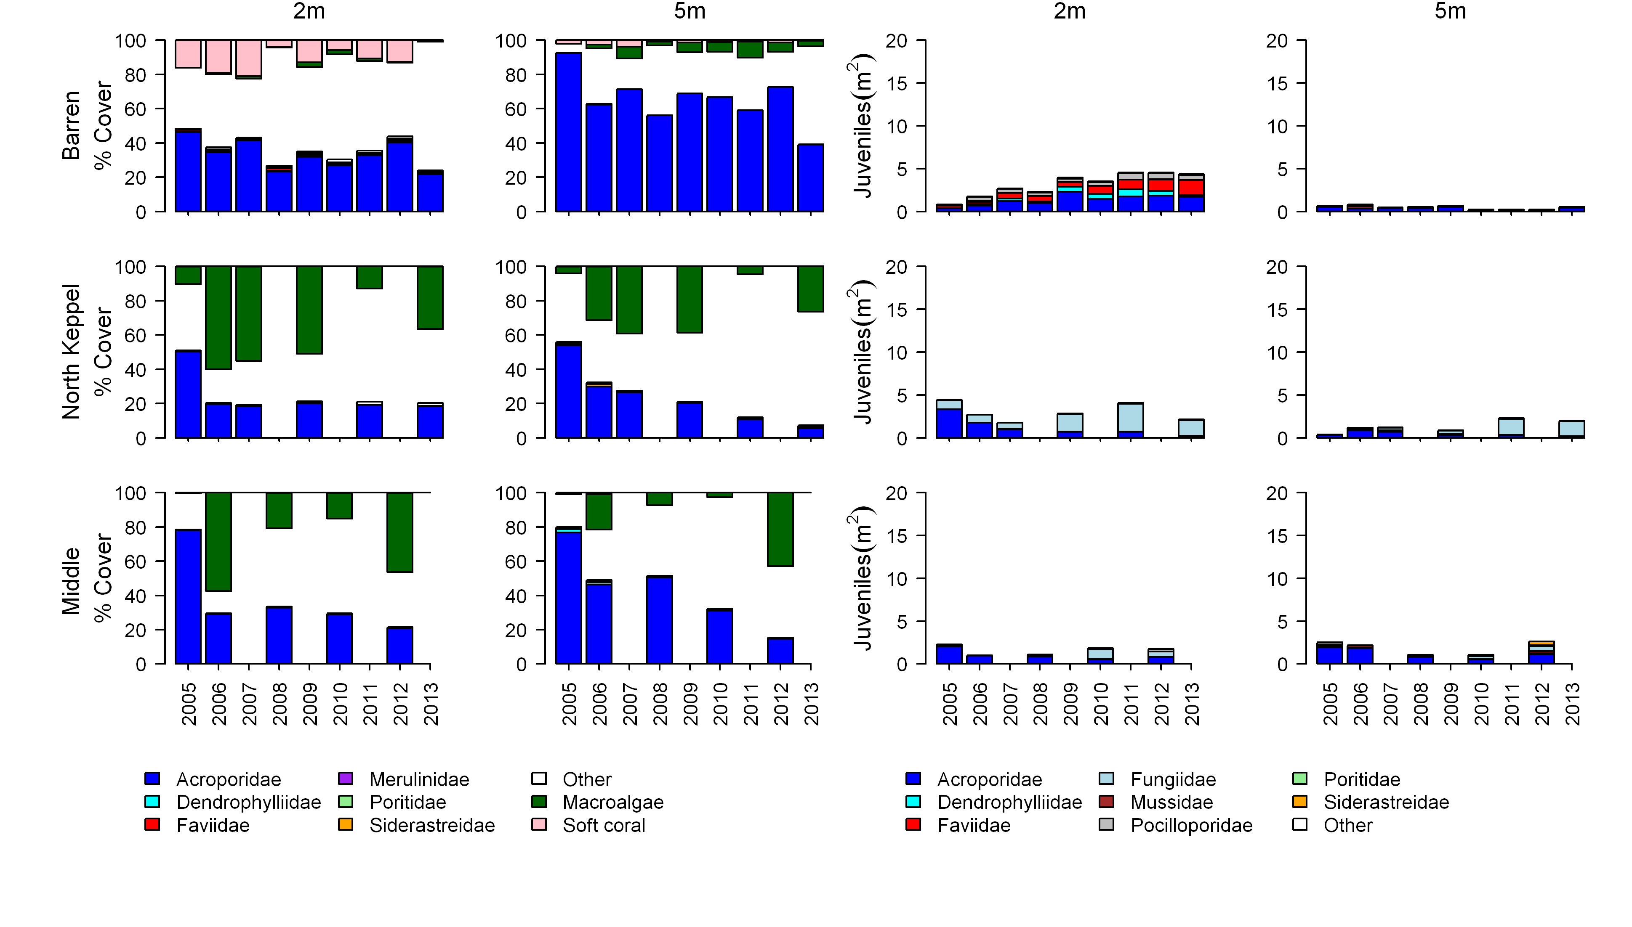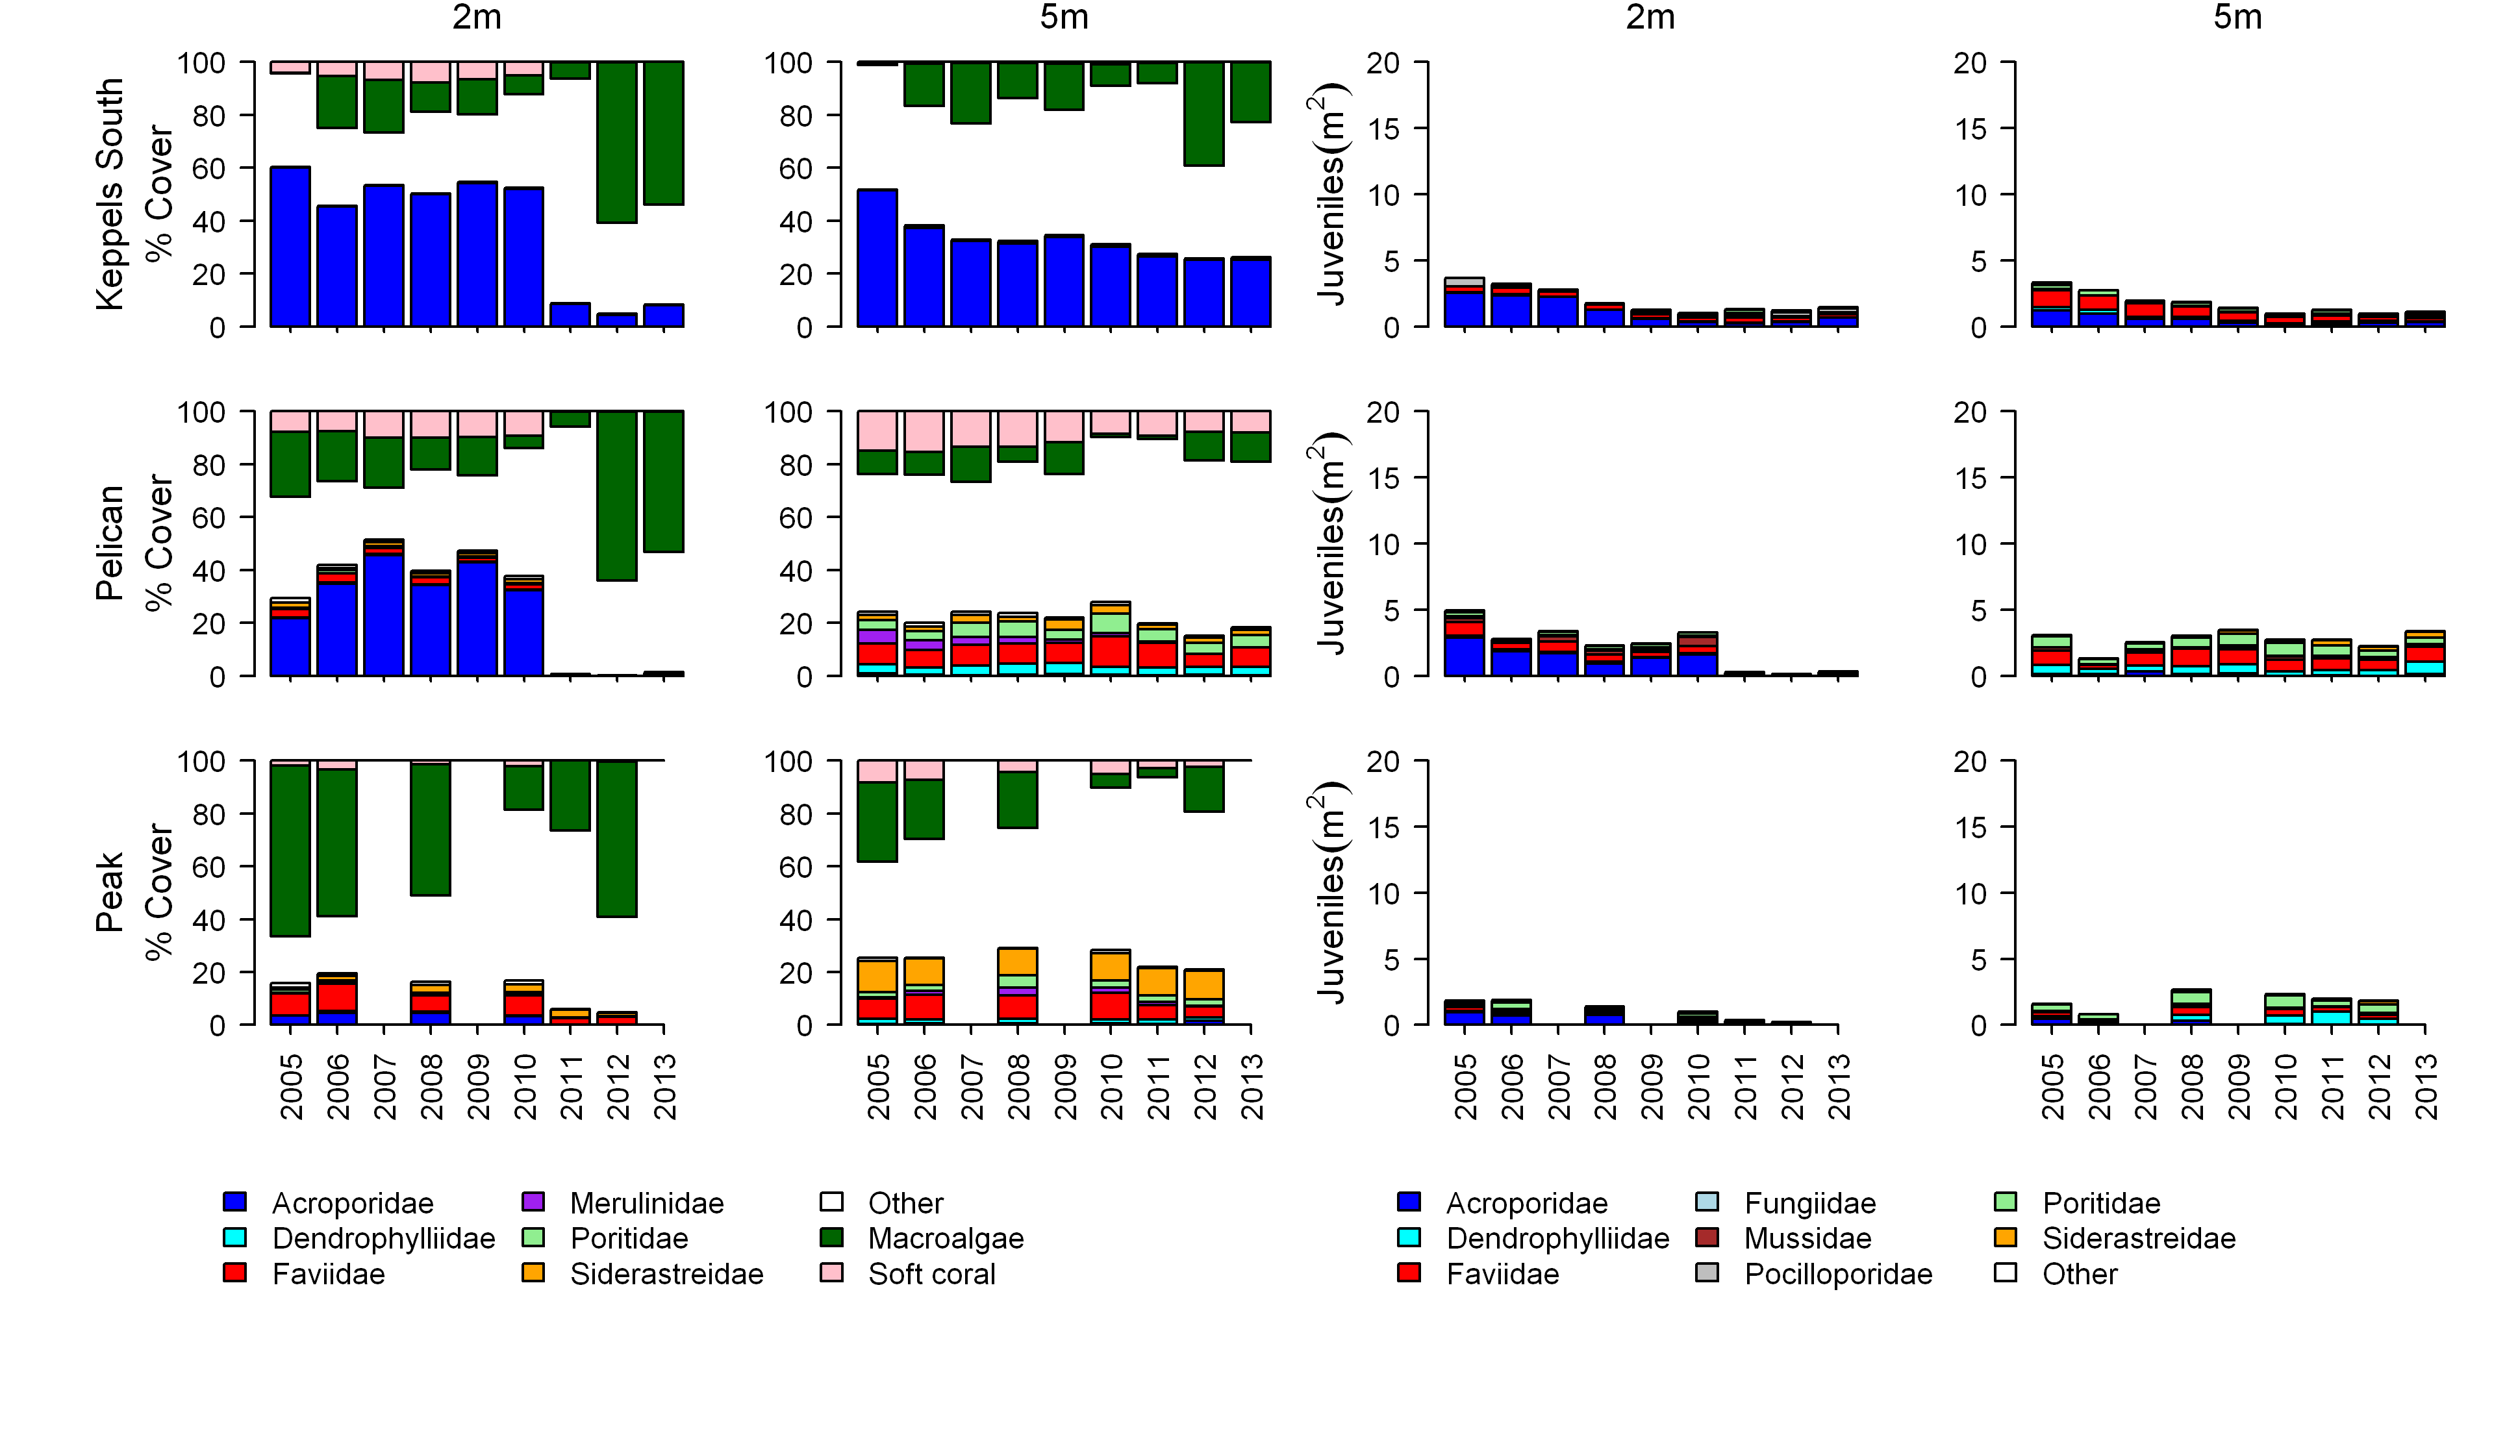
Figure 54: Cover of major benthic groups and density of hard coral juveniles at each depth for reefs in the inshore Fitzroy region.
Cover estimates are separated into regionally abundant hard coral families and the total cover for soft corals and macroalgae (hanging). Juvenile density estimates are for regionally abundant hard coral families. Separate legends with relevant groupings for cover and juvenile density estimates are located beneath the respective plots.

3.7 Burnett Mary
Figure 55: The condition of water quality and ecosystem health (seagrass and corals) in 2012-2013 across the inshore Burnett Mary region.

3.7.1 Summary results
- Overall marine health in the inshore Burnett Mary region remained poor in 2012-2013. Inshore water quality was poor and the condition of seagrass was very poor. No coral monitoring occurs in the inshore Burnett Mary region under the MMP (Figure 55).
- Inshore water quality for the region, as determined by remote sensing, was rated as poor overall in 2012-2013. Concentrations of suspended solids and chlorophyll a and suspended solids were again rated as poor and good, respectively.The continued decline in water quality was largely driven by changes in Chlorophyll a, which was a consequence of large scale floods in the Region.
- There is no routine monitoring of pesticides.
- Inshore seagrass condition remained at a very poor overall condition. Seagrass abundance and reproductive effort were very poor throughout the region. The nutrient status of seagrass tissue declined in 2012-2013 to poor, which is indicative of poor water quality following repeated flood events in the region.
- There is no comprehensive, ongoing in situ water quality monitoring in the inshore Burnett Mary Region. Estimates of chlorophyll a and total suspended solids are derived from remote sensing only, which requires further field validation and hence estimates have relatively low reliability compared to those for other regions (denoted by hatching). As such, Burnett Mary water quality data was not used in the overall assessment of Great Barrier Reef water quality and Great Barrier Reef health.
- No coral monitoring occurs in the inshore Burnett Mary region under the MMP.

3.7.2 Water quality condition and trend
Inshore water quality (assessed by remote sensing of chlorophyll a and suspended solids) in the Burnett Mary region was poor in 2012-2013 (Figure 56). The continued decline was driven by relatively large changes in chlorophyll a, while total suspended solids remained stable, which is a consequence of the recent large-scale flood events.
The water quality score is composed of very different ratings for chlorophyll a and total suspended solids. Chlorophyll a was rated as very poor in 2012-2013. Concentrations exceeded the Water Quality Guidelines³ for 99 and 97 percent of the inshore area in the dry and wet season, respectively, in 2012-2013. Total suspended solids were rated as good in 2012-2013. However, concentrations exceeded the Water Quality Guidelines³ for 27 and 36 per cent of the inshore area in the dry and wet season, respectively, in 2012-2013.
There is no routine monitoring of pesticides in the Burnett Mary.
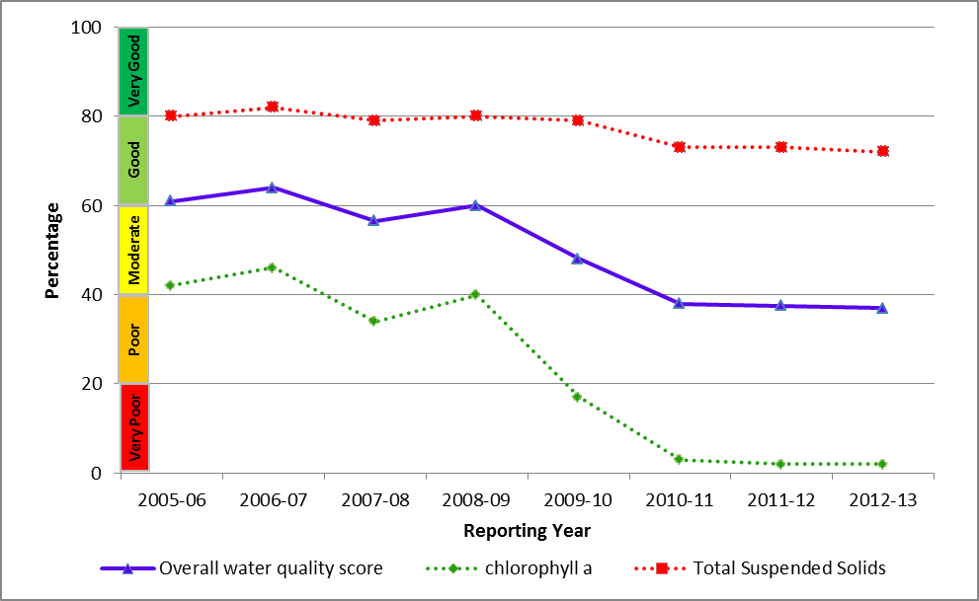
Figure 56: Trend in the water quality index from 2005-2006 to 2012-2013 in the inshore Burnett Mary region.

3.7.3 Seagrass condition and trend
The overall condition of inshore seagrass in the Burnett Mary region remained very poor in 2012-2013 (Figure 57), reflecting very poor abundance and reproductive effort of seagrass meadows. Seagrass condition has generally been declining since 2005-2006; however, the indicators driving the condition assessment have varied over the monitoring period.
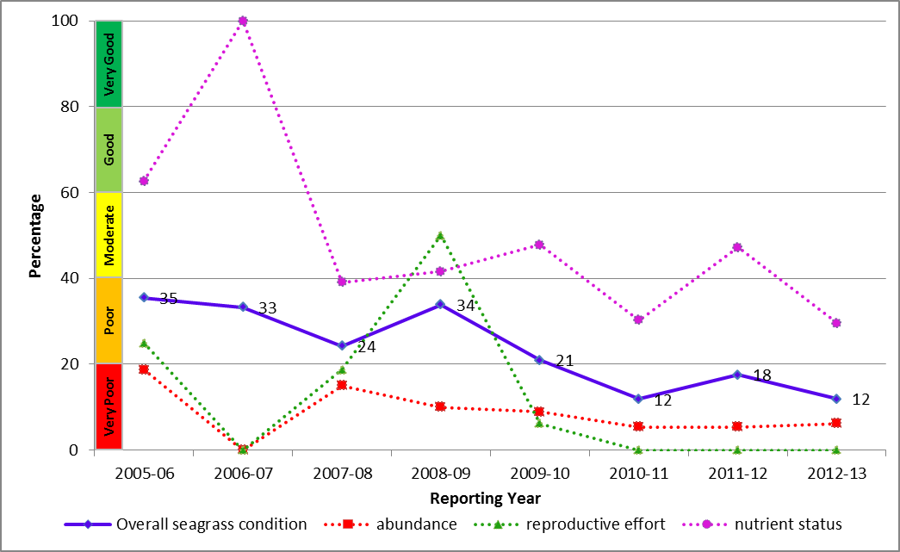
Figure 57: Trend in seagrass condition from 2005-2006 to 2012-2013 in the inshore Burnett Mary Region.
Seagrass is monitored at estuarine sites at Rodds Bay and Urangan, in the north and south of the inshore Burnett Mary region, respectively (Figure 58). The primary environmental drivers of community composition at these sites are fluctuating temperatures, catchment run-off and high turbidity. Seagrass abundance and reproductive effort were very poor in 2012-2013, which may indicate a reduced capacity of local meadows to recover from environmental disturbances. The nutrient concentrations of seagrass tissue declined to poor in 2012-2013, which is indicative of poor water quality following repeated flood events in the region.
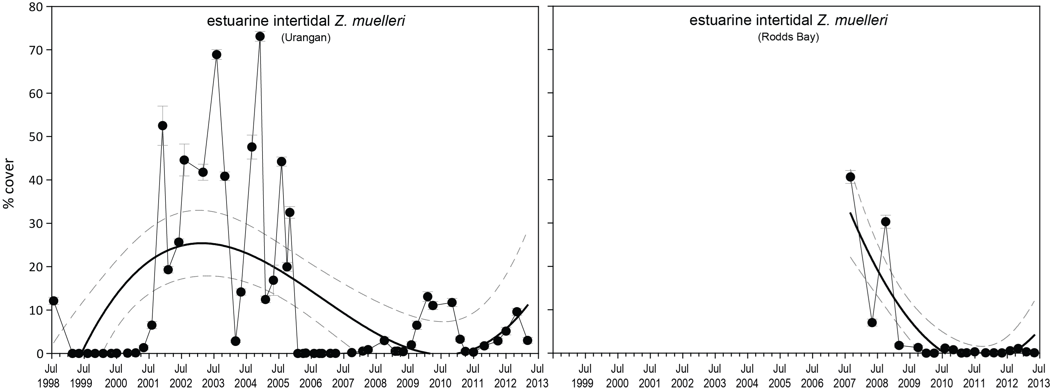
Figure 58: Changes in seagrass abundance (% cover ±Standard Error) at estuarine meadows in inshore Burnett Mary region from 1999 to 2013.

4. Summary
In the summer of 2012-2013, Tropical Cyclone Oswald delivered the most significant impact on the Great Barrier Reef, largely after it was downgraded to a significant rain depression. As the system tracked south along the coast it delivered above average rainfall to the entire Great Barrier Reef catchment, resulting in flooding of many rivers from Cairns to Bundaberg, with severe flooding in the Burnett catchment. The high winds and heavy rain associated with Cyclone Oswald had the greatest impact on coral reefs and seagrass meadows in the southern areas of the Great Barrier Reef. Impacts included wave damage, exposure to low salinity, high sediment loads and turbidity from flood plumes.
In 2012-2013, the combined river discharge for the entire Great Barrier Reef catchment was five times the annual median discharge representing the sixth consecutive year of record flow. Despite slight improvements in water quality since the record flooding of 2010-2011, the overall poor score for the Reef reflects the cumulative impact of these larger than normal flows over multiple years. Concentrations of suspended sediments frequently exceeded the Water Quality Guidelines during 2012-2013, particularly in the inshore Fitzroy region, reflecting the cumulative impact of multiple flood events and continual re-suspension of finer sediment particles by wind and wave action.
For all inshore regions of the Great Barrier Reef, one of the notable trends from remote sensing of water quality was a clear gradient of declining water quality from offshore areas more distant from terrestrial inputs, towards inshore areas were frequently exposed to flood waters. Localised changes in seagrass and coral community composition occurred both directly and indirectly as a result of the frequency and intensity of acute disturbances, in combination with the underlying chronic effects of poor water quality since 2010-2011.
Pesticides were detected at all sites in 2012-2013 with high variability in profiles and concentrations between regions and seasons. The most frequently detected pesticides in inshore waters were those that combine to inhibit PSII in plants, the most prevalent of which was diuron (heavily used in the sugarcane industry). At North Keppel Island in the Fitzroy region, Tebuthiuron (used in the grazing industry) was the only pesticide that exceeded the Water Quality Guidelines, and reflects the major land use in the Fitzroy catchment.
For the entire Great Barrier Reef coast, the condition of inshore seagrass meadows improved in 2012-2013, with small increases in abundance and reproductive effort evident at some sites; however, nutrient status remained in consistently poor condition. The impacts of the relatively slow recovery of seagrass communities on populations of dugong and turtle remain variable. Whilst recorded strandings of dugong have returned to ‘normal’ since the immediate aftermath of the 2011 floods, the rate of loss of turtles has remained higher than numbers recorded prior to the 2011 floods.
Coral cover in 2012-2013 was at its lowest since surveys began in 2005; this is a result of a combination of impacts associated with tropical cyclones, crown of thorns starfish outbreaks, broad-scale flooding and coral disease. The incidents of coral disease increased in several regions, which was related to poor water quality. Macroalgae was at its worst level for the entire Great Barrier Reef coast in 2012-2013, reflecting localised poor water quality.
The status of the Great Barrier Reef catchments that deliver pollutants to the inshore marine environment determine the risk of inshore ecosystems to flood plumes and the ecological consequences of any exposure. Each catchment is characterised by different topography, rainfall events, land use patterns and practices, and therefore the exposure of ecosystems to particular pollutants in adjacent waters is specific to these catchment characteristics. This information, coupled with knowledge of plume movement and composition that will be improved with the development of models, can be used to target management actions in areas that are delivering the highest loads of sediments, nutrients and pesticides to the Great Barrier Reef, and where the greatest number or area of inshore ecosystems are at risk of exposure to elevated levels of pollutants.
The variable climate of the Great Barrier Reef Region, its susceptibility to periodic acute disturbances, and the complexity of disturbance impacts and their potential time-lags, means that monitoring that spans several cycles of wet, dry and average years will be required to allow us to measure the trajectories of change, identify areas and regions at greatest risk, improve our ecosystem understanding and separate any influences of land management changes from the high temporal variability in marine water quality. Adaptive management that incorporates monitoring and reporting, effective networks between stakeholders and collective responses based on evidence are our best means of achieving long-term Great Barrier Reef health and resilience outcomes.

References
1. Great Barrier Reef Marine Park Authority 2009, Great Barrier Reef Outlook Report 2009, GBRMPA, Townsville, .
2. Furnas, M. 2003, Catchments and corals: terrestrial runoff to the Great Barrier Reef, Australian Institute of Marine Science, Townsville.
3. Great Barrier Reef Marine Park Authority 2010, Water quality guidelines for the Great Barrier Reef Marine Park, GBRMPA, Townsville, viewed dd/mm/yyyy, <http://www.gbrmpa.gov.au/__data/assets/pdf_file/0017/4526/GBRMPA_WQualityGuidelinesGBRMP_RevEdition_2010.pdf>.
4. Schaffelke, B., Anthony, K., Blake, J., Brodie, J., Collier, C., Devlin, M., Fabricius, K., Martin, K., McKenzie, L.J., Negri, A.P., Ronan, M., Thompson, A. and Warne, M. 2013, Chapter 1: marine and coastal ecosystem impacts, in Supporting evidence to Scientific Consensus Statement: land use impacts on the Great Barrier Reef water quality and ecosystem condition Reef Water Quality Protection Plan Secretariat, Brisbane.
5. Waters, D.K., Carroll, C., Ellis, R., Hateley, L., McCloskey, J., Packett, R., Dougall, C. and Fentie, B. 2014, Modelling reductions of pollutant loads due to improved management practices in the Great Barrier Reef catchments: Whole GBR, Volume 1, Department of Natural Resources and Mines, Brisbane, .
6. Gallen, C., Devlin, M., Paxman, C., Banks, A., Mueller, J 2013, Pesticide monitoring in inshore waters of the Great Barrier Reef using both time-integrated and event monitoring techniques (2012 - 2013), The University of Queensland, The National Research Centre for Environmental Toxicology (Entox).
7. Fabricius, K.E. 2005, Effects of terrestrial runoff on the ecology of corals and coral reefs: Review and synthesis, Marine Pollution Bulletin 50(2): 125-146.
8. Osborne, K., Dolman, A.M., Burgess, S.C. and Johns, K.A. 2011, Disturbance and the dynamics of coral cover on the Great Barrier Reef (1995–2009), PLoS ONE 6(3): e17516.
9. Great Barrier Reef Marine Park Authority 2014a, Great Barrier Reef Region Strategic Assessment: Strategic assessment report, GBRMPA, Townsville, Qld, viewed dd/mm/yyyy, <http://hdl.handle.net/11017/2861>.
10. Great Barrier Reef Marine Park Authority 2014b, Great Barrier Reef Outlook Report 2014, GBRMPA, Townsville, viewed dd/mm/yyyy, <http://hdl.handle.net/11017/2855>.
11. De'ath, G., Fabricius, K.E., Sweatman, H. and Puotinen, M. 2012, The 27–year decline of coral cover on the Great Barrier Reef and its causes, Proceedings of the National Academy of Sciences 109(44): 17995-17999.
12. Fabricius, K.E., Okaji, K. and De'ath, G. 2010, Three lines of evidence to link outbreaks of the crown-of-thorns seastar Acanthaster planci to the release of larval food limitation, Coral Reefs 29: 593-605.
13. Furnas, M., Brinkman, R., Fabricius, K., Tonin, H. and Schaffelke, B. 2013, Chapter 1: Linkages between river runoff, phytoplankton blooms and primary outbreaks of crown-of-thorns-seastars in the northern GBR, in Assessment of the relative risk of degraded water quality to ecosystems of the Great Barrier Reef: supporting studies. A report to the Department of Environment and Heritage Protection, Queensland Government, ed. J. Waterhouse, Centre for Tropical Water & Aquatic Ecosystem Research, James Cook University, Townsville.
14. Álvarez-Romero, J.G., Devlin, M., Teixeira da Silva, E., Petus, C., Ban, N.C., Pressey, R.L., Kool, J., Roberts, J.J., Cerdeira-Estrada, S., Wenger, A.S. and Brodie, J. 2013, A novel approach to model exposure of coastal-marine ecosystems to riverine flood plumes based on remote sensing techniques, Journal of Environmental Management 119: 194-207.
15. Brodie, J.E., Kroon, F.J., Schaffelke, B., Wolanski, E.C., Lewis, S.E., Devlin, M.J., Bohnet, I.C., Bainbridge, Z.T., Waterhouse, J. and Davis, A.M. 2012, Terrestrial pollutant runoff to the Great Barrier Reef: An update of issues, priorities and management responses, Marine Pollution Bulletin 65: 81-100.
16. Collier, C., Waycott, M. and Ospina, A.G. 2012, Responses of four Indo-Pacific seagrass species to shading, Marine Pollution Bulletin 65: 342-354.
17. McKenzie, L.J., Collier, C. and Waycott, M. 2012, Reef Rescue Marine Monitoring Program: Inshore seagrass, annual report for the sampling period 1st July 2010 – 31st May 2011, Fisheries Queensland, Cairns, .
18. Fabricius, K.E. 2011, Factors determining the resilience of coral reefs to eutrophication: A review and conceptual model, in Coral Reefs: An Ecosystem in Transition, eds Z. Dubinsky and N. Stambler, Springer, Dordrecht, pp. 493-508.
19. Weber, M., de Beer, D., Lott, C., Polerecky, L., Kohls, K., Abed, R.M.M., Ferdelman, T.G. and Fabricius, K.E. 2012, Mechanisms of damage to corals exposed to sedimentation, Proceedings of the National Academy of Sciences 109(24): E1558-E1567.
20. Moran, P.J. and De'ath, G. 1992, Estimates of the abundance of the crown-of-thorns starfish Acanthaster planci in outbreaking and non-outbreaking populations on reefs within the Great Barrier Reef, Marine Biology 113: 509-515.
21. Miller IR and Sweatman H 2013, The status of crown-of-thorns starfish populations on the Great Barrier Reef from AIMS surveys. Report to the National Environmental Research Program, Reef and Rainforest Research Centre Limited, Cairns, viewed dd/mm/yyyy, <http://www.nerptropical.edu.au/sites/default/files/publications/files/The%20status%20of%20crown-of-thorns%20starfish...%20Miller%20et%20al%202013.pdf>.
22. Brodie, J., Fabricius, K.E., De'ath, G. and Okaji, K. 2005, Are increased nutrient inputs responsible for more outbreaks of crown-of-thorns starfish? An appraisal of the evidence, Marine Pollution Bulletin 51(1-4): 266-278.
23. Maynard, J.A., Johnson, J.E., Marshall, P.A., Eakin, C.M., Goby, G., Schuttenberg, H. and Spillman, C.M. 2009, A Strategic Framework for Responding to Coral Bleaching Events in a Changing Climate, Environmental management 44(1): 1-11.
24. Johnson, J.E. and Marshall, P.A. (eds) 2007, Climate change and the Great Barrier Reef: a vulnerability assessment, Great Barrier Reef Marine Park Authority and Australian Greenhouse Office, Townsville.
25. Lough, J. 2007, Climate and climate change on the Great Barrier Reef, in Climate change and the Great Barrier Reef: A Vulnerability Assessment, eds J.E. Johnson and P.A. Marshall, Great Barrier Reef Marine Park Authority and Australian Greenhouse Office, Townsville, pp. 15-50, viewed dd/mm/yyyy, <http://www.gbrmpa.gov.au/__data/assets/pdf_file/0015/4443/VA-2007-chpt-2-Lough.pdf>.
26. Bruno, J.F., Selig, E.R., Casey, K.S., Page, C.A., Willis, B., Harvell, C.D., Sweatman, H. and Melendy, A.M. 2007, Thermal stress and coral cover as drivers of coral disease outbreaks, PLoS Biology 5(6): e124.
27. Hoegh-Guldberg, O., Mumby, P.J., Hooten, A.J., Steneck, R.S., Greenfield, P., Gomez, E., Harvell, C.D., Sale, P.F., Edwards, A.J., Caldeira, K., Knowlton, N., Eakin, C.M., Iglesias-Prieto, R., Muthiga, N., Bradbury, R.H., Dubi, A. and Hatziolos, M.E. 2007, Coral reefs under rapid climate change and ocean acidification, Science 318: 1737-1742.
28. Intergovernmental Panel on Climate Change 2007, Climate change 2007 synthesis report, Summary for policymakers, IPCC Secretariat, Gland, Switzerland, .
29. Wooldridge, S.A. 2009, Water quality and coral bleaching thresholds: formalising the linkage for the inshore reefs of the Great Barrier Reef, Australia, Marine Pollution Bulletin 58(5): 745-751.
30. Shaw, M., Negri, A.P., Fabricius, K. and Mueller, J.F. 2009, Predicting water toxicity: Pairing passive sampling with bioassays on the Great Barrier Reef, Aquatic Toxicology 95(2): 108-116.
31. Booij, K., Vrana, B. and Huckins, J.N. 2007, Theory, modelling and calibration of passive samplers used in water monitoring, in Passive sampling techniques in environmental monitoring, eds R. Greenwood, G. Millis and B. Vrana, Elsevier Amsterdam, Amsterdam, pp. 141-169.
32. Devlin, M., Waterhouse, J., Taylor, J. and Brodie, J. 2001, Flood plumes in the Great Barrier Reef: spatial and temporal patterns in composition and distribution, Great Barrier Reef Marine Park Authority, Townsville.
33. Thompson, A.A. and Dolman, A.M. 2010, Coral bleaching: one disturbance too many for near-shore reefs of the Great Barrier Reef, Coral Reefs 29(3): 637-648.
34. McKenzie, L.J. MTSRF Milestone report for June 2009: Seagrass indicators, distribution and thresholds of potential concern, viewed dd/mm/yyyy, <http://www.rrrc.org.au/publications/downloads/113-QDPIF-McKenzie-L-2009-June-Milestone-Report.pdf> .
35. Thompson, A., Costello, P., Davidson, J., Schaffelke, B., Uthicke, S. and Liddy, M. 2013, Reef Rescue Marine Monitoring Program. Report of AIMS activities: inshore coral reef monitoring 2012. Report for Great Barrier Reef Marine Park Authority, Australian Institute of Marine Science, Townsville, .
36. Mitchell, C., Brodie, J.E. and White, I. 2005, Sediments, nutrients and pesticide residues in event flow conditions in streams of the Mackay Whitsunday Region, Australia, Marine Pollution Bulletin 51(1-4): 23-36.
37. Lewis, S.E., Brodie, J.E., Bainbridge, Z.T., Rohde, K.W., Davis, A.M., Masters, B.L., Maughan, M., Devlin, M.J., Mueller, J.F. and Schaffelke, B. 2009, Herbicides: A new threat to the Great Barrier Reef, Environmental Pollution 157(8-9): 2470-2484.
38. Haynes, D., Mueller, J. and Carter, S. 2000, Pesticide and herbicide residues in sediments and seagrasses from the Great Barrier Reef World Heritage Area and Queensland coast, Marine Pollution Bulletin 41(7-12): 279-287.
39. Kapernick, A., Shaw, C., Dunn, A., Komarova, T., Mueller, J., Carter, S., Eaglesham, G., Alberts, V., Masters, B., Rhode, K., Packett, R., Prange, J. and Haynes, D. 2007, River pesticide loads and GBR lagoon pesticide data (2006-2007), Report to the Great Barrier Reef Marine Park Authority. National Research Centre for Environmental Toxicology (EnTox), University of Queensland, Brisbane, .
40. Packett, R., Dougall, C., Rohde, K. and Noble, R. 2009, Agricultural lands are hot-spots for annual runoff polluting the southern Great Barrier Reef lagoon, Marine Pollution Bulletin 58(7): 976-986.
41. Magnusson, M., Heimann, K. and Negri, A.P. 2008, Comparative effects of herbicides on photosynthesis and growth of tropical estuarine microalgae, Marine Pollution Bulletin 56: 1545-1552.
42. Jones, R.J. and Kerswell, A.P. 2003, Phytotoxicity of Photosystem II (PS-II) herbicides to coral, Marine Ecology Progress Series 261: 149-159.
43. Haynes, D., Ralph, P., Prange, J. and Dennison, W. 2000, The impact of the herbicide diuron on photosynthesis in three species of tropical seagrass, Marine Pollution Bulletin 41(7-12): 288-293.
44. Duarte, C.M. 1991, Allometric scaling of seagrass form and productivity, Marine Ecology Progress Series 77: 289-300.
45. Rohde, K., Masters, B., Fries, N., Noble, R., Carroll, C., Brodie, J. and Faithful, J. 2008, Fresh and marine water quality in the Mackay Whitsunday region, 2004/05 to 2006/07, Department of Natural Resources and Water, Brisbane, viewed dd/mm/yyyy, <http://www.derm.qld.gov.au/science/projects/mackaywhitsunday/pdf/eventreport_april2008.pdf>.

