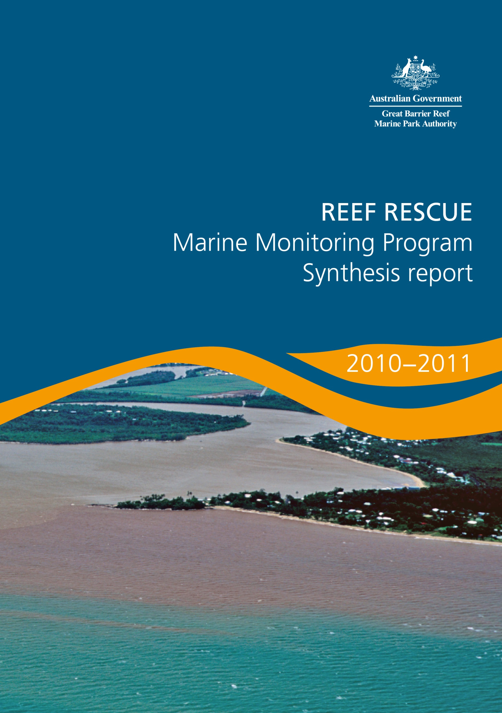

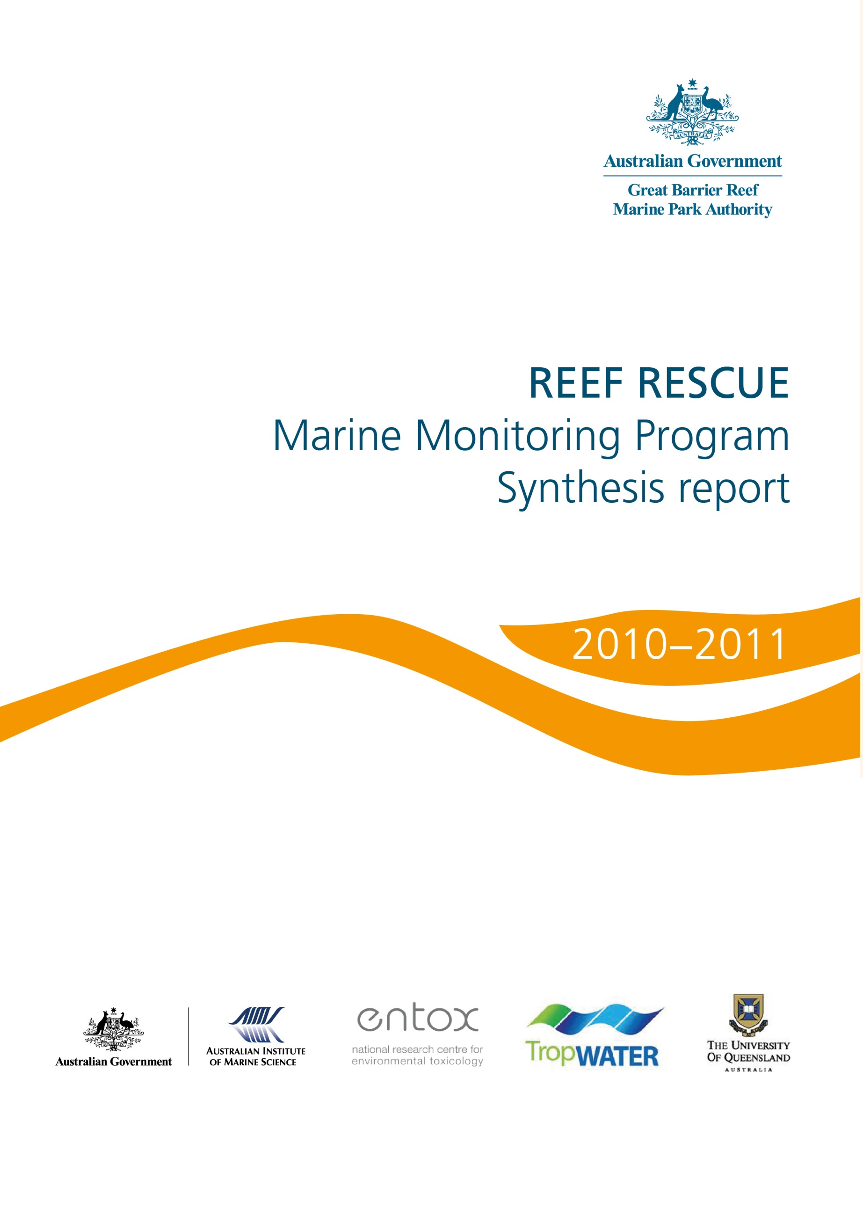

© Commonwealth of Australia 2014
Published by the Great Barrier Reef Marine Park Authority
ISSN 2200 4084
ISBN 978 1 921682 91 9 (ebook; pdf)
This work is copyright. Apart from any use as permitted under the Copyright Act 1968,
no part may be reproduced by any process without the prior written permission of the
Great Barrier Reef Marine Park Authority.
The Great Barrier Reef Marine Park Authority gratefully acknowledges the contributions of the MMP providers and their institutions to the Marine Monitoring Program Synthesis Report 2010-2011.
This publication should be cited as:
Martin, K.C., McKenzie, L.J., Thompson, A., Muller, J., Bentley, C., Paxman, C., Collier, C., Waycott, M., Brando, V. Devlin, M., and Schaffelke, B. 2014, Reef Rescue Marine Monitoring Program synthesis report. 2010-2011, GBRMPA, Townsville.
Requests and inquiries concerning reproduction and rights should be addressed to:
Director, Communication and Parliamentary
2-68 Flinders Street
PO Box 1379
TOWNSVILLE QLD 4810
Australia
Phone: (07) 4750 0700
Fax: (07) 4772 6093
info@gbrmpa.gov.au

Comments and inquiries on this document are welcome and should be addressed to:
Director, Reef 2050
info@gbrmpa.gov.au
www.gbrmpa.gov.au

Table of Contents
List of Figures 3
List of Tables 6
1. Introduction 7
1.1 The Great Barrier Reef 7
1.2 Threats from poor land management practices 7
1.3 Disturbances affecting the Great Barrier Reef 8
1.4 Influence of climate change 8
2. Methods 10
2.1 The Marine Monitoring Program 10
2.1.1 Inshore water quality 10
2.1.2 Flood plume dynamics 11
2.1.3 Seagrass status 12
2.1.4 Coral reef status 13
2.2 Synthesis and integration of data and information 15
2.2.1 Great Barrier Reef wide and regional scores 15
2.2.1.1 Water quality 15
2.2.1.2 Seagrass 15
2.2.1.3 Corals 16
2.2.2 Site-specific assessments 16
2.2.2.1 Water quality 16
2.2.2.2 Pesticides 16
3. Results 18
3.1 The Great Barrier Reef Region 18
3.1.1 Summary results 18
3.1.2 Case-study: Transport of pollutant loads entering the Great Barrier Reef in the Tully catchment 20
3.1.3 Disturbances affecting the Great Barrier Reef 22
3.1.3.1 Floods 22
3.1.3.2 Cyclones 25
3.1.3.3 Elevated sea surface temperatures 27
3.1.3.4 Crown-of-thorns starfish 29
3.1.4 Water quality condition and trend 30
3.1.4.1 Pesticides 32
3.1.5 Case-study: Declines in seagrass abundance linked to multiple stressors 34
3.1.6 Seagrass condition and trend 36
3.1.7 Coral condition and trend 39
3.2 Cape York 42
3.2.1 Summary results 42
3.2.2 Water quality condition and trend 44
3.2.3 Seagrass condition and trend 45
3.3 Wet Tropics 47
3.3.1 Summary results 47
3.3.2 Water quality condition and trend 49
3.3.3 Seagrass condition and trend 52
3.3.4 Coral condition and trend 54
3.4 Burdekin 59
3.4.1 Summary results 59
3.4.2 Water quality condition and trend 61
3.4.3 Seagrass condition and trend 64
3.4.4 Coral condition and trend 66
3.5 Mackay Whitsunday 69
3.5.1 Summary results 69
3.5.2 Water quality condition and trend 71
3.5.3 Seagrass condition and trend 74
3.5.4 Coral condition and trend 76
3.6 Fitzroy 79
3.6.1 Summary results 79
3.6.2 Water quality condition and trend 81
3.6.3 Seagrass condition and trend 84
3.6.4 Coral condition and trend 86
3.7 Burnett Mary 89
3.7.1 Summary results 89
3.7.2 Water quality condition and trend 90
3.7.3 Seagrass condition and trend 91
4. Summary 93
References 94

List of Figures
Figure 1: Passive samplers monitor marine water pesticide concentrations and WetLabs fluorometer water quality loggers for in situ marine water quality monitoring. 11
Figure 2: Satellite images (MODIS-Aqua) of the Fitzroy Region of the Great Barrier Reef during normal (low) flow conditions in November 2009 (a) and flood conditions in March and April (b, c, d). 12
Figure 3: Seagrass monitoring on the Great Barrier Reef. 13
Figure 4: Coral monitoring on the Great Barrier Reef. 14
Figure 5: The condition of water quality and ecosystem health (seagrass and corals) in 2010-2011 across the inshore region of the Great Barrier Reef. 18
Figure 6: Map of the Tully catchment showing locations of rain gauge, catchment monitoring and flood plume monitoring sites. 20
Figure 7: dissolved nutrient load at Tully Gorge and Euramo. 21
Figure 8: Dissolved Inorganic Nitrogen concentration from the initial flood plume leaving the Tully catchment. 21
Figure 9: The temporal change in DIN concentrations from two marine sites Tully River mouth (left) and Bedarra (right). 21
Figure 10. All Category 4/5 Cyclones that have affected the Great Barrier Reef from 2005 to 2011 with the zones of influence (wind categories) differentially shaded. The path of Cyclone Yasi is highlighted in red.³⁹ 26
Figure 11: Water temperature as degree heating days and areas where coral bleaching occurred. 28
Figure 12. The proportion of reefs with outbreaks of crown-of-thorns starfish since 1986 (AIMS). There were relatively few outbreaks in 2010-2011. 29
Figure 13: Trend in the water quality index from 2005-2006 to 2010-2011 (blue solid line: numbers are index categories). 30
Figure 14: Maximum PS-II herbicide equivalent concentrations at all sites monitored in the Great Barrier Reef from 2008-2009 to 2010-2011. 32
Figure 15: Maximum concentration of individual PS-II herbicides at all sites monitored across the Great Barrier Reef in 2010-2011, compared to the previous two years. 33
Figure 16: Trend in seagrass condition from 2005-2006 to 2010-2011 (blue solid line; numbers are index categories). 36
Figure 17: Trends in the abundance of inshore seagrass meadows at reef, coastal and estuarine sites since 1999. Seagrass meadows were generally in a state of decline in 2010-2011. 37
Figure 18: Average tissue nutrient content of seagrass tissue (per cent nitrogen and phosphorus) for each habitat type since 2005. 38
Figure 19: Trend in coral condition from 2007-2008 to 2010-2011 (blue solid line; numbers are index categories). 39
Figure 20: Variation in the cover of hard corals (A), cover of macroalgae (B), and density of hard coral juveniles (C) in the Wet Tropics, Burdekin, Mackay Whitsunday and Fitzroy inshore regions from 2005 to 2011. 41
Figure 21: The condition of water quality and ecosystem health (seagrass and corals) in 2010-2011 across the inshore Cape York region. 42
Figure 22: Trend in the Water quality index from 2005-2006 to 2010-2011 (blue solid line; numbers are index categories). 44
Figure 23: Trend in seagrass condition from 2005-2006 to 2010-2011 (blue solid line; numbers are index categories). 45
Figure 24: Trend in seagrass abundance (per cent cover) at the inshore intertidal fringing reef habitat at Archer Point. 46
Figure 25: The condition of water quality and ecosystem health (seagrass and corals) in 2010-2011 across the inshore Wet Tropics region. 47
Figure 26: Trend in the Water quality index from 2005-2006 to 2010-2011 blue solid line; numbers are index categories). 49
Figure 27: Water quality and pesticide scores for PS-II herbicides at fixed monitoring sites in the Wet Tropics. 50
Figure 28: Trends in average PS-II herbicide equivalent concentrations at each sampling site in the Wet Tropics according to season. 51
Figure 29: Trend in seagrass condition from 2005-2006 to 2010-2011 in the Wet Tropics (blue solid line; numbers are index categories). 52
Figure 30: Trend in seagrass abundance (per cent cover) at inshore intertidal coastal habitats (Yule Point and Lugger Bay) and inshore intertidal reef habitats (Green and Dunk Islands) in the Wet Tropics 53
Figure 31: Trend in coral condition from 2007-2008 to 2010-2011 in the Wet Tropics (blue solid line; numbers are index categories). 54
Figure 32: Cover of major benthic groups and levels of key environmental parameters: Barron Daintree sub-region, Wet Tropics Region. 55
Figure 33: Cover of major benthic groups and levels of key environmental parameters: Johnstone Russell-Mulgrave sub-region, Wet Tropics Region. 57
Figure 34: Cover of major benthic groups and levels of key environmental parameters: Herbert Tully sub-region, Wet Tropics Region. 58
Figure 35: The condition of water quality and ecosystem health (seagrass and corals) in 2010-2011 across the inshore Burdekin region. 59
Figure 36: Trend in the Water quality index from 2005-2006 to 2010-2011 (blue solid line; numbers are index categories). 61
Figure 37: Water quality and pesticide scores for PS-II herbicides at fixed monitoring sites in the Burdekin. 62
Figure 38: Trends in average PS-II herbicide equivalent concentrations at each sampling site in the Burdekin according to season. 63
Figure 39: Trend in seagrass condition from 2005-2006 to 2010-2011 in the Burdekin (blue solid line; numbers are index categories). 64
Figure 40: Trend in seagrass abundance (per cent cover) at inshore intertidal coastal habitats (Bushland and Shelly Beaches) and inshore fringing platform reef habitats (Magnetic Island) in the inshore Burdekin Region 65
Figure 41: Trend in coral condition from 2007-2008 to 2010-2011 in the Burdekin (blue solid line; numbers are index categories). 66
Figure 42: Cover of major benthic groups and levels of key environmental parameters: inshore Burdekin Region. 68
Figure 43: The condition of water quality and ecosystem health (seagrass and corals) in 2010-2011 across the inshore Mackay Whitsunday region 69
Figure 44: Trend in the water quality index from 2005-2006 to 2010-2011 (blue solid line; numbers are index categories). 71
Figure 45: Water quality and pesticide scores for PS-II herbicides at fixed monitoring sites in the Mackay Whitsundays. 72
Figure 46: Trends in average PS-II herbicide equivalent concentrations at each sampling site in the Mackay Whitsundays according to season. 73
Figure 47: Trend in seagrass condition from 2005-2006 to 2010-2011 in the Mackay Whitsundays (blue solid line; numbers are index categories). 74
Figure 48: Trend in seagrass abundance (per cent cover) at inshore intertidal estuarine habitats (Sarina Inlet), inshore intertidal coastal habitats (Pioneer Bay) and inshore fringing reef habitats (Hamilton Island) in the Mackay Whitsundays. 75
Figure 49: Trend in coral condition from 2007-2008 to 2010-2011 in the Mackay Whitsundays (blue solid line; numbers are index categories). 76
Figure 50: Cover of major benthic groups and levels of key environmental parameters: inshore Mackay Whitsunday Region. 78
Figure 51: The condition of water quality and ecosystem health (seagrass and corals) in 2010-2011 across the inshore Fitzroy region 79
Figure 52: Trend in the Water quality index from 2005-2006 to 2010-2011 (blue solid line; numbers are index categories). 81
Figure 53: Water quality and pesticide scores for PS-II herbicides at fixed monitoring sites in the Fitzroy. The water quality scores are a long-term integrative assessment based on four indicators of water quality relative to the Water Quality Guidelines.²² 82
Figure 54: Trends in average PS-II herbicide equivalent concentrations at the sampling site in the Fitzroy according to season. 83
Figure 55: Trend in seagrass condition from 2005-2006 to 2010-2011 in the inshore Fitzroy Region (blue solid line; numbers are index categories). 84
Figure 56: Trend in seagrass abundance (per cent cover) at inshore intertidal estuarine habitats (Gladstone Harbour), inshore intertidal coastal habitats (Shoalwater Bay) and inshore fringing reef habitats (Great Keppel Island) in the Fitzroy 85
Figure 57: Trend in coral condition from 2007-2008 to 2010-2011 in the inshore Fitzroy Region (blue solid line; numbers are index categories). 86
Figure 58: Cover of major benthic groups and levels of key environmental parameters in the inshore Fitzroy Region. 88
Figure 59: The condition of water quality and ecosystem health (seagrass and corals) in 2010-2011 across the inshore Burnett Mary region. 89
Figure 60: Trend in the water quality index from 2005-2006 to 2010-2011 (blue solid line; numbers are index categories). 90
Figure 61: Trend in seagrass condition from 2005-2006 to 2010-2011 in the Fitzroy Region (blue solid line numbers are index categories). 91
Figure 62: Trend in seagrass abundance (per cent cover) at inshore intertidal estuarine habitats (Urangan and Rodds Bay) in the Burnett Mary. 92

List of Tables
Table 1: The five categories of the PS-II Herbicide Equivalent Index. 17
Table 2: Annual freshwater discharge (October to September) for the major rivers of each region in the Great Barrier Reef relative to the long-term median discharge. 24
Table 3: Relative area (per cent) of the inshore, mid-shelf and offshore waterbodies of each region where the annual mean value for chlorophyll a and total suspended solids from remote sensing data exceeded the Water Quality Guidelines²² from 1 May 2010 to 30 April 2011. 31
Table 4: Summary of status and impacts to seagrass meadows in three inshore regions of the Great Barrier Reef that are important feeding grounds for dugong and predicted times to recovery. 35

1. Introduction

1.1 The Great Barrier Reef
The Great Barrier Reef is renowned internationally for its ecological importance and beauty. It is the largest and best known coral reef ecosystem in the world, extending more than 2300 kilometres along the Queensland coast and covering an area of 350,000 square kilometres. It includes more than 2900 coral reefs, as well as extensive seagrass meadows, mangrove forests and diverse seafloor habitats. It is a World Heritage Area and protected within the Great Barrier Reef Marine Park (Marine Park) in recognition of its diverse, unique and outstanding universal value. The Great Barrier Reef is also critical for the prosperity of Australia, contributing about $5.5 billion annually to the Australian economy.¹
The Great Barrier Reef is home to thousands of species, including corals and other invertebrates, bony fish, sharks, rays, marine mammals, marine turtles, sea snakes and seabirds, as well as a wide variety of other animals, algae and marine plants.¹ The high biodiversity of the region is nationally and internationally important for the continued survival of many species, particularly species of conservation concern such as dugongs, whales, dolphins, sharks and marine turtles. It is this biodiversity that builds such a remarkable ecosystem and supports human use of the Great Barrier Reef.
The Great Barrier Reef remains one of the most healthy and well managed coral reef ecosystems in the world.¹ However, there is no room for complacency as the future health and resilience of the Great Barrier Reef remains under threat from a range of factors including climate change, pollutants from the catchments and expanding coastal development. Effective management and strategic investment in improving water quality will mitigate some of the short-term impacts of climate change through enhancing Great Barrier Reef resilience. The health of the Great Barrier Reef depends on the integrity of its ecological processes and its capacity to recover from anthropogenic and natural disturbance.

1.2 Threats from poor land management practices
The Great Barrier Reef receives run-off from 35 major catchments, which drain 424,000 square kilometres of coastal Queensland. The Great Barrier Reef Region is relatively sparsely populated; however, there have been extensive changes in land use since European settlement, driven by increased urban, agricultural and industrial development, particularly in areas adjacent to the coast.^{2,3} Unfortunately, the combination of expanding catchment development and modification of land use has resulted in a significant decline in the quality of water flowing into the Reef lagoon over the past 150 years.^{2,4,5,6} Flood events in the wet season deliver low salinity waters and loads of nutrients, sediments and pesticides from the adjacent catchments into the Great Barrier Reef lagoon that are well above natural levels and many times higher than in non-flood waters.⁷ Pesticides, which are manufactured chemicals with no natural level, are now widespread in Great Barrier Reef waters.
Numerous studies have shown that nutrient enrichment, turbidity, sedimentation and pesticides all affect the resilience of the Great Barrier Reef ecosystem, degrading coral reefs and seagrass meadows at local and regional scales.^{8,9,10} Pollutants may also interact to have a combined negative effect on Great Barrier Reef resilience that is greater than the effect of each pollutant in isolation.^{11,12} For example, differences in tolerance to nutrient enrichment and sedimentation between species of adult coral can lead to changes in community composition.^{10,13}
Generally, reef ecosystems decline in species richness and diversity along a gradient from outer reefs distant from terrestrial inputs to near-shore coastal reefs more frequently exposed to flood waters.^{10,14} The area at highest risk from degraded water quality is the inshore area, which makes up approximately eight per cent of the Marine Park within 20 kilometres of the shore. The inshore area supports significant ecological communities and is also the area of the Great Barrier Reef most utilised by recreational visitors, commercial tourism operators and commercial fishers.

1.3 Disturbances affecting the Great Barrier Reef
The Great Barrier Reef ecosystem is affected by a range of human-induced and natural disturbances, including floods, cyclones, high seawater temperatures, outbreaks of coral disease and crown-of-thorns starfish. The impact of disturbances on the Great Barrier Reef depends on their frequency, duration and severity, as well as the state of the ecosystem.¹⁰
A resilient coral community has high rates of recruitment and growth that compensate for losses resulting from the combination of acute disturbances (such as cyclones) and chronic environmental stressors (for example poor water quality). However, coral recovery following a major disturbance is variable, with slow growing species taking decades to recover.¹⁵ Over time, chronic stress may decrease the resilience of the Great Barrier Reef ecosystem by slowing or inhibiting recovery from acute disturbances.^{8,10}
Importantly, reducing one stress will often help the ecosystem recover from or resist the impact of other pressures. For example, managing water quality may help minimise the effects of climate change.

1.4 Influence of climate change
Under future climate change scenarios, the frequency and intensity of disturbances is set to increase.¹⁶ The average annual seawater temperature on the Great Barrier Reef is likely to be as much as 1 to 3°C warmer than the present average temperature by 2100.^{17,18} In addition, it is predicted that Great Barrier Reef waters will become more acidic, sea level will continue to rise, patterns of ocean circulation will change and weather events will become more extreme.¹⁷ The Great Barrier Reef Outlook Report 2009¹ assessed the overall outlook for the Great Barrier Reef to be poor and that even with the recent initiatives to improve resilience, significant damage to the ecosystem may not be averted. It reported that building ecosystem resilience will give the Reef the best change of adapting to and recovering from the serious threats ahead, especially from climate change.
The extent and persistence of damage to the Great Barrier Reef will depend to a large degree on the rate and magnitude of future change in the world’s climate and on the resilience of the Great Barrier Reef ecosystem.¹ This has important implications for the future management of the Great Barrier Reef and run-off entering the Great Barrier Reef lagoon. For example, modelling suggests that the upper thermal bleaching limit of corals is affected by exposure to dissolved inorganic nitrogen and that reducing land-based run-off of this nutrient may lower bleaching thresholds and enhance the resilience of inshore corals.¹⁹ There is strong evidence that halting and reversing the decline of water quality entering the Great Barrier Reef lagoon will increase the natural resilience of Great Barrier Reef ecosystems to future challenges.

2. Methods

2.1 The Marine Monitoring Program
The most significant water quality issues for the Great Barrier Reef are those affecting inshore waters, and the majority of the assessment and monitoring information relates to this area. The Reef Rescue Marine Monitoring Program (MMP) monitors the condition of water quality in the inshore Great Barrier Reef lagoon and the long-term health of key marine ecosystems (inshore coral reefs and seagrasses). There are four sub-programs, the broad objectives of which are outlined below along with a brief overview of a sub-section of the methods.
More information about the MMP is available from the Great Barrier Reef Marine Park Authority's (agency) website: http://www.gbrmpa.gov.au/about-the-reef/how-the-reefs-managed/science-and-research/our-monitoring-and-assessment-programs/reef-rescue-marine-monitoring-program

2.1.1 Inshore water quality
Long-term monitoring of marine water quality in inshore areas of the Great Barrier Reef lagoon is essential to assess improvements in regional water quality that will occur as a result of reductions in pollutant loads from adjacent catchments.
Monitoring includes the measurement of concentrations of dissolved and particulate nutrients (nitrogen and phosphorus) and carbon, chlorophyll a, salinity, temperature, total suspended solids (water turbidity) and pesticides. Techniques used to monitor water quality include satellite remote sensing, automated high-frequency data loggers, and collection of water samples from research vessels for standard laboratory analysis. Passive samplers are used to measure the concentration of pesticides in the water column over time, by accumulating chemicals via passive diffusion.^{20,21} Key points include:
- Remote sensing of water quality utilises satellite images acquired on a daily basis across the Great Barrier Reef, except on overcast days.
- Monitoring of site-specific water quality by data loggers and direct water sampling is primarily conducted at the 14 inshore coral monitoring sites, two to three times per year, to allow for correlation with Great Barrier Reef ecosystem condition. Six open water sites off Cairns are also monitored to extend an existing long-term data series initiated in 1989 by the Australian Institute of Marine Science (AIMS).
- Pesticide concentrations are assessed with passive samplers at 12 sites at monthly intervals in the wet season and bi-monthly intervals in the dry season (Figure 1).
Water quality parameters are assessed against the Water Quality Guidelines for the Great Barrier Reef Marine Park (Water Quality Guidelines).²²
Further information is available in the annual science reports on the agency website: http://www.gbrmpa.gov.au/resources-and-publications/publications/scientific-and-technical-reports
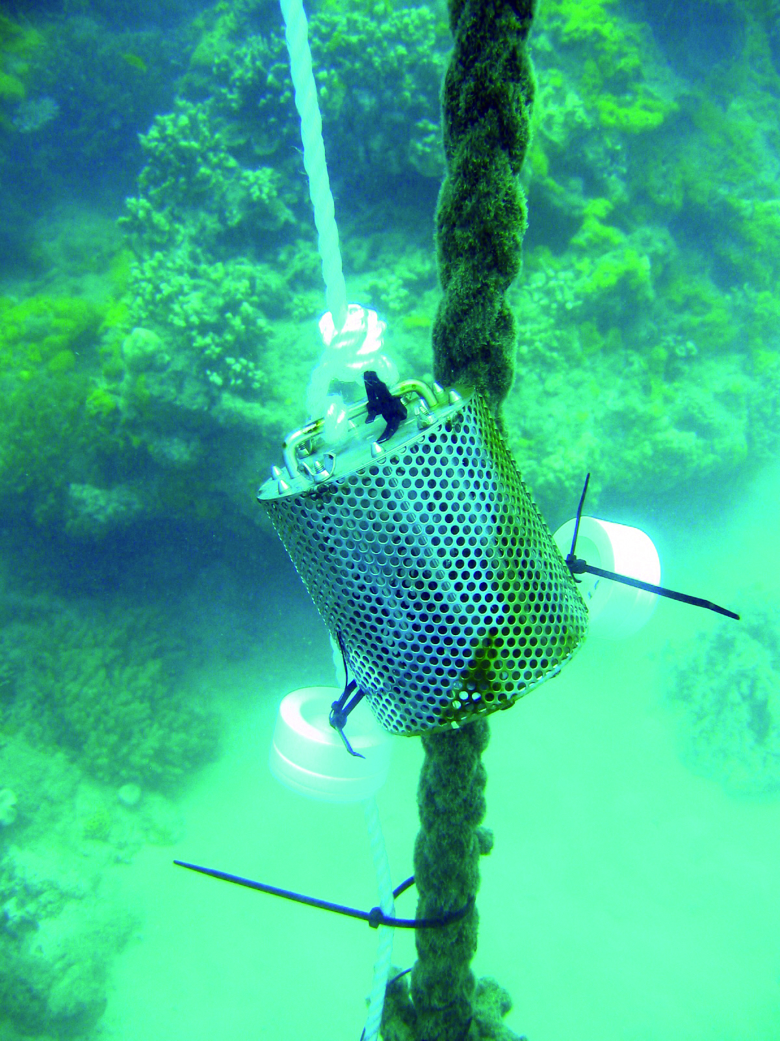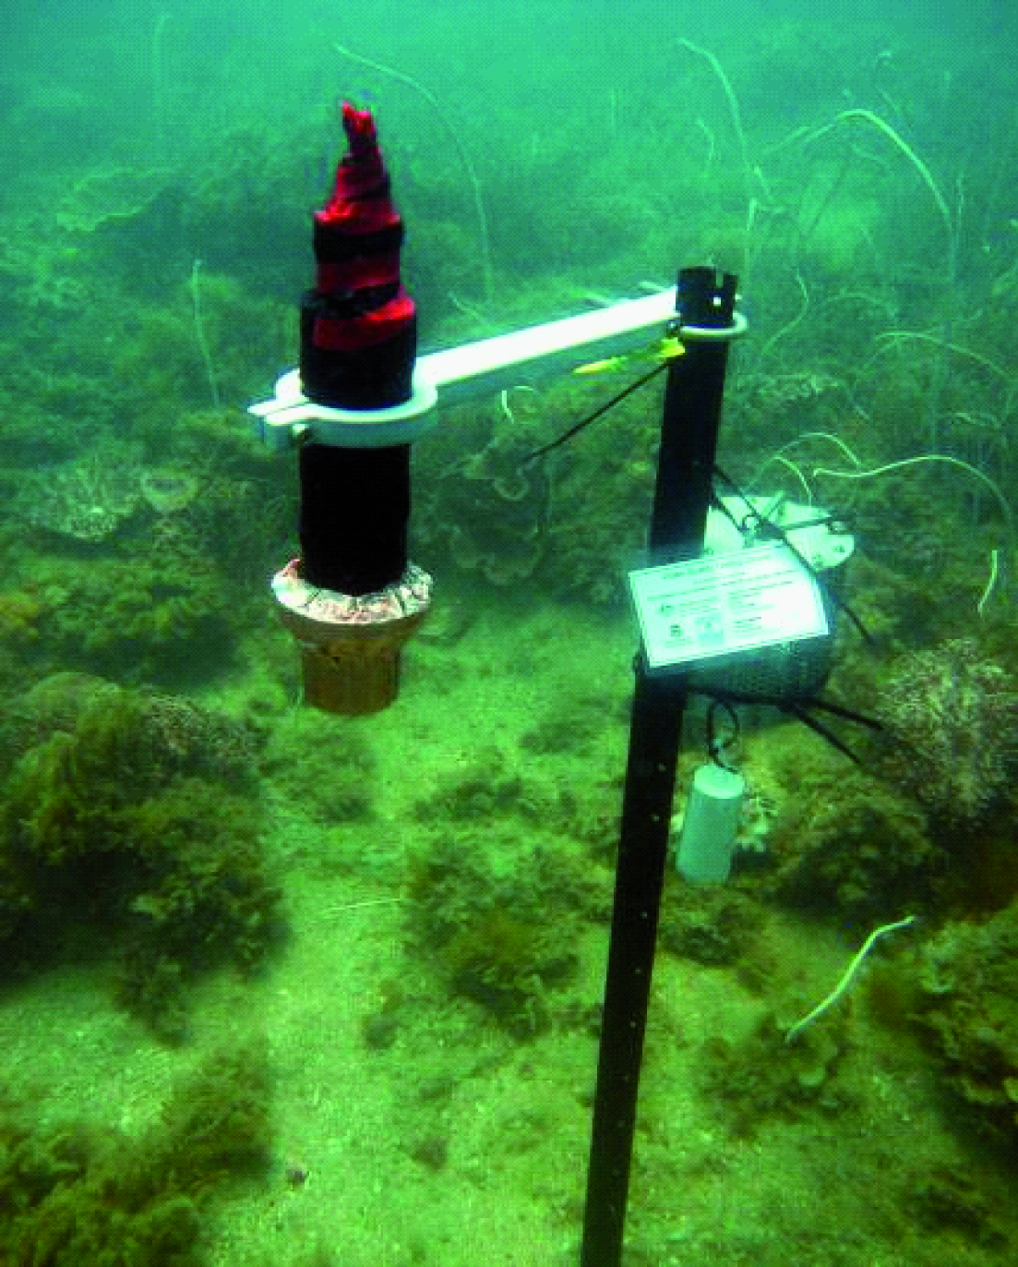
J. Muller, University of Queensland
Australian Institute of Marine Science
Figure 1: Passive samplers monitor marine water pesticide concentrations and WetLabs fluorometer water quality loggers for in situ marine water quality monitoring.

2.1.2 Flood plume dynamics
The majority of the annual pollutant load to the Great Barrier Reef is delivered by flood events in the wet season. Assessing trends in the delivery of pollutants by floods and the exposure of inshore ecosystems is essential to target management action to regions with a high probability of exposure to elevated pollutant concentrations.
Monitoring of water quality during flood events and throughout the wet season includes measurements of salinity, concentrations of nutrients, chlorophyll a, total suspended solids (water turbidity) and pesticides from water samples collected directly from research vessels. The movement of the flood plume across inshore waters of the Great Barrier Reef is assessed using images from aerial flyovers and remote sensing (Figure 2). Key points include:
- Monitoring is carried out in marine waters adjacent to targeted catchments along a north-east transect away from the river mouth, in the wet and dry tropics depending on flood conditions.
- Remote sensing of water quality utilises satellite images acquired on a daily basis across the Great Barrier Reef, except on overcast days.
Water quality parameters are assessed against the Water Quality Guidelines.²² Further information is available in the annual science reports on the agency website: http://www.gbrmpa.gov.au/resources-and-publications/publications/scientific-and-technical-reports
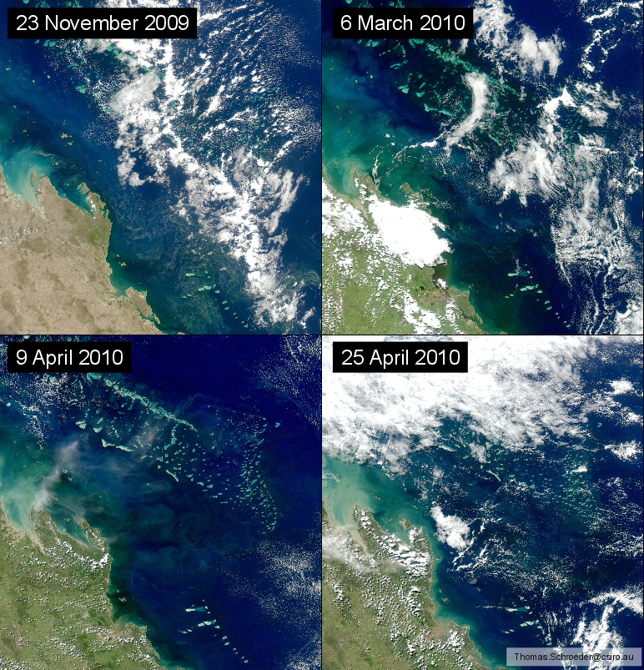
a
d
c
b
Figure 2: Satellite images (MODIS-Aqua) of the Fitzroy Region of the Great Barrier Reef during normal (low) flow conditions in November 2009 (a) and flood conditions in March and April (b, c, d).
The discharge from the Fitzroy River was more than four times the annual median flow and images b-d show large plumes of dissolved and suspended material in the coastal waters.

2.1.3 Seagrass status
Seagrasses are an important component of the marine ecosystem of the Great Barrier Reef. They form highly productive habitats that provide nursery grounds for many marine and estuarine species, including commercially important fish and prawns. Monitoring temporal and spatial variation in the status of intertidal seagrass meadows in relation to changes in local water quality is essential in evaluating long-term ecosystem health.
Monitoring includes assessment of the abundance of seagrass species, percentage of cover and seagrass reproductive effort (Figure 3), which provides an indication of the capacity for meadows to regenerate following disturbances and changed environmental conditions. Tissue nutrient composition is assessed in the laboratory as an indicator of potential nutrient enrichment. Key points include:
- Monitoring occurs at 30 sites across 15 locations, including nine inshore (intertidal coastal and estuarine) and six offshore reef intertidal locations. Three transects are monitored per site in both the late dry and monsoon seasons.
- Monitoring includes in situ within canopy temperature and light levels.
Further information is available in the annual science reports on the agency website: http://www.gbrmpa.gov.au/resources-and-publications/publications/scientific-and-technical-reports
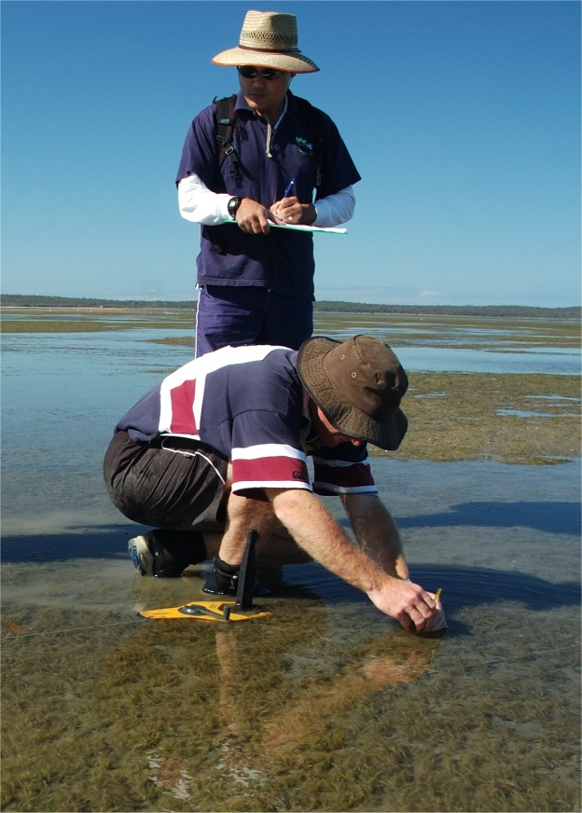
Figure 3: Seagrass monitoring on the Great Barrier Reef.

2.1.4 Coral reef status
Several reefs that make up the Great Barrier Reef are in inshore areas frequently exposed to run-off.²³ Monitoring temporal and spatial variation in the status of inshore coral reef communities in relation to changes in local water quality is essential in evaluating long-term ecosystem health.
Monitoring covers a comprehensive set of community attributes including the assessment of hard and soft coral cover; the density of hard coral juvenile colonies; macroalgae cover; and the rate of change in coral cover as an indication of the recovery potential of the Great Barrier Reef following a disturbance (Figure 4).²⁴ Comprehensive water quality measurements are also collected at many of the coral reef sites. Key points include:
- Monitoring of 32 inshore coral reefs in the Wet Tropics, Burdekin, Mackay Whitsunday and Fitzroy regions along gradients of exposure to run-off from regionally important rivers. At each reef, two sites are monitored at two depths (two and five metres) across five replicate transects. Reefs are designated as either ‘core’ or ‘cycle’ reefs. The 15 core reefs are surveyed annually and the 17 cycle reefs are surveyed every second year.
- Monitoring includes sea temperature, sediment quality and assemblage composition of benthic foraminifera as drivers of environmental conditions at inshore reefs.
Further information is available in the annual science reports on the agency website: http://www.gbrmpa.gov.au/resources-and-publications/publications/scientific-and-technical-reports
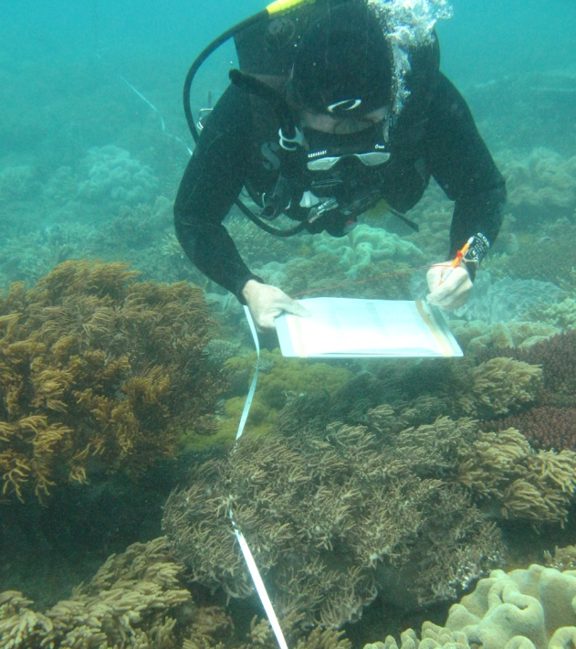
Figure 4: Coral monitoring on the Great Barrier Reef.

2.2 Synthesis and integration of data and information
A comprehensive list of water quality and ecosystem health indicators are measured under the MMP and a sub-set of these was selected to calculate the inshore water quality, seagrass and coral scores for the report card, based on expert opinion. These scores were expressed on a five point scale using a common colour scheme and integrated into an overall score that describes the status of the Great Barrier Reef and each region, where:
- 0-20 per cent is assessed as ‘very poor’ and coloured red
- >20-40 per cent equates to ‘poor’ and coloured orange
- >40-60 per cent equates to ‘moderate’ and coloured yellow
- >60-80 per cent equates to ‘good’, and coloured light green
- >80 per cent is assessed as ‘very good’ and coloured dark green.
A brief overview of the methods used to calculate the Great Barrier Reef wide and regional scores is presented below. More detailed information, including refinements to methods used for the first report card, is available from the annual science reports on the agency website: http://www.gbrmpa.gov.au/resources-and-publications/publications/scientific-and-technical-reports

2.2.1 Great Barrier Reef wide and regional scores

2.2.1.1 Water quality
The indicators used to evaluate inshore water quality status were near-surface concentrations of chlorophyll a and total suspended solids from remotely sensed images. Chlorophyll a is a measure of phytoplankton biomass that is related to the amount of available nutrients in the water column and therefore the productivity of the system. Total suspended solids is a measure of all other particulate matter in the water column, which influences water clarity and sedimentation regimes.
Water quality scores were calculated from the relative area (percentage) of inshore waters where the annual mean of chlorophyll a and total suspended solids exceeded the Water Quality Guidelines.²² The method used to calculate relative area of exceedance was refined in 2009-2010 and baseline values from 2008-2009 used in this report have been recomputed. In Cape York and Burnett Mary inshore regions, estimates of chlorophyll a and total suspended solids derived from remote sensing require further field validation and were excluded from overall assessments of Great Barrier Reef water quality and condition.

2.2.1.2 Seagrass
The indicators used to evaluate inshore seagrass condition were abundance, reproductive effort and nutrient status. Seagrass abundance includes assessment of per cent cover determined in reference to the seagrass abundance guidelines.²⁵ Reproductive effort is based on the average number of reproductive structures on an area basis and provides an indication of the capacity for recovery following disturbances. The nutrient status of seagrass is based on the ratio of carbon to nitrogen in leaf tissue and reflects the level of nutrients in the surrounding waters.
The methods used to calculate seagrass abundance, reproductive effort and nutrient status was refined in 2009-2010 and baseline values from 2008-2009 used in this report have been recomputed. The number of inshore seagrass sites in Cape York does not adequately reflect the variability of seagrass habitats in the region and were excluded from overall assessments of Great Barrier Reef seagrass condition and Great Barrier Reef condition.

2.2.1.3 Corals
The indicators used to evaluate inshore coral reef condition were coral cover, coral cover change, the juvenile density and macroalgae cover. Coral cover is a measure of the abundance of hard and soft corals, and indicates the capacity of coral to persist under the current environmental conditions and to recover from disturbances. Coral change is a measure of the change in hard coral cover from the preceding three years and is an indicator of the resilience of corals to disturbance. Juvenile density is a measure of the abundance of hard coral juveniles and is an indicator of the potential of the community to recover from disturbances or stress. Macroalgal cover is a measure of the abundance of large, fleshy algae. High abundance of algae is an indicator of poor water quality and may negatively influence the resilience of coral communities.
The method used to calculate the coral score was refined in 2009-2010 to remove the settlement of coral larvae and to include the rate of change in hard coral cover as a separate indicator, which was previously combined with assessments of coral cover. In addition, estimates of juvenile density were improved. Baseline values from 2008-2009 used in this report have been recalculated to reflect the above changes.

2.2.2 Site-specific assessments

2.2.2.1 Water quality
To complement the water quality scores derived from remotely sensed images and to give greater resolution on a regional scale, site-specific water quality data were reported in the regional sections using an interim water quality index, based on expert opinion.
The index aggregates the scores for four indicators of water quality relative to the Water Quality Guidelines²², to give an overall rating for each of the 20 fixed sampling sites (section 2.1.1). The four indicators, which reflect important bio-physical processes of the inshore environment, are an integrated assessment of turbidity, chlorophyll a and concentrations of particulate nitrogen and phosphorus. Decision rules for the water quality index are outlined in Schaffelke et al., 2010.²⁶ The proportional scores were expressed on a five point scale and converted to the colour scheme used for the Great Barrier Reef-wide and regional reporting. The water quality index will be refined with future research and data analysis.

2.2.2.2 Pesticides
The most frequently detected pesticides in inshore waters include those that inhibit the photosynthetic pathway (PS-II) of plants in an additive manner: the PS-II herbicides diuron, atrazine, hexazinone, simazine and tebuthiuron.^{27,28,29,30,31,32} These PS-II herbicides may also have a negative impact on non-target organisms such as algae, corals and seagrass.^{33,34,27,28} A metric for reporting pesticide concentrations is under development and will be based on the PS-II Herbicide Equivalent Index that was developed to incorporate both the relative potency and relative abundance of individual PS-II herbicides compared with a reference PS-II herbicide, diuron. The five categories of the Index were developed with reference to the Water Quality Guidelines²² (Table 1) and converted to the colour scheme used for the Great Barrier Reef-wide and regional reporting.
Table 1: The five categories of the PS-II Herbicide Equivalent Index.
Category | Concentration (ng.L⁻¹) | Description
5 | PS-II-HEq ≤ 10 | No published scientific papers that demonstrate any effects on plants or animals based on toxicity or a reduction in photosynthesis. The upper limit of this category is also the detection limit for pesticide concentrations determined in field collected water samples
4 | PS-II-HEq > 10  ≤ 50 | Published scientific observations of reduced photosynthesis for two diatoms.
3 | PS-II-HEq > 50  < 250 | Published scientific observations of reduced photosynthesis for two seagrass species and three diatoms.
2 | PS-II-HEq ≥ 250  ≤ 900 | Published scientific observations of reduced photosynthesis for three coral species.
1 | PS-II-HEq > 900 | Published scientific papers that demonstrate effects on the growth and death of aquatic plants and animals exposed to the pesticide. This concentration represents a level at which 99 per cent of tropical marine plants and animals are protected, using diuron as the reference chemical.

3. Results
Figure 5: The condition of water quality and ecosystem health (seagrass and corals) in 2010-2011 across the inshore region of the Great Barrier Reef.

3.1 The Great Barrier Reef Region

3.1.1 Summary results
- The condition of the inshore region of the Great Barrier Reef (similar to other reefs world-wide) has declined significantly over the last 150 years.
- Pollutant loads leaving the catchments during flood events in 2010-2011 reached the inshore region of the Great Barrier Reef in harmful concentrations.
- The Great Barrier Reef was affected by a range of disturbances. Significant rainfall events during 2010-2011 led to greater freshwater discharge across the Great Barrier Reef compared with the long-term annual median flow. Most catchments in the inshore Great Barrier Reef Region recorded flows that were two to six times above their median levels, and the Fitzroy and Proserpine Rivers had their largest flows on record. Exposure to large volumes of low salinity flood waters for an extended period contributed to localised coral bleaching on shallow, inshore reefs and significant declines in seagrass abundance. Tropical Cyclone Yasi passed through the Wet Tropics region causing physical damage to seagrass meadows and the reef at many sites, with its sphere of influence extending from Cooktown in the north to Mackay in the south.
- The overall condition of the inshore region of the Great Barrier Reef in 2010-2011 declined from moderate to poor across all regions (Figure 5). The condition of individual water quality, seagrass and coral indicators that comprise the overall condition assessment for the inshore region of the Great Barrier Reef declined at all sites monitored. It is important to refer to the inshore regional sections for detailed information due to the high spatial variability in condition assessments.
- Inshore water quality was poor overall in 2010-2011and varied from moderate to poor depending on the region (Figure 5). The overall concentrations of chlorophyll a and total suspended solids were very poor and moderate, respectively. Regional differences reflect the primary land use activities in adjacent catchments. The condition of inshore water quality had been relatively stable since 2005-2006 until the extreme weather events of 2010-2011.
- Herbicides were detected at all inshore sites in 2010-2011, with higher concentrations occurring in the wet season during periods of high flow. Diuron was the most prevalent herbicide and concentrations of tebuthiuron exceeded the Water Quality Guidelines²² at multiple sites in the inshore Burdekin and Fitzroy regions. The PS-II herbicide equivalent index, which considers the relative potency and abundance of each PS-II herbicide, showed concentrations that may have short-term effects on photosynthetic organisms were present from within one kilometre to more than 35 kilometres from the shore. There is evidence of an increasing trend in PS-II herbicide equivalent concentrations at most sites since 2005. The pesticide metolachlor exceeded the Australian and New Zealand Environment and Conservation Council (ANZECC) and the Agriculture and Resources Management Council of Australia and New Zealand (ARMANZ) interim working level for marine waters in flood plumes in the inshore Fitzroy region.
- Inshore seagrass meadows were in very poor condition overall in 2010-2011 (Figure 5), and their condition continued to decline since 2006-2007. Limited monitoring at the relatively pristine Cape York site also indicated a decline in seagrass condition from good to moderate. Seagrass abundance and reproductive effort, although highly variable between regions, were very poor overall. The nutrient status of seagrass was either poor or very poor in four of the six inshore regions, resulting in a poor score overall and indicating excess nutrients in the water.
- Inshore coral reefs were in poor condition overall in 2010-2011 (Figure 5), with some sites in the Wet Tropics and Mackay Whitsundays in moderate condition. The condition of inshore reefs had been relatively stable since 2007-2008 until the extreme weather events of 2010-2011. Coral cover at most inshore reefs was poor and the cover from competing macroaglae was low (good), particularly at sites in the inshore Mackay Whitsundays region. However, the density of hard coral juveniles and the rate of change in coral cover were very poor and poor overall, respectively, indicating recovery potential from disturbances may be poor at many inshore reefs.

3.1.2 Case-study: Transport of pollutant loads entering the Great Barrier Reef in the Tully catchment
The Tully catchment is 2,787km² and drains to the Great Barrier Reef (Figure 6). There is extensive sugar cane farming along with some grazing and horticulture as well as some protected areas in the upper part of the catchment. The catchment has high summer rainfall, with a mean annual rainfall between 2000 and 4000mm. This case-study presents concentrations of Dissolved Inorganic Nitrogen (DIN) measured in the upper (near pristine) Tully River, the lower Euramo gauge site and concentrations measured across a plume salinity gradient during periods of high flow.
The Tully River floods episodically, with the 2011 season characterised by 7 peak flow events, with maximum flow of 1833mL measured on the 3rd February, 2011 at Euramo gauge site.
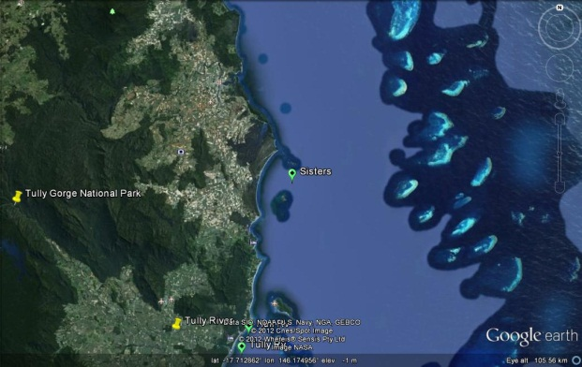
Figure 6: Map of the Tully catchment showing locations of rain gauge, catchment monitoring and flood plume monitoring sites.
The dissolved nutrients load (reported as DIN) was measured at Tully Gorge, Euramo, the mouth of the Tully and Hull River, and through plume waters of the Tully River from November to March (Figure 7 and Figure 8). At the pristine Tully Gorge site, the DIN load increased from less than 0.1mg/L during the event starting from the 17 November (day 2) until the 24th November (Day 9). The peak daily load occurred on the 22 November (Day 8).
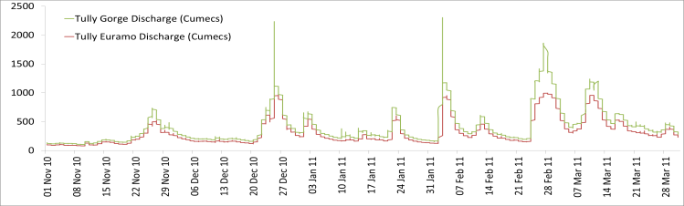
Figure 7: dissolved nutrient load at Tully Gorge and Euramo.
Figure 8: Dissolved Inorganic Nitrogen concentration from the initial flood plume leaving the Tully catchment.
Pollutants entering the Great Barrier Reef
The DIN concentration in the initial flood plume leaving the Tully catchment was measured from 22 November 2011 to 25 March 2012 (Figure 8). The concentration of all pollutants monitored was above the annual Water Quality guidelines for all days sampled over a period of 120 days. Elevated concentrations were found up to 44 km from the river mouth, past the Tully marine reef system and Islands. The graphs represent the temporal change in DIN concentrations at two marine sites, Tully River mouth and Bedarra (Figure 9). Concentrations of DIN at the Tully River mouth were relatively high compared to Bedarra, due to the transport and transformation processes occurring through the flood plume.
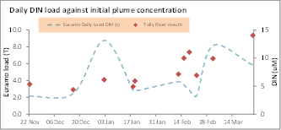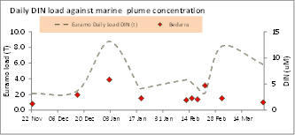
Figure 9: The temporal change in DIN concentrations from two marine sites Tully River mouth (left) and Bedarra (right).

Improving land management
Landholders in the Tully catchment are adopting improved land management practices that reduce nutrient, sediment and/or pesticide run off. This work is delivered through the Reef Water Quality Protection Plan, Reef Rescue Initiative and Terrain Natural Resource Management (http://www.reefplan.qld.gov.au/measuring-success/report-cards/second-report-card.aspx).
Effect on corals and seagrass
Nutrients in flood plumes at concentrations above the Water Quality guidelines may have a negative impact on corals and seagrass. Elevated nutrients promote the growth of macro-algae, which competes with the coral for light and space. The combination of high nutrient concentrations, reduced salinity and low light levels characteristic of flood plumes have a greater negative effect on corals and seagrass communities than each stressor in isolation (see 3.1.5).

3.1.3 Disturbances affecting the Great Barrier Reef
The health and resilience of the Great Barrier Reef is affected by a range of short-term acute and longer term chronic disturbances, including:
- floods
- cyclones
- elevated sea surface temperatures
- crown-of-thorns outbreaks.
The impact of disturbances on the Great Barrier Reef depends on their frequency, duration and severity, as well as the state of the ecosystem.^{13,35} Multiple disturbances may have a combined negative effect on Great Barrier Reef resilience that is greater than the effect of each disturbance in isolation^{36,37}. In 2010-2011, repeated floods and cyclones had a considerable impact on the water quality and ecosystem status of the inshore area of the Great Barrier Reef (Figure 5).

3.1.3.1 Floods
La Niña caused significant rainfall events across Queensland during 2010-2011, which led to greater collective freshwater discharge to the Great Barrier Reef compared with the long-term annual median flows for all years since 2000 (total discharge was more than five times the annual median flow). This was primarily due to high flows from the Burdekin, Fitzroy, Mary and Burnett Rivers, and all rivers in the Mackay Whitsunday region (Table 2). Discharges from most rivers in the Wet Tropics and Cape York regions were also at least 1.5 times their annual median flow. This is the fifth consecutive year where the collective freshwater discharge from all rivers has been greater than the long-term annual median, with the largest flows consistently from rivers in the southern regions. For example, in the 2010-2011 wet season, flows from the Fitzroy and Proserpine Rivers were the largest on record and discharge from the Herbert River was comparable to the record flood in 1994.
The influence of flood plumes on the marine environment depends on the volume and duration of river flows, the influence of wind direction and velocity, local currents and tidal regimes. Flood plumes had an impact on inshore areas along the Queensland coast during 2010-2011. The southern section of the Marine Park in particular was exposed to large volumes of low salinity flood waters for an extended period, which is likely to have contributed to localised coral bleaching on shallow, inshore reefs in the area.
In addition to large volumes of freshwater, wet season floods deliver the majority of annual loads of nutrients, sediments and herbicides to the Great Barrier Reef lagoon. In 2010-2011 concentrations of herbicides in flood plumes sometimes exceeded those known to have a negative effect on coral and seagrass.^{28,34,38}

Table 2: Annual freshwater discharge (October to September) for the major rivers of each region in the Great Barrier Reef relative to the long-term median discharge.
Median discharges were estimated from available long-term time series supplied by the Queensland Department of Environment and Resource Management and included data up to 2000, with the exception of the Burnett, Pioneer and Normanby Rivers where the mean of available data has been used. Colours highlight those years for which flow exceeded the median by 150-200 per cent (yellow), 200-300 per cent (dark orange), and more than 300 per cent (red).
Region | River | Median discharge (ML) | 2000-01 | 2001-02 | 2002-03 | 2003-04 | 2004-05 | 2005-06 | 2006-07 | 2007-08 | 2008-09 | 2009-10 | 2010-11
Cape York | Normanby | 3,323,657 |  | 0.0 | 0.0 | 0.0 | 0.0 | 0.0 | 0.5 | 1.1 | 0.7 | 0.9 | 1.8
Wet Tropics | Daintree | 727,872 | 1.4 | 0.0 | 0.2 | 2.0 | 0.7 | 1.7 | 1.0 | 1.2 | 0.0 | 1.7 | 2.2
Wet Tropics | Barron | 604,729 | 1.2 | 0.3 | 0.2 | 1.6 | 0.6 | 1.2 | 0.7 | 2.7 | 1.3 | 0.8 | 3.0
Wet Tropics | Mulgrave | 751,149 |  | 0.2 | 0.4 | 1.5 | 0.0 | 1.2 | 1.0 | 1.2 | 0.9 | 0.9 | 1.8
Wet Tropics | Russell | 983,693 | 1.0 | 0.4 | 0.6 | 1.4 | 1.0 | 1.3 | 1.3 | 1.1 | 1.1 | 1.2 | 1.7
Wet Tropics | North Johnstone | 1,732,555 | 1.2 | 0.4 | 0.5 | 1.3 | 0.8 | 1.2 | 1.2 | 1.1 | 1.1 | 1.1 | 1.9
Wet Tropics | South Johnstone | 830,984 | 1.0 | 0.4 | 0.4 | 0.0 | 0.7 | 1.2 | 1.1 | 1.0 | 1.2 | 0.9 | 1.9
Wet Tropics | Tully | 3,056,169 | 1.2 | 0.4 | 0.5 | 1.1 | 0.7 | 1.2 | 1.3 | 1.0 | 1.2 | 1.0 | 1.4
Wet Tropics | Herbert | 3,067,947 | 1.5 | 0.3 | 0.2 | 1.1 | 0.4 | 1.3 | 1.3 | 1.1 | 3.1 | 1.0 | 3.6
Burdekin | Burdekin | 6,093,360 | 1.5 | 0.7 | 0.3 | 0.2 | 0.7 | 0.4 | 1.6 | 4.5 | 4.9 | 1.3 | 5.7
Mackay Whitsunday | Proserpine | 17,140 | 0.8 | 1.2 | 1.1 | 0.6 | 1.4 | 1.2 | 2.6 | 4.5 | 3.8 | 3.1 | 20.3
Mackay Whitsunday | O’Connell | 205,286 | 1.0 | 0.4 | 0.1 | 0.0 | 0.4 | 0.4 | 0.8 | 1.1 | 0.8 | 1.5 | 2.8
Mackay Whitsunday | Pioneer | 1,375,894 |  | 0.0 | 0.0 | 0.0 | 0.0 | 0.0 | 0.6 | 1.0 | 0.7 | 1.0 | 1.7
Fitzroy | Fitzroy | 2,754,600 | 1.1 | 0.2 | 0.0 | 0.0 | 0.3 | 0.2 | 0.4 | 4.4 | 0.7 | 4.2 | 13.8
Burnett Mary | Burnett | 924,486 |  | 0.1 | 0.6 | 0.2 | 0.1 | 0.1 | 0.0 | 0.0 | 0.0 | 1.1 | 2.6

3.1.3.2 Cyclones
Three tropical cyclones had an impact on the Great Barrier Reef in 2010-2011. Cyclone Tasha (Category 1) crossed the coast near Innisfail and caused large-scale flooding from Brisbane, Burnett, Fitzroy and Burdekin Rivers. Cyclone Anthony (Category 2) passed through the Burdekin region and was closely followed by Cyclone Yasi (Category 5), which crossed the coast near Cardwell in early February 2011. Cyclone Yasi was one of the largest and most powerful cyclones to affect Queensland since records began.
About 13 per cent of the Great Barrier Reef, from Cairns to Townsville, was exposed to Yasi's destructive or very destructive wind speeds. The affected area represents a 300 kilometre stretch of the 2400 kilometre-long Great Barrier Reef. However, the influence of Yasi extended beyond the destructive wind band with some damage occurring to reefs between Townsville and Mackay Whitsundays.³⁹ Cyclones may cause extreme physical damage to benthic communities and the underlying reef structure. At the worst affected sites close to the eye of the storm, the impact of waves and debris generated by Yasi removed almost all traces of sessile marine life to depths of at least 15 metres.³⁹
Although storms of Yasi’s magnitude are generally considered rare, many areas of the Great Barrier Reef, including the inshore area, have been affected by Category 4 or 5 cyclones since 2005 (Figure 10). The combined paths of these cyclones have exposed 80 per cent of the Marine Park to gale force winds or above. Most of the affected reefs are outside the inshore area, which is a relatively small proportion of the whole Marine Park (7.8 per cent). Recent estimates attribute 34 per cent of total coral mortality recorded between 1995 and 2009 to cyclones and storms.³⁵
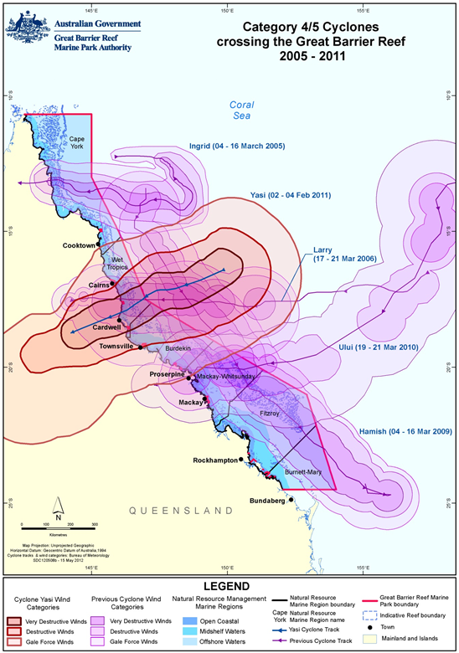
Figure 10. All Category 4/5 Cyclones that have affected the Great Barrier Reef from 2005 to 2011 with the zones of influence (wind categories) differentially shaded. The path of Cyclone Yasi is highlighted in red.³⁹

3.1.3.3 Elevated sea surface temperatures
Coral bleaching commonly occurs when accumulated temperature stress, measured as degree heating days over the summer months, exceeds a threshold of about 60-100 degree heating days.⁴⁰ In the last 50 years, an increase in the long-term average temperature of Great Barrier Reef waters is narrowing the gap between a regular summer and a coral bleaching season. For example, the frequency of mass bleaching events has increased over the last two decades, corresponding to higher seawater temperatures. Major coral bleaching events caused by unusually warm water temperatures have been recorded in the Marine Park in 1998, 2002 and to a lesser extent in 2006. Prolonged exposure to elevated seawater temperatures may increase the susceptibility of corals to disease.⁴¹
Degree heating days is a measure of only one potential stress. Coral bleaching may also occur in response to other stressors, such as exposure to low salinity flood waters and certain chemicals, and is probably often due to a combination of events.
In 2010-2011, sea surface temperatures around Australia were the highest on record.⁴² However, summer conditions on the Great Barrier Reef were influenced by a series of extreme weather events, including monsoonal cloud cover, rainfall and cyclonic activity, which collectively minimised the build-up of heat stress. Coral bleaching across the Great Barrier Reef was low to moderate, with only three per cent of reports indicating high levels of bleaching (Figure 11). Most of the bleached areas were in the central and southern sections of the Marine Park following, respectively, Cyclone Yasi and exposure to large volumes of freshwater.
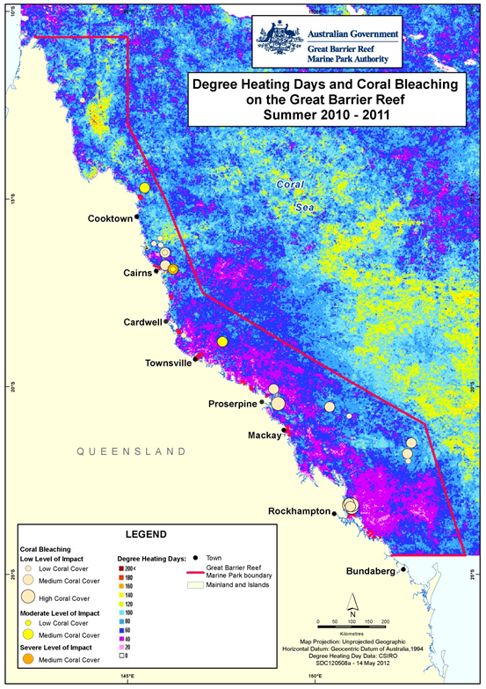
Figure 11: Water temperature as degree heating days and areas where coral bleaching occurred.

3.1.3.4 Crown-of-thorns starfish
Most of the crown-of-thorns starfish monitoring in the Great Barrier Reef is conducted by AIMS as part of the Long Term Monitoring Program (Figure 12). An active 'outbreak' of crown-of-thorns starfish is when densities are such that the starfish consume coral tissue faster than the corals can grow. This is generally considered to be densities greater than about 30 starfish per hectare.^{43,44} Most outbreaks occur on midshelf reefs, beginning along the narrow northern shelf between Cairns and Lizard Island and then moving to southern reefs as larvae are transported by the East Australian Current. The Swains Reefs in the Fitzroy region have had low-level chronic infestations throughout most of the last three decades, which is explained by the high density of reefs in this region and the regional oceanography.
Google Earth shows recent crown-of-thorns starfish densities :
(http://e-atlas.org.au/sites/default/files/datasetdetails/large-scale-manta-tow-surveys-densities-crown-thorns-starfish-and-benthic-cover-aims-ltmp-100/cots-outbreaks.kmz).
In 2010-2011, few outbreaks of crown-of-thorns starfish were detected on the northern reefs despite evidence of feeding scars on some reefs. This is because young starfish hide in the reef interior for the first two years, emerging only to feed at night. The situation in 2010-2011 is consistent with a new cycle of crown-of-thorns starfish outbreaks on the Great Barrier Reef caused by severe floods in 2009.
Crown-of-thorns starfish have had a major impact on the Great Barrier Reef since surveys began in the 1960s. A recent analysis of long-term monitoring data showed that the starfish have been responsible for more than 40 per cent of the decline in coral cover since 1985. The increasing incidence of crown of thorns starfish in recent decades may be linked to enhanced survival of larvae from nutrient-rich flood waters and increased availability of phytoplankton as a food source.^{45,46} However, a reduction in predator populations has also been suggested, as outbreaks are lower in zones closed to fishing.³⁵ It is postulated that the extremely high discharges from most rivers into the Great Barrier Reef lagoon in 2010-2011 created conditions likely to trigger additional outbreaks of crown of thorns starfish.
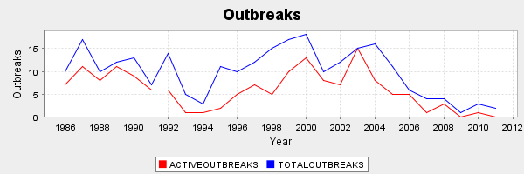
Figure 12. The proportion of reefs with outbreaks of crown-of-thorns starfish since 1986 (AIMS). There were relatively few outbreaks in 2010-2011.

3.1.4 Water quality condition and trend
The water quality of the inshore Great Barrier Reef declined from moderate to poor overall, which reflects freshwater discharge that was more than five times the annual median flow for the Great Barrier Reef Region. The decline in water quality is a departure from the trend for most years since 2005-2006 (Figure 13). Concentrations of chlorophyll a and total suspended solids were very poor and moderate overall, respectively; however, there were differences between inshore regions over time.
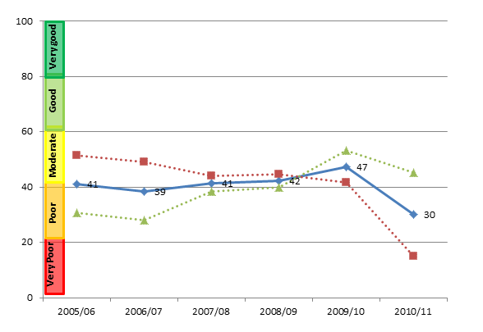
Figure 13: Trend in the water quality index from 2005-2006 to 2010-2011 (blue solid line: numbers are index categories).
The water quality index is also separated into component scores for concentrations of chlorophyll a and total suspended solids (red and green dotted lines, respectively).
In 2010-2011, remote sensing of water quality showed a clear gradient of declining water quality from offshore areas more distant from terrestrial inputs, to inshore areas more frequently exposed to flood waters. The inshore area of all regions had annual mean chlorophyll a concentrations that exceeded the Water Quality Guidelines²² with some areas approaching close to 100 per cent exceedance (shaded areas; Table 3). In Cape York and Mackay Whitsunday, water quality was influenced by a high annual mean concentration of total suspended sediment that exceeded the Water Quality Guidelines²² (shaded areas; Table 3). The relatively high concentrations of total suspended sediment in most inshore areas of Mackay Whitsunday may be a result of river discharge consistently above the median since 2007 and continued re-suspension of finer sediment particles by wind and wave action. Regions where the Water Quality Guidelines²² were exceeded had water quality scores that ranged from moderate to poor depending on the magnitude of exceedance.
Table 3: Relative area (per cent) of the inshore, mid-shelf and offshore waterbodies of each region where the annual mean value for chlorophyll a and total suspended solids from remote sensing data exceeded the Water Quality Guidelines²² from 1 May 2010 to 30 April 2011.
The confidence in water quality assessments is indicated by the relative number of valid observations used to calculate the values, where a higher number provides greater confidence in the results. Cells are shaded in grey where values exceeded the Water Quality Guidelines²² by more than 50 per cent. Caution must be applied in interpreting the results for the Cape York and Burnett Mary Regions, as well as the offshore water body, because there has been limited field validation for these regions.
Region | Number of valid observations |  |  | Chlorophyll  exceedance  (per cent) |  |  | Total suspended solids exceedance  (per cent)
Region | Inshore | Mid-shelf | Offshore | Inshore | Mid-shelf | Offshore | Inshore | Mid-shelf | Offshore
Cape York | <500,000 | 500,000-1,000,000 | >2,000,000 | 73 | 13 | 0 | 58 | 57 | 21
Wet Tropics | <500,000 | <500,000 | 500,000-1,000,000 | 93 | 31 | 2 | 30 | 6 | 30
Burdekin | <500,000 | 500,000-1,000,000 | 1,000,000-2,000,000 | 77 | 18 | 0 | 43 | 0 | 19
Mackay Whitsunday | <500,000 | 500,000-1,000,000 | 1,000,000-2,000,000 | 71 | 9 | 0 | 84 | 41 | 65
Fitzroy | <500,000 | 1,000,000-2,000,000 | >2,000,000 | 97 | 19 | 0 | 49 | 8 | 47
Burnett Mary | <500,000 | <500,000 | 1,000,000-2,000,000 | 96 | 15 | 0 | 21 | 0 | 4

3.1.4.1 Pesticides
Herbicides were detected at all sites in the Great Barrier Reef in 2010-2011, with high variability between regions and seasons. High PS-II herbicide equivalent concentrations coincided with periods of high flow from the major rivers in the wet season, and there was a positive relationship between increasing discharge and risk of exposure.
Biologically relevant concentrations of PS-II herbicides (Category 4) were present at most sites in the Wet Tropics, Burdekin, Mackay Whitsundays and Fitzroy inshore regions (Figure 14). The highest PS-II herbicide equivalent concentrations detected in 2010-2011 were in the inshore Mackay Whitsundays in areas with seagrass meadows and inshore coral reefs nearby, although concentrations were lower than those detected in 2009-2010. There is evidence of an increasing trend in PS-II herbicide equivalent concentrations since monitoring began in 2005, with Category 4 or greater levels detected at the majority of sites in 2010-2011.
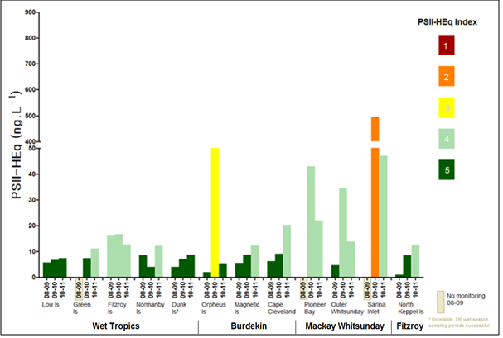
Figure 14: Maximum PS-II herbicide equivalent concentrations at all sites monitored in the Great Barrier Reef from 2008-2009 to 2010-2011.
Herbicide equivalent concentrations provide a single reporting parameter for PS-II herbicides with a similar mode of action; however, they may obscure differences in the abundance of individual herbicides detected in different regions, because herbicide equivalent concentrations also consider the potency of each herbicide. The type of pesticides detected in each inshore region is often related to the land management activities in adjacent catchments. The most prevalent herbicide detected across the Great Barrier Reef was diuron, which was the dominant contributor to the PS-II herbicide equivalent index (Figure 15). Atrazine, tebuthiuron and hexazinone were also frequently detected ⁴⁷, and tebuthiuron was the only PS-II herbicide that exceeded the Water Quality Guidelines²² at a routine monitoring site at North Keppel Island in the Fitzroy region.
However in contrast, samples collected in flood plumes had levels of tebuthiuron and metolachlor that met or exceeded the Water Quality Guidelines²² and the ANZECC and ARMCANZ interim working level for marine waters, respectively, at multiple sites in the Burdekin and the Fitzroy inshore regions. Levels of tebuthiuron were up to 4.5 times higher than the 99 per cent species protection low reliability guideline. A range of other pesticides were present including the insecticide imidacloprid, which was detected in flood waters in the Fitzroy and Wet Tropics inshore regions. There is currently no guideline value for imidacloprid and highly turbid waters may hinder the breakdown of this insecticide.
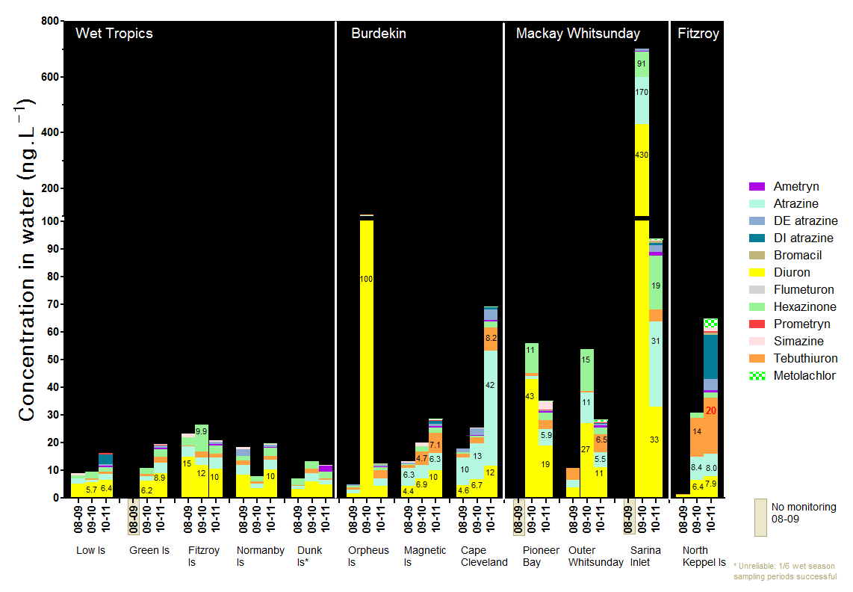
Figure 15: Maximum concentration of individual PS-II herbicides at all sites monitored across the Great Barrier Reef in 2010-2011, compared to the previous two years.

3.1.5 Case-study: Declines in seagrass abundance linked to multiple stressors
The 2010 to 2011 period saw the end of the hottest decade on record for both air and sea surface temperatures in Australia. Temperatures were above the long-term average at several locations on the Queensland coast and some areas of the Marine Park were exposed to moderate levels of cumulative heat stress in late summer. Cyclonic activity coupled with a strong La Niña brought significant rainfall events for the fourth consecutive year, which led to high freshwater discharge across the Great Barrier Reef. Flood waters deliver the majority of annual loads of nutrients, sediments and herbicides to the Great Barrier Reef lagoon, and many inshore sites had reduced water quality. The very destructive winds and five metre tidal surge from Cyclone Yasi and associated flooding caused considerable disturbance to coastal and nearshore seagrass environments from south of Cairns to Townsville.
Seagrass meadows of the Great Barrier Reef have generally been in a steady state of decline overall since 2005-2006. Indicators of this decline include:
- 80 per cent of sites with reduced (poor or very poor) seagrass abundance and 73 per cent of these sites showing declines linked to the extreme weather events of 2010-2011
- 55 per cent of sites with shrinking meadow area
- many sites with limited production of reproductive structures
- many sites with elevated tissue nutrient content.

Cumulative exposure to multiple stressors is likely to have had an impact on the resilience of inshore seagrass leading to increased vulnerability of meadows to the extreme weather events of 2010-2011. Key factors contributing to the chronic decline in seagrass abundance overall are high turbidity, which reduces the amount of light available for photosynthesis during the growing season, and elevated concentrations of nutrients. There were PS-II herbicides detected at some seagrass sites in some years, although concentrations were highly spatially and temporally variable. For example, at Sarina Inlet in Mackay Whitsundays in 2009-2010, seagrass meadows were exposed to PS-II herbicide equivalent concentrations (Categories 2 and 3) that were shown to affect photosynthesis of seagrass in the laboratory.²⁸ However, in 2010-2011, PS-II herbicide equivalent concentrations were lower (Category 4). The cumulative effect of long term exposure to low levels of herbicides on seagrass is unknown.
Following major disturbances, recovery of seagrass meadows from pioneer species through to the original foundational community structure can take more than a decade after a major disturbance.⁴⁸ There are a number of factors that will facilitate recovery of seagrass meadows, including seed banks, connectivity and improvement in environmental conditions such as light availability. Following the extreme weather events of 2010-2011, the time to recovery of meadows in three areas known to be important feeding grounds for dugong was estimated (Hinchinbrook, Shoalwater and Cleveland Bay; (Table 4). Based on the scale and nature of the impact of Cyclone Yasi and associated floods on seagrass meadows in the northern Hinchinbrook region, and their very poor reproductive effort, it was estimated that this region would be the slowest to recover. Recovery of seagrass meadows across the Great Barrier Reef will depend on the frequency and intensity of future disturbances, and whether water quality improves over the coming years before there are further big wet events.
Table 4: Summary of status and impacts to seagrass meadows in three inshore regions of the Great Barrier Reef that are important feeding grounds for dugong and predicted times to recovery.
Region | Abundance Status  (pre-event) | Impact  (H=high, M=moderate, L=low) |  |  | Reproductive status | Tissue nutrient concentrations | Estimated time to recovery to pioneer community of 25 per cent of previous mean cover (Halophila dominated) | Estimated time to recovery to foundation community
 |  | Physical | Light levels | Salinity
Northern Hinchinbrook | Poor | H^ | L | L | Poor | Poor | 1-2 years* | Slow (>5 years)
Cape Cleveland | Poor | M | L | L | Moderate | Fair | 1-2 year* | Moderate (3-8 years)
Shoalwater Bay | Fair | L | M | H | Good | Fair | One season | Fair (1-3 years)
Seagrass meadows in the northern Hinchinbrook region are likely to be slow to recover their foundational community structure, while the recovery time of meadows in Cleveland and Shoalwater Bays may be moderate and fair, respectively. * recovery of pioneer Halophila species via seed movement; will be a longer delay if substrate lost.

3.1.6 Seagrass condition and trend
The overall condition of inshore seagrass meadows in 2010-2011 declined from poor to very poor and has been declining since 2006-2007 (Figure 16). Seagrass abundance and reproductive effort were very poor, while nutrient status was poor overall. However, there are differences between habitats and inshore regions over time.
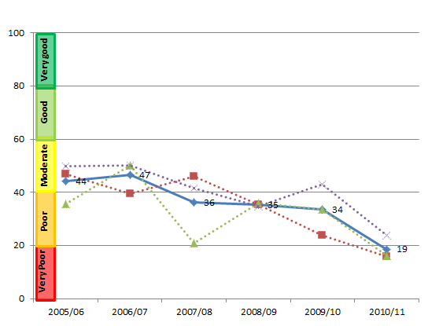
Figure 16: Trend in seagrass condition from 2005-2006 to 2010-2011 (blue solid line; numbers are index categories).
Seagrass condition is also separated into component scores for abundance, reproductive effort and nutrient status (red, green and purple dotted lines respectively).
In 2010-2011, the abundance of intertidal seagrasses declined to very poor at most locations from Cairns to the southern Great Barrier Reef. However, abundance was moderate at some sites in the northern Wet tropics and Fitzroy inshore regions. The impact of the flooding reversed any signs of recovery in abundance noted in 2009-2010. The inshore regions of greatest concern for seagrass are the Burdekin, Mackay Whitsunday and Burnett Mary where a decline in abundance was accompanied by very poor reproductive effort, which may result in reduced capacity of local meadows to recover from environmental disturbances.
Seagrass abundance differed according to habitat type (Figure 17). The greatest fluctuations occurred in estuarine habitats, most often in response to prevailing climatic conditions, but also with localised weather events such as pulses of nutrient-rich, sediment-laden flood waters and cyclonic activity. Seagrass abundance in coastal habitats has been relatively stable over the past decade; however, there are signs of decline since 2009 following repeated flood events. Abundance at inshore reef habitats appears to have been in a constant state of decline since monitoring began in 2005-2006.
Figure 17: Trends in the abundance of inshore seagrass meadows at reef, coastal and estuarine sites since 1999. Seagrass meadows were generally in a state of decline in 2010-2011.

Long-term increases in the nutrient content of seagrass tissue above biological thresholds across all habitats (Figure 18) reflected local declines in water quality. At sites in the Burdekin and Mackay Whitsunday inshore regions, interactions between low light and elevated nutrients had a negative impact on the survival of seagrass meadows. Overall, the resilience of seagrass meadows in the Great Barrier Reef is variable due to spatial and temporal variation in abundance, nutrient loads and production of reproductive structures.
Figure 18: Average tissue nutrient content of seagrass tissue (per cent nitrogen and phosphorus) for each habitat type since 2005.
Dashed lines indicate biological thresholds of 1.8 per cent and 0.2 per cent for tissue nitrogen and phosphorus, respectively. ⁴⁹ Long-term increases in the nutrient content of seagrass tissue above biological thresholds reflect local declines in water quality in some inshore regions.

3.1.7 Coral condition and trend
Inshore coral reefs remained in moderate condition overall in 2010-2011 (Figure 19). Coral cover was moderate and the level of cover from competing macroaglae was good. The density of hard coral juveniles and the rate of change in coral cover were poor overall. However, there are differences between inshore regions over time.
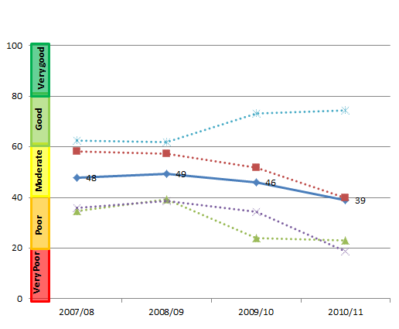
Figure 19: Trend in coral condition from 2007-2008 to 2010-2011 (blue solid line; numbers are index categories).
Coral condition is also separated into component scores for coral cover, coral cover change, juvenile density and macroalgae cover (red, green, purple and blue dotted lines, respectively). Coral data are available since 2005-2006; however, the trend in coral condition is only able to be calculated from 2007-2008, because the coral change indicator requires the preceding three years of data.
Monitoring of inshore reefs since 2005 has shown that variation in environmental conditions, particularly with respect to the magnitude of wet season run-off and other acute disturbances such as cyclones can alter the dynamics of coral communities on inshore reefs. However, the processes shaping community composition are complex and highly variable. Coral cover declined in all inshore regions to the lowest point since surveys began in 2005 (Figure 20), due to a combination of impacts associated with tropical cyclones and broad-scale flooding. In all inshore regions, the incidence of coral disease increased proportionally with the discharge of local rivers. The associated increase in turbidity and the proportion of fine-grained sediments is likely to have had a negative impact on coral growth and recruitment by smothering and limiting the amount of available light.
Coral cover of inshore reefs in the Wet Tropics varied, with those in the north in better condition than those in the south. Prior to 2010-2011, coral communities were recovering from the impact of past disturbances; however, cyclones Tasha and Yasi had a negative impact on coral cover and the density of juvenile corals across the region (Figure 20). Coral cover in the Burdekin has remained low since 2005 and reefs have had minimal recovery since a severe bleaching event in 1998. Some reefs had high larval settlement in 2010; however, cyclone Yasi hit shortly after settlement and will most likely have had a negative impact on the development of larvae into juvenile and then adult colonies. Similar to the Burdekin region, reefs in the Mackay Whitsunday also had very slow rates of increase in coral cover since cyclone Ului passed through the region in 2010. The largest change in coral cover from 2005 to 2011 occurred in the Fitzroy region with an average decline of 53 per cent, primarily due to record flooding in 2011 and coral bleaching in 2006.
Cyclone Yasi physically reduced macroalgae cover at some sites in the Wet Tropics and Burdekin inshore regions (Figure 20). However, it is likely that these reductions were only temporary and macroalgae cover is expected to increase rapidly in the following months (as was the case following cyclone Larry), due to the high availability of substrate and poor water quality at many sites.
The density of juveniles declined from 2005 to 2011 in all inshore regions except the Fitzroy, where densities remained stable (Figure 20). However, shifts in the community composition of several reefs in the Fitzroy may reflect a shift in selective pressures due to poor environmental conditions. Overall, cyclone Yasi had a negative impact on juvenile densities, with the largest declines on reefs in the Wet Tropics where juvenile density in 2010-2011 was 65 per cent lower on average. In the Burdekin and Mackay Whitsunday inshore regions, declines in juvenile densities co-occurred with high turbidity from above-median river discharge.
The relatively low cover of hard coral coupled with a decline in the density of juvenile colonies may indicate a lack of resilience of coral communities at many inshore reefs across the Great Barrier Reef. Acute disturbances in combination with periods of elevated stress from poor water quality are driving changes in the composition and condition of inshore coral reefs.
A
B
C
Figure 20: Variation in the cover of hard corals (A), cover of macroalgae (B), and density of hard coral juveniles (C) in the Wet Tropics, Burdekin, Mackay Whitsunday and Fitzroy inshore regions from 2005 to 2011.
Bold black curve represents predicted regional trend and blue dashed lines are the 95 per cent confidence intervals. Grey lines show observed trends for each reef. Data are averages from core reefs at 2m and 5m depths +/- standard error. Only reefs sampled in all years were included to ensure consistency between annual averages

3.2 Cape York
Figure 21: The condition of water quality and ecosystem health (seagrass and corals) in 2010-2011 across the inshore Cape York region.
3.2.1 Summary results
- Overall Great Barrier Reef health in the inshore Cape York region declined from moderate to poor in 2010-2011. Inshore water quality was poor and seagrass were in moderate condition overall. No coral monitoring occurs in the inshore Cape York region under the MMP; however some sites are monitored in the southern section by AIMS as part of the Long Term Monitoring Program (Figure 21).
- Inshore water quality for the region varied from moderate to poor since 2005-2006. Chlorophyll a and total suspended solids were poor and moderate, respectively, in 2010-2011.
- No herbicides were detected in 2010-2011. However, historically diuron has been the most predominant herbicide detected since monitoring began in 2006.
- Seagrass abundance was very poor; however, reproductive effort was good, which indicates communities may have a relatively high potential for recovery from environmental disturbances compared with seagrass in other inshore regions. Nutrient ratios of seagrass tissue were moderate, which reflected an environment relatively low in nutrients.
- The marine environment in the inshore Cape York region is relatively pristine compared with other inshore regions. However, increasing pressure from development and the associated impacts on water quality in the region mean that Cape York is a high priority for intensifying monitoring effort. No coral monitoring occurs in the inshore Cape York region in the MMP, though some sites are monitored in the southern section as part of AIMS Long Term Monitoring Program.
- There is no comprehensive, ongoing in situ water quality monitoring in the inshore Cape York Region. Estimates of chlorophyll a and total suspended solids are derived from remote sensing only, which requires further field validation and hence estimates have relatively low reliability compared to those for other regions (denoted by hatching). As such, Cape York water quality data was not used in overall assessments of Great Barrier Reef water quality and Great Barrier Reef health.

3.2.2 Water quality condition and trend
Inshore water quality in Cape York is poor overall and has varied from poor to moderate since 2005-2006 showing no clear correlation with the high freshwater discharges from Cape York and other catchments. The two water quality indicators, chlorophyll a and total suspended solids, have also varied similarly over time and were poor and moderate, respectively, in 2010-2011 (Figure 22).
Chlorophyll a exceeded the Water Quality Guidelines²² for 95 per cent of the inshore area in the dry season. However, in the wet season, the Water Quality Guidelines²² were exceeded for 45 per cent of the inshore area, mainly around river mouths and embayments. Total suspended solids exceeded the Water Quality Guidelines²² for 76 and 20 per cent of the inshore area, in the dry and wet seasons, respectively.
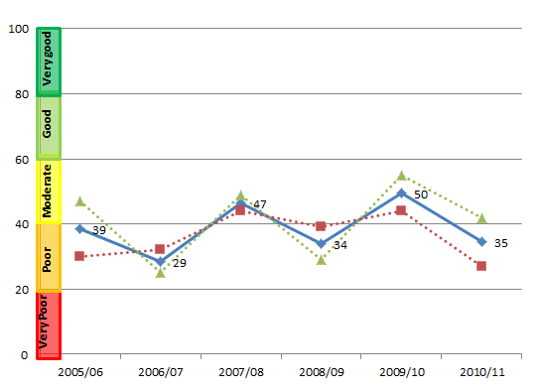
Figure 22: Trend in the Water quality index from 2005-2006 to 2010-2011 (blue solid line; numbers are index categories).
The Water quality index is also separated into component scores for chlorophyll a and total suspended solids (red and green dotted lines, respectively).
Pesticide monitoring was carried out at only one offshore site in Cape York and monitoring was discontinued in 2010. No herbicides were detected in 2010; however, diuron has been the most frequently detected herbicide since monitoring began in 2006. Other herbicides detected in the inshore region include hexazinone, simazine, and atrazine and its breakdown products. All herbicide concentrations were higher in the wet season.

3.2.3 Seagrass condition and trend
The condition of inshore seagrass in the inshore Cape York region declined to moderate overall and has been highly variable since 2005-2006 due to impacts of a complex and highly variable environment on seagrass abundance and reproductive effort (Figure 23). The paucity of monitoring sites in Cape York does not adequately capture the spatial variability of the inshore region. As such, Cape York seagrass data was not used in overall assessments of Great Barrier Reef health.
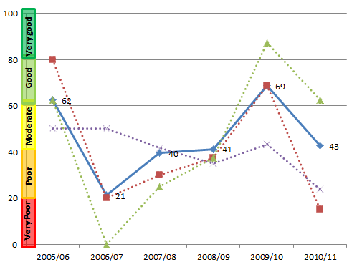
Figure 23: Trend in seagrass condition from 2005-2006 to 2010-2011 (blue solid line; numbers are index categories).
Seagrass condition is also separated into component scores for abundance, reproductive effort and nutrient status (red, green and purple dotted lines, respectively)
Seagrass is monitored at one fringing reef location in the southern part of the inshore Cape York region, Archer Point, which supports a diverse range of species. The environment is characterised by fluctuating temperature and salinity, and the growth of seagrass is primarily influenced by physical disturbance from waves and swell and associated sediment movement. Seagrass abundance in 2010-2011 declined to very poor (Figure 24) while reproductive effort was good, indicating communities may have a relatively high potential for recovery from environmental disturbances compared to seagrass in other inshore regions. Nutrient ratios of seagrass tissue were again rated as moderate, reflecting local water quality conditions.
Figure 24: Trend in seagrass abundance (per cent cover) at the inshore intertidal fringing reef habitat at Archer Point.

3.3 Wet Tropics
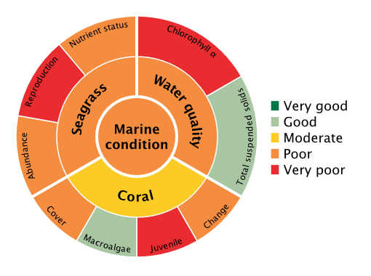
Figure 25: The condition of water quality and ecosystem health (seagrass and corals) in 2010-2011 across the inshore Wet Tropics region.

3.3.1 Summary results
- Overall Great Barrier Reef health in the inshore Wet Tropics region was poor in 2010-2011. Inshore water quality was moderate overall, and seagrass meadows and coral reefs were in poor and moderate condition, respectively (Figure 25).
- The inshore region of the Wet Tropics was influenced by flood waters and there were localised areas of coral bleaching where reefs were exposed to moderate levels of heat stress in late summer. The cover of branching coral in the northern part of the inshore region continued to increase as the reefs recovered from acute disturbances such as flooding in 2004 and from a crown-of-thorns outbreak in 2000. Reefs in the southern part of the inshore region are only now showing signs of recovery from cyclone Larry in 2006.
- Inshore water quality for the region varied from poor to moderate since 2005-2006, driven mostly by an overall improvement in concentrations of total suspended solids. The poor score for water quality in 2010-2011 is composed of very different ratings for chlorophyll a and total suspended solids, which were very poor and good respectively. Inshore areas with the highest concentrations of chlorophyll a and total suspended solids were mainly around the river mouths. Site-specific assessment of water quality showed a gradient of increasing water quality from the inshore to the mid-shelf area, with eight out of eleven sites in good or very good condition.
- A range of herbicides were detected including diuron, atrazine, hexazinone, simazine and tebuthiuron. The PS-II herbicide equivalent index, which considers the relative potency and abundance of each PS-II herbicide, showed that herbicides were present at biologically relevant concentrations at Green, Fitzroy and Normanby Islands (Category 4). The highest concentrations of herbicides were detected in flood waters near the mouth of the Tully River and around Bedarra Island (Category 3).
- Inshore seagrass meadows in the northern part of the region were in poor condition and their abundance remained stable. However, the condition of inshore seagrass in southern areas was very poor. Reproductive effort was very poor across the whole inshore region, which may indicate a low capacity to recover from disturbances. Seagrass nutrient status declined to poor overall and high tissue nitrogen is most likely a reflection of local water quality.
- Inshore coral reefs in the northern part of the region were downgraded to moderate, reflecting reductions in coral cover and densities of juvenile colonies linked to acute impacts of Cyclones Tasha and Yasi. Inshore coral reef in southern areas remained in poor condition, with very poor coral cover and poor densities of juvenile corals. Macroalgae cover was higher at some locations in 2010-2011, although Cyclone Yasi generally reduced macroalgae cover to good levels across the inshore region.

3.3.2 Water quality condition and trend
Inshore water quality in the inshore Wet Tropics is poor overall and has varied from poor to moderate since 2005-2006, largely driven by variation in suspended sediment concentrations. Scores for chlorophyll a were consistently lower than total suspended solids in all monitoring years (Figure 26).
In 2010-2011, chlorophyll a was rated as very poor, with concentrations exceeding the Water Quality Guidelines²² for 99 and 63 per cent of the inshore area, in the dry and wet season, respectively. Inshore areas with high concentrations were mainly around the mouths of the Mossman-Daintree, Barron, Russell-Mulgrave, Johnstone, Tully, Murray and Herbert Rivers, and in the Hinchinbrook Channel. Total suspended solids was rated as good; however, concentrations exceeded the Water Quality Guideline²² for 59 and 16 per cent of the inshore area, in the dry and wet seasons, respectively.
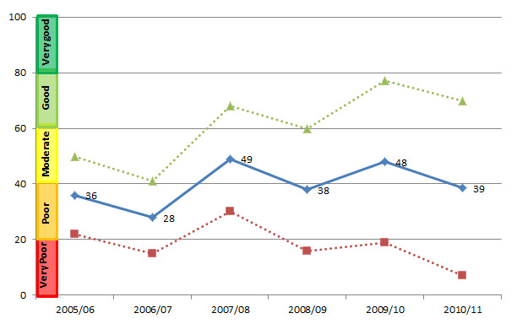
Figure 26: Trend in the Water quality index from 2005-2006 to 2010-2011 blue solid line; numbers are index categories).
The Water quality index is also separated into component scores for chlorophyll a and total suspended solids (red and green dotted lines, respectively).
Remote sensing of water quality across the inshore region showed a clear gradient of declining water quality from offshore areas more distant from terrestrial inputs, to inshore areas more frequently exposed to flood waters. This onshore-offshore gradient was supported by long-term assessments of water quality at specific sites, with variability between sites reflecting local hydrodynamic conditions and biophysical processes. Site-specific water quality was rated as either good or very good at eight out of eleven sites in the inshore region, three of which are located in the mid-shelf water body (Figure 27). However, water quality at the three sites close to river mouths draining highly developed catchments was rated as poor due to high concentrations of particulate phosphorus, chlorophyll a and turbidity that exceeded the Water Quality Guidelines²² in 2010-2011.
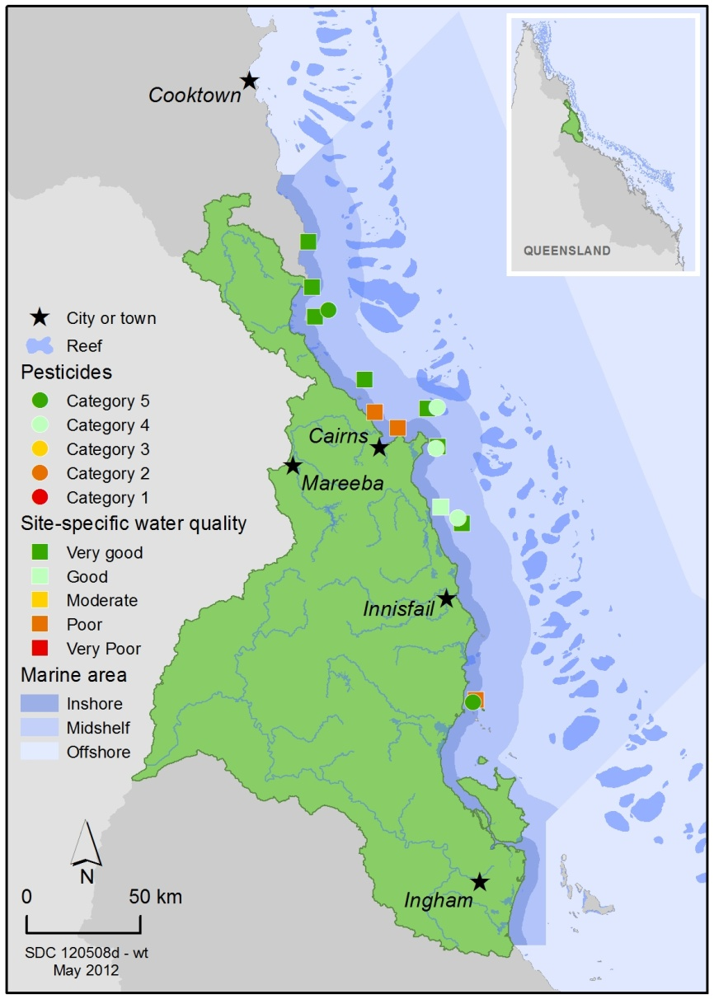
Figure 27: Water quality and pesticide scores for PS-II herbicides at fixed monitoring sites in the Wet Tropics.
The water quality scores are a long-term integrative assessment based on four indicators of water quality relative to the Water Quality Guidelines.²² The pesticide scores reflect the PS-II Herbicide Equivalent Index categories for maximum equivalent concentrations at each site. These concentrations integrate the relative potency and abundance of each PS-II herbicide to give the PS-II Herbicide Equivalent Index.
A range of herbicides were detected in the inshore Wet Tropics region, including atrazine and its breakdown products, diuron, hexazinone, simazine and tebuthiuron. However, diuron was present at the highest concentrations. In 2010-2011, concentrations of PS-II herbicides were above those known to affect photosynthesis in diatoms (Category 4) at Green, Fitzroy and Normanby Islands (Figure 28). The highest PS-II herbicide equivalent concentration in flood waters (Category 3) was detected in grab samples collected near the Tully River mouth and around Bedarra Island following a flow event.
Long-term monitoring of pesticides shows evidence of an increasing trend in the detection of herbicides at some sites in the Wet Tropics since 2005 (Figure 28). In 2010-2011, the higher concentrations typical of the wet season were sustained for longer periods of time, as evidenced by an increase in average PS-II herbicide concentrations by 1.5 to 3.4 times.
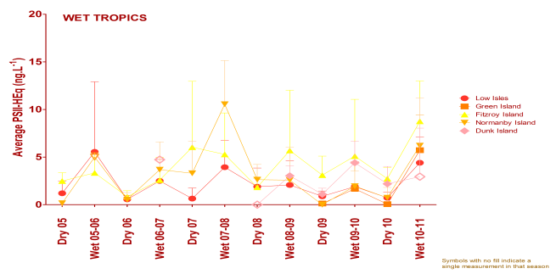
Figure 28: Trends in average PS-II herbicide equivalent concentrations at each sampling site in the Wet Tropics according to season.
High concentrations generally coincided with periods of high flow from the major rivers in the wet season compared to the dry season. Symbols with no fill indicate values with low reliability based on less than 30 per cent of the maximum number of deployments

3.3.3 Seagrass condition and trend
The overall condition of inshore seagrass in the inshore Wet Tropics region is poor and has been poor since 2005-2006. The poor assessment is a product of complex interactions between the three indicators of seagrass condition: abundance, reproductive effort and nutrient status, which are highly variable between years and habitats (Figure 29). Cyclone Yasi had an impact on the south of the inshore region, with abundance and meadow extent declining until only a few isolated shoots remained.
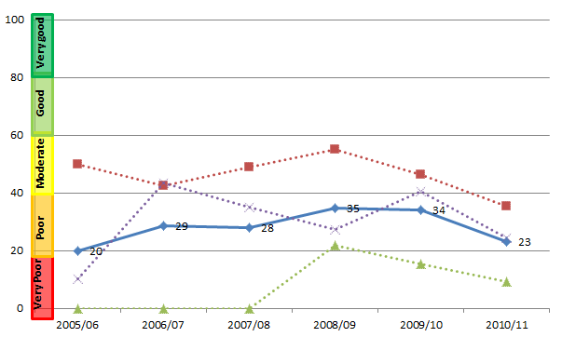
Figure 29: Trend in seagrass condition from 2005-2006 to 2010-2011 in the Wet Tropics (blue solid line; numbers are index categories).
Seagrass condition is also separated into component scores for abundance, reproductive effort and nutrient status (red, green and purple dotted lines, respectively).
Inshore seagrass were monitored in coastal and reef habitats in the Wet Tropics, and were in very poor or poor condition, respectively. Dominant influences on seagrass communities in the inshore region include elevated temperatures, seasonal run-off, and disturbance from wave action and associated sediment movement. In 2010-2011, seagrass meadows at Yule Point and Green Island in the north remained relatively stable. However, the effects of cyclone Yasi were apparent in the south, and seagrass meadows at Lugger Bay and Dunk Island were either completely lost or reduced to scattered isolated shoots by the physical disturbance and deposition of sediments (Figure 30). The reproductive effort of inshore seagrass in the Wet Tropics was very poor in five of the six monitoring years, which may indicate a low potential of meadows to recover from disturbances. Leaf tissue nutrient ratios were rated poor overall, with a site in the north showing signs of light limitation and poor water quality.
Figure 30: Trend in seagrass abundance (per cent cover) at inshore intertidal coastal habitats (Yule Point and Lugger Bay) and inshore intertidal reef habitats (Green and Dunk Islands) in the Wet Tropics

3.3.4 Coral condition and trend
The overall condition of inshore coral reefs in the Wet Tropics remained moderate (Figure 31); however, there were differences between northern and southern parts of the inshore region and the underlying scores decreased markedly from 2010. Coral reef communities in the Barron Daintree and Johnstone Russell-Mulgrave inshore areas in the northern Wet Tropics were downgraded from good to moderate condition, while those in the more southerly Herbert Tully inshore area were in poor condition.
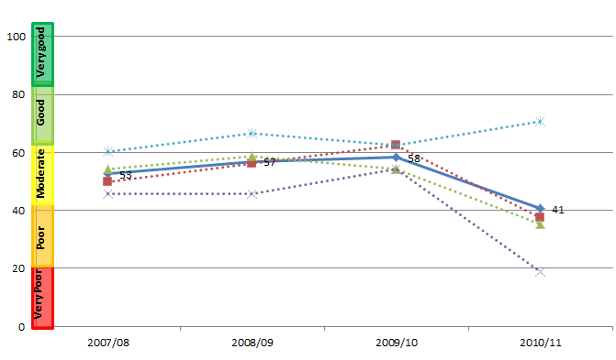
Figure 31: Trend in coral condition from 2007-2008 to 2010-2011 in the Wet Tropics (blue solid line; numbers are index categories).
Coral condition is also separated into component scores for coral cover, coral cover change, juvenile density and macroalgae cover (red, green, purple and blue dotted lines, respectively). Coral data are available since 2005-2006; however, the trend in coral condition is only able to be calculated from 2007-2008, because the coral change indicator requires the preceding three years of data.
Coral cover at sites in the Barron and Daintree inshore areas remained very good. However, coral cover at reefs in the Johnstone Russell-Mulgrave inshore area declined to moderate as a result of acute disturbances from cyclones Tasha and Yasi. Macroalgae cover was higher at some locations in 2010-2011 and the density of coral juveniles declined to very poor (Figure 32, Figure 33). Coral disease also contributed to declines in coral cover and the moderate condition assessment of reefs in the northern Wet Tropics.
In contrast, coral cover in the Herbert Tully inshore area was still very poor (Figure 34), reflecting the severity of cyclone Larry in 2006 and cyclone Yasi in 2011, and the subsequent negative impacts on the density of juvenile corals. As well as reducing coral cover, cyclone Yasi also reduced the cover of macroalgae resulting in a good score overall for the inshore Wet Tropics region. However, macroalgae cover is likely to increase rapidly, as occurred following cyclone Larry. Great Barrier Reefs in the inshore regions were recovering at a moderate rate prior to the extreme weather of 2010-2011, which may indicate some resilience to disturbance and a capacity for recovery.

Figure 32: Cover of major benthic groups and levels of key environmental parameters: Barron Daintree sub-region, Wet Tropics Region.
Stacked bars represent cumulative cover of hard coral (blue), soft coral (pink) and macroalgae (green). Box plots for both water and sediment quality represent the distribution of all observations to date, i.e., median value (fine line within the grey box), mean value (heavy line, WQ only), and the ranges of the central 50 per cent (grey box), 80 per cent (whiskers), and 90 per cent (black dots) of observations. Red reference lines indicate the Guidelines for water quality parameters²², and the overall mean across all MMP reefs for sediment parameters.
Figure 33: Cover of major benthic groups and levels of key environmental parameters: Johnstone Russell-Mulgrave sub-region, Wet Tropics Region.
Stacked bars represent cumulative cover of hard coral (blue), soft coral (pink) and macroalgae (green). Box plots for both water and sediment quality represent the distribution of all observations to date, i.e., median value (fine line within the grey box), mean value (heavy line, WQ only), and the ranges of the central 50 per cent (grey box), 80 per cent (whiskers), and 90 per cent (black dots) of observations. Red reference lines indicate the Guidelines for water quality parameters²², and the overall mean across all MMP reefs for sediment parameters.
Figure 34: Cover of major benthic groups and levels of key environmental parameters: Herbert Tully sub-region, Wet Tropics Region.
Stacked bars represent cumulative cover of hard coral (blue), soft coral (pink) and macroalgae (green). Box plots for both water and sediment quality represent the distribution of all observations to date, i.e., median value (fine line within the grey box, mean value (heavy line, WQ only), and the ranges of the central 50 per cent (grey box), 80 per cent (whiskers), and 90 per cent (black dots) of observations. Red reference lines indicate the Guidelines for water quality parameters²², and the overall mean across all MMP reefs for sediment parameters.

3.4 Burdekin
Figure 35: The condition of water quality and ecosystem health (seagrass and corals) in 2010-2011 across the inshore Burdekin region.

3.4.1 Summary results
- Overall Great Barrier Reef health in the inshore Burdekin region was poor in 2010-2011. Inshore water quality was moderate overall, and inshore seagrass meadows and coral reefs were both in poor condition (Figure 35).
- The inshore area of the Burdekin region was influenced by flood waters and there were localised areas of coral bleaching where reefs were exposed to moderate levels of heat stress in late summer. Coral cover across the inshore region had not recovered from the impact of coral bleaching in 1998 and 2002.
- Inshore water quality for the region has generally been at the lower range of moderate since 2005-2006. Concentrations of total suspended solids were moderate in 2010-2011 and chlorophyll a was poor. Site-specific assessment of water quality showed a gradient of increasing water quality from the inshore to the mid-shelf area, with poor water quality at Magnetic Island and good water quality at the two mid-shelf sites.
- A range of pesticides were detected including diuron, atrazine, hexazinone, simazine and tebuthiuron. Concentrations of tebuthiuron in flood waters from the Burdekin River exceeded the Water Quality Guidelines²² for the Great Barrier Reef. The PS-II herbicide equivalent index, which considers the relative potency and abundance of each PS-II herbicide, showed that herbicides were present at biologically relevant concentrations at Magnetic Island and Cape Cleveland (Category 4).
- Inshore seagrass meadows declined to a very poor state since 2005-2006, driven by relatively large declines in abundance and, more recently, in reproductive effort. Abundance and reproductive effort were very poor, and the nutrient content of seagrass tissue indicated high concentrations of phosphorus in coastal habitats and nitrogen in reef habitats.
- Inshore coral reefs have declined to a poor state since 2007-2008, reflecting very poor coral cover and densities of juvenile colonies, and inherently low rates of increase in coral cover during periods free from acute disturbances. Cyclone Yasi reduced the cover of macroalgae to good levels, although this is likely to have been temporary.

3.4.2 Water quality condition and trend
Inshore water quality in the inshore Burdekin region remained moderate in 2010-2011, although there were declines in the underlying scores for chlorophyll a and total suspended solids. Scores for the two water quality indicators, chlorophyll a and total suspended solids, varied since 2005 with the initial pattern of higher scores for chlorophyll a and lower scores for total suspended solids reversing in later monitoring years (Figure 36).
In 2010-2011, chlorophyll a was again rated as poor, with concentrations exceeding the Water Quality Guideline²² for 98 and 69 per cent of the inshore area, in the dry and wet season, respectively. Total suspended solids was rated as moderate; however, concentrations exceeded the Water Quality Guidelines²² for 62 and 34 per cent of the inshore area, in the dry and wet seasons, respectively .
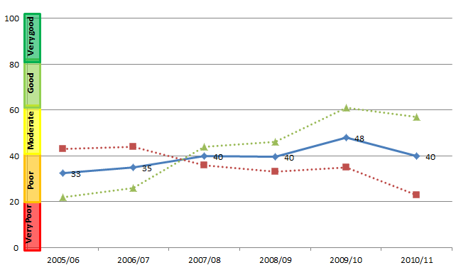
Figure 36: Trend in the Water quality index from 2005-2006 to 2010-2011 (blue solid line; numbers are index categories).
The Water quality index is also separated into component scores for chlorophyll a and total suspended solids (red and green dotted lines, respectively).
Remote sensing of water quality across the inshore region showed a clear gradient of declining water quality from offshore areas more distant from terrestrial inputs, to inshore areas more frequently exposed to flood waters. This onshore-offshore gradient was supported by long-term assessments of water quality at specific sites, with variability between sites reflecting local hydrodynamic conditions and biophysical processes. Site-specific water quality was good at the two mid-shelf sites and poor at Magnetic Island in the inshore region (Figure 37). The Water Quality Guideline²² values for turbidity and concentrations of particulate phosphorus were exceeded at Magnetic Island in 2010-2011.
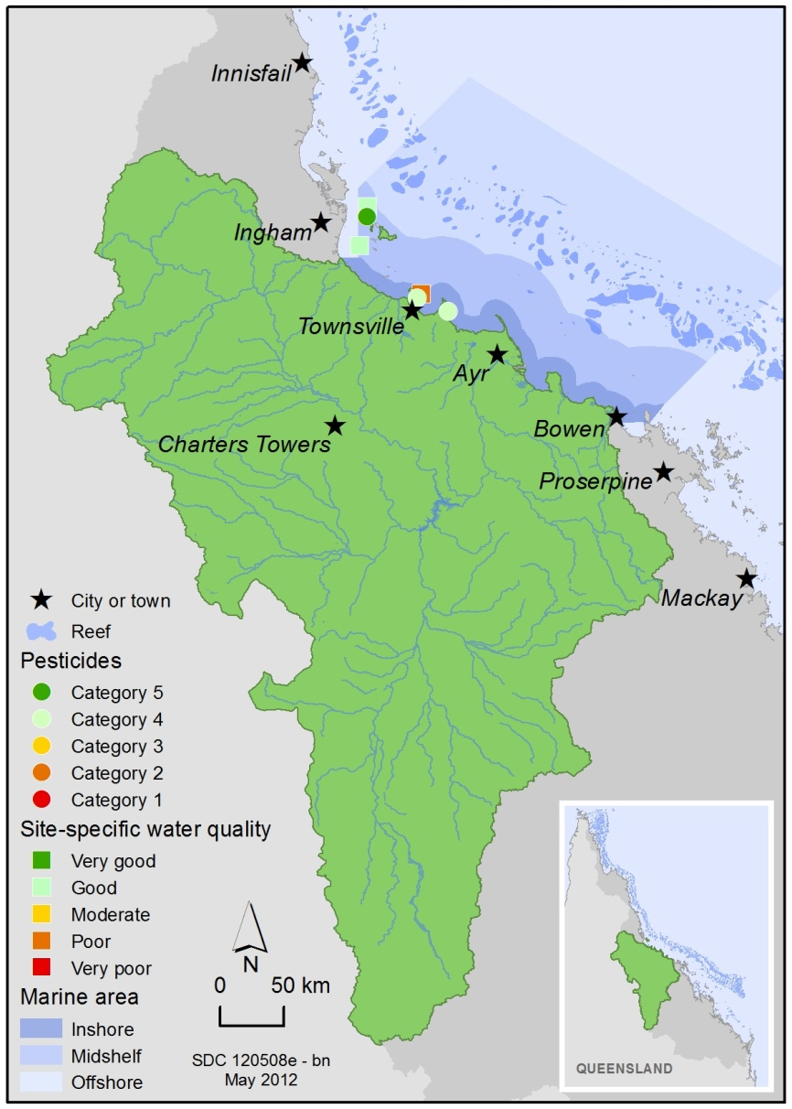
Figure 37: Water quality and pesticide scores for PS-II herbicides at fixed monitoring sites in the Burdekin.
The water quality scores are a long-term integrative assessment based on four indicators of water quality relative to the Water Quality Guidelines.²² The pesticide scores reflect the PS-II Herbicide Equivalent Index categories for maximum equivalent concentrations at each site. These concentrations integrate the relative potency and abundance of each PS-II herbicide to give the PS-II Herbicide Equivalent Index.
A range of herbicides was detected in the inshore Burdekin region, including atrazine and its breakdown products, diuron, hexazinone, simazine and tebuthiuron. The Burdekin River had a large flood event in the 2010-2011 wet season and tebuthiuron was detected in flood waters at concentrations that exceeded Water Quality Guideline²² values. Routine monitoring showed spatial variability in the abundance of herbicides, and atrazine concentrations typically exceeded diuron concentrations at Cape Cleveland and Magnetic Island, while at Orpheus Island closer to the Wet Tropics diuron was present at higher concentrations. In 2010-2011, concentrations of PS-II herbicides were above those known to affect photosynthesis in diatoms (Category 4) at Cape Cleveland and Magnetic Island (Figure 38).
Long-term monitoring of pesticides shows evidence of an increasing trend in the detection of herbicides at some sites in the Burdekin since 2005 .In 2010-2011, the higher in concentrations typical of the wet season were sustained for longer periods of time, as evidenced by a doubling in average PS-II herbicide concentrations.
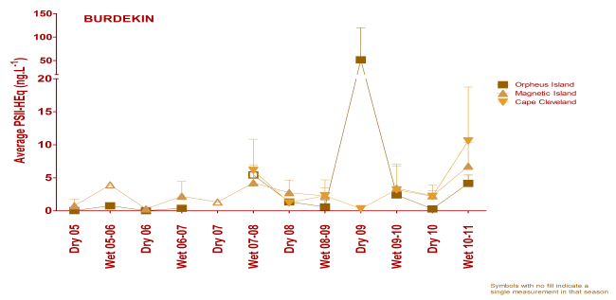
Figure 38: Trends in average PS-II herbicide equivalent concentrations at each sampling site in the Burdekin according to season.
High concentrations generally coincided with periods of high flow from the major rivers in the wet season compared to the dry season. Symbols with no fill indicate values with low reliability based on less than 30 per cent of the maximum number of deployments.

3.4.3 Seagrass condition and trend
The overall condition of inshore seagrass in the Burdekin region progressively declined from good in 2005-2006 to very poor in 2010-2011. The very poor assessment was driven by large declines in abundance and reproductive effort, and increased nutrient enrichment of seagrass tissue (Figure 39). Cyclone Yasi had an impact on the region, with abundance and meadow extent declining across the inshore region until only a few isolated shoots remained at the monitored sites.
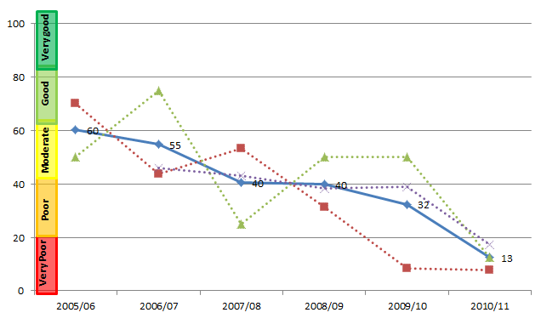
Figure 39: Trend in seagrass condition from 2005-2006 to 2010-2011 in the Burdekin (blue solid line; numbers are index categories).
Seagrass condition is also separated into component scores for abundance, reproductive effort and nutrient status (red, green and purple dotted lines, respectively).
Seagrass monitoring was conducted in coastal and reef habitats primarily influenced by wind-driven turbidity and pulsed delivery of nutrients and sediment, and seagrass abundance remained very poor across the inshore region. There was a decline in the reproductive effort of seagrass meadows at reef locations (Picnic Bay and Cockle Bay) and coastal locations (Bushland Beach and Shelly Bay) to poor and very poor, respectively (Figure 40). Low reproductive effort may indicate reduced capacity for recovery from environmental disturbances. The nutrient content of seagrass tissue was either very poor or poor and indicated nutrient enrichment in coastal and reef habitats, which reflected local water quality conditions.
Figure 40: Trend in seagrass abundance (per cent cover) at inshore intertidal coastal habitats (Bushland and Shelly Beaches) and inshore fringing platform reef habitats (Magnetic Island) in the inshore Burdekin Region

3.4.4 Coral condition and trend
The overall condition of inshore coral reefs in the Burdekin remained poor and had declined from moderate since 2007-2008 (Figure 41).
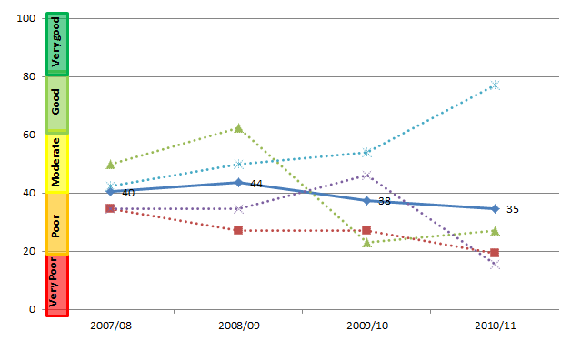
Figure 41: Trend in coral condition from 2007-2008 to 2010-2011 in the Burdekin (blue solid line; numbers are index categories).
Coral condition is also separated into component scores for coral cover, coral cover change, juvenile density and macroalgae cover (red, green, purple and blue dotted lines, respectively). Coral data are available since 2005-2006; however, the trend in coral condition is only able to be calculated from 2007-2008, because the coral change indicator requires the preceding three years of data.
Coral cover across the inshore Burdekin region has not recovered from the impact of coral bleaching in 1998 and 2002, and declined further following Cyclone Yasi to very poor in 2010-2011 (Figure 42). There was also a reduction in the density of juvenile corals from moderate to very poor levels that are likely to exacerbate the inherently low rates of increase in coral cover during periods free from acute disturbance. Reductions in the cover of macroalgae due to Cyclone Yasi are expected to have been temporary due to the high availability of substratum and environmental conditions that favour the persistence of macroalgae. The factors underlying the poor condition assessment suggest a lack of resilience of reef communities in the inshore Burdekin region.
.
Figure 42: Cover of major benthic groups and levels of key environmental parameters: inshore Burdekin Region.
Stacked bars represent cumulative cover of hard coral (blue), soft coral (pink) and macroalgae (green). Box plots for both water and sediment quality represent the distribution of all observations to date, i.e., median value (fine line within the grey box), mean value (heavy line, WQ only), and the ranges of the central 50 per cent (grey box), 80 per cent (whiskers), and 90 per cent (black dots) of observations. Red reference lines indicate the Guidelines for water quality parameters²², and the overall mean across all MMP reefs for sediment parameters.

3.5 Mackay Whitsunday
Figure 43: The condition of water quality and ecosystem health (seagrass and corals) in 2010-2011 across the inshore Mackay Whitsunday region

3.5.1 Summary results
- Overall Great Barrier Reef health in the inshore Mackay Whitsunday region is moderate in 2010-2011. Inshore water quality is moderate overall, and inshore seagrass meadows and coral reefs were in poor and moderate condition, respectively (Figure 43).
- The inshore area of the Mackay Whitsundays was influenced by multiple high flow events from all catchment rivers in the 2010-2011 wet season. Cyclone Ului passed almost directly over the monitoring sites at Daydream Island in early 2010 and caused a substantial reduction in coral cover across the inshore Mackay Whitsunday region. There were also localised areas of coral bleaching. Areas where Cyclone Ului had a minimal impact showed limited recovery in hard coral cover following widespread disturbances that include coral bleaching in 1998 and 2002 and repeated flooding events over the past four years.
- Inshore water quality for the region declined sharply from moderate to poor overall, having been relatively stable since 2005-2006. Chlorophyll a and total suspended solids also declined to poor and very poor, respectively. Site-specific water quality for the inshore region was moderate at Daydream and Pine Islands, and good at Double Cone Island, reflecting increasing water quality away from river mouths in the inshore area.
- A range of pesticides were detected including diuron, atrazine, hexazinone, simazine and tebuthiuron. The PS-II herbicide equivalent index, which considers the relative potency and abundance of each PS-II herbicide, showed that herbicides were present at biologically relevant concentrations at all sites in the Mackay Whitsundays, although concentrations were lower than in 2009-2010 (Category 4).
- Inshore seagrass meadows declined to a very poor state since 2005-2006, which reflected declines in abundance and reproductive effort, raising concerns about the capacity of local seagrass meadows to recover from environmental disturbances. The nutrient status of seagrass tissue was very poor and reflected local water quality, particularly high concentrations of nitrogen.
- Inshore coral reefs remained in moderate condition; however, coral cover showed very poor recovery from past disturbances. When considered in combination with poor densities of juvenile colonies, decreases in cover may have implications for the long-term resilience of coral communities in the inshore region. The low cover of macroalgae was rated as very good, which offset the poor or very poor ranking of most of the coral community attributes.

3.5.2 Water quality condition and trend
Inshore water quality in the Mackay Whitsundays declined sharply from moderate to poor overall, which represents a departure from the relatively stable condition of the inshore region since 2005-2006. Scores for chlorophyll a and total suspended solids also declined to similarly low levels (Figure 44).
In 2010-2011, chlorophyll a was rated as poor, with concentrations exceeding the Water Quality Guidelines²² for 99 and 44 per cent of the inshore area, in the dry and wet season, respectively. Inshore areas of exceedance in the wet season were mainly around the mouths of the Proserpine, O’Connell, Pioneer and Plane Rivers. Total suspended solids was rated as very poor, with concentrations exceeding the Water Quality Guidelines²² for 59 and 69 per cent of the inshore area, in the dry and wet season, respectively.
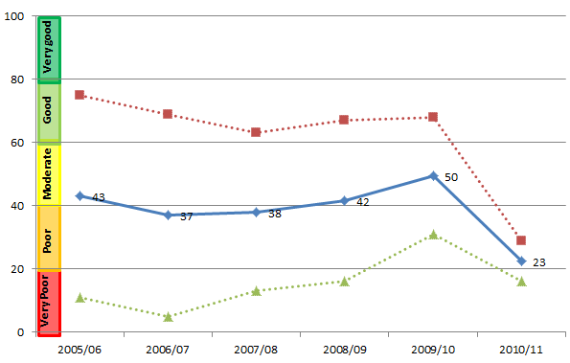
Figure 44: Trend in the water quality index from 2005-2006 to 2010-2011 (blue solid line; numbers are index categories).
The water quality index is also separated into component scores for chlorophyll a and total suspended solids (red and green dotted lines, respectively.
Remote sensing of water quality across the inshore region showed a clear gradient of declining water quality from offshore areas more distant from terrestrial inputs, to inshore areas more frequently exposed to flood waters. This gradient was supported by long-term assessments of water quality at specific sites, with variability between sites reflecting local hydrodynamic conditions and biophysical processes. Site-specific water quality remained moderate at Daydream and Pine Islands, and good at Double Cone Island. Annual mean turbidity levels at Pine and Daydream Islands exceeded the Water Quality Guidelines²² in 2010-2011.
A range of herbicides was detected in the inshore Mackay Whitsunday region, including atrazine and its breakdown products, diuron, hexazinone, simazine and tebuthiuron. There were multiple, high flow events in all rivers of the inshore Mackay Whitsunday region in 2010-2011, and concentrations of PS-II herbicides were above those known to affect photosynthesis in diatoms (Category 4) at all routine monitoring sites (Figure 45).
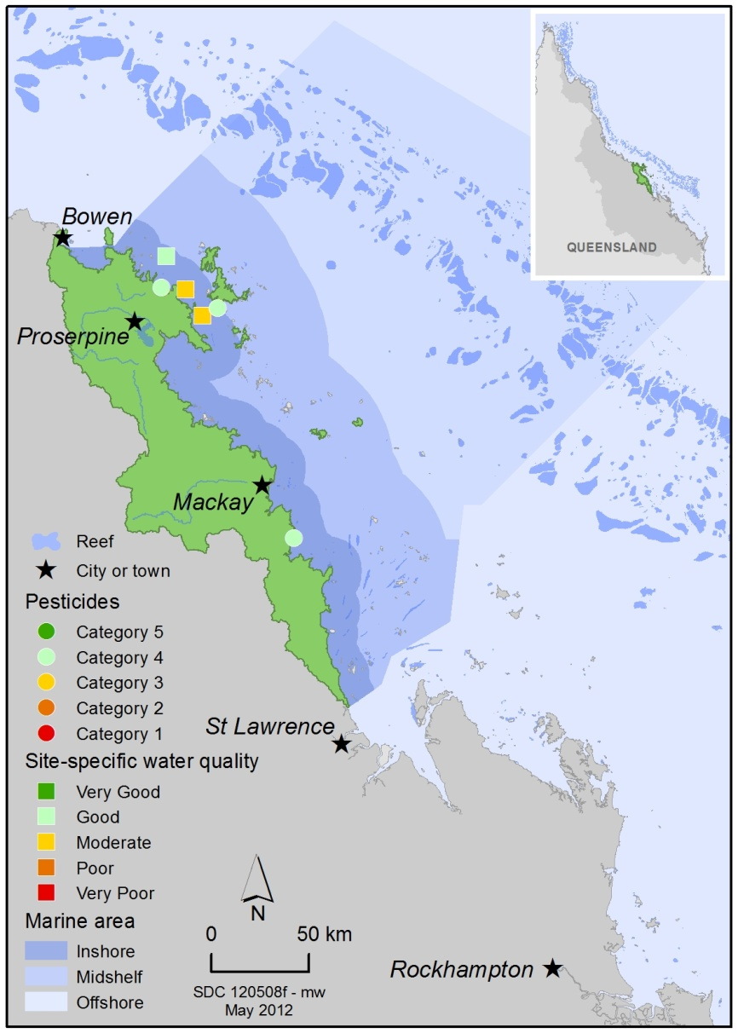
Figure 45: Water quality and pesticide scores for PS-II herbicides at fixed monitoring sites in the Mackay Whitsundays.
The water quality scores are a long-term integrative assessment based on four indicators of water quality relative to the Water Quality Guidelines²². The pesticide scores reflect the PS-II Herbicide Equivalent Index categories for maximum equivalent concentrations at each site. These concentrations integrate the relative potency and abundance of each PS-II herbicide to give the PS-II Herbicide Equivalent Index.
Long-term monitoring of pesticides shows evidence of an increasing trend in the detection of herbicides at some sites in the Mackay Whitsundays since 2005 (Figure 46). In 2010-2011, the higher in concentrations typical of the wet season, whilst still relatively high compared to previous years, were lower than those detected in 2009-2010.
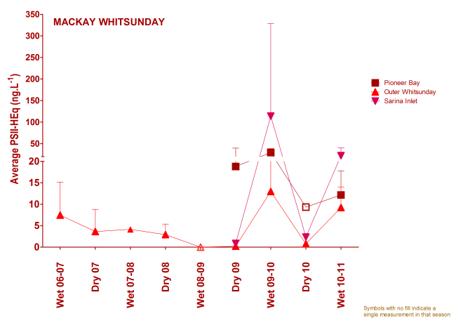
Figure 46: Trends in average PS-II herbicide equivalent concentrations at each sampling site in the Mackay Whitsundays according to season.
High concentrations generally coincided with periods of high flow from the major rivers in the wet season compared to the dry season. Symbols with no fill indicate values with low reliability based on less than 30 per cent of the maximum number of deployments.

3.5.3 Seagrass condition and trend
The overall condition of inshore seagrass in the Mackay Whitsundays region was very poor and has progressively declined since 2005-2006 to the lowest levels reported since 1999. The decline in seagrass condition reflects very poor abundance, very poor reproductive effort and increased nutrient enrichment of seagrass tissue (Figure 47).
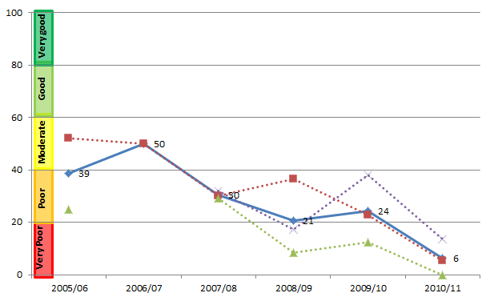
Figure 47: Trend in seagrass condition from 2005-2006 to 2010-2011 in the Mackay Whitsundays (blue solid line; numbers are index categories).
Seagrass condition is also separated into component scores for abundance, reproductive effort and nutrient status (red, green and purple dotted lines, respectively).
Seagrass meadows were monitored at coastal, estuarine and fringing reef locations in the inshore Mackay Whitsunday region (Pioneer Bay, Sarina Inlet and Hamilton Island, respectively). Key environmental drivers of seagrass communities in this inshore region include exposure at low tides and variable catchment run-off. Seagrass abundance declined in all habitats throughout the inshore region over the monitoring period (Figure 48); by late monsoon 2010, all sites were in very poor condition. Reproductive effort declined at both reef and coastal sites, raising concerns about the ability of local seagrass meadows to recover from environmental disturbances. The nutrient status of seagrass tissue was rated as poor in reef habitats and very poor in coastal and estuarine habitats, which reflected local water quality conditions following record flood events.
Figure 48: Trend in seagrass abundance (per cent cover) at inshore intertidal estuarine habitats (Sarina Inlet), inshore intertidal coastal habitats (Pioneer Bay) and inshore fringing reef habitats (Hamilton Island) in the Mackay Whitsundays.

3.5.4 Coral condition and trend
The overall condition of inshore coral reefs in the Mackay Whitsundays remained moderate since 2007-2008 (Figure 49).
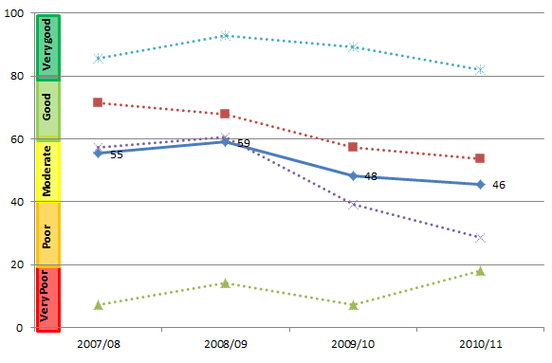
Figure 49: Trend in coral condition from 2007-2008 to 2010-2011 in the Mackay Whitsundays (blue solid line; numbers are index categories).
Coral condition is also separated into component scores for coral cover, coral cover change, juvenile density and macroalgae cover (red, green, purple and blue dotted lines, respectively). Coral data are available since 2005-2006; however, the trend in coral condition is only able to be calculated from 2007-2008, because the coral change indicator requires the preceding three years of data.
Coral cover remained moderate in 2010-2011, with the exception of one site at Double Cone Island where cover increased due to the survival and growth of coral fragments produced during cyclone Ului early in 2010 (Figure 50). The rate of increase in coral cover during periods free from acute disturbances was very poor and, when combined with the continual decline in the density of juvenile colonies to poor, may have implications for the long-term resilience of local coral communities in the inshore region. There were also outbreaks of coral disease in the inshore region that co-occurred with conditions known to be stressful to some corals, such as elevated turbidity and a high proportion of fine grained sediments from above-median river discharge. The very low cover of macroalgae offset the poor or very poor ranking of other coral community attributes, resulting in the overall condition assessment of moderate.
Figure 50: Cover of major benthic groups and levels of key environmental parameters: inshore Mackay Whitsunday Region.
Stacked bars represent cumulative cover of hard coral (blue), soft coral (pink) and macroalgae (green). Box plots for both water and sediment quality represent the distribution of all observations to date, i.e., median value (fine line within the grey box), mean value (heavy line, WQ only), and the ranges of the central 50 per cent (grey box), 80 per cent (whiskers), and 90 per cent (black dots) of observations. Red reference lines indicate the Guidelines for water quality parameters²², and the overall mean across all MMP reefs for sediment parameters.

3.6 Fitzroy
Figure 51: The condition of water quality and ecosystem health (seagrass and corals) in 2010-2011 across the inshore Fitzroy region

3.6.1 Summary results
- Overall Great Barrier Reef health in the inshore Fitzroy region was moderate in 2010-2011. Inshore water quality, inshore seagrass meadows and coral reefs were in moderate condition (Figure 51).
- The inshore area of the region was influenced by the high flow event from the Fitzroy River in 2010-2011 that was four times above the long-term median. There was an increase in the prevalence of coral disease in the inshore region that may be a consequence of chronic environmental stress following flooding of the Fitzroy River in 2008 and 2010. There were also localised inshore areas of coral bleaching partially linked to salinity stress and the cover of macroalgae at reefs increased with mortality and decreased with subsequent recovery of coral communities.
- Inshore water quality for the region declined from moderate to poor, having been relatively stable since 2005-2006. Concentrations of chlorophyll a and total suspended solids were very poor and moderate, respectively. Site-specific assessment of water quality showed a gradient of increasing water quality from the inshore to the mid-shelf area, with water quality poor at Pelican Island, good at Humpy Island and very good at Barren Island, respectively.
- A range of pesticides were detected including diuron, atrazine, hexazinone, simazine and tebuthiuron. The PS-II herbicide equivalent index, which considers the relative potency and abundance of each PS-II herbicide, showed that herbicides were present at biologically relevant concentrations at North Keppel Island (Category 4). At times, concentrations of tebuthiuron exceeded the Water Quality Guidelines²² for the Great Barrier Reef at North Keppel Island. Concentrations of tebuthiuron and metolachlor in flood waters met or exceeded the Water Quality Guidelines²² and the ANZECC and ARMCANZ interim working level for marine waters, respectively.
- Inshore seagrass meadows declined to poor condition overall, with poor abundance marginally offset by increased reproductive effort at some sites. Tissue nutrient content differed markedly according to habitat type, but was moderate overall.
- Inshore coral reefs were in poor condition overall, with poor coral cover and very poor densities of juvenile colonies. The rate of increase in coral cover declined to poor; however, the cover of competing macroalgae was good. The poor and very poor scores for many of the community attributes may have implications for the resilience of coral communities in the inshore region.

3.6.2 Water quality condition and trend
Inshore water quality in the Fitzroy declined from moderate to poor overall, representing a departure from the relative stability of water quality of the region since 2005-2006. The divergence in the scores for the two water quality indicators chlorophyll a and total suspended solids became more pronounced following the floods in 2010-2011 (Figure 52).
In 2010-2011, chlorophyll a declined sharply to very poor, with concentrations exceeding the Water Quality Guideline²² for 99 per cent and 89 per cent of the inshore area, in the dry and wet season, respectively. Total suspended solids were again rated as moderate; however, concentrations exceeded the Water Quality Guideline²² for 55 per cent and 47 per cent of the inshore area, in the dry and wet season, respectively.
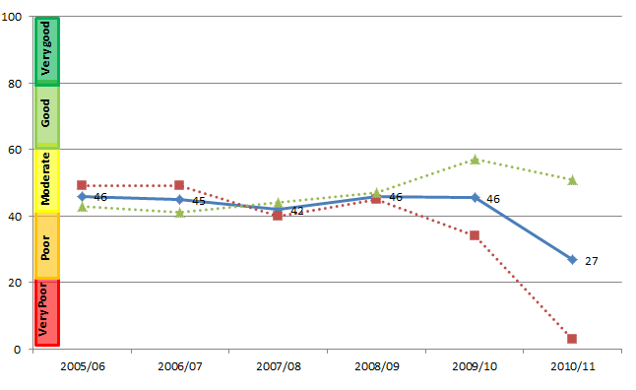
Figure 52: Trend in the Water quality index from 2005-2006 to 2010-2011 (blue solid line; numbers are index categories).
The Water quality index is also separated into component scores for chlorophyll a and total suspended solids (red and green dotted lines, respectively).
Remote sensing of water quality across the inshore region showed a clear gradient of declining water quality from offshore areas more distant from terrestrial inputs, to inshore areas more frequently exposed to flood waters. This gradient was supported by long-term assessments of water quality at specific sites, with variability between sites reflecting local hydrodynamic conditions and biophysical processes.
Site-specific water quality was poor at Pelican Island, moderate at Humpy Island and very good at Barren Island, respectively, reflecting increasing distance away from river influence (Figure 53). At Pelican Island, the Water Quality Guidelines²² were exceeded for chlorophyll a, turbidity and concentrations of particulate nitrogen and phosphorus in 2010-2011.
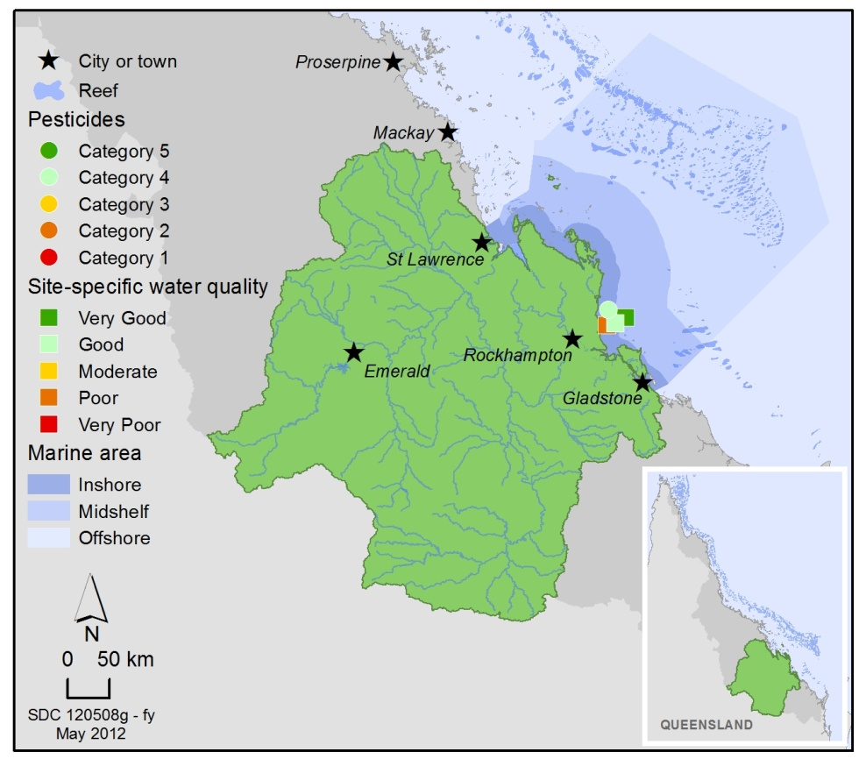
Figure 53: Water quality and pesticide scores for PS-II herbicides at fixed monitoring sites in the Fitzroy. The water quality scores are a long-term integrative assessment based on four indicators of water quality relative to the Water Quality Guidelines.²²
The pesticide scores reflect the PS-II Herbicide Equivalent Index categories for maximum equivalent concentrations at each site. These concentrations.integrate the relative potency and abundance of each PS-II herbicide to give the PS-II Herbicide Equivalent Index.
A range of herbicides was detected in the inshore Fitzroy region, including atrazine and its breakdown products, diuron, hexazinone, simazine and tebuthiuron. The Fitzroy River had large flow events in the 2010-2011 wet season and tebuthiuron and metolachlor were detected in flood waters at concentrations that met or exceeded the Water Quality Guidelines²² and the ANZECC and the ARMANZ Interim Working Level for marine waters, respectively. Tebuthiuron was also detected at concentrations that exceeded the Water Quality Guidelines²² at the routine monitoring site at North Keppel Island. However, on average, concentrations of PS-II herbicides were rated as Category 4 at North Keppel Island (Figure 53).
Long-term monitoring of pesticides shows evidence of an increasing trend in the detection of herbicides in the Fitzroy since 2005 (Figure 54). In 2010-2011, the higher in concentrations typical of the wet season were sustained for longer periods of time, as evidenced by an increase in average PS-II herbicide concentrations by five times.
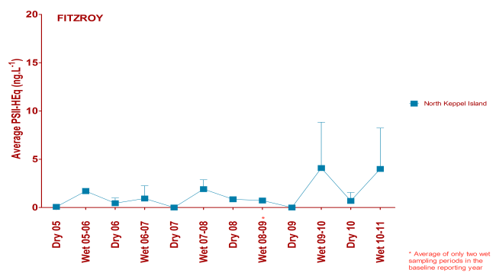
Figure 54: Trends in average PS-II herbicide equivalent concentrations at the sampling site in the Fitzroy according to season.
High concentrations generally coincided with periods of high flow from the major rivers in the wet season compared to the dry season.

3.6.3 Seagrass condition and trend
The overall condition of inshore seagrass in the Fitzroy region declined to poor, driven largely by poor seagrass abundance. Reproductive effort and nutrient content were not measured every year. Hence the capacity to assess trends in these two indicators, which were both rated as moderate in 2010-2011, is limited (Figure 55).
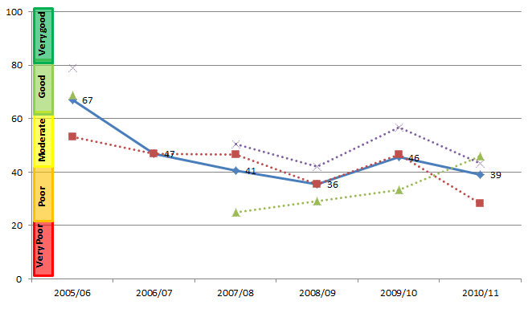
Figure 55: Trend in seagrass condition from 2005-2006 to 2010-2011 in the inshore Fitzroy Region (blue solid line; numbers are index categories).
Seagrass condition is also separated into component scores for abundance, reproductive effort and nutrient status (red, green and purple dotted lines, respectively).
Seagrass meadows were monitored at coastal, estuarine and fringing reef locations in the inshore Fitzroy region. Key environmental drivers in the inshore region include exposure at low tide and high turbidity. Seagrass abundance at both the coastal Shoalwater Bay and estuarine Gladstone Harbour sites declined to poor during the 2010-2011 monitoring period, which represented a reversal of previous trends (Figure 56). Similarly, seagrass meadows at the Great Keppel reef site continued to decrease in size and abundance remained very poor. Relatively high reproductive effort at the reef and estuarine sites indicates these seagrass meadows may have a higher capacity to recover from disturbances compared to seagrass in coastal habitats. The nutrient status of seagrass tissue was moderate overall, reflecting high concentrations of nutrients at the reef site, and moderate to good tissue nutrient status at the coastal and estuarine sites, respectively. High concentrations of nutrients in seagrass tissue are indicative of poor water quality in this inshore area following record flood events.
Figure 56: Trend in seagrass abundance (per cent cover) at inshore intertidal estuarine habitats (Gladstone Harbour), inshore intertidal coastal habitats (Shoalwater Bay) and inshore fringing reef habitats (Great Keppel Island) in the Fitzroy

3.6.4 Coral condition and trend
The overall condition of inshore coral reefs in the Fitzroy Region remained poor since 2007-2008 (Figure 57).
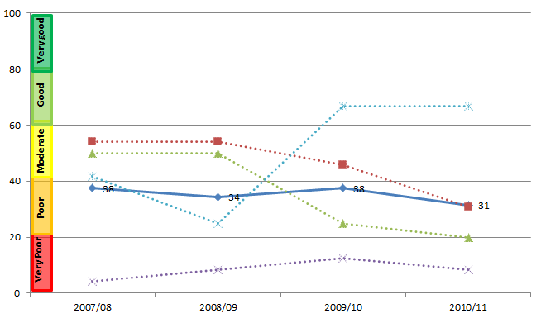
Figure 57: Trend in coral condition from 2007-2008 to 2010-2011 in the inshore Fitzroy Region (blue solid line; numbers are index categories).
Coral condition is also separated into component scores for coral cover, coral cover change, juvenile density and macroalgae cover ((red, green, purple and blue dotted lines, respectively). Coral data are available since 2005-2006; however, the trend in coral condition is only able to be calculated from 2007-2008, because the coral change indicator requires the preceding three years of data.
Coral cover declined to poor across the inshore Fitzroy region and the density of juveniles was very poor. There was a marked reduction in coral cover and juvenile densities to depths of at least two metres on reefs inshore of Great Keppel Island, consistent with exposure to low salinity waters in the Fitzroy River flood plume. The prevalence of coral disease in the inshore region appears to be proportional to the annual discharge from the Fitzroy River and changes in the community composition of several reefs in the inshore region may be a consequence of a shift in selective pressures. The rate of increase in coral cover was poor and is likely to reflect chronic stress associated with poor water quality following repeated flooding of the Fitzroy River in 2008, 2010 and 2011. In contrast, the cover of macroalgae was low, which may favour coral recovery (Figure 58).
Figure 58: Cover of major benthic groups and levels of key environmental parameters in the inshore Fitzroy Region.
Stacked bars represent cumulative cover of hard coral (blue), soft coral (pink) and macroalgae (green). Box plots for both water and sediment quality represent the distribution of all observations to date, i.e., median value (fine line within the grey box), mean value (heavy line, WQ only), and the ranges of the central 50 per cent (grey box), 80 per cent (whiskers), and 90 per cent (black dots) of observations. Red reference lines indicate the Guidelines for water quality parameters²², and the overall mean across all MMP reefs for sediment parameters.

3.7 Burnett Mary
Figure 59: The condition of water quality and ecosystem health (seagrass and corals) in 2010-2011 across the inshore Burnett Mary region.

3.7.1 Summary results
- Overall Great Barrier Reef health in the inshore Burnett Mary region was poor. Inshore water quality is moderate and the condition of seagrass was poor. No coral monitoring occurs in the inshore Burnett Mary region under the MMP (Figure 59).
- Inshore water quality declined since 2005-2006, driven by changes in concentrations of chlorophyll a. The moderate score for water quality in 2010-2011 is composed of very different ratings for chlorophyll a and total suspended solids, which were very poor and good, respectively.
- Inshore seagrass meadows declined to very poor condition after being in poor condition for five consecutive years. Seagrass abundance and reproductive effort were very poor throughout the inshore region, indicating meadows are likely to have a low capacity to recover from environmental disturbances. The nutrient status of seagrass is poor, reflecting consistently high concentrations of nitrogen in the surrounding environment.
- There is no comprehensive, ongoing in situ water quality monitoring in the inshore Burnett Mary Region. Estimates of chlorophyll a and total suspended solids are derived from remote sensing only, which requires further field validation and hence estimates have relatively low reliability compared to those for other inshore regions (denoted by hatching). As such, Burnett Mary water quality data was not used in the overall assessment of Great Barrier Reef water quality and Great Barrier Reef health.
- No coral monitoring occurs in the inshore Burnett Mary region under the MMP.

3.7.2 Water quality condition and trend
Inshore water quality in the Burnett Mary region continued to decline and was moderate in 2010-2011. The decline was driven by relatively large changes in chlorophyll a, while total suspended solids remained stable and scored consistently higher than chlorophyll a in all monitoring years (Figure 60).
In 2010-2011, chlorophyll a was very poor, with concentrations exceeding the Water Quality Guideline²² for 97 per cent and 96 per cent of the inshore area, in the dry and wet season, respectively. Total suspended solids was rated as good; however, concentrations exceeded the Water Quality Guidelines²² for 15 per cent and 26 per cent of the inshore area, in the dry and wet season, respectively.
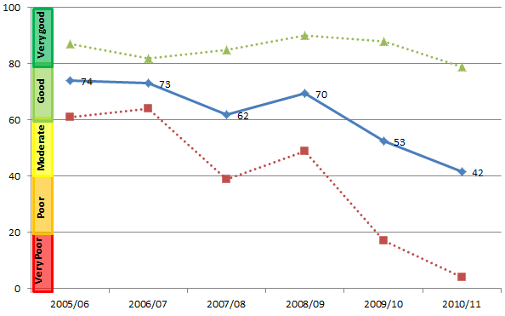
Figure 60: Trend in the water quality index from 2005-2006 to 2010-2011 (blue solid line; numbers are index categories).
The water quality index is also separated into component scores for chlorophyll a and total suspended solids (red and green dotted lines, respectively).

3.7.3 Seagrass condition and trend
The overall condition of inshore seagrass in the Burnett Mary region declined from poor to very poor, reflecting very poor abundance and reproductive effort of seagrass meadows and poor tissue nutrient status. Seagrass condition has generally been declining since 2005-2006; however the indicators driving the condition assessment were highly variable over the monitoring period (Figure 61).
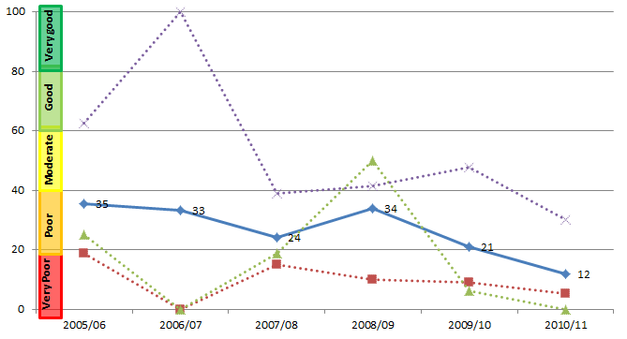
Figure 61: Trend in seagrass condition from 2005-2006 to 2010-2011 in the Fitzroy Region (blue solid line numbers are index categories).
Seagrass condition is also separated into component scores for abundance, reproductive effort and nutrient status (red, green and purple dotted lines, respectively).
Seagrass is monitored at estuarine sites at Rodds Bay and Urangan (Figure 62), in the north and south of the inshore Burnett Mary region, respectively. The primary environmental drivers of community composition at these sites are fluctuating temperatures, catchment run-off and high turbidity. Seagrass abundance was very poor throughout the inshore region. The meadow in the south showed signs of recovery in 2010 from previous years of flooding; however, following the extreme weather events, abundance declined to pre-2008 levels. Reproductive effort declined across the inshore region to a very poor state, which may result in reduced capacity of local meadows to recover from environmental disturbances. The nutrient concentrations of seagrass tissue were high, which is indicative of poor water quality following large flood events in the inshore region.
Figure 62: Trend in seagrass abundance (per cent cover) at inshore intertidal estuarine habitats (Urangan and Rodds Bay) in the Burnett Mary.

4. Summary
The summer of 2010-2011 was a season of extreme weather in the Great Barrier Reef. With the very strong La Niña beginning in mid-2010, intense, prolonged and above average rainfall occurred across eastern Queensland and three cyclones crossed the coast over a period of three months. These conditions resulted in record discharge from many rivers for the fourth consecutive year and an overall decline in water quality across the Great Barrier Reef, with some inshore sites in the poorest condition since monitoring began in 2005.
Changes in community composition and condition occurred both directly and indirectly as a result of the frequency and intensity of acute disturbances in combination with the underlying chronic effects of poor water quality. For example, there was an increase in the outbreak of coral disease in the inshore Mackay Whitsunday Region, which was linked to repeated above-median discharge from local rivers. The indicators of ecosystem health monitored in the MMP show that seagrass meadows and inshore coral reefs are in poor or very poor condition overall. Prior to the 2010-2011 wet season seagrass meadows in the Great Barrier Reef were already in a vulnerable condition. This season’s extreme weather resulted in substantial seagrass loss in areas directly affected by Cyclone Yasi and in regions exposed to flooding. Declines in seagrass abundance and coral cover were accompanied by low reproductive effort and numbers of juveniles, which may suggest reduced resilience and capacity to recover from disturbances in the immediate term.
Several locations affected by the flood events and Cyclone Yasi support significant dugong and green turtle populations, which are highly dependent on the local seagrass meadows for their primary food supply. The scale of seagrass damage is expected to have a flow-on effect on food availability for both dugong and turtle, resulting in increased mortality.
The status of the Great Barrier Reef catchments that deliver pollutants to the inshore marine environment determine the risk of inshore ecosystems to flood plumes and the ecological consequences of any exposure. Each catchment is characterised by different topography, rainfall events, land use patterns and practices, and therefore the exposure of ecosystems to particular pollutants in adjacent waters is specific to these catchment characteristics. This information, coupled with knowledge of plume movement and composition that will be improved with the development of models, can be used to target management actions in areas that are delivering the highest loads of sediments, nutrients and pesticides to the Great Barrier Reef, and where the greatest number or area of inshore ecosystems are at risk of exposure to elevated levels of pollutants.
The variable climate of the Great Barrier Reef Region, its susceptibility to periodic acute disturbances, and the complexity of disturbance impacts and their potential time-lags, means that monitoring that spans several cycles of wet, dry and average years will be required to allow us to measure the trajectories of change, identify areas and regions at greatest risk, improve our ecosystem understanding and separate any influences of land management changes from the high temporal variability in marine water quality. Adaptive management that incorporates monitoring and reporting, effective networks between stakeholders and collective responses based on evidence are our best means of achieving long-term Great Barrier Reef health and resilience outcomes.

References
1. Great Barrier Reef Marine Park Authority 2009, Great Barrier Reef Outlook Report 2009, GBRMPA, Townsville, .
2. Furnas, M. 2003, Catchments and corals: terrestrial runoff to the Great Barrier Reef, Australian Institute of Marine Science, Townsville.
3. Hutchings, P. and Haynes, D. 2005, Marine Pollution Bulletin Special Edition editorial, Marine Pollution Bulletin 51(1-4): 1-2.
4. Moss, A.J., Rayment, G.E., Reilly, N. and Best, E.K. 1992, Sediment and Nutrient Exports from Queensland Coastal Catchments, A Desk Study, Dept of Environment & Heritage, Dept of Primary Industries, Queensland, viewed dd/mm/yyyy, <Nutrients Terresterial>.
5. Neil, D.T., Orpin, A.R., Ridd, P.V. and Yu, B. 2002, Sediment yield and impacts from river catchments to the Great Barrier Reef Lagoon, Marine and Freshwater Research 53(4): 733-752.
6. McCulloch, M., Fallon, S., Wyndham, T., Hendy, E., Lough, J.M. and Barnes, D. 2003, Do sediments sully the reef? Ecos 115: 37-41.
7. Department of the Premier and Cabinet 2009, Reef Water Quality Protection Plan 2009 for the Great Barrier Reef World Heritage Area and Adjacent Catchments, Reef Water Quality Protection Plan Secretariat, DPC, Brisbane, viewed dd/mm/yyyy, <http://www.reefplan.qld.gov.au/resources/assets/reef-plan-2009.pdf>.
8. Department of the Premier and Cabinet 2008, Scientific consensus statement on water quality in the Great Barrier Reef, DPC, Brisbane, .
9. Waycott, M. and McKenzie, L.J. 2010, Final report project 1.1.3 to the Marine and Tropical Sciences Research Facility: Condition, trend and risk in coastal habitats: Seagrass indicators, distribution and thresholds of potential concern, Reef and Rainforest Research Centre, Cairns, .
10. Fabricius, K.E., Langdon, C., Uthicke, S., Humphrey, C., Noonan, S., De'ath, G., Okazaki, R., Muehllehner, N., Glas, M. and Lough, J.M. 2011, Losers and winners in coral reefs acclimatized to elevated carbon dioxide concentrations, Nature Climate Change 1: 165-169.
11. Collier, C. and Waycott, M. 2009, Drivers of change to seagrass distributions and communities on the Great Barrier Reef, literature review and gaps analysis. Report to the Marine and Tropical Sciences Research Facility, Reef and Rainforest Research Centre, Cairns, viewed dd/mm/yyyy, <http://www.rrrc.org.au/publications/downloads/113-JCU-Collier-C-et-al-2009-Seagrass-Disturbance-Review.pdf>.
12. van Dam, J.W., Negri, A.P., Mueller, J.F. and Uthicke, S. 2012, Symbiont-specific responses in foraminifera to the herbicide diuron, Marine Pollution Bulletin in press.
13. Fabricius, K.E. 2005, Effects of terrestrial runoff on the ecology of corals and coral reefs: Review and synthesis, Marine Pollution Bulletin 50(2): 125-146.
14. Cooper, T. and Fabricius, K. 2007, Coral-based indicators of changes in water quality on nearshore coral reefs of the Great Barrier Reef. Unpublished report to Marine and Tropical Sciences Research Facility, Reef and Rainforest Research Centre Limited, Cairns, .
15. Berumen, M.L. and Pratchett, M.S. 2006, Recovery without resilience: persistent disturbance and long-term shifts in the structure of fish and coral communities at Tiahura Reef, Moorea, Coral Reefs 25: 647-653.
16. Hoegh-Guldberg, O., Mumby, P.J., Hooten, A.J., Steneck, R.S., Greenfield, P., Gomez, E., Harvell, C.D., Sale, P.F., Edwards, A.J., Caldeira, K., Knowlton, N., Eakin, C.M., Iglesias-Prieto, R., Muthiga, N., Bradbury, R.H., Dubi, A. and Hatziolos, M.E. 2007, Coral reefs under rapid climate change and ocean acidification, Science 318: 1737-1742.
17. Intergovernmental Panel on Climate Change 2007, Climate change 2007 synthesis report, Summary for policymakers, IPCC Secretariat, Gland, Switzerland, .
18. Garnaut, R. 2008, The Garnaut Climate Change Review, Cambridge University Press, Melbourne, viewed dd/mm/yyyy, <http://www.garnautreview.org.au>.
19. Wooldridge, S.A. 2009, Water quality and coral bleaching thresholds: formalising the linkage for the inshore reefs of the Great Barrier Reef, Australia, Marine Pollution Bulletin 58(5): 745-751.
20. Booij, K., Vrana, B. and Huckins, J.N. 2007, Theory, modelling and calibration of passive samplers used in water monitoring, in Passive sampling techniques in environmental monitoring, eds R. Greenwood, G. Millis and B. Vrana, Elsevier Amsterdam, Amsterdam, pp. 141-169.
21. Shaw, M., Negri, A.P., Fabricius, K. and Mueller, J.F. 2009, Predicting water toxicity: Pairing passive sampling with bioassays on the Great Barrier Reef, Aquatic Toxicology 95(2): 108-116.
22. Great Barrier Reef Marine Park Authority 2010, Water quality guidelines for the Great Barrier Reef Marine Park, GBRMPA, Townsville, viewed dd/mm/yyyy, <http://www.gbrmpa.gov.au/__data/assets/pdf_file/0017/4526/GBRMPA_WQualityGuidelinesGBRMP_RevEdition_2010.pdf>.
23. Furnas, M. and Brodie, J. 1996, Current status of nutrient levels and other water quality parameters in the Great Barrier Reef, in Downstream effects of landuse, eds H.M. Hunter, A.G. Eyles and G.E. Rayment, Department of Natural Resources, Brisbane, pp. 9-21.
24. Thompson, A.A. and Dolman, A.M. 2010, Coral bleaching: one disturbance too many for near-shore reefs of the Great Barrier Reef, Coral Reefs 29(3): 637-648.
25. McKenzie, L.J. MTSRF Milestone report for June 2009: Seagrass indicators, distribution and thresholds of potential concern, viewed dd/mm/yyyy, <http://www.rrrc.org.au/publications/downloads/113-QDPIF-McKenzie-L-2009-June-Milestone-Report.pdf> .
26. Schaffelke, B., Carleton, J., Doyle, J., Furnas, M., Gunn, K., Skuza, M., Wright, M. and Zagorskis, I. 2010, Reef Rescue Marine Monitoring Program: Final report of AIMS activities 2009/10: Inshore water quality monitoring, Australian Institute of Marine Science, Townsville, viewed dd/mm/yyyy, <http://www.rrrc.org.au/mmp/downloads/378_AIMS_final-annual-report_2009-10.pdf>.
27. Haynes, D., Mueller, J. and Carter, S. 2000, Pesticide and herbicide residues in sediments and seagrasses from the Great Barrier Reef World Heritage Area and Queensland coast, Marine Pollution Bulletin 41(7-12): 279-287.
28. Haynes, D., Ralph, P., Prange, J. and Dennison, W. 2000, The impact of the herbicide diuron on photosynthesis in three species of tropical seagrass, Marine Pollution Bulletin 41(7-12): 288-293.
29. Mitchell, C., Brodie, J.E. and White, I. 2005, Sediments, nutrients and pesticide residues in event flow conditions in streams of the Mackay Whitsunday Region, Australia, Marine Pollution Bulletin 51(1-4): 23-36.
30. Lewis, S.E., Brodie, J.E., Bainbridge, Z.T., Rohde, K.W., Davis, A.M., Masters, B.L., Maughan, M., Devlin, M.J., Mueller, J.F. and Schaffelke, B. 2009, Herbicides: A new threat to the Great Barrier Reef, Environmental Pollution 157(8-9): 2470-2484.
31. Kapernick, A., Shaw, C., Dunn, A., Komarova, T., Mueller, J., Carter, S., Eaglesham, G., Alberts, V., Masters, B., Rhode, K., Packett, R., Prange, J. and Haynes, D. 2007, River pesticide loads and GBR lagoon pesticide data (2006-2007), Report to the Great Barrier Reef Marine Park Authority. National Research Centre for Environmental Toxicology (EnTox), University of Queensland, Brisbane, .
32. Packett, R., Dougall, C., Rohde, K. and Noble, R. 2009, Agricultural lands are hot-spots for annual runoff polluting the southern Great Barrier Reef lagoon, Marine Pollution Bulletin 58(7): 976-986.
33. Magnusson, M., Heimann, K. and Negri, A.P. 2008, Comparative effects of herbicides on photosynthesis and growth of tropical estuarine microalgae, Marine Pollution Bulletin 56: 1545-1552.
34. Jones, R.J. and Kerswell, A.P. 2003, Phytotoxicity of Photosystem II (PSII) herbicides to coral, Marine Ecology Progress Series 261: 149-159.
35. Osborne, K., Dolman, A.M., Burgess, S.C. and Johns, K.A. 2011, Disturbance and the dynamics of coral cover on the Great Barrier Reef (1995–2009), PLoS ONE 6(3): e17516.
36. McCook, L.J., Folke, C., Hughes, T., Nyström, M., Obura, D. and Salm, R. 2007, Ecological resilience, climate change and the Great Barrier Reef, in Climate Change and the Great Barrier Reef: A vulnerability assessment, eds J.E. Johnson and P.A. Marshall, Great Barrier Reef Marine Park Authority and Australian Greenhouse Office, Townsville, pp. 75-96, viewed dd/mm/yyyy, <http://www.gbrmpa.gov.au/__data/assets/pdf_file/0017/4445/chpt-4-McCook-et-al-2007.pdf>.
37. McClanahan, T., Polunin, N. and Done, T. 2002, Ecological states and the resilience of coral reefs, Conservation Ecology 6(2).
38. Magnusson, M., Heimann, K., Quayle, P. and Negri, A.P. 2010, Additive toxicity of herbicide mixtures and comparative sensitivity of tropical benthic microalgae, Marine Pollution Bulletin 60: 1978-1987.
39. Great Barrier Reef Marine Park Authority 2011, Impacts of tropical cyclone Yasi on the Great Barrier Reef: A report on the findings of a rapid ecological impact assessment, GBRMPA, Townsville, viewed dd/mm/yyyy, <http://www.gbrmpa.gov.au/media-room/feature/cyclone-yasi-report-released>.
40. Maynard, J.A., Johnson, J.E., Marshall, P.A., Eakin, C.M., Goby, G., Schuttenberg, H. and Spillman, C.M. 2009, A Strategic Framework for Responding to Coral Bleaching Events in a Changing Climate, Environmental management 44(1): 1-11.
41. Bruno, J.F., Selig, E.R., Casey, K.S., Page, C.A., Willis, B., Harvell, C.D., Sweatman, H. and Melendy, A.M. 2007, Thermal stress and coral cover as drivers of coral disease outbreaks, PLoS Biology 5(6): e124.
42. Bureau of Meteorology 2010, Annual Climate Summary 2009, National Climate Centre, Bureau of Meteorology, Melbourne, viewed dd/mm/yyyy, <www.bom.gov.au/climate/annual_sum/2009/>.
43. Engelhardt, U. and andLassig, B. 1997, A review of possible causes and consequences of outbreaks of crown-of-thorns starfish (Acanthaster planci) on the Great Barrier Reef - an Australian perspective, in The Great Barrier Reef, science, use and management: a national conference, eds. N. Turia and C. Dalliston. , Great Barrier Reef Marine Park Authority, Townsville, pp.243-259.
44. Sweatman, H., Cheal, A.J., Coleman, G.J., Emslie, M.J., Johns, K., Jonker, M., Miller, I.R. and Osborne, K. 2008, Long-term monitoring of the Great Barrier Reef: Status Report 8, Australian Institute of Marine Science, Townsville, .
45. Brodie, J., Fabricius, K.E., De'ath, G. and Okaji, K. 2005, Are increased nutrient inputs responsible for more outbreaks of crown-of-thorns starfish? An appraisal of the evidence, Marine Pollution Bulletin 51(1-4): 266-278.
46. Fabricius, K.E. 2011, Factors determining the resilience of coral reefs to eutrophication: A review and conceptual model, in Coral Reefs: An Ecosystem in Transition, eds Z. Dubinsky and N. Stambler, Springer, Dordrecht, pp. 493-508.
47. Kennedy, K., Schroeder, T., Shaw, M., Haynes, D., Lewis, S., Bentley, C., Paxman, C., Carter, S., Brando, V.E., Bartkow, M., Hearn, L. and Mueller, J.F. 2012, Long-term monitoring of photosystem II herbicides - Correlation with remotely sensed freshwater extent to monitor changes in the quality of water entering the Great Barrier Reef Australia, Marine Pollution Bulletin in press.
48. Birch, W.R. and Birch, M. 1984, Succession and pattern of tropical intertidal seagrases in Cockle Bay, Queensland, Australia: A decade of observations, Aquatic Botany 19: 343-367.
49. Duarte, C.M. 1991, Allometric scaling of seagrass form and productivity, Marine Ecology Progress Series 77: 289-300.



