Development case study - Baffle basin
Review of coastal ecosystem management to improve the health and resilience of the Great Barrier Reef World Heritage Area


Prepared on 14 June 2013 for the Great Barrier Reef Marine Park Authority by:
Glen Holmes, Chris McGrath, Josh Larsen, Marc Hockings and Patrick Moss
School of Geography, Planning and Environmental Management
The University of Queensland
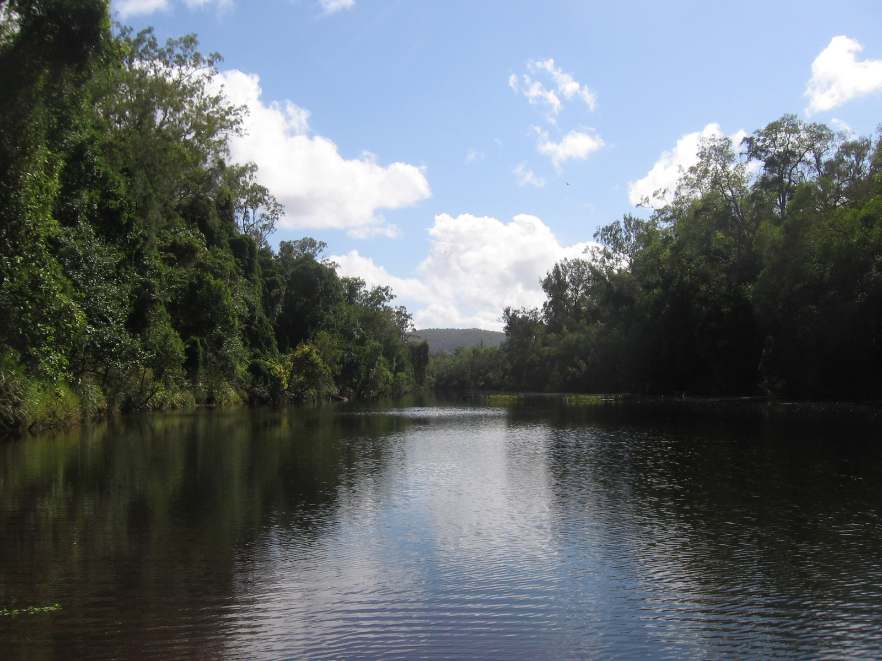

Page intentionally left blank for printing double-sided.

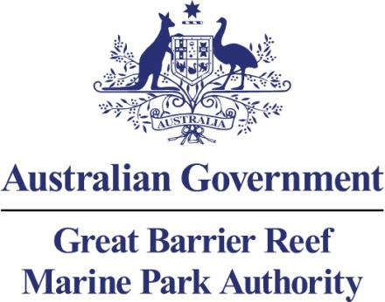

Development case study – Baffle basin
Review of coastal ecosystem management to improve the health and resilience of the Great Barrier Reef World Heritage Area
Prepared on 14 June 2013 for the Great Barrier Reef Marine Park Authority by:
Glen Holmes, Chris McGrath, Josh Larsen, Marc Hockings and Patrick Moss
School of Geography, Planning and Environmental Management
The University of Queensland

© Commonwealth of Australia 2013

Published by the Great Barrier Reef Marine Park Authority 2013

This work is copyright. You may download, display, print and reproduce this material in unaltered form only (appropriately acknowledging this source) for your personal, non-commercial use or use within your organisation. Apart from any use as permitted under the Copyright Act 1968, all other rights are reserved.

Disclaimer
The views and opinions expressed in this publication are those of the authors and do not necessarily reflect those of the Australian Government or the Minister for Sustainability, Environment, Water, Population and Communities.

While reasonable efforts have been made to ensure that the contents of this publication are factually correct, the Australian Government does not accept responsibility for the accuracy or completeness of the contents, and shall not be liable for any loss or damage that may be occasioned directly or indirectly through the use of, or reliance on, the contents of this publication.

National Library of Australia Cataloguing-in-Publication entry
Holmes, G.
Coastal ecosystems management – case study: regional planning, Glen Holmes, Chris McGrath, Josh Larsen, Marc Hockings and Patrick Moss.
ISBN 978 1 922126 18 4 (ebook)
Ecosystem management--Queensland--Great Barrier Reef.
Ecosystem health--Queensland--Great Barrier Reef.
Natural resources management areas--Queensland--Great Barrier Reef.
Great Barrier Reef (Qld.)--Management.
McGrath, Chris, 1972.
Larsen, Josh.
Hockings, Marc.
Moss, Patrick T.
Great Barrier Reef Marine Park Authority.
577.5109943
This publication should be cited as:
Holmes, G., McGrath, C., Larsen, J., Hockings, M. and Moss, P.T. 2013, Coastal ecosystems management – case study: regional planning.
Acknowledgements
This report was supported through funding from the Australian Government Department of Sustainability, Environment, Water, Population and Communities.

The authors would like to thank Sue Sargent from the Burnett Mary Regional Group, Gladstone Regional Council, Jim Tait from Econcern Environmental Consulting, and stakeholders as per field assessments and review (Dennis Dray (QNPWS), Lindsay Boyd (GRC), Heather Richards (GRC)).

Cover photo: Baffle Creek in the Baffle basin by Jim Tait (2006).
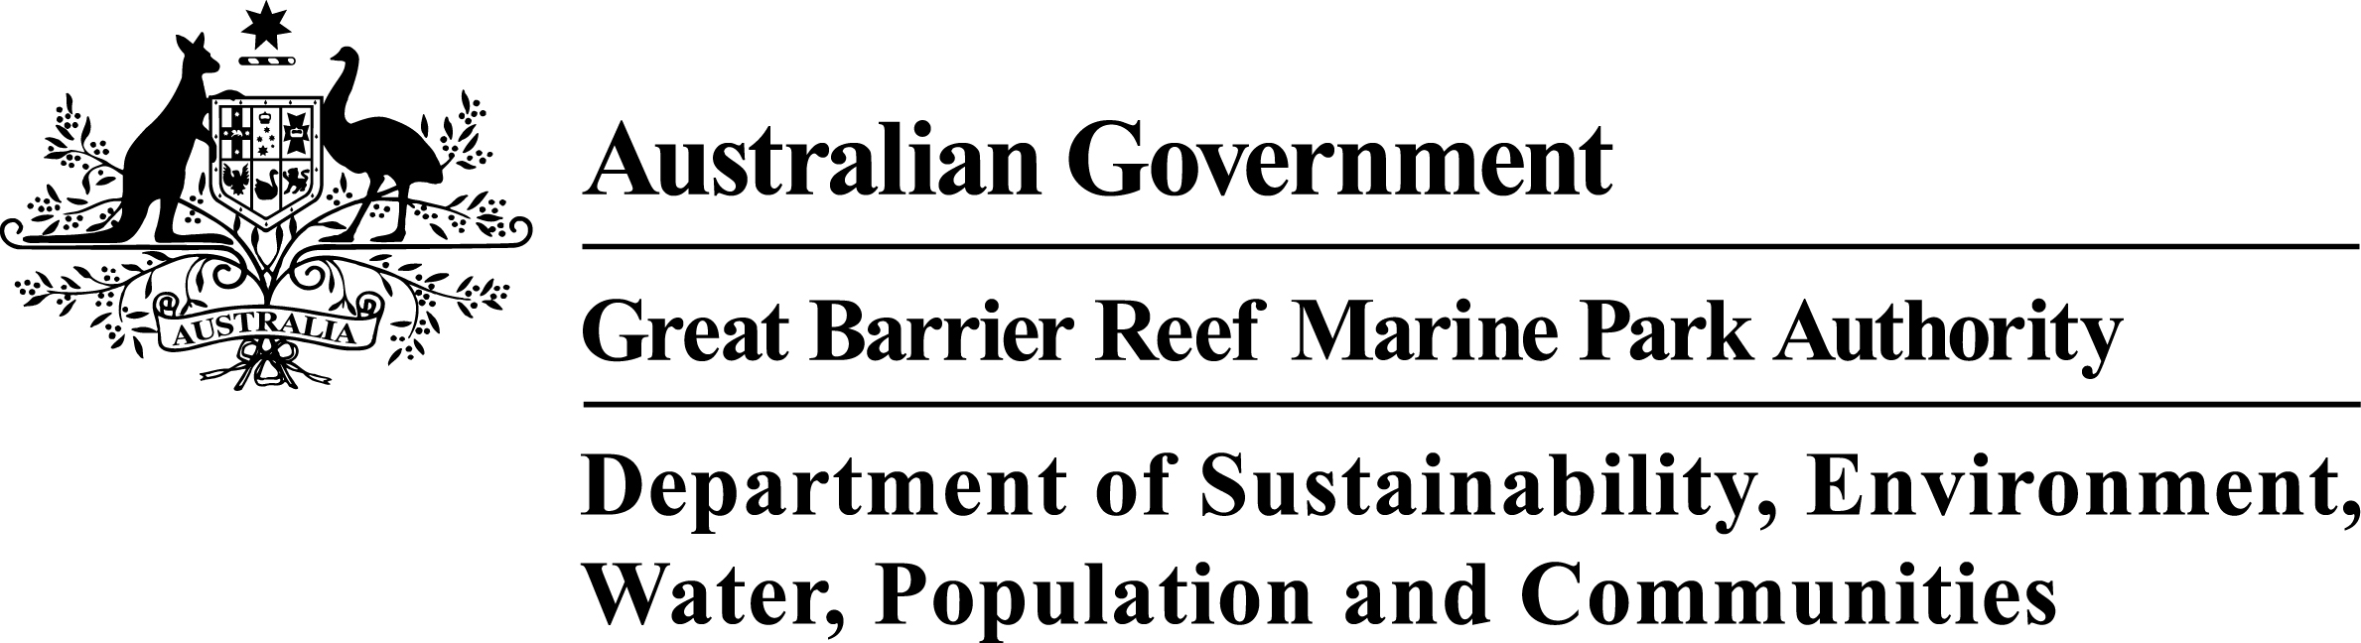

Requests and enquiries concerning reproduction and rights should be addressed to:

Great Barrier Reef Marine Park Authority
2-68 Flinders Street (PO Box 1379)
Townsville QLD 4810, Australia

Phone: (07) 4750 0700
Fax: (07) 4772 6093
Email: info@gbrmpa.gov.au

www.gbrmpa.gov.au

TABLE OF CONTENTS
EXECUTIVE SUMMARY 1
Context 1
Key issues 1
Current management 1
Potential management actions 2
INTRODUCTION 4
Background 4
Objectives and purpose of case study 4
METHODOLOGY 4
COASTAL ECOSYSTEMS OF THE REGION 5
Background 5
Overview of the Baffle basin 8
History of land use change 10
Impact on coastal ecosystems 12
Current condition and trend 14
Hummock Hill Island development case study 17
INFLUENCE OF CURRENT LAND-USE ACTIVITIES AND PRACTICES ON COASTAL ECOSYSTEMS 21
Background 21
Overlapping roles of government 21
General laws, policies and programs relevant to development in the Baffle basin 23
Local government planning under SPA 26
Development applications under SPA 28
Changes to coastal and regional planning 28
Changes to vegetation laws 30
Marine plants and fish habitat areas 30
Protected areas 31
Cumulative and indirect impacts 33
Return of coastal ecosystem function to modified landscapes 33
Forecast of likely future activities and impacts on coastal ecosystems 34
Uncertainty in assessment and managing risk 35
Adaptive management 36
DISCUSSION 37
Mapping “Great Barrier Reef priority areas” for guidance under the EPBC Act 40
Engagement and support for local governments 41
Potential management actions 42
APPENDIX A – Author profiles 46
APPENDIX B: Ecological processes of natural coastal ecosystems linked to the health and resilience of the World Heritage Area. 47
APPENDIX C: Ecological processes of modified systems linked to the health and resilience of the World Heritage Area. 49
APPENDIX D - DRAFT assessment criteria for establishing management actions within the Great Barrier Reef catchment that help maintain health and resilience of ecosystems in the World Heritage Area 51
APPENDIX E - Infrastructure associated with residential development 52

EXECUTIVE SUMMARY

Context
Development and ongoing management of land in the Great Barrier Reef catchment for agriculture, urban and industrial use or for mining and petroleum extraction can damage or remove the ecosystem functions and processes that are important for the health and resilience of the Great Barrier Reef World Heritage Area (World Heritage Area). This case study examines the control mechanisms for development within the Baffle basin, a relatively undeveloped catchment at the southern end of the World Heritage Area. Specifically, it looks at the current and proposed agricultural, urban, industrial and mining development and the associated infrastructure requirements, and how the potential impacts on the ecosystem processes of the World Heritage Area are being or can be managed to maintain coastal ecosystem connectivity and function.

Key issues
Maintaining the ecosystem functions provided by the Great Barrier Reef catchment is essential for maintaining the health of the World Heritage Area. Continued coastal ecosystem delivery of important ecosystem functions and processes requires connectivity between coastal ecosystems and the marine environment to be maintained. Modification of coastal ecosystems for residential or industrial development can potentially break this connectivity not only through the direct removal of habitat but also through changes to hydrology (such as through water resource allocation). The modification of coastal ecosystems outside of the World Heritage Area can directly impact the ecosystem functions provided by the coastal catchment to the World Heritage Area. Planning and management of these issues is complex and involves many stakeholders and interests. Past planning and management of development in the Great Barrier Reef catchment has often not recognised or valued the critical importance of the maintenance of the ecosystem functions of the catchment for the World Heritage Area. Ongoing and increasing development pressures in the Great Barrier Reef catchment, in addition to the legacy of past development, requires active engagement in the planning and management processes at Commonwealth, state and local government levels, and with the community to ensure that the ecosystem functions of the Great Barrier Reef catchment are protected, rehabilitated and restored.

Current management
Under the Queensland planning system, the Sustainable Planning Act 2009 (Qld) (SPA) is the principal mechanism for managing land development in the Baffle basin. Most state development control processes (for activities other than mining or petroleum extraction) are now part of the Integrated Development Assessment System (IDAS) under the SPA. For example, a proposed marina development involving the removal of mangroves affecting fisheries would be assessed through the IDAS, with consideration of fisheries issues under the Fisheries Act 1994 (Qld) and policies triggered as part of that assessment.
There are several layers of planning – state-wide, regional and local – that regulate development under SPA, with planning at the local level requiring a significant increase in levels of detail and specificity. As a consequence, while state and regional planning is important, local government planning schemes provide the bulk of laws and regulations managing land development in the Great Barrier Reef catchment.
Onshore mining and petroleum extraction is not regulated at a state level under SPA. For onshore mining, tenure and royalty payments are regulated under the Mineral Resources Act 1989 (Qld), while environmental issues are regulated under the Environmental Protection Act 1994 (Qld) (EPA). For onshore petroleum extraction (including coal seam gas), tenure and royalty payments are regulated under the Petroleum and Gas (Production and Safety) Act 2004 (Qld) and environmental issues are regulated under the EPA. These laws create assessment processes and offence provisions to assess and regulate mining and petroleum extraction.
At a Commonwealth level, the Environment Protection and Biodiversity Conservation Act 1999 (Cth) (EPBC Act) is the principal regulatory system for controlling new development impacting on matters of national environmental significance such as the World Heritage Area and threatened ecological communities and species. While this is an important process that has on occasion found projects with significant impacts on the ecosystem processes of the World Heritage Area and the Great Barrier Reef catchment as clearly unacceptable, the importance of state level laws, particularly for controlling cumulative impacts of urban expansion, must be recognised.
It is also important to recognise that the planning and management frameworks created by these state and Commonwealth laws principally regulate new activities and development. The legacy of past development tends to become a fixed part of the “status quo” forming a background of chronic impact on the condition of the environment.
Fifteen per cent of the Baffle basin is currently protected from most forms of development, including mining and petroleum extraction, due to its designation as national park or conservation park under the Nature Conservation Act 1992 (Qld). This is somewhat unusual as less than five per cent of Queensland is within a national park or conservation park.

Potential management actions
Actions that could be taken include:
- Engage with and support the Queensland Government in preparing or reviewing any regional plan for land in the Great Barrier Reef catchment, to ensure that, as far as is practicable, the protection of the ecosystem processes of the World Heritage Area and the Great Barrier Reef catchment are appropriately addressed (Note that a new Central Queensland Regional Plan covering the Baffle Basin was approved on 14 October 2013).
- Engage with and support local government and, where relevant, Queensland Government planning decisions by:
  - Providing technical advice to local governments during the preparation or review of any planning scheme in the Great Barrier Reef catchment to ensure that, as far as is practicable, the protection of the ecosystem functions and processes of the World Heritage Area and the Great Barrier Reef catchment are addressed. This approach could be piloted with the local governments in the Great Barrier Reef Marine Park Authority’s Reef Guardian Council program.
  - Monitoring development applications made under SPA in the Great Barrier Reef catchment, and providing technical information to local governments and the Queensland Government in making decisions on development applications with potential impacts on the ecosystem functions for the World Heritage Area. The support may take the form of providing technical advice, expertise in coastal management matters, or mechanisms to support positive regional ecosystem function outcomes. Where appropriate, this approach could extend to having expertise available to assist a local government in defending appeals to the Planning and Environment Court against refusal of development applications.
- Development of a guideline on actions likely to have a significant impact on the World Heritage Area under the EPBC Act to better inform landholders of what actions require approval under that Act. The guidelines could supplement existing guidelines on significance under the EPBC Act and be linked to maps of the “Framework to identify priority hydrological connections to the Great Barrier Reef World Heritage Area” identifying wetlands, watercourses and other areas important for maintaining ecosystem functions for the World Heritage Area. Actions in or affecting priority areas for protection, rehabilitation and restoration should be identified as likely to cause a significant impact on the World Heritage Area. The guideline might also identify particular actions within or affecting priority hydrological connections, such as dams, weirs and barrages that have the potential to significantly impact the World Heritage Area.
- Integrated planning outcomes should be considered when engaging with and supporting the planning and development assessment processes. Integrated planning outcomes should recognise the continuity of biophysical linkages across the entire coastal zone from the top of the Great Barrier Reef catchment through to the adjacent inshore marine areas. Zoning within the Great Barrier Reef Marine Park (Marine Park) such as green (no-take) zones be supported by complementary management within the Great Barrier Reef catchment.

INTRODUCTION

Background
This case study is part of a series of case studies developed in association with the Great Barrier Reef Coastal Ecosystem Assessment Framework (CEAF) basin assessments.¹ The CEAF delivers an assessment of the cumulative impacts of development in highly developed and less developed areas of the Great Barrier Reef coastal zone to inform assessment of both present and future development pressures and potential net conservation gain opportunities for the World Heritage Area.

Objectives and purpose of case study
The objective of this case study is to review current and potential future industrial and residential development activities in the Baffle basin (Figure 2) and identify opportunities to protect, rehabilitate and restore coastal ecosystem function. It is one of a series of case studies supporting the CEAF basin assessments which are intended to inform the strategic assessment of the World Heritage Area and adjacent coastal zone by exploring the current extent and connections of coastal ecosystems, land use within the basins, and identify blockages and obstructions in the environment that have the potential to affect the ecological processes important to the Great Barrier Reef.
This case study examines the links between industrial and residential infrastructure and coastal ecosystems. It examines how ecosystem connectivity and function can be maintained without hindering future infrastructure needs. In investigating this issue, the case study identifies existing residential and industrial development and its associated infrastructure within the Baffle Creek basin, as well as identifying potential future developments to 2025 that would require additional infrastructure.

METHODOLOGY
This case study was conducted in a short timeframe and without field work or attempting to gather primary data on the extent or nature of the development pressures within Baffle basin.
A literature review and use of mapping provided by GBRMPA from the CEAF basin assessments were the main methods used to gather information on the extent and nature of the pressure from development, the condition (including trends) of ecosystem functions in the catchment, and the regulatory response to the development pressure.
In considering possible policy improvements, the environmental regulatory design principles recommended by Gunningham and Grabosky² were adopted, namely:
- Prefer policy mixes incorporating a broader range of instruments and institutions
- Prefer less interventionist measures (for example voluntary measures rather than legislation if practicable)
- Ascend a dynamic instrument pyramid to the extent necessary to achieve policy goals building in regulatory responsiveness
- Empower participants which are in the best position to act as surrogate regulators
- Maximise the opportunities for win-win outcomes.
In doing so, where possible this case study presents potential management actions that would not involve legislative change and could be done using existing frameworks.
The methodology adopted in this case study is also based on the terminology and framework for assessing the importance of coastal ecosystems for the World Heritage Area set out in the report, Informing the Outlook for Great Barrier Reef Coastal Ecosystems.³ That report identifies the coastal ecosystems that have been modified and natural corridors and essential connections to the Great Barrier Reef for flora and fauna that have been lost or modified as a result of more than one hundred and fifty years of catchment clearing and coastal development.

COASTAL ECOSYSTEMS OF THE REGION

Background
Coastal ecosystems represent the bridging ecosystems between the marine and terrestrial environments. As such they play a vital role in maintaining the connectivity between these two environments through the provision of a range of ecosystem functions and processes. Ecosystem services are often considered within the context of the provision of services to human society. The Millennium Ecosystem Assessment grouped services into four categories:⁴
- Provisioning services such as food, water, timber, and fibre
- Regulating services such as the regulation of climate, floods, disease, wastes, and water quality
- Cultural services such as recreational, aesthetic, and spiritual benefits
- Supporting services such as soil formation, photosynthesis, and nutrient cycling.
Supporting services are those that maintain other ecosystem services such as the provision of habitat to support commercial fisheries. Regulating services not only provide services to human wellbeing but also to other ecosystems. For example, the regulation of floods not only protects human assets from the damaging effects of floods but also similarly protects downstream ecosystems. Coastal and marine ecosystems are closely interlinked and rely on each other for the provision of many ecosystem services to maintain ecosystem health. The CEAF identifies 13 natural ecosystems within the coastal zone of the Great Barrier Reef and a range of physical, biogeochemical and biological functions and processes that are provided to the Great Barrier Reef (Appendix B). Post-European settlement, coastal regions have undergone significant change and the naturally occurring ecosystems are no longer the only ones to influence the number and extent of ecosystem services provided. The CEAF also identifies a further eight "modified" ecosystems (Appendix C).
The southernmost region of the Great Barrier Reef, the Burnett-Mary, contains examples of all eight terrestrial "natural" coastal ecosystems. Each ecosystem within this region has undergone some level of change, with estuaries the least affected (for example the Baffle and Mary estuaries showing 99 per cent and 98 per cent remaining respectively) and the woodlands and forested floodplain showing the highest degree of change (Table 1).

Table 1: Summary of basin areas of concern within the Burnett-Mary Natural Resource Management (NRM) region – percentage of remaining coastal ecosystems for the five basins within the Burnett–Mary NRM region. Red cells indicate areas with less than 10 per cent remaining; orange 10-30 per cent; yellow 31-50 per cent and green greater than 50 per cent. Note these figures provide no information about ecosystem condition or functionality. White cells denote an absence of this coastal ecosystem from the basin.³
Basin | Rainforests | Forests | Woodlands | Forested floodplain | Grass and sedgelands | Heath and shrublands | Freshwater wetlands | Estuaries
Baffle | 89 | 62 | 78 | 38 |  | 98 | 60 | 99
Burnett | 23 | 46 | 27 | 15 | 71 | 91 | 53 | 73
Kolan | 59 | 51 | 30 | 26 |  | 40 | 50 | 78
Burrum | 18 | 64 | 69 | 57 |  | 79 | 88 | 96
Mary | 52 | 45 | 52 | 24 |  | 31 | 33 | 98

Altering coastal ecosystems through development for agriculture, or urban or industrial expansion, can alter or even remove the ecosystem function provided by the original ecosystem which can be detrimental to adjacent ecosystems such as the Great Barrier Reef. This case study examines the level of development within the northernmost basin of the Burnett-Mary region, the Baffle basin. Specifically, it looks at the current and proposed future urban and industrial development and how together with the associated required infrastructure could affect the future of coastal ecosystem connectivity and function.
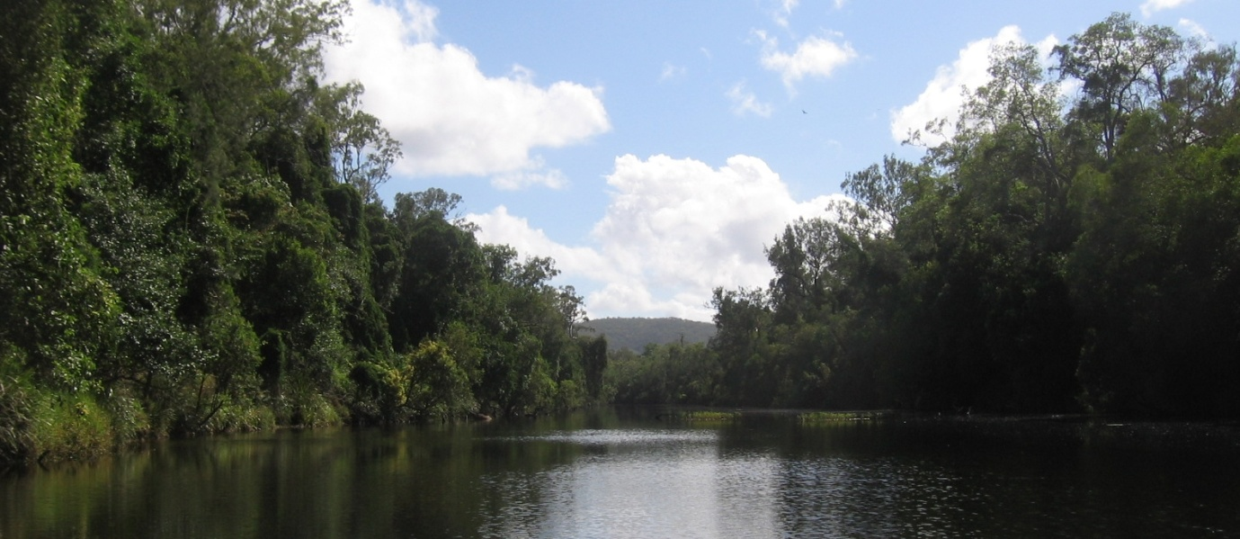
Figure 1: Baffle Creek is representative of many watercourses in the Baffle basin that are largely intact and have high ecosystem value for fish breeding and habitat. Source: Jim Tait (2006).
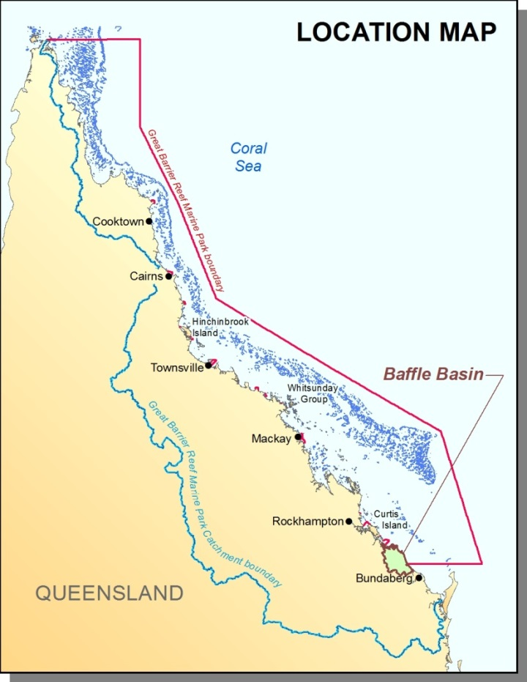
Figure 2: Baffle basin and its proximity to the Great Barrier Reef catchment and the Great Barrier Reef Marine Park.

Overview of the Baffle basin
The Baffle basin is the southernmost basin that borders the Marine Park and the northernmost within the Burnett-Mary NRM region (Figure 2). The basin contains representations of seven of the eight natural coastal ecosystems identified in the CEAF with only the Grass and Sedgelands ecosystem absent (Table 1). The waterways within the basin flow from northwest of Miriam Vale to the Baffle Creek estuary toward the southern bounds of the basin (Figure 3). There have been relatively low levels of development within the basin and it is considered the least impacted of the Central Queensland basins bordering the Marine Park. Waterways within the basin have not been exposed to any major hydrological modifications and remain unimpeded (there are no dams or weirs within the basin)⁵ (Figure 1). For this reason it is often used as a reference for what is considered "normal" within undisturbed systems.⁶
The basin covers two local government areas, falling predominantly within the bounds of Gladstone Regional Council; and region south from Baffle Creek within the Bundaberg Regional Council. Agnes Water is the main population centre (population 1814 at the 2011 census) with other smaller settlements at 1770 and Miriam Vale. More detailed information on the Baffle basin can be found in the relevant CEAF Basin Assessment Report.
A case study of a proposed major residential and tourism development is presented below to better understand the issues associated with the required infrastructure in the Baffle basin. The location of the proposed development is on Hummock Hill Island, adjacent to the northern edge of the Baffle basin. Although not officially within the Baffle basin (as it is an island), the proposed development is adjacent to an area of the basin with limited infrastructure and is surrounded by relatively undisturbed coastal ecosystems (Figure 3).

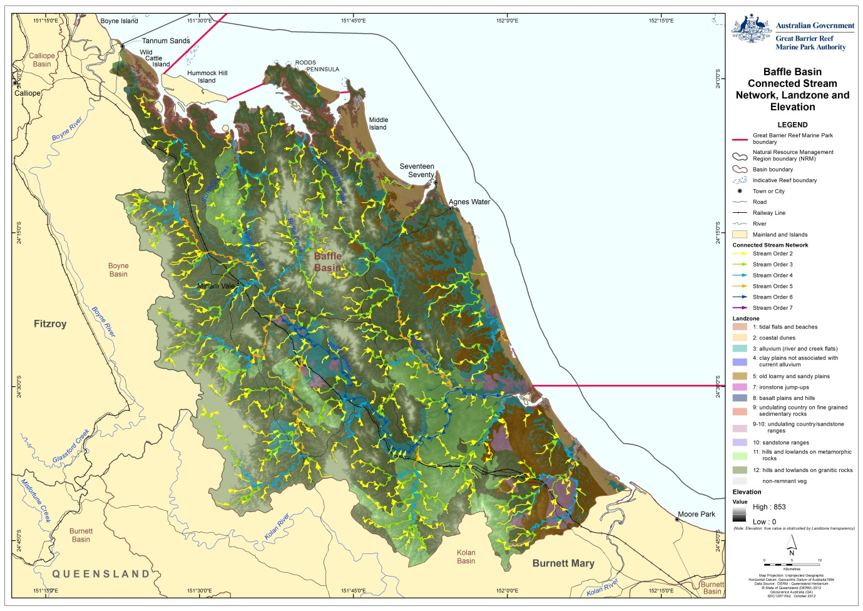
Hummock Hill Island case study site
Figure 3: Baffle basin stream network and location of the Hummock Hill Island case study site

History of land use change
While the Baffle basin may be considered to be relatively undisturbed, it is not wholly pristine. There has, post European settlement (hereafter referred to as post-clear), been considerable development of the inland areas of the basin primarily for agriculture with ~35 per cent of the total basin area modified in some way (Figure 5). The most significant levels of change are in the forests and forested floodplains (Table 2) which accounts for almost 95 per cent of the change within the basin. The forested floodplain has undergone the most change with only 38 per cent remaining largely unmodified.
In pre-European times, the 410,500 hectare Baffle basin was dominated by forests, woodlands and forested floodplain (Figure 5 top). Following European settlement, these forested areas were thinned for grazing and later cleared for irrigated intensive agriculture (in some areas) (Figure 5 bottom). Only 22 per cent of the basin remains as natural environments with the majority within national parks or other conservation areas (Table 3). The vast majority of land use change within the Baffle basin has been for the development of agriculture, with grazing natural vegetation the dominant land use comprising 67 per cent of the basin (Figure 4 and Table 3). The clearing of forests, woodlands and forested floodplain continued between 2006 and 2009 with more than 1600 hectares modified during that three year period. Urban and industrial development within the basin has remained very small with only two per cent of the basin within these land use categories.
Table 2: Area (ha) of pre-clear and post-clear (2009) coastal ecosystems (areas in square kilometres) based upon Queensland Government Regional Ecosystem mapping.

Coastal Ecosystem | Pre clear extent (ha) | 2006 extent (ha) | 2009 extent (ha) | % remaining
Rainforests | 16554 | 14952 | 14946 | 90%
Forests | 307791 | 191268 | 189854 | 62%
Woodlands | 24549 | 19203 | 19088 | 78%
Forested floodplain | 38420 | 14668 | 14547 | 38%
Grass and sedgelands | 0 | 0 | 0 | NA
Heath and shrublands | 6496 | 6399 | 6390 | 98%
Freshwater wetlands | 484 | 290 | 289 | 60%
Estuaries | 15924 | 15901 | 15901 | 100%
Non Remnant | 0 | 147172 | 148841 | NA
Not Mapped | 253 | 617 | 616 | NA

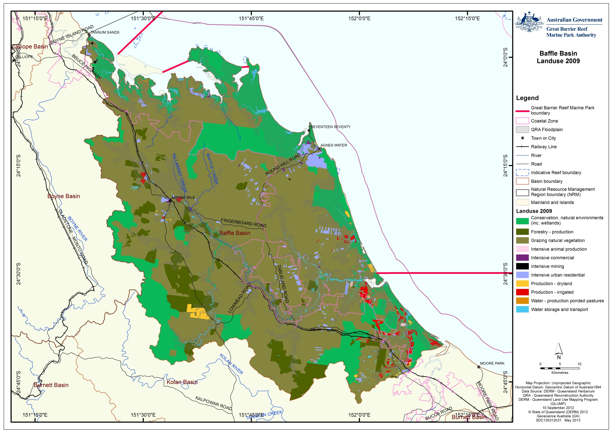
Figure 4: Land use in the Baffle basin based on 2009 QLUMP data

Table 3: Major land use categories (percentage) for the Baffle basin in 2009 based on Queensland Land Use Mapping Program data
 | Land use | 2009
 | Conservation, natural environments (inc. wetlands) | 22%
 | Forestry - production | 7%
 | Grazing natural vegetation | 67%
 | Intensive animal production | 0%
 | Intensive commercial | 0%
 | Intensive mining | 0%
 | Intensive urban residential | 2%
 | Production - dryland | 0%
 | Production - irrigated | 1%
 | Water - production ponded pastures | 0%
 | Water storage and transport | 1%
 | Not Mapped | 0%

Impact on coastal ecosystems
Within the Baffle basin, the majority of land use change has occurred on the western side of the basin, generally taking the form of clearing for grazing (Figure 5). Due to the low level of residential development along the coast (centred on Agnes Water and 1770), much of the coastal ecosystems within the coastal zone remain intact. The Baffle basin is also one of the only coastal basins to remain relatively free of barriers to connectivity, lacking any major dams or weirs. There are however, smaller potential barriers associated with infrastructure such as road crossings on smaller streams (Figure 6).
Despite the low levels of industrial or urban development within the basin, the clearing of forests and forested floodplain areas for agriculture has changed the level of ecosystem function provision to the World Heritage Area. These ecosystems provide a range of physical, biological and biogeochemical processes that are important to the health of the World Heritage Area (Appendix B). It is important to note however, that although there has been clearing of the forests and floodplain ecosystems for agriculture, the modified ecosystems that have replaced the pre-clear ones also provide a level of ecosystem function (Appendix C).

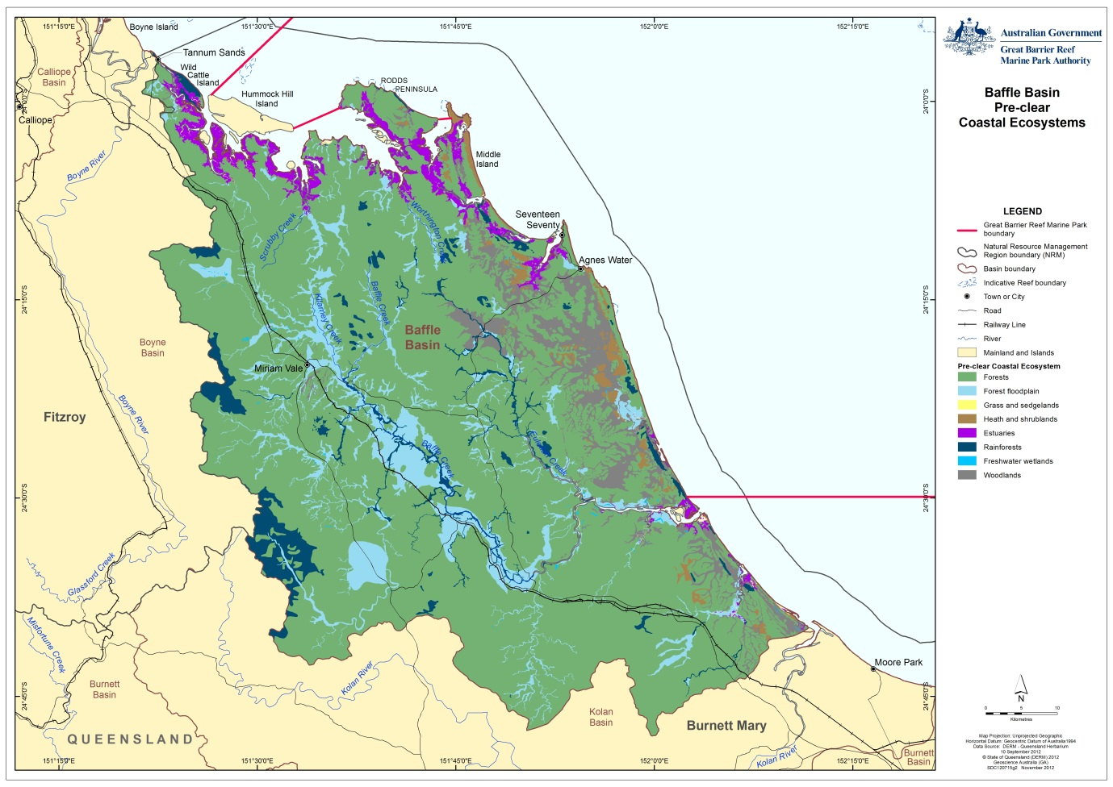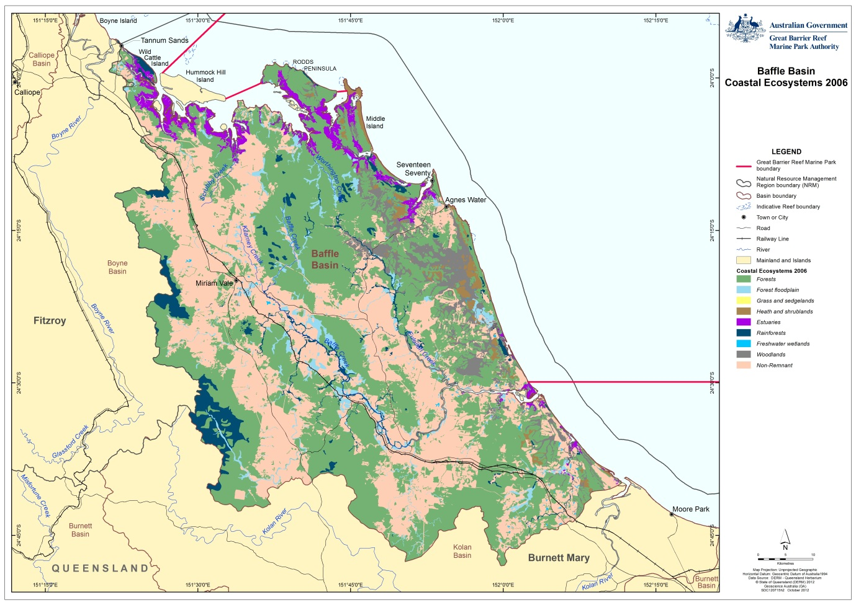
Figure 5: Baffle basin Coastal Ecosystems pre-European Settlement (above) and in 2006 (below)

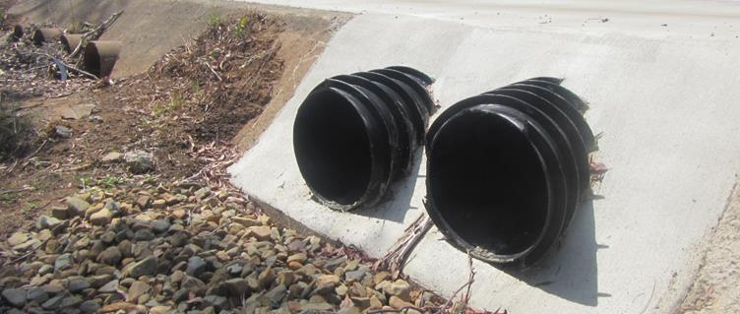
Figure 6: Culverts that are not best practice for fish passage located on Blackwater Creek. Note the ones in the foreground are however an improvement on the previous culverts in the background
Agricultural development within the Baffle basin has also been linked to declining water quality. In many places those impacts are mitigated through the retention of appropriate riparian buffers coupled with uptake of best management practices. The most recent report card of the Reef Water Quality Protection Plan (2013) however, identified that in the 2009-10 period, there has been a continued decline in both riparian vegetation and wetlands.⁷
The limited urbanisation and lack of industrialisation within the Baffle basin has resulted in the basin remaining more ecologically functional than other basins in the region. However, the growth of the Gladstone region as a result of the resources boom will likely put pressure on areas like the Baffle basin through increased demand for residential development and associated infrastructure. Such expansion will place increasing pressure on the coastal ecosystems and coastal waters of the World Heritage Area both through the physical disturbance to the systems (via development) as well as through increased usage levels of local residents and visitors.
In the southern Great Barrier Reef generally, we have reduced the assimilative capacity of the environment to absorb these pressures, and there is limited knowledge with regard to ecological ‘tipping points’ - the point at which it will be difficult to return ecosystem functions to the landscape without significant investment. The Baffle basin is one of the few locations where ecological assimilative capacities may still be relatively intact.
A more detailed description of the current impacts to coastal ecosystems can be found in the CEAF basin assessment report.

Current condition and trend
Despite widespread clearing in some parts of the Baffle basin, much of the ecosystem remains intact. This is more so in the coastal areas where many of the estuaries are in near pristine condition and around 75 per cent of the other coastal ecosystems remain unmodified (Figure 5). These estuaries often have seagrass meadows, and one estuary at the northern end of the basin (Pancake Creek), is home to possibly the last remaining estuarine coral reef along the central and southern Great Barrier Reef coastline (Figure 7).

The relatively low levels of urban or industrial development within the basin have resulted in much of the coastal zone remaining in largely pristine condition (Figure 8). These coastal zone ecosystems are likely to come under increasing pressure from urban expansion as growth within the region continues and people seek to live close to the ocean. The Wide Bay Burnett region is expected to grow by more than 50 per cent by 2031⁸ and the Gladstone region is expected to almost double in the same period⁹. The "sea change" phenomenon indicates that the bulk of this growth will be within the coastal zone. If not appropriately managed, this growth has the potential to fragment the remaining coastal ecosystems, reducing their connectivity and therefore their ability to provide ecosystem functions for the World Heritage Area.
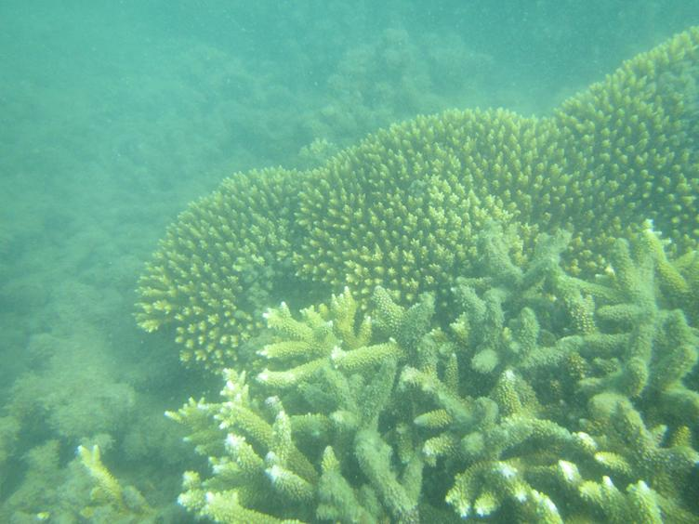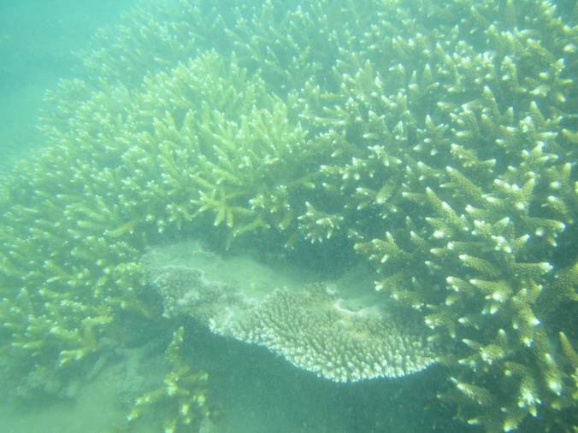
Figure 7: Acropora corals growing in Pancake Creek estuary (photos taken in December 2012. Photos courtesy of the GBRMPA)
Although only a small fraction of land use within the basin is residential, it is predominantly within the coastal zone (60 per cent in 2009) with a further 19 per cent within the floodplain (Figure 4). While the Gladstone Regional planning scheme has not yet been finalised, the planning scheme for the former Miriam Vale Shire indicates that residential development is expected to continue in the same areas, concentrated around Agnes Water and Seventeen Seventy (Figure 15). This planning scheme also identifies a large amount of peri-urban/rural residential areas within the coastal zone. Since the main transport corridor in the region, the Bruce Highway, is located on the western side of the basin, road connections to the coastal centres will likely require upgrading as the population of the basin expands.
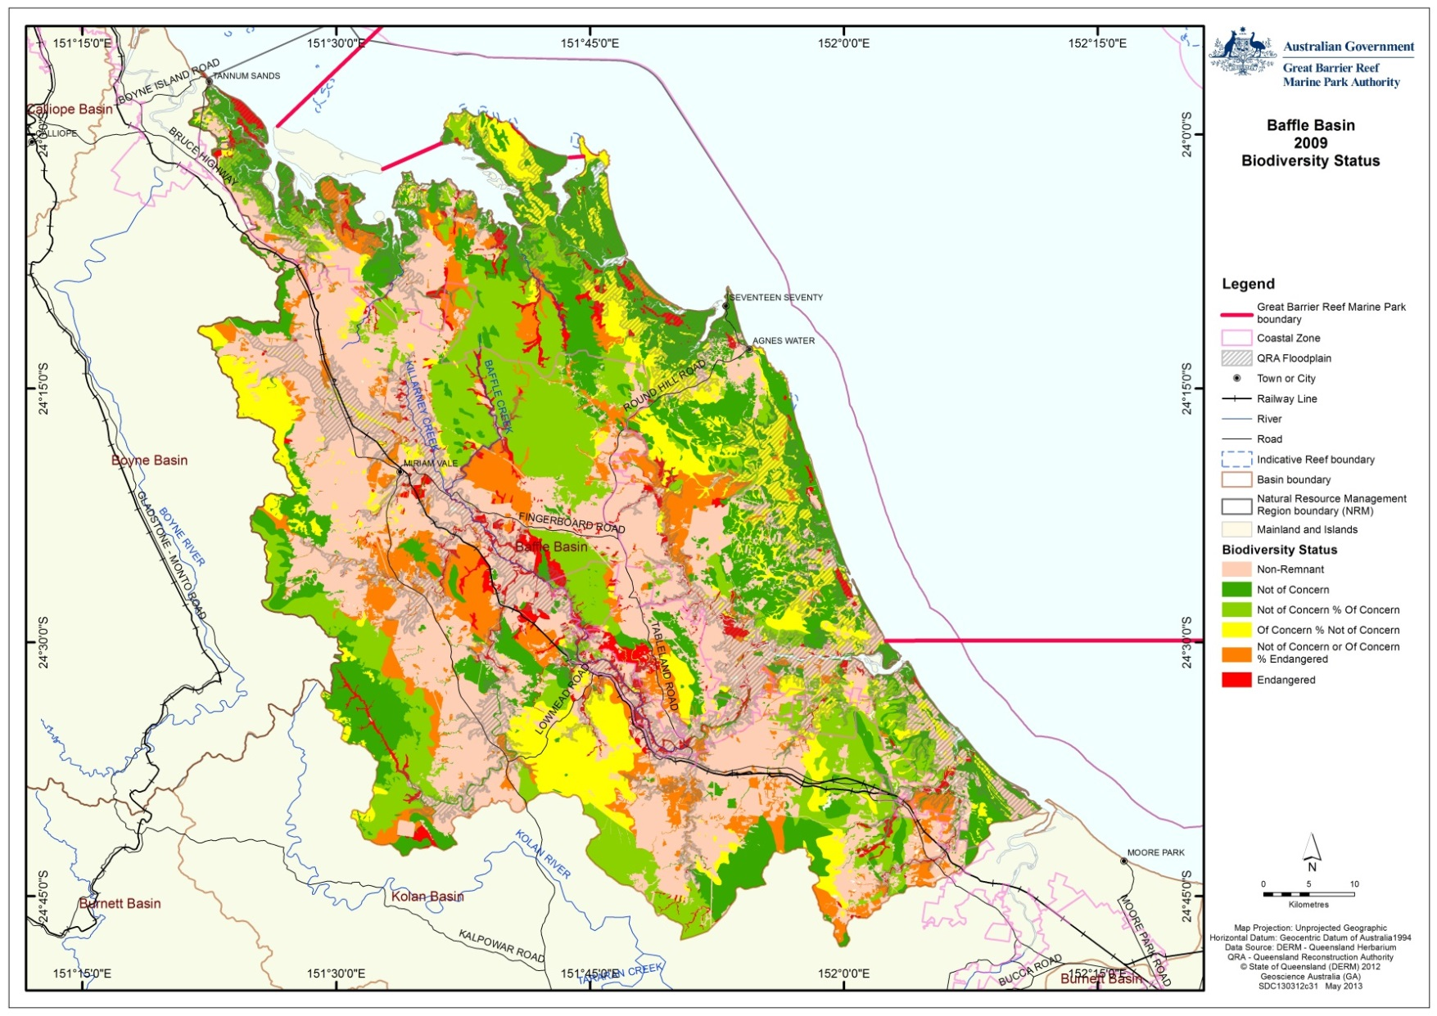
Figure 8: Baffle basin remnant and non-remnant vegetation conservation status

Hummock Hill Island development case study
A proposed residential development at Hummock Hill Island provides a recent example of significant development pressure immediately adjacent to the Baffle basin region. Although not officially within the Baffle basin (as it is an island), the proposed development is adjacent to an area of the basin with limited infrastructure and is surrounded by relatively undisturbed coastal ecosystems (Figure 3 and Figure 9). The site is near two protected coastal ecosystems in Wild Cattle Island National Park and Colosseum Inlet Fish Habitat Area and is surrounded by a Dugong Protection Area (Area B). It is outside the boundary of the Marine Park but wholly within the boundary of the World Heritage Area (including all of the land above the low water mark) (Figure 11).
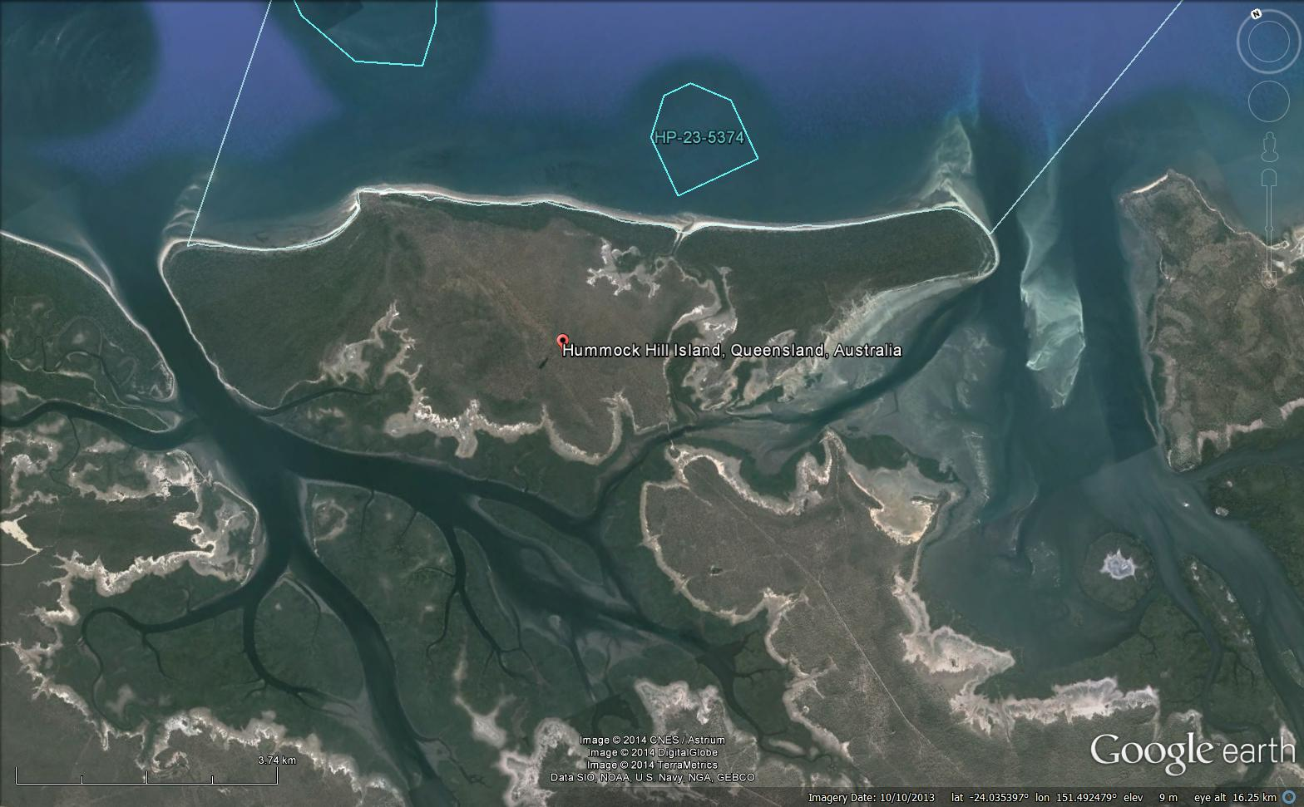
Figure 9: Hummock Hill Island and the adjacent northern section of Baffle basin are relatively undeveloped. Source: Google Earth. Image date: 10/10/2013
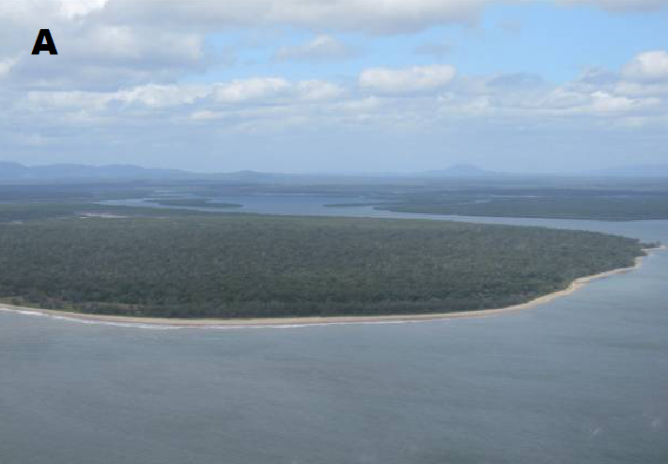 | 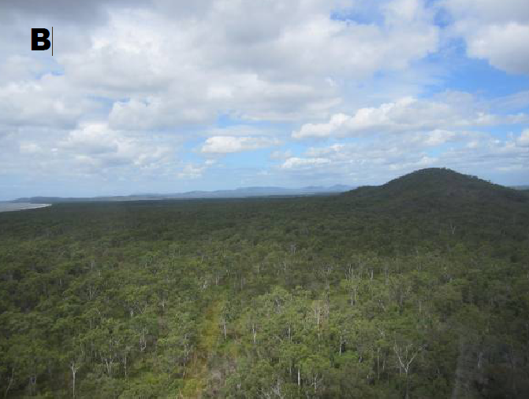
Figure 10: (A) aerial vista toward the south‐west, north‐eastern end of Hummock Hill Island in centre; (B) aerial vista toward the south over Hummock Hill Island, Hill at centre‐right¹⁰
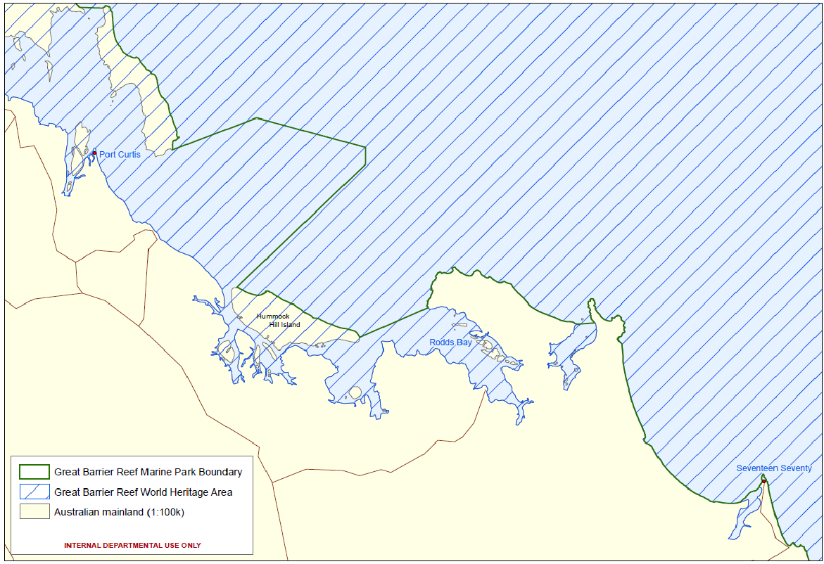
Figure 11: World Heritage Area and Marine Park boundary area adjacent to Hummock Hill Island¹⁰
In 2006 East Wing Corporation Pty Ltd proposed to construct, over 22 years, a large tourism and residential development on Hummock Hill Island. The total development value was initially estimated at $825 million over about 22 years, including $125 million in physical infrastructure and $29 million in social infrastructure and recreational facilities.¹¹ The development included a bridge to the mainland, a golf course, an airstrip, two boat ramps, a desalination plant, 790 residential allotments, two hotels, a conference centre and a motel, holiday accommodation, camping grounds, a commercial centre and a retail centre. It also included all supporting infrastructure such as roads, power, water, waste treatment, gas and sewerage and involve clearance of more than 300 hectares of native vegetation.
It was referred under the EPBC Act and determined to be a controlled action.
The project was declared a “significant project” in early 2006 and assessed by an environmental impact statement (EIS) under the State Development and Public Works Organisation Act 1971 (Qld). That process was used for the assessment of the project under the EPBC Act.
In February 2011, following completion of the EIS, the Queensland Coordinator-General recommended the proposed development be approved.¹²
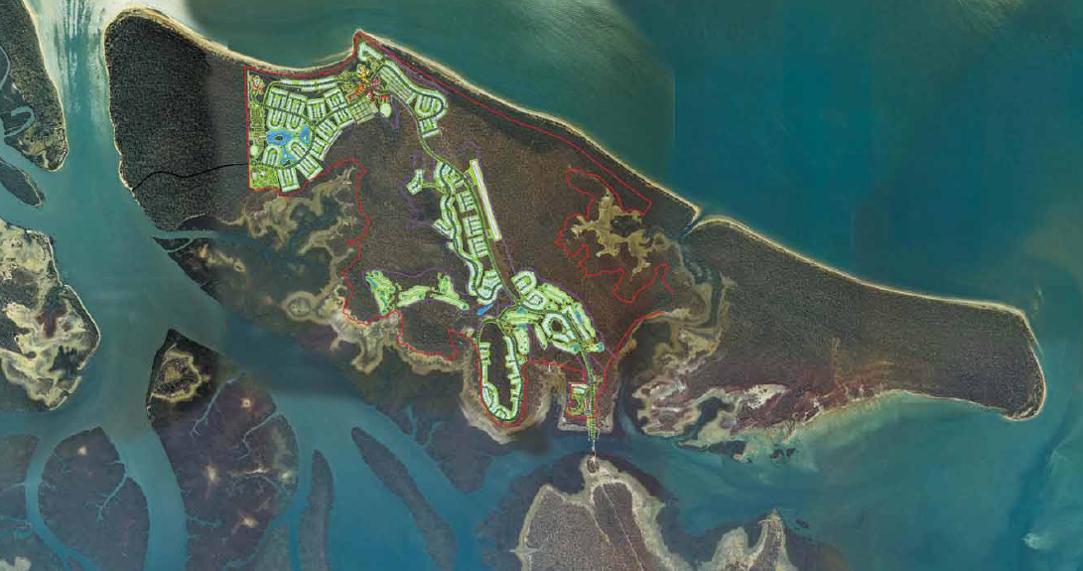
Figure 12: Master plan of original proposed Hummock Hill Island development¹¹
On 21 June 2011, the Commonwealth Environment Minister, Tony Burke MP, announced he proposed to refuse the project under the EPBC Act and invited members of the public to comment on the proposed decision.¹⁰ He stated in a media release that the reasons for the proposed refusal were:
Hummock Hill Island is one of a very small number of undeveloped islands remaining in the southern part of the Great Barrier Reef World Heritage Area.
As a large island close to the coast, Hummock Hill has remarkable natural and World Heritage values.
It is a unique large island ecosystem which contains species of plants and animals not widely represented in the rest of the World Heritage Area.
This is why I am proposing to refuse the development, after carefully considering the environmental assessment, expert advice and public submissions so far.
In making the proposed decision I have determined that the potential significant impacts on matters of national significance protected under national environmental laws and the potential significant impacts on ecological communities would be unacceptable.
As required under national environment law, I have considered the social and economic impacts of this project.
In making my proposed decision, I considered that the likely economic and social benefits would not outweigh the serious environmental impacts.
The Minister gave the public until 20 July 2011 to provide comments on the proposed refusal but the company withdrew the referral on that date and the ultimate decision to refuse it was, therefore, not made.
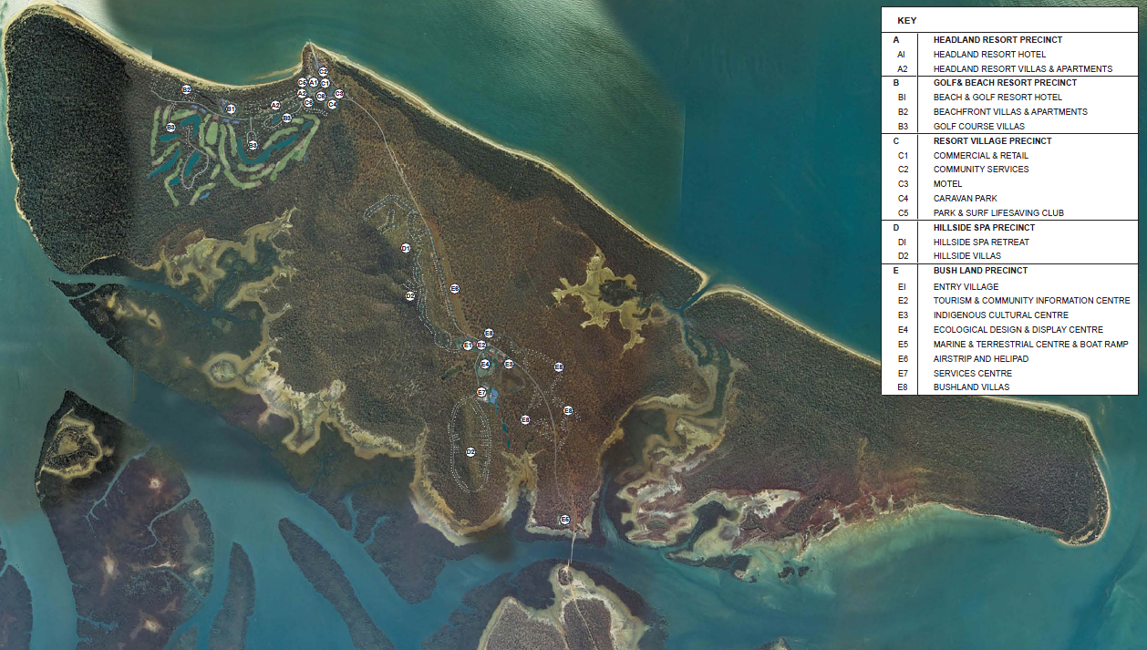
An amended proposal was referred under the EPBC Act in November 2012 and is currently undergoing assessment through a new EIS under the EPBC Act. The proponent, Eaton Place Pty Ltd, renamed the project the “Pacificus Tourism Project”. It includes two hotels, a motel, holiday villas, apartments, conference and exhibition centre, 18 hole golf course, caravan park, camping area, townhouses, retail and commercial centre, community services centre, private airstrip, bridge to the mainland, desalination plant, water treatment plant, wastewater treatment plant, access road, internal roads, boat ramp, stormwater drainage and treatment facilities.¹³
Figure 13: Master plan of revised proposed development on Hummock Hill Island, the “Pacificus Tourism Project”¹³
Hummock Hill island coastal ecosystems are mostly isolated from the mainland making them less susceptible to ecological edge effects and are more likely to sustain viable populations of flora and fauna.
If approved, the proposed Hummock Hill Island development will introduce a range of new or upgraded infrastructure to the area (installed and initially maintained at the developer’s cost), much of which will be located outside the development site itself.
This infrastructure, such as upgraded roads and new utility supplies has the potential to not only directly impact the coastal ecosystems and therefore the functions they provide to the World Heritage Area but also to indirectly impact on them through allowing greater access to the area. Improved facilities will, for example, increase the use of coastal waters by boaters through the introduction of better roads and new boat ramps. The construction of infrastructure to support the proposed development will likely promote further development of nearby land, potentially leading to development "creep" in the area resulting in the slow degradation of a much larger area of coastal ecosystems and the functions they provide to the World Heritage Area.
The cumulative impacts from further development, water, waste, electricity infrastructure, and marine access required to support the development, will have multiple and ongoing impacts on the integrity and functions of the coastal ecosystems of this area. Development in these coastal areas poses a significant long term threat to coastal ecosystems through ongoing fragmentation of habitat and loss of ecosystem function.

INFLUENCE OF CURRENT LAND-USE ACTIVITIES AND PRACTICES ON COASTAL ECOSYSTEMS

Background
Industrial and residential development within the Baffle basin has to-date remained relatively restrained. Industrial development is very limited with only small scale/light industry present. Residential areas have to-date been limited by a lack of supporting infrastructure such that only the small residential developments and tourism operations at Agnes Water and 1770 are found within the coastal zone of the basin. As the regions to the north and south of the Baffle basin continue to grow and develop, there will be increasing pressure on the local governments to develop the Baffle basin, and this has the potential to impact on the ability of the basin to continue to provide the current level of ecosystem function for the World Heritage Area.
Although minor barriers to connectivity exist within the Baffle basin, the low levels of development and corresponding lack of major infrastructure has ensured that the bulk of ecosystem connectivity and functionality has remained intact, thus allowing the continued delivery of ecosystem services to the Great Barrier Reef. Development within the basin in the form of residential expansion will require a range of additional infrastructure (Appendix E) including water resource allocation equipment, flood mitigation and possibly coastal protection measures to protect the ever increasing value of public and private sector assets.
The importance of ecosystem services both to human society and between ecosystems is now well established. Maintaining connectivity between systems is perhaps the most important supporting process to maintain to ensure the delivery of functions between ecosystems. The development of coastal areas has historically reduced connectivity as illustrated in other basins within the Great Barrier Reef catchment, such as the Fitzroy where there are potentially thousands of barriers within the system.¹⁴
To effectively manage the catchment and coastal threats and pressures to ecosystem functions important for the health of the Great Barrier Reef, management agencies need more information on how catchment and coastal ecosystem functions have been modified over the last 150 years to identify how management systems can be adapted to protect, rehabilitate and restore ecosystem function that are identified as critical to the long-term health of the Great Barrier Reef.

Overlapping roles of government
The complex jurisdictional environment and the arrangements applying to the coastal zone around Australia are well recognised.³
There are four tiers of governance with overlapping roles in the planning and management frameworks applying to the Baffle basin.
The World Heritage Committee plays an international oversight and assistance role under the World Heritage Convention. While the Committee cannot make decisions implementable under Australian law, its decisions and recommendations affect the governance of the World Heritage Area. At its 2012 meeting the Committee expressed its concern at the unprecedented scale of coastal development currently being proposed within and affecting the World Heritage Area. It will review the status of the property at its 2015 meetings with a view to possibly entering the World Heritage Area on the List of World Heritage in Danger. The Australian and Queensland governments have undertaken a strategic assessment of development adjacent to the World Heritage Area and adjacent coastal zone in response. While it has an important international role, the World Heritage Committee is not directly involved in the day-to-day planning and management of activities within or affecting the World Heritage Area.
The Commonwealth or Australian Government is ultimately responsible for fulfilling Australia’s obligations under the World Heritage Convention to protect, conserve, and restore the World Heritage Area. The GBRMPA is an independent statutory authority of the Australian Government responsible for the protection and management of the Marine Park and World Heritage Area. It shares the responsibility for day-to-day planning and management of activities within the Marine Park with relevant Queensland Government departments, such as the Queensland Boating and Fisheries Patrol. GBRMPA currently has a limited and largely advisory role in relation to coastal development adjacent to the World Heritage Area. The Australian Government Department of the Environment administers the EPBC Act, which regulates new development both within and outside the World Heritage Area likely to significantly impact on the World Heritage Area, but which has little control over the legacy effect of development prior to commencement of the EPBC Act in 2000.
The Queensland Government has primary responsibility for the planning and management of activities in the State of Queensland. It has many departments with roles in coastal planning, fisheries management, ports, agriculture and mining. Land-use and development (other than mining and petroleum extraction) are primarily regulated under the SPA. Many other pieces of legislation are integrated under SPA, including laws that influence the connectivity of coastal ecosystems, such as dams and weirs, and laws to manage damage to marine plants such as mangroves. Mining and petroleum extraction is regulated under separate legislation.
Local governments are statutory authorities created by the Queensland Government to govern within local government areas. Local governments play a central role in most land-use planning in the Great Barrier Reef catchment through the creation of planning schemes to guide new development. The local government responsible for the majority of the Baffle basin is Gladstone Regional Council (Figure 14). The City of Gladstone is a major port and industrial area. A small section of the Baffle basin south of Baffle Creek is within the local government area of Bundaberg Regional Council.
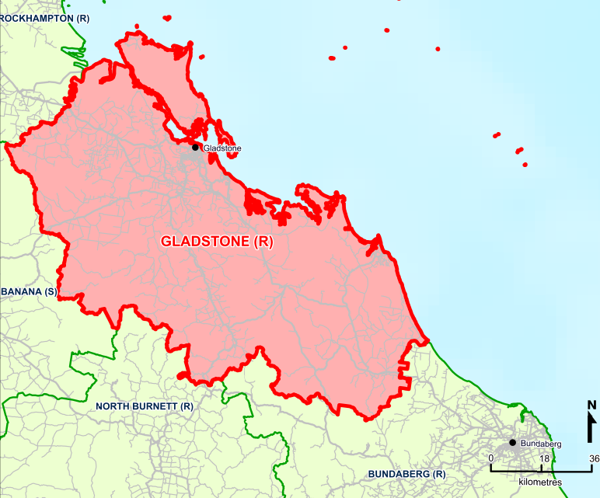
Figure 14: Map of Gladstone Regional Council area

General laws, policies and programs relevant to development in the Baffle basin
McGrath (2011)¹⁵ provides an overview of the major pieces of environmental legislation in Queensland and the following summary is based on that overview.
The principal controls on land development in Baffle basin are imposed under the SPA. Most State development control processes (for activities other than mining or petroleum extraction) are now integrated into the development assessment system under the SPA. For example, the proposed Hummock Hill Island development / Pacificus Tourism Project requires approval through the IDAS with consideration of matters such as native vegetation and marine plant clearing done as part of that assessment process.
SPA regulates development in two main ways. It provides a variety of planning instruments to be created setting out where and how local and state governments plan for development to occur. It also provides the IDAS – a process by which landholders can lodge applications for government approval of proposed development by reference to any relevant planning instruments.
There are several layers of planning – state-wide, regional and local – that regulate development under SPA. With decreasing geographic area of application there are dramatically increasing levels of detail and specificity. As a consequence, while state and regional planning is important, local government planning schemes provide the bulk of laws and regulations governing land development in the Great Barrier Reef catchment.
Water resource planning is linked to the SPA and dealt with under the Water Act 2000 (Qld), which established a hierarchy of planning. In the Baffle basin, the main plans for water resources are the Water Resource (Baffle Creek Basin) Plan 2010 and Baffle Creek Basin Resource Operations Plan 2011.
Onshore mining and petroleum extraction is not regulated at a state level under SPA. For onshore mining, tenure and royalty payments are regulated under the Mineral Resources Act 1989 (Qld) and environmental issues are regulated under the Environmental Protection Act 1994 (Qld) (EPA). For onshore petroleum (including coal seam gas) extraction, tenure and royalty payments are regulated under the Petroleum and Gas (Production and Safety) Act 2004 (Qld) and environmental issues are regulated under the EPA. These laws create assessment processes and offence provisions to regulate mining and petroleum extraction.
At a Commonwealth level the EPBC Act is the principal regulatory system for controlling new development. The EPBC Act protects matters of national environmental significance, which include the world heritage values of the World Heritage Area, the Marine Park, listed threatened species, migratory species, and Ramsar wetlands.
On relatively rare occasions, the EPBC Act has been important in stopping some major projects that would have had a significant impact on the World Heritage Area. For example, in 2008 the Minister rejected as clearly unacceptable a proposed new coal-loading terminal between Shoalwater Bay and Corio Bay Ramsar Wetland north of Gladstone in the World Heritage Area.
The case study of the proposed Hummock Hill Island development, set out above, is an example of the importance of the operation of the EPBC Act within the Baffle basin itself. While the Queensland Coordinator-General recommended the project be approved¹², the Minister proposed to refuse it due to its impacts on the World Heritage Area.¹⁰ It remains to be seen whether the revised development proposal submitted under the EPBC Act will be approved, given the fundamental reason for the original proposal refusal remains largely unchanged.
While the EPBC Act creates an important level of Commonwealth oversight and has occasionally stopped major projects that would have impacted on the ecosystem processes of the World Heritage Area and the Great Barrier Reef catchment, its role should not be overstated and the importance of State level laws, particularly for controlling cumulative impacts of urban expansion, must be recognised. It is important to recognise that state and local government approvals are far more numerous than EPBC Act approvals. For example, in 2008-2009 there were 438 referrals received under the EPBC Act, including not only matters regulated under state and territory planning laws, but also mining and offshore activities.¹⁶ Whilst some of these projects are very large, such as the Wandoan Coal Mine, in comparison the total number of development applications (not including mining, petroleum or offshore approvals) received under state and territory planning laws was 251,837.¹⁷ The importance of the EPBC Act as an over-arching environmental framework for Australia needs to be tempered with recognition that it is state and territory planning, mining and petroleum laws are where the bulk of detailed controls on land-use and resource management reside.
It is also important to recognise that the planning and management frameworks created by these state and Commonwealth laws principally regulate new activities and development. The legacy of past development tends to become a fixed part of the “status quo” forming a background of impacts or condition of the environment. For example, the EPBC Act has little influence or control over the legacy impacts of things that were constructed 40 or 50 years ago. Sections 43A and 43B of the EPBC Act exempt from requiring approval under the EPBC Act development and activities that were fully approved or an existing lawful use at the commencement of the EPBC Act on 16 July 2000.
In addition to the EPBC Act, a component of the general legal framework at a Commonwealth level potentially relevant to development in the Baffle basin is section 66(2)(e) of the Great Barrier Reef Marine Park Act 1975 (Cth), which provides a power to regulate or prohibit “acts (whether in the Marine Park or elsewhere) that may pollute water in a manner harmful to animals and plants in the Marine Park.” This power was used to regulate aquaculture development in the Great Barrier Reef catchment under the Great Barrier Reef Marine Park (Aquaculture) Regulations 2000 (Cth). As the power is limited to acts “that may pollute water”, it is does not provide a general power to regulate all forms of land development.
Finally, it should be noted that 15 per cent of the Baffle basin is completely protected from most forms of development, including mining and petroleum extraction, due to designation as national park or conservation park under the Nature Conservation Act 1992 (Qld), (Figure 17 and Table 4). This is somewhat unusual as less than 5 per cent of Queensland is within a national park or conservation park.

Local government planning under SPA
Virtually all local governments in the Great Barrier Reef catchment have planning schemes to regulate development. However, these planning schemes were created under the previous legislation, the Integrated Planning Act 1997 (Qld), and are required to be reviewed under the SPA. Figure 15 provides an extract of a zoning plan from the existing local government planning scheme regulating land use in the majority of Baffle basin.
A local government must prepare its planning scheme or review its planning scheme by following the process established in a guideline issued by the Queensland Minister for Planning under Chapter 3 of the SPA. This creates a four-stage process for the making and amendment of a local government’s planning scheme:
- planning and preparation stage
- state interest review stage
- public consultation stage
- adoption stage.
The third stage provides an important opportunity for the community (and potentially agencies like the GBRMPA), to make submissions about the draft planning scheme. The Gladstone Regional Council is currently preparing a new planning scheme covering the majority of the Baffle basin.

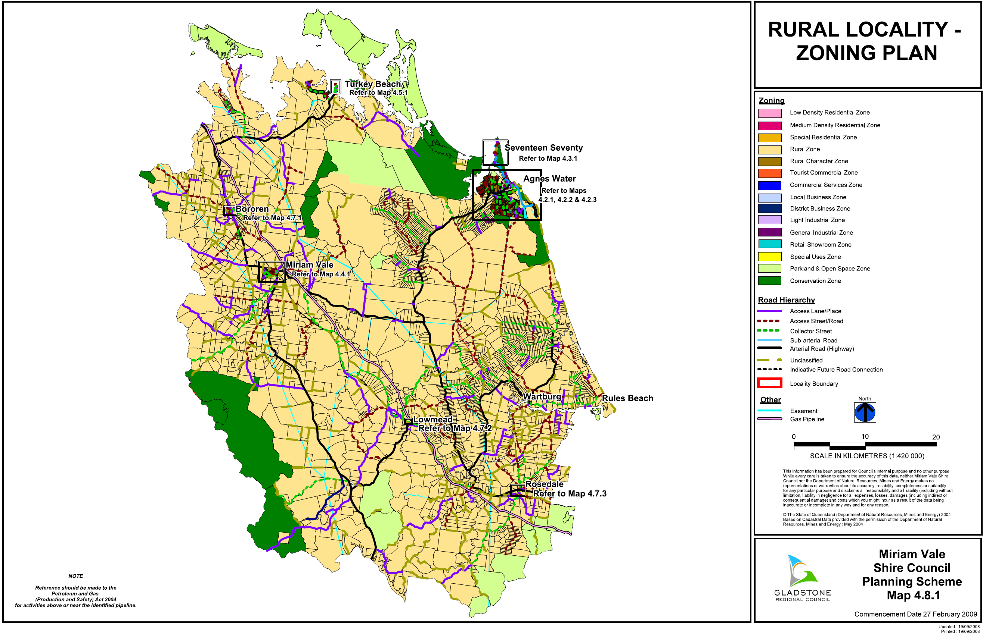
Figure 15: Zoning plan from the existing local government planning scheme regulating land use in the majority of Baffle basin. Source: Gladstone City Council.

Development applications under SPA
Local government planning schemes are an important tool for guiding future development, and the review and development of local government planning schemes provides a significant opportunity to include measures to protect, rehabilitate and restore ecosystem functions and processes provided to the World Heritage Area by the Great Barrier Reef catchment.
The principal test in deciding whether to approve or refuse a development application is to consider whether the proposed development is consistent with the relevant planning scheme and any planning instruments (for example state planning policies). If it is, it will generally be approved. If the development is inconsistent with the planning scheme or other planning instruments, it will generally be refused unless there are sufficient planning grounds to justify the approval despite the inconsistency.
This emphasises the importance of working with local government as planning schemes are prepared or amended to identify and protect important areas and environmental values. It is generally too late to protect important areas through the IDAS process when a development application is lodged, if the planning scheme does not protect the area and allows it to be developed. While a development that is approved under SPA might still legally be refused under the EPBC Act, it is preferable that state and Commonwealth decisions are consistent as much as possible. Ideally, regional and local planning should recognise and protect ecosystem functions in the Great Barrier Reef catchment consistent with the EPBC Act.
Decisions of a local government concerning a development application can be appealed by the applicant to the Queensland Planning and Environment Court. This process can be difficult and costly. It must be recognised that most local governments have very limited resources spread across many issues and may simply not have the staff or financial capacity to defend complicated environmental issues on appeal.

Changes to coastal and regional planning
Since the summaries of management arrangements were prepared for the Great Barrier Reef Outlook Report 2009¹⁸ and Informing the Outlook for Coastal Ecosystems³, state planning and environmental laws have undergone significant change.
The Coastal Protection and Management Act 1995 (Qld) (CPMA) provided for regional coastal management plans to be developed but those were repealed in 2012.
The Queensland Government created a new Queensland Coastal Plan in 2012 under the CPMA to replace the State Coastal Management Plan 2001 and associated regional coastal management plans. The plan had two parts: State Policy for Coastal Management and the State Planning Policy 3/11: Coastal Protection (SPP 3/11). SPP 3/11 provided policy direction for natural resource management decision-makers about land on the coast, such as coastal reserves, beaches, esplanades and tidal areas.
The Queensland Government suspended the operation of the SPP 3/11 and created the Coastal Protection State Planning Regulatory Provision (SPRP) in October 2012. The Queensland Coastal Plan – State Policy for Coastal Management and the SPRP remain in operation.
The Queensland Government is intending to replace the SPRP through the creation of a single state planning policy (single SPP) during 2013 / 2014. A draft single SPP has been released which includes sections on biodiversity, coastal management and healthy waterways and makes several references to the Great Barrier Reef including referring readers to “Guideline: Protecting wetlands of high ecological significance in Great Barrier Reef catchments (currently under review)” in relation to coastal management.
The Queensland Government recently completed a new regional plan for Central Queensland, which includes the Baffle basin (Figure 16).
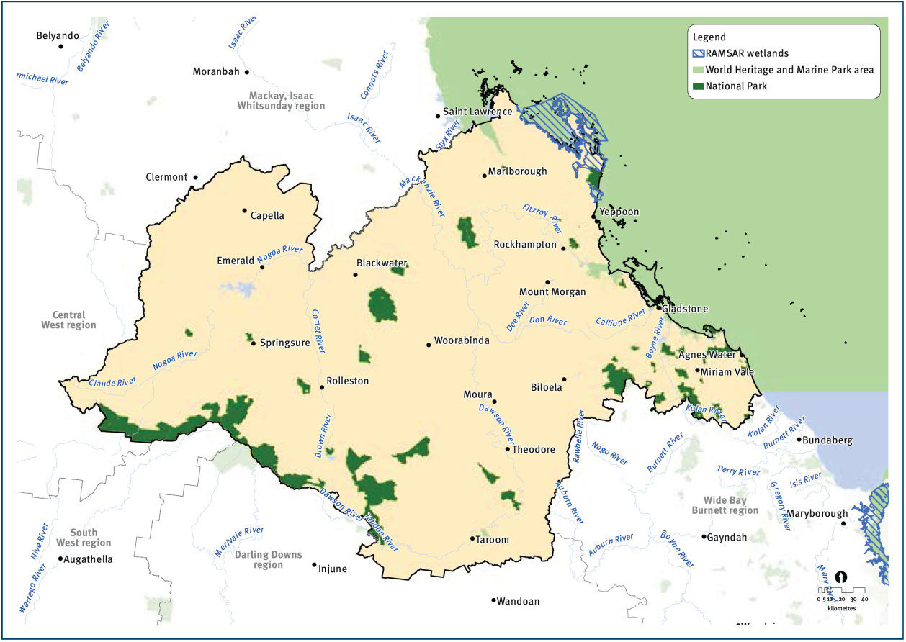
Figure 16: Map of area included in Central Queensland Regional Plan. Source: DSDIP

Changes to vegetation laws
An additional change in state laws and policies currently underway includes significant amendments to the vegetation management laws.
The Vegetation Management Framework Amendment Act 2013 (Qld), assented on 23 May 2013, amends the vegetation clearing controls created under the Vegetation Management Act 1999 (Qld) (VMA) and SPA. The changes remove the previous ban on broadscale clearing of remnant vegetation for agriculture if the proposed clearing is for cropping or irrigated pastures. The ban on clearing for non-irrigated pastures remains at this stage.
In addition, the amendments remove the controls on clearing of high value regrowth on freehold land other than in the “regrowth watercourse area” which is defined as “an area located within 50 m of a watercourse located in the Burdekin, Mackay Whitsunday or Wet Tropics catchments identified on the vegetation management watercourse map.” The Baffle basin is not included in the definition of “regrowth watercourse area” and, consequently, the previous controls on clearing of high value regrowth vegetation will be largely unrestricted.
A related change is that the recently enacted Land, Water and Other Legislation Act 2013 (Qld) removed the protection of riparian (in-stream) vegetation from section 814 of the Water Act 2000 (Qld). This removes restrictions on clearing under this Act that are otherwise allowed under the VMA/SPA, including high value regrowth vegetation.
Taylor¹⁹ suggests that in the Gladstone Regional Council local government area the amendments to the VMA/SPA framework allow clearing of up to 44,167 hectares of remnant vegetation and high value regrowth vegetation. This is over 10 per cent of the basin area which has already lost more than 60 per cent of forested floodplain, around 40 per cent of forests and 20 per cent of woodlands.
In the Baffle basin region the practical significance of the amendments, however, may be limited by lack of pressure to clear native vegetation.

Marine plants and fish habitat areas
Marine plants and declared fish habitat areas (FHA) are protected under the Fisheries Act 1994 (Qld) against physical disturbance associated with coastal development. Again, this system is now linked to SPA.
While FHA's are currently limited to the marine and estuarine environment, the Queensland Government recognises that there is a need to expand the declared FHA network into freshwater areas and policies have been under consideration for freshwater declared FHA assessment and management.²⁰
There are five declared fish habitat areas within the study area:
- Rodds Harbour
- Eurimbula
- Colosseum Inlet
- Seventeen Seventy - Round Hill
- Baffle Creek
These areas have been declared on a range of habitat and fisheries values as well as unique features (for example Baffle Creek is one of the few systems unimpeded by weirs or dams while Eurimbula is one of only two estuaries where the mangrove Lumnitzera racemosa is locally common).

Protected areas
As noted earlier, 15 per cent of the Baffle basin is protected from most forms of development, including mining and petroleum extraction, due to its designation as national park or conservation park under the Nature Conservation Act 1992 (Qld) (Figure 17 and Table 4). This is somewhat unusual as less than five per cent of Queensland is within a national park or conservation park.

Table 4: Area and percentage of protected areas in the Baffle basin (Data source: GBRMPA)
Protected areas of Queensland | Area (ha) | Percentage of total basin area
National Park (scientific) | 0 | 0.00 %
National Park | 57,749 | 14.07 %
National Park (Cape York Peninsula Aboriginal Land) | 0 | 0.00 %
National Park (recovery) | 0 | 0.00 %
Conservation Park | 3846 | 0.94 %
Resources Reserve | 2987 | 0.73 %
Forest Reserve | 1720 | 0.42 %
State Forest | 6528 | 1.59 %
Timber Reserve | 0 | 0.00 %
Total national parks & conservation parks | 61,595 | 15.01 %
Total protected areas | 72,831 | 17.74 %
Total basin area | 410,471 | 100 %

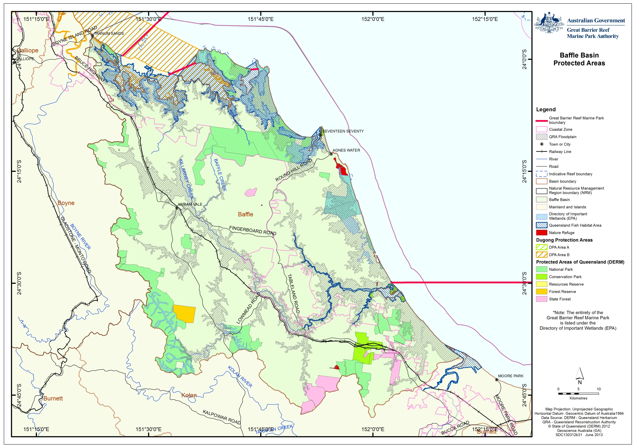
Joseph Banks Conservation Park
Eurimbula National Park
Deepwater National Park
Figure 17: Protected areas in Baffle basin

Cumulative and indirect impacts
The cumulative and indirect impacts of development and provision of infrastructure are addressed through the planning and development assessment processes outlined in previous sections. A principal objective of the planning process is to provide for sustainable development by designating some areas for residential use, agriculture, industrial use and nature conservation as well as mapping overlays for wetlands, flooding, acid sulphate soils and other issues. These mechanisms inherently deal with cumulative impacts of development within the planning area, and to a lesser extent indirect impacts associated with development (for example improved facilities leading to increased visitors to an area). How well a planning process addresses cumulative and indirect impacts is ultimately a question of implementation, generally don’t address cumulative pressures of past development, and until recently potentially reinforced a shifting baseline of environmental condition.
The EPBC Act does not provide as comprehensive planning framework as state planning laws. The EPBC Act does contain some planning elements, such as the designation of protected areas (for example the Marine Park or for other World Heritage properties and Ramsar Wetlands), as well as the strategic assessment process that is currently being applied to coastal development in the Great Barrier Reef catchment. While important, these elements are not intended to be comprehensive or to replace the need for comprehensive state and local government planning.
The EPBC Act also deals with cumulative and indirect impacts to an extent in the assessment of actions impacting on matters of national environmental significance. The cumulative impacts of other development on a matter protected under the EPBC Act are part of the context of the impacts of an action that must be considered in assessing whether the action will have a “significant impact”.²¹ For example, when assessing a proposed dam to supply water for irrigated agriculture to downstream farmers under the EPBC Act, the cumulative and indirect impacts of the use of the water by the farmers and the water pollution that they might generate must be considered²¹.
The EPBC Act has been used on occasion to regulate or prevent proposed coastal development impacting on already threatened species and modified ecosystems. For example, a 40-lot subdivision at Mission Beach in North Queensland was refused in 2008 due to clearly unacceptable impacts on a threatened species, the Southern Cassowary (EPBC Referral No. 2008/4257). The Act was applied in that instance to prevent impacts on a small population of a threatened species in an already highly fragmented habitat. The case study of the Hummock Hill Island development, provided above, is an important example of the EPBC Act regulating coastal development in the Baffle basin itself.

Return of coastal ecosystem function to modified landscapes
The relatively "pristine" nature of the Baffle basin means that many of the ecosystem functions and processes important to the World Heritage Area in the period prior to European settlement remain intact. This in turn infers that relative to other basins within the Great Barrier Reef catchment, only minor modifications may be required to return ecosystem functionality to areas where it has been lost or conversely where additional further development may tip the system beyond its assimilative capacity. There is limited understanding at present of these tipping points.
The majority of changes within the Baffle basin are as a result of the development of agriculture. Coastal ecosystems located in the floodplain and coastal zone of the Baffle basin are those that are most at risk in the future from development pressures such as increasing urbanisation or intensive agriculture. These areas are also at greatest risk from flooding, storm and climate change impacts, therefore high value infrastructure, such as residential and industrial development should be avoided in these areas or managed in such a way that manages the risk from natural events while maintaining ecosystem functions for the World Heritage Area. The impacts to ecosystem functionality from infrastructure associated with urbanisation in the Baffle basin remains relatively small.
Another factor to consider is that many of the modified systems provide a range of ecosystem functions of their own (Appendix B and C). Return of ecosystem function to an area should consider the services that the modified systems are supplying both to the World Heritage Area, adjacent ecosystems or society.

Forecast of likely future activities and impacts on coastal ecosystems
Unlike the Calliope basin to the north of the Baffle basin, there is currently very little industrial or urban development in the Baffle basin. With the expansion of the Gladstone region as a result of the resources boom over the last 15 years, there is pressure to expand residential development and the proximity and relatively undisturbed nature of the Baffle basin makes it attractive for residential and tourist development. To date, a lack of infrastructure (for example potable water) has restricted expansion of town centres such as Agnes Water and 1770. However, Gladstone Regional Council has previously indicated that it intends to provide services to outlying parts of the region so that all residents will have access to the same level of service.¹² The integrated water project at Agnes Water including the 1.5 meglitre/day desalination plant has relieved some of the limitations to residential expansion around Agnes Water and 1770. Residential expansion in this area may lead to further growth and additional demand for other services. These "new" infrastructure and services may draw more people to the area, which could then require upgraded or additional infrastructure such as roads.
As previously discussed, the proposed Hummock Hill Island development also has the potential to allow further development within the basin. The proposed residential and tourist facility on Hummock Hill Island will require a range of upgraded or additional infrastructure to be developed, some of which would be supplied from Gladstone, for example utilities like power and water.¹² The inclusion of this additional infrastructure may potentially "open-up" the northern end of the Baffle basin to further residential developments, such as the expansion of the coastal community of Tannum Sands in the north. Large scale developments such as the one proposed for Hummock Hill Island often includes the construction and initial maintenance of required infrastructure as part of the development scope, thus releasing or at least supplanting the burden on local governments.
Peri-urban developments within the basin are popular with many small rural blocks located inland of Agnes Water and to the south towards Baffle Creek (Figure 15). As regional expansion continues there is likely to be an increased demand for these rural residential lots as people desire the aesthetics of a rural lifestyle without working within the agricultural sector.
Another potential development within the Baffle basin is associated with coal exploration permits that have been granted to the south of the Baffle Creek estuary (Figure 18). Should these areas prove productive and are subsequently developed for coal mining, a significant increase in infrastructure in the region would be required. Such infrastructure may include new/upgraded roads, a rail line, water and wastewater services and electricity.
Although the focus of this study has been the infrastructure associated with residential and industrial development, it should be recognised that any expansion of infrastructure within the basin may also benefit other sectors such as rural enterprises. For example, water resource harvesting and storage for residential purposes may also (in part) provide a supply for agricultural activities that may not have otherwise been viable and this may in turn put further pressures on existing coastal ecosystems and the functions they provide.
Other future infrastructure works that have the potential to affect coastal ecosystem function include future flood mitigation strategies such as levies. The 2011 and 2013 floods affected many residents within the Baffle basin. Further residential and industrial expansion within the floodplains of the basin will likely place pressure on governments to establish more "flood proofing" infrastructure to protect human life and the increasing value of assets within the basin. This infrastructure, if not properly designed and planned, may have detrimental or unexplored impacts on downstream environments.
Potential Mining
Potential Residential Development/Expansion

Figure 18: Known potential residential and industrial developments within Baffle basin

Uncertainty in assessment and managing risk
Assessing the likely residential and industrial developments into anything beyond the immediate future can be highly uncertain. This study has, however, examined a future scenario to explore potential cumulative impacts on ecosystem functions and processes in a relatively undeveloped area, based on currently available information. It remains possible that unforseen development proposals for the Baffle basin may still be forthcoming.
Ecosystem functions and the role that they play is a complex issue. While it is well accepted that the functions ecosystems provide are vitally important to the heath of ecosystems, and subsequently to human society, the importance of one service over another is less understood. This is particularly important where it may be required to compare the value of one service to another when considering whether or not to undertake a management action. There also remains many unknowns with respect to the functions that one ecosystem provides for others as highlighted by both the blank cells within Appendices B and C as well as those labelled with a tick where the service is known but the capacity is unknown.

Adaptive management
Although knowledge gaps remain regarding the provision of ecosystem functions, there is sufficient understanding of the importance of ecosystem function provision to undertake management action. Management action should be designed with the principals of adaptive management incorporated. This is particularly important due to the number of unknowns associated with the various ecosystems and the functions that they may potentially provide. As a greater understanding of this area is developed, management actions can be reviewed and revised accordingly. Similarly, any management strategy aimed at a regional scale should be able to adjust to local/fine scale conditions.

DISCUSSION
Although the importance of ecosystem functions is widely acknowledged, recognition in current land management systems of the ecosystem functions that terrestrial systems provide to the World Heritage Area is poor. The current regulatory management frameworks that seek to maintain the ecosystems within the Great Barrier Reef catchment area, for the most part, are not specifically designed to protect the ecosystem functions and processes provided to the World Heritage Area. Although protection is often afforded through the current management frameworks, it is often incidental and not the primary objective of the framework.
One very real risk regarding urban expansion in areas such as the Baffle basin is through development "creep" rather than through major master planned residential development projects such as the proposed Hummock Hill Island development. Development "creep" is most likely to occur once infrastructure is in place to support urban nodes. The existence of infrastructure in a region may also make the surrounding rural land more financially attractive as a peri-urban land parcel. Subsequent small-scale sub-divisions of rural blocks represent relatively low risk individually; however, multiple small-scale sub-divisions of rural blocks can modify ecosystems, potentially having a significant impact on the downstream environments of the World Heritage Area. This is essentially a "death by a thousand cuts" for coastal ecosystems, their functions and processes.
To maintain and restore the ecosystem function of the Great Barrier Reef catchment for the World Heritage Area, there is a continual need to seek integrated planning outcomes that recognise the continuity of biophysical linkages across the entire coastal zone from the top of the Great Barrier Reef catchment to the adjacent marine areas. Zoning within the Marine Park, especially those focused on habitat protection such as green (no-take) zones should be supported by appropriate management within the Great Barrier Reef catchment.
To ensure as far as practicable the effective management of the World Heritage Area, land managers need to be able to identify the ecosystems that are of high priority in providing ecosystem functions and processes important to the World Heritage Area. One approach to effect this would be to map ecosystems of high ecosystem service provision in terms of functions and processes provided to the World Heritage Area, in a similar manner to the High Ecological Value (HEV) areas identified in the Water Quality Improvement Plans developed under the National Water Quality Management Strategy (NWQMS). Such mapping could then be used under the EPBC Act to trigger when experts should be consulted prior to a change of land use development. To be effective, such mapping would need to identify and prioritise the ecosystem functions provided by each ecosystem, including modified ecosystems. Appendices B and C lists known ecosystem functions and the level of provision from each ecosystem type. There are, however, many knowledge gaps in the list. It is important to note that while the data currently contained in Appendices B and C is sufficient to develop a preliminary priority ecosystems map, continual improvement by the filling of the knowledge gaps would enhance its robustness.
In identifying the priority ecosystem service providers it should be acknowledged that differing ecosystem functions may be of higher importance to the World Heritage Area than others. Similarly, the proximity of other providers of any given function should also be considered. By incorporating a proximity weighting measure, the potential for development "creep" to go undetected would be minimised. As an ecosystem is modified through change and functions and processes are removed or reduced, the remaining providers of that ecosystem function or process will become more important and therefore trigger more careful management to ensure the continued supply of the ecosystem service.
Areas of high risk could also be combined with maps of priority ecosystem function and process providers. By including areas where there is a high level of risk for a negative impact on the World Heritage Area, a spatially explicit tool could be developed to identify areas that should be carefully managed to ensure the minimum negative impact on the World Heritage Area.
GBRMPA has developed a preliminary version of such a management layer (Figure 19 and Appendix D) in their cumulative area analysis for areas of high functional connection for the World Heritage Area. It is however currently in a very preliminary stage and requires further development.
It should be noted that while there has already been an undertaking to identify areas with environmental values and areas of high ecological value under the Queensland Environmental Protection (Water) Policy 2009, these values may not always correspond to those for the World Heritage Area. Similarly, although there are many areas that are being maintained for conservation in national parks, these areas may not necessarily correspond to areas of high importance for the World Heritage Area (compare Figure 17 to Figure 19).

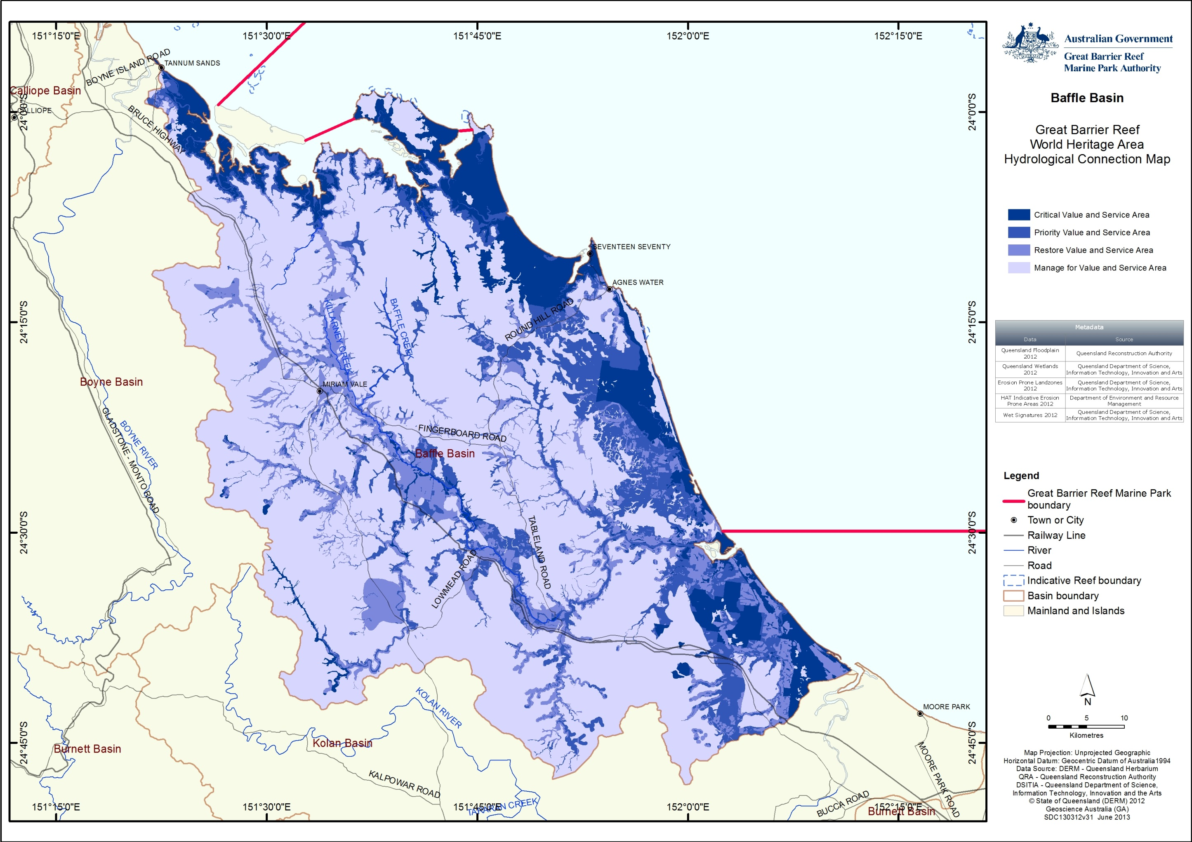
Figure 19: Draft GBRMPA Accumulative Analysis of Areas that have high functional connection to the World Heritage Area.

Mapping “Great Barrier Reef priority areas” for guidance under the EPBC Act
Clearer guidance could also be provided under the EPBC Act to ensure future development takes into account of areas or high ecological functions for the World Heritage Area. The threshold to trigger an assessment under the EPBC Act is that an action is likely to have a “significant impact” on a matter of national environmental significance. This term is not defined in the EPBC Act but the Federal Court has held it to mean an impact that is important, notable or of consequence having regard to its context and intensity.²¹ To assist members of the public to understand the test better, the Department of the Environment has published administrative guidelines on what constitutes a significant impact on a matter protected under the EPBC Act.²²
While the World Heritage Area and Marine Park are recognised as matters of national environmental significance under the EPBC Act, there is no specific guideline for actions having a significant impact on the World Heritage Area or Marine Park from actions outside these areas. The general guidelines on significance provide the following criteria for the Great Barrier Reef²²:
Significant impact criteria
An action is likely to have a significant impact on the environment of the Great Barrier Reef Marine Park if there is a real chance or possibility that the action will:
- modify, destroy, fragment, isolate or disturb an important, substantial, sensitive or vulnerable area of habitat or ecosystem component such that an adverse impact on marine ecosystem health, functioning or integrity in the Great Barrier Reef Marine Park results
- have a substantial adverse effect on a population of a species or cetacean including its life cycle (for example, breeding, feeding, migration behaviour, life expectancy) and spatial distribution
- result in a substantial change in air quality or water quality (including temperature) which may adversely impact on biodiversity, ecological health or integrity or social amenity or human health
- result in a known or potential pest species being introduced or becoming established in the Great Barrier Reef Marine Park
- result in persistent organic chemicals, heavy metals, or other potentially harmful chemicals accumulating in the marine environment such that biodiversity, ecological integrity, or social amenity or human health may be adversely affected, or
- have a substantial adverse impact on heritage values of the Great Barrier Reef Marine Park, including damage or destruction of an historic shipwreck.
These guidelines give a good foundation to work from, however mapping of areas of particular concern to the World Heritage Area to inform EPBC Act decisions would greatly improve the implementation and regulation of impacts on matters of national environmental significance. The regional ecosystem maps for vegetation management under state laws is an example of this. The ability to quickly obtain a property-level map of regional ecosystems for free from an online search tool has been one of the greatest strengths of the state vegetation management system over the past decade.
Application of the significance guidelines supporting the EPBC Act would be improved if if a framework to identify priority areas for protection, rehabilitation and restoration was implemented that identifies the areas that are most sensitive for impacts on the Great Barrier Reef like “important, substantial, sensitive or vulnerable areas” referred to in the first criterion in the general guidelines.
The areas identified in the “Framework to identify priority hydrological connections to the Great Barrier Reef World Heritage Area” provided to us by the GBRMPA (Figure 19) would be a suitable starting point for such mapping, assuming the guidelines referred to development “in or affecting” the areas identified in the maps. The boundaries of the areas are not critical, as the purpose of the maps would be to focus attention on the connection of the catchment to the World Heritage Area. That mapping could be linked to a free online search tool similar to State regional ecosystem maps that can generate property-level maps based on entering either the lot and plan of a property or its latitude and longitude coordinates.

Engagement and support for local governments
While the EPBC Act is an important regulatory control and the creation of a mapping layer of priority areas for protection, rehabilitation and restoration could assist its implementation, mapped layers must also have the ability to effectively inform local government, as most land-use decisions are made by local governments under the SPA. GBRMPA noted in the Outlook Report 2009¹⁸:
The planning system, particularly the Integrated Planning Act 1997, theoretically provides a framework within which the major threats and risks to Great Barrier Reef values can be addressed, but without the relevant regional plans, there is little guidance for local planning decisions. There is also limited capacity in some local government authorities to deal with the complex issues involved in coastal development. Pressure from stakeholders and high levels of staff turnover are significant issues in some areas. In addition, engagement of stakeholders through planning processes is generally not comprehensive and balancing government priorities, community concerns and technical input is a significant challenge at the local level.
These points remain valid since the replacement of the Integrated Planning Act 1997 (Qld) by SPA. We consider that the conclusions in the Outlook Report 2009¹⁸ remain valid concerning the existing protection and management tools relevant to the Marine Park. Overall the Outlook Report 2009 found a lack of integrated planning, resources and enforcement in managing coastal development is compromising the protection of the World Heritage Area.
Further assistance could be provided to local governments both in preparing their planning schemes and in the appeal process to defend the protection of ecosystem values for the World Heritage Area. Local governments participating in the Reef Guardian Councils would be the logical starting point to understand the assistance that the GBRMPA can provide and to understand what other local governments require. The GBRMPA could, for example, provide technical advice to assist a local government in defending appeals to the Planning and Environment Court against refusal of development applications.

Potential management actions
Actions that could be taken include:
- Engage with and support the Queensland Government in preparing or reviewing any regional plan for land in the Great Barrier Reef catchment, to ensure that, as far as is practicable, the protection of the ecosystem processes of the World Heritage Area and the Great Barrier Reef catchment are appropriately addressed (Note that a new Central Queensland Regional Plan covering the Baffle Basin was approved on 14 October 2013.)
- Engage with and support local government and, where relevant, Queensland Government planning decisions by:
  - Providing technical advice to local governments during the preparation or review of any planning scheme in the Great Barrier Reef catchment to ensure that, as far as is practicable, the protection of the ecosystem functions and processes of the World Heritage Area and the Great Barrier Reef catchment are addressed. This approach could be piloted with the local governments in the GBRMPA’s Reef Guardian Council program.
  - Monitoring development applications made under SPA in the Great Barrier Reef catchment, and providing technical information to local governments, and the Queensland Government in making decisions on development applications with potential impacts on the ecosystem functions important to the World Heritage Area. The support may take the form of providing technical advice, expertise in coastal management matters, or mechanisms to support positive regional ecosystem function outcomes. It may also, where appropriate, having expertise available to assist a local government in defending appeals to the Planning and Environment Court against refusal of development applications.
- Development of a guideline on actions likely to have a significant impact on the World Heritage Area under the EPBC Act to better inform landholders of what actions require approval under that Act. The guidelines could supplement existing guidelines on significance under the EPBC Act and be linked to maps of the “Framework to identify priority hydrological connections to the Great Barrier Reef World Heritage Area” identifying wetlands, watercourses and other areas important for maintaining ecosystem functions for the World Heritage Area. Actions in or affecting priority areas for protection, rehabilitation and restoration should be identified as likely to cause a significant impact on the World Heritage Area. The guideline might also identify particular actions within or affecting priority hydrological connections, such as dams, weirs and barrages that have the potential to significantly impact the World Heritage Area.
- Integrated planning outcomes should be considered when engaging with and supporting the planning and development assessment processes. Integrated planning outcomes should recognise the continuity of biophysical linkages across the entire coastal zone from the top of the Great Barrier Reef catchment through to the adjacent inshore marine areas. Zoning within the Great Barrier Reef Marine Park (Marine Park) such as green (no-take) zones be supported by complementary management within the Great Barrier Reef catchment.

REFERENCES
1. Great Barrier Reef Marine Park Authority 2012a, Great Barrier Reef Coastal Ecosystems Assessment Framework, Great Barrier Reef Marine Park Authority, Townsville.
2. Gunningham, N., Grabosky, P. and Sinclair, D. 1998, Smart regulation: designing environmental policy (Oxford socio-legal studies)(POD).
3. Great Barrier Reef Marine Park Authority 2012b, Informing the outlook for Great Barrier Reef coastal ecosystems, Great Barrier Reef Marine Park Authority, Townsville.
4. United Nations Environment Programme (UNEP) 2006, Marine and coastal ecosystems and human well-being: A synthesis report based on the findings of the Millennium Ecosystem Assessment. United Nations Environment Programme, Nairobi, Kenya.
5. Burnett-Mary Regional Group 2011, Burnett-Baffle Water Quality Improvement Plan (2011). Research and Development Prospectus, pp. 40.
6. Aquatic Ecosystem Health, Department of Environment & Resource Management 2012, Long-term Water Quality Monitoring of Estuaries and Inshore Coastal Waters in Central Queensland 1993 to 2006, The State of Queensland, Dept of Environment & Resource Management, Brisbane.
7. Department of Premier and Cabinet, State of Queensland in press, Great Barrier Reef Third Report Card 2011, Reef Water Quality Protection Plan, Reef Water Quality Protection Plan Secretariat, Brisbane, Australia.
8. Burnett Mary Regional Group for Natural Resource Management 2012, Wide Bay Burnett Natural Resource Management Plan 2011-2031.
9. Office of Economic and Statistical Research 2012, Population and dwelling profile: Gladstone regional council, Queensland Treasury and Trade.
10. Department of Sustainability, Environment, Water, Population and Communities Community invited to comment on proposed refusal of Hummock Hill Island development - media release 21 June 2011, viewed 30/06/2013, <http://www.environment.gov.au/minister/burke/2011/mr20110621a.html>.
11. GHD 2006, East Wing Corporation. Hummock Hill Island Development initial advice statement: A master planned integrated tourism community, GHD, Queensland.
12. Coordinator-General 2011, Hummock Hill Island development project: Coordinator-General's report on the environmental impact statement, Department of Infrastructure and Planning, Brisbane, Queensland.
13. Eaton Place Pty Ltd Pacificus Tourism Project EPBC Referral, Department of Sustainability, Environment, Water, Population and Communities, viewed 30/06/2013, <http://www.environment.gov.au/cgi-bin/epbc/epbc_ap.pl?name=current_referral_detail&proposal_id=6643>.
14. Moore, M. and Marsden, T. 2008, Fitzroy Basin Fish Barrier Prioritisation Project, Queensland Department of Primary Industries and Fisheries, Brisbane, Queensland.
15. McGrath, C. 2011, Synopsis of the Queensland Environmental Legal System, 5th edn, Environmental Law Publishing, East Brisbane, Queensland.
16. Department of the Environment, Water, Heritage and the Arts 2009a, Department of the environment, water, heritage and the arts annual report 2008-2009, Australian Government, Canberra.
17. South Australian Government 2010, Local government and planning ministers' council first national report on development assessment performance 2008/09, Local Government and Planning Misters' Council, Adelaide.
18. Great Barrier Reef Marine Park Authority 2009, Great Barrier Reef Outlook Report 2009, Great Barrier Reef Marine Park Authority, Townsville, .
19. Taylor, M.F.J. 2013, Bushland at risk of renewed clearing in Queensland. WWF-Australia, Sydney.
20. Fisheries Queensland and Department of Employment, Economic Development and Innovation 2010, Declared Fish Habitat Area network strategy 2009-2014, The State of Queensland, Queensland.
21. McGrath, C. 2004, Key Concepts of the Environment Protection and Biodiversity Conservation Act 1999 (Cth), Environmental and Planning Law Journal ( 22: 2005.
22. Department of the Environment, Water, Heritage and the Arts 2009b, Matters of national environmental significance: Significant impact guidelines 1.1. environment protection and biodiversity conservation act 1999, Australian Government, Canberra.
23. Great Barrier Reef Marine Park Authority 2011, Catchment to Reef Ecological Expert Advisory Workshop, Great Barrier Reef Marine Park Authority, Townsville.
24. Duffey, G. and Waterman, P. 2008, Coastal settlement in the Burnett Mary: Addressing climate change and population growth. Working Paper 3. University of the Sunshine Coast, Queensland.

APPENDIX A – Author profiles
Dr Glen Holmes is a part-time lecturer at the School of Geography, Planning and Environmental Management at the University of Queensland (GPEM). He holds a BEng, Master of Marine Studies, and PhD. His PhD research developed a scenario-based coral reef ecosystem model to assist management following mass coral mortality events; including research into the nutrient dynamics following coral mortality; coral settlement and recruitment; reef structure; and coral reef ecosystem modelling. His publications include: Holmes G, Johnstone R (2010). Modelling coral reef ecosystems with limited observational data, Ecological Modelling, 221: 1173-1183.
Dr Chris McGrath is a senior lecturer (environmental regulation) at GPEM. He holds a BSc, LLB, LLM and PhD. From 2000-2010 he practiced in Brisbane as a barrister specialising in environmental regulation. He has published extensively on environmental law and policy in Queensland. His publications include: McGrath C (2010), Does Environmental Law Work? How to Evaluate the Effectiveness of an Environmental Legal System (Lambert Academic Publishing, Saarbrücken); and McGrath C (2011), Synopsis of the Queensland Environmental Legal System (5th ed, Environmental Law Publishing, Brisbane).
Dr Josh Larsen is a lecturer in hydrology at GPEM. He holds a BSc (Hons) and PhD. He has broad research interests across hydrology, biogeochemistry, climate, and landscapes, both present and past. His publications include: Larsen, J.R. 2011. Was evaporation lower during the Last Glacial Maximum? Quaternary Australasia. 28(1), 11-13; and Larsen, A., Bork, H.-R., Fuchs, M., Fuelling, A., Larsen, J.R. (accepted). The processes and timing of sediment delivery from headwaters to the trunk stream of a central European mountain gully catchment. Geomorphology.
Professor Marc Hockings is the director of the environmental management program at GPEM. He holds a BSc, MSc (Zoology) and PhD. As Vice Chair of the IUCN World Commission on Protected Areas he leads the global program on Science and Management. He was the principal author of the IUCN’s best practice guidelines on evaluation of management effectiveness in protected areas. His research interests centre around the monitoring and evaluation of conservation management with a particular focus on protected areas. In 2008 he received the Kenton R. Miller Award for Innovation in Protected Area Sustainability for his work on management effectiveness. His publications include: Hockings, M. et al (2008) Enhancing our Heritage Toolkit: Assessing management effectiveness of natural World Heritage sites. UNESCO World Heritage Papers No. 23. UNESCO, Paris. 104pp; and Hockings, M. and Gilligan, B (2009) Assessment of management effectiveness for the 2009 Great Barrier Reef Outlook Report, Great Barrier Reef Marine Park Authority, Townsville.
Dr Patrick Moss is a senior lecturer at GPEM. He holds a BA(Hons), BSc and PhD. His research interests are in the areas of Biogeography, Landscape Ecology and Palaeoecology. He is currently working on reconstructing Quaternary environments in North and South Eastern Queensland, as well as examining the Eocene environments of the Okanagan highlands in British Columbia, Canada. His publications include: Moss, P.T., ‘An island of green in the sunburnt country: The rainforests of the Humid Tropics of northeastern Australia and their response to Quaternary environmental change’. Geography Compass 2 (6):1777-1797, 2008.
For further information and lists of publications, see the GPEM website at http://www.gpem.uq.edu.au/our-people#academic

APPENDIX B: Ecological processes of natural coastal ecosystems linked to the health and resilience of the World Heritage Area.
Note: Islands have been excluded as they vary considerably between island types.
Process | Ecological Service | Coral Reefs | Lagoon floor | Open water |  | Seagrass | Coastline | Estuaries | Freshwater wetlands | Forest floodplain | Heath and shrublands | Grass and sedgelands | Woodlands | Forests | Rainforests
 | Physical processes- transport and mobilisation
Recharge/discharge | Detains water |  |  |  |  |  |  | MH | H
Recharge/discharge | Flood mitigation |  |  |  |  |  |  | M |  | H |  | L
Recharge/discharge | Connects ecosystems |  |  |  |  |  |  |  | H | H
Recharge/discharge | Regulates water flow (groundwater, overland flows) | H | L |  |  |  |  | MH | H |  |  | L | MH | MH | H
Sedimentation/ erosion | Traps sediment | M | MH | ML |  | M |  | H | H |  |  | L | MH | MH | MH
Sedimentation/ erosion | Stabilises sediment from erosion |  |  |  |  | M | H |  |  |  |  | L | MH | MH | M
Sedimentation/ erosion | Assimilates sediment |  |  |  |  |  |  |  | H |  |  |  | MH | MH | H
Sedimentation/ erosion | Is a source of sediment |  |  |  |  |  |  |  | M |  |  |  | MH | MH
Deposition and mobilisation processes | Particulate deposition & transport (sed/nutr/chem. etc) |  |  |  |  |  |  |  | H
Deposition and mobilisation processes | Material deposition & transport (debris, DOM, rock etc) |  |  |  |  |  |  |  | H
Deposition and mobilisation processes | Transports material for coastal processes |  |  |  |  |  |  |  | H
 | Biogeochemical Processes – energy and nutrient dynamics
Production | Primary production |  |  | H |  | H |  | H | H |  |  |  | M | M | H
Production | Secondary production |  |  |  |  | H |  | H
Nutrient cycling (N, P) | Detains water, regulates flow of nutrients |  |  |  |  |  |  |  | H
Nutrient cycling (N, P) | Source of (N,P) |  |  |  |  | M | L | H |  |  |  |  | M | M | H
Nutrient cycling (N, P) | Cycles and uptakes nutrients | L | H | H |  | M | L | H | MH
Nutrient cycling (N, P) | Regulates nutrient supply to the reef |  |  |  |  | M | L | H | M | H |  |  | M | M | H
Carbon cycling | Carbon source |  |  |  |  | M | L | H | H |  |  |  |  |  | H
Carbon cycling | Sequesters carbon |  | H | L |  | M | L | H | H
Carbon cycling | Cycles carbon | L | H | H |  | M | L | H |  |  |  |  | H | H | H
Decomposition | Source of Dissolved Organic Matter |  |  |  |  |  |  | H | H |  |  |  |  |  | H
Oxidation-reduction | Biochar source |  |  |  |  |  |  |  |  |  |  |  | H | H
Oxidation-reduction | Oxygenates water |  | H | H |  |  | L
Oxidation-reduction | Oxygenates sediments |  |  |  |  | M | L
Regulation processes | pH regulation |  |  |  |  | M |  |  | H
Regulation processes | PASS management |  |  |  |  |  |  | H | H
Regulation processes | Salinity regulation
Regulation processes | Hardness regulation |  |  |  |  |  |  |  | H
Regulation processes | Regulates temperature |  |  |  |  |  |  |  |  |  |  |  |  |  | ML
Chemicals/heavy metal modification | Biogeochemically modifies chemicals/heavy metals | L |  |  |  | M |  |  | H
Chemicals/heavy metal modification | Flocculates heavy metals |  |  |  |  |  |  |  | H
 | Biological processes (processes that maintain animal/plant populations)
Survival/reproduction | Habitat/refugia for aquatic species with reef connections | H | M | L |  |  | H | H | H
Survival/reproduction | Habitat for terrestrial spp with connections to the reef | H |  |  |  |  |  |  | H
Survival/reproduction | Food source |  |  |  |  | H |  |  |  |  | H
Survival/reproduction | Habitat for ecologically important animals | H |  |  |  | H | L | H
Dispersal/ migration/ regeneration | Replenishment of ecosystems – colonisation (source/sink) | H |  |  |  | H | M | H | H
Dispersal/ migration/ regeneration | Pathway for migratory fish |  |  |  |  |  |  |  | H
Pollination
Recruitment | Habitat contributes significantly to recruitment | H |  |  |  | H | H | H | H |  | H
Capacity of natural coastal ecosystems to provide ecological functions and processes for the Great Barrier Reef²³
H – High capacity for this system to provide this function, M – medium capacity for this system to provide this function, L- low capacity for this system to provide this function, N – No capacity for this system to provide this function, X- Not applicable, – function is provided but capacity unknown. Boxes with no data indicate a lack of information available.

APPENDIX C: Ecological processes of modified systems linked to the health and resilience of the World Heritage Area.
Note: Islands have been excluded as they vary considerably between island types
Process | Ecological Service | Groundwater Ecosystems | Irrigated agriculture | Non-irrigated agriculture | Dams & Weirs | Urban | Mining – operational open cut | Forestry Plantation | Extensive agriculture | Ponded pastures
Physical processes- transport & mobilisation
Recharge/Discharge | Detains water | ₁ | M |  |  | L | M |  | H
Recharge/Discharge | Flood mitigation |  | N |  |  | L | X |  | X
Recharge/Discharge | Connects ecosystems | H | L |  |  | L | N |  | L
Recharge/Discharge | Regulates water flow (groundwater, overland flows) | H | M |  |  | L | L |  | M
Sedimentation/ erosion | Traps sediment | N | M₄ |  |  | L | M |  | H
Sedimentation/ erosion | Stabilises sediment from erosion |  | M₄ |  |  | H | N |  | H
Sedimentation/ erosion | Assimilates sediment |  | M |  |  | L | N |  | H
Sedimentation/ erosion | Is a source of sediment |  | L |  |  | L₁₁ | M |  | L
Deposition & mobilisation processes | Particulate deposition & transport (sed/nutr/chem. etc) | ₂ | L |  |  | L | L |  | H
Deposition & mobilisation processes | Material deposition & transport (debris, DOM, rock etc) |  | L |  |  | L | L |  | L
Deposition & mobilisation processes | Transports material for coastal processes |  | N |  |  | M | L
Biogeochemical Processes – energy & nutrient dynamics
Production | Primary production | N |  |  |  |  |  |  | M
Production | Secondary production | ₃ |  |  |  |  |  |  | H
Nutrient cycling (N, P) | Detains water, regulates flow of nutrients |  |  |  |  |  |  |  | M₁₃
Nutrient cycling (N, P) | Source of (N,P) |  |  |  |  |  |  |  | M
Nutrient cycling (N, P) | Cycles and uptakes nutrients |  |  |  |  |  |  |  | H
Nutrient cycling (N, P) | Regulates nutrient supply to the reef |  |  |  |  |  |  |  | H
Carbon cycling | Carbon source |  |  |  |  |  |  |  | M
Carbon cycling | Sequesters carbon |  |  |  |  |  |  |  | MH
Carbon cycling | Cycles carbon |  |  |  |  |  |  |  | H
Decomposition | Source of Dissolved Organic Matter |  |  |  |  |  |  |  | L₁₄
Oxidation-reduction | Biochar source |  |  |  |  |  |  |  | X
Oxidation-reduction | Oxygenates water | N |  |  |  |  |  |  | L
Oxidation-reduction | Oxygenates sediments | N |  |  |  |  |  |  | ₁₅
Regulation processes | pH regulation |  |  |  |  |  |  |  | ₁₅
Regulation processes | PASS management |  |  |  |  |  |  |  | L
Regulation processes | Salinity regulation |  |  |  |  |  |  |  | ₁₅
Regulation processes | Hardness regulation |  |  |  |  |  |  |  | ₁₅
Regulation processes | Regulates temperature |  |  |  |  |  |  |  | L₁₆
Chemicals/heavy metal modification | Biogeochemically modifies chemicals/heavy metals |  |  |  |  |  |  |  | X₁₇
Chemicals/heavy metal modification | Flocculates heavy metals |  |  |  |  |  |  |  | L
Biological processes (processes that maintain animal/plant populations)
Survival/reproduction | Habitat/refugia for aquatic species with reef connections | N | L₅ | L₅ | L₈ | L₁₂ | N | N | L | M₁₈
Survival/reproduction | Habitat for terrestrial spp with connections to the reef | N | L | L | H₉ | L | N | N | L | L₁₉
Survival/reproduction | Food source | N | N | N | M | L | N | L | M | L
Survival/reproduction | Habitat for ecologically important animals |  | N | N | L₁₀ | N | N | N | M | L₁₉
Dispersal/ migration/ regeneration | Replenishment of ecosystems – colonisation (source/sink) | N | N | N | L | N | N | N | M | L₂₀
Dispersal/ migration/ regeneration | Pathway for migratory fish | - | N₆ | N₆ | L₈ | N | N | N | ₁₅ | L₂₁
Pollination |  | - | L₇ | L₇ | N |  | N
Recruitment | Habitat contributes significantly to recruitment |  | N | N | L | N | N | N | M | N
Capacity of natural and modified coastal ecosystems to provide ecological functions and processes for the Great Barrier Reef. H – High capacity for this system to provide this function, M – medium capacity for this system to provide this function, L- low capacity for this system to provide this function, N – No capacity for this system to provide this function, X- Not applicable, – function is provided but capacity unknown. Boxes with no data indicate a lack of information available. Note that the capacity shown for modified systems assumes periods of low hydrological flow. End-notes 1 – Capacity depends on hydraulic characteristics of the aquifer (porosity, permeability, storativity); 2- particulate transport occurs sometimes in subterranean systems; 3- secondary production is variable; 4- dependent upon crop cycle; 5- Habitat for crocodiles and turtles; 6- especially in channels, but is dependent on water quality; 7- depends upon crop; 8- only where fish passage mechanisms exist; 9- especially water & shorebirds; 10- particularly aquatic species (though may lack connectivity); 11- refers to new developments; 12- impoundments, ornamental lakes and stormwater channels; 13- hoof compaction of soil increases runoff; 14- particulate Organic Carbon is high, Dissolved is Low; 15- unchanged from natural ecosystem capacity; 16- relates more to extent of vegetation clearance of riparian zone; 17- contaminant; 18 – in the dry season amongst Hymenachne; 19- particularly for birds; 20- sink biologically as species move into areas but reduced water quality can affect badly; 21- subject to water quality and grazing regime.

APPENDIX D - DRAFT assessment criteria for establishing management actions within the Great Barrier Reef catchment that help maintain health and resilience of ecosystems in the World Heritage Area
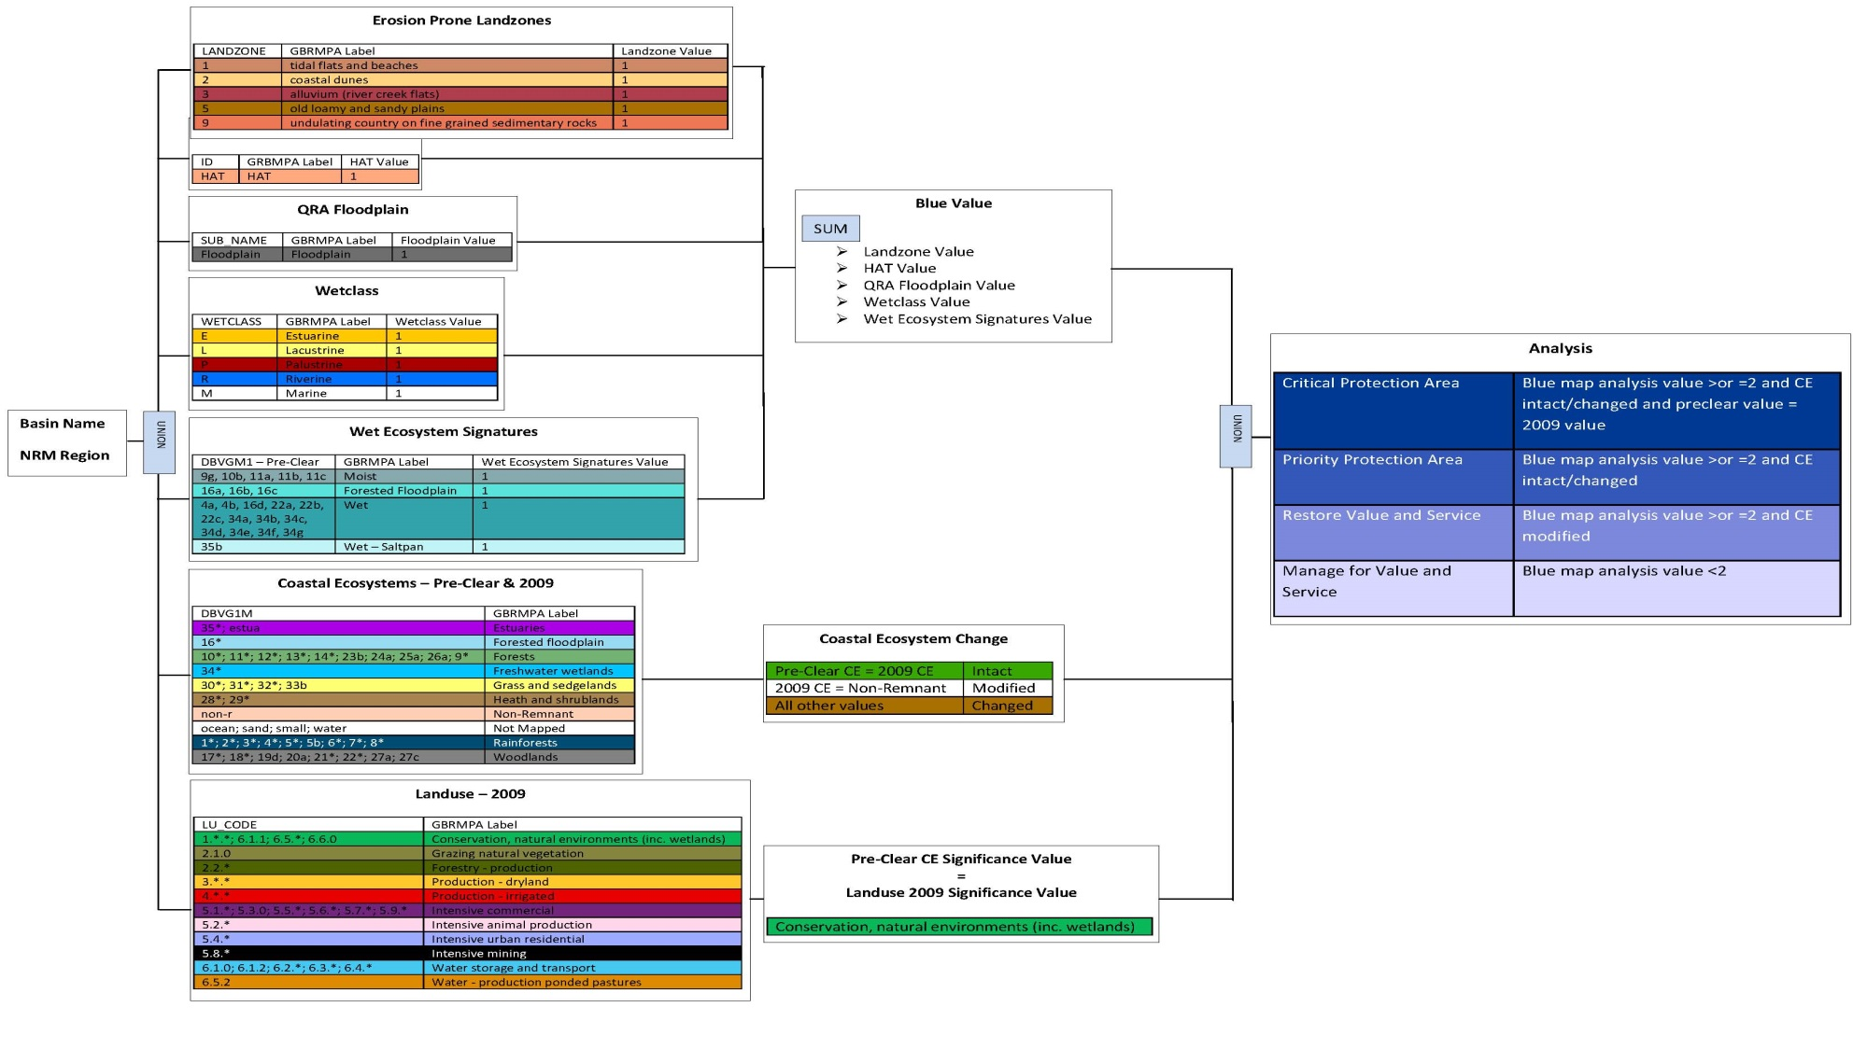

APPENDIX E - Infrastructure associated with residential development
Source: Duffy and Waterman (2009)²⁴

Section 27 of the Nature Conservation Act 1992 (Qld) prohibits the grant of mining or petroleum tenures in national parks and conservation parks. Residential and industrial development is prevented by State ownership of the land preventing any applications for development approval under SPA (which requires the owner’s consent).
See http://www.dsdip.qld.gov.au/regional-planning/the-central-queensland-regional-plan.html
EPBC referral No. 2005/2502.
See http://www.dsdip.qld.gov.au/assessments-and-approvals/hummock-hill-island-development.html
See http://www.environment.gov.au/minister/burke/2011/mr20110621a.html
EPBC referral No. 2012/6643.
Source: http://www.oesr.qld.gov.au/products/maps/qld-lga-asgc-2011/qld-lga-asgc-2011-gladstone.pdf
See http://www.envlaw.com.au/waratah.html
Section 27 of the Nature Conservation Act 1992 (Qld) prohibits the grant of mining or petroleum tenures in national parks and conservation parks. Residential and industrial development is prevented by State ownership of the land preventing any applications for development approval under SPA (which requires the owner’s consent).
See http://www.gladstone.qld.gov.au/web/guest/future-planning
SPA, s 326. The decisions of the Queensland Court of Appeal in Grosser v Gold Coast City Council [2001] QCA 423; (2001) 117 LGERA 153 and Weightman v Gold Coast City Council [2002] 2 Qd R 441; [2002] QCA 234 continue to provide important statements of principle in the application of the test under SPA.
See http://www.ehp.qld.gov.au/coastalplan/
See pp 27-28 at http://www.dsdip.qld.gov.au/resources/policy/state-planning/draft-spp.pdf
See http://www.dsdip.qld.gov.au/regional-planning/the-central-queensland-regional-plan.html
See http://www.dsdip.qld.gov.au/resources/plan/central-queensland/cq-the-region.pdf
Section 27 of the Nature Conservation Act 1992 (Qld) prohibits the grant of mining or petroleum tenures in national parks and conservation parks. Residential and industrial development is prevented by state ownership of the land preventing any applications for development approval under SPA (which requires the owner’s consent).
Based on the decision in Minister for the Environment and Heritage v QCC (2004) 139 FCR 24 (the Nathan Dam Case).
See the search tool on the EHP website at http://www.ehp.qld.gov.au/ecosystems/biodiversity/regional-ecosystems/maps/index.php#lot.
See http://www.gbrmpa.gov.au/our-partners/reef-guardians/reef-guardian-councils
See http://www.dsdip.qld.gov.au/regional-planning/the-central-queensland-regional-plan.html

