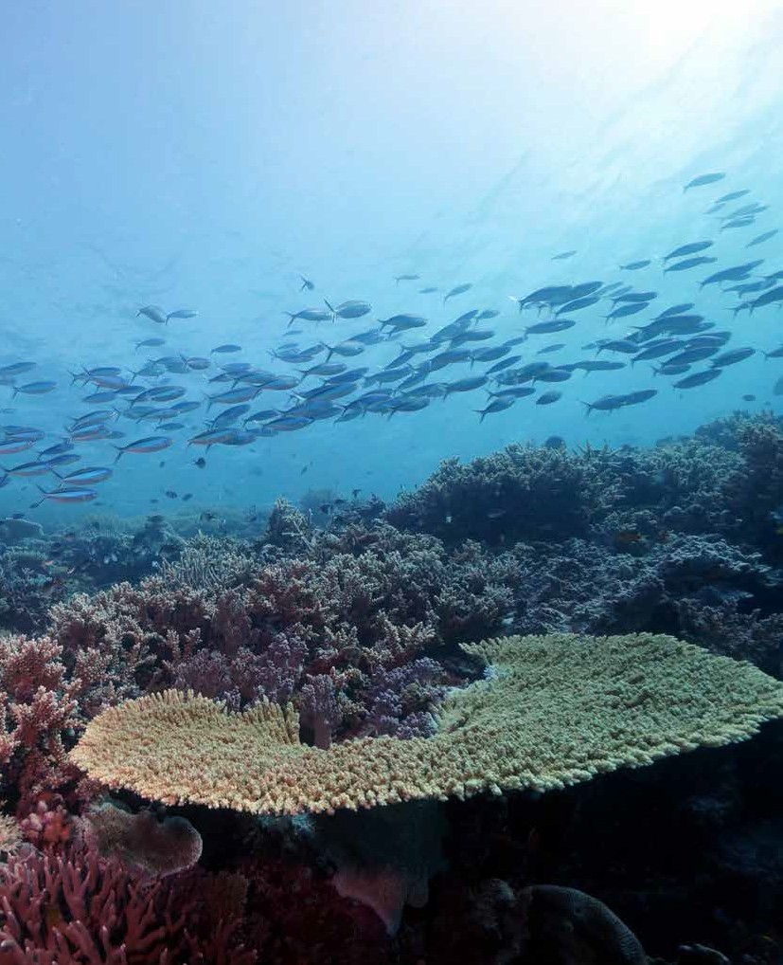

Russell-Mulgrave river mouth
(© Dieter Tracey, 2015)
Marine Monitoring Program
Summary Report — results for 2014-2015

Background

The Marine Monitoring Program¹ was established in 2005 to monitor the health of the inshore Great Barrier Reef, including water quality, seagrass and coral reef ecosystems. The program is one of the 10 components of the Paddock to Reef Integrated Monitoring, Modelling and Reporting Program², linking the health of the Reef with information on agricultural management practices, groundcover, catchment run-off and pollution loads. This monitoring directly supports the Reef Water Quality Protection Plan 2013 (Reef Plan), which aims to ensure that ‘by 2020 the quality of water entering the Reef from adjacent catchments has no detrimental impact on the health and resilience of the Great Barrier Reef.’

Snapshot of the Inshore Reef

Inshore coral reefs
Inshore coral reefs improved from a poor to moderate state, continuing their recovery since 2011-12 when their condition reached the lowest point since monitoring began following the cumulative impacts of multiple cyclones and floods.³ In 2014-15, all five indicators of coral health improved at inshore reefs overall,³ coinciding with lower loads of nutrients and sediment entering the Reef in run-off. Outbreaks of crown-of-thorns starfish at some reefs in the Wet Tropics region continued and are being actively managed.

Seagrass meadows
Inshore seagrass meadows in the Reef remained in poor condition overall, despite small improvements in some seagrass health indicators in Cape York, Wet Tropics and Mackay Whitsunday regions.⁴ There were overall improvements in abundance; however, reproductive effort declined and was poor or very poor in all regions.⁴ This indicates seagrass meadows have low capacity to recover from additional disturbances. Nutrient status also declined slightly overall across all regions.⁴ The stranding rate of dugong and turtles remained at historically low levels.⁵

Subtidal seagrass meadows at Green Island
(© Dieter Tracey, 2013)
2014-2015 Summary Report

Inshore water quality
The trend in inshore water quality improved in every region, based on remote sensing information, and the Reef-wide score increased from poor to moderate overall,⁶ coinciding with the below average annual river discharge in 2014-15. However, eight consecutive years of above average flows have deposited large amounts of sediment and nutrient into the lagoon that continues to affect the condition of the water through resuspension from wind and waves. In 2014-15, concentrations of chlorophyll a frequently exceeded the Water Quality Guidelines for the Great Barrier Reef Marine Park (Guidelines), particularly in the inshore areas of Cape York, Wet Tropics, Fitzroy and Burnett Mary regions.⁶ Total suspended solids also exceeded the Guidelines, but showed improvements in every region and overall, and remained moderate.⁶ Water quality in the inshore Reef has been gradually improving since the record flood events of 2010-2011.⁶

Pesticides
A wide range of pesticides — including insecticides and herbicides — were detected at 15 fixed long-term monitoring sites in 2014-2015.⁷ The most frequently detected pesticides in inshore waters (diuron, atrazine, hexazinone) are herbicides that inhibit photosynthesis (PSII herbicides).⁷ The highest concentration of PSII herbicides (category 3) in the marine environment was detected again in the Mackay-Whitsunday region, at the newly established Sandy Creek site.⁷ Pesticide concentrations were similar to, or lower than, those detected in 2013-14, and no individual pesticide exceeded the Guidelines. Other emerging ‘alternative’ herbicides (such as 2,4-dichlorophenoxyacetic acid (2,4-D), 2-methyl-4-chlorophenoxyacetic acid (MCPA), chlorpyrifos and pendimethalin) were also detected, but at relatively low concentrations.⁷ One-off samples ‘grabbed’ from flood waters from the Russell-Mulgrave river in the Wet Tropics region had concentrations of PSII herbicides (categories 2 and 3) known to suppress photosynthesis in marine species, mostly attributable to diuron.⁷

Disturbances
The 2014-2015 wet season was characterised by neutral (neither El Niño nor La Niña) climatic conditions and below-average rainfall. River discharge was below the long-term median for the Reef catchment for the first time since 2004-2005. Two tropical cyclones affected the Reef in 2015. Tropical cyclone Marcia (category 5) made landfall near Shoalwater Bay in February, affecting inshore areas south of Mackay. Tropical cyclone Nathan (category 4) made landfall between Cape Melville and Cape Flattery in March, affecting areas north of Cooktown. Just prior to this, the tropical depression that later formed into tropical cyclone Lam crossed the coast near Lockhart River in Cape York accompanied by strong winds and rain. In the ten year period since the Marine Monitoring Program began in 2005, nine category 3 or above cyclones have affected the Region. All of the category 5 cyclones that occurred since 1970 have been in the last decade. Many inshore coral reef and seagrass ecosystems are still recovering from the impacts of severe tropical cyclone Yasi in 2011, the most powerful cyclone (category 5) to affect Queensland since records began.⁸
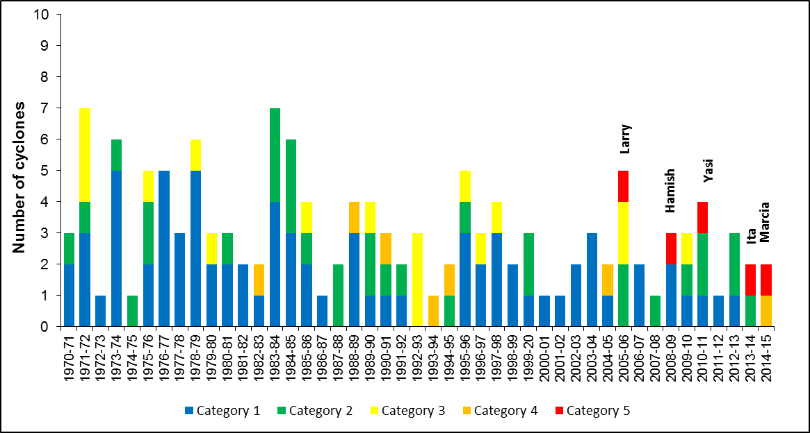

Number and severity of cyclones, 1970–2015
A number of severe cyclones have affected the Region over recent years. Five category five cyclones have occurred in the last 10 years.

Regional results

Cape York  — | Seagrass | The condition of inshore seagrass declined to a low point in 2011-12, and although it has recovered slowly since then, seagrass was still in poor condition in 2014-15. Abundance was moderate, nutrient status was poor and reproductive effort remained very poor. Assessments now utilise information from more sites at coastal intertidal habitats (Shelbourne Bay and Bathurst Bay) and reef intertidal habitats (Piper Reef, Yum Yum Beach, Stanley Island).⁴ Site-specific water quality, pesticides and coral were not monitored in the region.
Wet Tropics  — | Water quality | Site-specific water quality monitoring revealed that the long-term average of a number of water quality variables exceeded the Guidelines, including chlorophyll a (at Yorkey’s Knob, Fairlead Buoy, High West and Dunk North), Secchi depth (at all sites except Green Island), nitrate/nitrite (at Snapper North and High West) and particulate phosphorus (at Cape Tribulation).⁶
Wet Tropics  — | Pesticides | The herbicides diuron atrazine and hexazinone were frequently detected at six fixed long-term monitoring sites, and from passive samplers at sites extending out from two river mouths. However, no concentrations of individual pesticides exceeded the Guidelines. Maximum concentrations of diuron were 1.8 to 4.5 times lower than the previous year. ‘Alternative’ herbicides such as 2,4-D, imidacloprid, MCPA and metolachlor were also detected. Pesticides detected in grab samples from the Russell-Mulgrave River mouth were present in biologically relevant concentrations (category 2). The concentration of diuron exceeded the marine interim water level in a single grab sample, collected at the Russell-Mulgrave River mouth.⁷
Wet Tropics  — | Seagrass | Inshore seagrass in the Wet Tropics region remained poor in 2014-15 and has generally been poor since 2005-06, following the impact of two category 5 cyclones in the last decade. Seagrass condition varied across the region; however, abundance declined to very poor overall, reproductive effort improved from very poor to poor, and leaf tissue nutrient content remained poor. Together with other information about seagrass health, this suggests an excess of nitrogen in the inshore areas of the region.⁴
Wet Tropics  — | Coral | The condition of inshore coral reefs remained moderate overall; however, there were differences between sub-regions. All five coral health indicators remained moderate, with minor improvements in scores for coral cover, coral change, macroalgae cover and juvenile density.³ In the northern Barron-Daintree and Johnstone-Russell-Mulgrave sub-regions, coral reef communities remained in moderate condition, and in the more southern Herbert-Tully sub-region coral improved from poor to moderate.³
Burdekin  — | Water quality | Water quality data revealed that the long-term average of a number of water quality variables exceeded the Guidelines at specific monitoring sites, including chlorophyll a (at Magnetic Island), Secchi depth (all sites), nitrate/nitrite (at Magnetic Island) and particulate phosphorus (at Magnetic Island and the Haughton River).⁶
Burdekin  — | Pesticides | The most abundant and frequently detected herbicides from three fixed long-term monitoring sites were diuron, hexazinone, and atrazine and its breakdown products. Tebuthiuron was present at low levels. The ‘alternative’ herbicides 2,4-D, MCPA and metolachlor were frequently detected at all sites, and both fluazifop and haloxyfop were detected at Cape Cleveland only. No concentrations of individual pesticides exceeded the Guidelines. A series of passive samplers deployed upstream in Barratta Creek detected very high combined concentrations of PSII herbicides, which exceeded the Guideline for diuron (category 1), suggesting potential effects on some species. Concentrations of diuron, atrazine, metalachlor and tebuthiuron in Barratta Creek exceeded ANZECC and ARMCANZ freshwater guidelines.⁷
Burdekin  — | Seagrass | Seagrass remained in moderate condition. Seagrass meadows continued to increase in abundance across all habitat types, with the greatest improvements observed in subtidal meadows. In contrast, reproductive effort declined to poor. Leaf nutrient content also declined slightly but remained good. Epiphyte cover increased at subtidal and intertidal reef habitats.⁴
Burdekin  — | Coral | Inshore coral reefs remained poor, but improved slightly to levels comparable to 2010-2011. Improvement in the overall score was primarily driven by densities of juvenile corals and coral composition, which both improved from poor to moderate. Coral cover and coral change scores across the Burdekin region also improved slightly, but remained poor.³
Mackay Whitsunday  ↑ | Water quality | Water quality data revealed that the long-term average of a number of water quality variables exceeded the Guidelines at specific monitoring sites, including chlorophyll a (at all sites - Double Cone, Daydream Island, Pine Island, Seaforth Island and Repulse Island), Secchi depth (at all sites), nitrate/nitrite (at Pine Island) and particulate phosphorus (at Daydream Island, Pine Island, Seaforth Island and Repulse Island).⁶
Mackay Whitsunday  ↑ | Pesticides | The PSII herbicides most frequently detected were diuron, hexazinone, atrazine, ametryn, simazine, and tebuthiuron. Imidacloprid, 2,4-D and metolachlor were also detected regularly, and metsulfuron-methyl and metribuzin were detected in this region only. None of the individual pesticides were detected at concentrations that exceeded their Guideline value. Sandy Creek had the highest concentration of diuron of any site, and the highest risk of herbicide exposure overall (category 3). Inshore areas in this region had the highest concentrations of herbicides for the sixth consecutive year.⁷

Mackay Whitsunday continued | Seagrass | Seagrass condition improved, but remained poor overall. Seagrass abundance improved from very poor to poor, driven by an increase in abundance at coastal habitats and meadow extent across the region. Seagrass reproductive effort continued to recover, but remained poor. Leaf nutrient content was similar to the previous year and remained poor. Epiphyte cover decreased at estuarine and reef habitats.⁴
Mackay Whitsunday continued | Coral | The condition of inshore coral reefs in the region has remained moderate since 2009-2010, reflecting both the limited incidence of severe disturbances and the predominance of coral species tolerant of high turbidity. The cover of macroalgae has remained stable and low. Crown-of-thorns starfish outbreaks have not severely influenced any of the monitoring sites.³
Fitzroy  — | Water quality | Site-specific water quality was not monitored in the Fitzroy region in 2014-15.
Fitzroy  — | Pesticides | The only pesticide monitoring site in the Fitzroy region is at North Keppel Island, where the most abundant and frequently detected herbicides were atrazine, diuron, and tebuthiuron. All other pesticides were detected at very low concentrations. The maximum and average wet season pesticide concentrations have been consistently low or very low since 2005.⁷
Fitzroy  — | Seagrass | The condition of inshore seagrass declined to poor, with a declining trajectory since 2005-06. Abundance remained poor, reproductive effort remained very poor, and nutrient status decreased to poor, which may have been due to impacts associated with tropical cyclone Marcia.⁴
Fitzroy  — | Coral | Inshore coral reefs improved from very poor to poor condition. Coral health scores and indicators for coral change, juvenile density and coral composition all showed an improving trend. The influence of repeated and intense flooding, extreme temperatures and a series of severe storms since 2008 contributed to the overall decline in coral reef condition up to 2013-14.³
Burnett Mary  — | Seagrass | The condition of inshore seagrass declined slightly but remained poor. Meadow extent continued to recover at monitoring sites, to reach around half of what was observed when the program was established in 2005. Seagrass meadows remain vulnerable to further large disturbances due to very poor levels of reproductive effort and poor abundance.⁴  Site-specific water quality, pesticides and coral condition were not monitored in the region.
Scores: ■ = A, very good, ■ = B, good, ■ = C, moderate, ■ = D, poor, ■ = E, very poor. See www.reefplan.qld.gov.au/scoring for further details.
Trend in score since 2013-14: ↑ = improved, — = no change, ↓ = deteriorated.

Regional results continued

Conclusion
In 2014-15, there were signs the overall condition of the inshore marine environment had begun to improve, following two years of relatively neutral climatic conditions where river discharges were at or below the long-term median. There was a corresponding improvement in ecosystem health in most regions and if conditions continue to remain favourable, recovery of seagrass to pre-cyclone Yasi levels could occur within the next one or two years. However, the poor reproductive effort and absence of seed banks at some sites means that seagrass is vulnerable to further environmental disturbances. Overall improvements in all indicators of coral health reflect the inherent resilience of inshore reefs; however, the increase in macroalgal cover on some reefs may indicate local phase shifts in the ecosystem.
The scientific consensus is that the lag between management actions implemented now and improvements in water quality is such that sediments and nutrients are projected to continue to affect the Reef for the next 25 years. Adaptive management to drive improved land management practices, guided by monitoring, evaluation and reporting programs which share information across partners,²⁻⁹ will have a long-term positive outcome for the health and resilience of the Great Barrier Reef.

References and further Information
For more information please refer to our website, the Marine Monitoring Program publications and other websites:
- GBRMPA MMP website
- Paddock to Reef Program
- Inshore coral reef monitoring
- Inshore seagrass monitoring
- Marine wildlife standings
- Inshore water quality monitoring
- Inshore pesticides
- Wet season water quality and extreme weather monitoring
- Synthesis reports

© Commonwealth of Australia 2016. Published by the Great Barrier Reef Marine Park Authority.
ISBN 978-1-922126-88-7

