
2010-11
REEF RESCUE
Marine Monitoring
Program
Quality Assurance
and Quality Control
Manual


(
2010-11
REEF RESCUE
Marine Monitoring Program
Quality Assurance
and Quality Control Manual

© Commonwealth of Australia 2013

Published by the Great Barrier Reef Marine Park Authority

ISSN 2200 4084

ISBN 978 1 921682 84 1 (ebook; pdf)

This work is copyright. Apart from any use as permitted under the Copyright Act 1968,
no part may be reproduced by any process without the prior written permission of the
Great Barrier Reef Marine Park Authority.

National Library of Australia Cataloguing-in-Publication entry

Reef rescue marine monitoring program quality assurance and quality control manual. 2010/11
[electronic resource] / Great Barrier Reef Marine Park Authority.

ISBN 978 1 921682 84 1 (ebook; pdf)

Environmental monitoring--Queensland--Great Barrier Reef
Great Barrier Reef (Qld.)--Environmental aspects.
Great Barrier Reef Marine Park (Qld.)--Management.

Great Barrier Reef Marine Park Authority.

577.78909943

The Great Barrier Reef Marine Park Authority gratefully acknowledges the contributions of the MMP providers and their institutions to the Marine Monitoring Program Quality Assurance and Quality Control Manual.

Cover photographs courtesy of: far left, James Cook University (credited to NASA), top AIMS, 2nd down Queensland Government 3rd down AIMS, bottom CSIRO, background ENTOX (UQ).

This publication should be cited as:
Great Barrier Reef Marine Park Authority 2013, Reef rescue marine monitoring program quality assurance and quality control manual. 2010/11, GBRMPA, Townsville.

Requests and inquiries concerning reproduction and rights should be addressed to:
Director, Communication and Education Group
2-68 Flinders Street
PO Box 1379
TOWNSVILLE QLD 4810
Australia
Phone: (07) 4750 0700
Fax: (07) 4772 6093
info@gbrmpa.gov.au

Comments and inquiries on this document are welcome and should be addressed to:
Director, Coastal Ecosystems and Water Quality Group
info@gbrmpa.gov.au

www.gbrmpa.gov.au
Contents
1 Introduction 10
1.1 Threats to the Great Barrier Reef from poor water quality 10
1.2 Halting and reversing the decline in water quality 10
1.3 The Reef Rescue Marine Monitoring Program 11
1.3.1 Inshore Marine Water Quality Monitoring 13
1.3.2 Pesticide monitoring 13
1.3.3 Remote sensing of water quality 14
1.3.4 Marine flood plume monitoring 14
1.3.5 Intertidal seagrass monitoring 14
1.3.6 Inshore coral monitoring 15
1.4 Reef Rescue Marine Monitoring Program Quality Assurance and Quality Control Methods and Procedures 16
2 Inshore marine water quality monitoring 18
2.1 Introduction 18
2.2 Methods 19
2.2.1 Sampling locations 19
2.2.2 Sample collection, preparation and analysis 21
2.2.3 Autonomous environmental water quality loggers 22
2.3 Data management 23
2.4 Summary 24
3 Pesticide monitoring 25
3.1 Introduction 25
3.2 Methods 27
3.2.1 Sampling design - Passive sampling for routine monitoring 27
3.2.2 Sampling design - Passive sampling for flood monitoring 29
3.2.3 Target Pesticides in the different passive samplers 30
3.2.4 Passive Sampling Techniques 32
3.2.5 QA/QC procedures in the pesticide monitoring program 40
3.3 Data Management & Security 40
3.4 Summary 41
4 Remote sensing of water quality 42
4.1 Introduction 42
4.2 Methods 42
4.2.1 Acquisition and processing of satellite data 42
4.2.2 Field sampling 43
4.2.3 Determination of Spectroradiometric Properties to Apparent Optical Properties (AOP) 43
4.2.4 Measurement of Spectral Inherent Optical Properties (IOP) in situ 43
4.2.5 Discrete optical and biogeochemical measurements 44
4.2.6 Laboratory analysis 45
4.2.7 Data processing 45
4.3 Data Management 46
4.4 Summary of Quality Control measures 47
5 Flood plume water quality monitoring 48
5.1 Introduction 48
5.2 Methods 49
5.2.1 Field sampling design 49
5.2.2 Field protocols 50
5.2.3 Water quality sampling techniques 51
5.2.3 Phytoplankton sampling 54
5.2.4 Pesticide sampling 55
5.2.5 Trace metal processing 55
5.2.6 Chlorophyll processing 55
5.2.7 TSS processing 55
5.2.8 Laboratory analysis 56
5.2.9 Dissolved and total nutrients 57
5.2.10 Phytoplankton pigments 57
5.2.11 Total suspended solids 59
5.2.12 Coloured dissolved organic matter 60
5.2.13 Remotely sensed water quality concentrations, plume extent and duration 60
5.3 Data management 66
5.4 Summary of Quality Control measures 66
6 Inshore coral reef monitoring 67
6.1 Introduction 67
6.2 Methods 68
6.2.1 Sampling design 68
6.2.2 Site selection 69
6.2.3 Depth selection 69
6.2.4 Field survey methods 69
6.2.5 Hard coral recruitment measured by settlement tiles 74
6.2.6 Observer training 75
6.2.7 Foraminiferal abundance and community composition from sediment samples 76
6.2.8 Sediment quality 77
6.2.9 Temperature monitoring 78
6.3 Data management 78
6.4 Summary 79
7 Intertidal seagrass monitoring 80
7.1 Introduction 80
7.2 Methods 80
7.2.1 Sampling design - Intertidal seagrass meadow abundance, community structure and reproductive health 80
7.2.2 Field survey methods - Intertidal seagrass meadow abundance, community structure and reproductive health 80
7.2.3 Laboratory analysis - Intertidal seagrass meadow abundance, community structure and reproductive health 86
7.2.4 Sampling design - Intertidal seagrass meadow boundary mapping 88
7.2.5 Sampling design - Within seagrass canopy temperature loggers 89
7.2.6 Calibration procedures - Within seagrass canopy temperature loggers 89
7.2.7 Sampling design and logistics - Seagrass meadow canopy light loggers 90
7.3 Data management 91
7.3.1 Intertidal seagrass meadow abundance, community structure and reproductive health 91
7.3.2 Intertidal seagrass meadow boundary mapping 92
7.3.3 Within seagrass canopy temperature loggers 92
7.3.4 Seagrass meadow canopy light loggers 92
7.4 Summary of Quality Control measures 93
7.4.1 Intertidal seagrass meadow abundance, community structure and reproductive health 93
7.4.2 Intertidal seagrass meadow boundary mapping 93
7.4.3 Within seagrass canopy temperature loggers 93
7.4.4 Seagrass meadow canopy light loggers 93
8 References 94

List of Figures
Figure 2.1. Sampling locations under the MMP inshore marine water quality task 20
Figure 3.1. MMP passive sampling sites for routine monitoring purposes 27
Figure 3.2. The three Tully River Transect sites where more polar pesticides were monitored during the wet season using both passive and grab sampling techniques (Source – Michelle Devlin) 30
Figure 3.3. An Empore disk (ED) being loaded into the Teflon Chemcatcher housing (LHS) and an assembled housing ready for deployment 33
Figure 3.4. Passive flow monitors (PFMS) prior to deployment (LHS) and post-deployment (RHS) 33
Figure 3.5. The relationship between flow and the sampling rates of specific herbicides indicating a shift from aqueous boundary layer control to diffusion limiting membrane control under higher flow conditions 34
Figure 3.6. PDMS passive samplers loaded onto stainless steel sampler supports (LHS) which sits within the deployment cage (RHS) and sealed in place with wing nuts 36
Figure 3.7. A comparison of two different bio-fouling removal methods for the recovery of pesticides from PDMS exposed under the same conditions 37
Figure 3.8. Relationship between logKOW and logKSW for pesticides in the PDMS-water system in this calibration study 38
Figure 3.9. A schematic for the deployment of passive samplers (Empore disc in Chemcatcher housings, and SPMD/PDMS cages) together with the passive flow monitors for in-situ calibration of flow effects, in the field 39
Figure 5.1. Design of sampling program for high flow conditions. Further details can be found in Devlin et al. 2005. 50
Figure 5.2. The evolution of remote sensed imagery in the mapping and monitoring of plume waters in the Great Barrier Reef 63
Figure 5.3. MODIS AQUA imagery acquired 10th February, 2007 showing a sediment dominated flood plume of the Burdekin River and a dissolved organic matter dominated plume in Repulse Bay 64
Figure 6.1. Sampling design for coral reef benthic community monitoring. Terms within brackets are nested within the term appearing above. 68
Figure 6.2. Sampling locations under the Reef Rescue Marine Monitoring Program coral monitoring task. Core reef locations have annual coral reef benthos surveys, coral settlement assessments and water quality monitoring. Non-core reef locations have benthos surveys every two years and no water quality assessments. Exceptions are Snapper Island and Dunk Island North (water quality monitoring, coral annual surveys, but no coral settlement) 71
Figure 7.1. Intertidal seagrass monitoring sites for the Reef Rescue Marine Monitoring Program 81
Figure 7.2: Form and size of reproductive structure of the three seagrasses collected: Halophila ovalis, Halodule uninervis and Zostera muelleri ssp. capricorni 86

List of Tables
Table 1.1. The six component projects that make up the four sub-programs of the MMP and their respective monitoring providers 12
Table 2.1. Locations selected for inshore water quality monitoring (water sampling during 3 research cruises per year and continuous deployment of autonomous water quality instruments) 19
Table 3.1. Types of passive sampling which was conducted at each of the routine monitoring sites in 2010-2011 during either the dry (May – October) or wet (November – April) periods 28
Table 3.2. Pesticides specified under the MMP for analysis in different passive sampler extracts and the Limits of Reporting (LOR) for these analytes 31
Table 5.1. Example for unique sample identifiers for each water sample taken on site. 56
Table 5.2. Analysis technique associated with each water quality parameter in the ACTFR marine and freshwater laboratory 57
Table 6.1. Sites selected for inshore reef monitoring. Sites in bold are core reefs; those in standard font are cycle reefs. 72
Table 6.2. Distribution of sampling effort 73
Table 6.3. Observer training methods and quality measures 76
Table 7.1. Seagrass-Watch sites selected for the Reef Rescue Marine Monitoring Program (a discontinued 2010, b additional to tender) 84
Table 7.2. Seagrass-Watch sites selected for light logger data collection in the Reef Rescue Marine Monitoring Program 90

List of Appendices
I: Great Barrier Reef Report Card – Description of indicators and metric calculation process
A: Detailed AIMS Manuals and Standard Operational Procedures
B1: ACTFR Water Sampling Procedures
B2: ACTFR Water Sampling Field Sheet - Example
B3: Metadata for flood plume data entered into ACTFR flood database
B4: ACTFR Water Sampling Input Sheet
B5: ACTFR Auto-analysis methods – Nitrogen – Ammonia
B6: ACTFR Auto-analysis methods – Phosphorus
B7: ACTFR Auto-analysis methods – Nitrogen – Nitrate and Nitrite
B8: ACTFR Auto-analysis methods – Nitrogen – Total Alkaline Persulfate
B9: ACTFR Auto-analysis methods – Phosphorus – Total Alkaline Persulfate
B10: ACTFR Auto-analysis methods – Chlorophyll
B11: ACTFR Auto-analysis methods – Total Suspended Solids
B12: NASA Ocean Optics Protocols for Satellite Ocean Color Sensor Validation, Revision 4, Volume IV: Inherent Optical Properties: Instruments, Characterizations, Field Measurements and Data Analysis Protocols
C1: NASA QA/QC procedures for MODIS products
C2: Brando, V. E. and Dekker, A. G., Satellite hyperspectral remote sensing for estimating estuary and coastal water quality
C3: Wettle, M., Brando, V. E. and Dekker, A. G. (2004) A methodology for retrieval of environmental noise equivalent spectra applied to four Hyperion scenes of the same tropical coral reef. Remote Sensing of Environment 93: 188-197
C4: Cook book for RAMSES
C5: Dekker et al. Chapter 11: Imaging Spectrometry of Water
C6: Protocols for the validation of MERIS water products
D1: Seagrass-Watch monitoring methods
D2: Sediment herbicide sampling protocol
D3: Summary of precision criteria for environmental nutrient parameters
D4: Seagrass-Watch example data error report

These appendices are available from the GBRMPA on request.
List of Acronyms
AIMS Australian Institute of Marine Science
ANZECC Australian and New Zealand Environment and Conservation Council
AOP Apparent Optical Properties
ARMCANZ Agriculture and Resource Management Council of Australia and New Zealand
CDOM Coloured dissolved organic matter
CRC Cooperative Research Centre
CSIRO Commonwealth Scientific and Industrial Research Organisation
CTD Conductivity Temperature Depth profiler
DEEDI Department of Employment, Economic Development and Innovation
DON Dissolved Organic Nitrogen
DOP Dissolved Organic Phosphorus
QF Queensland Fisheries
ED Empore Disk
Entox National Research Centre for Environmental Toxicology,
The University of Queensland
GBRMPA Great Barrier Reef Marine Park Authority
GBROOS Great Barrier Reef Ocean Observing System
GBRWHA Great Barrier Reef World Heritage Area
GC Gas Chromatography
GPC Gel Permeation Chromatography
HCl Hydrochloric acid
HPLC High Performance Liquid Chromatography
IOP Inherent Optical Properties
JCU James Cook University
LCMS Liquid Chromatography-Mass Spectrography
MMP Reef Rescue Marine Monitoring Program
MODIS Moderate-resolution Imaging Spectroradiometer
MS Mass Spectroscopy
MTSRF Marine and Tropical Sciences Research Facility
NASA National Aeronautics and Space Administration
NATA National Association of Testing Authorities
NH₄ Ammonia
NO₂ Nitrogen dioxide
NO₃ Nitrate
NRM Natural Resource Management
PAH Polyaromatic Hydrocarbons
PDMS Polydimethylsiloxane
PN Particulate Nitrogen
PO₄ Phosphate
PP Particulate Phosphorus
PRC Performance Reference Compounds
QA Quality Assurance
QC Quality Control
QHFSS Queensland Health Forensic & Scientific Service
QSIA Queensland Seafood Industry Association
RRRC Reef & Rainforest Research Centre Ltd
Si(OH)₄ Silicate
SIOP Spectral Inherent Optical Properties
SOPs Standard Operating Procedures
SPMD Semipermeable Membrane Devices
TDN Total Dissolved Nitrogen
TDP Total Dissolved Phosphorus
TSS Total Suspended Solids
UQ The University of Queensland
VPIT Video Point Interception Method

Introduction
Katherine Martin

Great Barrier Reef Marine Park Authority

Threats to the Great Barrier Reef from poor water quality
The Great Barrier Reef is renowned internationally for its ecological importance and beauty. It is the largest and best known coral reef ecosystem in the world, extending over 2,300 kilometres along the Queensland coast and covering an area of 350,000 km². It includes over 2,900 coral reefs, as well as extensive seagrass meadows, mangrove forests and diverse seafloor habitats. It is a World Heritage Area and protected within the Great Barrier Reef Marine Park in recognition of its diverse, unique and outstanding universal value. The Reef is also critical for the prosperity of Australia, contributing about $5.4 billion annually to the Australian economy.¹

The Great Barrier Reef receives runoff from 35 major catchments, which drain 424,000 km² of coastal Queensland. The Great Barrier Reef catchment is relatively sparsely populated; however, there have been extensive changes in land-use since European settlement, driven by increased urban, agricultural and industrial development particularly in areas adjacent to the coast.^{2,3} Unfortunately, the combination of expanding catchment development and modification of land-use has resulted in a significant decline in the quality of water flowing into the Reef lagoon over the past 150 years.^{4,5,6,7}

Flood events in the wet season deliver low salinity waters and loads of nutrients, sediments and pesticides from the adjacent catchments into the Reef lagoon that are well above natural levels and many times higher than in non-flood waters.^{8,9}

Numerous studies have shown that nutrient enrichment, turbidity, sedimentation and pesticides all affect the resilience of the Reef ecosystem, degrading coral reefs and seagrass beds at local and regional scale.^{8,10,11} Pollutants may also interact to have a combined negative effect on Reef resilience that is greater than the effect of each pollutant in isolation.^{10,12} For example, differences in tolerance to nutrient enrichment and sedimentation between species of adult coral can lead to changes in community composition.^{11,13}

Generally, Reef ecosystems decline in species richness and diversity along a gradient water quality from outer reefs distant from terrestrial inputs to near-shore coastal reefs more frequently exposed to flood waters.^{13,14} The area at highest risk from degraded water quality is the inshore area, which makes up approximately 8 per cent of the Great Barrier Reef Marine Park and is generally within 20 kilometres of the shore. The inshore area supports significant ecological communities and is also the area of the Great Barrier Reef most utilised by recreational visitors and commercial tourism operations and commercial fisheries.

Halting and reversing the decline in water quality
Substantial investment is being undertaken to halt and reverse the decline of water quality entering the Reef lagoon under the joint Australian and Queensland Government Reef Water Quality Protection Plan (Reef Plan).¹⁵ Reef Plan was released in 2003 and updated in 2009 with the addition of the Australian Government's Caring for Our Country Reef Rescue initiative.¹⁶ Reef Rescue initiative is a $200 million dollar, five-year commitment by the Australian Government to tackle climate change and improve water quality in the Great Barrier Reef.

The focus of Reef Plan is on identifying and implementing solutions to improve water through sustainable natural resource management, with the goal to ‘halt and reverse the decline in water quality entering the Reef within ten years' (by 2013).

The update of Reef Plan in 2009 added the long-term goal "to ensure that by 2020 the quality of water quality entering the Great Barrier Reef from adjacent catchments has no detrimental impact on the health and resilience of the Great Barrier Reef", with specific targets for reduction in end of catchment pollutant loads. Progress towards Reef Plan goals and targets is assessed through an annual Report Card¹⁷, which is produced through the Paddock to Reef Integrated Monitoring, Modelling and Reporting Program. The Reef Plan Report Card is a collaborative effort involving governments, industry, regional natural resource management bodies and research organizations.

As part of the Reef Rescue initiative, $22 million is allocated to a Water Quality Monitoring and Reporting Program to expand existing monitoring and reporting of water quality in the Great Barrier Reef.

The Reef Rescue Marine Monitoring Program (MMP) receives $2 million per annum to monitor water quality and ecological health in inshore areas of the Great Barrier Reef Marine Park. The funding for the MMP is delivered to the Great Barrier Reef Marine Park Authority (GBRMPA) through a Memorandum of Understanding with the Department of Sustainability, Environment, Water, Population and Communities. The MMP was established in 2005 to:

- Monitor the condition of water quality in the coastal and mid-shelf (inshore) waters of the Reef lagoon
- Monitor the long-term health of key marine ecosystems (inshore coral reefs and seagrasses).

The MMP is a key component in the assessment of long-term improvements in inshore water quality and marine ecosystem health that are expected to occur with the adoption of improved land management practices in the Great Barrier Reef catchments under Reef Plan and Reef Rescue.

The Reef Rescue Marine Monitoring Program
The MMP is a collaborative effort that relies on effective partnerships between governments, industry, community, scientists and managers. A conceptual model¹⁸ was used to identify appropriate indicators linking water quality and ecosystem health and these indicators were further refined in consultation with monitoring providers and independent experts. The Great Barrier Reef Marine Park Authority is responsible for the management of the MMP in partnership with five monitoring providers:

- Australian Institute of Marine Science (AIMS)
- University of Queensland (UQ)
- James Cook University (JCU)
- Queensland Department of Employment, Economic Development and Innovation (DEEDI)
- Commonwealth Scientific and Industrial Research Organisation (CSIRO).

The five monitoring providers work together to deliver the four sub-programs of the MMP, the broad objectives of which are:

Inshore Marine Water Quality Monitoring: To assess temporal and spatial trends in marine water quality in inshore areas of the Reef lagoon.

Intertidal Seagrass Monitoring: To quantify temporal and spatial variation in the status of intertidal and subtidal seagrass meadows in relation to local water quality changes.

Inshore Coral Reef Monitoring: To quantify temporal and spatial variation in the status of inshore coral reef communities in relation to local water quality changes.

Assessment of Terrestrial Run-off Entering the Reef: To assess trends in the delivery of pollutants to the Reef lagoon during flood events and to quantify the exposure of Reef ecosystems to these pollutants.

Each monitoring provider has a different responsibility in the delivery of the six components that make up the four sub-programs of the MMP (Table 1.1.). This manual details the QA/QC methods and procedures for the six component projects of the MMP.

Water quality parameters are assessed against the Water Quality Guidelines for the Great Barrier Reef Marine Park¹⁹ that were established under and consistent with the Australian and New Zealand Guidelines for Fresh and Marine Water Quality²⁰ and the Australian National Water Quality Management Strategy.

Table 1.1. The six component projects that make up the four sub-programs of the MMP and their respective monitoring providers. Note that a project may contribute to more than one sub-program.

Monitoring sub-program | Component project(s) | Monitoring provider
Inshore Marine Water Quality | Inshore marine water quality monitoring | AIMS
Inshore Marine Water Quality | Pesticide monitoring | UQ
Inshore Marine Water Quality | Remote sensing of water quality | CSIRO
Assessment of terrestrial run-off entering the reef | Marine flood plume monitoring | JCU
Assessment of terrestrial run-off entering the reef | Pesticide monitoring | UQ
Assessment of terrestrial run-off entering the reef | Remote sensing of water quality | CSIRO
Assessment of terrestrial run-off entering the reef | Inshore marine water quality monitoring | AIMS
Intertidal seagrass monitoring | Intertidal seagrass monitoring | DEEDI, JCU
Inshore coral monitoring | Inshore coral monitoring | AIMS

Inshore Marine Water Quality Monitoring
Long-term in situ monitoring of spatial and temporal trends in the inshore water quality of the Reef lagoon is essential to assess improvements in regional water quality that will occur as a result of reductions in pollutant loads from adjacent catchments.

Monitoring includes assessment of dissolved and particulate nutrients and carbon, suspended solids, chlorophyll a, salinity, turbidity and temperature. Techniques used to monitor water quality include automated high-frequency data loggers and the collection of water samples from research vessels for standard laboratory analysis. Key points include:

- Monitoring of site-specific water quality by data loggers and direct water sampling is primarily conducted at the 14 inshore coral monitoring sites, two to three times per year, to allow for correlation with Reef ecosystem condition
- Six open water sites off Cairns are also monitored to extend an existing long-term data series initiated in 1989 by the Australian Institute of Marine Science

Water quality parameters are assessed against the Water Quality Guidelines for the Great Barrier Reef Marine Park.¹⁹

Pesticide monitoring
The off-site transport of pesticides from land-based applications has been considered a potential risk to the Great Barrier Reef. Of particular concern is the potential for compounding effects that these chemicals have on the health of the inshore reef ecosystem, especially when delivered with other water quality pollutants during flood events (this project is also linked to flood plume monitoring and the collection of water samples directly from research vessels, section 1.3.4).

Passive samplers are used to measure the concentration of pesticides in the water column integrated over time, by accumulating chemicals via passive diffusion.^{21,22} Monitoring of specific pesticides during flood events and throughout the year is essential to evaluate long-term trends in pesticide concentrations along inshore waters of the Great Barrier Reef. Key points include:

- Pesticide concentrations are measured with passive samplers at 12 sites (some of which were newly established in 2009/10) at monthly intervals in the wet season and bi-monthly intervals in the dry season.
Pesticide concentrations are assessed against the Water Quality Guidelines for the Great Barrier Reef Marine Park¹⁹ and reported as categories of sub-lethal stress defined by the published literature and taking into account mixtures of herbicides that affect photosynthesis.
- The continual refinement of techniques that allow a more sensitive, time-integrated and relevant approach for monitoring pollutant concentrations in the lagoon and assessment of potential effects that these pollutants may have on key biota.

Remote sensing of water quality
Remote sensing provides estimates of spatial and temporal changes in near surface concentrations of suspended solids (as non-algal particulate matter), turbidity (as the vertical attenuation of light coefficient, Kd), chlorophyll a (Chl) and coloured dissolved organic matter (CDOM) for the Great Barrier Reef. This is achieved through acquisition, processing with regionally valid algorithms, validation and transmission of geo-corrected ocean colour imagery and data sets derived from Moderate-resolution Imaging Spectroradiometer (MODIS) imagery.

Monitoring of water quality using remote sensing is essential for generating water quality information across the whole Great Barrier Reef. Key points include:

Water quality parameters are assessed against the Water Quality Guidelines for the Great Barrier Reef Marine Park.¹⁹
- The development of new analytical tools for detecting trends, specifically wet season to dry season variability, river plume composition and extent and algal blooms, based on the characteristics of optical satellite remote sensing data.
- The application of improved algorithms for water quality and atmospheric correction for the waters of the Great Barrier Reef.

Marine flood plume monitoring
Riverine flood plumes are of significant ecological importance to the Great Barrier Reef as river runoff is the principal carrier of eroded soil (sediment), nutrients and contaminants from the land into the coastal and inshore lagoon waters. Indeed, the majority of the annual pollutant load is delivered to the Reef in the wet season.

Assessing trends in the concentration and delivery of pollutants to the Reef lagoon by flood waters is essential to quantify the exposure of inshore ecosystems to these pollutants.

Monitoring of water quality during flood events and throughout the wet season includes measurements of salinity, concentrations of nutrients, chlorophyll, suspended solids (water turbidity) and pesticides from water samples collected directly from research vessels. The movement of flood plumes across inshore waters of the Reef is assessed using images from aerial flyovers and remote sensing. Key points include:

- Monitoring is carried out in marine waters adjacent to targeted catchments along a north-east transect away from the river mouth, in the wet and dry tropics depending on flood conditions.
- Remote sensing of water quality utilises satellite images acquired on a daily basis across the Reef, except on overcast days.
Water quality parameters are assessed against the Water Quality Guidelines for the Great Barrier Reef Marine Park.¹⁹

Intertidal seagrass monitoring
Seagrasses are an important component of the marine ecosystem of the Great Barrier Reef. They form highly productive habitats that provide nursery grounds for many marine and estuarine species, including commercially important fish and prawns. Monitoring temporal and spatial variation in the status of intertidal seagrass meadows in relation to changes in local water quality is essential in evaluating long-term ecosystem health. The intertidal seagrass monitoring project is closely linked to the Seagrass-Watch monitoring program
(http://www.seagrasswatch.org/home.html).

Monitoring includes seagrass cover (per cent) and species composition, macroalgal cover, epiphyte cover, canopy height, mapping of the meadow edge and assessment of seagrass reproductive effort, which provide an indication of the capacity for meadows to regenerate following disturbances and changed environmental conditions. Tissue nutrient composition is assessed in the laboratory as an indicator of potential nutrient enrichment. Key points include:

- Monitoring occurs at 30 sites across 15 locations, including nine inshore (intertidal coastal and estuarine) and six offshore reef intertidal locations. Three transects are monitored per site in both the late dry and monsoon seasons.
- Monitoring includes in situ within canopy temperature and light levels.

Inshore coral monitoring
Several reefs that make up the Great Barrier Reef are in inshore areas frequently exposed to runoff.²³ Monitoring temporal and spatial variation in the status of inshore coral reef communities in relation to changes in local water quality is essential in evaluating long-term ecosystem health.

Monitoring covers a comprehensive set of community attributes including the assessment of hard and soft coral cover, macroalgae cover, the density of hard coral juvenile colonies, richness of hard coral genera, coral settlement and the rate of change in coral cover as an indication of the recovery potential of the reef following a disturbance.²⁴ Comprehensive water quality measurements are also collected at many of the coral reef sites (this project is linked to inshore water quality monitoring, section 1.3.1). Key points include:

- Monitoring of 32 inshore coral reefs in the Wet Tropics, Burdekin, Mackay Whitsunday and Fitzroy regions along gradients of exposure to runoff from regionally important rivers. At each reef, two sites are monitored at two depths (2m and 5m) across five replicate transects. Reefs are designated as either ‘core’ or ‘cycle’ reefs. The 15 core reefs are surveyed annually and the 17 cycle reefs are surveyed every second year.
- Monitoring includes sea temperature, sediment quality and assemblage composition of benthic foraminifera as drivers of environmental conditions at inshore reefs.

Synthesis of data and integration
The reporting framework of the MMP was revised in 2010 to integrate with the Reef Plan Paddock-to-Reef Integrated Monitoring, Modelling and Reporting Program. This Program was set up to address Reef Plan goals and evaluate the long-term effectiveness of Reef Plan in reversing the decline in the quality of water entering the Reef from adjacent catchments. The data from the MMP is combined with monitoring data collected at the paddock and catchment scales to produce the Reef Plan Annual Report Card summary of the health of the Reef and its catchments.

A comprehensive list of water quality and ecosystem health indicators are measured under the Marine Monitoring Program (sections 1.3.1 to 1.3.6) and a sub-set of these were selected to calculate Water quality, Seagrass and Coral scores for the Report Card, based on expert opinion. These scores were expressed on a five point scale using a common colour scheme and integrated into an overall score that describes the status of the Great Barrier Reef and each region, where:

- 0-20 per cent is assessed as ‘very poor’ and coloured red
- >20-40 per cent equates to ‘poor’ and coloured orange
- >40-60 per cent equates to ‘moderate’ and coloured yellow
- >60-80 per cent equates to ‘good’, and coloured light green
- >80 per cent is assessed as ‘very good’ and coloured dark green.

An overview of the methods used to calculate the Great Barrier Reef wide and regional scores is given in Appendix I. More detailed information on the scores, including site-specific assessment of water quality and pesticides, is available from the annual science reports on the Great Barrier Reef Marine Park Authority website: http://www.gbrmpa.gov.au/resources-and-publications/publications/scientific-and-technical-reports

Reef Rescue Marine Monitoring Program Quality Assurance and Quality Control Methods and Procedures
Appropriate Quality Assurance/Quality Control (QA/QC) procedures are an integral component of all aspects of sample collection and analysis. The QA/QC procedures have been approved by an expert panel convened by the GBRMPA.

The GBRMPA set the following guidelines for implementation by MMP Program Leaders:

- Appropriate methods must be in place to ensure consistency in field procedures to produce robust, repeatable and comparable results, including consideration of sampling locations, replication and frequency.
- All methods used must be fit for purpose and suited to a range of conditions.
- Appropriate accreditation of participating laboratories or provision of standard laboratory protocols to demonstrate that appropriate laboratory QA/QC procedures are in place for sample handling and analysis.
- Participation in inter-laboratory performance testing trials and regular exchange of replicate samples between laboratories.
- Rigorous procedures to ensure ‘chain of custody’ and tracking of samples.
- Appropriate standards and procedures for data management and storage.

In addition to the QA/QC procedures outlined above, the MMP employs a proactive approach to monitoring through the continual development of new methods and the refinement of existing methods, such as the:

- Operation and validation of autonomous environmental loggers
- Validation of algorithms used for the remote sensing of water quality
- Improvement of passive sampling techniques for pesticides
- Introduction of additional monitoring components to evaluate the condition of inshore reefs, specifically coral recruitment.

The monitoring providers for the MMP have a long-standing culture of QA/QC in their monitoring activities. Common elements across the providers include:

- Ongoing training of staff (and other sampling providers) in relevant procedures
- Standard Operating Procedures (SOPs), both for field sampling and analytical procedures
- Use of standard methods (or development of modifications)
- Publishing of methods and results in peer-reviewed publications
- Maintenance of equipment
- Calibration procedures including participation regular inter-laboratory comparisons
- Established sample custody procedures
- QC checks for individual sampling regimes and analytical protocols
- Procedures for data entry, storage, validation and reporting.

This manual and its appendices detail the QA/QC methods and procedures for the six component projects that feed into the four sub-programs of the MMP (Table 1), including a description of the process for calculating Reef Plan Report Card scores.

The manual summarises the monitoring methods and procedures for each project. Detailed sampling manuals, standard operating procedures, analytical procedures and other details are provided as appendices. The full list of appendices is on page 7 and these are grouped by monitoring provider (Appendices A-D).

Inshore marine water quality monitoring
Britta Schaffelke, Miles Furnas, Michele Skuza

Australian Institute of Marine Science

Introduction
The biological productivity of the Great Barrier Reef is supported by nutrients (e.g. nitrogen, phosphorus, silicate, iron), which are supplied by a number of processes and sources.^{6,25} These include upwelling of nutrient-enriched subsurface water from the Coral Sea, rainwater, fixation of gaseous nitrogen by cyanobacteria and freshwater runoff from the adjacent catchment. Land runoff is the largest source of new nutrients to the Reef.⁶ However, most of the inorganic nutrients used by marine plants and bacteria on a day-to-day basis come from recycling of nutrients already within the Great Barrier Reef ecosystem.²⁶

Extensive water sampling throughout the Great Barrier Reef over the last 25 years has established the typical concentration range of nutrients, chlorophyll a and other water quality parameters and the occurrence of persistent latitudinal, cross-shelf and seasonal variations in these concentrations (summarised in Furnas,M. 2005²⁷ and De’ath and Fabricius 2008²⁸). While concentrations of most nutrients, suspended particles and chlorophyll a are normally low, water quality conditions can change abruptly and nutrient levels increase dramatically for short periods following disturbance events (wind-driven re-suspension, cyclonic mixing, and river flood plumes). Nutrients introduced, released or mineralised into Great Barrier Reef lagoon waters during these events are generally rapidly taken up by pelagic and benthic algae and microbial communities²⁹, sometimes fuelling short-lived phytoplankton blooms and high levels of organic production.²⁶

The longest and most detailed time series of a suite of water quality parameters has been measured by the Australian Institute of Marine Science (AIMS) at eleven coastal stations in the Great Barrier Reef lagoon between Cape Tribulation and Cairns since 1989; and has been continued under the MMP. Concentrations of nutrients and suspended solids show significant long-term patterns, generally decreasing since the early 2000s.³⁰ This trend is not seen in chlorophyll a data. The understanding of the causes of the observed fluctuations is incomplete.

Regional-scale monitoring of surface chlorophyll a concentrations in Great Barrier Reef waters since 1992 shows consistent regional (latitudinal), cross-shelf and seasonal patterns in phytoplankton biomass, which is regarded as a proxy for nutrient availability.³¹ In the mid and southern Great Barrier Reef, higher chlorophyll a concentrations are usually found in shallow waters (within twenty metres depth) close to the coast (less than 25 km offshore). Overall, however, no long-term net trends in chlorophyll a concentrations were found (CRC Consortium 2006).³¹

This project has the following key objectives:

- To describe spatial patterns and temporal trends in marine water quality (suspended sediments and nutrients) in high risk (inshore) areas of the Great Barrier Reef lagoon.
- To determine local water quality by autonomous instruments for high-frequency measurements at selected inshore reef sites where coral monitoring is carried out.

Methods
This chapter provides an overview of the sample collection, preparation and analyses methods. Most individual methods have a reference to a section at the end of the report with a detailed standard operational procedure document for comprehensive information.

Sampling locations
The 14 fixed sampling locations at inshore coral reefs (Table 2.1., Figure 2.1.) are congruent with the fourteen ‘core’ sites of the inshore coral reef monitoring (see Chapter 6). At these sites, detailed manual and instrumental water sampling is undertaken (see Table 2.1). Manual water sampling is also conducted at six open water stations along the ‘AIMS Cairns Coastal Transect’ (Table 2.1., Figure 2.1.).

Table 2.1. Locations selected for inshore water quality monitoring (water sampling during 3 research cruises per year and continuous deployment of autonomous water quality instruments)
The six locations of the ‘AIMS Cairns Transect’ (open water sampling) are in italics. Shaded cells indicate locations in the mid-shelf water body, as designated by the GBRMPA Water Quality Guidelines (GBRMPA 2009); all other locations are in the “open coastal” water body

NRM Region | Primary Catchment | Water quality monitoring locations
Wet Tropics | Daintree, Barron | Cape Tribulation
Wet Tropics | Daintree, Barron | Snapper Island North
Wet Tropics | Daintree, Barron | Port Douglas
Wet Tropics | Daintree, Barron | Double Island
Wet Tropics | Daintree, Barron | Yorkey’s Knob
Wet Tropics | Daintree, Barron | Fairlead Buoy
Wet Tropics | Daintree, Barron | Green Island
Wet Tropics | Russell-Mulgrave, Johnstone | Fitzroy Island West
Wet Tropics | Russell-Mulgrave, Johnstone | High Island West
Wet Tropics | Russell-Mulgrave, Johnstone | Frankland Group West (Russell Island)
Wet Tropics | Tully | Dunk Island North
Burdekin | Herbert, Burdekin | Pelorus & Orpheus Is West
Burdekin | Burdekin | Pandora Reef
Burdekin | Burdekin | Geoffrey Bay
Mackay Whitsunday | Proserpine | Double Cone Island
Mackay Whitsunday | Proserpine | Daydream Island
Mackay Whitsunday | Proserpine | Pine Island
Fitzroy | Fitzroy | Barren Island
Fitzroy | Fitzroy | Pelican Island
Fitzroy | Fitzroy | Humpy & Halfway Island

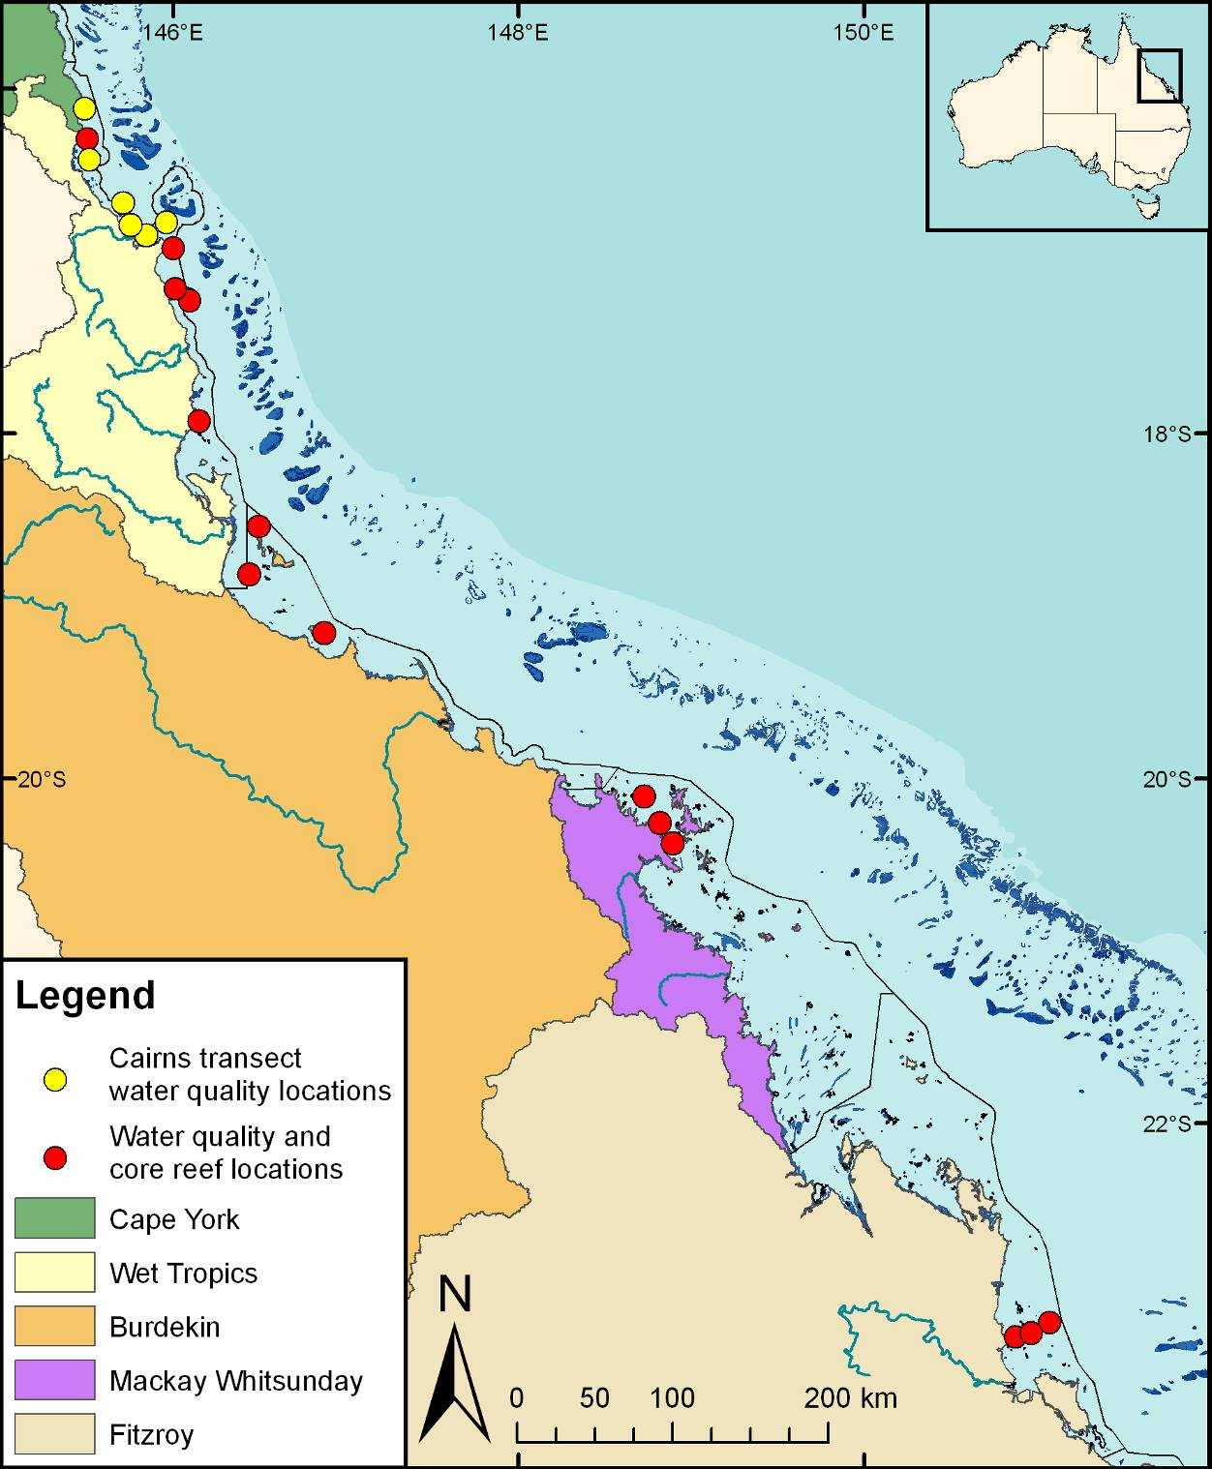
Figure 2.1. Sampling locations under the MMP inshore marine water quality task.
Red symbols indicate the 14 locations where autonomous water quality instruments (temperature, chlorophyll and turbidity) were deployed and regular water sampling was undertaken; these locations are also “Core reef locations” under the inshore coral reef monitoring task (see Chapter 6). Yellow symbols are the locations of the “AIMS Cairns Coastal Transect”, which have been sampled by AIMS from 1989-2008

Sample collection, preparation and analysis
At each location, vertical profiles of water temperature and salinity were measured with a Conductivity Temperature Depth profiler (CTD) (Seabird SBE25 or SBE19). The CTD was fitted with an in situ fluorometer for chlorophyll a (WET Labs) and a beam transmissometer (Sea Tech, 25 cm, 660 nm) for turbidity (Appendix A1).

Immediately following the CTD cast, discrete water samples were collected from two to three depths through the water column with Niskin bottles. Sub-samples taken from the Niskin bottles were analysed for dissolved nutrients and carbon (NH₄, NO₂, NO₃, PO₄, Si(OH)₄), DON, DOP, DOC), particulate nutrients and carbon (PN, PP, POC), suspended solids (SS) and chlorophyll a. Subsamples were also taken for laboratory salinity measurements using a Portasal Model 8410A Salinometer (Apendix A2). Temperatures were measured with reversing thermometers from at least two depths.

In addition to the ship-based sampling, water samples were collected by diver-operated Niskin bottle sampling both, (a) close to the autonomous water quality instruments (see below) and (b) within the adjacent reef boundary layer. These samples were otherwise processed in the same way as the ship-based samples.

The sub-samples for dissolved nutrients were immediately filtered through a 0.45 µm filter cartridge (Sartorius Mini Sart N) into acid-washed screw-cap plastic test tubes and stored frozen (-18ºC) until later analysis ashore. Separate sub-samples for DOC analysis were acidified with 100 μl of AR-grade HCl and stored at 4ºC until analysis. Separate sub-samples for Si(OH)₄ were filtered and stored at room temperature until analysis.

Inorganic dissolved nutrients (NH₄, NO₂, NO₃, PO₄, Si(OH)₄) concentrations were determined by standard wet chemical methods³² implemented on a segmented flow analyser³³ after return to the AIMS laboratories (Appendix A3). Analyses of total dissolved nutrients (TDN and TDP) were carried using persulphate digestion of water samples³⁴ (Appendix A3), which are then analysed for inorganic nutrients, as above. DON and DOP were calculated by subtracting the separately measured inorganic nutrient concentrations (above) from the TDN and TDP values.

To avoid potential contamination during transport and storage, analysis of ammonium concentrations in triplicate subsamples per Niskin bottle were also immediately carried out on board the vessel using a fluorometric method bases on the reaction of ortho-phthal-dialdehyde with ammonium.³⁵ These samples were analysed on fresh unfiltered seawater samples using specially cleaned glassware, because the experience of AIMS researchers shows that the risk of contaminating ammonium samples by filtration, transport and storage is high. If available, the NH₄ values measured at sea were used for the calculation of DIN (Appendix A4).

Dissolved organic carbon (DOC) concentrations were measured by high temperature combustion (680ºC) using a Shimadzu TOC-5000A carbon analyser. Prior to analysis, CO₂ remaining in the sample water is removed by sparging with O₂ carrier gas (Appendix A5).

The sub-samples for particulate nutrients and plant pigments were collected on pre-combusted glass fibre filters (Whatman GF/F). Filters were wrapped in pre-combusted aluminium foil envelopes and stored at -18ºC until analyses.

Particulate nitrogen (PN) is determined by high-temperature combustion of filtered particulate matter on glass fibre filters using an ANTEK 9000 NS Nitrogen Analyser (Appendix A6).³⁶ The analyser is calibrated using AR Grade EDTA for the standard curve and marine sediment BCSS-1 as a control standard.

Particulate phosphorus (PP) is determined spectrophotometrically as inorganic P (PO₄: Parsons et al. 1984³⁷) after digesting the particulate matter in 5 per cent potassium persulphate (Appendix A7) ³⁶ The method is standardised using orthophosphoric acid and dissolved sugar phosphates as the primary standards.

The particulate organic carbon content of material collected on filters is determined by high temperature combustion (950ºC) using a Shimadzu TOC-V carbon analyser fitted with a SSM-5000A solid sample module (Appendix A8). Filters containing sampled material are placed in pre-combusted (950ºC) ceramic sample boats. Inorganic C on the filters (e.g. CaCO₃) is removed by acidification of the sample with 2M hydrochloric acid. The filter is then introduced into the sample oven (950ºC), purged of atmospheric CO₂ and the remaining organic carbon is then combusted in an oxygen stream and quantified by IRGA. The analyses are standardised using certified reference materials (e.g. MESS-1).

Chlorophyll a concentrations are measured fluorometrically using a Turner Designs 10AU fluorometer after grinding the filters in 90% acetone (Appendix 9).³⁷ The fluorometer is calibrated against chlorophyll a extracts from log-phase diatom cultures (chlorophyll a and c). The extract chlorophyll concentrations are determined spectrophotometrically using the wavelengths and equation specified by Jeffrey and Humphrey (1975).

Sub-samples for suspended solids were collected on pre-weighed 0.4 µm polycarbonate filters. SS concentrations are determined gravimetrically from the difference in weight between loaded and unloaded 0.4 µm polycarbonate filters (47 mm diameter, GE Water & Process Technologies) after the filters had been dried overnight at 60ºC (Appendix A10).

For a detailed description of the data management procedures developed at the AIMS for the MMP refer to Appendix A15.

Autonomous environmental water quality loggers
Instrumental water quality monitoring is undertaken using WETLabs Eco FLNTUSB Combination Fluorometer and Turbidity Sensors. The Eco FLNTUSB instruments perform simultaneous in situ measurements of chlorophyll fluorescence, turbidity and temperature (Appendix A11). The fluorometer monitors chlorophyll concentration by directly measuring the amount of chlorophyll a fluorescence emission, using blue LEDs (centred at 455 nm and modulated at 1 kHz) as the excitation source. A blue interference filter is used to reject the small amount of red light emitted by the LEDs. The blue light from the sources enters the water at an angle of approximately 55-60 degrees with respect to the end face of the unit. The red fluorescence emitted (683 nm) is detected by a silicon photodiode positioned where the acceptance angle forms a 140-degree intersection with the source beam. A red interference filter discriminates against the scattered blue excitation light.

Turbidity is measured simultaneously by detecting the scattered light from a red (700 nm) LED at 140 degrees to the same detector used for fluorescence. The instruments were used in ‘logging’ mode and recorded a data point every ten minutes for each of the three parameters, which was a mean of fifty instantaneous readings.

Pre- and post-deployment checks of each instrument included measurements of a) the dark count (instrument response with no external fluorescence, essentially the ‘zero’ point), b) the maximum fluorescence response, c) ‘black cap’ readings of Nephelometric Turbidity Units (NTU), d) ‘registration cap’ readings of fluorescence and e) ‘Diet Coke solution’ readings of both NTU and fluorescence. Additional calibration checks performed with less frequency include dilution series of a 4000 NTU Formazin turbidity standard and of a pure plankton culture (for chlorophyll fluorescence) in custom-made calibration chambers (see Appendix A11 for detailed procedures). After retrieval from the field locations, the instruments were cleaned and data downloaded and converted from raw instrumental records into actual measurement units (µg L⁻¹ for chlorophyll fluorescence, NTU for turbidity, ºC for temperature) according to standard procedures by the manufacturer. Deployment information and all raw and converted instrumental records were stored in an Oracle-based data management system developed by the AIMS. Records are quality-checked using time-series data editing software (WISKI©-TV, Kisters) and unreliable data caused by instrument problems were removed. For a detailed description of the data management procedures developed at the AIMS for the MMP refer to Appendix A15.

Data management
Data Management practices are a major contributor to the overall quality of the data collected; poor data management can lead to errors, lost data and can reduce the value of the Reef Plan MMP data. Data from the AIMS MMP inshore water quality monitoring are stored in a custom-designed Reef Rescue MMP data management system in Oracle 9i databases to allow cross-referencing and access to related data. Once data are uploaded into the oracle databases after the quality assurance and validation processes, they are consolidated in an Access Database via oracle views. The Access Database product was chosen as the delivery mechanism for its simplicity and because most users are familiar with the software (see Appendix A15 for details about general AIMS in-house procedures for data security, data quality checking and backup).

It is AIMS policy that all data collected have a metadata record created for it. The metadata record is created using a Metadata Entry System where the metadata is in the form of ISO19139 XML. This is the chosen format for many agencies across Australia and the International Community that deal with spatial scientific data.
You can visit the AIMS Metadata System at: http://data.aims.gov.au/geonetwork/srv/en/main.home.

Several specific data systems have been developed for the MMP water quality monitoring to improve data management procedures (details on these are in Appendix A15)

- The Field Data Entry System (FDES) with an import Web Application
- The Filter Weight Management web application
- The Environmental Logger Data Management’ J2EE based web application

Summary
- Unique sample identifiers
- Training of field personnel, including deployment guidelines & records
- Analytical Quality Control measures including inclusion of QA/QC samples (replication of sampling and procedural blanks)
- Continual evaluation, method development and improvement of methods
- Advanced data management and security procedures

Pesticide monitoring
Jochen Mueller, Karen Kennedy, Christie Bentley, Chris Paxman

National Research Centre for Environmental Toxicology (Entox)

Introduction
The inshore waters of the Great Barrier Reef are impacted by the water quality of discharges from a vast catchment area which can include inputs of pesticides (i.e. insecticides, herbicides and fungicides). The need for a long term monitoring program on the Reef, which provides time-integrated data to assess temporal changes in environmentally relevant pollutant concentrations, was identified as a priority to address the information deficiencies regarding risks to the ecological integrity of this World Heritage Area in 2000.³⁸ The aim of this component of the MMP is to assess spatial and temporal trends in the concentrations of specific organic chemicals using time-integrated passive sampling techniques primarily through routine monitoring at specific sites.

Passive sampling techniques offer cost effective time-integrated monitoring, of both temporal and spatial variation in exposure, in the often remote locations encountered on the Reef.³⁹ These techniques are particularly suited to large scale studies with frequently recurring pollution events⁴⁰ to ensure these events are captured and they provide a cost effective means of assessing temporal trends in concentrations in systems over the long term.^{41,42}

Passive samplers accumulate organic chemicals such as pesticides from water in an initially time-integrated manner until eventually equilibrium is established between the concentration in water (C_{W} ng.L⁻¹) and the concentration in the sampler (C_{S} ng.g⁻¹). The concentration of the chemical in the water can be estimated from the amount of organic chemical accumulated within a given deployment period using calibration data obtained under controlled laboratory conditions. This calibration data consists of either sampling rates (R_{S} L.day⁻¹) for chemicals which are expected to be in the time-integrated sampling phase or sampler-water equilibrium partition coefficients (K_{SW} L.g⁻¹) for chemicals which are expected to be in the equilibrium sampling phase. The calibration of these samplers is described in detail under sampling techniques below.
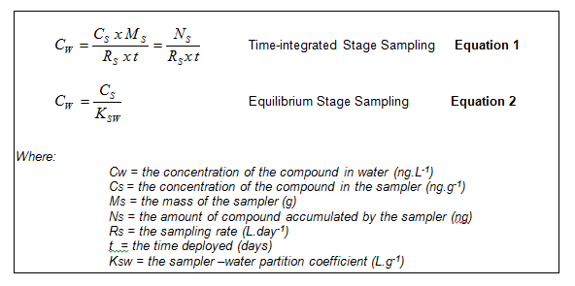

Different types of organic chemicals need to be targeted using different passive sampling phases. The passive sampling techniques which are utilized in the MMP include:

- SDB-RPS EmporeTM Disk (ED) based passive samplers for relatively hydrophilic organic chemicals with relatively low octanol-water partition coefficients (log K_{ow}) such as the PSII herbicides (example: atrazine a triazine herbicide). These are also referred to as polar organic chemical samplers.
- Polydimethylsiloxane (PDMS) and Semipermeable Membrane Devices (SPMDs) passive samplers for organic chemicals which are relatively more hydrophobic (higher log K_{ow}) (example: dieldrin an organochlorine insecticide). These are also referred to as non-polar organic chemical samplers.

Methods

Sampling design - Passive sampling for routine monitoring
Twelve sites (Figure 3.1) were monitored across five Natural Resource Monitoring Regions (Wet Tropics, Burdekin, Mackay Whitsunday and Fitzroy) in the current monitoring year from May 2010 to April 2011. The types of sampling which occurred at each site in either the dry (May – October) or wet (November – April) season sampling periods are indicated in Table 3.1. Samplers were deployed for two months during the dry season and one month during the wet season.

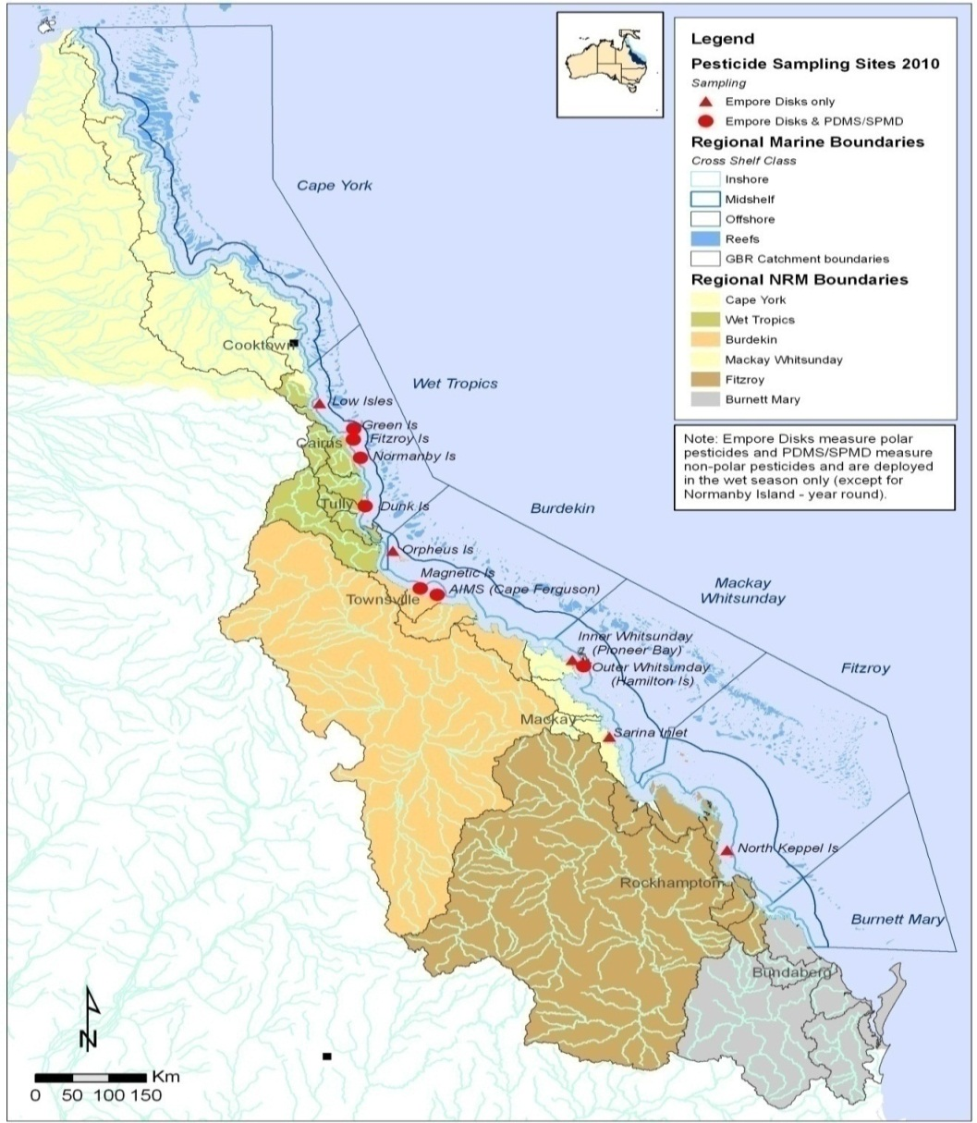
Figure 3.1. MMP passive sampling sites for routine monitoring purposes

Table 3.1. Types of passive sampling which was conducted at each of the routine monitoring sites in 2010-2011 during either the dry (May – October) or wet (November – April) periods

NRM Region | Sites | Polar Samplers (Empore discs) |  | Non-Polar Samplers (PDMS/SPMDª ) |  | Volunteer deployment staff
NRM Region | Sites | Dryª | Wet^{b} | Dry | Wet | Volunteer deployment staff
Wet Tropics | Low Isles |  |  |  |  | Low Isles Caretakers
Wet Tropics | Green Island |  |  |  |  | Green Island Resort
Wet Tropics | Fitzroy Island |  |  |  |  | Fitzroy Island Resort
Wet Tropics | Normanby Island |  |  |  |  | Frankland Island Cruise and Dive
Wet Tropics | Dunk Island |  |  |  |  | MBDI Water Taxi
Burdekin | Orpheus Island |  |  |  |  | Orpheus Island Research Station
Burdekin | Cape Cleveland (AIMS) |  |  |  |  | GBRMPA
Burdekin | Magnetic Island |  |  |  |  | Reef Safari Diving
Mackay Whitsunday | Pioneer Bay |  |  |  |  | Whitsunday Moorings
Mackay Whitsunday | Outer Whitsunday |  |  |  |  | Hamilton Island Resort
Mackay Whitsunday | Sarina Inlet |  |  |  |  | Sarina Inlet Bait and Tackle
Fitzroy | North Keppel Island |  |  |  |  | North Keppel Island Education Centre
ªSPMDs are only deployed at Normanby Island

The scientific criteria for selection of sampling sites include:
- The site must be representative of an inshore reef location (as outlined by the initial tender document);or
- The site is co-located in proximity to sites used by MMP bio-monitoring activities such as seagrass monitoring
- The site should not be impacted by specific local point sources such as anti-foulants from boats or inlets of treated or untreated wastewater
- The sampling site can be maintained for a long period.

In addition to the scientific requirements of the project, the selection of passive sampling deployment sites is governed by practicalities which include safety, security, site access, and the availability of a responsible community representative to take responsibility for the maintenance of the site. Site establishment has been a collaborative effort between the GBRMPA, AIMS and Entox.

The participation of volunteers (Table 3.1.) from various community groups, agencies and tourist operations is a key feature of the routine pesticide monitoring program and integral to the success of maintaining the program in often remote locations. These volunteers assist by receiving, deploying, retrieving and returning the passive samplers to Entox for subsequent extraction and analysis. This active participation of volunteers within the program is made possible by training from GBRMPA and/or Entox staff in Standard Operating Procedures to ensure a high level of continuous sampling and high quality usable data is obtained from these deployments. The GBRMPA has taken a lead role in ensuring community involvement and establishing contact with tourism operators and community and regional managers of water quality.

Sampling design - Passive sampling for flood monitoring
Pesticides were monitored during the wet season between16th December 2010 and the 15th April 2011 wet season using both 1 L grab samples (refer Section 6) and passive sampling (SDB-RPS EDs). These different techniques should provide both “point in time” or “spot” estimates of concentration along with time-integrated concentration estimates, respectively. Time-integrated estimates using passive samplers were both event based (3 – 6 days) and longer term (16 – 34 days). The aims of this component were to assess:

- Temporal and spatial variation during the wet season within a region
- Differences between time-integrated and point in time concentration estimates.

Spatial variation was assessed for given time periods at three sites extending from the Tully River in the Wet Tropics region. The sites included on the Tully River transect include the ACTFR Water Quality sampling sites Tully River Mouth, Bedarra Island and Sisters Island (Figure 3.2).

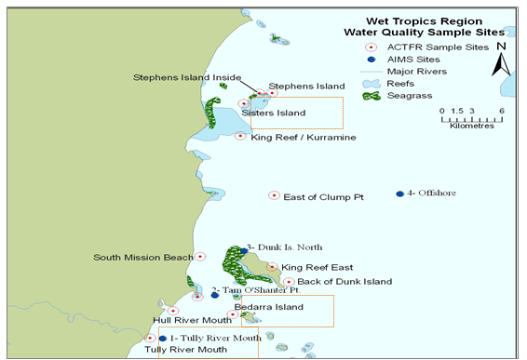
Figure 3.2. The three Tully River Transect sites where more polar pesticides were monitored during the wet season using both passive and grab sampling techniques (Source – Michelle Devlin)

Grab samples were taken at the beginning and end of each passive sampling period for the Tully transect sites. Additional grab samples have also been taken at a few locations within the Burdekin region and from the Fitzroy region through to the Mackay Whitsunday region in the 2010-2011 wet season. A total of 72 grab samples have been assessed for the concentrations of (mainly) herbicides in this wet season.

Target Pesticides in the different passive samplers
The chemicals targeted for analysis in the different passive samplers and the limits of reporting (LOR) are indicated in Table 3.2. This list of target chemicals was derived through consultation with GBRMPA with the criteria being:

- Detected in recent studies
- Recognised as a potential risk
- Analytical affordability and within the current analytical capabilities of Queensland Health Forensic and Scientific Services (QHFSS)
- Likelihood of accumulation in one of the passive samplers (exist as neutral species in the environment).

Empore disc sampler extracts are analysed using liquid chromatography mass spectrometry (LCMS) run in positive analysis mode. It should be noted that the analysis of bromacil was specifically requested from 2009-2010. Being run only in positive analysis mode excludes the detection of specific hydrophilic organic chemicals such as 2,4-D, MCPA, mecoprop, and picloram which would only be detected in negative analysis mode. PDMS and SPMD sampler extracts are analysed using gas chromatography mass spectrometry (GCMS). The limits of reporting (LOR) for the LCMS and GCMS instrument data have been defined by Queensland Health Forensic and Scientific Services laboratory as follows: The LORs are determined by adding a very low level amount of analyte to a matrix and injecting 6-7 times into the analytical instrument. The standard deviation of the resultant signals is obtained and a multiplication factor of 10 is applied to obtain the LOR. A further criterion for the LOR is that the analyte value should exceed 3 times the mass detected in the blank. Actual LOR for a given deployment may vary from those indicated in Table 3.2. and any result confirmed by QHFSS is converted to a concentration in water estimate and reported.

Table 3.2. Pesticides specified under the MMP for analysis in different passive sampler extracts and the Limits of Reporting (LOR) for these analytes

Pesticides |  | LOR (ng.L⁻¹)
 | SPMD |  | PDMS | ED
 | (GCMS) |  | (GCMS) | (LCMS)
Ametryn | - |  | <10 | <0.3
Atrazine | - |  | <10 | <0.3
Bifenthrin | - |  | <1 | -
Bromacil | - |  | - | <0.3
Chlordane | <0.1 |  | <0.5 | -
Chlorfenvinphos | - |  | <2 | -
Chlorpyrifos | <0.03 |  | <0.5 | -
Desisopropylatrazine | - |  | <25 | <0.3
DDT | <0.08 |  | <0.5 | -
Diazinon | <5 |  | <5 | -
Dieldrin | <0.2 |  | <0.5 | -
Diuron | - |  | <25 | <0.3
Endosulphan | <1.9 |  | <5 | -
Fenamiphos | - |  | <5 | -
Fenvalerate | - |  | <0.5 | -
Fluometuron | - |  | <30 | <0.3
Hexachlorobenzene | <0.09 |  | <0.5 | -
Heptachlor | <0.07 |  | <0.5 | -
Hexazinone | - |  | <25 | <0.3
Lindane | <0.5 |  | <5 | -
Metolachlor | - |  | <10 | <0.3
Oxadiazon | - |  | <0.5 | -
Prometryn | - |  | <5 | <0.3
Pendimethalin | <0.4 |  | <0.5 | -
Phosphate-tri-n-butyl | - |  | <3 | -
Propazine | - |  | <10 | -
Propiconazole | - |  | <2 | -
Propoxur | - |  | <25 | -
Prothiophos | <0.09 |  | <0.5 | -
Simazine | - |  | <30 | <0.3
Tebuconazole | - |  | <5 | -
Tebuthiuron | - |  | <25 | <0.3
Trifluralin | - |  | <0.5 | -

Passive Sampling Techniques

SDB-RPS Empore discs
- 3MTM EmporeTM Extraction Disks (SDB-RPS) –Phenomenex

Deployed in a Teflon “Chemcatcher” housing⁴³ (Figure 3.3)

- Routine time-integrated monitoring :
  - Deployed with a diffusion limiting 47 mm, 0.45 µm polyether sulfone membrane – PALL for either one month or two months
  - Deployed in a two disc configuration to extend the time-integrated monitoring period when deployed for two months.

- Event monitoring during flood plume events :
  - Deployed without a diffusion limiting membrane (i.e. “naked”) for 3 – 6 days

- Preparation:
  - Condition in methanol 30 minutes (HPLC grade, Merck)
  - Condition in milliQ water
  - Load into acetone rinsed Chemcatcher housing
  - Cover with membrane and solvent rinsed wire mesh.
  - Fill housing with MilliQ water
  - Seal for transport
  - Store in fridge and transport with ice packs.

- Extraction:
  - Remove membrane
  - Spike disk with deuterated simazine (labelled internal standard)
  - Extract disk using acetone and methanol in a solvent rinsed 15 ml centrifuge tube on an ultrasonic batch
  - Filter and concentrate to 0.5 ml using evaporation under purified N2
  - Add ultra-pure water to a final volume of 1 ml.

- Analyse using LCMS (Table 3.2.)

- Convert to concentration in water using compound specific in-situ sampling rates (refer method improvement below)

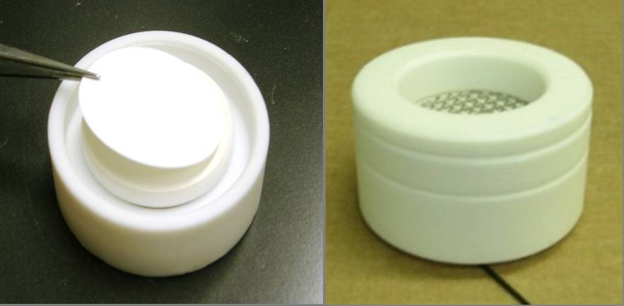
Figure 3.3. An Empore disk (ED) being loaded into the Teflon Chemcatcher housing (LHS) and an assembled housing ready for deployment

Method Improvement – In-situ calibration of Empore Disks
A diuron sampling rate (R_{S}) of 0.08 L.day⁻¹ ⁴⁴ has previously been assumed in the MMP for all herbicides accumulated in an Empore disks covered by a diffusion limiting membrane. However, compound specific sampling rates have been determined for a broader suite of herbicides and should be applied to the estimation of concentration in water to improve the accuracy of our estimates. Sampling rates may also be influenced by in-situ environmental conditions such as flow. A passive flow monitor (PFM) has been developed during the PhD of Dominique O’Brien at Entox.⁴⁵ The PFM is comprised of dental plaster cast into a plastic holder (Figure 3.4.). The elimination rate of dental plaster from the PFM during the deployment is proportional to flow velocity, and the influence of ionic strength (salinity) on this process has been quantified.⁴⁶ The sampling rates of reference chemicals in the ED, such as atrazine have subsequently been cross-calibrated to the loss of plaster from the PFM under varying flow conditions.⁴⁷

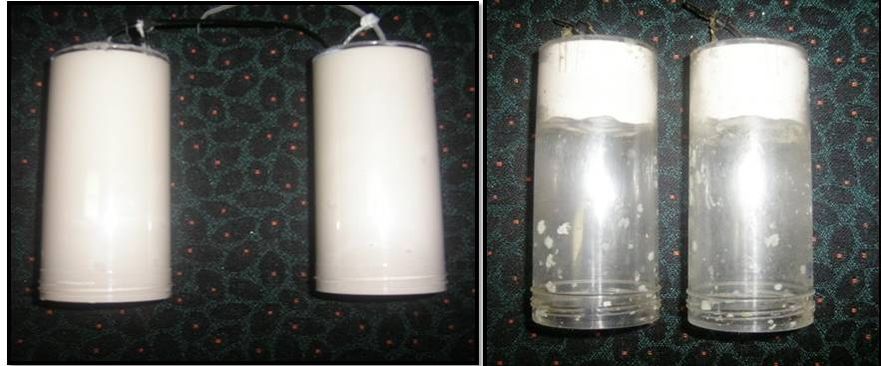
Figure 3.4. Passive flow monitors (PFMS) prior to deployment (LHS) and post-deployment (RHS)

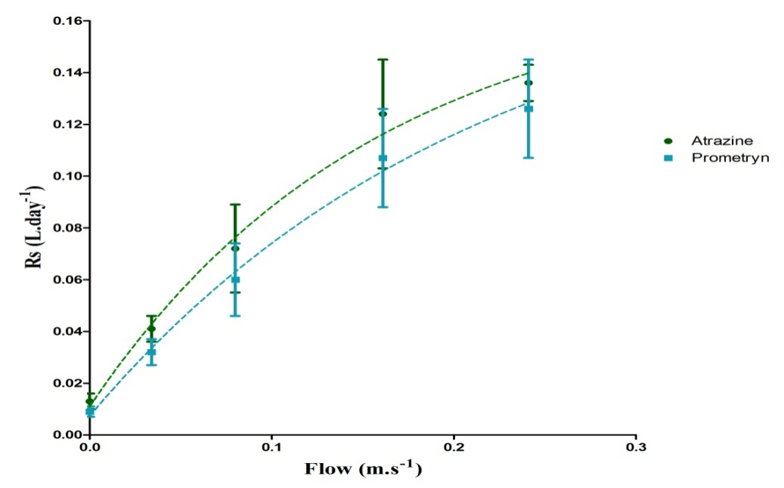
Figure 3.5. The relationship between flow and the sampling rates of specific herbicides indicating a shift from aqueous boundary layer control to diffusion limiting membrane control under higher flow conditions

The new in-situ calibration procedure employed at Entox is:

- PFMs are co-deployed alongside EDs
- Deployment in:
      - Wet season (one month) – without caps
      - Dry season (two months) – with a flow limiting cap (reduce loss rate by 15 %)
- The loss rate of plaster is determined while accounting for the influence of ionic strength
- The sampling rates of atrazine and prometryn are directly predicted from the PFM loss rate using models
The sampling rates of other individual herbicides are predicted based on the average ratio of the R_{S} of atrazine to the individual herbicide R_{S} across multiple calibration studies.^{22,44,46,48,49}

If the ED is deployed without a membrane these rates are adjusted using factors determined for individual herbicides (“naked” – no membrane: membrane R_{S}) in a laboratory calibration study.⁴⁴

Presentation and assessment of photosystem II herbicide concentrations (mixtures)
Photosystem II herbicides sampled by the SDB-RPS ED are a priority focus of the MMP pesticide monitoring due to the requirements of the Reef Water Quality Protection Plan.¹⁵ The concentrations of individual Photosystem II herbicides (ametryn, atrazine, diuron, hexazinone, flumeturon, prometryn, simazine and tebuthiuron) and atrazine transformation products (desethyl- and desiso-propyl – atrazine) are also expressed as a photosystem II herbicide equivalent concentration (PSII-HEq Equation 3) and assessed against a PSII-HEq Index described previously⁴² for reporting purposes. PSII-HEq provides a quantitative assessment of PSII herbicide mixture toxicity and assumes that these herbicides act additively.⁵⁰

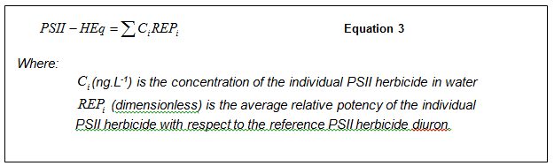

Polydimethylsiloxane (PDMS) samplers
- Silicone rubber 92 cm x 2.5 cm x 410 µm strips – Purple Pig
- Deployed in a marine grade stainless steel deployment cage
- Routine time-integrated (and equilibrium) monitoring:
      - Deployed for approximately one month during the wet season at specific sites only (Table 3.1.).
- Preparation:
      - Dialysis with acetone (2 x 24 hours) and then hexane (2 x 24 hours) in solvent rinsed glass jars in batches on a shaker
      - Stored in solvent rinsed glass jars, with Teflon lined lids, under purified N₂
      - Individual strips are wound around stainless steel spikes within the deployment cage in a standard configuration
      - The cage is assembled and sealed inside a metal can, stored at 4ºC and transported with ice packs.
- Extraction & purification:
      - Biofouling is removed from each strip by scrubbing with water (refer method improvement below)
      - Each strip is then dried with kimwipes and spiked with QHFSS surrogate standard
      - Each strip is dialysed with 200 ml of hexane (2 x 24 hours)
      - Sample extracts are rotary evaporated, further evaporated under purified N₂, dried using Na₂SO₄ columns and filtered (0.45 µm PTFE)
      - Samples are made up to 10 ml using dichloromethane and subjected to gel permeation chromatography
      - The collected fraction is evaporated to 1 ml and submitted for chemical analysis.
- Chemical analysis – GCMS (Table 3.2.).

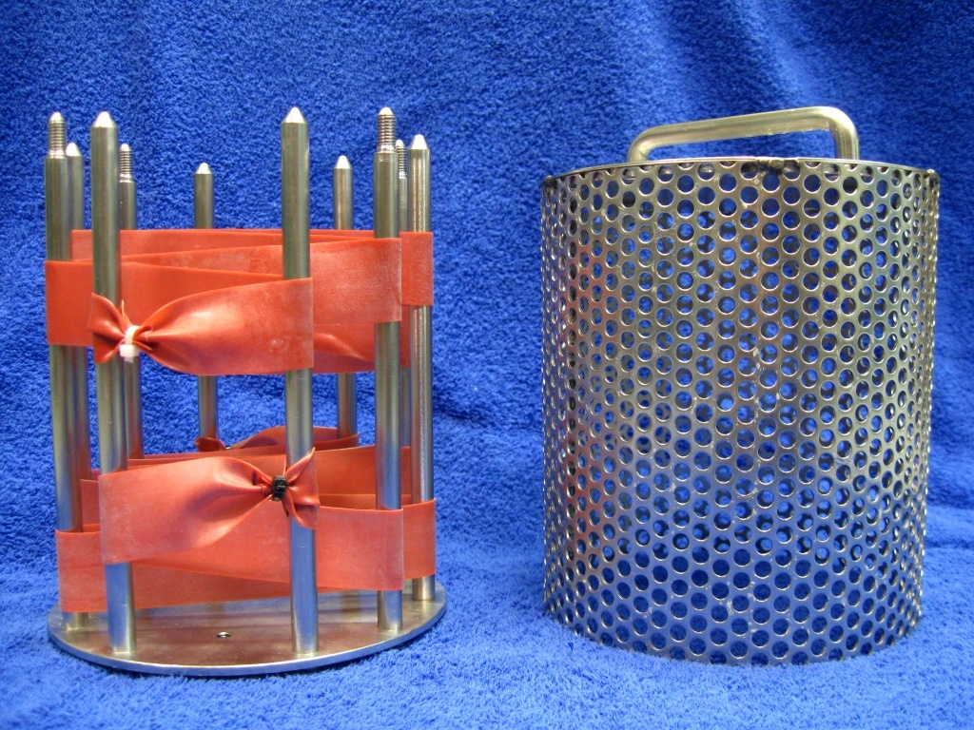
Figure 3.6. PDMS passive samplers loaded onto stainless steel sampler supports (LHS) which sits within the deployment cage (RHS) and sealed in place with wing nuts

Method Improvement – Surface cleaning of PDMS to remove bio-fouling
The bio-fouling which accumulates on the surface of PDMS samplers during the course of a deployment has typically been removed been using methods developed for the SPMD sampler by Jim Huckins of the USGS.⁵¹ There are however significant differences between the PDMS and the SPMD sampler in both the polarity range of chemicals sampled (moderately polar and non-polar vs. non-polar) and in their membrane materials (silicone rubber vs. low density polyethylene) and complexity (one phase vs. two phase). The influence of two different bi-fouling removal methods on the measured amount of pesticide accumulated by PDMS was therefore evaluated. These two methods were:

- Method 1 – Water Rinse
- Method 2 – “SPMD” Method – scrubbing with water, dry with kim-wipes, dip in 0.5 M HCL (20 seconds), hexane (30 seconds), surface rinse with acetone and isopropanol

Triplicate PDMS strips exposed to pesticides in water were cleaned either using Method 1 (1 strip) or Method 2 (2 strips). The amount of pesticide recovered from the PDMS strips using these different methods was then compared (Figure 3.7.). An average decrease of 31% in the total amount of accumulated pesticides per strip was observed when the Method 2 – “SPMD” technique was used to remove bio-fouling, relative to the Method 1- Water. From November 2010 onwards, Method 1 has been used within the SOPs for extraction of PDMS samples.

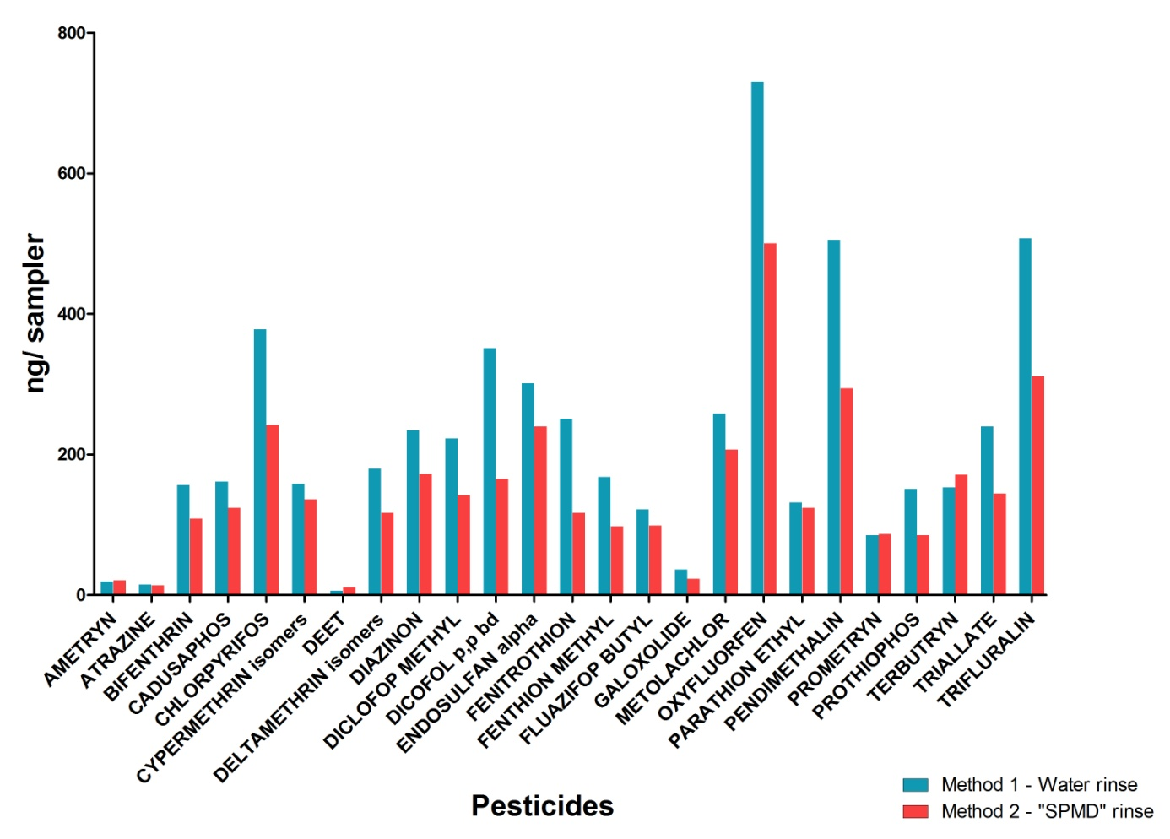
Figure 3.7. A comparison of two different bio-fouling removal methods for the recovery of pesticides from PDMS exposed under the same conditions

Calibration Data for PDMS
A lack of compound specific calibration data for a broad suite of pesticides in PDMS samplers prompted further laboratory calibration experiments as a collaborative research project between the Department of Environment and Resource Management (DERM) and Entox during 2010. This data remains confidential but will be used to estimate concentrations in water for all samplers deployed in the MMP from the 2010-2011 wet season. Forty chemicals with log K_{OW} (octanol-water partition coefficient) ranging from 2.18 to 8.15 were included in the study. Pesticides were selected by DERM based on use within Great Barrier Reef catchments and likelihood of or demonstrated accumulation of these chemicals in PDMS (e.g. tonalid, metolachlor, pendimethalin, chlorpyrifos).

In summary:

- Time-integrated sampling was evident for nine pesticides over 28 days and sampling rates (RS L.day-1) were determined for these chemicals.

- Equilibrium stage sampling was evident for 17 pesticides with logKOW ranging from 2.18 to 5.02, allowing for the measurement of sampler-water partition coefficients (KSW) for these pesticides. The relationship between the logKOW of these pesticides and the measured logKSW values is illustrated in Figure 3.8.

Figure 3.8. Relationship between logKOW and logKSW for pesticides in the PDMS-water system in this calibration study

The R_{S} determined in this calibration study will be used to estimate C_{W} from 2010-2011. If pesticides with logK_{OW} > 4 are detected in PDMS and no sampling rate is available, R_{S} will be extrapolated from pesticides of similar physico-chemical properties. Similarly, for pesticides with logK_{OW} < 4 with no measured logK_{SW} value, the logK_{SW} will be predicted from this relationship derived with logK_{OW}.

Semipermeable membrane devices (SPMDs)
Methods employed in the preparation, deployment and analysis of SPMDs are based on United States Geological Survey protocols and have been adopted with slight modification over the last nine years since SPMDs were first deployed for monitoring polyaromatic Hydrocarbons (PAHs) and organochlorines as part of the Brisbane River Moreton Bay Study.⁵²
Standard dimension SPMDs⁵¹ 92cm length x 2.5cm width consisting of 60 – 80 µm thick low density polyethylene (LDPE) lay-flat tubing filled with 99 % pure trioein spike with performance reference compounds (PRCs)⁵³
- Marine grade stainless steel deployment chambers (acetone rinsed) with sacrificial anode
- Preparation:
      - LDPE strips pre-extracted using (9:1 hexane:acetone) accelerated solvent extraction (ASE) using a program derived through method development
      - Dried under purified N2
      - Inject 1 ml of PRC loaded triolein into tube and disperse to remove air, heat seal each end while forming a loop to attach SPMDs to deployment “spiders” making a loop so SPMD is standard dimension between seals (i.e. 92 cm)
      - Load each strip onto spiders inside deployment cages and assemble cage
      - Seal cage in an acetone rinsed can, refrigerate prior to transport and transport on ice.
- Extraction & sample processing:
      - Remove SPMD from deployment cage and remove bio-fouling
    - Scrub with water
    - Dry with kimwipes
    - Dip in 0.1 M HCL for 20 seconds
    - Rinse surface briefly with acetone and isopropanol
      - Cut off deployment loops and open one end to spike with QHFSS surrogate standard, reseal the SPMD
      - Check for damage to the membrane and heat seal where appropriate
      - Extract (9:1 hexane:acetone)with accelerated solvent extraction using program developed by Entox
      - Proceed as per sampler evaporation and purification (GPC) described for PDMS
      - Evaporate to a final volume of 200 µL in an insert.
- Analysis – GCMS.

Concentrations of pesticides in water were determined using a calibration spreadsheet provided by Jim Huckins of the USGS who developed this sampler. This spreadsheet accounts for the influence of water temperature during the deployment period. The sampling rates for pesticides in SPMDs within this spreadsheet range from 1.0 – 6.9 L.day⁻¹ with an average of 3.5 L.day⁻¹.

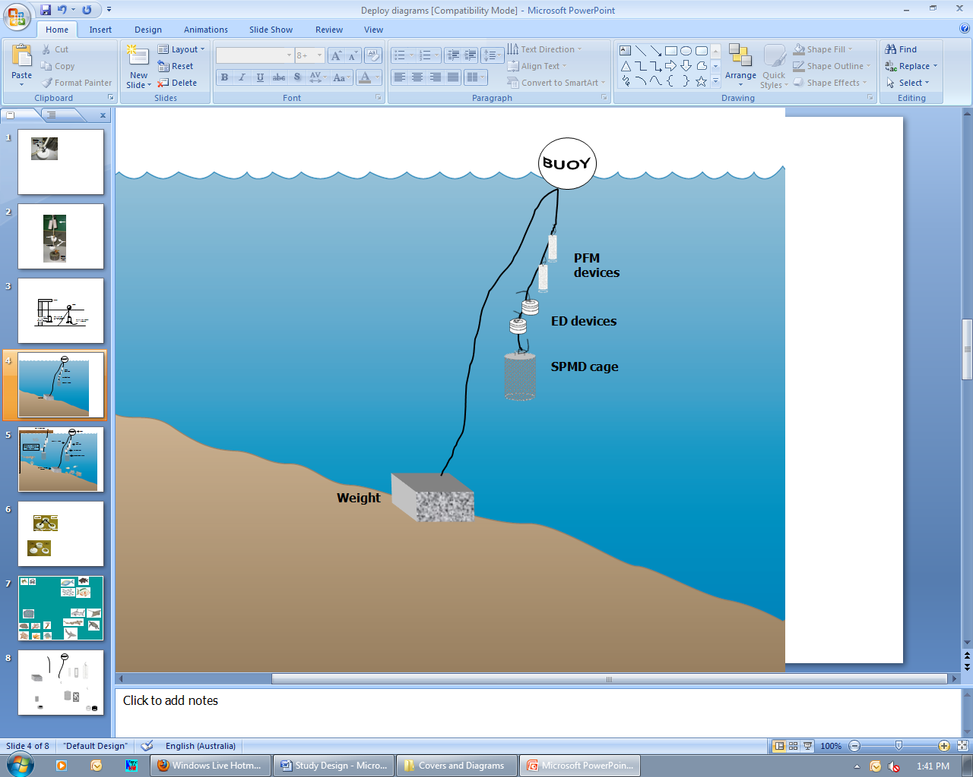
Figure 3.9. A schematic for the deployment of passive samplers (Empore disc in Chemcatcher housings, and SPMD/PDMS cages) together with the passive flow monitors for in-situ calibration of flow effects, in the field

QA/QC procedures in the pesticide monitoring program
The development, calibration, field application and validation of passive sampling for monitoring water has been a research focus of Entox over many years.^{22,41,44,45,46,47,54,55,56} The methods described above have been developed as a result of this work in collaboration with analytical method development by QHFSS. These methods are formalized as Standard Operating Procedures (SOPs) which describe the preparation, extraction and analysis of each type of passive sampler used in the MMP.

QA/QC procedures routinely employed by Entox in the MMP include:

- SOPs for the preparation, deployment, extraction and analysis of passive samplers
- Staff training in these SOPs (laboratory) and a record of this training is maintained
- Deployment guides for the training of field staff & volunteers
- Generation of a unique alphanumeric identifier code for each passive sampler
- Preparation, extraction, storage (4ºC or -20ºC) and subsequent analysis of procedural blank passive samplers with each batch of exposed passive samplers
- The use of labelled internal standards or other surrogate standards to evaluate or correct for recovery or instrument sensitivity throughout the extraction and within the analysis process respectively
- The exposure of replicate samplers during each deployment which are extracted and archived in our specimen bank @ -80 ºC
- A proportion of exposed replicate sample extracts are subsequently analysed, to determine the reproducibility of the sampling of organic chemicals across the program in that year (mean normalized difference).

Furthermore, all chemical analysis performed for the MMP is undertaken by the National Association of Standards Testing, accredited QHFSS laboratories. Details of QHFSS accreditation can be found at the National Association of Testing Authorities (NATA) website http://www.nata.asn.au/). Sample receipting, handling, analysis and data reporting at QHFSS will be based on NATA certified methods. The NATA accreditation held by the QHFSS includes a wide variety of QA/QC procedures covering the registration and identification of samples with specific codes and the regular calibration of all quantitative laboratory equipment required for the analysis.

Data Management & Security
The data management protocols for Entox are outlined below and include documentation of all steps within the sampling program: passive sampler identification, transport, deployment, transfer of samples to QHFSS for chemical analysis, analytical results, data manipulation, storage and access. This protocol may be summarised as:
- The unique alphanumeric identifier code attached to each passive sampler is applied to all subsequent daughter samples and results, ensuring a reliable link with the original sample.
- Deployment Records are sent with the sampling devices, and includes information on: the unique sampling device identifier, deployment identifier, name of the staff/volunteer who performed the operation, storage location, destination site, important dates, details of sample treatment and any problems that may have occurred. When returned, the information is entered into Excel spreadsheets and stored on the Entox main server with a back-up on one local hard drive.
- Detailed Chain of Custody records are kept with the samplers at all times. Devices are couriered directly to the tourism operators/community member and monitored via a tracking system. Delivery records are maintained by Entox to ensure traceability of samples.
- Hard copy records maintained of all sample submission forms provided to QHFSS for analysis.
- Results files provided by QHFSS along with a unique identifier code are transferred from the instrumentation computer to the Entox server and archived on the QHFSS network using an established data management system.
- Excel spreadsheets used for data manipulation and a summary results file (concentration in water estimates) are stored on the Entox server. Access to the Entox server is restricted to authorised personnel only via a password protection system. Provision of data to a third party is only occurs at the consent or request of the Program Manager.

Summary
- Unique sample identifiers
- Comprehensive Records and Chain of Custody paperwork across all components
- Training of field personnel, including deployment guidelines & records
- Analytical Quality Control measures
- Procedural QA/QC for the preparation, extraction and analysis of passive samplers including SOPs
- Inclusion of QA/QC samples (replication of sampling and procedural blanks)
- Continual evaluation, method development and improvement of methods for sampler processing & estimation of concentration in water
- Data management & security

Remote sensing of water quality
Vittorio Brando, Arnold Dekker, Thomas Schroeder

Commonwealth Scientific and Industrial Research Organisation

Introduction
This component will provide satellite-based information on near-surface chlorophyll and suspended solids concentrations, water column turbidity and Secchi-disk depth in lagoonal and coastal waters of the Great Barrier Reef. In order to achieve this goal the CSIRO (with support from the AIMS and JCU) will acquire, process, validate, interpret, archive and transmit geo-corrected ocean colour imagery and required information data sets derived from MODIS satellite imagery data.

In the field of remote sensing and the use of global datasets such as those from MODIS, there are a lot of publications and proposals for standardisation. However, these protocols are currently not agreed upon. As this field of applications is still developing, some of the methodology, including QA/QC procedures still needs standardisation. There is some convergence going on, and in several parts of the processing and measurement chain, there are established and agreed protocols.

As part of this project, the CSIRO will describe every step of the process of obtaining the final water quality products from MODIS for the Great Barrier Reef lagoon to ensure that a complete account of methods used for this project is available for future reference.

Methods

Acquisition and processing of satellite data
The MODIS instrument is carried by two different satellites, Terra (providing the morning overpass ~ 10.30am) and Aqua (providing the afternoon overpass ~ 1.30pm). Working in tandem to see the same area of the earth in the morning and the afternoon, the two satellites help to ensure MODIS and other instruments measurement accuracy by optimising cloud-free remote sensing of the surface and minimising any optical effects—like shadows or glare—that are unique to morning or afternoon sunlight. Having morning and afternoon sensors also permits investigation of changes that occur over the course of the day, such as the build-up or dissipation of clouds and changes in sea temperature or tidal conditions. MODIS data will be acquired for the entire Great Barrier Reef area.

The National Aeronautics and Space Administration (NASA) provide operational processing of the daily coverage of the MODIS data to different levels of calibration. Quality assurance is an important element in the sequential data reduction from Level 0 (L0) raw counts to Level 1B (L1B) calibrated radiance, and continually to Level 2 (L2) orbital swath granules and Level 3 (L3) global gridded products. Radiometrically calibrated data and the geolocation information (Level 1B) are the input to retrieve ‘higher levels’ of information (beyond grey levels and colours of pixels) such as chlorophyll concentration, or suspended solid concentrations (Level 2 products). The CSIRO may need to process from Level 1B onwards if the NASA Level 1B to Level 2 processing is found to be insufficiently accurate in the Great Barrier Reef lagoon waters. The NASA will complete processing to Level 2A (water leaving radiance or reflectance).

Documents related to MODIS data quality control are included in Appendix C1.

The CSIRO will complete processing of MODIS data to Level 2B: chlorophyll, total suspended matter and transparency. The methods for this process are outlined in Brando and Dekker 2003⁵⁷ (Appendix C2). Wettle et al. 2004⁵⁸ (Appendix C3) provide an overview of the estimation of noise levels in the satellite data.

Field sampling
In situ data collection to be undertaken by the CSIRO includes:

- Determination of spectroradiometric properties to apparent optical properties
- Biogeochemical validation
- Measurement of spectral inherent optical properties in situ
- Spectral inherent optical properties on samples.

Determination of Spectroradiometric Properties to Apparent Optical Properties (AOP)
The measurement methodology for the determination of Spectroradiometric Properties to Apparent Optical Properties is at Appendix C4. A thorough description of the UW light field and terminology is provided in Dekker et al. 2001⁵⁹ (Appendix C5). In addition, the measurement protocols as stated in Chapter 3 of the MERIS Validation Protocols (Appendix C6) are followed as closely as possible.

Measurement of Spectral Inherent Optical Properties (IOP) in situ
Inherent Optical Properties are the properties of the medium itself (i.e. water plus constituents) and depend on the concentration and type of optically-significant constituents present in the water, namely phytoplankton, non-algal particles and Coloured Dissolved Organic Material (CDOM or gelbstoff). Note that the term ‘non-algal particles’ include biogenous detritus, heterotrophic organisms, and minerals.

Together with water, their contribution to total absorption and scattering coefficients (a_{t}(λ) and b_{t}(λ), respectively, λ is the wavelength) is additive such that:

a_{t}(λ) = a_{w}(λ) + a_{g}(λ) + a_{ϕ}(λ) + a_{nap}(λ) (1)
b_{t}(λ) = b_{w}(λ) + b_{ϕ}(λ) + b_{nap}(λ) (2)

Where the subscripts w, g, ϕ and nap stand for pure water, CDOM, phytoplankton and non-algal particles, respectively.

Scattering by CDOM is usually considered as negligible.⁶⁰ The attenuation coefficient corresponds to the sum of absorption and scattering coefficients [c_{t}(λ) = a_{t}(λ) + b_{t}(λ)]. The particle single-scattering albedo (ω_{p}(λ)), an important parameter in radiative transfer models, is defined through the ratio of scattering to particle attenuation (b_{p}(λ)/(a_{p}(λ)+b_{p}(λ)) and used to quantify the scattering properties of particles relatively to their absorption properties.

The absorption and scattering coefficients of optically-significant constituents display specific spectral signatures that might be used in turn to estimate the contribution of each constituent to a bulk measurement. For that purpose, deconvolution procedures (experimental or numerical) are required and have been developed, to our knowledge, only for absorption measurements (e.g. Schofield et al. 2004⁶¹). Once deconvolved, the partial optical coefficients can be converted into meaningful biogeochemical quantities if specific optical coefficients are known.

The measurement methodology for the in situ optical measurements required for parameterising the optical model used for algorithm inversion has been described in detail in Oubelkheir et al. 2006.⁶² The variability of total (dissolved plus particulate) absorption and scattering spectral coefficients [a(λ) and b(λ)] will be monitored using a WETLabs ac-9 with nine wavelengths [412, 440, 488, 510, 532, 555, 650, 676 and 715 nm], with a 10 cm pathlength. The ac-9 is calibrated before the field campaigns with optically pure water obtained from a Milli-Q system (Elga Maxima) to quantify instrumental offsets in pure water. Correction for the in situ temperature and salinity effects on the optical properties of water will applied according to Pegau et al.1997.⁶³ Correction for incomplete recovery of the scattered light in the absorption tube of the ac-9 will be performed by using the proportional method described in Zaneveld et al. 1994.⁶⁴ The particle scattering coefficient (b(λ)) is computed as the difference between attenuation and absorption coefficients measured by the ac-9 (c(λ) - a(λ)).

The backscattering coefficient is measured at six wavelengths [442, 488, 555, 589, 676 and 852 nm] using a Hydroscat-6 (HOBILabs). A correction for incomplete recovery of backscattered light in highly-attenuating waters (i.e. sigma correction, Maffione and Dana 1997) is applied using absorption and attenuation coefficients measured in situ simultaneously using the ac-9. The Hydroscat-6 is calibrated in the laboratory, prior to the field campaign, using the calibration device provided by HOBILabs: the signal response is measured through the sample volume (Milli-Q water) over a Lambertian reflective (TeflonTM) plaque.⁶⁵

Discrete optical and biogeochemical measurements
For validation of data derived from satellite imagery, water sampling for analyses of plant pigments, Total Suspended Matter (TSM) and CDOM is undertaken. TSM and plant pigment samples will be analysed by the AIMS, with cross validation to be undertaken by the CSIRO Division of Marine and Atmospheric Research.

For the purposes of validating the information from the MODIS sensors (and also SeaWiFS and MERIS) it is advisable to measure many surface samples, at least at two-kilometre spacing, across gradients of optical water quality during 09:00 and 14:30 hours as that would create most match-up data. Final sampling design will depend on the conditions during the field cruises.

Discrete samples of water will be collected for validation of remote sensing of plant pigments and TSM with Niskin bottles (as above, Appendix A13) or 10L High Density Polyethylene containers during satellite overpasses. Duplicate sub-samples are filtered and plant pigment filters stored in liquid nitrogen until analyses. Samples have unique identifiers (Appendix B1 for standard labelling).

Laboratory analysis
Phytoplankton pigments: Water samples are filtered through a Whatman 47 mm GF/F glass-fibre filter and stored in liquid nitrogen until analysis. Phytoplankton pigments are analysed by the AIMS using High Performance Liquid Chromatography (Appendix B10). The CSIRO uses a different approach. An index of the size structure of the algal population will be derived by the CSIRO from individual pigments which are specific to a given phytoplankton group (diagnostic pigments). The contribution of small (pico, < 2 µm), medium (nano, 2-20 µm) and large (micro, 20-200 µm) cells to the algal population will be computed as described in detail in Uitz et al. 2006⁶⁶.

Total suspended matter: Total suspended matter filters are analysed by the AIMS as described in Appendix B11 Within the CSIRO, water samples are filtered through 47 mm preweighed Millipore Durapore® membrane filters or Pall Tuffryn® filters (pore size of 0.45 µm), and the filter paper then rinsed with distilled water to flush dissolved salts, and stored flat in a petrislide (Millipore). After collection, the filter papers are oven-dried at 60ºC, and weighed to constant weight.

Particulate (algal and non-algal) absorption: Water samples are filtered through a 25 mm GF/F glass-fibre filter (Whatman) stored flat in liquid nitrogen until analysis by the CSIRO. The optical density spectrum was measured over the 200-900 nm spectral range in 1.3 nm increments, using a GBC 916 UV/VIS dual beam spectrophotometer equipped with an integrating sphere. The pigmented material on the sample filter is then extracted using the method of Kishino et al.1985⁶⁷ to determine the optical density of the non-algal particles. The optical density due to phytoplankton was obtained by the difference between the optical density of the particulate and non-algal fractions. The path length amplification effect due to the filter (so-called ‘λ-factor’) was corrected by using the algorithm of Mitchell 1990⁶⁸. Note that comparisons between particulate absorption results corrected for the pathlength amplification effect using the Tassan and Ferrari 1995⁶⁹ algorithm instead of the Mitchell 1990⁶⁸ algorithm on samples collected in various areas (including turbid waters) showed no significant difference. A more detailed description of the method can be found in Clementson et al. 2001.⁷⁰

CDOM absorption: Water samples are collected in glass bottles and kept cool and dark until analysis by the CSIRO, which occurs within 24 hours of collection generally (on occasion up to 72 hours). Beyond this period, there might be a slight effect of biological activity on the CDOM concentrations, however provided that the material is cooled this effect will be minimal and compared to other measurement issues, negligible. Samples are allowed to come to room temperature before filtering through a 0.22 µm polycarbonate filter (Millipore) into a 10 cm pathlength quartz cell. The CDOM absorption coefficient (m⁻¹) of each filtrate is measured from 200 to 900 nm using a GBC 916 UV/VIS spectrophotometer, and Milli-Q water (Millipore) used as a reference. CDOM absorption spectra are finally normalised to zero at 680 nm and an exponential function fitted over the range 350 to 680 nm (Appendix B12).

Data processing
Spectral Inherent Optical Properties on samples (SIOPs)
A prerequisite for the accurate inversion of optical properties (measured in situ or using remote sensing) into biogeochemical quantities (e.g. concentrations, chemical composition, size) relies on an estimation of the extent of variability in:

- Some key optical parameters used in the inversion of AOP into IOP through radiative transfer models (e.g. particles backscattering efficiency, single scattering albedo)
- The relationships between IOP and the desired biogeochemical properties (e.g. SIOPs), i.e. optical properties normalized by the constituent concentration.

Once the SIOPs are established it is possible to generate any spectra that are a combination of naturally occurring concentrations of chlorophyll, TSM and CDOM. This family of representative spectra can then be inverted using specifically developed algorithms.

Previous work has clearly demonstrated that the global MODIS algorithms as available in SeaWiFS Data Analysis System (SeaDAS) 4.8 are invalid in near shore Great Barrier Reef lagoonal waters (based on previous work in the Fitzroy Estuary and the Mossman-Daintree region). The level of disagreement is at least twofold and can run up to tenfold or more. Therefore it will be necessary to develop and implement a different type of algorithm that can cope with the significant variability in the specific inherent optical properties encountered in these waters. Similar problems were encountered in developing algorithms for Moreton Bay, Port Curtis and the Fitzroy Estuary using the Landsat sensor. The new algorithms (inversion-optimisation) performed well and have been published. ^{71,72,73,74} The CSIRO intends to port these algorithms to MODIS and apply them to twelve months of MODIS data.
In order to parameterise and validate these new algorithms it is planned to take additional measurements of surface and water column apparent and inherent optical properties and associated concentrations (algal pigments, TSM, CDOM) necessary for parameterization and validation of algorithm performance during the four planned AIMS cruises for the MMP.

The new inversion-optimisation algorithms will be based on water-leaving radiances in the MODIS spectral bands. They will estimate simultaneously the concentration of chlorophyll, TSM and CDOM as well as calculate Secchi Disk Transparency and vertical attenuation coefficient Kd, if a bottom effect is visible they will also estimate the bottom depth. The accuracy of the calculated normalised water leaving radiances is dependent on the accuracy of the atmospheric correction. It is known that the standard atmospheric correction in SeaDAS 4.8 fails (especially in the blue region of the spectrum) in natural waters that reflect significantly above zero in the nearby infrared (as the nearby infrared is used in SeaDAS 4.8 to estimate the aerosol contents). The CSIRO intends to test and implement one out of two to three published SeaDAS code adaptations that improve the atmospheric correction over highly reflecting waters.

Data Management
The validation of remote sensing for water quality concentrations in the Great Barrier Reef is a substantial task that has not been undertaken before to this extent. Appropriate data entry systems will be developed during the lifetime of the contract. Existing data storage standards at the CSIRO will be utilised. Data is managed depending on the value/importance of the data, volume and format, but in general, file systems are backed up according to a regular four week backup schedule. A full backup is created and archived every month with a weekly incremental backup made and rotated every four weeks. Databases are managed according to the rate of change of data volume each day. The present schedule is a full monthly backup and daily incremental backups. The database is also replicated to another server offsite and the full backup is archived on LTO tape.

The analysis data generated by the AIMS will be incorporated into the MMP Data Management System.

Summary of Quality Control measures
- Training of staff
- Processing protocols
- Analytical quality control measures
- Parallel plant pigment analyses by the AIMS and CSIRO
- Sample custody
- Data entry quality control.

Flood plume water quality monitoring
Michelle Devlin

Catchment to Reef Research Group, Australian Centre for Tropical Freshwater Research, James Cook University

Introduction
The Great Barrier Reef is the largest coral reef system in the world, spanning almost 350,000 km² along the northeast Australian coast.⁹ During the last century coastal anthropogenic land clearing, agriculture, urban development and industrial activities have occurred adjacent to the reef.⁹ As such, there is presently much research being conducted to evaluate the impact of human activities upon water quality and coral health in the region.

During the northern Australian monsoon season (December-March), rainfall events cause flooding in local rivers. The resulting flood plumes act as a transport mechanism for terrestrial sediment and contaminants from the local catchments into the marine environment. Excessive sediment loads and dissolved substances within freshwater have been identified as potential stressors of corals and can lead to disease and coral bleaching.¹¹ Therefore, monitoring projects are required to assess the extent and impact of terrestrial runoff.

The Australian Centre for Tropical Freshwater Research (ACTFR) manages an extensive flood plume monitoring project in collaboration with AIMS, UQ and CSIRO. The aim of this project is to assess the concentrations and transport of terrestrially derived components, with a focus on the movement of pollutants (TSS, Chl-a and dissolved nutrients) into the Great Barrier Reef. Current sampling methods include discrete water profile sampling combined with fixed water quality logger sites and the implementation of MODIS imagery as a tool for qualitatively assessing flood plume extent within the Reef.

This subprogram of the MMP will collect water quality data in flood plumes emanating from rivers into the Great Barrier Reef lagoon and coastal waters. Monitoring will consist of a campaign style grab-sampling program in flood waters originating from major rivers flowing into the World Heritage Area (e.g. Burdekin, Fitzroy and rivers in the Mackay-Whitsunday and Wet Tropics regions). Manual sampling will occur over the ‘wet season’ (November to May) and will be correlated with water quality information collected using remote sensing and data loggers (AIMS ambient water quality program). Parameters measured as part of this project include nutrient species, suspended particulates, chlorophyll a, phytoplankton, trace metals, salinity and pesticides. There will be a continuation of the existing remote sensing work and further exploration of the value of remote sensing as a future water quality monitoring technique for flood plume monitoring. The long-term goals of this task are to:
- Assess the concentrations and transport of major land sourced pollutants to the Great Barrier Reef lagoon
- Assess spatial and temporal variation in near surface concentrations of suspended solids, turbidity and CDOM and chlorophyll a during available river plumes in the Great Barrier Reef catchment using remote sensing
- Assess the quantity of chemical pollutants that are transported to the Great Barrier Reef from selected rivers during ambient and flood events
- Quantify the exposure of reef ecosystems to these land based contaminants.

Methods

Field sampling design
River plumes were mapped using aerial survey and/or remote sensing techniques. Over the monsoon season, weather reports are monitored closely and when plumes formed aerial surveys can be conducted once or twice during the event. Plumes are readily observable as brown turbid water masses contrasting with cleaner seawater. The visible edge of the plume is followed at an altitude of 1,000-2,000 m in a light aircraft and mapped using GPS. Where individual rivers flood simultaneously, as often happens in the wet tropics, adjacent plumes merge into a continuous area. In these cases efforts are made to distinguish the edge of the individual river plumes through colour differences. The vertical distribution of plume water and depth stratification was studied by depth sampling. The results of each mapping exercise were transferred to a GIS on which subsequent spatial analysis is based. Remote sensing techniques are described in a later section.

Water samples are collected from multiple sites within the flood plume. Location of samples were dependent on which rivers were flooding and the areal extent of the plume but generally samples were collected in a series of transects heading out from the river mouth, with additional samples taken in between river mouths if more than one river was in flood. Timing of sampling was also dependent on the type of event and how quickly boats were mobilised. Sampling in flood plumes requires rapid response sampling protocols as a detailed pre-planned schedule is not possible due to the unpredictability of the river flood events. The need for a responsive, event-driven sampling strategy to sample plumes from small to medium sized rivers has been noted previously.⁷⁵ The majority of samples were collected inside the visible area of the plume, though some samples were taken outside the edge of the plume for comparison. Samples were collected along the plume salinity gradient, moving from the mouth of the river to the edge of the plume (Figure 5.1).


High flow conditions
Plume transects
Event 1
Event 2
Event 3
Day 1
Day 2
Site 1
Site 2
Site 3
Sample 1
Sample 2

Figure 5.1. Design of sampling program for high flow conditions. Further details can be found in Devlin and Brodie, 2005⁷⁶.

Field protocols
The guidelines for water quality sampling listed in this document are based on the protocols required by the ACTFR laboratory for the collection and storage of samples.

Safety always comes first. Staff must always be accompanied by at least one other person. Staff must have conducted a risk assessment of the sampling area, as well as current weather conditions and have an up-to-date emergency plan. Staff must be aware of their vessel and work through the safety protocols with the ship master.

- Before sampling, staff must clean their hands thoroughly with fresh water. Grease, oils, soap, fertilisers, sunscreen, hand creams and smoking can all contribute to contamination. If possible, staff should rinse their hands with sea water before sampling
- Before collecting each set of samples, staff should rinse the bucket and stirring rod three times in seawater
- After rinsing the bucket, collect enough sea water to rinse all bottles (at least 5,000 ml of sample required)
- Follow the filling instructions (contained in the following sections) thoroughly when filling containers
- On each sampling run record the date, time, unique sampling identification on the field data sheet. Each sampling kit for each site contains sets of sampling bottles and vials
- Note any significant change of conditions in the comments section of the record sheet
- If possible, take a few photos at each sampling site.

At each sampling station, vertical profiles of water temperature, salinity, dissolved oxygen; pH and fluorescence are measured with a Sealabs CTD and PAR sensor. Immediately following the CTD cast, water samples are collected from discrete depths for other analyses.

Surface samples are collected at 0.5 m below the surface, with a rinsed clean sampling container. Secchi disk clarity is determined at each station. Due to the high frequency of sampling during a plume event and the use of smaller vessels for sampling, the majority of the post processing (filtering and storage) takes place at the end of each day. Field sampling on the vessel typically consists of surface sample collection and filtering and collection of water samples on ice. Each site within a plume event has a basic number of water quality parameters taken within that site. They include:

- Dissolved nutrients
- Total nutrients
- Chlorophyll a
- Total suspended solids (TSS)
- Coloured dissolved organic matter (CDOM).

Additional samples can be taken at any site, dependent on the site location and the frequency of sampling decided prior to the event. Additional water quality sampling includes:

- Phytoplankton enumeration
- Trace metals
- Pesticides

5.2.3 Water quality sampling techniques

Nutrient sampling
Dissolved nutrient samples were collected using sterile 50 ml syringes. A 0.45 μm disposable membrane filter was then fitted to the syringe and a 10 ml sample collected in tubes pre-rinsed in filtered water. Tubes were placed in the clean plastic bag and stored on ice in an insulated container. Total Nitrogen and Phosphorus are collected, without filtering using the 50 ml syringes into the 10 ml sampling tubes.

Samples are analysed for dissolved inorganic nutrients (NH₄, NO₂, NO₃, NO₂ + NO₃, PO₄ and Si), particulate nitrogen and phosphorus (PN, PP), Total Dissolved Nitrogen and Phosphorus (TDN, TDP) and Total Nitrogen and Phosphorus (TN, TP).

The nutrient field sampling is summarised below for dissolved nutrients (NO₃, NO₂), NH₃, FRP (PO₄), TDN/TDP sampling.

Dissolved nutrients
- Requires six 10 ml vials, yellow lids
- Firstly, rinse out syringe three times with the water to be sampled
- Discard rinse water away from sampling area
- Attach yellow minisart 0.45μm filter to tip of syringe
- Fill syringe with sample water
- Minimise the air gap between water sample and black syringe plunger to prevent contamination
- Prime the filter paper (often done while fitting the plunger)
- DO NOT collect this rinse water
- DO NOT rinse vessel
- Fill the vials to the line (10 ml) (Prefer to be just below the mark to avoid loss of sample)
- Do not overfill, this may cause the vials to split when frozen – destroying the sample
- To minimise contamination please keep fingers away from all tops and lids (wear gloves if available)
- If possible, freeze samples before sending to the laboratory
- Otherwise, store in the dark on ice for transport the laboratory as soon as possible.

Total Nitrogen / Total Phosphorus (TN/TP)
- Requires one 60 ml plastic vial
- Filtering not required
- Do not rinse the vial with the water to be sampled
- Fill the vial leaving a ~3 cm air-gap from the top
- Do not overfill, this may cause the vial to split when frozen – destroying the sample
- To minimise contamination please keep fingers away from all tops and lids
- If possible, freeze samples before sending to the laboratory
- Otherwise, store in the dark on ice for transport the laboratory as soon as possible.

Chlorophyll and Total Suspended Solids
Chlorophyll a and TSS samples are collected in pre-rinsed 1,000 ml plastic containers. Each container is rinsed at least twice with the sample water, taking care to avoid contact with the sample. Chlorophyll a bottles are dark bottles to reduce the effect of sunlight on the phytoplankton species in the interim between collection and filtration. Both samples are stored on ice on the sampling vessel.
- Chlorophyll sampling requires a one-litre black plastic bottle
- Fill to overflowing and seal. Do not leave an air gap
- Once sample is taken it should be kept in the dark on ice.

CDOM (Coloured Dissolved Organic Matter)
- Requires 100/200 ml Amber (Glass) Bottle
- Samples not to be collected in these bottles
- Collected sample (from TSS bottle) is to be filtered down to 0.2 μm for the analysis of CDOM (defined as the fraction of organic matter <0.2μm)
- Gloves must be worn and sterile syringes only (no used and washed)
- Attach 0.45 μm (yellow) to syringe, fill with sample and insert plunger; air contact must be minimised so filter needs to be removed at this point to expel any trapped air
- Place filter back onto syringe and push some sample through to prime the filter
- A 0.2 μm filter (blue) is then placed onto the yellow filter; ensure they are locked together and onto the syringe by turning them until there are ‘locked’ together – at this point you syringe should have two filters attached with the yellow next to the syringe
- If syringes and filters aren’t fitted together correctly there may be a risk of contamination
- Sample should then be pushed through both filters into the glass amber bottle provided – minimum 100 ml filtered sample is required
- When there is too much back pressure on the syringe the yellow filter would need replacing first – if this does not alleviate the back pressure, blue one also needs replacing; always replace yellow filter first
- Sodium azide (NaN3) needs to be added to sample once filtered; this ensures the preservation of the sample prior to analysis (0.5ml 1% NaN3 per 100 ml)
- Care MUST be taken with sodium azide (NaN3).

Trace metal sampling
Samples for trace metals were collected using sterile 50 ml syringes. A 0.45 μm disposable membrane filter was then fitted to the syringe and a 10 ml sample collected in plastic tubes. Tubes were placed in the clean plastic bag and stored on ice in an insulated container. Wear plastic gloves to avoid metal contamination.

- Rinse out syringe three times with the water to be sampled
- Discard rinse water away from sampling area
- Attach yellow minisart 0.45 μm filter to tip of syringe
- Fill syringe with sample water
- Minimise the air gap between water sample and black syringe plunger to prevent contamination
- Prime the filter paper; often done while fitting the plunger
- DO NOT collect this rinse water
- DO NOT rinse the vessel
- Fill the vials to the line (10 ml) (Prefer to be just below the mark to avoid loss of sample)
- Do not overfill, this may cause the vials to split when frozen – destroying the sample
- To minimise contamination please keep fingers away from all tops and lids (wear gloves if available)
- If possible, freeze samples before sending to the laboratory
- Otherwise, store in the dark on ice for transport the laboratory as soon as possible.

Field protocols are listed in Appendix B.1.

Phytoplankton sampling

Formaldehyde sampling
- Wear gloves and avoid fumes
- Fill a one-litre container with ~900 ml of sample and 100 ml of formaldehyde. Do not overfill
- Rotate the bottle to mix the sample together (no need to vigorously shake)
- Leave the sample in a cool shady place for thirty minutes and then place in esky (do not place directly on ice but place newspaper on ice and then sample on top)
- Store sample in dark and keep refrigerated/cold before transport to laboratory.

Lugol/Iodine samples
- Wear gloves and avoid fumes
- Fill a one-litre container with ~990 ml of sample and 10 ml of formaldehyde. Do not overfill.
- Rotate the bottle to mix the sample together (no need to vigorously shake)
- Leave the sample in a cool shady place for thirty minutes and then place in esky (do not place directly on ice but place newspaper on ice and then sample on top)
- Store sample in dark and keep refrigerated/cold before transport to laboratory.

Live sampling
- Fill a one-litre container with sample
- Store the sample in a cool shady place (do not refrigerate or place on ice)
- When returning from the field, loosen the lid of the bottle to allow some oxygen for the sample. If you are in field for extended periods loosen lids and leave in hotel room in some light during the day.

Pesticide sampling
- Collect water in a one-litre brown glass bottle (available from Queensland laboratory)
- Stir sample
- Do not rinse bottles
- Fill to the neck of the bottle leaving an air gap
- Place samples in fridge, preferably dark location until collection or in esky on ice until returned to laboratory
- Do not freeze bottle.

Trace metal processing
One millilitre of nitric acid is added to each of the trace metal samples for preservation. Samples are stored at 4°C.

Chlorophyll processing
The first sample is to be filtered through GF/F (glass fibre) filters for chlorophyll and phaeophytin, the filter and retained algal cells were wrapped in aluminium foil and frozen. Filter using manifolds, provided – ensure manifold cups are washed with deionised water between samples to avoid contamination. Wash cups with deionised water to ensure the capture of the entire sample. Add approximately 0.2 ml of magnesium carbonate in sample to preserve/fix chlorophyll a on the filter paper. Filter papers are to be folded in half and wrapped to avoid loss of sample on the filter paper. Place wrapped filter paper in envelope with site no. reference (i.e. FPMP 68). Papers are to be stored frozen and not in water (kept dry) or as cold as possible prior to analysis in the laboratory.

TSS processing
The second sample is filtered through pre-weighed 0.45 μm membrane filters for suspended solids. Filter using manifolds, provided and ensure manifold cups are washed with deionised water between samples to avoid contamination. Record the volume dispensed into the filter cup ensuring that all liquid goes through, note whatever is left on the filter paper is to be dried and weighed for TSS analysis so care must be taken to not disturb the filter paper. Wash cup with deionised water to ensure all suspended solids get caught and residual particles not included in TSS calculations do not get included (i.e. salt). Wash cups between samples (avoid contamination). Record volume and filter paper number on sheet. Filter paper is taken from plastic lid (stacked evenly to avoid contamination) and note number of lid and record lid number with volume filtered. Maximum volume to be filtered is 1,000 ml but will be dependent on the turbidity of the water. Wash cups with deionised water to ensure the capture of the entire sample. Filter papers are to be placed back in appropriate lid for storage and return to laboratory. Unique sample id noted against the lid number and volume filtered.

Papers are to be stored frozen and not in water (kept dry) or as cold as possible prior to analysis in the lab. Samples returned to laboratory with field sheets and with TSS filtering information. At the end of each field trip, each site will have a set of labelled samples as listed in Table 5.1.

Samples are labelled with station name, depth, and parameter to be analysed. Flood plume samples are identified by the precursor of FPMP.

Table 5.1. Example for unique sample identifiers for each water sample taken on site.
Field and post-field processing summary for each sample
WQ parameter | Field processing | unique id | Post field processing | Laboratory container | Storage
DIN | Filtered sample | FPMP001 | n/a | 10 ml plastic tube | Frozen
TDN | Filtered sample | FPMP001 | n/a | 10 ml plastic tube | Frozen
PN | Filtered sample | FPMP001 | n/a | 10 ml plastic tube | Frozen
PP | Filtered sample | FPMP001 | n/a | 10 ml plastic tube | Frozen
DIP | Filtered sample | FPMP001 | n/a | 10 ml plastic tube | Frozen
TDP | Filtered sample | FPMP001 | n/a | 10 ml plastic tube | Frozen
TN and TP | Unfiltered sample | FPMP001 | n/a | 20 ml plastic tube | Frozen
Chlorophyll | Unfiltered sample (1,000 ml) in dark bottle | FPMP001 – chl | Filtered onto GFF | GFF filter paper wrapped in aluminium foil | Frozen
Total suspended solids | Unfiltered sample (1,000 ml) in clear bottle | FPMP001 – TSS | Filtered onto GFF | GFF paper stored on numbered plastic lid | Room temperature
CDOM | Filtered sample | FPMP001 – CDOM | n/a | 100 ml dark bottle | Stored at 4°C
Trace metals | Filtered sample | FPMP001 – CDOM | n/a | 100 ml dark bottle | Stored at 4°C
Pesticides | Unfiltered sample | FPMP001 – Pesticides | n/a | 1,000 ml dark bottle | Stored at 4°C
Phytoplankton | Unfiltered sample | FPMP001 – Form – PP | n/a | 1,000 ml bottle  stored in dark | Stored at 4°C
Phytoplankton | Unfiltered sample | FPMP001 – Lugol – PP | n/a | 1,000 ml bottle;  stored in dark | Stored at 4°C
Phytoplankton | Unfiltered sample | FPMP001 – Live – PP | n/a | 1,000 ml bottle;  stored with lid loose | Stored at 4°C

Laboratory analysis
Table 5.2. lists the analytical techniques used by the ACTFR laboratory. Further information on each technique can be found below and in the listed appendices.

Table 5.2. Analysis technique associated with each water quality parameter in the ACTFR marine and freshwater laboratory

Parameters | Analysis technique
Nutrients | Analysed on OI Analytical Flow IV Segmented Flow Analysers
Total Nitrogen and Phosphorus and  Total Filterable Nitrogen and Phosphorus | Simultaneous APHA 4500-NO₃⁻ F and APHA 4500-P F analyses after alkaline persulfate digestion
Nitrate | APHA 4500-NO₃⁻ F
Nitrite | APHA 4500-NO₂⁻ F
Ammonia | APHA 4500- NH₃ G
Filterable Reactive P | APHA 4500-P F
Chlorophyll a/Phaeophytin | APHA 10200 H
Total Suspended Solids | APHA 2540 D

Dissolved and total nutrients
Details of the methods used in the analysis of dissolved and total nutrients can be found in Appendices B5 to B9. Total nitrogen and total phosphorus are analysed simultaneously with total filterable nitrogen and phosphorus using an analytical segmented flow analyser. The particulate fraction is calculated by the difference between total and total dissolved nutrient fractions.

Phytoplankton pigments
The concentration of photosynthetic pigments is used extensively to estimate phytoplankton biomass. All green plants contain chlorophyll a which constitutes approximately 1-2% of the dry weight of planktonic algae. Other pigments that occur in phytoplankton include chlorophylls b and c, xanthophylls, phycobilins and carotens. The important chlorophyll degradation products found in the aquatic environment are the chlorophyllides, pheophorbides and pheophytins. The presence or absence of the various photosynthetic pigments is used, among other features, to separate the major algal groups.

Water samples are filtered through a Whatman 47 mm GF/F glass-fibre filter and stored frozen until analysis. Phytoplankton pigments are analysed by the ACTFR using the spectrophotometric method. Conduct work with chlorophyll extracts in subdued light to avoid degradation. Use opaque containers or wrap with aluminium foil. The pigments are extracted from the plankton concentrate with aqueous acetone and the optical density (absorbance) of the extract is determined with a spectrophotometer. The ease with which the chlorophylls are removed from the cells varies considerably with different algae. To achieve consistent complete extraction of the pigments, disrupt the cells mechanically with a tissue grinder. Freeze envelope until grinding is carried out. Samples on filters taken from water having pH 7 or higher may be stored frozen for three weeks. Process samples from acidic water promptly after filtration to prevent possible chlorophyll degradation from residual acidic water on filter.

Pigment extraction
Conduct work with chlorophyll extracts in subdued light to avoid degradation. Use opaque containers or wrap with aluminium foil. The pigments are extracted from the plankton concentrate with aqueous acetone and the optical density (absorbance) of the extract is determined with a spectrophotometer. The ease with which the chlorophylls are removed from the cells varies considerably with different algae. To achieve consistent complete extraction of the pigments, disrupt the cells mechanically with a tissue grinder.

Glass fibre filters are preferred for removing algae from water. The glass fibres assist in breaking the cells during grinding, larger volumes of water can be filtered, and no precipitate forms after acidification.

- Pour 10 ml of 90% aqueous acetone solution into a measuring cylinder
- Place sample in tissue grinder, cover with 2-3 mL of the 90% aqueous acetone solution, and macerate at 500 rpm for one minute
- Transfer sample to a screw cap centrifuge tube and use the remaining 7-8 ml of 90% aqueous acetone solution to wash remaining sample into centrifuge tube
- Keep samples between two and 24 hours at 4 ºC in the dark
- Centrifuge samples in closed tubes for approximately ten minutes at 500 g, shake tubes and centrifuge again for another ten minutes

Spectrophotometric determination of chlorophyll using a dual beam spectrophotometer (Determination of chlorophyll a in the presence of pheophytin)
- Turn spectrophotometer on; allow time for the instrument to self-check
- Use 90% aqueous acetone solution to blank spectrophotometer:
Pipette 3ml of 90% acetone into two 1 cm cuvettes and place in spectrophotometer.
Press: Params [F1] Set [F2] CHLOA [5] [Enter] BaseCorr [F1]
Leave the back cuvette in the cell for the rest of the analysis
- Remove the front cuvette, dispose of blank and transfer 3 ml clarified sample extract to cuvette. Place in spectrophotometer cell, close lid and press: MeasDisp [F3] [Enter]. This reads the absorbance of the extract at both 664 nm and 750 nm
Record the 664 nm – 750 nm value.
- Acidify extract in the cuvette with 0.1 ml of 0.1 N HCl. Cover with Parafilm and mix by inversion and place cuvette back in cell. Set a timer for ninety seconds and start timing as soon as acid is added to sample in cuvette
Press: [Return] [Mode] Params [F1] Set [F2] CHLOROAA [6] [Enter]
When ninety seconds has passed, read the sample by pressing: MeasDisp [F3] [Enter]. This reads the absorbance of the extract at both 665 nm and 750 nm
Record the 665 nm – 750 nm value
Press: [Return] [Mode] to get back to main screen to read next sample
- Rinse cuvette three times with 100% acetone and repeat sequence without the base correction, i.e. Params [F1] Set [F2] CHLOA [5] [Enter] MeasDisp [F3] [Enter]
- Note: The OD 664 before acidification should be between 0.1 and 0.8. For concentrated extracts (above 0.8) dilute sample 1:10 before measuring absorbances.

Calculations
- Subtract the 750 nm OD value from the readings before (OD 664 nm) and after acidification (OD 665 nm)
- Using the corrected values, calculate chlorophyll a and pheophytin a per cubic meter as follows:
Chlorophyll a, mg/m³ = 26.7 (664_{b} – 665_{a}) x V₁/ V₂ x L
Pheophytin a, mg/m³ = 26.7 [1.7 (665_{a}) – 664_{b}) x V₁/ V₂ x L
where:
V₁ = volume of extract, L,
V₂ = volume of sample, m³
L = light path length or width of cuvette, cm, and
664_{b}, 665_{a} = optical densities of 90% acetone extract before and after acidification, respectively

The value 26.7 is the absorbance correction and equals A x K
where:
A = absorbance coefficient for chlorophyll a at 664 nm = 11.0, and
K = ratio expressing correction for acidification.
= (664_{b}/665_{a}) pure chlorophyll a
(664_{b}/665_{a}) pure chlorophyll a – (664_{b}/665_{a}) pure pheophytin a
= 1.7/ 1.7-1.0 = 2.43
The chlorophyll method is further detailed in Appendix B10

Total suspended solids
A suspended solid refers to any matter suspended in water or wastewater. Total suspended solids, or TSS, comprise the portion of total solids retained by a filter. Suspended solids concentrations are determined gravimetrically from the difference in weight between loaded and unloaded 0.4 µm polycarbonate filters after the filters had been dried overnight at 60ºC. A well-mixed sample is filtered through a weighed standard glass fibre filter and the residue retained on the filter is dried to a constant weight at 103-105ºC. The increase in weight of the filter represents the total suspended solids. The TSS method is further detailed in Appendix B11.

Coloured dissolved organic matter
Coloured dissolved organic matter (CDOM) is an important optical component of coastal waters defined as the fraction of light absorbing substances that pass through a filter of 0.2 μm pore size. CDOM is typically comprised of humic and fulvic substances which are sourced from degradation of plant matter, phytoplankton cells and other organic matter. Waters dominated by CDOM often appear yellow/orange in colour and often black. This is a consequence of strong absorption exhibited by CDOM in the blue and ultra-violet (UV) regions of the electromagnetic spectrum. CDOM has been known to contaminate chlorophyll satellite algorithms and also has been examined as a tracer estuarine/river transport into the marine environment. Thus, knowledge of CDOM variability within the Great Barrier Reef is extremely useful.

Water samples are collected in glass bottles and kept cool and dark until analysis by ACTFR laboratory, which should occur within 24 hours of collection generally (on occasion up to 72 hours). Beyond this period, there might be a slight effect of biological activity on the CDOM concentrations, however provided that the material is cooled this effect will be minimal and compared to other measurement issues, negligible. Samples are allowed to come to room temperature before placement into a 10 cm pathlength quartz cell. The CDOM absorption coefficient (m⁻¹) of each filtrate is measured from 200-900 nm using a GBC 916 UV/VIS spectrophotometer, and Milli-Q water (Millipore) used as a reference. CDOM absorption spectra are finally normalised to zero at 680 nm and an exponential function fitted over the range 350-680 nm.

CDOM is quantified for remote sensing applications by determining absorption characteristics of a sample. CDOM absorption is commonly measured using either: in situ profiling spectrophotometer, or a bench top spectrophotometer; the ACTFR uses the latter method. Surface water samples are collected and filtered through 0.2 μm Millex GP cartridge filters and stored in acid washed, brown glass bottles. Samples are chilled and kept dark whilst in transit from the field to the laboratory to reduce possible photodegradataion. A dual beam Shimadzu UV1700 spectrophotometer is used to measure the absorption of the filtered sample relative to a MilliQ pure water reference. The instrument is baselined with a pure MilliQ water reference cuvette and a 0.2 μm filtered MilliQ water as the sample. After baselining the instrument the reference remains in the machine and a field sample is then placed into the sample cuvette. The optical density (OD) of the sample is then measured over 250-800 nm at 0.5 nm resolution. To obtain the absorption spectrum, the mean value from 590-600 nm where absorption is deemed to be zero is subtracted from spectrum. The resultant is multiplied by 2.303/l (where l the pathlength of the cuvettes is 0.1 m) to give the absorption in units of inverse metres (m⁻¹).Further details on the CDOM method is found in Appendix B12.

Remotely sensed water quality concentrations, plume extent and duration
The objectives of this research project are to use MERIS and MODIS imagery to complement current flood plume monitoring methods. There are three major objectives from this project: (1) using ocean colour imagery to determine flood plume type and spatial extent, (2) examine historical spatial and temporal variability of flood plumes within the Great Barrier Reef to assist in hydrodynamic modelling, and (3) further validation of regionally based algorithms suited to inshore turbid coastal waters.

Proposed outcomes from the research:
- Historical maps of flood extent within the Great Barrier Reef from 2002 to 2009 using MODIS and MERIS data
- Maps of flood plume type and extent from the development of a classification method
- Provide a basis for model validation of plume hydrodynamic modelling.

The satellite ocean colour imagery will be incorporated into the flood plume monitoring project. ENVISAT MERIS and EO MODIS-a/t imagery will be used to determine the extent and develop rules to categorise water bodies by composition into one of three groups: (i) primary plume, (ii) secondary plume and, (iii) tertiary plume. This will be achieved by using a combination of standard L2 products including: chlorophyll, suspended sediment and coloured dissolved organic matter (CDOM).

The MODIS instrument is carried by two different satellites, Terra (providing the morning overpass at approximately 10.30 am) and Aqua (providing the afternoon overpass at approximately 1.30 pm). Working in tandem to see the same area of the Earth in the morning and the afternoon, the two satellites help to ensure MODIS’ and other instruments’ measurement accuracy by optimizing cloud-free remote sensing of the surface and minimizing any optical effects—like shadows or glare—that are unique to morning or afternoon sunlight. Having morning and afternoon sensors also permits investigation of changes that occur over the course of the day, such as the build-up or dissipation of clouds and changes in sea temperature or tidal conditions. MODIS data will be acquired for the entire Great Barrier Reef area.

The National Aeronautics and Space Administration (NASA) provide operational processing of the daily coverage of the MODIS data to different levels of calibration. Quality assurance is an important element in the sequential data reduction from Level 0 (L0) raw counts to Level 1B (L1B) calibrated radiance, and continually to Level 2 (L2) orbital swath granules and Level 3 (L3) global gridded products. Radiometrically calibrated data and the geolocation information (Level 1B) are the input to retrieve higher levels of information (beyond grey levels and colours of pixels) such as chlorophyll concentration, or suspended solid concentrations (Level 2 products). The CSIRO may need to process from Level 1B onwards if the NASA Level 1B to Level 2 processing is found to be insufficiently accurate in the Great Barrier Reef lagoon waters. NASA will complete processing to Level 2A (water leaving radiance or reflectance).

After developing a classification regime for plume type and extent, historical data from MODIS and MERIS will be used to examine the variability of the flood plumes within the Great Barrier Reef. The spatial variability of flood plumes within the reef is modelled as a function of wind, currents and river stream flows. High resolution true-colour and L2 imagery will be utilised in as an interpretive tool, mapping flood plume movement for the validating hydrodynamic models.

Moderate Resolution Imaging Spectroradiometer (MODIS) remote sensing L0 data were acquired from the NASA Ocean Colour website: http://oceancolor.gsfc.nasa.gov/. SeaDAS routines were implemented to process MODIS Aqua and Terra data producing quasi-true colour images and L2 products for periods corresponding to high flow rates in the Tully River from 2003-2008 and little-no cloud cover. Chlorophyll-a and coloured dissolved organic matter (CDOM) absorption at 412 nm using the GSM01 algorithm at 250 metres resolution.^{77,78}

The highly turbid nature of the study region and close proximity to the coastal zone means that standard near-infrared (NIR) atmospheric corrections are inaccurate and as such, the quality of the retrieved product may be reduced.⁷⁹ To counter this effect, the NIR-SWIR combined atmospheric correction described by Wang and Shi (2007) was implemented in SeaDAS. Other considerations in processing were to switch off cloud and stray light masking as during processing attempts these lead to regions of interest containing high sediment loads being masked.

The derived CDOM absorption at 412 nm combined with careful examination of quasi-true colour and Chlorophyll a images provided information for defining river plume class and extent, which could then be mapped. A combination of high CDOM absorption and high sediment discharge apparent in the quasi-true colour imagery defined Primary plumes. High CDOM absorption and Chlorophyll a concentration with reduced sediment loads regions were identified as Secondary plumes. Tertiary plumes were defined by reduced chlorophyll and low CDOM absorption values.

During the analysis of MODIS Terra imagery excessive striping artefacts were apparent. Striping is evident as a pattern of recurring horizontal stripes causing the image to be disjointed.⁸⁰ Striping is of concern as it reduces the interpretability MODIS of imagery. Thus, further investigations into processing techniques that reduce the affect of striping are warranted.

Remote sensing integration
This component will provide satellite based information on near-surface chlorophyll and suspended solids concentrations, water column turbidity and Secchi disk depth in lagoonal and coastal waters of the Great Barrier Reef. In order to achieve this goal, the CSIRO (with support from the AIMS and ACTFR) will acquire, process, validate, interpret, archive and transmit geo-corrected ocean colour imagery and required information data sets derived from MODIS satellite imagery data.

There have been a number of different methods within the flood plume program to characterize, map and monitor flood events in the Reef over last 20 years (Fig. 12). These techniques and their resulting products evolved in complexity with time, from basic aerial photography in combination with in-situ monitoring to the application of advanced regional parameterized ocean colour algorithms.

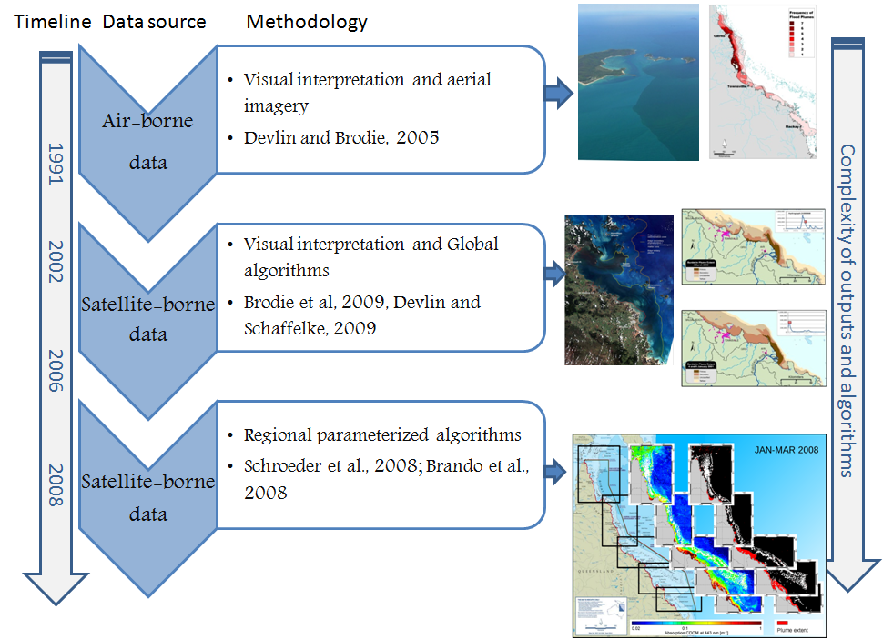
Figure 5.2. The evolution of remote sensed imagery in the mapping and monitoring of plume waters in the Great Barrier Reef

The use of ocean colour observations for plume mapping
The large scale spatial features of plumes are often difficult to observe during in situ sampling. Aerial imagery (using RGB techniques) can only distinguish the high sediment carrying plume waters. Limitations of aerial surveys are evident when the plume starts to move further offshore into a secondary phase and becomes dominated by chlorophyll and CDOM. The large scale spatial features become difficult to observe by aerial imagery and more difficult to sample over the larger extent. However, the high suspended sediment, high chlorophyll and high CDOM properties of the plume waters can be identified by appropriate ocean colour algorithms.^{81,82}

Information from the satellite imagery can assist greatly in determining the extent and location of plume boundaries and how these change over time. In the Great Barrier Reef region the use of satellite remote sensing imagery has allowed substantively more plume measurements to be included in the estimation of plume exposure. Furthermore the spectral data which enables the retrieval of water quality parameters, such as chlorophyll, TSM and CDOM, is unfeasible to obtain by aerial photography. The application of remote sensing data has changed the perception that plumes are nearly always constrained to the coast, with recognition that plume waters with elevated concentrations of chlorophyll and CDOM can be mapped at large distances offshore. Gradients of change within a plume is a dynamic movement, with TSM concentrations dropping out rapidly closer to the coast in lower salinity waters.^{76,83} Light is limited in these lower salinity waters, and thus inhibiting production by primary producers Reduction in turbidity occurs as the heavier particulate material deposits to the sea floor with a corresponding increase in dissolve nutrient availability. This leads to the appropriate conditions to support accelerated growth of phytoplankton. The later and extended stages of plume waters can still be visible by remote sensing algorithms with ongoing elevation of the CDOM concentrations. This variability on a spatial and temporal level is more easily monitored using spectral data acquired by ocean colour remote sensing sensors.

The optical complexity and variability of Great Barrier Reef coastal waters is illustrated by a MODIS true colour (RGB) composite acquired on 10 February 2007 covering the catchment of the Burdekin River and Repulse Bay of the Mackay-Whitsunday Region of Queensland, Australia (Figure 5.3). Intense wet season rainfall caused rivers in this region to produce large discharges to the Great Barrier Reef lagoon. The image captures the full variation of colour, or more precisely spectral reflectance, ranging from deep blue open ocean waters to more green and brownish coastal waters. This satellite image illustrates as well the influence of the land use on the composition of the flood waters. In the north, the Burdekin River discharges high loads of inorganic sediments into the lagoon, while further south Repulse Bay with regional land use dominated by sugarcane cultivation and beef grazing, receives high loads of dissolved organic matter.

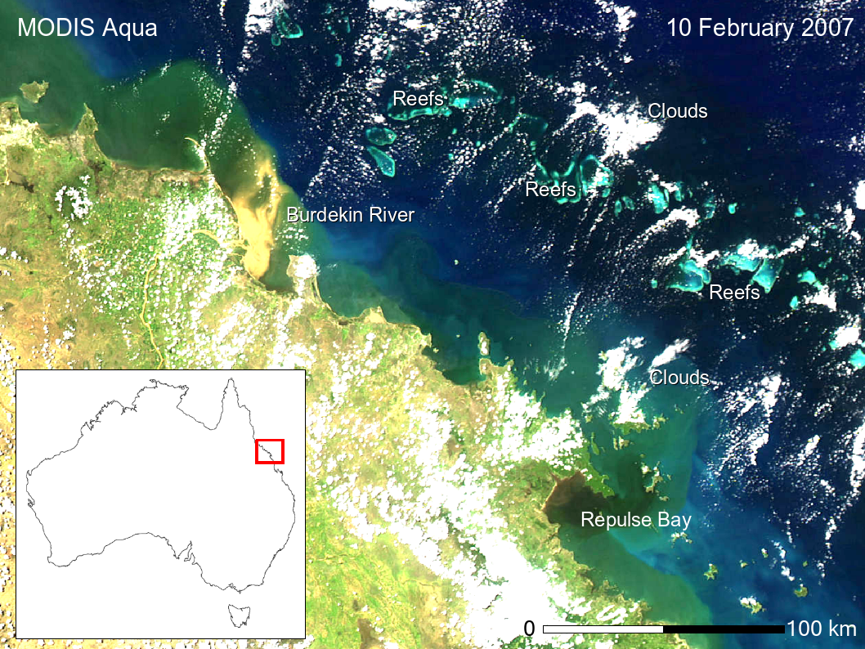Figure 5.3. MODIS AQUA imagery acquired 10th February, 2007 showing a sediment dominated flood plume of the Burdekin River and a dissolved organic matter dominated plume in Repulse Bay
The colour or spectral reflectance of the water is directly proportional to the backscattering and inversely proportional to the sum of backscattering and absorption. These inherent optical properties can be translated by an appropriate algorithm into concentrations of water constituents. The most common approach for the retrieval of water constituents from ocean colour observations is composed of two main processing or algorithm steps. First, an atmospheric correction procedure is applied to the satellite data to remove the disturbing effects of atmospheric absorption and scattering and to obtain the water-leaving radiance or reflectance. In a second step the obtained reflectance spectra is used to retrieve the water quality parameters.

The use of global ocean colour algorithms in plume mapping
In addition to the challenges of atmospheric correction above coastal waters, a large variability of in-water optical properties and concentration ranges, especially during flood events (Figure 5.3.), frequently cause empirical ocean colour algorithms to fail. These algorithms, like the default MODIS OC3 or SeaWiFS OC2 have been designed for open ocean waters, in which the optical properties are determined solely by phytoplankton their degradation products and the water itself. Simple reflectance ratios of two or more bands in the blue (443-490 nm) and green (550-565 nm) spectral region are used by these algorithms to estimate the concentration of chlorophyll. Coastal waters however, are usually influenced in addition by riverine inputs of terrestrial originated CDOM and inorganic suspended material as well as tidal resuspension. The spectral absorption features of these substances partly overlap with the absorption features of phytoplankton and cause a frequent overestimation of chlorophyll from these ratio algorithms. In the coastal waters of the Reef the global semi-analytical ocean colour algorithms, such as the GSM01 algorithm for chlorophyll⁷⁸, have been found more accurate than the empirical band ratio approach.⁸⁴

The use of regional parameterized ocean colour algorithms in plume mapping
In the Great Barrier Reef coastal waters, especially during flood events in the dry Tropics, we observe two distinct optically extreme cases of water types causing global algorithm failure. One is a highly scattering sediment dominated water type (Burdekin plume, Figure 5.3.) the other a highly absorbing one dominated by coloured dissolved organic material (Repulse Bay, Figure 5.3.). The standard algorithms that have traditionally been applied to Great Barrier Reef waters have difficulties in mapping due to this complexity of the inshore Reef waters, including bottom visibility, and proximity to coral reefs and seagrass beds which can cause errors in the algorithm outputs. To overcome these limitations associated with the use of global ocean colour algorithms in the Reef optically complex coastal waters, a regional algorithm was developed. This new approach is based on an inversion scheme which couples an artificial neural network atmospheric correction⁸⁵ with an in-water algorithm that is based on a variable parameterization of in-situ measured inherent optical properties.⁸⁶ This recently developed Artificial Neural Network (ANN) algorithm does not need to uncouple atmosphere and ocean signals, but uses the full spectral information as measured at top of atmosphere (~400-900 nm) and can be adapted to other satellite sensors. Further details on the development and application of these algorithms can be found in Johnson and Welch⁸⁷ and Devlin et al. in press⁸⁸.

Data management
Station description and details (e.g. geographical position, date, time, and depth) are recorded on weather proof field sheets (Appendix B2) and transferred at the end of each sampling day into Microsoft® Excel spreadsheets. All excel spreadsheets are collated and inputted into the Flood plume monitoring database (see Appendix B3 for metadata details).

Details of measurements at each station (sampling depths, Secchi depth, temperature readings and filter numbers) are recorded on the field sheets and transferred at end of day into Microsoft® Excel spreadsheets.

All water samples and filters are labelled with unique sample identifiers. The ACTFR laboratory put a flood sampling kit together for each site which has the unique identifier for all dissolved nutrients and total nutrients (10 ml plastic tubes), chlorophyll bottles.

The spreadsheet data are then transferred into the ACTFR flood plume Water Quality Database (currently in Microsoft® Access format). Data is also relayed onto the ACTFR laboratory input sheets (See Appendix B4) Both input data sheets, filtered samples and nutrient tubes are transferred to the laboratory for final processing and analysis Data are checked before and after transfer for completeness (e.g. agreement of station and sample numbers, all samples that were collected have been analysed) and correct data entry (comparison with previous data, cross-checking of data outside typical ranges with archived raw data records, for example, as hard copies or instrument files). Data are independently checked after entering them into the database.

Summary of Quality Control measures
- Training of samplers
- Periodic servicing of hydrolab sensors by manufacturer
- Sample custody
- Field blanks and replicates
- Overlap of manual and instrumental sampling
- Document control
- Metadata updates.

Inshore coral reef monitoring
Angus Thompson, Johnston Davidson, Britta Schaffelke

Australian Institute of Marine Science

Introduction
The objective of the biological monitoring of inshore reefs is to document spatial and temporal trends in the benthic reef communities on selected inshore reefs. Changes in these communities may be due to acute disturbances such as cyclonic winds, bleaching and crown-of-thorns starfish as well as more chronic disturbances such as those related to runoff (e.g. increased sedimentation and nutrient loads), which disrupt processes of recovery such as recruitment and growth. The reef monitoring sites are close to the sampling locations for lagoon water quality to assess the relationship between reef communities and water quality as well as other, more acute impacts.

One salient attribute of a healthy ecological community is that it should be self-perpetuating and ‘resilient’, that is: able to recover from disturbance. One of the ways in which water quality is most likely to shape reef communities is through effects on coral reproduction and recruitment. Laboratory and field studies show that elevated concentrations of nutrients and other agrichemicals and levels of suspended sediment and turbidity can affect one or more of gametogenesis, fertilisation, planulation, egg size, and embryonic development in some coral species (reviewed by Fabricius 2005¹¹). High levels of sedimentation can affect larval settlement or net recruitment of corals. Similar levels of these factors may have sub-lethal effects on established adult colonies. Because adult corals can tolerate poorer water quality than recruits and colonies are potentially long-lived, reefs may retain high coral cover even under conditions of declining water quality, but have low resilience. Some high-cover coral communities may be relic communities formed by adult colonies that became established under more favourable conditions. Such relic communities would persist until a major disturbance, but subsequent recovery may be slow if recruitment is reduced or non-existent. This would lead to long term degradation of reefs, since extended recovery time increases the likelihood that further disturbances will occur before recovery is complete⁸⁹. For this reason, the surveys for the MMP estimate cover of various coral taxa and also collect information of size-distribution of colonies as evidence for the extent of past and ongoing recruitment. In addition, settlement of corals is measured using settlement plates in all four Natural Resource Management (NRM) Regions. Assessments of sediment quality and assemblage composition of benthic foraminifera were added to the routine coral reef monitoring in 2007/08, to provide additional information about the environmental conditions at the individual survey reefs⁹⁰ and have been added as an annual monitoring component since 2010⁹¹.

This component of the MMP aims to accurately quantify temporal and spatial variation in inshore coral reef community status in relation to variations in local reef water quality. A detailed report⁹² linked the consistent spatial patterns in coral community composition observed over the first three years of the project with environmental parameters. As temporal span of this project extends it is intended to shift the focus toward understanding and documenting the differences in community dynamics (status) across the spatial extent of the sampling rather than reiterating spatial differences in composition.
In order to quantify inshore coral reef community status in relation to variations in local reef water quality, this project has several key objectives:

- Provide an annual time series of benthic community structure (viz. cover and composition of sessile benthos such as hard corals, soft corals and algae) for inshore reefs as a basis for detecting changes related to water quality and disturbances
- Provide information about coral recruitment on Great Barrier Reef inshore reefs as a measure for reef resilience
- Provide information about sea temperature and sediment quality as drivers of environmental conditions at inshore reefs
- Provide an integrated assessment of coral community condition for the inshore reefs monitored to serve as a report card against which changes in condition can be tracked

Methods

Sampling design
The sampling design was selected for the detection of change in benthic communities on inshore reefs in response to improvements in water quality parameters associated to specific catchments, or groups of catchments (Region), and to disturbance events. Within each Region, reefs are selected along a gradient in exposure to run-off, largely determined as increasing distance from a river mouth in a northerly direction. To account for spatial heterogeneity of benthic communities within reefs, two sites were selected at each reef (Figure 6.1).
Figure 6.1. Sampling design for coral reef benthic community monitoring. Terms within brackets are nested within the term appearing above.

Observations on a number of inshore reefs undertaken by AIMS in 2004 during the pilot study to the current monitoring program⁹³ highlighted marked differences in community structure and exposure to perturbations with depth; hence sampling within sites is stratified by depth. Within each site and depth, fine scale spatial variability is accounted for by the use of five replicate transects. Reefs within each region are designated as either ‘core’ or ‘cycle’ reefs. At core reefs all benthic community sampling methods are conducted annually, however, at cycle reefs sampling is undertaken every other year and coral recruitment estimates are not included.

Site selection
The reefs monitored were selected by the GBRMPA, using advice from expert working groups. The selection of reefs was based upon two primary considerations:

- To ensure sampling locations in each catchment of interest were spread along a perceived gradient of influence from river output
- Those sites are selected where there was evidence (in the form of carbonate-based substrate) that coral reef communities had been viable (net positive accretion of a carbonate substrate) in the past.

Where well developed reefs existed on more than one aspect of an island, two reefs are included in the design as although position relative to runoff exposure is similar, often quite different communities exist on windward compared to leeward reefs. A list of reefs selected is presented in Table 6.1. and map of the sampling locations in Figure 6.2.

Depth selection
From observations of a number of inshore reefs undertaken by AIMS in 2004⁹³, marked differences in community structure and exposure to perturbations with depth were noted. The lower limit for the inshore coral surveys was selected at 5m below datum, because coral communities rapidly diminish below this depth at many reefs; 2m below datum was selected as the shallow depth as this allowed surveys of the reef crest. Shallower depths were considered but discounted for logistical reasons, including the inability to use the photo technique in very shallow water, site markers creating a danger to navigation and difficulty in locating a depth contour on very shallow sloping substrata typical of reef flats.

Field survey methods
Site marking
At each selected reef sites are permanently marked with steel fence posts at the beginning of each twenty-metre transect and smaller (10 mm diameter) steel rods at the ten metre mark and end of each transect. Compass bearings coupled with distance along transects record the transect path between these permanent markers. Transects were set initially by running two sixty-metre fibreglass tape measures out along the desired five or two metre depth contour. Digital depth gauges are used along with tide heights from the closest location included in ‘Seafarer Tides’ electronic tide charts produced by the Australian Hydrographic Service. There are five-metre gaps between each consecutive twenty metre transect. The position of the first picket of each site is recorded by GPS.

Sampling methods
Five separate sampling methodologies are used to describe the benthic communities of inshore coral reefs. These are each conducted along the fixed transects identified in the sampling design though there are subtle differences in width or length of transect or spatial extent of the data sets as listed in Table 6.2.
Photo Point Intercept Method (PPIT)
This method is used to gain estimates of the percent cover of benthic community components. The method follows closely the Standard Operational Procedure Number 10 of the AIMS Long Term Monitoring Program⁹⁴. In short, digital photographs are taken at fifty-centimetre intervals along each twenty-metre transect. Estimation of cover of benthic community components is derived from the identification of the benthos lying beneath points overlaid onto these images. For the majority of hard and soft corals at least genus level identification is achieved. The categories used for identification of benthos are listed in Jonker, M. et al 2008⁹⁴.

The primary difference in the application of the method in this project from that described in Jonker et al. 2008⁹⁴ is in the sampling design. Sampling for this project is based on twenty metre transects, rather than fifty metre transects. To compensate for transects being shorter than in the standard method the density of frames per unit area of transect is doubled (images captured at 0.5 m rather than one-metre intervals). This alteration to the standard technique was adopted due to the limited size of some reefs sampled.

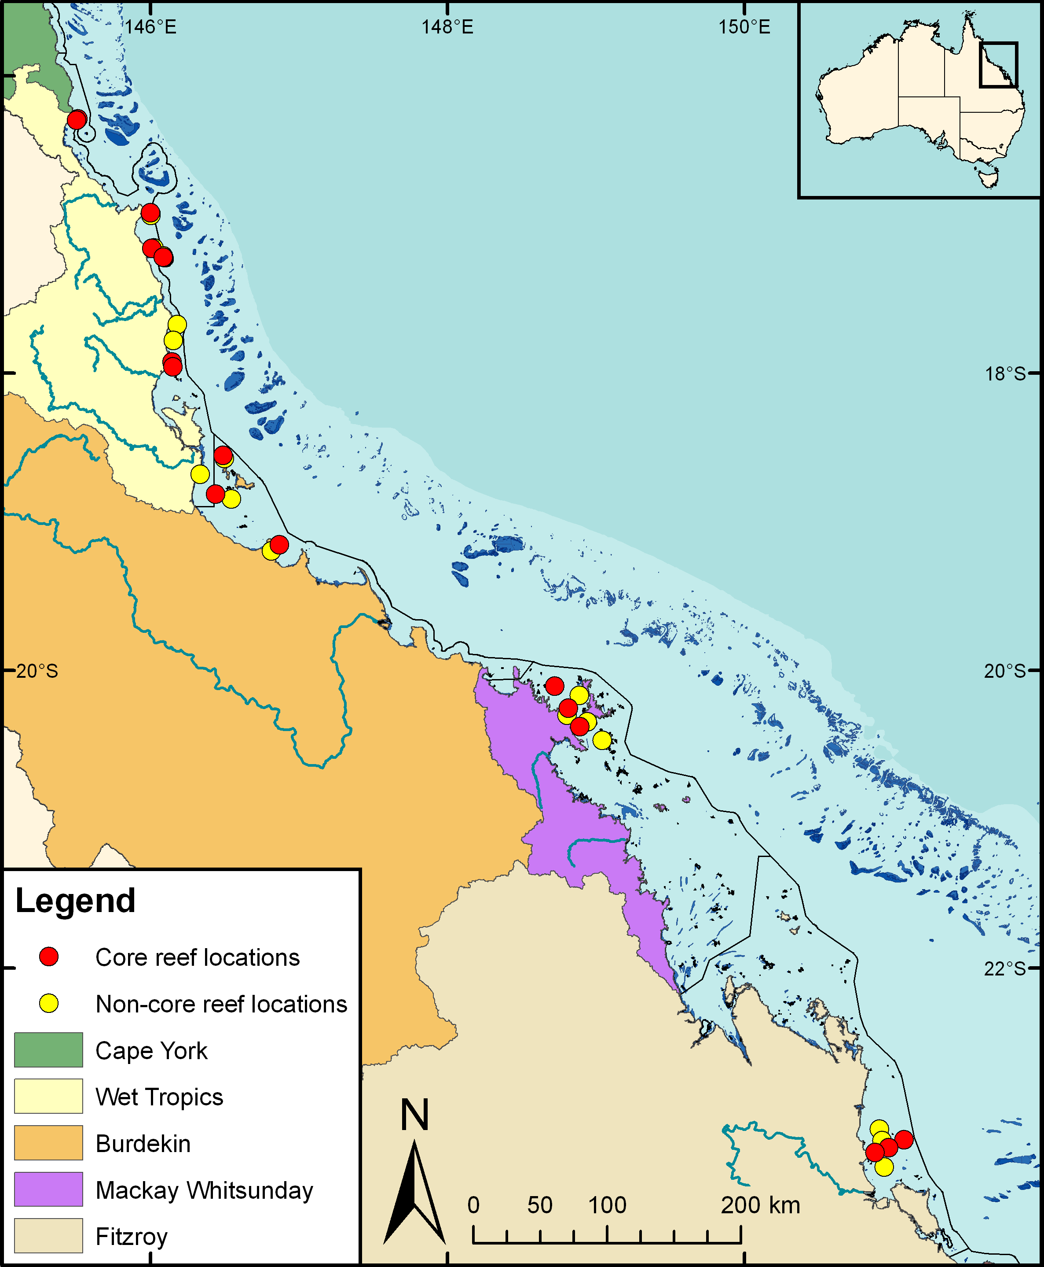
Figure 6.2. Sampling locations under the Reef Rescue Marine Monitoring Program coral monitoring task. Core reef locations have annual coral reef benthos surveys, coral settlement assessments and water quality monitoring. Non-core reef locations have benthos surveys every two years and no water quality assessments. Exceptions are Snapper Island and Dunk Island North (water quality monitoring, coral annual surveys, but no coral settlement)
Table 6.1. Sites selected for inshore reef monitoring. Sites in bold are core reefs; those in standard font are cycle reefs.
NRM Region | Catchment | Inshore reef monitoring sites | Team
Wet Tropics | Daintree | Snapper Island (North)  Snapper Island (South) | Sea Research
Wet Tropics | Russell / Mulgrave Johnstone | Fitzroy Island (East)  Fitzroy Island (West)  Frankland Island Group (East)  Frankland Island Group (West)  High Island (East)  High Island (West) | AIMS
Wet Tropics | Tully | Dunk Island (North)  Dunk Island (South)  King Reef  Nth Barnard Island | AIMS
Burdekin | Herbert | Lady Elliot Reef  Orpheus Island (East)  Pelorus Is & Orpheus Is (West) | AIMS
Burdekin | Burdekin | Geoffrey Bay  Middle Reef  Pandora Reef  Havannah Island | AIMS
Mackay / Whitsunday | Proserpine | Pine Island  Shute Island  Daydream Island  Double Cone Island  Seaforth Island  Dent Island  Hook Island | AIMS
Fitzroy | Fitzroy | Peak Island  Pelican Island  Humpy & Halfway Islands  Middle Island  Nth Keppel Island  Barren Island | AIMS

Table 6.2. Distribution of sampling effort
Survey Method | Information provided | Transect coverage | Spatial coverage
Photo Point Intercept | Percentage cover of the substrate of major benthic habitat components. | Approximately 25 cm belt along upslope side of transect form which 160 points are sampled. | Full sampling design
Demography | Size structure of coral communities, density post settlement recruitment | 34 cm belt along the upslope side of the transect. | Full sampling design
Scuba Search | Incidence of factors causing coral mortality | Two-metre belt centred on transect | Full sampling design
Settlement Tiles | Larval supply | Clusters of six tiles in the vicinity of the start of the 1st, 3rd and 5th transects of five-metre deep sites. | 12 core reefs and five metres depth only
Sediment sampling | Grain size distribution and the chemical content of nitrogen, organic carbon and inorganic carbon.  Community composition of Foraminifera | Sampled from available sediment deposits within the general area of transects. | Five metres depth only  Forams on 14 core reefs

Juvenile coral surveys
This survey aims to provide an estimate of the number of coral colonies that were successfully recruiting to and surviving early post settlement pressures. In the first year of sampling under this program these juvenile coral colonies were counted as part of a demographic survey that counted the number of individuals falling into a broader range of size classes. As the focus narrowed to just juvenile colonies the number of size classes reduced allowing an increase in the spatial coverage of sampling.

Coral colonies less than ten centimetres in diameter are counted within a belt 34 cm wide (data slate length) along the upslope side of each twenty-metre transect. Each colony is identified to genus and assigned to a size class of either, 0-2 cm, >2-5 cm, or >5-10 cm. Importantly this method aims at estimating the number of juvenile colonies that result from the settlement and subsequent survival and growth of coral larvae rather than small coral colonies resulting from fragmentation or partial mortality of larger colonies. With the exception of the transect dimension and the size classes used this method is consistent with the Standard Operational Procedure Number 10 of the AIMS Long-term Monitoring Program⁹⁴, Part 2, in which further detail relation to juvenile/fragment differentiation can be found.

Scuba Search Transects
Scuba search transects document the incidence of agents causing coral mortality or disease. Tracking of these agents of mortality is important as declines due to these agents must be carefully considered as covariates for possible trends associated with response to outcomes. The method used follows closely the Standard Operational Procedure Number 9 of the AIMS Long Term Monitoring Program⁹⁵, Part 2. In short, a search is made of a two-metre wide belt (one metre either side of the transect midline) for any recent scars, bleaching, disease or damage to coral colonies. An additional category not included in the standard procedure is physical damage. This is recorded on the same five-point scale as coral bleaching and describes the proportion of the coral community that has been physically damaged, as indicated by toppled or broken colonies. This category may include anchor as well as storm damage.

Hard coral recruitment measured by settlement tiles
This component of the study aims to provide standardised estimates of availability and relative abundance of coral larvae competent to settle. Such estimates may be compared among years for individual reefs to assess, for example, recovery potential of an individual reef after disturbance, a key characteristic of reef health.

The estimation of the availability of viable coral spat is inferred from numbers of coral recruits to terracotta tiles. The deployment of terracotta tiles as a standardised settlement substrate for collection of coral recruits is a standard method for which no suitable substitute exists. However, the use of this technique to monitor changes in the availability viable spat needs careful consideration as the duration and timing of tile deployment relative to spawning has the potential to alter the observed rates of settlement.

As a general rule coral spawning on near shore reefs of the Reef occurs several days after the full moon in either October or November⁹⁶, and annually confirmed since Babcock's publication. However, there is variability between years, nearby reefs and coral species as to the proportion of spawning that occurs following the October moon compared with moons later in the summer. This variability is due to interactions between environmental variables influencing the timing of spawning such as, but perhaps not limited to, temperature and moon phase. Further, as coral larvae can be competent to settle after just a few days⁹⁷ but maintain competence over several months (e.g. Wilson and Harrison 1998⁹⁸) the distribution of settlement within the spring/summer period at any given reef in will be variable and unpredictable. A separate consideration is that the period of deployment may influence the attractiveness of tiles as a settlement substrate. Tiles deployed too close to settlement may not have developed a biofilm suitable for coral settlement while those deployed for too long may have little available space as surfaces are colonised by other organisms.

In the face of such variability we have adopted a sampling design that attempts to maximise the consistency of tile deployments between reefs and the duration of time over the spring/summer settlement period that tiles are in place with a reasonable proportion of their surface available to coral settlement.

At each reef, tiles were deployed over the expected settlement period for each spawning season based on past observations of the timing of coral spawning events. Tiles are deployed for a period of at least 3 weeks for tiles to condition before any settlement is expected.

Tiles are fixed to small stainless steel base plates attached to the substratum with plastic masonry plugs, or cable ties (when no solid substratum was available). Each base plate holds one tile at a nominal distance of 10-20mm above the substratum. Tiles are distributed in clusters of six around the star pickets marking the start of the 1st, 3rd and 5th transect at each 5m depth site on 12 core reefs. Upon collection, the base plates are left in place for use in the following year. Collected tiles are stacked onto separate holders, tagged with the collection details (retrieval date, reef name, site and picket number). Small squares of low density foam placed between the tiles prevent contact during transport and handling as this may dislodge or damage the settled corals. On return to land the stacks of 6 tiles are carefully washed on their holders to remove loose sediment and then bleached for 12-24 hours to remove tissue and fouling organisms. Tiles are then rinsed and soaked in fresh water for a further 24 hours, dried and stored until analyses.

Hard coral recruits on retrieved settlement tiles are counted and identified using a stereo dissecting microscope. The taxonomic resolution of these young recruits is limited. The following taxonomic categories are identified with certainty: Acroporidae (not Isopora), Acroporidae (Isopora), Fungiidae, Poritidae, Pocilloporidae and other achieved. As set of reference images pertaining to these categories has been complied.

Observer training
The AIMS personnel collecting data in association with this project are without exception highly experienced in the collection of benthic monitoring data. Each observer has been involved in benthic monitoring and video analysis for at least a decade and was employed specifically for their skills associated with the tasks required. Initial training for this specific project occurred in 2004 when all observers were involved in the survey of a large number of similar reefs using essentially the same techniques.

Ongoing standardisation of observers is achieved through annual comparisons of data returned from duplicate surveys. Any discrepancy in these duplicates is used to identify and subsequently mitigate bias. For the most part however uncertainties in identification or classification are mitigated in the field via direct communication (as at least two experienced observers are generally present), or the use of a digital camera to record images for later identification and discussion.

In the event that new observers enter the team, training in each sampling method will be by direct tuition with an experienced observer and allowed to collect data only once meeting the standards listed in Table 6.3.
Classification to genus level underwater is augmented by the use of a small digital camera to take images for post dive scrutiny of difficult to identify colonies.

Sea Research is responsible for surveys in the Daintree catchment. The Sea Research observer, Tony Ayling, is the most experienced individual in Australia in surveying the benthic communities of near-shore coral reefs. He has twenty years experience surveying the sites in this catchment, amongst many others. His taxonomic skills are undoubted at genus level and as such observer standardisation for demography and scuba search surveys are limited to detailed discussion of methodologies with AIMS observers and explicit following of the protocols listed here. Sea Research will also use the same pre-printed datasheets and data entry programs. Analysis of video footage collected by Sea Research will be undertaken by the AIMS.

Table 6.3. Observer training methods and quality measures
Monitoring method | Training method | Quality measure
Photo Point Intercept | In-field identification of benthic components.  On screen classification of video points.  In-field tuition on photographic protocol. | All identifications double checked.
Juvenile counts | In-field identification of corals to genus level, and application of technique with experienced observer supervision.. | No greater than ten percent of colonies misidentified, overlooked or misclassified in size during supervised demographic surveys of two sites.
Scuba Search | In-field tuition in the classification of coral scars and damage. | Observation of at least ninety percent of damaged colonies and their correct classification during supervised surveys of two sites of damaged colonies.
Settlement Tiles | Laboratory identification to highest taxonomic levels. | No greater than ten percent difference in the identifications or numbers of recruits recorded from ten tiles between observers.

Foraminiferal abundance and community composition from sediment samples
The density and composition of foraminiferal assemblages were estimated from a subset of the surface sediment samples collected from 14 coral monitoring sites (see section 2.3). Sediments were washed with freshwater over a 63 μm sieve to remove small particles. After drying (>24 h, 60°C), haphazard subsamples (ca. 2 g) of the sediment were taken and, using a dissection microscope, all foraminifera present in these were collected. This procedure was repeated until about 200 foraminifera specimens were collected from each sediment sample. Only intact specimens which showed no sign of ageing were considered. Samples thus defined are a good representation of the present day biocoenosis⁹⁹, although not all specimens may have been alive during the time of sampling. Species composition of foraminifera was determined in microfossil slides under a dissection microscope following Nobes and Uthicke 2008¹⁰⁰. The dry weight of the sediment and the foraminifera was determined to calculate foraminiferal densities per gram sediment. These density values were used to calculate the FORAM index.

The FORAM index¹⁰¹ summarises foraminiferal assemblages based on the relative proportions of species classified as either symbiont bearing, opportunistic or heterotrophic and is used as an indicator of coral reef water quality in Florida and the Caribbean Sea¹⁰¹. In general, a decline in the FORAM index indicates an increase in the relative abundance of heterotrophic species. Symbiotic relationships with algae are advantageous to foraminifera in clean coral reef waters low in dissolved inorganic nutrients and particulate food sources, whereas heterotrophy becomes advantageous in areas of higher turbidity and availability of inorganic and particulate nutrients¹⁰². The FORAM index has been successfully tested in the Great Barrier Reef and corresponded well to water quality variables ^{103,104} .

To calculate the FORAM Index foraminifera are arranged into three groups: 1) Symbiont Bearing, 2) Opportunistic and 3) other small (or Heterotrophic).

The proportion of each functional group is then calculated as

- Proportion Symbiont Bearing = P_{S}= N_{S}/T

- Proportion Opportunistic = P_{O}= N_{O}/T

- Proportion Heterotrophic = P_{h}= N_{h}/T

Where N_{x} = number of foraminifera in the respective group, T= total number of foraminifera in each sample.

The FORAM index is then calculated as FI = 10P_{s} + P_{o} + 2P_{h}

The detailed Standard Operational Procedures for foraminiferan enumeration for FORAM index calculation are currently in press¹⁰⁵ and included for reference in Appendix A12.

Sediment quality
Sediment samples were collected from all reefs visited during 2008 for analysis of grain size and of the proportion of inorganic carbon, organic carbon and total nitrogen. At each five-metre deep site, six 30mm deep cores of surface sediment (representing 20 ml of material) were collected haphazardly using syringe tubes along the 120 metre length of the site from available deposits. On the boat, the excess sediment was removed to leave 10 ml in each syringe; this represents the top 10 ml of surface sediment. This sediment was transferred to the labelled sample jar, yielding a pooled sample of 10 ml sediment samples for each site. The sample jars were kept cold and dark in an ice box cooler to minimise bacterial decomposition and volatilisation of the organic compounds until transferred to a freezer at AIMS.

The sediment samples were defrosted and each sample was well mixed before being sub-sampled (approximately half removed) to a second labelled sample jar for grain-size analysis. The remaining material was dried, ground and analysed for the composition of organic carbon, inorganic carbon, and nitrogen.

Grain size fractions were estimated by sieving larger fractions (>1.4 mm) and MALVERN laser analysis of smaller fractions (<1.4 mm). From 2010, the grain size distributions from sediment samples collected by this study were analysed by Geoscience Australia under a cooperative agreement with AIMS (see Section A13 for analytical details).

Total carbon (carbonate carbon + organic carbon) was determined by combustion of dried and ground samples using a LECO Truspec analyser. Organic carbon and total nitrogen were measured using a Shimadzu TOC-V Analyser with a Total Nitrogen unit and a Solid Sample Module after acidification of the sediment with 2M hydrochloric acid. The carbonate carbon component was assumed to be CaCO₃ and was calculated as the difference between total carbon and organic carbon values. Detailed procedures are in Appendix A14.

Temperature monitoring
Temperature loggers are deployed at, or in close proximity to, all locations at both 2m and 5m depths and routinely exchanged at the time of the coral surveys (i.e. every 12 or 24 months). Two types of temperature loggers have been used for the sea surface temperature logger program. The first type was the Odyssey temperature loggers (http://www.odysseydatarecording.com/), these have now been superseded by the Sensus Ultra Temperature logger (http://reefnet.ca/products/sensus/). The Odyssey Temperature loggers were set to take readings every 30 minutes. The Sensus Temperature loggers were set to take readings every 10 minutes. Loggers were calibrated against a certified reference thermometer after each deployment and generally accurate to ± 0.2°C.

Detailed data download, quality checks and data management methods are described in Appendix A15.

Data management
Data Management practices are a major contributor to the overall quality of the data collected; poor data management can lead to errors, lost data and can reduce the value of the Reef Plan MMP data. Data from the AIMS MMP inshore coral reef monitoring are stored in a custom-designed Reef Rescue MMP data management system in Oracle 9i databases to allow cross-referencing and access to related data. Once data are uploaded into the oracle databases after the quality assurance and validation processes, they are consolidated in an Access Database via oracle views. The Access Database product was chosen as the delivery mechanism for its simplicity and because most users are familiar with the software (see Appendix A15 for details about general AIMS in-house procedures for data security, data quality checking and backup).

It is AIMS policy that all data collected have a metadata record created for it. The metadata record is created using a Metadata Entry System where the metadata is in the form of ISO19139 XML. This is the chosen format for many agencies across Australia and the International Community that deal with spatial scientific data. You can visit the AIMS Metadata System at:
http://data.aims.gov.au/geonetwork/srv/en/main.home.

All coral monitoring field data is recorded on pre-printed datasheets. The use of standard data sheets aids in ensuring standard recording of attributes, and ensures required data are collected.

On return from the field, all data is entered on the same day into database forms linked directly to an Oracle Lite database. Each field on these forms mirror those on pre-printed data sheets and include lookup fields to ensure data entered is of appropriate structure or within predetermined limits. For example, entry of genera to the demography data table must match a pre-determined list of coral genera.

On return to the office, the data is uploaded to an Oracle Database using the Oracle Lite synchronization process. All keyed data is printed and checked against field data sheets prior to final logical checking (ensuring all expected fields are included and tally with number of surveys). Photo images are also stored on a server that is included in a routine automatic back up schedule. Photo images are burnt to DVD prior to analysis as a second backup.

Image analysis of reef monitoring photos is performed within the AIMS monitoring data entry package “reefmon”. This software contains logical checks to all keyed data and is directly linked to a database to ensure data integrity. The directory path to transect images is recorded in the data base. This functionality allows the checking of benthic category identification. All photo transect data is checked by a second experienced observer prior to data analysis and reporting of results.

Summary
Most data collected involves the identification of coral reef benthos. Prior to the collection of data staff are trained and assessed by experienced observers to ensure their identification skills are consistent with the resolution required. Observers are encouraged to photograph organisms for which identification is uncertain. This allows identification by either reference to texts or discussion with other observers.

All data entry is via database forms that include logical checking on format and content of entered fields. All keyed data is checked against data sheets or in the case of photo transects verification of identification by revisiting each image. For a detailed description of the data management procedures developed at the AIMS for the MMP refer to Appendix A15.

Intertidal seagrass monitoring
¹Len McKenzie, ²Michelle Waycott, ¹Richard Unsworth, ²Catherine Collier, ¹Jane Mellors,

¹Fisheries Queensland (Department of Employment, Economic Development and Innovation)
²School of Marine and Tropical Biology, James Cook University

Introduction
There are nearly 6,000 km² of seagrasses in Great Barrier Reef waters shallower than 15 m, relatively close to the coast, and in locations that can potentially be influenced by adjacent land use practices. Monitoring of the major marine ecosystem types most at risk from land based sources of pollutants is being conducted to ensure that any change in their status is identified. Seagrass monitoring sites are associated with the river mouth and inshore marine water quality monitoring tasks in the MMP to enable correlation and concurrently collected water quality information.

The key aims of the intertidal seagrass monitoring under the MMP are to:

- Detect long-term trends in seagrass abundance, community structure, distribution, reproductive health and nutrient status from representative intertidal seagrass meadows in relation to large river inputs into the Great Barrier Reef
- Detect long-term trends in concentrations of ecologically significant herbicides and nutrient pollutants from representative intertidal seagrass meadows in relation to large river inputs into the Great Barrier Reef
- Work closely with and involve community partners (Seagrass-Watch) to ensure broad acceptance and ownership of the by the Queensland and Australian community.

Methods

Sampling design - Intertidal seagrass meadow abundance, community structure and reproductive health
The sampling design was selected to detect change in intertidal seagrass community status to compare with seagrass environmental status (water quality) in relation to specific catchments or groups of catchments (NRM region). Within each region, a relatively homogenous section of a representative seagrass meadow is selected to represent each of the seagrass habitats present (estuarine, coastal, reef) [Habitat(Region)]. To account for spatial heterogeneity, two sites were selected within each location (Site[Habitat(Region)]). Within each site, finer scale variability is accounted for by using three fifty-metre transects nested in each site. A site is defined as a 50mx50m area. At each site, monitoring is conducted during the late-monsoon (April) and late-dry (October) periods each year.

Field survey methods - Intertidal seagrass meadow abundance, community structure and reproductive health
Site marking
The sampling locations for this program are listed in Figure 7.1 and Table 7.1. Each selected intertidal seagrass site is permanently marked with plastic star pickets at the 0 m and 50 m points of transect. Labels identifying the sites and contact details for the program are attached to these pickets. Positions of 0 m and 50 m points for all three transects at a site are also noted using GPS. This ensures that the same site is monitored each event.

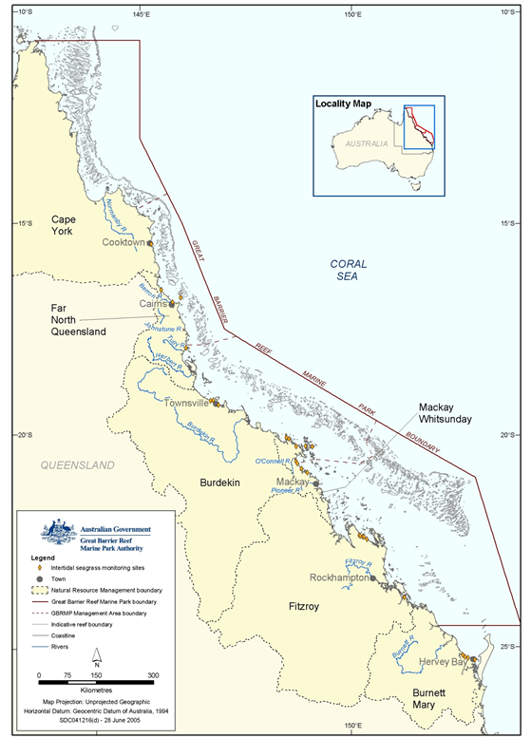
Figure 7.1. Intertidal seagrass monitoring sites for the Reef Rescue Marine Monitoring Program
Seagrass cover and species composition
Survey methodology follows Seagrass-Watch standard methodology^{106,107,108} (Appendix D1; see also www.seagrasswatch.org). A site is defined as a 50mx50m area within a relatively homogenous section of a representative seagrass community/meadow.¹⁰⁹ (http://www.seagrasswatch.org/monitoring.html)

Monitoring at the 28 sites identified for the MMP long-term intertidal monitoring in late-monsoon (April) and late-dry season (October) of each year is conducted by a qualified scientist, trained in Seagrass-Watch methods. Monitoring conducted outside these months, is conducted by trained volunteers, where at least one volunteer has passed Level 1 Seagrass-Watch Certification (http://www.seagrasswatch.org/training.html).

The collection of data by Seagrass-Watch volunteers necessitates a high level of training to ensure that the data is of a standard that can be used by management agencies. Technical issues concerning quality control of data are important especially when the collection of data is by people not previously educated in scientific methodologies. By using simple and easy methods, Seagrass Watch ensures completeness (the comparison between the amounts of valid or useable data originally planned to collect, versus how much was collected). Standard seagrass cover calibration sheets are used to ensure precision (the degree of agreement among repeated measurements of the same characteristic at the same place and the same time) and consistency between observers and across sites at monitoring times.

From 1 November 2007, Seagrass-Watch HQ introduced a new tiered level of certification for training participants over seventeen years of age. There are requirements before volunteers can attend a course, and a level of achievement to be completed to pass a training course:

Level 1 (Basic) Requirements = participants must have some Seagrass-Watch monitoring experience and have participated in at least one or more field monitoring events prior to attending. Achievement = Workshop attendance of classroom, laboratory and field session; achieve 80% of formal assessment (multiple choice, open book) and demonstrated competency in the field (successfully complete 3 monitoring events/periods within 12 months).
Level 2 (Intermediate) Requirements = Completion of Level 1 and must complete three monitoring events over a twelve-month period. Achievement = Refresher workshop attendance of classroom, laboratory and field session; achieve 80% of formal assessment (multiple choice, open book) and demonstrated competency in the field.

Ongoing standardisation of observers is achieved by on-site refreshers of standard percentage covers by all observers prior to monitoring and through ad hoc comparisons of data returned from duplicate surveys (e.g. either a site or a transect will be repeated by scientist – preferably the next day and unknown to volunteers). Any discrepancy in these duplicates is used to identify and subsequently mitigate bias. For the most part however uncertainties in percentage cover or species identification are mitigated in the field via direct communication (as at least one experienced/certified observer is always present), or the collection of voucher specimens (to be checked under microscope and pressed in herbarium) and the use of a digital camera to record images (protocol requires at least 27% of quadrats are photographed) for later identification and discussion. Evidence of competency is securely filed on a secure server in Cairns at the Northern Fisheries Centre.

Seagrass reproductive health
An assessment of seagrass reproductive health at locations identified in Table 7.1 via flower production and seed bank monitoring is conducted in late-Monsoon (April) and late-dry season (October) of each year at each site.

In the field, fifteen haphazardly placed cores (100mm diameter x 100mm depth) of seagrass are collected from an area adjacent, of similar cover and species composition, to each Seagrass-Watch monitoring site. All samples collected are given a unique sample code/identifier providing a custodial trail from the field sample to the analytical outcome.

- Seagrass tissue nutrients
Collection of intertidal seagrass tissue (targeted foundation genus include Halodule, Zostera and Cymodocea) for analysis of tissue nutrients (total C, N, P) is conducted in the late-dry season (October) sampling period at regions identified in Table7.1. Three to five haphazardly placed 0.25m² quadrats are harvested from an area adjacent, of similar cover and species composition, to each monitoring site. All samples collected are given a unique sample code/identifier providing a custodial trail from the field sample to the analytical outcome.

Rhizosphere sediment herbicide (haphazard)
Sediment samples for analysis of herbicide concentrations are collected in late-monsoon (April). Rhizosphere herbicide samples are obtained using a stainless steel spoon and bowl rinsed with acetone between each sample collection. The samples are stored in acetone rinsed Teflon lidded jars provided by the QHFSS. The collection methodology is outlined in Appendix D2. Sediments are kept frozen until analyses by the NATA accredited commercial laboratory at the QHFSS.

Table 7.1. Seagrass-Watch sites selected for the Reef Rescue Marine Monitoring Program (a discontinued 2010, b additional to tender)
Great Barrier Reef Region | NRM region  (Board) | Catchment | Monitoring location | Site |  | Latitude |  | Longitude |  | Seagrass community type
Far Northern | Cape York | Endeavour | Cooktown  Coastal intertidal | AP1ª | Archer Point | 15° | 36.5 | 145° | 19.143 | H. univervis/ H. ovalis with Cymodocea/T. hemprichii
 |  |  |  | AP2ª | Archer Point | 15° | 36.525 | 145° | 19.108 | H. univervis/H. ovalis with  C. rotundata
Northern | Wet Tropics  (Terrain) | Barron,  Russell/  Mulgrave,  Johnstone | Green Island  Offshore intertidal | GI1 | Green Island | 16° | 45.789 | 145° | 58.31 | C. rotundata/T. hemprichii with  H. uninervis/H. ovalis
 |  |  |  | GI2 | Green Island | 16° | 45.776 | 145° | 58.501 | C. rotundata/T. hemprichii with  H. uninervis/H. ovalis
Northern | Wet Tropics  (Terrain) | Barron,  Russell/  Mulgrave,  Johnstone | Cairns  Coastal intertidal | YP1 | Yule Point | 16° | 34.159 | 145° | 30.744 | H. uninervis with H. ovalis
 |  |  |  | YP2 | Yule Point | 16° | 33.832 | 145° | 30.555 | H. uninervis with H. ovalis
Northern | Wet Tropics  (Terrain) | Tully | Mission Beach  Coastal intertidal | LB1 | Lugger Bay | 17° | 57.645 | 146° | 5.61 | H. uninervis
 |  |  |  | LB2 | Lugger Bay | 17° | 57.674 | 146° | 5.612 | H. uninervis
Northern | Wet Tropics  (Terrain) | Tully | Dunk Island  Offshore intertidal | DI1 | Dunk Island | 17° | 56.6496 | 146° | 8.4654 | H. uninervis with T. hemprichii/  C. rotundata
 |  |  |  | DI2 | Dunk Island | 17° | 56.7396 | 146° | 8.4624 | H. uninervis with T. hemprichii/  C. rotundata
Central | Burdekin  (Burdekin Dry Tropics) | Burdekin | Magnetic island  Offshore intertidal | MI1 | Picnic Bay | 19° | 10.734 | 146° | 50.468 | H. uninervis with H. ovalis and  Zostera/T. hemprichii
 |  |  |  | MI2 | Cockle Bay | 19° | 10.612 | 146° | 49.737 | C. serrulata/ H. uninervis with  T. hemprichii/H. ovalis
Central | Burdekin  (Burdekin Dry Tropics) | Burdekin | Townsville  Coastal intertidal | SB1 | Shelley Beach | 19° | 11.046 | 146° | 45.697 | H. uninervis with H. ovalis
 |  |  |  | BB1 | Bushland Beach | 19° | 11.028 | 146° | 40.951 | H. uninervis with H. ovalis
Central | Mackay Whitsunday  (Mackay Whitsunday) | Proserpine | Whitsundays  Coastal intertidal | PI2 | Pioneer Bay | 20° | 16.176 | 148° | 41.586 | H. uninervis/ Zostera with H. ovalis
 |  |  |  | PI3 | Pioneer Bay | 20° | 16.248 | 148° | 41.844 | H. uninervis with Zostera/H. ovalis
Central | Mackay Whitsunday  (Mackay Whitsunday) | Proserpine | Whitsundays  Offshore intertidal | HM1 | Hamilton Island | 20° | 20.7396 | 148° | 57.5658 | H. uninervis with H. ovalis
 |  |  |  | HM2 | Hamilton Island | 20° | 20.802 | 148° | 58.246 | Z. capricorni with H. ovalis/  H. uninervis
Central | Mackay Whitsunday  (Mackay Whitsunday) | Pioneer | Mackay  Coastal intertidal | SI1 | Sarina Inlet | 21° | 23.76 | 149° | 18.2 | Z. capricorni with H. ovalis  (H. uninervis)
 |  |  |  | SI2 | Sarina Inlet | 21° | 23.712 | 149° | 18.276 | Z. capricorni with H. ovalis  (H. uninervis)
Southern | Fitzroy  (Fitzroy Basin Association) | Fitzroy | Shoalwater Bay  Coastal intertidal | RC | Ross Creek | 22° | 22.953 | 150° | 12.685 | Zostera capricorni with H. ovalis
 |  |  |  | WH | Wheelans Hut | 22° | 23.926 | 150° | 16.366 | Zostera capricorni with H. ovalis
Southern | Fitzroy  (Fitzroy Basin Association) | Fitzroy | Keppel Islands  Offshore intertidal | GK1 | Great Keppel Is. | 23° | 11.7834 | 150° | 56.3682 | H. uninervis with H. ovalis
 |  |  |  | GK2 | Great Keppel Is. | 23° | 11.637 | 150° | 56.3778 | H. uninervis with H. ovalis
Southern | Fitzroy  (Fitzroy Basin Association) | Boyne | Gladstone Harbour  Coastal intertidal | GH1^{b} | Gladstone Hbr | 23° | 46.005 | 151° | 18.052 | Zostera capricorni with H. ovalis
 |  |  |  | GH2^{b} | Gladstone Hbr | 23° | 45.874 | 151° | 18.224 | Zostera capricorni with H. ovalis
Southern | Burnett Mary  (Burnett Mary Regional Group) | Burnett | Rodds Bay  Coastal intertidal | RD1 | Rodds Bay | 24° | 3.4812 | 151° | 39.3288 | Zostera capricorni with H. ovalis
 |  |  |  | RD2 | Rodds Bay | 24° | 4.866 | 151° | 39.7584 | Zostera capricorni with H. ovalis
Southern | Burnett Mary  (Burnett Mary Regional Group) | Mary | Hervey Bay  Coastal intertidal | UG1 | Urangan | 25° | 18.053 | 152° | 54.409 | Zostera capricorni with H. ovalis
 |  |  |  | UG2 | Urangan | 25° | 18.197 | 152° | 54.364 | Zostera capricorni with H. ovalis

Laboratory analysis - Intertidal seagrass meadow abundance, community structure and reproductive health
Seagrass reproductive health
In the laboratory, reproductive structures (spathes, fruit, female flower or male flowers; Figure 7.2.) of plants from each core are identified and counted for each sample and species. If Halodule uninervis seeds (brown green colour) are still attached to the rhizome, they are counted as fruits. Seed estimates are not recorded for Halophila ovalis due to time constraints (if time is available post this first pass of the samples, fruits will be dissected and seeds counted). For Zostera muelleri ssp. capricorni, the number of spathes is recorded, male and female flowers and seeds counted during dissection, if there is time after the initial pass of the samples. Apical meristems are not recorded as they were too damaged by the collection process to be able to be identified correctly. Approximately 5% of samples are cross-calibrated between technicians (preferable from another centre). All flowers and spathes and fruits /fruiting bodies are kept and re-frozen in the site bags for approximately 2 years for revalidation if required.

Reproductive effort is calculated as the number of reproductive structures per node (leaf cluster emerging from the rhizome) as each of the three species examined (Halophila ovalis, Halodule uninervis and Zostera muelleri ssp. capricorni) have different reproductive structures (Figure 7.2.). For comparative purposes only the presence of a reproductive structure per node is counted rather than the relative number of flowers, fruits or seeds. The number of nodes counted reflects the number of shoots found in the core. Thus cores with larger numbers of nodes contained more shoots. The average number of reproductive structures per node reflects the per unit area occurrence of reproductive output and this is the reproductive effort (i.e. average number of flowers per core).

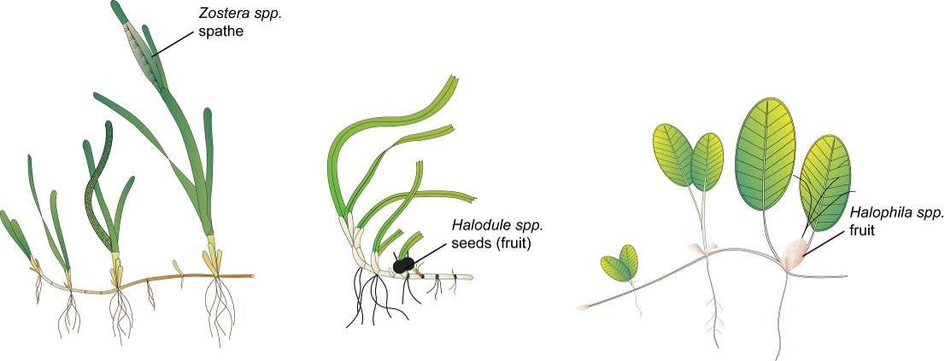
Figure 7.2: Form and size of reproductive structure of the three seagrasses collected: Halophila ovalis, Halodule uninervis and Zostera muelleri ssp. capricorni

Seagrass tissue nutrients
Leaves are separated in the laboratory into seagrass species and epiphytic algae removed by scraping. Samples are oven dried at 60°C to weight constancy. Dried biomass samples of leaves are then homogenised by milling to fine powders prior to nutrient analyses and stored in sealed vials.

The ground tissue samples are sent to Chemcentre (Western Australia) for analysis. The Chemcentre holds NATA accreditation for constituents of the environment including soil, sediments, waters and wastewaters. (Note that details of Chemcentre accreditation can be found at the NATA website http://www.nata.asn.au/). The NATA accreditation held by the ChemCentre includes a wide variety of QA/QC procedures covering the registration and identification of samples with unique codes and the regular calibration of all quantitative laboratory equipment required for the analysis. The ChemCentre has developed appropriate analytical techniques including QA/QC procedures and detection of nutrients. These procedures include blanks, duplicates where practical, and internal use of standards. In 2010, QA/QC also included an inter-lab comparison (using Queensland Health and Scientific Services – an additional NATA accredited laboratory) and an additional blind internal comparison.

Nitrogen and phosphorus are extracted using a standardized selenium Kjeldahl digest and the concentrations determined with an automatic analyser using standard techniques at Chemcentre in Western Australia (a NATA certified laboratory). Percent C was determined using atomic absorption, also at Chemcentre. Elemental ratios (C:N:P) are then calculated on a mole:mole basis using atomic weights (i.e., C=12, N=14, P=31). Analysis of all seagrass tissue nutrient data is based upon the calculation of the atomic ratios of C:N:P.

To determine percent carbon, dried and milled seagrass leaf tissue material is combusted at 1400°C in a controlled atmosphere (e.g. Leco). This converts all carbon containing compounds to carbon dioxide. Water and oxygen is then removed from the system and the gaseous product is determined spectrophotometrically.

Total nitrogen and phosphorus content of dried and milled homogenous seagrass tissue material is determined by Chemcentre using a standardized selenium Kjeldahl digest. Samples are digested in a mixture of sulphuric acid, potassium sulphate and a copper sulphate catalyst (cf. Kjeldahl). This converts all forms of nitrogen to the ammonium form and all forms of phosphorus to the orthophosphate form. The digest is diluted and any potentially interfering metals present are complexed with citrate and tartrate. For the nitrogen determination an aliquot is taken and the ammonium ions are determined colorimetrically following reduction with hydrazine to the nitrate ion, followed by diazotisation of 1-naphthylenediamine and subsequent coupling with sulphanilamide. For total phosphorus an aliquot of the digest solution is diluted and the P determined as the phosphomolybdenum blue complex (modified Murphy and Riley¹¹⁰ procedure).

Rhizosphere sediment herbicide (haphazard)
Extraction, clean-up and analysis of the sediments for herbicides is conducted according to NATA approved methods developed by the QHFSS. Approximately fifty grams of sediment is extracted overnight on an orbital shaker using a mixture of acetone and hexane (50:50). The organic layer is filtered through sodium sulphate and then concentrated using a rotary evaporator to a low volume. The extract is solvent exchanged into Methanol/water (50:50) (1 ml) and quantisation is performed using high performance liquid chromatography attached to a triple stage mass spectrometer (LCMSMS). A separate ten grams of sediment is taken for dry weight calculations.

Limits of Reporting on a dry weight basis are:
- Atrazine and metabolites 0.1 µg/kg
- Diuron 0.1 µg/kg
- Irgarol 0.5 µg/kg

Each batch of samples are run with a reagent blank and a sample fortified with a known concentration of the analytes to give a concentration in the sediment of diuron 5 µg/kg, atrazine 5 µg/kg and irgarol 2 µg/kg. An internal standard, deuterated atrazine, is added to all samples, fortified sample, reagent blank and standards before LCMSMS quantification. Certified reference standards are used for instrument calibration with a standard being run every ten samples. Where possible a duplicate sample is analysed every ten samples.

The Acceptance Criteria applied by the QHFSS are:
- For normal residue analysis, spike recoveries should fall within three standard deviations of the mean when plotted on a control chart. Where no control chart is available for a new or unusual matrix, recoveries between 65-120% recovery should be obtained for sediment matrices
- There should be no interference in the reagent blank
- Results must fall within the linear range of the detector. If results fall outside the linear range, extracts must be diluted and re-analysed
- Comment: At the present time Irgarol recoveries from sediments are approximately 35%. This is reflected in the higher limit of reporting

Sampling design - Intertidal seagrass meadow boundary mapping
Mapping the edge of the seagrass meadow within one hundred metres of each monitoring site is conducted in both the late dry (October) and late monsoon (April) monitoring periods at all sites identified in Table 7.1. Training and equipment (GPS) are provided to personnel involved in the edge mapping.

Mapping methodology follows Seagrass-Watch standard methodology¹¹¹ (Appendix D1). Edges are recorded as tracks or a series of waypoints in the field using a portable Global Positioning System receiver (i.e. Garmin GPSmap® 60CSx). Accuracy in the field is dependent on the portable GPS receiver (Garmin GPSmap® 60CSx is <15m RMS95% (DGPS (USCG) accuracy: 3-5m, 95% typical) and how well the edge of the meadow is defined. Generally accuracy is within that of the GPS (i.e. three to five metres) and datum used is WGS84. Tracks and waypoints are downloaded from the GPS to portable computer using MapSource software as soon as practicable (preferably on returning from the day’s activity) and exported as *.dxf files to ESRI® ArcGIS™.

Mapping is conducted by trained and experienced Fisheries Queensland (DEEDI) staff using ESRI® ArcMap™ 9.3 (ArcGIS™ Desktop 9.3). Boundaries of meadows are determined based on the positions of survey Tracks and/or Waypoints and the presence of seagrass. Edges are mapped using the polyline feature to create a polyline (i.e. ‘join the dots’) which is then smoothed using the B-spline algorithm. The smoothed polyline is then converted to a polygon and saved as a shapefile. Coordinate system (map datum) used for projecting shapefile is AGD94.

In certain cases seagrass meadows form very distinct edges that remain consistent over many growing seasons. However, in other cases the seagrass tends to grade from dense continuous cover to no cover over a continuum that includes small patches and shoots of decreasing density. Boundary edges in patchy meadows are vulnerable to interpreter variation. Final shapefiles are then overlayed with aerial photographs and base maps (AusLig™) to assist with illustration/presentation.

The expected accuracy of the map product gives some level of confidence in using the data. Using the GIS, meadow boundaries are assigned a quality value based on the type and range of mapping information available for each site and determined by the distance between waypoints and GPS position fixing error. These meadow boundary errors are used to estimate the likely range of area for each meadow mapped (see Lee Long et al. 1997¹¹² and McKenzie1996 and 1998^{113,114}.

Sampling design - Within seagrass canopy temperature loggers
Autonomous iBTag™ submersible temperature loggers are deployed at all sites identified in Table 7.1. The loggers record temperature (degrees Celsius) within the seagrass canopy every ninety minutes and store data in an inbuilt memory which is downloaded every three to six months, depending on the site.

iBCod 22L model of iBTag™ loggers are used as they can withstand prolonged immersion in salt water to a depth of six hundred metres. It is reinforced with solid titanium plates and over molded in a tough polyurethane casing that can take a lot of rough handling.

Main features of the iBCod 22L include:
- Operating temperature range: -40 to +85°C
- Resolution of readings: 0.5°C or 0.0625°C
- Accuracy: ±0.5°C from -10°C to +65°C
- Sampling Rate: 1 second to 273 hours
- Number of readings: 4,096 or 8,192 depending on configuration
- Password protection, with separate passwords for read only and full access.

The large capacity of this logger allows the collection of 256 days of readings at 90 minute intervals.

iBCod 22L submersible temperature loggers are placed at the permanent marker at each Seagrass-Watch site for three to six months (depending on monitoring frequency). Loggers are attached to the permanent station marker using cable ties, above the sediment-water interface. This location ensures that the sensors are not exposed to air unless the seagrass meadow is completely drained and places them out of sight of curious people.
Each logger has a unique serial number which is recorded within a central secure database. The logger number is recorded on the monitoring site datasheet with the time of deployment and collection. At each monitoring event (every three to six months) the iBTag™ temperature loggers are removed and replaced with a fresh logger (these are dispatched close to the monitoring visit). After collection, details of the logger number, field datasheet (with date and time) and logger are returned to Seagrass-Watch HQ for downloading.

Logger deployment and data retrieval is carried out by QPIF professional and technical personnel who have been trained in the applied methods. Methods and procedures documents are available to relevant staff and are collectively kept up-to-date. Changes to procedures are developed and discussed and recorded in metadata records.

Calibration procedures - Within seagrass canopy temperature loggers
Loggers are calibrated against a certified reference Photosynthetically Active Radiation sensor (LI-COR™ LI-192SB Underwater Quantum Sensor) against a Li-cor light source in controlled laboratory conditions.

The LI-192SB sensor is cosine corrected and specifications are:
- Absolute calibration: ±5% in air
- Relative error: <±5% under most conditions
- Sensitivity: typically 3μA per 1000μE s⁻¹ m⁻² in water.

The reference light sensor is calibrated before and after deployment by James Cook University (JCU). The calibration of each logger is logged within metadata and corresponds to the serial numbers attached to each logger. The calibration is performed in air and a 1.33 conversion factor is applied to the data to allow for the difference in light transmission to the sensor between air and water.¹¹⁵ This factor is not applied when the sensor is immersed at low tide, and emersion is estimated from sea level data provided by Maritime Safety Queensland.

Logger deployment and data retrieval is carried out by QPIF professional and technical personnel who have been trained in the applied methods. Methods and procedures documents are available to relevant staff and are collectively kept up-to-date. Changes to procedures are developed and discussed and recorded in metadata records.

Sampling design and logistics - Seagrass meadow canopy light loggers
Autonomous light loggers are currently deployed at inshore and an offshore seagrass sites in both the Cairns and Townsville regions (Table 7.2).

Table 7.2. Seagrass-Watch sites selected for light logger data collection in the Reef Rescue Marine Monitoring Program
GBR  Region | Catchment | Zone | Site | Latitude |  | Longitude
North | Daintree | Offshore intertidal & subtidal | Low Isles | 16° | 23.11 | 145° | 33.88
North | Barron,  Russell/  Mulgrave,  Johnstone | Offshore intertidal & subtidal | Green Island | 16° | 45.789 | 145° | 58.31
North | Barron,  Russell/  Mulgrave,  Johnstone | Coastal intertidal | Yule Point | 16° | 34.159 | 145° | 30.744
North | Tully | Offshore intertidal & subtidal | Dunk Island | 17° | 56.75 | 146° | 08.45
Central | Burdekin | Offshore intertidal & subtidal | Picnic Bay | 19° | 10.734 | 146° | 50.468
Central | Burdekin | Offshore intertidal | Cockle Bay | 19° | 10.612 | 146° | 49.737
Central | Burdekin | Coastal intertidal | Bushland Beach | 19° | 11.028 | 146° | 40.951
Central | Proserpine | Offshore intertidal | Hamilton Island | 20° | 20.802 | 148° | 58.246
Central | Proserpine | Coastal intertidal | Pioneer Bay | 20° | 16.176 | 148° | 41.586
Southern | Fitzroy | Offshore intertidal | Great Keppel Island | 23° | 11.7834 | 150° | 56.3682
Southern | Fitzroy | Coastal intertidal | Shoalwater Bay | 22° | 23.926 | 150° | 16.366
Southern | Burnett | Coastal intertidal | Rodds Bay | 24° | 4.866 | 151° | 39.7584

Submersible Odyssey™ photosynthetic irradiance loggers are placed at the permanent marker at each of the sites for three to six month periods (depending on monitoring frequency).

Odyssey™ data loggers (Odyssey, Christchurch, New Zealand) record Photosynthetically Active Radiation (400-1100nm) and store data in an inbuilt memory which is retrieved every three to six months, depending on the site. Each logger has the following technical specifications:
- Cosine corrected photosynthetic irradiance sensor 400-700 nm
- Cosine corrected solar irradiance sensor 400-1100 nm
- Integrated count output recorded by Odyssey data recorder
- User defined integration period
- Submersible to 20m water depth.

The logger is self-contained in a pressure-housing with batteries providing sufficient power for deployments of longer than six months. For field deployment, loggers are attached to a permanent station marker using cable ties; this is above the sediment-water interface at the bottom of the seagrass canopy. This location ensures that the sensors are not exposed to air unless the seagrass meadow is almost completely drained and places them out of sight of curious people.

Measurements are recorded by the logger every thirty minutes (The Odyssey™ data recorder has 64 k memory). Experiments utilizing loggers with and without wipers were conducted to determine the benefits of wiper use and it was confirmed that the wipers improved the quality of the data by keeping the sensor free from fouling. Automatic wiper brushes are attached to each logger to clean the optical surface of the sensor every thirty minutes to prevent marine organisms fowling the sensor, or sediment settling on the sensor, both of which would diminish the light reading.

Each light logger has a unique serial number which is recorded within a central secure database. The logger number is recorded on the monitoring site datasheet with the time of deployment and collection. At each monitoring event (every three to six months) the light loggers are removed and replaced with a ‘fresh’ logger (these are dispatched by JCU close to the monitoring visit). After collection, details of the logger number, field datasheet (with date and time) and logger are returned to JCU for downloading.

Photographs of the light sensor and/or notes on the condition of the sensor are recorded at logger collection. If fouling is major (because of wiper failure, for example), the data are truncated to included only that part before fouling began – usually one to two weeks. If fouling was minor (up to ~25% of the senor covered), back corrections to the data are made to allow for a linear rate of fouling (linear because with minor fouling it is assumed that the wiper was retarding algal growth rates, but not fully inhibiting them).

Data management

Intertidal seagrass meadow abundance, community structure and reproductive health
Fisheries Queensland (DEEDI) has systems in place to manage the way Seagrass-Watch data is collected, organised, documented, evaluated and secured. The Seagrass-Watch program collects and collates all data in a standard format. Seagrass-Watch HQ (DEEDI) has implemented a quality assurance management system to ensure that data collected by volunteers is organised and stored and able to be used easily.

All data (datasheets and photographs) received are entered onto a relational database on a secure server in Cairns at the Northern Fisheries Centre. Receipt of all original data hardcopies is documented and filed within the DEEDI Registered Management System, a formally organised and secure system. Seagrass-Watch HQ (DEEDI) operates as custodian of data collected from other participants and provides an evaluation and analysis of the data for reporting purposes. Access to the IT system and databases is restricted to only authorised personnel. Provision of data to a third party is only on consent of the data owner/principal.

Seagrass-Watch HQ (DEEDI) performs a quality check on long-term monitoring data submitted as part of Seagrass-Watch QA/QC. Seagrass-Watch HQ provides validation of data and attempts to correct incidental/understandable errors where possible (e.g. blanks are entered as -1 or if monospecific meadow percentage composition = 100%) (http://www.seagrasswatch.org/data_entry.html). Validation is provided by checking observations against photographic records to ensure consistency of observers and by identification of voucher specimens submitted.

In accordance with QA/QC protocols, Seagrass-Watch HQ advises observers via an official Data Error Notification of any errors encountered/identified and provides an opportunity for correction/clarification (this may include additional training) (see example provided in Appendix D4). Any data considered unsuitable (e.g. nil response to data notification within thirty days) is quarantined or removed from the database.

Intertidal seagrass meadow boundary mapping
After field collection, data points are downloaded from the GPS into computer memory and the data exported to ESRI® ArcGIS™. An administration file (*.gdb) is generated by the MapSource software that contains metadata information about the tracks, waypoints, dates and times of the measurements, and general comments. Data and metadata are stored on the Fisheries Queensland (DEEDI) secure server.

Within seagrass canopy temperature loggers
After retrieval, data are downloaded into computer memory and the data are displayed as graphs to allow visual identification of outliers. These outliers are then tagged and removed from the datasets (e.g. a temperature spike below -10°C or above 65°C). Other data adjustments are usually removal of data points from the beginning and end of the data series, e.g. when the logger was not attached to the permanent peg. An Administration file is generated by the logger software that contains metadata information about the deployment site, dates and times of the start and stop of measurements, and general comments. Data and metadata are stored in a temporary Microsoft® Access database.

Loggers are then launched for the next deployment. All data are transferred into the existing Fisheries Queensland (DEEDI) database.

Seagrass meadow canopy light loggers
After retrieval, data are downloaded into computer memory and the data are displayed as graphs to allow visual identification of outliers. These outliers are then tagged and removed from the datasets; such outliers however have mostly not been present. During the placement and retrieval of the logger, the site or logger may suffer a short disturbance from the technician; adjustments are made to the data to remove a small number of data points from the beginning and end of the data series to account for this.

An administration file is generated by the logger software that contains metadata information about the deployment site, dates and times of the start and stop of measurements, and general comments. Data and metadata are stored in a temporary Microsoft® Access database.

Loggers are then launched for the next deployment. All data are transferred into the existing JCU database.

Summary of Quality Control measures

Intertidal seagrass meadow abundance, community structure and reproductive health
- Training of field staff
- Sampling guidelines
- Document control
- Analytical Quality Control measures
- Data entry Quality Control

Intertidal seagrass meadow boundary mapping
- Training of deployment and retrieval staff
- Data download control
- Training of staff using ESRI® ArcGIS™ Desktop 9.3 software.

Within seagrass canopy temperature loggers
- Training of deployment and retrieval staff
- Use of serial numbers to provide unique identification to individual loggers
- Data download control
- Data entry Quality Control.

Seagrass meadow canopy light loggers
- Use of serial numbers to provide unique identification to individual loggers
- Training of deployment and retrieval staff
- Calibration of loggers with certified reference light sensor
- Data entry Quality Control.

References
1. Great Barrier Reef Marine Park Authority 2009, Great Barrier Reef Outlook Report 2009, GBRMPA, Townsville, .
2. Wilson, S.K., Bellwood, D.R., Choat, J.H. and Furnas, M.J. 2003, Detritus in the epilithic algal matrix and its use by coral reef fishes, Oceanography and Marine Biology: An Annual Review 41: 279-309.
3. Hutchings, P.A., Haynes, D., Goudkamp, K. and McCook, L.J. 2005, Catchment to reef: water quality issues in the Great Barrier Reef Region—an overview of papers, Marine Pollution Bulletin 51(1-4): 3-8.
4. Moss, A.J., Rayment, G.E., Reilly, N. and Best, E.K. 1992, Sediment and Nutrient Exports from Queensland Coastal Catchments, A Desk Study, Dept of Environment & Heritage, Dept of Primary Industries, Queensland, viewed dd/mm/yyyy, <Nutrients Terresterial>.
5. Neil, D.T., Orpin, A.R., Ridd, P.V. and Yu, B. 2002, Sediment Yield and impacts from river catchments to the Great Barrier Reef Lagoon, Marine and Freshwater Research 53(2002): 000-000.
6. Furnas, M. 2003, Catchments and corals: terrestrial runoff to the Great Barrier Reef, Australian Institute of Marine Science, Townsville.
7. McCulloch, M., Fallon, S., Wyndham, T., Hendy, E., Lough, J.M. and Barnes, D. 2003, Coral record of increased sediment flux to the inner Great Barrier Reef since European settlement, Nature 421(6924): 727-730.
8. Department of Premier and Cabinet 2008, Scientific consensus statement on water quality in the Great Barrier Reef, Department of Premier and Cabinet, Brisbane, viewed dd/mm/yyyy, <http://www.reefplan.qld.gov.au/library/pdf/publications/Scientific%20Consensus%20Statement%20on%20Water%20Quality%20in%20the%20GBR.pdf>.
9. Devlin, M., Waterhouse, J., Taylor, J. and Brodie, J. 2001, Flood plumes in the Great Barrier Reef: spatial and temporal patterns in composition and distribution, Great Barrier Reef Marine Park Authority, Townsville, viewed dd/mm/yyyy, <http://www.gbrmpa.gov.au/corp_site/info_services/publications/research_publications/rp068/index.html>.
10. Collier, C. and Waycott, M. 2009, Drivers of change to seagrass distributions and communities on the Great Barrier Reef. Literature review and gaps analysis. Report to the Marine and Tropical Sciences Research Facility, Reef and Rainforest Research Centre Limited, Cairns, viewed dd/mm/yyyy, <http://www.rrrc.org.au/publications/downloads/113-JCU-Collier-C-et-al-2009-Seagrass-Disturbance-Review.pdf>.
11. Fabricius, K.E. 2005, Effects of terrestrial runoff on the ecology of corals and coral reefs: review and synthesis, Marine Pollution Bulletin 50(2): 125-146.
12. van Dam, J.W., Negri, A.P., Mueller, J.F. and Uthicke, S. 2012, Symbiont-specific responses in foraminifera to the herbicide diuron, Marine Pollution Bulletin in press.
13. Fabricius, K.E. 2011, Factors determining the resilience of coral reefs to eutrophication: a review and conceptual model, in Coral reefs: an ecosystem in transition, eds Z. Dubinsky and N. Stambler, Springer, Dordrecht, pp. 493-508.
14. Cooper, T.F., Gilmour, J.P. and Fabricius, K.E. 2009, Bioindicators of changes in water quality on coral reefs: review and recommendations for monitoring programmes, Coral Reefs 28(3): 589-606.
15. Department of Premier and Cabinet 2009, Reef Water Quality Protection Plan 2009 for the Great Barrier Reef World Heritage Area and adjacent catchments, Reef Water Quality Protection Plan Secretariat, Department of Premier and Cabinet, Brisbane, viewed dd/mm/yyyy, <http://www.reefplan.qld.gov.au/resources/assets/reef-plan-2009.pdf>.
16. DAFF & DSEWPC 2012, Caring for our Country - Reef Rescue, Australian Government, viewed dd/mm/yyyy, <http://www.nrm.gov.au/about/key-investments/reef-rescue.html> .
17. Department of the Premier and Cabinet 2011, Reef Water Quality Protection Plan technical report baseline 2009, Reef Water Quality Protection Plan Secretariat, Department of the Premier and Cabinet, Brisbane, viewed dd/mm/yyyy, <http://www.reefplan.qld.gov.au/measuring-success/report-cards/assets/technical-report.pdf>.
18. Haynes, D.B., Brodie, J., Waterhouse, J., Bainbridge, Z., Bass, D. and Hart, B. 2007, Assessment of the water quality and ecosystem health of the Great Barrier Reef (Australia): conceptual models, Environmental Management 40(6): 993-1003.
19. Great Barrier Reef Marine Park Authority 2010, Water quality guidelines for the Great Barrier Reef Marine Park, GBRMPA, Townsville, viewed dd/mm/yyyy, <http://www.gbrmpa.gov.au/__data/assets/pdf_file/0017/4526/GBRMPA_WQualityGuidelinesGBRMP_RevEdition_2010.pdf>.
20. ANZECC & ARMCANZ 2000, Australian and New Zealand guidelines for fresh and marine water quality. National Water Quality Management Strategy Paper No 4. Australian and New Zealand Environment and Conservation Council and Agriculture and Resource Management Council of Australia and New Zealand, Canberra, .
21. Booij, K., Vrana, B. and Huckins, J.N. 2007, Theory, modelling and calibration of passive samplers used in water monitoring, in Passive sampling techniques in environmental monitoring, eds R. Greenwood, G. Millis and B. Vrana, Elsevier Amsterdam, Amsterdam, pp. 141-169.
22. Shaw, M. and Mueller, J.F. 2009, Time Integrative Passive Sampling: how well do Chemcatchers integrate fluctuating pollutant concentrations? Environmental science & technology 43(5): 1443-1448.
23. Furnas, M. and Brodie, J. 1996, Current status of nutrient levels and other water quality parameters in the Great Barrier Reef, in Downstream effects of landuse, eds H.M. Hunter, A.G. Eyles and G.E. Rayment, Department of Natural Resources, Brisbane, pp. 9-21.
24. Thompson, A.A. and Dolman, A.M. 2010, Coral bleaching: one disturbance too many for near-shore reefs of the Great Barrier Reef, Coral Reefs 29: 637-648.
25. Furnas, M.J. and Mitchell, A.L. 1997, Biological oceanography of the Great Barrier Reef, in eds. N. Turia and C. Dalliston. , Great Barrier Reef Maruine Park Authority, Townsville, .
26. Furnas, M., Mitchell, A., Skuza, M. and Brodie, J.E. 2005, In the other 90%: phytoplankton responses to enhanced nutrient availability in the Great Barrier Reef lagoon, Marine Pollution Bulletin 51: 253-265.
27. Furnas, M. 2005, Water quality in the Great Barrier Reef Lagoon: A summary of current knowledge, in Status and Trends of Water Quality and Ecosystem Health in the Great Barrier Reef World Heritage Area CRC Reefs, Townsville, pp. 32-53; 3.
28. De'ath, G. and Fabricius, K.E. 2008, Water quality of the Great Barrier Reef: distributions, effects on reef biota and trigger values for the protection of ecosystem health, Great Barrier Reef Marine Park Authority, Townsville, .
29. Alongi, D.M. and McKinnon, A.D. 2005, The cycling and fate of terrestrially-derived sediment and nutrients in the coastal zone of the Great Barrier Reef, Marine Pollution Bulletin 51: 239-253.
30. Schaffelke, B., Carleton, J., Doyle, J., Furnas, M., Gunn, K., Skuza, M., Wright, M. and Zagorskis, I. 2010, Reef Rescue Marine Monitoring Program: final report of AIMS activities 2009/10: inshore water quality monitoring, Australian Institute of Marine Science, Townsville, viewed dd/mm/yyyy, <http://www.rrrc.org.au/mmp/downloads/378_AIMS_final-annual-report_2009-10.pdf>.
31. Brodie, J., De'ath, G., Devlin, M., Furnas, M. and Wright, M. 2007, Spatial and temporal patterns of near-surface chlorophyll a in the Great Barrier Reef lagoon, Marine and Freshwater Research 58(4): 342-353.
32. Ryle, V.D., Muller, H.R. and Gentien, P. 1981, Automated analysis of nutrients in tropical sea waters. Australian Institute of Marine Science, Townsville, .
33. Bran and Luebbe 1997, Directory of Autoanalyser Methods, Bran and Luebbe GmbH, Nordstedt, Germany, .
34. Valderrama, J.C. 1981, The simultaneous analysis of total nitrogen and total phosphorus in natural waters, Marine Chemistry 10(2): 109-122.
35. Holmes, R.M., Aminot, A., Kérouel, R., Hooker, B.A. and Peterson, B.J. 1999, A simple and precise method for measuring ammonium in marine and freshwater ecosystems, Canadian Journal of Fisheries and Aquatic Sciences 56(10): 1801-1808.
36. Furnas, M., Mitchell, A.W. and Skuza, M. 1995, Nitrogen and Phosphorus Budgets for the Central Great Barrier Reef Shelf, Great Barrier Reef Marine Park Authority, Townsville, .
37. Parsons, T.R., Maita, Y. and Lalli, C.M. 1984, A manual of chemical and biological mathods for seawater analysis, Pergamon Press, Oxford.
38. Haynes, D. and Michalek-Wagner, K. 2000, Water quality in the Great Barrier Reef World Heritage Area: past perspectives, current issues and new research directions, Marine Pollution Bulletin : 428434.
39. Shaw, M. and Mueller, J.F. 2005, Preliminary evaluation of the occurrence of herbicides and PAHs in the Wet Tropics region of the Great Barrier Reef, Australia, using passive samplers, Marine Pollution Bulletin 51(8-12): 876-881.
40. Schäfer, R.B., Paschke, A., Vrana, B., Mueller, R. and Liess, M. 2008, Performance of the Chemcatcher< sup>®</sup> passive sampler when used to monitor 10 polar and semi-polar pesticides in 16 Central European streams, and comparison with two other sampling methods, Water research 42(10): 2707-2717.
41. Muller, J.F., Mortimer, M.R., O'Brien, J., Komarova, T. and Carter, S. 2011, A cleaner river: Long term use of semipermeable membrane devices demonstrate that concentrations of selected organochlorines and PAHs in the Brisbane River estuary, Queensland have reduced substantially over the past decade, Marine pollution bulletin 63(5-12): 73-76.
42. Kennedy, K., Bentley, C., Paxman, C., Dunn, A., Heffernan, A., Kaserzon, S. and Mueller, J. 2010, Monitoring of organic chemicals in the Great Barrier Reef Marine Park using time integrated monitoring tools (2009-2010); final report, National Research Centre for Environmental Toxicology (EnTox), University of Queensland, Brisbane, viewed dd/mm/yyyy, <http://www.gbrmpa.gov.au/__data/assets/pdf_file/0020/46532/200910_pesticide_monitoring_report_EnTox.pdf>.
43. Kingston, J.K., Greenwood, R., Mills, G.A., Morrison, G.M. and Persson, L.B. 2000, Development of a novel passive sampling systemfor the time-averaged measurement of a range of organic pollutants inaquatic environments, J.Environ.Monit. 2(5): 487-495.
44. Shaw, M., Eaglesham, G. and Muller, J.F. 2009, Uptake and release of polar compounds in SDB-RPS Empore (TM) disks; implications for their use as passive samplers, Chemosphere 75(1): 1-7.
45. O'Brien, D.S., Chiswell, B. and Mueller, J.F. 2009, A novel method for the in situ calibration of flow effects on a phosphate passive sampler, J.Environ.Monit. 11(1): 212-219.
46. O'Brien, D.S., Booij, K., Hawker, D.W. and Mueller, J.F. 2011, Method for the in Situ Calibration of a Passive Phosphate Sampler in Estuarine and Marine Waters, Environmental science & technology 45(7): 2871-2877.
47. O'Brien, D.S., Bartkow, M. and Muller, J.F. 2011, Determination of deployment specific chemical uptake rates for SDB-RPD Empore disk using a passive flow monitor (PFM), Chemosphere 83(9): 1290-1295.
48. Vermeirssen, E.L.M., Bramaz, N., Hollender, J., Singer, H. and Escher, B.I. 2009, Passive sampling combined with ecotoxicological and chemical analysis of pharmaceuticals and biocides-evaluation of three Chemcatcher (TM) configurations, Water research 43(4): 903-914.
49. Stephens, B.S., Kapernick, A.P., Eaglesham, G. and Muller, J.F. 2009, Event monitoring of herbicides with naked and membrane-covered Empore disk integrative passive sampling devices, Marine pollution bulletin 58(8): 1116-1122.
50. Escher, B., Quayle, P., Muller, R., Schreiber, U. and Muller, J.F. 2006, Passive sampling of herbicicdes combined with effect analysis in algae using a novel high-throughput phytoxocity assay (Maxi-Imaging-PAM). Journal of Environmental Monitoring 8(4): 456-464.
51. Huckins, J.N., Petty, J.D., Prest, H.F., Clark, R., Alvarez, D., Orazio, C., Lebo, J., Cranor, W. and Johnson, B. 2002a, A guide for the use of semipermeable membrane devices (SPMDs) as samplers of waterborne hydrophobic organic contaminants, API publication 4690: 1-192.
52. Mueller, J.F., Shaw, G.R., Mortimer, M., Connell, D.W. and Sadler, R. 1999, Task BT: Bioaccumulation of Toxicants. Final Report. Report No S2R2 No. 24, South East Queensland Water Quality Strategy, Brisbane, .
53. Huckins, J.N., Petty, J.D., Lebo, J.A., Almeida, F.V., Booij, K., Alvarez, D.A., Cranor, W.L., Clark, R.C. and Mogensen, B.B. 2002b, Development of the permeability/performance reference compound approach for in situ calibration of semipermeable membrane devices, Environmental science & technology 36(1): 85-91.
54. Shaw, M., Furnas, M.J., Fabricius, K.E., Haynes, D., Carter, S., Eaglesham, G. and Muller, J.F. 2010, Monitoring pesticides in the Great Barrier Reef, Marine Pollution Bulletin 60(1): 113-122.
55. Shaw, M., Negri, A., Fabricius, K. and Mueller, J.F. 2009, Predicting water toxicity: Pairing passive sampling with bioassays on the Great Barrier Reef, Aquatic Toxicology 95(2): 108-116.
56. Shaw, C.M., Lam, P.K.S. and Muller, J.F. 2008, Photosystem II herbicide pollution in Hong Kong and its potential photosynthetic effects on corals, Marine pollution bulletin 57(6): 473-478.
57. Brando, V.E. and Dekker, A.G. 2003, Satellite hyperspectral remote sensing for estimating estuarine and coastal water quality, Geoscience and Remote Sensing, IEEE Transactions on 41(6): 1378-1387.
58. Wettle, M., Brando, V.E. and Dekker, A.G. 2004, A methodology for retrieval of environmental noise equivalent spectra applied to four Hyperion scenes of the same tropical coral reef, Remote Sensing of Environment 93(1): 188-197.
59. Dekker, A., Brando, V.E., Anstee, J.M., Pinnel, N., Kuster, T., Hoogenboom, E.J., Peters, S., Pasterkamp, R., Vos, R., Olbert, C. and Malthus, T.J.M. 2001, Chapter 11: Imaging spectrometry of water, in Imaging Spectrometry: Basic principles and prospective applications: Remote Sensing and Digital Image Processing. Vol. IV., eds F. van der Meer and S. de Jong, Dordrecht, Kluwer Academic Publishers, Boston, pp. 307-309.
60. Bricaud, A., Morel, A. and Prieur, L. 1981, Absorption by dissolved organic matter of the sea (yellow substance) in the UV and visible domains, Limnology and Oceanography 26: 43-53.
61. Schofield, O., Bergmann, T., Oliver, M.J., Irwin, A., Kirkpatrick, G., Bissett, W.P., Moline, M.A. and Orrico, C. 2004, Inversion of spectral absorption in the optically complex coastal waters of the Mid-Atlantic Bight, J.Geophys.Res 109: C12S04.
62. Oubelkheir, K., Clementson, L.A., Webster, I.T., Ford, P.W., Dekker, A.G., Radke, L.C. and Daniel, P. 2006, Using inherent optical properties to investigate biogeochemical dynamics in a tropical macrotidal coastal system, Journal of geophysical research 111(C7): C07021.
63. Pegau, W.S., Gray, D. and Zaneveld, J.R.V. 1997, Absorption and attenuation of visible and near-infrared light in water: dependence on temperature and salinity, Applied Optics 36(24): 6035-6046.
64. Zaneveld, J.R.V., Kitchen, J.C. and Moore, C.C. 1994, Scattering error correction of reflecting-tube absorption meters, in Proceedings of SPIE, eds. Anonymous , pp.44.
65. Maffione, R.A. and Dana, D.R. 1997, Instruments and methods for measuring the backward-scattering coefficient of ocean waters, Applied Optics 36(24): 6057-6067.
66. Uitz, J., Claustre, H., Morel, A. and Hooker, S.B. 2006, Vertical distribution of phytoplankton communities in open ocean: An assessment based on surface chlorophyll, J.Geophys.Res 111: C08005.
67. Kishino, M., Takahashi, M., Okami, N. and Ichimura, S. 1985, Estimation of the spectral absorption coefficients of phytoplankton in the sea, Bulletin of Marine Science 37(2): 634-642.
68. Mitchell, B.G. 1990, Algorithms for determining the absorption coefficient for aquatic particulates using the quantitative filter technique, in Proceedings of SPIE, eds. Anonymous , pp.137.
69. Tassan, S. and Ferrari, G.M. 1995, An alternative approach to absorption measurements of aquatic particles retained on filters, Limnology and Oceanography : 1358-1368.
70. Clementson, L.A., Parslow, J.S., Turnbull, A.R., McKenzie, D.C. and Rathbone, C.E. 2001, Optical properties of waters in the Australasian sector of the Southern Ocean, Journal of geophysical research 106(C12): 31611-31625.
71. Phinn, S., Roelfsema, C., Scarth, P., DEKKER, A., BRANDO, V., ANSTEE, J. and MARKS, A. 2005, An integrated remote sensing approach for adaptive management of complex coastal waters. Final Report-Moreton Bay Remote Sensing Tasks (MR2), CRC for Coastal Zone, Estuary & Waterway Management, .
72. Phinn, S., Dekker, A., Brando, V., Roelfsema, C. and Scarth, P. 2004, MR2 - Remote Sensing for Moreton Bay, CRC for Coastal Zone, Estuary and Waterways Management, Brisbane, .
73. Dekker, A., Brando, V., Anstee, J., Marks, A., Phinn, S., Roelfsema, C. and Scarth, P. 2005, Final report–Fitzroy Estuary and Port Curtis remote sensing tasks (FE2 and PC2), Cooperative Research Centre for Coastal Zone, Estuary and Waterway Management, Brisbane .
74. Dekker, A., Brando, V., Oubelkheir, K., Wettle, M., Clementson, L., Peters, S. and van der Woerd, H. 2004, When Freshwater Meets Ocean Water: How Variable SIOPS Affect Remote Sensing Products of Estuaries, Bays and Coastal Seas, S.Ackleson and P.Bontempi.Ocean Optics XVII .
75. Wheatcroft, R.A. and Borgeld, J.C. 2000, Oceanic floodl ayers on the northern California margin: Large-scale distribution and small-scale physical properties, Continental Shelf Research 20: 2163-2190.
76. Devlin, M.J. and Brodie, J. 2005, Terrestrial discharge into the Great Barrier Reef lagoon: nutrient behaviour in coastal waters, Marine Pollution Bulletin 51(1-4): 9-22.
77. Garver, S.A. and Siegel, D.A. 1997, Inherent optical property inversion of ocean color spectra and its biogeochemical interpretation 1. Time series from the Sargasso Sea, Journal of Geophysical Research 102(C8): 18607-18625.
78. Maritorena, S., Siegel, D.A. and Peterson, A.R. 2002, Optimization of a semianalytical ocean color model for global-scale applications, Applied Optics 41(15): 2705-2714.
79. Wang, M. and Shi, W. 2007, The NIR-SWIR combined atmospheric correction approach for MODIS ocean color data processing, Optics Express 15(24): 15722-15733.
80. Rakwatin, P., Takeuchi, W. and Yasuoka, Y. 2007, Stripe noise reduction in MODIS data by combining histogram matching with facet filter, Geoscience and Remote Sensing, IEEE Transactions on 45(6): 1844-1856.
81. Nezlin, N.P. and DiGiacomo, P.M. 2005, Satellite ocean color observations of stormwater runoff plumes along the San Pedro Shelf (southern California) during 1997-2003, Continental Shelf Research 25(14): 1692-1711.
82. Nezlin, N.P., DiGiacomo, P.M., Stein, E.D. and Ackerman, D. 2005, Stormwater runoff plumes observed by SeaWiFS radiometer in the Southern California Bight, Remote Sensing of Environment 98(4): 494-510.
83. Brodie, J., Schroeder, T., Rohde, K., Faithful, J., Masters, B., Dekker, A., Brando, V. and Maughan, M. 2010, Dispersal of suspended sediments and nutrients in the Great Barrier Reef lagoon during river-discharge events: conclusions from satellite remote sensing and concurrent flood-plume sampling, Marine and Freshwater Research 61(6): 651-664.
84. Qin, Y., Brando, V.E., Dekker, A.G. and Blondeau-Patissier, D. 2007, Validity of SeaDAS water constituents retrieval algorithms in Australian tropical coastal waters, Geophysical Research Letters 34(21): L21603.
85. Schroeder, T., Brando, V., Cherukuru, N., Clementson, L., Blondeau-Patissier, D., Dekker, A., Schaale, M. and Fischer, J. 2008, Remote sensing of apparent and inherent optical properties of Tasmanian coastal waters: application to MODIS data, in Proceedings of the Ocean Optics conference XIV, Italy. CDROM, eds. Anonymous , .
86. Brando, V.E., Schroeder, T., Dekker, A. and Blondeau-Patissier, D. 2008, MTSRF Project 3.7.9 - remote sensing of GBR wide water quality: RWQPP Marine Monitoring Program, CSIRO, Canberra, viewed dd/mm/yyyy, <http://www.gbrmpa.gov.au/__data/assets/pdf_file/0012/42411/MMP_Remote_Sensing_CSIRO_Dec2008_12.pdf>.
87. Martin, K., Schaffelke, B., Thompson, A., McKenzie, L., Muller, J., Bentley, C., Paxman, C., Collier, C., Waycott, M. and Brando, V. 2013, Reef Rescue Marine Monitoring Program Synthesis Report 2010/11, Great Barrier Reef Marine Park Authority, Townsville, .
88. Devlin, M., Schroeder, T., McKinna, L., Brodie, J., Brando, V. and Dekker, A. 2012, Monitoring and mapping of flood plumes in the Great Barrier Reef based on in-situ and remote sensing observations, in: Advances in Environmental Remote Sensing to Monitor Global Changes. in Environmental Remote Sensing and Systems Analysis, ed. Ni-Bin Chang, CRC Press, .
89. McCook, L.J., Wolanski, E. and Spagnol, S. 2001, Modelling and visualizing interactions between natural disturbances and eutrophication as causes of coral reef degradation, in Oceanographic processes of coral reefs: physical and biological links in the Great Barrier Reef, ed. E. Wolanski, CRC Press, Boca Raton, USA, pp. 113-125.
90. Schaffelke, B., Thompson, A., Carleton, J., Cripps, E., Davidson, J., Doyle, J., Furnas, M., Gunn, K., Neale, S., Skuza, M., Uthicke, S., Wright, M. and Zagorskis, I. 2008, Water Quality and Ecosystem Monitoring Programme: Reef Water Quality Protection Plan: final report 2007/08, Australian Institute of Marine Science, Townsville, viewed dd/mm/yyyy, <http://www.gbrmpa.gov.au/__data/assets/pdf_file/0006/36636/Reef_Plan_MMP_August_2008_Final_Report-revision16Dec08.pdf>.
91. Thompson, A., Davidson, J., Uthicke, S., Schaffelke, B., Patel, F. and Sweatman, H. 2011, Reef Rescue Monitoring Program: final report of AIMS activities 2010: project 3.7.1b inshore coral reef monitoring, Australian Institute of Marine Science, Townsville, viewed dd/mm/yyyy, <http://www.gbrmpa.gov.au/__data/assets/pdf_file/0009/47691/2010_AIMS_annual_report.pdf>.
92. Thompson, A., Schaffelke, B., De'ath, G., Cripps, E. and Sweatman, H. 2010, Water Quality and Ecosystem Monitoring Programme Reef Water Quality Protection Plan: synthesis and spatial analysis of inshore monitoring data 2005-08, Australian Institute of Marine Science, Townsville, viewed dd/mm/yyyy, <http://www.gbrmpa.gov.au/__data/assets/pdf_file/0016/42406/Reef_Plan_MMP_Stats_report_revision2_Jan2010.pdf>.
93. Sweatman, H., Thompson, A., Delean, S., Davidson, J. and Neale, S. 2007, Status of near-shore reefs of the Great Barrier Reef 2004. Report to the Marine and Tropical Sciences Research Facility, Reef and Rainforest Research Centre Limited, Cairns, .
94. Jonker, M., Johns, K. and Osborne, K. 2008, Surveys of benthic reef communities using underwater digital photography and counts of juvenile corals. Long-term Monitoring of the Great Barrier Reef. Standard Operational Procedure. No. 10. . Australian Institute of Marine Science, Townsville, viewed dd/mm/yyyy, <http://data.aims.gov.au/extpubs/attachmentDownload?docID=3013>.
95. Miller, I.R., Jonker, M. and Coleman, G. 2009, Crown-of-thorns starfish and coral surveys using the manta tow and SCUBA search techniques, viewed dd/mm/yyyy, <http://www.aims.gov.au/documents/30301/20e3bf4f-4b3b-4808-ac02-c15c2912c3f2>.
96. Babcock, R.C., Bull, G.D., Harrison, P.L., Heyward, J.K., Oliver, C.C. and Willis, B.L. 1986, Synchronous spawnings of 105 scleractinian coral species on the Great Barrier Reef, Marine Biology 90: 379-394.
97. Miller, K. and Mundy, C. 2003, Rapid settlement in broadcast spawning corals: implications for larval dispersal, Coral Reefs 22(2): 99-106.
98. Wilson, J. and Harrison, P. 1998, Settlement-competency periods of larvae of three species of scleractinian corals, Marine Biology 131(2): 339-345.
99. Yordanova, E.K. and Hohenegger, J. 2002, Taphonomy of larger foraminifera: relationships between living individuals and empty tests on flat reef slopes (Sesoko Island, Japan), Facies 46(1): 169-203.
100. Nobes, K. and Uthicke, S. 2008, Benthic foraminifera of the Great Barrier Reef: a guide to species potentially useful as water quality indicators. Report to the Marine and Tropical Sciences Research Facility, Reef and Rainforest Research Centre Limited, Cairns, .
101. Hallock, P., Lidz, B.H., Cockey-Burkhard, E.M. and Donnelly, K.B. 2003, Foraminifera as bioindicators in coral reef assessment and monitoring: the FORAM index, Environmental monitoring and assessment 81: 221-238.
102. Hallock, P. 1981, Algal symbiosis: a mathematical analysis, Marine Biology 62(4): 249-255.
103. Uthicke, S., Thompson, A. and Schaffelke, B. 2010, Effectiveness of benthic foraminiferal and coral assemblages as water quality indicators on inshore reefs of the Great Barrier Reef, Australia, Coral Reefs 29: 209-225.
104. Uthicke, S. and Nobes, K. 2008, Benthic foraminifera as a ecological indicators for water quality in the Great Barrier Reef, Estuarine, Coastal and Shelf Science 78: 763-773.
105. Uthicke, S. and Patel, F. In press, Standard Operational Procedures for Foraminiferan enumeration for FORAM index calculation. Report to the Marine and Tropical Sciences Research Facility. Reef and Rainforest Research Centre Limited, Cairns, .
106. McKenzie, L., Campbell, S. and Coles, R. 2004, Seagrass-Watch: a community-based seagrass monitoring program – 1998-2004, in Proceedings of Seagrass2004 and the International Seagrass Biology Workshop (ISBW6), Townsville, 24 September - 1 October, eds. A. Calladine and M. Waycott. , James Cook University, Townsville, .
107. McKenzie, L., Mellors, J. and Yoshida, R. 2005, Seagrass-Watch: guidelines for community groups & volunteers in the Townsville region, in Proceedings of a training workshop, Belgian Gardens State School, Townsville, 4th June, eds. LJ McKenzie, JE Mellors and RL Yoshida. , DPIF, Cairns, .
108. McKenzie, L.J., Yoshida, R.L., Coles, R.G. and Mellors, J.E. 2005, Seagrass-watch, .
109. McKenzie, L.J., Lee Long, W.J., Coles, R.G. and Roder, C.A. 2000, Seagrass-watch: community based monitoring of seagrass resources, Biologia Marina Mediterranea 7(2): 393-396.
110. Murphy, J. and Riley, J. 1962, A modified single solution method for the determination of phosphate in natural waters, Analytica Chimica Acta 27(1): 31-36.
111. McKenzie, L.J., Finkbeiner, M.A. and Kirkman, H. 2001, Methods for mapping seagrass distribution. Chapter 5<br />, in Global Seagrass Research Methods, eds F.T. Short and R.G. Coles, Elsevier Science, Amsterdam, pp. 101-122.
112. Lee Long, W.J., McKenzie, L.J. and Coles, R.G. 1997, Seagrass communities in the Shoalwater Bay region, Queensland - Spring (September) 1995 and Autumn (April) 1996, Great Barrier Reef Marine Park Authority, Townsville, .
113. McKenzie, L.J., Rasheed, M.A., Lee Long, W.J. and Coles, R.G. 1996, Port of Mourilyan seagrass monitoring baseline surveys - summer (December) 1993 and winter (July) 1994, Ports Corporation of Queensland, Brisbane, .
114. McKenzie, L.J., Lee Long, W.J., Roelofs, A.J., Roder, C.A. and Coles, R.G. 1998, Port of Mourilyan seagrass monitoring: first four years summer 1993 -1996, winter 1994 - 1997, Ports Corporation of Queensland, Brisbane, .
115. Kirk, J.T.O. 1994, Light and photosynthesis in aquatic ecosystems, 2nd edn, Cambridge University Press, Cambridge, UK.

