Local Marine Advisory Committee Highlights

Established in 1999, Local Marine Advisory Committees provide a forum for local communities to contribute to the management of the Great Barrier Reef Marine Park. The 12 committees engage with local residents and stakeholders, and provide an opportunity to raise issues and give valuable feedback to the Great Barrier Reef Marine Park Authority to benefit their region.

Over the years, the committees have been instrumental in providing guidance on policies and plans, activities, proposed activities, and input into draft plans of management; helping protect and improve the Reef’s health and resilience, while allowing sustainable use.

They are also flexible and responsive, identifying areas of concern and working with the Authority to take steps to educate the community and improve outcomes for the Reef and catchments in local areas.

Representing community interests from Cape York to the Burnett region, each advisory committee meets at least five times a year. Committee members are appointed for a three-year term and represent diverse interests and backgrounds.

Cape York LMAC
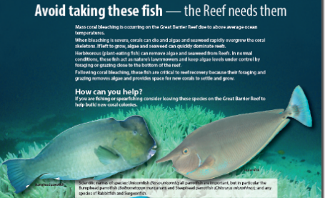
Local response to bleaching
The reefs offshore from Cape York suffered severely during the mass bleaching in 2016.

The committee wanted to do something practical to help the Reef recover. Seaweed, or algae, can quickly grow after a disturbance, taking up space that new corals need to settle on.
Some fish play an important role by eating the algae and clearing space for new coral. In an effort to protect the fish, the committee created a poster asking
spearfishers to avoid taking the important seaweed-eating fish while the Reef recovers.

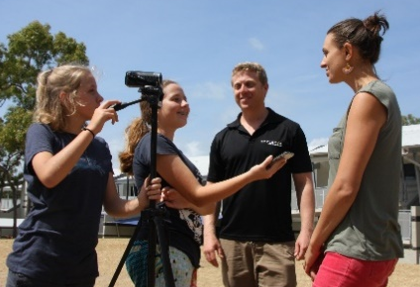
Film school
The Cape York Local Marine Advisory Committee sponsored the inaugural Cape York film school.
Cairns-based film producer Gus Burrows trained students in camera basics, interview techniques and film editing.
Students interviewed local residents for a short film to describe changes to the Great Barrier Reef since Captain Cook sailed past Cape York almost 250 years ago.

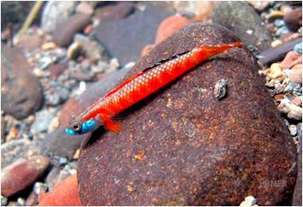
Regional meetings
The members are committed to visiting regional Cape York communities at least once a year, despite some of them being in remote and rugged areas.
Members travelled to Lakeland in 2016 and presented the local school with the committee’s ‘Keep Our Cape Clean’ water bottles and calico bags. In 2017, the committee held a public meeting in Bloomfield, which featured a talk about rare fish species discovered locally by researcher Dr Brendan Ebner. These meetings are a great opportunity to learn first-hand from Photograph: Dr. Brendan Ebner
communities about local issues.

Douglas LMAC

Coastal adaptation training
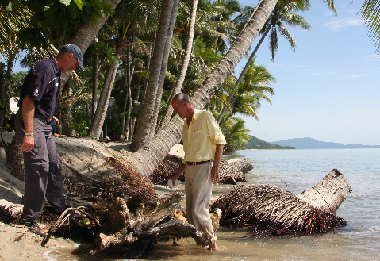
The Douglas Local Marine Advisory Committee recognises the Douglas Shire is vulnerable to extreme weather events and rising oceans, and the community needs to adapt to the changing climate.
It’s important to plan and prepare for future scenarios. In 2017, the committee supported a Douglas Shire Council officer to attend a university course in coastal hazard management in south-east Queensland. As a result, this is one of the first regions in Queensland to develop a coastal hazard adaptation strategy.

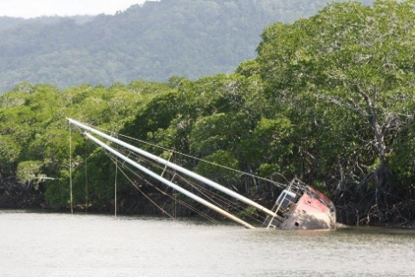
Wrecks in Dickson Inlet
More than a dozen vessels lie abandoned and sinking in popular anchorage site, Dickson Inlet. The wrecks are an eyesore, a navigational hazard and environmentally damaging to the Inlet.
The committee has been advocating for their removal, with the support of the Douglas Shire Council. Members will continue to call on the Queensland Government to address the short-term problem of removing the wrecks and provide a long-term response to stop the problem from recurring.
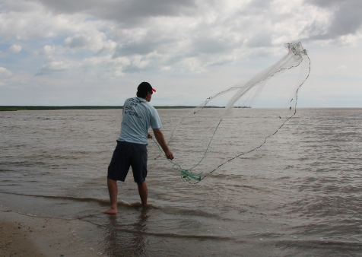
Bait netting best practice
Every wet season people come to the Douglas region’s beautiful beaches to net for prawns.
Unfortunately many juvenile fish also fall victim to the nets. In response, in 2017 the committee ran a campaign and competition in the local media promoting sustainable netting practices.
The committee received a lot of positive feedback and hopes it convinced locals to use a bait net rather than damaging drag nets.

Cairns LMAC

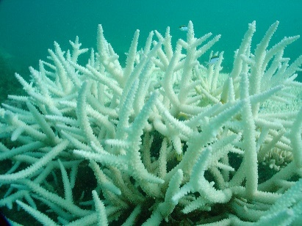
Coral bleaching
While mass coral bleaching in 2016 and 2017 kept the Cairns region in the global spotlight, it’s important to put the issue into context and help local communities understand it.

The committee hosted a community forum on bleaching in 2016 with representatives from research, conservation, fishing and tourism sectors.
The presentations provoked lively discussions and participants called for bipartisan involvement and investment to improve the Reef’s long-term outlook. There was broad agreement that while the Reef is battered and bruised, it is still beautiful and resilient and there are things that everyone can do to help.

Cairns port proposal
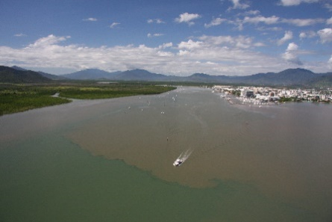
The proposed expansion of the Cairns port has been frequently discussed at committee meetings in 2017–18, with regular updates from the proponents as they adapted the concept to meet environmental challenges.
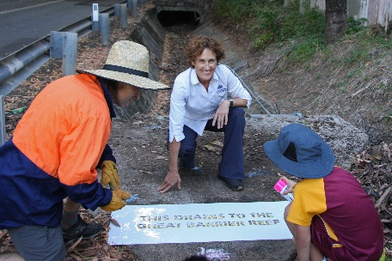
The committee commended the decision not to dump dredge spoil in the Great Barrier Reef, but remains concerned about the indirect impacts of disposing it on land. The diverse range of interests on the committee means it has been an invaluable forum to inform developers, such as the Port of Cairns.
Community projects
The Cairns Local Marine Advisory Committee supported several community projects, including drain stencilling, to raise awareness of urban pollution; plus the citizen science program MangroveWatch, which uses video assessments to monitor mangroves along Cairns shorelines. The data will feed into a national database called Shoreview.
Photograph: Campbell Clarke

Cassowary Coast

Plastic Free Awareness Campaign
The Cassowary Coast Local Marine Advisory Committee wants to encourage shoppers to kick the single-use plastic bag habit by bringing their own reusable bags, so committee members held a plastic-free awareness campaign in Mission Beach in July 2017.
The committee set-up an information outlet at the entry to Woolworths and showcased the Mission Beach Boomerang Bag project with sewing demonstrations.
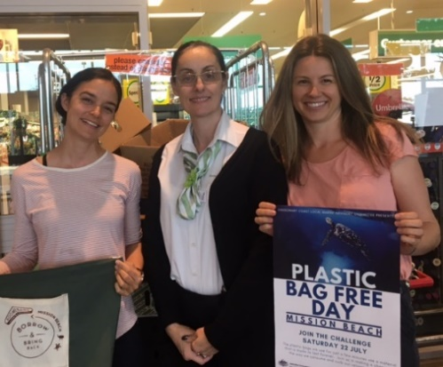
Over 800 shoppers were involved in the four-hour event, with over 100 reusable bags and hundreds of leaflets given out, providing tips on how to reduce plastic. Many shoppers stopped and shared information about what their local councils were doing about waste and plastic reduction. The Woolworths managers were supportive of the event and have welcomed the continuation of plastic awareness events at their store.

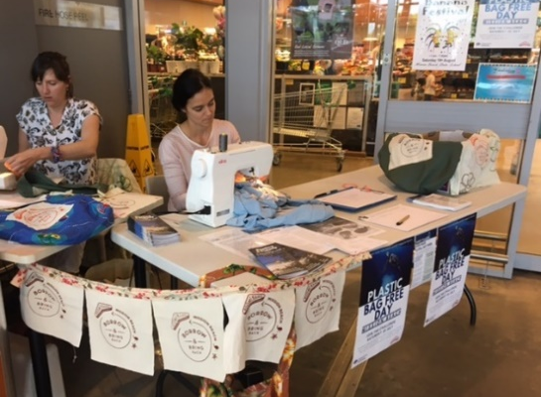

Left to right: Carmen Walker (LMAC member),
Jelena (Woolworths Mission Beach store manager)
and Katie Hatten (LMAC member).
Boomerang bags sewing demonstration

Seabed Watch Inc.
Seagrass has been slow to recover in some areas since prawn trawling stopped in the 1990s. With the added disturbance of cyclones Larry and Yasi, seagrass coverage is relatively low.
The committee has been funding seagrass monitoring in the area, in particular to Seabed Watch Inc., which has monitored seagrass in the Mission Beach area for 10 years. Monitoring is done by a local free dive team of citizen scientists who collect information on seagrass species and cover, sediment and algal cove.
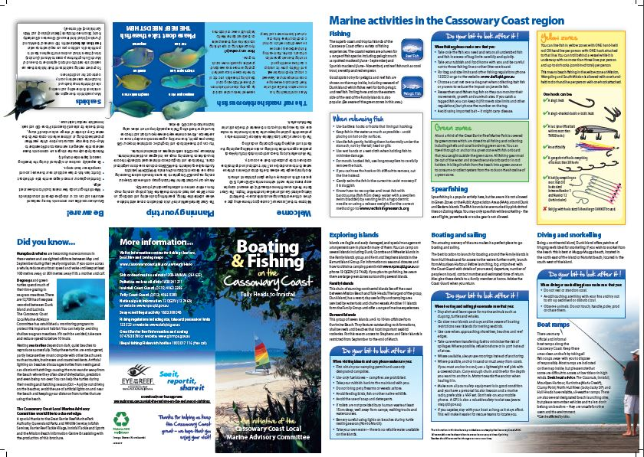
Cassowary Coast Fishing and Boating Brochure
The popular and informative Cassowary Coast fishing and boating brochure has been updated by the committee to include current information on turtle nesting, the importance of herbivorous fish and the Eye on the Reef app. It also includes a zoning map, rules and regulations surrounding marine activities, and tips for doing your bit to look after our marine environment and animals. Brochures are distributed to key outlets for locals and visitors.
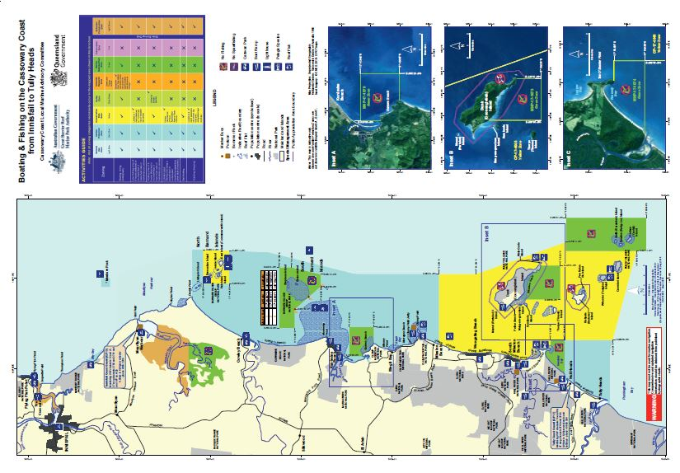

Hinchinbrook

Plastics and Micro Fibres in the Marine Environment
The Hinchinbrook Local Marine Advisory Committee hosted a public meeting at the Tyto Conference Centre in Ingham in 2017 to raise the profile of the effects of plastics in the marine environment.
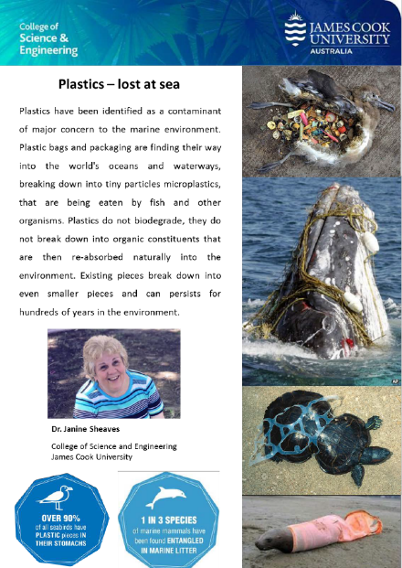
James Cook University’s Dr Janine Sheaves’ presentation was horrifying and enlightening, as she explained the source and fate of everyday items that find their way into our oceans. The effect of micro-fibres on the food chain, including potential human health implications that occurred from something as simple as washing your clothes, was particularly startling.This meeting reinforced the difference Local Marine Advisory Committees make and their role in raising awareness.

Hinchinbrook marine wonders
The issue of tourists and visitors not being aware of local fishing regulations, marine park zones, voluntary transit lanes, local information on islands and wildlife was originally identified by a member of the committee. The committee members, with support from other agencies, worked collaboratively to produce the Hinchinbrook Marine Wonders booklet. This booklet assists visitors and tourists to do the right thing while visiting the region and on the water.
The committee has reprinted this popular booklet, which included updates and additional information about the protection of islands and wildlife. This booklet is available through local information centres and a number of caravan parks in the Hinchinbrook area.

Townsville

Reef Recovery
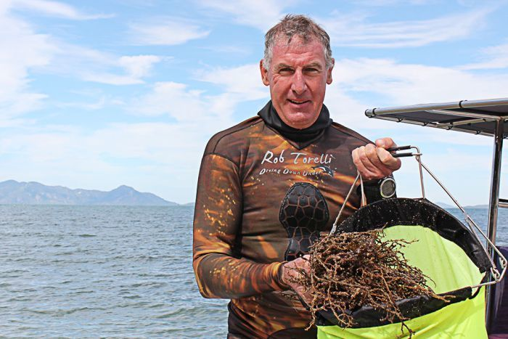
Reef Recovery was initiated by committee secretary Adam Smith on behalf of Reef Ecologic and Townsville Skin Diving Club. The citizen science project involved local and international people — including scientists — in a trial to remove what is reportedly an elevated level of the brown algae Sargassum muticum; which is dominating potential coral structure in Nelly Bay on Magnetic Island and other locations.
Two different-sized trial areas have been established; one using
2x2 4m2 plots and the other using 10x10 100m2 plots.
It is hoped by reducing a key competitor, corals will re-establish and increase as a percentage of biomass on the shallow fringing reef.
Photo ABC North QLD: Harriet Tatham

Deadly Science
Deadly Science provides an opportunity to elevate the role of young Aboriginal and Torres Strait Islander women from remote communities in marine science and leadership.
The project was initiated in 2012, by committee members and James Cook University researcher Blanche D’Anastasi. It funds travel and accommodation for people from remote communities to Orpheus Island where participants learn leadership and marine science skills.

Planning for change
Townsville is the largest population centre in the Great Barrier Reef and the range of issues in the region are diverse.
The Townsville Local Marine Advisory Committee has identified climate change, urban run-off and direct physical impacts, such as boat strike, as key issues. A long-term goal of the committee is to see as much renewable energy (with storage) on Great Barrier Reef islands and the mainland as possible. One example is Palm Island, which could move from diesel power to renewable energy with a combination of wind, solar and batteries, while keeping the diesel generators in location as an emergency backup. This would be similar, but at a larger scale, to what has been achieved at Hidden Valley Resort. While it’s just an idea, the committee continues to stay aware of developments in technology that could make this a reality.

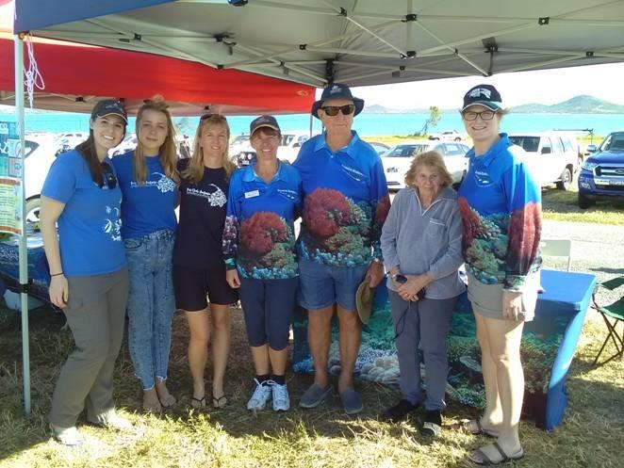
Bowen Burdekin

150 Year Lighthouse celebration
In 2017, over 1,000 people walked from the mainland to the lighthouse to celebrate 150 years of the Bowen Lighthouse.
The Bowen Burdekin Local Marine Advisory Committee and Reef Check set up an information stall on the beach to help walkers get there safely, with minimal impact on the environment. It was a great opportunity to talk to people and promote the Bowen Burdekin Local Marine Advisory Committee.

Members field trip
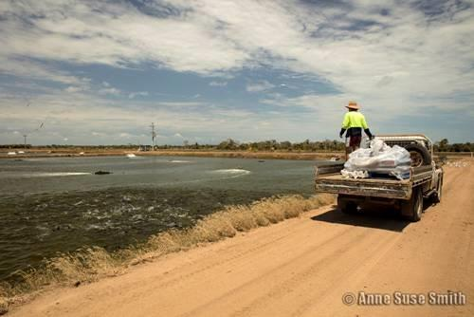
Committee members toured the Pacific Reef Fisheries and a local algae farm in 2017. It was an opportunity to learn about their challenges and see the advances in environmental management, such as growing mangroves in the holding ponds and cultivating algae, which cleans the nutrients from the prawn farm out-flow.

Photograph: Anne Suse Smith

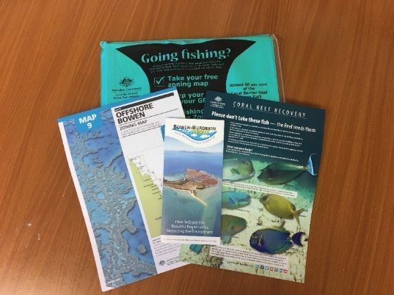
Packs for community
Committee members made information packs for travellers staying in the Bowen region.
The packs included a brochure about avoiding catching fish that help protect corals and a marine parks zoning map.
They were handed out to caravan parks and tourism information centres.

Whitsunday LMAC

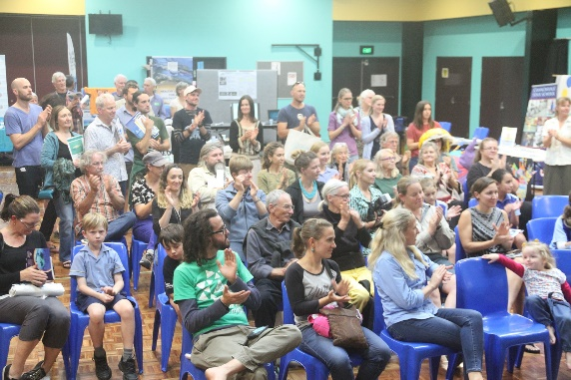
Celebrating Nature in the Whitsundays
Did you know that there are over 16 environment organisations in the Whitsunday region, all working hard to protect the incredible natural
resources of the area?

The Whitsunday Local Marine Advisory Committee celebrated this fact with Nature Celebration Whitsundays.
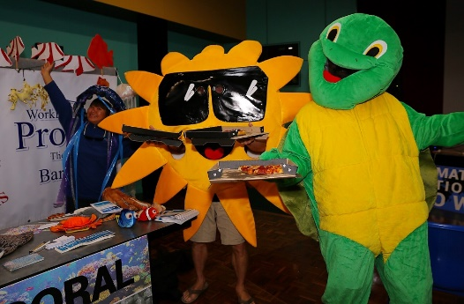
The event brought together local environmental groups and their members to celebrate their work and passion. The public was also invited to meet the groups and get a better understanding of local environmental issues in a relaxed and fun evening.

Go slow for those below
In July 2017, the committee launched two videos encouraging boaties to ‘go slow for those below’. The videos were done with the help of local community members and Cannonvale State School — a Reef Guardian School — and have been viewed over 3,500 times.
See the videos at https://www.facebook.com/ReefCatchments/videos/1452957138107369/ and https://vimeo.com/225917580
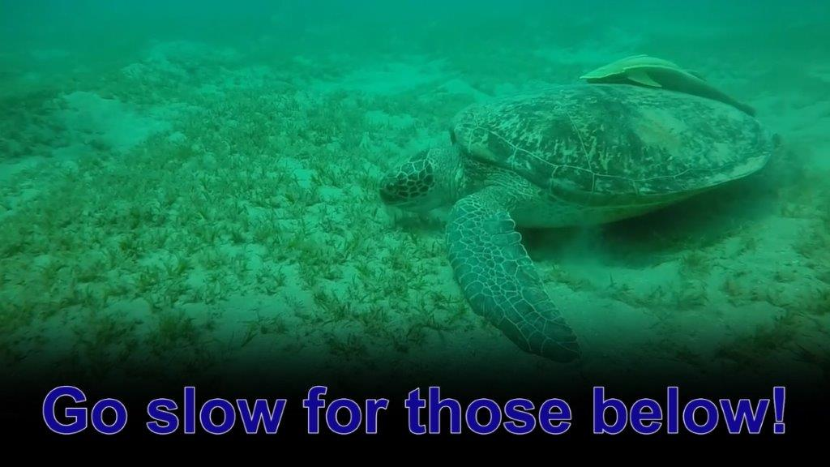

Spearfishing Brochure
The Whitsundays is one of the Great Barrier Reef’s most visited regions, with the greatest concentration of users. Spearfishing is a popular activity in the area and — until now — there wasn’t an easy reference to show where spearfishing could and couldn’t occur. The Spearfishing in the Whitsundays guide was initiated by the committee and is available via the Great Barrier Reef Marine Park Authority website.

Mackay

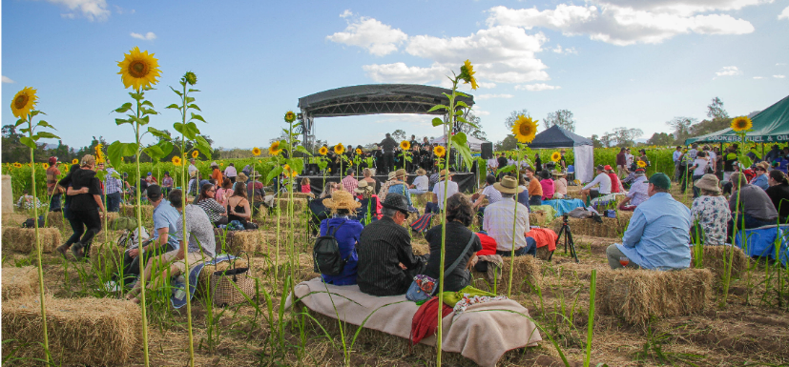
Symphony in the sunflowers
In July 2017, Mackay Local Marine Advisory Committee supported an innovative collaboration between Marian farmer Simon Mattsson and New South Wales artists Kim Williams and Lucas Ihlein.
The team carved out an amphitheatre from Simon’s dual crop of sugarcane and sunflowers and hosted a gala community event featuring the Mackay Youth Orchestra, the Sakwolo Islander Dancers, and food from The Family Table.
The event brought together a diversity of people including farmers, musicians, artists, and members of the Australian South Sea Islander community, to learn about the crucial role played by regenerative agriculture in promoting healthy soils and reducing the impact of agriculture on the Great Barrier Reef. The evening culminated in the presentation of a documentary about artists and farmers joining forces to transform the public’s understanding of farming.
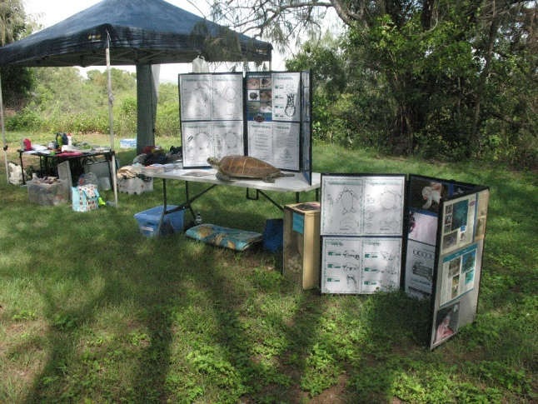
Mackay District Turtle Watch
The Mackay District Turtle Watch Association has had a representative on the Mackay LMAC for over 10 years. LMAC supported the Association by purchasing new display boards to use in schools to teach students about turtle lifecycles and threats. Students also go on field trips to learn how to identify turtle nests on the beach and how they can help protect turtles in the Marine Park.

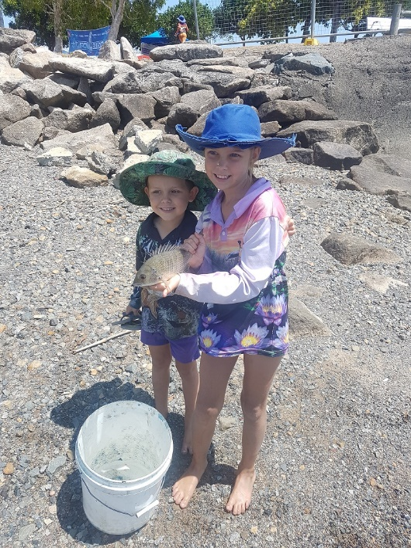
Mackay Recreational Fishers Alliance
The Mackay Recreational Fishers Alliance’s school fish program has educated over 10,000 school children over the last 10 years.
The program is supported by the committee and sees volunteers teaching students about all aspects of angling — from how to assemble and care for fishing equipment and environmental awareness, to bag and size limits. The classroom activities are followed by field trips to a local creek or beaches.

Capricorn Coast LMAC
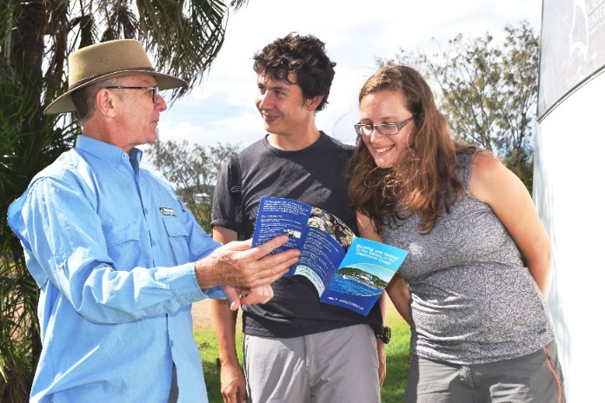

Boating and fishing guide
An informed local perspective of an area is always invaluable for residents and visitors.
The Boating and fishing in the waters of the Capricorn Coast brochure provides this service.
The committee supported an update and reprint of the brochure, which includes Great Barrier Reef Marine Parks zoning, camp site, boat ramp and local features information.

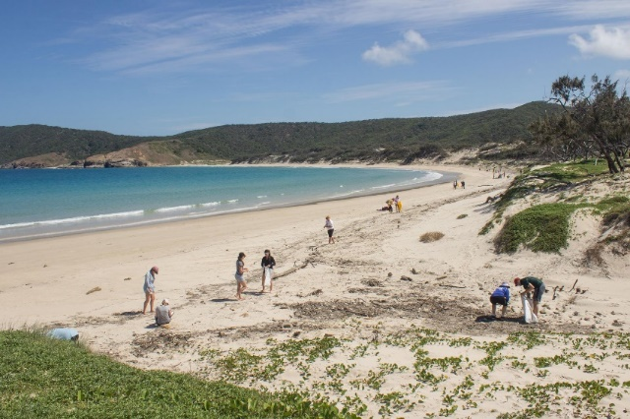
Marine debris
The Capricorn Coast Local Marine Advisory Committee (along with other LMACs across the Great Barrier Reef) provided funding to Tangaroa Blue to develop an app which collects data about marine debris. The app was highlighted by the Australian Government’s senate inquiry into marine debris and is aimed at empowering citizen scientists to easily submit marine debris data during beach clean-ups. The data is used to raise awareness of the issue and help inform management agencies about the state of marine debris in the World Heritage Area and promote change.

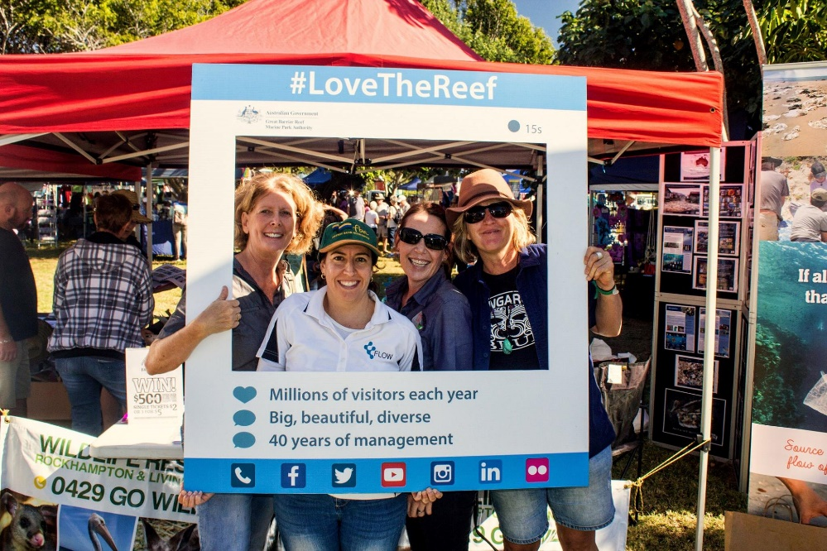
Microbeads
Microbeads are tiny plastic beads used in soaps and skin products and are polluting our oceans and food chain. The committee instigated and coordinated advice, from the majority of LMACs, to the Authority and Department of Environment and Energy, supporting a ban on the use of microbeads in Australian retail products.
This advice ties in with the 2014 Outlook Report which identified marine debris as a ‘high risk’ to the Great Barrier Reef ecosystem and heritage values, and was seeking to support a shift from voluntary compliance to regulation.

Gladstone LMAC

Marine debris
Marine debris has been a major focus of the committee over the past few terms. Individually, and as a committee member, members have promoted marine debris awareness, helped in beach clean ups, carried out marine debris surveys and even removed a wrecked vessel from a reef, and thereby preventing it from disintegrating. Some creative members have also developed a business using recycled materials in artworks, school projects, for public events and to raise awareness. Committee funds were also directed to Tangaroa Blue to develop a marine debris app for infield recording of marine debris locations.
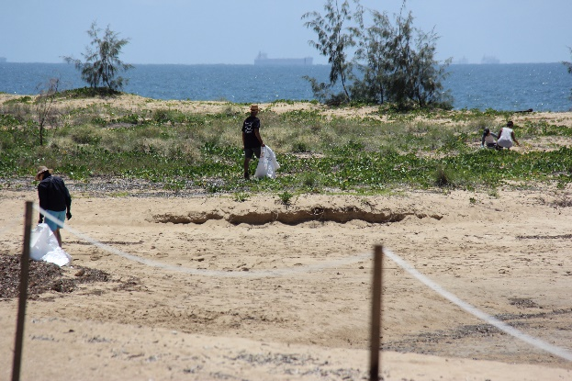
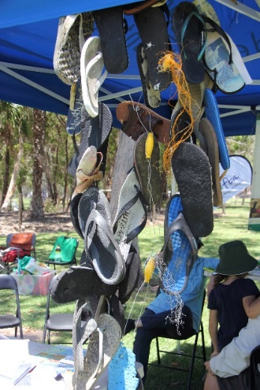
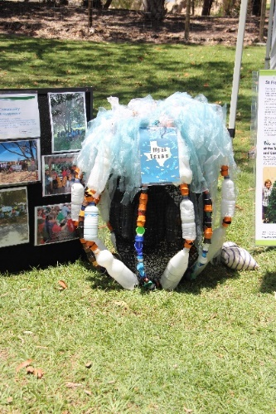

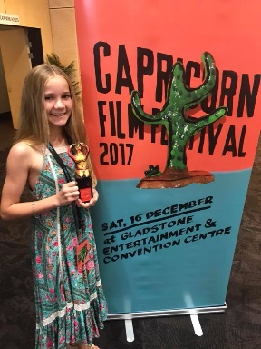
Short video competition
Films are a great way to raise awareness about threats to the Great Barrier Reef. The committee has supported a schools short film competition, which received such a positive response from schools, that a Reef Short Film category was incorporated into the Capricorn Film Festival.
The quality of film making, the creative talent and the enthusiasm shown for this project is a wonderful way to engage younger people in learning about the Reef and its management.

Promotional LMAC video
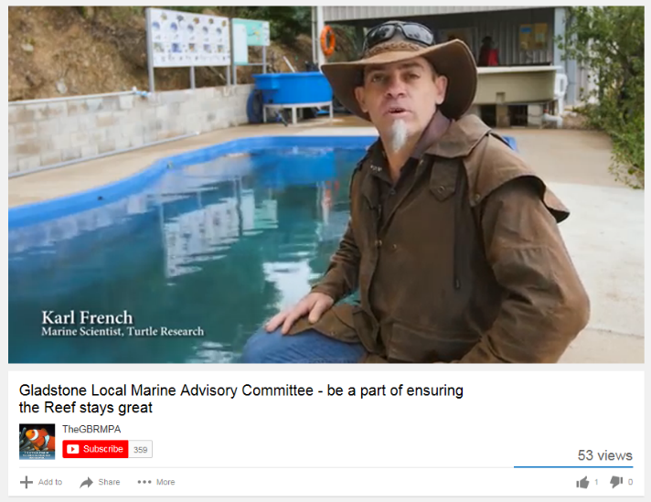
The Gladstone Local Marine Advisory Committee produced a short video to address the decline in local membership. The video raises awareness of what LMACs do, how people are involved and how they are a conduit for information from the Authority to the local community. The video highlighted the diverse group the members come from and the goals and aspirations of members working alongside managers of the Reef. It has since been shown at a number of local events including the Tannum Boyne Hook-up fishing competition, Gladstone Eco Fest, and a Conservation Volunteers Reef Blitz event.

Burnett LMAC

Turtles
The committee has supported a number of turtle projects in conjunction with the Sea Turtle Alliance, including the purchase of wet weather gear and headlamp chargers for the group.
In 2017, the committee funded the launch of a Junior Turtle Ranger program with a video on their achievements for social media, to promote turtle conservation to a new generation.
After many years of community effort, the numbers of turtles are starting to recover, but nesting loggerheads and their hatchlings now face a new threat with urban development and light pollution, so the committee must now help ‘Stop the glow to help turtles go!’
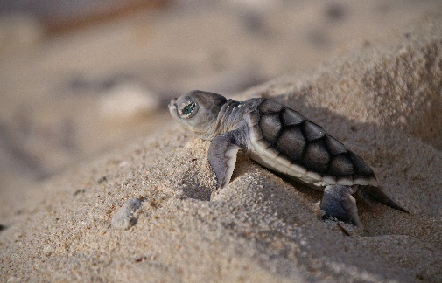
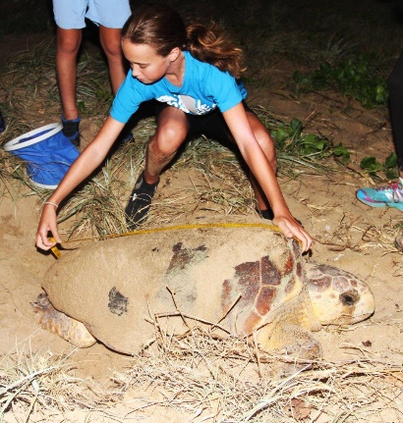
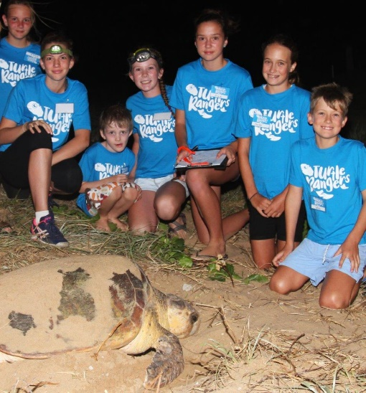

Sustainable fishing
The Burnett Local Marine Advisory Committee has supported Bundaberg Sport Fishing Club to buy tags. The club has an active tag and release program, which provides information on size, age and growth rates and fish movement — all critical information for fisheries managers.
The longest distance an Australian Bass moved was 320 kilometres, with the fish tagged in Lake Boondooma in 2006 and recaptured 2,703 days (7.4 years) later in 2014 in Splitters Creek near Bundaberg. The fish went over two dam walls and four weirs.
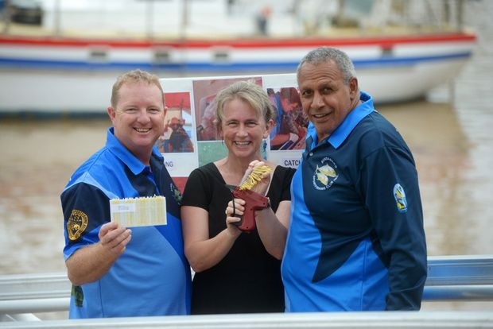
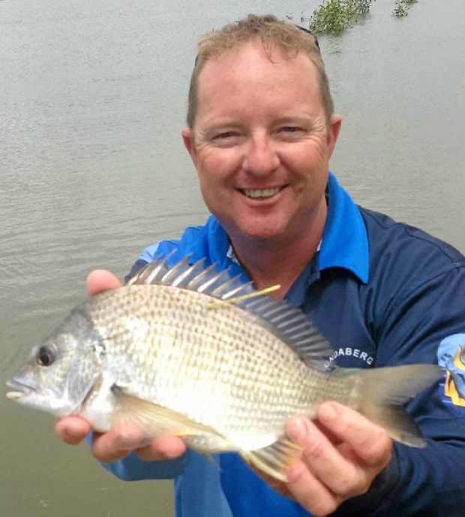
Photographs: Bundaberg Sport Fishing Club

Marine debris
Following a major flood and marooning and decomposition of a large styrofoam pontoon, the committee urged the Queensland Government to change the Code for Assessable Development: Tidal Works. In 2013, this was achieved with new requirements for pontoons to be restrained and for infrastructure to be marked with an identification plate.
The committee also supported the Container Refund Scheme and the banning of single use plastic bags, both of which will be introduced in Queensland in July 2018.
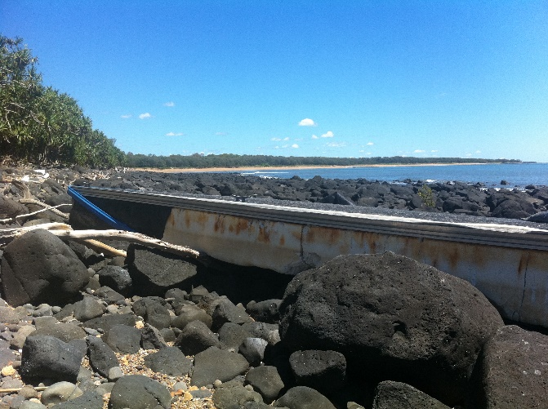
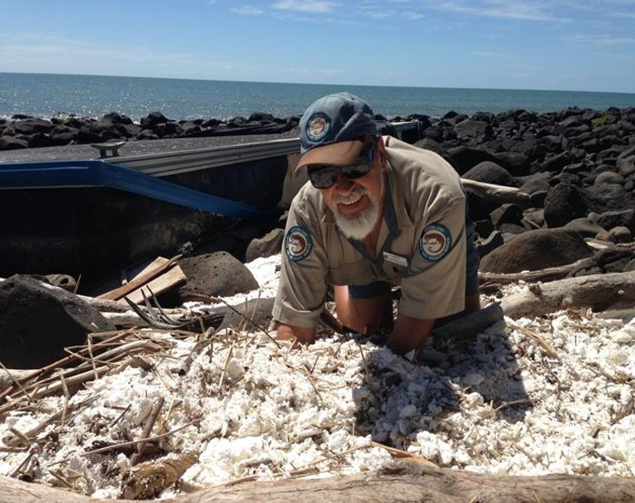
If you knew that each plastic drink bottle was going to last 600 years would you think twice about using your own bottle? Marine debris timeline activity and reminder book labels are delivered by the committee at Future Leader Eco Challenge events. This is a really practical way of communicating the seriousness of plastic waste.
Photographs: Karl French

Find out more

With the Reef facing unprecedented pressure from a range of impacts including climate change, declining water quality, coastal development and illegal fishing, Local Marine Advisory Committees are more relevant than ever.
Members come from a diverse range of backgrounds with a variety of skill sets, but all are united in the common goal of encouraging and empowering local communities to take action to reduce threats and build Reef resilience.
More information on the Local Marine Advisory Committees, their work and membership is available at www.gbrmpa.gov.au

