Reef Rescue Marine Monitoring Program

Inshore Water Quality and Coral Reef Monitoring
Annual Report of AIMS Activities 2012 to 2013

Angus Thompson, Britta Schaffelke, Murray Logan
Paul Costello, Johnston Davidson, Jason Doyle, Miles Furnas, Kevin Gunn,
Michelle Liddy, Michele Skuza, Sven Uthicke, Margaret Wright, Irena Zagorskis

December 2013

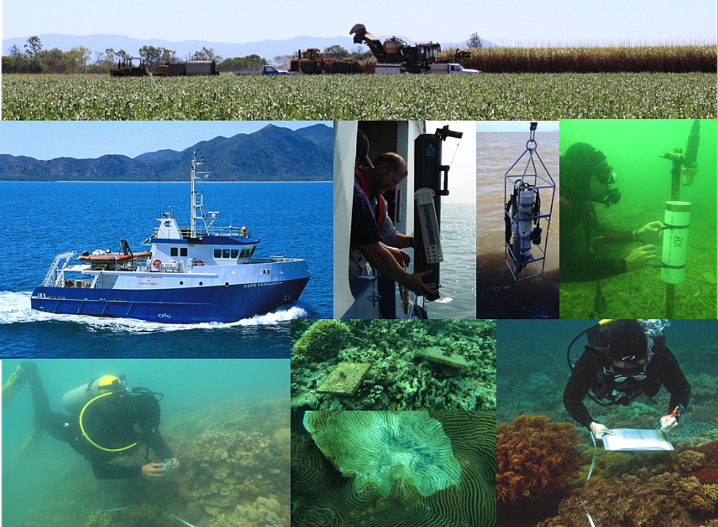

Australian Institute of Marine Science
PMB No 3
Townsville MC Qld 4810

This report should be cited as:
Thompson A, Schaffelke B, Logan M, Costello P, Davidson J, Doyle J, Furnas M, Gunn K, Liddy M, Skuza M, Uthicke S, Wright M and Zagorskis I (2013) Reef Rescue Marine Monitoring Program. Annual Report of AIMS Activities 2012 to 2013– Inshore water quality and coral reef monitoring. Report for the Great Barrier Reef Marine Park Authority. Australian Institute of Marine Science, Townsville. 182 pp.

© Copyright .Australian Institute of Marine Science (AIMS) 2013
All rights are reserved and no part of this document may be reproduced, stored or copied in any form or by any means whatsoever except with the prior written permission of AIMS.

DISCLAIMER
While reasonable efforts have been made to ensure that the contents of this document are factually correct, AIMS does not make any representation or give any warranty regarding the accuracy, completeness, currency or suitability for any particular purpose of the information or statements contained in this document. To the extent permitted by law AIMS shall not be liable for any loss, damage, cost or expense that may be occasioned directly or indirectly through the use of or reliance on the contents of this document.

Contents
List of Figures and Tables ii
List of Figures and Tables-Appendices iii
Executive Summary v

Preface 1
1. Introduction 2

2. Methods summary 5
2.1 Sampling design 5
2.2 Sampling methods 5
2.2.1 Water quality monitoring 7
2.2.2 Sea temperature monitoring 8
2.2.3 Sediment quality monitoring 8
2.2.4 Foraminifera monitoring 8
2.2.5 Benthic community sampling 8
2.3 Data analyses 9
2.4 Water type classifications 9

3. Results and discussion 10
3.1 Regional reports 11
3.1.1 Wet Tropics Region: Barron Daintree sub-region 11
3.1.2 Wet Tropics Region: Johnstone Russell-Mulgrave sub-region 16
3.1.3 Wet Tropics Region: Herbert Tully sub-region 23
3.1.4 Burdekin Region 28
3.1.5 Mackay Whitsunday Region 34
3.1.6 Fitzroy Region 40
3.2 Case study: Trends in coral settlement 46
3.3 Case study: The importance of long-term time series in water quality monitoring 52

4. Conclusion 56
Acknowledgments 62

5. References 63

Appendix 1: Material and Methods 76
A1.1 Water quality monitoring methods 77
A1.3 Coral reef monitoring methods 84

Appendix 2: Additional Information 94

Appendix 3: QAQC Information 136

Appendix 4: Ongoing efforts to improve calibration and validation of chlorophyll estimates from WET Labs ECO FLNTUSB loggers 143

Appendix 5: Scientific publications and presentations arising from the Programme 2012-13 182

List of Figures and Tables
Figure 1 Ecosystem health indicators. vi
Figure 2 Sampling locations of the MMP coral and water quality monitoring. 6
Figure 3 MMP sampling sites in the Barron Daintree sub-region. 11
Figure 4 Combined discharge for the Barron and Daintree Rivers. 12
Figure 5 Sea temperature for the Barron Daintree sub-region. 12
Figure 6 Water quality trends in the Barron Daintree sub-region. 14
Figure 7 Coral reef community and sediment quality trends in the Barron Daintree sub-region. 15
Figure 8 MMP sampling sites in the Johnstone Russell-Mulgrave sub-region. 16
Figure 9 Combined discharge for the North and South Johnstone, Russell and Mulgrave rivers. 17
Figure 10 Sea temperature for the Johnstone Russell-Mulgrave sub-region. 17
Figure 11 Water quality trends in the Johnstone Russell-Mulgrave sub-region. 20
Figure 12 Coral reef community and sediment quality trends in the Johnstone Russell-Mulgrave sub-region. 21
Figure 13 MMP sampling sites in the Herbert Tully sub-region. 23
Figure 14 Combined discharge for Tully and Herbert Rivers. 24
Figure 15 Sea temperature for the Herbert-Tully sub-region. 24
Figure 16 Water quality trends in the Herbert-Tully sub-region. 26
Figure 17 Coral reef community and sediment quality trends in the Herbert-Tully sub-region. 27
Figure 18 MMP sampling sites in the Burdekin NRM Region. 28
Figure 19 Discharge for the Burdekin River. 29
Figure 20 Sea temperature for the Burdekin region. 29
Figure 21 Water quality trends in the Burdekin region. 32
Figure 22 Coral reef community and sediment quality trends in the Burdekin region. 33
Figure 23 MMP sampling sites in the Mackay Whitsunday NRM Region. 34
Figure 24 Combined discharge for the O'Connell, Proserpine and Pioneer Rivers. 35
Figure 25 Sea temperature for the Mackay Whitsunday region. 35
Figure 26 Water quality trends in the Mackay Whitsunday region. 38
Figure 27 Coral reef community and sediment quality trends in the Mackay Whitsunday region. 39
Figure 28 MMP sampling sites in the Fitzroy NRM Region. 40
Figure 29 Discharge for the Fitzroy River. 41
Figure 30 Sea temperature for the Fitzroy region. 41
Figure 31 Water quality trends in the Fitzroy region. 44
Figure 32 Coral reef community and sediment quality trends in the Fitzroy region. 45
Figure 33 Observed settlement of Acroporidae. 47
Figure 34 Partial effects plots of covariates to Acroporidae settlement. 49
Figure 35 Relationship between settlement and the maximum cover of adult Acroporidae. 50
Figure 36 Water quality index scores 1992-2013. 52
Figure 37 Long-term water quality trends along the Cairns Transect. 54
Figure 38 Combined river discharge (blue line) and annual woody vegetation clearing rate for
the Barron and Daintree catchments. 55

Table 1 Sampling locations of the MMP coral and water quality monitoring. 7

List of Figures and Tables-Appendices
Appendix 1: Material and Methods
Table A1- 1 Trigger values from the GBRMPA Water Quality Guidelines for the Great Barrier Reef Marine Park and the Queensland Water Quality Guidelines. 80
Table A1- 2 Summary of sampling methods applied in the MMP inshore coral reef monitoring. 85
Table A1- 3 Locations and periods of coral settlement tile deployment for 2012 spawning. 88
Table A1- 4 Coral settlement tile sampling. Filled cells indicate year and location of sampling. 88
Table A1- 5 Threshold values for the assessment of coral reef condition and resilience 93

Appendix 2: Additional Information
Figure A2- 1 Time series of daily means of chlorophyll (green line) and turbidity (red line)
collected by ECO FLNTUSB instruments. 103
Figure A2- 2 Seasonal trends in water quality variables in reporting (sub-) regions. 108
Figure A2- 3 Cover of major benthic groups and density of hard coral juveniles for reefs in the Daintree sub-region. 121
Figure A2- 4 Cover of major benthic groups and density of hard coral juveniles for reefs in the Johnstone sub-region. 122
Figure A2- 5 Cover of major benthic groups and density of hard coral juveniles for reefs in the
Tully sub- region. 124
Figure A2- 6 Cover of major benthic groups and density of hard coral juveniles for reefs in the Burdekin region. 126
Figure A2- 7 Cover of major benthic groups and density of hard coral juveniles for reefs in the Mackay Whitsunday region. 129
Figure A2- 8 Cover of major benthic groups and density of hard coral juveniles for reefs in the
Fitzroy region. 132
Figure A2- 9 Regional trends in coral settlement. 134
Figure A2- 10 Incidence of coral mortality. 135

Table A2- 1 Annual freshwater discharge for the major GBR Catchments. 95
Table A2- 2 Summary statistics for direct water sampling data from inshore lagoon sites from August 2005-June 2013. 96
Table A2- 3 Summary of turbidity (NTU) data from ECO FLNTUSB instruments at 14 inshore
reef sites. 101
Table A2- 4 Interim water quality index for each water quality sampling location. 109
Table A2- 5 Disturbance histories for coral monitoring locations. 116
Table A2- 6 Report card metric assessments for benthic communities at each reef and depth
based on 2013 condition. 118
Table A2- 7 Report card metric scores for coral and foraminifera communities through time
within each (sub-)region 120

Appendix 3: QAQC Information
Figure A3- 1 Match-up of duplicate samples analysed for chlorophyll a by fluorometry and HPLC. 140
Figure A3- 2 Match-up of instrument readings of turbidity (NTU) from field deployments of WET Labs Eco FLNTUSB Combination Fluorometer and Turbidity Sensors with values from standard laboratory analysis of concurrently collected water samples. 141

Table A3- 1 Limit of detection (LOD) for analyses of marine water quality parameters. 137
Table A3- 2 Summary of coefficients of variation (CV, in %) of replicate measurements (N) of a standard or reference material. 138
Table A3- 3 Summary of average recovery of known analyte concentrations. 138
Table A3- 4 Summary of average Z-scores of replicate measurements (N) of a standard or reference material. 139
Table A3- 5 Comparison of instrument readings of wet filter blanks to actual sample readings 140

Appendix 4: Ongoing efforts to improve calibration and validation of chlorophyll estimates from WET Labs ECO FLNTUSB loggers
Figure A4- 1 The analysis status of the logger chlorophyll data set as of mid-September 2013. 145
Figure A4- 2 Calibrations used in working up the chlorophyll logger data set. 146
Figure A4- 3 A comparison between chlorophyll concentrations estimated by Wet Labs loggers and in situ chlorophyll sampled manually at the time of logger change-overs.. 148
Figure A4- 4 Comparisons between logger chlorophyll concentrations measured at Snapper Island in the 24 hours before and after a change-over and the chlorophyll concentration determined from manual sampling at the changeover. 152
Figure A4- 5 Comparisons between logger chlorophyll concentrations measured at Fitzroy Island in the 24 hours before and after a change-over and the chlorophyll concentration determined from manual sampling at the changeover. 152
Figure A4- 6 Comparisons between logger chlorophyll concentrations measured at High Island in the 24 hours before and after a change-over and the chlorophyll concentration determined from manual sampling at the changeover.. 153
Figure A4- 7 Comparisons between logger chlorophyll concentrations measured at Russell Island in the 24 hours before and after a change-over and the chlorophyll concentration determined from manual sampling at the changeover. 153
Figure A4- 8 Comparisons between logger chlorophyll concentrations measured at Dunk Island in the 24 hours before and after a change-over and the chlorophyll concentration determined from manual sampling at the changeover.. 154
Figure A4- 9 Comparisons between logger chlorophyll concentrations measured at Pelorus Island in the 24 hours before and after a change-over and the chlorophyll concentration determined from manual sampling at the changeover. 154
Figure A4- 10 Comparisons between logger chlorophyll concentrations measured at Pandora Reef in the 24 hours before and after a change-over and the chlorophyll concentration determined from manual sampling at the changeover. 155
Figure A4- 11 Comparisons between logger chlorophyll concentrations measured at Geoffrey Bay in the 24 hours before and after a change-over and the chlorophyll concentration determined from manual sampling at the changeover. . 155
Figure A4- 12 Comparisons between logger chlorophyll concentrations measured at Double Cone Island in the 24 hours before and after a change-over and the chlorophyll concentration determined from manual sampling at the changeover. 156
Figure A4- 13 Comparisons between logger chlorophyll concentrations measured at Daydream Island in the 24 hours before and after a change-over and the chlorophyll concentration determined from manual sampling at the changeover. . 156
Figure A4- 14 Comparisons between logger chlorophyll concentrations measured at Pine Island in the 24 hours before and after a change-over and the chlorophyll concentration determined from manual sampling at the changeover. 157
Figure A4- 15 Comparisons between logger chlorophyll concentrations measured at Barren Island in the 24 hours before and after a change-over and the chlorophyll concentration determined from manual sampling at the changeover. 157
Figure A4- 16 Comparisons between logger chlorophyll concentrations measured at Humpy Island in the 24 hours before and after a change-over and the chlorophyll concentration determined from manual sampling at the changeover. . 158
Figure A4- 17 Comparisons between logger chlorophyll concentrations measured at Pelican Island in the 24 hours before and after a change-over and the chlorophyll concentration determined from manual sampling at the changeover. 158
Figure A4- 18 Differences between 24-hour median chlorophyll concentrations (µg L⁻¹) measured by pairs of loggers (outgoing, incoming) at logger changeovers.. 159
Figure A4- 19 Time series of raw chlorophyll readings from 12 loggers deployed simultaneously from the AIMS wharf in January 2012. 160
Figure A4- 20 Time series of raw chlorophyll readings from 14 loggers deployed simultaneously from the AIMS wharf in May 2012. 161
Figure A4- 21 Time series of raw chlorophyll readings from 16 loggers deployed simultaneously from the AIMS wharf in July 2013. . 162

Table A4- 1 A summary of the closeness of join between contiguous logger chlorophyll records and with discrete chlorophyll determined at logger changeovers. 151
Table A4- 2 Mean deviations of individual, de-trended logger chlorophyll records from the time series of mean values in each of seven experiments carried out at the AIMS wharf during 2012 and 2013. 163

Executive Summary
The management of water quality remains an essential requirement to ensure the long-term protection of the coastal and inshore ecosystems of the Great Barrier Reef (GBR). The land management initiatives under the Australian and Queensland Government's Reef Water Quality Protection Plan (Reef Plan) are key tools to improve the water quality entering the GBR with the goal “To ensure that by 2020 the quality of water entering the reef from broadscale land use has no detrimental impact on the health and resilience of the Great Barrier Reef.” This report summarises the results of water quality and coral reef monitoring activities, carried out by the Australian Institute of Marine Science as part of the Reef Rescue Marine Monitoring Program (MMP) from 2005 to 2013.

Methods
The key goal of the MMP inshore water quality and coral reef monitoring components is to quantify temporal and spatial variation in inshore coral reef community condition and relate this variation to differences in local reef water quality. The sampling design was selected for the detection of change in benthic communities on inshore reefs in response to changes in water quality parameters. Within each of four Natural Resource Management (NRM) regions: Wet Tropics, Burdekin, Mackay Whitsunday and Fitzroy, sites were selected along a gradient of exposure to runoff to ensure coverage of communities occupying a range of environmental conditions.

Reefs were designated as either ‘core’ or ‘cycle’ reefs. At the 14 core reefs, detailed manual and instrumental water sampling was undertaken as well as annual surveys of reef status including the monitoring of coral recruitment, the foraminifera (FORAM) index, and sediment quality. The 18 cycle reefs are visited every other year for surveys of reef status including the monitoring of sediment quality. Originally cycle reefs were sampled each year (2005 and 2006) however the sampling design was altered in 2007 as a result of fiscal limitations. Sampling cycle reefs in alternate years was as cost effective solution to maintaining the spatial coverage of the program. Sampling of the six open water stations of the long-term ‘AIMS Cairns Transect’ was also continued.

Trends in key ecosystem health indicators
In this report we provide temporal trends of water quality indicators, together with trends in sediment quality and coral reef condition indicators. The water and sediment quality around inshore reefs declined in response to increased river flows, which are used here as a proxy for river loads of sediments, nutrients and pollutants. These changed environmental conditions had clear impacts on the resilience of inshore coral reef communities.

The general trends of key ecosystem health indicators, summarised as report card indices, are presented at the scale of geographic regions, corresponding to the four NRM regions, to give a general overview of major changes in the water quality and benthic community composition at inshore coral reefs in the central and southern GBR (Figure 1).

In contrast to water quality which has maintained ‘good’ index scores throughout the program, the overall condition of reefs in the Wet Tropics Region has continued to decline from 2010 to be assessed as ‘poor’ in 2013. In each sub-region coral disease, cyclones and crown-of-thorns starfish have variously reduced coral cover. In the Barron-Daintree and Johnstone Russell-Mulgrave regions high levels of coral disease in 2010 and 2011 in combination with crown-of-thorns seastars outbreaks, have reduced coral cover. Cyclone Yasi in 2011 also reduced coral cover in the in the Johnstone Russell-Mulgrave sub-region and further reduced cover in the Herbert Tully sub-region compounding the substantial disturbance caused by Cyclone Larry in 2006. Following coral losses there has been a general increase in the cover of macroalgae in all sub-regions, especially on reefs situated closer to the coast or on the sheltered sides of islands where exposure to pollutants is greatest. The proliferation of macro algae indicates the potential that despite regionally good assessments, water quality at some sites is sufficiently poor to foster macroalgal blooms that will in turn reduce the rate coral communities recover from disturbances. The decline to low densities of juvenile corals in both the Barron-Daintree and Johnstone Russell-Mulgrave regions, provide evidence for a lack of recovery potential within the coral communities that likely stems from a combination of the loss of adult coral cover and the increase in macroalgae. In contrast, while coral cover is still very low in the Herbert Tully sub-region following the severe reductions caused by Cyclone Yasi in 2011, increases in the density of juvenile corals indicates some level of recovery.

Within this region the direct responses of coral communities to fluctuations in water quality associated with variation in the flow of local rivers are not as clear as in other regions, likely because of the lower magnitude of flow variation in this region. This means that flood conditions do not represent as dramatic a change in conditions as those observed during flooding of the larger rivers to the south. Of added concern in this region are the larger, GBR-scale implications of water quality such as proposed links between crown-of-thorn seastar outbreaks and runoff-derived nutrients. Certainly the present outbreaks of crown-of-thorns seastars on reefs in this region coincide with the onset of high flows to the GBR post 2006.

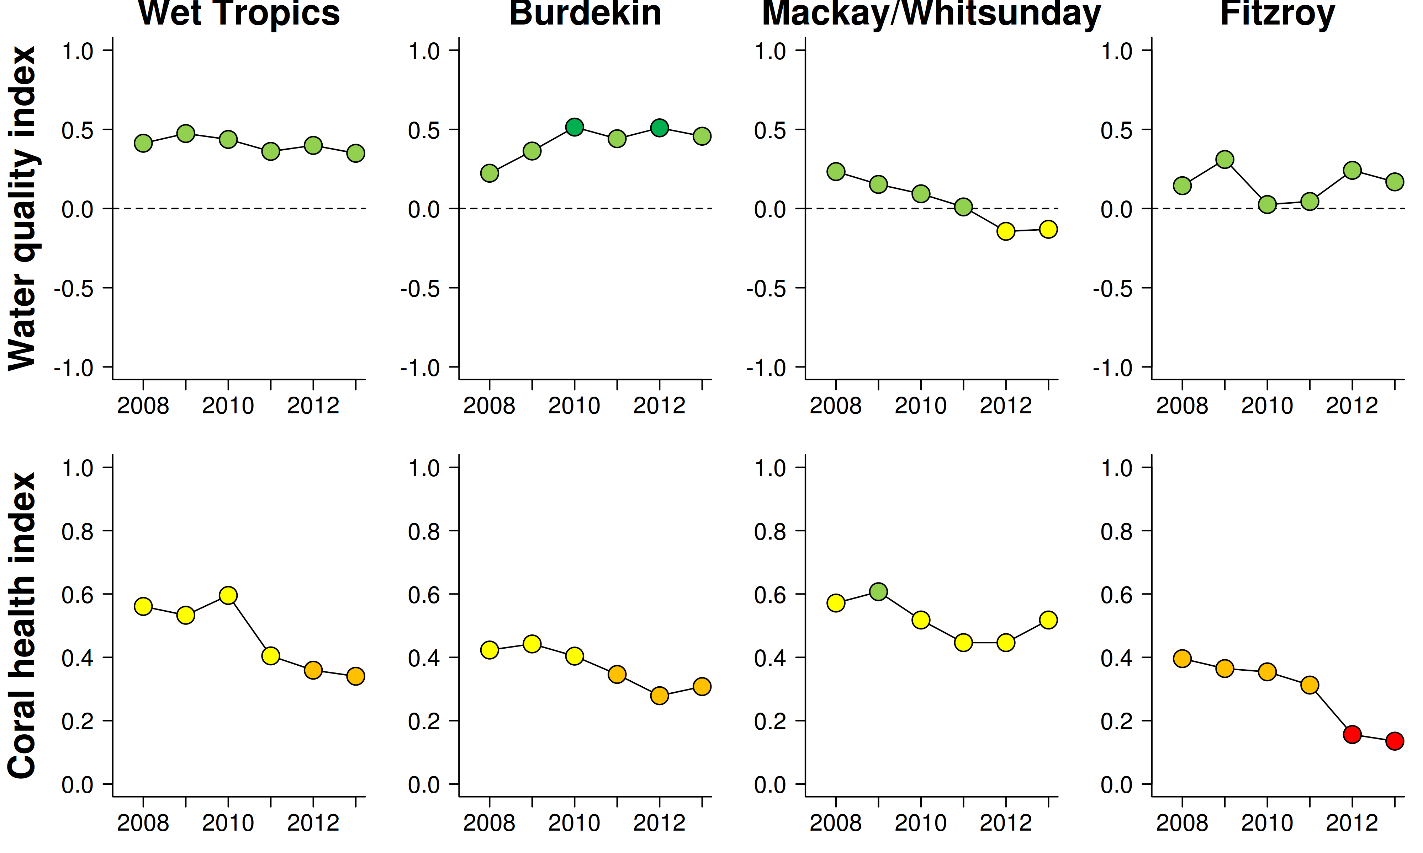
Figure 1 Ecosystem health indicators.
The water quality index aggregates scores for four indicators: concentrations of particulate phosphorus, particulate nitrogen and chlorophyll and a combined water clarity indicator (suspended solids, turbidity and Secchi depth), relative to Guideline values (GBRMPA 2010). The coral health index aggregates the attributes: cover of corals, cover of macroalgae, density of juvenile corals and the rate of coral cover increase. Red= very poor, orange= poor, yellow= moderate, light green= good, dark green= very good. Detailed derivation of scores can be found in Appendix 1.2.3 and Appendix tables A2-3 and A2-5.

The overall condition of the water quality in the Burdekin Region has improved over the course of the MMP monitoring, with continuous overall index scores of ‘good’ or ‘very good’ since 2008. In contrast, the condition of coral communities remains ‘poor’ following several years of decline. For coral communities the current ‘poor’ condition has been influenced by low coral cover as a result of disturbances, most recently Cyclone Yasi. Regionally low coral cover will have contributed to low and declining settlement of larvae with flow-on effects to low numbers of juvenile corals. Of concern are two indications that environmental conditions may be compounding the effects of disturbance and so further suppressing the recovery potential of coral communities. Firstly, relatively high levels of disease coincided with the change from a period of below median discharges from the Burdekin River to a period of wetter years implying environmental conditions had changed sufficiently to cause mortality among sensitive species and result in a further reduction of coral cover. Secondly, the cover of macroalgae has been persistently high on four of the five reefs with the poorest water quality. Macroalgae can suppress the recovery of coral communities following disturbance and will have contributed to the observed low densities of juvenile corals and low rates of cover increase on those reefs.

The overall condition of the water quality in the Mackay Whitsunday Region has steadily declined over the course of the MMP monitoring to attain a ‘moderate index score over the last two years. This decline most likely reflects the impacts of above-median river flows in this region since 2007 and the fact that this region is also exposed to runoff from the neighbouring large catchments of the Burdekin and Fitzroy rivers. Despite declines in water quality the coral reef communities have maintained a ‘moderate’ estimate of condition. The positive indicators of condition of low cover of macroalgae and moderate to high cover of corals were balanced against slow rates of increase in hard coral cover. The density of juvenile corals was also a positive indicator of coral community condition. However, as the density of juvenile corals is standardised for the proportion of substrate available for settlement, the high proportion of substrate in this region that is covered by fine sediments and so not considered suitable for coral settlement, leads to a conservative assessment for this indicator: the uncorrected number of juvenile corals has been low for several years. It appears that high turbidity in this region has selected for coral communities tolerant of such conditions. We have noted increased levels of disease that coincide with periods of increased river discharge implying that the selection for corals tolerant of the environmental conditions in the region is an ongoing process.

The overall condition of the water quality in the Fitzroy Region has fluctuated over the course of the MMP monitoring, more or less following the discharge pattern of the Fitzroy River, but still maintained an overall index score of ‘good’. The influence of flooding on the water quality within the region has contributed to the decline in coral reef condition to the ‘very poor’ rating in 2012 and 2013. Exposure to low salinity flood waters in 2011 caused a marked reduction in coral cover and juvenile densities down to at least 2m depth on reefs inshore of Great Keppel Is. Elsewhere recovery from coral bleaching in 2006 and periodic storms has been compromised by a persistent bloom of macroalgae, high levels of disease and declining densities of juvenile corals, all consistent with the influence that flooding has had on environmental conditions.

FORAM index-based assessments of the reef condition reinforce observations from previous years of a substantial shift in community composition from those observed in 2005-2007. In all regions, values of the FORAM index declined to a ‘very poor’ rating as the abundance of autotrophic species, which favour high light and low nutrient environments, declined relative to the abundance of heterotrophic species, which are typically associated with lower light conditions and fine sediments high in organic matter. The consistency of this decline strongly implies an increase in fine sediments and/or nutrients in all regions over the period 2009- 2013. The concurrent change in foraminiferal community composition, declines in coral community condition and declines in water quality combine to demonstrate that ecosystem responses coinciding with elevated levels of runoff are consistent across a range of benthic organisms.

Conclusions
The monitoring data show increases in mean turbidity and concentrations of suspended solids, chlorophyll and nutrients, both dissolved and particulate, and declines in Secchi depth that correspond to increased river flow in all regions. This is particularly pronounced at reef sites which are close to the coast and frequently exposed to riverine flood plumes. The increased turbidity and suspended solids concentrations during the high-flow years of ~2008-2012 led to an increased supply of fine sediment to the reef substratum. There was a general increase in the proportions of fine-grained particles, nutrients and organic carbon in reefal sediments, however at individual reefs, the hydrodynamic setting determines whether particles accumulate over longer time frames.

The steady decline of the FORAM index on most reefs is a strong indication that the observed changes in water and sediment quality represent a shift in environmental conditions that were sufficient to alter the composition of foraminifera communities.
The general responses of coral reef communities to water quality are relatively well understood and contribute to differences in the composition of key organisms along environmental gradients in the inshore GBR. However, the processes shaping higher order biological communities are complex due to interactions between environmental variables, other organisms, and the effects of past disturbances events. In contrast to the relatively short life span of foraminifera, corals are long lived and their community composition reflects the cumulative result of selective pressures over longer time frames. In addition, corals are subject to acute disturbance events such as cyclones, crown-of-thorns seastar (COTS) outbreaks, or thermal bleaching events. The potential role of poor water quality in suppressing the resistance to, or recovery from, these disturbances is critical for the resilience of coral communities on inshore reefs. We interpret the recent declines in our assessments of coral community health to reflect a combination of acute disturbances and environmental limitations to coral community resilience. It is of concern that the state of resilience indicators (cover of macroalgae, juvenile density, rate of coral cover increase), along with the number of coral larvae settling to tiles, have remained at low levels or declined over recent years. The effects were common in all regions, across environmental gradients and affecting a diversity of taxonomic groups demonstrating the broad footprint of runoff within the near-shore GBR lagoon.

The severity of disturbance events is projected to increase as a result of climate change. Any increase in susceptibility to these disturbances as a result of local stressors will compound the pressures imposed on sensitive species and potentially lead to profound changes in coral community composition. Recent research into the interactions between water quality and climate change suggests that the tolerance to heat stress and ocean acidification of corals and foraminifera is reduced by exposure to contaminants including nutrients, herbicides and suspended particulate matter. Evidence is also accumulating that COTS outbreaks are initiated as a result of increased nutrient loads delivered to the GBR lagoon during major flood events. The resilience of inshore reefs will be severely compromised if declining water quality influences the severity and/or frequency of coral bleaching or COTS outbreaks or reduces the recovery from such events. At present, there is a limited understanding of the cumulative impacts of these multiple pressures. The GBRMPA Strategic Assessment identified this as a key knowledge gap and the management of these impacts as a key strategic challenge. The evidence summarised in the recent Reef Plan Scientific Consensus Statement “indicates that a reduction in catchment pollutant loads is essential to halt and reverse further decline in the GBR ecosystem condition at a time of rapidly warming climate and ocean acidification.” Continued monitoring of the coastal and inshore GBR lagoon is fundamental to determine the status of marine water quality and ecosystem health and long-term trends related to Reef Plan activities.

Preface
Management of human pressures on regional and local scales, such as enhanced nutrient runoff and overfishing, is vital to provide corals and reef organisms with the optimum conditions to cope with global stressors, such as climate change and ocean acidification (Bellwood et al. 2004, Marshall and Johnson 2007, Carpenter et al. 2008, Mora 2008, Hughes et al. 2010). The management of water quality remains a strategic priority for the Great Barrier Reef Marine Park Authority (GBRMPA) to ensure the long-term protection of the coastal and inshore ecosystems of the GBR (GBRMPA 2013). The key management tool is the Reef Water Quality Protection Plan (Reef Plan; recently updated, Anon 2013), with the actions being delivered through the recently released Reef 2050 Plan funding to which the Australian Government has committed a further $200 million to continue efforts to protect the GBR through improvements to the quality of water flowing into the GBR lagoon.

The Reef Rescue Marine Monitoring Program (MMP), formerly known as the Reef Plan MMP, was designed and developed by the GBRMPA and was (to 2013) funded by the Australian Government’s Reef Rescue initiative. A summary of the MMP’s overall goals and objectives and a description of the sub-programs are available at: http://www.gbrmpa.gov.au/about-the-reef/how-the-reefs-managed/science-and-research/our-monitoring-and-assessment-programs/reef-rescue-marine-monitoring-program and http://e-atlas.org.au/rrmmp.

The MMP forms an integral part of the Paddock to Reef Integrated Monitoring, Modelling and Reporting Program, which is a key action of Reef Plan and is designed to evaluate the efficiency and effectiveness of implementation and report on progress towards the Reef 2050 Plan goals and targets. A key output of the Paddock to Reef Program is an annual report card, including an assessment of Reef water quality and ecosystem condition to which the MMP contributes assessments and information. The first Annual Reef Plan Report Card for 2009 (Anon. 2011), serves as a baseline for future assessments, and report cards for 2010 and 2011 have since been released (available at www.reefplan.qld.gov.au).

The Australian Institute of Marine Science (AIMS) and the GBRMPA entered into a co-investment agreement in May 2011 (updated in December 2011) to provide monitoring activities under the MMP from 2011 to 2013. The AIMS monitoring activities in the current contract period of the MMP are largely an extension of activities established under a previous arrangements from 2005 to 2011 and are grouped into two components:

- Inshore Marine Water Quality Monitoring
- Inshore Coral Reef Monitoring

This report combines the results of the AIMS Water Quality and Coral Reef Monitoring into an integrated report. This better reflects the monitoring design, which is based on co-location of sampling sites, and the overarching objective of the MMP to:
“Assess Great Barrier Reef water quality and quantify its spatial and temporal impact on the health and resilience of seagrass and coral.”
An objective that in turn allows the ongoing progress toward Reef 2050 Plan’s single long-term goal for the marine environment that is,
“To ensure that by 2020 the quality of water entering the reef from broadscale land use has no detrimental impact on the health and resilience of the Great Barrier Reef.”

The reporting period is from December 2012 to November 2013 for the coral reef monitoring, and May 2012 to July 2013 for the water quality monitoring activities, with inclusion of data from the previous MMP monitoring since 2005.

1. Introduction
Coastal areas around the world are under increasing pressure from human population growth, intensifying land use and urban and industrial development. As a result, increased loads of suspended sediment, nutrients and pollutants, such as pesticides and other chemicals, invariably enter coastal waters and lead to a decline in estuarine and coastal marine water quality.

It is well documented that sediment and nutrient loads carried by land runoff into the coastal and inshore zones of the Great Barrier Reef (GBR) have increased since European settlement (e.g., Kroon et al. 2012). While nutrients to sustain the biological productivity of the GBR are supplied by a number of processes and sources such as upwelling of nutrient-enriched deep water from the Coral Sea and nitrogen fixation by (cyano-) bacteria (Furnas et al. 2011), land runoff is the largest source of new nutrients to the inshore GBR (ibid.), especially during monsoonal flood events. These nutrients augment the regional stocks of nutrients already stored in biomass or detritus (Furnas et al. 2011) which are continuously recycled to supply nutrients for marine plants and bacteria (Furnas et al. 2005, Furnas et al. 2011). Reflecting differences in inputs and transport, water quality parameters in the GBR vary along cross-shelf, seasonal and latitudinal gradients (Brodie et al. 2007, De’ath and Fabricius 2008, Schaffelke et al. 2012).

Coral reef communities also vary in response to environmental conditions such as light availability, sedimentation and hydrodynamics and occur in a wide range of environmental settings (e.g. Done 1982, Fabricius and De’ath 2001a, DeVantier et al. 2006, De’ath and Fabricius 2010). Coral reefs in the coastal and inshore zones of the GBR, which are often fringing reefs around continental islands, are located in shallow, and generally more turbid, waters than reefs further offshore due to frequent exposure to resuspended sediment and episodic flood events. It is difficult to quantify the changes to coral reef communities caused by runoff of excess nutrients and sediments because of the lack of historical biological and environmental data that predate significant land use changes on the catchment. However, recent research has strengthened the evidence for causal relationships between water quality changes and the decline of some coral reefs and seagrass meadows in these zones (reviewed in Brodie et al. 2012a and Schaffelke et al. 2013).

Concern about these negative effects of land runoff triggered the formulation of the Reef Water Quality Protection Plan (Reef Plan) for catchments adjacent to the GBR World Heritage Area by the Australian and Queensland governments (Anon. 2003; 2009). Reef Plan was revised and recently updated (Anon. 2013). The current Reef 2050 Plan actions and initiatives aim to improve land management practices that are expected to result in measurable positive changes in the downstream water quality of creeks and rivers. These actions and initiatives should, with time, also lead to improved water quality in the coastal and inshore GBR (see Brodie et al. 2012b for a discussion of expected time lags in the ecosystem response). Given that the benthic communities on inshore reefs of the GBR show clear responses to gradients in water quality, especially of water turbidity, sedimentation rate and nutrient availability (De’ath and Fabricius 2010, Thompson et al. 2010, Uthicke et al. 2010, Fabricius et al. 2012), improved land management practices have the potential to reduce levels of chronic environmental stresses that impact on coral reef communities.

Reef Plan actions also include the establishment of monitoring programs extending from the paddock to the Reef (Anon. 2010), to assess the effectiveness of the Reef Plan's implementation, which are predominantly funded by the Australian Government’s Reef 2050 Plan. The MMP is an integral part of this monitoring providing reliable physicochemical and biological data to investigate the effects of changes in inputs from the GBR catchments on marine water quality and the condition of inshore ecosystems.

The information gathered under the current MMP inshore water quality sampling program has improved our understanding of the spatial distribution and temporal variability of water quality in the coastal and inshore GBR. This includes detailed information about the site-specific state of water quality around inshore coral reefs (this report), wide-field spatial patterns in water quality measured by remote sensing (separate report by CSIRO, Brando et al. 2011, latest report not yet available at the time of writing), detailed information about water quality in flood plumes (separate report by JCU, Devlin et al. in prep.) and information about herbicide levels in the inshore GBR (separate report by UQ, Bentley et al. 2013).

The MMP inshore coral reef monitoring focuses on key condition attributes that indicate whether reef communities are self-perpetuating and ‘resilient’, i.e., able to recover from disturbance. Common disturbances to inshore reefs include cyclones (often associated with flooding), thermal bleaching, and outbreaks of crown-of-thorns starfish, all of which can result in widespread mortality of corals (e.g. Sweatman et al. 2007). Recovery from such events is reliant on both the recruitment of new colonies and regeneration of existing colonies from remaining tissue fragments (Smith 2008, Diaz-Pulido et al. 2009). Elevated concentrations of nutrients, agrichemicals, and turbidity can negatively affect reproduction in corals (reviewed by Fabricius 2005, van Dam et al. 2011 Erftemeijer et al. 2012), while high rates of sediment deposition and accumulation on surfaces can affect larval settlement (Babcock and Smith 2002, Baird et al. 2003, Fabricius et al. 2003) and smother juvenile corals (Harrison and Wallace 1990, Rogers 1990, Fabricius and Wolanski 2000). Any of these water quality-related pressures on the early life stages of corals have the potential to suppress the resilience of communities reliant on recruitment for recovery. Suppression of recovery may lead to long-term degradation of reefs as extended recovery time increases the likelihood that further disturbances will occur before recovery is complete (McCook et al. 2001b). For this reason, the MMP includes estimates of the supply of coral larvae, and the density and composition of juvenile coral communities to identify areas of the inshore GBR where there are declines or improvements in these key life history processes.

In addition to influences on the early life stages of corals, the position of a reef along environmental gradients can influence the health and hence, distribution of mature colonies. In very general terms, community composition changes along environmental gradients due to the differential abilities of species to derive sufficient energy for growth in a given environmental setting. Corals derive energy in two ways, by feeding on ingested particles and plankton organisms and from the photosynthesis of their symbiotic algae (zooxanthellae). The ability to compensate by feeding where there is a reduction in energy derived from photosynthesis, e.g. as a result of light attenuation in turbid waters, varies between species (Anthony 1999, Anthony and Fabricius 2000). Similarly, the energy required to shed sediments varies between species due to differences in the efficiencies of passive (largely depending on growth form) or active (such as mucus production) strategies for sediment removal (Rogers 1990, Stafford-Smith and Ormond 1992). At the same time, high nutrient levels may favour particle feeders such as sponges and heterotrophic soft corals which are potential space competitors of hard corals. In addition, macroalgae have higher abundance in areas with high water column chlorophyll concentrations, indicating higher nutrient availability (De’ath and Fabricius 2010). High macroalgal abundance may suppress reef resilience (e.g. Hughes et al. 2007, Cheal et al. 2010; Foster et al. 2008; but see Bruno et al. 2009) by increased competition for space or changing the microenvironment for corals to settle and grow in (e.g. McCook et al. 2001a, Hauri et al. 2010). Macroalgae have been documented to suppress fecundity (Foster et al. 2008), reduce recruitment of hard corals (Birrell et al. 2008b, Diaz-Pulido 2010), diminish the capacity of growth among local coral communities (Fabricius 2005),and suppress coral recovery by altering microbial communities associated with corals (Morrow et al. 2012, Vega Thurber et al. 2012).The result is that the combination of environmental parameters at a given location will disproportionately favour some species and thus influence the community composition of coral reef benthos. Documenting and monitoring change in the absolute and relative cover of coral reef communities is an important component of the MMP as our expectations for the rate of recovery from disturbances will differ based on the community composition (Thompson and Dolman 2010).

It is important to note, however, that coral colonies exhibit a degree of plasticity in both their physiology (e.g. Falkowski et al. 1990 and Anthony and Fabricius 2000), and morphology (reviewed by Todd 2008) which allows them, within limits, to adapt to their environmental setting. This plasticity has the potential to decouple the relationship between benthic communities and their environmental setting, especially in locations that have been spared major disturbance. In effect, stands of large (typically old) colonies may represent relics of communities that recruited and survived under conditions different to those occurring today. The response of the coral reef community to chronic changes in environmental conditions may be delayed until a severe disturbance resets the community (through mortality of the relic community components) with subsequent recovery of species suited to the current conditions.

In recognition of the potential lagged response of coral communities to changing conditions, monitoring of benthic foraminifera communities was added to the suite of biological indicators as an indicator of environmental change that appears to respond faster and more specifically to changes in water quality (Uthicke and Nobes 2008, Uthicke and Altenrath 2010, Uthicke et al. 2010).

In order to relate inshore coral reef community health to variations in local reef water quality, this component of the MMP has three key objectives:

- Provide time series of GBR marine water quality variables, sea temperature and sediment quality as indicators of environmental conditions in the GBR inshore lagoon;
- Provide time series of benthic community structure (hard corals, soft corals, algae and Foraminifera) and the number of hard coral juveniles on inshore reefs as a basis for detecting changes that correspond to changes in water quality ;
- Provide an integrated assessment of water quality and inshore coral community condition allowing the reporting of progress toward Reef 2050 Plan goals.

2. Methods summary
In the following an overview is given of the sampling design and indicators collected. More details of the data collection, preparation and analytical methods are in Appendix 1 and in a separate QAQC report, updated annually (GBRMPA in press), which covers e.g., the objectives and principles of analyses, step-by-step sample analysis procedures, instrument performance, data management and quality control measures.

2.1 Sampling design
The key goal of the MMP inshore water quality and coral reef monitoring components is to accurately quantify temporal and spatial variation in inshore coral reef community condition and relate this variation to differences in local reef water quality. To facilitate the identification of relationships between the composition and resilience of benthic communities and their environmental conditions it is essential that the environmental setting of each monitoring location is adequately described, to this end:

- Water temperature is continuously monitored at all locations to identify instances of thermal stress;
- Assessments of the grain size distribution and nutrient content of sediments were added in 2006/07 as indicators for the accumulation of fine sediments and/or nutrients and to infer the general hydrodynamic setting of sites;
- The water quality monitoring sites are matched to the core coral reef monitoring locations.

The sampling design was selected for the detection of change in benthic communities on inshore reefs in response to improvements in water quality parameters associated with specific (sub-)regions. Within each (sub-)region sites were selected along a gradient of exposure to runoff, largely determined as increasing distance from a river mouth in a northerly direction to reflect the predominantly northward flow of surface water forced by the prevailing south-easterly winds (Larcombe et al. 1995, Brinkman et al. 2011). Sub-regions were included in the Wet Tropics region as in this region sites were selected along gradients extending from the combined catchments of; the Barron and Daintree rivers, the Johnstone and Russell-Mulgrave rivers, and the Herbert and Tully rivers.

Reefs within each of four Natural Resource Management (NRM) regions were designated as either ‘core’ or ‘cycle’ reefs (Figure 2, Table 1). At core reefs, detailed manual and instrumental water sampling was undertaken as well as annual surveys of reef status including the monitoring of coral recruitment, the FORAM index, and sediment quality. Cycle reefs were visited every other year for surveys of reef status including the monitoring of sediment quality. Sampling of the six open water stations of the long-term ‘AIMS Cairns Transect’ was also continued (Figure 2, Table 1). Coral reef surveys were undertaken predominantly over the months May-July. Water sampling was conducted three times a year with sampling nominally in February, in June/July and then again in September/October.

2.2 Sampling methods
This section provides a brief overview of sampling undertaken. Detailed descriptions of methodologies can be found as Appendix 1.

Figure 2 Sampling locations of the MMP coral and water quality monitoring.
Table 1 describes monitoring activities undertaken at each location. NRM Region boundaries are represented by coloured catchment areas.

Table 1 Sampling locations of the MMP coral and water quality monitoring.
At ‘Core reefs’: coral communities, sediment composition, seawater temperature, benthic foraminifera assemblage composition, coral settlement are monitored annually; water quality is monitored by both grab samples and water quality loggers. At ‘Cycle reefs’: coral communities, sediment composition and seawater temperature are monitored in either odd or even years. At ‘Cairns water quality transect’ sites only grab sampling of water quality is undertaken. Locations within the ‘midshelf’ water body (GBRMPA 2009) are in italics.

NRM region | Sub Regions | Core reefs | Cycle reefs |  | Cairns water quality transect
NRM region | Sub Regions | Core reefs | Odd years | Even Years | Cairns water quality transect
Wet Tropics | Barron, Daintree | Snapper North* | Snapper South* | Snapper South* | Cape Tribulation
Wet Tropics | Barron, Daintree |  |  |  | Port Douglas
Wet Tropics | Barron, Daintree |  |  |  | Double Island
Wet Tropics | Barron, Daintree |  |  |  | Green Island
Wet Tropics | Barron, Daintree |  |  |  | Yorkey's Knob
Wet Tropics | Barron, Daintree |  |  |  | Fairlead Buoy
Wet Tropics | Johnstone, Russell-Mulgrave | Fitzroy West | High East | Fitzroy East
Wet Tropics | Johnstone, Russell-Mulgrave | High West | Franklands East
Wet Tropics | Johnstone, Russell-Mulgrave | Franklands West
Wet Tropics | Herbert, Tully | Dunk North* | Barnards | King Reef
Wet Tropics | Herbert, Tully |  |  | Dunk South
Burdekin |  | Palms West | Havannah | Palms East
 |  | Pandora Reef | Middle Reef | Lady Elliot Reef
 |  | Magnetic
Mackay Whitsunday |  | Double Cone | Dent | Shute Harbour
 |  | Daydream | Seaforth | Hook
 |  | Pine
Fitzroy |  | Barren | North Keppel | Peak
 |  | Pelican |  | Middle
 |  | Keppels South
* no settlement tiles at Snapper North and Dunk North, no temperature monitoring at Snapper South and surveyed in both odd and even years.

2.2.1 Water quality monitoring
At each of the 20 sampling locations, vertical profiles of water temperature, salinity, chlorophyll, and turbidity were measured with a Conductivity Temperature Depth profiler (CTD). Immediately following the CTD cast, discrete water samples were collected with Niskin bottles. Samples were collected from the surface, 1m from the seabed and, where the water depth exceeded 15m, from mid-water. In addition to the ship-based sampling, water samples were also collected by diver-operated Niskin bottle sampling, close to the autonomous water quality instruments (see below).Sub-samples taken from the Niskin bottles were analysed for the following species of dissolved and particulate nutrients and carbon:
- ammonium= NH₄,
- nitrite= NO₂,
- nitrate= NO₃,
- phosphate/filterable reactive phosphorus= PO₄,
- silicate/filterable reactive silicon= Si(OH)₄),
- dissolved organic nitrogen= DON,
- dissolved organic phosphorus= DOP,
- dissolved organic carbon= DOC),
- particulate organic nitrogen= PN,
- particulate phosphorus= PP,
- particulate organic carbon= POC.
(note that +/- signs identifying the charge of the nutrient ions were omitted for brevity).

Continuous in situ measurements of chlorophyll fluorescence and turbidity were perform at the 14 core reefs using WET Labs ECO FLNTUSB Combination Fluorometer and Turbidity Sensors, deployed at 5m at the start of coral survey transects.

2.2.2 Sea temperature monitoring
Temperature loggers were deployed at, or in close proximity to, each coral survey location at both 2m and 5m depths and routinely exchanged at the time of the coral surveys (i.e. every 12 or 24 months).

2.2.3 Sediment quality monitoring
Sediment samples were collected from all reefs visited for analysis of grain size and of the proportion of inorganic carbon, organic carbon and total nitrogen.

2.2.4 Foraminifera monitoring
The composition of foraminiferal assemblages was estimated from surface sediment samples collected at the 14 core coral monitoring sites. Species composition of foraminifera was determined using a dissection microscope following Nobes and Uthicke (2008). Data are presented as a FORAM index (Hallock et al. 2003) based on the relative proportions of species classified as either symbiont-bearing, opportunistic, or heterotrophic, a method that has been used as an indicator of coral reef water quality in Florida and the Caribbean Sea (Hallock et al. 2003) and successfully tested on GBR reefs (Uthicke and Nobes 2008, Uthicke et al. 2010). Detail of the methods used for the calculation of the FORAM index is presented in Appendix, A1.3.4.

2.2.5 Benthic community sampling
To account for spatial heterogeneity of benthic communities within reefs, two sites were selected at each survey reef. During a pilot study to the current monitoring program (Sweatman et al. 2007), marked differences were found in community structure and exposure to perturbations with depth; hence sampling within sites was stratified by depth. Within each site and depth, fine scale spatial variability was accounted for by the use of five replicate transects. Four separate sampling methods were used to describe the benthic communities of inshore coral reefs, as outlined below. These were each conducted along the fixed transects.

Benthic composition
The photo point intercept (PPI) method was used to gain estimates of the composition of the benthic communities. The method followed closely the Standard Operation Procedure Number 10 of the AIMS Long-Term Monitoring Program (Jonker et al. 2008).

Juvenile coral surveys
These surveys aimed to provide an estimate of the number of both hard and soft coral colonies that were successfully recruiting and surviving early post-settlement pressures. Importantly, this method aims to record only those small colonies assessed as juveniles, i.e. which result from the settlement and subsequent survival and growth of coral larvae, and does not include small coral colonies considered as resulting from fragmentation or partial mortality of larger colonies.

Scuba search transects
Scuba search transects document the incidence of disease and other agents of coral mortality and damage. Tracking of these agents of mortality is important, because declines in coral condition due to these agents are potentially associated with changes in water quality. This method follows closely the Standard Operation Procedure Number 9 of the AIMS Long-Term Monitoring Program (Miller et al. 2009).

Hard coral recruitment measured by settlement tiles
This component of the study aims to provide standardised estimates of availability and relative abundance of coral larvae competent to settle. Such estimates may be compared among years for individual reefs to assess, for example, recovery potential of an individual reef after disturbance, a key characteristic of reef health. At each reef, tiles were deployed over the expected settlement period for each spawning season based on past observations of the timing of coral spawning events. Hard coral recruits on retrieved settlement tiles were counted and identified using a dissecting microscope.

2.3 Data analyses
In this report results are presented to reveal temporal changes in coral community attributes and key environmental variables. Generalized additive mixed effects models were fitted to community attributes and environmental variables for each NRM region, or sub-region to identify the presence and consistency of trends. More detailed description of statistical methods and data summaries can be found in Appendix 1.2.

Water quality data were summarised as a simple water quality index, which is based on comparisons with existing water quality guidelines (DERM 2009,GBRMPA, 2009), to generate an overall assessment of water quality at each of the 20 water quality sampling locations (14 core reef locations, 6 open water sites of the Cairns Water Quality Transect). Detail of the methods used for the calculation of the water quality index is presented in Appendix, A1.2.3.

The coral reef community indicators were summarised into a coral reef condition index, which is also used in the Reef Plan Report Card. This index was based on a combination of indicators of the current condition (cover of corals and macroalgae) and of the potential to recover from disturbance (rate of coral cover increase and density of juvenile corals). The underlying assumption is that a ‘healthy’ community should show clear signs of recovery after inevitable acute disturbances, such as cyclones and coral bleaching events, or, in the absence of disturbance, maintain a high cover of corals and successful larval recruitment and survival of juveniles. Detail of the methods used for the calculation of the coral index is presented in Appendix, A1.3.7.

2.4 Water type classifications
Within each section of the results region maps include an overlay of river plume exposure. These estimates were supplied by Dr Michelle Devlin of the Centre for Tropical Water and Aquatic Ecosystem Research, Catchment to Reef Research Group, James Cook University. These exposure maps represent the proportion of time within the wet season (December to April, over the years 2007 to 2012 inclusive) during which the optical properties of the water were consistent with those classified as either “primary” or “secondary” water masses in GBR flood plumes as described by Devlin et al. (2012). In brief, the estimates of exposure were derived following the methodology of Alvarez Romero et al. (2013) wherein water type was classified on the basis of two ocean-colour products (nLw667 and adg443, see Alvarez Romero et al. 2013 for further detail) applied to data derived from the satellite-mounted Moderate Resolution Imaging spectroradiometer (MODIS) Aqua sensor.

3. Results and discussion
This section provides detailed trend analysis of key water quality constituents, other environmental drivers and reef condition indicators within each region. For the Wet Tropics Region, data are presented for sub-regions corresponding to major catchments.

Specifically, the information provided here is focused on identification and interpretation of temporal trends observed in the environmental and community attributes monitored. For each region the following information is included and discussed:
- A figure including a map of the water quality and benthic community monitoring locations with an overlay derived from satellite imagery that categorises the exposure of the area to flood plumes.
- A figure providing time-series of discharge from local rivers and sea temperature along with the timing of tropical cyclones that influenced the region. This figure is presented to allow the reader to visualise the major climatic drivers of environmental variability that influence water quality and benthic communities.
- A figure providing regional trends in key water quality parameters and the resultant trend in the water quality index.
- A figure providing regional trends in the Foram index, sediment composition, the coral health index, and the coral reef community data from which the Coral index is derived.

Site-specific data and additional information tables are presented in Appendix 2 (referred to by Figure and Table numbers prefixed “A2”) and may be referred to where specific detail is required. These more detailed data summaries include:
- Table A2-1. Annual freshwater discharge for the major GBR Catchments relative to long term medians
- Table A2-2, Summary statistics for each direct water sampling variable from each monitoring location.
- Table A2-3, Annual summaries of WET Labs ECO FLNTUSB Combination Fluorometer and Turbidity Sensor derived turbidity for each monitoring location.
- Figure A2-1, Time-series of temperature, Chlorophyll a and turbidity derived from WET Labs ECO FLNTUSB Combination Fluorometer and Turbidity Sensors.
- Figure A2-2, A panel of seasonal trends in water quality variables allowing inter-regional comparison.
- Table A2-4. Time series of water quality index for each location
- Table A2-5 Chronology of disturbance to coral communities at each monitoring location
- Table A2-6 Report card metric scores for coral communities at each monitoring location
- Table A2-7 Time series of regional report card metrics for coral communities and Foram index.

3.1 Regional reports

3.1.1 Wet Tropics Region: Barron Daintree sub-region

The sampling sites in this sub-region are influenced by the discharge from the Daintree and Barron rivers, and, to a lesser extent, the Mossman River and other rivers south of the sub-region. This sub-region, especially the Daintree catchment, has a high proportion of forest and National Park areas, with the primary agricultural land use being grazing (Brodie et al. 2003, GBRMPA 2012).

Two reefs, Snapper North and Snapper South are sampled annually for coral reef condition assessments and there is a water quality sampling location co-located with Snapper North (Figure 3). This sub-region also contains the six open water sites of the ‘Cairns long-term water quality transect’.

Most of the sampling locations in this region are frequently exposed to secondary plume-type waters (Figure 3, definitions of exposure categories in caption). Two Cairns transect sites in Trinity Inlet are exposed to secondary plume-type waters most days during the wet season, while the two locations in the midshelf water body (Green and Double, Table 1) are rarely exposed to secondary plume-type waters.

Over the period 2005 to 2012, annual discharge for both the Daintree and Barron rivers has been at, or slightly above, median levels in most years with major floods of the Barron River in 2008 and again in 2011 when the Daintree River also flooded (Figure 4, Appendix Table A2-1). The 2011 floods were the highest flows recorded for both rivers over the last ten years (Table A2-1). Discharge in 2013 was below the long-term median (Figure 4, Table A2-1).

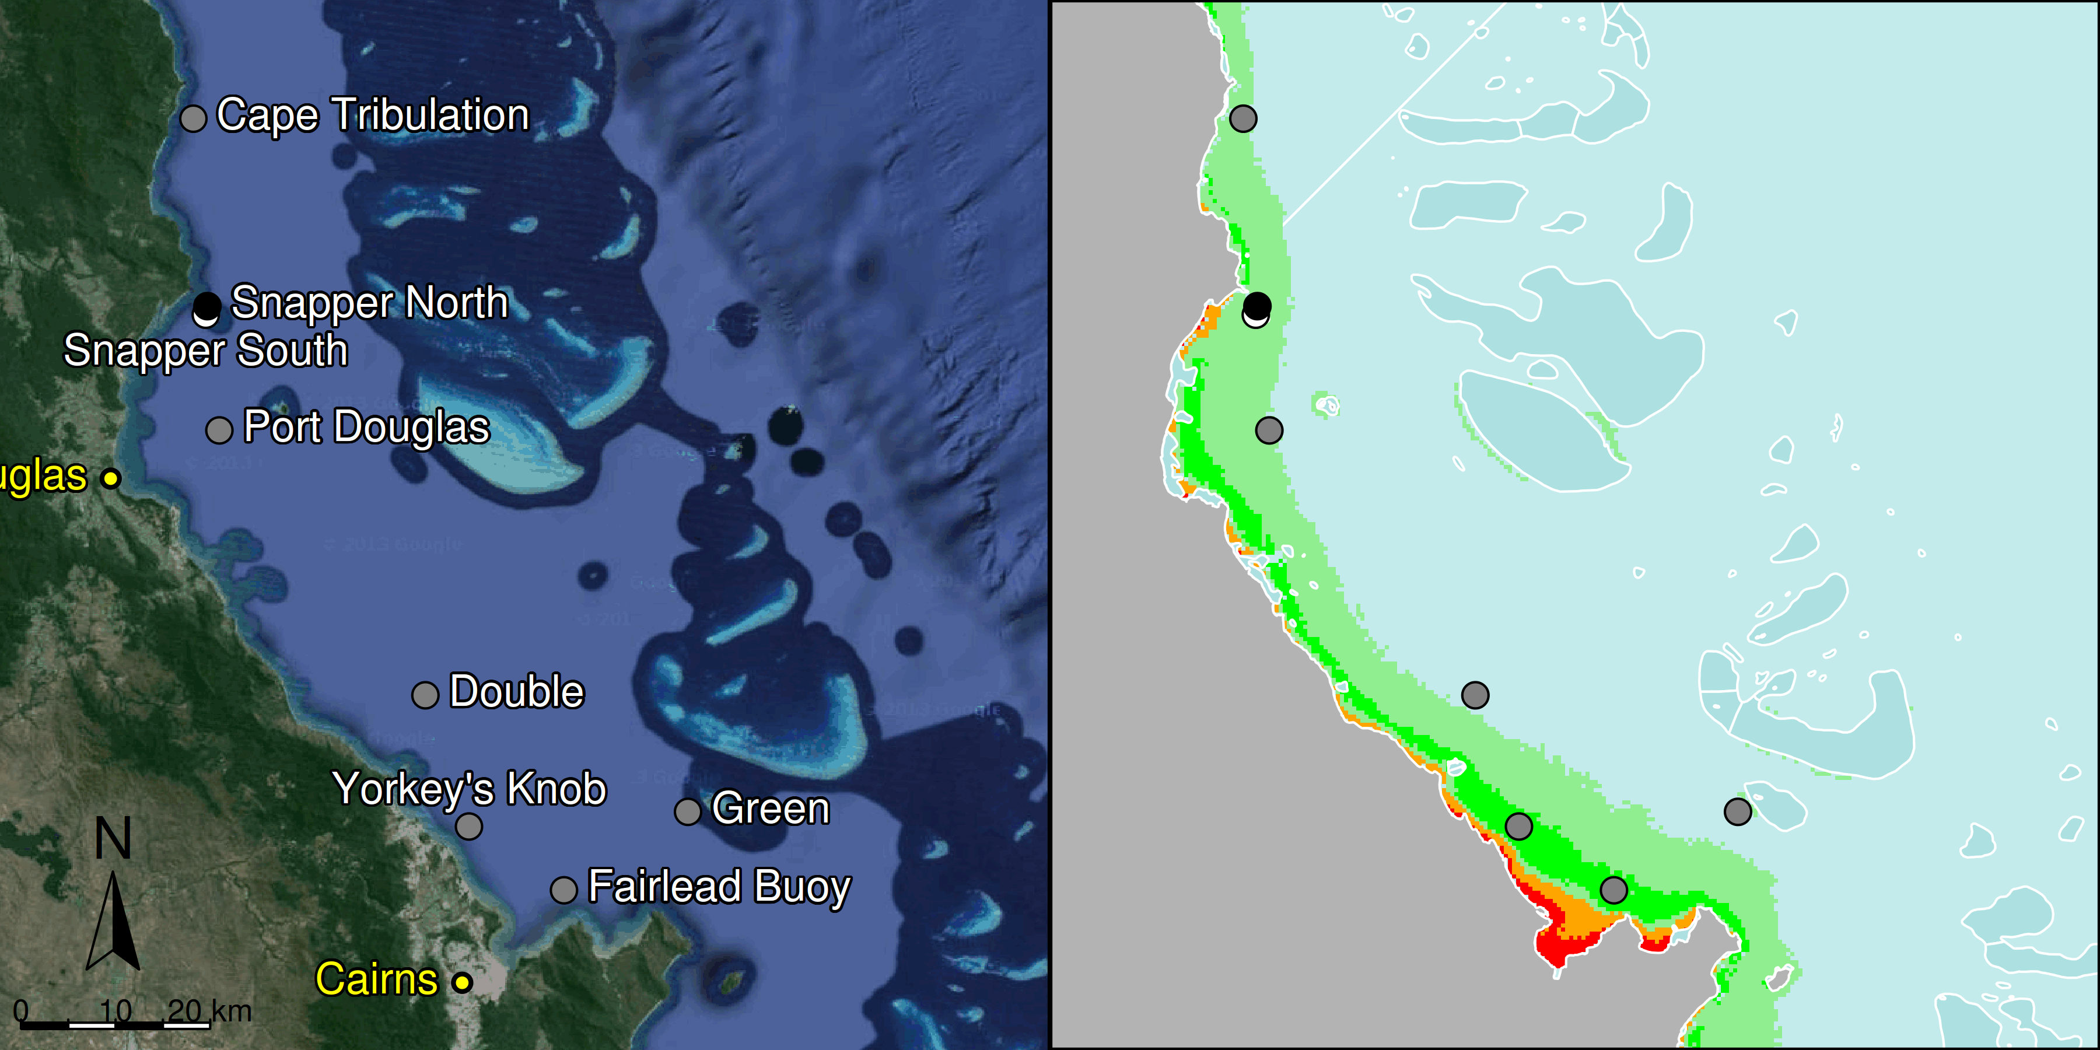

Figure 3 MMP sampling sites in the Barron Daintree sub-region.
Black symbols are water quality and core reef sampling locations, white symbols are cycle reef locations, grey symbols are the six open water sites of the AIMS Cairns Transect. Gradients of exposure to flood plume water types (Álvarez-Romero et al. 2013) during the wet season (December to March) are represented as areas exposed to primary plume-type waters most days (> 67% of days during the wet season, red shading) or frequently (33% - 67% of wet season days, orange shading), and areas exposed to secondary plume-type waters most days (>67% of wet season days, solid green shading), frequently (33% - 67% of wet season days, transparent green shading) or rarely (< 33% of wet season days, light blue shading).
From 2005 to 2013, the only acute disturbance to have had an impact on these locations was a storm event (possibly associated with Cyclone Hamish in March 2009) that caused physical damage to corals at Snapper North (Figure 5, Figure A2-3).

Temperature records show periods of above or below long-term average temperatures, however, no extreme temperature events have been recorded that would have led to coral bleaching (Figure 5).

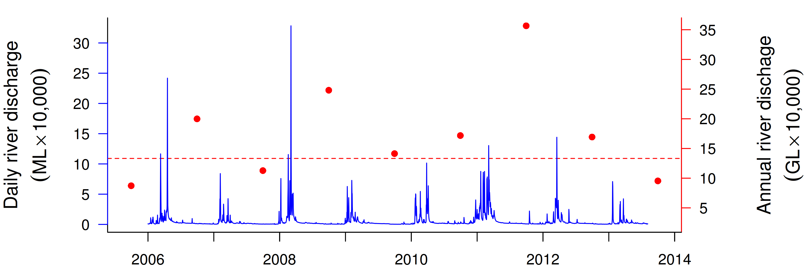
Figure 4 Combined discharge for the Barron and Daintree Rivers.
Daily (blue) and annual (October to September, red) discharge shown. Red dashed line represents long-term median of the combined annual discharge.
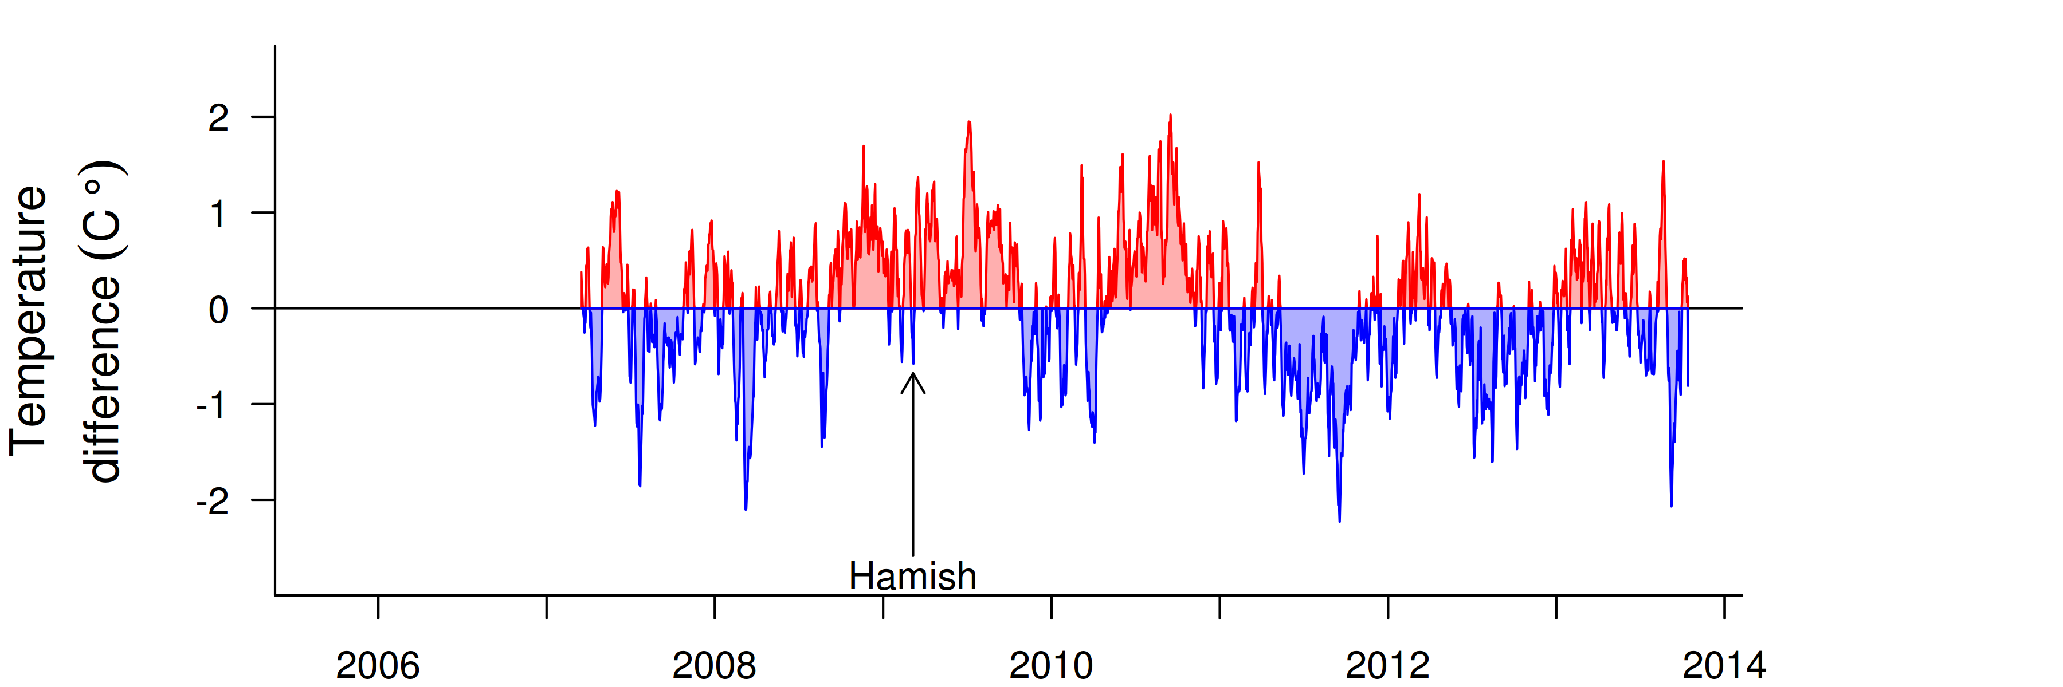
Figure 5 Sea temperature for the Barron Daintree sub-region.
Red and blue regions signify periods of above and below seasonal average.

The water quality index in this sub-region remained ‘good’, though this has declined slightly since 2009 (Figure 6a). Concentrations of chlorophyll a (chl a), suspended solids (SS) and particulate nitrogen (PN) were high at the beginning of the MMP sampling in 2005-06, then declined, and increased again after the major Barron River floods in 2008 (Figure 6b,c,f). Highest concentrations of chl a, PN, SS and particulate phosphorus (PP) were observed in ~2010 to 2011, with the predicted overall trend-line for chl a, PP and SS exceeding water quality guidelines (guideline) (GBRMPA 2009). Chl a, PN, PP and SS concentrations have since improved. Secchi depth declined to low levels in 2012 and has since improved, albeit overall never complying with the guideline (Figure 6e). The concentrations of dissolved oxidised nitrogen (NOx) steadily increased over the course of the program, with the overall trend-line approaching the guideline value in 2013 (Figure7d). This increase is mostly due to high NOx concentrations at the reef locations of Snapper North, Fitzroy West, High West and Dunk North (Table A2-2). The nitrogen content of sediments at the reef sites has also increased, indicating a more general change in nitrogen levels within this sub-region (Figure 7g).
The temporally better resolved instrumental chlorophyll (chl) and turbidity values were from only one location, Snapper North. The chl trend-line showed more pronounced fluctuations compared to the regional trend which summarised a number of manual sampling locations along gradients of water quality, with values above the guideline in the wet seasons of 2009 and 2011 (Figure 6b). The trend-line of the instrumental turbidity record was generally above the guideline and slightly increasing in 2013 (Figure 6g). This location has very variable turbidity (Figure A2-1), mostly influenced by wind-driven resuspension of sediments, and 8-12% of days were above the biological threshold of 5 NTU suggested by Cooper et al. (2007, 2008): above this threshold corals experience severe photo-physiological stress due to light limitation.

At the location-specific level, Fairlead Buoy and Yorkey’s Knob, which are close to the coast and more frequently exposed to flood plume water types (Figure 3), exceed the guideline for many variables, while the midshelf locations Double and Green were generally compliant (see Table A2-2 for detailed data). A case study of the 25-year trends of the Cairns Transect water quality stations is included later in the report (Section 3.3).

Two reefs, Snapper North and Snapper South are sampled annually in this sub-region (Figure 3). Prior to surveys in 2005, these reefs were monitored annually by Sea Research since 1995 (Ayling and Ayling 2005). The location of Snapper Island just 4km from the mouth of the Daintree River exposes corals frequently to low salinity waters during flood events (Figure 3) with high rates of mortality recorded at Snapper South 2m depth as a result of flooding in 1996 and then again in 2004 (Ayling and Ayling 2005). While not monitored at that time, anecdotal evidence suggests the deeper 5m sites were below the impact of these flood events. The coral communities at Snapper North were less damaged by these floods, though they did suffer substantial reductions in cover caused by coral bleaching in 1998 and then Cyclone Rona in 1999 (Ayling and Ayling 2005). Following each of these events coral cover began to increase demonstrating the resilience of these communities (Sweatman et al. 2007, Table A2-6).

This capacity to recover is also evident in the observations presented here with coral cover increasing over the period 2005 to 2007 at all locations (Figure 7d, Figure A2-3) and contributes to the initial ‘very good’ assessment of the coral health index in 2008. Since this initial assessment the coral health index has progressively declined, mirroring the trajectory in the water quality index (Figures 7a, 8b). The declines in the coral health index represent the culmination of several processes. From 2009 a reduction in the rate of coral cover increase began to reduce scores for the coral change indicator. In 2010 there was an increase in levels of coral disease (Figure A2-10) causing obvious mortality of corals further limiting coral cover increase or resulting in coral declines in 2010 and 2011. The density of juvenile corals has generally declined with the exception of the 2m depth at Snapper South where a strong pulse of recruitment was observed over the period 2008-2010 (Figure A2-3). In 2012 small numbers of small (generally <20cm diameter) crown-of-thorns seastars (COTS) where observed. In 2013 the numbers (600 per hectare) and size (most >25cm diameter) of COTS had increased and these coral predators were clearly causing substantial damage to coral communities, and in particular, reducing the cover of the family Acroporidae (Figure A2-3). Finally, in parallel with the loss of coral as a result of disease and COTS, there has been an increase in the cover of macroalgae (Figure 7f). The macroalgal community is predominantly composed of red algae, a group that has been shown to inhibit coral growth by both direct shading and also by causing changes to the chemical microenvironment of the surrounding water (Hauri et al. 2010).

In parallel to the decline in the coral health index was a substantial decline in the FORAM index at Snapper North to values around 4 from 2010-2013 (Figure 7a). In the Caribbean, FORAM index values of between 2 and 4 reflect environmental conditions that are marginal for coral reef growth (Hallock et al. 2003). This result coincides with a period during which the rate of increase in coral cover was suppressed and high incidences of disease were observed (Tables A2-6, A2-7 and Figure A2-10) which adds weight to the interpretation that environmental conditions in recent years have been sufficiently poor to have caused chronic stress to the benthic communities at the monitored reefs.

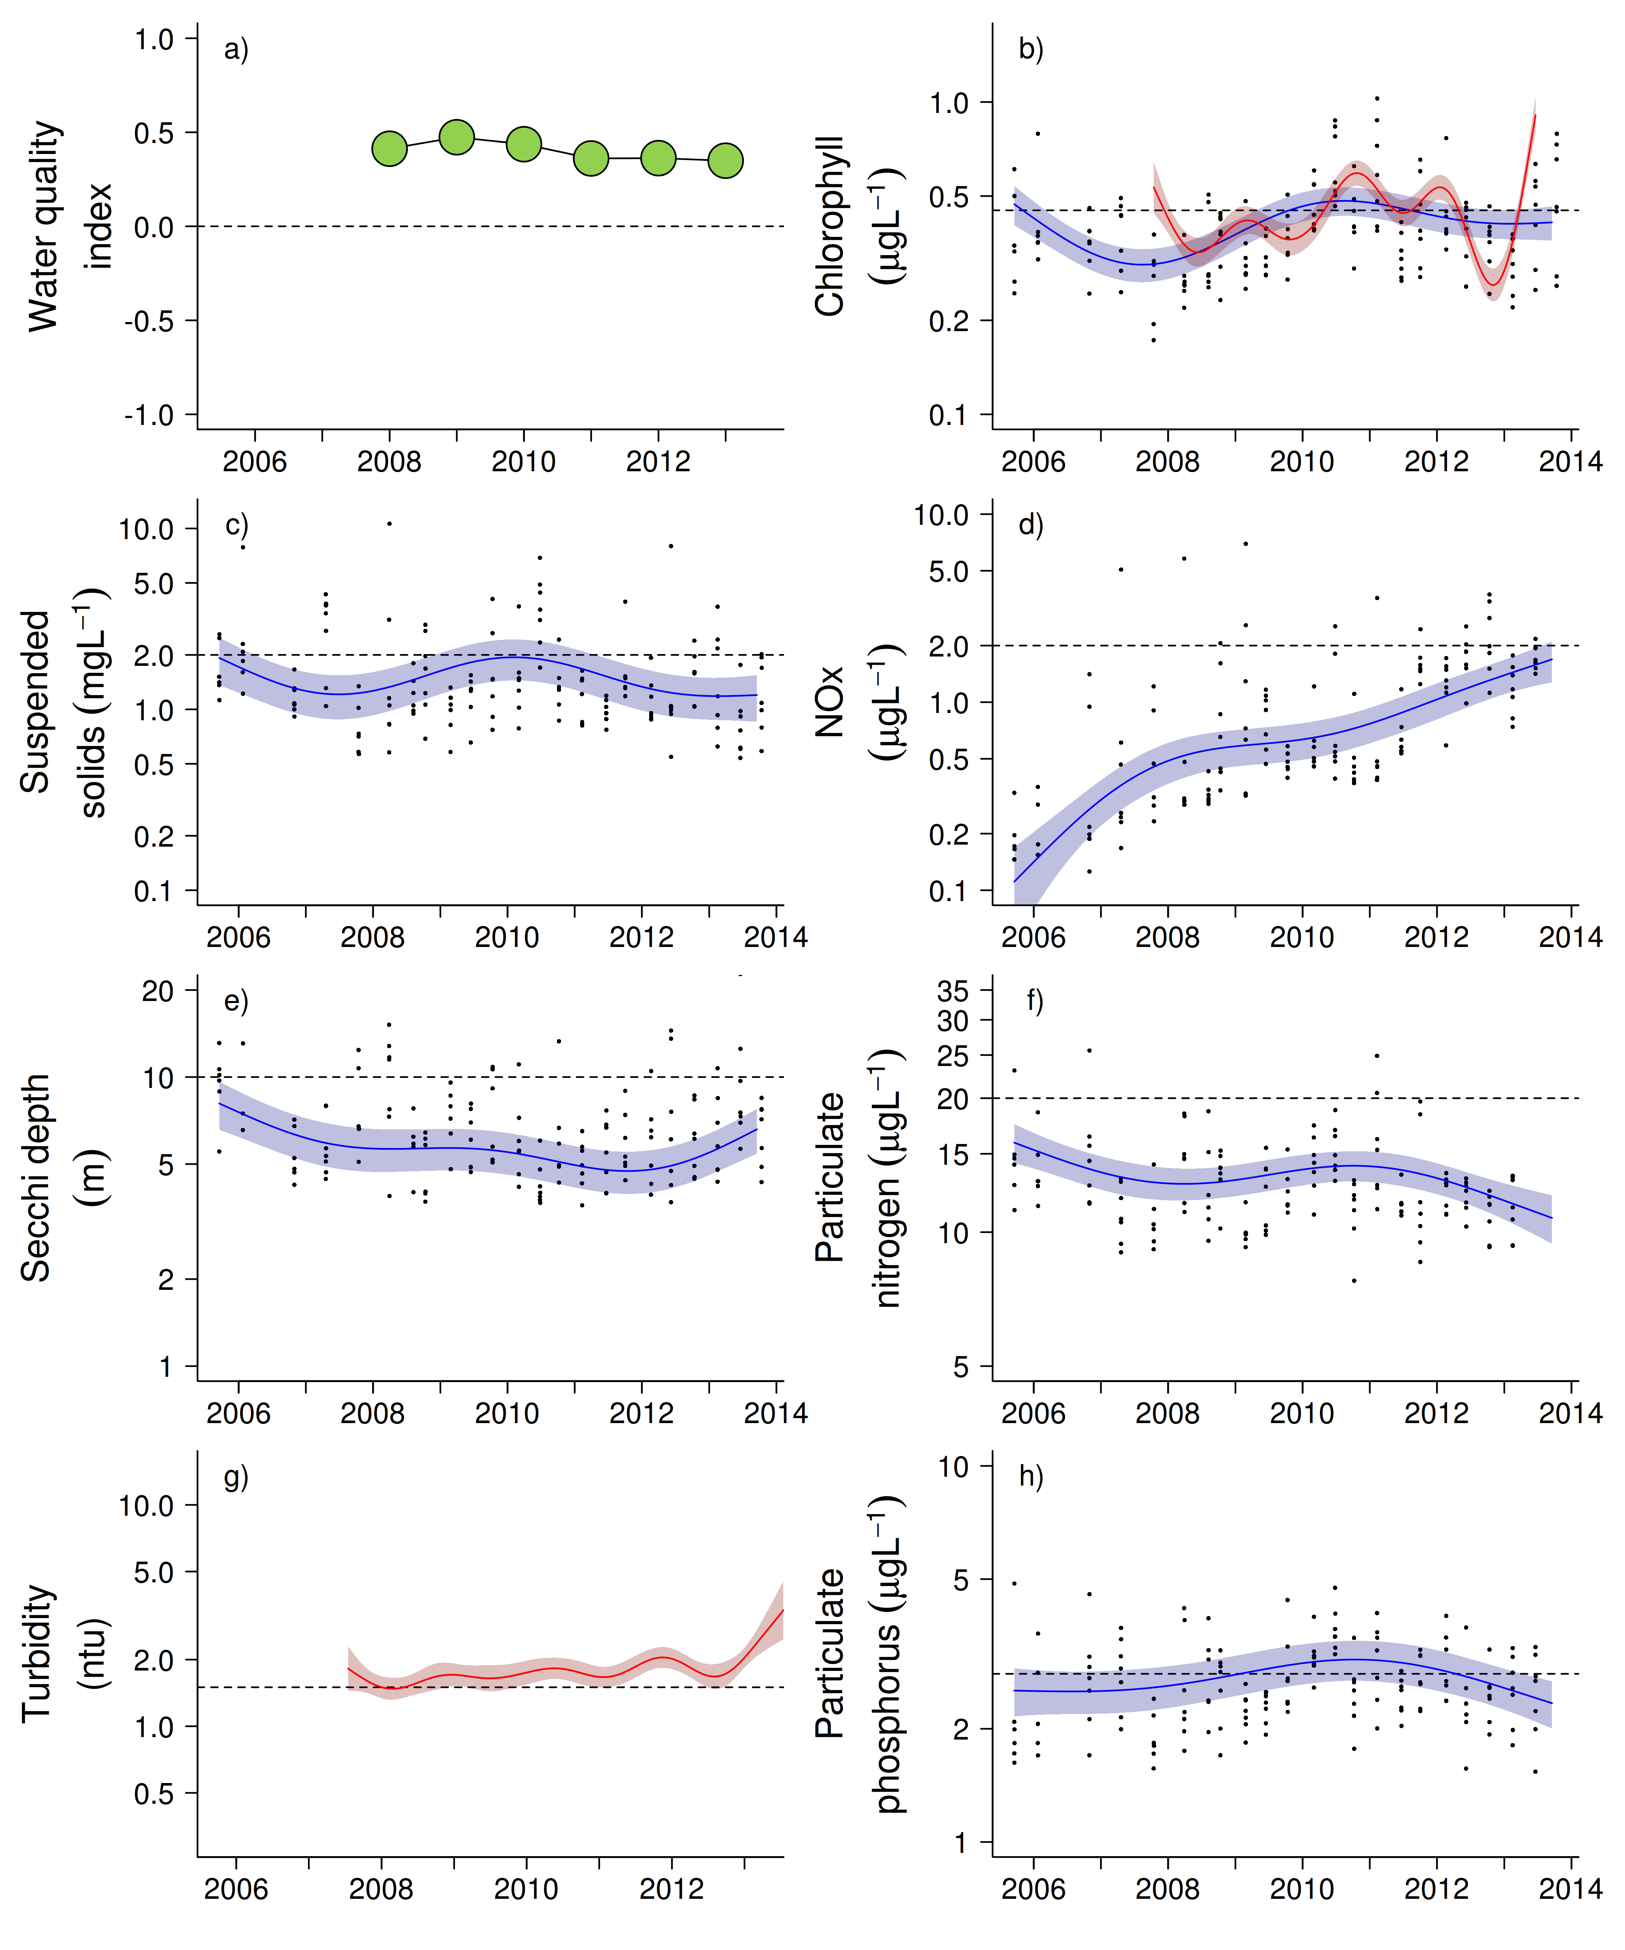
Figure 6 Water quality trends in the Barron Daintree sub-region.
Water quality index colour coding: dark green- ‘very good’; light green-‘good’; yellow – ‘moderate; orange – ‘poor’; red – ‘very poor’. The water quality index is the aggregate of variables plotted in with the exception of NOx and calculated as described in Appendix 1.2.3. Trends in manually sampled water quality variables are represented by blue lines with blue shaded areas defining 95% confidence intervals of those trends, black dots represent observed data. Trends of records from ECO FLNTUSB instruments are represented in red, individual records are not displayed. Dashed reference lines indicate guideline values.
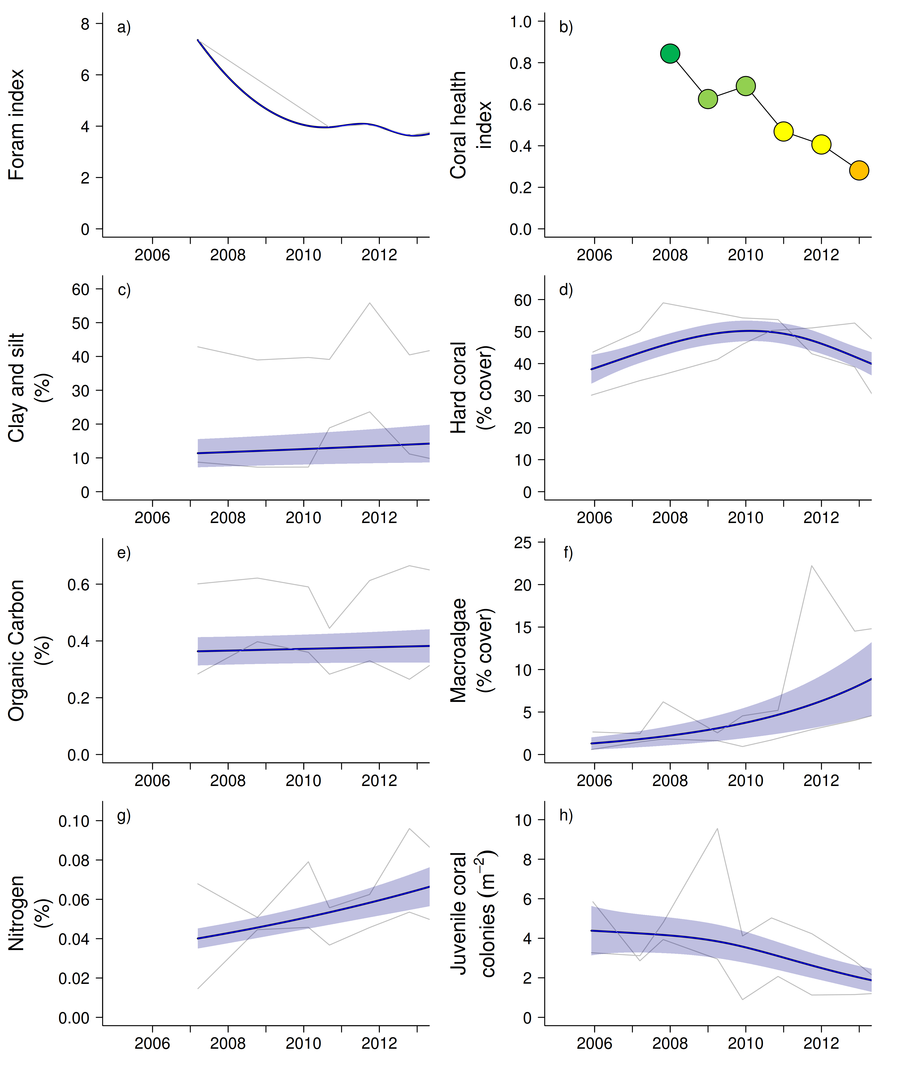

Figure 7 Coral reef community and sediment quality trends in the Barron Daintree sub-region.
Coral health index colour coding: dark green- ‘very good’; light green-‘good’; yellow – ‘moderate; orange – ‘poor’; red – ‘very poor’. Coral index is calculated from variables plotted in d, f, h, along with the derived estimate of “rate of cover increase” as described in Appendix 1.3.7.Trends in Foram index, sediment and benthic community variables are represented by blue lines with blue shaded areas defining 95% confidence intervals of those trends, grey lines represent observed profiles averaged over depths at individual reefs.

3.1.2 Wet Tropics Region: Johnstone Russell-Mulgrave sub-region
The sampling sites in this sub-region are influenced by the discharge from the Russell-Mulgrave and Johnstone rivers, and, to a lesser extent, by other rivers south of the sub-region, such as the Burdekin (Furnas et al. 2013). The sub-region has a high proportion of forest and National Park areas; 20% of the sub-regional area is used for sugar production, especially in the lower catchment areas, and there are significant grazing areas in the Johnstone catchment (Brodie et al. 2003).

Six reefs are sampled for coral reef condition assessments in this sub-region and there are three water quality sampling locations co-located with the annually monitored core reefs (Figure 8).

The sampling locations in this region that are located in the open coastal water body (see Table 1), Fitzroy and High, are frequently exposed to secondary plume-type waters during the wet season, while the Franklands are located in the midshelf water body and rarely exposed to secondary plume-type water (Figure 8).

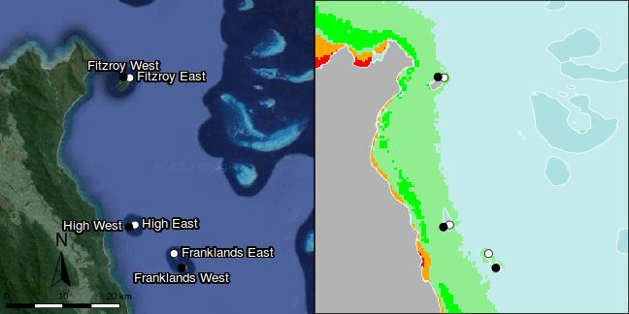

Figure 8 MMP sampling sites in the Johnstone Russell-Mulgrave sub-region.
Black symbols are water quality and core reef sampling locations, white symbols are cycle reef locations, grey symbols are the six open water sites of the AIMS Cairns Transect. Gradients of exposure to flood plume water types (Álvarez-Romero et al. 2013) during the wet season (December to March) are represented as areas exposed to primary plume-type waters most days (> 67% of days during the wet season, red shading) or frequently (33% - 67% of wet season days, orange shading), and areas exposed to secondary plume-type waters most days (>67% of wet season days, solid green shading), frequently (33% - 67% of wet season days, transparent green shading) or rarely (< 33% of wet season days, light blue shading).

Over the period 2006 to 2012, annual discharge for both the Russell-Mulgrave and Johnstone rivers has been at, or slightly above, median levels in most years with major floods in 2011 (Figure 9, Appendix Table A2-1). Discharge in 2013 was below the long-term median.

Tropical cyclones Larry in 2006, Tasha in late 2010 and Yasi in 2011 (Figure 10) caused reductions in coral cover predominantly on the Eastern sides of the islands (Figure A2-4, Table A2-5).

Temperature records since 2005 reveal no periods of extreme temperatures that would have led to coral bleaching (Figure 10). Temperatures were consistently low in 2011 though no effect on coral communities was evident during the winter surveys of that year.

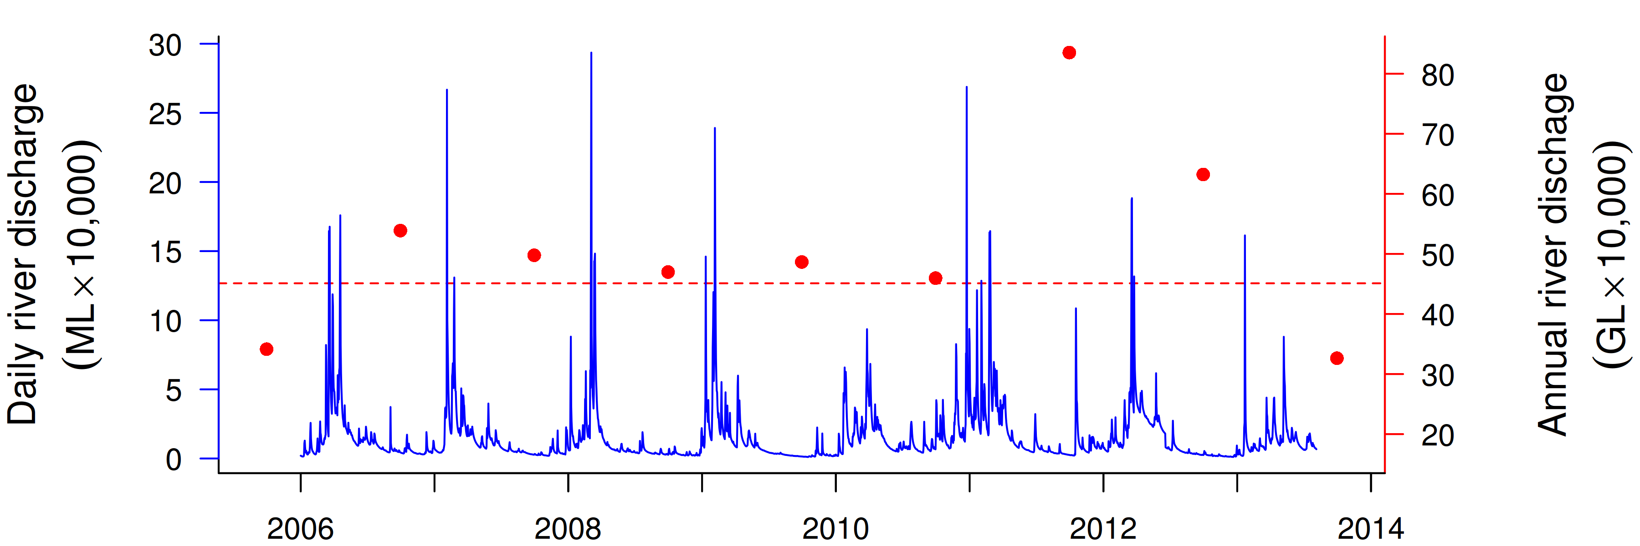
Figure 9 Combined discharge for the North and South Johnstone, Russell and Mulgrave rivers.
Daily (blue) and annual (October to September, red) discharge shown. Red dashed line represents the long-term median of the combined annual discharge.
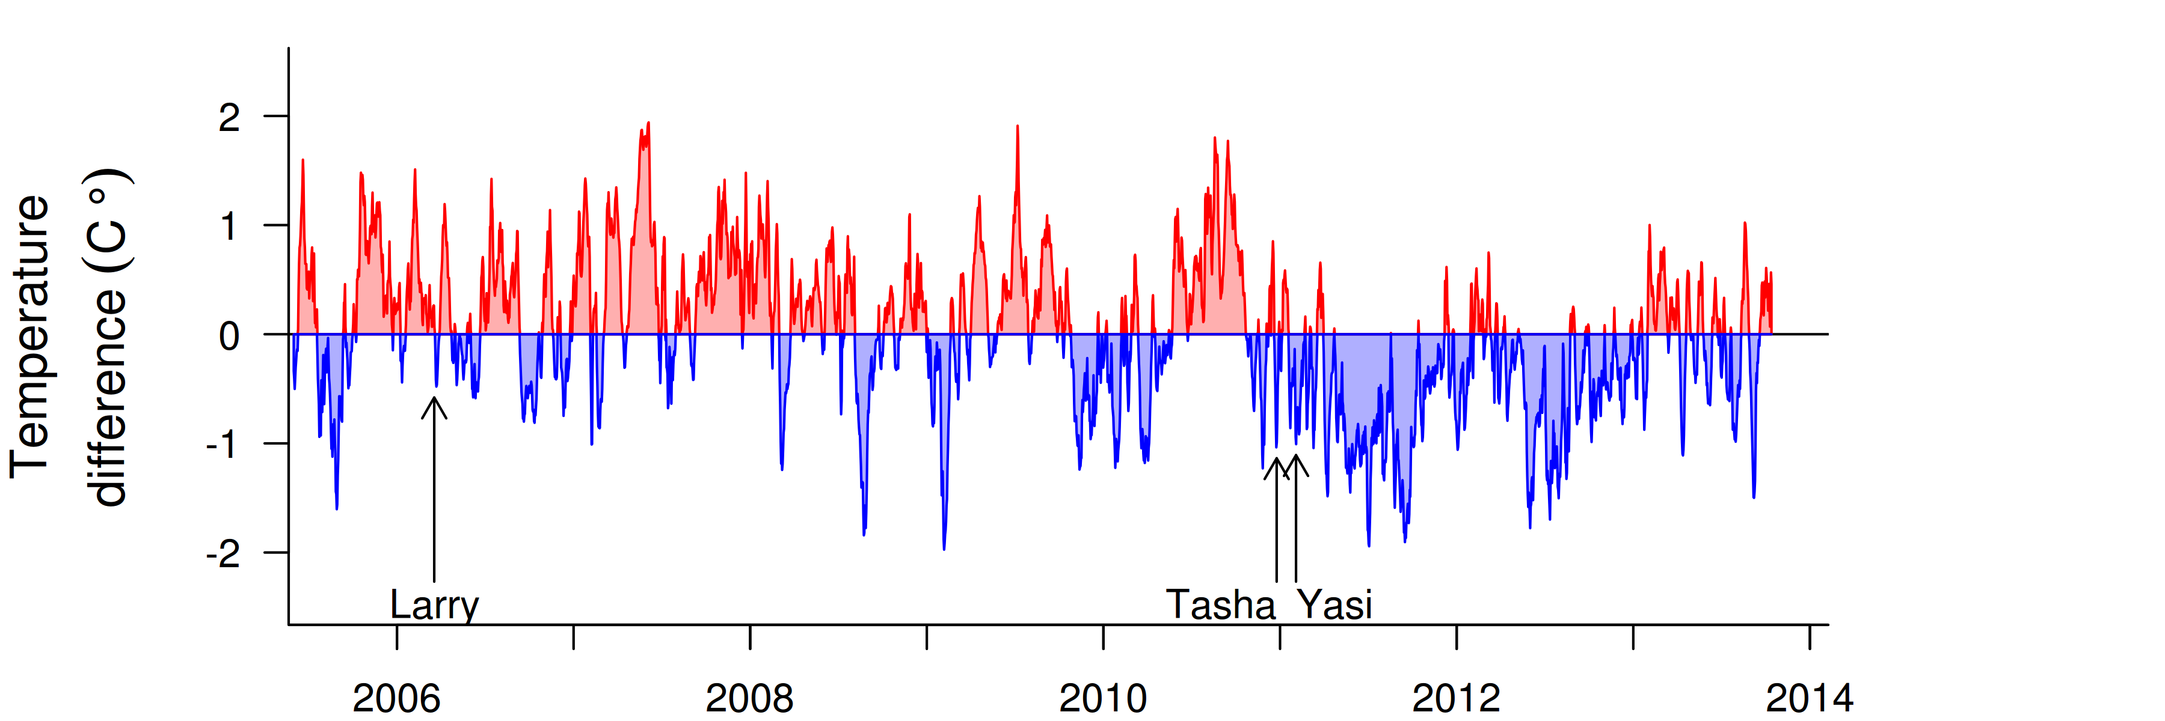
Figure 10 Sea temperature for the Johnstone Russell-Mulgrave sub-region.
Red and blue regions signify periods of above and below seasonal average.

The water quality index at the coral reef sampling locations in this sub-region remained relatively stable maintaining scores of ‘very ‘good’ (Figure 11a). Concentrations of chlorophyll a (chl a), suspended solids (SS), particulate nitrogen (PN) and particulate phosphorus (PP) were close to guideline levels at the beginning of the MMP sampling in 2005-06, then declined, prior to slight increases during the major flood period in 2011 (Figure 11b,c,f,h). The predicted overall trendline for chl a was at the guideline from 2011 onwards; the trendlines for all other variables were below the guideline (Figure 11). Secchi depth declined to a low point in 2010-12 and has since improved to levels close to complying with the guideline (Figure 11e). The concentrations of dissolved oxidised nitrogen (NOx), while overall always below the QLD guideline, but steadily increased over time and started to stabilise from 2012 (Figure12d).

Instrumental chlorophyll (chl) and turbidity records show more pronounced fluctuations than the manual sampling data (Figure 11b,g). While not exceeding the guideline, the trendlines show distinct maxima of chl and turbidity in 2011 - most likely in response to sediment and nutrient inputs from the major floods and resuspension of bottom sediments during the passage of tropical cyclones Tasha and Yasi. The clay-silt and nitrogen content of the sediments at the coral reef sites was also elevated during 2011-12 and has since decreased (Figure 12c, g).

At the location-specific level, Fitzroy West and High West show occasional guideline exceedance of some water quality variables, mostly Secchi depth, while Frankland West was generally compliant (see Tables A2-2 to A2-4 for detailed data).

The general compliance with guideline values ensures the water quality index in this sub-region has remained ‘very good’ though potentially masks the influence of short-lived episodes of poor water quality, as detected by instrumental records of turbidity and chlorophyll. The ‘good’ and increasing values of the coral index up to 2010 demonstrate that water quality in the region is generally not strongly limiting coral communities. The sharp declines in both the coral health index and the FORAM index after 2010 (Figures 13a, b) are largely a response to the impacts of tropical cyclones (corals) and potentially elevated river discharge over the 2010/2011 wet season (Figures 9 and 10, Tables A2-1 and A2-5).

The sampling of foraminifera occurs at the western sides of the reefs sampled in this sub-region. These sites are relatively sheltered from wave action which predisposes them to the accumulation of fine-grained sediments (Wolanski et al. 2005). The shift in the community composition of Foraminifera is consistent with the observed changes in sediment composition toward higher proportions of clay -silt sized particles and higher nitrogen content (Figures 13: c, g): conditions known to favour heterotrophic species (Uthicke et al. 2010). The slight increase in the proportion of clay-silt sized particles in sediments and declines in the FORAM index observed in 2010 coincided with increasing turbidity recorded at these locations (Figure 11g) but preceded both cyclone Yasi and high flows of local rivers. While sediment trap deployments over the period of cyclone Yasi and subsequent flooding clearly demonstrate the mobilisation of sediments corresponding to these events (Thompson et al. 2012) the increase in turbidity and change in sediment composition preceding these events suggest that these changed environmental conditions could be a delayed response to flooding of the more distant Herbert or Burdekin Rivers in 2009. Of note is that levels of coral disease also increased in 2010 (Figure A2-10), further indicating a shift in environmental conditions that preceded local runoff events.

In 2013 the coral communities in this sub-region were again assessed to be in moderate condition with moderate to high coral cover and low cover of macroalgae - at Fitzroy Island and High Island, compensating for continued low densities of juvenile corals and limited rates of increase in coral cover in recent years (Tables A2-6, A2-7).

The profile of the coral health index tracks the influence of disturbance and subsequent recovery. Prior to the commencement of MMP monitoring in 2005, surveys conducted by AIMS and Sea Research indicated that coral communities at Fitzroy Island and the Frankland Group were in a state of recovery following impacts attributed to predation by the crown-of-thorns seastar (COTS) and coral bleaching (Sweatman et al. 2007, Ayling and Ayling 2005). Since 2005, Cyclone Larry in 2006 caused substantial loss of cover at Franklands East (Figure A2-4). Up until 2010 the ‘good’ and increasing assessment of the coral health index reflected the recovery from, or resistance to these past disturbance events.

The decline in the coral health index in 2011 was largely due to losses in coral cover attributed to: Cyclone Yasi, Cyclone Tasha, low salinity water at 2m depth transects as a result of flooding in early 2011, high levels of disease observed in 2010 and 2011, and also a continued decline in the density of juvenile corals. From low values in 2011, the coral health index has gradually increased primarily due to the recovery of coral communities at High East and Frankland East where coral cover and the density of juvenile corals have increased. Limiting recovery at Fitzroy Island and, to a lesser degree, at Franklands West has been the presence of COTS. At Fitzroy Island, the density of COTS in 2012 was estimated at 300 (Fitzroy West) and 175 (Fitzroy East) individuals per hectare with the majority of individuals small (most <20cm diameter) and feeding within the understory of the coral community. In 2013 the densities of COTS were lower, 50 seastars per hectare at Fitzroy West, though they were adult-sized (>30cm diameter) and clearly causing ongoing damage to coral communities. The reduction in COTS numbers may reflect a combination of the COTS control program run by the association of marine park tourism operators and movement of animals to other areas of the reef. At Frankland West the density of COTS was lower and declined from 75 individuals per hectare in 2012 to 25 per hectare in 2013. Unlike at Fitzroy Island, COTS had not caused extensive damage to coral communities at Frankland West and no COTS or feeding scars were observed at Frankland East in 2013.

Macroalgae are potentially limiting the resilience of coral communities at the Frankland Group. At Franklands West there has been a persistent community of red algae (predominantly Hypnea and Laurencia) largely occupying the spaces within branched and submassive coral growth forms, in particular species of Porites. At Franklands East a more mixed community of red (including Asparagopsis and Hypnea) but also brown (Padina) and green (including Halimeda and Caulerpa) macroalgae colonise the substrate adjacent to Normanby Island. In both instances, space occupied by these algae will almost certainly be limiting coral recruitment (Birrell et al. 2005, 2008) and competing with corals for space and so reducing growth. At Franklands West at 5m depth the competition with algae is the most likely cause for the recent gradual decline in the cover of Poritidae corals (Figure A2-4).

Within the region, differences in macroalgal cover between reefs do not correspond to observed differences in the water quality indicators. At both Fitzroy Island and High Island cover of macroalgae has been consistently low, contrasting with the persistently high cover at the Frankland Group where the water quality index was similar to Fitzroy West and better than at High West (Figure 11, Tables A2- to A2-4). Within the Frankland Group, the variability in cover of macroalgae can be partly attributed to cyclone disturbances. At Frankland East Cyclone Larry substantially reduced coral cover in early 2006. This physical disturbance would have also removed macroalgae. As surveys in 2006 were only six weeks after the passage of Cyclone Larry cover of macroalgae was still low, a similar reduction on macroalgae cover was observed at Franklands West where the monitoring sites are more protected and coral cover was not reduced. In contrast, surveys in 2011 again demonstrate a reduction in coral cover at Franklands East but an increase in cover of macroalgae, the difference being that surveys in 2011 were conducted some 6-8 months following the passage of cyclones Tasha and Yasi allowing time for macroalgae cover to increase following any storm related reduction. In 2013, macroalgae cover was higher than previously recorded at both Franklands West and Franklands East, demonstrating that, once established, environmental conditions at this reef support a mixed community of macroalgae.

Since 2005, the density of juvenile corals declined to a minimum in 2011; in 2013 densities were still low on most reefs (Figure 12h). It is primarily the strong recruitment of Acroporidae colonies to High East which increases the assessment of this metric from ‘very poor’ in recent years to ‘poor’ in 2013 (Tables A2-5, A2-6). We suggest that the reasons for the substantial decline in density of juvenile colonies are due to a combination of processes. The numbers of juvenile colonies recorded in this study are the result of settlement and survival over the preceding two to three years, meaning that the juveniles recorded in 2005 may have recruited over the period 2002 and 2005. A combination of a high availability of available space due to the loss of coral cover from past disturbance events (crown-of-thorns, and coral bleaching, Table A2-5) and below-median river flows (Table A2-1) may have provided the space and environmental conditions conducive to high juvenile survival. Subsequent growth of these colonies, as indicated by increasing cover at those reefs with highest settlement would have excluded that area of substratum to further settlement, thus reducing the juvenile densities count even though adult cover increases. In addition, high levels of disease infecting adult corals in 2010-2011 (Figure A2-10) along with high densities of COTS in 2012 and 2013 (Fitzroy East and West) are likely to have caused mortality of juvenile corals and contribute to low numbers in recent years.
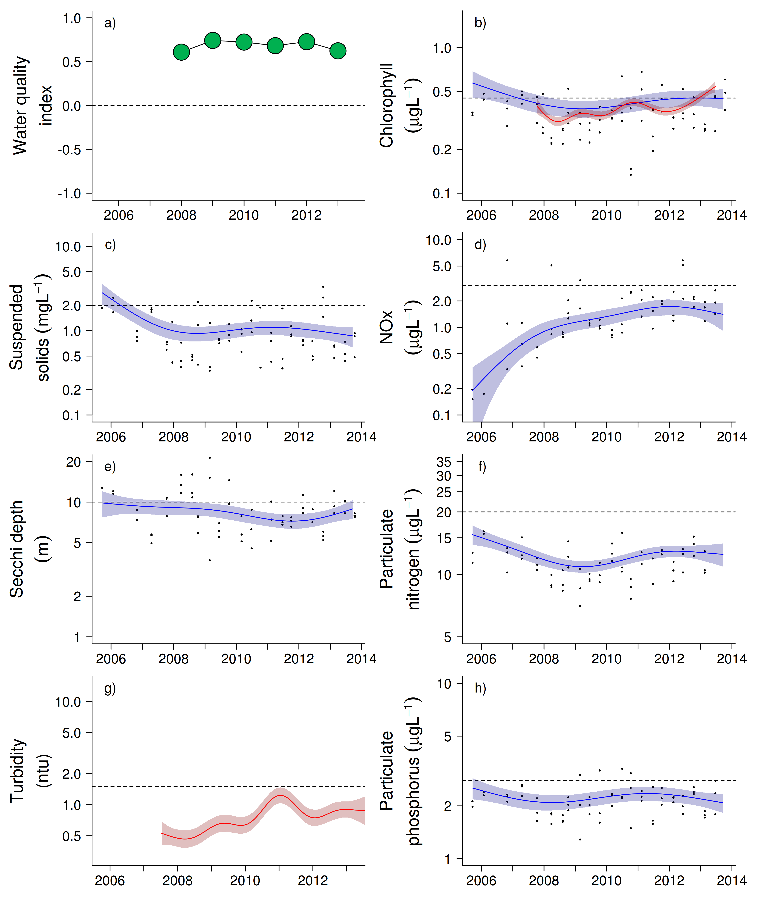
Figure 11 Water quality trends in the Johnstone Russell-Mulgrave sub-region.
Water quality index colour coding: dark green- ‘very good’; light green-‘good’; yellow – ‘moderate; orange – ‘poor’; red – ‘very poor’. The water quality index is the aggregate of variables plotted in with the exception of NOx and calculated as described in Appendix 1.2.3. Trends in manually sampled water quality variables are represented by blue lines with blue shaded areas defining 95% confidence intervals of those trends, black dots represent observed data. Trends of records from ECO FLNTUSB instruments are represented in red, individual records are not displayed. Dashed reference lines indicate guideline values.

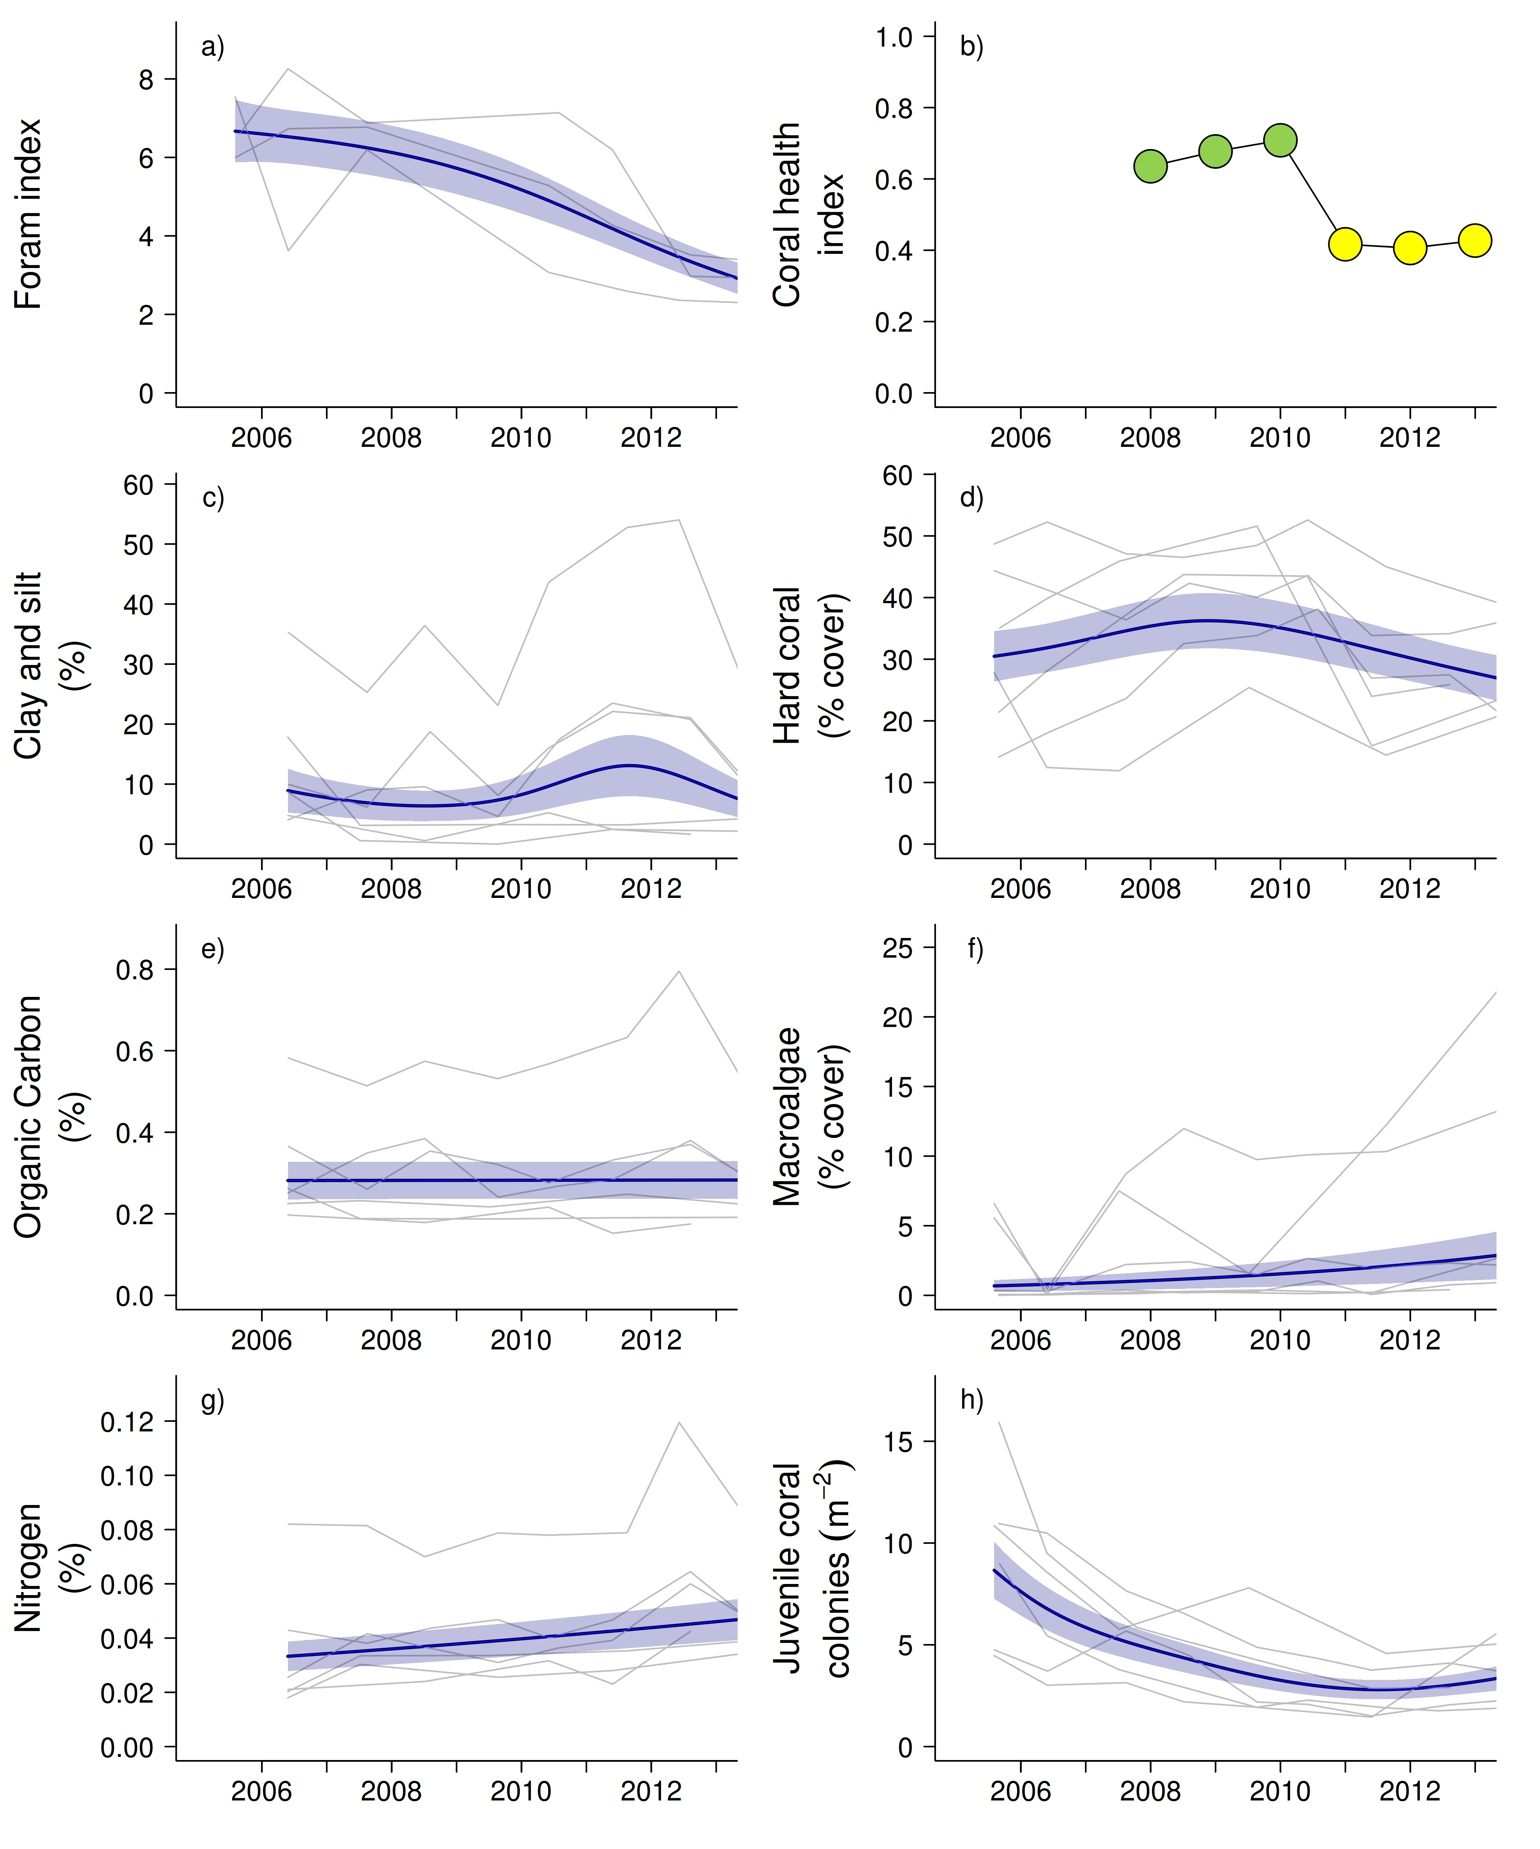
Figure 12 Coral reef community and sediment quality trends in the Johnstone Russell-Mulgrave sub-region.
Coral health index colour coding: dark green- ‘very good’; light green-‘good’; yellow – ‘moderate; orange – ‘poor’; red – ‘very poor’. Coral index is calculated from variables plotted in d, f, h, along with the derived estimate of “rate of cover increase” as described in Appendix 1.3.7.Trends in Foram index, sediment and benthic community variables are represented by blue lines with blue shaded areas defining 95% confidence intervals of those trends, grey lines represent observed profiles averaged over depths at individual reefs.

In summary, the differences between the East and West locations on the reefs in this sub-region highlight the need to consider the hydrodynamic setting of a location when assessing the possible influences of runoff. On the wave-exposed Eastern reefs, coral communities have a high proportion of the fast-growing family Acroporidae and have shown a clear ability to recover from disturbance events (Figure A2-4). However, these communities are susceptible to predation by COTS and the current high densities of these seastars pose a substantial risk to coral cover in the near future. Links between COTS and elevated nutrient levels resulting from large flood events have been proposed (Brodie et al. 2008, Fabricius et al. 2010) and given the severity of disturbance these seastars impart on the GBR in general (Osborne et al. 2011, De’ath et al. 2012), further research into the role of water quality plays in promoting such outbreaks is justified. In contrast, while the more sheltered reefs of High West and Franklands West have been less susceptible to acute disturbance they have also shown limited recovery potential. The high coral cover at these reefs is dominated by a few species of the family Poritidae (Figure A2-4), a family generally tolerant to fluctuations in environmental conditions that have almost certainly selected against more susceptible species. The rapid response of the FORAM index provides evidence for the selective pressures attributed to environmental fluctuations at these more sheltered locations.

3.1.3 Wet Tropics Region: Herbert Tully sub-region

The sampling sites in this sub-region are influenced by the discharge from the Tully and Herbert rivers, and, to a lesser extent, by the Burdekin River (Furnas et al. 2013). The Tully catchment has a high proportion of forest and National Park areas while the predominant land use in the Herbert catchment is grazing. Around 10% of the sub-regional area is used for sugar production, especially in the lower catchment areas (Brodie et al. 2003, GBRMPA 2012).

Four reefs are sampled for coral reef condition assessments in this sub-region, there is one water quality sampling location co-located with the coral site at Dunk North (Figure 13).

Dunk Island is exposed to secondary plume-type waters on most days during the wet season, while the other two reefs are frequently exposed to this water type (Figure 13).

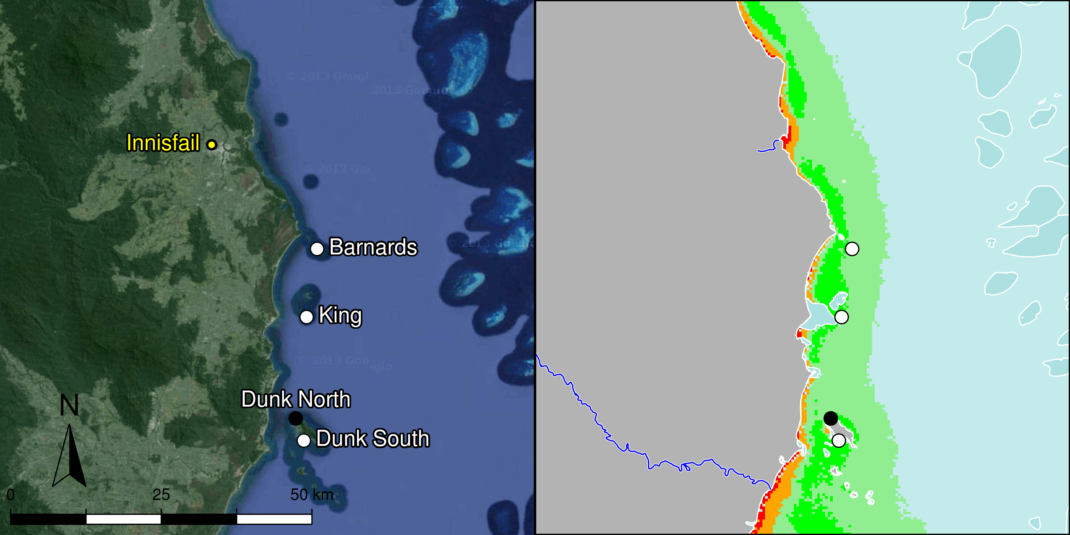

Figure 13 MMP sampling sites in the Herbert Tully sub-region.
Black symbols are water quality and core reef sampling locations, white symbols are cycle reef locations, grey symbols are the six open water sites of the AIMS Cairns Transect. Gradients of exposure to flood plume water types (Álvarez-Romero et al. 2013) during the wet season (December to March) are represented as areas exposed to primary plume-type waters most days (> 67% of days during the wet season, red shading) or frequently (33% - 67% of wet season days, orange shading), and areas exposed to secondary plume-type waters most days (>67% of wet season days, solid green shading), frequently (33% - 67% of wet season days, transparent green shading) or rarely (< 33% of wet season days, light blue shading).

Over the period 2006 to 2012, annual discharge for both the Tully and Herbert rivers (Figure 14) has been at, or slightly above, median levels in most years with major floods of the Tully River in 2011 and of the Herbert River in 2009 and 2011 (Appendix Table A2-1). Discharge in 2013 was below the long-term median.

Tropical cyclones Larry in 2006 and Yasi in 2011 (Figure 15), had significant negative impacts on in coral cover on the reefs in this sub-region (Figure A2-5, Table A2-5).

Temperature records show periods since 2005 do not reveal any prolonged exposure to high temperatures likely to have resulted in coral bleaching (Figure 15).

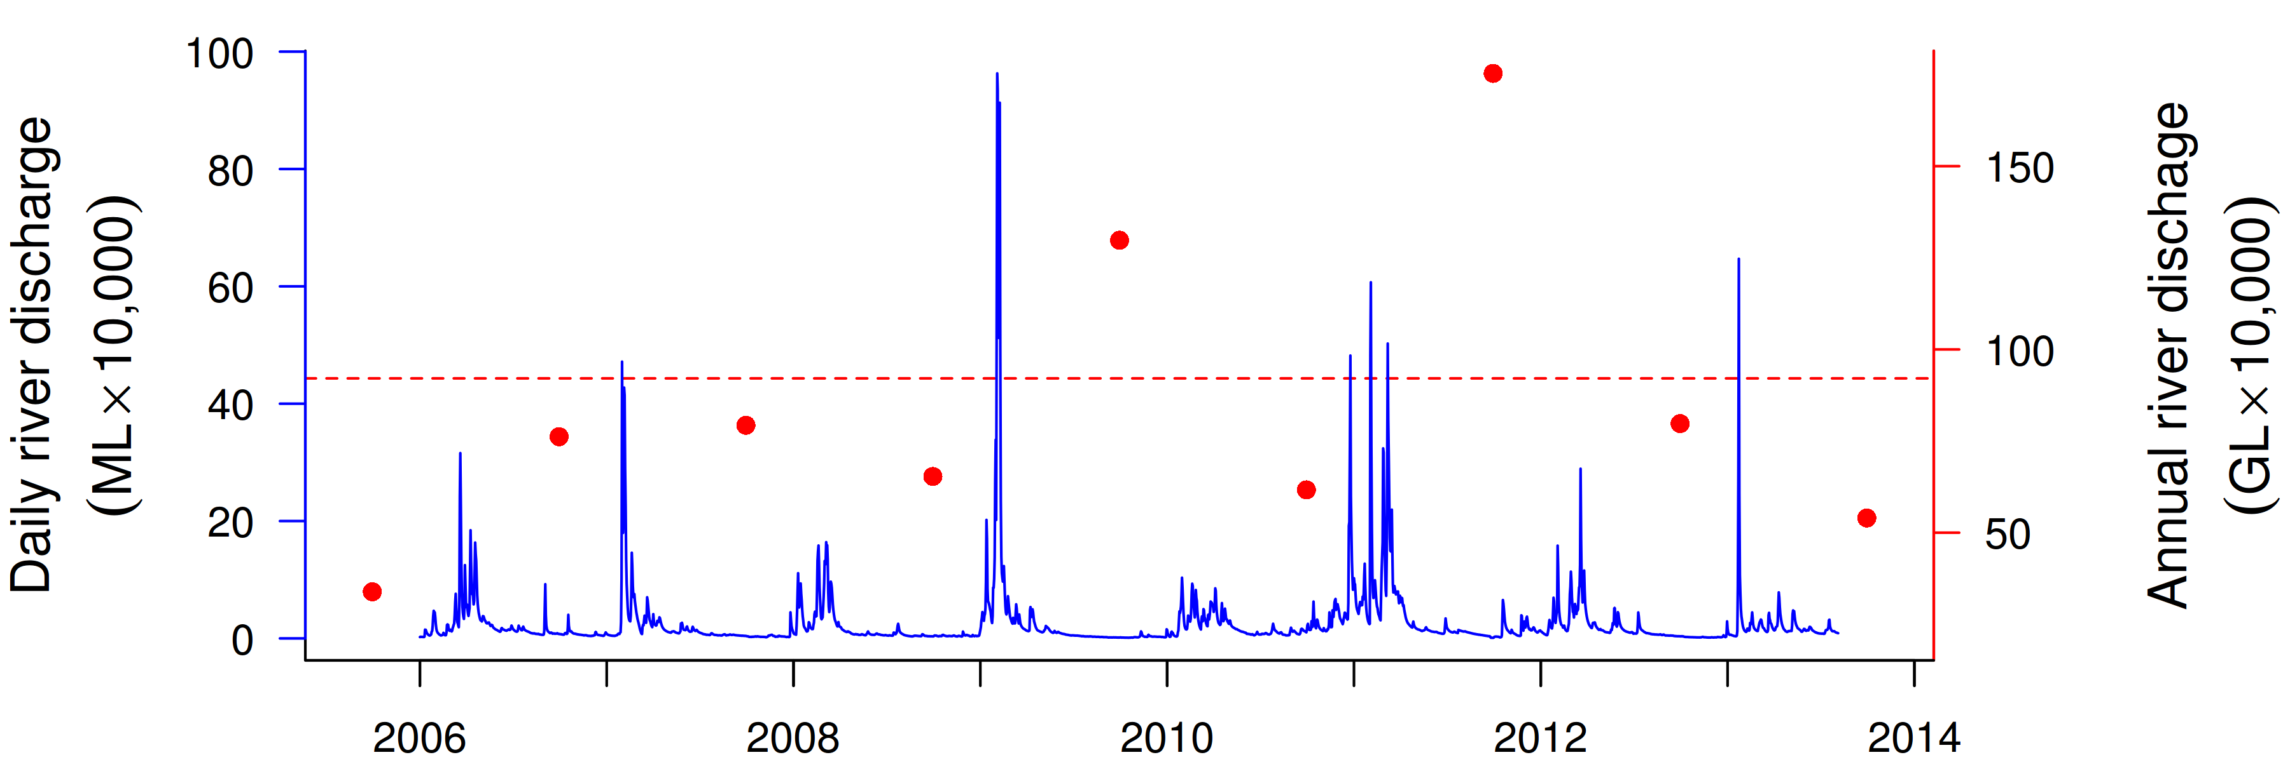
Figure 14 Combined discharge for Tully and Herbert Rivers.
Daily (blue) and annual (October to September, red) discharge shown. Red dashed line represents the long-term median of the combined annual discharge.
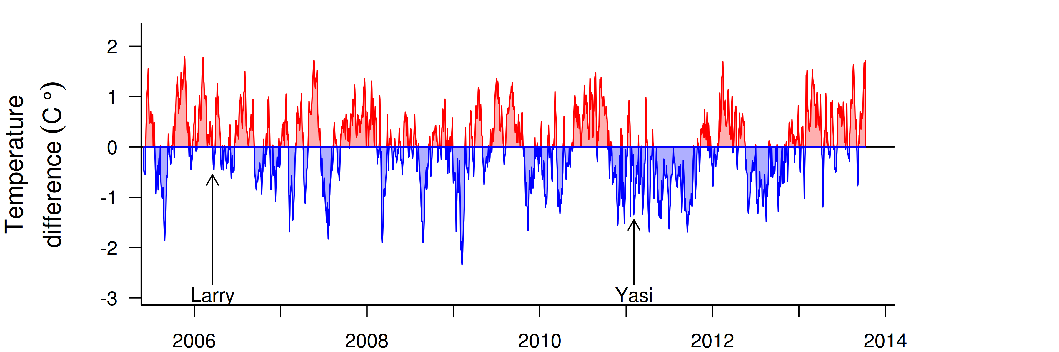
Figure 15 Sea temperature for the Herbert-Tully sub-region.
Red and blue regions signify periods of above and below the long term seasonal average.

The water quality index at Dunk North was stable over the past four years, maintaining a ‘moderate’ rating (Figure 16a). Trends in concentrations of chlorophyll a (chl a), particulate nitrogen (PN) and particulate phosphorus (PP) showed distinct cycles, with periods of high values in 2006-07 and 2011-12 (Figure 16b,f,h), coinciding with the beginning of the relatively “wet” period with at or above median flows after 3-4 drier years and with the two major cyclones in 2006 and 2011. Trend-lines for PP were almost entirely above water quality guidelines (guideline) until 2013, while chl a trend-lines exceeded the guideline from 2010 to mid-2011 (Figure 16b,h). The concentrations of dissolved oxidised nitrogen (NOx) also showed two periods of high values, lagging the particulate nutrients by about a year and exceeding the guideline during 2012 (Figure17d). Concentrations of suspended solids (SS) declined steadily over the course of the program and complied with the guideline for the first time in ~2013, while Secchi depth remained relatively stable with at a long-term average of about 5m, which is non-compliant with the guideline.

The instrumental Chlorophyll (chl) and turbidity records showed more pronounced fluctuations than the manual sampling data (Figure 16b,g). The trend-lines of chl showed distinct maxima above the guideline during the wet seasons of 2009, 2011 and 2012 (Figure 16b), the years with high to very high discharges from the influencing rivers, Tully, Herbert and Burdekin. The turbidity maxima cover most of the years 2009 and 2011, with a brief decline during 2012 before increasing again; overall, the trend-line was ~ twice the guideline (Figure 16g). The turbidity at Dunk North was generally very variable (see Appendix Figure A2-1), mostly driven by sediment resuspension from the surrounding shallow seabed.

The clay-silt content of the sediments at Dunk North was higher than at other reef locations in this sub-region (Figure 17c, highest grey line); on a sub-regional level the proportion of clay-silt sized particles in sediments was generally high in the period 2010-2012, while sediment nitrogen content has steadily increased (Figure 17c, g). These changes in sediment composition are also manifested in the decline in the Foram index at Dunk North (Figure 17a)

The persistently “poor” values of the coral health index in the region reflect the effects of recent disturbance events but also suggest a chronic influence of poor water quality.

In 2006 Cyclone Larry severely damaged the coral reefs in this sub-region, in particular the Barnards and Dunk North. In 2011, Cyclone Yasi again damaged the reefs in this sub-region resulting in low cover on all reefs in 2011 through to 2013 (Figure 16d, Figure A2-5). This regionally low cover of corals has influenced the poor values of the coral health index since first assessed in 2008 (Table A2-6, A2-7).

Persistently high macroalgae cover suggests the influence of poor water quality in addition to recent cyclones on benthic communities in this sub-region. One basis for the selection of guideline values for chlorophyll, nutrients and turbidity was that higher cover of macroalgae occurred when guideline values were exceeded (De’ath and Fabricius 2008, 2010): a relationship supported by the data from this sub-region. The cover of macroalgae was high on most reefs prior to Cyclone Larry, was temporarily reduced as a consequence of cyclones Larry and Yasi, and quickly increased to similar or higher levels in subsequent years (Figure 15f, Figure A2-5) indicating the suitability of environmental conditions for sustained high macroalgal cover. This high and persistent cover of macroalgae decreases the coral health index in this region (Tables A2-6, A2-7).

Despite the persistent cover of macroalgae on all reefs it is only at 2m depth at King Reef, where macroalgae cover is highest, that coral community resilience appears to be clearly affected. Prior to Cyclone Larry, coral cover at this location was very low, cover of macroalgae very high, and density of juvenile corals very low (Figure A2-5). These indicators of poor coral community health have shown no improvement over the period 2005-2013, which suggests that the environmental conditions at this location are unsuitable for coral community recovery. In contrast, the coral communities at both Dunk North and Barnards, although supporting moderate to high cover of macroalgae, have shown resilience following cyclonic disturbance with ongoing recruitment of juvenile corals and increasing cover during periods free from acute disturbance.

The resilience of coral communities at Dunk South is unclear, due to the limited observations post Cyclone Yasi. There are, however, several indications that coral communities at this reefs are strongly influenced by poor water quality, including: the decline of coral cover to 2012 following initial declines attributed to Cyclone Yasi and associated flooding in 2011, persistently high cover of macroalgae, juvenile densities consistently lower than at Dunk North or Barnards, and sharp change in coral community composition from 2m to 5m depth indicative of a substantial reduction of light at depth due to high turbidity. This location is more directly exposed to the influences of runoff than other reefs in the region due to the proximity to local rivers (Figure 13).

A further point of note is the disparity between the compositions of juvenile and adult communities particularly at Dunk North and Barnards where there is a disproportionally high density of juvenile Dendrophyliidae relative to the adult community (Figure A2-5). Juveniles of the family Dendrophyliidae on these reefs are almost entirely of the genus Turbinaria, a group that can form high cover stands especially on turbid-water reefs. However, despite several years of very high numbers of juveniles the adult cover of this family has not increased indicating high mortality of these juveniles for as yet unknown reasons.

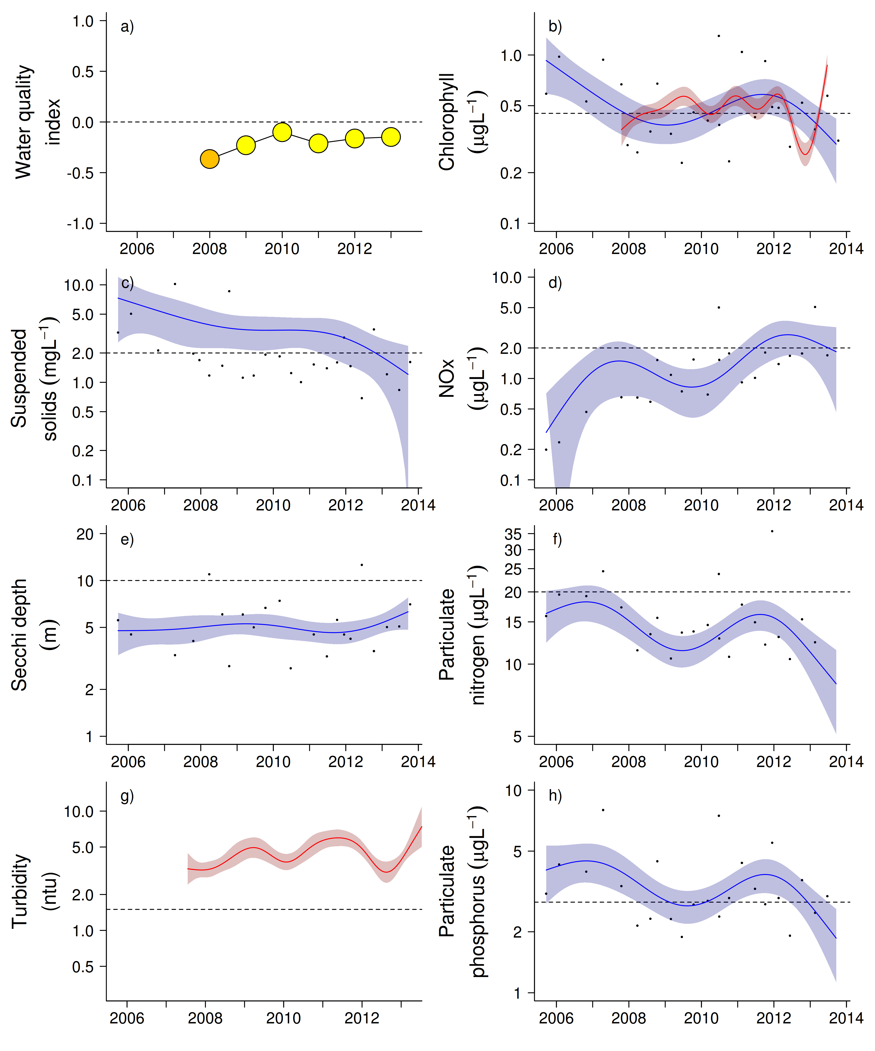
Figure 16 Water quality trends in the Herbert-Tully sub-region.
Water quality index colour coding: dark green- ‘very good’; light green-‘good’; yellow – ‘moderate; orange – ‘poor’; red – ‘very poor’. The water quality index is the aggregate of variables plotted in with the exception of NOx and calculated as described in Appendix 1.2.3. Trends in manually sampled water quality variables are represented by blue lines with blue shaded areas defining 95% confidence intervals of those trends, black dots represent observed data. Trends of records from ECO FLNTUSB instruments are represented in red, individual records are not displayed. Dashed reference lines indicate guideline values.

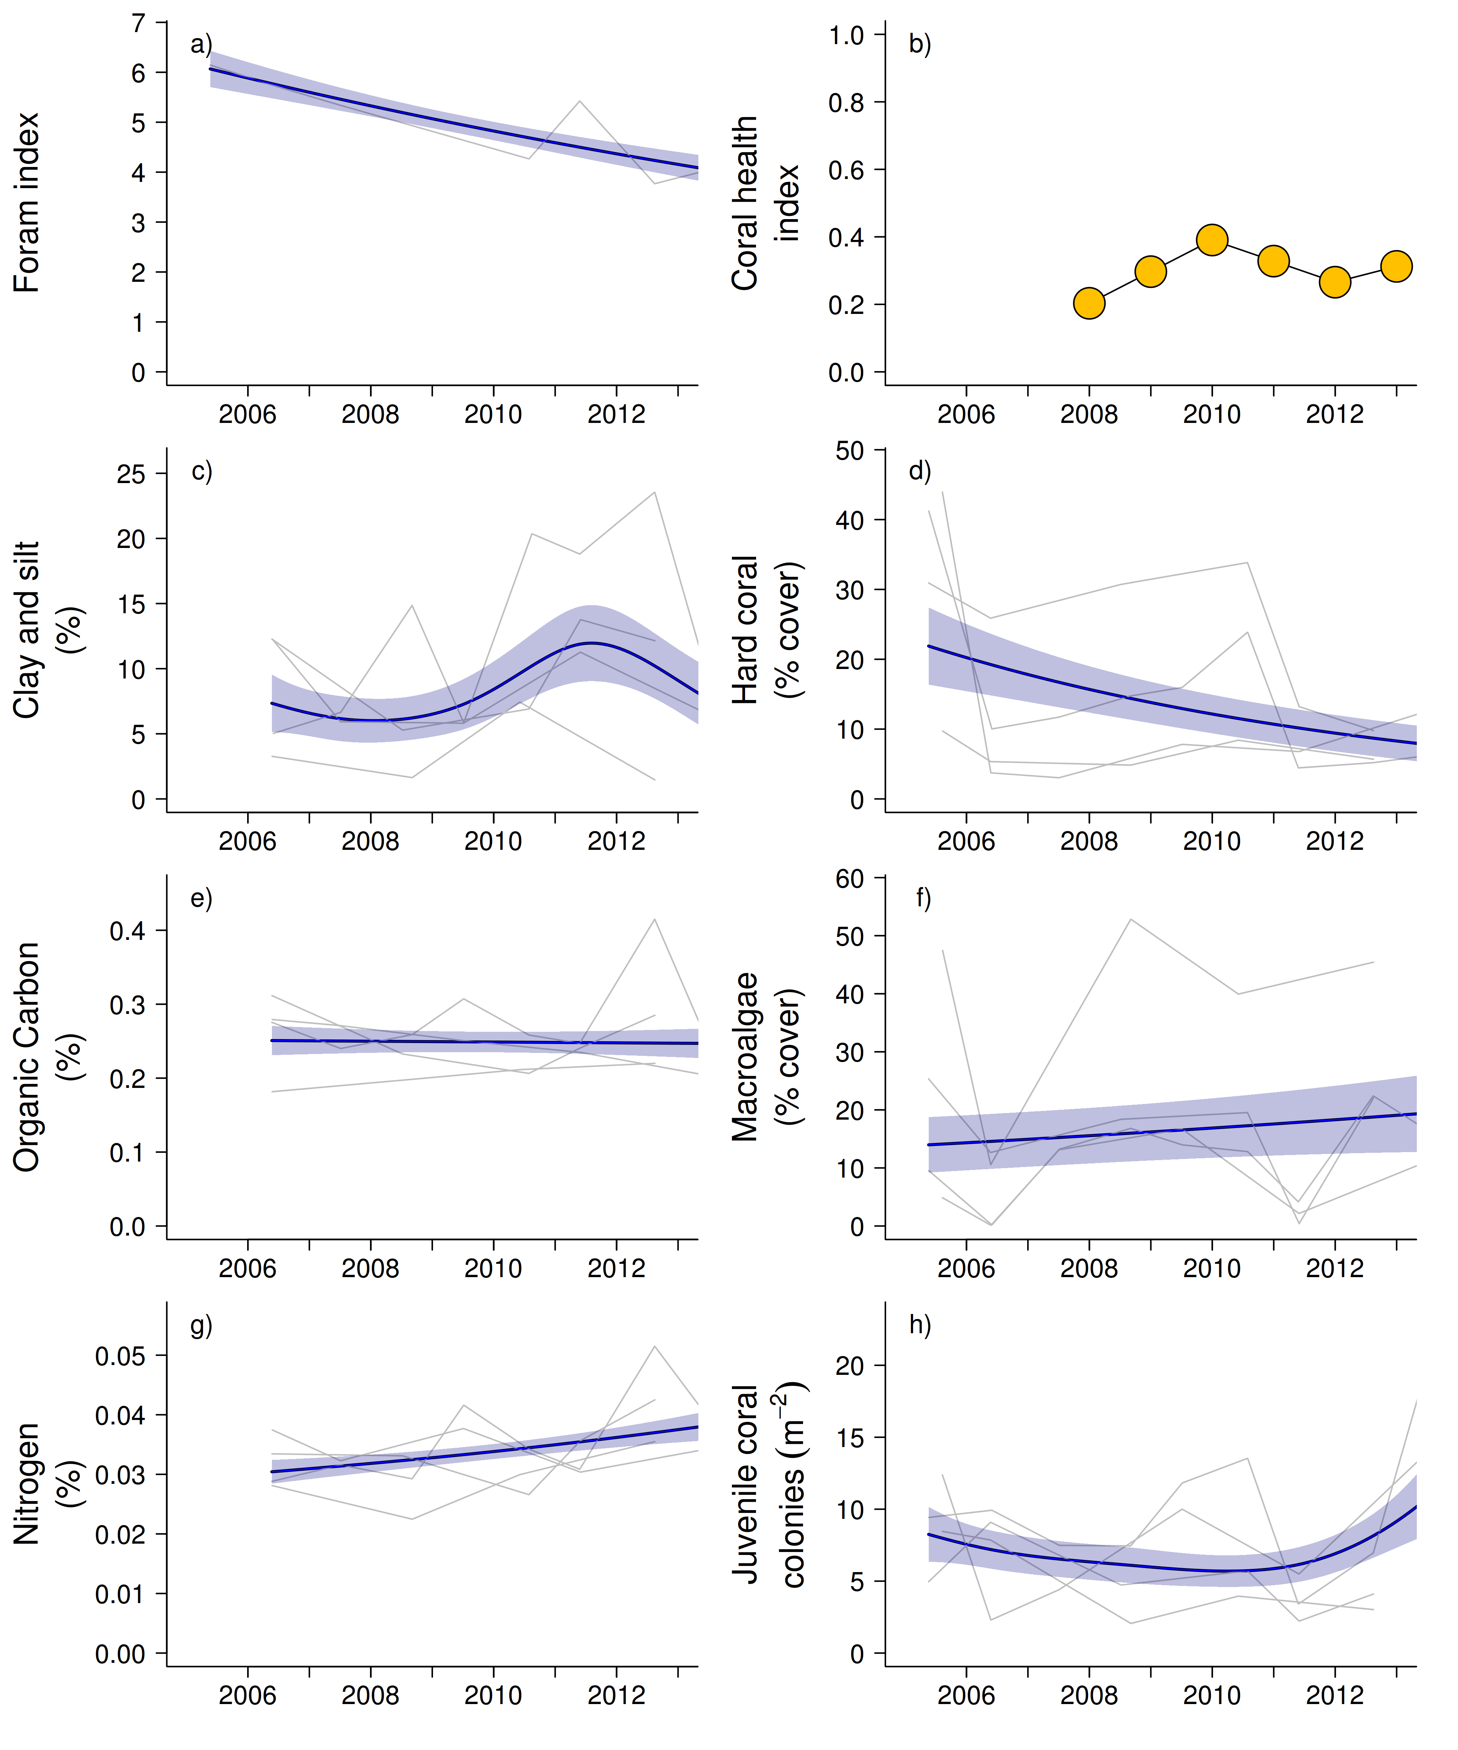

Figure 17 Coral reef community and sediment quality trends in the Herbert-Tully sub-region.
Coral health index colour coding: dark green- ‘very good’; light green-‘good’; yellow – ‘moderate; orange – ‘poor’; red – ‘very poor’. Coral index is calculated from variables plotted in d, f, h, along with the derived estimate of “rate of cover increase” as described in Appendix 1.3.7.Trends in Foram index, sediment and benthic community variables are represented by blue lines with blue shaded areas defining 95% confidence intervals of those trends, grey lines represent observed profiles averaged over depths at individual reefs.

3.1.4 Burdekin Region

The Burdekin Region is one of the two large dry tropical catchment regions adjacent to the GBR, with cattle grazing as the primary land use on over 95% of the catchment area (Brodie et al. 2003, GBRMPA 2012). There is also extensive irrigated planting of sugarcane on the floodplains of the Burdekin and Haughton rivers. Fluctuations in climate and cattle numbers greatly affect the state and nature of vegetation cover, and therefore, the susceptibility of soils to erosion and off-site transport of suspended sediments and associated nutrients.

Seven reefs are sampled for coral reef condition assessments in this region, with three water quality sampling locations co-located with the annually monitored core reefs (Figure 18). The monitoring locations are located along gradients away from the Burdekin River mouth and from the coast; there are no well-developed reefs closer to the Burdekin River than Magnetic Island.

The exposure to secondary plume-type water during wet season varies among reefs: Middle Reef, Magnetic and Lady Elliot are exposed on most days, Pandora and Havannah are frequently exposed and the locations in the Palm Group are rarely exposed to this water type (Figure 18). Havannah, Pandora and the Palm Group are located in the midshelf water body (GBRMPA 2009, Table 1). This gradient in exposure to plume-type waters is reflected in decreasing values of most water quality parameters from Magnetic through Pandora to Palms West (Tables A2-2 to A2-4).

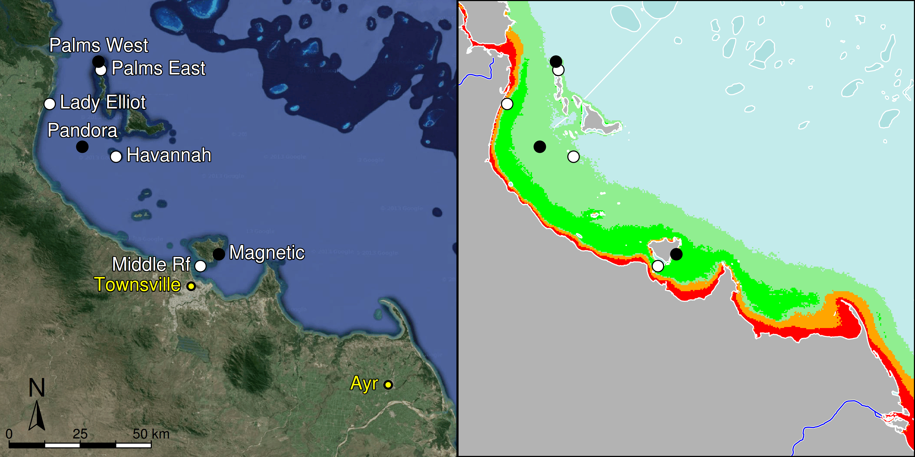

Figure 18 MMP sampling sites in the Burdekin NRM Region.
Black symbols are water quality and core reef sampling locations, white symbols are cycle reef locations, grey symbols are the six open water sites of the AIMS Cairns Transect. Gradients of exposure to flood plume water types (Álvarez-Romero et al. 2013) during the wet season (December to March) are represented as areas exposed to primary plume-type waters most days (> 67% of days during the wet season, red shading) or frequently (33% - 67% of wet season days, orange shading), and areas exposed to secondary plume-type waters most days (>67% of wet season days, solid green shading), frequently (33% - 67% of wet season days, transparent green shading) or rarely (< 33% of wet season days, light blue shading).
.

Over the period 2007 to 2012, annual discharge from the Burdekin River (Figure 19) was above median levels, with extreme floods in 2008, 2009 and 2011 (see Appendix Table A2-1). The 2011 flood was the third largest recorded at almost six times the long term median discharge (Table A2-1). Discharge in 2013 was below the long-term median.

The monitoring locations were variously damaged by tropical cyclones Larry in 2006, Olga in 2010 and Yasi in 2011 (Figure 20), all of which caused reductions in coral cover at some reefs (Figure 22d, Table A2-5, Figure A2-6).

Temperature records since 2005 reveal no extreme temperature events that would be expected to cause coral bleaching (Figure 20).

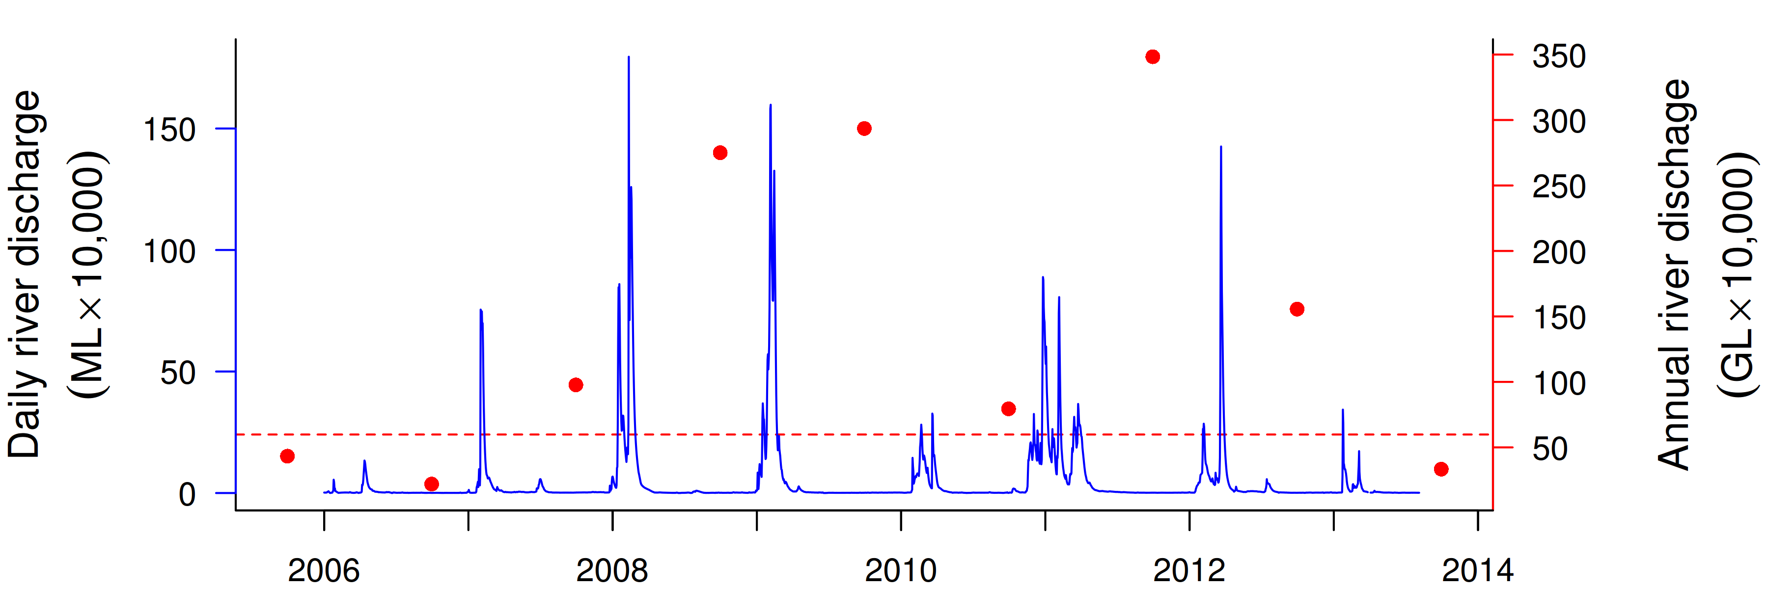
Figure 19 Discharge for the Burdekin River.
Daily (blue) and annual (October to September, red) discharge shown. Red dashed line represents the long-term median annual discharge.
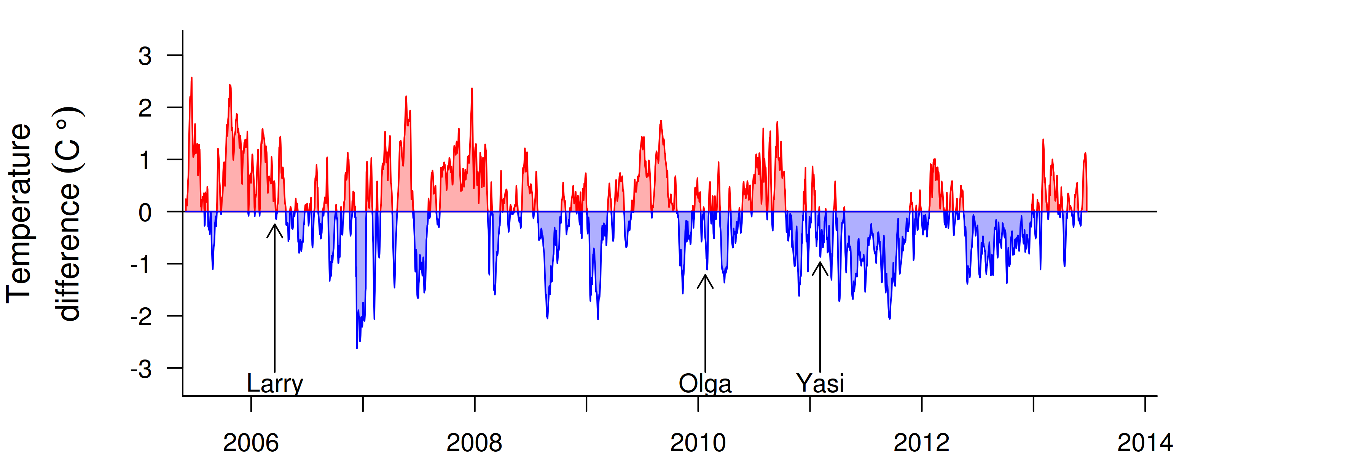
Figure 20 Sea temperature for the Burdekin region.
Red and blue regions signify periods of above and below the long term seasonal average.

The water quality index in this region was relatively stable over the past four years, oscillating between ‘good’ and ‘very good’ ratings (Figure 21a). Trends in concentrations of chlorophyll a (chl a), suspended solids (SS), particulate nitrogen (PN) and particulate phosphorus (PP) declined slightly over the course of the program, with a period of slightly increased values in the latter three variables around 2011-12 (Figure 21b, c, f, h), likely influenced by the both Cyclone Yasi and extreme flooding of the Burdekin and local rivers in 2011 (Figures 19, 20 and Table A2-1). From 2007 onwards, the overall trend-lines for chl a, SS, PN and PP were below water quality guidelines (guideline). Secchi depth remained relatively stable but non-compliant with the guideline (Figure 21e). The concentrations of dissolved oxidised nitrogen (NOx) increased sharply after the first major flood event in 2008 and have since remained at levels close to or above the guideline (Figure21d).

Instrumental chlorophyll (chl) and turbidity records showed more pronounced fluctuations than the manual sampling data (Figure 21b, g). The trendlines of chl showed distinct maxima above the guideline during the wet season of 2008, then stayed at a high level and increased again above the guideline since 2012 (Figure 21b). The turbidity record showed maxima above the guideline in most of the years 2009, 2011 and 2012, after which values decreased (Figure 21g).

The content of fine grain-sizes and nitrogen in reef sediments show slight increases (Figure 22e, g). Four of the five sites sampled in 2012 showed a distinct peak in sediment nitrogen in that year (Figure 22g). Despite the limited evidence for large changes in sediment composition, the FORAM index has declined considerably (Figure 22a). Lower values of the FORAM index indicate a high relative abundance of heterotrophic species. As for other regions, we assume that this increase in heterotrophic species is driven by increased availability of nutrients within the sediments, a notion supported by the slight rises in sediment nitrogen (Figure 22g), but also the increase water column oxidised nitrogen (Figure 21d). Several studies suggest the slow growth of autotrophic forams under high NOx (Uthicke and Aldernath 2010, Reymond et al. 2011, Uthicke et al. 2012b). The declines in FORAM index resulted in a negative condition rating of the communities of foraminifera on all three reefs (Table A2-7), and subsequently the continued ‘very poor’ rating for FORAM community condition in the region (Table A2-6).

Reefs in the Burdekin Region have been monitored since 1989 (AIMS, DERM and Sea Research), with bleaching and cyclones identified as the principal disturbances to coral communities over that period (Ayling and Ayling 2005, Sweatman et al. 2007, Table A2-5). Temperature-induced coral bleaching in 1998 had the largest impact from a single event, reducing regional coral cover by an average of 37% (Table A2-5). Cyclonic disturbances in 1990 (Cyclone Joy), 1997 (Cyclone Justin), 2000 (Cyclone Tessi), and 2006 (Cyclone Larry) have variously affected reefs in this region (Table A2-5).

Coral mortality as a result of cyclones and previous mass bleaching events clearly contribute to the continued ‘poor’ assessments of the coral health index (Figure 22b). In addition to the direct influences of these events on coral cover, it appears the loss of corals has been sufficiently severe to substantially limit the supply of larvae and, hence, reduce the rate at which coral communities recover (Done et al. 2007, Sweatman et al. 2007). Hydrodynamic modelling indicates limited connectivity between Halifax Bay and reefs further offshore (Luick et al. 2007, Connie 2.0) and, hence, regionally reduced coral cover may partially explain the low settlement of coral larvae (Figure A2-9) and low densities of juvenile colonies in this region (Figure 12f, Figure A2-6). In late 2010, we recorded a strong settlement pulse of Acropora to settlement tiles that followed the gradual increase in cover of Acropora within the region, potentially indicating the release from chronic broodstock limitation, or that atypical currents provided greater connectivity to more distant broodstock in that year. Irrespective of the source of these larvae, their survival and progression into juvenile size classes was not apparent in subsequent surveys of juvenile corals and Cyclone Yasi again reduced the cover of potential broodstock. See case study in section 3.2 for a more detailed exploration of the coral larvae settlement data.

In the face of the severity of recent disturbances it is not unexpected that coral cover is low, which also influences the overall coral health index. It is essential that coral communities show evidence of resilience by recovering from disturbance events through the survival and growth of coral recruits and remaining colonies. Poor water quality has the potential to suppress this resilience, especially by facilitating the growth of macroalgae (De’ath and Fabricius 2008, 2010). Macroalgae have been documented to suppress fecundity (Foster et al. 2008), reduce recruitment of hard corals (Birrell et al. 2008b, Diaz-Pulido 2010), diminish the capacity of growth among local coral communities (Fabricius 2005),and suppress coral recovery by altering coral associated microbial communities associated with corals (Morrow et al. 2012, Vega Thurber et al. 2012). Within this region, macroalgae cover has been persistently high at most coral locations within the area bounded by frequent exposure to plume-type waters (Figure 18, Figure A2-6). Only at 2m depth at Havannah has macroalgal cover been decreasing, coupled with a clear increase in hard coral cover (Figure A2-6). While not a water quality monitoring site, based on the flood exposure map (Figure 18) it is likely that the water quality is better at Havannah compared to the other reefs in this region that have a sustained high cover of macroalgae. While links between coral cover and larval supply have been discussed above, we cannot exclude the role of high macroalgae cover from further suppressing the density of juvenile colonies observed at some reefs. The only reef in the region with consistently moderate to high densities of juvenile corals is Lady Elliot Reef at 2m depth. However, the juvenile community was dominated by unusually high densities of juvenile mushroom corals (Fungiidae) and a strong recruitment of Dendrophyliidae - genus Turbinaria, in 2012 (Figure A2-6). Finally, low rates of coral cover increase during periods when no acute disturbances are recorded have been a feature of the coral communities in this region (Table A2-6, A2-7). In the three years leading up to 2013 it was only at Palms East, the 2m depth at Havannah and Middle Rf that coral cover had increased at or above rates expected for the coral communities present (Table A2-6,). None of these reefs had a high cover of macroalgae over this period (Figure A2-6).

The composition of coral communities vary in response to environmental gradients, with water clarity and exposure to sedimentation widely acknowledged as key parameters. Within this region there is a shift from communities dominated by the families Acroporidae, Pocilloporidae and Poritidae (genus Porites) in clearer waters through to communities dominated by families such as Agariciidae, Oculinidae, Pectiniidae and Poritidae (Genus Goniopora) in more turbid and sheltered settings (Figure A2-6). In addition to selecting for different community types, the environmental setting of these reefs has also resulted in differential exposure to disturbances. The orientation of the reef differentially exposes corals to physical damage by cyclone driven waves, while differences in community composition result in differential impact of bleaching events as susceptibility to thermal stress varies among species (Baird and Marshall 2002). The communities dominated by Acroporidae: Palms East, Palms West (2m) and Magnetic (2m) have been most damaged by cyclones and bleaching events and in 2013 share very low coral cover (Figure A2-6). The exception is Havannah where the Acroporidae at 2m was sheltered from Cyclone Yasi and cover has recently increased. Conversely, the relatively sheltered communities at Middle Rf and at the 5m depth at Lady Elliot Rf maintain a moderate coral cover due to being sheltered from recent cyclones and having a high representation of species relatively resistant to both thermal stress, and high turbidity.

Recent palaeoecological evidence suggests that present-day coral assemblages in the Burdekin Region are the result of a shifted baseline; from dominant arborescent Acropora to a remnant community of sparse Acropora and/or dominant non-Acropora species (Roff et al. 2013). An implied cause of this change is the sustained decline in water quality resulting from the expansion of agriculture in the catchment. Exposed to increased chronic stress the, once ubiquitous suite of arborescent Acropora species were no longer able to recover from recurring impacts of cyclones and floodwaters, suffering a systematic collapse between 1920 and 1955. In the context of Roff et al. 2013, the current Acropora assemblages on inshore reefs represent fragile communities exposed to poor water quality, with low resistance and resilience, and an uncertain future. This interpretation is supported by our observations of increased levels of disease in 2007-2009 (Figure A2-10) that coincide with increased discharge of the Burdekin River (Table A2-1, Figure 19) and elevation in NOx concentrations in the regions waters (Figure 11d) suggesting the ongoing selection for benthic communities tolerant of the elevated levels of pollutants delivered in flood plumes. Nutrient enrichment has been suggested as increasing the incidence of coral disease (Vega Thurber et al. 2013). The potential links between high NOx concentrations and a reduction in coral bleaching threshold (Wooldridge 2009) my help to explain the reasons that corals in this region suffered such high mortality attributed to thermal bleaching in 1998 and also the decline of the branching Acropora described by Roff et al. (2013).

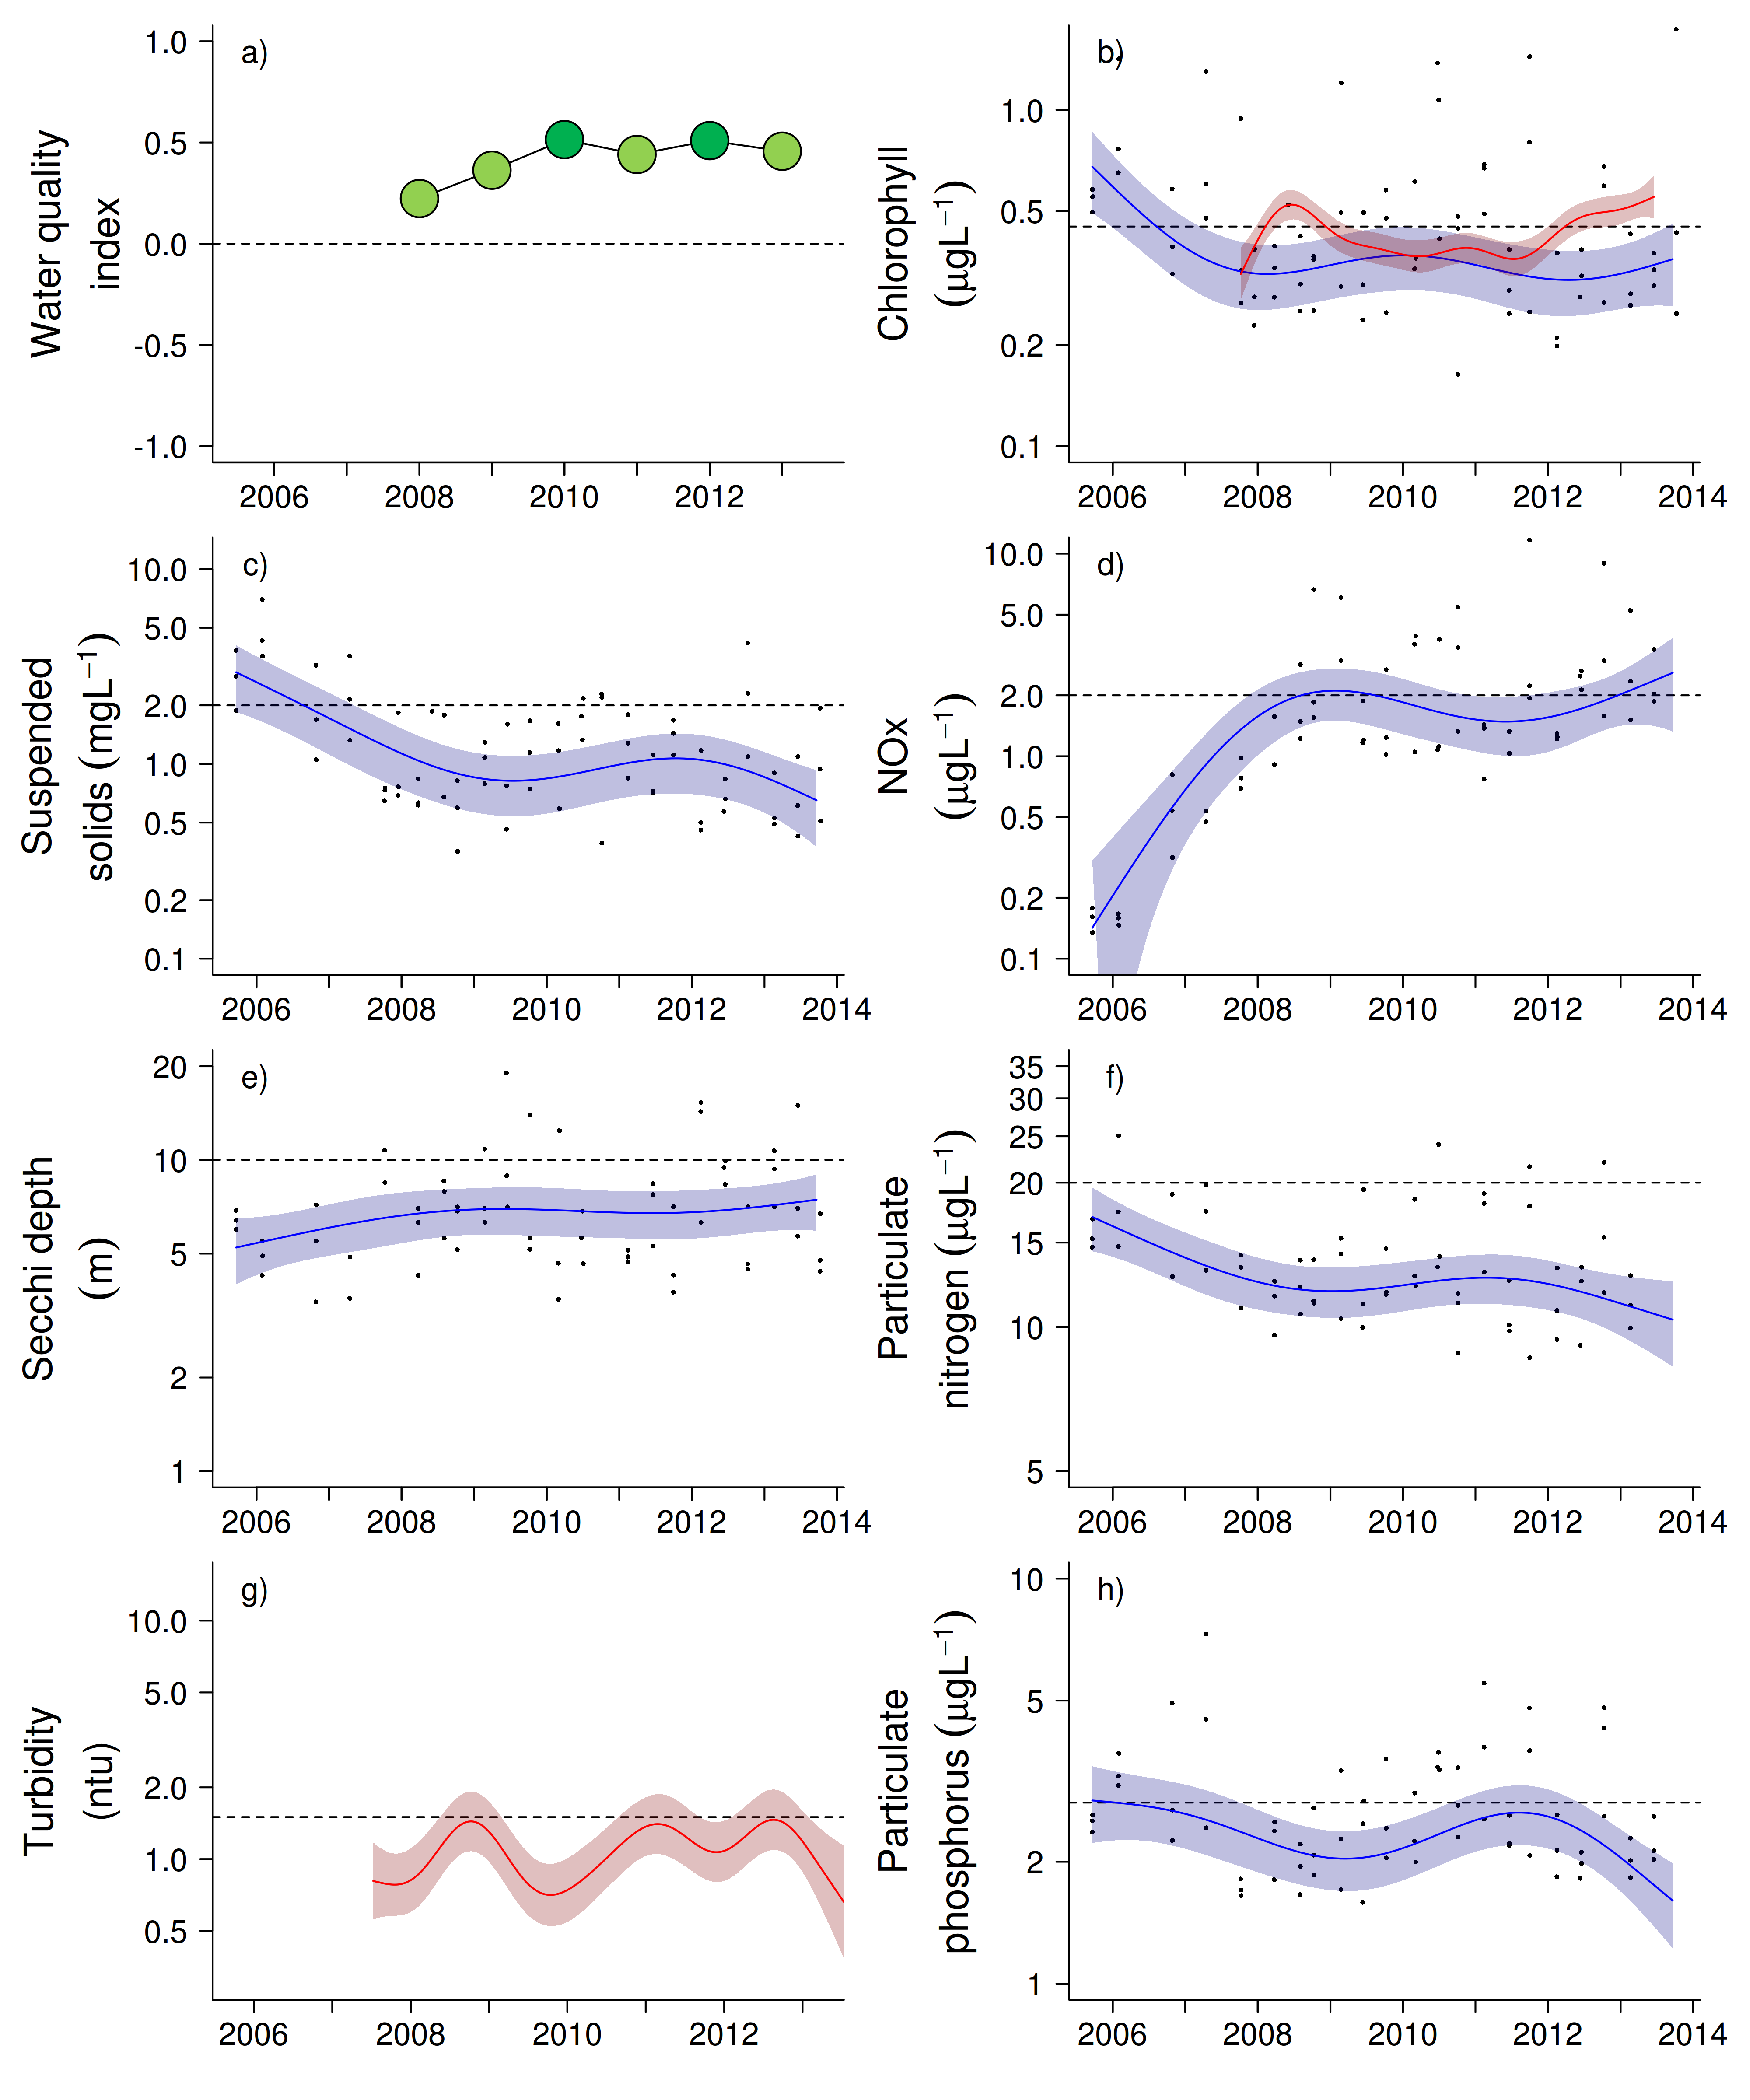
Figure 21 Water quality trends in the Burdekin region.
Water quality index colour coding: dark green- ‘very good’; light green-‘good’; yellow – ‘moderate; orange – ‘poor’; red – ‘very poor’. The water quality index is the aggregate of variables plotted in with the exception of NOx and calculated as described in Appendix 1.2.3. Trends in manually sampled water quality variables are represented by blue lines with blue shaded areas defining 95% confidence intervals of those trends, black dots represent observed data. Trends of records from ECO FLNTUSB instruments are represented in red, individual records are not displayed. Dashed reference lines indicate guideline values.
.

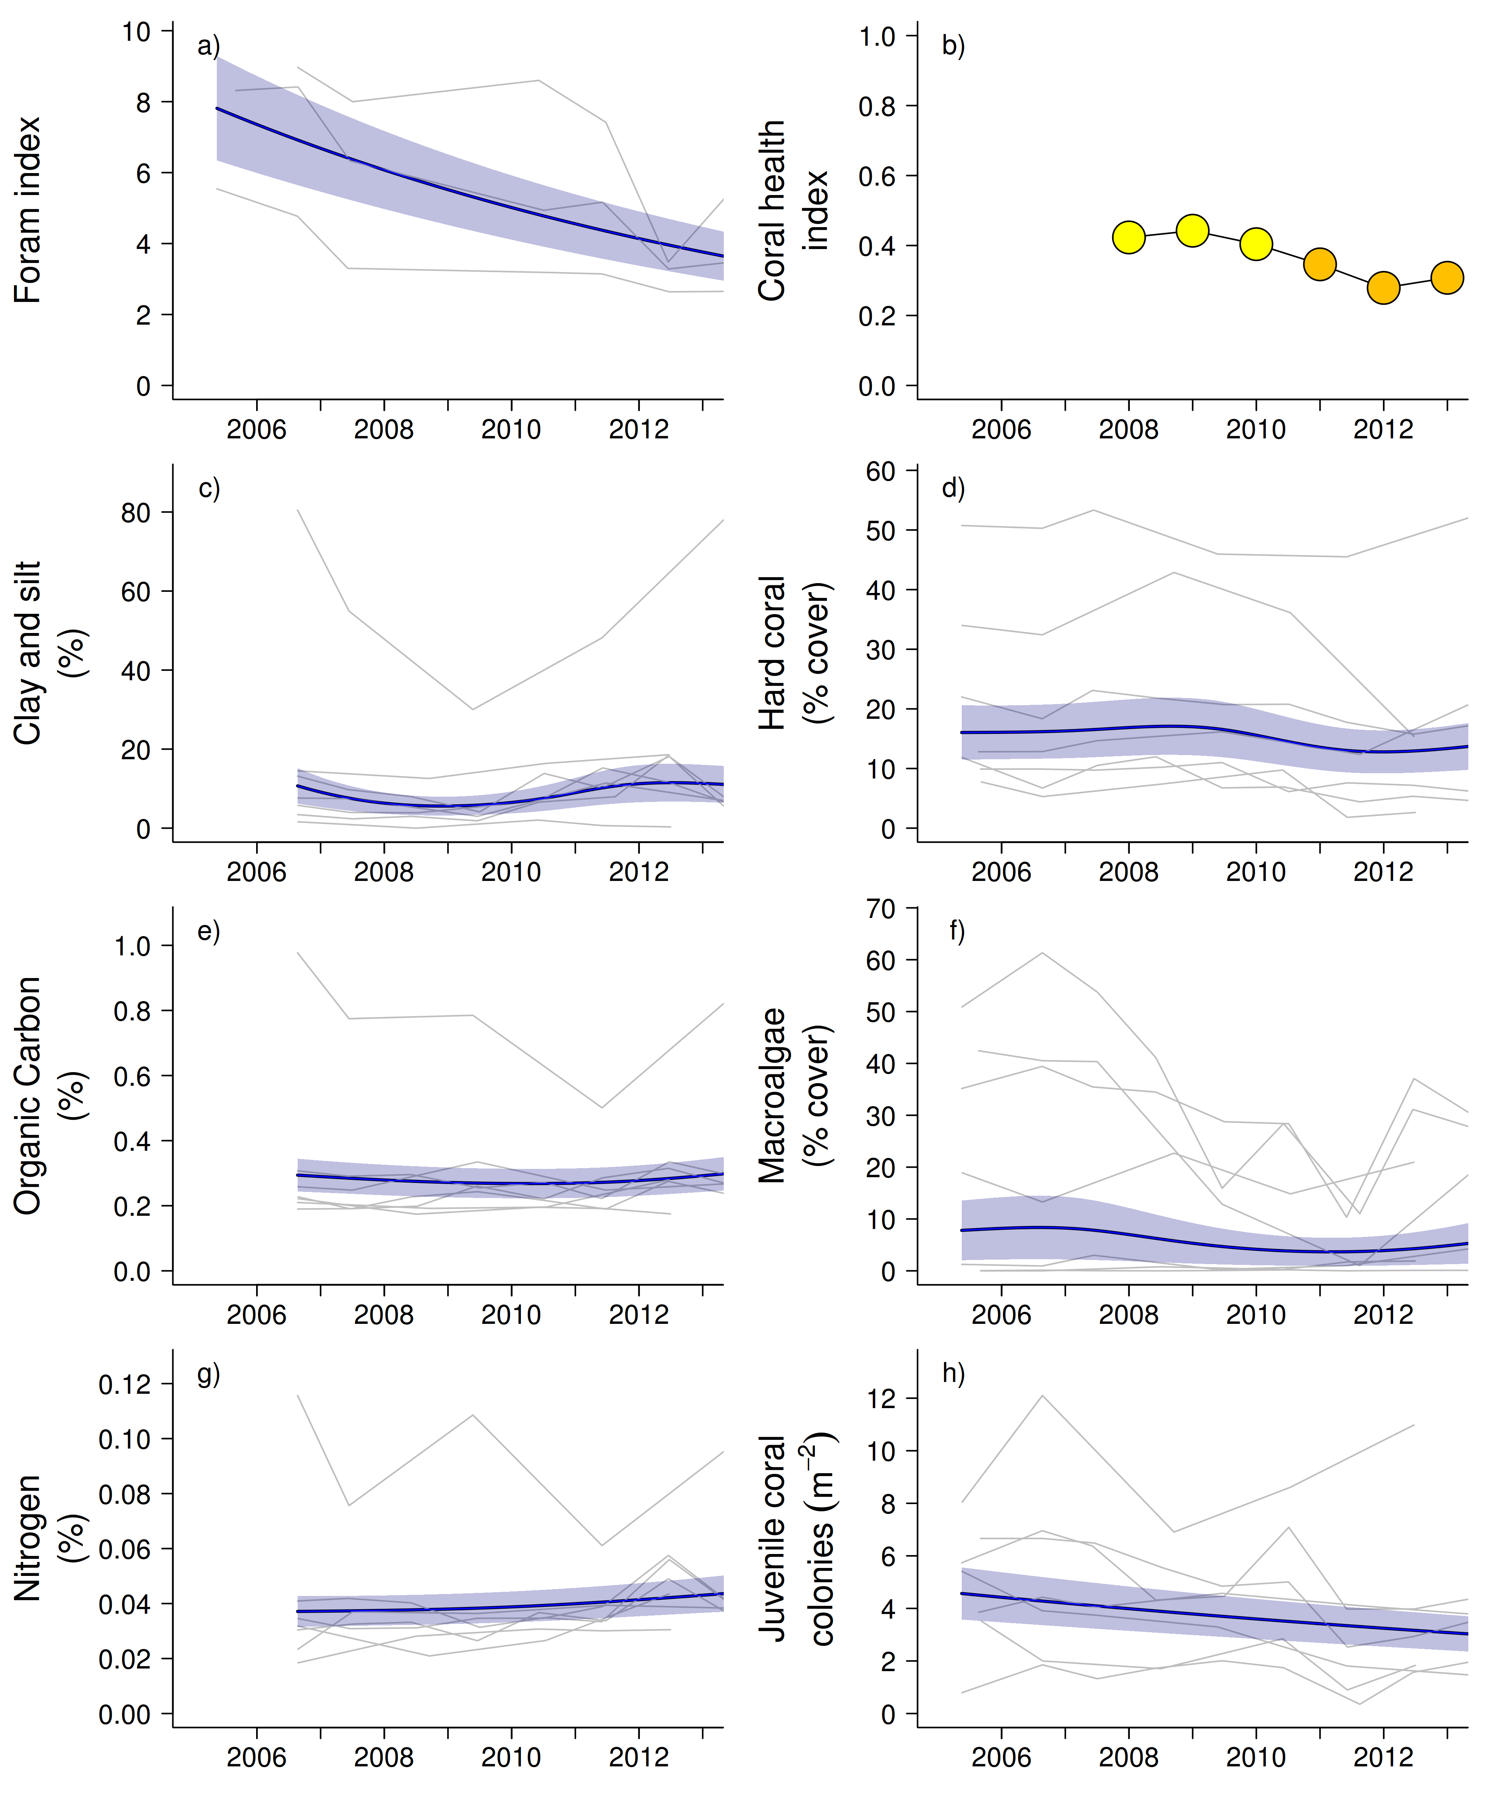

Figure 22 Coral reef community and sediment quality trends in the Burdekin region.
Coral health index colour coding: dark green- ‘very good’; light green-‘good’; yellow – ‘moderate; orange – ‘poor’; red – ‘very poor’. Coral index is calculated from variables plotted in d, f, h, along with the derived estimate of “rate of cover increase” as described in Appendix 1.3.7.Trends in Foram index, sediment and benthic community variables are represented by blue lines with blue shaded areas defining 95% confidence intervals of those trends, grey lines represent observed profiles averaged over depths at individual reefs.

3.1.5 Mackay Whitsunday Region

The Mackay Whitsunday Region is located in the central section of the GBR and comprises four major river catchments, the Proserpine, O’Connell, Pioneer and Plane catchments that enter the sea to the south of the monitoring locations. The region is also potentially influenced by runoff from the Burdekin and Fitzroy rivers during extreme events or through longer-term transport and mixing. The climate in this region is wet or mixed wet and dry tropical with the catchment land use dominated by agriculture broadly divided into grazing in the upper catchments and sugarcane cultivation on the coastal plains (Brodie et al. 2003, GBRMPA 2012). In addition, there are expanding urban areas along the coast.

Seven reefs are sampled for coral reef condition assessments in this Region, all located in the Whitsunday Islands, a group of high continental islands that is a major tourist destination. Tidal range in this region can exceed four metres, which is greater than in most other inshore areas of the GBR. The monitoring locations are located along gradients away from the Proserpine and O’Connell river mouths and away from the coast with four reefs sampled in the inner Whitsundays and three in the outer Whitsundays, separated by a relatively deep channel (Figure 23). Three water quality sampling locations are co-located with the annually monitored core reefs in the inner Whitsundays.

Shute Harbour, Daydream, Pine and Dent are exposed to secondary plume-type waters on most days during wet seasons, while the other three sites are frequently exposed (Figure 23).

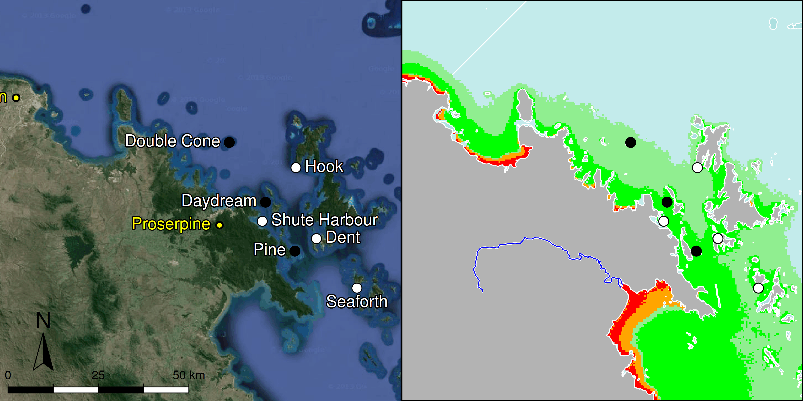

Figure 23 MMP sampling sites in the Mackay Whitsunday NRM Region.
Black symbols are water quality and core reef sampling locations, white symbols are cycle reef locations, grey symbols are the six open water sites of the AIMS Cairns Transect. Gradients of exposure to flood plume water types (Álvarez-Romero et al. 2013) during the wet season (December to March) are represented as areas exposed to primary plume-type waters most days (> 67% of days during the wet season, red shading) or frequently (33% - 67% of wet season days, orange shading), and areas exposed to secondary plume-type waters most days (>67% of wet season days, solid green shading), frequently (33% - 67% of wet season days, transparent green shading) or rarely (< 33% of wet season days, light blue shading).

Over the period 2007 to 2012, annual discharge from the Proserpine, O’Connell and Pioneer rivers was above median levels (Table A2-1). Extreme floods (> 3x median) were recorded for the O’Connell River in 2011, the Pioneer River in 2008 and 2010 to 2012, and the Proserpine River each year 2008-2012 (Table A2-1). The 2011 flood was the largest on record for the Proserpine River and the third largest for the O’Connell River. Discharge in 2013 was below the long-term median for the O’Connell River while the Pioneer and Proserpine rivers again exceeded long-term median flows (Table A2-1).

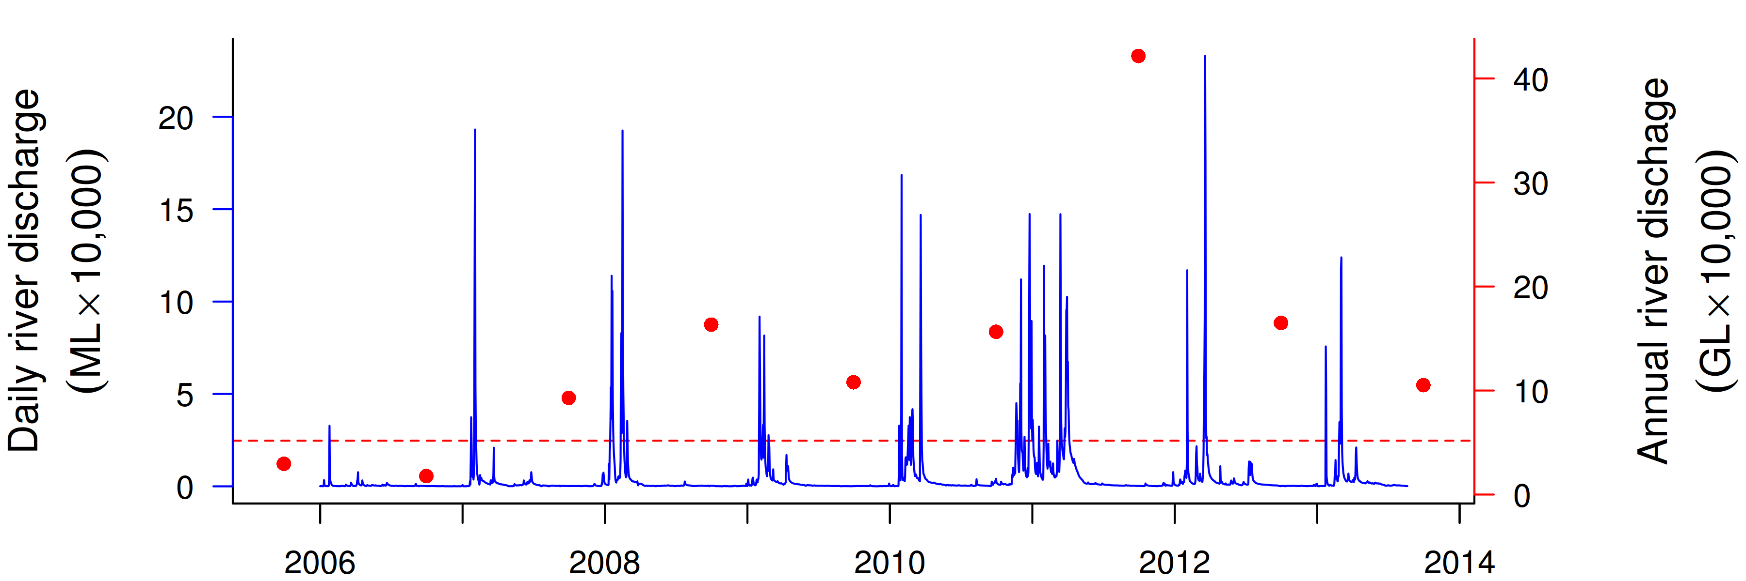
Figure 24 Combined discharge for the O'Connell, Proserpine and Pioneer Rivers.
Daily (blue) and annual (October to September, red) discharge shown. Red dashed line represents the long-term median of the combined annual discharges.
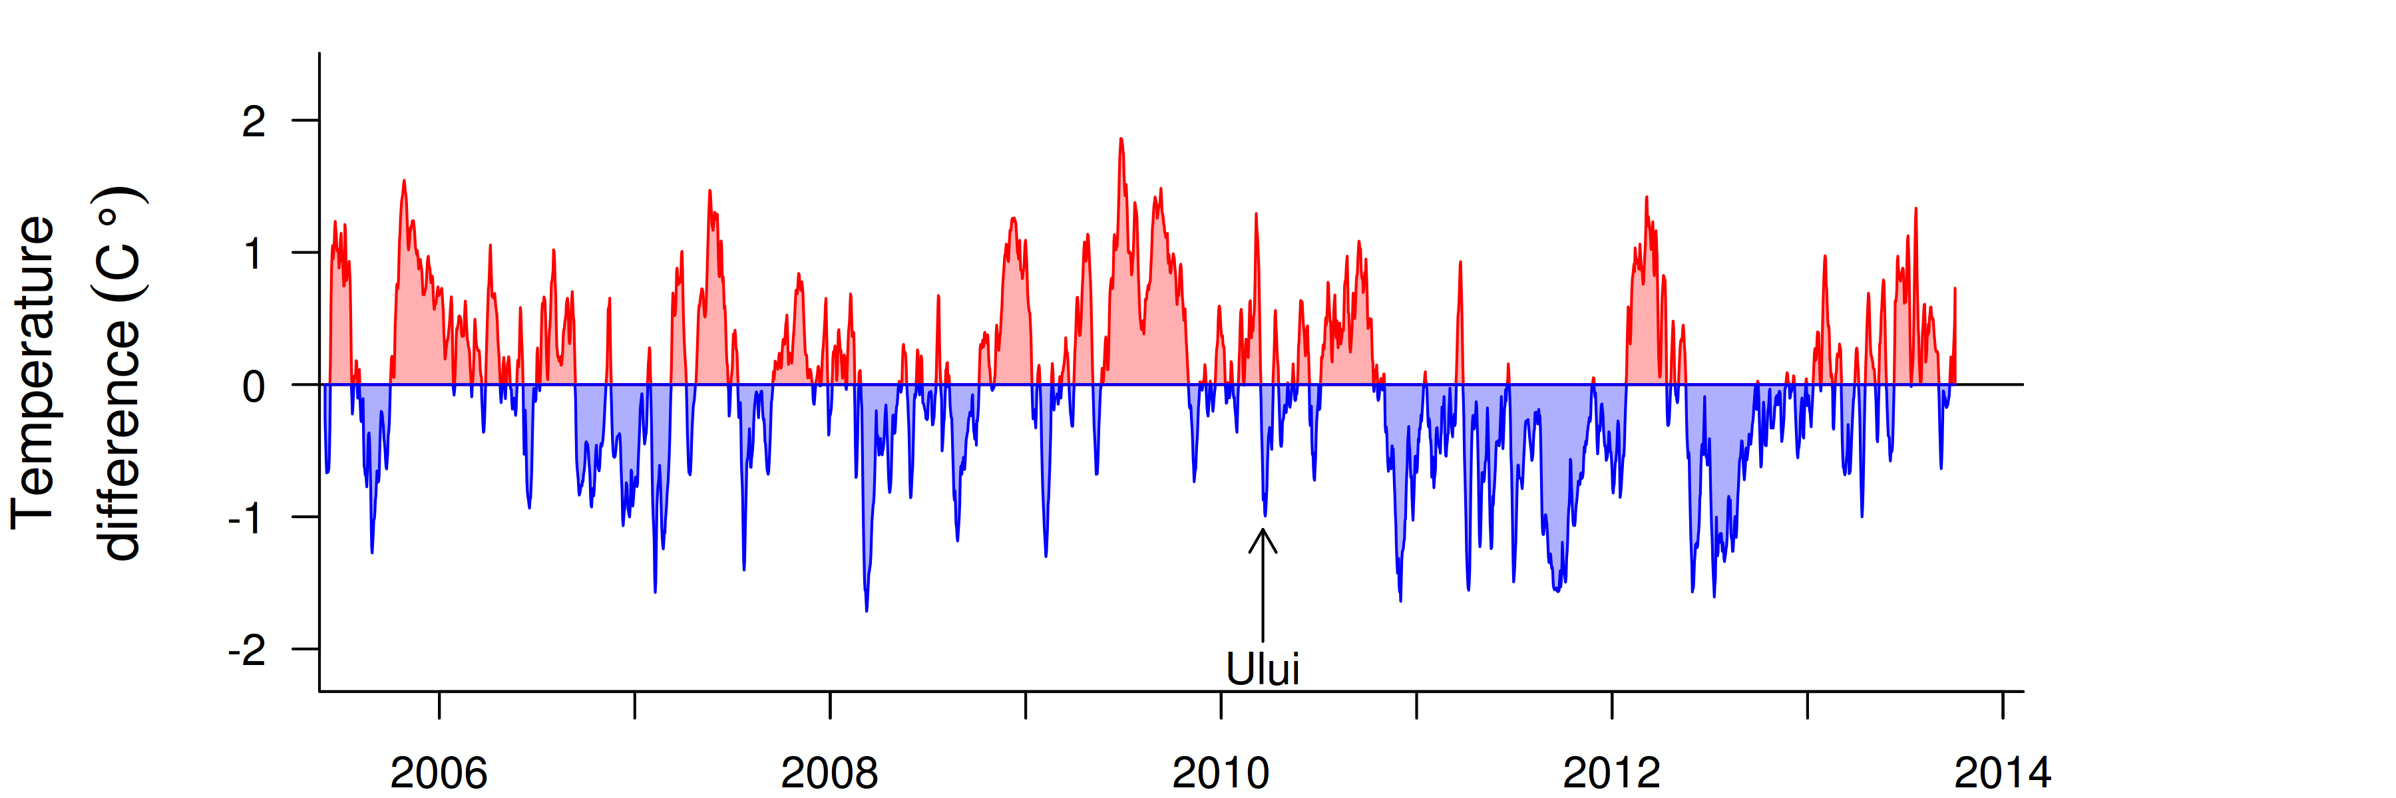
Figure 25 Sea temperature for the Mackay Whitsunday region.
Red and blue regions signify periods of above and below the long term seasonal average.

The water quality index in this sub-region has declined since 2008 to the current ‘moderate’ rating (Figure 26a). Trends in concentrations of chlorophyll a (chl a), suspended solids (SS) and particulate phosphorus (PP) increased after 2008 with highest values, above water quality guidelines (guideline), in ~2010 and 2013 for chl a and 2011-12 for SS and PP (Figure 26b,c,h), likely influenced by the sustained high or extreme flows of the adjacent rivers. The overall trend for particulate nitrogen (PN) was stable (Figure 26f). Secchi depth has declined by about 50% since 2008 and remained on this low level, which is non-compliant with the guideline (Figure 26e). The concentrations of dissolved oxidised nitrogen (NOx) increased sharply after the first above-median river flows in 2007 and since remained high with the overall trend-line above the guideline since 2012 (Figure27d).

Instrumental chlorophyll (chl) records showed more pronounced fluctuations but generally followed the same trend as the manual sampling data (Figure 26b,g). The trendline of the instrumental turbidity record was above the guideline for most of the monitoring period, with an upward trend from 2012; this broadly mirrors the increase in SS to above guideline levels in 2009 and corresponding decline in Secchi depth, with all three indicators of water “clarity” continuing to not comply with the guideline (Figure 26c,e,g). This is especially the case for Pine and Daydream (Tables A2-2 to A2-4, Figure A2-1 j, k), which are more frequently exposed to flood plumes (Figure 23). The reef sediments in this region have the highest proportion of clay and silt-sized particles, organic carbon and nitrogen of all sampling regions, and the clay-and-silt and nitrogen content slightly increased over the monitoring period (Figure 27e,g).

There are limited historical time-series data available for the coral communities in this region (Sweatman et al. 2007). The largest widespread disturbances in recent history were coral bleaching events in 1998 and 2002, which most likely affected the reefs monitored by this program (Table A2-5). Observations from Dent Is and Daydream Is suggest an approximate 40% reduction in coral cover during 1998, while observations from AIMS LTMP monitoring sites at reefs in the outer Whitsunday Group record no obvious impact in 1998 and only marginal reductions in 2002 (Sweatman et al. 2007). Temperature records since 2005 show no extreme temperature events that would have led to coral bleaching (Figure 25). Since monitoring began in 2005, Cyclone Ului in 2010 has been the only acute disturbance to coral communities with impacts largely restricted to Daydream and Double Cone (Figure A2-7, Table A2-5).

Despite the recent decline in water quality, the overall condition of coral communities in 2013 remains “moderate”, though this has increased slightly from a low point in 2011 (Figure 27b). Positive aspects of the communities indicated by persistently low cover of macroalgae and moderate to high coral cover on most reefs compensate for the generally low rates of increase in coral cover (Table A2-6, A2-7). Most influencing the slight improvement in the regional coral health index has been the increasing coral cover at Double Cone in recent years (Figure A2-7). In addition to improving the indicator ‘rate of coral cover change’, this increase in cover has reduced the available space for juvenile corals. While the numbers of juvenile colonies remained low, the health indicator ‘juvenile density’, which standardises the observed number of juvenile colonies to the availability of suitable settlement substratum (see detailed Methods section Appendix 1.3.2), has increased because of the space occupied by increasing adult coral cover (Table A2-6).

The standardisation of juvenile densities for available substrate is specifically designed to not penalise the assessment of juvenile abundances when there is limited settlement opportunity because of the prior occupation of space by adult corals, e.g. as at Double Cone. However, as corals require a solid substrate on which to recruit, sediment deposits are also deemed as unavailable space. Consequently, high levels of sedimentation can shift the classification of substratum from being available to unavailable, resulting in an increase in the standardised density of juvenile colonies, and so, an overly positive rating of this metric in the coral health index. The abundance of juvenile corals has not increased appreciably on the reefs in this region (Figure A2-7) and, coupled with our observations of increased sedimentation detailed below, we feel the improvement of the coral reef index based on calculated increase in densities of juvenile colonies per area of available substrate is misleading (Table A2-6, A2-7). Rather, abundances of juvenile corals have declined (Figure 27h), consistent with previous findings that increased sediment accumulation reduces larval settlement and survival (Babcock and Smith 2002, Birrell et al. 2005, Goh and Lee 2008). We intend to investigate was of refining the coral index to avoid this incongruence in the future.

Reefs in the Whitsunday Group are generally sheltered from wave action by the surrounding islands and, hence, predisposed to the accumulation of fine sediments. From 2008 onwards, accumulated sediments on living coral colonies have been a commonly associated with partial mortality and disease, and substrata between corals have accumulated thick deposits of silt on most monitored reefs. This increase in fine sediment supply is evident in increases in the clay and silt content and also nitrogen content of sediments at the monitoring locations (Figure 27c,g). The period over which these increases have occurred coincide with increased turbidity (Figure 26c,e) that in turn coincides with increased flows of the rivers in this and adjacent regions (Figure 24, Table A2-1).

The selective pressure associated with turbidity and sedimentary regimes has clearly influenced the composition of both coral and foraminiferal communities in this region. Marked differences in composition of coral communities between 2m and 5m transects are indicative of a steep gradient in environmental conditions, most likely due to high water turbidity. While community composition varies strongly between reefs, there are relatively high abundances of sediment- and low light-tolerant taxa (families Oculinidae, Pectiniidae, Agariciidae and Poritidae (genus Goniopora)) at 5m locations compared to the communities at 2m depths which have higher cover of Acroporidae (here mostly genus Acropora) and Poritidae (genus Porites) (Figure A2-7). At the two reefs, Daydream and Dent, where cover of Acroporidae was relatively high at 5m depth, cover of this family has declined due to the combined effects of Cyclone Ului in 2010 and the high incidence of coral disease in 2007-8 and again in 2011 (Figure A2-10). The connection between physiochemical aspects of terrestrial runoff and disease prevalence has been recognised before (Bruno et al. 2003, Kaczmarsky and Richardson 2010, Haapkylä et al. 2011, 2013, Vega Thurber et al. 2013). Our observations support this connection as increases in coral disease in the inshore GBR coincided with the transition from a period of below-median river flows to well above median flows, which in turn coincided with a decrease in water quality, and demonstrate the selective pressure that runoff can exert on benthic communities.

The cover of macroalgae has remained stable and relatively low throughout the region. Only Pine and Seaforth maintain significant macroalgal cover (Figure A2-7). These reefs are closest to the rivers influencing the region. Water quality data from Pine shows that many water quality variables consistently exceeded the guideline (Tables A2-2 to A2-4). Turbidity and chlorophyll concentrations are lower at Daydream Is albeit still mostly exceeded the guideline. However, macroalgal cover has not increased here in recent years despite the availability of substratum for colonisation following Cyclone Ului. It is not certain what has inhibited increased macroalgal cover at Daydream. One possible explanation is a difference in grazing pressure. Herbivory has been demonstrated as a critically important for the maintenance of reefs in a coral dominated state (Hughes et al. 2007), and postulated to offer resilience to conditions that may otherwise support a shift to algal dominance (Cheal et al. 2013). At Daydream, we consistently see higher numbers of the grazing urchin Diadema sp. than at Pine.

A recent study of sediment cores from the Whitsunday area showed clear shifts in foraminiferal assemblages at Daydream, Double Cone, and Dent from a composition of relatively high proportions of autotrophic species over several thousand years to increasing proportions of heterotrophic species and, hence, a decline in the FORAM index post European settlement (Uthicke et al. 2012a). The recently observed changes in the assemblage composition and decline in the FORAM index to the currently very low values (Figure 27a) indicate the ongoing selective pressures of recently experienced environmental conditions. Consistent with the steep decline in the water quality index, possible reasons for declines in the FORAM index are reduced light availability for photosynthetic species and increased nutrient supply favouring heterotrophic species (Uthicke and Altenrath 2010, Reymond et al. 2011, Uthicke et al. 2012b).

Overall, the influence of prevailing environmental conditions such as high turbidity and increasing proportions of fine sediment on the coral communities in this region (particularly on juvenile survivorship) appears to be significant (Thompson et al. in review). The moderate to high coral cover on most reefs suggests a selection for species tolerant of the high turbidity and high rates of sedimentation that characterise this region. However, the continued low abundance of juvenile corals and poor rates of coral cover increase suggest that if an acute disturbance were to occur, the ability of reef communities to return to a coral-dominated state may be severely reduced.

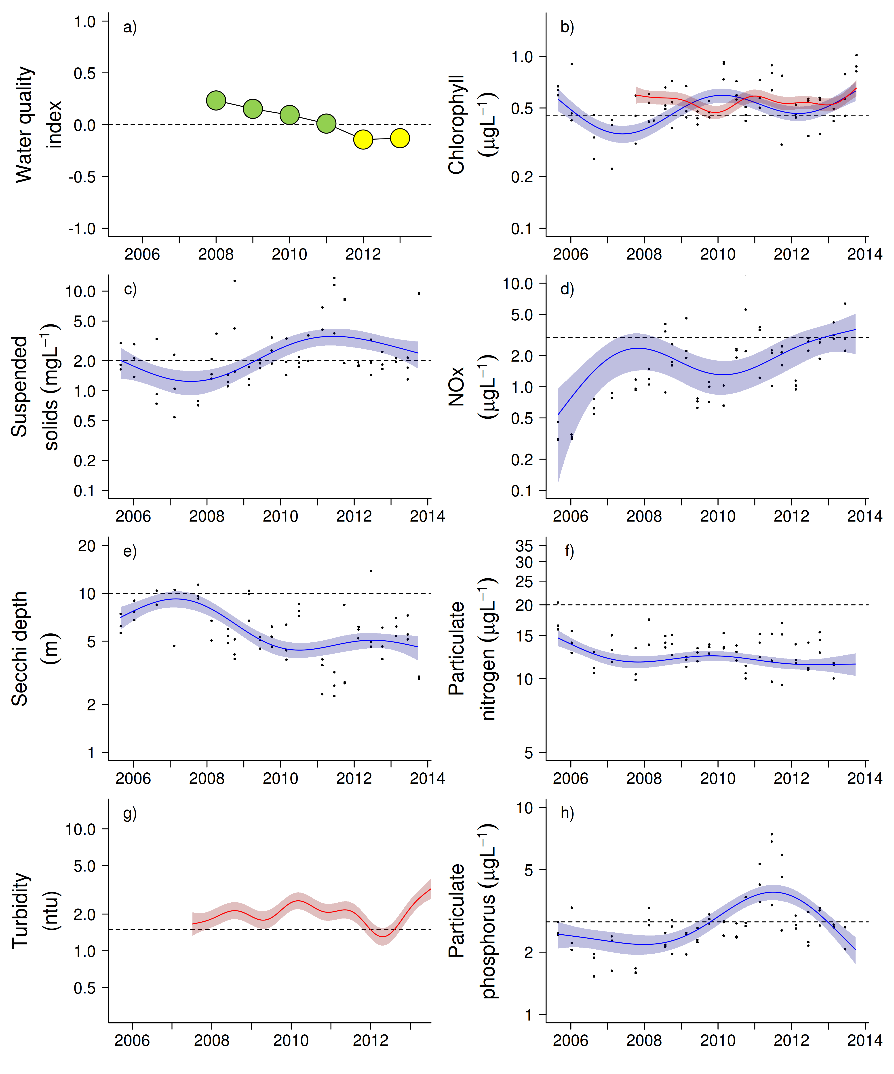
Figure 26 Water quality trends in the Mackay Whitsunday region.
Water quality index colour coding: dark green- ‘very good’; light green-‘good’; yellow – ‘moderate; orange – ‘poor’; red – ‘very poor’. The water quality index is the aggregate of variables plotted in with the exception of NOx and calculated as described in Appendix 1.2.3. Trends in manually sampled water quality variables are represented by blue lines with blue shaded areas defining 95% confidence intervals of those trends, black dots represent observed data. Trends of records from ECO FLNTUSB instruments are represented in red, individual records are not displayed. Dashed reference lines indicate guideline values.

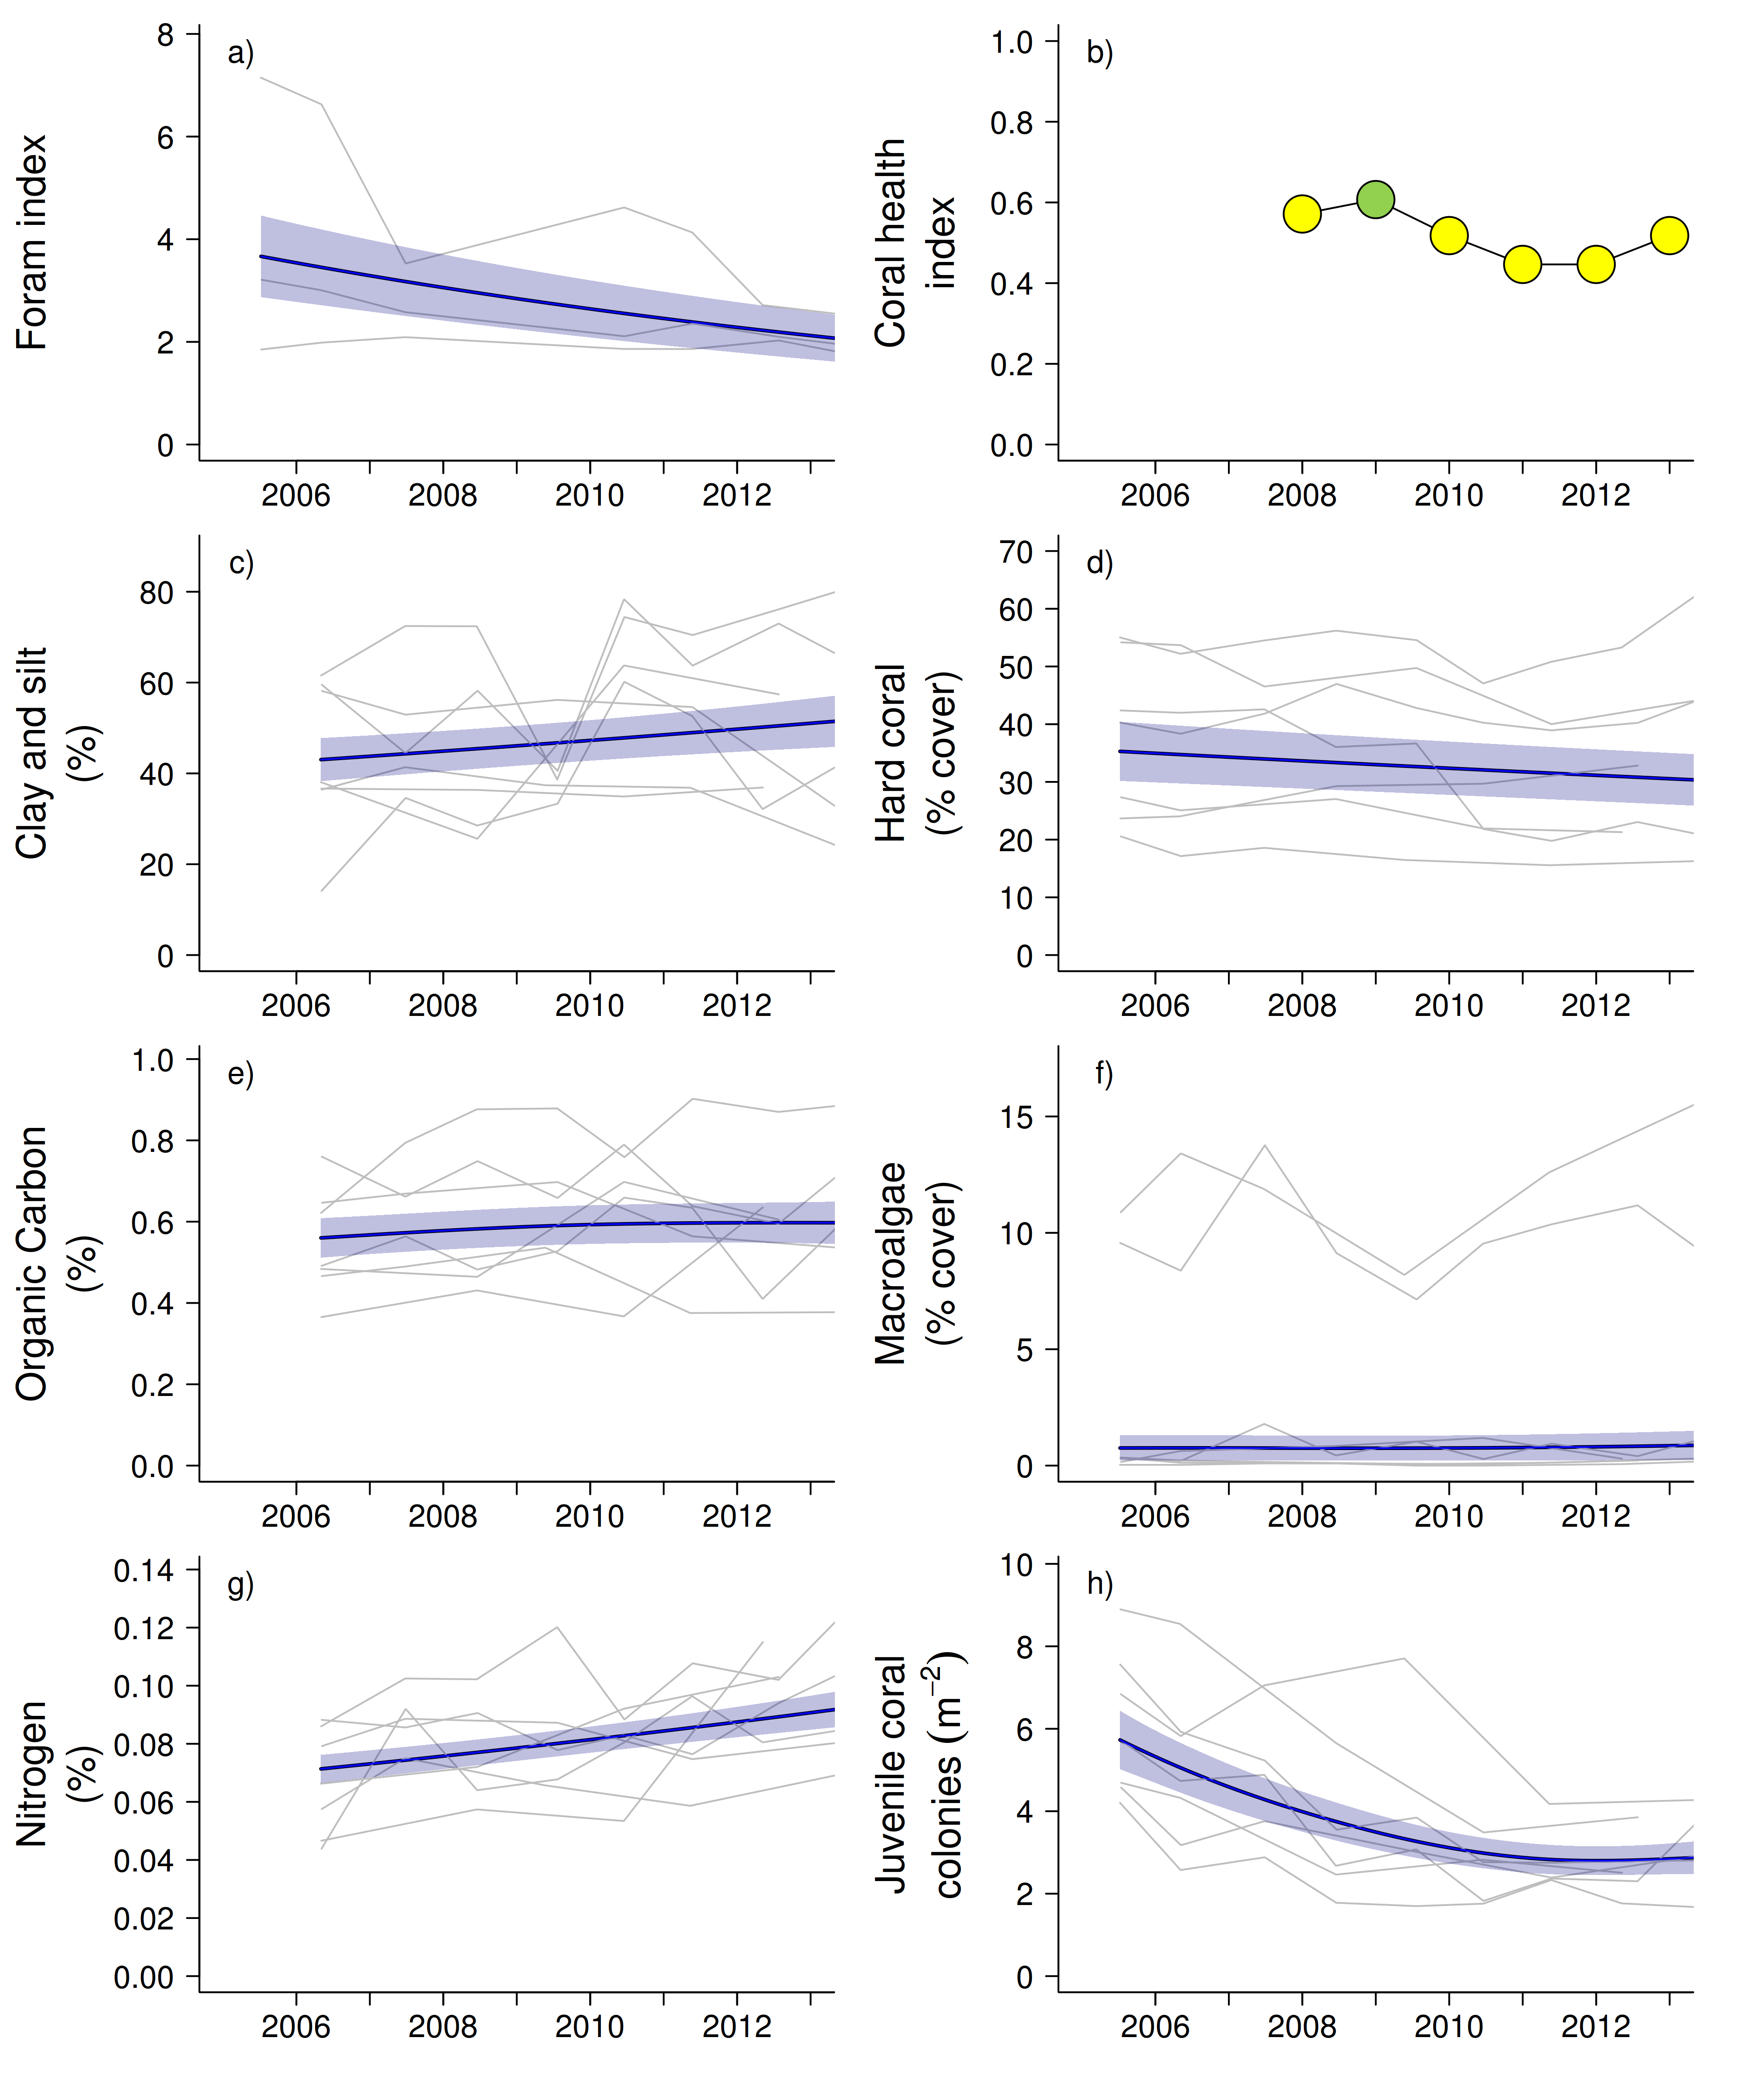
Figure 27 Coral reef community and sediment quality trends in the Mackay Whitsunday region.
Coral health index colour coding: dark green- ‘very good’; light green-‘good’; yellow – ‘moderate; orange – ‘poor’; red – ‘very poor’. Coral index is calculated from variables plotted in d, f, h, along with the derived estimate of “rate of cover increase” as described in Appendix 1.3.7.Trends in Foram index, sediment and benthic community variables are represented by blue lines with blue shaded areas defining 95% confidence intervals of those trends, grey lines represent observed profiles averaged over depths at individual reefs.

3.1.6 Fitzroy Region

The Fitzroy NRM Region has the largest catchment area draining into the GBR. The climate is dry tropical with highly variable rainfall, high evaporation rates and prolonged dry periods, followed by infrequent major floods. By area, cattle grazing is the primary land use (Brodie et al. 2003, GBRMPA 2012). Fluctuations in climate and cattle numbers greatly affect the state and nature of vegetation cover, and therefore, the susceptibility of soils to erosion, which leads to runoff of suspended sediments and associated nutrients.

Six reefs are sampled for coral reef condition assessments in this region. These fringing reefs are formed around continental islands in Keppel Bay, many of which are used extensively for recreational and tourism activities. The monitoring locations are located along gradients away from the Fitzroy River mouth and away from the coast (Figure 28). Three water quality sampling locations are co-located with the annually monitored core reefs.

Pelican and Peak Is have been exposed to a primary plume water type on most days during wet seasons; these are the only monitoring sites of this sub-program with this level of exposure to primary plume water type. North Keppel, Middle and Keppels South are close to the border of the area exposed to a secondary plume water type on most days or frequently during wet seasons while Barren is rarely exposed to flood plume-type waters (Figure 28) and is the only location in this region situated in the midshelf water body (sensu GBRMPA 2009, Table 1).

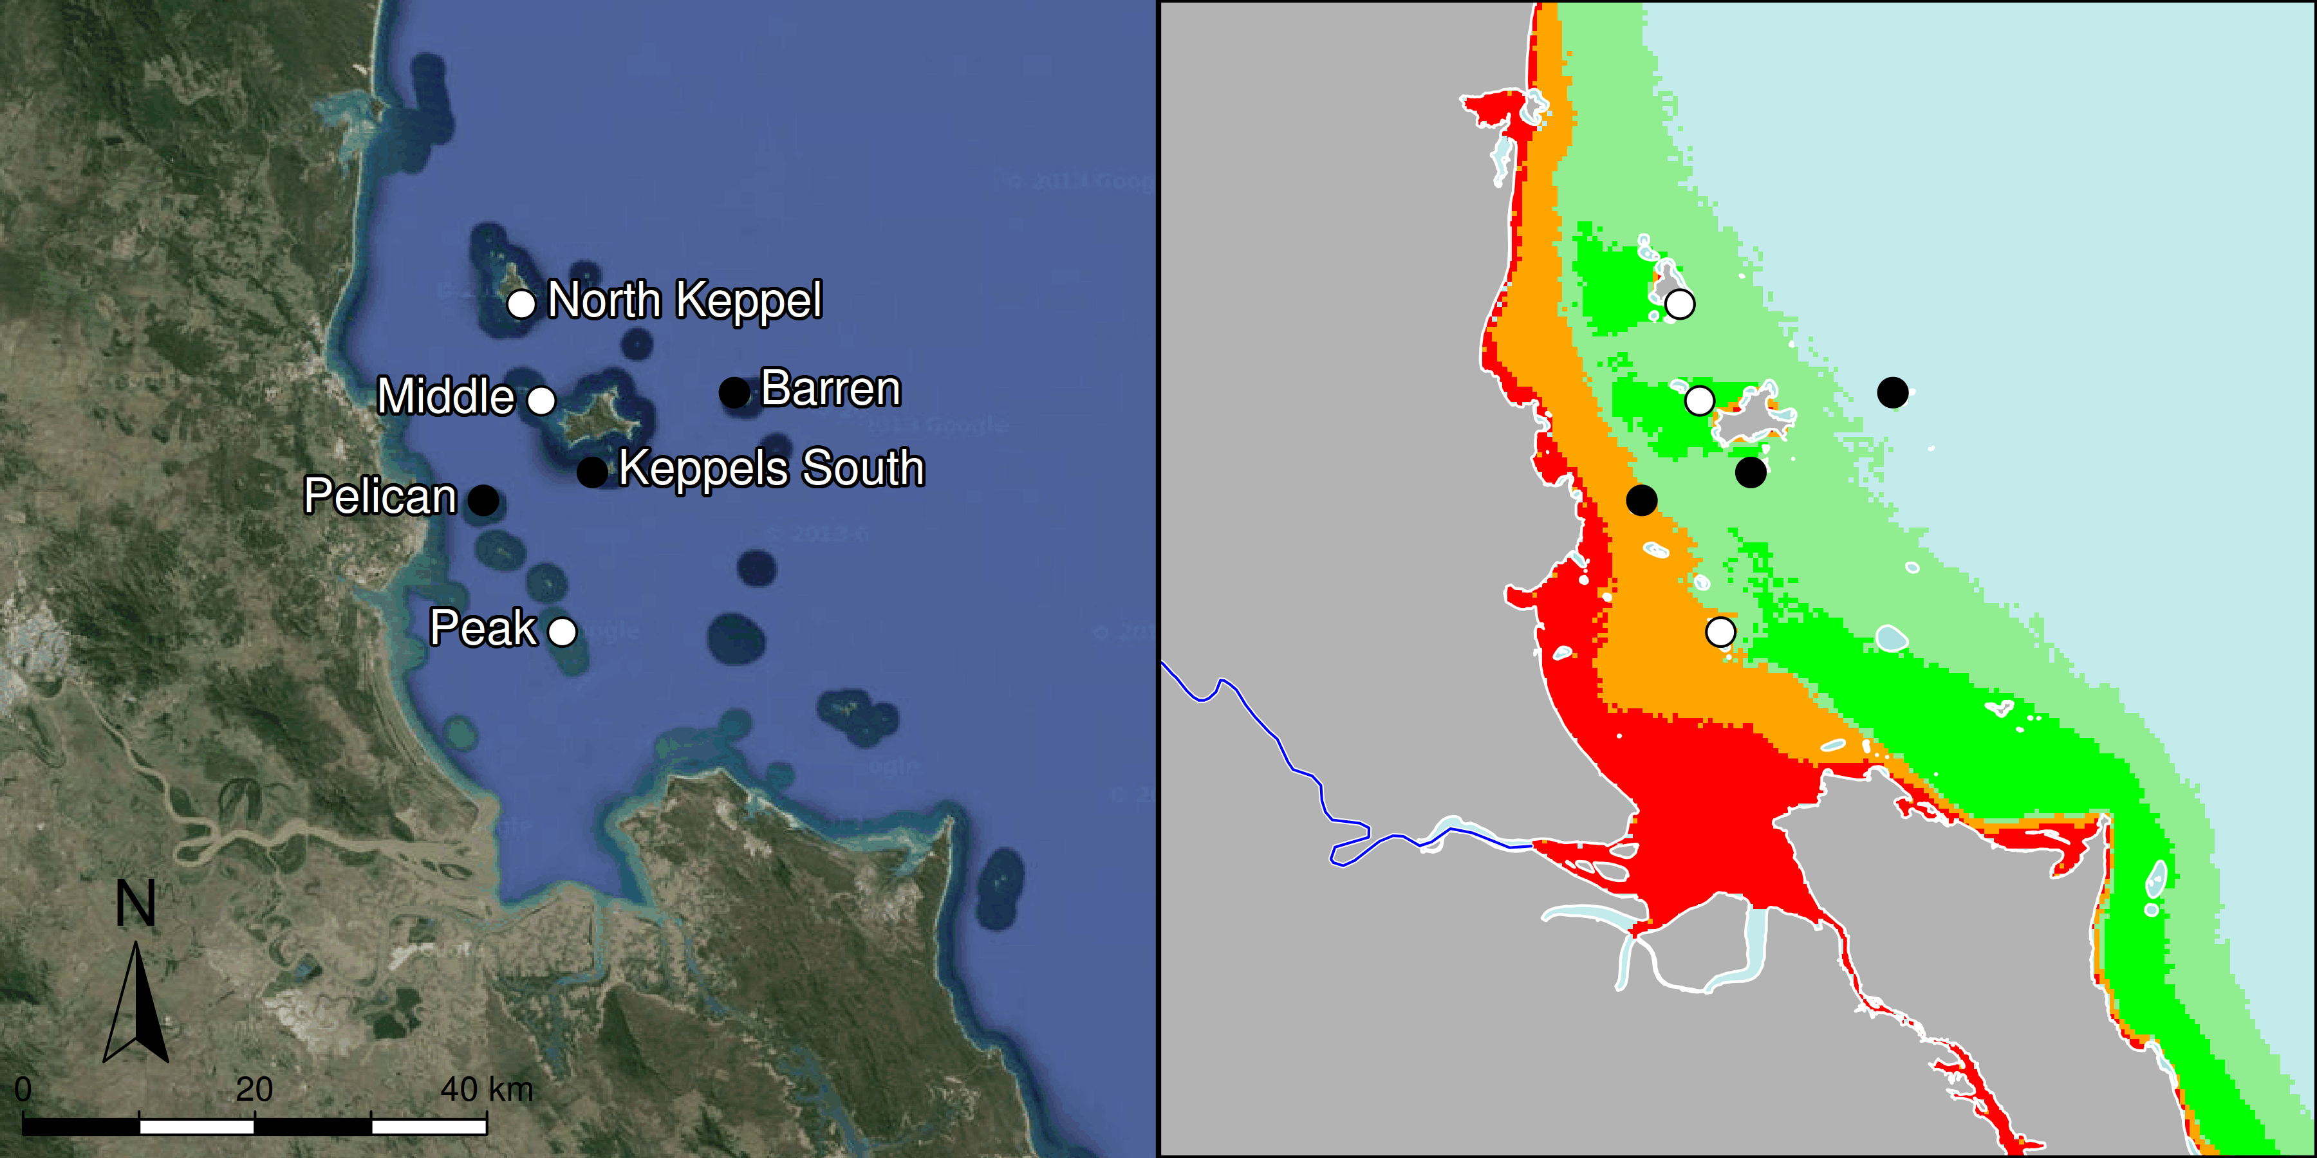

Figure 28 MMP sampling sites in the Fitzroy NRM Region.
Black symbols are water quality and core reef sampling locations, white symbols are cycle reef locations, grey symbols are the six open water sites of the AIMS Cairns Transect. Gradients of exposure to flood plume water types (Álvarez-Romero et al. 2013) during the wet season (December to March) are represented as areas exposed to primary plume-type waters most days (> 67% of days during the wet season, red shading) or frequently (33% - 67% of wet season days, orange shading), and areas exposed to secondary plume-type waters most days (>67% of wet season days, solid green shading), frequently (33% - 67% of wet season days, transparent green shading) or rarely (< 33% of wet season days, light blue shading).

From 2002 to 2007, annual flows of the Fitzroy River were below the long-term median and the catchment had been in drought. In 2008, 2010 and 2011 the river had extreme floods (> 3x median) - the 2011 event being the largest on record, and large floods (~2-3 x median) in 2012 and 2013 (Figure 29, Table A2-1). The 2011 floods caused significant reductions in coral cover across the region, most notably at Pelican, Keppels South, and North Keppel (Figure A2-8, Table A2-5).
Severe storms in 2008, 2010 and 2013 reduced coral cover on northerly exposed sites, and, most notably, at Barren in the 2008 and 2013 (Figure A2-8).
Temperature records highlight a period of prolonged high temperatures over the summer of 2005-2006 that led to widespread bleaching of the coral communities at all reefs surveyed with the exception of Peak and Pelican (Figures 30, A2-8 and Table A2-5).

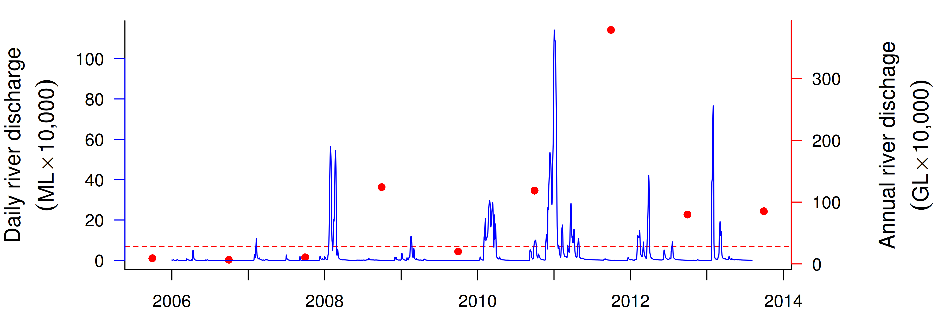
Figure 29 Discharge for the Fitzroy River.
Daily (blue) and annual (October to September, red) discharge shown. Red dashed line represents the long-term median annual discharge.
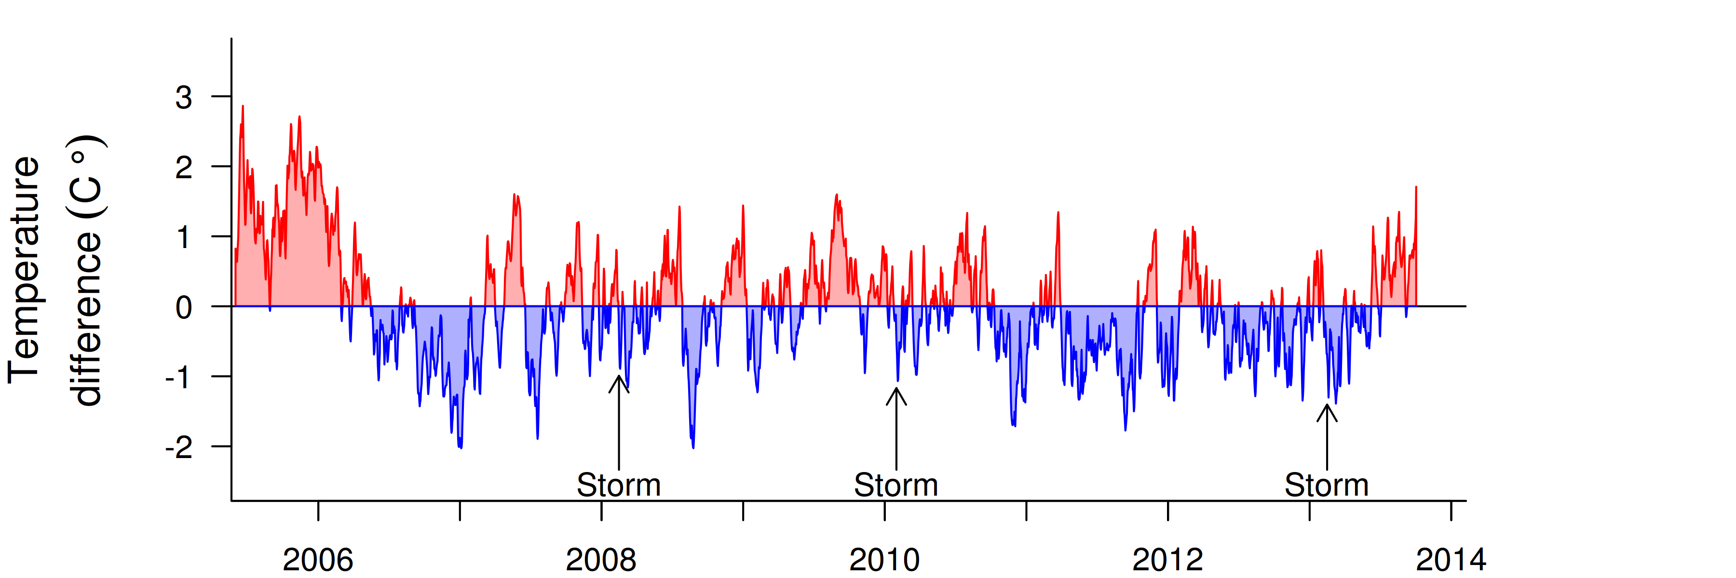
Figure 30 Sea temperature for the Fitzroy region.
Red and blue regions signify periods of above and below the long term seasonal average.

The water quality index in this sub-region has been rated as ‘good’ since 2008 (Figure 31a). Concentrations of chlorophyll a (chl a) were high and the overall trend was above water quality guidelines (guideline) in 2009-10 and since decreased (Figure 31b). The overall trends in concentrations of particulate nitrogen (PN) and particulate phosphorus (PP) were largely stable and below the guideline (Figure 31f,h). The overall trend in suspended solids (SS) is relatively uncertain (large confidence interval), reflecting the large differences in this parameter across the three sampling locations, but was generally below the guideline (Figure 31c). The overall trend for Secchi depth was stable with a slight decline after 2011, but was overall non-compliant with the guideline (Figure 31e). The concentrations of dissolved oxidised nitrogen (NOx) increased sharply after the first floods in 2008 and then remained high, close to the guideline, with a recent decrease since 2012 (Figure31d).

Instrumental chlorophyll (chl) and turbidity records showed more pronounced fluctuations than the manual sampling data (Figure 31b,g). The trendlines for chl and turbidity were at or above the guideline during the flood periods and remained at a high level since 2012 (Figure 31b,g). The site-specific data show the differences along the water quality gradient (Tables A2-2, to A2-4, Figure A2-1), with Pelican generally not compliant with the guideline for all variables except for PN. In contrast, all water quality variables at Barren were within the guideline. Pelican is not only strongly influenced by river floods but also regularly experiences wind-driven resuspension of any settled material, leading to frequent spikes in turbidity (Figure A2-1). The reef sediments in the Fitzroy Region have relatively low proportions of clay and silt-sized particles (Figure 32c) compared to other regions, indicating that the hydrodynamic setting of these reefs is sufficiently energetic to prevent the long-term accumulation of fine-grained sediments. However, the clay-silt, nitrogen and organic carbon content of sediments has increased over the monitoring period (Figure 32c,e,g) indicating an increased level of accumulation after the major flood inputs.

Declines in the FORAM index are relatively minor compared to other regions (Figure 32a), though still imply a change in environmental conditions consistent with the observed increases in organic content and the proportion of clay and silt grainsized particles in sediments and NOx in the water column (Figures 32c,e,g and 31d). As with other regions these changes are demonstrating that the sediment dynamics at inshore reefs respond to riverine inputs.

The location of reefs along water-quality gradients away from the Fitzroy River influences both the composition and dynamics of benthic communities. Peak and Pelican are situated in relatively turbid and nutrient-rich waters compared to the reefs further offshore (Figure 28, Tables A2-2 to A2-4). At these reefs benthic communities differ markedly between the 2m and 5m depths (Figure A2-8), illustrating the substantial differences in light conditions due to attenuation by high turbidity. Although water quality is not measured at Peak Is, the low coral cover, low density of juvenile corals, high cover of macroalgae, along with a lack of substantial reef development suggest that the environmental conditions at this location are marginal for most corals (Figure A2-8). Further offshore, reefs become dominated by the family Acroporidae (mostly the branching species Acropora intermedia and A. muricata) at both 2m and 5m (Figure A2-8).

Prior to the commencement of the MMP in 2005, Queensland Parks and Wildlife Service monitoring of reefs in Keppel Bay from 1993-2003 recorded substantial loss of coral cover as a result of thermal bleaching events in 1998 and 2002 (Table A2-5). Importantly, these surveys also demonstrated the resilience of the corals to these events with coral cover clearly increasing in subsequent years (Sweatman et al. 2007). Initial MMP surveys in 2005 documented moderate to high hard coral cover on all the Acropora-dominated reefs confirming this recovery. In 2005-06, increased sea surface temperatures again led to a severe bleaching event resulting in marked reductions in coral cover, in particular Acroporidae, and a resultant bloom of the brown macroalgae Lobophora variegata (Figures 32d and A2-8, see also Diaz-Pulido et al. 2009).

Variation in the resilience of communities to the 2006 bleaching event provides insight into the role of water quality in suppressing resilience in this region. The level of recovery following the 2006 bleaching event is inversely related to the persistence of macroalgal communities. At the three reefs often exposed to a secondary plume water type (Keppels South, Middle and North Keppel: the Keppel Group) macroalgal cover has remained high and rates of change in coral cover have remained low or cover has continued to decline (Figure A2-8). In contrast, Barren Is, which is rarely exposed to flood plumes had lower levels of all water quality variables (Tables A2-2 to A2-4), the bloom of L. variegata was less pronounced and only ephemeral and recovery of the coral community clearly progressed in 2007 (Figure A2-8).

In addition to potentially facilitating the persistence of macroalgae within the Keppel Group, flooding of the Fitzroy River also appears to have directly stressed the corals across the region. The incidence of coral disease has shown distinct peaks: the first was associated with the coral bleaching event in 2006, subsequent high levels of disease in 2008, 2010 and 2011 followed extreme flood events (Figure A2-10, Table A2-1). The consistent pattern of high incidence of disease amongst coral communities following each of the recent floods supports the hypothesis that increased organic matter availability, reduced salinity (Haapkylä et al. 2011), and increased nutrient enrichment (Vega Thurber et al. 2013) facilitate coral disease. Reduction in light levels over extended periods of time as a result of higher turbidity from increasing concentrations of suspended sediments as well as dense plankton blooms is another plausible explanation for reduced fitness of corals (Cooper et al. 2008).

The contrast in the rapid recovery of these coral communities after the 2006 bleaching event over a period of two years of negligible river flow compared to the recent lack of recovery highlights the significant role of terrestrial run-off and water quality parameters in the ecology of these reefs. Since the start of the high discharge period in 2008, the compounding effects of additional disturbances such as storms (Table A2-5), continued slow rates of cover increase as a result of disease, and competition with the high cover of macroalgae, have led to the decrease in the coral health index from ‘poor’ to ‘very poor’ (Figure 32b, Table A2-7).

Low and declining densities of juvenile corals further contribute to the ‘very poor’ assessment of the coral health index (Figure 32h). Most notable are the extremely low densities at 2m depths at Peak and Pelican where almost all juveniles were killed by flood waters in 2011 (Figure A2-8). At most other reefs, juvenile densities have been consistently low following the loss of corals and increase in macroalgae in 2006. While Birrell et al. (2008b) found that the presence of L. variegata promoted the settlement of Acropora coral, this contradicts reports from the Caribbean (Kuffner et al. 2006 ) and the general literature indicating that macroalgae suppress coral recruitment via a range of physical and chemical mechanisms (e.g. Birrell et al. 2008a). Juvenile corals are also likely to be susceptible to the same chronic conditions that led to disease of larger colonies, as discussed above.

The generally low densities of juvenile corals in this region are likely to continue in the short term given the likely relationship between regionally declining coral cover (Figure 32d) and declines in coral settlement (Figure A2-9).

In summary, the ‘very poor’ assessment of the coral health index comes after a period of repeated flooding and contrasts recovery of coral cover following previous bleaching events during periods with low river flows. Light reduction as a result of turbidity, increased nutrient supply, along with lower salinity, are all mechanisms that reduce coral fitness or contribute to higher rates of disease in corals (e.g. Fabricius 2005, Voss and Richardson 2006, Haapkylä et al. 2011). In the event of a return to lower flows, the rate at which the current suppression of resilience is reversed will help to assess the longer term impacts of runoff on the ecology of the reefs in this region. However, given the highly variable flow of the Fitzroy River, periods of low rainfall, which in this catchment may reduce vegetation cover and so increase the potential for erosion and mobilisation of catchment soils, will inevitably be followed by large flood events carrying this available material into coastal waters.

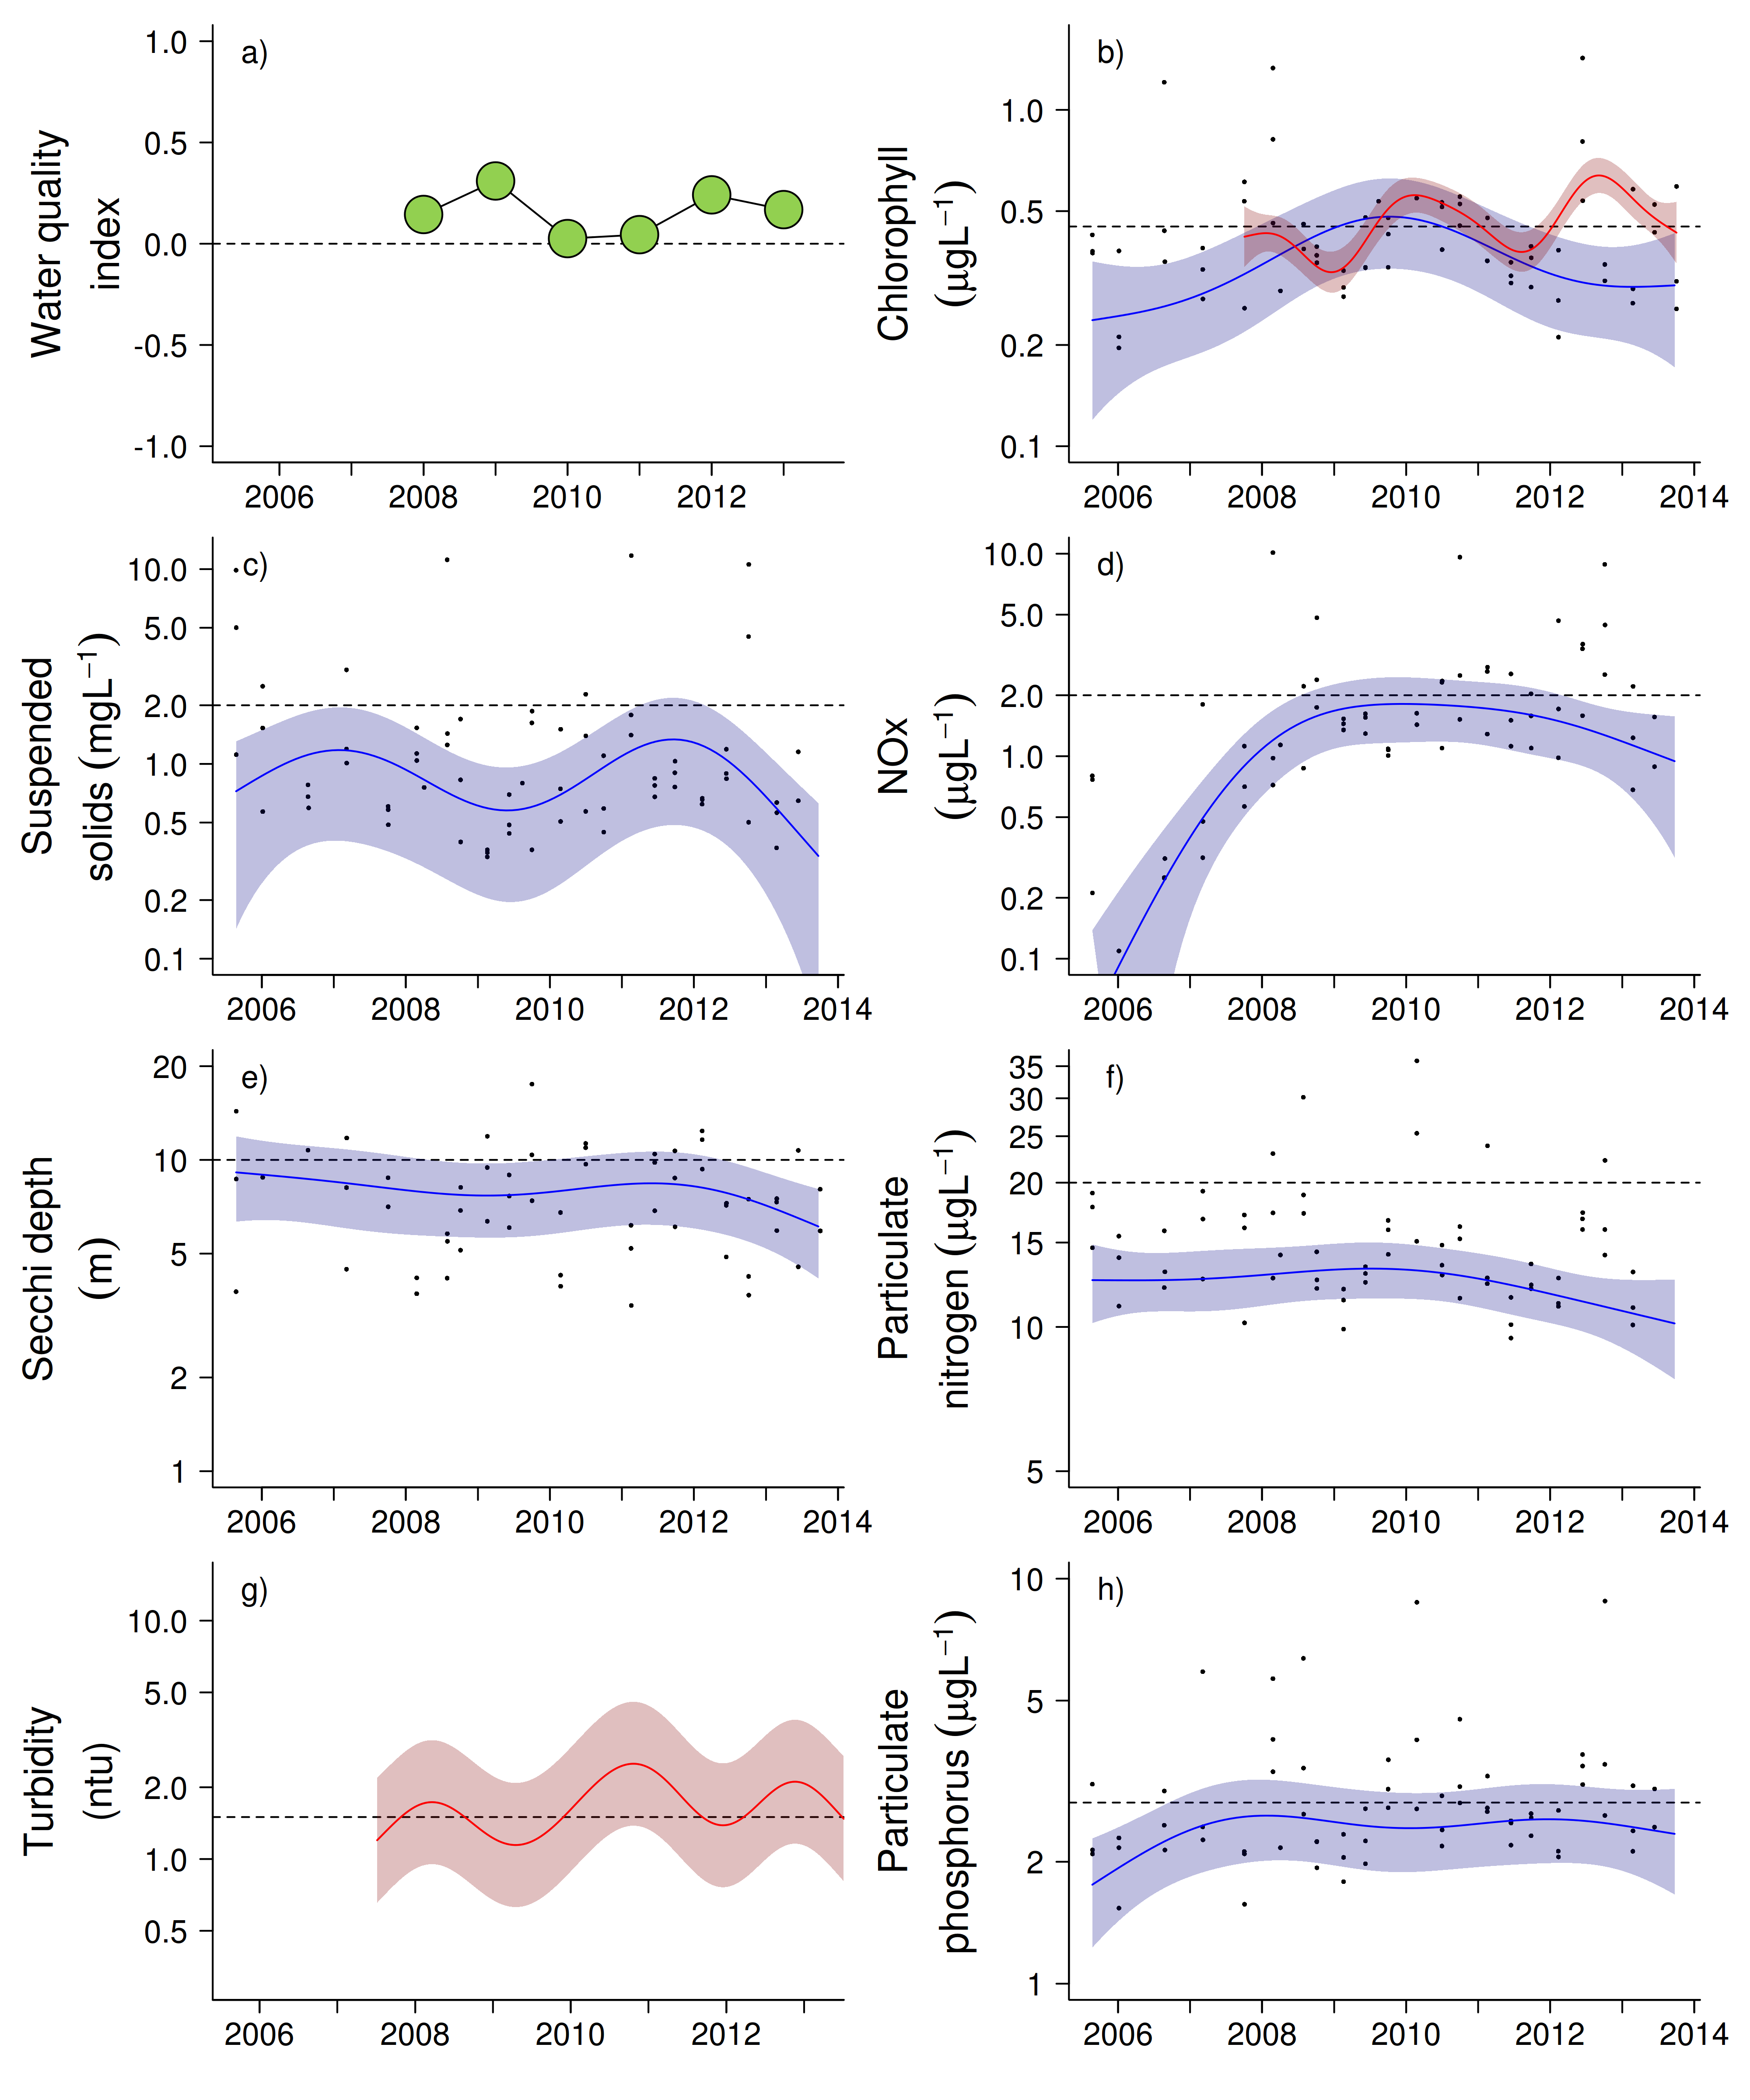
Figure 31 Water quality trends in the Fitzroy region.
Water quality index colour coding: dark green- ‘very good’; light green-‘good’; yellow – ‘moderate; orange – ‘poor’; red – ‘very poor’. The water quality index is the aggregate of variables plotted in with the exception of NOx and calculated as described in Appendix 1.2.3. Trends in manually sampled water quality variables are represented by blue lines with blue shaded areas defining 95% confidence intervals of those trends, black dots represent observed data. Trends of records from ECO FLNTUSB instruments are represented in red, individual records are not displayed. Dashed reference lines indicate guideline values.

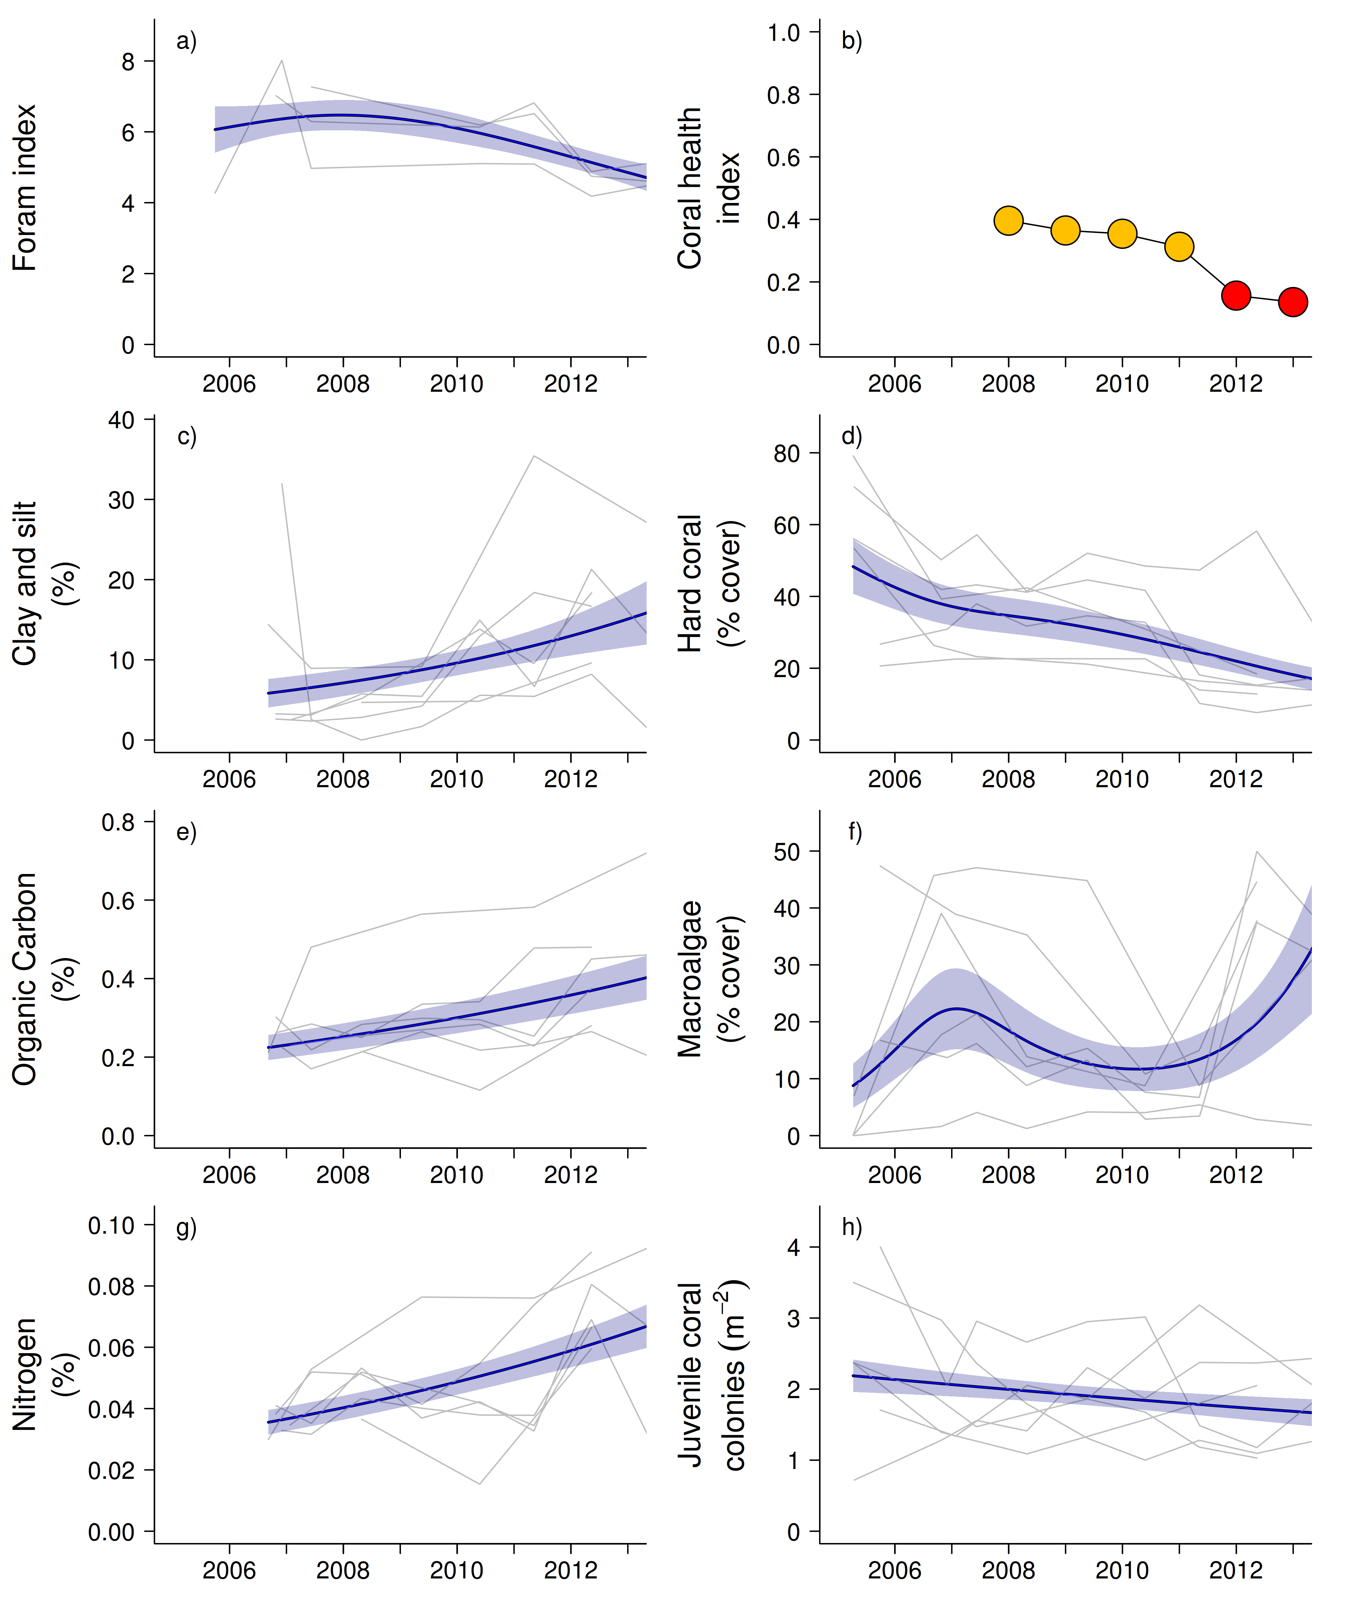
Figure 32 Coral reef community and sediment quality trends in the Fitzroy region.
Coral health index colour coding: dark green- ‘very good’; light green-‘good’; yellow – ‘moderate; orange – ‘poor’; red – ‘very poor’. Coral index is calculated from variables plotted in d, f, h, along with the derived estimate of “rate of cover increase” as described in Appendix 1.3.7.Trends in Foram index, sediment and benthic community variables are represented by blue lines with blue shaded areas defining 95% confidence intervals of those trends, grey lines represent observed profiles averaged over depths at individual reefs.

3.2 Case study: Trends in coral settlement
This case study is included as the decision has been made to discontinue this component of the coral reef monitoring program. As such, it is timely to highlight the main points of relevance to water quality within the data.

Replenishment of scleractinian corals through recruitment is critical for the long-term resilience of reef communities facing increasing pressures from stressors such as thermal bleaching, crown-of-thorns seastars outbreaks, and coral disease (Bruno et al. 2009, Chin et al. 2011). Where reefs are located close to coasts and subject to discharge from river systems, coral communities are at risk from the additional stressors of high turbidity, sedimentation, nutrient enrichment, pollutants and hyposalinity (Fabricius 2005, 2011, Berkelmans et al. 2012). Successful recruitment requires survival of coral larvae; from fertilisation to settlement and metamorphosis on suitable substrata. While the process of coral recruitment has been the subject of increasing experimental research, no long-term field studies have been carried out that enable us to derive predictive models of recruitment that support the management of reef resilience. This component of the MMP inshore coral reef monitoring aimed to estimate the extent to which recruitment is influenced by the inshore environment; through monitoring the recruitment of coral larvae at 12 core reefs (see Table 1).

Methods
For this case study, we focused on the analyses of a number of indicators considered to be potential explanatory variables of the observed recruitment pattern. Most of these variables were routinely collected as part of the MMP:

- Cover of adult hard corals, soft corals and macroalgae on the monitored reefs- averaged over 2m and 5m depths
- Cover of encrusting coralline algae (CCA) on settlement tiles
- Water temperature
- Turbidity
- Concentration of water column chlorophyll a
- Grain size and nutrient content in surrounding reefal sediment

Coral settlement was estimated at 5m depths at the 12 core reefs (Figure 2, Table 1) using settlement tiles: as described in Appendix 1.3.2.

To investigate possible factors contributing to the substantial variability in settlement we separately analysed the data to explore those variables contributing to inter-annual variability within reefs and then the differences in mean settlement between reefs.

Temporal variation in settlement was investigated using linear mixed effects models (LMM, (Pinheiro and Bates, 2000). Individual reefs were included as random effects to account for spatial variation, pseudo-replication and temporal auto-correlation arising from multiple and repeated observations from the same reefs. To improve normality and reduce heteroskedasticity, the response was logarithmically transformed. Given the substantial variation of the explanatory variables between reefs, all explanatory variables (with the exception of sampling years) were centred within reefs by subtracting the reef-level mean and then scaled by dividing each observation by the pre-centred mean. Model selection, was used to identify those variables that explained any of the observed variability in settlement, by comparing Akaike information criteria values (AIC) across the suite of candidate models, including additive fixed effects combinations of the explanatory variables listed above.

To investigate possible drivers of the differences in settlement between reefs we separately fit linear models relating mean settlement to mean values (or maximum in the case of Acroporidae cover) of each explanatory variable listed above.

Results and discussion
This case study examines results between 2006 and 2011: regional trends including MMP data to 2012 data are presented as Figure A2-9. From a total of 116,935 corals that settled onto sampling tiles from 2006-2011, an overwhelming proportion were of the family Acroporidae (85%), while remaining taxa included: Poritidae (5%), Pocilloporidae (2%), and ‘other taxa’ (8%). Accordingly, our statistical analyses focused on the distribution and patterns of abundance of Acroporidae settlement only.

The overall settlement of Acroporidae averaged 36 spat per tile, equating to ~1200 per square meter of tile surface. This abundance of larvae settling to tiles demonstrates the general availability of viable larvae in these inshore waters, though, as is evident from Figure 33 this supply, or the cues to settle on tiles, vary markedly, both within and among reefs.

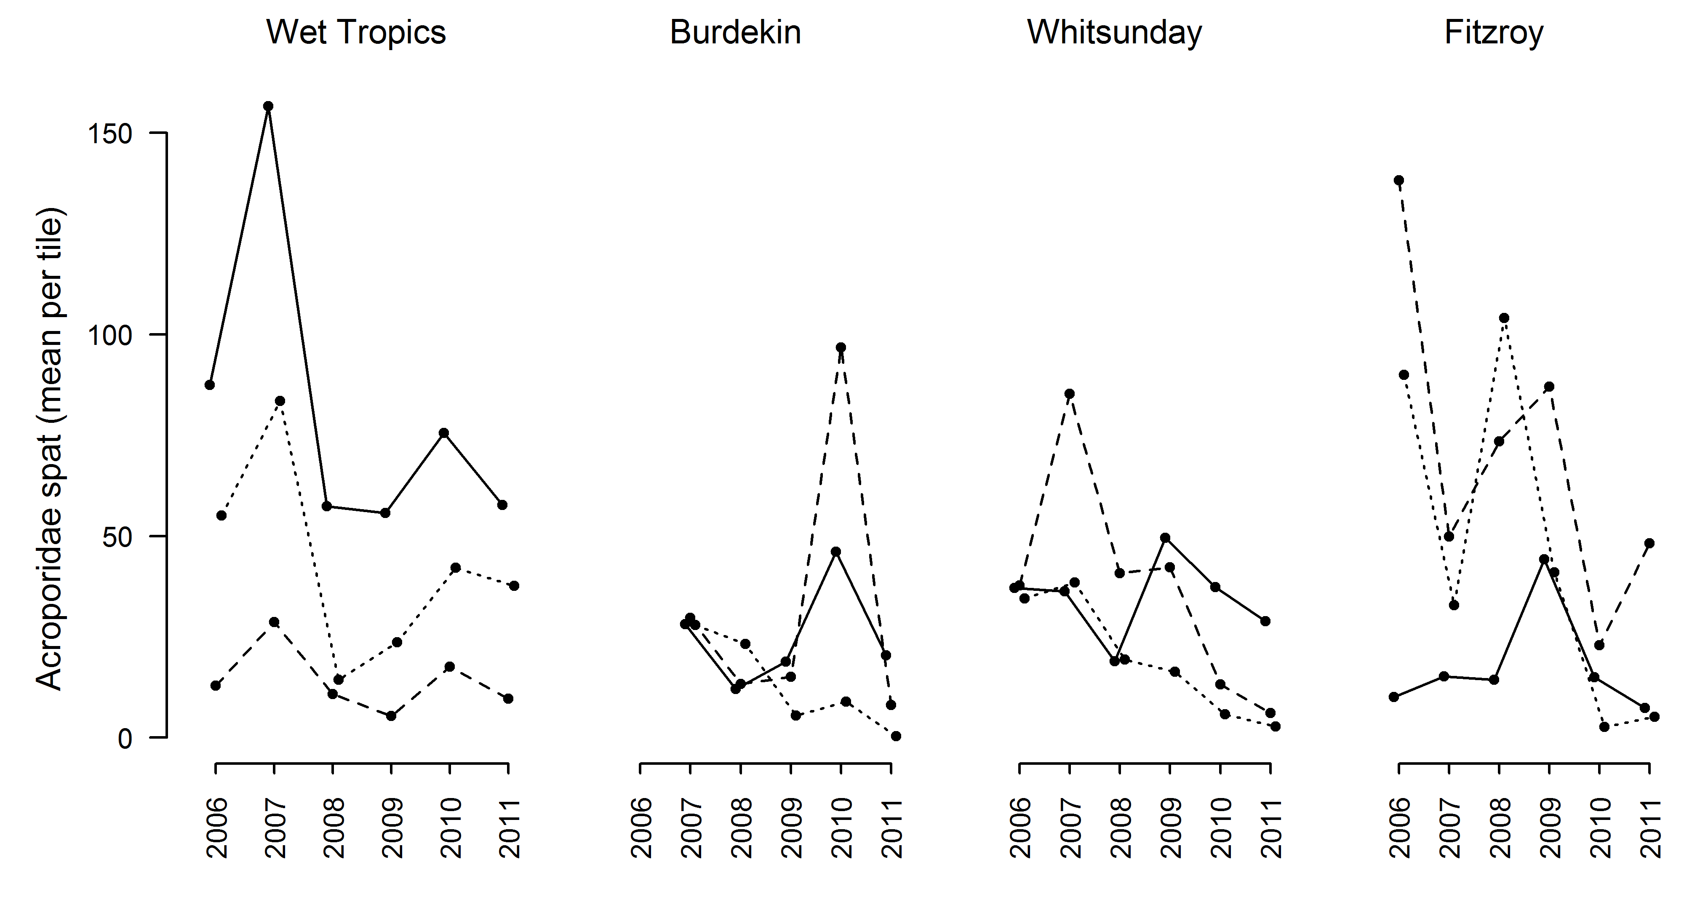
Figure 33 Observed settlement of Acroporidae.
Data are presented as a time series for each reef. Within each region the reefs are identified by line style with reefs closest to rivers dotted, intermediate distance dashed and furthest from rivers solid.

High temporal and spatial variation, particularly at the reef level, is typical for coral settlement studies (Harriot and Fisk 1987, Babcock 1988, Dunstan and Johnson 1998, Hughes et al. 2000, 2002, Smith et al. 2005). This high variability makes the influence of environmental factors on settlement patterns particularly difficult to identify. In our analysis of factors that explain some the inter-annual variability observed we detected:
- a decline in settlement through time that explained 14% of the overall variation in settlement (Figure 34a),
- a decline in settlement with increasing turbidity in the month following coral spawning that explained an additional 14% of the variation in settlement (Figure 34b),
- a positive relationship between settlement and the proportion of tile surface encrusted with crustose coralline algae at the time of collection, that explained 10% of the overall variation (Figure 34c).

Based on AIC values we found no evidence that changes in the other explanatory variables assessed influenced settlement. Similarly, when considering the variables that correlate to differences in settlement between reefs, it was only the cover of Acroporidae corals that showed a significant relationship (P<0.05, Figure 35).

Decline over time
Although variable among reefs, there was evidence for a substantial reduction in settlement over the period of this study. Low settlement was also observed in 2012 on most reefs, continuing the generally lower settlement in recent years (Appendix Figure A2-9). While we included the cover of Acroporidae at each reef as a covariate in the model it is certain that the potential source of larvae extends well beyond the local monitoring sites. At regional scales the cover of Acroporidae has declined in both the Wet Tropics and Fitzroy Regions as a result of various disturbance events, and has remained stable, and at lower levels, on most reefs in the Burdekin and Whitsunday Regions (see regional results sections 3.1.1-3.1.6 of this report for more detail), and so observed declines may be influenced by brood-stock availability. Also influential are the timing of peak settlement events in 2006 or 2007 on a number of reefs (Figure 33), as these occurred toward the beginning of the study they strongly influence the observed decline. We can’t, however, explain the reasons for these strong settlement events in terms of environmental conditions though clearly very high numbers of larvae must have been present implying strong connectivity to spawning corals and survival of larvae in those years.

Turbidity
High turbidity is generally considered to equate to a poor environment for both adult Acroporidae colonies (Fabricius et al. 2011) and the settlement, metamorphosis, and survival of coral planulae (reviewed by Fabricius 2005, see also Fabricius et al. 2005, Cooper et al. 2007). In our study settlement tended to decline with increasing turbidity levels measured in the month following the expected spawning peak in a given year (Figure 34b). Further investigation as to which reefs were most influencing this relationship indicated that this general trend was most evident at the reefs with comparatively high mean turbidity such that of the six reefs at which mean turbidity was >0.95ntu ( Pelican, Magnetic, Pine, Daydream, Double Cone and Pandora), the lowest settlement coincided with maximum turbidity levels at all but Double Cone. Of the remaining six reefs with clearer waters, only one, Keppels South, had minimum settlement coinciding with maximum turbidity. Conversely six reefs had highest settlement during the year of minimum turbidity including reefs across the full range of mean turbidity values.

Spawning of Acroporidae at the MMP reefs occurs primarily in October to November each year. At this time of year, variations in turbidity are mostly due to sediment resuspension by wind-driven waves and tidal action. Wet-season river-flows typically begin later (from January to March), and well after the majority of Acroporidae have spawned and settled (Baird et al. 2009). However, it is becoming increasingly apparent that the additional flux of material imported by rivers remains available in the coastal zone for periods of months to years, leading to chronically elevated turbidity and rates of sedimentation (Wolanski et al. 2008, Lambrechts et al. 2010, Brodie et al. 2012b, Fabricius et al. 2013a, Fabricius et al. in review). As such it is possible that when windy periods coincide with the spawning, larval and settlement phase of the coral lifecycle, the resuspension of accumulated sediment deposits may reduce coral recruitment. However, we cannot discount the possibility that our empirical relationship between turbidity and settlement is not representative of variability in the hydrodynamic processes that influence the connectivity between our sample reefs and populations of spawning corals.

Cover of crustose coralline algae on settlement tiles
A weak positive relationship was found for higher recruitment in years when tiles had higher cover of CCA (Figure 34c). The direction of this relationship is consistent with experimental work that demonstrates that presence of CCA, in combination with a complex microbial biofilm, can be a strong inducer of coral attachment and metamorphosis (Heyward and Negri 1999, Harrington et al. 2004, Webster et al. 2004, Vermeij and Sandin 2008). It is also clear from other studies that the presence of CCA, and co-existing biofilms, is heavily influenced by local conditions. In broad terms the distribution of CCA across the GBR is related to the sedimentary environment (Fabricius and De’ath 2001b), ranging from <1% cover at reefs pone to high rates of sedimentation in inshore waters, to >20% cover among the clearer outer reefs. Where reefs experience frequent turbidity, or during periods of extended flood plumes, changes occur in the bacterial communities in both the water column and among biofilms (Witt et al. 2012), that may result in less induction of coral recruitment (Tebben et al. 2011). Trace concentrations of the herbicide diuron, which is widely detected in the inshore GBR, can significantly affect the health of CCA (Harrington et al. 2005). In addition recent studies have shown that ocean acidification and thermal stress can negatively affect CCA cues for coral settlement (Webster et al. 2011, Webster et al. 2013) suggesting future climate change may compound any environmental limitations to CCA and biofilm facilitation of coral settlement.

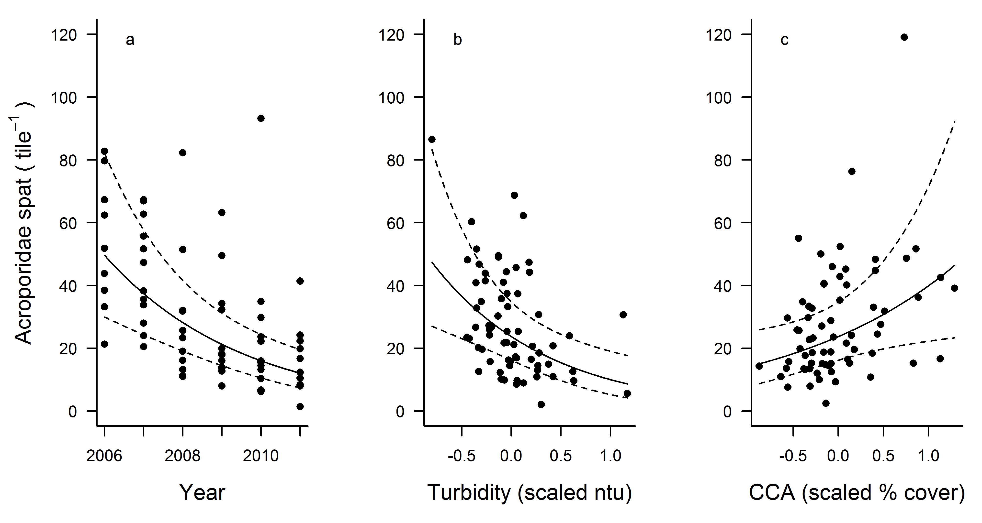

Figure 34 Partial effects plots of covariates to Acroporidae settlement.
a) years, b) turbidity, and c) cover of crustose coralline algae (CCA) on tiles. Dashed lines represent 95% confidence interval of the relationship. Both turbidity and CCA are scaled by dividing each observation by the reef level pre-centred mean.

Adult cover
Averaged across years there was a positive relationship between the maximum cover of adult Acroporidae at a reef and the mean number of spat settling to tiles, suggesting a brood-stock – recruitment relationship (Figure 35). Hughes et al. (2000) have shown local adult fecundity to be a significant determinant of coral settlement. It could equally be argued that the relationship between high potential cover of Acroporidae and settlement occurs as a result of the larvae selectively settling into environments conducive to their subsequent survival, a trait with clear evolutionary merit (Baird et al. 2003). Attempting to attribute variability between years with variability in brood-stock is problematic as the variability in the hydrodynamic environment at scales that determine retention or dispersal of larvae within a natal reef, or promote connectivity between reefs, dictate that potential brood-stock is effectively unknown at any single place in time.

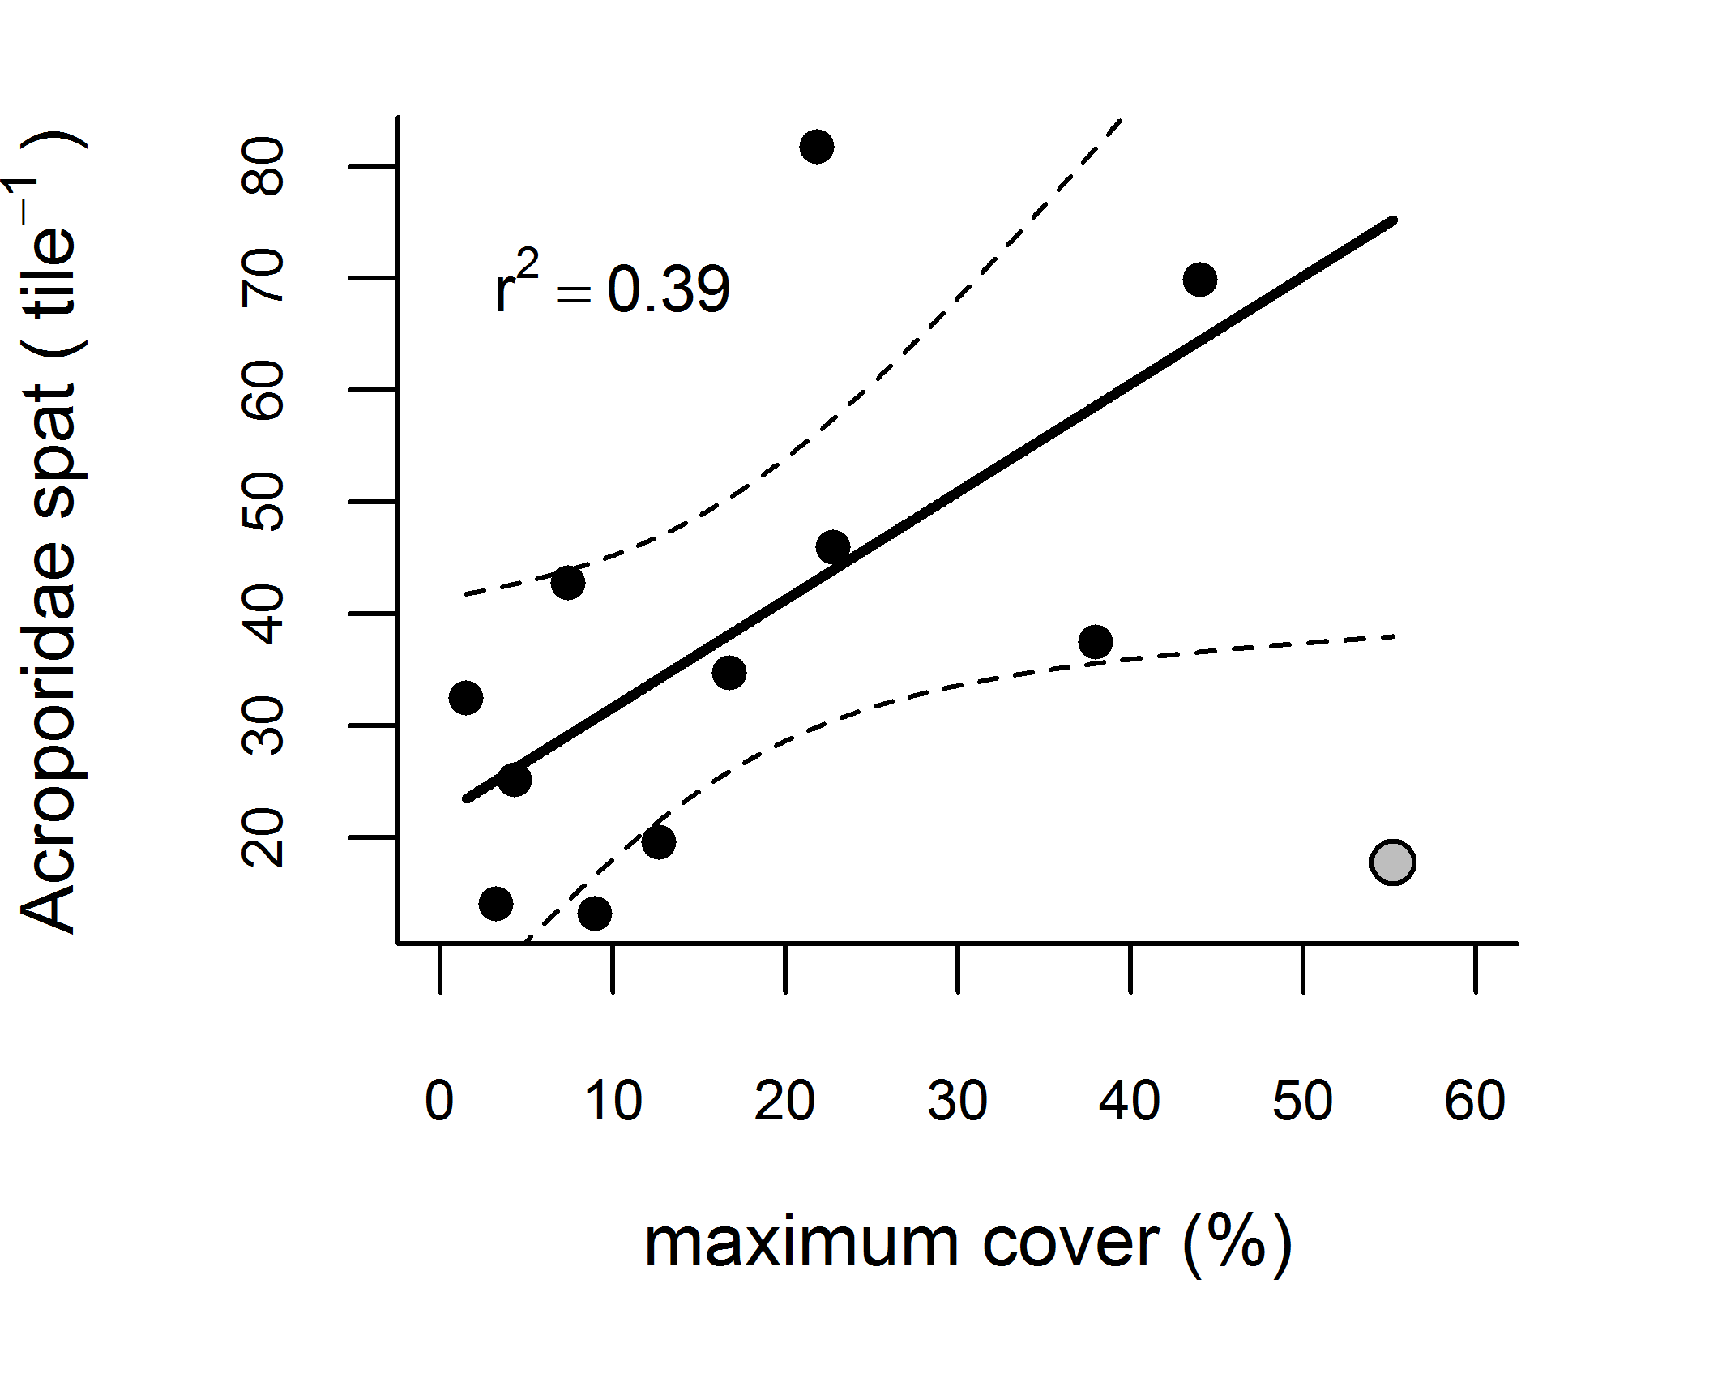
Figure 35 Relationship between settlement and the maximum cover of adult Acroporidae.
Fitted line was derived with the exclusion of Barren Island (grey symbol).

Efficacy of settlement tiles to assess coral replenishment

While our analyses provide results generally consistent with the bulk of experimental data in demonstrating positive relationships between both CCA and adult coral cover to larval settlement, and a negative relationship between turbidity and settlement, these relationships were not strong. We suspect our inability to more definitively identify environmental drivers of coral settlement success is because variables in addition to those measured interact to affect settlement and so likely confound any influence of the variables included in our models.

There are two primary difficulties in the interpretation of the spatial and temporal patterns in settlement data: variability in connectivity to brood-stock, and variability in the microbial conditioning of the tiles at the time of settlement, both of which were beyond the logistic constraints of the MMP. The relationship between larval supply to a site and potential brood-stock is governed by the extent and fecundity of the brood-stock, and the hydrodynamic processes which vary continuously in response to local weather conditions and larger scale currents. The result of this variability is that for any spawning event the dispersal or retention of larvae within and between reefs may vary substantially. Without adequately accounting for variability in the ‘effective brood-stock’ any relationship to environmental variables will be confounded. Importantly, the effective brood-stock of any reef in any year will almost certainly include populations of corals extending well beyond our monitoring sites. Broadcast spawners, such as the Acroporidae, are dependent on both intra- and inter-reef connectivity for dispersal within complexes such as the Great Barrier Reef. While coral communities are typically self-seeding, dispersal at local and regional scales (10’s to 100’s km) has been reported by several authors (review by Jones et al. (2009), van Oppen et al. (2011)). Most studies have used molecular genetics to prove connectivity, as hydrodynamic models of coral settlement have been difficult to validate, even at local spatial scales (Oliver et al 1992). During our study, Pandora Reef, with a particularly depauperate coral community, received a large pulse of larvae from outside the immediate reefal area. Certainly, the general pattern of reducing cover of Acroporidae on a regional scale, and declines in cover mentioned above, imply a general brood-stock to settlement relationship. To improve the estimate of brood-stock availability would require expanding the survey to include estimates of adult cover more broadly within each region and, crucially, incorporate hydrodynamic modelling to better identify the potential provenance of larvae, which is beyond the scope of this monitoring program.

Acroporidae larvae have been shown to be highly sensitive to the presence of CCA and biofilms on potential recruitment surfaces (Harrington et al. 2004, Webster et al. 2004). To capture the bulk of the expected Acroporidae spawning necessitated the deployment of tiles over several lunar cycles. However, given the variable timing of spawning between years and across species there was limited opportunity to present a standard settlement surface at the time of spawning. Further, the biofilm condition of the tiles will almost certainly vary across the months of the tile deployment meaning that the cover of CCA observed on collection will not be the same as that present at the time of settlement. Standardising the conditioning of tiles simultaneously across the large spatial scale, and for each potential spawning event, presents a problem not easily resolved within the logistic capability of the current MMP. A further confounding factor is that it the relative ‘attractiveness’ of tiles compared to reefal substrates may vary across environmental gradients and have the effect of decoupling observed settlement patterns from environmental drivers. For example, at reefs situated in conditions promoting unsuitable settlement substrates (i.e. poorer water quality, high sedimentation), the recently deployed tiles may offer a relatively attractive substrate compared to the surrounding reef - in contrast to reefs where environmental conditions promote the development of suitable biofilms for coral settlement on reefal substrates.

We argue that the above issues reduce the usefulness of settlement tiles as a sampling technique to assess the potential environmental limitations to coral replenishment. We have shown that viable larvae are reaching all of the twelve monitored reefs however, high turbidity may reduce settlement. We conclude that, for the purposes of long-term monitoring of coral reef dynamics, recruitment success is much better reflected by monitoring the abundance of coral juveniles; those small size-class corals that, having successfully survived the usually-high mortality rates of the first one to two years, replenish the coral community and are responsible for future reef resilience. The MMP includes the density of hard coral juveniles as a key indicator for reef resilience, and includes this measure in the coral health index for the Reef Report Card (see main report).

3.3 Case study: The importance of long-term time series in water quality monitoring
Observational time series are becoming increasingly important as they are the most effective tool for detecting long-term, systemic changes in marine systems (e.g. Cloern and Jassby 2010, Wiltshire et al. 2010). Our knowledge of the behaviour of ecosystems is often biased by the frequency, spatial extent, and especially, the duration of observations of a system. Modern instrumental monitoring systems (e.g. the Integrated Marine Observing System which includes sites in the GBR, imos.org.au) have greatly increased the frequency of observations, but the spatial coverage is generally limited and the duration (~5 years) is still too short to unambiguously detect trends.

The ‘Cairns Transect’, regularly sampled by AIMS since 1989, is the longest-term dataset covering a comprehensive range of water quality parameters in the GBR lagoon. The only other long time series is a surface chlorophyll dataset (1992-2007) from a number of cross-shelf transects along the GBR (Brodie et al. 2007)

The complete suite of MMP manual water quality parameters (see Appendix 1.1.1) were measured at eleven locations between Cape Tribulation and Cape Grafton from 1989-2008, reduced to six locations from 2008. The transect includes both deep mid-shelf and shallow coastal sites which are directly affected by runoff from the wet tropics, and in particular, flood plumes from the Barron and Daintree Rivers (see Figures 3 and 4 in main report). Sampling frequency ranged from 1-4 times per year between 1989 and 2007, with regular sampling three times a year since 2007. As well as calculating the MMP water quality index for these long-term data, we explored the temporal trends (see Appendix 1.2.2 for methods) of eight water quality variables for relationships with potential environmental drivers: chlorophyll a (chl), particulate nitrogen (PN), dissolved organic nitrogen (DON), oxidised nitrogen (NO_{x} =NO₂, + NO₃), particulate phosphorus (PP), dissolved organic phosphorus (DOP), phosphate (PO₄) and suspended solids (SS).

While most water quality index values calculated from the Cairns transect data are close to, or above the GBRMPA guideline (guideline; GBRMPA, 2009), the index went through a four-year period of below-guideline values between 1998 and 2002 after which the index continually improved (Figure 36). A weak downward trend in the index has occurred from 2008.

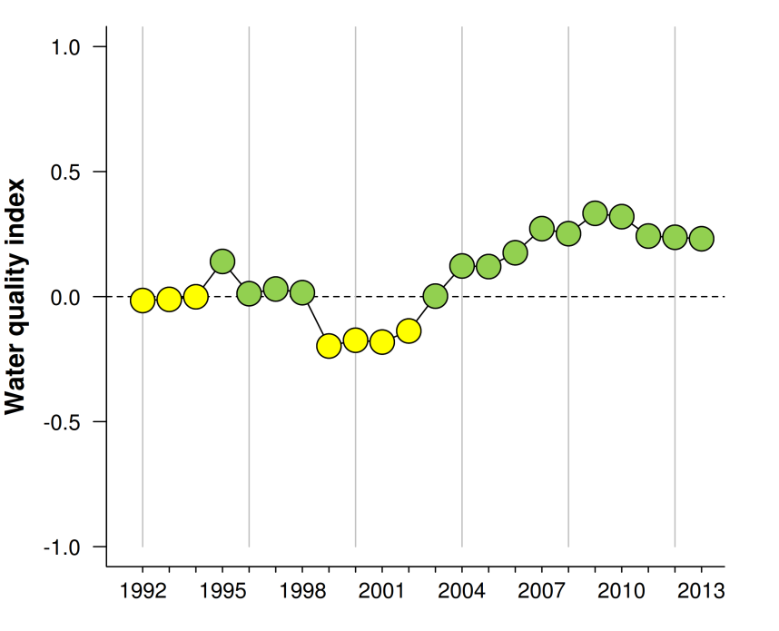

Figure 36 Water quality index scores 1992-2013.
The index aggregates four-year running means of concentrations of particulate phosphorus, particulate nitrogen, chlorophyll and suspended solids relative to Guideline (GBRMPA 2009, see Appendix 1.2.3 for detailed information on the derivation of scores).

To identify long-term trends in the eight water quality variables, the periodic (seasonal) component of variability in the data was first removed (Figure 37a, see Figure A2-2 for seasonality in these variables). For water quality variables that are sampled infrequently, variations in physical conditions can add substantial noise to the data which can hamper the detection of, and reduce confidence in, the underlying long-term trends. Hence, in a second step, the trends were standardised to remove the influence of confounding physical drivers (wind waves and tidal flow, see Appendix A1.2.2). The remaining long-term trends (Figure 37b) are considered to be primarily influenced, directly and indirectly, by land runoff.

All eight variables parameters showed significant long-term variability (Figure 37). The SS concentrations were high from 1997 to 2003 with the overall trendline clearly above the guideline, and then declined with a brief period of slightly elevated values in 2010-11. The nitrogen species PN and NOx showed distinct peaks in 2000, while DON had maximum values in 2004. PN has since declined with a brief increase in 2008/09, while NO_{x} greatly increased from 2004 and DON from 2008 onwards. Chlorophyll a and the phosphorus species PP and PO₄ had regular multi-year cycles. The chl and PP trendlines cycled around the guideline, with PP showing a slightly decreasing trend and PO₄ an increasing trend. DOP had a period of high concentrations around 1999-2005 (Figure 37).

The 24-year sampling period was characterized by substantial inter-annual variability in the magnitude of land runoff (indicated by the discharge of the rivers directly influencing this marine area, Figure 38) and by changes in catchment land use (indicated by land clearing rates). Vegetation clearing rates increased dramatically after 1994 and more than doubled in the period between 1995 and 2001 over the previous 1991-95 period (Figure 38). The resulting soil disturbance coupled with increased rainfall would have resulted in increased soil erosion, increased delivery of sediment and associated nutrients to the river systems and a greater input of sediment and nutrients to coastal waters during that period.

The relatively ‘wet’ years 1996-2001 coincided with the high land clearing rates and preceded the ~1997-2003 period characterized by higher concentrations of chlorophyll a, particulate and dissolved nutrients, and suspended solids in the adjacent marine waters. After 2000, land clearing activity decreased and was very low by 2009. In this period, concentrations of suspended sediments and particulate nutrients only exhibited minor increases during the period of higher river flow starting in 2004, with major floods in 2008 and 2011. In contrast, NO_{x} distinctly increased from 2004 and DON from 2008 to levels similar to the earlier period (~1997-2003) of high values.

The evidence for a long-term change in GBR inshore water quality is strong, but circumstantial. Historical changes in biological communities (corals: Roff et al. 2013; foraminifera: Uthicke et al. 2012a) and coral geochemical records (McCulloch et al. 2003, Lewis et al. 2007, Jupiter 2008, Mallela et al. 2013) indicate changes in marine water quality that are coincident with or follow historical changes in land use that have increased nutrient and sediment loads in river runoff (Kroon et al. 2012). A comparison of Secchi disc readings from the 1928-1929 British Museum Expedition to Low Isles, which is close to the Cairns transect, with more recent readings suggest a 50% decline in mean water clarity (Wolanski and Spagnol 2000).

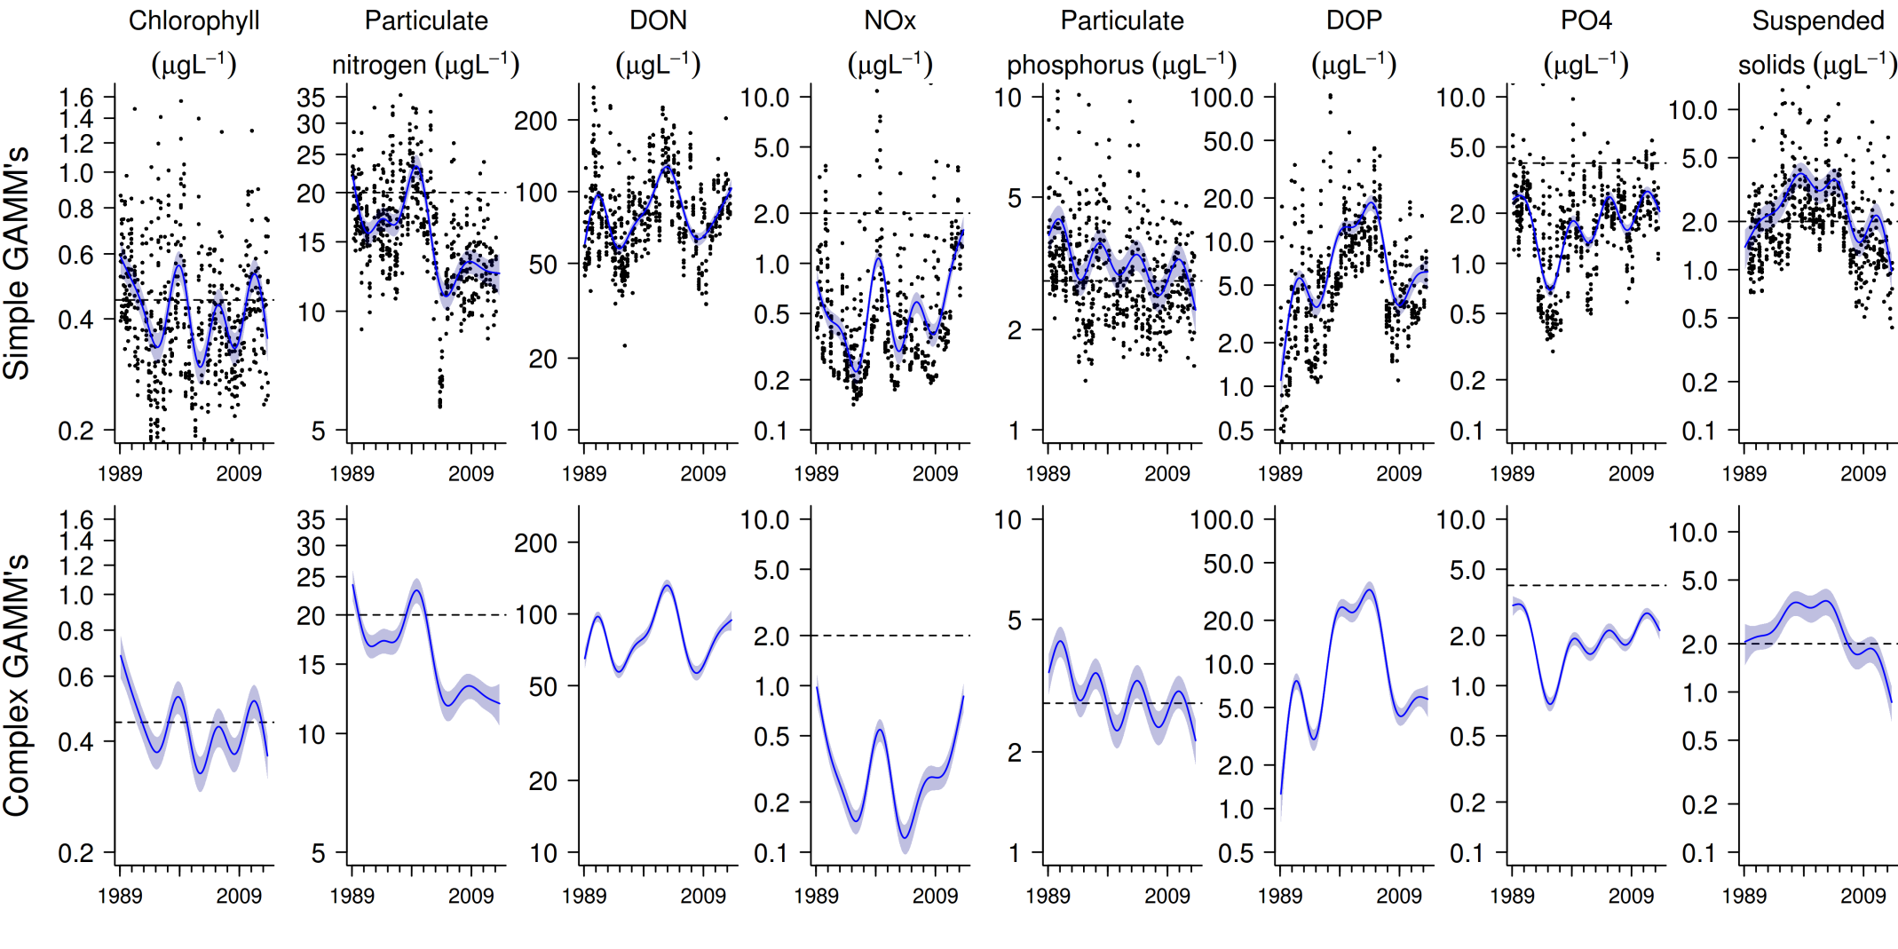
Figure 37 Long-term water quality trends along the Cairns Transect.
Trends in manually sampled water quality variables are represented by blue lines with blue shaded areas defining 95% confidence intervals of those trends, black dots represent observed data. a) Values de-trended for seasonal variability b) Values de-trended for variability due to season, wind, swell height and tidal flow.
.

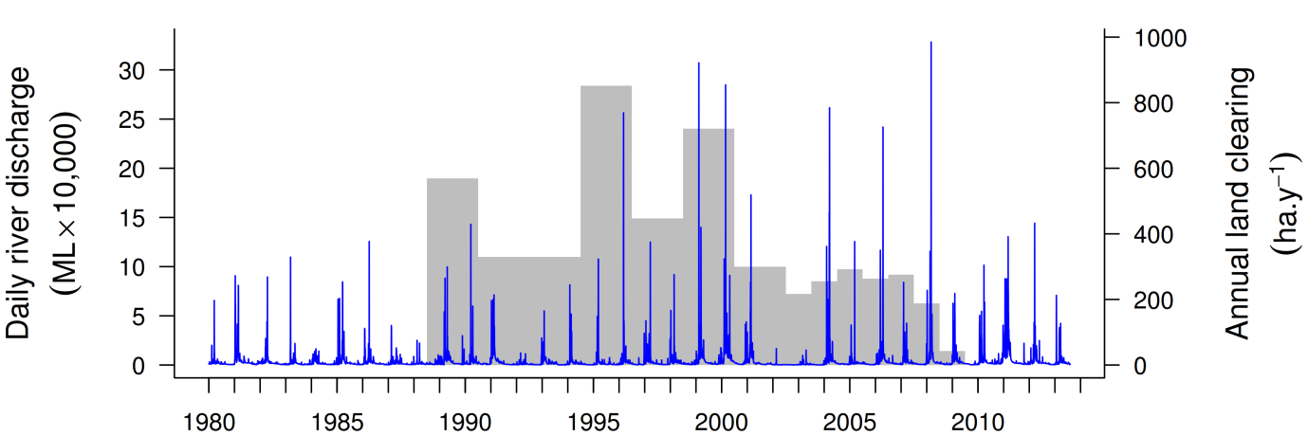
Figure 38 Combined river discharge (blue line) and annual woody vegetation clearing rate for the Barron and Daintree catchments. (from the Queensland Statewide Landcover and Trees Study http://www.nrm.qld.gov.au/slats/).

A previous analysis of the Cairns transect data to 2008 presented empirical evidence that land clearing in adjacent river catchments has both an immediate and longer-term impact on water quality (Schaffelke et al. 2010). The observed changes in the current, longer, time series, which encompasses another period of high discharge, warrant further in-depth analysis of the external drivers for the water quality changes. Unfortunately, current time series of reliable end-of-river nutrient and suspended sediment load estimates are too short to be useful for establishing correlations with the long-term marine water quality data sets.

The changes in water-quality variables and their apparent relationship with both natural and anthropogenic drivers were only detectable because of the 24-year duration of the Cairns Transect data set. Shorter term studies, especially if undertaken in the period from 1995 to 2001, would have produced a much different picture of water quality in the inshore waters of the GBR lagoon.

Given the World Heritage status of the GBR region and the clear links between lagoonal water quality and catchment development, there is clear need to more effectively manage land use activities, and to continue to monitor the effects of improved land management practices through initiatives such as the Paddock to Reef Program.

4. Conclusion
Local environmental conditions, such as water quality, clearly influence the benthic communities found on coastal and inshore reefs of the Great Barrier Reef (GBR). Collectively, these reefs differ markedly from those found in clearer, offshore waters (e.g. Done 1982, Wismer et al. 2009, De’ath and Fabricius 2010). Within the inshore zone, coral reef communities vary along steep environmental gradients that occur with distance from the coast and from major rivers (van Woesik and Done 1997, van Woesik et al. 1999, Fabricius et al. 2005, De’ath and Fabricius 2008, Uthicke et al. 2010, Fabricius et al. 2012), but also within individual reefs in response to localised hydrodynamic conditions (Uthicke et al. 2010, Thompson et al. 2010, Browne et al. 2010). The premise underpinning Reef 2050 Plan is that contaminant loads delivered by rivers sufficiently alter the environmental conditions in inshore waters of the GBR to suppress ecological resilience.

In this report for the MMP we provide temporal trends of water quality indicators in the GBR, together with trends in sediment quality and coral reef condition indicators. The water and sediment quality around inshore reefs changed in response to the magnitude of river flows - used here as a proxy for river loads of sediments, nutrients and pollutants. These changed environmental conditions had clear impacts on the resilience of inshore coral reef communities.

Variation in runoff alters environmental conditions at near-shore reefs

Water quality in the inshore GBR shows clear gradients away from river mouths, with higher levels of most indicators close to the coast, and is influenced over short time periods by flood events and sediment resuspension, and over longer time periods by a complex interplay of physical forcing and biological transformation processes (see Schaffelke et al. 2013 and references therein). Such gradients and processes are a natural part of the GBR ecosystem, albeit under far lower levels of input of runoff-derived pollutants than currently occur. An analysis of five years of MMP water quality data showed significant variability (Schaffelke et al. 2012). Most variation was explained by temporal factors (seasons, years and river flow), highlighting the extremely variable climate of coral reef systems, with regional aspects (such as latitude, land use on adjacent catchments, proximity to rivers and resuspension) explaining a smaller, albeit significant, amount of the variation. It is the quantification of the compounding of conditions along naturally occurring gradients as a result of runoff and any subsequent improvement under Reef 2050 Plan that is the core focus of the water quality monitoring component of the MMP.

The current report shows that over the course of the MMP, most monitored water quality parameters have changed in response to changes in river discharge. It was the substantial change in rainfall pattern from a period of below-median rainfall leading up to and including the first two years of monitoring followed by a period of well above-median flows that facilitated our demonstration that riverine inputs are sufficient to alter environmental conditions in inshore waters of the GBR. In the period 2007 to 2012, discharges from the major rivers in the Burdekin, Mackay Whitsunday and Fitzroy regions were at least twice the long-term median in at least four of the six years. In comparison, discharges in all regions were generally well below the long-term median in the period 2002 to 2006. In 2013, discharges were below-median in in the Wet Tropics and Burdekin regions, but were still 2-3 times above-median in most rivers of the Mackay Whitsunday Region and in the Fitzroy River. The range of river discharges experienced over the duration of the MMP have confounded the ability to assess any changes in water quality that can be ascribed to Reef Plan initiatives to-date. The data do, however, provide a solid baseline allowing the future de-trending of water quality data from the effects of flow variation.

Our data show increases in mean turbidity and concentrations of suspended solids, chlorophyll and nutrients and declines in Secchi depth that correspond to increased river flow in all regions. This is particularly pronounced at reef sites which are close to the coast and frequently exposed to riverine flood plumes (Álvarez-Romero et al. 2013). Over the course of the MMP monitoring, the (sub-) regional water quality index for reef water quality slightly declined in the Wet Tropics, markedly declined in the Mackay Whitsunday regions, intermittently declined in the Fitzroy Region but remained relatively stable in the Burdekin Region. Most water quality parameters showed some improvement after 2011 (which was an extreme flood year), corresponding to decreasing river discharge but perhaps also indicating the potential exhaustion of catchment sources of fine sediment and nutrients or reduced erosion due to high vegetation cover resulting from the preceding years of high rainfall (Kuhnert et al. 2012). However, concentrations of dissolved oxidised nitrogen (NOx) remained at a high level in all six (sub-)regions, while chlorophyll was high in four (sub-) regions. These findings may indicate extended residence of runoff-derived contaminants within the GBR lagoon and active transformation processes of organic matter that continue to release dissolved nutrients. The improvement of land management practices may have also contributed to the improvements in some water quality parameters; the last Reef Plan report cards (2010, 2011, and 2012-2013, available at www.reefplan.qld.gov.au) report reductions in end-of-river loads of sediment and nutrients. However, these load reductions are estimated using models based on the adoption of agricultural best management practices and it is unclear if these reductions have measurably changed the end-of-river loads. Recent studies suggested significant time lags between management changes and reductions in river loads and the requirement for decadal time-series to unequivocally detect such changes (Brodie et al. 2012, Darnell et al. 2012, Barrtley et al. 2014).

To understand the effects of land runoff on GBR coastal and inshore waters, it is important to understand the fundamental processes that control the fate and impact of freshwater, sediment, nutrients and pesticides delivered from catchments. At this point a distinction must be made between flushing time of water and residence time of nutrients, sediments and other contaminants. Flushing times of waters introduced as runoff are a function of river flows, exchange rates and oceanographic processes. Water flushing times in the GBR lagoon are still debated as estimates from different modelling approaches range from weeks (Hancock et al. 2006), Wang et al. 2007, Choukroun et al. 2010) to several months (Brinkman et al. 2002, Luick et al. 2007). Analysis of satellite imagery of flood plumes suggest flushing times of several weeks in the coastal and inshore GBR (Schroeder et al. 2012) and episodic transport of flood-borne material into the mid-shelf and outer-shelf reef regions (Devlin and Schaffelke 2009). Residence times additionally consider the mediation of flushing time by processes such as biological uptake and transformation, sedimentation and burial, resuspension and remineralisation (Alongi and McKinnon 2005, Furnas et al. 2011, Bainbridge et al. 2012), which are not yet fully quantified on a whole-of-GBR scale (see Furnas et al. 2011).

Gross levels of turbidity and sedimentation at a given location are largely driven by resuspension of accumulated sediment deposits (Larcombe et al. 1995, Larcombe et al. 2001), which is also a mechanism for the release of sediment-associated nutrients (Furnas et al. 2011). However, it is becoming increasingly apparent that the additional flux of fine sediment imported by rivers remains in the coastal zone for periods of months to years leading to chronically elevated turbidity and rates of sedimentation (Wolanski et al. 2008, Lambrechts et al. 2010, Brodie et al. 2012b, Thompson et al. 2012, Fabricius et al. 2013a). An increase in turbidity and chlorophyll levels during years with above-median river discharge was also shown in an analysis of MMP remote sensing data for the reefs monitored in the Mackay Whitsunday Region (Thompson et al., in review) and another study showed a correlation between decreased photic depth and river flow in the Burdekin region (Fabricius et al. in review). MMP water quality data are currently being used to parameterise models of sediment dynamics and biogeochemical processes under the multi-agency project eReefs (http://www.bom.gov.au/environment/eReefs_Infosheet.pdf), that will enhance the capacity to predict changes in water quality in space and time in response to changing land use and runoff load scenarios.

The trends in site-specific water quality presented in this report provide a useful indication of the actual environmental conditions coral reef organisms were exposed to. To better understand the relative importance of the various covariates influencing these water quality conditions, the case study using data from the AIMS Cairns Transect (1989-2013) included temporal trends corrected for physical forcing by wind, wave and tide-driven resuspension. This reveals the variability caused by other drivers such as river discharge, and could be used in future analyses of the MMP water quality data to attribute long-term trends in ambient marine water quality to changes in land runoff to better inform catchment management decisions. In the catchments adjacent to the Cairns transect, the wet years 1996-2001 coincided with high land clearing rates and were associated with high concentrations in the adjacent marine waters of chlorophyll a, nutrients and suspended solids. After this period, land clearing rates were low, concentrations of suspended sediments and particulate nutrients decreased and only showed very minor increases during the major flood year of 2011. In contrast, dissolved inorganic nitrogen distinctly increased from 2004, while chlorophyll concentrations showed regular multi-year cycles.

At most MMP survey reefs, the turbidity and suspended solids concentrations increased during ~2008-2012. This led to an increased supply of fine sediment, and any adsorbed contaminants, to the reef substratum (Thompson et al. 2012). High rates of sedimentation require a combination of a high supply of suspended particles, measurable as high turbidity, coupled with a low energy hydrodynamic setting that allows these particles to settle and accumulate (Wolanski et al. 2005). While there was a general increase in the proportions of fine-grained particles, nutrients and organic carbon in sediments at the reefs sites in all regions, this result is likely to underestimate the changes occurring at the more turbid and sheltered locations because reefs in relatively clear waters that are exposed to wave-driven resuspension are unlikely to accumulate fine sediments and so limit the sensitivity of our analyses to detect trends in sediment characteristics as a response of increased turbidity. Reefs in the Mackay Whitsunday Region, Middle Reef in the Burdekin Region and Snapper Island North in the Wet Tropics Region are subjected to high levels of turbidity, have sediments with high proportions of fine-grained particles, nutrients and organic carbon and are hence considered to be predisposed to the detrimental impacts of sedimentation. In the Fitzroy Region, these sediment quality indicators showed marked increases after the recent major floods, especially at sites close to the coast.

Ecological response of coral reef communities to changed environmental conditions

The steady decline of the FORAM index on most reefs is a strong indication that our observations of changed water quality and sediment characteristics represent a shift in environmental conditions sufficient to alter foraminiferal assemblages. The recent changes in the foraminiferal assemblages of the inshore GBR are consistent with responses linked to declines in light availability and increased sediment nutrient concentrations (Uthicke and Nobes 2008, Uthicke and Altenrath 2010, Reymond et al. 2011, Uthicke et al. 2012b). Increases in dissolved inorganic nitrogen in the water column seem to be detrimental to symbiont-bearing foraminifera (Reymond et al. 2012). Increased DIN explained a higher amount of variation of reduced calcification in two foraminiferal species in the Whitsunday area than reduced light conditions (Uthicke and Altenrath 2010). Experimental studies also showed reduced growth and increased mortality under elevated DIN (Reymond et al. 2011, Uthicke et al. 2012b). The susceptibility of foraminifera to the effects of runoff has been previously demonstrated in the Whitsunday Region where sediment cores revealed foraminiferal assemblages that had been historically persistent underwent a marked changes that coincided with the onset of anthropogenic changes within the catchment starting ~150 years ago (Tager et al. 2010, Uthicke et al. 2012a). Similarly, the FORAM index at Christmas Is. was reduced after human settlement, with the largest changes observed where human population density was high (Carilli and Walsh 2012). The recent changes in the foraminiferal assemblages of the inshore GBR indicate the ongoing and widespread selective pressures consistent with observed increases in turbidity and NOx .

The general responses of coral reef communities to water quality are relatively well understood (recently reviewed in Schaffelke et al. 2013) and contribute to the compositional differences that occur along environmental gradients in the inshore GBR (Done 1982, van Woesik and Done 1997, van Woesik 1999, Fabricius et al. 2005, De’ath and Fabricius 2008, Browne et al. 2010, De’ath and Fabricius 2010, Thompson et al. 2010, Uthicke et al. 2010, Browne et al. 2012, Fabricius et al. 2012). Simplistically, species that are tolerant to the environmental pressures at a given location are likely to be more abundant compared to less-tolerant species. However, the processes shaping biological communities are complex due to interactions between environmental variables, other organisms and the effects of past disturbances events. In contrast to the relatively short life span of foraminifera, corals are long lived and so coral community composition naturally reflects the cumulative result of selective pressures over longer time frames.

For corals to persist in a location requires that they are able to survive extremes in environmental conditions but also maintain a competitive ability during periods of more moderate conditions. In addition, corals are subject to acute disturbance events such as cyclones, crown-of-thorns seastar (COTS) outbreaks or thermal bleaching events. Since MMP surveys began in 2005 acute disturbance events causing loss of coral cover have included thermal bleaching (Fitzroy Region 2006), Cyclone Larry (Wet Tropics and Burdekin regions 2006), Cyclone Ului (Whitsunday Region 2010), Cyclone Tasha (Wet Tropics 2011), Cyclone Yasi (Wet Tropics and Burdekin regions 2011), sub-cyclonic storms (Barron Daintree sub-region 2009)., Burdekin 2009, Fitzroy 2008, 2010, 2013) and COTS (Wet Tropics 2012, 2013). Direct exposure to low salinity flood waters also reduced coral cover at some reefs at 2m depths in the Fitzroy Region in 2011. The frequency and severity of these disturbances must be considered in our interpretation of coral community condition. While these impacts per se do not constitute a loss of resilience, coral cover is included in our assessment of coral community resilience primarily as an indicator of the availability of brood-stock for the recovery process. It is very likely that the prolonged impact of acute disturbances on coral cover compared to any influences on water quality contribute to discrepancies between trends in the water quality index and coral health index.

Of more concern is that the resilience indicators: cover of macroalgae, juvenile density and rate of cover increase, along with the number of coral larvae settling to tiles have collectively remained stable at low levels or declined over recent years. Within our data, we interpret the following observations as implicating water quality as a contributing factor to the observed declines in the coral health index:

- Firstly, the rate at which coral cover increases during periods free of disturbance is important if coral cover is to be maintained in the long term and at regional scales. The indicator for rate of cover change has shown general declines in most regions. In each region we noted fluctuations in the incidence of coral disease with peaks in disease generally observed in years that included major flooding, which suggests that environmental conditions associated with those floods are stressful for coral communities. This is supported by studies indicating that higher availability of nutrients and organic matter are associated with higher incidence and severity of coral disease (Bruno et al. 2003, Haapkylä et al. 2011, Vega Thurber et al. 2013).
Two exceptions were: high levels of white syndrome observed amongst Acropora communities in the Russell-Mulgrave sub-region in 2010 for which we cannot identify a plausible environmental stressor and, higher incidence of disease in 2005 and 2006 than in subsequent years in the Herbert Tully sub-region. The observed higher incidence of disease in the Herbert Tully sub-region is likely due, at least in part, to the reduced number of colonies in this region following severe reductions caused by Cyclone Larry in early 2006.

- Secondly, macroalgae generally benefit from increased nutrient availability due to runoff (e.g., Schaffelke et al. 2005) and, as coral competitors, supress both coral growth and juvenile settlement or survival (e.g., McCook et al. 2001a, Birrell et al. 2005, 2008). High cover of macroalgae has been recorded at 19 of the 32 reefs monitored. Of these 19 reefs, Barren Island in the Fitzroy Region had an ephemeral, post-disturbance macroalgal bloom after a coral bleaching event in 2006. This bloom was not sustained, potentially due to the better water quality compared to nearby reefs where similar post-bleaching blooms persisted. Persistent high cover of macroalgae has also largely disappeared at the 2m depth of Havannah Island, which is the reef in the Burdekin region with the least exposure to plume-type waters and generally better water quality than the sites that maintain high cover of macroalgae in that region. The decline in the macroalgae resilience indicator is due to the disproportionate number of reefs at which macroalgae have become established compared to those at cover has declined.

- Finally, the density of juvenile corals declined in all regions over the period with high runoff with lowest densities observed between 2011 and 2013 in all six (sub-)regions. The early life history stages of corals are sensitive to a range of water quality parameters that vary in response to runoff (see Fabricius 2011 for a synthesis). We now have documented declines in the number of juvenile corals at reefs exposed to a wide range of water quality conditions, which indicates that the causes of these declines are not clearly linked to a single environmental threshold. Rather, the stressors influencing larval settlement and/or subsequent survival are likely to vary across environmental gradients. Confounding direct links between water quality and coral recruitment will be secondary influences of water quality such as the presence or not of persistent macroalgal communities which limit coral recruitment, as well as factors such as reduced brood-stock due to disturbance events that are not linked to water quality.
In 2013, the indicator score for the density of juvenile corals had improved in four of the six (sub-)regions, coinciding with return to lower flows from adjacent catchments. No improvement was observed in the Barron Daintree sub-region, which currently suffers a COTS outbreak at Snapper Island. Nor was there any improvement in the Fitzroy Region where a high cover of macroalgae has persisted at most reefs. In the Herbert Tully sub-region the increase in juvenile density was predominantly due to very high numbers of the genus Turbinaria. As this genus was not well represented in the adult community prior to the successive cyclonic disturbances in 2006 and 2011, it is unclear whether this recruitment pattern is simply due to natural variability or indicates the selection for species more suited to the recent environmental conditions than to those previously present. Although less extreme, the genus Turbinaria has also recruited in higher proportions to several of the more turbid water reefs in the adjacent Burdekin Region.

The widespread decline in coral reef condition demonstrates the sensitivity of inshore coral communities to elevated loads of contaminants introduced by runoff. The effects were common in all regions, across environmental gradients and affecting a diversity of taxonomic groups, which makes the identification of individual areas most at risk to the effects of runoff a challenging task. Once pollutants reach the GBR lagoon, mixing and far-field transport makes it difficult to separate the effects of different catchment sources (but see Furnas et al. 2013). Because coral communities are the result of selection influenced by the local long-term environmental conditions their responses are expected to be site-specific and exposure-dependent (see e.g. McCook et al. 2001b).

In addition to reducing the ability to recover from disturbance, degraded water quality potentially increases the susceptibility of corals to disturbance. Evidence from recent research into the interactions between water quality and climate change suggests that the tolerance to heat stress of corals and foraminifera is reduced by exposure to contaminants including nutrients, herbicides and suspended particulate matter (Negri et al. 2011, Wiedenmann et al. 2013, Uthicke et al. 2012b, Fabricius et al. 2013b). The amount and variability of rainfall has already significantly increased in northern Australia over the past 100 years (Lough 2011) and the severity of disturbance events are projected to increase as a result of climate change (Steffen et al. 2013). Any increase in susceptibility to these disturbances as a result of local stressors will compound the pressures imposed on sensitive species and potentially lead to profound changes in coral communities for GBR inshore communities. In a similar vein, evidence is accumulating that COTS outbreaks are initiated as a result of increased nutrient loads delivered to the GBR lagoon and so extending the influence of runoff to large tracts of the GBR (Fabricius et al. 2010). At present, there is a limited understanding of the cumulative impacts of these multiple pressures. The GBRMPA Strategic Assessment identified this as a key knowledge gap and the management of these impacts as a key strategic challenge (GBRMPA 2013).

In summary, our results clearly identify that the runoff associated with recent flood events has been sufficient to alter environmental conditions within the inshore GBR. The location of sampling sites along underlying environmental gradients and adjacent to different catchments influences the exposure to the various components of runoff. Large changes in environmental variables such as water quality can influence the resilience of reef communities, for example by supporting a sustained high cover of macroalgae. However, it is increasingly apparent that within a location stress to coral communities occurs due more to the response of sensitive species to changes in environmental conditions than to the ambient conditions to which the species present are clearly tolerant. This is because the community composition at a location has been selected for by the long-term environmental conditions at that site. Environmental degradation is operating over several time scales with short-term fluctuations continuously selecting for or against certain species, a processes evidenced by the increase in disease we saw following flood events, which in the long term may lead to selection of species both competitively competent during ambient conditions and tolerant to environmental extremes. If environmental conditions further deteriorate or become more variable, the coral reef species capable of persisting into the future may be an ever diminishing subset of the regional species pool (Devantier et al. 2006) or lead to specialist communities able to persistent in environmental extremes or high variability (Browne et al. 2012). In contrast, the ongoing selection for species tolerant of the environmental conditions at a given location imposes a degree of inertia into the communities that will limit the potential for rapid response to subtly improved conditions. This inertia linked to both the occupation of space by tolerant species limiting the settlement of previously excluded species but also the limitation of larvae due to limited brood-stock of sensitive species.

The way forward – recommendation for changes to the Program and associated activities

As our understanding of the ecology of inshore reefs improves and our data set grows some aspects of our data analysis and sampling strategies can be reconsidered. We have included a case study that considers the settlement of coral larvae at our core reefs. While this study has revealed broad relationship between the settlement of larvae and the condition of the tiles in terms of coverage of crustose coralline algae, links to the availability of brood-stock, and limitation at high levels of turbidity, we have found the data difficult interpret due to an inability to control for a range of potential contributing factors that may influence the settlement observed. In effect we have demonstrated that competent larvae are reaching all reefs and that there has been a general decline in settlement over the period 2006-2011, a trend that continued to 2012 with data collected subsequent to the case study analysis. Because we cannot satisfactorily account for the variation due to unknown (and we consider unknowable in the context of this project) external drivers, and that we can estimate both regional brood-stock and the density of juvenile corals surviving on the actual reefal substrates, it was jointly decided between AIMS and GBRMPA to cease this component of the project.
The coral health index presented in this report is the coral reef component of the Reef Plan GBR Report card. A key indicator of the coral health index is the density of juvenile corals. As it has been applied, the density of juvenile corals corrects for the availability of space so as to not penalise observations of low abundance of juveniles in situations where coral cover is very high or substantial areas of the sites span areas of soft sediments, both of which exclude juvenile coral from settling. What we had not considered was that the proportion of the sites defined as sand or silt would appreciably change. What we have observed is that the large flood events in recent years have led to the accumulation of fine sediments on reefs in sheltered locations. This accumulation has resulted in the covering of reefal substrate with that silt, which changes the categorisation of substrate from some form of algae to silt. As silt is classified as not available space, and algae is classified as available space, this results in the indicator of juvenile density increasing with increasing smothering of substrates with sediments, thus masking the likely negative effect of sediment accumulation on juvenile numbers. In retrospect we consider that future assessments of juvenile density should correct only for coral cover.
Our results to date indicate that the GBR Water Quality Guidelines (guideline) generally reflect the condition of inshore reefs, within the limits of disturbance-related effects. However, in the recent assessments, in particular the FORAM index showed a significant decline while the water quality variables are still mostly compliant with the guideline. Many ecological responses are continuous while the guideline provides a hard threshold. The differential responses of community types (which would reflect also site-specific selection processes) could be used in a future revision and refinement of the guideline. Also, our data demonstrate a multi annual response of dissolved nutrients to flood events. The Queensland guideline for these values (NOx, PO4) are very high compared to the values measured in the MMP and, hence, responses of these variables in an index based on compliance with the guideline would not properly reflect the significant changes that we observed over the course of the monitoring as almost all values are below the guidelines. The MMP data would be very valuable to the development of guideline values for dissolved nutrients specific for GBR inshore waters. In contrast, the high-frequency records derived from in-situ sensors corroborate data from satellites and flood plume monitoring in demonstrating the locally extreme environmental conditions resulting during flood events. It is likely that these extremes are important drivers of selection within biological communities but are currently underrepresented in water quality reporting, it is possible the this underrepresentation may be contributing to some of the discrepancies between trends in the water quality index and the coral reef community condition.

Acknowledgments
We thank Aaron Anderson, Joe Gioffre, Charlotte Johansson, Shawn Smith, Marcus Stowar and Kate Osborne for valuable field assistance over the years. We also thank Ed Butler, Terry Done, Johanna Johnson, Katherine Martin and a number of anonymous reviewers for their detailed reviews that improved the previous reports on which this current instalment builds. Finally we acknowledge the valuable contributions to data collection, sampling integrity and reporting of Stephen Neale and Damian Thomson over the first few years of the monitoring program and staff at Geoscience Australia for grain size analysis of sediment samples.

5. References
Alongi D M, McKinnon AD (2005) The cycling and fate of terrestrially-derived sediments and nutrients in the coastal zone of the Great Barrier Reef shelf. Marine Pollution Bulletin 51:239-252.
Álvarez-Romero JG, Devlin MJ, Teixeira da Silva E, Petus C, Ban N, Pressey RJ, Kool J, Roberts S, Cerdeira WA, Brodie J (2013) A novel approach to model exposure of coastal-marine ecosystems to riverine flood plumes based on remote sensing techniques. J Environ Manage 119:194–207
Anon. (1997) Directory of Autoanalyser Methods, Bran and Luebbe GmbH, Norderstedt, Germany.
Anon. (2003) Reef Water Quality Protection Plan for catchments adjacent to the Great Barrier Reef World Heritage Area. The State of Queensland and Commonwealth of Australia. Queensland Department of Premier and Cabinet, Brisbane. 43 pp
Anon. (2009) Reef Water Quality Protection Plan 2009. For the Great Barrier Reef World Heritage Area and adjacent catchments. The State of Queensland and Commonwealth of Australia. Queensland Department of the Premier and Cabinet, Brisbane. 30 pp.
Anon. (2010) Paddock to Reef Integrated Monitoring, Modelling and Reporting Program Design (DRAFT). Version 12 February 2010. The State of Queensland, Queensland Department of the Premier and Cabinet, Brisbane. 93 p.
Anon. (2011) Reef Water Quality Protection Plan. First Report 2009 Baseline. The State of Queensland and Commonwealth of Australia. Queensland Department of Premier and Cabinet, Brisbane. 140 pp. Available at www.reefplan.qld.gov.au
Anon. (2013) Reef Water Quality Protection Plan 2013.Securing the health and resilience of the Great Barrier Reef World Heritage Area and adjacent catchments. The State of Queensland. Reef Water Quality Protection Plan Secretariat, Brisbane. 34 p. Available at www.reefplan.qld.gov.au
Anthony KRN (1999) Coral suspension feeding on fine particulate matter. Journal of Experimental Marine Biology and Ecology 232:85-106
Anthony KRN, Fabricius KE (2000) Shifting roles of heterotrophy and autotrophy in coral energetics under varying turbidity. Journal of Experimental Marine Biology and Ecology 252:221-253
Ayling AM, Ayling AL (2005) The dynamics of Cairns and Central section fringing reefs: 2005 Unpublished report submitted to the Great Barrier Reef Marine Park Authority, Townsville
Babcock RC (1988) Fine-scale spatial and temporal patterns in coral settlement. In: Proceedings of the 6th International Coral Reef Symposium, Australia, Vol. 2:625-634
Babcock RC, Smith L (2002) Effects of sedimentation on coral settlement and survivorship. In: Proceedings of the 9th International Coral Reef Symposium, Bali, Indonesia, 245–248
Bainbridge ZT, Wolanski E, Álvarez-Romero JG, Lewis SE, Brodie JE (2012) Fine sediment and nutrient dynamics related to particle size and floc formation in a Burdekin River flood plume, Australia. Marine Pollution Bulletin 65: 236-248
Baird AH, Babcock RC, Mundy CP (2003) Habitat selection by larvae influences the depth distribution of six common coral species. Marine Ecology Progress Series 252:289-293
Baird AH, Guest JR, Willis BL (2009) Systematic and Biogeographical Patterns in the Reproductive Biology of Scleractinian Corals. doi:10.1146/annurev.ecolsys.110308.120220
Baird AH, Marshall PA (2002) Mortality, growth and reproduction in scleractinian corals following bleaching on the Great Barrier Reef. Marine Ecology Progress Series 237:133-141Bartley R, Bainbridge ZT, Lewis SE, Kroon FJ, Wilkinson SN, Brodie JE, Silburn DM (2014) Relating sediment impacts on coral reefs to watershed sources, processes and management: A review. Science of The Total Environment 468–469:1138-1153
Bellwood DR, Hughes TP, Folke C, Nyström M (2004) Confronting the coral reef crisis. Nature 429:827-833
Bentley C, Devlin M, Paxman C, Chue KL, Mueller J (2013) Pesticide monitoring in inshore waters of the Great Barrier Reef using both time-integrated and event monitoring techniques (2011 - 2012). The University of Queensland, The National Research Centre for Environmental Toxicology (Entox)
Berkelmans R, Jones A, Brinkman R, Schlott C (2011) Salinity thresholds of reef corals. A review prepared for the Great Barrier Reef Marine Park Authority. Australian Institute of Marine Science, Townsville. 14pp.
Birrell CL, McCook LJ, Willis BL (2005) Effects of algal turfs and sediment on coral settlement. Marine Pollution Bulletin 51:408-414
Birrell CL, McCook LJ, Willis BL, Diaz-Pulido GA (2008a) Effects of benthic algae on the replenishments of corals and the implications for the resilience of coral reefs. Oceanography and Marine Biology: An Annual Review 46:25-64
Birrell CL, McCook LJ, Willis BL, Harrington L (2008b) Chemical effects of macroalgae on larval settlement of the broadcast spawning coral Acropora millepora. Marine Ecology Progress Series 362:129-137
Boyer J, Fourqurean J, Jones R (1999) Seasonal and long-term trends in the water quality of Florida Bay (1989–1997). Estuaries and Coasts 22:417-430
Brando VE, Blondeau-Patissier D, Schroeder T, Dekker AG, Clementson L (2011) Reef Rescue Marine Monitoring Program: Assessment of terrestrial run-off entering the Reef and inshore marine water quality monitoring using earth observation data. Final Report for 2010/11 Activities. CSIRO, Canberra. 201pp
Brando VE, Devlin MJ, Dobbie M, McNeil A, Schaffelke B, Schroeder T (2013). Developing integrated assessment metrics for reporting of water quality in the Great Barrier Reef lagoon. Report to the Reef Rescue Water Quality Research & Development Program. Reef and Rainforest Research Centre Limited, Cairns. 53pp.
Brinkman R, Herzfeld M, Andrewartha J, Rizwi F, Steinberg C, Spagnol S (2011) Hydrodynamics at the whole of GBR scale. AIMS Final Project Report MTSRF Project 2.5i.1, June 2011. Report to Reef and Rainforest Research Centre. Australian Institute of Marine Science, Townsville. 42 pp.
Brinkman R, Wolanski E, Deleersnijder E, McAllister F, Skirving W (2002) Oceanic inflow from the Coral Sea into the Great Barrier Reef. Estuarine, Coastal and Shelf Science 54:655-668
Brodie J, Binney J, Fabricius K, Gordon I, Hoegh-Guldberg O, Hunter H, O’Reagain P, Pearson R, Quirk M, Thorburn P, Waterhouse J, Webster I, Wilkinson S (2008) Synthesis of evidence to support the Scientific Consensus Statement on Water Quality in the Great Barrier Reef. The State of Queensland (Department of the Premier and Cabinet). Published by the Reef Water Quality Protection Plan Secretariat, Brisbane. 59pp
Brodie J, De’ath G, Devlin M, Furnas MJ, Wright M (2007) Spatial and temporal patterns of near-surface chlorophyll a in the Great Barrier Reef lagoon. Marine and Freshwater Research 58: 342-353.
Brodie J, Wolanski E, Lewis S, Bainbridge Z (2012b) An assessment of residence times of land-sourced contaminants in the Great Barrier Reef lagoon and the implications for management and reef recovery. Marine Pollution Bulletin 65: 267-279
Brodie JE, Kroon FJ, Schaffelke B, Wolanski EC, Lewis SE, Devlin MJ, Bohnet IC, Bainbridge ZT, Waterhouse J, Davis AM (2012a) Terrestrial pollutant runoff to the Great Barrier Reef: An update of issues, priorities and management responses. Marine Pollution Bulletin 65: 81-100
Brodie JE, McKergow LA, Prosser IP, Furnas MJ, Hughes AO, Hunter H (2003) Sources of sediment and nutrient exports to the Great Barrier Reef World Heritage Area. Australian Centre for Marine and Tropical Freshwater Research Report No. 03/11. James Cook University, Townsville
Browne NK, Smithers SG, Perry CT (2010) Geomorphology and community structure of Middle Reef, central Great Barrier Reef, Australia: an inner-shelf turbid zone reef subject to episodic mortality events. Coral Reefs 29: 683-689
Browne NK, Smithers SG, Perry CT (2012) Coral reefs of the turbid inner-shelf of the Great Barrier Reef, Australia: An environmental and geomorphic perspective on the occurrence, composition and growth. Earth-Science Reviews 115:1-20
Bruno JF, Petes LE, Harvell CD, Hettinger A (2003) Nutrient enrichment can increase the severity of coral diseases. Ecology Letters 6:1056-1061
Bruno JF, Sweatman H, Precht WF, Selig ER, Schutte VGW (2009) Assessing evidence of phase shifts from coral to macroalgal dominance on coral reefs. Ecology 90:1478-1484
Caccia VG, Boyer JN (2005) Spatial patterning of water quality in Biscayne Bay, Florida as a function of land use and water management. Marine Pollution Bulletin 50:1416-1429
Carilli, J, Walsh S (2012). Benthic foraminiferal assemblages from Kiritimati (Christmas) Island indicate human-mediated nutrification has occurred over the scale of decades. Marine Ecology Progress Series 456:87-99
Carpenter KE, Abrar M, Aeby G, Aronson RB, Banks S, Bruckner A, Chiriboga A, Cortes J, Delbeek JC, DeVantier L, Edgar GJ, Edwards AJ, Fenner D, Guzman HM, Hoeksema BW, Hodgson G, Johan O, Licuanan WY, Livingstone SR, Lovell ER, Moore JA, Obura DO, Ochavillo D, Polidoro BA, Precht WF, Quibilan MC, Reboton C, Richards ZT, Rogers AD, Sanciangco J, Sheppard A, Sheppard C, Smith J, Stuart S, Turak E, Veron JEN, Wallace C, Weil E, Wood E (2008) One-Third of Reef-Building Corals Face Elevated Extinction Risk from Climate Change and Local Impacts. Science 321:560-563
Cheal AJ, , Emslie M, MacNeil MA, Miller I, Sweatman H (2013) Spatial variation in the functional characteristics of herbivorous fish communities and the resilience of coral reefs Ecological Applications, 23:174–188
Cheal AJ, MacNeil MA, Cripps E, Emslie M, Jonker M, Schaffelke B, Sweatman H (2010) Coral-macroalgal phase shifts or reef resilience: links with diversity and functional roles of herbivorous fishes on the Great Barrier Reef. Coral Reefs 29:1005-1015
Chin A, Lison De Loma T, Reytar K, Planes S, Gerhardt K, Clua E, Burke L, Wilkinson C (2011) Status of Coral Reefs of the Pacific and Outlook: 2011. Global Coral Reef Monitoring Network, 260pp
Choukroun S, Ridd PV, Brinkman R, McKinna LIW (2010) On the surface circulation in the western Coral Sea and residence times in the Great Barrier Reef. J. Geophys. Res. 115: C06013. doi:10.1029/2009JC005761.
Cloern J, Jassby A (2010) Patterns and Scales of Phytoplankton Variability in Estuarine–Coastal Ecosystems. Estuaries and Coasts 33:230-241
Connie 2.0, CSIRO Connectivity Interface, http://www.csiro.au/connie2/
Cooper TF, Ridd PV, Ulstrup KE, Humphrey C, Slivkoff M, Fabricius KE (2008) Temporal dynamics in coral bioindicators for water quality on coastal coral reefs of the Great Barrier Reef. Marine and Freshwater Research 59:703-716
Cooper TF, Uthicke S, Humphrey C, Fabricius KE (2007) Gradients in water column nutrients, sediment parameters, irradiance and coral reef development in the Whitsunday Region, central Great Barrier Reef. Estuarine, Coastal and Shelf Science 74:458-470Darnell R, Henderson B, Kroon FJ, Kuhnert P (2012) Statistical power of detecting trends in total suspended sediment loads to the Great Barrier Reef. Marine Pollution Bulletin 65:203-209
De'ath G, Fabricius KE (2008) Water Quality of the Great Barrier Reef: Distributions, Effects on Reef Biota and Trigger Values for the Protection of Ecosystem Health. Research Publication No. 89. Great Barrier Marine Park Authority, Townsville, p. 104 p
De'ath G, Fabricius KE (2010) Water quality as a regional driver of coral biodiversity and macroalgae on the Great Barrier Reef. Ecological Applications 20:840–850
De’ath G, Fabricius KE, Sweatman H, Puotinen M (2012) The 27-year decline of coral cover on the Great Barrier Reef and its causes. Proceedings of the National Academy of Sciences 190(44):17995-17999
Dennis B, Taper ML (1994) Density dependence in time series observations of natural populations: estimation and testing. Ecological Monographs 64:205-224
Department of Environment and Resource Management (2009) Queensland Water Quality Guidelines, Version 3. 167 p. Available at www.derm.qld.gov.au. ISBN 978-0-9806986-0-2
DeVantier L, De’ath G, Turak E, Done TJ, Fabricius KE (2006) Species richness and community structure of reef-building corals on the nearshore Great Barrier Reef. Coral Reef 25:329-340
Devlin M, Schaffelke B (2009) Spatial extent of riverine flood plumes and exposure of marine ecosystems in the Tully coastal region, Great Barrier Reef. Marine and Freshwater Research 60:1109-1122
Devlin M, McKinna LW, Álvarez-Romero J, Petus C, Abott B, Harkness P, Brodie J (2012) Mapping the pollutants in surface plume waters in the Great Barrier Reef, Australia. Marine Pollution Bulletin 65:224:235
Devlin M, Petus C, da Silva, ET Debose J, Álvarez-Romero J, in prep. Reef Rescue Marine Monitoring Program: Final report of JCU Activities 2012/13 - Flood Plumes and Extreme weather monitoring for the Great Barrier Reef Marine Park Authority. James Cook University, Townsville, Australia.
Diaz-Pulido G, Harii S, McCook LJ, Hoegh-Guldberg O (2010) The impact of benthic algae on the settlement of a reef-building coral. Coral Reefs 29:203-208
Diaz-Pulido G, McCook LJ, Dove S, Berkelmans R, Roff G, Kline DI, Weeks S, Evans RD, Williamson DH, Hoegh-Guldberg O (2009) Doom and Boom on a Resilient Reef: Climate Change, Algal Overgrowth and Coral Recovery. PLoS ONE 4(4): e5239.
Done T, Turak E, Wakeford M, DeVantier L, McDonald A and Fisk D (2007) Decadal changes in turbid-water coral communities at Pandora Reef: loss of resilience or too soon to tell? Coral reefs 26:789–805
Done TJ (1982) Patterns in the distribution of coral communities across the central Great Barrier Reef. Coral Reefs 1:95-107
Dunstan PK, Johnson CR (1998) Spatio-temporal variation in coral recruitment at different scales on Heron Reef, southern Great Barrier Reef. Coral Reefs 17:71–81
Erftemeijer PLA, Reigl B, Hoeksema BW, Todd PA (2012) Environmental impacts of dredging and other sediment disturbances on corals: A review. Marine Pollution Bulletin 64:1737-1765
Fabricius KE (2005) Effects of terrestrial runoff on the ecology of corals and coral reefs: Review and synthesis. Marine Pollution Bulletin 50:125-146.
Fabricius KE (2011) Factors determining the resilience of coral reefs to eutrophication: a review and conceptual model. In: Dubinsky Z, Stambler N (eds) Coral Reefs: An Ecosystem in Transition, Springer Press, pp 493-506
Fabricius KE, Cooper TF, Humphrey C, Uthicke S, De’ath G, Davidson J, LeGrand H, Thompson A, Schaffelke B (2012) A bioindicator system for water quality on inshore coral reefs of the Great Barrier Reef. Marine Pollution Bulletin 65:320-332
Fabricius KE, Cseke S, Humphrey CA, De’ath G (2013b) Does trophic status enhance or reduce the thermal tolerance of scleractinian corals? A review, experiment and conceptual framework. PLoS ONE 8 e54399
Fabricius KE, De’ath G (2001a) Biodiversity on the Great Barrier Reef: Large-scale patterns and turbidity-related local loss of soft coral taxa. In Wolanski E (ed) Biological-Physical Links: Oceanographic processes on the Great Barrier Reef. CRC Press, Boca Raton
Fabricius, KE, De’ath G (2001b) Environmental factors associated with the spatial distribution of crustose coralline algae on the Great Barrier Reef. Coral Reefs, 19:303–309
Fabricius KE, De’ath G, Humphrey C, Zagorskis I, Schaffelke B (2013a) Intra-annual variation in turbidity in response to terrestrial runoff on near-shore coral reefs of the Great Barrier Reef, Estuarine Coastal and Shelf Science 116:57-65
Fabricius KE, De’ath G, McCook L, Turak E, Williams DMcB (2005) Changes in algal, coral and fish assemblages along water quality gradients on the inshore Great Barrier Reef. Marine Pollution Bulletin 51:384-396
Fabricius KE, Logan M, Weeks S, Brodie J (in review) Assessing inter- and intra-annual changes in water clarity in response to river run-off on the central Great Barrier Reef from 10 years of MODIS-Aqua data. Marine Pollution Bulletin
Fabricius KE, Okaji K, De’ath G (2010) Three lines of evidence to link outbreaks of the crown-of-thorns seastar Acanthaster planci to the release of larval food limitation. Coral Reefs 29:593-605
Fabricius KE, Wild C, Wolanski E, Abele D (2003) Effects of transparent exopolymer particles and muddy terrigenous sediments on survival of hard coral recruits. Estuarine, Costal and Shelf Science 57:613-621
Fabricius KE, Wolanski E (2000) Rapid smothering of coral reef organisms by muddy marine snow. Estuarine, Costal and Shelf Science 50:115-120
Falkowski PG, Jokiel PL, Kinzie RA (1990) Irradiance and corals. In Dubinsky Z (ed) Ecosystems of the world 25: Coral Reefs. Elsevier, New York, pp 89-107
Foster NL, Box SJ, Mumby PJ (2008) Competitive effects of macroalgae on the fecundity of the reef-building coral Montastrea annularis. Marine Ecology Progress Series 367:143-152.
Furnas M, Alongi D, McKinnon AD, Trott L, Skuza M (2011) Regional-scale nitrogen and phosphorus budgets for the northern (14ºS) and central (17ºS) Great Barrier Reef shelf ecosystem. Continental Shelf Research 31:1967-1990
Furnas M, Brinkman R, Fabricius K, Tonin H, Schaffelke B (2013) Linkages between river runoff, phytoplankton blooms and primary outbreaks of crown-of-thorns seastars in the Northern GBR. Chapter 3 in Waterhouse et al. Assessment of the relative risk of water quality to ecosystems of the Great Barrier Reef. Department of the Environment and Heritage Protection, Queensland Government, Brisbane
Furnas MJ, Mitchell AW, Skuza M (1995) Nitrogen and Phosphorus Budgets for the Central Great Barrier Reef Shelf. Research Publication No. 36. Great Barrier Reef Marine Park Authority, Townsville.
Furnas MJ, Mitchell AW, Skuza M, Brodie J (2005) In the other 90%: Phytoplankton responses to enhanced nutrient availability in the Great Barrier Reef lagoon. Marine Pollution Bulletin 51: 253-256.
Gavio B, Palmer-Cantillo S, Mancera JE (2010) Historical analysis (2000-2005) of the coastal water quality in San Andrés Island, SeaFlower Biosphere Reserve, Caribbean Colombia. Marine Pollution Bulletin 60:1018-1030
Goh BPL, Lee CS (2008) A study of the effect of sediment accumulation on the settlement of coral larvae using conditioned tiles. In: Proceedings Eleventh International Coral Reef Symposium, Ft. Lauderdale, Florida, 1235-1239
Great Barrier Reef Marine Park Authority (2010) Water Quality Guidelines for the Great Barrier Reef Marine Park. Revised Edition 2010. Great Barrier Reef Marine Park Authority, Townsville. 100 p.
Great Barrier Reef Marine Park Authority (2012) Informing the outlook for Great Barrier Reef coastal ecosystems. Great Barrier Reef Marine Park Authority, Townsville.
Great Barrier Reef Marine Park Authority (2013) Great Barrier Reef Region Strategic Assessment. Draft for public comment. Great Barrier Reef Marine Park Authority, Townsville.
Great Barrier Reef Marine Park Authority (in press) Reef Rescue Marine Monitoring Program: Quality Assurance/Quality Control Methods and Procedures. Great Barrier Reef Marine Park Authority, Townsville.
Haapkyla J, Melbourne-Thomas J, Flavell M, Willis B (2013) Disease outbreaks, bleaching and a cyclone drive changes in coral assemblages on an inshore reef of the Great Barrier Reef. Coral Reefs 32:815-824
Haapkylä J, Unsworth R, Flavell M, Bourne D, Schaffelke B, Willis BL (2011) Seasonal rainfall and runoff promote coral disease on an inshore reef of the Great Barrier Reef, Australia. PLoS One. 6(2): e16893
Hallock P (1981) Algal Symbiosis: a mathematical analysis. Marine Biology 62:249–155
Hallock P, Lidz BH, Cockey-Burkhard EM, Donnelly KB (2003) Foraminifera as bioindicators in coral reef assessment and monitoring: the FORAM index. Environmental Monitoring and Assessment 81: 221-238
Hancock GJ, Webster IT, Stieglitz TC (2006) Horizontal mixing of Great Barrier Reef waters: Offshore diffusivity determined from radium isotope distribution. J. Geophys. Res. 111:C12019
Harrington L, Fabricius K, De’ath G, Negri A (2004) Recognition and selection of settlement substrata determine post-settlement survival in corals. Ecology, 85:3428–3437
Harrington L, Fabricius K, Eaglesham G, Negri A (2005) Synergistic effects of diuron and sedimentation on photosynthesis and survival of crustose coralline algae. Marine pollution bulletin, 51:415–27
Harrison PL, Wallace CC (1990) Reproduction, dispersal and recruitment of Scleractinian corals. In Dubinsky Z (ed) Ecosystems of the world 25: Coral Reefs. Elsevier, New York, pp 133-202
Hauri C, Fabricius K, Schaffelke B, Humphrey C (2010) Chemical and physical environmental conditions underneath mat- and canopy-forming macroalgae, and the effects on understory corals. PLoS ONE 5(9): e12685
Hertler H, Boettner AR, Ramírez-Toro GI, Minnigh H, Spotila J, Kreeger D (2009) Spatial variability associated with shifting land use: Water quality and sediment metals in La Parguera, Southwest Puerto Rico. Marine Pollution Bulletin 58:672-678
Heyward AJ, Negri AP (1999) Natural inducers for coral larval metamorphosis. Coral Reefs, 18:273–279
Holmes RM, Aminot A, Kérouel R, Hooker BA, Peterson BJ (1999) A simple and precise method for measuring ammonium in marine and freshwater ecosystems. Can. J. Fish. Aquat. Sci. 56, 1801-1808
Hughes TP, Baird AH, Dinsdale EA, Moltschaniwskyj NA, Pratchett MS, Tanner JE, Willis BL (2000) Supply-side ecology works both ways: the link between benthic adults, fecundity, and larval recruits. Ecology, doi:10.1890/0012-9658(2000)081[2241:SSEWBW]2.0.CO;2
Hughes TP, Baird AH, Dinsdale EA, Harriott VJ, Moltschaniwskyj NA, Pratchett MS, Tanner JE Willis BL (2002) Detecting regional variation using meta-analysis and large-scale sampling: latitudinal patterns in recruitment. Ecology, doi:10.1890/0012-9658(2002)083[0436:DRVUMA]2.0.CO;2
Hughes TP, Bellwood DR, Baird AH, Brodie J, Bruno JF, Pandolfi JM (2011) Shifting base-lines, declining coral cover, and the erosion of reef resilience: comment on Sweatman et al., 2011. Coral Reefs 30:653-660
Hughes TP, Graham NAJ, Jackson JBC, Mumby PJ, Steneck RS (2010) Rising to the challenge of sustaining coral reef resilience. Trends in Ecology and Evolution 25(11):633-642
Hughes TP, Rodrigues MJ, Bellwood DR, Ceccarelli D, Hoegh-Guldberg O, McCook L, Moltschaniwskyj N, Pratchett MS, Steneck RS, Willis B (2007) Phase Shifts, Herbivory, and the Resilience of Coral Reefs to Climate Change. Current Biology 17:360-365
Ives AR, Dennis B, Cottingham KL, Carpenter SR (2003) Estimating community stability and ecological interactions from time series data. Ecological Monographs 73:301-330
Jeffrey, S.W., Humphrey, G.F. (1975). New spectrophotometric equations for determining chlorophylls a,b,b₁ and c₂ in higher plants, algae and natural phytoplankton. Biochem. Physiol. Pflanzen 167: 191-194.
Jones GP, Almany GR, Russ GR, Sale PF, Steneck RS, van Oppen MJH, Willis BJ (2009) Larval retention and connectivity among populations of corals and reef fishes: history advances and challenges. Coral Reefs 28:307-325
Jonker M, Johns K, Osborne K (2008) Surveys of benthic reef communities using underwater digital photography and counts of juvenile corals. Long-term Monitoring of the Great Barrier Reef, Standard Operational Procedure Number 10, Australian Institute of Marine Science, Townsville
Joo M, Raymond MAA, McNeil VH, Huggins R, Turner RDR, Choy S (2012) Estimates of sediment and nutrient loads in 10 major catchments draining to the Great Barrier Reef during 2006–2009. Marine Pollution Bulletin 65: 150-166
Jupiter S, Roff G, Marion G, Henderson M, Schrameyer V, McCulloch M, Hoegh-Guldberg O (2008) Linkages between coral assemblages and coral proxies of terrestrial exposure along a cross-shelf gradient on the southern Great Barrier Reef. Coral Reefs 27:887-903
Kaczmarsky L, Richardson LL (2010) Do elevated nutrients and organic carbon on Philippine reefs increase the prevalence of coral disease? Coral Reefs 30:253-257
Kroon FJ (2012) Towards ecologically relevant targets for river pollutant loads to the Great Barrier Reef. Marine Pollution Bulletin 65: 261-266
Kroon FJ, Kuhnert PM, Henderson BL, Wilkinson SN, Kinsey-Henderson A, Abbott B, Brodie JE, Turner RDR (2012) River loads of suspended solids, nitrogen, phosphorus and herbicides delivered to the Great Barrier Reef lagoon. Marine Pollution Bulletin 65:167–181
Kuffner IB, Walters LJ, Becerro MA, Paul VJ, Ritson-Williams R, Beach KS (2006) Inhibition of coral recruitment by macroalgae and cyanobacteria. Marine Ecology Progress Series 323:107-117
Kuhnert PM, Henderson BL, Lewis SE, Bainbridge ZT, Wilkinson SN, Brodie JE (2012) Quantifying total suspended sediment export from the Burdekin River catchment using the loads regression estimator tool. Water Resources Research 48:W04533
Lambrechts J, Humphrey C, McKinna L, Gourge O, Fabricius KE, Mehta AJ, Lewis S, Wolanski E (2010) Importance of wave-induced bed liquefaction in the fine sediment budget of Cleveland Bay, Great Barrier Reef. Estuarine, Coastal and Shelf Science 89:154-162
Larcombe P, Costen A, Woolfe K (2001) The hydrodynamic and sedimentary setting of nearshore coral reefs, central Great Barrier Reef, Australia: Paluma Shoals, a case study. Sedimentology 48:811-835
Larcombe P, Ridd PV, Prytz A, Wilson B (1995) Factors controlling suspended sediment on inner-shelf coral reefs. Townsville, Australia. Coral Reefs 14:163-171
Lewis SE, Shields GA, Kamber BS, Lough JM (2007) A multi-trace element coral record of land-use changes in the Burdekin River catchment, NE Australia. Palaeogeography, Palaeoclimatology, Palaeoecology 246: 471-487
Lirman D, Fong P (2007) Is proximity to land-based sources of coral stressors an appropriate measure of risk to coral reefs? An example from the Florida Reef Tract. Marine Pollution Bulletin 54:779-791Lough JM (2011) Great Barrier Reef coral luminescence reveals rainfall variability over northeastern Australia since the 17th century. Paleoceanography 26: PA2201
Lough JM (2011) Great Barrier Reef coral luminescence reveals rainfall variability over northeastern Australia since the 17th century. Paleoceanography 26 doi:10.1029/2010PA002050
Luick JL, Mason L, Hardy T, Furnas MJ (2007) Circulation in the Great Barrier Reef Lagoon using numerical tracers and in situ data. Continental Shelf Research 27:757-778
Mallela J, Lewis SE, Croke B (2013) Coral Skeletons Provide Historical Evidence of Phosphorus Runoff on the Great Barrier Reef. PLoS ONE 8:e75663
Marshall PA, Johnson JE (2007) The Great Barrier Reef and climate change: vulnerability and management implications. In: Johnson JE, Marshall PA (eds) Climate change and the Great Barrier Reef. Great Barrier Reef Marine Park Authority and the Australian Greenhouse Office, Australia, pp 774-801
McCook LJ, Jompa J, Diaz-Pulido G (2001a) Competition between corals and algae on coral reefs: a review of evidence and mechanisms. Coral Reefs 19:400-417
McCook LJ, Wolanski EJ, Spagnol SB (2001b) Modelling and visualising interactions between natural disturbances and eutrophication as causes of coral reef degradation. Chapter 8, In: Wolanski EJ, Oceanographic Processes of Coral Reefs: Physical and Biological Links in the Great Barrier Reef. CRC press
McCulloch M, Fallon S, Wyndham T, Hendy E, Lough J, Barnes D (2003) Coral record of increased sediment flux to the inner Great Barrier Reef since European settlement. Nature 421: 727-730
McKenzie LJ, Collier C, Waycott M (2012) Reef Rescue Marine Monitoring Program: Inshore Seagrass, Annual Report for the sampling period 1st July 2010-31st May 2011. Fisheries Queensland. 177pp
Miller IR, Jonker M, Coleman G (2009) Crown-of-thorns seastars and coral surveys using the manta tow and SCUBA Search techniques. Long-term Monitoring of the Great Barrier Reef Standard Operational Procedure Number 9, Edition 3. Australian Institute of Marine Science, Townsville
Mora C (2008) A clear human footprint in the coral reefs of the Caribbean. Proceedings of the Royal Society B 275: 767-773
Morrow KM, Ritson-Williams R, Ross C, Liles MR, Paul VJ (2012) Macroalgal extracts induce bacterial assemblage shifts and sublethal tissue stress in Caribbean corals. PLoS ONE 7(9):e44859.
Negri AP, Flores F, Röthig T, Uthicke S (2011) Herbicides increase the vulnerability of corals to rising sea surface temperature. Limnology and Oceanography. 56:471-485
Nobes K, Uthicke S (2008) Benthic Foraminifera of the Great Barrier Reef: A guide to species potentially useful as Water Quality Indicators. Report to the Marine and Tropical Sciences Research Facility. Reef and Rainforest Research Centre Limited, Cairns (44pp.). Available at: http://www.rrrc.org.au/publications/downloads/371-AIMS-Nobes-et-al-2008-Benthic-Foraminifera-of-the-GBR.pdf
Oliver JK, King BA, Willis BL, Babcock RC, Wolanski E (1992) Dispersal of coral larvae from a lagoonal reef – II. Comparisons between model predictions and observed concentrations. Continental Shelf Research Vo 12 No 7/8 873-889
Osborne K, Dolman AM, Burgess SC, Johns KA (2011) Disturbance and the Dynamics of Coral Cover on the Great Barrier Reef (1995–2009). PLoS ONE 6:e17516
Parsons, T.R., Maita, Y., Lalli, C.M. (1984). A Manual of Chemical and Biological Methods for Seawater Analysis. Oxford, Pergamon Press.
Perry CT, Smithers SG (2011) Cycles of coral reef ‘turn-on’, rapid growth and ‘turn-off’ over the past 8500 years: a context for understanding modern ecological states and trajectories. Global Change Biology 17:76-86
Pinheiro JC, Bates DM (2000) Mixed-Effects Models in S and S-PLUS, Statistics and Computing Series, Springer-Verlag, New York, NY
R Development Core Team (2013). R: A language and environment for statistical computing. R Foundation for Statistical Computing, Vienna, Austria.
Reymond CE, Uthicke S, Pandolfi JM (2011) Inhibited growth in the photosymbiont-bearing foraminifer Marginopora vertebralis from the nearshore Great Barrier Reef, Australia. Marine Ecology Progress Series 435:97-109
Roff G, Clark TR, Reymond CE, Zhao J-x, Feng Y, McCook LJ, Done TJ, Pandolfi JM (2013) Palaeoecological evidence of a historical collapse of corals at Pelorus Island, inshore Great Barrier Reef, following European settlement. Proceedings of the Royal Society B 280 1750 20122100; doi:10.1098/rspb.2012.2100
Rogers CS (1990) Responses of coral reefs and reef organisms to sedimentation. Marine Ecology progress Series 62:185-202
Ryle, V. D., Mueller, H. R., Gentien, P. (1981). Automated analysis of nutrients in tropical sea waters. AIMS Technical Bulletin, Oceanography Series No. 3, Australian Institute of Marine Science, Townsville. 24 p
Schaffelke B, Anthony K, Blake J, Brodie J, Collier C, Devlin M, Fabricius K, Martin K, McKenzie L, Negri A, Ronan M, Thompson A, Warne M (2013). Supporting evidence to Scientific consensus statement: Land use impacts on Great Barrier Reef water quality and ecosystem condition. Chapter 1, Marine and Coastal ecosystem impacts, Reef Water Quality Protection Plan Secretariat, Brisbane. Available at: www.reefplan.qld.gov.au
Schaffelke B, Carleton J, Costello P, Davidson J, Doyle J, Furnas M, Gunn K, Skuza M, Wright M, Zagorskis I (2012) Reef Rescue Marine Monitoring Program. Final Report of AIMS Activities 2011/12– Inshore Water Quality Monitoring. Report for the Great Barrier Reef Marine Park Authority. Australian Institute of Marine Science, Townsville 94p
Schaffelke B, Carleton J, Doyle J, Furnas M, Gunn K, Skuza M, Wright M, Zagorskis I (2010) Reef Rescue Marine Monitoring Program. Annual Report of AIMS Activities – Inshore water quality monitoring 2009/10. Report for Reef and Rainforest Research Centre. Australian Institute of Marine Science, Townsville. 81 p.
Schaffelke B, Carleton J, Doyle J, Furnas M, Gunn K, Skuza M, Wright M, Zagorskis I (2011) Reef Rescue Marine Monitoring Program. Final Report of AIMS Activities 2010/11– Inshore Water Quality Monitoring. Report for the Great Barrier Reef Marine Park Authority. Australian Institute of Marine Science, Townsville. 83 p.
Schaffelke B, Carleton J, Skuza M, Zagorskis I, Furnas MJ (2012) Water quality in the inshore Great Barrier Reef lagoon: Implications for long-term monitoring and management. Marine Pollution Bulletin 65: 249-260. DOI: 10.1016/j.marpolbul.2011.10.031
Schaffelke B, Mellors J, Duke NC (2005) Water quality in the Great Barrier Reef region: responses of mangrove, seagrass and macroalgal communities. Marine Pollution Bulletin 51:279-296
Schaffelke B, Thompson A, Carleton J, Cripps E, Davidson J, Doyle J, Furnas M, Gunn K, Neale S, Skuza M, Uthicke S, Wright M, Zagorskis I (2008) Water Quality and Ecosystem Monitoring Programme – Reef Water Quality Protection Plan. Final Report August 2008. Report to the Great Barrier Reef Marine Park Authority. Australian Institute of Marine Science, Townsville. 153 p
Schaffelke B, Thompson A, Carleton J, Davidson J, Doyle J, Furnas M, Gunn K, Skuza M, Wright M, Zagorskis I (2009) Reef Rescue Marine Monitoring Program. Final Report of AIMS Activities 2008/09. Report for Reef and Rainforest Research Centre. Australian Institute of Marine Science, Townsville. 146 p
Schaffelke B, Thompson A, Carleton J, De’ath G, Doyle J, Feather G, Furnas M, Neale S, Skuza M, Thomson D, Sweatman H, Wright M, Zagorskis I (2007) Water Quality and Ecosystem Monitoring Programme – Reef Water Quality Protection Plan. Final Report to GBRMPA. Australian Institute of Marine Science, Townsville. 197 p
Schroeder T, Devlin M, Brando V, Dekker AG, Brodie JE, Clementson LA, McKinna L (in revision) Inter-annual variability of wet season freshwater extent into the Great Barrier reef lagoon based on satellite coastal ocean colour observations. Marine Pollution Bulletin
Smth LD (2008) Resilience of coral communities on an isolated system of reefs following catastrophic mass-bleaching. Coral Reefs 27:197-205
Smith LD, Devlin M, Haynes D, Gilmour JP (2005) A demographic approach to monitoring the health of coral reefs. Marine pollution bulletin, 51:399–407
Stafford-Smith MG, Ormond RFG (1992) Sediment-rejection Mechanisms of 42 Species of Australian Scleractinian Corals. Australian Journal of Marine and Freshwater Research 43:683-705
Steffen W, Hughes L, Karoly, D (2013) The Critical Decade: Extreme Weather. Climate Commission Secretariat, Department of Industry, Innovation, Climate Change, Science, Research and Tertiary Education, Commonwealth of Australia, 63p
Sweatman H, Thompson A, Delean S, Davidson J, Neale S (2007) Status of inshore reefs of the Great Barrier Reef 2004. Australian Institute of Marine Science, Townsville
Szmant AM (2002) Nutrient enrichment on coral reefs: Is it a major cause of coral reef decline? Estuaries 25: 743-766
Tager D, Webster JM, Potts DC, Renema W, Braga JC, Pandolfi JM (2010) Community dynamics of Pleistocene coral reefs during alternative climatic regimes. Ecology 91:191-200
Tebben J, Tapiolas DM, Motti CA, Abrego D, Negri AP, Blackall LL, Steinberg PD, Harder T (2011) Induction of Larval Metamorphosis of the Coral Acropora millepora by Tetrabromopyrrole Isolated from a Pseudoalteromonas Bacterium. PLoS ONE 6(4): e19082. doi:10.1371/journal.pone.0019082
Thompson A, Brando VE, Schaffelke B, Schroeder T (in review) Runoff supresses coral communities of the Whitsunday Islands. Coral Reefs
Thompson A, Costello P, Davidson J, Logan M, Schaffelke B, Takahashi M, Uthicke S (2012) Reef Rescue Marine Monitoring Program. Final Report of AIMS Activities 2011 Inshore coral reef monitoring. Report for Great Barrier Reef Marine Park Authority. Australian Institute of Marine Science, Townsville.
Thompson A, Dolman A (2010) Coral bleaching: one disturbance too many for inshore reefs of the Great Barrier Reef. Coral Reefs 29:637-648
Thompson A, Schaffelke B, De’ath G, Cripps E, Sweatman H (2010) Water Quality and Ecosystem Monitoring Programme-Reef Water Quality Protection Plan. Synthesis and spatial analysis of inshore monitoring data 2005-08. Report to the Great Barrier Reef Marine Park Authority. Australian Institute of Marine Science, Townsville. 81 p
Todd PA (2008) Morphological plasticity in Scleractinian corals. Biological Reviews 83:315-337
Uthicke S, Altenrath C (2010) Water column nutrients control growth and C : N ratios of symbiont-bearing benthic foraminifera on the Great Barrier Reef, Australia. Limnology and Oceanography 55:1681-1669
Uthicke S, Nobes K (2008) Benthic foraminifera as ecological indicators for water quality on the Great Barrier Reef. Estuarine, Costal and Shelf Science 78:763-773
Uthicke S, Patel F, Ditchburn R (2012a) Elevated land runoff after European settlement perturbs persistent foraminiferal assemblages on the Great Barrier Reef. Ecology 93:111-121
Uthicke S, Thompson A, Schaffelke B (2010) Effectiveness of benthic foraminiferal and coral assemblages as water quality indicators on inshore reefs of the Great Barrier Reef, Australia. Coral Reefs 29:209-225
UthickeS, Vogel N, Doyle J, Schmidt C, Humphrey C (2012b) Interactive effects of climate change and eutrophication on the dinoflagellate bearing benthic foraminifera Marginopora vertebralis. Coral Reefs 31:401-414
Valderrama, J.C. (1981). The simultaneous analysis of total nitrogen and total phosphorus in natural waters. Marine Chemistry 10: 109-122.
van Dam JW, Negri AP, Uthicke S, Muller JF (2011) Chemical pollution on coral reefs: exposure and ecological effects. In: Sanchez-Bayo F, van den Brink PJ, Mann RM (Eds.), Ecological Impact of Toxic Chemicals. Bentham Science Publishers Ltd.
van Oppen, MJH, Peplow, LM, Kininmonth, S and Berkelmans, R (2011). Historical and contemporary factors shape the population genetic structure of the broadcast spawning coral, Acropora millepora, on the Great Barrier Reef. Molecular Ecology 20(23): 4899-4914
van Woesik R, Done TJ (1997) Coral communities and reef growth in the southern Great Barrier Reef. Coral Reefs 16:103-115
van Woesik R, Tomascik T, Blake S (1999) Coral assemblages and physico-chemical characteristics of the Whitsunday Islands: evidence of recent community changes. Marine and Freshwater Research 50:427-440
Vega Thurber R, Burkepile DE, Correa AMS, Thurber AR, Shantz AA (2012) Macroalgae Decrease Growth and Alter Microbial Community Structure of the Reef-Building Coral, Porites astreoides. PLoS ONE 7(9): e44246.
Vermeij MJ, Sandin S (2008) Density-dependent settlement and mortality structure the earliest life phases of a coral population. Ecology 89:1994–2004
Voss JD, Richardson LL (2006) Nutrient enrichment enhances black band disease progression in corals. Coral Reefs 25:569-576
Wang Y, Ridd PV, Heron ML, Stieglitz TC, Orpin AR (2007) Flushing time of solutes and pollutants in the central Great Barrier Reef lagoon, Australia. Marine and Freshwater Research 58:778-791
Waterhouse J, Brodie J, Maynard J, Bennett J, Furnas M, Devlin M, Lewis S, Collier C, Schaffelke B, Fabricius K, Petus C, da Silva E, Zeh D, Randall L, Brando V, McKenzie L, O’Brien D, Smith R, Warne M, Brinkman R, Tonin H, Bainbridge Z, Bartley R, Negri A, Turner R, Davis A, Mueller J, Alvarez-Romero J, Henry N, Waters D, Yorkston H (2013) Assessment of the relative risk of water quality to ecosystems of the Great Barrier Reef. Department of the Environment and Heritage Protection, Queensland Government, Brisbane
Wiltshire K, Kraberg A, Bartsch I, Boersma M, Franke H-D, Freund J, Gebühr C, Gerdts G, Stockmann K, Wichels A (2010) Helgoland Roads, North Sea: 45 Years of Change. Estuaries and Coasts 33:295-310
Webster NS, Smith LD, Heyward AJ, Watts JEM, Webb RI, Blackall LL, Negri AP (2004) Metamorphosis of a scleractinian coral in response to microbial biofilms. Applied and Environmental Microbiology 70:1213-1221
Webster NS, Soo R, Cobb R, Negri AP (2011) Elevated seawater temperature causes a microbial shift on crustose coralline algae with implications for the recruitment of coral larvae. The ISME journal, 5:759–70
Webster NS, Uthicke S, Botté ES, Flores F, Negri AP (2013) Ocean acidification reduces induction of coral settlement by crustose coralline algae. Global change biology, 19:303–15
Wiedenmann J, D'Angelo C, Smith EG, Hunt AN, Legiret FE, Postle AD, Achterberg EP (2013) Nutrient enrichment can increase the susceptibility of reef corals to bleaching. Nature Climate. Change 3:160-164
Wismer S, Hoey AS, Bellwood DR (2009) Cross-shelf benthic community structure on the Great Barrier Reef: relationships between macroalgal cover and herbivore biomass. Marine Ecology Progress Series 376:45-54
Witt V, Wild C, Uthicke S (2012) Terrestrial runoff controls the bacterial community composition of biofilms along a water quality gradient in the Great Barrier Reef. Applied and environmental microbiology, 78:7786–7791
Wolanski E, Fabricius KE, Cooper TF, Humphrey C (2008) Wet season fine sediment dynamics on the inner shelf of the Great Barrier Reef. Estuarine, Coastal and Shelf Science 77:755-762
Wolanski E, Fabricius KE, Spagnol S, Brinkman R (2005) Fine sediment budget on an inner-shelf coral-fringed island, Great Barrier Reef of Australia. Estuarine, Coastal and Shelf Science 65:153-158
Wolanski E, Spagnol S (2000) Pollution by Mud of Great Barrier Reef Coastal Waters. Journal of Coastal Research 16: 1151-1156
Wolanski EJ (2007) Estuarine Ecohydrology. Elsevier. 168 p.
Wood SN (2006) Generalized Additive Models: An Introduction with R. Chapman & Hall/CRC
Wood SN (2011) Fast stable restricted maximum likelihood and marginal likelihood estimation of semiparametric generalized linear models. Journal of the Royal Statistical Society (B) 73(1):3-36
Wood SN, Bates DM (2000) Mixed effects models in S and S-PLUS. Springer-Verlag, New York Team RC (2013) R: A Language and Environment for Statistical Computing.
Wooldridge S, Done T (2004) Learning to predict large-scale coral bleaching from past events: A Bayesian approach using remotely sensed data, in-situ data, and environmental proxies. Coral Reefs 23:96–108
Wooldridge SA (2009) Water quality and coral bleaching thresholds: formalising the linkage for the inshore reefs of the Great Barrier Reef (Australia). Marine Pollution Bulletin 58:745-751
Wright S, Jeffrey S (2006) Pigment Markers for Phytoplankton Production. In: The Handbook of Environmental Chemistry, Volume 2N/2006. Springer, Berlin Heidelberg, p 71-104
Yordanova EK, Hohenegger J (2002) Taphonomy of larger Foraminifera: relationships between living individuals and empty tests on flat reef slopes (Sesoko Island, Japan). Facies 46:169-204

Appendix 1: Material and Methods

A1.1 Water quality monitoring methods

A1.1.1 Direct water sample collection, preparation and analyses
At each of the 20 water quality monitoring locations (Figure 3, Table 1 in main report text), vertical profiles of water temperature and salinity were measured with a Conductivity Temperature Depth profiler (CTD) (Sea-Bird Electronics SBE25 or SBE19) to characterise the water column, e.g. to identify and record any stratification. The CTD was fitted with a fluorometer (WET Labs) and a beam transmissometer (Sea Tech, 25cm, 660nm) for concurrent chlorophyll and turbidity measurements. CTD data are not reported here but were used for the interpretation of water sample results.

Immediately following the CTD cast, discrete water samples were collected from two to three depths through the water column with Niskin bottles. Sub-samples taken from the Niskin bottles were analysed for the following species of dissolved and particulate nutrients and carbon:

- ammonium= NH₄,
- nitrite= NO₂,
- nitrate= NO₃,
- phosphate/filterable reactive phosphorus= PO₄,
- silicate/filterable reactive silicon= Si(OH)₄),
- Total dissolved nitrogen= TDN,
- Total dissolved phosphorus= TDP,
- dissolved organic carbon= DOC),
- particulate organic nitrogen= PN,
- particulate phosphorus= PP,
- particulate organic carbon= POC.

(note that +/- signs identifying the charge of the nutrient ions were omitted for brevity).

Subsamples were also taken for analyses of suspended solids (SS) and chlorophyll a and for laboratory salinity measurements using a Portasal Model 8410A Salinometer. Temperatures were measured with reversing thermometers from at least 2 depths.

In addition to the ship-based sampling, water samples were collected by diver-operated Niskin bottle sampling, i) close to the autonomous water quality instruments (see below) and ii) within the adjacent reef boundary layer. These water samples were processed in the same way as the ship-based samples.

The sub-samples for dissolved nutrients were immediately hand-filtered through a 0.45-µm filter cartridge (Sartorius Mini Sart N) into acid-washed (10% HCl) screw-cap plastic test tubes and stored frozen (-18ºC) until later analysis ashore. Separate samples for DOC analysis were filtered, acidified with 100 μL of AR-grade HCl and stored at 4ºC until analysis. Separate sub-samples for Si(OH)₄ were filtered and stored at room temperature until analysis.

Inorganic dissolved nutrients (NH₄, NO₂, NO₃, PO₄, Si(OH)₄) concentrations were determined by standard wet chemical methods (Ryle et al. 1981) implemented on a segmented flow analyser (Anon. 1997) after return to the AIMS laboratories. NO₂ + NO₃, is reported as NOx (oxidised nitrogen). Analyses of total dissolved nutrients (TDN and TDP) were carried out using persulphate digestion of water samples (Valderrama 1981), which are then analysed for inorganic nutrients, as above.

To avoid potential contamination during transport and storage, analysis of ammonium concentrations in triplicate subsamples per Niskin bottle were also immediately carried out on board the vessel using a fluorometric method based on the reaction of ortho-phthal-dialdehyde (OPA) with ammonium (Holmes et al. 1999). These samples were analysed on fresh unfiltered seawater samples using specially cleaned glassware; AIMS experience shows that the risk of contaminating ammonium samples by filtration, transport and storage is high. If available, the NH₄ values measured at sea were used for the calculation of DIN.

Dissolved organic carbon (DOC) concentrations were measured by high temperature combustion (680ºC) using a Shimadzu TOC-5000A carbon analyser. Prior to analysis, CO₂ remaining in the acidified sample water was removed by sparging with O₂ carrier gas.

The sub-samples for particulate nutrients and chlorophyll a determinations were collected by vacuum filtration on pre-combusted glass-fibre filters (Whatman GF/F). Filters were wrapped in pre-combusted aluminium foil envelopes and stored at -18ºC until analyses.

Particulate nitrogen (PN) was determined by high-temperature combustion of filtered particulate matter on glass-fibre filters using an ANTEK 9000 NS nitrogen analyser (Furnas et al. 1995). The analyser was calibrated using AR Grade EDTA for the standard curve and marine sediment BCSS-1 as a control standard.

Particulate phosphorus (PP) was determined spectrophotometrically as inorganic P (PO₄: Parsons et al. 1984) after digesting the particulate matter in 5% potassium persulphate (Furnas et al. 1995). The method was standardised using orthophosphoric acid and dissolved sugar phosphates as the primary standards.

The particulate organic carbon content (POC) of material collected on filters was determined by high temperature combustion (950ºC) using a Shimadzu TOC-V carbon analyser fitted with a SSM-5000A solid sample module. Filters containing sampled material were placed in pre-combusted (950ºC) ceramic sample boats. Inorganic C on the filters (e.g. CaCO₃) was removed by acidification of the sample with 2M hydrochloric acid. The filter was then introduced into the sample oven (950ºC), purged of atmospheric CO₂ and the remaining organic carbon was then combusted in an oxygen stream and quantified by IRGA. The analyses were standardised using certified reference materials (e.g. MESS-1).

Chlorophyll a concentrations were measured fluorometrically using a Turner Designs 10AU fluorometer after grinding the filters in 90% acetone (Parsons et al. 1984). The fluorometer was calibrated against chlorophyll a extracts from log-phase diatom cultures. The extract chlorophyll a concentrations were determined spectrophotometrically using the wavelengths and equation specified by Jeffrey and Humphrey (1975).

Sub-samples for suspended solids (SS) were collected on pre-weighed 0.4 µm polycarbonate filters. SS concentrations were determined gravimetrically from the difference in weight between loaded and unloaded 0.4 µm polycarbonate filters (47 mm diameter, GE Water & Process Technologies) after the filters had been dried overnight at 60ºC.

Details about method performance and QAQC procedures are given in Appendix 3.

A1.1.2 Autonomous Water Quality Loggers
Instrumental water quality monitoring at the 14 core reefs (Figure 3, Table 1 in main report text) was undertaken using WET Labs ECO FLNTUSB Combination Fluorometer and Turbidity Sensors. These were deployed at 5m below LAT at the start of coral survey transects. The ECO FLNTUSB Combination instruments were deployed year round and perform simultaneous in situ measurements of chlorophyll fluorescence, turbidity and temperature.

The fluorometer monitors chlorophyll concentration by directly measuring the amount of chlorophyll fluorescence emission, using LEDs (centred at 455 nm and modulated at 1 kHz) as the excitation source. The fluorometer measures fluorescence from a number of chlorophyll pigments and their degradation products which are collectively referred to as “chlorophyll”, in contrast to data from the direct water sampling which specifically measures “chlorophyll a”. Optical interference, and hence an overestimation of the true “chlorophyll” concentration, can occur if fluorescent compounds in dissolved organic matter are abundant (Wright and Jeffrey 2006), for example in waters affected by flood plumes (see also Appendix 2). Throughout this report the instrument data are referred to as “chlorophyll”, in contrast to data from the direct water sampling which measures specifically “chlorophyll a”. A blue interference filter is used to reject the small amount of red light emitted by the LEDs. The light from the sources enters the water at an angle of approximately 55–60 degrees with respect to the end face of the unit. The red fluorescence emitted (683 nm) is detected by a silicon photodiode positioned where the acceptance angle forms a 140-degree intersection with the source beam. A red interference filter discriminates against the scattered excitation light.

Turbidity is measured simultaneously by detecting the scattered light from a red (700 nm) LED at 140 degrees to the same detector used for fluorescence. The instruments were used in ‘logging’ mode and recorded a data point every 10 minutes for each of the three parameters, which was a mean of 50 instantaneous readings.

Pre- and post-deployment checks of each instrument included measurements of the maximum fluorescence response, the dark count (instrument response with no external fluorescence, essentially the ‘zero’ point) and of a dilution series of a 4000 NTU Formazin turbidity standard in a custom-made calibration chamber (see Schaffelke et al. 2007 for details on the calibration procedure). After retrieval from the field locations, the instruments were cleaned and data downloaded and converted from raw instrumental records into actual measurement units (µg L⁻¹ for chlorophyll fluorescence, NTU for turbidity, ºC for temperature) according to standard procedures by the manufacturer. Deployment information and all raw and converted instrumental records were stored in an Oracle-based data management system developed by AIMS. Records are quality-checked using a time-series data editing software (WISKI©-TV, Kisters). Instrumental data were validated by comparison with chlorophyll and suspended solid concentration obtained by analyses of water samples collected close to the instruments, which was carried out at each change-over (see Appendix 2).

Over the past two years, a serious calibration problem was identified by the manufacturer and adjustments and validation of the chlorophyll fluorescence data were undertaken. An update of this exercise is included in Appendix 4.

A1.2 Water quality data analysis and presentation

A1.2.1 Comparison with trigger values from the GBR Water Quality Guidelines
The Water Quality Guidelines for the Great Barrier Reef Marine Park (GBRMPA 2010) provides a useful framework to interpret the water quality values obtained at the twenty sampling locations and to identify areas/locations with potential water quality issues. Table A1- 1 gives a summary of the Guidelines for seven water quality variables in four cross-shelf water bodies. The MMP inshore monitoring locations are mostly located in the Open coastal water body, with four sites (Franklands West, Palms West, Pandora and Barren) located in the Midshelf water body, which has the same Guidelines trigger values.

The relevant trigger values from Queensland Water Quality Guidelines (DERM 2009) are used in the GBR Guidelines for the enclosed coastal water body (Table A1- 1). The Queensland guidelines also identify trigger values for dissolved inorganic nutrients in marine waters. At present, trigger values for dissolved inorganic nutrients are not defined for the GBR lagoon as in the GBR lagoon dissolved inorganic nutrients are rapidly cycled through uptake and release by biota and are variable on very small spatial and temporal scales (Furnas et al. 2005, 2011). Due to this high variability their concentrations did not show as clear spatial patterns (De'ath 2007) or correlations with coral reef attributes as the other water quality parameters that were included in the Guidelines and are considered to integrate nutrient availability over time (De’ath and Fabricius 2008; 2010). A review of the Guidelines that will consider the results of the MMP is planned to be undertaken by the GBRMPA during 2014 and is likely to include dissolved nutrients as more data are now available from the MMP.

Table A1- 1 Trigger values from the Water Quality Guidelines for the Great Barrier Reef Marine Park (GBRMPA 2009) and the Queensland Water Quality Guidelines^{Qld} (DERM 2009).

 |  | Enclosed coastal^{Qld} |  | Open coastal |  | Midshelf |  | Offshore
Parameter | Unit | Wet Tropics | Central Coast | Wet Tropics | Central Coast | Wet Tropics | Central Coast | Wet Tropics | Central Coast
Chlorophyll a | μg L⁻¹ | 2.0 | 2.0 | 0.45 | 0.45 | 0.45 | 0.45 | 0.40 | 0.40
Particulate nitrogen | μg L⁻¹ | n/a | n/a | 20.0 | 20.0 | 20.0 | 20.0 | 17.0 | 17.0
Particulate phosphorus | μg L⁻¹ | n/a | n/a | 2.8 | 2.8 | 2.8 | 2.8 | 1.9 | 1.9
Suspended solids | mg L⁻¹ | n/a | 15.0 | 2.0 | 2.0 | 2.0 | 2.0 | 0.7 | 0.7
Turbidity | NTU | 10.0 | 6.0 | 1.5* | 1.5* | 1.5* | 1.5* | <1^{Qld} | <1^{Qld}
Secchi | m | 1.0 | 1.5 | 10.0 | 10.0 | 10.0 | 10.0 | 17.0 | 17.0
NOx^{Qld} | μg L⁻¹ | 10.0 | 3.0 | 2.0 | 3.0 | 2.0 | 2.0 | 2.0 | 2.0
PO₄^{Qld} | μg L⁻¹ | 5.0 | 6.0 | 4.0 | 6.0 | 4.0 | 6.0 | 4.0 | 5.0
* The turbidity trigger value for opens coastal and midshelf water bodies (1.5 NTU) was derived for the MMP reporting by transforming the suspended solids trigger value in the Guidelines (2 mg L⁻¹) using an equation based on a comparison between direct water samples and instrumental turbidity readings (see Appendix 3 and Schaffelke et al. 2009).

A1.2.2 Summary statistics and data presentation
Values for water quality parameters at each monitoring location were calculated as depth-weighted means by trapezoidal integration of the data from discrete sampling depths. This included the samples collected by divers directly above the reef surface and the depth-profile station collected from the research vessel. Summary statistics for each of the 20 locations over all sampling years of these depth-weighted mean values are presented as tables in Appendix 2. Concentrations were compared to Guideline trigger values (guideline, GBRMPA 2010, DERM 2009) for the following water quality constituents: chlorophyll a, particulate nitrogen (PN), particulate phosphorus (PP), suspended solids (SS), Secchi depth, oxidised nitrogen (NOx) and phosphate (PO4).

Daily averages of the chlorophyll fluorescence and turbidity levels measured by the ECO FLNTUSB instruments at each of 14 core locations are presented as line graphs in Appendix 2 (Figure A2-1). Annual means and medians of turbidity were also calculated for each site based on the DERM “water year” (01 October to 30 September) and compared with the guideline.

In the main report, temporal trends are reported for selected key water quality variables (chlorophyll, SS, Secchi depth, turbidity, NOx, PN, PP) on a region or sub-region level. The Wet Tropics NRM region was subdivided into three sub-regions to reflect the different catchments influencing part of the Region: Barron Daintree sub-region, Johnstone Russell-Mulgrave sub-region and Herbert Tully sub-region. The Burdekin, Mackay Whitsunday and Fitzroy NRM regions were reported on the regional levels (using the marine boundaries of each NRM region, as provided by the GBRMPA).

Generalized additive mixed effects models (GAMMs; Wood, 2006) were used to decompose the irregularly spaced time series into its trend cycles (long-term) and periodic (seasonal) components. GAMMs are an extension of additive models (which allow flexible modelling of non-linear relationships by incorporating penalized regression spline types of smoothing functions into the estimation process), in which the degree of smoothing of each smooth term (and by extension, the estimated degrees of freedom of each smoother) is treated as a random effect and thus estimable via its variance as with other effects in a mixed modelling structure (Wood, 2006).

For each water quality indicator within each sub-region, the indicator was modelled against a thin-plate smoother for date and a cyclical cubic regression spline (maximum of 5 knots) for month of the year. Spatial and temporal autocorrelation in the residuals was addressed by including sampling locations as a random effect and imposing a first order continuous-time auto-regressive correlation structure (Pinheiro and Bates, 2000). The seasonal components are graphically represented in Appendix 2 (Figure A2-2).

An additional, more complex trend analysis of the water quality along the 'Cairns Transect’ (sampled since 1989) was carried out and presented as a separate case study.

Water quality measurements are likely to be influenced by the physical conditions at the time of sampling. For water parameters that are sampled infrequently, variations in these physical conditions can add substantial noise to the data that can reduce detection and confidence in the underlying temporal signals. For the 'Cairns transect' (sampled since 1989), attempts were made to standardize some of these physical conditions by parsing out the effects of wind, swell and tidal flow (collective proxies for water movement potential) in the GAMMs. For each of the observations, covariates of wind speed (data from the Bureau of Meteorology, Cairns Aero weather station, averaged from hourly records weighted as exponential attenuations over time up to five days), swell height (BOM, Low Isles Lighthouse, averaged from hourly records weighted as exponential attenuations over time up to five days) and tidal flow (difference in tidal heights predicted via a harmonic tidal clock for the top and bottom of the hour around the sampling time) were also compiled. Specifically, attenuated wind speed, attenuated swell height and tidal flow were all incorporated into the GAMMs as β-spline smoothers.

All GAMMs were fitted using the mgcv (Wood, 2006; Wood, 2011) package in R 3.0.1 (R Development Core Team, 2013).

A1.2.3 Interim site-specific water quality index

In the current Paddock to Reef Report Cards (e.g., Anon. 2013), water quality assessments are based only on the MMP broad-scale monitoring using ocean colour remote sensing imagery that covers a larger area than the 20 fixed sampling locations reported here (Brando et al. 2011, latest report not yet available at time of writing). A recent project completed a proof-of-concept for an integrated assessment framework for the reporting of GBR water quality using a spatio-temporal statistical process model that combines all MMP water quality data and discussed reasons for differences between the different measurement approaches (manual sampling, in situ data loggers, remote sensing; Brando et al. 2013). However, for this report, the focus is on interpreting coral reef condition and trends in conjunction with site-specific water quality, which is well described by the instrumental monitoring of turbidity and chlorophyll and by the parallel manual sampling that connects the instrumental measurements to the broader suite of variables (nutrients, dissolved and suspended organic matter, suspended particulates, carbonate chemistry, etc.) that influence the health, productivity and resilience of coral reefs. The application of remote sensing data will remain useful to assess the broader water quality in the inshore GBR lagoon.

We developed a simple water quality index to generate an overall assessment of water quality at each of the 20 water quality sampling locations (14 inshore reef locations with FLNTUSB instruments, 6 open water sites of the Cairns Water Quality Transect). The index is based on all available data to June 2013 using four-year running means as a compromise between having sufficient data for the assessment and the ability to show trends. The index is different to that report in Schaffelke et al. (2012) as we now include a scaling step that moves beyond a simple binary compliance vs non-compliance assessment. The index aggregates scores given to four indicators, in comparison with the GBR Water Quality Guidelines (GBRMPA 2010). The six indicators, comprising four indicator groups were:

- Suspended solids concentration, SS, in water samples; Secchi depth; and turbidity measurements by FLNTUSB instruments, where available.
- Chlorophyll a (Chl a) concentration in water samples;
- Particulate nitrogen (PN) concentrations in water samples;
- Particulate phosphorus (PP) concentrations in water samples.

The six individual indicators are a subset of the comprehensive suite of water quality variables measured in the MMP inshore water quality program. They have been selected because Guideline trigger values (guideline, GBRMPA 2010) are available for these measures and they can be considered as relatively robust indicators, integrating a number of bio-physical processes. Suspended solids, turbidity and Secchi depth are indicators for the clarity of the water, which is influenced by a number of oceanographic factors, such as wind, waves and tides as well as by suspended solids carried into the coastal zone by rivers (Fabricius et al., 2013). Chl a concentrations are widely used as proxies for phytoplankton biomass as a measure of the productivity of a system or its eutrophication status and are considered to indicate nutrient availability (Brodie et al. 2007). Particulate nutrients (PN, PP) are a useful indicator for nutrient stocks in the water column (predominantly bound in phytoplankton and detritus as well as adsorbed to fine sediment particles) but are less affected by small-scale variability in space and time than dissolved nutrients (Furnas et al. 2005, Furnas et al. 2011). Indicators for which only Queensland guideline were available (NOx, PO4) were not included in the indicator selection for the index. The Queensland guideline values are very high compared to the values measured in the MMP and, hence, a score based on the compliance with the Queensland guideline would not properly reflect the significant changes that we observed over the course of the monitoring (especially in the long-term time series of the Cairns water quality transect) as almost all values are below the Queensland guidelines. In essence, as most scores for NOx and PO4 would be compliant, their inclusion in the index would ‘dilute’ the other indicator scores better reflect changes in water quality as the GBRMPA guideline have been specifically developed for coral reefs and the frequency distributions of indicator values generally encompass the guideline (data not shown).

Steps in the calculation of the index:
- Calculate four mean values for each of the six indicators (i.e. all values from 2005-08, 2006-09, 2007-10, 2008-11, 2009-12 and 2010-13 respectively).
- Calculate the proportional deviations (ratios) of these running mean values (V) from the associated guideline as the difference of binary logarithms (log_2 n) of values and guidelines:
Ratio = log_2V - log_2 guideline
Binary logarithm transformations are useful for exploring data on powers of 2 scales and thus are ideal for generating ratios of two numbers in a manner that will be symmetrical around 0. Ratios of 1 and -1, respectively, signify a doubling and a halving compared to the guideline. Hence, a ratio of 0 indicates a running mean that is the same as its guideline, ratios < 0 signify running means that exceeded the guideline and ratios >0 means that complied with the guideline.
- Ratios exceeding 1 or -1 (more than twice or half the guideline) were capped at 1 to bind the water quality index scales to the region -1 to 1.
- A combined turbidity ratio was generated by averaging the ratios of Secchi, SS and turbidity (where available).
- The water quality index for each site per four year period was calculated by averaging the ratios of PP, PN, Chl a and the combined turbidity ratio.
- In accordance with other GBR Report Card indicators (see Anon. 2011), the water quality index scores (ranging from -1 to 1) were converted to a “traffic light” colour scheme for reporting whereby:
  - <-0.66 to -1 equates to “very poor” and is coloured red
  - < -0.33to -0.66 equates to “poor” and is coloured orange
  - < 0 to -0.33 equates to “moderate” and is coloured yellow
  - >0 to 0.5 equates to “good”, and is coloured light green
  - >0.5 to 1 equates to “very good” and is coloured dark green.
- For the regional or sub-regional summaries, the index scores of all sampling locations within a (sub-)region were averaged and converted into the colour scheme as above.

The aggregated scores for each region or sub-region are in the main report, while site-specific indices for all years are in Appendix 2 (Table A2-4).

A1.2.4 Sea temperature monitoring

Temperature loggers were deployed at each coral monitoring reef at both 2m and 5m depths and routinely exchanged at the time of the coral surveys (i.e. every 12 or 24 months). Exceptions were Snapper South, Fitzroy East, High East, Franklands East, Dunk South, and Palms East where loggers were not deployed due to the proximity of those deployed on the western or northern aspects of these same islands. Initially Odyssey temperature loggers (http://www.odysseydatarecording.com/) were used prior to gradual change over to Sensus Ultra temperature loggers (http://reefnet.ca/products/sensus/). The Odyssey loggers were set to take readings every 30 minutes. The Sensus loggers were set to take readings every 10 minutes. Loggers were calibrated against a certified reference thermometer after each deployment and were generally accurate to ± 0.2°C.

To represent temperature data records from each retrieved logger within a (sub-)region where averaged to derive a mean daily temperature estimate. Time series analyses were applied to these estimates and deviations from the seasonal trend plotted. This presentation of the data allows the easy visualisation of a-seasonally high or low temperatures and so the identification of periods likely to have resulted in thermal stress to coral communities.

A1.3 Coral reef monitoring methods

A1.3.1 Coral community sampling design

Site Selection

The reefs monitored were selected by the GBRMPA, using advice from expert working groups. The selection of reefs was based upon two primary considerations:

- Sampling locations in each catchment of interest were spread along a perceived gradient of influence away from a priority river;
- Sampling locations were selected where there was either an existing coral reef community or evidence (in the form of carbonate-based substratum) of past coral reef development.

In the Wet Tropics region, where well-developed reefs existed on more than one aspect of an island, two reefs were included in the design. Coral reef communities can be quite different on windward compared to leeward reefs even though the surrounding water quality is relatively similar. Differences in wave and current regimes determine whether materials, e.g. sediments, fresh water, nutrients or toxins imported by flood events, accumulate or disperse and hence determine the exposure of benthic communities to environmental stresses. A list of the selected reefs is presented in Table 1 and the geographic locations are shown in Figure 2 of the main report, and also indicated on maps within each (sub-)regional section. Reefs within each section are designated as either ‘core’ in which case coral community monitoring occurs annually and includes the settlement tile component (see below). At ‘Core’ reefs sites are co-located with water quality monitoring locations. The remaining coral monitoring sites are classified as ‘cycle’ and monitored biannually in either odd or even years (Table 1, Figure 2)

During the first two years of sampling, some fine tuning of the sampling design occurred. In 2005 and 2006 three mainland fringing reef locations were sampled along the Daintree coast. Concerns over increasing crocodile populations in this area led to the cessation of sampling at these locations. The sites at which coral settlement tiles were deployed changed over the first few years as a focus shifted from fine scale process to inter-regional comparisons (Table A1-4).

Depth Selection

From observations of a number of inshore reefs undertaken by AIMS in 2004 (Sweatman et al. 2007), marked differences in community structure and exposure to perturbations with depth were noted. The lower limit for the inshore coral surveys was selected at 5m below datum, because coral communities rapidly diminish below this depth at many reefs; 2m below datum was selected as the ‘shallow’ depth as this allowed surveys of the reef crest. Shallower depths were considered but discounted for logistical reasons, including the inability to use the photo technique in very shallow water, site markers creating a danger to navigation and difficulty in locating a depth contour on very shallow sloping substrata typical of reef flats.

Site marking

At each reef (Table 1 in main report), sites were permanently marked with steel fence posts at the beginning of each of five 20m transects and smaller (10mm diameter) steel rods at the 10m mark and the end of each transect. Compass bearings and measured distances record the transect path between these permanent markers. Transects were set initially by running two 60m fibreglass tape measures out along the desired 5m or 2m depth contour. Digital depth gauges were used along with tide heights from the closest location included in ‘Seafarer Tides’ electronic tide charts produced by the Australian Hydrographic Service to set transects as close as possible to the desired depths of 5m and 2m below lowest astronomical tide (LAT). Consecutive 20m transects were separated by 5m. The position of the first picket of each site was recorded by GPS.

A1.3.2 Coral community sampling methods

Five separate sampling methodologies were used to describe the benthic communities of inshore coral reefs (Table A1-3).

Photo point intercept transects

Estimates of the composition of the benthic communities were derived from the identification of organisms on digital photographs taken along the permanently marked transects. The method followed closely the Standard Operation Procedure Number 10 of the AIMS Long-Term Monitoring Program (Jonker et al. 2008). In short, digital photographs were taken at 50cm intervals along each 20m transect. Estimations of cover of benthic community components are derived from the identification of the benthos lying beneath five fixed points digitally overlaid onto these images. At total of 32 images are analysed from each transect. For the majority of hard and soft corals, identification to at least genus level is achieved. Identifications for each point are entered directly into a data entry front end to an Oracle-database, developed by AIMS. This system allows the recall of images and checking of any identified points.

Juvenile coral surveys

The number of juvenile coral colonies were counted along the permanently marked transects. In 2005 and 2006 these juvenile coral colonies were counted as part of a demographic survey that counted the number of all individuals falling into a broad range of size classes that intersected a 34cm wide belt along the first 10m of each 20m transect. As the focus narrowed to just juvenile colonies, the number of size classes was reduced allowing an increase in the spatial coverage of sampling. From 2007 coral colonies less than 10cm in diameter were counted along the full length of each 20m transect within a belt 34cm wide (data slate length) positioned on the upslope side of the marked transect line. Each colony was identified to genus and assigned to a size class of either, 0-2cm, >2-5cm, or >5-10cm. Importantly, this method aims to record only those small colonies assessed as juveniles, i.e. which result from the settlement and subsequent survival and growth of coral larvae, and so does not include small coral colonies considered as resulting from fragmentation or partial mortality of larger colonies.

Table A1- 2 Summary of sampling methods applied in the MMP inshore coral reef monitoring.

Survey Method | Information provided | Transect coverage | Spatial coverage
Photo point Intercept | Percentage covers of the substratum of major benthic habitat components. | Approximately 34cm belt along upslope side of transect from which 160 points were sampled. | Full sampling design
Demography | Size structure and density of juvenile (<10cm) coral communities. | 34cm belt along the upslope side of transect. | Full sampling design
Scuba search | Incidence of factors causing coral mortality | 2m belt centred on transect | Full sampling design
Settlement tiles | Larval supply | Clusters of six tiles in the vicinity of the start of the 1st, 3rd and 5th transects | 12 core reefs and 5m depth only
Sediment sampling | Grain size distribution and the chemical content of nitrogen, organic carbon and inorganic carbon.  Community composition of foraminifera | Sampled from available sediment deposits within the general area of transects. | 5m depth only  Forams on 14 core reefs

Scuba search transects

Scuba search transects document the incidence of disease and other agents of coral mortality and damage. Tracking of these agents of mortality is important, because declines in coral condition due to these agents are potentially associated with changes in water quality. This method follows closely the Standard Operation Procedure Number 9 of the AIMS Long-Term Monitoring Program (Miller et al. 2009). For each 20m transect a search was conducted within a 2m wide belt centred on the marked transect line for any recent scars, bleaching, disease or damage to coral colonies. An additional category not included in the standard procedure was physical damage. This was recorded on the same 5 point scale as coral bleaching and describes the proportion of the coral community that has been physically damaged, as indicated by toppled or broken colonies. This category may include anchor as well as storm damage.

Hard coral settlement

This component of the study aims to provide standardised estimates of availability and relative abundance of coral larvae competent to settle.

At each reef, tiles were deployed over the expected settlement period for each spawning season based on past observations of the timing of coral spawning events (
Table A1- 3). Tiles were deployed approximately 2-3 weeks prior to any expected settlement to allow a period of ‘conditioning’ (i.e. the development of a natural, site-specific microbial community that aids settlement, see Webster et al. 2004).

Each year tiles were fixed to small stainless steel base plates attached to the substratum with plastic masonry plugs, or cable ties (when no solid substratum was available). Each base plate holds one tile at a nominal distance of 10mm above the substratum. Tiles were distributed in clusters of six around the star pickets marking the start of the 1st, 3rd and 5th transect at each site and depth sampled (see Table A1-4): noting that as the program proceeded the sampling design evolved so that from 2007 on tiles were deployed at 5m depths of three core reefs within each region. Upon collection, the base plates were left in place for use in the following year if not overgrown. Collected tiles were stacked onto separate holders and tagged with collection details (retrieval date, reef name, site and picket number). Small squares of low density foam placed between the tiles prevented contact during transport and handling as this may dislodge or damage the settled corals. On return to land the stacks of tiles were carefully washed on their holders to remove loose sediment and then bleached for 12-24 hours to remove tissue and fouling organisms. Tiles were then rinsed and soaked in fresh water for a further 24 hours, dried and stored until analyses.

Hard corals settled on tiles were counted and identified using a stereo dissecting microscope. The taxonomic resolution of these young recruits was limited. The following taxonomic categories were identified: Acroporidae (excluding Isopora spp.), Acroporidae (Isopora spp.), Fungiidae, Poritidae, Pocilloporidae and ’other families‘. A set of reference images pertaining to these categories has been compiled.

Table A1- 3 Locations and periods of coral settlement tile deployment for 2012 spawning.

NRM Region | Reef | Tiles deployed | Tiles retried
Wet Tropics | Fitzroy West | 11/10/12 | 04/01/13
Wet Tropics | Franklands West | 11/10/12 | 03/01/13
Wet Tropics | High West | 11/10/12 | 03/01/13
Burdekin | Palms West | 09/10/12 | 16/01/13
Burdekin | Pandora Reef | 08/10/12 | 16/01/13
Burdekin | Magnetic | 08/10/12 | 15/01/13
Mackay Whitsunday | Double Cone | 07/10/12 | 10/01/13
Mackay Whitsunday | Daydream | 06/10/12 | 10/01/13
Mackay Whitsunday | Pine | 06/10/12 | 10/01/13
Fitzroy | Barren | 04/10/12 | 11/01/13
Fitzroy | Keppels South | 04/10/12 | 11/01/13
Fitzroy | Pelican Island | 05/10/12 | 11/01/13

Table A1- 4 Coral settlement tile sampling. Filled cells indicate year and location of sampling.

Region | Reef | Depth (m) | 2005 | 2006 | 2007 | 2008 | 2009 | 2010 | 2011 | 2012
Wet Tropics | Fitzroy East | 2
Wet Tropics | Fitzroy East | 5
Wet Tropics | Fitzroy West | 2
Wet Tropics | Fitzroy West | 5
Wet Tropics | Franklands East | 2
Wet Tropics | Franklands East | 5
Wet Tropics | Franklands West | 2
Wet Tropics | Franklands West | 5
Wet Tropics | High East | 2
Wet Tropics | High East | 5
Wet Tropics | High West | 2
Wet Tropics | High West | 5
Burdekin | Magnetic | 5
Burdekin | Pandora | 5
Burdekin | Palms West | 5
Mackay Whitsunday | Daydream | 2
Mackay Whitsunday | Daydream | 5
Mackay Whitsunday | Double Cone | 2
Mackay Whitsunday | Double Cone | 5
Mackay Whitsunday | Pine | 2
Mackay Whitsunday | Pine | 5
Fitzroy | Barren | 2
Fitzroy | Barren | 5
Fitzroy | Keppels South | 2
Fitzroy | Keppels South | 5
Fitzroy | Pelican | 2
Fitzroy | Pelican | 5

A1.3.3 Foraminiferal sampling

The composition of foraminiferal assemblages were estimated from a subset of surface sediment samples collected from the 5m depths at the 14 core coral monitoring sites (see Table 1). Sediments were washed with freshwater over a 63 μm sieve to remove small particles. After drying (>24 h, 60°C), haphazard subsamples of the sediment were taken and, using a dissection microscope, all foraminifera present collected. This procedure was repeated until about 200 foraminifera specimens were collected from each sample. Only intact specimens showing no sign of weathering were collected. Samples thus defined are a good representation of the present day biocoenosis (Yordanova and Hohenegger 2002), although not all specimens may have been alive during the time of sampling. Species composition of foraminifera was determined in microfossil slides under a dissection microscope following Nobes and Uthicke (2008).

A1.3.4 Assessment of Foraminiferal community condition
The FORAM index (Hallock et al. 2003) summarises foraminiferal assemblages based on the relative proportions of species classified as either symbiont-bearing, opportunistic or heterotrophic and has been used as an indicator of coral reef water quality in Florida and the Caribbean Sea (Hallock et al. 2003). In general, a decline in the FORAM index indicates an increase in the relative abundance of heterotrophic species. Symbiotic relationships with algae are advantageous to foraminifera in clean coral reef waters low in dissolved inorganic nutrients and particulate food sources, whereas heterotrophy becomes advantageous in areas of higher turbidity and higher availability of particulate nutrients (Hallock 1981). The FORAM index has been successfully tested on GBR reefs and corresponded well to water quality variables (Uthicke and Nobes 2008, Uthicke et al. 2010).

To calculate the FORAM Index foraminifera are grouped into three groups: 1) Symbiont-bearing, 2) Opportunistic and 3) Other small (or heterotrophic).

The proportion of each functional group is then calculated as:

- Proportion symbiont-bearing = P_{S}= N_{S}/T

- Proportion opportunistic = P_{O}= N_{O}/T

- Proportion heterotrophic = P_{h}= N_{h}/T

Where N_{x} = number of foraminifera in the respective group, T= total number of foraminifera in each sample.

The FORAM index is then calculated as FI = 10P_{s} + P_{o} + 2P_{h}

Thus, a maximum value of 10 is attained for samples containing only symbiont bearing taxa, and a minimum of 2 if only heterotrophic taxa are present.

Assemblages at each reef were assessed relative to their deviation from baseline observations over the period 2005-2007 as the assemblage composition is expected to vary between reefs due to the underlying differences in the ambient environmental conditions. The baseline was calculated as the average of the FORAM index (sensu Hallock et al. 2003) calculated from observations in each year during the period 2005-2007 for each reef. For each reef, subsequent observations scored positive if the FORAM index exceeded the baseline mean by more than one standard deviation of the mean, neutral if observed values were within one standard deviation of the mean, and negative if values were more than one standard deviation below the baseline mean. Other calculations and the application of the colour scheme were as described above for the assessment of coral reef communities.

A1.3.5 Sediment sampling

Sediment samples were collected from all reefs visited for analysis of grain size and of the proportion of inorganic carbon, organic carbon and total nitrogen. At each 5m deep site 60ml syringe tubes were used to collect cores of surface sediment from available deposits along the 120m length of the site. On the boat, the excess sediment was removed to leave 10mm in each syringe, which represented the top centimetre of surface sediment. This sediment was transferred to a sample jar, yielding a pooled sediment sample. Another four cores were collected in the same way to yield a pooled sample for analysis of foraminiferal assemblage composition. The sample jars were stored in an ice box with ice packs to minimise bacterial decomposition and volatilisation of the organic compounds until transferred to a freezer on the night of collection and kept frozen until analysis.

The sediment samples were defrosted and each sample well mixed before being sub-sampled (approximately 50% removed) to a second labelled sample jar for grain-size analysis. The remaining material was dried, ground and analysed for the composition of organic carbon, inorganic carbon, and nitrogen.

Grain size fractions were estimated by sieving two size fractions (1.0 -1.4mm, >2.0mm) from each sample followed by MALVERN laser analysis of smaller fractions (<1.0mm). Sieving and laser analysis was carried out by the School of Earth Sciences, James Cook University for samples collected in 2005-2009 and subsequently by Geoscience Australia. .

Total carbon (combined inorganic carbon and organic carbon) was determined by combustion of dried and ground samples using a LECO Truspec analyser. Organic carbon and total nitrogen were measured using a Shimadzu TOC-V Analyser with a Total Nitrogen unit and a Solid Sample Module after acidification of the sediment with 2M hydrochloric acid. The inorganic carbon component was calculated as the difference between total carbon and organic carbon values. In purely reef-derived sediments (CaCO₃) the inorganic carbon component will be12% of the sample, values lower than this can be interpreted as including higher proportions of non-reefal, terrigenous material.

A1.3.6 Coral reef data analysis and presentation
Recent MMP reports presented comprehensive statistical analyses of spatial patterns in the inshore coral reef data and identified both regional differences in community attributes as well as the relationships between both univariate and multivariate community attributes and key environmental parameters such as water column particulates and sediment quality (Schaffelke et al. 2008, Thompson et al. 2010a). Statistical analysis of spatial relationships between coral communities and their environmental setting are not repeated here.

In this report results are presented to reveal temporal changes in coral community attributes and key environmental variables. Generalized additive mixed models (GAMM) were fitted to community attributes and environmental variables separately for each NRM region. The analyses were carried out using the R statistical package (R_Development_Core_Team 2011). In these analyses we were interested in identifying the presence and consistency of trends. To this end, observations for each variable were averaged to the reef level for each year and individual reefs treated as random factors. To allow flexibility in their form, trends are modelled as natural cubic splines. A log link function was used as we were explicitly interested in identifying the consistency of proportional changes in a given variable among reefs, acknowledging that the absolute levels of that variable may differ between reefs.

The results of these analyses are graphically presented in a consistent format for both, environmental variables and biological variables: Predicted trends were plotted as bold blue lines, the confidence intervals of these trends delimited by blue shading; the observed trends at each survey reef were plotted in the background as thin grey lines. A point to note is that in some instances it appears that the predicted trends are slightly offset to the observed changes, which is due to the inclusion in the analysis of both core reefs (sampled every year) and cycle reefs (sampled every other year). Changes occurring on cycle reefs more than a year preceding the survey will be perceived as having occurred in the survey year.

A1.3.7 Assessment of coral community condition
As expected, coral communities show clear relationships to local environmental conditions, however, these relationships do not easily translate into an assessment of the “health” of these communities as gradients in both environmental condition and community composition may naturally occur. The assessment of coral community condition presented here considers the levels of key community attributes that may each indicate the potential of coral communities to recover from inevitable disturbances. The attributes assessed were: coral cover, macroalgae cover, the rate of coral cover increase, and the density of juvenile hard corals. Thompson et al. (2010b) presented a baseline assessment of coral community condition based on data collected between 2005 and 2009, which was included in the First Report of the Paddock to Reef Integrated Monitoring, Modelling and Reporting Program (Anon. 2011).

Subsequent to this baseline assessment, the estimation of coral community condition was revised with the view to enhancing the sensitivity of the assessment to change. In short, the period over which the metric based on rates of increase in cover of hard corals was restricted to three years and coral settlement was removed as a metric due to high inter-annual variability the causes of which remain unresolved. The 2010 MMP inshore coral monitoring report used this revised assessment protocol (Thompson et al. 2011). The rationale for, and calculation of, the four metrics used to generate the regional condition scores are outlined below.

Combined cover of hard corals and soft corals

For coral communities, the underlying assumption for resilience is that recruitment and subsequent growth of colonies is sufficient to compensate for losses resulting from the combination of acute disturbances and chronic environmental limitations. High abundance, expressed as proportional cover of the substratum, can be interpreted as an indication of resilience as the corals are clearly adapted to the ambient environmental conditions. Also, high cover equates to a large broodstock, a necessary link to recruitment and an indication of the potential for recovery of communities in the local area. The selection of critical values (“decision rules” in Table 4) for cover from which to derive community condition scores (Table 4) were largely subjective, however, approximate the lower, central and upper thirds of cover data observed in 2005 for the monitored communities. Setting reference points at these baseline levels will reveal relative changes in cover through time, and allows comparisons of this indicator at the regional level.

Rate of increase in cover of hard corals

While high coral cover can justifiably be considered a positive indicator of community condition, the reverse is not necessarily true of low cover. Low cover may occur following acute disturbance and, hence, may not be a direct reflection of the community’s resilience to underlying environmental conditions. For this reason, in addition to considering the actual level of coral cover (as per above) we also assess the rate at which coral cover increases as a direct measure of recovery potential. The assessment of rates of cover increase is possible as rates of change in coral cover on inshore reefs have been modelled (Thompson and Dolman 2010); allowing estimations of expected increases in cover for communities of varying composition to be compared against observed changes. In brief, the model used observations of annual change in benthic cover derived from 47 near-shore reefs sampled over the period 1987-2007 to parameterise a multi-species form of the Gompertz growth equation (Dennis and Taper 1994; Ives et al. 2003). The model returned estimates of growth rates for three coral groups; soft corals, hard corals of the family Acroporidae and hard corals of all other families. Importantly, growth rate estimates for each coral group are dependent on the cover of all coral groups and also the cover of macroalgae which in combination represent potential space competitors. It should be noted that the model projections of future coral cover on GBR inshore reefs indicate a long-term decline (Thompson and Dolman 2010) if disturbances, especially bleaching events, would occur with the same frequency and severity as in the recent past. For this reason, only increases in cover that exceeded the upper confidence level of those predicted by the model were considered positive, while observations falling within the upper and lower confidence intervals of the change in cover predicted by the model were scored as neutral and those not meeting the lower confidence interval of the predicted change were scored as negative (Table A1- 5. ). Initially the rate of change was averaged over the years 2005-2009 as a baseline estimate for this metric (Thompson et al. 2010b, Anon. 2011), subsequently, the period over which the rate of change was averaged was reduced to three years of observations including in the most recent.

Cover of macroalgae

Macroalgal recruitment, growth and biomass are controlled by a number of environmental factors such as the availability of suitable substratum, sufficient nutrients and light, and rates of herbivory (Schaffelke et al. 2005). Abundant fleshy macroalgae on coral reefs are considered to be a consequence and, mostly, not a cause of coral mortality (McCook et al. 2001a, Szmant 2002). However, high macroalgal abundance may suppress reef resilience (e.g., Hughes et al. 2007, Foster et al. 2008, Cheal et al. 2010; but see Bruno et al. 2009) by increased competition for space or changing the microenvironment for corals to settle and grow in (e.g. McCook et al. 2001a, Hauri et al. 2010). On the GBR, high macroalgal cover correlates with high concentrations of chlorophyll, a proxy for nutrient availability (De’ath and Fabricius 2010). Once established, macroalgae pre-empt or compete with corals for space that might otherwise be available for coral growth or recruitment (e.g. Box and Mumby 2007, Hughes et al. 2007). However, as the interactions between corals and algae are complex, likely species-specific and, mostly, un-quantified (McCook et al. 2001a), it is difficult to determine realistic thresholds of macroalgal cover from which to infer impacts to the resilience of coral communities. Similar to the assessment of coral cover, we have decided on subjective thresholds based on the distribution of observed macroalgal cover data (Table A1- 5) These thresholds clearly identify, and score positively, reefs at which cover of large fleshy algae is low and unlikely to be influencing coral resilience. Conversely, the distinction between moderate and high levels of macroalgal cover score negatively those reefs at which cover of macroalgae is high or has rapidly increased and where there is a high likelihood of increased coral-algal competition. For the purpose of this metric macroalgae are considered as those species of the families, Rhodophyta, Phaeophyta and Chlorophyta excluding crustose coralline algae and species with a short “hair-like” filamentous growth form, collectively considered as turfs.

Density of juvenile hard corals

Recruitment is an important process for the resilience of coral communities. The abundance of juvenile corals provides an indication of the scope for recovery of populations following disturbance or of those exposed to chronic environmental pressures. Juvenile colonies have been shown to be disproportionately susceptible to the effects of poor water quality (Fabricius 2005), which makes them an important indicator to monitor. However, as the quantification of the density of juvenile corals is a relatively new addition to monitoring studies on the GBR there is little quantitative information about adequate densities of juveniles to ensure the resilience of coral communities. At present, we can only assess juvenile densities in relative terms among reefs or over time. The number of juvenile colonies observed along fixed area transects may also be biased due to the different proportions of substratum available for coral recruitment. For example, live coral cover effectively reduces the space available for settlement, as do sandy or silty substrata onto which corals are unlikely to settle. To create a comparative estimate of juvenile colonies between reefs, the numbers of recruits per square metre were converted to standardised recruit densities per square metre of ‘available substratum’ by considering only the proportion of the substratum that was occupied by turf algae, and hence potentially available to coral recruitment. Based on current knowledge, there is no adequate description of what density of juveniles would represent a resilient coral community. In the interim, we have opted to set the densities observed over all reefs during the first five years of survey as a baseline against which future change can be assessed (Table A1- 5).

Table A1- 5 Threshold values for the assessment of coral reef condition and resilience

Community attribute | Assessment category | Decision rule
Combined hard and soft coral cover | + | > 50%
Combined hard and soft coral cover | neutral | between 25% and 50%
Combined hard and soft coral cover | - | < 25%
Rate of increase in hard coral cover (preceding 3 years) | + | above upper confidence interval of model-predicted change
Rate of increase in hard coral cover (preceding 3 years) | neutral | within confidence intervals of model-predicted change
Rate of increase in hard coral cover (preceding 3 years) | - | below lower confidence interval of model-predicted change
Macroalgae cover | + | < 5%
Macroalgae cover | neutral | stable between 5-15%
Macroalgae cover | - | > 15%
Density of hard coral juveniles | + | > 10.5 juvenile colonies per m² of available substratum (2m depth), or  > 13 juvenile colonies per m² of available substratum (5m depth)
Density of hard coral juveniles | neutral | - between 7 and 10.5 juvenile colonies per m² of available substratum (2m depth), or  - between 7 and 13 juvenile colonies per m² of available substratum (5m depth)
Density of hard coral juveniles | - | < 7 juvenile colonies per m² of available substratum
Settlement of coral spat* | + | > 70 recruits per tile
Settlement of coral spat* | neutral | between 30 and 70 recruits per tile
Settlement of coral spat* | - | < 30 recruits per tile
. *Settlement of coral spat is not considered in regional assessments.

Aggregating indicator scores to regional-scale assessments

The assessment of coral communities based on the above indicators is made at the scale of individual depths at each reef. Regional assessments are derived by aggregating over scores for each indicator and reef/depth combination. At the reef by depth level, observations for each indicator were scored on a three point scale of negative, neutral or positive as per rules detailed above and summarised in Table A1- 5. To aggregate indicator scores to (sub-)regional level the assessments for each indicator were converted to numeric scores whereby: positive = 1, neutral = 0.5, and negative = 0. These numeric scores were averaged for each indicator to derive an indicator score and these score averaged to derived the regional score these indicator and regional scores range between 0 and 1. Lastly scores were converted to qualitative assessments by converting to a five point rating and colour scheme: Scores of

- 0 to 0.2 were rated as ‘very poor’ and coloured red
- >0.2 to 0.4 were rated as ‘poor’ and coloured orange
- >0.4 to 0.6 were rated as ‘moderate’ and coloured yellow
- >0.6 to 0.8 were rated as ‘good’, and coloured light green
- >0.8 were rated as ‘very good’ and coloured dark green.

Appendix 2: Additional Information

Table A2- 1 Annual freshwater discharge for the major GBR Catchments.
Values for each water year (October to September) represent the proportional discharge relative to long-term medians for each river (in ML). Median discharges were estimated from available long-term time series and included data up until 2000; years with 40 or more daily flow estimates missing were excluded. Colours highlight years for which flow was 1.5 to 2 times the median (yellow), 2 to 3 times the median (orange), or more than three times the median (red). *** Indicates years for which >15% of daily flow estimates were not available, ** similarly indicate years for which >15% of daily flow was not available but these missing records are likely have been zero flow and so annual flow estimates are valid, whereas an * indicates that between 5% and 15% of daily observations were missing. Discharge data were supplied by the Queensland Department of Natural Resources and Mines (gauging station codes given after river names).

Region | River | Median discharge (ML) | 2001 | 2002 | 2003 | 2004 | 2005 | 2006 | 2007 | 2008 | 2009 | 2010 | 2011 | 2012 | 2013
Wet Tropics | Daintree (108002A) | 727,872 | 1.4* | 0.1*** | 0.2 | 2.0 | 0.7 | 1.7 | 1.0 | 1.2 | 0.9 | 1.7 | 2.3 | 1.3 | 0.9
Wet Tropics | Barron (110001D) | 604,729 | 1.4 | 0.3 | 0.2 | 1.6 | 0.6 | 1.2 | 0.7 | 2.7 | 1.3 | 0.8 | 3.2 | 1.3 | 0.5
Wet Tropics | Mulgrave (111007A) | 751,149 | 1.0*** | 0.2 | 0.4 | 1.5 | 0.6*** | 1.2 | 1.0 | 1.3 | 1.0 | 1.0 | 2.0 | 1.4 | 0.7
Wet Tropics | Russell (111101D) | 1,193,577 | 1.0 | 0.4 | 0.5 | 1.1 | 0.8 | 1.1 | 1.1 | 0.9 | 1.0 | 1.1 | 1.4 | 1.1 | 0.7
Wet Tropics | North Johnstone (112004A) | 1,746,102 | 1.2 | 0.4 | 0.5 | 1.3 | 0.8 | 1.2 | 1.2 | 1.1 | 1.1 | 1.0 | 2.0 | 1.7 | 0.8
Wet Tropics | South Johnstone (112101B) | 820,304 | 1.0* | 0.4 | 0.4 | 0.5 | 0.7 | 1.2 | 1.1 | 1.0 | 1.2 | 0.9 | 1.9 | 1.1 | 0.6
Wet Tropics | Tully (113006A) | 3,074,666 | 1.2 | 0.4 | 0.5 | 1.1 | 0.7 | 1.2 | 1.3 | 1.0 | 1.2 | 1.0 | 2.0 | 1.2 | 0.8
Wet Tropics | Herbert (116001E/F) | 3,067,947 | 1.5 | 0.3 | 0.2 | 1.1 | 0.4 | 1.3 | 1.3 | 1.1 | 3.1 | 1.0 | 3.7 | 1.4 | 0.9
Burdekin | Burdekin (120006B) | 5,982,681 | 1.5 | 0.7 | 0.3 | 0.3 | 0.7 | 0.4 | 1.6 | 4.6 | 4.9 | 1.3 | 5.8 | 2.6 | 0.6
Mackay Whitsunday | Proserpine (122005A) | 17,140 | 0.8 | 1.2 | 1.1 | 0.6 | 1.4 | 1.2 | 2.6 | 4.5 | 3.8 | 3.1 | 20.2 | 3.0 | 2.2
Mackay Whitsunday | O'Connell (124001B) | 145,351 | 1.0 | 0.6 | 0.2* | 0.2*** | 0.5 | 0.6 | 1.2 | 1.8 | 1.3 | 2.3 | 4.0 | 2.0 | 0.7
Mackay Whitsunday | Pioneer (125007A) | 355,228 | 2.0 | 0.6 | 0.3 | 0.1 | 0.6 | 0.2 | 2.0 | 3.7 | 2.3 | 3.3 | 9.2 | 3.7 | 2.6
Fitzroy | Fitzroy (130005A) | 2,827,222 | 1.1 | 0.2 | 0.9** | 0.5** | 0.3* | 0.2 | 0.4 | 4.4 | 0.7 | 4.2 | 13.4 | 2.8 | 3.0

Table A2- 2 Summary statistics for direct water sampling data from inshore lagoon sites from August 2005-June 2013.
N= number of sampling occasions. Data are in mg L-1 for suspended solids (SS) and m for Secchi depth. All other parameters are in µg L-1 µM (see main report for abbreviations). Long-term averages that exceed available water quality guidelines (DERM 2009, GBRMPA 2010) are shaded in red.
Region | Site |  | Chl a (μgL⁻¹) | DIN (μgL⁻¹) | DOC (μgL⁻¹) | DON (μgL⁻¹) | DOP (μgL⁻¹) | NOx (μgL⁻¹) | PN (μgL⁻¹) | PO4 (μgL⁻¹) | POC (μgL⁻¹) | PP (μgL⁻¹) | Secchi (m) | SS (mgL⁻¹)
Wet Tropics | Cape Tribulation | N | 22 | 22 | 22 | 22 | 22 | 22 | 22 | 22 | 22 | 22 | 22 | 22
Wet Tropics | Cape Tribulation | Mean | 0.39 | 1.33 | 810.8 | 78.17 | 4.9 | 0.70 | 12.6 | 2.6 | 110.1 | 2.6 | 7.3 | 1.3
Wet Tropics | Cape Tribulation | Median | 0.36 | 1.49 | 818.6 | 81.31 | 4.3 | 0.50 | 12.1 | 2.7 | 103.2 | 2.4 | 6.5 | 1.2
Wet Tropics | Cape Tribulation | 5th | 0.23 | 0.56 | 598.9 | 42.59 | 2.0 | 0.14 | 9.4 | 0.3 | 76.8 | 1.9 | 3.8 | 0.6
Wet Tropics | Cape Tribulation | 20th | 0.27 | 0.58 | 708.7 | 65.64 | 2.4 | 0.14 | 10.1 | 1.4 | 89.9 | 2.0 | 5.4 | 0.7
Wet Tropics | Cape Tribulation | 80th | 0.49 | 1.80 | 899.4 | 93.67 | 6.1 | 1.21 | 14.1 | 3.4 | 126.4 | 3.1 | 10.1 | 1.6
Wet Tropics | Cape Tribulation | 95th | 0.73 | 2.04 | 994.6 | 106.85 | 8.3 | 1.49 | 18.9 | 3.7 | 181.5 | 3.7 | 11.0 | 2.9
Wet Tropics | Cape Tribulation | Guideline | 0.45 | 4.00 |  |  |  | 2.00 | 20.00 |  |  | 2.80 | 10.00 | 2.00
Wet Tropics | Snapper North | N | 21 | 21 | 21 | 21 | 21 | 21 | 21 | 21 | 21 | 21 | 21 | 21
Wet Tropics | Snapper North | Mean | 0.35 | 3.42 | 836.6 | 81.72 | 3.6 | 2.59 | 11.5 | 3.0 | 102.4 | 2.3 | 6.0 | 1.2
Wet Tropics | Snapper North | Median | 0.30 | 2.99 | 809.4 | 86.09 | 2.8 | 2.18 | 10.7 | 3.2 | 91.5 | 2.1 | 6.0 | 1.2
Wet Tropics | Snapper North | 5th | 0.20 | 0.96 | 668.9 | 43.22 | 1.7 | 0.14 | 7.4 | 0.9 | 57.2 | 1.2 | 3.9 | 0.5
Wet Tropics | Snapper North | 20th | 0.24 | 1.81 | 751.9 | 63.61 | 2.2 | 1.16 | 9.3 | 2.0 | 73.2 | 1.8 | 4.0 | 0.8
Wet Tropics | Snapper North | 80th | 0.46 | 4.86 | 928.0 | 98.26 | 5.0 | 4.06 | 13.0 | 3.7 | 124.9 | 2.9 | 7.6 | 1.5
Wet Tropics | Snapper North | 95th | 0.51 | 7.04 | 1085.1 | 115.48 | 6.8 | 6.13 | 19.1 | 5.0 | 177.2 | 3.3 | 9.1 | 2.1
Wet Tropics | Snapper North | Guideline | 0.45 | 4.00 |  |  |  | 2.00 | 20.00 |  |  | 2.80 | 10.00 | 2.00
Wet Tropics | Port Douglas | N | 23 | 23 | 23 | 23 | 23 | 23 | 23 | 23 | 23 | 23 | 23 | 23
Wet Tropics | Port Douglas | Mean | 0.36 | 0.91 | 795.9 | 74.16 | 4.3 | 0.59 | 12.5 | 2.3 | 100.1 | 2.4 | 6.9 | 1.3
Wet Tropics | Port Douglas | Median | 0.34 | 0.90 | 772.2 | 75.24 | 3.2 | 0.40 | 12.1 | 2.2 | 93.2 | 2.4 | 7.0 | 1.2
Wet Tropics | Port Douglas | 5th | 0.23 | 0.15 | 614.8 | 36.54 | 1.8 | 0.14 | 9.2 | 0.5 | 64.3 | 1.5 | 3.5 | 0.6
Wet Tropics | Port Douglas | 20th | 0.25 | 0.59 | 727.7 | 50.35 | 2.1 | 0.19 | 10.2 | 1.3 | 78.9 | 2.1 | 5.0 | 0.9
Wet Tropics | Port Douglas | 80th | 0.41 | 1.45 | 887.9 | 96.07 | 5.4 | 1.04 | 14.4 | 3.5 | 117.7 | 2.8 | 9.0 | 1.8
Wet Tropics | Port Douglas | 95th | 0.63 | 1.62 | 985.2 | 122.32 | 7.4 | 1.27 | 17.3 | 3.7 | 152.5 | 3.4 | 10.9 | 2.3
Wet Tropics | Port Douglas | Guideline | 0.45 | 4.00 |  |  |  | 2.00 | 20.00 |  |  | 2.80 | 10.00 | 2.00
Wet Tropics | Double Island | N | 22 | 22 | 22 | 22 | 22 | 22 | 22 | 22 | 22 | 22 | 22 | 22
Wet Tropics | Double Island | Mean | 0.37 | 0.82 | 799.1 | 76.35 | 4.9 | 0.54 | 11.3 | 2.1 | 100.9 | 2.3 | 8.0 | 1.2
Wet Tropics | Double Island | Median | 0.34 | 0.49 | 769.9 | 76.96 | 3.8 | 0.28 | 11.5 | 2.1 | 97.0 | 2.3 | 7.5 | 1.1
Wet Tropics | Double Island | 5th | 0.20 | 0.07 | 668.9 | 38.12 | 2.3 | 0.14 | 8.0 | 0.3 | 59.7 | 1.5 | 3.5 | 0.5
Wet Tropics | Double Island | 20th | 0.27 | 0.16 | 716.1 | 61.98 | 2.9 | 0.14 | 9.3 | 1.0 | 74.2 | 1.9 | 5.0 | 0.9
Wet Tropics | Double Island | 80th | 0.49 | 1.47 | 910.9 | 92.85 | 5.5 | 1.11 | 13.1 | 3.4 | 114.5 | 2.8 | 10.0 | 1.3
Wet Tropics | Double Island | 95th | 0.59 | 2.01 | 995.4 | 105.91 | 8.8 | 1.37 | 13.9 | 4.1 | 162.2 | 3.0 | 14.0 | 2.1
Wet Tropics | Double Island | Guideline | 0.45 | 4.00 |  |  |  | 2.00 | 20.00 |  |  | 2.80 | 10.00 | 2.00

Table A2-2 Continued

Region | Site |  | Chl a (μgL⁻¹) | DIN (μgL⁻¹) | DOC (μgL⁻¹) | DON (μgL⁻¹) | DOP (μgL⁻¹) | NOx (μgL⁻¹) | PN (μgL⁻¹) | PO4 (μgL⁻¹) | POC (μgL⁻¹) | PP (μgL⁻¹) | Secchi (m) | SS (mgL⁻¹)
Wet Tropics | Green Island | N | 23 | 23 | 23 | 23 | 23 | 23 | 23 | 23 | 23 | 23 | 23 | 23
Wet Tropics | Green Island | Mean | 0.26 | 1.44 | 781.7 | 76.60 | 5.0 | 0.87 | 9.4 | 2.2 | 74.9 | 1.6 | 13.2 | 0.4
Wet Tropics | Green Island | Median | 0.23 | 1.13 | 803.6 | 85.24 | 3.8 | 0.65 | 9.4 | 2.1 | 72.2 | 1.6 | 13.0 | 0.4
Wet Tropics | Green Island | 5th | 0.13 | 0.33 | 580.6 | 40.92 | 2.2 | 0.18 | 7.2 | 1.1 | 45.9 | 0.9 | 8.0 | 0.1
Wet Tropics | Green Island | 20th | 0.14 | 0.55 | 696.6 | 53.21 | 2.5 | 0.37 | 8.0 | 1.6 | 55.4 | 1.1 | 9.9 | 0.1
Wet Tropics | Green Island | 80th | 0.34 | 2.22 | 889.4 | 96.31 | 7.3 | 1.49 | 10.6 | 2.9 | 88.3 | 2.0 | 16.0 | 0.7
Wet Tropics | Green Island | 95th | 0.51 | 3.38 | 936.8 | 104.59 | 9.8 | 2.13 | 12.3 | 3.6 | 118.0 | 2.3 | 18.9 | 1.0
Wet Tropics | Green Island | Guideline | 0.45 | 4.00 |  |  |  | 2.00 | 20.00 |  |  | 2.80 | 10.00 | 2.00
Wet Tropics | Yorkey's Knob | N | 23 | 23 | 23 | 23 | 23 | 23 | 23 | 23 | 23 | 23 | 23 | 23
Wet Tropics | Yorkey's Knob | Mean | 0.56 | 1.13 | 819.7 | 77.44 | 5.2 | 0.69 | 16.2 | 2.2 | 142.6 | 3.8 | 3.9 | 2.8
Wet Tropics | Yorkey's Knob | Median | 0.52 | 0.92 | 784.2 | 81.26 | 3.8 | 0.49 | 15.5 | 2.0 | 138.1 | 3.6 | 3.0 | 2.2
Wet Tropics | Yorkey's Knob | 5th | 0.31 | 0.14 | 624.3 | 36.25 | 1.9 | 0.14 | 11.9 | 0.6 | 107.9 | 2.8 | 2.0 | 1.2
Wet Tropics | Yorkey's Knob | 20th | 0.43 | 0.61 | 715.0 | 63.21 | 2.7 | 0.21 | 13.5 | 1.1 | 111.1 | 3.1 | 2.5 | 1.9
Wet Tropics | Yorkey's Knob | 80th | 0.71 | 1.61 | 947.1 | 94.00 | 6.8 | 1.18 | 18.5 | 3.3 | 158.4 | 4.4 | 5.6 | 3.6
Wet Tropics | Yorkey's Knob | 95th | 0.80 | 2.85 | 1017.0 | 105.60 | 11.0 | 1.55 | 21.7 | 4.0 | 239.1 | 5.3 | 6.9 | 5.5
Wet Tropics | Yorkey's Knob | Guideline | 0.45 | 4.00 |  |  |  | 2.00 | 20.00 |  |  | 2.80 | 10.00 | 2.00
Wet Tropics | Fairlead Buoy | N | 23 | 23 | 23 | 23 | 23 | 23 | 23 | 23 | 23 | 23 | 23 | 23
Wet Tropics | Fairlead Buoy | Mean | 0.52 | 1.12 | 832.9 | 77.62 | 4.9 | 0.60 | 16.4 | 2.2 | 159.5 | 4.1 | 3.7 | 3.6
Wet Tropics | Fairlead Buoy | Median | 0.43 | 0.82 | 848.6 | 79.51 | 3.6 | 0.29 | 16.6 | 2.2 | 145.9 | 3.9 | 3.2 | 2.8
Wet Tropics | Fairlead Buoy | 5th | 0.31 | 0.38 | 635.3 | 36.86 | 1.5 | 0.14 | 11.4 | 0.4 | 101.8 | 2.4 | 2.0 | 0.7
Wet Tropics | Fairlead Buoy | 20th | 0.37 | 0.54 | 723.3 | 58.21 | 2.7 | 0.14 | 13.9 | 1.2 | 120.4 | 3.0 | 2.5 | 1.7
Wet Tropics | Fairlead Buoy | 80th | 0.67 | 1.67 | 929.8 | 92.46 | 5.6 | 1.10 | 18.2 | 3.1 | 182.2 | 5.1 | 4.5 | 5.3
Wet Tropics | Fairlead Buoy | 95th | 0.90 | 2.51 | 1011.6 | 106.46 | 10.5 | 1.52 | 21.9 | 4.0 | 265.0 | 6.2 | 7.9 | 8.5
Wet Tropics | Fairlead Buoy | Guideline | 0.45 | 7.00 |  |  |  | 3.00 | 20.00 |  |  | 2.80 | 10.00 | 2.00

Table A2-2 Continued
Region | Site |  | Chl a (μgL⁻¹) | DIN (μgL⁻¹) | DOC (μgL⁻¹) | DON (μgL⁻¹) | DOP (μgL⁻¹) | NOx (μgL⁻¹) | PN (μgL⁻¹) | PO4 (μgL⁻¹) | POC (μgL⁻¹) | PP (μgL⁻¹) | Secchi (m) | SS (mgL⁻¹)
Wet Tropics | Fitzroy West | N | 22 | 22 | 22 | 22 | 22 | 22 | 22 | 22 | 22 | 22 | 22 | 22
Wet Tropics | Fitzroy West | Mean | 0.31 | 2.79 | 799.5 | 75.22 | 3.9 | 1.83 | 10.7 | 2.5 | 91.4 | 2.0 | 8.7 | 0.8
Wet Tropics | Fitzroy West | Median | 0.33 | 2.13 | 826.1 | 81.95 | 3.6 | 1.78 | 10.6 | 2.5 | 83.2 | 1.9 | 8.5 | 0.7
Wet Tropics | Fitzroy West | 5th | 0.14 | 0.65 | 640.7 | 38.21 | 1.3 | 0.41 | 7.0 | 0.6 | 56.0 | 1.2 | 5.0 | 0.2
Wet Tropics | Fitzroy West | 20th | 0.18 | 1.05 | 686.7 | 59.20 | 2.0 | 0.61 | 9.0 | 1.5 | 64.7 | 1.5 | 7.0 | 0.4
Wet Tropics | Fitzroy West | 80th | 0.37 | 3.80 | 884.3 | 93.47 | 5.7 | 2.37 | 12.5 | 3.4 | 107.2 | 2.4 | 10.0 | 1.1
Wet Tropics | Fitzroy West | 95th | 0.49 | 7.09 | 920.7 | 109.25 | 7.5 | 3.47 | 15.5 | 4.3 | 150.9 | 2.8 | 13.1 | 1.9
Wet Tropics | Fitzroy West | Guideline | 0.45 | 7.00 |  |  |  | 3.00 | 20.00 |  |  | 2.80 | 10.00 | 2.00
Wet Tropics | High West | N | 24 | 24 | 24 | 24 | 24 | 24 | 24 | 24 | 24 | 24 | 24 | 24
Wet Tropics | High West | Mean | 0.45 | 2.57 | 825.2 | 78.24 | 4.8 | 1.68 | 12.4 | 2.3 | 107.8 | 2.6 | 6.8 | 1.2
Wet Tropics | High West | Median | 0.38 | 2.39 | 834.4 | 80.32 | 4.4 | 1.50 | 12.2 | 2.3 | 94.0 | 2.4 | 6.5 | 0.9
Wet Tropics | High West | 5th | 0.25 | 0.71 | 630.1 | 46.23 | 2.1 | 0.24 | 8.3 | 1.1 | 68.6 | 1.8 | 3.0 | 0.3
Wet Tropics | High West | 20th | 0.30 | 1.53 | 700.4 | 58.28 | 2.4 | 0.53 | 10.0 | 1.4 | 79.7 | 2.1 | 4.0 | 0.6
Wet Tropics | High West | 80th | 0.63 | 3.85 | 931.8 | 95.36 | 6.6 | 2.69 | 15.0 | 3.1 | 136.9 | 2.9 | 9.8 | 1.7
Wet Tropics | High West | 95th | 0.80 | 4.77 | 1059.4 | 104.78 | 7.6 | 3.47 | 17.2 | 3.2 | 162.3 | 3.8 | 11.9 | 2.6
Wet Tropics | High West | Guideline | 0.45 | 4.00 |  |  |  | 2.00 | 20.00 |  |  | 2.80 | 10.00 | 2.00
Wet Tropics | Franklands West | N | 24 | 24 | 24 | 24 | 24 | 24 | 24 | 24 | 24 | 24 | 24 | 24
Wet Tropics | Franklands West | Mean | 0.34 | 1.86 | 779.8 | 74.39 | 4.7 | 1.17 | 10.9 | 2.3 | 83.6 | 1.9 | 9.9 | 0.7
Wet Tropics | Franklands West | Median | 0.32 | 1.78 | 777.6 | 76.33 | 3.8 | 0.91 | 10.4 | 2.7 | 79.2 | 2.0 | 9.5 | 0.6
Wet Tropics | Franklands West | 5th | 0.18 | 0.85 | 644.7 | 44.02 | 1.1 | 0.15 | 7.7 | 0.9 | 56.0 | 1.2 | 5.9 | 0.1
Wet Tropics | Franklands West | 20th | 0.22 | 1.04 | 693.2 | 55.75 | 2.7 | 0.63 | 9.1 | 1.4 | 67.4 | 1.5 | 6.9 | 0.3
Wet Tropics | Franklands West | 80th | 0.41 | 2.46 | 866.4 | 88.17 | 6.8 | 2.00 | 13.5 | 3.1 | 91.7 | 2.3 | 13.0 | 1.0
Wet Tropics | Franklands West | 95th | 0.67 | 2.98 | 883.7 | 108.33 | 9.6 | 2.52 | 15.0 | 3.3 | 120.6 | 2.6 | 13.3 | 1.3
Wet Tropics | Franklands West | Guideline | 0.45 | 4.00 |  |  |  | 2.00 | 20.00 |  |  | 2.80 | 10.00 | 2.00
Wet Tropics | Dunk North | N | 26 | 26 | 26 | 26 | 26 | 26 | 26 | 26 | 26 | 26 | 26 | 26
Wet Tropics | Dunk North | Mean | 0.53 | 2.47 | 884.2 | 79.97 | 4.8 | 1.64 | 15.6 | 2.3 | 144.6 | 3.3 | 5.1 | 2.3
Wet Tropics | Dunk North | Median | 0.41 | 1.85 | 857.5 | 75.85 | 4.0 | 1.22 | 14.3 | 2.5 | 116.2 | 2.9 | 5.0 | 1.3
Wet Tropics | Dunk North | 5th | 0.19 | 0.32 | 709.6 | 42.68 | 2.1 | 0.14 | 9.3 | 0.7 | 72.3 | 1.8 | 2.0 | 0.5
Wet Tropics | Dunk North | 20th | 0.30 | 0.91 | 734.5 | 66.81 | 2.3 | 0.29 | 11.8 | 1.7 | 91.7 | 2.3 | 3.4 | 1.1
Wet Tropics | Dunk North | 80th | 0.75 | 3.12 | 962.3 | 97.71 | 6.2 | 1.53 | 19.1 | 3.0 | 164.6 | 4.1 | 6.4 | 2.3
Wet Tropics | Dunk North | 95th | 1.35 | 7.77 | 1203.3 | 110.30 | 9.3 | 5.59 | 25.0 | 3.3 | 278.4 | 5.8 | 8.9 | 8.9
Wet Tropics | Dunk North | Guideline | 0.45 | 4.00 |  |  |  | 2.00 | 20.00 |  |  | 2.80 | 10.00 | 2.00

Table A2-2 Continued
Region | Site |  | Chl a (μgL⁻¹) | DIN (μgL⁻¹) | DOC (μgL⁻¹) | DON (μgL⁻¹) | DOP (μgL⁻¹) | NOx (μgL⁻¹) | PN (μgL⁻¹) | PO4 (μgL⁻¹) | POC (μgL⁻¹) | PP (μgL⁻¹) | Secchi (m) | SS (mgL⁻¹)
Burdekin | Palms West | N | 24 | 24 | 24 | 24 | 24 | 24 | 24 | 24 | 24 | 24 | 24 | 24
Burdekin | Palms West | Mean | 0.39 | 2.38 | 797.2 | 76.89 | 5.3 | 1.39 | 11.6 | 2.6 | 91.3 | 2.1 | 8.7 | 0.8
Burdekin | Palms West | Median | 0.32 | 1.64 | 814.5 | 78.56 | 4.6 | 0.78 | 11.0 | 2.8 | 92.0 | 2.0 | 8.5 | 0.7
Burdekin | Palms West | 5th | 0.15 | 0.61 | 646.3 | 31.15 | 1.8 | 0.15 | 7.6 | 0.9 | 53.7 | 1.3 | 5.5 | 0.2
Burdekin | Palms West | 20th | 0.19 | 1.07 | 685.7 | 61.18 | 2.5 | 0.35 | 9.1 | 2.0 | 62.8 | 1.5 | 7.0 | 0.3
Burdekin | Palms West | 80th | 0.58 | 2.64 | 891.0 | 96.92 | 6.3 | 1.47 | 14.8 | 3.2 | 114.0 | 2.5 | 9.0 | 1.0
Burdekin | Palms West | 95th | 0.74 | 4.44 | 937.7 | 102.10 | 6.9 | 2.56 | 17.3 | 3.9 | 132.6 | 3.0 | 15.0 | 1.9
Burdekin | Palms West | Guideline | 0.45 | 6.00 |  |  |  | 2.00 | 20.00 |  |  | 2.80 | 10.00 | 2.00
Burdekin | Pandora | N | 24 | 24 | 24 | 24 | 24 | 24 | 24 | 24 | 24 | 24 | 24 | 24
Burdekin | Pandora | Mean | 0.36 | 2.78 | 844.1 | 80.12 | 4.8 | 1.80 | 12.6 | 2.8 | 106.2 | 2.4 | 7.4 | 1.1
Burdekin | Pandora | Median | 0.30 | 2.38 | 809.3 | 81.73 | 4.4 | 1.40 | 11.3 | 2.9 | 95.2 | 2.1 | 6.5 | 0.9
Burdekin | Pandora | 5th | 0.14 | 0.51 | 660.8 | 38.38 | 1.0 | 0.14 | 9.3 | 1.1 | 68.7 | 1.7 | 4.0 | 0.1
Burdekin | Pandora | 20th | 0.25 | 1.41 | 717.0 | 67.55 | 2.0 | 0.31 | 10.3 | 2.0 | 82.2 | 1.8 | 4.5 | 0.5
Burdekin | Pandora | 80th | 0.48 | 3.89 | 952.4 | 98.80 | 6.7 | 2.95 | 16.5 | 3.5 | 141.0 | 3.1 | 9.5 | 1.4
Burdekin | Pandora | 95th | 0.77 | 6.07 | 1031.5 | 104.89 | 8.2 | 4.90 | 18.4 | 4.2 | 158.2 | 4.0 | 12.0 | 2.7
Burdekin | Pandora | Guideline | 0.45 | 6.00 |  |  |  | 2.00 | 20.00 |  |  | 2.80 | 10.00 | 2.00
Burdekin | Magnetic | N | 26 | 26 | 26 | 26 | 26 | 26 | 26 | 26 | 26 | 26 | 26 | 26
Burdekin | Magnetic | Mean | 0.64 | 4.47 | 911.1 | 82.68 | 4.9 | 2.75 | 16.9 | 3.6 | 148.2 | 3.6 | 4.6 | 2.4
Burdekin | Magnetic | Median | 0.57 | 3.11 | 872.3 | 90.45 | 4.5 | 1.95 | 16.4 | 3.4 | 149.1 | 3.4 | 4.0 | 1.6
Burdekin | Magnetic | 5th | 0.23 | 0.74 | 706.2 | 40.81 | 0.8 | 0.14 | 11.1 | 1.9 | 72.8 | 1.7 | 2.0 | 0.5
Burdekin | Magnetic | 20th | 0.31 | 1.33 | 758.2 | 66.02 | 2.9 | 0.54 | 13.1 | 2.6 | 97.1 | 2.4 | 2.8 | 0.7
Burdekin | Magnetic | 80th | 0.89 | 8.93 | 990.0 | 101.98 | 7.2 | 4.87 | 18.9 | 4.4 | 191.5 | 4.3 | 6.4 | 3.2
Burdekin | Magnetic | 95th | 1.23 | 10.09 | 1256.2 | 105.28 | 8.1 | 7.08 | 25.2 | 5.3 | 279.7 | 5.7 | 8.4 | 5.0
Burdekin | Magnetic | Guideline | 0.45 | 7.00 |  |  |  | 3.00 | 20.00 |  |  | 2.80 | 10.00 | 2.00
Mackay Whitsunday | Double Cone | N | 24 | 24 | 24 | 24 | 24 | 24 | 24 | 24 | 24 | 24 | 24 | 24
Mackay Whitsunday | Double Cone | Mean | 0.48 | 2.44 | 795.9 | 75.36 | 5.0 | 1.24 | 12.5 | 3.2 | 108.2 | 2.5 | 6.4 | 1.7
Mackay Whitsunday | Double Cone | Median | 0.45 | 1.73 | 804.9 | 76.96 | 3.9 | 0.99 | 12.2 | 3.2 | 112.4 | 2.4 | 6.0 | 1.3
Mackay Whitsunday | Double Cone | 5th | 0.18 | 0.82 | 587.9 | 44.37 | 1.9 | 0.14 | 8.6 | 1.8 | 76.5 | 1.3 | 3.0 | 0.4
Mackay Whitsunday | Double Cone | 20th | 0.30 | 1.03 | 654.5 | 57.37 | 3.0 | 0.44 | 10.4 | 2.3 | 84.5 | 1.9 | 5.0 | 0.9
Mackay Whitsunday | Double Cone | 80th | 0.58 | 3.16 | 938.1 | 82.49 | 5.5 | 1.77 | 14.7 | 4.1 | 131.1 | 3.0 | 7.0 | 2.3
Mackay Whitsunday | Double Cone | 95th | 0.92 | 6.65 | 1009.7 | 119.00 | 11.2 | 4.06 | 16.3 | 5.1 | 143.9 | 3.2 | 11.0 | 4.2
Mackay Whitsunday | Double Cone | Guideline | 0.45 | 7.00 |  |  |  | 3.00 | 20.00 |  |  | 2.80 | 10.00 | 2.00

Table A2-2 Continued
Region | Site |  | Chl a (μgL⁻¹) | DIN (μgL⁻¹) | DOC (μgL⁻¹) | DON (μgL⁻¹) | DOP (μgL⁻¹) | NOx (μgL⁻¹) | PN (μgL⁻¹) | PO4 (μgL⁻¹) | POC (μgL⁻¹) | PP (μgL⁻¹) | Secchi (m) | SS (mgL⁻¹)
Mackay Whitsunday | Daydream | N | 23 | 23 | 23 | 23 | 23 | 23 | 23 | 23 | 23 | 23 | 23 | 23
Mackay Whitsunday | Daydream | Mean | 0.58 | 3.19 | 792.4 | 80.50 | 5.5 | 1.86 | 13.1 | 3.5 | 113.6 | 2.8 | 5.9 | 2.4
Mackay Whitsunday | Daydream | Median | 0.57 | 2.29 | 832.6 | 85.29 | 4.1 | 1.30 | 13.7 | 3.5 | 98.0 | 2.6 | 4.8 | 1.7
Mackay Whitsunday | Daydream | 5th | 0.25 | 0.94 | 582.1 | 50.05 | 1.6 | 0.14 | 9.2 | 1.6 | 75.0 | 1.7 | 2.0 | 0.7
Mackay Whitsunday | Daydream | 20th | 0.44 | 1.42 | 703.7 | 62.66 | 3.3 | 0.52 | 10.9 | 2.5 | 82.1 | 2.1 | 3.7 | 1.4
Mackay Whitsunday | Daydream | 80th | 0.73 | 3.73 | 908.8 | 95.83 | 6.0 | 2.37 | 14.5 | 4.4 | 138.5 | 3.1 | 8.5 | 3.1
Mackay Whitsunday | Daydream | 95th | 0.91 | 7.87 | 941.5 | 107.52 | 12.5 | 5.48 | 17.6 | 5.6 | 161.3 | 4.7 | 9.9 | 6.4
Mackay Whitsunday | Daydream | Guideline | 0.45 | 7.00 |  |  |  | 3.00 | 20.00 |  |  | 2.80 | 10.00 | 2.00
Mackay Whitsunday | Pine | N | 23 | 23 | 23 | 23 | 23 | 23 | 23 | 23 | 23 | 23 | 23 | 23
Mackay Whitsunday | Pine | Mean | 0.59 | 5.57 | 812.0 | 85.86 | 5.0 | 3.15 | 13.5 | 4.0 | 112.4 | 3.1 | 5.1 | 3.3
Mackay Whitsunday | Pine | Median | 0.55 | 3.01 | 795.8 | 84.82 | 4.0 | 1.48 | 13.3 | 3.8 | 99.9 | 2.7 | 5.0 | 2.4
Mackay Whitsunday | Pine | 5th | 0.40 | 0.75 | 594.9 | 57.22 | 1.3 | 0.23 | 9.6 | 2.2 | 68.7 | 1.8 | 1.5 | 1.1
Mackay Whitsunday | Pine | 20th | 0.46 | 1.41 | 727.8 | 72.69 | 3.4 | 0.50 | 11.9 | 2.7 | 87.8 | 2.3 | 3.0 | 1.6
Mackay Whitsunday | Pine | 80th | 0.74 | 7.75 | 922.8 | 98.36 | 6.6 | 4.59 | 15.5 | 4.9 | 135.0 | 3.4 | 7.0 | 4.2
Mackay Whitsunday | Pine | 95th | 0.82 | 16.32 | 998.2 | 120.31 | 8.6 | 7.63 | 18.0 | 6.8 | 180.2 | 6.0 | 9.0 | 8.3
Mackay Whitsunday | Pine | Guideline | 0.45 | 7.00 |  |  |  | 3.00 | 20.00 |  |  | 2.80 | 10.00 | 2.00
Fitzroy | Barren | N | 22 | 22 | 22 | 22 | 22 | 22 | 22 | 22 | 22 | 22 | 22 | 22
Fitzroy | Barren | Mean | 0.34 | 2.59 | 845.0 | 84.74 | 5.3 | 1.47 | 12.8 | 2.4 | 148.9 | 2.1 | 11.5 | 0.4
Fitzroy | Barren | Median | 0.25 | 2.16 | 867.0 | 84.20 | 4.1 | 1.40 | 12.0 | 2.4 | 107.9 | 1.8 | 11.0 | 0.3
Fitzroy | Barren | 5th | 0.14 | 0.40 | 637.2 | 59.14 | 2.2 | 0.14 | 8.4 | 0.7 | 66.6 | 1.3 | 6.5 | 0.1
Fitzroy | Barren | 20th | 0.18 | 1.34 | 696.5 | 63.98 | 2.9 | 0.48 | 9.8 | 1.8 | 75.5 | 1.5 | 8.6 | 0.1
Fitzroy | Barren | 80th | 0.49 | 3.05 | 930.2 | 98.36 | 6.3 | 2.06 | 15.6 | 3.1 | 167.4 | 2.9 | 15.0 | 0.7
Fitzroy | Barren | 95th | 0.83 | 6.14 | 992.6 | 110.82 | 10.9 | 3.40 | 18.6 | 4.0 | 375.8 | 3.3 | 17.1 | 1.0
Fitzroy | Barren | Guideline | 0.45 | 6.00 |  |  |  | 2.00 | 20.00 |  |  | 2.80 | 10.00 | 2.00
Fitzroy | Keppels South | N | 24 | 24 | 24 | 24 | 24 | 24 | 24 | 24 | 24 | 24 | 24 | 24
Fitzroy | Keppels South | Mean | 0.57 | 2.57 | 934.3 | 84.26 | 5.1 | 1.41 | 14.2 | 3.5 | 157.8 | 2.7 | 9.4 | 0.7
Fitzroy | Keppels South | Median | 0.30 | 2.15 | 854.0 | 84.27 | 4.0 | 1.24 | 13.2 | 2.6 | 114.9 | 2.5 | 9.5 | 0.5
Fitzroy | Keppels South | 5th | 0.19 | 0.20 | 671.2 | 59.84 | 1.5 | 0.14 | 8.1 | 0.9 | 67.4 | 1.4 | 3.0 | 0.2
Fitzroy | Keppels South | 20th | 0.22 | 1.33 | 725.8 | 62.34 | 2.0 | 0.36 | 10.3 | 1.7 | 86.2 | 1.6 | 7.0 | 0.3
Fitzroy | Keppels South | 80th | 0.70 | 4.23 | 1092.3 | 98.52 | 6.0 | 1.74 | 16.7 | 3.5 | 152.8 | 3.1 | 12.0 | 1.4
Fitzroy | Keppels South | 95th | 1.57 | 5.87 | 1205.9 | 107.62 | 11.0 | 3.89 | 23.0 | 7.7 | 337.4 | 5.2 | 15.0 | 1.7
Fitzroy | Keppels South | Guideline | 0.45 | 7.00 |  |  |  | 3.00 | 20.00 |  |  | 2.80 | 10.00 | 2.00
Fitzroy | Pelican | N | 24 | 24 | 24 | 24 | 24 | 24 | 24 | 24 | 24 | 24 | 24 | 24
Fitzroy | Pelican | Mean | 0.81 | 4.38 | 1068.3 | 91.81 | 5.3 | 2.87 | 18.9 | 6.5 | 221.5 | 4.5 | 4.2 | 4.0
Fitzroy | Pelican | Median | 0.49 | 1.80 | 967.6 | 88.10 | 4.6 | 0.90 | 16.5 | 4.5 | 156.1 | 3.4 | 3.5 | 2.0
Fitzroy | Pelican | 5th | 0.24 | 0.71 | 710.6 | 63.18 | 1.8 | 0.16 | 9.9 | 1.6 | 74.6 | 2.2 | 1.0 | 0.6
Fitzroy | Pelican | 20th | 0.26 | 0.95 | 779.4 | 71.11 | 2.4 | 0.39 | 12.0 | 2.3 | 109.6 | 2.5 | 1.5 | 0.9
Fitzroy | Pelican | 80th | 0.97 | 6.67 | 1183.2 | 106.59 | 6.9 | 4.11 | 22.7 | 6.5 | 310.0 | 6.5 | 6.0 | 5.4
Fitzroy | Pelican | 95th | 2.75 | 14.18 | 2231.1 | 130.64 | 10.5 | 9.48 | 37.1 | 28.8 | 453.3 | 10.4 | 10.0 | 14.0
Fitzroy | Pelican | Guideline | 0.45 | 7.00 |  |  |  | 3.00 | 20.00 |  |  | 2.80 | 10.00 | 2.00

Table A2- 3 Summary of turbidity (NTU) data from ECO FLNTUSB instruments at 14 inshore reef sites.
N= number of daily means in the annual time series (October to September); SE= standard error; “% d> trigger” refers to the percentage of days within the annual record with mean values above the trigger values in the GBRMPA Water Quality Guidelines for the Great Barrier Reef Marine Park (GBRMPA 2010). Red shading highlights the annual means that are above the trigger value. The turbidity trigger value (1.5 NTU) was derived by transforming the suspended solids trigger value in the Guidelines (2 mg L-1) using an equation based on a comparison between direct water samples and instrumental turbidity readings (see Appendix 2). “% d> 5 NTU” refers to the percentage of days above 5 NTU, a threshold suggested by Cooper et al. (2007, 2008) above which hard corals are likely to experience photo-physiological stress
 |  | Oct 2007 - Sept 2008 |  |  |  |  |  | Oct 2008 - Sept 2009 |  |  |  |  |  | Oct 2009 - Sept 2010
Region | Site | N | Annual Mean | SE | Annual Median | %d >trigger | %d >5 trigger | N | Annual Mean | SE | Annual Median | %d >trigger | %d >5 trigger | N | Annual Mean | SE | Annual Median | %d >trigger | %d >5 trigger
Wet Tropics | Snapper North | 353 | 2.20 | 0.12 | 1.38 | 46 | 4 | 365 | 1.87 | 0.12 | 1.26 | 37 | 2 | 197 | 3.21 | 0.23 | 1.90 | 59 | 12
Wet Tropics | Fitzroy West | 249 | 0.85 | 0.05 | 0.70 | 6 | 0 | 173 | 0.89 | 0.10 | 0.70 | 6 | 1 | 356 | 0.88 | 0.05 | 0.67 | 9 | 1
Wet Tropics | High West | 356 | 0.81 | 0.03 | 0.67 | 6 | 0 | 365 | 0.84 | 0.03 | 0.69 | 8 | 0 | 365 | 1.20 | 0.07 | 0.78 | 18 | 1
Wet Tropics | Franklands West | 357 | 0.49 | 0.01 | 0.42 | 2 | 0 | 365 | 0.63 | 0.02 | 0.54 | 4 | 0 | 352 | 0.71 | 0.03 | 0.52 | 6 | 0
Wet Tropics | Dunk North | 277 | 2.17 | 0.16 | 1.06 | 36 | 6 | 244 | 2.34 | 0.20 | 1.19 | 38 | 6 | 130 | 3.09 | 0.31 | 1.39 | 47 | 14
Burdekin | Palms West | 258 | 0.50 | 0.01 | 0.48 | 0 | 0 | 365 | 0.74 | 0.04 | 0.56 | 7 | 0 | 363 | 0.60 | 0.03 | 0.52 | 2 | 0
Burdekin | Pandora | 358 | 0.96 | 0.04 | 0.71 | 13 | 0 | 365 | 1.17 | 0.14 | 0.74 | 10 | 1 | 365 | 1.10 | 0.05 | 0.85 | 17 | 0
Burdekin | Magnetic | 266 | 2.07 | 0.17 | 1.09 | 35 | 4 | 365 | 2.33 | 0.24 | 1.31 | 42 | 4 | 291 | 1.79 | 0.09 | 1.26 | 41 | 1
Mackay Whitsunday | Double Cone | 199 | 1.15 | 0.07 | 0.84 | 17 | 0 | 273 | 1.42 | 0.07 | 0.99 | 30 | 0 | 360 | 1.74 | 0.09 | 1.19 | 40 | 1
Mackay / Whitsunday | Daydream | 359 | 2.01 | 0.10 | 1.40 | 45 | 3 | 365 | 1.99 | 0.08 | 1.48 | 49 | 1 | 365 | 2.42 | 0.11 | 1.82 | 59 | 3
Mackay / Whitsunday | Pine | 296 | 3.12 | 0.18 | 2.20 | 68 | 8 | 289 | 3.12 | 0.17 | 2.18 | 66 | 9 | 258 | 3.50 | 0.28 | 1.80 | 62 | 11
Fitzroy | Barren | 364 | 0.37 | 0.02 | 0.25 | 2 | 0 | 333 | 0.46 | 0.03 | 0.25 | 6 | 0 | 221 | 0.47 | 0.05 | 0.27 | 4 | 0
Fitzroy Basin Association | Keppels South | 362 | 0.88 | 0.06 | 0.41 | 17 | 0 | 142 | 0.89 | 0.09 | 0.46 | 11 | 0 | 365 | 1.26 | 0.15 | 0.53 | 17 | 1
Fitzroy Basin Association | Pelican | 363 | 5.08 | 0.36 | 2.15 | 55 | 23 | 363 | 3.42 | 0.24 | 1.21 | 44 | 15 | 365 | 5.50 | 0.50 | 1.60 | 52 | 21

Table A2-3 Continued
 |  | Oct 2010 - Sept 2011 |  |  |  |  |  | Oct 2011 - Sept 2012 |  |  |  |  |  | Oct 2012 - Sept 2013
Region | Site | N | Annual Mean | SE | Annual Median | %d >trigger | %d >5 trigger | N | Annual Mean | SE | Annual Median | %d >trigger | %d >5 trigger | N | Annual Mean | SE | Annual Median | %d >trigger | %d >5 trigger
Wet Tropics | Snapper North | 365 | 2.46 | 0.18 | 1.40 | 44 | 7 | 366 | 2.40 | 0.17 | 1.24 | 38 | 6 | 263 | 2.85 | 0.25 | 1.36 | 45 | 8
Wet Tropics | Fitzroy West | 365 | 1.26 | 0.12 | 0.74 | 16 | 2 | 274 | 1.21 | 0.08 | 0.78 | 17 | 1 | 264 | 1.08 | 0.12 | 0.76 | 8 | 1
Wet Tropics | High West | 365 | 1.56 | 0.15 | 0.82 | 21 | 2 | 366 | 1.08 | 0.08 | 0.64 | 14 | 2 | 264 | 1.41 | 0.11 | 0.93 | 21 | 1
Wet Tropics | Franklands West | 365 | 1.14 | 0.15 | 0.54 | 13 | 3 | 366 | 0.88 | 0.07 | 0.54 | 9 | 2 | 264 | 1.01 | 0.08 | 0.70 | 12 | 1
Wet Tropics | Dunk North | 229 | 3.32 | 0.39 | 1.36 | 44 | 11 | 220 | 2.91 | 0.26 | 1.17 | 40 | 12 | 185 | 3.41 | 0.32 | 1.41 | 44 | 13
Burdekin | Palms West | 263 | 1.17 | 0.21 | 0.68 | 17 | 0 | 366 | 0.69 | 0.03 | 0.60 | 4 | 0 | 261 | 1.01 | 0.09 | 0.62 | 10 | 2
Burdekin | Pandora | 365 | 1.70 | 0.23 | 0.89 | 25 | 2 | 366 | 1.31 | 0.10 | 0.88 | 17 | 2 | 260 | 1.50 | 0.10 | 1.06 | 23 | 2
Burdekin | Magnetic | 365 | 2.79 | 0.30 | 1.48 | 49 | 6 | 366 | 2.30 | 0.15 | 1.37 | 44 | 5 | 260 | 4.61 | 0.58 | 1.89 | 66 | 13
Mackay Whitsunday | Double Cone | 332 | 1.47 | 0.05 | 1.27 | 39 | 1 | 366 | 1.31 | 0.04 | 1.05 | 28 | 0 | 365 | 1.75 | 0.07 | 1.31 | 41 | 0
Mackay / Whitsunday | Daydream | 365 | 2.56 | 0.10 | 2.04 | 67 | 4 | 366 | 1.73 | 0.06 | 1.43 | 46 | 0 | 314 | 2.75 | 0.11 | 2.19 | 65 | 1
Mackay / Whitsunday | Pine | 336 | 3.34 | 0.13 | 2.72 | 82 | 7 | 231 | 2.20 | 0.08 | 1.92 | 66 | 0 | 365 | 3.21 | 0.13 | 2.42 | 71 | 8
Fitzroy | Barren | 246 | 0.39 | 0.02 | 0.24 | 2 | 0 | 366 | 0.24 | 0.01 | 0.17 | 0 | 0 | 365 | 0.75 | 0.07 | 0.28 | 13 | 1
Fitzroy Basin Association | Keppels South | 365 | 1.25 | 0.07 | 0.66 | 26 | 1 | 366 | 0.70 | 0.03 | 0.49 | 10 | 0 | 365 | 1.27 | 0.12 | 0.56 | 25 | 1
Fitzroy Basin Association | Pelican | 226 | 6.75 | 0.60 | 2.10 | 58 | 28 | 366 | 4.76 | 0.29 | 2.26 | 61 | 21 | 289 | 5.92 | 0.48 | 2.19 | 57 | 27

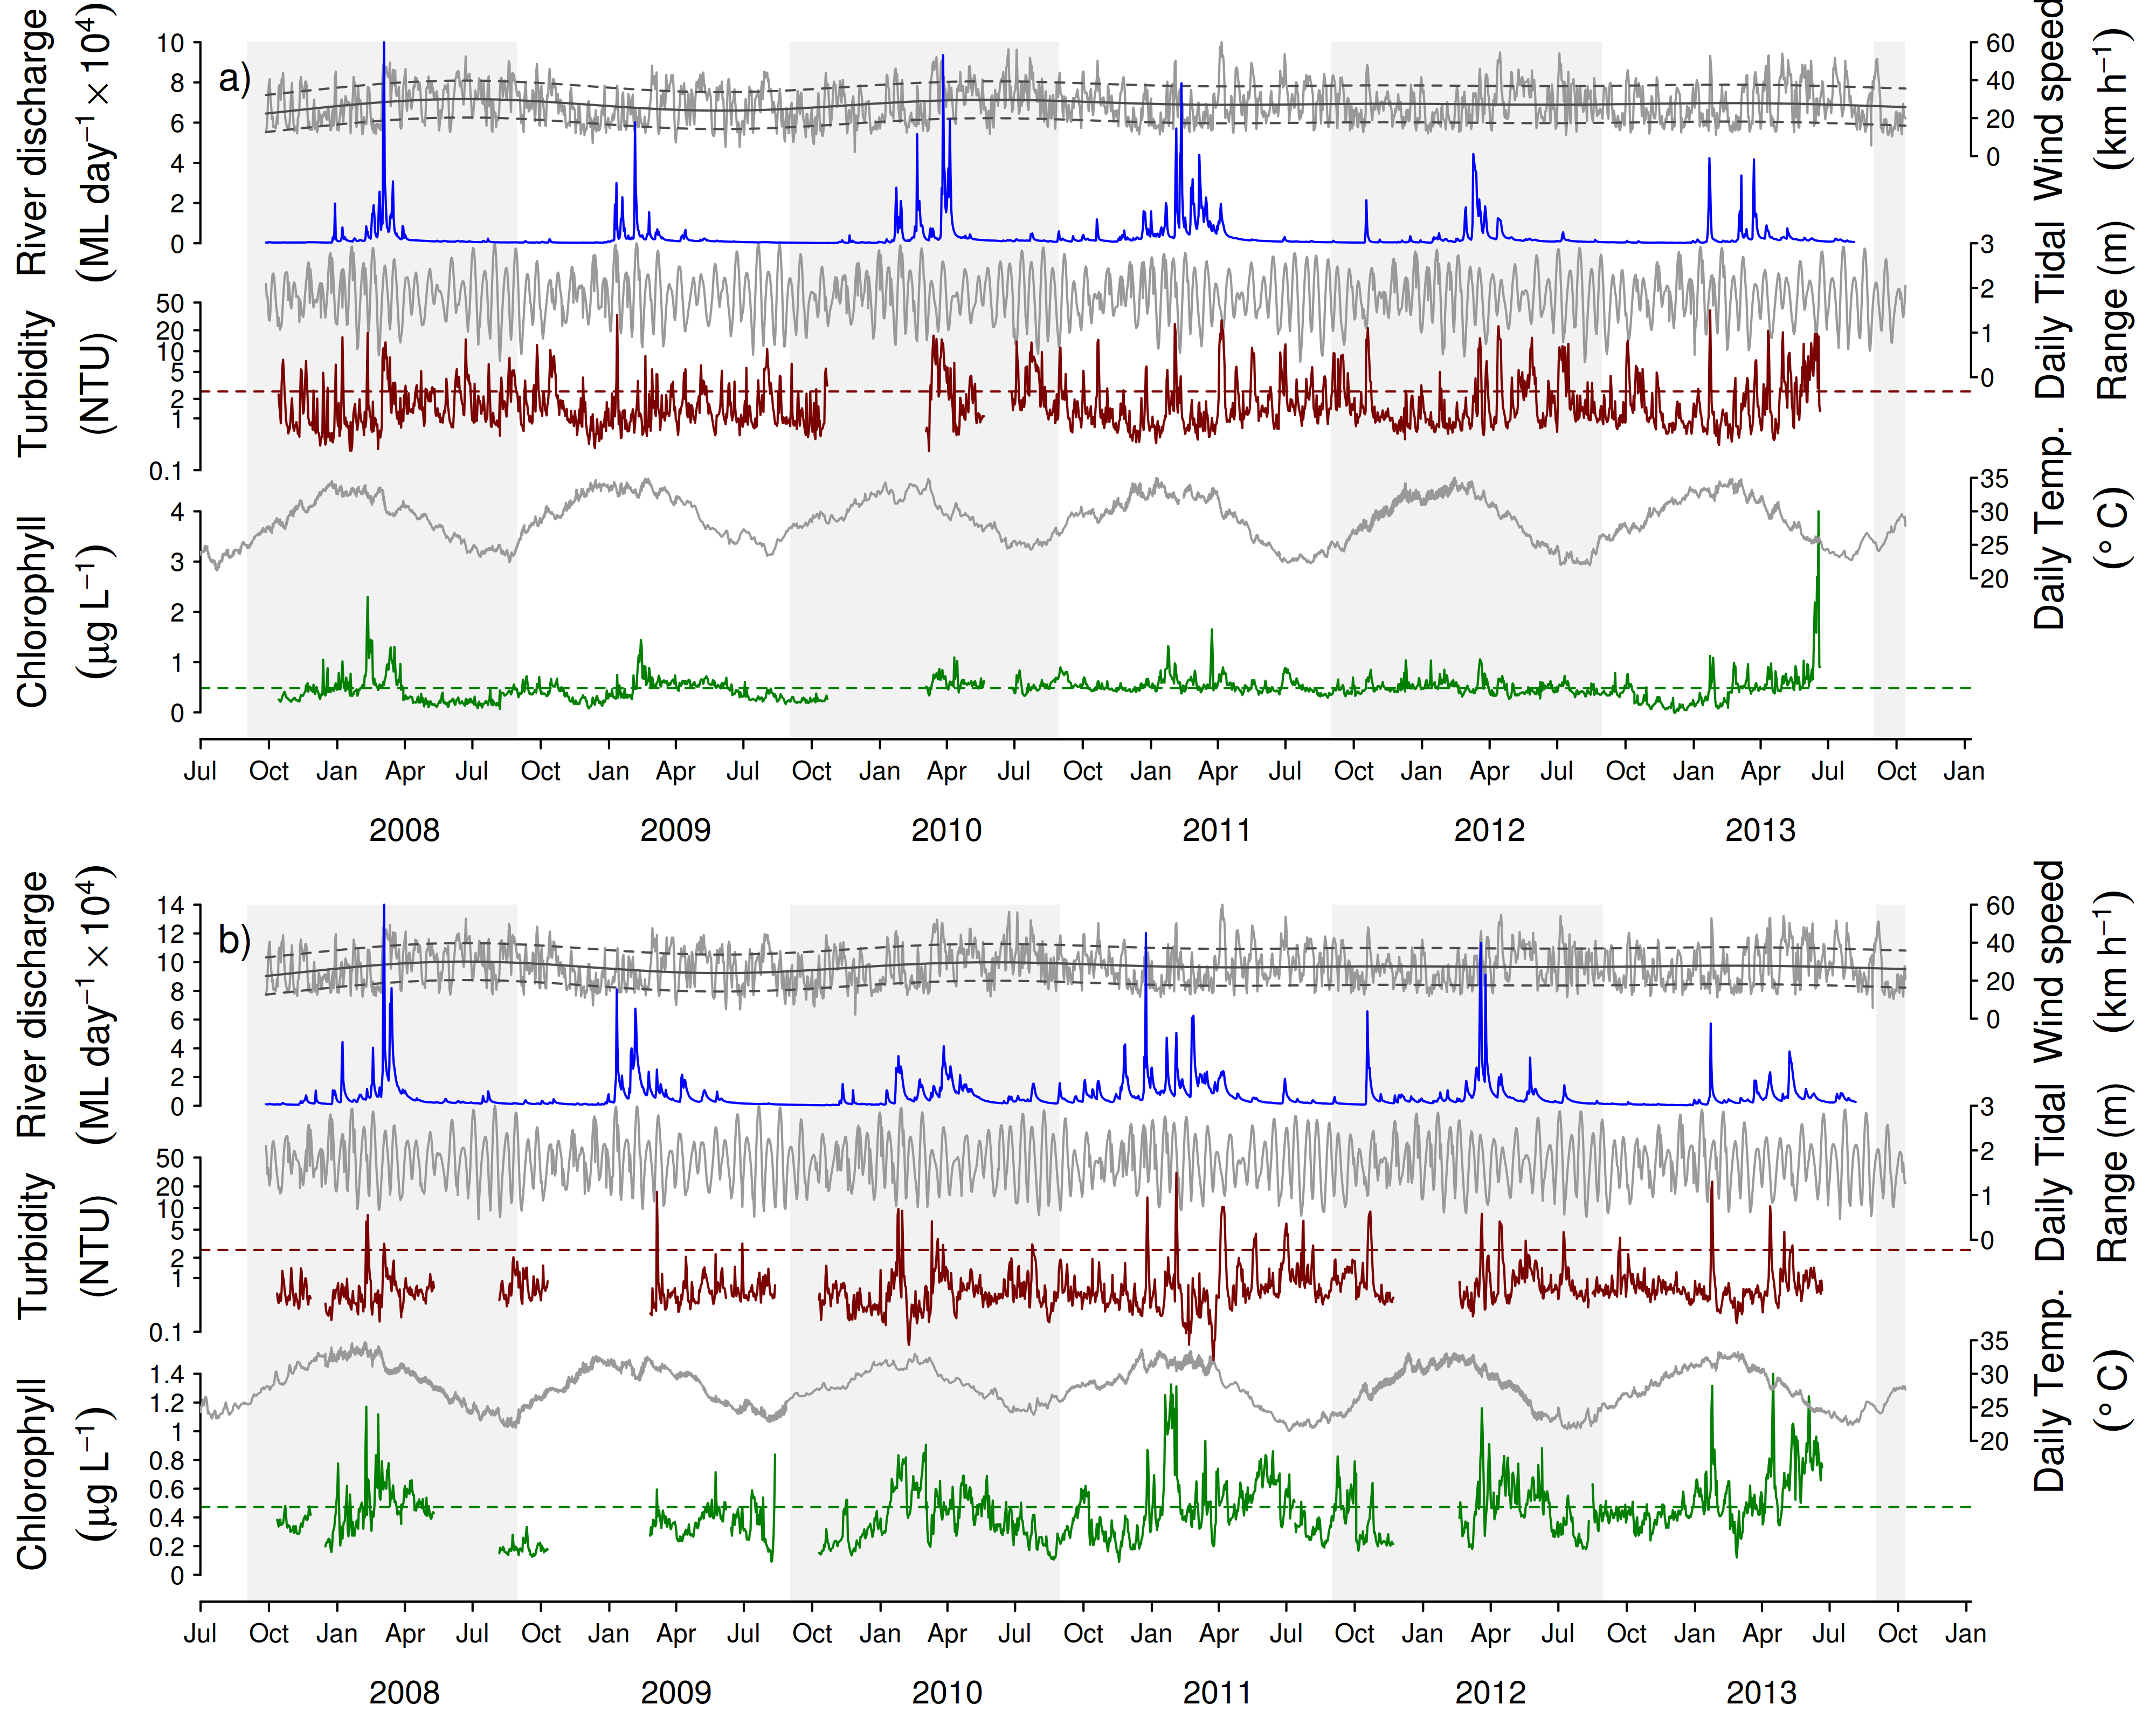
Figure A2- 1 Time series of daily means of chlorophyll (green line) and turbidity (red line) collected by ECO FLNTUSB instruments.
Additional panels represent daily discharge from nearest rivers (blue line) and daily wind speeds (grey line,) from the nearest weather stations. Horizontal green and red lines are the GBR Water Quality Guidelines values (GBRMPA 2010). Turbidity trigger value (red line, 1.5 NTU) was derived by transforming the suspended solids trigger value (see Schaffelke et al. 2009). Plots a-n represent locations of FLNTUUSB instruments; a) Snapper Is North, b) Fitzroy Is West, c) High West, d) Franklands West, e) Dunk North, f) Palms West, g) Pandora, h) Magnetic Is, i) Double Cone, j) Daydream, k) Pine, l) Barren, m) Keppels South, n) Pelican.

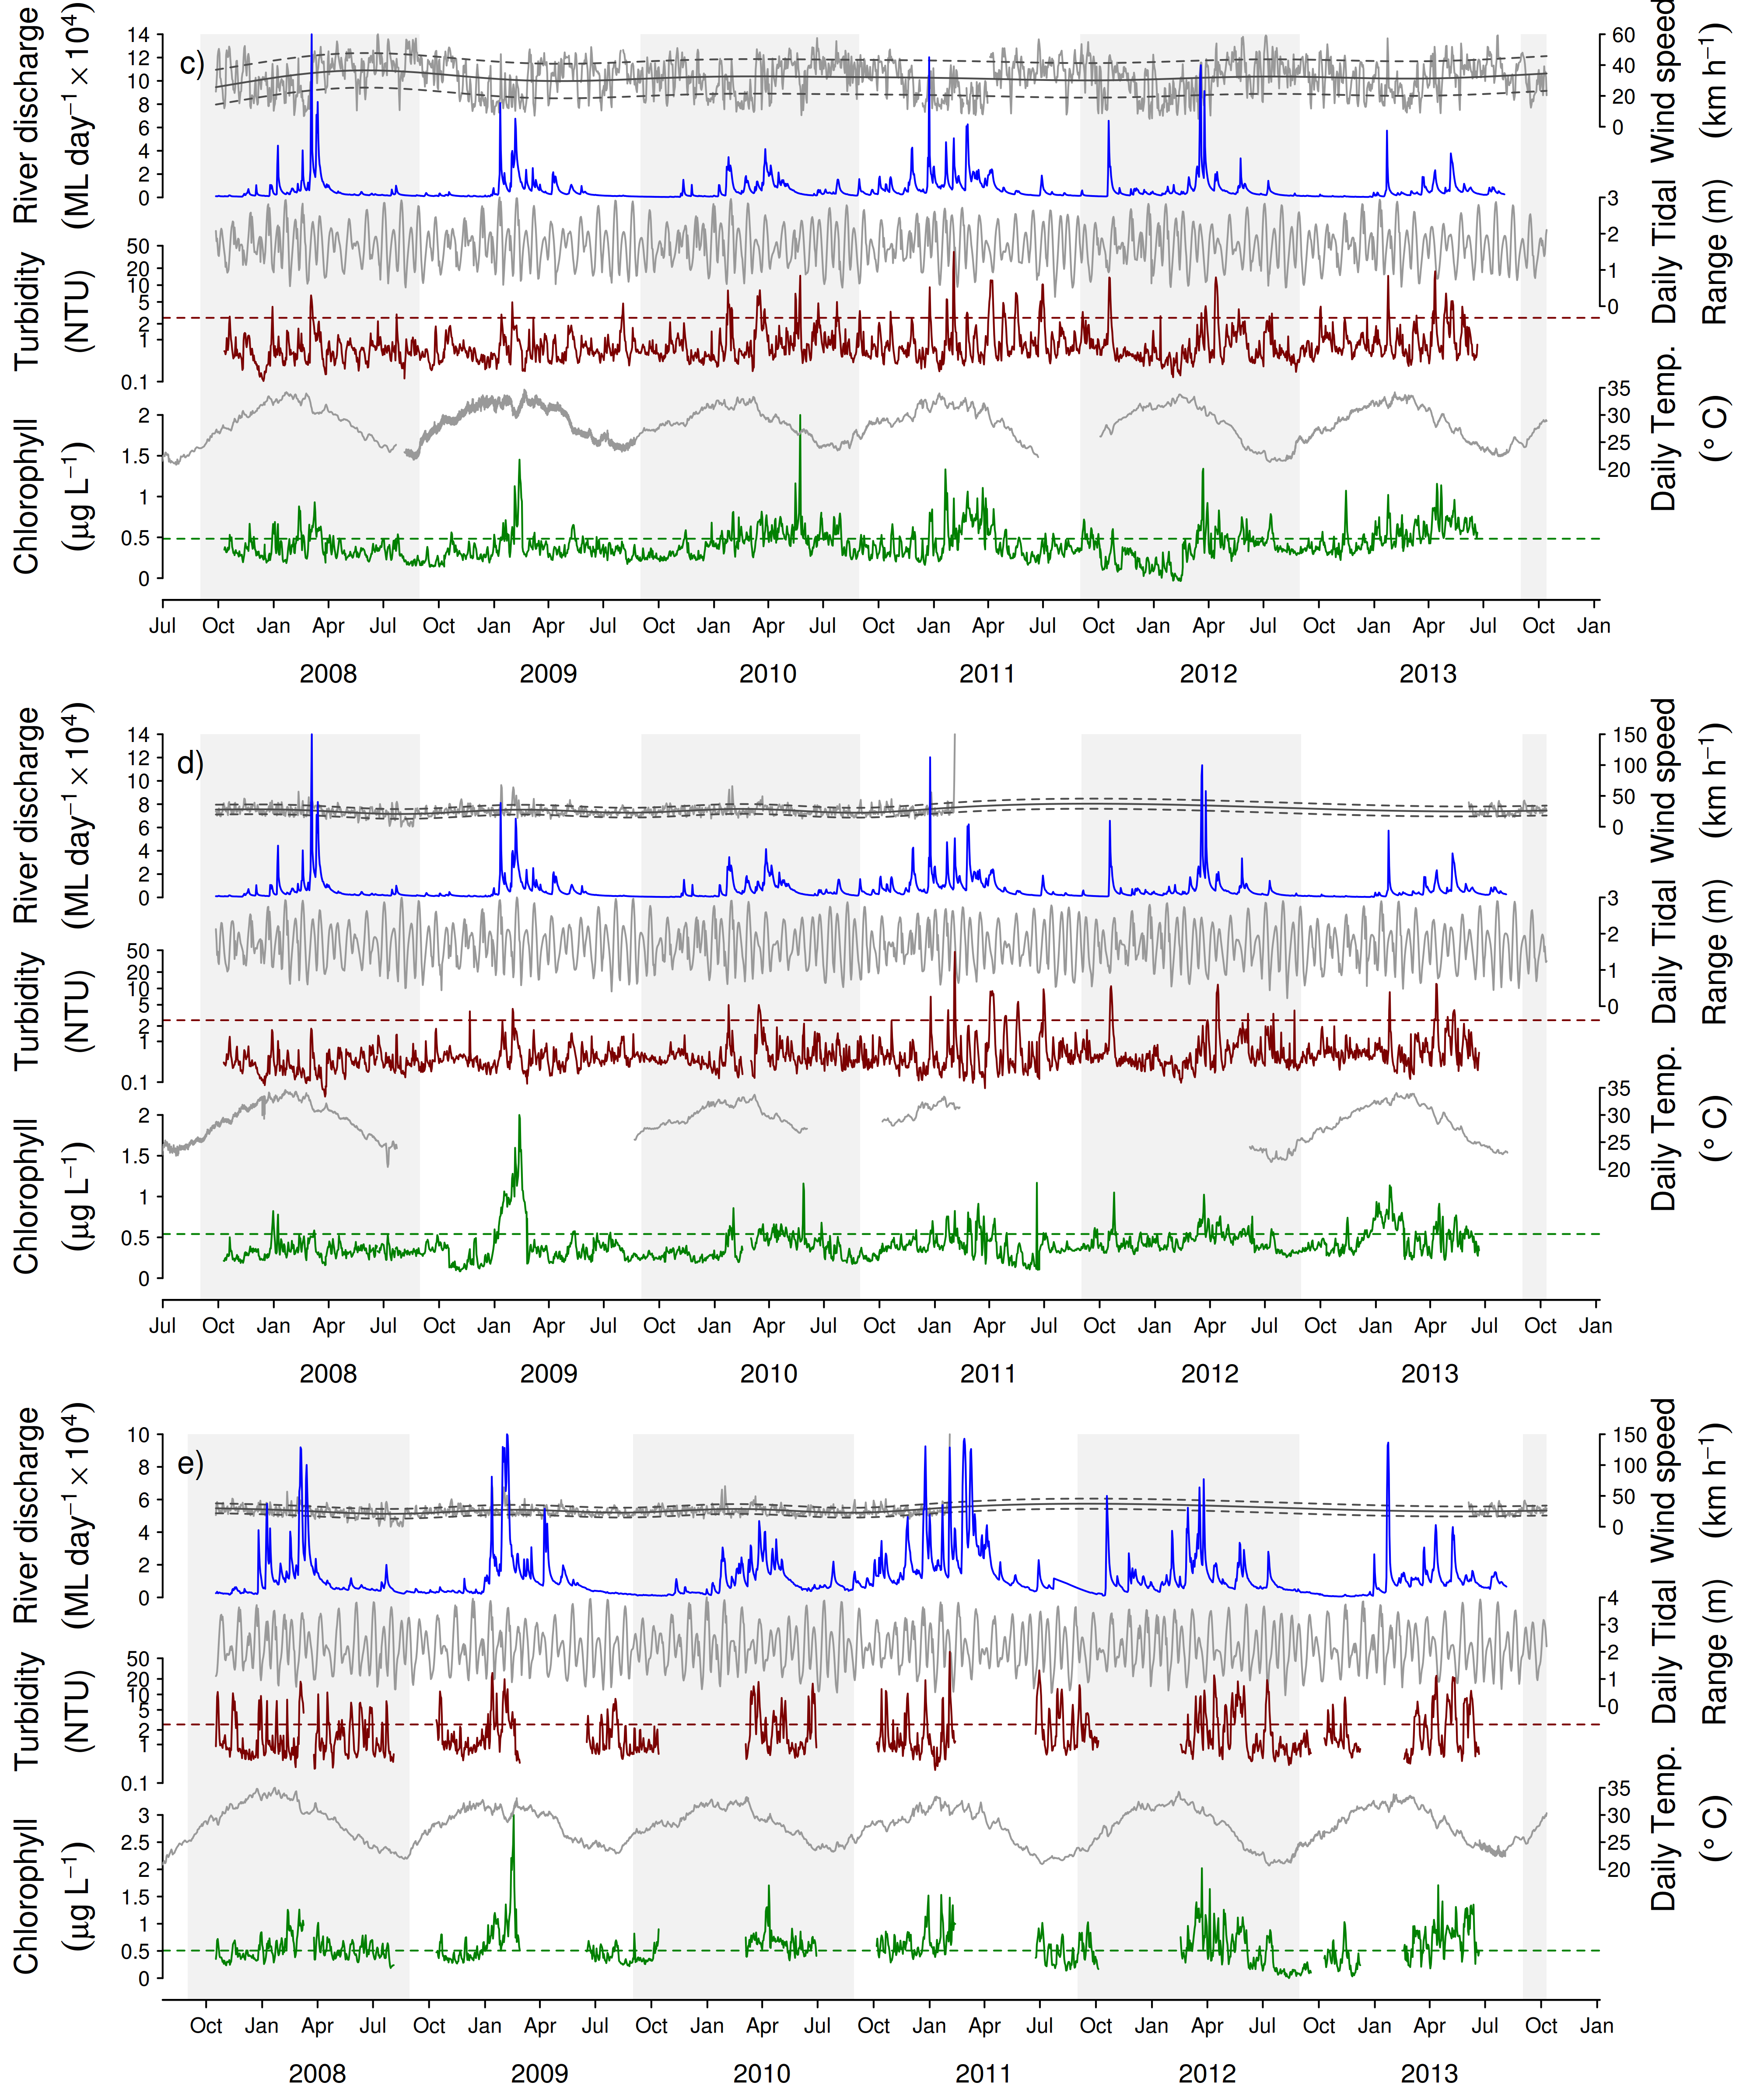
Figure A2-1 Continued - c) High Is West, d) Franklands Is West, e) Dunk Is North

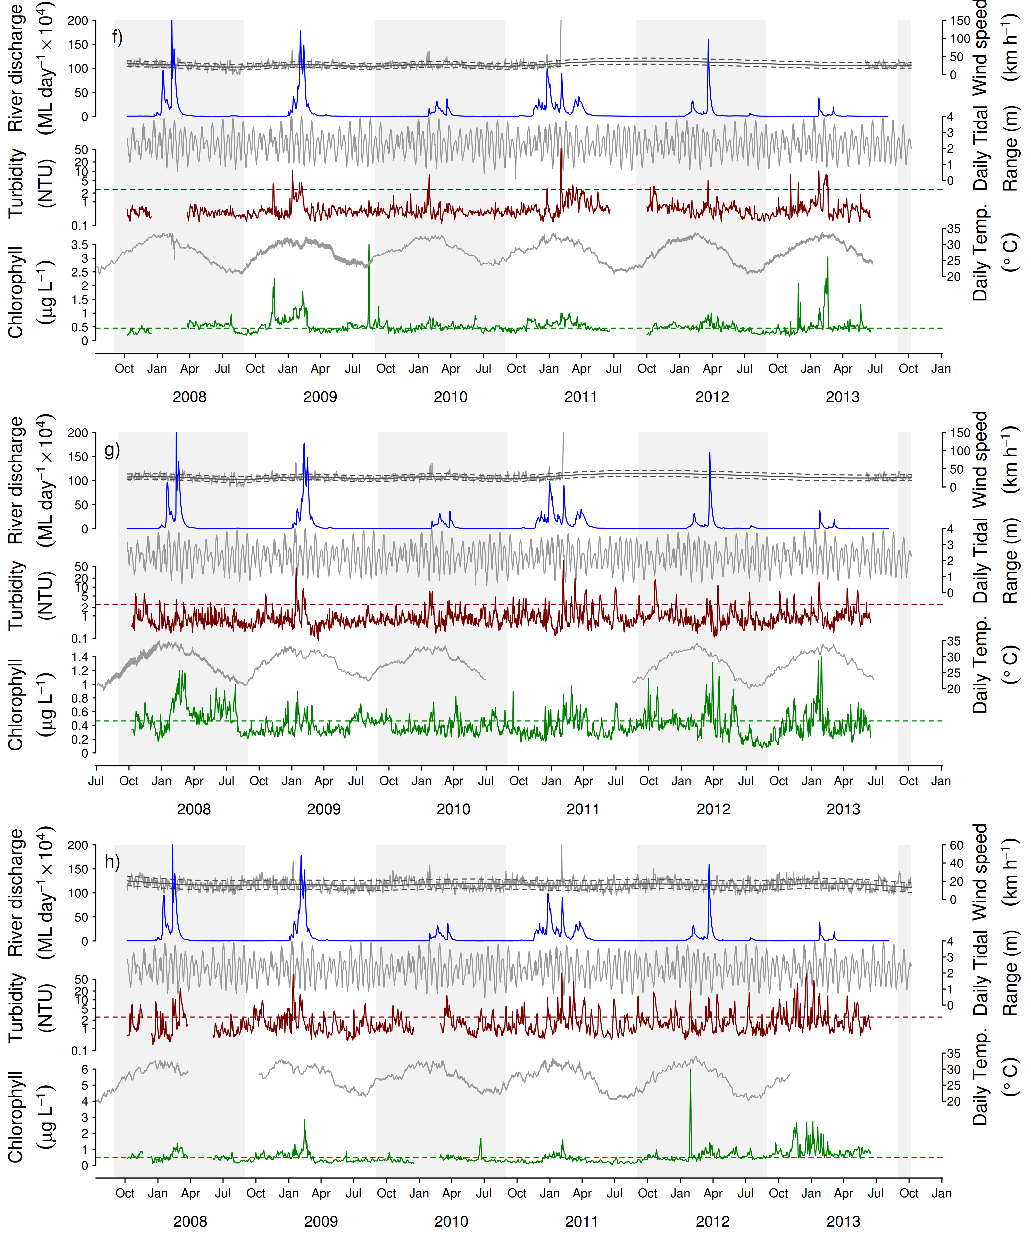

Figure A2-1 Continued - f) Palms West, g) Pandora, h) Magnetic Is

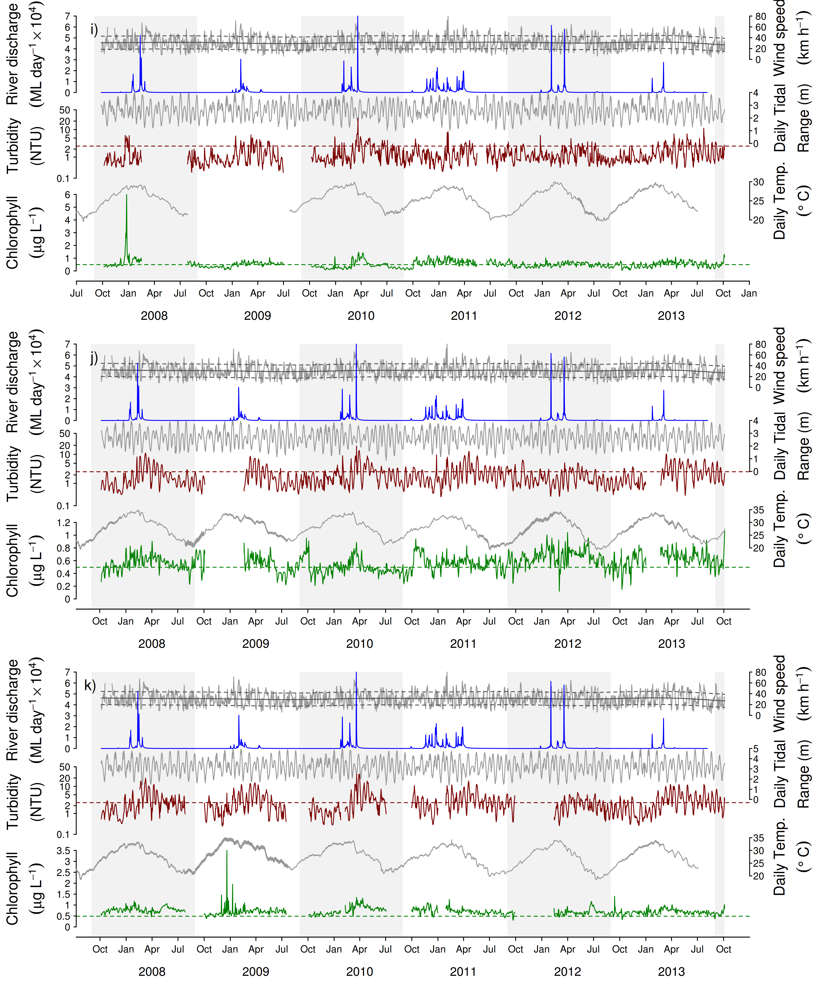

Figure A2-1 Continued - i) Double Cone Is, j) Daydream Is, k) Pine Is

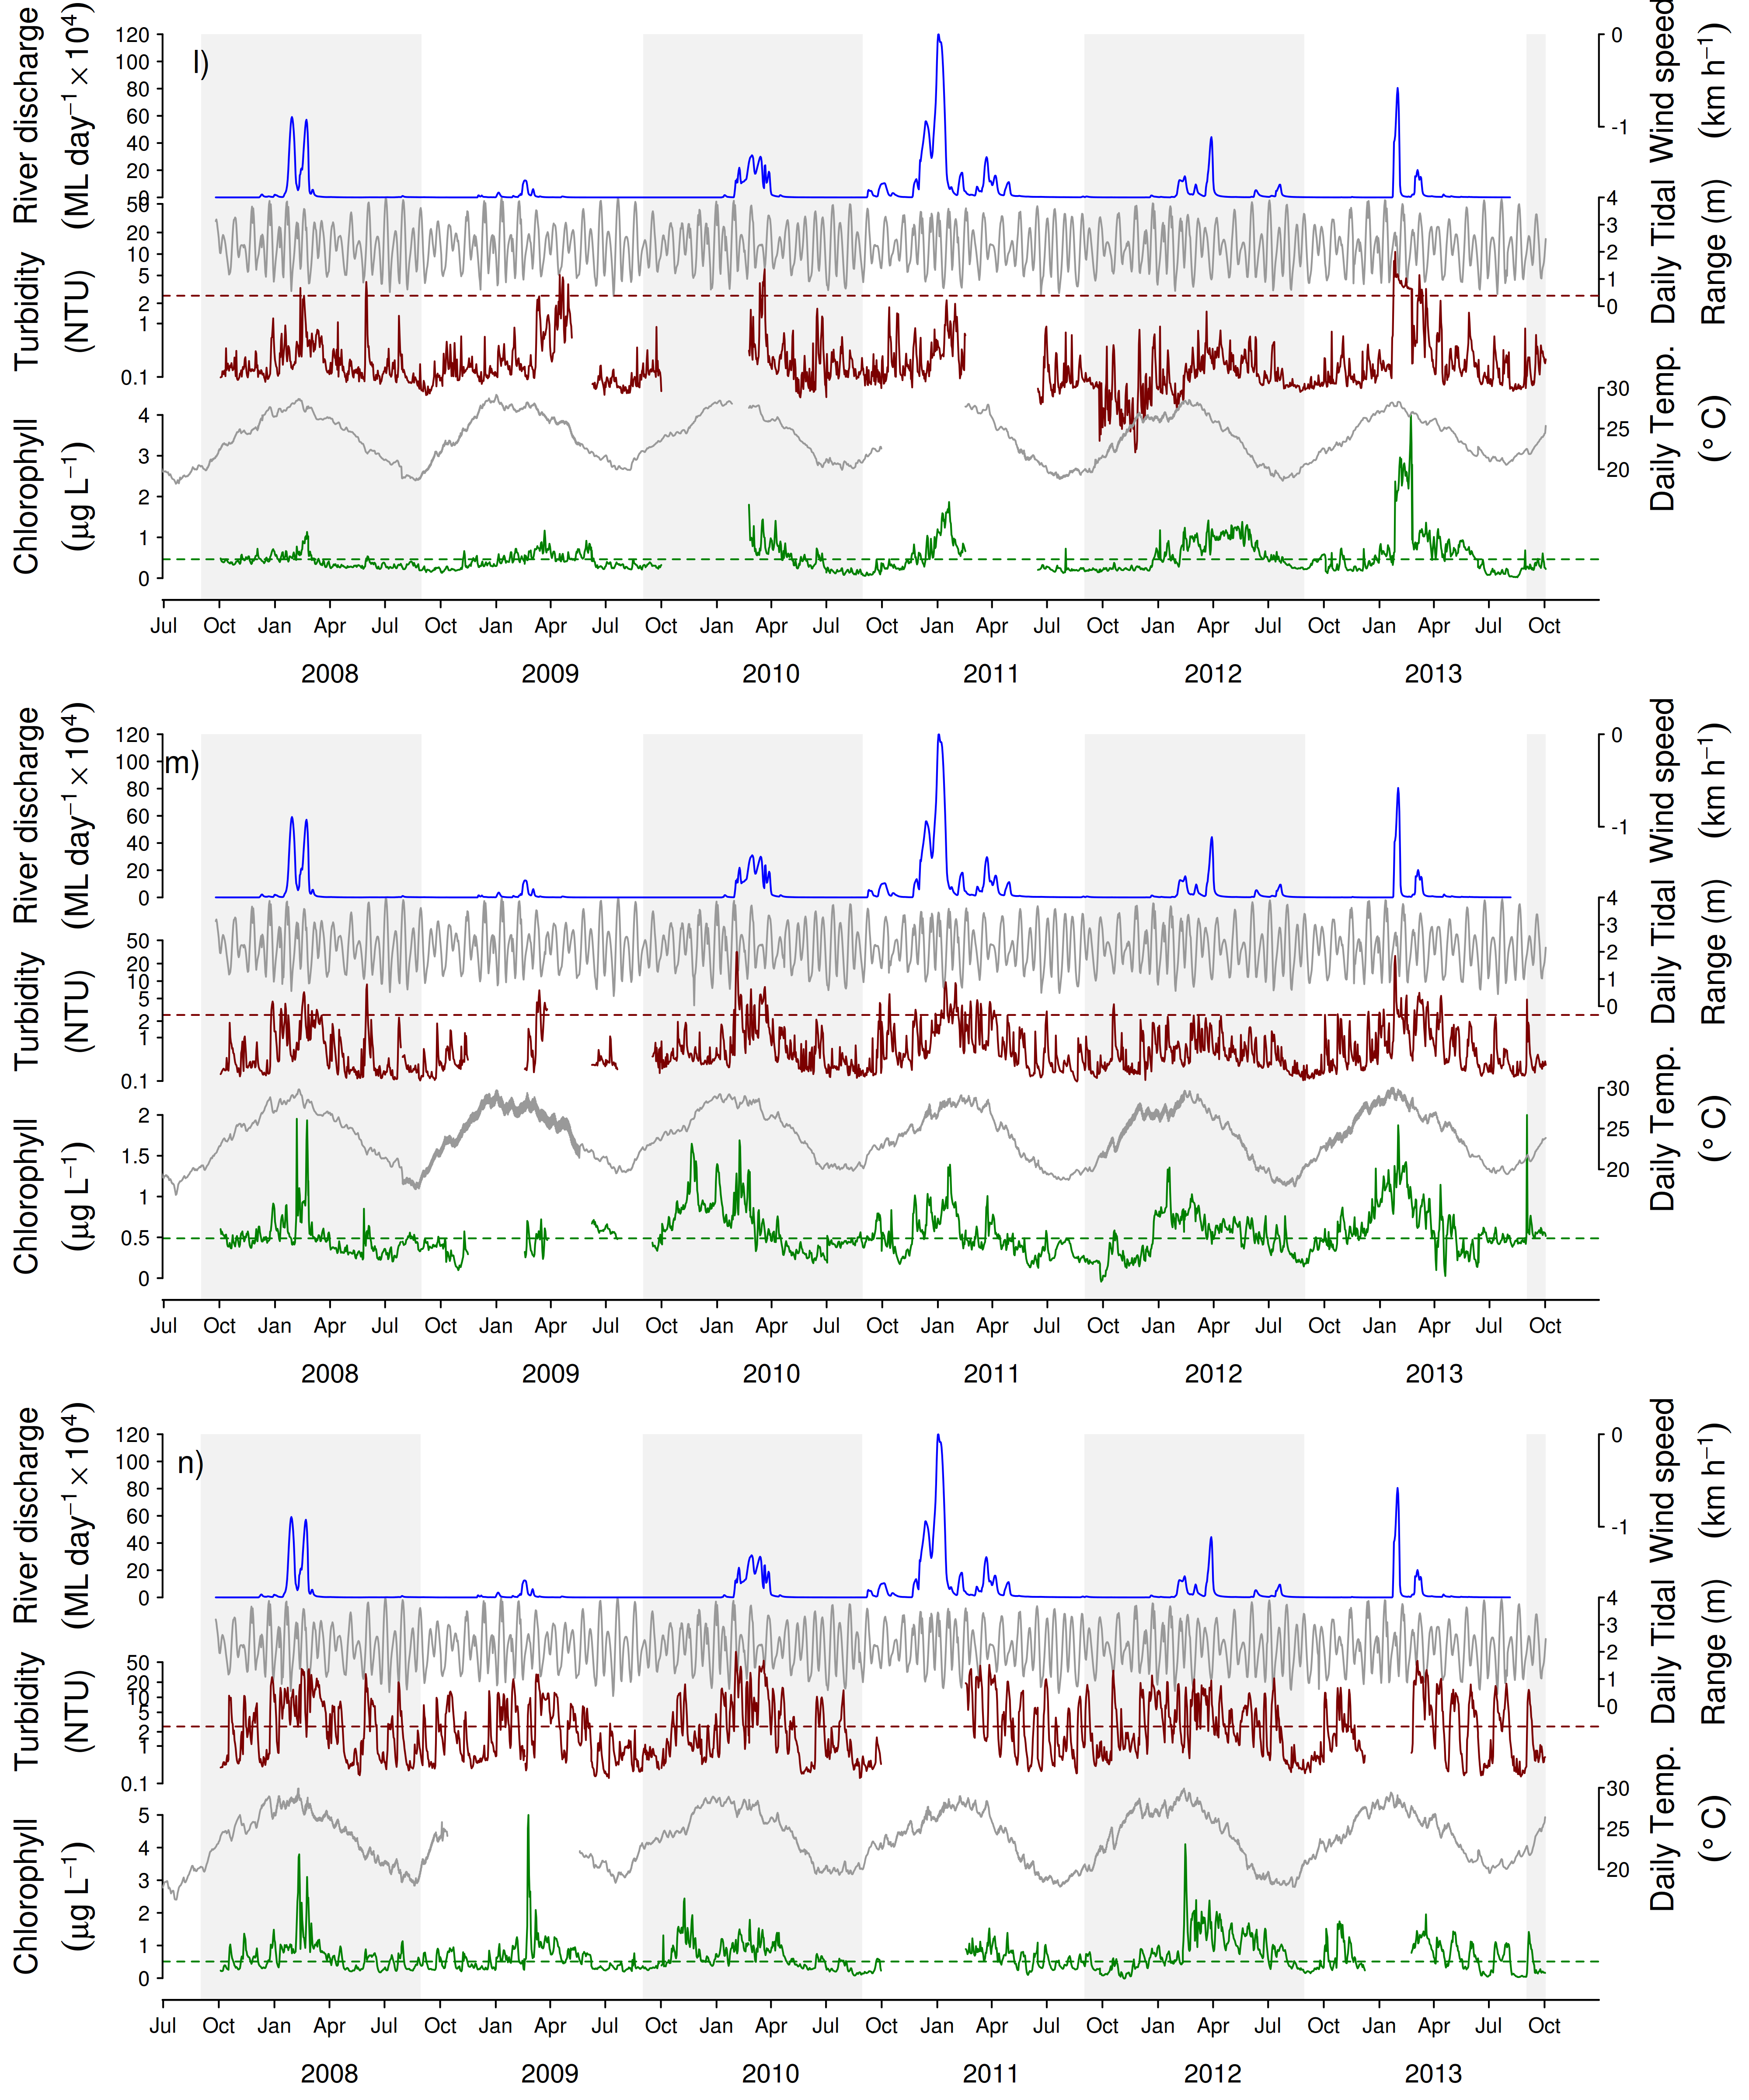

Figure A2-1 Continued - l) Barren Is, m) Keppels South, n) Pelican Is
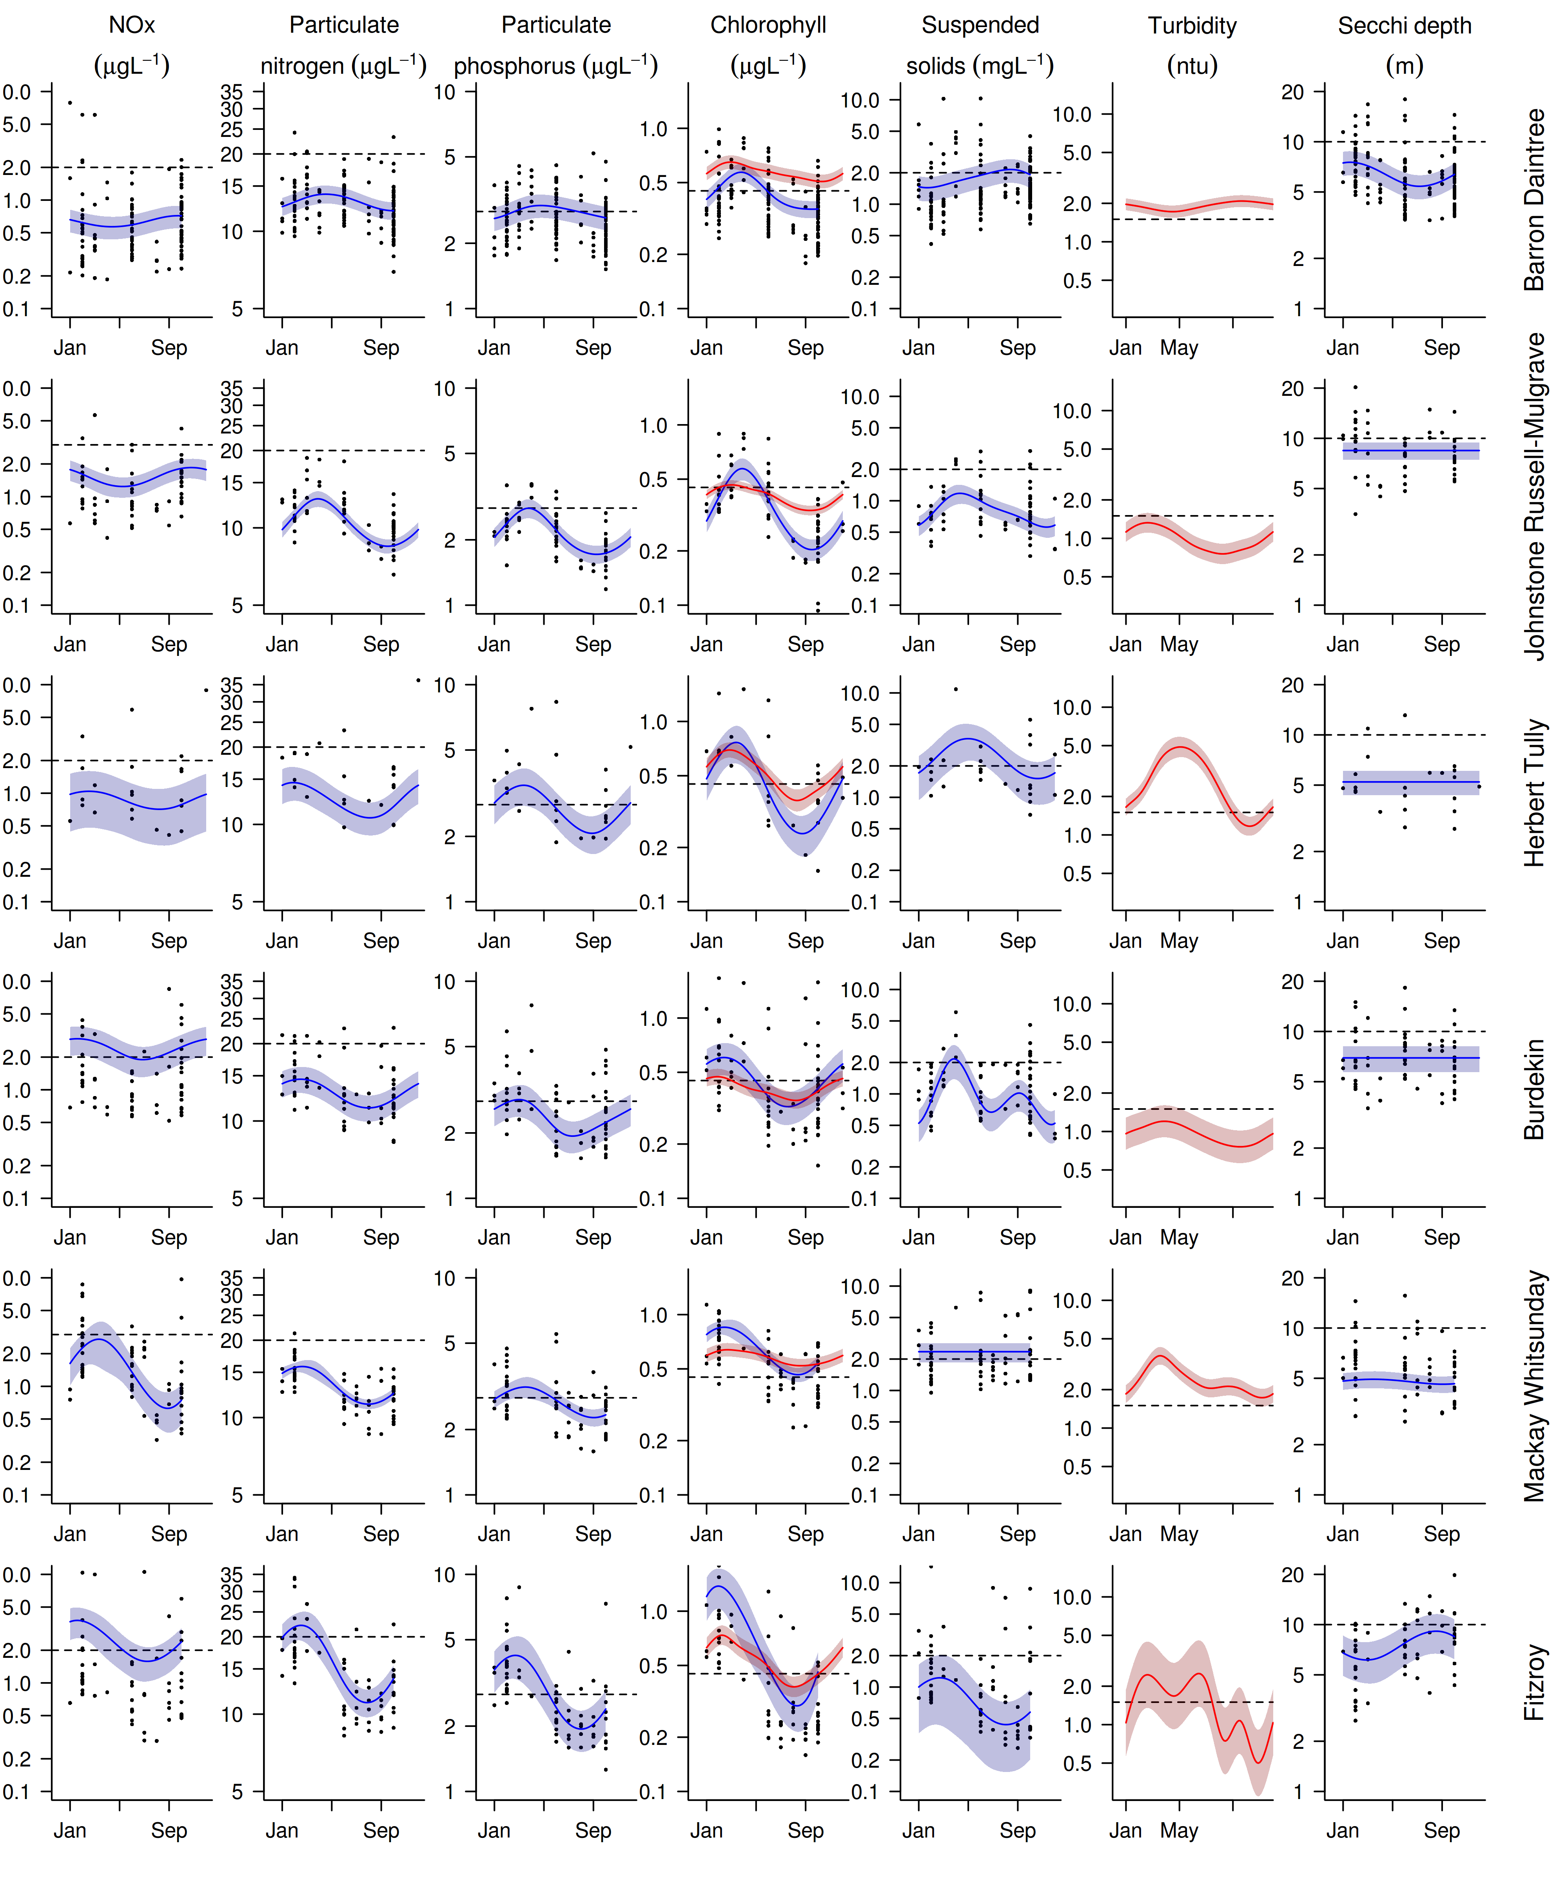
Figure A2- 2 Seasonal trends in water quality variables in reporting (sub-) regions.
Trends in manually sampled water quality variables are represented by blue lines with blue shaded areas defining 95% confidence intervals of those trends, black dots represent observed data. Trends of records from ECO FLNTUSB instruments are represented in red, individual records are not displayed.

Table A2- 4 Interim water quality index for each water quality sampling location.

Summary of four-year running means and calculation of the index, see Appendix 1.2.3 for details on index calculation. Data range = from start of the program (2005 for direct water sampling data or 2007 for water quality instruments) to September of each respective year (June for 2012). Red shaded cells are running means that did not comply with the GBRMPA Water Quality Guidelines for the Great Barrier Reef Marine Park (GBRMPA 2010). The scores for suspended solids, turbidity and Secchi depth were averaged for a “combined turbidity score”. The sum of these combined scores and the scores for PN, PP and chlorophyll yielded a total score per site. This total score was converted into a percentage rating and colour-coded (see Section 2.2. for details). Empty cells indicate data not available.

 |  | Depth-weighed means |  |  |  |  |  | Indicator scores
Site | Date range | PN | PP | Chl a | SS | Secchi | Turbidity | PN | PP | Chl a | SS | Turbidity | Combined Turbidity | Total score | Total score (%)
Cape Tribulation | 2003-06 | 0.87 | 0.06 | 0.31 | 1.43 | 10 |  | 0.71 | 0.62 | 0.54 | 0.49 |  | 0.49 | 2.36 | 0.59
Cape Tribulation | 2004-07 | 0.84 | 0.06 | 0.29 | 1.24 | 10 |  | 0.77 | 0.58 | 0.61 | 0.69 |  | 0.69 | 2.66 | 0.66
Cape Tribulation | 2005-08 | 0.9 | 0.08 | 0.33 | 1.6 | 7.5 |  | 0.67 | 0.18 | 0.43 | 0.32 |  | 0.32 | 1.61 | 0.4
Cape Tribulation | 2006-09 | 0.88 | 0.08 | 0.33 | 1.49 | 6.63 |  | 0.69 | 0.23 | 0.45 | 0.42 |  | 0.42 | 1.8 | 0.45
Cape Tribulation | 2007-10 | 0.9 | 0.08 | 0.39 | 1.4 | 6.72 |  | 0.67 | 0.1 | 0.22 | 0.51 |  | 0.51 | 1.5 | 0.37
Cape Tribulation | 2008-11 | 0.98 | 0.09 | 0.46 | 1.53 | 6.3 |  | 0.54 | -0.02 | -0.02 | 0.38 |  | 0.38 | 0.89 | 0.22
Cape Tribulation | 2009-12 | 0.93 | 0.09 | 0.44 | 1.23 | 6.39 |  | 0.63 | 0.07 | 0.05 | 0.7 |  | 0.7 | 1.45 | 0.36
Cape Tribulation | 2010-13 | 0.91 | 0.09 | 0.45 | 1.25 | 7.17 |  | 0.65 | 0.06 | 0.01 | 0.68 |  | 0.68 | 1.4 | 0.35
Snapper North | 2003-06
Snapper North | 2004-07 | 1.36 | 0.1 | 0.29 | 1.54 | 4 |  | 0.07 | -0.21 | 0.63 | 0.38 |  | 0.38 | 0.87 | 0.22
Snapper North | 2005-08 | 0.86 | 0.08 | 0.31 | 1.19 | 6.75 | 2.09 | 0.74 | 0.22 | 0.56 | 0.75 | -0.48 | 0.14 | 1.65 | 0.41
Snapper North | 2006-09 | 0.81 | 0.07 | 0.29 | 1.15 | 6.43 | 2.1 | 0.81 | 0.3 | 0.62 | 0.8 | -0.48 | 0.16 | 1.89 | 0.47
Snapper North | 2007-10 | 0.84 | 0.07 | 0.31 | 1.09 | 6.8 | 2.2 | 0.76 | 0.29 | 0.53 | 0.88 | -0.55 | 0.16 | 1.75 | 0.44
Snapper North | 2008-11 | 0.82 | 0.07 | 0.36 | 1.25 | 6.45 | 2.29 | 0.79 | 0.31 | 0.31 | 0.67 | -0.61 | 0.03 | 1.44 | 0.36
Snapper North | 2009-12 | 0.85 | 0.07 | 0.36 | 1.25 | 5.64 | 2.34 | 0.76 | 0.28 | 0.31 | 0.67 | -0.64 | 0.02 | 1.36 | 0.34
Snapper North | 2010-13 | 0.83 | 0.07 | 0.36 | 1.27 | 5.73 | 2.44 | 0.78 | 0.31 | 0.32 | 0.65 | -0.7 | -0.02 | 1.39 | 0.35
Port Douglas | 2003-06 | 1.09 | 0.06 | 0.29 | 1.63 | 9.5 |  | 0.39 | 0.52 | 0.65 | 0.3 |  | 0.3 | 1.85 | 0.46
Port Douglas | 2004-07 | 1.07 | 0.07 | 0.28 | 1.52 | 8.67 |  | 0.42 | 0.41 | 0.67 | 0.39 |  | 0.39 | 1.9 | 0.47
Port Douglas | 2005-08 | 0.92 | 0.06 | 0.28 | 1.33 | 8.5 |  | 0.64 | 0.5 | 0.69 | 0.59 |  | 0.59 | 2.41 | 0.6
Port Douglas | 2006-09 | 0.92 | 0.07 | 0.28 | 1.29 | 7.89 |  | 0.64 | 0.39 | 0.69 | 0.63 |  | 0.63 | 2.35 | 0.59
Port Douglas | 2007-10 | 0.91 | 0.07 | 0.32 | 1.18 | 7.2 |  | 0.65 | 0.27 | 0.49 | 0.76 |  | 0.76 | 2.16 | 0.54
Port Douglas | 2008-11 | 0.9 | 0.08 | 0.36 | 1.21 | 6.71 |  | 0.66 | 0.22 | 0.32 | 0.72 |  | 0.72 | 1.92 | 0.48
Port Douglas | 2009-12 | 0.9 | 0.08 | 0.38 | 1.31 | 6.12 |  | 0.67 | 0.13 | 0.26 | 0.61 |  | 0.61 | 1.67 | 0.42
Port Douglas | 2010-13 | 0.87 | 0.08 | 0.4 | 1.37 | 6.17 |  | 0.72 | 0.14 | 0.19 | 0.54 |  | 0.54 | 1.58 | 0.4

Table A2-4 Continued: Wet Tropics Region

 |  | Depth-weighed means |  |  |  |  |  | Indicator scores
Site | Date range | PN | PP | Chl a | SS | Secchi | Turbidity | PN | PP | Chl a | SS | Turbidity | Combined Turbidity | Total score | Total score (%)
Double | 2003-06 | 0.91 | 0.05 | 0.37 | 1.34 | 14 |  | 0.65 | 0.92 | 0.28 | 0.58 |  | 0.58 | 2.42 | 0.61
Double | 2004-07 | 0.93 | 0.06 | 0.36 | 1.28 | 9.5 |  | 0.62 | 0.65 | 0.31 | 0.64 |  | 0.64 | 2.22 | 0.56
Double | 2005-08 | 0.91 | 0.06 | 0.35 | 1.14 | 11 |  | 0.66 | 0.53 | 0.38 | 0.82 |  | 0.82 | 2.38 | 0.6
Double | 2006-09 | 0.81 | 0.06 | 0.32 | 1.15 | 9.5 |  | 0.82 | 0.51 | 0.5 | 0.8 |  | 0.8 | 2.63 | 0.66
Double | 2007-10 | 0.8 | 0.07 | 0.32 | 1.13 | 8.67 |  | 0.83 | 0.36 | 0.51 | 0.83 |  | 0.83 | 2.52 | 0.63
Double | 2008-11 | 0.81 | 0.07 | 0.37 | 1.15 | 8.09 |  | 0.82 | 0.3 | 0.3 | 0.8 |  | 0.8 | 2.21 | 0.55
Double | 2009-12 | 0.79 | 0.08 | 0.38 | 1.15 | 7.12 |  | 0.86 | 0.26 | 0.25 | 0.8 |  | 0.8 | 2.16 | 0.54
Double | 2010-13 | 0.8 | 0.08 | 0.39 | 1.23 | 7 |  | 0.83 | 0.2 | 0.21 | 0.7 |  | 0.7 | 1.94 | 0.48
Green | 2003-06 | 0.62 | 0.05 | 0.19 | 1.06 | 22 |  | 1 | 0.87 | 1 | 0.92 |  | 0.92 | 3.79 | 0.95
Green | 2004-07 | 0.61 | 0.04 | 0.17 | 0.82 | 19.33 |  | 1 | 1 | 1 | 1 |  | 1 | 4 | 1
Green | 2005-08 | 0.67 | 0.05 | 0.25 | 0.68 | 15.83 |  | 1 | 0.84 | 0.87 | 1 |  | 1 | 3.71 | 0.93
Green | 2006-09 | 0.64 | 0.05 | 0.22 | 0.51 | 15.33 |  | 1 | 0.95 | 1 | 1 |  | 1 | 3.95 | 0.99
Green | 2007-10 | 0.67 | 0.05 | 0.23 | 0.3 | 13.7 |  | 1 | 0.93 | 0.95 | 1 |  | 1 | 3.89 | 0.97
Green | 2008-11 | 0.7 | 0.05 | 0.28 | 0.33 | 12.67 |  | 1 | 0.77 | 0.67 | 1 |  | 1 | 3.44 | 0.86
Green | 2009-12 | 0.67 | 0.05 | 0.28 | 0.31 | 12.38 |  | 1 | 0.77 | 0.66 | 1 |  | 1 | 3.43 | 0.86
Green | 2010-13 | 0.7 | 0.05 | 0.29 | 0.37 | 11.46 |  | 1 | 0.76 | 0.64 | 1 |  | 1 | 3.4 | 0.85
Yorkey's Knob | 2003-06 | 1.48 | 0.14 | 0.59 | 4.21 | 3.5 |  | -0.05 | -0.61 | -0.4 | -1 |  | -1 | -2.06 | -0.51
Yorkey's Knob | 2004-07 | 1.35 | 0.13 | 0.55 | 3.55 | 3.33 |  | 0.09 | -0.51 | -0.28 | -0.83 |  | -0.83 | -1.54 | -0.39
Yorkey's Knob | 2005-08 | 1.25 | 0.12 | 0.5 | 2.76 | 4.17 |  | 0.19 | -0.35 | -0.16 | -0.46 |  | -0.46 | -0.78 | -0.2
Yorkey's Knob | 2006-09 | 1.22 | 0.12 | 0.52 | 2.86 | 4 |  | 0.23 | -0.41 | -0.2 |  |  | -0.52 | -0.9 | -0.22
 | 2007-10 | 1.1 | 0.12 | 0.52 | 2.69 | 3.75 |  | 0.38 | -0.4 | -0.21 | -0.43 |  | -0.43 | -0.66 | -0.16
 | 2008-11 | 1.12 | 0.12 | 0.58 | 3.04 | 3.96 |  | 0.35 | -0.43 | -0.36 | -0.61 |  | -0.61 | -1.05 | -0.26
 | 2009-12 | 1.15 | 0.13 | 0.62 | 3.07 | 3.67 |  | 0.32 | -0.51 | -0.46 | -0.62 |  | -0.62 | -1.27 | -0.32
 | 2010-13 | 1.12 | 0.12 | 0.6 | 2.77 | 3.96 |  | 0.36 | -0.46 | -0.41 | -0.47 |  | -0.47 | -0.98 | -0.25

Table A2-4 Continued: Wet Tropics Region
 |  | Depth-weighed means |  |  |  |  |  | Indicator scores
Site | Date range | PN | PP | Chl a | SS | Secchi | Turbidity | PN | PP | Chl a | SS | Turbidity | Combined Turbidity | Total score | Total score (%)
Fairlead Buoy | 2003-06 | 1.15 | 0.09 | 0.47 | 2.63 | 5.5 |  | 0.32 | 0.06 | -0.06 | -0.4 |  | -0.4 | -0.08 | -0.02
Fairlead Buoy | 2004-07 | 1.17 | 0.11 | 0.44 | 2.7 | 3.75 |  | 0.28 | -0.23 | 0.02 | -0.43 |  | -0.43 | -0.36 | -0.09
Fairlead Buoy | 2005-08 | 1.17 | 0.11 | 0.47 | 2.65 | 4.5 |  | 0.29 | -0.3 | -0.06 | -0.41 |  | -0.41 | -0.48 | -0.12
Fairlead Buoy | 2006-09 | 1.12 | 0.12 | 0.47 | 3.05 | 4.06 |  | 0.35 | -0.4 | -0.06 | -0.61 |  | -0.61 | -0.72 | -0.18
Fairlead Buoy | 2007-10 | 1.14 | 0.14 | 0.49 | 3.78 | 3.65 |  | 0.32 | -0.63 | -0.14 | -0.92 |  | -0.92 | -1.36 | -0.34
Fairlead Buoy | 2008-11 | 1.16 | 0.14 | 0.55 | 4.44 | 3.69 |  | 0.3 | -0.68 | -0.3 | -1 |  | -1 | -1.68 | -0.42
Fairlead Buoy | 2009-12 | 1.18 | 0.15 | 0.56 | 4.43 | 3.35 |  | 0.27 | -0.72 | -0.31 | -1 |  | -1 | -1.75 | -0.44
Fairlead Buoy | 2010-13 | 1.21 | 0.15 | 0.56 | 4.08 | 3.24 |  | 0.24 | -0.7 | -0.31 | -1 |  | -1 | -1.78 | -0.44
Fitzroy West | 2003-06
Fitzroy West | 2004-07 | 0.78 | 0.06 | 0.25 | 0.54 | 9 |  | 0.87 | 0.66 | 0.84 | 1 |  | 1 | 3.36 | 0.84
Fitzroy West | 2005-08 | 0.81 | 0.07 | 0.35 | 0.94 | 8.75 | 0.84 | 0.81 | 0.36 | 0.35 | 1 | 0.84 | 0.92 | 2.44 | 0.61
Fitzroy West | 2006-09 | 0.72 | 0.06 | 0.3 | 0.84 | 9.71 | 0.88 | 0.99 | 0.53 | 0.57 | 1 | 0.77 | 0.88 | 2.97 | 0.74
Fitzroy West | 2007-10 | 0.74 | 0.06 | 0.31 | 0.89 | 8.95 | 0.88 | 0.94 | 0.53 | 0.54 | 1 | 0.77 | 0.88 | 2.9 | 0.72
Fitzroy West | 2008-11 | 0.75 | 0.06 | 0.3 | 0.84 | 9.05 | 0.94 | 0.94 | 0.53 | 0.59 | 1 | 0.67 | 0.83 | 2.9 | 0.72
Fitzroy West | 2009-12 | 0.75 | 0.06 | 0.28 | 0.85 | 8.77 | 1.05 | 0.93 | 0.56 | 0.66 | 1 | 0.51 | 0.75 | 2.91 | 0.73
Fitzroy West | 2010-13 | 0.79 | 0.06 | 0.3 | 0.85 | 8 | 1.08 | 0.85 | 0.52 | 0.58 | 1 | 0.48 | 0.74 | 2.7 | 0.67
High West | 2003-06 | 0.99 | 0.08 | 0.41 | 2.17 | 10.25 |  | 0.53 | 0.22 | 0.14 | -0.11 |  | -0.11 | 0.78 | 0.19
High West | 2004-07 | 0.93 | 0.08 | 0.37 | 1.77 | 8.83 |  | 0.62 | 0.26 | 0.26 | 0.17 |  | 0.17 | 1.31 | 0.33
High West | 2005-08 | 0.97 | 0.08 | 0.47 | 1.41 | 8.58 | 0.88 | 0.56 | 0.16 | -0.07 | 0.5 | 0.77 | 0.64 | 1.29 | 0.32
High West | 2006-09 | 0.91 | 0.08 | 0.45 | 1.29 | 7.89 | 0.82 | 0.66 | 0.14 | 0 | 0.64 | 0.87 | 0.75 | 1.56 | 0.39
High West | 2007-10 | 0.87 | 0.08 | 0.45 | 1.1 | 7 | 0.89 | 0.72 | 0.13 | -0.01 | 0.87 | 0.75 | 0.81 | 1.65 | 0.41
High West | 2008-11 | 0.87 | 0.09 | 0.48 | 1.14 | 6.45 | 1.06 | 0.71 | 0.03 | -0.1 | 0.81 | 0.51 | 0.66 | 1.31 | 0.33
High West | 2009-12 | 0.82 | 0.09 | 0.44 | 1.04 | 6 | 1.14 | 0.8 | 0.08 | 0.04 | 0.94 | 0.4 | 0.67 | 1.6 | 0.4
High West | 2010-13 | 0.87 | 0.08 | 0.46 | 1.12 | 5.77 | 1.23 | 0.72 | 0.11 | -0.04 | 0.83 | 0.28 | 0.56 | 1.35 | 0.34

Table A2-4 Continued: Wet Tropics Region
 |  | Depth-weighed means |  |  |  |  |  | Indicator scores
Site | Date range | PN | PP | Chl a | SS | Secchi | Turbidity | PN | PP | Chl a | SS | Turbidity | Combined Turbidity | Total score | Total score (%)
Franklands West | 2003-06 | 0.86 | 0.06 | 0.31 | 1.18 | 13 |  | 0.74 | 0.66 | 0.56 | 0.76 |  | 0.76 | 2.72 | 0.68
Franklands West | 2004-07 | 0.77 | 0.06 | 0.26 | 0.96 | 11.5 |  | 0.9 | 0.71 | 0.78 | 1 |  | 1 | 3.39 | 0.85
Franklands West | 2005-08 | 0.8 | 0.06 | 0.35 | 0.85 | 10.4 | 0.45 | 0.83 | 0.58 | 0.38 | 1 | 1 | 1 | 2.79 | 0.7
Franklands West | 2006-09 | 0.74 | 0.05 | 0.31 | 0.66 | 11.25 | 0.55 | 0.94 | 0.73 | 0.54 | 1 | 1 | 1 | 3.21 | 0.8
Franklands West | 2007-10 | 0.75 | 0.06 | 0.32 | 0.56 | 10.35 | 0.6 | 0.93 | 0.6 | 0.47 | 1 | 1 | 1 | 3 | 0.75
Franklands West | 2008-11 | 0.76 | 0.06 | 0.37 | 0.66 | 9.91 | 0.71 | 0.91 | 0.52 | 0.3 | 1 | 1 | 1 | 2.73 | 0.68
Franklands West | 2009-12 | 0.73 | 0.06 | 0.33 | 0.57 | 9.86 | 0.8 | 0.97 | 0.54 | 0.46 | 1 | 0.9 | 0.95 | 2.92 | 0.73
Franklands West | 2010-13 | 0.81 | 0.07 | 0.35 | 0.68 | 9.05 | 0.88 | 0.82 | 0.43 | 0.36 | 1 | 0.76 | 0.88 | 2.49 | 0.62
Dunk North | 2003-06 | 1.28 | 0.11 | 0.72 | 3.17 | 5 |  | 0.16 | -0.31 | -0.68 | -0.66 |  | -0.66 | -1.5 | -0.37
Dunk North | 2004-07 | 1.28 | 0.11 | 0.6 | 2.53 | 5 |  | 0.16 | -0.28 | -0.41 | -0.34 |  | -0.34 | -0.88 | -0.22
Dunk North | 2005-08 | 1.28 | 0.13 | 0.64 | 3.07 | 5.2 | 2.24 | 0.16 | -0.52 | -0.5 | -0.62 | -0.58 | -0.6 | -1.46 | -0.37
Dunk North | 2006-09 | 1.15 | 0.12 | 0.56 | 2.72 | 5 | 2.39 | 0.31 | -0.35 | -0.32 | -0.45 | -0.67 | -0.56 | -0.92 | -0.23
Dunk North | 2007-10 | 1.08 | 0.11 | 0.49 | 2.35 | 5.39 | 2.37 | 0.4 | -0.23 | -0.13 | -0.23 | -0.66 | -0.45 | -0.4 | -0.1
Dunk North | 2008-11 | 1.07 | 0.11 | 0.56 | 2.87 | 5 | 2.48 | 0.42 | -0.32 | -0.32 | -0.52 | -0.73 | -0.62 | -0.85 | -0.21
Dunk North | 2009-12 | 1.09 | 0.11 | 0.54 | 2.35 | 4.68 | 2.79 | 0.39 | -0.23 | -0.26 | -0.23 | -0.89 | -0.56 | -0.65 | -0.16
Dunk North | 2010-13 | 1.08 | 0.1 | 0.54 | 2.19 | 4.99 | 2.86 | 0.4 | -0.21 | -0.25 | -0.13 | -0.93 | -0.53 | -0.59 | -0.15

Table A2-4 Continued: Burdekin Region
 |  | Depth-weighed means |  |  |  |  |  | Indicator scores
Site | Date range | PN | PP | Chl a | SS | Secchi | Turbidity | PN | PP | Chl a | SS | Turbidity | Combined Turbidity | Total score | Total score (%)
Palms West | 2004-07 | 0.92 | 0.07 | 0.41 | 1.56 | 8.17 |  | 0.63 | 0.44 | 0.13 | 0.36 |  | 0.36 | 1.56 | 0.39
Palms West | 2005-08 | 0.86 | 0.06 | 0.4 | 1.12 | 7.7 | 0.54 | 0.73 | 0.48 | 0.16 | 0.84 | 1 | 0.92 | 2.3 | 0.57
Palms West | 2006-09 | 0.83 | 0.06 | 0.42 | 0.95 | 8.19 | 0.67 | 0.79 | 0.51 | 0.1 | 1 | 1 | 1 | 2.39 | 0.6
Palms West | 2007-10 | 0.84 | 0.06 | 0.4 | 0.72 | 8.56 | 0.65 | 0.76 | 0.51 | 0.17 | 1 | 1 | 1 | 2.44 | 0.61
Palms West | 2008-11 | 0.87 | 0.07 | 0.46 | 0.81 | 8.05 | 0.74 | 0.72 | 0.31 | -0.03 | 1 | 1 | 1 | 2 | 0.5
Palms West | 2009-12 | 0.83 | 0.07 | 0.44 | 0.79 | 8.18 | 0.77 | 0.79 | 0.31 | 0.03 | 1 | 0.97 | 0.98 | 2.11 | 0.53
Palms West | 2010-13 | 0.83 | 0.07 | 0.4 | 0.77 | 8.45 | 0.81 | 0.78 | 0.32 | 0.16 | 1 | 0.89 | 0.94 | 2.2 | 0.55
Pandora | 2003-06 | 0.96 | 0.08 | 0.57 | 2.69 | 5.5 |  | 0.58 | 0.12 | -0.34 | -0.43 |  | -0.43 | -0.07 | -0.02
Pandora | 2004-07 | 0.9 | 0.08 | 0.48 | 2.24 | 5.67 |  | 0.66 | 0.16 | -0.08 | -0.17 |  | -0.17 | 0.58 | 0.14
Pandora | 2005-08 | 0.94 | 0.09 | 0.46 | 1.94 | 6 | 1.1 | 0.6 | 0.08 | -0.03 | 0.04 | 0.45 | 0.25 | 0.89 | 0.22
Pandora | 2006-09 | 0.88 | 0.08 | 0.41 | 1.59 | 6.81 | 1.14 | 0.69 | 0.25 | 0.15 | 0.33 | 0.39 | 0.36 | 1.45 | 0.36
Pandora | 2007-10 | 0.84 | 0.07 | 0.35 | 1.19 | 7.89 | 1.09 | 0.77 | 0.32 | 0.36 | 0.75 | 0.47 | 0.61 | 2.06 | 0.51
Pandora | 2008-11 | 0.89 | 0.08 | 0.37 | 1.06 | 7.75 | 1.23 | 0.68 | 0.21 | 0.28 | 0.91 | 0.29 | 0.6 | 1.76 | 0.44
Pandora | 2009-12 | 0.87 | 0.08 | 0.33 | 0.74 | 8.27 | 1.3 | 0.72 | 0.26 | 0.46 | 1 | 0.2 | 0.6 | 2.04 | 0.51
Pandora | 2010-13 | 0.91 | 0.08 | 0.34 | 0.75 | 8.27 | 1.33 | 0.66 | 0.16 | 0.42 | 1 | 0.18 | 0.59 | 1.83 | 0.46
Magnetic | 2003-06 | 1.79 | 0.13 | 1.28 | 3.46 | 4 |  | -0.32 | -0.58 | -1 | -0.79 |  | -0.79 | -2.69 | -0.67
Magnetic | 2004-07 | 1.7 | 0.15 | 1.09 | 4.02 | 3.33 |  | -0.25 | -0.74 | -1 | -1 |  | -1 | -3 | -0.75
Magnetic | 2005-08 | 1.5 | 0.15 | 0.85 | 3.96 | 4 | 2.72 | -0.07 | -0.71 | -0.91 | -0.98 | -0.86 | -0.92 | -2.61 | -0.65
Magnetic | 2006-09 | 1.38 | 0.13 | 0.73 | 3.17 | 4.28 | 2.51 | 0.05 | -0.52 | -0.7 | -0.66 | -0.75 | -0.7 | -1.88 | -0.47
Magnetic | 2007-10 | 1.22 | 0.12 | 0.58 | 2.74 | 4.7 | 2.21 | 0.23 | -0.41 | -0.37 | -0.46 | -0.56 | -0.51 | -1.05 | -0.26
Magnetic | 2008-11 | 1.16 | 0.12 | 0.58 | 2.49 | 4.68 | 2.33 | 0.3 | -0.36 | -0.38 | -0.32 | -0.64 | -0.48 | -0.92 | -0.23
Magnetic | 2009-12 | 1.11 | 0.11 | 0.53 | 1.85 | 4.86 | 2.29 | 0.37 | -0.22 | -0.23 | 0.12 | -0.61 | -0.25 | -0.33 | -0.08
Magnetic | 2010-13 | 1.07 | 0.11 | 0.52 | 1.88 | 4.98 | 2.64 | 0.41 | -0.27 | -0.21 | 0.09 | -0.82 | -0.36 | -0.43 | -0.11

Table A2-4 Continued: Mackay Whitsunday Region
 |  | Depth-weighed means |  |  |  |  |  | Indicator scores
Site | Date range | PN | PP | Chl a | SS | Secchi | Turbidity | PN | PP | Chl a | SS | Turbidity | Combined Turbidity | Total score | Total score (%)
Double Cone | 2004-07 | 0.92 | 0.07 | 0.5 | 1.36 | 7.83 |  | 0.63 | 0.34 | -0.17 | 0.56 |  | 0.56 | 1.36 | 0.34
Double Cone | 2005-08 | 0.92 | 0.07 | 0.49 | 1.29 | 8.3 | 1.28 | 0.64 | 0.38 | -0.14 | 0.64 | 0.23 | 0.43 | 1.32 | 0.33
Double Cone | 2006-09 | 0.91 | 0.07 | 0.47 | 1.25 | 7.44 | 1.31 | 0.65 | 0.4 | -0.07 | 0.68 | 0.2 | 0.44 | 1.42 | 0.36
Double Cone | 2007-10 | 0.9 | 0.07 | 0.46 | 1.23 | 6.94 | 1.41 | 0.66 | 0.37 | -0.03 | 0.71 | 0.09 | 0.4 | 1.41 | 0.35
Double Cone | 2008-11 | 0.94 | 0.08 | 0.51 | 1.76 | 6.25 | 1.49 | 0.61 | 0.14 | -0.17 | 0.18 | 0.01 | 0.1 | 0.67 | 0.17
Double Cone | 2009-12 | 0.9 | 0.09 | 0.49 | 1.9 | 5.5 | 1.48 | 0.66 | 0.06 | -0.13 | 0.08 | 0.02 | 0.05 | 0.64 | 0.16
Double Cone | 2010-13 | 0.88 | 0.09 | 0.47 | 1.86 | 6 | 1.49 | 0.7 | 0.03 | -0.07 | 0.1 | 0.01 | 0.06 | 0.71 | 0.18
Daydream | 2003-06 | 1.13 | 0.07 | 0.53 | 1.81 | 7.5 |  | 0.34 | 0.31 | -0.23 | 0.14 |  | 0.14 | 0.56 | 0.14
Daydream | 2004-07 | 1.04 | 0.06 | 0.39 | 1.6 | 10.75 |  | 0.46 | 0.48 | 0.22 | 0.32 |  | 0.32 | 1.48 | 0.37
Daydream | 2005-08 | 1 | 0.07 | 0.42 | 1.49 | 9.42 | 2.27 | 0.51 | 0.43 | 0.08 | 0.42 | -0.6 | -0.09 | 0.93 | 0.23
Daydream | 2006-09 | 0.98 | 0.07 | 0.49 | 1.79 | 8.17 | 2.13 | 0.54 | 0.36 | -0.11 | 0.16 | -0.5 | -0.17 | 0.61 | 0.15
Daydream | 2007-10 | 0.94 | 0.08 | 0.55 | 1.93 | 7.2 | 2.08 | 0.6 | 0.27 | -0.28 | 0.05 | -0.47 | -0.21 | 0.37 | 0.09
Daydream | 2008-11 | 0.91 | 0.08 | 0.6 | 2.16 | 5.4 | 2.16 | 0.65 | 0.12 | -0.42 | -0.11 | -0.52 | -0.32 | 0.04 | 0.01
Daydream | 2009-12 | 0.91 | 0.1 | 0.63 | 3.04 | 4.59 | 2.18 | 0.64 | -0.17 | -0.47 | -0.6 | -0.54 | -0.57 | -0.57 | -0.14
Daydream | 2010-13 | 0.9 | 0.1 | 0.62 | 2.86 | 4.41 | 2.18 | 0.66 | -0.21 | -0.45 | -0.52 | -0.54 | -0.53 | -0.52 | -0.13
Pine | 2003-06 | 1.11 | 0.07 | 0.52 | 2.04 | 7.25 |  | 0.36 | 0.29 | -0.22 | -0.03 |  | -0.03 | 0.41 | 0.1
Pine | 2004-07 | 1.03 | 0.07 | 0.5 | 1.94 | 6.38 |  | 0.48 | 0.28 | -0.16 | 0.04 |  | 0.04 | 0.64 | 0.16
Pine | 2005-08 | 1.03 | 0.08 | 0.54 | 1.73 | 6.9 | 3.24 | 0.48 | 0.22 | -0.26 | 0.21 | -1 | -0.4 | 0.04 | 0.01
Pine | 2006-09 | 1 | 0.08 | 0.56 | 1.94 | 6.44 | 3.25 | 0.52 | 0.21 | -0.3 | 0.05 | -1 | -0.48 | -0.05 | -0.01
Pine | 2007-10 | 0.97 | 0.08 | 0.58 | 2.05 | 5.89 | 3.09 | 0.55 | 0.15 | -0.37 | -0.03 | -1 | -0.52 | -0.18 | -0.04
 | 2008-11 | 0.95 | 0.09 | 0.6 | 2.56 | 5.61 | 3.23 | 0.59 | -0.03 | -0.41 | -0.36 | -1 | -0.68 | -0.53 | -0.13
 | 2009-12 | 0.94 | 0.11 | 0.62 | 3.85 | 4.61 | 3.2 | 0.6 | -0.26 | -0.47 | -0.95 | -1 | -0.97 | -1.1 | -0.27
 | 2010-13 | 0.94 | 0.11 | 0.61 | 4.08 | 4.34 | 2.95 | 0.6 | -0.34 | -0.45 | -1 | -0.98 | -0.99 | -1.18 | -0.29

Table A2-4 Continued: Fitzroy Region
 |  | Depth-weighed means |  |  |  |  |  | Indicator scores
Site | Date range | PN | PP | Chl a | SS | Secchi | Turbidity | PN | PP | Chl a | SS | Turbidity | Combined Turbidity | Total score | Total score (%)
Barren | 2003-06 | 1.03 | 0.06 | 0.18 | 0.96 | 12.2 |  | 0.47 | 0.67 | 1 | 1 |  | 1 | 3.14 | 0.78
Barren | 2004-07 | 1.06 | 0.06 | 0.24 | 0.69 | 11.07 |  | 0.43 | 0.59 | 0.88 | 1 |  | 1 | 2.9 | 0.73
Barren | 2005-08 | 1.05 | 0.07 | 0.33 | 0.61 | 11.8 | 0.44 | 0.45 | 0.45 | 0.47 | 1 | 1 | 1 | 2.37 | 0.59
Barren | 2006-09 | 0.99 | 0.06 | 0.3 | 0.51 | 11.17 | 0.4 | 0.54 | 0.5 | 0.58 | 1 | 1 | 1 | 2.61 | 0.65
Barren | 2007-10 | 0.97 | 0.07 | 0.37 | 0.38 | 12.56 | 0.45 | 0.56 | 0.42 | 0.3 | 1 | 1 | 1 | 2.28 | 0.57
Barren | 2008-11 | 0.89 | 0.07 | 0.36 | 0.41 | 11.78 | 0.44 | 0.68 | 0.43 | 0.32 | 1 | 1 | 1 | 2.43 | 0.61
Barren | 2009-12 | 0.84 | 0.06 | 0.32 | 0.35 | 12.09 | 0.38 | 0.76 | 0.49 | 0.48 | 1 | 1 | 1 | 2.72 | 0.68
Barren | 2010-13 | 0.86 | 0.07 | 0.37 | 0.33 | 11.95 | 0.49 | 0.73 | 0.4 | 0.27 | 1 | 1 | 1 | 2.4 | 0.6
Keppels South | 2003-06 | 1.03 | 0.07 | 0.48 | 1.24 | 14.25 |  | 0.47 | 0.45 | -0.09 | 0.69 |  | 0.69 | 1.52 | 0.38
Keppels South | 2004-07 | 0.96 | 0.07 | 0.5 | 1.03 | 12.17 |  | 0.58 | 0.31 | -0.14 | 0.96 |  | 0.96 | 1.71 | 0.43
Keppels South | 2005-08 | 1.08 | 0.09 | 0.69 | 1 | 9.8 | 1.14 | 0.41 | 0.08 | -0.61 | 1 | 0.39 | 0.7 | 0.58 | 0.14
Keppels South | 2006-09 | 1.02 | 0.08 | 0.56 | 0.78 | 9.75 | 0.93 | 0.49 | 0.22 | -0.32 | 1 | 0.69 | 0.84 | 1.24 | 0.31
Keppels South | 2007-10 | 1.14 | 0.1 | 0.79 | 0.68 | 7.94 | 1.15 | 0.32 | -0.11 | -0.81 | 1 | 0.39 | 0.69 | 0.1 | 0.03
Keppels South | 2008-11 | 1.12 | 0.1 | 0.75 | 0.75 | 8.1 | 1.19 | 0.35 | -0.11 | -0.73 | 1 | 0.34 | 0.67 | 0.18 | 0.04
Keppels South | 2009-12 | 0.99 | 0.09 | 0.58 | 0.63 | 9.68 | 1.06 | 0.53 | 0.04 | -0.36 | 1 | 0.5 | 0.75 | 0.97 | 0.24
Keppels South | 2010-13 | 1.01 | 0.09 | 0.61 | 0.75 | 8.95 | 1.16 | 0.5 | -0.07 | -0.44 | 1 | 0.38 | 0.69 | 0.67 | 0.17
Pelican | 2003-06 | 1.03 | 0.08 | 0.39 | 2.15 | 8 |  | 0.47 | 0.2 | 0.21 | -0.1 |  | -0.1 | 0.78 | 0.19
Pelican | 2004-07 | 1.28 | 0.14 | 0.49 | 4.86 | 5.83 |  | 0.16 | -0.68 | -0.11 | -1 |  | -1 | -1.64 | -0.41
Pelican | 2005-08 | 1.43 | 0.16 | 0.81 | 4.27 | 6.1 | 7.09 | 0 | -0.8 | -0.85 | -1 | -1 | -1 | -2.64 | -0.66
Pelican | 2006-09 | 1.35 | 0.15 | 0.75 | 4.05 | 4.81 | 5.08 | 0.08 | -0.71 | -0.73 | -1 | -1 | -1 | -2.36 | -0.59
Pelican | 2007-10 | 1.49 | 0.16 | 1.02 | 3.68 | 4.06 | 5.12 | -0.06 | -0.83 | -1 | -0.88 | -1 | -0.94 | -2.84 | -0.71
Pelican | 2008-11 | 1.49 | 0.15 | 1.03 | 4.34 | 4.25 | 5.22 | -0.06 | -0.7 | -1 | -1 | -1 | -1 | -2.76 | -0.69
Pelican | 2009-12 | 1.31 | 0.13 | 0.83 | 3.8 | 3.91 | 4.93 | 0.12 | -0.52 | -0.88 | -0.93 | -1 | -0.96 | -2.24 | -0.56
Pelican | 2010-13 | 1.34 | 0.14 | 0.93 | 4.09 | 3.86 | 5.32 | 0.09 | -0.66 | -1 | -1 | -1 | -1 | -2.57 | -0.64

Table A2- 5 Disturbance histories for coral monitoring locations.

For coral bleaching, decimal fractions indicate the probability of occurrence at this site (see table footnote). Percentages in brackets are the observed proportional loss of hard coral cover for a given disturbance at that reef.
Region | Catchment | Reef | Bleaching |  |  | Other recorded disturbances
Region | Catchment | Reef | 1998 | 2002 | 2006
Wet Tropics | Barron  Daintree | Snapper North | 0.92 (19%) | 0.95 (Nil) |  | Flood 1996 (20%), Cyclone Rona 1999 (74%), Storm , Mar 2009 (14% at 2m, 5% at 5m),  Disease 2011 (16% at 2m, 24% at 5m), crown-of-thorns 2012 (10% at 2m, 8% at 5m), crown-of-thorns 2013 (54% at 2m, 24% at 5m)
Wet Tropics | Barron  Daintree | Snapper South | 0.92 (Nil) | 0.95 (Nil) |  | Flood 1996 (87%), Flood 2004 (32%), crown-of-thorns 2013 (20% at 2m, 15% at 5m)
Wet Tropics | Johnstone  Russell-Mulgrave | Fitzroy East | 0.92 | 0.95 |  | Cyclone Felicity 1989 (75% manta tow data), Disease 2011 (54% at 2m, 38% at 5m), crown-of-thorns 2012 (3% at 5m)
Wet Tropics | Johnstone  Russell-Mulgrave | Fitzroy West | 0.92 (13%) | 0.95(15%) |  | Crown-of-thorns 1999-2000 (78%), Cyclone Hamish 2009 (stalled recovery trajectory),  Disease 2011 (40% at 2m, 14% at 5m), crown-of-thorns 2012 (7% at 5m), crown-of-thorns 2013 (27% at 2m,32% at 5m)
Wet Tropics | Johnstone  Russell-Mulgrave | Franklands East | 0.92 (43%) | 0.80 (Nil) |  | Unknown though likely crown-of-thorns 2000 (68%) Cyclone Larry 2006 (60% at 2m , 46% at 5m),  Cyclone Tasha/Yasi 2011 (51% at 2 m, 35% at 5m)
Wet Tropics | Johnstone  Russell-Mulgrave | Franklands West | 0.93 (44%) | 0.80 (Nil) |  | Unknown though likely crown-of-thorns 2000 (35%) Cyclone Tasha/Yasi 2011 (33% at 2m)
Wet Tropics | Johnstone  Russell-Mulgrave | High East | 0.93 | 0.80 |  | Cyclone Tasha/Yasi 2011 (80% at 2m, 56% at 5m)
Wet Tropics | Johnstone  Russell-Mulgrave | High West | 0.93 | 0.80 |  | Cyclone Larry 2006 (25% at 5m), Flood/Bleaching 2011 (19% at 2m, 29% at 5m)
Wet Tropics | Herbert  Tully | Barnards | 0.93 | 0.80 |  | Cyclone Larry 2006 (95% at 2m , 86% at 5m), Cyclone Yasi 2011 (26% at 2m)
Wet Tropics | Herbert  Tully | King Reef | 0.93 | 0.85 |  | Cyclone Larry 2006 (35% at 2m, 47% at 5m)
Wet Tropics | Herbert  Tully | Dunk North | 0.93 | 0.80 |  | Cyclone Larry 2006 (80% at 2m , 71% at 5m), Cyclone Yasi 2011 (91% at 2m, 71% at 5m)
Wet Tropics | Herbert  Tully | Dunk South | 0.93 | 0.85 |  | Cyclone Larry 2006 (12% at 2m , 18% at 5m), Cyclone Yasi 2011 (75% at 2m, 53% at 5m)
Note: As direct observations of impact were limited during the wide spread bleaching events of 1998 and 2002 tabulated values for these years are the estimated probability that each reef would have experienced a coral bleaching event as calculated using a Bayesian Network model (Wooldridge and Done 2004). The network model allows information about site-specific physical variables (e.g. water quality, mixing strength, thermal history, wave regime) to be combined with satellite-derived estimates of sea surface temperature (SST) in order to provide a probability (= strength of belief) that a given coral community in a given patch of ocean would have experienced a coral bleaching event. Higher probabilities indicate a greater strength of belief in both the likelihood of a bleaching event and the severity of that event. Where impact was observed the proportional reduction in coral cover is included. For all other disturbances listed the proportional reductions in cover are based on direct observation.
Table A2-5: continued.
Region | Catchment | Reef | Bleaching |  |  | Other recorded disturbances
Region | Catchment | Reef | 1998 | 2002 | 2006
Burdekin | Burdekin | Palms East | 0.93 | 0.80 |  | Cyclone Larry 2006 (22% at 2m, 40% at 5m), Cyclone Yasi 2011 (81% at 2m, 82% at 5m)
Burdekin | Burdekin | Palms West | 0.92 (83%) | 0.80 |  | Unknown 1995-7 though possibly Cyclone Justin (32%) , Cyclone Larry 2006 (16% at 2m), Flood 2010 (63% at 2m, 27% at 5m)
Burdekin | Burdekin | Lady Elliott Reef | 0.93 | 0.85
Burdekin | Burdekin | Pandora Reef | 0.93 (21%) | 0.85 (2%) |  | Cyclone Tessie 2000 (9%), Cyclone Larry 2006 (78% at 2m, 30% at 5m), Storm 2009 (16% at 2m, 51% at 5m), Cyclone Yasi 2011 (50% at 5m)
Burdekin | Burdekin | Havannah | 0.93 (49%) | 0.95 (21%) |  | Combination of Cyclone Tessie and Crown-of-thorns 1999-2001 (66%)
Burdekin | Burdekin | Middle Reef | 0.93 (4%) | 0.95 (12%) |  | Cyclone Tessie 2000 (10%) , Flood/Beaching 2009 (14%),
Burdekin | Burdekin | Magnetic | 0.93 (24%) | 0.95 (37%) |  | Cyclone Joy 1990 (13%), Bleaching 1993 (10%), Cyclone Tessie 2000 (18%), Cyclone Larry 2006 (31% at 2m, 4% at 5m), Flood/Bleaching 2009 (2% at 2m, 7% at 5m), Flood 2010 (24% at 2m)  Cyclone Yasi and Flood/Bleaching 2011 (20% at 2m, 12% at 5m)
Mackay Whitsunday | Proserpine | Hook | 0.57 | 1 |  | Coral Bleaching Jan 2006, probable though not observed we did not visit region at time of event. Same for other reefs in region, Cyclone Ului 2010 (27% at 2m, 12% at 5m)
Mackay Whitsunday | Proserpine | Dent | 0.57 (crest 32%) | 0.95 |  | Cyclone Ului 2010 most likely although reef not surveyed in that year (17% at 2m, 22% at 5m)
Mackay Whitsunday | Proserpine | Seaforth | 0.57 | 0.95
Mackay Whitsunday | Proserpine | Double Cone | 0.57 | 1 |  | Cyclone Ului 2010 (21% at 2m, 10% at 5m)
Mackay Whitsunday | Proserpine | Daydream | 0.31 (crest 44%) | 1 |  | Cyclone Ului 2010 (40% at 2m, 41% at 5m)
Mackay Whitsunday | Proserpine | Shute Harbour | 0.57 | 1 |  | Cyclone Ului 2010 (3% at 2m)
Mackay Whitsunday | Proserpine | Pine | 0.31 | 1 |  | Cyclone Ului 2010 (7% at 2m, 5% at 5m)
Fitzroy | Fitzroy | Barren | 1 | 1 | (22%, 2m ) (33%, 5m) | Storm Feb 2008 (38% at 2m, 21% at 5m), Storm Feb 2010 plus disease (14% at 2m), Storm Feb 2013 (45% at 2m, 46% at 5m)
Fitzroy | Fitzroy | North Keppel | 1 (15%) | 0.89 (36%) | (60%, 2m) (42% , 5m) | Storm Feb 2010 possible though not observed as site not surveyed that year. 2011 ongoing disease (44% at 5m) possibly associated with flood.
Fitzroy | Fitzroy | Middle Is | 1 (56%) | 1 (Nil) | (62%, 2m) (39%, 5m) | Storm Feb 2010 plus disease (12% at 2m, 37% at 5m)
Fitzroy | Fitzroy | Keppels South | 1 (6%) | 1 (26%) | (24%, 2m) (26%, 5m) | Flood 2008 (6% at 2m, 2% at 5m),Flood 2011 (83% at 2m, 12% at 5m)
Fitzroy | Fitzroy | Pelican | 1 | 1 | 17%, 5m | Flood /Storm 2008 (23% at 2m, 2% at 5m), Flood/Storm 2010 (20% at 2m), Flood 2011 (99%at 2m, 29% at 5m)
Fitzroy | Fitzroy | Peak | 1 | 1 |  | Flood 2008 (17% at 2m), Flood 2011 (65% at 2m, 22% at 5m)

Table A2- 6 Report card metric assessments for benthic communities at each reef and depth based on 2013 condition.
Region | Reef | depth | Coral cover | Macro- algae | Juvenile corals | Cover change |  | FORAM index
Daintree | Snapper North | 2 | neutral | - | - | -
Daintree | Snapper North | 5 | neutral | neutral | - | -
Daintree | Snapper South | 2 | neutral | + | - | -
Daintree | Snapper South | 5 | + | neutral | - | -
Report Card Score - Poor |  |  | 0.625 | 0.5 | 0 | 0
Johnstone Russell-Mulgrave | Fitzroy East | 2 | neutral | + | - | -
Johnstone Russell-Mulgrave | Fitzroy East | 5 | neutral | + | - | -
Johnstone Russell-Mulgrave | Franklands East | 2 | - | - | - | neutral
Johnstone Russell-Mulgrave | Franklands East | 5 | neutral | - | neutral | neutral
Johnstone Russell-Mulgrave | Fitzroy West | 2 | + | + | neutral | -
Johnstone Russell-Mulgrave | Fitzroy West | 5 | neutral | + | neutral | - |  | -
Johnstone Russell-Mulgrave | Franklands West | 2 | + | neutral | - | -
Johnstone Russell-Mulgrave | Franklands West | 5 | neutral | - | - | - |  | -
Johnstone Russell-Mulgrave | High East | 2 | neutral | + | neutral | +
Johnstone Russell-Mulgrave | High East | 5 | neutral | + | neutral | neutral
Johnstone Russell-Mulgrave | High West | 2 | + | + | - | -
Johnstone Russell-Mulgrave | High West | 5 | neutral | + | - | - |  | -
Report Card Score - Moderate |  |  | 0.58 | 0.71 | 0.21 | 0.21 |  | 0
Herbert Tully | Barnards | 2 | - | neutral | + | neutral
Herbert Tully | Barnards | 5 | - | neutral | + | neutral
Herbert Tully | King | 2 | - | - | - | neutral
Herbert Tully | King | 5 | - | - | neutral | neutral
Herbert Tully | Dunk North | 2 | - | - | + | neutral
Herbert Tully | Dunk North | 5 | - | neutral | + | neutral |  | -
Herbert Tully | Dunk South | 2 | - | - | - | -
Herbert Tully | Dunk South | 5 | - | neutral | neutral | -
Report Card Score - Poor |  |  | 0 | 0.25 | 0.625 | 0.375 |  | 0
Burdekin | Palms East | 2 | - | + | - | +
Burdekin | Palms East | 5 | - | + | - | neutral
Burdekin | Palms West | 2 | - | + | neutral | -
Burdekin | Palms West | 5 | neutral | + | neutral | - |  | -
Burdekin | Havannah | 2 | neutral | + | - | neutral
Burdekin | Havannah | 5 | - | - | neutral | -
Burdekin | Pandora | 2 | - | - | - | -
Burdekin | Pandora | 5 | - | - | - | - |  | -
Burdekin | Lady Elliot | 2 | - | - | + | -
Burdekin | Lady Elliot | 5 | neutral | neutral | + | -
Burdekin | Magnetic | 2 | - | - | - | -
Burdekin | Magnetic | 5 | - | - | neutral | - |  | -
Burdekin | Middle Rf | 2 | + | + | neutral | neutral
Report Card Score - Poor |  |  | 0.19 | 0.5 | 0.35 | 0.19 |  | 0

Table A2- 6 continued.
Region | Reef | depth | Coral cover | Macro- algae | Juvenile corals | Cover change |  | FORAM index
Mackay Whitsunday | Double Cone | 2 | + | + | neutral | +
Mackay Whitsunday | Double Cone | 5 | + | + | neutral | + |  | -
Mackay Whitsunday | Hook | 2 | neutral | + | - | -
Mackay Whitsunday | Hook | 5 | neutral | + | - | -
Mackay Whitsunday | Daydream | 2 | neutral | + | neutral | -
Mackay Whitsunday | Daydream | 5 | neutral | + | neutral | - |  | -
Mackay Whitsunday | Dent | 2 | + | + | neutral | -
Mackay Whitsunday | Dent | 5 | neutral | + | - | -
Mackay Whitsunday | Shute harbour | 2 | + | + | + | neutral
Mackay Whitsunday | Shute harbour | 5 | neutral | + | + | -
Mackay Whitsunday | Pine | 2 | neutral | neutral | neutral | neutral
Mackay Whitsunday | Pine | 5 | neutral | neutral | - | - |  | -
Mackay Whitsunday | Seaforth | 2 | neutral | - | neutral | -
Mackay Whitsunday | Seaforth | 5 | - | neutral | neutral | -
Report Card Score - Moderate |  |  | 0.61 | 0.82 | 0.43 | 0.21 |  | 0
Fitzroy | Barren | 2 | - | + | - | neutral
Fitzroy | Barren | 5 | neutral | + | - | neutral
Fitzroy | Middle | 2 | - | - | - | -
Fitzroy | Middle | 5 | - | - | - | -
Fitzroy | North Keppel | 2 | - | - | - | -
Fitzroy | North Keppel | 5 | - | - | - | -
Fitzroy | Keppels South | 2 | - | - | - | -
Fitzroy | Keppels South | 5 | neutral | - | - | - |  | -
Fitzroy | Pelican | 2 | - | - | - | +
Fitzroy | Pelican | 5 | neutral | neutral | neutral | - |  | neutral
Fitzroy | Peak | 2 | - | - | - | -
Fitzroy | Peak | 5 | - | - | - | -
Report Card Score - Very Poor |  |  | 0.12 | 0.21 | 0.04 | 0.17 |  | 0.25

Table A2- 7 Report card metric scores for coral and foraminifera communities through time within each (sub-)region

 |  | 2008 | 2009 | 2010 | 2011 | 2012 | 2013
Daintree | Coral cover | 0.88 | 0.88 | 1.00 | 0.88 | 0.88 | 0.63
Daintree | Macroalgae | 1.00 | 0.88 | 0.88 | 0.50 | 0.50 | 0.50
Daintree | Juvenile coral | 0.63 | 0.25 | 0.50 | 0.25 | 0.13 | 0.00
Daintree | Cover change | 0.88 | 0.50 | 0.38 | 0.25 | 0.12 | 0.0
Daintree | Report Card Score | 0.84 | 0.62 | 0.69 | 0.47 | 0.41 | 0.28
Johnstone Russell-Mulgrave | Coral cover | 0.67 | 0.79 | 0.83 | 0.46 | 0.54 | 0.58
Johnstone Russell-Mulgrave | Macroalgae | 0.83 | 0.96 | 0.92 | 0.79 | 0.75 | 0.71
Johnstone Russell-Mulgrave | Juvenile coral | 0.50 | 0.46 | 0.42 | 0.13 | 0.13 | 0.21
Johnstone Russell-Mulgrave | Cover change | 0.54 | 0.50 | 0.67 | 0.29 | 0.21 | 0.21
Johnstone Russell-Mulgrave | Report Card Score | 0.64 | 0.68 | 0.71 | 0.42 | 0.41 | 0.43
Johnstone Russell-Mulgrave | FORAM index |  |  | 0.17 | 0.00 | 0.00 | 0.00
Herbert Tully | Coral cover | 0.06 | 0.06 | 0.13 | 0.00 | 0.00 | 0.00
Herbert Tully | Macroalgae | 0.19 | 0.19 | 0.25 | 0.69 | 0.31 | 0.25
Herbert Tully | Juvenile coral | 0.31 | 0.56 | 0.75 | 0.25 | 0.38 | 0.63
Herbert Tully | Cover change | 0.25 | 0.38 | 0.44 | 0.38 | 0.38 | 0.38
Herbert Tully | Report Card Score | 0.20 | 0.30 | 0.39 | 0.33 | 0.27 | 0.31
Herbert Tully | FORAM index |  |  | 0.00 | 0.50 | 0.00 | 0.00
Burdekin | Coral cover | 0.35 | 0.27 | 0.27 | 0.19 | 0.12 | 0.19
Burdekin | Macroalgae | 0.42 | 0.50 | 0.54 | 0.77 | 0.58 | 0.50
Burdekin | Juvenile coral | 0.35 | 0.35 | 0.46 | 0.15 | 0.19 | 0.35
Burdekin | Cover change | 0.58 | 0.65 | 0.34 | 0.27 | 0.23 | 0.19
Burdekin | Report Card Score | 0.42 | 0.44 | 0.40 | 0.35 | 0.28 | 0.31
Burdekin | FORAM index |  |  | 0.17 | 0.00 | 0.00 | 0.00
Mackay Whitsunday | Coral cover | 0.71 | 0.68 | 0.57 | 0.54 | 0.57 | 0.61
Mackay Whitsunday | Macroalgae | 0.86 | 0.93 | 0.89 | 0.82 | 0.82 | 0.82
Mackay Whitsunday | Juvenile coral | 0.57 | 0.61 | 0.39 | 0.29 | 0.29 | 0.43
Mackay Whitsunday | Cover change | 0.14 | 0.21 | 0.21 | 0.14 | 0.11 | 0.21
Mackay Whitsunday | Report Card Score | 0.57 | 0.61 | 0.52 | 0.45 | 0.45 | 0.52
Mackay Whitsunday | FORAM index |  |  | 0.33 | 0.33 | 0.17 | 0.00
Fitzroy | Coral cover | 0.54 | 0.54 | 0.46 | 0.29 | 0.21 | 0.13
Fitzroy | Macroalgae | 0.38 | 0.29 | 0.54 | 0.67 | 0.29 | 0.21
Fitzroy | Juvenile coral | 0.04 | 0.08 | 0.13 | 0.08 | 0.08 | 0.04
Fitzroy | Cover change | 0.62 | 0.54 | 0.29 | 0.21 | 0.04 | 0.17
Fitzroy | Report Card Score | 0.40 | 0.36 | 0.35 | 0.31 | 0.16 | 0.14
Fitzroy | FORAM index |  |  | 0.50 | 0.25 | 0.25 | 0.25

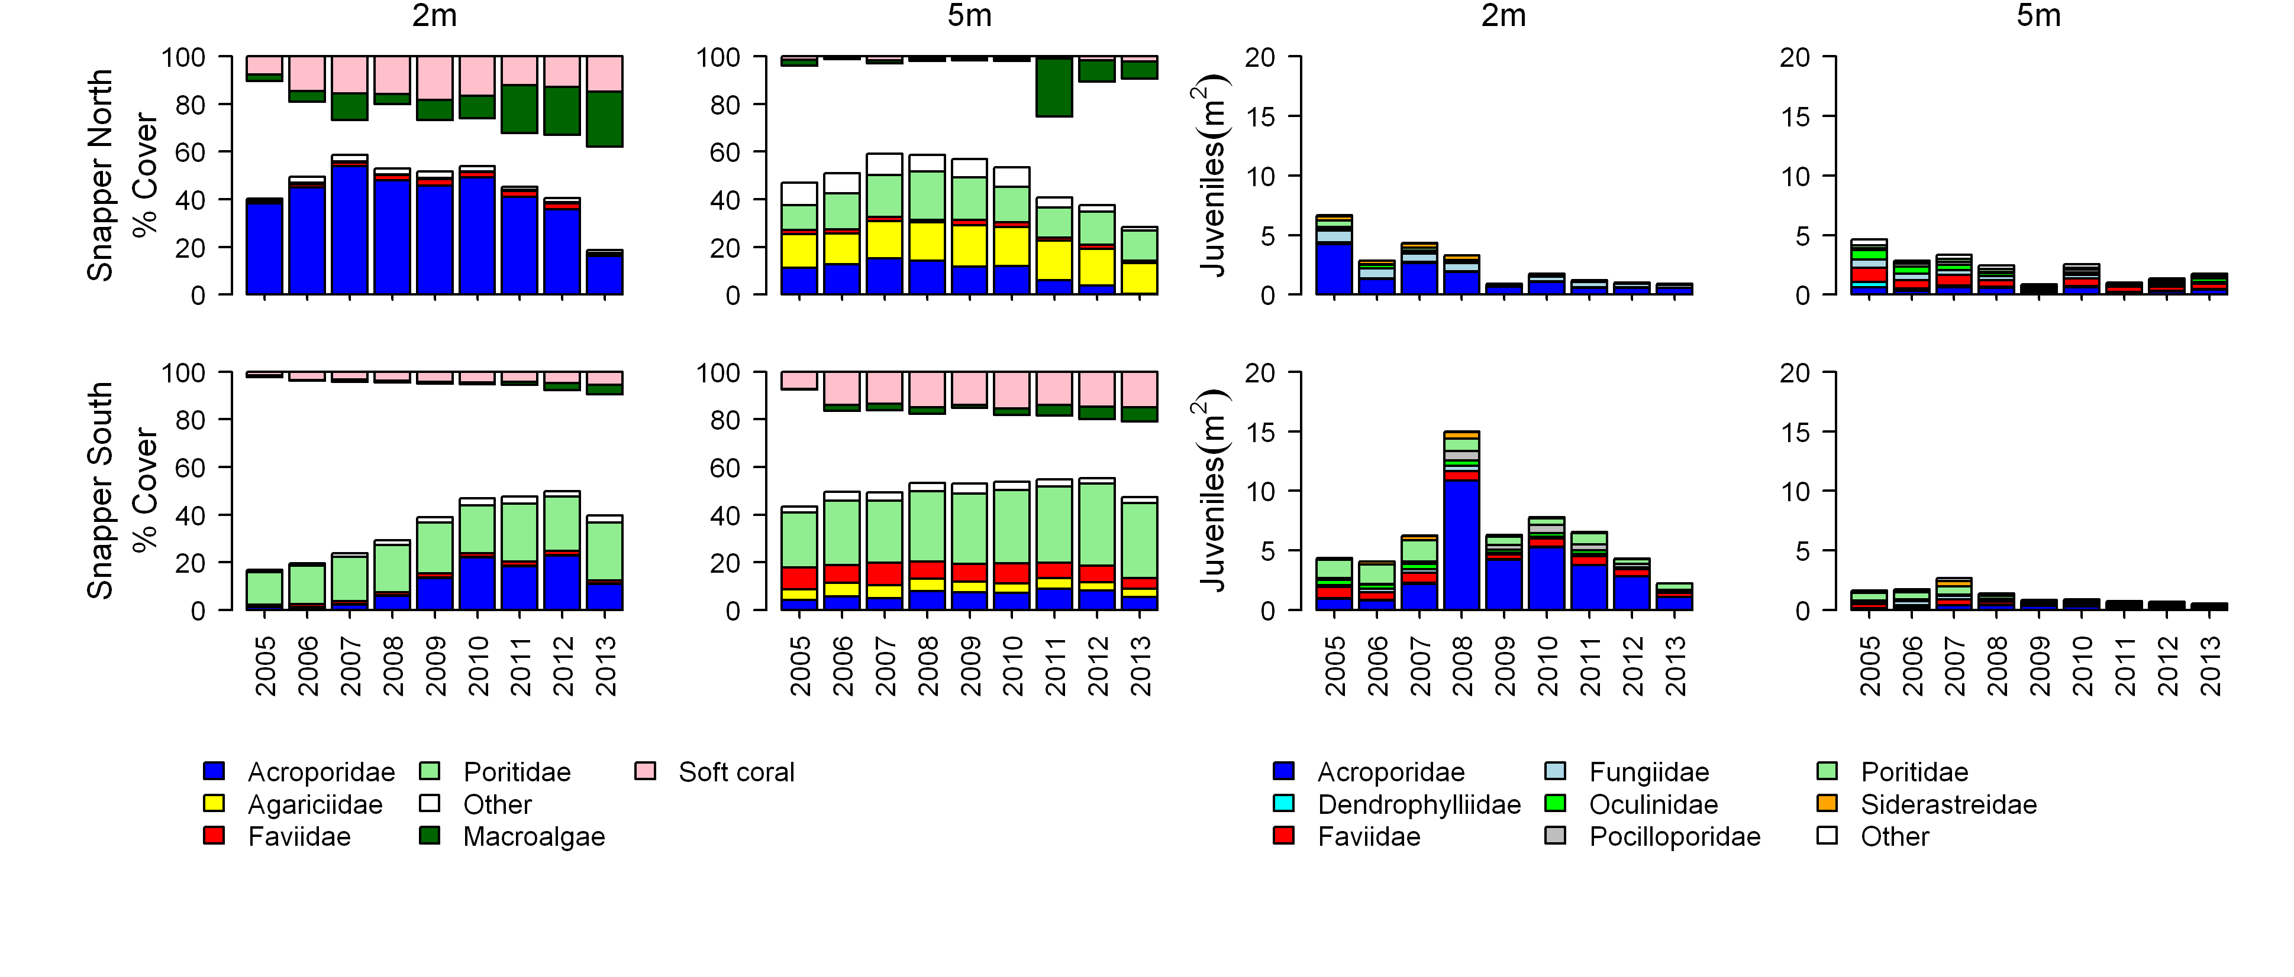
Figure A2- 3 Cover of major benthic groups and density of hard coral juveniles at each depth for reefs in the Daintree sub-region.
Cover estimates are separated into regionally abundant hard coral families and the total cover for soft corals and macroalgae (hanging). Juvenile density estimates are for regionally abundant hard coral families. Separate legends relevant groupings for cover and juvenile density estimates are located beneath the relevant plots.

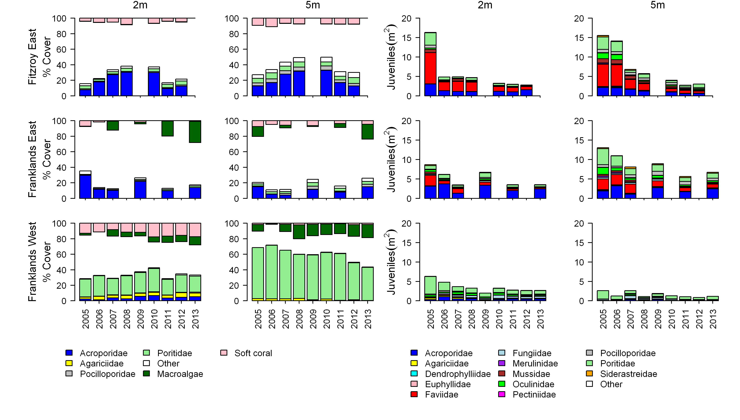
Figure A2- 4 Cover of major benthic groups and density of hard coral juveniles at each depth for reefs in the Johnstone sub-region.
Cover estimates are separated into regionally abundant hard coral families and the total cover for soft corals and macroalgae (hanging). Juvenile density estimates are for regionally abundant hard coral families. Separate legends relevant groupings for cover and juvenile density estimates are located beneath the relevant plots.

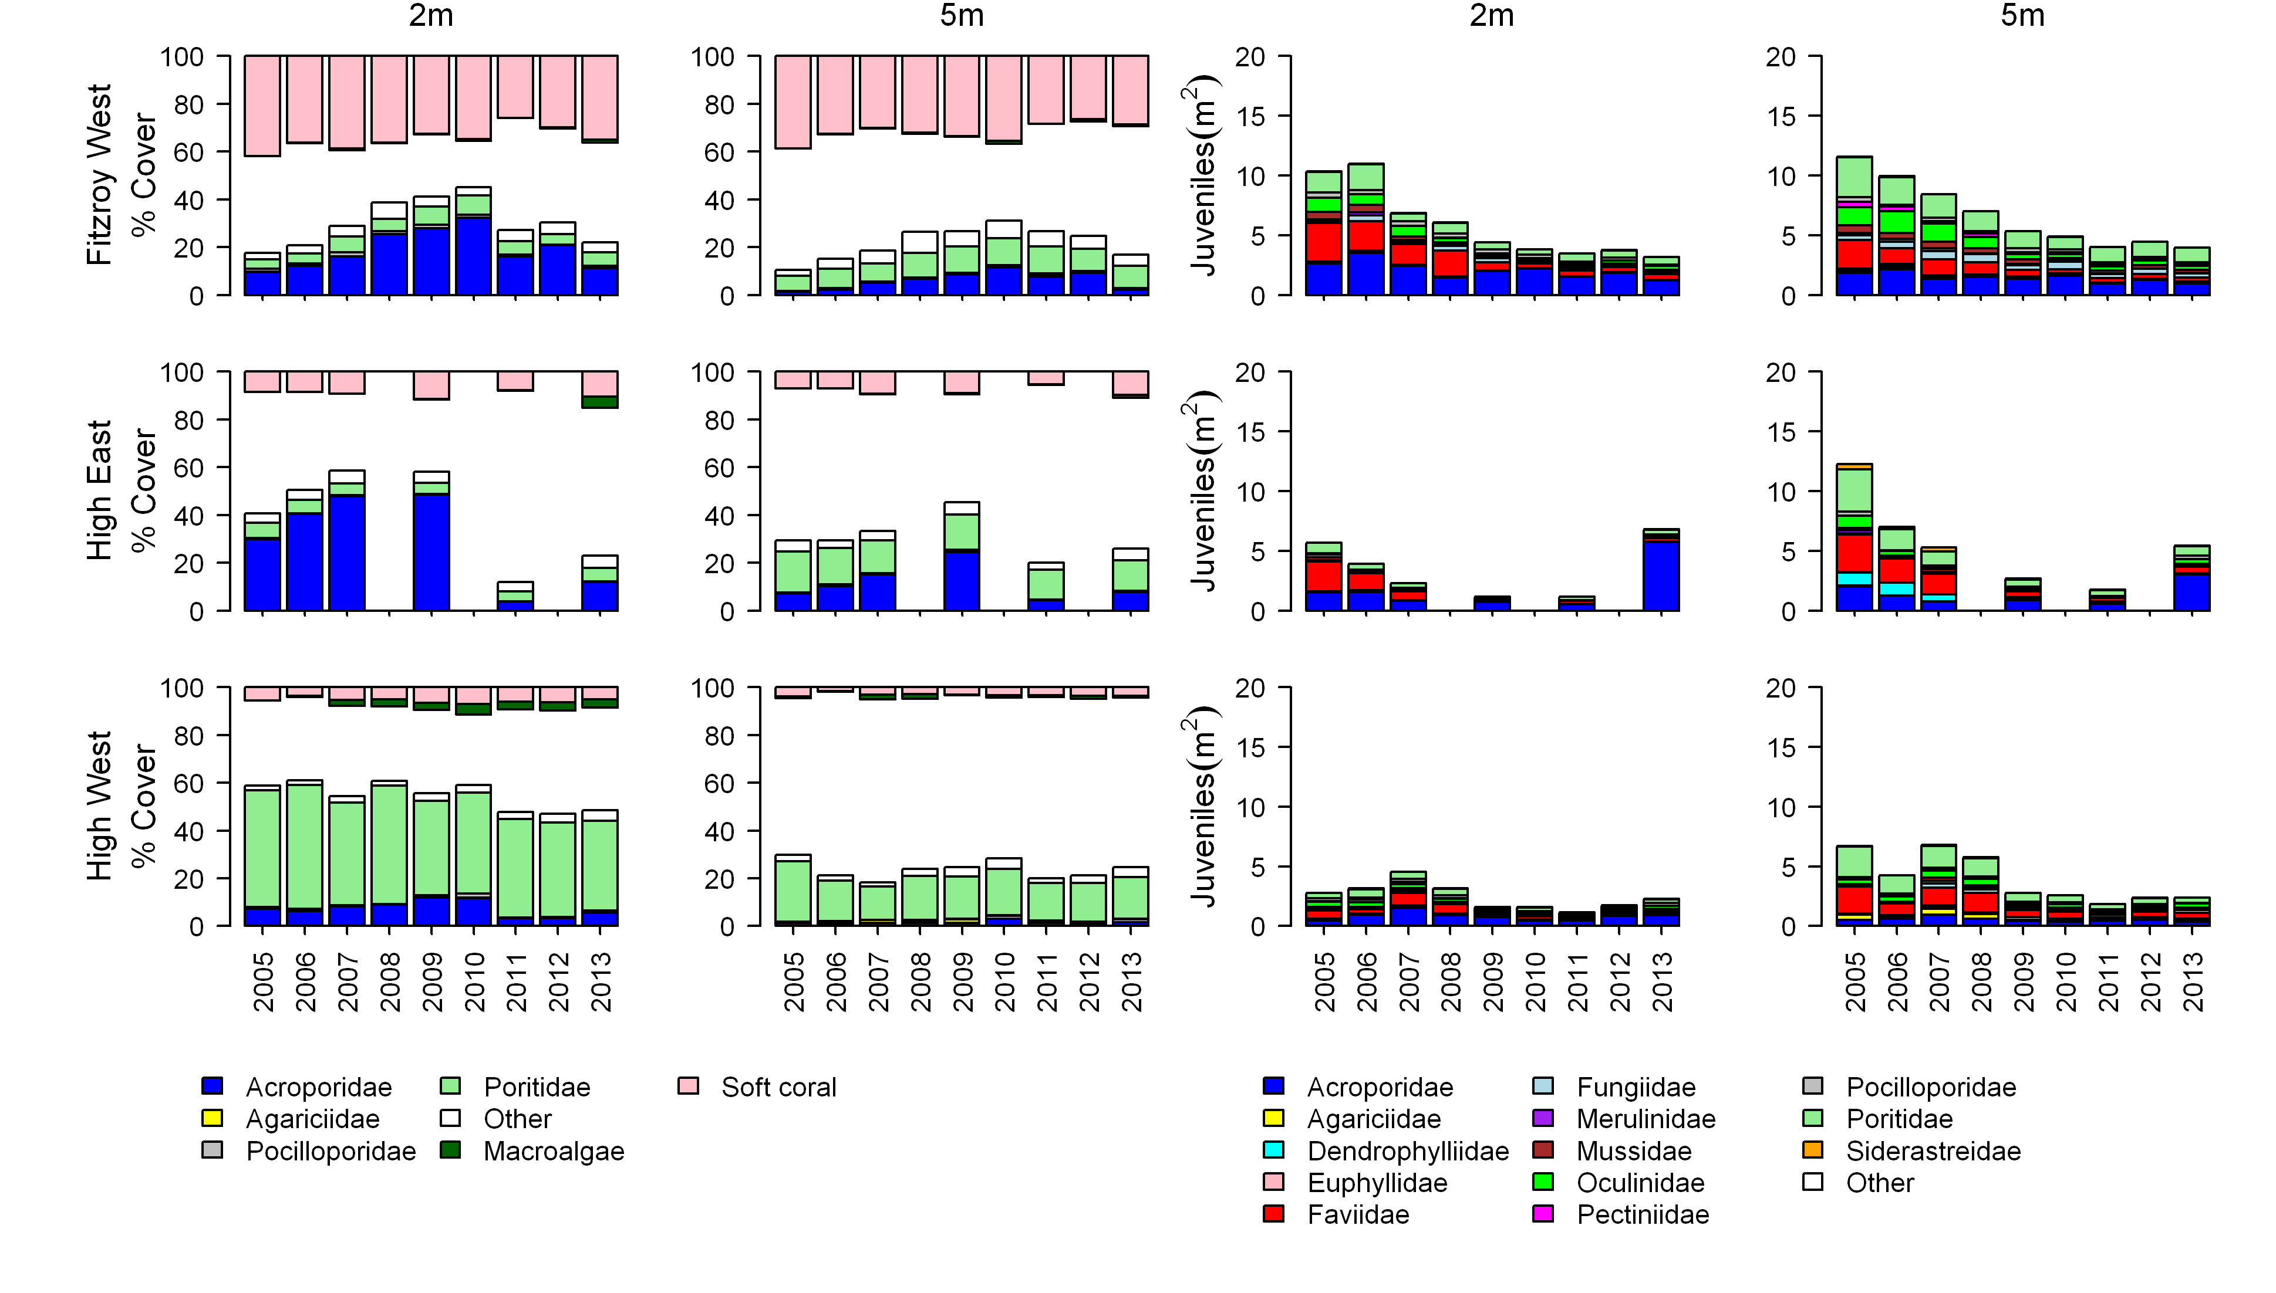
Figure A2-4 Continued.

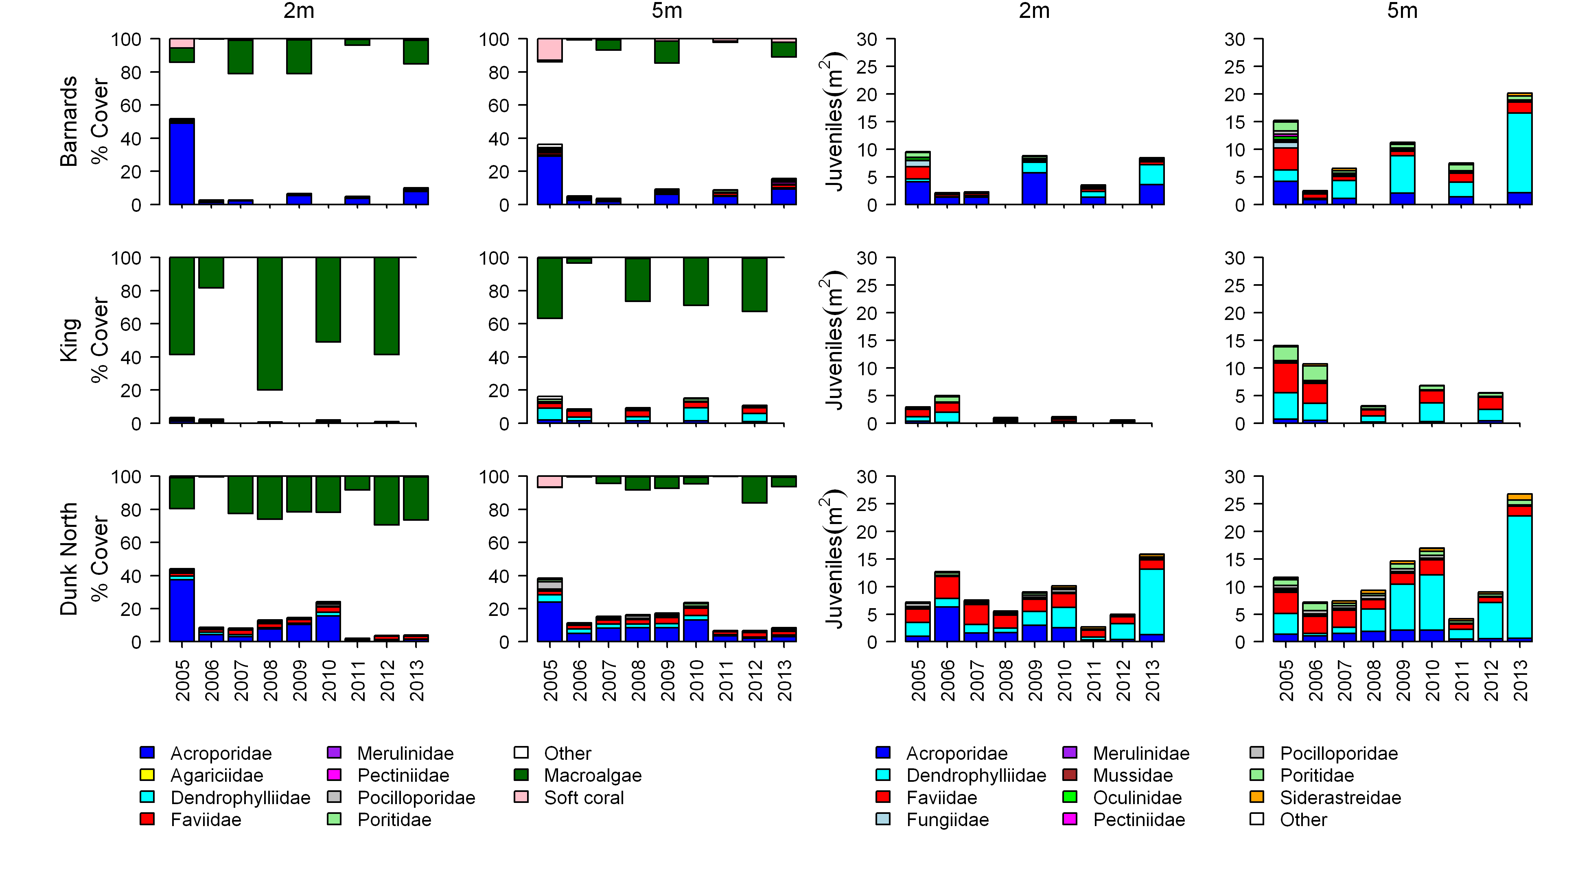
Figure A2- 5 Cover of major benthic groups and density of hard coral juveniles at each depth for reefs in the Tully sub- region.
Cover estimates are separated into regionally abundant hard coral families and the total cover for soft corals and macroalgae (hanging). Juvenile density estimates are for regionally abundant hard coral families. Separate legends with relevant groupings for cover and juvenile density estimates are located beneath the respective plots.

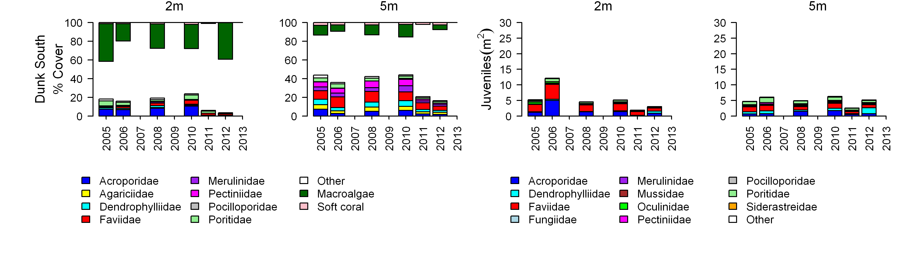
Figure A2-5 continued.

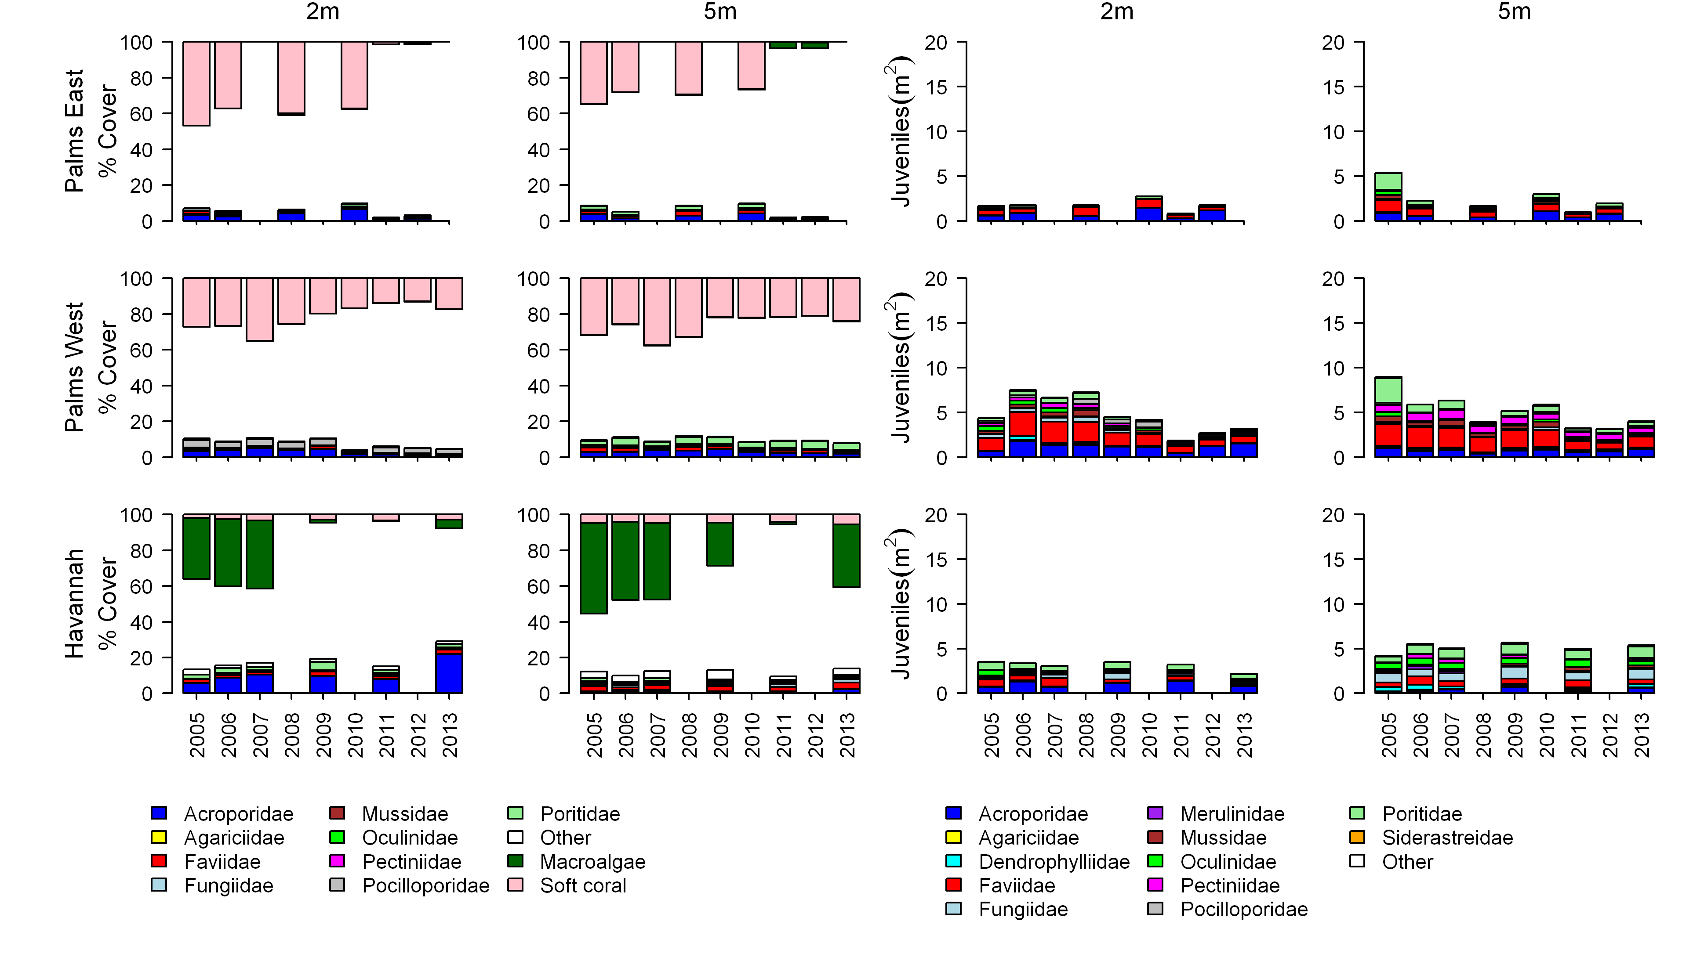
Figure A2- 6 Cover of major benthic groups and density of hard coral juveniles at each depth for reefs in the Burdekin region.
Cover estimates are separated into regionally abundant hard coral families and the total cover for soft corals and macroalgae (hanging). Juvenile density estimates are for regionally abundant hard coral families. Separate legends with relevant groupings for cover and juvenile density estimates are located beneath the respective plots.

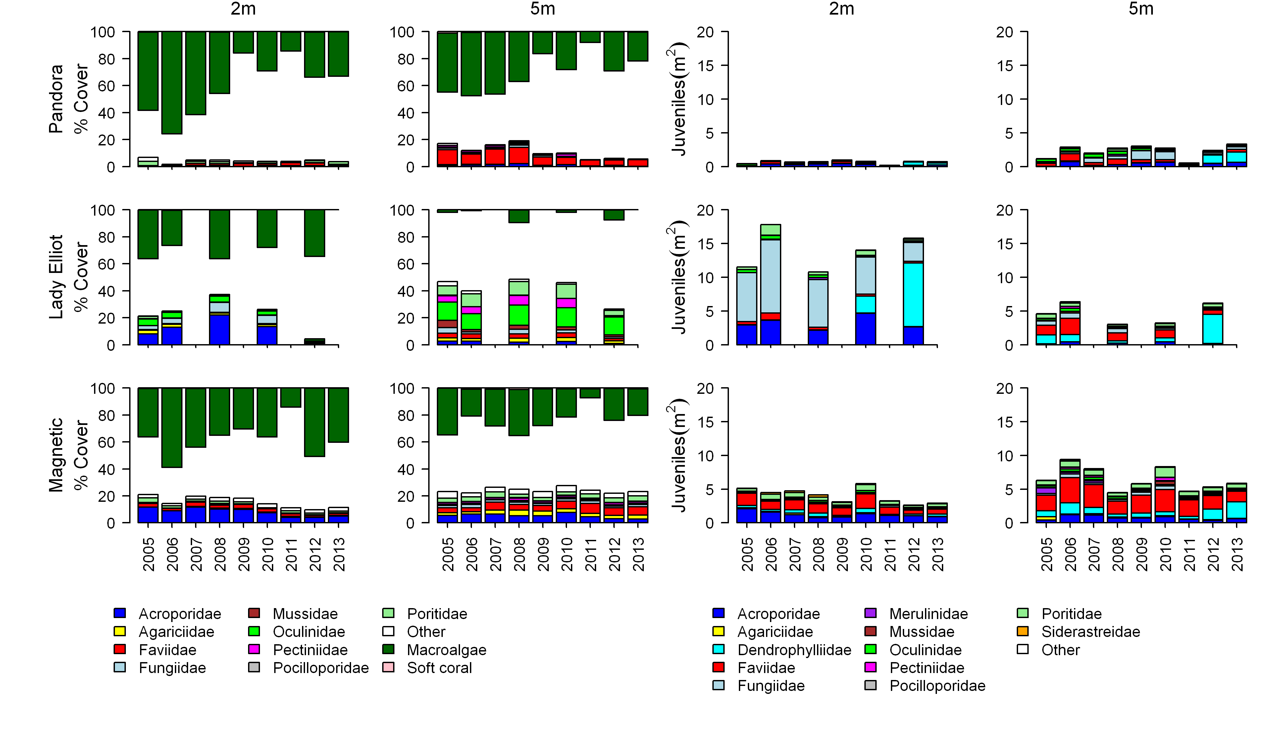
Figure A2-6 continued.

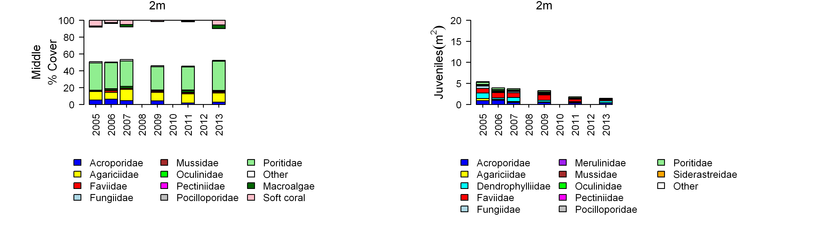
Figure A2-6 continued.

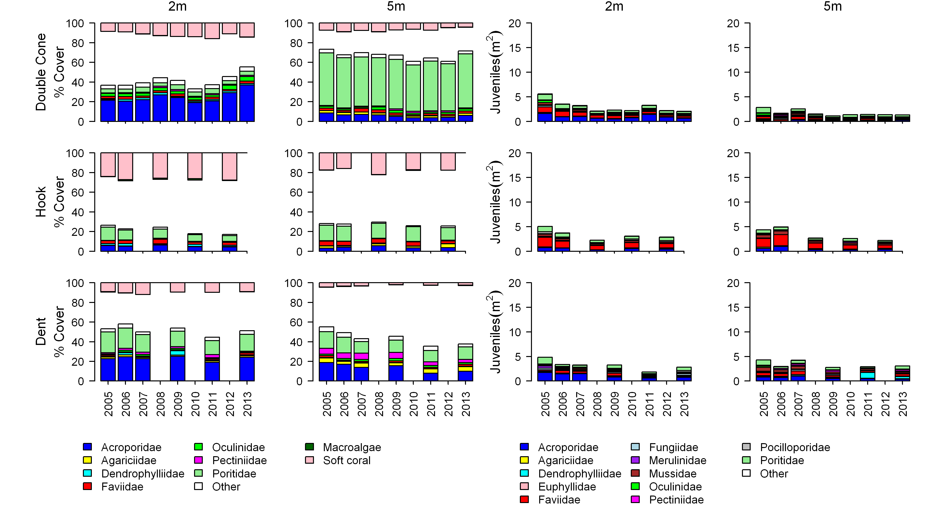
Figure A2- 7 Cover of major benthic groups and density of hard coral juveniles at each depth for reefs in the Mackay Whitsunday region.
Cover estimates are separated into regionally abundant hard coral families and the total cover for soft corals and macroalgae (hanging). Juvenile density estimates are for regionally abundant hard coral families. Separate legends with relevant groupings for cover and juvenile density estimates are located beneath the respective plots.

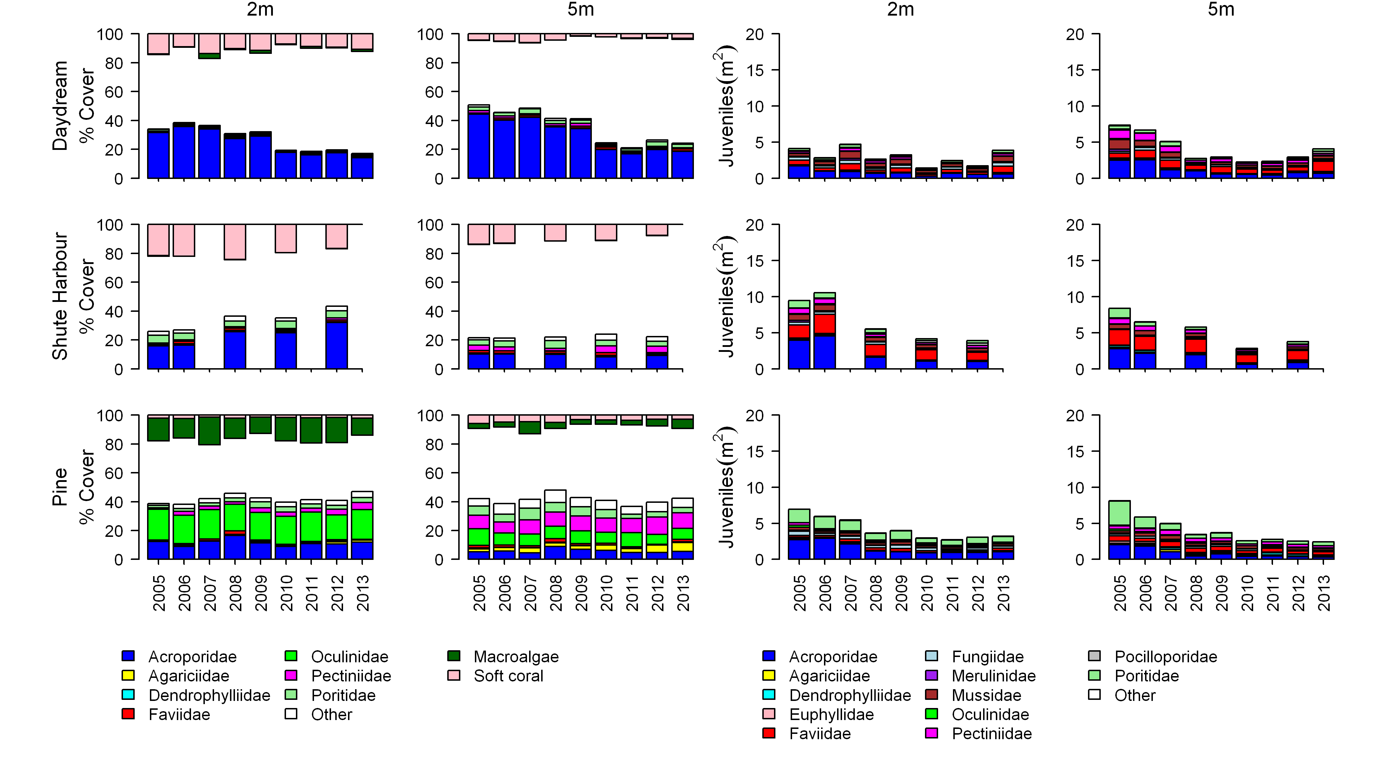
Figure A2-7 continued.

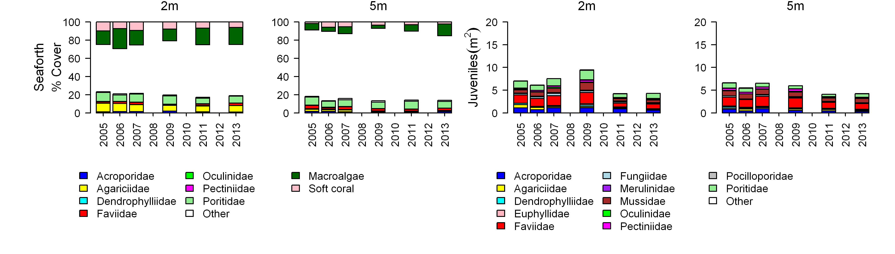
Figure A2-7 continued.

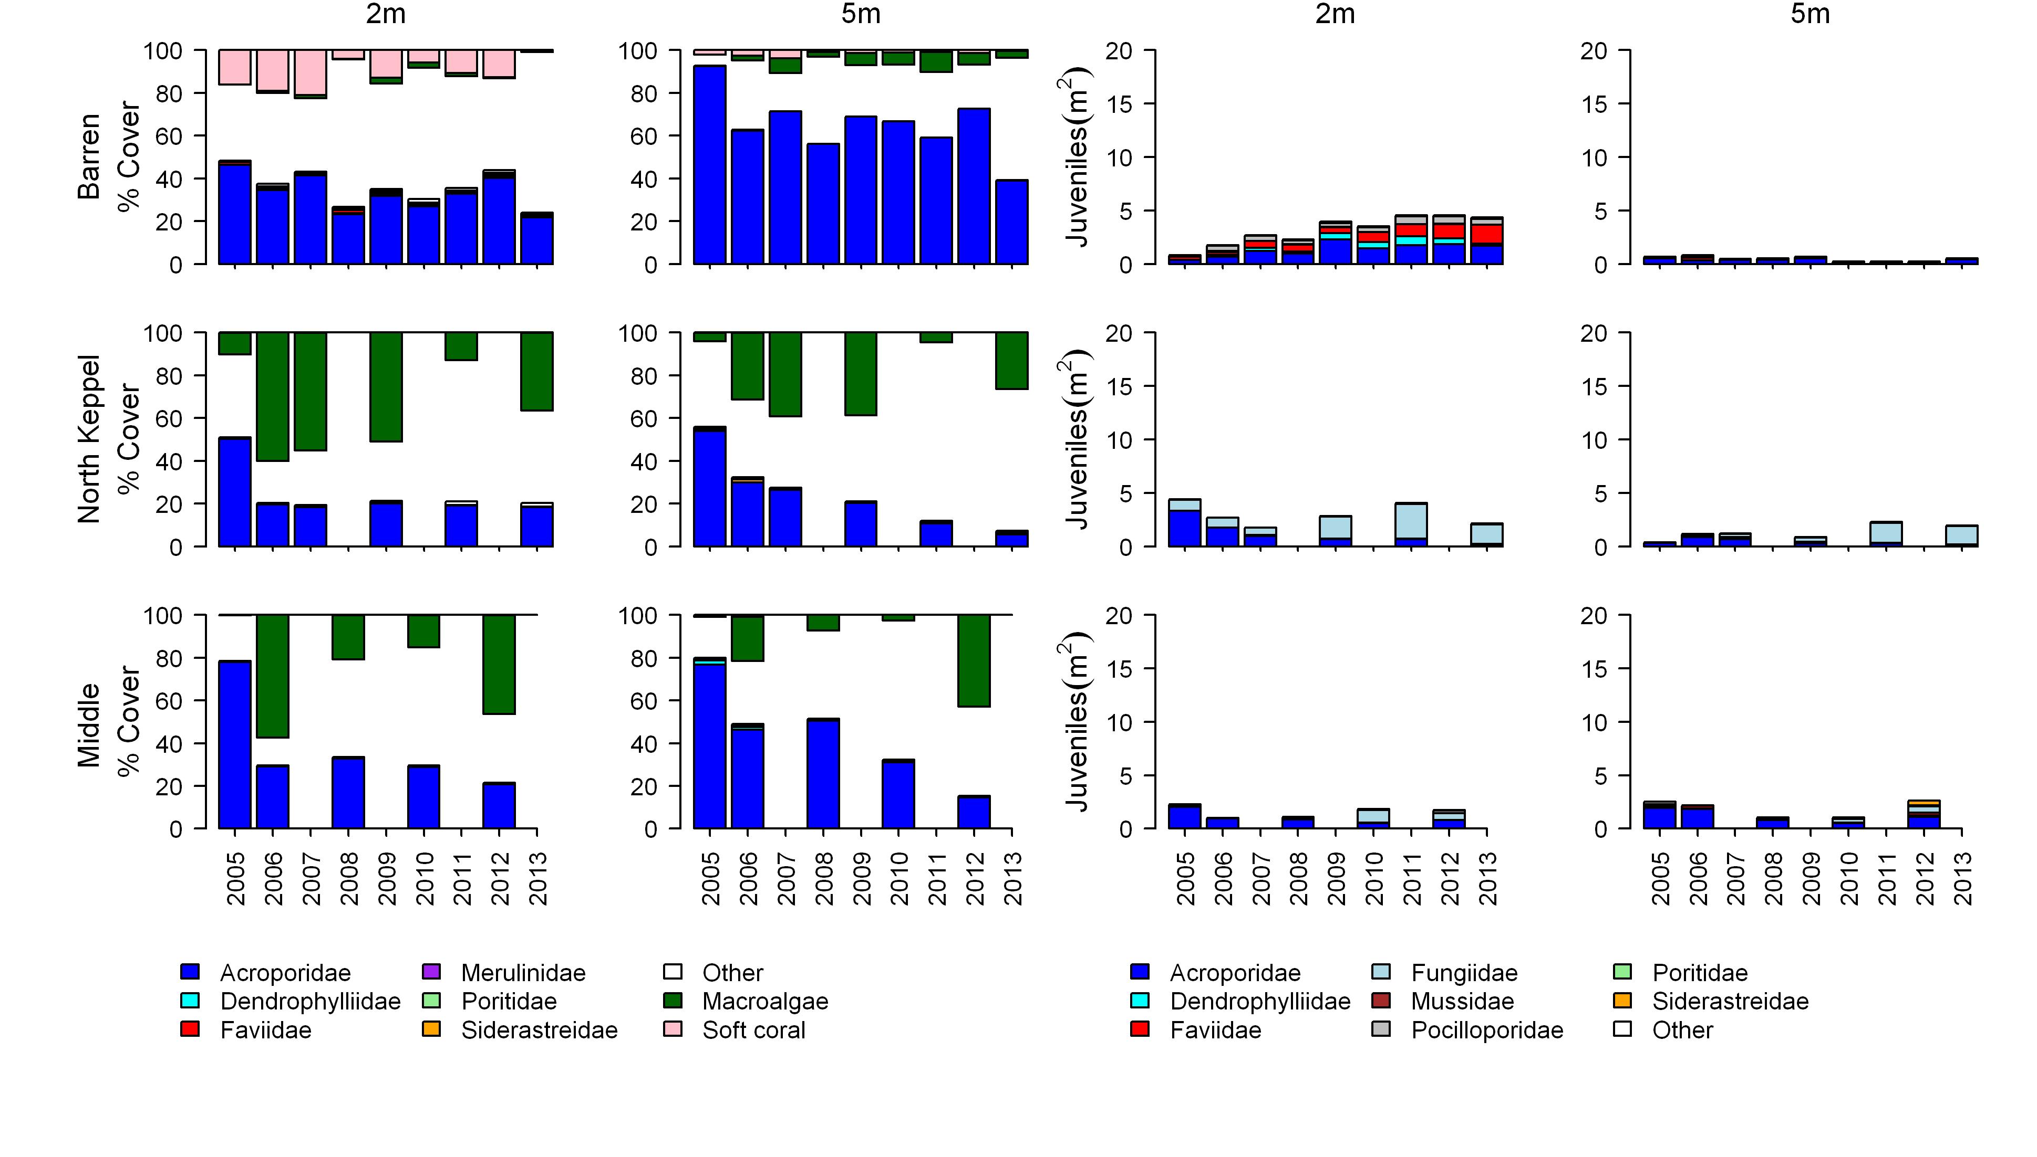
Figure A2- 8 Cover of major benthic groups and density of hard coral juveniles at each depth for reefs in the Fitzroy region.
Cover estimates are separated into regionally abundant hard coral families and the total cover for soft corals and macroalgae (hanging). Juvenile density estimates are for regionally abundant hard coral families. Separate legends with relevant groupings for cover and juvenile density estimates are located beneath the respective plots.

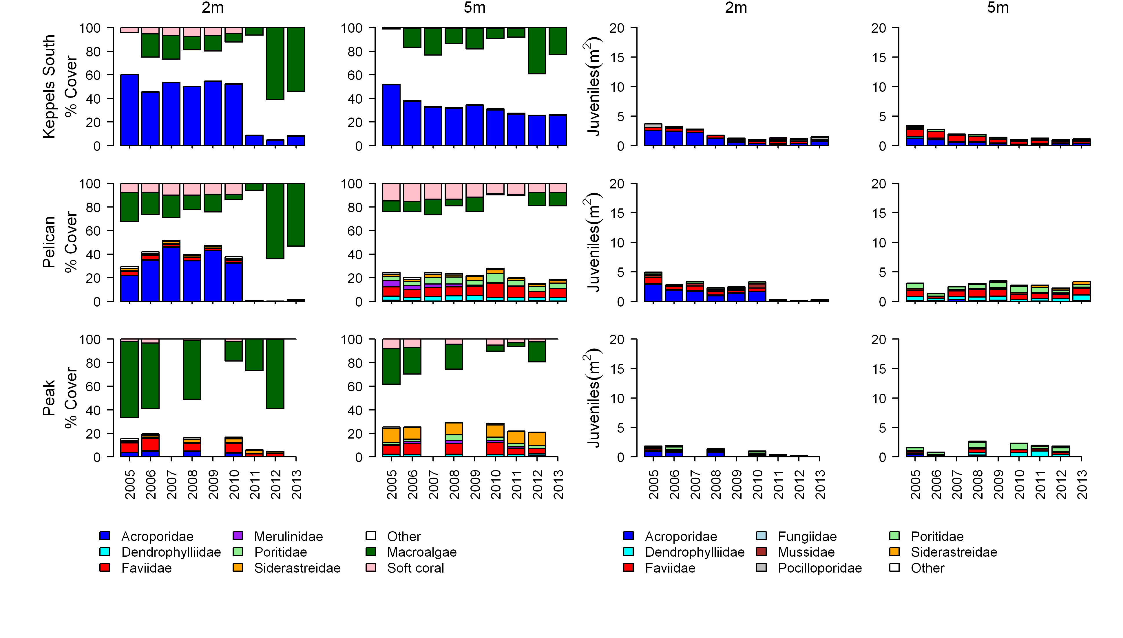Figure A2-8 continued.

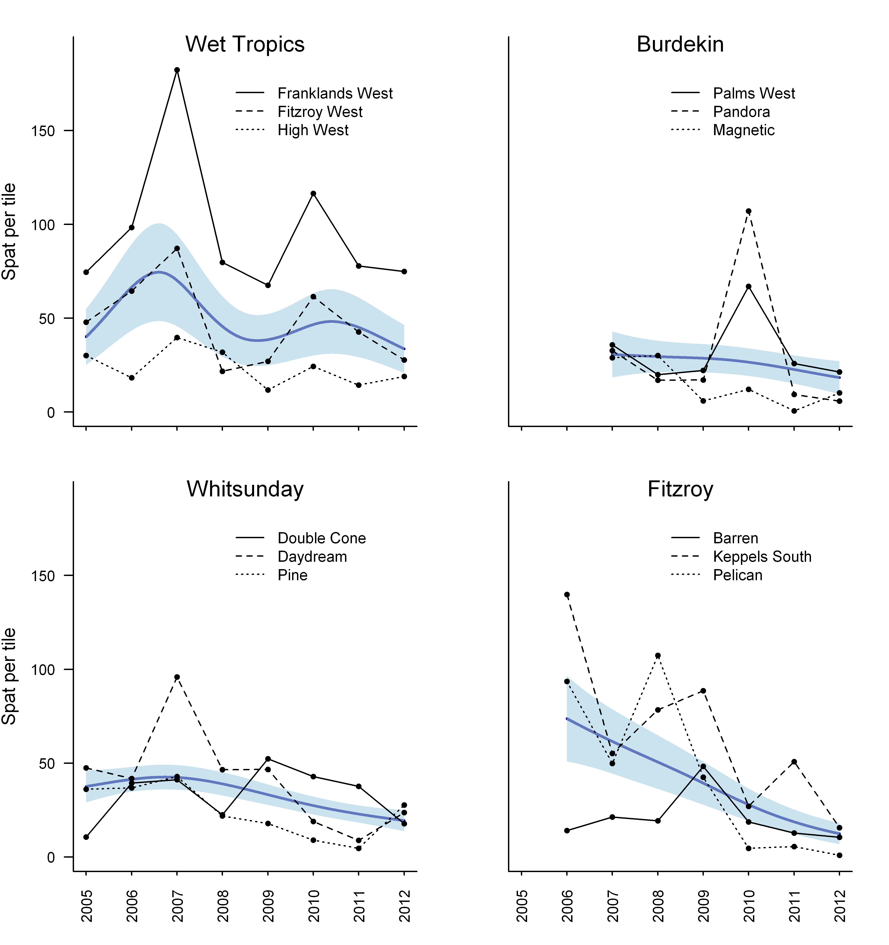
Figure A2- 9 Regional trends in coral settlement.
Bold blue curve represents regional trend bounded by blue shaded area depicting the 95% confidence intervals of that trend (see section 2.6 for analysis detail). Observed trends for individual reefs depicted by the three lines, see legend for details.

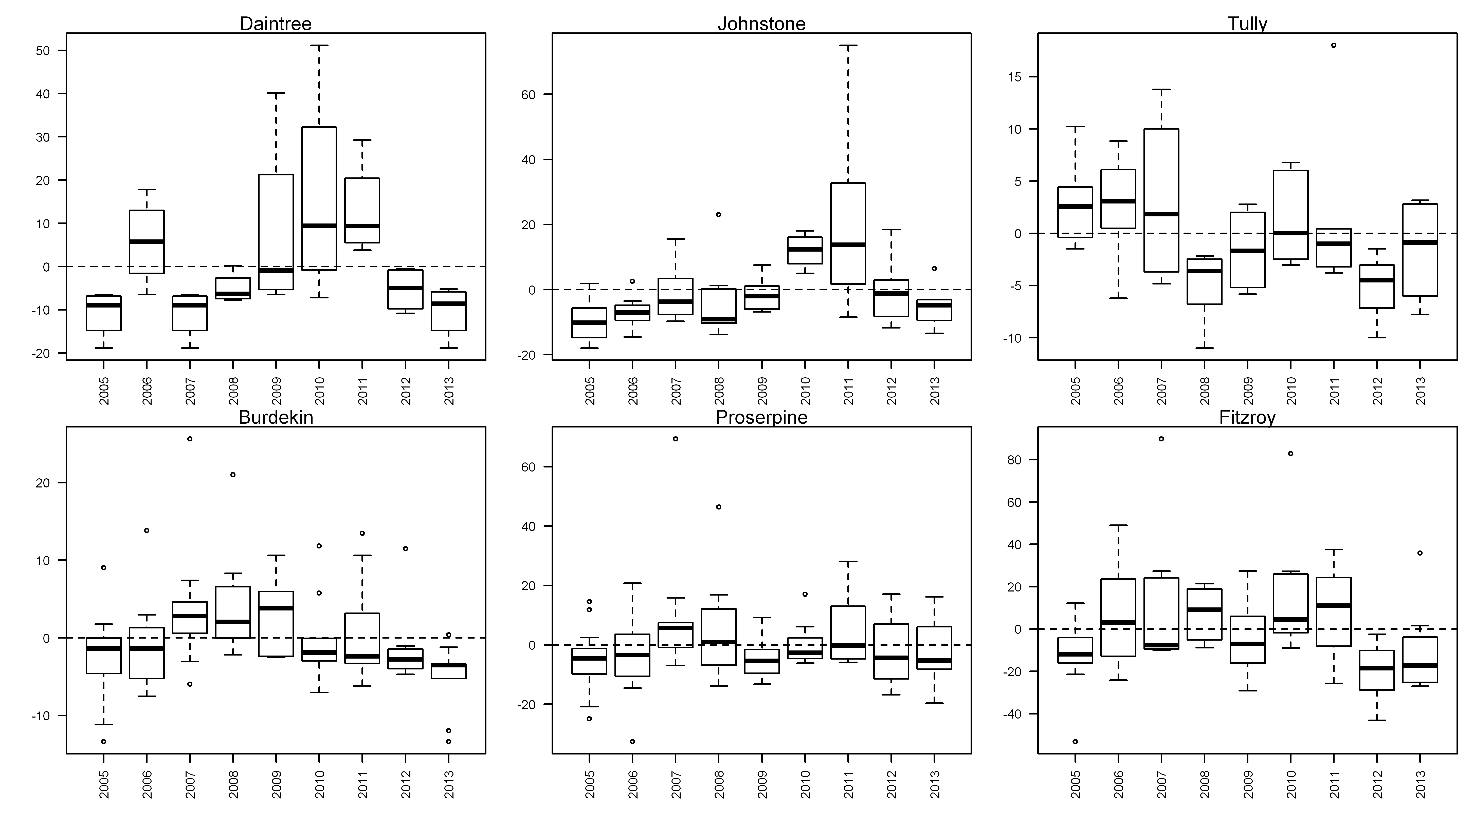
Figure A2- 10 Incidence of coral mortality.
Boxplots include the number of coral colonies suffering ongoing mortality attributed to either disease, sedimentation or ‘unkown causes’ for each reef, depth and year standardised to the reef and depth mean across years.

Appendix 3: QAQC Information

Method performance and QAQC information for water quality monitoring activities

Information pertaining to quality control and assurance generally includes the assessment of the limit of detection (LOD), measurements of accuracy (e.g. using reference materials to assess recovery of known amount of analyte) and precision (the repeated analyses of the same concentration of analyte to check for reproducibility).

Limits of detection
Limit of Detection (LOD) or detection limit, is the lowest concentration level that can be determined to be statistically different from a blank (99% confidence). LOD of water quality parameters sampled under the MMP are summarised below:

Table A3- 1 Limit of detection (LOD) for analyses of marine water quality parameters.

Parameter (analyte) | LOD
NO2 | 0.14 - 0.28 µg L⁻¹*
NO3+ NO2 | 0.42 - 0.56 µg L⁻¹*
NH4 | 0.70 - 0.84 µg L⁻¹*
NH4 by OPA | 0.14 µg L⁻¹
TDN | 0.42 – 0.56 µg L⁻¹*
PN | 1.0 µg filter⁻¹
PO4 | 0.62 – 0.93 µg L⁻¹*
TDP | 0.62 – 1.24 µg L⁻¹*
PP | 0.09 µg L⁻¹
Si | 1.4 – 1.96 µg L⁻¹*
DOC | 0.1 mg L⁻¹
POC | 1.0 µg filter⁻¹
Chlorophyll a | 0.004 µg L⁻¹
SS | 0.15 mg filter⁻¹
Salinity | 0.03 PSU
*LOD for analysis of dissolved nutrients is estimated for each individual analytical batch, the range given is the range of LODs from batches analysed with samples collected in 2012/13.

Precision
The variation between results for replicate analyses of standards or reference material is used as a measure for the precision of an analysis. Reproducibility of samples was generally within a CV of 20%, with the majority of analyses delivering precision of results within 10% (
Table A3- 2)

Table A3- 2 Summary of coefficients of variation (CV, in %) of replicate measurements (N) of a standard or reference material.
Parameter (analyte) | CV (%) | N
NO2 | 3-39* | 4-6
NO3+ NO2 | 1-12* | 4-6
NH4 | 4-24* | 4-6
TDN | 5-9* | 4-6
PN | 4-6 | 6-24
PO4 | 2-30* | 4-6
TDP | 3-29* | 4-6
PP | 2 | 6
Si | 1-7* | 4-6
DOC | 2-4* | 42-49
POC | 5-8** | 8-26
Chlorophyll a | 1.6 | 22
SS | n/a***
Salinity | <0.1 | 2-5

*Precision for analysis of dissolved nutrients is estimated for each individual analytical batch, the range given is the range of CVs from batches analysed with samples collected in 2012/13.
** two different reference materials used in each batch
***n/a= no suitable standard material available for analysis of this parameter

Accuracy
Analytical accuracy is measured as the recovery (in %) of a known concentration of a certified reference material or analyte standard (where no suitable reference material is available, e.g. for PP), which is usually analysed interspersed between samples in each analytical run. The recovery of known amounts of reference material is expected to be within 90-110% (i.e. the percent difference should be ≤ 20%) of their expected (certified) value for results to be considered accurate. The accuracy of analytical results for PN, PP, POC, chlorophyll, SS and salinity was generally within this limit (Table A3- 3). Analytical results for PP are adjusted using a batch-specific recovery factor that is determined with each sample batch.

Table A3- 3 Summary of average recovery of known analyte concentrations.

Parameter (analyte) | Average recovery (%) | N
PN | 101-102 | 6-24
PP | 89* | 6
POC | 97-108 | 57
Chlorophyll a | 103 | 22
SS | n/a**
Salinity | 100 | 4
*PP: data are adjusted using a batch-specific efficiency factor (recovery)
**n/a= no suitable reference material available for analysis of this parameter

The accuracy of analytical results for dissolved nutrients is being assessed using z-scores of the results returned from analysis of NLLNCT certified reference material (National Low-Level Nutrient Collaborative Trials, run every year by the Queensland Health Forensic and Scientific Services, QHFSS- AIMS is a formal participant of these trials). According to the NLLNCT instructions, accuracy is deemed good if results are within 1 z-score and satisfactory if results are within 2 z-scores. In each analytical batch, two bottles with different concentrations were analysed. In 2012/13 we used bottles #5 and #7 from Round 17 of the NLLNCT. For both the #5 bottle (lower concentrations) and the #7 bottle (higher concentrations) all nutrient analyses z-scores were within 1 z-score (Table A3- 4) and,
hence, accuracy was deemed good. To assure that the monitoring results were accurate, additional QAQC samples were included in all batches (e.g. in-house reference seawater that allows for batch to batch comparison, added nutrient spikes) which usually return acceptable results.

Table A3- 4 Summary of average Z-scores of replicate measurements (N) of a standard or reference material.
Accuracy of analysis of dissolved nutrients is estimated for each individual analytical batch, the range given is the range of average Z-scores from batches analysed with samples collected in 2012/13.

Parameter (analyte) | Z-score for  bottle #5 * | Z-score for  bottle #7 * | N
NOx | -0.57 to -0.29 | -0.82 to 0.78 | 3
NH4 | -0.47 to 0.15 | -0.41 to -0.21 | 3
TDN | -0.50 to 0.42 | -0.38 to 0.56 | 3
PO4 | -0.43 to 0.54 | 0 to 1.01 | 3
TDP | -0.09 to 0.47 | 0.02 to 0.56 | 3
Si | -0.97 to 0.50 | -0.4 to 0.04 | 3
* NLLNCT reference samples round 17, bottles #5 and #7 analysed with samples collected in 2012/13.

Procedural blanks
Wet filter blanks (filter placed on filtration unit and wetted with filtered seawater, then further handled like samples) were prepared during the on-board sample preparation to measure contamination during the preparation procedure for PN, PP, POC and chlorophyll. The instrument readings (or actual readings, in case of chlorophyll) from these filters were compared to instrument readings from actual water samples. On average, the wet filter blank values were below 5% of the measured values for PN and below 2% of the measured values for chlorophyll a (Chl) (Table A3- 5) and we conclude that contamination due to handling was minimal.

Wet filter blanks (as well as filter blanks using pre-combusted filters) for PP and POC generally returned measureable readings, which indicates that the filter material contains phosphorus and organic carbon. The blank values are relatively constant and were subtracted from sample results to adjust for the inherent filter component.

Wet filter blanks for SS analysis (filter placed on filtration unit and wetted with filtered seawater, rinsed with distilled water, then further handled like samples) were prepared during the on-board sample preparation. The mean weight difference of these filter blanks (final weight - initial filter weight) was 0.00008 g (n=30). This value indicated the average amount of remnant salt in the filters (“salt blank”). The salt blank was about 5% of the average sample filter weight (Table A3- 5). This value was included in the calculation of the amount of suspended solids per litre of water by subtraction from the sample filter weight differences.

Table A3- 5 Comparison of instrument readings of wet filter blanks to actual sample readings

 | PP  (absorbance readings) | PN  (instrument readings) | Chl  (µg L⁻¹) | SS  (mg filter⁻¹) | POC  (µg filter⁻¹)
Average of blank readings | 0.012 | 2214 | 0.006 | 0.08 | 7.75
N of blank readings | 26 | 20 | 14 | 30 | 20
Average of sample readings | 0.090 | 52961 | 0.29 | 1.48 | 28.3
N of sample readings | 466 | 495 | 492 | 496 | 469
Average of blanks as % of average sample readings | 13.2% | 4.9% | 1.5% | 5.1% | 27.4%

Validation by alternative methods

Chlorophyll a
To validate the results of the chlorophyll a analysis by fluorometry (which is the routinely applied standard method for samples collected under the MMP), a number of samples (collected separately from surface waters after the main Niskin cast) were analysed at AIMS by HPLC (a more elaborate technique yielding high resolution detection of various phytoplankton pigments) during the previous years of MMP monitoring. In 2012/13 this validation was not carried out for cost reasons. The previous results always showed a good agreement between the two standard methods, consistent for several years. However the fluorometry method showed values on average 10% lower than those obtained by the HPLC technique (Figure A3- 1). This small difference is most likely due to differences in extraction methods and hence, extraction efficiency. When the same extract was used for analysis by both instruments the agreement was very good (y=0.99x, R²=0.995, N=6). The differences in extraction efficiency between these two methods do not affect the reliability and usefulness of the results obtained by fluorometry, which applies the internationally accepted US EPA standard method and has been used at AIMS for about 20 years.

Figure A3- 1 Match-up of duplicate samples analysed for chlorophyll a by fluorometry and HPLC.

Validation of ECO FLNTUSB instrument data
Direct water samples were collected and analysed (see Appendix 1- Materials and Methods for details) for comparison to instrument data acquired at the time of manual sampling.

Turbidity was validated against suspended solids concentrations in the water column. The relationship between optically measured turbidity and total suspended solids analysed on filters was good (Figure A3- 2), and the linear equation [SS (mgL-1)] = 1.3 x FLNTUSB Turbidity (NTU)] has been used for conversion between these two variables. The equation has been the same in last three year’s estimates (Schaffelke et al. 2009, 2010, 2011).

Using this equation, the SS trigger value in the Guidelines of 2.0 mg L-1 (GBRMPA 2010) translates into a turbidity trigger value of 1.5 NTU.

For a correlation between chlorophyll fluorescence and directly measured chlorophyll a in water samples see Appendix 4, which gives and update of the quality assurance tests and adjustments of the instrument-derived chlorophyll fluorescence data, which are still underway.

Figure A3- 2 Match-up of instrument readings of turbidity (NTU) from field deployments of WET Labs Eco FLNTUSB Combination Fluorometer and Turbidity Sensors with values from standard laboratory analysis of concurrently collected water samples.

Method performance and QAQC information for coral monitoring activities

Photo point intercept transects. The QA/QC for the estimation of cover of benthic communities has two components. The sampling strategy which uses permanently marked transects ensures estimates are derived from the same area of substratum each year to minimise possible sampling error. The second component is to ensure the consistency of identification of community components from digital photo images, and to achieve this, all points are double-checked by a single observer on completion of analysis each year. This double-checking has now been done for all digital still photograph images in the database. All hard corals, soft corals and macroalgae were identified to at least genus level where image quality allowed. Other benthic groups were also checked and consistency in differentiation achieved.

Juvenile coral belt transects. Two observers collected juvenile coral count data in 2013. Data from Snapper Is was supplied by Sea Research. The Sea Research observer, Tony Ayling, is the most experienced individual in Australia in surveying the benthic communities of inshore coral reefs. Like the AIMS observers, his taxonomic skills are complete at genus level and he used the same field protocols, pre-printed datasheets and data entry programs as AIMS observers. Prior to commencement of surveys observer standardisation for Tony Ayling included detailed discussion and demonstration of methodologies with the AIMS team. While we are confident that limited bias was introduced as a result of his participation as the focus of the program is for temporal comparisons any bias between Tony Ayling and AIMS observers will not manifest in temporal comparisons at Snapper Is. All other reefs were surveyed by an experienced AIMS staff member. It must be acknowledged however that for some of the smallest size class <2cm identification to genus is impossible in the field, though for the most part this is the case for relatively rare taxa for which reference to nearby larger individuals cannot be made. All data are entered into the database and rechecked against field data sheets.

Settlement plate spat counts. It is the stated QA/QC aim that hard coral recruits (spat) on retrieved settlement tiles were to be counted and identified using a stereo dissecting microscope with identification to the highest practicable taxonomic resolution and between observer errors (spat overlooked) should not exceed 10%. Identification of the various taxa of spat was achieved on the basis of experience and reference to a photographic archive spat. To examine the percentage of spat overlooked a second observer examined a subset of tiles. In most years the error rate has fallen within the allowable 10% range. For the current year marginally the very low numbers of coral settling inflated the consequence of missing individual spat and the error rate at 11% missed was marginally outside the target range.

Appendix 4: Ongoing efforts to improve calibration and validation of chlorophyll estimates from WET Labs ECO FLNTUSB loggers

Objectives of instrumental water quality monitoring within the MMP
The objective of the in-situ environmental logger sub-project is to measure high-frequency time series of two key water quality parameters (turbidity, chlorophyll fluorescence) at the fourteen (14) core inshore reefs to:

- Quantify the cumulative exposure of inshore reef communities to adverse water quality conditions caused by recurrent, short-term disturbance events (wind or current-driven sediment resuspension, flood plumes, cyclonic storms)
- Provide a strong statistical basis for identifying long-term trends in water quality at these sites in relation to changing land-management practices under the Reef 2050 Plan to reduce runoff of terrestrial sediment and nutrients.

WET Labs Environmental Characterization Optics (ECO) FLNTUSB (Fluorescence, NTU) loggers were selected. The instruments measure chlorophyll fluorescence and turbidity (NTU) at 10-minute intervals over deployments of approximately four months duration (see methods section in Appendix 1). NTU is a proxy for the mass of suspended matter in water as well as turbidity. The chlorophyll and turbidity sensors of the WET Labs loggers are identical to those installed in research-grade CTD profilers used internationally, and by AIMS in GBR waters.

Issues related to calibration and validation of WET Labs ECO FLNTU logger data
In order to make meaningful interpretations of water quality, it is essential that the logger data is appropriately calibrated and that sources of variability in the data related to instrumental and natural causes are well understood. In a previous report (Schaffelke et al. 2012), issues related to uncertainties in the calibration of the chlorophyll fluorescence sensors on the FLNTUSB loggers are described in detail. Earp et al. (2011) provide a general review of procedures and issues behind the calibration of chlorophyll fluorescence sensors. The introduction by the manufacturer of a ‘wet’ fluorescence calibration procedure based on uranine solutions in mid-2011 initiated a still-ongoing effort to improve the calibration status of all GBR logger records, and as necessary, to re-process earlier logger data to an improved, common standard.

Figure A4- 1 presents a summary of the current logger data set (as of September 2013) with regard to the status of individual logger records (good, lost or corrupted, bad or missing data, negative data in records). In particular, sources of negative values in individual processed records are being examined in detail. Figure A4- 2 presents a summary of the calibration status of all processed logger records up to September 2013. In this summary, individual records are divided into three groups: [1] records using the new ‘wet’ uranine standards for factory calibration (green segments), [2] records using older (‘dry’) factory calibrations based on plastic disk standards, but adjusted using the pre-calibration measurement of ‘wet’ uranine standard (yellow segments), and [3] records using older factory calibrations based on the ‘dry’ plastic standard, but without any temporal overlap with the newer ‘wet’ uranine calibration (blue segments). All chlorophyll records from mid-2012 are based on the ‘wet’ uranine calibration.

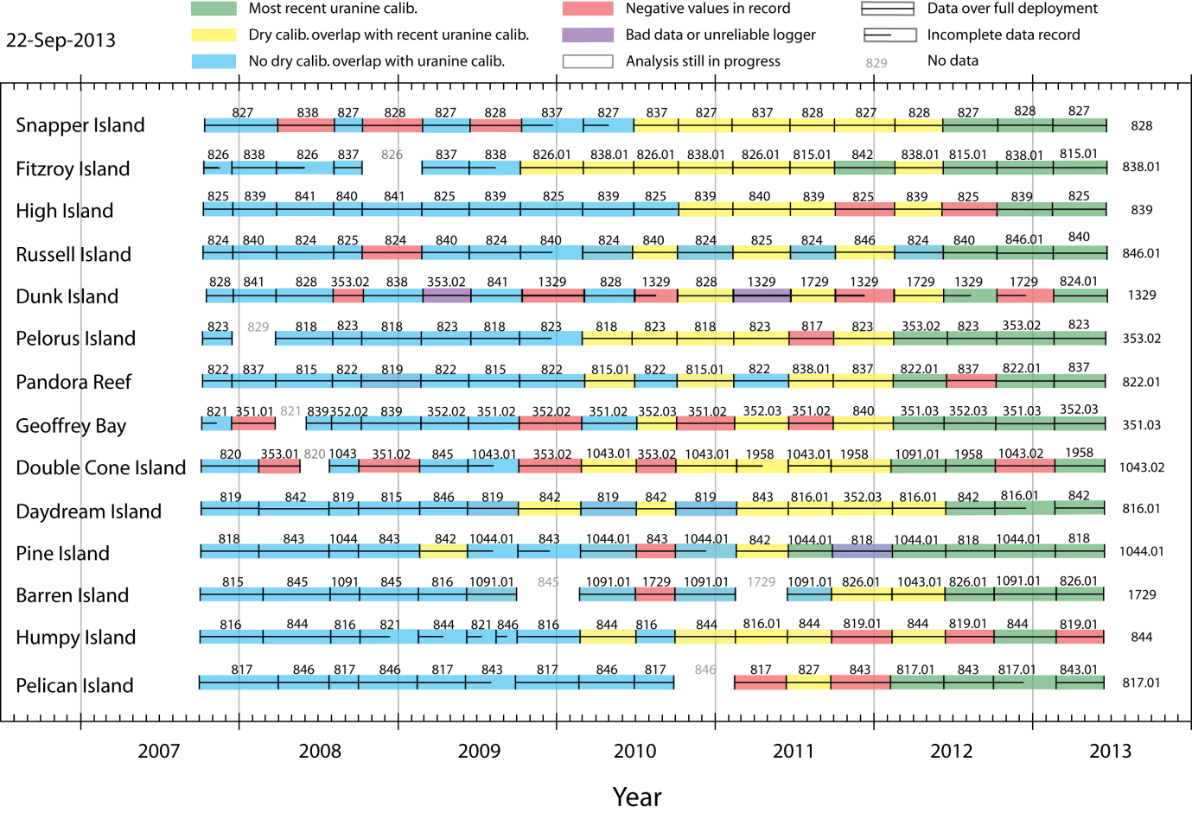

Figure A4- 1 The analysis status of the logger chlorophyll data set as of mid-September 2013.

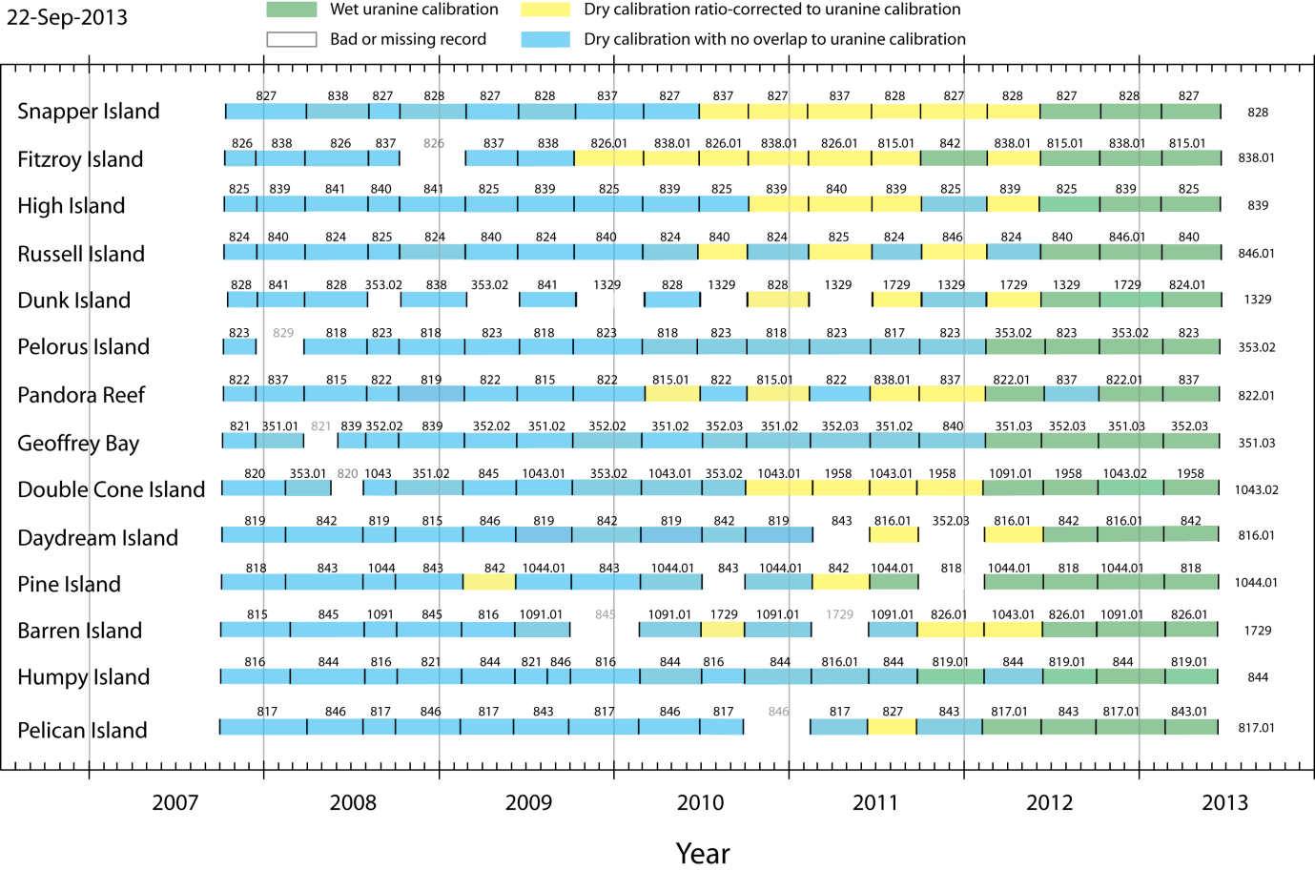
Figure A4- 2 Calibrations used in working up the chlorophyll logger data set.

Retrospective adjustments of logger florescence records were performed on a number of records from deployments between 2010 and 2012, plus two deployments beginning in 2009. This was possible because most loggers serviced between mid-2011 and late-2012 had been dry-calibrated as part of their previous servicing and could be re-calibrated using the ‘wet’ method at the factory prior to the next servicing. Differences between the ’dry’ calibrations from the previous service and the following ‘wet’ pre-calibrations were used to calculate factors to adjust ‘dry’-calibration-based chlorophyll concentrations to chlorophyll values that would nominally have been produced using a calibration relationship based on the ‘wet’ calibration.

However, all individual instruments were serviced one or more times prior to the introduction of the ‘wet’ calibration method, so it was not possible to directly link the oldest ‘dry’ calibrations to the more recent ‘wet’ calibrations. Additionally, some instruments either failed and/or had the optics replaced, so an adjustment of the data records was not possible. These fluorescence records contain a degree of uncertainty in their calibration and are therefore used cautiously.

Direct comparisons between instrumental measurements of turbidity (measured in NTU) and total suspended solids (SS) mass in GBR waters determined by manual sampling show a strong linear correlation, indicating that SS can be robustly estimated from logger NTU measurements (see Appendix 3, Figure A3- 2). No adjustments of these turbidity records were undertaken.

In situ chlorophyll a concentrations are widely used as a measure of phytoplankton biomass, which in turn is used as a proxy index of water column nutrient availability because bio-available nutrients (chiefly N, but also P, etc.) are rapidly assimilated into biomass by phytoplankton and bacteria. Chlorophyll concentrations derived from instrumentally measured fluorescence and manual sampling/analysis normally varied over a relatively small dynamic range. As a result, observed correlations between instrumental and hand-measured estimates of chlorophyll are less robust (Figure A4- 3) than the relationship between turbidity and SS. To better understand this relationship, a program of testing and analysis of logger chlorophyll data was undertaken

A plot of the relationship between the central tendency values (12-hr medians) for logger chlorophyll records before and after a logger changeover and diver-collected validation samples (Figure A4- 3) show that the two measurements are of similar order, over a data range 0 - 1 µg L⁻¹ chlorophyll, but with considerable scatter. One obvious feature of the plot is that there were very few manual chlorophyll concentrations < 0.15 µg L⁻¹, whereas there are a considerable number of nominal logger concentrations below this value. This discrepancy is a consequence of the ‘zero point error’ inherent in extrapolating calibration relationships to low values (e.g. MacDonald et al., 2013)

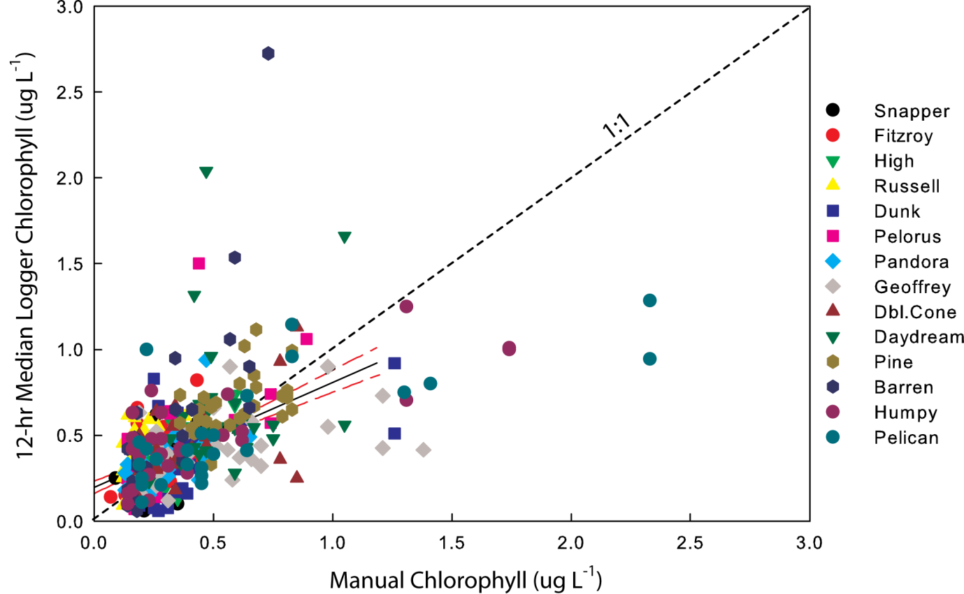

Figure A4- 3 A comparison between chlorophyll concentrations estimated by Wet Labs loggers and in situ chlorophyll sampled manually at the time of logger change-overs. The regression line (± 95% CI) for samples with chl a ≤ 1.0 µg L⁻¹) is: Logger median chl = 0.29 (manual chl) + 0. 24; r² = 0.12.

A number of potential sources of error or variability can affect estimates of in situ chlorophyll from loggers. They include:

- Inaccurate or inappropriate factory calibrations of the FLNTUSB chlorophyll sensors
- Temporal drift in logger calibration factors and offsets.
- Analytical issues (analytical variability, inherent biases) associated with manual fluorometric measurement of chlorophyll in validation samples.
- Spatial/temporal chlorophyll patchiness at the scale of logger measurements and manual sampling.
We discuss each of the four points in detail:
- Factory chlorophyll calibrations are based upon relationships between instrument responses to the analytically-determined chlorophyll content of suspensions of cultured eukaryotic microalgal cells (or a fluorescence proxy) across a range of chlorophyll concentrations. In single-point calibrations, there is also an explicit assumption of a zero fluorescence reading when there is no ‘standard’ material added. Fluorescence-based estimates of chlorophyll assume that natural phytoplankton populations with differing and variable floristic composition (pigment suites), pigment packaging and cell size characteristics produce the same instrumental response as the uni-algal cultures used in factory calibrations. This is a reasonably robust assumption. However; phytoplankton populations at inshore reef sites in the GBR are generally dominated by very small (< 2 µm) cyanobacteria (primarily Synechococcus. Very small cells are known to have absorptive and refractive properties different from larger cells (e.g. Morel and Bricaud 1986). The extent to which this affects the FLNTU chlorophyll sensor performance is not resolved. Cyanobacterial pigments (primarily chlorophyll a, di-vinyl chlorophyll a, zeaxanthin, phycoerythrin) differ from those in eukaryotes. At the present time, the default assumption is that these differences have negligible effect on logger chlorophyll readings, but further tests will be conducted to investigate the impact of these small cells on the chlorophyll readings.
- At present, it is assumed that logger instrumental responses to chlorophyll and SS concentrations are constant between periodic factory services. This can, to some degree, be checked with fluorescence or turbidity standards supplied with the instruments (e.g. Earp et al., 2011). The degree of variability in the dry chlorophyll calibration procedure was found to be sufficiently large that this procedure could not reliably verify calibration stability for the narrow range( 0 – 1 µg L⁻¹) of in situ chlorophyll concentrations normally encountered. However, the relative stability of the FLNTU turbidity: SS relationship across time and instruments suggests that instrument electronics and optical characteristics are, and have been, stable.

- Manual chlorophyll sampling and analysis is subject to a number of artefacts, including: non-quantitative collection of very small cells on the glass fibre filters (Whatman GF/F), loss of chlorophyll from broken cells on filters, incomplete pigment extraction, chlorophyll degradation during analysis, and errors in reading extracted chlorophyll fluorescence. A priori, these errors are presumed to be small, but further tests will be made over the next year to ensure that these artefacts do not impact our chlorophyll reading. Experiments in GBR nearshore waters (Furnas unpubl.) indicate that GF/F glass fibre filters have an operational pore size close to 0.5 µm; i.e. inshore chlorophyll concentrations derived from samples collected on GF/F filters (Whatman) are not statistically different from samples collected in parallel on filters with a more uniform and rigid pore size of 0.45 µm (Millipore HA). Chlorophyll measurements using ‘standard’ method of chlorophyll extraction (mechanical grinding in 90% acetone) and fluorometric detection (Parsons et al., 1984) average within approximately 10 percent of chlorophyll values determined using high-efficiency micro-extraction (shaking with zircon beads in 100% acetone) and HPLC chlorophyll quantitation (Appendix 3, Figure A3- 1).

- Direct comparisons between logger responses and discrete chlorophyll samples are based on the assumption that the phytoplankton cells and their chlorophyll are uniformly distributed through the water so that both approaches are sampling an identical, homogenous distribution of pigments. This is likely not the case. Discrete chlorophyll analyses are based on 100 ml water samples [(4.6 cm)³], while the FLNTU loggers have an ‘active’ sampling volume < 5 ml [(<1.7 cm)³]. If phytoplankton cells and chlorophyll are not uniformly distributed through the water on spatial scales of ~ 5 cm (e.g. algal-laden marine snow aggregates, large diatoms and diatom chains, Trichodesmium colonies), then the loggers may detect much higher or lower apparent chlorophyll concentrations than bulk water sampling. As this type of patchiness is likely to be a significant contributor to the observed short-term variability (‘spikiness’) we will investigate this spatial heterogeneity during a forthcoming MMP cruise.

While the four factors above that potentially affect logger calibrations and logger chlorophyll data records are well known from a theoretical perspective, they are very difficult to isolate and to independently quantify in a routine fashion. Until such time that information to do so is available, we have taken a null position – that they do not have a material net effect upon instrumental chlorophyll, and that manually sampled discrete chlorophyll samples are a genuine measure of spatially averaged in situ chlorophyll as seen by the loggers.

With this in mind, it is instructive to examine links between contiguous logger records and between concurrent operational estimates of chlorophyll determined by FLNTUSB loggers and discrete sampling. Figure A4- 4 to Figure A4- 17 presents ranges of chlorophyll concentrations measured in the 24-hour periods before and after logger changeovers by individual loggers and chlorophyll concentrations determined manually in a discrete sample collected during changeovers. The data are summarized in Table A4- 1. Normally, one (undisturbed) water sample was collected by divers at the changeover. Where there was a break (e.g. overnight) between a logger recovery and re-deployment, water samples were taken at both events. The histograms in Figure A4- 4 to Figure A4- 17 are colour-coded by individual loggers to facilitate comparison between instruments. Where a single manual chlorophyll sample was taken, the chlorophyll concentration is shown against both summaries of logger measurements about the changeover. Statistics for a 24 hour period were used as this reflects the nominal ‘average’ regional conditions around the site, involves a number of measurements (144) sufficient for calculating robust summary statistics and minimizes the likelihood of spikes distorting the comparisons. In general, tidal water excursions remain within a meso-scale (1-10 km) spatial domain at all sites, and within this area distributions of near-surface chlorophyll do not exhibit large variability in GBR waters. Similar summary statistics and graphics calculated for the 12-hour periods adjoining the changeovers (not shown) are very similar to those calculated for 24-hour periods.

Inspection of the differences between median chlorophyll estimates in the 24 hours before and after logger changeovers shows a variety of responses. In most cases, median chlorophyll concentrations in contiguous 24 hour of periods were not closely matched. Overlapping of the 25th to 75th percentile bands for contiguous 24-hour out-/in- logger records was observed in 39 ± 14 percent of cases at individual sites. Overlaps of the 10th to 90th percentile ranges occurred in 63 ± 15 percent of joins at individual sites. In a number of cases, however there was no overlap between ranges of chlorophyll readings in the two contiguous records (e.g. Figures A4-7, A4-8, A4-13).

Figure A4-18 presents the observed range of differences in logger chlorophyll concentrations (24-hr medians) at the end and beginning of contiguous deployments. The background colour scheme represents the dominant calibration regime in place at the time. Despite the changes in calibration schemes, the range of differences has remained relatively stable over the 5 years of logger deployments considered. A statistical test (t-test) of the magnitude of differences under the ‘old-dry’ and ‘new-wet’ calibration regimes were non-significant.

Table A4- 1 A summary of the closeness of join between contiguous logger chlorophyll records and with discrete chlorophyll determined at logger changeovers.
Logger statistics are based on the last- or first 24 hours of logger readings before or after a change-over (n~144 measurements). Logger comparisons were made for overlaps between the 25th to 75th and 10th to 90th percentile bands. Discrete chlorophyll values (mean of duplicate analyses) were compared with the 25th to 75th and the 10th to 90th percentile bands and the full range of logger chlorophyll values recorded in the adjoining 24 hours.

Site | Before-after  record  matchups | 25 - 75  %-ile overlap | % Total | 10- 90  %-ile overlap | % Total | Logger-Manual Chl  Match-ups | Chl within  10 to 90  %-ile band | % Total | Chl within  10 to 90  %-ile band | % Total | Chl within  24-hr  range | % Total
Snapper Is. | 13 | 5 | 0.38 | 8 | 0.62 | 30 | 5 | 0.17 | 12 | 0.40 | 17 | 0.57
Fitzroy Is. | 10 | 5 | 0.50 | 8 | 0.80 | 28 | 6 | 0.21 | 11 | 0.39 | 16 | 0.57
High Is. | 16 | 12 | 0.75 | 14 | 0.88 | 34 | 15 | 0.44 | 18 | 0.53 | 26 | 0.76
Russell Is. | 15 | 5 | 0.33 | 6 | 0.40 | 30 | 5 | 0.17 | 8 | 0.27 | 12 | 0.40
Dunk Is. | 12 | 5 | 0.42 | 7 | 0.58 | 27 | 8 | 0.30 | 12 | 0.44 | 20 | 0.74
Pelorus Is. | 14 | 5 | 0.36 | 8 | 0.57 | 29 | 7 | 0.24 | 8 | 0.28 | 13 | 0.45
Pandora Rf. | 16 | 6 | 0.38 | 12 | 0.75 | 29 | 8 | 0.28 | 14 | 0.48 | 18 | 0.62
Geoffrey Bay | 13 | 6 | 0.46 | 10 | 0.77 | 30 | 10 | 0.33 | 14 | 0.47 | 20 | 0.67
Double Cone Is. | 11 | 3 | 0.27 | 6 | 0.55 | 28 | 11 | 0.39 | 13 | 0.46 | 17 | 0.61
Daydream Is. | 14 | 5 | 0.36 | 6 | 0.55 | 28 | 11 | 0.26 | 9 | 0.33 | 14 | 0.50
Pine Is. | 14 | 5 | 0.36 | 9 | 0.64 | 27 | 8 | 0.30 | 10 | 0.37 | 20 | 0.74
Barren Is. | 11 | 4 | 0.36 | 6 | 0.55 | 24 | 5 | 0.21 | 6 | 0.25 | 15 | 0.63
Humpy Is. | 12 | 5 | 0.42 | 9 | 0.75 | 27 | 4 | 0.15 | 9 | 0.33 | 14 | 0.52
Pelican Is. | 12 | 1 | 0.08 | 8 | 0.67 | 25 | 5 | 0.20 | 8 | 0.32 | 15 | 0.60
Sum | 183 | 72 |  | 116 |  | 395 | 104 |  | 152 |  | 237
Mean |  |  | 0.39 |  | 0.63 |  |  | 0.26 |  | 0.38 |  | 0.60
1 S.D. |  |  | 0.14 |  | 0.15 |  |  | 0.09 |  | 0.09 |  | 0.11

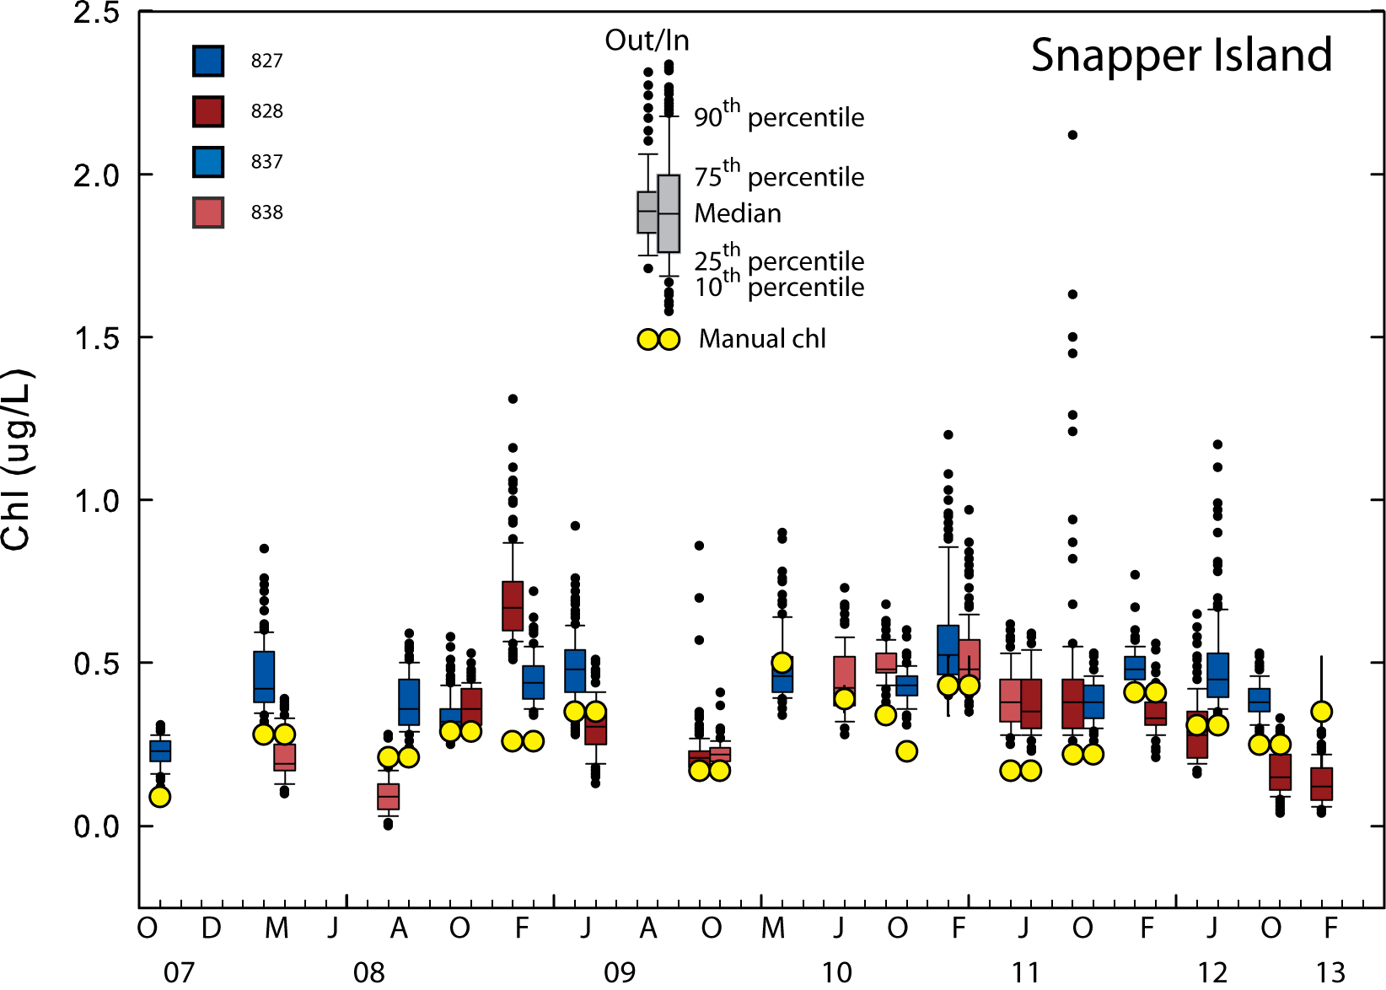

Figure A4- 4 Comparisons between logger chlorophyll concentrations measured at Snapper Island in the 24 hours before and after a change-over and the chlorophyll concentration determined from manual sampling at the changeover.
In a paired set, the left box and whisker plot summarizes data from the 24-hours before the changeover, and the right box and whisker plot summarizes the first 24-hours after. Data from individual loggers are colour-coded. Un-paired boxes indicate the absence of one set of logger data at the change-over. Coloured bars show the 25th to 75th percentile data range. Whiskers show the 10th to 90th percentile range. Small black symbols show data outside of this range. Doublet yellow circles indicate only a single manual chlorophyll sample applies to both Out- and In- logger records.

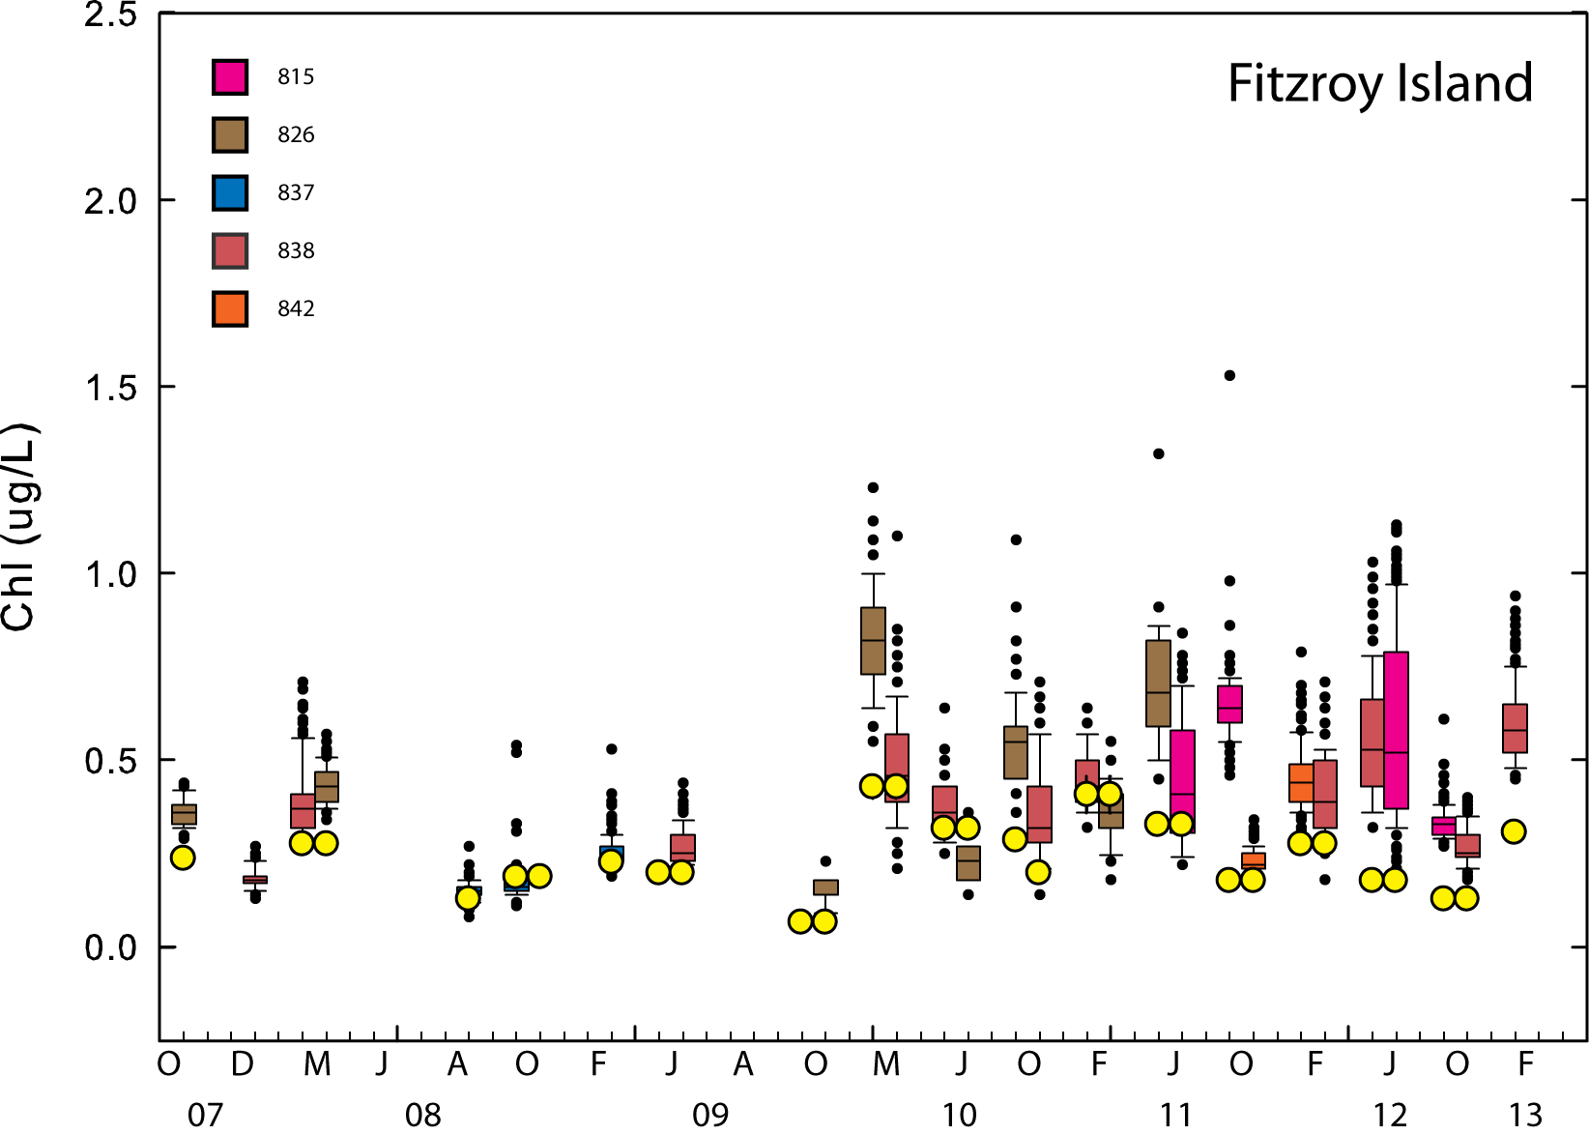
Figure A4- 5 Comparisons between logger chlorophyll concentrations measured at Fitzroy Island in the 24 hours before and after a change-over and the chlorophyll concentration determined from manual sampling at the changeover. Symbols are as given in Figure A4- 4.

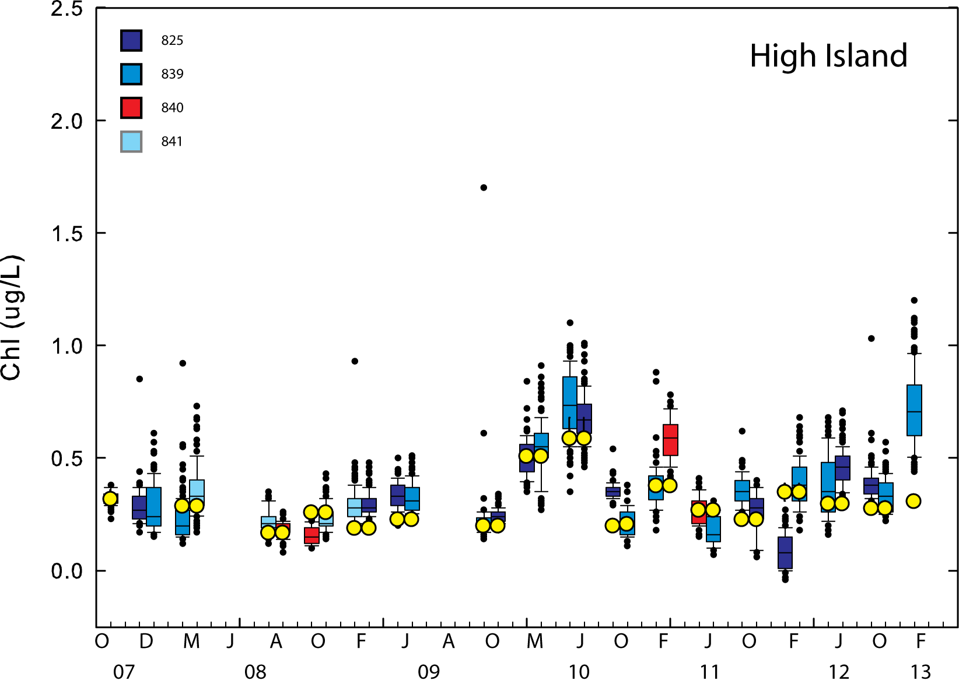

Figure A4- 6 Comparisons between logger chlorophyll concentrations measured at High Island in the 24 hours before and after a change-over and the chlorophyll concentration determined from manual sampling at the changeover. Symbols are as given in Figure A4- 4.
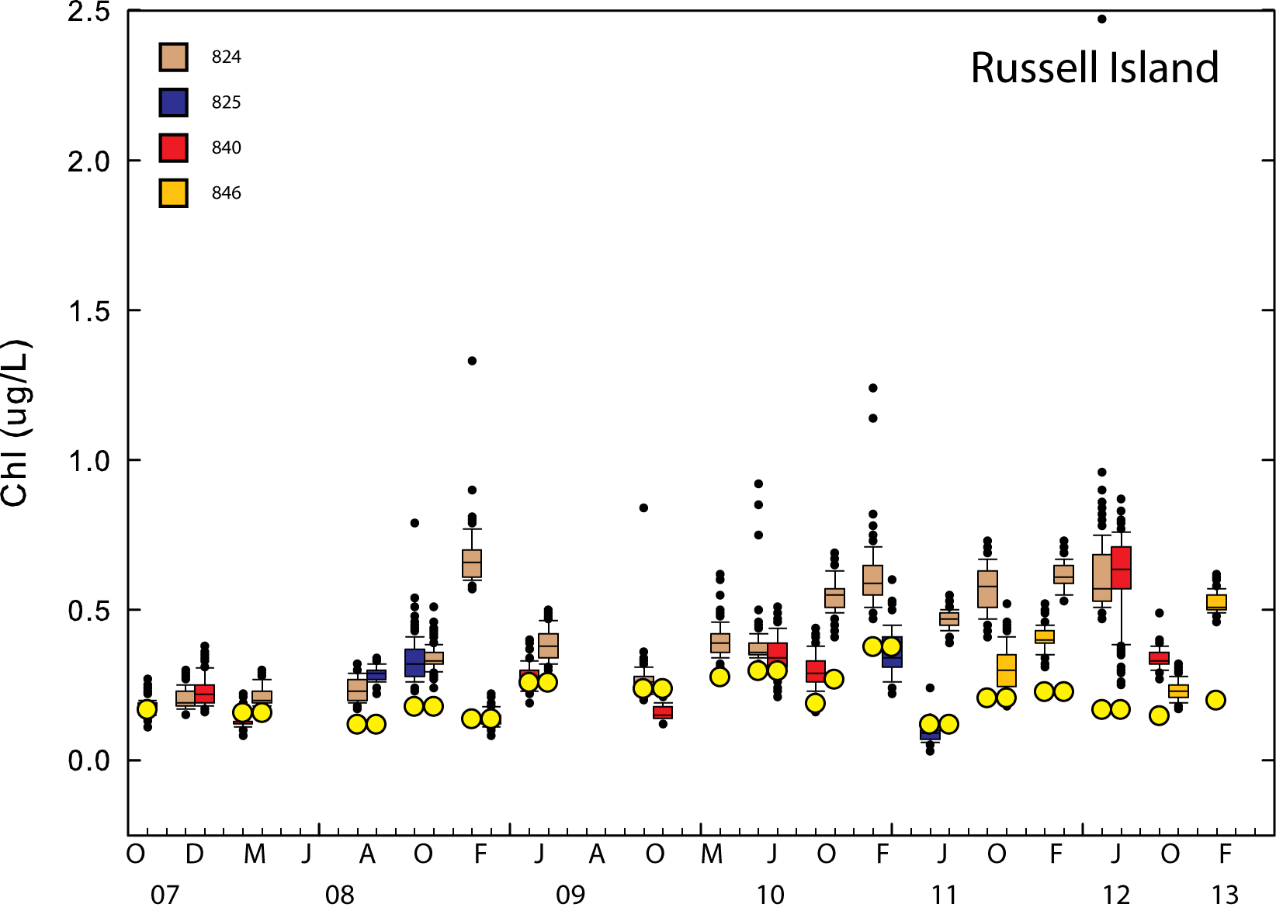

Figure A4- 7 Comparisons between logger chlorophyll concentrations measured at Russell Island in the 24 hours before and after a change-over and the chlorophyll concentration determined from manual sampling at the changeover. Symbols are as given in Figure A4- 4.

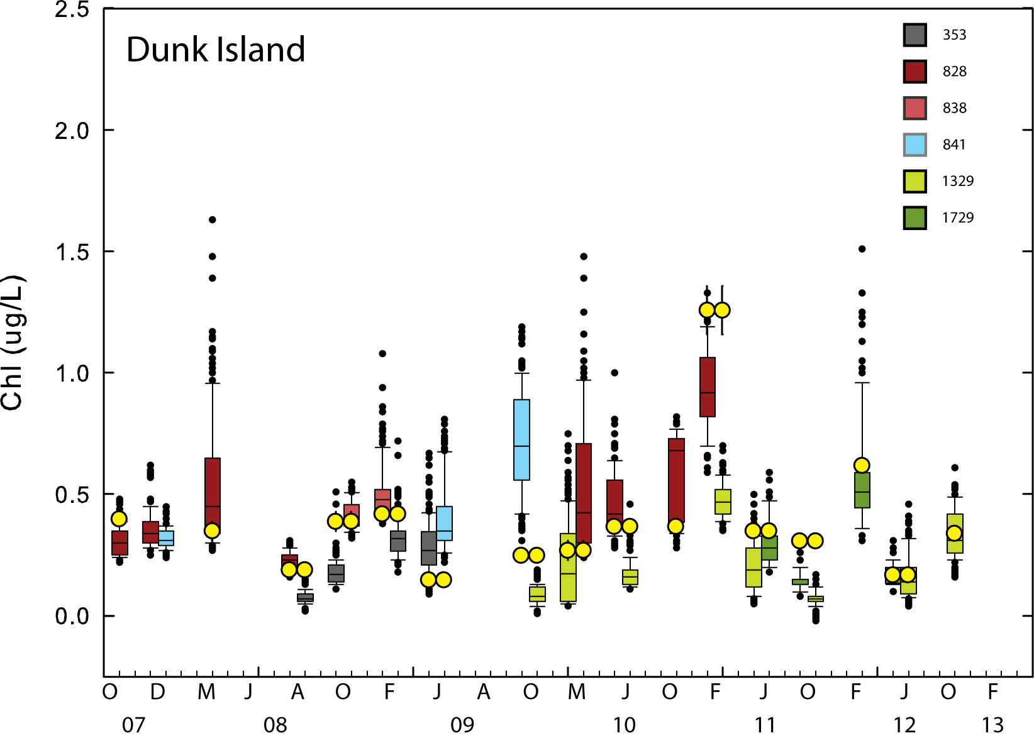

Figure A4- 8 Comparisons between logger chlorophyll concentrations measured at Dunk Island in the 24 hours before and after a change-over and the chlorophyll concentration determined from manual sampling at the changeover. Symbols are as given in Figure A4- 4.

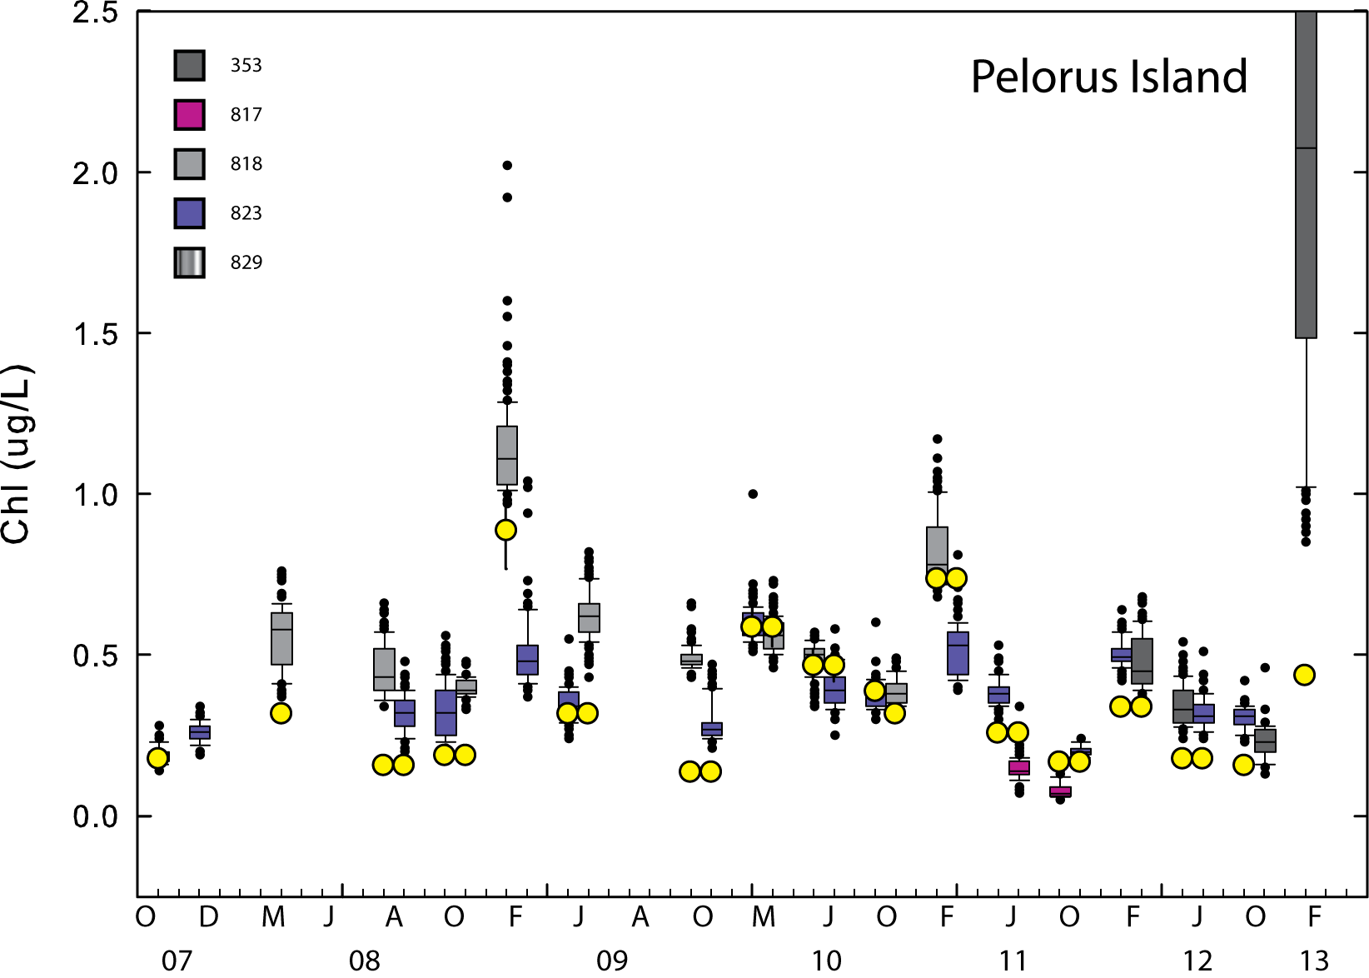

Figure A4- 9 Comparisons between logger chlorophyll concentrations measured at Pelorus Island in the 24 hours before and after a change-over and the chlorophyll concentration determined from manual sampling at the changeover. Symbols are as given in Figure A4- 4.

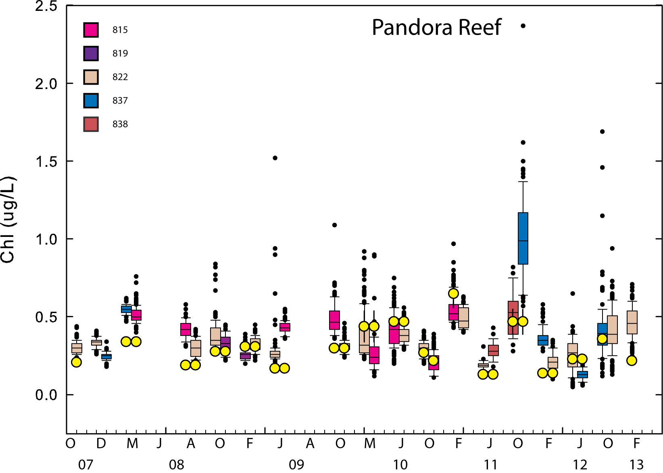

Figure A4- 10 Comparisons between logger chlorophyll concentrations measured at Pandora Reef in the 24 hours before and after a change-over and the chlorophyll concentration determined from manual sampling at the changeover. Symbols are as given in Figure A4- 4.

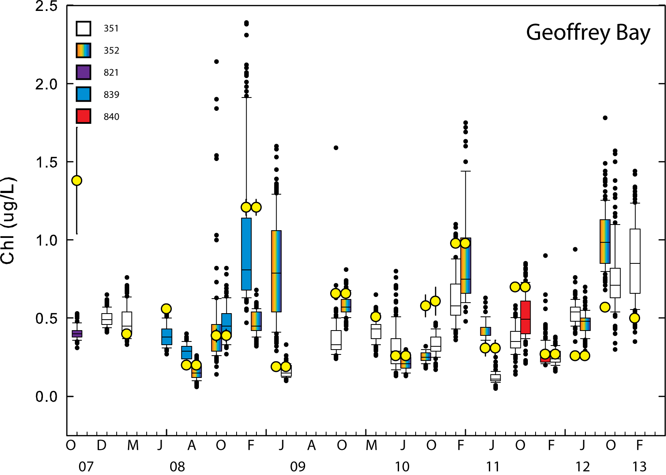

Figure A4- 11 Comparisons between logger chlorophyll concentrations measured at Geoffrey Bay in the 24 hours before and after a change-over and the chlorophyll concentration determined from manual sampling at the changeover. Symbols are as given in Figure A4- 4.

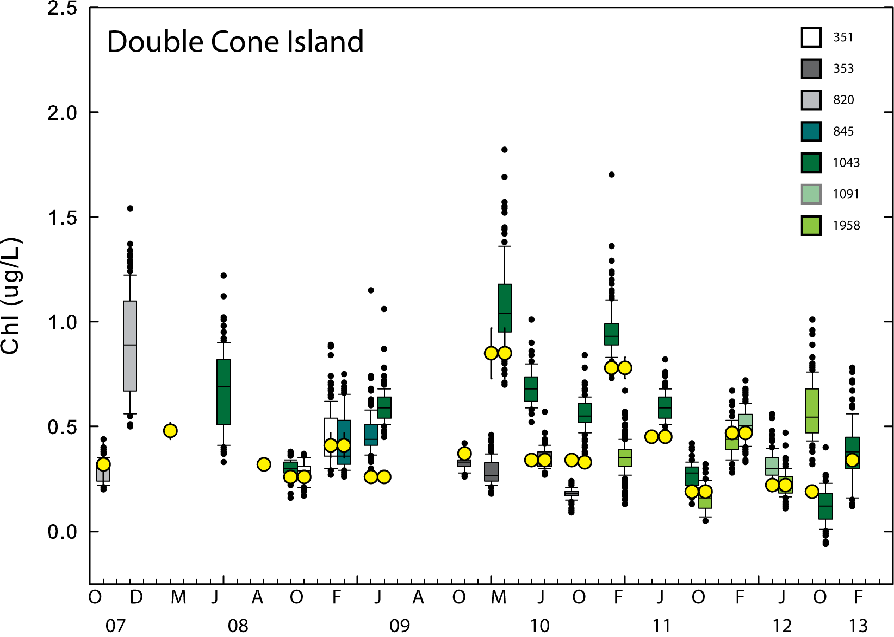

Figure A4- 12 Comparisons between logger chlorophyll concentrations measured at Double Cone Island in the 24 hours before and after a change-over and the chlorophyll concentration determined from manual sampling at the changeover. Symbols are Symbols are as given in Figure A4- 4.

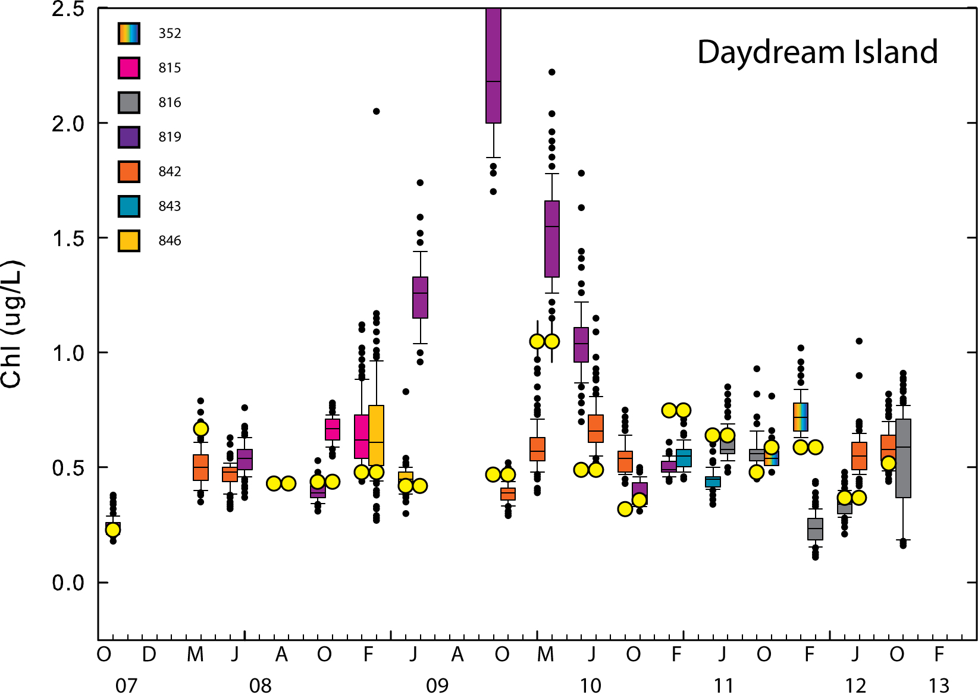

Figure A4- 13 Comparisons between logger chlorophyll concentrations measured at Daydream Island in the 24 hours before and after a change-over and the chlorophyll concentration determined from manual sampling at the changeover. Symbols are as given in Figure A4- 4.

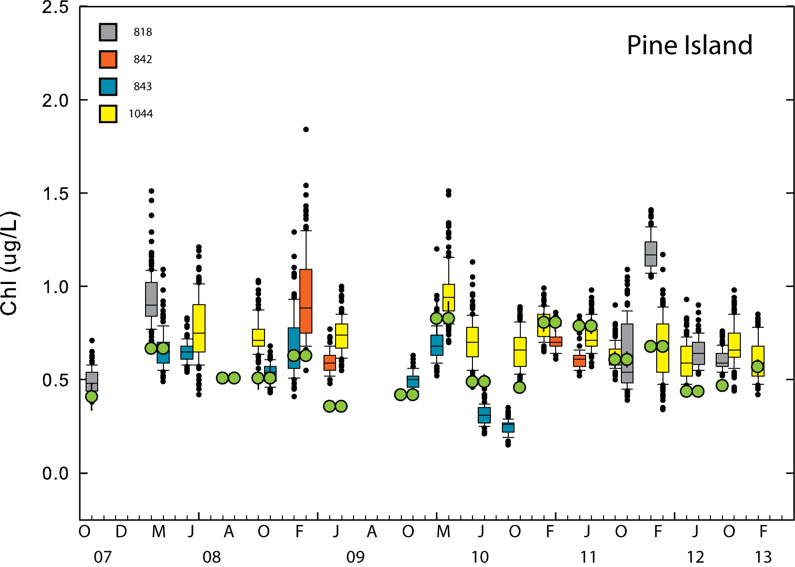

Figure A4- 14 Comparisons between logger chlorophyll concentrations measured at Pine Island in the 24 hours before and after a change-over and the chlorophyll concentration determined from manual sampling at the changeover. Symbols are as given in Figure A4- 4.

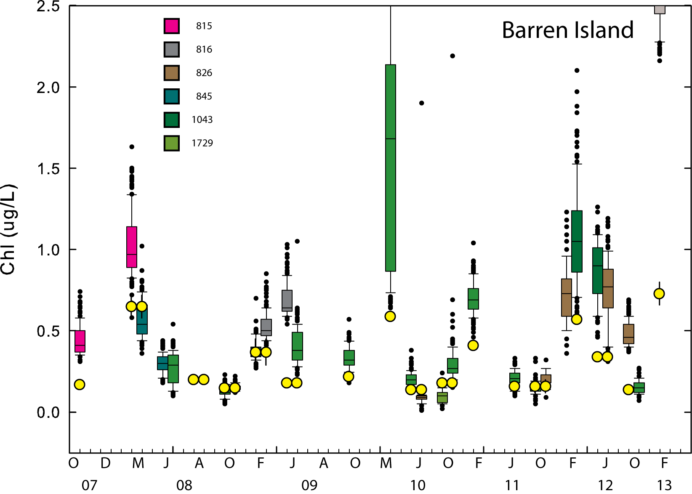

Figure A4- 15 Comparisons between logger chlorophyll concentrations measured at Barren Island in the 24 hours before and after a change-over and the chlorophyll concentration determined from manual sampling at the changeover. Symbols are as given in Figure A4- 4.
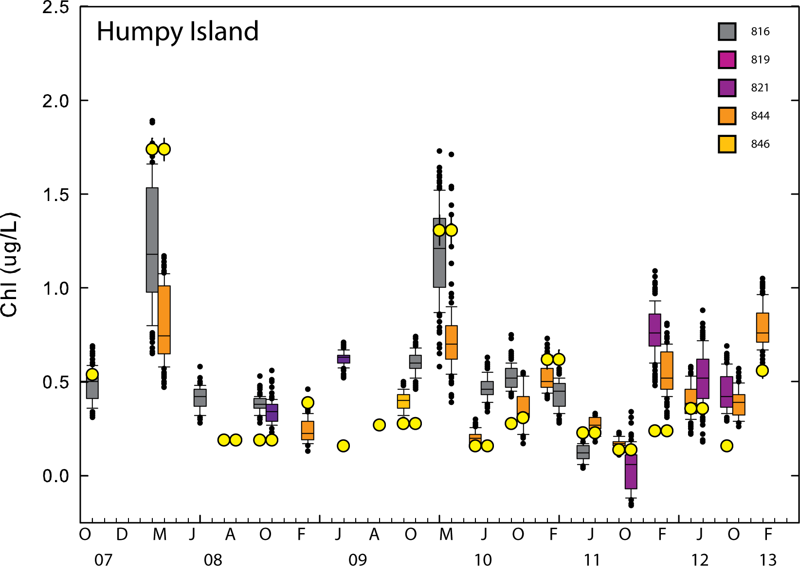

Figure A4- 16 Comparisons between logger chlorophyll concentrations measured at Humpy Island in the 24 hours before and after a change-over and the chlorophyll concentration determined from manual sampling at the changeover. Symbols are as given in Figure A4- 4.

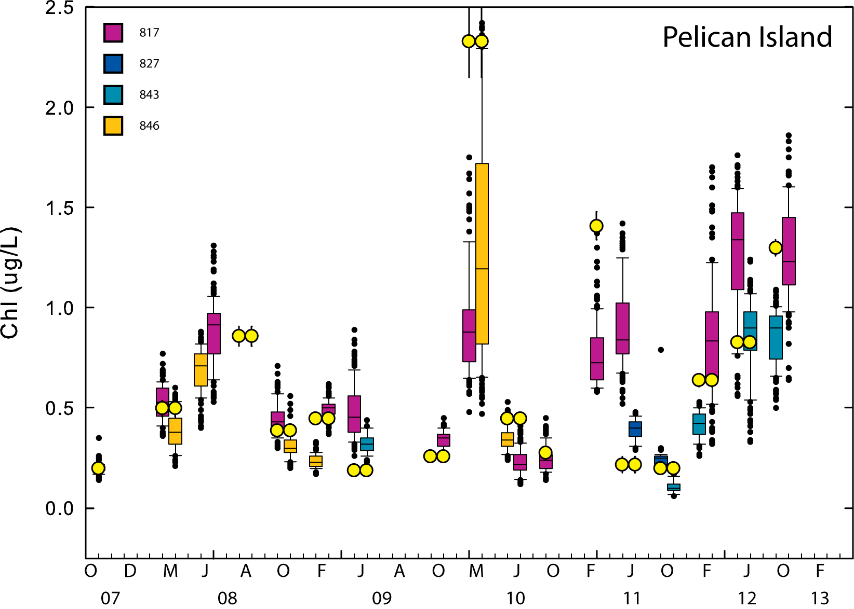

Figure A4- 17 Comparisons between logger chlorophyll concentrations measured at Pelican Island in the 24 hours before and after a change-over and the chlorophyll concentration determined from manual sampling at the changeover. Symbols are as given in Figure A4- 4.

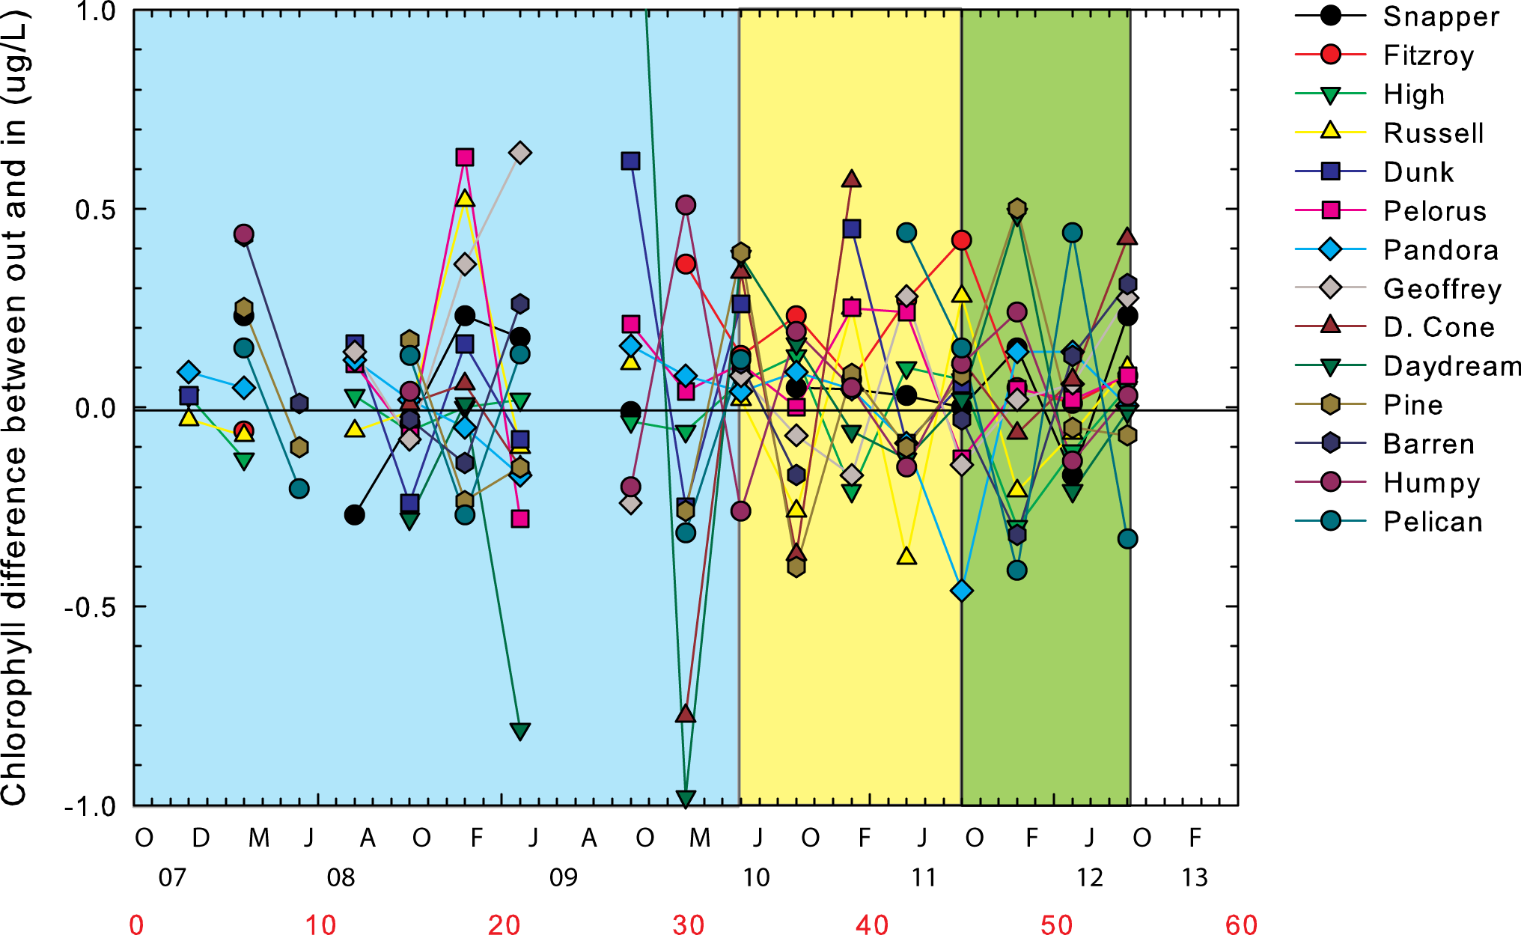

Figure A4- 18 Differences between 24-hour median chlorophyll concentrations (µg L⁻¹) measured by pairs of loggers (outgoing, incoming) at logger changeovers. The green-shaded background indicates that logger readings were factory calibrated using the ‘wet’- uranine method. Yellow shading indicates the period where factory ‘dry’ calibrations could be overlapped with ‘wet’ calibrations. Blue shading indicates the period where only ‘dry’ calibrations were used.

Despite the differences between logger-derived and manual measurements of chlorophyll, it is important to note that large or long-term (~ 1 year) fluctuations in chlorophyll concentration over the full time period of deployments considered were largely captured by both manual and instrumental measurement methods. Manual validation chlorophyll values fell within the daily (24-hour) range of instrument-recorded chlorophyll values for at least one logger at 94 percent of changeovers.

To further resolve observed inter-logger differences and check factory calibrations, seven (7) experiments carried out at the AIMS wharf site between January 2012 and October 2013 have been further analysed. These experiments involved simultaneous deployments of twelve (12) to sixteen (16) individual loggers. Figures A4-19 to A4-21 present examples of data obtained from three experiments run in January 2012, May 2012 and July 2013.

In each experiment, the loggers where mounted pointing downward in a rigid frame so that individual logger sensor heads were within 55 cm of each other. The loggers generally sampled at 10 min intervals (n=306 readings over 51 hours) and were set to sample at the same time. In two experiments when logging occurred at a higher rate, the raw records were sub-sampled at 5-minute intervals. Apart from small-scale spatial variability on the order of 10’s of cm or less, all loggers essentially measured chlorophyll at the same time in the same patch (ca. 1 m³) of water. Chlorophyll concentrations were calculated using the most recent and appropriate factory calibration for each logger. Most of these calibrations were based on the ‘wet’ uranine method, or could be ratio-corrected to a wet standard.

Inspection of logger records from particular experiments showed often quite divergent results within a group of loggers (e.g. Fig. A4-19). Differences between chlorophyll concentrations in the raw records could exceed 1 µg L⁻¹. The operational question was: To what extent were the individual loggers measuring different amounts of chlorophyll (spatial patchiness), or responding differently to the same amount of chlorophyll (instrumental bias).

Individual logger data records for each experiment were de-trended and normalized to a common zero value by subtracting the mean chlorophyll value for each sampling time from each individual data point at that time. The thick red line in the top panel of the three example plots show the average chlorophyll reading over the two-day period.

Inspection of the plotted differences from the mean value over time (middle panel) always showed that some loggers in each experiment were consistently high and some were consistently low relative to the mean chlorophyll value. At any particular time, the record could span a chlorophyll range between several 0.1’s of µgL⁻¹ to > 1 µgL⁻¹.

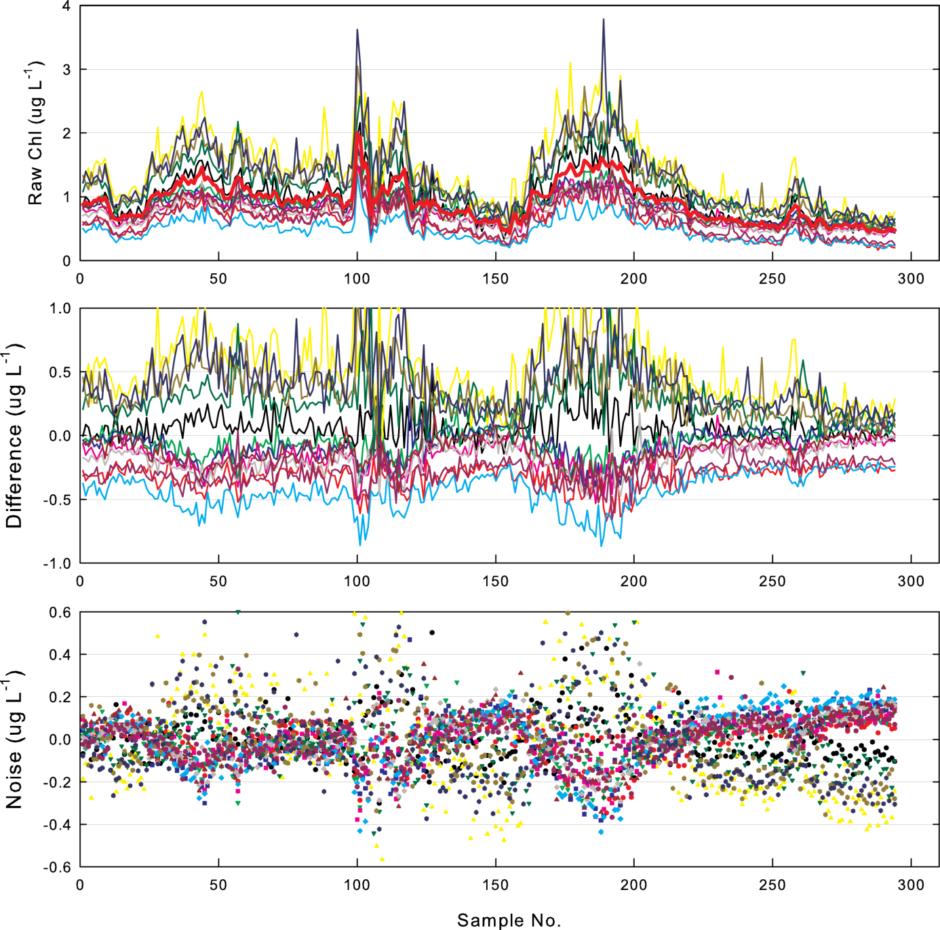

Figure A4- 19 [Top] Time series of raw chlorophyll readings from 12 loggers deployed simultaneously from the AIMS wharf in January 2012. The heavy red line indicates the mean of each set of successive readings taken by all loggers at 10-minute intervals. [Middle] Time series of differences of individual logger readings from the mean reading of all instruments at one sampling time. [Bottom] A time series of the range of readings at any one time if the mean differences of individual loggers (offsets) are subtracted from individual readings.

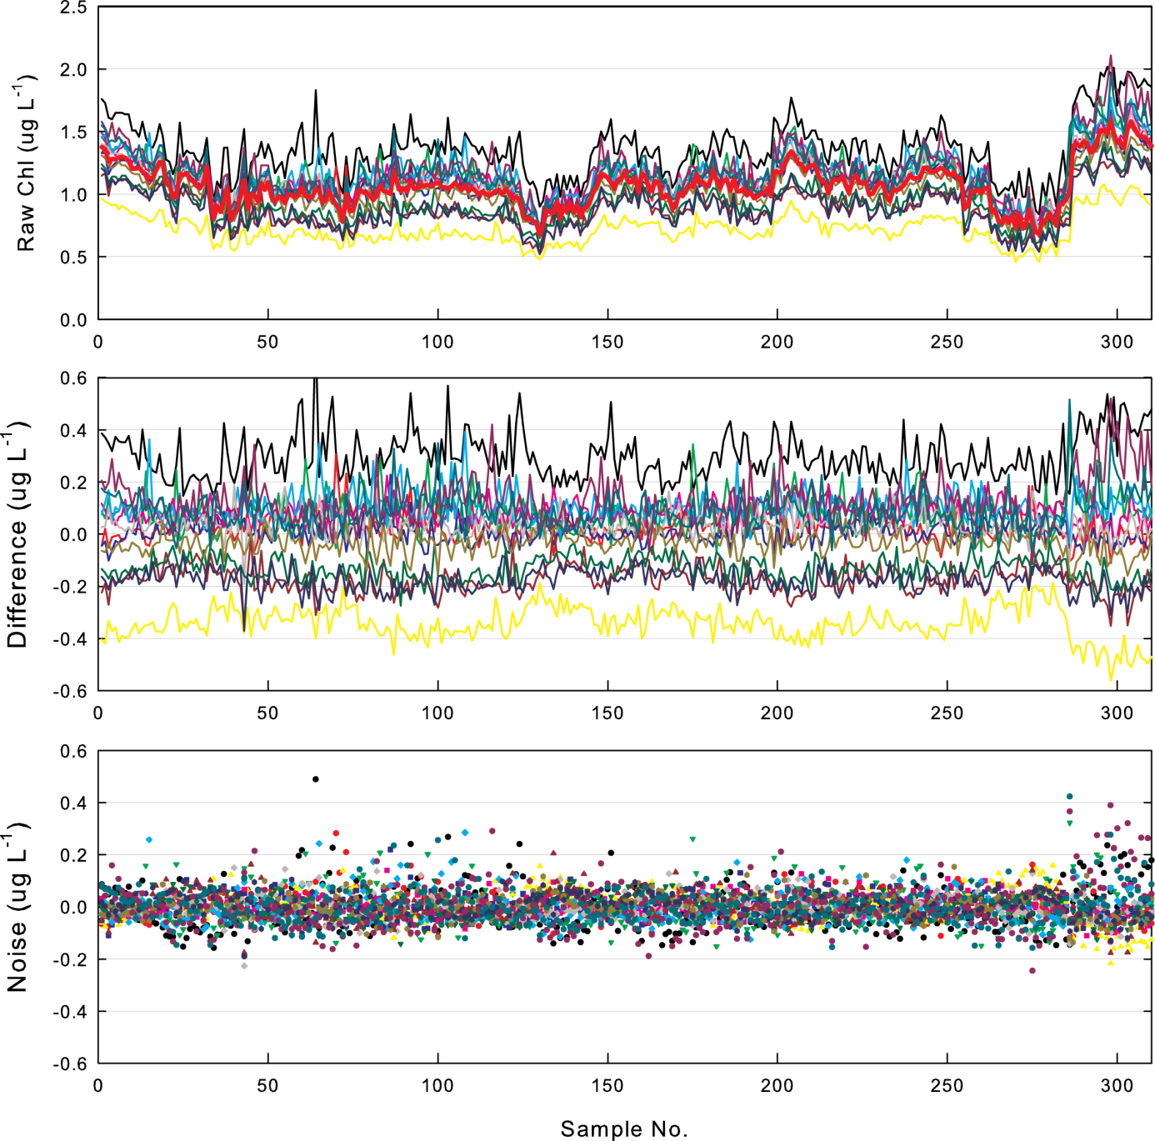

Figure A4- 20 [Top] Time series of raw chlorophyll readings from 14 loggers deployed simultaneously from the AIMS wharf in May 2012. The heavy red line indicates the mean of each set of successive readings taken by all loggers at 10-minute intervals. [Middle] Time series of differences of individual logger readings from the mean reading of all instruments at one sampling time. [Bottom] A time series of the range of readings at any one time if the mean differences of individual loggers (offsets) are subtracted from individual readings.

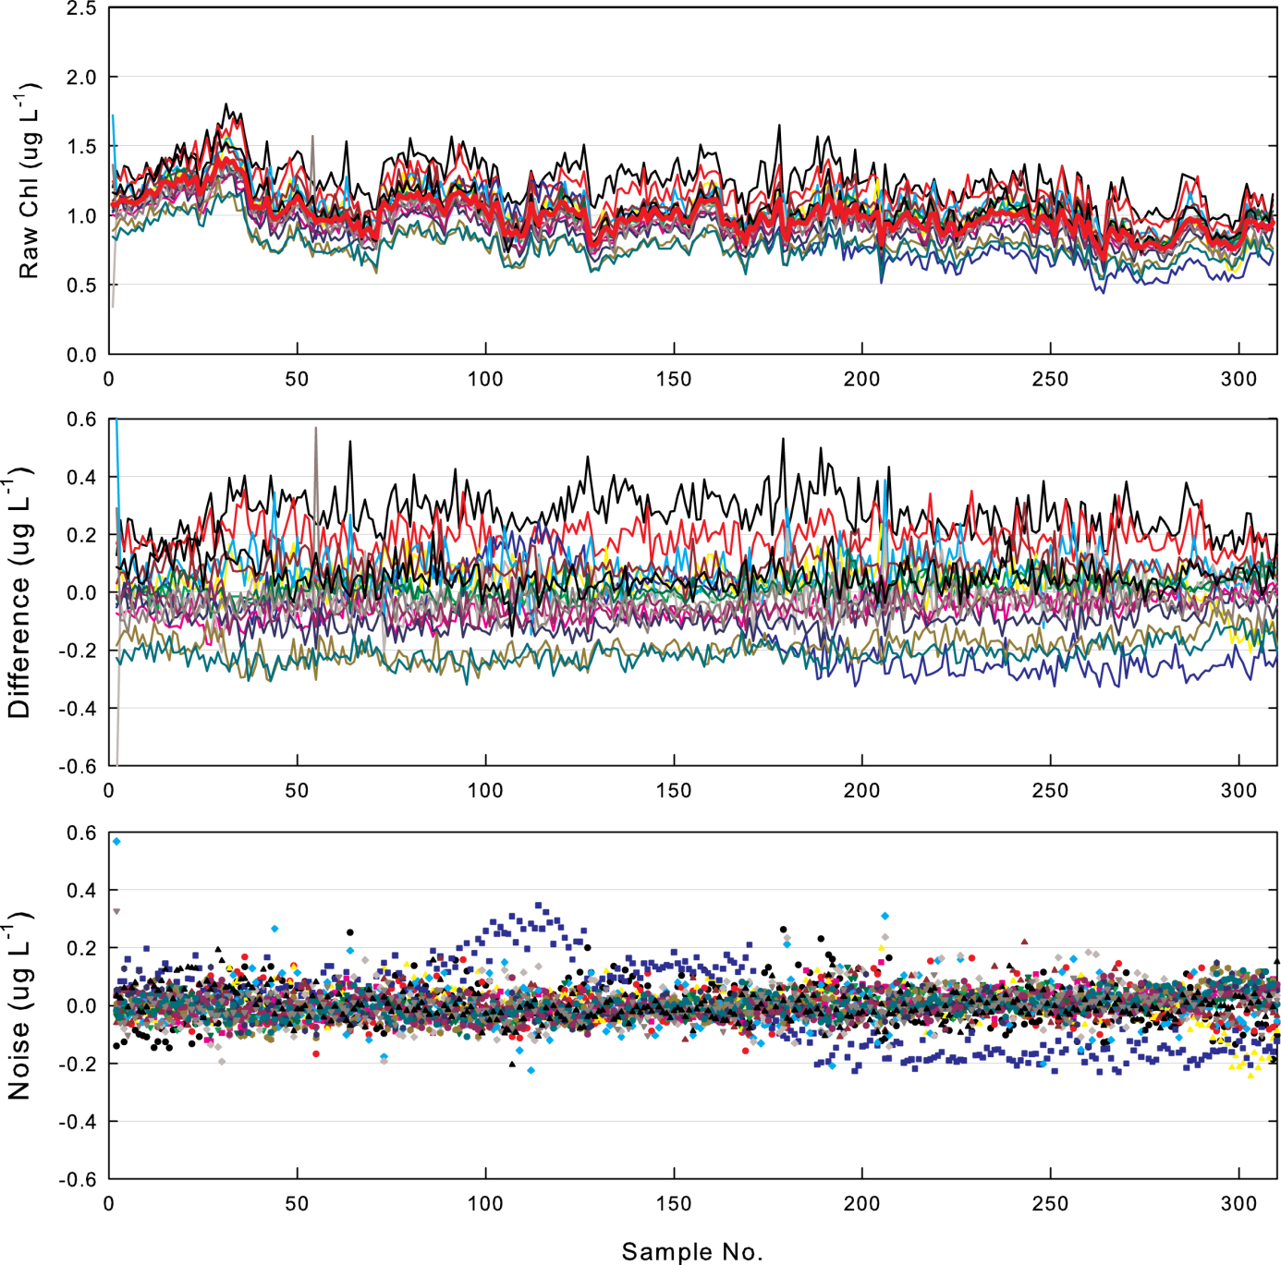

Figure A4- 21 [Top] Time series of raw chlorophyll readings from 16 loggers deployed simultaneously from the AIMS wharf in July 2013. The heavy red line indicates the mean of each set of successive readings taken by all loggers at 10-minute intervals. [Middle] Time series of differences of individual logger readings from the mean reading of all instruments at one sampling time. [Bottom] A time series of the range of readings at any one time if the mean differences of individual loggers (offsets) are subtracted from individual readings.

Table A4- 2 Mean deviations of individual, de-trended logger chlorophyll records from the time series of mean values in each of seven experiments carried out at the AIMS wharf during 2012 and 2013. Logger 821 is the ‘golden logger’ used as a laboratory reference. Logger serial numbers without decimal places indicate original optics on the instrument, and the decimals indicate the version number with replaced optics which is effectively a different instrument. Shaded means and medians identify loggers with consistent trends below the mean. Where no deviations are recorded loggers had failed prior to these experiments.

Logger serial number | Jan 2012 | Feb 2012 | May 2012 | Jun 2012 | Sept 2012 | July 2013 | Oct 2013 | Mean | Median
351.03 |  |  |  | 0.10 | -0.02 |  | 0.01 | 0.03 | 0.01
352.03 |  | -0.40 |  |  |  | 0.27 |  | -0.07 | -0.07
353.02 |  |  | 0.30 | 0.09 |  |  | -0.45 | -0.02 | 0.09
815.01 | 0.06 |  |  | 0.56 |  | 0.19 |  | 0.27 | 0.19
816.01 | -0.32 |  |  | -0.34 | 0.03 |  | 0.08 | -0.14 | -0.15
817.01 |  |  |  | 0.08 | 0.01 |  | 0.00 | 0.03 | 0.01
818 |  | 0.42 | 0.02 |  |  | 0.01 |  | 0.15 | 0.02
819.01 |  | 0.44 | 0.08 |  |  | 0.04 |  | 0.19 | 0.08
820
821 | -0.05 |  | -0.34 |  | -0.01 | -0.10 | -0.21 | -0.14 | -0.10
822.01 | 0.53 |  |  | 0.19 | 0.11 |  | 0.20 | 0.26 | 0.20
823 |  |  | 0.01 |  |  | -0.06 |  | -0.03 | -0.03
824.01 | -0.08 |  |  | -0.14 |  | 0.08 |  | -0.05 | -0.08
825 |  | 0.03 | 0.08 |  |  | -0.01 |  | 0.03 | 0.03
826.01 |  | -0.65 | 0.11 |  |  | 0.09 |  | -0.15 | 0.09
827 |  | 0.02 | 0.04 |  |  | 0.01 |  | 0.02 | 0.02
828 | -0.16 |  |  | -0.24 | -0.21 |  | -0.29 | -0.23 | -0.23
829
837 |  | 0.04 | -0.17 |  |  | -0.19 |  | -0.11 | -0.17
838.01 | -0.43 |  |  | -0.39 | 0.05 |  | 0.20 | -0.14 | -0.17
839 | -0.18 |  |  |  | -0.11 |  | -0.22 | -0.17 | -0.18
840 |  | -0.03 | -0.13 |  |  | -0.09 |  | -0.08 | -0.09
841
842 |  | 0.28 | -0.03 |  |  | 0.04 | 0.02 | 0.08 | 0.03
843 |  | -0.18 | -0.18 |  |  | -0.21 |  | -0.19 | -0.18
844 | -0.12 |  |  | -0.22 | -0.05 |  | -0.20 | -0.15 | -0.16
845
846 |  | 0.32 |  | 0.12 | -0.01 |  | -0.06 | 0.09 | 0.06
1043.01 | 0.28 |  |  | -0.03 | 0.10 |  | 0.10 | 0.11 | 0.10
1044.01 | 0.35 |  |  | 0.10 | 0.02 |  | 0.11 | 0.15 | 0.11
1091.01 | 0.42 |  |  | 0.09 | -0.03 | -0.04 |  | 0.11 | 0.03
1329 |  |  | 0.13 |  |  |  |  | 0.13 | 0.13
1729 | -0.29 |  |  | -0.33 | 0.22 |  | 0.08 | -0.08 | -0.11
1958 |  | -0.29 | 0.09 |  |  | 0.05 |  | -0.05 | 0.05

When the average differences of each logger record from the running time mean of all loggers in a particular experiment (Summarized in Table A4-2) were subtracted from each de-trended, normalized logger record, the individual records collapsed into a much narrower and more random band of values (Bottom panels). With individual logger offsets removed, the de-trended chlorophyll values were generally within a band ± 0.1 µgL⁻¹ of the running time central value, although data points for individual loggers could deviate by wider margins. This narrower variability range for most of the time is of similar order to the operational precision of manual chlorophyll determinations by fluorometry (Parsons et al. 1984) given the vagaries of small-scale spatial variability in chlorophyll concentrations and analytical variability.

Sources of variability within this residual range are still being analysed. Some of this variability is due to as-yet unresolved (but inevitable) errors or uncertainties in the factory calibration slope and offset values. In cases during the wharf experiments where the range of logger readings increased as the mean chlorophyll concentration increased (e.g. Figure A4-19), the differences between individual loggers are clearly influenced by real differences in the calibration slope values. Conversely, where the difference remains constant over changing concentrations, the differences between logger readings is more influenced by the intercept (zero offset error) of the calibration. However, as the residual variations in logger records (Bottom panels) appear to be of a more random nature, a significant degree of variability is likely due to natural small-scale spatial variability (patchiness) of chlorophyll which is packaged in small, and not-so-small, particles such as cyanobacteria, Trichodesmium colonies or marine snow aggregates.

Field Results – Validation Samples

The general correspondence between logger-derived time series of daily median chlorophyll and turbidity (Figures A4-22 to A4-35 as examples) and in situ validation samples collected by divers clearly show that the WET Labs loggers are successfully capturing the larger and longer term temporal pattern (event, seasonal, inter-annual) of variability of these parameters at the individual reef sites. This agreement clearly shows that the logger time series for individual sites are useful for identifying and quantifying large-magnitude event-scale variability, inter-annual variability in ‘baseline’ chlorophyll or NTU, and for identifying secular trends in chlorophyll concentration and turbidity at these sites. However, the calculation of whether conditions at a particular site fall above or below a particular threshold value and the amount of time that conditions exceed defined values requires greater certainty about the values produced by the loggers in individual 4-month records. For the most part, turbidity values produced by the loggers are tightly correlated with measurements of SS (Figure A3-2; Figures A4-22 to A4-35), indicating that the loggers produce reliable turbidity estimates. The closeness of fit between logger-derived chlorophyll concentrations and values derived from diver-collected validation samples, however, was more variable, both within individual time series at one site and between sites.

Empirical comparison between temporal trends of daily median chlorophyll and NTU values and validation samples generally show a good correspondence. Manual values are generally close to instrumental values on the day, or fall within the day-to-day range of median values near the time of sampling.

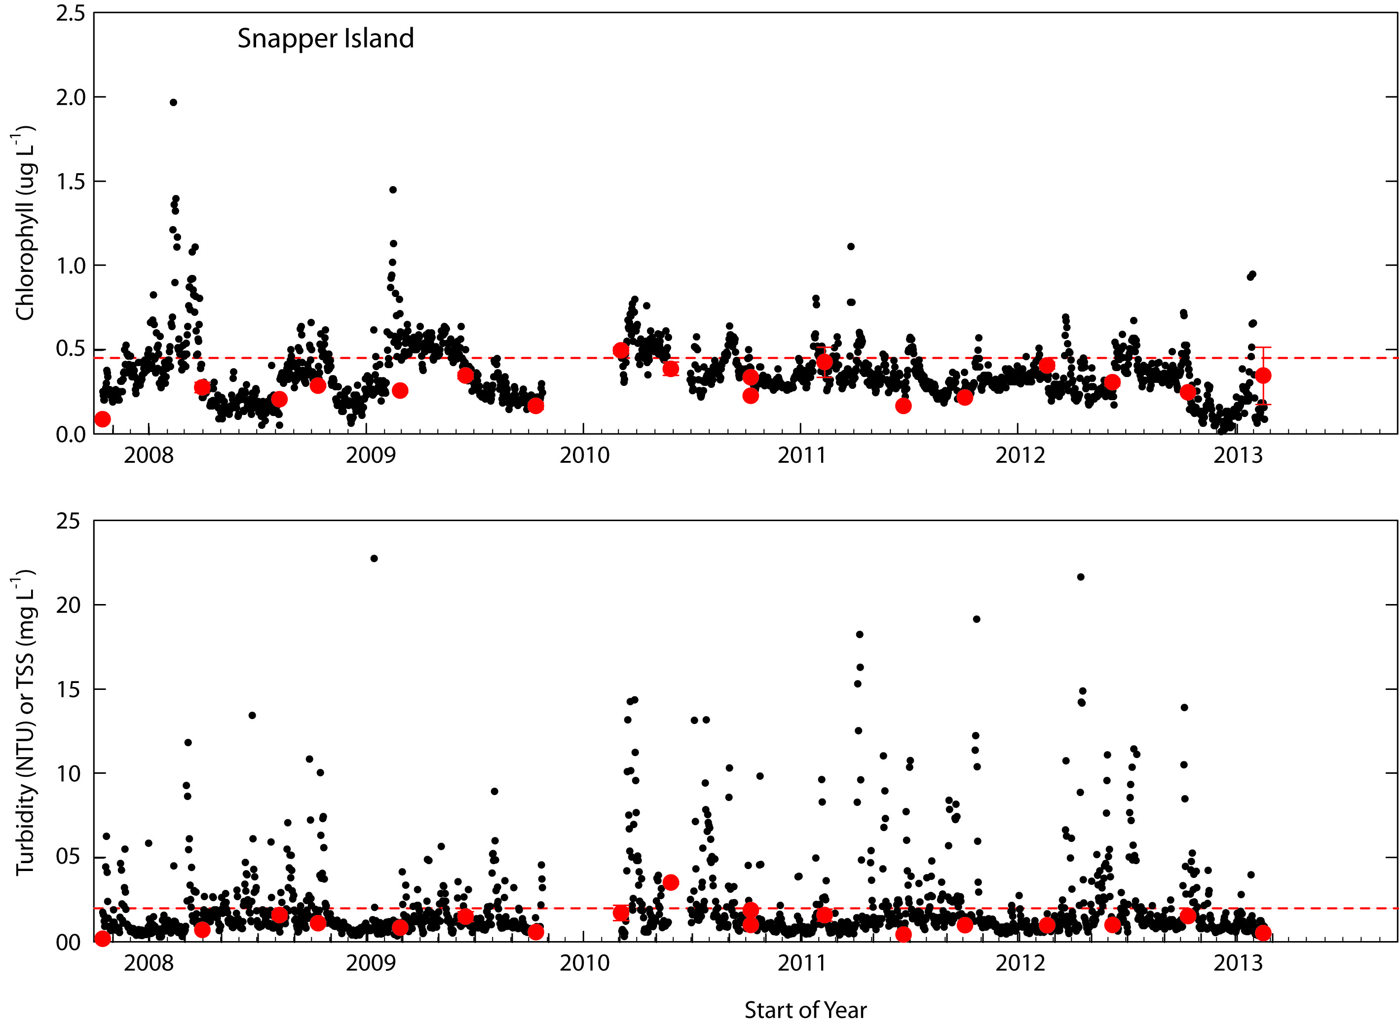

Figure A4-22 Comparisons between logger-derived time series of daily median chlorophyll concentrations (Top) and turbidity (Bottom) at the Snapper Island logger site and levels of these variables in diver-collected validation samples. The horizontal dotted lines indicate the GBR Water Quality Guideline values (GBRMPA 2010).
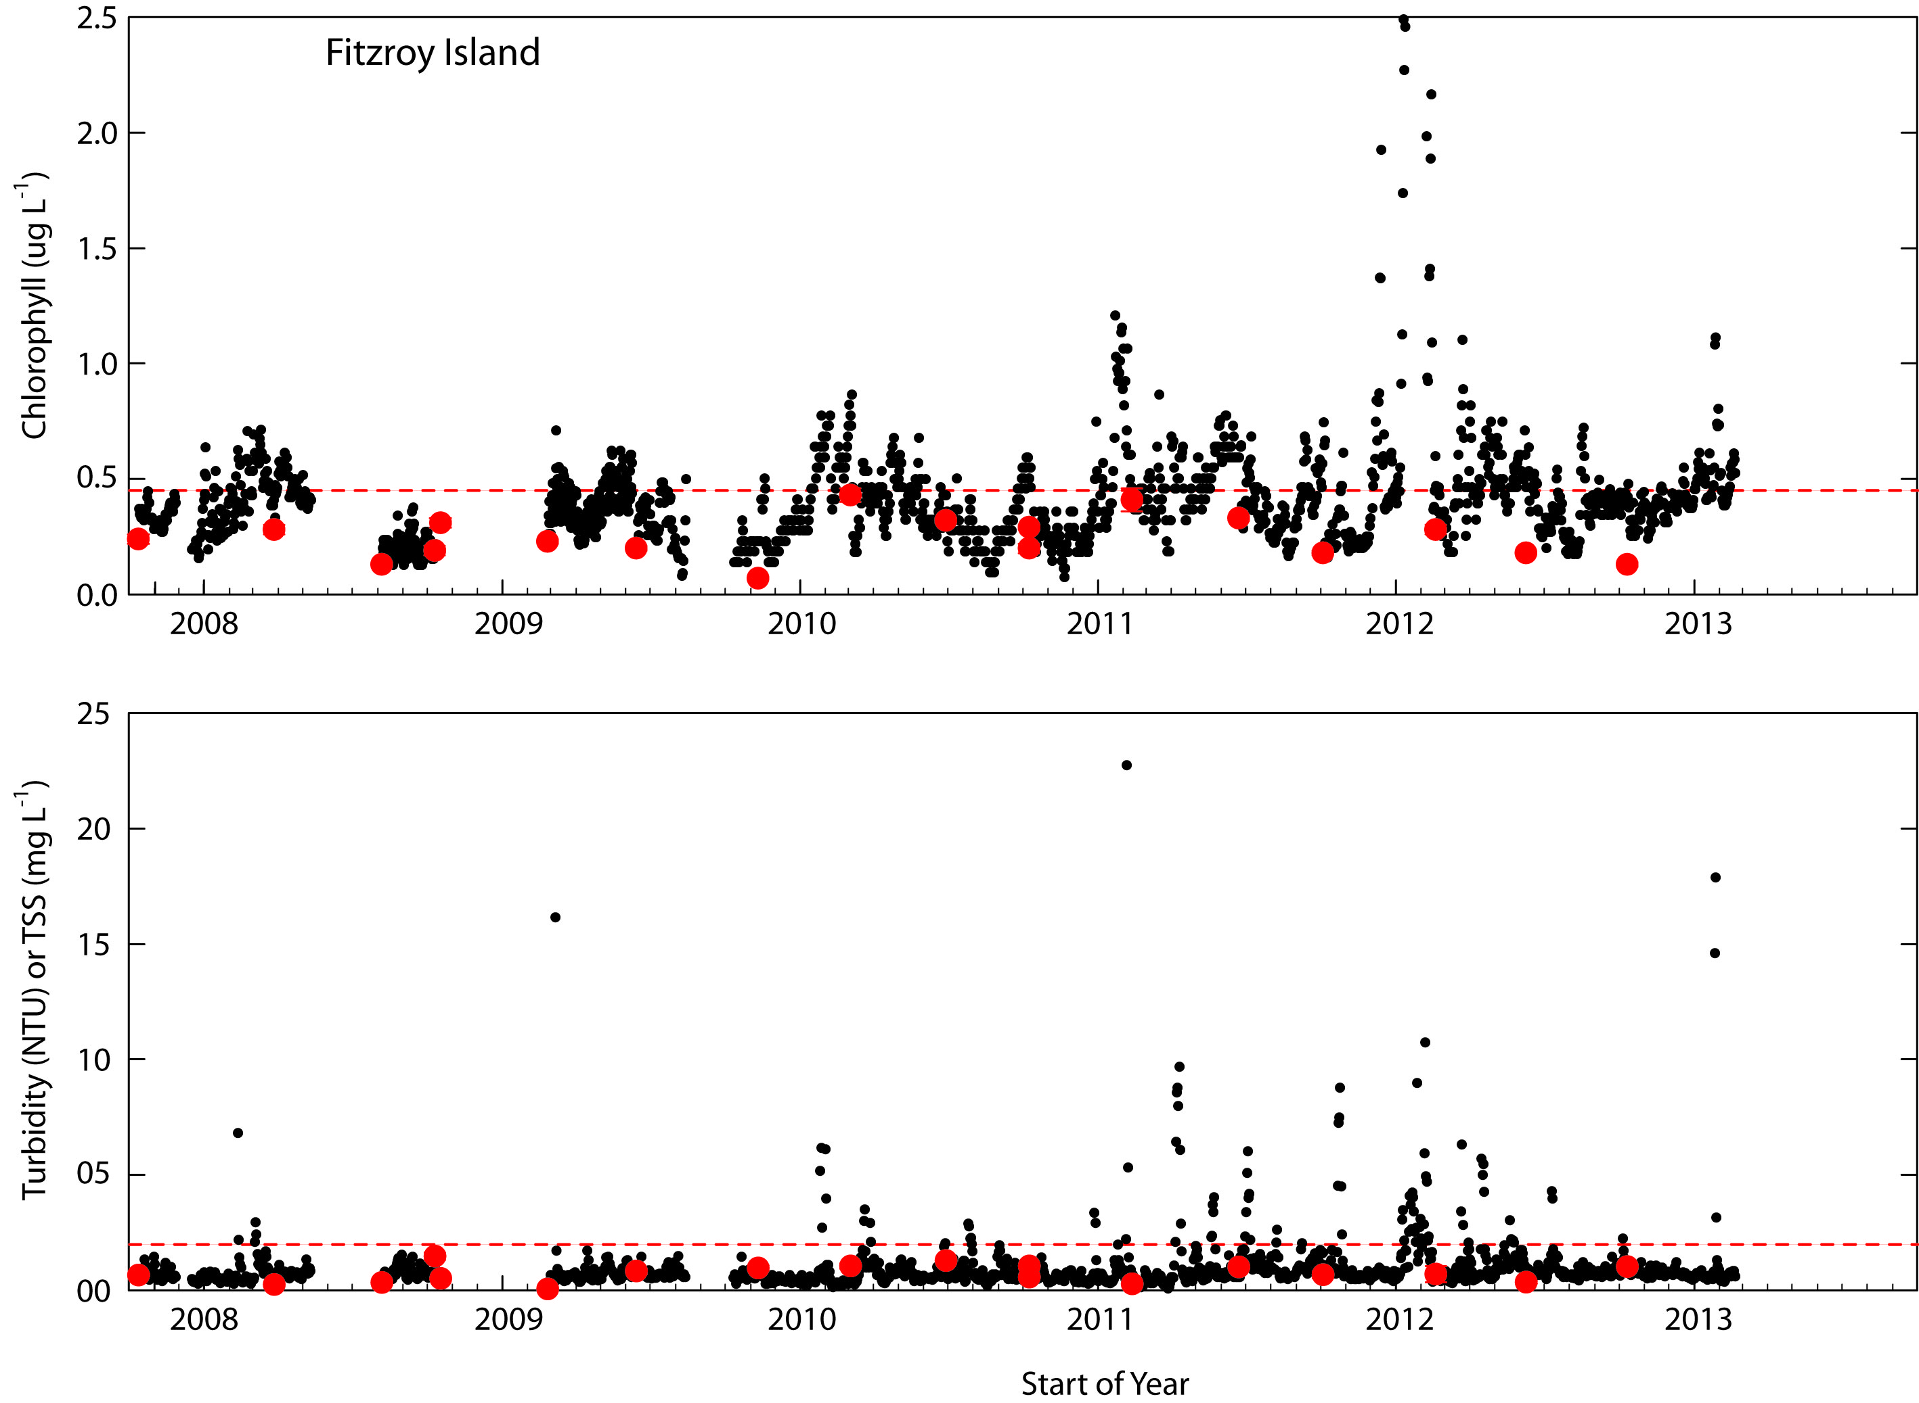

Figure A4-23 Comparisons between logger-derived time series of daily median chlorophyll concentrations (Top) and turbidity (Bottom) at the Fitzroy Island logger site and levels of these variables in diver-collected validation samples. The horizontal dotted lines indicate the GBR Water Quality Guideline values (GBRMPA 2010).
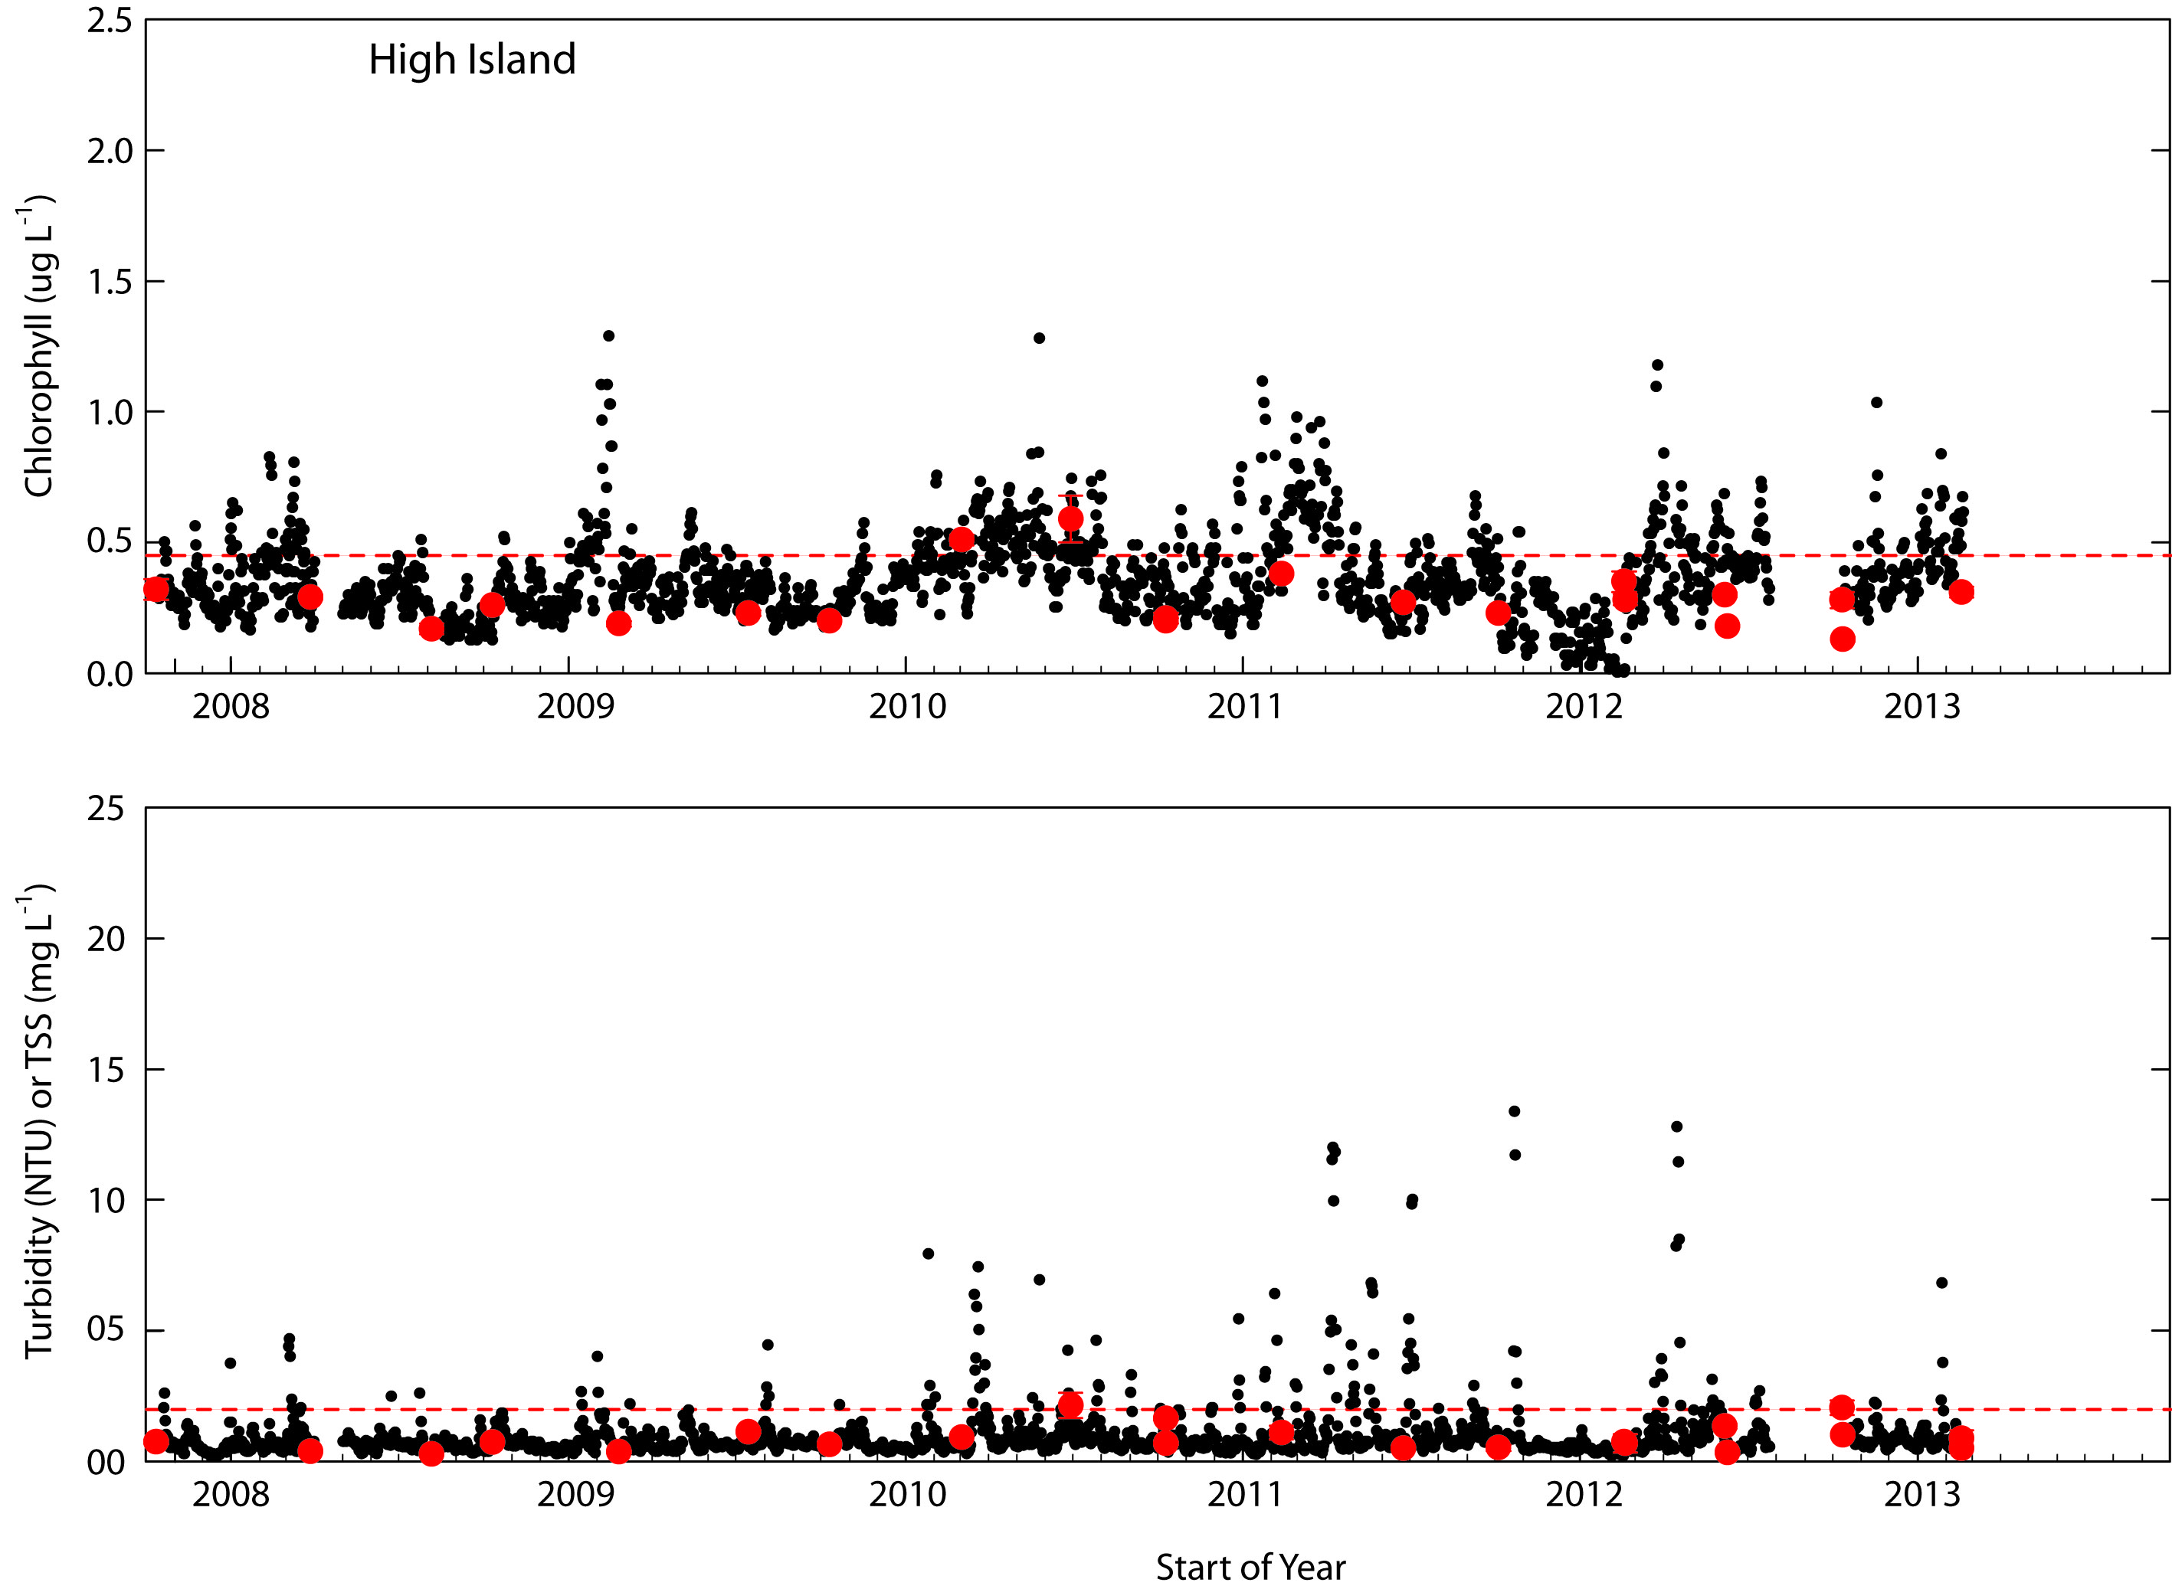

Figure A4-24 Comparisons between logger-derived time series of daily median chlorophyll concentrations (Top) and turbidity (Bottom) at the High Island logger site and levels of these variables in diver-collected validation samples. The horizontal dotted lines indicate the GBR Water Quality Guideline values (GBRMPA 2010).

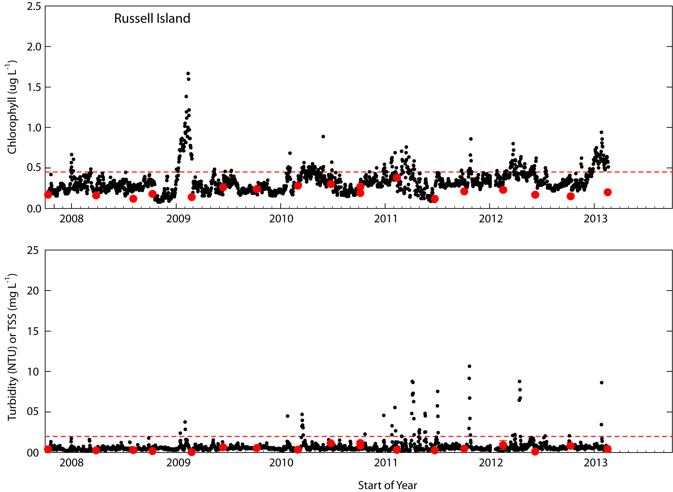

Figure A4-25 Comparisons between logger-derived time series of daily median chlorophyll concentrations (Top) and turbidity (Bottom) at the Russell Island logger site and levels of these variables in diver-collected validation samples. The horizontal dotted lines indicate the GBR Water Quality Guideline values (GBRMPA 2010).

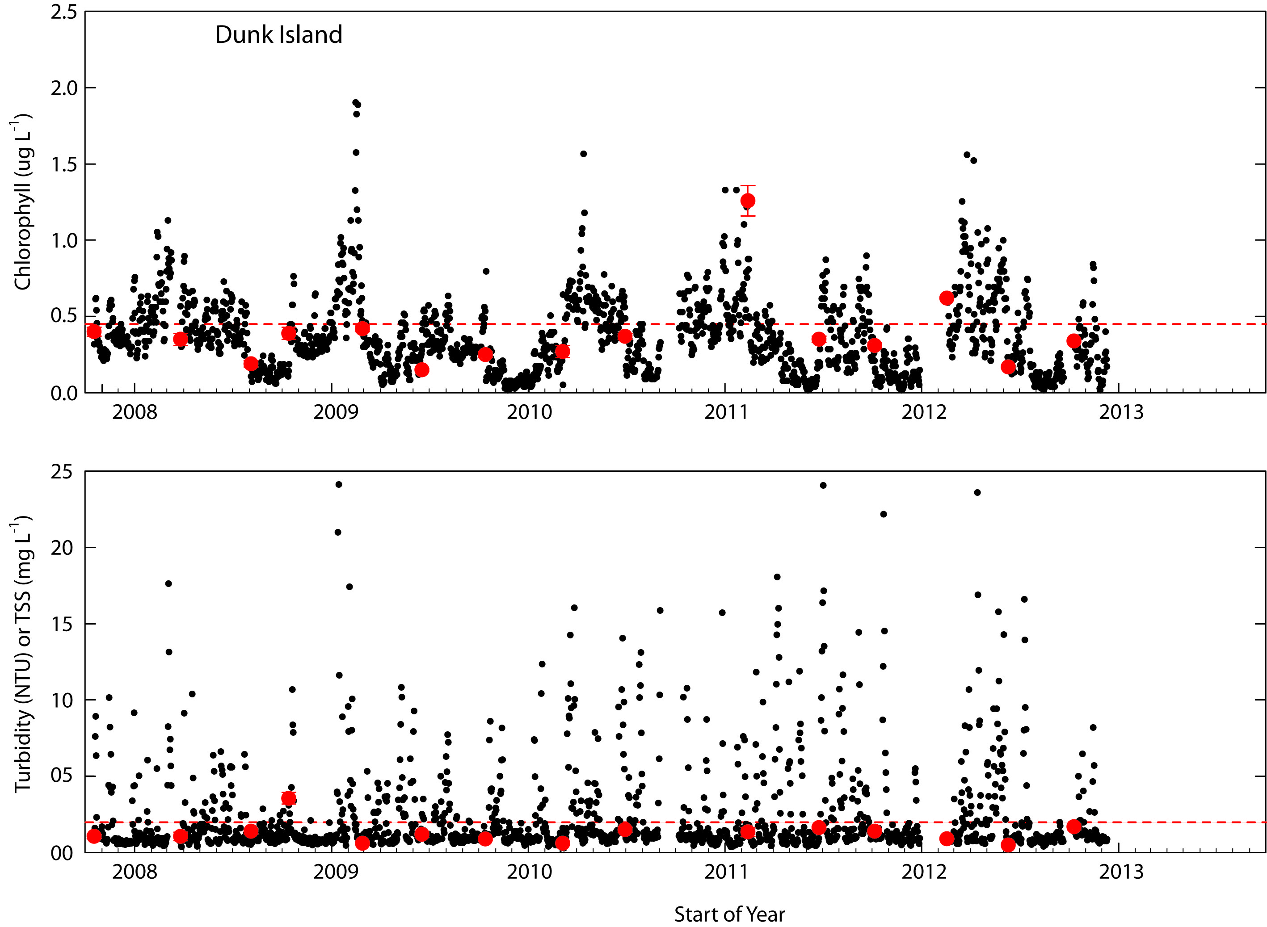

Figure A4-26 Comparisons between logger-derived time series of daily median chlorophyll concentrations (Top) and turbidity (Bottom) at the Dunk Island logger site and levels of these variables in diver-collected validation samples. The horizontal dotted lines indicate the GBR Water Quality Guideline values (GBRMPA 2010).

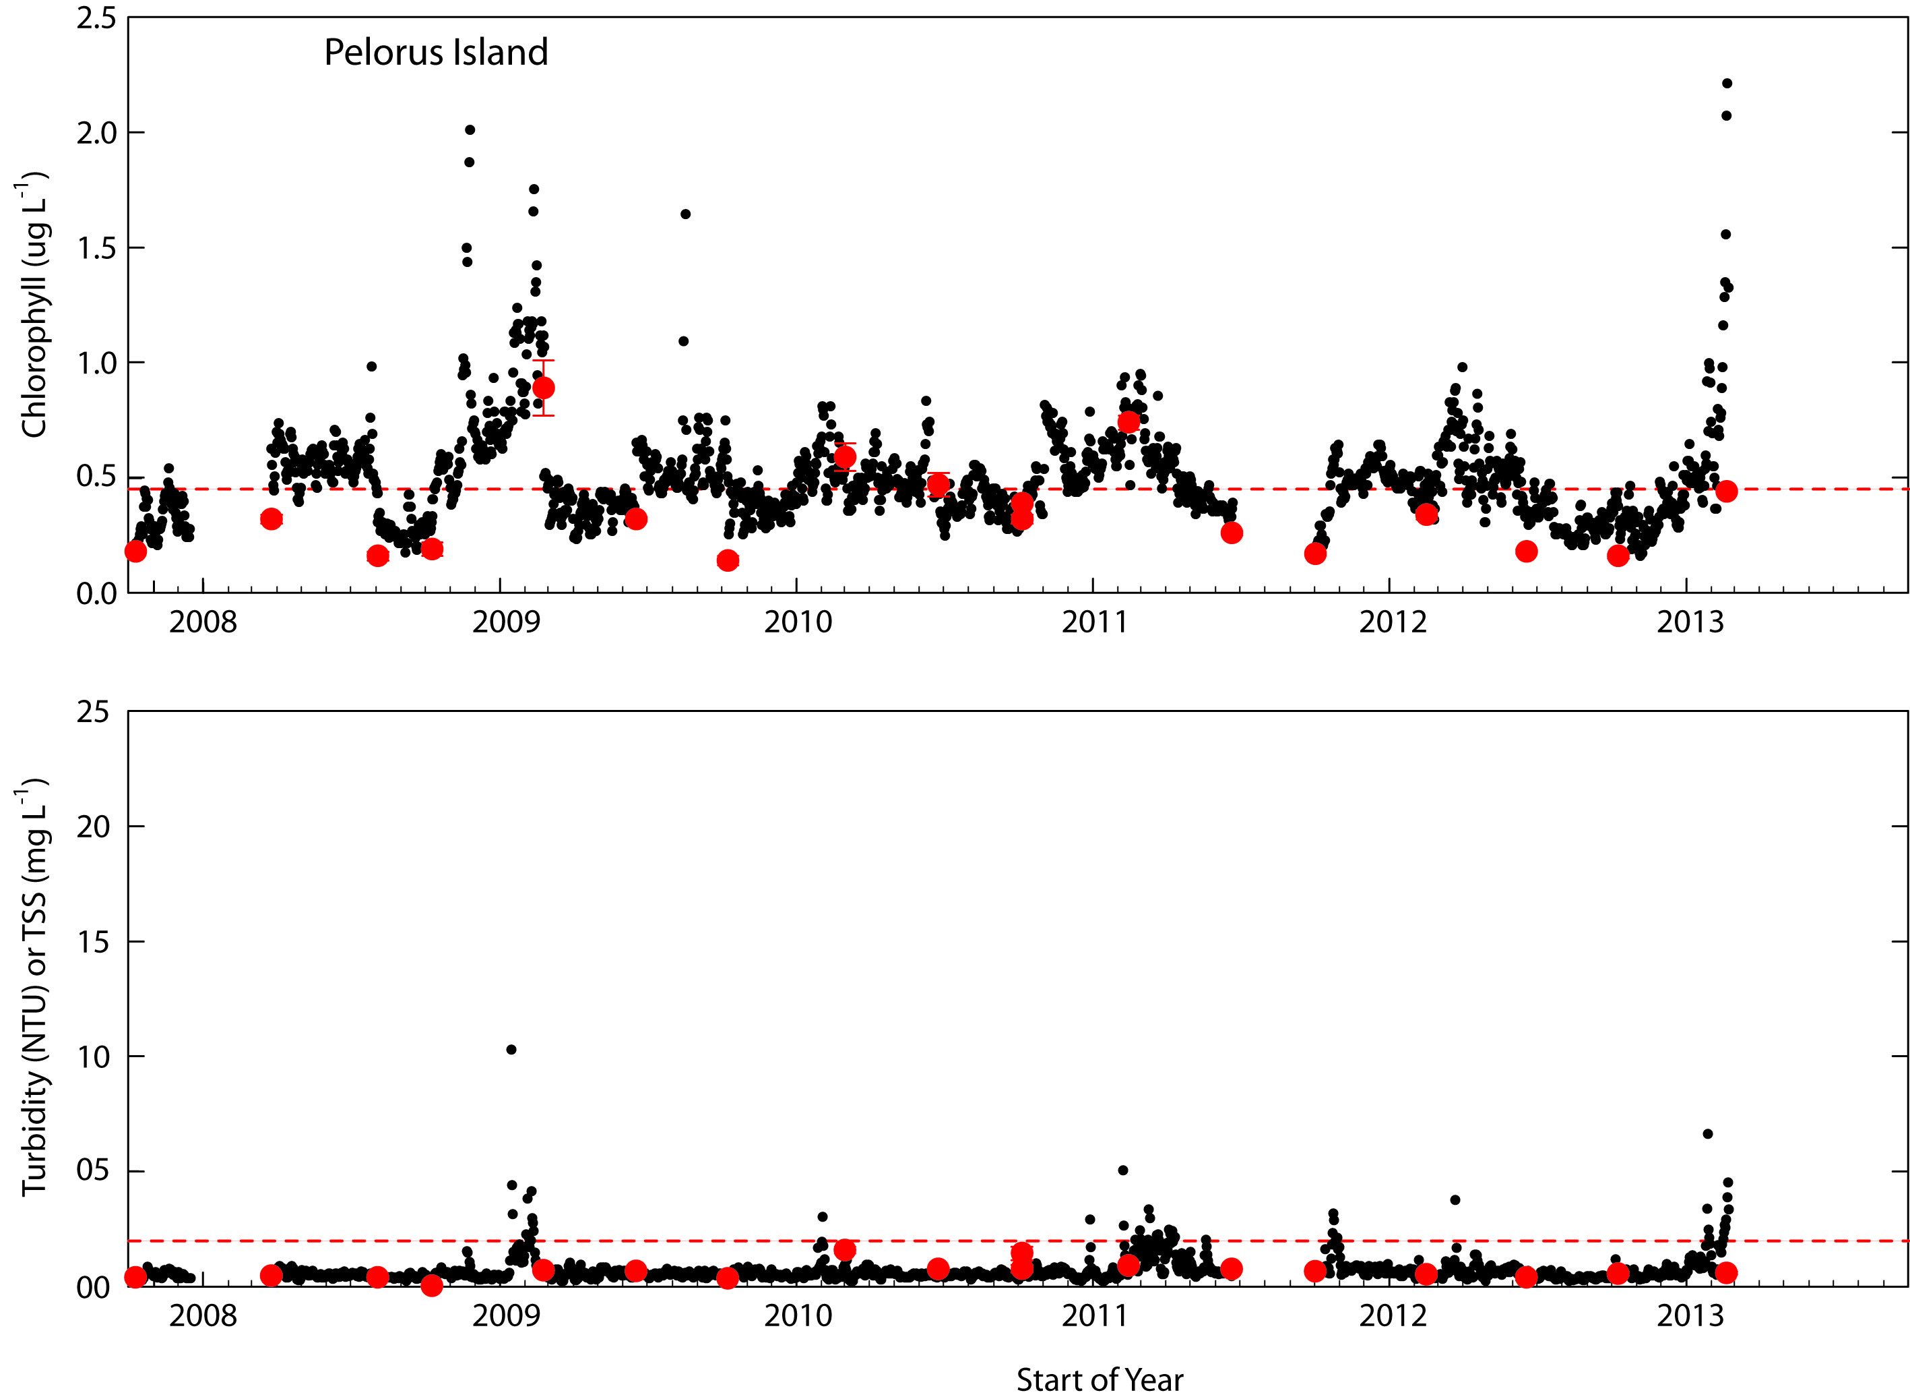

Figure A4-27 Comparisons between logger-derived time series of daily median chlorophyll concentrations (Top) and turbidity (Bottom) at the Pelorus Island logger site and levels of these variables in diver-collected validation samples. The horizontal dotted lines indicate the GBR Water Quality Guideline values (GBRMPA 2010).

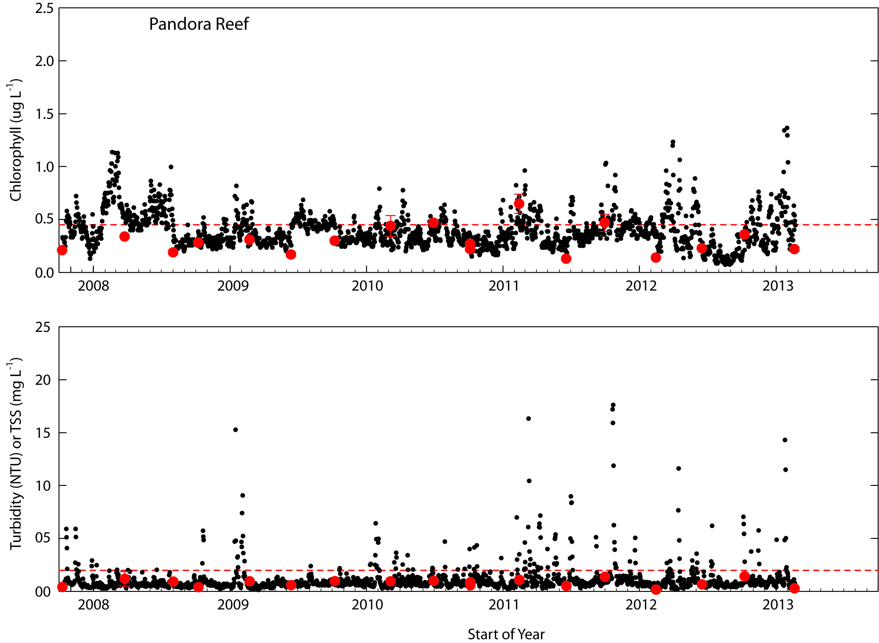

Figure A4-28 Comparisons between logger-derived time series of daily median chlorophyll concentrations (Top) and turbidity (Bottom) at the Pandora Reef logger site and levels of these variables in diver-collected validation samples. The horizontal dotted lines indicate the GBR Water Quality Guideline values (GBRMPA 2010).

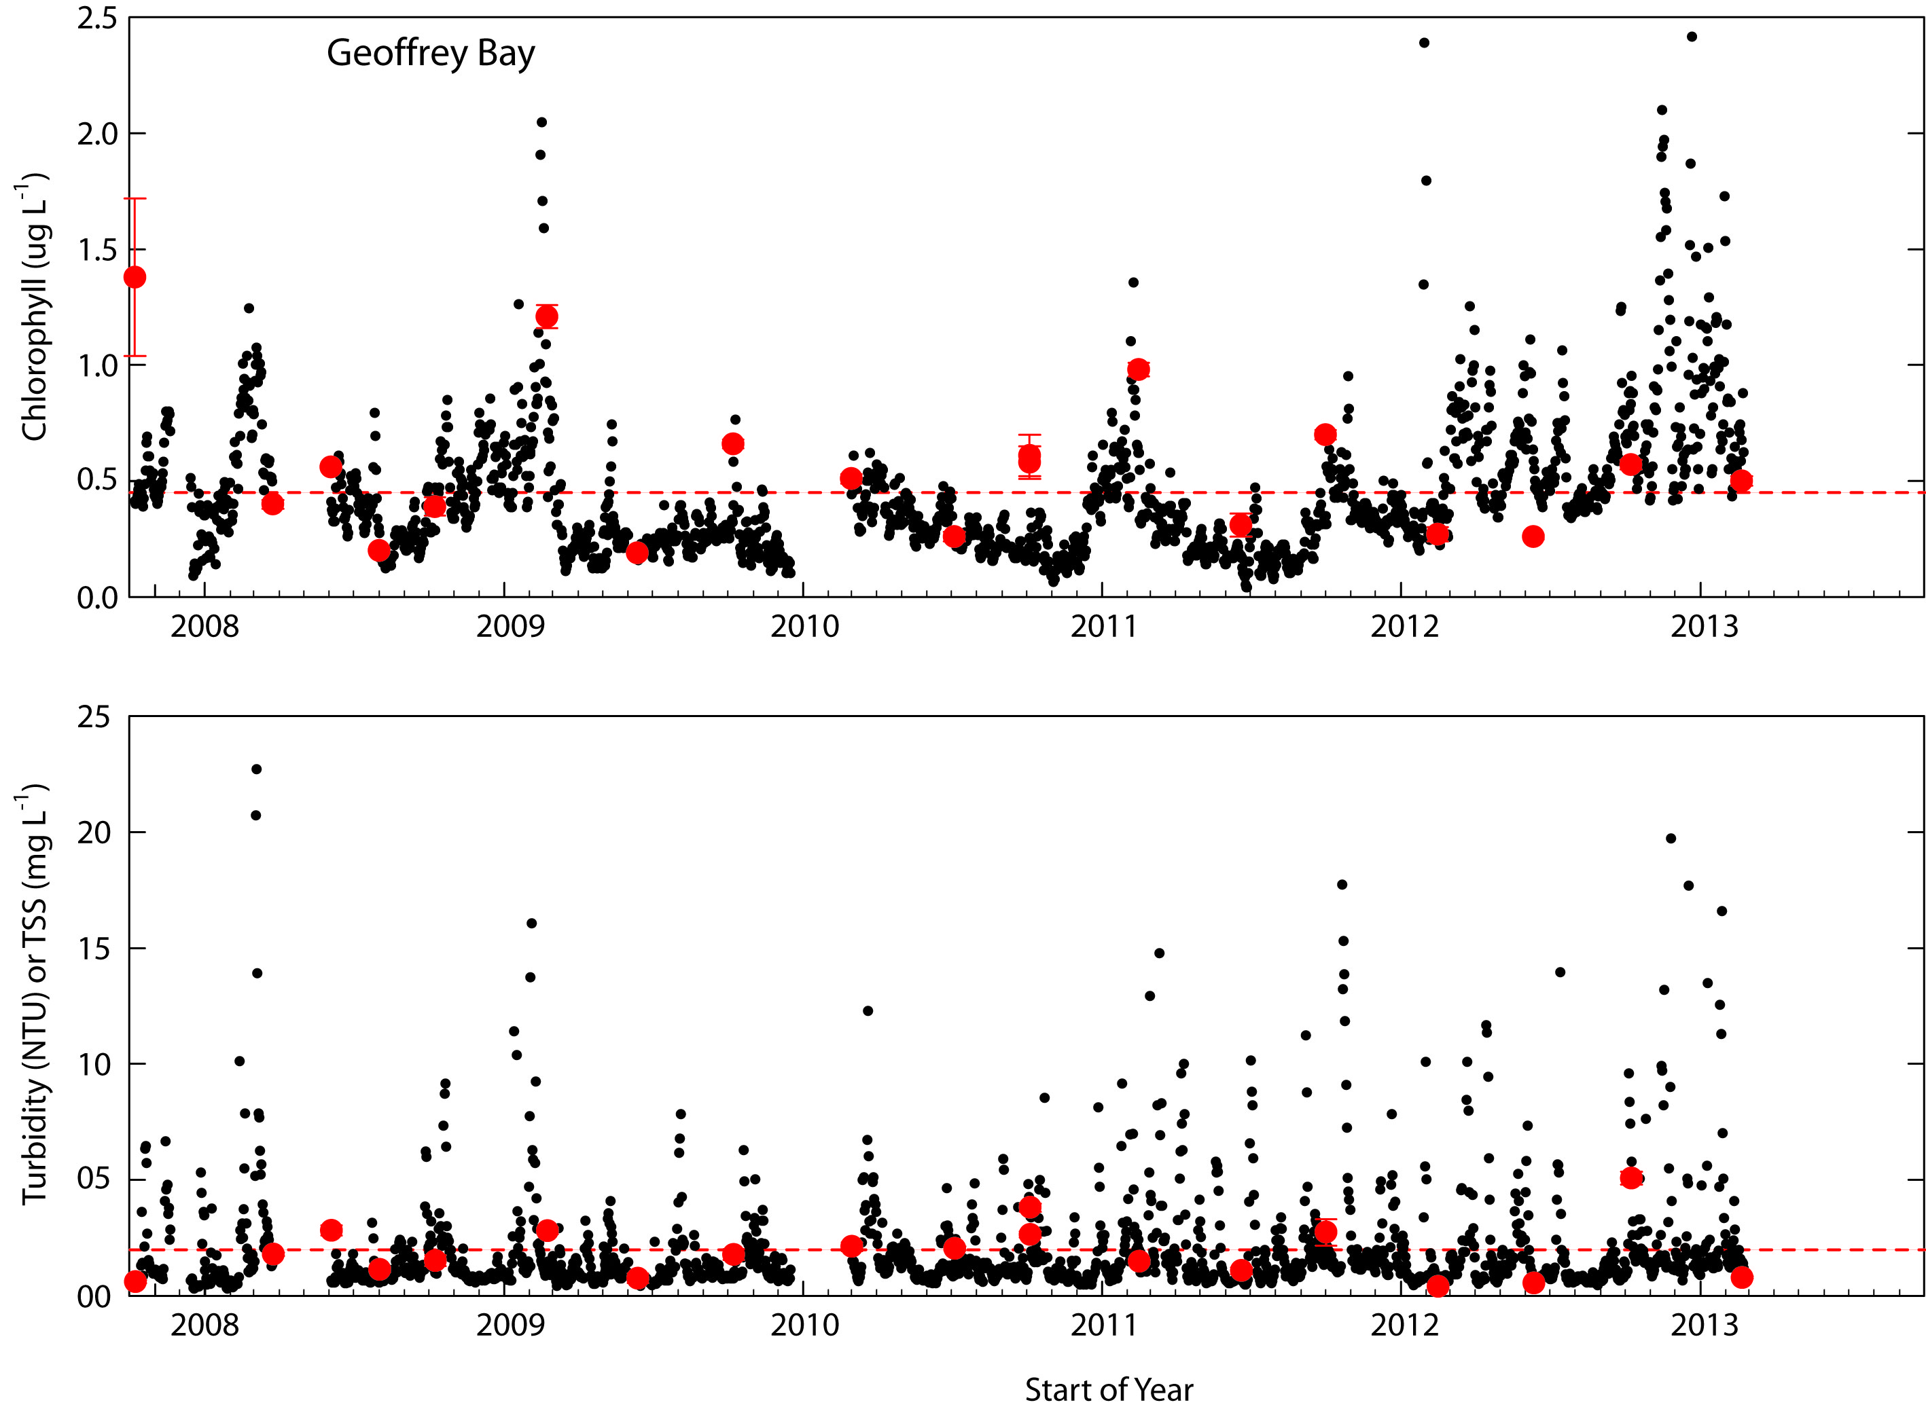

Figure A4-29 Comparisons between logger-derived time series of daily median chlorophyll concentrations (Top) and turbidity (Bottom) at the Geoffrey Bay logger site and levels of these variables in diver-collected validation samples. The horizontal dotted lines indicate the GBR Water Quality Guideline values (GBRMPA 2010).

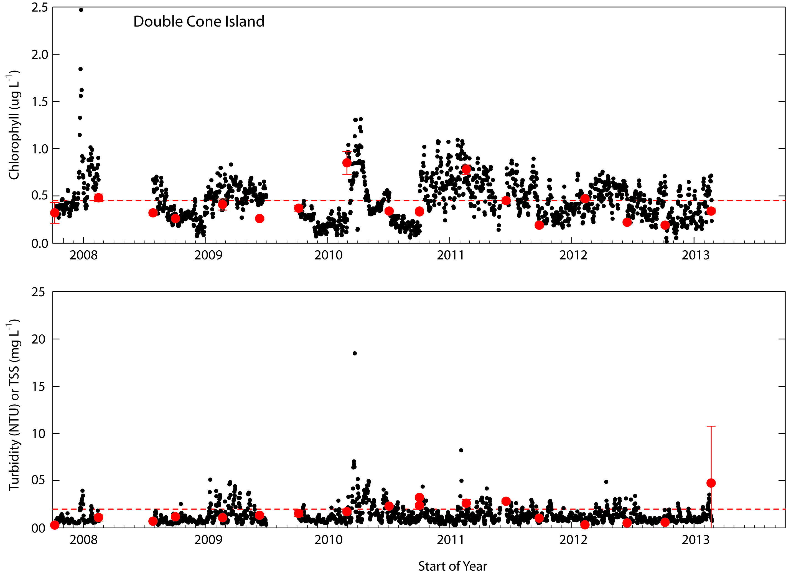

Figure A4-30 Comparisons between logger-derived time series of daily median chlorophyll concentrations (Top) and turbidity (Bottom) at the Double Cone Island logger site and levels of these variables in diver-collected validation samples. The horizontal dotted lines indicate the GBR Water Quality Guideline values (GBRMPA 2010).

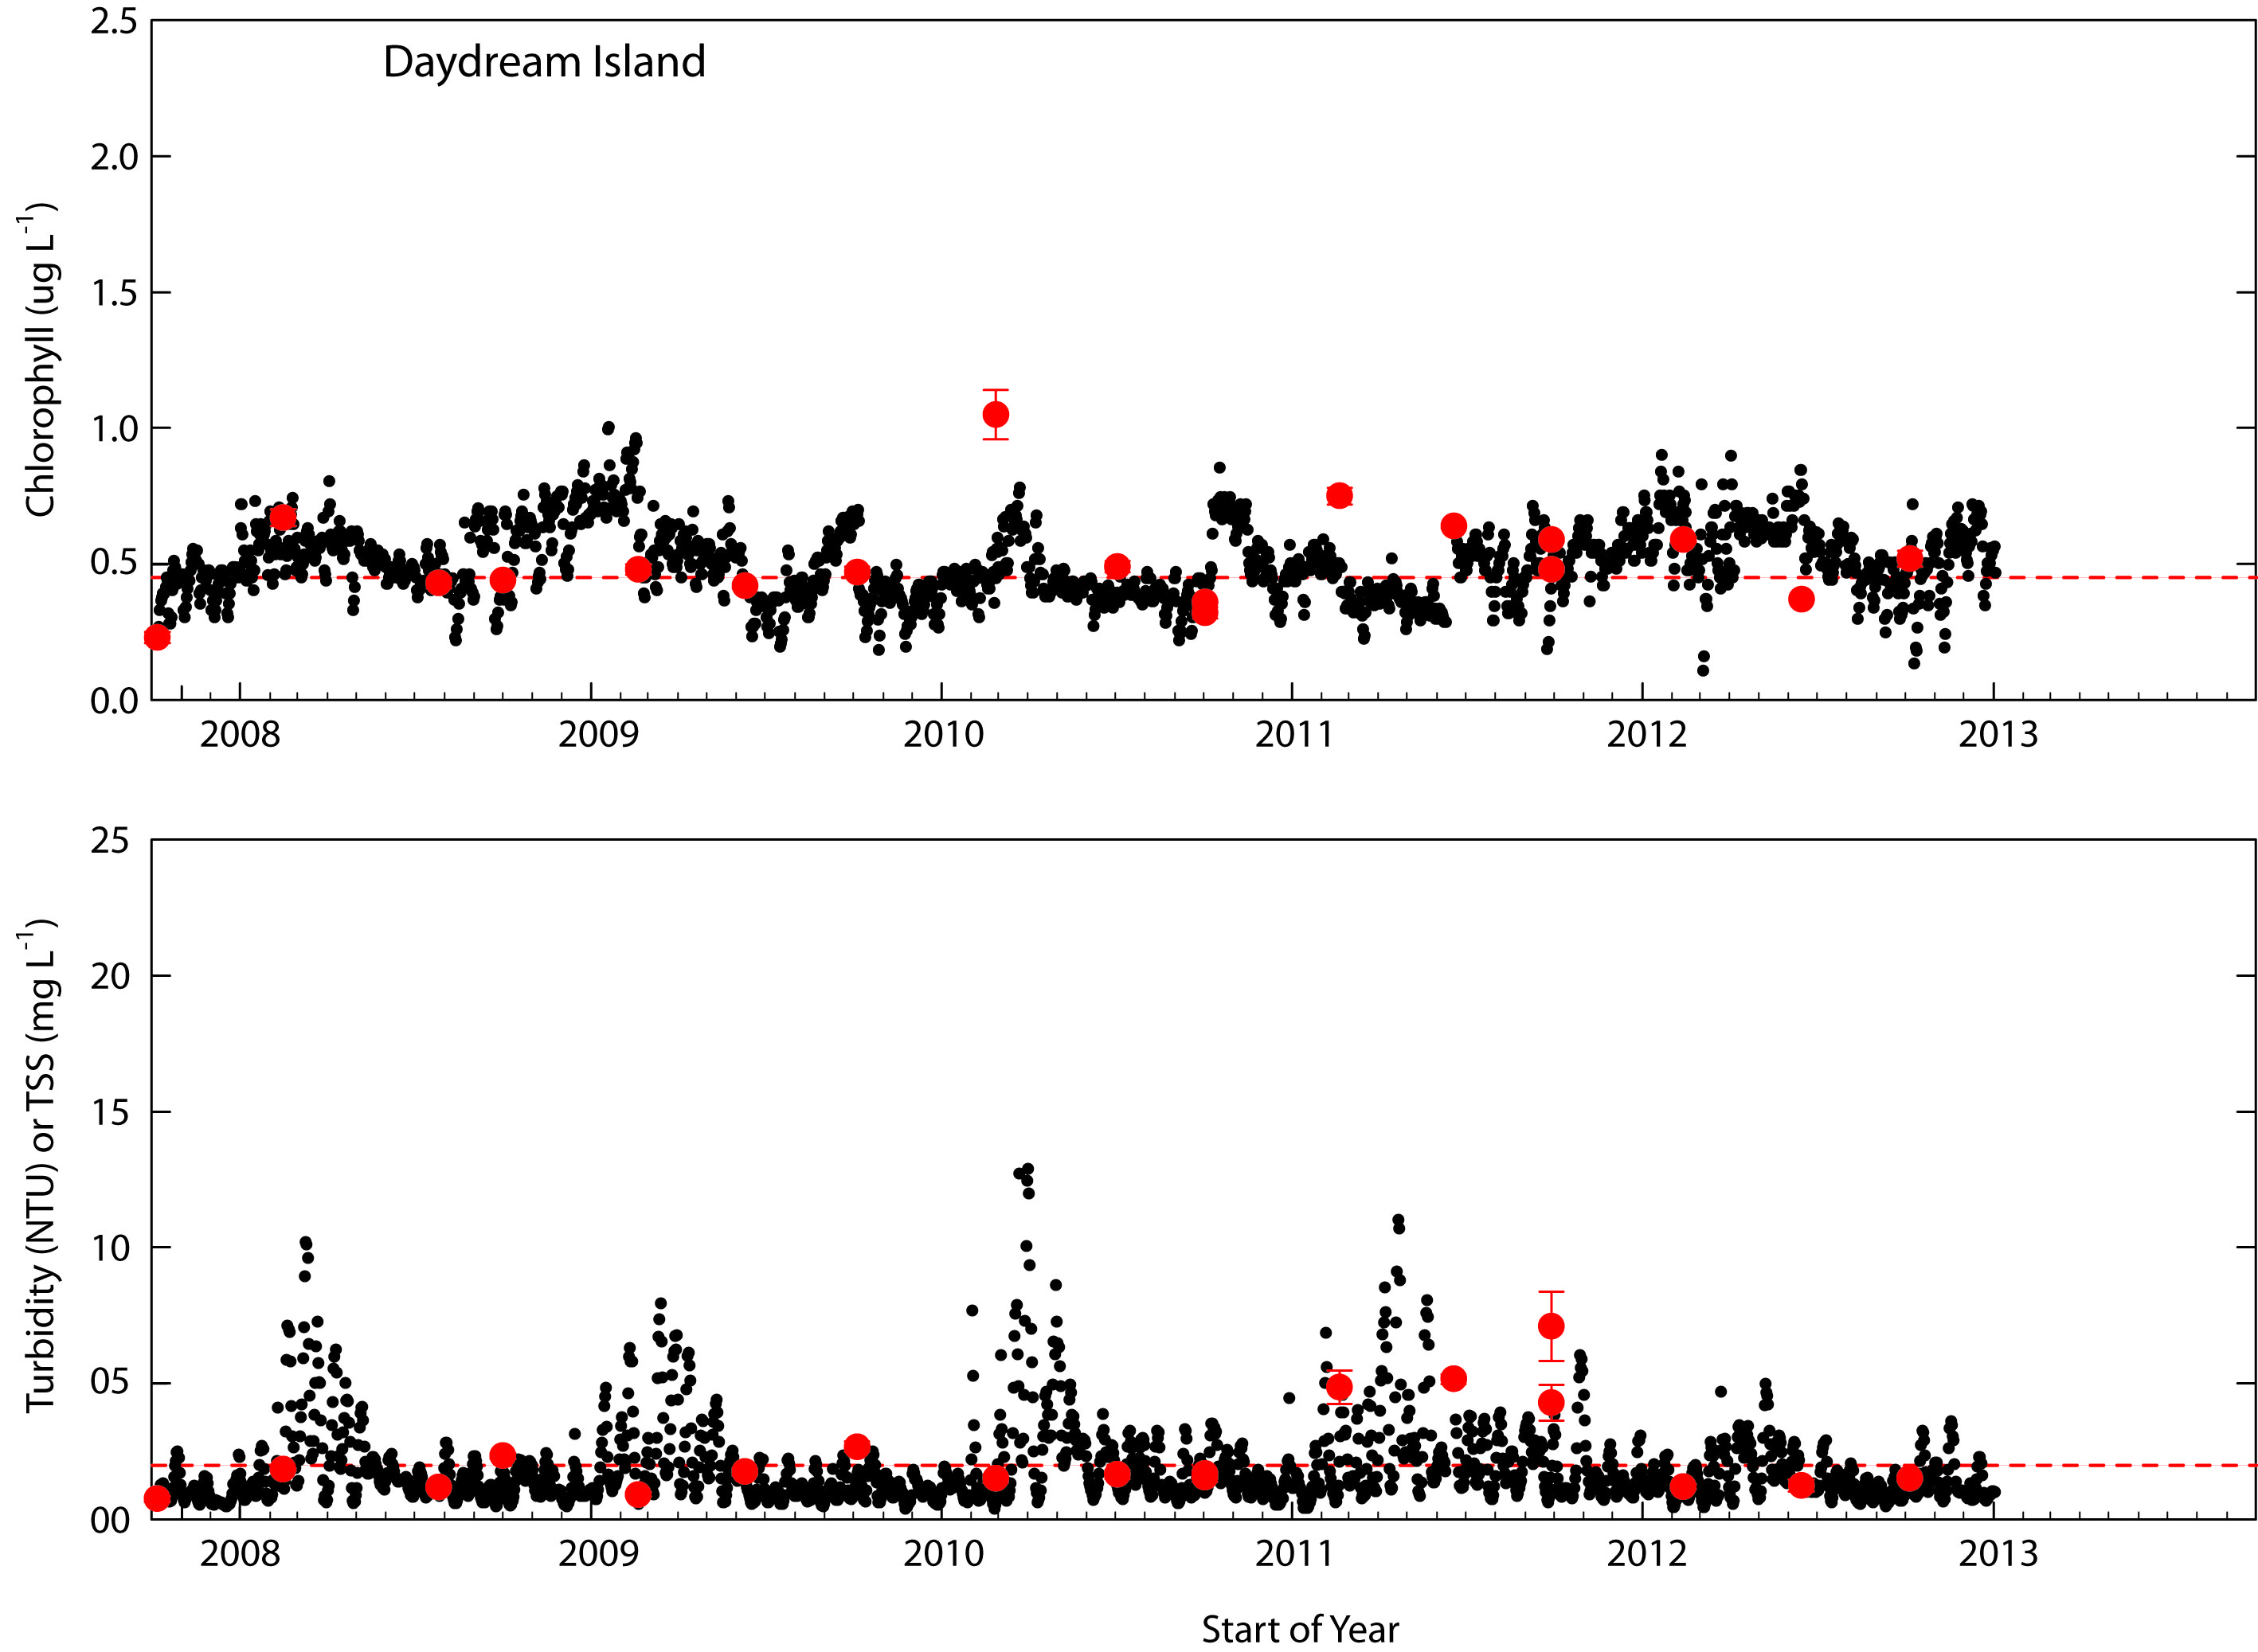

Figure A4-31 Comparisons between logger-derived time series of daily median chlorophyll concentrations (Top) and turbidity (Bottom) at the Daydream Island logger site and levels of these variables in diver-collected validation samples. The horizontal dotted lines indicate the GBR Water Quality Guideline values (GBRMPA 2010).

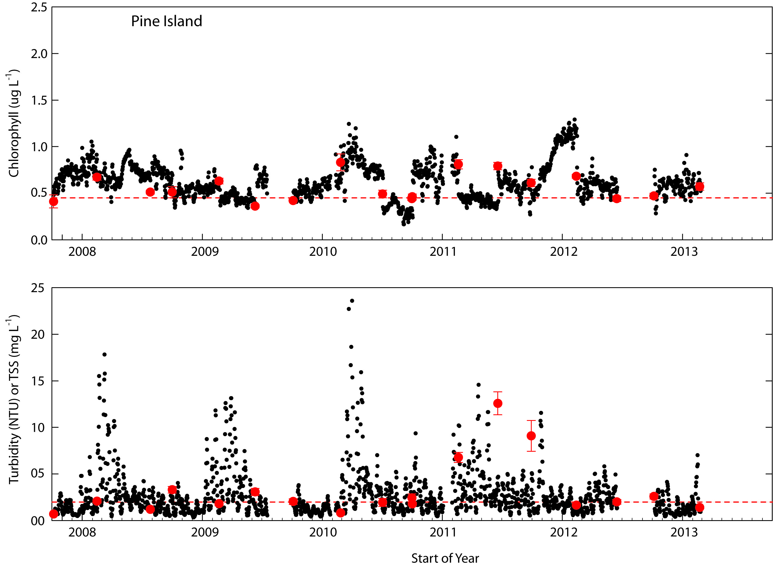

Figure A4-32 Comparisons between logger-derived time series of daily median chlorophyll concentrations (Top) and turbidity (Bottom) at the Pine Island logger site and levels of these variables in diver-collected validation samples. The horizontal dotted lines indicate the GBR Water Quality Guideline values (GBRMPA 2010).

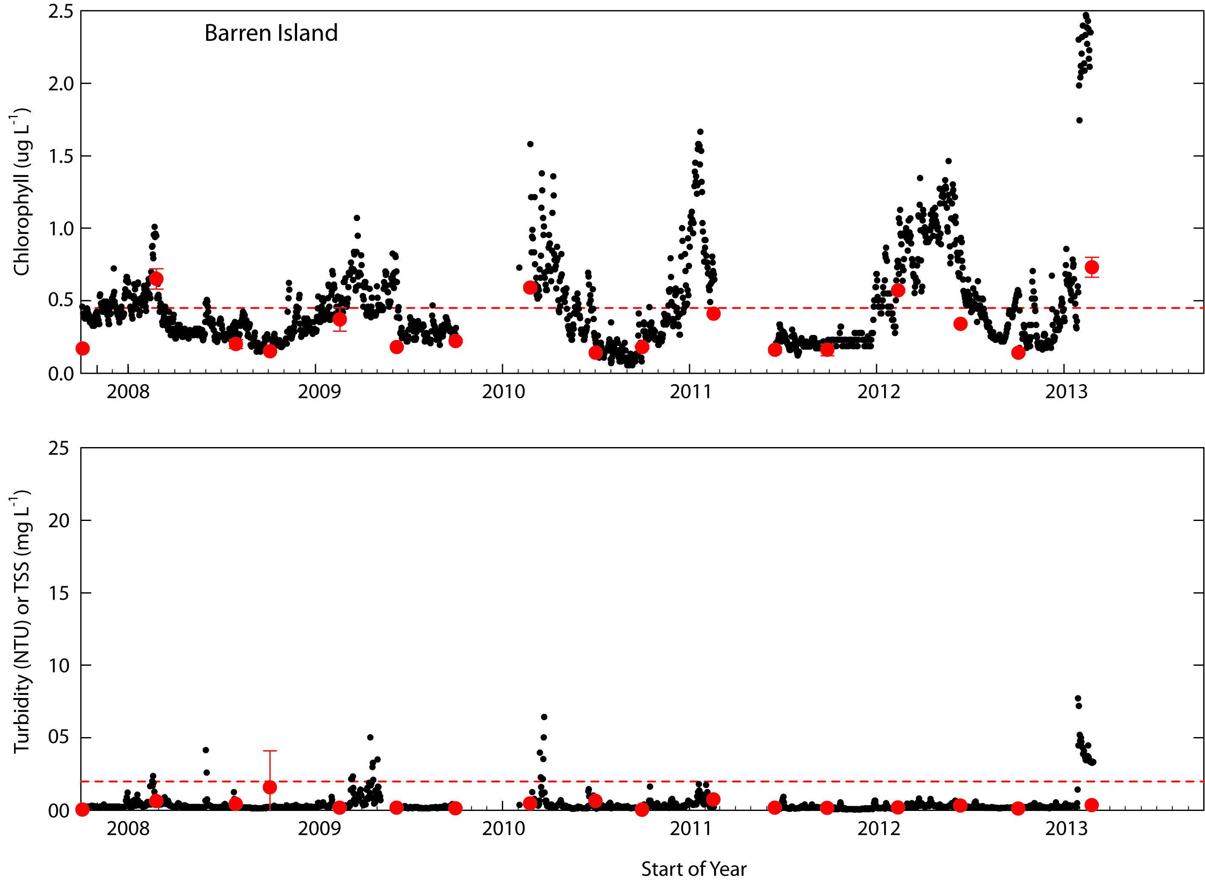

Figure A4-33 Comparisons between logger-derived time series of daily median chlorophyll concentrations (Top) and turbidity (Bottom) at the Barren Island logger site and levels of these variables in diver-collected validation samples. The horizontal dotted lines indicate the GBR Water Quality Guideline values (GBRMPA 2010).

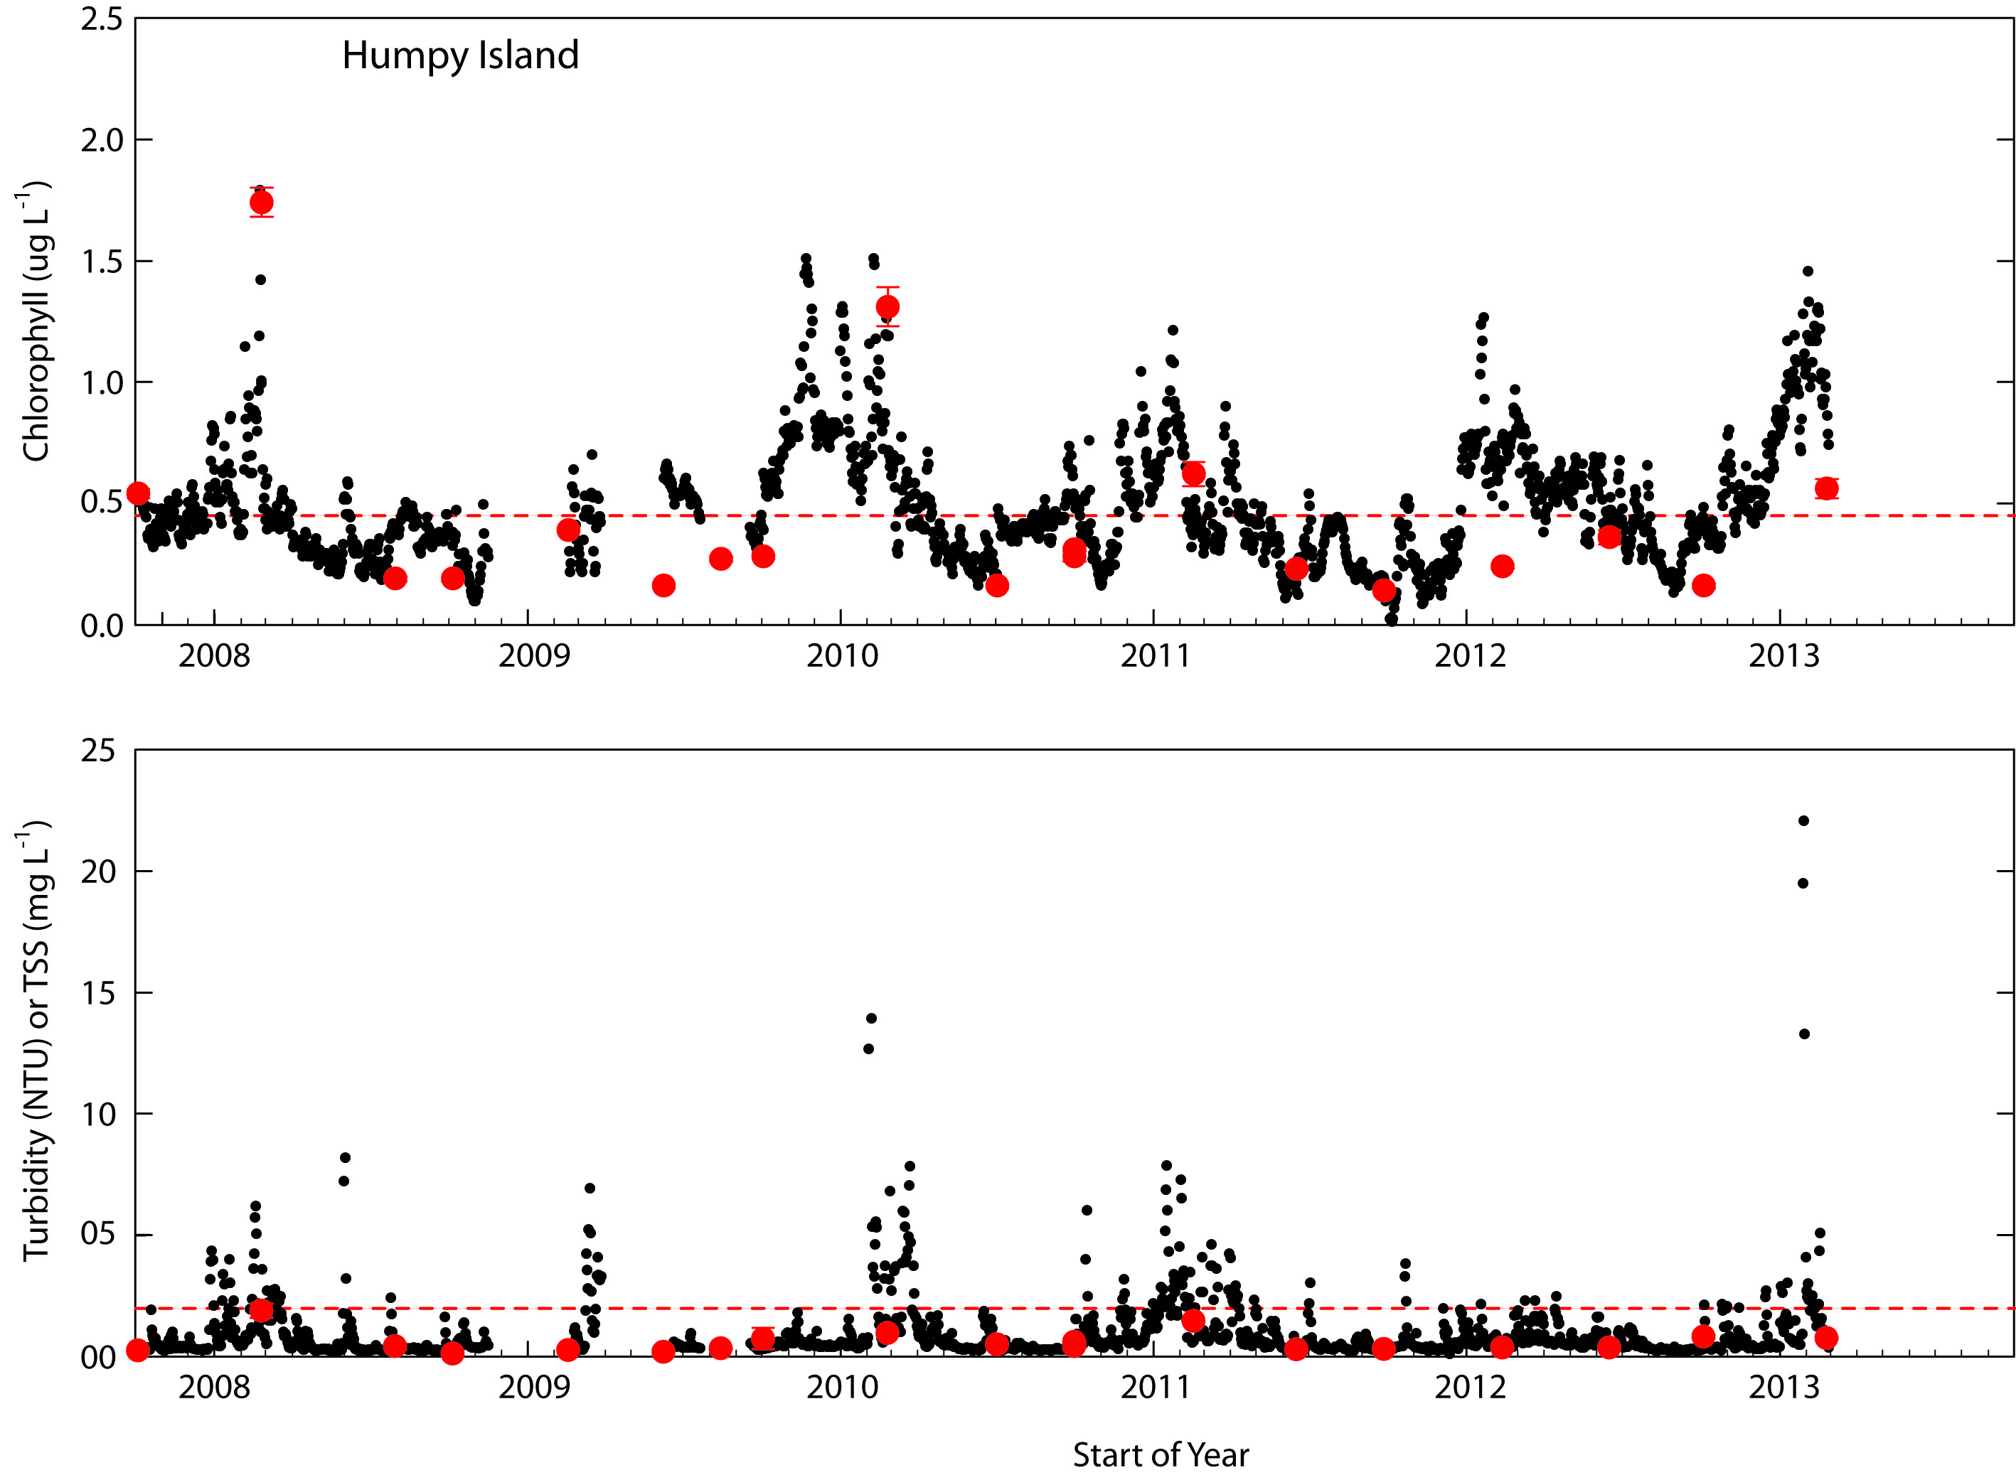

Figure A4-34 Comparisons between logger-derived time series of daily median chlorophyll concentrations (Top) and turbidity (Bottom) at the Humpy Island logger site and levels of these variables in diver-collected validation samples. The horizontal dotted lines indicate the GBR Water Quality Guideline values (GBRMPA 2010).

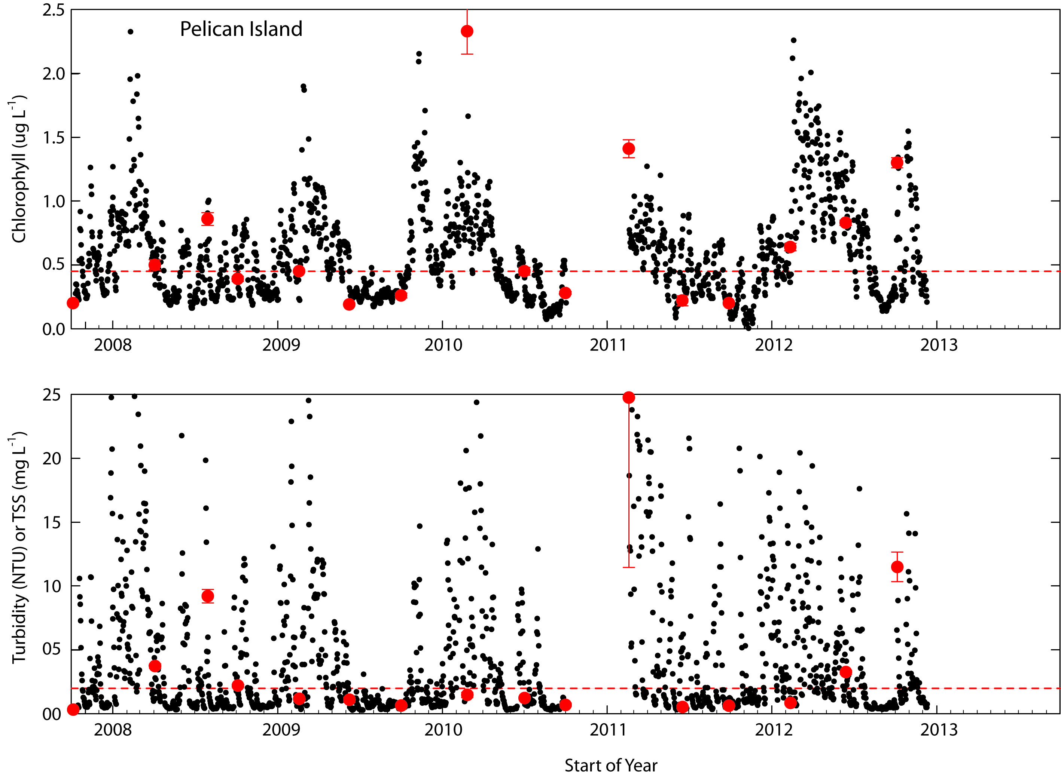

Figure A4-35 Comparisons between logger-derived time series of daily median chlorophyll concentrations (Top) and turbidity (Bottom) at the Pelican Island logger site and levels of these variables in diver-collected validation samples. The horizontal dotted lines indicate the GBR Water Quality Guideline values (GBRMPA 2010).

Summary and conclusions
The current MMP coral community and water quality monitoring program provides a detailed and long-term view of relationships between inshore reef dynamics, reef status and coastal water quality. It is unique as it provides an opportunity to quantitatively examine relationships between community structure and integral exposure to water quality conditions across the full range of temporal variability in these conditions (hourly to inter-annual).

The strong correspondence between logger-derived time series of daily median chlorophyll and turbidity and diver-collected in situ validation samples clearly show that the WET Labs loggers used in the MMP successfully capture both the large and long-term temporal variability (event, seasonal, inter-annual) and secular trends of these parameters at the individual reef sites. The WET Labs loggers operate 24/7 and functioned effectively in all weather conditions, producing consistent, high density temporal records. There is no other technology which can do this in an equally economical manner.

An important application of the logger data is determining whether turbidity or chlorophyll conditions at any site fall above or below a defined value (Water Quality Thresholds) and the amount of time that conditions exceed these defined values. Logger data is useful for this purpose, but requires careful consideration of all sources of variability in derived values.

In the MMP data set, logger-derived turbidity values and estimates of suspended sediment concentration are strongly correlated with manual measurements of SS (Figure A3-2), indicating that the loggers produce reliable estimates of turbidity or suspended sediment concentrations (Figures A4-22 to A4-35).

Logger-derived chlorophyll concentrations are also correlated with manual chlorophyll values from validation samples; however, the relationship exhibited a higher degree of variability. The lower degree of correlation is due to the smaller absolute range of chlorophyll concentration variability, the inherent spatial variability (patchiness) of chlorophyll in the environment and unresolved instrumental issues with the chlorophyll sensor.

The wharf experiments show that batches of individual loggers, using factory calibrations, produce time series of chlorophyll that differ consistently by various amounts (Table A4-2). When these differences are taken into account, however, most loggers produce very similar estimates of chlorophyll concentration over time periods of several days. The magnitudes of the differences (offsets) in normalized chlorophyll concentrations between individual loggers are of similar order to the observed differences between ending and beginning 12 to 24 hour periods of contiguous logger records at changeovers (Figure A4-18). This strongly suggests that these discontinuities arise from the offsets between individual loggers. If these offsets are consistent and stable, discontinuities between logger records can potentially be eliminated, or at least minimized, by applying suitable derived offset values to all individual logger records to normalize them to a common base.

Ongoing factory upgrades of sensor optics and factory calibration procedures (from mid-2012) have improved the overall reliability of the WET Labs loggers. While it is possible to adjust some of the data obtained prior to these changes using retrospective factors tied to both ‘dry’ and ‘wet’ calibrations, most earlier logger records (pre- mid-2010) are not so tied and cannot be unambiguously adjusted. There are two approaches to this dilemma: un-adjustable early records should be excluded from any future analysis; or with suitable validation samples, these records can be used, but with acknowledgement of potential usage and quality limitations. We have chosen the latter course.

In doing so, however, two issues are currently unresolved: what is the appropriate base to normalize individual records to, and more importantly, whether these offsets are stable and can be robustly extended back in time to earlier logger deployments utilizing different factory calibrations. It still remains unclear whether, or to what extent, these offsets reflect inherent optical and electronic differences between individual instruments, or are an artefact of the calibration process. If it is the former, then it is likely that appropriate corrections can be derived to minimize the offsets of individual records in longer time series. As offsets are better understood and derived, the instrumental records can readily be re-processed to reduce inter-record variability. If it is the latter, then more rigorous calibration procedures will be needed, or we must accept that there are limits on interpretation of logger-based data sets. These problems are open to experimental resolution, but the importance of maintaining existing time series with half the logger pool at any time means that this will need to be an ongoing effort.

Testing is now underway to determine whether application of the mean offset values in Table A4-2 will reduce discontinuities between adjacent logger records seen in Figures A4-4 to A4-17 in a statistically robust fashion and provide a better fit between logger-derived and manually sampled chlorophyll concentrations in situ (e.g. Figures A4-22 to A4-35).

Technical issues related to chlorophyll fluorescence sensor and turbidity (NTU) calibration have been discussed in detail in a number of publications, most recently by Earp et al. (2011) and Macdonald et al. (2013). Problems with sensor or calibration variability between loggers or within batches of loggers have not been raised in these publications. Under the water quality conditions which generally occur in the GBR, the observed offsets between loggers are of similar order to natural fluctuations in chlorophyll in the environment. These differences must be understood, and hopefully corrected for, to resolve important fluctuations in the environment and the extent to which conditions at particular sites exceed water quality threshold values.

The significant degree of natural short-term temporal variability (‘noise’) in raw logger chlorophyll and turbidity records is indicative of the level of natural small-scale spatial (= temporal) variability in particulate water quality variables within the GBR system. Noise is an inherent property of any measurement process. This ‘noise’ will set confidence limits around the value any particular observation or set of observations within a time interval to describe system state and practically means that some degree of signal averaging or noise reduction will be required for useful, economical, interpretation of long-term data sets. Current analysis of logger data sets indicates that confidence intervals about temporal trends can be readily set.

We conclude:
- The WET labs FLNTU loggers produce reliable absolute and relative long-term (multi-year, multi-logger) trends of daily median (or mean) chlorophyll and suspended particulate matter concentrations in coastal GBR waters.
- Pre-2012 chlorophyll records based on factory ‘dry’ calibrations appear valid when compared to concurrent manual validation samples. However, some residual uncertainty remains about to the pre-2012 ‘dry’ instrumental calibrations relative to current ‘wet’ calibrations.
- Logger-derived time series provide reliable estimates of large-amplitude (> 2x baseline) variability in chlorophyll and suspended sediment concentration event-scale time frames. The frequency, duration and magnitude of large-amplitude variability differ considerably between sites.
- Annual logger time series (derived from 3-4 logger records) are reliable for determining mean chlorophyll and suspended sediment concentration relative to current GBRMPA water quality guideline values.
- Where inferences about mean values or guideline exceedance are to be drawn on the basis of shorter data sets (1-2 logger records), these records must be rigorously validated against in situ measurements to eliminate potential biases associated with offsets between individual loggers.
- Direct match-ups between individual instrumental measurements or short (< 1-day) time series and manual sampling are inherently limited by the natural small-scale spatial and temporal variability of chlorophyll and suspended sediment concentrations in coastal GBR waters.

Overall, the WET Labs FLNTU turbidity sensors provide reliable and consistent measurements of turbidity and suspended sediment concentration (vis a vis gravimetric analyses) on coastal reef-front locations. The loggers provide reliable estimates of chlorophyll concentrations over annual to multi-year time frames, but with a somewhat higher degree of uncertainty which is due to unresolved instrumental issues. As both sensors provide valuable information on event-scale variability in water quality in all weather conditions which currently cannot be obtain in any other way, we strongly recommend that chlorophyll and turbidity measurements by loggers are continued. We acknowledge an ongoing need for improvements in logger calibrations, particularly for chlorophyll, and ongoing retrospective analysis of logger data sets to the highest current standard.

We will continue to:
- Undertake experiments and analyses to improve the accuracy of logger calibrations.
- Undertake validation sampling at all logger change-overs ensure loggers faithfully record long-term variability and trends in situ
- Undertake group deployments of loggers to better quantify calibration offsets between loggers and potential causes

The degree of complication imparted by current within- and between-record variability depends on what information is to be drawn from the logger records. Loggers are sensitive, reliable and robust, and should remain as a valuable tool for understanding long-term trends, seasonality and event-scale variability in GBR coastal water quality and its potential influence on reef ecology.

Appendix 5: Scientific publications and presentations arising from the Programme 2012-13
Publications

Results of the MMP were included in the Reef Plan Scientific Consensus Statement 2013:
- Brodie J, Waterhouse J, Schaffelke B, Kroon F, Thorburn P, Rolfe J, Johnson J, Fabricius K, Lewis S, Devlin M, Warne M, McKenzie L (2013). Reef Plan Scientific Consensus Statement: Land use Impacts on Great Barrier Reef Water Quality and Ecosystem Condition. Reef Water Quality Protection Plan Secretariat, Brisbane. Available at: www.reefplan.qld.gov.au
- Schaffelke B, Anthony K, Blake J, Brodie J, Collier C, Devlin M, Fabricius K, Martin K, McKenzie L, Negri A, Ronan M, Thompson A, Warne M (2013). Supporting evidence to Scientific consensus statement: Land use impacts on Great Barrier Reef water quality and ecosystem condition. Chapter 1, Marine and Coastal ecosystem impacts, Reef Water Quality Protection Plan Secretariat, Brisbane. Available at: www.reefplan.qld.gov.au
- Brodie J, Waterhouse J, Schaffelke B, Furnas M, Maynard J, Collier C, Lewis S, Warne M, Fabricius K, Devlin M, McKenzie L, Yorkston H, Randall L, Bennett J, Brando V (2013). Supporting evidence to Scientific consensus statement: Land use impacts on Great Barrier Reef water quality and ecosystem condition. Chapter 3, Relative risks to the Great Barrier Reef from degraded water quality. Reef Water Quality Protection Plan Secretariat, Brisbane. Available at: www.reefplan.qld.gov.au

Angus Thompson A, Brando VE, Schaffelke B, Schroeder T (in review) Runoff supresses coral communities of the Whitsunday Islands. Coral Reefs

Presentations:

Angus Thompson “Reef dynamics and resilience in muddy waters”. GBR Resilience workshop/think tank, AIMS 7-8 March 2013.

Britta Schaffelke “What is the current status of GBR water quality and associated impacts on ecosystems?” NERP Tropical Ecosystems Hub and Reef Rescue R&D Conference 2013, 7th-10th May, Cairns.

Britta Schaffelke “What is the current status of GBR water quality and associated impacts on ecosystems?” Australian Water Association North Queensland Regional Conference, Townsville, 29 Aug 2013.

Angus Thompson “Reef Rescue Marine Monitoring Program”. AIMS Science Day, Townsville, 04 August 2013.

Britta Schaffelke “Condition and trends in the inshore GBR: Water quality, coral reefs and seagrass” NQ Dry Tropics Forum for Reef Rescue 2 Delivery in the Burdekin Region, 22 October 2013.

Schaffelke B, Carleton J, Costello P, Davidson J, Doyle J, Furnas M, Gunn K, Skuza M, Wright M, Zagorskis I (2012) Reef Rescue Marine Monitoring Program. Final Report of AIMS Activities 2010/11– Inshore Water Quality Monitoring. Report for the Great Barrier Reef Marine Park Authority. Australian Institute of Marine Science, Townsville. (97 p.)
Earp, A., Hanson CE, Ralph PJ, Brando VE, Allen S, Baird, M, Clementson L, Daniel P, Dekker AG, Fearns PRCS, Parslow J, Strutton PG, Thompson PA, Underwood M, Weeks S, Doblin MA (2011) Review of fluorescent standards for calibration of in situ fluorometers: Recommendations applied in coastal and ocean observing programs. Optics Express 19(27)
Macdonald, RK, Ridd, PV, Whinney, JC, Larcombe, P, Neil, DT (2013) Towards environmental management of water turbidity within open coastal waters of the Great Barrier Reef. Marine Pollution Bulletin 74: 82-94.
Morel, A, Bricaud A (1986) Inherent properties of algal cells including picoplankton. Theoretical and experimental results. Canadian Bulletin of Fisheries and Aquatic Sciences 214: 521-559.
Parsons, TR, Maita, Y, Lalli, CM (1984) A Manual of Chemical and Biological Methods for Seawater Analysis. Pergamon Press, London.
Parsons, TR, Y Maita, CM Lalli (1984) A Manual of Chemical and Biological Methods for Seawater Analysis. Elsevier, New York.
Medians are used because they provide a robust measure of the central tendency of daily measurements, discounting the importance of rare, usually high, outlier values.

