
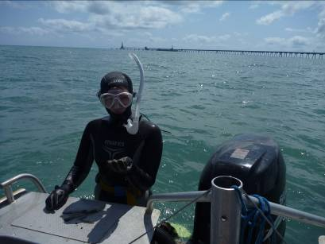
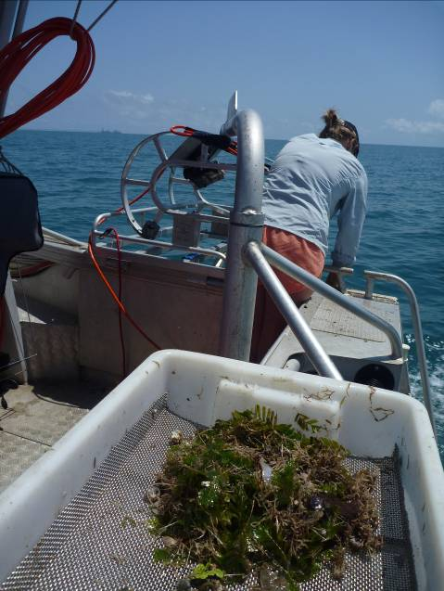
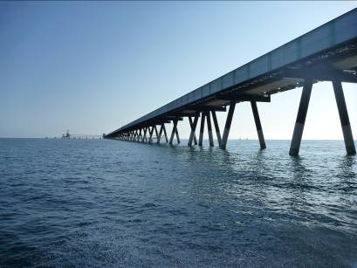

Marine Monitoring Program: Final report of JCU Activities 2012/13 - Flood Plumes and Extreme weather monitoring for the Great Barrier Reef Marine Park Authority.
– Final Report –

Lead Authors: Michelle Devlin¹, Eduardo Teixeira da Silva¹, Caroline Petus¹, Dieter Tracey¹
Report No. 15/57

Report No. 15/14
DATE
Marine Monitoring Program: Final report of JCU Activities 2012/13 - Flood Plumes and Extreme weather monitoring for the Great Barrier Reef Marine Park Authority.
– Final Report –

A Report for the Great Barrier Reef Marine Park Authority

Report No. 15/57

2015
Prepared by Michelle Devlin¹, Eduardo Teixeira da Silva¹, Caroline Petus¹, Dieter Tracey¹
¹TropWATER, James Cook University

Centre for Tropical Water & Aquatic Ecosystem Research
(TropWATER)
James Cook University
Townsville
Phone: (07) 4781 4262
Email: TropWATER@jcu.edu.au
Web: www.jcu.edu.au/tropwater/


Information should be cited as:
Devlin, M. da Silva, E.T., Petus, C., Tracey, D. 2015. Marine Monitoring Program: Final report of JCU Activities 2012/13 - Flood Plumes and Extreme weather monitoring for the Great Barrier Reef Marine Park Authority.Tropical Water & Aquatic Ecosystem Research (TropWATER) Publication. Report No 15/57. James Cook University, Townsville, Australia. 102 pp.

For further information contact:
Michelle Devlin
Centre for Tropical Water & Aquatic Ecosystem Research (TropWATER)
James Cook University
michelle.devlin@jcu.edu.au

This publication has been compiled by the Centre for Tropical Water & Aquatic Ecosystem Research (TropWATER), James Cook University.

© James Cook University, 2015.

Except as permitted by the Copyright Act 1968, no part of the work may in any form or by any electronic, mechanical, photocopying, recording, or any other means be reproduced, stored in a retrieval system or be broadcast or transmitted without the prior written permission of TropWATER. The information contained herein is subject to change without notice. The copyright owner shall not be liable for technical or other errors or omissions contained herein. The reader/user accepts all risks and responsibility for losses, damages, costs and other consequences resulting directly or indirectly from using this information.

Enquiries about reproduction, including downloading or printing the web version, should be directed to Great Barrier Reef Marine Park Authority

Acknowledgments:
We acknowledge the Australian Government funding under the Australian Government Reef Program and specifically thank the Great Barrier Reef Marine Park Authority and Department of Environment for financial and technical support under this program. Thank you to Katherine Martin and Carol Marshall for timely and helpful project management. We thank all the amazing people involved in our field work and all who have helped us through sampling of in some very extreme conditions. We particularly thank Jason and Bec from Mission Beach Charters who have been involved in our long term sampling of the Tully and Russell-Mulgrave marine waters, and who have been a key part of our program. Thanks to all the other MMP providers from JCU, AIMS and UQ. It’s a great team of people to be a part of and thanks for all the good discussions. Thank you to the TropWater laboratory that have analysed thousandrs of samples for us. Thank you to CSIRO, particularly Thomas Schroeder and Vittorio Brando, who have provided advice and data for our ocean colour map. Thanks to BOM for the implementation of the WQ dashboard where we can now access remote sensed data. Finally, thank you to a great team of people at TropWater, particularly the Catchment to Reef Research Group, a small but wonderful team of people.

TABLE OF CONTENTS
About this Report xii
1. Executive summary 1
1.1. Scope of report 1
1.2. Characteristics of the 2012-2013 Wet Season 1
1.3. In-Situ Water Quality 1
1.4. Mapping of river plumes 4
1.5. Future RS developments 9
2. Introduction 10
2.1. Marine Monitoring Program 10
2.2. Sampling design 12
3. Characteristics of the 2012-2013 wet season. 14
3.1. Wet Season conditions 14
3.2. Extent of river plumes – 2012/2013 wet season 16
3.2.1. Wet Tropics NRM 17
3.2.2. Burdekin NRM: Burdekin River 19
3.2.3. Mackay-Whitsundays NRM: Pioneer River 19
3.2.4. Regional differences 23
4. In-situ Water Quality 25
4.1 Sampling design – 2012-2013 25
4.2 Methodology – Water Quality 29
4.2.1 Water samples – 2012-2013 29
4.2.2 Data analysis - spatial 29
4.2.3 Data analysis – Temporal 30
4.3 Results 32
4.3.1 Data analysis - spatial 32
4.2.1 Data analysis - temporal 47
5. Mapping of river plumes 55
5.1. Introduction 55
5.2. Methods 56
5.2.1. GBR plumes water types 56
5.2.2. Mapping of the GBR River plumes, using MODIS images 56
5.2.3. Development of Remote sensing products 56
5.2.4. Remote sensing products: “potential risk” maps 58
5.2.5. Exposure of GBR ecosystems to river plumes 60
5.3. Results 62
5.3.1. Production maps (weekly composite maps of secondary water type) 62
5.3.2. 2012-13 frequency maps 65
5.3.3. Water Quality concentration in river plumes 74
5.3.4. Potential river plume risk maps – 2012/2013 76
5.3.5. Comparison between RS outputs derived from the TC and L2 methods 77
5.3.6. Exposure of GBR ecosystems to river plumes and potential risk from river plume exposure in 2013 79
5.3.7. Potential river plume risk maps – 2007 - 2012 81
6. Discussion and conclusions 87
7. Future developments 92
7. References 94
LIST OF FIGURES
Figure 1-1: Potential exposure of seagrass beds and coral reefs to the highest potential risk categories (III and IV) from river plume exposure during the 2012-13 wet season. 8
Figure 2-1: The Great Barrier Reef Marine Park (light grey, Queensland, Australia), major marine ecosystems (coral reefs and seagrass beds), Natural Resource Management regions (red colour scale) and marine portions (delineated by dark grey liens) of the NRM regions and major rivers: Normanby (N), Barron (Ba), Johnstone (J), Tully (T), Herbert (H), Burdekin (Bu), Pioneer (P), Fitzroy (F), modified from Petus et al., in review. 11
Figure 3-1: Long-term total hydrological year discharge (c.a., Oct-1 to Sep-30) for the main GBR Rivers (Source: DNRM, http://watermonitoring.dnrm.qld.gov.au/host.htm). 14
Figure 3-2: a) True colour and b) plume waters mapped the 25th and 29th of January, 2013 in the Wet Tropics NRM using the method of Álvarez-Romero et al. (2013). These maps show Barron River plume waters deflected toward offshore by the NW winds. Wind direction measured at 12:00 am is indicated with black arrows. 18
Figure 3-3: a) True colour and b) plume waters mapped from the 25th to the 31rd of January 2013 in the Wet Tropics NRM using the method of Álvarez-Romero et al. (2013). This series of maps illustrate high importance of river discharge rates modulations on the river plumes areas. Wind direction measured at 15:00 am is indicated with black arrows (data at 12:00 am are unavailable for the Ingham meteorological stations). 19
Figure 3-4: a) True colour and b) plume waters mapped on the 27th and 29th of Jan 2013 in the Burdekin NRM using the method of Álvarez-Romero et al. (2013). Burdekin River plume waters are deflected offshore under strong western winds and reach the inner coral reefs on the 25th of January. Wind direction measured at 12:00 am is indicated with black arrows. 20
Figure 3-5: True colour (a and c) and plume waters (b and d) mapped from the 30th of January to the 01th of February and from the 2nd to the 4th of February in the Burdekin NRM using the method of Álvarez-Romero et al. (2013). Wind direction measured at 12:00 am is indicated with black arrows. 21
Figure 3-6: a) True colour and b) plume waters mapped from the 7th of March to the 16th of March 2013 in the Mackay Whitsundays NRM using the method of Álvarez-Romero et al. (2013).. Wind direction measured at 12:00 am is indicated with black arrows. 22
Figure 3-7: MODIS true colour image of the 16th of March 2013 showing waters from the Pioneer River deflected toward the south from their northern Coriolis-induced movement. 23
Figure 4-1: Location of the Marine Monitoring Sites sampled in the 2012-2013 wet season under the MMP terrestrial discharge program. Site locations for the two regions sampled (Wet Tropics, Burdekin are identified by colours (see legend). 26
Figure 4-2: Total daily discharge (megalitres/day) for the main NRM Wet Tropics and Burdekin rivers for the 2012-2013 wet season (Source: DNRM, http://watermonitoring.dnrm.qld.gov.au/host.htm). Dots indicate the sampling dates and colours stand for sites close to or under influence of a particular river. 27
Figure 4-3: Total annual discharge (ML, megalitres), calculated from October, 1st to September, 30th, for the main NRM Wet Tropics and Burdekin rivers (Source: DNRM, http://watermonitoring.dnrm.qld.gov.au/host.htm). 28
Figure 4-4a: (i) Sites are colour coded to identify location on maps, (ii) date of sampling relative to river flow over wet season, (iii)mixing plots for DIN in the Burdekin, Herbert and Tully regions for 2012-13. Freshwater end end were estimed from all samples collected below 5ppt. 35
Figure 4-5: Variation of selected WQ parameters sampled in the Tully region for Kd(PAR), CDOM, TSS, and chl-a, dissolved and particulate nutrients. All water quality parameters are plotted against (a) distance between the sampling site and nearest/influential river mouth (distance), (b) 5-day average river discharge calculated from the sampling date (discharge). Red solid line stands for a non-parametric fitting curve (loess model, see Crawley, 2007) and red dashed lines stand for 2 SE. 42
Figure 4-6: Variation of selected WQ parameters sampled in the Herbert region for Kd(PAR), CDOM, TSS, and chl-a, dissolved and particulate nutrients. All water quality parameters are plotted against (a) distance between the sampling site and nearest/influential river mouth (distance), (b) 5-day average river discharge calculated from the sampling date (discharge). Red solid line stands for a non-parametric fitting curve (loess model, see Crawley, 2007) and red dashed lines stand for 2 SE. 43
Figure 4-7: Variation of selected WQ parameters sampled in the Burdekin region for Kd(PAR), CDOM, TSS, and chl-a, dissolved and particulate nutrients. All water quality parameters are plotted against (a) distance between the sampling site and nearest/influential river mouth (distance), (b) 5-day average river discharge calculated from the sampling date (discharge). Red solid line stands for a non-parametric fitting curve (loess model, see Crawley, 2007) and red dashed lines stand for 2 SE. 45
Figure 4-8a:GAMM analysis for Kd, /m, left column), CDOM, /m, mid column) and TSS, mg/L, right column) collected from December, 2005 to April, 2013 (inclusive). First four plots in each column are for the partial effect plots and last pot is the temporal analysis (see text for explanation). Shade area stands for ±1 SE and rubs on x-axis stand for data density. 52
Figure 5-1: Remote sensing products designed in order to model the risk of GBR ecosystems due to river plumes during the wet season. 58
Figure 5-2: Marine boundaries used for the GBR Marine Park (a), each NRM region and the coral reefs ecosystems. Coral Reef and NRM layers derived from: GBRMPA, 2013, GBR feature shapefiles and enlargements around (b) the Tully-Herbert Rivers and (c) the Burdekin river. 61
Figure 5-3: Marine boundaries used for the GBR Marine Park (a), each NRM region and the coral reefs ecosystems. NRM layers derived from: GBRMPA, 2013, GBR feature shapefiles and seagrass layers from DAFF, Feb. 2013; and enlargements around (b) the Tully-Herbert rivers and (c) the Burdekin rivers. Spatial distribution of the surveyed seagrasses bed is an historical layer composed from all meadows examined between 1984 and 2008 (see reports at: http://www.seagrasswatch.org/meg.html). 61
Figure 5-4: a) Secondary plume waters areas recorded for the GBR, the Tully-Herbert and the Burdekin subsets and b) cumulative weekly river discharge measured for the Tully-Herbert and Burdekin rivers. 62
Figure 5-5: Secondary plume weekly composites of the Tully-Herbert marine region 63
Figure 5-6: Secondary plume weekly composites of the Burdekin marine region 64
Figure 5-7: Frequency of occurrence of river plume recorded in 2013 in the Tully-Herbert region by a) and b) the TC method and c) and d) the L2 method. Maps a) and c) show all areas that have been classified as least one day over the wet season 2012-13 as river plume waters. Maps b) and d) show same maps reclassified into frequency breaks 66
Figure 5-8: Frequency of occurrence of river plume recorded in 2013 in the Burdekin region by a) and b) the TC method and c) and d) the L2 method. Maps a) and c) show all areas that have been classified as least one day over the wet season 2012-13 as river plume waters. Maps b) and d) show same maps reclassified into frequency breaks 67
Figure 5-9: Frequency of occurrence of Primary plume waters recorded in 2013 in the Tully-Herbert region by a) and b) the TC method and c) and d) the L2 method. Maps a) and c) show all areas that have been classified as least one day over the wet season 2012-13 as Primary plume waters. Maps b) and d) show same maps reclassified into frequency breaks 68
Figure 5-10: Frequency of occurrence of Primary plume waters recorded in 2013 in the Burdekin region by a) and b) the TC method and c) and d) the L2 method. Maps a) and c) show all areas that have been classified as least one day over the wet season 2012-13 as Primary plume waters. Maps b) and d) show same maps reclassified into frequency breaks 69
Figure 5-11: Frequency of occurrence of Secondary plume waters recorded in 2013 in the Tully-Herbert region by a) and b) the TC method and c) and d) the L2 method. Maps a) and c) show all areas that have been classified as least one day over the wet season 2012-13 as Secondary plume waters. Maps b) and d) show same maps reclassified into frequency breaks 70
Figure 5-12: Frequency of occurrence of Secondary plume waters recorded in 2013 in the Burdekin region by a) and b) the TC method and c) and d) the L2 method. Maps a) and c) show all areas that have been classified as least one day over the wet season 2012-13 as Secondary plume waters. Maps b) and d) show same maps reclassified into frequency breaks 71
Figure 5-13: Frequency of occurrence of Tertiary plume waters recorded in 2013 in the Tully-Herbert region by a) and b) the TC method and c) and d) the L2 method. Maps a) and c) show all areas that have been classified as least one day over the wet season 2012-13 as Tertiary plume water. Maps b) and d) show same maps reclassified into frequency breaks 72
Figure 5-14: Frequency of occurrence of Tertiary plume waters recorded in 2013 in the Burdekin region by a) and b) the TC method and c) and d) the L2 method. Maps a) and c) show all areas that have been classified as least one day over the wet season 2012-13 as Tertiary plume water. Maps b) and d) show same maps reclassified into frequency breaks. 73
Figure 5-15: Mean concentrations of in-situ WQ measurements within each plume type. WQ data were assigned to plume water type based on dominant frequency (frequency > 0.5). Data are reported for (a) total suspended solids (TSS), with higher values in the Primary plume zone, (b) KdPAR, with higher values in the Primary plume zone, and (c) chl-a, with highest values in the Secondary plume zone (modified from Devlin et al., 2013b). 74
Figure 5-16: mean concentrations of in-situ WQ measurements (CDOM, TSS, Chl-a and Kd(PAR)) within each plume water type. WQ data assigned to plume water when the difference between in-situ collection and the satellite over passes is within ±2 h. Number of data is indicated in italic (modified from Petus et al., in press). 75
Figure 5-17: 2012-13 “potential” river plume risk maps of (left) the GBR; (middle) the Tully Herbert region and (right) the Burdekin region produced by a) the TC method and b) the L2 method. Maps have been smoothed twice with a 4 pixel majority filter (ArcGIS). 77
Figure 5-18: Areas (km²) and percentage (%) of the a) GBR lagoon, b) coral reefs and c) seagrass beds (c1: surveyed; c2: deep and c3) total (surveyed + deep) seagrass beds) exposed to different categories of river plume risk within each NRM and during the wet season 2012-13. 81
Figure 5-19: “potential” river plume risk maps of (left) the GBR; (middle) the Tully Herbert region and (right) the Burdekin region produced by a) the TC method in a) 2007, b) 2008, c) 2009. Maps have been smoothed twice with a 4 pixel majority filter (ArcGIS). 83
Figure 5-20: “Potential” river plume risk maps of (left) the GBR; (middle) the Tully Herbert region and (right) the Burdekin region produced by a) the TC method in a) 2010, b) 2011, c) 2012. Maps have been smoothed twice with a 4 pixel majority filter (ArcGIS). 84
Figure 5-21: relationships between the total GBR areas exposed to to the highest potential risk categories (III and IV, red line) to river plume and the total GBR river discharge (blue line, calculated as the sum of the Normanby, Daintree, Barron, Russell, Mulgrave, North Johnstone, South Johnstone, Tully, Herbert, Burdekin, O'Connell, Pioneer, Proserpine, Plane, Fitzroy, Burnett and Mary-river discharges for the whole hydrological year (i.e., from Oct-1 to Sep-30). 84
Figure 5-22: Multi-annual (2007-2013) “potential” river plume risk maps of (left) the GBR; (middle) the Tully Herbert region and (right) the Burdekin region produced by a) the TC method. Maps have been smoothed twice with a 4 pixel majority filter (ArcGIS). 85
Figure 5-23: mean multiannual (2007-2013) percentage (%, in grey) and areas (km², in black) of a) coral reefs and b) total seagrass exposed to potential risk categories I 86
LIST OF TABLES
Table 1-1: Summary of the sampling effort carried out in the 2012-13 wet season campaign by NRM, presenting the number of field trips per River/transect, sites sampled and the sampling period. Data in italics (Daintree – Mossman, Barron,Cape York, Burnett Mary) are not described in this report. 2
Table 1-2: List of all water quality parameters collected as part of the MMP wet season water quality program. 2
Table 1-3: Spearman’s rank correlation coefficients for the parameters for the Wet Tropics, Burdekin. All highlighted values are significant at p < 0.01 and represent a correlation >0.6 or <-.06. Parameters listed in the table are surface salinity (Sal.), 5-day average discharge (Disch.), distance between the river mouth and the sampling site (Dist.), TSS, chlorophyll-a, TN, TDN, DIN, TP, TDP, DIP, PN, PP and Si. 3
Table 1-4: Characteristics of Remote sensed products developed partly through MMP funding described against management outcomes. 4
Table 1-5: Risk matrix in function of the magnitude and the likelihood of the river plume risk. Risk categories (I, II, III, IV, V) 5
Table 2-1: Description of outputs related to the aims of the MMP wet season monitoring program. 12
Table 3-1: Long term river discharge (ML) statistics of GBR rivers for the 2012-2013 hydrological year (c.a., Oct-1 to Sep-30), compared against the previous three hydrological years, and long-term (LT) medians, means and standard deviations (SD). Colours indicate levels above the long-term median: yellow for 1.5 to 2 times; orange for 2 to 3 times, and red for greater than 3 times. Long term statistics were calculated based on a hydrological year taking into account measurements from 1915 to 2000. (Data source: DNRM). Discharge for Tully at Euramo station (113006A) for the dry season was estimated as 3.5941 times the Tully discharge at Gorge National Park station (113015A), based on a long-term discharge comparison for flows < 20,000 ML/day (r-sq = 0.802). 15
Table 3-2: The 75th and 95th percentile flow (ML/day) for the major GBR rivers (based on flow between the beginning of the station to 2012-09-30 obtained from DNRM). 16
Table 4-1: Summary of the sampling effort carried out in the 2012-13 wet season campaign by NRM, presenting the number of field trips, sites sampled and the sampling period for each river visited within each NRMs. 25
Table 4-2: Summary of chemical and biological parameters sampled for the MMP flood plume monitoring. 29
Table 4-3: Summary of statistical analysis techniques exploring spatial variation applied to the WQ parameters sampled within the wet 2012-2013 wet season. 30
Table 4-4: Long term wet season river discharge (ML, megalitre) statistics of five GBR rivers for the last 8 years (c.a., Nov-1 to Apr-30), compared against their long-term (LT) median. Colours indicate levels above the long term median: yellow for 1.5 to 2 times; orange for 2 to 3 times, and red for greater than 3 times. Long term statistics were calculated based on a hydrological year taking into account measurements from 1915 to 2000 (where data available). (Data source: DNRM). 31
Table 4-5: Summary of transects that were completed and including in this report during the 2012-2013 wet season under the MMP program. Minimum (min), maximum (max), mean, standard deviation (SD) and the number of samples are calculated over multiple sites and multiple dates within each river plume water surface and are provided as a guidance of the range of values within each sampling transect. 33
Table 4-6: Spearman’s rank correlation coefficients for the parameters from the Wet Tropics region. All highlighted values are significant at p < 0.01 and represent a correlation >0.6 or <-.06. Parameter on the table are surface salinity (Sal.), 5-day average discharge (Disch.), distance between the river mouth and the sampling site (Dist.), TSS, chl-a TN, TDN, DIN, TP, TDP, DIP, PN, PP and Si. 46
Table 4-7: Spearman’s rank correlation coefficients for the parameters from Tully and Herbert rivers sampled more than 20 times in the Wet Tropics in the 2012-2013 wet season. All highlighted values are significant at p < 0.01 and represent a correlation >0.6 or <-.06. Parameters listed in the table are surface salinity (Sal.), 5-day average discharge (Disch.), distance between the river mouth and the sampling site Dist.), TSS, chl-a TN, TDN, DIN, TP, TDP, DIP, PN, PP and Si. 46
Table 4-8: Spearman’s rank correlation coefficients for the parameters from the Burdekin region. All highlighted values are significant at p < 0.01 and represent a correlation >0.6 or <-.06. Parameter on the table are surface salinity (Sal.), 5-day average discharge (Disch.), distance between the river mouth and the sampling site (Dist.), TSS, chl-a, TN, TDN), DIN, TP, TDP, DIP, PN, PP and Si. 47
Table 4-9: Mean, maximum and minimum WQ parameters concentrations measured at 4 of the most often sampled transects (i.e., Franklins, Tully to Sisters, Burdekin to Palm Island, and Fitzroy to Keppels) over the last 8 wet seasons (2006 – 2013). WQ parameters include TSS, chl-a TN, TP, DIN, DIP, PN, PP. 48
Table 4-10: Spearman’s rank correlation coefficients form the four most frequent sampled transects over the GRB wide in the last 8 wet seasons. Values stand for correlation coefficient between the total wet season river discharge and the WQ parameters: include TSS, chl-a TN, TP, DIN, DIP, PN, PP. Highlighted values are significant at p < 0.01. 49
Table 4-11: Statistical summary of the multiple regression analysis. Number of data points, the general model r-squared and its p-value for each WQ component are shown in the left site of the table. The p-value and the percentage of contribution to the total r-squared for each predictor from the relative importance (number in brackets) are in the right side of the table. WQ components are sorted by general model r-squared, and numbers in bold stand for predictors not included in the GAMM analysis. 51
Table 5-1: Risk categories (I, II, III, and IV) in function of the magnitude and the likelihood of the river plume risk (modified from Petus et al., 2014b). 59
Table 5-2: inter-annual (2007-2012) areas (km², left table) and percentage (%, right table) of the GBR under potential risk from river plume exposure. 84

Acronyms and Abbreviations
AIMS Australian Institute of Marine Science
CDOM Coloured Dissolved Organic Matter
Chl a a
CSIRO Commonwealth Scientific and Industrial Research Organisation
DNRM Queensland Department of Natural Resources and Mines
DIN Dissolved inorganic nitrogen
DIP Dissolved inorganic phosphorus
EnTox National Research Centre for Environmental Toxicology, University of Queensland
GBR Great Barrier Reef
GBRMPA Great Barrier Reef Marine Park Authority
JCU James Cook University
Kd(PAR) Diffuse vertical light attenuation coefficient in the Photosynthetically Active Radiation
ML Mega-litres
NASA National Aeronautics and Space Administration
NRM Natural Resource Management
NTU Nephelometric Turbidity Units
PN Particulate Nitrogen
PP Particulate Phosphorous
PSII herbicide Photosystem II inhibiting herbicide
PSII-HEq PSII – Herbicide Equivalent
QLD Queensland
SE Standard Error
SPM Suspended particulate matter
TSS Total suspended solids
OAC’s Optically active components

About this Report
This report provides a synthesis of the key findings of research conducted on water quality collected through the 2012/20-13 wet season s in the Great Barrier Reef (GBR) and is designed to update the previous reports submitted under the Marine Monitoring Program. The report was commissioned and supported by Government funding under the Australian Government Reef Program and managed by the Great Barrier Reef Marine Park Authority.

Executive summary

Scope of report
The Australian Government Reef Program Marine Monitoring Program (herein referred to as the MMP) undertaken in the Great Barrier Reef (GBR) lagoon assesses the long-term effectiveness of the Australian and Queensland Government’s Reef Water Quality Protection Plan and the Australian Government Reef Programme initiative. The MMP was established in 2005 to help assess the long-term status and health of GBR ecosystems and is a critical component in the assessment of regional water quality as land management practices are improved across GBR catchments. The program forms an integral part of the Reef Plan Paddock to Reef Integrated Monitoring, Modelling and Reporting Program supported through Reef Plan. This report details the sampling that has taken place under the Marine Monitoring Program: Terrestrial discharge into the Great Barrier Reef for the 2012/13 sampling year, led by James Cook University (JCU). The sampling in the 2012-2013 wet season was carried out in conjunction with CSIRO and the eReefs program which allowed us to sample with increased frequency over much larger spatial scales
The main objective of wet season monitoring under the Marine Monitoring Program (MMP) is to describe water quality (WQ) concentrations within wet season conditions, characterise the spatial and temporal variability associated with flood plumes and produce maps of river plumes and models that summarize land-sourced contaminants transport. Ultimately the integration of all these methods in a single risk assessment framework would provide a baseline to evaluate the susceptibility of GBR key ecosystems to the river plume/pollutants exposure i.e., to model the risk of GBR ecosystem due to exposure to river plumes and acute water quality conditions.

Characteristics of the 2012-2013 Wet Season
The wet season 2013 was characterised by neutral (neither El Niño nor La Niña) to borderline El Niño climatic conditions and tropical cyclone activity for the 2012-12 wet season was slightly below the typical cyclone season activity of Queensland. Two main flood periods were recorded in the river hydrographs: around the 25th of January and the 11th of February under the influence of Tropical Cyclone Oswald and around the 24th of February and 18th of March. Maximum river plume aerial extents were recorded between these dates.

In-Situ Water Quality
Sampling of flood plumes was successfully conducted during the 2012-13 wet season with four Natural Resource Management (NRM) areas sampled over the GBR: Cape York, Wet Tropics, Burdekin and Burnett-Mary. A total of 201 sites were visited in the 2012-13 wet season with 63 sampled in the Cape York, 90 in the Wet Tropics, 36 in the Burdekin and 12 sites in the Burnett-Mary region (Table 1-1). The data from the Wet Tropics and Burdekin are described in this report, with data collected in Cape York analysed and reported in a standalone report (Howley et al., 2015) and the Burnett-Mary data collected and reported to the Burnett Mary Regional Group (da Silva et al., 2015).
Sampling within water associated with the formation and transport of river flood plumes included the collection of water samples listed in Table 1-2. Terminology for each parameter is listed in this table and will be used for the remainder of the report. Some parameters listed in Table 1-2 were not reported on in this report, including phytoplankton, due to limited number of samples, and PSII herbicides, reported in detail in Gallen et al. (2013).
Table 1-1: Summary of the sampling effort carried out in the 2012-13 wet season campaign by NRM, presenting the number of field trips per River/transect, sites sampled and the sampling period. Data in italics (Daintree – Mossman, Barron,Cape York, Burnett Mary) are not described in this report.
NRM | River/transect | No. of Field Trips | Total No. of Samples | Start Date | End Date
Cape York | Pascoe | 1 | 9 | 01/12/2012 | 04/12/2012
Cape York | Stewart/Normanby | 2 | 23 | 01/12/2012 | 01/02/2013
Wet Tropics | Daintree/Mossman | 1 | 5 | 30/11/2012 | 02/02/2013
Wet Tropics | Barron | 1 | 5 | 05/12/2012 | 03/02/2013
Wet Tropics | Russell/Mulgrave | 1 | 7 | 10/12/2012 | 03/02/2013
Wet Tropics | Tully | 4 | 43 | 10/11/2012 | 16/04/2013
Wet Tropics | Northern Herbert | 2 | 12 | 16/01/2013 | 25/03/2013
Wet Tropics | Southern Herbert | 2 | 14 | 17/01/2013 | 25/03/2013
Burdekin | Burdekin | 1 | 36 | 13/03/2013 | 18/03/2013
Burdekin | Don | 1 | 11 | 14/03/2013 | 16/03/2013
Burnet-Mary | Mary | 1 | 12 | 08/02/2013 | 09/02/2013

Table 1-2: List of all water quality parameters collected as part of the MMP wet season water quality program.
Condition | Parameter | Terminology | Units of Measure
Physico-chemical | Salinity | Salinity | PSU
 | Temperature | Temperature | Celsius degree
 | Dissolved Oxygen | DO | mg/L
Turbidity | Total Suspended Sediment | TSS | mg/L
 | Light Attenuation | Kd(PAR) | m⁻¹
 | Coloured Dissolved Organic Matter | CDOM | m⁻¹
Nutrients | Ammonia as N | NH4 | µM
 | Nitrate | N03 | µM
 | Nitrite | NO2 | µM
 | Dissolved Inorganic Nitrogen | DIN | µM
 | Dissolved Inorganic Phosphate | DIP | µM
Productivity | Chlorophyll-a | Chl-a | µg/L
 | Phytoplankton counts | PP | Cells/L
Pesticides | photosystem II inhibiting herbicide | PSII herbicides | ng/L

Analysis of spatial variation across all WQ parameters, considering the factors of salinity, distance and 5-day average flow was performed on Tully and Herbert in the Wet Tropics; and the Burdekin region. Table 1-3 presents the outputs of the Spearman’s analysis on correlative co-factors for rivers sampled more than 20 times in the 2012-2013 wet season. Highlighted cells identify variables which are positively or negatively correlated with each other. Salinity in the Tully and Herbert is correlated with most of the forms of nitrogen and phosphorous, excluding the dissolved forms. River discharge correlates with DIN and Si for the Tully River samples and with TP for the Herbert. Distance did not presented any significant correlation, indicating that linear dilution processes are not occurring in these regions. Dissolved nutrients are not strongly correlated with any factor, indicating that both coastal hydrodynamic, biological processes and dilution are influencing the transport and uptake of the WQ parameters in these regions. Note that these processes are examined over the whole of the wet season and individual events over single dates show a greater correlation with distance and salinity.
The water quality samples form the Burdekin River exhibit little correlation with the three factors. This may relate more to the low flow conditions for central GBR for 2012/2013, with flow being confounded by other conditions such as tidal factors, wind resuspension and wind direction.
Table 1-3: Spearman’s rank correlation coefficients for the parameters for the Wet Tropics, Burdekin. All highlighted values are significant at p < 0.01 and represent a correlation >0.6 or <-.06. Parameters listed in the table are surface salinity (Sal.), 5-day average discharge (Disch.), distance between the river mouth and the sampling site (Dist.), TSS, chlorophyll-a, TN, TDN, DIN, TP, TDP, DIP, PN, PP and Si.

Wet Tropics
 | Sal. | Disch. | Dist. | TSS | chl-a | TN | TDN | DIN | TP | TDP | DIP | PN | PP | Si
Sal. | 1 | -0.58 | 0.11 | -0.30 | -0.15 | -0.41 | -0.57 | -0.46 | -0.59 | -0.61 | -0.40 | 0.29 | -0.33 | -0.67
Disch. | -0.58 | 1 | 0.11 | 0.15 | 0.18 | -0.03 | 0.25 | 0.48 | 0.28 | 0.28 | 0.27 | -0.39 | 0.10 | 0.68
Dist. | 0.11 | 0.11 | 1 | -0.25 | -0.08 | -0.39 | -0.15 | -0.11 | -0.27 | -0.19 | -0.27 | -0.20 | -0.25 | -0.32
TSS | -0.30 | 0.15 | -0.25 | 1 | 0.52 | 0.31 | 0.20 | -0.02 | 0.20 | 0.16 | -0.08 | 0.12 | 0.15 | 0.27
chl-a | -0.15 | 0.18 | -0.08 | 0.52 | 1 | 0.29 | 0.18 | 0.06 | 0.13 | -0.02 | -0.07 | 0.23 | 0.18 | 0.21
TN | -0.41 | -0.03 | -0.39 | 0.31 | 0.29 | 1 | 0.79 | 0.11 | 0.65 | 0.54 | 0.36 | 0.18 | 0.44 | 0.20
TDN | -0.57 | 0.25 | -0.15 | 0.20 | 0.18 | 0.79 | 1 | 0.29 | 0.60 | 0.57 | 0.43 | -0.33 | 0.33 | 0.31
DIN | -0.46 | 0.48 | -0.11 | -0.02 | 0.06 | 0.11 | 0.29 | 1 | 0.21 | 0.26 | 0.37 | -0.20 | 0.13 | 0.56
TP | -0.59 | 0.28 | -0.27 | 0.20 | 0.13 | 0.65 | 0.60 | 0.21 | 1 | 0.82 | 0.49 | -0.15 | 0.75 | 0.41
TDP | -0.61 | 0.28 | -0.19 | 0.16 | -0.02 | 0.54 | 0.57 | 0.26 | 0.82 | 1 | 0.57 | -0.26 | 0.30 | 0.47
DIP | -0.40 | 0.27 | -0.27 | -0.08 | -0.07 | 0.36 | 0.43 | 0.37 | 0.49 | 0.57 | 1 | -0.21 | 0.16 | 0.55
PN | 0.29 | -0.39 | -0.20 | 0.12 | 0.23 | 0.18 | -0.33 | -0.20 | -0.15 | -0.26 | -0.21 | 1 | 0.06 | -0.20
PP | -0.33 | 0.10 | -0.25 | 0.15 | 0.18 | 0.44 | 0.33 | 0.13 | 0.75 | 0.30 | 0.16 | 0.06 | 1 | 0.18
Si | -0.67 | 0.68 | -0.32 | 0.27 | 0.21 | 0.20 | 0.31 | 0.56 | 0.41 | 0.47 | 0.55 | -0.20 | 0.18 | 1
Burdekin
 | Sal. | Disch. | Dist. | TSS | chl-a | TN | TDN | DIN | TP | TDP | DIP | PN | PP | Si
Sal. | 1 | 0.19 | 0.29 | 0.02 | 0.02 | 0.15 | -0.17 | -0.12 | -0.39 | -0.27 | -0.09 | 0.28 | -0.08 | -0.07
Disch. | 0.19 | 1 | 0.60 | 0.24 | 0.33 | 0.09 | -0.27 | 0.04 | -0.27 | -0.18 | -0.10 | 0.28 | -0.09 | -0.44
Dist. | 0.29 | 0.60 | 1 | -0.12 | 0.07 | 0.16 | 0.04 | -0.04 | -0.16 | -0.05 | -0.06 | 0.19 | -0.17 | -0.49
TSS | 0.02 | 0.24 | -0.12 | 1 | 0.50 | 0.29 | 0.16 | 0.00 | 0.07 | 0.04 | 0.09 | 0.25 | 0.13 | 0.30
chl-a | 0.02 | 0.33 | 0.07 | 0.50 | 1 | -0.04 | 0.02 | 0.19 | -0.03 | -0.11 | 0.07 | -0.12 | 0.13 | 0.23
TN | 0.15 | 0.09 | 0.16 | 0.29 | -0.04 | 1 | 0.44 | -0.32 | 0.17 | 0.04 | -0.09 | 0.67 | 0.09 | 0.03
TDN | -0.17 | -0.27 | 0.04 | 0.16 | 0.02 | 0.44 | 1 | -0.22 | 0.58 | 0.48 | 0.18 | -0.25 | 0.08 | 0.14
DIN | -0.12 | 0.04 | -0.04 | 0.00 | 0.19 | -0.32 | -0.22 | 1 | 0.21 | -0.01 | -0.17 | -0.13 | 0.25 | 0.23
TP | -0.39 | -0.27 | -0.16 | 0.07 | -0.03 | 0.17 | 0.58 | 0.21 | 1 | 0.62 | 0.12 | -0.19 | 0.39 | 0.36
TDP | -0.27 | -0.18 | -0.05 | 0.04 | -0.11 | 0.04 | 0.48 | -0.01 | 0.62 | 1 | 0.29 | -0.36 | -0.40 | 0.12
DIP | -0.09 | -0.10 | -0.06 | 0.09 | 0.07 | -0.09 | 0.18 | -0.17 | 0.12 | 0.29 | 1 | -0.31 | -0.15 | -0.07
PN | 0.28 | 0.28 | 0.19 | 0.25 | -0.12 | 0.67 | -0.25 | -0.13 | -0.19 | -0.36 | -0.31 | 1 | 0.13 | -0.05
PP | -0.08 | -0.09 | -0.17 | 0.13 | 0.13 | 0.09 | 0.08 | 0.25 | 0.39 | -0.40 | -0.15 | 0.13 | 1 | 0.43
Si | -0.07 | -0.44 | -0.49 | 0.30 | 0.23 | 0.03 | 0.14 | 0.23 | 0.36 | 0.12 | -0.07 | -0.05 | 0.43 | 1

The temporal variation of the wet season WQ components (data set 2006-2013) was best modelled by using all predictors (i.e., salinity, river discharge and distance) as random effects. Exceptions occurred for chlorophyll-a and PN that had no inclusion of the predictor distance, which is presented as a straight line parallel to x-axis in the partial effect plots (Figure. 4-8a). Moreover, no temporal variation was identified for CDOM (Figure 4.8a), chlorophyll-a (Figure. 4.8b) and Si (Figure 4.8c), which presented an r-squared < 0, suggesting that a straight line parallel to the x-axis explained their temporal behaviour better than the fitted models. All the other WQ components exhibited significant temporal trends. For DIN and DIP, one can see a clear reduction in values after 2012, which was preceded by an increase in concentrations in 2010-2011 wet season, corresponding to the Ex-Tropical Cyclone Yasi passage in January-February, 2011. Patterns in light attenuation were similar highlighting that the turbid waters in 2011-12 wet season were partly driven by green (secondary) waters. As a general trend, the majority of the parameters show a reduction in values towards the end of the analysed period, with the exception of TSS, that increased from 2010/2011 onwards. These results suggest that the chronic increases in DIN and DIP are largely related to the scale and extent of the wet season flow, however TSS increases, whilst driven by the sediment inputs from catchments, can also be linked to other factors, such as the resuspension of the finer sediment through the frequency and intensity of the wind.

Mapping of river plumes
Numerous studies have shown that nutrient enrichment, turbidity, sedimentation and pesticides all affect the resilience of the GBR ecosystems, degrading coral reefs and seagrass beds at local and regional scales. The main objective of the remote sensing component of the wet season monitoring under the Marine Monitoring Program (MMP) is to produce maps of river plumes, models that summarize land-sourced contaminants transport, describe WQ concentrations within wet season conditions, and to integrate all these methods in single risk assessment framework to evaluate the susceptibility of GBR key ecosystems to the river plume/pollutants exposure i.e., to model the risk of GBR ecosystem due to exposure to river plumes.
Different RS products and dataset (with spatial resolution of 1 km x 1 km or 500 m x 500 m) were developed through the previous and this MMP reporting periods at different geographical and temporal scales (Table 1-4).
Table 1-4: Characteristics of Remote sensed products developed partly through MMP funding described against management outcomes.
Product | Management outcome | Spatial and temporal resolution
River plume maps | Illustrate the movement of riverine waters, but do not provide information on the composition of the water and WQ constituents | - Whole-GBR; NRM, river  - Daily, weekly and seasonal or multi-seasonal (frequency of occurrence)
Plume water type maps | Plume water types are associated with different levels and combination of pollutants and, in combination with in-situ WQ information, provide a broad scale approach to reporting contaminant concentrations in the GBR marine environment. | - Whole-GBR; NRM, river  - Daily, weekly and seasonal or multi-seasonal (frequency of occurrence)
Load maps of land-sourced pollutants (TSS and DIN) | The load mapping exercise, allows us to further understand the movements of pollutants which are carried within the river plume waters. | - Whole-GBR; NRM, river  - seasonal or multi-seasonal
Potential river plume risk maps | Preliminary product aiming to evaluate the ecological risk of GBR ecosystems from river plume exposure | - Whole-GBR; NRM, river  - Daily, weekly and seasonal or multi-seasonal (frequency of occurrence)
Exposure Assessment of the coral reefs and seagrass beds | Assess the exposure of key GBR ecosystems to plume exposure and potential risk from the river plume exposure.  Expressed simply as the area (km²) and percentage (%) of coral reefs and seagrass meadows exposed  Assume that historical reef and coral shapefiles can be used to assess the coral and seagrass location (stable over the years) | Whole-GBR; NRM; ecosystem
Three different water types (Primary, Secondary, tertiary) are characteristic of the WQ gradient across the GBR river plumes and have been described from the inshore to the offshore boundaries of river plumes. Each plume water type is associated with above-natural pollutant concentrations and different concentrations of land-sourced pollutants and light levels. Concentrations of TSS, CDOM and light levels in flood plumes generally decrease across plume water types i.e., from Primary to Tertiary water types. Linear decrease of DIN and PSII herbicides concentrations from Primary to Tertiary water types have also been reported in the literature. Both the amount (concentration or load) and duration of exposure to a contaminant often co-determine the severity of an ecosystem response to the contaminant exposure (GRMPA, 2010). As a first approximation, it is assumed in this report and Petus et al. 2014b that the magnitude of risk for the GBR seagrass beds and coral reefs from river plume exposure (i.e., from land-sourced pollutants in river plumes) will increase from the Tertiary waters to the Primary core of river plumes and with the frequency of exposure.
A new satellite product called ‘potential river plume risk map’ was developed based on the WQ characteristics of the GBR plume water types, the simplified framework published in Petus et al., 2014b and the risk matrix below.
This risk matrix assumes that potential risk level for GBR ecosystems can be ranked in four qualitative categories (I, II, III, IV) determined by the combination of the magnitude (mapped through the Primary, Secondary, Tertiary water type classes) and the likelihood (mapped through the frequency of occurrence of Primary, Secondary, Tertiary water type classes) of the river plume risk. This assumption is based on the ecological risk increasing with increased pollutant concentrations (magnitude) and increased exposure (frequency).
This Framework is still theoretical and the term ‘potential’ risk from plume exposure is used as risk maps haven’t been yet validated against ecological health data to confirm the ecological consequences of the risk, i.e., the risk ranking (I to IV) given a combination of magnitude and likelihood is, at this stage, theoretical (Petus et al., in review). Recent work on the correlations between frequency of true colour and seagrass decline (Petus et al., 2014) has shown that a decline in seagrass meadow area and biomass is positively linked to high occurrence of turbid water masses mapped through MODIS imagery.
Table 1-5: Risk matrix in function of the magnitude and the likelihood of the river plume risk. Risk categories (I, II, III, IV, V)
Magnitude | Tertiary | Secondary | Primary
Likelihood | Tertiary | Secondary | Primary
rare | I | I | II
infrequent | I | II | II
occasional | II | II | III
frequent | II | III | III
very frequent | III | III | IV

The river plume maps suggest that river plumes are constrained close to the coast by the Coriolis Effect and the prevailing wind regime, limiting impacts on the more offshore ecosystems like coral reefs, while onshore ecosystems like seagrass beds are under a greatest risk from river plumes and associated pollutants. However, under offshore wind conditions, river plumes can be deflected seaward and “rarely to occasionally reach the mid and outer-shelf of the GBR reef. Mid and outer-shelf of the GBR reef are nevertheless more likely to be affected by the Tertiary water type (i.e., less concentrated in land-sourced pollutants) than the Primary turbid core (i.e., more concentrated in land-sourced pollutants) of the river plumes.
As a result, a general inshore to offshore spatial pattern is present in the potential risk maps from 2012-13 wet season, with inshore areas and ecosystems within 10 to 30 km of the coast, including the coastal (surveyed seagrass), experiencing highest potential risk (Risk categories III and IV) from river plume exposure. Offshore areas and ecosystems, including the offshore seagrass and coral reefs, are estimated at lower risk from river plume water.
Differences also exist between NRMs and, for example, coastal waters of the Burdekin NRM are more often exposed to Primary waters (i.e., sediment dominated water type), than coastal waters of the Wet Tropic NRM. Conversely, marine areas occasionally to frequently exposed to Secondary and Tertiary water types are more extended in the Wet Tropic NRM than in the Burdekin NRM. These results are in agreement with current knowledge as high TSS concentrations have been mainly linked to grazing activities in the Dry Tropics and particularly the Burdekin NRM; while occurrence of coastal waters with elevated concentrations of dissolved inorganic nitrogen (DIN) has been linked to fertilised agriculture (predominantly sugarcane) in the Wet Tropics region.
From the 2012-13 plume frequency maps and potential risk map, it was estimated that (Figure 1-1):
- The total GBR area exposed to river plume waters was 153852 km² i.e., 44% of the GBR, with 63027 km² (18% of the GBR) very frequently to frequently exposed to river plume.
- NRM areas exposed ranged from 2050 km² in Burnett-Mary to 18522 km² in the Fitzroy NRM.
- Twelve percent (Mackay-Whitsundays NRM) to 100% (Burnett-Mary NRMs) of the coral reefs were exposed to river plumes. Coral reef areas exposed to the highest potential risk (categories III and IV) were greater in Fitzroy > Mackay-Whitsundays > Cape York;
- Ninety four percent (Cape York NRM) to 100% (Burdekin, Fitzroy and Burnett-Mary NRMs) of the monitored seagrass beds were exposed to river plumes. Seagrass beds exposed to the highest potential risk (categories III and IV) were greater in the Cape York and Burdekin.
- Sixty four percent (Burdekin NRM) to 100% (Wet Tropics, Mackay-Whitsundays and Fitzroy NRMs) of the modelled deep seagrass beds were exposed to river plumes. Deep seagrass beds exposed to potential risk categories II and III were greater in the Cape York > Burnett-Mary > Fitzroy.
- Finally, when the modelled and deep seagrass beds were combined, total seagrass beds the most at risk (potential risk categories III and IV) were located in the Cape York > Burdekin > Fitzroy NRMs.
A multiannual potential risk map was calculated by averaging the inter-annual risk maps produced. Recalculating individual wet season risk maps to a long-term (7-year) map is useful to describe where potential risk conditions from river plume are, on average. From this multi-annual composite map, it was estimated that:
- Coral reef areas exposed to potential risk categories III and IV were greater in Mackay-Whitsunday > Fitzroy > Wet Tropics > Burdekin > Burnett-Mary NRMs.
- Total seagrass areas exposed to potential risk categories III and IV were greater in Fitzroy > Burdekin > Mackay-Whitsunday > Wet Tropics > Burnett-Mary NRMs.
- In the Mackay Whitsunday Region, 60% of the total seagrass areas were in the highest relative risk categories compared to less than 10% for all other regions.
These result are similar to the result obtained by Brodie et al., 2013 who assessed the risk of pollutants to GBR ecosystems using a comprehensive combination of qualitative and semi-quantitative WQ information about the influence of individual catchments in the 6 natural resource management (NRM) regions on coral reefs and seagrass ecosystems.
This illustrates the potential of using the Primary, Secondary, Tertiary plume water type classification scheme to simply estimate combined WQ stressors in plume waters and thus simply model the risk of cumulative effects of pollutants in river plumes at different spatial and temporal scales.

Figure 1-1: Potential exposure of seagrass beds and coral reefs to the highest potential risk categories (III and IV) from river plume exposure during the 2012-13 wet season.
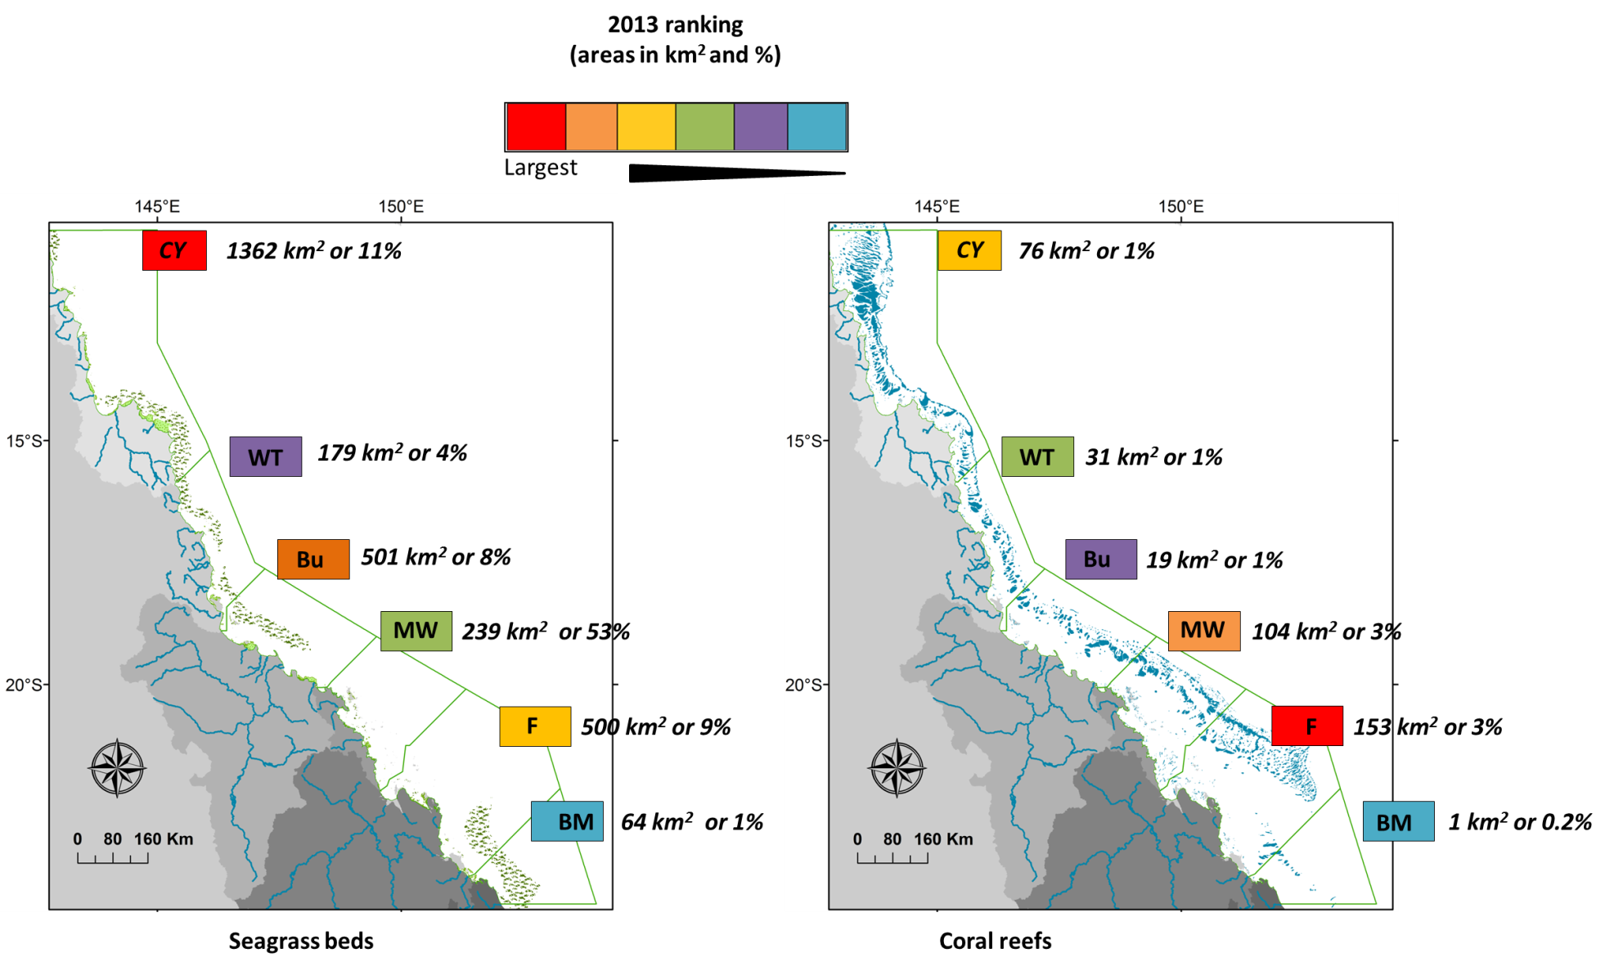

Future RS developments
- Recent progresses have been made to develop accurate regional algorithms for the GBR region (Brando et al., 2008; Brando et al., 2010a; Brando et al., 2010b; Schroeder et al., 2007) that provide better retrieval in optically complex coastal waters.
  - Using these algorithms to map chlorophyll-a concentrations in near future will be instrumental in more accurate mapping of river plume waters using the Level-2 method.
  - MODIS images calibrated into accurate water quality metrics would allow producing produce compliance maps to ecological threshold
- Further comparisons between RS-derived products and in situ WQ data acquired over the next MMP monitoring years will be undertaken.
- Progress toward validated river plume risk maps:
  - Must be accompanied by sound knowledge of the regional ecosystems and of the water quality concentrations across plume water types relative to natural levels and to ecologically-relevant thresholds.
  - Ecological consequences of the risk will primarily be a function of the presence/absence of GBR ecosystems exposed. However, community characteristics such as the sensitivity and resilience of particular seagrass or coral communities are additional parameters that must be considered when defining the ecological consequences of the risk.
  - The consequence of the exposure of species to a range of WQ conditions is complicated by the influence of multiple stressors and additional external influences including weather and climate conditions.
  - All this information should be used in future to develop ecosystem-specific risk matrix combining the magnitude (mapped through the Primary, Secondary, Tertiary water type classes), likelihood (mapped through the frequency of occurrence) of the river plume risk and the sensitivity of the studied ecosystem.
  - Finally, the GBR areas classified following the risk framework of Petus et al. (2014b) should be compared to ecosystem health data and the validity of the risk framework assessed by examining spatial patterns, including the distribution of monitored cases of ecosystem health decline per designated risk area (Petus et al., in prep.).
- Further developments of our RS methods to map loads of pollutants (TSS, DIN and pesticides) include:
  - The increase of the spatial resolution of WQ data used to calculate the spatially distributed DIN and TSS maps and re-run the model with the annual loads from the Source Catchments modelling for all of the 35 GBR catchments.
  - The production annual load maps of Photosystem II inhibiting herbicides (PSII herbicides). The approach for modelling exposure to DIN (i.e., assuming conservative mixing) will be used for PSII. However, further investigation will be necessary to adjust the dispersal relationships i.e., relationship between PSII concentrations and color classes (Álvarez-Romero et al., 2013) to calculate the annual cost surface for PSII.

Introduction

Marine Monitoring Program
The Marine Monitoring Program (herein referred to as the MMP) undertaken in the Great Barrier Reef (GBR) lagoon assesses the long-term effectiveness of the Australian and Queensland Government’s Reef Water Quality Protection Plan (Reef Plan) and the Australian Government’s Reef Programme initiative. The MMP was established in 2005 to help assess the long-term status and health of GBR ecosystems and is a critical component in the assessment of regional water quality as land management practices are improved across GBR catchments. The program forms an integral part of the Reef Plan Paddock to Reef Integrated Monitoring, Modelling and Reporting Program (P2R program) supported through Reef Plan and Australian Government Reef Programme initiatives. The Wet Season monitoring program is part of the water quality monitoring program under the MMP, which includes baseline, ambient and event sampling (Johnson et al., 2011; Martin et al., 2014). This monitoring is run in partnership with the other MMP programs including water quality (Bentley et al., 2012; Brando et al., 2008; Brando et al., 2010a; Johnson et al., 2011; Kennedy et al., 2012; Schaffelke et al., 2012), coral monitoring and seagrass monitoring (McKenzie et al., 2014; McKenzie et al., 2012; Thompson et al., 2013).
Water quality in the GBR is influenced by an array of factors including diffuse source land-based runoff, point source pollution, and extreme weather conditions. Monitoring the impacts of land based runoff into the GBR is undertaken within the wet season monitoring program under the MMP, which targets sampling of the wet season and high flow events to characterise the input of terrestrially sourced pollutants delivered through river discharge to the GBR (Devlin et al., 2012; Devlin et al., 2013; Johnson et al., 2011).
This program, through in-situ water quality sampling and remote sensed data identifies and maps the risk and exposure of GBR ecosystems to anthropogenic water quality influences (e.g., nutrients, sediments and pesticides). River flood plumes are important pathway for terrestrial materials entering the sea, and a dominant source of coastal pollutants. Spatial and temporal maps of the river plume extent, frequency of occurrence and duration of exposure provides information in the development of river plume risk models. These models identify plume-affected areas that may experience acute or chronic exposure to contaminants delivered by river discharge. Knowledge of the areas and ecosystems that are most likely to be impacted by changing water quality helps focus our understanding on what type of ecological impacts are occurring and to better inform marine, coastal and catchment management.
Due to the large size of the GBR Marine Park (350,000 km²), the short-term nature and variability of runoff events (hours to weeks) and the often difficult weather conditions associated with floods, it is difficult and expensive to launch and coordinate comprehensive runoff plume water quality sampling campaigns across a large section of the GBR (Devlin et al., 2001). Wet season water quality data is measured through a combination of in-situ water quality measurements taken at peak and post flow conditions in targeted catchments throughout the wet season. River plume extent, frequency and duration are also measured and mapped through the use of remote sensing products, and more recently, the development of hydrodynamic models.
The GBR is the most extensive reef system in the world and comprises over 2900 km² of coral reefs. It also comprises over 43000 km² of seagrass meadows (Error! Reference source not found.). Thirty major rivers drain into the GBR, all of which vary considerably in length, catchment area, and flow frequency and intensity. Rivers discharging into the GBR lagoon are the main land-based source of pollutants (i.e., sediments, nutrients and pesticides) of the GBR. The actual distribution and movement of the individual pollutants varies considerably between the Wet (north of Townsville) and Dry Tropic rivers (Devlin et al., 2011; Devlin et al., 2013).
In the GBR, river plumes are driven by high river flow conditions, which occur during the monsoonal season and are typically associated with the passage of cyclones or low pressure systems, i.e., from about December to April (Devlin and Brodie, 2005). Wet Tropic catchments, located between Townsville and Cooktown, have frequent storm and runoff events in generally short, steep catchments that have more direct and frequent linkages to coastal environments. In the Dry Tropic catchments, the major flow events may occur at intervals of years, with long lag times for the transport of material through these large catchments (Brodie et al., 2009).
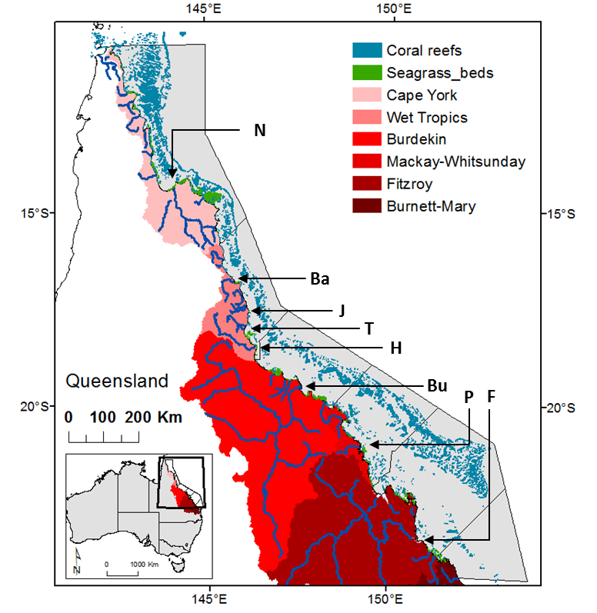
Figure 2-1: The Great Barrier Reef Marine Park (light grey, Queensland, Australia), major marine ecosystems (coral reefs and seagrass beds), Natural Resource Management regions (red colour scale) and marine portions (delineated by dark grey liens) of the NRM regions and major rivers: Normanby (N), Barron (Ba), Johnstone (J), Tully (T), Herbert (H), Burdekin (Bu), Pioneer (P), Fitzroy (F), modified from Petus et al., in review.
The GBR catchment has been divided into six large areas defined as Natural Resource Management (NRM) regions (Figure 2-1), each defined by a set of land use/cover, biophysical and socio-economic characteristics. The Cape York region is largely undeveloped and is considered to have the least impact on GBR ecosystems from existing land-based activities. In contrast, the Wet Tropics, Burdekin, Mackay-Whitsunday, Fitzroy and the Burnett-Mary regions are characterised by more extensive agricultural land uses including sugarcane, grazing, bananas and other horticulture, cropping, mining and urban development, and contribute to discharge of sediments, nutrients and pesticides to the GBR during the wet season.
Occurrence of coastal waters with elevated concentrations of dissolved inorganic nitrogen (DIN) has been linked to fertilised agriculture (predominantly sugarcane) in the Wet Tropics region, while high TSS concentrations are mainly linked to grazing activities in the Dry Tropics and in particular the Burdekin catchment (Brodie et al., 2008; Brodie et al., 2014; Brodie et al., 2012; Brodie and Waterhouse, 2012; Joo et al., 2012; Kroon, 2012; Maughan and Brodie, 2009; Waterhouse et al., 2012).

Sampling design
The three main facets of the marine flood plume monitoring program are in-situ data, collected in the field through the wet season, remotely sensed data, and integration of both in-situ and remote sensed data. Data from the flood monitoring feeds into the validation of existing models and the development of regionally based remote sensing algorithms (Brando et al., 2008; Brando et al., 2010b; Brando et al., 2009). Water quality collected in flood plume waters is targeted at measuring the conditions during first flush and high flow event situations to identify the duration and extent of altered water quality conditions (Table 2-1). Data collected under the MMP is also being tested for the improvement of the P2R water quality metric and ongoing P2R program reporting.
Table 2-1: Description of outputs related to the aims of the MMP wet season monitoring program.
Aim | Description
Assessment of the transport and processing of nutrients, suspended sediment and pesticides | Delivered through water quality monitoring in flood plumes. Measurement of water quality parameters presented against salinity gradients for each catchment and each event to describe the movement and transport of water quality parameters.
Estimation of the extent and exposure of flood plumes to reefs and seagrass beds related to prevailing weather and catchment conditions | Delivered through spatial mapping of plume extent and frequency. Information acquired from remote sensing products including true colour processing of plume waters and the application of water quality algorithms (chlorophyll-a, CDOM and TSS). Catchment runoff events involve space scales ranging from hundreds of metres to kilometres and time scales from hours to weeks, thus the use of remote sensing products at appropriate time and space scales is useful as a key indicators of cause and effect.
Incorporation and synthesis of monitoring data into GBR wide understanding of anthropogenic water quality conditions, water models, the MMP and Paddock to Reef reporting. | Synthesis and reporting of flood plume water quality data and exposure mapping into the MMP. Further work on the integration and reporting of water quality data collected under this sub-program and the long-term water quality sub-program is currently being investigated by JCU, CSIRO and AIMS researchers through Australian Government Reef programme R&D funding (see http://www.rrrc.org.au/reefrescue/index.html).
The priority catchments targeted for intensive sampling were chosen based on risk as reported in (Brodie et al., 2014). The Tully River catchment is also the ideal location to assess the long-term effectiveness of Reef Plan as data can be collected every year as it is the wettest catchment in Australia. Repeated sampling in the Tully also adds value to the long-term data set collected in this region from 1994 to 2012 (Devlin and Schaffelke, 2009). The wet season in 2012-13, as with 2010-11, started with onset of early flows in the Wet Tropics during October and November, and extended into April 2012. It was characterised by many smaller episodic flows but no large flow associated with a cyclonic period. Heavy and consistent rain also continued in the Wet Tropics region later in the wet season, peaking in late March. Samples were taken from sites from the Cape York region down to the Fitzroy River. This report summarises the data collected in the 2012-13 wet season and presented as part of a longe term data set collected under the MMP between 2004 and 2013.

Characteristics of the 2012-2013 wet season.

Wet Season conditions
A neutral activity, with respect to the El Niño-Southern Oscillation (ENSO) since mid-2012, promoted below average rainfall levels throughout the 2012-2013 wet season for the GBR region (http://www.bom.gov.au/climate/enso). In this period, only two cyclones associated with low pressure system were observed in the region: Ex-tropical cyclone Oswald, that crossed Cape York Peninsula on 21 January 2013 and moved down the Queensland coast, bringing strong to gale force winds, heavy rain, damaging waves and floods, and Ex-tropical cyclone Zane, that entered into the Marine Park from the Coral Sea and moved over Cape York Peninsula, affecting areas from Cape Grenville to Cooktown at the beginning of May 2013 (GBRMPA, Environmental Conditions 2012/2013, http://www.gbrmpa.gov.au/outlook-for-the-reef/climate-change/marine-park-management/current-conditions-on-the-great-barrier-reef).
South-east Queensland and parts of the Central Coast received above average levels (50–400 mm higher than the monthly average) mainly due to the influence of ex-tropical cyclone Oswald, whereas the other areas through GBR experienced low rainfalls in the 2012-2013 wet season. Ex-tropical cyclone Oswald caused minor to major floods, and flood plumes, in all major river systems from south of Mackay to the Queensland–New South Wales border (GBRMPA, Environmental Conditions 2012/2013, http://www.gbrmpa.gov.au/outlook-for-the-reef/climate-change/marine-park-management/current-conditions-on-the-great-barrier-reef).
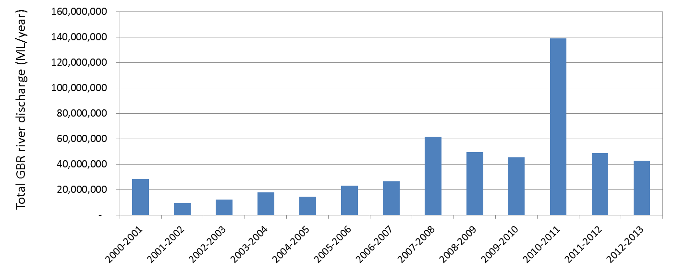
Figure 3-1: Long-term total hydrological year discharge (c.a., Oct-1 to Sep-30) for the main GBR Rivers (Source: DNRM, http://watermonitoring.dnrm.qld.gov.au/host.htm).
Even though the 2012-2013 wet season was not characterized by intense rainfall such as that which occurred in 2010-2011, it still had the 6th largest discharge (approximately 4.3×10⁷ megalitres) for the last 13 years. This was 7% lower than 2011-2012 discharges and 40% lower than 2010-2011 discharges (Figure 3-1). Flow data (measured as total annual flow since 2000) shows that river discharge into the GBR has been consistently higher in the most recent 6 years (Figure 3-1). This increase in flow has been a key driver in measurements of ecosystem decline, including seagrass condition (McKenzie et al., 2012) and coral health metrics (Thompson et al., 2012). The large volume of freshwater discharge is the main factor influencing in the extent of plume area (see Álvarez-Romero et al, 2013).

Table 3-1: Long term river discharge (ML) statistics of GBR rivers for the 2012-2013 hydrological year (c.a., Oct-1 to Sep-30), compared against the previous three hydrological years, and long-term (LT) medians, means and standard deviations (SD). Colours indicate levels above the long-term median: yellow for 1.5 to 2 times; orange for 2 to 3 times, and red for greater than 3 times. Long term statistics were calculated based on a hydrological year taking into account measurements from 1915 to 2000. (Data source: DNRM). Discharge for Tully at Euramo station (113006A) for the dry season was estimated as 3.5941 times the Tully discharge at Gorge National Park station (113015A), based on a long-term discharge comparison for flows < 20,000 ML/day (r-sq = 0.802).

Region | River | Annual LT median river discharge | Annual LT mean river discharge | Annual LT SD river discharge | Total year discharge 2009/2010 | Total year discharge 2010/2011 | Total year discharge 2011/2012 | Total year discharge 2012/2013
CapeYork | Pascoe | 1,252,975 | 1,194,911 | 723,925 | 1,534,694 | 1,972,999 | 758,509 | 827,312
CapeYork | Stewart | 212,336 | 196,926 | 125,224 | 188,528 | 376,009 | 106,219 | 90,343
CapeYork | Normanby |  |  |  | 2,945,850 | 5,964,886 | 1,148,416 | 1,822,135
CapeYork | Annan | 276,538 | 279,594 | 162,344 | 407,257 | 550,403 | 331,370 | 196,988
Wet Tropics | Daintree | 704,634 | 820,437 | 478,584 | 1,216,318 | 1,640,196 | 998,710 | 694,098
Wet Tropics | Barron | 572,725 | 702,662 | 483,058 | 500,233 | 1,927,091 | 774,595 | 297,555
Wet Tropics | Mulgrave | 728,917 | 795,475 | 380,792 | 773,158 | 1,568,750 | 1,083,093 | 567,079
Wet Tropics | Russell | 995,142 | 981,043 | 348,369 | 1,298,963 | 1,719,880 | 1,290,488 | 888,722
Wet Tropics | N Johnstone | 1,758,717 | 1,821,250 | 670,503 | 1,826,418 | 3,541,632 | 2,023,900 | 1,478,171
Wet Tropics | S Johnstone | 850,463 | 824,374 | 320,024 | 728,626 | 1,612,187 | 941,983 | 584,344
Wet Tropics | Tully¹ | 2,944,018 | 2,989,001 | 1,157,654 | 2,984,477 | 6,202,306 | 2,854,247 | 2,775,345
Wet Tropics | Herbert |  |  |  | 3,163,763 | 11,448,794 | 4,131,993 | 2,896,025
Burdekin | Burdekin | 5,312,986 | 7,490,799 | 8,285,066 | 7,946,435 | 34,834,316 | 15,568,159 | 3,417,924
Burdekin | Don | 51,243 | 162,586 | 261,912 | 144,481 | 847,617 | 216,956 | 179,755
Mackay Whitsunday | Proserpine | 14,632 | 23,617 | 20,620 | 52,304 | 346,248 | 51,927 | 37,411
Mackay Whitsunday | O'Connell | 307,272 | 291,155 | 208,999 | 327,627 | 587,525 | 278,370 | 109,094
Mackay Whitsunday | Pioneer | 355,317 | 639,899 | 733,958 | 1,183,875 | 3,284,668 | 1,312,054 | 912,117
Mackay Whitsunday | Plane | 142,404 | 194,543 | 220,784 | 621,629 | 866,229 | 516,769 | 382,404
Fitzroy | Fitzroy | 2,899,842 | 4,690,607 | 5,564,305 | 11,755,415 | 37,942,149 | 7,993,273 | 8,532,130
Burnett-Mary | Burnett | 282,151 | 374,103 | 362,186 | 1,022,820 | 8,565,016 | 584,670 | 6,884,668
Burnett-Mary | Mary River | 696,590 | 1,257,673 | 1,353,771 | 1,926,194 | 6,227,933 | 3,100,196 | 5,464,353
Total |  | 20,358,902 | 25,730,656 |  | 42,549,067 | 132,026,835 | 46,065,897 | 39,037,974

In the 2012-2013 wet season, seven rivers, located in four regions had flows that were greater than two times the long-term median. High flows were observed from the southern Burdekin to the Burnett-Mary regions, where the total flow for the hydrological year (ca., from Oct, 1st to Sep, 30th) exceeded the long-term median discharge by 2 and 3 times, respectively (
Table 3-1).
In the Cape York and Wet Tropics regions, none of the main rivers exceeded the long-term median in 2012-13. The discharges from the southern rivers were much higher, with 2012-13 flow exceeding long-term median by 3.5 (Don), 2.9 (Fitzroy), 2.9 (Burdekin) and 7.8 for the Mary River. The discharge from the Burnett River was over 6 million megalitres, which was 24 times greater the long-term median flow. The summary of the plume events computed as the number of days in which flow exceeded a long-term 75th and 95th percentile is shown in Table 3-2. Overall, all major rivers in the GBR had daily flow rates that exceeded the 75th percentile for periods between 15 days and 2 months. The high frequency events that exceeded the 95th percentile were in the southern part of the GBR, which was mainly associated with the passage of the Ex-tropical cyclone Oswald.
Table 3-2: The 75th and 95th percentile flow (ML/day) for the major GBR rivers (based on flow between the beginning of the station to 2012-09-30 obtained from DNRM).

River | Station | 75th %ile (ML/day) | 95th %ile (ML/day) | No days (2012-13) exceed 75th percentile | No days (2012-13) exceed 95th percentile
Pascoe | 102102A | 1,757 | 18,385 | 16 | 2
Stewart | 104001A | 219 | 3,245 | 15 | 2
Normanby | 105107A | 3,405 | 46,691 | 20 | 3
Annan | 107003A | 671 | 2,767 | 27 | 3
Daintree | 108002A | 1,938 | 8,924 | 23 | 3
Barron | 110001D | 1,036 | 6,090 | 8 | 2
Mulgrave | 111007A | 2,000 | 7,109 | 21 | 2
Russell | 111101D | 3,210 | 12,308 | 21 | 3
N Johnstone | 112004A | 5,329 | 16,694 | 24 | 2
S Johnstone | 112101B | 2,326 | 7,097 | 15 | 1
Tully | 113006A | 9,270 | 28,441 | 27 | 3
Herbert | 116001F | 16,470 | 60,888 | 7 | 1
Burdekin | 120006B | 6,747 | 115,249 | 14 | 1
Don | 121003A | 87 | 1,405 | 60 | 3
Proserpine | 122005A | 43 | 404 | 45 | 6
Fitzroy | 130005A | 3,644 | 64,988 | 30 | 7
Burnett | 136007A | 338 | 4,316 | 37 | 24
Mary | 138014A | 1,438 | 12,306 | 41 | 10

Extent of river plumes – 2012/2013 wet season
Two main flood periods were recorded in the river hydrographs: (i) around the 25th of January and the 11th of February under the influence of Tropical Cyclone Oswald and (ii) around the 24th of February and 18th of March. Although a relatively weak storm (cyclone of category 1; Source: BOM), Oswald produced torrential rains over much of Queensland. Rainfall peaked in Tully where approximately 1,000 mm of rain fell; with 632 mm falling over a 48 hour span. The Herbert River rose rapidly after 200 mm of rain fell in the town of Ingham in just three hours (source: BOM). Illustration of areas flooded along the Herbert River is presented in Appendix A, Figure A-1.

Wet Tropics NRM
A selection of MODIS true color images recorded during the 2 main flood events shows river plumes formed from the main GBR rivers (the Normanby River, the Barron and Johnstone rivers, the Tully and Herbert rivers, the Burdekin River, the Pioneer River, the Fitzroy and The Burnett-Mary River). These images are presented in Appendix A. Figure 3-2 to Figure 3-7 Error! Reference source not found. present enlargements of some of these MODIS true colour image as well as corresponding plume waters types (6 colour classes corresponding to Primary, Secondary, Tertiary plume waters types) mapped by the TC method of Álvarez-Romero et al. (2013). These figures help describing the movements and spatio-temporal variability of the GBR River plumes during the 2012-13 wet season.
In the Wet Tropics, none of the main rivers exceeded the long-term median in 2012-13 and river discharge rates for the Barron and Johnstone Rivers were relatively low (Appendix A Figure 3-2, Figure 3-3). Maximum peak discharge of 106,510 ML day⁻¹ for the Johnstone and 34,788 ML day⁻¹ for the Barron River were recorded the 24th and 25th of January 2013 respectively. Barron and Johnstone river plumes mapped were not well developed and the turbid river plume waters were mainly constrained close to the coast (Appendix B). However, on the 25th of January, Barron river plume waters were deflected offshore toward the inner coral reefs by the NW winds (Error! Reference source not found.). The 29th of June, the TC method failed to fully map the river plume waters located north of the Barron estuary mouth due to atmospheric perturbations, but Primary plume waters were observed close to the estuary mouth on both the true colour and 6-classes river plume maps
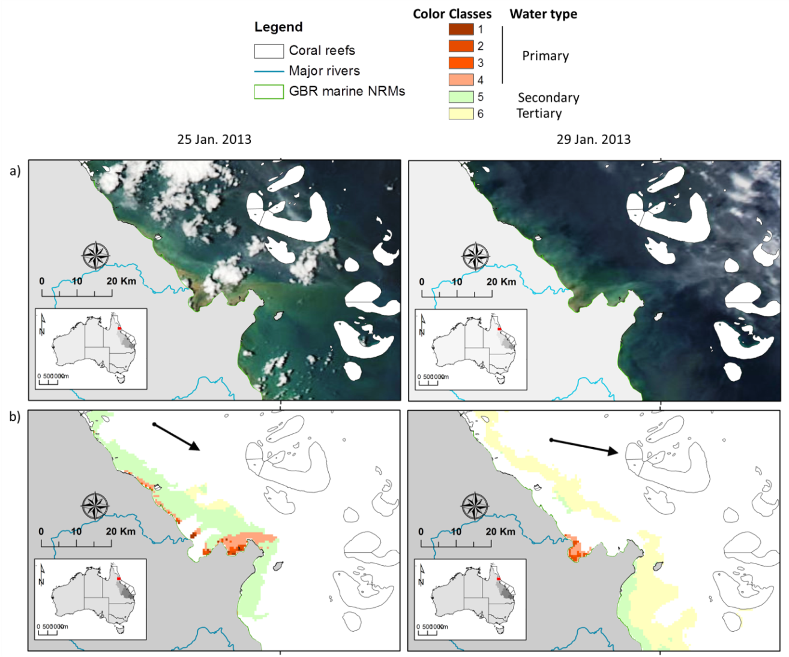
Figure 3-2: a) True colour and b) plume waters mapped the 25th and 29th of January, 2013 in the Wet Tropics NRM using the method of Álvarez-Romero et al. (2013). These maps show Barron River plume waters deflected toward offshore by the NW winds. Wind direction measured at 12:00 am is indicated with black arrows.
Highest river discharge rates for the Tully and Herbert rivers were measured on the 25th of January (563816 ML day⁻¹ for the Herbert and 831701 ML day⁻¹ for the Tully River, (Appendix A, Figure 3-3). Maximum surface areal extents for both the Tully and Herbert River plumes were measured, in response, the 25th of January 2013. The Herbert River plume surface areas decreased after the 25th of January 2013, following the reduction of the Herbert river flow (Appendix A). Surface areas of the Herbert Primary plume waters decreased from about 360 km² the 25th of January, to 78 km², 64 km² and 0.3 km² the 29, 30 and 31th of January 2013 (Herbert river discharge of 21354ML day⁻¹ on the 31th of January).
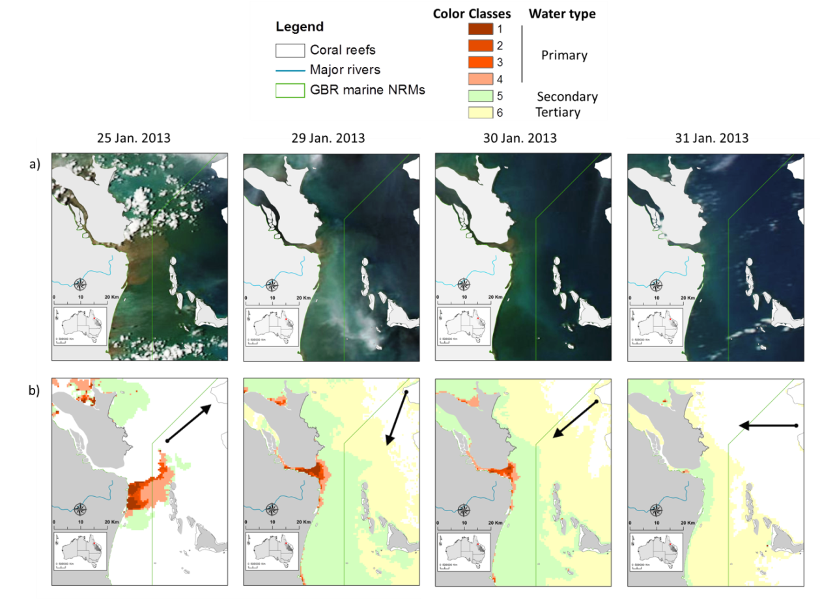
Figure 3-3: a) True colour and b) plume waters mapped from the 25th to the 31rd of January 2013 in the Wet Tropics NRM using the method of Álvarez-Romero et al. (2013). This series of maps illustrate high importance of river discharge rates modulations on the river plumes areas. Wind direction measured at 15:00 am is indicated with black arrows (data at 12:00 am are unavailable for the Ingham meteorological stations).

Burdekin NRM: Burdekin River
Ex-tropical cyclone Oswald induced flooding in the Burdekin NRM. The highest Burdekin river discharge was measured on the 25th of January (343,366 ML day⁻¹; Appendix A: Figure 3-4, Figure 3-5) unfortunately the cloud cover on this day prevented any mapping of the Burdekin River plume. Well-developed turbid river plumes were, however, observed on the MODIS TC images of the 27th and 29th of January (Figure 3-4). The river plume monitored the 27th of January was clearly deflected by the western winds toward the inner coral reefs, but atmospheric and sun-glint perturbations prevented an exact delineation of the river plume external boundary. The 27th of January, the Primary plume waters extended more than 100 km offshore from the Burdekin River mouth. Well-developed Burdekin River plumes were also observed from the 30th of January to the 04th of February (Figure 3-5) and from the 7th to the 13th of March 2013 (Appendix A). Field sampling in the Burdekin region was undertaken between the 13th and the 18th of March of 2013.

Mackay-Whitsundays NRM: Pioneer River
High flow periods were observed in the Mackay-Whitsundays and the total hydrological year flow (ca. from Oct, 1st to Sep, 30th) for 2012-2013 exceeded >2 folds the long-term median discharge (
Table 3-1). Maximum peak discharges of 60,197 ML day⁻¹ and 106,788 ML day⁻¹ were recorded the 25th of January and the 6th of March 2013, respectively. Between the 30th and the 16th of March, the turbid Primary plume waters mapped were mainly constrained close to the coast (Appendix A and Figure 3-6). However, areas of Secondary and, to a lesser extent, Tertiary water types, were observed offshore of the Pioneer river mouth (up to 70 km for the Secondary waters and 130 km offshore for the Tertiary waters on the 7th of March 2013).
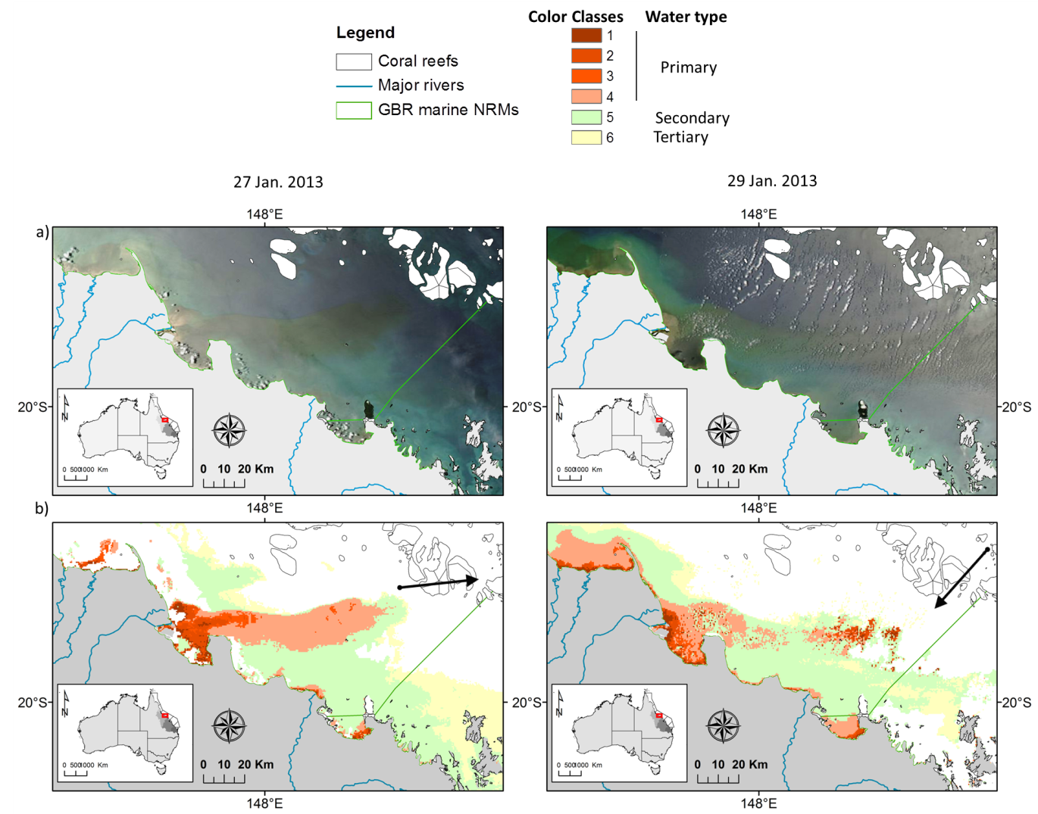
Figure 3-4: a) True colour and b) plume waters mapped on the 27th and 29th of Jan 2013 in the Burdekin NRM using the method of Álvarez-Romero et al. (2013). Burdekin River plume waters are deflected offshore under strong western winds and reach the inner coral reefs on the 25th of January. Wind direction measured at 12:00 am is indicated with black arrows.
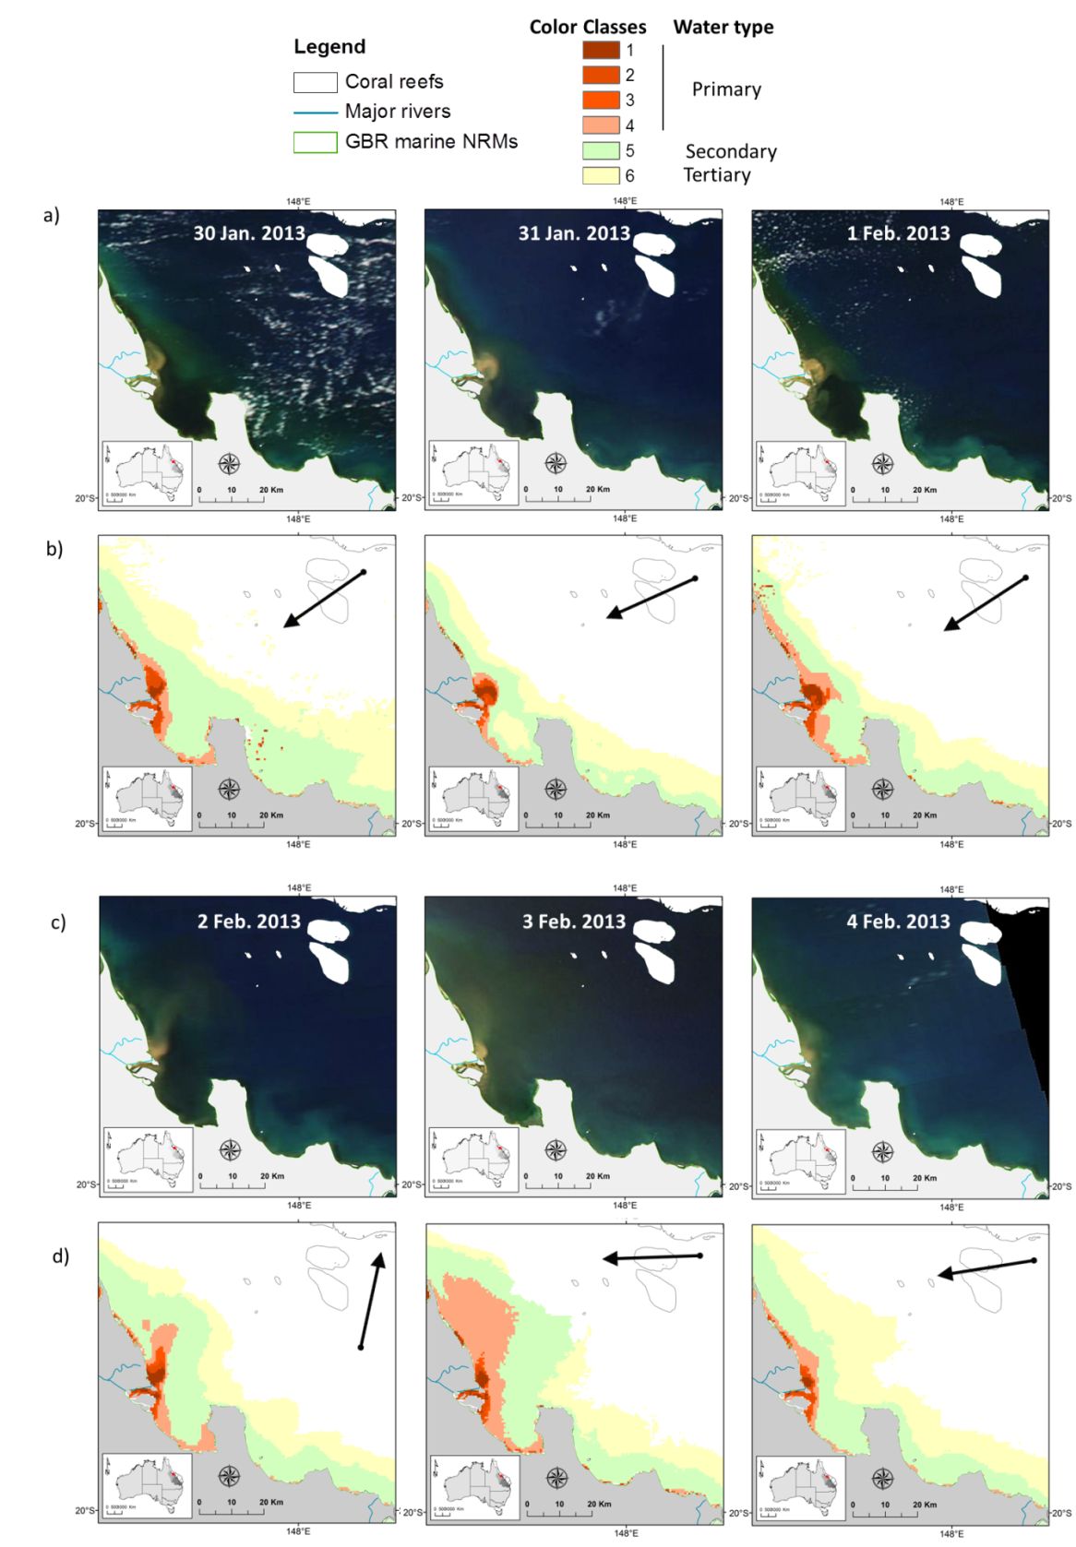
Figure 3-5: True colour (a and c) and plume waters (b and d) mapped from the 30th of January to the 01th of February and from the 2nd to the 4th of February in the Burdekin NRM using the method of Álvarez-Romero et al. (2013). Wind direction measured at 12:00 am is indicated with black arrows.
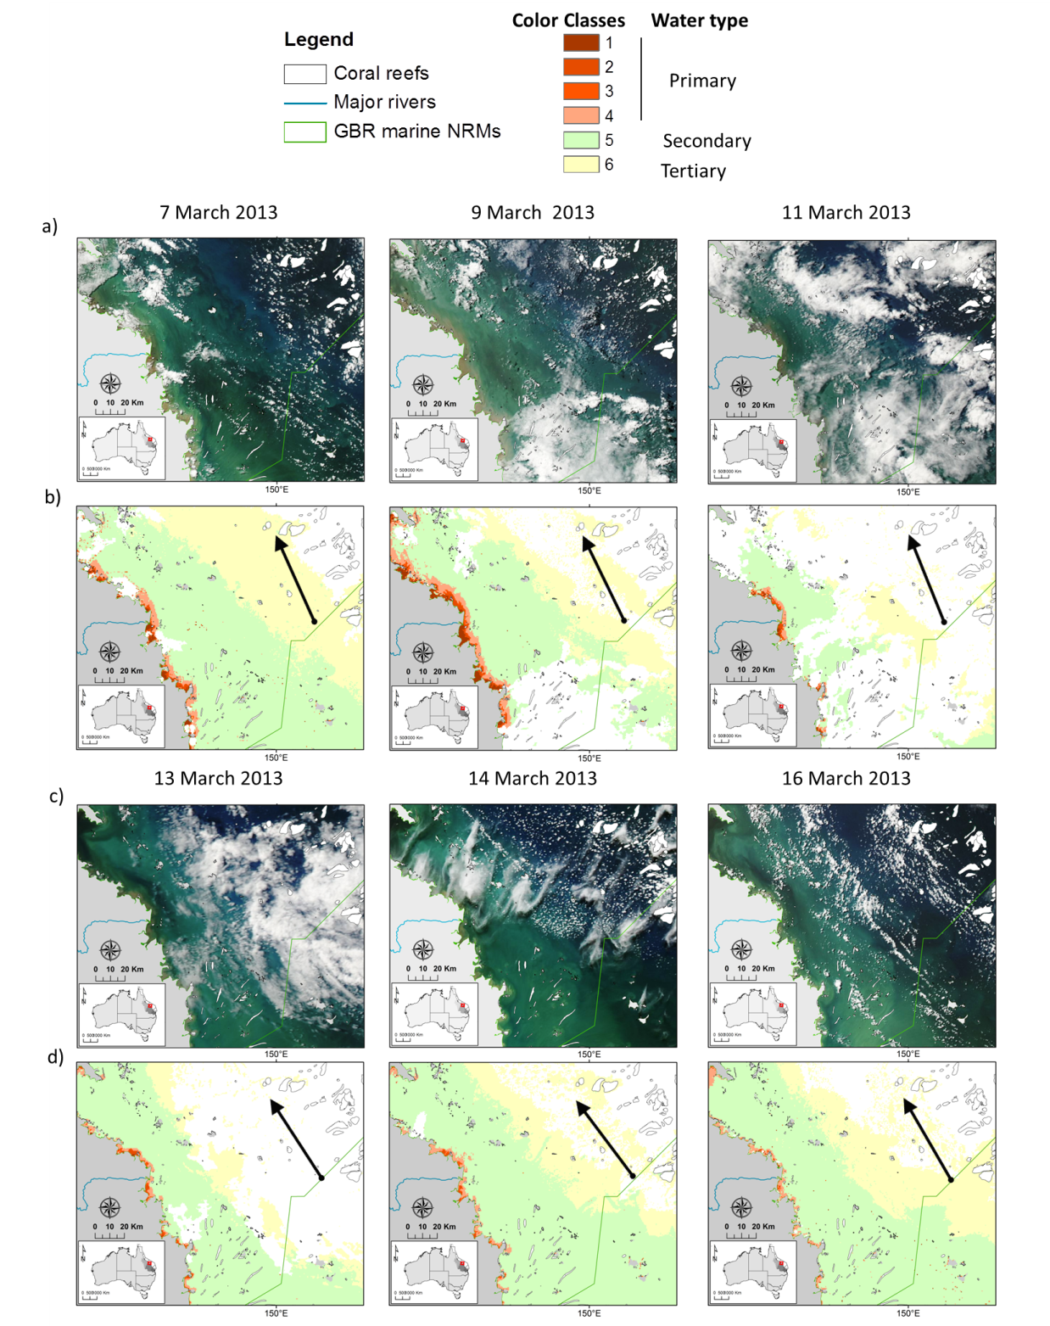
Figure 3-6: a) True colour and b) plume waters mapped from the 7th of March to the 16th of March 2013 in the Mackay Whitsundays NRM using the method of Álvarez-Romero et al. (2013).. Wind direction measured at 12:00 am is indicated with black arrows.
Furthermore, on true colour images of the 7th to 16th of March 2013 (Figure 3-6), secondary plume waters located north of the Pioneer River mouth deflected toward the south from their northern, Coriolis-induced, motion. This was particularly well illustrated the 16th of March 2013 (Figure 3-7a) when a tongue of Secondary waters, flowing toward the south as a counter current to the coastal Primary plume waters (Figure 3-7b), seems to explain the large areas of Secondary water type mapped by the TC classification method (Figure 3-6). The presence of a southern current located offshore of the Pioneer river could be an explanation for this observed phenomenon.

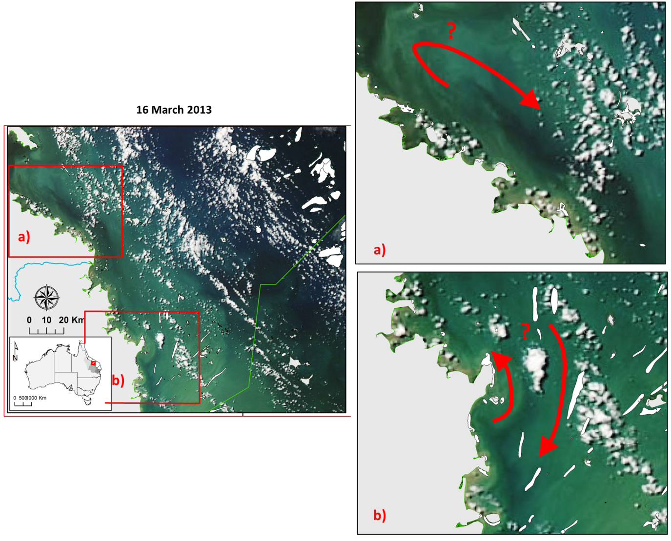
Figure 3-7: MODIS true colour image of the 16th of March 2013 showing waters from the Pioneer River deflected toward the south from their northern Coriolis-induced movement.

Regional differences
These snapshots of river plume dynamics in each NRM during the wet season 2012-13 are in agreement with theoretical models (Geyer et al., 2004), previous physical oceanographic studies (Wolanski and Jones, 1981; Wolanski and Van Senden, 1983), modelling studies and previous MMP reports (Devlin et al., 2001). The movement of plumes highlights that GBR river plumes are mainly constrained close to the coast by the Coriolis effect and the prevailing wind regime, but regional differences in plume orientation and aerial extent are shaped by a combination of hydro-climatic forces, including (i) the river discharge rates, (ii) the wind strength and orientation and (iii) the local currents.
Plume exposure on the more offshore ecosystems, like coral reefs, is often limited while onshore ecosystems like coastal seagrass beds are under a greatest exposure from river plumes and associated pollutants. However under offshore wind conditions, river plumes can be deflected seaward, like observed on the 27th and 29th of Jan 2013 in the Burdekin NRM (e.g Figure 3-4). River plumes reach the mid and outer-shelf of the GBR reef over “rare”and “occasional” scales (at the wet season scale) as observed on the true colour images of the Barron River, on the 25th of January (Figure 3-2). Mid and outer-shelf of the GBR reef are nevertheless more than likely to be only affected by the Tertiary water type (i.e., less concentrated in land-sourced pollutants) than the Primary turbid core (i.e., more concentrated in land-sourced pollutants) of the river plumes.
Primary (highly turbid) coastal water surface areas are mainly modulated by the river discharge rates. More offshore plume types (Secondary and Tertiary river plumes) are also correlated to the river discharge, but their shapes and orientations are strongly modulated by the wind, the local currents and Secondary and Tertiary plume waters from different river plumes are often merged all together.

In-situ Water Quality

Sampling design – 2012-2013
Sampling of wet season conditions at MMP sites were carried out within the Cape York, Daintree, Barron, Russell-Mulgrave, Tully, Herbert, Burdekin and Burnett-Mary marine regions. Water quality samples collected in the Daintree, Barron and Russell-Mulgrave sites were collected on route to Cape York and whilst providing longer-term data for the Wet Tropics, they will not be reported on, at a regional level, due to the low number of samples. Additionally plume samples collected in Cape York form part of a larger study and will be reported on separately (Howley et al., 2015). Burnett-Mary samples were taken as part of an integrated monitoring exercise with the Burnett Mary Regional Group, and has been reported elsewhere (da Silva et al., 2013). Water quality reporting will focus on the samples collected in 2012-2013 in the Tully, Herbert and Burdekin rivers (Table 4-1).
Table 4-1: Summary of the sampling effort carried out in the 2012-13 wet season campaign by NRM, presenting the number of field trips, sites sampled and the sampling period for each river visited within each NRMs.
NRM | River | No. of Field Trips | No. of Sites | Start Date – 2013/2014 | End Date  2013/2014
Wet Tropics | Daintree/Mossman | 1 | 5 | 30/11/2012 | 02/02/2013
Wet Tropics | Barron | 1 | 5 | 05/12/2012 | 03/02/2013
Wet Tropics | Russell/Mulgrave | 1 | 7 | 10/12/2012 | 03/02/2013
Wet Tropics | Tully | 4 | 43 | 10/11/2012 | 16/04/2013
Wet Tropics | Northern Herbert | 2 | 12 | 16/01/2013 | 25/03/2013
Wet Tropics | Southern Herbert | 2 | 14 | 17/01/2013 | 25/03/2013
Burdekin | Burdekin | 1 | 25 | 13/03/2013 | 18/03/2013
Burdekin | Don | 1 | 11 | 14/03/2013 | 16/03/2013

Sites within the Wet Tropics region extended from the south of Palm Island to the north of the Daintree River mouth (Figure 4-1). Sampling dates covered the period between 30/11/2012 to 16/04/2013, where three major flood events were sampled: (a) on 23/01/2013 with a total daily discharge of 291,901 ML; (b) on 24/03/2013 with a total daily discharge of 102,154 ML and (c) on 13/04/2012 with a total daily discharge of 83,340 ML (Figure 4-2). Flow rates in 2012-2013 presented the 8th highest total annual discharge within the last 13 years (Figure 4-3).
Sites within the Burdekin region extended towards the south of Palm Island at the Edgecumbe Bay at Bowen (Figure 4-1). Two regions were visited within this area, the Burdekin River and the Don River, just after the second highest peak discharge occurred in the 2012-2013 wet season (07-03-2013, 173,312 ML, Figure 4-2). Burdekin river flow in 2012-2013 presented the 10th highest total annual discharge within the last 13 years (Figure 4-3).

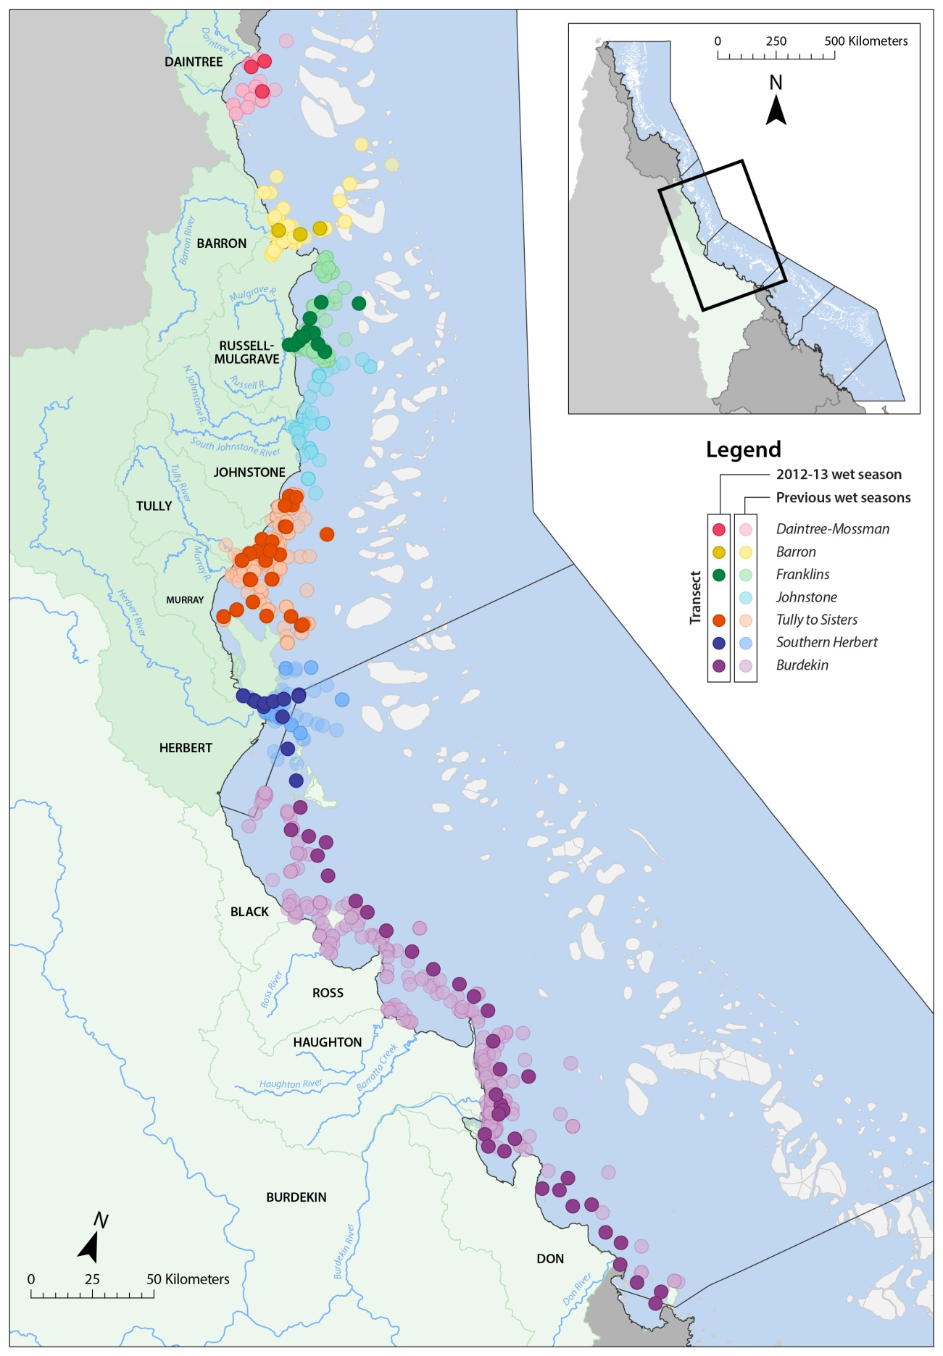
Figure 4-1: Location of the Marine Monitoring Sites sampled in the 2012-2013 wet season under the MMP terrestrial discharge program. Site locations for the two regions sampled (Wet Tropics, Burdekin are identified by colours (see legend).

Figure 4-2: Total daily discharge (megalitres/day) for the main NRM Wet Tropics and Burdekin rivers for the 2012-2013 wet season (Source: DNRM, http://watermonitoring.dnrm.qld.gov.au/host.htm). Dots indicate the sampling dates and colours stand for sites close to or under influence of a particular river.

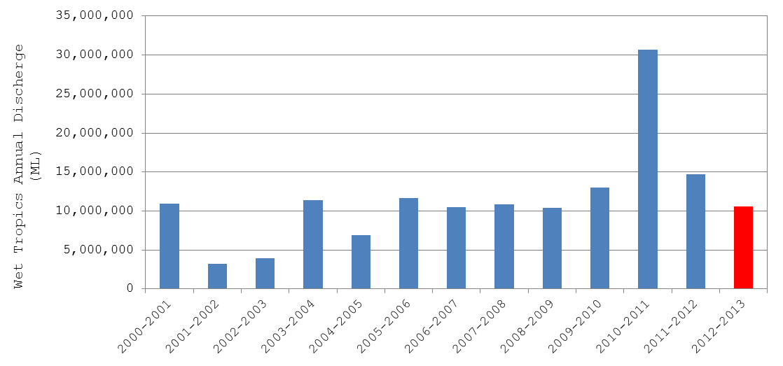
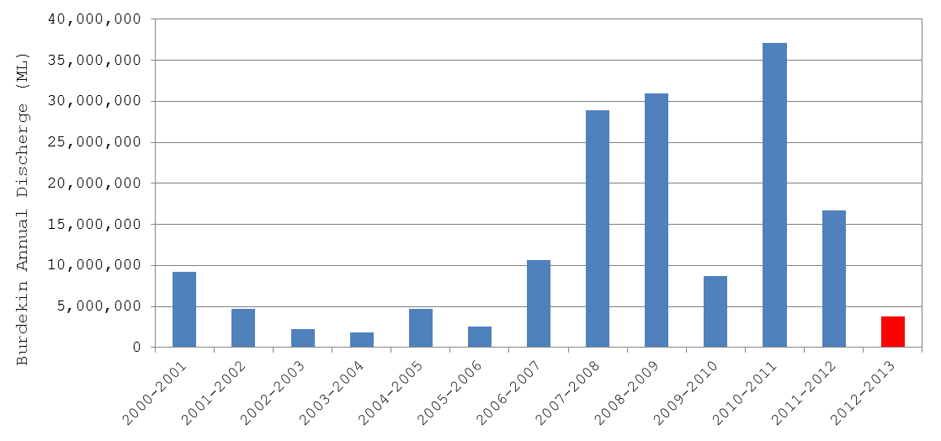
Figure 4-3: Total annual discharge (ML, megalitres), calculated from October, 1st to September, 30th, for the main NRM Wet Tropics and Burdekin rivers (Source: DNRM, http://watermonitoring.dnrm.qld.gov.au/host.htm).

Methodology – Water Quality

Water samples – 2012-2013
Water Quality for the 2012-13 wet season is discussed for the Wet Tropics and Burdekin Water sampling included the collection of surface samples (within the first 50 cm) for the analysis of TSS, chl-a, CDOM, DIN, DIP, PN, PP, salinity, temperature and Kd(PAR). For full details of field and laboratory methods, refer to the MMP QA/QC manual (Anon, 2013, 2014). Depth profiling was undertaken using a CTD from Sea-Bird Electronics (SBE-19Plus) equipped with sensors for temperature, salinity, depth, oxygen and light. The CTD profiler was kept at the water surface for 3 minutes for sensors stabilization before starting downcast. CTD data reported herein represents surface salinity and surface water temperature only, calculated as an average of readings between 0.3 m and 0.7 m below the water surface, after visual removal of outliers corresponding to the 3 minutes stabilization period. Underwater light extinction coefficient (Kd, m⁻¹) was calculated using the Lambert-Beer equation on the CTD light profile with a summary of the parameters collected in the program provided in Table 4-2.
Table 4-2: Summary of chemical and biological parameters sampled for the MMP flood plume monitoring.
Type of data | Parameter | Comments | Reported
Physico-chemical | Depth (m) | Taken continuously through the water column at each site. Sampled with a SeaBird profiler  Not at all sites | √
 | Salinity |  | √
 | Temperature (˚C) |  | √
 | Turbidity (ntu) |  | √
 | Light Attenuation (PAR)* |  | √
Water quality | Dissolved nutrients (µM) | Surface sampling only | √
 | Particulate Nutrients (µM) | Surface sampling only | √
 | Chlorophyll-a (µg/L) | Surface sampling only | √
 | Phaeophytin (µg/L) | Surface sampling only | √
 | Total Suspended solids(mg/L) | Surface sampling only | √
 | Coloured Dissolved Organic Matter (443 m⁻¹) | Surface sampling only | √
 | Pesticides (PS-II herbicides) (ng/L)*
Biological | Phytoplankton counts*
* not sampled at all sites

Data analysis - spatial
Four strategies were adopted in order to analyse the sampled data. Firstly, mixing plots were produced for each WQ parameter grouped by sampling events for the main sampled rivers (i.e., rivers with more than 20 samples: Tully, Herbert, and Burdekin). The WQ parameters sampled in the Tully, Herbert and Burdekin area were also plotted against two parameters: (a) the distance between the sampling site and the nearest (or influential) river mouth, (b) 5-days average river discharge calculated from the sampling date. These plots aimed to investigate the temporal and spatial variation of the sampled WQ parameters and describe the influence of river discharge. In order to facilitate the identification of WQ patterns, a non-parametric fitting curve (loess model, see Crawley, 2007) was adjusted to the data. For the distance calculation, sites were assigned to the nearest (or influential) river based on the site location. The “5-day” average was arbitrarily selected as a way to represent a potential delay between water passing the river gauge measurements (average dist. ~36 km from river mouth, ranging from 6 – 91 km) and the measurement at the sampling site (within 1 – 270 km from the river mouth, average dist. ~47 km). Furthermore, a correlation table was produced comparing each water quality parameter, grouped by river, against the two supporting parameters (i.e., distance and discharge). Correlations were calculated using the Spearman's rank correlation coefficient because the majority of the variables did not present normal distribution (Table 4-3).

Table 4-3: Summary of statistical analysis techniques exploring spatial variation applied to the WQ parameters sampled within the wet 2012-2013 wet season.
Statistical approach | Data set used and method | Potential outcome
Mixing plots | 2012-2013 WQ data grouped by sampling events against salinity. Lower salinity point taken by average NRM value < 5ppt | Scatter plots identifying superficial mixing profiles and WQ parameter reduction from a potential freshwater value
Scatter plots | 2012-2013 WQ data grouped by River against distance and discharge | Patterns on the temporal and spatial variation of WQ as resulted from river discharge and proximity to source (i.e., river mouth).
Correlation table | The Spearman's rank correlation was computed for all 2012-2013 WQ and also distance and river discharge. | Find out correlated WQ parameters between themselves and with river discharge and distance

Data analysis – Temporal
The temporal variation of WQ parameters sampled at selected transects were plotted on top of the temporal variation of the total wet season river discharge. When comparing multi-annual data sets for temporal variation it is important to consider that differences can be imposed on temporal trends due to inter-annual environmental changes and to differences in the sampling frequency rate and/or in the size of the covered sampling area. These issues of limitation are true for all data when comparing across long-term data, where the variability of the parameter can be influenced by many factors.
The annual river discharge for 5 GBR rivers is presented for the 4 transects considered in the WQ temporal variation analysis, compared against their long term mean annual discharge (Error! Not a valid bookmark self-reference.). All the rivers considered presented discharge above the long-term mean in the 2010-2011 wet season (period of the TC Yasi). The Fitzroy River exhibited annual discharges above its mean annual value more often than the other rivers, followed by the Burdekin River. The Russell, Mulgrave and Tully rivers exhibited relative unchanged discharge over the past 8 years with a peak in the 2010-2011 wet season only.
Temporal trends on the WQ components collected under the Marine Monitoring Program, at surface waters over the Great Barrier Reef, were investigated using Generalized Additive Mixed Models (GAMM, Crawley, 2007) in R language (R Development Core Team, 2015). Data sampled from December, 2005 to April, 2013 (inclusive) constrained to the Central and Southern GRB regions was selected for this analysis because of their better temporal and spatial coverage. The following WQ components were analysis by GAMM: light attenuation coefficient (Kd), coloured dissolved organic matter (CDOM), total suspended solids (TSS), chlorophyll-a (chl-a), particulate nitrogen (PN), dissolved inorganic nitrogen (DIN), particulate phosphorous (PP), dissolved inorganic phosphorous (DIP) and silica (Si), which are the main WQ components driving corals and seagrass communities in the Great Barrier Reef ecosystems.
The investigation of temporal patterns on the selected WQ components was performed in two steps. Firstly, a multiple regression analysis using non-parametric smoothers in a Generalized Additive Model (GAM, R Development Core Team, 2015) was performed to choose a set of predictors that best explain each WQ component. The predictors included (i) mean of 5-days river discharge, (ii) distance between the sampling site and the nearest river mouth, and (iii) surface salinity. These components were used as predictors in the multiple regression analyses and in order to select the most appropriated smooth terms (or predictors), the residual maximum likelihood (REML) method was applied. This method uses a likelihood function calculated from a transformed set of data, so that irrelevant predictors have no effect in the model (R Development Core Team, 2015). This method is similar to a stepwise regression analysis but where one uses, in this case, cubic spline to fit each predictor rather than a straight line. In order to investigate the predictors which have more influence in the GAM analysis, the relative importance analysis (Grömping, 2006) was performed on the data.
Secondly, the set of predictors selected from the multiple regression analysis was used in a Generalized Additive Mixed Model (GAMM) in order to investigate temporal trends in each WQ component. In these temporal trend models, time (i.e., Sample Date) was used as fixed effect, which is the variable that influences the mean of the WQ component, and the other selected predictors were used as random effects, i.e., what influences the variance of the WQ component.

Table 4-4: Long term wet season river discharge (ML, megalitre) statistics of five GBR rivers for the last 8 years (c.a., Nov-1 to Apr-30), compared against their long-term (LT) median. Colours indicate levels above the long term median: yellow for 1.5 to 2 times; orange for 2 to 3 times, and red for greater than 3 times. Long term statistics were calculated based on a hydrological year taking into account measurements from 1915 to 2000 (where data available). (Data source: DNRM).

River | LT median | 2005-2006 | 2006-2007 | 2007-2008 | 2008-2009 | 2009-2010 | 2010-2011 | 2011-2012 | 2012-2013
Russel | _{632,309} | _{817,392} | _{912,129} | _{858,993} | _{966,983} | _{878,223} | _{1,293,058} | _{815,652} | _{409,489}
Mulgrave | _{440,347} | _{643,907} | _{530,609} | _{835,704} | _{591,860} | _{541,997} | _{1,315,073} | _{751,882} | _{277,050}
Tully | _{1,894,102} | _{2,254,263} | _{2,714,150} | _{2,437,338} | _{2,852,481} | _{1,860,031} | _{4,642,874} | _{1,445,101} | _{1,576,555}
Burdekin | _{4,669,849} | _{1,798,930} | _{8,656,136} | _{27,130,969} | _{29,091,190} | _{7,661,648} | _{33,885,815} | _{14,333,639} | _{3,110,545}
Fitzroy | _{1,880,471} | _{547,415} | _{870,801} | _{12,209,913} | _{1,982,217} | _{10,906,736} | _{35,886,042} | _{6,479,801} | _{8,307,455}

Results

Data analysis - spatial
Two transects in the Wet Tropics region are included in this report (Tully and Herbert) and the Burdekin in the Dry Tropics (Table 4-5). Overall, the mean values for each WQ parameters sampled in the Wet Tropics were highest in the Southern Herbert transect followed by the sites in the Tully transect. The lowest mean values were observed on average in the Northern Herbert transect. Total suspended solids (TSS) ranged between 3.1 – 57 mg/L, with the highest value sampled at the Herbert River mouth on 25-03-2013, corresponding to a 5-days average river discharge of 11,677 ML/d (below 75th percentile, 16,470 ML/d, Table 4-5), suggesting a potential high suspended solid load from the Herbert catchment. Chl-a ranged between 0.20 – 9.74 µg/L, and in 70% of the sampled sites it was above the (annual) water quality guideline (i.e., 0.45 µg/L, GBRMPA, 2009). The highest chl-a value was observed at the King Reef (approx. 30 km form the Tully River mouth), under the influence of secondary, phytoplankton enriched waters. The minimum values for DIN ranged from 0.5 – 1.1 µM and minimum DIP values ranged from 0.03 – 0.06 µM. The maximum values for DIN ranged from 1.8 – 12.6 µM and maximum DIP values ranged from 0.13 – 0.29 µM. The highest value of DIN (12.6 µM) was recorded at Tully River mouth on 26-01-2013 at a salinity of 9.5 and under a 5-days average discharge of 64,443 ML/d (higher than the 95th percentile, 28,441 ML/d, Table 2-2), suggesting a strong continental contribution of DIN during flood conditions. The largest variation between WQ parameters was for Si, which varied more than 3 fold between Southern Herbert transect (43.97 ± 93.37 µM, mean ± 1SD) and the Burdekin transect (7.72 ± 13.8 µM).
A long transect was sampled in the Burdekin region, covering the Burdekin and Don Rivers, with a total of 36 sites sampled from the Edgecumbe Bay at Bowen to the south of Palm Island (Table 4-5). Overall, the mean values for each WQ parameters sampled in this transect were higher in the Burdekin region than in the Don region. Total suspended solids (TSS) ranged between 3.10 – 12 mg/L. The highest TSS value was sampled at the Burdekin River plume on 17-03-2013, 10 days after the second major flood event (peak discharge of 173,173 ML/d), at 14 km from the Burdekin River mouth, under a salinity of 33, and under a 5-days average river discharge of 17,981 ML/d (below 95th percentile, 115,249 ML/d, Table 2-2). Chl-a ranged between 0.2 – 1.08 µg/L, and 60% of the sampled sites were above the (annual) water quality guideline (i.e., 0.45 µg/L, GBRMPA, 2009). The highest chl-a value was observed on 15-03-2013 near the Sinclairs Bay (35 km from the Don River mouth), under influence of secondary waters. The minimum values for DIN ranged from 0.8 – 1.1 µM and minimum DIP values ranged from 0.03 – 0.06 µM. DIN values ranged from 1.07 – 3.0 µM and DIP values ranged from 0.03 – 0.23 µM. The highest value of DIN (3.0 µM) was recorded at Cape Cleveland on 14-03-2013 at a salinity of 22.8 and under a 5-days average discharge of 34,057 ML/d (lower than the 95th percentile, 115,249 ML/d, Table 2-2). As observed for the previous two NRMs, the largest variation between WQ parameters was for Si, which varied 4.6 fold between Don area (1.66 ± 0 µM, mean ± 1SD) and the Burdekin area (7.72 ± 13.81 µM).

Table 4-5: Summary of transects that were completed and including in this report during the 2012-2013 wet season under the MMP program. Minimum (min), maximum (max), mean, standard deviation (SD) and the number of samples are calculated over multiple sites and multiple dates within each river plume water surface and are provided as a guidance of the range of values within each sampling transect.
Parameters | Stats. | Tully | Northern Herbert | Southern-Herbert | Burdekin
Temperature (˚C) | Min. | 25.70 | 28.20 | 28.40 | 27.33
Temperature (˚C) | Max. | 30.75 | 30.47 | 30.79 | 28.52
Temperature (˚C) | Mean | 28.08 | 29.17 | 29.39 | 27.89
Temperature (˚C) | SD | 1.38 | 0.89 | 0.70 | 0.37
Temperature (˚C) | Count | 46 | 12 | 14 | 22
Salinity | Min. | 9.56 | 29.44 | 3.12 | 21.55
Salinity | Max. | 35.37 | 35.64 | 35.73 | 34.04
Salinity | Mean | 30.56 | 33.50 | 30.54 | 32.60
Salinity | SD | 6.11 | 2.03 | 8.74 | 3.16
Salinity | Count | 46 | 12 | 14 | 25
Underwater Light Extinction Coefficient (/m) | Min. | 0.04 | 0.12 | 0.18 | 0.03
Underwater Light Extinction Coefficient (/m) | Max. | 1.26 | 0.90 | 0.92 | 0.78
Underwater Light Extinction Coefficient (/m) | Mean | 0.36 | 0.41 | 0.48 | 0.35
Underwater Light Extinction Coefficient (/m) | SD | 0.27 | 0.29 | 0.29 | 0.18
Underwater Light Extinction Coefficient (/m) | Count | 34 | 6 | 12 | 21
Coloured Dissolved Organic Matter (/m) | Min. | 0 | 0 | 0 | 0
Coloured Dissolved Organic Matter (/m) | Max. | 2.90 | 0.39 | 1.24 | 0.25
Coloured Dissolved Organic Matter (/m) | Mean | 0.80 | 0.12 | 0.44 | 0.12
Coloured Dissolved Organic Matter (/m) | SD | 0.96 | 0.12 | 0.32 | 0.06
Coloured Dissolved Organic Matter (/m) | Count | 39 | 12 | 9 | 12
Total Suspended Solids (mg/L) | Min. | 3.50 | 4.40 | 3.50 | 3.10
Total Suspended Solids (mg/L) | Max. | 21.00 | 24.00 | 57.00 | 12.00
Total Suspended Solids (mg/L) | Mean | 7.84 | 9.74 | 15.66 | 7.83
Total Suspended Solids (mg/L) | SD | 3.78 | 6.08 | 17.86 | 2.25
Total Suspended Solids (mg/L) | Count | 31 | 12 | 9 | 25
Chlorophyll-a (µg/L) | Min. | 0.23 | 0.29 | 0.49 | 0.20
Chlorophyll-a (µg/L) | Max. | 9.74 | 2.90 | 3.00 | 1.08
Chlorophyll-a (µg/L) | Mean | 1.28 | 0.97 | 1.62 | 0.65
Chlorophyll-a (µg/L) | SD | 1.46 | 0.77 | 0.86 | 0.28
Chlorophyll-a (µg/L) | Count | 44 | 12 | 14 | 25
Total Nitrogen (µM) | Min. | 5.50 | 5.71 | 6.43 | 8.21
Total Nitrogen (µM) | Max. | 24.77 | 11.99 | 20.56 | 16.78
Total Nitrogen (µM) | Mean | 13.01 | 9.83 | 12.02 | 10.74
Total Nitrogen (µM) | SD | 4.61 | 1.84 | 4.32 | 2.03
Total Nitrogen (µM) | Count | 46 | 12 | 14 | 25
Total Phosphorus (µM) | Min. | 0.13 | 0.10 | 0.10 | 0.16
Total Phosphorus (µM) | Max. | 0.65 | 0.36 | 1.10 | 0.42
Total Phosphorus (µM) | Mean | 0.29 | 0.19 | 0.32 | 0.25
Total Phosphorus (µM) | SD | 0.14 | 0.08 | 0.28 | 0.06
Total Phosphorus (µM) | Count | 46 | 12 | 14 | 25
Dissolved Inorganic Nitrogen (µM) | Min. | 0.50 | 1.07 | 1.14 | 1.07
Dissolved Inorganic Nitrogen (µM) | Max. | 12.64 | 1.78 | 9.50 | 3.00
Dissolved Inorganic Nitrogen (µM) | Mean | 2.59 | 1.40 | 3.29 | 1.52
Dissolved Inorganic Nitrogen (µM) | SD | 2.96 | 0.25 | 2.88 | 0.47
Dissolved Inorganic Nitrogen (µM) | Count | 46 | 12 | 14 | 25
Dissolved Inorganic Phosphorus (µM) | Min. | 0.06 | 0.03 | 0.06 | 0.03
Dissolved Inorganic Phosphorus (µM) | Max. | 0.29 | 0.13 | 0.29 | 0.23
Dissolved Inorganic Phosphorus (µM) | Mean | 0.13 | 0.07 | 0.13 | 0.09
Dissolved Inorganic Phosphorus (µM) | SD | 0.06 | 0.04 | 0.06 | 0.04
Dissolved Inorganic Phosphorus (µM) | Count | 46 | 12 | 14 | 25
Particulate Nitrogen (µM) | Min. | 0.07 | 0.29 | 0.29 | 0.00
Particulate Nitrogen (µM) | Max. | 8.07 | 4.21 | 6.43 | 8.00
Particulate Nitrogen (µM) | Mean | 1.75 | 1.30 | 2.34 | 2.15
Particulate Nitrogen (µM) | SD | 1.82 | 1.18 | 1.87 | 1.99
Particulate Nitrogen (µM) | Count | 46 | 12 | 14 | 25
Particulate Phosphorus (µM) | Min. | 0.00 | 0.00 | 0.00 | 0.00
Particulate Phosphorus (µM) | Max. | 0.32 | 0.16 | 0.87 | 0.23
Particulate Phosphorus (µM) | Mean | 0.08 | 0.04 | 0.15 | 0.06
Particulate Phosphorus (µM) | SD | 0.07 | 0.05 | 0.25 | 0.06
Particulate Phosphorus (µM) | Count | 46 | 12 | 14 | 25
Silica (µM) | Min. | 1.66 | 1.66 | 3.33 | 1.66
Silica (µM) | Max. | 184.57 | 111.41 | 290.99 | 56.53
Silica (µM) | Mean | 27.59 | 13.86 | 43.97 | 7.72
Silica (µM) | SD | 37.70 | 31.22 | 93.37 | 13.81
Silica (µM) | Count | 42 | 12 | 9 | 25

It is difficult to compare and contrast data across one sampling period in wet season conditions due to the high variability of the water quality data in response to river flow and prevailing weather conditions. The concentrations of water quality parameters in plumes are directly related to the degree of mixing between the fresh and salt water. If the changes in concentration result only from the dilution associated with mixing, the constituents are said to behave conservatively. One of the most useful techniques available for interpreting mixing processes is to examine whether data is consistent with conservative behaviour. This is undertaken by testing the linearity of the relationship between the concentration of the water quality parameter and an index of conservative mixing. In applying this technique, salinity is usually used as an index of conservative mixing (Devlin et al., 2001). Salinity mixing plots for Burdekin, Tully, Herbert are presented from data collected in the 2012-2013 wet season for DIN (Figure 4-4a), DIP, (Figure 4-4b), Kd(PAR) (Figure 4-4c), TSS (Figure 4-4d), chl-a (Figure 4-4e) and CDOM (Figure 4-4f).
No clear pattern was observed for the WQ parameters in the Burdekin sites against salinity . The lack of pattern might be due to a low density of data points at low salinities (Figure 4-5), even though the sites were sampled just after the second largest river discharge in the season. The other two rivers, Tully and Herbert, exhibited some typical mixing plots with reduction of WQ parameters as moving away from the source (i.e., river mouth). Clearer patterns were always observed for WQ parameters when sites were sampled after some peak discharge. Examples are the DIN and DIP concentrations that generally follow a conservative mixing process, diluting in a linear pattern in relation to the salinity concentrations (Figs. 4-4a, 4-4b). Source and end concentrations are variable between catchment and as a result, there are different slopes to the lines in relation to catchment.

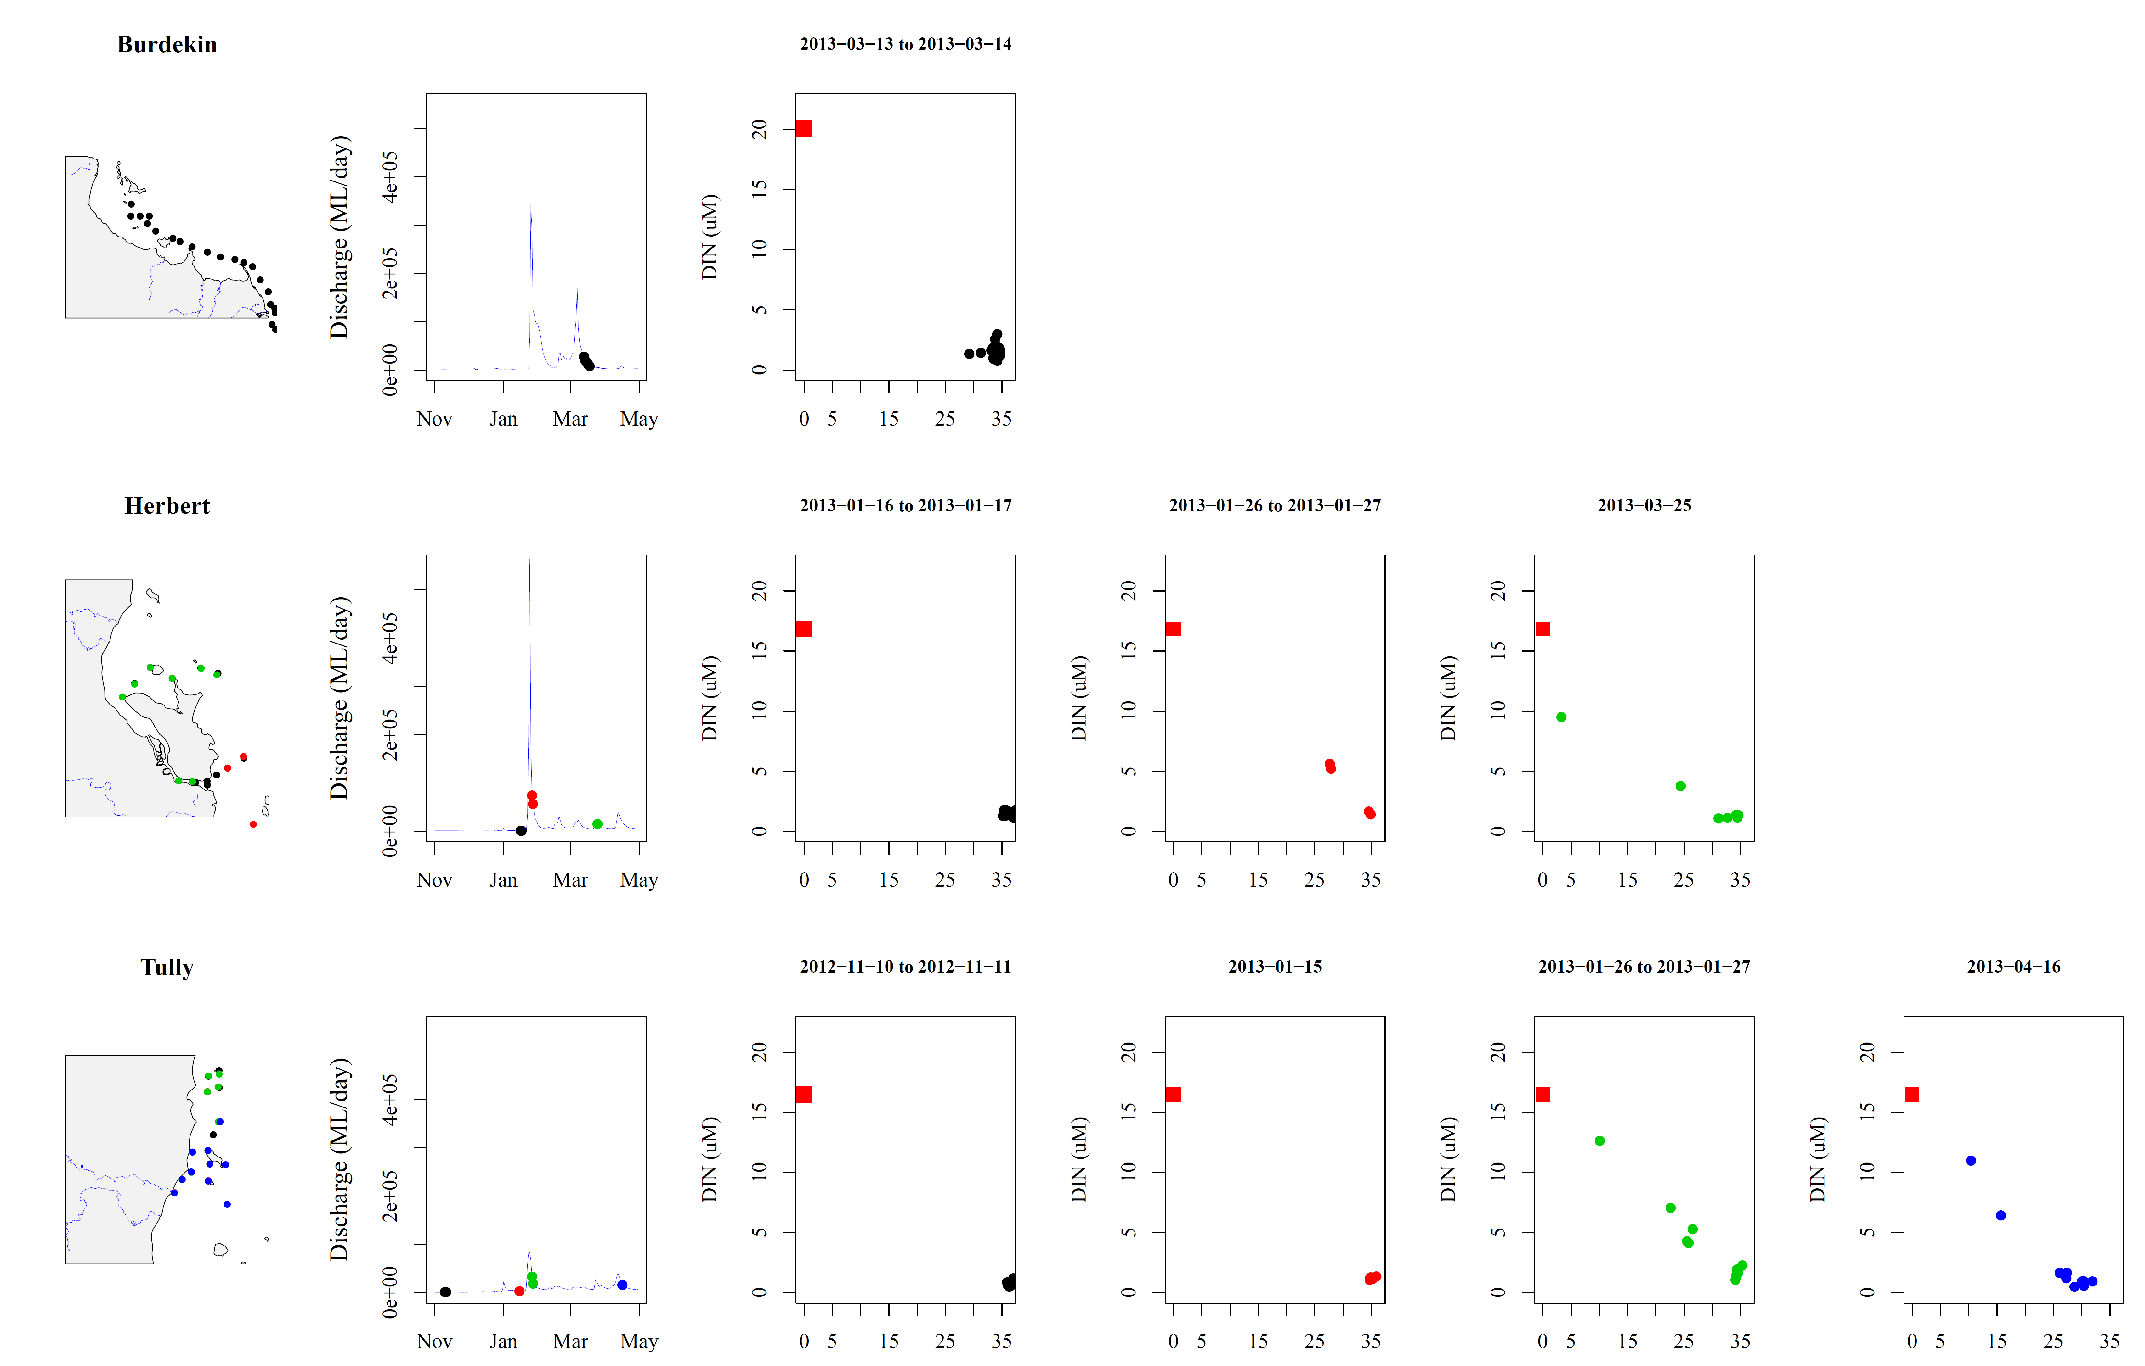
Figure 4-4a: (i) Sites are colour coded to identify location on maps, (ii) date of sampling relative to river flow over wet season, (iii)mixing plots for DIN in the Burdekin, Herbert and Tully regions for 2012-13. Freshwater end end were estimed from all samples collected below 5ppt.

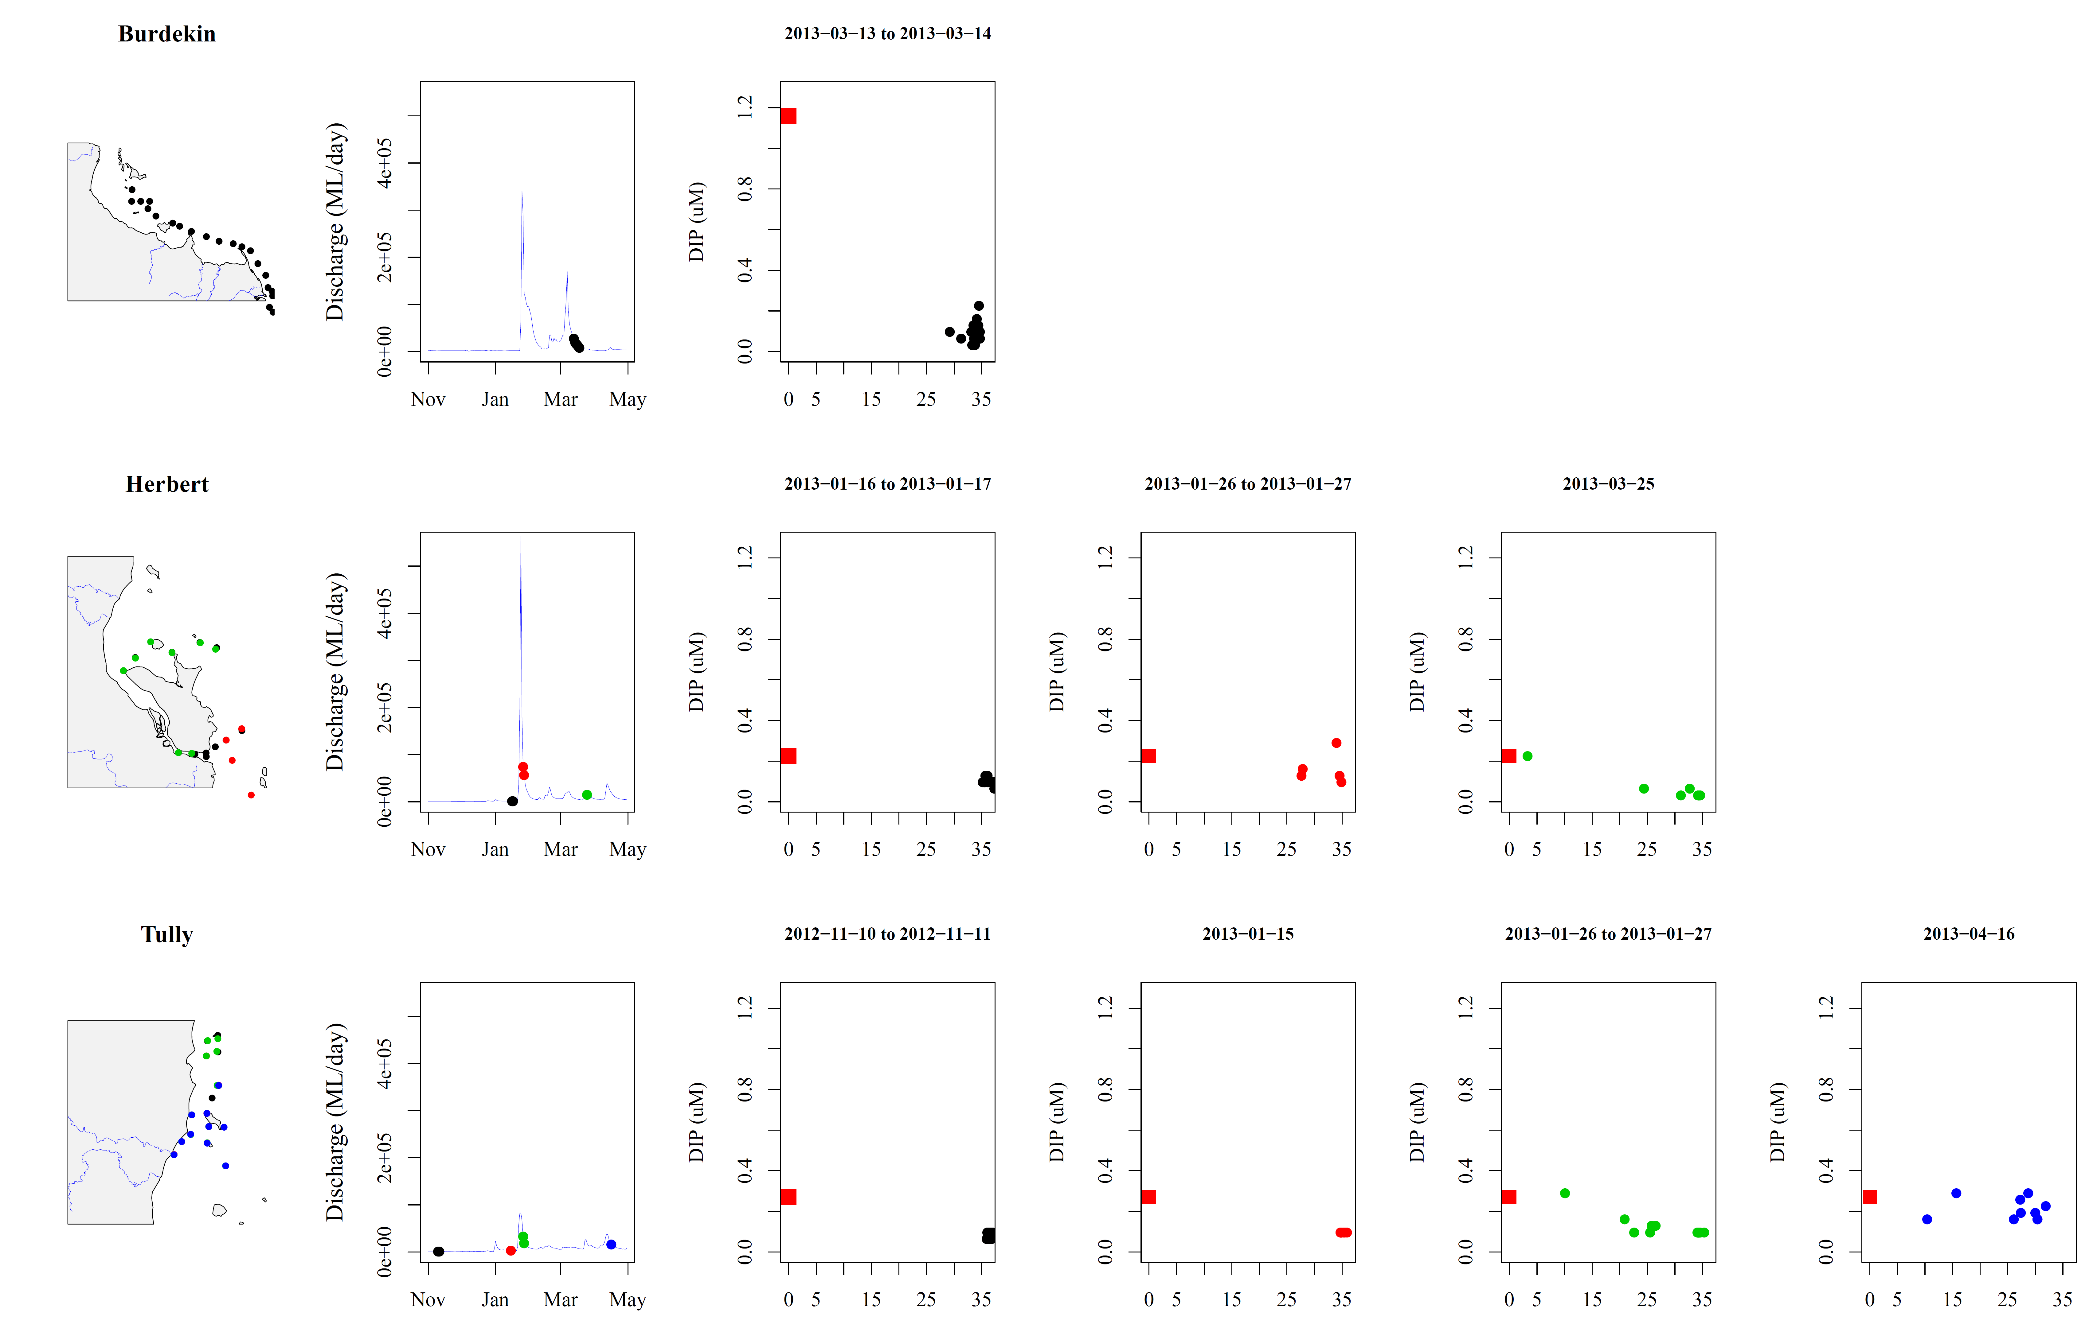
Figure 4-4b (i) Sites are colour coded to identify location on maps, (ii) date of sampling relative to river flow over wet season, (iii) mixing plots for DIP in the Burdekin, Herbert and Tully regions for 2012-13.

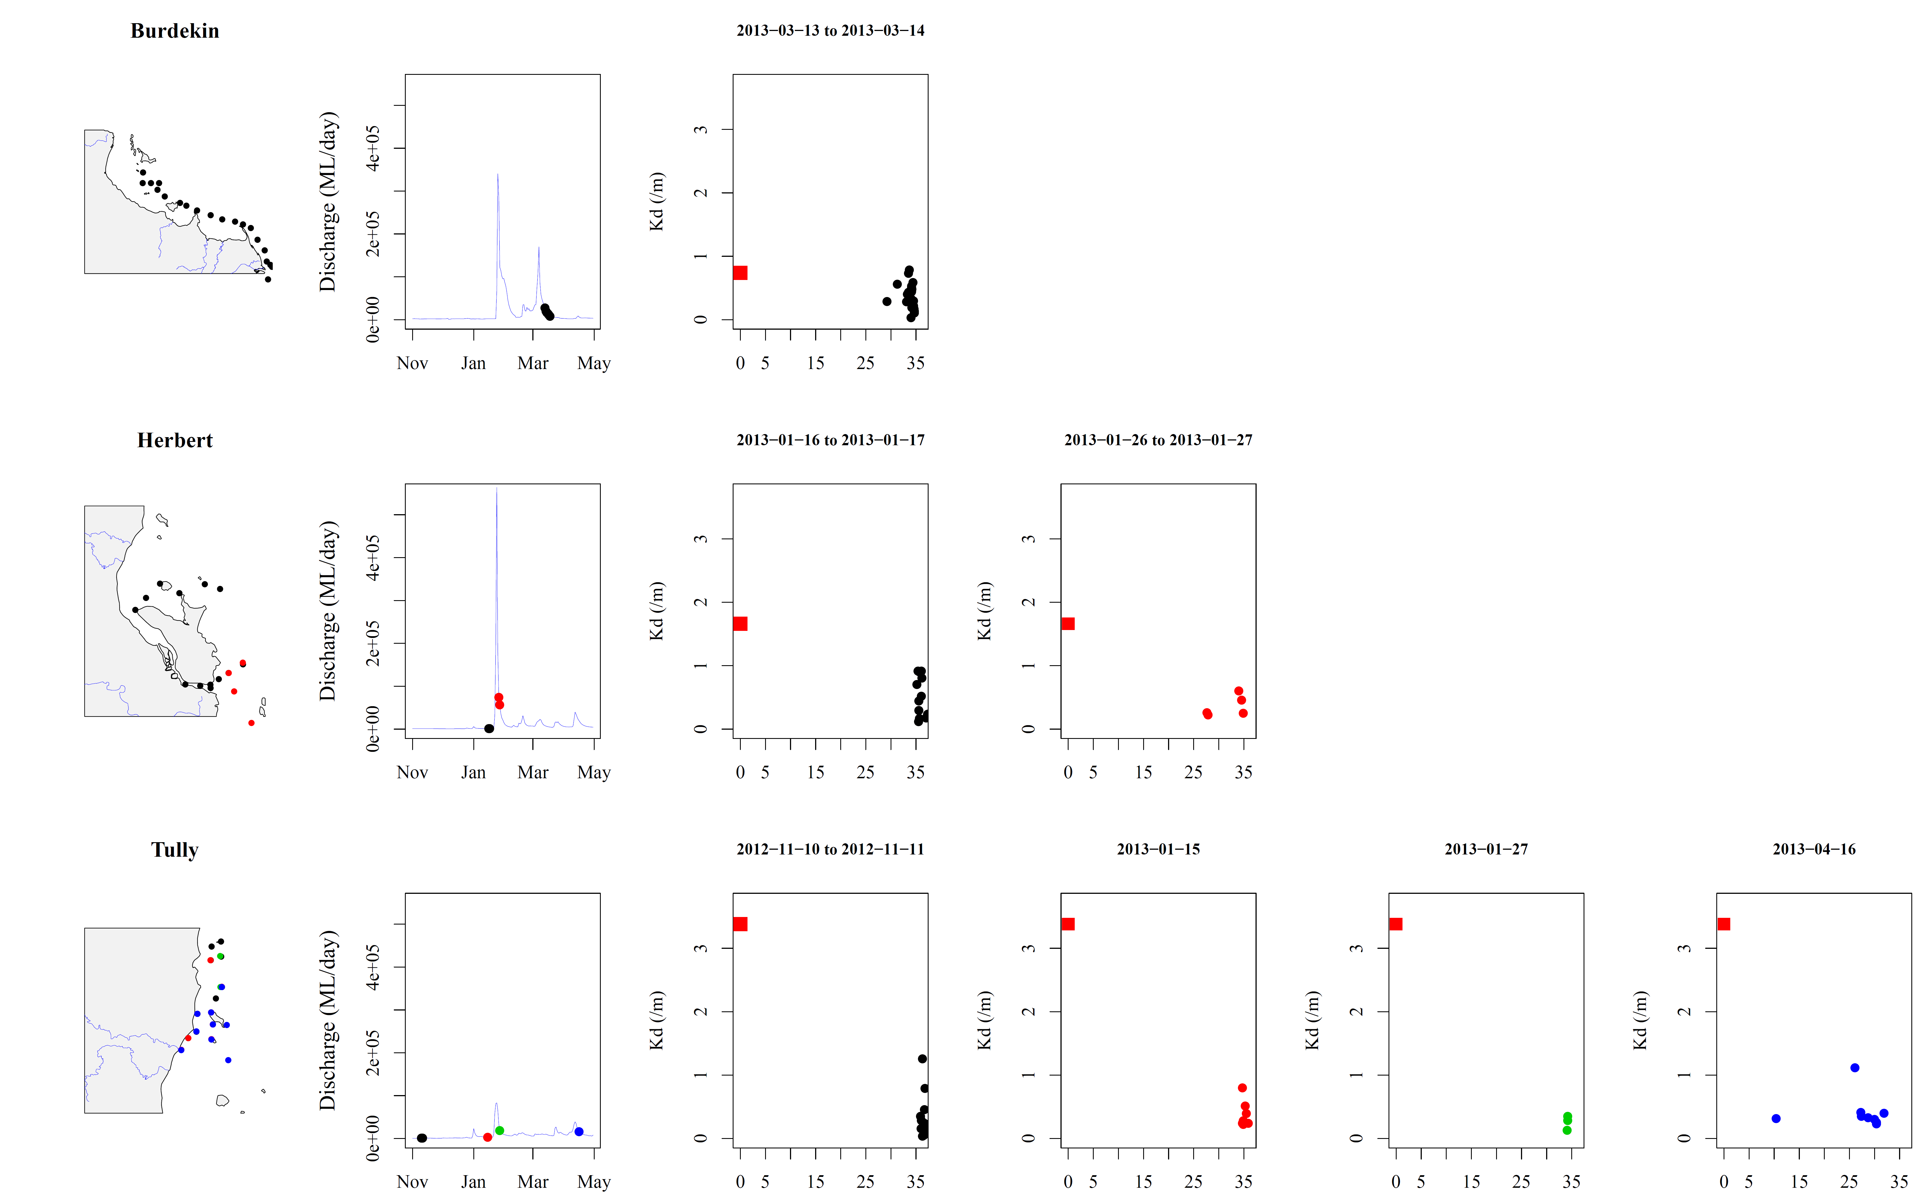
Figure 4-4c (i) Sites are colour coded to identify location on maps, (ii) date of sampling relative to river flow over wet season, (iii) mixing plots for K_{d} in the Burdekin, Herbert and Tully regions for 2012-13.

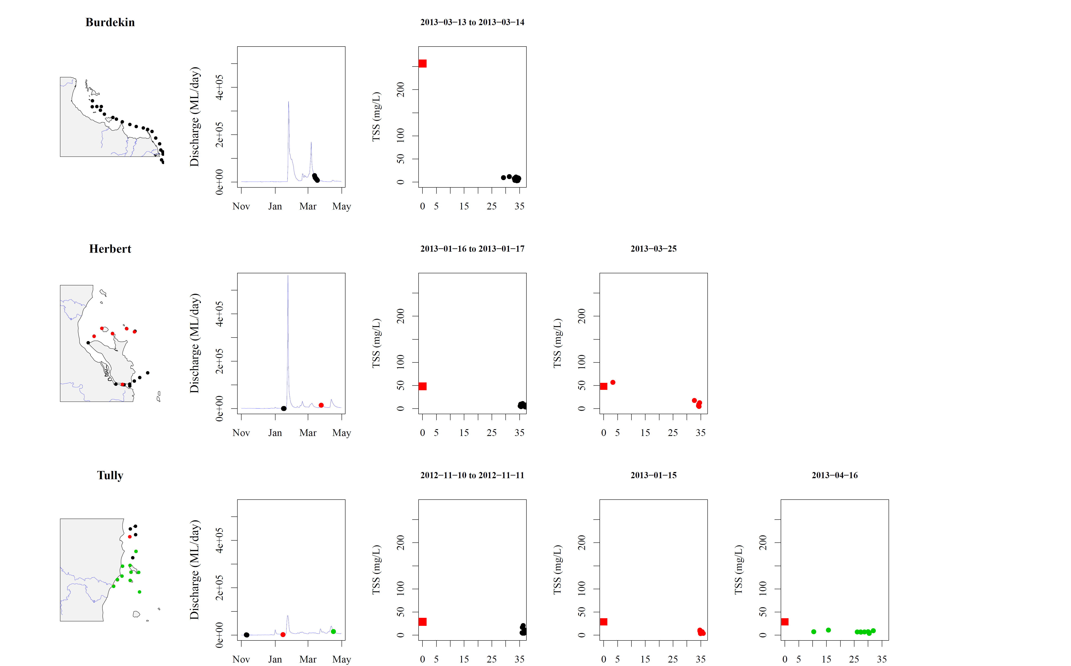
Figure 4-4d (i) Sites are colour coded to identify location on maps, (ii) date of sampling relative to river flow over wet season, (iii) mixing plots for TSS in the Burdekin, Herbert and Tully regions for 2012-13.

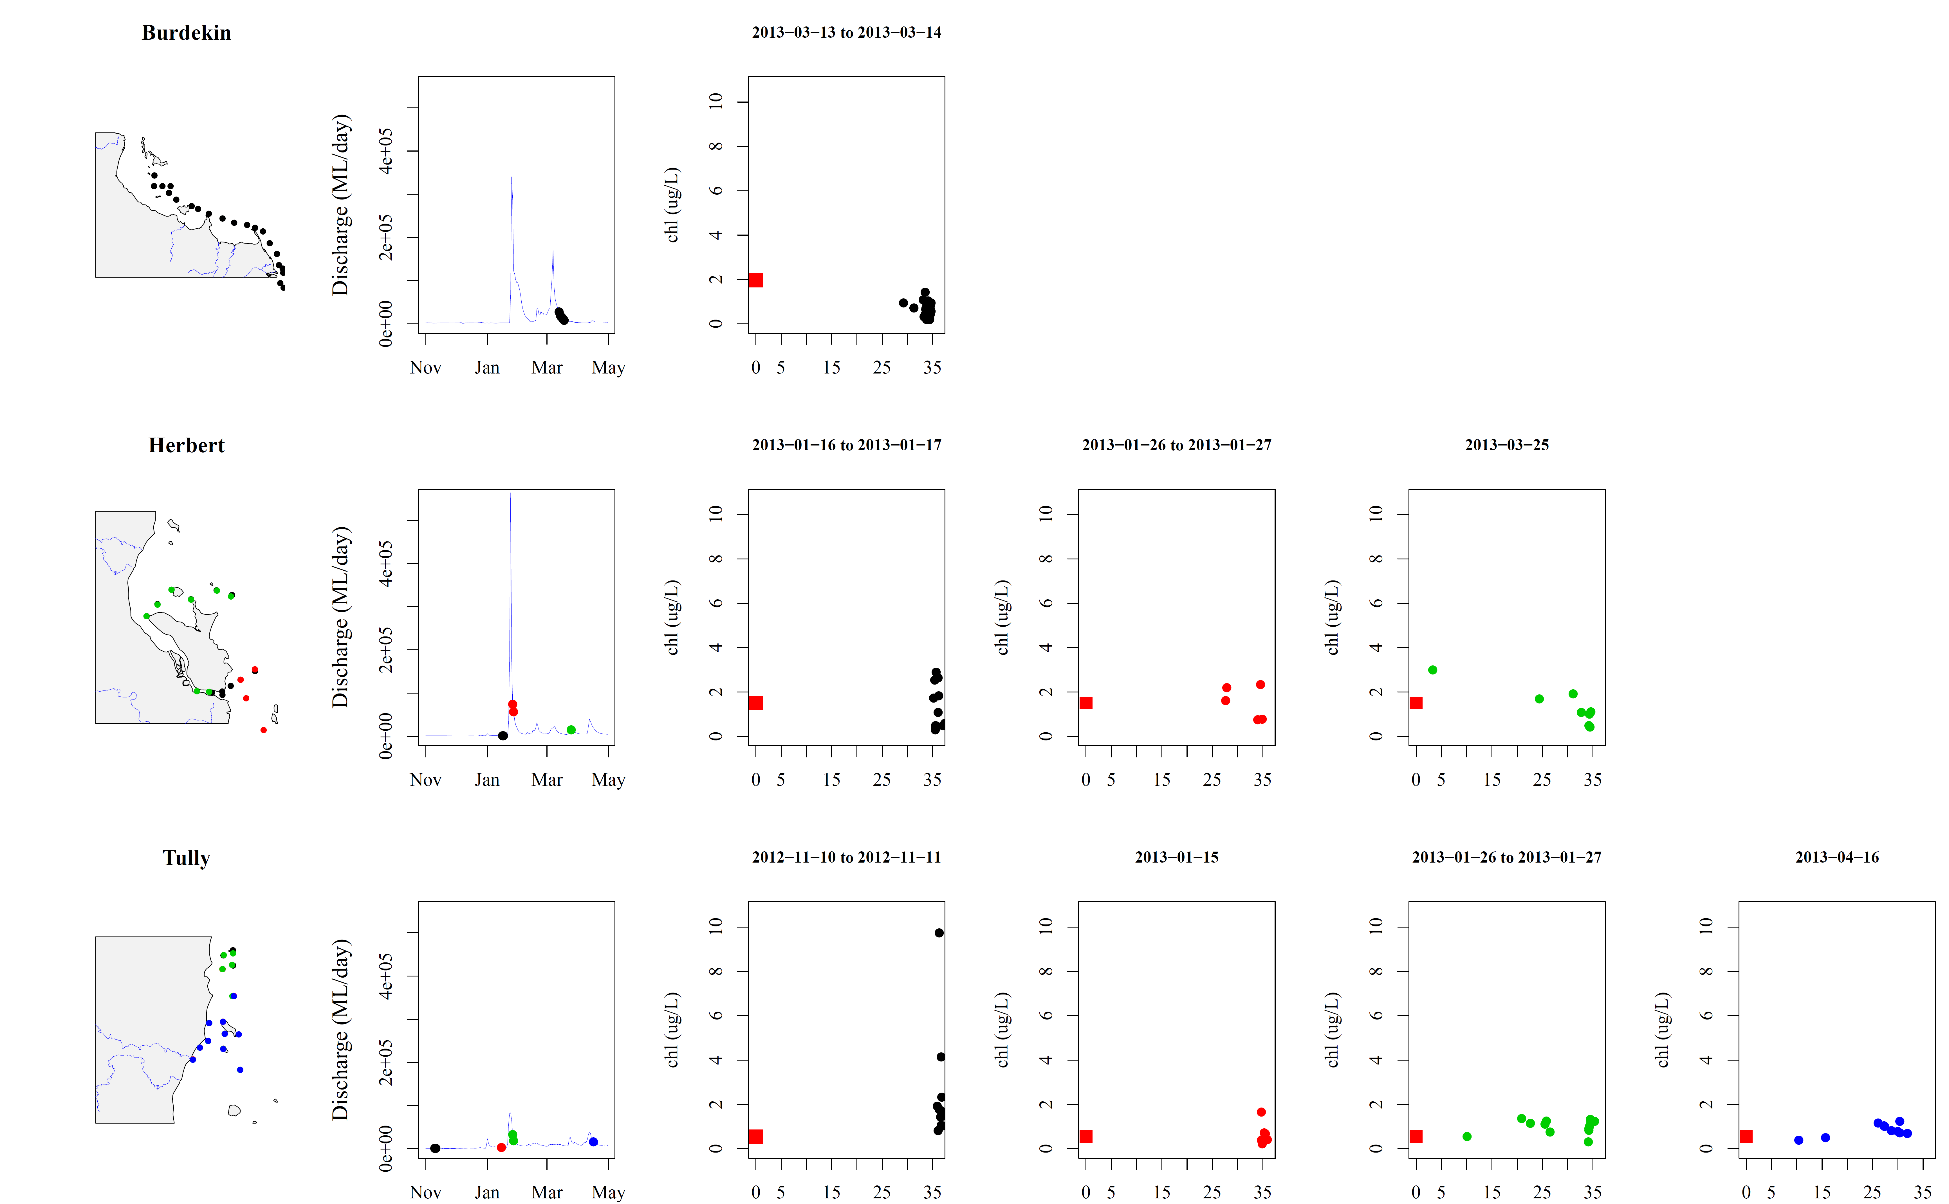
Figure 4-4e (i) Sites are colour coded to identify location on maps, (ii) date of sampling relative to river flow over wet season, (iii) mixing plots for chlorophyll-a in the Burdekin, Herbert and Tully regions for 2012-13.

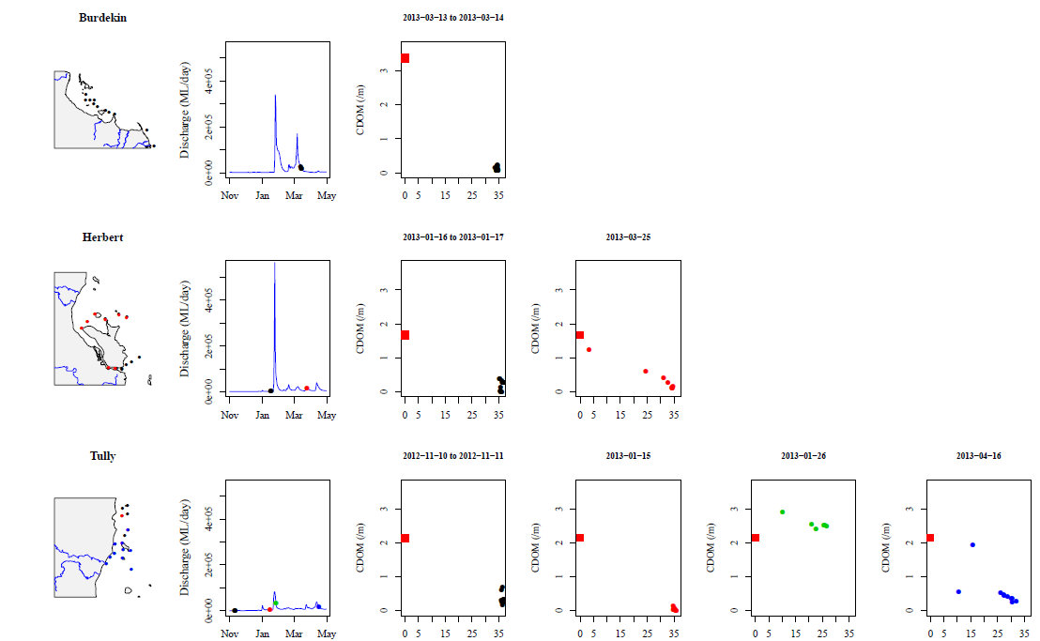
Figure 4-4f (i) Sites are colour coded to identify location on maps, (ii) date of sampling relative to river flow over wet season, (iii) mixing plots for CDOM in the Burdekin, Herbert and Tully regions for 2012-13.

The WQ parameters, sampled in the Tully (Figure 4-5), are plotted against two parameters: (a) the distance between the sampling site and the nearest (or influential) river mouth, (b) 5-days average river discharge calculated from the sampling date. These plots highlighted the variable river inputs from several Wet Tropics Rivers and events, which can influence the shape of the model. For example, Kd(PAR) and TSS in the Tully exhibited a decreasing concentrations in response to the distance plots, with CDOM also having the converse relationship with discharge, increasing to a maximum value at maximum flow, but with high scatter in response to distance. CDOM is a well-recognised proxy for freshwater influence and generally exhibits strong linear patterns with discharge. TSS in the Tully sites is elevated at maximum flow, but high TSS values are also associated with low flow conditions, close to the shore, suggesting strong tidal influence, and/or first flush conditions. Chl-a in the Tully transect remained constant across distance (Figure 4-5), with some elevated peaks at 15 to 30km offshore.
DIN presents a clear dilution pattern in the Tully, with elevated concentrations close to the river mouth, that is reduced moving away from the mouth.. A clear trend is also observed against river discharge, as the greater the discharge the higher the DIN concentration. Such pattern was not observed for DIP, although in general DIP decreases away from the coast. The minimum values for DIN ranged from 0.5 – 1.1 µM and minimum DIP values ranged from 0.03 – 0.10 µM. The maximum values for DIN ranged from 1.6 – 12.6 µM and maximum DIP values ranged from 0.13 – 0.29 µM. The highest value of DIN (12.6 µM) was recorded at Tully River mouth on 26-01-2013 at a salinity of 9.5 and under a 5-days average discharge of 64,443 ML/d (higher than the 95th percentile, 28,441 ML/d), suggesting either a strong continental contribution of DIN during flood conditions or in response to first flush. The highest concentrations of DIN was observed in moderate flow conditions, suggesting this was an example of first flush, where a small amount of flow can transport very high concentrations of pollutants into the nearshore marine environment. The site representing the “Tully River mouth” is situated after extensive wet land and coastal areas, in which up to 40% of the Tully River can be discharged across, resulting in estuarine processes before the first plume-sampling site (Figure 4-5). DIN also exhibits only a small increase against river discharge, however high values are associated with the high discharge conditions (Figure 4-5), but only one maximum discharge event were capture by the 2012-2013 wet season sampling, with most data representing flux or fall of the river flow.
The WQ parameters sampled in the Herbert (Figure 4-6) were plotted against two parameters: (a) the distance between the sampling site and the nearest (or influential) river mouth, (b) 5-days average river discharge calculated from the sampling date. These plots highlighted the variable river inputs from the Herbert River on several events, smaller coastal rivers and Hinchinbrook Channel, all which can influence the shape of the model. Kd(PAR) in the Herbert River exhibited a ‘U’ shape curve for the distance plots, with the initial reduction in Kd(PAR) following similar reductions in chlorophyll-a and CDOM across distance. Highest TSS in the Herbert sites is against the maximum flow conditions. Chl-a in the Herbert transect reduces from initial high values between 0.5 µg/L and 3.0 µg/L in the first 10km, with some reduction across distance, but increasing or stabilising at 35km distance (6), with some elevated peaks at 15 km to 30 km offshore. All of the Herbert plots for OAC’s and Kd(PAR) represent two sources of river inputs, (north and south transects with different river inputs) and are also influenced by the movement of water around and through the Hinchinbrook channel and are variable due to the mixing of the fresh-end sources and the tidal dynamics around Hinchinbrook Island.
DIN and DIP do not presented a clear dilution pattern in the Herbert, with elevated concentrations across the whole of distance plots, with highest concentrations measured between 50 km to 100 km distances from the Herbert mouth. These distance plots are taken from the point of the Herbert River, and the high DIN concentration was taken just north of the Hinchinbrook Channel, where the influence of the Hinchinbrook channel is significant.
(a)
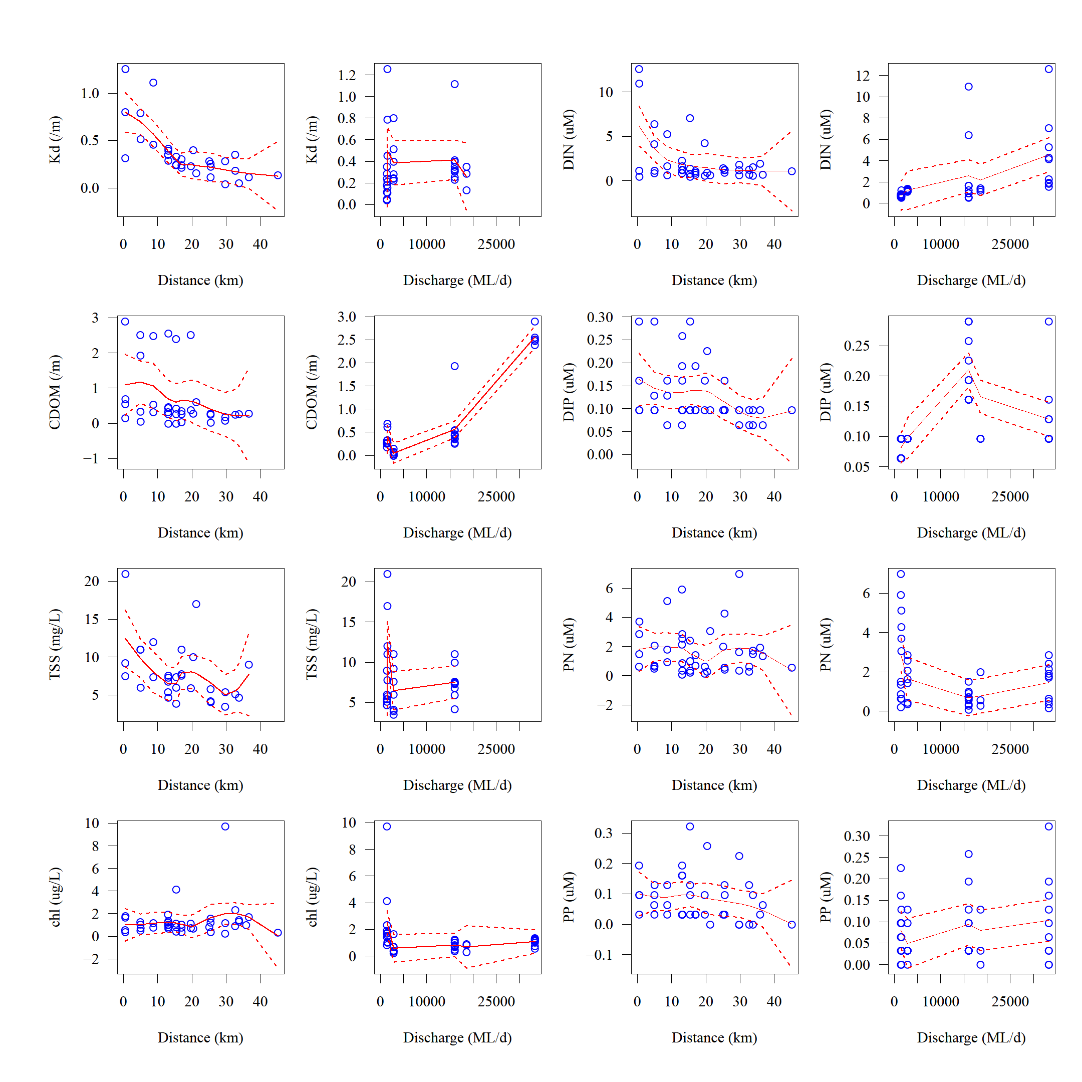
(b)
(b)
(a)
Figure 4-5: Variation of selected WQ parameters sampled in the Tully region for Kd(PAR), CDOM, TSS, and chl-a, dissolved and particulate nutrients. All water quality parameters are plotted against (a) distance between the sampling site and nearest/influential river mouth (distance), (b) 5-day average river discharge calculated from the sampling date (discharge). Red solid line stands for a non-parametric fitting curve (loess model, see Crawley, 2007) and red dashed lines stand for 2 SE.
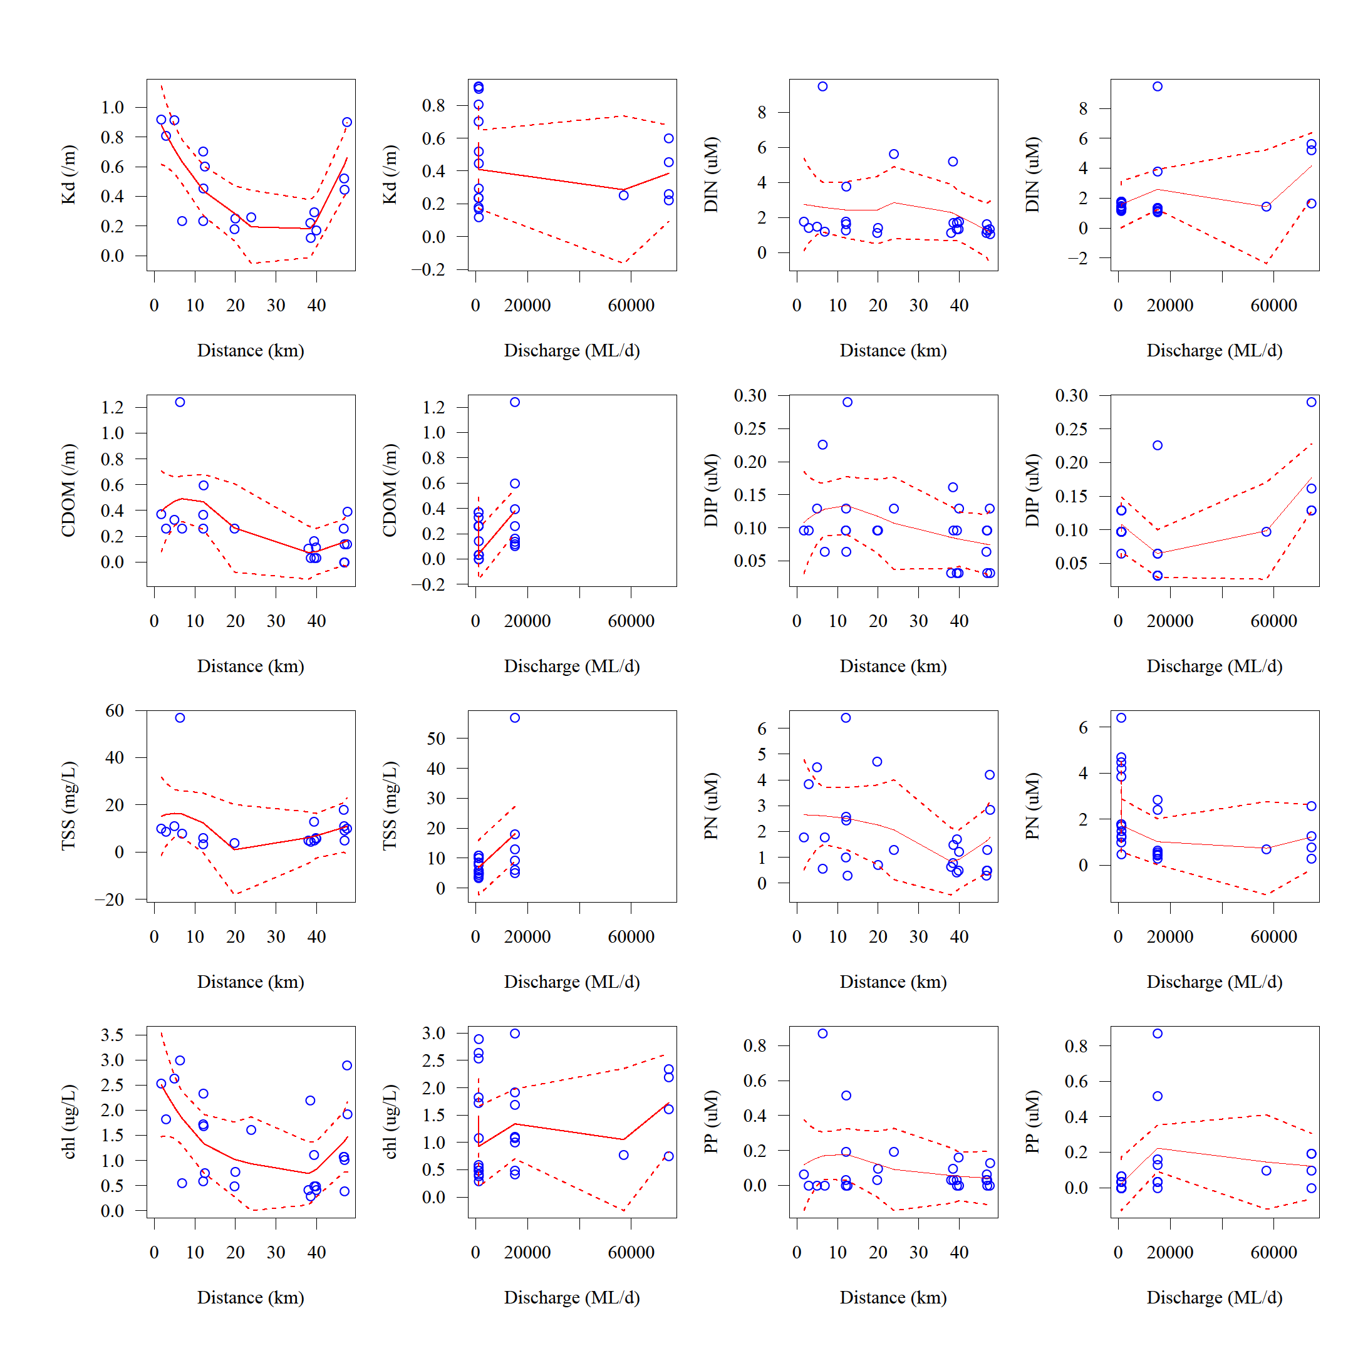
(a)
(b)
(b)
(a)
Figure 4-6: Variation of selected WQ parameters sampled in the Herbert region for Kd(PAR), CDOM, TSS, and chl-a, dissolved and particulate nutrients. All water quality parameters are plotted against (a) distance between the sampling site and nearest/influential river mouth (distance), (b) 5-day average river discharge calculated from the sampling date (discharge). Red solid line stands for a non-parametric fitting curve (loess model, see Crawley, 2007) and red dashed lines stand for 2 SE.

The WQ parameters sampled in the Burdekin region were plotted against two parameters: (a) the distance between the sampling site and the nearest (or influential) river mouth, (b) 5-days average river discharge calculated from the sampling date (Figure 4-6). CDOM and Chl-a both look to be influencing Kd(PAR) with a significant decrease across distance aligning with the initial decrease in the Kd(PAR) values. Kd(PAR) values decrease initially from a maximum of 0.8 to minimum of 0.05. There is a secondary peak after 100 km, coincident with the Cape Cleveland, a region with common high turbid waters due to resuspension and the influence of the finer sediment transport. TSS concentrations show a slight decrease across distance, but with high scatter around all points, particularly those taken within 20 km. The TSS concentrations are reduced in the lower salinity, nearshore sites in comparison to other Burdekin events (Devlin et al., 2001; Devlin et al., 2012) due to the sampling period only being at the end (flux) of the second flow events and not representative of a large Burdekin peak flow event.
Nutrients in general do not present a dilution pattern, with DIN and DIP being relatively unchanged across start and end distances from the river mouth and discharge (Figure 4-6). These patterns suggest that due to the low discharge regime the samples were taken, nutrients were more driven by local process than external input. PP shows a pattern similar to DIP, being relatively unchanged across distances. PNis more variable showing increasing concentrations away from the river mouth, suggesting biological mediated processes may be influencing the transport and formation of the PN through flood influenced waters. Once again, these models show wider error bars due to the reduced number of data points, so caution must be taken on their interpretation.

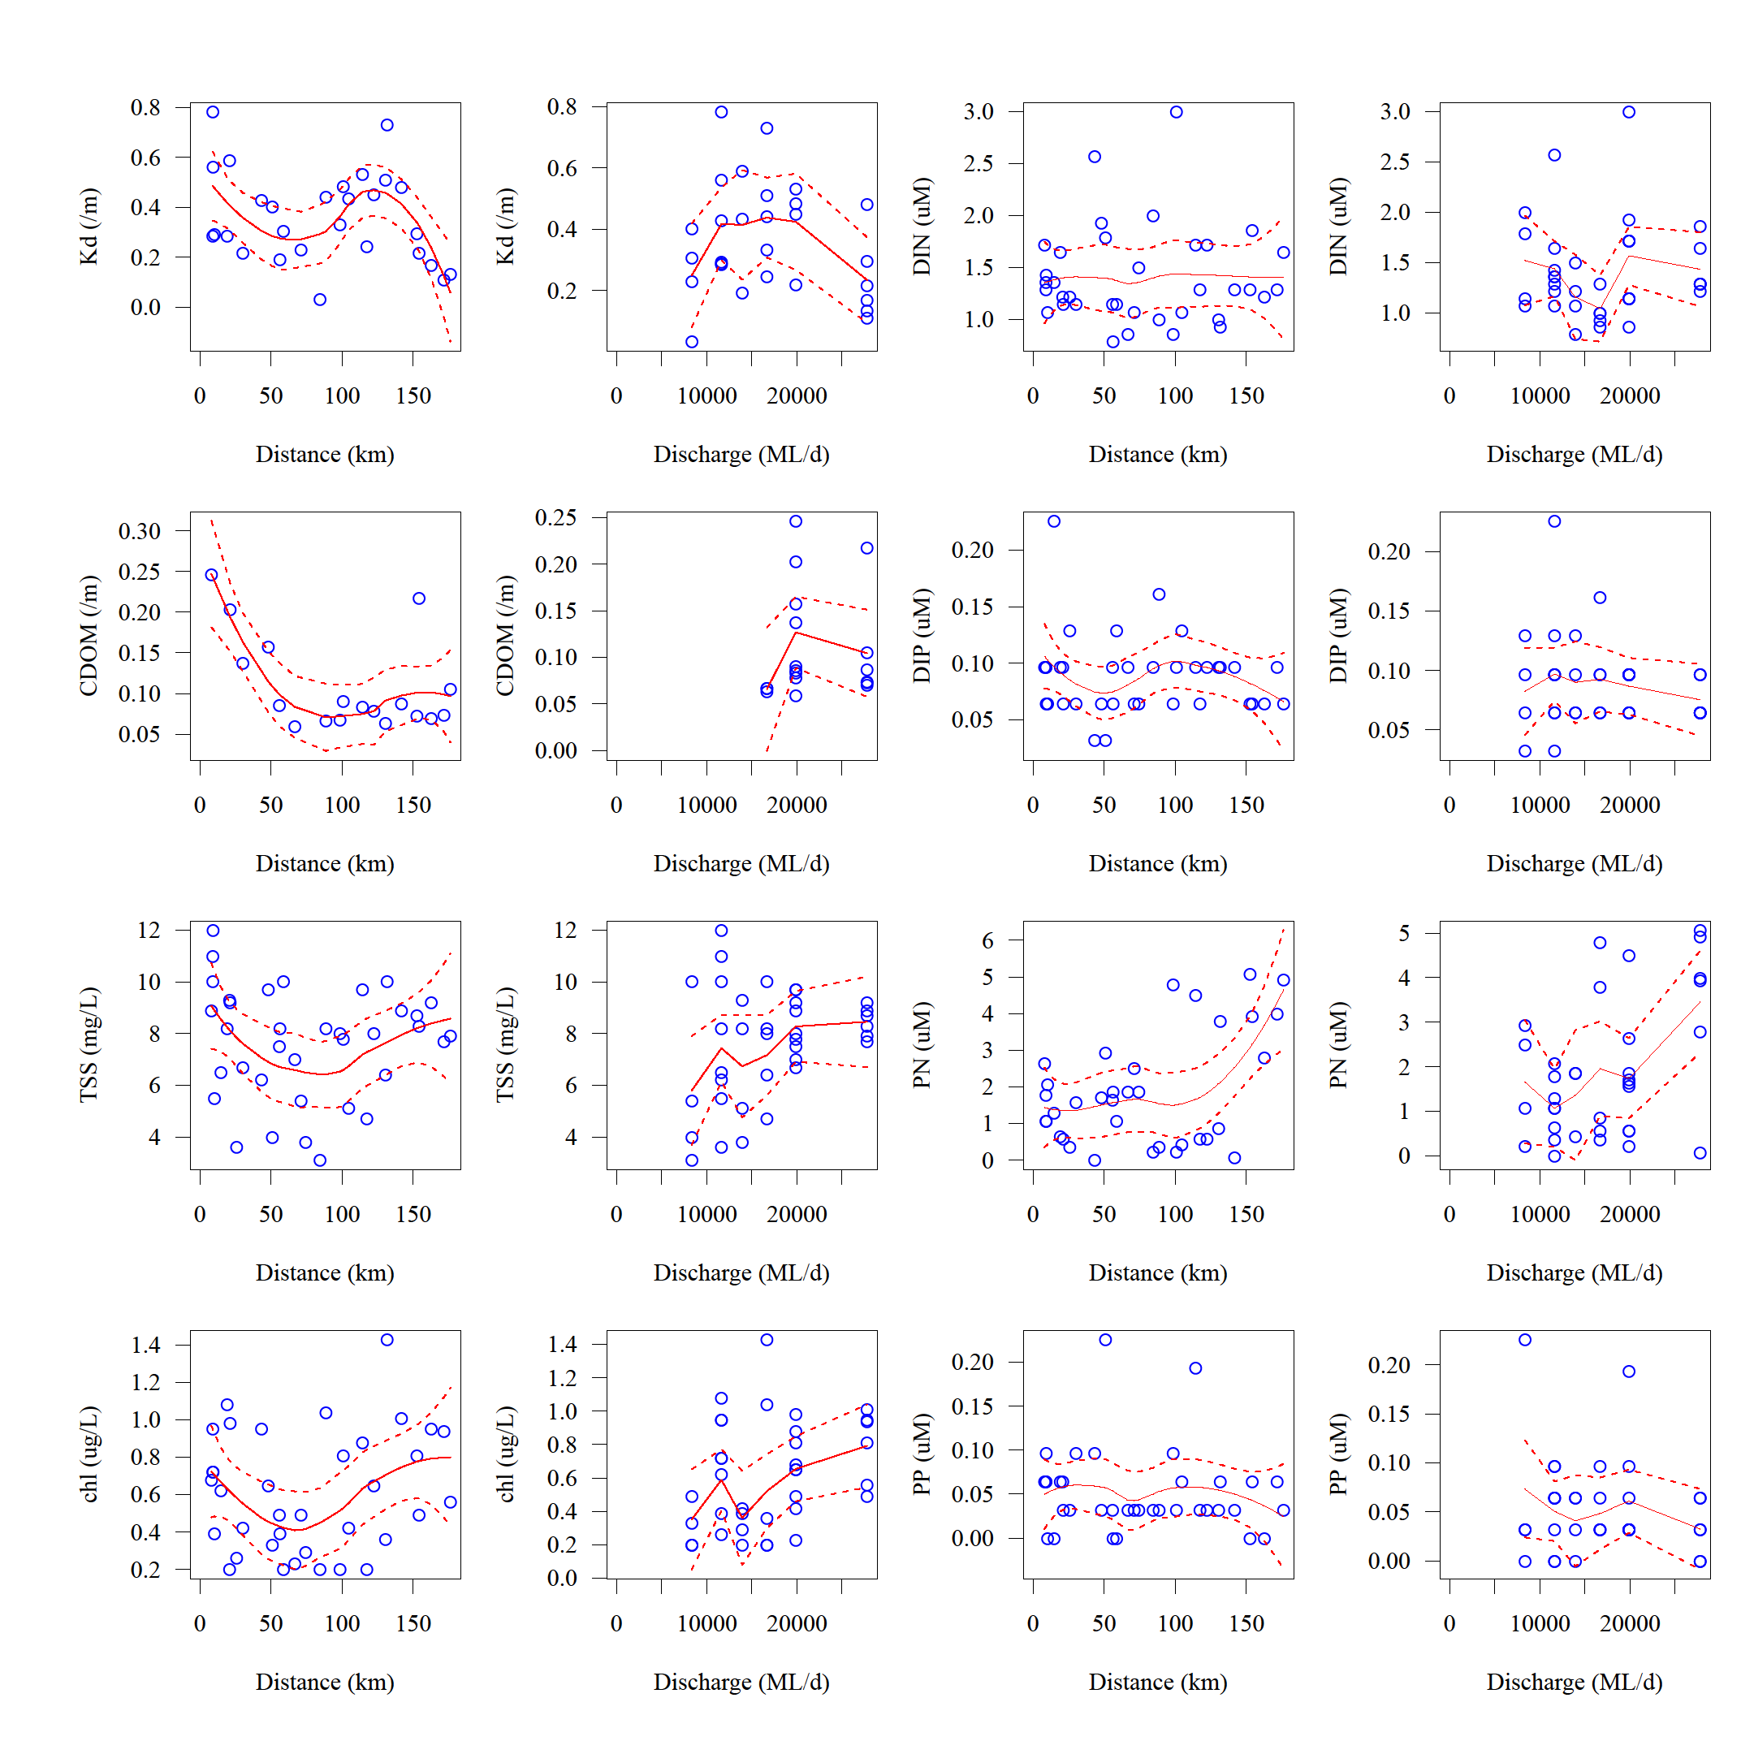
Figure 4-7: Variation of selected WQ parameters sampled in the Burdekin region for Kd(PAR), CDOM, TSS, and chl-a, dissolved and particulate nutrients. All water quality parameters are plotted against (a) distance between the sampling site and nearest/influential river mouth (distance), (b) 5-day average river discharge calculated from the sampling date (discharge). Red solid line stands for a non-parametric fitting curve (loess model, see Crawley, 2007) and red dashed lines stand for 2 SE.

Spearman’s rank correlation coefficient identified few significant high correlations (>0.61) for the WQ parameters sampled in the Wet Tropics (Table 4-6), differently from what was observed for the Tully and Herbert transects when analysed individually. Only Si and TDP exhibited some correlation with salinity and river discharge. Other significant correlations presented were between different nutrients (e.g., TN and TP, r = 0.65) and forms of the same nutrient (e.g., TDN and TN, r = 0.79). When data is analysed for individual rivers in the Wet Tropics, some more significant correlations are identified (Table 4-7), compared to those obtained when all the rivers are analysed together. This ‘by river’ analysis could be done for the Tully and Herbert Rivers. The analysis was compromised for the other rivers due to their reduced number of data points. Salinity is correlated with most of the forms of nitrogen and phosphorous, excluding the dissolved forms. River discharge correlates with DIN and Si for the Tully River samples and with TP for the Herbert. Distance did not presented any significant correlation, indicating that linear dilution processes are not occurring in these regions, which can be resulted from the mixing of river plumes from close rivers and or the hydrodynamic complexity of these areas. Dissolved nutrients are not correlated with any factor, indicating that both coastal hydrodynamic and biological processes are influencing the transport and uptake of the WQ parameters in these regions.
Table 4-6: Spearman’s rank correlation coefficients for the parameters from the Wet Tropics region. All highlighted values are significant at p < 0.01 and represent a correlation >0.6 or <-.06. Parameter on the table are surface salinity (Sal.), 5-day average discharge (Disch.), distance between the river mouth and the sampling site (Dist.), TSS, chl-a TN, TDN, DIN, TP, TDP, DIP, PN, PP and Si.
 | Sal. | Disch. | Dist. | TSS | chl-a | TN | TDN | DIN | TP | TDP | DIP | PN | PP | Si
Sal. | 1 | -0.58 | 0.11 | -0.30 | -0.15 | -0.41 | -0.57 | -0.46 | -0.59 | -0.61 | -0.40 | 0.29 | -0.33 | -0.67
Disch. | -0.58 | 1 | 0.11 | 0.15 | 0.18 | -0.03 | 0.25 | 0.48 | 0.28 | 0.28 | 0.27 | -0.39 | 0.10 | 0.68
Dist. | 0.11 | 0.11 | 1 | -0.25 | -0.08 | -0.39 | -0.15 | -0.11 | -0.27 | -0.19 | -0.27 | -0.20 | -0.25 | -0.32
TSS | -0.30 | 0.15 | -0.25 | 1 | 0.52 | 0.31 | 0.20 | -0.02 | 0.20 | 0.16 | -0.08 | 0.12 | 0.15 | 0.27
chl-a | -0.15 | 0.18 | -0.08 | 0.52 | 1 | 0.29 | 0.18 | 0.06 | 0.13 | -0.02 | -0.07 | 0.23 | 0.18 | 0.21
TN | -0.41 | -0.03 | -0.39 | 0.31 | 0.29 | 1 | 0.79 | 0.11 | 0.65 | 0.54 | 0.36 | 0.18 | 0.44 | 0.20
TDN | -0.57 | 0.25 | -0.15 | 0.20 | 0.18 | 0.79 | 1 | 0.29 | 0.60 | 0.57 | 0.43 | -0.33 | 0.33 | 0.31
DIN | -0.46 | 0.48 | -0.11 | -0.02 | 0.06 | 0.11 | 0.29 | 1 | 0.21 | 0.26 | 0.37 | -0.20 | 0.13 | 0.56
TP | -0.59 | 0.28 | -0.27 | 0.20 | 0.13 | 0.65 | 0.60 | 0.21 | 1 | 0.82 | 0.49 | -0.15 | 0.75 | 0.41
TDP | -0.61 | 0.28 | -0.19 | 0.16 | -0.02 | 0.54 | 0.57 | 0.26 | 0.82 | 1 | 0.57 | -0.26 | 0.30 | 0.47
DIP | -0.40 | 0.27 | -0.27 | -0.08 | -0.07 | 0.36 | 0.43 | 0.37 | 0.49 | 0.57 | 1 | -0.21 | 0.16 | 0.55
PN | 0.29 | -0.39 | -0.20 | 0.12 | 0.23 | 0.18 | -0.33 | -0.20 | -0.15 | -0.26 | -0.21 | 1 | 0.06 | -0.20
PP | -0.33 | 0.10 | -0.25 | 0.15 | 0.18 | 0.44 | 0.33 | 0.13 | 0.75 | 0.30 | 0.16 | 0.06 | 1 | 0.18
Si | -0.67 | 0.68 | -0.32 | 0.27 | 0.21 | 0.20 | 0.31 | 0.56 | 0.41 | 0.47 | 0.55 | -0.20 | 0.18 | 1

Table 4-7: Spearman’s rank correlation coefficients for the parameters from Tully and Herbert rivers sampled more than 20 times in the Wet Tropics in the 2012-2013 wet season. All highlighted values are significant at p < 0.01 and represent a correlation >0.6 or <-.06. Parameters listed in the table are surface salinity (Sal.), 5-day average discharge (Disch.), distance between the river mouth and the sampling site Dist.), TSS, chl-a TN, TDN, DIN, TP, TDP, DIP, PN, PP and Si.
Tully [46]
 | Sal. | Disch. | Dist. | TSS | chl-a | TN | TDN | DIN | TP | TDP | DIP | PN | PP | Si
Sal. | 1 | -0.70 | 0.28 | -0.21 | 0.14 | -0.38 | -0.60 | -0.54 | -0.63 | -0.69 | -0.65 | 0.27 | -0.28 | -0.84
Disch. | -0.70 | 1 | -0.04 | -0.14 | -0.18 | -0.13 | 0.13 | 0.70 | 0.32 | 0.49 | 0.46 | -0.31 | 0.07 | 0.79
Dist. | 0.28 | -0.04 | 1 | -0.46 | 0.08 | -0.44 | -0.43 | -0.35 | -0.33 | -0.20 | -0.39 | -0.11 | -0.30 | -0.42
TSS | -0.21 | -0.14 | -0.46 | 1 | -0.01 | 0.29 | 0.24 | -0.19 | 0.03 | 0.01 | 0.16 | 0.21 | -0.01 | 0.02
chl-a | 0.14 | -0.18 | 0.08 | -0.01 | 1 | 0.16 | -0.02 | -0.27 | -0.10 | -0.23 | -0.43 | 0.30 | 0.11 | -0.39
TN | -0.38 | -0.13 | -0.44 | 0.29 | 0.16 | 1 | 0.81 | 0.11 | 0.56 | 0.39 | 0.30 | 0.24 | 0.42 | 0.27
TDN | -0.60 | 0.13 | -0.43 | 0.24 | -0.02 | 0.81 | 1 | 0.28 | 0.73 | 0.71 | 0.59 | -0.28 | 0.34 | 0.56
DIN | -0.54 | 0.70 | -0.35 | -0.19 | -0.27 | 0.11 | 0.28 | 1 | 0.26 | 0.34 | 0.38 | -0.19 | 0.15 | 0.68
TP | -0.63 | 0.32 | -0.33 | 0.03 | -0.10 | 0.56 | 0.73 | 0.26 | 1 | 0.77 | 0.71 | -0.33 | 0.66 | 0.65
TDP | -0.69 | 0.49 | -0.20 | 0.01 | -0.23 | 0.39 | 0.71 | 0.34 | 0.77 | 1 | 0.81 | -0.50 | 0.09 | 0.74
DIP | -0.65 | 0.46 | -0.39 | 0.16 | -0.43 | 0.30 | 0.59 | 0.38 | 0.71 | 0.81 | 1 | -0.42 | 0.18 | 0.81
PN | 0.27 | -0.31 | -0.11 | 0.21 | 0.30 | 0.24 | -0.28 | -0.19 | -0.33 | -0.50 | -0.42 | 1 | 0.04 | -0.38
PP | -0.28 | 0.07 | -0.30 | -0.01 | 0.11 | 0.42 | 0.34 | 0.15 | 0.66 | 0.09 | 0.18 | 0.04 | 1 | 0.21
Si | -0.84 | 0.79 | -0.42 | 0.02 | -0.39 | 0.27 | 0.56 | 0.68 | 0.65 | 0.74 | 0.81 | -0.38 | 0.21 | 1
Herbert [26]
 | Sal. | Disch. | Dist. | TSS | chl-a | TN | TDN | DIN | TP | TDP | DIP | PN | PP | Si
Sal. | 1 | -0.56 | -0.01 | -0.63 | -0.44 | -0.70 | -0.73 | -0.13 | -0.68 | -0.66 | 0.08 | 0.22 | -0.49 | -0.34
Disch. | -0.56 | 1 | 0.31 | 0.47 | 0.08 | 0.27 | 0.55 | 0.23 | 0.69 | 0.48 | 0.08 | -0.55 | 0.53 | -0.09
Dist. | -0.01 | 0.31 | 1 | 0.04 | -0.31 | -0.08 | 0.15 | -0.37 | 0.02 | 0.07 | -0.31 | -0.32 | -0.03 | -0.21
TSS | -0.63 | 0.47 | 0.04 | 1 | 0.75 | 0.68 | 0.60 | 0.10 | 0.63 | 0.71 | -0.09 | -0.15 | 0.37 | 0.59
chl-a | -0.44 | 0.08 | -0.31 | 0.75 | 1 | 0.54 | 0.21 | 0.23 | 0.40 | 0.40 | 0.34 | 0.29 | 0.25 | 0.71
TN | -0.70 | 0.27 | -0.08 | 0.68 | 0.54 | 1 | 0.79 | 0.27 | 0.43 | 0.58 | 0.25 | -0.03 | 0.13 | 0.67
TDN | -0.73 | 0.55 | 0.15 | 0.60 | 0.21 | 0.79 | 1 | 0.34 | 0.55 | 0.67 | 0.03 | -0.55 | 0.30 | 0.14
DIN | -0.13 | 0.23 | -0.37 | 0.10 | 0.23 | 0.27 | 0.34 | 1 | 0.34 | 0.27 | 0.68 | -0.17 | 0.27 | 0.20
TP | -0.68 | 0.69 | 0.02 | 0.63 | 0.40 | 0.43 | 0.55 | 0.34 | 1 | 0.84 | 0.11 | -0.34 | 0.79 | 0.30
TDP | -0.66 | 0.48 | 0.07 | 0.71 | 0.40 | 0.58 | 0.67 | 0.27 | 0.84 | 1 | 0.06 | -0.40 | 0.40 | 0.36
DIP | 0.08 | 0.08 | -0.31 | -0.09 | 0.34 | 0.25 | 0.03 | 0.68 | 0.11 | 0.06 | 1 | 0.15 | -0.02 | 0.41
PN | 0.22 | -0.55 | -0.32 | -0.15 | 0.29 | -0.03 | -0.55 | -0.17 | -0.34 | -0.40 | 0.15 | 1 | -0.17 | 0.43
PP | -0.49 | 0.53 | -0.03 | 0.37 | 0.25 | 0.13 | 0.30 | 0.27 | 0.79 | 0.40 | -0.02 | -0.17 | 1 | 0.24
Si | -0.34 | -0.09 | -0.21 | 0.59 | 0.71 | 0.67 | 0.14 | 0.20 | 0.30 | 0.36 | 0.41 | 0.43 | 0.24 | 1

Spearman’s rank correlation coefficient identified only four significant high correlations (>0.61) for the WQ parameters sampled in the Burdekin NRM (Table 4-8). These correlations were observed for the pairs TP – TDP and PN – chl-a. Discharge, distance and salinity were not highly correlated, influenced by the low flow conditions associated with the timing of the sampling in the Burdekin transect.
Table 4-8: Spearman’s rank correlation coefficients for the parameters from the Burdekin region. All highlighted values are significant at p < 0.01 and represent a correlation >0.6 or <-.06. Parameter on the table are surface salinity (Sal.), 5-day average discharge (Disch.), distance between the river mouth and the sampling site (Dist.), TSS, chl-a, TN, TDN), DIN, TP, TDP, DIP, PN, PP and Si.
 | Sal. | Disch. | Dist. | TSS | chl-a | TN | TDN | DIN | TP | TDP | DIP | PN | PP | Si
Sal. | 1 | 0.19 | 0.29 | 0.02 | 0.02 | 0.15 | -0.17 | -0.12 | -0.39 | -0.27 | -0.09 | 0.28 | -0.08 | -0.07
Disch. | 0.19 | 1 | 0.60 | 0.24 | 0.33 | 0.09 | -0.27 | 0.04 | -0.27 | -0.18 | -0.10 | 0.28 | -0.09 | -0.44
Dist. | 0.29 | 0.60 | 1 | -0.12 | 0.07 | 0.16 | 0.04 | -0.04 | -0.16 | -0.05 | -0.06 | 0.19 | -0.17 | -0.49
TSS | 0.02 | 0.24 | -0.12 | 1 | 0.50 | 0.29 | 0.16 | 0.00 | 0.07 | 0.04 | 0.09 | 0.25 | 0.13 | 0.30
chl-a | 0.02 | 0.33 | 0.07 | 0.50 | 1 | -0.04 | 0.02 | 0.19 | -0.03 | -0.11 | 0.07 | -0.12 | 0.13 | 0.23
TN | 0.15 | 0.09 | 0.16 | 0.29 | -0.04 | 1 | 0.44 | -0.32 | 0.17 | 0.04 | -0.09 | 0.67 | 0.09 | 0.03
TDN | -0.17 | -0.27 | 0.04 | 0.16 | 0.02 | 0.44 | 1 | -0.22 | 0.58 | 0.48 | 0.18 | -0.25 | 0.08 | 0.14
DIN | -0.12 | 0.04 | -0.04 | 0.00 | 0.19 | -0.32 | -0.22 | 1 | 0.21 | -0.01 | -0.17 | -0.13 | 0.25 | 0.23
TP | -0.39 | -0.27 | -0.16 | 0.07 | -0.03 | 0.17 | 0.58 | 0.21 | 1 | 0.62 | 0.12 | -0.19 | 0.39 | 0.36
TDP | -0.27 | -0.18 | -0.05 | 0.04 | -0.11 | 0.04 | 0.48 | -0.01 | 0.62 | 1 | 0.29 | -0.36 | -0.40 | 0.12
DIP | -0.09 | -0.10 | -0.06 | 0.09 | 0.07 | -0.09 | 0.18 | -0.17 | 0.12 | 0.29 | 1 | -0.31 | -0.15 | -0.07
PN | 0.28 | 0.28 | 0.19 | 0.25 | -0.12 | 0.67 | -0.25 | -0.13 | -0.19 | -0.36 | -0.31 | 1 | 0.13 | -0.05
PP | -0.08 | -0.09 | -0.17 | 0.13 | 0.13 | 0.09 | 0.08 | 0.25 | 0.39 | -0.40 | -0.15 | 0.13 | 1 | 0.43
Si | -0.07 | -0.44 | -0.49 | 0.30 | 0.23 | 0.03 | 0.14 | 0.23 | 0.36 | 0.12 | -0.07 | -0.05 | 0.43 | 1

Data analysis - temporal
Statistical measures of the main WQ parameters that have been measured in the most frequently sampled transect for the last 8 wet seasons are presented in Table 4-9. Minimum values were consistently measured at the Franklins transect and the maximum values were consistently measured at the Burdekin to Palm Island transect, for all WQ parameters with the exception of TSS (430mg/L) and chl-a (26.7 µg/L), which were measured in the Fitzroy. The maximum concentration of DIN (26.3 µM) was measured in the Tully. These simple statistical measurements reflect the hydromorphological characteristics and adjacent land use activity, with the high concentrations of DIN consistently measured off the Tully influenced by the high rates of fertilised agriculture with multi-annual discharge events delivering the DIN to the marine environment (Waterhouse et al., 2014).
Table 4-9: Mean, maximum and minimum WQ parameters concentrations measured at 4 of the most often sampled transects (i.e., Franklins, Tully to Sisters, Burdekin to Palm Island, and Fitzroy to Keppels) over the last 8 wet seasons (2006 – 2013). WQ parameters include TSS, chl-a TN, TP, DIN, DIP, PN, PP.
 | Minimum
Parameters | Frank. | Tully | Burden. | Fitzroy | Total count
TSS | 1.46 | 0.40 | 0.25 | 0.82 | 171
Chl-a | 0.21 | 0.20 | 0.20 | 0.20 | 174
TN | 6.43 | 0.93 | 1.93 | 5.50 | 168
TP | 0.16 | 0.10 | 0.16 | 0.31 | 155
DIN | 0.79 | 0.07 | 0.03 | 0.01 | 156
DIP | 0.06 | 0.01 | 0.03 | 0.03 | 172
PN | 0.07 | 0.07 | 0.00 | 0.07 | 166
PP | 0.03 | 0.00 | 0.00 | 0.03 | 161
Mean Count | 23 | 370 | 175 | 92 | 165
 | Mean
TSS | 4.95 | 7.19 | 25.92 | 28.98
Chl-a | 0.77 | 0.98 | 0.96 | 2.41
TN | 11.50 | 11.72 | 16.79 | 24.05
TP | 0.45 | 0.67 | 1.20 | 1.60
DIN | 2.28 | 2.48 | 3.74 | 3.42
DIP | 0.21 | 0.31 | 0.36 | 0.96
PN | 3.62 | 2.38 | 3.85 | 5.98
PP | 0.16 | 0.17 | 0.56 | 0.49
Mean Count | 23 | 370 | 175 | 92
 | Maximum
TSS | 15.00 | 38.00 | 348.00 | 430.00
Chl-a | 1.60 | 9.74 | 13.78 | 26.70
TN | 19.92 | 56.40 | 127.36 | 56.90
TP | 0.77 | 2.68 | 10.25 | 5.65
DIN | 5.57 | 26.34 | 23.20 | 13.99
DIP | 0.58 | 0.71 | 3.07 | 3.16
PN | 11.28 | 26.70 | 40.93 | 26.13
PP | 0.39 | 1.94 | 8.71 | 5.23
Mean Count | 23 | 370 | 175 | 92

Highest concentrations of TSS, PN and PP were measured off both Burdekin and Fitzroy, reflecting the large area of grazing land and the movement of fine sediment through the river plumes (Bainbridge et al., 2014). High DIP measurements recorded for Burdekin and Fitzroy indicate desorption processes releasing DIP from high PP concentrations. Chlorophyll-a is more varied, with the maximum values measured off the Dry Tropics, with the high mean values skewed by a small number of high values. Chlorophyll-a collected off the Tully and Franklin Islands have lower maxima, but comparable mean values indicating that the range of concentrations are less skewed and consistently elevated.
The Spearman’s rank correlation coefficients were computed (Table. 4-10) for each river representing the significance of the correlation between the water quality parameters and the adjacent river discharge. The Tully has several WQ parameters correlating significantly with river discharge, including TSS, TP, DIN, DIP and PP. For Franklins, TN, DIN and PN were significantly correlated with discharge. The dissolved nutrients were not significant for the Burdekin, but TN, TP, PN and PP all correlated strongly. The Fitzroy river discharge correlates with all the nitrogen species, including TN, DIN and PN.
Table 4-10: Spearman’s rank correlation coefficients form the four most frequent sampled transects over the GRB wide in the last 8 wet seasons. Values stand for correlation coefficient between the total wet season river discharge and the WQ parameters: include TSS, chl-a TN, TP, DIN, DIP, PN, PP. Highlighted values are significant at p < 0.01.

 | Franklins | Tully | Burdekin | Fitzroy
TSS | -0.56 | -0.29 | 0.05 | -0.07
chl | 0.71 | 0.05 | 0.17 | 0.04
TN | 0.10 | 0.00 | 0.38 | 0.40
TP | 0.71 | 0.51 | 0.47 | 0.03
DIN | 0.86 | 0.26 | 0.23 | 0.40
DIP | 0.68 | 0.23 | 0.28 | -0.07
PN | -0.09 | -0.01 | 0.41 | 0.41
PP | 0.40 | 0.15 | 0.32 | -0.07

The result of the GAMM analysis for each WQ component is presented as a set of 4 plots, vertically distributed (Figure 4-8, Figure 4-9, Figure 4-10). The first three plots in each column are the partial effect plots from the multiple regression analysis. These plots show the behaviour of the WQ component against each predictor individually (i.e., either (i) surface salinity, (ii) distance or (iii) river discharge) when the other two predictors are kept constant. The last plot represents the temporal variation of each WQ component when the selected predictors (i.e., those that did not present as a straight line in the partial plots) were used as random effects in the GAMM analysis
The temporal variation of the wet season WQ components (data set 2006-2013) was best modelled by using all predictors (i.e., salinity, river discharge and distance) as random effects. Exceptions occurred for chlorophyll-a and PN that had no inclusion of the predictor distance, which is presented as a straight line parallel to x-axis in the partial effect plots (Fig. 4-8). Moreover, no temporal variation was identified for CDOM (Figure 4.8), chlorophyll-a (Figure. 4.9) and Si (Figure 4.10), which presented an r-squared < 0, suggesting that a straight line parallel to the x-axis explained their temporal behaviour better than the fitted models. All the other WQ components exhibited significant temporal trends although the fitted models explain less than 10% of the data variability, except for DIP (r-sq. = 0.33, Figure 4.10). For DIN and DIP, one can see a clear reduction in values after 2012, which was preceded by an increase in concentrations in 2010-2011 wet season, corresponding to the Ex-Tropical Cyclone Yasi passage in January-February, 2011. Patterns in light attenuation were similar highlighting that the turbid waters in 2011-12 wet season were partly driven by green (secondary) waters. As a general trend, the majority of the parameters show a reduction in values towards the end of the analysed period, with the exception of TSS, that increased from 2010/2011 onwards. These results suggest that the chronic increases in DIN and DIP are largely related to the scale and extent of the wet season flow, however TSS increases, whilst driven by the sediment inputs from catchments, can also be linked to other factors, such as the resuspension of the finer sediment through the frequency and intensity of the wind
The partial effect plots (Figure 4.8, Figure 4.9, Figure 4.10; first 3 plots in each column) provide useful insights on the behaviour of each WQ component against the predictors. Surface salinity was a significant predictor for all the WQ components (Table 4.11). As a general trend, all the WQ components reduce as salinity increases, stabilising in the mid salinity ranges, although the stabilization point varies depending on the WQ component (Figure. 4.8, plots in the top row). Different patterns are observed for chlorophyll-a and DIP. Chlorophyll-a exhibits a peak of concentration around salinity 15 (Figure 4.9), and PN increases with salinity > 30 (Figure 4.10).
In relation to distance, as would be expected, most of the WQ components reduce as water moves far from the river mouth (Figure 4.8, plots in the second row). The peak of reduction is also variable depending on the WQ component, ranging from as close as 20 km from the river mouth (e.g., Kd, Figure 4.8), up to 100 km or more such as for DIN (Figure 4.9). However, caution must be taken when looking at data > 100 km far from the coast due to the reduced number of data points, which result in wider error bars. For example, distance does not present a significant pattern for PP, PN, DIP and Chl-a (Table 4.11), although only chlorophyll-a and PN were not included as predictor in the following GAMM analysis as they were excluded in the predictor selection in the GAM analysis (Figure 4.9) as the fitted model is parallel to x-axis.
Most of the WQ components respond to river discharge, being the higher the discharge the higher the concentration (Figure 4.8, plots in the third row), up to a maximum value where discharge is no longer influential. An exception to this pattern is exhibited by Si (Figure 4.10), where the maximum peak occurs at relatively low discharges (> 50,000 ML). Again caution must be taken when looking at data sampled under high river discharge due to the reduced number of data points, which results in wider error bars. For example, river discharge does not present a significant pattern for Kd and Chl-a (Table 4.11), although both were included as predictor in the GAMM analysis.
The WQ components that were explained well by the selected predictors (i.e., among salinity, river discharge and distance) were Si, CDOM and DIN, with variability explained by greater than 55%. Chlorophyll-a was the component with less variability explained (5%) by the predictors. Among the predictors, salinity has on average the highest contribution to the general r-squared, so it is the most influential parameter analysed for the WQ components, followed by discharge and distance.

Table 4-11: Statistical summary of the multiple regression analysis. Number of data points, the general model r-squared and its p-value for each WQ component are shown in the left site of the table. The p-value and the percentage of contribution to the total r-squared for each predictor from the relative importance (number in brackets) are in the right side of the table. WQ components are sorted by general model r-squared, and numbers in bold stand for predictors not included in the GAMM analysis.
WQ component | multiple regression model |  |  |  | p-value of each predictor (% of r-sq. contribution)
WQ component | Data size | r-sq. | p-value |  | Salinity | Distance | Discharge
Si | 165 | 0.85 | < 0.01 |  | < 0.01 (79.1) | < 0.01 (7.7) | < 0.01 (13.3)
CDOM | 589 | 0.58 | < 0.01 |  | < 0.01 (56.2) | < 0.01 (5.8) | < 0.01 (38)
DIN | 698 | 0.57 | < 0.01 |  | < 0.01 (77.2) | < 0.01 (1.5) | < 0.01 (21.4)
TSS | 740 | 0.47 | < 0.01 |  | < 0.01 (53.3) | < 0.01 (3.7) | < 0.01 (43)
PP | 719 | 0.39 | < 0.01 |  | < 0.01 (64.7) | 0.17 (1.4) | < 0.01 (33.8)
Kd | 355 | 0.36 | < 0.01 |  | < 0.01 (71.8) | < 0.01 (23.7) | 0.26 (4.5)
PN | 701 | 0.30 | < 0.01 |  | < 0.01 (71.9) | 1 (0.7) | < 0.01 (27.5)
DIP | 776 | 0.09 | < 0.01 |  | < 0.01 (39.5) | 0.12 (16.4) | < 0.01 (44.1)
Chl-a | 868 | 0.05 | < 0.01 |  | < 0.01 (94.4) | 0.99 (1.7) | 0.53 (3.9)
mean | 623.4 | 0.4 |  |  | (67.6) | (7) | (25.5)

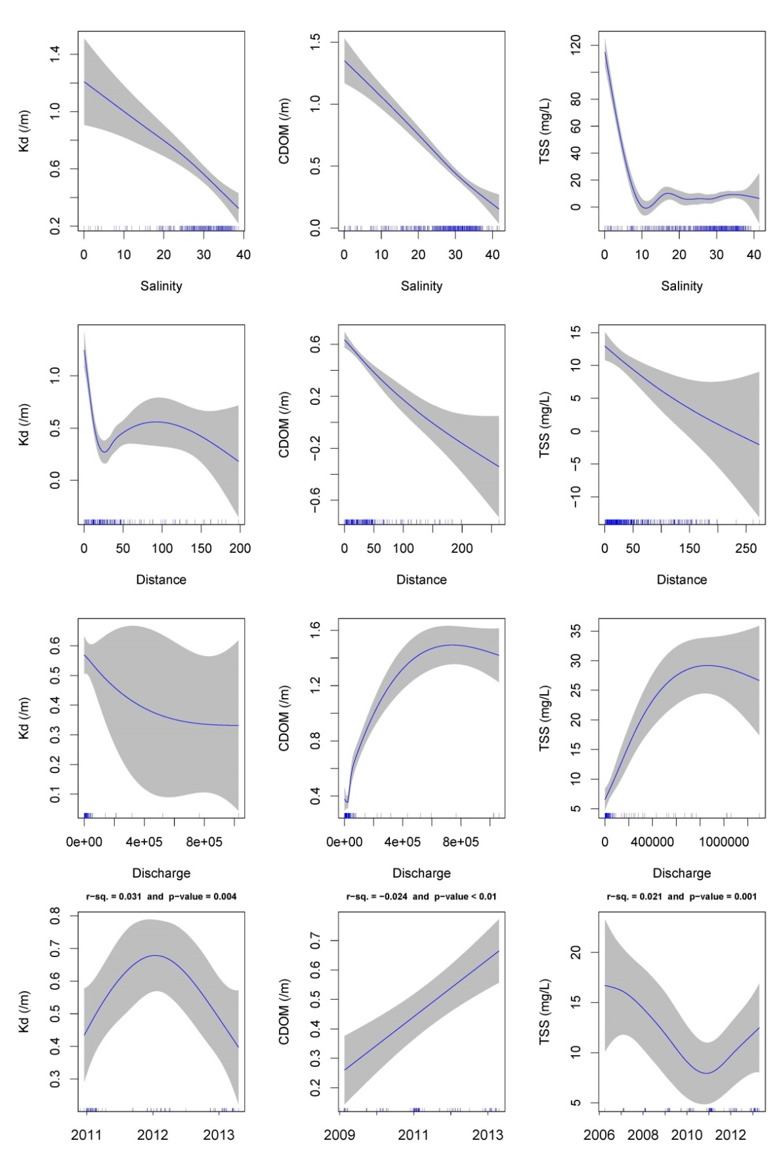
Figure 4-8:GAMM analysis for Kd, /m, left column), CDOM, /m, mid column) and TSS, mg/L, right column) collected from December, 2005 to April, 2013 (inclusive). First four plots in each column are for the partial effect plots and last pot is the temporal analysis (see text for explanation). Shade area stands for ±1 SE and rubs on x-axis stand for data density.
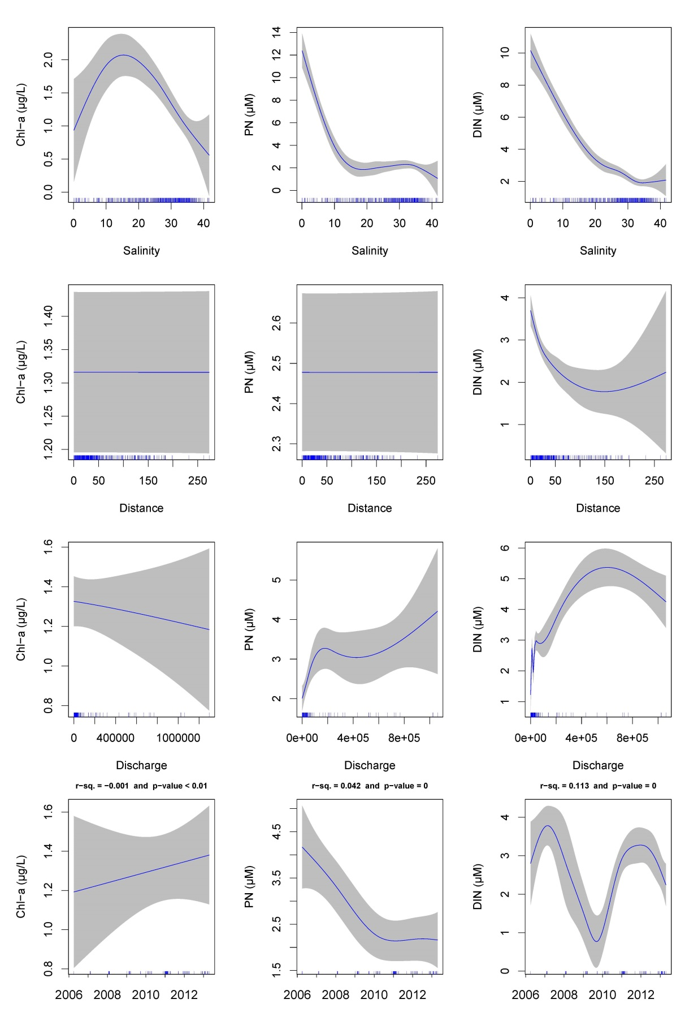
Figure 4-9: GAMM analysis for Chl-a, µg/L, left column), PN, µM, mid column) and DIN, µM, right column) collected from December, 2005 to April, 2013 (inclusive). First three plots in each column are for the partial effect plots and last pot is the temporal analysis Shade area stands for ±1 SE and rubs on x-axis stand for data density.
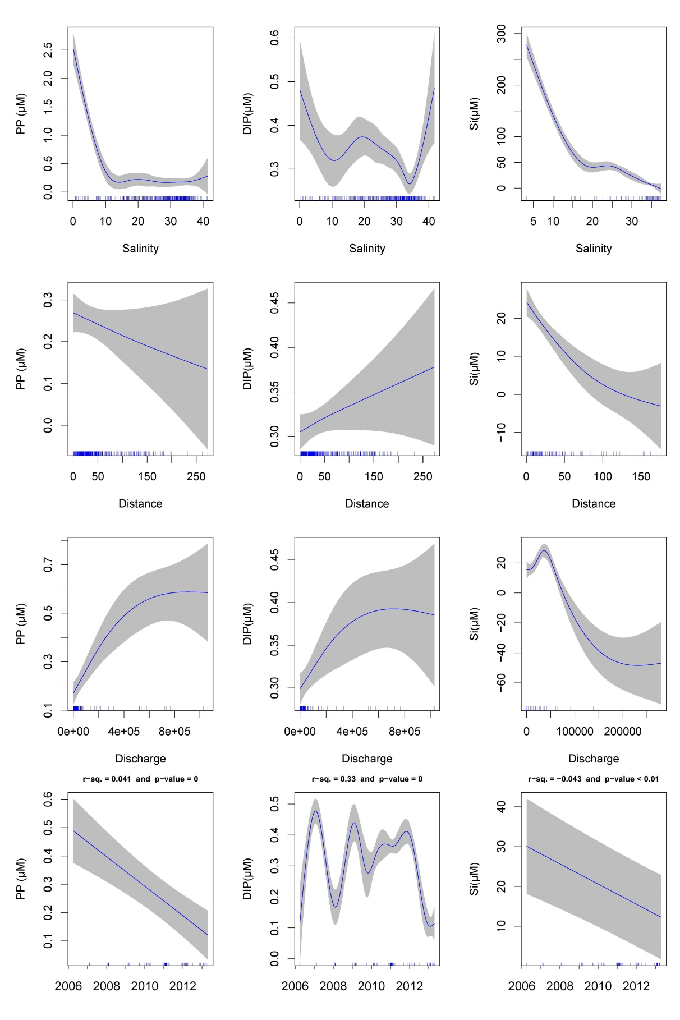
Figure 4-10: GAMM analysis for PP, µM, left column), DIP, µM, mid column) and Si, µM, right column) collected from December, 2005 to April, 2013 (inclusive). First three plots in each column are for the partial effect plots and last pot is the temporal analysis.

Mapping of river plumes

Introduction
Remote sensing imagery has become a useful and operational assessment tool in the monitoring of river flood plumes (hereafter river plumes) in the GBR. Combined with in situ WQ sampling the use of remote sensing (RS) is a valid and practical way to estimate both the extent and frequency of river plume exposure on GBR ecosystems. Ocean colour imagery provides synoptic-scale information regarding the movement and composition of river plumes. Thus, in the past five years, RS imagery combined with in situ sampling of river plumes has provided an essential source of data related to the movement and composition of river plumes in GBR waters (e.g., Bainbridge et al., 2012; Brodie et al.; 2010; Devlin et al.; 2012a, b; Schroeder et al., 2012).
Our efforts to improve RS methods are continuing. As part of the last MMP in 2011-12 (Devlin et al., 2013a), a number of important and innovative developments were undertaken to improve our capacity to identify and monitor the exposure of GBR ecosystems to river plumes and anthropogenic WQ influences, using RS data. These steps included:
- The development of a semi-automated qualitative method to delineate river plumes (full extent) and river plume water types (Primary, Secondary, and Tertiary) using two types of Moderate Resolution Imaging Spectroradiometer (MODIS) imagery: (i) true color (TC) data (Álvarez-Romero et al., 2013; Devlin et al., 2013a). Maps produced from this method are hereafter referred as “TC maps”. (ii) MODIS Level 2 (L2; i.e., geophysical) data and WQ thresholds (Devlin et al., 2013a, Petus et al., 2014b). Maps produced from this method are hereafter referred as “L2 maps”. Both TC and L2 maps are used to map the extent, movement and frequency of occurrence of river plumes in the GBR during the wet season.
- The development of an innovative satellite method to map the discharge and dispersal of TSS and DIN in the coastal/marine environment (Álvarez-Romero, 2013). It incorporates TC-derived products and spatially distributed load data to produce TSS and DIN load maps from 2007 to 2011. Maps produced from this method are referred as “load maps”.
As part of this MMP report in 2012-13, our technical efforts focused on the improvement and validation of the RS methods developed in 2011-12 to map GBR river plumes and river plume water types (hereafter, plumes water types), as well as on the development of new methods to measure the exposure of coastal-marine ecosystems to river plumes and associated pollutants through the production of river plume exposure/risk maps (herafter potential risk maps). More particularly we focused on:
- The improvement, automation and validation of the TC and L2 methods to delineate river plumes (full extent) and plume water types (Primary, Secondary, Tertiary) (e.g. Petus et al., 2014b). Outputs from both MODIS TC and L2 -derived products are compared in this report to determine the best outputs to use as problem-oriented management tools.
- The improvement and automation of the production of pollutants load maps (TSS, DIN, pesticides; Álvarez-Romero, 2013). This load work is still in progress and no outputs are presented in this report as we are currently incorporating all rivers into the pollutant loading surface.
- The exploration of the potential of using MODIS images to produce potential risk maps from river plume exposure for GBR reef and seagrass ecosystems;

Methods

GBR plumes water types
Three distinct plume water types have been described within GBR river plumes (from the inshore to the offshore boundary of river plumes). They are characterized by varying salinity levels, spectral properties, colour, and WQ concentrations.
- The Primary water type presents very high turbidity, low salinity (0 to 10; Devlin et al., 2010), and very high values of CDOM and Total Suspended Sediment (TSS). Turbidity levels limit light penetration in Primary waters, inhibiting primary production and limiting chl-a concentration.
- The Secondary water type is characterised by intermediate salinity, elevated CDOM concentrations, and reduced TSS due to sedimentation (Bainbridge et al., 2012). In this water type (middle salinity range: 10 to 25; Devlin et al., 2010), the phytoplankton growth is prompted by the increased light (due to lower TSS) and high nutrient availability delivered by the river plume.
- The Tertiary water type occupies the external region of the river plume. It exhibits no or low TSS associated with the river plume, and above-ambient concentrations of chl-a and CDOM. This water type can be described as being the transition between Secondary water and marine ambient water, and present salinity lower than the marine waters (typically defined by salinity ≥ 35; e.g., Pinet, 2000).

Mapping of the GBR River plumes, using MODIS images
Level of exposure of GBR ecosystems (including the coral reefs and seagrass meadows) to river plumes and land-sourced contaminants is spatially and temporally dependent of the different land-uses in the GBR catchments, the local transports of contaminants, and the distance of respective ecosystems to the river mouths (Brodie et al., 2013). Understanding the exposure of the GBR ecosystems and resulting changes in ecosystem health conditions is important to facilitate management of the GBR to respond to anthropogenic pressures under a changing climate. The main objective of the RS component of the wet season monitoring under the MMP is to produce maps of river plumes, models that summarize land-sourced contaminants transport, describe water quality concentrations within wet season conditions, and to integrate all these methods to evaluate the susceptibility of GBR key ecosystems to the river plume/pollutants exposure i.e. to model the risk of GBR ecosystem due to exposure to river plumes (Figure 5-1).

Development of Remote sensing products
MODIS images, offer daily and whole GBR scale pictures of GBR coastal environments and thus help with identification and mapping of GBR river plumes. Two families of supervised classification methods based on MODIS data have been investigated though MMP funding to map marine areas exposed to river plumes and the different plume water types: one based on MODIS true colour images (hereafter TC method), and one using MODIS images calibrated into WQ proxies (i.e., MODIS L2 data; hereafter L2 method). The TC method is based on classification of spectrally enhanced quasi-true colour MODIS images (Álvarez-Romero et al., 2013). This method exploits the differences in colour between the turbid river plumes and the marine ambient water, and between respective water type inside the river plumes (Álvarez-Romero et al., 2013). The second family of analysis or L2 method, uses threshold values applied to atmospherically corrected Level-2 products derived from satellite images to delineate river plume boundaries and surface water types inside river plumes (e.g., Dzwonkowski and Yan, 2005; Petus et al., 2014b; Saldias et al., 2012; Schroeder et al. 2012). Both methods (Álvarez-Romero et al., 2013, Devlin et al. 2013a, Petus et al., 2014b) present advantages and disadvantages, described in Petus et al. (2014b) and in the discussion section of this report in order to determine the best data to use as problem-oriented management tool.
Maps were produced at different spatial (whole-GBR; NRM-, river-) and temporal (daily-, weekly-, annual- and multi-annual-) scales and included:
- River plume (full extent) maps. The river plume maps illustrate the movement of riverine waters, but do not provide information on the composition of the water and WQ constituents.
- Plume water type (Primary, Secondary and Tertiary) maps produced from the TC and L2 methods Plume water types are associated with different levels and combination of pollutants (see, e.g., discussion in Petus et al., 2014b) and, in combination with in-situ WQ information, provide a broad scale approach to reporting contaminant concentrations in the GBR marine environment.
- Load maps of land-sourced pollutants (TSS and DIN) derived from the TC method. The load mapping exercise, allows us to further understand the movements of pollutants which are carried within the river plume waters.

Figure 5-1: Remote sensing products designed in order to model the risk of GBR ecosystems due to river plumes during the wet season.

Remote sensing products: “potential risk” maps
As part of our efforts for this 2012-13 MMP report, we have assessed the potential of using annual water type maps produced from both L2 and TC method to produce potential risk maps for the GBR ecosystems from river plume exposure (Petus et al., 2014b, Petus et al., in prep.).
Theories behind the production of River plume risk maps for the GBR ecosystems are described in Petus et al. (2014b) and summarized briefly here. Measuring the magnitude of the river plume risk to coral reefs and seagrass beds can be challenging because of the combination of different stressors in river plume waters. Devlin et al. (2012b) underscored the need to develop risk models that incorporate the cumulative effects of pollutants. Elevated levels of turbidity, which limits light penetration, and reduce the amount of light available for seagrass photosynthesis, are described as the primary cause of seagrass loss (Mckenzie et al. 2012; Collier et al. 2012a, b). Coral biodiversity also declines as a function of increasing turbidity throughout the GBR (De’ath and Fabricius 2010) and reef development ceases at depths where light is below 6- 8% of surface irradiance (Cooper et al. 2007; Titlyanov and Latypov 1991). Furthermore, more than 90% of the land-sourced nutrients enter the GBR lagoon during high flow periods (Brodie et al., 2012; Mitchell et al., 2005). A linear decrease of DIN concentrations across river plumes (from the coast to offshore i.e., from Primary to Tertiary water types) have been described by Álvarez-Romero et al. (2013). Photosystem II inhibiting herbicides (PSII herbicides) at elevated concentrations have also been traced during the wet season in river plumes from catchments to the GBR lagoon (Davis et al., 2008). It was demonstrated by Kennedy et al. (2012) and Lewis et al. (2009) that the concentrations of PSII herbicides on the GBR typically exhibit a linear decline across the salinity gradient (i.e., from Primary to Tertiary water types).
As an approximation, Petus et al., (2014b) assumed that the magnitude of risk for the GBR seagrass beds and coral reefs from river plume exposure will increase from the Tertiary waters to the Primary core of river plumes. Classification of surface waters into Primary, Secondary, and Tertiary water types can thus provide a mechanism to cluster cumulative WQ stressors into three (ecologically relevant) broad categories of risk magnitude. At the multi-annual scale, the changes in the frequency of occurrence of these surface water types help understanding the likelihood of the different categories of risk magnitude. Producing annual maps of frequency of Primary, Secondary, and Tertiary water types in the GBR lagoon summarise thus the combined likelihood and magnitude of the river plume risk over a defined time period. In combination with ecosystem maps, it can serve as the basis to assess potential ecological consequences imposed by different levels and frequency of exposure to land-sourced contaminants in river plume (i.e., magnitude of risk).
Thus, in summary, the risk of a particular ecosystem (e.g., in the GBR, seagrass meadows or coral reefs) to be affected by a particular stressor (in this case land-sourced pollutants associated with river plumes) can be assessed by evaluating:
- The likelihood of the risk, i.e., how likely a particular stressor is to happen. This can be estimated by calculating the frequency of occurrence of river plumes or specific plume water type;
- The magnitude of the risk, i.e., in river plume risk analysis, the intensity quantified as concentration, level or load of pollutant discharge through the river plume; and
- The ecological consequences of the risk, i.e., the extent of the ecological impact for a particular ecosystem given a combination of magnitude and likelihood of occurrence of the stressor.
Annual “potential” risk maps were produced over seven wet seasons (2007 to 2013) using annual maps of frequency of occurrence of plume water types produced from both the TC and L2 methods as well as a simplified risk matrix (Table 5-1).

Table 5-1: Risk categories (I, II, III, and IV) in function of the magnitude and the likelihood of the river plume risk (modified from Petus et al., 2014b).
Magnitude | Tertiary | Secondary | Primary
Likelihood | Tertiary | Secondary | Primary
rare | I | I | II
infrequent | I | II | II
occasional | II | II | III
frequent | II | III | III
very frequent | III | III | IV

This risk matrix assumes that potential risk level for GBR ecosystems can be ranked in four qualitative categories (I, II, III, IV) determined by the combination of the magnitude (i.e., the estimated level of land-sourced pollutants in flood plume) and the likelihood (i.e. the frequency of occurrence) of the river plume risk (modified from Castillo et al., 2012). Potential risk maps were produced in Arcgis and a 4 pixel majority filter used to smooth the final maps. The term ‘potential’ is used as risk maps haven’t been yet validated against ecological health data to confirm the ecological consequences of the risk, i.e., the risk ranking in Table 5-1 (I, II, III, IV) given a combination of magnitude and likelihood is, at this stage, theoretical.

Exposure of GBR ecosystems to river plumes
RS products designed from both TC and L2 methods help to evaluate the level of exposure of the coral reefs and seagrass meadows to river plumes and land-sourced contaminants during the wet season (e.g., Petus et al., 2014b). These mapping outputs are used to define the exposure of GBR ecosystems (coral reefs and seagrass meadows) to river plumes and anthropogenic WQ exposure. The exposure of GBR marine ecosystems is expressed simply as the area (km2) and percentage (%) of coral reefs and seagrass meadows exposed to river plume and exposed to the different categories (I, II, III, IV) of potential risk from river plume exposure. Areas of GBR waters within each marine NRM region exposed to river plume and river plume risk are also reported in recognition of other important habitats and populations that exist in these areas (Brodie et al., 2013). Figure 5-2 and Figure 5-3 present the marine boundaries used for the GBR Marine Park, each NRM region and the seagrass and coral reefs ecosystems.
We assumed in this study that the shapefile can be used as a representation of the actual seagrass distribution. Spatial distribution of the deepwater seagrass is a statistically modelled probability of seagrass presence (using generalized additive models (GAMs) with binomial error and smoothed terms in relative distance across and along the GBR) in GBRWHA waters >15m depth, based on ground-truthing of each data point. For details on approach, see Coles et al. (2009).
These mapping outputs are used to define the exposure of GBR ecosystems (coral reefs and seagrass meadows) to river plumes and anthropogenic WQ exposure. The exposure of GBR marine ecosystems is expressed simply as the area (km²) and percentage (%) of coral reefs and seagrass meadows exposed to river plume and exposed to the different categories (I to IV) of potential risk from river plume exposure. Areas of GBR waters within each marine NRM region exposed to river plume and river plume risk are also reported in recognition of other important habitats and populations that exist in these areas (Brodie et al., 2013). Error! Reference source not found. and Error! Reference source not found. present the marine boundaries used for the GBR Marine Park, each NRM region and the seagrass and coral reefs ecosystems.
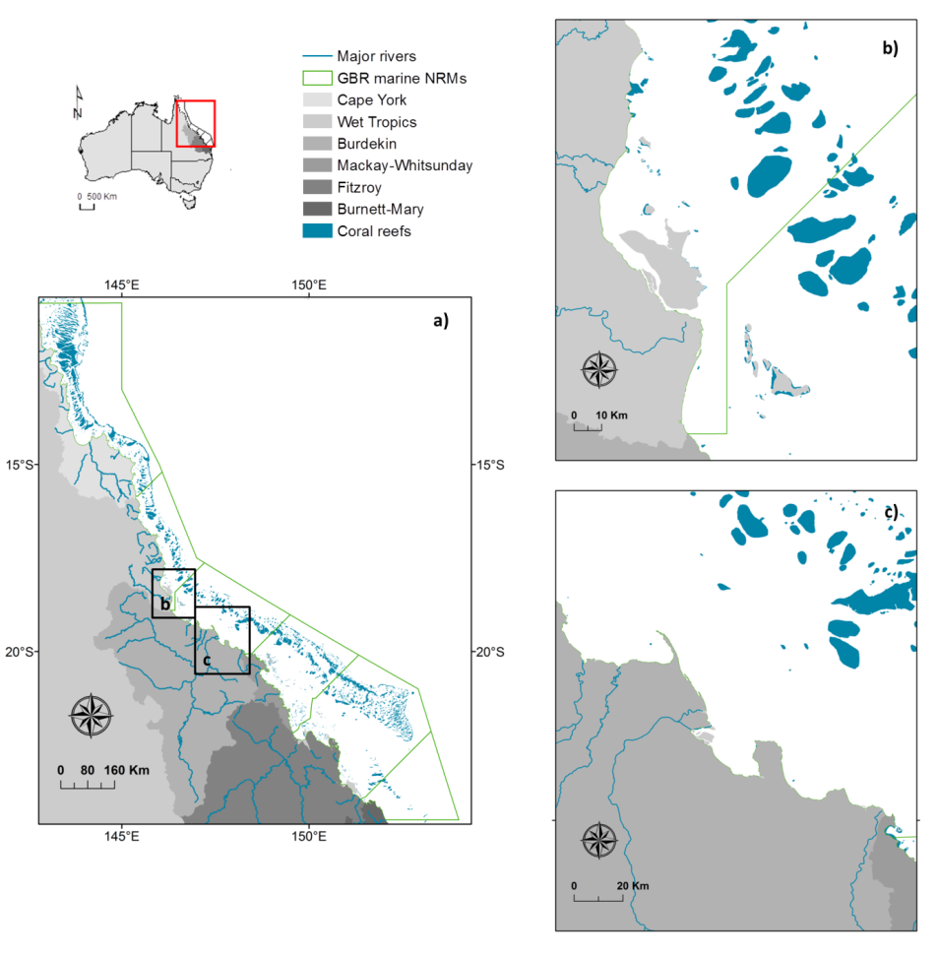

Figure 5-2: Marine boundaries used for the GBR Marine Park (a), each NRM region and the coral reefs ecosystems. Coral Reef and NRM layers derived from: GBRMPA, 2013, GBR feature shapefiles and enlargements around (b) the Tully-Herbert Rivers and (c) the Burdekin river.

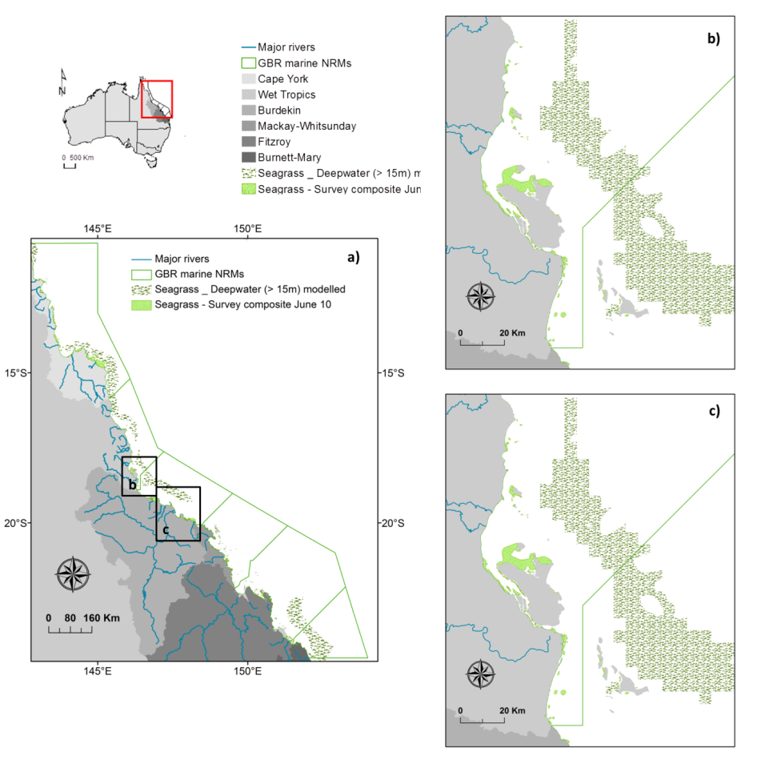
Figure 5-3: Marine boundaries used for the GBR Marine Park (a), each NRM region and the coral reefs ecosystems. NRM layers derived from: GBRMPA, 2013, GBR feature shapefiles and seagrass layers from DAFF, Feb. 2013; and enlargements around (b) the Tully-Herbert rivers and (c) the Burdekin rivers. Spatial distribution of the surveyed seagrasses bed is an historical layer composed from all meadows examined between 1984 and 2008 (see reports at: http://www.seagrasswatch.org/meg.html).

Results

Production maps (weekly composite maps of secondary water type)
Weekly composite maps of secondary plume water type focusing on the Tully-Herbert and Burdekin regions are presented in Figure 5-5 and Figure 5-6, respectively. Identifying the full extent of these Secondary waters on weekly basis provides recurrent production maps (i.e., areas with mean chl-a = 1.3±0.6 μg L⁻¹; Devlin et al., 2013), and identifies areas in which high phytoplankton biomass production are likely to occur during the variable wet season conditions. Secondary composite maps for the whole GBR are presented in Appendix B, Figure B-1. Table B-1 in Appendix B presents a conversion chart between Julian days, dates and week numbers. The maximum surface aerial extents of secondary waters were recorded around weeks 9, 15 and 20 (i.e., between the 26th of January and 19th of April and followed maximum peaks of discharge measured in the Tully-Herbert and Burdekin rivers (Figure 5-4). Surface aerial extent mapped were largest in end of January/early February in the wet Tropics and in mid-March/early April in the Burdekin region. Some areas were underestimated due to cloud cover; for example weeks 8 or 19 in the Wet Tropics and week 9 in the Burdekin region (Figure 5-5 and Figure 5-6).
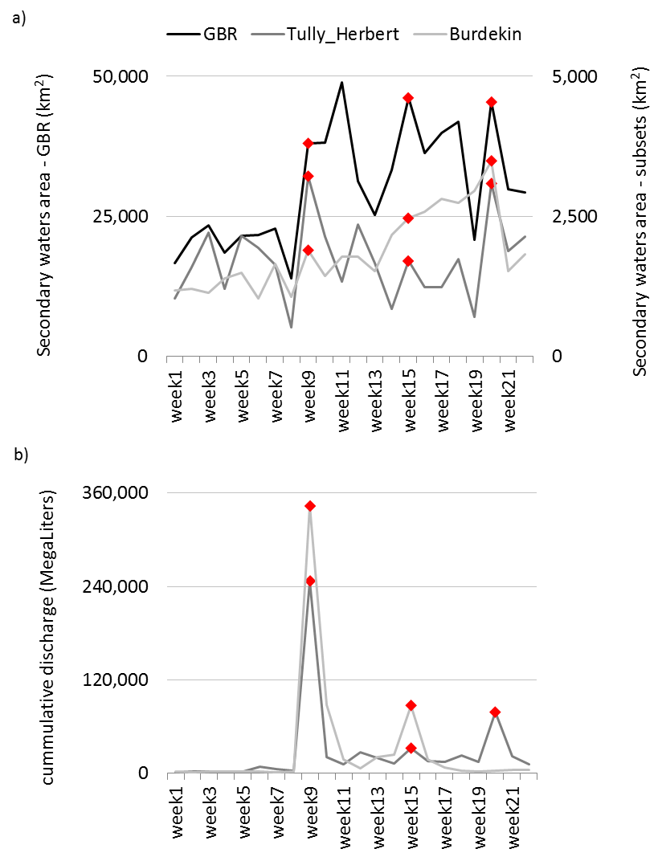
Figure 5-4: a) Secondary plume waters areas recorded for the GBR, the Tully-Herbert and the Burdekin subsets and b) cumulative weekly river discharge measured for the Tully-Herbert and Burdekin rivers.

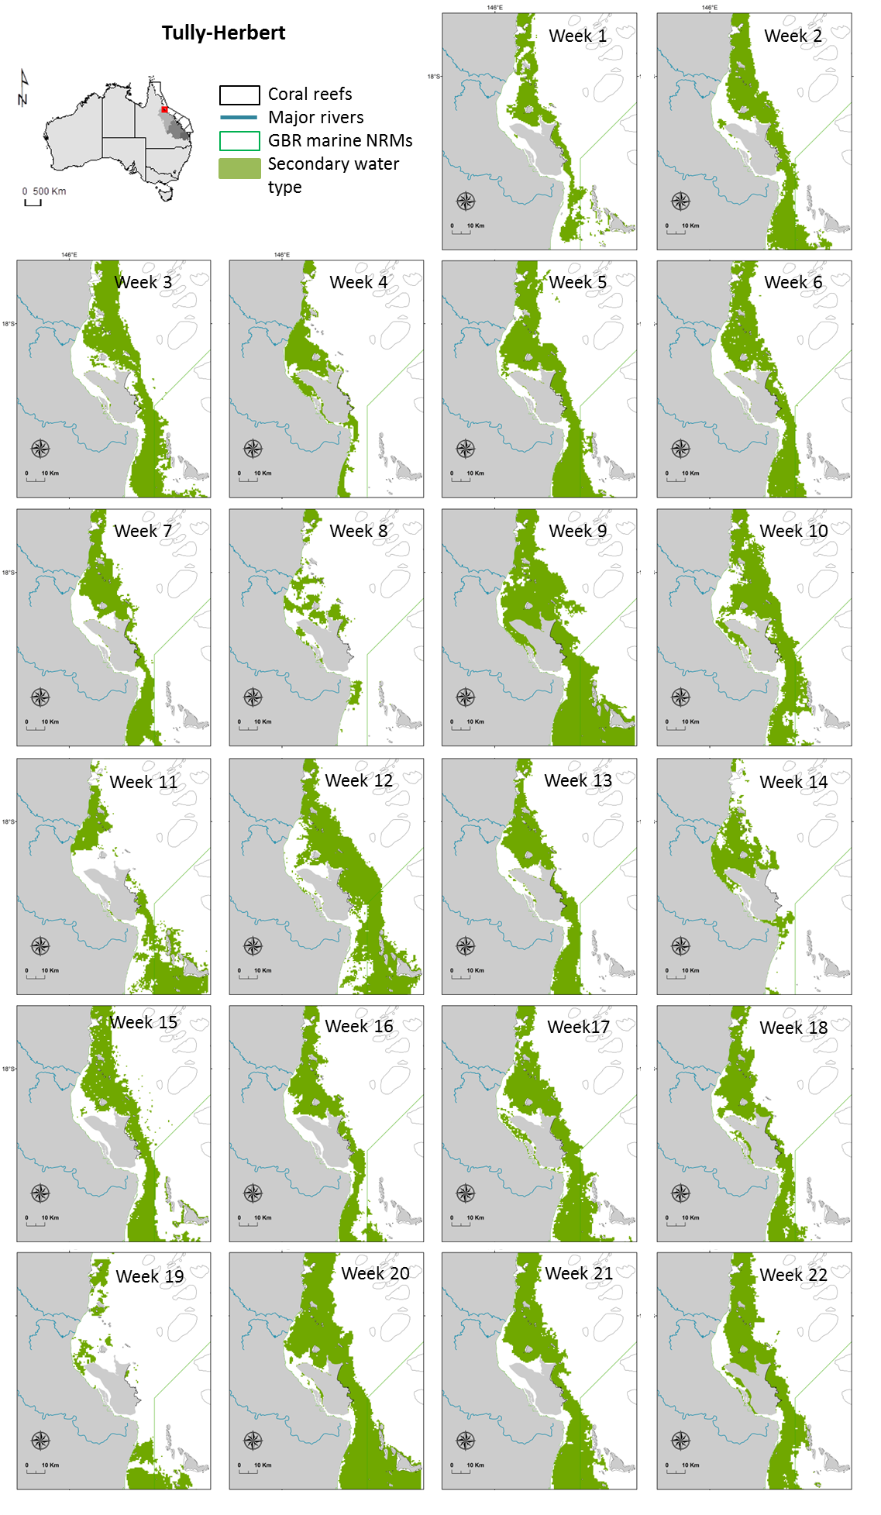
Figure 5-5: Secondary plume weekly composites of the Tully-Herbert marine region

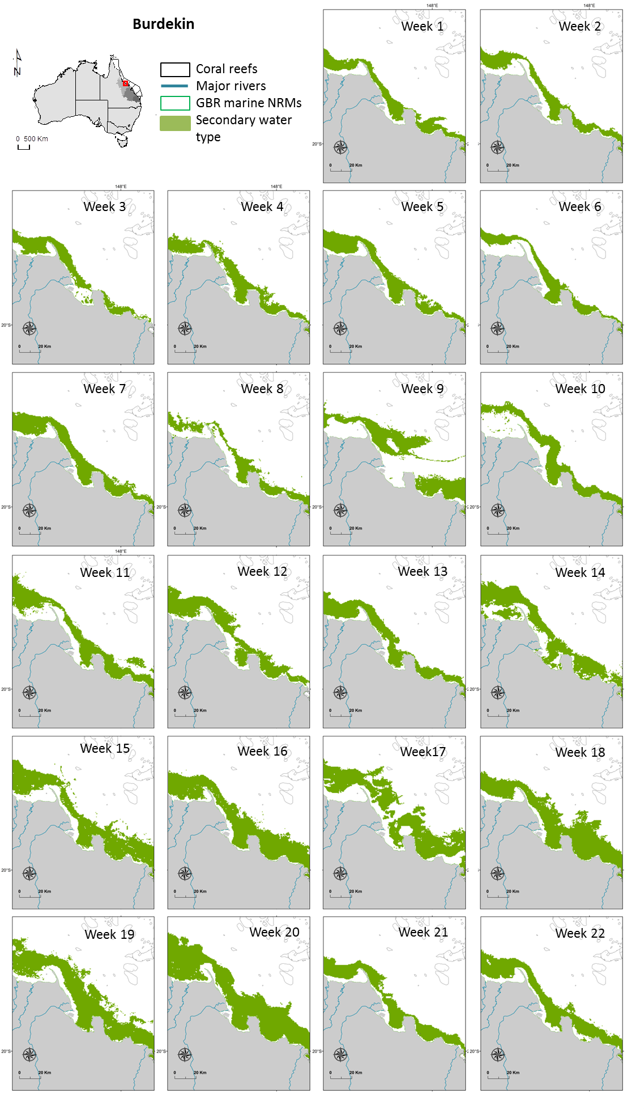
Figure 5-6: Secondary plume weekly composites of the Burdekin marine region

2012-13 frequency maps
The annual frequency maps produced applying both TC and L2 methods illustrate GBR marine areas affected by river plume waters as well as the spatial distribution and frequencies of occurrence of the three GBR plume water types (Primary, Secondary, and Tertiary) during the wet season 2012-13. Enlargements around the Tully Herbert and Burdekin regions are presented in Figure 5-7 to Figure 5-14 and whole-GBR scale maps in Appendix B (Figures B-2 to B-5). Note that this mapping exercise only identifies the surface river plume waters and plume water types and is not identifying scale or extent of impact on GBR ecosystems. The higher level of precision observed in all TC maps in comparison to L2 maps is due to satellite resolution. TC data used are, indeed, with a 500 m x 500 m resolution, while the L2 data are only 1000 m x 1000 m. The TC and L2 methods give similar outcomes in term of total GBR areas exposed to river plume. However, frequencies of exposure to river plumes differ and areas mapped as very frequently to frequently exposed to river plumes are more extensive in area using the TC method than the L2 method, particularly in the wet tropics
The plume water type maps provide information on the type/composition of river plume (through the Primary, Secondary, and Tertiary water type classification) and on the frequency of occurrence (or likelihood) of these plume water types (Figure 5-9 to Figure 5-14). Differences exist between areas and frequencies of plume water types mapped using the L2 and TC methods, particularly between the TC and L2 Secondary (chl-dominated) water type maps. Using the TC outputs, coastal waters of the Burdekin NRM are more often exposed to primary waters (i.e., sediment dominated water type, Figure 5-10) than coastal waters of the Wet Tropic NRM (Figure 5-9). Inversely marine areas occasionally to frequently exposed to Secondary and Tertiary water types are more extended in the Wet Tropic NRM (Figure 5-11 and Figure 5-13) than in the Burdekin NRM (Figure 5-12 and Figure 5-14). Tertiary waters (CDOM dominated) are located offshore in the GBR and constitute the transitional waters between plume-affected and ambient waters.
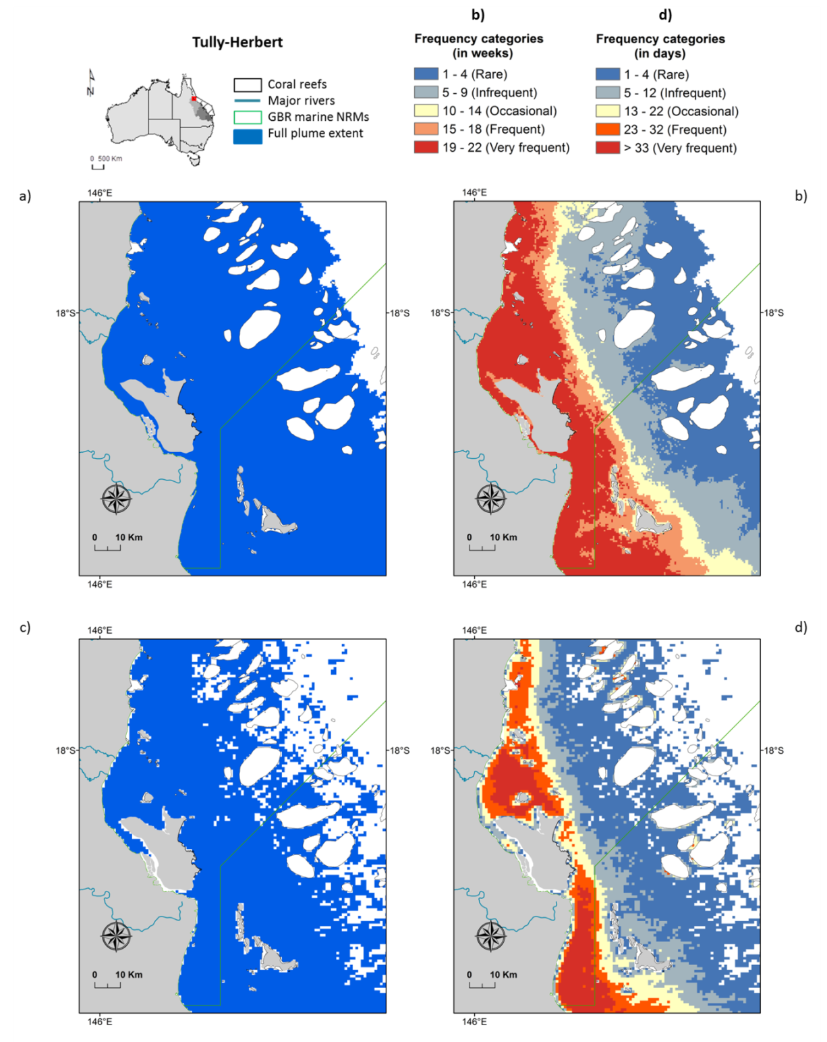
Figure 5-7: Frequency of occurrence of river plume recorded in 2013 in the Tully-Herbert region by a) and b) the TC method and c) and d) the L2 method. Maps a) and c) show all areas that have been classified as least one day over the wet season 2012-13 as river plume waters. Maps b) and d) show same maps reclassified into frequency breaks
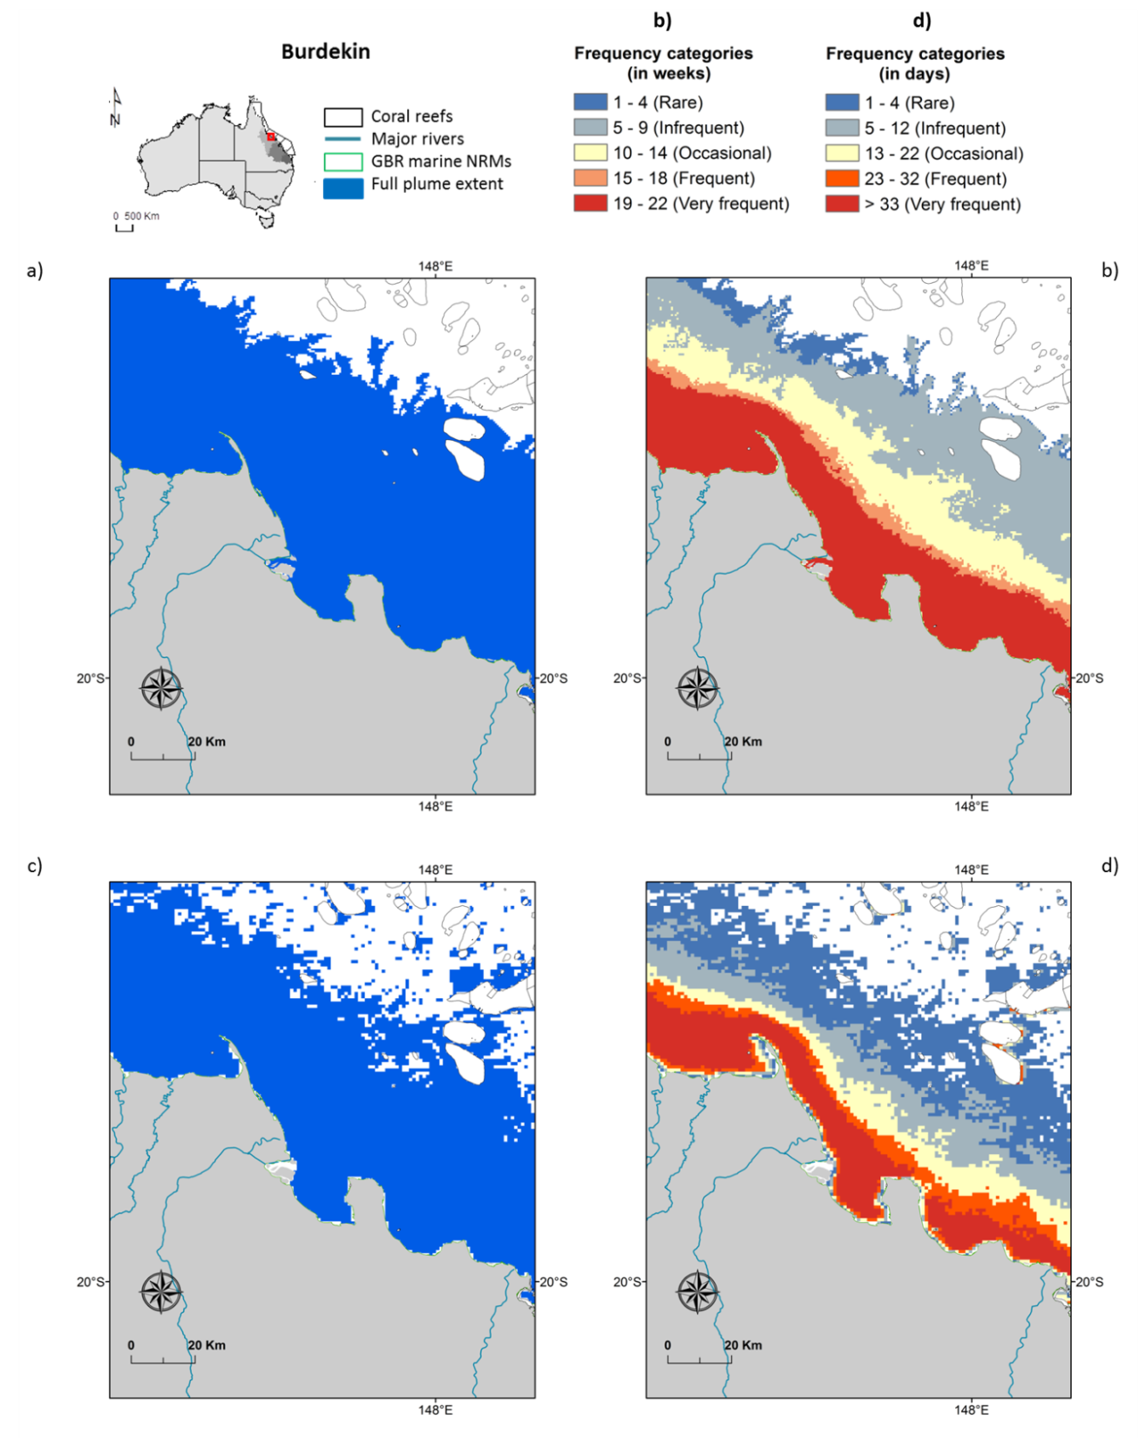
Figure 5-8: Frequency of occurrence of river plume recorded in 2013 in the Burdekin region by a) and b) the TC method and c) and d) the L2 method. Maps a) and c) show all areas that have been classified as least one day over the wet season 2012-13 as river plume waters. Maps b) and d) show same maps reclassified into frequency breaks

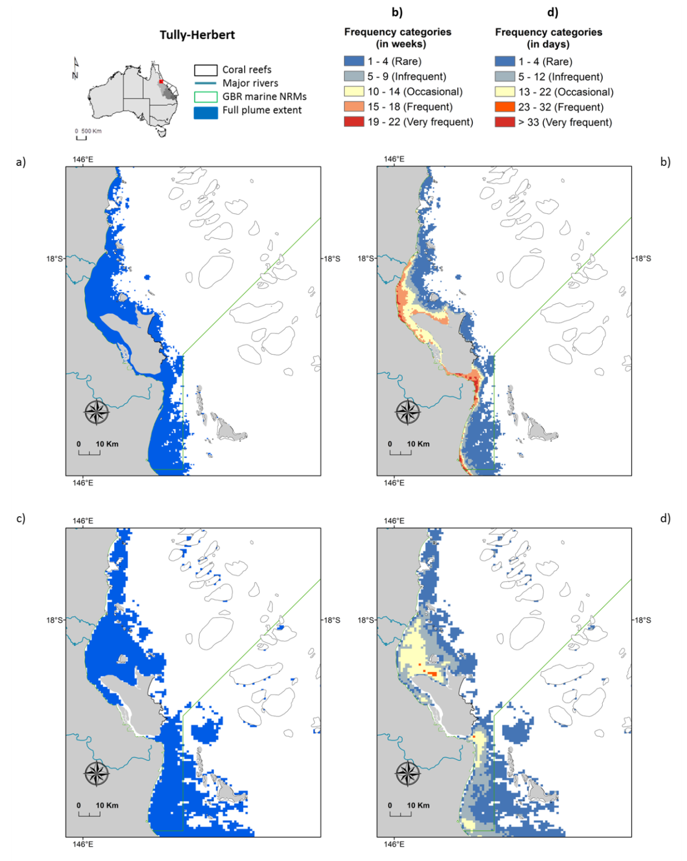
Figure 5-9: Frequency of occurrence of Primary plume waters recorded in 2013 in the Tully-Herbert region by a) and b) the TC method and c) and d) the L2 method. Maps a) and c) show all areas that have been classified as least one day over the wet season 2012-13 as Primary plume waters. Maps b) and d) show same maps reclassified into frequency breaks
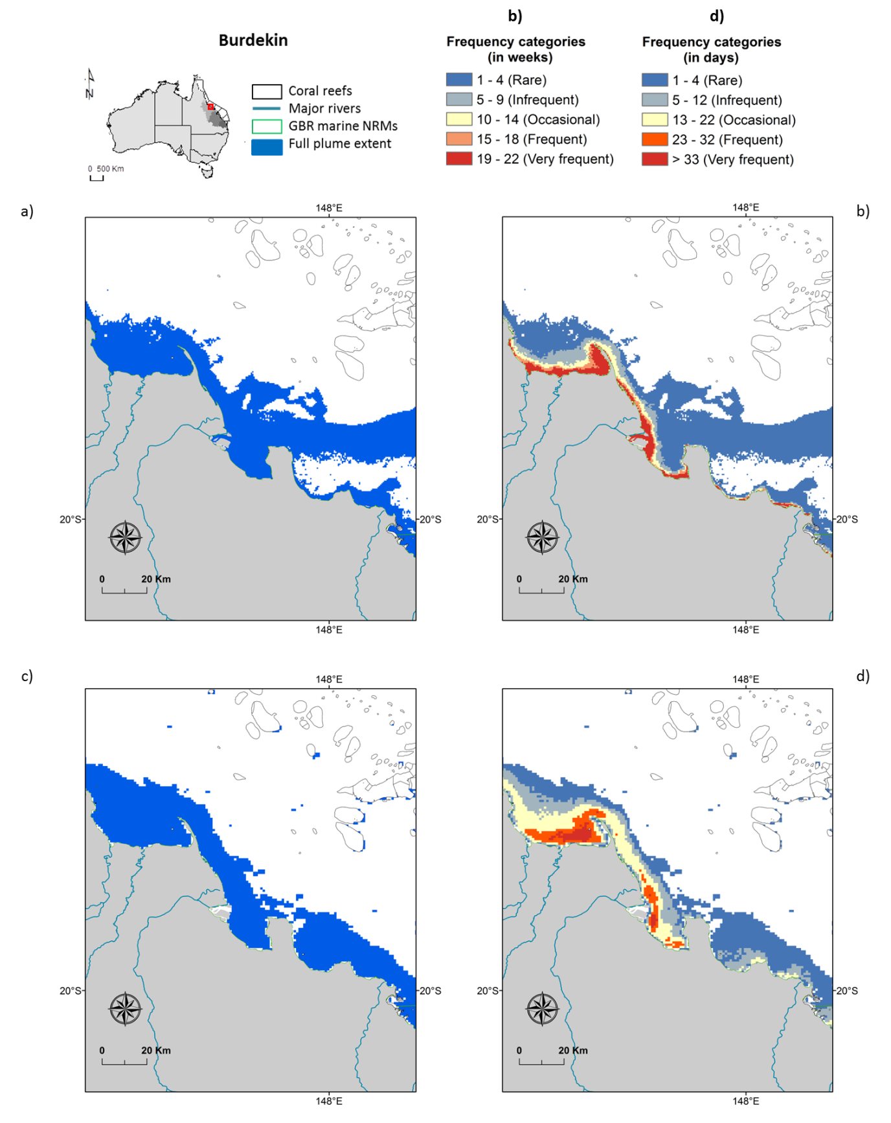
Figure 5-10: Frequency of occurrence of Primary plume waters recorded in 2013 in the Burdekin region by a) and b) the TC method and c) and d) the L2 method. Maps a) and c) show all areas that have been classified as least one day over the wet season 2012-13 as Primary plume waters. Maps b) and d) show same maps reclassified into frequency breaks
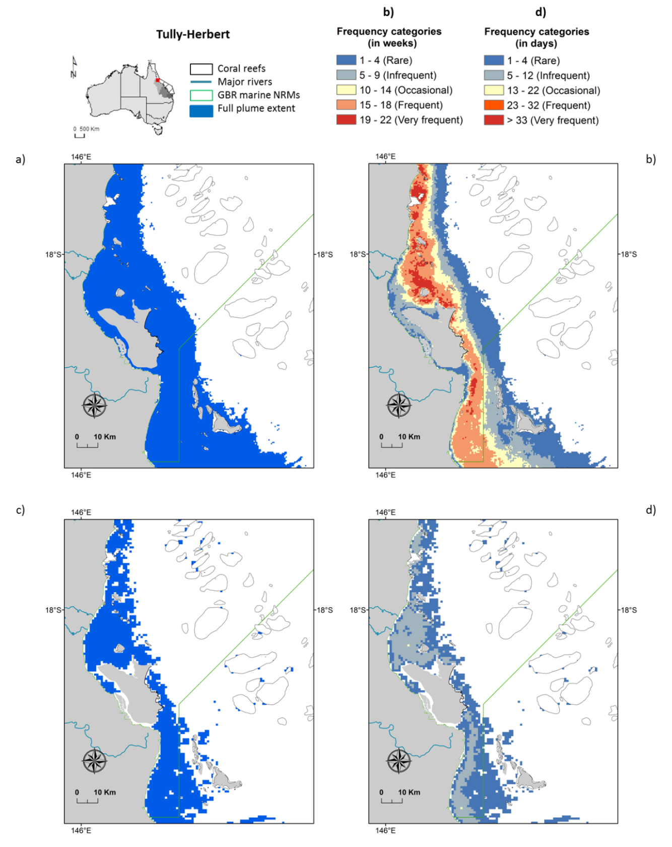
Figure 5-11: Frequency of occurrence of Secondary plume waters recorded in 2013 in the Tully-Herbert region by a) and b) the TC method and c) and d) the L2 method. Maps a) and c) show all areas that have been classified as least one day over the wet season 2012-13 as Secondary plume waters. Maps b) and d) show same maps reclassified into frequency breaks
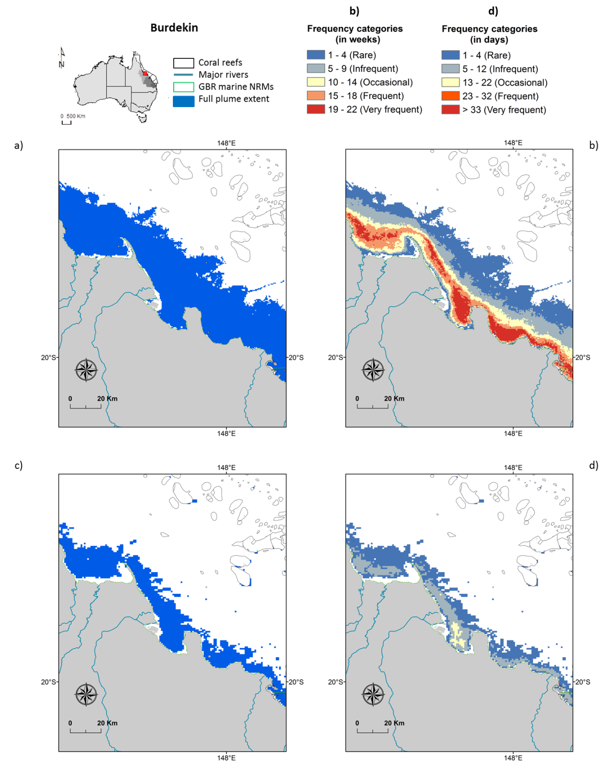
Figure 5-12: Frequency of occurrence of Secondary plume waters recorded in 2013 in the Burdekin region by a) and b) the TC method and c) and d) the L2 method. Maps a) and c) show all areas that have been classified as least one day over the wet season 2012-13 as Secondary plume waters. Maps b) and d) show same maps reclassified into frequency breaks
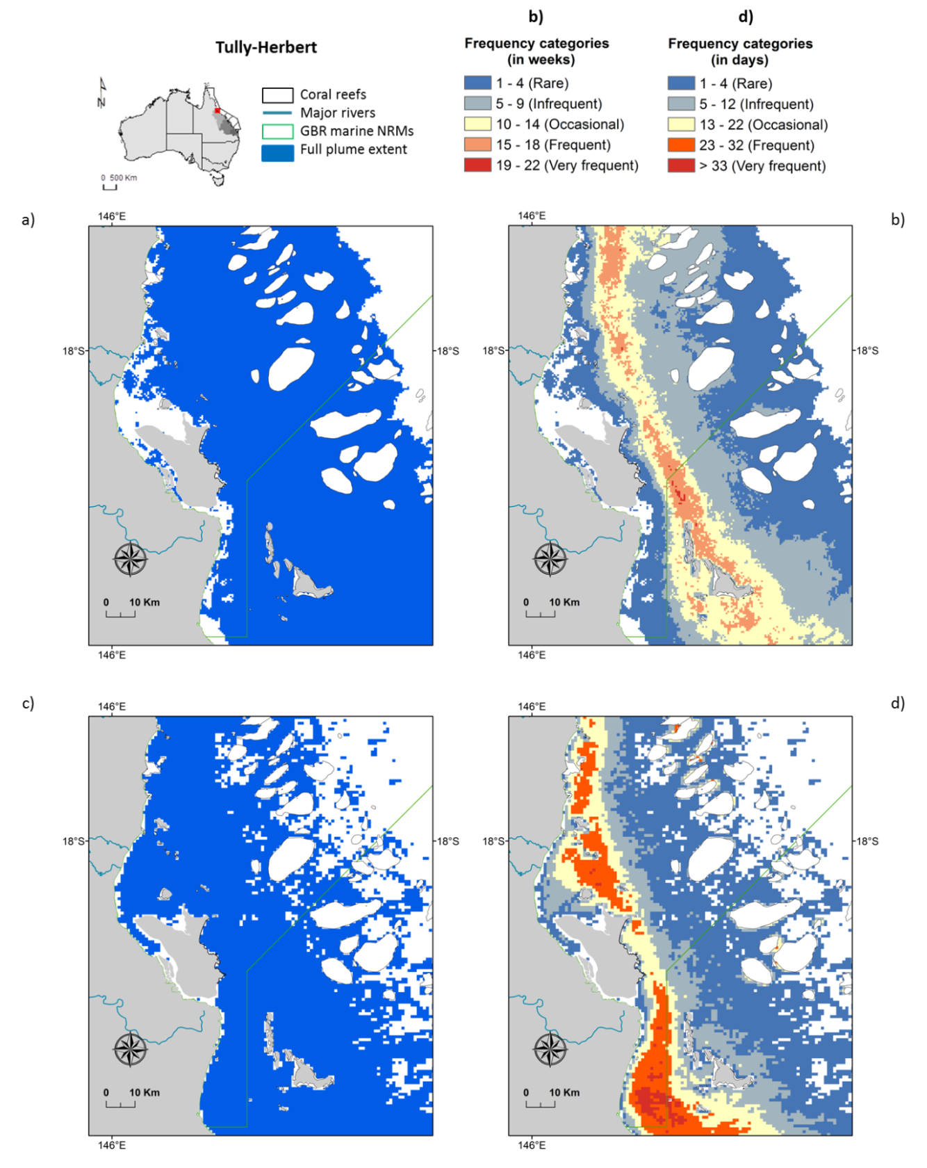
Figure 5-13: Frequency of occurrence of Tertiary plume waters recorded in 2013 in the Tully-Herbert region by a) and b) the TC method and c) and d) the L2 method. Maps a) and c) show all areas that have been classified as least one day over the wet season 2012-13 as Tertiary plume water. Maps b) and d) show same maps reclassified into frequency breaks
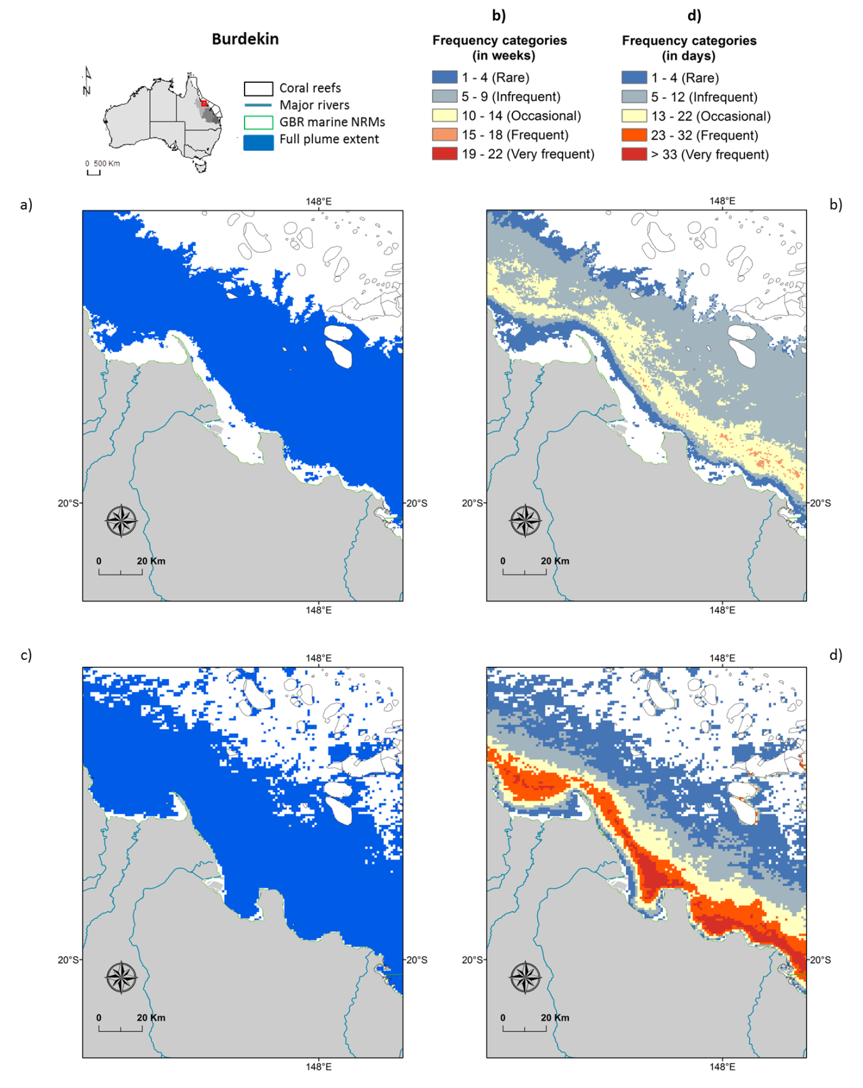
Figure 5-14: Frequency of occurrence of Tertiary plume waters recorded in 2013 in the Burdekin region by a) and b) the TC method and c) and d) the L2 method. Maps a) and c) show all areas that have been classified as least one day over the wet season 2012-13 as Tertiary plume water. Maps b) and d) show same maps reclassified into frequency breaks.

Water Quality concentration in river plumes
Comparison of plume water type maps produced from the TC method with in-situ WQ data of the wet seasons from 2007 to 2012 were performed and published in Devlin et al. (2013b). Mean annual (i.e., from December to April) in-situ values of chl-a, TSS and the Kd(PAR), measured across plume waters through MMP funding, were mapped against annual frequency maps of Primary, Secondary and Tertiary water types produced from the TC method for 6 wet seasons (2007 to 2012). WQ data (chl-a, TSS, KdPAR) over these 6 years were assigned to Primary, Secondary or Tertiary water type where that frequency of the water type was greater than 0.5, representing the pixel was identified as “this” water type for at least 50% of the wet season. The mean value (x +/- standard error) of chl-a, Kd(PAR) and TSS was calculated for each water type over the sampling period .
WQ concentrations across the three plume water types were comparable with the current understanding of GBR WQ gradients (as described by e.g. Devlin and Schaffelke, 2009; Devlin et al., 2012a and Devlin et al., 2013a, b). It supported the validity of the TC method developed to produce GBR river plume and plume water type maps as well as theories behind the production of potential river plume risk maps for GBR ecosystems, i.e., theories assuming that the magnitude of the river plume risk for the GBR seagrass beds and coral reefs from combined WQ stressors would increase from the Tertiary waters to the Primary core of river plumes. The TSS and Kd(PAR) values reduce through the three plume water types from 36.8 ± 5.5 mg l⁻¹ and 0.73 ± 0.54 m⁻¹ (Primary), to 8.9 ± 18.1 mg l⁻¹ and 0.39 ± 0.20 m⁻¹ (Secondary) and to 2.9 ± 3.2 mg l⁻¹, and 0.24 ± 0.02 m⁻¹ (Tertiary), respectively. The chl-a concentration were lower in the initial turbid Primary water type (0.98 ± 0.2 μg L⁻¹) and increased through the Secondary water type (1.3 ± 0.6 μg L⁻¹) as sedimentation increases and nutrient concentrations stay elevated. The concentrations were lower in the Tertiary zone (0.7 ± 0.3 μg L⁻¹), suggesting dilution processes and biological uptake as the flood plume aged over time and space.
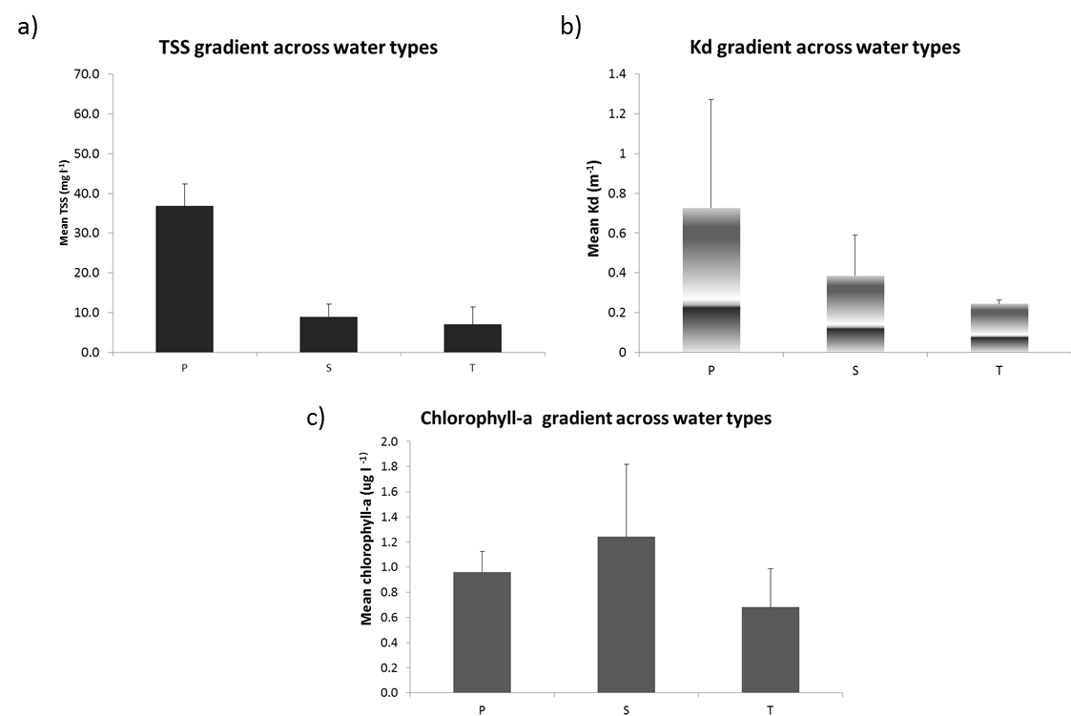
Figure 5-15: Mean concentrations of in-situ WQ measurements within each plume type. WQ data were assigned to plume water type based on dominant frequency (frequency > 0.5). Data are reported for (a) total suspended solids (TSS), with higher values in the Primary plume zone, (b) KdPAR, with higher values in the Primary plume zone, and (c) chl-a, with highest values in the Secondary plume zone (modified from Devlin et al., 2013b).

Similar results were obtained by Petus et al. (2014b). where the authors compared water type maps produced from the L2 method in wet seasons of 2011, 2012, 2013 against in-situ values of chl-a, TSS, CDOM, and Kd(PAR) acquired within ±2 h of the satellite over passes. WQ concentrations across the three plume water were comparable with the current understanding of WQ gradients (as described by e.g. Devlin and Schaffelke, 2009; Devlin et al., 2012a, 2013a, b), with mean in-situ WQ values similar to the ones calculated for the validation of the TC method (Devlin et al., 2013b). The Kd(PAR) and CDOM values reduced through the three plume water types from 0.67 m⁻¹ and 0.35 m⁻¹ (Primary) to 0.32 m⁻¹ and 0.22 m⁻¹ (Tertiary), respectively. The chl-a concentration were lower in the initial turbid Primary water type (0.75 μg L⁻¹) and increased through the Secondary water type (0.96 μg L⁻¹) as sedimentation increases and nutrient concentrations stay elevated. The chl-a values calculated in the TC method are slightly higher with 0.98 μg L⁻¹ in the Primary water type and 1.3 μg L⁻¹ in the secondary water type. These differences in chl-a values are the most probably due to datasets used to compare the in-situ WQ data and the river plume maps. Indeed L2 comparisons utilize only data acquired within ±2 h of the satellite over passes (i.e., direct match ups) while TC comparisons utilize all data available and do not exclude on direct match ups. Furthermore, differences have been observed between areas and frequencies of plume water types mapped using the L2 and TC methods, particularly between the TC and L2 Secondary (chl-dominated) water type maps (see previous section).

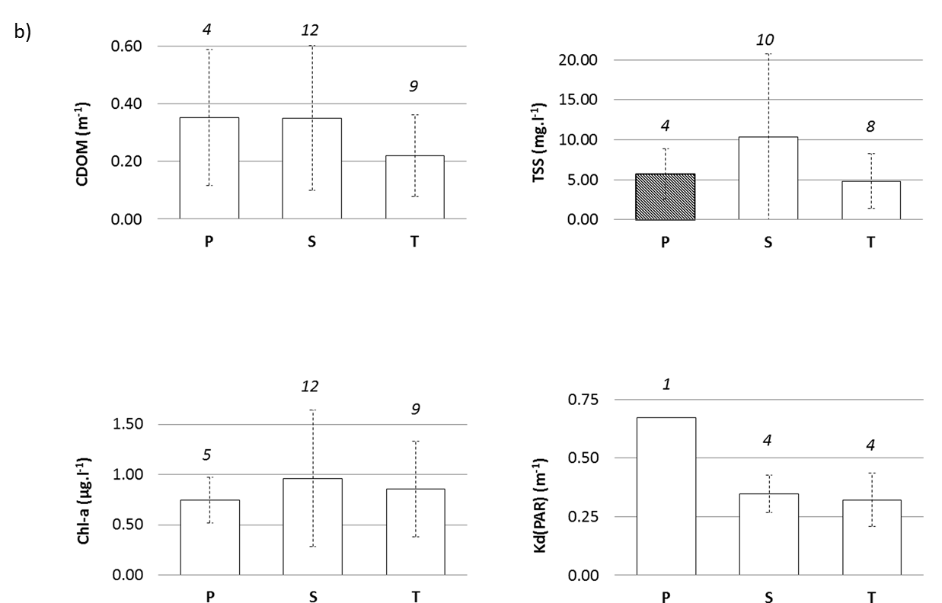
Figure 5-16: mean concentrations of in-situ WQ measurements (CDOM, TSS, Chl-a and Kd(PAR)) within each plume water type. WQ data assigned to plume water when the difference between in-situ collection and the satellite over passes is within ±2 h. Number of data is indicated in italic (modified from Petus et al., in press).

TSS concentration reduced from the Secondary (10 mg L⁻¹) to the Tertiary (5 m L⁻¹) water type. The low TSS concentrations in the Primary water type, as compared to e.g. Devlin et al. (2013b) can be attributed to the limited number of TSS data points available within ±2 h time difference between in-situ collection and the satellite over passes in the Primary water type data (only 2 TSS measurements). Despite this limitation, Figure 2 support the validity of the supervised classification method applied in this study.

Potential river plume risk maps – 2012/2013
Figure 5-17 presents the 2013 river plume potential risk map and enlargements around the Tully Herbert and Burdekin regions produced using the simple risk matrix (Figure 5-1). This table assumes that potential risk level from plume exposure for GBR ecosystems can be ranked in four qualitative categories (I, II, III and IV) determined by the combination of the magnitude (mapped through the Primary, Secondary, Tertiary water type classes) and the likelihood (mapped through the frequency of occurrence of Primary, Secondary, Tertiary water type classes) of the river plume exposure (Petus et al., 2014b).
At the GBR scale, the TC and L2 methods give similar outcomes. A general inshore to offshore spatial pattern is present in both TC and L2 potential river plume risk maps, with inshore areas within 10 to 30 km of the coast experiencing exposure to the highest potential risk categories (III and IV) and offshore areas experiencing lower potential risk from river plume water. At the regional scale, differences exist between potential risk maps produced using the L2 and TC methods, particularly around the Wet-tropics (Figure 5-17). In this region, areas categorized as potential risk III for the GBR ecosystems are largest using the TC method than the L2 method. Potential risk maps produced in the Burdekin region are similar using both the TC and L2 methods, even if areas categorized as potential risk III are again largest using the TC method. Total areas under exposure to river plumes extend 85 km offshore of the Herbert River mouth and 60 km offshore of the Burdekin River mouth (if measured along a NE/SW strait line from both estuary mouths).

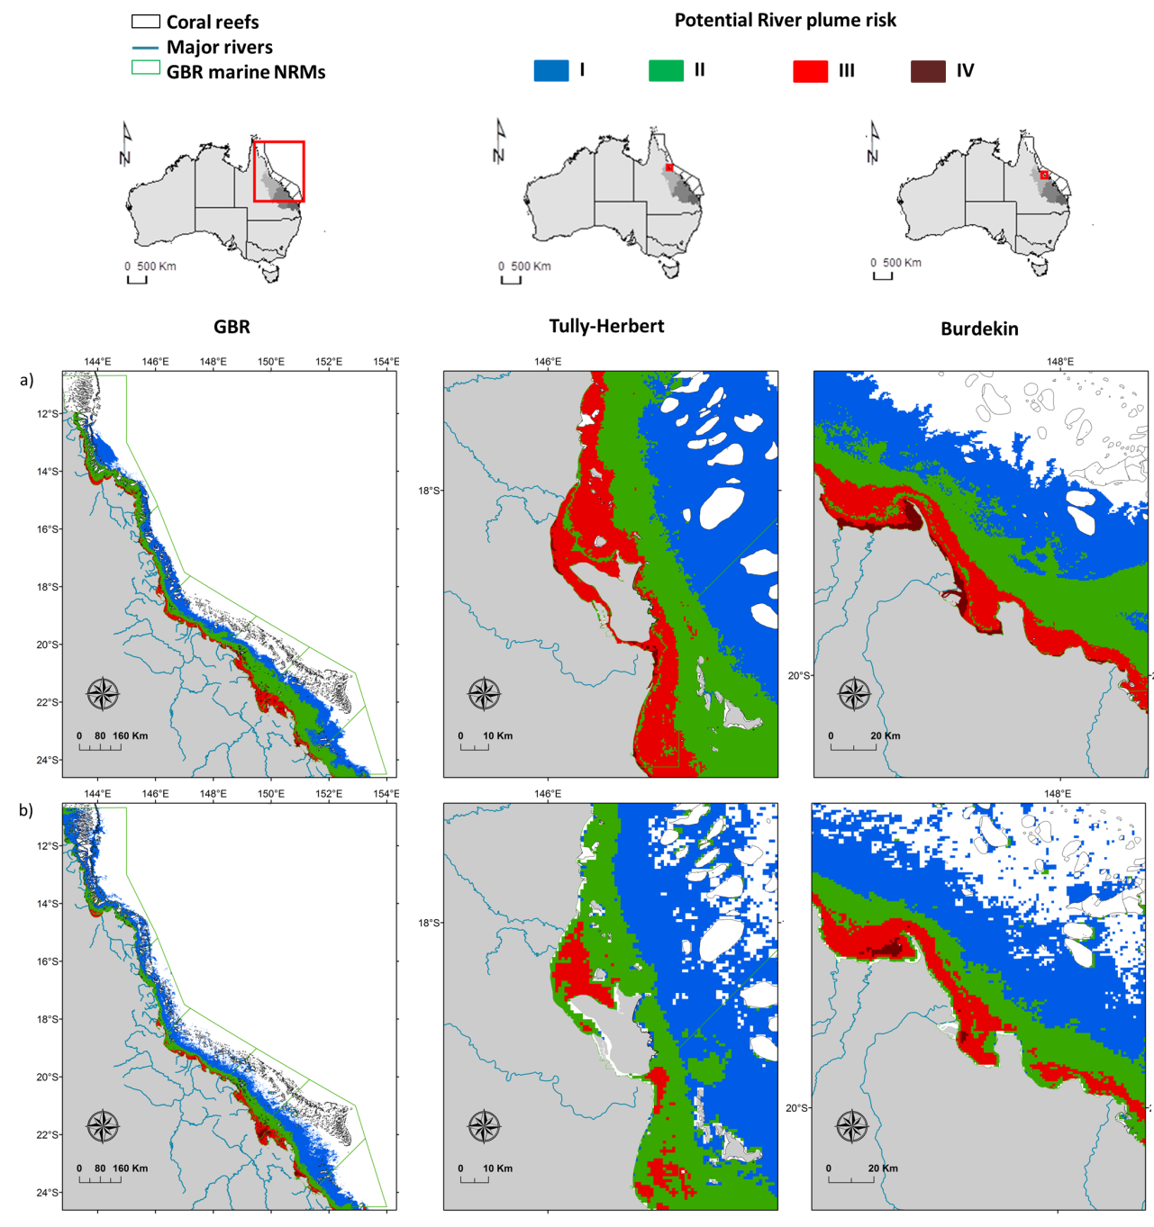
Figure 5-17: 2012-13 “potential” river plume risk maps of (left) the GBR; (middle) the Tully Herbert region and (right) the Burdekin region produced by a) the TC method and b) the L2 method. Maps have been smoothed twice with a 4 pixel majority filter (ArcGIS).

Comparison between RS outputs derived from the TC and L2 methods
Both the TC and L2 methods used in this report rely on the same principle: gradients of WQ existing in river plumes (from the estuary mouth to the edge of the river plume) modify the optical signature of the water (related to the concentration of TSS, chl-a, CDOM), which in turn change the colour of the water. Both methods present advantages and disadvantages: the TC method offers a simple and objective method by clustering the information contained in MODIS true-colour composites (Red–Green–Blue bands), but relies on non-atmospherically corrected data, and the spectral signature used to classify images (from Alvarez-Romero et al., 2013) does not incorporate potential spatio-temporal variability. The L2 threshold method assumes fixed WQ value/level/concentration thresholds (Petus et al., 2014b) and thus also ignores potential temporal and spatial variability, but does account for atmospheric correction. In addition, this method offers valuable quantitative information, such as the concentration of CDOM, TSS, chl-a, or Kd(PAR) values that are not directly available through the clustering of the true-colour composites. This quantitative information can be interesting to further evaluate the concentration/level/load of stressors discharged through river plumes during the wet season and to assess potential ecological impacts.
Differences observed between the annual L2 and TC maps of frequency of occurrence of river plumes and plume water types produced can be explained by different factors:
- Maps are with different spatial resolutions: 500 m for the TC outputs vs. 1000 m for the L2 outputs;
- The TC method allow to map river plumes and plume water types under light cloud cover or sunglint conditions (Alvarez-Romero et al., 2013); while MODIS Level-2 products used for the L2 method are inaccurate and masked out when any cloud or sunglint are present. Numbers of river plumes mapped per wet season are thus larger using the TC method than the L2 method.
- Annual maps of frequency of occurrence of river plumes and plume water types obtained from the TC method are created from weekly 6-color class composites produced from the TC method while L2 maps are created from daily river plume maps and plume water type maps produced from the L2 method. The technique presented by Alvarez-Romero et al (2013) to calculate the weekly color class composites is really conservative as the minimum color-class value of each cell/week (i.e., the color class with the highest turbidity level) is used to map the color classes. This means that the highest level of risk to river plume for each week is selected (assuming the color classes represented a gradient in exposure to pollutants). This also explain why breaks used to categorize the annual maps of frequency of occurrence of river plume and plume water types are different when using the L2 (breaks in days) and TC methods (breaks in weeks) (Annexe 4-1.4, Table 2).
- External/full extent boundaries of the weekly TC are manually cleaned (high precision but time consuming) while a simple “maximum river plume extent” shapefile (computed from MODIS river plumes mapped from 2007 to 2013) is used to clean the L2 annual maps of frequency of occurrence of river plumes and plume water types (lower precision but less time consuming);
The main objective of the RS part of the MMP is to develop and apply innovative spatial products. Assessing water quality concentrations, and especially the CDOM and Chl-a concentrations, with satellite data is notoriously challenging in the optically complex coastal waters (Case 2 waters) around the world, including the GBR lagoon, where suspended sediment and Coloured Dissolved Organic Matter (CDOM) co-occur with phytoplankton (see Gitelson et al. 2008, Odermatt et al. 2012). For the GBR, Qin et al. (2007) demonstrated that the accuracy of NASA algorithms implemented in SeaDAS for the retrieval of Chl-a, TSS concentrations or CDOM (hereafter global algorithms) decreased with increasing CDOM and inorganic particles concentrations; with level of disagreement at least twofold for Chl-a concentrations above 2 μg L⁻¹ (Brando et al. 2011; 2013; King et al. 2014). Differences observed between TC and L2 maps of frequency of occurrence of Secondary water type are the most probably linked to the MODIS algorithm used to estimate the chl-a concentrations (chl-a-oc3 algorithm, Petus et al., 2014b). Regional parameterisation helps to increase accuracies of so called “global algorithms”, and a regionally parameterised inversion algorithm for the GBR coastal waters (hereafter GBR Algorithm) was developed to achieve more accurate retrievals of optically active constituents in the GBR (Brando et al. 2008, Schroeder et al. 2008, Brando et al. 2010, Brando et al. 2012, Schroeder et al. 2012, Brando et al. 2013, King et al., 2014). This GBR algorithm nevertheless still requires further validation across the GBR coastal water types, particularly in optically complex wet season conditions (Petus et al., 2015).
It was thus decided, for the rest of this report and for the following monitoring years, to work with river plume products derived from MODIS true color satellite data only to assess the exposure of GBR key ecosystems to the river plume and describe the potential risk experienced by these ecosystems from the river plume exposure. It is however worth noting that effort to produce accurate L2 data for the GBR and other optically complex waters in the world are ongoing in the RS community. Methods could thus be updated in future toward the use of L2 derived RS product if more accurate L2 algorithms become available.

Exposure of GBR ecosystems to river plumes and potential risk from river plume exposure in 2013
The 2013 frequency maps (full extent and plume water types) and potential risk maps constructed from the TC methods were used to describe the exposure of GBR ecosystems to plumes and potential risk from river plume exposure during the 2012-13 wet season (Appendix B, Tables A-2, A-3, A-4). The total GBR area exposed to river plume waters was 153852 km² i.e., 44% of the GBR (Figure 5-18 and Appendix B: Table A-2. However, the actual area very frequently to frequently exposed to river plume was much lower: 63027 km² i.e., about 18% of the GBR. NRM areas exposed ranged from 2050 km² in Burnett-Mary (i.e., 5% of the Burnett-Mary NRM) to 18522 km² (i.e., 21% of the Burnett-Mary NRM) in the Fitzroy NRM.
Figure 5-18 illustrates the areas (km²) and percentage (%) of the GBR lagoon, coral reefs and seagrass beds, including the surveyed; deep and total (surveyed + deep) seagrass beds exposed to different categories of potential river plume risk within each NRM (Appendix B: Table A-3 and A-4). Coral reefs and seagrass beds exhibit a wide range of exposure to the potential river plume risk, reflecting the differences in exposure (likelihood or frequency) and composition (measured though the different water types) of river plumes across the NRM regions as well of cross-shore locations of the habitats. In 2013, the potential risk from exposure to river plume generally increased from the coral reefs, to the deep seagrasses, to the surveyed (coastal) seagrass beds (Figure 5-18)
Twelve percent (Mackay-Whitsundays NRM) to 100% (Burnett-Mary NRM) of the coral reefs were exposed to river plumes, with most of them exposed to the lowest potential risk categories (I and II) from the river plumes exposure (Figure 5-18b and Appendix B: Table A-3). Coral reefs of the Fitzroy NRM experienced the highest potential risk from river plume (153 km² or 3% of the Fitzroy reefs exposed potential risk categories III and IV), followed by the Mackay-Whitsundays reefs (104 km² or 3% of the Mackay-Whitsundays reefs), and Cape York reefs (76 km² or 1% of the Cape York reefs) (Appendix B: Table A-3). Despite being nearly always exposed to plume waters (> 98% of the wet season), the potential river plume risk was lower for coral reefs of the Wet Tropics and Burnett Mary NRM regions (more than 96% of reefs under potential risk category I).
Ninety four percent (Cape York NRM) to 100% (Burdekin, Fitzroy and Burnett-Mary NRM regions) of the monitored seagrass beds were exposed to river plumes, with most of them under the highest potential risk categories (III and IV) from the river plumes (Figure 5-18 and Appendix B: Table A-4a). Seagrass beds of the Cape York and Burdekin NRM regions were evaluated as the most at risk, with 1186 km² (or 49%) and 501 km² (or 80%) of the monitored Cape York and Burdekin seagrass beds exposed to potential risk categories III and IV, respectively. When expressed in percentage, monitored seagrass beds the most exposed the potential risk category IV were those located in the Dry tropics NRM regions (Fitzroy: 24%, Burnett-Mary: 20% and Burdekin: 11% of the seagrass beds monitored in each respective NRM).
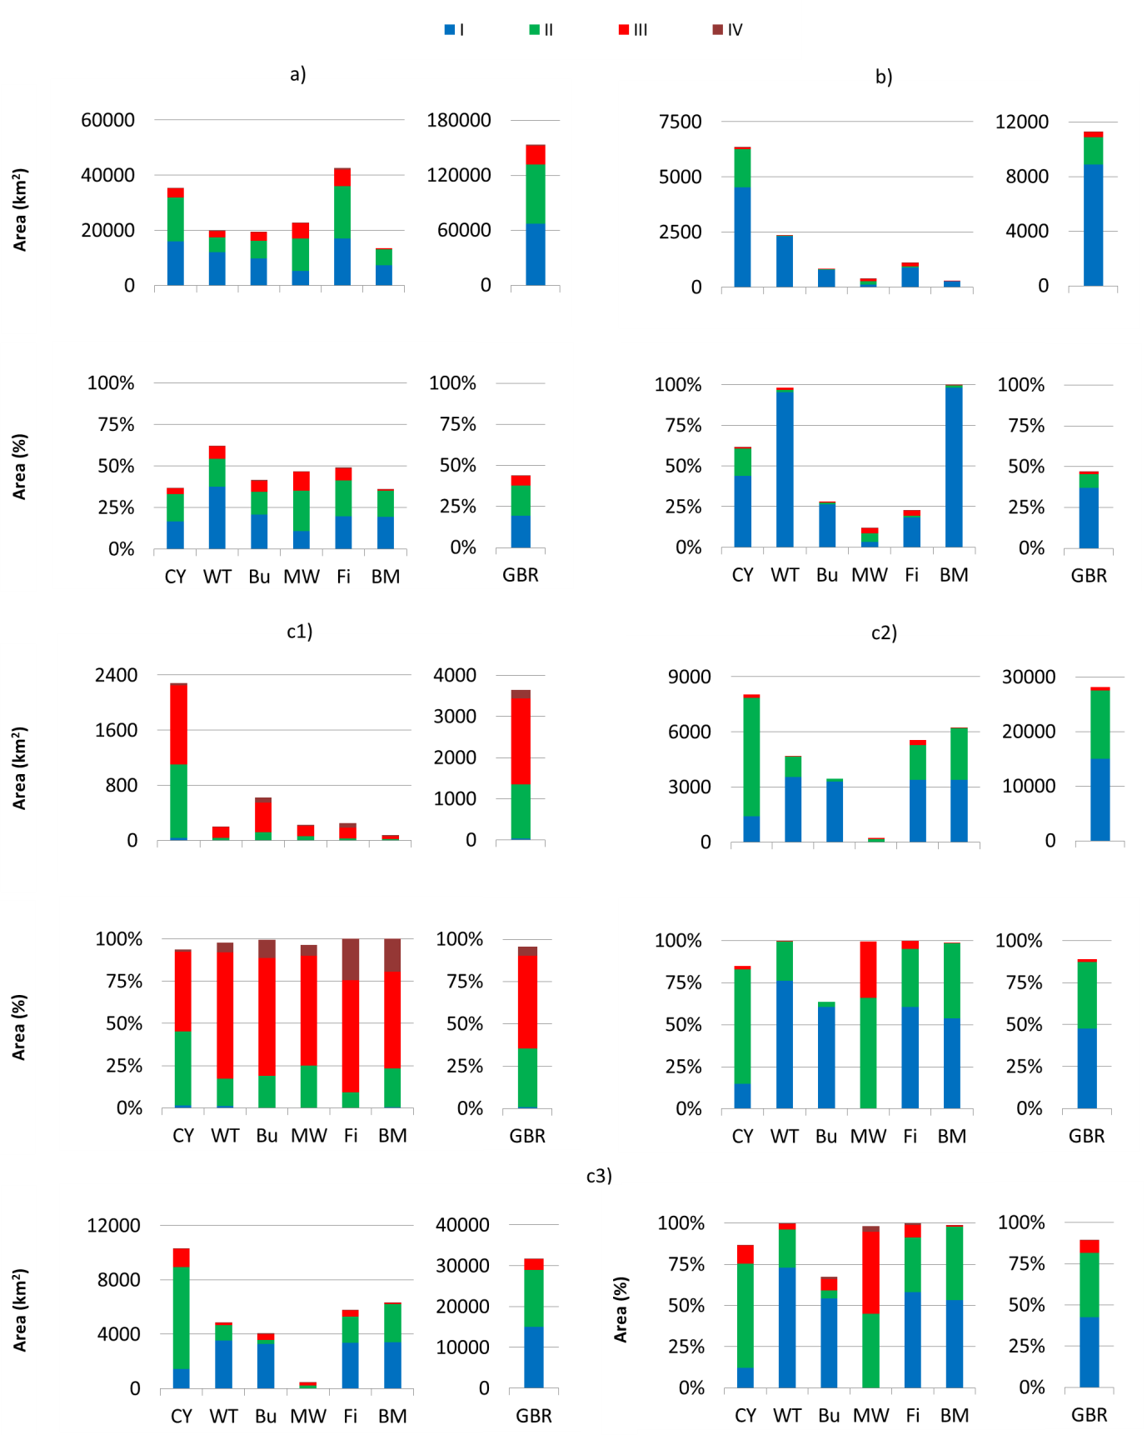
Figure 5-18: Areas (km²) and percentage (%) of the a) GBR lagoon, b) coral reefs and c) seagrass beds (c1: surveyed; c2: deep and c3) total (surveyed + deep) seagrass beds) exposed to different categories of river plume risk within each NRM and during the wet season 2012-13.

Sixty four percent (Burdekin NRM) to 100% (Wet Tropics, Mackay-Whitsundays and Fitzroy NRM regions) of the modelled deep seagrass beds were exposed to river plumes, with most of them under potential risk categories II and III from the river plumes (Figure 5-18c2 and Appendix B: Table A-4b). Deep seagrass of the Cape York, Burnett-Mary and Fitzroy NRM regions were evaluated as the most at risk, with 6634 km² (or 70%), 2829 km² (or 45%) and 2181 km² (or 39%) of the Cape York, Burnett-Mary and Fitzroy deep seagrass beds exposed to potential risk categories II and III, respectively. When expressed in percentage, deep seagrass beds the most exposed to potential risk categories II and III from river plumes were located in the Mackay-Whitsundays, Cape York, Burnett-Mary and Fitzroy (100%, 70%, 45% and 39% of the deep seagrass beds modelled in each respective NRM).
Finally, when the modelled and deep seagrass beds were combined, total seagrass beds the most at risk were located in the Cape York, Burdekin and Fitzroy NRM regions, with 1362 km² (or 11%), 501 km² (or 8%) and 500 km² (or 9%) of the Cape York, Burdekin and Fitzroy total seagrass beds exposed to the highest potential risk categories (III and IV), respectively. When expressed in %, total seagrass beds the most exposed were those located in the Mackay-Whitsunday NRM, with 239 km² (or 53%) of seagrass bed under the potential risk categories III and IV and 203 km² (45%) under the potential risk category III. The Burdekin seagrass beds were the least at risk from river plumes; however, seagrass meadows in Hervey Bay (outside of the GBR southern boundary) were not included in the potential risk analysis (Figure 5-18c3).

Potential river plume risk maps – 2007 - 2012
Annual potential risk maps from river plume exposure produced from 2007 to 2012 using the TC method are presented in Figure 5-19 and Figure 5-20. Surface areas of the GBR under the highest potential risk (III and IV) from river plumes exposure ranged between 24340 km² (in 2011) to 16940 km² (in 2008) (Table 5-2). Whatever the year considered, areas under the potential risk category IV were higher in the Burdekin region than in the Tully-Herbert region.
No significative correlation could be found between the total GBR surface areas exposed to river plume and the total GBR river discharge. Surface areas of the GBR (in km²) under the highest potential risk from river plume exposure (III and IV) were, however, correlated to the total GBR river discharge (Figure 5-21), but 2008 was an outlier of the relationship (Figure 5-21: R²= 0.8).

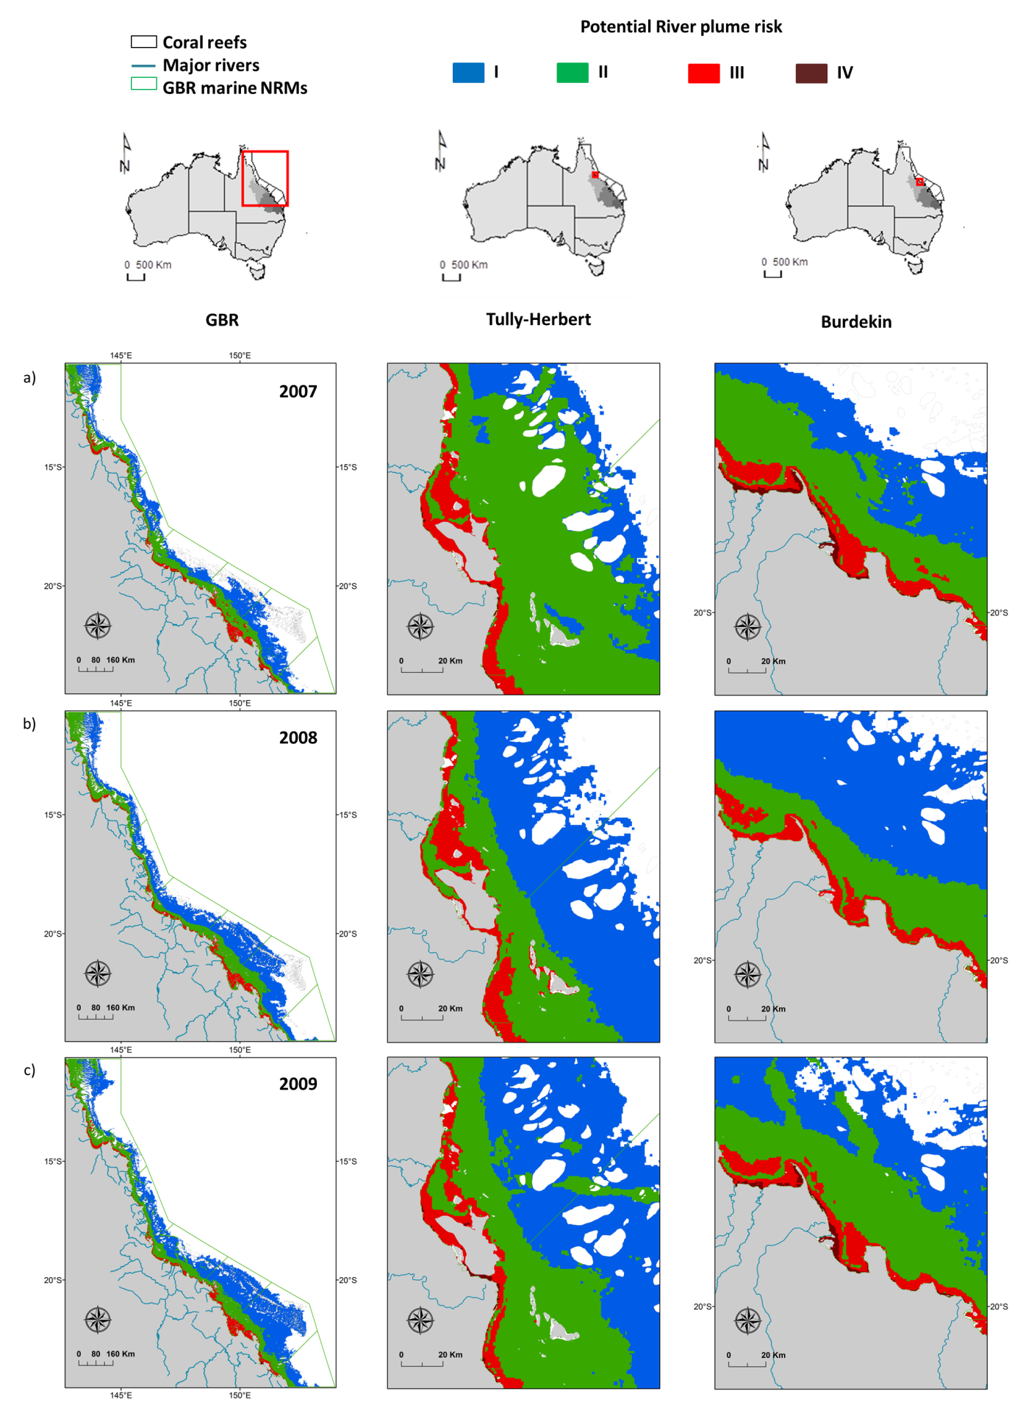
Figure 5-19: “potential” river plume risk maps of (left) the GBR; (middle) the Tully Herbert region and (right) the Burdekin region produced by a) the TC method in a) 2007, b) 2008, c) 2009. Maps have been smoothed twice with a 4 pixel majority filter (ArcGIS).
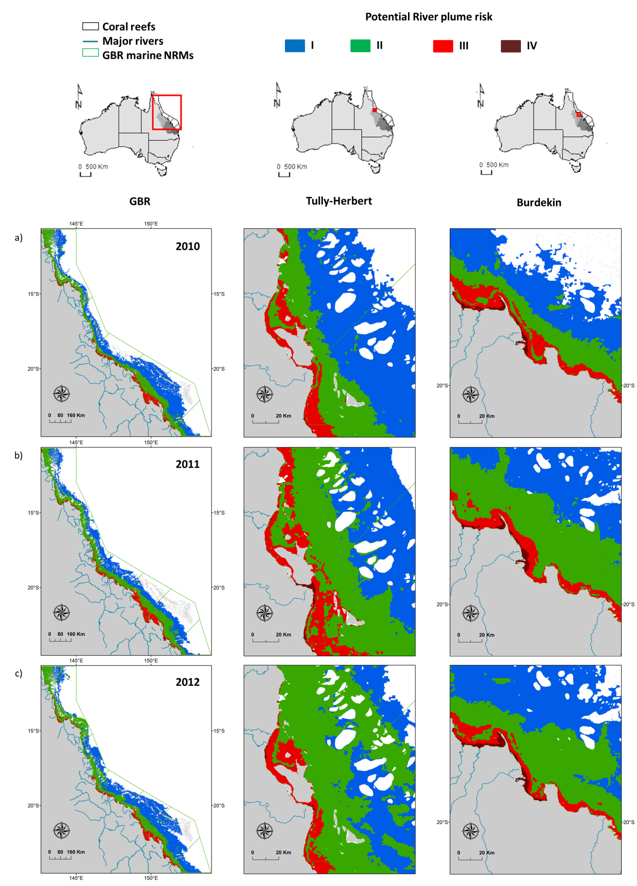
Figure 5-20: “Potential” river plume risk maps of (left) the GBR; (middle) the Tully Herbert region and (right) the Burdekin region produced by a) the TC method in a) 2010, b) 2011, c) 2012. Maps have been smoothed twice with a 4 pixel majority filter (ArcGIS).
Table 5-2: inter-annual (2007-2012) areas (km², left table) and percentage (%, right table) of the GBR under potential risk from river plume exposure.
 | Risk category |  |  |  |  |  | TOT exp. | TOT non exp. |  | Risk category |  |  |  |  |  |  | TOT exp. |  | TOT non exp.
GBR (km²) | I | II |  | III |  | IV | TOT exp. | TOT non exp. | GBR (%) | I |  | II |  | III |  | IV
2007 | 89362 | 58587 |  | 18497 |  | 1163 | 167609 | 181144 | 2007 | 26 |  | 17 |  | 5 |  | 0 | 48 |  | 52
2008 | 111035 | 59513 |  | 16940 |  | 0 | 187488 | 161265 | 2008 | 32 |  | 17 |  | 5 |  | 0 | 54 |  | 46
2009 | 135839 | 67621 |  | 18660 |  | 1008 | 223128 | 125625 | 2009 | 39 |  | 19 |  | 5 |  | 0 | 64 |  | 36
2010 | 117960 | 65914 |  | 18239 |  | 1071 | 203185 | 145568 | 2010 | 34 |  | 19 |  | 5 |  | 0 | 58 |  | 42
2011 | 85836 | 76766 |  | 22752 |  | 1588 | 186942 | 161811 | 2011 | 25 |  | 22 |  | 7 |  | 0 | 54 |  | 46
2012 | 122430 | 77886 |  | 18222 |  | 1395 | 219933 | 128820 | 2012 | 35 |  | 22 |  | 5 |  | 0 | 63 |  | 37
2013 | 67194 | 64466 |  | 20782 |  | 1168 | 153610 | 195143 | 2013 | 19 |  | 18 |  | 6 |  | 0 | 44 |  | 56

Figure 5-21: relationships between the total GBR areas exposed to to the highest potential risk categories (III and IV, red line) to river plume and the total GBR river discharge (blue line, calculated as the sum of the Normanby, Daintree, Barron, Russell, Mulgrave, North Johnstone, South Johnstone, Tully, Herbert, Burdekin, O'Connell, Pioneer, Proserpine, Plane, Fitzroy, Burnett and Mary-river discharges for the whole hydrological year (i.e., from Oct-1 to Sep-30).

A multiannual potential risk composite map was calculated by averaging the inter-annual risk maps produced from the TC methods (Error! Reference source not found.). Recalculating individual wet season risk maps to a long-term (7-year) map is useful to describe where potential risk conditions from river plume are, on average. As observed on the 2013 risk maps, an inshore to offshore spatial pattern is present, with inshore areas within ~ 20 km of the coast experiencing high frequency of Primary waters and thus highest potential risk from river plume water (as Primary waters are the most concentrated in land-sourced pollutants), and offshore areas experiencing highest/lowest frequency of Tertiary/Primary plume water types and thus lowest potential risk from river plume exposure (as Tertiary waters are the less concentrated in land-sourced pollutants). Multi-annual composite maps of the river plume frequency and plume water type frequency are also presented in appendix B, Figure B-1 and B-2.
Total areas exposed to river plumes extended about 100 km offshore of the Herbert River mouth and 110 km offshore of the Burdekin River mouth (if measured along a NE/SW strait line from both estuary mouths), i.e. further offshore than observed in 2013 (Figure 5-22).

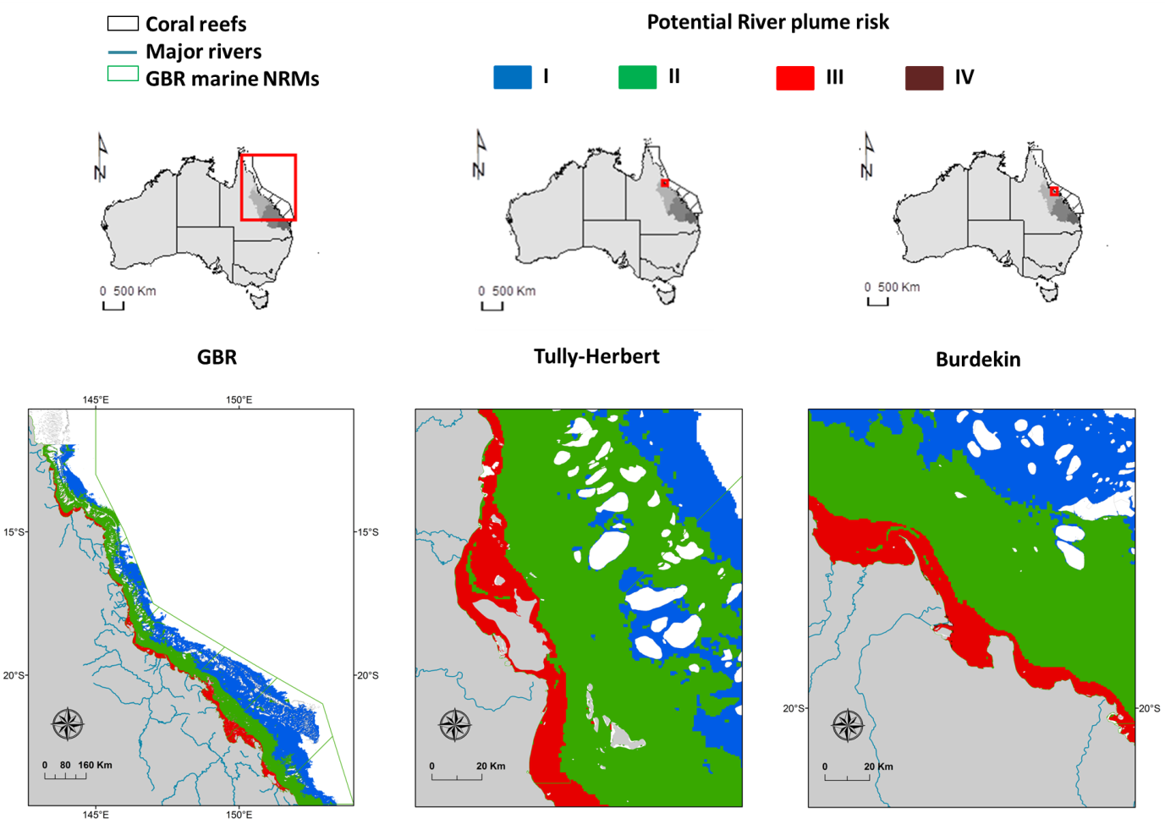
Figure 5-22: Multi-annual (2007-2013) “potential” river plume risk maps of (left) the GBR; (middle) the Tully Herbert region and (right) the Burdekin region produced by a) the TC method. Maps have been smoothed twice with a 4 pixel majority filter (ArcGIS).

Using the mean multi-annual (2007-2013) surface areas (in km²) of coral and seagrass beds under the highest potential risk categories (III and IV) from plume exposure (and without considering Cape York) were calculated (Figure 5-23):
- Coral reef areas under potential risk categories III and IV were greater in Mackay-Whitsunday > Fitzroy > Wet Tropics > Burdekin > Burnett-Mary NRM regions.
- Total seagrass areas under potential risk categories III and IV greater in Fitzroy > Burdekin > Mackay-Whitsunday > Wet Tropics > Burnett-Mary NRM regions.
In the Mackay Whitsunday Region, 60% of the total seagrass areas were in the highest relative potential risk categories compared to less than 10% for all other regions (Figure 5-23). Note that seagrass meadows in Hervey Bay (outside of the GBR southern boundary) were not included in the risk analysis.

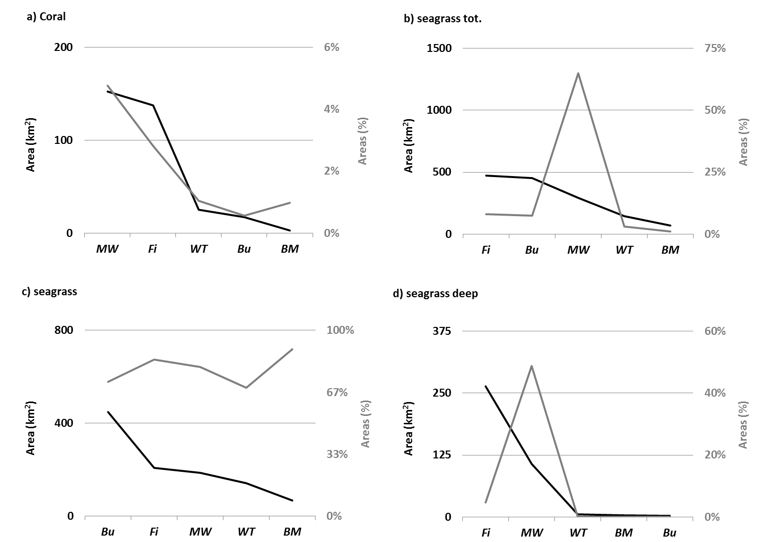
Figure 5-23: mean multiannual (2007-2013) percentage (%, in grey) and areas (km², in black) of a) coral reefs and b) total seagrass exposed to potential risk categories I

Discussion and conclusions
  - The 2012-13 wet season
The wet season 2013 was characterised by neutral (neither El Niño nor La Niña) to borderline El Niño climatic conditions and tropical cyclone activity for the 2012-12 wet season was slightly below the typical cyclone season activity of Queensland. Two main flood periods were recorded in the river hydrographs: (i) around the 25th of January and the 11th of February under the influence of Tropical Cyclone Oswald and (ii) around the 24th of February and 18th of March. Maximum aerial extents of the GBR River plumes are recorded between these dates (Appendix A. Figure 3-2 to Figure 3-7 Error! Reference source not found.).
Analysis of spatial variation across all WQ parameters, considering the factors of salinity, distance and 5-day average flow was performed on Tully and Herbert data in the Wet Tropics; and the Burdekin region. Salinity in the Tully and Herbert is correlated with most of the forms of nitrogen and phosphorous, excluding the dissolved forms. River discharge correlates with DIN and Si for the Tully River samples and with TP for the Herbert. Distance showed that OAC’s and Kd (PAR) generally decreased across distance from a river mouth, however these patterns were not always seen in the nutrient concentrations, which suggests strongly that discharge, tides, and prevailing winds also influence the concentrations across that distance gradients. Dissolved nutrients were responsive to coastal hydrodynamic, biological processes and dilution across distance and discharge. Note that these processes are examined over the whole of the wet season and the individual events over single dates show a greater correlation with distance and salinity. The Burdekin showed clearer reductions over salinity and distance in response to defined flow events, however the scatter around the TSS values, DIN and DIP values are due to the flow conditions characterised by sampling in the flux (decline) of the second major flow event (07-03-2013, 173,312 ML, Figure 4-2 4-2). The highest peak flow event was not captured in the Burdekin data (Figure 4-2).
Outcomes of the temporal analysis shows the Tully has several WQ parameters correlating significantly with river discharge, including TSS, TP, DIN, DIP and PP. For Franklins, TN, DIN and PN were significantly correlated with discharge. The dissolved nutrients were not significant for the Burdekin, but TN, TP, PN and PP all correlated strongly. The Fitzroy river discharge correlates with all the nitrogen species, including TN, DIN and PN. For most of the WQ parameters analysed, the best temporal model was obtained by using all variables, i.e., salinity, flow, distance, River and water type as random effects. For light extinction, the best model was obtained using salinity, distance and water type only, and for chl-a, distance was used as a single random effect to produce the best model. The low r-squared indicates that in general the models do not explain much of the data variability, although they capture the general temporal trend of the data (all-significant at p < 0.05). For chl-a, DIN and DIP, one can see a clear reduction in values after a 2012, which was precede by an increasing in concentrations in 2010-11 wet season, corresponding to the Ex-Tropical Cyclone Yasi passage in January-February, 2011. Interesting to note that the same trend was observed for light attenuation, suggesting clear waters in 2010-11 wet season. As a general trend the majority of the parameters show reducing values towards the end of the analysed period, except for CDOM and DIP, which all show increasing values from 2013-13 wet season onwards.
The river plume snapshots, as well as the river plume and plume water type frequency maps illustrate GBR marine areas affected by river plume waters and inform on the type/composition of river plume through the Primary, Secondary, and Tertiary water type classification (Figure 5-7 to Figure 5-14). They also inform on the frequency of occurrence of these plume water types during the wet season 2012-13. These maps are in agreement with theoretical models (Geyer et al., 2004; Wiseman Jr and Garvine, 1995), previous physical oceanographic studies (Wolanski and Jones 1981; Wolanski and van Senden 1983), modelling studies (King et al., 1997) and previous MMP reports (e.g., Devlin et al., 2013a) of river plumes in the GBR, and suggest that river plumes are constrained close to the coast by the Coriolis effect and the prevailing wind regime, limiting impacts on the more offshore ecosystems like coral reefs, while onshore ecosystems like seagrass beds are under a greatest risk from river plumes and associated pollutants. However under offshore wind conditions, river plumes can be deflected seaward (e.g., Error! Reference source not found.) and occasionally to rarely (at the wet season scale) reach the mid and outer-shelf of the GBR reef. Mid and outer-shelf of the GBR reef are nevertheless more likely to be affected by the Tertiary water type (i.e., less concentrated in land-sourced pollutants) than the Primary turbid core (i.e., more concentrated in land-sourced pollutants) of the river plumes. As a result, a general inshore to offshore spatial pattern is present in the potential risk maps from plume exposure of the 2012-13 wet season, with inshore areas and ecosystems within 10 to 30 km of the coast, including the coastal (surveyed seagrass) estimated at the highest potential risk (categories III and IV) from river plume exposure, and offshore areas and ecosystems, including the offshore seagrass and coral reef, estimated at lower risk from river plume water (Figure 5-17).
Differences also exist between NRMs and, for example, coastal waters of the Burdekin NRM are more often exposed to Primary waters (i.e., sediment dominated water type, Error! Reference source not found.) than coastal waters of the Wet Tropic NRM. Conversely, marine areas occasionally to frequently exposed to Secondary and Tertiary water types are more extended in the Wet Tropic NRM than in the Burdekin NRM (Figure 5-9 to Figure 5-14). These results are in agreement with current knowledge as high TSS concentrations have been mainly linked to grazing activities in the Dry Tropics and particularly the Burdekin NRM; while occurrence of coastal waters with elevated concentrations of dissolved inorganic nitrogen (DIN) has been linked to fertilised agriculture (predominantly sugarcane) in the Wet Tropics region (e.g., Brodie et al., 2008a, 2008b, 2012; Brodie and Waterhouse, 2009). The GBR areas estimated under a potential risk from river plume exposure extended 85 km offshore of the Herbert River mouth and 60 km offshore of the Burdekin River mouth (if measured along a NE/SW strait line from both estuary mouths, Figure 5-17.
From the 2012-13 plume frequency maps and potential risk map, it was estimated that:
- The total GBR area exposed to river plume waters was 153852 km² i.e., 44% of the GBR, with 63027 km² (18% of the GBR) very frequently to frequently exposed to river plume. i.e., more than 15 weeks out of the 22 (68 %) of the wet season.
- NRM areas very frequently to frequently exposed ranged from 2050 km² in Burnett-Mary (i.e., 5% of the Burnett-Mary NRM) to 18522 km² (21%) in the Fitzroy NRM.
- Twelve percent (Mackay-Whitsundays NRM) to 100% (Burnett-Mary NRM regions) of the coral reefs were exposed to river plumes. Coral reef areas under the highest potential risk (III and IV) were greater in Fitzroy (153 km² or 3% of Fitzroy reefs) > Mackay-Whitsundays (104 km² or 3%) > Cape York (76 km² or 1%);
- Ninety four percent (Cape York NRM) to 100% (Burdekin, Fitzroy and Burnett-Mary NRM regions) of the monitored seagrass beds were exposed to river plumes. Seagrass beds under the highest potential risk (III and IV) were greater in the Cape York (1186 km² or 49%) and Burdekin (501 km² or 80%).
- Sixty four percent (Burdekin NRM) to 100% (Wet Tropics, Mackay-Whitsundays and Fitzroy NRM regions) of the modelled deep seagrass beds were exposed to river plumes. Deep seagrass beds exposed to potential risk categories II and III were greater in the Cape York (6634 km² or 70%) > Burnett-Mary (2829 km² or 45%) > Fitzroy (2181 km² or 39%).
- Finally, when the modelled and deep seagrass beds were combined, total seagrass beds the most at risk (III and IV) were located in the Cape York (1362 km² or 11%) > Burdekin (501 km² or 8%) > Fitzroy NRM regions (500 km² or 9%).
River plume models help mapping areas which may experience acute or chronic high exposure to river plumes and associated land-sourced pollutants, including sediments, nutrients and pesticides. Knowledge of the areas and the type of ecosystem that is the most likely to be impacted by degraded WQ through river plume exposure help focus our understanding on what type of ecological impacts are occurring to those ecosystems and help marine, coastal and catchment management.
As part of our efforts for the MMP in 2012-13, we have undertaken a number of important steps to improve our capacity to identify and monitor the level of exposure of GBR coral reefs and seagrass meadows to river plumes and land-sourced contaminants during the wet season. These steps include the validation and development of innovative RS methods, the production of synoptic maps describing the spatial and temporal movements of GBR river plumes, and a preliminary assessment of the potential of using MODIS-derived products to assess the potential risk of GBR ecosystems due to the river plume exposure during the 2012-13 wet season and over multiple wet seasons (2006-07 to 2012-13).
  - True colour vs. Level 2 methods
Three different water types (Primary, Secondary, tertiary) are characteristic of the WQ gradient across the GBR river plumes and have been described from the inshore to the offshore boundaries of river plumes. Two families of supervised classification methods based on MODIS data have been investigated in this report to map GBR river plumes and plume water type surface areas: one based on MODIS true colour images, and one using MODIS images calibrated into WQ proxies. Both methods present advantages and disadvantages, described in the section “Comparison between RS outputs derived from the TC and L2 methods”. Quickly, the TC method offers a simple and objective method by clustering the information contained in MODIS true-colour composites (Red–Green–Blue bands), but relies on non-atmospherically corrected data. The L2 threshold method provide valuable quantitative information, such as the concentration of CDOM, TSS, chl-a, or Kd(PAR) values that are not directly available through the TC method, but rely on bio-optical algorithms that are not fully validated in the optically complex waters, such as the GBR coastal waters. It was thus decided, for the rest of this report and for the following monitoring years, to work with river plume products derived from MODIS true colour satellite data to assess the exposure of GBR key ecosystems to the river plume and describe the potential risk experienced by these ecosystems from the river plume exposure. Methods could be updated in future toward the use of L2 derived RS product if more accurate L2 algorithms become available.
  - Toward the production of river plume risk maps for the GBR ecosystems
Each plume water type is associated with different optical properties, colours, as well as different concentrations and proportions of nutrient, sediment and pesticides and different light levels. Concentrations of TSS, CDOM and light levels in flood plumes generally decrease across plume water types i.e., from Primary to Tertiary water types. Linear decrease of DIN and PSII herbicides concentrations across river plumes (from the coast to offshore i.e., from Primary to Tertiary water types) have also been reported in the literature (Álvarez-Romero et al., 2013, Kennedy et al., 2012, Lewis et al. 2009). As an approximation, it can be assumed that the magnitude of risk for the GBR seagrass beds and coral reefs from river plume exposure (i.e., from land-sourced pollutants in river plumes) will increase from the Tertiary waters to the Primary core of river plumes.
River plume maps produced have been used as an interpretative tool for understanding changes in seagrass meadow health in the GBR, and decline in seagrass meadow area and biomass has been positively linked to high occurrence of turbid water masses mapped through MODIS imagery (Petus et al., 2014c). Petus et al. (2014b) proposed that time series of MODIS plume water type maps could help progress river plume risk maps for the GBR by clustering water masses with different concentrations and proportions of land-sourced contaminants and, thus, by mapping ‘potential’ risk areas in the marine environment from river plume exposure. They proposed a simplified framework to produce river plume risk maps for seagrass and coral ecosystems based on a simplified risk matrix assuming that ecological responses and, thus, ecological risk from the river plume exposure, will increase linearly with the pollutant concentrations and frequency or ‘likelihood’ of river plume occurrence. Annual river plume risk maps were produced in this report for the wet seasons 2006-07 to 2012-13.
It should nevertheless be emphasized the mapping of exposure and water types; and thus of the final river plume risk; is depend on the availability of MODIS images. Number of MODIS cloud free images available for a specific study area is, in general, inversely proportional to the local river discharge conditions (Petus et al., 2014). Strong river discharge rates are associated with stormy/cyclonic conditions and characterised by high rainfall rates and high cloud coverage. This cloud contamination prevents ocean colour observations (TC method allow to map river plumes and plume water types only under light cloud cover) and to map GBR River plumes through MODIS images. Inversely, a greater availability of satellite information due to a less frequent cloud cover can results in mapping relatively higher frequency of occurrence of river plume. Finally, it is worth noting any results obtained in the Cape York NRM should be considered with care. Cape York is a shallow and optically complex environment where the TC method hasn’t been fully validated.
  - Inter-annual and averaged (7-year) trends in the GBR
Annual river plume risk maps were produced for the wet seasons 2006-07 to 2011-12 (Figure 5-19 and Figure 5-20). This multi-annual satellite dataset illustrates the complex spatial and a temporal dynamic that affect GBR lagoon areas exposed to river plume risk and constitutes a preliminary baseline against which to assess future changes in ecosystems health against exposure to river plume and potential risk from this exposure.
Spatial extent and orientations of river plumes are shaped by the Coriolis effect and a combination of hydro-climatic forces, including (i) the river discharge rates, (ii) the wind strength and orientation and (iii) the local currents. Primary (highly turbid) coastal water surface areas are mainly modulated by the river discharge rates. More offshore, Secondary and Tertiary river plumes water areas are also correlated to the river discharge, but their shapes and orientations are strongly modulated by the wind, the local currents and Secondary and Tertiary plume waters from different river plumes are often merged all together. This might explain why, at the multi-annual scale, total river discharge per NRM was well correlated with areas under very high to river plume risk, identified primarily as areas occasionally to very frequently inundated by Primary plume water (Figure 5-21), while no relationships could be found with the total areas exposed to river plume (all water types).
A multiannual potential risk map was calculated by averaging the inter-annual risk maps produced. Recalculating individual wet season risk maps to a long-term (7-year) map is useful to describe where potential risk conditions from river plume are, on average. From this multi-annual composite map, it was estimated that:
- Coral reef areas exposed to potential risk categories III and IV were greater in Mackay-Whitsunday > Fitzroy > Wet Tropics > Burdekin > Burnett-Mary NRMs.
- Total seagrass areas exposed to potential risk categories III and IV greater in Fitzroy > Burdekin > Mackay-Whitsunday > Wet Tropics > Burnett-Mary NRMs.
In the Mackay Whitsunday Region, 60% of the total seagrass areas were in the highest relative risk categories compared to less than 10% for all other regions. This result is similar to the result obtained by Brodie et al., 2013 who assessed the risk of pollutants to GBR ecosystems using a comprehensive combination of qualitative and semi-quantitative WQ information about the influence of individual catchments in the 6 natural resource management (NRM) regions on coral reefs and seagrass ecosystems. They described 40% of the seagrass areas in the Mackay Whitsunday Region in the highest relative risk class of degraded WQ compared to less than 10% for all other regions. They also ranked the regional risk to coral reefs from degraded WQ as (without considering Cape York) highest in the Wet Tropics, Fitzroy and Mackay Whitsunday NRMs (though ranking was Wet Tropics> Fitzroy > Mackay Whitsunday), medium in Burdekin and the lowest in the Burnett-Mary NRM. This illustrates the potential of using the Primary, Secondary, Tertiary plume water type classification scheme to simply estimate combined WQ stressors in plume waters and thus simply model the risk of cumulative effects of pollutants in river plumes at different spatial and temporal scales.

Future developments
The MMP was established in 2005 to help assess the long-term status and health of GBR ecosystems and is a critical component assessing regional water quality changes as land management practices improve across GBR catchments. The program forms an integral part of the Reef Plan Paddock to Reef Integrated Monitoring, Modelling and Reporting Program.
- The water quality program will integrate into one combined program with wet season sampling, ambient and pesticide monitoring programs. The new water quality program will include ambient and wet season monitoring provided by researchers from James Cook University (JCU), Australian Institute of Marine Science (AIMS) and University of Queensland (UQ). These monitoring programs will provide a comprehensive data set that will further characterise the temporal and spatial variability of coastal water quality in the GBR.
- Four focus areas, including Tully, Russell-Mulgrave, Mackay-Whitsundays and Burdekin will be sampled over pre-determined sites through the wet and dry seasons.
Further developments include improvements of our RS methods to map river plumes, plume water types and the river plume risk:
- Recent progresses have been made to develop accurate regional algorithms for the GBR region (Brando et al., 2012; Schroeder et al., 2012), that provide better retrieval in optically complex coastal waters. Using these algorithms to map chl-a concentrations in near future will be instrumental in more accurate mapping of river plume waters using the Level-2 method and more particularly of the productive Secondary waters. MODIS images calibrated into relevant water quality metrics (e.g. TSM, chl-a, Dissolved Organic Matters concentrations, light attenuation) using accurate algorithms would allow producing produce compliance maps to ecological threshold and describing thresholds of acceptable WQ changes as well as their respective extent, frequency and duration for ecological management purposes.
- Further comparisons between RS-derived products and in situ WQ data acquired over the next MMP monitoring years will be undertaken.
- Finally, analysis of the magnitude and likelihood of the risk from the RS data must be accompanied by sound knowledge of the regional ecosystems and of the water quality concentrations across plume water types relative to natural levels and to ecologically-relevant thresholds, to produce river plume risk assessment of reef and seagrass ecosystems. Ecological consequences of the risk will primarily be a function of the presence/absence of GBR ecosystems subjected to different occurrence and magnitude of risk. However, community characteristics such as the sensitivity and resilience of particular seagrass or coral communities (e.g., associated with their natural levels of exposure to pollutants) are additional parameters that must be considered when defining the ecological consequences of the risk. Indeed, different species assemblages will respond differently to the same exposure (i.e., same likelihood × magnitude of risk) to river plumes. The consequence of the exposure of species to a range of WQ conditions is complicated by the influence of multiple stressors and additional external influences including weather and climate conditions. All this information should be used in future to develop ecosystem-specific risk matrix combining the magnitude (mapped through the Primary, Secondary, Tertiary water type classes), likelihood (mapped through the frequency of occurrence) of the river plume risk and the sensitivity of the studied ecosystem.
- Finally, the GBR areas classified following the risk framework of Petus et al. (2014b) should be compared to ecosystem health data and the validity of the risk framework assessed by examining spatial patterns, including the distribution of monitored cases of ecosystem health decline per designated risk area.
Further developments of our RS methods to map loads of pollutants (TSS, DIN and pesticides) include:
- The Increase of the spatial resolution of WQ data used to calculate the spatially distributed DIN and TSS maps. In this present form, the true colour method uses annual loads of TSS and DIN from seven major rivers draining into four selected NRMs to calculate their proportional contribution to the total pollutant load. Increasing the spatial resolution of these data would improve the precision of the mapping. Work is also currently undertaken to re-run the model with the annual loads from the Source Catchments modelling for all of the 35 GBR catchments. This requires establishment of dispersal relationships for the additional rivers and require non-negligible processing time and effort to automate processing steps as much as possible.
- The production annual load maps of Photosystem II inhibiting herbicides (PSII herbicides). The approach for modelling exposure to DIN (i.e., assuming conservative mixing) will be used for PSII. However, further investigation will be necessary to adjust the dispersal relationships i.e., relationship between PSII concentrations and color classes (see Figure 3 of Álvarez-Romero et al., 2013) to calculate the annual cost surface for PSII.
- Updates on the loading maps will be made available as the load data is update from all rivers in the GBR.

References
Álvarez-Romero, J.G., Devlin, M., Teixeira da Silva, E., Petus, C., Ban, N.C., Pressey, R.L., Kool, J., Roberts, J.J., Cerdeira-Estrada, S., Wenger, A.S., Brodie, J., 2013. A novel approach to model exposure of coastal-marine ecosystems to riverine flood plumes based on remote sensing techniques. Journal of environmental management 119, 194-207.
Anon, 2013. Reef rescue marine monitoring program quality assurance and quality control manual. 2010/11, in: Authority, G.B.R.M.P. (Ed.), GBRMPA, Townsville.
Anon, 2014. Reef rescue marine monitoring program quality assurance and quality control manual. 2013/14, in: Authority, G.B.R.M.P. (Ed.), GBRMPA, Townsville.
Bentley, C., Devlin, M., Paxman, C., Chue, K.L., Mueller, J.F., 2012. Pesticide monitoring in inshore waters of the Great Barrier Reef using both time-integrated and event monitoring techniques (2011 - 2012). University of Queensland, Marine Monitoring Program - Pesticides.
Brando, V., Schroeder, T., Dekker, A., Park, Y., 2008. Reef rescue marine monitoring program: using remote sensing for GBR wide water quality. Final Report for.
Brando, V., Schroeder, T., Dekker, A., Park, Y., 2010a. Reef Rescue Marine Monitoring Program: Using Remote Sensing for GBR Wide Water Quality: Final Report for 2009/10 Activities. CSIRO Land & Water.
Brando, V., Steven, A., Schroeder, T., Dekker, A., Park, Y., Daniel, P., Ford, P., 2010b. Remote-sensing of GBR Waters to assist performance monitoring of Water Quality Improvement Plans in Far North Queensland. Final report for Department of the Environment and Water Heritage and the Arts. Canberra, ACT. CSIRO Land & Water, Canberra, ACT, p. 88.
Brando, V.E., Anstee, J.M., Wettle, M., Dekker, A.G., Phinn, S.R., Roelfsema, C., 2009. A physics based retrieval and quality assessment of bathymetry from suboptimal hyperspectral data. Remote Sensing of Environment 113, 755-770.
Brodie, J., Binney, J., Fabricius, K., Gordon, I., Hoegh-Guldberg, O., Hunter, H., O’Reagain, P., Pearson, R., Quirk, M., Thorburn, P., 2008. Synthesis of evidence to support the scientific consensus statement on water quality in the Great Barrier Reef. The State of Queensland (Department of Premier and Cabinet), Brisbane.
Brodie, J., Burford, M., Davis, A., da Silva, E., Devlin, M., Furnas, M., Kroon, F., Lewis, S., Lønborg, C., O’Brien, D., Schaffelke, B., 2014. The relative risks to water quality from particulate nitrogen discharged from rivers to the Great Barrier Reef in comparison to other forms of nitrogen. . TropWATER Report 14/31. October 2014, 81.
Brodie, J., Kroon, F., Schaffelke, B., Wolanski, E., Lewis, S., Devlin, M., Bohnet, I., Bainbridge, Z., Waterhouse, J., Davis, A., 2012. Terrestrial pollutant runoff to the Great Barrier Reef: an update of issues, priorities and management responses. Marine pollution bulletin 65, 81-100.
Brodie, J., Lewis, S., Bainbridge, Z., Mitchell, A., Waterhouse, J., Kroon, F., 2009. Target setting for pollutant discharge management of rivers in the Great Barrier Reef catchment area. Marine and Freshwater Research 60, 1141-1149.
Brodie, J., Waterhouse, J., 2012. A critical review of environmental management of the ‘not so Great’Barrier Reef. Estuarine, Coastal and Shelf Science 104, 1-22.
Crawley, M. J. (2012). The R book. John Wiley & Sons.
Da Silva, E., Devlin, M., Wenger, A., Petus, C., 2013. Burnett-‐Mary Wet Season 2012-‐2013: Water Quality Data Sampling, Analysis and Comparison against Wet Season 2010-‐2011 data, Centre for Tropical Water & Aquatic Ecosystems Research (TropWater) Publications. JCU, James Cook University, Townsville, p. 31.
Devlin, M., Schaffelke, B., 2009. Spatial extent of riverine flood plumes and exposure of marine ecosystems in the Tully coastal region, Great Barrier Reef. Marine and Freshwater Research 60, 1109-1122.
Devlin, M., Schroeder, T., McKinna, L., Brodie, J., Brando, V., Dekker, A., 2011. Monitoring and mapping of flood plumes in the Great Barrier Reef based on in-situ and remote sensing observations. Advances in Environmental Remote Sensing to Monitor Global Changes, CRC Press, Boca Raton.
Devlin, M., Waterhouse, J., Taylor, J., Brodie, J., 2001. Flood plumes in the Great Barrier Reef: spatial and temporal patterns in composition and distribution. Great Barrier Reef Marine Park Authority.
Devlin, M., Wenger, A., Da Silva, E., Alvarez Romero, J.G., Waterhouse, J., McKenzie, L., 2012. Extreme weather conditions in the Great Barrier Reef: Drivers of change?
Devlin, M.J., Álvarez-Romero, J., da Silva, E.T., DeBose, J., Petus, C., Wenger, A., 2013. Reef Rescue Marine Monitoring Program. Final report of JCU activities 2011/12 – Flood plumes and extreme weather monitoring for the Great Barrier Reef Marine Park Authority. James Cook University, Townsville.
Devlin, M.J., Brodie, J., 2005. Terrestrial discharge into the Great Barrier Reef Lagoon: nutrient behavior in coastal waters. Marine pollution bulletin 51, 9-22.
Gallen, C., Devlin, M., Paxman, C., Banks, A., Mueller, J. (2013) Pesticide monitoring in inshore waters of the Great Barrier Reef using both time-integrated and event monitoring techniques (2012 - 2013). The University of Queensland, The National Research Centre for Environmental Toxicology (Entox).
Geyer, W., Hill, P., Kineke, G., 2004. The transport, transformation and dispersal of sediment by buoyant coastal flows. Continental Shelf Research 24, 927-949.
Howley, C., Devlin, M.J. Petus, C., da Silva, E., Tracey, D. 2015. Water Quality in Princess Charoltte Bay Flood plumes: 2012- 2014. Report to the Great Barrier Reef Marine Park Authority Marine Monitoring Programme. TropWater Report.
Johnson, J., Brando, V., Devlin, M., McKenzie, L., Morris, S., Schaffelke, B., Thompson, A., Waterhouse, J., Waycott, M., 2011. Reef rescue marine monitoring program: 2009/2010 synthesis report. Reef and Rainforest Research Centre.
Joo, M., Raymond, M.A., McNeil, V.H., Huggins, R., Turner, R.D., Choy, S., 2012. Estimates of sediment and nutrient loads in 10 major catchments draining to the Great Barrier Reef during 2006–2009. Marine pollution bulletin 65, 150-166.
Kennedy, K., Devlin, M., Bentley, C., Lee-Chue, K., Paxman, C., Carter, S., Lewis, S.E., Brodie, J., Guy, E., Vardy, S., 2012. The influence of a season of extreme wet weather events on exposure of the World Heritage Area Great Barrier Reef to pesticides. Marine pollution bulletin 64, 1495-1507.
Kroon, F.J., 2012. Towards ecologically relevant targets for river pollutant loads to the Great Barrier Reef. Marine pollution bulletin 65, 261-266.
Martin, K., McKenzie, L.J., Thompson, A., Muller, J., Bentley, C., Paxman, C., Collier, C., Waycott, M., Brando, V., Devlin, M., Schaffelke, B., 2014. Reef Rescue Marine Monitoring Program synthesis report. 2010-2011, A report to the Great Barrier Reef Marine Park Authority., GBRMPA, Townsville.
Maughan, M., Brodie, J., 2009. Reef exposure to river-borne contaminants: a spatial model. Marine and Freshwater Research 60, 1132-1140.
McKenzie, L., Collier, C., Waycott, M., 2014. Reef Rescue Marine Monitoring Program: Inshore Seagrass, Annual Report for the sampling period 1st July 2011–31st May 2012.
McKenzie, L., Collier, C., Waycott, M., Unsworth, R., Yoshida, R., Smith, N., 2012. Monitoring inshore seagrasses of the GBR and responses to water quality.
Petus, C., Collier, C., Devlin, M., Rasheed, M., McKenna, S., 2014. Using MODIS data for understanding changes in seagrass meadow health: A case study in the Great Barrier Reef (Australia). Marine environmental research 98, 68-85.
Petus C., Devlin, M., Thompson, A., McKenzie, L., Teixeira da Silva, E., collier, C., Tracey, D., Martin, K., (in review). Estimating the exposure of coral reefs and seagrass meadows to land-sourced contaminants in river flood plumes of the Great Barrier Reef: validating a simple satellite risk framework with Environmental Data. Remote Sensing
Petus, C., Teixeira da Silva,E., Devlin, M., Wenger, A.,Álvarez-Romero, J. G. 2014b. Using MODIS data for mapping of water types within river plumes in the Great Barrier Reef, Australia: towards the production of river plume risk maps for reef and seagrass ecosystems. Journal of Environmental Management 137: 163-177.
R Development Core Team. 2014. R: A Language and Environment for Statistical Computing (Version 3.12) [Software]. Vienna, Austria: R Foundation for Statistical Computing. Retrieved from http://www.Rproject.org.
Schaffelke, B., Carleton, J., Skuza, M., Zagorskis, I., Furnas, M.J., 2012. Water quality in the inshore Great Barrier Reef lagoon: Implications for long-term monitoring and management. Marine pollution bulletin 65, 249-260.
Schroeder, T., Behnert, I., Schaale, M., Fischer, J., Doerffer, R., 2007. Atmospheric correction algorithm for MERIS above case‐2 waters. International Journal of Remote Sensing 28, 1469-1486.
Thompson, A., Schaffelke, B., Logan, M., Costello, P., Davidson, J., Doyle, J., Furnas, M., Gunn, K., Liddy, M., Skuza, M., 2013. Reef Rescue Marine Monitoring Program: Annual Report of AIMS Activities 2012 to 2013, Inshore water quality and coral reef monitoring.
Waterhouse, J., Brodie, J., Lewis, S., Mitchell, A., 2012. Quantifying the sources of pollutants in the Great Barrier Reef catchments and the relative risk to reef ecosystems. Marine pollution bulletin 65, 394-406.
Wolanski, E., Jones, M., 1981. Physical properties of Great Barrier Reef lagoon waters near Townsville. I. Effects of Burdekin River floods. Marine and Freshwater Research 32, 305-319.
Wolanski, E., Van Senden, D., 1983. Mixing of Burdekin river flood waters in the Great Barrier Reef. Marine and Freshwater Research 34, 49-63.
Wood, S. N. (2006). Low‐Rank Scale‐Invariant Tensor Product Smooths for Generalized Additive Mixed Models. Biometrics, 62(4), 1025-1036.

Appendix A: snapshots of River plumes during the 2012-13 wet season
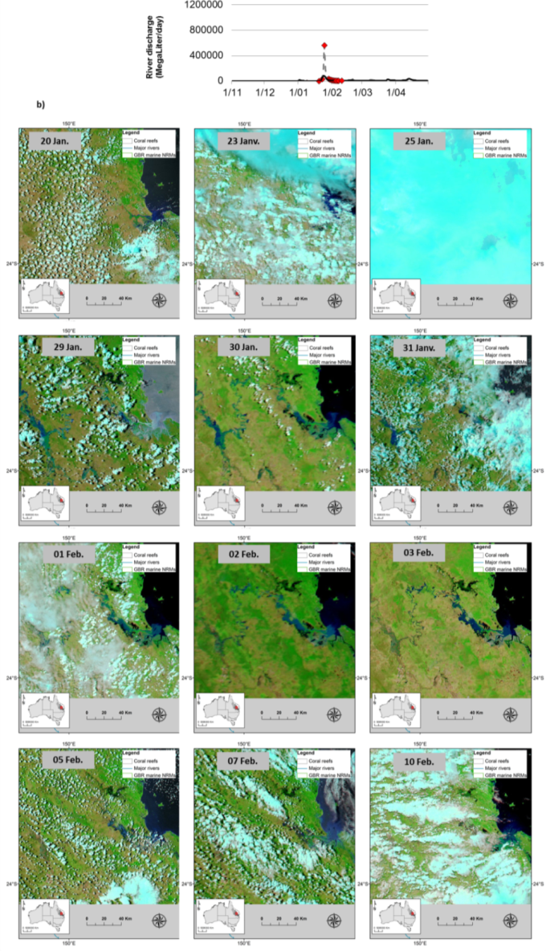
Figure A-1: MODIS-Aqua true colour composite (7 – 2 – 1) of the Burdekin NRM (b) and corresponding river discharge rates (a)

Figure A-2: MODIS true color images (b) selected over a flood period of the Normanby River (a). Dates when the true color images were acquired are identified by red diamonds on discharge plot.
Figure A-3: MODIS true color images (b) selected over a flood period of the Normanby River (a). Dates when the true color images were acquired are identified by red diamonds on discharge plot.
Figure A-4: MODIS true color images (b) selected over a flood period of the Barron and Johnstone Rivers (a). Dates when the true color images were acquired are identified by red diamonds on discharge plot.
Figure A-5: MODIS true color images (b) selected over a flood period of the Barron and Johnstone Rivers (a). Dates when the true color images were acquired are identified by red diamonds on discharge plot.
Figure A-6: MODIS true color images (b) selected over a flood period of the Tully and Herbert Rivers (a). Dates when the true color images were acquired are identified by red diamonds on discharge plot.

Figure A-7: MODIS true color images (b) selected over a flood period of the Tully and Herbert Rivers (a). Dates when the true color images were acquired are identified by red diamonds on discharge plot.
Figure A-8: MODIS true color images (b) selected over a flood period of the Burdekin River (a). Dates when the true color images were acquired are identified by red diamonds on discharge plot.
Figure A-9: MODIS true color images (b) selected over a flood period of the Burdekin River (a). Dates when the true color images were acquired are identified by red diamonds on discharge plot.
Figure A-10: MODIS true color images (b) selected over a flood period of the Burdekin River (a). Dates when the true color images were acquired are identified by red diamonds on discharge plot.
Figure A-11: MODIS true color images (b) selected over a flood period of the Pioneer River (a). Dates when the true color images were acquired are identified by red diamonds on discharge plot.
Figure A-12: MODIS true color images (b) selected over a flood period of the Pioneer River (a). Dates when the true color images were acquired are identified by red diamonds on discharge plot.
Figure A-13: MODIS true color images (b) selected over a flood period of the Fitzroy River (a). Dates when the true color images were acquired are identified by red diamonds on discharge plot.
Figure A-14: MODIS true color images (b) selected over a flood period of the Fitzroy River (a). Dates when the true color images were acquired are identified by red diamonds on discharge plot.
Figure A-15: MODIS true color images (b) selected over a flood period of the Burnett and Mary rivers (a). Dates when the true color images were acquired are identified by red diamonds on discharge plot.
Figure A-16: MODIS true color images (b) selected over a flood period of the Burnett and Mary River (a). Dates when the true color images were acquired are identified by red diamonds on discharge plot

Appendix B: RS products and data, wet season 2012-13

Weekly productivity maps: GBR scale
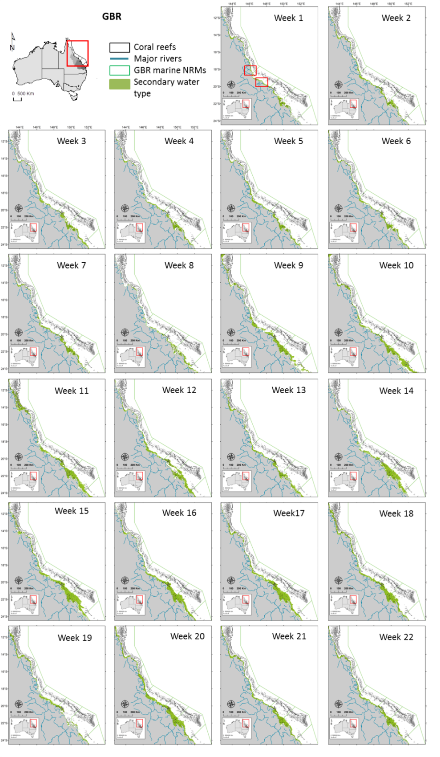
Figure B-1: Secondary waters mapped during the 2012-13 wet season: Weekly composites

Table B-1: conversion chart between Julian days, dates (regular years) and week numbers. For dates on leap year, check URL: http://landweb.nascom.nasa.gov/browse/calendar.html

Julian | 335 - 341 | 342 - 348 | 349 - 355 | 356 - 362 | 363 - 004 | 005 - 011
Dates | 1 - 7 Dec | 8 - 14 Dec | 15 - 21 Dec | 22 - 28 Dec | 29 Dec - 4 Jan | 5 - 11 Jan
Week | 1 | 2 | 3 | 4 | 5 | 6
Days | 012 - 018 | 019 - 025 | 026 - 032 | 033 - 039 | 040 - 046 | 047 - 053
Dates | 12 - 18 Jan | 19 - 25 Jan | 26 Jan - 1 Feb | 2 - 8 Feb | 9 - 15 Feb | 16 - 22 Feb
Week | 7 | 8 | 9 | 10 | 11 | 12
Julian | 054 - 060 | 061 - 067 | 068 - 074 | 075 - 081 | 082 - 088 | 089 - 095
Dates | 23 Feb - 1 Mar | 2 - 8 Mar | 9 - 15 Mar | 16 - 22 Mar | 23 - 29 Mar | 30 Mar - 5 Apr
Week | 13 | 14 | 15 | 16 | 17 | 18
Julian | 096 - 102 | 103 - 109 | 110 - 116 | 117 - 120
Dates | 6 - 12 Apr | 13 - 19 Apr | 20 - 26 Apr | 27 - 30 Apr
Week | 19 | 20 | 21 | 22

Frequency of occurrence of river plume and plume water types in 2013
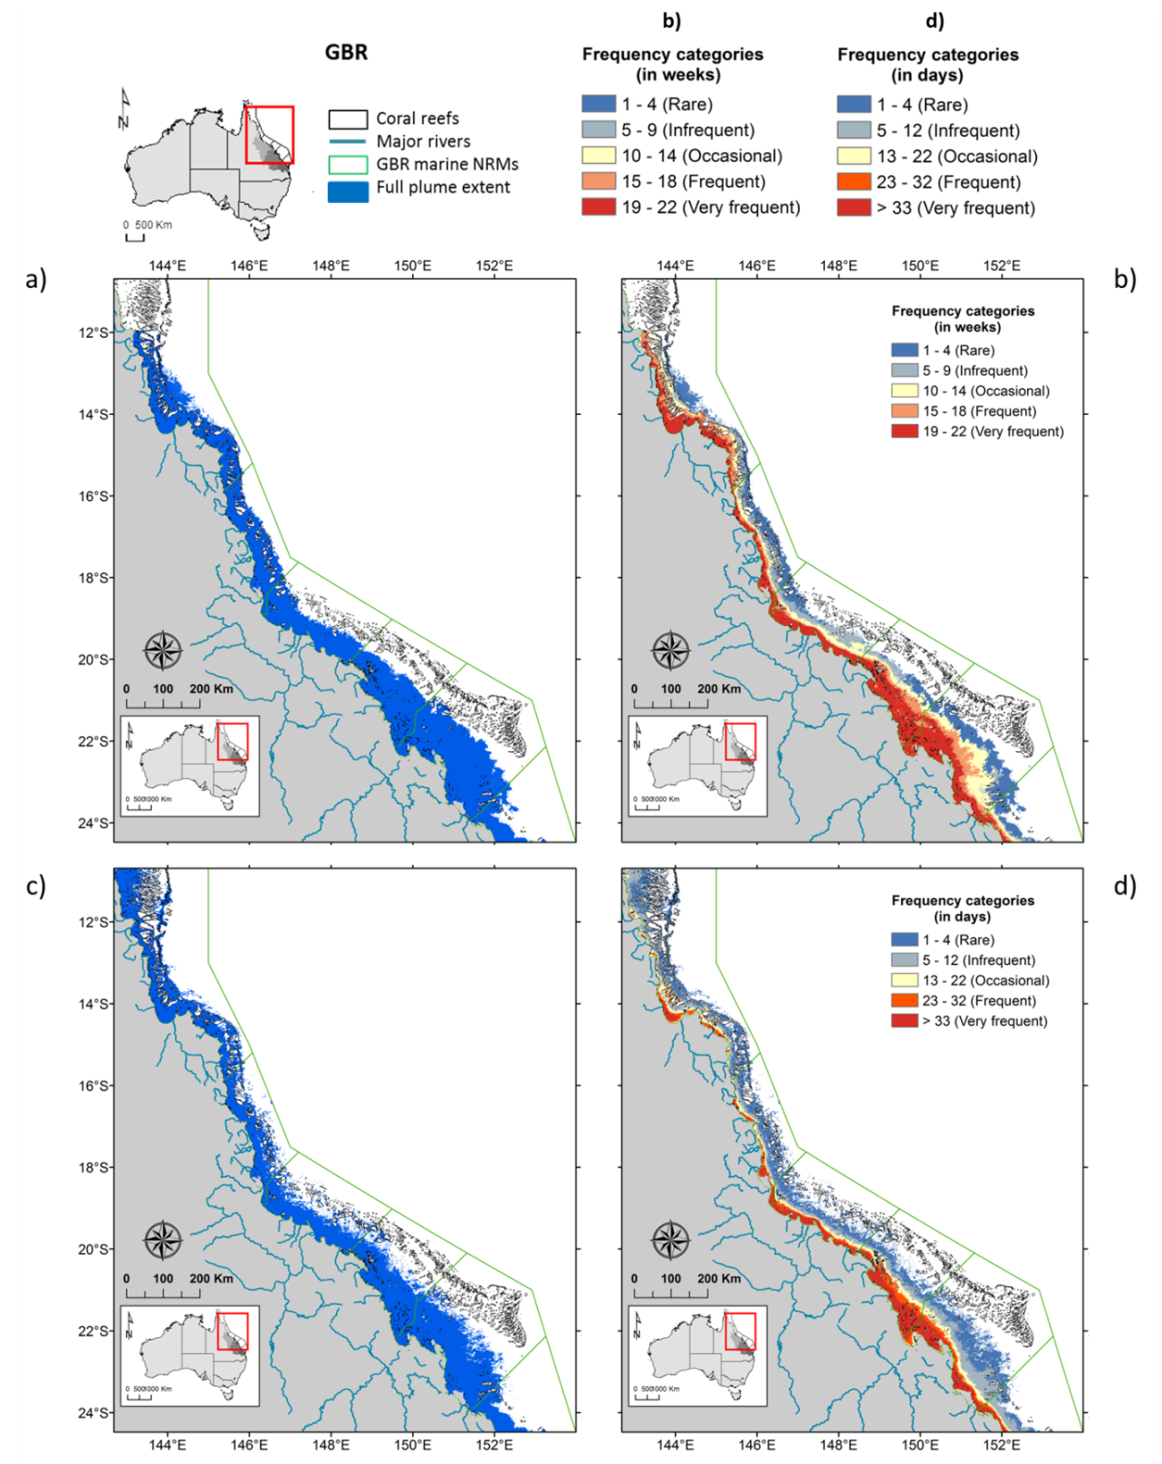
Figure B-2: Frequency of occurrence of river plume recorded in 2013 by a) and b) the TC method and c) and d) the L2 method. Maps a) and c) show all areas that have been classified as least one day over the wet season 2012-13 as river plume waters. Maps b) and d) show same maps reclassified into frequency breaks using the Jenk classification embedded in ArcGIS. Jenks is a statistical procedure that analyses the distribution of values in the data and finds the most evident breaks in it. Note that breaks of the TC method are in weeks while breaks of the L2 method are in days.
Primary plume water type
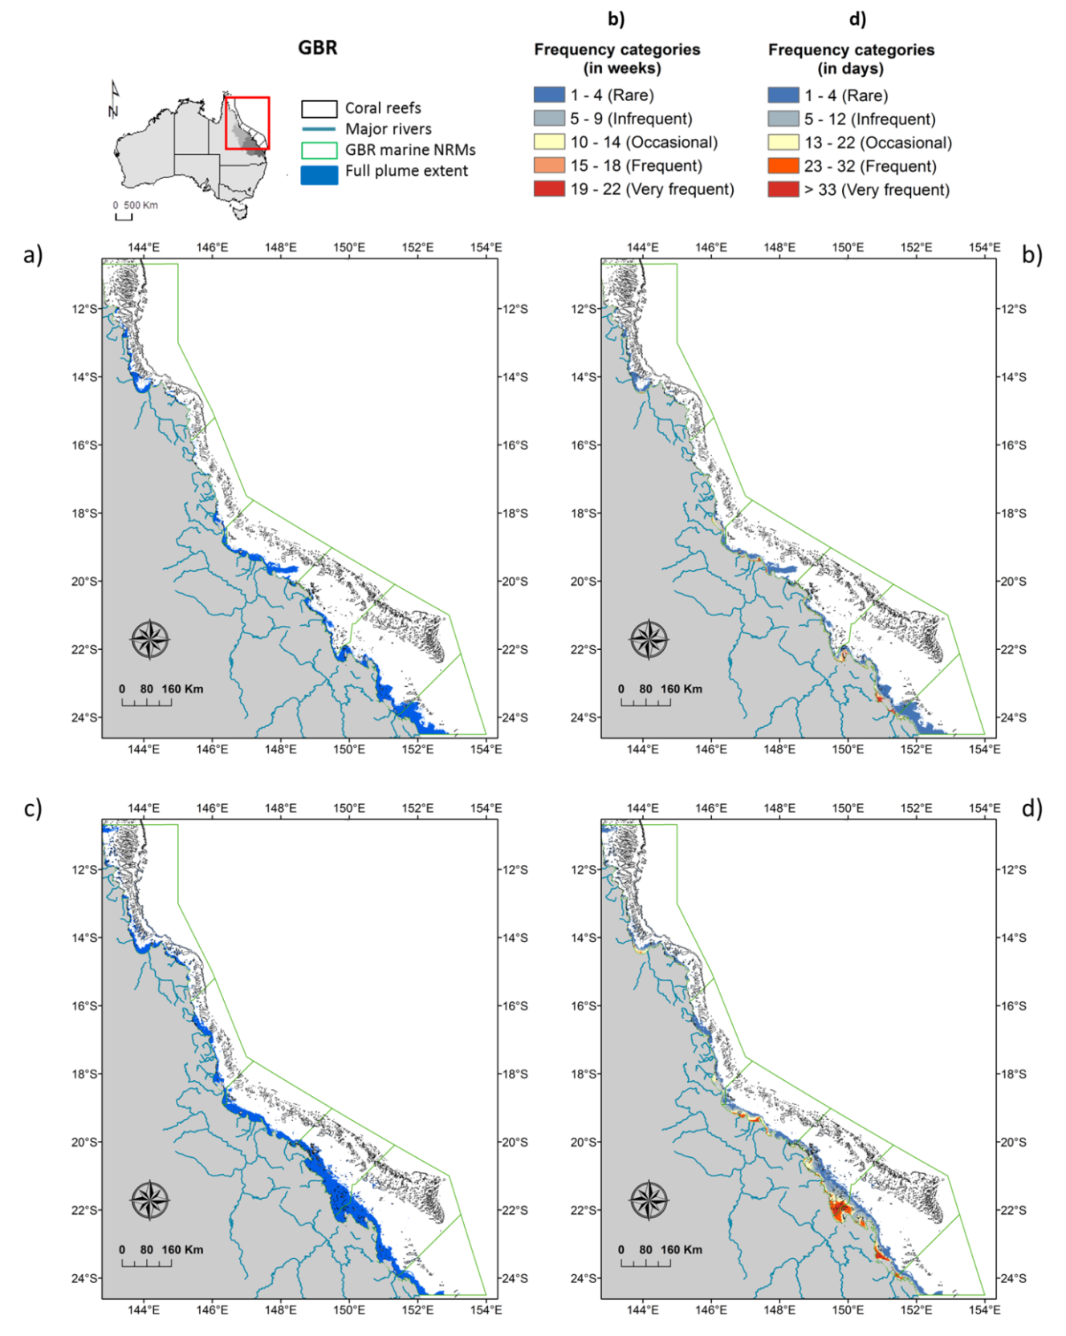
Figure B-3: Frequency of occurrence of Primary plume waters recorded in 2013 by a) and b) the TC method and c) and d) the L2 method. Maps a) and c) show all areas that have been classified as least one day over the wet season 2012-13 as Primary plume waters. Maps b) and d) show same maps reclassified into frequency breaks using the Jenk classification embedded in ArcGIS. Jenks is a statistical procedure that analyses the distribution of values in the data and finds the most evident breaks in it. Note that breaks of the TC method are in weeks while breaks of the L2 method are in days.
Secondary plume water type
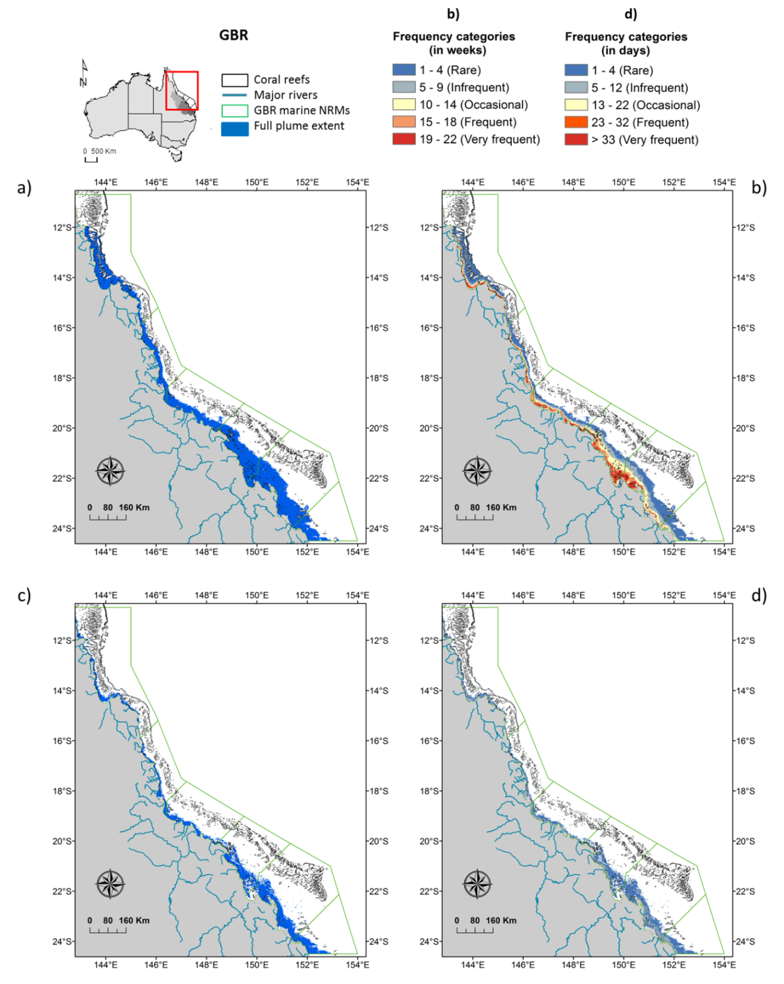
Figure B-4: Frequency of occurrence of Secondary plume waters recorded in 2013 by a) and b) the TC method and c) and d) the L2 method. Maps a) and c) show all areas that have been classified as least one day over the wet season 2012-13 as Secondary plume waters. Maps b) and d) show same maps reclassified into frequency breaks using the Jenk classification embedded in ArcGIS. Jenks is a statistical procedure that analyses the distribution of values in the data and finds the most evident breaks in it. Note that breaks of the TC method are in weeks while breaks of the L2 method are in days.
Tertiary plume water type
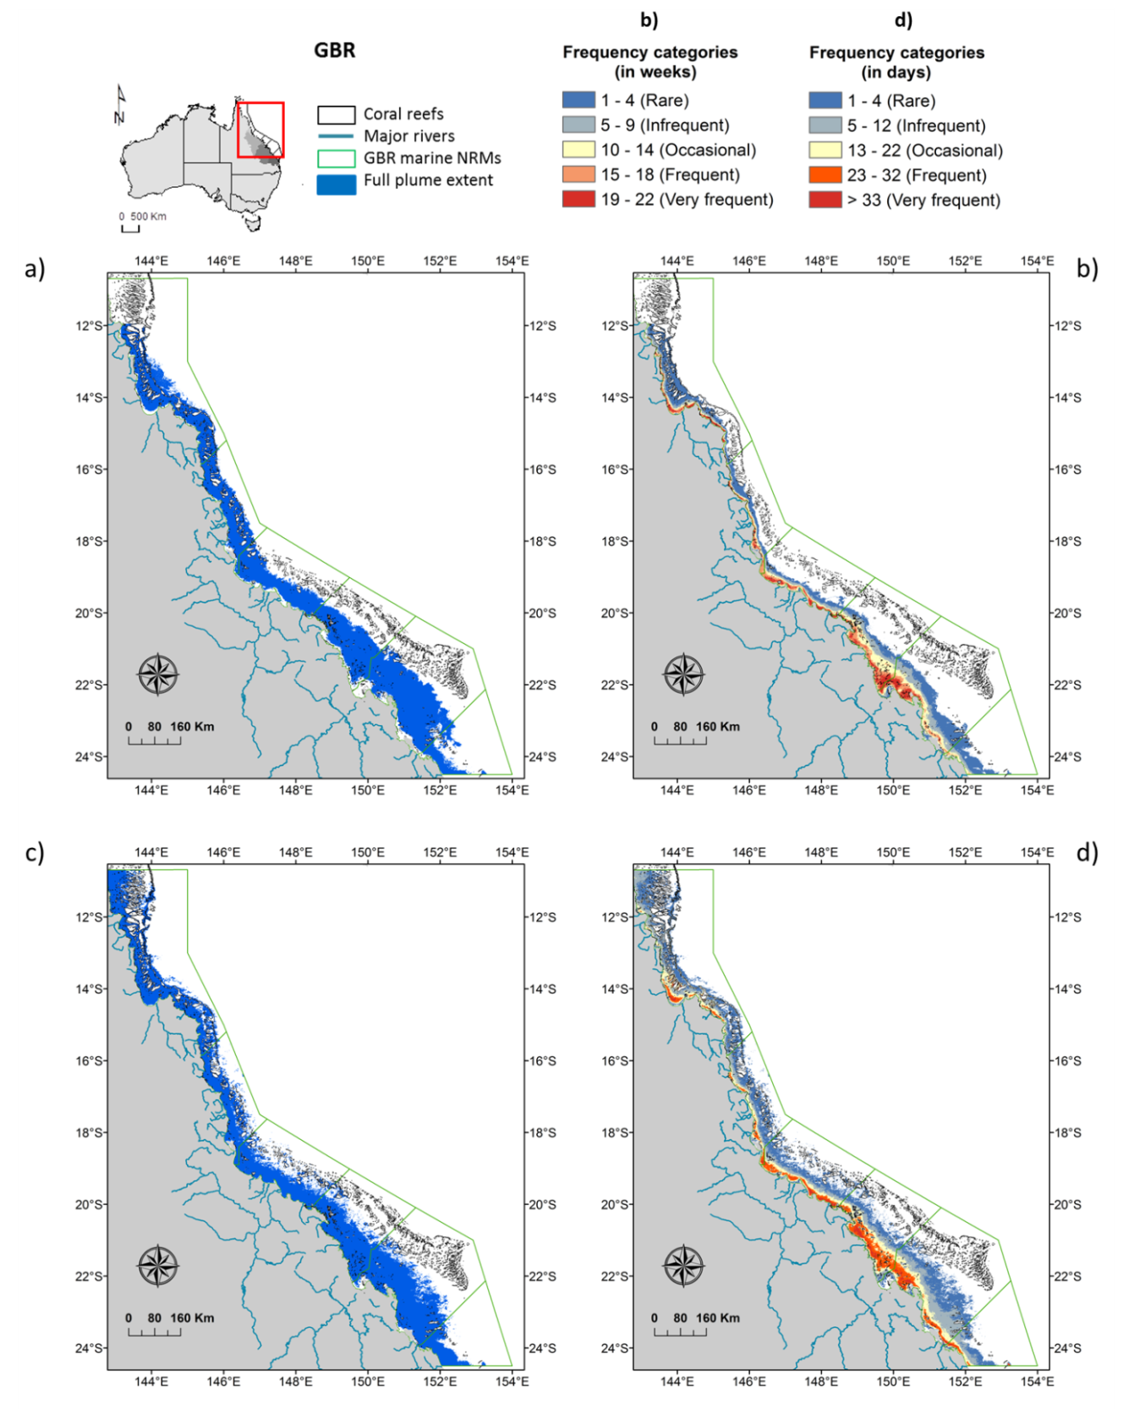
Figure B-5: Frequency of occurrence of Tertiary plume waters recorded in 2013 by a) and b) the TC method and c) and d) the L2 method. Maps a) and c) show all areas that have been classified as least one day over the wet season 2012-13 as Tertiary plume water. Maps b) and d) show same maps reclassified into frequency breaks using the Jenk classification embedded in ArcGIS. Jenks is a statistical procedure that analyses the distribution of values in the data and finds the most evident breaks in it. Note that breaks of the TC method are in weeks while breaks of the L2 method are in days.

Table A-2: Areas (km2) and percentage (%) of the GBR lagoon exposed to different categories of river plume frequency (or likelihood of risk) and potential river plume risk within the GBR and each NRM.
 |  |  | River plume frequency |  |  |  |  | TOT exp. | TOT non exp. | Potential risk category |  |  |  | TOT exp. | TOT non exp.
NRM |  | Tot | Rare | Infreq. | Occas. | Freq. | V.Freq | TOT exp. | TOT non exp. | I | II | III | IV | TOT exp. | TOT non exp.
GBR | area | 348753 | 45991 | 20251 | 24584 | 21304 | 41723 | 153852 | 194901 | 67194 | 64466 | 20782 | 1168 | 153610 | 195143
GBR | % | 100% | 13% | 6% | 7% | 6% | 12% | 44% | 56% | 19% | 18% | 6% | 0% | 44% | 56%
Cape York | area | 96316 | 9413 | 5469 | 5814 | 6863 | 7767 | 35326 | 60990 | 16034 | 15800 | 3285 | 69 | 35188 | 61128
Cape York | % | 100% | 10% | 6% | 6% | 7% | 8% | 37% | 63% | 17% | 16% | 3% | 0% | 37% | 63%
Wet Tropics | area | 31949 | 7225 | 4441 | 2209 | 1992 | 3980 | 19847 | 12102 | 12022 | 5332 | 2458 | 26 | 19838 | 12111
Wet Tropics | % | 100% | 23% | 14% | 7% | 6% | 12% | 62% | 38% | 38% | 17% | 8% | 0% | 62% | 38%
Burdekin | area | 46967 | 3498 | 5418 | 3642 | 1295 | 5694 | 19547 | 27420 | 9734 | 6464 | 3022 | 306 | 19526 | 27441
Burdekin | % | 100% | 7% | 12% | 8% | 3% | 12% | 42% | 58% | 21% | 14% | 6% | 1% | 42% | 58%
Mackay-Whitsundays | area | 48949 | 2851 | 2029 | 3083 | 4019 | 10845 | 22826 | 26123 | 5210 | 11918 | 5532 | 136 | 22795 | 26154
Mackay-Whitsundays | % | 100% | 6% | 4% | 6% | 8% | 22% | 47% | 53% | 11% | 24% | 11% | 0% | 47% | 53%
Fitzroy | area | 86860 | 13259 | 2089 | 8797 | 6368 | 12154 | 42666 | 44194 | 16944 | 19022 | 6127 | 581 | 42674 | 44186
Fitzroy | % | 100% | 15% | 2% | 10% | 7% | 14% | 49% | 51% | 20% | 22% | 7% | 1% | 49% | 51%
Burnett-Mary | area | 37712 | 9746 | 806 | 1039 | 767 | 1283 | 13641 | 24071 | 7250 | 5930 | 360 | 50 | 13590 | 24122
Burnett-Mary | % | 100% | 26% | 2% | 3% | 2% | 3% | 36% | 64% | 19% | 16% | 1% | 0% | 36% | 64%
Table A-3: Areas (km²) and percentage (%) of coral reefs exposed (‘exp.’) to river plumes and potential river plume risk within the GBR and each NRM.
 |  |  | River plume frequency |  |  |  |  | TOT exp. | TOT non exp. | Potential risk category |  |  |  | TOT exp. | TOT non exp.
Coral reefs |  | Tot | Rare | Infreq. | Occas. | Freq. | V.Freq | TOT exp. | TOT non exp. | I | II | III | IV | TOT exp. | TOT non exp.
GBR | area | 24075 | 5163 | 2992 | 2130 | 580 | 407 | 11272 | 12803 | 8887 | 2015 | 381 | 3 | 11287 | 12788
GBR | % | 100% | 21% | 12% | 9% | 2% | 2% | 47% | 53% | 37% | 8% | 2% | 0% | 47% | 53%
Cape York | area | 10332 | 1760 | 2042 | 1966 | 458 | 97 | 6323 | 4010 | 4526 | 1727 | 75 | 1 | 6329 | 4004
Cape York | % | 100% | 17% | 20% | 19% | 4% | 1% | 61% | 39% | 44% | 17% | 1% | 0% | 61% | 39%
Wet Tropics | area | 2418 | 1829 | 482 | 21 | 11 | 38 | 2379 | 38 | 2309 | 28 | 31 | 0 | 2369 | 49
Wet Tropics | % | 100% | 76% | 20% | 1% | 0% | 2% | 98% | 2% | 96% | 1% | 1% | 0% | 98% | 2%
Burdekin | area | 2966 | 589 | 185 | 32 | 4 | 16 | 826 | 2140 | 777 | 35 | 19 | 0 | 832 | 2134
Burdekin | % | 100% | 20% | 6% | 1% | 0% | 1% | 28% | 72% | 26% | 1% | 1% | 0% | 28% | 72%
MWS | area | 3196 | 107 | 4 | 69 | 65 | 128 | 373 | 2822 | 107 | 164 | 104 | 1 | 375 | 2820
MWS | % | 100% | 3% | 0% | 2% | 2% | 4% | 12% | 88% | 3% | 5% | 3% | 0% | 12% | 88%
Fitzroy | area | 4880 | 602 | 276 | 42 | 42 | 125 | 1088 | 3792 | 890 | 55 | 151 | 2 | 1098 | 3782
Fitzroy | % | 100% | 12% | 6% | 1% | 1% | 3% | 22% | 78% | 18% | 1% | 3% | 0% | 23% | 77%
Burnett-Mary | area | 284 | 276 | 3 | 0 | 0 | 4 | 283 | 0.3 | 278 | 5 | 1 | 0 | 283 | 0.3
Burnett-Mary | % | 100% | 97% | 1% | 0% | 0% | 2% | 99.9% | 0.1% | 98% | 2% | 0% | 0% | 99.9% | 0.1%
Table A-4: Areas (km²) and percentage (%) of seagrass beds exposed (‘exp.’) to river plumes and potential river plume risk within the GBR and each NRM: a) surveyed seagrass beds, b) deep seagrass beds and c) total (surveyed + deep) seagrass beds
 |  |  | River plume frequency |  |  |  |  | TOT exp. | TOT non exp. | Potential risk category |  |  |  | TOT exp. | TOT non exp.
- Seagrass survey |  | Tot | Rare | Infreq. | Occas. | Freq. | V.Freq | TOT exp. | TOT non exp. | I | II | III | IV | TOT exp. | TOT non exp.
GBR | area | 3814 | 6 | 24 | 140 | 481 | 3004 | 3655 | 159 | 34 | 1315 | 2097 | 201 | 3647 | 167
GBR | % | 100% | 0% | 1% | 4% | 13% | 79% | 96% | 4% | 1% | 34% | 55% | 5% | 96% | 4%
Cape York | area | 2438 | 1 | 13 | 81 | 416 | 1774 | 2285 | 152 | 31 | 1068 | 1154 | 32 | 2285 | 153
Cape York | % | 100% | 0% | 1% | 3% | 17% | 73% | 94% | 6% | 1% | 44% | 47% | 1% | 94% | 6%
Wet Tropics | area | 204 | 2 | 3 | 7 | 11 | 176 | 199 | 5 | 2 | 33 | 153 | 11 | 199 | 5
Wet Tropics | % | 100% | 1% | 1% | 3% | 6% | 86% | 97% | 3% | 1% | 16% | 75% | 6% | 98% | 2%
Burdekin | area | 621 | 0 | 1 | 15 | 3 | 600 | 619 | 2 | 0 | 117 | 433 | 68 | 619 | 2
Burdekin | % | 100% | 0% | 0% | 2% | 0% | 97% | 100% | 0% | 0% | 19% | 70% | 11% | 100% | 0%
Mackay-Whitsundays | area | 231 | 1 | 3 | 30 | 30 | 161 | 225 | 6 | 0 | 57 | 151 | 15 | 223 | 8
Mackay-Whitsundays | % | 100% | 0% | 1% | 13% | 13% | 70% | 97% | 3% | 0% | 25% | 65% | 6% | 97% | 3%
Fitzroy | area | 247 | 1 | 3 | 4 | 20 | 225 | 253 | 0 | 0 | 23 | 164 | 60 | 247 | 0
Fitzroy | % | 100% | 0% | 1% | 2% | 8% | 91% | 100% | 0% | 0% | 9% | 66% | 24% | 100% | 0%
Burnett-Mary | area | 74 | 1 | 1 | 3 | 1 | 68 | 75 | 0 | 0 | 17 | 42 | 15 | 74 | 0
Burnett-Mary | % | 100% | 1% | 2% | 4% | 2% | 93% | 100% | 0% | 0% | 23% | 57% | 20% | 100% | 0%
 |  |  | River plume frequency |  |  |  |  | TOT exp. | TOT non exp. | Potential risk category |  |  |  | TOT exp. | TOT non exp.
- Seagrass deep |  | Tot | Rare | Infreq. | Occas. | Freq. | V.Freq | TOT exp. | TOT non exp. | I | II | III | IV | TOT exp. | TOT non exp.
GBR | area | 31632 | 10058 | 5800 | 5783 | 3881 | 2618 | 28141 | 3491 | 15001 | 12596 | 548 | 0 | 28145 | 3487
GBR | % | 100% | 32% | 18% | 18% | 12% | 8% | 89% | 11% | 47% | 40% | 2% | 0% | 89% | 11%
Cape York | area | 9459 | 229 | 1100 | 1631 | 3200 | 1870 | 8031 | 1428 | 1397 | 6458 | 176 | 0 | 8031 | 1428
Cape York | % | 100% | 2% | 12% | 17% | 34% | 20% | 85% | 15% | 15% | 68% | 2% | 0% | 85% | 15%
Wet Tropics | area | 4661 | 1562 | 1763 | 943 | 241 | 152 | 4661 | 0 | 3547 | 1099 | 15 | 0 | 4661 | 0
Wet Tropics | % | 100% | 34% | 38% | 20% | 5% | 3% | 100% | 0% | 76% | 24% | 0% | 0% | 100% | 0%
Burdekin | area | 5437 | 1623 | 1658 | 154 | 18 | 0 | 3454 | 1983 | 3293 | 165 | 0 | 0 | 3459 | 1978
Burdekin | % | 100% | 30% | 31% | 3% | 0% | 0% | 64% | 36% | 61% | 3% | 0% | 0% | 64% | 36%
Mackay-Whitsundays | area | 220 | 0 | 0 | 20 | 43 | 157 | 220 | 1 | 0 | 146 | 74 | 0 | 220 | 1
Mackay-Whitsundays | % | 100% | 0% | 0% | 9% | 19% | 71% | 100% | 0% | 0% | 66% | 34% | 0% | 100% | 0%
Fitzroy | area | 5554 | 1431 | 875 | 2733 | 234 | 280 | 5554 | 0 | 3372 | 1905 | 276 | 0 | 5554 | 0
Fitzroy | % | 100% | 26% | 16% | 49% | 4% | 5% | 100% | 0% | 61% | 34% | 5% | 0% | 100% | 0%
Burnett-Mary | area | 6301 | 5214 | 403 | 302 | 145 | 158 | 6221 | 79 | 3391 | 2822 | 7 | 0 | 6221 | 80
Burnett-Mary | % | 100% | 83% | 6% | 5% | 2% | 3% | 99% | 1% | 54% | 45% | 0% | 0% | 99% | 1%
 |  |  | River plume frequency |  |  |  |  | TOT exp. | TOT non exp. | Potential risk category |  |  |  | TOT exp. | TOT non exp.
- Seagrass tot |  | Tot | Rare | Infreq. | Occas. | Freq. | V.Freq | TOT exp. | TOT non exp. | I | II | III | IV | TOT exp. | TOT non exp.
GBR | area | 35447 | 10065 | 5825 | 5923 | 4362 | 5622 | 31796 | 3651 | 15035 | 13911 | 2645 | 201 | 31792 | 3655
GBR | % | 100% | 28% | 16% | 17% | 12% | 16% | 90% | 10% | 42% | 39% | 7% | 1% | 90% | 10%
Cape York | area | 11896 | 229 | 1113 | 1713 | 3616 | 3644 | 10316 | 1580 | 1428 | 7526 | 1330 | 32 | 10316 | 1581
Cape York | % | 100% | 2% | 9% | 14% | 30% | 31% | 87% | 13% | 12% | 63% | 11% | 0% | 87% | 13%
Wet Tropics | area | 4865 | 1564 | 1766 | 949 | 252 | 328 | 4860 | 5 | 3549 | 1132 | 168 | 11 | 4861 | 5
Wet Tropics | % | 100% | 32% | 36% | 20% | 5% | 7% | 100% | 0% | 73% | 23% | 3% | 0% | 100% | 0%
Burdekin | area | 6058 | 1623 | 1659 | 169 | 21 | 600 | 4073 | 1985 | 3294 | 283 | 433 | 68 | 4078 | 1981
Burdekin | % | 100% | 27% | 27% | 3% | 0% | 10% | 67% | 33% | 54% | 5% | 7% | 1% | 67% | 33%
Mackay-Whitsundays | area | 451 | 1 | 3 | 50 | 73 | 318 | 444 | 7 | 0 | 203 | 225 | 15 | 443 | 9
Mackay-Whitsundays | % | 100% | 0% | 1% | 11% | 16% | 70% | 98% | 2% | 0% | 45% | 50% | 3% | 98% | 2%
Fitzroy | area | 5801 | 1432 | 878 | 2738 | 254 | 505 | 5806 | 0 | 3372 | 1928 | 440 | 60 | 5801 | 0
Fitzroy | % | 100% | 25% | 15% | 47% | 4% | 9% | 100% | 0% | 58% | 33% | 8% | 1% | 100% | 0%
Burnett-Mary | area | 6374 | 5214 | 405 | 305 | 146 | 226 | 6296 | 78 | 3392 | 2839 | 49 | 15 | 6295 | 80
Burnett-Mary | % | 100% | 82% | 6% | 5% | 2% | 4% | 99% | 1% | 53% | 45% | 1% | 0% | 99% | 1%

2012 and 2013 load data were not yet available at the time of this report.
Jenks classification is embedded in ArcGIS as a statistical procedure that analyses the distribution of values in the data and finds the most evident breaks in it. Note that breaks of the TC method are in weeks while breaks of the L2 method are in days.

