Climate change
Year 10
Learning area: Science
Science Understanding (sub-strand):
Earth and space sciences

© Commonwealth of Australia 2016
Published by the Great Barrier Reef Marine Park Authority
With the exception of the Commonwealth Coat of Arms, content supplied by third parties, logos and other material protected by a trademark, the content of this publication is licensed under the Creative Commons Attribution-Non Commercial-Share Alike 3.0 Licence.
A summary of license terms is available from
http://www.creativecommons.org/licenses/by-nc-sa/3.0/
The full license terms are available from
http://www.creativecommons.org/licenses/by-nc-sa/3.0/legalcode
This publication should be cited as:
Great Barrier Reef Marine Park Authority 2015, Climate change: Year 10 Australian science curriculum focus, GBRMPA, Townsville.
National Library of Australia Cataloguing-in-Publication entry
Climate change: year 10 Australian science curriculum focus / Great Barrier Reef Marine Park Authority.
ISBN 9781922126719
Climatic changes—Queensland—Great Barrier Reef—Study and teaching (Secondary).
Biodiversity—Climatic factors—Queensland—Great Barrier Reef—Study and teaching (Secondary).
Great Barrier Reef (Qld.)—Study and teaching (Secondary).
Great Barrier Reef Marine Park Authority.
577.2209943

In this unit, the sections ‘Curriculum intent’, ‘Assessment – Assessing student learning’ and ‘Making judgements – achievement standard’ include content that is © Australian Curriculum, Assessment and Reporting Authority (ACARA) 2010 to present, unless otherwise indicated. This material was downloaded from the Australian Curriculum website (accessed March 2015) and was modified. The material is licensed under CC BY 4.0. Version updates are tracked on the Curriculum version history page of the Australian Curriculum website.
ACARA does not endorse any product that uses the Australian Curriculum or make any representations as to the quality of such products. Any product that uses material published on this website should not be taken to be affiliated with ACARA or have the sponsorship or approval of ACARA. It is up to each person to make their own assessment of the product, taking into account matters including, but not limited to, the version number and the degree to which the materials align with the content descriptions (where relevant). Where there is a claim of alignment, it is important to check that the materials align with the content descriptions (endorsed by all education Ministers), not the elaborations (examples provided by ACARA).
Comments and inquiries on this document should be addressed to:
Great Barrier Reef Marine Park Authority
2-68 Flinders Street
PO Box 1379
TOWNSVILLE QLD 4810
Australia
Phone: (07) 4750 0700
Fax: (07) 4772 6093
info@gbrmpa.gov.au
http://www.gbrmpa.gov.au
Climate change — Year 10
Contents
Unit overview 5
Teacher information 6
Curriculum intent 12
Feedback 18
Assessment 19
Sequencing teaching and learning 20
Making judgements 21
Teaching sequence 22
Resources 42
Resource 1 – Word bank 43
Resource 2 – Student reflections 44
Resource 3 – Investigation planner 45
Resource 4 – Greenhouse investigation – Jars and temperature 47
Resource 5 – Greenhouse investigation – Building a greenhouse 48
Resource 6 – Making carbon dioxide 50
Resource 7 – Carbon cycle questions 51
Resource 8 – Ocean acidification in a Jar 53
Resource 9 – Rubber egg experiment 54
Resource 10 – Coral growth data 55
Resource 11 – Futures circle 56
Resource 12 – Student task sheet and Guide for making judgements 57

Unit overview

Unit title | Climate change
Learning Area | Science
Science Understanding  (sub-strand) | Earth and space sciences
Year level | 10
Duration | Approximately 7 weeks*  *based on two to three lessons of science per week for Year 10 (50 minutes per lesson)  This mini unit provides a Great Barrier Reef perspective to the understanding of the carbon cycle across the four global systems and impacts of climate change. An alternative to teaching this unit is to incorporate lessons into pre-existing Year 10 units.
Unit description | In this mini unit, students will explore the carbon cycle and the four global systems: biosphere, lithosphere, atmosphere and hydrosphere. Students will investigate greenhouses gases and carbon dioxide and describe the relationship between the carbon cycle and climate change. Students will investigate what happens when carbon dioxide is absorbed by seawater and potential impacts of ocean acidification on reef biodiversity. Students will discuss impacts of climate change on ecosystems and everyday changes to reduce these impacts.

Teacher information

Safety and risk management
You will need to identify safety issues and conduct your own curriculum activity risk assessments for all activities and excursions in this mini unit.
For advice and documents, please refer to the Department of Education and Training Curriculum Activity Risk Assessment Guidelines: http://education.qld.gov.au/health/safety/hazards/curriculum-activities.html
The actual risk level for activities in this mini unit will vary according to the specific circumstances of the activity and your school and classroom context. You must consider all specific circumstances when you complete a risk assessment. Examples of considerations include, but are not limited to:
Is the activity occurring within, or outside school grounds e.g. an excursion?
How will students be supervised during the activity?
What will students do during the activity?
Are there any special student considerations e.g. medical, behavioural or special needs?
What hazards do you need to take into account e.g. hazardous substances, tools or equipment?

Unit details
The Great Barrier Reef Marine Park Authority (GBRMPA) Climate Change unit is a Year 10 Science unit of work. The content descriptors for this unit are from the Australian Curriculum: Science (Version 7.4 dated 30th March 2015 http://www.australiancurriculum.edu.au).
The mini unit follows the inquiry-based 5Es approach to teaching science. The inquiry questions that underpin the mini unit are:
What is the carbon cycle?
What are the four subsystems that interact to make up the carbon cycle?
How have humans impacted the carbon cycle?
What is climate change?
How has biodiversity been affected by climate change?
What behaviours can we change to reduce the impacts of climate change?

Time allocation
The mini unit is based on a minimum of two lessons of science per week for Year 10 students. Each lesson is approximately 50 minutes long, with some lessons requiring more time to allow further depth of study e.g. internet research, or time for excursions.
The overall mini unit, or the individual lessons, can be extended or shortened to cater for individual classes as deemed necessary by the class teacher.

Unit aims
The lessons in this mini unit are structured to build students’ knowledge of climate change and how it is affecting the Great Barrier Reef. Investigating the global systems that rely on interactions involving the biosphere, lithosphere, hydrosphere and atmosphere, students will develop an understanding of how human activities have impacted these global systems which has led to climate change. Students will also investigate and build their knowledge of the impacts of climate change on sea levels and biodiversity. For more information on climate change and the Great Barrier Reef see below in ‘climate change background information’ and also http://www.gbrmpa.gov.au.
Understanding these effects – what has caused them and what the future effects will be – will build students’ environmental knowledge and encourage their understanding of sustainability and stewardship.

Key threats to the Reef
GBRMPA encourages teachers, students and communities to follow the main aim of Reef Guardians – to be custodians of their local ecosystems and stewards of the Reef. In the Great Barrier Reef Outlook Report 2014, the key threats to the Reef are identified as climate change, land-based run-off, coastal development and other direct impacts such as unsustainable fishing activities and marine debris. (See http://www.gbrmpa.gov.au for more information on the Outlook Report 2014).
In this mini unit, students will explore the threat of climate change.

Stewardship
The Reef Guardian Schools Program encourages responsible use and protection of the Great Barrier Reef ecosystems. Schools are encouraged to take ownership of conservation activities and on-ground projects that involve students, teachers and their local communities. These environmental actions foster a greater appreciation and understanding of the Great Barrier Reef and empower students to become lifelong stewards.
The following are examples of stewardship activities that relate to the learning experiences of this unit:
- Students could consider the impact of climate change on their local area. How will sea level rise affect their coastal zone? How will it affect islands of the pacific?
- If your school has the capacity to go snorkelling, students could measure the recovery of a coral reef area after a storm/cyclone.
- As a class, decide on a location that is at risk and take steps to ‘future proof’ that area e.g. local creek, reef, mangrove, forest or beach. For ideas of actions, view Reef Beat Posters 2009 - Climate Change and the Reef (posters 9 and 10: A resilient reef what can you do?’) available at: http://elibrary.gbrmpa.gov.au/jspui/handle/11017/2780

Citizen science participation
Citizen science is scientific research conducted by non-professionals – in this case by students, teachers and communities. Schools can participate in the collection and submission of scientific data to local management authorities including GBRMPA, local councils and local Natural Resource Management agencies where the data can be used to inform sustainable ecosystem management decisions.
Examples of citizen science participation are provided in the lesson plans of this mini unit found in the ‘Teaching sequence’ section.

Building partnerships
Delivery of this unit can be enhanced by building partnerships within the school and wider community.
Partner organisations could include the following:
- local council
- Local Marine Advisory Committees (LMAC)
- your nearest natural resource management organisation (NRM): http://www.nrm.gov.au/regional/regional-nrm-organisations
- conservation groups
- other schools
- local universities
- CSIRO or other research body

Background information – climate change

What is climate change?
Gases in the Earth’s atmosphere trap some of the sun’s energy that would otherwise be radiated back into space. This is called the greenhouse effect. This effect keeps the Earth at a temperature suitable for life. Climate change results from an enhanced greenhouse effect.
Increased levels of greenhouse gases (mostly carbon dioxide) in the atmosphere mean that more heat is being trapped and the Earth’s temperature is increasing. There is now consensus that emissions from human activities are largely responsible for enhanced levels of greenhouse gases.
We have already seen evidence of climate change resulting from elevated greenhouse gas concentrations. Since the beginning of last century, air temperature has increased by 0.6°C on average worldwide. In Australia, 2005 was the hottest year ever recorded. The temperature was 1.1°C higher than the average from the previous 30 years.

How has climate change affected the Great Barrier Reef ecosystem?
The Great Barrier Reef is internationally renowned for its biodiversity. Its reefs (about 2900 in total) are home to thousands of species. Extensive areas of seagrass meadows, mangrove forests, salt marsh, sand and mud areas also provide a diverse range of habitats for many species.
The diversity of the Great Barrier Reef’s natural values makes it a particularly unique and valued ecosystem. Understanding the vulnerability of such a large and intricate system to climate change is a challenge. We must first understand how climate change will affect an individual species or a community of different species. Identifying how these predictions will influence the entire Great Barrier Reef is a much larger challenge. While few systems are likely to benefit from climate change, coral reefs are particularly vulnerable.
The vulnerability of corals to future climate change has received considerable attention, as impacts on them have already been observed. Coral bleaching has begun to increase in frequency and severity due to rising sea temperatures. These events have led some experts to claim that coral reefs around the world are ‘in crisis’.
At least nine mass bleaching events have affected the world’s reefs since 1979. The Great Barrier Reef was most severely affected by the 1998 and 2002 mass coral bleaching events, but was also affected by bleaching in 2006. Projections of future water temperatures suggest coral bleaching could become more extreme in the course of this century.
Many other species including microbes, fish, marine turtles and seabirds are also sensitive to temperature changes. Scientists predict there will be impacts on these species with future climate change projections. For example, the gender of turtle hatchlings is temperature determined; higher temperatures lead to an increased proportion of females. However, increased temperature is just one of the many impacts of climate change on the Reef.
There are a number of other environmental changes predicted that suggest potential impacts on the Reef and some may have severe consequences. The implications of ocean acidification for animals and plants that produce calcium carbonate skeletons for example, could be profound. Rising sea levels could lead to large redistributions of benthic (bottom-dwelling) habitats and the animals that depend on them. In fact, all animals will be impacted by climate change in the future. Scientists are still working on solving some of these mysteries, as it is the interactions between the varied effects that are most uncertain.

What can you do?
As our awareness of climate change has increased, so too has our need to understand the threat it poses. Knowledge of the vulnerability of the Great Barrier Reef to climate change is essential to meaningfully respond to this challenge. This has prompted experts to assess the vulnerability of all species groups and habitats of the Great Barrier Reef to climate change and to highlight its social and cultural implications.
Climate Change and the Great Barrier Reef: A Vulnerability Assessment (http://www.gbrmpa.gov.au) is a collaboration between the Great Barrier Reef Marine Park Authority and over 80 leading climate and tropical marine scientists. This publication provides a comprehensive assessment of how future climate changes are likely to affect Great Barrier Reef species, ecosystems, industries and communities.
Climate change cannot be fully averted and we must understand, prepare and adapt to the inevitable effects of climate change. GBRMPA’s Climate Change Response Program is taking important steps towards reducing the negative impacts of climate change on the Great Barrier Reef.
Climate change is a global issue but there are many things that individuals, businesses and governments can do to help minimise its impact on the Great Barrier Reef. There are two main steps that you can take to help the Reef in the face of climate change. The first is to reduce greenhouse gas emissions, as increases in their concentrations are responsible for climate change. The greenhouse gas emissions that we produce come from using electricity, burning fuel in our cars and using products that require fuel and electricity to produce. Some things you can do at home, or at school, to reduce greenhouse gas emissions are:
switch to ‘green’ electricity produced from renewable sources by contacting your energy provider
use energy efficient lights
choose energy efficient products
turn off electrical devices such as televisions at the power point
turn off lights around the house
refuse, reduce, re-use and recycle
use less hot water
dry your clothes the natural way, not in the dryer
plant trees which take up carbon dioxide as they grow
heat and cool your house efficiently
drive less: car pool, use public transport, walk or cycle
spread the word to others
offset or neutralise your greenhouse gas emissions.
The second step is to reduce the impact that you have on the Reef. A healthy reef is more resilient and can recover quickly from the impacts of climate change, such as coral bleaching. See http://www.gbrmpa.gov.au for more information on what you can do to look after the health of our Great Barrier Reef.

Useful websites
- ReefVid – a resource of free coral reef video clips:
http://www.reefvid.org
- EcoKids:
http://www.ecokids.ca
- Great Barrier Reef Marine Park Authority:
http://www.gbrmpa.gov.au
- Middle School Science:
http://www.middleschoolscience.com
- The Biology Corner:
http://www.biologycorner.com
- The Eye on the Reef Program:
http://www.gbrmpa.gov.au/visit-the-reef/eye-on-the-reef/report-sightings
- GBRMPA – Climate change information:
http://www.gbrmpa.gov.au/managing-the-reef/threats-to-the-reef/climate-change
- The Reef 2050 Long-term Sustainability Plan:
https://www.environment.gov.au/system/files/consultations/8b8f5023-3cfb-4310-bc51-1136aa5d875a/files/reef-2050-long-term-sustainaiblity-plan.pdf

Curriculum intent

Australian Curriculum: Science

Year 10 Level Description
The Science Inquiry Skills and Science as a Human Endeavour strands are described across a two-year band. In their planning, schools and teachers refer to the expectations outlined in the achievement standard and also to the content of the science understanding strand for the relevant year level to ensure that these two strands are addressed over the two-year period. The three strands of the curriculum are interrelated and their content is taught in an integrated way. The order and detail in which the content descriptions are organised into teaching and learning programs are decisions to be made by the teacher.
In the Year 10 curriculum students explore systems at different scales and connect microscopic and macroscopic properties to explain phenomena. Students explore the biological, chemical, geological and physical evidence for different theories, such as the theories of natural selection and the Big Bang.
Students develop their understanding of atomic theory to understand relationships within the periodic table. They understand that motion and forces are related by applying physical laws. They learn about the relationships between aspects of the living, physical and chemical world that are applied to systems on a local and global scale and this enables them to predict how changes will affect equilibrium within these systems.

Content descriptions
This mini unit provides opportunities for students to engage in the following Australian Curriculum Content descriptions:
Science Understanding (SU) | Science as a Human Endeavour (SHE) | Science Inquiry Skills (SIS)*  *You may need to remove SIS below depending on what extent students plan investigations using the investigation planners in this unit
Earth and space sciences  - Global systems, including the carbon cycle, rely on interactions involving the biosphere, lithosphere, hydrosphere and atmosphere (ACSSU189) | Nature and development of science  - Scientific understanding, including models and theories, is contestable and is refined over time through a process of review by the scientific community (ACSHE191)  Use and influence of science  - People use scientific knowledge to evaluate whether they accept claims, explanations or predictions, and advances in science can affect people’s lives, including generating new career opportunities (ACSHE194)  - Values and needs of contemporary society can influence the focus of scientific research (ACSHE230) | Questioning and predicting  - Formulate questions or hypotheses that can be investigated scientifically (ACSIS198)  Planning and conducting  - Plan, select and use appropriate investigation types, including field work and laboratory experimentation, to collect reliable data; assess risk and address ethical issues associated with these methods (ACSIS199)  - Select and use appropriate equipment, including digital technologies, to collect and record data systematically and accurately (ACSIS200)  Processing and analysing data and information  - Analyse patterns and trends in data, including describing relationships between variables and identifying inconsistencies (ACSIS203)  - Use knowledge of scientific concepts to draw conclusions that are consistent with evidence (ACSIS204)  Evaluating  - Evaluate conclusions, including identifying sources of uncertainty and possible alternative explanations, and describe specific ways to improve the quality of the data (ACSIS205)  - Critically analyse the validity of information in primary and secondary sources, and evaluate the approaches used to solve problems (ACSIS206)  Communicating  - Communicate scientific ideas and information for a particular purpose, including constructing evidence-based arguments and using appropriate scientific language, conventions and representations (ACSIS208)

Year 10 achievement standard
By the end of Year 10, students analyse how the periodic table organises elements and use it to make predictions about the properties of elements. They explain how chemical reactions are used to produce particular products and how different factors influence the rate of reactions. They explain the concept of energy conservation and represent energy transfer and transformation within systems. They apply relationships between force, mass and acceleration to predict changes in the motion of objects. Students describe and analyse interactions and cycles within and between Earth’s spheres. They evaluate the evidence for scientific theories that explain the origin of the universe and the diversity of life on Earth. They explain the processes that underpin heredity and evolution. Students analyse how the models and theories they use have developed over time and discuss the factors that prompted their review.
Students develop questions and hypotheses and independently design and improve appropriate methods of investigation, including field work and laboratory experimentation. They explain how they have considered reliability, safety, fairness and ethical actions in their methods and identify where digital technologies can be used to enhance the quality of data. When analysing data, selecting evidence and developing and justifying conclusions, they identify alternative explanations for findings and explain any sources of uncertainty. Students evaluate the validity and reliability of claims made in secondary sources with reference to currently held scientific views, the quality of the methodology and the evidence cited. They construct evidence-based arguments and select appropriate representations and text types to communicate science ideas for specific purposes.

General capabilities
This mini unit provides opportunities to address the following organising elements of the general capabilities:
Literacy  - Composing texts through speaking, writing and creating  - Text knowledge  - Grammar knowledge  - Word knowledge  - Visual knowledge. | ICT capability  - Applying social and ethical protocols and practices when using ICT  - Investigating with ICT  - Managing and operating ICT
Numeracy  - Estimating and calculating with whole numbers  - Recognising and using patterns and relationships  - Using measurement  - Using spatial reasoning | Critical and creative thinking  - Inquiring – identifying, exploring and organising information and ideas  - Generating ideas, possibilities and actions  - Reflecting on thinking and processes
Personal and social competence  - Self-awareness  - Self-management  - Social awareness  - Social management | Ethical understanding  - Reasoning in decision making and actions
Intercultural understanding
- Recognising culture and developing respect

Cross-curriculum priorities
This mini unit provides opportunities for students to address aspects of the following cross-curriculum priorities:
Sustainability
Students will:
- understand that the biosphere is a dynamic system providing conditions that sustain life on Earth
- focus on designing action for a sustainable future that recognises that we need to explore and understand environments, evaluate past practises and form balanced judgements based on projected future social, economic and environmental impacts.

Relevant prior curriculum
Students require prior experience from year 9 with:

Science Understanding

Biological sciences
- Ecosystems consist of communities of interdependent organisms and abiotic components of the environment; matter and energy flow through these systems (ACSSU176)

Science as a Human Endeavour

Nature and development
- Scientific understanding, including models and theories, is contestable and is refined over time through a process of review by the scientific community (ACSHE157)

Use and influence of science
- People use scientific knowledge to evaluate whether they accept claims, explanations or predictions, and advances in science can affect people’s lives, including generating new career opportunities (ACSHE160)
- Values and needs of contemporary society can influence the focus of scientific research (ACSHE228)

Curriculum working towards
Relevant Senior Science subject content

Feedback

Supportive learning environment
Differentiation  Consider the individual needs of your students including gifted and talented, ESL and students requiring additional support.  For information refer to the Australian Curriculum, Assessment and Reporting Authority (ACARA) web pages on student diversity:  http://www.australiancurriculum.edu.au/studentdiversity/student-diversity-advice  Further information for Queensland state schools can be found as part of the P-12 curriculum, assessment and reporting framework and associated resources:  http://education.qld.gov.au/curriculum/framework/p-12/ | Feedback to students  Teachers:  - plan opportunities for conversations to provide ongoing feedback (spoken and written) and encouragement to students on their strengths and areas for improvement  - reflect on and review learning opportunities to individualise learning experiences required  - provide multiple opportunities for students to experience, practise and improve knowledge, processes and skills.  Students:  - identify what they can do well and what they need to improve  - provide feedback to a peer on interaction skills and suggest some strategies for improvement (written and spoken feedback).
Reflection on the unit plan
At the conclusion of the unit, teachers can reflect on it for future planning by answering the following questions:
- What worked well in this unit?
- What was a stumbling block?
- How would you refine it?
- What trends and gaps in learning have you identified?
- How will you build on these learning experiences next term and beyond?

Assessment
Assessment is the purposeful, systematic and ongoing collection of information as evidence for use in making judgements about student learning and to support improving student learning.

Monitoring student learning
Student learning should be monitored throughout the unit. Each lesson in this unit provides opportunities for monitoring learning and for gathering evidence of student progress. For examples of ways to monitor learning, refer to each of the lesson plans under the section ‘Teaching sequence’.

Assessing student learning
Summative assessment task: | Climate change - report (Lessons 11-13)
Description: | Students will write a persuasive text about climate change. They will describe what climate change is and explain how it has affected biodiversity on the Great Barrier Reef. They will describe their predictions for future effects of climate change and how it may impact biodiversity both on the Great Barrier Reef and in other ecosystems. They will identify local and global considerations to reduce the impact of climate change.
This assessment task provides opportunities to gather evidence of student learning in: | Science Understanding  Earth and space sciences  - Global systems, including the carbon cycle, rely on interactions involving the biosphere, lithosphere, hydrosphere and atmosphere (ACSSU189)  Science Inquiry Skills  Communicating  - Communicate scientific ideas and information for a particular purpose, including constructing evidence-based arguments and using appropriate scientific language, conventions and representations (ACSIS208)
See Resource section: Resource 12 for the Student task sheet and the Guide for making judgements for the assessment task: Climate change –report.

Sequencing teaching and learning
A suggested learning sequence for this mini unit is summarised below. For detailed information for each lesson in this sequence go to the section ‘Teaching Sequence’.
Inquiry phase | Lesson | Purpose
Engage | Lesson 1: What do you know about the carbon cycle and four global systems? | To capture interest and discover what students know about the carbon cycle and the four global systems: biosphere, lithosphere, atmosphere and hydrosphere.
Explore | Lesson 2: Do greenhouse gases affect air temperature? | To investigate the relationship between greenhouse gases and temperature change and relate findings to climate change and the carbon cycle.
 | Lesson 3: Can you make carbon dioxide? | To produce carbon dioxide in a reaction and investigate the properties of carbon dioxide.
Explain | Lesson 4 - 5: What are the four global systems? | To research and understand the four global systems: biosphere, lithosphere, atmosphere and hydrosphere.
 | Lesson 6: What is the carbon cycle and how does it relate to climate change? | To understand the carbon cycle and how it links across the four global systems. To describe the relationship between the carbon cycle and climate change.
Elaborate | Lesson 7: What happens when water absorbs carbon dioxide? | To investigate what happens when water absorbs carbon dioxide and to describe how increased acid levels in the ocean can affect marine animals.
 | Lesson 8 - 9: How might sea level rise affect coral growth on the reef? | To discuss potential impacts of climate change on the Great Barrier Reef. To analyse data on coral growth at different sea depths and draw conclusions about how sea level rise might impact corals and biodiversity on the Reef.
 | Lesson 10: How might climate change impact ecosystems including the Great Barrier Reef? | To identify impacts of climate change on ecosystems including the Great Barrier Reef. To discuss everyday changes we can make to reduce these potential impacts.
Evaluate | Lesson 11 - 13: Reflections and assessment task | To review and reflect on learning and introduce and complete the assessment task.
TOTAL: 13 Lessons (50 minutes per lesson)

Making judgements

Achievement standard
In this mini unit, assessment of student learning aligns to the following components of the Year 10 achievement standard:
By the end of Year 10, students analyse how the periodic table organises elements and use it to make predictions about the properties of elements. They explain how chemical reactions are used to produce particular products and how different factors influence the rate of reactions. They explain the concept of energy conservation and represent energy transfer and transformation within systems. They apply relationships between force, mass and acceleration to predict changes in the motion of objects. Students describe and analyse interactions and cycles within and between Earth’s spheres. They evaluate the evidence for scientific theories that explain the origin of the universe and the diversity of life on Earth. They explain the processes that underpin heredity and evolution. Students analyse how the models and theories they use have developed over time and discuss the factors that prompted their review.
Students develop questions and hypotheses and independently design and improve appropriate methods of investigation, including field work and laboratory experimentation. They explain how they have considered reliability, safety, fairness and ethical actions in their methods and identify where digital technologies can be used to enhance the quality of data. When analysing data, selecting evidence and developing and justifying conclusions, they identify alternative explanations for findings and explain any sources of uncertainty. Students evaluate the validity and reliability of claims made in secondary sources with reference to currently held scientific views, the quality of the methodology and the evidence cited. They construct evidence-based arguments and select appropriate representations and text types to communicate science ideas for specific purposes.

Guide for making judgements
See Resource section: Resource 12 for the Student task sheet and the Guide for making judgements for the assessment task: Climate change – report.

Teaching sequence
Engage
Explore
Explain
Elaborate
Evaluate

Lesson 1: What do you know about the carbon cycle and four global systems?
Duration: 50 minutes

Lesson objectives
Students will:
identify and communicate what they already know about the carbon cycle and the four global systems: biosphere, lithosphere, atmosphere and hydrosphere.

Suggested learning sequence

Introduction – Carbon cycle
- View images of the carbon cycle or footage of the carbon cycle. Many images are available online and on YouTube (see ‘Useful web links’ for ideas).
- Discuss the cycle and ask students to draw their own labelled diagram of the carbon cycle in pairs or individually. The cycle will be explained in detail later in the unit.
Activity – four global systems
- Provide a diagram of four global systems – biosphere, lithosphere, atmosphere and hydrosphere.
- Briefly discuss and explain these four systems. Record inquiry questions for later research. Students will be provided with the opportunity to research these topics later in the unit.
- Ask students to divide a piece of paper into four to represent each of the four global systems and in pairs or groups, write how the carbon cycle relies on interaction in each of the four global systems.
- Students may want to watch video clips again as they explain how the carbon cycle is related to the four global systems.
- Students keep these notes as a reference for a future activity in the unit. Share and discuss ideas with others in class.
- Review with students the scientific vocabulary pertinent to this lesson (See Resource 1 – Word bank for suggested terms).
- Start a science journal with the students to record their learning and reflections after each science lesson. (See Resource 2 – Student reflections for examples of sentence starters you can use to guide student reflections).

Science journal
A science journal is a record of observations, experiences and reflections. It contains a series of dated, chronological entries. It may include written text, drawings, labelled diagrams, photographs, tables and graphs. The science journal can be used as a part of student assessment.

Opportunities to monitor student learning
Diagnostic assessment opportunities:
Observe students’ responses during the lesson to determine their awareness of the carbon cycle and four global systems.

Resources

Useful web links
Images and/or footage of the carbon cycle. Some YouTube clips examples are:
Carbon cycle cartoon -
http://www.youtube.com/watch?v=U3SZKJVKRxQ
NASA: Keeping up with carbon - http://www.youtube.com/watch?v=HrIr3xDhQ0E&feature=related
Hint: Access and pre-load YouTube clips before the lesson so that you can play them immediately for students when required.
Diagrams of the four global systems – hydrosphere, biosphere, lithosphere, atmosphere for example:
Earth: Earth’s environmental spheres - http://www.britannica.com/media/full/279025/112176
How are Earth’s spheres Interacting? - https://www.classzone.com/books/earth_science/terc/content/investigations/es0103/es0103page02.cfm?chapter_no=investigation (click on each sphere to visualise)

Great Barrier Reef Outlook Report 2014
Access the report at: http://elibrary.gbrmpa.gov.au/jspui/handle/11017/2855
Useful information for this lesson can be found on:
page 155-160: Climate change.

Great Barrier Reef Strategic Assessment: Strategic assessment report, 2014
Access the report at: http://elibrary.gbrmpa.gov.au/jspui/handle/11017/2861
Useful information for this lesson can be found at:
chapter 5 - page 7 (5-7) – The science of carbon dioxide concentrations and coral reefs.

Printable resources
Resource 1 – Word bank
Resource 2 – Student reflections
Engage
Explore
Explain
Elaborate
Evaluate

Lesson 2: Do greenhouse gases affect air temperature?
Duration: 50 minutes

Lesson objectives
Students will:
investigate the relationship between greenhouse gases and temperature change and relate their findings to climate change and the carbon cycle.

Suggested learning sequence
Introduction – Investigation set-up
- Ask students what they already know about greenhouse gases and how they relate to climate change.
- As a class, read Resource 4 and 5 – Greenhouse investigations. Discuss the investigation with students then set them up.
Notes: There are two investigations to show two different ways of demonstrating the impacts of increasing greenhouse gases. Students could do one or both.
The first investigation (Resource 4 – Jars and temperature) can be set up and completed during this lesson. Whilst in between reading temperatures, students can set up the second investigation (Resource 5 – Building a greenhouse) which is ongoing and will last several weeks.
Return to this second investigation during the unit and use it to discuss the correlation between CO2 and temperature.
For either investigation you may wish to use or alter and use Resource 3 – Investigation planner with students.
Activity – Greenhouse effect
- Have students complete the jar and temperature investigation, record results and answer the questions provided. If the second investigation was also set up, ask students to discuss what they think will happen and why. How will it affect the growth of the plants?
- As a class, discuss their results and link how this relates back to the carbon cycle.
Notes about the jar experiment: Carbon dioxide and other greenhouse gases have a similar effect on the atmosphere as the glass jar did on the air inside the jar. This is similar to what happens in a greenhouse and so is called the ‘greenhouse effect’. The greenhouse effect is important for us as it has made the Earth warm enough to support life. However, human activity is now adding more ‘greenhouse gases’ to the atmosphere, putting the carbon cycle out of balance and causing the earth to get hotter.
- Review with students the scientific vocabulary pertinent to this lesson (See Resource 1 – Word bank for suggested terms).
- Students add their learning and reflections to their science journal. (See Resource 2 – Student reflections for examples of sentence starters you can use to guide student reflections).

Citizen Science participation
Build your own functioning greenhouse.

Opportunities to monitor student learning
Formative assessment opportunities:
Use students’ answers to questions and discussions to assess their understanding of the greenhouse effect and the relationship to carbon dioxide.

Resources

Printable resources
Resource 1 – Word bank
Resource 2 – Student reflections
Resource 3 – Investigation planner
Resource 4 – Greenhouse investigation – jars and temperature
Resource 5 – Greenhouse investigation – building a greenhouse

Great Barrier Reef Outlook Report 2014
Access the report at: http://elibrary.gbrmpa.gov.au/jspui/handle/11017/2855
Useful information for this lesson can be found on:
page 156 Figure 6.5: Changes in global atmospheric carbon dioxide concentrations.
Other resources
Materials list for the investigations as listed in Resource 4 and 5
Engage
Explore
Explain
Elaborate
Evaluate

Lesson 3: Can you make carbon dioxide?
Duration: 50 minutes

Lesson objectives
Students will:
produce carbon dioxide in a reaction and investigate its properties.

Suggested learning sequence
Introduction – Investigation set-up
- As a class, read Resource 6 – Making carbon dioxide.
- Discuss what the students know about the properties of carbon dioxide.
Activity – Making carbon dioxide
- Complete the ‘Making carbon dioxide’ experiment and record results.
- Discuss the students’ results and answers to the questions and describe properties of carbon dioxide gas.
- Review results from the Building greenhouse investigation if you set it up. Discuss the correlation between CO₂ and temperature.
- Review with students the scientific vocabulary pertinent to this lesson (See Resource 1– Word bank for suggested terms).
- Students add their learning and reflections to their science journal. (See Resource 2 – Student reflections for examples of sentence starters you can use to guide student reflections).

Opportunities to monitor student learning
Formative assessment opportunities:
Use students’ answers to questions and discussions to assess their understanding of carbon dioxide.

Resources

Printable resources
Resource 1 – Word bank
Resource 2 – Student reflections
Resource 6 – Making carbon dioxide

Great Barrier Reef Outlook Report 2014
Access the report at: http://elibrary.gbrmpa.gov.au/jspui/handle/11017/2855
Useful information for this lesson can be found on:
page 156 Figure 6.5: Changes in global atmospheric carbon dioxide concentrations.

Other resources
Materials list for the investigations as listed in Resource 6
Engage
Explore
Explain
Elaborate
Evaluate

Lesson 4 - 5: What are the four global systems?
Duration: 1 hour 40 minutes

Lesson objectives
Students will:
research and understand the four global systems: biosphere, lithosphere, atmosphere and hydrosphere.

Suggested learning sequence
Introduction – Class discussion
- Discuss the four global systems with students and ask them to share what they know about each system. Students may refer back to some of their notes and reflections from Lesson 1.
- On a board or large piece of paper divided into four (to represent each of the four global systems) record students’ responses.
Activity – Class research
- Divide students into pairs or groups. Each is to choose one of the four systems to research. Provide books and access to the Internet for students to research their chosen system.
- Students might also want to refer back to the questions about the four global systems they wrote down in Lesson 1.
- Have student groups create a visual representation or a small report that provides diagrams and facts about their chosen system.
- Students can share their findings with the class and add the information to the original class responses from the beginning of the lesson.
- Review results from the Building greenhouse investigation if you set it up. Discuss CO₂ and how it features as part of the four global systems.
- Review with students the scientific vocabulary pertinent to this lesson (See Resource 1 – Word bank for suggested terms).
- Students add their learning and reflections to their science journal. (See Resource 2 – Student reflections for examples of sentence starters you can use to guide student reflections).

Opportunities to monitor student learning
Formative assessment opportunities:
Use students’ responses and reports to assess their developing knowledge of the four global systems.

Resources

Printable resources
Resource 1 – Word bank
Resource 2 – Student reflections

Great Barrier Reef Outlook Report 2014
Access the report at: http://elibrary.gbrmpa.gov.au/jspui/handle/11017/2855
Useful information for this lesson can be found on:
page 159: Global ocean currents and weather patterns

Other resources
Books and Internet access for students to research the four global systems
Engage
Explore
Explain
Elaborate
Evaluate

Lesson 6: What is the carbon cycle and how does it relate to climate change?
Duration: 50 minutes
Lesson objectives
Students will:
understand the carbon cycle and how it links across the four global systems
describe the relationship between the carbon cycle and climate change.

Suggested learning sequence

Introduction – Video
- Watch the YouTube clip – The Carbon Cycle and Global Warming (8 minutes):
http://www.youtube.com/watch?v=1o4ODWMZq5U&feature=related
- Discuss how the carbon cycle relates to the four global systems. Refer back to Lesson 1 notes to discuss if students’ understanding of the carbon cycle and the four global systems has changed.
Activity – Questions
- Have students watch the clip again and use Resource 7 – Carbon cycle questions to answer questions as they re-watch the clip.
- Discuss and clarify with students their understanding of the carbon cycle and how it relates to climate change.
- Create a definition of what climate change is using the students’ knowledge of the carbon cycle and the four global systems.
- Review results from the Building greenhouse investigation if you set it up. Discuss the results and how CO₂ relates to the carbon cycle and climate change.
- Review with students the scientific vocabulary pertinent to this lesson (See Resource 1 – Word bank for suggested terms).
- Students add their learning and reflection to their science journal. (See Resource 2 – Student reflections for examples of sentence starters you can use to guide student reflections).

Opportunities to monitor student learning
Formative assessment opportunities:
Use students’ responses to the question sheet to assess their developing understanding of the carbon cycle and the four global systems.

Resources

Useful web links
YouTube Clip – Carbon Cycle and Global Warming:
http://www.youtube.com/watch?v=1o4ODWMZq5U&feature=related
Hint: Access and pre-load YouTube clips before the lesson so that you can play them immediately for students when required.

Great Barrier Reef Outlook Report 2014
Access the report at: http://elibrary.gbrmpa.gov.au/jspui/handle/11017/2855
Useful information for this lesson can be found on:
page 19: 2.3.4: Seagrass meadows sequester carbon.

Printable resources
Resource 1 – Word bank
Resource 2 – Student reflections
Resource 7 – Carbon cycle questions
Engage
Explore
Explain
Elaborate
Evaluate

Lesson 7: What happens when water absorbs carbon dioxide?
Duration: 50 minutes

Lesson objectives
Students will:
investigate what happens when water absorbs carbon dioxide
describe how increased acid levels in sea water can affect marine animals.

Suggested learning sequence

Introduction – Ocean acidification in a jar
- Read Resource 8 – Ocean acidification in a jar and complete the investigation.
- Discuss the results and the questions as a class.
- Ask and discuss with students how increasing carbon dioxide levels, and therefore increasing acid levels, might affect animals in the ocean, specifically animals with shells. What are their predictions? Have students note this.
Activity – Rubber egg experiment
- Read Resource 9 – Rubber egg experiment.
- Discuss how the experiment relates to investigating the impacts of increasing carbon dioxide levels in the ocean.
- Set up the experiment. It will be reviewed at the beginning of the next lesson. If you wish to, you may use or alter and use Resource 3 - Investigation planner with students for this experiment.
OPTIONAL HIGHER ORDER THINKING ACTIVITY
Warmer water absorbs less carbon dioxide thus disrupting the carbon cycle even further. Ask students to create their own experiment to demonstrate the fact that warm water absorbs less carbon dioxide than cool normal ocean temperatures.
- Review with students the scientific vocabulary pertinent to this lesson (See Resource 1 – Word bank for suggested terms).
- Students add their learning and reflection to their science journal. (See Resource 2 – Student reflections for examples of sentence starters you can use to guide student reflections).

Opportunities to monitor student learning
Formative assessment opportunities:
Use students’ investigation planners (if completed) and discussion responses to assess their science understandings and science inquiry skills.

Resources

Useful web links
Reef Beat Posters 2009 - Climate Change and the Reef (Poster 4 – ocean acidification) available at:
http://elibrary.gbrmpa.gov.au/jspui/handle/11017/2780

Printable resources
Resource 1 – Word bank
Resource 2 – Student reflections
Resource 3 – Investigation planner
Resource 8 – Ocean acidification in a jar
Resource 9 – Rubber egg experiment

Great Barrier Reef Outlook Report 2014
Access the report at: http://elibrary.gbrmpa.gov.au/jspui/handle/11017/2855
Useful information for this lesson can be found on:
page 159-160: Carbon dioxide concentrations and ocean acidification.

Other resources
Materials list for the ocean acidification investigation is provided in Resource 8
Materials list for Rubber Egg Experiment is provided in Resource 9
Engage
Explore
Explain
Elaborate
Evaluate

Lesson 8 and 9: How might sea level rise affect
coral growth on the reef?
Duration: 1 hour 40 minutes

Lesson objectives
Students will:
discuss potential impacts of climate change on the Great Barrier Reef
analyse data on coral growth at different sea depths and draw conclusions about how sea level rise might impact corals and biodiversity on the Reef.

Suggested learning sequence

Introduction – Climate change and the Reef
- Examine results from the rubber egg experiment (set up in lesson 7). Were students’ predictions correct?
- Work through the questions and discuss what ocean acidification means for animals with shells on the Great Barrier Reef. You may choose to watch the GBRMPA video ‘Ocean acidification – Hermie the hermit crab’ (See ‘useful websites’ for the link).
- Read Reef Beat 2009 - Climate Change and the Reef (Poster 3) which is about climate change impacts on the Great Barrier Reef.
- Discuss with the class all the different impacts climate change will have on the Reef.
- Explain to students they are going to investigate how increasing sea levels might impact the reef. Ask students for their ideas and discuss them.
Activity – Coral growth
- Show students Resource 10 - Coral growth data.
- Read the data table together and ask students to graph the data onto graph paper (sea depth is on the horizontal axis, coral growth is on the vertical axis).
- Ask students to answer the questions below the data table.
- Discuss the questions and draw conclusions about how sea level rise might this affect coral biodiversity on the reef.
- Depending on time and class needs, lead students into providing an analysis of how destruction of coral on the Reef will lead to a lack of biodiversity within the entire Reef ecosystem.
- Review with students the scientific vocabulary pertinent to this lesson (See Resource 1 – Word bank for suggested terms).
- Students add their learning and reflection to their science journal. (See Resource 2 – Student reflections for examples of sentence starters you can use to guide student reflections).

Citizen Science participation
Join ‘Eye on the Reef’ and take part in reporting changes to your local reefs. Find out more at:
http://www.gbrmpa.gov.au/managing-the-reef/how-the-reefs-managed/eye-on-the-reef

Opportunities to monitor student learning
Formative assessment opportunities:
Use students’ graphs and responses to questions to assess their science understandings and inquiry skills.

Resources

Useful web links
Ocean acidification – Hermie the hermit crab YouTube video at:
https://www.youtube.com/user/TheGBRMPA
Reef Beat Posters 2009 - Climate Change and the Reef (Poster 3) available at:
http://elibrary.gbrmpa.gov.au/jspui/handle/11017/2780
Hint: Access and pre-load YouTube clips before the lesson so that you can play them immediately for students when required.

Great Barrier Reef Strategic Assessment Report 2014
Access the report at: http://elibrary.gbrmpa.gov.au/jspui/handle/11017/2861
Useful information for this lesson can be found at:
chapter 5 - page 7 (5-7) - The science of carbon dioxide concentrations and coral reefs
chapter 7 - page 14 (7-14) - Figure 7.2: Hard coral cover in the Great Barrier Reef, 1986-2012.

Printable resources
Resource 1 – Word bank
Resource 2 – Student reflections
Resource 9 – Rubber egg experiment
Resource 10 – Coral growth data
Engage
Explore
Explain
Elaborate
Evaluate

Lesson 10: How might climate change impact ecosystems including the Great Barrier Reef?
Duration: 50 minutes

Lesson objectives
Students will:
identify impacts of climate change on ecosystems including the Great Barrier Reef
discuss everyday changes we can make to reduce these potential impacts.

Suggested learning sequence

Introduction – What if?
- Discuss with students how climate change may affect a variety of ecosystems and their biodiversity. Refer back to Lessons 8 and 9 and all the climate change impacts discussed on the Reef Beat Poster.
- In groups or pairs, ask students to choose a specific ecosystem. This might be a local place, or a place students are familiar with.
- Ask each group to spend 15-20 minutes brainstorming how climate change is impacting their chosen ecosystems including:
how climate change may affect the biodiversity of the ecosystems
why the loss of biodiversity in an ecosystem is something to be concerned about.
Students could brainstorm as a dot point list or you might choose to introduce and have students use a cause-and-effect chart in the form of a futures circle (see example in Resource 11 – Futures circle).
Activity – What can we do?
- Watch Climate Change Animations from GBRMPA - What is Climate Change? What are the Impacts of Climate Change? (See ‘useful websites’ for the link).
- Discuss the information presented in the animations.
- Do a class hot potato activity to generate a discussion about the following topics. (You could also add in their own questions):
What does it really mean to be sustainable?
How can our actions impact the Reef?
What does climate change mean for the Great Barrier Reef?
Where does our fuel come from and can this change?
What simple things can everyone realistically do every day?
- As a class, read through the answers and make decisions about how students can learn more about climate change and live more sustainably.
- Review with students the scientific vocabulary pertinent to this lesson (See Resource 1– Word bank for suggested terms).
- Students add their learning and reflection to their science journal. (See Resource 2 – Student reflections for examples of sentence starters you can use to guide student reflections).

Citizen Science participation
Create a map-based model of your local area/catchment and create a climate change predictions model based on estimations of future impacts.

Opportunities to monitor student learning
Formative assessment opportunities:
Use students’ brainstorming and hot potato activity responses to assess their science understandings and science as a human endeavour.

Resources

Useful web links
GBRMPA Climate change animation – What is climate change?
https://www.youtube.com/user/TheGBRMPA
GBRMPA Climate change animation – The impacts of climate change
https://www.youtube.com/user/TheGBRMPA
Animations available also available on the Reef Beat 2009 DVD from GBRMPA
Hint: Access and pre-load YouTube clips before the lesson so that you can play them immediately for students when required.

Great Barrier Reef Outlook Report 2014
Access the report at: http://elibrary.gbrmpa.gov.au/jspui/handle/11017/2855
Useful information for this lesson can be found on:
page 158-9: Vulnerability to the ecosystem to climate change
page 288: Appendix 7: Assessment of risks to the region’s values.

Great Barrier Reef Strategic Assessment Report 2014
Access the report at: http://elibrary.gbrmpa.gov.au/jspui/handle/11017/2861
Useful information for this lesson can be found at:
chapter 6 - page 10-15 (6-10) – 6.4.1 Climate change impacts.

Printable resources
Resource 1 – Word bank
Resource 2 – Student reflections
Resource 11 – Futures circle

Other resources
Large paper and pens for hot potato activity
Engage
Explore
Explain
Elaborate
Evaluate

Lesson 11 - 13: Reflections and assessment task
Duration: 2 hours 30 minutes to 3 hours

Suggested learning sequence

Introduction – Reflections and task introduction
- As a class, reflect on what has been learned throughout the lessons.
- Explain to students that they are going to begin their final assessment project. Present them with the task sheet and the Guide for making judgements (Resource 12 – Student task sheet and Guide for making judgements).
- Read through the task sheet and Guide for making judgements together and identify all the requirements of the task.
- Discuss available resources (identify all the work done throughout the unit that will help the students complete the task).
- Set out a plan for time management and resource management.
Activity – Prepare reports
- Allow students time to research and prepare their reports.
- Students may need scaffolding for different parts of the report writing; this will depend on the needs of the class.
- How much time students are able to spend preparing their reports will depend on the needs of the class and the length of time available in the school term.

Opportunities to monitor student learning
Summative assessment opportunities:
Student reports can be used to assess their knowledge and understanding of science understandings, science as a human endeavour and science inquiry skills.

Resources

Printable resources
Resource 12 – Student task sheet and Guide for making judgements

Other resources
Class charts
Fact sheets, posters
Access to the Internet

Resources

Resource 1 – Word bank

Carbon | Carbon dioxide | Carbon cycle | Biosphere
Lithosphere | Atmosphere | Hydrosphere | Greenhouse effect
Greenhouse gases | Climate | Climate change | Global warming
Acidification | Acid | Neutral | Alkali
pH | Biodiversity | Ecosystems | Sustainable

Resource 2 – Student reflections
Consider displaying sentence starters or questions such as below in the classroom. Alternatively, they could be turned into laminated thought bubbles that are passed to students directly. Students could choose two or three thoughts to complete in their journal then share their responses with the class.
End of lesson reflections |  | Guiding students to reflect on their own thinking
Today I discovered …  I want to know more about …  Something new I found out was …  I am excited about …  Something I am finding interesting is …  The most challenging thing was … | I am most proud of …  I feel confident about …  I am enjoying … because …  I am confused by …  Today I asked …  A question I have is … | I am starting to think differently about …  I got stuck when … and I got back on track by …  I figured out that …  I solved a problem by …  I first thought … but then I realised that … | This idea is useful for …  Some things I didn’t understand are …  To help me understand better I will …  Before I didn’t know …  Now I realise/know …
Reflecting on stewardship and taking action |  | End of unit reflections – where I was and where I am now
This information can make a difference by …  It is important to know about this because …  Something I will now do as a result of my learning is …  Something I want to do next is … | Something I will now help others understand is …  I can make a difference by …  An action I/we can take is …  If we don’t … the consequences could be …  It is important to … because … | - I used to think …  - Now I know …  - This causes me to (re)think/ wonder … | - Revisit your first journal entry. What do you understand now that you didn’t back then?  - Review your work so far. What has been the biggest discovery/learning/challenge?  - Reconsider your initial ideas. Have your ideas changed? If so how?
- I didn’t know how to …
- Now I can …
- In the future I will …

Resource 3 – Investigation planner
Name: Date:
Investigation question |  | Prediction (I think … because …)
To make it a fair test, what are you going to do?
Independent variable  Change? | Dependent variable  Measure? |  |  | Controlled variables  Keep the same?
Labelled Diagram | Equipment list |  | Procedure  What are the steps to follow to do this investigation?

Results
When you changed __________________________ what happened?

Why did this happen? | Was your prediction accurate?
What challenges did you have in doing this investigation? | How could you improve this investigation? (Fairness? Accuracy?)

Resource 4 – Greenhouse investigation – Jars and temperature

Aim
To discover the impact of greenhouse gases on the temperature of the atmosphere.
Equipment per group
- A sunny day
- Two small thermometers
- One large clear glass jar
Procedure
- Put two thermometers side by side on the same surface outdoors in the direct sunlight.
- Cover one of the thermometers with the glass jar. The jar will need to be put upside down over the thermometer.
- Record the readings from each thermometer straight away in the table below.
- Record the readings from each thermometer again after 30 minutes from the start time in the table below.
- Record the readings from each thermometer again after 60 minutes from the start time in the table below.
Answer the following questions:
- Is there a difference in the temperature inside and outside the jar that was not there at the start?
- Use your own words or pictures to explain why there was a difference if there was one.

Time | Temperature – no glass jar | Temperature – with glass jar
Start
After 30 min
After 60 min

Resource 5 – Greenhouse investigation – Building a greenhouse

Aim
To find out if the amount of CO₂ in a closed environment will cause the temperature to rise within that environment.
Equipment per group
- Two terrarium containers (could be glass jars, plastic bottles or takeaway containers. They need to be clear and have lids that fit securely).
- Soil
- Worm castings or mulch if available
- Seeds – flowers or vegetables
- Two thermometers
Procedure
- Fill the bottom half of each container with soil.
- Add worm castings or mulch if available.
- Add seeds to both containers.
- Water the seeds in each container.
- Put a thermometer into each terrarium.
- Record the temperature of each terrarium as the starting temperature in the results table below.
- Put the lid on one of the terrariums and leave the other one without a lid.
- Put the terrariums in a sunny spot where they will be safe but will not be exposed to rain (to keep it a fair test).
- Two or three times a week, record the temperature of each terrarium until the seedlings become too big and need to be planted out into the garden.
- Plot your results on a graph.

Results
Date | Temperature – no lid | Temperature – with lid
Start

Resource 6 – Making carbon dioxide

Aim
To make carbon dioxide and learn about its properties.
Equipment per group
- One large orange juice or similar bottle with a large plastic cap (a big bottle is better)  - One flexible drinking straw  - Blu Tack or similar to seal around the straw  - Baking soda (sodium bicarbonate) | - Vinegar (a dilute acid)  - One short candle  - One glass jar at least twice the height of the candle  - One small glass
Procedure
- Make a hole the same size as the straw in the juice bottle cap.
- From the top of the cap, push the straw about 1cm through the cap into the bottle. If you put it in too far, the froth from the reaction will come out the straw.
- Seal around the straw with Blu Tack.
- Stand the candle up in the glass jar and light it. It should stay alight. If it goes out, the jar is too narrow and you will need a wider jar.
- Put two teaspoons of baking soda into the juice bottle. Add two to three drops of vinegar. You should see some fizzing and frothing as the two chemicals react. Quickly replace the cap onto the juice bottle.
- Pour about 1cm of vinegar into the small glass.
- When everything is ready, take the cap off the juice bottle and quickly pour the vinegar from the small glass into the juice bottle and then quickly put the cap back on.
- Put the tip of the straw over the edge of the jar with the candle and watch what happens.
Answer the following questions:
- What made the carbon dioxide?
- Why did the carbon dioxide go into the jar?
- Why did the candle go out?

Resource 7 – Carbon cycle questions

- Carbon is found in many places. Name three.
- What is the terrestrial biosphere?
- What is the atmosphere?
- What is the geosphere, also called the lithosphere?
- What would happen to Kate the Cow if there was nothing to absorb the carbon dioxide she breathes out?
- What would happen to plants if the things that eat them did not breathe out carbon dioxide?
- Kate makes carbon dioxide by breathing and in other ways. What is one other way Kate makes carbon dioxide?

- Put yourself in the picture of Pat the Plant and Kate the Cow. Draw yourself as a stick person and use arrows to show where you might get carbon from for your body and how you give it back.
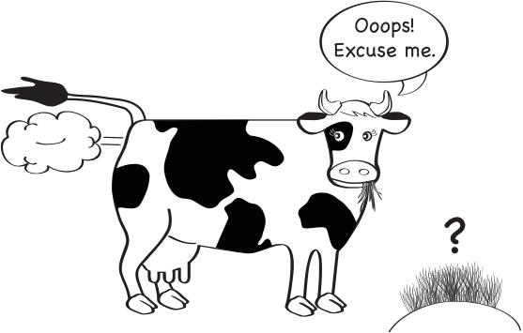
- What fuels can be made from dead plants and animals when they have been buried for a very long time?
- What natural processes or things use up the carbon dioxide in the atmosphere?
- What happens to the carbon dioxide in plants if they are burnt?
- Put a sea creature in the picture (see question 8). Draw arrows to show where it gets carbon from for its body and how it gives it back.

Resource 8 – Ocean acidification in a Jar

Aim
To find out how water absorbs carbon dioxide.
Equipment per group
- One glass jar
- Water
- Bromothymol blue
- One straw
Procedure
- Fill the glass jar with water.
- Add some bromothymol blue to the water until you get a blue colour (a few millilitres of bromothymol blue should be enough for one cup of water). The water will turn blue if it is basic, green if it is neutral and yellow if it is acidic. You want your water to be basic to start the investigation.
- Blow gently into the water using a straw.
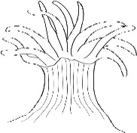
Answer the following questions in your journal:
- What happens to the colour of the water?
- What does this mean has happened to the water?
- Can you explain what this could mean for our oceans given the increase in carbon dioxide being released into the atmosphere by the burning of fossil fuels?

Resource 9 – Rubber egg experiment

Aim
To find out what could happen to shells and corals in more acidic waters.
Equipment per group
- Two hard boiled eggs (you could use raw eggs but it will end messy)  - Vinegar  - Tap water | - Two beakers (big enough to put the an egg into and easily cover with liquid)  - Litmus paper or a pH test kit
Procedure
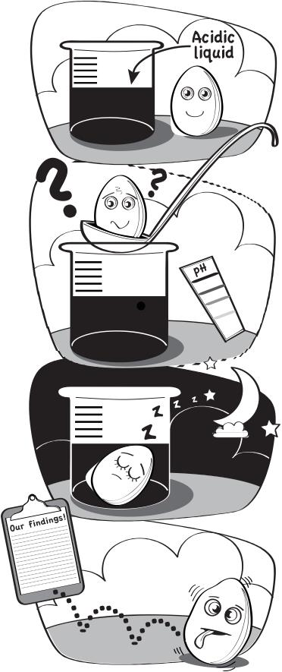
- Fill one of the beakers with vinegar and one with water.
- Measure the pH level of the vinegar and water to determine the acid level of each liquid.
- Carefully place an egg into each beaker.
- Leave three to four days (observing daily if possible).
- Remove the eggs from the beakers and record your findings.
Once complete, answer the following questions in your journal:
- What happened to the egg shells in each beaker? Why?
- Was there a difference depending on the pH of the substance used?
- How is pH related to ocean acidity?
- What does a lower pH mean for marine organisms?
- How are the atmosphere and the ocean connected?

Resource 10 – Coral growth data
Table 1: The table shows the total rate of growth (in mm per year) of coral patch reefs in different depths of water along the Great Barrier Reef*
Depth (m) | 0.5 | 1.5 | 2.5 | 3.5 | 4.5 | 5.5 | 6.5 | 7.5
Total growth  (mm in 1 year) | 8.9 | 10.3 | 16.2 | 9.2 | 12.1 | 10.6 | 9.9 | 7.8
Depth (m) | 8.5 | 9.5 | 10.5 | 11.5 | 12.5 | 13.5 | 14.5 | 15.5
Total growth  (mm in 1 year) | 5.8 | 8.4 | 7.8 | 8.7 | 9.3 | 9.4 | 9.4 | 9.3
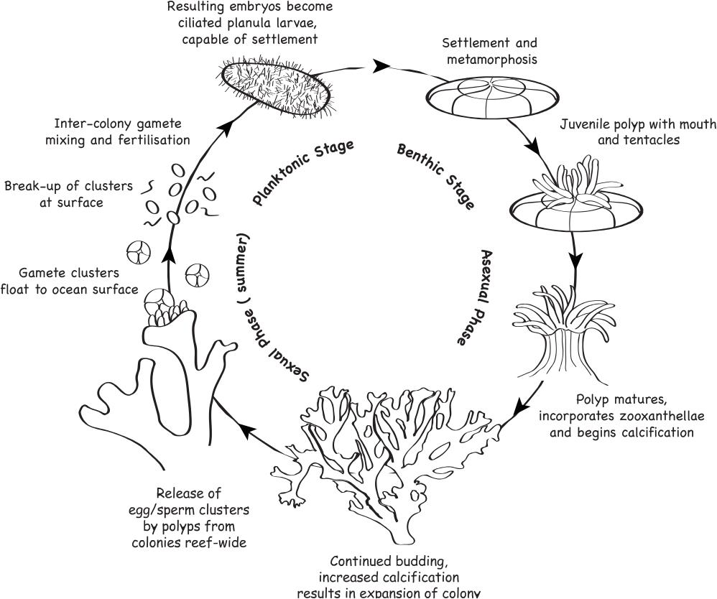
*This table shows an example of approximate coral growth rates. Different coral species grow at different rates and growth rates can also change due to environmental conditions.
Answer the following questions:
At what depth do these corals grow fastest?

At what depth do these corals grow slowest?

How might these corals be affected by sea level rise?

What other factors might influence coral growth?

Resource 11 – Futures circle
Students identify a certain event. As they move out of the circle, they define what gradually happens due to the event. For more advanced analysis of an event, students look at the N, S, E and W of an event - Natural, Social, Economic and who did it? And/or who will fix it? Students could then go on to investigate how it could be fixed.
Natural impacts
Social impacts
Economic impacts
Who did it?
Who will fix it?
EVENT
IMMEDIATE EFFECT
An immediate result of the event
SHORT AND LONG TERM EFFECTS
Things that happen more slowly over time due to the immediate impacts

Resource 12 – Student task sheet and Guide for making judgements

Climate change – Year 10 persuasive text

Your task:
You will write a persuasive text about climate change in the form of a magazine article, a newspaper editorial, an essay or a journal article. Use evidence-based arguments in your text and appropriate diagrams or pictures to represent your ideas.

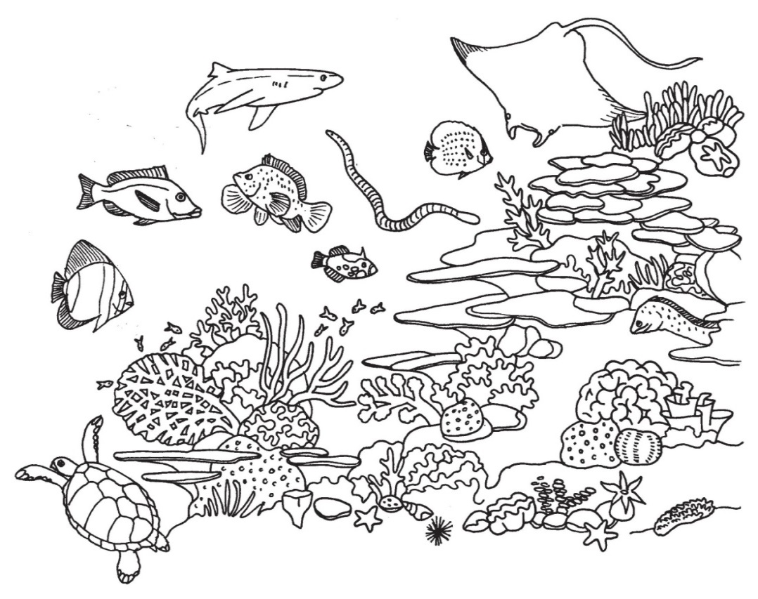
The persuasive text should include the following:
- A description of what climate change is
- A description of how climate change has affected biodiversity on the Great Barrier Reef.
- A description of how climate change may impact biodiversity of the Great Barrier Reef and other ecosystems in the future.
- Identified local and global actions that can be taken to reduce the impact of climate change.

Do not forget:
You will need to make sure you reference the carbon cycle and its interaction within and between the four global systems when you describe climate change and its impacts.

Year 10 Science: Climate change – persuasive text | Name:
Purpose: To describe what climate change is and how it has affected biodiversity on the Great Barrier Reef with reference to the carbon cycle and its interaction within and between the four global systems. Describe how climate change may impact biodiversity of ecosystems in the future and what local to global actions can be taken to reduce climate change impacts.
Explains how relationships with other living things and the environment assist or hinder its survival
Science Understanding |  | Science Inquiry Skills
Earth and space sciences |  | Communicating
Describes what climate change is and how it has affected biodiversity on the Great Barrier Reef with reference to the carbon cycle and its interaction within and between the four global systems. Describes how climate change may impact biodiversity of ecosystems in the future and what local to global actions can be taken to reduce climate change impacts |  | Constructs evidence-based arguments and selects appropriate representations and text types to communicate science ideas for specific purposes
 | Integrates all descriptions with scientific knowledge |  | Uses concise and coherent arguments and science terminology and representations throughout to suit the purpose | A
 | - Links all descriptions with scientific knowledge |  | - Uses coherent arguments and science terminology and representations throughout to suit the purpose | B
 | - Describes what climate change is and how it has affected biodiversity on the Great Barrier Reef with reference to the carbon cycle and its interaction within and between the four global systems. Describes how climate change may impact biodiversity of ecosystems in the future and what local to global actions can be taken to reduce climate change impacts |  | - Constructs evidence-based arguments and selects appropriate representations and text types to communicate science ideas for specific purposes | C
 | - Partially identifies what climate change is and recalls some affects to biodiversity on the Great Barrier Reef. Some recall of the carbon cycle and its interaction within and between the four global systems. Partial ideas of future impacts of climate change and actions that can be taken to reduce climate change impacts |  | - Constructs arguments and communicates using everyday language and representations | D
 | - Recalls some facts about climate change and the carbon cycle and its interaction within and between the four global systems |  | - Fragmented communication of science ideas | E
Teacher feedback:

