This information sheet has been developed to inform our stakeholders and the general public about the role of ports and shipping in the Great Barrier Reef Region and how GBRMPA is meeting the challenges of managing an ecologically sustainable multiple-use Marine Park.

The Great Barrier Reef Marine Park
The Great Barrier Reef Marine Park (Marine Park) is widely recognised as one of the best managed marine areas in the world., Almost the entire Great Barrier Reef ecosystem is included within the Marine Park which extends over 2300 kilometres along the coast of Queensland, covering some 344,400 square kilometres.²
Coastal ecosystems in and adjacent to the Great Barrier Reef are the critical habitats that connect the land and the sea. Coastal ecosystems and inshore biodiversity are sensitive to changes to the natural environment, in particular, land clearing and development.
Many vulnerable habitats and species occur in inshore areas of the Reef. The draft Great Barrier Reef Biodiversity Conservation Strategy 2012 provides overwhelming evidence that inshore habitats and species are in decline and being impacted by a range of activities including habitat loss due to coastal and port development.
Many of the at-risk habitats, species and groups of species identified in the Biodiversity Conservation Strategy can be found in the same areas as existing or proposed ports and their related activity. This related activity includes dredging and ship anchorage areas.
Management responsibility
The Great Barrier Reef Marine Park Authority (GBRMPA) is within the portfolio of the Australian Government Minister for the Department of Sustainability, Environment, Water, Population and Communities (DSEWPaC). GBRMPA manages the Marine Park in collaboration with a range of Queensland and Australian Government agencies. An intergovernmental agreement between the Queensland and Australian Government provides a formal framework for this collaboration. Management is further enhanced through partnerships with stakeholders, scientists and members of the Great Barrier Reef coastal community. Marine Park field management is conducted in partnership with the Queensland Parks and Wildlife Service (QPWS).4
GBRMPA and DSEWPaC share responsibility for World Heritage issues concerning the Marine Park. The Great Barrier Reef Marine Park Act 1975 (Marine Park Act 1975) is the primary legislation governing the Marine Park.

Supports multiple use and the economy

The Marine Park is a multi-use park that supports a range of activities, industries, communities and businesses including commercial marine tourism, fishing, recreation, scientific research, indigenous traditional use and ports and shipping. The Great Barrier Reef brings billions of dollars into Australia's economy each year and supports more than 50,000 jobs. Most uses of the Reef are dependent on it being an intact, healthy and resilient ecosystem.2 The Great Barrier Reef Marine Park Zoning Plan 2003 defines what activities can occur in which locations, both to protect the marine environment and to separate potentially conflicting activities.5
Jurisdictions within the Great Barrier Reef
The boundaries of the World Heritage Area and the Marine Park differ slightly, although the Marine Park makes up most (98.96 per cent) of the World Heritage Area. The only parts of the World Heritage Area which are not part of the Marine Park are Queensland internal waters, Queensland islands, islands of other tenure and some areas adjacent to the coast (including most ports).
One of the world's largest World Heritage Areas, the Great Barrier Reef was proclaimed in 1981 for its outstanding universal value.
GBRMPA has jurisdiction over activities within the Marine Park. The Great Barrier Reef Coast Marine Park is a State Marine Park that protects Queensland tidal lands and tidal waters and is managed under the Queensland Marine Parks Act 2004 by QPWS.

As most of ports in the Great Barrier Reef Region are located outside of the Marine Park, their activities are mostly managed by the Queensland Government unless they trigger matters of national environmental significance under the Commonwealth Environment Protection and Biodiversity Conservation Act 1999 (EPBC Act), where DSEWPaC also has jurisdiction. There are eight matters of national environmental significance protected under the EPBC Act, such as wetlands of international importance, threatened species and world heritage properties.

In 2009 the Marine Park was also included as a ‘matter of national environmental significance’. Since then development proposals outside the Marine Park likely to have a significant impact on the environment of the Marine Park, or other matters of national environmental significance must be assessed under the EPBC Act.

The legislative changes also created a better integration between the Marine Park Act 1975 and the EPBC Act, so that a single environmental impact assessment system can apply to development proposals in the Marine Park. If a development proposal is referred under the EPBC Act and the action or a component of that action requires a permit under the Marine Park Act 1975, the EPBC Act referral is also deemed to be a Marine Park application and a single assessment is conducted.

Where GBRMPA does not have direct jurisdiction for activities outside of the Marine Park, it takes an active role in providing advice and making recommendations to DSEWPaC on proposals referred under the EPBC Act.

Due to ports and shipping activities crossing jurisdictional boundaries including Queensland state waters, the Marine Park, the World Heritage Area, Commonwealth waters and international waters (ie shipping), ports and their associated activities are governed by local, state, national and international requirements for the protection of the environment.

Ports in the Great Barrier Reef
As Australia is dependent on maritime trade, our ports are an important gateway for goods. Consequently, ports and their associated infrastructure are of significant economic and social importance to Australia. Ports are also important for the competitiveness of Australian businesses which rely on them to deliver business inputs and to take exports to the global market.
A number of Queensland's ports, including those in the Great Barrier Reef Region, are considered nationally significant for cargo throughputs and contributions to the national economy — accounting for some 197 of the 942 tonnes of cargo which travel through Australian ports.
Importance for national and local economies
The value of Queensland's international seaborne trade is about $69 billion per year. During
2010–11, the value of coal exports reached $43.9 billion and the Queensland coal industry contributed $24.25 billion to the Australian economy during this period. Coal made up about 49 per cent of the total contribution of goods for overseas export during that year.
The Gladstone, Abbot Point and Hay Point ports, all located in the Great Barrier Reef Region, are major hubs for the export of coal. During
2010–11, the Port of Hay Point had the highest value of coal export among all Queensland ports at $18 billion.
The shipping industry that transits the waters of the Great Barrier Reef accounts for an estimated $38 billion of Australia's export trade each year (2011).¹¹

Great Barrier Reef Region ports

There are 12 ports in the Great Barrier Reef Region that are managed by four port authorities, all Queensland Government-owned corporations. The largest ports in infrastructure, operational capacity and size are the ports Abbot Point, Gladstone, Hay Point and Townsville. The minor ports of Quintell Beach on the east coast of northern Cape York, and Cooktown are the only ports located within the Marine Park. However, most ports are located within the World Heritage Area, as shown in Figure 1.
Growth in ports
Recently there has been a significant increase in the global demand for coal and the expectation is that this demand will continue. This has resulted in a number of planned new mines and mine expansions in Queensland. The Queensland Resources Council observes that in order to support the predicted increase in annual coal production, port capacity (including all Queensland's ports) would need to more than triple to reach 787 million tonnes by the year 2020, compared to its current level of about
242 million tonnes.¹³
There has also been a number of proposals for significant port expansions to service additional coal exports, including ports at Hay Point, Abbot Point and Gladstone. The Port of Hay Point is already one of the largest coal export ports in the world.

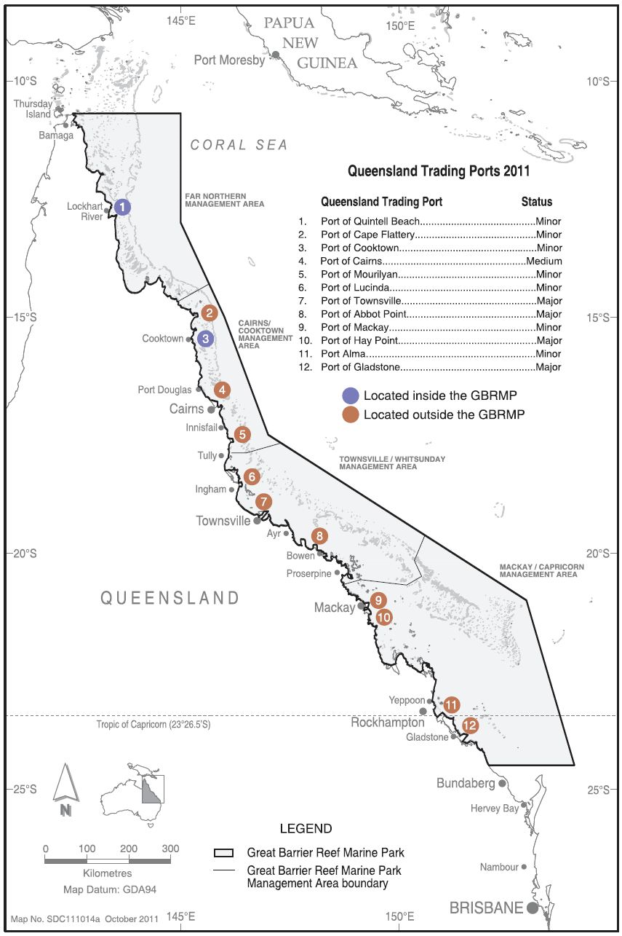
Figure 1: Map of Queensland ports in the Great Barrier Reef Region. Source: GBRMPA.

Challenges for the Great Barrier Reef

Outlook for the Great Barrier Reef

While the Great Barrier Reef is one of the most closely managed marine areas in the world it is facing challenges from a range of threats. The Great Barrier Reef Outlook Report 2009 identified climate change, continued declining water quality from catchment runoff, loss of coastal habitats from coastal development and impacts from fishing, illegal fishing and poaching as major threats to the health of the Great Barrier Reef, with moderate but localised risks posed by ports and shipping activities.¹⁴
Since the release of the Outlook Report in 2009 and as a result of mining and coal seam gas industry growth, there has been a significant increase in development proposals to expand all of Queensland's major trading ports, including several new port development proposals. These inshore areas of the Great Barrier Reef are where species and habitats critical to the healthy functioning of the Reef's ecosystems are under the greatest pressure from a range of threats, including coastal development.
Development proposals can be viewed on the DSEWPaC's website at http://www.environment.gov.au/epbc/recent-notices.html.
Ports
Mining and coal seam gas industry growth will also drive port expansions and a rise in shipping traffic through Great Barrier Reef waters. The construction, operation and maintenance of land and ocean-based activities include but are not limited to:
- terminals
- storage and waste facilities
- cargo holding facilities
- loading and un-loading facilities
- stockpiles
- lay-down areas
- land reclamation
- de-watering and management of tail waters
- water storage ponds
- rail and road networks
- trestles
- installation of safety and navigational aids and lighting
- monitoring buoys
- tug boat and shipping berths
- dredging and sea dumping.
The extent to which this increase in ports and shipping activities will emerge as a threat to the health of the Great Barrier Reef will undoubtedly depend on how well these activities are managed by all stakeholders, industries and regulators.
Dredging and dredge disposal
Dredging takes place for the purposes of maintaining safe access channels for ships into ports. Dredging and dredge disposal in Queensland occurs both inside the Marine Park and outside the Marine Park boundary (but within the World Heritage Area).
Capital vs maintenance dredging
Capital dredging is dredging for navigation, to create new or enlarge existing channels, berth areas, swing basins, marinas and boat harbour areas.¹⁴
Maintenance dredging is undertaken to ensure that previously dredged channels, berths or construction works are maintained at their designated dimensions.¹⁴ Maintenance dredging and disposal projects are often undertaken by the Queensland Government, or private marina operators to maintain existing recreational and tourism access to the Great Barrier Reef.
Dredge material disposal and sea dumping
Dredge material disposal is the relocation of dredged material from the dredging site to a designated disposal site. Disposal sites may include ocean or land-based receiving facilities. When disposal sites are ocean-based, the disposal is often referred to as sea dumping.¹⁴

Existing ocean dredge material disposal sites are located both within the Marine Park and outside the Marine Park (Figure 2a and 2b).
Potential environmental impacts of port expansions, dredging and sea dumping
Impacts to the marine environment from the operational activities associated with ports may include:
- removal of existing habitats such as seagrasses^{14,,,}
- reclamation
- seabed disturbance¹⁸
- cumulative losses of species and habitats which are of environmental significance^{15,}
- creation of artificial habitats¹⁹
- degradation of water quality^{16,17,19,}
- burial and smothering of benthic fauna and flora^{16,17,20}
- changes to hydrodynamics, including turbidity and re-suspension which can affect sensitive areas such as seagrasses and corals a long way from dredge disposal grounds^{15,16,20}
- changes to coastal hydrology
- introduction of contaminants¹⁶
- transport or resuspension of contaminants2
- increased underwater noise,
- pollution from port waste²¹
- alteration of coastal processes²³
- injury or mortality to marine wildlife including species that are ecologically significant or are considered threatened, endangered or vulnerable to extinction^{15,} ^{17,18,19}
- translocation of pest species
- impacts from coal dust²¹
- increase in CO₂ emissions
- displacement of other Marine Park users, including loss of amenity and safety considerations
- impacts to local communities from increased dust, noise and lighting²¹
- introduction of harmful substances and odours²⁵
- loss of amenity, aesthetic values for nearby communities²⁵
- socio-cultural impacts.²⁵
Regulatory framework for dredging and sea dumping
Legislation
International protocols and Commonwealth legislation require the protection and preservation of the marine environment from dredge-related pollution at sea.
Australia is party to the 1996 Protocol to the Convention on the Prevention of Marine Pollution by Dumping of Wastes and Other Matter 1972 (London Protocol) which recognises measures that prevent, reduce and where practicable eliminate pollution caused by the dumping of waste at sea.
Any disposal of dredge material in the World Heritage Area is subject to comprehensive environmental assessment and decision under the EPBC Act and the Environment Protection (Sea Dumping) Act 1981 (Sea Dumping Act).
For loading or dumping and artificial reef placements within the Marine Park, GBRMPA assesses and grants or refuses sea dumping permits under the Sea Dumping Act, even if other activities associated with dumping, such as dredging, may occur outside the Marine Park.
For sea dumping in the Marine Park, a permit under the Marine Park Act 1975 is also required.
Policies and guidelines
There are a number of Commonwealth policies and guidelines that apply to sea dumping and dredging activities in the marine environment and Marine Park. These documents support international and Commonwealth legislation and are based on the best available scientific information. They are designed to prevent or minimise as much as possible, environmental harm that may be caused by the activity.
- The National Assessment Guidelines for Dredging (2009) (NAGD) describe in detail, the procedures which are to be followed in sampling, testing and assessing the suitability of material to be disposed at sea and requirements for the evaluation and monitoring of disposal sites.
- GBRMPA's Dredging and Spoil Disposal Policy (2010) describes the management arrangements in place for the mitigation of environmental impacts associated with dredging and sea dumping in the Marine Park. The policy stipulates that if dredge material is contaminated above the maximum levels defined in the National Ocean Disposal Guideline for Dredged Materials 2002, it must not be disposed in the Marine Park. The policy also contains provisions for long-term management plans and monitoring, caps on annual maintenance dredge volumes, and the use of environmentally friendly dredge methods close to sensitive environments.
- Compliance with GBRMPA's Water Quality Guidelines for the Great Barrier Reef Marine Park (2010) must be considered for dredging and disposal activities inside the Marine Park. The guidelines prescribe the maximum concentrations of sediment, nutrients and pesticides permitted to protect marine species and the health of the Great Barrier Reef's ecosystem.
- GBRMPA's Environmental Impact Management Policy applies when assessing major developments in the Marine Park.
Assessment of dredging and sea dumping proposals

Sea dumping proposals are rigorously assessed by GBRMPA under a regulatory framework that includes evaluating disposal alternatives and waste minimisation procedures, site and impact assessments, and management and monitoring programs.

The assessment considers any land-based alternatives to sea dumping such as beneficial
re-use, recycling, or treating the material without presenting risks to human health, the environment or disproportionate costs. If viable alternatives to sea dumping exist, an application for a sea dumping permit is unlikely to be approved.

If GBRMPA determines that disposal at sea is the only viable option, the proponent must demonstrate that the dredge material is suitable for ocean disposal by way of a comprehensive sediment quality assessment (which can involve chemical testing, toxicity testing and bioavailability testing) in accordance with the NAGD 2009.

A proposed ocean disposal site must comply with the guidelines, and include operational considerations, bathymetry and seafloor topography, substrate type, hydrographic factors and ecological and economic factors.

GBRMPA assesses each application for sea dumping on a case-by-case basis, taking a risk-based approach in line with all relevant legislation, policies and guidelines.

Permissions granted for dredging or sea dumping inside the Marine Park place certain obligations on the permittee which may include (but are not limited to) having an approved environmental management plan, requirements for environmental site supervision, dredge plume hydrodynamic modelling, water quality monitoring and offsets.
Status of dredging and dredge disposal activities in the Great Barrier Reef Region

On average, over the last 10 years, 902,154 cubic metres of capital dredge material and
362,392 cubic metres of maintenance dredge material were disposed each year within the Marine Park (Figure 3). These activities were permitted only after a rigorous environmental impact assessment which included examining alternative disposal options, analyses of sediment composition and possible contaminants and assessing possible impacts from dredge plumes and re-suspension.

Existing permits and current applications
The following website shows the status of current permits and applications for the Marine Park which includes a search function for dredging and dredge disposal activities.
http://www.gbrmpa.gov.au/zoning-permits-and-plans/permits/reef-permits

Forecast increases in dredging and dredge disposal

There are proposed expansions in at least four of the 12 Queensland ports along the coastline of the Great Barrier Reef including new berths, new trestles, dredge channels and land-based development.
Proposals include a major expansion of the coal export infrastructure at Abbot Point and new port facilities at Dudgeon Point (which will form part of the Port of Hay Point). The Port of Townsville is expanding with a proposed 100 hectare reclamation to accommodate an additional six berths. The Port of Gladstone is undergoing significant expansion with port developments, liquefied natural gas (LNG) developments on Curtis Island, reclamation and a large-scale dredging and disposal program.
As of July 2012, there were three proposals for the development of new ports on previously undeveloped sites at Wongai (Bathurst Bay, Cape York), Fitzroy Terminal (in the vicinity of Port Alma) and Balaclava Island (near Curtis island, Gladstone).
The volume of dredge material proposed to be disposed in the Marine Park as a result of these expansion proposals is likely to increase, particularly over the next three years. Figure 3 shows a projected 3–17 million cubic metres of capital and maintenance dredge material volumes for disposal. Volumes are based on current proposals compared with actual volumes that were disposed in the Marine Park, over the last
10 years.

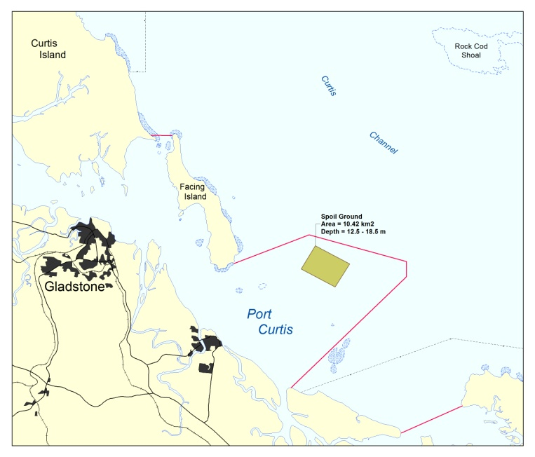
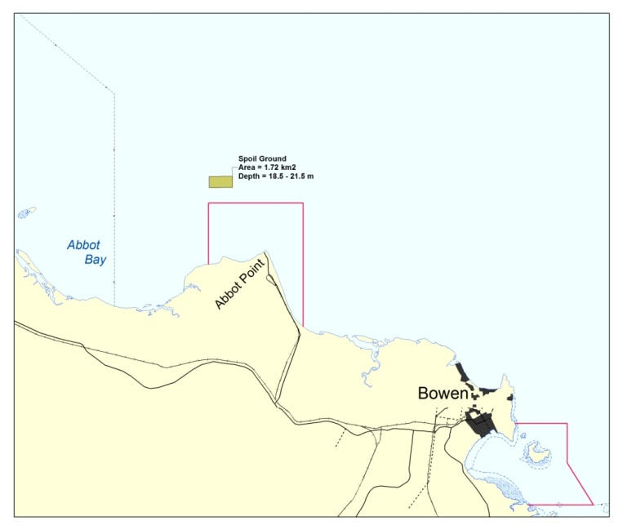
Figure 2a: Examples of ports that have dredge disposal grounds (in green) in the Marine Park (Abbot Point) and ports that have dredge disposal grounds outside the Marine Park (Gladstone). Red line is the boundary of the Marine Park.
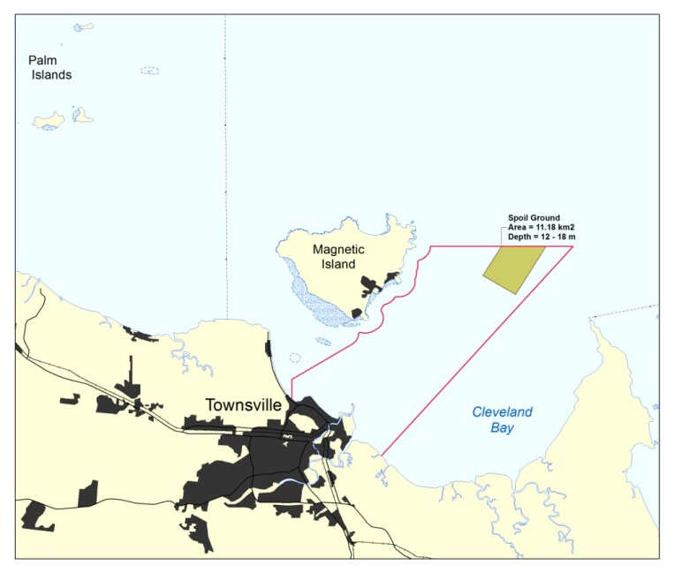
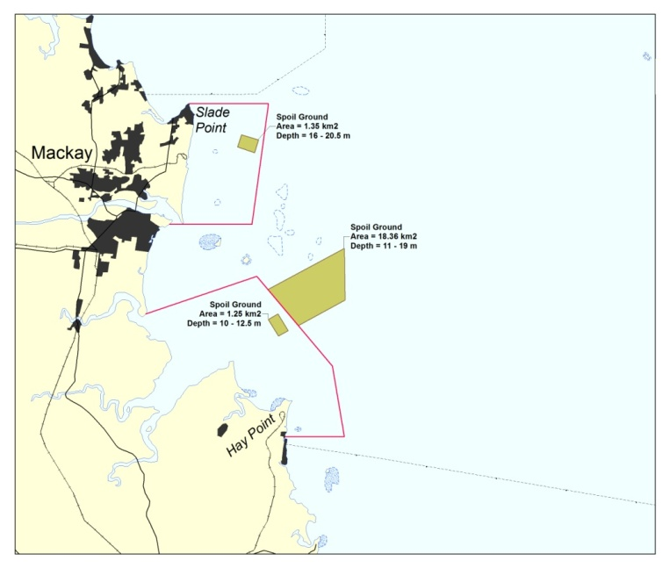
Figure 2b: Examples of ports that have dredge disposal grounds (in green) in the Marine Park (Hay Point) and ports that have dredge disposal grounds outside the Marine Park (Mackay, Townsville). The red line is the boundary of the Marine Park.

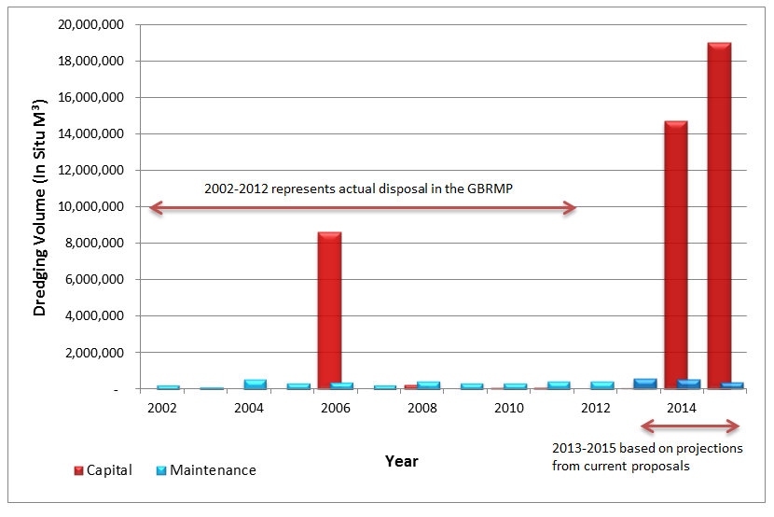
Figure 3: Actual historical dredge disposal volumes compared to projected future dredge disposal volumes to the Marine Park based on information supplied by permittees (in accordance with GBRMPA permit requirements) and EPBC referrals. Potential maximum projections are based on all referred projects being approved and proceeding as proposed. Source: GBRMPA and DSEWPaC.

Shipping

Status of Shipping in the Great Barrier Reef Region

Commerical shipping in the Great Barrier Reef Region is vital to Australia's economy for facilitating the import and export of goods and services.

Global factors directly affect shipping activity, and in turn the ports that service it. The global economy also drives the need for product export and imports. The amount of shipping in the Great Barrier Reef is, in part, a direct reflection of the global demand and development occurring overseas and the need for products to supply economic activity.9

Shipping in Reef waters likely to increase
Over the last 10 years there has been a gradual increase in individual ships transiting the Marine Park to Queensland ports, representing an annual average growth rate of 2.1 per cent. In 2012, 3950 ships called at Great Barrier Reef ports.²⁹ This increase has been driven mainly by industry and mining demands.² The average size of ships is also increasing. World-wide, the general trend shows an 85 per cent increase in the average size of ships over the last 15 years.
As levels of shipping activity are affected by a number of economic factors, it is difficult to predict the amount of shipping that will occur through the waters of the Great Barrier Reef in future years.
Economic forecasts show that there will be a significant increase in shipping in Reef waters over the next 20 years as a result of mining and LNG industry growth, port expansions and increases in trade (Figure 4). These forecasts may be considered as an upper limit.²⁹ The actual number of vessels may well be lower than this forecast. Market forces, changing economic circumstances and cost factors greatly influence export volumes and thus shipping trade that will ultimately eventuate.
In the Great Barrier Reef Region, shipping includes iron ore, coal, LNG, sugar, timber, oil, chemicals, live cattle and general cargo. There are a range of chemicals and hazardous and noxious substances (HNS) transported by ships transiting through the Great Barrier Reef. Hazardous and noxious substances are either carried in bulk or in packaged form inside shipping containers. These substances are often mining by-products and or used to extract minerals from ore. They may include, for example, sulphuric acid, ammonia, sodium cyanide and caustic soda.
Potential environmental impacts of shipping in the Great Barrier Reef
There are a range of potential impacts associated with shipping activity in the Marine Park and World Heritage Area. Potential impacts include:
- accidents, incidents and groundings,
- oil or chemical spills,
- waste discharges
- atmospheric pollution,,
- pollution from illegal dumping
- introduction and translocation of invasive marine species²⁴
- introduction of harmful substances
- anchor damage to the benthos
- vessel strike on threatened or migratory species
- displacement of other users through the exclusive use of anchoring areas
- social and economic impacts²¹
- impact to or loss of aesthetic values of the Great Barrier Reef
- increase in CO₂ emissions²⁵
- increased underwater noise resulting in displacement, hearing loss and stranding.²²

Despite increases in shipping traffic, improvements in shipping safety management have resulted in fewer major shipping incidents in the past 10 years², with almost all ships travelling safely along the designated shipping routes of the Great Barrier Reef.²² However when they do occur, ship groundings, and oil, chemical and hazardous and noxious substance spills have the potential to cause extensive, long-term damage to the environment, economic activity and socio-cultural activites in the region and may carry significant human health and safety risks.²⁵ The most recent major incident was the grounding of the Shen Neng in April 2010.
Regulatory framework for shipping
In recognition of the outstanding universal value of the GBRWHA, and the need to protect it from potential shipping impacts, the International Maritime Organization (IMO) in 1990 designated the Great Barrier Reef as a Particularly Sensitive Sea Area (PSSA). This allows internationally recognised ‘associated protective measures’ to be used. PSSAs of the marine environment need special protection through action by the IMO because of the significance of their recognised ecological, socio-economic or scientific attributes where such attributes may be vulnerable to damage by international shipping activities. This has allowed Australia to implement a range of special protective measures to control shipping operations.
Two agencies from the Australian Government (the Australian Maritime Safety Authority (AMSA), http://www.amsa.gov.au/, and GBRMPA), and one agency from the Queensland Government (Maritime Safety Queensland, http://www.msq.qld.gov.au/), administer a suite of special measures under international and domestic law to regulate ship activities in the Great Barrier Reef Region. Navigation markers, designated shipping channels and passages, ship routeing, traffic management, shore-based monitoring, emergency response arrangements and pilotage comprise the current key risk mitigation measures to ensure ships safely transit the Great Barrier Reef. These measures are being reviewed.
Shipping management measures
Environmental protection measures implemented under the Marine Park Act 1975 include compulsory pilotage and a zoning system, in accordance with the Great Barrier Reef Zoning Plan 2003 which confines shipping traffic to designated shipping areas. Table 1 shows when shipping management measures have been implemented in the Great Barrier Reef from 1990 to 2011.

Figure 4: Projected shipping increases in the Great Barrier Reef Region

Table 1 – Timeline of shipping management measures in the Great Barrier Reef
Year | Management arrangement
1983 | Designation of the Capricorn and Bunker Groups of Islands as an Area to be Avoided by IMO.
1990 | The IMO designated the Great Barrier Reef Marine Park as one of the world’s first Particular Sensitive Sea Areas (PSSA).
1991 | The associated protective measure of a compulsory pilotage regime was first introduced to the northern part of the inner route from Cape York to Cairns.
1997 | A Ship Reporting System (SRS) was introduced as a joint initiative between AMSA and the Queensland Department of Transport in 1997 this system is known as REEFREP.
1999 | GBRMPA Cruise Shipping Policy implemented. This policy contains a number of environmental protection measures which include a booking system prior to visiting designated cruise ship anchorages in the Marine Park and where preliminary safety and environmental assessment raises issues with a proposed cruise ship anchorage in the Marine Park, a full risk analysis approach will be adopted.
2004 | Great Barrier Reef Marine Park Zoning Plan 2003 came into effect, with new rules that apply to shipping. Ships may only navigate within the Designated Shipping Area and the General Use Zone. The Designated Shipping Area has been placed to minimise the impact on the shipping industry whilst having regard for Australia's international obligations.
2004 | 1 December 2004, amendments to introduce a Coastal Vessel Traffic Services were declared by the IMO as a measure to further enhance navigational safety in Torres Strait and the Great Barrier Reef. The Great Barrier Reef and Torres Strait Vessel Traffic Service (REEFVTS) is comprised of two major components: (1) the mandatory Ship Reporting System, REEFREP; and (2) monitoring and surveillance systems including radar, Automatic Identification System (AIS), Automated Position Reporting via Inmarsat C (APR) and VHF Reporting.
2006 | Associated protective measures were approved by IMO for application, being an extension of the system of pilotage that had applied in the Great Barrier Reef since 1990 via Marine Order Part 54. (Hydrographers Passage and Whitsundays)
2006 | AMSA also implemented the National Maritime Emergency Response Arrangements (NMERA). NMERA’s aim is to protect the marine environment from actual or potential ship-sourced pollution. Under the NMERA, a number of Emergency Towage Vessels (ETVs) are located in strategic Australian coastal regions. AMSA has contracted a dedicated ETV – the Pacific Responder - that operates 24/7 under AMSA’s direction to provide emergency towage and first response capability in the PSSA in the Torres Strait and Great Barrier Reef area north of Cairns/Mourilyan.
2008 | Phase is completed for Automatic Identification Systems (AIS) to be carried on board vessels as per the International Convention for the Safety of Life at Sea 1974 (SOLAS).
2011 | Extension of the existing ship reporting and vessel traffic service boundary to the southern Marine Park boundary.
Source: GBRMPA.

Meeting the challenge: Ecologically sustainable development of ports and shipping

GBRMPA is committed to protecting the Great Barrier Reef while ensuring the sustainable development of ports and shipping. GBRMPA aims to achieve this through a range of management initiatives, through partnerships and in consultation and collaboration with industry, government agencies and other Great Barrier Reef stakeholders.

Protecting the Reef: Comprehensive Strategic Assessment
A key focus for GBRMPA is a joint Australian and Queensland government comprehensive strategic assessment of the World Heritage Area and adjacent coastal zone under the EPBC Act, with the aim of assessing and managing the impacts of actions, including coastal development, on the World Heritage property and other matters of national environmental significance. The comprehensive strategic assessment presents an opportunity to better address cumulative impacts from multiple developments over a time period. The strategic assessment is being prepared and will be available for public consultation in 2013.
There are two key components of the strategic assessment — a marine component and a coastal component, both of which are intrinsically linked.
GBRMPA is leading the marine component which is looking at the arrangements in place to manage and protect matters of national environmental significance including the Marine Park and World Heritage Area.
The Queensland Government is leading the coastal component which is looking at coastal developments and planning for urban, industrial and port developments. It will also examine the processes and management arrangements in place to ensure development occurs sustainably and does not impact unacceptably on matters of national environmental significance.
The two assessments together will form a comprehensive strategic assessment of the World Heritage Area and the adjacent coastal zone and will:
- Investigate the adequacy of the existing management arrangements for the World Heritage Area.
- Assess current and future planned development in the World Heritage Area and the adjacent coastal zone and analyse its likely direct, indirect and cumulative impacts.
- Assess the potential impacts on matters of national environmental significance from the management arrangements for the World Heritage Area and the implementation of the Queensland coastal management, planning and development framework.
GBRMPA and the Queensland Government will work together to analyse impacts at the marine–coastal interface from activities such as shipping, water quality management in reef catchments and island management.
The strategic assessment will help identify, plan for and manage existing and emerging risks to ensure the ongoing protection and management of the unique environmental values of the World Heritage Area, the Marine Park, the adjacent coastal zone and other matters of national environmental significance.
Achieving ecologically sustainable outcomes for ports and shipping
GBRMPA is developing a number of management initiatives that will inform the strategic assessment and establish best practice environmental management to address risks to the values of the Marine Park and World Heritage Area while providing for ecologically sustainable development of ports and shipping.

GBRMPA working with stakeholders
As part of this process, GBRMPA is working with stakeholders to promote stewardship in environmental management, including the development of innovative management tools and incentives for the adoption of best practice environmental management.
Management initiatives
Management initiatives will include (but are not limited to) the following:
- Working in partnership with North Queensland Bulk Ports (NQBP), key stakeholders and DSEWPaC to assess proposed developments in the Port of Abbot Point area to examine the cumulative impacts of their proposed activities.
- Identifying and engaging with all port-related stakeholders and initiate an improved memorandum of understanding and develop best practice port management guidelines. GBRMPA will also develop industry-specific position papers, including shipping and ports. The aim of these position papers and guidelines is to establish ecologically sustainable management frameworks and incorporate best practice management techniques to minimise environmental impacts from ports and shipping.
- Developing guidelines for hydrodynamic modelling for dredging projects to provide a framework for effective application of modelling in the Marine Park and to assist in the prediction of potential impacts associated with dredge plumes.
- Undertaking targeted research projects (funded through the Australian Government’s Sustainable Regional Development program) to address key knowledge gaps relating to ports and shipping. Studies will examine ways to improve management of dredge material disposal in the Great Barrier Reef Region and identify the impacts and effective management strategies associated with offshore ship anchorages in the World Heritage Area. The outcomes of research will inform the comprehensive strategic assessment.
- Working closely with AMSA, other government agencies and industry stakeholders to prepare the North East Shipping Management Plan to assess the effectiveness of current shipping safety measures and identify additional or enhanced measures that may be needed in the future. The plan will focus on issues directly related to the safety of shipping such as navigation, routeing, water space management as well as issues that prevent or mitigate ship-sourced pollution.
GBRMPA intends to actively work with our stakeholders including the ports and shipping industries, DSEWPaC and other Australian and Queensland government agencies to develop initiatives and innovative management tools to ensure that ports and shipping are sustainable in the Great Barrier Reef and that the Reef is preserved now and in the future.

Great Barrier Reef Marine Park Authority Decision
Approved by: | General Manager, Marine Park Management, Great Barrier Reef Marine Park Authority, August 2012
Last reviewed: | May 2013 –
Next review: | December 2013
Created: | March 2012

Further information contact:

GBRMPA Ports and Shipping Team
ports@gbrmpa.gov.au or phone (07) 4750 0700

References

United Nations Educational, Scientific and Cultural Organization [UNESCO] World Heritage Committee Mission Report – Great Barrier Reef (Australia) (N 154) June, 2012.
Great Barrier Reef Marine Park Authority (2009). Outlook Report 2009.http://www.gbrmpa.gov.au/__data/assets/pdf_file/0018/3843/OutlookReport_Full.pdf
Great Barrier Reef Marine Park Authority (2012). Informing the Outlook for the Great Barrier Reef coastal ecosystems (Draft), Great Barrier Reef Marine Authority, Qld.
Great Barrier Reef Marine Park Authority (2012). Great Barrier Reef Biodiversity Conservation Strategy 2012, GBRMPA, Townsville. See http://www.gbrmpa.gov.au/__data/assets/pdf_file/0020/21728/BioStrategy-DRAFT-Aug-2012.pdf
Access Economics Pty Ltd (2008). Measuring community attitudes and awareness towards the Great Barrier Reef 2007. Research publication 90, Great Barrier Reef Marine Park Authority, Townsville, Australia. http://www.gbrmpa.gov.au/__data/assets/pdf_file/0019/5590/gbrmpa_RP90_Measuring_Community_Attitudes_And_Awareness_Towards_The_GBR_2008.pdf
National Transport Commission (2010). National Ports Strategy – Infrastructure for an economically, socially and environmentally sustainable future – December 2010. http://www.infrastructureaustralia.gov.au/gateways/files/National_Ports_Strategy_DEC2010_v2.pdf
Ports Australia (2012). Total throughput. See http://www.portsaustralia.com.au/tradestats/?id=1&period=11
Department of Foreign Affairs and Trade (2011). Australia's trade performance 1990-91 to 2010-11. See http://www.dfat.gov.au/publications/stats-pubs/australias-trade-performance-1990-91-2010-11.pdf
Queensland Treasury and State (2011). Annual Economic Report on the Queensland Economy year ended June 2011. See http://www.oesr.qld.gov.au/products/publications/annual-econ-report/annual-econ-report-2010-11.pdf
Bureau of Resources and Energy Economics [BREE] (2012). Energy in Australia 2012. See http://bree.gov.au/documents/publications/energy/energy-in-australia-2012.pdf
Office of Economic Statistical Research (2012). Overseas export of goods by port, value, Queensland port, 2001-02 to 2011-12p. See http://www.oesr.qld.gov.au/subjects/economy/trade/tables/os-export-goods-port-qld-ports/index.php
Deloite Access Economics (2011, November). Queensland Resource Council Queensland resource sector state growth outlook study. See http://www.qrc.org.au/_dbase_upl/Growth%20Outlook%20Report_Final.pdf.
Bureau of Resources and Energy Economics [BREE] (2012). Australian bulk commodity export and infrastructure – outlook to 2025. See http://www.bree.gov.au/documents/publications/resources/Export-Infrastructure-Report.pdf
Brunner, R.W.J. (2011). Sustainability in the Design of Bulk Coal Ports – an Australian Case Study. General Manager Planning – Hay Point, North Queensland Bulk Ports Corporation Limited.
Erfemeijer, P. L. A. & Lewis III, R. R. R. (2006). Environmental impacts of dredging on seagrass: A review. Marine Pollution Bulletin, 52(12), pp. 1553-1572.
Rasheed, K. & Balchand, A. N. (2007). Environmental studies on impacts of dredging. International Journal of Environmental Studies, 58(6), pp. 703-725.
Smith, R., Boyd, S. E., Rees, H. L., Dearnaley, M. P. & Stevenson, J. R. (2006). Effects of dredging activity on epifaunal communities – Surveys following cessation of dredging. Estuarine, Coastal and Shelf Science, 70, pp. 207-223.
Foster, T., Corcoran, E., Erftemeijer, P., Fletcher, C., Peirs, K., Dolmans, C., Smith, A., Yamamoto, H. & Jury, M. (2010). Dredging and port construction around coral reefs, PIANC Environmental Commission, Report No 108.
Greenpeace (2012, March). Boom goes the reef: Australia's coal export boom and the industrialisation of the Great Barrier Reef. Retrieved from http://www.greenpeace.org/australia/Global/australia/reports/Download%20the%20report.pdf
Smith, A., Koloi, P., Foster, T. Monkivitch, J., Edison, K. Molly, F. & Johnston, M. (2007). Dredging in sensitive coral environments, GBRMPA experience, lessons learned and initiatives for the future. GBRMPA staff papers.
United Nations Economic and Social Commission for Asia and the Pacific, Transport Division. (1992). Assessment of the Environmental Impact of Port Development. A Guidebook for EIA of Port Development. UNESCAP reference number: ST/ESCAP/1234, New York.
McKenna, M. F., Ross, D., Wiggins, S. M. & Hildebrand, J. A. (2012). Underwater radiated noise from modern commercial ships. The Journal of the Acoustical Society of America, 131(1), pp. 92-103.
Ellison, W. T., Southall, B. L., Clark, C. W. & Frankel, A. S. (2011). A new context-based approach to assess marine mammal behavioural responses to anthropogenic sounds. Conservation Biology, 26(1), pp. 21-28.
Hayes, K., Sliwa, C., Migus, S., McEnnulty, F & Dunstan, P. (2005, February). National priority pests: Part II Ranking of Australian marine pests. An independent report undertaken for the Department of Environment and Heritage by CSIRO Marine Research.
OECD (2011). Environmental Impacts of International Shipping: The The role of Ports, OECD Publishing. http://dx.doi.org/10.1787/9789264097339-en
National Assessment Guidelines for Dredging (2009). See http://www.environment.gov.au/coasts/pollution/dumping/publications/pubs/guidelines09.pdf
National Ocean Disposal for Dredged Materials (2002). See http://www.environment.gov.au/coasts/pollution/dumping/publications/pubs/guidelines.pdf
Bureau of Transport and Regional Economics (2007). Australian sea freight 2005-2006. Information paper 60, Bureau of Transport and Regional Economics, Canberra, Australia.
PGM Environment (2012), Great Barrier Reef Shipping: Review of Environmental Implications, pp.18, 60.
Shipping Statistics and Market Review (2011). Institute of Shipping Economics and Logistics, 55(1-2).
Asia Pacific ASA. See http://www.asascience.com/about/index.shtml
Smith, A., Marshall, P., Christie, C. & Storrie, J (2002). Environmental management of a shipping accident in the world's largest marine park. Australian Journal of Environmental Management. 9(2), pp. 74-76.
Marshall, P., Christie, C., Dobbs, K., Green, A., Haynes, D., Brodie, J., Michalek-Wagner, K., Smith, A., Storrie, J. & Turak, E. (2002). Grounded ship leaves TBT-based antifoulant on the Great Barrier Reef : an overview of the environmental response. Spill Science & Technology Bulletin. 7(5-6), pp. 215-221.
Great Barrier Reef Marine Park Authority (2010, April 23). Marine Shipping Incident. Great Barrier Reef Marine Park - Douglas Shoal: Information Sheet 3. Retrieved from http://www.gbrmpa.gov.au/__data/assets/pdf_file/0003/17832/Shen-Neng-information-sheet-3.pdf
The Australian (2010, April 4). Great Barrier Reef island oil spill clean-up starts, Retrieved from http://www.theaustralian.com.au/news/health-science/great-barrier-reef-island-oil-spill-clean-up-starts/story-e6frg8y6-1225853562627
Polglaze, J. (2003). Can we always ignore ship-generated food waste? Marine Pollution Bulletin, 46, pp. 33-38.
Ocean Commission (2003). General vessel pollution issues and cruise ship pollution. Retrieved from http://www.oceancommission.gov/meetings/apr2_3_03/minutes/gen_vessel_pollution.pdf
Pandolfi, M., Gonzalez-Castanedo, Y., Alastuey, A., de la Rosa, J. D., Mantilla, E., de la Campa, A. S., Querol, X., Pey, J., Amato, F. & Moreno, T. (2011). Source appointment of PM10 and PM2.5 at multiple sites in the strait of Gibraltar by PMF: impact of shipping emissions. Environmental Science and Pollution Research, 18, pp. 260-269.
National Oceanic and Atmospheric Administration [NOAA] (2011, September 12). NOAA led study: Air pollution caused by ships plummets when vessels shift to cleaner, low sulfur fuels. Retrieved from http://www.noaanews.noaa.gov/stories2011/20110912_shipemissions.html
Dinsdale, E. A. & Harriott, V. J. (2004). Assessing anchor damage on coral reefs: A case study in selection of environmental indicators. Environmental Management, 33(1), pp. 126-139.
Vanderlaan, A. M. & Taggart, C. T. (2007, January). Vessel collisions with whales: the probability of lethal injury based on vessel speed. Marine Mammal Science, 23(1): pp. 144-156.
Australian Maritime Safety Authority, National Plan to Combat Pollution of the Sea by Oil and other Noxious and Hazardous Substances Annual Report 2009-10. http://www.amsa.gov.au/Marine_Environment_Protection/National_plan/
Australian Maritime Safety Authority (2010, April), Improving safe navigation in the Great Barrier Reef. http://www.amsa.gov.au/shipping_safety/Great_Barrier_Reef_and_Torres_Strait/documents/AMSA%20report%20of%20safe%20navigation%20in%20the%20GBR.pdf

