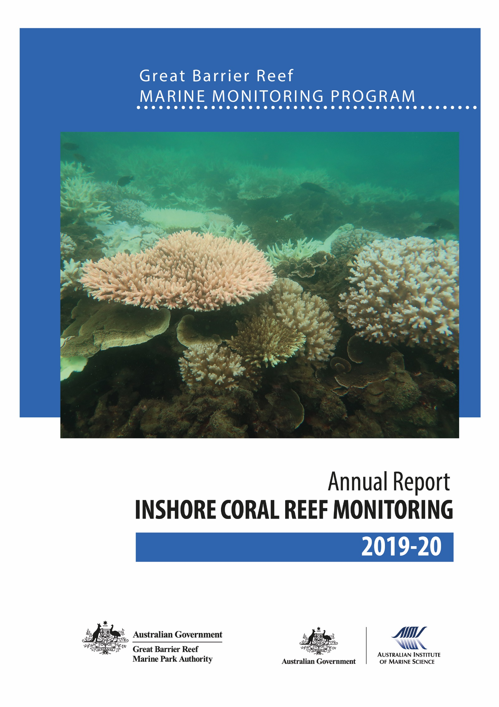
© Copyright Commonwealth of Australia (Australian Institute of Marine Science) 2021
Published by the Great Barrier Reef Marine Park Authority
ISSN 2208-4118

A catalogue record for this publication is available from the National Library of Australia

This document is licensed by the Commonwealth of Australia for use under a Creative Commons By Attribution 4.0 International licence with the exception of the Coat of Arms of the Commonwealth of Australia, the logo of the Great Barrier Reef Marine Park Authority and the Australian Institute of Marine Science, any other material protected by a trademark, content supplied by third parties and any photographs. For licence conditions see: http://creativecommons.org/licences/by/4.0

This publication should be cited as:
Thompson, A., Costello, P., Davidson, J., Logan, M., Coleman, G. 2021, Marine Monitoring Program Annual Report for Inshore Coral Reef Monitoring: 2019–20. Report for the Great Barrier Reef Marine Park Authority, Great Barrier Reef Marine Park Authority, Townsville.146 pp.

Front cover photo: The severity of bleaching, in response to high water temperatures in early 2020, varied among corals at Halfway Island, May 2020 © Australian Institute of Marine Science, Photographer: Johnston Davidson

The Great Barrier Reef Marine Park Authority acknowledges the continuing Sea Country management and custodianship of the Great Barrier Reef by Aboriginal and Torres Strait Island Traditional Owners whose rich cultures, heritage values, enduring connections and shared efforts protect the Reef for future generations.

DISCLAIMER
While reasonable efforts have been made to ensure that the contents of this document are factually correct, AIMS does not make any representation or give any warranty regarding the accuracy, completeness, currency or suitability for any particular purpose of the information or statements contained in this document. To the extent permitted by law AIMS shall not be liable for any loss, damage, cost or expense that may be occasioned directly or indirectly through the use of or reliance on the contents of this document.
Comments and questions regarding this document are welcome and should be addressed to:

Australian Institute of Marine Science
PMB No 3
Townsville MC Qld 4810

This project is supported by the Great Barrier Reef Marine Park Authority through funding from the Great Barrier Reef Marine Monitoring Program, and the Australian Institute of Marine Science.

Contents
List of figures and tables iii
Appendices: List of figures and tables iv
Commonly used abbreviations and acronyms iv
Acknowledgments v
Executive Summary 1
Wet Tropics region condition 2
Burdekin region condition 2
Mackay–Whitsunday region condition 2
Fitzroy region condition 3
Role of water quality on inshore reef resilience 3
1.1 Conceptual basis for coral monitoring program 4
1.2 Purpose of this report 5
1.3 Structure of the report 5
Methods 7
1.1 Climate and environmental pressures 7
1.1.1 River discharge 7
1.1.2 River nutrient and sediment loads 7
1.1.3 Sea temperature 7
1.1.4 Temperature stress 9
1.1.5 Cyclone tracks 9
1.1.6 Water quality 9
1.1.7 Light available for photosynthesis 10
1.1.8 Sediment characteristics 10
1.2 Coral monitoring 11
1.2.1 Sampling design 11
1.2.2 Site selection 11
1.2.3 Depth selection 12
1.2.4 Site marking 12
1.2.5 Sampling timing and frequency 12
1.3 Coral community sampling methods 15
1.3.1 Photo point intercept transects 15
1.3.2 Juvenile coral transects 15
1.3.3 SCUBA search transects 16
1.4 Calculating report card scores 16
1.4.1 Coral cover metric 17
1.4.2 Macroalgae metric 17
1.4.3 Density of juvenile hard corals metric 19
1.4.4 Cover change metric 20
1.4.5 Community composition metric 22
1.4.6 Aggregating indicator scores to Reef and regional scale assessments 23
1.5 Data analysis and presentation 24
1.5.1 Variation in index and indicator scores to gradients in water quality 24
1.5.2 Relationship between index and indicator scores and temporal variability in environmental conditions 25
1.5.3 Temporal trends in coral index and indicators 25
1.5.4 Analysis of change in index and indicator scores 26
1.5.5 Response to pressures 26
Pressures influencing coral reefs in 2019-20 28
1.1 Cyclones 28
1.2 Sea temperature 28
1.3 Crown-of-thorns starfish 32
1.4 River discharge 33
Coral condition and trend 35
1.1 Reef-wide coral condition and trend 35
1.2 Relative impact of disturbances 36
1.3 Coral condition and trends in each (sub-)region 38
1.3.1 Wet Tropics region 38
1.3.2 Wet Tropics region: Barron Daintree sub-region 39
1.3.3 Wet Tropics region: Johnstone Russell-Mulgrave sub-region 42
1.3.4 Wet Tropics region: Herbert Tully sub-region 46
1.4 Burdekin region 50
1.5 Mackay-Whitsunday region 54
1.6 Fitzroy region 58
1.7 Response of coral communities to environmental conditions 62
1.7.1 Location along water quality gradients 62
1.7.2 Influence of discharge, catchment loads and water quality on reef recovery 65
1.7.3 Impact of 2020 marine heat wave 67
Discussion 70
1.1 Pressures 70
1.1.1 Acute disturbances 70
1.1.2 Chronic conditions – water quality 71
1.2 Ecosystem State 72
1.2.1 Coral condition based on the index 72
1.2.2 Coral cover 75
1.2.3 Rate of change in coral cover 75
1.2.4 Community composition 76
1.2.5 Macroalgae 77
1.2.6 Juvenile density 78
1.3 Regional summaries 78
1.3.1 Wet Tropics 78
1.3.2 Burdekin 79
1.3.3 Mackay-Whitsunday 80
1.3.4 Fitzroy 81
1.4 Management response 82
Conclusion 84
References 86
Appendix 1: Additional Information 96
Appendix 2: Publications and presentations 2019–2020 146

List of figures and tables
Figure 1 Trends in Coral index and contributing indicator scores for the inshore Reef 1
Figure 2 Sampling locations of coral monitoring 14
Figure 3 Scoring diagram for the coral cover metric 18
Figure 4 Scoring diagram for the Macroalgae metric 19
Figure 5 Scoring diagram for the Juvenile metric 20
Figure 6 Scoring diagram for Cover Change metric. 22
Figure 7 Scoring diagram for community composition metric 24
Figure 8 Cyclone tracks for systems crossing the inshore Reef over the last decade 30
Figure 9 Annual degree heating day estimates for the Reef 31
Figure 10 Annual degree heating week estimates for the Reef 32
Figure 11 Annual total river discharge to the Reef. 35
Figure 12 Reef level trend in coral index and indicator scores 36
Figure 13 Hard coral cover loss by disturbance type across the inshore Reef 37
Figure 14 Trends in Coral index and contributing indicator scores for the Wet Tropics region 39
Figure 15 Trends in Coral index and contributing indicator scores for the Barron Daintree sub-region 40
Figure 16 Barron Daintree sub-region environmental pressures 41
Figure 17 Barron Daintree sub-region indicator trends 42
Figure 18 Trends in Coral index and indicator scores for the Johnstone Russell-Mulgrave subregion 43
Figure 19 Johnstone Russell-Mulgrave sub-region environmental pressures 45
Figure 20 Johnstone Russell-Mulgrave sub-region indicator trends 46
Figure 21 Trends in Coral index and contributing indicator scores for the Herbert Tully subregion 47
Figure 22 Herbert Tully sub-region environmental pressures 49
Figure 23 Herbert Tully sub-region indicator trends 50
Figure 24 Trends in Coral index and contributing indicator scores for the Burdekin region 51
Figure 25 Burdekin Region environmental pressures 53
Figure 26 Burdekin Region indicator trends 54
Figure 27 Trends in Coral index and contributing indicator scores for the Mackay-Whitsunday region 55
Figure 28 Mackay-Whitsunday Region environmental pressures 57
Figure 29 Mackay-Whitsunday Region indicator trends 58
Figure 30 Trends in Coral index and contributing indicator scores for the Fitzroy region 59
Figure 31 Fitzroy Region environmental pressures 61
Figure 32 Fitzroy Region indicator trends 62
Figure 33 Coral index and indicator score relationships to Chl a concentration 64
Figure 34 Coral indicator score relationships to PAR 65
Figure 35 Relationship between proportions of algal cover classified as macroalgae and water quality 65
Figure 36 Relationship between coral community composition and water quality proxies 66
Figure 37 Relationship between the coral index and run-off from local catchments 67
Figure 38 (sub-)regional distributions of thermal stress and coral community responses in 2020 70

Table 1 Summary of climate and environmental data considered in this report 10
Table 2 Coral monitoring locations 13
Table 3 Survey methods used by the MMP and LTMP to describe coral communities 16
Table 4 Threshold values for the assessment of coral reef condition and resilience indicators. 25
Table 5 Format for presentation of community condition. 25
Table 6 Information considered for disturbance categorisation 28
Table 7 Number of crown-of-thorns removed by the Authority’s crown-of-thorns control program 33
Table 8 Size class distribution of crown-of-thorns on inshore reefs in the Wet Tropics 34
Table 9 Index and indicator score comparisons in the Barren Daintree sub-region 40
Table 10 Index and indicator score comparisons in the Johnstone Russell-Mulgrave sub-region. 43
Table 11 Index and indicator score comparisons in the Herbert Tully sub-region 47
Table 12 Index and indicator score comparisons in the Burdekin Region 51
Table 13 Index and indicator score comparisons in the Mackay-Whitsunday Region 55
Table 14 Index and indicator score comparisons in the Fitzroy Region 59
Table 15 Relationship between index and indicator scores and gradients in water quality 64
Table 16 Relationship between indicator values underpinning the macroalgae and composition indicator scores 65
Table 17 Relationship between changes in index scores and environmental conditions 67
Table 18 Temperature stress metrics observed in 2020 68

Appendices: List of figures and tables
Figure A 1 Barron Daintree sub-region benthic community composition 110
Figure A 2 Johnstone Russell-Mulgrave sub-region benthic community composition 111
Figure A 3 Herbert Tully sub- region benthic community composition 114
Figure A 4 Burdekin Region benthic community composition 116
Figure A 5 Mackay-Whitsunday Region benthic community composition 120
Figure A 6 Fitzroy Region benthic community composition 124
Figure A 7 Coral disease by year in each region 126
Figure A 8 Crown -of-thorn-starfish mean density (individuals/ha) by year in each region 127
Figure A 9 Mean density of Drupella (P/ha) by year in each (sub)-region 128
Figure A 10 Temporal trends in water quality: Barron Daintree sub-region 141
Figure A 11 Temporal trends in water quality 142
Figure A 12 Temporal trends in water quality: Herbert Tully sub-region 143
Figure A 13 Temporal trends in water quality: Burdekin region 144
Figure A 14 Temporal trends in water quality 145
Figure A 15 Temporal trends in water quality: Fitzroy region 146

Table A 1 Source of river discharge data used for daily discharge estimates 98
Table A 2 Source of river loads time series used for analysis 98
Table A 3 Temperature loggers used 98
Table A 4 Thresholds for proportion of macroalgae in the algae communities. 99
Table A 5 Eigenvalues for hard coral genera along constrained water quality axis 100
Table A 6 Annual freshwater discharge for the major Reef Catchments 101
Table A 7 Disturbance records for each reef 102
Table A 8 Reef level Coral index and indicator scores 2020 107
Table A 9 Environmental covariates for coral locations 109
Table A 10 Percent cover of hard coral genera 2020 129
Table A 11 Percent cover of soft coral families 2020. 133
Table A 12 Percent cover of Macroalgae groups 2020 137

Commonly used abbreviations and acronyms
AIMS | Australian Institute of Marine Science
Authority | Great Barrier Reef Marine Park Authority
BoM | Bureau of Meteorology
Chl a | Chlorophyll a
LTMP | Long-Term Monitoring Program
MMP | Marine Monitoring Program
NAP | Non-algal particulate
NOAA | National Oceanic and Atmospheric Administration
Reef 2050 WQIP | Reef 2050 Water Quality Improvement Plan
The Reef | Great Barrier Reef
PAR | Photosynthetically available radiation

Acknowledgments
We acknowledge the valuable contributions to data collection, sampling integrity and reporting of Stephen Neale and Damian Thomson over the first few years of the monitoring program. We thank Aaron Anderson, Tom Armstrong, Rebecca Forester, Joe Gioffre, Charlotte Johansson, Sam Noonan, Kate Osborne, Shawn Smith, Marcus Stowar and Irena Zagorskis for valuable field assistance over the years. We also thank Ed Butler, Terry Done, Johanna Johnson, Katherine Martin, Bronwyn Houlden, Carol Honchin, Daniela Ceccarelli and anonymous reviewers for their detailed reviews that improved the series of reports culminating in this current document.

Executive summary
This report details the condition of 31 inshore coral reefs monitored under the Great Barrier Reef Marine Monitoring Program and nine inshore coral reefs monitored by the Australian Institute of Marine Science’s Long-Term Monitoring Program. Results are presented in the context of the pressures faced by the ecosystem and their ramifications for the long-term health of inshore coral reefs.
Above average seawater temperatures in early 2020 caused coral bleaching on inshore reefs. The highest temperature anomalies occurred in the Burdekin, Mackay–Whitsunday, and Fitzroy regions. Within these regions impacts to coral communities varied strongly among reefs. Although a high proportion of corals were bleached white, loss of coral cover was low at the time of survey. There were no severe disturbances associated with tropical cyclones. Populations of corallivorous crown-of-thorns starfish were increasing on reefs in the Johnstone Russell–Mulgrave subregion, where multiple cohorts of starfish were observed at densities sufficient to categorise reefs as harbouring active outbreaks.
Inshore corals remained in an overall ‘poor’ condition in 2020 (Figure 1). The cover of macroalgae, which compete with coral, continued to increase. In addition, increasing numbers of juvenile crown-of-thorns in the Johnstone Russell–Mulgrave subregion and widespread bleaching were observed. Despite this, both coral cover and the density of juvenile corals showed some improvement (Figure 1).
Coral communities are naturally dynamic, going through periods of recovery following acute disturbances such as cyclones. Improvement of coral condition scores from a low in 2011 through to 2016 demonstrated the innate capacity of inshore coral communities to recover. However, since 2016, the cumulative pressures imposed by cyclones, high seawater temperatures, flooding, and crown-of-thorns starfish have contributed to a period of decline. The current poor condition of inshore coral communities shows that, over the 16 years of this monitoring program, there has been a mismatch between impacts of disturbances and the rate at which coral communities can recover.
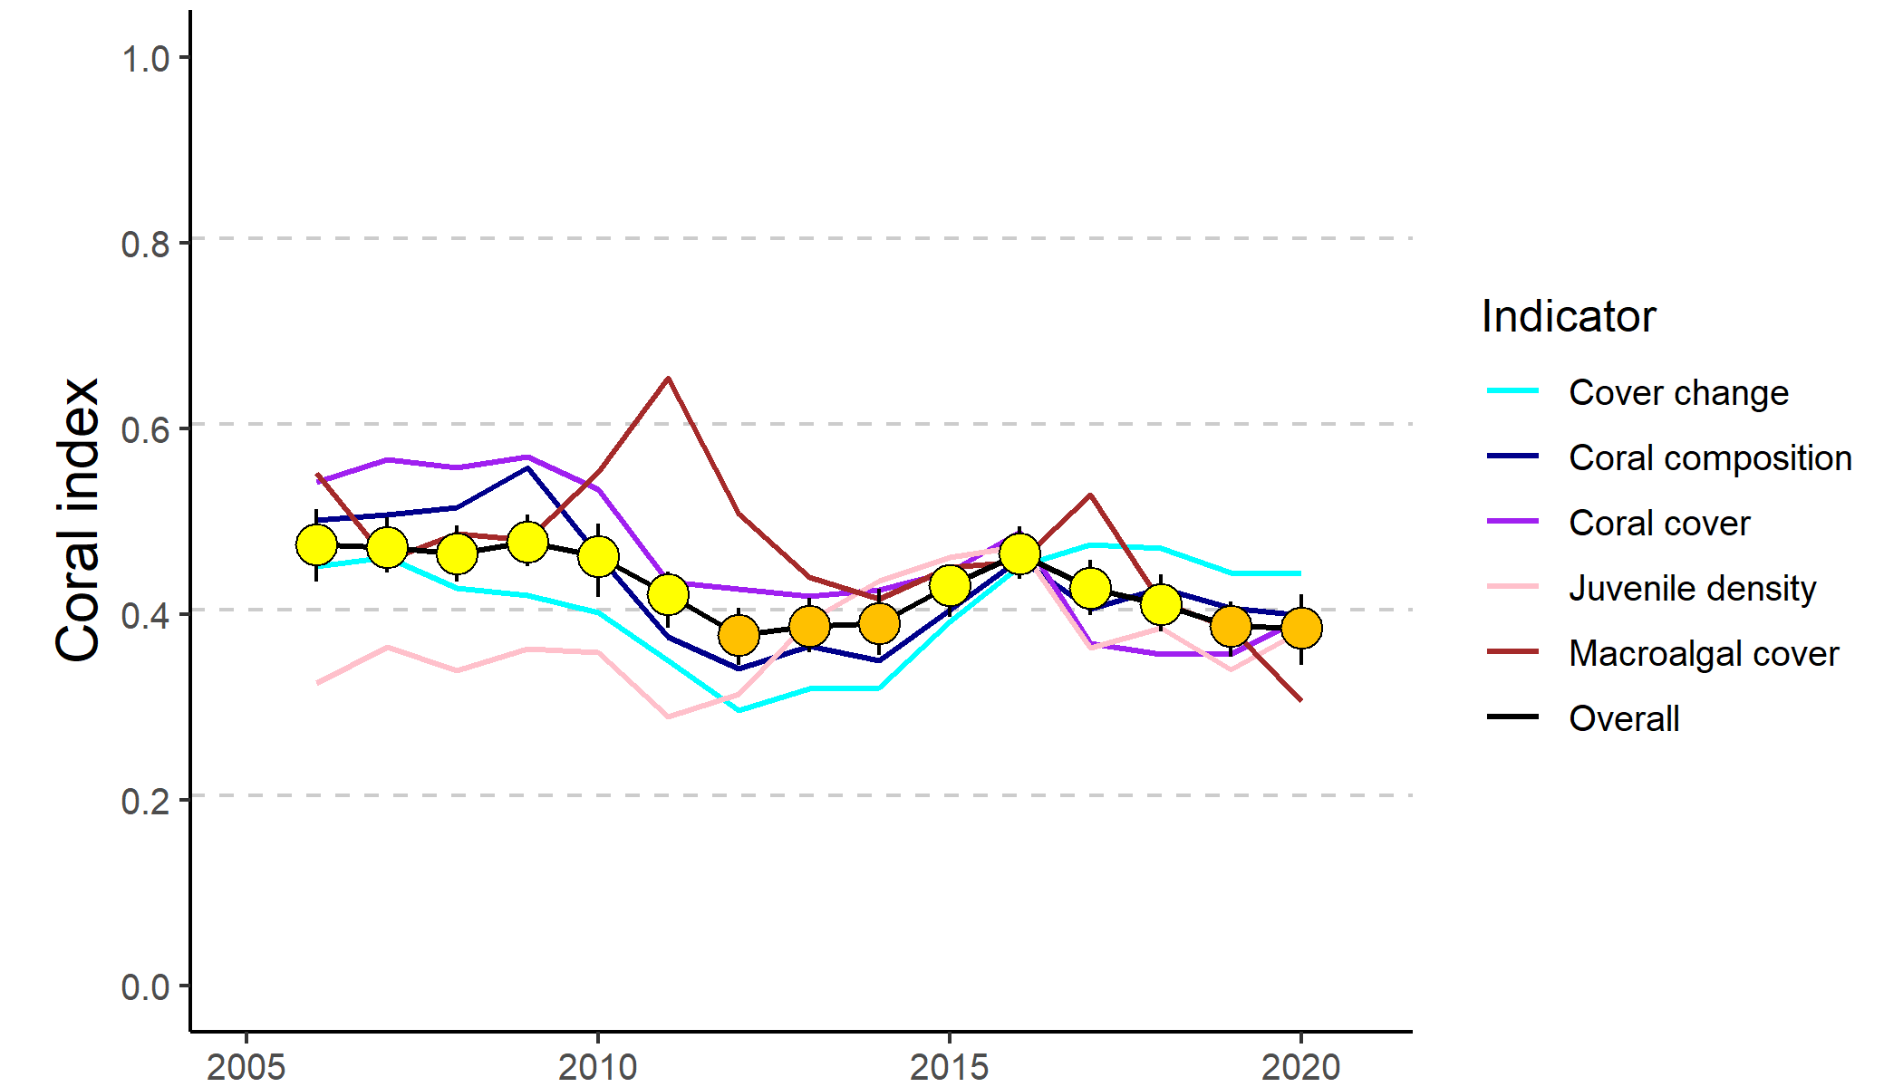
Figure 1 Trends in Coral index and contributing indicator scores for the inshore Reef
. Coral index scores are coloured according to Reef Water Quality Report Card categories: orange = ‘poor’, yellow=’moderate’. Error in index score derived from bootstrapped distribution of regional indicator scores weighted by the relative area of inshore coral reefs in each region.
Coral condition, expressed as the coral index, is a composite of five indicators combined for all reefs in a region. Each indicator represents different processes that contribute to coral community resilience. Indicators are in bold, followed by an explanation for their selection:
- coral cover as an indicator of corals' ability to resist the cumulative environmental pressures to which they have been exposed, but also the relative size of the population of corals as a source of larvae
- proportion of macroalgae in algal cover as an indicator of competition with corals
- juvenile coral density as an indicator of the success of early life history stages in the replenishment of coral populations
- rate of coral cover change as an indicator of the recovery potential of coral communities due to growth
- community composition as an indicator of selective pressures imposed by the environmental conditions at a reef.

The coral index score is published in the Reef Water Quality Report Card and contributes to the marine condition score. Index scores are based primarily on Marine Monitoring Program data, but also include data from inshore reefs monitored by the Australian Institute of Marine Science’s Long-Term Monitoring Program. These scores, in combination with additional locally relevant data sources, are also published in regional report cards. Regional level coral community condition and trends are summarised below.

Wet Tropics region condition
Inshore coral communities remain in ‘moderate’ condition. However, the overall stable condition observed since 2016 masks differing trends within the three sub-regions.
- In the Barron Daintree sub-region, coral condition remained ‘moderate’. Coral community condition has improved since 2019, when flooding of the Daintree River and physical damage caused by cyclone Owen caused a slight decline. Low densities of juvenile corals and very high cover of macroalgae at shallow sites of Snapper North continued to influence scores.
- In the Johnstone Russell–Mulgrave sub-region coral condition has fluctuated between ‘moderate’ and ‘good’ condition since 2016. Ongoing low scores for the macroalgae and juvenile coral indicators at Franklands West continued to limit condition within the sub-region. Crown-of-thorns starfish were observed at high densities at High Island, Fitzroy Island and in the Frankland Group. Despite predation of corals by these starfish, rapid growth of corals resulted in a continued increase in coral cover.
- In the Herbert Tully sub-region, coral condition remained ‘good’. A slight decline in condition at Dunk South and Bedarra contrasted the ongoing recovery at other reefs since cyclone Yasi in 2011.

Burdekin region condition
Inshore coral communities remain in ‘moderate’ condition. Coral communities continued to recover from a low point following the impact of cyclone Yasi in 2011. Thermal stress in early 2020 caused severe coral bleaching at most reefs, however loss of coral cover was minimal.
Macroalgal scores improved but remained low at several reefs where high cover of large brown macroalgal species persisted. Low densities of juvenile corals at most shallow sites also continued to limit scores.

Mackay–Whitsunday region condition
Inshore coral condition has continued to decline and remained ‘poor’. The coral index declined sharply due to the impact of cyclone Debbie in 2016. Clear evidence of recovery is yet to be observed.
Low density of juvenile corals, high macroalgal cover at some reefs and historically low scores for the coral cover change indicator suggest rapid recovery is unlikely.

Fitzroy region condition
Inshore coral condition remained ‘poor’ but has continued to improve from the ‘very poor’ condition observed in 2013 and 2014. Corals were severely bleached by high water temperatures in early 2020, however minimal loss of cover had occurred at the time the reefs were surveyed.
The state of reefs varied markedly across the region. Coral cover was highest at the reef furthest from the coast, Barren Island (above 60 per cent at the 5 metre depth sites). In contrast, coral cover remained ’poor’ or ‘very poor’ closer to the coast. Macroalgal cover remained high at almost all survey reefs.

Role of water quality on inshore reef resilience
While the results presented here do not provide clear guidance in terms of load reductions required to improve coral condition in the inshore Reef, they do support the premise of the Reef 2050 Water Quality Improvement Plan that the loads entering the Reef during high rainfall periods are reducing the resilience of these communities. The potential for phase shifts to algae-dominated states, or delayed recovery because of poor water quality, in combination with expected increase in disturbance frequency, reinforces the importance of managing local pressures to support the long-term maintenance of these communities.

Introduction
The proximity of inshore reefs to the coast make them highly accessible; this elevates their social, economic and cultural importance disproportionately to their small contribution to the area of the Great Barrier Reef World Heritage area’s coral estate (GBRMPA 2019).
Unfortunately, this proximity also exposes inshore reefs to increased pressures of turbidity, nutrient levels and low salinity flood plumes compared to their offshore counterparts. Reefs globally are under pressure as the effects of climate change are superimposed onto the natural disturbance and recovery cycles of coral communities. This ramping up of pressures facing coral reefs makes it ever more important that the Reef environment is managed to optimise the potential for coral communities to resist or recover from inevitable disturbance events (Bellwood et al. 2004, Marshall & Johnson 2007, Carpenter et al. 2008, Mora 2008, Hughes et al. 2010).

Conceptual basis for coral monitoring program
Disentangling the complexity of interactions between benthic communities and environmental pressures influencing the condition of coral reefs is reliant on accurate, long-term field-based observations of the response of communities to a range of pressures. To this end, the Australian Institute of Marine Science (AIMS) and the Great Barrier Reef Marine Park Authority (the Authority) have co-invested to provide inshore coral reef monitoring under the Great Barrier Reef Marine Monitoring Program (MMP) since 2005.
A key component of the MMP is the synthesis and communication of information to a range of stakeholders. The primary communication tool for the coral component of the MMP is the coral index, which contributes to the Reef report card. The coral index is designed to capture key aspects of coral community condition and resilience that is used to track trends in community condition, but also to highlight where and when condition is poor.
The coral index is based on the general understanding that healthy and resilient coral communities exist in a dynamic equilibrium, with communities periodically in a state of recovery, punctuated by acute disturbance events. Common disturbances to inshore reefs include cyclones (often coinciding with flooding), high water temperatures and, rarely, outbreaks of crown-of-thorns starfish, all of which can result in widespread mortality of corals (e.g., Sweatman et al. 2007, Osborne et al. 2011). Nutrients carried into the system as run-off may compound the influences of acute disturbances by increasing the susceptibility of corals to disease (Bruno et al. 2003, Haapkylä et al. 2011, Kline et al. 2006, Kuntz et al. 2005, Weber et al. 2012, Vega Thurber et al. 2013), promoting outbreaks of crown-of-thorns starfish (Wooldridge & Brodie 2015) and increasing susceptibility to thermal stress (Wooldridge & Done 2004, Wiedenmann et al. 2013). It is the potential for pollutants in run-off to suppress the recovery of coral communities (Schaffelke et al. 2013) that is a key focus of this monitoring and reporting program.
The replacement of corals lost to disturbance is reliant on both the recruitment of new colonies and regeneration of existing colonies from remaining tissue fragments (Smith 2008, Diaz-Pulido et al. 2009). Elevated concentrations of nutrients, agrochemicals and turbidity can negatively affect reproduction in corals (reviewed by Fabricius 2005, van Dam et al. 2011, Erftemeijer et al. 2012). High rates of sediment deposition and accumulation on reef surfaces can affect larval settlement (Babcock & Smith 2002, Baird et al. 2003, Fabricius et al. 2003, Ricardo et al. 2017) and smother juvenile corals (Harrison & Wallace 1990, Rogers 1990, Fabricius & Wolanski 2000). The density of juvenile hard corals is included as a key indicator of the success of recruitment processes. Relationships between nutrient and organic matter availability and higher incidence or severity of coral disease (Bruno et al. 2003, Haapkylä et al. 2011, Weber et al. 2012, Vega Thurber et al. 2013) suggest the cumulative pressure that poor water quality will have on corals already stressed by recent disturbances.
Macroalgae are monitored and reported on because they are more abundant in areas with high water column chlorophyll concentrations, indicating higher nutrient availability (De’ath & Fabricius 2010, Petus et al. 2016). High macroalgal abundance may suppress reef resilience (e.g., Hughes et al. 2007, Cheal et al. 2010, Foster et al. 2008, but see Bruno et al. 2009) through increased competition for space or by changing the microenvironment into which corals settle and grow (e.g., McCook et al. 2001, Hauri et al. 2010). Macroalgae have been documented to suppress fecundity (Foster et al. 2008) and reduce recruitment of hard corals (Birrell et al. 2008a, Diaz-Pulido et al. 2010), although chemical cues from some species appear to promote the settlement of coral larvae (Birrell et al. 2008b, Morse et al. 1996). Macroalgae have also been shown to diminish the capacity for growth among local coral communities (Fabricius 2005) and suppress coral recovery by altering microbial communities associated with corals (Morrow et al. 2012, Vega Thurber et al. 2012).
Hard coral community composition is monitored, as the selective pressure of water quality on coral communities is clear in changes in community composition along environmental gradients (De’ath & Fabricius 2010, Thompson et al. 2010, Uthicke et al. 2010, Fabricius et al. 2012). Corals derive energy in two ways; by feeding on ingested particles and planktonic organisms (heterotrophic feeding), and from the photosynthesis of their symbiotic algae. The ability to compensate, by heterotrophic feeding, where there is a reduction in energy derived from photosynthesis, e.g., because of light attenuation in turbid waters (Bessell-Browne et al. 2017a), varies between species (Anthony 1999, Anthony & Fabricius 2000). Similarly, the energy required to shed sediment varies between species due to differences in the efficiencies of passive (largely depending on growth form) or active (such as mucus production) strategies for sediment removal (Rogers 1990, Stafford-Smith & Ormond 1992, Duckworth et al. 2017).
A precursor, and more responsive indication of selective pressures imposed by water quality is the rate that coral cover recovers following disturbances. Reduced energy delivered to corals by their symbionts, or competition for space, are likely to reduce the rate at which corals grow or increase their susceptibility to disease. A derivative of coral cover is an indicator based on expected rate of coral cover increase (Thompson et al.2020).

Purpose of this report
The purpose of this report is to provide the data, analyses, and interpretation underpinning coral index scores included in the 2020 Reef report card. This report covers inshore coral reef monitoring conducted by AIMS as part of the MMP until August 2020, with inclusion of data from reefs monitored by the AIMS Long-Term Monitoring Program (LTMP) from 2005 to 2020. The coral indicator and index scores reported here are also supplied to regional bodies responsible for the Wet Tropics, Burdekin Dry Tropics and Mackay-Whitsunday-Isaac regional report cards.
To relate changes in the condition of coral reef communities to variations in local water quality, the coral component of the MMP has the overarching objective to “quantify the extent, frequency and intensity of acute and chronic impacts on the condition and trend of inshore coral reefs and their subsequent recovery”. The specific objectives are to monitor, assess and report:
- the condition and trend of Great Barrier Reef inshore coral reefs in relation to desired outcomes (expressed as coral index scores) along identified or expected gradients in water quality;
- the extent, frequency and intensity of acute and chronic impacts on the condition of Great Barrier Reef inshore coral reefs, including exposure to flood plumes, sediments, nutrients and pesticides;
- the recovery in condition of Great Barrier Reef inshore coral reefs from acute and chronic impacts including exposure to flood plumes, sediments, nutrients and pesticides;
- trends in incidences of coral mortality attributed to coral disease, crown-of-thorns-starfish, Drupella spp., Cliona orientalis, physical damage and thermal bleaching.

Structure of the report
In keeping with the objectives listed above, the report is structured to firstly present data relating to key pressures likely to have influenced the condition of coral communities (section 3), followed by the coral community responses to those pressures (section 4). Coral community condition summaries are reported at the scale of the inshore Reef (section 4.1, 4.2) followed by more detailed exploration of regional patterns (section 4.3) and finally responses of communities to environmental conditions (section 4.7). These results are discussed in section 5. Finer scale trends in condition for individual reefs are available online at http://apps.aims.gov.au/reef-monitoring/.

Methods
This section provides an overview of the source and manipulation of climate and environment pressure data, the sampling of coral communities, and the methods used to analyse these data.

Climate and environmental pressures
A range of environmental pressure variables are incorporated into this report as a basis for interpreting spatial and temporal trends in coral communities. The source and use of these data are summarised in Table 1.

River discharge
Daily records of river discharge were obtained from Queensland Government Department of Natural Resources and Mines (DNRM) river gauge stations for the major rivers draining to the Reef. For the Reef and each (sub-)region, total annual discharge for each Water-year, 1st October to 30th September, include a correction factor applied to gauged discharges to account for ungauged areas of the catchment (Waterhouse et al. 2021, Table A 6).
For each (sub-)region, time-series of daily discharge were estimated as the sum of gauged values from gauging stations nearest to the mouths of the major rivers (Table A 1).
Total annual river discharge for each region was used as a covariate in analysis of change in coral index scores. For this analysis, the biennial changes in index scores were considered due to the underlying sampling design of the program (Table 2). To match this sampling frequency, the maximum of the total annual discharge from all rivers discharging into a given region for each two-year period between 2006 and 2020 was calculated.

River nutrient and sediment loads
Loads of total nitrogen (TN), phosphorous (TP) and suspended sediment (TSS) delivered by rivers were sourced from the Great Barrier Reef Catchment Loads Monitoring Program. In short, annual loads are estimated from concentrations measured across the year’s hydrological cycle. Time series of loads that span the coral monitoring data are limited to those detailed in Table A 2.
The load time series from the Great Barrier Reef Catchment Loads Monitoring Program were supplied by the State of Queensland, Department of Environment and Science. Loads for 2016-17 and 2017-18 are available from the © State of Queensland (Department of Environment and Science) 2019.
Additional loads data for particulate nitrogen, dissolved inorganic nitrogen and total suspended solids were supplied by James Cook University (JCU). These data attempt to incorporate loads entering the marine system from portions of the catchment below gauging stations or via ungauged waterways and are used as the input data for load mapping reported by the water quality component of the Marine Monitoring Program (Waterhouse et al. 2021).

Sea temperature
To assess variability in temperature stress within and among regions, temperature loggers were deployed at each coral monitoring reef at both 2 m and 5 m depths, and routinely exchanged at the time of the coral surveys (i.e., every 12 or 24 months). Exceptions were Snapper South, Fitzroy East, High East, Franklands East, Dunk South, and Palms East where loggers were not deployed due to the proximity of those sites to the sites on the western or northern aspects of these same islands, where loggers were deployed. A range of logger models have been used (Table A 3).
Loggers were calibrated against a certified reference thermometer after each deployment and were generally accurate to ± 0.2°C.

Table 1 Summary of climate and environmental data considered in this report
 | Data range | Method | Usage | Data source
Climate
Riverine discharge | 1980 – 2020 | water gauging stations closest to river mouth, adjusted for ungauged area of catchment | regional discharge plots and table, covariate in analysis of temporal change in Coral index | DNRME, adjustment as tabulated by Gruber et al. (2020.)
Riverine Total P loads | 2006 – 2019 |  | covariate in analysis of temporal change in Coral index | Data sourced from the State of Queensland, Great Barrier Reef Catchment Loads Monitoring Program
Sea temperature | 2005 – 2020 | in situ sensor at coral sites | regional plots, thermal bleaching disturbance categorisation, in situ degree heating day estimates | MMP Inshore Coral monitoring
Degree heating days | 2006 – 2020 | remote sensing, ~4 km² pixels adjacent to coral sites | informing attribution of thermal stress, regional plots, thermal bleaching disturbance categorisation, thermal stress maps | Bureau of Meteorology
Degree heating weeks | 2006 – 2020 | remote sensing | informing attribution of thermal stress, thermal stress maps | National Oceanographic and Atmospheric Administration
Cyclone tracks | 2005– 2020 |  | informing attribution of storms as cause of observed coral loss, cyclone track maps | Bureau of Meteorology
Environment at coral sites
Chlorophyll a exposure  Chlorophyll a and Total suspended solids | 2003 – 2020 | product of water colour classification derived from remote sensing and coupled niskin samples, resolution ~1 km² | Chl a exposure, mapping. Chl a and TSS concentrations covariates in analysis of variability in index score changes | MMP Water Quality (Waterhouse et al. 2021)
Non-algal particulate (NAP)  Chlorophyll a | 2002 – 2019 | remote sensing adjacent to coral sites, resolution ~1 km² | Macroalgae and Community Composition metric thresholds, mapping | Bureau of Meteorology
Photosynthetically Active Radiation (PAR) | 2005 – 2019 | remote sensing adjacent to coral sites, resolution ~1 km² | covariate in analysis of spatial trends in index and indicator score, covariate in analysis of temporal variability in index score changes | Marites Magno-Canto (AIMS)
Sediment grain size | 2006 – 2017 | optical and sieve analysis of samples from coral sites | Macroalgae metric thresholds | MMP Inshore Coral monitoring

For presentation and analysis, the data from all loggers deployed within a (sub-)region were averaged to produce a time-series of mean average water temperature. From these time-series a seasonal climatology for each (sub-)region was estimated as the mean temperature for each day of the year over the period 2005 to 2015. This baseline climatology excludes the high temperatures that led to coral bleaching in 2016 and 2017. For the Fitzroy Region bleaching was also observed in 2006, and that year is also excluded from the baseline climatology. Temperature data for each (sub-)region are plotted as anomalies, estimated as the mean difference between daily observations within a (sub-)region and the seasonal climatology.

Temperature stress
Three estimates of seasonal temperature anomalies, as an indication of potential temperature stress to corals, are also presented.
The first, $Obs.DHD,$ is derived from the logger time-series and presents the summer (December to March) exposure to temperatures greater than the (sub-)region’s seasonal climatology as:
$$Obs.DHD= \sum{T_{i}-Tci}$$
Where, $T_{i}$ is the mean temperature recorded by all loggers in a (sub-)region on a particular day (i), and$Tci$ is (sub-)region’s climatological monthly mean temperature for that day of the year. Only positive anomalies are summed.
The second, degree heating days (DHD), was derived from ~4 km² pixels adjacent to each coral monitoring location downloaded from the Bureau of Meteorology satellite-based interactive website ReefTemp Next Generation. DHD values were calculated as the sum of daily positive deviations from 14-day IMOS climatology – a one-degree exceedance for one day equates to a one-degree heating day, a two-degree exceedance for one day equates to two DHD. DHD anomalies are summed over the period December 1 to March 31 each summer.

Cyclone tracks
Cyclone tracks and intensity were downloaded from the Australian Bureau of Meteorology at http://www.bom.gov.au/cyclone/history/index.shtml. These tracks were primarily used to double-check damage categorised as being caused by cyclones at the time of coral surveys. They are also presented in graphical form to illustrate the proximity of cyclones to the reefs monitored.

Water quality
Non-algal particulate (NAP) and Chl a concentrations, were derived from the MODIS aqua satellite mounted sensor were downloaded from the Australian Bureau of Meteorology. For each monitoring location a square of nine 1 km² pixels were identified in closely adjacent waters from which daily medians were used to estimate monthly means. For use as a background to maps as an illustration of variability in conditions among monitoring sites, these monthly means were aggregated to annual estimates and then long-term mean conditions (2003-2019) to develop maps that illustrated variability in conditions among monitoring sites. These data were not available for 2020. Historically these data were also used to estimate thresholds for the macroalgae indicator.
Relative concentrations of TSS and Chl a at each reef in each year were also estimated based on the methods developed by the water quality component of the MMP (Waterhouse et al. 2021, Petus et al. 2016). In brief, MODIS aqua images were used to classify waters into one of six colour classes that range from those typical of primary (most turbid, colour classes 1–4), secondary (class 5), or tertiary (class 6) wet season water types, which reflect the influence of river discharge and resuspension events. The lowest (most turbid and nutrient rich) colour class for a given pixel was recorded as the exposure of that pixel in each week.
It is important to note that waters can be classified into these colour classes when not exposed to flood plumes as non-plume processes, such as when wind driven resuspension produces waters with similar spectral signatures.
Water sampled from within colour classified water bodies provided mean concentrations of Chl a and TSS within each colour class. For each wet season (December – April, inclusive), multiplying the proportion of the wet season that each pixel was classified as a particular colour class by the concentration of Chl a or TSS in that colour class provided annual wet season estimates of the mean Chl a and TSS concentrations and also exposure to Chl a concentrations above wet-season guideline values (0.63 ug L⁻¹, GBRMPA 2010). Estimates were derived from the same nine pixels as described above for estimation of NAP concentration.

Light available for photosynthesis
The estimates of Chl a and TSS, or NAP, described above quantify the relative exposure to nutrients and suspended sediments. These and other optically active components of the water column interact to reduce the penetration of light at wavelengths necessary for photosynthesis (photosynthetically active radiation, PAR). As proxy for relative light attenuation at the coral sites, daily estimates of PAR at 8 m depth below mean tide height were estimated based on an algorithm applied to MODIS aqua images (Magno-Canto et al. 2019) and extracted from the same pixels as used for the NAP and Chl a estimates. For each reef, annual water-year estimates (October through September) were derived as the mean of daily estimates capped at 16 µmol m⁻² d⁻¹.
A regional light stress index described by Magno-Canto et al. (in review) was also used as a relative estimate of light stress across each region. This product estimates stress caused by limited light arriving at the benthos within each water body across the entire region. As such, the magnitude of this index is of little value for coral reefs, which are shallower than most inter-reefal benthos. However, interannual variability in this regional index is here considered as an observed proxy for regional water quality.

Sediment characteristics
The proportion of sediments with grainsize < 63µm (clay and silt) from the reef sites was used as a proxy for exposure to wave and tide mediated resuspension. These estimates were used as covariates in analyses of spatial distributions of index and indicator scores, and in analyses that determined reef level thresholds for macroalgae (Thompson et al. 2016).
Grainsize distribution of sediments was estimated from samples collected from the 5 m depth MMP sites at the time of coral sampling until 2014. At each site, five 60 ml syringe tubes were used to collect cores of surface sediment from available deposits along the site. The end of the syringe tube was cut away to produce a uniform cylinder. Sediment was collected by pushing the tube into the sediment, being careful not to suck sediment and pore-water into the tube with the plunger. A rubber stopper was then inserted to trap the sediment plug. The surface centimetre of sediment was retained and grainsize distribution determined by a combination of sieving and laser analysis carried out by the School of Earth Sciences, James Cook University (2005–2009) and subsequently by Geoscience Australia.
For LTMP sites, the clay and silt content of sediments was estimated by interpolating between MMP sites with similar exposure to prevailing wind driven waves. Estimated sediment composition was verified by visually checking images, including sediment from photo transects, against images from MMP sites with similar exposure.
For the new site at Bedarra, sediment samples collected in 2015 were passed through a 63 µm sieve to estimate the clay and silt proportion of the sample.

Coral monitoring
This section details the sampling design and sampling methods used to monitor and report coral community condition.

Sampling design
Monitoring of inshore coral reef communities occurred at reefs adjacent to four of the six natural resource management regions with catchments draining into the Reef: Wet Tropics, Burdekin, Mackay-Whitsunday, and Fitzroy (Table 2, Figure 2). Sub-regions were included in the Wet Tropics Region to align reefs more closely with the combined catchments of the: Barron and Daintree rivers, the Johnstone and Russell-Mulgrave Rivers, and the Herbert and Tully rivers.
No reefs are included adjacent to Cape York due to logistic and occupational health and safety issues relating to diving in coastal waters in this region. Limited development of coral reefs in nearshore waters adjacent to the Burnett Mary Region precluded sampling there.

Site selection
Initial selection of sites was jointly decided by an expert panel chaired by the Authority. The selection was based on two primary considerations:
- Within the Reef, strong gradients in water quality exist with increasing distance from the coast and exposure to river plumes (Larcombe et al. 1995, Brinkman et al. 2011). The selection of reefs for inclusion in the sampling design was informed by the desire to include reefs spanning these gradients to help assess the impact of water quality associated impacts.
- There was either an existing coral reef community or evidence (in the form of carbonate-based substratum) of past coral reef development.
Exact locations were selected without prior investigation. Once a section of reef had been identified that was of sufficient size to accommodate the sampling design, a marker was deployed from the surface and transects established from this point.
In the Wet Tropics region, where few reefs exist in the inshore zone and well-developed reefs exist on more than one aspect of an island, separate reefs on windward and leeward aspects were included in the design. Coral reef communities can be quite different on these two aspects even though the surrounding water quality is relatively similar. Differences in wave and current regimes determine whether materials such as sediments, freshwater, nutrients, or toxins accumulate or disperse, and hence determine the exposure of benthic communities to environmental stresses. In addition to reefs monitored by the MMP, data from inshore reefs monitored by the AIMS LTMP have been included in this report.
Since the program began in 2005 there have been two changes to the selection of reefs sampled. In 2005 and 2006, three mainland fringing reef locations were sampled along the Daintree coast. Concerns over increasing crocodile populations in this area led to the cessation of sampling at these locations. In 2015, a revision of the marine water quality monitoring component of the MMP resulted in modifications to the sampling design for water quality. This included a concentration of sampling effort along a gradient away from the Tully River mouth. To better match the water quality sampling to the coral reef sampling in the Herbert Tully sub-region, a new reef site was initiated at Bedarra and sampling at King Reef discontinued. As the MMP sites at Middle Reef in the Burdekin region were co-located with LTMP sites, this reef was removed from the MMP sampling schedule in 2015.
The frequency of sampling by the MMP has varied between annual and biennial, and the LTMP samples on a biennial basis. Sampling undertaken at each reef is detailed in Table 2 and the location of those reefs presented in Figure 2. In 2019 the LTMP sampled three inshore reefs in both the Wet Tropics and Mackay-Whitsunday regions and two of three reefs in the Burdekin region; these are the most recent observations at those reefs. In 2020 the MMP sampled all reefs other than Peak Island in the Fitzroy region to allow assessment of the impacts of coral bleaching and crown-of-thorns starfish.

Depth selection
Within the turbid inshore waters of the Reef the composition of coral communities varies strongly with depth due to differing exposure to pressures and disturbances (e.g., Sweatman et al. 2007). For the MMP, transects were established at two depths. The lower limit for the inshore coral surveys was selected at 5 m below lowest astronomical tide datum (LAT). Below this depth, coral communities rapidly diminish at many inshore reefs. A shallower depth of 2 m below LAT was selected as a compromise between a desire to sample the reef crest and logistical reasons, including the inability to use the photo point intercept technique in very shallow water and the potential for site markers to create a danger to navigation. The AIMS LTMP sites are not as consistently depth defined as those of the MMP, with most sites set in the range of 5–7 m below LAT. Middle Reef is the exception with sites there at approximately 3 m below LAT.

Site marking
At each reef, two sites separated by at least 250 m were selected along a similar aspect. These sites are permanently marked with steel fence posts at the beginning of each of five 20 m-long transects and smaller steel rods (10 mm-diameter) at the midpoint and the end of each transect. Compass bearings and measured distances record the transect path between these permanent markers. Transects were set initially by running two 60-m fibreglass tape measures out along the desired depth contour. Digital depth gauges were used along with tide heights from the closest location included in ‘Seafarer Tides’ electronic tide charts produced by the Australian Hydrographic Service to set transects as close as possible to the desired depth. Consecutive transects were separated by five metres. The position of the first picket of each site was recorded by GPS. Site directions and waypoints are stored electronically in AIMS databases.

Sampling timing and frequency
Coral reef surveys were undertaken predominantly over the months May-July, as this allows most of the influences resulting from summer disturbances, such as cyclones and thermal bleaching events, to be realised. Although the acute events occur over summer, the stress incurred can cause ongoing mortality for several months. The winter sampling also protects observers from potential risk from marine stingers over the summer months. The exception was Snapper Island, where sampling occurred typically in the months August – October.
The frequency of surveys has changed gradually over time due to budgetary constraints. In 2005 and 2006 all MMP reefs were surveyed. From 2007 through to 2014 a subset of reefs at which there were co-located water sampling sites were classified as “core” reefs and sampled annually. The remaining reefs were classified as “cycle” and sampled only in alternate years, with half sampled in odd-numbered years (i.e., 2009, 2011 and 2013) and the remainder in even-numbered years.
When an acute disturbance was suspected to have impacted cycle reefs during the preceding summer they were resurveyed, irrespective of their odd or even year classification, to gain the best estimate of the impact of the acute event and bookend the start of the recovery period. Further funding reductions necessitated the adoption of a biennial sampling cycle for all reefs, although a contingency for the out-of-phase resampling of reefs impacted by acute disturbance was maintained.

Table 2 Coral monitoring locations
. Black dots mark reefs surveyed as per sampling design, the “+” symbol indicates reefs surveyed out of schedule to assess disturbance. WQ, indicates reefs at which water quality monitoring is undertaken, * indicates WQ was ceased in 2014, and ** indicates WQ was begun in 2015. Shading indicates discontinued reefs. Blank cells indicate where reefs were not surveyed.
(Sub-) Region | Reef | Program | 2005 | 2006 | 2007 | 2008 | 2009 | 2010 | 2011 | 2012 | 2013 | 2014 | 2015 | 2016 | 2017 | 2018 | 2019 | 2020
Barron Daintree | Cape Tribulation North | MMP | ● | ●
 | Cape Tribulation Mid | MMP | ● | ●
 | Cape Tribulation South | MMP | ● | ●
 | Snapper North (WQ*) | MMP | ● | ● | ● | ● | ● | ● | ● | ● | ● | ● | ● | + | ● | + | ● | +
 | Snapper South | MMP | ● | ● | ● | ● | ● | ● | ● | ● | ● | ● | ● | ● | + | ● | + | ●
 | Low Isles | LTMP | ● |  | ● |  | ● |  | ● |  | ● |  | ● |  | ● |  | ●
Johnstone Russell-Mulgrave | Green | LTMP | ● |  | ● |  | ● |  | ● |  | ● |  | ● |  | ● |  | ●
 | Fitzroy West | LTMP | ● |  | ● |  | ● |  | ● |  | ● |  | ● |  | ● |  | ●
 | Fitzroy West (WQ) | MMP | ● | ● | ● | ● | ● | ● | ● | ● | ● | ● | ● | + | ● | + | ● | +
 | Fitzroy East | MMP | ● | ● | + | ● |  | ● | + | ● |  | ● |  | ● |  | ● |  | ●
 | High East | MMP | ● | ● | ● |  | ● |  | ● |  | ● |  | ● | + | ● | + | ● | +
 | High West (WQ) | MMP | ● | ● | ● | ● | ● | ● | ● | ● | ● | ● |  | ● | + | ● | + | ●
 | Frankland East | MMP | ● | ● | ● |  | ● |  | ● |  | ● |  | ● | + | ● | + | ● | +
 | Frankland West (WQ) | MMP | ● | ● | ● | ● | ● | ● | ● | ● | ● | ● |  | ● | + | ● |  | ●
Tully | Barnards | MMP | ● | ● | ● |  | ● |  | ● |  | ● |  | ● |  | ● | + | ● | +
 | King | MMP | ● | ● |  | ● |  | ● |  | ● |  | ●
 | Dunk North (WQ) | MMP | ● | ● | ● | ● | ● | ● | ● | ● | ● | ● |  | ● | + | ● |  | ●
 | Dunk South | MMP | ● | ● |  | ● |  | ● | + | ● |  | ● |  | ● | + | ● | + | ●
 | Bedarra | MMP |  |  |  |  |  |  |  |  |  |  | ● | ● | ● | ● | ● | ●
Burdekin | Palms West (WQ) | MMP | ● | ● | ● | ● | ● | ● | ● | ● | ● | ● | ● | + | ● | + | ● | +
 | Palms East | MMP | ● | ● |  | ● |  | ● | + | ● |  | ● |  | ● |  | ● | + | ●
 | Lady Elliot | MMP | ● | ● |  | ● |  | ● |  | ● |  | ● |  | ● |  | ● |  | ●
 | Pandora North | LTMP | ● |  | ● |  | ● |  | ● |  | ● |  | ● |  | ● |  | ●
 | Pandora (WQ) | MMP | ● | ● | ● | ● | ● | ● | ● | ● | ● | ● |  | ● | + | ● |  | ●
 | Havannah North | LTMP | ● |  | ● |  | ● |  | ● |  | ● |  | ● |  | ● |  | ● | +
 | Havannah | MMP | ● | ● | ● |  | ● |  | ● |  | ● |  | ● | + | ● | + | ● | +
 | Middle Reef | LTMP | ● |  | ● |  | ● |  | ● |  | ●
 | Middle Reef | MMP | ● | ● | ● |  | ● |  | ● |  | ●
 | Magnetic (WQ) | MMP | ● | ● | ● | ● | ● | ● | ● | ● | ● | ● | ● | + | ● | + | ● | +
Mackay-Whitsunday | Langford | LTMP | ● |  | ● |  | ● |  | ● |  | ● |  | ● |  | ● |  | ●
 | Hayman | LTMP | ● |  | ● |  | ● |  | ● |  | ● |  | ● |  | ● |  | ●
 | Border | LTMP | ● |  | ● |  | ● |  | ● |  | ● |  | ● |  | ● |  | ●
 | Double Cone (WQ) | MMP | ● | ● | ● | ● | ● | ● | ● | ● | ● | ● |  | ● | + | ● | + | ●
 | Hook | MMP | ● | ● |  | ● |  | ● |  | ● |  | ● |  | ● |  | ● |  | ●
 | Daydream (WQ*) | MMP | ● | ● | ● | ● | ● | ● | ● | ● | ● | ● |  | ● | + | ● |  | ●
 | Shute Harbour | MMP | ● | ● |  | ● |  | ● |  | ● |  | ● |  | ● | + | ● |  | ●
 | Dent | MMP | ● | ● | ● |  | ● |  | ● |  | ● |  | ● |  | ● |  | ● | +
 | Pine (WQ) | MMP | ● | ● | ● | ● | ● | ● | ● | ● | ● | ● | ● |  | ● | + | ● | +
 | Seaforth (WQ**) | MMP | ● | ● | ● |  | ● |  | ● |  | ● |  | ● |  | ● |  | ● | +
Fitzroy | North Keppel | MMP | ● | ● | ● |  | ● |  | ● |  | ● | + | ● |  | ● |  | ● | +
 | Middle | MMP | ● | ● |  | ● |  | ● |  | ● |  | ● | + | ● |  | ● | + | ●
 | Barren (WQ*) | MMP | ● | ● | ● | ● | ● | ● | ● | ● | ● | ● | ● |  | ● |  | ● | +
 | Keppels South (WQ*) | MMP | ● | ● | ● | ● | ● | ● | ● | ● | ● | ● | ● | ● | + | ● |  | ●
 | Pelican (WQ*) | MMP | ● | ● | ● | ● | ● | ● | ● | ● | ● | ● | ● | ● |  | ● |  | ●
 | Peak | MMP | ● | ● |  | ● |  | ● | + | ● |  | ● | + |  | ● |  | ●

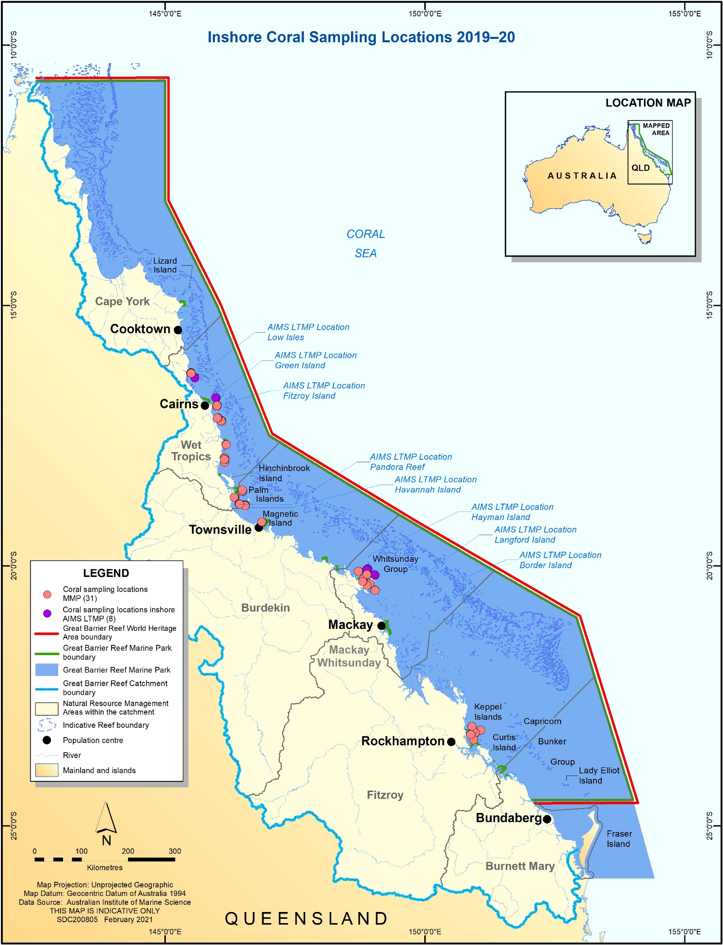

Figure 2 Coral sampling locations that exist as of 2020
. However, not all locations were assessed/sampled in 2020
.

Coral community sampling methods
Two sampling methodologies were used to describe the benthic communities of inshore coral reefs (Table 3).

Table 3 Survey methods used by the MMP and LTMP to describe coral communities.
Survey Method | Information provided | Transect dimension
 |  | MMP (20 m long transects) | LTMP (50 m long transects)
Photo point Intercept | Percentage cover of the substratum of major benthic habitat components. | Approximately 34 cm belt along upslope side of transect sampled at 50 cm intervals from which 32 frames are sampled. | Approximately 34 cm belt along upslope side of transect sampled at 1 m intervals from which 40 frames are sampled.
Juvenile coral transects | Size structure and density of juvenile coral communities. | 34 cm belt (dive slate length) along the upslope side of transect. Size classes: 0–2 cm, 2–5 cm | 34 cm belt along the upslope side of the first 5 m of transect. Size class: 0–5 cm.
Scuba search transects | Cause of any current or recent coral mortality | 2 m wide belt centred on the transect line | 2 m wide belt centred on the transect line

Photo point intercept transects
Estimates of the composition of benthic communities were derived from the identification of organisms on digital photographs taken along the permanently marked transects. The method closely followed the Standard Operation Procedure Number 10 of the AIMS LTMP (Jonker et al. 2008). In short, digital photographs were taken at 50 cm intervals along each 20 m transect. Estimates of cover of benthic community components were derived from the identification of the benthos lying beneath five fixed points digitally overlaid onto these images. A total of 32 images were randomly selected and analysed from each transect. Poor quality images were excluded and replaced by an image from those not originally randomly selected. The AIMS LTMP utilised longer 50 m transects sampled at 1m intervals, from which 40 images were selected.
For most of hard and soft corals, identification to genus level was achieved. Identifications for each point were entered directly into a data-entry front-end to an Oracle-database, developed by AIMS. This system allows the recall of images and checking of any identified points.

Juvenile coral transects
These surveys provide an estimate of the number of both hard and soft coral colonies that have successfully survived early life-cycle stages culminating in visible juvenile corals. The number of juvenile coral colonies were counted along the permanently marked transects. In the first year of this program, juvenile coral colonies were counted as part of a demographic survey that counted the number of all individuals falling into a broad range of size classes that intersected a 34-cm wide (data slate length) belt along the upslope side of the first 10 m of each 20-m marked transect. As the focus narrowed to just juvenile colonies, the number of size classes was reduced, allowing an increase in the spatial coverage of sampling. From 2006 coral colonies less than 10 cm in diameter were counted within a belt 34 cm wide along the full length of each 20 m transect. Each colony was identified to genus and assigned to a size class of either 0–2 cm, >2–5 cm, or >5–10 cm. In 2019 recording of the 5-10cm size class was discontinued as reporting focused on the <5 cm size class, and the age of larger colonies becomes increasingly uncertain. Importantly, this method aims to record only those small colonies assessed as juveniles resulting from the settlement and subsequent survival and growth of coral larvae, and so does not include small coral colonies considered as resulting from fragmentation or partial mortality of larger colonies. In 2006 the LTMP also introduced juvenile surveys along the first 5 m of each transect and focused on the single size-class of 0–5 cm. In practice, corals < ~ 0.5 cm are unlikely to be detected.

SCUBA search transects
SCUBA search transects document the incidence of disease and other agents of coral mortality and damage. Tracking of these agents of mortality is important as declines in coral condition due to these agents are potentially associated with increased exposure to nutrients or turbidity (Morrow et al. 2012, Vega Thurber et al. 2013). The resulting data are used primarily for interpretive purposes and help to identify both acute events such as a high proportion of damaged corals following storms, high densities of coral predators, or periods of chronic stress as inferred from high levels of coral disease.
This method closely follows the Standard Operation Procedure Number 9 of the LTMP (Miller et al. 2009). For each 20 m transect a search was conducted within a 2 m wide belt centred on the marked transect line. Within this belt, any colony exhibiting a scar (bare white skeleton) was identified to genus and the cause of the scar categorised as either; brown band disease, black band disease, white syndrome (a catch-all for unspecified disease), Drupella spp. (in which case the number of Drupella spp. snails was recorded), crown-of-thorns starfish feeding scar, bleaching (when the colony was bleached and partial mortality was occurring), and unknown (when a cause could not be confidently assumed). In addition, the number of crown-of-thorns starfish and their size-class were counted, and the number of coral colonies being overgrown by sponges was also recorded.
Finally, an 11-point scale was used to record the proportions of the coral community that were bleached or had been physically damaged as indicated by toppled or broken colonies. The scale ranges from 0+ when individual colonies were bleached or damaged, and through the categories 1 to 5 when 1–10%, 11–30%, 31–50%, 50–75% and 75–100% of colonies were affected. The categories 1 to 5 are further refined by inclusion of a –ve or +ve symbol when affected proportions are estimated as being in the lower or upper portion of the category. The physical damage category may include anchor as well as storm damage. The LTMP include these surveys over the full 50 m length of transects used in that program.

Calculating report card scores
Coral community condition is summarised as an index score that aggregates scores for five indicators of reef ecosystem state (Thompson et al. 2020). The resulting coral index score provides the coral component of the Reef report card. The coral index is formulated around the concept of community resilience. The underlying assumption is that a ‘resilient’ community should show clear signs of recovery after inevitable acute disturbances, such as cyclones and thermal bleaching events, or, in the absence of disturbance, maintain a high cover of corals and successful recruitment processes. Each of the five indicators of coral community condition represents a different process that contributes to coral community resilience that is potentially influenced by water quality:
- coral cover as an indicator of corals’ ability to resist the cumulative environmental pressures to which they have been exposed,
- proportion of macroalgae in algal cover as an indicator of competition with corals,
- juvenile coral density as an indicator of the success of early life history stages in the replenishment of coral populations,
- rate at which coral cover increases as an indicator of the recovery potential of coral communities due to growth, and
- community composition as an indicator of selective pressures imposed by the environmental conditions at a reef.
For each of these indicators a metric has been developed to allow scoring of observed condition on a consistent scale (0–1). The aggregation of indicator scores provides the coral index score as a summary of coral community condition.

Coral cover metric
High coral cover is a highly desirable state for coral reefs, both in providing essential ecological goods and services related to habitat complexity, maintenance of biodiversity and long-term reef development, and from a purely aesthetic perspective, with clear socio-economic advantages. In terms of reef resilience, although low cover may be expected following severe disturbance events, high cover implies a degree of resistance to any chronic pressures influencing a reef. Of note, this resistance may have selected for high cover of a relatively few, particularly tolerant species, necessitating some consideration of community composition when assessing high coral cover. Finally, high cover equates to a large brood-stock: a necessary link to recruitment and an indication of the potential for recovery of communities in the local area.
This metric scores reefs based on the level of coral cover derived from point intercept transects. For each reef the proportional cover of all hard (order Scleractinia) and soft (subclass Octocorallia) corals are defined as two groups: “HC” and “SC” respectively. The coral cover indicator is then calculated as:
${Coral cover}_{ij}$ = ${HC}_{ij}$ + ${SC}_{ij}$
Where $i$ = reef and $j$ = time.
The threshold values for scoring this metric were based on assessment of coral cover time-series observed at inshore reefs from LTMP data (1992-2014), MMP data (2005-2014) and surveys from Cape Flattery to the Keppels by Sea Research prior to 1998 (Ayling 1997), which identified a mean of >50% for combined coral cover on those inshore reefs. Due to the low likelihood of coral cover reaching 100%, the threshold for this indicator (where the score is a maximum of 1) has been set at 75%. This value captures the plausible level of coral cover achievable on reefs within the inshore Reef and allows a natural break point for the categorisation of coral cover into the 5 reporting bands of the report card. Thus, the scoring for the coral cover indicator is scaled linearly from zero when cover is 0% through to 1 when cover is at or above the threshold level of 75% (Figure 3).

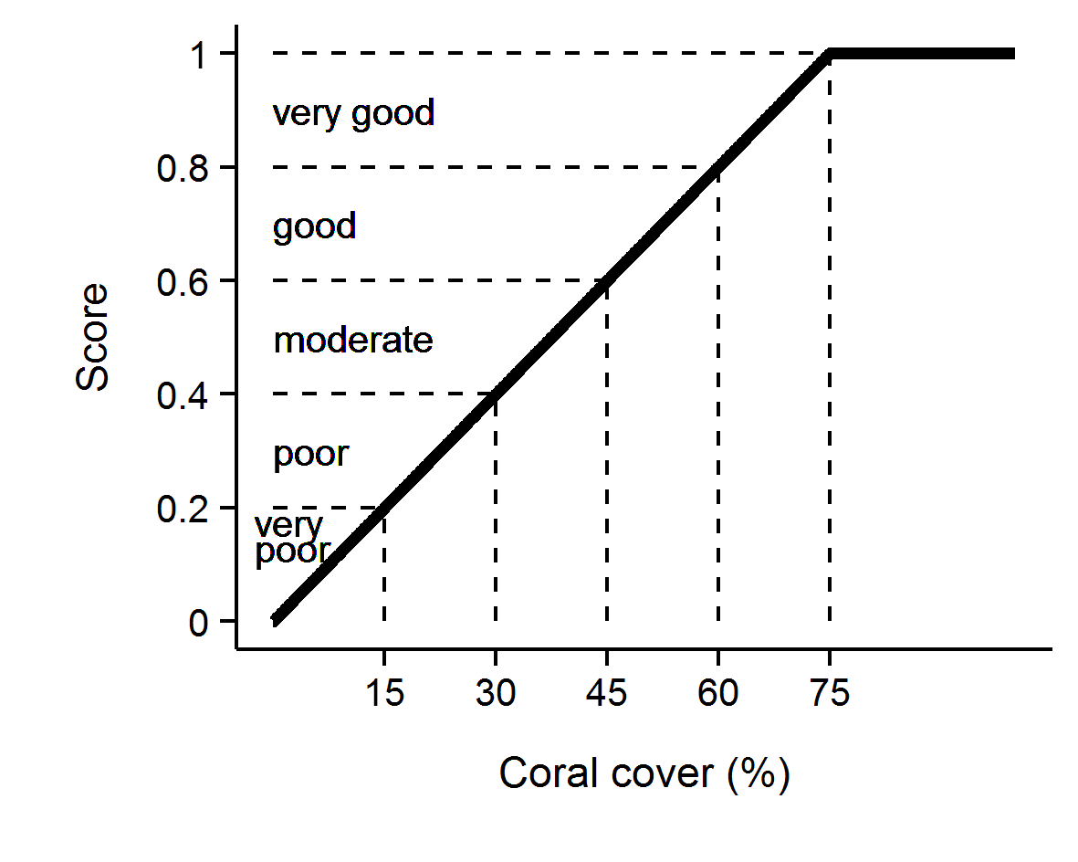
Figure 3 Scoring diagram for the coral cover metric
. Numeric scores and associated condition classifications based on observed coral cover are presented.

Macroalgae metric
In contrast to coral cover, high cover of macroalgae on coral reefs is widely accepted as representing a degraded state. As opportunistic colonisers, macroalgae generally out-compete corals, recovering more quickly following physical disturbances. Macroalgae have been documented to suppress coral fecundity (Foster et al. 2008), reduce recruitment of hard corals (Birrell et al. 2008a, b, Diaz-Pulido et al. 2010) and diminish the capacity for growth among local coral communities (Fabricius 2005). The macroalgae metric considers the proportional representation of macroalgae in the algal community based on cover estimates derived from point intercept transects and is calculated as:
${MAproportion}_{ij}$ = ${MA}_{ij}$ / $A_{ij}$
Where, $A$= percent cover of all algae, $i$ = reef, $j$ = time and $MA$ = percent cover of macroalgae.
For the purpose of calculating this metric, the collective term macroalgae defines a broad functional grouping that combines species clearly visible to the naked eye, although excluding crustose coralline and fine filamentous or “turf” forms. In addition, as macroalgae show marked differences in abundance across the naturally steep gradient of environmental conditions within the inshore Reef, separate upper and lower thresholds were estimated for each reef and depth (Table A 4). The use of separate thresholds ensures that the indicator is sensitive to changes likely to occur at a given reef.
The thresholds for each reef were determined based on predicted MAproportion from Generalised Boosted Models (Ridgeway 2007) that included mean MAproportion over the period 2005–2014 as the response and long-term mean chlorophyll a concentration, suspended sediment concentration, and proportion of clay and silt sized grains in reefal sediments as covariates (Thompson et al. 2016). Recognising the likelihood that the observed cover of macroalgae reflects a shifted baseline, an additional consideration in setting the upper threshold for MAproportion was the ecological influence of macroalgae on other indicators of coral community condition. Regression tree analyses that included MAproportion as the predictor variable indicated reduced scores for the juvenile density, coral cover, and cover change indicators at higher levels of MAproportion (Thompson et al. 2016). These thresholds for ecological impacts caps informed the setting of upper bounds of MAproportion across all reefs at 23% at 2 m and a 25% at 5 m. The upper bounds for any reefs with predicted MAproportion higher than these caps were reduced to the cap level.
Scores for Macroalgae metric were scaled linearly from 0 when MAproportion is at or above the upper threshold through to 1 when MAproportion is at or below the lower threshold (Figure 4).

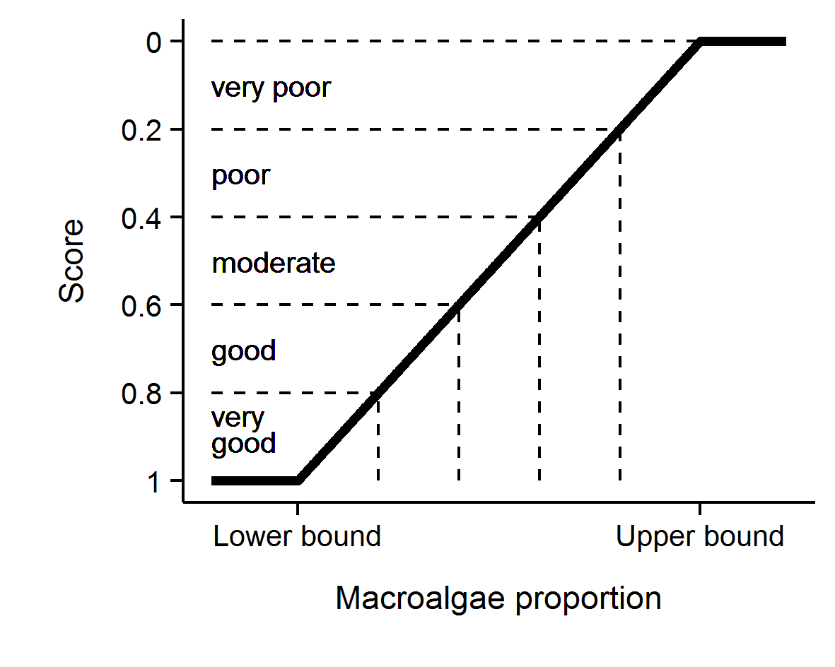
Figure 4 Scoring diagram for the Macroalgae metric
. Upper and lower threshold values are reef and depth specific. Numeric scores and associated condition classifications are presented. Note that for this metric the y-axis is inverted as high values reflect poor condition.

Density of juvenile hard corals metric
For coral communities to recover rapidly from disturbance events there must be adequate recruitment of new corals into the population. This metric scores the important recruitment process by targeting corals that have survived the early life stages. With the inclusion of LTMP data into the coral index, juvenile count data were subset to only include colonies up to 5 cm in diameter as this size class is common to both MMP and LTMP sampling. Counts of juvenile hard corals were converted to density per m² of space available to settlement as:
${Juvenile density}_{ij}$ = $J_{ij}$ / ${AS}_{ij}$
Where, $J$= count of juvenile colonies < 5 cm in diameter, $i$ = reef, $j$ = time and $AS$ = area of transect occupied by any algae as estimated from the co-located photo point intercept transects.
Selection of thresholds for the scoring of this metric was based on the analysis of recovery outcomes for MMP and LTMP reefs up to 2014 (Thompson et al. 2016). From these time series a binomial model was fit to juvenile densities observed at times when coral cover was below 10% and categorised based on recovery rate as being either below or above the predicted lower estimate of hard coral cover increase as estimated by the cover change indicator described below. This analysis identified a threshold of 4.6 juveniles per m² beyond which the probability that coral cover would subsequently increase at predicted rates outweighed the probability of lower than predicted rates of recovery.
Adding some weight to this result is that it was broadly consistent with the density of 6.3 juveniles per m², in the wider size range <10 cm, necessary for recovery in the Seychelles (Graham et al. 2015). As the upper density of juvenile colonies is effectively unbounded, it was desirable to set an upper threshold for scoring purposes. The density at which the probability was > 80% for coral cover to recover at predicted rates was 13 juveniles per m², and this density was chosen as the upper threshold. Based on this analysis, this metric was scored as follows; juvenile density was scaled linearly from 0 at a density of 0 to 0.4 at a density of 4.6 colonies per m², then linearly to a score of 1 when the density was 13 colonies per m² or above (Figure 5).

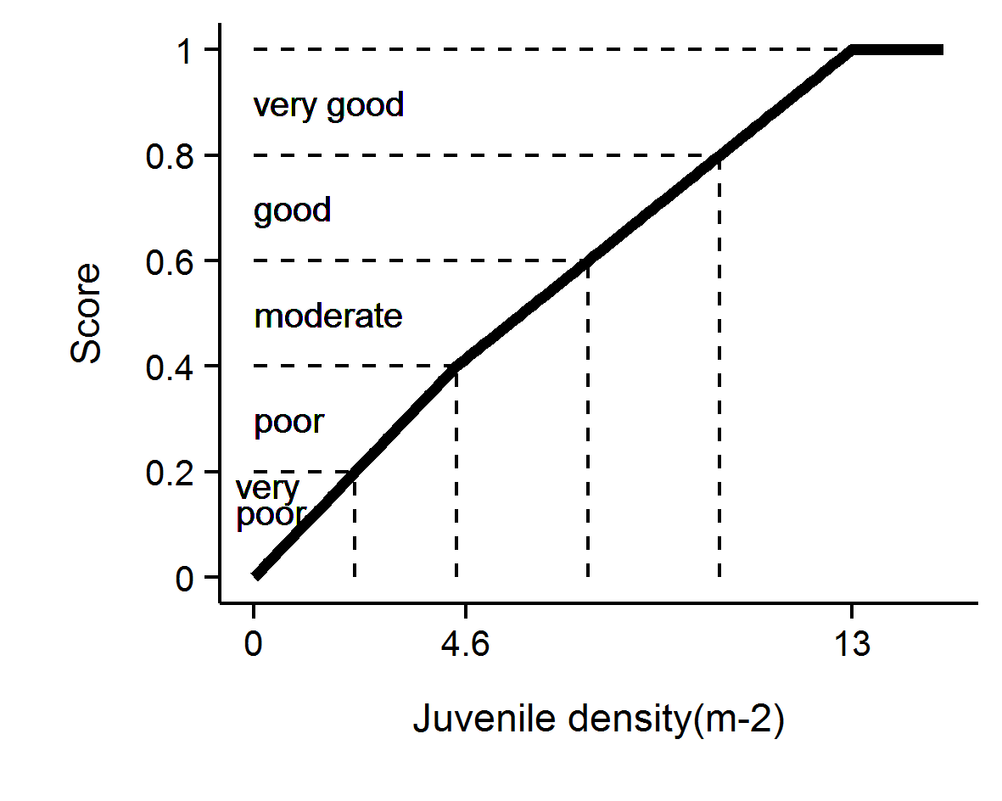
Figure 5 Scoring diagram for the Juvenile metric
. Numeric scores and associated condition classifications are presented.

Cover change metric
A second avenue for recovery of coral communities is the growth of corals during periods free from acute disturbance (Gilmour et al. 2013). Chronic pressures associated with water quality may suppress the rate at which coral cover increases and indicate a lack of resilience. The change in coral cover indicator score is derived from the comparison of the observed change in coral cover between two visits and the change in cover predicted by Gompertz growth equations (Thompson & Dolman 2010) parameterised from time-series of coral cover available on inshore reefs form 1992 until 2007. Gompertz equations were parameterised separately for the fast-growing corals of the family Acroporidae and the slower growing combined grouping of all other hard corals at each of 2 m and 5 m depths. Initial exploratory analysis provided no justification for a more detailed parameterisation of the coral community, in part due to the increasing imprecise estimates of cover due to declining cover for each group with further sub-setting of the coral community.
Years in which disturbance events occurred at a reef preclude the estimation of this indicator, as there is no expectation for increase in such situations. As such, estimates are only derived for annual or biennial periods during which no acute disturbances occurred.
A Bayesian framework was used to permit propagation of uncertainty through the predictions of expected coral cover increase from the two separately predicted coral types.

$\ln\left({Acr}_{it}\right) \sim N(μ_{it},σ^{2})$
$μ_{it}=v{Acr}_{i}+\ln\left({Acr}_{it-1}\right)+\left(-\frac{v{Acr}_{i}}{\ln\left(estK_{i}\right)}\right)*ln⁡({Acr}_{it-1}+ {OthC}_{it-1}+ {Sc}_{it-1})$
$v{Acr}_{i}= α+ \sum_{j=0}^{J}{β_{j}{Region}_{i}}\sum_{k=0}^{K}{γ_{k}{Reef}_{i}}$
$α \sim N(0,{10}^{6})$
$β_{j} \sim N(0, σ_{Region}^{2})$
$γ_{k} \sim N(0, σ_{Reef}^{2})$
$σ^{2},σ_{Region}^{2},σ_{Reef}^{2}= U(0,100)$
$rAcr=v{\overline{A}cr}_{i}$

Where, ${Acr}_{it},{OthC}_{it}$ and ${Sc}_{it}$ are the cover of Acroporidae coral, other hard coral, and soft coral respectively at a given reef at time ($t$). $eskK$ is the community size at equilibrium (100) and $rAcr$ is the rate of increase (growth rate) in percent cover of Acroporidae coral. Varying effects of Region and Reef ($β_{j}$ and $Υ_{k}$ respectively) were also incorporated to account for spatial autocorrelation. Model coefficients associated with the intercept, Region and Reef ($α_{i}, β_{j}$ and $Υ_{k}$) all had weakly informative Gaussian priors, the latter two with model standard deviation. The overall rate of coral growth$rAcr$, constituted the mean of the individual posterior rates of increase for ${vAcr}_{i}$.
As model predictions relate to annual changes in coral cover, observed cover was adjusted to an estimated annual change since the previous observation (${Acr}_{adj}$) prior to comparison to modelled estimates. Adjusted values, ${Acr}_{adj},$ were estimated as per the following formula:
$${Acr}_{adj}={Acr}_{i-1}+({Acr}_{i}{-Acr}_{i-1})*(365/(days between samples)$$
Where cover declined no adjustment was made and ${Acr}_{adj}$ assumed ${Acr}_{i}$.
Note, the above formulae apply to the family Acroporidae (Acr) and have the same form as those applied for Other Corals (OthC) if these terms are exchanged where they appear in the equations.
Gompertz models were fitted in a Bayesian framework to facilitate combining growth rates and associated uncertainties across models. A total of 20,000 Markov-chain Monte Carlo (MCMC) sampling interactions across three chains with a warmup of 10,000 and thinned to every fifth observation resulted in well mixed samples from stable and converged posteriors (all rhat (potential scale reduction factor) values less than 1.02). Model validation did not reveal any pattern in the residuals. Bayesian models were run in JAGS (Plummer 2003) via the R2jags package (Su & Yajima 2015) for R.
The posteriors of Acroporidae predicted cover and Other Coral predicted cover were combined into posterior predictions of total coral cover from which the mean, median and 95% Highest Probability Density (HPD) intervals were calculated.
As changes in coral cover from one year to the next are relatively small, the indicator value is averaged over valid estimates (inter-annual or biennial periods when cover was not impacted by an acute disturbance) for a four-year period culminating in the reporting year. If no valid observations were available in that four-year period, the most recent valid estimate is rolled forward.
To convert this indicator to a metric the following process was applied (Figure 6):
- If coral cover declined between surveys, a score of 0 was applied.
- If cover change was between 0 and the lower HPD interval of predicted total cover change, scores were scaled to between 0.1 when no change was observed through to 0.4 when change was equal to the lower interval of the predicted change.
- If cover change was within the upper and lower HPD intervals of the predicted change the score was scaled from 0.4 at the lower interval through to 0.6 at the upper interval.
- If cover change was greater than the upper HPD interval of predicted change and less than double the upper interval, scores were scaled from 0.6 at the upper interval to 0.9 at double the upper interval.
- If change was greater than double the upper HPD interval, a score of 1 was applied.

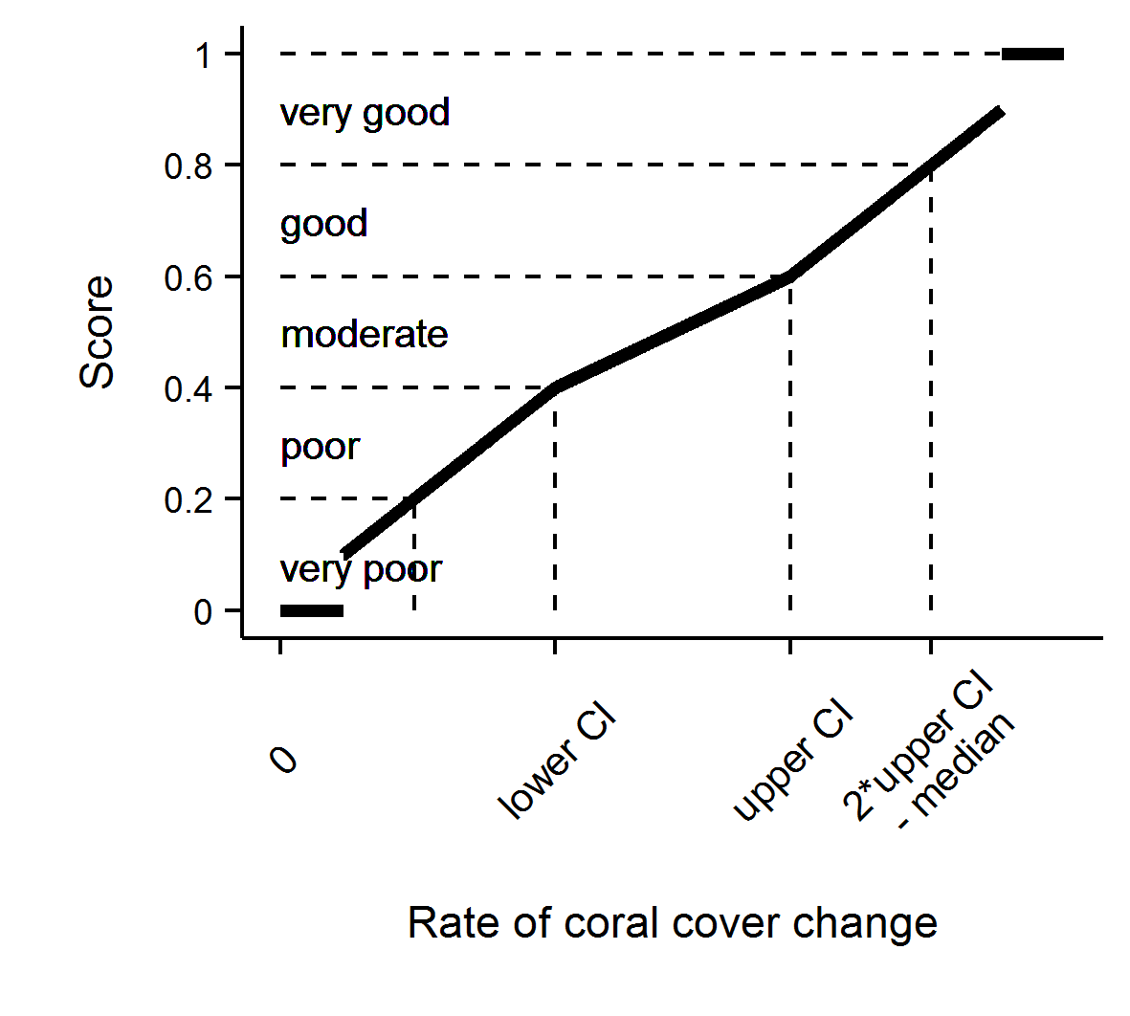
Figure 6 Scoring diagram for Cover Change metric.

Community composition metric
The coral communities monitored by the MMP vary considerably in the relative composition of coral species (Uthicke et al. 2010, Thompson et al. 2020). As demonstrated by Uthicke et al. (2010) and Fabricius et al. (2012), some of this variability can be attributed to differences in environmental conditions between locations, which implies selection for certain species based on the environmental conditions experienced. Coral communities respond to environmental conditions in a variety of ways. Most noticeably, they respond to acute shifts in conditions such as exposure to substantially reduced salinity (van Woesik 1991, Berkelmans et al. 2012), deviations from normal temperature (Hoegh-Guldberg 1999) or hydrodynamic conditions (cyclones); all of which result in reductions in coral cover as susceptible species are killed. In contrast, the increased loads of sediments and nutrients entering the Reef, because of land use practices in the adjacent catchments (Waters et al. 2014), may include a combination of acute conditions associated with flood events and then chronic change in conditions as pollutants are cycled through the system. Chronic change in conditions, such as elevated turbidity or nutrient levels, could provide a longer period of selective pressures as environmental conditions disproportionately favour recruitment and survival of species tolerant to those conditions.
This metric compares the composition of hard coral communities at each reef to a baseline composition at that reef (see below) and interprets any observed change as being representative of communities expected under improved or worsened water quality. A full description of this indicator is provided in Thompson et al. (2014b). The basis of the metric is the scaling of cover for constituent genera (subset to life-forms for the abundant genera Acropora and Porites) by weightings that correspond to the distribution of each genus along a water quality gradient. The location of each Reef along the water quality gradient was estimated as the reef’s score along the first axis of a principal component analysis applied to observed turbidity and Chl a concentration. Genus weightings were derived from the location, each genus along the axis using these reef level water quality scores as a constraining variable in a Canonical Analysis of Principal Coordinates (partial CAP; Anderson & Willis 2003) applied to MMP data (Thompson et al. 2020) as:
$$C_{t}= \sum_{i=1}^{n}{H_{it}*G_{i}}$$
Where, $C_{t}$ = the community composition location along the water quality gradient at time $t$,
$H_{it}$ = the Hellinger transformed (Legendre & Gallagher 2001) cover of genus $i$ at time $t$, and
$G_{i}$ = the score for genus $i$ taken from the constrained axis of the partial CAP.
Indicator scores are assigned based on the location of $C_{t}$ for the year of interest relative to a community specific baseline. The baseline for each community is bounded by the 95% confidence intervals about the mean $C_{t}$ from the first five years of observations of the community at each reef and depth. The scoring of the indicator is categorical being 0.5 when $C_{t}$ falls within the 95% confidence intervals for the location, 1 if beyond the confidence interval in a direction toward a community representative of lower turbidity and Chl a concentration, and 0 if beyond the confidence interval in the direction of a community representative of higher turbidity and Chl a concentration (Figure 7).

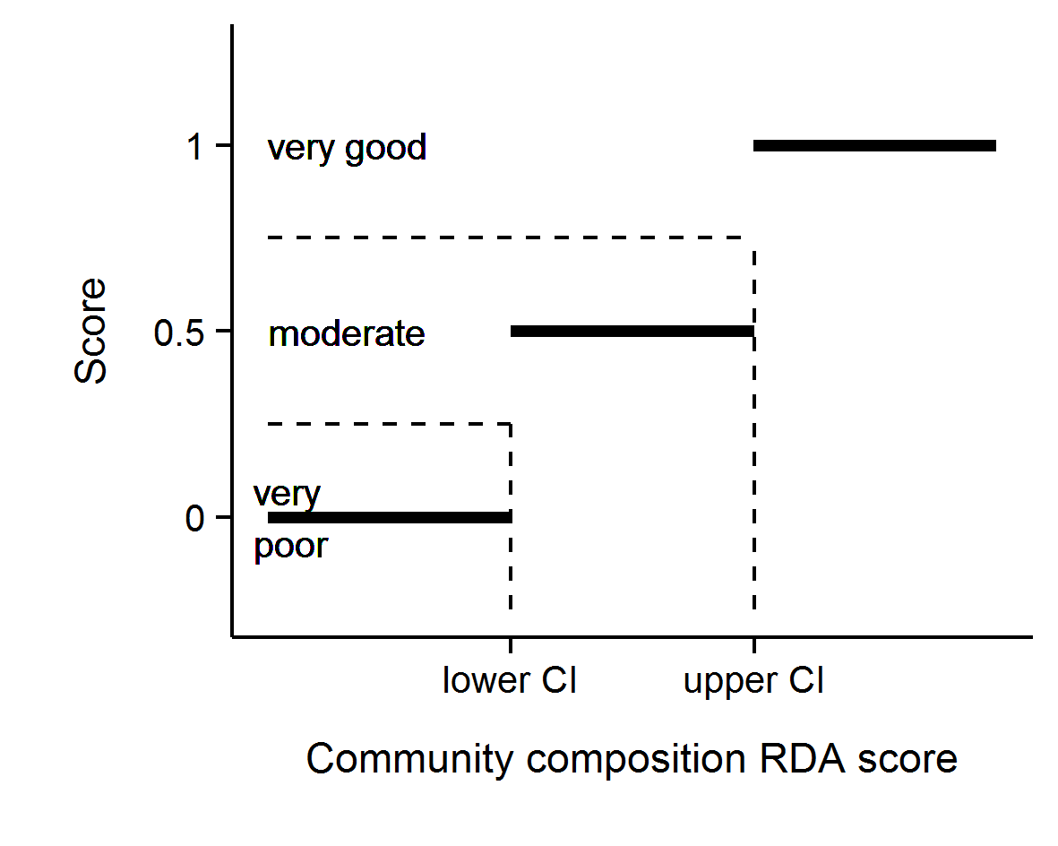
Figure 7 Scoring diagram for community composition metric

Aggregating indicator scores to Reef and regional scale assessments
In aggregating scores for various indicators into a single index, uncertainty should be considered. The degree of uncertainty in an index score derived for any spatial scale of interest will include uncertainty across multiple levels: from basic observational error, the relevance of thresholds, and then variation in scores for different indicators or communities being assessed.
To derive report card scores for regions that propagated uncertainty through the double hierarchical aggregation of indicators and then reefs, a bootstrapping method was adopted. Firstly, for each indicator a distribution of 10,000 observations was created by resampling (with replacement) from the observed scores for all reef and depth combinations within the Region or sub-region of interest. Secondly these 5 resulting distributions (one for each indicator) were added together and collectively resampled 10,000 times (with replacement) to derive a single distribution comprising 10,000 scores.
To generate estimates of precision (and thus confidence intervals) appropriate for the scale of the sampling design, the bootstrapped distribution of 10,000 scores was resampled once for every original input indicator score. Confidence intervals were calculated as the 2.5% and 97.5% quantiles of repeated estimates of the mean.
Mean index scores for each (sub-)region were estimated as the mean of observed mean scores for each indicator from all reefs and depths within the (sub-)region. Reef level scores as reported in the Reef report card were estimated as the weighted mean of regional scores. Weightings applied reflect the relative proportion of inshore coral reef area within the four regions as: Wet Tropics (0.209), Burdekin (0.092), Mackay-Whitsunday (0.381) and Fitzroy (0.318). Lastly, index scores were converted to qualitative assessments by converting to a five-point rating and colour scheme with scores of:
- 0 to 0.2 were rated as ‘very poor’ and coloured red
- 0.21 to 0.4 were rated as ‘poor’ and coloured orange
- 0.41 to 0.6 were rated as ‘moderate’ and coloured yellow
- 0.61 to 0.8 were rated as ‘good’, and coloured light green
- 0.81 were rated as ‘very good’ and coloured dark green.

The indicators, associated thresholds, and scoring system utilised is summarised in Table 4. We note that the community composition indicator is likely to respond over longer time frames than the other indicators due to the inertia in community composition imposed by long-lived coral species.

Table 4 Threshold values for the assessment of coral reef condition and resilience indicators.
Community attribute | Score | Thresholds
Combined hard and soft coral cover | Continuous between 0–1 | 1 at 75% cover or greater
 |  | 0 at zero cover
Proportion of algae cover classified as Macroalgae | Continuous between 0–1 | ≤ reef specific lower bound and ≥ reef specific upper bound
Density of hard coral juveniles (<5 cm diameter) | 1 | > 13 juveniles per m² of available substrate
 | Continuous between 0.4 and 1 | 4.6 to 13 juveniles per m² of available substrate
 | Continuous between 0 and 0.4 | 0 to 4.6 juveniles per m² of available substrate
Rate of increase in hard coral cover (preceding 4 years) | 1 | Change > 2x upper 95% CI of predicted change
 | Continuous between 0.6 and 0.9 | Change between upper 95% CI and 2x upper 95% CI
 | Continuous between 0.4 and 0.6 | Change within 95% CI of the predicted change
 | Continuous between 0.1 and 0.4 | Change between lower 95% CI and 2x lower 95% CI
 | 0 | change < 2x lower 95% CI of predicted change
Composition of hard coral community | 1 | Beyond 95% CI of baseline condition in the direction of improved water quality
 | 0.5 | Within 95% Confidence intervals of baseline composition
 | 0 | Beyond 95% CI of baseline condition in the direction of declined water quality

Data analysis and presentation
Observed coral community condition and relationships to variability in environmental conditions are presented at a range of spatial and temporal scales (Table 5).

Table 5 Format for presentation of community condition.
Section | Scope | Scale | Covariates | Analyses/Presentation
4.1 | Temporal trend in coral condition | Reef | Major disturbances | Relative influence of major pressures over the time-series
4.3 | Trends in Coral index and individual indicators | (Sub-)regional |  | Generalised linear mixed models; pairwise comparisons
4.7.1 | Coral index and indicator scores in 2020 | Reef and Regional | Chl a, PAR | Generalised linear mixed models, predicted responses
4.7.2 | Temporal variability in Coral index in relation to water quality | Regional | Regional riverine: discharge, Total N and Total P loads.  Chl a exposure, PAR | Generalised additive models, predicted responses
Appendix 1: Additional Information | Trends in benthic community composition. | Reef/Depth |  | Plots
 | Summaries of 2020 observations | Reef/Depth |  | Observed values

Variation in index and indicator scores to gradients in water quality
The relationships between the most recent index or indicator scores, at each depth, and the location of reefs along water quality gradients were explored via generalised linear mixed models. Each combination of index or indicator score, and depth were fit separately to two water quality proxies: mean Chl a concentration and PAR at 8m depth. General Reef-wide trends were identified on the basis that Akaike information criterion (AICc) values for models fitting indicator response to the water quality proxy and including random intercepts for each region were at least 2 units lower than the simpler model that did not include the water quality proxy. As scores are bound by 0 and 1, models assumed a Beta response distribution. Where the distribution of scores included 0 or 1, data were scaled as (Score*0.998) + 0.001) prior to analysis to lie between 0 and 1 as defined by a beta distribution. The exception was the composition indicator scores that were modelled using a probit regression due to their categorical response. Indicator values for the macroalgae and composition indicators (proportion of algal cover categorised as macroalgae, and product of genus cover and water quality eigenvector weightings) were also examined, as the scores for these indicators are based on thresholds that account for variability along water quality gradients. Macroalgal proportion was also fit using a beta distribution and a gaussian distribution was used for genus composition values.
Where relationships between index or indicator scores or indicator values were implied based on AICc comparisons, the generality of the response was further explored by plotting predicted responses from more complex models that also allowed for varied slopes among regions by inclusion of an interaction between water quality proxy and region to the models described above. The results of these models are plotted and confidence intervals for slopes within each region estimated to identify the regions contributing most to the general Reef-wide trends. Generalised linear mixed models were fit via the mgcv package (Wood 2019) while the probit model for Composition was fit with the polr function in the MASS package within the R Statistical and Graphical Environment (R Core Team 2018).

Relationship between index and indicator scores and temporal variability in environmental conditions
The response of coral communities to variation in environmental conditions was assessed by comparing changes in index scores to:
- annual discharge and total N and P loads estimated from the adjacent catchments,
- exposure to above Guideline concentrations of Chl a over the wet season,
- PAR levels at reef and regional scales.
For these analyses Generalised Additive Models (GAMs) were applied separately to results from each Region. The response variable was the biennial change in the index score (I) at a given reef (r) from one year (y) to the year (y+2). Biennial changes were considered due to the biennial sampling design of the program.
$$ΔI = I_{ry+2}– I_{ry}$$
Similarly, the covariates in each model were selected to represent the maximum exposure of the two water years ending in the survey year (y+2). To reduce confounding between the response of the index to acute disturbances, observations of change in the index at reefs categorised as being influenced by an acute disturbance event in a given biennial period were excluded.
In the first instance, GAMs allowed for the fitting of non-linear responses using natural splines; when these models did not support non-linear response, simple linear models were used.
All GAM models were fit via the mgcv package (Wood 2019) and linear models were fit via the stats package within the R Statistical and Graphical Environment (R Core Team 2017).

Temporal trends in coral index and indicators
A panel of plots provide temporal trends in the coral condition index and the five indicators on which the index is based. The derivation of annual coral index scores and associated confidence intervals is detailed in section 2.4.
For each of the five indicators that inform the coral index, temporal trends and their 95% confidence intervals in there observed values were derived from linear mixed effects models. Models for each indicator included a fixed effect for year and random effect for each reef and depth combination. The inclusion of random locational effects helps to account for the sampling design that includes a mixture of annual and biennial sampling frequency. To account for missing samples in estimating the trend in index scores, missing indicator scores were infilled with observations from the preceding year as is done for the estimation of annual index scores.
Observed trends for individual reef and depth combinations (averaged over sites) are provided as grey lines.
A more detailed summary of raw data for benthic cover and juvenile density at each reef and depth combination is presented as bar plots (Figure A 1 to Figure A 6). These additional plots break down cover and density of corals to the taxonomic level of Family. Genus level cover data for the current year only are included in Table A 10 to Table A 12.

Analysis of change in index and indicator scores
Differences in the index, or individual indicator scores were estimated between focal years identified as local maxima or minima within the time-series of the index scores within each (sub-)region. Confidence in the magnitude of these differences is expressed as a probability that the mean difference in scores was greater or less than zero. Probabilities were estimated based on the location of zero (no difference) within the posterior distribution (n=1000) estimated from the mean and standard deviation of observed differences in scores between focal years. Probabilities were estimated separately for communities at 2 m and 5 m depths.

Response to pressures
The most tangible immediate effect of disturbances to coral communities is the loss of coral cover. A summary of disturbance history across all reefs and within each (sub-)region is presented as a bar plot of annual hard coral cover loss. The height of the bar represents the mean coral cover lost across all 2 m and 5 m sites within a region. Bars are segmented based on the proportion of loss attributed to different disturbance types. For each observation of hard coral cover at a reef and depth, the observation was categorised by any disturbance that had impacted the reef since the previous observation (Table 6) and the coral cover lost calculated as:
$$Loss= predicted- observed$$
$w$here, observed is the observed cover of hard corals, and predicted was the cover of hard corals predicted from the application of the coral growth models described for the cover change indicator (section 2.4.4). The observed cover is adjusted to represent an annual time step, based on the period since the previous observation, so as to be consistent with the model predicted value. The proportion of coral cover lost per region for each disturbance type is subsequently calculated as:

$$proportional Loss=(\frac{Loss}{∑{Loss}_{r}})$$
Where, $∑{Loss}_{r}$ is the overall cover lost at the scale of interest, either Reef or (sub-)region. It is important to note that for each loss attributed to a specific disturbance any cumulative impact of water quality is implicitly included.

For reference among (sub-)regions, the y axis of each plot was scaled to the maximum mean hard coral cover loss observed across regions in a single year (25.5% loss of coral cover within the Mackay Whitsunday region in 2017).

Table 6 Information considered for disturbance categorisation
Disturbance | Description
Thermal bleaching | Consideration of in situ degree heating day estimates and reported observations of coral bleaching
Crown-of-thorns starfish | SCUBA search revealing > 40 ha⁻¹ density of crown-of-thorns during present or previous survey of the reef
Disease | SCUBA search observations of coral disease during present or previous survey of the reef
Flood | Discharge from local rivers sufficient that reduced salinity at the reef sites can reasonably be inferred. An exception was classification of a flood effect in the Whitsundays region based on high levels of sediment deposition to corals. This classification has been retained for historical reasons and would not be classified as a flood effect under the current criteria
Storm | Observations of physical damage to corals during survey that can reasonably be attributable to a storm or cyclone event based on nature of damage and the proximity of the reef to storm or cyclone paths.
Multiple | When a combination of the above occur
Chronic | In years that no acute disturbance was recorded a Loss was recorded when observed hard coral cover fell below the predicted cover and these losses classified as disturbance type ‘Chronic’. This categorisation will include the cumulative impacts of minor exposure to any of the above disturbances along with chronic environmental conditions. Importantly as estimates for each disturbance are a mean and the disturbance categorisation “Chronic” includes all non-disturbance observations any proportion of loss attributed to this category represents a mean under performance in rate of cover increase for reefs not subject to an acute disturbance.

Pressures influencing coral reefs in 2019-20
The condition of coral communities is impacted by a range of environmental pressures. Interpreting the impact of pressures associated with water quality relies on first understanding the impacts of confounding pressures such as cyclones, high seawater temperatures that lead to coral bleaching and predation by crown-of-thorns starfish. This section summarises the primary pressures imposed on inshore areas of the Reef in recent years. The impacts of these pressures are spatially variable and summarised at the Reef level in section 4.1 and (sub-)regional level in section 4.3.

Cyclones
Tropical cyclones frequently cross the inshore Reef.
Over the 2019-20 reporting period there was no cyclone activity likely to have produced damaging waves to the Reef. The only cyclone in the Coral Sea region was cyclone Uesi, and this system passed through the far eastern region of the Coral Sea (Figure 8).
Since 2005 three intense systems caused region-wide damage to coral communities:
- cyclone Larry (2006) and cyclone Yasi (2011) both caused damage to Wet Tropics and Burdekin region reefs. The severely impacted reefs at Dunk North and the 2 m depth at Barnards in the Herbert Tully subregion are showing clear signs of recovery from these storms (Figure A 3). Coral cover at the Barnards has largely returned to the high level observed in 2005. At Palms East in the Burdekin region Cyclone Yasi removed almost all the previously high cover of soft corals. The recovery of coral cover at this reef has resulted in a shift in coral community composition with the current community dominated by hard corals of the family Acroporidae (Figure A 4)
- cyclone Debbie (2017) caused severe coral loss on reefs in the Mackay-Whitsunday Region (Figure 8, Table A 7,). There are yet to be clear signs of recovery of coral communities in the wake of this cyclone.
Numerous smaller cyclones have crossed the inshore Reef over the last decade (Figure 8) causing more moderate and localised damage (Table A 7, see also ((sub-)regional summaries section 4.3).

Sea temperature
Sea temperatures over the 2020 summer were above long-term averages. The highest deviations occurred in inshore areas south of Hinchinbrook Island (Figure 9, Figure 10). Widespread coral bleaching was observed at reefs in the Burdekin and Fitzroy regions during MMP surveys in 2020. High temperatures were also experienced across the MMP reporting area in 2017 but not 2016, when northern areas of the Reef experienced extreme temperatures (Figure 9, Figure 10). Published thresholds for moderate to severe bleaching are 100 DHDs (Garde et al. 2014).

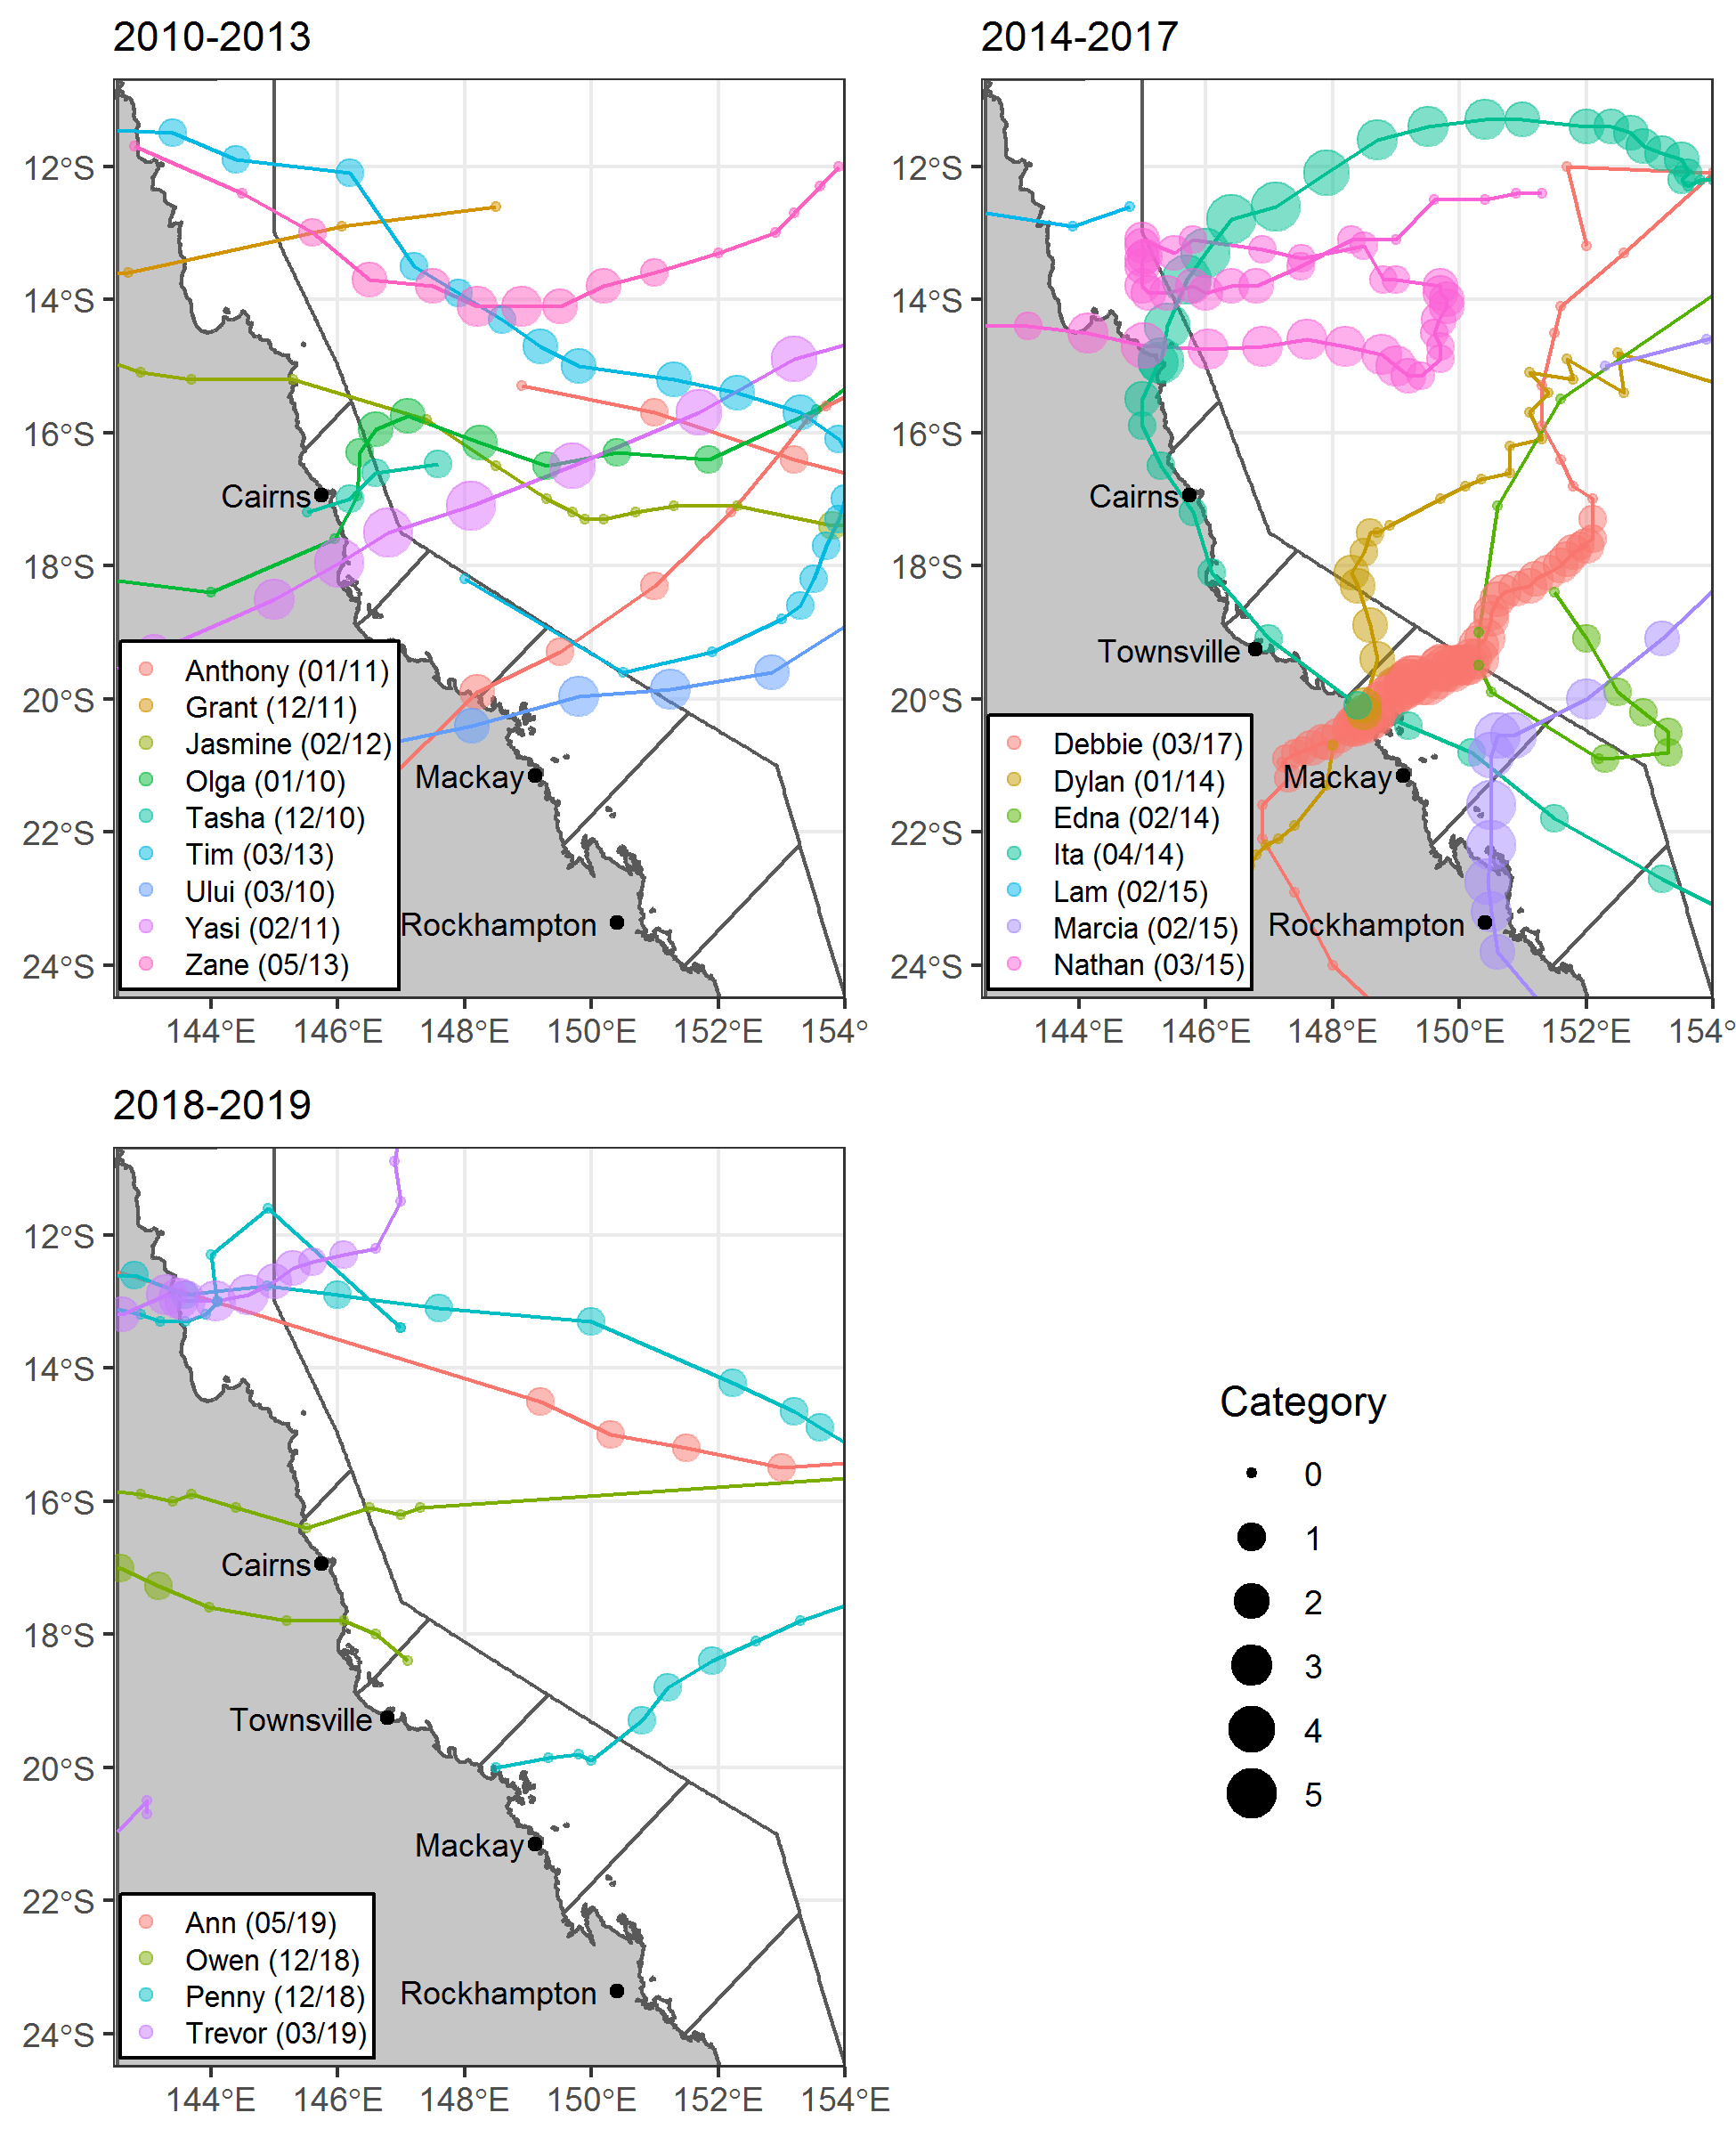
Figure 8 Cyclone tracks for systems crossing the inshore Reef over the last decade
. Tracks sourced from the Bureau of Meteorology.

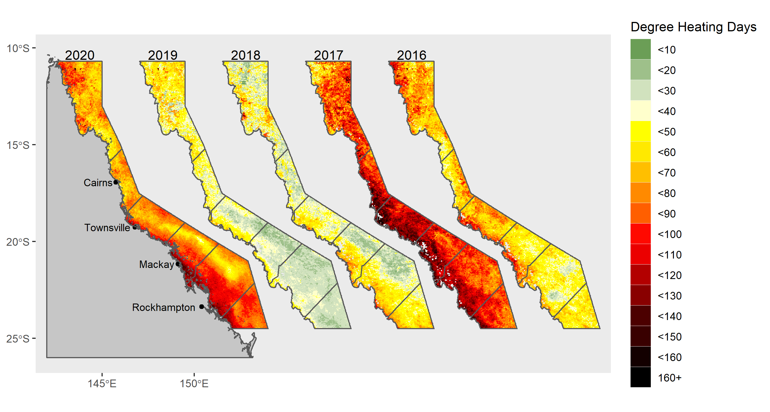
Figure 9 Annual degree heating day estimates for the Reef
. Data are the annual degree heating day accumulations over the summer period (1 December to 31 March) for ~4 km² pixels based on temperatures exceeding 14 Day IMOS climatology. Data were sourced from the Australian Bureau of Meteorology ReefTemp next generation web data service .

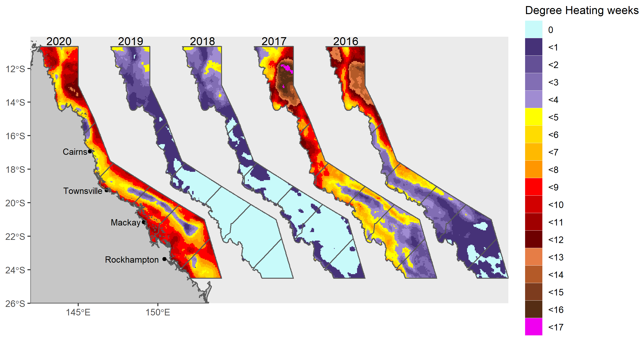
Figure 10 Annual degree heating week estimates for the Reef
. Data are the annual maximum degree heating week estimates for each ~25 km² pixel. Date were sourced from NOAA coral reef watch.

Crown-of-thorns starfish
Elevated populations of crown-of-thorns starfish on the inshore reefs have been limited to reefs in the Barron-Daintree and Johnstone Russell-Mulgrave sub-regions, where they have caused 37.5% and 17.5% coral cover losses, respectively, since 2005 (Figure 16, Figure 19). These losses occurred over the period from 2012 to 2015. The potential impact of crown-of-thorns starfish on these reefs was almost certainly mitigated by the removal of starfish under the Authority’s crown-of-thorns control program (Table 7).
Since 2015 crown-of-thorns starfish have remained present on reefs in the Johnstone Russell-Mulgrave sub-region, with numbers increasing to outbreak levels (> 30 individuals per hectare) at five of the six reefs monitored in 2020 (Table 7, Figure A 8). The impact on coral cover was limited by the small size of these starfish (Table 8) and ongoing population control (Table 7). In the smaller size classes, crown-of-thorns starfish tend to feed in the understory of the coral community, and this, along with the relatively small size of their feeding scars, limits the loss of coral observed using photo transects. This feeding will however have put downward pressure on the cover change indicator scores at these reefs.

Table 7 Number of crown-of-thorns removed by the Authority’s crown-of-thorns control program.
Figure in bold are the number of individuals removed. The catch rate per diver hour is given in bracket to provide an idea of relative population density.
Reef | 2012 | 2013 | 2014 | 2015 | 2016 | 2017 | 2018 | 2020
Fitzroy Island | 961 (8.6) | 2761 (11.9) | 793 (6.8) | 175 (1.6) | 385 (5.7) | 71 (0.6) | 3 (0.04) | 137 (3.75)
Green Island | 2838 (17.6) | 2889 (10.2) | 758 (4.9) | 352 (3.2) | 579 (4.9) | 170 (2.1) | 2 (0.04)
Low Isles |  | 405 (23.7) | 296 (2.3) | 144 (2.2) | 1 (0.1) |  |  | 2 (0.11)
Frankland Group |  |  |  |  |  | 770 (5.6) | 73 (0.8) | 525 (15.5)
Snapper Island |  | 135 (16.2)

Following surveys by the MMP the Authority’s crown-of-thorns control program initiated culling in the Frankland Group (Round and Russell Islands) and at Fitzroy Island. The crown-of-thorns starfish removed ranged in size across several cohorts, confirming MMP observations (Table 8) and indicating the ongoing recruitment and survival of crown-of-thorns starfish over recent years. Similar recruitment of crown-of-thorns starfish was observed by the AIMS LTMP on mid-shelf reefs of the Innisfail sector, where juvenile and sub-adult crown-of-thorns starfish were noted during surveys in February 2020.
In 2020 no crown-of-thorns starfish were observed during MMP surveys in other regions. Sighting data supplied by the Authority indicate low numbers of crown-of-thorns starfish at Hayman Island in the Mackay-Whitsunday region.
In contrast, population outbreaks of crown-of-thorns starfish recorded by the AIMS LTMP on mid shelf reefs between Innisfail sector 2018 and Townsville sector 2019 had declined to below outbreak levels during the most recent surveys (Innisfail sector 2020, Townsville sector 2020). Most recent AIMS LTMP results recorded active outbreaks of crown-of-thorns starfish on mid-shelf reefs south of Mackay (Pompey sector 2019, Swain sector 2020).

Table 8 Size class distribution of crown-of-thorns on inshore reefs in the Wet Tropics
. Included are the percentages culled, as listed in Table 7, of cohorts 1-4
, and percentage in size-classes observed by the MMP.
Year | Authority’s crown-of-thorns control program |  |  |  | MMP surveys
 | Cohort 1  0-15 cm | Cohort 2  15-25 cm | Cohort 3  25-40 cm | Cohort 4  >40 cm | 5-15 cm | 15-25 cm | >25 cm
2012 | 25 | 27 | 34 | 14 | 54 | 40 | 2
2013 | 26 | 45 | 24 | 5 | 15 | 57 | 28
2014 | 39 | 36 | 19 | 6 | 57 |  | 43
2015 | 69 | 27 | 3 | >1 | 50 | 17 | 33
2016 | 88 | 11 | >1 | 0 | 67 | 33
2017 | 67 | 30 | 3 | 0 | 55 | 45
2018 | 55 | 44 | 1 | 0 | 14 | 36 | 50
2019 |  |  |  |  | 33 | 67
2020 | 44 | 45 | 12 |  | 27 | 49 | 24

River discharge
Discharge from the catchments adjacent to the Reef has the potential to impact coral communities, either by exposing corals to lethally low salinity in flood plumes or via the increased loads of sediments and nutrients delivered to inshore waters. The likelihood of negative impacts associated with runoff is logically related to the volume of freshwater and contaminants delivered, both of which vary with river discharge.
At the scale of the Reef interannual variability in discharge highlights potential for increased risk to corals over the period 2007-08 to 2012-13 and then in 2018-19 (Figure 11). Discharge in 2020 was below median levels.
In 2018-19 record flooding of the Daintree River in combination with minor storm damage attributed to pre-cyclone Owen resulted in the loss of 38% of hard coral cover at 2 metre depth at Snapper Island South (Figure A 1). This was the only acute disturbance to have directly impacted inshore coral communities over the 2018-19 summer.
Heavy rainfall in February 2019 resulted in major flooding of rivers in the Burdekin region and above median discharges from rivers in the Mackay-Whitsunday region and Herbert Tully and Johnstone Russell-Mulgrave sub-regions. There was no evidence that these floods had any direct impacts on coral communities at reefs monitored in 2019, as species of Acropora, known to be sensitive to exposure to low salinities (Berkelmans et al. 2012), were surviving at the shallow sites on reefs most proximal to the rivers. However, it is likely that the level of discharge contributed to chronic pressures on coral communities as evidenced by increased levels of disease in these regions. Closer to the coast the authors’ personal observations were that corals at Virago Shoal off the coast of Townsville were killed by floods of the Ross River, while corals along the eastern face of Cape Cleveland were killed by the plume of the Burdekin and / or Haughton rivers.
In previous years, the most extensive damage to monitored reefs occurred in 2011 in the Fitzroy region when there was very high mortality of corals at 2 m depths on reefs to the south of Great Keppel Island (Table A 7, Figure A 6). As at 2020 recovery from this event was occurring at Keppels South but limited, at best, at Peak and Pelican Islands.
The influence of sediment and nutrient loads are not as overtly obvious as those associated with exposure to freshwater and are explored in terms of suppression of coral recovery and variable condition of coral communities along water quality gradients in section 4.7.1.

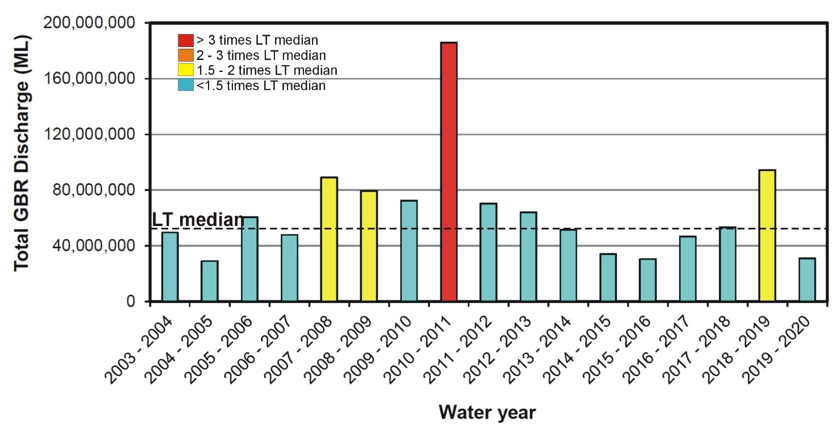
Figure 11 Annual total river discharge to the Reef.
Annual estimates aggregate over the water year: 1 October to 30 September, for the 35 main Reef basins. Values are colour coded relative to proportion of long-term (LT) median (1986-2016) discharge. Figure source: Waterhouse et al. 2021, data source: DNRM, http://watermonitoring.dnrm.qld.gov.au/host.htm

Coral condition and trend
Results are presented in the following sequence:
- Reef level trend in coral condition and indicator scores (4.1)
- Reef level attribution of pressures causing coral cover losses (4.2)
- (sub-)Regional level trend in coral condition and indicator scores (4.3 - 4.6)
- relationship between the condition of coral communities in 2020 and water quality gradients (4.7.1)
- the influence of river discharge and reef-level water quality on change in community condition (4.7.2)
The above results highlight that pressures and current coral condition differ among and within regions. As such, temporal trends in community attributes are presented for each (sub-)region along with time-series of data relating to the primary pressures influencing coral communities.
Finally, site-specific data and additional information tables are presented in Appendix 1. Time series of community condition and composition for each reef monitored are available online at http://apps.aims.gov.au/reef-monitoring/.

Reef-wide coral condition and trend
At the Reef scale, the coral index score remained largely unchanged form that observed in 2019 and remains ‘poor’ (Figure 12). The decline from ‘moderate’ in 2016 represents the combined pressures associated with cyclone Debbie, high sea temperatures causing coral bleaching, predation of corals by crown-of-thorns starfish and flooding of the Daintree River (Figure 8, Figure 10, Table 7, Table A 6). The lack of change in index score between 2019 and 2020 reflects slight improvements in coral cover and juvenile coral indicator score, counteracted by declines in the macroalgae indicator.

Figure 12 Reef level trend in coral index and indicator scores
. Coral index scores are coloured by report card categories: orange = ‘poor’, yellow=’moderate’. Error in index score derived from bootstrapped distribution of regional indicator scores weighted by the relative area of inshore coral reefs in each region.
The recovery of coral communities between 2013 and 2016 demonstrated the recent resilience of inshore coral communities. That the current condition is again low is unsurprising given the level of pressure imposed in recent years. A positive indication for future recovery is that despite the high level of coral bleaching in the Burdekin and Fitzroy regions and increase in abundance of crown-of-thorns starfish in the Wet Tropics region the mean coral cover and the density of juvenile corals across reefs increased between 2019 and 2020. Conversely, macroalgae indicator scores were lower, indicating their continued downward pressure on recovery.
Ultimately, the Reef level coral community condition reflects large-scale averages and overall responses of coral communities exposed to varied past and ongoing pressures. The following sections explore results at finer spatial resolution. What is clear from the Reef level disturbance time-series is that since 2005 inshore reefs have been exposed to a barrage of disturbance events, the impacts of which have outweighed the coral community’s ability to recover.

Relative impact of disturbances
The most directly observable impact of acute disturbance events is the loss of coral cover. Over the period of the MMP, cyclones and storms have caused almost half (46%) of all coral cover losses on inshore reefs (Figure 13). Unsurprisingly, the intense category 4 and 5 systems; cyclone Larry (Wet Tropics and Burdekin Regions – 2006), cyclone Yasi (Wet Tropics and Burdekin Regions – 2011), and cyclone Debbie (Whitsunday Region – 2017) have caused the greatest losses. Changes in the community composition indicator scores (Figure 12) following acute disturbances indicate that it is species sensitive to poor water quality (primarily Acropora, Table A 5) that are disproportionately impacted by these events.
When interpreting Figure 13 is important to note that the biennial sampling design of both the MMP and LTMP results in some lagged attribution of coral loss to disturbance events. For example, loss of coral cover attributed to cyclone Debbie at three reefs monitored by the LTMP in the Mackay-Whitsunday region were not quantified until 2019. Similarly, while the MMP sampling design includes capacity for contingency sampling in the event of acute disturbances, to limit this lagged assessment, cyclone and bleaching impacts recorded in 2018 (Figure 13) reflect pressures imposed in early 2017.
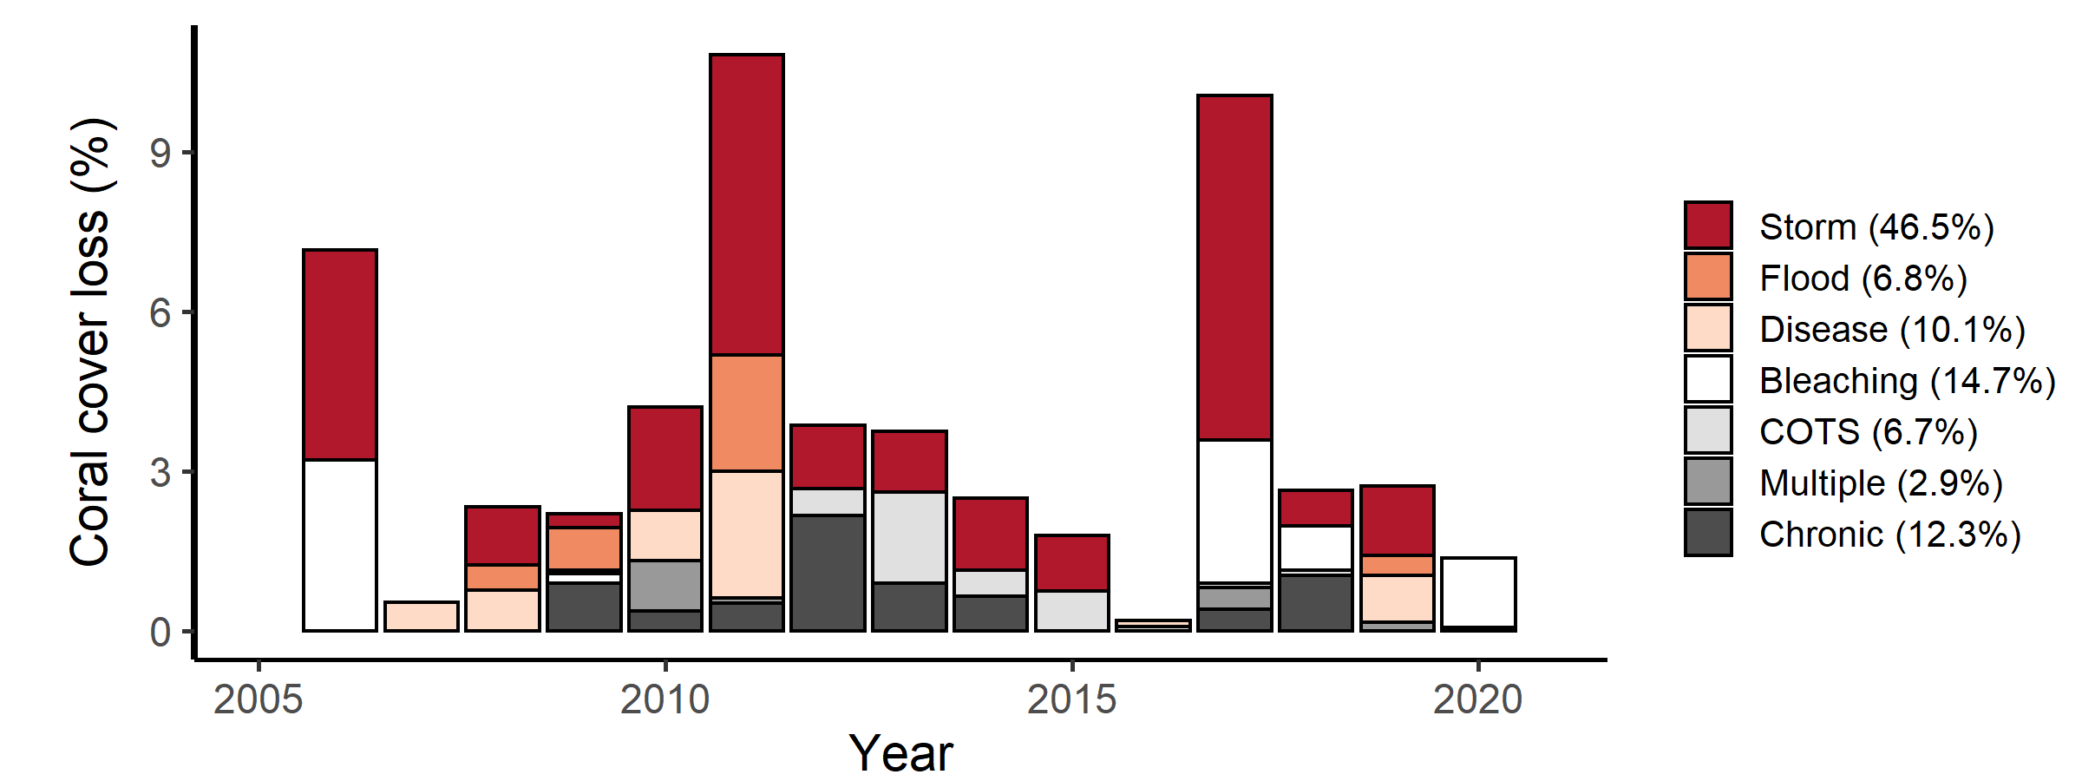
Figure 13 Hard coral cover loss by disturbance type across the inshore Reef
. Length of bars represents the mean loss of cover across all reefs in each year. Colours represent the identified cause of cover loss.

Thermal bleaching events have contributed to 15% of the coral cover losses since 2005. High water temperatures causing bleaching and subsequent loss of coral cover occurred in 2006, 2017, and 2020 (Figure 13); the loss indicated in 2018 is due to some impacted reefs not being surveyed in 2017. It is likely that some losses of cover recorded as Disease in 2007 and Chronic in 2017 and 2018 were influenced by stress imposed by high water temperatures also. While crown-of-thorns starfish have caused moderate losses (7%, Figure 13), their effect has likely been limited by active removal to control populations at Fitzroy Island, Green Island and in the Frankland Group. These figures contrast with those from more offshore areas where crown-of-thorns starfish (Osborne et al. 2011, De’ath et al. 2012) and more recently thermal bleaching (Hughes et al. 2018) are recognised as major contributors to loss of coral cover.
Loss of corals from direct exposure to low salinity flood waters has been limited to 2 m depths on reefs most proximal to rivers during major flood events. This is unsurprising, as more frequent exposure would be expected to preclude reef development. Indeed, the reefs most impacted, Peak Island and Pelican Island in the Fitzroy region, demonstrate minimal development of a carbonate substrate, questioning their appropriate inclusion as coral reef monitoring locations. All other reefs included in the LTMP and MMP were selected to capture areas where development of a carbonate substrate provides evidence for historical reef building capacity of corals.
In combination, these acute disturbance events contribute strongly to the declines in the coral cover (Lam et al. 2018) and index scores in all regions.
The losses of coral cover attributed to disease and chronic pressures (23%, Figure 13) are more likely to reflect the impacts of water quality. However this figure is likely to be an underestimate, as losses attributed to acute disturbances will include any compounding impacts associated with chronic pressures as elevated levels of nutrients may: increase the susceptibility of corals to disease (Bruno et al. 2003, Haapkylä et al. 2011, Kline et al. 2006, Kuntz et al. 2005, Weber et al. 2012, Vega Thurber et al. 2013), promote outbreaks of crown-of-thorns starfish (Wooldridge & Brodie 2015) and increase susceptibility to thermal stress (Wooldridge & Done 2004, Wiedenmann et al. 2013).
The transport of coastal nutrients to the mid-shelf Reef remains a plausible factor enhancing the survival of crown-of-thorns starfish larvae, and so potentially extends the influence of run-off to large tracts of the Reef (Brodie et al. 2005, Fabricius et al. 2010, Furnas et al. 2013, Pratchett et al. 2014, Wooldridge & Brodie 2015, Brodie et al. 2017). However, the role of runoff in crown-of-thorns outbreak dynamics remains unresolved (Pratchett et al. 2017).

Coral condition and trends in each (sub-)region

Wet Tropics region
Coral communities in inshore areas of the Wet Tropics remain in ‘moderate’ condition. The stable condition observed since 2016 masks differing trends within sub-regions (Figure 14). High scores for the cover change indicator in recent years demonstrate the ongoing capacity for coral cover to rebound following disturbance events. The stable over-all condition, however, reflects a range of minor disturbances that have variously impacted reefs among the sub-regions, as detailed in the following sections. At the regional level, no indicator scores have fallen below moderate levels since 2014.

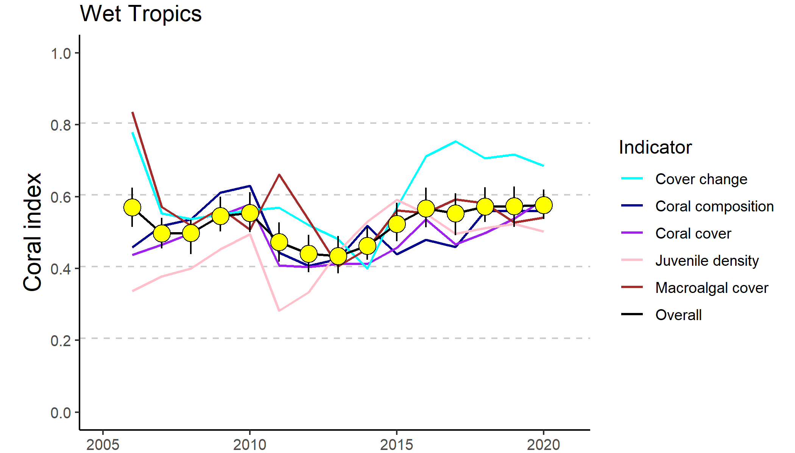
Figure 14 Trends in Coral index and contributing indicator scores for the Wet Tropics region
. Coral index scores are coloured by report card category: yellow=’moderate’ Error in index score derived from bootstrapped distributions of indicator scores at individual reefs.

Wet Tropics region: Barron Daintree sub-region
In 2020 the coral condition was ‘moderate’, having improved slightly from 2019 (Figure 15). A low point in index scores was recorded in 2014 following an outbreak of coral disease in 2012, predation by crown-of-thorns starfish and then damage attributed to cyclone Ita in April 2014 (Figure 16). Since then, there has been no clear recovery of coral communities at 2 m depth (Table 9). This lack of improvement also relates to high macroalgae cover at Snapper North, low juvenile densities and coral cover at Snapper South due to by exposure to flood waters and cyclone Owen in 2019 (Figure 16, Figure 17), although cover change scores have improved to good levels (Figure 17). Reduced composition scores since 2014 at 2 m depth (Table 9) are influenced by the disproportionate loss of Acroporidae corals at Snapper South in 2019 and a lack of recovery of this family at Snapper North in contrast to increased cover of Faviidae (Figure A 1), genus Echinopora (Table A 10).

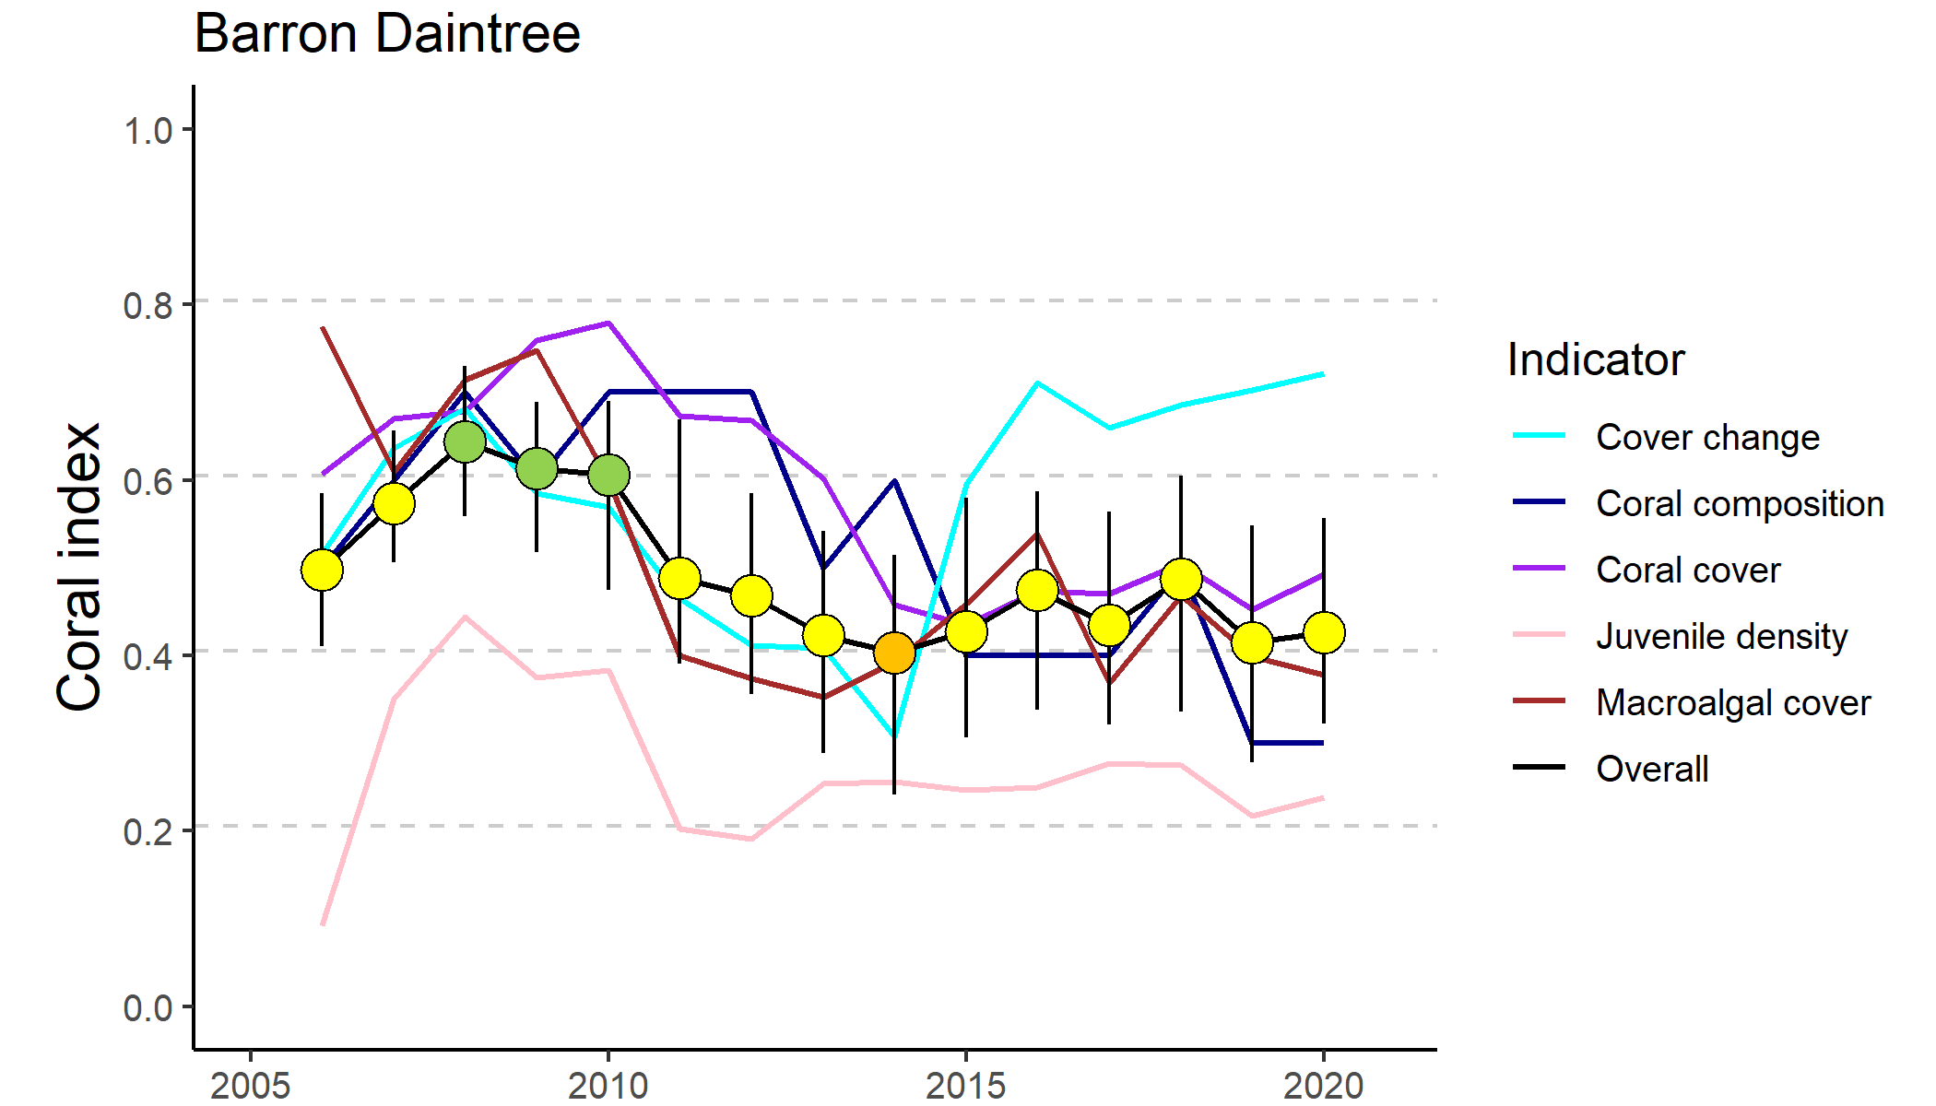
Figure 15 Trends in Coral index and contributing indicator scores for the Barron Daintree sub-region
. Coral index scores are coloured by report card categories: orange = ‘poor’, yellow=’moderate’ and green=’good. Error in index score derived from bootstrapped distributions of indicator scores at individual reefs.

Table 9 Index and indicator score comparisons in the Barren Daintree sub-region
. Data compare the changes in scores between local maxima and minima in the index time-series. For the index, and each indicator, the observed change in the score and the probability that the change was greater or less than zero (no change) are presented. Shading is used as a visual aid to highlight the magnitude of the probability the score improved (blue shades) or declined (red shades). Probabilities are derived from the posterior distribution of observed score changes at each reef and depth.
Period | Depth | Condition Index |  | Coral Cover |  | Macroalgae |  | Juvenile Coral |  | Cover Change |  | Composition
 |  | Score | P | Score | P | Score | P | Score | P | Score | P | Score | P
2008 to 2014 | 2 | -0.21 | 0.89 | -0.36 | 0.71 | -0.17 | 0.76 | -0.41 | 0.93 | -0.62 | 0.99 | 0.50 | 1.00
 | 5 | -0.26 | 0.81 | -0.13 | 0.61 | -0.42 | 0.81 | -0.04 | 0.58 | -0.21 | 0.70 | -0.50 | 1.00
2014 to 2020 | 2 | -0.08 | 0.78 | 0.06 | 0.76 | 0 | NA | -0.11 | 0.71 | 0.65 | 1.00 | -1.00 | 1.00
 | 5 | 0.09 | 0.71 | 0.01 | 0.53 | -0.03 | 0.55 | 0.04 | 0.60 | 0.26 | 0.805 | 0.17 | 0.73

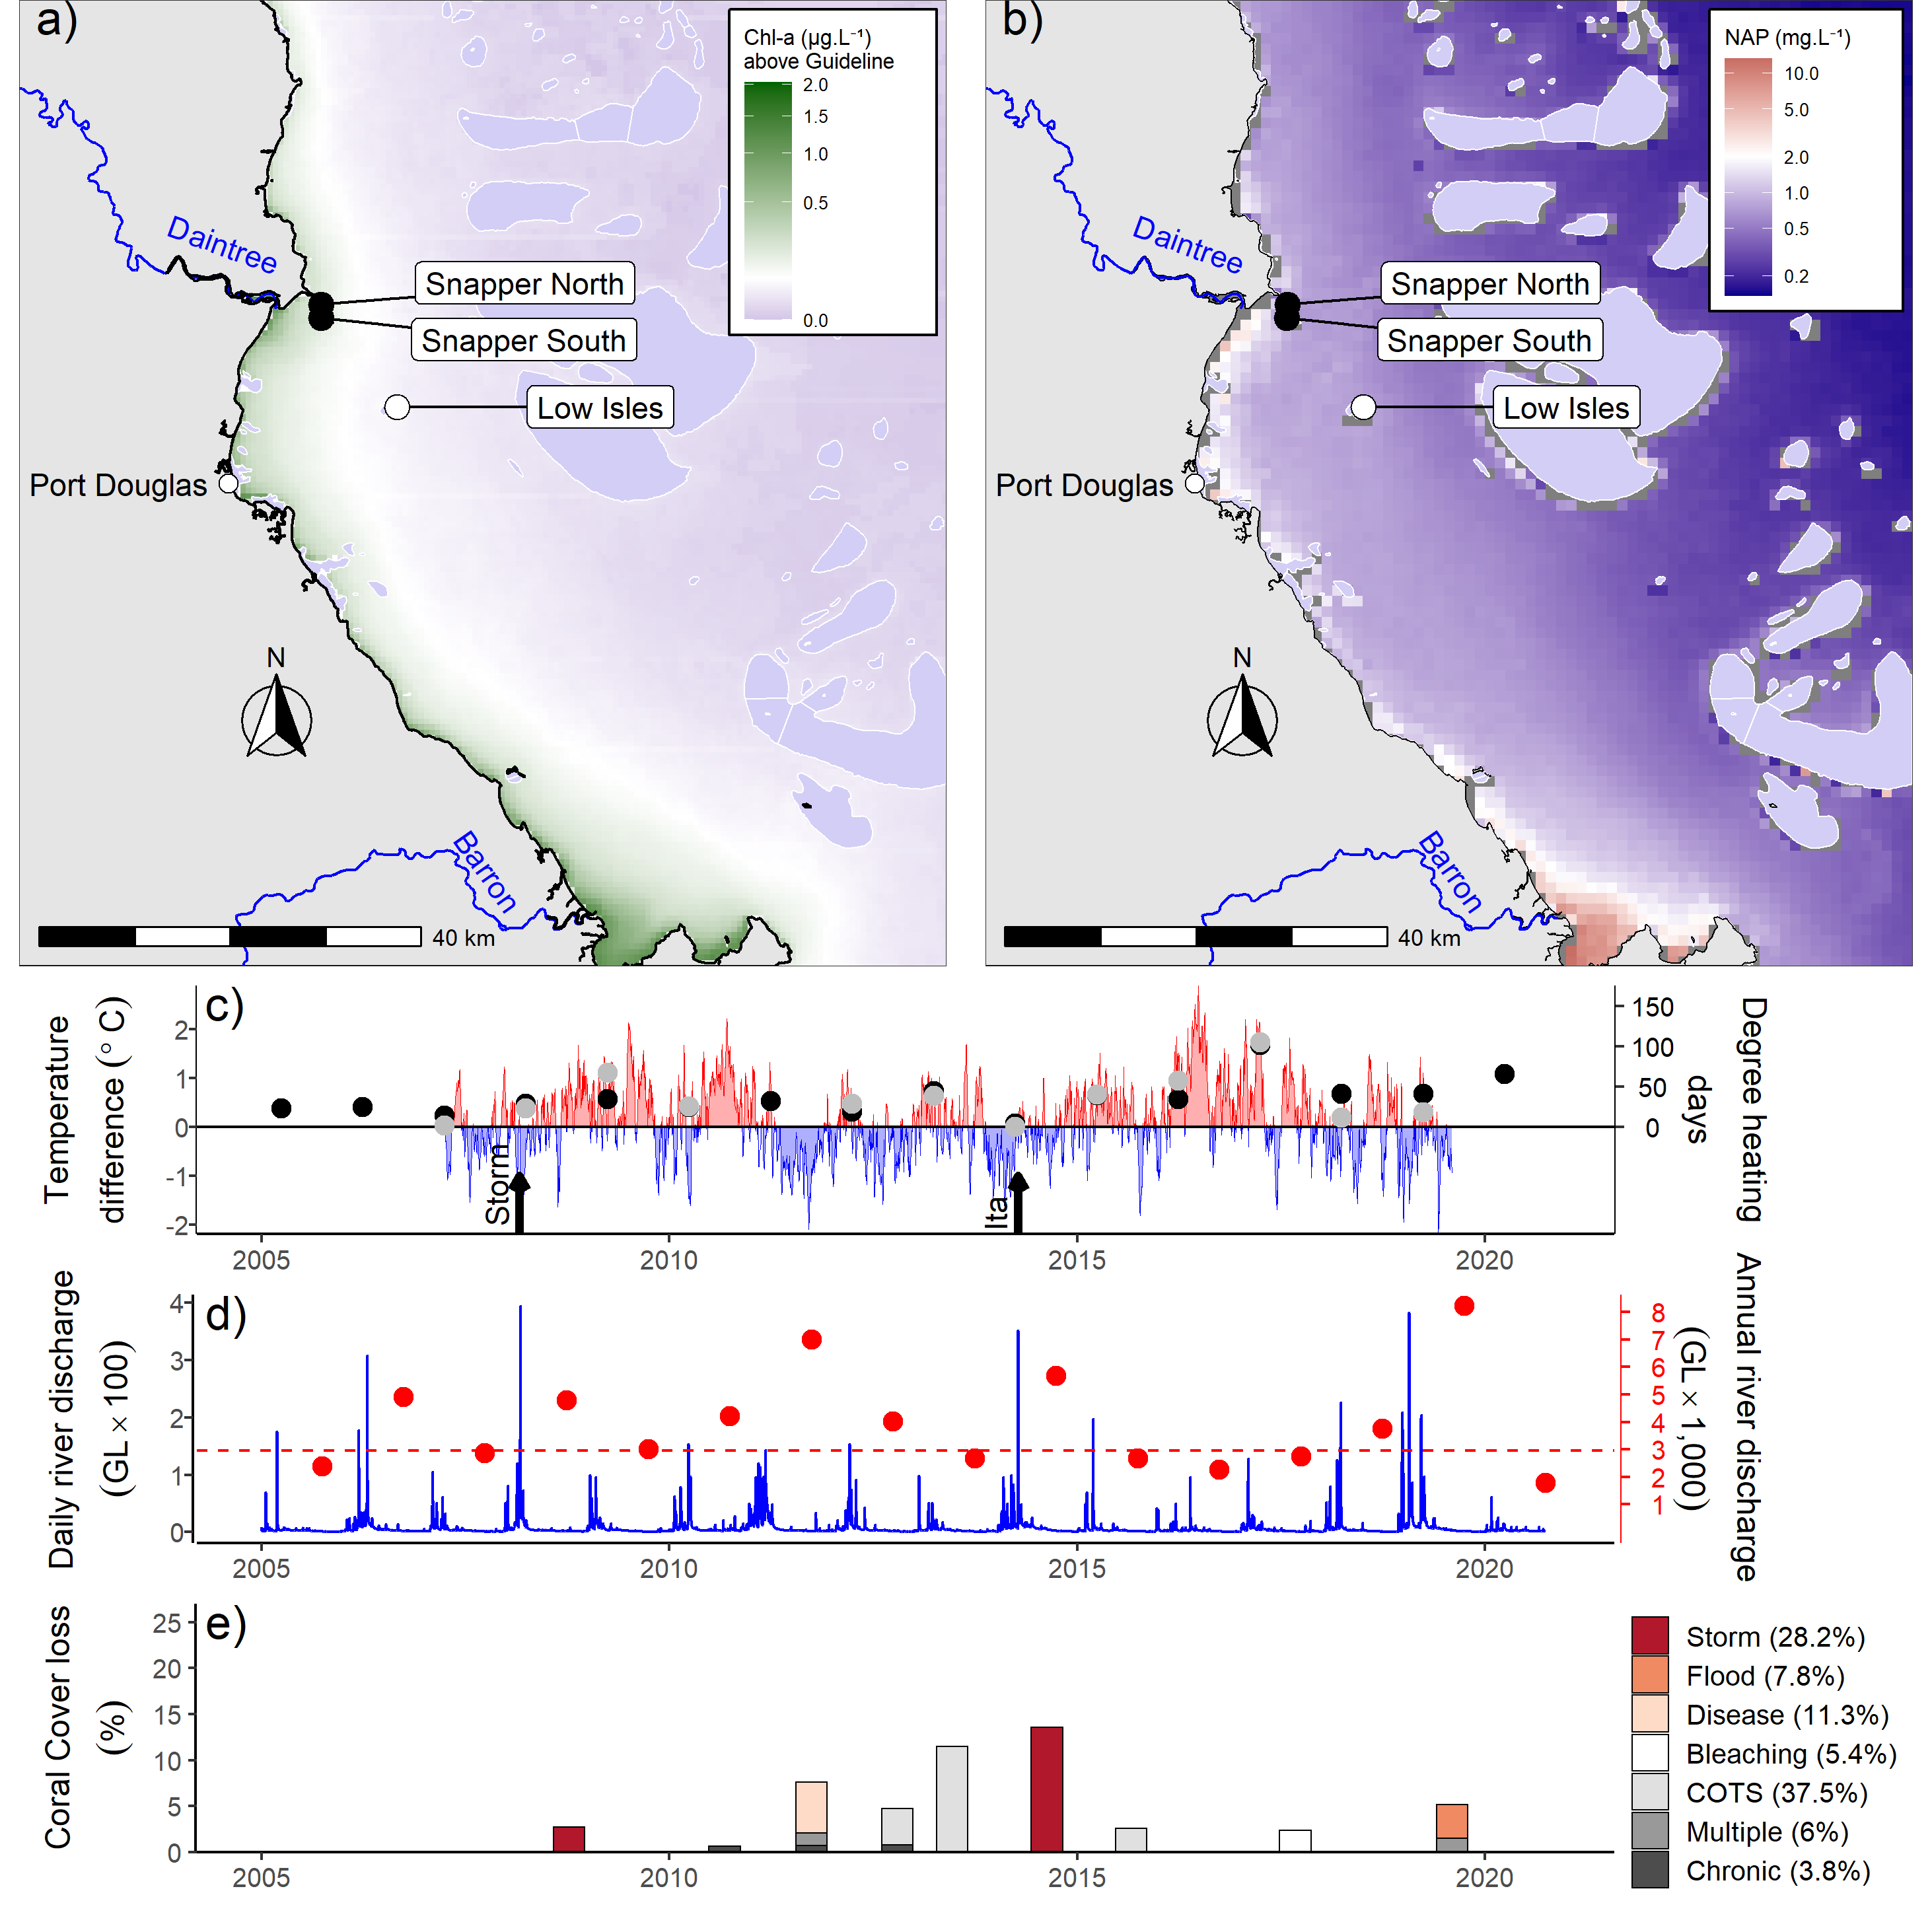
Figure 16 Barron Daintree sub-region environmental pressures
. Maps show location of monitoring sites, black symbols MMP, white symbols LTMP along with a) mean chlorophyll a exceedance of wet season Guideline (0.63ugL-1) and b) mean Non Algal Particulate concentrations. Water quality data are mean levels over the period 2003-2018. c) Seasonally adjusted temperature deviation, timing of cyclones and storms indicated by black arrows, accumulated degree heating days over the summer period (1st of December – 31st March) as reported by BoM (black symbols) and derived from in situ loggers (grey symbols) d) Combined daily (blue) and annual water year – October to September (red) discharge for the Daintree and Barron basins, red dashed line represents long-term median discharge (1986–2016). e) break-down of hard coral cover loss by disturbance type; length of bars represents the mean loss of cover across all reefs in the sub-region.

At 5 m depth, index scores have tended to improve since 2014, due primarily to improved scores for the coral change indicator (Table 9). The current scores for Low Isles are based on 2019 results that capture the cumulative impact of thermal bleaching in 2017 and crown-of-thorns-starfish (Figure A 1), and this is limiting overall improvement at 5 m depths.
Scores for the juvenile indicator remain poor (Figure 15), especially at Snapper Island (Figure 17, Table A 8). It is reasonable to consider that the high macroalgae cover and regional declines in coral cover following consecutive thermal bleaching events in 2016 and 2017 across the northern Great Barrier Reef contribute to this result.
Despite high discharge (Figure 16d) and associated high loads of nutrients and sediments delivered from adjacent catchments (Waterhouse et al. 2021), the water quality index returned to ‘good’ condition in 2019 where it remained in 2020 (Figure A 10). Not included in the index are concentrations of dissolved organic carbon and oxidised nitrogen species (NOx), both of which show substantial increase since 2005 (Figure A 10). It remains unclear what has caused this increase and what the ramifications for corals might be (Waterhouse et al. 2021).

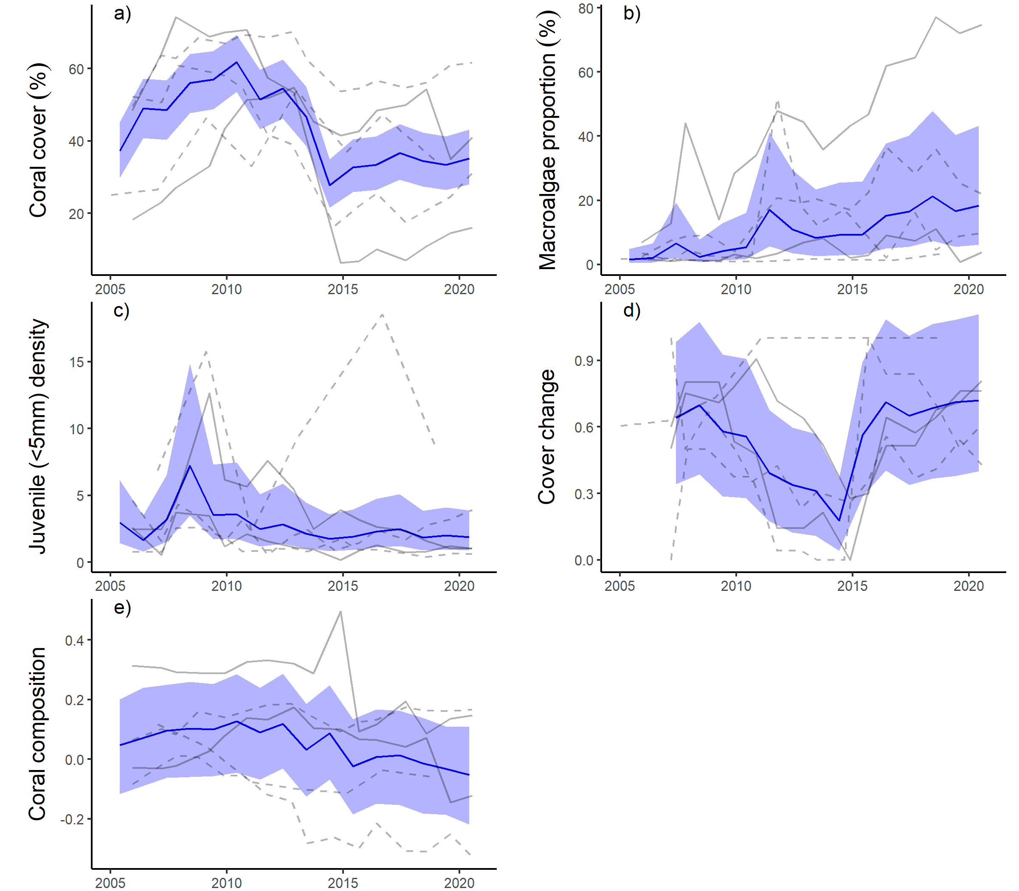
Figure 17 Barron Daintree sub-region indicator trends
. a – e) trends in individual indicators, (blue lines) bound by 95% confidence intervals of those trends (shading), grey lines represent observed profiles at 5 m (dashed) and 2 m (solid) depths for individual reefs.

Wet Tropics region: Johnstone Russell-Mulgrave sub-region
The 2020 coral index score was categorised as ‘good’, a very marginal increase since 2019 (Figure 18).
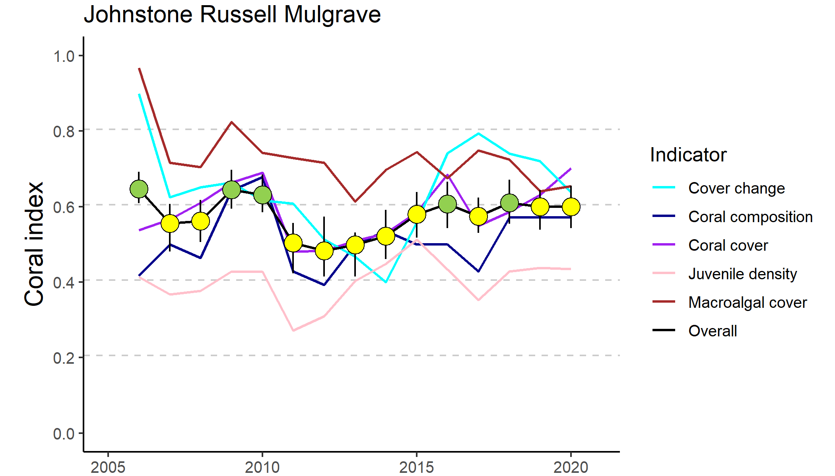
Figure 18 Trends in Coral index and contributing indicator scores for the Johnstone Russell-Mulgrave subregion
. Coral index scores are coloured by report card categories: orange = ‘poor’, yellow=’moderate’ and green=’good. Error in index score derived from bootstrapped distributions of indicator scores at individual reefs.

The index has generally improved since the low levels of 2012 (Table 10) and has fluctuated about the threshold between ‘moderate’ and ‘good’ scores since 2016 (Figure 18). Compared to 2012, the index has improved more consistently at 2 m than at 5 m (Table 10). Increase in coral cover was more consistent among reefs at 2 m depth, where the genus Acropora has increased at most reefs, which has resulted in improved composition scores (Table 10). In 2020 juvenile densities had increased at most reefs, however scores have been variable among years and this is the only indicator to have returned a poor score at the regional level over the last six years (Figure 18).
Table 10 Index and indicator score comparisons in the Johnstone Russell-Mulgrave sub-region.
Data compare the changes in scores between local maxima and minima in the index time-series. For the index, and each indicator, the observed change in the sub-regional score and the probability that the change was greater or less than zero (no change) are presented. Shading is used as a visual aid to highlight the magnitude of the probability the score improved (blue shades) or declined (red shades). Probabilities are derived from the posterior distribution of observed score changes at each reef and depth.
Period | Depth | Condition Index |  | Coral Cover |  | Macroalgae |  | Juvenile |  | Cover Change |  | Composition
 |  | Score | P | Score | P | Score | P | Score | P | Score | P | Score | P
2009 to 2012 | 2 | -0.21 | 0.93 | -0.24 | 0.85 | -0.21 | 0.70 | -0.12 | 0.80 | -0.21 | 0.70 | -0.25 | 0.73
 | 5 | -0.13 | 0.79 | -0.14 | 0.87 | -0.03 | 0.55 | -0.12 | 0.82 | -0.10 | 0.60 | -0.25 | 0.71
2012 to 2020 | 2 | 0.14 | 0.84 | 0.32 | 0.90 | -0.07 | 0.54 | 0.09 | 0.82 | 0.11 | 0.64 | 0.25 | 0.82
 | 5 | 0.10 | 0.74 | 0.14 | 0.74 | -0.06 | 0.66 | 0.15 | 0.88 | 0.14 | 0.63 | 0.13 | 0.61

In general, the trend in the coral index in the sub-region reflects the impact, and subsequent recovery, of coral communities following cyclones Tasha and Yasi in 2011 (Figure 19). These cyclones caused substantial damage to coral communities at Franklands East, Franklands West and High East. At High West, loss of coral cover at 2 m depth following these cyclones was attributed to low salinity floodwaters (Figure A 2, Table A 7). The effects of cyclones were further compounded by the increased prevalence of disease in 2011 (Figure 19e). Fitzroy Island, which had escaped serious damage from the cyclones, lost a substantial proportion of coral cover to disease; at Fitzroy East between 60% (2 m) and 42% (5 m) of the cover of hard corals, predominantly Acropora, was lost (Table A 7, Figure A 2). This outbreak of disease coincided with high discharge from local rivers (Figure 19d). The low point in the index reached in 2012 reflects decline in the cover change score in 2012 compounding reductions in other indicator scores in direct response to the cyclones in 2011 (Table 10, Figure 20). The plateau in recovery of the coral communities in recent years has been influenced by thermal bleaching in the 2016-2017 years, when up to 23% of the cover of hard corals was lost at individual reefs (Figure 20a, Figure A 2).
Crown-of-thorns starfish populations peaked in 2012 (Figure A 8) and were the primary cause of coral loss at Fitzroy Island and Green Island over the period 2012-2015 (Figure 19e, Figure A 2). The impact of crown-of-thorns feeding over this period was almost certainly reduced by the Authority’s crown-of-thorns control program. It is possible that the loss of coral cover attributed to thermal bleaching in 2017 included some loss due to crown-of-thorns starfish. In 2019 numbers of crown-of-thorns starfish were variable between reefs. A maximum density of 75 per ha was recorded at Frankland Island East (Figure A 8), however their impact of appears to be minimal at this stage with coral cover generally high at affected reefs.
Coral consumed by crown-of-thorns starfish will have contributed to the reduced coral change scores in the region (Figure 20d). Previously, active control programs have helped mitigate the impact from crown-of-thorns starfish. No population control was conducted at any of our monitoring sites in the period between 2018 and 2020 surveys, controls listed in 2020 in Table 7 were undertaken following MMP reporting high numbers of crown-of-thorns to the Authority.
Discharge from rivers in the sub-region was above median levels over the 2019 water year. However, peak flows remained relatively low (Figure 19d) and evidence of direct impacts due to exposure to low salinity plume waters was limited to minimal damage suspected at 2 m depth at High West. In 2020 and prior to 2018, annual discharge was at, or below, median levels since 2012 (Figure 19d) and under these conditions the coral communities demonstrated a clear recovery.
The long-term water quality index in this sub-region has remained in ‘good’ condition and although there appears to be a slight declining trend in the long-term index, the short-term index suggested improved conditions in 2019-2020 (Figure A 11). In 2020 most water quality parameters were near or below the guideline values (Figure A 11). Not included in the index are concentrations of dissolved and particulate organic carbon, both of which show substantial increase since 2005 (Figure A 11). It remains unclear what has caused this increase and what the ramifications for corals might be (Waterhouse et al. 2021).
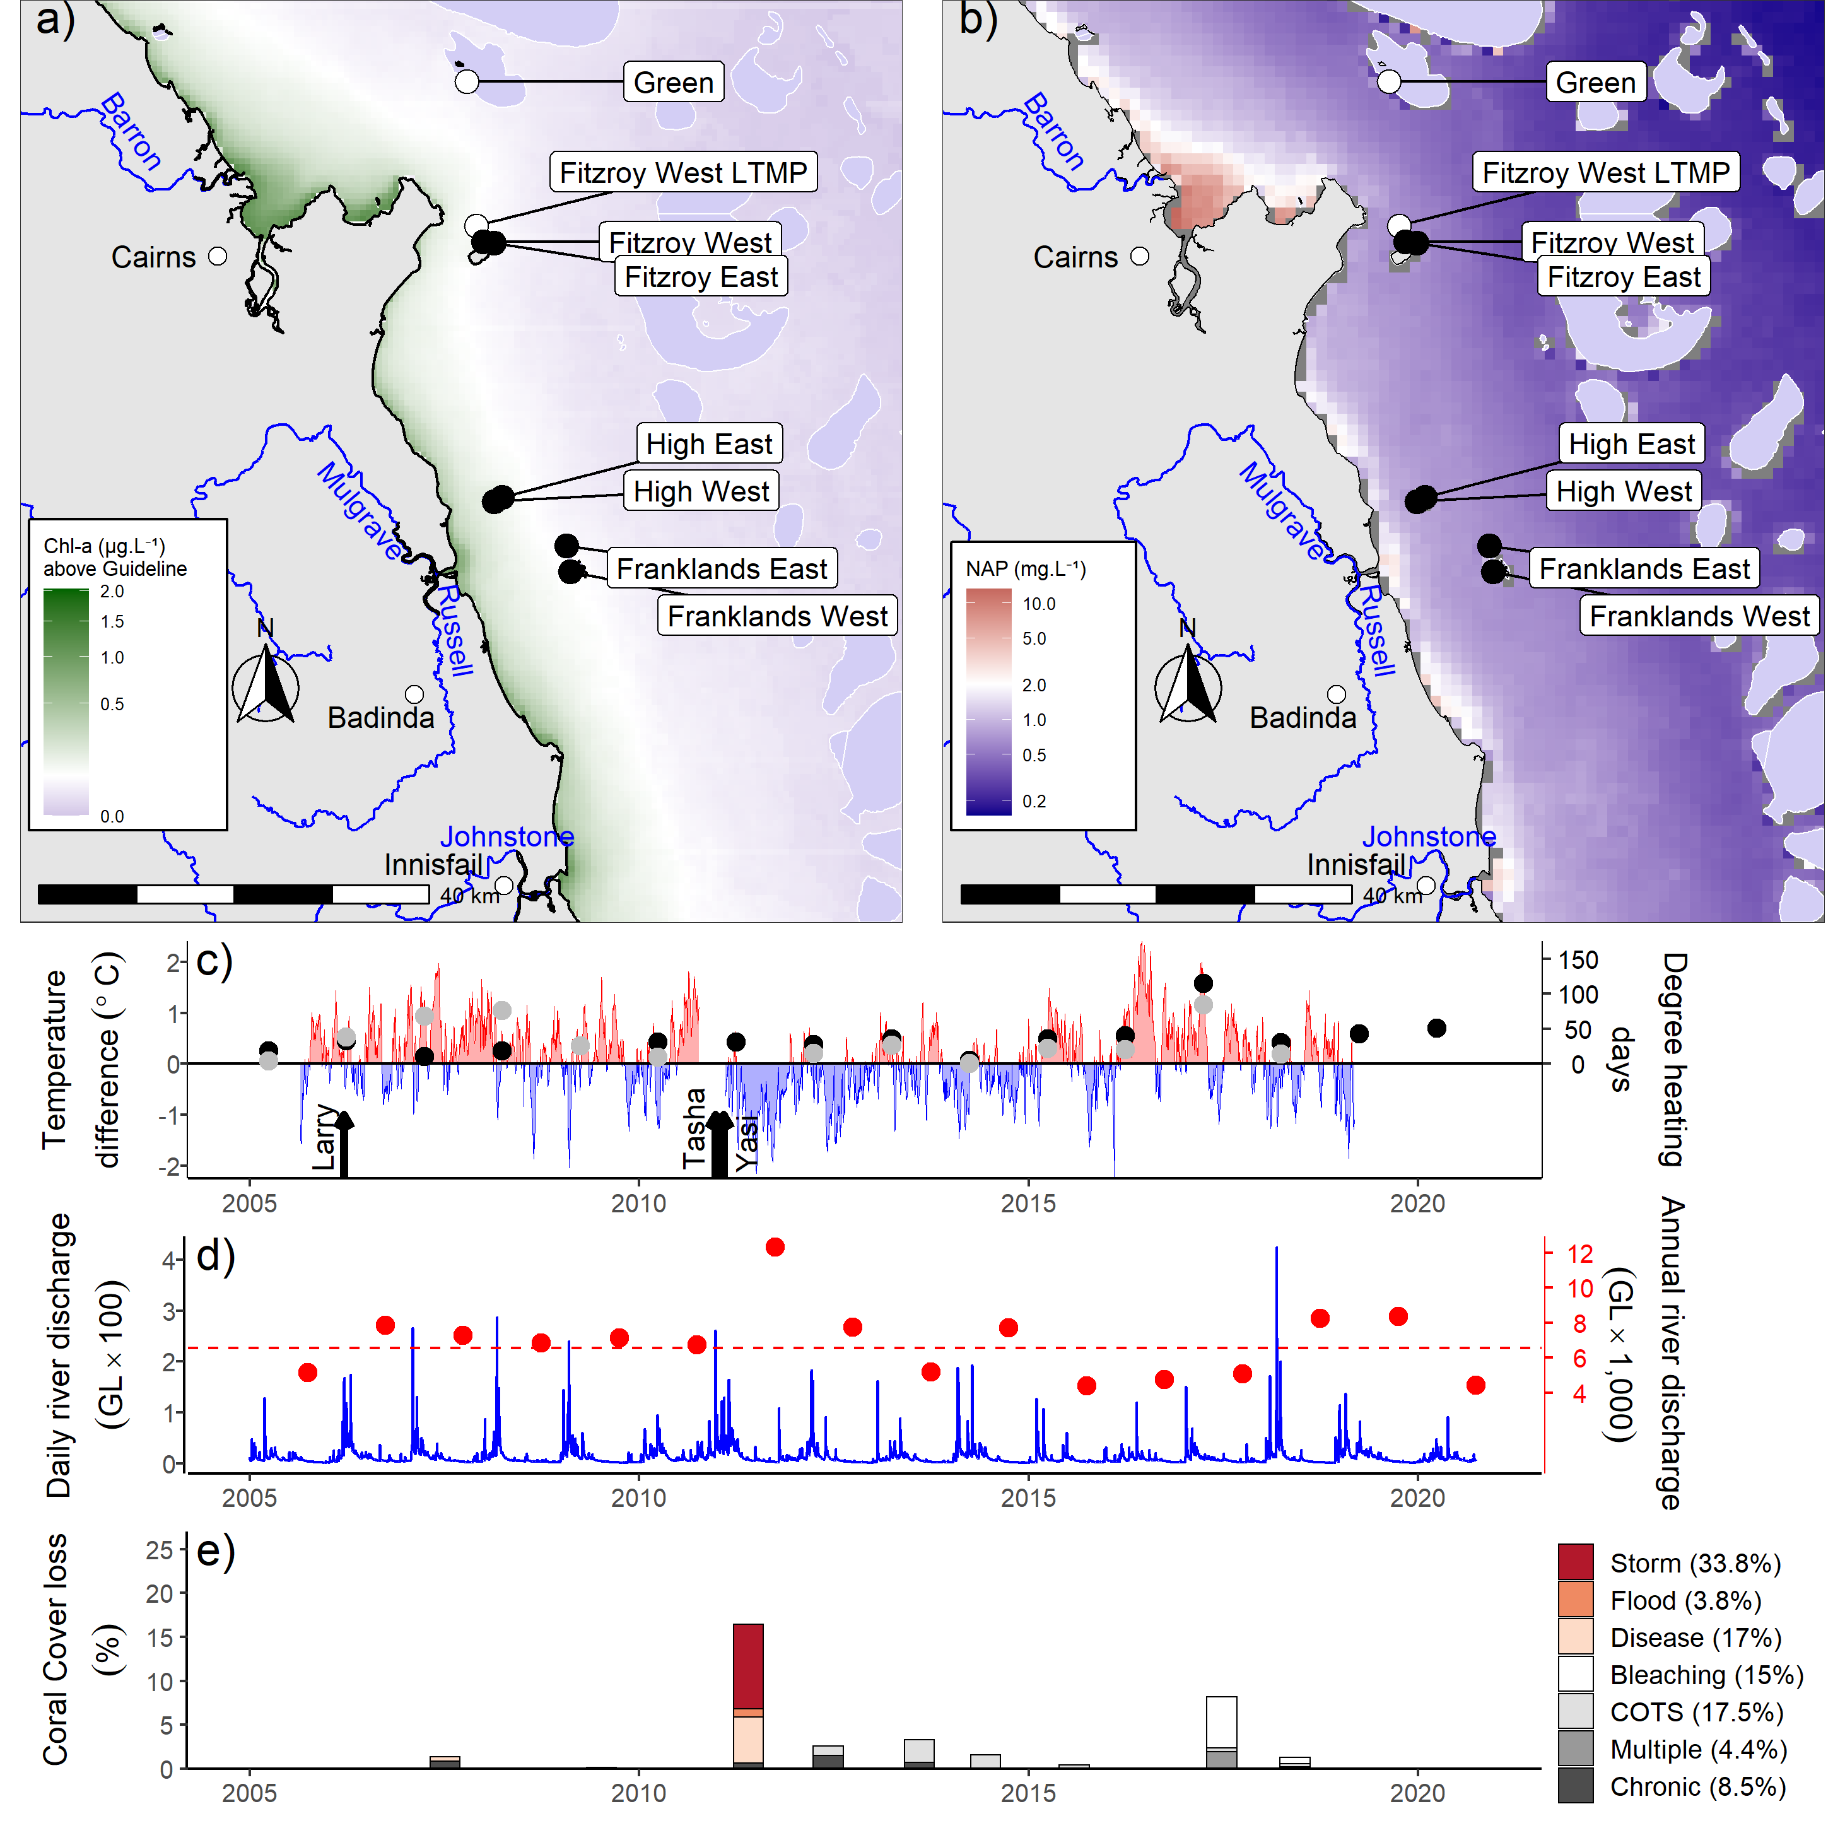
Figure 19 Johnstone Russell-Mulgrave sub-region environmental pressures
. Maps show location of monitoring sites, black symbols MMP, white symbols LTMP along with a) mean chlorophyll a exceedance of wet season Guideline (0.63ugL-1) and b) mean Non Algal Particulate concentrations. Water quality data are mean levels over the period 2003–2018 (Chl) and 2003-2018 (NAP). c) Seasonally adjusted temperature deviation, timing of cyclones and storms indicated by black arrows, accumulated degree heating days over the summer period (1st of December – 31st March) as reported by BoM (black symbols) and derived from in situ loggers (grey symbols) d) Combined daily (blue) and annual water year – October to September (red) discharge for the North Johnstone, South Johnstone, Russell and Mulgrave basins, red dashed line represents long-term median discharge (1986–2016). e) break-down of hard coral cover loss by disturbance type; length of bars represents the mean loss of cover across all.

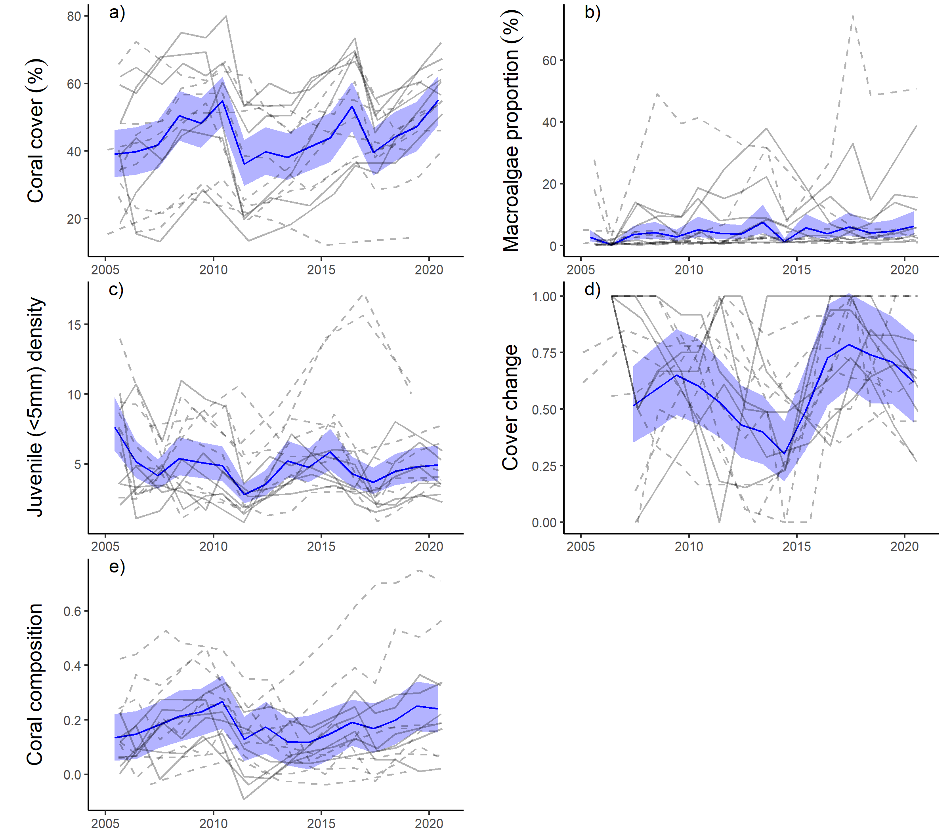

Figure 20 Johnstone Russell-Mulgrave sub-region indicator trends
. a– e) trends in individual indicators, (blue lines) bound by 95% confidence intervals of those trends (shading), grey lines represent observed profiles at 5 m (dashed) and 2 m (solid) depths for individual reefs.

Wet Tropics region: Herbert Tully sub-region
The coral condition index in the Herbert Tully sub-region remains categorised as ‘good’, having declined marginally since 2019 as the rate of coral cover increase has slowed (Figure 21).

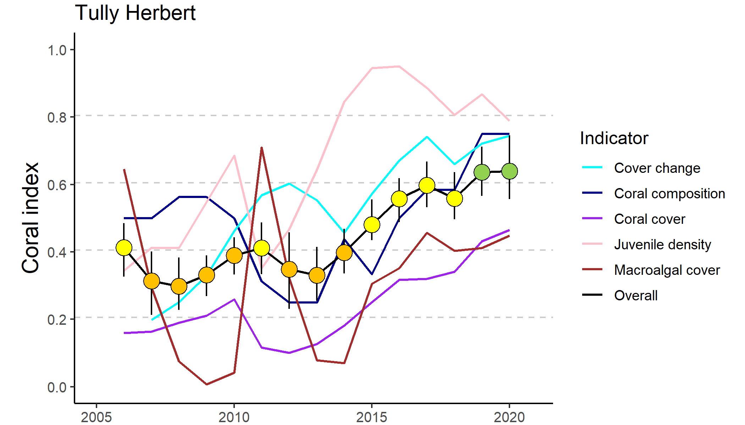
Figure 21 Trends in Coral index and contributing indicator scores for the Herbert Tully subregion
. Coral index scores are coloured by report card categories: orange = ‘poor’, yellow=’moderate’ and green=’good. Error in index score derived from bootstrapped distributions of indicator scores at individual reefs.

The improved index scores since 2013 reflect consistent improvements in most metrics at both 2 m and 5 m depths. Exceptions were juvenile and macroalgae scores for which trends were variable between reefs (Table 11).

Table 11 Index and indicator score comparisons in the Herbert Tully sub-region
. Data compare the changes in scores between local maxima and minima in the index time-series. For the index, and each indicator, the observed change in the sub-regional score and the probability that the change was greater or less than zero (no change) are presented. Shading is used as a visual aid to highlight the magnitude of the probability the score improved (blue shades) or declined (red shades). Probabilities are derived from the posterior distribution of observed score changes at each reef and depth.
Period | Depth | Condition Index |  | Coral Cover |  | Macroalgae |  | Juvenile |  | Cover Change |  | Composition
 |  | Score | P | Score | P | Score | P | Score | P | Score | P | Score | P
2008 to 2011 | 2 | 0.10 | 0.76 | -0.08 | 0.75 | 0.67 | 0.92 | -0.05 | 0.64 | 0.33 | 0.94 | -0.38 | 0.93
 | 5 | 0.13 | 0.80 | -0.07 | 0.66 | 0.60 | 0.89 | -0.07 | 0.56 | 0.30 | 0.74 | -0.13 | 0.70
2011 to 2013 | 2 | -0.04 | 0.64 | 0.02 | 0.64 | -0.67 | 0.92 | 0.39 | 0.83 | 0.05 | 0.58 | 0 | NA
 | 5 | -0.12 | 0.88 | 0.01 | 0.54 | -0.59 | 0.90 | 0.20 | 0.75 | -0.08 | 0.60 | -0.13 | 0.70
2013 to 2020 | 2 | 0.34 | 1.00 | 0.46 | 1.00 | 0.33 | 0.73 | -0.11 | 0.68 | 0.38 | 0.95 | 0.67 | 0.99
 | 5 | 0.36 | 1.00 | 0.35 | 0.99 | 0.39 | 0.76 | 0.14 | 0.72 | 0.39 | 0.83 | 0.50 | 1.00

Since monitoring began in 2005 changes in the coral index show a repeat sequence of disturbance and subsequent recovery. Cyclone Larry in 2006 and cyclone Yasi in 2011 severely impacted coral communities, with rapid recovery occurring in both instances (Figure 23a). The combined impacts of these cyclones account for 75% of hard coral cover losses since 2005 (Figure 22e).
Following each cyclone, in addition to an immediate reduction, was a lagged decline in the index scores (Figure 21). This lagged response reflects temporary improvement in the macroalgae indicator score in the first post-cyclone survey (Figure 23d). During cyclones, macroalgae are stripped from the substrate, temporarily reducing their abundance. Subsequent colonisation of space made available to algae due to reduced coral cover results in a lagged impact on index scores.
A strong contributor to the current score has been the rapid rate at which coral cover has recovered, influencing both the cover change and coral cover indicators (Figure 21). At the three reefs sampled in both 2005 and 2020 mean coral cover in 2020 had recovered to 99% of that observed in 2005 (Figure A 3). This rate of increase did slow in 2020 as evidenced by loss of corals attributed to “Chronic” conditions (Figure 22e). Although remaining at ‘good’ levels, scores for the juvenile indicator have declined in recent years (Figure 23c) as strong cohorts of Turbinaria that recruited in the years following cyclone Yasi are growing out of the juvenile size classes (Figure 23c, Figure A 3) – it is not expected that this decline will have drastic implications for future recovery of these coral communities.
While the macroalgae indicator has improved in 2020, scores for this indicator remain at minimum levels of zero (Table A 8) at the 2 m depths of Bedarra, Dunk North and Dunk South. At these reefs, the macroalgae community is dominated by persistent brown algae of the genus Sargassum (Table A 12)
No major floods were recorded in the sub-region in 2020 (Figure 22d) with annual discharge near median levels. While no direct impacts of flood waters were observed at the time of coral surveys, a low salinity plume was evident at Bedarra at the time of survey (1st June 2020) suggesting this site is regularly exposed to low salinity waters and/or poor water quality (Table A 9, Figure 22a) even in the absence of major floods.
The coral sampling sites in this sub-region are primarily influenced by discharge from the Tully and Herbert rivers. All the coral monitoring sites in this sub-region are situated in nutrient rich (mean Chl a concentration over the wet season exceed the guideline) waters (Figure 22a, Table A 9). The combination of high turbidity and high nutrient availability (Figure A 12) is consistent with the prevalence of macroalgae observed in the shallow, but not deeper, depths at most reefs (Figure 23b, Figure A 3). The long-term water quality index for this sub-region remains poor (Figure A 12a). In contrast, the short-term water quality index improved to moderate condition in 2020 due to declines in concentration of most water-quality parameters that coincided with low discharge from the local catchments (Figure A 12, Figure 22d).

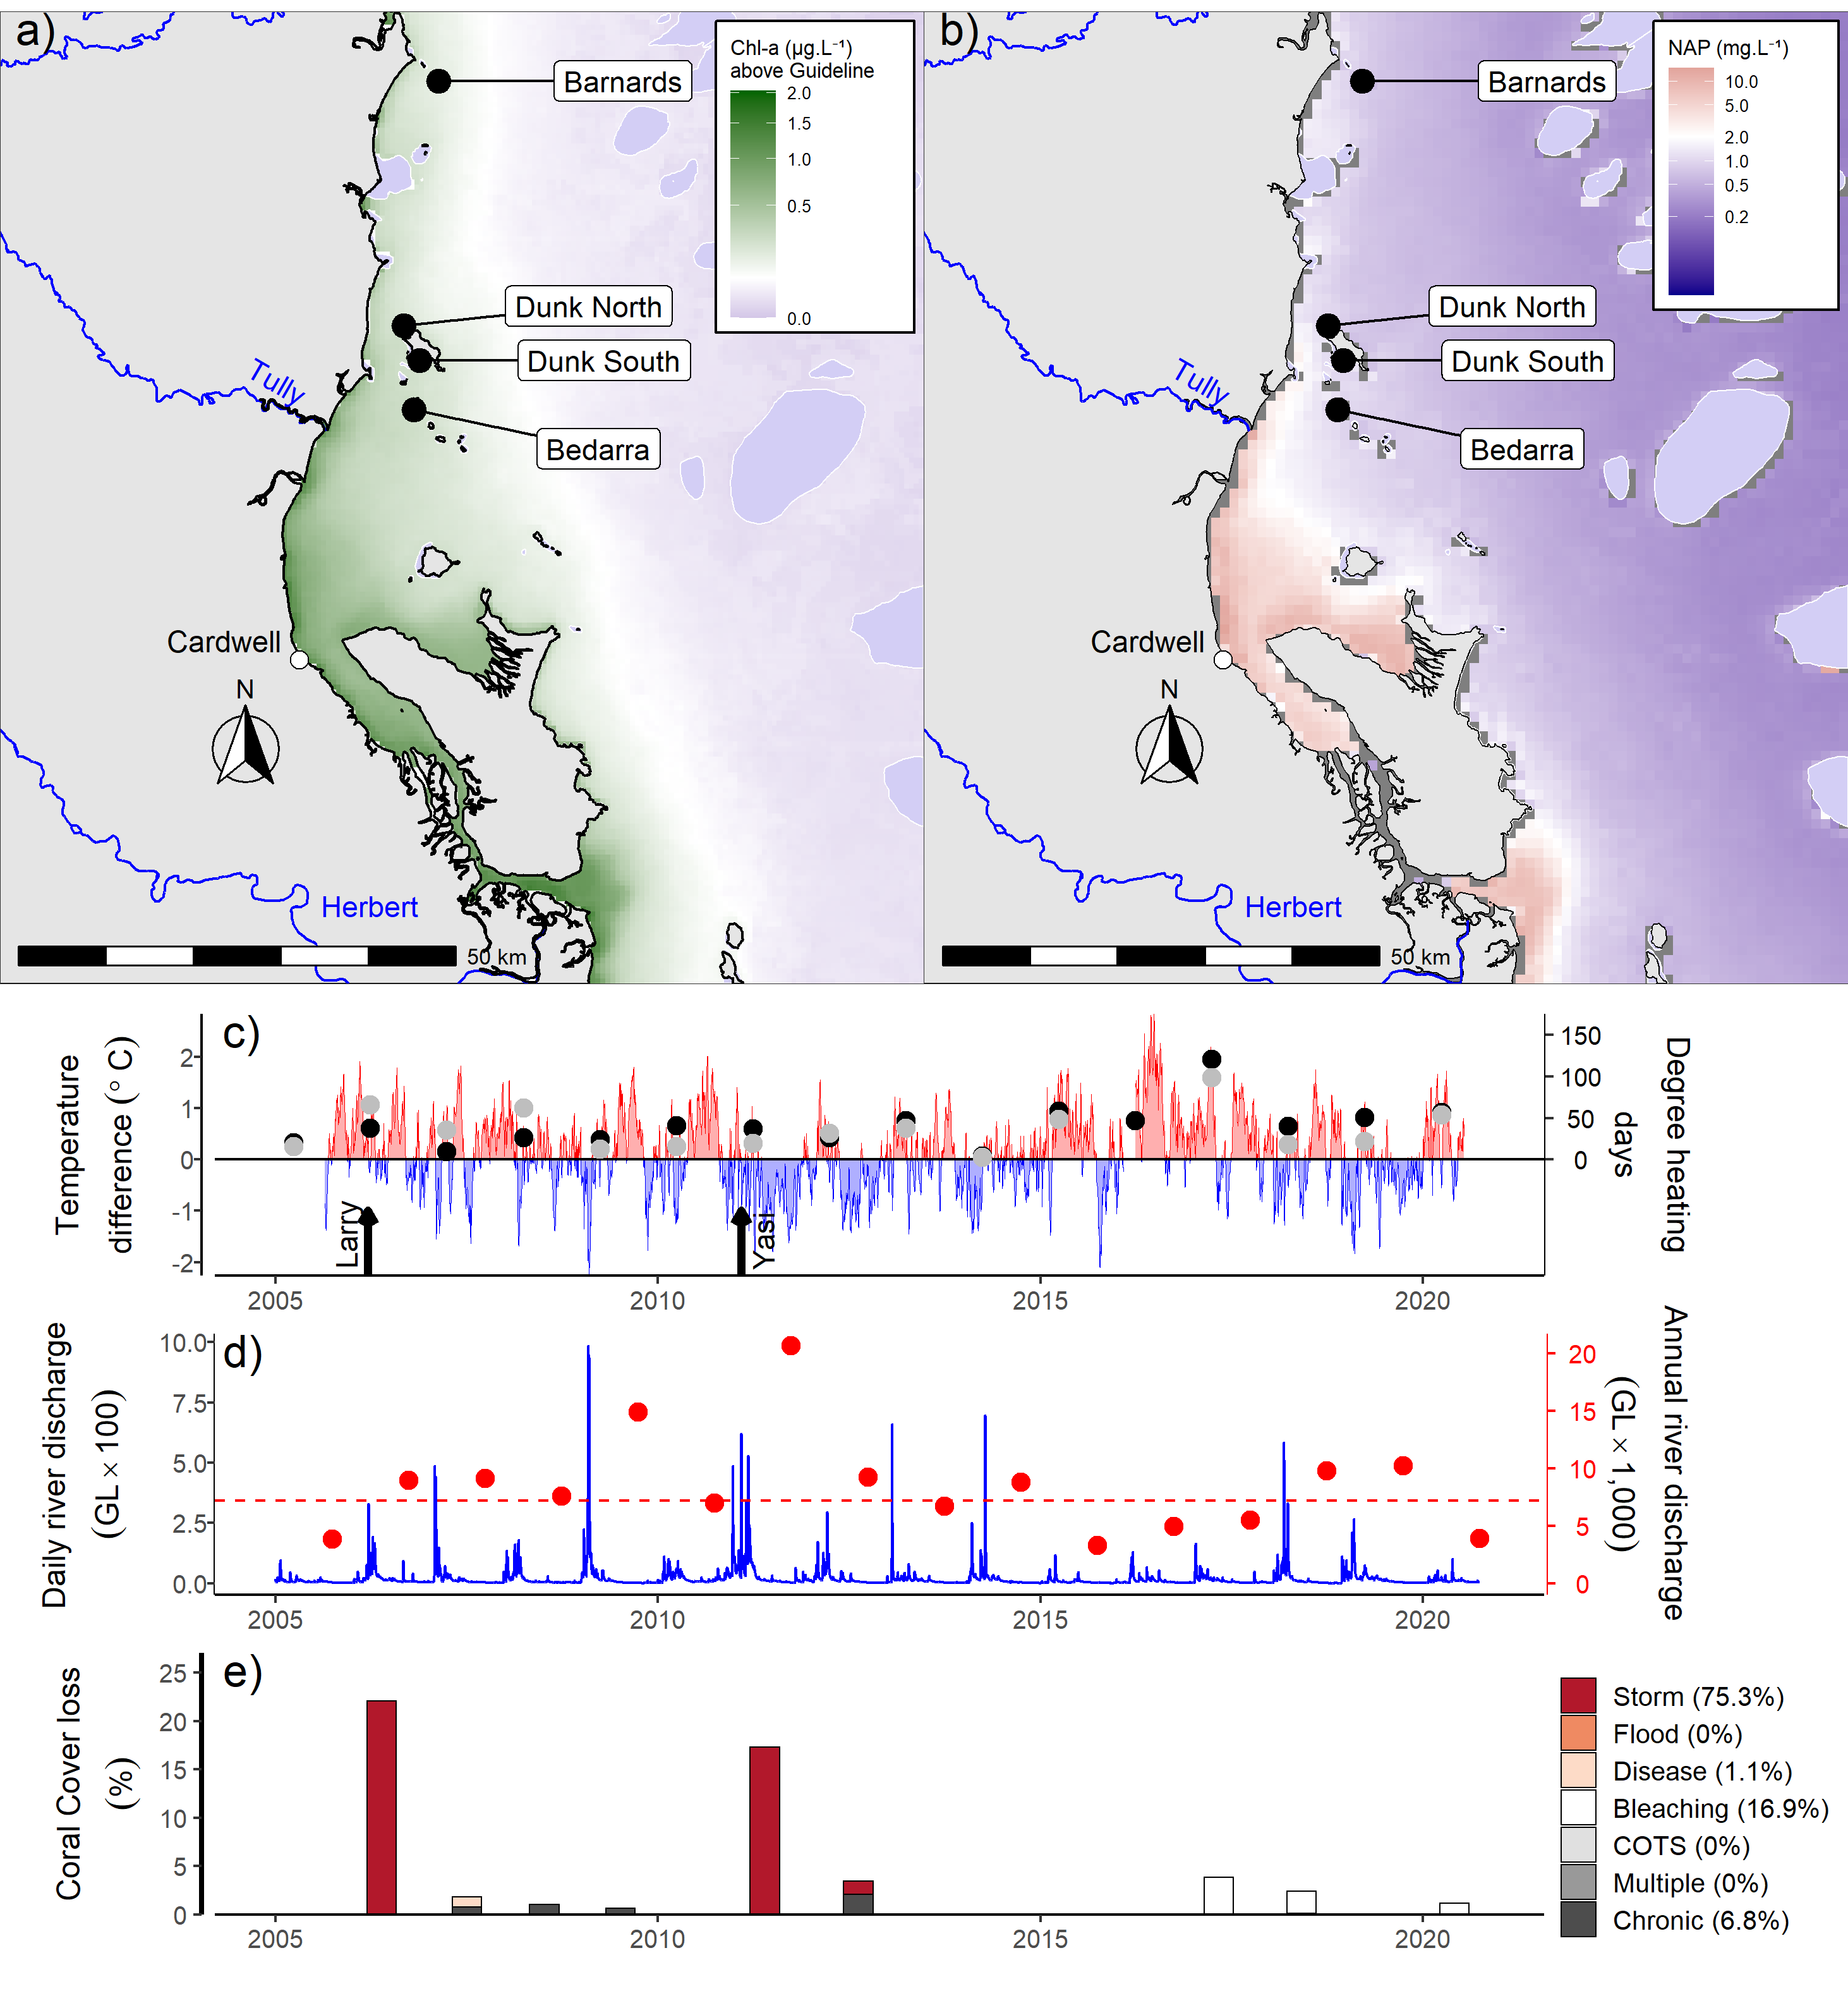
Figure 22 Herbert Tully sub-region environmental pressures
. Maps show location of monitoring sites along with, a) mean chlorophyll a exceedance of wet season Guideline (0.63ugL-1) and b) mean Non Algal Particulate concentrations. Water quality data are mean levels over the period 2003–2018 (Chl) and 2003–2018 (NAP). c) Seasonally adjusted temperature deviation, timing of cyclones and storms indicated by black arrows, accumulated degree heating days over the summer period (1st of December – 31st March) as reported by BoM (black symbols) and derived from in situ loggers (grey symbols) d) Combined daily (blue) and annual (red) discharge for the Herbert, Murray and Tully basins, red dashed line represents long-term median discharge (1986–2016). e) break-down of hard coral cover loss by disturbance type; length of bars represents the mean loss of cover across all reefs.

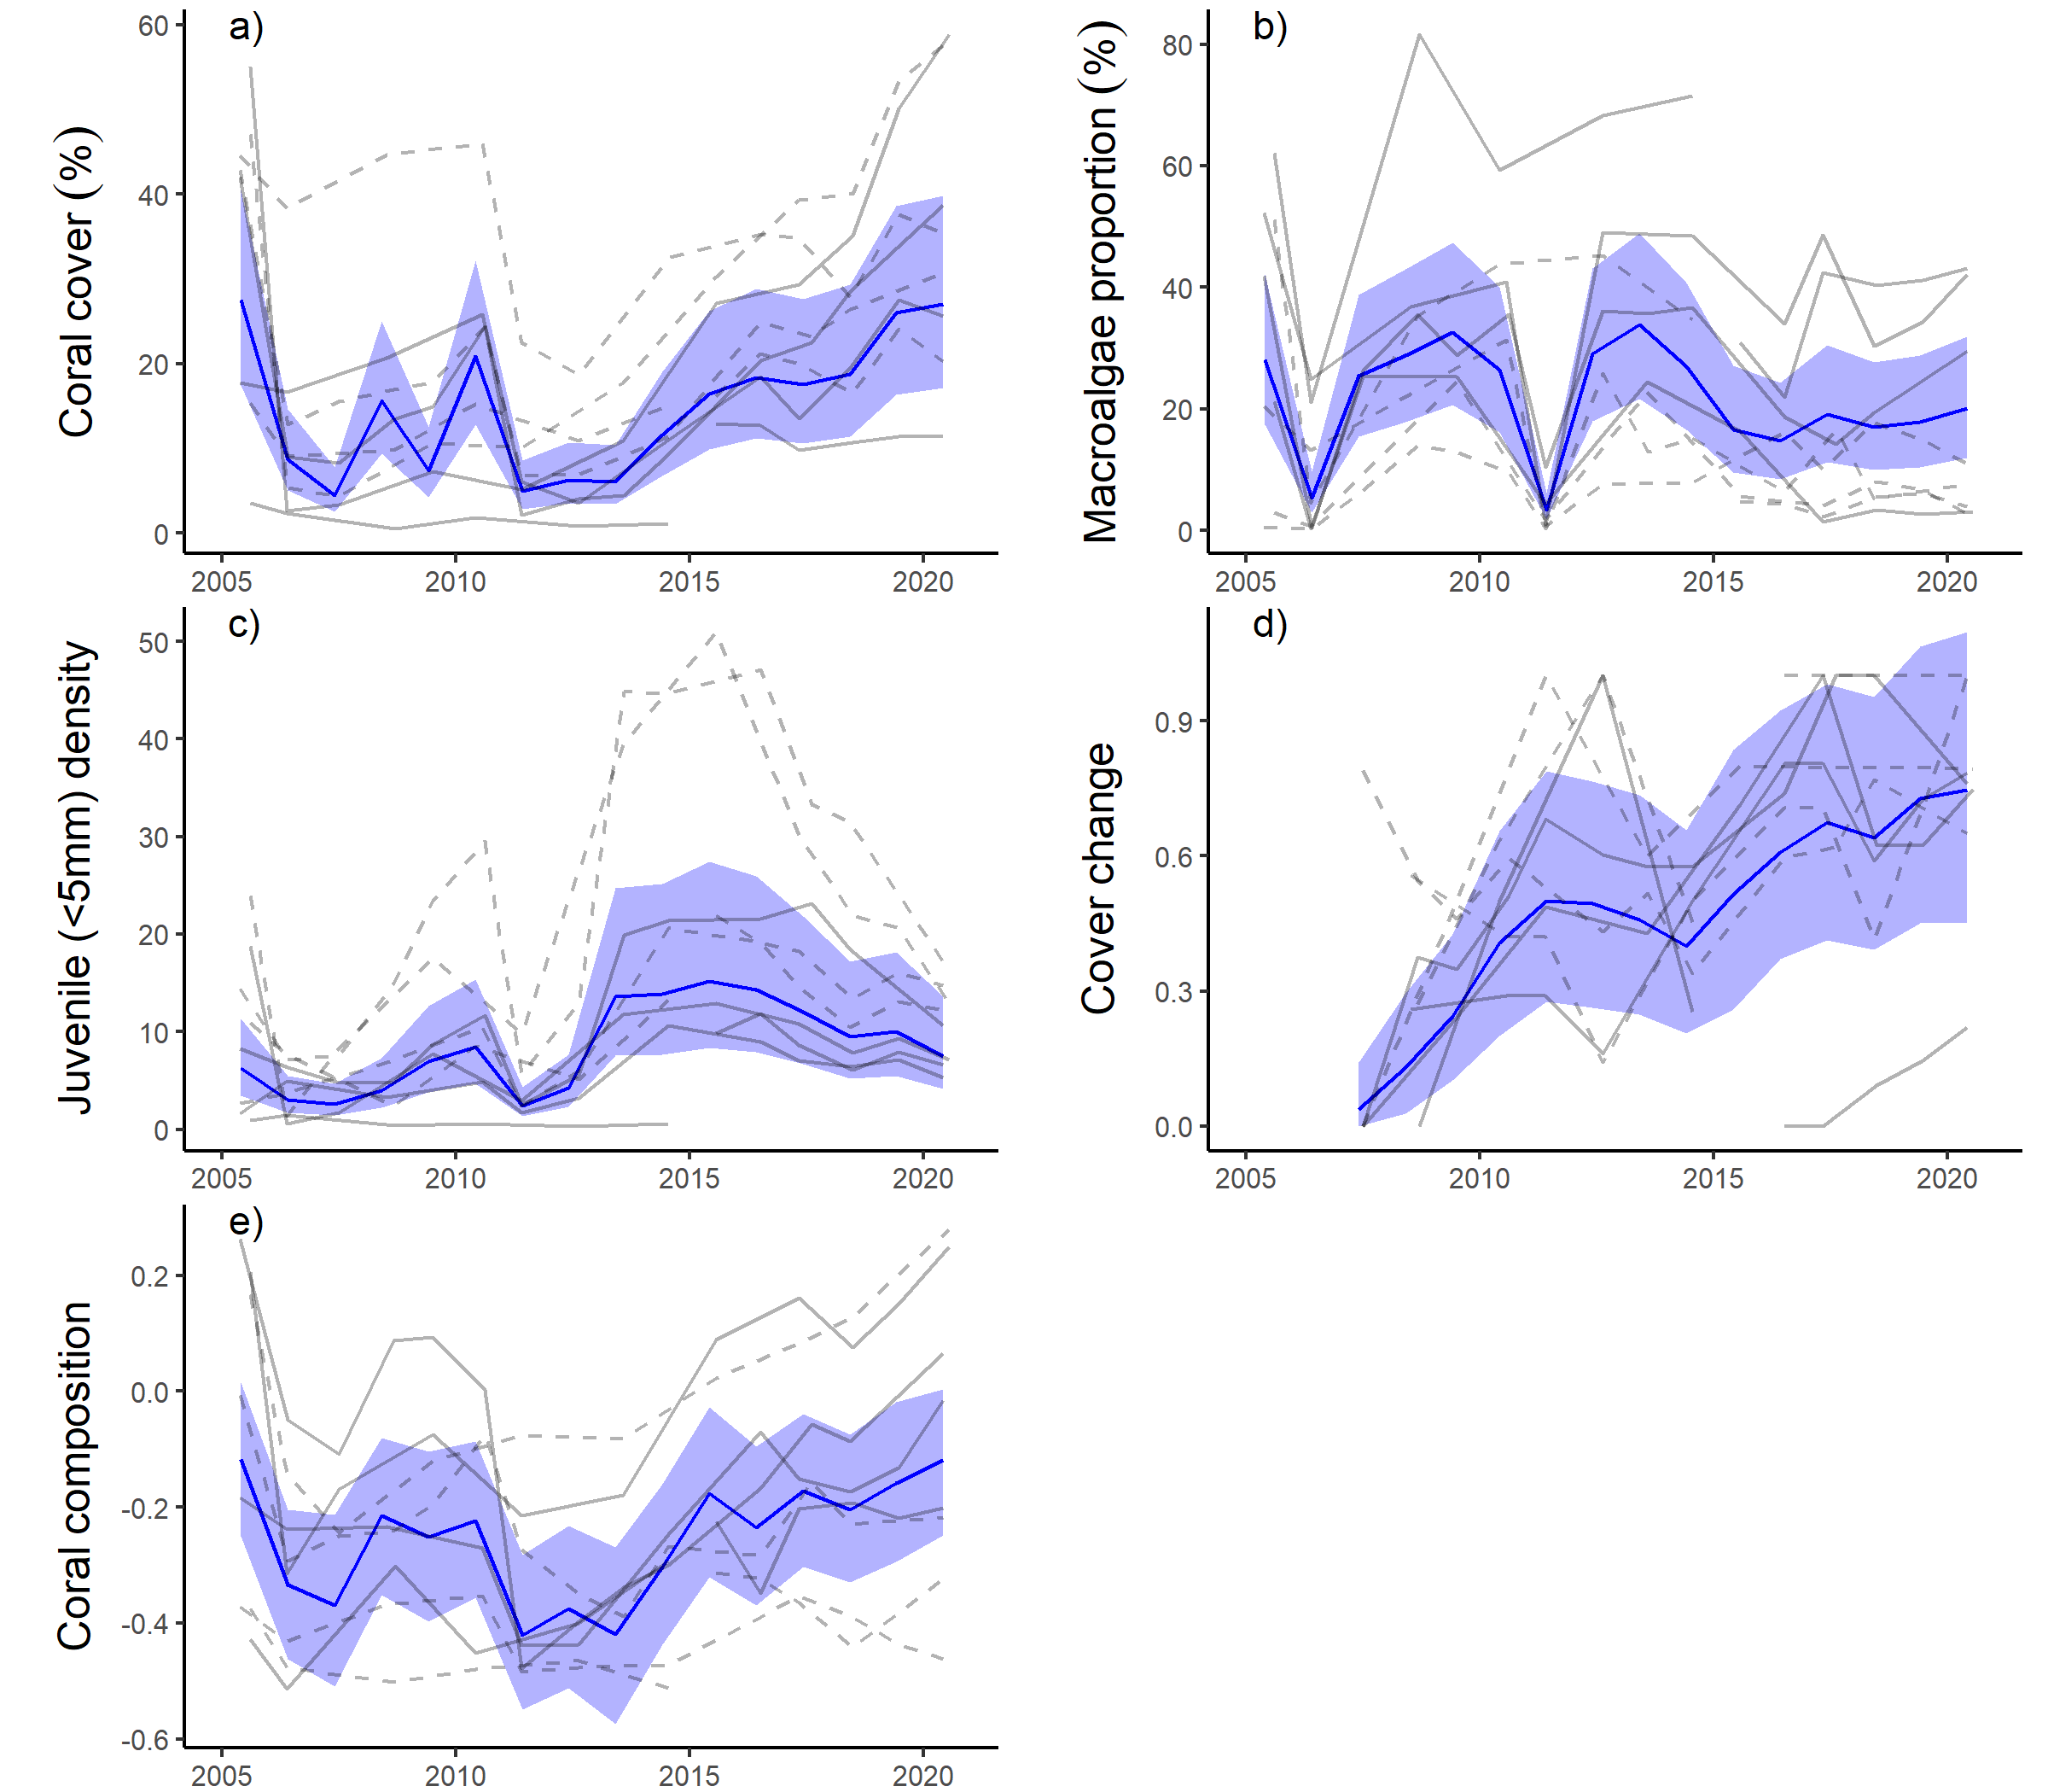

Figure 23 Herbert Tully sub-region indicator trends
. a – e) trends in individual indicators, (blue lines) bound by 95% confidence intervals of those trends (shading), grey lines represent observed profiles at 5 m (dashed) and 2 m (solid) depths for individual reefs.

Burdekin region
The coral condition index has continued to improve since 2013 and remains moderate in 2020 (Figure 24, Table 12).

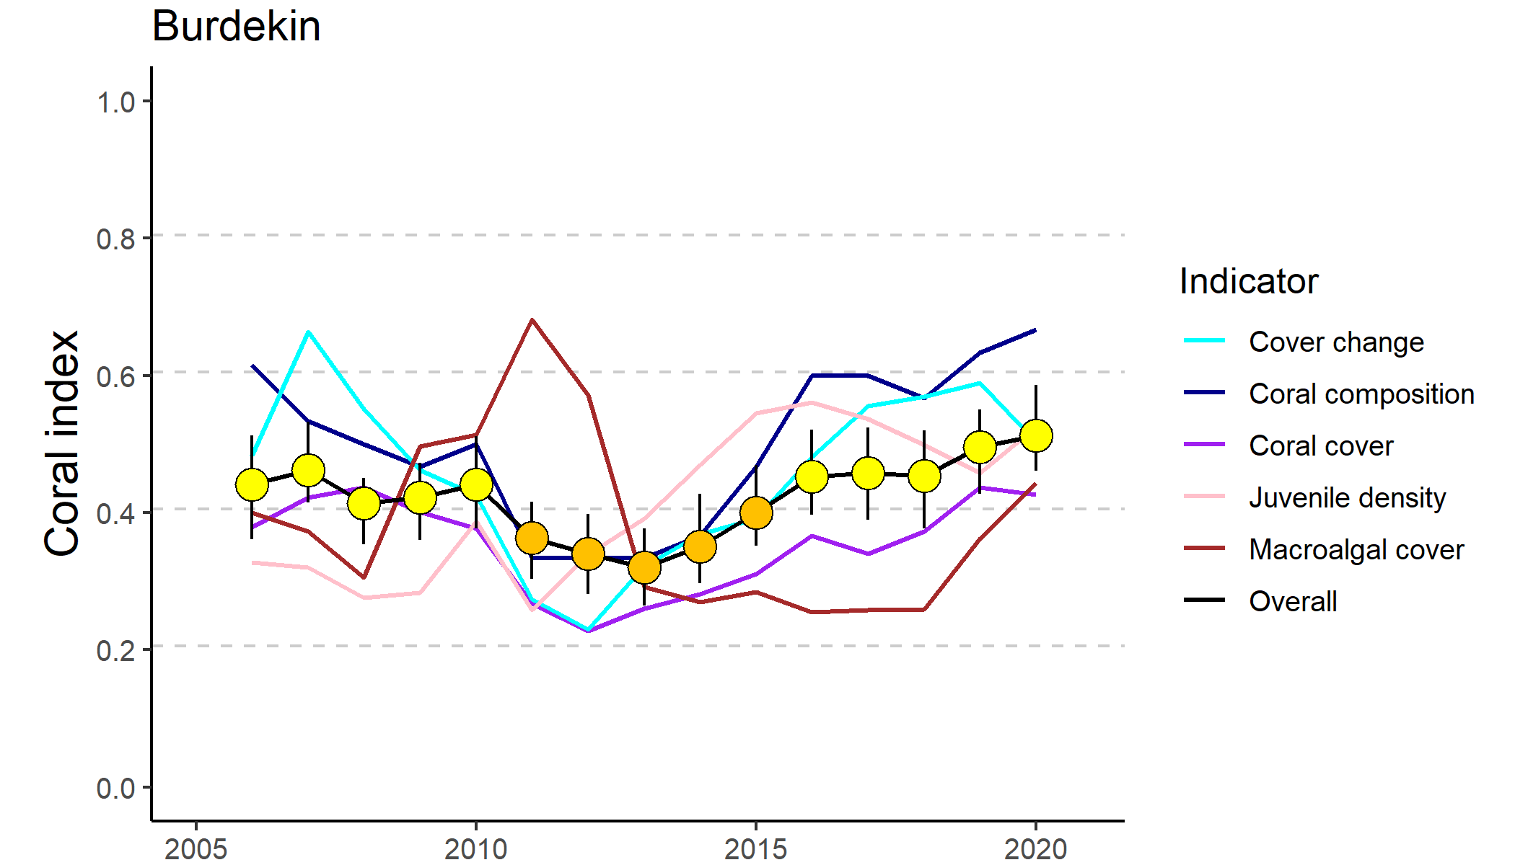
Figure 24 Trends in Coral index and contributing indicator scores for the Burdekin region
. Coral index scores are coloured by report card categories: orange = ‘poor’, yellow=’moderate’. Error in index score derived from bootstrapped distributions of indicator scores at individual reefs.

Improvement in index and indicator scores since 2013 have been most evident at 5 m depths where all indicators have improved (Table 12). At 2 m depths the index scores also improved, with coral cover and to a lesser extent composition and macroalgae scores showing the most consistent improvement among reefs (Table 12).

Table 12 Index and indicator score comparisons in the Burdekin Region
. Data compare the changes in scores between local maxima and minima in the index time-series. For the index, and each indicator, the observed change in the sub-regional score and the probability that the change was greater or less than zero (no change) are presented. Shading is used as a visual aid to highlight the magnitude of the probability the score improved (blue shades) or declined (red shades). Probabilities are derived from the posterior distribution of observed score changes at each reef and depth.
Period | Depth | Condition Index |  | Coral Cover |  | Macroalgae |  | Juvenile |  | Cover Change |  | Composition
 |  | Score | P | Score | P | Score | P | Score | P | Score | P | Score | P
2010 to 2013 | 2 | -0.08 | 0.70 | -0.09 | 0.64 | -0.17 | 0.71 | -0.04 | 0.61 | -0.05 | 0.54 | -0.07 | 0.57
 | 5 | -0.15 | 0.86 | -0.14 | 0.82 | -0.26 | 0.82 | 0.04 | 0.61 | -0.15 | 0.80 | -0.25 | 0.71
2013 to 2020 | 2 | 0.14 | 0.80 | 0.17 | 0.80 | 0.16 | 0.75 | -0.03 | 0.54 | 0.0 | 0.51 | 0.42 | 0.75
 | 5 | 0.26 | 0.93 | 0.22 | 0.89 | 0.18 | 0.77 | 0.26 | 0.87 | 0.33 | 0.89 | 0.31 | 0.76

Improvement in the coral index prior to 2017 coincided with a period of below median discharge from the region’s rivers (Figure 25d) and absence of acute disturbances (Figure 25c). Despite widespread thermal bleaching over the 2016–2017 year, and then again in 2020, which accounted for 26% of the coral cover lost since 2005, the index score has continued to improve. Notably, coral cover continued to increase at Palms East, reinforcing the strong recovery of this coral community following the severe impact of cyclone Yasi (Figure A 4).
Overall, there were declines in macroalgae cover at reefs surveyed in 2020, which resulted in macroalgae scores improving into the ‘moderate’ condition range (Figure 24, Figure 26b). The exceptions were reefs where the macroalgae community included a high proportion of the genus Sargassum (Magnetic, Pandora 2 m depth and Havannah 5 m). Increased cover of macroalgae at these reefs had no influence on the change in score for macroalgae between 2019 and 2020 as cover was sufficiently high to ensure scores of zero in both years. The increase in cover of Sargassum noted in 2020 may reflect seasonal variability, as the 2020 surveys were undertaken in April, which is earlier in the year than all previous surveys of these reefs.
In 2020 coral cover declined marginally with continued increase in cover at Palms East contrasting loss of cover at most other reefs where higher temperature anomalies caused widespread coral bleaching. In contrast, coral cover increased at most reefs in 2019. The exception was at Havannah, 2 m depth where corals were severely bleached in 2017 and disease then killed large stands of branching Acropora, in particular, A. pulchra. This progression of disease was influential in the inconsistent trend in the cover change indicator at 2 m depth since 2013 (Table 12).
The general improvement in the composition indicator score (Table 12) reflects regional coral cover increase and includes recovery of taxa sensitive to poor water quality, in particular, cover of Acropora spp. has increased notably at some reefs (Figure A 4, Table A 10). Palms West and Pandora North are the only reefs at which the proportion of species sensitive to poor water quality has declined compared to baseline observations.
Juvenile indicator scores at 5 m depths have generally improved since 2013 (Table 12) and remain at moderate levels regionally (Figure 24). The lowest densities of juveniles in 2020 were recorded at 2 m depths of Palms East, Palms West, Havannah and Magnetic where densities were in the ‘very-poor’ to ‘poor’ range (Table A 8).
Declines in the index through to 2013 coincided with the combined influence of cyclone Yasi and a period of very high discharge from the region’s rivers (Figure 25d, e). Since 2005, cyclones and storms have accounted for 41% of hard coral losses in the region (Figure 25e). The lagged influence from cyclone Yasi noted in 2012 (Figure 25e) is due to LTMP surveys post-Yasi not occurring until that year. East-facing locations, such as Palms East and Lady Elliot (2 m), were particularly exposed to storm driven seas, and show the impacts of cyclone Yasi (2011) (Figure A 4, Table A 7). At both these reefs coral cover has returned to similar levels as observed prior to 2011. At Lady Elliot the community composition returned to pre-disturbance communities. At Palms East the 2005-2010 coral community was dominated by soft corals and has been replaced by a hard-coral community dominated by Acroporidae (Figure A 4).
The period 2010 to 2013 saw a reduction in scores for the coral cover change indicator at 5 m depths (Table 12). This reduced rate of increase in coral cover saw observed cover fall below that predicted by coral growth models and accounts for most of the cover loss since 2005 attributed to chronic pressures (Figure 25e). Although not categorised as a disease outbreak for disturbance estimation, elevated levels of disease were observed from 2007 to 2009 (Figure A 7) and will have contributed to the chronic disturbances recorded over the period 2008 to 2010 (Figure 25e).
Chronic pressures are assumed when there is no evidence for impacts associated with acute disturbance. Rather, they represent the cumulative impacts of environmental pressures that suppress the annual increments in cover that are the basis of the cover change scores. As Acropora and Montipora were the genera most infected by disease, the disproportionate loss of these groups will have contributed to the decline in the composition indicator score.

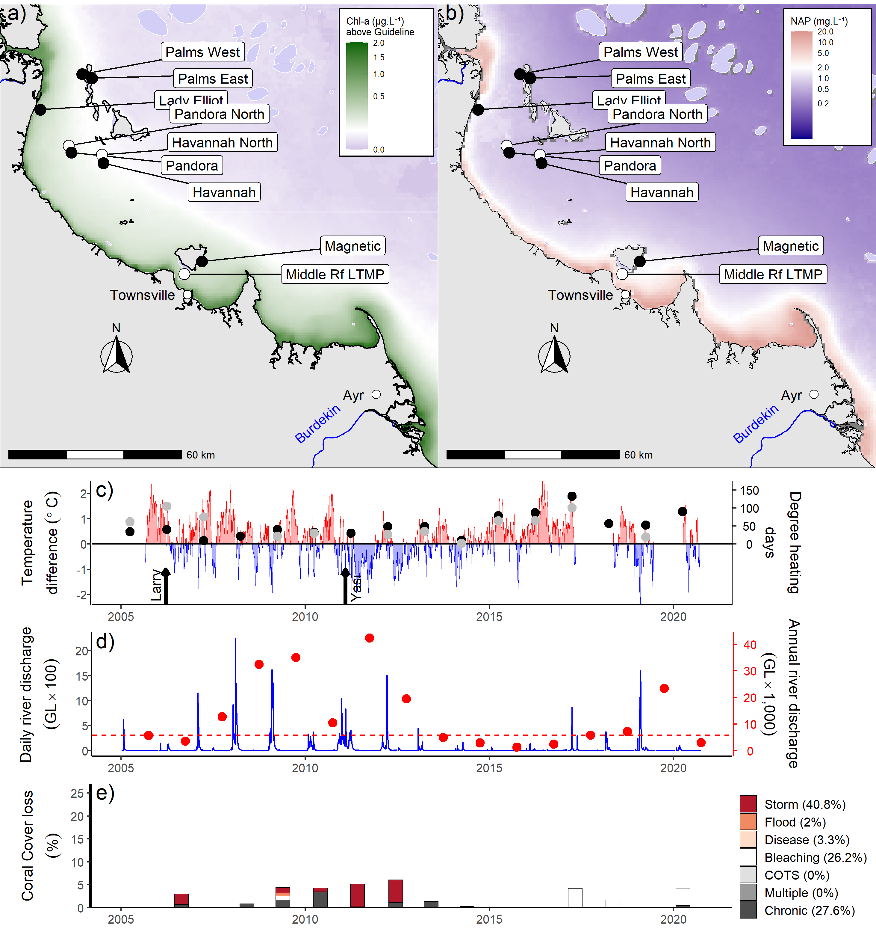
Figure 25 Burdekin Region environmental pressures
. Maps show location of monitoring sites, black symbols MMP, white symbols LTMP along with a) mean chlorophyll a exceedance of wet season Guideline (0.63ugL-1) and b) mean Non Algal Particulate concentrations. Water quality data are mean levels over the period 2003–2018 (Chl) and 2003–2018 (NAP). c) Seasonally adjusted temperature deviation, timing of cyclones and storms indicated by black arrows, accumulated degree heating days over the summer period (1st of December – 31st March) as reported by BoM (black symbols) and derived from in situ loggers (grey symbols) d) Combined daily (blue) and annual water year – October to September (red) discharge for the Black, Burdekin, Don and Haughton basins, red dashed line represents long-term median discharge (1986–2016). e) break-down of hard coral cover loss by disturbance type; length of bars represents the mean loss of cover across all reefs.
Major flooding occurred in the region in February 2019 (Figure 25d). Despite this event there were no direct impacts to coral communities. However, incidence of disease did increase slightly in 2019, which may be attributed to the decreased water quality associated with the floods. Impacts of disease in 2019 were most evident at Havannah, where coral cover declined by 23% at 2 m (Figure A 4). While this is likely to be a continuation of disease observed at this reef following the thermal bleaching in 2017, it is possible that reduced fitness from plume water exposure exacerbated the effects. Discharge in 2020 was well below median levels (Figure 25) and unlikely to have influenced coral communities.
Concentrations for most water-quality parameters declined in 2020 leading to an improvement in the short-term water quality index to ‘good’ (Figure A 13a). An exception, as for most other regions, were concentrations of NOx that have steadily increased over the duration of the program (Figure A 13c). Concentrations of dissolved and particulate forms of organic carbon have also markedly increased over the duration of the program (Figure A 13), however these parameters do not contribute to water quality index scores (Gruber et al. 2020). At the regional scale, recent improvement in coral index scores demonstrate coral communities have retained a degree of resilience despite the changes in biophysical processes in their surrounding waters suggested by increasing NOx and organic carbon concentrations (Waterhouse et al. 2021).

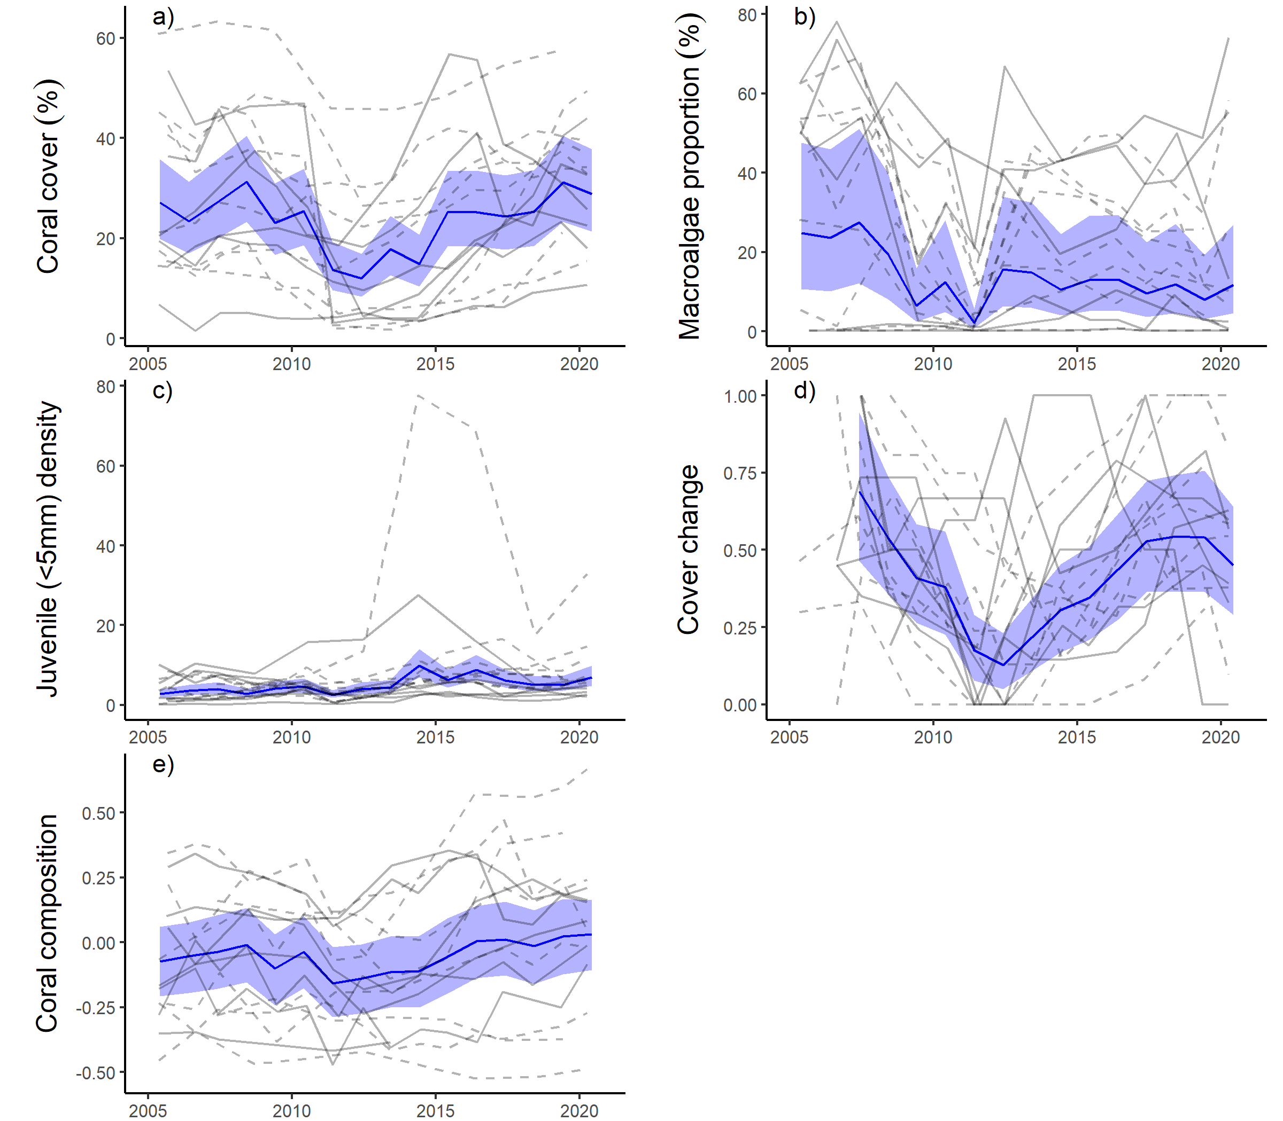
Figure 26 Burdekin Region indicator trends
. a – e) trends in individual indicators, (blue lines) bound by 95% confidence intervals of those trends (shading), grey lines represent observed profiles at 5 m (dashed) and 2 m (solid) depths for individual reefs.

Mackay-Whitsunday region
The coral index has continued to decline and remains ‘poor’ although the rate of decline has slowed as scores for four of the five indicators have stabilised or begun to improve (Figure 27, Table 13).

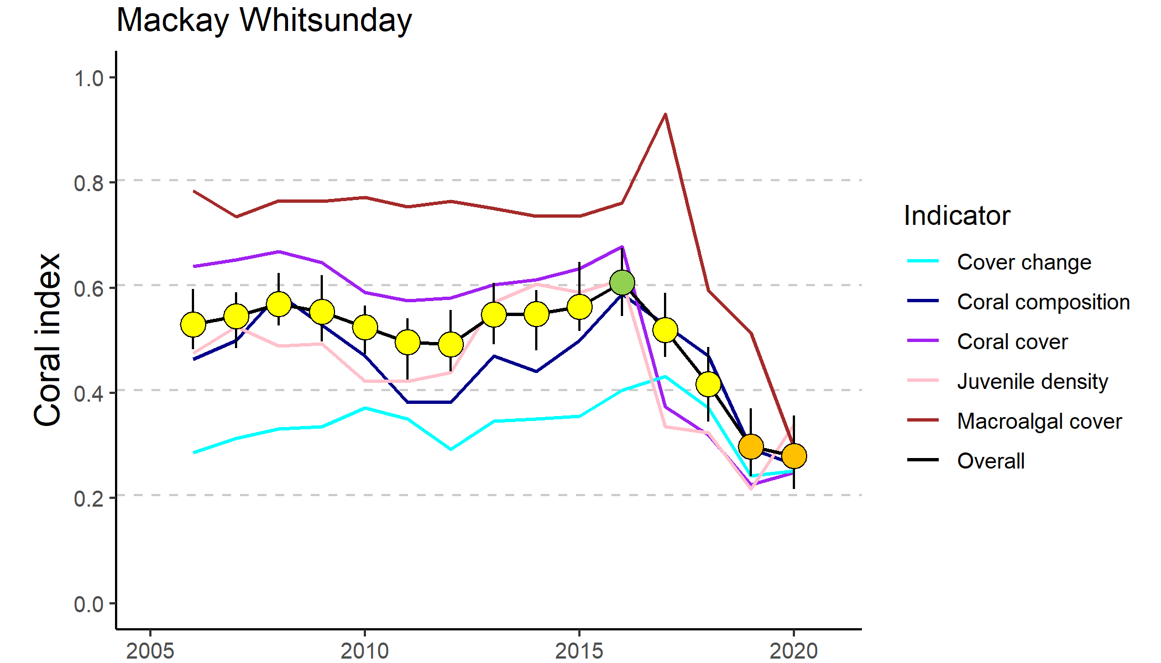
Figure 27 Trends in Coral index and contributing indicator scores for the Mackay-Whitsunday region
. Coral index scores are coloured by report card categories: orange = ‘poor’, yellow=’moderate’, green=’good’. Error in index score derived from bootstrapped distributions of indicator scores at individual reefs.

The continued decline in index scores since 2016 is due to the direct impacts of cyclone Debbie and the lack of recovery to date (Figure 28e, Figure 27). The impact of cyclone Debbie has resulted in regional declines in all indicator scores (Table 13).

Table 13 Index and indicator score comparisons in the Mackay-Whitsunday Region
. Data compare the changes in scores between local maxima and minima in the index time-series. For the index, and each indicator, the observed change in the sub-regional score and the probability that the change was greater or less than zero (no change) are presented. Shading is used as a visual aid to highlight the magnitude of the probability the score improved (blue shades) or declined (red shades). Probabilities are derived from the posterior distribution of observed score changes at each reef and depth.
Period | Depth | Condition Index |  | Coral Cover |  | Macroalgae |  | Juvenile |  | Cover Change |  | Composition
 |  | Score | P | Score | P | Score | P | Score | P | Score | P | Score | P
2008 to 2012 | 2 | -0.07 | 0.77 | -0.07 | 0.91 | 0.00 | NA | -0.08 | 0.80 | -0.05 | 0.60 | -0.14 | 0.72
 | 5 | -0.08 | 0.80 | -0.10 | 0.87 | 0.00 | 0.63 | -0.03 | 0.61 | -0.03 | 0.53 | -0.25 | 0.83
2012 to 2016 | 2 | 0.16 | 0.99 | 0.15 | 0.95 | 0.00 | NA | 0.18 | 0.86 | 0.20 | 0.76 | 0.29 | 0.86
 | 5 | 0.09 | 0.77 | 0.06 | 0.72 | -0.01 | 0.63 | 0.17 | 0.75 | 0.05 | 0.57 | 0.15 | 0.68
2016 to 2020 | 2 | -0.41 | 0.96 | -0.53 | 0.97 | -0.52 | 0.88 | -0.27 | 0.92 | -0.34 | 0.92 | -0.43 | 0.83
 | 5 | -0.27 | 0.92 | -0.36 | 0.95 | -0.43 | 0.83 | -0.28 | 0.86 | -0.06 | 0.57 | -0.25 | 0.76

Scores for the cover change indicator have been consistently low since surveys began in 2005 (Figure 27). The minor decline in index scores between 2019 and 2020 is primarily due to further declines in the macroalgae indicator with very poor scores at the four MMP reefs severely impacted by cyclone Debbie (Daydream, Double Cone, Hook and Pine) and Seaforth (Table A 8). It should be noted that the LTMP reefs in this Region were not monitored in 2020 but had increased levels of macroalgae when surveyed in 2019 (Figure A 5).
Since cyclone Debbie, macroalgal communities have been in a state of succession. At Double Cone macroalgae cover has declined as thick mats of red macroalgae observed in 2018 are being replaced by a lower cover of the potentially persistent brown macroalgae Lobophora and Sargassum (Table A 12). Similarly, at Pine the initial increase in macroalgae cover included a high proportion of red macroalgae species along with Lobophora, and in 2020 the red species had declined to be replaced by Sargassum, which was common prior to 2017 (Table A 12). At Hook Island, a small green macroalgae (not identified) was common over silt-laden substrates at 5 m depth.
Prior to cyclone Debbie, the only acute disturbance events recorded since 2005 were flooding in 2009 and cyclone Ului in 2010 (Figure 28e). These contributed to a slight decline in the coral index through to 2012. Daydream was severely impacted by cyclone Ului, losing 47% of the coral cover at 5 m depth (Figure A 5, Table A 7). By 2016, coral cover at Daydream had recovered to its former level. Following cyclone Debbie, cyclones have contributed to 70% of coral loss since 2005 (Figure 28e).
Chronic stress remains the second highest contributor to the loss of hard coral in the region (Figure 28e). The influence of chronic environmental pressures in the region is demonstrated by the marked differences in the composition of coral communities between 2 m and 5 m depths (Figure 29e, Figure A 5). High turbidity at most of the MMP reef sites (Table A 9), in combination with limited exposure to wave energy among the Whitsunday Islands, results in reduced availability of light and accumulation of fine sediments at 5 m depths and the selection for corals tolerant of these conditions(Oculinidae, Pectiniidae, Agariciidae, Poritidae (genus Goniopora)). In contrast, Acroporidae and Poritidae (genus Porites) are most common at 2 m depths (Figure A 5). Reductions in the composition metric score following cyclones imply additional selective pressures on those species sensitive to poor water quality. The pressure imposed by the water quality in this region is also expressed by relatively low scores for the cover change indicator (Figure 27), which in turn contribute to the frequently categorised chronic stresses (Figure 28e). This is particularly a concern for reefs dominated by corals other than Acroporidae, as their growth expectation is low within the model. With both the long-term and short-term water quality index scores categorised as poor in 2020 (Figure A 14) there is little prospect for future improvements.
High incidence of coral disease was observed in 2007 and 2008 as discharge from local catchments rose to above median levels (Figure 28d), and then in the two years following cyclone Ului, again coinciding with high river discharges (Figure 28d, e, Figure A 7). Disease was noted as a cause for decline in coral cover at Dent Island in 2019, again coinciding with above median discharges from the local catchment (Figure A 7, Figure 29a).
Direct impacts due to flooding were recorded only in 2009 (Figure 28e), attributed primarily to the high loads of sediments observed on corals during surveys. The source of these sediments is not clear, as the local rivers did not experience extreme flooding over the preceding summer (Figure 28d), although local heavy rainfall did result in several landslides along the adjacent ranges.

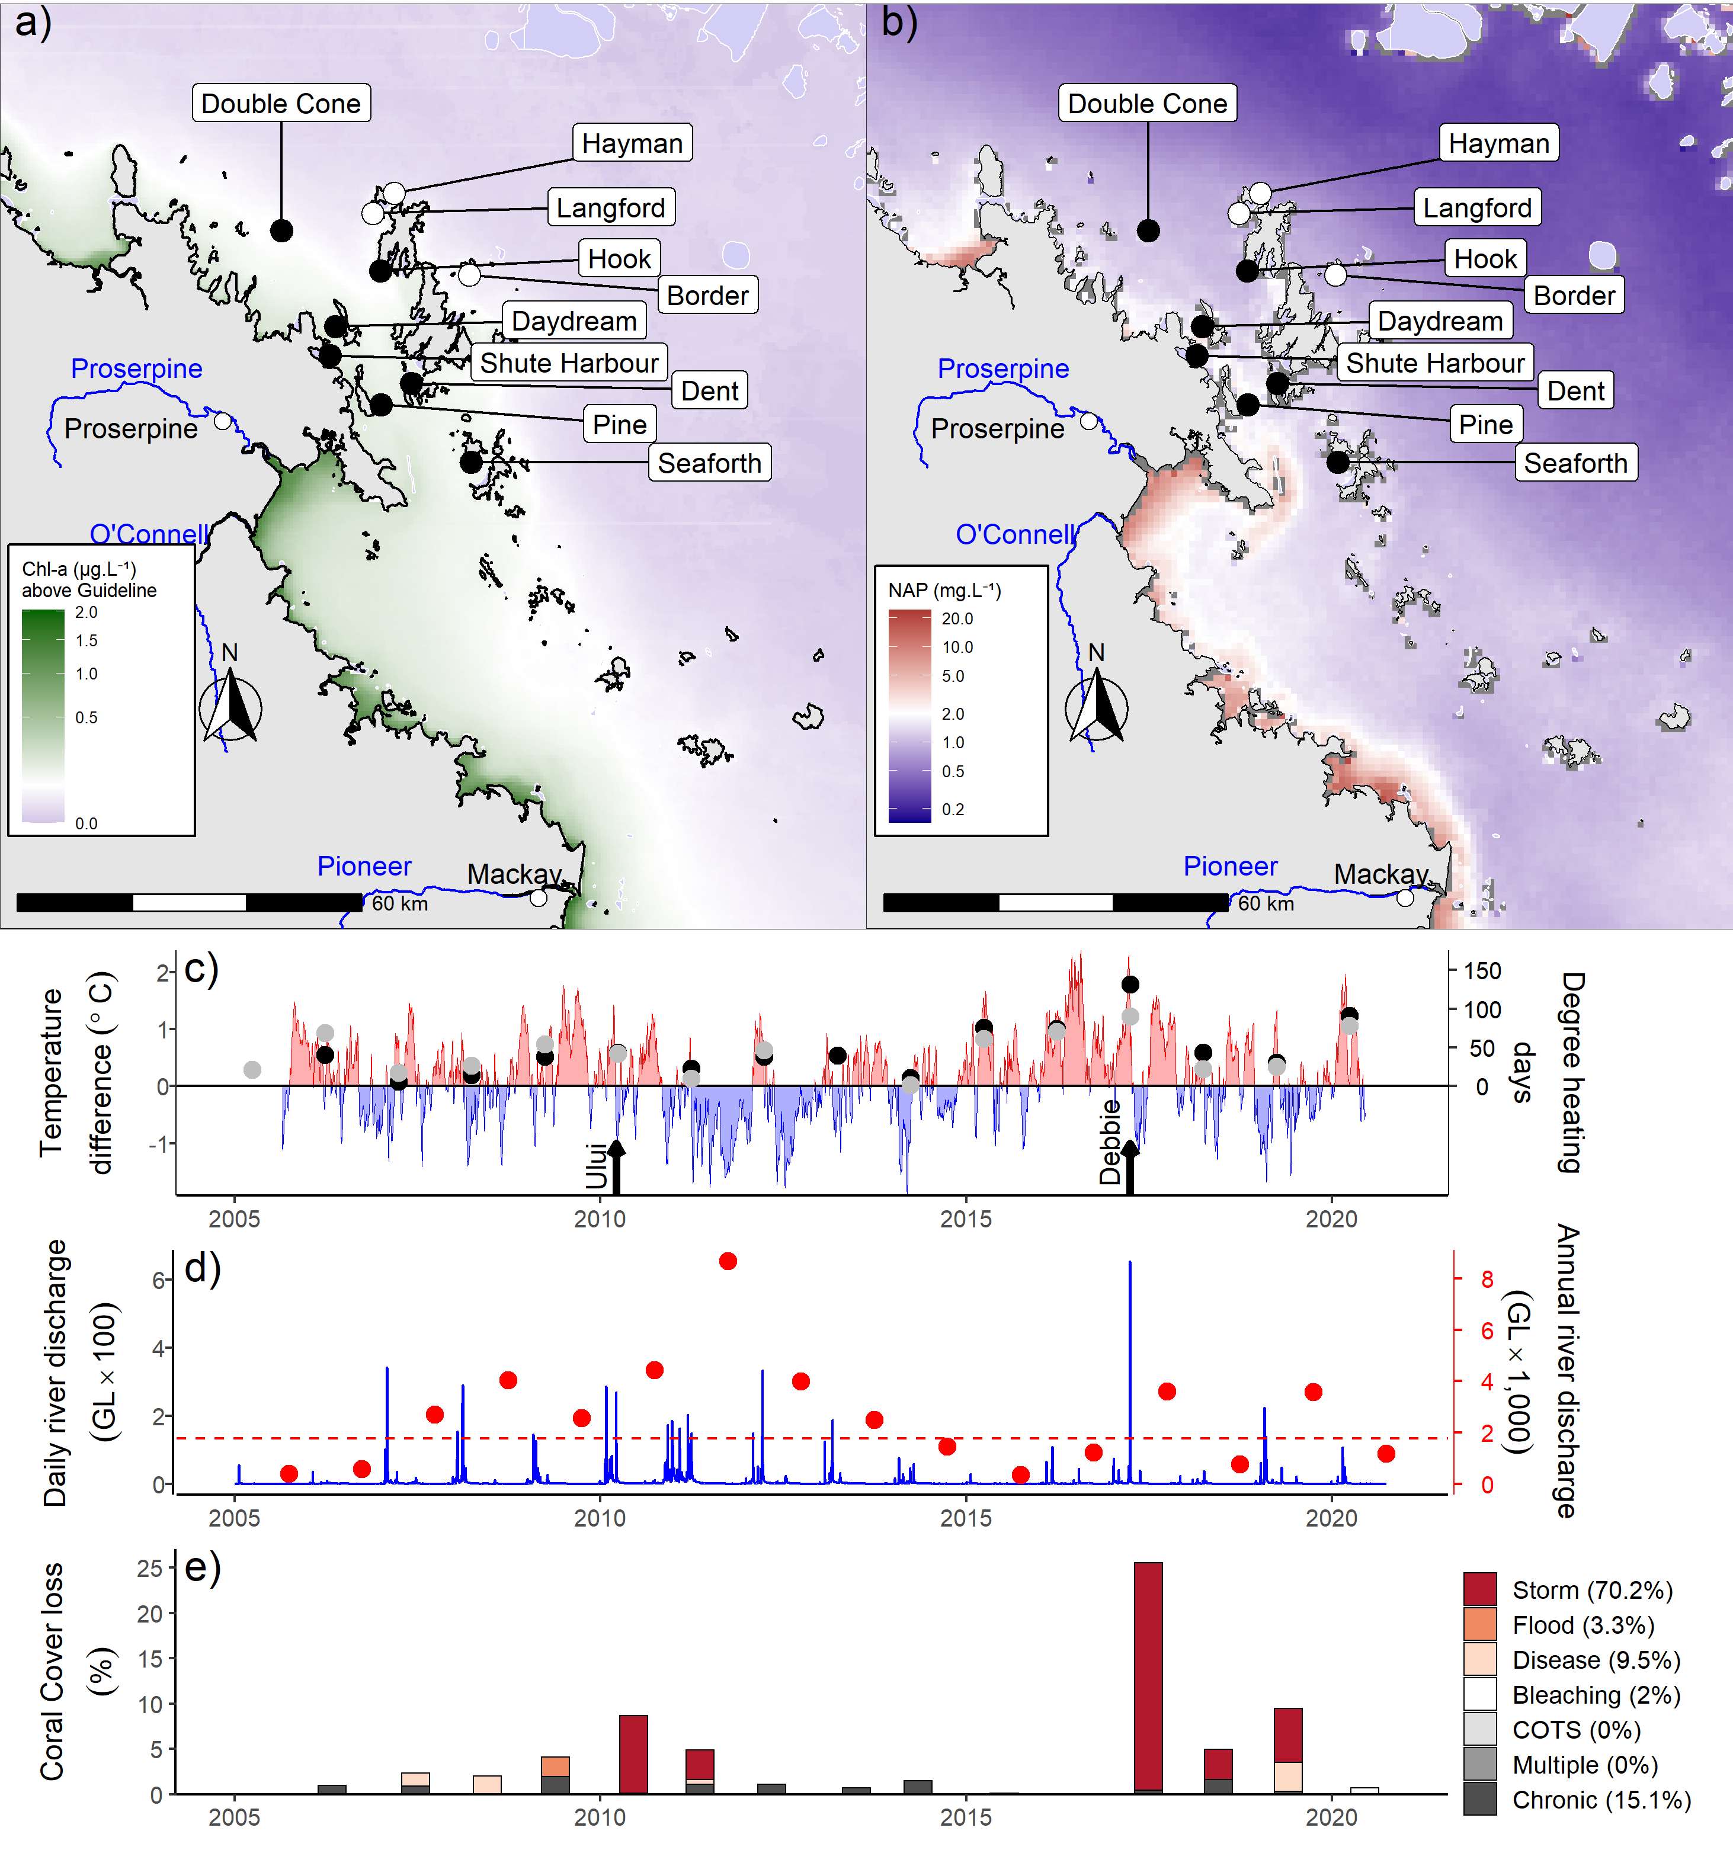
Figure 28 Mackay-Whitsunday Region environmental pressures
. Maps show location of monitoring sites, black symbols MMP, white symbols LTMP along with a) mean chlorophyll a exceedance of wet season Guideline (0.63ugL-1) and b) mean Non Algal Particulate concentrations. Water quality data are mean levels over the period 2003–2018 (Chl) and 2003–2018 (NAP). c) Seasonally adjusted temperature deviation, timing of cyclones and storms indicated by black arrows, accumulated degree heating days over the summer period (1st of December – 31st March) as reported by BoM (black symbols) and derived from in situ loggers (grey symbols) d) Combined daily (blue) and annual water year – October to September (red) discharge for the Carmila and Sandy creeks, Gregory, O’Connell and Pioneer rivers, red dashed line represents long-term median discharge (1986–2016). e) break-down of hard coral cover loss by disturbance type; length of bars represents the mean loss of cover across all reefs.

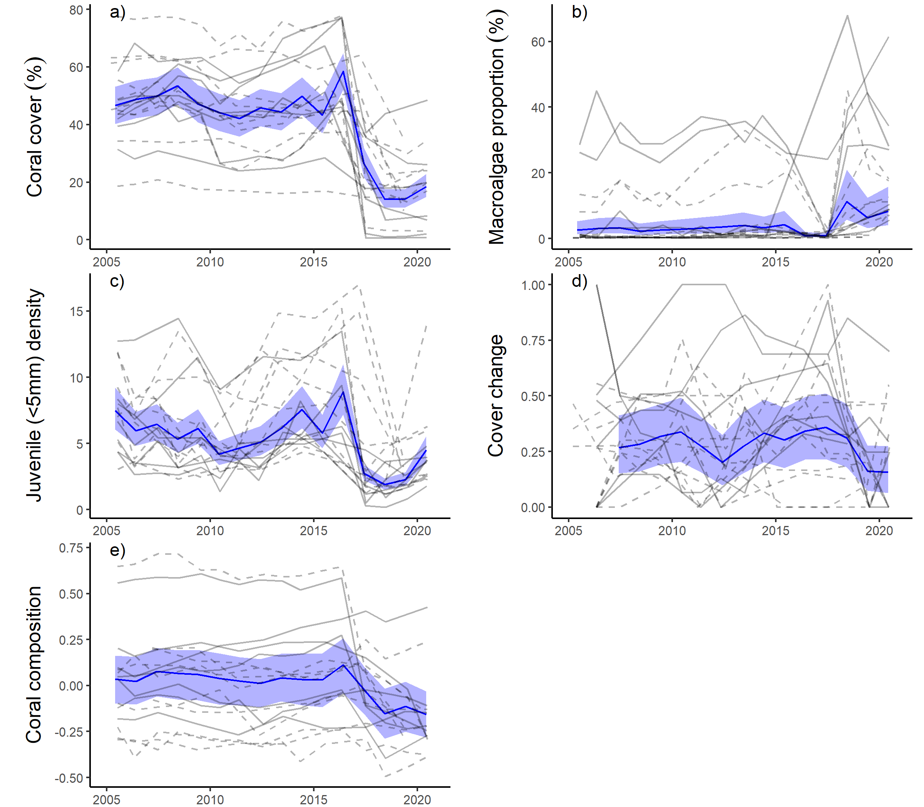
Figure 29 Mackay-Whitsunday Region indicator trends
. a – e) trends in individual indicators, (blue lines) bound by 95% confidence intervals of those trends (shading), grey lines represent observed profiles at 5 m (dashed) and 2 m (solid) depths for individual reefs.

Fitzroy region
The coral index score in the Fitzroy Region remains ‘poor’ but continues to improve from the ‘very poor’ condition observed in 2014 (Figure 30, Table 14).

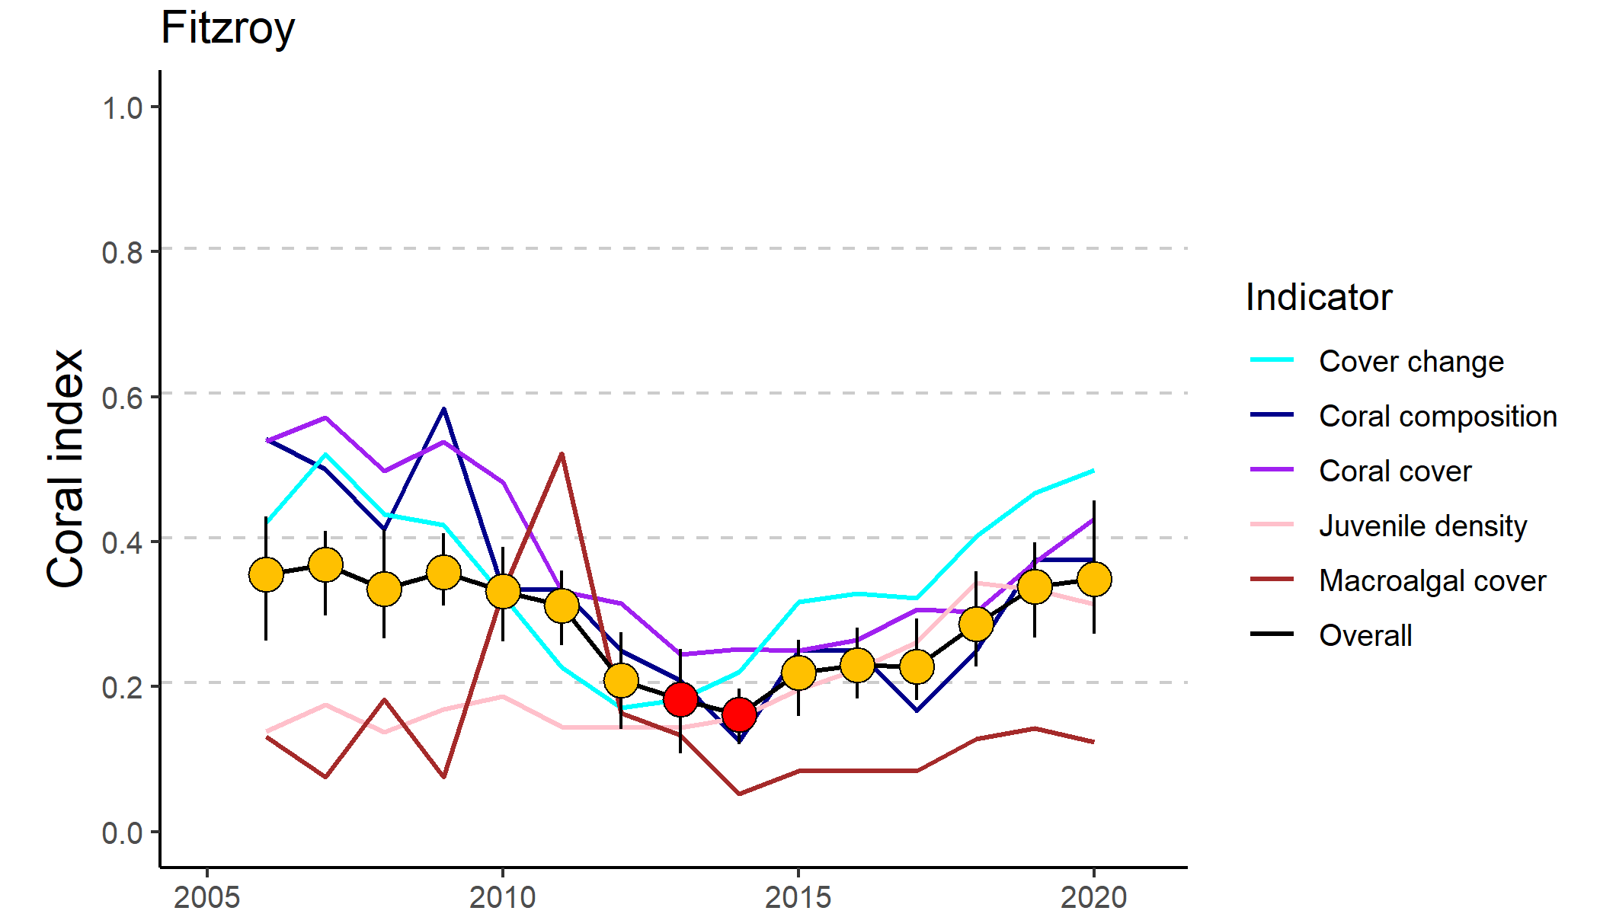
Figure 30 Trends in Coral index and contributing indicator scores for the Fitzroy region
. Coral index scores are coloured by report card categories: red=’very poor’, orange = ‘poor’. Error in index score derived from bootstrapped distributions of indicator scores at individual reefs.

Improvements in index scores reflect improvement in scores for most indicators at both 2 m and 5 m depths of most reefs (Table 14, Figure 32a,c,d). The macroalgae indicator is a notable exception, with inconsistent changes in scores since 2014 and with scores remaining very poor at the regional level (Figure 30, Table 14). Ongoing improvement in the cover change indicator and minimal impact of disturbances in recent years (Figure 30, Table 14) have seen coral cover scores reach a moderate level for the first time since 2010 (Figure 30).

Table 14 Index and indicator score comparisons in the Fitzroy Region
. Data compare the changes in scores between local maxima and minima in the index time-series. For the index, and each indicator, the observed change in the sub-regional score and the probability that the change was greater or less than zero (no change) are presented. Shading is used as a visual aid to highlight the magnitude of the probability the score improved (blue shades) or declined (red shades). Probabilities are derived from the posterior distribution of observed score changes at each reef and depth.
Period | Depth | Condition Index |  | Coral Cover |  | Macroalgae |  | Juvenile |  | Cover Change |  | Composition
 |  | Score | P | Score | P | Score | P | Score | P | Score | P | Score | P
2007 to 2014 | 2 | -0.25 | 0.92 | -0.36 | 0.85 | -0.05 | 0.67 | -0.06 | 0.61 | -0.41 | 0.88 | -0.42 | 0.98
 | 5 | -0.15 | 0.92 | -0.28 | 0.93 | 0 | NA | 0.02 | 0.57 | -0.13 | 0.72 | -0.33 | 0.90
2014 to 2020 | 2 | 0.18 | 1.00 | 0.19 | 0.89 | 0.06 | 0.67 | 0.14 | 0.84 | 0.28 | 0.76 | 0.25 | 0.74
 | 5 | 0.19 | 0.86 | 0.17 | 0.82 | 0.08 | 0.70 | 0.17 | 0.76 | 0.28 | 0.82 | 0.25 | 0.70
The coral communities monitored are situated along a distinct environmental gradient within Keppel Bay. Peak and Pelican are in relatively turbid and nutrient rich waters compared to reefs further offshore (Figure 31a, b). Keppels South, Middle and North Keppel are exposed to concentrations of Chl a that exceed guideline values, whereas at Barren the Chl a level is lower; these four reefs share reasonably low levels of total suspended solids (Figure 31a, b, Table A 9). The gradient in water quality is clearly reflected in the benthic communities. At Peak and Pelican benthic communities differ markedly between 2 m and 5 m depths (Figure A 6) illustrating the substantial attenuation of light due to high turbidity. The differences in community composition are evident in the baseline conditions for the composition indicator (Figure 32e). Pelican has a highly stratified environment, supporting slow growing, low-light tolerant corals at depth, and fast-growing Acroporidae (Acropora, Montipora spp.) in the shallows; although these shallow communities were killed and replaced by macroalgae (Sargassum spp) following exposure to low salinity flood plumes in 2011 (Figure A 6). Closer to the Fitzroy River, Peak is defined by low cover of corals, low density of juvenile corals and high cover of macroalgae (Figure A 6). A lack of substantial reef development at both Peak and Pelican suggests that the environmental conditions at these locations are marginal for most corals, questioning their suitability as inshore coral reef monitoring locations. In the less turbid waters surrounding the remaining reefs coral communities are dominated by Acroporidae (Figure A 6), principally, but not restricted to, the branching species A. intermedia and A. muricata (Table A 10).
Between 2006 and 2015 reefs within this region were exposed to a series of acute disturbances including cyclones and storms, high water temperature leading to coral bleaching, and flooding of the Fitzroy River (Figure 31c-e). These disturbances resulted in a clear reduction in coral cover (Table 14, Figure 32a). The disproportionate loss of Acropora (Figure A 6) resulted in a reduction in the community composition indicator scores (Table 14, Figure 30). Compounding the impact of the acute disturbances was a low rate of recovery of coral cover, demonstrating the effect of chronic impacts (Figure 31e), evidenced by high levels of disease (Figure A 7) and declines in the cover change scores between 2007 and 2014 (Table 14). During this period of slow recovery annual discharge from the Fitzroy River was mostly well above median levels (Figure 31d). No assessment of change in the macroalgae indicator scores between 2007 and 2014 at 5 m depth was possible (Table 14), as scores were zero at all reefs in both years: further implicating availability of nutrients in the observed slow recovery. The initial increase in macroalgae cover occurred as brown algae of the genus Lobophora rapidly occupied space made available following the death of corals in 2006 (Figure 32c, Diaz-Pulido et al. 2009).
Prior to the commencement of the MMP, Queensland Parks and Wildlife Service monitoring of reefs in Keppel Bay from 1993–2003 recorded substantial loss, and subsequent recovery, of coral cover following thermal bleaching events in 1998 and 2002 (Table A 7). Initial MMP surveys in 2005 documented ‘good’ to ‘very good’ hard coral cover on all the Acropora-dominated reefs, confirming the potential for recovery at these reefs when not subjected to additional pressures. Elevated water temperatures (2016, 2017, Figure 31c) and exceedance of median discharge levels from the local catchment (in 2017, Figure 31d) did not result in substantial loss of coral cover, but are likely causes of observed low rates of increase in coral cover represented as chronic stress (Figure 31e). High water temperatures in 2020 resulted in extensive bleaching and observed mortality of corals at Barren Island during surveys. Despite this mortality, and the regional stress imposed by the 2020 bleaching event, coral cover across the region increased between 2019 and 2020 (Figure 32a). Recent improvement in the coral change indicator (Table 14) to “moderate’ levels reflects improvement at several reefs, however across the region recovery remained slightly below expected rates, that would return a score of 0.5 (Figure 32d).
Water quality monitoring (in-situ) was discontinued in the Keppels region in 2015. The final year of water quality sampling saw an improvement in the water quality index (Lønborg et al. 2015). Measured levels of Chl a showed a slight downturn coinciding with a respite from flooding in the region since 2012 (Lønborg et al. 2015). Modelling of total suspended solids and dissolved inorganic nitrogen indicate substantially lower concentrations in the region from 2014 to 2016 compared to those associated with the high discharge years of 2010, 2011 and 2013 (Waterhouse et al. 2017).
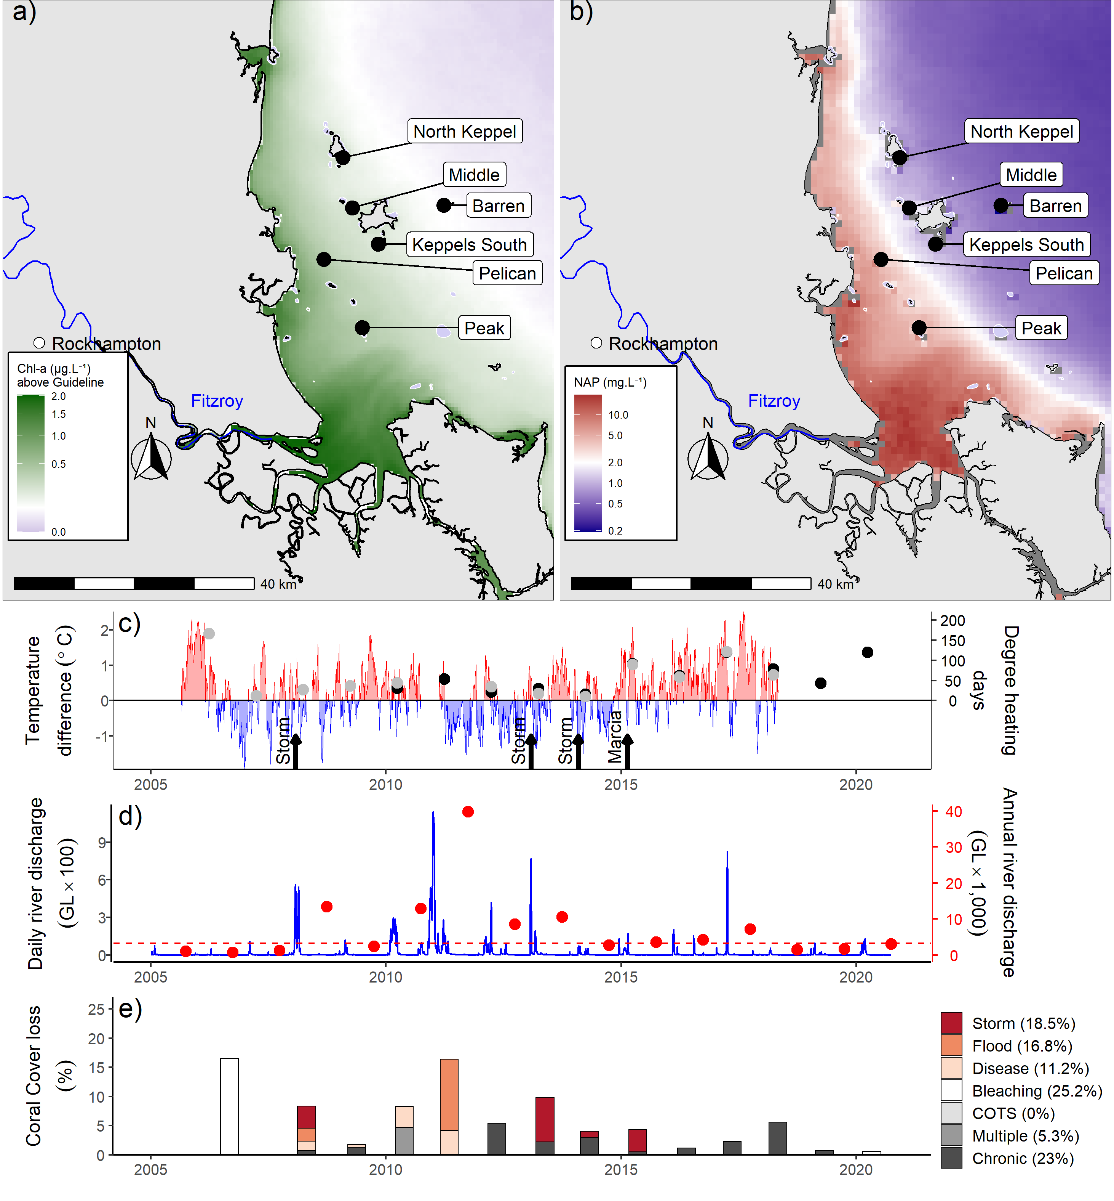
Figure 31 Fitzroy Region environmental pressures
. Maps show location of monitoring sites along with a) mean chlorophyll a exceedance of wet season Guideline (0.63ugL-1) and b) mean Non Algal Particulate concentrations. Water quality data are mean levels over the period 2003–2018 (Chl) and 2003–2018 (NAP). c) Seasonally adjusted temperature deviation, timing of cyclones and storms indicated by black arrows, accumulated degree heating days over the summer period (1st of December – 31st March) as reported by BoM (black symbols) and derived from in situ loggers (grey symbols) d) Combined daily (blue) and annual water year – October to September (red) discharge for the Calliope and Fitzroy rivers and Waterpark Creek, red dashed line represents long-term median discharge (1986–2016). e) break-down of hard coral cover loss by disturbance type; length of bars represents the mean loss of cover across all reefs.

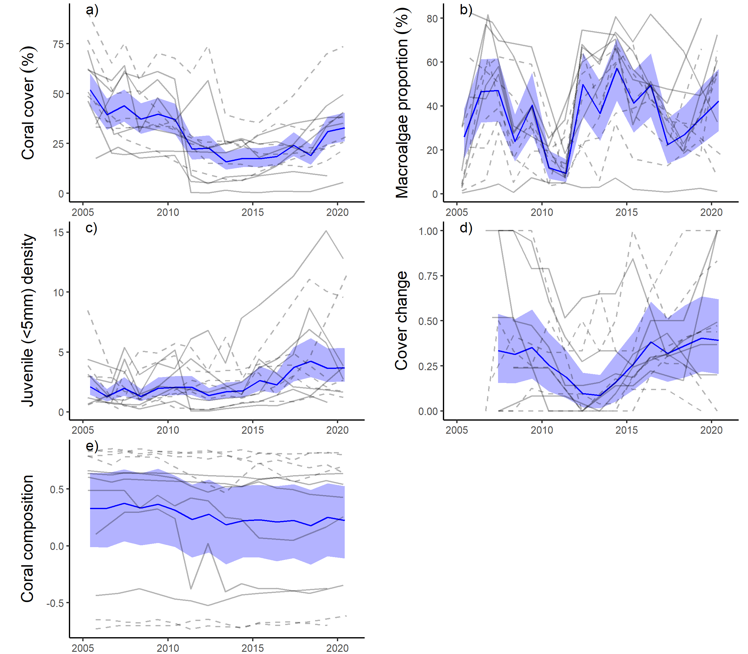
Figure 32 Fitzroy Region indicator trends
. a– e) trends in individual indicators, (blue lines) bound by 95% confidence intervals of those trends (shading), grey lines represent observed profiles at 5 m (dashed) and 2 m (solid) depths for individual reefs.

Response of coral communities to environmental conditions

Location along water quality gradients
Reef-wide index scores at 2 m depth show a negative relationship to Chl a concentration in surrounding waters, although this relationship was only statistically evident in the Wet Tropics region (Table 15, Figure 33a). In general, index scores in 2020 did not reflect relative exposure to pressures associated with water quality over the last five years (Table 15). For the Mackay-Whitsunday region similarly low wet season exposure to above guideline Chl a concentration among reefs (Figure 33) limit the sensitivity of these analyses. Recent severe impacts associated with cyclone Debbie will also confound any relationship between index scores and water quality in the Mackay Whitsunday region.
Of the individual indicators:
- Scores for coral cover were negatively related to increasing concentration of Chl a at 2 m and 5 m depths. This relationship strongest in the Fitzroy region and at 2 m depth in the Wet Tropics region (Table 15, Figure 33b).
- Reef-wide scores for macroalgae were negatively related to Chl a concentration at both 2 m and 5 m depths and positively related to light levels (PAR) at 5 m depth. At 2 m depth these relationships were most evident in the Burdekin region and at 5 m depth in the Mackay Whitsunday region (Figure 33c, d, Figure 34a, Table 15).
The juvenile indicator at 5 m depths was the only indicator for which Reef-wide scores were positively related to Chl a concentration. This relationship was evident in both the Wet Tropics and Burdekin regions (Table 15, Figure 33b). Very high densities of Turbinaria spp (family Dendrophylliidae) juveniles at reefs with relatively high Chl a concentration in the Herbert Tully sub-region and Burdekin Region are influential in these results (Figure A 12, Figure A 13).
Reef-wide scores for the juvenile indicator at 5 m depth were negatively related to PAR concentration. This pattern was not strongly evident within any region (Table 15, Figure 34c).
Both the macroalgae and composition indicator scores are based on thresholds that vary along water quality gradients to ensure scores are sensitive to change at each reef. As such, the spatial analysis of scores masks underlying differences in the values underpinning these scores. Reef-wide, the proportion of algal cover classified as macroalgae shows a negative relationship to PAR and positive relationship to Chl a at 2 m depths (Table 16, Figure 35). These relationships are most evident in the Burdekin region.
Reef-wide genus composition values were derived from the product of genus level coral cover estimates and eigenvalues for the distribution of genera along WQ gradients (Table A 5). That composition is negatively related to Chl a concentration and positively related to PAR (Figure 36) is entirely to be expected given the derivation and intent of this indicator. Limiting the sensitivity for change in community composition to water quality in the Mackay-Whitsunday region is the relatively short gradient in water quality compared to that observed in other regions.

Table 15 Relationship between index and indicator scores and gradients in water quality.
. Tabulated values are upper and lower confidence intervals of the trend in scores for each combination of index or indicator, and depth, for which Reef-wide relationships between scores in 2020 and water quality proxies; mean wet season Chl a (2016-2020) and PAR (2015-2019) were observed. Slopes for which confidence intervals did not include zero are shaded to highlight the direction of the relationship.
Response | Depth | Reef-wide |  | Wet Tropics |  | Burdekin |  | Mackay-Whitsunday |  | Fitzroy
 |  | l | u | l | u | l | u | l | u | l | u
Chlorophyll a concentration
Coral Index | 2 | -3.8 | -0.3 | -5.0 | 0.0 | -5.0 | 1.4 | -3.5 | 20.3 | -6.2 | 1.1
Coral cover score | 2 | -6.3 | -1.6 | -9.3 | -2.3 | -5.6 | 2.7 | -8.8 | 20.0 | -10.0 | -0.4
Macroalgae score | 2 | -8.0 | -1.4 | -9.7 | 1.0 | -13.3 | -0.4 | -18.9 | 21.4 | -12.3 | 1.4
 | 5 | -7.3 | -1.4 | -6.5 | 3.1 | -12.7 | 2.0 | -21.8 | -5.6 | -8.6 | 4.5
Juvenile score | 5 | 1.9 | 7.5 | 0.5 | 8.6 | 0.5 | 13.5 | -1.54 | 14.6 | -2.9 | 9.4
Photosynthetically active radiation
Macroalgae score | 5 | 0.06 | 0.5 | -0.4 | 0.8 | -0.1 | 0.7 | 0.3 | 1.3 | -0.3 | 0.4
Juvenile score | 5 | -0.5 | -0.1 | -1.0 | 0.02 | -0.7 | 0.01 | -0.9 | 0.2 | -0.5 | 0.3

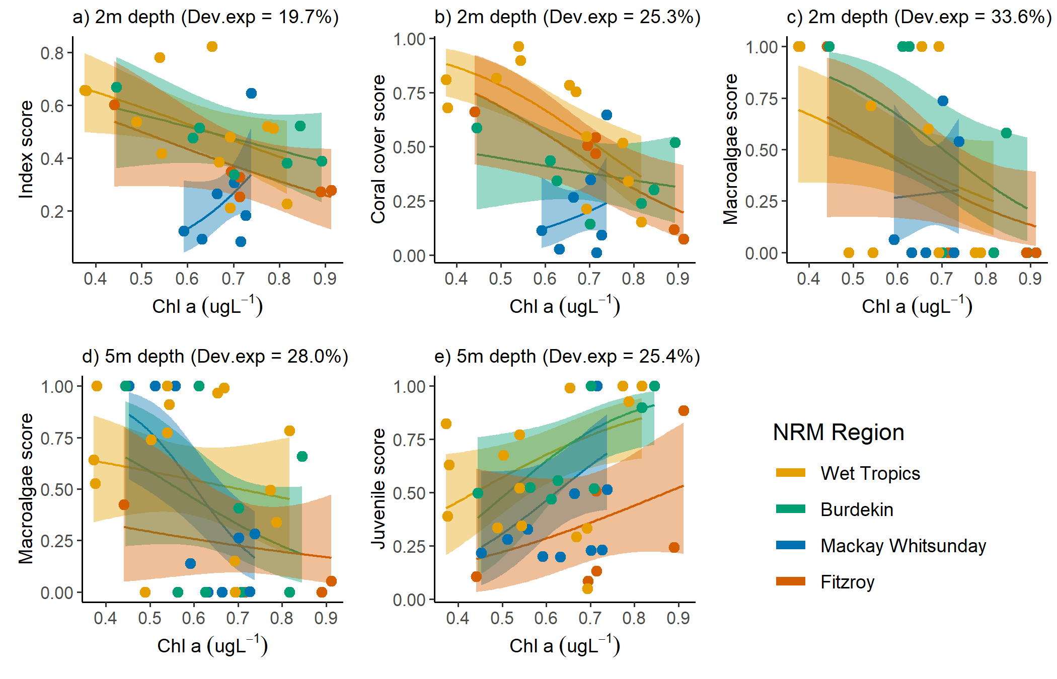
Figure 33 Coral index and indicator score relationships to Chl a concentration
. Combinations of coral index or indicator and depth are included where Reef wide relationships were indicated by models. Plots present predicted relationship within each region. Confidence intervals in predicted slopes are provided in Table 15. Chl a concentration expressed as mean wet-season exceedance of Guideline values (0.63µgL⁻¹).

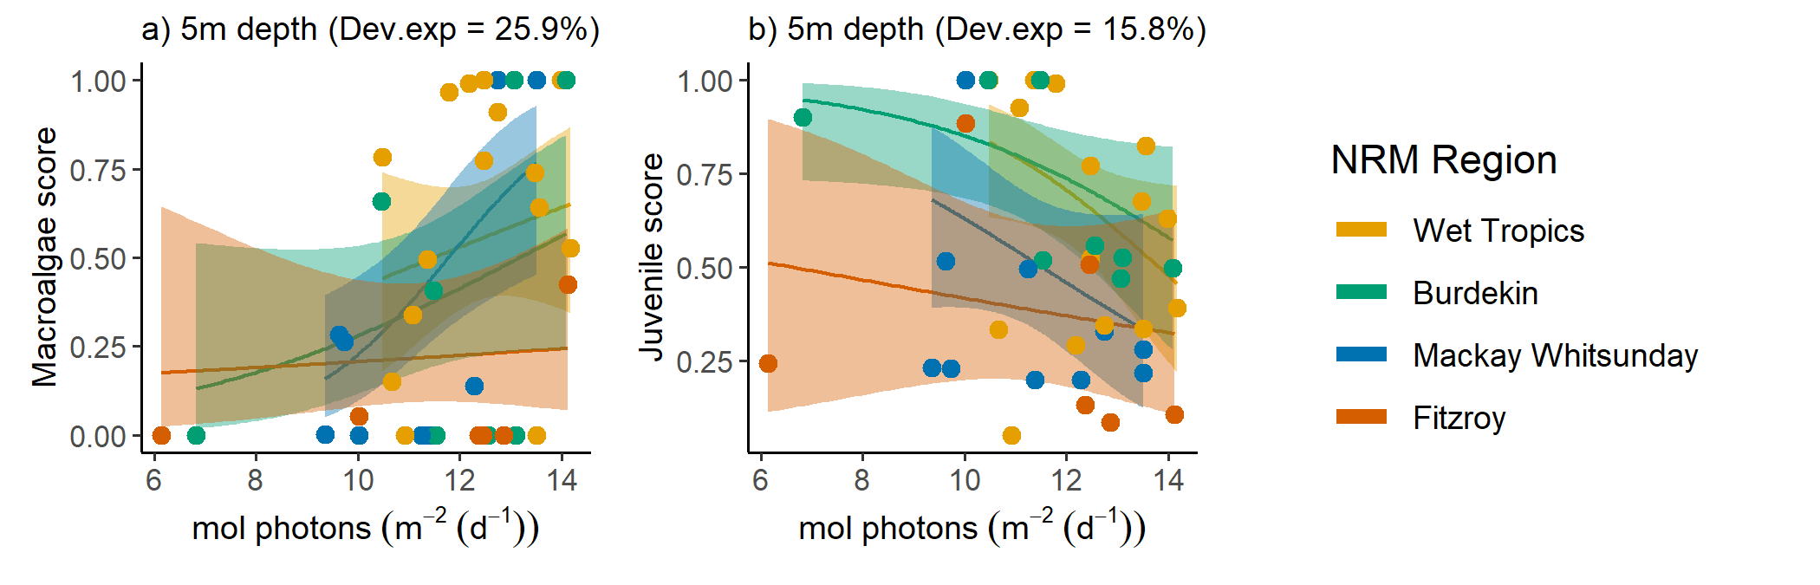
Figure 34 Coral indicator score relationships to PAR
. Combinations of coral index or indicator and depth are included where Reef wide relationships were indicated by models. Plots present predicted relationship within each region. Confidence intervals in predicted slopes are provided in (Table 15).

Table 16 Relationship between macroalgae and composition indicator values and water quality gradients
. Tabulated values are upper and lower confidence intervals of the trend in values for each combination of indicator value and depth. Slopes for which confidence intervals did not include zero are shaded to highlight the direction of the relationship.
Response | Depth | Reef-wide |  | Wet Tropics |  | Burdekin |  | Mackay-Whitsunday |  | Fitzroy
 |  | l | u | l | u | l | u | l | u | l | u
Chlorophyll a concentration
Macroalgae proportion | 2 | 1.7 | 7.4 | -0.5 | 7.6 | 0.8 | 13.1 | -13.9 | 16.8 | -1.0 | 11.0
Genus composition | 2 | -1.2 | -0.04 | -1.6 | 0.1 | -1.9 | 7.3 | -1.2 | 6.0 | -2.5 | 0.3
 | 5 | -2.9 | -1.2 | -2.9 | -0.7 | -4.2 | -0.8 | -3.4 | 5.6 | -4.5 | -1.0
Photosynthetically active radiation
Macroalgae proportion | 2 | -0.6 | -0.1 | -0.9 | 0.1 | -0.8 | -0.1 | -0.8 | 0.7 | -1.1 | 0.3
Genus composition | 2 | 0.01 | 0.1 | -0.01 | 0.2 | -0.03 | 0.1 | -0.3 | 0.1 | 0.03 | 0.3
 | 5 | 0.09 | 0.2 | 0.1 | 0.3 | 0.01 | 0.2 | -0.2 | 0.2 | 0.2 | 0.6

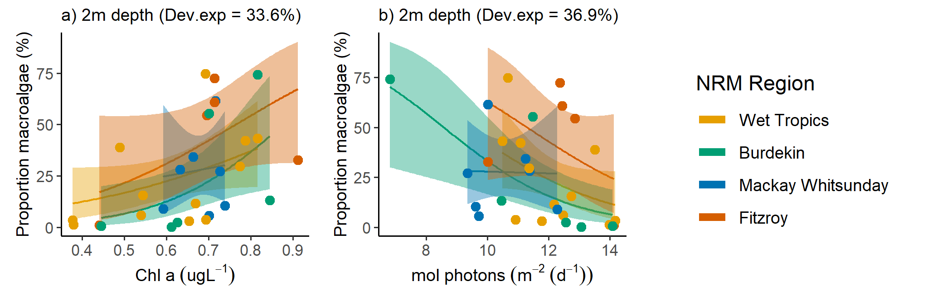
Figure 35 Relationship between proportions of algal cover classified as macroalgae and water quality proxies
. Plots present predicted relationship within each region. Confidence intervals in predicted slopes are provided in (Table 15). Chl a concentration, expressed as mean wet-season exceedance of Guideline values (0.63µgL⁻¹).

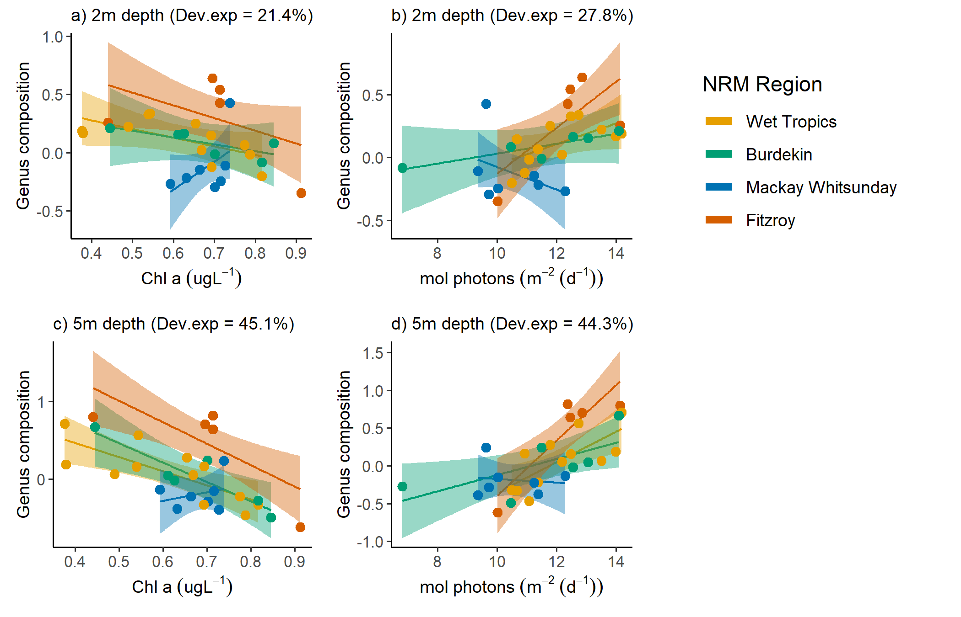
Figure 36 Relationship between coral community composition and water quality proxies
. Plots present predicted relationship within each region. Confidence intervals in predicted slopes are provided in Table 15. Colour coding for regional trends are consistent with those in above figures. Chl a concentration, expressed as mean wet-season exceedance of Guideline values (0.63µgL⁻¹).

Influence of discharge, catchment loads and water quality on reef recovery
During periods free from acute disturbances (cyclones, thermal bleaching, crown-of-thorns starfish or direct exposure to low salinity floodwaters), the recovery of reefs as measured by biennial change in index scores was negatively related to discharge from the local catchments in each region other than Mackay-Whitsunday (Table 17, Figure 37). Importantly, these relationships consider only the contemporary influence of environmental conditions on the indicators during recovery periods. Any influence of water quality on the severity of response to disturbance events, or lagged responses of indicators will not be included. In the case of lagged influences, such as the initial decrease then post-disturbance increases in macroalgal cover that has been observed on several occasions following cyclones and floods, this will result in the underestimation of the response. PN, TP and TSS loads were also negatively associated with change in index scores across all regions, except for the Mackay-Whitsunday region (Table 17). It is not surprising that relationships between particulate P and Total N and coral index change were generally mirroring those described for discharge as nutrient loads in rivers are correlated with river discharge.
Prior to analysis the values for satellite derived water quality variables estimated from the waters adjacent to the coral monitoring sites, Chl a, TSS and PAR, were centred (mean for the reef subtracted) to reflect inter-annual variability at the reef level rather than spatial variability among reefs. Changes in coral index scores to relative Chl a, and PAR levels were most evident in the Fitzroy Region where high Chl a and lower light correspond to reduced community resilience (Table 17). Similar though less pronounced effects were observed in the Burdekin and Wet Tropics. Regional reductions in PAR reaching the benthos, as estimated by the PAR WQI, also corresponded to reduced change in index scores in each region, other than Mackay-Whitsunday with the regional WQI proving a stronger predictor of coral community resilience than the reef specific values in both the Burdekin and Wet Tropics. The only relationship between water quality and changes in index scores in the Mackay-Whitsunday Region was variability in TSS levels at the reef (Table 17).

Table 17 Relationship between changes in index scores and environmental conditions
. Tabulated are the proportion of deviance explained by models fit to relationships between the time-series of index score changes during non-disturbance periods and summaries of environmental condition during those periods. Shading indicates the relationship was monotonic with higher increase in index scores at lower exposures to the environmental pressure. A (*) marks relationships that where not monotonic although either, the most negative index score changes were observed at high exposures, or most positive changes occurred at lower exposures. A (#) marks relationships that are curved and do not indicate a unidirectional relationship. Blank cells indicate no relationship was observed with AICc not more than 2 units lower than null models. For light at reef level positive responses are shaded as low light is the pressure.
Region | Freshwater Discharge | PN (JCU extrapolated load) | Total P river load (2019) | TSS river load (2019) | PAR WQI (2019) | DIN (JCU extrapolated load) | Chl a  (reef ) | TSS  (reef ) | PAR  (reef 2019)
Wet Tropics | 15.7% | 19% | 21.4% | 17.7% | 15.7% |  | 4.5% |  | 5.2%
Burdekin | 15.5% | 12.9%* | 14.4% | 13.3%* | 14.1% |  | 9.3% | 9.3% | 10.1%
Mackay-Whitsunday |  |  |  |  |  | 9.2% #
Fitzroy | 26.8% | 19.2% | 19.7% | 20.0% | 21.7% | 24.4% | 27.2% | 21.8% | 33.9%
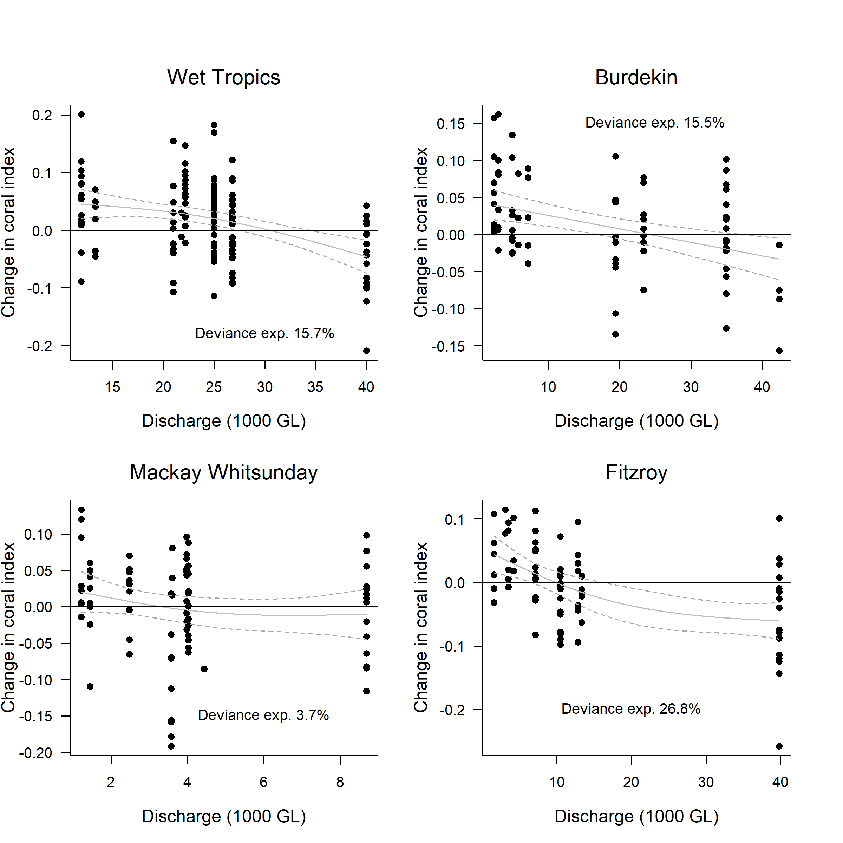
Figure 37 Relationship between the coral index and run-off from local catchments
. Plotted points represent observed change in the index score at each reef and depth over a two-year period. Observations following years for which acute disturbances impacted communities in the period between samples were excluded. Discharge values represent the cumulative discharge from the region’s major rivers over the two-year period corresponding to index changes. Trend lines represent the predicted change in index scores (solid line) and the 95% confidence intervals of the prediction (dashed lines).

Impact of 2020 marine heat wave
High water temperatures over early 2020 exposed most inshore reefs south of the Wet Tropics to high levels of thermal stress (Table 18).

Table 18 Temperature stress metrics observed in 2020
. DHD are degree heating day values derived from satellite observations downloaded from the Bureau of Meteorology (ReefTemp next generation), DHD.obs are degree heating day estimates calculated from in situ temperature loggers, and DHW are degree heating week estimates sourced from (NOAA coral reef watch). Shading indicates values at or above the minimum DHD value at which bleaching was observed during 2020 surveys, or DHW above level 2 alert. The proportion of hard corals bleached at the time of survey at 2 m and 5 m depths are included.
subregion | REEF | DHD | DHD.obs | DHW | % Hard Coral Bleached
 |  |  |  |  | 2 m | 5 m
Daintree | Snapper South | 63 |  | 5.7 | 0 | 0.3
 | Snapper North | 67 | 59 | 4.6 | 0.5 | 0.6
Johnstone | High East | 41 |  | 4.2 | 0 | 0.2
 | High West | 46 | 30 | 4.2 | 0.1 | 0.0
 | Fitzroy East | 50 |  | 4.7 | 0.4 | 1.2
 | Franklands East | 51 |  | 4.2 | 0.1 | 0.6
 | Fitzroy West | 51 | 48 | 4.9 | 0 | 0.2
 | Franklands West | 54 | 35 | 4.2 | 0 | 0.1
Tully | Dunk North | 48 | 72 | 3.4 | 1.7 | 0.5
 | Barnards | 57 | 64 | 4.1 | 0 | 0
 | Dunk South | 60 |  | 3.3 | 0 | 4.4
 | Bedarra | 63 | 98 | 4.2 | 1.1 | 8.9
Burdekin | Palms East | 67 | 48 | 6.1 | 5.9 | 11.9
 | Havannah | 83 | 58 | 8.8 | 62.3 | 59.9
 | Palms West | 84 | 55 | 6.4 | 70.7 | 11.0
 | Pandora | 90 | 82 | 9.0 | 79.2 | 75.3
 | Lady Elliot | 92 | 85 | 9.4 | 15.3 | 46.4
 | Magnetic | 99 | 104 | 9.7 | 18.6 | 64.7
Mackay Whitsunday | Hook | 78 | 72 | 7.8 | 1.5 | 1.2
 | Daydream | 87 | 74 | 8.6 | 0 | 8.7
 | Dent | 99 | 88 | 8.0 | 0.6 | 1.2
 | Seaforth | 101 | 91 | 8.2 | 0.9 | 7.9
 | Double Cone | 101 | 80 | 8.7 | 8.0 | 2.0
 | Pine | 103 | 90 | 8.3 | 3.9 | 4.6
 | Shute Harbour |  | 84 | 8.3 | 3.4 | 7.6
Fitzroy | Middle | 107 |  | 9.3 | 84.4 | 65.5
 | Barren | 114 | 98 | 8.7 | 63.5 | 33.0
 | Keppels South | 116 | 105 | 9.7 | 58.4 | 55.4
 | North Keppel | 117 | 95 | 9.3 | 74.0 | 43.6
 | Pelican | 132 | 111 | 10.5 | 31.6 | 12.1

In general, observed bleaching levels (Figure 38a) were consistent with published thresholds of bleaching response for the heat stress metrics: for DHDs moderate bleaching is expected between 60 and 100 DHDs and severe bleaching thereafter (Garde et al. 2014), a threshold of 8 DHW is a trigger for a level 2 alert under NOAA Coral Reef Watch (2018) and severe bleaching and significant mortality are likely.
Surveys of reefs in the Burdekin region were undertaken from 3 to 6 April 2020, with marked variability in the level of bleaching observed (Figure 38b). At Palms East, the location with lowest heat stress metric estimates in the region, only 6% of corals showed signs of bleaching at 2 m depths, compared to 12% at 5m depth (Table 18). At all other reefs at least 50% of corals were bleached at either or both site depths. Bleaching was also widespread and common in the Fitzroy region where surveys were undertaken during the first week of May 2020 (Table 18). Much of the bleaching noted in the Fitzroy region constituted pale rather than completely white or fluorescent corals and it appeared recovery of symbionts was occurring among many of these corals.
A low proportion of corals in the Mackay-Whitsunday region were bleached, despite the similar levels of thermal stress as experienced in the Burdekin and Fitzroy regions. Surveys of reefs in this region were undertaken in mid-June, and it is probable that recovery of symbiont communities within surviving corals contributed to this result. Other potentially confounding factors are the high turbidity and strong currents in the region, as both are factors postulated to reduce corals sensitivity to thermal anomalies (van Woesik et al. 2012, West & Salm 2003). Interestingly, the proportion of coral cover lost on these reefs was like that in the neighbouring regions (Figure 38c). However, this result needs to be considered with caution as coral cover was very low prior to 2020 and coral recovery slow in the wake of cyclone Debbie. Slight underperformance of coral recovery compared to modelled predicted increases at such low covers can result in relatively high estimates of proportional loss.
Surveys of the northern Wet Tropics sub-regions occurred in July and into August, by which time any bleached corals would likely have recovered. However, the low heat stress and increasing coral cover in both the Barron Daintree and Johnstone Russell-Mulgrave sub-regions (Figure 38a, c) demonstrate that these reefs were not severely impacted by the 2020 marine heat wave.

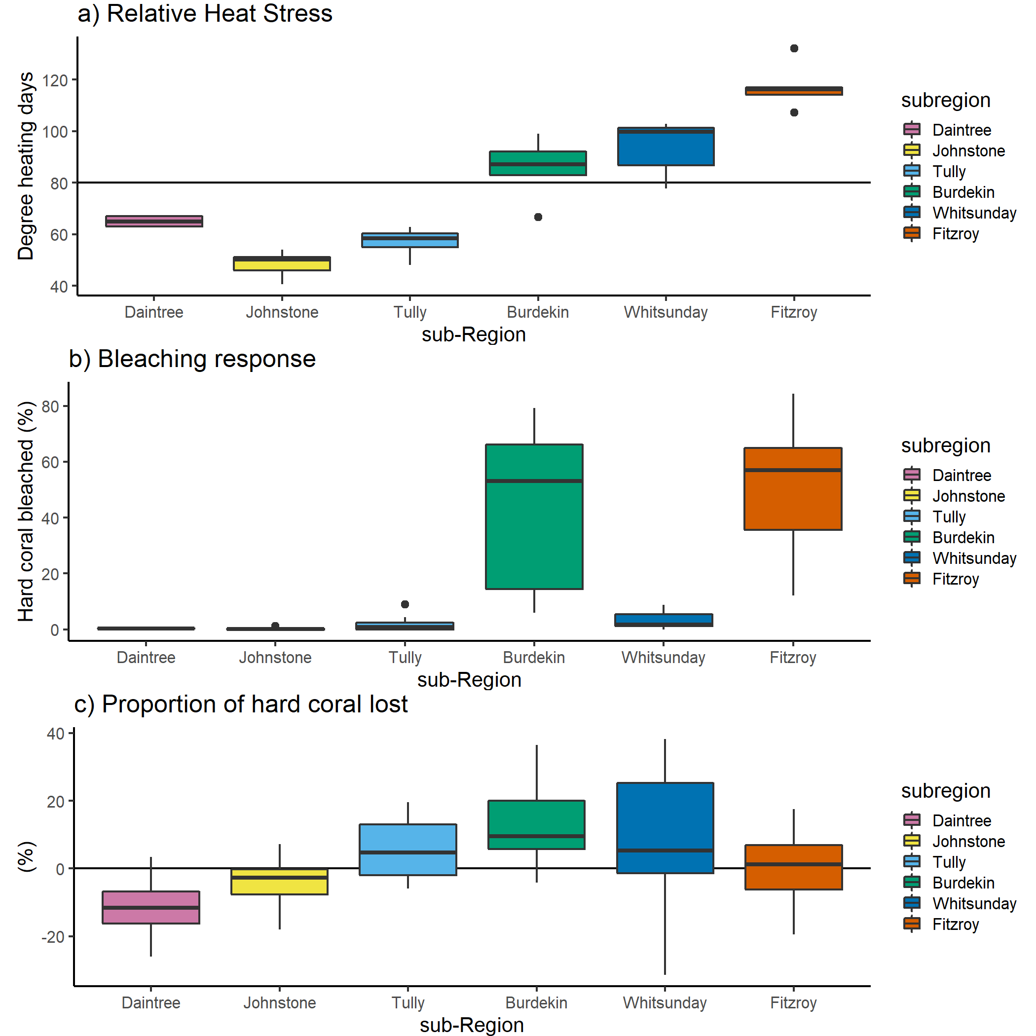
Figure 38 (sub-)regional distributions of thermal stress and coral community responses in 2020
. a) degree heating day (BoM) values recorded adjacent to coral monitoring sites, b) Observed proportion of hard coral cover that was bleached at the time of survey, both partially bleached and bleached white corals are included, c) the proportion of hard coral cover lost since reefs were last surveyed in either 2019 or 2018.

Discussion
As naturally dynamic systems that alternate between impacts and periods of recovery (Connell 1978), it is critical for the persistence of coral communities that there is a long-term balance between disturbance and recovery processes. This balance can only be achieved if there is sufficient time between disturbance events and favourable environmental conditions that promote recovery during intervening periods. The Driver-Pressure-State-Impact-Response (DPSIR) framework (Maxim et al. 2009, Rehr et al. 2012) allows identification of some of the key drivers and pressures influencing coral condition and the potential imbalance in the disturbance recovery cycle. These include:
- Social and economic development are two of the drivers of human activities; from local, within catchment, through to global scales.
- Human activities result in local scale pressures on downstream ecosystems, such as increased exposure to sediments, nutrients and toxicants, through to direct drivers such as global climate change. In this context, there is a distinction between pressures arising from climate change that are beyond the realm of management under the Reef 2050 Water Quality Improvement Plan, such as acute disturbances associated with severe cyclones and thermal bleaching events, and those related more tangibly to water quality, that may be locally manageable. A primary focus of this component of the MMP is assessing the role of water quality in this balance.
- These pressures change the state of the Reef ecosystems. This state can then be interpreted in terms of impact on desirable ecosystem functioning or services that can be used to inform management actions (response) that alleviate impacts.

Pressures

Acute disturbances
Since MMP surveys began in 2005 inshore reefs have been impacted by multiple acute disturbance events. Cyclones and storms have caused almost half (46%) of all coral cover losses on inshore reefs since 2005. Unsurprisingly it has been the intense category 4 and 5 systems; cyclone Larry (Wet Tropics and Burdekin Regions – 2006), cyclone Yasi (Wet Tropics and Burdekin Regions – 2011), and cyclone Debbie (Whitsunday Region – 2017) that have caused the greatest losses.
Following high water temperatures over the 2017 and 2020 summers the relative impact of coral bleaching has increased to account for 15% of coral cover loss. In 2020, although bleaching was severe at several reefs in the Burdekin and Keppel regions, loss of coral cover was relatively minor. However, as corals were severely bleached at some reefs at the time of surveys it is possible that further loss in coral cover may occur before corals fully recover. Potentially confounding the influence of the 2020 coral bleaching event was that coral cover prior to the bleaching event was rapidly increasing. A case in point was Barren Island in the Fitzroy region. Here, surveys in 2020 revealed multiple recently dead and dying corals at 2 m depth, however, despite this clear mortality coral cover had increased since the previous survey.
In general, the inshore reefs monitored by the MMP have suffered lower loss of coral cover because of thermal stress than some offshore areas (Hughes et al. 2018). Considering the magnitude of thermal stress across the Reef in 2016, 2017 and 2020 it seems clear that inshore reefs have to date been spared the magnitude of thermal stress, measured as DHW, that have resulted in widespread mortality of corals elsewhere (Hughes et al. 2018). Worryingly, even prior to the 2017 and 2020 marine heat waves it was clear that the frequency and severity of such events had increased, and were likely to continue to do so, as the climate continues to warm (Oliver et al. 2018). The level of bleaching observed on inshore reefs in the Burdekin and Fitzroy regions in 2020 suggest that this event was very near the threshold that would result in widespread mortality.
Exposure to low salinity flood waters has been limited to two metre depths on reefs south of Great Keppel Island in the Fitzroy region in 2011, and at Snapper Island in 2019. In combination, these disturbance events contribute strongly to the declines in the coral cover (Lam et al. 2018) and index scores in those areas.
The maintenance of coral community condition requires that recovery process keep pace with the impact of disturbances. For the MMP, it is important that acute disturbances are identified, and quantified, primarily to allow understanding of the resilience of communities to cumulative impacts and then focus on the recovery processes on disturbed reefs.
The quantification of disturbance is largely based on changes in coral cover as a coral community state. Each of the remaining indicator metrics has been formulated to limit responsiveness to acute pressures to focus, as directly as possible, on responses to chronic pressures, such as water quality.
The reader must be aware, however, that while the categorisation of both acute and chronic pressures helps to focus on reef recovery processes, it is inevitable that acute and chronic pressure interact. In short, quantification of acute pressures will include the cumulative response of the identified pressure and any additional sensitivity of the coral community to that pressure because of local environmental conditions. Similarly, minor acute pressures that go unnoticed will potentially confound estimates of chronic pressure.

Chronic conditions – water quality
Water quality is a summary term for a range of chemical and physical properties of marine waters that exert a fundamental influence on the processes governing ecosystem health. Water quality in the inshore Reef shows a strong gradient, improving with distance from the coast and major rivers. Variation in benthic communities on coral reefs along these gradients provides clear evidence for the selective pressures imposed by water quality (van Woesik & Done 1997, van Woesik et al. 1999, Fabricius et al. 2005, De’ath & Fabricius 2008, Uthicke et al. 2010, Fabricius et al. 2012). The physical properties of the sites such as hydrodynamic conditions and depth also contribute (Uthicke et al. 2010, Thompson et al. 2010, Browne et al. 2010).
Such gradients are a natural part of the Reef ecosystem, albeit with historically lower contribution by loads of run-off-derived pollutants than presently occurs (Belperio & Searle 1988, Waters et al. 2014). The premise underpinning the Reef 2050 WQIP is that anthropogenic contaminant loads delivered by rivers create conditions that suppress the health or resilience of the Reef’s ecosystems. It is the quantification of the compounding influence of run-off on the naturally occurring gradients, and any subsequent improvement under the Reef 2050 WQIP, that is the core focus of the water quality monitoring component of the MMP (see separate report by Waterhouse et al. 2021).
For corals, the pressure relating to land management practices influence the ‘state’ of marine water quality. The MMP river plume monitoring (see Waterhouse et al. 2021) clearly shows that inshore reefs are directly exposed to elevated loads of sediments and nutrients carried by flood plumes. Such plumes may be considered acute pressures. However, variability in nutrient loads delivered to the Reef has not been closely linked to variability in ambient marine water quality conditions. This is not unexpected given the complexity of nutrient cycling that occurs in marine waters, dilution of plumes, and the necessarily sparse sampling regime of the long-term water quality monitoring program. Both the cycling of flood delivered loads and the loads delivered during more moderate river flows become a chronic pressure for inshore corals.
It is evident from the MMP marine water quality time-series that there have been general increases in oxidised forms of dissolved nitrogen (NOx) and dissolved organic carbon (DOC). Lønborg et al. (2015) suggest that these observations indicate changes in the carbon and nutrient cycling processes in the Reef lagoon, although the detailed understanding of these processes remains elusive.
Of direct relevance to corals is that both increased DOC and nutrient concentrations have been shown to influence the microbiome of corals with potential to shift microbial fauna to a more pathogenic state (Kline et al. 2006, Kuntz et al. 2005, Vega Thurber et al. 2009). An emerging concept is that dissolved inorganic nitrogen (DIN) enrichment can lead to an imbalance in the N:P ratios within the corals’ symbiotic algae that reduces the provision of carbon to the coral. This, in turn, increases their susceptibility to thermal stress and reduces energy required for recovery (Morris et al. 2019). Perversely, given energy supplied to the coral is in the form of DOC, elevated water column concentration of DOC has also been shown to stimulate nitrogen fixation by cyanobacteria within corals that further enhances the availability of N to algal symbionts (Pogoreutz et al. 2017). In general, the NOx concentrations observed are low in comparison to P concentration and so unlikely to directly cause imbalance in N:P ratio. The role of increased DOC however, remains unknown.
Turbidity in the Reef lagoon is strongly influenced by variations in the inflow of particles from the catchment and resuspension by wind, currents, and tides (Larcombe et al. 1995). The trends emerging from the MMP support other studies showing that the additional flux of fine sediment imported by rivers remains in the coastal zone for periods of months to years, leading to chronically elevated turbidity (Wolanski et al. 2008, Lambrechts et al. 2010, Brodie et al. 2012, Thompson et al. 2020, Fabricius et al. 2013a, Fabricius et al. 2014, Fabricius et al. 2016). Any increase in turbidity associated with run-off will reduce the level of photosynthetically active radiation reaching the benthos; a primary energy source for corals and so a key factor limiting coral productivity and growth (Cooper et al. 2007, Muir et al. 2015).

Ecosystem State

Coral condition based on the index
Temporal trends in coral index scores reflect the cumulative influence of multiple acute disturbances and the mediation of recovery by chronic environmental pressures. In all regions, index scores reached a low point between 2012 and 2014 following a period of acute disturbances, but also high discharge and the associated nutrient and sediment loads from adjacent catchments. In all regions, recovery was observed and the condition in 2020 reflects both the strength of this recovery but also the influence of more recent disturbance events.
In 2020:
- The Barron Daintree sub-region score had improved marginally since 2019 but has not consistently improved relative to a low point in 2014.The cumulative impacts of thermal stress in 2017, exposure to flooding of the Daintree River in 2019 and crown-of-thorns starfish have each caused recent declines in scores. Low scores for macroalgae and juvenile indicators suggest low recruitment is limiting recovery.
- Johnstone Russell-Mulgrave sub-region score has varied about the threshold between ‘moderate’ and ‘good’ since 2015. Thermal bleaching in 2017 in combination with ongoing presence of crown-of-thorns starfish and low densities of juvenile corals have limited increase in index scores.
- Herbert Tully sub-region score remains in ‘good’ condition following strong recovery from the ‘poor’ level observed in 2013. Thermal bleaching in 2017 and again in 2020 caused a slight pause to otherwise consistent improvement.
- Despite severe coral bleaching at some reefs in 2017 and 2020 the Burdekin index score continues to improve from a low point in 2013.
- The poor score for Mackay-Whitsunday region in 2020 reflects both the severity of coral loss caused by cyclone Debbie in 2017 and the subsequent colonisation of damaged reefs by macroalgae.
- Slow recovery of reefs in the Fitzroy region continued in 2020. High cover of macroalgae continues to limit reef recovery.

Within regions, the condition of coral communities varies among reefs. In 2020 coral condition scores at two metre depths were inversely related to the concentration of Chlorophyll a (Chl a) in surrounding waters. This relationship was not consistent among regions or the individual indicators, but most strongly influenced by negative relationships between coral cover and Chl a concentration in the Wet Tropics and Fitzroy regions and macroalgae scores in the Burdekin region. At five metre depth no overall relationship between index scores and Chl a level was observed, however macroalgae scores did decline with increasing Chl a concentration. This relationship was most evident in the Mackay-Whitsunday region where macroalgae scores have declined since reefs were impacted by cyclone Debbie in 2017. In contrast, juvenile scores show a positive relationship with Chl a concentration, due largely to high densities of Turbinaria at some reefs exposed to high Chl a concentration in the Herbert Tully sub-region and Burdekin region.
Relationships between 2020 indicators scores and gradients in availability of light at wavelengths suitable for photosynthesis were limited and largely mirror relationships between Chl a and macroalgae and juvenile scores.
Spatial relationship between index and indicator scores and gradients in water quality measures at any point-in-time should not be over interpreted. Confounding between responses due to the chronic influence of water quality and variability among reefs’ exposure to past acute disturbances is unavoidable. A case in point is the Mackay-Whitsunday region where cyclone Debbie caused loss of coral cover at reefs exposed to high waves because of their orientation, a factor clearly independent of the reefs ambient water quality. Such confounding should reduce relative to the time since a major disturbance has impacted a region’s coral communities, giving more weight to results from the Wet Tropics, Burdekin and Fitzroy regions that have not been impacted by severe acute disturbances for at least 5 years.
In addition, the relatively low variability in water quality conditions among some reefs such as observed in the Mackay-Whitsunday Region, especially among the MMP reefs, likely reduces the scope for strong differentiation of condition. Compounding this lack of differentiation among sites is that satellite derived estimates of water quality are necessarily derived from open waters adjacent to the sampled reefs, assimilating estimates from waters ~ 1-3 km from the coral sites. Fine-scale hydrodynamic processes or reef topography may divorce the conditions estimated in waters adjacent to the reefs from those experienced by the corals.
Despite the limitations imposed by the above factors it is important to note that, with the exception of scores for juvenile corals, when relationships between scores and environmental conditions were statistically supported these consistently revealed improved community condition where water quality was better.
Finally, the index has been designed to be responsive to change in environmental pressures and this required ensuring reef level scores for each indicator had the potential to either improve or decline. This desire for a responsive index required setting location-specific thresholds for scores of the cover change, composition and macroalgae indicators as water quality pressures unequivocally influence the underlying values of these indicators. Analysis of the values underpinning the macroalgae and composition indicators to reef-level water quality demonstrates both the higher proportion of macroalgae in algal communities at 2 m depth at reefs in high nutrient and turbid waters (high concentrations of Chl a and low PAR levels), and changes in community composition that are driven by water quality. This setting of location specific thresholds means that indicator scores must be considered in relative terms of improvement or decline as the baseline condition is likely to reflect communities that have be selected for by an already altered environment (van Woesik et al. 1999, Roff et al. 2013).
Further, the single dimensional summaries of community composition reported were derived from the product of eigenvalues for each coral genus along water-quality gradients and the relative cover of those genera. Importantly, the fast-growing Acropora score positively on this scale compared to the slower growing species of most other genera. The result is that while the cover change score is standardised for community composition the actual rate of recovery of communities will be higher at reefs with a high proportion of Acropora. In short, the negative relationships between genus composition and water quality variables are indicative of reduced recovery rates of coral cover as water quality declines.
Acute disturbance events are primarily responsible for the loss of coral cover at most reefs (Lam et al. 2018). The impact of poor water quality is evident in the rate coral communities recover from these events. In the Wet Tropics, Burdekin, and Fitzroy regions coral community resilience, estimated as the change in index scores during periods reefs were free from acute disturbances, was reduced when discharge from the adjacent catchments, and the associated loads of nutrients and sediments was high. Similar relationships were evident for end-of-catchment loads of total phosphorus and total nitrogen in these regions, a logical result as loads were closely related to discharge. A new metric that summarises regional scale light stress to the benthos (Magno-Canto et al. in review) demonstrates similar negative relationships with change in index scores as does discharge. Further work is required to disentangle the role of riverine inputs in the scores for this index.
The observed relationship between discharge and changes in the coral condition index implies that the cumulative impacts of river-delivered contaminants suppress the resilience of coral communities. We are mindful, however, that temporal responses of the index to water quality or discharge varied among reefs. This is expected as index scores at any point in space or time will reflect the cumulative responses of the communities to past disturbance events and chronic pressures, selective pressures imposed by ambient conditions and stochasticity in the population dynamics of the diverse communities inhabiting these reefs. In combination, variable exposure to past events and location specific pressures are also likely to have selected for communities tolerant of those conditions. What this means, is that communities in different locations will have different susceptibilities to water quality pressures (e.g., Morgan et al. 2016). It is precisely the inability to accurately measure, or predict, cumulative impacts across a diversity of exposures that supports the use of biological indicators, such as the coral and seagrass (McKenzie et al. 2020) indices in the MMP, as tools to identify where, and when, environmental stress is occurring (Karr 2006, Crain et al. 2008). A potential way forward is to consider reef level responses within a decision tree framework that is explicitly aimed at identification of likely drivers of any observed lack of resilience (Flower et al. 2017).
In general, the spatial and temporal variability in index scores presented in this report are consistent with well documented links between increased run-off and stress to corals (Bruno et al. 2003, Kline et al. 2006, Kuntz et al. 2005, Voss & Richardson 2006, Kaczmarsky & Richardson 2010, Haapkylä et al. 2011, 2013, Vega Thurber et al. 2013). Failure to observe a clear relationship between discharge and change in the index scores in the Mackay-Whitsunday Region is likely due to the relatively low discharge but high tidal range in this region. This combination, along with the distance of reefs from river mouths, will reduce the relative influence of run-off compared with hydrodynamic processes on the variability in conditions experienced by corals. Indeed, the strong vertical differentiation in community composition at many Mackay-Whitsunday reefs, where there is a high representation of species tolerant to high turbidity at the five metre depths, reflects a selection for turbidity tolerance that is likely to offer a degree of resistance to additional pressures imposed by variable run-off; a point raised by Morgan et al. (2016). Influential in the results for the Mackay-Whitsunday Region were declines in the index that occurred in 2006 when discharge was low. While the 2006 declines remain unexplained, our estimation of relative temperature stress - based on in situ loggers rather than satellites and expressed as degree heating days (available from the Bureau of Meteorology), implicate high summer temperatures as the likely stressor.
Changes in index scores attributed to acute disturbances are also likely to be confounded by water quality pressures. In addition to reducing capacity for recovery, degraded water quality may also increase the susceptibility of corals to acute disturbance events. Evidence from recent research into the interactions between water quality and temperature suggests that coral’s tolerance to heat stress is reduced by exposure to contaminants including nutrients, herbicides and suspended particulate matter (Wooldridge & Done 2004, Negri et al. 2011, Wiedenmann et al. 2013, Fabricius et al. 2013b, Wooldridge 2016, Bessell-Browne et al. 2017b, Morris et al. 2019), although during the widespread and severe 2016 thermal bleaching no such effect was detected (Hughes et al. 2017). Widespread thermal bleaching events impacting the Reef in 2016 and 2017 (Hughes et al. 2018) and again in 2020 appears to confirm predictions of increased frequency of thermal stress events as a result of climate change (van Hooidonk et al. 2017). Additionally, any interaction between water quality conditions and temperature on the fate of corals remains an ongoing concern. Similarly, the increased stress to corals in response to run-off, discussed above, may compound losses of coral cover attributed to cyclones, floods, or crown-of-thorns starfish.

Coral cover
For corals to persist in a location they need to be able to survive environmental extremes but also maintain a competitive ability under ambient conditions. Although low scores for the coral cover indicator in the Mackay-Whitsunday compared to the Wet Tropics and Burdekin regions is clearly influenced by the recent impact of cyclone Debbie, low cover, as a response to water quality pressures, can also be inferred from our analyses. In 2020, coral cover at 2 m depths was generally higher at reefs with low Chl a concentration. High Chl a concentration does not, however, preclude high cover of corals on inshore reefs. There is ample evidence from the data presented in this report along with other studies (e.g., Sweatman et al. 2007, Browne et al. 2010, Morgan et al. 2016) that reefs in highly turbid settings can support very high cover of species tolerant to those conditions. Despite claims for high diversity in turbid habitats based on aggregated diversity over a variety of microhabitats (Browne et al. 2010, Morgan et al. 2016), from sites that control for depth and exposure to wave energy, it is evident that as turbidity increases, high coral cover typically results from relatively few species that are tolerant of their local environment, particularly at deeper depths (De Vantier et al. 2006, Sweatman et al. 2007).

Rate of change in coral cover
The cover change metric assesses the rate of change in coral cover (growth) during years free from acute disturbances. An adequate rate of coral cover increase is essential to ensure the long-term balance between cover lost to disturbances and that regained under ambient conditions. Within regions, the cover change indicator scores are often highly variable. Such variability is likely due to a combination of both sampling error and communities being differentially exposed to pressures in both space and time. The formulation of this metric includes the averaging of estimates over a four-year period, intended to allow averaging over potential sampling error. Unfortunately, the move to a biennial sampling and the multiple disturbances recorded over the life of the program mean that the scores over a four-year period may represent estimates derived from a single observation of cover change. It was partly to account for this that the program adopted a contingent sampling design to ensure visitation of reefs following disturbances, and so improve the data available from which to estimate scores for this indicator.
In 2020, although all MMP reefs other than Peak Island were surveyed, many were categorised as having been impacted by either crown-of thorns starfish (Johnstone Russell Mulgrave subregion) or, from the Tully Herbert subregion south, coral bleaching. LTMP reefs were last surveyed in 2019. This means that the cover change scores reported here primarily reflect the rate of recovery of coral cover between 2016 and 2019. With this period in mind, cover change indicator scores were lowest in the Mackay-Whitsunday Region, where coral cover has shown little sign of recovery in the three years since cyclone Debbie. Of concern is that the consistently low cover change indicator in the Mackay-Whitsunday Region is combined with communities dominated by slow growing species at five metre depths, suggesting that very slow recovery is likely. It is important to recognise that this indicator applies differential expectations on the recovery of coral cover based on the composition of the community at a point in time. Relatively low cover of the fast-growing Acroporidae ensures lower expectations for the rate of recovery. It is almost certain that a lack of relationship between this indicator and spatial variability in environmental conditions is due in part to the sensitivity of Acroporidae to water quality.
In contrast, the moderate to high scores for the cover change indicator in Burdekin, Fitzroy and Wet Tropics in 2020 demonstrate the ongoing recovery potential exhibited by these of coral communities, especially those in less turbid waters. Of note is that ongoing presence of crown-of-thorn starfish in recent years at most Johnstone Russell-Mulgrave subregion reefs are likely to have reduced the rate of increase in cover at these reefs, meaning that the cover change score, although good, may be underestimated.
Over the period of the MMP, temporal trends in cover change indicator scores can be generalised as having declined to low points in the coral index between 2012 and 2014 and subsequently improved. Exceptions were the Herbert Tully sub-region, where both the index and cover change indicator scores improved between 2008 and 2011, and the Mackay-Whitsunday Region, where the cover change score was consistently low prior to declining further since 2017. The general decline in the cover change indicator scores coincided with a period during which high river discharge delivered high loads of sediments and nutrients to the Reef (Joo et al. 2012, Turner et al. 2012, 2013, Wallace et al. 2014, 2015). In each region, we noted peaks in coral disease over this period that corresponded to major flooding in the adjacent catchments.
The conclusion is that environmental conditions associated with the increased loads of sediments and nutrients delivered by these floods were sufficiently stressful to limit the recovery of coral cover, and/or induce disease in susceptible species. This is consistent with previous observations linking nutrients and organic matter availability to higher incidence and severity of coral disease (Bruno et al. 2003, Haapkylä et al. 2011, Weber et al. 2012, Vega Thurber et al. 2013).
As discharge from local catchments returned to median levels or below, the cover change indicator scores improved, suggesting a link between coral community recovery and catchment inputs and at least a partial release from chronic pressures.

Community composition
It is well documented that compositional differences in coral communities on the Reef occur along environmental gradients at a range of scales (Done 1982, van Woesik et al. 1999, Fabricius et al. 2005, Browne et al. 2010, De’ath & Fabricius 2010, Uthicke et al. 2010). The relationships between disease and altered environmental conditions, discussed above, demonstrate the dynamic nature of coral community selection occurring on inshore reefs. Sensitive species gain a foothold during relatively benign conditions only to be removed during periods when environmental conditions are beyond their tolerance.
In 2020, the composition indicator scores remained relatively stable following a period of improvement over recent years. The exception was in Mackay-Whitsunday where, following the impact of cyclone Debbie in 2017, composition scores have continued to decline. Other than in the Mackay-Whitsunday region these results demonstrate that recovery of coral cover prior to 2020 included increased representation of species sensitive to poor water quality. In general, the coral community composition indicator has tended to track the trend in coral cover, indicating the disproportionate loss, and subsequent recovery, of genera sensitive to water quality. This does not necessarily imply poor water quality as a causative agent as the genus most susceptible to poor water quality, Acropora, is also susceptible to cyclones (Fabricius et al. 2008), thermal bleaching (Marshall & Baird 2000), and a preferred prey group for crown-of-thorns starfish (Pratchett 2007). Over the longer term, however, there is evidence that the representation of Acropora on reefs in the Burdekin region has declined since the mid-20th century, possibly due to increased run-off from the adjacent catchments (Roff et al. 2013). Branching Acropora were one group identified by Roff et al. (2013) as showing clear reduction in contemporary communities. While branching Acropora have recruited and contributed to increased coral cover across the region, losses of cover at two metre depth of Havannah Island since 2017 were primarily the result of large stands of Acropora pulchra, a branching species, being killed by disease. Bleaching in 2020 has further reduced the cover of remaining branching Acropora species at this reef.
That this indicator tends to reiterate changes in coral cover, due to its responsiveness to fluctuations in the cover of Acropora, means it is partially redundant within the index. As the indicator is based on a constrained redundancy analysis it is only sensitive to changes in the taxa that respond strongly to the univariate water quality gradient imposed on that analysis, meaning that changes in relative abundance of other taxa may go unnoticed. It is also apparent that the use of a three-level categorical scoring can result in large changes in score with very little actual change in community composition when communities are near categorical thresholds.
In light of these realisations, consideration will be given to removing this indicator from the annually reported coral index and investing effort into the development of a less constrained method for the identification of changes in community composition; the cause and change could be investigated using post hoc analyses focused on likely drivers.

Macroalgae
Macroalgae generally benefit from increased nutrient availability due to run-off (e.g., Schaffelke et al. 2005). As coral competitors, macroalgae suppress both coral growth and juvenile settlement or survival (e.g., Tanner 1995, McCook et al. 2001, Birrell et al. 2005, 2008a, b) providing positive feedbacks to maintain communities in a macroalgae dominated state (Johns et al. 2018). Clear relationships between Chl a concentration, a proxy for nutrient availability, and the proportion of macroalgae at 2 m depths link nutrient availability to reduced coral community resilience in inshore areas of the Reef.
Unlike the coral indicators that are plausibly responding to water quality extremes, the persistence of macroalgae suggest that ambient water quality levels are important for the maintenance of high macroalgal cover. While reef specific thresholds for macroalgae allow for increased abundance of macroalgae in response to naturally occurring gradients of water quality, their cover in 2020, where long-term Chl a concentration exceeds guideline levels, was often at levels likely to have detrimental influences on coral recruitment and growth.
It is important to note that the relationship between high Chl a concentration and macroalgae cover is correlative only and does not necessarily indicate a direct cause-effect relationship between nutrient concentration and pressures imposed by macroalgae. Chl a may be a proxy for environmental variables or ecological processes other than the direct availability of nutrients that influence macroalgae abundance. Wismer et al. (2009) demonstrate an inverse relationship between macroalgal cover and herbivore biomass and Cheal et al. (2013) link this relationship to water quality by demonstrating a decline in herbivorous fish populations with increasing turbidity. Importantly, the reduction in herbivore biomass noted by Cheal et al. (2013) occurred on the LTMP survey reefs included in this report and are among the reefs toward the better end of the strong water quality gradient in inshore waters. The higher turbidity at most reefs surveyed under the MMP suggest even lower biomass of herbivorous fishes.
Grazing is a key process for the control of macroalgal blooms and research demonstrates the importance of the maintenance of herbivore populations to avoid a phase shift to a macroalgae dominated state (e.g., Hughes et al. 2007). Within the Burdekin region Hughes et al. (2007) demonstrated that dense macroalgal communities could be supported in the absence of grazing on a reef with generally low cover of fleshy macroalgae, partly divorcing macroalgae biomass from a direct relationship to water quality alone. The relative influences of herbivory and nutrients on coral reef macroalgae is undoubtedly complex and likely to ‘depend on the species, circumstances and life-history processes under consideration’ (Diaz-Pulido & McCook 2003).
Irrespective of the underlying mechanism that limits macroalgae on reefs, the environmental conditions at sites where Chl a concentration frequently exceeds the summer guideline value support macroalgal cover at a level detrimental to coral community resilience. The distribution of large brown macroalgae shows a strong relationship to environmental conditions of high nutrient availability, adequate light (prevalence is limited by turbidity at five metre depths) and sufficient water movement to preclude the build-up of fine sediments on the substrate (Thompson et al. 2017).
In terms of light availability and water movement, the preferred habitat for brown macroalgae overlaps strongly with that of some corals, particularly the fast-growing Acroporidae, highlighting the direct competition for space between these groups. The correlation between high prevalence of macroalgae and Chl a concentration implies that a reduction in the availability of nutrients has the potential to shift the competitive relationship between macroalgae and coral reducing potential for long-term phase shifts. Alternatively, the persistence of macroalgae may be supported by density dependant feedbacks that help to maintain the macroalgal dominated state (Roff et al. 2015, Johns et al. 2018).

Juvenile density
The early life history stages of corals are sensitive to a range of water quality parameters (Fabricius 2011). Direct effects of high concentrations of suspended sediments can reduce fertilisation (Ricardo et al. 2016) whereas the accumulation of sediments on the substrate can preclude larval settlement (Ricardo et al. 2017). In contrast, conditions that promote macroalgae are likely to have secondary effects on larval settlement and survival (Tanner 1995, McCook et al. 2001, Birrell et al. 2005, 2008a, b). That the juvenile indicator scores do not correspond to observed gradients in water quality almost certainly reflects the interaction of a range of additional limiting factors such as acute disturbances, variable connectivity to brood-stock populations and changes in juvenile community composition among sites.
Some of the highest densities of juvenile corals occur in the Herbert Tully and Burdekin (sub-)regions on reefs where the genus Turbinaria recruits in vast numbers. As this genus was not well represented in the adult community prior to successive cyclones in 2006 and 2011, it is unclear whether this recruitment pattern is simply due to natural variability, successional processes or indicates the selection for species more suited to the recent environmental conditions (Sofonia & Anthony 2008). These Turbinaria juveniles appear tolerant of conditions that limit recruitment of other species. The abundance of Turbinaria on some reefs has the potential to mask trends in other species that may be responding to environmental gradients. A possible solution would be the development of a metric that includes consideration of community composition in addition to abundance of juveniles, or focused on a group, such as Acropora, that is important for recovery of coral communities (Fabricius et al. 2012).
In general, juvenile densities have increased at most reefs over several years following the major disturbances that led to low points in condition index scores between 2012 and 2014 in each region. While these increases demonstrate an ongoing capacity for recovery of communities via the recruitment of new colonies there are some notable exceptions that suggest a limiting influence of water quality. At many reefs with persistently very poor scores for macroalgae, the scores for the juvenile density indicator were also very poor. Where this relationship is not evident higher juvenile scores result from high densities of juveniles from genera such as Turbinaria, Goniastrea, and Favites that have cover distributions skewed toward poor water quality environments.
Monitoring of coral settlement during early years of the MMP (Davidson et al. 2019) indicated sporadic but generally low supply of larvae to reefs in the Burdekin region and a severe reduction in settlement at Pelican Island in the Keppel region following local loss of corals. These results suggest connectivity to broodstock may also play an important role in early recovery of reefs. Preliminary hydrodynamic modelling (Luick et al. 2007, Connie 2.0) and differences in population genetics of corals (Mackenzie et al. 2004) in the Burdekin Region both indicate limited connectivity between Halifax Bay and reefs further offshore. Perhaps the most compelling evidence for low larval supply to some inshore reefs has been observed at Snapper Island South. At the 2 m depths at Snapper South macroalgae cover is low but juvenile densities are also typically low, a situation punctuated by a single pulse of recruitment observed in 2008 that demonstrates the suitability of the substrate to coral recruitment should larvae be available.

Regional summaries

Wet Tropics
At the regional level, index scores have remained relatively stable since 2016. The cover change indicator remains categorised as good and all other indicators moderate. While there have been no severe disturbances over this period, scores within subregions have varied as communities have been impacted by, and recovered from, localised pressures.
The Barron Daintree sub-region saw reductions in scores due to coral bleaching in 2017 and then the combined influence of a flood of the Daintree River and cyclone Owen prior to 2019 surveys. Bleaching in 2017 also impacted scores in Johnstone Russel-Mulgrave sub-region. Reefs in this region escaped exposure to high levels of thermal stress in 2020 with negligible impact observed.
This is the only region in which crown-of-thorns starfish have been common on inshore reefs. In recent years, the Authority’s crown-of-thorns control program has helped to mitigate the impact of crown-of-thorns starfish with 15,067 individuals removed from the monitoring reefs prior to 2019. There was no culling on inshore reefs between 2019 and 2020 surveys. MMP surveys have continued to note the presence of crown-of-thorns starfish across a range of size classes with densities in 2020 at outbreak levels on most Johnstone Russell-Mulgrave reefs. The ongoing risk posed by these coral predators was reported to the Authority and further culling initiated. That crown-of-thorns have not had greater impact in the Johnstone Russell-Mulgrave region appears due to the majority of individuals being in smaller size classes, which have lower feeding rates than larger individuals, but also the rapid growth of Acropora colonies that has been a feature of these reefs in recent years. While still in the ‘good’ range, recent declines in the Cover Change indicator in the Johnstone Russell Mulgrave subregion is almost certainly being influenced by crown-of-thorns starfish.
In general, most reefs have demonstrated a clear potential for recovery during periods free from acute disturbance events, with coral cover increasing. However, persistently very poor scores for the macroalgae indicator at 2 m depths of Bedarra, Dunk South and Snapper North limit the region’s overall index scores and focus on the most direct influence of water quality to these locations.

Burdekin
The coral index score for the Burdekin region has continued to improve and remains ‘moderate’ in 2020. Recent surveys record the highest index score in the sixteen years of the MMP, and the first instance that all indicators returned at least ‘moderate’ scores at the regional scale. This overall condition does, however, mask the continued poor condition of several reefs.
Most improved in 2020 were scores for the macroalgae indicator. Notable reductions in macroalgae cover were noted at Lady Elliot Reef, at 5 m depth at Pandora and at Palms East, where cover was very low. In contrast, stands of large brown-algae, Sargassum (Magnetic and Pandora 2 m) and Lobophora (Havannah 5 m) persist. These established algal communities influence the continued relationship between the macroalgae scores and water quality at two metre depths that imply nutrient levels are influencing the score for this indicator. Johns et al. (2018) show that at Havannah North macroalgae were at sufficient density to severely limit juvenile settlement and this is likely to have trapped the benthic community in a macroalgae dominated phase for two decades. It is noteworthy that the surveys in 2019 demonstrate the first evidence of coral recovery at this reef in unison with declines in cover of macroalgae. However, the long-term persistence of high macroalgae at the reefs mentioned above, along with persistently low coral cover suggest the ongoing downward pressure that macroalgae impose on coral communities at these reefs.
Historically, recovery from acute events in this region has been slow (Sweatman et al. 2007, Cheal et al. 2013). Monitoring of coral settlement during early years of the MMP (Davidson et al. 2019) indicated sporadic but generally low supply of larvae to this region. Low settlement would logically contribute to the low density of juveniles on most reefs. Preliminary hydrodynamic modelling (Luick et al. 2007, Connie 2.0) and differences in population genetics of corals (Mackenzie et al. 2004) both indicate limited connectivity between Halifax Bay and reefs further offshore, meaning local fluctuations in coral cover are likely to directly influence larval supply. Exacerbating any supply-side limitation to coral recruitment is the aforementioned persistently high cover of macroalgae at several reefs, which is likely to suppress recruitment success (Tanner 1995, McCook et al. 2001, Birrell et al. 2005, 2008a, b, Johns et al. 2018).
The recent improvement in index scores has coincided with a prolonged dry period, although punctuated by the 2019 flooding, ensuring relatively low loads of nutrient and sediments being delivered from the adjacent catchments. Over the last sixteen years reef resilience has been inversely related to discharge, nutrient and sediment loads from the Region’s rivers. It was not until 2014, a year into a period of below median discharges from the Region’s rivers, that the average rates of hard coral cover increase began matching modelled expectations.
In addition to generally low rates of cover increase, stress to corals during periods of high catchment discharge were observed as increased disease prevalence in 2007-2009. Over that period discharge from the Region’s rivers were consistently above median levels, in contrast to the below median discharges of the preceding years. Moderate increases in coral disease were also noted in 2011 and 2019, again following high catchment discharges, although the severe impact of cyclone Yasi confounds the 2011 observation. In combination, these results are consistent with the well documented link between increased run-off and stress in coral communities, expressed as increased levels of coral disease (Bruno et al. 2003, Kline et al. 2006, Kuntz et al. 2005, Voss & Richardson 2006, Kaczmarsky & Richardson 2010, Haapkylä et al. 2011, 2013, Vega Thurber et al. 2013). Increased levels of disease recorded in 2018 are likely associated with the reduced fitness of corals due to thermal bleaching (Morris et al. 2019) in the previous year, although potentially exacerbated by above median discharge for the first time since 2013.

Mackay-Whitsunday
The coral index in the Mackay-Whitsunday Region declined dramatically through to 2019, due to the impacts of cyclone Debbie. In 2020 the index declined further with scores for the index and each indicator classified as ‘poor’. It is likely that high temperatures experienced over early 2020 contributed to slight reductions in coral cover across the region.
Prior to cyclone Debbie index scores had remained relatively stable in the ‘moderate’ range. During this period macroalgae scores remained ‘good’ as macroalgae cover was very low on most monitored reefs. Conversely, coral cover scores were generally ‘good’, with the exception of a short decline to ‘moderate’ levels due to damage imposed by cyclone Ului in 2010. The primary limitation to index scores prior to cyclone Debbie was regionally ‘poor’ scores for the cover change indicator as coral cover increase was slow despite a lack of acute disturbance events.
It is the consistently low scores for the cover change indicator that pose the most concern for the recovery of coral communities that were severely impacted by cyclone Debbie. Environmental conditions will play a large role in determining the future of these coral communities. Conditions at monitoring sites in this region are generally characterised by high turbidity and high rates of sedimentation. In combination, these conditions have imposed strong selective pressures on corals that is clearly illustrated by the marked differences in coral community composition between 2 m and 5 m depths at most reefs. Although the corals present (Figure A5) at 5 m depths are tolerant of the highly turbid conditions, they tend to be slow growing. As the cover change indicator is calibrated to account for the slower growth of non-Acroporid species, the consistently low scores observed over the duration of the MMP indicate particularly low capacity for rapid recovery, especially at the five metre depths.
Prior to cyclone Debbie most monitored reefs had low cover of macroalgae; it was only Seaforth and Pine islands where macroalgae were present at levels sufficient to reduce indicator scores below the ‘very good’ range. At these reefs macroalgae was temporarily removed by cyclone Debbie resulting in an improvement in the macroalgae score in 2017. At both reefs macroalgae cover has returned to pre-cyclone levels. Driving the macroalgae indicator lower has been the colonisation of macroalgae at reefs severely impacted by cyclone Debbie, most notably Daydream, Double Cone and, to a lesser degree, Hook islands.
Initial increase in macroalgae cover following disturbances is not uncommon as algae quickly establishes on the available space following the loss of coral (McManus & Polsenberg 2004, Ceccarelli et al. 2020). The post cyclone algal community at Double Cone was dominated by a mix of small red algae species that formed a thick mat over the substrate, especially at two metre depth. Although cover of macroalgae has since declined the algal community now includes a higher proportion of brown algal species including Sargassum and Lobophora that, once established, have proven persistent at other reefs monitored by the MMP. Although in low abundance in 2020, the appearance of these large macroalgae species was also observed at Dent Island and Shute Island. This observation is worth noting, as once established, these species have proven persistent at other MMP reefs and if established have the potential to constrain coral recovery, potentially trapping benthic communities in a macroalgal dominated state (Mumby et al. 2013, Johns et al. 2018). At Daydream Island, high macroalgae cover in 2020 was primarily comprised of a mixed community of what are likely to be ephemeral species, however, the high cover of these algae is almost certainly constraining the onset of coral recovery.
Despite the clear pressures imposed by the environmental conditions, consistent improvement in the coral index from 2012 to 2016 was observed, reflecting both the tolerance of coral communities to their environmental settings and the ability of these reefs to recover from, at least minor, disturbance events. Prior to 2017, the only other major disturbance event to impact this region, since LTMP monitoring commenced in 1992, was cyclone Ului in 2010, which contributed to the decline in the index through to 2012. Improvement in the coral index post-2012 was largely due to rapid recovery of communities at two metre depths, where cover of the family Acroporidae rapidly increased. Whilst impacts of cyclone Ului were widespread, they were substantially less severe than those incurred during cyclone Debbie.
The decline in the short-term water quality index (Waterhouse et al. 2021) captures anecdotal observations from commercial users, suggesting high turbidity persisted for several months in the aftermath of cyclone Debbie. At the time of coral surveys in July 2017 turbidity was noticeably high and sedimentation to the substrate was ongoing. It is highly likely that these conditions precipitated the further loss of coral cover observed at reefs resurveyed in 2018. Both the long-term and short-term water quality indices demonstrate ongoing poor water quality across the region.
Given past observations of low scores for the cover change indicator, the unsuitable nature of the substrate for coral settlement (Ricardo et al. 2017), and the regionally reduced brood-stock, a slow recovery of coral communities at the worst impacted reefs appears likely.

Fitzroy
The coral index continued to improve in 2020, although coral condition remains poor. Improvement of the coral index scores occurred despite the clear impact of thermal stress in early 2020 that led to a high proportion of corals being bleached. The current condition of reefs in the region is still influenced by the cumulative impacts of thermal stress in 2006, a series of cyclones and storms, and flooding of the Fitzroy River (Jones & Berkelmans 2014) that drove index scores to a ‘very poor’ level in 2014. The recovery from these pressures has been suppressed by high water temperatures in 2016 and 2017 (Kennedy 2018) and again in 2020.
Flooding of the Fitzroy River impacts coral communities in two primary ways. Corals in shallow waters, particularly those to the south of Great Keppel Island, have been repeatedly exposed to the low salinity plumes that kill the corals (van Woesik 1991, data herein, Jones & Berkelmans 2014). In addition, the negative relationship between the rate of change in index scores and discharge from the Fitzroy River demonstrates the wider impact of major flood events on coral community condition within Keppel Bay. Of note were elevated levels of disease following major flood events supporting hypotheses that either reduced salinity (Haapkylä et al. 2011) or increased nutrient enrichment (Vega Thurber et al. 2013) were sufficiently stressful to facilitate coral disease. Reduction in light levels over extended periods of time due to increased concentrations of suspended sediments delivered by the floods, as well as dense plankton blooms following the floods, is another plausible explanation for reduced fitness of corals (Cooper et al. 2007) and is supported by the clear relationship between PAR levels and change in index scores in this region.
Variation among reefs in the recovery of coral communities further illustrates the role of water quality in supressing coral community resilience. Following thermal bleaching in 2006, recovery of coral cover was inversely related to the persistence of macroalgae. At the three Acropora dominated communities on reefs surrounded by waters with Chl a concentration consistently above the wet season guideline level (Keppels South, Middle and North Keppel) macroalgae cover (predominantly Lobophora spp.) rapidly increased and persisted at high densities; at the same time the rate of change in coral cover remained low or coral cover continued to decline. In contrast, at Barren, where Chl a concentration is lower, the Lobophora bloom was less pronounced and recovery of the coral community clearly progressed. Most telling, however, has been the complete lack of recovery of coral cover at Peak Island or Pelican Island between 2011 and 2019 although cover had shown a modest increase at Pelican in 2020. Across the region continued ‘very poor’ scores for the macroalgae indicator demonstrate the ongoing pressure macroalgae are imposing on coral communities.
A bottleneck for recovery of coral communities is the low density of juvenile corals. Although the juvenile density indicator scores have improved since 2014, region densities of juvenile corals remain ‘poor’. Recruitment of corals is likely limited by a combination of larval supply and the negative influence of high macroalgae cover. The prevalence of macroalgae is highly likely to be supressing recruitment processes (Johns et al. 2018). Following loss of corals in 2011 there was a substantial decline in the settlement of coral larvae, especially at Pelican Island where the cover of potential brood-stock was effectively eradicated (Davidson et al. 2019). From these results we cannot distinguish between the relative roles of reduced local brood-stock and high cover of macroalgae.
Despite the influences of macro-algae and low densities of juvenile corals and the repeated exposure to high thermal stress in recent years, coral cover had improved at almost all reefs since low points in 2014. This increasing recovery demonstrates the ongoing resilience of these communities when not exposed to the low salinity sediment and nutrient loads delivered by Fitzroy River floods.

Management response
Coral reefs in general are subjected to cumulative impacts of acute disturbances and environmental pressures. Simplistically, successful management should promote a balance between the coral losses and subsequent recovery. The breakdown of causes of coral loss and relationships between recovery and environmental conditions emerging from the MMP provide some salient observations that may guide management initiatives.
In terms of limiting of coral loss the Authority’s crown-of-thorns control program has helped to mitigate the impact of crown-of-thorns starfish in the Wet Tropics Region. The small size and isolation of many inshore reefs may make such controls particularly feasible. MMP surveys in 2020 again noted high densities of crown-of-thorns starfish across a range of size classes demonstrating an ongoing pressure to reefs in this region.
Within each region there are reefs where macroalgae cover is persistently high and coral communities fail to recover. That this occurs predominantly in areas with higher Chl a suggest that nutrient loads entering the reef are a primary driver contributing to persistent macroalgae cover on these reefs. It must be noted however, that the environment occupied by many macroalgae is still suitable for corals and it is potentially density dependant feed backs that maintain these high covers of macroalgae. As such removal of algae such as Lobophora and Sargassum in the early stages of post disturbance succession may prove a viable and efficient action to avert long-term phase shifts (Ceccarelli et al. 2018).
In most regions coral communities retain the ability to recover following impacts from acute disturbances. The rate of this recovery is however suppressed relative to the loads of nutrients and or sediment entering the particularly during flood events. To maintain the balance between disturbance and recovery of the inshore Reef it is essential that management actions provide corals with optimum conditions to cope with ever increasing global stressors such as climate change (Bellwood et al. 2004, Marshall & Johnson 2007, Carpenter et al. 2008, Mora 2008, Hughes et al. 2010, Claar et al. 2020).
Benthic communities in inshore areas of the Reef show clear responses to gradients in water quality that demonstrates the selective pressure imposed (van Woesik et al. 1999, Fabricius & De’ath 2001, Fabricius et al. 2005, Wismer et al. 2009, Uthicke et al. 2010, Fabricius et al. 2012). Changes to land management practices should, with time, lead to improved coastal and inshore water quality that in turn supports the health and resilience of the Reef (see Brodie et al. 2012 for a discussion of expected time lags in the ecosystem response). It is recognised, however, that the management of locally produced pressures, such as poor water quality, are secondary to the urgent need to reduce global carbon emissions to avoid irreversible loss of coral reef ecosystems (Van Oppen & Lough 2018, GBRMPA 2019).

Conclusion
The cumulative impacts of tropical cyclones and storms, predation by crown-of-thorns starfish, thermal stress and exposure to low salinity flood plumes has clearly impacted the condition of inshore reefs (Lam et al. 2018, Ceccarelli et al. 2020, Thompson et al. 2020). Compounding the impact of these acute events are the chronic pressures of water quality that operate both spatially along gradients in water quality and temporally in response to variability in the loads of sediments and nutrients delivered by rivers. These chronic pressures suppress the recovery of coral communities following acute events.
The persistence of inshore coral communities will depend on the long-term balance between frequency and severity of acute pressures and the ability of corals to recover. Central to this balance will be management actions that reduce the influence of chronic pressures that either interact with acute events to exacerbate community declines or suppress the recovery process. Given projections for increased severity and/or frequency of pressures due to climate change and other human activities (Steffen et al. 2013, Halpern et al. 2015, Hughes et al. 2018), the focus on supporting recovery in a climate of increasing disturbance is ever-sharpening (Abelson 2020, GBRMPA 2019).
Disentangling the influence of run-off on the observed declines in coral condition, or on the ability of communities to recover, remains difficult for several reasons. Firstly, coral response-thresholds to the cumulative pressures associated with water quality will be spatially variable because of the selection and acclimatisation of corals in response to location-specific conditions. Secondly, extrinsic variability, due to weather, along with low concentrations for many constituents of water quality, limits the ability to quantify pressures resulting from run-off at scales relevant to the communities monitored. Finally, effects of interactions between water quality stressors and with other acute disturbances have only been quantified for a limited combination of pressures and few coral species (e.g. Uthicke et al. 2016). In combination, these knowledge gaps limit the ability to quantify thresholds for water quality that are appropriate to the diversity of coral communities found on inshore reefs. However, focusing on the response of the coral communities (as measured by differences in index scores) does identify both spatial and temporal patterns in the responses of coral communities to variation in water quality (Thompson et al. 2020).
Spatially, results from this project substantiate that macroalgal abundance is enhanced, to the detriment of corals, in areas exposed to chronic high nutrient availability (Fabricius et al. 2005). Temporally, the recovery of coral communities, assessed as rate of increase in index scores, shows a negative relationship to river discharge volume and the corresponding loads of sediments and nutrients carried therein. In combination these results highlight the detrimental influence of water quality constituents on the recovery of coral communities following inevitable exposure to acute pressures.
As the time-series for the MMP lengthens some pertinent observations relating to the balance between the impact of disturbances and recovery of coral communities can be made:
- In the Wet Tropics, Burdekin and Fitzroy regions coral communities have demonstrated the capacity to recover following severe loss of coral due to acute disturbances. The rate of this recovery has, however, been supressed during periods of increased loads of sediments and/or nutrients from the adjacent catchments. On balance, condition index scores have returned to those observed at the beginning of the project. However, in 2005 the condition of some reefs in these regions was poor and as such the 2005 condition is not an appropriate aspirational baseline.
- At reefs where high levels of macroalgae establish the recovery of coral communities can be stalled. Acute disturbance to coral communities, in combination with high nutrient concentrations, are likely to have promoted the initial high cover of macroalgae. Once established macroalgae are often highly persistent as density-dependant feedbacks bolster their competitive advantage relative to that of corals. As a result, the strength of relationship between changes in index scores and environmental variability may be underestimated.
- In the Mackay-Whitsunday Region high turbidity coupled with the sheltered nature of many reefs combine to both reduce the light required for healthy corals and ensure high rates of sedimentation that creates unsuitable conditions for the recruitment of some corals at deeper sites. Despite these conditions large colonies of tolerant species are found. The magnitude of impact from cyclone Debbie in 2017 is unprecedented in the monitoring time-series from this region. It will be informative to observe how well these communities recover. Data to date suggest that low juvenile densities and low rates of cover increase will result in slow recovery of these communities. Of some concern is the colonisation by macroalgae at some reefs. The persistence of these algae should be a focus of monitoring in the medium term.
While the results presented here do not provide clear guidance in terms of load reductions required to improve coral condition in the inshore Reef, they do support the premise of the Reef 2050 WQIP that the loads entering the Reef during high rainfall periods are reducing the resilience of these communities. The potential for phase shifts to algae-dominated states, or delayed recovery because of poor water quality, in combination with expected increase in disturbance frequency, reinforces the importance of managing local pressures to support the long-term maintenance of these communities (Abelson 2020).

References
Abelson A (2020) Are we sacrificing the future of coral reefs on the altar of the “climate change” narrative?. ICES Journal of Marine Science,77(1): 40-45
Anderson MJ, Willis TJ (2003) Canonical analysis of principal coordinates: a useful method of constrained ordination for ecology. Ecology 84:511–525
Anthony KRN (1999) Coral suspension feeding on fine particulate matter. Journal of Experimental Marine Biology and Ecology 232:85-106
Anthony KRN, Fabricius KE (2000) Shifting roles of heterotrophy and autotrophy in coral energetics under varying turbidity. Journal of Experimental Marine Biology and Ecology 252:221-253
Ayling A (1997) The biological status of fringing reefs in the Great Barrier Reef world heritage area. Proceedings of the State of the Great Barrier Reef World Heritage Area Workshop pp. 109-113
Babcock RC, Smith L (2002) Effects of sedimentation on coral settlement and survivorship. In: Proceedings of the 9th International Coral Reef Symposium, Bali, Indonesia, 245–248
Baird AH, Babcock RC, Mundy CP (2003) Habitat selection by larvae influences the depth distribution of six common coral species. Marine Ecology Progress Series 252:289-293
Belperio AP, Searle DE (1988) Terrigenous and carbonate sedimentation in the Great Barrier Reef province. In: J, D.L., H, R.H. (Eds.), Carbonate to Clastic Facies Changes. Developments in Sedimentology. Elsevier Science Publishers, Amsterdam, pp. 143–174
Bellwood DR, Hughes TP, Folke C, Nyströmm (2004) Confronting the coral reef crisis. Nature 429:827-833
Berkelmans R, Jones A, Schaffelke B (2012) Salinity thresholds of Acropora spp. On the Great Barrier Reef. Coral Reefs 31:1103-1110
Bessell-Browne P, Negri AP, Fisher R, Clode PL, Jones R (2017a) Impacts of light limitation on corals and crustose coralline algae. Scientific Reports. doi:10.1038/s41598-017-11783-z
Bessell-Browne P, Negri AP, Fisher R, Clode PL, Jones R (2017b) Cumulative impacts: thermally bleached corals have reduced capacity to clear deposited sediment. Scientific Reports. doi:10.1038/s41598-017-02810-0
Birrell CL, McCook LJ, Willis BL (2005) Effects of algal turfs and sediment on coral settlement. Marine Pollution Bulletin 51:408-414
Birrell CL, McCook LJ, Willis BL, Diaz-Pulido GA (2008a) Effects of benthic algae on the replenishments of corals and the implications for the resilience of coral reefs. Oceanography and Marine Biology: An Annual Review 46:25-64
Birrell CL, McCook LJ, Willis BL, Harrington L (2008b) Chemical effects of macroalgae on larval settlement of the broadcast spawning coral Acropora millepora. Marine Ecology Progress Series 362:129-137
Brinkman R, Herzfeld M, Andrewartha J, Rizwi F, Steinberg C, Spagnol S (2011) Hydrodynamics at the whole of GBR scale. AIMS Final Project Report MTSRF Project 2.5i.1, June 2011. Report to Reef and Rainforest Research Centre. Australian Institute of Marine Science, Townsville. 42pp
Brodie J, Fabricius K, De’ath G, Okaji K (2005) Are increased nutrient inputs responsible for more outbreaks of crown-of-thorns starfish? An appraisal of the evidence. Marine Pollution Bulletin, 51(1):266-278
Brodie J, Wolanski E, Lewis S, Bainbridge Z (2012) An assessment of residence times of land-sourced contaminants in the Great Barrier Reef lagoon and the implications for management and reef recovery. Marine Pollution Bulletin 65:267-279
Brodie JE, Devlin MJ, Lewis S (2017) Potential enhanced survivorship of crown-of-thorns starfish larvae due to near-annual nutrient enrichment during secondary outbreaks on the central mid-shelf of the Great Barrier Reef, Australia. Diversity 9,17
Browne NK, Smithers SG, Perry CT (2010) Geomorphology and community structure of Middle Reef, central Great Barrier Reef, Australia: an inner-shelf turbid zone reef subject to episodic mortality events. Coral Reefs 29: 683-689
Bruno JF, Petes LE, Harvell CD, Hettinger A (2003) Nutrient enrichment can increase the severity of coral diseases. Ecology Letters 6:1056-1061
Bruno JF, Sweatman H, Precht WF, Selig ER, Schutte VGW (2009) Assessing evidence of phase shifts from coral to macroalgal dominance on coral reefs. Ecology 90:1478-1484
Carpenter KE, Abrar M, Aeby G, Aronson RB, Banks S, Bruckner A, Chiriboga A, Cortes J, Delbeek JC, DeVantier L, Edgar GJ, Edwards AJ, Fenner D, Guzman HM, Hoeksema BW, Hodgson G, Johan O, Licuanan WY, Livingstone SR, Lovell ER, Moore JA, Obura DO, Ochavillo D, Polidoro BA, Precht WF, Quibilan MC, Reboton C, Richards ZT, Rogers AD, Sanciangco J, Sheppard A, Sheppard C, Smith J, Stuart S, Turak E, Veron JEN, Wallace C, Weil E, Wood E (2008) One-Third of Reef-Building Corals Face Elevated Extinction Risk from Climate Change and Local Impacts. Science 321:560-563
Ceccarelli DM, Loffler Z, Bourne DG, Al Moajil-Cole GS, Boström-Einarsson L, Evans-Illidge E, Fabricius K, Glasl B, Marshall P, McLeod I, Read M, Schaffelke B, Smith AK, Torras Jorda G, Williamson DH, Bay L (2018) Rehabilitation of coral reefs through removal of macroalgae: State of knowledge and considerations for management and implementation Restoration Ecology 26: 827-838
Ceccarelli, D.M., Evans, R.D., Logan, M., Mantel, P., Puotinen, M., Petus, C., Russ, G.R. and Williamson, D.H., 2020. Long‐term dynamics and drivers of coral and macroalgal cover on inshore reefs of the Great Barrier Reef Marine Park. Ecological Applications, 30(1), p.e02008.
Cheal AJ, Emslie M, MacNeil MA, Miller I, Sweatman H (2013) Spatial variation in the functional characteristics of herbivorous fish communities and the resilience of coral reefs. Ecological Applications 23:174-188
Cheal AJ, MacNeil MA, Cripps E, Emslie M, Jonker M, Schaffelke B, Sweatman H (2010) Coral-macroalgal phase shifts or reef resilience: links with diversity and functional roles of herbivorous fishes on the Great Barrier Reef. Coral Reefs 29:1005-1015
Claar DC, Starko S, Tietjen K., Epstein HE, Cunning R, Cobb KM, Baker AC, Gates RD, Baum JK (2020) Dynamic symbioses reveal pathways to coral survival through prolonged heatwaves. Nature Communications 11(1): 1-10
Connell JH. (1978). Diversity in tropical rain forests and coral reefs. Science, 199(4335), 1302-1310.
Cooper TF, Uthicke S, Humphrey C, Fabricius KE (2007) Gradients in water column nutrients, sediment parameters, irradiance and coral reef development in the Whitsunday Region, central Great Barrier Reef. Estuarine, Coastal and Shelf Science 74:458-470Darnell R, Henderson B, Kroon FJ, Kuhnert P (2012) Statistical power of detecting trends in total suspended sediment loads to the Great Barrier Reef. Marine Pollution Bulletin 65:203-209
Crain CM, Kroeker K, Halpern BS (2008) Interactive and cumulative effects of multiple human stressors in marine systems. Ecology letters, 11(12), pp.1304-1315.
Davidson J, Thompson A, Logan M, Schaffelke B (2019) High spatio-temporal variability in Acroporidae settlement to inshore reefs of the Great Barrier Reef. PLoS ONE 14(1):e0209771. https://doi.org/10.1371/journal.pone.0209771
De'ath G, Fabricius KE (2008) Water Quality of the Great Barrier Reef: Distributions, Effects on Reef Biota and Trigger Values for the Protection of Ecosystem Health. Research Publication No. 89. Great Barrier Marine Park Authority, Townsville, p. 104p
De'ath G, Fabricius KE (2010) Water quality as a regional driver of coral biodiversity and macroalgae on the Great Barrier Reef. Ecological Applications 20:840–850
De’ath G, Fabricius KE, Sweatman H, Puotinen M (2012) The 27-year decline of coral cover on the Great Barrier Reef and its causes. Proceedings of the National Academy of Sciences 190(44):17995-17999
DeVantier L, De’ath G, Turak E, Done TJ, Fabricius KE (2006) Species richness and community structure of reef-building corals on the nearshore Great Barrier Reef. Coral Reef 25:329-340
Diaz-Pulido G, Harii S, McCook LJ, Hoegh-Guldberg O (2010) The impact of benthic algae on the settlement of a reef-building coral. Coral Reefs 29:203-208
Diaz-Pulido G, McCook LJ (2003) Relative roles of herbivory and nutrients in the recruitment of coral-reef seaweeds. Ecology 84:2026-2033
Diaz-Pulido G, McCook LJ, Dove S, Berkelmans R, Roff G, Kline DI, Weeks S, Evans RD, Williamson DH, Hoegh-Guldberg O (2009) Doom and Boom on a Resilient Reef: Climate Change, Algal Overgrowth and Coral Recovery. PLoS ONE 4(4): e5239
Done TJ (1982) Patterns in the distribution of coral communities across the central Great Barrier Reef. Coral Reefs 1:95-107
Duckworth A, Giofre N, Jones R (2017) Coral morphology and sedimentation. Marine Pollution Bulletin doi.org/10.1016/j.marpolbul.2017.08.036
Erftemeijer PLA, Reigl B, Hoeksema BW, Todd PA (2012) Environmental impacts of dredging and other sediment disturbances on corals: A review. Marine Pollution Bulletin 64:1737-1765
Fabricius KE (2005) Effects of terrestrial runoff on the ecology of corals and coral reefs: Review and synthesis. Marine Pollution Bulletin 50:125-146
Fabricius KE (2011) Factors determining the resilience of coral reefs to eutrophication: a review and conceptual model. In: Dubinsky Z, Stambler N (Eds) Coral Reefs: An Ecosystem in Transition, Springer Press, pp.493-506
Fabricius KE, Cooper TF, Humphrey C, Uthicke S, De’ath G, Davidson J, LeGrand H, Thompson A, Schaffelke B (2012) A bioindicator system for water quality on inshore coral reefs of the Great Barrier Reef. Marine Pollution Bulletin 65:320-332
Fabricius KE, De’ath G, Humphrey C, Zagorskis I, Schaffelke B (2013a) Intra-annual variation in turbidity in response to terrestrial runoff on near-shore coral reefs of the Great Barrier Reef, Estuarine Coastal and Shelf Science 116:57-65
Fabricius KE, Cseke S, Humphrey CA, De’ath G (2013b) Does trophic status enhance or reduce the thermal tolerance of scleractinian corals? A review, experiment and conceptual framework. PLoS ONE 8 e54399
Fabricius KE, De’ath G (2001) Biodiversity on the Great Barrier Reef: Large-scale patterns and turbidity-related local loss of soft coral taxa. In Wolanski E (Ed) Biological-Physical Links: Oceanographic processes on the Great Barrier Reef. CRC Press, Boca Raton
Fabricius KE, De’ath G, McCook L, Turak E, Williams DMcB (2005) Changes in algal, coral and fish assemblages along water quality gradients on the inshore Great Barrier Reef. Marine Pollution Bulletin 51:384-396
Fabricius KE, De’ath G, Puotinen MJ, Done T, Cooper TF, Burgess SC (2008) Disturbance gradients on inshore and offshore coral reefs caused by a severe tropical cyclone. Limnology and Oceanography 53(2): 690-704
Fabricius KE, Logan M, Weeks S, Brodie J (2014) Assessing inter- and intra-annual changes in water clarity in response to river run-off on the central Great Barrier Reef from 10 years of MODIS-Aqua data. Marine Pollution Bulletin 84:191-200
Fabricius KE, Logan M, Weeks SJ, Lewis SE, Brodie J (2016) Changes in water clarity in response to river discharges on the Great Barrier Reef continental shelf: 2002-2013. Estuarine Coastal and Shelf Science 173:A1-A15
Fabricius KE, Okaji K, De’ath G (2010) Three lines of evidence to link outbreaks of the crown-of-thorns seastar Acanthaster planci to the release of larval food limitation. Coral Reefs 29:593-605
Fabricius KE, Wild C, Wolanski E, Abele D (2003) Effects of transparent exopolymer particles and muddy terrigenous sediments on survival of hard coral recruits. Estuarine, Costal and Shelf Science 57:613-621
Fabricius KE, Wolanski E (2000) Rapid smothering of coral reef organisms by muddy marine snow. Estuarine, Costal and Shelf Science 50:115-120
Flower J, Ortiz JC, Chollett I, Abdullah S, Castro-Sanguino C, Hock K, Lam V, Mumby PJ (2017) Interpreting coral reef monitoring data: A guide for improved management decisions. Ecological indicators 72:848-69.
Foster NL, Box SJ, Mumby PJ (2008) Competitive effects of macroalgae on the fecundity of the reef-building coral Montastrea annularis. Marine Ecology Progress Series 367:143-152
Furnas M, Brinkman R, Fabricius K, Tonin H, Schaffelke B (2013) Linkages between river runoff, phytoplankton blooms and primary outbreaks of crown-of-thorns seastars in the Northern GBR. Chapter 3 in Waterhouse et al. Assessment of the relative risk of water quality to ecosystems of the Great Barrier Reef. Department of the Environment and Heritage Protection, Queensland Government, Brisbane
Garde LA, Spillman CM, Heron S, Beeden R (2014) ReefTemp Next Generation: A New Operational System for Monitoring Reef Thermal Stress, Journal of Operational Oceanography, 7:21-33
Gilmour JP, Smith LD, Heyward AJ, Baird AH, Pratchett MS (2013) Recovery of an isolated coral reef system following severe disturbance. Science 340(6128):69-71
Graham NAJ, Jennings S, MacNeil MA, Mouillot D, Wilson SK (2015) Predicting climate-driven regime shifts versus rebound potential in coral reefs. Nature 518(7537):94-97
Great Barrier Reef Marine Park Authority (2010) Water Quality Guidelines for the Great Barrier Reef Marine Park. Revised Edition 2010. Great Barrier Reef Marine Park Authority, Townsville. 100p
Great Barrier Reef Marine Park Authority (2019) Great Barrier Reef Outlook Report 2019, Great Barrier Reef Marine Park Authority, Townsville.
Gruber R, Waterhouse J, Logan M, Petus C, Howley C, Lewis S, Tracey D, Langlois L, Tonin H, Skuza M, Costello P, Davidson J, Gunn K, Wright M, Zagorskis I, Kroon F, Neilen A, Lefevre C, Shanahan M (2020) Marine Monitoring Program: Annual Report for inshore water quality monitoring 2018-2019. Report for the Great Barrier Reef Marine Park Authority, Townsville
Haapkylä J, Melbourne-Thomas J, Flavell M, Willis B (2013) Disease outbreaks, bleaching and a cyclone drive changes in coral assemblages on an inshore reef of the Great Barrier Reef. Coral Reefs 32:815-824
Haapkylä J, Unsworth R, Flavell M, Bourne D, Schaffelke B, Willis BL (2011) Seasonal rainfall and runoff promote coral disease on an inshore reef of the Great Barrier Reef, Australia. PLoS One. 6(2): e16893
Halpern BS, Frazier M, Potapenko J, Casey KS, Koenig K, Longo C, Stewart Lowndes J, Rockwood C, Selig ER, Selkoe KA, Walbridge S (2015) Spatial and temporal changes in cumulative human impacts on the world’s oceans. Nature Communications 6:7615 DOI:10.1038/ncomms8615
Harrison PL, Wallace CC (1990) Reproduction, dispersal and recruitment of Scleractinian corals. In Dubinsky Z (Ed) Ecosystems of the world 25: Coral Reefs. Elsevier, New York, pp 133-202
Hauri C, Fabricius K, Schaffelke B, Humphrey C (2010) Chemical and physical environmental conditions underneath mat- and canopy-forming macroalgae, and the effects on understory corals. PLoS ONE 5(9): e12685
Hoegh-Guldberg O (1999) Climate change, coral bleaching and the future of the world’s coral reefs. Marine and Freshwater Research 50:839-866
Hughes TP, Rodrigues MJ, Bellwood DR, Ceccarelli D, Hoegh-Guldberg O, McCook L, Moltschaniwskyj N, Pratchett MS, Steneck RS, Willis B (2007) Phase Shifts, Herbivory, and the Resilience of Coral Reefs to Climate Change. Current Biology 17:360-365
Hughes TP, Graham NAJ, Jackson JBC, Mumby PJ, Steneck RS (2010) Rising to the challenge of sustaining coral reef resilience. Trends in Ecology and Evolution 25(11):633-642
Hughes TP, Kerry JT, Alvarez-Noriega M, Alvarez-Romero JG, Anderson KD, Baird AH et al. (2017) Global warming and recurrent mass bleaching of corals. Nature 543 373:377 doi: 10.1038/nature21707
Hughes TP, Anderson KD, Connolly SR, Heron SF, Kerry JT, Lough JM, Baird AH, Baum JK, Berumen ML, Bridge TC, Claar DC, Eakin CM, Gilmour JP, Graham NAJ, Harrison H, Hobbs J-PA, Hoey AS, Hoogenboom M, Lowe RJ, McCulloch MT, Pandolfi JM, Pratchett M, Schoepf V, Torda G, Wilson SK (2018) Spatial and temporal patterns of mass bleaching of corals in the Anthropocene. Science 369 (6371): 80-83. DOI: 10.1126/science.aan8048
Johns KA, Emslie MJ, Hoey AS, Osborne K, Jonker MJ, Cheal AJ (2018) Macroalgae feedbacks and substrate properties maintain a coral reef regime shift. Ecosphere 9(7):e02349
Jones AM, Berkelmans R (2014) Flood impacts in Keppel Bay, Southern Great Barrier Reef in the aftermath of cyclonic rainfall. PLOS one doi:10.1371/journal.pone.0084739
Jonker M, Johns K, Osborne K (2008) Surveys of benthic reef communities using underwater digital photography and counts of juvenile corals. Long-term Monitoring of the Great Barrier Reef, Standard Operational Procedure Number 10, Australian Institute of Marine Science, Townsville.
Joo M, Raymond MA, McNeil VH, Huggins R, Turner RD, Choy S (2012) Estimates of sediment and nutrient loads in 10 major catchments draining to the Great Barrier Reef during 2006–2009. Marine pollution bulletin, 65(4):150-166
Kaczmarsky L, Richardson LL (2010) Do elevated nutrients and organic carbon on Philippine reefs increase the prevalence of coral disease? Coral Reefs 30:253-257
Karr JR (2006) Seven foundations of biological monitoring and assessment. Biologia Ambientale 20(2):7-18
Kennedy EV, Ordonez A, Diaz-Pulido G (2018) Coral bleaching in the southern inshore Great Barrier Reef: a case study from the Keppel Islands. Marine and Freshwater Research 69:191-197
Kline DL, Kuntz NM, Breitbart M, Knowlton N, Rohwer F (2006) Role of elevated organic carbon levels and microbial activity in coral mortality. Marine Ecology Progress Series 314:119–125
Kuntz N, Kline D, Sandin S, Rohwer F (2005) Pathologies and mortality rates caused by organic carbon and nutrient stressors in three Caribbean coral species. Marine Ecology Progress Series 294:173–180
Lam V, Chaloupka M, Thompson A, Doropoulos C, Mumby P (2018) Acute drivers influence recent inshore Great Barrier Reef dynamics. Proceedings of the Royal Society B, DOI: 10.1098/rspb.2018.2063
Lambrechts J, Humphrey C, McKinna L, Gourge O, Fabricius KE, Mehta AJ, Lewis S, Wolanski E (2010) Importance of wave-induced bed liquefaction in the fine sediment budget of Cleveland Bay, Great Barrier Reef. Estuarine, Coastal and Shelf Science 89:154-162
Larcombe P, Ridd PV, Prytz A, Wilson B (1995) Factors controlling suspended sediment on inner-shelf coral reefs. Townsville, Australia. Coral Reefs 14:163-171
Legendre P, Gallagher ED (2001) Ecologically meaningful transformations for ordination of species data.Oecologia 129:271-280
Liu G, Heron S, Eakin C, Muller-Karger F, Vega-Rodriguez M, Guild L, De La Cour J, Geiger E, Skirving W, Burgess T, Strong A, Harris A, Maturi E, Ignatov A, Sapper J, Li J, Lynds S. 2014. Reef-scale thermal stress monitoring of coral ecosystems: new 5-km global products from NOAA coral reef watch. Remote Sensing 6(11):11579–11606 DOI 10.3390/rs61111579.
Liu G, Strong AE, Skirving W, Arzayus LF (2006) June. Overview of NOAA coral reef watch program’s near-real time satellite global coral bleaching monitoring activities. In Proceedings of the 10th international coral reef symposium (Vol. 1793:1783-1793)
Lønborg C, Devlin M, Brinkman R, Costello P, da Silva E, Davidson J, Gunn K, Logan M, Petus C, Schaffelke B, Skuza M, Tonin H, Tracey D, Wrightm and Zagorskis I (2015) Reef Rescue Marine Monitoring Program. Annual Report of AIMS and JCU Activities 2014 to 2015– Inshore water quality monitoring. Report for the Great Barrier Reef Marine Park Authority. Australian Institute of Marine Science and JCU TropWATER, Townsville.168p
Luick JL, Mason L, Hardy T, Furnas MJ (2007) Circulation in the Great Barrier Reef Lagoon using numerical tracers and in situ data. Continental Shelf Research 27:757-778
McCook LJ, Jompa J, Diaz-Pulido G (2001) Competition between corals and algae on coral reefs: a review of evidence and mechanisms. Coral Reefs 19:400-417
McKenzie LJ, Collier CJ, Langlois LA, Yoshida RL, Uusitalo J, Smith N, Waycott M (2019) Marine Monitoring Program: Annual Report for Inshore Seagrass Monitoring 2017–18. Report for the Great Barrier Reef Marine Park Authority, Great Barrier Reef Marine Park Authority, Townsville, 180pp.
Mackenzie JB, Munday PL, Willis BL, Miller DJ, Van Oppen MJH (2004) Unexpected patterns of genetic structuring among locations but not colour morphs in Acropora nasuta (Cnidaria; Scleractinia). Molecular Ecology 13(1):9-20
Magno-Canto MM, McKinna LIW, Robson BJ, Fabricius KE (2019) Model for deriving benthic irradiance in the Great Barrier Reef from MODIS satellite imagery. Opt. Express 27: A1350-A1371
Magno-Canto, M. M., Fabricius, K. E., Logan, M., Lewis, S., McKinna, L. I. W., & Robson, B. J. (in review). A benthic light index of water quality in the Great Barrier Reef, Australia.
Marshall PA, Baird AH (2000) Bleaching of corals on the Great Barrier Reef: differential susceptibilities among taxa. Coral Reefs 19(2):155-163
Marshall PA, Johnson JE (2007) The Great Barrier Reef and climate change: vulnerability and management implications. In: Johnson JE, Marshall PA (Eds) Climate change and the Great Barrier Reef. Great Barrier Reef Marine Park Authority and the Australian Greenhouse Office, Australia, pp 774-801
Maxim L, Spangenberg JH, O’Connerm (2009) An analysis of risks for biodiversity under the DPSIR framework. Ecological Economics 69:12-23
McManus JW, Polsenberg JF (2004) Coral–algal phase shifts on coral reefs: Ecological and environmental aspects. Prog. Oceanogr. 60, 263–279
Miller IR, Jonker M, Coleman G (2009) Crown-of-thorns seastars and coral surveys using the manta tow and SCUBA Search techniques. Long-term Monitoring of the Great Barrier Reef Standard Operational Procedure Number 9, Edition 3. Australian Institute of Marine Science, Townsville
Mora C (2008) A clear human footprint in the coral reefs of the Caribbean. Proceedings of the Royal Society B 275:767-773
Morgan KM, Perry CT, Smithers SG, Johnson JA, Daniell JJ (2016) Evidence of extensive reef development and high coral cover in nearshore environments: implications for understanding coral adaptation in turbid settings. Scientific Reports. 6:29616, DOI: 10.1038/srep29616
Morris LA, Voolstra CR, Quigley KM, Bourne DG, Bay LK (2019) Nutrient availability and metabolism affect the stability of Coral-Symbiodiniaceae symbioses. Trends in Microbiology 27(8):678-689
Morrow KM, Ritson-Williams R, Ross C, Liles MR, Paul VJ (2012) Macroalgal extracts induce bacterial assemblage shifts and sub lethal tissue stress in Caribbean corals. PLoS ONE 7(9):e44859
Morse DE, Iwao K, Baba M, Shimoike K, Hayashibara T, Omori M (1996) An ancient chemosensory mechanisum brings new life to coral reefs. Biological Bulletin 191:149-154
Muir PR, Wallace CC, Done T, Aguirre DJ (2015) Limited scope for latitudinal extension of reef corals. Science 348:1135-1138
Mumby PJ, Steneck RS, Hastings A (2013). Evidence for and against the Existence of Alternate Attractors on Coral Reefs. Oikos 122. doi:10.1111/j.1 600-0706.2012.00262.x.
Negri AP, Flores F, Röthig T, Uthicke S (2011) Herbicides increase the vulnerability of corals to rising sea surface temperature. Limnology and Oceanography 56:471-485
NOAA Coral Reef Watch. 2018, updated daily. NOAA Coral Reef Watch Version 3.1 Daily Global 5-km Satellite Coral Bleaching Degree Heating Week Product, Data set accessed 2020-10-14 at https://coralreefwatch.noaa.gov/satellite/hdf/index.php
Oliver EC, Donat MG, Burrows MT, Moore PJ, Smale DA, Alexander LV, Benthuysen JA, Feng M, Gupta AS, Hobday AJ, Holbrook,NJ, Perkins-Kirkpatrick SE, Scannell HA, Straub SC, Wernberg T (2018) Longer and more frequent marine heatwaves over the past century. Nature communications, 9(1):1-12.
Osborne K, Dolman AM, Burgess SC, Johns KA (2011) Disturbance and the Dynamics of Coral Cover on the Great Barrier Reef (1995–2009). PLoS ONE 6:e17516
Petus C, Devlin M, Thompson A, McKenzie L, Teixeira da Silva E, Collier C, Tracey D, Martin K (2016) Estimating the Exposure of Coral Reefs and Seagrass Meadows to Land-Sourced Contaminants in River Flood Plumes of the Great Barrier Reef: Validating a Simple Satellite Risk Framework with Environmental Data. Remote Sensing 8(3):210
Plummer M (2003). JAGS: A Program for Analysis of Bayesian Graphical Models Using Gibbs Sampling, Proceedings of the 3rd International Workshop on Distributed Statistical Computing (DSC 2003), March 20–22, Vienna, Austria. ISSN 1609-395X.
Pogoreutz C, Rȁdecker N, Cardenas A, Gȁrdes A Voolstra CR, Wild C (2017) Sugar enrichment provides evidence for a role of nitrogen fixation in coral bleaching. Global Change Biology 23(9):3838-3848
Pratchett MS (2007) Feeding preferences of Acanthastrea planci (Echinodermata: Asteroidea) under controlled conditions of food availability 1. Pacific Science 61(1): 113-120
Pratchett MS, Caballes CF, Rivera-Posada Ja, Sweatman HPA (2014) Limits to understanding and managing outbreaks of crown-of-thorns starfish (Acanthaster spp.) Oceanography and Marine Biology: An Annual Review 52:133-200
Pratchett MS, Caballes CF, Wilmes JC, Matthews S, Mellin C, Sweatman HPA, Nadler LE, Brodie J, Thompson CA, Hoey J, Bos AR, Byrne M, Messmer V, Fortunato SA, Chen CC, Buck ACE, Babcock RC, Uthicke S (2017). Thirty years of research on crown-of-thorns starfish (1986-2016): Scientific advances and emerging opportunities. Diversity, 9,41; doi:10.3390/d9040041
R Core Team (2018). R: A language and environment for statistical computing. R Foundation for Statistical Computing, Vienna, Austria. URL https://www.R-project.org/
Rehr AP, Small MJ, Bradley P, Fisher WS, Vega A, Black K, Stockton T (2012) A decision support framework for science-based multi-stakeholder deliberation: A coral reef example. Environmental Assessment 50:1204-1218
Ricardo G, Jones R, Negri A, Stocker R (2016) That sinking feeling: Suspended sediments can prevent the ascent of coral egg bundles. Scientific Reports. doi:10.1038/srep21567
Ricardo GF, Jones RJ, Nordborg M, Negri AP (2017) Settlement patterns of the coral Acropora millepora on sediment-laden surfaces. Science of The Total Environment doi.org/10.1016/j.scitotenv.2017.07.153
Ridgeway G (2007) Generalized boosted models: a guide to the gbm package, http://www.saedsayad.com/docs/gbm2.pdf
Roff G, Clark TR, Reymond CE, Zhao J, Feng Y, McCook LJ., Done TJ, Pandolfi JM (2013) Palaeoecological evidence of a historical collapse of corals at Pelorus Island, inshore Great Barrier Reef, following European settlement.280. Proc. R. Soc. B. http://doi.org/10.1098/rspb.2012.2100
Roff G, Doropoulos C, Zupan M, Rogers A, Steneck RS, Golbuu Y, Mumby PJ (2015) Phase shift facilitation following cyclone disturbance on coral reefs. Oecologia 178(4):1193-1203
Rogers CS (1990) Responses of coral reefs and reef organisms to sedimentation. Marine Ecology Progress Series 62:185-202
Schaffelke B, Anthony K, Blake J, Brodie J, Collier C, Devlin M, Fabricius K, Martin K, McKenzie L, Negri A, Ronan M, Thompson A, Warnem (2013) Supporting evidence to Scientific consensus statement: Land use impacts on Great Barrier Reef water quality and ecosystem condition. Chapter 1, Marine and Coastal ecosystem impacts, Reef Water Quality Protection Plan Secretariat, Brisbane. Available at: www.reefplan.qld.gov.au
Schaffelke B, Mellors J, Duke NC (2005) Water quality in the Great Barrier Reef region: responses of mangrove, seagrass and macroalgal communities. Marine Pollution Bulletin 51:279-296
Smith LD (2008) Resilience of coral communities on an isolated system of reefs following catastrophic mass-bleaching. Coral Reefs 27:197-205
Sofonia JJ, Anthony KRN (2008) High-sediment tolerance in the reef coral Turbinaria mesenterina from the inner Great Barrier Reef lagoon (Australia). Estuarine & Coastal Shelf Science 78: 748–752
Stafford-Smith MG, Ormond RFG (1992) Sediment-rejection Mechanisms of 42 Species of Australian Scleractinian Corals. Australian Journal of Marine and Freshwater Research 43:683-705
Steffen W, Hughes L, Karoly, D (2013) The Critical Decade: Extreme Weather. Climate Commission Secretariat, Department of Industry, Innovation, Climate Change, Science, Research and Tertiary Education, Commonwealth of Australia, 63p
Sweatman H, Thompson A, Delean S, Davidson J, Neale S (2007) Status of inshore reefs of the Great Barrier Reef 2004. Australian Institute of Marine Science, Townsville
Tanner, J. E. (1995) Competition between scleractinian corals and macroalgae: an experimental investigation of coral growth, survival and reproduction. Journal of Experimental Marine Biology and Ecology 190(2):151-168
Thompson A, Brando VE, Schaffelke B, Schroeder T (2014a) Coral community responses to declining water quality: Whitsunday Islands, Great Barrier Reef, Australia. Coral Reefs 33:923-938
Thompson A, Costello P, Davidson J, Logan M, Coleman G, Gunn K, Schaffelke B (2017) Marine Monitoring Program: Annual Report for inshore coral reef monitoring: 2015 to 2016. Report for the Great Barrier Reef Marine Park Authority, Great Barrier Reef Marine Park Authority, Townsville. 133 pp
Thompson A, Costello P, Davidson J, Logan M, Gunn K, Schaffelke B (2016) Marine Monitoring Program: Annual report for inshore coral reef monitoring. Report for the Great Barrier Reef Marine Park Authority. Australian Institute of Marine Science 133p
Thompson AA, Dolman AM (2010) Coral bleaching: one disturbance too many for near-shore reefs of the Great Barrier Reef. Coral Reefs,29(3):637-648
Thompson A, Martin K, Logan M (2020) Development of the coral index, a summary of coral reef resilience as a guide for management. Journal of Environmental Management 271:111038.
Thompson A, Schaffelke B, De’ath G, Cripps E, Sweatman H (2010) Water Quality and Ecosystem Monitoring Program-Reef Water Quality Protection Plan. Synthesis and spatial analysis of inshore monitoring data 2005-08. Report to the Great Barrier Reef Marine Park Authority. Australian Institute of Marine Science, Townsville. 81p
Turner RDR, Huggins R, Wallace R, Smith RA, Vardy S, Warne MStJ (2012) Sediment, nutrient, and pesticide loads: Great Barrier Reef Catchment Loads Monitoring Program 2009–2010. Department of Science, Information Technology, Innovation and the Arts, Brisbane
Turner RDR, Huggins R, Wallace R, Smith RA, Vardy S, Warne MStJ (2013) Total suspended solids, nutrient and pesticide loads (2010–2011) for rivers that discharge to the Great Barrier Reef: Great Barrier Reef Catchment Loads Monitoring Program 2010–2011. Department of Science, Information Technology, Innovation and the Arts, Brisbane.
Uthicke S, Thompson A, Schaffelke B (2010) Effectiveness of benthic foraminiferal and coral assemblages as water quality indicators on inshore reefs of the Great Barrier Reef, Australia. Coral Reefs 29:209-225
Uthicke S, Fabricius K, De’ath G, Negri A, Warne M, Smith R, Warne M, Noonan S, Johansson C, Gorsuch H, Anthony K (2016) Multiple and cumulative impacts on the GBR: assessment of current status and development of improved approaches for management. Final Report Project 1.
van Dam JW, Negri AP, Uthicke S, Muller JF (2011) Chemical pollution on coral reefs: exposure and ecological effects. In: Sanchez-Bayo F, van den Brink PJ, Mann RM (Eds.), Ecological Impact of Toxic Chemicals. Bentham Science Publishers Ltd.
van Hooidonk R, Maynard J, Tamelander J, Gove J, Ahmadia G, Raymundo L, Willians G, Heron S, Tracey D, Parker B, Planes S (2017) Coral bleaching futures – Downscaled projections of bleaching conditions for the world’s coral reefs, implications of climate policy and management responses. United Nations Environment Programme, Nairobi, Kenya
van Oppen MJ, Lough JM, eds. (2018) Coral bleaching: patterns, processes, causes and consequences. Vol. 233. Springer
van Woesik R (1991) Immediate impact of the January 1991 floods on the coral assemblages of the Keppel Islands. Research Publication No. 23, GBRMPA
van Woesik R, Done TJ (1997) Coral communities and reef growth in the southern Great Barrier Reef. Coral Reefs 16:103-115
van Woesik R, Tomascik T, Blake S (1999) Coral assemblages and physico-chemical characteristics of the Whitsunday Islands: evidence of recent community changes. Marine and Freshwater Research 50:427-440
van Woesik R, Houk P, Isechal AL, Idechong JW, Victor S, Golbuu Y (2012) Climate‐change refugia in the sheltered bays of Palau: analogs of future reefs. Ecology and evolution 2(10):2474-2484
Vega Thurber RL, Burkepile DE, Fuchs C, Shantz AA, McMinds R, Zaneveld JR (2013) Chronic nutrient enrichment increases prevalence and severity of coral disease and bleaching. Global Change Biology 2014 Feb; 20(2):544-54
Vega Thurber R, Burkepile DE, Correa AMS, Thurber AR, Shantz AA (2012) Macroalgae decrease growth and alter microbial community structure of the reef-building coral, Porites astreoides. PLoS ONE 7(9): e44246
Vega Thurber RV, Wilner-Hall D, Rodriguez-Muller B, Desnues C, Edwards RA, Angly F, Dinsdale E, Kelly L, Rohwer F (2009) Metagenomic analysis of stressed coral holobionts. Environmental Microbiology. 11(8)2148-2163
Voss JD, Richardson LL (2006) Nutrient enrichment enhances black band disease progression in corals. Coral Reefs 25:569-576
Wallace R, Huggins R, Smith R, Turner R, Vardy S and Warne MStJ (2014) Total suspended solids, nutrient and pesticide loads (2011–2012) for rivers that discharge to the Great Barrier Reef – Great Barrier Reef Catchment Loads Monitoring Program 2011–2012. Department of Science, Information Technology, Innovation and the Arts. Brisbane
Wallace R, Huggins R, Smith RA, Turner RDR, Garzon-Garcia A and Warne MS J (2015) Total suspended solids, nutrient and pesticide loads (2012–2013) for rivers that discharge to the Great Barrier Reef – Great Barrier Reef Catchment Loads Monitoring Program 2012–2013. Department of Science, Information Technology and Innovation. Brisbane
Waterhouse J, Lønborg C, Brinkman R, Costello P, da Silva E, Davidson J, Gunn K, Lewis S, Logan M, Petus C, Schaffelke B, Skuza M, Tonin H, Tracey D, Wright M and Zagorskis I (2017) Marine Monitoring Program: Annual Report for inshore water quality monitoring, 2016-2017. Report for the Great Barrier Reef Marine Park Authority. Australian Institute of Marine Science and JCU TropWATER, Townsville
Waterhouse J, Gruber R, Logan M, Petus C, Howley C, Lewis S, Tracey D, Langlois L, Tonin H, Skuza M, Costello P, Davidson J, Gunn K, Wright M, Zagorskis I, Kroon F, Neilen A, Lefevre C, Shanahan M (2021) Marine Monitoring Program: Annual Report for inshore water quality monitoring 2019-2020. Report for the Great Barrier Reef Marine Park Authority, Townsville
Waters DK, Carroll C, Ellis R, Hateley L, McCloskey GL, Packett R, Dougall C, Fentie B (2014) Modelling reductions of pollutant loads due to improved management practices in the Great Barrier Reef catchments – Whole of GBR, Technical Report, Volume 1, Queensland Department of Natural Resources and Mines, Toowoomba, Queensland (ISBN: 978-1-7423-0999)
Weber M, de Beer D, Lott C, Polerecky L, Kohls K, Abed RMM, Ferdelman TG, Fabricius KE (2012) Mechanisms of damage to corals exposed to sedimentation. Proceedings of the National Academy of Sciences 109(24):E1558-E1567
West JM, Salm RV (2003) Resistance and resilience to coral bleaching: implications for coral reef conservation and management. Conservation Biology 17(4): 956-967
Wiedenmann J, D'Angelo C, Smith EG, Hunt AN, Legiret FE, Postle AD, Achterberg EP (2013) Nutrient enrichment can increase the susceptibility of reef corals to bleaching. Nature Climate. Change 3:160-164
Wismer S, Hoey AS, Bellwood DR (2009) Cross-shelf benthic community structure on the Great Barrier Reef: relationships between macroalgal cover and herbivore biomass. Marine Ecology Progress Series 376:45-54
Wolanski E, Fabricius KE, Cooper TF, Humphrey C (2008) Wet season fine sediment dynamics on the inner shelf of the Great Barrier Reef. Estuarine, Coastal and Shelf Science 77:755-762
Wood SN (2019) Package ‘mgcv’. https://cran.r-project.org/web/packages/mgcv/mgcv.pdf
Wooldridge SA (2016) Excess seawater nutrients, enlarged algal symbiont densities and bleaching sensitive reef locations: 1. Identifying thresholds of concern for the Great Barrier Reef, Australia. Marine Pollution Bulletin http://dx.doi.org/10.1016/j.marpolbul.2016.04.054
Wooldridge S, Done T (2004) Learning to predict large-scale coral bleaching from past events: A Bayesian approach using remotely sensed data, in situ data, and environmental proxies. Coral Reefs 23:96–108
Wooldridge S, Brodie JE (2015) Environmental triggers for primary outbreaks of crown-of-thorns starfish on the Great Barrier Reef, Australia. Marine Pollution Bulletin. http://dx.doi.org/10.1016/j.marpollbul.2015.08.049
Su Y-S, Yajima M, (2015). R2jags: Using R to Run 'JAGS'. R package version 0.5-7. https://CRAN.R-project.org/package=R2jags

Appendix 1: Additional Information

Table A 1 Source of river discharge data used for daily discharge estimates
(sub-)region | Rivers – Gauging station
Barron Daintree | Broomfield-108003A, Daintree-108002A, Mossman-109001A, Barron-110001D
Johnstone Russell-Mulgrave | Mulgrave River-111007A, Russell River-111101D, North Johnstone-112004A, South Johnstone-112101B
Herbert Tully | Tully River - 113006A, Murray River - 114001A, Herbert River – 116001E then 116001F
Burdekin | Bluewater Creek-117003A, Black River-117002A, Haughton River-119003A, Barratta Creek-119101A, Burdekin River-120006B, Don River-121003A, Elliot River-121002A, Euri Creek-121004A
Mackay-Whitsunday | O'Connell River-124001B, Andromache River-124003A, St Helens Creek-124002A, Pioneer River-125016A, Sandy Creek-126001A, Carmila Creek-126003A
Fitzroy | Waterpark Creek - 129001A, Fitzroy River - 130005A

Table A 2 Source of river loads time series used for analysis
Basin | Gauging station | Site name | Years available
Barron | 110001D | Barron River at Myola | 2008-2018
Johnstone | 112101B | South Johnstone River at Upstream Central Mill | 2007-2018
Tully | 113006A | Tully River at Euramo | 2007-2018
Burdekin | 120001A | Burdekin River at Home Hill | 2007-2018
Pioneer | 125013A | Pioneer River at Dumbleton Pump Station | 2007-2018
Fitzroy | 1300000 | Fitzroy River at Rockhampton | 2007-2018

Table A 3 Temperature loggers used
Temperature Logger Model (Supplier) | Deployment period | Recording frequency (mins)
‘392’ and ‘Odyssey’ (Dataflow System) | 2005 to 2008. | 30
‘Sensus Ultra’ (ReefNet) | 2008 to 2017 | 10
‘Vemco Minilog-II-T’ (Vemco) | 2015 onward | 10

Table A 4 Thresholds for proportion of macroalgae in the algae communities.
Reef | 2 m Depth |  | 5 m Depth |  |  | Reef | 2 m Depth |  | 5 m Depth
 | Upper | Lower | Upper | Lower |  |  | Upper | Lower | Upper | Lower
Barnards | 23 | 4.8 | 20.8 | 1.7 |  | Keppels South | 23 | 3.9 | 24 | 1.7
Barren | 13 | 3.7 | 12.6 | 1.6 |  | King | 23 | 6.2 | 24.8 | 1.8
Bedarra | 23 | 5.3 | 15.6 | 1.9 |  | Lady Elliot | 23 | 6.1 | 15.3 | 1.9
Border |  |  | 8.2 | 1.4 |  | Langford |  |  | 7.9 | 1.4
Daydream | 13.5 | 3.5 | 10.4 | 1.5 |  | Low Isles |  |  | 8.9 | 1.4
Dent | 11.6 | 3.5 | 10.2 | 1.5 |  | Magnetic | 23 | 6.4 | 19 | 2
Double Cone | 8.9 | 3.4 | 7.6 | 1.4 |  | Middle Rf | 21.9 | 5.5
Dunk North | 23 | 4.6 | 13.5 | 1.7 |  | Middle | 23 | 5.2 | 23 | 1.8
Dunk South | 23 | 5.3 | 15.6 | 1.9 |  | North Keppel | 23 | 5.1 | 22.6 | 1.8
Fitzroy East | 11.7 | 3.5 | 10 | 1.5 |  | Palms East | 12.2 | 3.6 | 10.5 | 1.5
Fitzroy West | 12.5 | 3.3 | 13.3 | 1.5 |  | Palms West | 12.8 | 3.4 | 17.5 | 1.5
Franklands East | 12.2 | 3.4 | 10.5 | 1.5 |  | Pandora North |  |  | 13.1 | 1.6
Franklands West | 11.4 | 3.4 | 15.8 | 1.5 |  | Pandora | 23 | 4.7 | 16.2 | 1.6
Green |  |  | 11.9 | 1.6 |  | Peak | 23 | 6.3 | 19.1 | 2
Havannah North |  |  | 21.7 | 1.5 |  | Pelican | 23 | 6.4 | 18.8 | 2
Havannah | 18.2 | 3.4 | 25 | 1.6 |  | Pine | 18.3 | 4.4 | 11.2 | 1.6
Hayman |  |  | 9.4 | 1.4 |  | Seaforth | 11.8 | 3.4 | 10.2 | 1.4
High East | 11.2 | 3.4 | 13 | 1.4 |  | Shute Harbour | 17.6 | 4.2 | 11.7 | 1.6
High West | 22.4 | 4.4 | 12.1 | 1.6 |  | Snapper North | 18.7 | 4.4 | 11.3 | 1.6
Hook | 9.3 | 3.4 | 8.1 | 1.4 |  | Snapper South | 23 | 4.4 | 13.1 | 1.6
Keppels South | 23 | 3.9 | 24 | 1.7

Table A 5 Eigenvalues for hard coral genera along constrained water quality axis
. * indicates genera with both low cover (maximum < 0.5% on any reef) and limited distribution (present on < 25% of reefs).
Genus | 2 m | 5 m | Genus | 2 m | 5 m
Psammocora | -0.194 | -0.366 | Scolymia * | 1 | 0
Turbinaria | -0.279 | -0.307 | Ctenactis * | 0.016 | 1
Goniopora | -0.320 | -0.304 | Anacropora * |  | 1
Goniastrea | -0.115 | -0.278 | Physogyra | 0 | 1
Pachyseris | -0.077 | -0.235 | Cynarina * | -0 | 4
Favites | -0.096 | -0.230 | Sandalolitha* | 3 | 5
Alveopora | -0.076 | -0.221 | Montastrea | 0.019 | 5
Hydnophora | -0.047 | -0.213 | Fungia | 0.013 | 0.015
Cyphastrea | -0.386 | -0.193 | Encrusting Acropora | 0.048 | 0.015
Galaxea | -0.081 | -0.159 | Acanthastrea * | -0.014 | 0.017
Mycedium | -0.017 | -0.151 | Symphyllia | 0.034 | 0.018
Favia | -0.134 | -0.136 | Seriatopora | 0.05 | 0.027
Pectinia | -0.030 | -0.126 | Stylophora | 0.035 | 0.033
Podobacia | -0.025 | -0.122 | Oulophyllia | 0.02 | 0.037
Plesiastrea | -0.125 | -0.114 | Digitate Acropora | 0.034 | 0.039
Echinophyllia | -2 | -0.11 | Montipora | -0.131 | 0.045
Moseleya * | -0.058 | -0.091 | Leptastrea * | 0.022 | 0.048
Oxypora | -8 | -0.076 | Coeloseris | 0.052
Merulina | -0.01 | -0.073 | Bottlebrush Acropora | 0.153 | 0.070
Coscinaraea | -0.011 | -0.062 | Pocillopora | 0.058 | 0.074
Duncanopsammia * |  | -0.042 | Branching Porites | 0.059 | 0.075
Caulastrea | 7 | -0.041 | Leptoria | 0.054 | 0.077
Platygyra | 0.048 | -0.040 | Porites rus | 0.122 | 0.087
Herpolitha | -0.013 | -0.034 | Echinopora | 0.076 | 0.096
Lobophyllia | 0.018 | -0.034 | Massive Porites | -0.054 | 0.122
Pavona | -0.152 | -0.024 | Diploastrea | 3 | 0.173
Astreopora | 0.031 | -0.023 | Tabulate Acropora | 0.052 | 0.224
Euphyllia | -0.012 | -0.023 | Corymbose Acropora | 0.060 | 0.240
Leptoseris | -0.011 | -0.021 | Branching Acropora | 0.657 | 0.810
Palauastrea * | 2 | -0.021
Polyphyllia * | 0 | -0.020
Heliofungia | 0.015 | -7
Catalaphyllia * | -2 | -6
Stylocoeniella * | 4 | -6
Pseudosiderastrea * | -1 | -6
Gardineroseris * | -4
Submassive Porites | -0.047 | -5
Submassive Acropora | 0.043 | -4
Halomitra * |  | -2
Plerogyra | 2 | -1
Lithophyllon* |  | -1
Tubastrea* | 5 | -0

Table A 6 Annual freshwater discharge for the major Reef Catchments
. Values represented as proportional to the median (1986-2016). Flows corrected for ungauged area of catchments as per Waterhouse et al. (2021). Levels of exceedance of median flow expressed as multiples of median flow: Yellow = 1.5-1.9, Orange = 2.0-2.9, Red = 3.0 and above.
Region | River | Median | 2006 | 2007 | 2008 | 2009 | 2010 | 2011 | 2012 | 2013 | 2014 | 2015 | 2016 | 2017 | 2018 | 2019 | 2020
Wet Tropics | Daintree River | 1512054 | 1.8 | 1 | 1.3 | 0.9 | 1.6 | 2.2 | 1.3 | 1 | 2.4 | 1.1 | 0.9 | 1.1 | 1.2 | 3.3 | 0.6
 | Mossman River | 858320 | 1.5 | 1 | 1.1 | 0.9 | 1.3 | 1.7 | 1.3 | 1 | 1.6 | 0.7 | 0.9 | 1.0 | 1.2 | 1.9 | 0.6
 | Barron River | 574567 | 1.6 | 0.9 | 3.4 | 1.6 | 1 | 4 | 1.6 | 0.6 | 1.3 | 0.7 | 0.3 | 0.5 | 1.6 | 2.7 | 0.6
 | Russell - Mulgrave River | 2600465 | 1.2 | 1.1 | 1.1 | 1 | 1.1 | 1.8 | 1.3 | 0.8 | 1.2 | 0.7 | 0.7 | 0.7 | 1.3 | 1.4 | 0.7
 | Johnstone River | 3953262 | 1.2 | 1.1 | 1 | 1.1 | 1 | 2 | 1.1 | 0.8 | 1.1 | 0.6 | 0.7 | 0.8 | 1.2 | 1.2 | 0.7
 | Tully River | 3241383 | 1.2 | 1.3 | 1.1 | 1.2 | 1 | 2.1 | 1 | 0.9 | 1.2 | 0.8 | 0.8 | 0.9 | 1.2 | 1.2 | 0.7
 | Murray River | 380472 | 1.4 | 1.1 | 1 | 1.5 | 0.8 | 3.5 | 1.7 | 0.8 | 1.2 | 0.3 | 0.8 | 0.8 | 1.4 | 1.4 | 0.5
 | Herbert River | 3556376 | 1.2 | 1.2 | 1 | 2.9 | 1 | 3.6 | 1.3 | 0.9 | 1.2 | 0.3 | 0.5 | 0.6 | 1.5 | 1.6 | 0.4
Burdekin | Black River | 208308 | 1 | 2.2 | 2.5 | 4.6 | 2.2 | 5.5 | 3.2 | 0.7 | 1.9 | 0.1 | 0.5 | 0.3 | 2.0 | 5.0 | 0.5
 | Ross River | 261907 | 0.8 | 1.7 | 2.3 | 3.2 | 1.4 | 3.0 | 2.2 | 0.6 | 0.7 | 0.2 | 0.4 | 0.4 | 0.1 | 6.3 | 0.4
 | Haughton River | 419051 | 1.1 | 2.2 | 3.3 | 4.4 | 2.1 | 4.7 | 3.2 | 0.9 | 1 | 0.3 | 0.5 | 0.7 | 1.4 | 5.6 | 0.6
 | Burdekin River | 4406780 | 0.5 | 2.2 | 6.2 | 6.7 | 1.8 | 7.9 | 3.6 | 0.8 | 0.4 | 0.2 | 0.4 | 1.0 | 1.3 | 4 | 0.5
 | Don River | 508117 | 0.9 | 2.1 | 4.8 | 3.8 | 1.6 | 7.1 | 2.2 | 1.4 | 0.8 | 0.4 | 0.3 | 2.2 | 0.6 | 2.7 | 0.8
Mackay-Whitsunday | Proserpine River | 284542 | 0.8 | 1.6 | 2.3 | 1.7 | 2.9 | 5.2 | 2.4 | 1 | 0.8 | 0.2 | 0.4 | 1.9 | 0.6 | 3.0 | 0.7
 | O’Connell River | 478097 | 0.5 | 1.7 | 2.2 | 1.5 | 2.5 | 4.8 | 2 | 1.1 | 0.8 | 0.2 | 0.6 | 1.9 | 0.5 | 2.6 | 0.6
 | Pioneer River | 692342 | 0.1 | 1.4 | 2.2 | 1.4 | 2.3 | 5.2 | 2.3 | 1.7 | 0.9 | 0.2 | 0.9 | 2 | 0.4 | 1.7 | 0.6
 | Plane Creek | 309931 | 0.1 | 1.4 | 2.7 | 1.2 | 2.7 | 4.1 | 2.5 | 1.7 | 0.7 | 0.2 | 0.8 | 2.4 | 0.3 | 1.1 | 1.0
Fitzroy | Water Park Creek | 97115 | 0.2 | 0.5 | 2.5 | 1 | 2.8 | 4.8 | 1.5 | 5.2 | 2.9 | 2.2 | 1.8 | 2.6 | 1.4 | 0.7 | 1.5
 | Fitzroy River | 2852307 | 0.2 | 0.4 | 4.4 | 0.7 | 4.1 | 13.3 | 2.8 | 3 | 0.6 | 0.9 | 1.2 | 2.2 | 0.3 | 0.5 | 0.9
Table A 7 Disturbance records for each reef
. Tabulated losses of coral cover are calculated using the methods described in section 2.5.5 of this report and represent the proportion of hard coral lost compared to projected cover based on previous observations as opposed to reduction in observed cover that does not account for expected increase in cover because of growth between surveys. * represent cases where bleaching was the likely primary cause of loss although other factors may have contributed, ** bleaching likely however impact confounded by other severe disturbance. Bleaching events that occurred beyond the span of available time-series indicated by n/a. COTS refers to crown-of-thorns starfish
Sub-Region | Reef | Bleaching |  |  | Other recorded disturbances
 |  | 1998 | 2002 | 2017
Barron  Daintree | Snapper North | 0.92 (19%) | 0.95 (Nil) | 58% (2 m) 38%t (5 m) | Flood 1996 (20%), Cyclone Rona 1999 (74%), Storm 2008 (14% at 2 m 8% at 5 m), Disease 2011 (21% at 2 m, 27% at 5 m), COTS 2012-2013 (78% at 2 m, 66% at 5 m), Cyclone Ita 12th April 2014 (90% at 2 m, 50% at 5 m) – possible flood associated and COTS 2014
 | Snapper South | 0.92 (Nil) | 0.95 (Nil) | 5% (2 m)  1% (5 m) | Flood 1996 (87%), Flood 2004 (32%), COTS 2013 (26% at 2 m, 17% at 5 m), Cyclone Ita April 12th, 2014 (18% at 2 m, 22% at 5 m), Flood 2019 (38% at 2 m, includes probable impact of pre-cyclone Owen)
 | Low Islets |  |  |  | COTS 1997-1999 (69%), Multiple disturbances (Cyclone Rona, crown-of-thorns) 1999-2000 (61%), Multiple disturbances (Cyclone Yasi, bleaching and disease) 2009-2011 (23%), COTS 2013-2015 (38%),
Johnstone  Russell-Mulgrave | Fitzroy East | 0.92 | 0.95 | 15% (2 m)  10%(5 m)* | Cyclone Felicity 1989 (75% manta tow data), Disease 2010 (15% at 2 m, 5% at 5 m), Disease 2011 (60% at 2 m, 42% at 5 m), COTS: 2012 (12% at 5 m), 2014 (27% at 2 m, 48% at 5 m), Bleaching 2017* assessed in 2018
 | Fitzroy West | 0.92 (13%) | 0.95(15%) | 21% (2 m) 24% (5 m) | COTS 1999-2000 (78%), Cyclone Hamish 2009 (stalled recovery trajectory),  Disease 2011 (42% at 2 m, 17% at 5 m), COTS: 2012 (13% at 5 m), 2013 (32% at 2 m,36% at 5 m), 2014(5% at 2 m)
 | Fitzroy West LTMP | 12% |  |  | COTS and continued bleaching 2000 (80%), COTS: 2013 (6%), 2014-15(46%)
 | Franklands East | 0.92 (43%) | 0.80 (Nil) | 22% (2 m) 30%* (5 m) | Unknown although likely COTS 2000 (68%) Cyclone Larry 2006 (64% at 2 m, 50% at 5 m), Disease 2007-2008 (35% at 2 m), Cyclone Tasha/Yasi 2011 (61% at 2 m, 41% at 5 m), 2017* COTS likely to have contributed, COTS 2020 (8% at 5m)
 | Franklands West | 0.93 (44%) | 0.80 (Nil) | 17%* (2 m) 21% (5 m) | Unknown although likely COTS 2000 (35%) Cyclone Tasha/Yasi 2011 (35% at 2 m), 2017* COTS likely to have contributed
 | High East | 0.93 | 0.80 | 27% (2 m) 11%* (5 m) | Cyclone Tasha/Yasi 2011 (81% at 2 m, 58% at 5 m), 2017* COTS likely to have contributed, COTS 2018 (10% at 5 m)
 | High West | 0.93 | 0.80 | 18% (2 m) 27% (5 m) | Cyclone Larry 2006 (25% at 5 m), Flood/Bleaching 2009(11% at 2 m), Storm 2011 (21% at 2 m, 35% at 5 m)
 | Green |  |  | 12 % | COTS: 1994 (21%), 1997 (55%), 2011-2013 (44%), 2014-2015 (47%)

Table A 4 continued
Sub-Region | Reef | Bleaching |  |  | Other recorded disturbances
 |  | 1998 | 2002 | 2017
Herbert Tully | Barnards | 0.93 | 0.80 | 17% (2 m) | Cyclone Larry 2006 (95% at 2 m 87% at 5 m), Cyclone Yasi 2011 (53% at 2 m, 24% at 5 m), Bleaching 2018 (10% at 5 m)
 | King Reef | 0.93 | 0.85 | n/a | Cyclone Larry 2006 (56% at 2 m,50% at 5 m), Cyclone Yasi 2011 (71% at 2 m, 37% at 5 m)
 | Dunk North | 0.93 | 0.80 | 18% (2 m) 16% (5 m) | Cyclone Larry 2006 (81% at 2 m, 71% at 5 m), Disease 2007 (34% at 2 m), Cyclone Yasi 2011 (93% at 2 m, 75% at 5 m)
 | Dunk South | 0.93 | 0.85 | 45% (2 m) 6% (5 m) | Cyclone Larry 2006 (23% at 2 m, 19% at 5 m), Cyclone Yasi 2011 (79% at 2 m, 56% at 5 m), Bleaching 2018 (28% at 5 m)
 | Bedarra | n/a | n/a | 36% (2 m) 10% (5 m) | Bleaching 2018 (26% at 5 m)

Table A 4 continued
Region | Reef | Bleaching |  |  |  | Other recorded disturbances
 |  | 1998 | 2002 | 2017 | 2020
Burdekin | Palms East | 0.93 | 0.80 |  |  | Cyclone Larry 2006 (23% at 2 m, 39% at 5 m), Cyclone Yasi 2011 (83% at 2 m and at 5 m)
 | Palms West | 0.92 (83%) | 0.80 | 30% (2 m) 15% (5 m) |  | Unknown 1995-1997 although possibly Cyclone Justin (32%), Cyclone Larry 2006 (15% at 2 m),  Storm 2010 (68% at 2 m)
 | Lady Elliott Reef | 0.93 | 0.85 |  | 26% (2 m) 8% (5 m) | Cyclone Yasi 2011 (86% at 2 m, 45% at 5 m)
 | Pandora Reef | 0.93 (21%) | 0.85 (2%) | 33% (2 m) | 18% (2 m) | Cyclone Tessie 2000 (9%), Cyclone Larry 2006 (80% at 2 m, 34% at 5 m), Storm 2009 (37% at 2 m, 56% at 5 m), Cyclone Yasi 2011 (30% at 2 m, 57% at 5 m)
 | Pandora North | 11% |  | 5 %* | n/a | Cyclone Yasi 2011 (25%)
 | Havannah | 0.93 | 0.95 | 37% (2 m) 11% (5 m) | 33% (2 m) 8% (5 m) | Combination of Cyclone Tessie and Crown-of-thorns 1999-2001 (66%) Cyclone Yasi 2011 (35% at 2 m, 34% at 5 m), Disease 2016 (9% at 2 m), Bleaching 2018 (26% at 2 m, 16% at 5 m), Disease 2019 (23% at 2 m)
 | Havannah North | 49% | 21% |  | n/a | Cyclone Tessie 2000 (54%), 2001 COTS (44%) Cyclone Yasi 2011 (69%)
 | Middle Reef LTMP | (7%) | (12%) | n/a | n/a | Flood 2009 (20%)
 | Magnetic | 0.93 (24%) | 0.95 (37%) | 32% (2 m) | 36% (2 m) 18% (5 m) | Cyclone Joy 1990 (13%), Bleaching 1993 (10%), Cyclone Tessie 2000 (18%), Cyclone Larry 2006 (39% at 2 m, 5% at 5 m), Cyclone Yasi and Flood/Bleaching 2011 (39% at 2 m, 20% at 5 m)

Table A 4 continued
Region | Reef | Bleaching |  |  |  | Other recorded disturbances
 |  | 1998 | 2002 | 2017 | 2020
Mackay-Whitsunday | Hook | 0.57 | 1 |  | 27% (2 m) 20% (5 m | Coral Bleaching Jan 2006, probable although not observed as we did not visit region at time of event. Same for other reefs in region, Cyclone Ului 2010 (31% at 2 m,17% at 5 m), Cyclone Debbie 2017 (recorded in 2018) (83% at 2 m, 45% at 5 m)
 | Dent | 0.57 (32%) | 0.95 | ** |  | Disease 2007(17% at 2 and at 5 m), Cyclone Ului 2010 most likely although reef not surveyed in that year (21% at 2 m, 27% at 5 m), Cyclone Debbie 2017 (48% at 2 m, 38% at 5 m), Cyclone Debbie 2017 (48% at 2 m, 38% at 5 m), Disease 2019 (44% at 2 m, 25% at 5 m)
 | Seaforth | 0.57 | 0.95 | ** | 8% (2 m) | Flood 2009 (16% at 2 m,, 22% at 5 m), Cyclone Debbie 2017 (45% at 2 m, 26% at 5 m)
 | Double Cone | 0.57 | 1 | ** | 15% (2 m) 3% (5 m) | Flood 2009( 13% at 2 m), Cyclone Ului 2010 (26% at 2 m, 12% at 5 m), Cyclone Debbie 2017 (97% at 2 m, 74% at 5 m)
 | Daydream | 0.31 (44%) | 1 | ** | 42% (2 m) 38% (5 m) | Disease 2008 (26% at 2 m, 20% at 5 m), Cyclone Ului 2010 (47% at 2 m, 46% at 5 m), Cyclone Debbie 2017 (98% at 2 m, 90% at 5 m)
 | Shute Harbour | 0.57 | 1 | ** | 10% (2 m) | Cyclone Ului 2010 (8% at 2 m), Cyclone Debbie 2017 (48% at 2 m, 55% at 5 m)
 | Pine | 0.31 | 1 | ** | 35% (2 m) | Flood 2009(14% at 2 and at 5 m), Cyclone Ului 2010 (13% at 2 m, 10% at 5 m), Disease 2011(15% at 5 m), Cyclone Debbie 2017 (74% at 2 m, 56% at 5 m), Disease 2019 (40% at 2 m, 29% at 5m)
 | Hayman |  |  |  |  | Cyclone Ului 2010 (36%), Cyclone Debbie 2017 (recorded 2019) (86% )
 | Langford |  |  |  |  | Cyclone Debbie 2017 (recorded 2019) (56% )
 | Border |  | (11%) |  |  | Cyclone Debbie 2017 (recorded 2019) (45% )

Table A 4 continued
Region | Reef | Bleaching |  |  |  | Other recorded disturbances
 |  | 1998 | 2002 | 2006 | 2020
Fitzroy | Barren | 1 | 1 | 25% (2 m) 30% (5 m) |  | Storm Feb 2008 (43% at 2 m, 24% at 5 m), Storm Feb 2010 plus disease (25% at 2 m,8% at 5 m),  Storm Feb 2013 (51% at 2 m, 48% at 5 m) ), Storm Feb 2014 (18% at 2 m and at 5 m), Cyclone Marcia 2015 (45% at 2 m, 20% at 5 m), clear bleaching mortality in 2020 obscured by rapid growth
 | North Keppel | 1 (15%) | 0.89 (36%) | 61% (2 m) 41% (5 m) | 18% (2 m) 7% (5 m) | Storm Feb 2010 possible although not observed as site not surveyed that year. 2011 ongoing disease (26% at 2 m and 54% at 5 m)
 | Middle Is | 1 (56%) | 1 (Nil) | 61% (2 m) 38% (5 m) | 15% (2 m) | Storm Feb 2010 plus disease (29% at 2 m, 42% at 5 m) Cyclone Marcia 2015 (30% at 2 m, 32% at 5 m)
 | Keppels South | 1 (6%) | 1 (26%) | 27% (2 m) 28% (5 m) | 1% (2 m) 2% (5 m) | Flood 2008 and associated disease (14% at 2 m, 15% at 5 m), Disease 2010 (12% at 2 m 22% at 5 m), Flood 2011 and associated disease (85% at 2 m, 23% at 5 m)
 | Pelican | 1 | 1 | 17% (5 m) |  | Flood /Storm 2008 (29% at 2 m, 7% at 5 m), Disease 2009 (13% at 5 m), Disease 2010 (28% at 2 m),  Flood 2011 (99%at 2 m, 32% at 5 m), Cyclone Marcia 2015 (65% at 2 m, 35% at 5 m)
 | Peak | 1 | 1 |  |  | Flood 2008 (28% at 2 m), Flood 2011 (70% at 2 m, 27% at 5 m)
Note: As direct observations of impact were limited during the wide spread bleaching events of 1998 and 2002 tabulated values for these years are the estimated probability that each reef would have experienced a coral bleaching event as calculated using a Bayesian Network model (Wooldridge & Done 2004). The network model allows information about site-specific physical variables (e.g. water quality, mixing strength, thermal history, wave regime) to be combined with satellite-derived estimates of sea surface temperature (SST) to provide a probability (= strength of belief) that a given coral community would have experienced a coral bleaching event. Higher probabilities indicate a greater strength of belief in both the likelihood of a bleaching event and the severity of that event. Where impact was observed the proportional reduction in coral cover is included. For all other disturbances listed the proportional reductions in cover are based on direct observation.
Table A 8 Reef level Coral index and indicator scores 2020
. Coral index and (sub-)regional indicator scores are colour coded by condition categories: red = very poor, orange = poor, yellow = moderate, light green = good and dark green = very good.
Region | Reef | Depth | Coral Cover | Juvenile | Macroalgae | Cover Change | Composition | Coral index
Barron Daintree | Low Isles | 5 | 0.46 | 0.68 | 0.74 | 1.00 | 0.50 | 0.68
 | Snapper North | 2 | 0.21 | 0.04 | 0.00 | 0.81 | 0.00 | 0.21
 |  | 5 | 0.42 | 0.33 | 0.15 | 0.61 | 0.00 | 0.30
 | Snapper South | 2 | 0.55 | 0.09 | 1.00 | 0.76 | 0.00 | 0.48
 |  | 5 | 0.82 | 0.05 | 0.00 | 0.43 | 1.00 | 0.46
Report Card Score - Moderate |  |  | 0.49 | 0.24 | 0.38 | 0.72 | 0.30 | 0.43
Johnstone Russell-Mulgrave | Green | 5 | 0.19 | 0.82 | 0.64 | 0.62 | 0.50 | 0.56
 | Fitzroy East | 2 | 0.68 | 0.50 | 1.00 | 0.60 | 0.50 | 0.65
 |  | 5 | 0.73 | 0.63 | 1.00 | 1.00 | 0.00 | 0.67
 | Fitzroy West | 2 | 0.96 | 0.43 | 0.71 | 0.80 | 1.00 | 0.78
 |  | 5 | 0.72 | 0.52 | 0.77 | 1.00 | 0.50 | 0.70
 | Fitzroy West LTMP | 5 | 0.53 | 0.77 | 1.00 | 0.50 | 0.50 | 0.66
 | Franklands East | 2 | 0.81 | 0.31 | 1.00 | 0.67 | 0.50 | 0.66
 |  | 5 | 0.61 | 0.39 | 0.53 | 0.45 | 1.00 | 0.60
 | Franklands West | 2 | 0.82 | 0.23 | 0.00 | 0.63 | 1.00 | 0.54
 |  | 5 | 0.72 | 0.34 | 0.00 | 0.28 | 0.50 | 0.37
 | High East | 2 | 0.90 | 0.20 | 0.00 | 0.49 | 0.50 | 0.42
 |  | 5 | 0.86 | 0.34 | 0.91 | 1.00 | 1.00 | 0.82
 | High West | 2 | 0.75 | 0.31 | 0.60 | 0.27 | 0.00 | 0.39
 |  | 5 | 0.53 | 0.29 | 0.99 | 0.63 | 0.50 | 0.59
Report Card Score - Moderate |  |  | 0.70 | 0.43 | 0.65 | 0.64 | 0.57 | 0.60
Herbert Tully | Barnards | 2 | 0.78 | 0.58 | 1.00 | 0.75 | 1.00 | 0.82
 |  | 5 | 0.78 | 0.99 | 0.97 | 0.79 | 1.00 | 0.91
 | Dunk North | 2 | 0.52 | 0.83 | 0.00 | 0.76 | 0.50 | 0.52
 |  | 5 | 0.41 | 1.00 | 0.49 | 0.65 | 0.50 | 0.61
 | Dunk South | 2 | 0.34 | 0.44 | 0.00 | 0.78 | 1.00 | 0.51
 |  | 5 | 0.47 | 0.93 | 0.34 | 1.0 | 0.50 | 0.65
 | Bedarra | 2 | 0.15 | 0.54 | 0.00 | 0.22 | NA | 0.23
 |  | 5 | 0.27 | 1.00 | 0.78 | 1.0 | NA | 0.76
Report Card Score – Good |  |  | 0.46 | 0.79 | 0.45 | 0.74 | 0.75 | 0.64
Burdekin | Palms East | 2 | 0.59 | 0.19 | 1.00 | 0.57 | 1.00 | 0.67
 |  | 5 | 0.66 | 0.50 | 1.00 | 0.83 | 1.00 | 0.80
 | Palms West | 2 | 0.44 | 0.35 | 1.00 | 0.60 | 0.00 | 0.48
 |  | 5 | 0.46 | 0.47 | 1.00 | 0.10 | 0.00 | 0.40
 | Havannah North | 5 | 0.28 | 0.52 | 0.00 | 0.77 | 1.00 | 0.52
 | Havannah | 2 | 0.34 | 0.23 | 1.00 | 0.00 | 1.00 | 0.52
 |  | 5 | 0.49 | 0.56 | 0.00 | 1.00 | 1.00 | 0.61
 | Pandora | 2 | 0.14 | 0.42 | 0.00 | 0.63 | 0.50 | 0.34
 |  | 5 | 0.20 | 1.00 | 0.41 | 0.38 | 1.00 | 0.60
 | Pandora North | 5 | 0.77 | 0.52 | 0.00 | 0.31 | 0.00 | 0.32
 | Lady Elliot | 2 | 0.30 | 0.40 | 0.58 | 0.33 | 1.00 | 0.52
 |  | 5 | 0.53 | 1.00 | 0.66 | 0.59 | 0.50 | 0.65
 | Magnetic | 2 | 0.24 | 0.27 | 0.00 | 0.39 | 1.00 | 0.38
 |  | 5 | 0.44 | 0.90 | 0.00 | 0.55 | 0.50 | 0.48
 | Middle Rf LTMP | 2 | 0.52 | 0.54 | 0.00 | NA | 0.50 | 0.39
Report Card Score – Moderate |  |  | 0.43 | 0.53 | 0.44 | 0.50 | 0.67 | 0.51

Table A 5 continued
Region | Reef | Depth | Coral cover | Juvenile | Macroalgae | Cover Change | Composition | Coral index
Mackay-Whitsunday | Hayman | 5 | 0.13 | 0.22 | 1.00 | 0.20 | 0.00 | 0.31
 | Langford | 5 | 0.20 | 0.28 | 1.00 | 0.00 | 0.00 | 0.30
 | Border | 5 | 0.47 | 0.33 | 1.00 | 0.47 | 0.00 | 0.45
 | Hook | 2 | 0.11 | 0.32 | 0.06 | NA | 0.00 | 0.12
 |  | 5 | 0.32 | 0.20 | 0.14 | NA | 0.50 | 0.29
 | Double Cone | 2 | 0.03 | 0.15 | 0.00 | 0.29 | 0.00 | 0.09
 |  | 5 | 0.27 | 0.20 | 0.00 | 0.00 | 0.00 | 0.09
 | Daydream | 2 | 0.01 | 0.41 | 0.00 | 0.00 | 0.00 | 0.08
 |  | 5 | 0.04 | 1.00 | 0.00 | 0.00 | 0.00 | 0.21
 | Dent | 2 | 0.35 | 0.21 | 0.74 | 0.25 | 0.00 | 0.31
 |  | 5 | 0.46 | 0.23 | 0.26 | 0.27 | 0.00 | 0.25
 | Shute Harbour | 2 | 0.65 | 0.35 | 0.54 | 0.70 | 1.00 | 0.65
 |  | 5 | 0.33 | 0.51 | 0.28 | 0.47 | 1.00 | 0.52
 | Pine | 2 | 0.09 | 0.33 | 0.00 | 0.00 | 0.50 | 0.18
 |  | 5 | 0.23 | 0.23 | 0.00 | 0.33 | 0.00 | 0.16
 | Seaforth | 2 | 0.27 | 0.31 | 0.00 | 0.25 | 0.50 | 0.26
 |  | 5 | 0.26 | 0.50 | 0.00 | 0.55 | 1.00 | 0.46
Report Card Score – Poor |  |  | 0.25 | 0.34 | 0.30 | 0.25 | 0.26 | 0.28
Fitzroy | Barren | 2 | 0.66 | 0.98 | 1.00 | 0.37 | 0.00 | 0.60
 |  | 5 | 0.98 | 0.11 | 0.42 | 0.83 | 0.00 | 0.47
 | North Keppel | 2 | 0.51 | 0.04 | 0.00 | 0.20 | 1.00 | 0.35
 |  | 5 | 0.34 | 0.08 | 0.00 | 0.44 | 0.50 | 0.27
 | Middle | 2 | 0.47 | 0.17 | 0.00 | 1.00 | 0.00 | 0.33
 |  | 5 | 0.29 | 0.51 | 0.00 | 0.47 | 0.00 | 0.25
 | Keppels South | 2 | 0.54 | 0.23 | 0.00 | 0.49 | 0.00 | 0.25
 |  | 5 | 0.52 | 0.13 | 0.00 | 0.00 | 0.50 | 0.23
 | Pelican | 2 | 0.07 | 0.32 | 0.00 | 1.00 | 0.00 | 0.28
 |  | 5 | 0.38 | 0.88 | 0.05 | 1.00 | 1.00 | 0.66
 | Peak | 2 | 0.12 | 0.07 | 0.00 | 0.18 | 1.00 | 0.27
 |  | 5 | 0.30 | 0.24 | 0.00 | 0.00 | 0.50 | 0.21
Report Card Score – Poor |  |  | 0.43 | 0.31 | 0.12 | 0.50 | 0.38 | 0.35

Table A 9 Environmental covariates for coral locations
. For chlorophyll a (Chl a) and Photosynthetically available radiation (PAR) a square of nine 1km square pixels was selected adjacent to each reef location. For Chl a mean concentrations over the 2016-2020 wet seasons were estimated based proportion of time waters were classified into one of six colour classes (Petus et al. 2016) and the mean concentration of Chl a from MMP water samples taken within each colour class (Waterhouse et al. 2021). PAR values are mean values 2015-2019 form the same pixels estimated at 8m depth (Magno-Canto et al. 2019) Clay and silt is the mean proportion of sediments from reef sites with grainsize < 63um.
(sub) Region | Reef | Wet season Chl a  (µgL⁻¹) | PAR  (mol photons m⁻², d⁻¹) | Clay and silt (%)
Barron Daintree | Low Isles | 0.50 | 13.48 | 7.5
 | Snapper North | 0.69 | 10.66 | 40.5
 | Snapper South | 0.69 | 10.91 | 11.2
Johnstone Russell-Mulgrave | Fitzroy East | 0.38 | 13.98 | 1.7
 | Franklands East | 0.38 | 14.18 | 3.2
 | Green | 0.37 | 13.56 | 6.5
 | Franklands West | 0.49 | 13.51 | 31.3
 | Fitzroy West | 0.54 | 12.47 | 9.3
 | High East | 0.54 | 12.74 | 1.3
 | High West | 0.67 | 12.18 | 12.8
Herbert Tully | Barnards | 0.65 | 11.78 | 6.1
 | Dunk North | 0.77 | 11.36 | 12.3
 | Dunk South | 0.79 | 11.08 | 12.1
 | Bedarra | 0.82 | 10.49 | 42.3
Burdekin | Palms East | 0.45 | 14.08 | 0.5
 | Havannah North | 0.56 | 13.10 | 7.1
 | Palms West | 0.61 | 13.06 | 5.6
 | Havannah | 0.63 | 12.56 | 7.0
 | Pandora North | 0.71 | 11.53 | 46.0
 | Pandora | 0.70 | 11.48 | 4.1
 | Lady Elliot | 0.85 | 10.47 | 14.5
 | Magnetic | 0.82 | 6.81 | 10.0
 | Middle Rf | 0.89 | 4.95 | 51.5
Mackay-Whitsunday | Hayman | 0.45 | 13.50 | 8.0
 | Langford | 0.51 | 13.51 | 46.0
 | Border | 0.56 | 12.74 | 12.5
 | Hook | 0.59 | 12.29 | 35.6
 | Double Cone | 0.63 | 11.38 | 36.1
 | Seaforth | 0.66 | 11.25 | 37.1
 | Dent | 0.70 | 9.73 | 53.8
 | Daydream | 0.72 | 10.02 | 72.4
 | Pine | 0.73 | 9.36 | 61.0
 | Shute Harbour | 0.74 | 9.62 | 53.9
Fitzroy | Barren | 0.44 | 14.12 | 4.2
 | Keppels South | 0.71 | 12.37 | 9.8
 | North Keppel | 0.70 | 12.86 | 21.3
 | Middle | 0.71 | 12.45 | 4.8
 | Peak | 0.89 | 6.15 | 9.5
 | Pelican | 0.91 | 10.01 | 2.1

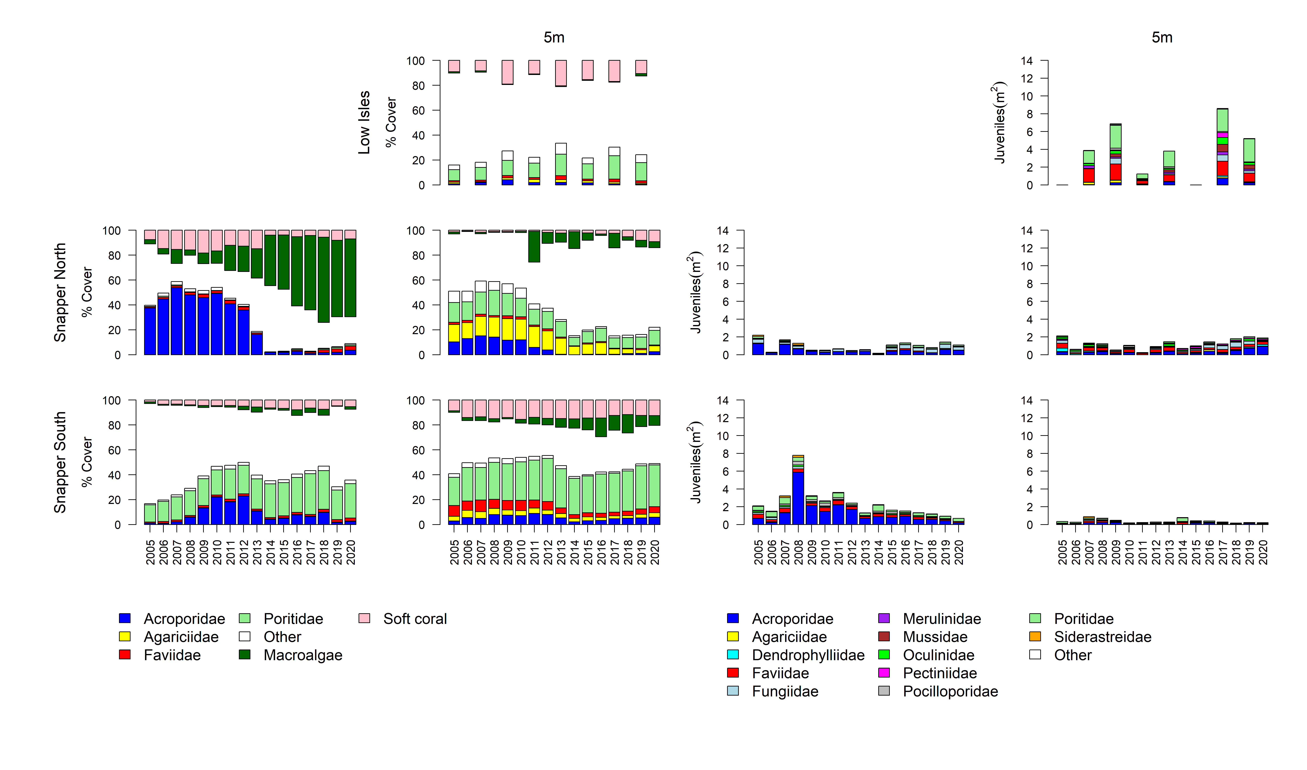
Figure A 1 Barron Daintree sub-region benthic community composition
. Cover estimates are separated into regionally abundant hard coral families and the total cover for soft corals and macroalgae (hanging). Juvenile density estimates are for regionally abundant hard coral families. Separate legends relevant groupings for cover and juvenile density estimates are located beneath the relevant plots.

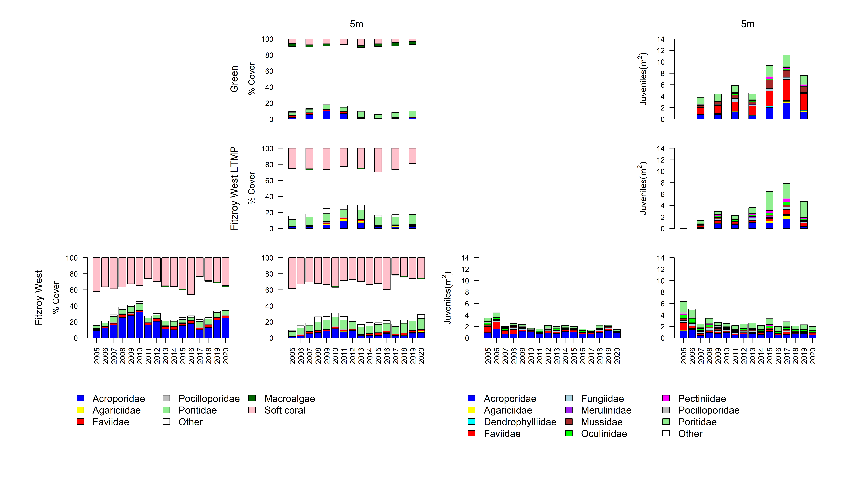
Figure A 2 Johnstone Russell-Mulgrave sub-region benthic community composition
. Cover estimates are separated into regionally abundant hard coral families and the total cover for soft corals and macroalgae (hanging). Juvenile density estimates are for regionally abundant hard coral families. Separate legends relevant groupings for cover and juvenile density estimates are located beneath the relevant plots.

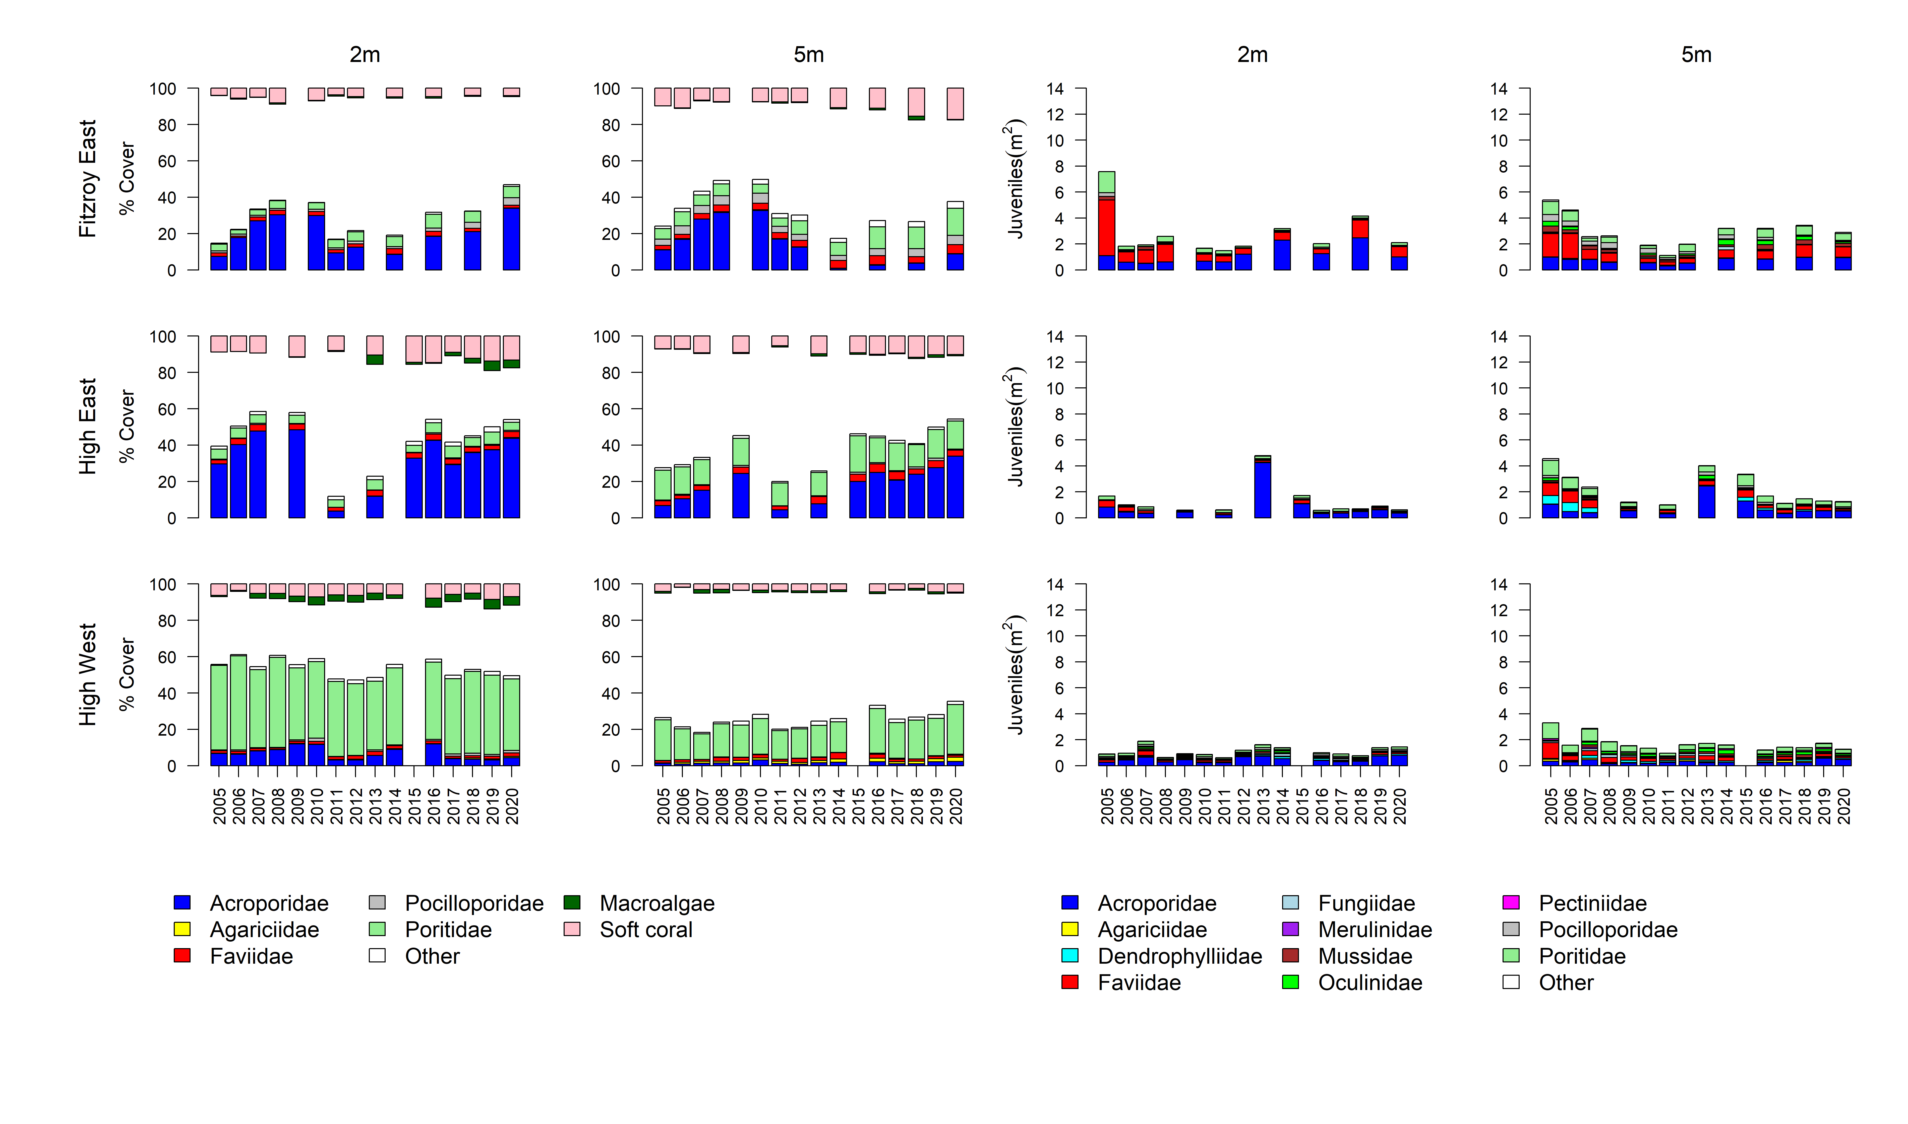Figure A 2 continued

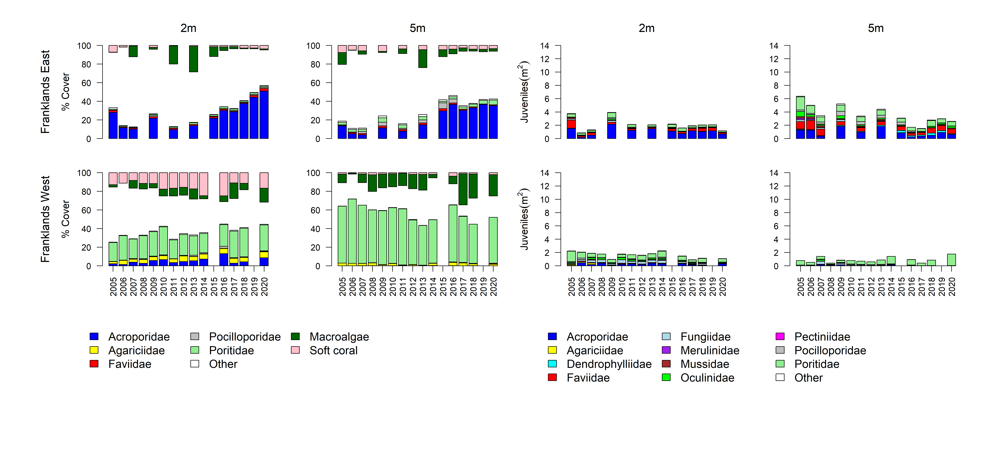Figure A 2 continued

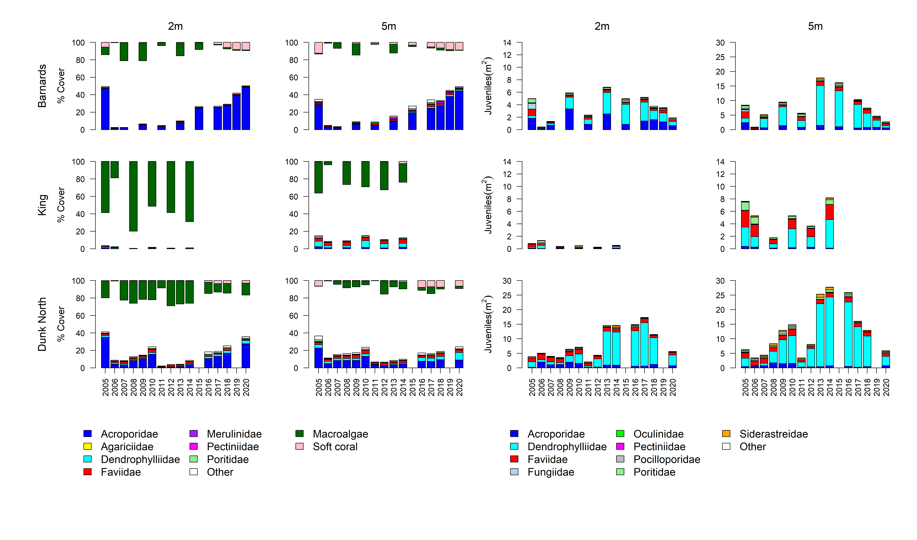
Figure A 3 Herbert Tully sub- region benthic community composition
. Cover estimates are separated into regionally abundant hard coral families and the total cover for soft corals and macroalgae (hanging). Juvenile density estimates are for regionally abundant hard coral families. Separate legends with relevant groupings for cover and juvenile density estimates are located beneath the respective plots.

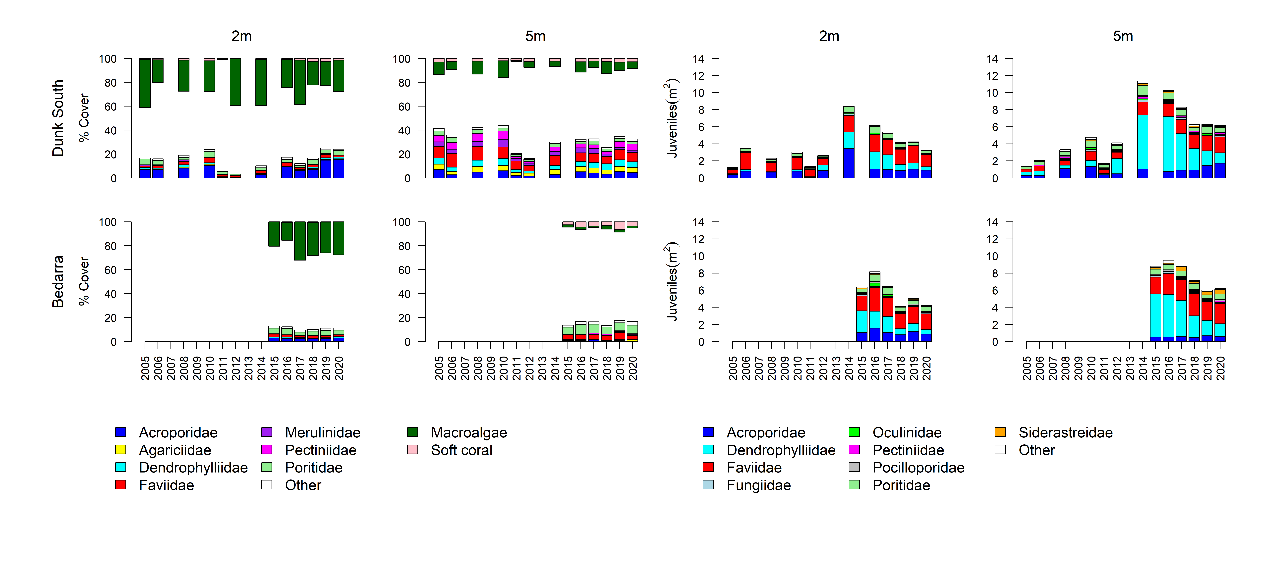Figure A 3 continued

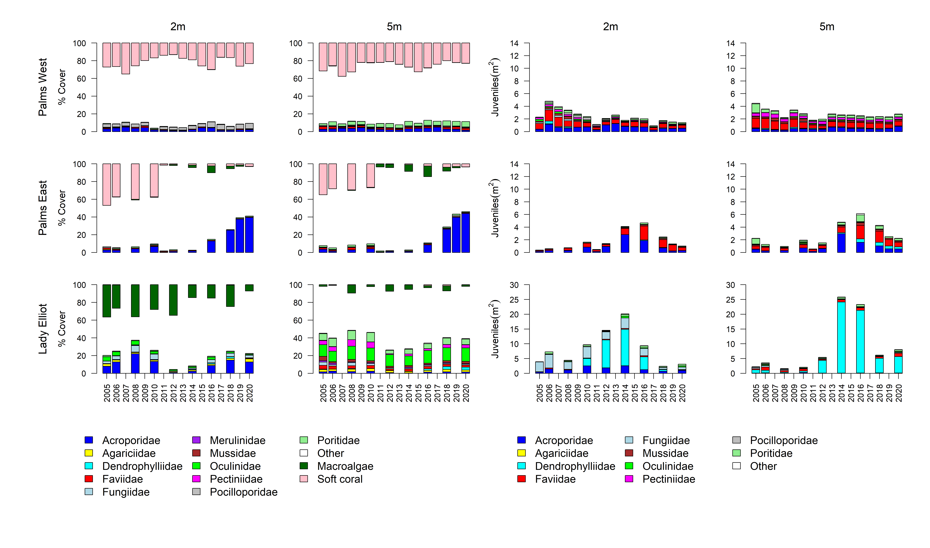
Figure A 4 Burdekin Region benthic community composition
. Cover estimates are separated into regionally abundant hard coral families and the total cover for soft corals and macroalgae (hanging). Juvenile density estimates are for regionally abundant hard coral families. Separate legends with relevant groupings for cover and juvenile density estimates are located beneath the respective plots.

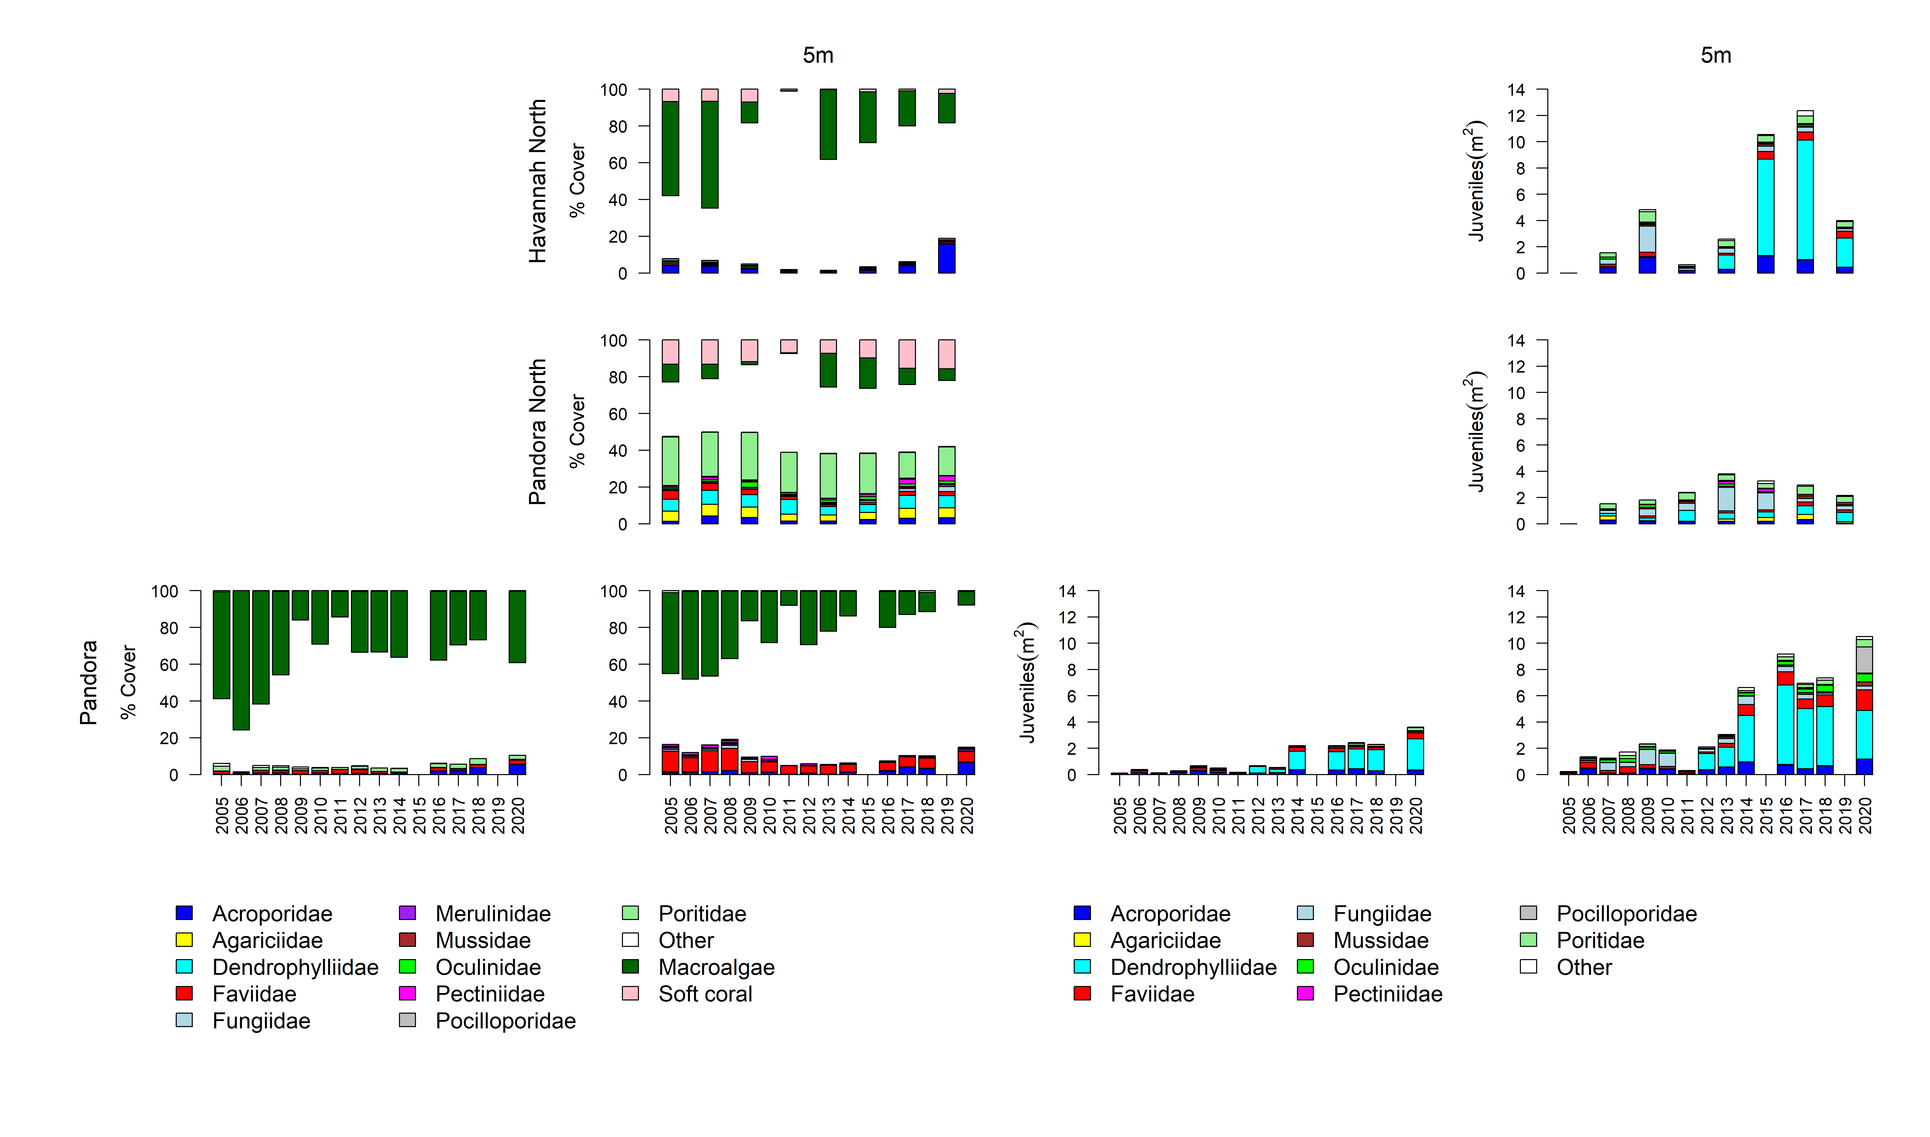
Figure A 4 continued
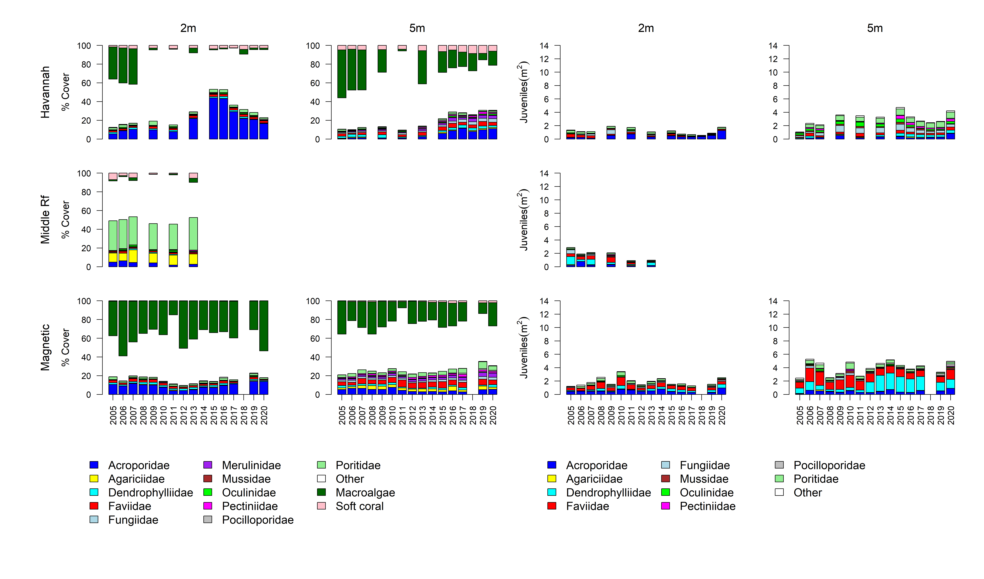
Figure A 4 continued

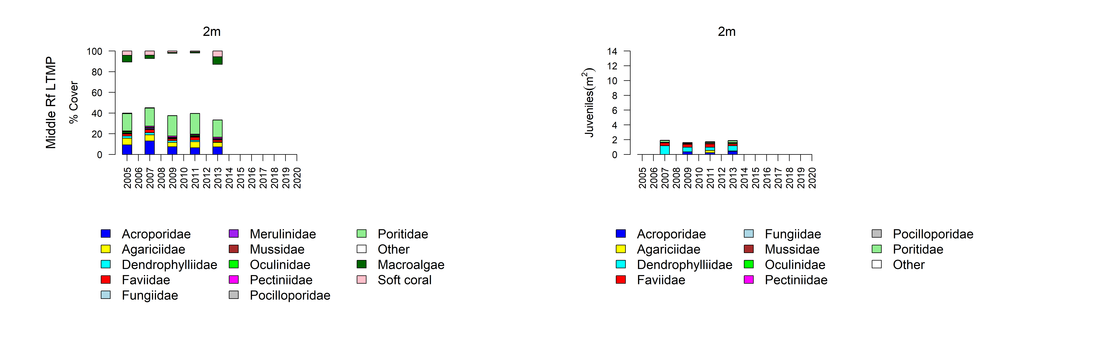
Figure A 4 continued

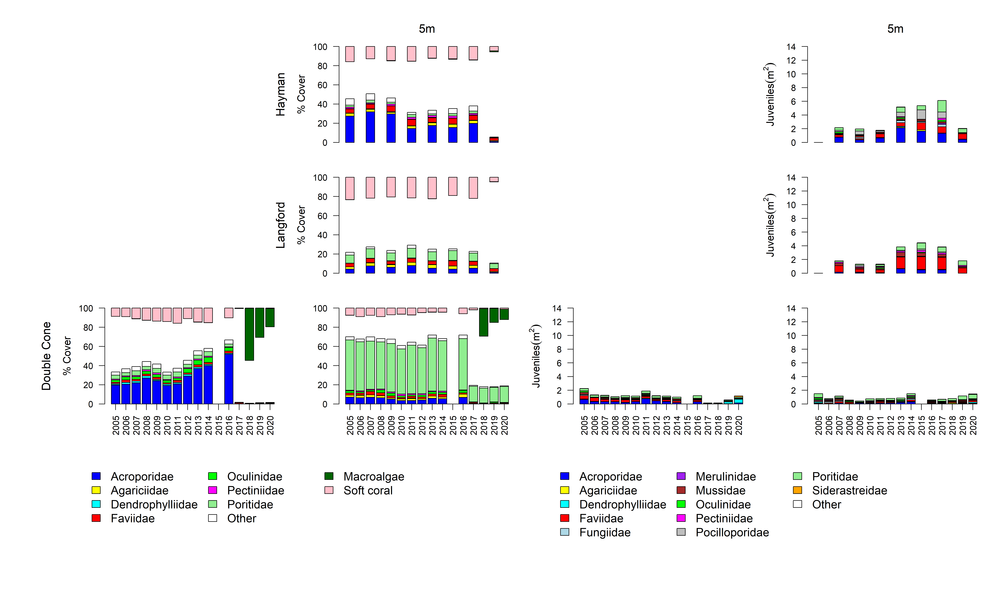
Figure A 5 Mackay-Whitsunday Region benthic community composition
. Cover estimates are separated into regionally abundant hard coral families and the total cover for soft corals and macroalgae (hanging). Juvenile density estimates are for regionally abundant hard coral families. Separate legends with relevant groupings for cover and juvenile density estimates are located beneath the respective plots.

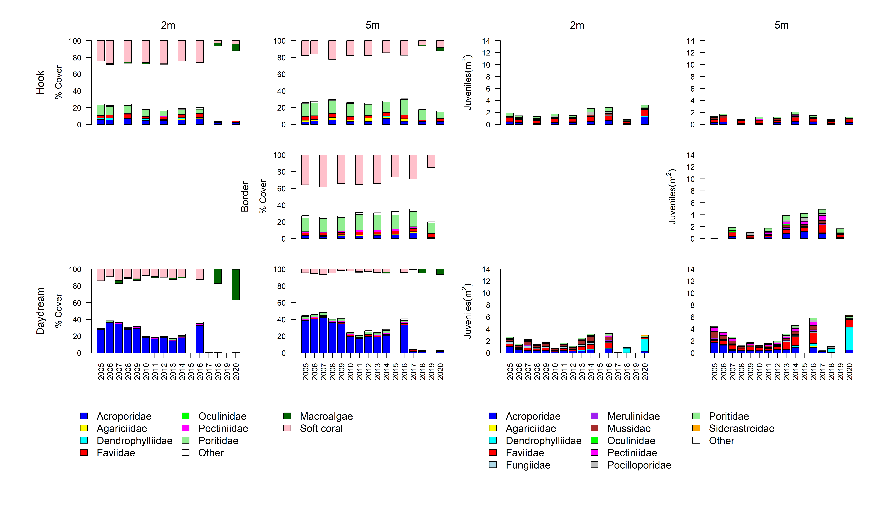
Figure A 5 continued

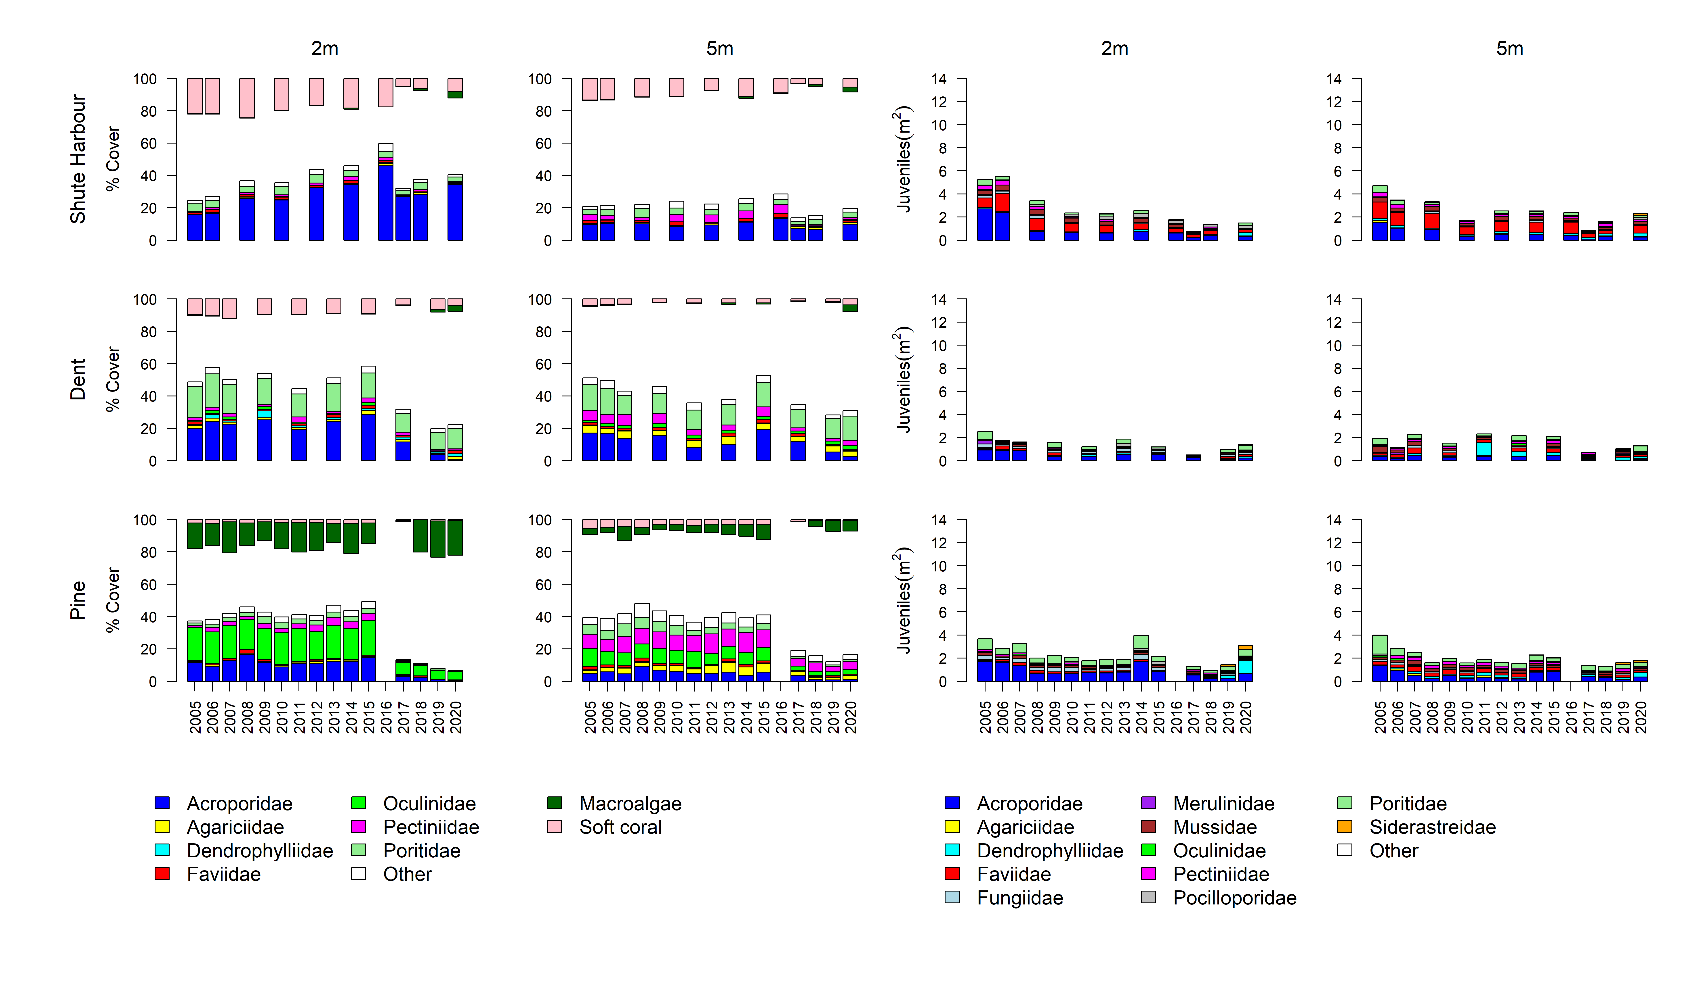
Figure A 5 continued

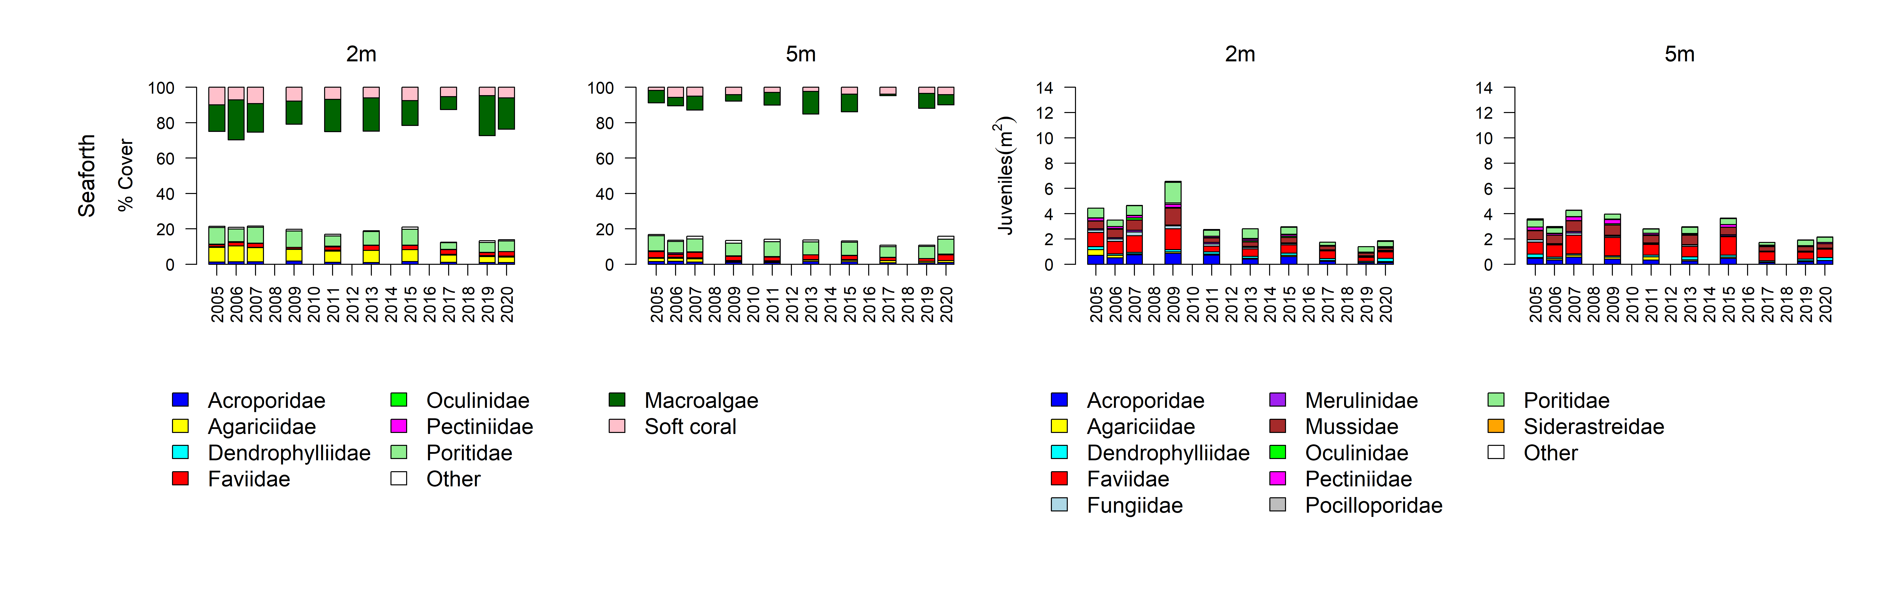
Figure A 5 continued

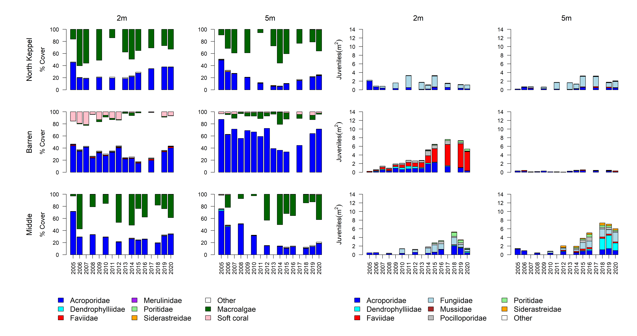
Figure A 6 Fitzroy Region benthic community composition
. Cover estimates are separated into regionally abundant hard coral families and the total cover for soft corals and macroalgae (hanging). Juvenile density estimates are for regionally abundant hard coral families. Separate legends with relevant groupings for cover and juvenile density estimates are located beneath the respective plots.

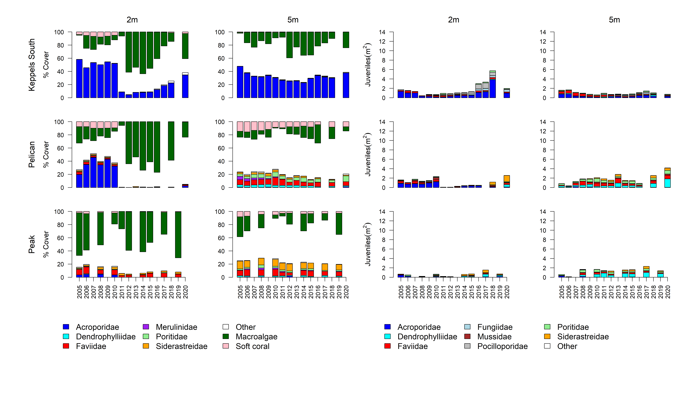
Figure A 6 continued

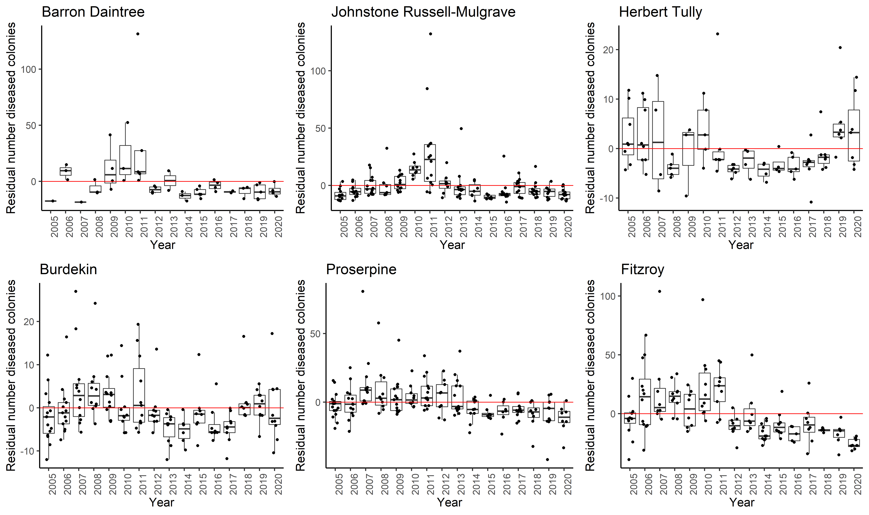
Figure A 7 Coral disease by year in each region
. Boxplots include the number of coral colonies suffering ongoing mortality attributed to either disease, sedimentation or ‘unknown causes’ for each reef, depth and year. Data are standardised to the reef and depth mean across years.
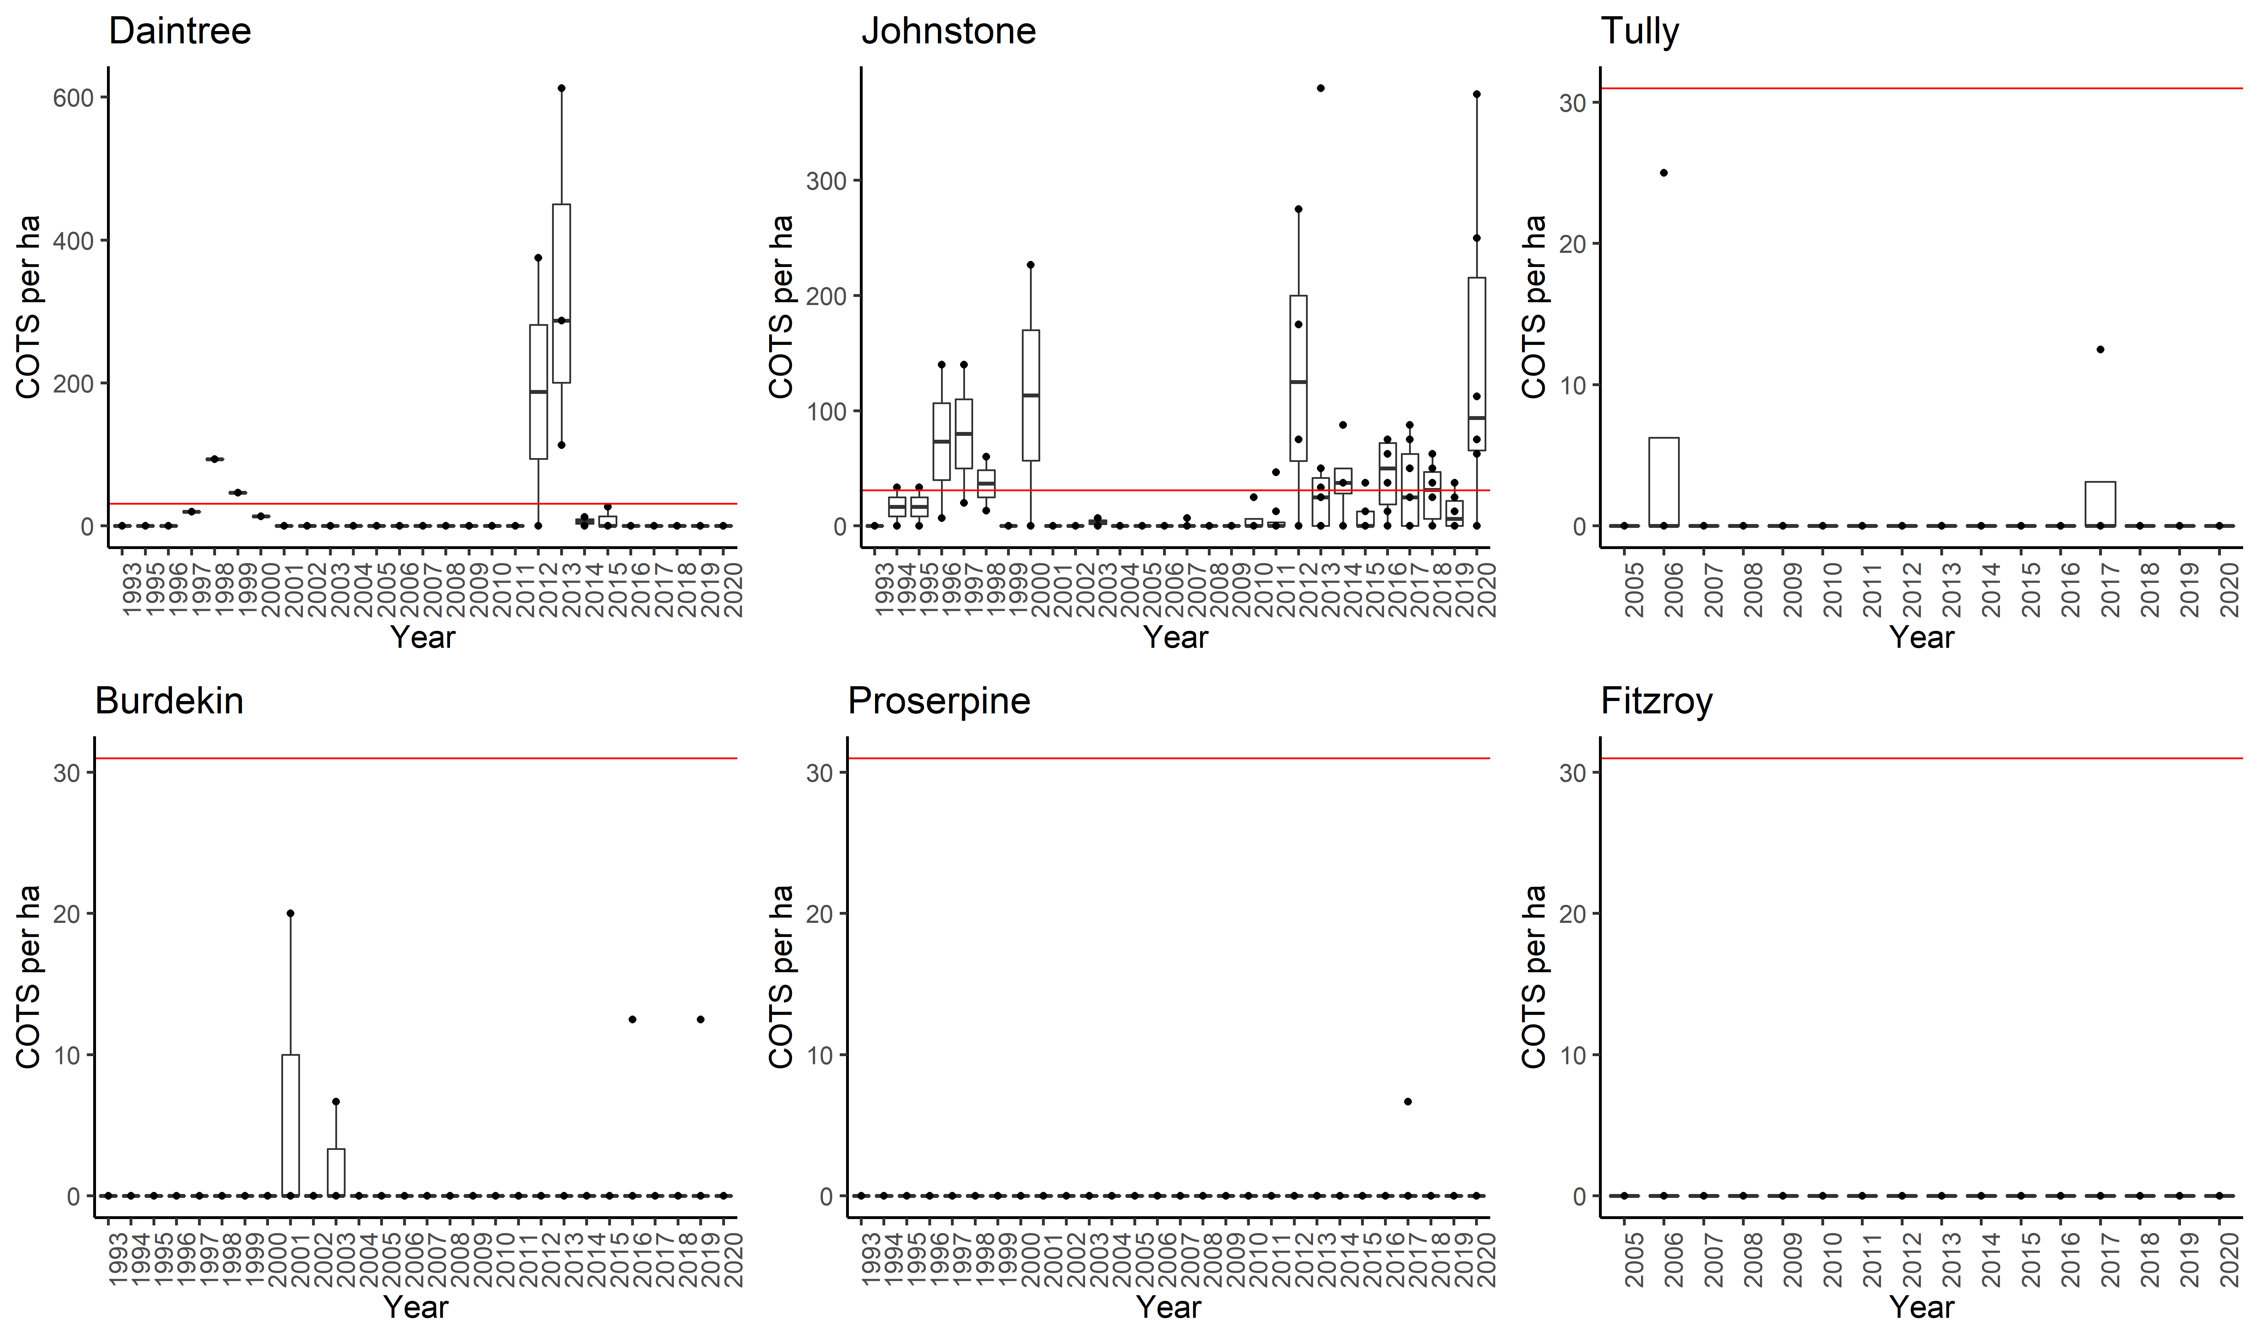
Figure A 8 Crown -of-thorn-starfish mean density (individuals/ha) by year in each region
. Red line indicates outbreak densities of 31 individuals per hectare.

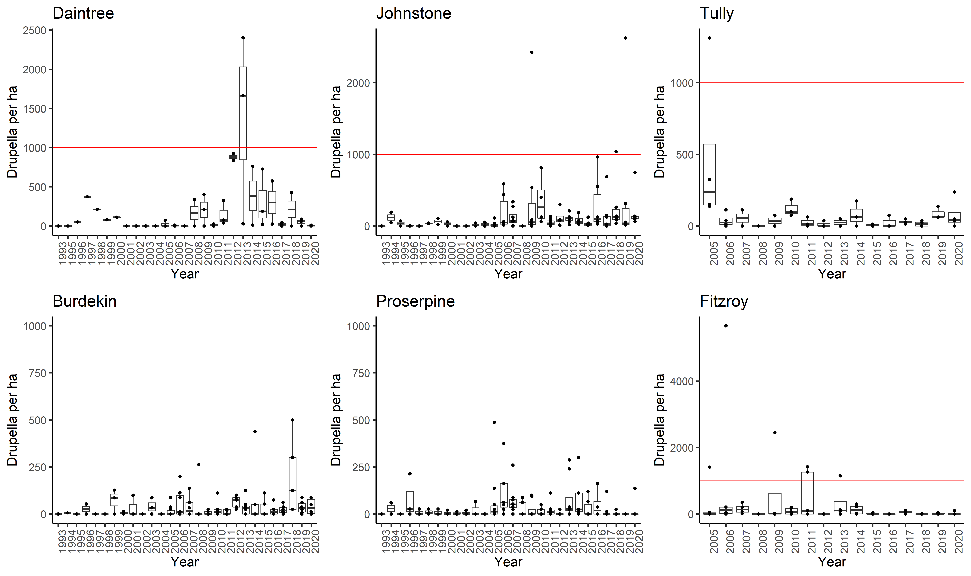
Figure A 9 Mean density of Drupella (P/ha) by year in each (sub)-region
. Red line indicates densities of Drupella which have detrimental impact on coral communities.

Table A 10 Percent cover of hard coral genera 2020
. Genera for which cover did not exceeded 1% on at least one reef or were unidentified to genus level are grouped as “other”.
(sub-)Region | Reef | Depth | Acropora | Alveopora | Caulastrea | Cyphastrea | Diploastrea | Echinopora | Favia | Favites | Fungia | Galaxea | Goniastrea | Goniopora | Isopora | Lobophyllia | Merulina | Montipora | Mycedium | Oxypora | Pachyseris | Pavona | Pectinia | Platygyra | Plesiastrea | Pocillopora | Podobacia | Porites | Psammocora | Turbinaria | Other
Barron Daintree | Low Isles | 5 | 0.30 | 0 | 0.03 | 0.03 | 0.20 | 1.00 | 0.07 | 0 | 0.60 | 2.24 | 0.13 | 0.37 | 0 | 1.79 | 0.17 | 0.10 | 0.07 | 0.03 | 0.77 | 0.03 | 0 | 0.17 | 0 | 0.23 | 0.20 | 14.29 | 0.03 | 0.07 | 1.27
 | Snapper North | 2 | 3.33 | 0 | 0.04 | 0 | 0 | 3.17 | 0 | 0 | t0.38 | 0.17 | 0 | 0.04 | 0 | 0.21 | 0.08 | 0.29 | 0 | 0 | 0 | 0.04 | 0 | 0.04 | 0 | 0.04 | 0 | 1.00 | 0.04 | 0 | 0.04
 |  | 5 | 1.06 | 0 | 0.06 | 0.13 | 0 | 0 | 0.25 | 0.13 | 0.38 | 0.81 | 0 | 8.25 | 0.25 | 0.06 | 0.06 | 1.13 | 0 | 0 | 3.56 | 0.81 | 0.13 | 0.06 | 0 | 0.06 | 0.06 | 3.44 | 0.13 | 0.06 | 1.13
 | Snapper South | 2 | 0.88 | 0 | 0 | 0.08 | 0 | 0.04 | 0.17 | 0.29 | 0.08 | 2.17 | 1.29 | 0.29 | 0 | 0.04 | 0 | 1.71 | 0 | 0 | 0 | 0.17 | 0 | 0.21 | 0 | 0 | 0 | 27.42 | 0.33 | 0.13 | 0.42
 |  | 5 | 5.31 | 0.06 | 4.44 | 0 | 0 | 0.13 | 0 | 0.13 | 0.19 | 0 | 0 | 2.88 | 0 | 0.06 | 0 | 0.56 | 0 | 0 | 2.81 | 0.88 | 0 | 0 | 0.06 | 0 | 0 | 30.69 | 0.19 | 0.31 | 0.31
Johnstone Russell-Mulgrave | Green | 5 | 1.40 | 0 | 0 | 0 | 0.06 | 0.13 | 0.23 | 0.03 | 0.03 | 0.17 | 0.06 | 0.35 | 0 | 0.26 | 0 | 0.20 | 0 | 0 | 0.03 | 0 | 0 | 0.10 | 0 | 0.03 | 0.03 | 7.11 | 0 | 0.10 | 0.86
 | Fitzroy East | 2 | 28.75 | 0 | 0 | 0.25 | 0 | 0.06 | 0.19 | 0.44 | 0 | 0 | 0.31 | 0 | 0.06 | 0 | 0 | 5.06 | 0 | 0 | 0 | 0.19 | 0 | 0.06 | 0 | 4.19 | 0 | 6.25 | 0.38 | 0 | 0.69
 |  | 5 | 7.94 | 0.50 | 0 | 0 | 0.56 | 2.25 | 0.38 | 0.31 | 0.06 | 1.00 | 0.44 | 0.31 | 0 | 0.88 | 0.06 | 0.63 | 0.06 | 0.25 | 0 | 0.13 | 0 | 0.56 | 0 | 5.13 | 0 | 14.06 | 0.56 | 0.06 | 1.56
 | Fitzroy West | 2 | 20.13 | 0 | 0 | 0 | 1.19 | 1.06 | 0.13 | 0.06 | 0.44 | 0.81 | 0 | 0.44 | 0 | 0.69 | 0.63 | 4.44 | 0 | 0 | 0 | 0.19 | 0 | 0.06 | 0 | 0.75 | 0 | 5.38 | 0 | 0.06 | 0.94
 |  | 5 | 4.50 | 0 | 0.06 | 0.06 | 1.25 | 0.19 | 0.19 | 0.06 | 0.31 | 0.50 | 0 | 0.56 | 0 | 2.88 | 0.13 | 2.38 | 0.81 | 0.06 | 1.56 | 0 | 0.13 | 0.31 | 0 | 0.38 | 0 | 12.45 | 0 | 0 | 0.31
 | Fitzroy West LTMP | 5 | 1.19 | 0 | 0.10 | 0.03 | 0.07 | 0.48 | 0.03 | 0.03 | 0.26 | 0.79 | 0.03 | 0.16 | 0 | 1.12 | 0.26 | 1.19 | 0.20 | 0.03 | 1.33 | 0.07 | 0.32 | 0.17 | 0 | 0.20 | 0.07 | 12.18 | 0 | 0.07 | 0.36
 | Franklands East | 2 | 31.69 | 0 | 0 | 0.13 | 0 | 1.88 | 0.31 | 0.13 | 0.06 | 0.13 | 0.19 | 0 | 0.25 | 0 | 0.19 | 18.81 | 0 | 0 | 0 | 0 | 0 | 0.19 | 0 | 1.06 | 0 | 1.31 | 0.13 | 0 | 0.50
 |  | 5 | 33.09 | 0 | 0.06 | 0.25 | 0 | 0.25 | 0 | 0.25 | 0.06 | 0.50 | 0 | 0.06 | 0 | 0.38 | 0.06 | 2.19 | 0 | 0 | 0.06 | 0 | 0.13 | 0.06 | 0 | 0 | 0 | 4.94 | 0.06 | 0 | 0.19
 | Franklands West | 2 | 8.38 | 0 | 0 | 0 | 0 | 0.50 | 0 | 0 | 0.06 | 0.25 | 0 | 0.50 | 0 | 0 | 0 | 0.31 | 0 | 0 | 6.31 | 0.06 | 0 | 0 | 0 | 0.25 | 0 | 27.33 | 0 | 0 | 0.69
 |  | 5 | 0.06 | 0 | 0 | 0 | 0 | 0.88 | 0 | 0 | 0 | 0 | 0 | 0.13 | 0 | 0 | 0 | 0 | 0 | 0 | 1.63 | 0 | 0 | 0 | 0 | 0 | 0 | 49.16 | 0 | 0 | 0.19
 | High East | 2 | 36.31 | 0 | 0 | 0.06 | 0 | 1.63 | 0.13 | 0 | 0 | 0.31 | 0.56 | 0.31 | 0 | 0.38 | 0.06 | 7.44 | 0 | 0 | 0 | 0.31 | 0 | 0.88 | 0 | 0.69 | 0 | 4.13 | 0.19 | 0.06 | 0.63
 |  | 5 | 27.25 | 0 | 0 | 0.06 | 0 | 2.44 | 0.25 | 0.19 | 0 | 0.19 | 0.06 | 0.38 | 0 | 0.44 | 0.13 | 6.44 | 0.13 | 0 | 0 | 0.06 | 0 | 0.06 | 0 | 0.44 | 0 | 15.00 | 0.06 | 0.06 | 0.69
 | High West | 2 | 3.75 | 0 | 0.06 | 0 | 0 | 0.75 | 0.38 | 0 | 0.06 | 0.38 | 0.19 | 2.76 | 0 | 0.19 | 0.38 | 0.50 | 0 | 0 | 0.31 | 0.38 | 0 | 0.25 | 0 | 1.44 | 0 | 36.64 | 0.13 | 0 | 1.00
 |  | 5 | 1.56 | 0 | 0 | 0.13 | 0 | 0 | 0.38 | 0.13 | 0 | 0.56 | 0.06 | 4.75 | 0 | 0.06 | 0.19 | 0.25 | 0 | 0.13 | 0.50 | 1.75 | 0.13 | 0.38 | 0 | 0.56 | 0 | 22.63 | 0 | 0 | 1.31
Herbert Tully | Barnards | 2 | 33.94 | 0 | 0 | 0.19 | 0 | 0 | 0.19 | 0.06 | 0 | 0 | 0 | 0 | 0 | 0 | 0 | 14.38 | 0 | 0 | 0 | 0 | 0 | 0.38 | 0 | 0.31 | 0 | 0.19 | 0 | 0.31 | 0.25
 |  | 5 | 23.19 | 0 | 0 | 0.19 | 0 | 0.44 | 0.31 | 0.13 | 0.13 | 0.44 | 0 | 0.19 | 0 | 0 | 0.06 | 20.63 | 0.19 | 0.38 | 0.06 | 0 | 0 | 0.25 | 0 | 0.31 | 0.13 | 0.50 | 0.13 | 1.31 | 0.44
 | Dunk North | 2 | 22.94 | 0.19 | 0 | 0.38 | 0 | 0 | 0.19 | 0.25 | 0 | 0.19 | 0.19 | 0.13 | 0 | 0 | 0 | 4.44 | 0.06 | 0 | 0.19 | 0 | 0 | 0 | 0.13 | 1.50 | 0 | 0.63 | 0.06 | 3.75 | 0.56
 |  | 5 | 4.44 | 0 | 0 | 0.19 | 0 | 0 | 0.56 | 0.88 | 0.19 | 0.25 | 0.31 | 0.31 | 0 | 0.38 | 0.31 | 4.06 | 0 | 0.25 | 0.06 | 0 | 0 | 0.56 | 0 | 0.75 | 0 | 0.50 | 0.31 | 8.69 | 1.13
 | Dunk South | 2 | 10.63 | 0 | 0 | 0.81 | 0 | 0 | 0.13 | 0.25 | 0.13 | 0.75 | 0.06 | 0 | 0 | 0.19 | 0 | 4.81 | 0 | 0 | 0 | 0.50 | 0 | 0 | 0 | 0.06 | 0 | 3.75 | 0 | 1.63 | 0.31
 |  | 5 | 1.31 | 0 | 0.13 | 0.75 | 0 | 0 | 2.94 | 0.88 | 0.06 | 0.31 | 1.56 | 0.31 | 0 | 0.25 | 1.75 | 3.19 | 2.44 | 1.50 | 3.69 | 0.63 | 0.50 | 1.44 | 0 | 0.50 | 0.38 | 1.88 | 0 | 4.63 | 1.50
 | Bedarra | 2 | 2.13 | 0 | 0 | 0.25 | 0 | 0 | 0.44 | 0.31 | 0.06 | 0.13 | 0.06 | 0.19 | 0 | 0.75 | 0.06 | 0.63 | 0 | 0 | 0 | 0.19 | 0.06 | 0.25 | 0.06 | 0.38 | 0 | 3.69 | 0.19 | 1.00 | 0.44
 |  | 5 | 0.13 | 0 | 0.13 | 0.13 | 0 | 0 | 2.19 | 0.38 | 0.13 | 0 | 0.13 | 3.63 | 0 | 1.69 | 0.75 | 0.31 | 0.50 | 0.06 | 0.88 | 0.06 | 0 | 0.13 | 0 | 0.13 | 0.56 | 3.63 | 0 | 0.19 | 1.19
Burdekin | Palms East | 2 | 38.63 | 0 | 0 | 0.25 | 0 | 0.06 | 0.13 | 0.06 | 0 | 0 | 0.06 | 0 | 0.06 | 0 | 0 | 0.69 | 0 | 0 | 0 | 0 | 0 | 0 | 0 | 0 | 0 | 1.00 | 0 | 0 | 0.19
 |  | 5 | 42.69 | 0 | 0 | 0 | 0 | 0 | 0 | 0.13 | 0 | 0.06 | 0.19 | 0 | 0 | 0 | 0 | 1.25 | 0 | 0 | 0 | 0 | 0 | 0.38 | 0 | 0.50 | 0 | 0.88 | 0 | 0 | 0
 | Palms West | 2 | 1.94 | 0 | 0 | 0.06 | 0.06 | 0 | 0.06 | 0.13 | 0.13 | 0 | 0 | 0.13 | 0 | 0 | 0 | 0.19 | 0 | 0 | 0.19 | 0 | 0.13 | 0.06 | 0.06 | 5.75 | 0 | 0 | 0.06 | 0 | 0.44
 |  | 5 | 0.44 | 0 | 0 | 0.13 | 0.44 | 0.25 | 0.31 | 0.25 | 0.19 | 0.13 | 0.19 | 0.94 | 0 | 0.38 | 0 | 1.00 | 0.06 | 0 | 0.13 | 0.13 | 0 | 0.06 | 0 | 0.63 | 0 | 5.00 | 0 | 0 | 0.69
 | Havannah North | 5 | 13.06 | 0 | 0 | 0.10 | 0 | 0.17 | 0.16 | 0 | 0.20 | 0.30 | 0.06 | 0.10 | 0 | 0.03 | 0.13 | 2.63 | 0.03 | 0.03 | 0.10 | 0 | 0.07 | 0.10 | 0 | 0.03 | 0 | 0.66 | 0.03 | 0.23 | 0.59
 | Havannah | 2 | 9.31 | 0 | 0 | 0 | 0 | 0.63 | 0.31 | 0 | 0.06 | 0.50 | 0.19 | 0.31 | 2.38 | 0.13 | 0 | 4.81 | 0 | 0 | 0 | 0.13 | 0.13 | 1.19 | 0 | 1.00 | 0 | 1.13 | 0 | 0.50 | 0.19
 |  | 5 | 6.75 | 0 | 0 | 0.50 | 0.94 | 0.88 | 0.19 | 0.25 | 3.00 | 1.44 | 0.19 | 0.19 | 0.06 | 0.56 | 3.13 | 4.31 | 0.13 | 0.31 | 1.13 | 0 | 0.44 | 0.44 | 0 | 0.38 | 0.06 | 1.13 | 0.19 | 2.19 | 1.94
 | Pandora | 5 | 4.44 | 0 | 0 | 0.13 | 0 | 0 | 0.06 | 0.13 | 0 | 0 | 0.06 | 0 | 0 | 0 | 0 | 1.13 | 0 | 0 | 0 | 0 | 0 | 0.06 | 0.94 | 0.19 | 0 | 2.25 | 0 | 0.06 | 1.06
 |  | 2 | 5.69 | 0 | 0 | 0.31 | 2.44 | 0.06 | 1.38 | 0.31 | 0.25 | 0.38 | 0 | 0.25 | 0 | 0.13 | 0.13 | 0.88 | 0.06 | 0 | 0 | 0 | 0 | 0.94 | 0.06 | 0.13 | 0 | 0.19 | 0 | 0.06 | 1.31
 | Pandora North | 5 | 1.37 | 1.10 | 0.07 | 0.17 | 0.03 | 0.96 | 0.57 | 0.17 | 1.70 | 1.37 | 0.07 | 11.05 | 0.03 | 0.63 | 1.00 | 1.77 | 1.00 | 0.67 | 4.55 | 0.10 | 0.47 | 0.23 | 0 | 0.10 | 0.27 | 3.54 | 0.03 | 6.62 | 2.40
 | Lady Elliot | 2 | 7.19 | 0 | 0 | 0 | 0 | 0.31 | 0.06 | 0.06 | 2.88 | 0.88 | 0 | 0.06 | 0 | 0 | 0 | 5.56 | 0 | 0 | 0 | 3.50 | 0 | 0.13 | 0 | 0 | 0 | 0.75 | 0.13 | 0.63 | 0.38
 |  | 5 | 1.13 | 0.19 | 0 | 0 | 0 | 0 | 0.94 | 0.75 | 0.06 | 15.06 | 0.19 | 2.50 | 0 | 2.50 | 0.38 | 0.31 | 1.25 | 1.31 | 2.25 | 0 | 0.94 | 0.06 | 0.13 | 0 | 0.94 | 3.56 | 0.19 | 3.31 | 1.25
 | Magnetic | 2 | 5.25 | 0 | 0 | 0.19 | 0 | 0 | 0.13 | 0.25 | 0 | 0 | 0 | 0.13 | 0 | 0 | 0 | 8.50 | 0 | 0 | 0.13 | 0 | 0 | 0.06 | 0.13 | 0.06 | 0 | 1.38 | 0.06 | 1.06 | 0.56
 |  | 2 | 2.56 | 0 | 0 | 0.31 | 0 | 0 | 1.94 | 0.50 | 0.25 | 0.31 | 0.13 | 2.06 | 0 | 0.06 | 3.75 | 2.38 | 0.13 | 0.63 | 2.31 | 0 | 0.69 | 1.56 | 0 | 0.44 | 1.81 | 2.50 | 0 | 2.75 | 3.75
 | Middle Rf LTMP | 5 | 1.47 | 0 | 0 | 0.07 | 0 | 0.07 | 0.91 | 0.10 | 0.03 | 0.13 | 0.07 | 15.38 | 0.23 | 0.24 | 0.47 | 5.54 | 0.07 | 0.20 | 4.27 | 0.13 | 0.41 | 0.24 | 0 | 0.13 | 0.23 | 1.31 | 0 | 0.37 | 1.24
Mackay-Whitsunday | Hayman | 5 | 0 | 0 | 0 | 0.03 | 0.93 | 0.24 | 0.53 | 0.20 | 0.13 | 0 | 0.23 | 0.30 | 0 | 0.17 | 0 | 1.00 | 0 | 0.03 | 0.66 | 0.10 | 0 | 0.43 | 0 | 0 | 0 | 0.30 | 0 | 0 | 0.30
 | Langford | 5 | 0.03 | 0 | 0 | 0.07 | 0.20 | 0.17 | 1.09 | 0.27 | 0.03 | 0.03 | 0.49 | 3.86 | 0 | 0.46 | 0 | 0.59 | 0 | 0 | 0.33 | 0.46 | 0 | 0.03 | 0 | 0.07 | 0 | 1.27 | 0 | 0.03 | 1.09
 | Border | 5 | 0.63 | 0.10 | 0.03 | 0.03 | 0.50 | 0.33 | 1.20 | 0.33 | 0.03 | 0 | 0.33 | 9.35 | 0 | 0.70 | 0.10 | 0.60 | 0.27 | 0.03 | 0.53 | 0.20 | 0.30 | 0.10 | 0 | 0.10 | 0.17 | 3.16 | 0 | 0.03 | 0.93
 | Hook | 2 | 0.13 | 0 | 0 | 0.13 | 0 | 0.06 | 0.25 | 0.56 | 0 | 0 | 0.06 | 0 | 0 | 0 | 0 | 1.81 | 0 | 0 | 0.50 | 0.06 | 0 | 0.06 | 0 | 0 | 0 | 0.25 | 0 | 0 | 0.25
 |  | 5 | 0.38 | 0 | 0 | 0.06 | 0 | 0.13 | 1.13 | 0.81 | 0 | 0.06 | 0.13 | 1.00 | 0 | 0.50 | 0 | 2.19 | 0 | 0 | 0.63 | 0.38 | 0 | 0.25 | 0 | 0 | 0 | 6.88 | 0 | 0 | 1.25
 | Double Cone | 2 | 0 | 0 | 0 | 0 | 0 | 0.31 | 0 | 0 | 0 | 0 | 0.13 | 0.25 | 0 | 0.06 | 0.13 | 0.13 | 0 | 0 | 0.25 | 0 | 0 | 0 | 0 | 0 | 0 | 0.25 | 0 | 0 | 0.06
 |  | 5 | 0 | 0 | 0 | 0 | 0 | 0.06 | 0 | 0 | 0 | 0.69 | 0.25 | 16.28 | 0 | 0.56 | 0.06 | 0.06 | 0 | 0.06 | 0.25 | 0 | 0 | 0.12 | 0 | 0 | 0.13 | 0.25 | 0 | 0 | 0.13
 | Daydream | 2 | 0 | 0 | 0 | 0.13 | 0 | 0 | 0 | 0 | 0 | 0 | 0 | 0 | 0 | 0.06 | 0 | 0.06 | 0 | 0 | 0 | 0 | 0 | 0 | 0 | 0 | 0 | 0.31 | 0 | 0 | 0.06
 |  | 5 | 0 | 0 | 0 | 0 | 0 | 0 | 0.06 | 0.19 | 0 | 0 | 0.44 | 0 | 0 | 0.13 | 0 | 1.06 | 0 | 0.31 | 0 | 0 | 0 | 0 | 0 | 0 | 0 | 0.31 | 0 | 0 | 0.38
 | Dent | 2 | 0.44 | 0.06 | 0.06 | 0 | 0 | 0.75 | 0.13 | 0.13 | 0 | 0.50 | 0 | 5.94 | 0 | 1.19 | 0.69 | 0.19 | 0.06 | 0.19 | 0.38 | 1.50 | 0.44 | 0 | 0 | 0 | 0 | 6.69 | 0 | 1.88 | 0.94
 |  | 5 | 1.69 | 0.19 | 0 | 0 | 0 | 0.25 | 0.31 | 0 | 0 | 2.25 | 0.06 | 12.75 | 0 | 0.75 | 0.63 | 0.13 | 0.44 | 1.69 | 2.25 | 0.56 | 0.75 | 0.06 | 0 | 0.25 | 0.19 | 2.38 | 0 | 0.38 | 3.13
 | Shute Harbour | 2 | 30.69 | 0 | 0.06 | 0 | 0 | 0 | 0.19 | 0.19 | 0 | 0 | 0 | 2.63 | 0.06 | 0.69 | 0.06 | 3.44 | 0 | 0 | 0 | 0.88 | 0.63 | 0 | 0 | 0.13 | 0 | 0.13 | 0 | 0 | 0.69
 |  | 5 | 8.25 | 0 | 0 | 0 | 0 | 0.25 | 0.38 | 0.13 | 0 | 0.56 | 0 | 2.50 | 0 | 0.69 | 0.13 | 1.56 | 0.31 | 0.19 | 0.69 | 0.31 | 0.69 | 0.38 | 0 | 0.81 | 0 | 0.88 | 0 | 0 | 0.94
 | Pine | 2 | 0.19 | 0 | 0 | 0 | 0 | 0.06 | 0.13 | 0 | 0 | 5.19 | 0.06 | 0.13 | 0 | 0 | 0 | 0.06 | 0 | 0 | 0.25 | 0 | 0.25 | 0 | 0 | 0 | 0 | 0.13 | 0 | 0 | 0
 |  | 5 | 0.50 | 0 | 0 | 0 | 0 | 0.25 | 0.19 | 0.19 | 0 | 2.94 | 0 | 0.69 | 0 | 1.06 | 0.06 | 0.63 | 1.13 | 1.13 | 1.94 | 0 | 1.88 | 0.31 | 0 | 0.19 | 0.81 | 0.38 | 0 | 0.06 | 2.06
 | Seaforth | 2 | 0.69 | 0 | 0 | 0 | 0 | 0.31 | 0.63 | 0.94 | 0 | 0 | 0.25 | 0.31 | 0 | 0.25 | 0 | 0 | 0 | 0 | 0.06 | 3.02 | 0 | 0.06 | 0 | 0.06 | 0 | 5.76 | 0 | 0.63 | 0.88
 |  | 5 | 0.56 | 0 | 0.19 | 0.06 | 0.94 | 0 | 1.31 | 0 | 0.31 | 0.13 | 0.25 | 5.94 | 0 | 0.63 | 0 | 0.13 | 0.06 | 0 | 0.13 | 0.94 | 0.19 | 0.19 | 0 | 0 | 0 | 2.50 | 0 | 0 | 1.31
Fitzroy | Barren | 2 | 31.50 | 0 | 0 | 0 | 0 | 0 | 0 | 0.13 | 0 | 0 | 0.31 | 0 | 1.75 | 0 | 0 | 6.88 | 0 | 0 | 0 | 0.13 | 0 | 0.88 | 0 | 0.25 | 0 | 0.56 | 0.13 | 0 | 0.88
 |  | 5 | 63.81 | 0 | 0 | 0.06 | 0 | 0 | 0 | 0.06 | 0 | 0 | 0 | 0 | 0.31 | 0 | 0 | 7.06 | 0 | 0 | 0 | 0 | 0 | 0 | 0 | 0.06 | 0 | 0 | 0 | 0 | 0.13
 | North Keppel | 2 | 36.78 | 0 | 0 | 0 | 0 | 0 | 0 | 0 | 0.19 | 0.06 | 0 | 0 | 0 | 0 | 0 | 0.63 | 0 | 0 | 0 | 0 | 0 | 0 | 0 | 0.13 | 0 | 0 | 0 | 0 | 0.06
 |  | 5 | 21.13 | 0 | 0 | 0 | 0 | 0 | 0 | 0.13 | 0.31 | 0 | 0 | 0 | 0 | 0 | 0 | 2.06 | 0.19 | 0 | 0 | 0 | 0 | 0.38 | 0 | 0 | 0 | 0 | 0.63 | 0 | 0.06
 | Middle | 2 | 29.75 | 0 | 0 | 0 | 0 | 0 | 0 | 0 | 0.44 | 0 | 0 | 0 | 0 | 0 | 0 | 3.94 | 0 | 0 | 0 | 0 | 0 | 0 | 0 | 0.31 | 0 | 0.31 | 0 | 0 | 0
 |  | 5 | 13.75 | 0 | 0 | 0.25 | 0 | 0 | 0.13 | 0 | 0.75 | 0 | 0 | 0 | 0 | 0 | 0 | 4.63 | 0 | 0 | 0 | 0 | 0 | 0 | 0 | 1.25 | 0 | 0 | 0.13 | 0.13 | 0
 | Keppels South | 2 | 26.13 | 0 | 0 | 0.25 | 0 | 0 | 0 | 0 | 0.06 | 0 | 0 | 0 | 0 | 0 | 0 | 8.13 | 0 | 0 | 0 | 0 | 0 | 0 | 0 | 3.44 | 0 | 0.06 | 0 | 0.06 | 0.06
 |  | 5 | 35.06 | 0.06 | 0 | 0 | 0 | 0 | 0 | 0 | 0 | 0 | 0 | 0 | 0 | 0 | 0 | 2.56 | 0 | 0 | 0 | 0 | 0 | 0 | 0 | 0.81 | 0 | 0.13 | 0 | 0 | 0.06
 | Pelican | 2 | 0.81 | 0 | 0 | 0.19 | 0 | 0 | 0.25 | 0.06 | 0 | 0 | 0.06 | 0.06 | 0 | 0 | 0 | 1.63 | 0 | 0 | 0 | 0 | 0 | 0 | 0.81 | 0.44 | 0 | 0 | 0.44 | 0.13 | 0.06
 |  | 5 | 0 | 6.94 | 0 | 0.06 | 0 | 0 | 0.19 | 2.75 | 0 | 0 | 1.50 | 1.88 | 0 | 1.00 | 0 | 1.25 | 0 | 0 | 0 | 0 | 0 | 0.81 | 0.44 | 0 | 0 | 0.06 | 0.94 | 1.50 | 1.38
 | Peak | 2 | 0.13 | 0.13 | 0 | 0.94 | 0 | 0 | 0.38 | 0.13 | 0 | 0 | 0 | 0 | 0 | 0 | 0 | 0 | 0 | 0 | 0 | 0 | 0 | 0.06 | 2.94 | 0 | 0 | 0.56 | 2.38 | 0 | 0.31
 |  | 5 | 0 | 0.25 | 0 | 2.63 | 0 | 0 | 0 | 2.06 | 0 | 0 | 0.88 | 1.44 | 0 | 0.06 | 0 | 0.50 | 0 | 0 | 0 | 0 | 0 | 0.06 | 0.75 | 0.06 | 0 | 0.44 | 7.94 | 1.38 | 1.25

Table A 11 Percent cover of soft coral families 2020.
Families for which cover did not exceeded 0.25% on at least one reef or corals not identified to family level are grouped to ‘Other’.
(sub-)Region | Reef | Depth | Alcyoniidae | Anthothelidae | Briareidae | Clavulariinae | Heliporidae | Neptheidae | Xeniidae | Gorgoniidae like | Other
Barron Daintree | Low Isles | 5 | 0.47 | 0 | 6.35 | 0 | 0.26 | 0 | 0.01 | 0 | 0.10
 | Snapper North | 2 | 0.05 | 0 | 2.79 | 1.92 | 0 | 0 | 0 | 0 | 0
 |  | 5 | 0 | 0 | 0.38 | 0.03 | 0 | 0 | 1.25 | 0 | 0
 | Snapper South | 2 | 0.17 | 0 | 0.21 | 0.04 | 3.71 | 0 | 0 | 0 | 0
 |  | 5 | 0.01 | 0 | 6.13 | 0 | 6.13 | 0 | 0 | 0 | 0.19
Johnstone Russell-Mulgrave | Green | 5 | 0.35 | 0 | 0.13 | 0 | 0.13 | 0.01 | 0 | 0 | 0.06
 | Fitzroy East | 2 | 0.24 | 0 | 0.75 | 0.59 | 0 | 0.03 | 0 | 0 | 0
 |  | 5 | 1.26 | 0 | 6.19 | 0.31 | 0 | 0.03 | 0 | 0 | 0
 | Fitzroy West | 2 | 4.32 | 0 | 0.19 | 0.03 | 0 | 0 | 0 | 0 | 0
 |  | 5 | 3.13 | 0 | 0 | 0 | 0 | 0 | 0 | 0 | 0
 | Fitzroy West LTMP | 5 | 2.34 | 0 | 0.07 | 0.02 | 0 | 0 | 0 | 0 | 0.15
 | Franklands East | 2 | 0.16 | 0 | 0 | 0.56 | 0.75 | 0 | 0.09 | 0 | 0
 |  | 5 | 0.23 | 0 | 0.63 | 0.13 | 0 | 0.01 | 0.09 | 0 | 0
 | Franklands West | 2 | 0.95 | 0 | 0 | 4.13 | 0 | 0.08 | 0 | 0 | 0
 |  | 5 | 0.14 | 0 | 0 | 0.47 | 0 | 0 | 0 | 0 | 0
 | High East | 2 | 0.88 | 0 | 6.13 | 0.03 | 0 | 0 | 0 | 0 | 0
 |  | 5 | 0.07 | 0 | 9.56 | 0 | 0 | 0 | 0 | 0 | 0
 | High West | 2 | 0.45 | 0 | 0 | 0 | 3.44 | 0 | 0 | 0 | 0
 |  | 5 | 0.20 | 0 | 1.19 | 0.06 | 1.50 | 0 | 0 | 0 | 0

(sub-)Region | Reef | Depth | Alcyoniidae | Anthothelidae | Briareidae | Clavulariinae | Heliporidae | Neptheidae | Xeniidae | Gorgoniidae like | Other
 | Barnards | 2 | 0.17 | 0 | 1.75 | 0 | 0 | 0 | 0.79 | 0 | 0
Herbert Tully |  | 5 | 0.21 | 0 | 1.88 | 0.06 | 0 | 0 | 0.72 | 0 | 0
 | Dunk North | 2 | 0.24 | 0.06 | 0.13 | 0.13 | 0 | 0 | 0.09 | 0 | 0
 |  | 5 | 0.09 | 0 | 0.38 | 0 | 0 | 0 | 0.71 | 0.25 | 0.13
 | Dunk South | 2 | 0.05 | 0 | 1.00 | 0.06 | 0 | 0 | 0 | 0 | 0
 |  | 5 | 0.09 | 0 | 2.06 | 0.03 | 0 | 0 | 0 | 0 | 0
 | Bedarra | 2 | 0 | 0 | 0.13 | 0 | 0 | 0 | 0 | 0 | 0
 |  | 5 | 0.05 | 0.31 | 2.31 | 0 | 0 | 0.02 | 0.02 | 0.06 | 0
 | Palms East | 2 | 0.36 | 0 | 0 | 0 | 0 | 0 | 0 | 0 | 0
Burdekin |  | 5 | 0.41 | 0 | 0 | 0 | 0 | 0.01 | 0 | 0 | 0
 | Palms West | 2 | 1.89 | 0 | 0.19 | 0.78 | 0 | 0.71 | 0 | 0 | 0
 |  | 5 | 1.84 | 0 | 4.31 | 0.31 | 0 | 0.33 | 0 | 0.38 | 0
 | Havannah North | 5 | 0.09 | 0 | 0.90 | 0.23 | 0.03 | 0 | 0.02 | 0 | 0.03
 | Havannah | 2 | 0.05 | 0 | 2.50 | 0 | 0 | 0 | 0 | 0 | 0
 |  | 5 | 0.02 | 0 | 6.06 | 0 | 0 | 0 | 0 | 0 | 0
 | Pandora | 2 | 0.01 | 0 | 0 | 0.03 | 0 | 0 | 0 | 0 | 0.03
 |  | 5 | 0.05 | 0 | 0 | 0.03 | 0 | 0 | 0 | 0 | 0
 | Pandora North | 5 | 0.29 | 0 | 9.63 | 1.86 | 0 | 0 | 0 | 0 | 0
 | Lady Elliot | 2 | 0.01 | 0 | 0 | 0 | 0 | 0 | 0 | 0 | 0
 |  | 5 | 0.02 | 0 | 0.06 | 0 | 0 | 0 | 0 | 0 | 0
 | Magnetic | 2 | 0 | 0 | 0.06 | 0 | 0 | 0 | 0 | 0 | 0
 |  | 5 | 0.24 | 0 | 0.06 | 0 | 0 | 0 | 0 | 0.06 | 0

(sub-)Region | Reef | Depth | Alcyoniidae | Anthothelidae | Briareidae | Clavulariinae | Heliporidae | Neptheidae | Xeniidae | Gorgoniidae like | Other
Mackay Whitsunday | Hayman | 5 | 0.39 | 0 | 1.12 | 0 | 0 | 0.02 | 0 | 0 | 0.07
 | Langford | 5 | 0.54 | 0 | 0.16 | 0 | 0 | 0 | 0 | 0 | 0.07
 | Border | 5 | 1.80 | 0 | 0.17 | 0 | 0 | 0.01 | 0.03 | 0.20 | 0.03
 | Hook | 2 | 0.48 | 0 | 0.38 | 0 | 0 | 0 | 0 | 0 | 0
 |  | 5 | 0.92 | 0 | 0.94 | 0 | 0 | 0 | 0 | 0 | 0
 | Double Cone | 2 | 0.05 | 0 | 0.13 | 0 | 0 | 0 | 0 | 0 | 0
 |  | 5 | 0.04 | 0 | 0.94 | 0 | 0 | 0 | 0 | 0 | 0
 | Daydream | 2 | 0.01 | 0 | 0 | 0 | 0 | 0.01 | 0 | 0 | 0
 |  | 5 | 0.02 | 0 | 0 | 0 | 0 | 0 | 0 | 0 | 0
 | Dent | 2 | 0.22 | 0 | 1.94 | 0 | 0 | 0.03 | 0 | 0 | 0
 |  | 5 | 0.30 | 0.06 | 1.13 | 0 | 0 | 0 | 0 | 0 | 0
 | Shute Harbour | 2 | 0.94 | 0 | 0.44 | 0 | 0 | 0.01 | 0.01 | 0 | 0
 |  | 5 | 0.64 | 0 | 0.13 | 0 | 0 | 0.01 | 0 | 0.06 | 0
 | Pine | 2 | 0.05 | 0 | 0.06 | 0 | 0 | 0 | 0 | 0 | 0
 |  | 5 | 0.03 | 0 | 0.38 | 0 | 0 | 0 | 0 | 0 | 0
 | Seaforth | 2 | 0.57 | 0.31 | 0.94 | 0 | 0 | 0 | 0 | 0.25 | 0
 |  | 5 | 0.07 | 3.56 | 0 | 0 | 0 | 0 | 0 | 0 | 0

(sub-)Region | Reef | Depth | Alcyoniidae | Anthothelidae | Briareidae | Clavulariinae | Heliporidae | Neptheidae | Xeniidae | Gorgoniidae  like | Other
Fitzroy | Barren | 2 | 0.30 | 0 | 0 | 0 | 0 | 0 | 0.54 | 0 | 0
 |  | 5 | 0.01 | 0 | 0 | 0 | 0 | 0 | 0.29 | 0 | 0
 | North Keppel | 2 | 0.02 | 0 | 0 | 0 | 0 | 0 | 0 | 0 | 0
 |  | 5 | 0.09 | 0 | 0 | 0 | 0 | 0 | 0 | 0 | 0
 | Middle | 2 | 0.02 | 0 | 0 | 0 | 0 | 0 | 0.03 | 0 | 0
 |  | 5 | 0.09 | 0 | 0 | 0 | 0 | 0.01 | 0 | 0 | 0
 | Keppels South | 2 | 0.25 | 0 | 0 | 0 | 0 | 0 | 0.07 | 0 | 0
 |  | 5 | 0.01 | 0 | 0 | 0 | 0 | 0 | 0.04 | 0 | 0
 | Pelican | 2 | 0.07 | 0.06 | 0 | 0 | 0 | 0 | 0 | 0 | 0
 |  | 5 | 0.78 | 0 | 0 | 0 | 0 | 0.03 | 0 | 1.13 | 0.06
 | Peak | 2 | 0.07 | 0.19 | 0 | 0 | 0 | 0 | 0 | 0.06 | 0
 |  | 5 | 0.10 | 0 | 0 | 0 | 0 | 0.03 | 0.03 | 1.31 | 0

Table A 12 Percent cover of Macroalgae groups 2020
. Genera for which cover exceeded 0.5% on at least one reef are included, rare or unidentified genera are grouped to ‘Unidentified’.
(sub-)Region | Reef | Depth | Rhodophyta (red algae) |  |  |  |  |  | Chlorophyta (green algae) |  | Phaeophyta (brown algae)
 |  |  | Acanthophora | Asparagopsis | Hypnea | Peyssonnelia | Calcareous | Undefined | Halimeda | Undefined | Dictyopteris | Dictyota | Lobophora | Padina | Sargassum | Spatoglossum | Stypopodium | Undefined
Barron Daintree | Low Isles | 5 | 0 | 0 | 0 | 0 | 0.23 | 0.23 | 0.73 | 0.27 | 0 | 0 | 0 | 0.17 | 0 | 0 | 0 | 0.20
 | Snapper North | 2 | 11.29 | 3.54 | 3.71 | 0.46 | 0.46 | 22.96 | 2.88 | 0.29 | 0 | 16.42 | 0 | 0.17 | 0.04 | 0 | 0 | 0.29
 |  | 5 | 0 | 0 | 0 | 0 | 0 | 0.69 | 0.06 | 0 | 0 | 4.07 | 0 | 0 | 0 | 0 | 0 | 0
 | Snapper South | 2 | 0 | 0 | 0.25 | 0.21 | 0.04 | 1.13 | 0 | 0.42 | 0 | 0.08 | 0 | 0 | 0 | 0 | 0 | 0
 |  | 5 | 0 | 0 | 0.81 | 0.50 | 2.50 | 3.63 | 0 | 0.06 | 0 | 0.25 | 0.19 | 0 | 0 | 0 | 0 | 0
Johnstone Russell-Mulgrave | Green | 5 | 0 | 0 | 0 | 0 | 0.14 | 1.03 | 6.77 | 0.15 | 0 | 0 | 0 | 0 | 0 | 0 | 0 | 0.19
 | Fitzroy East | 2 | 0 | 0 | 0 | 0 | 0 | 0.44 | 0 | 0.13 | 0 | 0 | 0 | 0 | 0 | 0 | 0 | 0
 |  | 5 | 0 | 0 | 0 | 0 | 0 | 0.25 | 0 | 0.06 | 0 | 0 | 0 | 0 | 0 | 0 | 0 | 0
 | Fitzroy West | 2 | 0 | 0 | 0.50 | 0.38 | 0.06 | 0.63 | 0 | 0.06 | 0 | 0 | 0 | 0 | 0 | 0 | 0 | 0
 |  | 5 | 0 | 0 | 0.13 | 0.44 | 0.06 | 0.75 | 0 | 0 | 0 | 0 | 0 | 0 | 0 | 0 | 0 | 0
 | Fitzroy West LTMP | 5 | 0 | 0 | 0 | 0 | 0 | 0.29 | 0.20 | 0 | 0 | 0 | 0 | 0 | 0 | 0 | 0 | 0.09
 | Franklands East | 2 | 0 | 0 | 0.44 | 0.06 | 0 | 0.63 | 0 | 0 | 0 | 0 | 0 | 0 | 0 | 0 | 0 | 0
 |  | 5 | 0 | 0 | 0.06 | 0.44 | 1.13 | 1.19 | 0 | 0 | 0 | 0 | 0 | 0 | 0 | 0 | 0 | 0
 | Franklands West | 2 | 0 | 0 | 1.63 | 0.44 | 0.06 | 9.88 | 0.44 | 0.19 | 0 | 2.38 | 0 | 0 | 0 | 0 | 0 | 0
 |  | 5 | 0 | 0 | 0.38 | 0.63 | 4.19 | 15.57 | 1.25 | 0.44 | 0 | 0.44 | 0 | 0 | 0 | 0 | 0 | 0.06
 | High East | 2 |  | 0 | 0 | 0.13 | 0 | 2.00 | 0 | 0.13 | 0 | 0 | 0 | 0 | 0 | 0 | 0 | 0
 |  | 5 | 0 | 0 | 0.25 | 0.06 | 0 | 0.38 | 0 | 0 | 0 | 0 | 0 | 0 | 0 | 0 | 0 | 0.06
 | High West | 2 | 0 | 0 | 2.19 | 0.25 | 0.06 | 2.06 | 0 | 0.06 | 0 | 0 | 0 | 0 | 0 | 0 | 0 | 0
 |  | 5 | 0 | 0 | 0.25 | 0 | 0.13 | 0.25 | 0 | 0 | 0 | 0 | 0 | 0 | 0 | 0 | 0 | 0

(sub-)Region | Reef | Depth | Rhodophyta (red algae) |  |  |  |  |  | Chlorophyta (green algae) |  | Phaeophyta (brown algae)
 |  |  | Acanthophora | Asparagopsis | Hypnea | Peyssonnelia | Calcareous | Undefined | Halimeda | Undefined | Dictyopteris | Dictyota | Lobophora | Padina | Sargassum | Spatoglossum | Stypopodium | Undefined
Herbert Tully | Barnards | 2 | 0 | 0 | 0.31 | 0 | 0 | 0.25 | 0 | 0 | 0 | 0.19 | 0 | 0 | 0 | 0 | 0 | 0.06
 |  | 5 | 0 | 0 | 0 | 0.06 | 0 | 0.19 | 0 | 0 | 0 | 0.19 | 0 | 0 | 0 | 0 | 0 | 0
 | Dunk North | 2 | 0 | 0 | 0 | 0 | 0 | 1.81 | 0 | 0.06 | 0 | 0.19 | 0.19 | 0 | 11.31 | 0 | 0 | 0.06
 |  | 5 | 0 | 0 | 0 | 0 | 0 | 0.25 | 0 | 0 | 0 | 0.38 | 0.06 | 0 | 1.94 | 0 | 0 | 0
 | Dunk South | 2 | 0 | 0 | 0 | 0 | 0.50 | 1.19 | 0 | 0 | 0 | 0.06 | 2.63 | 0 | 20.69 | 0.31 | 0.56 | 0.19
 |  | 5 | 0 | 0 | 0 | 0.19 | 0 | 0.38 | 0 | 0 | 0 | 0 | 4.81 | 0 | 0.19 | 0 | 0 | 0
 | Bedarra | 2 | 0 | 0 | 0.25 | 0 | 0.25 | 0.44 | 0 | 0.19 | 0 | 1.75 | 0.50 | 0.06 | 23.75 | 0 | 0 | 0.31
 |  | 5 | 0 | 0 | 0 | 0 | 0 | 0.31 | 0 | 0 | 0 | 0.50 | 0.38 | 0 | 0.38 | 0 | 0 | 0.13
Burdekin | Palms East | 2 | 0 | 0 | 0 | 0 | 0 | 0 | 0 | 0.25 | 0 | 0 | 0 | 0 | 0 | 0 | 0 | 0.06
 |  | 5 | 0 | 0 | 0 | 0 | 0 | 0 | 0 | 0.13 | 0 | 0 | 0 | 0 | 0 | 0 | 0 | 0
 | Palms West | 2 | 0 | 0 | 0 | 0 | 0 | 0 | 0 | 0.06 | 0 | 0 | 0 | 0 | 0 | 0 | 0 | 0
 |  | 5 | 0 | 0 | 0 | 0 | 0 | 0.06 | 0 | 0 | 0 | 0 | 0 | 0 | 0 | 0 | 0 | 0.06
 | Havannah North | 5 | 0 | 0 | 0 | 0 | 0 | 1.83 | 0 | 0.45 | 0 | 0.84 | 10.80 | 0.30 | 10.43 | 0 | 0 | 3.16
 | Havannah | 2 | 0 | 0 | 0 | 0 | 0 | 0.13 | 0 | 0 | 0 | 0.19 | 0.94 | 0.06 | 0.06 | 0 | 0 | 0.25
 |  | 5 | 0 | 0 | 0 | 0 | 0 | 0.06 | 0 | 0.31 | 0 | 1.31 | 6.06 | 0.06 | 6.25 | 0 | 0 | 0.88
 | Pandora | 2 | 0 | 0 | 0 | 0.06 | 0 | 0.38 | 0 | 0.06 | 0 | 0.50 | 1.44 | 0.06 | 36.15 | 0 | 0 | 0.31
 |  | 5 | 0 | 0 | 0 | 0.13 | 0 | 0.56 | 0 | 0 | 0 | 0.19 | 2.63 | 0 | 3.25 | 0 | 0 | 0.63
 | Pandora North | 5 | 0 | 0 | 0 | 0 | 0 | 1.80 | 0 | 0 | 0 | 0.90 | 11.30 | 0.10 | 3.41 | 0 | 0 | 1.40
 | Lady Elliot | 2 | 0 | 0 | 1.44 | 2.56 | 0.06 | 1.06 | 0 | 0 | 0 | 0.31 | 0.38 | 0 | 1.00 | 0 | 0 | 0.25
 | Lady Elliot | 5 | 0 | 0 | 0.06 | 1.13 | 0 | 0.31 | 0 | 0.06 | 0 | 0 | 0 | 0 | 0 | 0 | 0 | 0.06
 | Magnetic | 2 | 0 | 0 | 0 | 0.44 | 0 | 0 | 0 | 0.06 | 0 | 0.63 | 2.50 | 0 | 49.44 | 0 | 0 | 0.38
 |  | 5 | 0 | 0 | 0.06 | 0.75 | 0.19 | 0.75 | 0 | 0 | 0 | 2.13 | 1.19 | 0 | 18.63 | 0 | 0 | 1.06
Mackay Whitsunday | Hayman | 5 | 0 | 0 | 0 | 0 | 0 | 1.88 | 0 | 0.10 | 0 | 0 | 0.10 | 0 | 0 | 0 | 0 | 1.29
 | Langford | 5 | 0 | 0 | 0 | 0 | 0 | 0.17 | 0 | 0 | 0 | 0 | 0 | 0 | 0 | 0 | 0 | 0.03
 | Border | 5 | 0 | 0 | 0 | 0 | 0.05 | 0.15 | 0 | 0 | 0 | 0 | 0 | 0 | 0 | 0 | 0 | 0.10
 | Hook | 2 | 0 | 0 | 0 | 0 | 0.94 | 0.44 | 0 | 6.31 | 0 | 0 | 0.13 | 0 | 0 | 0 | 0 | 0
 |  | 5 | 0 | 0 | 0 | 0 | 0 | 0.13 | 0 | 3.69 | 0 | 0 | 0 | 0 | 0 | 0 | 0 | 0
 | Double Cone | 2 | 0 | 0.06 | 0 | 0 | 5.44 | 0.75 | 0 | 0.06 | 0 | 2.31 | 6.56 | 0 | 3.25 | 0 | 0 | 0.56
 |  | 5 | 0 | 0 | 0 | 0.19 | 0.31 | 0.69 | 0 | 0 | 0 | 2.31 | 2.50 | 0.06 | 3.56 | 0 | 0.12 | 0.94
 | Daydream | 2 | 0 | 0 | 0 | 0.06 | 2.19 | 10.19 | 0.13 | 0 | 1.00 | 2.13 | 2.56 | 1.38 | 10.13 | 0 | 0 | 6.88
 |  | 5 | 0 | 0 | 0 | 0 | 0.81 | 0.38 | 0 | 0.13 | 0 | 0.81 | 3.00 | 0.06 | 0.75 | 0 | 0 | 0.31
 | Dent | 2 | 0 | 0 | 0 | 0.13 | 0 | 0 | 0 | 0.38 | 0 | 0 | 3.13 | 0 | 0 | 0 | 0 | 0
 |  | 5 | 0 | 0 | 0 | 0.44 | 0 | 0.63 | 0 | 0 | 0 | 0 | 3.13 | 0 | 0 | 0 | 0 | 0
 | Shute Harbour | 2 | 0 | 0 | 0 | 0 | 0.31 | 0.69 | 0 | 0 | 0 | 1.25 | 0.44 | 0.25 | 0.88 | 0 | 0 | 0.19
 |  | 5 | 0 | 0 | 0 | 0.06 | 0 | 0.25 | 0 | 0 | 0 | 1.31 | 1.25 | 0 | 0.19 | 0 | 0 | 0
 | Pine | 2 | 0 | 0 | 0 | 1.63 | 0.25 | 2.63 | 0.50 | 0.25 | 0 | 1.44 | 8.50 | 0.25 | 5.94 | 0.06 | 0 | 0.19
 |  | 5 | 0 | 0 | 0 | 1.88 | 0 | 0.94 | 0.31 | 0.13 | 0 | 0 | 3.06 | 0 | 0.06 | 0 | 0 | 0.19
 | Seaforth | 2 | 0 | 0 | 0.88 | 0 | 2.38 | 2.25 | 0 | 0.13 | 0 | 3.76 | 1.88 | 0.75 | 4.51 | 0 | 0 | 1.06
 |  | 5 | 0 | 0 | 0 | 0.06 | 0.88 | 0.44 | 0 | 0 | 0 | 2.44 | 0.69 | 0 | 0.88 | 0 | 0 | 0.38
Fitzroy | Barren | 2 | 0 | 0 | 0 | 0.19 | 0 | 0.31 | 0 | 0 | 0 | 0 | 0 | 0 | 0 | 0 | 0 | 0
 |  | 5 | 0 | 0 | 0 | 0.31 | 0 | 1.38 | 0 | 0 | 0 | 0 | 0.38 | 0 | 0 | 0 | 0 | 0
 | North Keppel | 2 | 0 | 0 | 0 | 0.38 | 0 | 1.06 | 0 | 0 | 0 | 0 | 31.20 | 0.06 | 0 | 0 | 0 | 0
 |  | 5 | 0 | 0 | 0 | 0.88 | 0 | 0.44 | 0 | 0 | 0 | 3.56 | 30.19 | 0 | 0 | 0 | 0 | 0
 | Middle | 2 | 0 | 0 | 0 | 0.94 | 0 | 2.00 | 0 | 0 | 0 | 0.06 | 25.44 | 0 | 9.88 | 0 | 0 | 0.06
 |  | 5 | 0 | 0 | 0 | 2.13 | 0 | 1.25 | 0 | 0 | 0 | 3.13 | 20.75 | 0 | 13.50 | 0 | 0 | 0.38
 | Keppels South | 2 | 0 | 0 | 0 | 1.25 | 0 | 0.25 | 0 | 0 | 0 | 2.56 | 21.38 | 0.19 | 12.06 | 0.06 | 0 | 0.50
 |  | 5 | 0 | 0 | 0 | 0.38 | 0 | 0.06 | 0 | 0 | 0 | 2.38 | 20.38 | 0 | 0 | 0 | 0 | 0.63
 | Pelican | 2 | 0 | 0 | 0 | 1.00 | 5.00 | 3.25 | 0 | 0.06 | 0 | 0.13 | 7.25 | 0 | 6.13 | 0 | 0.13 | 0
 |  | 5 | 0 | 0 | 0 | 0.13 | 0.06 | 4.19 | 0 | 0 | 0 | 0.13 | 1.06 | 0 | 0.75 | 0 | 0 | 0.13
 | Peak | 2 | 0 | 1.25 | 0 | 0.75 | 3.38 | 33.75 | 2.94 | 0.13 | 0.19 | 0.06 | 5.06 | 0 | 16.56 | 3.50 | 1.19 | 0.88
 |  | 5 | 0 | 0 | 0 | 1.75 | 2.56 | 24.56 | 2.63 | 0.19 | 0 | 0 | 0.63 | 0 | 0 | 0 | 0 | 0.13

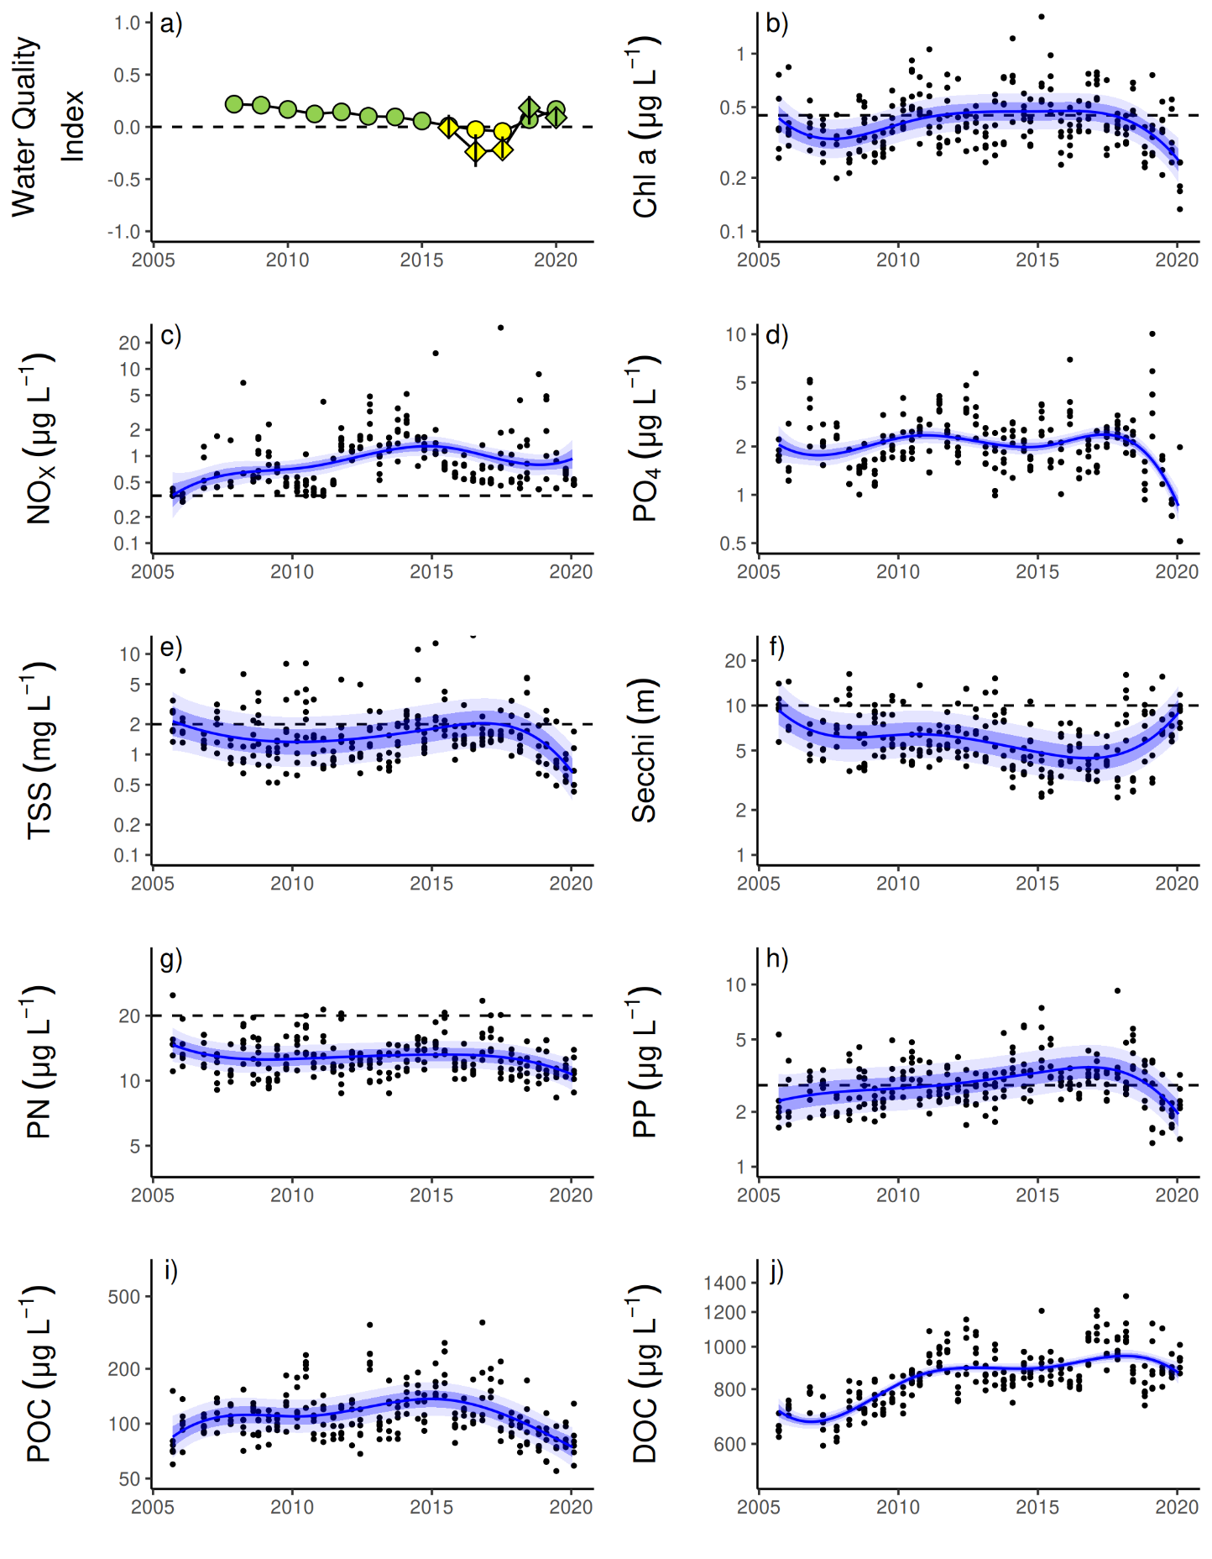
Figure A 10 Temporal trends in water quality: Barron Daintree sub-region
. a) water quality index, b) chlorophyll a, c) nitrate/nitrite, d) Phosphate, e) total suspended solids, f) secchi depth, g) particulate nitrogen, h) particulate phosphorus, i) particulate organic carbon and j) dissolved organic carbon. Water quality index colour coding: dark green- ‘very good’; light green – ‘good’; yellow – ‘moderate; orange – ‘poor’; red – ‘very poor’. The water quality index is the aggregate of variables plotted in b, c, e - h and calculated as described in Gruber et al. (2020). Trends in PO4, POC and DOC values are plotted here (d, I, j); threshold levels have yet to be established. Trends in manually sampled water quality variables are represented by blue lines with blue shaded areas defining 95% confidence intervals of those trends, black dots represent observed data. Dashed reference lines indicate guideline values (GBRMPA 2010). Extract from Waterhouse et al. (2021).
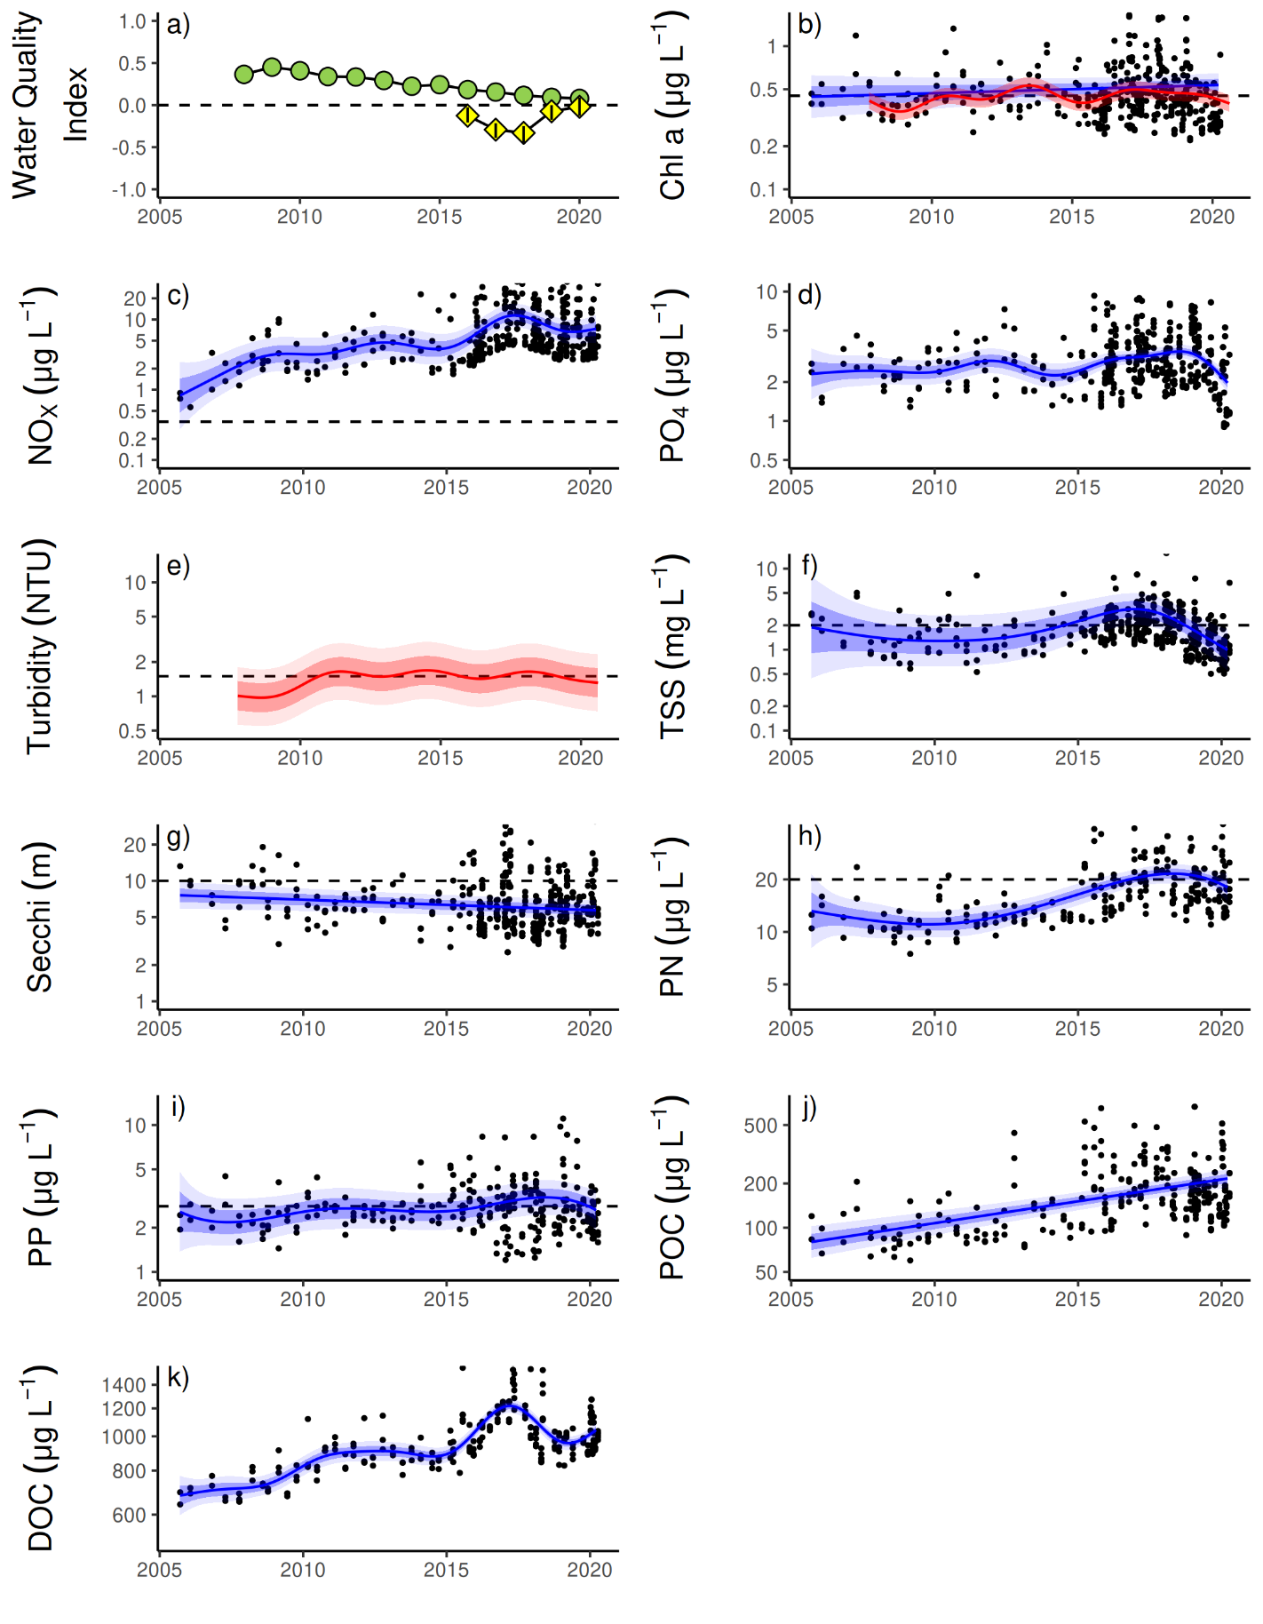
Figure A 11 Temporal trends in water quality
. Johnstone Russell-Mulgrave sub-region. a) water quality index, b) chlorophyll a, c) nitrate/nitrite, d) Phosphate e) turbidity, f) total suspended solids, g) secchi depth, h) particulate nitrogen, i) particulate phosphorus j), particulate organic carbon and k) dissolved organic carbon. Water quality index colour coding: dark green- ‘very good’; light green – ‘good’; yellow – ‘moderate; orange – ‘poor’; red – ‘very poor’. The water quality index is the aggregate of variables plotted in b, c, f - i and calculated as described in Gruber et al. (2020). Trends in PO4, POC and DOC values are plotted here (d, j, k); threshold levels have yet to be established. Trends in manually sampled water quality variables are represented by blue lines with blue shaded areas defining 95% confidence intervals of those trends, black dots represent observed data. Trends of records from ECO FLNTUSB instruments (b, e) are represented in red, individual records are not displayed. Dashed reference lines indicate guideline values (GBRMPA 2010). Extract from Waterhouse et al. (2021).
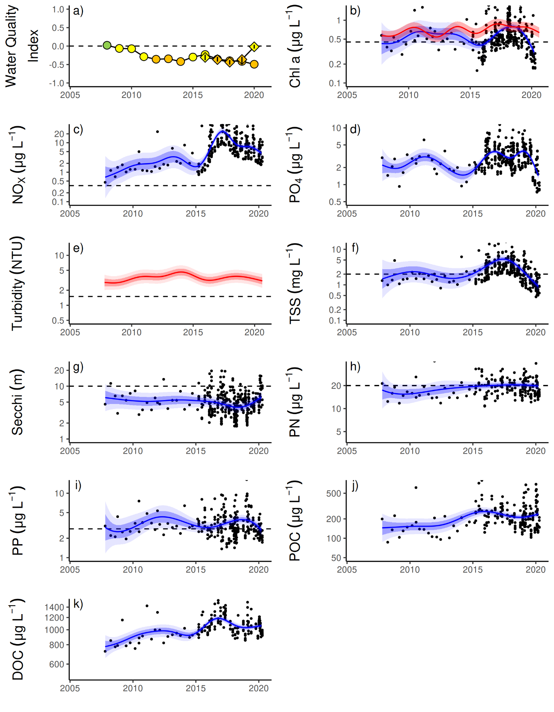
Figure A 12 Temporal trends in water quality: Herbert Tully sub-region
. a) water quality index, b) chlorophyll a, c) nitrate/nitrite, d) Phosphate e) turbidity, f) total suspended solids, g) secchi depth, h) particulate nitrogen, i) particulate phosphorus, j) particulate organic carbon and k) dissolved organic carbon. Water quality index colour coding: dark green- ‘very good’; light green – ‘good’; yellow – ‘moderate; orange – ‘poor’; red – ‘very poor’. The water quality index is the aggregate of variables plotted in b - i and calculated as described in Gruber et al. (2020). Trends in PO4, POC and DOC values are plotted here (d, j, k); threshold levels have yet to be established. Trends in manually sampled water quality variables are represented by blue lines with blue shaded areas defining 95% confidence intervals of those trends, black dots represent observed data. Trends of records from ECO FLNTUSB instruments (b, e) are represented in red, individual records are not displayed. Dashed reference lines indicate guideline values (GBRMPA 2010). Extract from Waterhouse et al. (2021).
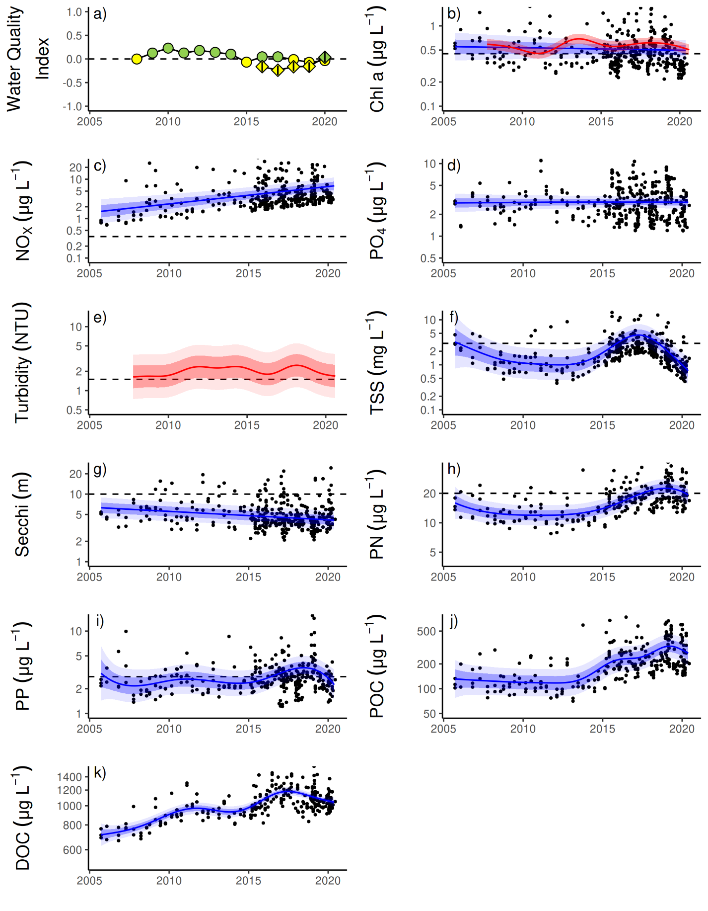
Figure A 13 Temporal trends in water quality: Burdekin region
. a) water quality index, b) chlorophyll a, c) nitrate/nitrite, d) Phosphate e) turbidity, f) total suspended solids, g) secchi depth, h) particulate nitrogen, i) particulate phosphorus, j) particulate organic carbon and k) dissolved organic carbon. Water quality index colour coding: dark green- ‘very good’; light green – ‘good’; yellow – ‘moderate; orange – ‘poor’; red – ‘very poor’. The water quality index is the aggregate of variables plotted in b - i and calculated as described in Gruber et al. (2020). Trends in PO4, POC and DOC values are plotted here (d, j, k); threshold levels have yet to be established. Trends in manually sampled water quality variables are represented by blue lines with blue shaded areas defining 95% confidence intervals of those trends, black dots represent observed data. Trends of records from ECO FLNTUSB instruments (b, e) are represented in red, individual records are not displayed. Dashed reference lines indicate guideline values (GBRMPA 2010). Extract from Waterhouse et al. (2021).
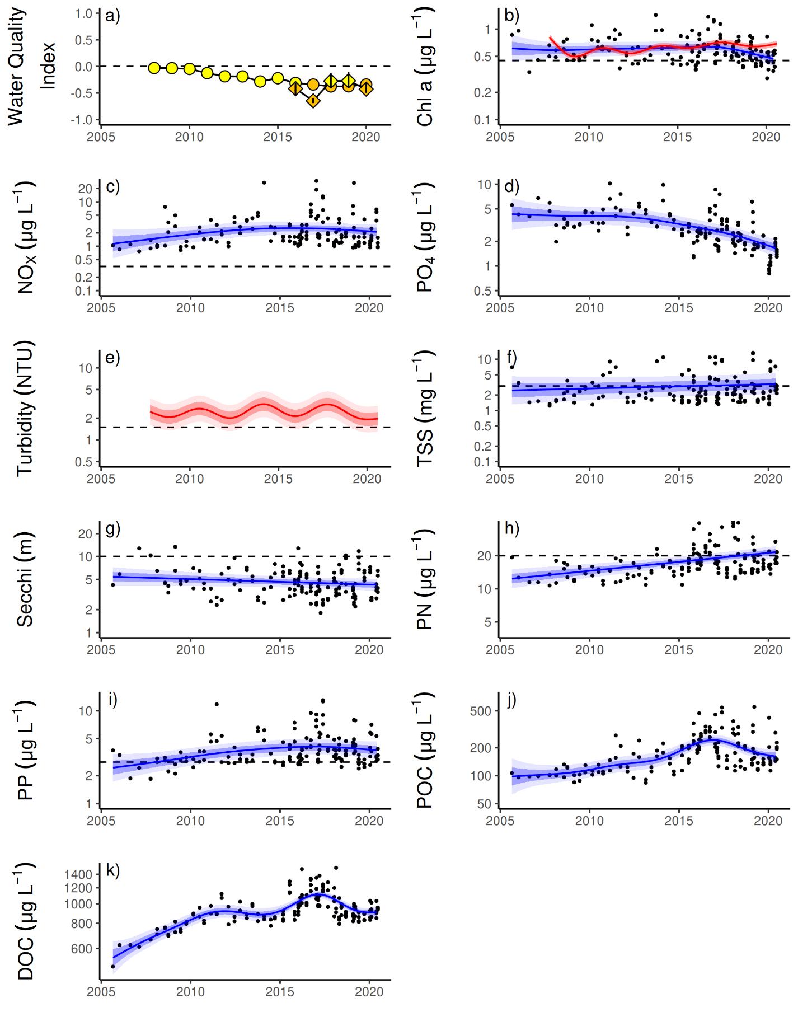
Figure A 14 Temporal trends in water quality
. Mackay-Whitsundays region. a) water quality index, b) chlorophyll a, c) nitrate/nitrite, d) Phosphate e) turbidity, f) total suspended solids, g) secchi depth, h) particulate nitrogen, i) particulate phosphorus, j) particulate organic carbon and k) dissolved organic carbon. Water quality index colour coding: dark green- ‘very good’; light green – ‘good’; yellow – ‘moderate; orange – ‘poor’; red – ‘very poor’. The water quality index is the aggregate of variables plotted in b - i and calculated as described in Gruber et al. (2020). Trends in PO4, POC and DOC values are plotted here (d, j, k); threshold levels have yet to be established. Trends in manually sampled water quality variables are represented by blue lines with blue shaded areas defining 95% confidence intervals of those trends, black dots represent observed data. Trends of records from ECO FLNTUSB instruments (b, e) are represented in red, individual records are not displayed. Dashed reference lines indicate guideline values (GBRMPA 2010). Extract from Waterhouse et al. (2021).
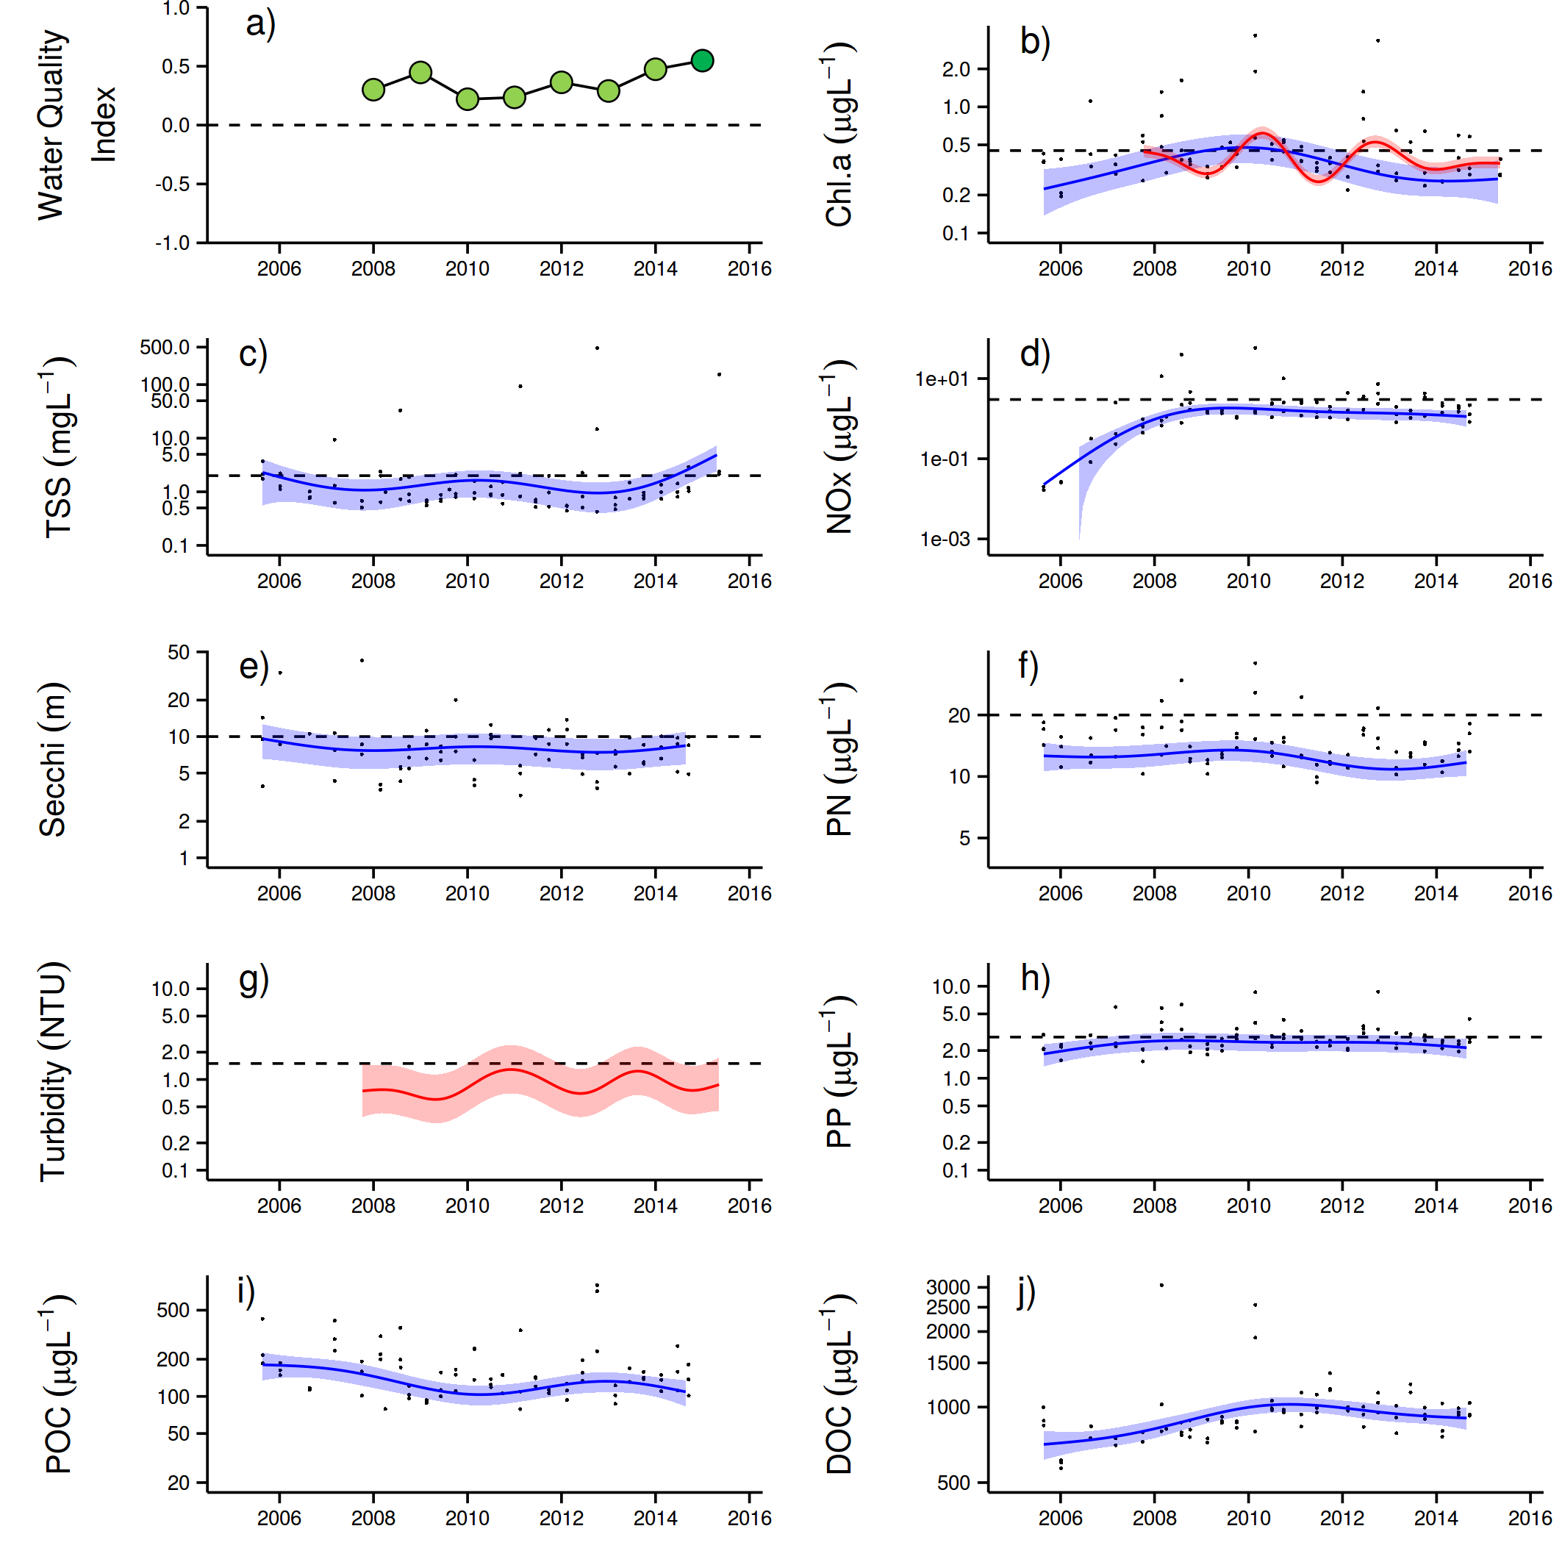
Figure A 15 Temporal trends in water quality: Fitzroy region
. a) water quality index, b) chlorophyll a, c) total suspended solids, d) nitrate/nitrite, e) secchi depth, f) particulate nitrogen, g) turbidity, h) particulate phosphorus, i) particulate organic carbon and j) dissolved organic carbon. Water quality index colour coding: dark green- ‘very good’; light green – ‘good’; yellow – ‘moderate; orange – ‘poor’; red – ‘very poor’. The water quality index is the aggregate of variables plotted in b - h and calculated as described in Waterhouse et al. (2021). Trends in POC and DOC values are plotted here (I, j); threshold levels have yet to be established. Trends in manually sampled water quality variables are represented by blue lines with blue shaded areas defining 95% confidence intervals of those trends, black dots represent observed data. Trends of records from ECO FLNTUSB instruments (b, g) are represented in red, individual records are not displayed. Dashed reference lines indicate guideline values (GBRMPA 2010). Extract from Waterhouse et al. (2021).

Appendix 2: Publications and presentations 2019–2020
Peterson, E.E., Santos-Fernández, E., Chen, C., Clifford, S., Vercelloni, J., Pearse, A., Brown, R., Christensen, B., James, A., Anthony, K., Loder, J. 2020, Monitoring through many eyes: Integrating disparate datasets to improve monitoring of the Great Barrier Reef. Environmental Modelling & Software, 124: 104557.
Schaffelke, B., Anthony, K., Babcock, R., Bridge, T., Carlos, E., Diaz-Pulido, G., Gonzalez-Rivero, M., Gooch, M., Hoey, A., Horne, D., Kane, K., McKenzie, C., Merida, F., Molloy, F., Moon, S., Mumby, P., Ortiz, J.C., Pears, R., Phinn, S., Ridway, T., Roelfsema, C., Singleton, G., Thompson, A. 2020, Monitoring coral reefs within the Reef 2050 Integrated Monitoring and Reporting Program: final report of the coral reef expert group. Great Barrier Reef Marine Park Authority, Townsville.
Smith, J.N., Mongin, M., Thompson, A., Jonker, M.J., De'ath, G., Fabricius, K.E. 2020, Shifts in coralline algae, macroalgae, and coral juveniles in the Great Barrier Reef associated with present‐day ocean acidification, Global Change Biology 26(4):2149-60.
Thompson, A., Martin, K., Logan, M. 2020, Development of the coral index, a summary of coral reef resilience as a guide for management, Journal of Environmental Management 271:111038.
Thompson, A., Menendez, P. 2020, Supplementary report to the final report of the Reef 2050 Integrated Monitoring and Reporting Program coral reef expert group: S5. Statistical power of existing AIMS Long-Term Reef Monitoring Programs. Great Barrier Reef Marine Park Authority, Townsville.
State of coral communities in the Mackay Whitsunday Isaac Region 2020, Mackay Whitsunday Paddock to Reef Virtual Integrated Science Forum.

. ReefTemp Next Generation was developed through the Centre for Australian Weather and Climate Research (CAWCR) – a partnership between CSIRO and the Bureau of Meteorology (Garde et al. 2014).
Marine water quality indices produced by the Australian Bureau of Meteorology as a contribution to eReefs - a collaboration between the Great Barrier Reef Foundation, Australian Government, Bureau of Meteorology, Commonwealth Scientific and Industrial Research Organisation, Australian Institute of Marine Science and the Queensland Government. Data were acquired from NASA spacecraft. Note that this product has been discontinued.
Connie 2.0, CSIRO Connectivity Interface, CSIRO connie2
Australian Government crown-of-thorns starfish management programme data supplied by Great Barrier Reef Marine Park Authority, Eye on the Reef.
Connie 2.0, CSIRO Connectivity Interface, CSIRO connie2

