

**Reef 2050 Plan   
Insights Report**

***(to inform the 2019 Outlook Report)***

Report to the Great Barrier Reef Marine Park Authority

Protected Area Solutions Pty Ltd

August 2018



Report to the Great Barrier Reef Marine Park Authority

Protected Area Solutions Pty Ltd

August 2018

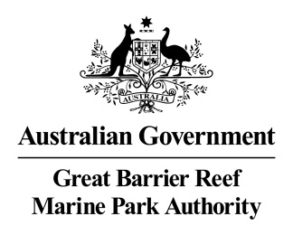

Reef 2050 Plan

Insights Report

**Report prepared by:**

Andrea Leverington1, Marc Hockings1 and Fiona Leverington1

**for the**

*Great Barrier Reef Marine Park Authority*

1 Protected Area Solutions Pty Ltd

Cover photo

Hill Inlet and Whitehaven Beach, Whitsunday Islands © Marc Hockings

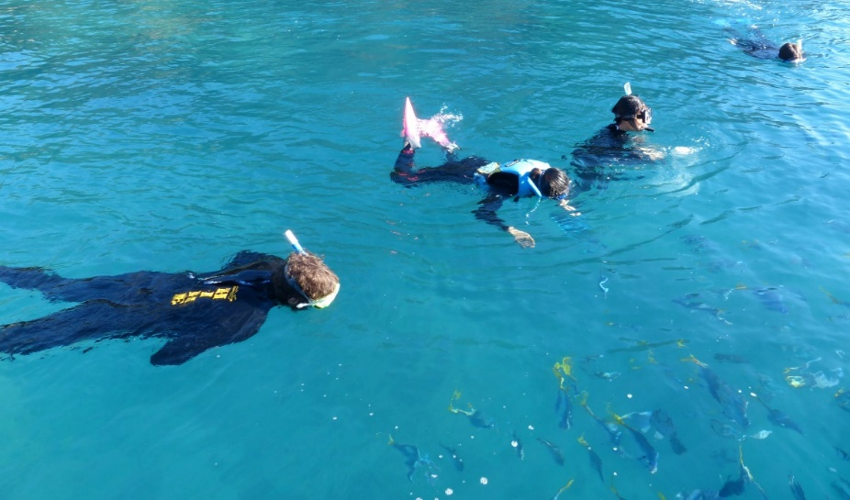



© Commonwealth of Australia 2019Published by the Great Barrier Reef Marine Park AuthorityISBN 978 064 835 702 5

This report is licensed by the Commonwealth of Australia for use under a Creative Commons By Attribution 4.0 International licence with the exception of the Coat of Arms of the Commonwealth of Australia, the logo of the Great Barrier Reef Marine Park Authority and Protected Area Solutions Pty Ltd any other material protected by a trademark, content supplied by third parties and any photographs. For licence conditions see: <http://creativecommons.org/licences/by/4.0> Title: Creative Commons BY licence information - Description: This work is licensed under the Creative Commons Attribution 4.0 International License. 

For licence conditions see: http://creativecommons.org/licences/by/4.0  

Protected Area Solutions has made all reasonable efforts to identify content supplied by third parties using the following format ‘© Copyright, [name of third party]’. Permission may need to be obtained from third parties to re-use their material.

**Disclaimer**

This report was prepared by Protected Area Solutions in good faith exercising all due care and attention, but no representation or warranty, express or implied, is made as to the relevance, accuracy, completeness or fitness for purpose of this document in respect of any particular user’s circumstances. Users of this document should satisfy themselves concerning its application to, and where necessary seek expert advice in respect of, their situation. The views expressed within are not necessarily the views of the Great Barrier Reef Marine Park Authority and may not represent their policy.

**A catalogue record for this report is available from the National Library of Australia**

**This publication should be cited as:**

Leverington, A., Leverington, F. and Hockings, M. (2019) *Reef 2050 Plan Insights Report.* Report to the Great Barrier Reef Marine Park Authority, Townsville.

Comments and questions regarding this document should be addressed to:

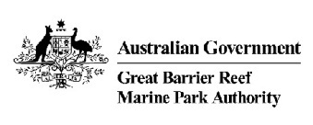

Great Barrier Reef Marine Park Authority

280 Flinders Street

(PO Box 1379)

Townsville QLD 4810, Australia

Phone: (07) 4750 0700

Email: [info@gbrmpa.gov.au](mailto:info@gbrmpa.gov.au)

[www.gbrmpa.gov.au](http://www.gbrmpa.gov.au/)

**Table of contents**

1. Executive summary 6

2. Introduction 7

The Reef 2050 Long-Term Sustainability Plan 7

The Reef 2050 Insights Report 7

3. Methodology 10

4. Context 12

Rating: Mostly effective 12

Understanding 12

Consideration of context 13

5. Planning 14

Rating: Mostly effective. 14

Planning issues 14

Efficiency and consistency 15

Improvements in legislation and policy 16

6. Inputs 17

Rating: Mostly effective 17

Sustainability of resourcing 17

Knowledge gaps 18

Resource allocation 18

7. Processes 19

Rating: Mostly effective 19

Standard of governance 19

Cross-jurisdiction consistency 19

Performance monitoring 20

8. Outputs 21

Rating: Effective 21

Delivery of outputs 21

Appropriateness of outputs 22

9. Outcomes 23

Rating: Partially effective 23

Vision and objectives 23

Conservation of values 23

Threat amelioration 24

Community benefits 25

10. Insights for the 2020 review 26

Ecosystem health 26

Biodiversity 26

Heritage 26

Water quality 26

Community benefits 27

Economic benefits 27

Governance 27

11. Conclusions 28

12. References 30

13. Attachment one: Assessment tables 32

# Executive summary

Every five years, the Great Barrier Reef Marine Park Authority is required by legislation to produce an Outlook Report. The aim of the Outlook Report is *“to provide a regular and reliable means of assessing reef health and management in an accountable and transparent way”* (GBRMPA 2018). A legislative requirement of the five-yearly Outlook Reports is to provide an independent assessment of existing measures to protect and manage ecosystems within the Region. This is known as the management effectiveness assessment, and has been completed to inform chapter seven of each Outlook Report. Following the *Great Barrier Reef Outlook Report 2014* (GBRMPA 2014), the Queensland and Australian governments responded with the development of an overarching plan for the Reef – the *Reef 2050 Long-term Sustainability Plan* (the Reef 2050 Plan) (Australian Government 2015). An updated and revised version was released in July 2018 (Commonwealth of Australia 2018). Given its overarching scope across many Reef-related management topics and the significant investments involved (monetary, governance and human resources), a stand-alone summary report was commissioned by the Great Barrier Reef Marine Park Authority to provide management effectiveness insights related solely to the Reef 2050 Plan. The primary purpose of this Reef 2050 Insights Report is to complement the findings of the *Great Barrier Reef Outlook Report 2019* and contribute to informing the forthcoming 2020 review of the Reef 2050 Plan, by providing insights into the strengths and weaknesses of the Plan and its contribution to effective management of the Region. The Reef 2050 Insights Report should be considered in conjunction with the overarching management effectiveness review and the findings in the 2019 Outlook Report.

Evidence to inform this ‘Reef 2050 Insights Report’ draws from the overarching management effectiveness assessment and is supported with evidence provided by all Reef 2050 government partners. A management effectiveness evaluation approach based on the Framework developed by the World Commission on Protected Areas (IUCN WCPA) has been used to consider whether the Reef 2050 Plan appears to be *appropriate* and *effective* in achieving its vision, based on evidence of progress towards the targets and objectives and improvements achieved to date. The Reef 2050 Insights Report considers the seven themes from the Reef 2050 Plan: Ecosystem Health, Biodiversity, Heritage, Water Quality, Community Benefits, Economic Benefits and Governance.

This Report is organised according to the six elements of management effectiveness; context, planning, inputs, processes, outputs and outcomes. Questions were framed around each of these elements and were considered for each of the themes of the Reef 2050 Plan. A four-point rating scale was used to assess each question, with the total scores resulting in a rating of *effective, mostly effective, partially effective* or *ineffective* for each management effectiveness element.

The analysis has concluded that the Reef 2050 Plan framework is *mostly effective* in driving efforts relevant to the Plan’s vision. The elements of context, planning, inputs and processes are all *mostly effective*, while outputs are *effective*. The outcomes element was rated as Partially effective, resulting from the clear indication that targets for themes of ecosystem health, biodiversity and water quality are unlikely to be met in the short to medium term.

The Reef 2050 Plan is *effective* as an umbrella document to consolidate and provide direction across levels of government and relevant sectors. It provides a very sound framework for improving the effective management of the Reef’s values through improved governance, planning and resourcing, however it is apparent that significant further effort in management still needs to be made to protect the Reef’s values

# Introduction

## The Reef 2050 Long-Term Sustainability Plan

In 2011, the World Heritage Committee requested that Australia prepare a Strategic Assessment and a long-term plan for “sustainable development that will protect the Outstanding Universal Value of the property for the Great Barrier Reef World Heritage Area” (World Heritage Committee Decision 35 COM 7B.10). A number of other recommendations were made by the World Heritage Committee in relation to this plan, including a 2014 request that the plan “...results in concrete and consistent management measures that are sufficiently robust, effectively governed and adequately financed to ensure the overall long-term conservation of the property and its Outstanding Universal Value” (UNESCO World Heritage Committee 2014).

The Reef 2050 Long-Term Sustainability Plan (the original Reef 2050 Plan) (Commonwealth of Australia 2015) was prepared to meet these requests and to address the serious concern of many stakeholders and managers about the state of the Great Barrier Reef World Heritage Area. The Reef 2050 Plan was developed in a cooperative manner with input from government agencies, scientists, communities, Traditional Owners, industry and non-governmental organisations, and based on the best science available at the time. The Reef 2050 Plan was published in March 2015, and a revised version was finalised in July 2018 (Commonwealth of Australia 2018). The revised Reef 2050 Plan was updated in response to the climate events that impacted the condition of the Reef, and includes a consolidation of existing actions. The water quality theme has also been aligned with the revised Reef 2050 Water Quality Improvement Plan. A comprehensive review of the Reef 2050 Plan will occur in 2020, following the release of the 2019 Great Barrier Reef Outlook Report and consideration of the State of Conservation of the Reef by the World Heritage Committee in 2020.

The vision set out in the Reef 2050 Plan is “to ensure the Great Barrier Reef continues to improve on its Outstanding Universal Value every decade between now and 2050 to be a natural wonder for each successive generation to come”. The World Heritage Area includes areas under the jurisdictions of both the Australian and Queensland governments. The rights and interests of Traditional Owners are recognised, while other managers and key stakeholders include local government, tourism and other industries, port authorities and local communities. A key focus of the Reef 2050 Plan is to coordinate actions of all these players to better guide management of the region as well as associated management activities in its adjacent catchment. The Reef 2050 Plan is based on a number of foundational programs, plans and legislation that have been in place for many years (for example, the Great Barrier Reef Marine Park Zoning Plan 2003 and the *Reef Water Quality Protection Plan 2013* (and its earlier editions). It also includes a number of new actions, based on recommendations from documents such as the *Great Barrier Reef Coastal Zone Strategic Assessment* (DSDIP 2014) and the *Great Barrier Reef Region Strategic Assessment* (GBRMPA 2014).

All values within the World Heritage Area are covered in the Reef 2050 Plan, from species and habitats to Indigenous values and historic heritage, with an emphasis on values that contribute to the Outstanding Universal Value of the World Heritage Area.

## The Reef 2050 Insights Report

This Report was commissioned by the Great Barrier Reef Marine Park Authority (under the Commonwealth of Australia), which requested that it “*contribute to informing the forthcoming 2020 review of the Reef 2050 Plan by providing insights into the Reef 2050 Plan’s contributions to effective management of the Region. This should be a synthesis of any Reef 2050 specific management identified as part of the management effectiveness review*” (Commonwealth of Australia 2017). This report has focused on the targets and objectives of the Reef 2050 Plan. Actions, which have been the focus of the mid-term review of the Reef 2050 Plan, are not evaluated in this report.

A management effectiveness evaluation approach based on the Framework developed by the World Commission on Protected Areas (IUCN WCPA) has been used to consider whether the Reef 2050 Plan appears to be *appropriate* and *effective* in achieving its vision, based on its goals, objectives and targets, and evidence of improvements achieved to date[1]. This approach is based on the premise that to best understand effectiveness, we need to assess how well the Reef 2050 Plan to date:

* addresses and achieves improvements in the *context* in which it is operating;
* supports the undertaking of appropriate and coordinated *planning* in the WHA;
* is resulting in better resourcing and *inputs* to put plans into actions;
* ensures effective *processes* of management;
* supports appropriate *outputs*; and
* is on track to achieve its desired *outcomes.*

The IUCN WCPA framework is based on evaluating the cycle of management (Figure 1). This starts with understanding the context of a region, including its values and threats, existing status and pressures, progresses through establishing a vision, planning and allocating of resources and, as a result of management actions, producing results that are intended to lead to the outcomes defined during the area’s establishment and planning. Monitoring and evaluation of these stages of the management cycle provide the links that enable planners and managers to learn from experience (Table 1).

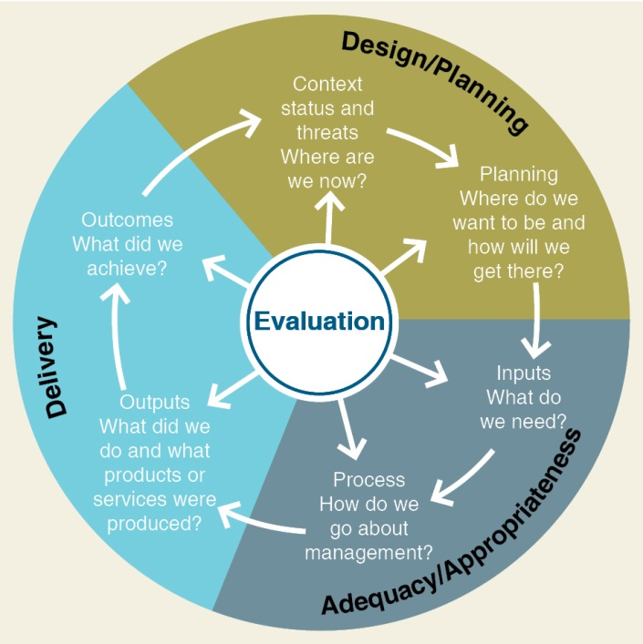

Figure 1: The IUCN WCPA Management Effectiveness Framework (Hockings et al. 2006)

Table 1: Elements and criteria for evaluation (Hockings et al. 2006)

|  |  |  |  |
| --- | --- | --- | --- |
| **Elements of evaluation** | **General topics addressed** | **Criteria that are assessed** | **Focus of evaluation** |
| Context | What is the current situation?  Assessment of importance, threats and policy environment | Significance  Threats  Vulnerability  National context  Partners | Status |
| Planning | Is the design of the area, planning systems and plans adequate?  Assessment of protected area design and planning | Protected area legislation and policy  Protected area system design  Reserve design  Management planning | Appropriateness |
| Inputs | Are resources for management adequate?  Assessment of resources needed to carry out management | Resourcing of agency  Resourcing of site | Adequacy |
| Processes | How is management carried out and does it meet relevant standards?  Assessment of the way in which management is conducted | Suitability of management processes | Efficiency and appropriateness |
| Outputs | What were the results?  Assessment of the implementation of management programmes and actions; delivery of products and services | Results of management actions  Services and products | Effectiveness |
| Outcomes | What has been achieved?  Assessment of the outcomes and the extent to which they achieved objectives | Impacts: effects of management in relation to objectives | Effectiveness and appropriateness |

# Methodology

The Reef 2050 Insights Report was prepared in conjunction with the overarching Management Effectiveness Report for the *Great Barrier Reef Outlook Report 2019*, which considers the evidence provided for the fourteen management topics relevant to management of the Region and factors affecting the Region as these relate to the objectives and targets of the Reef 2050 Plan. The Reef 2050 Insights Report is organised according to the elements of management effectiveness (Table 1) using the following questions to consider effectiveness of the Reef 2050 Plan:

Context

* How well do the Reef 2050 Plan’s targets, objectives and outcomes contribute to and affect understanding of the values, current condition and trend, impacts and stakeholders of the Region?
* Does the Reef 2050 Plan clearly and appropriately consider the values, threats and internal and external social and policy environment, including rights-holders and stakeholders?

Planning

* Does the Reef 2050 Plan help address issues relating to planning, including the appropriateness, coverage and quality of plans?
* Does the Reef 2050 Plan ensure planning is more efficient, reduces duplication and is consistent across jurisdictions?
* Does the Reef 2050 Plan contribute to appropriate improvements in legislation and policy?

Inputs

* Has the Reef 2050 Plan been effective in improving the level or sustainability of resourcing for management of the Reef?
* Does the Reef 2050 Plan help to identify gaps in knowledge and recommend action to remedy these gaps?
* Has the Reef 2050 Plan helped to ensure effective allocation and use of the resources (for example through less duplication)?

Processes

* Does the Reef 2050 Plan encourage better governance across the Region (including legitimacy, clear direction, performance, accountability, fairness and rights)?
* Does the Reef 2050 Plan facilitate the consistent implementation of programs/policy across jurisdictions?
* Is there effective performance monitoring to gauge progress towards the objectives of the Reef 2050 Plan?

Outputs

* Has the Reef 2050 Plan resulted in better delivery of outputs?
* Are these outputs appropriate to achieve the targets and outcomes? Have the key outputs been identified?

Outcomes

* Is the Reef 2050 Plan on track to achieve its stated vision and objectives (and where it can possibly be measured based on the evidence collected – any targets)?
* Is it likely that values will be better conserved because of the Reef 2050 Plan?
* Are threats being better ameliorated because of the Reef 2050 Plan?
* Is it likely that community well-being and relationships will be improved because of the Reef 2050 Plan?

Information to answer these questions has primarily been obtained from information gathered as part of the management effectiveness review for the Outlook Report, as well as the mid-term review of the Reef 2050 Plan. Each question has been considered and scored for each theme of the Reef 2050 Plan:

* Ecosystem health
* Biodiversity
* Heritage
* Water quality
* Community benefits
* Economic benefits
* Governance

The four-point rating scale used for individual questions is that used in the Outlook Report:

1 = 0-20 per cent of optimal condition,

2 = 21-50 per cent of optimal condition,

3 = 51-80 per cent of optimal condition,

4 = 81-100 per cent of optimal condition.

Ratings for each question were combined to provide scores for each element of the IUCN framework, and a system was developed to convert these scores to a rating of management effectiveness as follows:

* If the total score is between 85 and 100%, then the overall grading statement for that element is *effective*.
* If the total score is between 66 and 85%, then the overall grading statement for that element is *mostly effective*.
* If the total score is between 40 and 66%, then the overall grading statement for that element is *partially effective*.
* If the total score is less than 40% then the overall grading statement for that element is *ineffective.*

In the following sections, the overall management effectiveness rating is presented, followed by key points for each of the questions. It should be noted that the ranges for the four ratings are not equal. The high score required to achieve an *effective* rating is consistent with the grading framework for the management effectiveness section of Outlook Reports. It reflects the decision made by the Great Barrier Reef Marine Park Authority when undertaking the first Outlook Report that a higher standard was needed to for management to be considered *effective* within a World Heritage Area. Scores for all questions are included in Appendix One. The overall management effectiveness ratings and a summary of the findings form the basis of this Report.

# Context

## Rating: Mostly effective

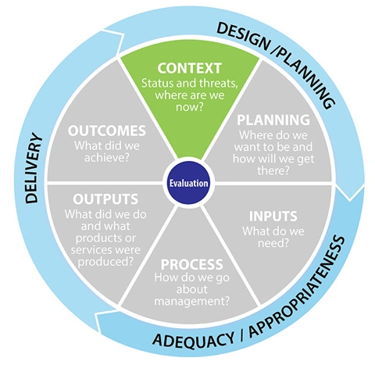

## Understanding

*How well do the Reef 2050 Plan’s targets, objectives and outcomes contribute to and effect understanding of: the values, current condition and trend, impacts and stakeholders of the Region?*

The Reef 2050 Plan demonstrates a very well-developed understanding of the attributes underpinning the Outstanding Universal Value of the Great Barrier Reef. This assessment is in line with the findings of the *Great Barrier Reef Outlook Report 2009* and *2014*. The high level of understanding is reflected in the overarching vision for the Reef 2050 Plan and its desired outcomes, objectives and targets. Objectives and targets seek to enhance understanding of ecosystem values and the critical habitats underpinning overall ecosystem health, as well as of heritage and social and economic factors.

The focus of objectives and targets around species of conservation concern is necessary, but understanding could be strengthened by considering biodiversity as a whole, especially as current condition and trend information for many species is less certain following bleaching events in 2016 and 2017. The Reef 2050 Plan recognises the importance of the Reef to Traditional Owners, local communities and the wider Australian community. The *Aboriginal and Torres Strait Islander Heritage Strategy* has clearly articulated the Indigenous heritage values of the Great Barrier Reef World Heritage Area. Within the Reef 2050 Plan, recognition of Indigenous values of the Reef is strong. The importance of economic values is also very well understood. There is an emphasis on the need for a better understanding of community benefits; this is being developing through focussed work as a result of the Reef 2050 Plan.

## Consideration of context

*Does the Reef 2050 Plan clearly and appropriately consider the values, threats and internal and external social and policy environment, including rights-holders and stakeholders*?

The Reef 2050 Plan is clearly focussed on protection and restoration of the Outstanding Universal Value of the Great Barrier Reef World Heritage Area in its overall framework and vision, in the decision-making principles to guide development and implementation and in thematic structure of the Plan.

The Reef 2050 Plan draws on risks identified in the 2014 Outlook Report, which provide a comprehensive understanding of threats to the Reef and its values. However, while recognising climate change as the most significant threat overall, the original Reef 2050 Plan itself did not directly address this threat other than by indicating that objectives and targets relating to improved resilience are, in part, a response to climate change impacts. In addition, climate change is not recognised as a threat to any of the specific themes, though it will clearly affect them. However, the mid-term review of the Reef 2050 Plan was brought forward in response to concerns regarding the recent major bleaching events and the deteriorating outlook for the Reef. The revised Reef 2050 Plan includes new actions to undertake specific research to prepare for the comprehensive review of the Reef 2050 Plan in 2020.

Foundational programs and activities provide understanding of the legislative and policy environment relevant to the Reef, and areas requiring further policy development are identified. The governance arrangements specified in the Reef 2050 Plan take into account the wide range of managers, rights-holders and stakeholders.

# Planning

## Rating: Mostly effective.

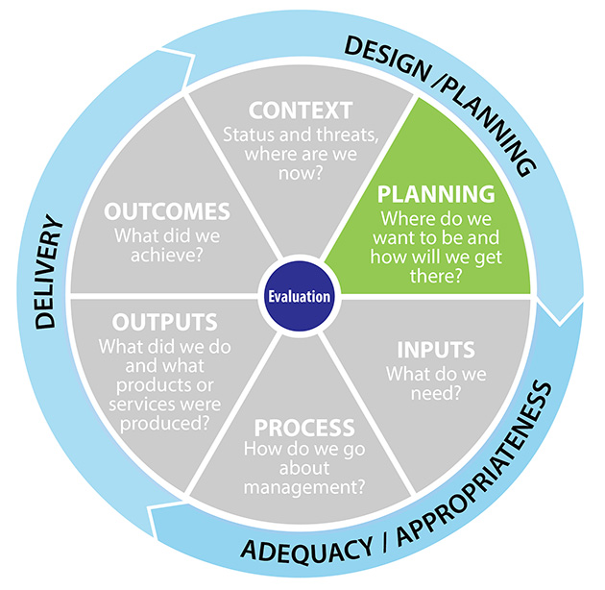

## Planning issues

*Does the Reef 2050 Plan help address issues relating to planning, including the appropriateness, coverage and quality of plans?*

The Reef 2050 Plan encourages adaptive management and allows for committees of experts to provide advice on priorities and actions. The Reef 2050 Plan encourages all organisations in the regions to fully consider the Outstanding Universal Value of the Great Barrier Reef in decision making and planning, and to address threats to these values.

The Reef 2050 Plan outlines some priorities for planning the management of ecosystem services, as well as directions for plan implementation by various agencies and local government. Work proposed under the Reef 2050 Plan will strengthen planning and decision making in relation to ecosystem health across the Region.

Planning priorities relating to biodiversity are set out in the Reef 2050 Plan at a general level for species of conservation concern. The focus of objectives and targets is oriented primarily towards these species of conservation concern, but bleaching events in 2016 and 2017 have resulted in significant impacts on a much wider group of species. It may be useful to broaden focus of planning and response to address biodiversity more generally. It is understood that a broader focus on biodiversity has been identified in the Great Barrier Reef Blueprint 2017, and this may be incorporated in the reviewed Reef 2050 Plan in 2020. Biodiversity at a broad level may be monitored through specification of key indicator species and key processes within the Reef 2050 Integrated Monitoring and Reporting Program (RIMReP).

Up to date and quality planning for both historic and Indigenous heritage processes have already improved as a result of the Reef 2050 Plan. Engagement of Traditional Owners and stakeholders in planning has improved in recent years: for example, a comprehensive engagement program was undertaken for the Great Barrier Reef Marine Park Authority’s *Aboriginal and Torres Strait Islander Heritage Strategy*. In January 2018 the Federal Environment Minister announced resources to support increased Traditional Owner involvement in implementing the Reef 2050 Plan, which includes sea country planning aspirations.

The Reef 2050 Plan encourages the development of plans and policy that support consideration of community benefits in decision making, and recognises the need to protect Outstanding Universal Value associated with superlative natural beauty and sense of place. The Reef 2050 Plan also focusses on planning addressing the immediate local and regional threats associated with ports and fishing. It encourages more sustainable tourism through improved planning and consideration of the Reef’s Outstanding Universal Value in decision making.

The Reef 2050 Plan comprehensively addresses issues associated with water quality, including urban and industrial water quality, ports and dredging, as well as the land management sector.

## Efficiency and consistency

*Does the Reef 2050 Plan ensure planning is more efficient, reduces duplication and is consistent across jurisdictions?*

The Reef 2050 Plan is *mostly effective* as an umbrella document to consolidate and provide direction across levels of government and relevant sectors. It is also *mostly effective* in its efforts to ensure coordinated responses to issues of declining ecosystem health and biodiversity across a number of areas of focus and responsibility (e.g. fisheries, the Field Management Program, transport and Traditional Owners). The Reef 2050 Plan consolidates water quality planning across a number of different programs, and reduces duplication by providing a single framework for addressing water quality issues, including urban and industrial water quality, ports and associated dredging as well as water quality associated with land-based runoff from the agricultural sector. The revised Reef 2050 Plan (Commonwealth of Australia 2018) aligns the water quality targets with the *Reef 2050 Water Quality Improvement Plan 2017-2022*.

The Reef 2050 Plan supports consideration of community benefits in policy development across all jurisdictions and encourages cross-jurisdictional cooperation in planning associated with port development and reef-related industries such as tourism and fishing. However, it is relatively silent on coordination with research institutions and research funding mechanisms such as the National Environmental Science Program, which play a critical role in relation to improving biodiversity knowledge, understanding and management. With diverse research institutions each pursuing their own agendas while still seeking to contribute to understanding and solutions to reef issues, mechanisms to coordinate such efforts are currently lacking. Management agencies that work across a number of reef issues and have established relationships with research providers are in strong positions to provide such coordination. The Reef 2050 Plan Independent Expert Panel is also in an ideal position to provide coordination and lead development of a research agenda for the Reef 2050 Plan.

Duplication has not been significantly reduced in the heritage area, as site-based management plans are still divided by jurisdiction - for example non-Commonwealth islands are not included in the Marine Park Authority’s Heritage strategies, and this may be confusing for most people. Some Traditional Owner groups may prefer to develop Sea Country plans that cover all jurisdictions within their country, including islands and reefs.

## Improvements in legislation and policy

*Does the Reef 2050 Plan contribute to appropriate improvements in legislation and policy?*

The Reef 2050 Plan considers relevant regulation, policies and strategies across all government agencies. The requirements for changes to legislation concerning environmental impact assessment under both Australian and Queensland legislation are identified. Changes to legislation associated with land clearing and sea-based disposal of capital dredge material have been implemented. The Reef 2050 Plan highlights where policy and decisions taken under legislation (such as *Transport Infrastructure Act*) are needed to support Reef ecosystems.

The Reef 2050 Plan encourages policy and decision making across all issues to consider cumulative impacts and community benefits. It also strengthens policy in relation to Indigenous engagement in ecosystem management, enhancing ecosystem resilience, biodiversity assessment and the protection of species and habitats considered to be of conservation concern. It has resulted in clearer policy and guidelines for impact assessment and knowledge management for Traditional Owners.

The Reef 2050 Plan encourages the development of better policies and guidelines to take into consideration the Reef's Outstanding Universal Value in all decision making and resource allocation guidelines. Examples of policy and legislation implementation include the Queensland Government’s recent legislation to establish three net-free fishing zones.

# Inputs

## Rating: Mostly effective

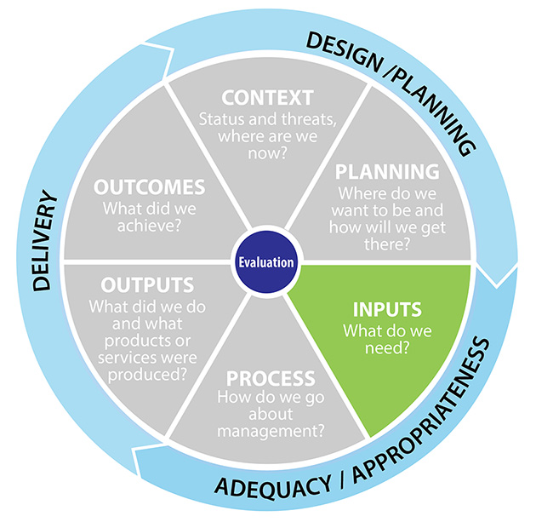

## Sustainability of resourcing

*Has the Reef 2050 Plan been effective in improving the level or sustainability of resourcing for management of the Reef?*

The Reef 2050 Plan has been instrumental in consolidating multiple areas of investment for reef activities through the *Reef 2050 Investment Framework* (Commonwealth of Australia 2016a)., and it also prioritises how funding should be spent. The Investment Framework has helped to identify shortcomings in the funding needed to achieve targets For example, resources for the management of water quality have increased. The Investment Framework highlighted gaps and shortfalls in resourcing needed to achieve targets relating to resilience and ecosystem health. In early 2018, the Australian Government announced $500 million, in addition to funding already included in the Reef 2050 funding pool, to address water quality, crown-of-thorns starfish control, reef resilience and restoration, and to support management of the Great Barrier Reef.

The *Net Benefits Policy* (GBRMPA 2018)and joint government investments, driven by the Reef 2050 Plan, will help address the need for improvement of ecosystem health and resilience, in part through enhanced funding for the Field Management Program. Investment in ecosystem health is identified as the second largest area of investment under the Reef 2050 Plan, although nearly half the actions relating to ecosystem health have an unquantifiable or medium to high funding gap. Required investment is difficult to quantify due to the sheer scale of coastal and marine restoration required, and the current lack of understanding of the most effective restoration actions. The *Reef Restoration and Adaption Program*, boosted by $100 million through the recent funding announcement, will significantly support this work.

The Reef 2050 Plan goes some way towards integrating funding that will directly support biodiversity-related research and management from existing research and management sources (e.g. through the National Environmental Science Program, research through Australian Institute for Marine Science, Universities and State and Australian Government agencies and local government) and additional funds through Reef Trust, particularly directed to crown-of-thorns starfish control. Development of the RIMReP will enhance this coordination and inform the prioritisation of funding to key areas and issues.

Investment in RIMReP will also help to enable the development of cultural protocols and data sharing arrangements with willing Traditional Owner groups, and will provide appropriate indicators. Indigenous Ranger numbers working in the Region have been increased, in part due to the recommendations of the Australian Government’s *Dugong and Turtle Protection Plan* *2014-2017,* a Reef 2050 Plan initiative under the Reef Trust, which was extended in 2018. The RIMReP has also recently funded the update and extension of the Social and Economic Long-term Monitoring Program (SELTMP) (Marshall et al 2017) for the Great Barrier Reef. Funding through the Reef 2050 Plan has also enabled the collation of information to help measure progress towards meeting objectives associated with community benefits.

The Reef 2050 Plan recognises existing activities in the area of economic benefits, rather than driving resourcing in this area.

## Knowledge gaps

*Does the Reef 2050 Plan help to identify gaps in knowledge and recommend action to remedy these gaps?*

The Reef 2050 Plan is expected to improve knowledge of possible management responses to achieve objectives across all themes. The Reef 2050 Plan has identified knowledge gaps in monitoring and evaluation. It is anticipated that these issues will be addressed through the development of RIMReP, although its development has been very slow. Projects funded by RIMReP such as the SELTMP are filling knowledge gaps in human dimensions and social planning. RIMReP will also identify and plan to address knowledge gaps relevant to biodiversity management. Access to historic heritage information is improving through the heritage database.

## Resource allocation

*Has the Reef 2050 Plan helped to ensure effective allocation and use of the resources (for example through less duplication)?*

As implementation of the Reef 2050 Plan has begun, areas where further investment is needed have become apparent. Responsibilities for the Reef 2050 Plan's actions have been identified and this has improved coordination. Through clear documentation and focus on partnerships with researchers, managers and other stakeholders, there is evidence that the Reef 2050 Plan is strengthening cooperative efforts and contributing to more efficient use of resources. For example, the Reef 2050 Plan has documented all resources that are committed to water quality across the range of jurisdictions. The Reef 2050 Plan is also focussing attention on the key knowledge gaps and requirements for a more structured approach to restoring and enhancing ecosystem health. It has prioritised actions associated with shipping, managing cumulative impacts and improving sustainability.

# Processes

## Rating: Mostly effective

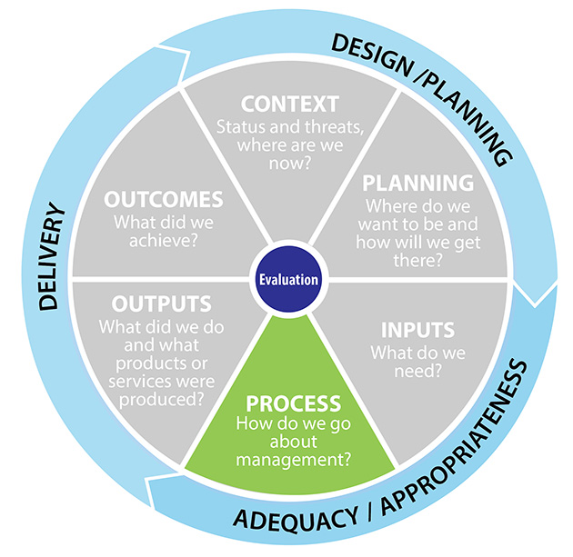

## Standard of governance

*Does the Reef 2050 Plan encourage better governance across the Region (including legitimacy, clear direction, performance, accountability, fairness and rights)?*

Governance generally is well addressed in the governance section with clear directions to reduce duplication and encourage better cooperation. The recognition of Indigenous people as rights-holders and vital partners in management is improving. The rights and interests of Traditional Owners are recognised and provided for in specific objectives and targets in the Reef 2050 Plan. However, in the governance section, it appears that Indigenous people are included as stakeholders on par with researchers and other stakeholder groups, rather than as rights-holders and vital partners in management.

Mechanisms for appropriate sectoral engagement in governance of all issues are clear and appropriate. The Reef 2050 Plan has driven the review and improvement of water quality plans and policies to align with clear targets and objectives from all sectors including industry, urban sources, and broadacre land management. The development of RIMReP as the principal monitoring and reporting system for the Reef 2050 Plan will assist in achieving good governance in relation to both biophysical and socio-economic aspects of management. Other principles of good governance, such as transparency, accountability and responsiveness, are clearly spelled out throughout the document.

## Cross-jurisdiction consistency

*Does the Reef 2050 Plan facilitate the consistent implementation of programs/policy across jurisdictions?*

The Reef 2050 Plan has identified the wide range of managers responsible for improving reef outcomes. However, clear directions as to which agency or organisation is responsible for each action are still being refined. Generally, the Reef 2050 Plan does promote consistent implementation and policy across jurisdictions through joint funding programs, such as the *Reef Water Quality Water Quality Improvement Plan* and the joint Field Management Program. While not in scope of the Reef 2050 Plan, inconsistent policy directions within governments at all levels as highlighted by Dale et al. (2016), will likely impede consistency in relation to development and decision making that will impact on the Reef. For example, aspirations to develop Northern Australia, expand agriculture, develop natural resources and to grow regional towns and cities have the potential to undermine efforts to restore the Great Barrier Reef if these policies are not closely aligned with environmental protection requirements.

RIMReP and partnerships between management agencies and research institutions supported by targeted funding (e.g. National Environment Science Program, Reef Restoration and Adaption Program) are principal mechanisms to enhance integration and consistency in relation to research and monitoring. Consistency and integration are weakest for heritage planning and management, but strong in relation to water quality.

## Performance monitoring

*Is there effective performance monitoring to gauge progress towards the objectives of the Reef 2050 Plan?*

Effective performance monitoring, overseen through Reef 2050 Advisory Committees and supported by State Party reporting to the World Heritage Committee, is a feature of the Reef 2050 Plan. Objectives and targets are generally measurable, with further specific details to be provided under actions, so that effective performance monitoring will be possible. Baseline knowledge is needed in some areas to support this monitoring (e.g. in relation to ecosystem health, heritage and community benefits, economic benefits) but is already strong for water quality. RIMReP is a key development to support performance monitoring, although it has been slower to develop than originally foreseen. The *Outlook Report 2019* and Reef 2050 Plan annual reports will guide the five-year review of the Reef 2050 Plan. It is anticipated that the regular reporting of actions, often at the catchment scale, will assist with adaptive management to improve the targets and indicators, and identify gaps in knowledge and understanding. An example is the basin-specific targets for water quality (Brodie et al 2017). Changes to targets were based on improved understanding of specific catchment processes.

# Outputs

## Rating: Effective

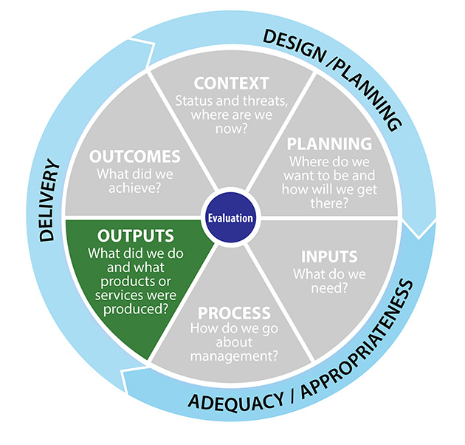

## Delivery of outputs

*Has the Reef 2050 Plan resulted in better delivery of outputs?*

Clearly articulated targets and objectives drive delivery of outputs for each theme. The monitoring and reporting framework keeps track of these outputs.

The Reef 2050 Plan identifies many knowledge gaps in relation to understanding and measurement of ecosystem health and resilience and is directing actions to address these knowledge gaps. However, objectives and targets for a broad range of ecosystem health indicators and species, not only those listed as of conservation concern, would strengthen the delivery of outcomes. Work needed to address cumulative impacts is identified and polices ensure that full and proper consideration of these impacts are being developed. The Reef 2050 Plan has been a key driver of the development of RIMReP on all themes and provides an integrating framework for both research into and management of biodiversity, with a focus on species of conservation concern.

The Reef 2050 Plan has been *effective* in encouraging delivery of outputs for the heritage theme, including the *Aboriginal and Islander Heritage Strategy* (GBRMPA 2018). In addition, increased support for Traditional Owner involvement in implementing the Reef 2050 Plan is recognised as a key priority for investment (Commonwealth of Australia 2016a). More vessels have been delivered for the crown-of-thorns starfish control program, and outputs in relation to Ports have been implemented including the Ports strategy, legislation, maintenance dredging strategy.

The Reef 2050 Plan has also been *effective* in delivering outputs associated with water quality, community benefits and activities that contribute to improved economically sustainable activities that recognise the Reef’s Outstanding Universal Value. Examples include increased participation of agricultural land holders in regional water quality improvement initiatives and a coordinated dredging strategy.

## Appropriateness of outputs

*Are these outputs appropriate to achieve the targets and outcomes? Have the key outputs been identified?*

Outputs as a result of the Reef 2050 Plan are generally appropriate for the themes. For example, outputs in relation to heritage have covered capacity building, protection of heritage, management planning, monitoring and reporting. Outputs for ecosystem health cover identification and filling of key knowledge gaps, initiatives to enhance ecosystem health and resilience, means to address impacts, and planning and monitoring for ecosystem health. Outputs related to water quality include improved agricultural management approaches to reduce nutrients and sediments in farm run-off.

However, the focus of biodiversity objectives and targets that are driving outputs may be too concentrated on just ‘species of conservation concern’. Given the impact of bleaching in 2016 and 2017 on many species and processes, a broader focus on biodiversity and ecosystem health as a whole might enable more appropriate response to such events. (It is noted that this impact occurred after the development of the Reef 2050.) Proposals for improving resilience of the Region and for addressing other significant impacts that will affect the Reef’s biodiversity as a whole, such as crown-of-thorns starfish, do not have the same restricted focus as the biodiversity objectives and targets.

# Outcomes

## Rating: Partially effective

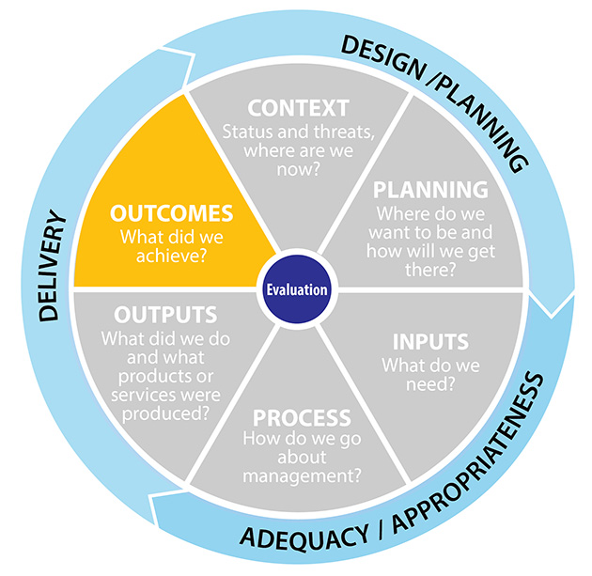

## Vision and objectives

*Is the Reef 2050 Plan on track to achieve its stated vision and objectives (and where it can possibly be measured based on the evidence collected – any targets)?*

This question has not been considered across all themes, as a number of other review processes are underway to answer this question in detail. However, the following comments can be made. Positive progress has been made in a number of areas, for example legislation has been enacted regarding sustainable port planning, land-based disposal of capital dredge spoil (Commonwealth of Australia 2016b) and tighter tree-clearing laws. However, bleaching events in 2016 and 2017, together with impacts from crown-of-thorns starfish and other stressors means that a number of biodiversity and ecosystem health targets will not be on track for the foreseeable future (as found by Tarte et al. 2017). Other targets will also be difficult to achieve while the current level of policy dissonance within government and between sectors mentioned in section six persists. (Note that the impact of broader government development policies is not in scope of the Reef 2050 Plan). The *Scientific Consensus Statement* (Waterhouse et al. 2017*)* and Reef 2050 Plan advisory committees have identified that the targets for water quality are unlikely to be met in the Reef 2050 Plan timeframes. The *Reef 2050 Water Quality Improvement Plan 2017-2022* (Australian Government 2018) has adopted the water quality targets using better science at specific catchment scales, and these targets are more realistic.

These issues have contributed to the *partially effective* rating for outcomes.

## Conservation of values

*Is it likely that values will be better conserved because of the Reef 2050 Plan?*

It is acknowledged that many of the actions outlined in the Reef 2050 Plan were being undertaken prior to its development. However, with the collation and prioritisation of actions from across all levels of government, and associated increased funding, it is anticipated that the values of the Reef will be better conserved as a result of the Reef 2050 Plan. Outcomes from actions in the Reef 2050 Plan will likely improve resilience of the system, and values will be in better condition than in the absence of this work. This improvement will depend on the actions being adaptive and responsive to impacts on the Reef, as impacts may occur in between the five-yearly reviews. Work on identification and targeted management of key ecological sites and standards for ecosystem management, together with work on ecosystem restoration, will assist in reef protection. The values associated with community benefits, including aesthetic and recreation values, will be better protected as a result of the Reef 2050 Plan. The effect of the Reef 2050 Plan on heritage protection will be difficult to judge as there are many factors at work, but the motivation for partners to work together and to document values should have some positive impact. Consideration of improved sustainability for a range of reef-dependant industries will also contribute to better protection of Reef values.

## Threat amelioration

*Are threats being better ameliorated because of the Reef 2050 Plan?*

The time lag and complexity of actions means this is a difficult aspect to assess, but it seems likely that the better governance arrangements will lead to some threats being more effectively ameliorated. However, at the same time the level of impact from threats, especially those related to climate change, is increasing very rapidly. Scaling up of work on crown–of-thorns starfish control is likely to help the system to better cope with the current outbreak (at least in the highly controlled areas) and may position management to respond in an appropriate way earlier in any future outbreaks when a an early, more pre-emptive response is needed. The Reef 2050 Plan’s focus on understanding and addressing cumulative impacts is useful.

The listed threats of lack of capacity and opportunity for Traditional Owners have been partly addressed in the Reef 2050 Plan, but the key threats of climate change and associated sea level rise have not been considered in relation to the heritage theme, and these will seriously impact heritage values. The risks of information loss over time and accidental and intentional damage to cultural and historical sites are being reduced through the Reef 2050 Plan’s focus on improved documentation of heritage values and strengthened compliance presence through the joint Field Management Program. Protocols for handling and sharing Indigenous heritage information have been established, and a pilot program where the Woppaburra people have documented values and established protocols for assessing activities shows promise.

Success of the Reef 2050 Plan in ameliorating the threats associated with poor water quality is uncertain due to time lags between on-ground actions and results, and the time taken for behaviour change to make a difference in outcomes. Similarly, it is too soon to determine whether improved coastal planning has resulted in reduced threats to Reef health. The threat of climate change through associated ecosystem degradation and extreme weather as well as sea-level rise will also seriously impact on economic benefits associated with reef-based activities. For example, tourism is particularly vulnerable to these impacts and the tourism industry has voiced concerns about the potential effect on major visitor sites and infrastructure as well as increased insurance and operational costs.

The absence of objectives and targets directly focussed on climate change was a limitation of the initial Reef 2050 Plan developed in 2015. The mid-term review of the Reef 2050 Plan was brought forward in response to the concerns regarding the recent major bleaching events and the deteriorating outlook for the Reef. While the revised Reef 2050 Plan (Commonwealth of Australia 2018) does not have objectives and targets focussed on climate change, it does include an improved narrative about climate change as well as local climate resilience and climate adaptation actions. While local actions can contribute to climate change mitigation, they are primarily directed towards adaptation. The focus on building resilience of the Reef is a major focus. Although out of scope for the Reef 2050 Plan, truly effective national and global efforts to mitigate climate change are needed if the Reef is to recover and persist: this has implications broadly across other sectors and policies.

## Community benefits

*Is it likely that community well-being and relationships will be improved because of the Reef 2050 Plan?*

Governance arrangements outlined in the Reef 2050 Plan support the consideration of community well-being and relationships at all levels. Although there is still room for improvement, the Reef 2050 Plan draws the various management institutions and levels of government together to make decisions and sets ecosystem health objectives and measures. Links to coastal management and its impacts on ecosystem health are strong. Relationships with Traditional Owners have improved through their extensive involvement in the formulation of the Reef 2050 Plan, and in the development of plans and other products resulting from it. The Reef 2050 Plan also provides a focus for community involvement and engagement with water quality issues, through formal mechanisms as well as on-ground activities.  It strongly supports the better engagement with all sectors of the community, and a better understanding of community engagement with the Reef's Outstanding Universal Value.  Economically and ecologically sustainable activities that recognise the well-being of the community are supported by the Reef 2050 Plan.

# Insights for the 2020 review

## Ecosystem health

Since the Reef 2050 Plan was developed, increased summer water temperatures and associated severe bleaching events in 2016 and 2017 have made the challenge of restoring ecosystem health across the Great Barrier Reef a much more daunting task and one that will likely take decades to achieve. Some scientists (such as Hughes et al 2018) consider that these events have produced a fundamental and long-lasting change in the coral assemblage, which will have ecosystem-wide effects. These changes will impact the feasibility of achieving the desired outcome, objectives and targets concerning maintenance and restoration of the connectivity, resilience and condition of marine and coastal ecosystems. The *Great Barrier Reef blueprint for resilience* (GBRMPA 2017) and the revised Reef 2050 Plan (Australian Government 2018) have made a start in more thoroughly addressing climate change impacts, and additional funding for research into issues and solutions relating to resilience and restoration will support this work. However, it will take time to develop practical methods for building resilience and restoring ecosystems over a broad geographic scale and this work is unlikely to be finalised in time for the 2020 Review. Resourcing implementation of resilience and restoration efforts will need to be considered once practical strategies have been developed.

## Biodiversity

Similar challenges for the Biodiversity components of the Reef 2050 Plan are evident following the 2016-17 changes to the ecosystem. Broadening the focus of the Biodiversity component of the plan from ‘species of conservation concern’ and ‘key indicator species’ to broader consideration of the biodiversity and processes supporting biodiversity of the Region as a whole will be important to improving management effectiveness. Updating vulnerability assessments to guide actions and objectives will strengthen this section of the Reef 2050 Plan.

## Heritage

The Reef 2050 Plan has a specific intent to work with and support Traditional Owners to collect, store and manage their own cultural heritage information. Additional funding in 2018 to support Indigenous traditional knowledge for sea country management has the potential to improve the engagement of Traditional Owners in Reef 2050 Plan activities. Recognition of Traditional Owners as rights-holders as opposed to stakeholders is a key consideration. The Reef 2050 Plan does not make recommendations to better integrate heritage planning or site-based management activities on the State Islands within the Great Barrier Reef World Heritage Area across jurisdictions. This is an area of weakness as there is inconsistency and duplication in planning and management of heritage values across jurisdictional boundaries.

## Water quality

The Reef 2050 Plan makes a strong contribution to further pursuing the improved water quality agenda and provides additional momentum to the *Reef 2050 Water Quality Improvement Plan*. The review of the sediment and nutrient targets at the catchment scale in light of new scientific evidence is a sound indication of the responsiveness to new information. Increased funding to support landholders in changing farming practices, such as reduced fertiliser use and adopting new technologies and land management practices, is also very positive. The greatest concern is whether a reduction in sediment and nutrient loads can occur before further serious damage occurs. On-going monitoring is vital to ensure actions on land are resulting in measurable improvements within the Reef, and actions that are more directive in terms of nutrient and sediment management may be required. The impact of port development has the potential to negatively impact the Reef’s Outstanding Universal Value if not managed effectively. While a number of positive actions have been progressed through the Reef 2050 Plan, further expansion of ports and the disposal of associated maintenance dredge spoil in the Region and adjacent port exclusion areas may result in further conflict between positive Reef outcomes and economic benefits. The potential environmental impacts of disposal of capital and maintenance dredge spoil on land may also be an increasing future management concern for coastal ecosystems.

## Community benefits

The Reef 2050 Plan recognises the importance of considering community benefits in planning and policy development. Improved understanding of the impact of activities (such as tourism, recreation and coastal planning) on community benefits, and the better understanding of the intangible benefits of the Reef such as community participation in reef protection, the aesthetic values of the reef and the appreciation of nature, will help guide actions. Refining targets and objectives based on the information that is currently being obtained will improve the effectiveness of the Reef 2050 Plan.

## Economic benefits

An economic agenda that is in conflict with protecting the Reef’s Outstanding Universal Value is one of the greatest challenges for management. The Reef 2050 Plan supports ecological, social and economic sustainability of Reef-based activities and those occurring in the coastal strip that may affect the Reef. However, economic drivers outside the scope of the Reef 2050 Plan, such as the broader climate mitigation policy, the expansion of coal mines, and new agricultural development in Northern Australia remain matters of concern. While it is difficult to address these issues within the scope of Reef 2050 Plan, strengthening controls of development within the Region may be necessary to deliver the desired medium to long-term outcomes.

## Governance

The governance model associated with the Reef 2050 Plan is recognised as necessarily complex given the diversity of governments, institutions, rights-holders and stakeholders involved. The advisory committees have provided critical input into the implementation of the Reef 2050 Plan. The lead agencies and partners are included for each of the actions in the Reef 2050 Plan, but clearer attribution of responsibilities for actions is desirable. The success of the Reef 2050 Plan relies on governments at all levels working cooperatively, stakeholder and community engagement being strong, and the scientific community providing sound and timely input. Traditional Owner input and engagement is fundamental, with their recognition as partners not just stakeholders. The on-going demonstration of an adaptive approach to ensure governance is streamlined, appropriate and connected will strengthen the Reef 2050 Plan.

# Conclusions

The Reef 2050 Plan provides a sound framework for improving governance and management across and adjacent to the Reef, with a strong emphasis on transparency, accountability and responsiveness. The analysis presented in this report, based around the management effectiveness elements of context, planning, inputs, processes, outputs and outcomes, has concluded that the Reef 2050 framework is *mostly effective* in driving efforts relevant to the Plan’s vision.

Effective management is built upon a solid foundation provided by consideration of the management *context*. This is demonstrated by sound understanding of values, threats and policy environment, and the understanding and engagement of key rights-holders and stakeholders. The Reef 2050 Plan is considered to be *mostly effective* in this regard. In each of the themes, the column detailing the foundational programs and activities brings together information on the diverse agencies and programs that are used to manage the Reef. This provides useful information to ensure better integration across these groups. Understanding of the condition and trend of values and threats In the Reef 2050 Plan is drawn from the *Outlook Report 2014*. Coral bleaching events in 2016 and 2017 have substantially affected current condition and trend across the full range of values underpinning the Outstanding Universal Value of the Reef, and this change in circumstances means that understanding of condition and trend is not entirely up to date. The absence of explicit consideration of climate change in the objectives and targets under the themes was considered a major weakness of the original Reef 2050 Plan. However, the Plan does focus on improving the resilience of reef ecosystems, which is a key climate change adaptation measure. The revised Reef 2050 Plan recognises the concerns about the recent bleaching events.

*Planning* for the seven themes in the Reef 2050 Plan is also considered to be *mostly effective*, with clear targets and objectives. While a focus on planning for ‘species of conservation concern’ is important in maintaining the Outstanding Universal Value of the Reef, broader scale consideration of habitats, species and ecological processes is also warranted. The integration of high level planning across the major themes for the management of the Reef is a significant advance, though the differences between the World Heritage Area and the Great Barrier Reef Marine Park remain confusing. Duplication of effort is reduced, with improved consistency of purpose in many areas. There remains a major issue of conflicting policies and directions in other sectors concerning land use and development versus reef protection (as expressed by Dale et al, 2016).

*Inputs*are considered to be *mostly effective*. The Reef 2050 Plan has resulted in a much better understanding of what resources are currently being spent on reef activities by agencies and has attracted focussed investment on prioritised projects. The implementation of the Reef 2050 Plan has leveraged significant additional resources and specified additional resource needs through the *Reef 2050 Investment Framework*.

*Processes* are considered to be *mostly effective*. Clear governance and integration between agencies outlined in the Reef 2050 Plan has led to improved processes across all themes. However, governance arrangements (for example who is responsible for leading actions and reporting) are still very complex. The Reef 2050 Plan will have improved performance monitoring, but this is reliant on the Reef Integrated Monitoring and Reporting Program taking effect. Reef scientists from a number of institutions who were interviewed as part of this assessment raised concerns about the complexity and delayed delivery of this program.

The Reef 2050 Plan’s targets and objectives for delivering *outputs* are considered to be *effective*. The regular monitoring and reporting frameworks in place mean that regular up-dates on progress in publicly available. Outputs in the Plan are considered appropriate for most themes, although the current framework does not take into consideration the impacts of the 2016 and 2017 coral bleaching episodes.

*Outcomes* are difficult to assess at this early stage of implementation of the Reef 2050 Plan, given that the due date for outcomes is 2050. They are considered to be *partially effective*. It is clear that outcomes relating to improved environmental condition such as ecosystem health, biodiversity and water quality will not be delivered in the short to medium term. This is because recovery of ecosystems can take decades or more and these ecosystems are still experiencing impacts from climate change, including coral bleaching, sea-level rise and severe weather. In addition, the size of the task, and need to alter human behaviour with respect to water quality and ecosystem health, means that outcomes will take time to eventuate. Outcomes are already being delivered with respect to community and economic benefits. The Reef 2050 Plan strongly supports better engagement with all sectors of the community, and a better understanding of community engagement with the Reef's Outstanding Universal Value.

In conclusion, the Reef 2050 Plan provides a sound framework for improving the effective management of the Reef’s values through improved governance, planning and resourcing. However, the outcomes of implementation of many aspects of the Reef 2050 Plan are yet to be seen. An adaptive management approach is encouraged throughout the Reef 2050 Plan, including its emphasis on integrated monitoring and reporting and the feedback loop to management responses. The revision of the Reef 2050 Plan in July 2018 is an indication that an adaptive management approach is being implemented. This type of approach will enable actions to be rapidly adjusted to new emerging issues and information. While the Reef 2050 Plan will only be updated every five years, management responses can be delivered much more rapidly when needed.

# References

Australian Government 2018, *Reef 2050 Water Quality Improvement Plan 2017–2022*

Brodie, J., Baird, M., Waterhouse, J., Mongin, M., Skerratt, J., Robillot, C., Smith, R., Mann, R., Warne, M., 2017, *Development of basin-specific ecologically relevant water quality targets for the Great Barrier Reef.* TropWATER Report No. 17/38, James Cook University, Published by the State of Queensland, Brisbane, Australia. 68 pp.

Commonwealth of Australia 2015, *Reef 2050 Long-Term Sustainability Plan*

Commonwealth of Australia 2016a, *Reef 2050 Plan—Investment Framework*

Commonwealth of Australia 2016b *Reef 2050 Plan-Update on Progress*

Commonwealth of Australia. 2017a,Approach to market Reference ID ATM000016.

Commonwealth of Australia. 2017b. *Recovery Plan for Marine Turtles in Australia 2017-2027*. Commonwealth of Australia, Canberra.

Commonwealth of Australia 2018, *Reef 2050 Long-Term Sustainability Plan-July 2018*.

Dale, A. P., Vella, K., Pressey, R. L., Brodie, J., Gooch, M., Potts, R. and Eberhard, R. (2016), Risk analysis of the governance system affecting outcomes in the Great Barrier Reef. *Journal of Environmental Management* 183, Part 3: 712-721.

Great Barrier Reef Marine Park Authority 2009, *Great Barrier Reef Outlook Report*. GBRMPA Townsville.

Great Barrier Reef Marine Park Authority 2014, *Great Barrier Reef Outlook Report 2014*. GBRMPA Townsville.

Great Barrier Reef Marine Park Authority 2017, *Great Barrier Reef blueprint for resilience*, GBRMPA, Townsville.

Great Barrier Reef Marine Park Authority 2017, *Net Benefit Policy: Draft for public consultation*, GBRMPA, Townsville.

Great Barrier Reef Marine Park Authority 2018, *Aboriginal and Torres Strait Islander Heritage Strategy*. GBRMPA. Townsville.

Hockings M.; Stolton S.; Dudley N.; Leverington F. & Courrau J. 2006, *Evaluating effectiveness: a framework for assessing the management of protected areas*. Second edition. IUCN, Gland, Switzerland and Cambridge, UK.

Hughes, T. P., Kerry, J. T., Baird, A. H., Connolly, S. R., Dietzel, A., Eakin, C. M., Heron, S. F., Hoey, A. S., Hoogenboom, M. O., Liu, G., McWilliam, M. J., Pears, R. J., Pratchett, M. S., Skirving, W. J., Stella, J. S. and Torda, G. 2018, Global warming transforms coral reef assemblages. *Nature* 556 (7702): 492-496.

Reef Water Quality Protection Plan Secretariat, July 2013. *Reef Water Quality Protection Plan 2013.* State of Queensland. Brisbane.

UNESCO World Heritage Committee. (2014), Decision : 38 COM 7B.63 Great Barrier Reef (Australia) (N 154). <https://whc.unesco.org/en/decisions/6049> retreived 24/3/2017.

Waterhouse, J., B., Schaffelke, R., Bartley, R., Eberhard, J., Brodie, M. Star, P. Thorburn, 2017. *2017 Scientific Consensus Statement. Land use Impacts on Great Barrier Reef Water Quality and Ecosystem Condition*. Brisbane: The State of Queensland https://www.reefplan.qld.gov.au/about/assets/2017-scientific-consensus-statement-summary.pdf

# Attachment one: Assessment tables

CONTEXT

* **CO1** How well do the Reef 2050 Plan’s targets, objectives and outcomes contribute to and effect understanding of: the values, current condition and trend, impacts and stakeholders of the Region?

|  |  |  |  |  |  |  |
| --- | --- | --- | --- | --- | --- | --- |
| **Governance** | **Ecosystem health** | **Biodiversity** | **Heritage** | **Water quality** | **Community benefits** | **Economic benefits** |
| 4 | 3 | 3 | 4 | 4 | 3 | 4 |
| The Plan clearly articulates who is responsible for the various actions and outcomes, and provides and clear understanding of reef managers and stakeholders | The Plan addresses issues of condition and resilience of ecosystem elements and processes across the Reef and adjacent ecosystems.  There is a focus on engagement with Traditional Owners, local government, management agencies and researchers.  Knowledge of condition and many ecosystems elements is incomplete. | The Plan targets habitats and species of conservation concern with a focus on targeted monitoring and an intent to ensure favourable status for biodiversity across the Reef.  The Plan's Independent Expert Panel will provide an additional avenue for stakeholder input. However delays in the development of the Integrated Monitoring and Reporting Program, combined with the impacts of bleaching events in 2016/17, mean that understanding of condition and trend in biodiversity values has declined. | The Plan has a specific intent to work with and support Traditional Owners to collect, store and manage their own cultural heritage information. This is already resulting in a better understanding of values. Related implementation is also increasing understanding of the condition and trend of heritage. In addition, development of the Plan and of the draft Heritage Strategy has encouraged better shared understanding especially of Indigenous values through planning processes and working with Traditional Owners. | The Plan recognises that land-based run-off, including nutrients, sediments, pesticides and marine debris, has an immediate and system-wide impact on the reef. The Plan acknowledges that improving the water quality entering the reef lagoon is pivotal in supporting the Outstanding Universal Value of the Region and has prioritised better understanding of catchment-specific knowledge of sediment and nutrient sources, and mechanisms to reduce run-off. | The Plan recognises the important role the GBR plays with Traditional Owners and the community, such as employment, as well as the less tangible benefits such well-being associated with human well-being. The Plan encourages better understanding of the values of community benefits, and the need to consider these issues in all aspects of assessment and decision making. This is a relatively new area of consideration, and further knowledge is required to better fully understand the implications of this topic. | The Plan recognises that the Reef is a critical economic asset, and recent work has shown that it is worth $56 billion (Deloitte Access Economics, 2017). The Plan recognises the need to ensure that activities need to be ecologically and socially, as well as economically, sustainable.  The Plan considers both marine activities, such as safe shipping, as well as activities such as fishing, tourism and development such as ports. The Plan also recognises coastal development activities such as terrestrial discharges that impact on the Reef Outstanding Universal Value. |

**CO2 Does the Reef 2050 Plan clearly and appropriately consider the values, threats and internal and external social and policy environment, including rights-holders and stakeholders?**

|  |  |  |  |  |  |  |
| --- | --- | --- | --- | --- | --- | --- |
| **Governance** | **Ecosystem health** | **Biodiversity** | **Heritage** | **Water quality** | **Community benefits** | **Economic benefits** |
| 4 | 3 | 2 | 3 | 4 | 3 | 3 |
| The governance arrangements specified in the Plan take into account the wide range of managers, rightsholders and stakeholders. | Plan recognises climate change as the most significant threat to the ecosystem health of the Reef but the plan itself does not directly address climate change other than by indicating that objectives and targets relating to improved resilience are, in part, a response to climate change impacts. Improved resilience is a key element of the Reef 2050 Plan.  Other threats to ecosystem health from direct harvest to development impacts are recognised and addressed in the Plan with engagement of relevant stakeholders. | Plan recognises climate change as the most significant threat to the biodiversity of the Reef but the Plan itself does not directly address climate change other than by indicating that objectives and targets relating to improved resilience are, in part, a response to climate change impacts.  Other threats to biodiversity from direct harvest to development impacts are recognised and addressed in the Plan with engagement of relevant stakeholders. | The Plan makes a good attempt to consider values, but fails to fully consider all threats to heritage, such as climate change and its associated impacts such as sea level rise and the effects on important cultural species and ecosystems. | Following 20 years of work on water quality from land-based run-off, the Plan consolidates the knowledge and experience to clearly articulate the values, threats and policy environment associated with managing land-based runoff | The Plan takes an excellent step towards considering all these factors, but still requires further work before that values and threats are fully understood. | The Plan takes into consideration threats from cumulative impacts, poor planning and development and damaging incidents, but does not take into account the impact of climate change on industries reliant on the Reef. |

**PLANNING**

**PL1 Does the Reef 2050 Plan help address issues relating to planning, including the appropriateness, coverage and quality of plans?**

|  |  |  |  |  |  |  |
| --- | --- | --- | --- | --- | --- | --- |
| **Governance** | **Ecosystem health** | **Biodiversity** | **Heritage** | **Water quality** | **Community benefits** | **Economic benefits** |
| 4 | 4 | 3 | 4 | 4 | 3 | 3 |
| The Plan has identified the wide range of managers responsible for improving reef outcomes, rather than relying on one agency (e.g. GBRMPA) to undertake all actions.  The Plan is encouraging adaptive management and allow for committees of experts to provide advice on priority and actions. The Plan encourages taking Outstanding Universal Value into account in decision making and planning. Cooperative management agreements are taken into account. The Plan is tailored to reflect regional differences in threats to values of the Reef | The Plan outlines some priorities for plan development and directions for implementation of plans by various agencies and local government. Work proposed under the Reef 2050 Plan will strengthen planning and decision making in relation to ecosystem health across the Reef. | Planning priorities relating to biodiversity are set out in the Reef 2050 Plan at a general level for species of conservation concern. Focus of objectives and targets is oriented primarily towards these species of conservation concern but bleaching events in 2016 and 2017 are likely to have resulted in significant impacts on a much wider group of species. A process to broaden focus of planning and response to address biodiversity more generally may be required and could be achieved through the specification of key indicator species in the RIMReP program | Up to date and quality planning for both historic and Indigenous heritage processes have already improved and are well underway because of targets set in the Plan. Engagement of Traditional Owners and stakeholders in planning has been good. | The Plan comprehensively addresses all issues associated with water quality, including urban and industrial water quality, port and dredging as well as the more traditional land management sector. | The Plan focusses on the development of plans and policy that support the consideration of community benefits in decision making, and recognises the need to protect the Reef’s Outstanding Universal Value associated with superlative natural beauty and sense of place as desirable for maintenance for future generations. | The Plan focusses on planning associated with ports and shipping and improving the sustainability of tourism and fishing through improved planning and consideration of the Reef’s Outstanding Universal Value in decision making. |

**PL2 Does the Reef 2050 Plan ensure planning is more efficient, reduces duplication and is consistent across jurisdictions?**

|  |  |  |  |  |  |  |
| --- | --- | --- | --- | --- | --- | --- |
| **Governance** | **Ecosystem health** | **Biodiversity** | **Heritage** | **Water quality** | **Community benefits** | **Economic benefits** |
| 4 | 3 | 3 | 2 | 4 | 3 | 3 |
| The Reef 2050 Plan provides an umbrella document to identify actions and targets enabling less duplication assisting with consistency through clear and available documentation. | The Plan consolidates and provides direction across levels of government and relevant sectors and should ensure coordinated responses to help address issues of declining ecosystem health. | The Plan addresses issues relating to biodiversity across a number of areas of focus and responsibility (e.g. Fisheries, Field Management Program, Transport and Traditional Owners) but is relatively silent on coordination with research institutions and research funding, which play a critical role in relation to biodiversity knowledge, understanding and management. | Duplication has not been reduced as plans are still divided by jurisdiction - for example non-Commonwealth islands are not included in plans, and this is confusing for most people. Many Traditional Owners would prefer to develop Sea Country plans that cover all jurisdictions within their country. | The Plan consolidates the work on water quality from a number of disparate programs, and reduces duplication by providing a single framework for addressing water quality issues. | The Plan supports consideration of community benefits in policy development across all jurisdictions. | The Plan encourages cross-jurisdictional cooperation in issues associated with economic development, such as considering the relationship between reef heath and the sustainability of reef-related industries. |

**PL3 Does the Reef 2050 Plan contribute to appropriate improvements in legislation and policy?**

|  |  |  |  |  |  |  |
| --- | --- | --- | --- | --- | --- | --- |
| **Governance** | **Ecosystem health** | **Biodiversity** | **Heritage** | **Water quality** | **Community benefits** | **Economic benefits** |
| 4 | 4 | 3 | 3 | 4 | 3 | 3 |
| The Reef 2050 Plan considers relevant regulation, policies and strategies across government, and makes recommendations including changes to legislation in its actions, and encourages policy and decision making to take issues such as cumulative impacts, and community benefits into account | The Plan strengthens policy in relation to Indigenous engagement in ecosystem management and enhancing ecosystem resilience. It highlights areas where legislative change is needed to support ecosystem health (e.g. tree clearing legislation) and where policy and decisions taken under other legislation such as Transport Infrastructure Act are needed to support Reef ecosystems. | The Plan strengthens policy in relation to Indigenous engagement in biodiversity assessment and management and protection of species and habitats considered to be of conservation concern. No changes of legislation were recommended. | The Plan has resulted in clearer policy and guidelines for impact assessment and knowledge management. No changes of legislation were recommended. | The Plan highlights areas where policy and legislation are lacking, and provides guidance prioritising new work in the area, including legislation to ban sea-based disposal of capital dredging | The Plan supports new policy development across a range of areas, and changes to existing policies to consider community benefits. The potential requirements for changes to legislation concerning environmental impact assessment under both Australian and Queensland legislation are identified | The Plan supports new policy development across a range of areas, and changes to existing policies to consider community benefits. The potential requirements for changes to legislation concerning environmental impact assessment under both Australian and Queensland legislation are identified." |

**INPUTS**

**IN1 Has the Reef 2050 Plan been effective in improving the level or sustainability of resourcing for management of the Reef?**

|  |  |  |  |  |  |  |
| --- | --- | --- | --- | --- | --- | --- |
| Governance | Ecosystem health | Biodiversity | Heritage | Water quality | Community benefits | Economic benefits |
| 4 | 4 | 3 | 3 | 4 | 3 | 3 |
| The Plan has been in instrumental in pulling together all the investment on reef activities, and prioritising how funding should be spent, as well as enabling the shortcoming in funding to achieve targets to be identified. | Net benefits policy and Reef Trust investments will help address the needs for improvement of ecosystem health and resilience. Investment in ecosystem health is identified as the second largest area of investment under the plan, but nearly half the actions relating to ecosystem health have an unquantifiable or medium to high funding gap. The sheer scale of restoration required and lack of current understanding of the most effective restoration actions to take means that required investment is difficult to quantify.  The RRAP program has been boosted by $100 million through the recent funding announcement and will significantly support his work. | The Plan integrates funding that will directly impact on biodiversity related research and management from existing research and management sources (research through AIMS, Universities and Queensland and Australian Government agencies and local government).  Additional funds through Reef Trust and $58 million of the recently announced funding partnership with the Great Barrier Reef Foundation are particularly directed to COTs control.  Development of RIMReP will enhance this coordination and direct funding to key areas and issues. | Investment in RIMReP will help to enable the development of cultural protocols, data negotiation, and storage. It will also help in the development of appropriate indicators.  There has not been a substantial increase in funding or staffing for heritage programs because of the Plan. Indigenous Ranger numbers have been increased in part due to the recommendations of the Australian Government’s Dugong and Turtle Protection Plan 2014-2017, a Reef 2050 initiative under the Reef Trust as well as a result of other processes.  Additional funding for Indigenous partnerships has been announced in 2018. | The Plan has been successful in increasing the level of resources and for the management of water quality, and has highlighted the gaps and shortfalls needed to achieve targets required to build resilience and improve ecosystem health. | The RIMReP has recently funded the update and extension of the social and economic long-term monitoring program (SELTMP) for the Great Barrier Reef. Funding through the Reef 2050 Plan has enabling contracting of further work to provide the collation of data and other information to assist with benchmarking for progress towards meeting objectives associated with community benefits. | The Plan recognises existing activities in this area, rather than driving resourcing in this area. |

**IN2 Does the Reef 2050 Plan help to identify gaps in knowledge and recommend action to remedy these gaps?**

|  |  |  |  |  |  |  |
| --- | --- | --- | --- | --- | --- | --- |
| **Governance** | **Ecosystem health** | **Biodiversity** | **Heritage** | **Water quality** | **Community benefits** | **Economic benefits** |
| 3 | 4 | 3 | 3 | 4 | 3 | 3 |
| The Plan has identified gaps in monitoring and evaluation that has led to the development of RIMReP, although slow. Projects such as the SELTMP are filling big gaps in human dimensions and social planning aspects. | The Plan does focus on development of guidelines, strategies and actions needed to support and enhance ecosystem resilience and restoration and should improve knowledge of possible management responses to achieve ecosystem health objectives. | Focus is through the development of the Seagrass, Coral, Fish, Mega-fauna and Other (islands) theme groups of RIMReP that will both identify and plan to address knowledge gaps relevant to biodiversity management under the Reef 2050 Plan. However, development of RIMReP program has been slower than anticipated. | There is a specific target to increase knowledge of values, and some work has already happened on the ground to improve Indigenous knowledge.  Access to historic heritage information is improving through the heritage database. | The Plan supports better understanding of the gaps in knowledge about water quality. Work, such as the scientific consensus status is an on-going project, regular reporting under the Paddock to Reef program is supported. | The SELTMP report funded through RIMReP has provided critical insights into the social-economic dimensions of socio-ecological change in the region. The Plan has contributed to a much better understanding of the community benefits to the region. | The Plan includes targets and objectives to encourage cumulative impacts to be considered and that the viability of Reef dependant industries is understood. |

**IN3 Has the Reef 2050 Plan helped to ensure effective allocation and use of the resources (for example through less duplication)?**

|  |  |  |  |  |  |  |
| --- | --- | --- | --- | --- | --- | --- |
| **Governance** | **Ecosystem health** | **Biodiversity** | **Heritage** | **Water quality** | **Community benefits** | **Economic benefits** |
| 4 | 4 | 4 | 3 | 4 | 3 | 3 |
| Work under the Plan has resulted in gaps in investment being identified, and results in responsibilities across the Plan's actions being identified. | The Plan is focussing attention on the key knowledge gaps and requirements for a more structured approach to restoring and enhancing ecosystem health. Focussing attention of researchers, managers and other stakeholders on these key issues should direct cooperative efforts in this direction and focus allocation of resources. | Through clear documentation and focus on partnerships, the Plan should be contributing to more efficient use of resources. Recent research partnership announcements and associated funding commitments will help support this collaboration. | Through clear documentation and focus on partnerships, the Plan should be contributing to more efficient use of resources. Better integration of heritage planning across governments will improve the effective allocation of resources. | The Plan has been very effective in reporting on all resources that are committed to water quality across the range of jurisdictions. Allocation of resources through the Reef 2050 Plan assists in less duplication across government. | Through clear documentation and focus on partnerships, the Plan should be contributing to more efficient use of resources. Investment requirements are still being identified. | The Plan has helped prioritise actions associated with shipping, managing cumulative impacts and improving sustainability. |

**PROCESSES**

**PR1 Does the Reef 2050 Plan encourage better governance across the Region (including legitimacy, clear direction, performance, accountability, fairness and rights)?**

|  |  |  |  |  |  |  |
| --- | --- | --- | --- | --- | --- | --- |
| **Governance** | **Ecosystem health** | **Biodiversity** | **Heritage** | **Water quality** | **Community benefits** | **Economic benefits** |
| 4 | 4 | 4 | 4 | 4 | 3 | 3 |
| Governance generally is well addressed in the governance section, but there is weakness in the recognition of Indigenous people as rightsholders and partners rather than stakeholders in the Region. Other principles such as transparency, accountability and responsiveness are clearly spelled out. | Plan encourages Indigenous engagement in ecosystem management and will draw all major players in research and management of marine and coastal ecosystems into the monitoring and reporting system through RIMReP. | Plan encourages Indigenous engagement in biodiversity management and will draw all major players in research and biodiversity management into the monitoring and reporting system through RIMReP. | The Plan clearly recognises rights of Indigenous people, the need to clear directions, and improves accountability. Clear assessment guidelines for heritage matters improve the clarity of direction and the accountability of decisions. | The Plan has driven the review and improvement of water quality plans and policies to align with clear targets an objective from all sectors including industry, urban sources, and broadacre land management. | The Plan encourages good governance and engagement with local partnerships, planning and community engagement to strengthen the regional, catchment and property-scale delivery network. | The Plan encourages accountability for actions through the inclusion of economic factors in the RIMRep, and encourages better governance by documenting the activities being undertaken and the relevant responsibilities for those actions |

**PR 2 Does the Reef 2050 Plan facilitate the consistent implementation of programs/policy across jurisdictions?**

|  |  |  |  |  |  |  |
| --- | --- | --- | --- | --- | --- | --- |
| **Governance** | **Ecosystem health** | **Biodiversity** | **Heritage** | **Water quality** | **Community benefits** | **Economic benefits** |
| 4 | 4 | 4 | 2 | 4 | 3 | 3 |
| The Plan considers regulations and strategies across all levels of government that should result in consistent implementation of programs across jurisdictions. | Meeting the Plan's objectives and targets will require integration across programs and jurisdictions. RIMReP and partnerships between management agencies and research institutions supported by targeted funding (e.g. NESP, RRAP) are a principal mechanism to achieve this.  Enhancing engagement between sectors, management agencies, local government and communities should direct consistent policy and action to address ecosystem health issues. | Meeting the Plan's objectives and targets will require integration across programs and jurisdictions. RIMReP and partnerships between management agencies and research institutions supported by targeted funding (e.g. NESP, RRAP) are the principal mechanisms to achieve this | The Plan does not make recommendations to better integrate heritage planning or management activities across jurisdictions. While the JFMP works to manage heritage sites across reefs and islands, the Plan does not address the inconsistent and uneven treatment of historic heritage in listed versus non-listed places, or integrate treatment of heritage across marine and island areas. | The Plan integrates several programs across jurisdictions, and considers water quality issues from agriculture, urban, industrial, aquaculture and port activities. | The Plan encourages consistent consideration community benefits across all assessment and decision making. | The Plan does not make recommendations concerning legislation, but does encourage improved consistency of policy across jurisdictions. |

**PR3 Is there effective performance monitoring to gauge progress towards the objectives of the Reef 2050 Plan?**

|  |  |  |  |  |  |  |
| --- | --- | --- | --- | --- | --- | --- |
| **Governance** | **Ecosystem health** | **Biodiversity** | **Heritage** | **Water quality** | **Community benefits** | **Economic benefits** |
| 4 | 3 | 3 | 2 | 4 | 3 | 3 |
| Performance and monitoring are regularly undertaken, with reviews and updates occurring. Oversight of the implementation of the Plan is though advisory committees and international State of the parties reporting to the international World Heritage Committee. | Objectives and targets in the Plan are measurable (with further specific details to be provided under actions) so that effective performance monitoring will be possible. Baseline knowledge, standards and indicators for ecosystem health require development but the Plan identifies these needs and seeks to address them. While some relevant programs exist to monitor performance, others remain to be fully specified and implemented but this is expected as elements of RIMReP are rolled out. | Objectives and targets in the Plan are measurable (with further specific details to be provided under actions) so that effective performance monitoring will be possible. While some relevant programs exist to monitor performance, others remain to be fully specified and implemented but this is expected as elements of RIMReP are rolled out. | The Plan has not specifically addressed improved monitoring of objectives for heritage. However, RIMREP activities will provide better information for evaluating progress in Indigenous partnerships. In addition, other specific targets in the Plan will be monitored: for example, targets relating to Traditional Owners in ecosystem health. | The Plan has very specific targets for water quality that are monitored to gauge process towards the objectives of the Plan. | Specific and measurable targets are an identified need (not yet achieved) that can be developed once the indicators for monitoring and modelling the human dimension outcomes, objectives and targets are developed as an outcome of NESP Project 3.2.2. supported by the Plan | The monitoring and reporting framework associated with the Plan includes economic indicators, though these are yet to be fully developed. |

**OUTPUTS**

**OP1 Has the Reef 2050 Plan resulted in better delivery of outputs?**

|  |  |  |  |  |  |  |
| --- | --- | --- | --- | --- | --- | --- |
| **Governance** | **Ecosystem health** | **Biodiversity** | **Heritage** | **Water quality** | **Community benefits** | **Economic benefits** |
| 4 | 4 | 4 | 4 | 4 | 3 | 3 |
| The Plan is very clear about targets and objectives, which drive delivery of outputs. The monitoring and reporting framework keeps track of these outputs. | The Plan identifies key knowledge gaps in relation to understanding and measurement of ecosystem health and resilience and is directing actions to address these knowledge gaps.  Work needed to address cumulative impacts is identified but mechanisms needed to ensure full and proper consideration of these impacts are not addressed in the Plan | The Plan has been a key driver of the development of integrated monitoring and reporting on biodiversity for the GBR and provides an integrating framework for both research and management of biodiversity, with a focus on species of conservation concern | The Plan has been highly effective in encouraging delivery of. guidelines to inform permittees and assessors about requirements, when assessing places with heritage value have been finalised. These include the Maritime Cultural Heritage Protection Special Management Area Guidelines, the Other Places of Historic and Social Significance Guidelines, the World War II Features and Sites, and Voyages and Shipwrecks Guidelines, and the Traditional Owner Heritage Assessment Guidelines. | The Plan has been very effective in encouraging and driving the delivering the outputs associated with water quality | The Plan has been very effective in encouraging and driving the delivery of outputs associated with community benefits | The Plan has been helpful in documenting the various activities that contribute to improved economically sustainable activities that recognise the Reef’s Outstanding Universal Value. |

**OP2 Are these outputs appropriate to achieve the targets and outcomes? Have the key outputs been identified*?***

|  |  |  |  |  |  |  |
| --- | --- | --- | --- | --- | --- | --- |
| **Governance** | **Ecosystem health** | **Biodiversity** | **Heritage** | **Water quality** | **Community benefits** | **Economic benefits** |
| 4 | 3 | 3 | 4 | 4 | 3 | 3 |
| Outputs are clearly identified in the Plan and are appropriate to achieving the vision for the Plan. | Outputs for ecosystem health cover identification and filling of key knowledge gaps, initiatives to enhance ecosystem health and resilience, means to address impacts and supporting planning and monitoring for ecosystem health. These are appropriate output areas for this topic. | Focus of biodiversity objectives and targets that are driving outputs maybe too focussed on just " species of conservation concern" given the likely significant impact of bleaching in 2016 and 2017 as well as other significant impacts such as COTs that will affect GBR biodiversity. | Outputs identified in relation to heritage have covered building capacity, ensuring protection, management planning, monitoring and reporting. These are appropriate output areas for this topic. | The outputs for water quality are clearly articulated. The use of time-bound targets is particularly appropriate to measure these outcomes | The outputs for the consideration of community benefits across all relevant policies and decision-making processes has been clearly articulated. However, these outputs are more difficult to quantify than outputs for other themes. | Key outputs have been identified for the range of activities. However, the Plan does not consider the full range of activities that impact on the Outstanding Universal Value of the Reef |

**OUTCOMES**

**OC1 Is the Plan on track to achieve its stated vision and objectives (and where it can possibly be measured based on the evidence collected – any targets)**

|  |  |  |  |  |  |  |
| --- | --- | --- | --- | --- | --- | --- |
| **Governance** | **Ecosystem health** | **Biodiversity** | **Heritage** | **Water quality** | **Community benefits** | **Economic benefits** |
|  | 1 | 1 |  | 1 |  |  |
|  | Bleaching events in 2016 and 2017, together with impacts from COTs and other stressors means that the biodiversity Target 5 and objectives 2 and 3 will not be on track for the foreseeable future (Tarte et al., 2017).  Targets 3 and 4 will be difficult to achieve while the current level of policy dissonance within government and between sectors persists. | Bleaching events in 2016 and 2017, together with impacts from COTs and other stressors means that the biodiversity Targets 2 and 5 and objectives 4 and 5 will not be on track for the foreseeable future (Tarte et al., 2017). This conclusion likely applies to Objective 3 as well. |  | Report the scientific consensus statement and advisory bodies indicate that the water quality targets WQT1, WQT2 and WQT4 will not be meet in the timeframes indicated by the Plan. |  |  |

**OC2 Is it likely that values will be better conserved due to the Reef 2050 Plan?**

|  |  |  |  |  |  |  |
| --- | --- | --- | --- | --- | --- | --- |
| **Governance** | **Ecosystem health** | **Biodiversity** | **Heritage** | **Water quality** | **Community benefits** | **Economic benefits** |
| 3 | 2 | 2 | 3 | 3 | 3 | 3 |
| Targets included investment of actions are prioritised, and evidence-based risk assessment undertaken to maximise reef health and resilience. | Bleaching events in 2016 and 2017, together with impacts from COTs and other stressors means that the biodiversity Target 5 and objectives 2 and 3 will not be on track for the foreseeable future (Tarte et al., 2017). Targets 3 and 4 will be difficult to achieve while the current level of policy dissonance within government and between sectors persists. However, the Plan will likely improve resilience of the system and values will be in better condition than in the absence of this work. Work on identification and targeted management of key ecological sites and standards for ecosystem management, together with work on ecosystem restoration will assist. | Bleaching events in 2016 and 2017, together with impacts from COTs and other stressors means that the biodiversity Targets 2 and 5 and objectives 4 and 5 will not be on track for the foreseeable future (Tarte et al., 2017).  This conclusion likely applies to Objective 3 as well. However, the Plan will likely improve resilience of the system and values will be in better condition than in the absence of this work. | The effect of the Plan on heritage protection will be difficult to judge as there are many factors at work. The motivation for partners to work together and to document values should have some positive impact. | The values of the reef impacted by water quality will be better protected because of the Plan, however all evidence to date indicates that the targets are unlikely to meet within the specified time frames | The values associated with community benefits will be better protected because of the Plan with community benefits now being considered in many of the policies and decision-making processes. | Values of the Reef impacted by economic development will be better protected with the implementation of the Plan. With improved sustainability for a range of reef-dependant industries being considered. |

**OC3 Are threats being better ameliorated because of the Reef 2050 Plan?**

|  |  |  |  |  |  |  |
| --- | --- | --- | --- | --- | --- | --- |
| **Governance** | **Ecosystem health** | **Biodiversity** | **Heritage** | **Water quality** | **Community benefits** | **Economic benefits** |
| 3 | 2 | 2 | 3 | 3 | 3 | 3 |
| It is too early to judge, and the time lag and complexity of actions mean this is difficult to assess. However, the expectation is that the better governance arrangements will lead to threats being better ameliorated.  The governance section, while comprehensive, continues to support a "business as usual" program. It does not recognise that amelioration of threats to the reef will only be achieved through a game-changing approach. | Scaling up of work on COTs control will likely help the system to survive the current outbreak and may position management to respond in an appropriate way early in any future outbreaks, when response actions may be more effective.  Focus on understanding and addressing cumulative impacts is useful.  The absence of objectives and targets directly focussed in climate change is a limitation. | Scaling up of work on COTs control will likely help the system to survive the current outbreak and may position management to respond in an appropriate way early in any future outbreak when response actions may be more effective.  The absence of objectives and targets directly focussed in climate change is a limitation. | The listed threats of lack of capacity and opportunity for Traditional Owners have been partly addressed. Key threat of climate change and sea level rise has not been ameliorated. and this will seriously impact heritage values. The threat of information loss and accidental damage has been reduced by improved documentation of heritage values, especially in pilot areas. | Whether the Plan is successful in ameliorating the threats associated with poor water quality is uncertain due to time lags in the system, and the time taken for behaviour change to make a difference in outcomes. However, the threats are being better ameliorated than if there was no action. | The threat to poor understanding of the benefits the Reef’s Outstanding Universal Value to the community will be better ameliorated, however it is too soon to determine of the threats of poor coastal planning for the management of climate change will be improved.  The listed threats of poor engagement with. and opportunities for Traditional Owners have been partly addressed. | The threats associated with economic benefits listed in the Plan will be better ameliorated by the implementation of the Plan, however the threat of climate change and sea level rise has not been ameliorated. This will seriously impact on economic benefits associated with reef-based activities. |

**OC4 Is it likely that community well-being and relationships will improve because of the Reef 2050 Plan?**

|  |  |  |  |  |  |  |
| --- | --- | --- | --- | --- | --- | --- |
| **Governance** | **Ecosystem health** | **Biodiversity** | **Heritage** | **Water quality** | **Community benefits** | **Economic benefits** |
| 3 | 3 | 3 | 3 | 3 | 4 | 3 |
| Governance arrangements support the involvement of community wellbeing and relationships at all levels. | The Plan does draw together the various research and management institutions and levels of government together involved in decision-making and setting ecosystem health objectives and measures.  Links to coastal management and its impacts on ecosystem health are strong. Objectives,  Targets and objectives involving communities and sectors such as tourism in ecosystem health management are not prominent in the Plan. | The Plan does draw together the various research and management institutions, primarily around RIMReP.  Targets and objectives involving communities and sectors such as tourism in biodiversity management are not prominent in the Plan. | Relationships with the Indigenous community have improved through extensive involvement in the development of plans and other products included in the Plan actions, as well as in the formulation of the Plan itself. | The Plan provides a focus for community involvement and engagement with water quality issues, through formal mechanisms as well as on-ground activities. | The Plan strongly supports the better engagement with all sectors of the community, and a better understanding of community engagement with the Reef's Outstanding Universal Value. | The Plan supports economically and ecologically sustainable activities that recognise the well-being of the community. |

1. For explanation of the management effectiveness evaluation approach, please refer to Hockings et al. (2006).