Future Leaders Eco Challenge 2019: Highlights Report
From its inception in 2003, the Reef Guardian Schools program helps communities facilitate stewardship action. By sharing knowledge, developing networks, connecting partners and providing opportunities to act, the program fosters future stewardship leaders who care for the Reef. Small acts by many people make a big difference, showing we can all act local and think global.

Future Leaders Eco Challenge objective
Each year, the Reef Guardian Schools program holds the Future Leaders Eco Challenges (FLEC), a series of stewardship workshops held across the Great Barrier Reef catchment. FLECs are designed to empower students, teachers and communities by giving them new skills and connecting them to the bigger picture of Reef protection. Teachers also achieve professional development hours though capacity building at the FLECs.
FLECs provide an opportunity to empower people and partners together to ‘secure a positive future for the Reef’ as outlined in the Great Barrier Reef blueprint for resilience. This aligns with partner organisations and contributes to stewardship, a key action in the Reef 2050 Long-Term Sustainability Plan.

Theme
Each year, the focus of the program aligns with the strategic direction of the Authority. This year, the theme was ’Protect Your Patch’, allowing each region to focus on activities relevant to their community. This follows the Great Barrier Reef Marine Park Authority’s focus on zoning compliance, another key activity in the Reef Blueprint.

Stewardship community support
FLECs provide our partners across the Queensland coast the opportunity to collaborate with schools on new and existing projects. In doing so, FLECs provide a practical and local approach to reef protection where partners can share knowledge and resources with participants to address local issues. The support of regional partners is crucial to the success of the FLECs. Partners include Reef Guardian Councils, Local Marine Advisory Committees, Natural Resource Management organisations, Traditional Owner and Indigenous groups, environmental education centres, government, local and not-for-profit organisations.
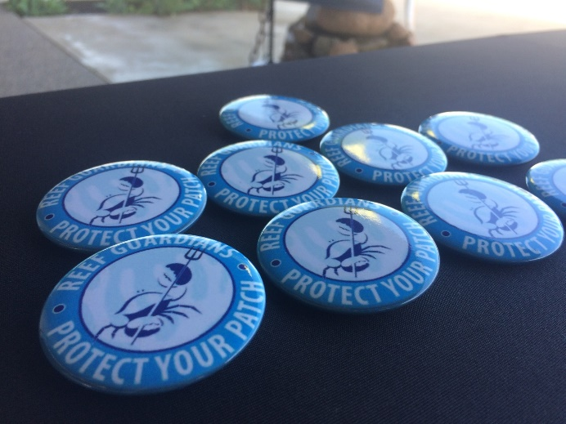
Each student, teacher and partner were provided with a badge to serve as a reminder of the skills learnt at FLEC to Protect Your Patch

Summary of events
During the FLECs, students learnt about becoming Reef stewards by:
- caring and respecting the Reef, its catchment and community
- learning and improving
- acting to minimise environmental impacts and conserve resources
- sharing knowledge and collaborating.
Through their experiences at the FLECs, students and teachers have become advocates for the Reef and can influence not only their fellow classmates and teachers at school, but their families and the wider community around them. The Reef Guardian School students are generating a culture of community stewardship for the Great Barrier Reef. This culminates in future stewards who are prepared to protect their patch. Further details of individual events are below.

Whitsundays region, Cannonvale Foreshore: 15 March 2019
Connections to place
Whitsunday students explored the concept of connections to place to develop an understanding of what Country means for Aboriginal and Torres Strait Islander people. Students learnt that Country is a spiritual and cultural place of origin which encompasses all living things, beliefs, values and creation spirits connected to that area. Students explored this idea by drawing their own special place in their life and detailing what they would like their place to look like in the future.

The Great Relay Rubbish game
Students learnt about how to dispose of rubbish properly before putting their knowledge to the test in the Great Relay Rubbish game. They had to think quick to decipher between composting, landfill and recyclable items, place it in the correct bins, and tag their teammate. They also learnt about environmentally-friendly products, how to refuse and reduce products and research correct disposal methods to ensure hazardous products don’t find themselves in our toilets, sinks and drains.

Students shared the reef-friendly actions they learnt at their FLECs via 34 school presentations and newsletter articles, expanding the reach to over 14,000 students.

Source reduction workshop
Having completed litter surveys at school prior to the FLEC, students selected one item from the top three items found in their school bins and completed a source reduction plan to take action in minimising their waste. The plan included where it was coming from, why it might be ending up in the environment, why they should stop it from getting into the environment, and how they could reduce waste at the source. Their source reduction plans were taken back to their schools to implement and take action.

The Reef Ranger game
Students learnt how the Great Barrier Reef Marine Park is managed and protected through an interactive Reef Ranger game. Using large scale mats with various Marine Park zones, some of the students played out scenarios of recreational and commercial activities occurring in particular zones. Other students took the role of a Reef Ranger and had to determine if the activities could occur in that area and the restrictions and requirements of the zone. This activity gave students an insight into the purpose and application of zoning and the life of a ranger upholding and enforcing the rules of the Great Barrier Reef Marine Park.

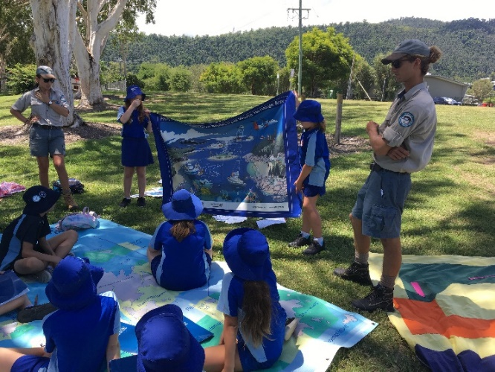
Queensland Parks and Wildlife Services (QPWS) Rangers leading students in the Reef Rangers in Action Activity

Composting and worm farming
After learning how green waste from urban areas can cause excess nutrient levels flowing into the ocean, students got their hands dirty constructing compost and worm farms. Staff from Cannonvale Bunnings showed students how to use green waste as food for worms and use their by-products as natural fertilizers for the garden, a fun way to take action for our oceans.

Beach clean-up and sorting marine debris
Partner organisation, ReefClean, explained the issue of marine debris and how they take a proactive role in cleaning up the Whitsunday Islands. Students took to the Cannonvale Foreshore to complete their own beach clean-up and undertook a rubbish audit of their findings using the Australian Marine Debris Initiative methodology. The majority of debris found in the Whitsundays is plastic, which prompted discussions about how we can reduce our consumption of plastics at the source. From the activity, students learnt the importance of removing rubbish from our natural environment and that collecting data on rubbish is a key part to stop the products at the source.

Bundaberg region, Innes Park Foreshore Reserve: 19 March 2019
Marine debris clean-up
Conservation Volunteers Australia staff and Gidarjil Land and Sea Rangers shared information about marine debris and the importance of keeping our waterways and beaches clean. Students completed a clean-up at Innes Park Beach where they found the locals are doing a great job of keeping the beach clean but discovered many small pieces of plastics. Students learnt that small plastics are just as important to pick up as larger items, as they continue to break up into tiny pieces over many years. In total, the students picked up 0.5kg of rubbish off the beach.
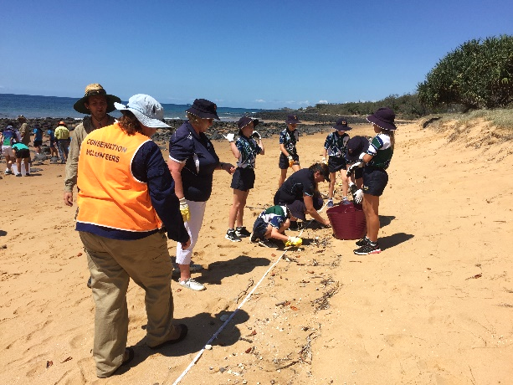
Beach clean-up activity led by Conservation Volunteers Australia staff and Gidarjil Land and Sea Rangers
Source reduction workshop
Having completed litter surveys prior to the FLEC, students selected one item from their top three items found in their school bins and completed a source reduction plan to take action in minimising their waste. The plan included where it was coming from, why it might be ending up in the environment, why they should stop it from getting into the environment, and how they could reduce waste at the source. Their plans were taken back to their schools to implement and take action.

Coastal vegetation transects
Students learnt about the critical role of dune vegetation in attracting wildlife and protecting the beach against severe weather, before heading down to the Innes Park foreshore where Bundaberg Regional Council led a coastal vegetation dune succession activity. Students completed quadrat surveys from the high tide mark towards the inland woodlands to record plant species, coverage and organisms present. Students observed and recorded the physical changes along this gradient and how the environment was altered by the presence of different forms of vegetation.

‘Great activity, hands on and students were well involved’ — Kate Connor, Burnett Heads State School
Low Glow project talk
Bundaberg Regional Council and Sea Turtle Alliance delivered a short talk on the Low Glow Project. Students learnt about how artificial light sources have a negative impact on turtles and discussed what actions they could take to reduce the amount of light on local beaches.

Ingham and Cardwell region, Tyto Wetlands: 20 March 2019
Welcome to Country and Sea Country Connection
A Warrgamay Traditional Owner began the day with a Welcome to Country, proudly sharing knowledge of his country. Students learnt the traditional Warrgamay names of animals and the special connection the Warrgamay coastal people have with crocodiles.

Fishing and zoning game
Students were given a chance to ‘go fishing’ using a giant Marine Park zoning map. They learnt the differences between zones, how to measure fish and crabs to ensure they were legal size, and why some fish can’t be taken in order to protect their populations or for human health concerns. As fishing is a major hobby for some students in the region, the activity gave them a hands-on learning experience about the importance of sustainable fishing.

TUMRAs and Sea Country Protection
Traditional Owners from the Girringun Aboriginal Corporation explained their role protecting the sea country alongside the Girringun Rangers. They shared how Traditional Use of Marine Resource Agreements (TUMRAs) are used to assist sea country to recover and return to its previous state, for example, not fishing for various species or only taking for ceremonial purposes. The presentation gave students an understanding of how the Indigenous members of their community protect their sea country.

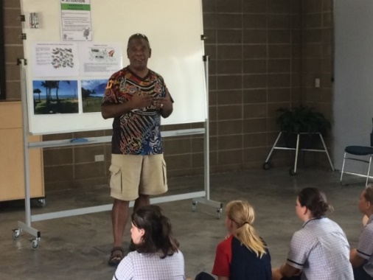
Traditional Owner shares his knowledge with students
Protect your home, school and community patch
Hinchinbrook Shire Council explained how they work to look after the foreshores of the region. Students explained the actions they take to protect their patch at home and school, with special mentions to animals like dugongs and turtles and how we need to protect valuable resources such as seagrass. In groups, students created posters to help inform the public about actions everyone can take to protect the Reef. Their posters were presented at the FLEC and respective schools to share important reef-friendly messages.

Source reduction workshop
Having completed litter surveys prior to the FLEC, students selected one item from their top three items found in their school bins and completed a source reduction plan to take action in minimising their waste. The plan included where it was coming from, why it might be ending up in the environment, why they should stop it from getting into the environment, and how they could reduce waste at the source. Their plans were taken back to their schools to implement and to take action.

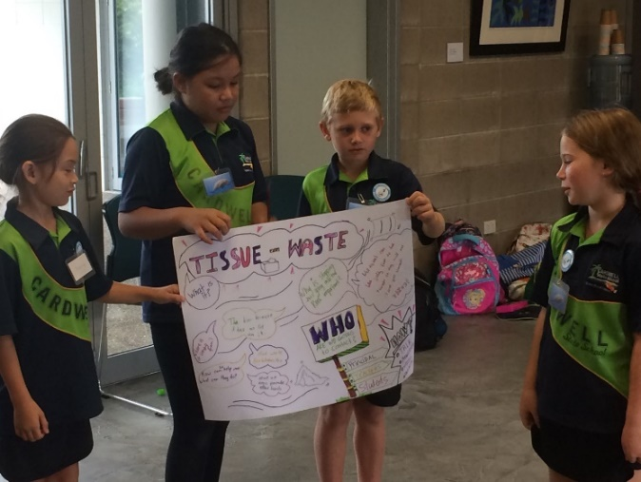
Students presenting their source reduction plan poster
Turtle Hatchlings game
A game of Turtle Hatchlings was played with students taking the role of either hatchlings making their way to sea, or predators such as birds, crabs and sharks. After witnessing a small portion of hatchlings surviving the gauntlet, students discussed the dangers turtles face in a natural environment that lead to only 1 in 1000 hatchlings living to an adult size. A second scenario incorporated human influences, such as boats, marine debris and poachers which saw no hatchlings make it to the sea. This fun game highlighted the message that if we do not protect our patch, our turtle species will become further threatened.

Gladstone region, Canoe Point: 21 March 2019
Marine debris clean-up, litter reduction plan and marine debris art
Conservation Volunteers Australia and Tangaroa Blue Foundation explained the issue of marine debris, how rubbish makes its way to our oceans, and the importance of keeping our waterways and beaches clean. They also discussed what actions the community can take at home and school to reduce debris at the source. Along Canoe Point, students completed a clean-up where they found the locals are doing a great job of keeping the beach clean but discovered many small pieces of plastics. Students learnt that small plastics are just as important to remove, as they continue to break up into tiny pieces over many years. In total, the students picked up 1kg of rubbish off the beach. Under the guidance of Gladstone Ports Corporation staff, students also created amazing marine debris artwork collected in the local area.

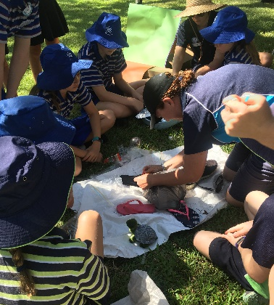
ReefClean staff helping students create art with litter collected off the beach
The Reef Ranger game
Students learnt how the Great Barrier Reef Marine Park is managed and protected through an interactive Reef Ranger game. Using large scale mats with various Marine Park zones, students played out scenarios of recreational and commercial activities occurring in particular zones. Other students took the role of a Reef Ranger and had to determine if the activities could occur in that area and the restrictions and requirements of the zone. This activity gave students an insight into the purpose and application of zoning and the life of a ranger upholding and enforcing the rules of the Great Barrier Reef Marine Park.

Coastal revegetation
Students completed a coastal revegetation tree planting activity with Gladstone Regional Council on their local foreshore. They learnt about the importance of revegetation of coastal zones and how they stabilise sand dunes and protect them from storm surges. Students were shown the correct method to plant a tree and taught how the plants survive in their environment.

Rocky foreshore investigation
Staff from Boyne Island Environmental Education Centre helped the students investigate the rocky zones of Canoe Point using quadrats. Students investigated what organisms they found, counted them, and described their structures and behaviours that help them survive in that zone. They also used a multi probe to measure the temperature, pH, turbidity and other water quality parameters in a rock pool, giving the students a holistic view of the foreshore.

‘I believe this is a great event that promotes a great understanding for the youth’ — Gladstone Regional Council

Capricorn region, Lammermoor Beach: 26 March 2019
Marine debris clean-up
ReefClean and a representative from the local Science, Technology, Engineering, Arts and Maths hub, taught the students about marine debris and the importance of keeping our waterways and beaches clean. They completed a clean-up of Lammermoor Beach where they found many small pieces of plastic and learnt that plastics don’t break down, they break up. This highlighted the importance in reducing the amount of plastic entering the marine environment as it continues to break up into smaller pieces and creates a potentially greater problem. In total, 4.7kg of rubbish was collected off the beach.

The Reef Ranger game
Students learnt how the Great Barrier Reef Marine Park is managed and protected through an interactive Reef Ranger game, assisted by Marine Park Rangers from our Field Management Partners, the Queensland Parks and Wildlife Service. Using large scale mats with various Marine Park zones, students played out scenarios of recreational and commercial activities occurring in particular zones. Other students took the role of Reef Rangers and had to determine if the activities could occur in that area and the restrictions and requirements of the zone. This activity gave students an insight into the purpose and application of zoning and the life of a ranger upholding and enforcing the rules of the Great Barrier Reef Marine Park.

Litter reduction plan
Students and staff from Fitzroy Basin Association discussed how litter ends up as marine debris. Through the development of a Litter Reduction Plan, they learnt how to reduce sources of litter within their schools, home and community.
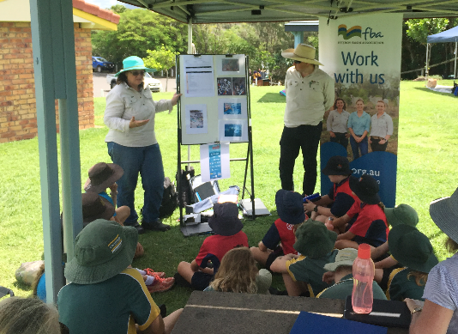
Staff from Fitzroy Basin Association discussing how litter ends up as marine debris
Coastal revegetation
Students went to Lammermoor Beach where they participated in a coastal revegetation tree planting activity with Livingstone Shire Council. They learnt about the importance of revegetation of coastal zones and how they stabilise sand dunes and protect them from storm surges. Students learnt the correct methods to plant a tree and how plants survive in their environments.

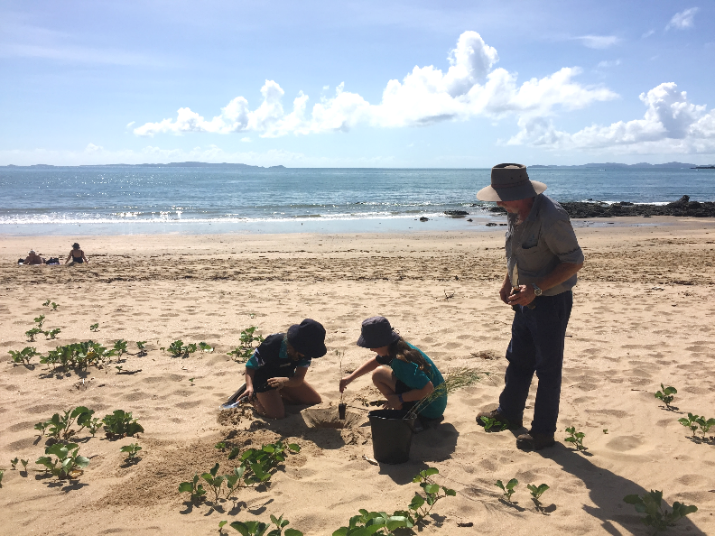
Staff from Livingstone Shire Council supervising a coastal revegetation activity

Burdekin region, Home Hill State High School: 27 March 2019
Sea country connections art workshop
Gudjuda Reference Group Rangers delivered a Sea Country Connections Art Workshop by teaching students about Indigenous art and helping students paint replica turtle shells. Artworks were taken home to remind them of everything they learnt throughout the day to protect their patch.

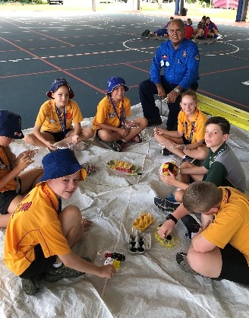
Students learning Indigenous art from a Traditional Owner

‘The day was fun. It is good to learn how to look after the Reef’ — Louise Nicholas, Home Hill State High School
Turtle Hatchlings game
A game of Turtle Hatchlings was played with students taking the role of either hatchlings making their way to sea, or predators such as birds, crabs and sharks. After witnessing a small portion of hatchlings surviving the gauntlet, students discussed the dangers turtles face in a natural environment that lead to only 1 in 1000 hatchlings living to an adult size. A second scenario incorporated human influences, such as boats, marine debris and poachers which saw no hatchlings make it to the sea. This fun game highlighted the message that if we do not protect our patch, our turtle species will become further threatened.
Protecting the community’s patch
Burdekin Shire Council showcased an interactive model of the Burdekin region to demonstrate how they can improve environmental practices and make the community more sustainable. Using the model, children saw how land-based activities affect the water quality around Burdekin’s wetlands and, subsequently, the water quality of the Great Barrier Reef. Students left with a take the home message of ‘human impacts and solutions to protect the environment’
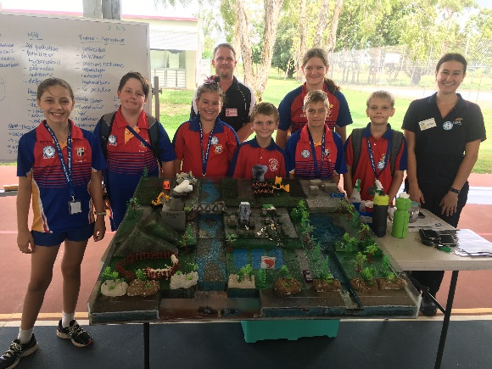
Staff from Burdekin Shire Council and students demonstrate
the effects of run-off and rubbish on the Reef using a model of
the region
Source reduction workshop
Having completed litter surveys prior to the FLEC, students selected one item from their top three items found in their school bins and completed a source reduction plan to take action in minimising their waste. The plan included where it was coming from, why it might be ending up in the environment, why they should stop it from getting into the environment, and how they could reduce waste at the source. Their plans were taken back to their schools to implement and to take action.

‘Participating students seemed to be relatively well-informed prior to attending. The activities allowed them to build on their existing knowledge’ — Ashley McLachlan, Principal Paluma Environmental Education Centre

Home Hill State High School talk and tour
Home Hill State High School’s Year 7 students presented a talk and tour about the activities and actions they take at school to protect their patch of the Reef. For example, recycling, waste-free lunches, aquaponics, vegetable gardens, and worm farms.

Mackay region, Mackay Regional Botanical Gardens: 28 March 2019
Connections to Land
A Yuibera Traditional Owner opened the event with a Welcome to Country where students learned about his cultural background, sustainability, local foods, hunting and traditional Aboriginal plant uses.

Fish ways and habitats
Students explored Lagoon Creek’s man-made fish way and wetland lagoon and learnt why fish ways are vital for certain species of fish to complete their life cycle. Students also discussed how wetlands provide a safe haven for fish to grow and can reduce sediment run-off flowing down rivers and into the Great Barrier Reef Marine Park.

Soil health activity
A local cane farmer involved in the Watershed Land Art Project explained how cane farmers’ actions improve soils in the Pioneer Valley and help the Reef, and the importance of the project in educating the Mackay community. The students thought about how one teaspoon of healthy soil can hold more organisms than there are people living in Mackay, even though they may not be able to see them all. Students learnt that regenerative agriculture principles enable farmers to improve plant, soil and ecosystem health, reduce the need for synthetic inputs and fertilizers, reduce soil and fertilizer run-off into local waterways and the Great Barrier Reef, and increase soil carbon sequestration.

Shaping our watershed and reducing the effects of land-based runoff
Another partner from the Watershed Land Art Project gave students a better understanding of the Great Barrier Reef catchment. Specifically, they discussed erosion and how water flowing through the catchment eventually flows to the Reef. Students brainstormed how different groups within the community contribute to and can reduce the amount of land-based run-off entering our waterways and the Reef. The groups worked through a series of scenarios, looking for creative ways to minimise their impacts as community, councils, farmers or industry.

Source reduction workshop
Having completed litter surveys at school prior to the FLEC, students selected one item from their top three items found in their school bins and completed a source reduction plan to take action in minimising their waste. The plan included where it was coming from, why it might be ending up in the environment, why they should stop it from getting into the environment, and how they could reduce waste at the source. Their plans were taken back to their schools to implement and to take action.

Bowen region, Horseshoe Bay & Mount Gordon: 2 April 2019
Local geography
Whitsunday Regional Council’s Natural Resource Manager described to students the local coastal geography of Horseshoe Bay. Students answered questions on potential hazards and impacts created by humans and how the area might be managed, giving them a sense of understanding and ownership of their coastal environment.

Connections to place
Students explored the coastal trail from Horseshoe Bay to Greys Bay, enjoying the natural beauty and look for locations of importance to Indigenous ancestors. Students considered their connections to an important place in their life to gain an understanding of how Traditional Owners think of ‘being on Country’. Students were surprised to learn that when the Kapok tree, Bowen’s flower emblem, is flowering it signals turtle nesting season.

Managing the environment with Queensland Parks and Wildlife Services
A QPWS Ranger asked students to consider the changes that have occurred over time in the environment and on the Great Barrier Reef. He explained the difference in vegetation found in our coastal areas, and that some introduced species can become pests which affect local biodiversity.
Students were given a chance to ‘go fishing’ using a giant Marine Park zoning map. They learnt the differences between zones, how to measure fish and crabs to ensure they were legal size, and understood why some fish can’t be taken in order to protect their populations or for human health concerns.

Source reduction workshop
Having completed litter surveys prior to the FLEC, students selected one item from their top three items found in their school bins and completed a source reduction plan to take action in minimising their waste. The plan included where it was coming from, why it might be ending up in the environment, why they should stop it from getting into the environment, and how they could reduce waste at the source. Their plans were taken back to their schools to implement and to take action.

Great Rubbish Relay game
Students learnt about how to dispose of rubbish properly before putting their knowledge to the test in the Great Rubbish Relay game. Students had to think quick to decipher between composting, landfill and recyclable items, place it in the correct bins, and tag their teammate. Students also learnt about environmentally-friendly products, how to refuse and reduce products and research correct disposal methods to ensure hazardous products don’t find themselves in our toilets, sinks and drains.

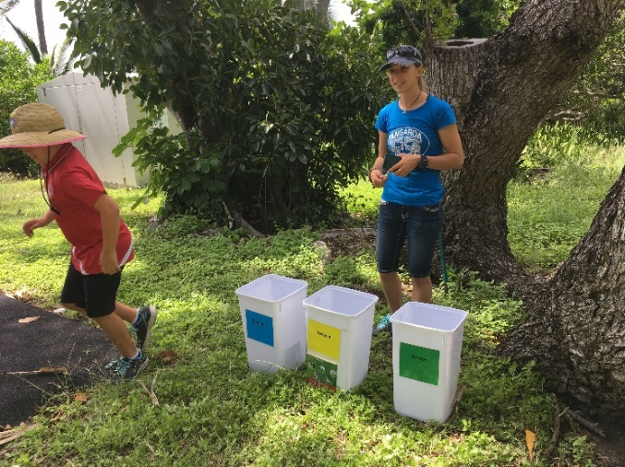
ReefClean staff with the Great Rubbish Relay Game
Beach clean-up
ReefClean hosted a beach clean-up at Gordon’s Beach. As the beach is directly beside the Bruce Highway and positioned to capture rubbish via currents and winds, marine debris is a major problem in this area. Students were able to collect 29kgs of rubbish in just 40 minutes.

Townsville region, St. Benedict’s Catholic School: 3 April 2019
St Benedict’s Catholic School protecting their patch
As the FLEC host school, St Benedict’s Catholic School students and teachers delivered a presentation about the actions and projects they take to protect the environment and the Great Barrier Reef. The students learnt about specific environmental projects each year level works on through the school year, including creating a chicken coop and a vegetable garden.

Protecting the community’s patch
Townsville City Council explored the issues associated with marine debris and how everyone can make a difference using the 4 Rs of waste management — refuse, reduce, reuse and recycle. Inspired by a video on the 'Journey to the Ocean via Rubbish', students developed posters in groups, demonstrating how they will use the 4 Rs of waste management to protect their patch. Students left the activity with a strong understanding of the environmental impacts associated with littering and the ways they can reduce their waste footprint.

‘Kids came away from the day eager to start making a change’ — Elyse Charles, Kelso State School
Turtle Hatchlings game
A game of Turtle Hatchlings was played with students taking the role of either hatchlings making their way to sea, or predators such as birds, crabs and sharks. After witnessing a small portion of hatchlings surviving the gauntlet, students discussed the dangers turtles face in a natural environment that lead to only 1 in 1000 hatchlings living to an adult size. A second scenario incorporated human influences, such as boats, marine debris and poachers which saw no hatchlings make it to the sea. This fun game highlighted the message that if we do not protect our patch, our turtle species will become further threatened.

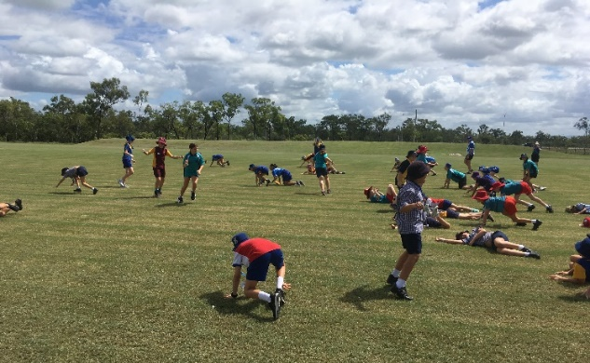
Students taking part in the Turtle Hatchlings game
Source reduction workshop
Having completed litter surveys prior to the FLEC, students selected one item from their top three items found in their school bins and completed a source reduction plan to take action in minimising their waste. The plan included where it was coming from, why it might be ending up in the environment, why they should stop it from getting into the environment, and how they could reduce waste at the source. Their plans were taken back to their schools to implement and to take action.

Responsible Reef Practices
Queensland Boating and Fisheries Patrol joined forces with Reef Guardian staff to deliver a fun and informative activity in fishing, zoning and boating practices in the Great Barrier Reef. Students learnt about what zones they can and can’t fish in, as well as what they can take home or release back. They also learnt how to be responsible when using boats in the Marine Park and learnt about safety considerations to care for themselves and marine life.

