# Position statement marine debris

## Our position

Marine debris is a major threat to the health of the Great Barrier Reef and kills marine life such as turtles, dugongs, dolphins and seabirds. Collective action by community, industry and government to choose sustainable options, minimise waste and undertake stewardship activities is required to reduce the impacts of marine debris on the Reef.

## Position Snapshot

The major threats to the health and resilience of the Great Barrier Reef include climate change, land-based run-off, coastal development and marine debris.1

The United Nations Environment Programme defines marine debris as any persistent, manufactured or processed solid material discarded, disposed of or abandoned in the marine and coastal environment.2

Sources of marine debris include urban stormwater discharge, severe weather events, international waters, and deliberate or accidental littering from shipping or boating activities.

Plastic pollution is a high and increasing threat to the Reef.2,3,4 More than 80 per cent of marine debris found in the Reef is plastic3, which includes macroplastics, microplastics, and abandoned, lost or otherwise discarded fishing and boating gear. Once plastic enters the ocean it can travel vast distances and break up into smaller pieces, which increases the risk of impacts.5The proportion of plastic in the Marine Park is greater in the north than the south, and may come from the land or sea.6

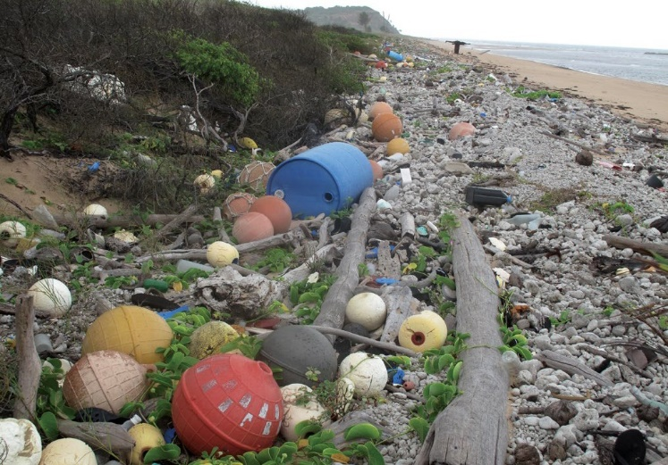

Photo – marine debris washed up on Cape York beach, © Tangaroa Blue Foundation and Australian Marine Debris Initiative, photographer: H. Taylor

Plastic is life-threatening for marine species. Impacts include entanglement, ingestion, toxic exposure, disease and death. Marine debris negatively affects all species of sea turtle and more than half of all known species of marine mammal and seabirds.7,8 Critical nesting habitats are also affected. Studies show that plastic exposure also dramatically increases the occurrence of coral disease.9

The Great Barrier Reef Marine Park Authority supports accelerated, evidence-based actions at local, national and international levels to reduce all sources of marine debris through:

* reimagining and repurposing products away from plastics
* reducing production and use of plastic, particularly single-use plastic
* phasing out plastic microbeads in personal care products and rinse-off cosmetics
* preventing the direct release of microplastics into the Marine Park through innovative solutions at municipal outfalls, resorts and other facilities
* prioritising reusable options
* enhancing plastic recyclability
* enhancing community awareness of responsible recycling practices
* removing existing marine debris through clean-up activities.

The Authority is committed to working with partners through education and stewardship programs to address gaps and reduce the impacts of marine debris on the Reef. Strengthening international partnerships to advocate for global change and educate and raise awareness about marine debris is a priority for the Authority.

## The Great Barrier Reef is a valuable environmental, cultural and economic asset

The Great Barrier Reef Region22 is listed as a World Heritage Area. This comes with a responsibility to protect the Reef’s condition for current and future generations.

The Great Barrier Reef Marine Park Authority manages the Marine Park under the *Great Barrier Reef Marine Park Act 1975.*

The Reef is worth $6.4 billion annually to the Australian economy23 — a contribution largely derived from the tourism industry — with the Reef attracting nearly two million visitors each year from across the globe.

Traditional Owners have cultural connections with the Reef that extend back thousands of years, and most Australians revere the Reef as the nation’s most inspirational landscape.23

## Issue: marine debris is an increasing threat to the Reef

Marine debris is a major and increasing threat to the Reef.1 Debris is transported by ocean currents from both local and international sources and has been found in some of the most remote areas of the region.1 Marine debris can float, sink, become entangled on rocky outcrops or reefs10, or become buried in the sea floor where it can resurface after disturbances such as tropical cyclones and floods.

More than 80 per cent of marine debris is plastic and includes:

* macroplastics –– plastic items greater than five millimetres in size –– that enter the marine environment via urban stormwater discharge, wind, streams, severe weather events, community landfills, direct littering of beaches11, international sources, and shipping or boating activities. Plastic pollution from international sources is an issue in the far north of the Marine Park, where up to 95 per cent of marine debris is plastic.3,6
* primary microplastics –– less than five millimetres in size –– such as plastic resin pellets, microbeads from personal care products and microfibres shed from synthetic clothing materials during clothes-washing
* secondary microplastics from the breakup of macroplastics
* abandoned, lost or otherwise discarded fishing gear from recreational and commercial fishing, including crab pots and fishing nets.

Other marine debris consists of wood, metal, shipping containers, foam, rubber and glass.

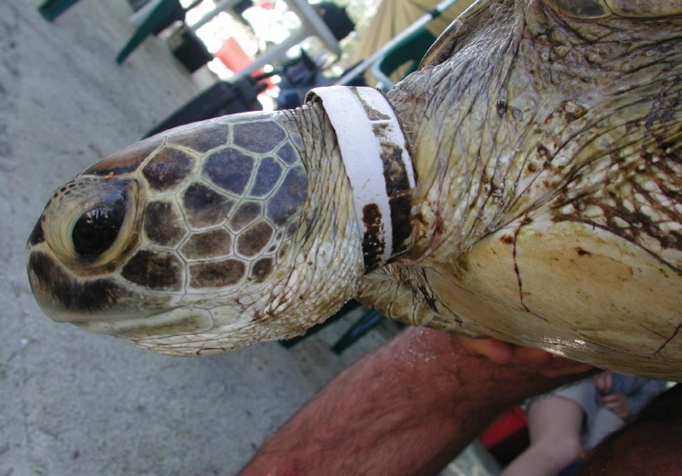

Photo – green turtle with plastic debris around its neck at the Howicks, 150 kilometres north of Cooktown © Queensland Parks and Wildlife Service

## Impact: marine debris negatively affects all of the Reef’s values

Marine debris has an impact on all Reef values12 — its beauty, rich biodiversity, extensive natural habitats, historic heritage, and Aboriginal and Torres Strait Islander cultural values.

Impacts on the Reef from marine debris include:

* entanglement of wildlife in abandoned or lost fishing gear, balloons and plastic bags2, causing drowning, amputation of limbs, and increased risk of predation of turtles, dugongs, cetaceans, seabirds and other species13
* ingestion of plastic bags and microplastics by turtles14, cetaceans, seabirds and fish12,15, resulting in gastrointestinal blockages or perforation, feelings of fullness leading to starvation, underdevelopment and mortality16
* potential toxic effects on marine species caused by chemicals in plastic that leach out after being eaten.17,18 Contaminants associated with plastics may also accumulate in the tissues of marine animals over time16
* smothering and entanglement of corals by plastic, increasing the incidence of coral disease7
* loss of critical habitat for nesting turtles
* negative effects on community benefits such as enjoyment, visual features, appreciation, personal connection, tourist satisfaction19,20 and the aesthetics of the Reef
* negative effects on Aboriginal and/or Torres Strait Islander heritage values such as totem species, stories, songlines, sites of particular significance and important places for cultural tradition.

Marine debris adds to the cumulative impact of other key pressures affecting the health and resilience of the Reef.

Injury and fatality to vertebrate marine life, caused by ingestion of, or entanglement in, harmful marine debris was named as a key threatening process under the *Environment Protection and Biodiversity Conservation Act 1999.* The Australian Government has adopted a [Threat Abatement Plan](http://environment.gov.au/biodiversity/threatened/publications/tap/marine-debris-2018)10 to provide a coordinated national approach to mitigate the impacts of marine debris on the vertebrate wildlife of Australia’s coasts and oceans.

## Actions and outcomes: strong action is urgently needed to prevent marine debris

A suite of actions is required to stop marine debris entering the Marine Park. These actions need to apply at local, regional, national and international scales, with the goal of stopping marine debris at the source or before release into the environment. Source reduction requires coordinated actions to drive change through effective policies and strategies to reduce impacts on the Reef.

The National Waste Policy reflects a global shift towards a circular economy, which involves designing systems and products to avoid waste, conserving resources and maximising the value of all materials used. It also includes improving capacity for products to be better designed, reused, repaired and recycled.

The Queensland Government is developing a Plastic Pollution Reduction Plan as part of its broader waste strategy to identify how government, businesses and the community can work together to reduce the impacts of plastic pollution. This plan aims to influence responsible consumption and disposal behaviors, encourage redesign and innovation, and to stimulate and develop industry.

Hierarchy. In order from top to bottom: repurpose and reimaging; reduce; reuse; recycle; recover; and disposal.

Items higher up on the hierarchy are most preferred, with those lower are least preferred

Photo – Hierarchy of actions that can be taken to address the impacts of marine debris on the Reef.

**Repurposing and reimagining** includes changing the composition or function of products to minimise waste or non-renewable material, or redesigning products to reduce or remove plastic content. Two examples are the [voluntary phase-out](http://www.environment.gov.au/protection/waste-resource-recovery/plastics-and-packaging/plastic-microbeads) of personal care products containing microbeads, and the actions of the Australian Packaging Covenant Organisation to implement targets to reduce waste from packaging and improve recycling by 2025.21

**Reducing and reusing** plastic results in less plastic ending up in the Reef. Changes are required by industry and consumers to replace single-use plastic items like straws, coffee cups, pods and plastic beverage containers with reusable products that have lower overall environmental impacts. For example, Citizens of the Great Barrier Reef and partners have [pledged](https://citizensgbr.org/c/plastic-free-pledge/) to cease use of single-use plastics such as straws. The ban on single-use plastic bags by the Queensland Government is a good example of effective policy leading to behavioural change and product reuse.

**Recycling** captures items that cannot be reused. There are many effective government policies in place that address recycling, including kerbside collection, the [container refund scheme](https://www.qld.gov.au/environment/pollution/management/waste/recovery/reduction/container-refund) adopted by the Queensland Government, and the collection and recycling of soft plastics through groups like [RedCycle](https://www.redcycle.net.au/) and [RePlas](https://www.replas.com.au/). The National Waste Policy will help to improve Australia’s recovery of resources through recycling.

**Recovering and removing** marine debris through beach clean-ups and gross pollutant traps complement longer-term, strategic source reduction activities and anti-littering campaigns. Larger plastic items are easier to identify and remove from the environment and if they are not removed they break up into smaller plastic pieces which are more difficult to remove.

## Working at home and overseas

The Authority empowers and supports education and stewardship to help drive change to improve the health of the Reef. This is possible by working with Traditional Owners, Local Marine Advisory Committees and non- government organisations. Reef HQ Aquarium is the Authority’s education centre which raises awareness of the impacts of marine debris through educational talks and tours including the Turtle Hospital.

The Authority’s Reef Guardian program collaboratively facilitates the adoption of ‘reef friendly’ behaviours and practices within the community led by schools, local government and industry. Program activities aim to build a network of informed, connected and empowered environmental stewards by building knowledge, fostering leadership, encouraging action and facilitating partnerships. Supporting capacity-building activities helps to reduce marine debris at source and promoting stewardship empowers stakeholders to be part of the solution.

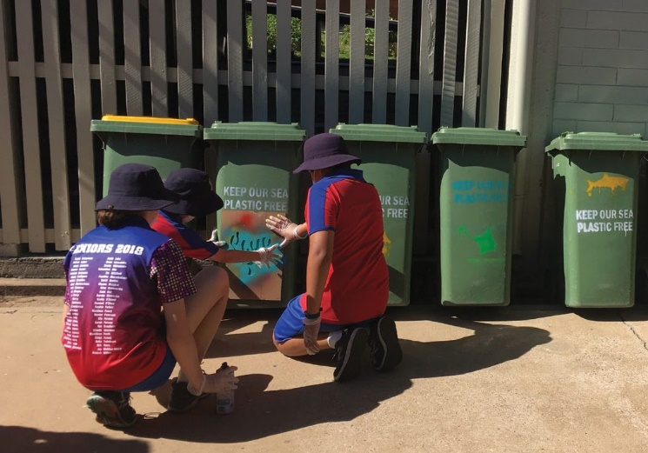

Photo – Reef Guardian School St Francis stenciling rubbish bins with *Keep our sea plastic free* © Commonwealth of Australia (Great Barrier Reef Marine Park Authority)

International partnerships such as the International Coral Reef Initiative and the Commonwealth Clean Oceans Alliance are effective forums to advocate for a reduction in internationally sourced plastic pollution and marine debris. Australia is a founding member of the International Coral Reef Initiative, which was started to raise the profile of the impacts on coral reefs locally and internationally.

## Working in partnership

Aboriginal and Torres Strait Islanders are regularly involved in marine debris clean-up projects. Land and Sea Rangers work with [Tangaroa Blue](https://www.tangaroablue.org/amdi/indigenous-rangers.html) [Foundation](https://www.tangaroablue.org/amdi/indigenous-rangers.html) to remove thousands of tonnes of marine debris from remote and significant sites across Australia.

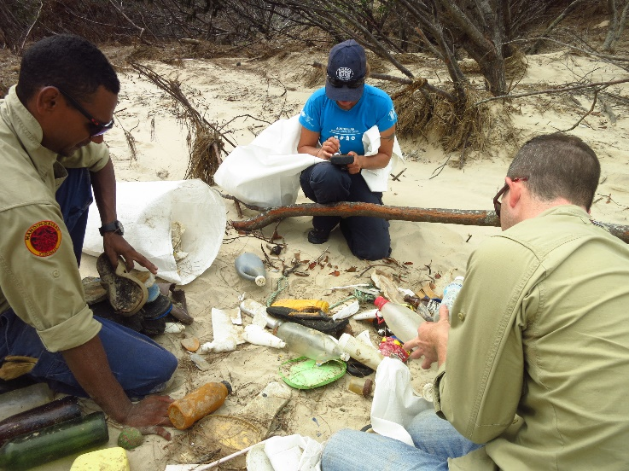

Photo – Yeppoon cyclone clean-up 2015 © Tangaroa Blue Foundation

## In summary

Marine debris is a major threat to the health of the Great Barrier Reef. Strong action is required to repurpose and reimagine products for sustainability, to reduce the use of plastics, increase reusable options, and recycle effectively to reduce all forms of marine debris entering the Marine Park.

## References

1. Great Barrier Reef Marine Park Authority 2014, *Great Barrier Reef Outlook Report 2014*, Great Barrier Reef Marine Park Authority, Townsville.
2. United Nations Environment Programme 2009, *Marine Litter: A Global Challenge,* UNEP, Nairobi, Kenya.
3. Kroon, F., Berry, K., Brinkman, D., Davis, A., King, O., Kookana, R., Lewis, S., Leusch, F., Makarynskyy, O. and Melvin, S. 2015, *Identification, Impacts, and Prioritisation of Emerging Contaminants Present in the GBR and Torres Strait Marine Environments. Report to the National Environmental Science Programme,* Reef and Rainforest Research Centre Limited, Cairns.
4. Waterhouse, J., Schaffelke, B., Bartley, R., Eberhard, R., Brodie, J., Star, M., Thorburn, P., Rolfe, J., Taylor, B. and Kroon, F. 2017, *2017 Scientific Consensus Statement: Land Use Impacts on Great Barrier Reef Water Quality and Ecosystem Condition,* The State of Queensland, Brisbane.
5. Ivar do Sul, J.A. and Costa, M.F. 2014, The present and future of microplastic pollution in the marine environment (review), *Environmental Pollution* 185: 352.
6. Australian Marine Debris Initiative and Tangaroa Blue Foundation 2018, Australian Marine Debris Database, AMDI, [tangaroablue.org/database.html](https://www.tangaroablue.org/database.html).
7. Gall, S.C. and Thompson, R.C. 2015, The impact of debris on marine life, *Marine Pollution Bulletin* 92: 170-179.
8. Wilcox, C., Van Sebille, E. and Hardesty, B.D. 2015, Threat of plastic pollution to seabirds is global, pervasive, and increasing, *Proceedings of the National Academy of Sciences of the United States of America* 112(38): 11899-11904.
9. Lamb, J.B., Willis, B.L., Fiorenza, E.A., Couch, C.S., Howard, R., Rader, D.N., True, J.D., Kelly, L.A., Ahmad, A. and Jompa, J. 2018, Plastic waste associated with disease on coral reefs, *Science* 359(6374): 460-462.
10. Australian Government Department of the Environment and Energy 2017, *Threat Abatement Plan for the Impacts of Marine Debris on Vertebrate Marine Life.*
11. Keep Australia Beautiful National Association Inc. 1996, *Looking at Litter and What’s Being Done About It: A Survey of Litter in Australia*, The Association, Deakin, ACT.
12. Great Barrier Reef Marine Park Authority 2014, *Great Barrier Reef Region Strategic Assessment: Strategic Assessment Report,* GBRMPA, Townsville.
13. Wilcox, C., Hardesty, B.D., Sharples, R., Griffin, D.A., Lawson, T.J. and Gunn, R. 2013, Ghostnet impacts on globally threatened turtles, a spatial risk analysis for Northern Australia, *Conservation Letters* 6(4): 247-254.
14. Caron, A.G.M., Thomas, C.R., Berry, K.L.E., Motti, C.A., Ariel, E. and Brodie, J.E. 2018, Ingestion of microplastic debris by green sea turtles *(Chelonia mydas)* in the Great Barrier Reef: Validation of a sequential extraction protocol, *Marine Pollution Bulletin* 127: 743-751.
15. Critchell, K. and Hoogenboom, M.O. 2018, Effects of microplastic exposure on the body condition and behaviour of planktivorous reef fish *(Acanthochromis polyacanthus),* PLoS ONE 13(3): e0193308.
16. Rochman, C.M., Hoh, E., Kurobe, T. and Teh, S.J. 2013, Ingested plastic transfers hazardous chemicals to fish and induces hepatic stress, S*cientific Reports* 3: 3263.
17. Lithner, D., Larsson, A. and Dave, G. 2011, Environmental and health hazard ranking and assessment of plastic polymers based on chemical composition, *Environmental Science and Technology* 409: 3309.
18. Rochman, C.M., Hoh, E., Hentschel, B.T. and Kaye, S. 2013, Long-term field measurement sorption of organic contaminants to five types of plastic pellets: implications for plastic marine debris, *Environmental Science and Technology* 47: 1646.
19. Mustika, P., Stoeckl, N. and Farr, M. 2016, The potential implications of environmental deterioration for business and non-business visitor expenditures in a natural setting: a case study of Australia’s Great Barrier Reef, Tourism Economics 22(3): 484-504.
20. Jarvis, D., Stoeckl, N. and Liu, H. 2016, The impact of economic, social and environmental factors on trip satisfaction and the likelihood of visitors returning, *Tourism Management* 52: 1-18.
21. Australian Packaging Covenant Organisation 2018, *Australia’s environmental ministers commit to eliminating all packaging going to landfill by 2025,* APCO, [https://www. packagingcovenant.org.au/news/australias-environment- ministers-commit-to-eliminating-all-packaging-g](https://www.packagingcovenant.org.au/news/australias-environment-ministers-commit-to-eliminating-all).
22. *Great Barrier Reef Marine Park Act 1975,* Commonwealth of Australia.
23. Deloitte Access Economics 2017, *At What Price? The Economic, Social and Icon Value of the Great Barrier Reef,* Deloitte Access Economics, Brisbane.
24. Marshall, N.A., Bohensky, E., Curnock, M., Goldberg, J., Gooch, M., Nicotra, B., Pert, P.L., Scherl, L., Stone-Jovicich, S. and Tobin, R.C. 2014, *The Social and Economic Long Term Monitoring Program (SELTMP) for the Great Barrier Reef. Final Report. Report to the National Environmental Research Program,* Reef and Rainforest Research Centre Limited, Cairns.

## Further information

Director, Strategic Advice

## Great Barrier Reef Marine Park Authority

PO Box 1379

Townsville Qld 4810 Australia

Phone: + 61 7 4750 0700

Email: [info@gbrmpa.gov.au](mailto:info@gbrmpa.gov.au)

[gbrmpa.gov.au](http://www.gbrmpa.gov.au/)

Document Control Information

*Approved by: Great Barrier Marine Park Authority Board on 04-Dec-2018*

*Last reviewed: 04-Dec-2018*

*Next review: 04-Dec-2018*

*Created: 04-Dec-2018*

*Document custodian: Director, Strategic Advice*

*Replaces: New*

All photos in this document are © Commonwealth of Australia (Great Barrier Reef Marine Park Authority)