Position Statement Coastal ecosystems

Our position
The loss of ecosystem function from coastal development is one of the major threats to the Great Barrier Reef. An integrated whole-of-catchment approach is needed to protect and restore the ecological functioning of coastal ecosystems. Healthy coastal ecosystems are critical for the long-term health of the Reef.

Position Snapshot
Coastal ecosystems are the 14 ecosystems that connect with the catchment to the reef: coral reefs, lagoon floors, islands, open water, seagrass, coastline, estuaries, freshwater wetlands, forested floodplains, heath and shrublands, grass and sedgelands, woodlands, forests, and rainforests. They provide a range of ecological processes that support the health of the Great Barrier Reef.
Catchment areas have undergone significant change since European settlement and Reef health is declining due to pressures from the human use of the terrestrial and marine environment.
Protecting, maintaining and restoring coastal ecosystems is critical to supporting Reef recovery. It is important — but not enough — to protect remaining coastal ecosystems from further loss.
Improving ecological processes through interventions across human modified coastal ecosystems is needed. Interventions can help to ensure ongoing sustainability of ecosystem function and help to build the resilience of the Reef.
Best practice coastal ecosystem management is based on an integrated whole-of-system approach. This involves evaluating and prioritising proposed actions through evidence-based ecological risk assessment processes that consider cumulative impacts to the Reef, including climate change impacts, such as rising sea levels.
The Australian and Queensland governments’ Reef 2050 Long-Term Sustainability Plan (Reef 2050 Plan) provides an overarching strategy to coordinate actions for managing the Reef, including the objective: ‘the Great Barrier Reef World Heritage Area retains its integrity and system functions by maintaining and restoring the connectivity, resilience and condition of marine and coastal ecosystems’.¹
The Authority has identified specific coastal ecosystems critical to the health of the Reef. It recognises that protection or restoration should be prioritised for areas of highest value within inshore waters, or where improving ecosystem processes will provide the greatest benefit to multiple values in the catchment and the Reef.
The Authority encourages all catchment users, natural resource managers, decision makers and stakeholders to understand how their local catchments function through application of the Queensland Government’s Whole-of-System Catchment Management Framework.²

The Authority supports:
- management of coastal ecosystems based on an integrated whole-of-system approach
- a catchment-wide and multi-disciplinary understanding of the connections between the catchment and the Reef
- prevention of further decline in catchment components and processes
- best practice management that promotes the protection and restoration of critical Great Barrier Reef coastal ecosystems.
Protection and restoration of coastal ecosystems will help reduce the cumulative effects of the current and ongoing impacts to the health of the Reef.
Supporting coastal ecosystem health also has climate change-related benefits. Coastal habitats, such as mangrove forests and seagrass meadows store carbon, known as blue carbon, which helps to reduce global warming.
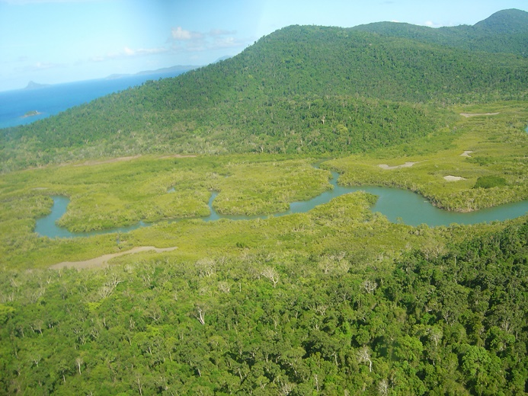
Photo - Conway National Park near the Whitsunday Islands, is one of the coastal ecosystems of the Great Barrier Reef

Issues: coastal ecosystems connect the catchment on the Reef
The catchment is complex and intrinsically connected through its flora, fauna, soils and water. Coastal ecosystems support the physical, biological, biogeochemical and chemical processes that reinforce the Reef’s ecosystem health and resilience. Some remain in their natural state while others have been modified and their function altered through changes in land-use.
Coastal ecosystems deliver many ecosystem goods and services that have a direct and indirect impact on human wellbeing and support a range of Reef-dependent industries. Understanding how hydrology, biology, geology, fluvial geomorphology and coastal processes have shaped the catchment and the Reef is essential to protect the Reef’s environmental, economic, social and cultural values.
Coastal ecosystems and inshore biodiversity are sensitive to changes caused by modification to the catchment, in particular, land clearing and/or development and altered water flow.

Impacts: changes in coastal ecosystems affect the health of the Reef
Although the most serious threat to the health of the Reef is climate change³, increasing development since European settlement has significantly impacted coastal ecosystems.
The extent of coastal ecosystems and land uses in the catchment have been mapped⁴, and a comparison of these two factors highlights the extensive changes in the catchment since European settlement.
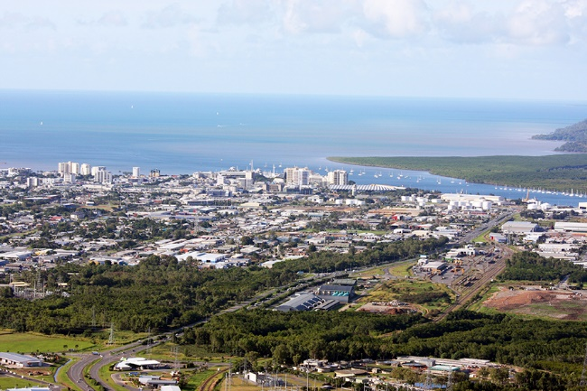
Photo - Cairns is located on the intertidal ecosystem connecting the land to the Reef in far north Queensland
Impacts to the Reef resulting from reduced or changed coastal ecosystem services include:
- increased loads of suspended solids entering Reef waters, contributing to greater inshore turbidity, affecting light availability for species and habitats
- increased loads of bioavailable nutrients entering Reef waters, providing a food source for crown-of-thorns starfish larvae resulting in increased survivorship and exacerbating outbreaks of this native pest species⁵
- increased freshwater volume and velocity entering Reef waters leading to larger flood plumes that extend further into the Reef. These flows also lead to greater erosion of stream and river banks, further increasing sediment loads
- reduction in groundwater base flows that can result in declining riverine and wetland water quality and habitats
- loss of connectivity affecting marine species that depend on the catchment for parts of their life cycle (through removal of critical migration pathways and habitat for refuge, feeding, breeding and nurseries for juveniles such as barramundi and mangrove jack)
- loss of habitat that provides roosts, refugia, food and connections to the Reef for non-marine species (such as butterflies, bats and birds)
- loss of biogeochemical regulation, altering the catchment’s ability to regulate temperature, pH and alkalinity, and resulting in changes to downstream aquatic ecosystems and species
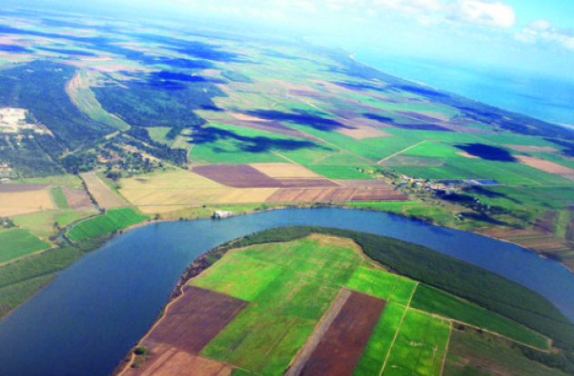
Photo - Farms along the banks of the Burnett River near Bundaberg in the Great Barrier Reef catchment
- exposure of potential acid sulphate soils, leading to long-term declines in downstream habitats and species diversity because of exposure to highly acidic or toxic waters
- accelerated erosion of areas surrounding hard-engineered coastal barriers (for example, sea walls) and loss of coastal habitat.

The Great Barrier Reef is a valuable environmental, cultural and economic asset
The Great Barrier Reef Region⁶ is listed as a World Heritage Area. This comes with a responsibility to protect the Reef’s condition for current and future generations.
The Great Barrier Reef Marine Park Authority manages the Marine Park under the Great Barrier Reef Marine Park Act 1975.
The Reef is worth $6.4 billion annually to the Australian economy⁷ – a contribution largely derived from the tourism industry — with the Reef attracting nearly 2 million visitors each year from across the globe.
Traditional Owners have cultural connections with the Reef that extend back thousands of years, and most Australians revere the Reef as the nation’s most inspirational landscape⁸.

Actions and outcomes: protecting and restoring coastal ecosystems for a healthier Reef
The Authority encourages all catchment users, natural resource managers, decision makers and stakeholders to understand how their local catchments function through application of the Queensland Government’s Whole-of-System Catchment Management Framework.²
A catchment-wide and multi-disciplinary understanding of the connections between the catchment and the Reef is essential and should be based on:
- ecosystem components (such as the flora, fauna, soil and water) and ecological processes (biological, physical and chemical) that also support ecosystem services, and how they function as a system
- understanding the extent of modification and the stressors on the components and processes (including current and future threats), and enhancing efforts to protect components and to prevent further declines
- the values supported by ecosystem services, including environmental, economic, social and cultural values, and the current and future threats to these values (including climate change impacts)
- management and regulatory frameworks — legislation, policies, programs and projects
- short, medium and long-term management objectives.
This understanding should form the basis of basin-scale integrated catchment management.
Any catchment modifications or interventions should aim to facilitate groundwater exchange and future coastal retreat, regulate freshwater flows nutrients, sediments and trace elements, provide habitat and food for marine species and other wildlife, and regulate potential acid sulphate soils.
Management of coastal ecosystems should adopt an integrated whole-of-system approach that:
- defines the ecosystem services provided by the catchment that help build resilience in the Reef
- protects remaining coastal ecosystems
- restores, enhances and manages ecosystem components and ecological processes at a range of scales
- ensures key direct human-related activities are managed to reduce cumulative impacts and achieve a net benefit for the Reef
- considers the materials to be used in system repair projects and potential long-term negative implications of those materials ending up as marine debris. Natural materials rather than synthetic materials should be considered for system repair projects
- is adaptive, promotes continuous environmental improvement, is underpinned by research, integrated monitoring, and evaluation programs.
Management actions should be evaluated and prioritised through evidence-based ecological risk assessment processes for both current and proposed management actions and provide an assessment of cumulative impacts including climate change.
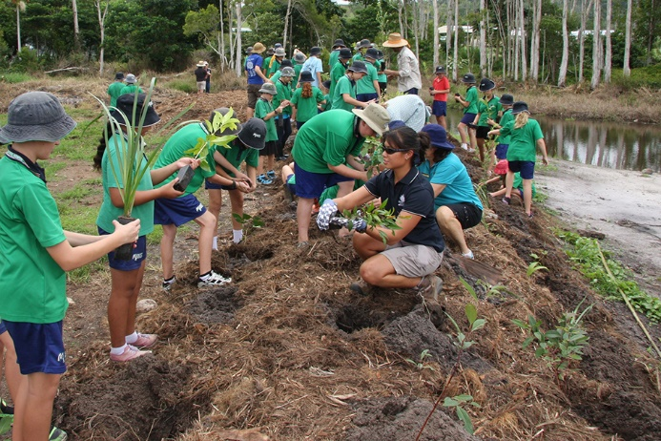
Photo - Students from Mission Beach State School plant trees to restore a local wetland near Mission Beach
To help identify priority areas within the catchment, the Authority and the Queensland Government have developed resources to assist land managers to recognise and understand the crucial role of coastal ecosystems at local and regional scales. The Authority encourages the use of hydrological connectivity mapping that show aquatic connections between the catchment and Reef.
Preventing further decline in the extent and health of coastal ecosystems is important — but not enough — to support Reef health. To enhance the function of both natural and modified coastal ecosystems, the Authority supports the use of one or more of the following interventions²:
- system repair — repairing natural components or processes within partially modified or re-constructed natural coastal ecosystems for example, artificial wetlands
- best management practices — including a set of principles, methods or techniques that promote minimising negative impacts upon the environment by reducing further environmental damage
- engineering and treatment solutions — re-establishing some of the functioning of the catchment system and restore ecosystem services. Where restoring and repairing is implemented, soft engineering that uses ecological principles and practices creating more long-term and sustainable solutions is preferred to highly visible, man-made hard engineering solutions that disrupt natural processes
- planning and institutional arrangements — protecting high value coastal ecosystems or species and the ecological processes that support them are recognised and addressed in regulatory planning, assessment and approval mechanisms across all levels of government
- engagement, extension and education — building enthusiasm, generational change, relationships, knowledge and capacity for improved management
- research — addressing knowledge gaps and ensuring the best available science is applied. Monitoring condition and trends of coastal ecosystems, drivers or stressors (including legacy drivers) and sharing successes and failures of Whole-of-System Catchment Management Framework practical applications.²

Caring for coastal ecosystems is a shared responsibility
All stakeholders that rely on coastal ecosystem services have a role in coastal ecosystem management by:
- raising awareness of the important role coastal ecosystems play in maintaining the health of the Reef
- establishing principles for protecting, managing and restoring coastal ecosystems to enhance the capacity of the Reef catchment to support Reef health
- promoting the use of specific decision-support tools such as hydrological connectivity maps that can inform catchment management approaches to improve health, biodiversity and water quality of coastal ecosystems.

In summary
Coastal ecosystems connect the catchment to the Reef. Protecting and restoring the function of coastal ecosystems is critical to the health of the Reef and its values.
This position statement is endorsed by the Great Barrier Reef Marine Park Authority Board. For the evidence underpinning this position statement, refer to the Great Barrier Reef Outlook Report 2014, supporting references and selected bibliography.

References
1. Commonwealth of Australia 2015, Reef 2050 Long-Term Sustainability Plan, Department of the Environment and Great Barrier Reef Marine Park Authority, Canberra.
2. Queensland Government 2016, Wetlands in the Great Barrier Reef Catchments, Management Strategy 2016-21, Queensland Government, Brisbane.
3. Great Barrier Reef Marine Park Authority 2014, Great Barrier Reef Outlook Report 2014, Great Barrier Reef Marine Park Authority, Townsville.
4. Great Barrier Reef Marine Park Authority 2012, Informing the outlook for Great Barrier Reef coastal ecosystems, GBRMPA, Townsville.
5. Pratchett, M.S., Caballes, C.F., Wilmes, J.C., Matthews, S., Mellin, C., Sweatman, H., Nadler, L.E., Brodie, J., Thompson, C.A. and Hoey, J. 2017, Thirty years of research on Crown-of-Thorns Starfish (1986–2016): Scientific advances and emerging opportunities, Diversity 9(4): 41.
6. Great Barrier Reef Marine Park Act 1975.
7. Deloitte Access Economics 2017, At what price? The economic, social and icon value of the Great Barrier Reef, Deloitte Access Economics, Brisbane.
8. Marshall, N., Bohensky, E., Curnock, M., Goldberg, J., Gooch, M., Nicotra, B., Pert, P.L., Scherl, L., Stone-Jovicich, S., Tobin, R. 2014, The Social and Economic Long Term Monitoring Program for the Great Barrier Reef (SELTMP) 2014. Report to the National Environmental Science Programme. Reef and Rainforest Research Centre Limited, Cairns, Australia.
9. Queensland Government 2017, Hydrological connectivity of the pre-clear landscape to the Great Barrier Reef V1.6, Queensland Department of Environment and Science, Brisbane.

Selected bibliography
Bunn, S.E. and Arthington, A.H. 2002, Basic principles and ecological consequences of altered flow regimes for aquatic biodiversity, Environmental management 30(4): 492-507.
Department of State Development, Infrastructure and Planning 2014, Great Barrier Reef Coastal Zone Strategic Assessment: Strategic Assessment Report, DSDIP, Brisbane.
Great Barrier Reef Marine Park Authority 2013, Great Barrier Reef Biodiversity Conservation Strategy 2013, GBRMPA, Townsville.
Great Barrier Reef Marine Park Authority 2014, Great Barrier Reef Region Strategic Assessment: Strategic Assessment Report, GBRMPA, Townsville.
Johnson, J.E. and Marshall, P.A. (eds) 2007, Climate change and the Great Barrier Reef: a vulnerability assessment, Great Barrier Reef Marine Park Authority and Australian Greenhouse Office, Townsville.
Millennium Ecosystem Assessment 2005, Ecosystems and human well-being: biodiversity synthesis, World Resources Institute, Washington DC.
Palmeri, L., Barausse, A. and Jorgensen, S.E. 2013, Ecological Processes Handbook, CRC Press, Copenhagen University, Denmark.
State of the Environment 2011 Committee 2011, Australia State of the Environment 2011: Independent report to the Australian Government Minister for Sustainability, Environment, Water, Population and Communities, Department of Sustainability, Environment, Water, Population and Communities, Canberra.

Further information
Director, Strategic Advice
Great Barrier Reef Marine Park Authority
280 Flinders Street
PO Box 1379
Townsville Qld 4810
Australia

Phone: + 61 7 4750 0700
Email: info@gbrmpa.gov.au
www.gbrmpa.gov.au
Document Control Information
Approved by: Great Barrier Marine Park Authority Board on 13-Mar-2018
Last reviewed: 13-Mar-2018
Next review: 13-Mar-2021
Created: 13-Mar-2018
Document custodian: Director, Strategic Advice
Replaces: New

All photos in this document are © Commonwealth of Australia (Great Barrier Reef Marine Park Authority)

