Australian Government Great Barrier Reef Marine Park Authority
Information sheet

Dive into history around Magnetic Island

Protecting our past so that the tales can be told for generations to come.

There are more than 20 known wrecks around Magnetic Island — not only an attraction for tourists, they also provide a unique insight into past events.

Exhibiting a bygone era of our maritime cultural heritage and attracting marine life, shipwrecks are popular for diving, snorkelling and photography. Twelve wrecks in Magnetic Island waters are considered historic (under national maritime heritage legislation) as they are over 75 years old.

Even minor disturbance to the surface of a wreck can begin or accelerate degradation.

You must not collect, touch, move or interfere with artefacts or relics.

When exploring the wonders of the past it is important to protect the beauty and history of the shipwrecks for future generations by taking the following steps.

When planning your visit and arriving at a wreck site:
· do not tie marker buoys or access lines directly to the shipwrecks
· do not anchor on shipwrecks
· keep group sizes to a minimum
· know where you can fish — pick up your free zoning map (map 7) at bait and tackle shops or access online at www.gbrmpa.gov.au.

When snorkelling and diving at wreck sites:
· look, but don’t touch
· be aware of your fins
· exercise proper buoyancy control
· ensure that all diving equipment — such as gauges and regulators — are secured firmly and not dragging
· do not enter the wreck, observe from the outside.

The story of the City of Adelaide, Cockle Bay
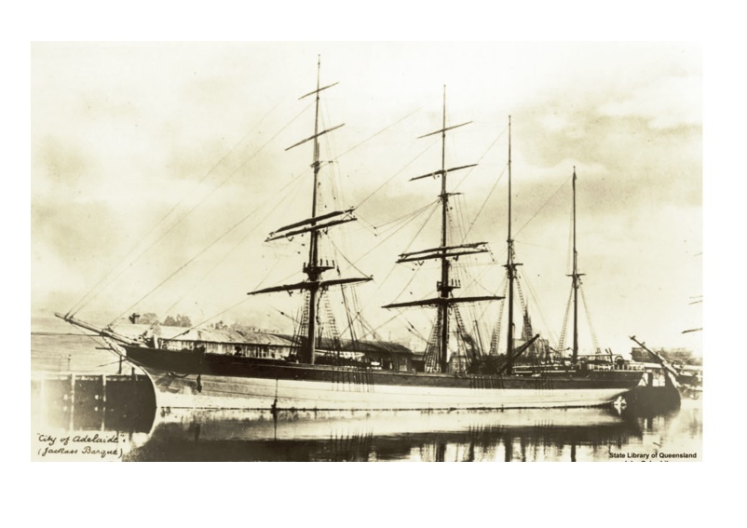
Photo of the City of Adelaide as a passenger steam ship in 1980. Copyright John Oxley Library

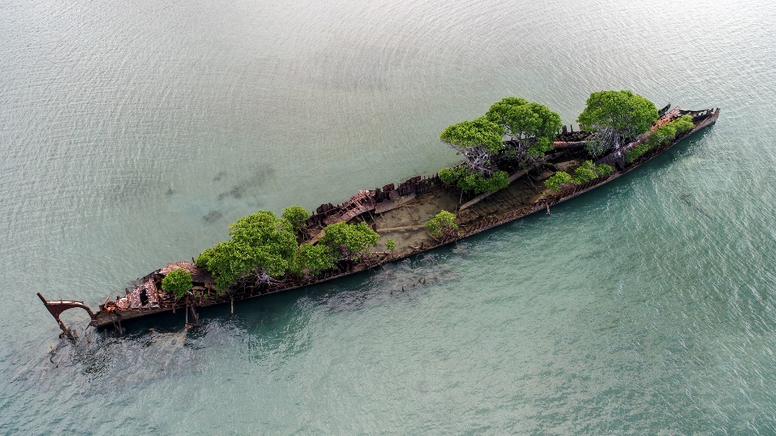

Photo of City of Adelaide as seen today at Cockle Bay. Copyright Australian Broadcasting Corporation, photographer Tom Edwards

Built in Glasgow in 1864, the City of Adelaide — once used as a passenger vessel between Melbourne and Sydney and later as a mail steamer to New Zealand, Honolulu and San Francisco — came to Magnetic Island in 1902 as a coal storage ship.

After a fire in the cargo section in 1910 and the vessel became unsuitable for work, there were plans for the ship to become accommodation at Picnic Bay. These plans were shelved when the ship ran aground at Cockle Bay in 1915, where it remains today. The ship was later used as a practice marker for Australian Airforce Beaufort bombers in World War II. In 1942 a plane struck its mast, killing four people on board the aircraft.

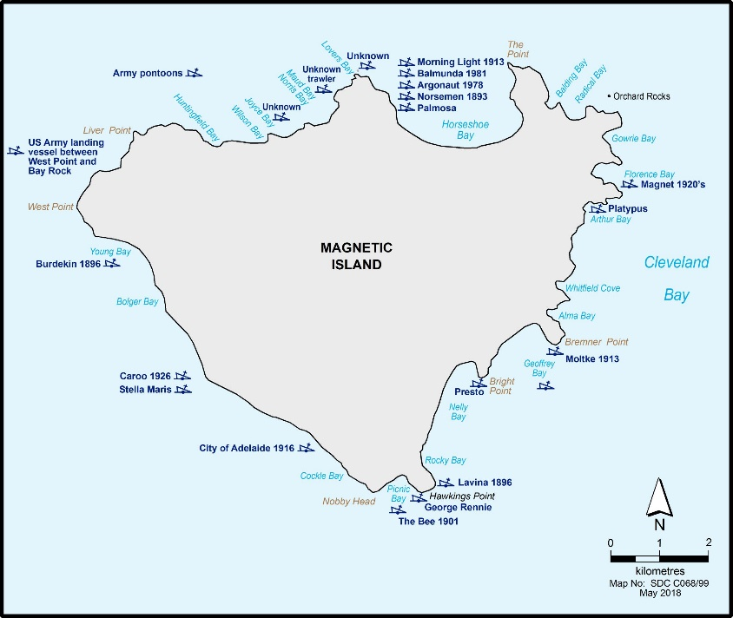
Map of the shipwrecks surrounding Magnetic Island
Thank you for helping us to protect the maritime cultural heritage of the Great Barrier Reef. Enjoy your time exploring and learning more about the wrecks around Magnetic Island.

The steps in this information sheet should be applied when encountering and approaching all ship and plane wrecks within the Great Barrier Reef.

There are several other significant wrecks throughout the Marine Park including the famous Yongala wreck, located south of Townsville offshore from Ayr. For information on the known historic wrecks throughout the Great Barrier Reef visit the Australian National Shipwreck Database at www.environment.gov.au/heritage

If you find the remains of undiscovered vessels or relics, please notify the Great Barrier Reef Marine Park Authority by phone 4750 0700, or email
info@gbrmpa.gov.au or contact the Queensland Department of Environment and Science via email archaelogy@des.qld.gov.au.

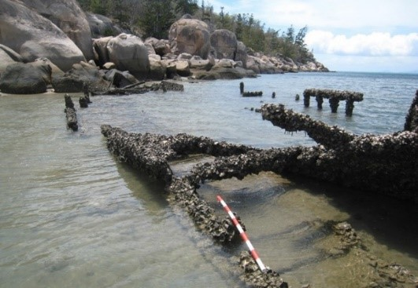

Photo of George Rennie Picnic Bay

www.gbrmpa.gov.au

