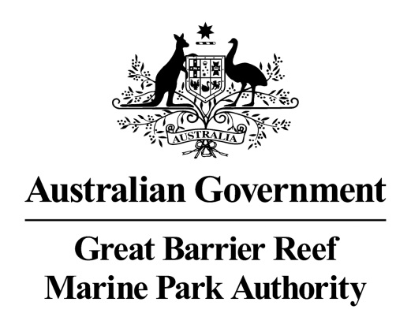

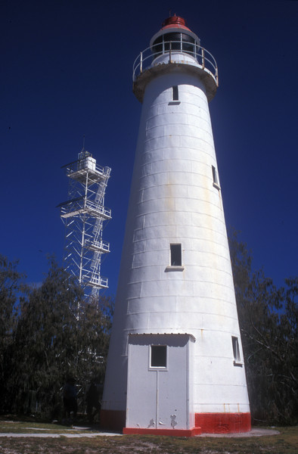
© Commonwealth of Australia (Great Barrier Reef Marine Park Authority)

Lady Elliot Island Lightstation
Heritage Register

December 2017

The Lady Elliot Island lightstation is listed on the Commonwealth Heritage List for its historic heritage value. The property is managed by the Great Barrier Reef Marine Park Authority, a Commonwealth Government Agency. This Register is required by the Environment Protection and Biodiversity Conservation Act 1999 s341ZB). It lists the Commonwealth heritage values that the Marine Park Authority is charged with identifying, conserving, managing, interpreting and celebrating.

Commonwealth Heritage List Place ID Number | 105415
Current Status | Listed place as at 22 June 2004
Ownership | The property is owned by the Marine Park Authority on behalf of the Commonwealth. Two lessees have lease arrangements with the Marine Park Authority. The lease agreements require the lessees to comply with the requirements set out in this Heritage Management Plan:  - The private lease relates to the use of the island for resort purposes and commenced on 1 December 2005; and  - A second lease relates to the ongoing presence of a navigation light and commenced on 27 May 2003.
Location | Lady Elliot Island is situated at the southernmost end of the Great Barrier Reef approximately 90 kilometres north-east of Bundaberg and 150 kilometres east-south-east of Gladstone (24° 07' S, 152° 43' E). The island, which occupies a surveyed area of 34.67 hectares, is Australia’s most southerly coral cay and is situated at the southerly end of a drying platform reef of about 142 hectares. The Heritage Management Plan Area occupies approximately 0.8 hectares along the western side of the island and is delineated by the boundary of the lighthouse and residential precincts.  The yellow arrow on the below Google Map shows the relationship of Lady Elliot Island to Bundaberg on the mainland.  On the following image from Google Earth, the red arrow is pointing to the Lightstation precinct.
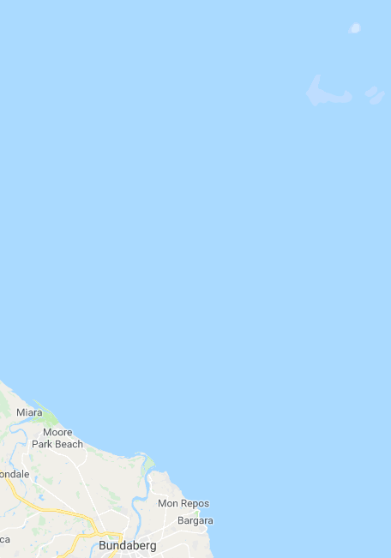
Google Maps map data © 2018 GBRMPA, Google Australia
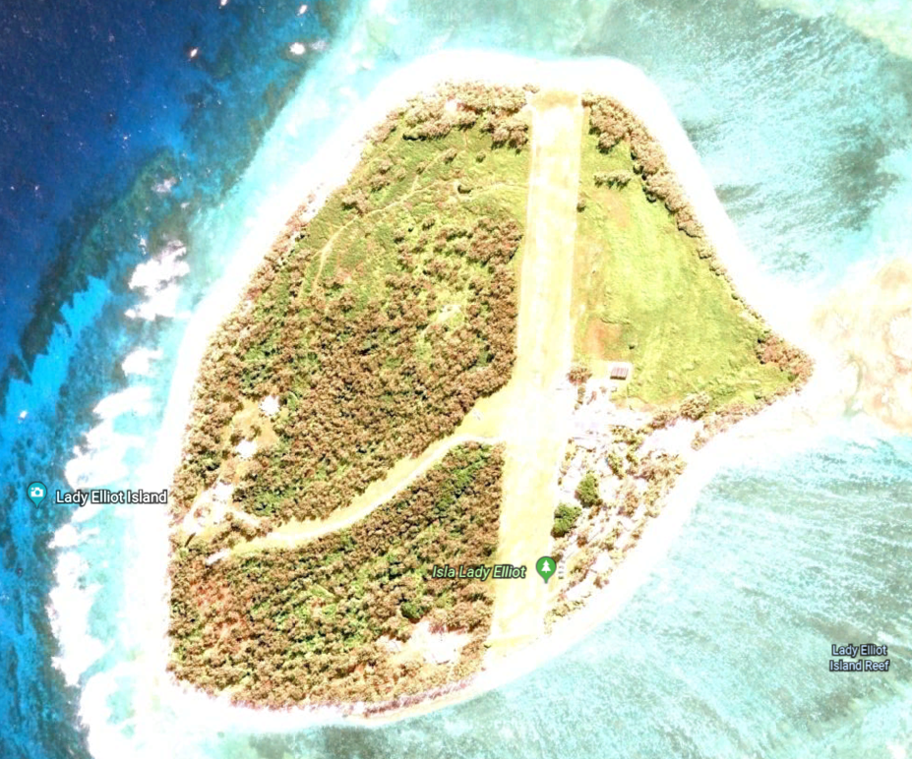
© Google

Description | Lighthouse tower: Concrete base contained within stone wall; timber tower frame, floors, stairs, ladder; curved iron plating with fixed glass windows and timber-framed and sheeted door. Nothing remains of the original balcony floor, lantern, or optical apparatus.  Condition: Stable, painted externally in 2007.  Lighthouse balcony and lantern room floor: Steel plate floor, round in plan, bolted onto rolled steel angle and channel supports, with steel balcony handrail. Condition: Additional painting of balcony required to arrest rust; otherwise stable.  Lighthouse lantern room: Chance Brothers & Company fourth order lantern with vertical astragals, curved glazing, drum (admiralty pattern) vent.  Condition: stable.  Lighthouse porch: Enclosed porch with timber frame covered with flat asbestos-cement sheet; skillion roof; concrete floor at level of bottom stair tread; ledged and braced door; fixed glass window. Condition: stable.  New power house: Freestanding building with concrete slab on ground; unpainted cavity brick walls; concrete ring beam; stainless steel sheeted skillion roof; bunded fuel storage area attached at back, enclosed with chain wire fence. Used for storage by resort operator. Condition: stable; minor cracking to concrete ring beam.  Old power house: Small gable roofed building; timber frame; concrete slab on ground floor; walls sheeted with flat asbestos-cement; roof sheeted with corrugated asbestos-cement sheet. Used for storage by resort operator.  Condition: Stable.  Workshop: Small gable roofed building with skillion roofed extension; timber frame; concrete slab on ground floor; walls sheeted with flat asbestos-cement; roof sheeted with corrugated asbestos-cement sheet.  Used for storage by resort operator. Condition: Stable.  Fuel store: Small gable roofed building; timber frame; concrete slab on ground floor; walls sheeted with flat asbestos-cement; roof sheeted with corrugated asbestos-cement sheet. Used for storage by resort operator.  Condition: Stable.  Fuel drum rack: Two parallel hardwood rails supported on short hardwood posts, designed to hold 44 gallon (200 litre) drums clear of the ground.  Condition: Settled and misaligned; one rail not supported at one end.  Light keepers’ house: Three identical detached timber-framed single-storey lowset houses with surrounding verandahs. Houses are lined with flat asbestos-cement sheeting, and supported on concrete truncated pyramid piers. Each has three concrete stairs. The verandahs are enclosed with asbestos-cement sheeting, shutters and casement windows. The hipped roofs are sheeted with corrugated asbestos-cement. Condition: Stable.  Rainwater tanks: Six spherical glass reinforced plastic tanks, each about 3.6 m diameter, partly sunk into the ground, two at each of the houses. Condition: Stable.  Boat shed: Small gable roofed building; timber frame; concrete slab on ground floor; walls sheeted with flat asbestos-cement; roof sheeted with corrugated steel. Condition: Stable.  Fowl house: One small skillion roofed building; timber frame; walls sheeted with flat asbestos-cement; roof sheeted with corrugated asbestos-cement.  Condition: Roof deteriorated.  Steel tank stands: Two of the three tank stands remain, each with galvanised hot-rolled steel angle stanchions, rails and braces, with timber decking on channel joists; no tanks remaining; semi-rotary hand pumps and pipe work fixed to house. Condition: Stable.  Septic tanks: Three concrete septic tanks partly buried behind houses, with associated drains and fixtures. Condition: Stable.  Loading ramp: Concrete retaining wall, backfilled with soil. Condition: Stable.  Coral paths: Raised pathways of coral, now overgrown with grass. Condition: Stable.  Concrete paths: Concrete paths. Condition: Minor cracking; otherwise stable.  Graves: Site of two graves, marked with headstones, surrounded by a picket fence. Condition: Some pickets loose; otherwise stable.
Sequential summary use of place – post European arrival | 1860s -1890s: Occupied and used by Europeans to extract deposits of guano – accumulation of seabird excrement use at the time as a fertiliser and gunpowder ingredient  1866: Lady Elliot Island lightstation established with a temporary navigation light erected in the form of a tall mast on which a light was shone  1872: Lighthouse construction  1873: Lighthouse light is first lit, and operated by the Queensland Department of Harbours and Rivers  1923: Brightness of light upgraded to 23,000 candlepower  1927: Optical apparatus, lantern and balcony/lantern-room floor were replaced. Three new houses were built to replace two old ones  Date unknown c. 1952: Diesel generator installed to provide power to houses  c. 1961: Goats removed and a beautification scheme commenced including small casuarina trees planted  1963: Plastic rainwater tanks were installed to supplement earlier corrugated iron tanks  1966: Bathrooms connected to septic tanks  1980: Lighthouse converted from kerosene to acetylene operation which involved extensive changes, including fact that now operating automatically without human intervention so keepers were withdrawn  1980s: Casuarina trees had grown so tall they obstructed visibility of the light from some sectors.  1989: Electric rotating beacon replaced the acetylene operation. It was powered by batteries charged by solar photovoltaic panels  1995: Original Lighthouse is superseded by a new taller structure a short distance away. The tower is surrounded by a fence.
Statement of significance | Lady Elliot Island lightstation, established in 1866, is significant for its evidence of important steps in the development of a system of navigation aids along the Queensland coast in the nineteenth century. The centrepiece is a lighthouse, first lit in 1873, that was the first of a series designed in Queensland to suit local conditions and economic constraints.
Official heritage values | Criterion A processes  The Lady Elliot lightstation is significant as an important element in the establishment of navigational aids along the Queensland coast, which reflects the development of the coastal regions of Queensland after its separation from New South Wales. The lightstation portrays the historical development of the complex over time, with the changes made in lighthouse technology, accommodation and the addition of other service buildings.  Attributes  The lighthouse, adaptations to the light, and all associated structures.
Criterion B rarity
The use of timber framing for the staircase is a rare example of this construction method in lighthouses in Australia.
Attributes
The timber framed staircase.

Criterion D characteristic values
Lady Elliot Island lightstation is significant as a lighthouse built in 1873, using a timber framed substructure and cast iron external cladding.
Attributes
The use of cast iron external cladding.

Criterion E aesthetic characteristics
The Lady Elliot Island lightstation is significant as a landmark feature which, along with the island, marks the southern end of the Great Barrier Reef Marine Park.
Attributes
The prominence and location of the lighthouse.

Criterion F technical achievement
Lady Elliot Island lightstation is significant as a lighthouse built in 1873, using a timber framed substructure and cast iron external cladding.
Attributes
All of the original fabric and in particular the use of a timber frame with external cast iron cladding.

Other current heritage listings | Gladstone Regional Council
Access restrictions | The private lessee controls access to the buildings within the historic precinct.  The relative remoteness of Lady Elliot Island makes access challenging and provides the lightstation with a natural security buffer. Most visitors to the island arrive by aircraft, with some trawlers anchoring up in the lee side of the island to escape poor weather, and other vessels as part of organised live-aboard dive voyages. Access to the island and precinct is limited by the Commonwealth Islands zoning, lease and permit requirements.  Australian Maritime Safety Authority (AMSA) personnel and contractors periodically visit the AMSA lease to inspect or maintain the navigation aids which are secured by a tall fence. They generally arrive by air, and do not usually need access to the historic precinct. There may be times when the AMSA will need to transport equipment and material to the island by sea and will need to traverse the historic lightstation area.
Consultation requirements | Consultation is directed by the EPBC Act when developing the Heritage Management Plan; involves stakeholder and public consultation.
Relevant documents or references | Lady Elliot Island Lightstation Heritage Management Plan
Date last updated | 2012
Other places significant by association | The lighthouse, erected on the island in 1873, was one of a series of 12 lighthouse towers of a distinctive type, built between 1873 and 1890.

