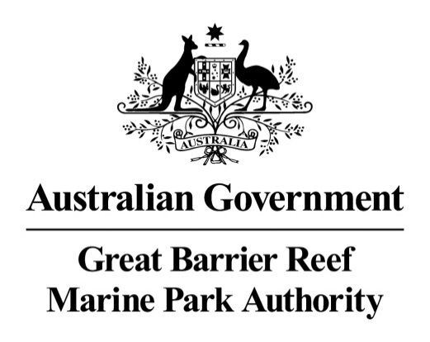

Great Barrier Reef Marine Park Commonwealth Heritage Listed Places and Properties Heritage Strategy
2018―21

December 2017

The Great Barrier Reef Marine Park Authority acknowledges the continuing sea country management and custodianship of the Great Barrier Reef by Aboriginal and Torres Strait Islander Traditional Owners whose rich cultures, heritage values, enduring connections and shared efforts protect the Reef for future generations.

Contents

1. Our heritage 1
1.1 Introduction 1
1.1.1 Heritage definitions used by the Great Barrier Reef Marine Park Authority 4
1.1.2. History of Great Barrier Reef lightstations 6
1.1.3. Dent Island lightstation 7
1.1.4. Lady Elliot Island lightstation 8
1.1.5. Low Island and Low Islets lightstation 9
1.2. Authority’s corporate objective 11
1.3. Statement of objective 12
2. Managing our heritage 13
2.1. Key positions responsible for heritage matters 13
2.2. Tools and activities 14
2.3. Identification and assessment program 18
2.4. Consultation 19
2.4.1. Government 20
2.4.2. Community 20
2.4.3. Indigenous 21
2.4.4. Lessees 22
2.5. Conflict resolution 22
3. Future of our heritage 24
3.1 Developments 24
3.2 Monitoring, reviewing and reporting 24
3.3 Training staff 25
3.4 Promoting community awareness 26
4. Appendices 28
Appendix 1. Commonwealth Heritage Management Principles 28
Appendix 2. Commonwealth Heritage List criteria 29
Appendix 3. Commonwealth Islands Zone 30
Appendix 4. Matters of National Environmental Significance 31
Appendix 5. Dent Island Lightstation Heritage Register 32
Appendix 6. Lady Elliot Island Lightstation Heritage Register 38
Appendix 7. Low Islet Lightstation and Low Island Heritage Register 46
Appendix 8. List of actions arising from the Strategy 52

Tables

1 EPBC regulation 10.03E schedule 7C heritage strategies compliance table………………3
2 Properties and the Commonwealth Heritage List criteria they meet…………………….…..5
3 Examples of heritage definitions against properties……………………………………….….6
4 Heritage management tasks and those responsible for them……………………………...13
5 Status of the Heritage Management Plans……………………………………………..........17
6 Commonwealth legislation and the agencies/departments that administer the Acts, that concerns the Authority’s Commonwealth heritage listed places and properties……………20

Figures

1 Map showing Commonwealth Heritage listed properties and places managed by the Great
Barrier Reef Marine Park Authority 2
2 Dent Island lighthouse 7
3 Dent Island’s winch house and Derrick crane 8
4 Lady Elliot Island lighthouse with current working light tower in background 9
5 Photo of the Low Island museum, set up as a replica of the laboratory of Charles Yonge 10
6 Low Island and Low Islets lightstation 11
7 Lady Elliot lighthouse and cottage 12
8 Front covers of the two Commonwealth heritage listed places and properties Heritage Management Plans 16
9 The artwork from a Marine Park Authority pull-up banner 27

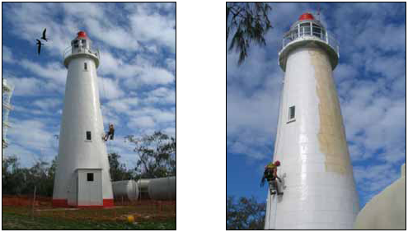

Two photos showing different angles of a painter painting the Lady Elliot Island Lighthouse
Photo © Wayne Fox

1. Our heritage

1.1 Introduction
The Great Barrier Reef is exceptional because all or parts of it are listed on any one of a trifecta of heritage listings; World, National and Commonwealth. These listings are recognition of the extraordinary breadth of components within the Great Barrier Reef Marine Park (Marine Park) that have heritage value.
The Great Barrier Reef Marine Park Authority (the Authority) recognises and understands the importance of heritage. In 2009 The Great Barrier Reef Marine Park Act 1975 (the Act) was amended ‘…to provide for the long term protection and conservation of the environment, biodiversity and heritage values of the Great Barrier Reef Region’. A corporate goal for the Authority is to safeguard the Great Barrier Reef’s heritage values.
The Authority is committed to managing the protection of heritage values across the entire property and it has obligations to meet, and programs and policies in place to do this. One of these obligations is to manage heritage values at the three Commonwealth heritage listed places and one property it owns and controls, in a manner consistent with the Commonwealth heritage management principles outlined in the Environment Protection and Biodiversity Conservation 1999 Act.
These Commonwealth heritage listed places and property in the Marine Park had their heritage values assessed in 2013 and reported in the Great Barrier Reef Outlook Report 2014. These were assessed as ‘good’ (out of a possible grading of very good, good, poor, very poor). They were given the highest confidence grade because there is adequate high-quality evidence and a high level of consensus. Their heritage values are being maintained, are well recorded and there has been extensive maintenance in recent years. They will be reassessed for 2019 outlook reporting.
On 1 January 2004 amendments to the Australian Government’s Environment Protection and Biodiversity Conservation Act 1999 (EPBC Act) came into force. Amendments were also made to the Environment Protection and Biodiversity Conservation Regulations 2003 (EPBC Regulations). Together these establish a heritage system to identify, protect and manage the natural, Indigenous and historic heritage values of places and properties under Commonwealth ownership or control – or that are on the Commonwealth Heritage List.
Under Section 341ZA in the EPBC Act each Commonwealth authority that owns or controls one or more Commonwealth heritage place and property must prepare a heritage strategy and undertake a review of that strategy at least once every three years. In accordance with Regulation 2000 (No.1) that aims to address all matters required under ‘Schedule 7C: Heritage Strategies’, the Authority prepared its first Great Barrier Reef Marine Park Heritage Strategy in 2005. In January 2006 it was endorsed by the Australian Heritage Committee and the then Minister for the Environment and Heritage. It addressed heritage throughout the entire Marine Park. It was anticipated at this time that the entire Marine Park would be Commonwealth heritage listed; an outcome that has not eventuated.
This Great Barrier Reef Marine Park Commonwealth Heritage Listed Places and Properties Heritage Strategy has been prepared in accordance with the EPBC Amendment Regulations 2003 (No.1). It addresses the overarching approach the Authority takes to identify, assess and manage heritage values at the places and properties that the Authority owns or controls as shown on the Commonwealth Heritage List, which are:
- Dent Island lightstation
- Lady Elliot Island lightstation
- Low Islets lightstation and Low Island.

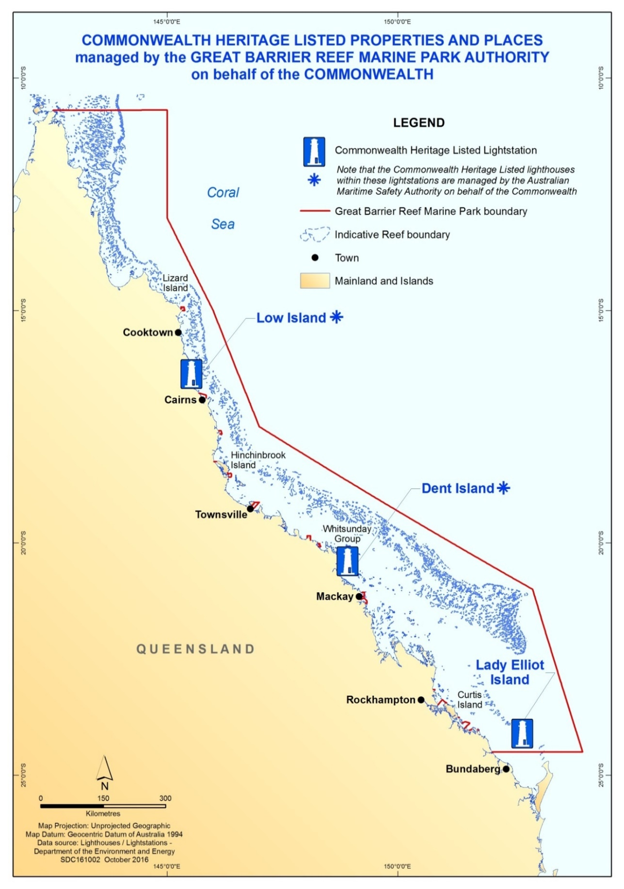
Figure 1 Map showing Commonwealth Heritage listed properties and places managed by the Great Barrier Reef Marine Park Authority
Dent Island lightstation is on the western side of Dent Island in the Whitsunday region of the Marine Park, approximately 18 kilometres south-east of Shute Harbour, Airlie Beach.
Lady Elliot Island lightstation is situated on a small coral cay that is approximately 90 kilometres north-east of Bundaberg and 150 kilometres east-south-east of Gladstone. It is at the southernmost end of the Marine Park.
Low Island is a sandy coral cay and one of two small islands that make up the Low Isles in the Marine Park. The other island is called Woody Island and is an uninhabited coral/mangrove island. The islands are located 13 kilometers from Port Douglas, situated on the western edge of a main shipping channel. The Low Islets lightstation is located on Low Island.
It should be noted that both the Dent Island lighthouse and Low Islets lighthouse that are within the respective lightstations, are owned by the Australian Maritime Safety Authority (AMSA). This is because they both remain working aids to navigation. The heritage management component of these two lighthouses is the responsibility of AMSA.
The Authority has until now, undertaken to include both the Shoalwater Bay Military Training Area and North Reef lightstation in its list of Commonwealth heritage properties, possibly because they are both located within the Marine Park. However the Department of Environment and Energy confirmed in 2016 that the Department of Defence controls the Shoalwater Bay Military Training Area and the AMSA is the owner of the North Reef Lightstation and lighthouse. Therefore this Strategy does not address the Commonwealth heritage values at these two places.
Table 1 outlines requirements under Regulation 10.03E Schedule 7C: Heritage strategies.
Table 1 EPBC Regulation 10.03E Schedule 7C Heritage strategies compliance table
Great Barrier Reef Marine Park Authority  Commonwealth Heritage Strategy contents | Relevant Schedule 7C clause
- Our heritage
1.1 Introduction | 3c
- Authority’s corporate objective | 1b, 3f
1.3 Statement of objective | 1a
2. Managing our heritage
2.1 Key positions responsible for heritage matters | 1c
2.2 Tools and activities | 3b
2.3 Identification and assessment program | 2a, 2b(i)
2.4 Consultation
2.4.1 Government | 1d
2.4.2 Community | 1e
2.4.3 Indigenous | 1e
2.4.4 Lessees
2.5 Conflict resolution | 1f
3. Future of our heritage
3.1 Developments | 2b(ii), 3a, 3d, 3e
3.2 Monitoring, reviewing and reporting | 1g, 2b(iii),3g
3.3 Staff training | 4a
3.4 Promoting community awareness | 4b

Complementing this Strategy are a number of other documents, also required under the EPBC Act:
- A report reviewing the implementation of the 2005 heritage strategy; and
- Copies of the heritage registers for each of the three properties.
In accordance with the EPBC Act, the Authority will provide an updated strategy, a report reviewing this Strategy, and a copy of the updated Registers by 2021.
The Authority takes a consolidated approach to protecting heritage values, recognised or not on heritage listings. Two other documents are being developed for this purpose.
- A complementary heritage strategy, Aboriginal and Torres Strait Islander Heritage Strategy 2018 – 2022
- An information piece, Heritage in the Great Barrier Reef Marine Park: How the Great Barrier Reef Marine Park Authority manages the protection of heritage values in the Great Barrier Reef Marine Park.
The delivery of this suite of documents meets objectives set in the Australian and Queensland government’s Reef 2050 Long-Term Sustainability Plan 2015.
Heritage values are defined in the defined in the EPBC Act. The heritage value ‘of a place includes the place’s natural and cultural environment having aesthetic, historic, scientific or social significance, or other significance, for current future Australians’. The Great Barrier Reef Marine Park Act 1975 (the Act) directs to the EPBC Act for the definition of heritage value.
The Authority follows best practice in managing the protection of its heritage values.
- As defined in Article 21 in the Australia International Council on Monuments and Sites Burra Charter, 2013 (Burra Charter), it promotes ‘adaptive re-use’ of their heritage listed places. This means adaptation may involve additions to the place, the introduction of new services, or a new use, or changes to safeguard the place.
- It promotes ‘compatible use’. That is a use that respects the cultural significance of the place so involves no, or minimal impact on cultural significance.
- It manages its heritage values at the Commonwealth Heritage listed properties in a manner consistent with the Commonwealth Heritage Management Principles outlined in the EPBC Act, Appendix 1.

Heritage definitions used by the Great Barrier Reef Marine Park Authority
Heritage: as defined in the EPBC Act, includes places, features, structures and objects that have aesthetic, archaeological, historic, scientific or social significance or other special value for the present community and for future generations.
Commonwealth Heritage List: as defined in the EPBC Act, is a list of places and properties owned or controlled by the Australian Government, managed by the Department of Environment and Energy. The list includes places connected to defence, communications, customs and other government activities that reflect Australia’s development as a nation.
Heritage criteria: are the principles or standards by which something is judged or decided to be on the Commonwealth Heritage List. For example, the place has outstanding heritage value to the nation because of the place’s importance in exhibiting particular aesthetic characteristics valued by a community or cultural group. (Appendix 2 for the list of Commonwealth heritage criteria). The Authority’s three Commonwealth heritage properties and one place are recognised in six of the nine Commonwealth heritage listing criteria.

Table 2 Properties and the Commonwealth Heritage List criteria they meet
Property or place | Commonwealth Heritage List criteria
Dent Island lightstation | Processes: the place has significant heritage value because of the place's importance in the course, or pattern, of Australia's natural or cultural history  Characteristic values: the place has significant heritage value because of the place's importance in demonstrating the principal characteristics of a class of Australia's natural or cultural places or environments
Lady Elliot lightstation | Processes: the place has significant heritage value because of the place's importance in the course, or pattern, of Australia's natural or cultural history  Rarity: the place has significant heritage value because of the place's possession of uncommon, rare or endangered aspects of Australia's natural or cultural history  Characteristic values: the place has significant heritage value because of the place's importance in demonstrating the principal characteristics of a class of Australia's natural or cultural places or environments  Aesthetic characteristics: the place has significant heritage value because of the place's importance in exhibiting particular aesthetic characteristics valued by a community or cultural group  Technical achievement: the place has significant heritage value because of the place's importance in demonstrating a high degree of creative or technical achievement at a particular period
Low Islets lightstation | Processes: the place has significant heritage value because of the place's importance in the course, or pattern, of Australia's natural or cultural history
Low Isles | Indigenous tradition: the place has significant heritage value because of the place's importance as part of Indigenous tradition

Class: For Commonwealth heritage listed places and properties, the heritage values in use are ‘classed’ as natural, Indigenous and historic, as prescribed in Section 341D of the EPBC Act, sub regulation (2). The three lightstations and one island are all classed for their historic heritage value.
Component: the item assessed for its heritage value, such as a lantern, the tower, tank, cottage.
Attribute: the characteristic that gives the component its significance. Attributes are also provided on the Commonwealth Heritage List, under the heading of Official Values. An example of an attribute is the structural system of a lightstation including timber framing and iron cladding.
Table 3 provides examples of the above definitions for the Commonwealth listed places the Authority owns or controls.

Table 3 Examples of heritage definitions against properties
Listed place or property | Value, or class | Criteria | Component | Attributes
Dent Island lightstation | Historic | - Processes  - Characteristic | Derrick crane and associated winch house | - Rare surviving example of a lighthouse crane  - Demonstrates the development and operation of the lightstation
Lady Elliot lightstation | Historic | - Processes  - Rarity  - Characteristic values  - Aesthetic  - Technical achievement | lighthouse tower | - First timber-framed iron plated lighthouse  - Development of technology  - Association with designers
Low Islets lightstation | Historic | - Processes | House | - Demonstrates improvements to the keepers’ living conditions  - Characteristic element of lightstations
Low Island | Historic | - Indigenous tradition | The island | - Was part of a united landmass that became separated during the creation period (the Dreamtime)

History of Great Barrier Reef lightstations
Great Barrier Reef islands with lighthouses played a fundamental role in Australia’s development. Safe sea passage was vital for the nation's emerging colonial economy and for a long time the country was entirely dependent on the sea for trade, communication and supplies. Lighthouses were initially built and managed by the respective colonial governments.
On 1 July 1915, when the Lighthouses Act 1911 came into effect, the Commonwealth officially accepted responsibility for the nation's lighthouses. Management of these Commonwealth Islands at this time was the responsibility of the Australian Maritime Safety Authority (AMSA).
In 1988, the Great Barrier Reef Marine Park Authority increased involvement in the management of the Commonwealth Islands, eventually taking ownership of the Commonwealth lighthouse islands and their lightstations in 2003. AMSA now leases back any relevant portion of land it uses for aids to navigation.

Dent Island lightstation
Dent Island lightstation was included in the Commonwealth Heritage List in 2004. The Dent Island lightstation reflects the development of the colony and Queensland after separation from New South Wales. A navigational light has shone on Dent Island since 1879, marking an area of danger and facilitating the safe passage of goods and people along the inner route of the Great Barrier Reef.
Today AMSA continues to operate the Dent Island lighthouse for the safe navigation of all vessels. AMSA owns the lighthouse on behalf of the Commonwealth but leases the land from the Authority. The Authority’s Joint Field Management Program manages all the other structures and land that make up the lightstation. The Program oversees the heritage on Commonwealth-owned islands, including maintenance, restoration and developing Heritage Management Plans. Dent Island has a Heritage Management Plan in place.
The lightstation property comprises two keepers’ houses, store, winch house, workshop/store/radio-room, engine room, tramway, derrick crane, various concrete paths, two graves, septic tanks, main concrete water tank, water header tank on its steel lattice stand, fowl house, lighthouse keeper’s gardens, and the spa bath with roof.
The two keepers’ houses continue in use as dwellings by the lessee’s staff. Continuous occupation of the houses by people who understand the heritage values of the lightstation and act as good custodians is an excellent conservation measure. Residents can constantly observe and monitor the condition of the structures, and facilitate timely maintenance.

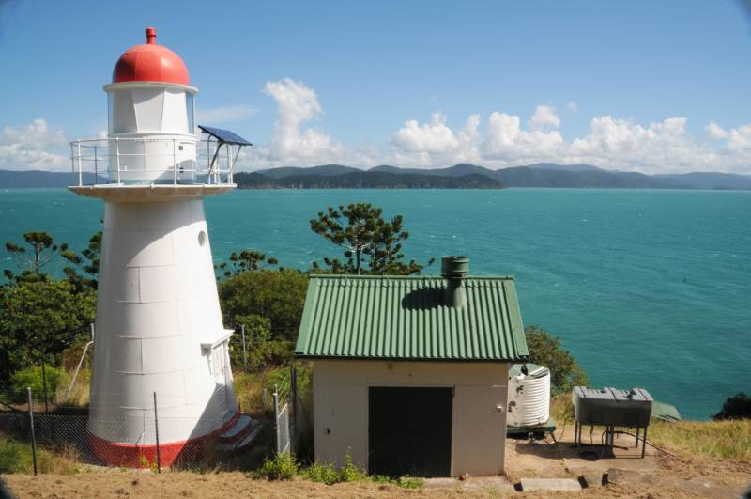
Figure 2 Dent Island Lighthouse © Commonwealth of Australia (Great Barrier Reef Marine Park Authority)
Visitors mostly arrive by ferry from Hamilton Island to play golf at the Hamilton Island Golf Club’s 18-hole championship golf course on Dent Island. There is no access signage in place to the lightstation and the lightstation has live-in caretakers ensuring access is managed and protected from unauthorised access.
AMSA personnel and contractors regularly visit to inspect and maintain the lighthouse. The Joint Field Management Program personnel and contractors also regularly visit to inspect and maintain the property. Occasional visits to the lightstation by small groups who are interested in the history and conservation of lightstations, such as Lighthouses of Australia Inc., are also welcomed. AMSA has a practice of opening otherwise closed lightstations for public access, primarily to coincide with major events in the life of the lightstation, such as 100 and 150-year anniversaries.

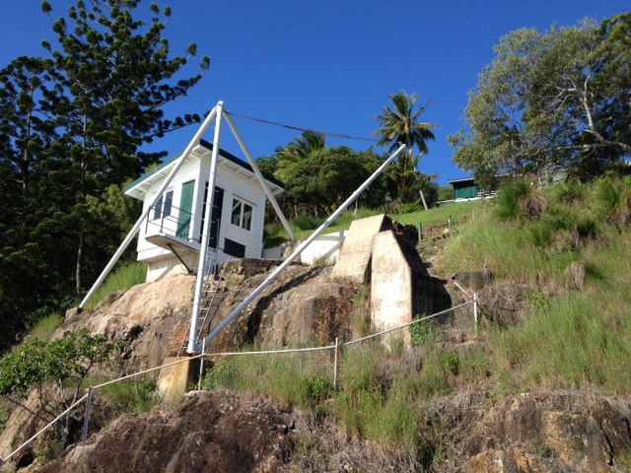

Figure 3 Dent Island’s Winch House and Derrick Crane © Commonwealth of Australia (Great Barrier Reef Marine Park Authority)
The decision to open the Dent Island lightstation (but not the lighthouse) for occasional visits is a matter for the Joint Field Management Program and its private lessee. A decision to do so is based on the findings of a risk analysis and the availability of personnel.
The height of the trees in front of the lighthouse needs to be managed as they have the potential to impact the aesthetic value of the lighthouse.

Lady Elliot Island lightstation
Lady Elliot Island lightstation was listed on the Commonwealth Heritage List in 2004 for its significance to the history of settlement along the Queensland coast and for its historical heritage associated with the lighthouse. It was the third lighthouse erected in Queensland and the first in Australia to be constructed using a timber frame clad with iron plates. It demonstrates the historical development of a lightstation over time, with changes made in lighthouse technology and accommodation, and the addition of other service buildings. The original lighthouse was lit in 1873 and deactivated in 1995 when the light was replaced by a modern tower standing close to the original lighthouse. AMSA owns and manages the modern light tower and leases the land that it stands on, from the Authority.
The lightstation is also recognised for its aesthetic characteristics as a landmark feature which, along with the island, marks the southern end of the Great Barrier Reef Marine Park. A Heritage Management Plan is in place.
Lady Elliot Island lightstation is jointly managed by the Joint Field Management Program, with a collaborative lease arrangement with a tourism operator.
This private lessee is aware of the significance of the lightstation and this is reflected in the lease agreement with the Joint Field Management Program. Conditions of the lease ensure that the lessee must assist with conserving and maintaining the historic precinct to the standard required by the Heritage Management Plan in place. They lessee must give the Joint Field Management Program prior notice before commencing any structural works that may be required.
The lessee is currently using the lightstation accommodation as staff quarters and the associated buildings are used for storage. The lighthouse itself is not being used for any purpose at this stage. The lease provides that the lessee must notify the Authority when and if they intend to use the lighthouse for any purpose.
The lessee controls access to the buildings within the historic precinct.
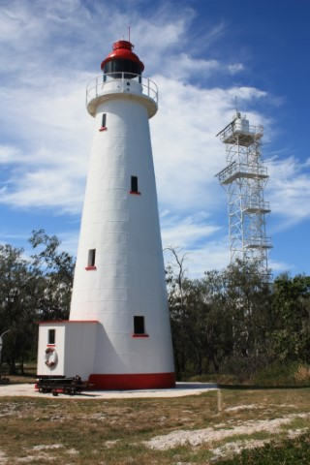
The relative remoteness of Lady Elliot Island makes access by unauthorised persons challenging and provides the lightstation with a natural security buffer. Most visitors to the island arrive by aircraft, with some trawlers and other vessels as part of organised live-aboard dive voyages, anchoring on the opposite, sheltered side of the island to escape poor weather.
Visitors generally arrive by air and tours of the heritage precinct grounds are offered by the lessee.
There is no access signage in place for the heritage buildings and the lightstation is utilised by the Lady Elliot Island lessee for staff accommodation which limits unauthorised access.
The Joint Field Management Program personnel and contractors also regularly visit the lightstation to inspect and maintain the property.
There is currently no conflict of interests with the property’s current use and its heritage values.

Figure 4 Lady Elliot Island Lighthouse with current working light tower in background © Commonwealth of Australia (Great Barrier Reef Marine Park Authority)

Low Island and Low Islets lightstation
Low Island and Low Islets lightstation were listed on the Commonwealth Heritage List in 2008 because they demonstrate the historical pattern of development of coastal aids to navigation in colonial Queensland, and because of the Island’s significance to the Kuku Yalanji and Yiriganji Traditional Owners as part of their Dreamings.
The lighthouse was built in 1878 to address the dangers to shipping approaching newly established ports, including Cairns and Port Douglas. It has been a base for scientific research and weather data collection. It is now de-manned and the light is solar-powered and operates automatically.
It is jointly managed by the Joint Field Management Program and AMSA. The small area of land on which the lighthouse stands is leased by the Authority to AMSA. AMSA operates the lighthouse as one of its system of aids to navigation. As the manager, the Authority employs a resident caretaker who looks after the lightstation, which houses a museum with historical information and relics of the past. Volunteer caretakers work when the full-time caretakers are away.
Day visitors come to Low Island on a daily basis via a number of commercial operators and recreational vessels. The tour operators must operate in accordance with the terms of their permit, jointly issued by the Authority and the Queensland Parks and Wildlife Service (QPWS). Visitors can come ashore and see the active lighthouse and visit the museum that was established by the Authority caretakers in one of the lightstation’s buildings. Over 50,000 people pass through this attraction on an annual basis. It is maintained by the caretakers.

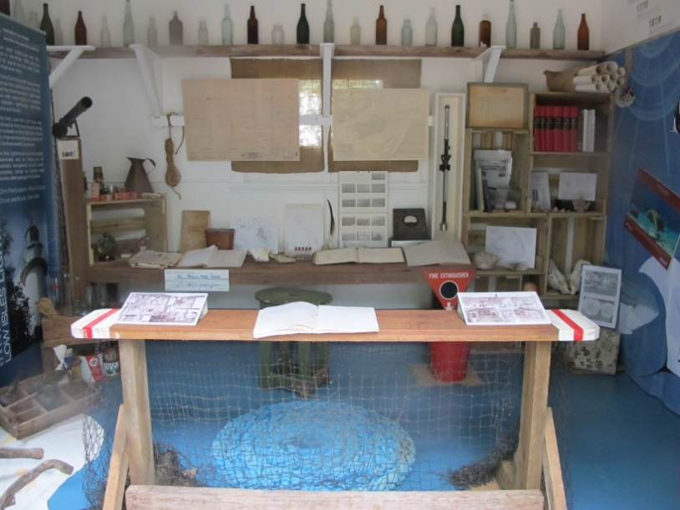
Figure 5 Photo of the Low Island museum, set up as a replica of the laboratory of Charles Yonge who led a scientific expedition on Low Isles from 1928-1929 © Commonwealth of Australia (Great Barrier Reef Marine Park Authority)
Private vessels can moor or anchor overnight in the lagoon. There are paths for people to walk along that have interpretive signage. There is no overnight accommodation on the island and visitors must not arrive before sunrise and must depart by sunset. All users (including recreational users) access the island in accordance with the Cairns Area Plan of Management. Staff of the Joint Field Management Program and other authorised people if visiting for management purposes, sometimes stay overnight in the former light keepers’ houses.
Figure 6 Low Island and Low Islets lightstation © Commonwealth of Australia (Great Barrier Reef Marine Park Authority)

Authority’s corporate objective
The public annual Great Barrier Reef Marine Park Authority Corporate Plan identifies safeguarding the Reef’s heritage as one of its four goals. From this strategic direction and performance outcomes base, the Authority’s executive management group allocates tasks to branches and their sections. Annual operating plans are developed at the section level and identify specific actions. The task to develop a Great Barrier Reef Marine Park Commonwealth Heritage Listed Places and Properties Heritage Strategy appears in the 2016―2017 Annual Operating Plan within the Heritage, International and Governance Section of the Authority.
Tasks identified in this Strategy are incorporated into the Authority’s operating plans of those responsible for their implementation. Through the business planning and budgeting processes the Authority confirms and reviews all proposed tasks on an annual basis.
The Authority’s budget for our Commonwealth heritage listed places and properties covers the wages of the caretaker and maintenance for the Commonwealth heritage listed structures at Low Island.
As many of the Commonwealth heritage listed structures are made of asbestos, the Authority (jointly with the Queensland Government), share the costs of meeting statutory asbestos requirements.
The lessees have the obligation to maintain the buildings within the Dent Island and Lady Elliot lightstations (apart from the Lady Elliot Island lighthouse that the Authority is responsible for), including the Commonwealth heritage listed structures.
The budgeting for the protection of the Authority’s Commonwealth heritage listed place and properties is managed by the Joint Field Management Program. Below is an overview of the budget.

Place | Item | Budget per annum
Low Isles | Caretaker’s salary and maintenance costs | $130,000
Dent Island | As this property is leased, ongoing maintenance is the responsibility of the lessee. The Authority do an inspection and maintenance plan on an annual basis for the lessee to follow
Lady Elliot Island | Lighthouse | $15,000

Budgeting, activities and achievements are reported in the annual report that is presented to the Prime Minister and tabled before both Houses of Parliament. The Authority’s annual reports are available at http://www.gbrmpa.gov.au/about-us/corporate-information/annual-report.

Statement of objective
To identify and care for the heritage places and properties in the Authority’s control, consistent with current best practice in conservation and management and the principles and requirements in the EPBC Act.

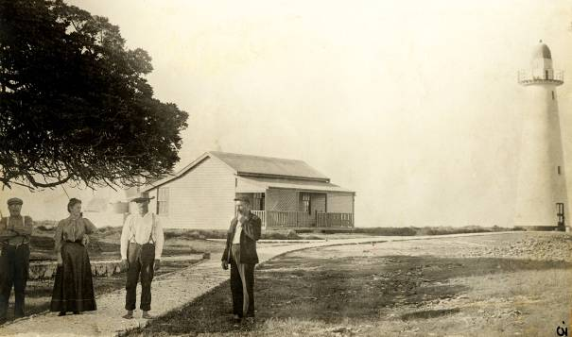
Figure 7 Lady Elliot Lighthouse and cottage, no date, sourced from Australian Maritime Safety Authority

Managing our heritage

Key positions responsible for heritage matters
The Great Barrier Reef Marine Park Authority consists of a full-time chairman and three part-time members; one part-time member is nominated by the Queensland Government. The Great Barrier Reef Marine Park Act 1975 (the Act) also provides that one of the part-time members represent the interests of Aboriginal and Torres Strait Islander communities living adjacent to the Marine Park. Board members are responsible for major policy decisions and their statutory decision-making must be in accordance with the GBRMP Act.
The primary contact for heritage is:
General Manager
Reef Strategy Branch
Great Barrier Reef Marine Park Authority
PO Box 1379
Townsville QLD 4810
Telephone: 07 4750 0700
The Commonwealth heritage listed places and properties are jointly managed by two principal partners, the Authority and the Queensland Parks and Wildlife Service (QPWS), through a program called the Joint Field Management Program. The program has a dedicated team of managers and field officers that together oversee that heritage on Commonwealth owned or controlled places and properties are protected in line with industry recognised best heritage practice.

Specific heritage management tasks are spread across a range of other responsibilities within the Authority. Administrative decision-making in relation to heritage management matters also lies at various levels.
Table 4 Heritage management tasks and those responsible for them
Authority section | Position | Responsibility
Executive senior management team | All | - Liaising with minister and other government agencies
Strategic advice | - Director  project manager | - Heritage strategy planning  - Planning and budgeting for maintenance and conservation  - Developing and implementing the identification and assessment  - Maintaining heritage register  - Strategy reviewing and reporting to the minister
Field management | - Field operations Project manager  - Director  - Manager  - QPWS rangers | - Coordinating preparation of Heritage Management Plans  - Planning and budgeting for maintenance and conservation of Commonwealth heritage listed structures  - Monitoring, reviewing and reporting on Management Plan implementation  - Assessing and managing heritage responsibilities  - Ensuring heritage responsibilities are included in leasing arrangements  - Liaising with stakeholders and other government agencies  - Enforcement and compliance
Environmental assessment and protection | Director | - Assessing permit applications
Planning and policy | Director | - Consideration of and inclusion during the development or amendment of Plans of management, site plans and special management areas  - Inclusion of Aboriginal and Torres Strait Islander Traditional Owners and their information in heritage planning
Information management systems and technologies | Cartographer | - Preparation of maps for heritage planning
Communication | Director | - Appropriate coverage in news items  - Maintaining information for stakeholders  - Promotion to raise public awareness
Reef HQ Aquarium | Director | - Educating and promotion
Legal Services | Director | - Providing legal advice
Tourism and stewardship | Director | - Promoting through Reef Guardian program and tourism operators

Tools and activities
Tools and activities used to protect heritage values are:
- Great Barrier Reef Marine Park Authority Corporate Plan
These annual plans identify the Authority’s key priorities, including the goal to safeguard the Reef’s heritage;
- Great Barrier Reef Marine Park Outlook Report
The Great Barrier Reef Outlook Report, developed every five years, reports on the status of components with heritage values. The next Outlook Report is due in 2019. In 2014 the Authority introduced a section dedicated to assisting the outlook of heritage values.

- Reef 2050 Long-Term Sustainability Plan
Australian Government and Queensland Government’s Reef 2050 Long-Term Sustainability Plan (2015). It has 11 actions that directly point to the protection of heritage values including the completion of a Heritage Management Plan for Low Island and the Low Isles lightstation under the 2035 objective, Indigenous and non-Indigenous heritage including natural, aesthetic, historic, scientific, and social values are identified, conserved and managed in partnership with the community; and
- Reef Integrated Monitoring and Reporting Program
Reef Integrated Monitoring and Reporting Program (RIMReP), is a coordinated and integrated monitoring, modelling and reporting program to help track the progress towards targets and objectives of the Reef 2050 Plan under the plans’ seven themes. A number of expert theme groups have been established in 2017 to develop indicators to measure Indigenous, historic and natural heritage values.
- Great Barrier Reef Marine Park Zoning Plan
The Great Barrier Reef Marine Park is a multiple-use area and the Great Barrier Reef Zoning Plan 2003 (zoning plan) is the tool that assists the Authority and its partners to manage these multiple uses. Zoning helps to manage and protect the heritage values of the Marine Park. The zoning plan defines what activities can occur in which locations, both to protect the marine environment and to separate potentially conflicting activities. All lightstations sit within the Commonwealth Islands Zone. The Commonwealth Island Zone can be used or entered without permission for low impact (non-extractive) activities, including, photography, filming, sound recording, and limited educational programs. The Commonwealth Islands Zone including limitations is detailed in Appendix 3.
- Plans of Management
Plans of Management are generally prepared for intensively used, or particularly vulnerable groups of islands and reefs, and for the protection of vulnerable species or ecological communities. They complement Marine Park zoning by addressing issues specific to an areas, species or community in greater details than can be accomplished by the broader reef-wide zoning plan. Low Island is covered within the Cairns Area Plan of Management 1998. This additional plan is in place because this area contains some of the most intensively used reefs, cays and waters in the Marine Park and supports the highest level of marine tourism in the Marine Park. External organisations may have a plan that must be considered, such as the Bama Ngulkurrku Wawu Wawurrku Bundangka Bubungu Jalunbu: Healthy Mob, Healthy Land and Sea: Eastern Kuku Yalanji Indigenous Protected Area Management Plan, in the case of Low Isles.
- Permits
Marine Park tourist program permits are jointly issued by the Authority and QPWS. The permits align with leases so heritage management requirements are addressed. Permits allow the Authority to:
  - Reduce impacts on high-use and sensitive areas
  - Separate potentially conflicting activities
  - Encourage responsible behaviour in all marine parks users
  - Collect data for planning of marine parks
  - Monitor activities which may become damaging to the Marine Park.

- Heritage Management Plans
This tool directly targets the protection of the Commonwealth heritage listed properties and places owned and managed by the Authority. Heritage management plans are a requirement under s.341S of the EPBC Act. The purpose of the plans is to provide property managers with regimes to ensure the Commonwealth heritage values of a Commonwealth heritage listed place or property are recognised and maintained into the future.
The Authority’s heritage management plans describe and assess the heritage values at each Commonwealth heritage place, as well as detailing obligations, appropriate policies and management regimes required to ensure that the heritage values are managed and protected.
Heritage management plans were registered as a legislative instrument for the Lady Elliot Island lightstation in 2012 and Dent Island lightstation in 2013. The Dent Island Lightstation Heritage Management Plan was the first ‘joint agency’ plan prepared under the EPBC Act, meaning it was jointly prepared by staff within the Joint Field Management Program and the Australian Maritime Safety Authority (AMSA).

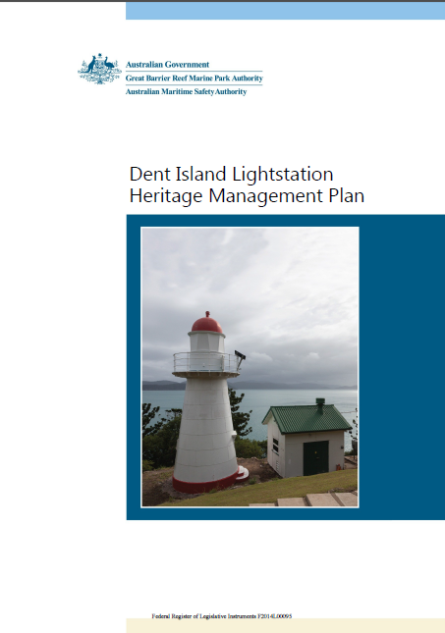
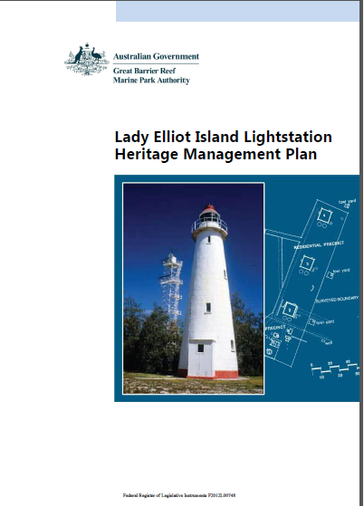

Figure 8 Front covers of the two Commonwealth Heritage listed places and properties Heritage Management Plans
In the case of the Dent Island Lightstation Heritage Management Plan, the private lessee prepared the initial draft which was then augmented and edited by a consultant conservation architect, and lastly, reviewed by the Commonwealth Islands expert within the Authority. In the case of Dent Island’s Lightstation, AMSA was also involved as reviewers. In the case of the Lady Elliot Island Lightstation Management Plan, it was prepared by the Authority in consultation with a heritage architect. The Authority’s Chairman approved the heritage management plans.

Table 5 Status of the Heritage Management Plans
Property or place | Status
Dent Island lightstation | Under the EPBC Act, the Dent Island Lightstation Heritage Management Plan is due to be reviewed in 2018.
Lady Elliot lightstation | Under the EPBC Act, the Lady Elliot Lightstation Heritage Management Plan is due to be reviewed in 2017. This should be finalised in 2018.
Low Island and Low Islets lightstation | A Heritage Management Plan is being prepared for the Minister’s consideration for 2018. It will be a joint plan between the Great Barrier Reef Marine Park Authority and AMSA.  Under the EPBC Act, the Low Island and Low Islets Lightstation Heritage Management Plan will be reviewed five years after its acceptance by the Minister as a plan consistent with the Commonwealth heritage management principles.

In order to develop a heritage management plan a process is followed that facilitates a logical flow from evidence to significance, policy development, implementation and management. Each step is given equal weight and the resulting document reflects the complexity of the individual place.
Once the plan is developed, implementation is prepared for and actioned. The plan’s implementation is constantly monitored, and once every five years it is reviewed.
This process follows good professional practice in the field. The method used is consistent with the recommendations of the Burra Charter (2013) which is authored by the Australian National Committee of the International Council on Monuments and Sites. The Burra Charter provides guidance for the conservation and management of places of cultural significance.
- Leases
There is a lease arrangement for the research station at Low Isles, and a collaborative lease arrangement with a tourist operator to ensure cooperative management of Lady Elliot Island’s lightstation. Conditions of the lease ensure that the lessee assists with conserving and maintaining the place to the reasonable standard required by a heritage management plan. The lessee must give the Authority prior notice before commencing any works and the Joint Field Management Program staff must assess potential impacts.
- Caretaker services agreements
These allow for caretakers to undertake day-to-day maintenance (at Low Isles).
- Compliance
The Joint Field Management Program also has the responsibility of protecting the Great Barrier Reef and its heritage values through a compliance program. The compliance program includes education, audits of activities that require a permit or lease, annual audits and annual reports. The aim is to achieve high levels of voluntary compliance, while also maintaining a strong enforcement approach to deter and detect prohibited activity. The Joint Field Management Program works closely with partners including the Queensland Police Service, Maritime Safety Queensland and the Australian Federal Police. The dedicated team of managers and field officers together oversee that heritage on Commonwealth owned or controlled places and properties are protected in line with industry recognised best heritage practice. Field Management Fact Files are prepared by the Authority for the rangers with heritage key messaging which keeps them informed and updated.
- Engagement
Regular consultation is conducted by the Authority with all stakeholders when heritage management plans are being developed for a property. This includes with other government agencies. Local Marine Advisory Committees for the relevant region are engaged with to keep them updated of any works, new management tools or events. Consultation is held with tourism operators through the Authority’s tourism section. The Reef Guardians program consults with relevant local councils. The Authority consults on a regular basis with members from the Traditional Owner groups. Interest groups and individuals with an association are engaged with too. Family members who grew up on the lightstations are invited to events such as National Heritage Week.
- Interpretation and education
Heritage is communicated through promotion to users and stakeholders for their interest and learning, and taught to staff for their understanding and deliberation. For example, the Authority celebrates National Heritage Week with a talk series that is open to the general public. The Authority works closely with community and partners that wish to act to protect the Reef’s heritage they value, such as lighthouse enthusiasts and scuba divers searching for shipwrecks.
Signage at the places, the Authority’s website and social media are the tools that the Authority employs to raise the awareness of people visiting the Commonwealth Heritage listed places. Select this link to see a video produced and posted on social media. https://www.youtube.com/watch?v=vPsKxFXqU0g&feature=player_embedded
Staff are engaged with on an annual basis as part of National Heritage Week and an annual staff forum. Otherwise there is a comprehensive heritage section on the website, http://www.gbrmpa.gov.au/about-the-reef/heritage and dedicated staff that are always available to assist staff with any queries. An example of assistance where heritage expertise is provided is to the section of the Authority that processes permits.

Identification and assessment program
The approach the Authority takes to identify and assess its heritage values, wherever feasible across the entire Marine Park, is:
Step 1: Identify places of heritage value based on expert advice and Traditional Owner advice received through stakeholder consultation
Step 2: Determine the history of the place, drawn from various documentary sources
Step 3: Identify and contact people and groups with an interest in the place, for consultation
Step 4: Prepare an inventory of each element, with a description of the place, the element’s current condition based on site survey information, some history and its significance
Step 5: Analyse against the statement of significance using the Commonwealth heritage criteria drawn from the regulations (Appendix 2)
Step 6: Gather information about other factors affecting the future of the place
Step 7: Describe the heritage values.
These steps are part of the process to develop a Heritage Management Plan. Therefore the identification and assessment program for Dent Island and Lady Elliot Islands lightstations is complete and both are due to be reviewed. The time-frame to complete for Low Island and Low Islets lightstation is 2018 with the completion of the heritage management plan due at this time.

Consultation
In order to develop a heritage management plan, the EPBC Act requires consultation with all stakeholders. Consultation is typically with Commonwealth agencies, lessees, caretakers, heritage experts (for large works), and community, including Traditional Owners. Consultation may be through a formal or an informal process.
Consultation provides the opportunity for stakeholders to be informed and have their views considered. Importantly, it allows the Authority to hear different and valuable opinions when it seeks suitable measures to protect places with heritage value. Traditional Owners are the primary source of information for Indigenous heritage values. They are the only people that can identify heritage that they value. The Authority acknowledges effective and meaningful partnerships, communication, and engagement between the Authority and Traditional Owners is essential to protect Indigenous heritage values.
Tourist operators are another example of a group that the Authority consults with on a regular basis. This Authority will introduce a unit into the Reef Discovery Course, a heritage training tool for tourism staff. There is already a section dedicated to World Heritage: criteria, obligations, how the Great Barrier Reef came to be listed.
The Authority’s consultation for heritage of value is guided by current national standards, namely:
Article 43 of the Australian Natural Heritage Charter (2002) for natural heritage places.
‘Consult with individual and organisations with an interest in the natural significance or future use of a place is highly desirable, especially at the time of developing the conservation policy and the conservation plan.’
Ask First, a guide to respecting Indigenous heritage places and values
‘Identify Traditional Owners and other Indigenous people with rights and interests in the area. Identify non-Indigenous people with rights and interests in the area. Agree on a process for addressing Indigenous heritage matters. Arrange a meeting of all stakeholders to discuss the project or activity and agree who will undertake work.’
Article 26.3 of The Burra Charter, 2013
‘Groups and individuals with associations with the place as well as those involved in its management should be provided with opportunities to contribute to and participate in identifying and understanding the cultural significance of the place. Where appropriate they should also have opportunities to participate in its conservation and management.’
The Authority recognises that maintaining contact is crucial to the effective management of its Commonwealth heritage places and properties.

Government
The Authority recognises that liaising with the Commonwealth agencies with an interest in heritage matters in the Great Barrier Reef Marine Park is not only a legislative requirement but also crucial to the effective management of heritage. Managing such a large and complex property requires a collaborative effort.
Ongoing consultation and regular liaison with Queensland Parks and Wildlife Service (QPWS) colleagues assists with the development of heritage management plans, maintenance and restoration at places.
Ongoing consultation with heritage experts within the Commonwealth Department of the Environment and Energy and the Australian Maritime Safety Authority (AMSA) occurs for the purposes of heritage management, environmental management and ongoing maintenance of aids to navigation.
The Authority consults with heritage experts for large projects. The consultation will take place in the early stages of project development or initiation of works proposals which has the advantage of avoiding unnecessary delays and costly plan revisions.
Relevant Commonwealth legislation that concerns the Authority’s Commonwealth heritage listed places and properties and the agencies/departments that administer these Acts are shown in this table.
Table 6 Commonwealth legislation and the agencies/departments that administer the Acts, that concerns the Authority’s Commonwealth heritage listed places and properties
National legislation | Agencies/Departments that administer
Great Barrier Reef Marine Park Authority Act 1975 | Great Barrier Reef Marine Park Authority
Environment Protection & Biodiversity Conservation Act 1999 | Department of Environment and Energy
Navigation Act 2012 | Australian Maritime Safety Authority
Workplace Health and Safety Act 2011 | Comcare

Community
As far as practicable, the Authority aims to provide all Australians with effective, meaningful consultation in heritage matters. The Authority recognises that a wide variety of people and groups have an interest in the identification and assessment of the heritage values. For this reason it has a number of mechanisms to effectively and appropriately include and consult with communities.
The Authority has:
- Regional offices in Cairns, Townsville, Mackay and Rockhampton with dedicated liaison staff whom are easily accessible for local people in these regions
- A comprehensive range of expert and local advisory committees feeding into locally relevant decision making
  - Indigenous and tourism issues-based Reef Advisory Committees (RAC) that comprise a range of stakeholders and independent experts in their field
  - Twelve Local Marine Advisory Committees (LMACs) that operate along the coastline adjacent to the Great Barrier Reef. LMACs provide advice to the Authority, other government agencies and organisations on marine and coastal issues and specific activities that affect the Marine Park in the local regions. LMACs provide local people with an opportunity to identify regional issues of importance as well as broader issues of concern, and to help develop policy responses to those problems. The Authority monitors membership of the LMACs in the interests of access and equity, and makes ongoing effort to encourage representation from a wide range of individuals and interest groups.
The Authority follows the consultation requirements in the EPBC Act so notices advertising a consultation period for a draft Heritage Management Plan are published in The Australian newspaper and on the Authority’s public website.
Any opportunities for consultation or comment are also widely promoted to stakeholders through electronic newsletters that the Authority regularly distributes.
Once a Heritage Management Plan has been approved and implemented, consultation becomes part of the monitoring process and further consultation will occur during reviews of the Heritage Management Plan.

Indigenous
The traditional affiliations, culture, heritage values and rights in relation to Traditional Owners is always taken into account in the management of Commonwealth heritage listed places and properties. Australia’s Aboriginal and Torres Strait Islander peoples are the primary source of information on the significance of their heritage and their participation is obligatory to identify and assess Indigenous heritage values.
All major planning exercises, including developing Heritage Management Plans, and permit decisions, includes consultation with Aboriginal and Torres Strait Islander communities.
The Authority is involved in projects that rely on effective consultation with Traditional Owners; the development of a dedicated Aboriginal and Torres Strait Islander Heritage Strategy 2018–23, and the development of a cultural protocol and a data sharing agreement template that the Authority can use to progress understanding of sea country heritage components valued by Traditional Owners.
A management framework has been developed describing the Marine Park in 27 Traditional Use Management Units based on criteria including tribal or clan boundaries, administrative groupings and geographical range. This allows each clan group, or individual, to be as involved in heritage matters as they choose to be. The Commonwealth Heritage Management Principles (EPBC Regulations, Schedule 7B (6), Appendix 1) state that ‘Indigenous people are the primary source of information on the value of their heritage and that the active participation of Traditional Owners in identification, assessment and management is integral to the effective protection of Indigenous heritage values’.

Dent Island lightstation
The locality and the surrounding area are culturally significant to the Ngaro people who in turn are part of the Birri-Gubba nation. While there is no current native title claim over Dent Island nor the surrounding lands and seas of the Whitsunday region, the Ngaro people are widely acknowledged as the Traditional Owners of the Whitsunday region.
The Authority maintains consultation with these Traditional Owners including:
- One-on-one consultation with Elders
- Contact with joint field management program staff
- Involvement on the LMAC
- The Authority’s Indigenous Partnerships Group regularly meeting with them and their representative bodies
- Contact through the North Queensland Land Council Aboriginal Corporation (NQLCAC).
Lady Elliot lightstation
The locality and the surrounding area are culturally significant to the Taribelang Bunda, Bailai, Gooreng Gooreng, and Gurang Aboriginal Traditional Owner groups. All the islands offshore from Bundaberg/Gladstone are included in the Port Curtis Coral Coast Native Title Claim which has been active since 2001.
The Authority maintains consultation with the Traditional Owners of the mainland including:
- One-on-one consultation with Elders
- Contact with Field Management staff from the Authority and the QPWS
- Involvement on the Local Marine Advisory Committee
- Through the Queensland South Native Title Services as part of future act notifications prior to permits being granted for works on the island
- The Authority’s Indigenous Partnerships Group regularly meeting with them and their representative bodies
- The requirement to notify possible actions in relation to permit applications in accordance with the Native Title Act 1993.
Low Island and Low Islets Lightstation
The locality and surrounding area are culturally significant to the Eastern Kuku Yalanji and Yirrganydji Aboriginal Traditional Owner groups. Both of these groups in 2017 are in the native title mediation process. The Authority’s Indigenous Partnerships section maintains consultation with these two Traditional Owner groups and their representative bodies. There are currently efforts to engage for the purposes of completing the assessment of Indigenous heritage values on Low Island in order to complete a Heritage Management Plan.

Lessees
The Authority maintains consultation with lessees utilising any of the Islands’ lightstations. There are ongoing requirements in each lease for regular meetings and reporting, including annual audits and annual reports.

Conflict resolution
The Authority recognises that the management of the Great Barrier Reef Marine Park is a high profile public issue and that strategies for management will legitimately have their proponents and detractors. The Authority recognises that in assessing and managing the protection of components with heritage value, it is possible for situations to arise where there is disagreement over the assessment; or where the management of a place or property for one or more of heritage values conflicts with management for another reason, including another heritage value.
While the Authority has a formal process for negotiating with stakeholders on significant issues the process does not incorporate a formalised conflict resolution or mediation process. The Authority’s strategy is to engage actively with stakeholders on a ‘no surprises’ basis and seek to join with stakeholders as shared custodians of both the issue and its subsequent solution.
Staff can nominate themselves to be trained in conflict avoidance/resolution and mediation.
Where a decision or an action of the Authority relates to a proposal that involves a significant impact, the Authority may seek the advice of the Australian Heritage Council and/or consult with the Department of Environment and Energy. The Authority may refer the matter to the Minister if a proposal involves a significant impact on a matter of national environmental significance (Appendix 4).
The Authority has a formal statutory review mechanism for permit applications where heritage values may be adversely affected. If an application for a permission is refused on the grounds that it would adversely affect the heritage values of an area, the proponent may ask for a reconsideration of the decision to be undertaken internally. A different person from that who made the initial decision then undertakes this reconsideration. If the proponent still wishes to pursue the matter, they can appeal the decision to the Administrative Appeals Tribunal or under the Administrative Decisions (Judicial Review) Act 1977 (ADJR Act).
If conflict arises between the management of different heritage values, this will be resolved via the following process:
- Reference the relevant standard heritage industry guidelines:
- the Australian Natural Heritage Charter (2002), especially Article 7, for natural heritage places
- the provisions in Ask First, a guide to respecting Indigenous heritage places and values (Australian Heritage Commission 2002) for Indigenous heritage places, noting that the overall management process may be the relevant process
- the latest version of the Burra Charter, especially Articles 5.1 and 13, for cultural heritage places including both Indigenous and historic places.
- Reference to commitments within:
  - leasing arrangements
  - permit arrangements
  - the EPBC Act
  - obligations on the Authority imposed by the GBRMP Act.
- Through a negotiation process involving heritage conservation experts.
If this process cannot resolve the conflict, non-statutory advice may be sought from heritage consultants with appropriate expertise and skills, the Department of the Environment and Energy’s Heritage Division or the Australian Heritage Council, and provided to a mediation process for consideration and possible resolution.

Future of our heritage

3.1 Developments
The Authority has completed a Heritage Register for each of the Commonwealth heritage listed sites, including the identification of heritage values. See appendices 5, 6 and 7. Information on the registers will be updated in parallel with actual maintenance at any of the places or findings when updating heritage management plans. The Registers will be available to the public as they will be placed on the Authority’s website alongside the Heritage Management Plans, once approved by the Minister.
There are currently no works or disposal of Commonwealth heritage listed properties underway, or expected works or disposal that may affect Commonwealth heritage values.
Whenever the Authority is considering future development works, the reduction of an asset, or other proposals, heritage issues are identified early on in the project planning to ensure heritage values are not destroyed or degraded. To do this the Authority:
- Uses the self-assessment tool as contained in Working Together: Managing Commonwealth Heritage Places (DEWHA 2008) to measure the likely extent of impact of a proposal
- Considers the significance of any major proposal in the context of the referral provisions in the EPBC Act
- Uses the Matters of national environmental significance, Significant Impact Guidelines 1.1, EPBC Act 1999 (DEWHA 2009) to assist in identifying the significance of impacts
- Ensures any decision must be consistent with a Heritage Management Plan in place. If a plan is not yet available, (Low Island and Low Islets lightstation), the Authority takes all reasonable steps to ensure that any actions are consistent with the Commonwealth Heritage Management Principles (sub-section 341V), (Appendix 1)
- Prepares a heritage impact statement using expert advice identifying alternatives considered and the level of impacts on the heritage values, in line with the Authority’s Environmental Impact Management processes.
The Authority in any of these scenarios will seek advice from one or more of the following to help identify options for managing changes while protecting the heritage values of the place or property: The Commonwealth Department of Environment and Energy, other government agencies, a heritage professional from an independent expert source, internal source; and / or professional heritage advice.

3.2 Monitoring, reviewing and reporting
Monitoring and reviewing the process by which the Authority conserves its heritage values
The level of success of heritage value conservation at the Commonwealth listed places is determined through regular monitoring and reviewing. The monitoring and reviewing methods include inspections followed by reports with findings and recommendations for management, consultation with stakeholders, caretakers and lease owners, and the level of usage of the Authority’s Heritage Register.
The private lessees are required under the terms of the lease to report to the Authority on the state of the Commonwealth heritage values on an annual basis. Paid caretakers provide the Authority with a monthly report. Asbestos experts provide reports on the condition of any asbestos within the buildings. Visual inspections of the heritage values are conducted annually by relevant field management representatives. The Authority’s Commonwealth Islands’ Project Manager visits for an inspection as a once a year.
In accordance with the EPBC Act (s. 341ZB), the Authority maintains a minor register containing information on Commonwealth Heritage places they own or control. The information is entered into the minor register for each place as soon as practicable after receipt. These records enable managers to monitor and review the conservation of the heritage values. Information included in these minor registers is:
- A description of the Commonwealth heritage components
- The current condition of the components as reported by the tenants and from inspections by the Authority representatives
- A record of all work carried out on any of the lightstations - this will include photographs, written documentation and drawings/plans
- A record of all proposals for development or adaptive re-use of the lightstations
- A record of all actual developments or adaptive re-use of the lightstations
- A record of all past and present heritage management plans for the lightstations.

Managers also review the number of permit applications being received and allocated for a place, and the conditions within lease requirements.
The implementation of the Strategy is monitored, reviewed and reported on in accordance with the EPBC Regulations (s10.03F). The Authority will review the strategy at least once every three years and provide a report of the review to the Minister for the Environment. Specific actions arising from the Strategy are contained in Appendix 8.
The activities to monitor, review and report on the implementation of this Strategy at the Authority are:
- Individual Heritage Management Plans for each property that are reviewed and updated every five years
- The Outlook Report 2019 provides an assessment and grade for places and properties against the criteria on the Commonwealth Heritage List
- Heritage undertakings incorporated into annual reports
- Reports to the Senate Estimates Committee in relation to heritage matters and related expenditure
- Identification of heritage values and any risks to these values, through heritage impact assessments
- Updating and maintaining the heritage registers for each property
- Infrastructure asset appraisal process
- Referrals under the EPBC Act
- Annual visits, inspections and the successful application of annual maintenance plans
- Engagement of appropriate heritage expertise to provide heritage documentation to satisfy the Authority’s requirements under the EPBC Act.
The general manager, Reef Information and Strategy Branch at the Authority is responsible for the review and reporting to the Minister.

3.3 Training staff
The Authority acknowledges the requirement for staff to be trained about Commonwealth heritage obligations and best practice in heritage management. Training courses relating to heritage, conservation and the protection of a place’s significant values may be made available, resource permitting, to key staff as part of continuing professional development.
Training is also achieved through:
- Annual staff forums about heritage
- Awareness of this Strategy and Heritage Management Plans
- National Heritage Week activities that staff are encouraged to attend
- Encouraging people to understand the best practice guides and relevant legislation including Ask First, the Burra Charter and EPBC Act
- Ongoing consultation and discussion with heritage professionals
- Ongoing consultation and discussion with Traditional Owners who talk about their heritage values
- Fact sheets for Queensland Parks and Wildlife rangers
- Understanding of and commitment to the Heritage Management Plans
- Access to resource materials available on the website, including the Department of Environment and Energy website.
Credentials will be checked on any potential contractors and trades people. Once accepted, they will be inducted prior to working on the properties and regularly checked to ensure appropriate techniques for working with and protecting components with heritage value are being adopted.

3.4 Promoting community awareness
The Authority relies on existing communication tools and activities to promote heritage value messages. These tools and activities are:
- Updating the Authority’s website, http://www.gbrmpa.gov.au/about-the-reef/heritage
- Information products for communicating messages to the wider community, which have included pull-up banners and the video previously mentioned
- Promotion to the general public to attend National Heritage Week talks
- Public electronic newsletters
- The regional engagement team through school visits and being available on an exhibition stand at local events
- Displays at the Museum of Tropical Queensland
- On-site interpretation signage
- Low Island ‘museum’
- Museums displaying examples of equipment from the lightstations.

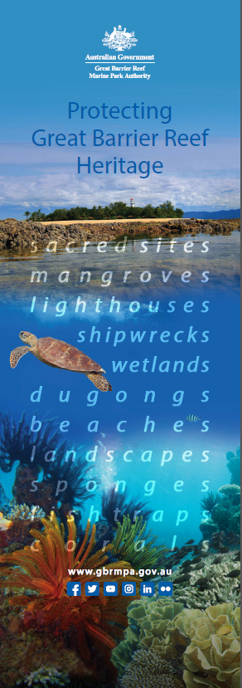
[Figure 9 The artwork from an Authority pull-up banner. Its key message is to raise awareness about the breadth of components in the Marine Park with heritage value

Appendices

Appendix 1. Commonwealth Heritage Management Principles

For subsection 341Y (1) of the Act, the Commonwealth heritage management principles are set out in Schedule 7B.
1. The objective in managing Commonwealth heritage places is to identify, protect, conserve, present and transmit, to all generations, their Commonwealth heritage values.
2. The management of Commonwealth heritage places should use the best available knowledge, skills and standards for those places, and include ongoing technical and community input to decisions and actions that may have a significant impact on Commonwealth heritage values.
3. The management of Commonwealth heritage places should respect all heritage values of the place and seek to integrate, where appropriate, any Commonwealth, state and territory and local government responsibilities for those places.
4. The management of Commonwealth heritage places should ensure that their use and presentation is consistent with the conservation of their Commonwealth heritage values.
5. The management of Commonwealth heritage places should make timely and appropriate provision for community involvement, especially by people who:
- have a particular interest in, or associations with, the place, and
- may be affected by the management of the place.
6. Indigenous people are the primary source of information on the value of their heritage and the active participation of Indigenous people in identification, assessment and management is integral to the effective protection of Indigenous heritage values.
7. The management of Commonwealth heritage places should provide for regular monitoring, review and reporting on the conservation of Commonwealth heritage values.

Appendix 2. Commonwealth Heritage List criteria

(1) For section 341D of the EPBC Act, subregulation (2) prescribes the Commonwealth Heritage criteria for the following:
- natural heritage values of places
- Indigenous heritage values of places
- historic heritage values of places.
(2) The Commonwealth Heritage criteria for a place are any or all of the following:
- the place has significant heritage value because of the place’s importance in the course, or pattern, of Australia’s natural or cultural history
- the place has significant heritage value because of the place’s possession of uncommon, rare or endangered aspects of Australia’s natural or cultural history
- the place has significant heritage value because of the place’s potential to yield information that will contribute to an understanding of Australia’s natural or cultural history
- the place has significant heritage value because of the place’s importance in demonstrating the principal characteristics of:
(i) a class of Australia’s natural or cultural places; or
(ii) a class of Australia’s natural or cultural environments.
- the place has significant heritage value because of the place’s importance in exhibiting particular aesthetic characteristics valued by a community or cultural group
- the place has significant heritage value because of the place’s importance in demonstrating a high degree of creative or technical achievement at a particular period
- the place has significant heritage value because of the place’s strong or special association with a particular community or cultural group for social, cultural or spiritual reasons
- the place has significant heritage value because of the place’s special association with the life or works of a person, or group of persons, of importance in Australia’s natural or cultural history
- the place has significant heritage value because of the place’s importance as part of Indigenous tradition.
(3) For subregulation (2), the cultural aspect of a criterion means the Indigenous cultural aspect, the non-Indigenous cultural aspect, or both.

Appendix 3. Commonwealth Islands Zone

The Commonwealth Islands Zone is comprised of those land areas of the Great Barrier Reef Marine Park above the mean low water mark that are directly managed by the Commonwealth.
The Commonwealth Island Zone can be used or entered without permission for low impact (non-extractive) activities, including, photography, filming, sound recording and limited educational programs subject to the following limitations:
- Certain Commonwealth Islands are subject to private lease arrangements, Defence activities or are managed by a caretaker. These islands have additional management arrangements in place. Contact the Great Barrier Reef Marine Park Authority on freecall 1800 990 770 for more information
- As with all islands in the Great Barrier Reef World Heritage Area, seasonal bird closures exist on some Commonwealth Islands. For further information contact the Great Barrier Reef Marine Park Authority
- Eshelby Island located approximately 30 kilometres north of Airlie Beach is surrounded by a Preservation (pink) Zone and therefore no access is permitted to the island other than in accordance with Preservation (pink) Zone requirements
- Camping permits for Russell Island and Kent Island can be obtained by contacting the Department of Environment and Resource Management in Cairns on (07) 4046 6677
- Traditional use of marine resources is allowed on Commonwealth Islands with written permission or in accordance with an accredited Traditional Use of Marine Resources Agreement.

Appendix 4. Matters of National Environmental Significance

- World Heritage properties
- Ramsar Wetlands
- Nationally listed threatened species and ecological communities
- Listed migratory species
- Activities related to nuclear energy
- National heritage places
- The Great Barrier Reef Marine Park
- A water resource in relation to coal seal gas development and large coal mining development

Appendix 5. Dent Island Lightstation Heritage Register
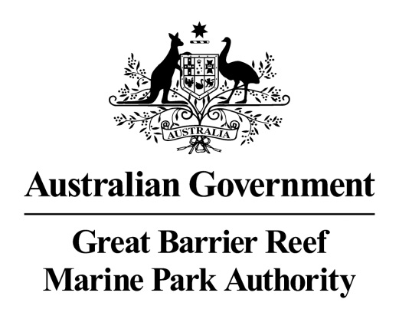
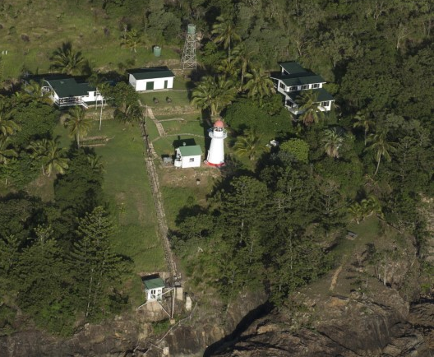
Aerial view of Dent Island lightstation © Commonwealth of Australia (Great Barrier Reef Marine Park Authority)

Dent Island Lightstation
Heritage Register

December 2017
The Dent Island lightstation is listed on the Commonwealth Heritage List for its historic heritage value. The property is managed by the Great Barrier Reef Marine Park Authority, a Commonwealth Government agency. This Register is required by the Environment Protection and Biodiversity Conservation Act 1999 s341ZB). It lists the Commonwealth heritage values that the Marine Park Authority is charged with identifying, conserving, managing, interpreting and celebrating.
Commonwealth Heritage List Place ID Number | 105369
Current Status | Listed place since 22 June 2004
Ownership | This property is owned by the Marine Park Authority on behalf of the Commonwealth. The southern part of Dent Island comprises four leased areas. Two relate to the lightstation. Lot 1 HR2019 (58 m²): This small area contains the lighthouse tower and is leased from the Marine Park Authority by the Australian Maritime Safety Authority (AMSA). AMSA owns the Lighthouse and the associated equipment and is responsible for maintaining this structure. AMSA has rights of access to the site through the surrounding areas. Lot 2 HR2019 (2836 m²): This lease contains the former light keepers’ houses and other ancillary structures of the lightstation and is leased from the Marine Park Authority by a private lessee. The private lessee is responsible for the day-to-day maintenance of this Lot.
Location | Dent Island is in the Whitsunday Island Group of the Great Barrier Reef approximately 18 km south-east of Shute Harbour (20º20'21"s, 148º55'48"e).  Dent Island is in between the Queensland coast and the outer Reef. It is approximately 1.5 km west of the largest inhabited island in the Whitsundays, Hamilton Island, positioned about midway along the coastline between Brisbane and Cairns. The island has a surveyed area of about 312 ha.  The yellow arrow on the below Google Map view is pointing to Dent Island, and on the Google Earth view it is pointing to the location of the Lightstation on Dent Island.
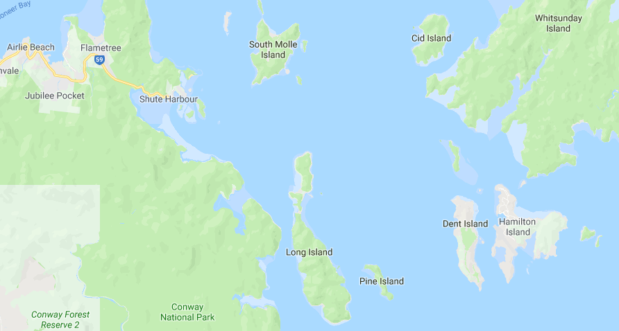

Google Maps map data © 2018 GBRMPA, Google Australia
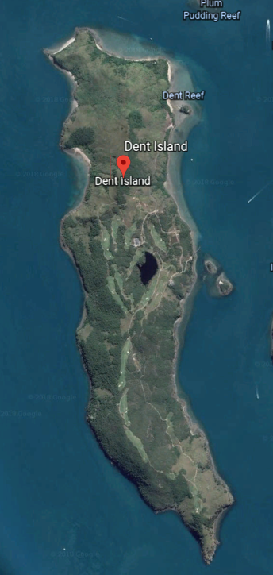
© Google Earth
Description | The light provides navigational guidance for ships passing through the narrow passage between Whitsunday Island and the islands adjacent to the mainland.  The tower is erected around a timber frame of colonial hardwood. The conical boiler plate casing is non-structural.  The six buildings associated with the tower (two residences, a winch house, store shed, engine room and combined workshop/radio room) are constructed variously of weatherboard and fibro sheeting on timber frames, with galvanised iron roofs.  The red domed, white conical tower of timber framed, iron clad construction stands 10 metres high. A circular cast iron staircase runs inside the tower to the light platform. A fourth order lens, and oil wick burner were originally installed in the light.  The lens is presently surmounted by a 6ft 7.75in diameter lantern manufactured by Chance Brothers of Birmingham, England. The optical apparatus consists of a self-contained electric beacon mounted on the handrail of the tower balcony. It is powered by banks of solar cells housed on a north facing prefabricated stand erected close to the tower. The apparatus gives a character of flashing every five seconds with an intensity of 1,310 candelas resulting in a nominal visible range of 10 nautical miles.  Accommodation consists of two timber framed, fibrocement cottages.  Cottage 1 is a two level building with three bedrooms and a bathroom located on the lower level and living room, kitchen, storage room, toilet, laundry and enclosed verandah on the upper level.  Cottage 2 is of single level construction with three bedrooms, living room, dining, kitchen, laundry, toilet, bathroom and store room and open front verandah. Just up the hill from the tower is a tiny, white picket fence enclosing the grave of a newborn baby (apparently the first born of an early light keeper).  Other structures on the site (store shed, engine room and combined workshop/radio room), have concrete floors, are timber framed and have flat asbestos cement external wall cladding. A boat ramp is provided at the base of the cliff and concrete steps have been erected to provide access to the upper level. Associated buildings include a weatherboard bulk fuel store and winch shed located adjacent to the crane landing and haulage way. A diesel powered winch was used to transfer stores from ship to shore.  It is possible that the place may have Indigenous heritage value. The national estate value of this aspect of the site's heritage significance has yet to be assessed.
Sequential history | 1878: Commander George Poynter Heath, the Chairman of the Queensland Marine Board, wrote to the Colonial Treasurer in February recommending the construction of lights on both Cape Cleveland and Dent Island. Formal approval was granted in April and tenders were subsequently called. William P Clark was awarded the contract to erect the tower and two ancillary cottages for 1820 pounds.  1879: Building completed in September.  1925: The burner was replaced by a 35mm incandescent kerosene mantle and the intensity of the light increased from 4,000 to 225,000 candelas.  1927: The original lens was replaced by a reconditioned fourth order lens from Cape Cleveland.  1960: Accommodation consisting of two timber framed, fibrocement cottages is erected.  1982: The light was converted to electric operation and down-graded from 18 nautical miles to 10 nautical miles.
Statement of significance | Dent Island Lighthouse is significant as a light tower built in response to, and to further encourage, the expansion of regular coastal shipping along the inner route of the Great Barrier Reef, following the economic development of northern Queensland. The Lighthouse is significant as an intact representative example of a timber-framed, iron clad tower an innovative structural system designed in the office of the Queensland Colonial Architect and typical of Queensland lighthouses of the time. Dent Island Lighthouse is important as one of a pair of identical lighthouse towers built at the same time, the other being situated at Cape Cleveland. The lightstation complex of tower, houses, store shed, engine room and combined workshop/radio room is significant as a complete intact example of a lightstation complex in Queensland. Later stages of development have integrated with the original fabric and detail of the lightstation, contributing to the continuum of a complex dedicated to the single aim of maintaining the aid to navigation.
Official heritage values | Criterion A processes  Dent Lighthouse, constructed in 1879, is significant as a light tower built in response to the dramatic expansion of regular coastal shipping along the inner route of the Great Barrier Reef, following the economic development of northern Queensland.  The lightstation complex of tower, houses, store shed, engine room and combined workshop/radio room, dating from 1879 to c 1960 is significant as a complete intact example of a lightstation complex in Queensland. Later stages of development have integrated with the original fabric and detail of the lightstation, contributing to the continuum of a complex dedicated to the single aim of maintaining the aid to navigation.  Attributes  The lighthouse and its relationship to the houses, storage shed, engine room and combined workshop/radio room, dating from 1879 to c 1960.
Criterion D characteristic values
The lighthouse is significant as an intact representative example of a timber — framed, iron clad tower an innovative structural system designed in the office of the Queensland Colonial Architect and typical of Queensland lighthouses of the time. Dent Island lighthouse is important as one of a pair of identical lighthouse towers built at the same time, the other is at Cape Cleveland.
Attributes
The structural system and all of the fabric including timber framing and iron cladding.
Dent Island lighthouse 2013 © Commonwealth of Australia (Great Barrier Reef Marine Park uthority)

Other current heritage listings | Nil
Access restrictions | The lightstation excluding the lighthouse is managed by the Marine Park Authority and a lessee is in place. The lessee manages all access as they utilise it as accommodation for staff.  The lighthouse is still working and is managed by the Australian Maritime Safety Authority. There is no public access.  Access to Dent Island is only by water motor craft.
Consultation requirements | The Marine Park Authority consults with the lessee.  Consultation is directed by the EPBC Act when developing the Heritage Management Plan; involves stakeholder and public consultation.
Relevant documents or references | Dent Island Lightstation Heritage Management Plan 2013
Date last updated | 2013
Other places significant by association | The lighthouse, erected on the island in 1879, was one of a series of 12 lighthouse towers of a distinctive type, built between 1873 and 1890.

Appendix 6. Lady Elliot Island Lightstation Heritage Register

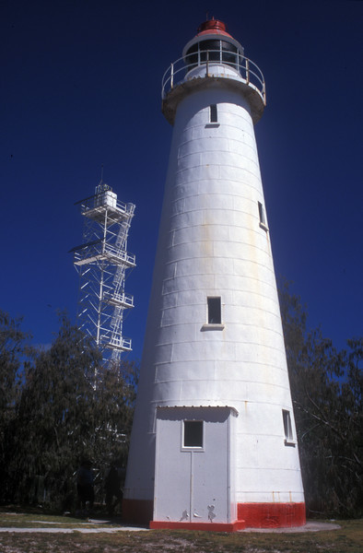
© Commonwealth of Australia (Great Barrier Reef Marine Park Authority)

Lady Elliot Island Lightstation
Heritage Register

December 2017
The Lady Elliot Island lightstation is listed on the Commonwealth Heritage List for its historic heritage value. The property is managed by the Great Barrier Reef Marine Park Authority, a Commonwealth Government Agency. This Register is required by the Environment Protection and Biodiversity Conservation Act 1999 s341ZB). It lists the Commonwealth heritage values that the Marine Park Authority is charged with identifying, conserving, managing, interpreting and celebrating.

Commonwealth Heritage List Place ID Number | 105415
Current Status | Listed place as at 22 June 2004
Ownership | The property is owned by the Marine Park Authority on behalf of the Commonwealth. Two lessees have lease arrangements with the Marine Park Authority. The lease agreements require the lessees to comply with the requirements set out in this Heritage Management Plan:  - The private lease relates to the use of the island for resort purposes and commenced on 1 December 2005; and  - A second lease relates to the ongoing presence of a navigation light and commenced on 27 May 2003.
Location | Lady Elliot Island is situated at the southernmost end of the Great Barrier Reef approximately 90 kilometres north-east of Bundaberg and 150 kilometres east-south-east of Gladstone (24° 07' S, 152° 43' E). The island, which occupies a surveyed area of 34.67 hectares, is Australia’s most southerly coral cay and is situated at the southerly end of a drying platform reef of about 142 hectares. The Heritage Management Plan Area occupies approximately 0.8 hectares along the western side of the island and is delineated by the boundary of the lighthouse and residential precincts.  The yellow arrow on the below Google Map shows the relationship of Lady Elliot Island to Bundaberg on the mainland.  On the following image from Google Earth, the red arrow is pointing to the Lightstation precinct.
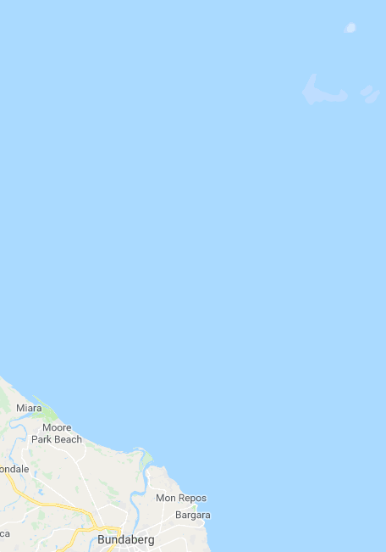
Google Maps map data © 2018 GBRMPA, Google Australia
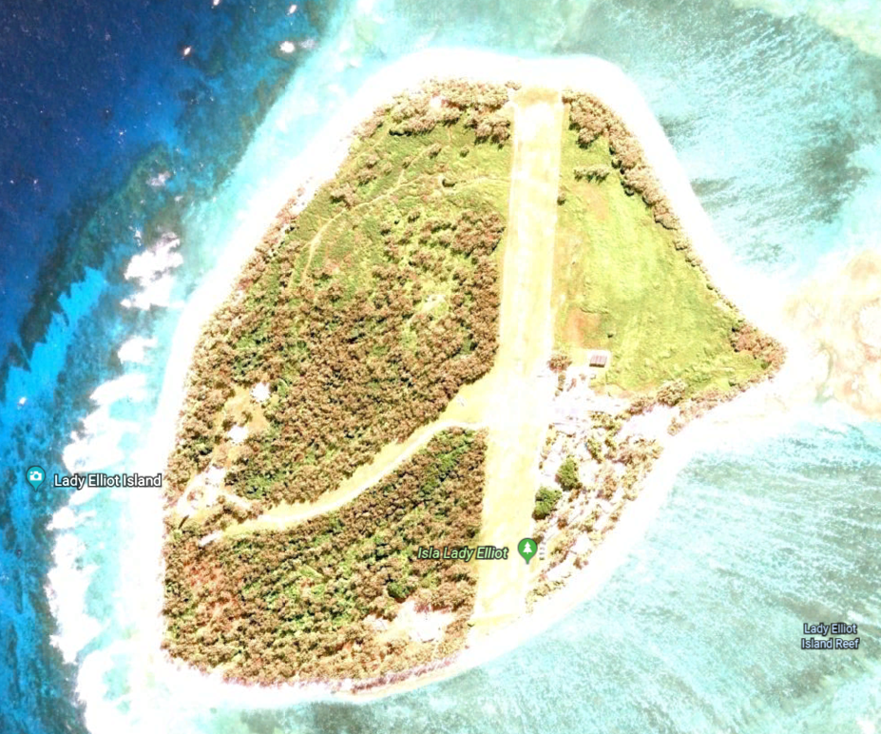
© Google
Description | Lighthouse tower: Concrete base contained within stone wall; timber tower frame, floors, stairs, ladder; curved iron plating with fixed glass windows and timber-framed and sheeted door. Nothing remains of the original balcony floor, lantern, or optical apparatus.  Condition: Stable, painted externally in 2007.  Lighthouse balcony and lantern room floor: Steel plate floor, round in plan, bolted onto rolled steel angle and channel supports, with steel balcony handrail. Condition: Additional painting of balcony required to arrest rust; otherwise stable.  Lighthouse lantern room: Chance Brothers & Company fourth order lantern with vertical astragals, curved glazing, drum (admiralty pattern) vent.  Condition: stable.  Lighthouse porch: Enclosed porch with timber frame covered with flat asbestos-cement sheet; skillion roof; concrete floor at level of bottom stair tread; ledged and braced door; fixed glass window. Condition: stable.  New power house: Freestanding building with concrete slab on ground; unpainted cavity brick walls; concrete ring beam; stainless steel sheeted skillion roof; bunded fuel storage area attached at back, enclosed with chain wire fence. Used for storage by resort operator. Condition: stable; minor cracking to concrete ring beam.  Old power house: Small gable roofed building; timber frame; concrete slab on ground floor; walls sheeted with flat asbestos-cement; roof sheeted with corrugated asbestos-cement sheet. Used for storage by resort operator.  Condition: Stable.  Workshop: Small gable roofed building with skillion roofed extension; timber frame; concrete slab on ground floor; walls sheeted with flat asbestos-cement; roof sheeted with corrugated asbestos-cement sheet. Used for storage by resort operator.  Condition: Stable.  Fuel store: Small gable roofed building; timber frame; concrete slab on ground floor; walls sheeted with flat asbestos-cement; roof sheeted with corrugated asbestos-cement sheet. Used for storage by resort operator.  Condition: Stable.  Fuel drum rack: Two parallel hardwood rails supported on short hardwood posts, designed to hold 44 gallon (200 litre) drums clear of the ground.  Condition: Settled and misaligned; one rail not supported at one end.  Light keepers’ house: Three identical detached timber-framed single-storey lowset houses with surrounding verandahs. Houses are lined with flat asbestos-cement sheeting, and supported on concrete truncated pyramid piers. Each has three concrete stairs. The verandahs are enclosed with asbestos-cement sheeting, shutters and casement windows. The hipped roofs are sheeted with corrugated asbestos-cement. Condition: Stable.  Rainwater tanks: Six spherical glass reinforced plastic tanks, each about 3.6 m diameter, partly sunk into the ground, two at each of the houses. Condition: Stable.  Boat shed: Small gable roofed building; timber frame; concrete slab on ground floor; walls sheeted with flat asbestos-cement; roof sheeted with corrugated steel. Condition: Stable.  Fowl house: One small skillion roofed building; timber frame; walls sheeted with flat asbestos-cement; roof sheeted with corrugated asbestos-cement.  Condition: Roof deteriorated.  Steel tank stands: Two of the three tank stands remain, each with galvanised hot-rolled steel angle stanchions, rails and braces, with timber decking on channel joists; no tanks remaining; semi-rotary hand pumps and pipe work fixed to house. Condition: Stable.  Septic tanks: Three concrete septic tanks partly buried behind houses, with associated drains and fixtures. Condition: Stable.  Loading ramp: Concrete retaining wall, backfilled with soil. Condition: Stable.  Coral paths: Raised pathways of coral, now overgrown with grass. Condition: Stable.  Concrete paths: Concrete paths. Condition: Minor cracking; otherwise stable.  Graves: Site of two graves, marked with headstones, surrounded by a picket fence. Condition: Some pickets loose; otherwise stable.
Sequential summary use of place – post European arrival | 1860s -1890s: Occupied and used by Europeans to extract deposits of guano – accumulation of seabird excrement use at the time as a fertiliser and gunpowder ingredient  1866: Lady Elliot Island lightstation established with a temporary navigation light erected in the form of a tall mast on which a light was shone  1872: Lighthouse construction  1873: Lighthouse light is first lit, and operated by the Queensland Department of Harbours and Rivers  1923: Brightness of light upgraded to 23,000 candlepower  1927: Optical apparatus, lantern and balcony/lantern-room floor were replaced. Three new houses were built to replace two old ones  Date unknown c. 1952: Diesel generator installed to provide power to houses  c. 1961: Goats removed and a beautification scheme commenced including small casuarina trees planted  1963: Plastic rainwater tanks were installed to supplement earlier corrugated iron tanks  1966: Bathrooms connected to septic tanks  1980: Lighthouse converted from kerosene to acetylene operation which involved extensive changes, including fact that now operating automatically without human intervention so keepers were withdrawn  1980s: Casuarina trees had grown so tall they obstructed visibility of the light from some sectors.  1989: Electric rotating beacon replaced the acetylene operation. It was powered by batteries charged by solar photovoltaic panels  1995: Original Lighthouse is superseded by a new taller structure a short distance away. The tower is surrounded by a fence.
Statement of significance | Lady Elliot Island lightstation, established in 1866, is significant for its evidence of important steps in the development of a system of navigation aids along the Queensland coast in the nineteenth century. The centrepiece is a lighthouse, first lit in 1873, that was the first of a series designed in Queensland to suit local conditions and economic constraints.
Official heritage values | Criterion A processes  The Lady Elliot lightstation is significant as an important element in the establishment of navigational aids along the Queensland coast, which reflects the development of the coastal regions of Queensland after its separation from New South Wales. The lightstation portrays the historical development of the complex over time, with the changes made in lighthouse technology, accommodation and the addition of other service buildings.  Attributes  The lighthouse, adaptations to the light, and all associated structures.
Criterion B rarity
The use of timber framing for the staircase is a rare example of this construction method in lighthouses in Australia.
Attributes
The timber framed staircase.
Criterion D characteristic values
Lady Elliot Island lightstation is significant as a lighthouse built in 1873, using a timber framed substructure and cast iron external cladding.
Attributes
The use of cast iron external cladding.
Criterion E aesthetic characteristics
The Lady Elliot Island lightstation is significant as a landmark feature which, along with the island, marks the southern end of the Great Barrier Reef Marine Park.
Attributes
The prominence and location of the lighthouse.
Criterion F technical achievement
Lady Elliot Island lightstation is significant as a lighthouse built in 1873, using a timber framed substructure and cast iron external cladding.
Attributes
All of the original fabric and in particular the use of a timber frame with external cast iron cladding.
Other current heritage listings | Gladstone Regional Council
Access restrictions | The private lessee controls access to the buildings within the historic precinct.  The relative remoteness of Lady Elliot Island makes access challenging and provides the lightstation with a natural security buffer. Most visitors to the island arrive by aircraft, with some trawlers anchoring up in the lee side of the island to escape poor weather, and other vessels as part of organised live-aboard dive voyages. Access to the island and precinct is limited by the Commonwealth Islands zoning, lease and permit requirements.  Australian Maritime Safety Authority (AMSA) personnel and contractors periodically visit the AMSA lease to inspect or maintain the navigation aids which are secured by a tall fence. They generally arrive by air, and do not usually need access to the historic precinct. There may be times when the AMSA will need to transport equipment and material to the island by sea and will need to traverse the historic lightstation area.
Consultation requirements | Consultation is directed by the EPBC Act when developing the Heritage Management Plan; involves stakeholder and public consultation.
Relevant documents or references | Lady Elliot Island Lightstation Heritage Management Plan
Date last updated | 2012
Other places significant by association | The lighthouse, erected on the island in 1873, was one of a series of 12 lighthouse towers of a distinctive type, built between 1873 and 1890.

Appendix 7. Low Islet Lightstation and Low Island Heritage Register

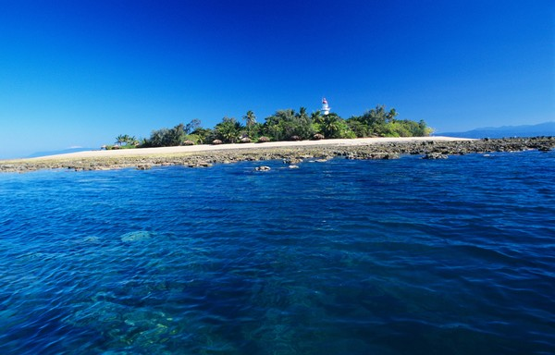
© Commonwealth of Australia (Great Barrier Reef Marine Park Authority)

Low Islet Lightstation and Low Island
Heritage Register

December 2017

The Low Islet lightstation is listed on the Commonwealth Heritage List for its historic heritage value. Low Island is listed on the Commonwealth Heritage List for its Indigenous heritage value. The property is managed by the Great Barrier Reef Marine Park Authority, a Commonwealth Government agency. This Register is required by the Environment Protection and Biodiversity Conservation Act 1999 s341ZB). It lists the Commonwealth Heritage values that the Marine Park Authority is charged with identifying, conserving, managing, interpreting and celebrating.
Commonwealth Heritage List Place ID Number | 105367
Current Status | Listed place, 28 May 2008
Ownership | As the lighthouse is a working aid to navigation it is the property of the Australian Maritime Safety Authority (AMSA). Otherwise the site is managed by the Marine Park Authority.
Location | Low Island is in Trinity Bay, about 15 km north east of Port Douglas, and 60 km north of Cairns (16º 23' 02.6” s and 145º 33' 35.58” e) Immediately to its west is Woody Island. Together these islands are known as the Low Isles and their relationship to the mainland can be seen in the Google Map below.  On the Google Earth view on the next page, the red arrow is pointing to the light house tower.
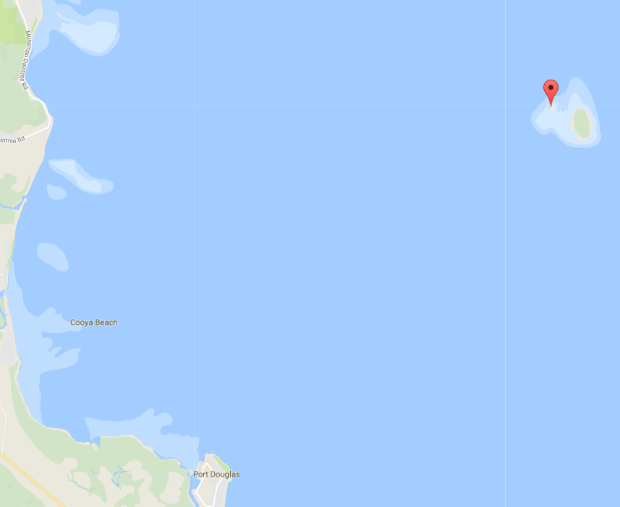
Google Maps map data © 2018 GBRMPA, Google Australia
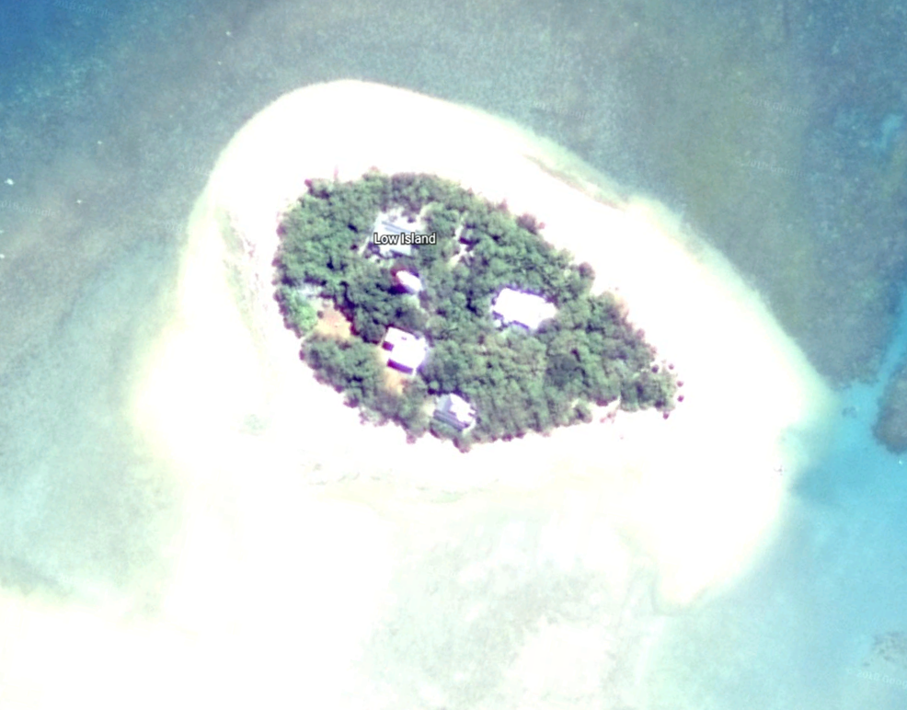
© Google
Description | The Low Islets lighthouse was the fifth to be built in northern Queensland using the iron-clad timber-framed method first used at Lady Elliott Island in 1873. However, the cladding was galvanised iron, instead of black iron plates round, timber-framed towers clad with galvanised iron sheets were unique to Queensland and incorporated Queensland resources.  The lighthouse is a truncated 21-metre conical tower, and the timber frame construction sheathed with iron is in the typical fashion of Queensland lighthouses. The tower is painted white with a red dome, stands on a concrete base, and was the first to have porthole windows.  An internal timber staircase gives access to the lantern room. The optical apparatus consists of a Chance Brothers Third Order revolving lens supported by a roller bearing rotating pedestal, driven by an electric motor. Solar conversion was undertaken at the lightstation in 1993. The beam source is a 120-volt 1000-watt tungsten halogen lamp and solar array.  The grouping of the buildings of the lightstation follows a generally radial pattern with the lighthouse as the axis, rather than the more common lineal layout found on many other lightstations. This radial layout may have been determined by the physical size of the island, giving more privacy to keepers and maximising the use of the limited space on the island. The cottages and sheds are built in a compact arrangement around the Lighthouse, forming one physical precinct combining both service and residential functions, and are surrounded by thick vegetation. The original cottages were demolished and replaced by new keepers' residences, timber framed and clad with fibro, in the early.  The elements which make up the lightstation are the lighthouse; the head keeper's house; the assistant keeper's house; the relieving quarters; the old power house; the old fuel store; later service structures including a bulk fuel store, a power house and a boat house; and a toilet block constructed to meet the needs of tourism. There is also an unmarked grave on the site.  Low Islets is part of a geographic complex, which includes Snapper Island (Minyi Gambyi), the mouth of the Daintree (Binda) and Cape Kimberley (Baku). There is a legend that a down-welling stream inland from Mossman Gorge exists undersea near Low Isles.  There is evidence of the past activities of the Kuku Yalanji people from the presence of shell midden sites and the lower-woody mangrove which is still used for hunting practices.
Sequential summary use of place | Kuku Yalanji and Yiriganji Traditional Owner groups visited regularly  1770: Noted by Lieutenant James Cook on the Endeavour in 1770 and the location marked on his chart.  1819: Captain Phillip Parker King on a survey voyage on HMS Mermaid officially named the place Low Isles.  1860s-1870s: Low Island was used intermittently by bêche-de-mer fishermen  1876: Authorisation sought to build a lighthouse  1877: Tenders call and the contract for construction signed  1878: Lighthouse construction completed in 7 months by W P Clark (Brisbane) for £2,865 and the first superintendent appointed, Daniel Owen  Date unknown: Three separate cottages built  1923: Light was upgraded to incandescent kerosene lighting  1928-1929: British-Australian Great Barrier Reef Expedition to Low Isles led by Charles Maurice Yonge  1930: Lens mounted on a new mercury float pedestal with a new weight-driven clock allowing the lens to rotate faster and the flashes went from intervals of 60 seconds to 2.5 seconds  1934: Cyclone demolishes outbuildings, tears of the rooves of two cottages and the Yonge’s laboratory  1941: Provided a radio transceiver to receive orders about extinguishing or relighting during World War II  1961: Powering of the Lighthouse converted to electricity  1993: Lighthouse converted to solar-electric operation and the last of the lightkeepers left the island  1998: Island surveyed by Queensland National Parks and Wildlife Service for use as a tourist site: network of paths, removal of structures, installation of others, interpretation signage, toilets, orientation centre and office space.
Statement of significance | Constructed in 1878, the Low Islets lightstation was the first lightstation in the north of Queensland, and its location inside the Great Barrier Reef represented the first attempt to address the dangers to shipping approaching newly established ports from the north, including Cairns and Port Douglas which developed in the 1870s as a result of the discovery of gold in the region. The establishment of the Low Islets lightstation gave increased certainty to shipping in the Inner Passage inside the Great Barrier Reef, and improved safety of access to these developing northern ports.  Low Islets lightstation demonstrates an important step in the establishment of maritime navigational aids along the Queensland coast and reflects the growth and development of Queensland after its separation from New South Wales.  Low Island has heritage significance to Kuku Yalanji and Yiriganji as part of their dreamings.
Official heritage values | Criterion A processes  Low Islets lightstation was first lit in 1878, offshore from Port Douglas and inside the Great Barrier Reef. It was the first lighthouse constructed in the north of the colony of Queensland, and its location inside the Reef represented the first attempt to address the dangers to shipping approaching the northern Queensland ports, including Cairns and Port Douglas. It is significant in Australian cultural history as it occupies an integral part in the establishment of maritime navigational aids along the Queensland coast which allowed overseas trade to be developed in Queensland’s northern ports. This trade was important for the growth and development of Queensland. The lighthouse tower and its relationship with the light keepers’ houses, the two engine houses, the boat shed, and the fuel tank installation, dating from 1878 to the 1960s are also relevant attributes.
Criterion I Indigenous tradition
Low Island has heritage significance to Kuku Yalanji and Yiriganji as part of their dreamings. Kuku Yalanji believe the Low Islets and Snapper Island ('Minya Gambyi'), the mouth of the Daintree ('Binda') and Cape Kimberley ('Baku') were once part of a united landmass that became separated during the creation period (the Dreamtime). Traditionally, these three sites were visited regularly by Traditional Owners to maintain contact with important dreaming sites and stories and the local Aboriginal community continues to maintain a strong spiritual connection to these places).
Other heritage listings | Nil
Access restrictions | Low island is held by the Marine Park Authority on behalf of the Commonwealth of Australia.  The Australian Maritime Safety Authority (AMSA) leases two small adjoining parcels of land on Low Island on which the Lighthouse stands. The lighthouse is an operating aid to navigation owned by AMSA and there is no public access.  There are currently five operators with Marine Parks Permits endorsed to access Low Island daily for 365 days a year. A further two bookings for other operators is available daily but for a maximum of 50 days per year for each operator.
Consultation requirements | Consultation is directed by the EPBC Act when developing the Heritage Management Plan; involves stakeholder and public consultation.
Date last updated | 2012
Other places significant by association | Lady Elliot Island lightstation
Archived records | Nil

Appendix 8. List of actions arising from the Strategy

EPBC Regulation | Section of Strategy | Action arising from Strategy
 |  | By next Strategy review | Ongoing
2(a) Identify and assess the Commonwealth Heritage values of properties | 2.1 |  | Seek relevant expert advice from qualified sources in the assessment of the full range of heritage values for properties and utilise the information in Heritage Management Plans to inform discussions around the management of the places.
2b(ii) Completion of the Register of Places and their Commonwealth Heritage values | 3.1 | Provide to the Minister of the Environment and Energy in 2021 as required by the EPBC Regulations
2b(iii) Completion of the report reviewing the implementation of the Strategy to the Minister that includes a copy of the registers | 3.2 | Provide to the Department of the Environment and Energy in 2021 as required by the EPBC Regulations
3a Maintain registers | 3.1 |  | Update the Registers;  - As required and in a timely manner  - When the Heritage Management Plans are reviewed in accordance with section 341X of the EPBC Act.
3b Prepare Heritage Management Plans | 2.2 |  | - Prepare a Heritage Management Plan for Low Island and Low Islets lightstation for the Minister in 2018 - a joint plan between the Authority and the Australian Maritime Safety Authority; and  - Review the Lady Elliot lightstation Heritage Management Plan and Dent Island lightstation Heritage Management Plan in 2018.
4a Train staff about Commonwealth heritage obligations and best practice heritage management | 3.3 |  | - Promote all training opportunities on the intranet; and  - Provide training as resources allow.
4b Program to promote community awareness of Commonwealth heritage values | 3.4 |  | - Include Authority’s communications section in promotional activities  - Base content on current Heritage Management Plans  - Use existing communication tools  - Use signage for visitors to the properties.

