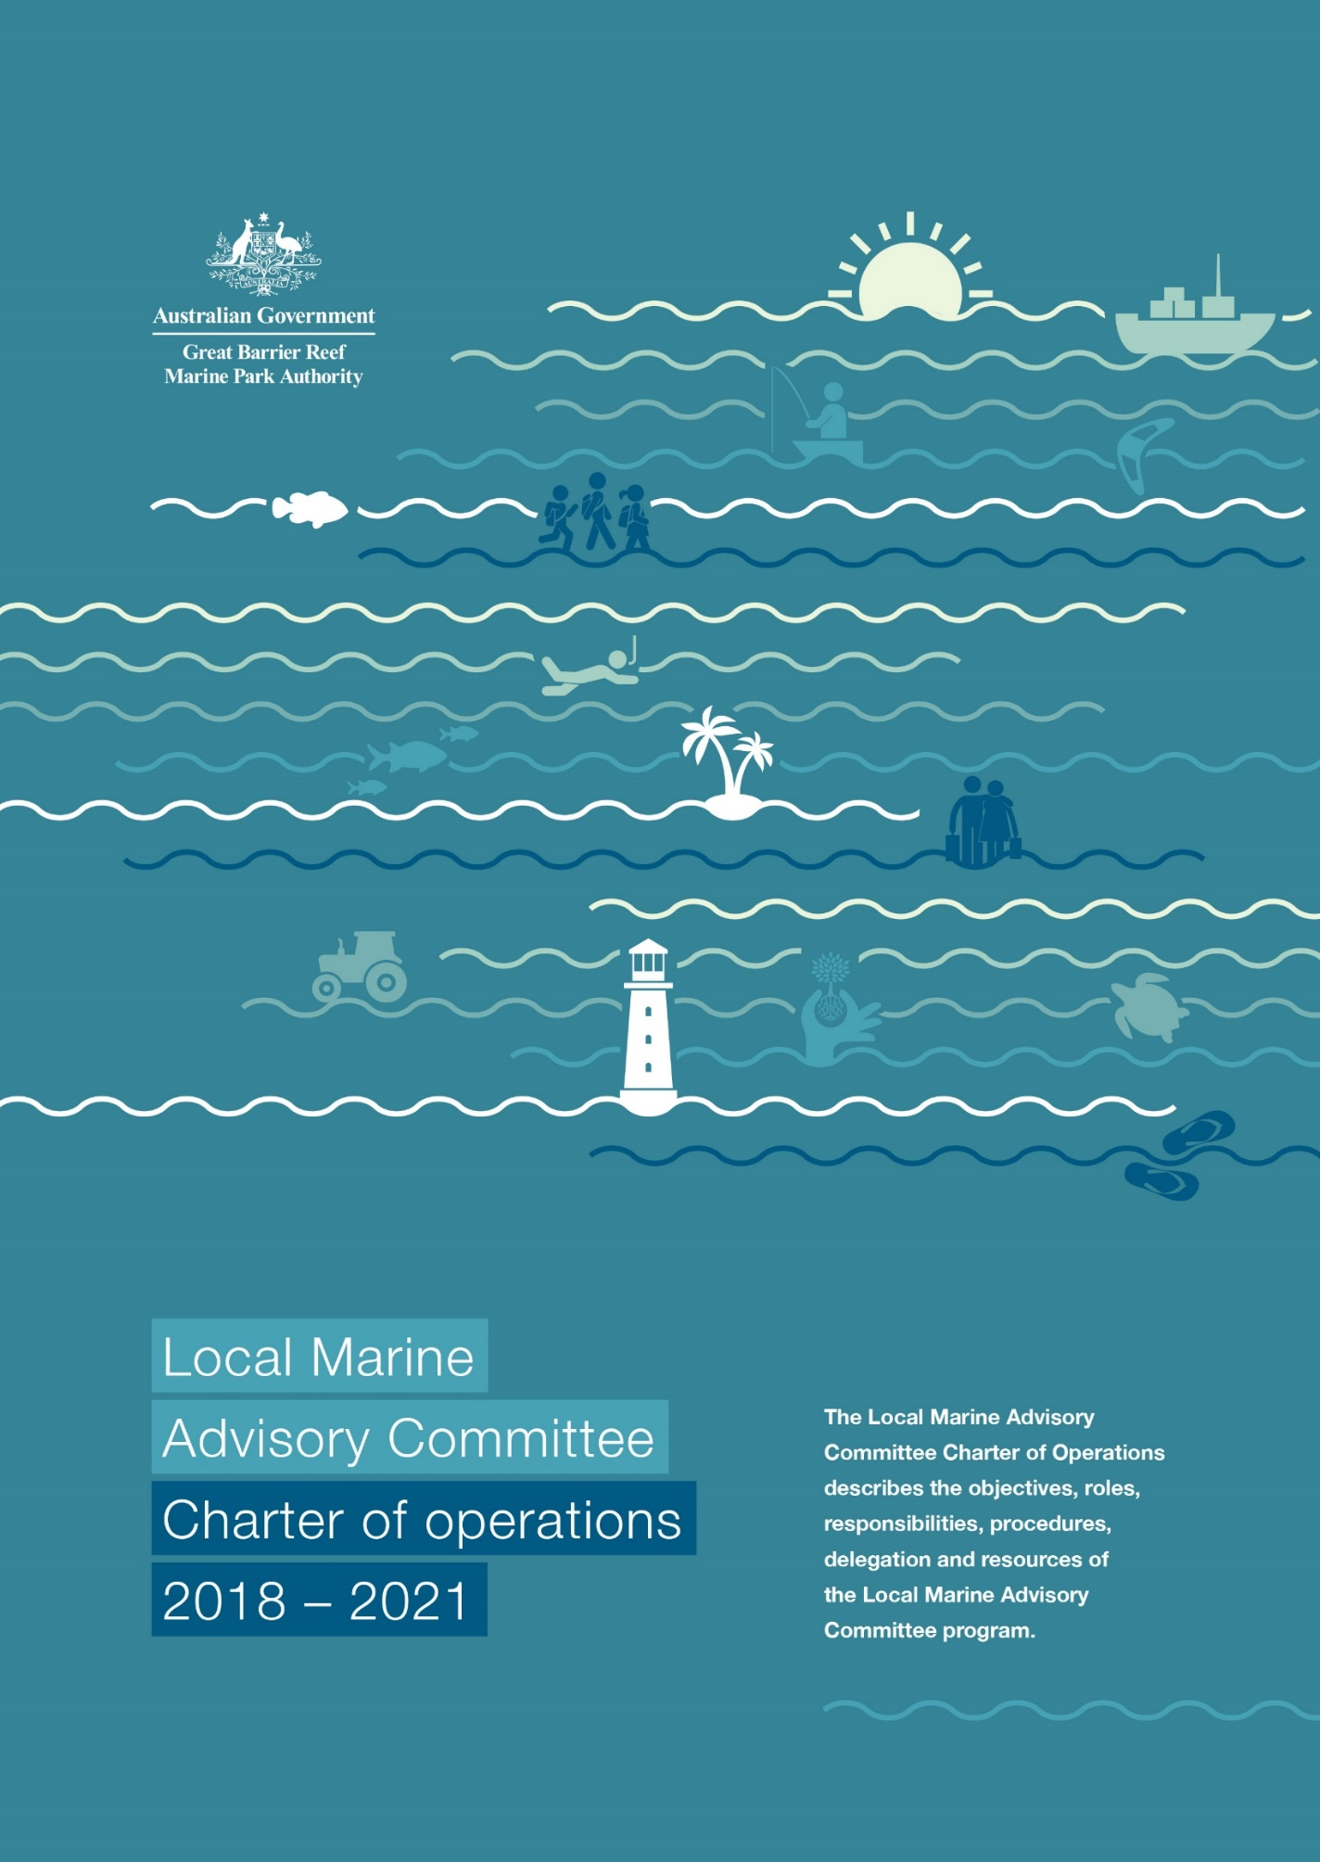

© Commonwealth of Australia 2018 Published by the Great Barrier Reef Marine Park Authority 2018 ISBN 978-0-6480965-1-1
A cataloguing record for this publication is available from the National Library of Australia.
This document is licensed by the Commonwealth of Australia for use under a Creative Commons By Attribution 4.0 International licence with the exception of the Coat of Arms of the Commonwealth of Australia, the logo of the Great Barrier Reef Marine Park Authority, any other material protected by a trademark, content supplied by third parties and any photographs. For licence conditions see http://creativecommons.org/licences/by/4.0
This publication should be cited as:
Great Barrier Reef Marine Park Authority 2018, Local Marine Advisory Committee: Charter of operations 2018–2021, Great Barrier Reef Marine Park Authority, Townsville.
DISCLAIMER
The views and opinions expressed in this publication do not necessarily reflect those of the Australian Government. While reasonable effort has been made to ensure that the contents of this publication are factually correct, the Commonwealth does not accept responsibility for the accuracy or completeness of the contents, and shall not be liable for any loss or damage that may be occasioned directly or indirectly through the use of, or reliance on, the contents of this publication.

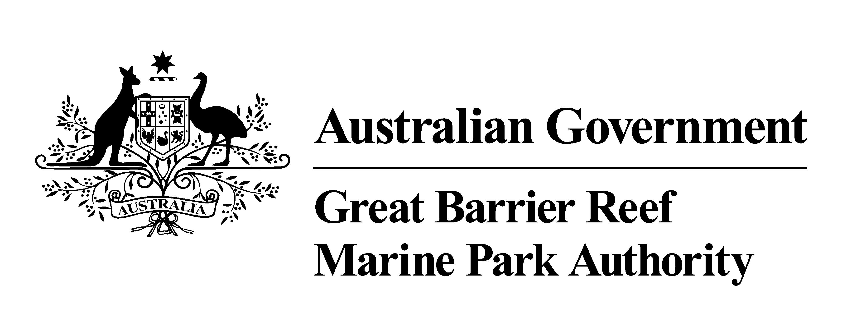
Requests and enquiries concerning reproduction and rights should be addressed to:

Director, Communication and Regional Engagement
2–68 Flinders Street
(PO Box 1379)
Townsville QLD 4810, Australia
Phone: (07) 4750 0700
Email: info@gbrmpa.gov.au
Comments and enquiries about this document are welcome and should be addressed to:
LMAC Coordination Team
lmac@gbrmpa.gov.au
www.gbrmpa.gov.au

Contents

Purpose in establishing Local Marine Advisory Committees 4
Regional distribution 4
Local Marine Advisory Committees boundary map 6
Appointment 7
Stakeholder representation 7
Selection of LMAC members 7
Code of conduct 8
Authority and management partner representation 9
Meeting attendance and proxies 9
Observers 9
External meetings and events 10
LMAC Chairs meeting 10
Personal information and privacy issues 11
Context and next review 12
Appendix 1: Election of executive roles …………………………………………………………………13
Election of the LMAC Chair 13
Election of the LMAC Secretary 13
Appendix 2: Roles and responsibilities …………………………………………………………………15
LMAC members 15
LMAC Chair 15
LMAC Secretary 16
Management partners 17
Authority representatives 17
LMAC Coordinators 18
LMAC Coordination Team 19
LMAC Program Director 19
Appendix 3: Meeting procedures ………….………………………………………………………………21
Frequency and timing of meetings 21
Induction 21
Meeting agenda 22
Appendix 4: Communication ………………………………….……………………………………………23
Reporting to the LMAC 23
Reporting from the LMAC 23
Legal implications of making comments / defamation 23
Media 23
Social media 24
Representing the LMAC in other forums 25
Correspondence 25
LMAC generic email address 25
LMAC individual email addresses 25
Appendix 5: Finance …………………………………………………………………………….……………13
Fee for service 27
Appendix 6: Insurance ……………………………………………………………………………………...…28

Purpose in establishing
Local Marine Advisory Committees
The Great Barrier Reef is globally recognised for its spectacular beauty and diversity of marine life. In addition to its outstanding universal value as a World Heritage Area, the Reef is integral to Australia’s identity and to the lifestyles and livelihoods of hundreds of thousands of Queenslanders.
In 2017 the Great Barrier Reef’s economic, social and icon assets were valued at $56 billion. Each year the Reef supports 64,000 jobs and contributes $6.4 billion to the Australian economy. It has unique cultural values for its Traditional Owners who have a special and continuing connection with the area.
Like tropical coral reefs around the world, the Great Barrier Reef is under pressure from a range of impacts including climate change, declining water quality, coastal development and illegal fishing. Everyone’s actions to reduce threats and help build the Reef’s resilience – whether big or small – will improve its outlook.
Against this backdrop, it is more important than ever that catchment communities and Reef stakeholders work together to protect the Reef. As Australia’s lead manager for the Reef, the Great Barrier Reef Marine Park Authority sees engaging with and empowering stakeholders and local communities as an essential part of managing the Marine Park.
The Authority has established 12 Local Marine Advisory Committees (LMACs) to provide a forum for local communities to discuss issues and have input into management arrangements.
The purpose of LMACs is to:
- promote the exchange of information between stakeholders, the Authority and other management partners
- provide advice to the Authority on issues and management proposals relating to the Great Barrier Reef
- encourage and empower local communities to take action to reduce threats and build Reef resilience (as identified in the Reef Blueprint, Outlook Report and the Reef 2050 Long-Term Sustainability Plan).
LMACs are established and sponsored by the Authority to provide advice to the Authority and assist it in its endeavours to empower communities and foster stewardship. They are encouraged to advocate and champion Reef stewardship within their communities, but are not a vehicle for political lobbying.

Regional distribution
The LMACs focus on regional issues and represent community views in 12 distinct geographic areas:
Cape York
(Peninsula communities – Cape York to Bloomfield River)
Douglas
(Daintree, Mossman and Port Douglas communities – Bloomfield River to Buchan Point)
Cairns
(Cairns, Gordonvale and Babinda communities – Buchan Point to Flying Fish Point)
Cassowary Coast
(Innisfail, Mission Beach and Tully communities – Flying Fish Point to Tully Heads)
Hinchinbrook
(Cardwell and Ingham communities – Tully Heads to Balgal Beach)
Townsville
(Townsville community – Balgal Beach to Haughton River)
Bowen–Burdekin
(Giru, Ayr and Bowen communities – Haughton River to Yeates Creek)
Whitsundays
(Airlie Beach and Proserpine communities – Yeates Creek to Midge Point)
Mackay
(Mackay and Sarina communities – Midge Point to Arthur Point)
Capricorn Coast
(Rockhampton and Capricorn Coast communities – Arthur Point to Sea Hill Point)
Gladstone
(Gladstone community – from Sea Hill Point to Rocky Point)
Burnett
(Burnett and Bundaberg communities – Rocky Point to Burrum Point)

Local Marine Advisory Committees boundary map

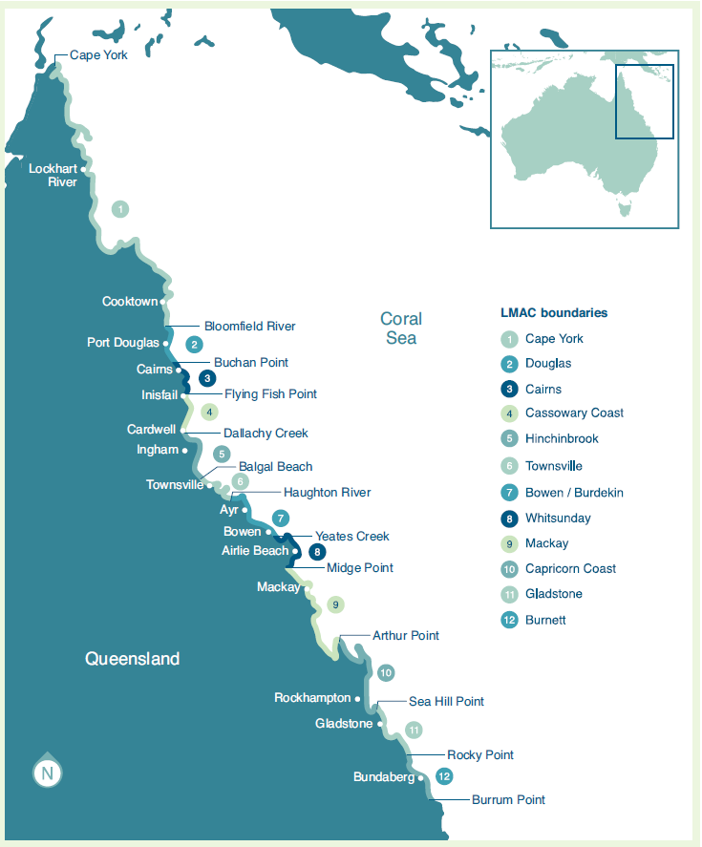

Appointment
LMAC members are appointed every three years following a public call for nominations. Membership for 2015–2018 LMAC members concludes on 30 June 2018. The new three-year term commences on 1 July 2018 and will conclude on 30 June 2021.

Stakeholder representation
LMAC membership aims to achieve a representative diversity of each region’s communities and interest groups. The Authority understands that community members may be linked with more than one interest group and that differences between the LMAC regions may lead to interest groups having additional representation on LMACs.
LMAC members may represent a primary and secondary interest group. Having primary and secondary representation for each member allows the Authority to ensure there is broad representation on the LMAC. Identifying a primary and secondary interest group does not exclude LMAC members from commenting or providing input to any topics relating to the other interest groups listed below.
The LMAC may include representatives from the following interest groups:
- Aboriginal/Torres Strait Islander community
- Agriculture
- Aquaculture
- Business
- Charter boat / fishing guide
- Commercial fishing
- Conservation
- Diving / snorkelling
- Education / research
- Industrial / mining
- Marine rescue
- Natural resource management
- Ports / shipping
- Recreational fishing
- Sailing / boating / kayaking
- Traditional Owner
- Tourism
- Other

Selection of LMAC members
Nomination for membership is on an individual basis, however an individual may be endorsed by an organisation to represent their views.
Applicants who would like to become a LMAC member should read the Roles and responsibilities (Appendix 2) to ensure they understand the requirements of the role.
Applicants must submit a nomination form which details their ability to contribute to the LMAC and capacity to represent and report back to their respective community networks. This form is available on the LMAC page of the Authority’s website.
Given the committees represent regional interests, members should only be associated with one LMAC. Multiple memberships are not encouraged, although stakeholder organisations may be represented on more than one LMAC.
Former members who have been found by the Authority to have breached the Code of conduct are not eligible for re-nomination.
Authority staff will consider each nomination and make a recommendation to the Authority’s Chief Executive Officer (CEO) with the goal of achieving a diverse membership that represents the local community. If a former member, the applicant’s previous attendance record will be considered when evaluating nominations for a new term.
Recommendations and final selection of LMAC members is discretionary and the decision of the CEO is final. The Authority will notify applicants of the outcome of their nomination.
Should a member leave the organisation they represent, the organisation would need to submit another nomination form for a new representative. If a member leaves an organisation but wishes to remain on the LMAC, they would need to submit a change-of-details form to become an independent member or to represent an alternative organisation.
During the three-year term, additional stakeholders may express an interest in joining the LMAC. It is recommended that potential LMAC members initially attend one or more meetings as observers.
The nomination process during the term is the same as outlined above, however the LMAC Chair will also make a recommendation for each nomination received.
Nominations for new members submitted during the LMAC term will be processed twice a year – June and December. Nominations will not be accepted within six months before the end of a LMAC term.

Code of conduct
The following Code of conduct outlines the standards of conduct required of all LMAC participants:
- behave honestly and with integrity in the course of all LMAC business
- act with care and diligence
- treat all LMAC participants and Authority staff with respect and courtesy, and without harassment
- comply with all applicable Australian laws
- not be under the influence of alcohol or illicit drugs in the course of all LMAC business
- not provide false or misleading information in response to a request for information
- at all times behave in a way that upholds the integrity and good reputation of the LMACs
- declare real or perceived conflicts of interest in meeting business
- not make improper use of:
- LMAC information
- LMAC resources
- the LMAC duties, status, power or authority, in order to gain, or seek to gain, a benefit or advantage for the participant or for any other person.
The Authority may, at its own discretion, terminate an individual’s membership of the LMAC at any time if the Authority is satisfied that the individual has breached the Code of conduct.

Authority and management partner representation
Each LMAC is assigned a representative from the Authority to ensure a direct flow of communication between the regional community and the executive.
Engagement managers based in or near the LMAC region are responsible for coordinating the operation of each LMAC. The LMAC Coordinator provides a local point of contact for members between meetings.
Local, state and Australian government agencies are working together to achieve better outcomes for the Great Barrier Reef. The Authority will seek representatives from these management partners to attend LMAC meetings and contribute to discussions.

Meeting attendance and proxies
It is expected that LMAC members will prioritise their attendance at LMAC meetings above other responsibilities, given there are only five meetings a year and the dates are established early in the LMAC term. However, it is recognised that circumstances may prevent members from attending every meeting. Some LMAC members, such as commercial fishers and LMAC members who travel long distances, may have difficulty attending all meetings.
It is important for all members to identify potential proxies who can provide input and vote on their behalf if they are unable to attend a meeting.
In the event a LMAC member will be an apology, they are encouraged to appoint a proxy in writing for approval from the LMAC Chair or LMAC Coordinator before the meeting. The proxy may vote on behalf of the LMAC member they represent, however the proxy’s vote counts as one vote only. A proxy is not a LMAC member and should only attend meetings in the absence of the LMAC member.
LMACs are encouraged to use phone and video conferencing if participants are unable to attend meetings in person.
If a LMAC member (or their proxy) misses three consecutive meetings, or five meetings during the term of the LMAC, the member will be deemed to have resigned from the committee and the Authority may seek an alternative representative from their interest group. A LMAC member will not be reinstated during the LMAC term in circumstances where they are deemed to have resigned. It is important to note that a ‘deemed resignation’ will be considered by the Authority as part of any future application for LMAC membership.
LMAC members may resign at any time by writing to the Authority (an email is acceptable).

Observers
On occasion, external stakeholders may have an interest in an item on the agenda or a LMAC member may wish to bring a guest to a meeting. Observers are welcome to attend meetings with the approval of the LMAC Chair or LMAC Coordinator before the meeting. The Chair or Coordinator should consider the content of the meeting before granting (or possibly refusing) permission.
Observers do not have voting rights; however, they may contribute to relevant discussions at the invitation of the LMAC Chair.

Presenters
The LMAC may request a presentation at a meeting from an expert or an organisation to learn more about a specific issue.
It is recommended that the LMAC Chair consult with the LMAC Coordinator and Authority representative to identify and organise guest speakers for meetings.
It is desirable for the presentation to be scheduled early in the meeting so the speaker is not required to stay for the entire meeting. The presenter should provide a copy of their presentation to be circulated with the meeting minutes.

External meetings and events
If LMAC members plan to attend a community event or participate in a field trip, a risk assessment form must be completed to ensure relevant insurances are in place for all LMAC activities undertaken outside of scheduled meetings. Refer to Insurances (Appendix 6) on the LMAC page of the Authority’s website.
Subcommittees
On occasion, when a specific issue needs to be addressed outside the scheduled meeting time, the LMAC Chair may endorse the formation of a subcommittee or working group. Once formed, the subcommittee may decide how often it meets. The general LMAC meeting should be addressed by a spokesperson from the subcommittee to keep LMAC members updated on its progress.
When a subcommittee drafts responses to a specific issue, these drafts must be sent to all LMAC members for consideration and to ensure endorsement can be made at the next LMAC meeting. If the subcommittee is unable to table the drafts at a meeting the drafts must be provided to the members for endorsement out of session. The subcommittee can proceed with their proposed action once it is endorsed by the LMAC.

LMAC Chairs meeting
During the LMAC term, the Authority will facilitate and sponsor two LMAC Chairs meetings to bring together representatives from each of the 12 LMACs. These meetings are held in Townsville and all costs associated with the LMAC Chairs meeting will be covered by the Authority.
The first meeting of the term will focus on ensuring Chairs and Secretaries/nominated members are familiar with the Authority’s role. It will clarify their roles and responsibilities and provide additional skills and training. A draft strategic plan for the three-year term will be tabled for discussion. Once finalised, this strategic plan will guide meeting agendas throughout the term and be updated annually.
The second meeting of the term provides an opportunity to review the progress of LMACs, and to discuss issues of concern as well as the current priorities for the community and the Authority.
Senior Authority staff including the CEO, General Managers, Directors and Managers attend these meetings. Other attendees at the meeting may include management partners, Reef Advisory Committee Chairs and Authority Board Members.
LMAC Chairs will be requested to present a report on the activities undertaken by the LMAC since the previous Chairs meeting and identify regional marine related issues. The content of the report is to be endorsed by the LMAC ahead of the meeting.
Reef Guardian Grants
The LMACs play an important role in considering local applications for Reef Community Grants as part of the Authority’s Reef Guardian Grant program. The grant program has been established to support locally relevant stewardship projects that will contribute to Reef health. The aim is to foster a culture of stewardship, develop partnerships and networks, and empower communities to take local action.
There will be up to two funding rounds each financial year, in September–November and March–May. The Authority will circulate project proposals to LMAC members for consideration as early as possible before the relevant meeting. At the meeting, members choose which projects will receive a LMAC letter of endorsement, with the decision captured in the meeting minutes. Once endorsed by the LMAC, the applications will be considered by the Authority.
Further information about the Reef Guardian Grants can be found on the Authority’s website.

Personal information and privacy issues
Personal information collected by the Authority from LMAC members, proxies, observers and other participants (LMAC participants) is handled in accordance with the Great Barrier Reef Marine Park Authority’s obligations under the Privacy Act 1988 (the Privacy Act).
Personal information provided by LMAC participants to the Authority during the course of the LMAC nomination process and membership, including any comments/opinions made during LMAC meetings will be used by the Authority for the purpose of facilitating the LMACs.
The Authority may publish the following personal information on its external website:
- member’s name
- which LMAC the member is a part of
- details of the interest group the LMAC member represents
- name of any organisation or association the LMAC member represents.
Personal information, such as contact information, may also be distributed within each LMAC for the purposes of administration and operation of the relevant LMAC.
The Authority will not otherwise disclose personal information of LMAC participants to any third party without that person’s consent unless it is required to do so by law.
LMAC members agree to ensure that their personal information, in particular contact details, are kept
up-to-date.
LMAC participants may, at times, have access to or be provided with personal information as a result of LMAC business. This type of information must only be used for the purpose for which the information is provided to the LMAC participant and only in connection with LMAC business.
Under the Privacy Act, ‘personal information’ means information or an opinion about an identified individual, or individual who is reasonably identifiable:
a. whether the information or opinion is true or not; and
b. whether the information or opinion is recorded in material form or not.
At times, documents may be made available to the LMAC in draft form. These working documents must not be distributed outside the LMAC without express written permission from the Authority.
(While LMACs are not bound by the Privacy Act as they are not considered to be an agency for the purposes of the Act, information provided during the course of LMACs should only be used for the purpose for which it is provided. Improper use of information is a breach of the Code of conduct.)
For further information on how the Authority collects and handles personal information and its complaint process, please read the Privacy policy on the Authority’s website.

Context and next review
This Local Marine Advisory Committee Charter of Operations – February 2018 replaces the former LMAC Terms of reference – February 2015. It applies to LMAC members, proxies, presenters, observers, management partners and the Authority staff.
To ensure that the LMAC Charter remains consistent with the objectives of the Authority, it will be reviewed by the Authority before advertising the next LMAC term (July 2021–June 2024), or on an ‘as needed’ basis.
The LMAC Charter shall be determined by the Authority, and endorsed by the Authority’s CEO.
Further information is available in the appendices:
Appendix 1 Election of executive roles
Appendix 2 Roles and responsibilities
Appendix 3 Meeting procedures
Appendix 4 Communication
Appendix 5 Finance
Appendix 6 Insurance

Appendix 1:
Election of executive roles
At their first meeting at the beginning of the three-year term, the newly approved LMAC members should elect a LMAC Chair and LMAC Secretary.

Election of the LMAC Chair
The Authority representative responsible for the LMAC will chair the first meeting of the newly formed LMAC and call for nominations for the LMAC Chair. Once the Chair has been elected the Authority representative will stand down and the newly elected Chair will preside over the remainder of the first meeting.
Those members wishing to nominate for the role of LMAC Chair should ensure they have read the Roles and responsibilities – LMAC Chair (Appendix 2) to understand the requirements of the role.
LMAC members are asked to consider a nominee’s suitability in terms of:
- previous involvement with community groups
- experience in chairing meetings
- standing within the local community
- demonstrated ability in the role of LMAC Chair.
If several LMAC members are nominated for the position of the Chair, a ballot will be held. The LMAC members can decide if the ballot will be secret or by show of hands. Once a nominee has been endorsed by the LMAC, the person must then be accepted by the Authority’s CEO and a formal appointment will be made in writing. The meeting minutes should reflect who nominates LMAC members for the LMAC Chair’s role, as well as the successful nominee.
An external LMAC Chair may be considered if no LMAC members nominate for the position, or the LMAC cannot agree on a LMAC Chair. Authority staff will assist LMAC members to identify suitable external applicants. The LMAC will go through the normal voting procedures and Authority endorsement for an external LMAC Chair.
LMAC Chairs will be paid a fee by the Authority for each meeting attended in recognition of their contribution, and to offset travel and communication costs. For further information refer to the Finance – Fee for service (Appendix 5).

Election of the LMAC Secretary
The LMAC Coordinator will perform the duties of Secretary until a LMAC Secretary has been appointed. Nominations will be called for the role of LMAC Secretary at the first meeting.
Those LMAC members wishing to nominate for the role of LMAC Secretary should ensure they have read the Roles and responsibilities – LMAC Secretary (Appendix 2) to understand the requirements of the role.
LMAC members are asked to consider a nominee’s suitability in terms of:
- their organisational skills
- note-taking, writing and word processing skills
- time management skills
If several LMAC members are nominated for the position, a ballot will be held. The LMAC members can decide if the ballot will be secret or by show of hands. The meeting minutes should reflect who nominates members for the LMAC Secretary role, as well as the successful nominee.
An external LMAC Secretary may be considered if no LMAC members nominate for the position, or the LMAC cannot agree on a secretary. Authority staff will assist LMAC members to identify suitable external applicants to provide professional secretarial support. This person will not be a member of the LMAC and will attend meetings only to perform the responsibilities of the LMAC Secretary.
LMAC Secretaries will be paid a fee by the Authority for each meeting attended in recognition of their contribution and to offset travel and communication costs. For further information refer to the Finance – Fee for service (Appendix 5).
Costs such as home phone use, internet, stationery and printer cartridges may be covered if previously agreed by the Authority, and upon the presentation of receipts or statements.

Appendix 2:
Roles and responsibilities

LMAC members
The LMAC members’ roles and responsibilities are to:
- keep informed of local marine and coastal issues and community concerns
- provide a channel of two-way communication between their interest group and management agencies
- attend LMAC meetings throughout the term and appoint a proxy or notify the LMAC Secretary or Chair if they will be absent
- work towards identifying and resolving issues at a local level
- provide advice on proposed Authority management policies and actions as requested
- empower others to adopt sustainable practices and take action to protect the Reef
- act as role models for their sector
- foster new ideas and partnerships that will benefit the Reef
- raise public awareness by information sharing and community education.
Before each meeting LMAC members should:
- read the previous meeting’s draft minutes to check the meeting has been properly recorded and ensure any actions for which they are responsible have been undertaken
- contact their interest group to identify information to be shared or any issues to be raised
- notify the Secretary if unable to attend the meeting, and request the approval of the Chair if a proxy is proposed as a replacement.
During the meeting LMAC members should:
- declare real or perceived conflicts of interest in meeting business
- actively participate in an equitable forum that allows all participants to express the views of their interest groups
- accurately represent the views of their interest groups – without personal bias and without letting self-interest interfere with LMAC processes
- present a verbal report on activities, issues and concerns of the community.
After the meeting LMAC members should:
- report back or circulate relevant information to their community networks and stakeholder organisations after each meeting.

LMAC Chair
The LMAC Chair performs the duties of a LMAC member for the interest groups they represent, and also performs the duties of the LMAC Chair. In the event that the LMAC Chair is absent from a LMAC meeting, the LMAC may elect a LMAC member or request the Authority representative chair the meeting.
The LMAC Chair’s roles and responsibilities are to:
- be consistent and impartial in rulings on all occasions, regardless of personal views
- follow the rules of natural justice, common law and the LMAC Charter
- encourage broad representation at every opportunity
- coordinate LMAC activities such as speaking to the media, meeting with partners and drafting letters
- contribute to recommendations on LMAC membership nominations (of the current term)
- attend the LMAC Chairs meetings to discuss issues, provide input and share achievements.
Before each meeting the LMAC Chair should:
- prepare by liaising with the LMAC Secretary, the Authority representative and the LMAC Coordinator on actions to be completed from the previous meeting, invitations to guest speakers and the agenda
- prepare an update on the status of LMAC activities and actions.
During the meeting the LMAC Chair should:
- preserve order according to generally accepted meeting procedures
- update members on the status of LMAC activities and actions.
After the meeting, the LMAC Chair should:
- provide input to and approve the key discussion points to be uploaded on the Authority’s website
- provide input to and approve the draft LMAC meeting minutes for circulation to members
- submit the LMAC Chair’s claim form to the LMAC Coordinator before the next meeting – this form is available on the LMAC page of the Authority’s website.
- ensure committee members have endorsed any media/public statement being made on behalf of the LMAC
- ensure the Authority representative and LMAC Program Director are aware of any media/public statements from the LMAC before they are issued.

LMAC Secretary
The LMAC Secretary will perform the duties of a LMAC member for the interest group they represent and will also perform the duties as LMAC Secretary.
The LMAC Secretary’s roles and responsibilities are to:
- draft meeting agendas and minutes
- draft correspondence on behalf of the LMAC Chair
- coordinate incoming and outgoing mail and emails
- assist in the coordination of LMAC activities
- organise guest speakers under the direction of the LMAC Chair and Authority staff
- maintain attendance records, minutes, and correspondence so that LMAC members, auditors and the Authority staff can access them.
Before each LMAC meeting the LMAC Secretary should:
- Two weeks prior, remind LMAC members of the next meeting date and call for agenda items and apologies. It may be necessary to post items to members who don’t have access to email.
- Liaise with the LMAC Chair, Authority representative and LMAC Coordinator to finalise the agenda and any other administrative duties.
- One week prior, send the agenda and redistribute the previous minutes and any other relevant information to LMAC members and regular participants.
During the LMAC meeting the LMAC Secretary should:
- record meeting attendances, including any apologies
- take notes or record the meeting, particularly any action items or decisions
- ensure a file containing minutes from previous meetings, correspondence and any other relevant paperwork is available if required for reference during the meeting.
After the LMAC meeting the LMAC Secretary should:
- compile the draft minutes as soon as possible and email to the LMAC Chair, Authority representative and LMAC Coordinator for their comment
- incorporate the consolidated comments and distribute draft minutes to all LMAC members and regular guests/observers within two weeks of the meeting
- submit a claim form to the LMAC Coordinator before the next meeting – this form is available on the LMAC page of the Authority’s website.

Management partners
The management partner representative’s roles and responsibilities are to:
- attend meetings to listen to the LMAC’s concerns and contribute to committee discussions
- provide an update on their management activities
- ensure items for action or requests for further information are addressed
- communicate LMAC information and issues back to their management agency.

Authority representatives
An Authority staff member is assigned to each LMAC to ensure a direct flow of communication between the regional community and the Authority’s senior management.
Roles and responsibilities are to:
- champion the LMAC region and take an active interest in regional issues, in particular those which affect the Marine Park, its management and LMAC members
- contribute to recommendations on LMAC membership nominations
- chair the first meeting of a newly formed LMAC until the LMAC Chair is elected
- attend in person or by video conference at least four of the five LMAC meetings held each year
- if unable to attend a LMAC meeting, the Authority representative is responsible for nominating a proxy to attend in their place
- attend LMAC Chairs meetings
- facilitate a two-way flow of information between the LMAC and the Authority
- advise how the Authority may assist the LMAC with Marine Park issues
- liaise with the LMAC Chair, LMAC Coordinator and LMAC Secretary on administration, organisation and issues of concern to the LMAC
- review LMAC media releases and inform relevant Directors if the topic relates to their area of responsibility before sending to the LMAC Program Director and Authority Media Manager for approval.
Before each LMAC meeting the Authority representative should:
- ensure that items from previous meetings requiring action from the Authority have been progressed
- liaise with the LMAC Program Director and LMAC Coordinator to ensure relevant local issues are included in the Authority Update which is sent to the LMAC members before the meeting
- provide any comments to the LMAC Coordinator about the proposed agenda
- liaise with the LMAC Coordinator about meeting details, travel arrangements, and meetings to be organised to coincide with the LMAC meeting if possible.
During the LMAC meeting the Authority representative should:
- report on actions from previous meetings which have been addressed by the Authority
- represent the Authority’s views and policies and address any questions regarding Marine Park management
- deliver highlights of the Authority’s comprehensive report and field any questions
- identify up to three priority issues or concerns raised by the LMAC to be referred to the Authority’s senior executive.
After the LMAC meeting the Authority representative should:
- report on issues raised at the LMAC meeting to senior management and relevant officers of the Authority
- provide comments about the LMAC discussion points for inclusion in the LMAC
- provide comments to the LMAC Coordinator about the draft minutes after receiving them from the LMAC Secretary.

LMAC Coordinators
The LMAC Coordinator is responsible for coordinating the operation of the LMACs in their relevant region.
The LMAC Coordinator’s roles and responsibilities are to:
- champion the LMAC region and take an active interest in regional issues, in particular those which affect the Marine Park, its management and LMAC members
- seek LMAC nominations from relevant interest groups to ensure broad stakeholder representation, relevant to the region for each LMAC
- contribute to recommendations on LMAC membership nominations
- attend meetings with the Authority representative and represent the Authority’s views and policies in relation to Marine Park issues
- provide a regular point of contact for the LMAC Chair, LMAC Secretary and LMAC members between meetings
- facilitate a two-way flow of information ensuring advice and any issues from the LMAC are brought to attention of relevant staff at the Authority
- forward relevant media reports and information to the Authority representative to ensure they are informed about regional events and issues
- coordinate field trips and visits for the Authority representative to ensure background knowledge of the region and local issues important to the community
- liaise with the LMAC Chair, LMAC representative and LMAC Secretary on administration, organisation and issues of concern to the LMAC
- support LMAC Coordination Team in the organisation of LMAC Chairs’ meetings, and attend the meetings
- review relevant LMAC pages on the Authority external website every six months and provide updated information to the LMAC Coordination Team
- ensure electronic and hard copies of agendas, minutes and other correspondence are properly filed for the Authority’s records
- the Authority’s regional office can receive LMAC postage and the LMAC Coordinator must then forward incoming correspondence to the LMAC Secretary.
Before each LMAC meeting, the LMAC Coordinator should:
- ensure the LMAC Secretary has circulated the draft minutes, meeting reminder and a call for agenda items and apologies to LMAC members
- liaise with the Authority representative regarding the proposed agenda and forward consolidated comments to the LMAC Secretary
- liaise with the LMAC Chair, LMAC Secretary, Authority representative and guest speakers on meeting arrangements, travel details and presentation requirements
- provide relevant local issues for the Authority Update.
During the LMAC meeting, the LMAC Coordinator should:
- field any questions about the Authority Update in the absence of the Authority representative
- report on local activities relevant to the LMAC
- assist the Authority representative in reporting on actions/issues raised at the previous meeting
- collect and approve claim forms from the LMAC Chair and LMAC Secretary.
- After each LMAC meeting, the LMAC Coordinator should:
- provide the LMAC Chair and LMAC Secretary with key discussion points from the meeting for inclusion in the LMAC meeting summary
- ensure the LMAC Secretary has distributed the meeting’s draft minutes to the LMAC Chair and Authority representative, and provide the Authority representative’s comments to the LMAC Secretary
- assist the Authority representative in following up LMAC requests for information or action from the Authority and other organisations
- save all signed claim forms in the relevant files and advise the Authority Finance Section. LMAC Coordination Team.

LMAC Coordination Team
The LMAC Coordination Team is made up of several staff from the Authority and helps coordinate and administer the LMAC program and reports directly to the LMAC Program Director.
The LMAC Coordination Team’s roles and responsibilities are to:
- support the LMAC Program Director to champion the LMAC program within the Authority to ensure LMACs are appropriately engaged in relation to the Authority business
- provide regular advice on the operation and administration of LMACs to internal Authority staff, LMAC members, stakeholders and the general public
- advise how the Authority may assist the LMAC with Marine Park issues
- coordinate advertising the call for nominations at the beginning of each LMAC term
- generate briefings to the Authority Chief Executive Officer on LMAC nomination recommendations
- draft and administer whole-of-LMAC correspondence
- ensure the Authority’s timely response to letters received from LMACs
- manage the LMAC email account
lmac@gbrmpa.gov.au
- maintain LMAC pages on the Authority’s external website under advice from LMAC Coordinators and LMAC Program Director
- maintain official membership and finance records for all LMACs
- in partnership with the Authority Communications and Regional Engagement Section, Authority representatives, LMAC Coordinators and LMAC Program Director, organise relevant articles for internal and external newsletters
- coordinate and attend the LMAC Chairs’ meetings
- support each Authority representative and LMAC Coordinator as required in fulfilling their LMAC responsibilities
- coordinate reviews/updates to the LMAC Charter as required.
Before scheduled LMAC meetings, the LMAC Coordination Team should liaise with Authority staff relating to agenda items relevant to more than one LMAC, for the LMAC Program Director to approve for the purpose of the Authority business.
After scheduled LMAC meetings, the LMAC Coordination Team should collate and proof all LMAC meeting summaries and publish them on the Authority’s external website.

LMAC Program Director
The LMAC Program Director plays a key role in ensuring consistency across all LMACs in relation to the overall management of the LMACs.
The LMAC Program Director’s roles and responsibilities are to:
- champion the LMAC program within the Authority to ensure the LMACs are appropriately engaged in relation to the Authority’s business
- provide oversight of the recommendation process for LMAC nominations
- liaise with the LMAC Coordination Team, representatives and coordinators on matters relevant to the administration of the LMAC Program
- advise how the Authority may assist the LMAC with issues
- approve media releases and social media posts and, if assistance is requested by the LMAC, facilitate their distribution
- approve updates on the LMAC web pages on the Authority’s external website
- facilitate and attend the LMAC Chairs meetings.
Before scheduled LMAC meetings the LMAC Program Director should:
- coordinate the development of a comprehensive management update to be sent to LMACs prior to the meetings
- liaise with the Authority staff relating to agenda items relevant to more than one LMAC, and approve these items for the purpose of the Authority’s business.
After each round of LMAC meetings the LMAC Program Director should:
- brief the General Manager about key issues and discussions raised by the LMACs
- promote discussions at Senior Management Team meetings relating to issues raised by LMACs.

Appendix 3:
Meeting procedures

Frequency and timing of meetings
The Authority will fund up to five LMAC meetings which are generally scheduled for February, May, July, September and November.
Draft meeting dates will be circulated and discussed each November for the coming calendar year. Standard meeting dates and times may need to be altered, such as in the event of extreme weather or clashes with other events such as school holidays.
LMAC meetings are generally held after office hours on a week day, with starting times ranging from 6 to 7.30 pm, depending upon the preferences of members. It is recommended that meetings are a maximum of three hours long.
Special meetings may be held between regular meetings to address specific issues. The Authority also supports LMACs undertaking field trips to better understand issues or the views of various interest groups.
LMACs may hold public information sessions, in consultation with the Authority, on relevant issues of regional interest. It should be noted that matters or topics raised at these public meetings should not be regarded as resolutions or decisions of the LMAC.
Any costs associated with additional meetings, field trips and public information sessions will need to be agreed by the Authority in advance.

Induction
At the first LMAC meeting of a new term the Authority representative will lead an induction session to familiarise participants with:
- the LMAC Charter of operations
- the LMAC’s role, to ensure all LMAC members are clear of what they can expect from participation in a LMAC
- information on the structure of the Authority and its relevant policies and management responsibilities
- information on the structure of relevant management partner agencies and their relevant policies and management responsibilities
- introduction by each LMAC member explaining why they joined the LMAC, their interest groups, their representative organisation, plus skills, issues and interests.
Voting
Endorsement of the draft minutes is often the only agenda item which is formally put to a vote in LMAC meetings. It is not expected that issues will be put to a vote, and instead the LMAC may indicate to the Authority that its advice represents unanimous, majority or a range of different views. If the LMAC wishes to vote on an issue, the process is for a member to propose a motion and for another member to second it. The motion does not need to be in writing and may be made verbally at the LMAC meeting without advance notice to the LMAC Chair.
A motion should be clearly worded and in a positive affirmative form. It should commence with the word ‘that’, and be worded in such a way to enable LMAC members to vote in favour of or against the proposal. For example, a LMAC member may say, ‘I move that the LMAC writes to the Chair of the Great Barrier Reef Marine Park Authority about the problem of abandoned and derelict vessels in port areas adjacent to the Great Barrier Reef.’ The Chair will then ask if a member seconds the motion.
The LMAC Chair may decline to accept a motion if:
- it conflicts with the rules of the LMAC or is contrary to the law
- it is outside the scope and authority of the meeting
- it is not relevant to the business item
- it is a negative of a previous resolution or an attempt to reverse a lost motion.
When a motion has been accepted by the LMAC Chair, it should be re-stated clearly, and recorded in the minutes.
The motion will then be put to a vote. A minimum of 40 per cent constitutes a quorum. If a quorum is not achieved at a meeting, discussions may still go ahead, but formal decision-making should not be undertaken. In these cases, the motion may be held over and put to a vote out-of-session or at the next meeting.
All LMAC members should be notified of the outcome of meeting discussions through the minutes.
Each LMAC member present is entitled to one vote, however they may choose to abstain. A proxy may have one vote, but a LMAC member who holds a proxy for another member may still exercise only one vote. Authority representatives, management partners, presenters and observers are not eligible to vote.
The LMAC Chair may have a deliberative vote and, in the event of an equal number both for and against, also has a casting vote.
A vote may be cast in several ways however voting by a show of hands is the most common method. The LMAC Chair asks those in favour of the motion to raise their hands; then those against. The votes are counted and if the majority of votes are in favour, the LMAC Chair announces that the vote is carried and the resolution passed. Where the majority is not in favour, the motion is lost.

Meeting agenda
The LMAC Secretary will send a meeting reminder and call for agenda items from LMAC members no later than two weeks before the meeting. A final agenda will be approved by the LMAC Chair, Authority representative and LMAC Coordinator, and will be circulated to LMAC members by the LMAC Secretary at least one week before the meeting. The agenda template can be found with the LMAC documents is available on the LMAC page of the Authority’s website.
Meeting minutes
The minutes will provide an accurate, objective account of each meeting, in particular any actions or decisions made. It is the LMAC’s responsibility to be satisfied that they are an accurate record. The minutes should be a maximum of four pages long. An example can be found with the LMAC documents on the LMAC page of the Authority’s website.
Minutes of LMAC meetings should provide:
- the date and location of meeting
- apologies and absences
- a list of attendees and their interest group
- summaries of discussions
- details of any actions or resolutions.
The minutes are internal documents for members and are not for wider dissemination to interest groups. A LMAC meeting summary combining the key discussions of all 12 LMACs will be emailed to members and posted on the Authority’s website.
Appendix 4:
Communication

Reporting to the LMAC
LMAC members, Authority staff and management partners are expected to provide a brief verbal or written report at each meeting.
Before each round of meetings, a comprehensive update from the Authority will be drafted by the Communications group, Authority representatives and LMAC Coordinators and approved by the LMAC Program Director. The LMAC Coordination Team will email the Authority Update to LMAC members.
At the LMAC meeting, the Authority representatives will field any questions about the Authority Update and highlight key points of interest.

Reporting from the LMAC
Following each LMAC meeting, the LMAC Secretary will summarise several key discussion points from the meeting to be reviewed and endorsed by the LMAC Chair and the Authority representative as soon as practicable. If any contentious issues are discussed, members may also request to view the draft to ensure they agree with the content. Once approved, the key points from each LMAC will be combined into a Reef-wide LMAC meeting summary for dissemination to members and their interest groups. The LMAC Coordination Team will post the summary on the Authority’s external website.
Following each LMAC meeting, the Authority representative will report to the LMAC Program Director and the Senior Management Team on issues raised and discussions at the meeting. The LMAC Program Director will elevate issues when required to the senior executive.
Management partner representatives who attend LMAC meetings are responsible for communicating LMAC issues to their organisations.
When necessary the LMAC Coordination Team will provide information to the Authority’s Board members and Reef Advisory Committees to give an update on LMAC membership and representation, current issues of LMAC concern, and current LMAC projects. These reports will be approved by the LMAC Program Director.
The LMAC Coordination Team and the LMAC Program Director will provide input to the Authority’s Annual Report and when possible provide a case study on the LMAC program.
Three months after the end of a LMAC term, the LMAC Coordination Team will provide an end-of-term report, detailing the Reef Guardian Grants endorsed by LMACs, outgoing correspondence, presenters at meetings, community events hosted/attended and financial summary. This report will be approved by the LMAC Program Director.

Legal implications of making comments / defamation
LMAC members making any comments, verbal or written, on behalf of the LMAC or themselves must be careful not to defame the reputation of an individual, organisation, association or corporation in any way. The LMACs are not incorporated therefore any individual who makes comments, or repeats comments that may be defamatory, may be personally liable.

Media
The media provides an opportunity for the LMAC to raise its profile through promoting activities it has undertaken or supported, and by providing comment on issues discussed at LMAC meetings.
The LMAC Chair should discuss any proposed media activities with the Authority representative or LMAC Coordinator.
The preferred way to generate media coverage is through a media release or through the Authority’s established social media channels. An example media release can be found with the LMAC documents on the LMAC page of the Authority’s website.
Media releases should represent the views of the committee as a whole and LMAC members may request to approve the draft before it is released.
All media releases should include the footnote disclaimer: Local Marine Advisory Committees (LMACs) from Cooktown to Bundaberg provide community advice to the Great Barrier Reef Marine Park Authority. The views and opinions of the LMACs do not necessarily reflect the policies or position of the Great Barrier Reef Marine Park Authority.
Draft media releases should be provided to the LMAC Program Director and Media Manager for approval at least one week before the proposed distribution date.
If no response is received within one week, the release is deemed to be approved.
Once media releases are approved by the Authority, the LMAC can distribute directly to the media and field follow-up phone calls. Ongoing liaison with the Media Manager will help to ensure the information is also disseminated through the Authority’s social media channels.
The LMAC Chair may also request assistance from Authority staff to draft and disseminate media releases.
The media release may result in reporters contacting the LMAC Chair for further comment. The LMAC Chair must make correct and accurate comments on behalf of the LMAC.
Members should be advised that writing a media release does not mean that the media will necessarily use it or that it will be presented exactly as it is written.
Letters to the Editor should be treated in the same way as a media release, as should articles provided to stakeholder or community publications or newsletters.
The LMAC and the Authority should ensure that the information in the article is correct and factual before it is published. The LMAC Coordinator must receive a signed Consent form – release for use of images/recordings, if photographs are to be published with the article, even if the article is not being published by the Authority.
From time-to-time, the LMAC may be approached directly by journalists. All media comments should accurately reflect the views of the LMAC as a whole and be delivered by the LMAC Chair (or an approved nominee). No LMAC member may speak independently on behalf of the LMAC or comment on any business transacted in the meetings without approval from the LMAC Chair.
LMACs should not make comments to the media regarding management or policy matters relevant to the Authority or other management partners without permission.
(Note, this does not prevent LMAC members from expressing their personal views or representing their interest group’s view independently of the LMAC).

Social media
The LMACs can ask the Authority to post information such as upcoming events and images on the Authority’s Facebook, Twitter, Instagram, Flickr, Linked-in and YouTube accounts. The LMAC Chair should provide the information to the LMAC Coordinator who will pass it onto the LMAC Program Coordinator to decide on the most appropriate channels.
To comply with government privacy rules, the LMAC Coordinator must receive a signed Consent form – release for use of images/recordings, if photographs are to be published with the social media content. The LMAC must also have copyright for any image it proposes to post on an Authority social media channel.
Social media tips for LMAC members can be found with the LMAC documents on the LMAC page of the Authority’s website.
The Authority is trialing a closed Facebook account for the LMACs. The protocols for this account can be found with the LMAC documents on the LMAC page of the Authority’s website.
Just as in mainstream media, personal comments made by individuals on social media platforms should not seek to associate their comments with the LMAC.

Representing the LMAC in other forums
Any person representing the LMAC at another forum must first be endorsed to do so by a meeting of the LMAC or by the LMAC Chair. Comments made on behalf of the LMAC must be the view of the LMAC as a whole, not an individual’s view.

Correspondence
At times, the LMAC may wish to formally raise an issue by writing to the Authority.
As an advisory committee to the Authority, it is expected that issues and concerns will be brought to the Authority’s attention in the first instance before other organisations, associations or government. LMACs must not lobby elected officials.
If a committee wishes to bring an issue to the attention of a member of parliament, the preferred process is through advice to the Marine Park Authority. This does not prevent members from writing as individuals or as members of other organisations to members of parliament.
An example of a LMAC letter can be found with the LMAC documents on the LMAC page of the Authority’s website.
The LMAC Secretary will assist the LMAC Chair in preparing correspondence with a draft to be forwarded to the Authority representative and LMAC Coordinator.
Correspondence should represent the views of the committee as a whole and LMAC members may request to approve the draft correspondence before it is sent.
If the LMAC wishes to raise an issue that affects more than one LMAC region, the Authority representative, LMAC Coordinator and LMAC Coordination Team can assist in coordinating advice from multiple LMACs.
Before deciding to write a letter, the LMAC should consider whether it would be more appropriate coming from individual organisations represented on the LMAC.
All letters should be copied to the Authority’s CEO and the LMAC Coordination Team (via the email address lmac@gbrmpa.gov.au), and should include the footnote disclaimer: “Local Marine Advisory Committees (LMACs) from Cooktown to Bundaberg provide community advice to the Great Barrier Reef Marine Park Authority. The views and opinions of the LMACs do not necessarily reflect the policies or position of the Great Barrier Reef Marine Park Authority.”

LMAC generic email address
The generic email address lmac@gbrmpa.gov.au is managed by the LMAC Coordination Team. The purpose of this email address is to capture and distribute whole-of-LMAC related business from one location. This email address is available to the public and LMAC participants through the Authority’s external website.

LMAC individual email addresses
The Authority has created free email accounts for each LMAC for the purpose of sending and receiving emails on behalf of the relevant LMAC. These email addresses are available on the Authority’s external website on the relevant LMAC webpages for use by the general public and LMAC participants.
These free email accounts are coordinated by the Authority, and administered by the LMAC Chair and LMAC Secretary for the purpose of LMAC business.
The Authority will set usernames and passwords, and these should not be changed or modified by the LMAC Chair or LMAC Secretary without prior approval.
These email accounts should be used in accordance with this document and the Terms of service and Privacy policy of Google gmail. A copy of these documents can be found at
www.google.com.au/intl/en/policies/
The email addresses for each of the LMACs is as follows:
capeyork.lmac@gmail.com
douglas.lmac@gmail.com
cairns.lmac@gmail.com
cassowarycoast.lmac@gmail.com
hinchinbrook.lmac@gmail.com
townsville.lmac@gmail.com
bowenburdekin.lmac@gmail.com
whitsunday.lmac@gmail.com
mackay.lmac@gmail.com
capricorncoast.lmac@gmail.com
gladstone.lmac@gmail.com
burnettlmac@gmail.com
It should be noted that these email accounts may not be accessible from some government workplaces.
The LMAC should not create email addresses with other service providers.

Appendix 5:
Finance
The LMACs are unincorporated advisory committees administered and funded by the Authority. It is the responsibility of the Authority representative, LMAC Coordinator and LMAC Coordination Team to ensure that all finances associated with the LMACs are managed in accordance with the Public Governance, Performance and Accountability Act 2013 and relevant Authority policies and procedures. For example, the LMAC is prohibited from selling products and the purchase of alcoholic beverages is strictly prohibited.
Because the LMACs are unincorporated, they are not eligible for a majority of grants made available to community groups. Should the LMAC wish to obtain grant funding, other organisations may sponsor the LMAC and apply for the grant on their behalf. In these instances the LMAC will not receive the funding, but goods and/or services will be provided through the sponsor. These arrangements will require the approval of the LMAC members, the LMAC Coordinator and the Authority representative.

Fee for service
The Authority recognises the extra effort and time taken by the LMAC Chair and LMAC Secretary, who not only perform their duties as members, but also perform the duties of their elected roles.
The fee payable to the LMAC Chair is $150 per official meeting and LMAC Secretary is up to $275 per official meeting, determined by the number of hours worked in the role – up to 10 hours. Payment of the fee will be subject to duties being sufficiently carried out.
To claim the fee for service, the Chair and Secretary must complete the following documents:
- Chair payment form or Secretary payment form found with the LMAC documents on the LMAC page of the Authority’s website. The forms needs to be submitted after each meeting.
- Australian Taxation Office statement by supplier form which can be obtained from www.ato.gov.au or through the LMAC Coordination Team. This form only needs to be submitted with the first fee claim.
- An Electronic funds transfer form which can be obtained through the LMAC Coordination Team. This form only needs to be submitted with the first fee claim.

Appendix 6:
Insurance
LMAC members undertaking LMAC activities, under the direction of the Authority, are covered for workers compensation, accidents or injuries as follows:
- LMAC members who are employees of government departments and agencies or semi-government bodies who attend meetings as part of their duties should be covered by their employer.
- LMAC members who are employees of private sector organisations who attend meetings to represent their employer or industry should be covered by their employer.
- LMAC members who attend a LMAC activity to represent a community group, which is not insured for this purpose, or as an individual, will be covered under the Commonwealth Government’s Workers Compensation scheme for loss of income incurred as a result of an accident or injury. Specific enquiries regarding workers compensation coverage for individual LMAC members should be made through the LMAC Coordinator.
LMAC activities that are undertaken outside of scheduled meetings inherently carry greater risk. Members should ensure their attendance at these activities is covered by the organiser’s insurance (e.g. the local council or community organisation).
A Risk assessment form must be completed and approved by the Authority for any LMAC activities that are undertaken outside of scheduled meetings (e.g. field trips, attendance at community events).

