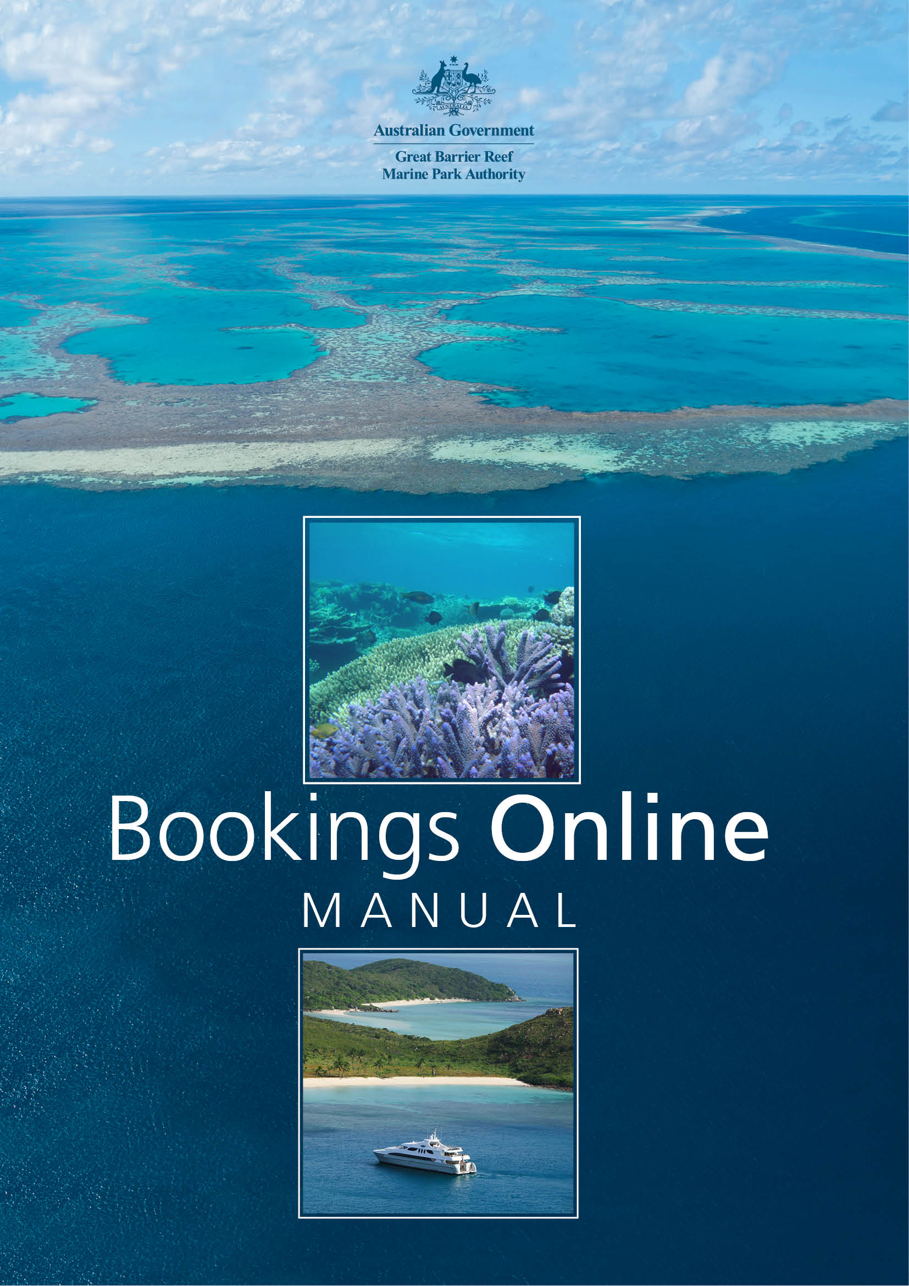

© Commonwealth of Australia 2017
Published by the Great Barrier Reef Marine Park Authority
ISBN 978 064 809 649 8
Bookings Online Manual, 2nd edition is licensed by the Commonwealth of Australia for use under a Creative Commons By Attribution 4.0 International licence with the exception of the Coat of Arms of the Commonwealth of Australia, the logo of the Great Barrier Reef Marine Park Authority, any other material protected by a trademark, content supplied by third parties and any photographs. For licence conditions see: http://creativecommons.org/licences/by/4.0

A catalogue record for this book is available from the National Library of Australia

This publication should be cited as:
Great Barrier Reef Marine Park Authority 2017, Bookings Online Manual, 2nd edition, GBRMPA, Townsville.

Comments and questions regarding this document are welcome and should be addressed to:
Great Barrier Reef Marine Park Authority
2–68 Flinders Street
(PO Box 1379)
Townsville QLD 4810, Australia

Phone: (07) 4750 0700
Email: info@gbrmpa.gov.au
www.gbrmpa.gov.au

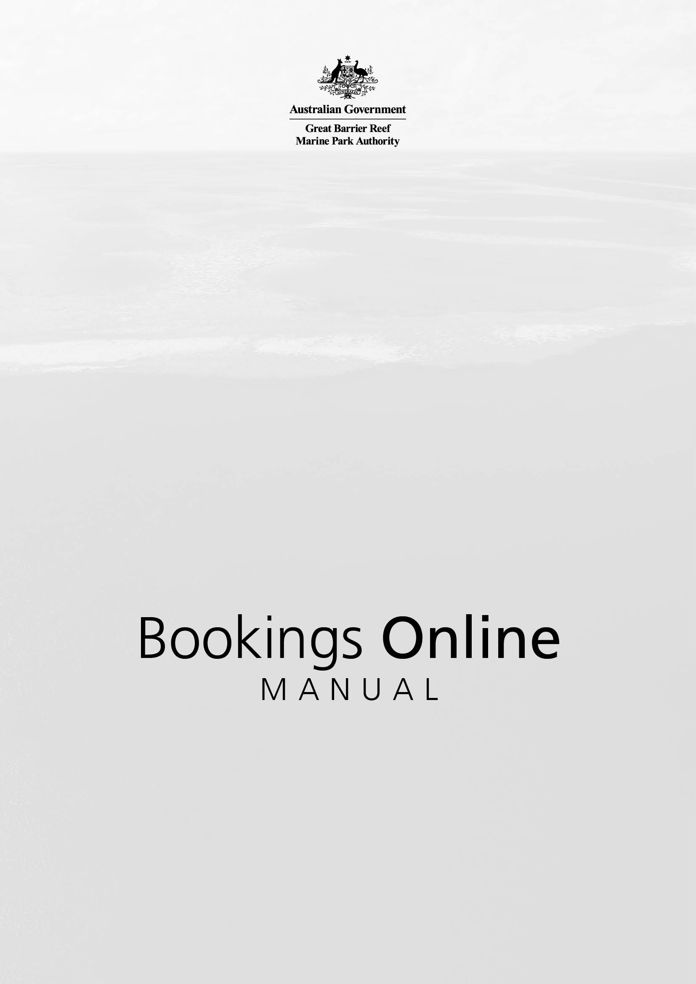

After reviewing this manual, if you still require assistance using the Bookings Online system, please contact the Great Barrier Reef Marine Park Authority (GBRMPA)

For bookings to the Plan of Management areas (including the Cairns, Hinchinbrook and Whitsunday planning areas):
Phone: (07) 4750 0700 during business hours (8.30am to 5.00pm EST weekdays).
Email: bookings@gbrmpa.gov.au

For designated anchorage and superyacht anchorage bookings:
Phone: (07) 4750 0700 during business hours (8.30am to 5.00pm EST weekdays).
Email: bookings@gbrmpa.gov.au
Additional support material can be obtained online through www.gbrmpa.gov.au.

FEEDBACK
All feedback regarding the Bookings Online system or its data should be sent directly to bookings@gbrmpa.gov.au.

1.0 GREAT BARRIER REEF MARINE PARK AUTHORITY BOOKINGS ONLINE 1
2.0 ABOUT BOOKINGS ONLINE 1
2.1 BOOKINGS ONLINE RULES 3
3.0 FURTHER INFORMATION AND MAPS 4
4.0 ACCESSING AND NAVIGATING BOOKINGS ONLINE 4
4.1 LOGGING INTO BOOKINGS ONLINE 5
4.2 USING BOOKINGS ONLINE FOR THE FIRST TIME 6
4.3 SELECT A DIFFERENT PERMITTEE 7
4.4 CHANGE CONTACT DETAILS 8
4.5 LOG OUT 9
5.0 GLOSSARY 9
5.1 ADD ICON 9
5.2 COPY ICON 9
5.3 DELETE ICON 9
5.4 ARROW TABS 9
5.5 DISPLAY BOXES 10
5.6 DEFAULT BOXES 10
5.7 DATE FIELDS 11
5.8 DROPDOWN LISTS 11
5.9 NAVIGATIONAL SECTION 11
6.0 VEHICLES 12
6.1 SET UP YOUR VEHICLES (VESSELS / AIRCRAFT) 12
7.0 BOOKINGS CALENDAR 15
8.0 AIRCRAFT AND VESSEL BOOKINGS 17
8.1 ADD A NEW BOOKING 17
8.2 DUPLICATE BOOKINGS 25
8.3 DELETE BOOKINGS 26
8.4 SEARCH BOOKINGS 27
9.0 DESIGNATED ANCHORAGE BOOKINGS 28
9.1 ADD A NEW BOOKING 28
9.2 DUPLICATE BOOKINGS 35
9.3 DELETE BOOKINGS 35
9.4 SEARCH BOOKINGS 36
10.0 SUPERYACHTS ANCHORAGE BOOKINGS 37
10.1 ADD A NEW BOOKING 37
10.2 DUPLICATE BOOKINGS 38
10.3 DELETE BOOKINGS 39
11.0 REPORTS 40
11.1 HOW TO VIEW YOUR REPORT 40
11.2 HOW TO DOWNLOAD YOUR REPORT 42

1.0 GREAT BARRIER REEF MARINE PARK AUTHORITY BOOKINGS ONLINE
Bookings Online has been developed to provide you with a user-friendly, online platform to make and manage your bookings and anchorage reservations.
As a recreational visitor using a vessel greater than 35 metres there are certain requirements to ensure you operate in a manner that protects the Great Barrier Reef Marine Park. Reservations of anchorages assist in ensuring your access to anchorages for a specified period.
As a permit holder, or authorised contact, you contribute directly to the protection of the Great Barrier Reef Marine Park by ensuring you operate according to your Marine Parks permit.
Conditions within your Marine Parks permit will state whether you need to book to:
- Access the Cairns, Hinchinbrook or Whitsunday planning areas (the Planning Areas). Most tourism operators can book to the Cairns and Hinchinbrook Planning Areas for up to 50 days in any 365-day period or to the Whitsunday Planning Area for up to 50 days in a calendar year (1 January – 31 December)
- Access a sensitive location in the Cairns or Hinchinbrook planning areas (the number of bookings that can be made for a specific location on any one day varies to each of these planning areas)
- Access a designated anchorage. Generally, only one cruise ship, superyacht or large vessel is allowed at an anchorage at any one time.
A booking provides tourism operations access to planning areas, sensitive locations within the planning areas and designated anchorages for a specific period of time. All vessels requiring access to designated anchorages including recreational users are also required to make a booking.
All users are strongly encouraged to familiarise themselves with the Marine Park Zoning and Plan of Management (where relevant) for the area they are visiting. For more information see the Great Barrier Reef Marine Park Authority’s website at www.gbrmpa.gov.au

2.0 ABOUT BOOKINGS ONLINE
To access Bookings Online, you will need to be recognised as an authorised contact and obtain a password to login.
If you need help with this process or require login details, please email bookings@gbrmpa.gov.au or contact the Great Barrier Reef Marine Park Authority (GBRMPA) on (07) 4750 0700 during business hours (8:30am to 5:00pm EST weekdays).

When making a booking for tourism operators:
- Use the bookings calendar to check if the planning area, sensitive location or designated or superyacht anchorage is available for the period you are interested in.
- Bookings Online will display all your relevant Marine Park permits, for which you may want to make a booking with, in a dropdown menu. If you have multiple permits choose the relevant permit.
- Bookings Online will display all operations or vehicles (vessel, aircraft or ships) under that permit in a dropdown menu. If you have multiple options, you will need to choose the relevant option.
- Bookings Online will display all the options for planning areas, sensitive locations and designated or superyacht anchorages in dropdown menus for you to select. Links to maps for these areas are listed on page 4 of this manual.
- To access a designated or superyacht anchorage select the time slot you wish to secure. For all other tourism operations, select the date you will be accessing the planning area and/or sensitive location within the planning area. Click Check Booking for availability and then Save to make the booking.
When making an anchorage reservation for recreational superyachts:
- Please email: bookings@gbrmpa.gov.au to obtain log in and password details.
- In the email you will need to provide your name, contact details as well as the vessel name and length.
- You will also be required to provide relevant information that confirms you will be operating as a private recreational user. For example, if you are a foreign flagged vessel please provide a copy of your ‘Control Permit’ from the Australian Border Force.
- Bookings Online will display all options for designated and superyacht anchorages in drop down menus for you to select. Links to maps for these areas are listed in page 4 of this manual.
- Choose the date, and the time slot you wish to reserve for the anchorage. Click ‘check booking’ for availability and then save to make the reservation.
Bookings Online will automatically:
- Indicate if the anchorage is available for booking on that day.
- Indicate if the anchorage is available at that time.
- Send you a confirmation email.
- Provide you with access to personalised reports which can help you manage your bookings.

2.1 BOOKINGS ONLINE RULES
Bookings Online has been developed to accommodate all statutory requirements of the relevant plans of management. It also contains a number of other rules designed to reduce potential user conflict by limiting the ability of users to make bookings over excessively long periods of time and for dates far into the future. These rules are explained in greater detail below:
- Planning area limitations are set according to the relevant plan of management. The system accounts for specific rules for different types of vehicles and activities, and prevents users from booking locations they are not permitted to access. Access limits to each planning area are explicitly spelled out — if limits are exceeded the system will not allow the booking to be made. The easiest place to view these is through the bookings calendar.
- Sensitive location limits (for the Cairns and Hinchinbrook planning areas) are also set according to relevant plan of management rules. The system accounts for specific rules for different types of vessels and activities, and prevents users from booking locations they are not permitted to access. Again, access limits to each sensitive location are stated in Bookings Online — if booking limits are exceeded, Bookings Online will not allow further bookings to be made. The easiest place to view these details is through the bookings calendar.
- The system automatically captures booking requirements of your relevant permits and vehicles (e.g. vessel, aircraft). You will not be able to make bookings to areas and locations to which you are not allowed, or conversely to which you do not need to book.
- The system maintains a count of booking days used over a 365-day period for the Cairns and Hinchinbrook Planning Areas and a calendar year (1 January – 31 December) for the Whitsunday Planning Area
- You cannot book more than seven days consecutively to the same location.
- Aircraft and vessel bookings can be made up to 365 days in advance.
- Bookings to designated anchorages and superyacht anchorages can be made up to three years in advance.
- Designated or superyacht anchorage bookings may be made without a permit but if it will be used for commercial purposes it will need to be linked to a Marine Parks permission before use.
- Bookings cancelled after midnight (post 12am) the day before the planned access will incur the loss of a booking day.
- Bookings made to the same designated or superyacht anchorage on the same day must be separated by at least an hour.
- All Far Northern designated anchorages, except for the anchorages in the Flinders Island group, only allow a maximum vessel length of 120 metres and maximum passenger capacity of 150. The Flinders Island group has no vessel length limit, and only 1 vessel at a time is allowed.

3.0 FURTHER INFORMATION AND MAPS
Further information on making Bookings is located on GBRMPA’s website.
Other helpful materials include:
- Maps of the Cairns Planning Area and Sensitive Locations
- Maps of the Hinchinbrook Planning Area and Sensitive Locations
- A map of the Whitsunday Planning Area
- A map of designated anchorages for the whole of the Great Barrier Reef.

If you need help, please check the help screen (the answer may be there), or alternatively:
- Send your vessel and aircraft queries to bookings@gbrmpa.gov.au or phone
(07) 4750 0700 during business hours
- For technical support including adding new users to your account, please email bookings@gbrmpa.gov.au.
You can also access the bookings online system without a login to view current bookings for each of the planning areas and designated anchorages across the Great Barrier Reef.

4.0 ACCESSING AND NAVIGATING BOOKINGS ONLINE
Bookings Online is hosted by GBRMPA and is available via the internet.
Bookings Online can also be accessed directly through GBRMPA’s external website secure login facility. This is located through our home page at www.gbrmpa.gov.au.
Simply hover over Login for at the top of the page and select Bookings Online (as shown below).
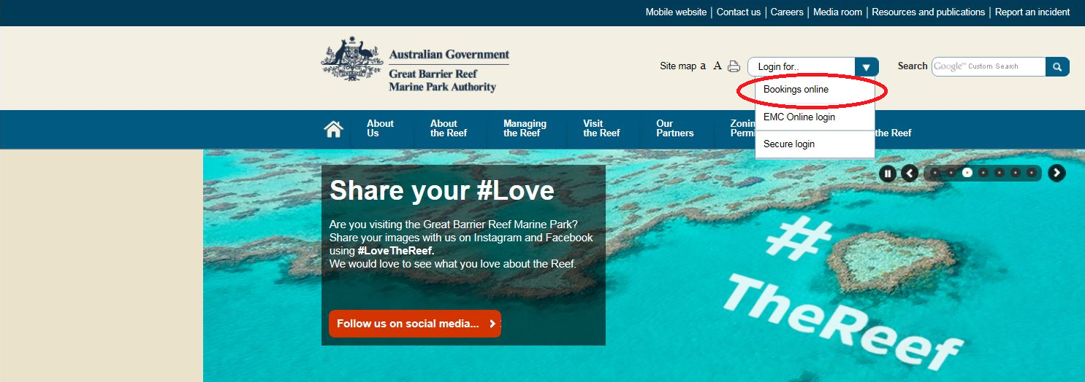
Figure 1 Screenshot of GBRMPA’s home page — a circle outlines the link to the Bookings Online login

4.1 LOGGING INTO BOOKINGS ONLINE
The first page you will see when accessing Bookings Online is the home page. To access Bookings Online you must login using a valid username and password (by clicking Log In on the right-hand side).
If you do not have a username and password please email us at bookings@gbrmpa.gov.au and we will create a user account for you. Please note that you can only make bookings for permits for which you are an authorised contact. If you are not an authorised contact, please have the permit holder authorise you as a contact via their Permits Online account.
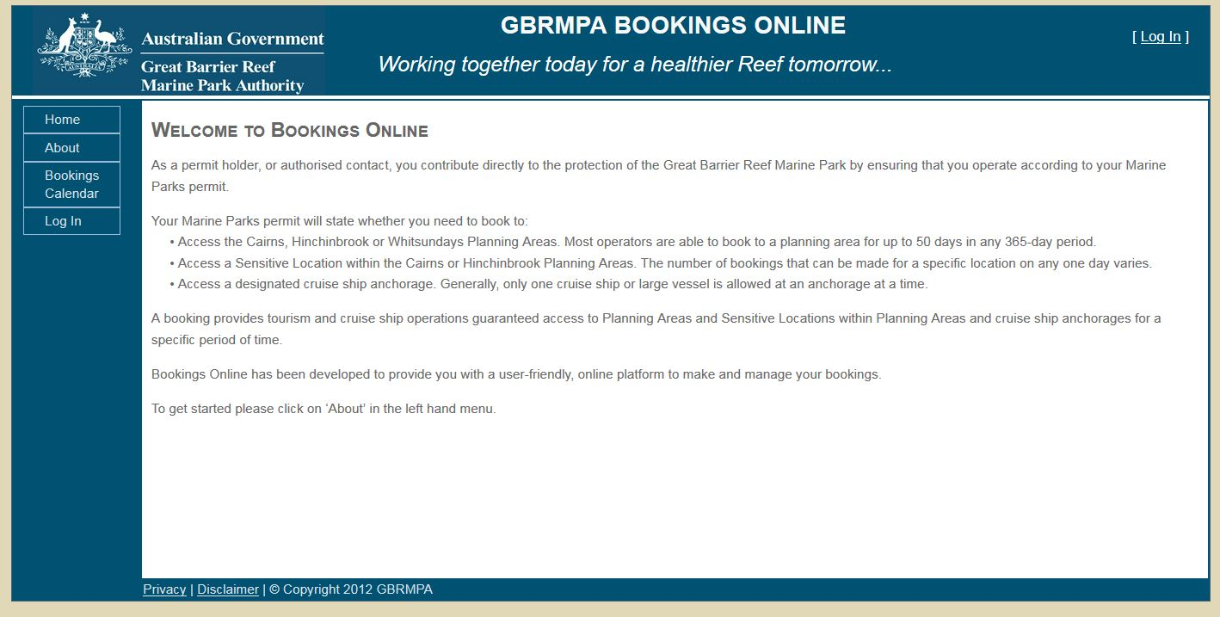
  - Figure 2 Screenshot showing the GBRMPA Bookings Online welcome page
If you have an account, enter your username and password into the appropriate fields and click Log In (or press the enter key).
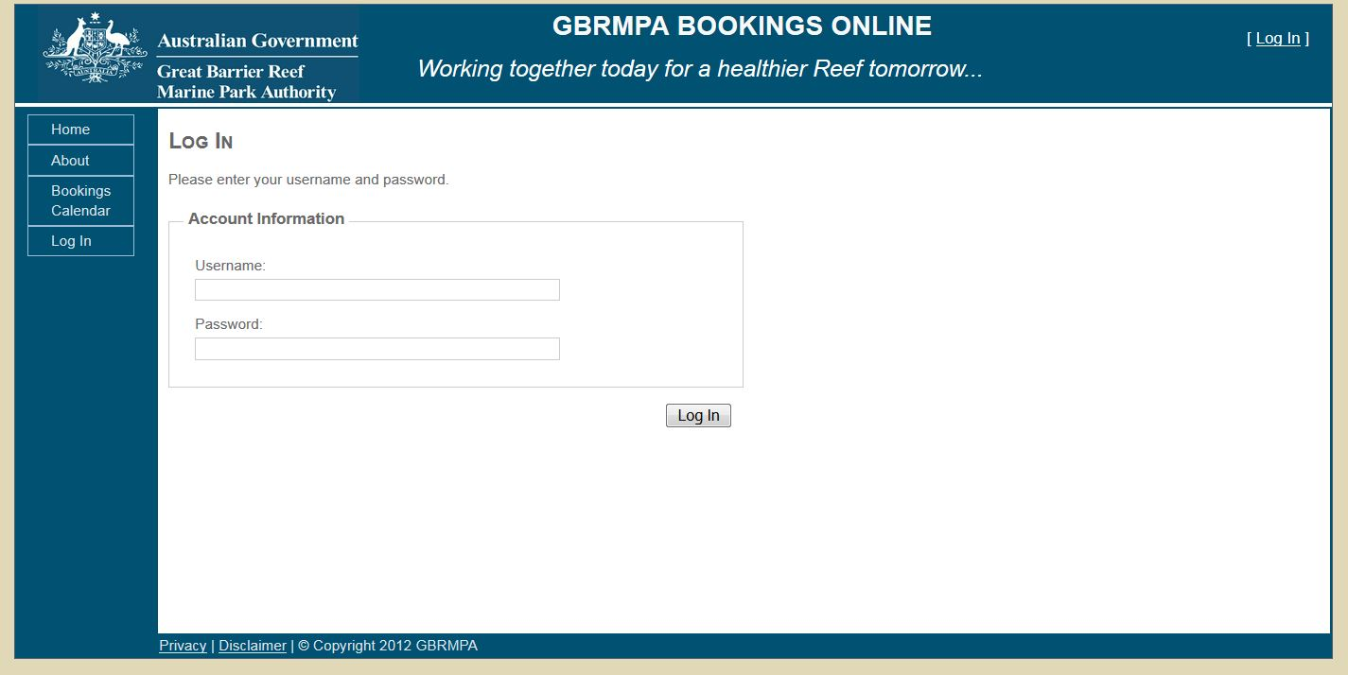
Figure 3 Screenshot showing the GBRMPA Bookings Online login screen

4.2 USING BOOKINGS ONLINE FOR THE FIRST TIME
If this is the first time you have used Bookings Online it is recommended that you change your password.
Hover over the Admin option on the left-hand toolbar and select Change Password.
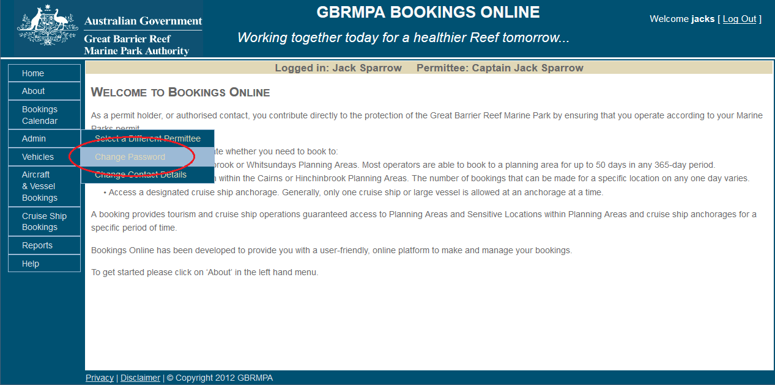
Figure 4 Screenshot of Bookings Online with a circle around the Change Password option

For security purposes, there are rules for creating a new password. Any attempt to enter a password that does not fit the below guidelines will be rejected and will result in an error message.
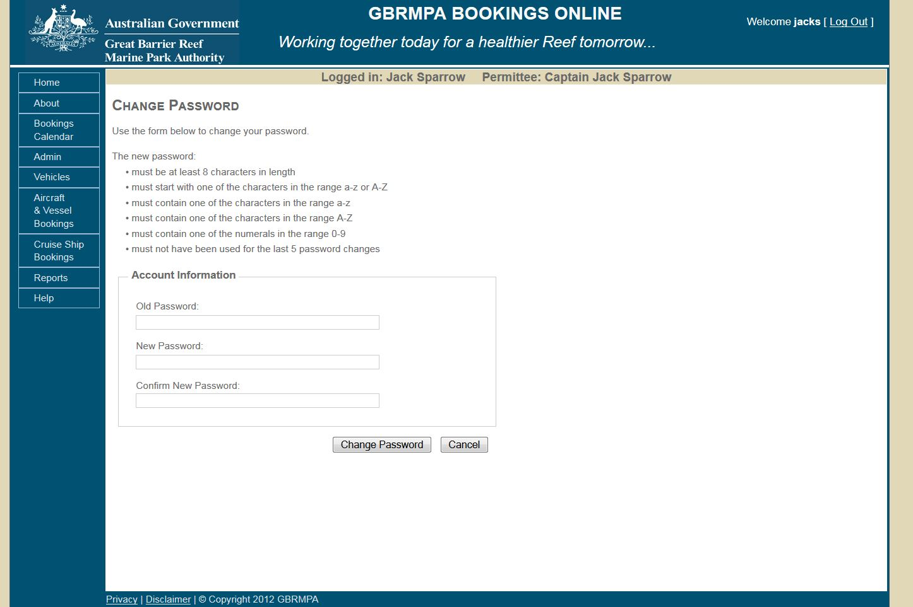
Figure 5 Screenshot showing the Change Password screen

4.3 SELECT A DIFFERENT PERMITTEE
To select a different permittee, simply choose Select a Different Permittee in the Admin tab in the navigation section. Note that you can only select a different permittee if you are an approved authorised contact. If you are not an authorised contact, have the permit holder authorise you as a contact via their Permits Online account.
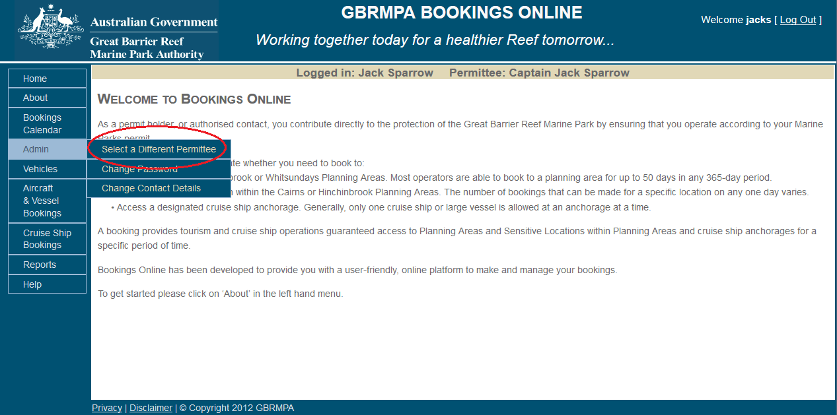
Figure 6 Screenshot showing the GBRMPA Bookings Online login screen

Your name and your permittee name will appear in the middle of the screen as shown below.
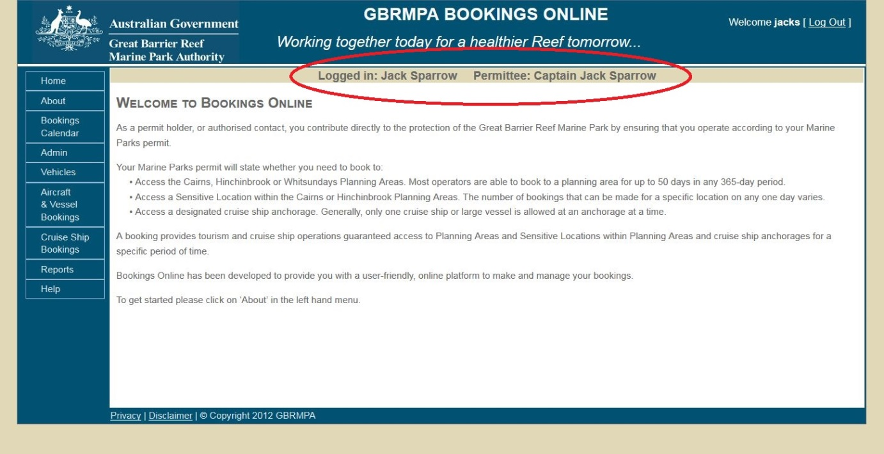
Figure 7 Screenshot of Bookings Online with a circle around the logged in and permittee details

4.4 CHANGE CONTACT DETAILS
To change contact details, click Change Contact Details in the Admin tab on the navigation section. This enables you to change your email address, phone and mobile number. Any other changes to contact details should be made via your Permits Online account.
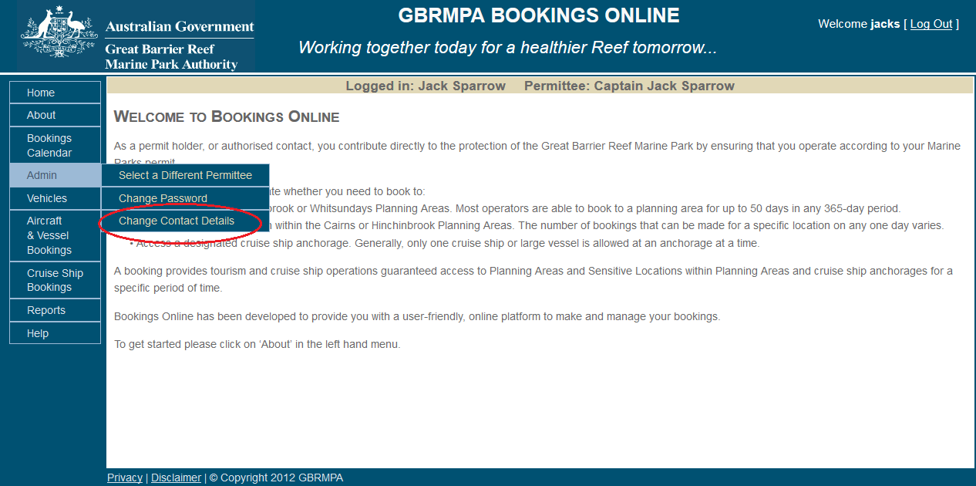
  - Figure 8 Screenshot of Bookings Online with a circle around the Change Contact Details option

4.5 LOG OUT
To log out of Bookings Online simply click Log Out in the top right-hand corner.
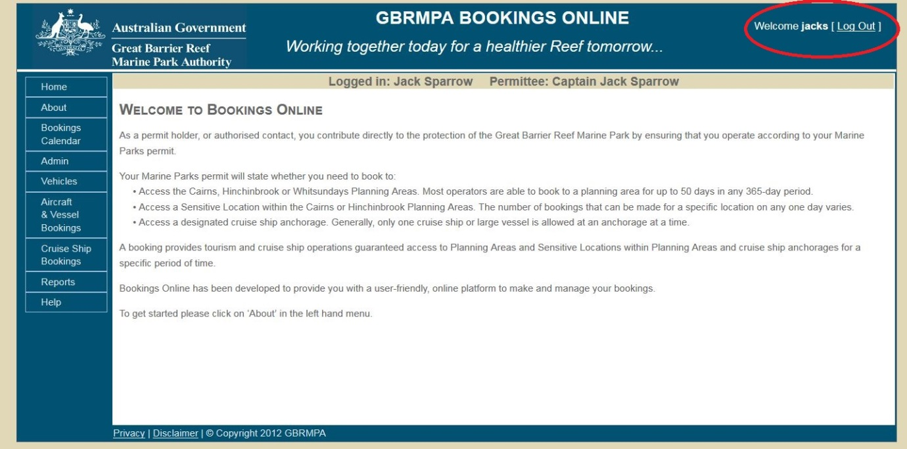
  - Figure 9 Screenshot of Bookings Online with a circle around Log Out

5.0 GLOSSARY
This section describes the primary fields and icons that will be encountered during use of Bookings Online.

5.1 ADD ICON
The add icon will allow you to insert an entry into any field. To add an entry, click .

5.2 COPY ICON
The copy icon will allow you to make a copy of a selected booking. To copy your entries, click .

5.3 DELETE ICON
The delete icon will allow you to remove your entries. If this icon is not displayed it means the entry is in use and cannot be deleted. If the delete icon is displayed, it means the entry is not in use and can be deleted. To delete your entries click . If you have deleted an entry in error, simply click the add icon () to add another entry.

5.4 ARROW TABS
Arrow tabs allow you to enter numbers or dates into the field. Click the arrow tabs icon
() to choose the number or dates that you want.

5.5 DISPLAY BOXES
Display boxes allow you to choose a vehicle, destination and sensitive location. This allows you to customise your booking by simply selecting or unselecting the displayed option as required. Please note that unselecting the ‘Displayed’ tick box automatically results in the ‘Default’ tick box also being unselected.
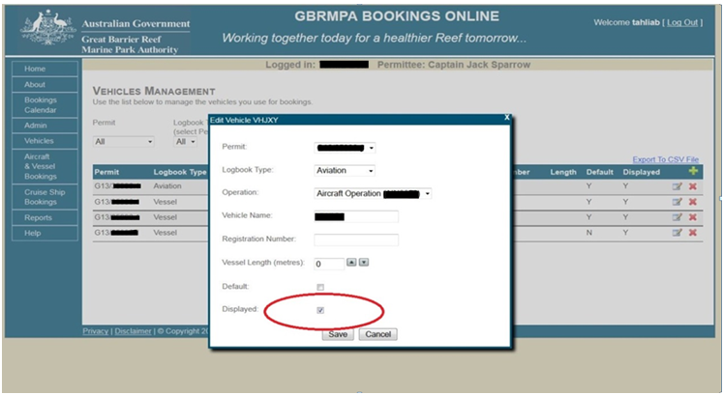
Figure 10 Screenshot of Bookings Online with a circle around the Displayed box

5.6 DEFAULT BOXES
Default boxes allow you to set specific vessel/aircraft, destination or sensitive location favourites to automatically populate vessels/aircraft or locations when entering data through the booking interface. This reduces time spent manually completing required fields. If you only have one vessel or aircraft linked to an operation it will automatically default as long as it is displayed. Selecting or unselecting the default option allows you to customise the entry of your new bookings as required. Please note that selecting the ‘Default’ tick box automatically results in the ‘Displayed’ tick box also being selected.
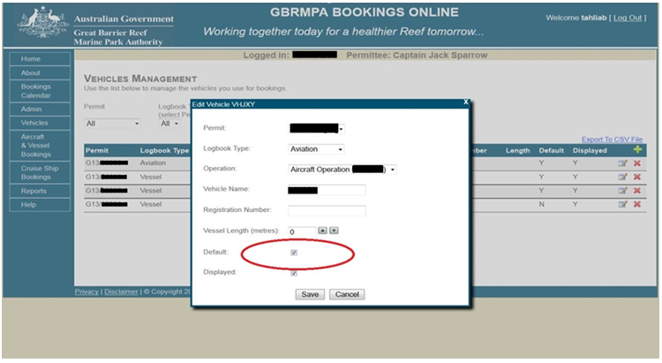
Figure 11 Screenshot of Bookings Online with a circle around the Default box

5.7 DATE FIELDS
Dates can be entered into the date fields by selecting the field and entering the date:
- in a dd/mm/yyyy format
- by clicking on arrow tabs () or
- by clicking the calendar icon () at the right-hand side of the field and selecting the relevant date from the displayed calendar. The current month will be displayed in the calendar by default. Use the dropdown list arrows to navigate to other months and years.
If an inappropriate value is entered into a date field an error message will be generated.

5.8 DROPDOWN LISTS
Bookings Online has dropdown lists for numerous fields. Each list contains a description for each available option.
Options can be selected from dropdown lists by clicking the arrow located at the right-hand side of the field and either:
- using your mouse pointer to select the appropriate option directly
- entering the first letter of your desired selection with the keyboard and finalising your selection with the enter key
- selecting any option with the mouse pointer, scrolling through the dropdown list with up and down arrow keys and pressing the enter key once the desired option is highlighted.
On selection of an item from a dropdown list, the description is displayed. To unselect a dropdown list item, click the list and make another selection.

5.9 NAVIGATIONAL SECTION
For the purposes of Bookings Online, the navigational section refers to the side bar within Bookings Online on the left-hand side, as shown below.
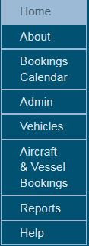
Figure 12 Example of navigational section

6.0 VEHICLES

6.1 SET UP YOUR VEHICLES (VESSELS / AIRCRAFT)
To set up your vessels or aircraft, simply click Vehicles in the navigation section.
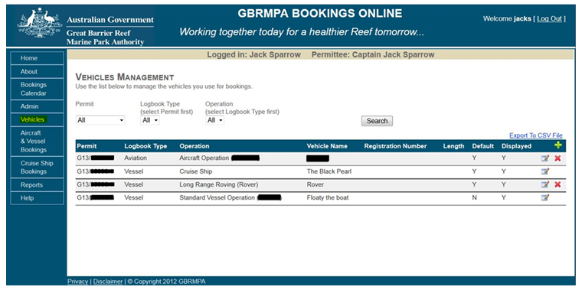
Figure 13 Screenshot showing the vehicles management screen
By default, the search will appear as 'all' in all dropdown boxes. To refine this search, simply click Permit, Logbook Type (bareboat, aircraft or vessel) and Operation by using dropdown boxes. The records that match your search (which is performed when you click Search) are displayed on the following search page.
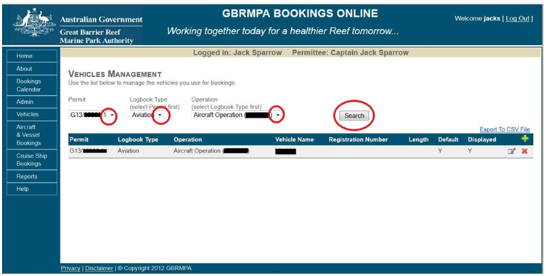
Figure 14 Screenshot of Bookings Online with circles around search functions
To add a vehicle favourite simply click the add icon ().
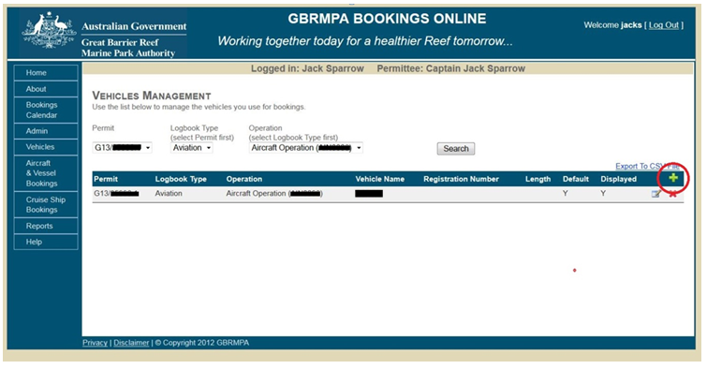
Figure 15 Screenshot of Bookings Online with circle around the add icon
The screen below will be displayed. To add a vehicle as a favourite, fill in all parameters including the registration if you have a vessel, aircraft or bareboat.
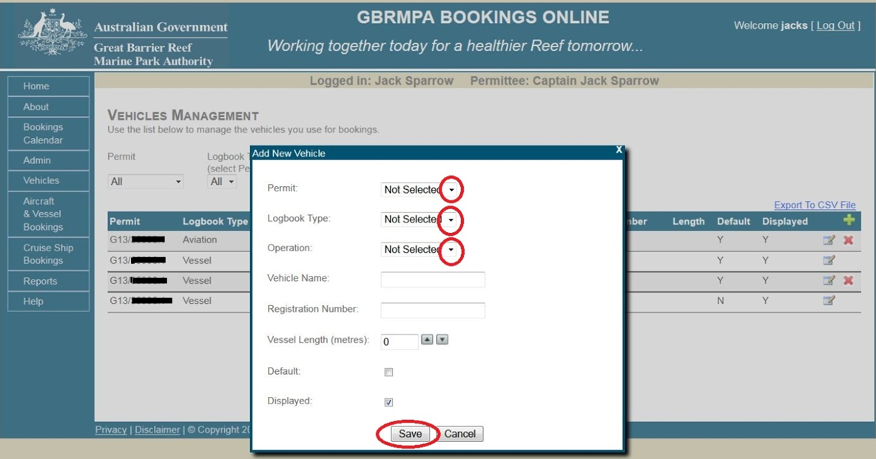 Figure 16 Screenshot of Bookings Online with circles around dropdown lists and Save

You can select or unselect the default box (see section 4.6 for a description of this function).
You can select or unselect the displayed box (see section 4.5 for a description of this function).
Click Save. 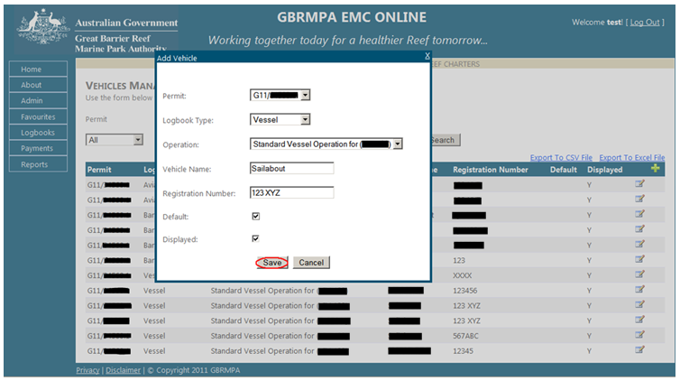
Figure 17 Screenshot of Bookings Online with circle around Save
Your selection will be displayed as shown below. If you wish to add multiple vehicles, simply click the add icon (). If you need to edit your vehicles click the edit icon (). If you wish to delete vehicles click the delete icon ().
Please note, if the delete icon is not displayed it means the vehicle favourite is currently in use for a future booking.
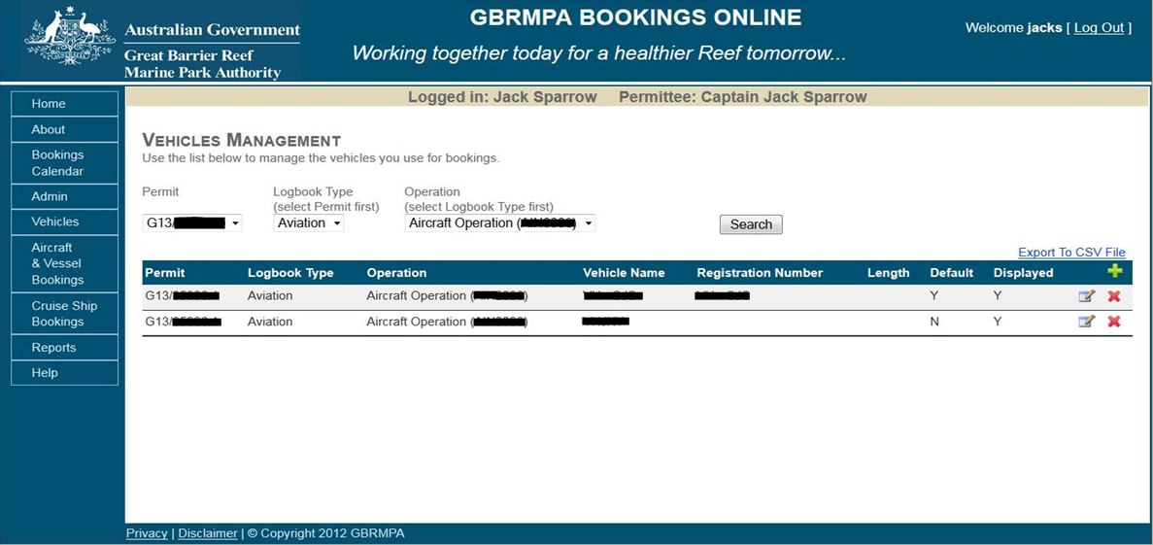
Figure 18 Screenshot showing the vehicles management screen
You can export your vehicle favourites to a CSV or excel file by clicking Export to CSV file.
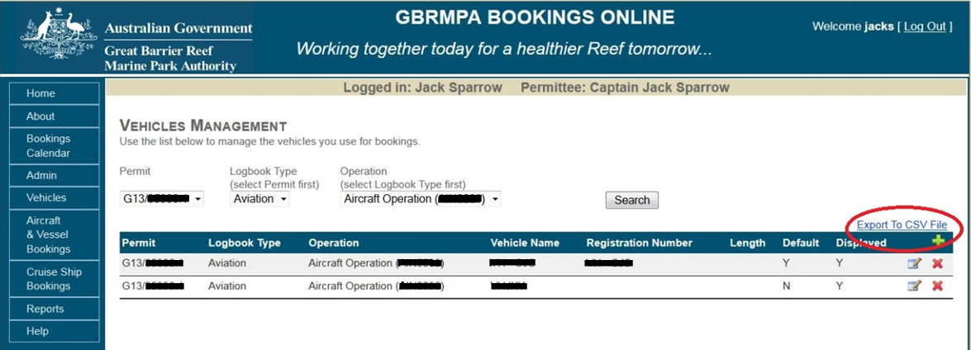
Figure 19 Screenshot of Bookings Online with a circle around the Export to CSV File option

7.0 BOOKINGS CALENDAR
To view the bookings calendar, click Bookings Calendar on the navigation panel.
Try searching for booking limitations using the following steps:
- Click dropdown and select a booking type (e.g. Aircraft & Vessels)
- Click dropdown and select a planning area (e.g. Cairns)
- Click dropdown and select a sensitive location (e.g. Michaelmas Cay)
- Click dropdown and select a month (e.g. May 2016)
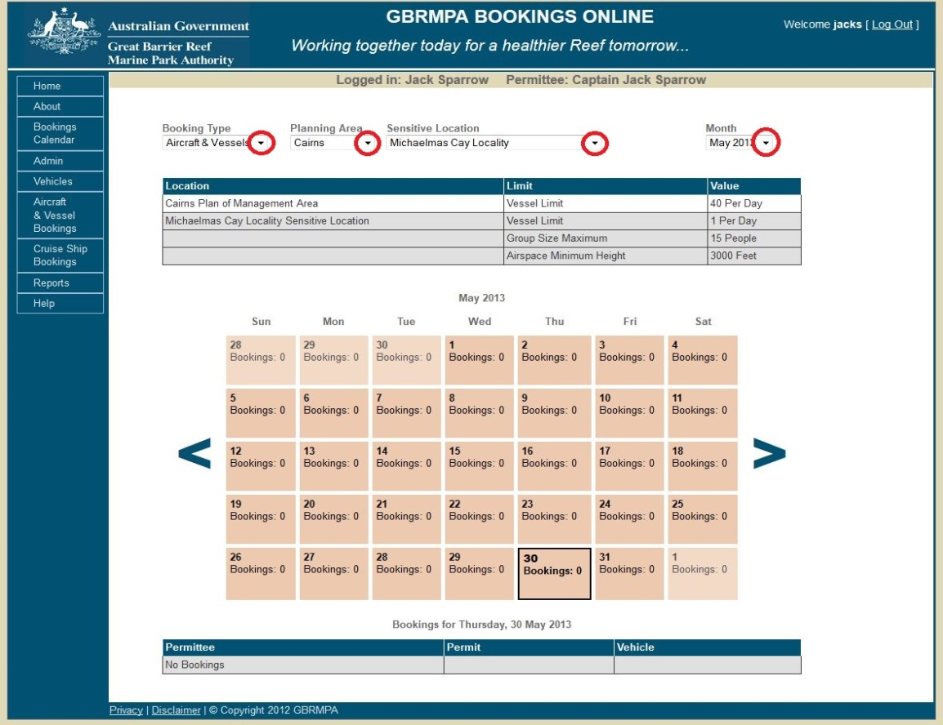
Figure 20 Screenshot of Bookings Online with circles around dropdown lists
Once the search criteria has been entered, a table outlining booking rules for the selected plan of management and sensitive location will appear.
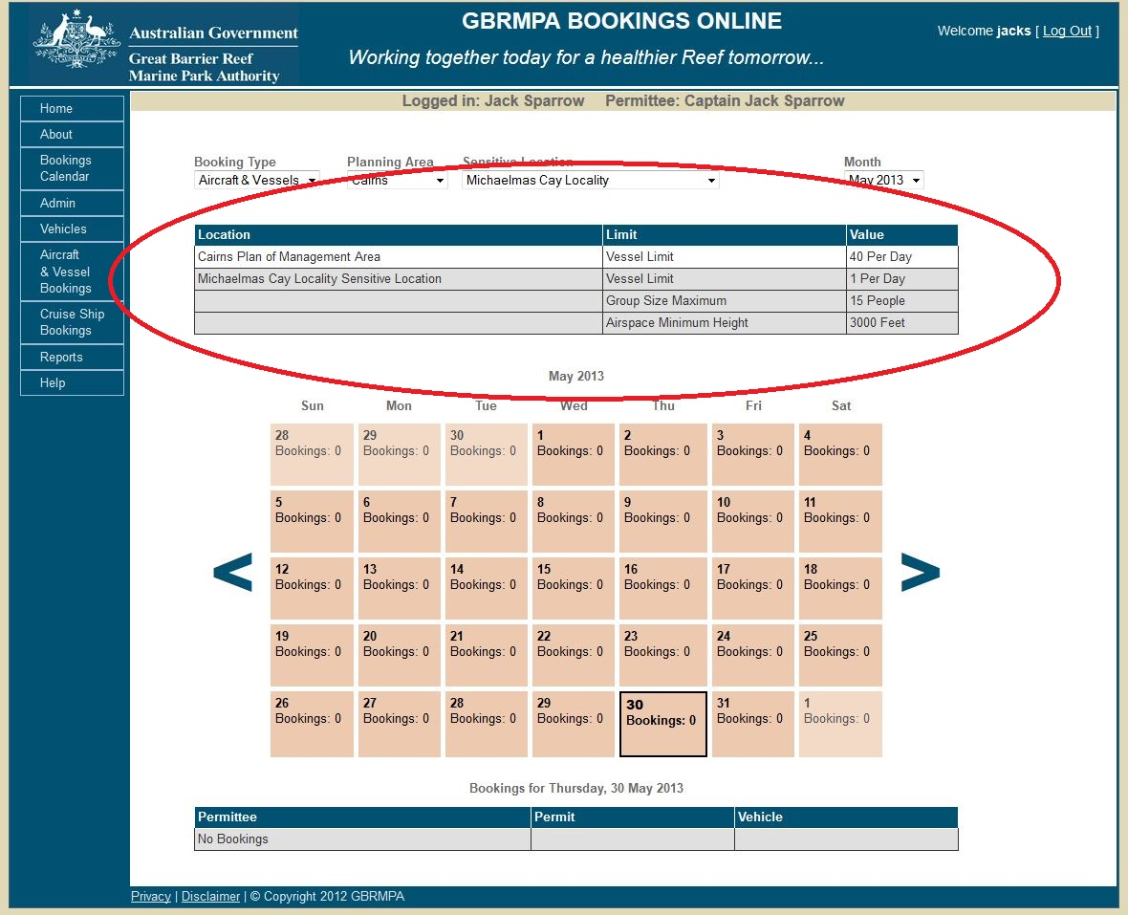
Figure 21 Screenshot of Bookings Online with a circle around the booking rules
Location | Limit | Value
Cairns Area Plan of Management | Vessel limit | 40 per day
Michaelmas Cay locality sensitive location | Vessel limit | 1 per day
 | Group size maximum | 15 people
 | Airspace minimum height | 3000 feet
Table 1 Limitations on bookings made for the Cairns Area Plan of Management, Michaelmas Cay locality
For example, the above table outlines the limitations on bookings made for the Cairns Area Plan of Management, Michaelmas Cay locality. This plan of management allows 40 vessels per day to be booked. For the Michaelmas Cay locality, one vessel per day is allowed with a group size of 15 (maximum) and airspace minimum height of 3000 feet.
The booking limitations table enables you to determine when and where to make a booking.

8.0 AIRCRAFT AND VESSEL BOOKINGS

8.1 ADD A NEW BOOKING
To create a new booking, click Aircraft & Vessel Bookings in the navigation section.
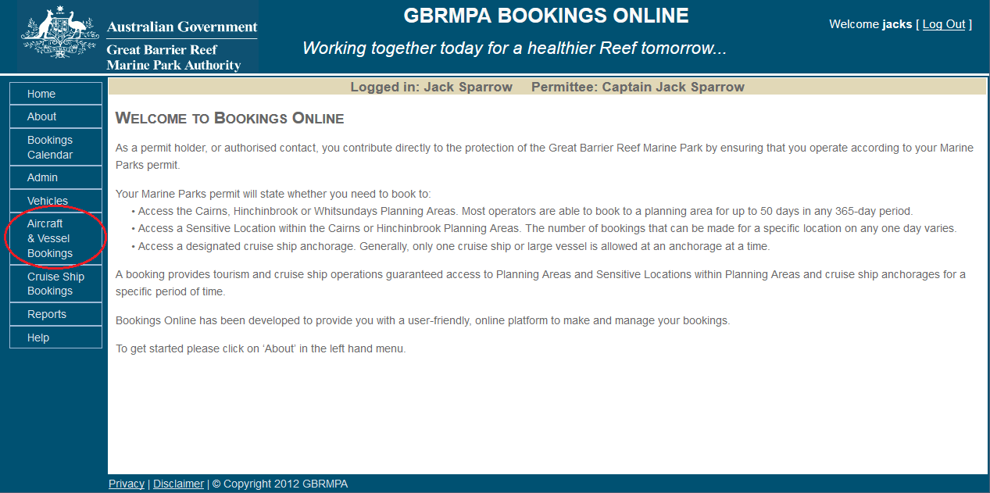
Figure 22 Screenshot of Bookings Online with a circle around Aircraft & Vessel Bookings

To add a new booking click add ().
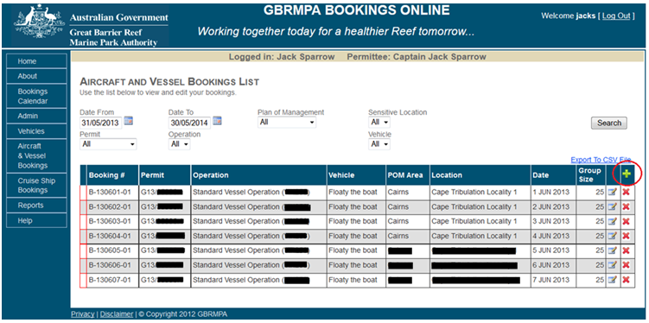
Figure 23 Screenshot of Bookings Online with a circle around the add icon

Select a permit and operation by using the dropdown list in the Add New Booking display box.
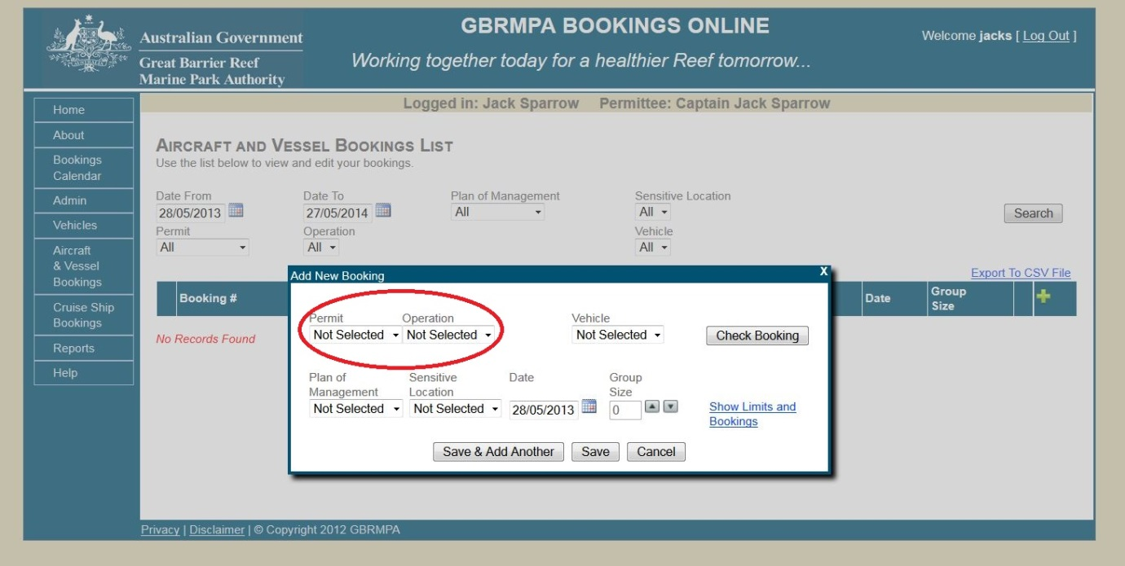
Figure 24 Screenshot of Bookings Online with a circle around the permit and operation dropdown lists

Select a vehicle from the dropdown list in the Add New Booking display box. 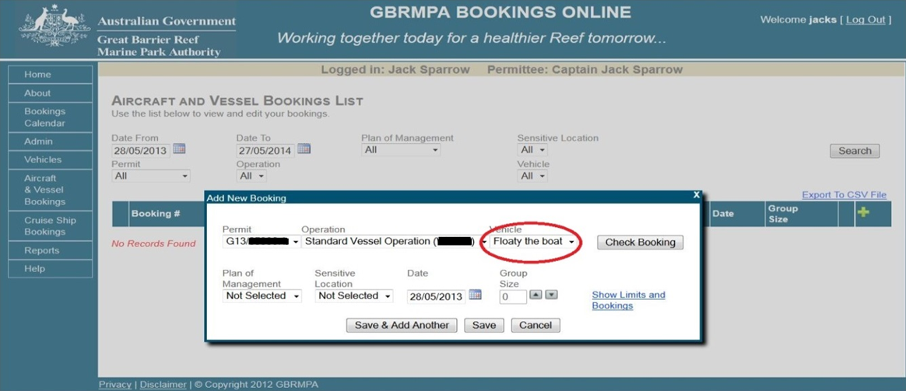
Figure 25 Screenshot of Bookings Online with a circle around the vehicle dropdown list

Select a plan of management from the dropdown list in the Add New Booking display box.
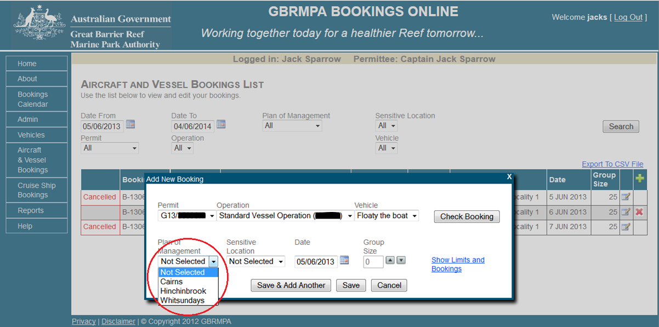
Figure 26 Screenshot of Bookings Online with a circle around the plan of management dropdown list
Please note the system has been set up so the booking requirements of the permits and vessels that you selected are programmed into the system. The system will not allow you to make bookings to locations you are unable to access and conversely to areas to which you do not have to book due to your permitted endorsements (as shown below). If you believe the system has incorrectly determined your booking requirements please contact GBRMPA via e-mail at bookings@gbrmpa.gov.au or phone (07) 4750 0700 during business hours.

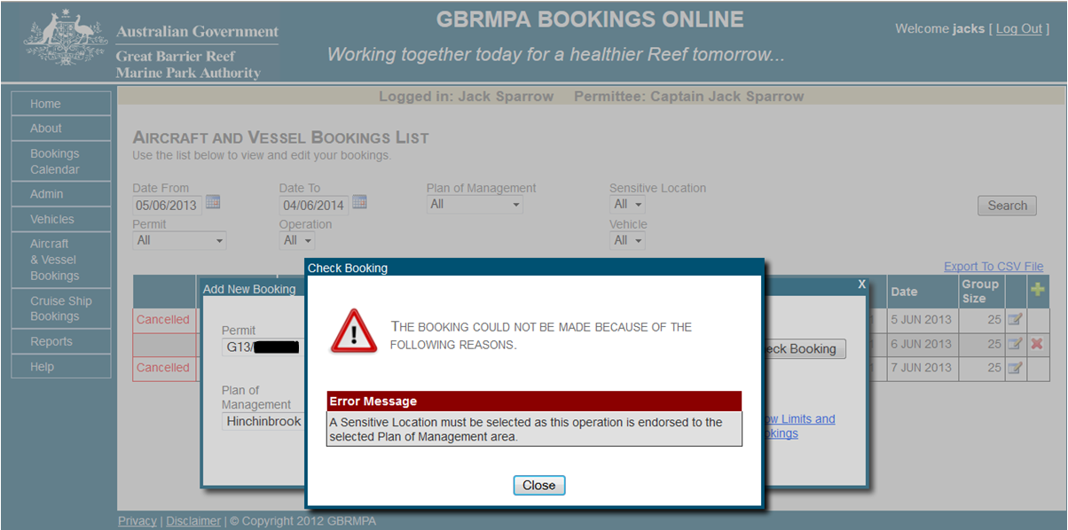
Figure 27 Screenshot of Bookings Online error message

If a sensitive location is required, select an option from the dropdown list in the Add New Booking display box.
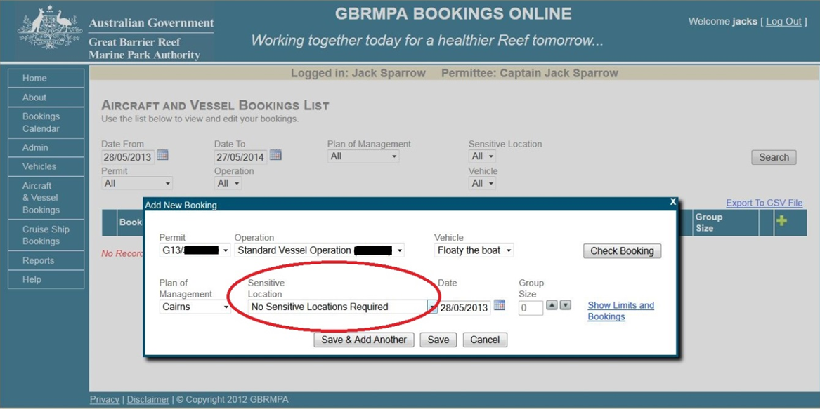
Figure 28 Screenshot of Bookings Online with a circle around the sensitive location field

To select a date for a new booking, click the calendar icon on the right side of the date field in the Add New Booking display box.
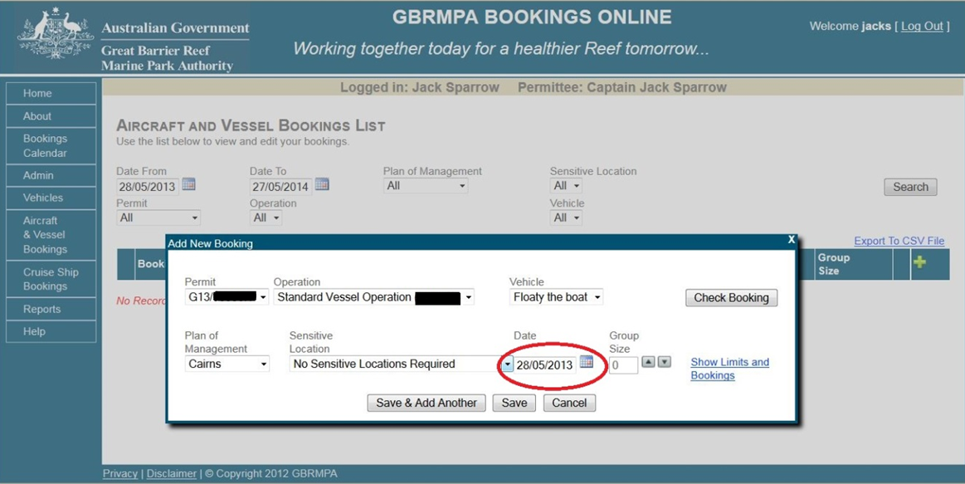
Figure 29 Screenshot of Bookings Online with a circle around the date field

To select a group size use the up and down icons () from the Add New Bookings display box.
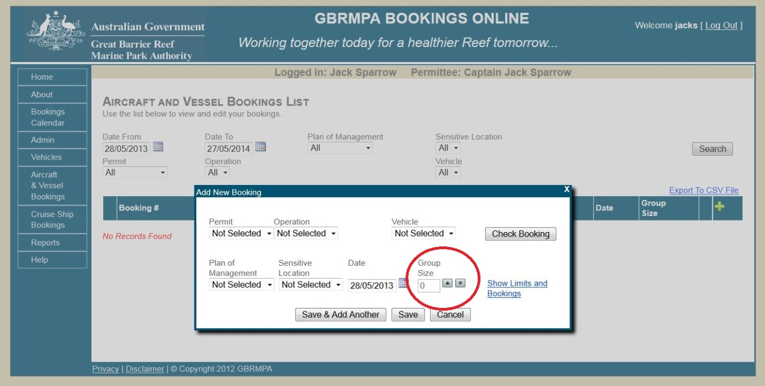
Figure 30 Screenshot of Bookings Online with a circle around the Group Size field

To check your booking, click Check Booking on the right side of the Add New Booking display box.
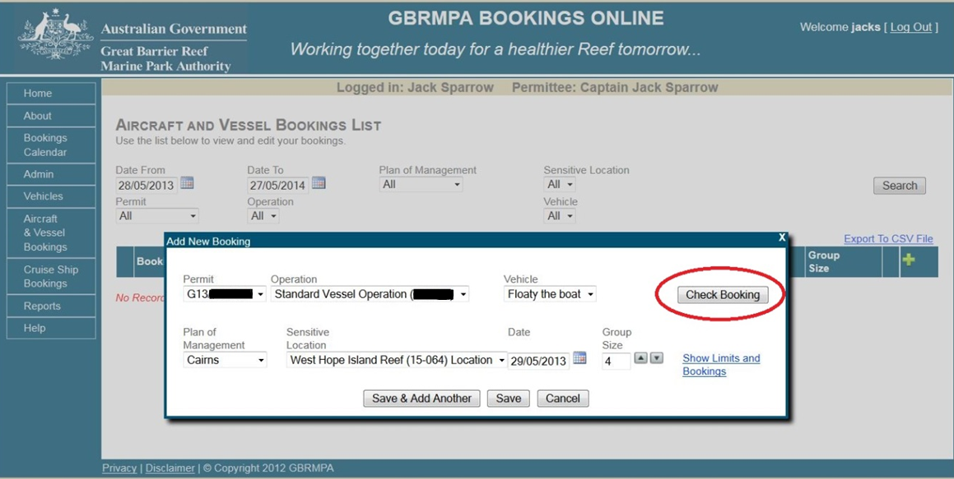
Figure 31 Screenshot of Bookings Online with a circle around Check Booking

The Check Booking display box will appear. This will let you know if you are permitted to make this booking and, if so, will tell you how many booking days you have remaining. Booking days are automatically tracked within the system over a 365-day period for the Cairns and Hinchinbrook Planning Areas and a calendar year (1 January – 31 December) for the Whitsunday Planning Area, allowing you to keep track of how many bookings you have left.
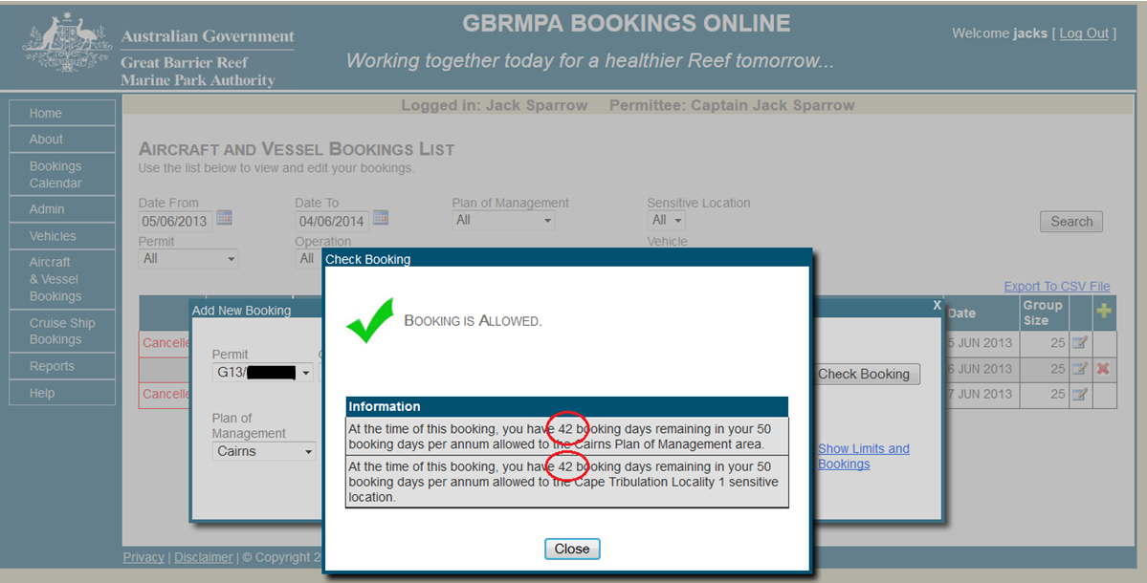
Figure 32 Screenshot of Bookings Online with a circle around the number of bookings remaining

To show limitations on the bookings and the bookings calendar, click Show Limits and Bookings on the right side of the Add New Booking display box.
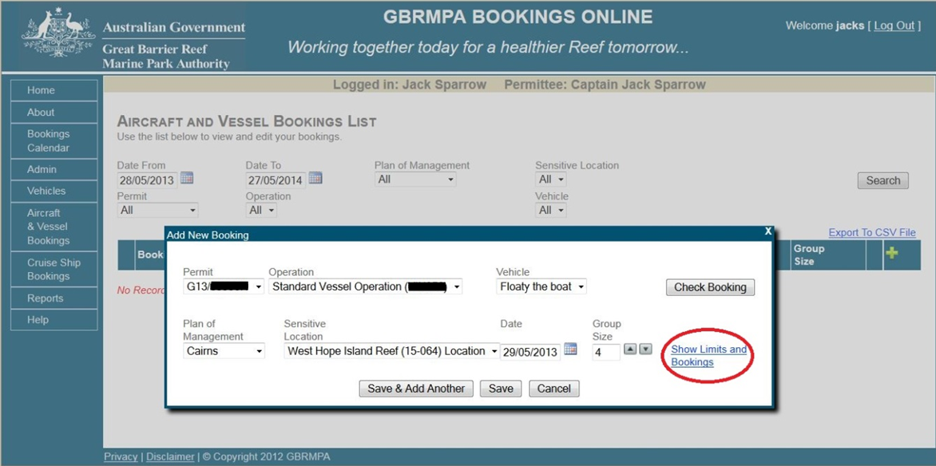
Figure 33 Screenshot of Bookings Online with a circle around Show Limits and Bookings

A new display box will appear, outlining the rules applicable to bookings in the plans of management and sensitive locations selected.
This display box also includes an up-to-date calendar, enabling you to view bookings for the selected plan of management and sensitive location. Click the date box to view the details of the booking for that day.
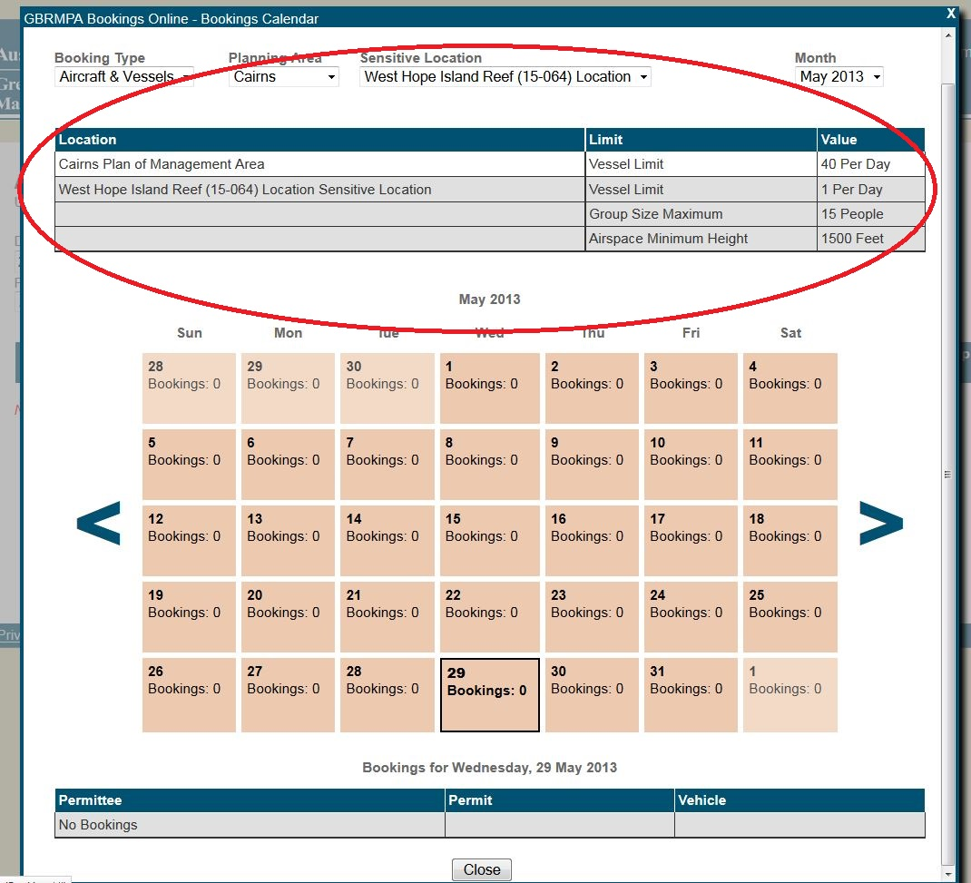
Figure 34 Screenshot of Bookings Online with a circle around the rules of booking
For further information on the Bookings Calendar, go to section 7.0 of the manual.
To save and add another booking, click Save and Add Another in the Add New Booking display box. By clicking Save and Add Another you will duplicate the booking details for the following day.
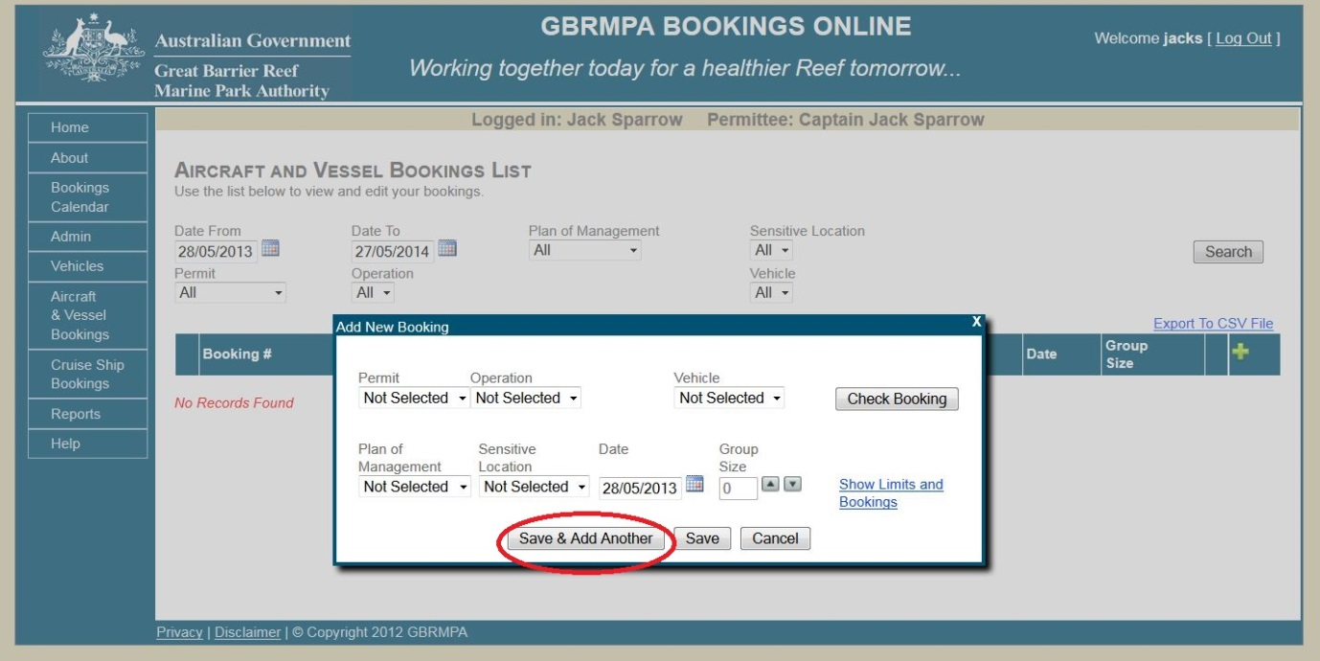
Figure 35 Screenshot of Bookings Online with a circle around Save & Add Another
To save a single booking, click Save in the Add New Booking display box.
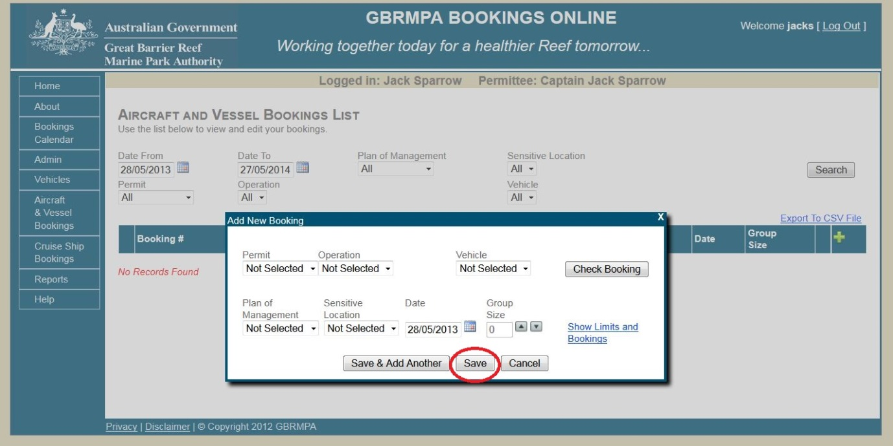
Figure 36 Screenshot of Bookings Online with a circle around Save

Once your booking is saved, it will appear in the aircraft and vessel bookings list. You will receive a booking confirmation email.
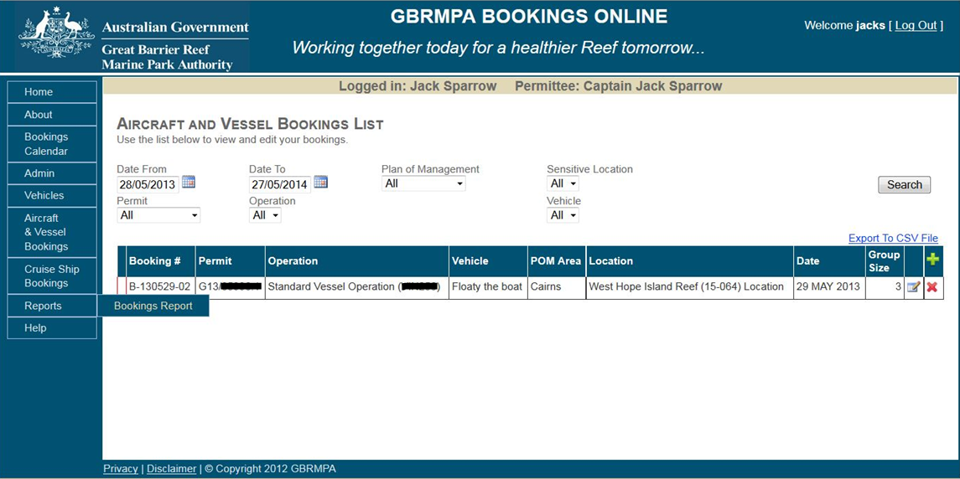
Figure 37 Screenshot showing the aircraft and vessel bookings list screen

8.2 DUPLICATE BOOKINGS
To duplicate a booking for a different day or site, click Aircraft and Vessel Bookings in the navigation section. Click the copy icon () next to the booking you would like to duplicate.
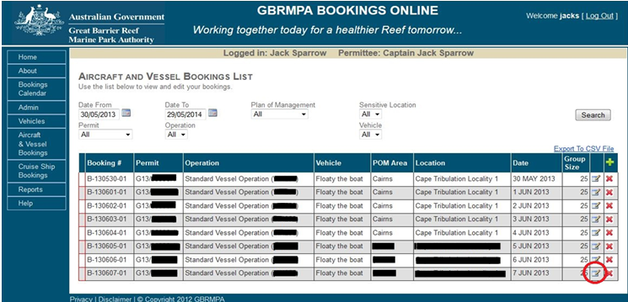
Figure 38 Screenshot of Bookings Online with a circle around the edit icon
The Add New Booking display box will appear and contain the same booking information as the previous booking but for the following day.
You can edit the date, then click Save or Save and Add Another.

8.3 DELETE BOOKINGS
You can delete bookings without losing the day from your allocated visits as long as it is deleted prior to midnight the day before the booking. A booking can be cancelled on the day; however you will incur the loss of a booking day. To delete a booking click on the delete icon
().
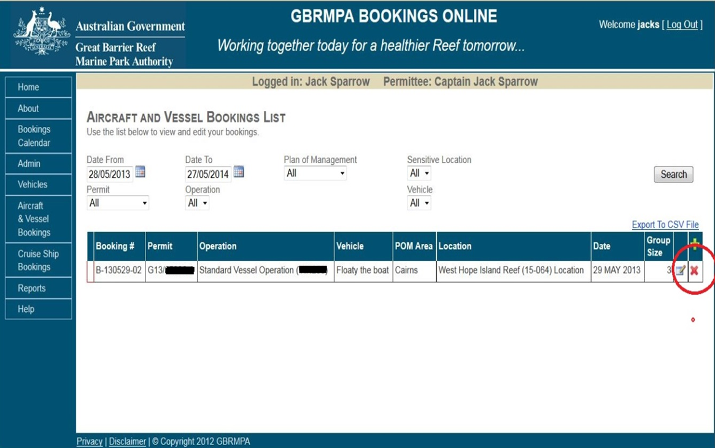
Figure 39 Screenshot of Bookings Online with a circle around the delete icon
A new display box will appear. To confirm cancellation, you must provide a reason in the text box and click Cancel Booking. The aircraft and vessel bookings list will now display the booking as cancelled. You will be sent a confirmation email once the booking has been cancelled.
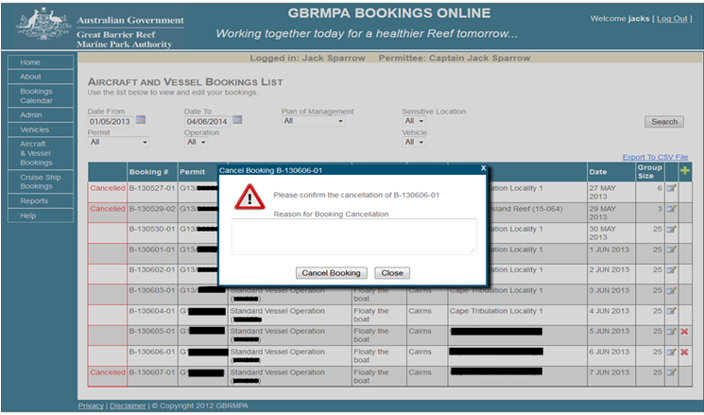
Figure 40 Screenshot showing the booking confirmation pop-up
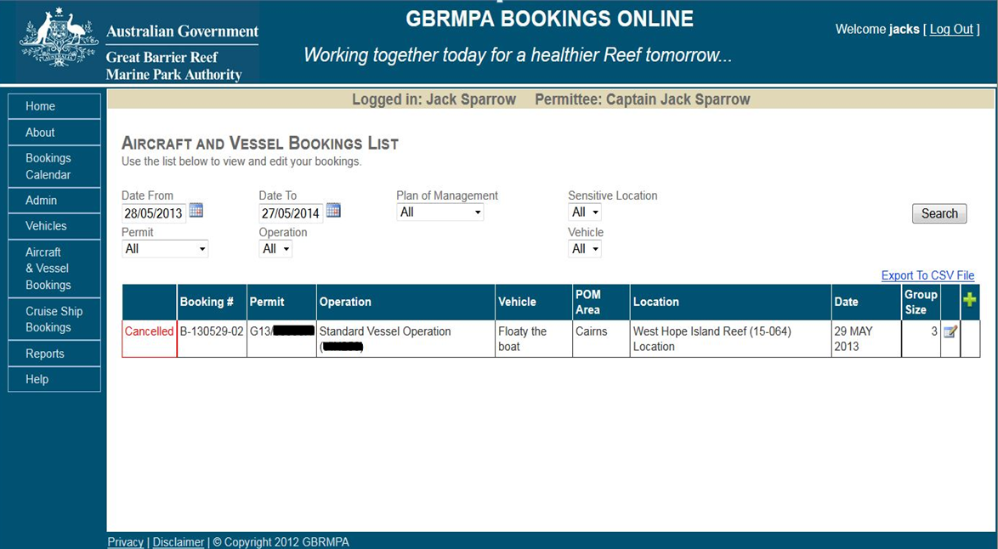
Figure 41 Screenshot showing a cancelled booking on the aircraft and vessel bookings list screen

8.4 SEARCH BOOKINGS
To search for your bookings select Aircraft and Vessel Bookings from the navigation section.
Use fields at the top of the page to select search criteria. Once fields have been selected, click Search. 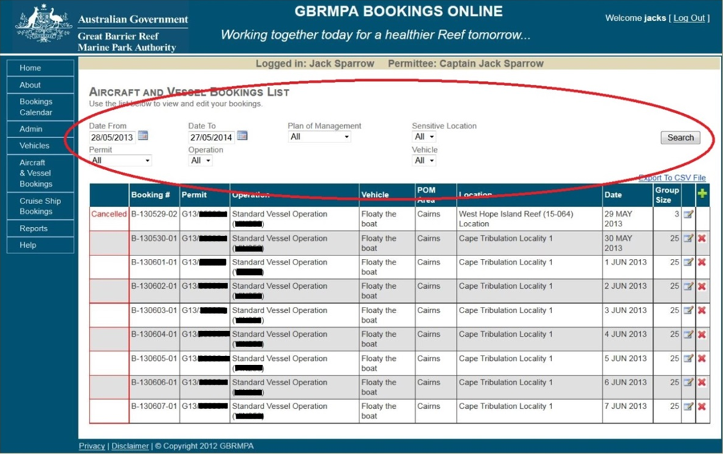
Figure 42 Screenshot of Bookings Online with a circle around the search fields

9.0 DESIGNATED ANCHORAGE BOOKINGS

9.1 ADD A NEW BOOKING
To add a new Anchorage booking, select Anchorage Bookings from the navigation panel.
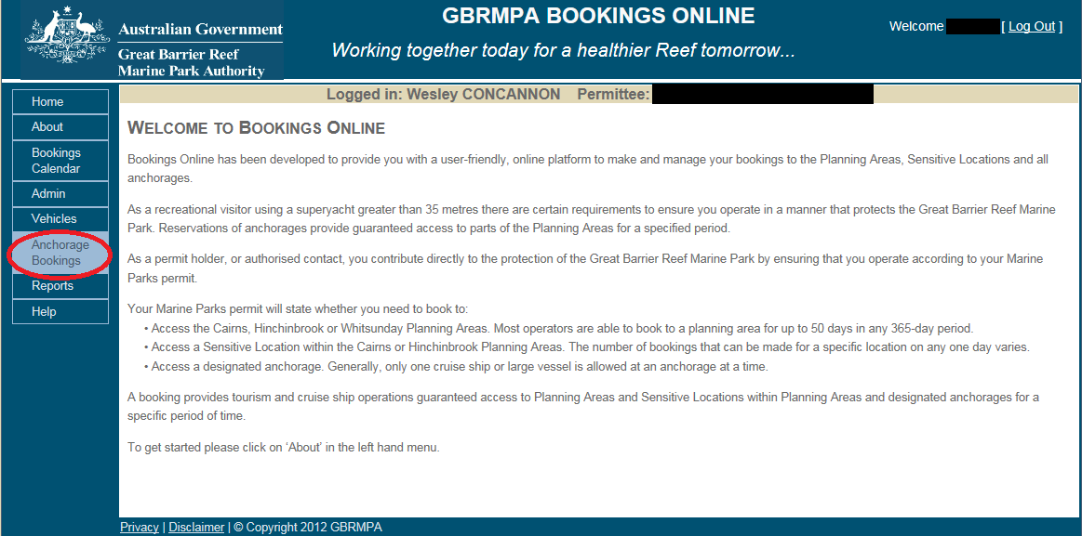
Figure 43 Screenshot of Bookings Online with a circle around Anchorage Bookings
To add a new booking, click the add icon ().
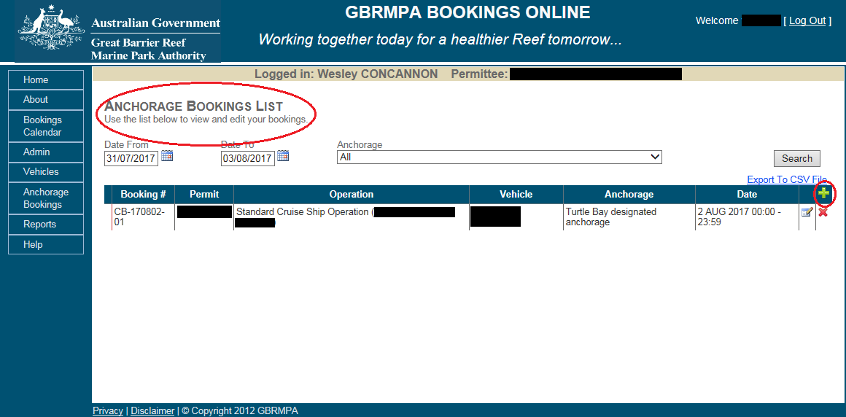
Figure 44 Screenshot of Bookings Online with a circle around the add icon

Select a permit and operation by using the dropdown list in the Add New Anchorage Booking display box.
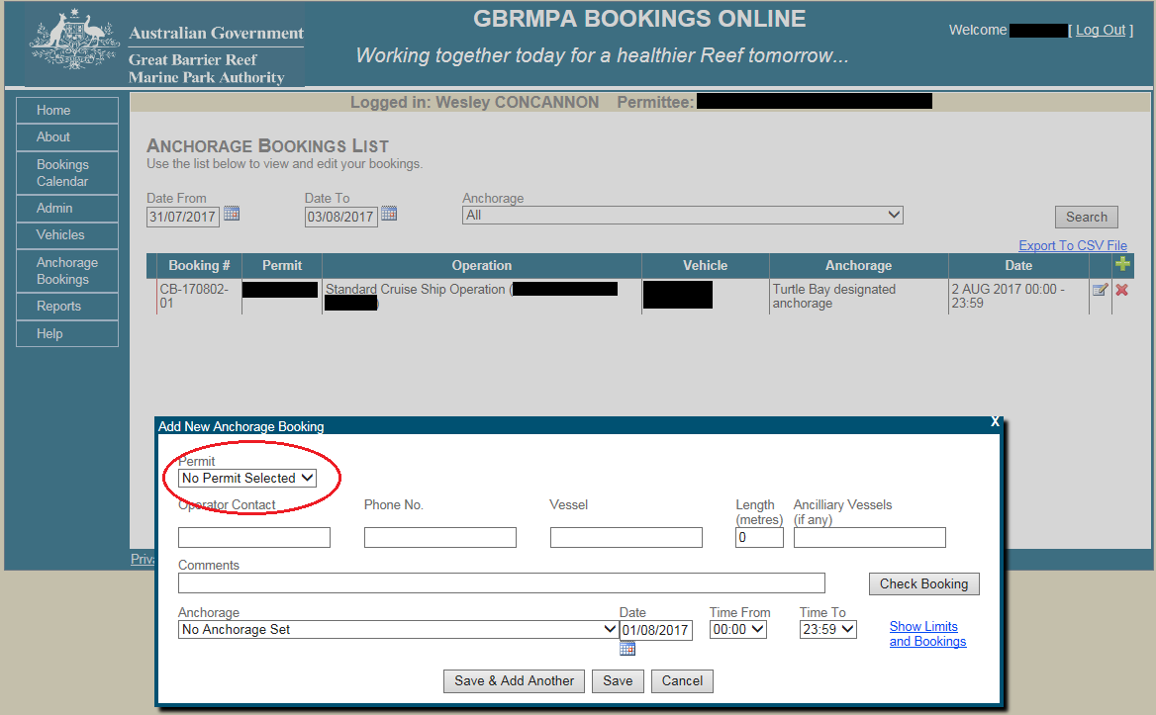
Figure 45 Screenshot of Bookings Online with a circle around the permit field
Select a vessel from the dropdown list in the Add New Anchorage Booking display box.
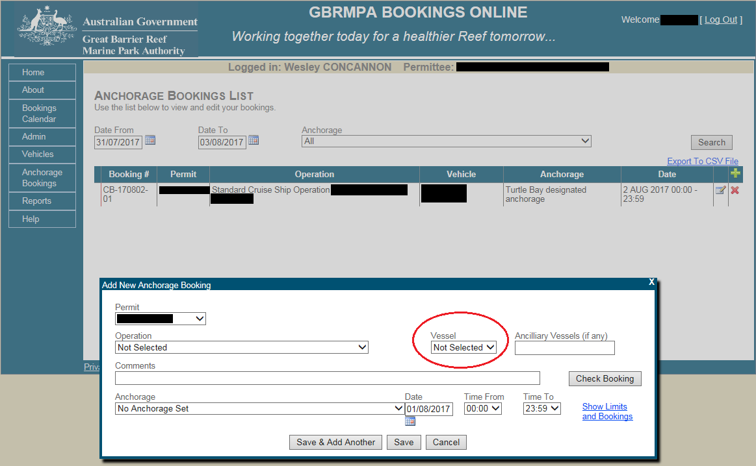
Figure 46 Screenshot of Bookings Online with a circle around the Vessel field
Add in any applicable comments about the bookings in the Comments section of the Add New Anchorage Booking display box.
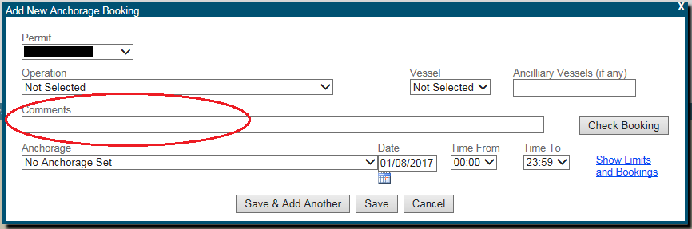
Figure 47 Screenshot of Bookings Online with circle around the comments field

Select an anchorage using the dropdown list in the Add New Anchorage Booking display box.
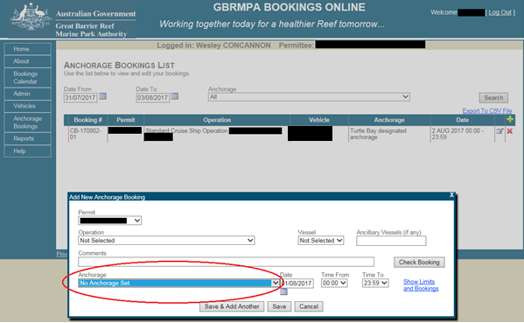
Figure 48 Screenshot of Bookings Online with a circle around the anchorage field

To select a date for a new booking click the calendar icon on the right side of the Date field in the Add New Anchorage Booking display box.
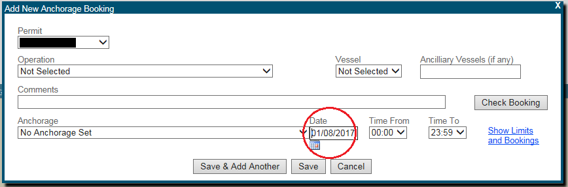
Figure 49 Screenshot of Bookings Online with a circle around the Date field
New Anchorage bookings require date and time fields to be filled in. Only one day can be booked per booking. If you need to stay overnight at an anchorage you will need to book for both days. To select arrival and departure times from the anchorage, use the dropdown lists Time From and Time To.
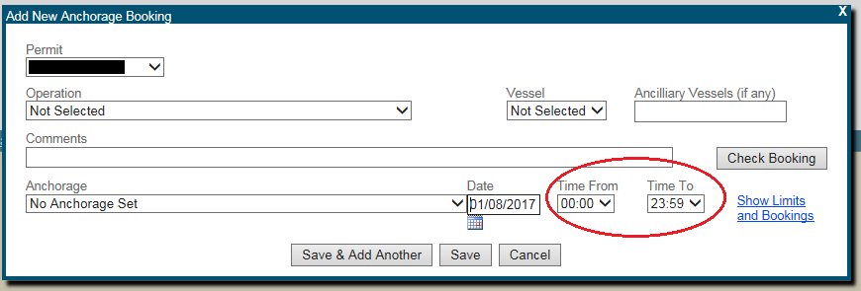
Figure 50 Screenshot of Bookings Online with circle around the Time From and Time To fields
To check your booking, click Check Booking on the right side of the Add New Anchorage Booking display box.
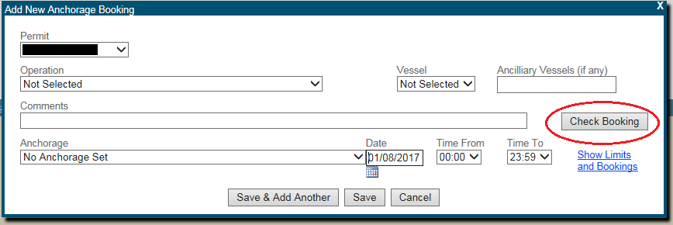
Figure 51 Screenshot of Bookings Online with a circle around Check Booking
If mandatory fields are not filled in, a new display box will outline the error. To amend the booking, click Close and change the necessary fields.
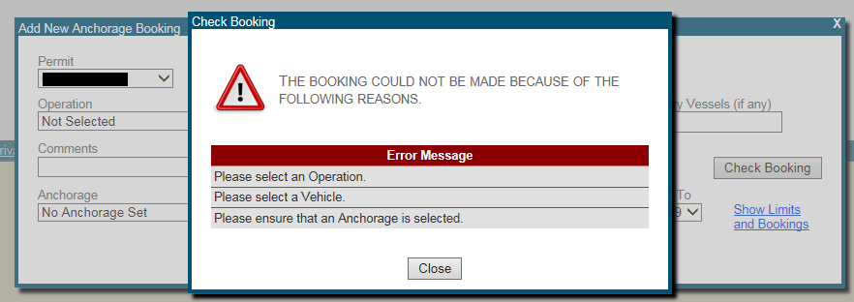
Figure 52 Screenshot of Bookings Online with a circle around the Error Message

If the booking is permitted, you will see a display box stating that the booking is allowed.
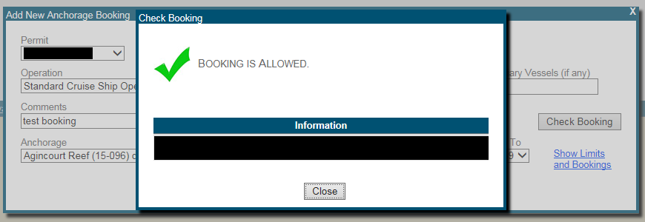
Figure 53 Screenshot showing the booking is allowed pop-up
To show the limitations of booking an anchorage, click Show Limits and Bookings on the right side of the Add New Anchorage Booking display box.
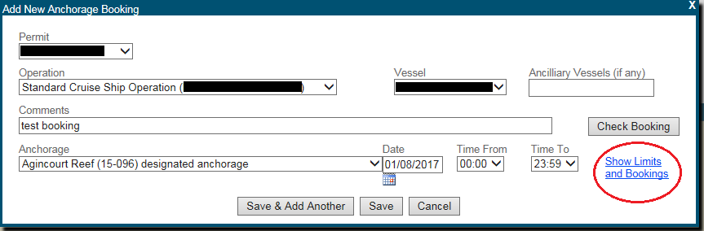
Figure 54 Screenshot of Bookings Online with a circle around Show Limits and Bookings
A new display box will appear, outlining rules applicable to bookings in the plan of management areas or for bookings for an anchorage.
This display box also includes an up-to-date calendar, enabling you to view bookings for your selected plan of management and anchorage. Click the date box to view details of the booking for that day.
For further information on the bookings calendar refer to section 7.0 of the manual.
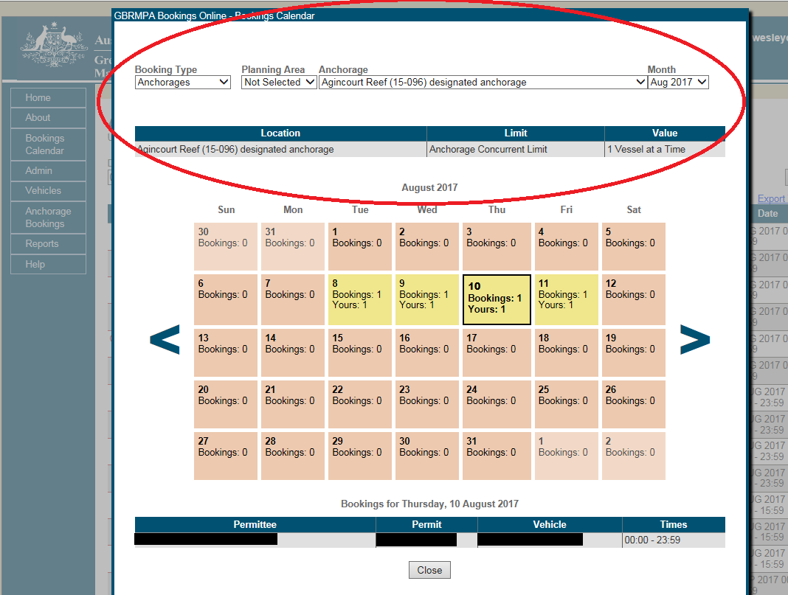
Figure 55 Screenshot of Bookings Online with a circle around the rules of bookings
To save and add another booking, click Save & Add another in the Add New Anchorage Booking display box. This will duplicate the booking details for the following day.
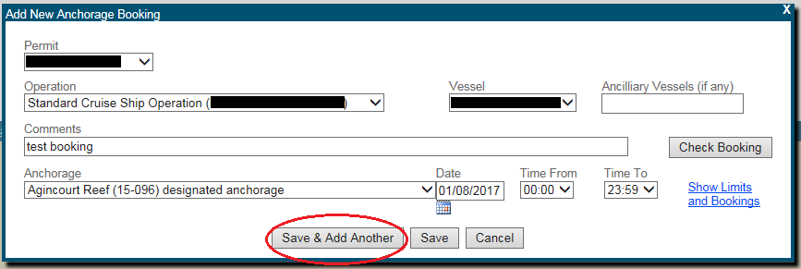
Figure 56 Screenshot of Bookings Online with a circle around Save & Add Another
To save a single booking, click Save in the Add New Anchorage Booking display box.
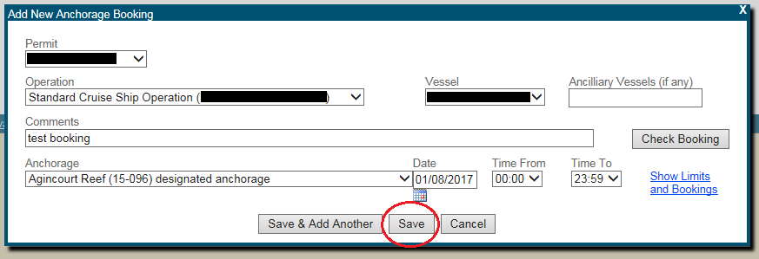
Figure 57 Screenshot of Bookings Online with a circle around Save

Once your booking is saved it will appear in the Anchorage Bookings List. You will receive a booking confirmation email.
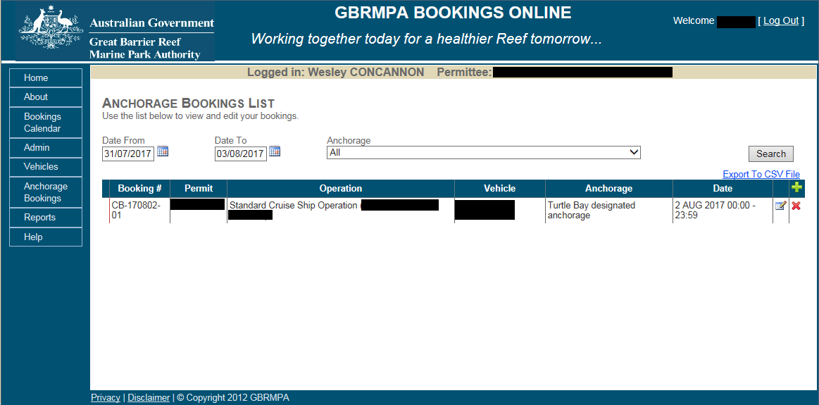
Figure 58 Screenshot showing the anchorage bookings list screen

9.2 DUPLICATE BOOKINGS
To duplicate a booking, click the copy icon () next to the booking you would like to duplicate.
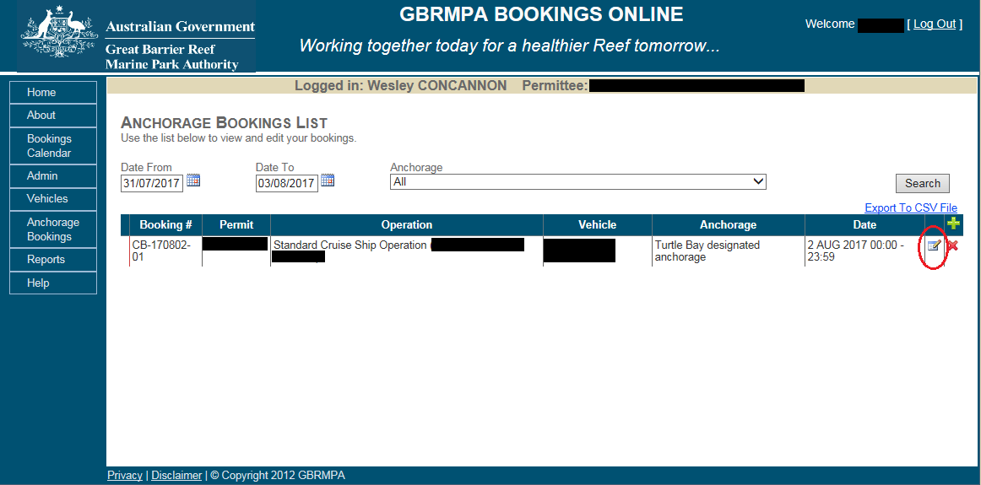
Figure 59 Screenshot of Bookings Online with a circle around the copy icon
A display box with Add New Anchorage Booking will appear and will contain the same booking information as the previous booking but for the following day.
You can edit the date to make a booking. Click Save or Save & Add Another.

9.3 DELETE BOOKINGS
To delete a booking, click the delete icon ()
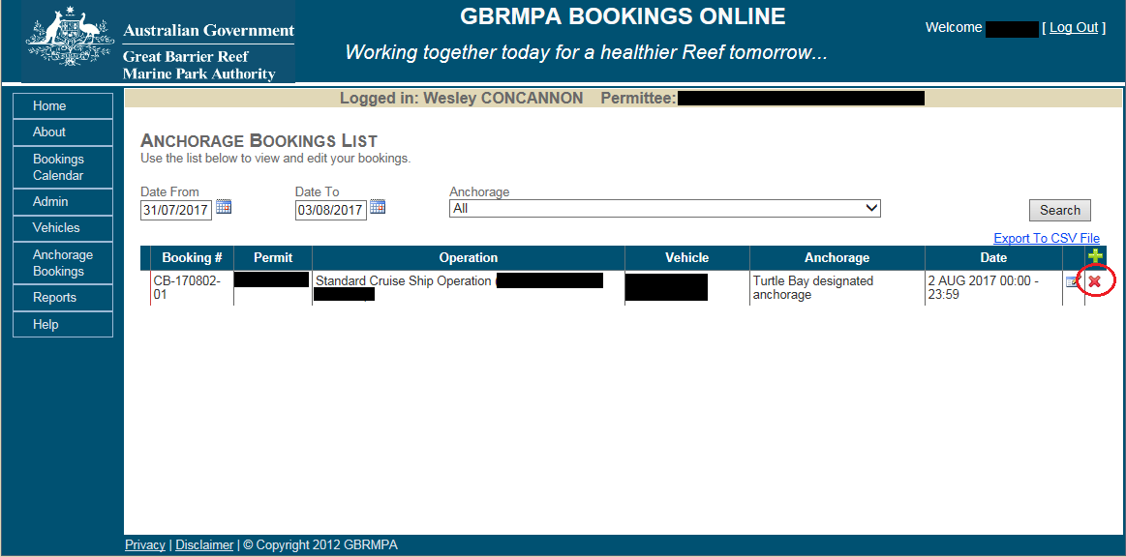
Figure 60 Screenshot of Bookings Online with a circle around the Delete icon
A new display box will appear. To confirm cancellation, you must provide a reason in the text box and then click Cancel Booking to confirm. This will remove the booking from anchorage bookings list. You will be sent a confirmation email once the booking has been cancelled.
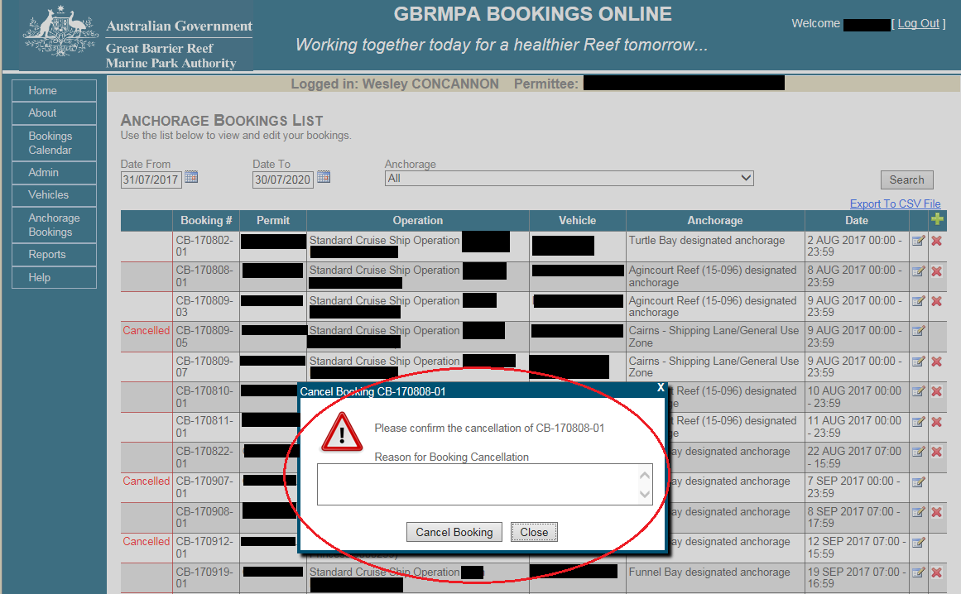
Figure 61 Screenshot of Bookings Online showing the booking cancellation confirmation pop-up

9.4 SEARCH BOOKINGS
To search for your bookings, select Anchorage Bookings from the navigation section.
Use fields at the top of the page to select search fields. Once you have selected fields you would like to search, click Search.
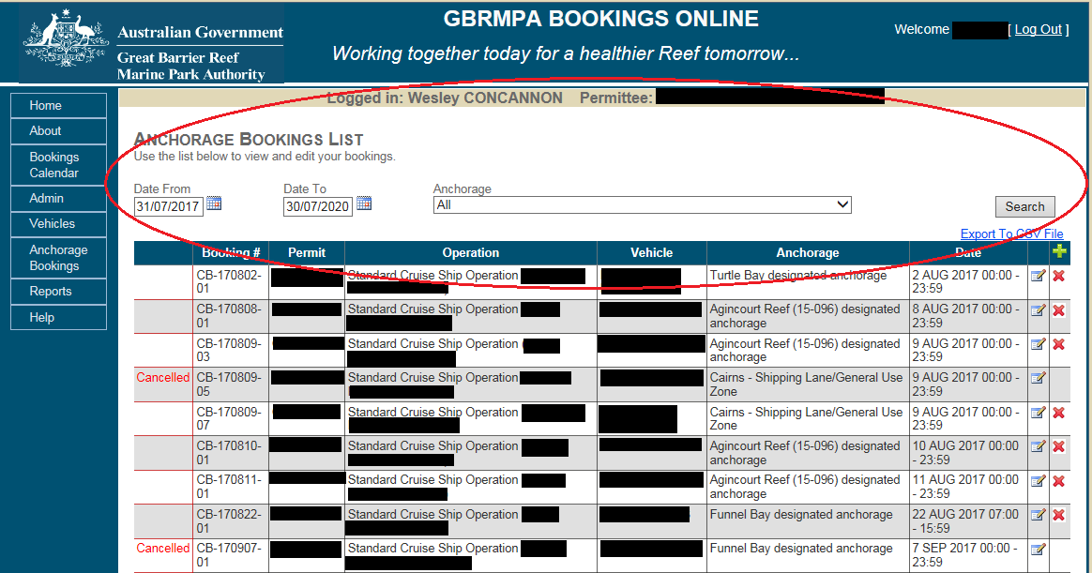
Figure 62 Screenshot of Bookings Online with a circle around search fields
The anchorage booking list will be updated to suit your selected criteria.

10.0 SUPERYACHTS ANCHORAGE BOOKINGS
The definition of superyacht is located in the Great Barrier Reef Marine Park Regulations 1983. The regulations define a superyacht as a high-value, luxury sailing or motor vessel in use for sport or pleasure. Superyacht anchorages within the Whitsunday Planning Area are specifically for superyachts less than 70 metres carrying no more than 12 people, other than master and crew.
NOTE: Superyachts 70 metres and above must book to a ‘Designated Anchorage’.
Superyachts may operate as either a private recreational or commercial user.
- If operating commercially you are required to have a marine parks permit and make a booking to the designated anchorage or superyacht anchorage. If the anchorage is within a Planning Area, the system will also automatically count this as a booking to the Planning Area.
- If you are operating recreationally you are only required to book to the anchorage. You will need to prove that you are operating recreationally, for further information refer to 2.0 ABOUT BOOKINGS ONLINE.
NOTE: A log in will have to be obtained first please email bookings@gbrmpa.gov.au or contact the Great Barrier Reef Marine Park Authority (GBRMPA) on (07) 4750 0700 during business hours (8:30am to 5:00pm EST weekdays).

10.1 ADD A NEW BOOKING
To make a booking, select Anchorage Bookings,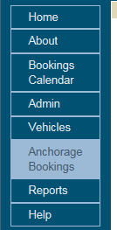 then click the add icon ( ). A bookings window will appear.
For bookings without a permit, fill in the required fields Operator Contact, Phone No., Vessel Name and Length. Choose the anchorage, a date, and time slot. Click Check Booking for availability and then save to make the booking. For ‘Commercial Superyacht’ bookings select the permit number and fill in any remaining details.
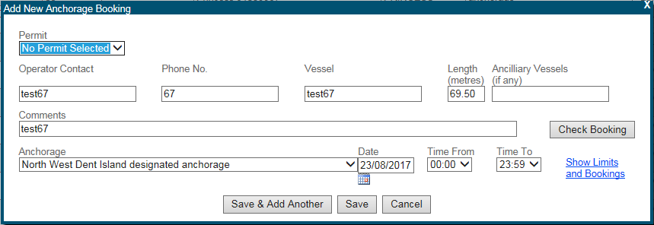
Figure 69 Screenshot of the Anchorage bookings window
Once you select save, the booking will appear in the anchorage bookings list.
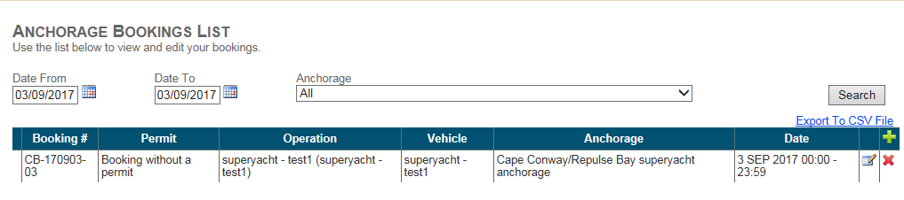
Figure 70 Screenshot of a booking in the Anchorage Bookings list

10.2 DUPLICATE BOOKINGS
If the second booking has the same details as the first, but has a different date, select the copy booking icon () next to the booking you wish to copy. This will display the same details as the previous booking but automatically change the date to the following day. Select the date you wish to book and change the anchorage if different, then click Save. The second booking will be saved.
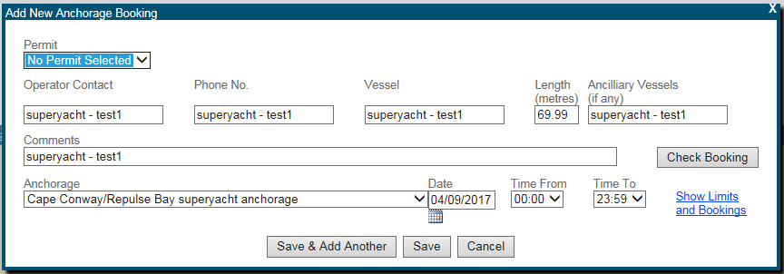
Figure 71 Screenshot of an add duplicate booking

The second booking will appear with the first booking in the anchorage bookings list.
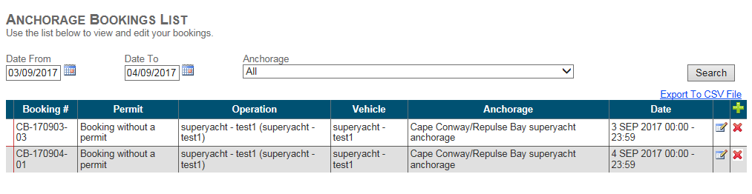
Figure 72 Screenshot of a bookings list with multiple bookings

10.3 DELETE BOOKINGS
If you have accidentally created a booking and the details are incorrect, you can delete a booking using the delete icon () on the anchorage bookings list screen. The day of use for the operation will not be affected, as long as the correction is made more than 24 hours before the booking commences. You can also use the delete icon to cancel a booking if you no longer need the booking. Ensure you put sufficient details in the comments box when cancelling.
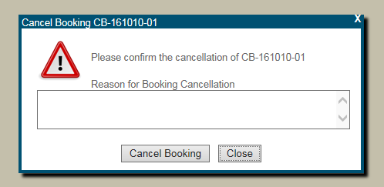
Figure 73 Screenshot of the reason for booking cancellation pop-up window.
Select log out in the top right-hand corner of the screen to log out.

11.0 REPORTS
Bookings Online can provide detailed reports on activity and bookings.
The reports include information on vehicles used, permit numbers, operations, date, number of passengers, locations visited, status of the booking and the reference number.

11.1 HOW TO VIEW YOUR REPORT
Try a simple search by following these steps:
- Click Reports in the navigation section of Bookings Online
- Click the dropdown list to select booking type
- Click the dropdown list to select report type
- Click the dropdown list to sort the order of the report
- Click the dropdown list to select the plan of management area
- Click the dropdown list to select a sensitive location
- Click the dropdown to select a permittee
- Click the calendar icon () to select a date from and date to.
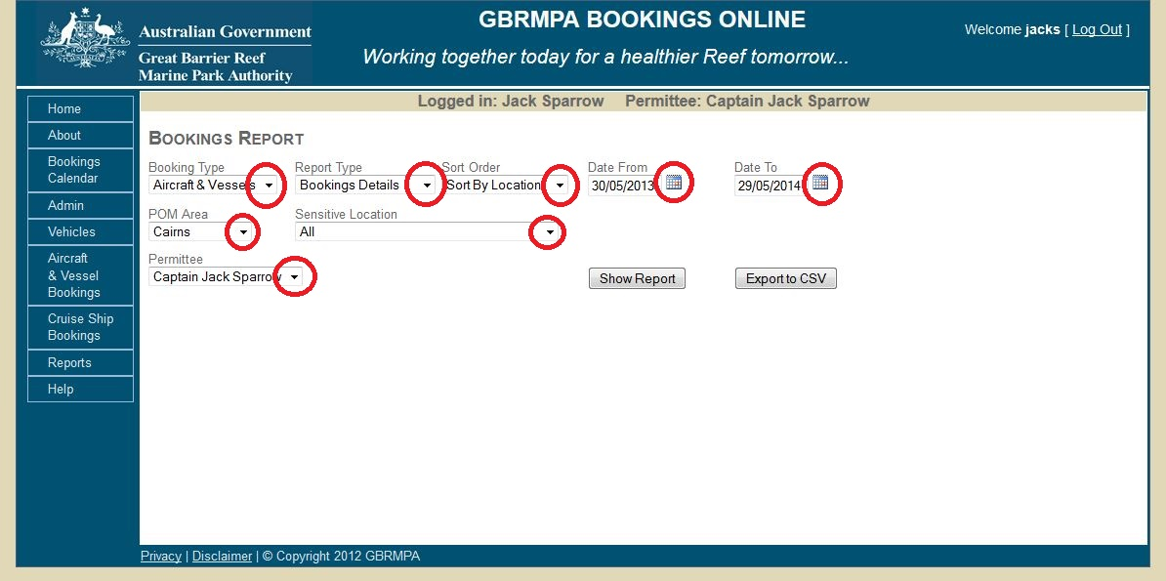
Figure 63 Screenshot of Bookings Online with circles around dropdown lists and calendar icons

Once you have finished selecting your report parameters, click Show Report to generate report results.
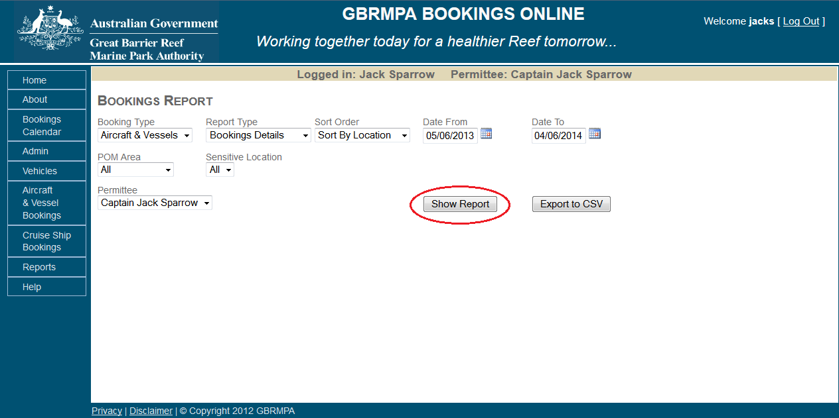
Figure 64 Screenshot of Bookings Online with a circle around Show Report

Once Show Report has been selected your report will appear below. The report contains all relevant information including a booking status to keep track of cancelled and current bookings. It will also advise if your booking was cancelled with or without the loss of a booking day.
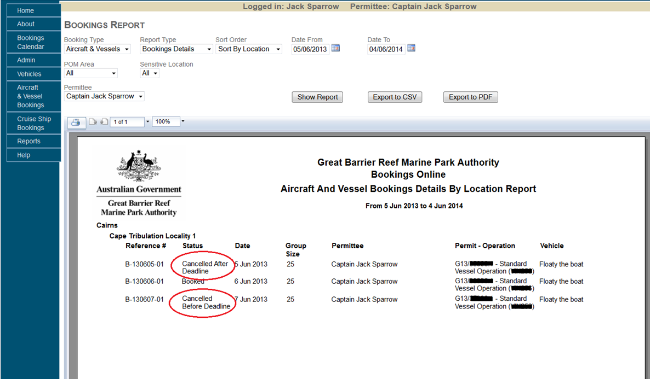
Figure 65 Screenshot of Bookings Online with circles around the status
Different style reports can be generated by selecting different criteria from the available picklists. Shown below is a bookings summary report.
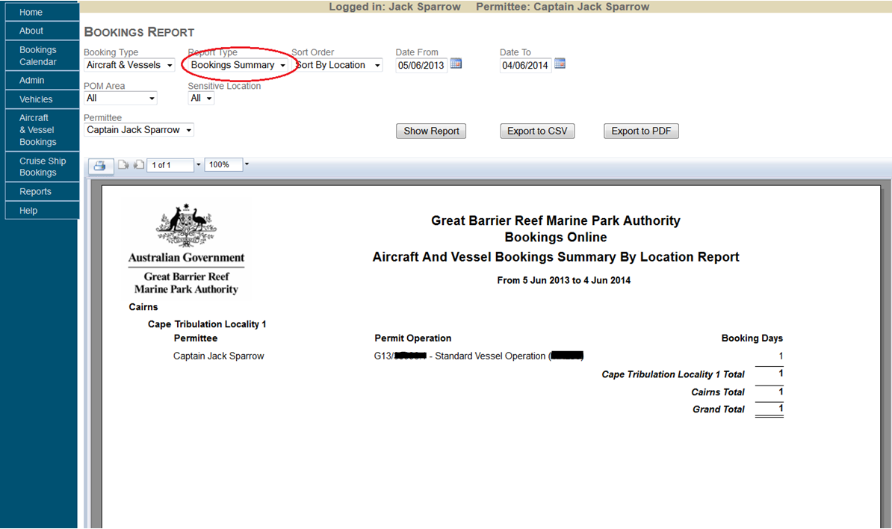
  - Figure 66 Screenshot of Bookings Online with a circle around the Report Type dropdown list

11.2 HOW TO DOWNLOAD YOUR REPORT
To download report results click Export Report to PDF. A pop-up box will appear. Click OK, and your report will be displayed in Adobe Reader. To access PDFs your computer must have Adobe Acrobat Reader DC, which can be downloaded from http://www.adobe.com.
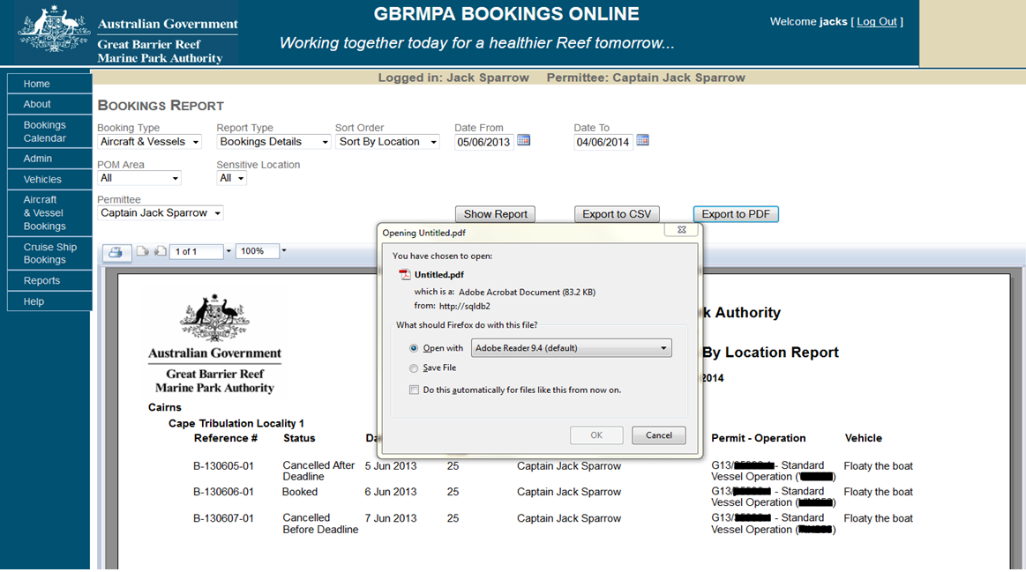
Figure 67 Screenshot showing the Download Your Report pop-up box
Reports may also be exported as CSV files by selecting the Export to CSV option and also printed directly from this screen via the printer icon (). Exporting a report to CSV will allow you to open the report in a Microsoft Excel Document.
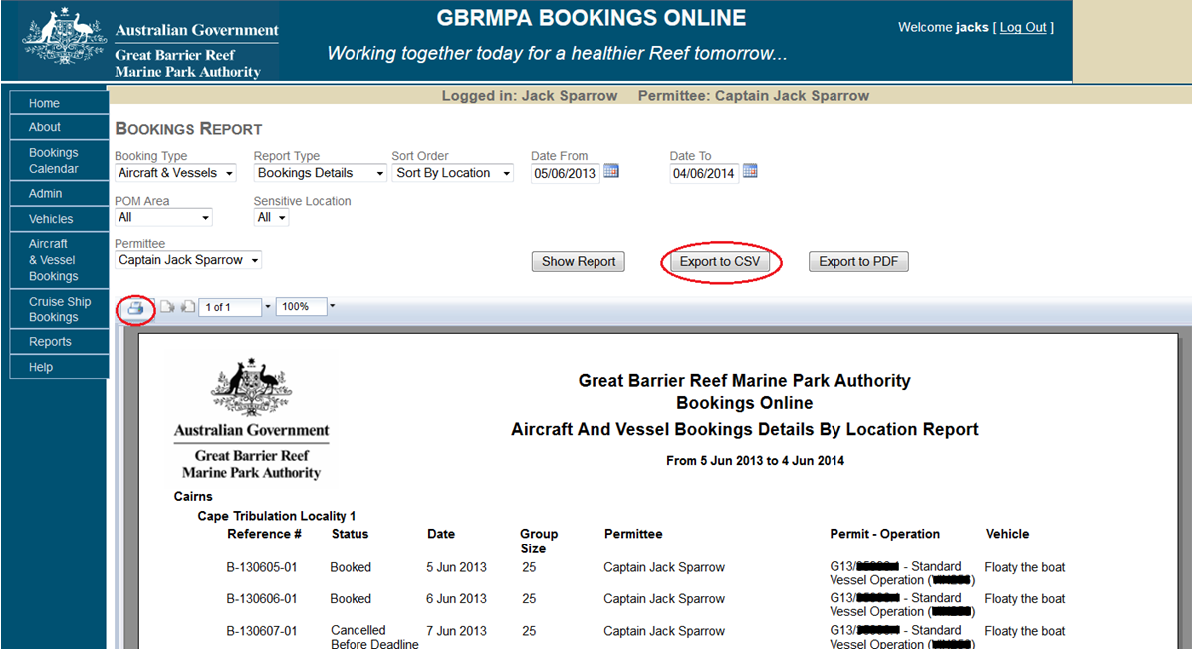
Figure 68 Screenshot of Bookings Online with a circle around Export to CSV

