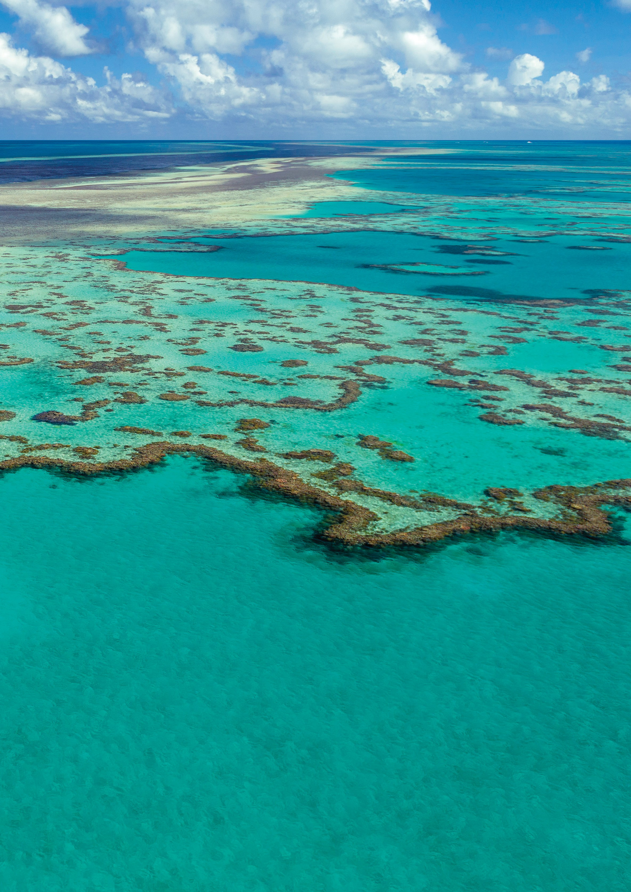

REEF BLUEPRINT

GREAT BARRIER REEF BLUEPRINT FOR RESILIENCE

Improving the capacity of corals and coral reefs to resist and recover from disturbance.

© Commonwealth of Australia 2017
Published by the Great Barrier Reef Marine Park Authority ISBN 978-0-6480964-3-6
This document is licensed by the Commonwealth of Australia for use under a Creative Commons By Attribution 4.0 International licence with the exception of the Coat of Arms of the Commonwealth of Australia, the logo
of the Great Barrier Reef Marine Park Authority, any other material protected by a trademark, content supplied by third parties and any photographs. For licence conditions see: http://creativecommons.org/licences/by/4.0

A Cataloguing-in-Publication entry for this document is available from the National Library of Australia

This publication should be cited as:
Great Barrier Reef Marine Park Authority 2017, Great Barrier Reef blueprint for resilience, GBRMPA, Townsville.

Comments and questions regarding this document are welcome and should be addressed to:

Great Barrier Reef Marine Park Authority
2–68 Flinders Street
(PO Box 1379)
Townsville QLD 4810, Australia
Phone: (07) 4750 0700
Fax: (07) 4772 6093
Email: info@gbrmpa.gov.au www.gbrmpa.gov.au

Unless otherwise noted all images are © to the Great Barrier Reef Marine Park Authority
Cover image/page 5: Jumbo Aerials

First nations people of Australia continue an age old, long-established spiritual and physical bond with the Great Barrier Reef that has existed for over 60,000 years. The Reef is a place that is highly significant for sustaining cultural celebration and community wellbeing for over 70 Traditional Owner groups.
Recent events occurring on the Reef, both natural and man-made, have had a disastrous impact on its state of health. Our tears of joy when connecting with the Reef as young people have turned to tears of deep sadness as elders. We watch this wonder of the natural world show us that it needs our immediate care.
We the first nations people of Australia send an urgent call to all people of the world to please give us your help to turn back the clock of deterioration.
We believe it is no longer a question of resilience but a desperate need for intervention. With deep respect, we call out to all global citizens and international storytellers who have, in the past, and wish to in the future, experience the majesty of the Reef, to walk with us on this journey of courage, to give back her dignity, by nursing her back to health.
We the first nations people of Australia, acknowledge the Great Barrier Reef World Heritage Area is a natural wonder and a global asset and as such requires solutions to come from the global village to stop this tragedy from happening in our lifetimes.
Let us be a generation of action and restoration. We must ensure the universal songlines of the Great Barrier Reef continue to endure for many generations to come.
INDIGENOUS REEF ADVISORY COMMITTEE

GREAT BARRIER REEF MARINE PARK AUTHORITY 2017

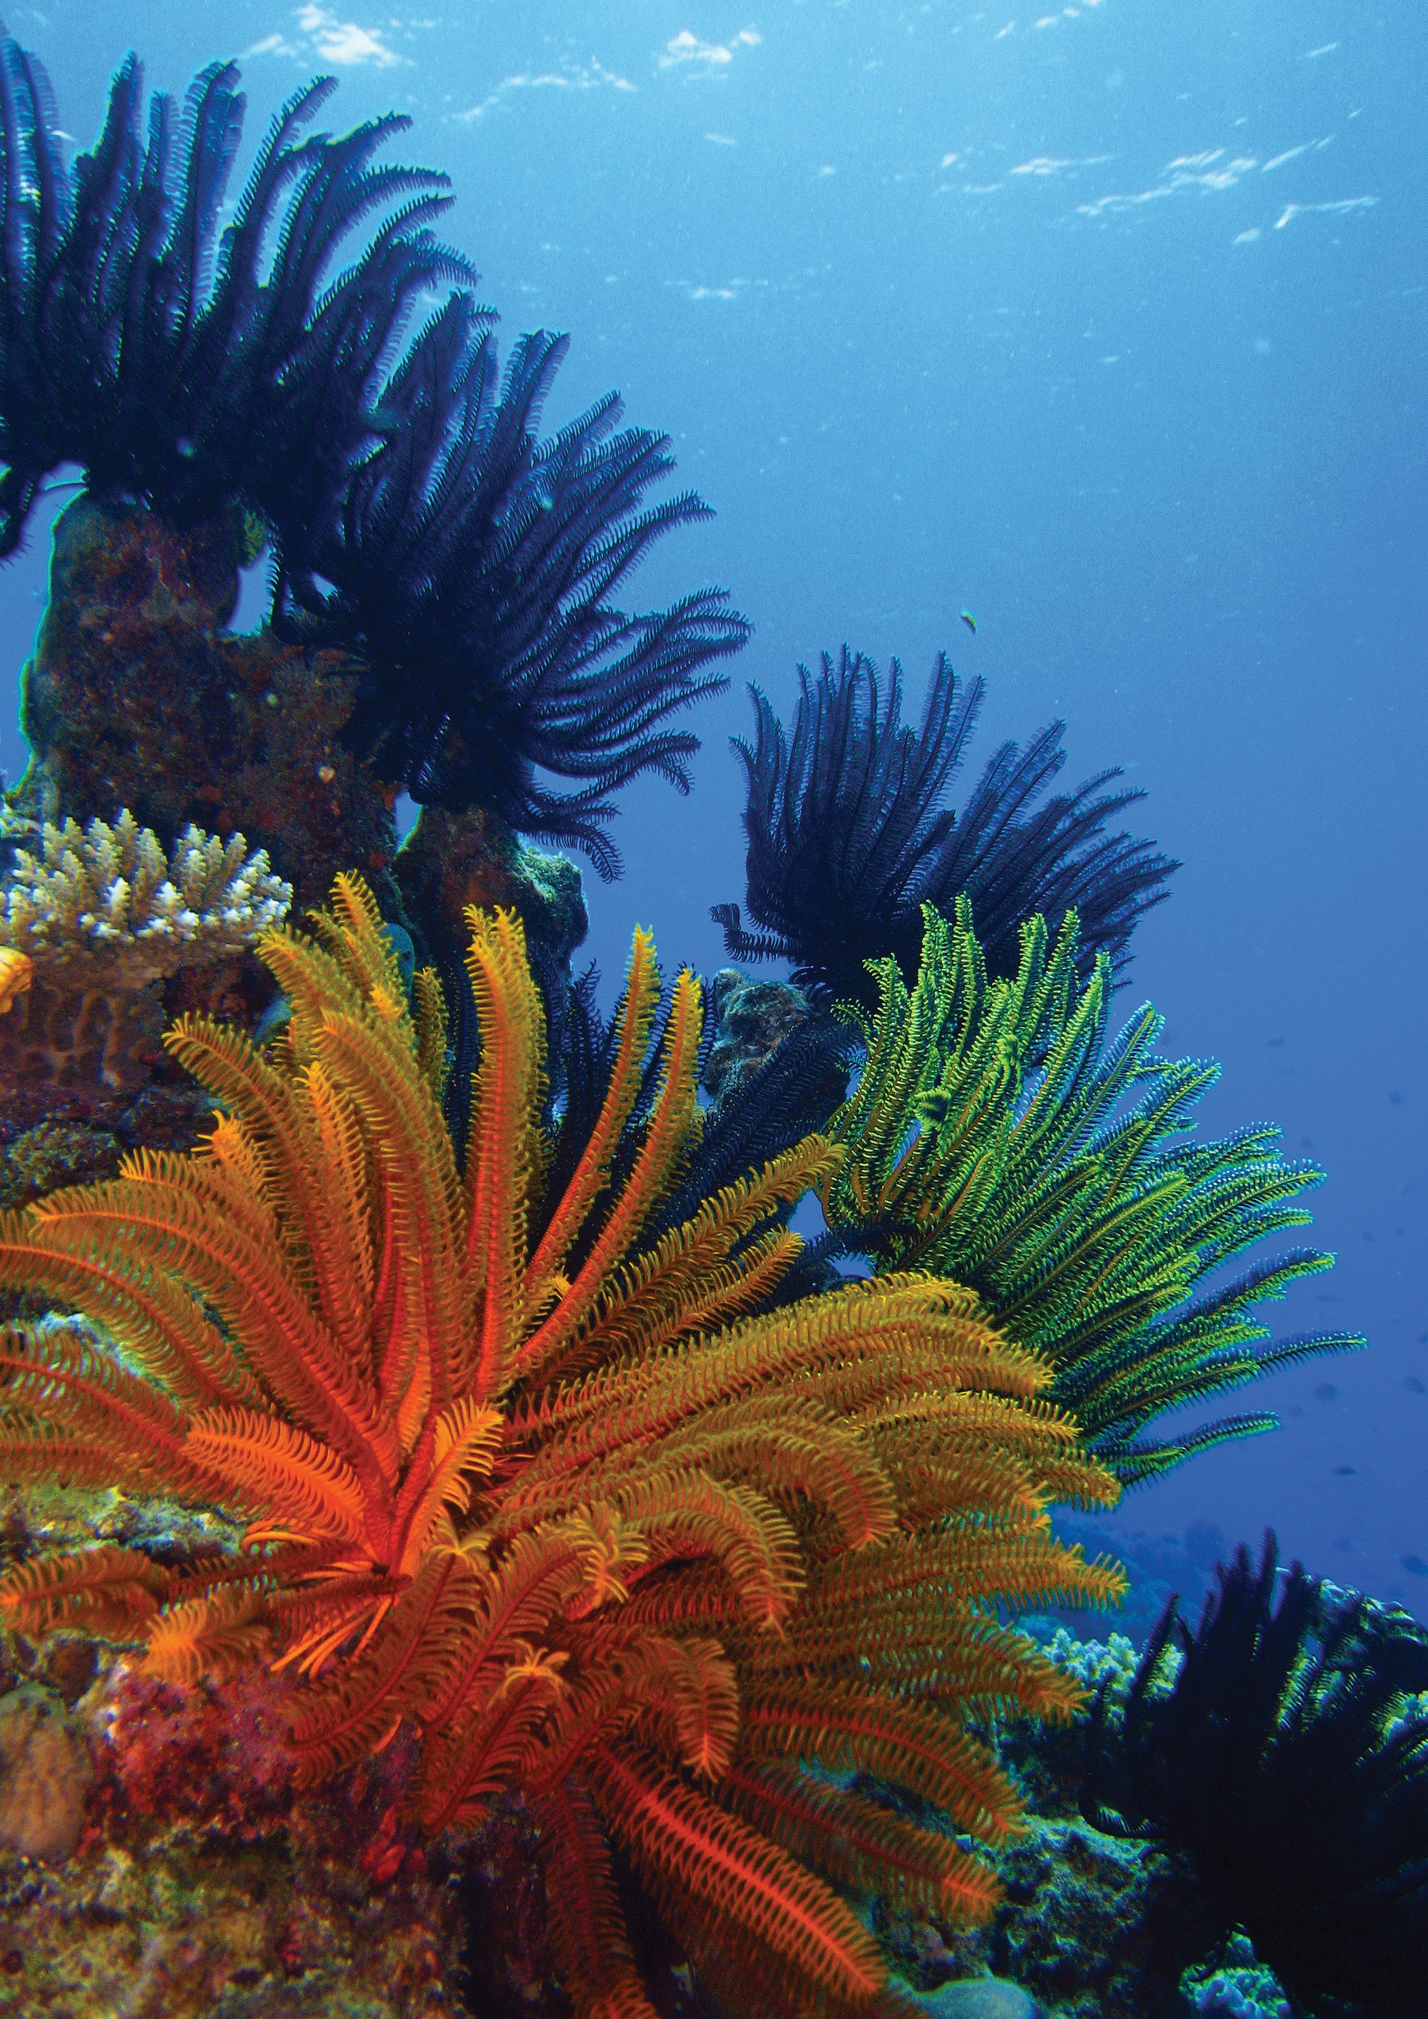

‘Together we can secure the future of the Great Barrier Reef — but we need to try harder, do more and act now’

2 GREAT BARRIER REEF MARINE PARK AUTHORITY

CONTENTS

FOREWORD 4
NAVIGATING BEYOND THE CROSSROAD 6
A SHARED COMMITMENT TO BUILDING REEF RESILIENCE 8
FRAMING OUR RESPONSE 9
MANAGING FOR RESILIENCE 10
PRIORITY INITIATIVES 11
BUILDING A RESILIENCE NETWORK 12
IDENTIFYING AND PROTECTING A RESILIENCE NETWORK 13
CORAL REEFS IN THE RESILIENCE NETWORK 14
DELIVERING ON-GROUND ACTIONS TO ENHANCE RESILIENCE 15
DRAMATICALLY ENHANCING COMPLIANCE 16
RAMPING UP CROWN-OF-THORNS STARFISH CONTROL 17
PROTECTING KEY SPECIES FOR REEF RECOVERY 18
ACTIVE LOCALISED RESTORATION 19
EMPOWERING OTHERS TO BE PART OF THE SOLUTION 20
ACCELERATING ACTIONS TO ADDRESS CLIMATE CHANGE 21
FOSTERING PARTNERSHIPS FOR ACTION AND INNOVATION 22
FOSTERING CHANGE 23
ADAPTING POLICY AND LEGISLATION 24
DEVELOPING DECISION-SUPPORT SYSTEMS 25
BUILDING AWARENESS AND SUPPORT 26
SCALE AND DELIVERY OF INITIATIVES 27
FROM BLUEPRINT TO ACTION 29

FOREWORD

This blueprint signals a change in the future management of the Great Barrier Reef.
Like all reefs globally, accumulated pressures, in particular those related to climate change, are impacting the Reef’s resilience and we are witnessing dramatic system-wide declines in its condition.
These changes, combined with future climate projections, compel us to refocus our management efforts and adopt new approaches to secure the future of this irreplaceable icon.
Tackling threats to the Reef at their source is critical. Accelerating actions to address climate change and continuing improvements in catchment water quality are fundamental to providing the best possible future for the Reef. At the same time, we must intensify our efforts to build the Reef’s resilience to the disturbances we know to expect in coming decades.
It is within this context, and building on our strong foundation of world-class management, that this blueprint outlines key initiatives that we — the Great Barrier Reef Marine Park Authority — will pursue with our partners to improve the outlook for the Reef and sustain the many benefits it provides.
Establishing a reef-wide ‘resilience network’ lies at the heart of the blueprint’s design. The network will include coral reefs that best support the Reef’s ecological, social, economic, cultural and heritage values. By focusing efforts on the resilience network, we will build resilience at local, regional and reef-wide scales.
Together with our partners, we will enhance the use of existing tools and trial new approaches and technologies to build resilience. Initiatives we will pursue include ramping up crown-of-thorns starfish control, strengthening compliance, enhanced protection of key species for Reef recovery, and testing and deploying methods for reef restoration.
We will enable these changes to occur by adapting our policies, improving information and decision-support systems, and seeking champions across sectors and within communities to substantially escalate our collective response.

This blueprint has been shaped by the outcomes of the Great Barrier Reef Summit, backed by the knowledge, experience and unwavering commitment of the dedicated individuals at the Great Barrier Reef Marine Park Authority and our many partners.
This blueprint is not intended to be a ‘plan’, but rather to present the 10 most promising initiatives — based on our collective experience, knowledge and best available information — to protect the Reef and build resilience.
A strong message from the Great Barrier Reef Summit was:

‘Together we can secure the future of the Great Barrier Reef — but we need to try harder, do more and act now’.
We must all step up and accelerate efforts to reduce impacts and improve the Reef’s resilience if we are to transform the outlook for the Great Barrier Reef.
This blueprint signals the changes the Authority will embark on to make this happen. We hope it acts as a catalyst for others to join us.

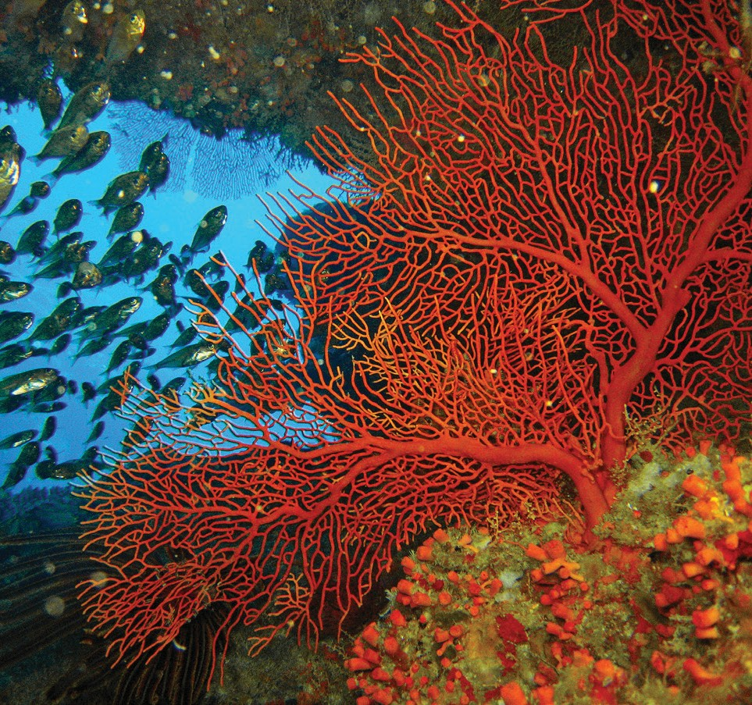

BLUEPRINT FOR RESILIENCE

Our approach is future-focused, our efforts collaborative, our actions targeted. Innovation and adaptation are central elements. And everything we do is within the context of a changing climate.

BUILDING A RESILIENCE NETWORK
- Identifying and protecting a resilience network
DELIVERING ON-GROUND ACTIONS TO ENHANCE RESILIENCE
- Dramatically enhancing compliance
- Ramping up crown-of-thorns starfish control
- Protecting key species for reef recovery
- Active, localised restoration
EMPOWERING PEOPLE TO BE PART OF THE SOLUTION
- Accelerating actions to address climate change
- Fostering partnerships for action and innovation

Adapting policy and legislation
FOSTERING CHANGE
Developing decision-support systems

Building awareness and support

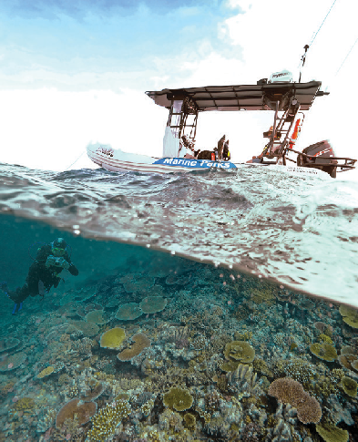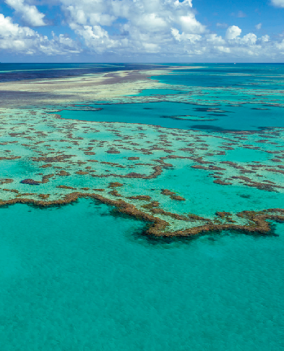

Our blueprint draws on the collective wisdom, knowledge and insights of marine park managers, Traditional Owners, the scientific community, industry, non-government organisations and individuals with deep connections to the Reef. It does not stand alone but builds on the strong foundation and legacy of 40 years of world class management.

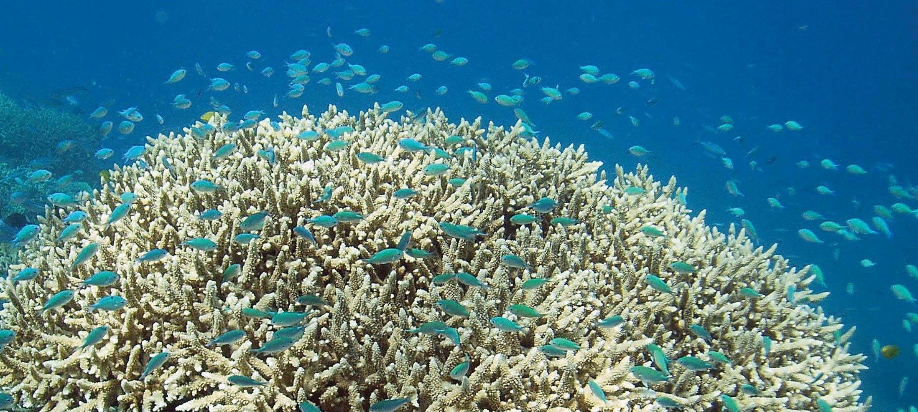
Photograph: Chris Jones

NAVIGATING BEYOND THE CROSSROAD

For more than 40 years it has been the Great Barrier Reef Marine Park Authority’s great privilege to manage the Great Barrier Reef for its long-term protection and conservation on behalf of Australians and the world.
Over this time, coral reefs around the world, including the Great Barrier Reef, have been experiencing the impacts of compounding pressures from a range of sources, most significantly climate change.
In the last two years, the resilience of the Great Barrier Reef has faced its greatest test yet in the form of an unprecedented combination of system impacts: two consecutive years of mass coral bleaching, coral disease outbreaks and a category 4 tropical cyclone which crossed reefs in the Whitsundays. Adding to these climate-related impacts is a major crown-of-thorns starfish outbreak, which has been ongoing since 2010.
The resulting decline in the ecological health of the Reef is unprecedented in our lifetime, and represents a genuine crisis. It is central to the culture and wellbeing of many Australians, and as a World Heritage property is recognised internationally for its outstanding universal value. The Reef supports a range of traditional, commercial and recreational uses, including a billion- dollar Reef tourism industry. Allowing it to decline further without committing every effort to help it cope with the challenges ahead is not an option.

In response to this crisis, the Authority convened the Great Barrier Reef Summit – Managing for Resilience on 24 and 25 May 2017 to help craft a blueprint to navigate a future characterised by uncertainty and accelerating change.
The summit brought together more than 70 regional, national and international delegates representing marine park managers, Traditional Owners, government agencies, the scientific community, industry groups and individuals with deep connections to the Reef.
The summit produced insights, innovations and recommendations that, together with the knowledge and expertise of Authority staff, form the basis of this blueprint.
Building on existing management arrangements to protect the Great Barrier Reef, this blueprint outlines additional actions and innovative approaches the Authority will pursue with its partners to better support and protect coral reefs in the face of a changing climate. Its explicit focus on coral reefs reflects their critical state, and their role as the cornerstones of the Great Barrier Reef’s broader ecological, social, economic, cultural and heritage values.
By focusing our efforts on building the resilience of coral reefs, we will give the entire Great Barrier Reef ecosystem its best chance of coping with the challenges ahead.

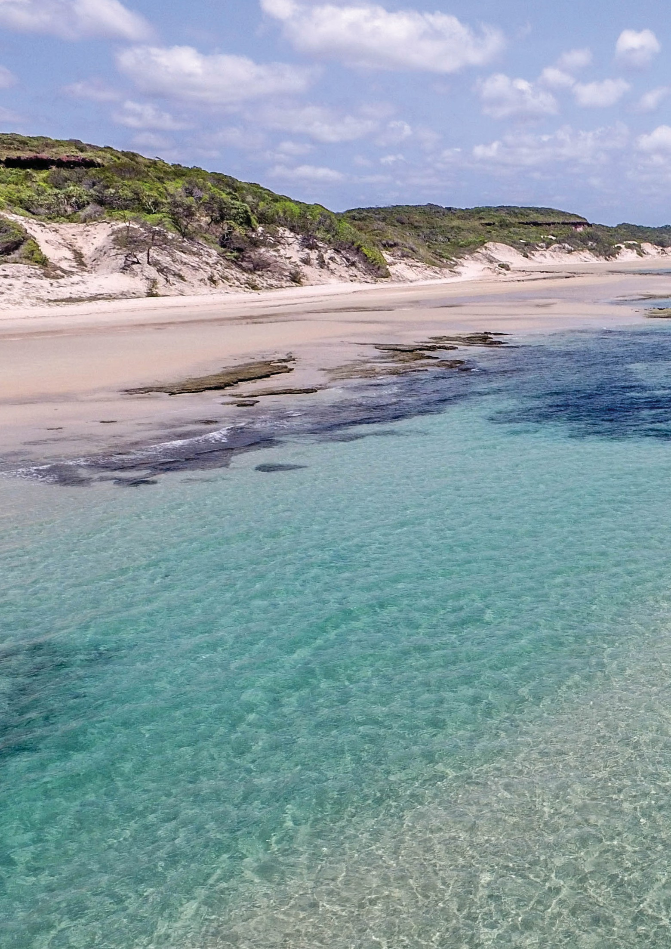

A key outcome from the Great Barrier Reef Summit was strong affirmation of shared commitment by all participants to protect the
Reef and build its resilience.

GREAT BARRIER REEF BLUEPRINT FOR RESILIENCE 7

A SHARED COMMITMENT TO BUILDING REEF RESILIENCE

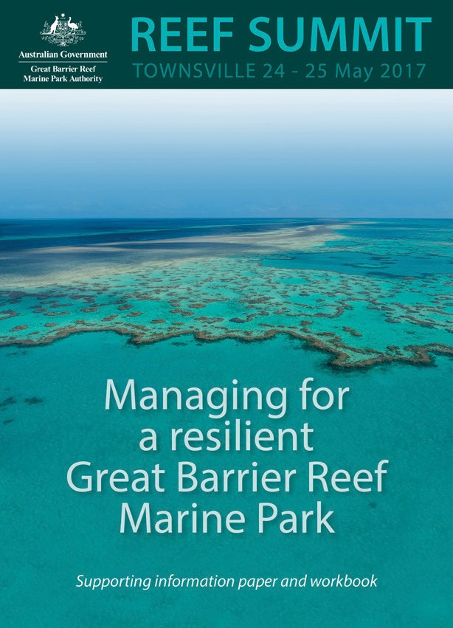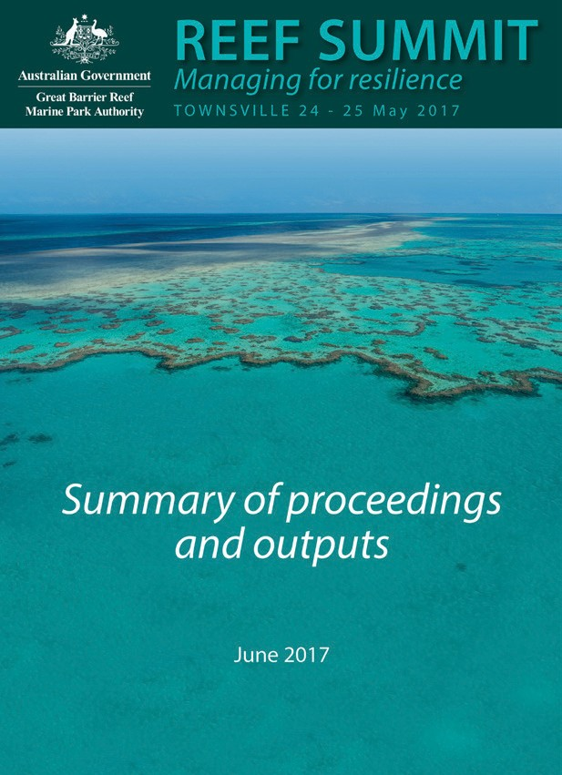A key outcome from the Great Barrier Reef Summit was strong affirmation of shared commitment by all participants to protect the Reef and build its resilience.
The summit was informed by an information paper and outcomes were captured in a summary
of proceedings. Both these documents provide important context for this blueprint.

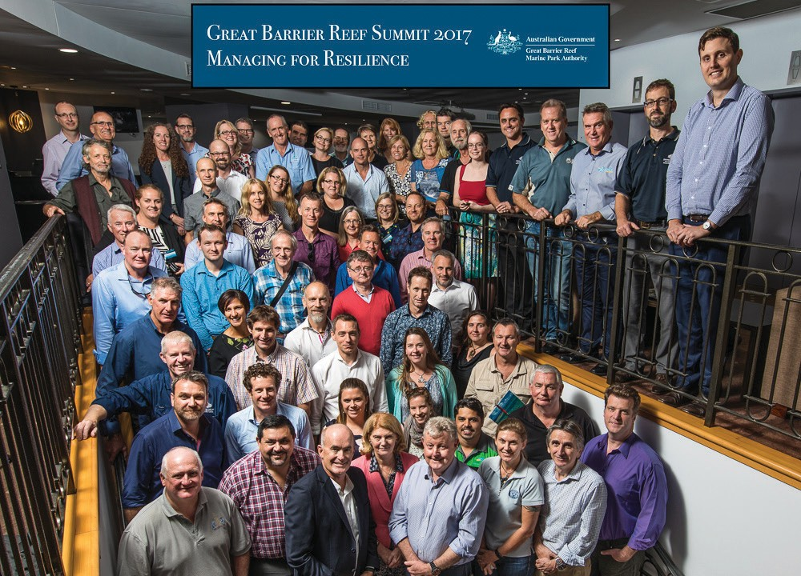

Photograph: Cameron Laird

FRAMING OUR RESPONSE

The summit highlighted that our response to recent bleaching events and cumulative pressures affecting the Reef must build on the strong foundation of past and current programs. New tools and innovative approaches must be developed and used to transform the outlook for the Reef.
While the summit focused on actions to be taken within the Great Barrier Reef Marine Park to build coral and coral reef resilience, a strong message was: ‘tackling drivers of impacts to the Reef ecosystem at their source is vital’.
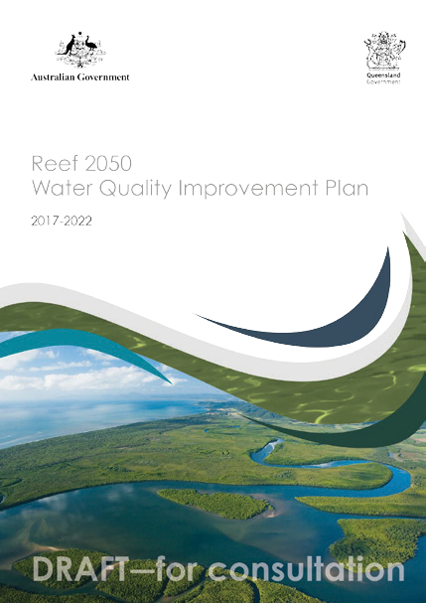Collective efforts to reduce climate change impacts must occur now, and wherever possible be accelerated, as their effects will take years to decades to be realised. To ensure the Reef is a functioning ecosystem in the future, the stronger position in the Paris Agreement to restrict the temperature increase to 1.5ºC (or ideally less) above pre-industrial levels is essential.
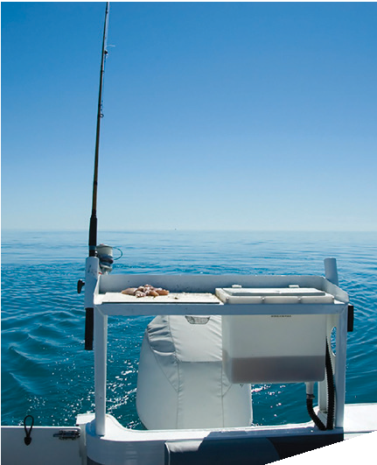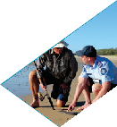There was strong recognition for the need to continue to drive improvements to the quality of water entering the Reef from the catchment. Actions to improve water quality are yielding positive results and must not lose momentum. The effects of this work will take many years to be fully realised on the Reef.
Queensland Sustainable Fisheries Strategy

2017–2027

Department of Agriculture and Fisheries
The Queensland Government Sustainable Fisheries Strategy also plays a key role in framing our response. Some elements of this strategy have specific relevance to coral and coral reef resilience and are embedded in the initiatives of the blueprint. Beyond corals and coral reefs, this strategy has a key role to play in improving the resilience of the entire Reef ecosystem.
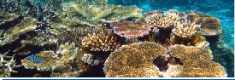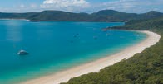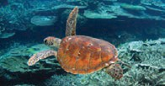The Reef 2050 Plan provides the overarching framework for the protection of the Reef bringing together actions across government, Traditional Owners, industry, researchers and the community. The in-park and immediate efforts described in this blueprint are increasingly crucial if we are to sustain the Reef as a functioning ecosystem while key drivers of impacts are being tackled over the longer term.

Reef 2050 Long-Term Sustainability Plan
The Reef 2050 Plan is being reviewed in 2017–18, and we anticipate the initiatives in this blueprint will inform the revised plan.

MANAGING FOR RESILIENCE

Resilience refers to the capacity of a system to resist and recover from disturbance and undergo change while still retaining essentially the same function, structure and integrity. It is not about a single state, but the capacity of an ever-changing, dynamic system to return to a healthy state after a disturbance or impact. Managing for resilience builds on and operates in conjunction with foundational management programs and approaches, including the Great Barrier Reef Marine Park Zoning Plan.
Defining features of our resilience-based management approach include:
Being future-focused, dynamic and adaptive Resilience-based management responses place a strong emphasis on the use of forecasting tools to inform planning and actions, together with monitoring and diagnostic tools to adjust actions.
Understanding the processes of resilience to guide management actions and adaptation responses Actions are designed to maximise recovery and limit disturbances or impacts.
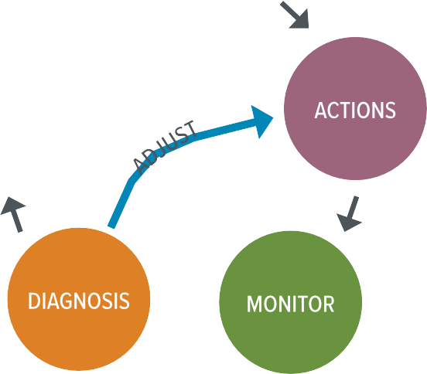For example, understanding processes that support resilience enables the selection of sites for greater protection or targeted management actions to:
- minimise exposure to damaging physical (e.g. cyclone and sea temperature), chemical (e.g. nutrient cycling) and ecological (e.g. disease and predation) processes and impacts
- support critical ecological processes like recruitment, herbivory and connectivity, and
- support social, economic and cultural resilience and adaption to enable communities to better prepare, limit impacts and adapt in response to changing conditions.

Taking a system perspective
Effective resilience-based management uses an understanding of the cause-and-effect relationships between drivers and pressures on the state of the system and impacts on the benefits the system provides. Within this context, actions are targeted to areas that will produce the greatest system-wide benefits.

Having an understanding of scale
Understanding the range of spatial and temporal scales at which drivers and pressures operate, and the variable and uncertain processes of recovery, is critical to formulating resilience-based responses. This knowledge informs where and when resilience actions should occur.

Being collaborative and innovative
Resilience-based management embraces innovation and seeks opportunities to align effort, share information, generate new ideas and achieve multiple outcomes.

PRIORITY INITIATIVES

The blueprint is designed around 10 key initiatives focused on actions to deliver maximum benefits for reef resilience. They fall into four broad areas:
- Building a resilience network
- Delivering on-ground actions to enhance resilience
- Empowering people to be part of the solution
- Fostering change.

Delivering these initiatives involves a combination of improvements to existing management approaches and the adoption of innovative ideas.
Outcomes for each initiative are framed as vision statements to align with outputs from the summit.
A description of each initiative is provided in the following sections.
BUILDING A RESILIENCE NETWORK

- Identifying and protecting a resilience network

DELIVERING ON-GROUND ACTIONS TO ENHANCE RESILIENCE
- Dramatically enhancing compliance
- Ramping up crown-of-thorns starfish control
- Protecting key species for reef recovery
- Active, localised restoration

EMPOWERING PEOPLE TO BE PART OF THE SOLUTION
- Accelerating actions to address climate change
- Fostering partnerships for action and innovation

FOSTERING CHANGE

- Adapting policy and legislation
- Developing decision-support systems
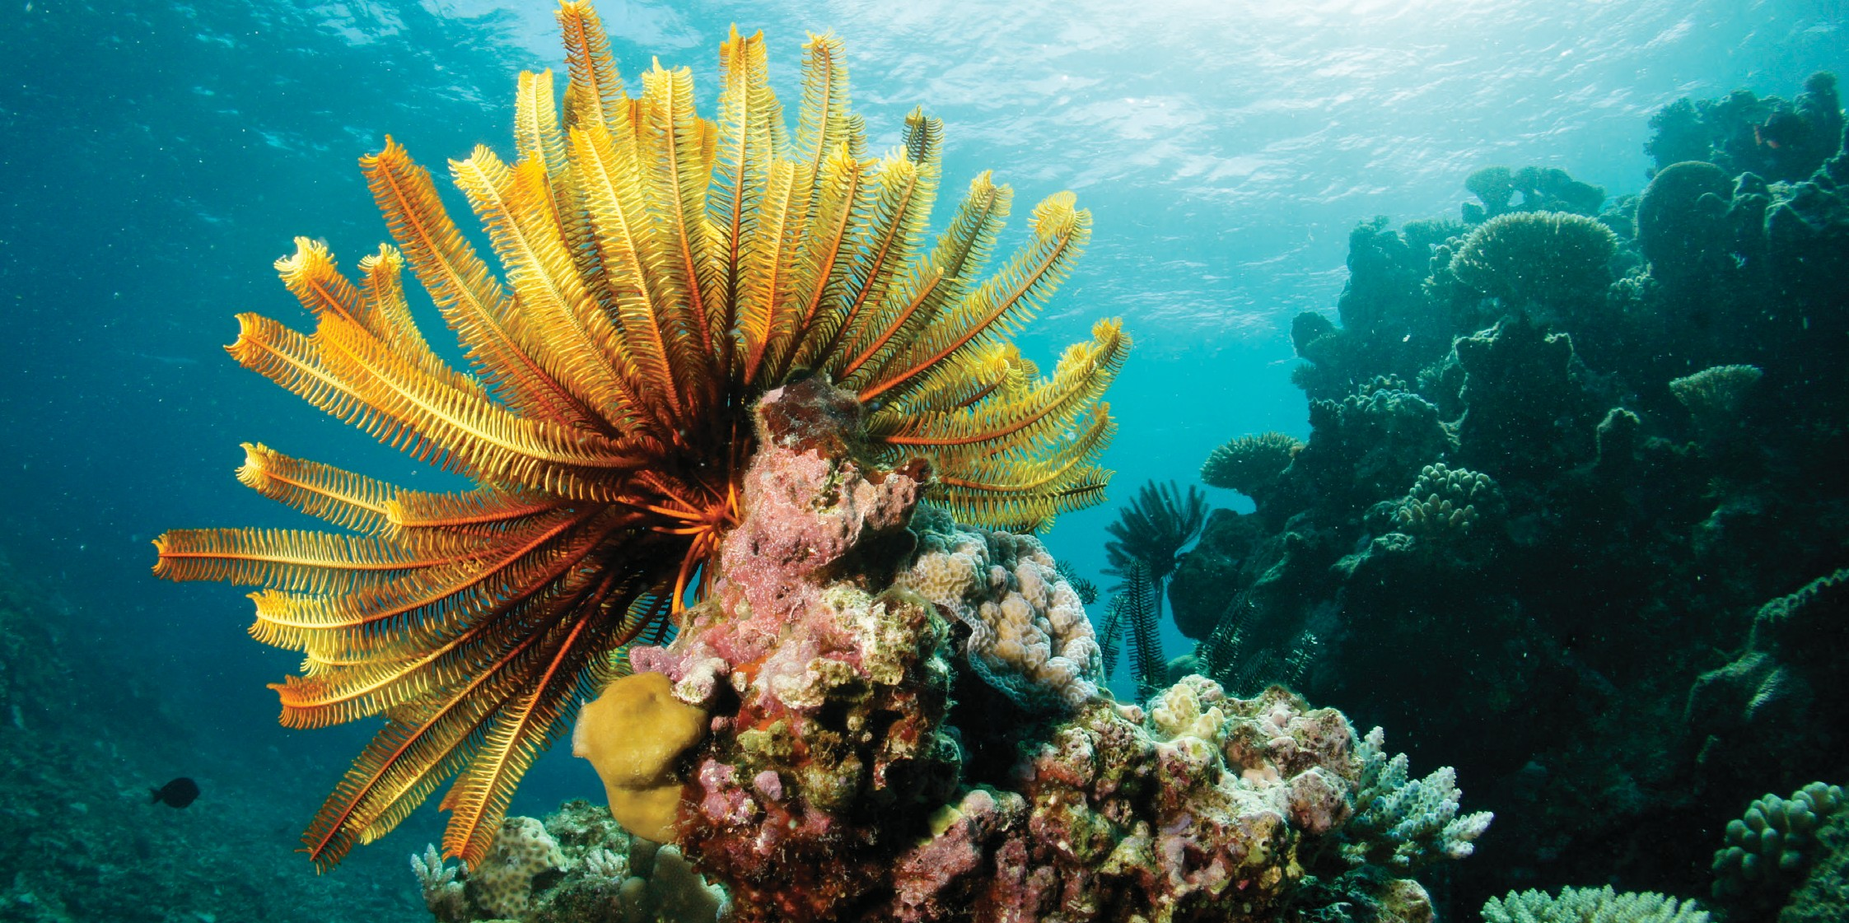
- Building awareness and support

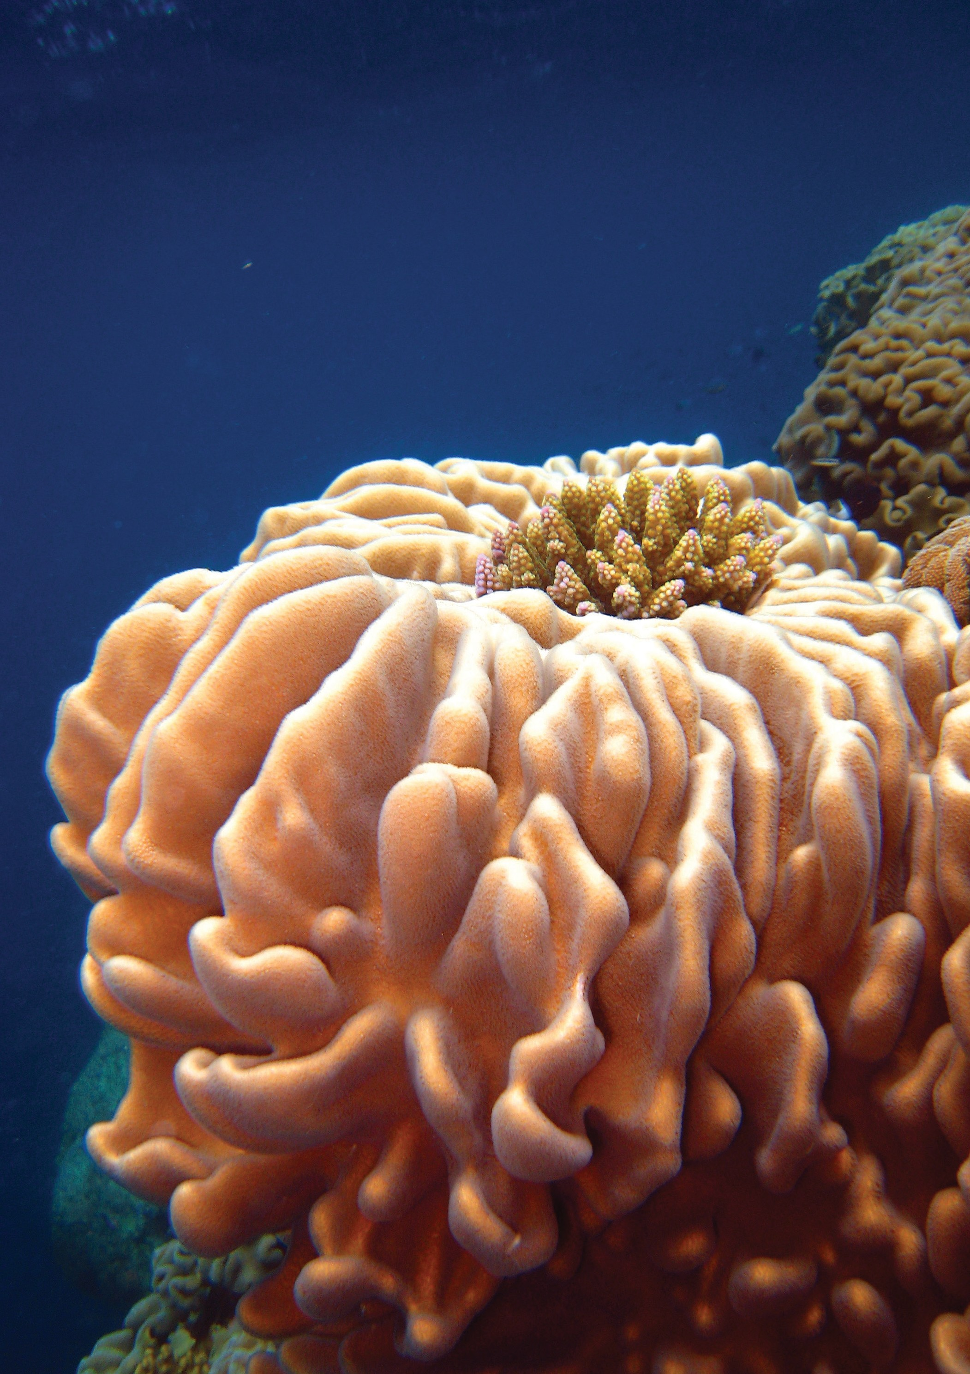BUILDING A RESILIENCE NETWORK

IDENTIFYING AND PROTECTING A RESILIENCE NETWORK

Photograph: Chris Jones

12 GREAT BARRIER REEF MARINE PARK AUTHORITY

BUILDING A RESILIENCE NETWORK

IDENTIFYING AND PROTECTING A RESILIENCE NETWORK

Vision for 2020
A resilience network has been identified, evaluated, and is the focus of additional management efforts.
In the face of pervasive pressures from external drivers such as climate change and degraded water quality, the focus for management efforts within the Great Barrier Reef Marine Park must be on actions that will maximise system resilience.
To facilitate this, we will establish a reef-wide ‘resilience network’. This will allow us to strategically target efforts on coral reef areas that are of greatest value to the future of the Reef as a whole. The resilience network will not include changes to the Zoning Plan itself, but will complement the zoning network.
Building a resilience network involves three key steps:
- identifying coral reefs that are disproportionately important to the Reef’s resilience (i.e. areas that best support ecological, social, economic, cultural and heritage values across the entire Reef system)
- evaluating these areas to determine the best resilience-building activities to reduce impacts and improve condition, and
- focusing collaborative efforts on delivery of resilience-based actions across the resilience network.
These steps are central to operationalising and delivering an enhanced resilience-based management framework for the Great Barrier Reef. It enables management effort to focus on a tractable number of areas and deliver system- wide resilience with multiple benefits through coordinated local actions.
To achieve the 2020 vision the Authority will work with partners to:
- develop an operational decision-support tool for dynamic exposure and connectivity mapping, linked to monitoring and modelling information, to identify coral reef areas that form part of the resilience network
- determine the best measures to reduce impacts and improve resilience at those areas, and
- implement a program of tailored resilience-based measures across the resilience network.
Our priority will be to identify coral reefs that make up the resilience network and actions at these sites to build resilience. Additional actions will be designed to reduce local pressures and support recovery from specific incidents, such as coral bleaching, damage from cyclones or outbreaks of crown-of-thorns starfish. These, and other actions, will also contribute to protecting the broader Reef system and building resilience in the face of pervasive external pressures.
Building on existing collaborations to enhance resilience, we will operationalise key components of the Reef 2050 Integrated Monitoring and Reporting Program to identify the resilience network and enable us to better predict and respond to threats.
We will use the best available science, including the approach being pioneered through the crown-of-thorns starfish control program.

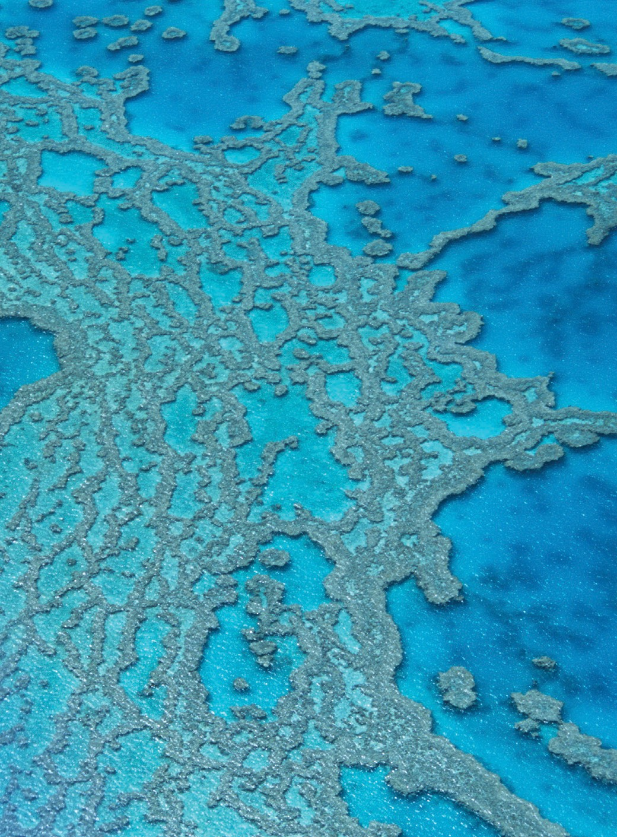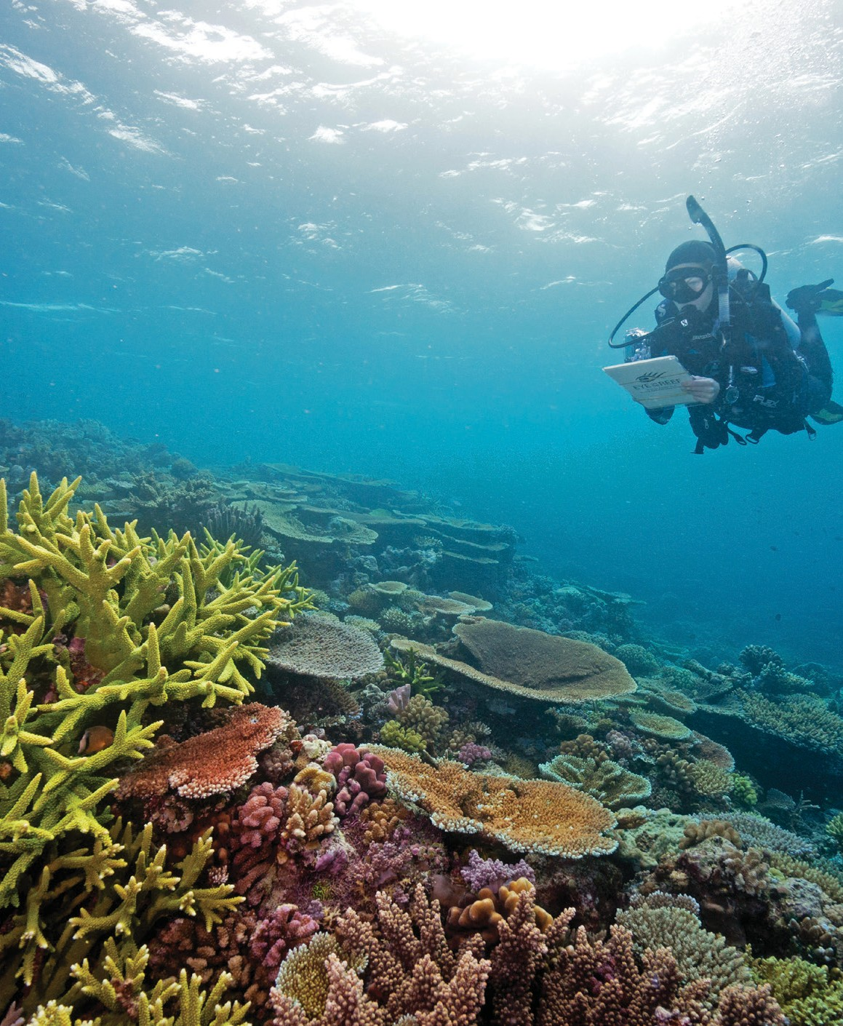

Photograph: Wendy Stewart

CORAL REEFS IN THE RESILIENCE NETWORK

Coral reefs that form part of the resilience network will be identified using the best available science, complemented by the knowledge and experience of Authority staff and our partners. These include
Traditional Owners, the scientific community, industry groups, and community representatives.
We will consider reef areas that:
  - have relatively lower exposure to high water temperatures, cyclones and floods
  - retain relatively higher coral cover
  - recover rapidly after impacts
  - make relatively higher contribution to the coral larval supply to downstream reefs, and
  - make relatively higher contributions to broader ecological, social, economic, cultural and/or heritage values.

While it is unlikely all areas that form part of the resilience network will have all these attributes, we will seek to maximise these attributes in the overall network.
Connectivity between areas in the network is critical to ensure they function as an interconnected network, not stand alone refugia.
Fully realised, this approach will enable the Authority to deliver system-wide benefits through targeted local actions.
It will also create opportunities for local resilience- building actions by Traditional Owners, local communities, businesses and government agencies to improve the outlook for the Great Barrier Reef.

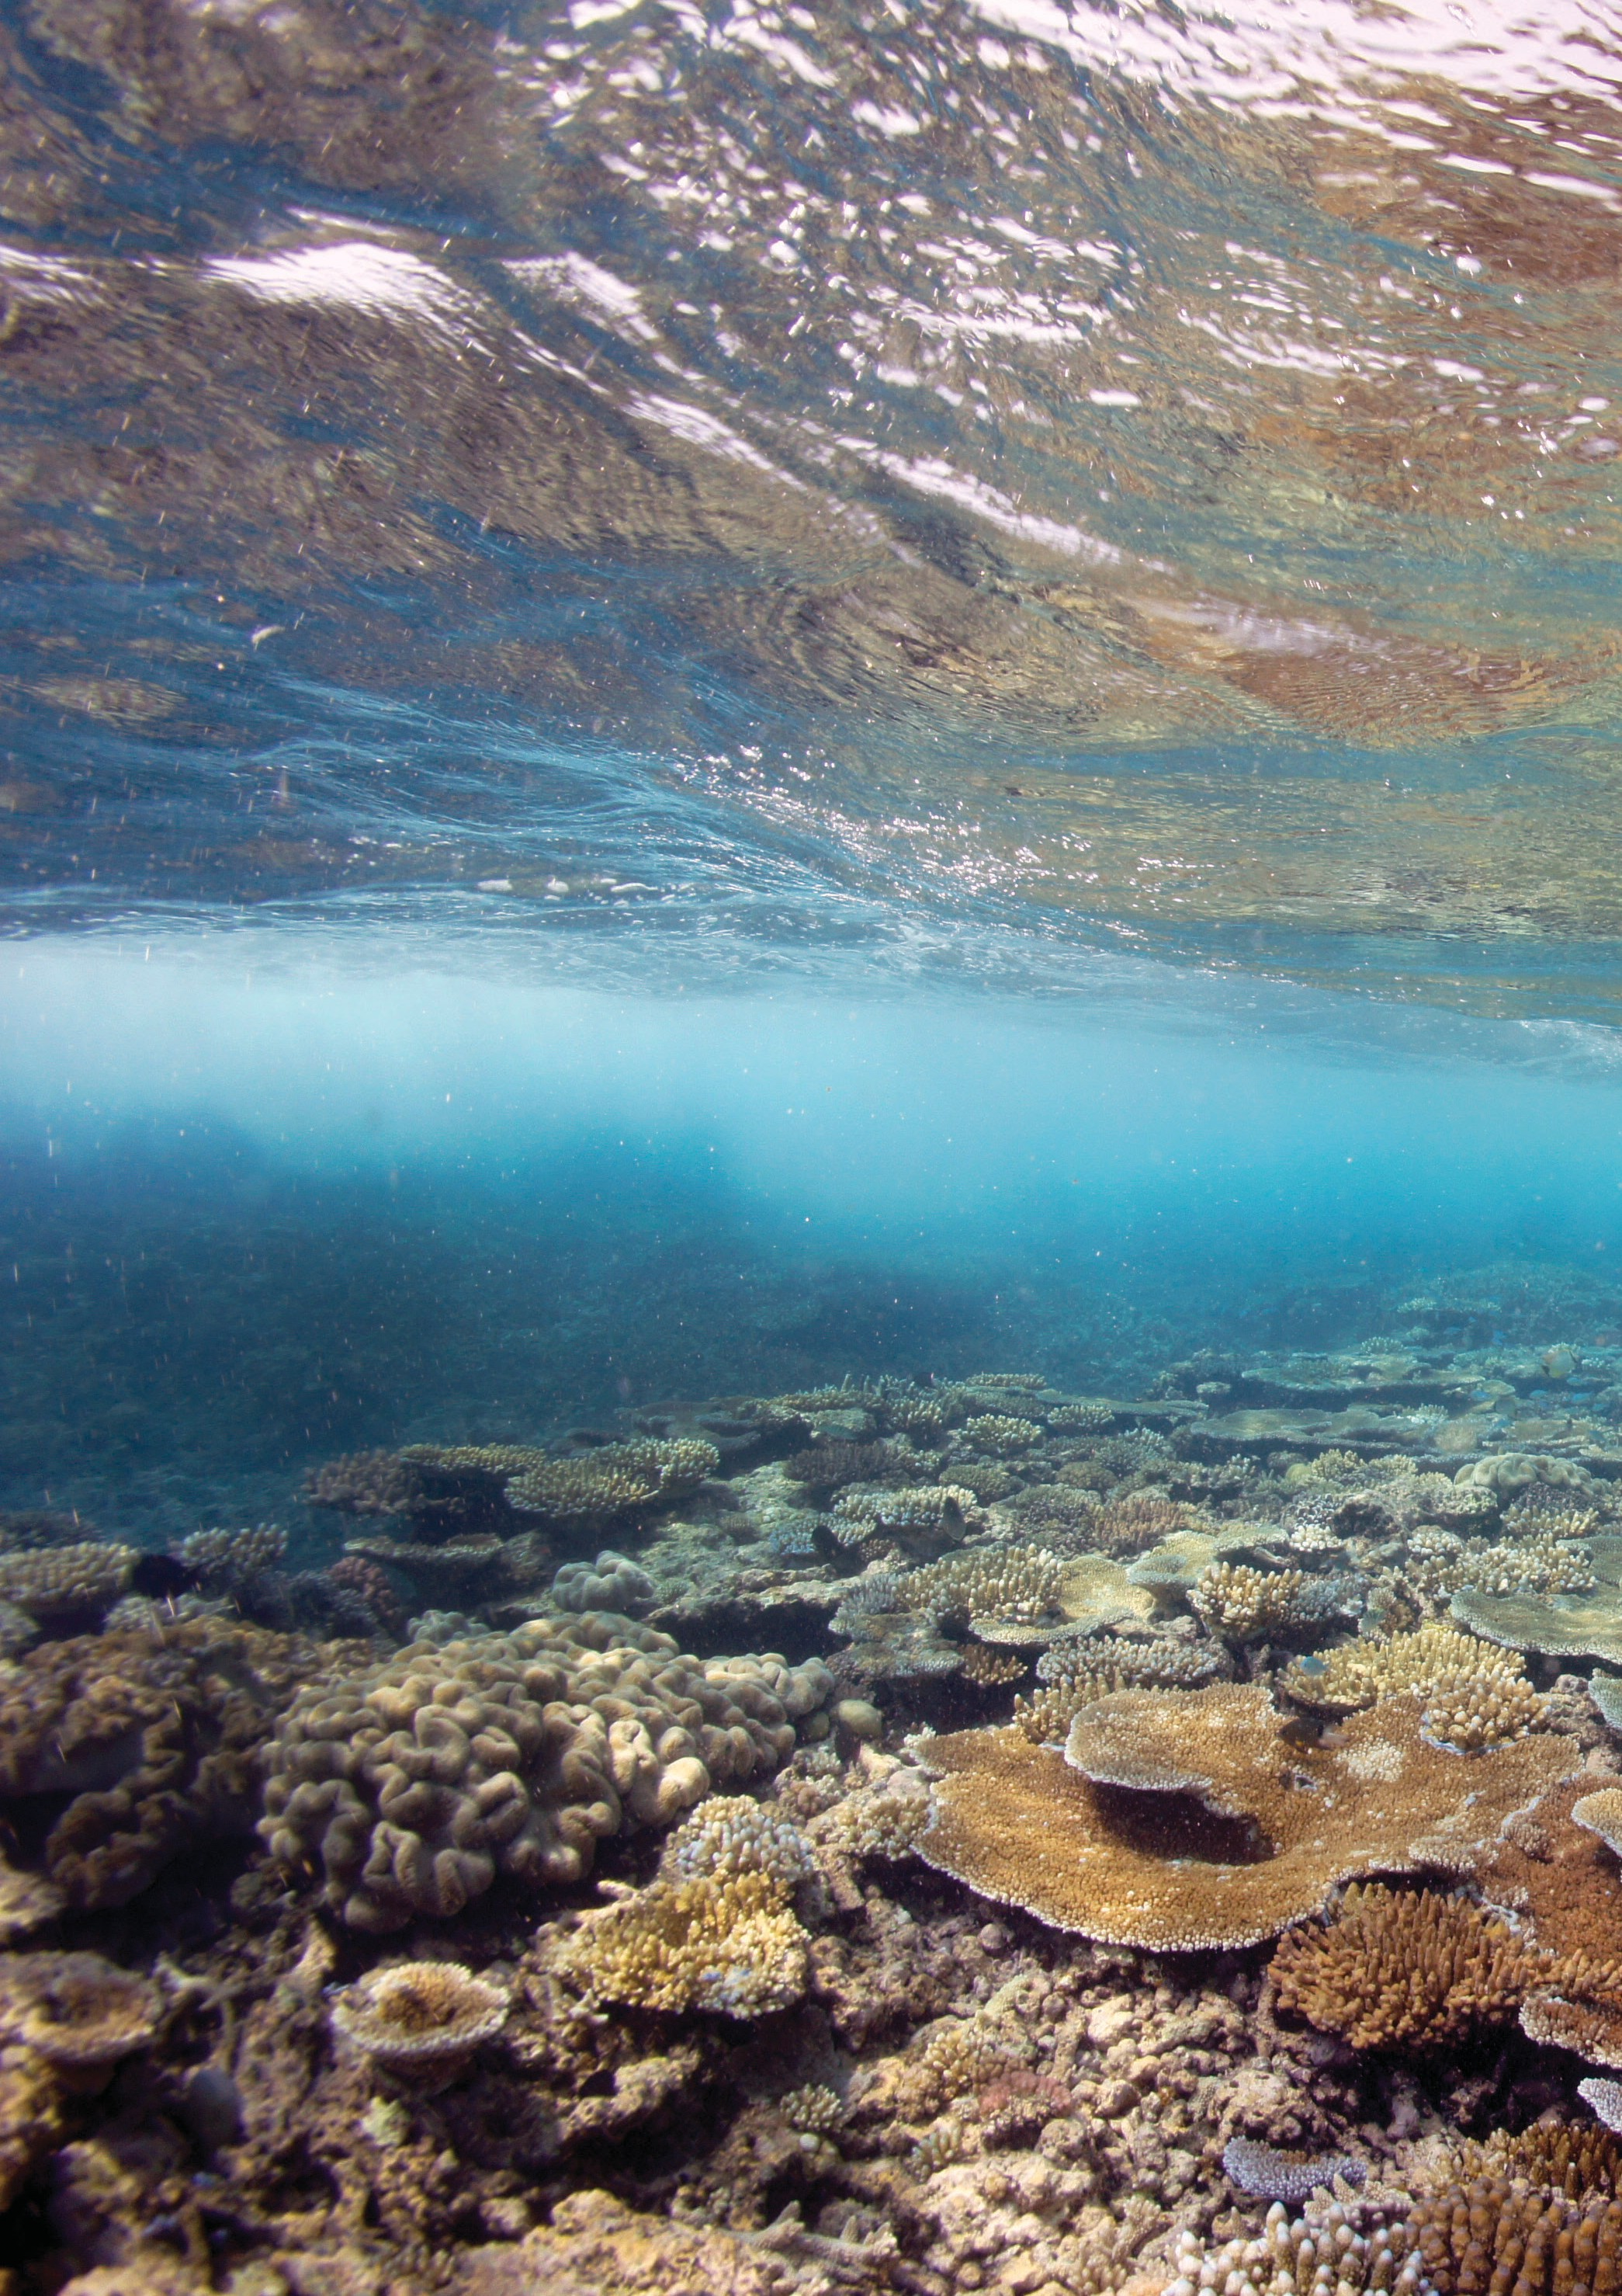

DELIVERING
ON- GROUND ACTIONS TO ENHANCE RESILIENCE

DRAMATICALLY ENHANCING COMPLIANCE

RAMPING UP CROWN-OF-THORNS STARFISH CONTROL PROTECTING KEY SPECIES FOR REEF RECOVERY ACTIVE, LOCALISED RESTORATION

GREAT BARRIER REEF BLUEPRINT FOR RESILIENCE 15

DELIVERING ON-GROUND ACTIONS TO ENHANCE RESILIENCE

DRAMATICALLY ENHANCING COMPLIANCE

Vision for 2020
The benefits of Marine Park zoning to the resilience of coral reefs is maximised through high levels of compliance.

Long-term monitoring has shown that the Great Barrier Reef’s no-take zones afford a range of benefits, including faster recovery of coral and fish communities following cyclones, coral bleaching, crown-of-thorns starfish and coral disease outbreaks.
Controls on activity outside of no-take zones (for example, fishing catch and effort limits, species protection or rules on anchoring practices) help to extend those resilience benefits through the whole Reef system. The effectiveness of no-take zones and other controls on activity depends on strong compliance. As the Reef enters a phase of greatly amplified vulnerability, compliance with rules that protect features or processes important to resilience is vital.
This initiative focuses on substantially improving compliance with rules that contribute to the resilience of coral reefs through a range of measures targeting both commercial and recreational use of the Great Barrier Reef Marine Park.
To achieve the 2020 vision the Authority will work with partners to:
- support implementation of the Queensland Sustainable Fisheries Strategy 2017–2027, including implementation of mandatory vessel monitoring systems on all commercial fishing vessels (including dories) operating in the Marine Park by 2020
- deliver a compliance management program aligned with maximising benefits from the resilience network
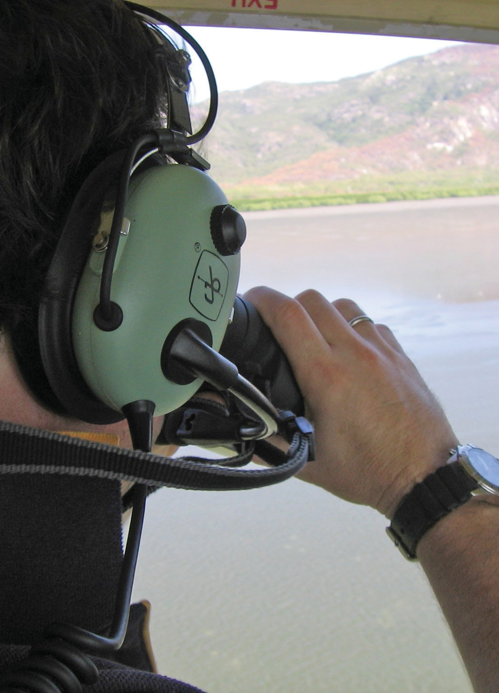
- enhance on-water presence of Marine Park rangers and partner agencies to educate reef users on the benefits provided by the Zoning Plan and enforce rules
- move quickly to adopt new technologies to improve compliance outcomes such as using remotely piloted aircraft (e.g. drones)
- improve broader community understanding of how the Zoning Plan supports the Reef’s ecological, social, economic, cultural and heritage values
- increase awareness within the judicial system of the impacts of Zoning Plan non-compliance on reef health and resilience
- identify regulations most important to supporting resilience and pursue stronger penalties for non-compliance, and
- drive innovations in marine protected areas compliance management to improve planning, intelligence and surveillance functions.
Our initial efforts will focus on implementing vessel monitoring on commercial fishing vessels and enhancing on-water presence of rangers through our joint Field Management Program.

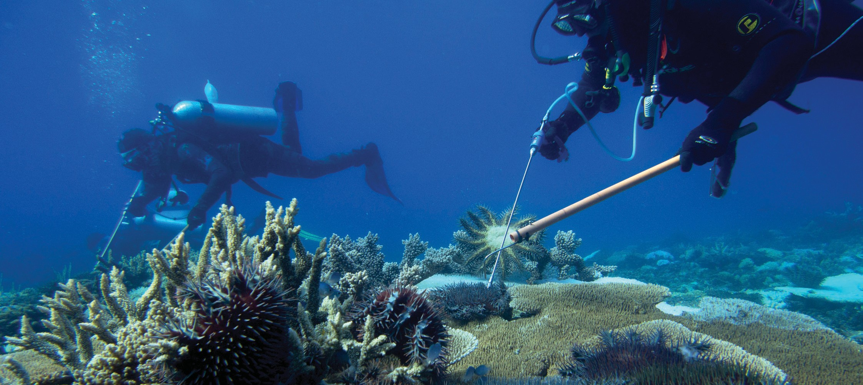
RAMPING UP CROWN-OF- THORNS STARFISH CONTROL

Vision for 2020
The crown-of-thorns starfish population is suppressed to minimise coral predation and maximise coral cover.

Crown-of-thorns starfish (COTS) outbreaks are one of the major sources of coral mortality across the Great Barrier Reef Marine Park, driving coral decline on a scale comparable to cyclones and severe bleaching events. However, unlike cyclones and bleaching events, COTS outbreaks can be predicted and controlled.
Consequently, reducing the potential for future COTS outbreaks and reducing the impacts of current outbreaks through targeted COTS control is one of the most scalable and feasible actions for reducing coral mortality and preventing further declines in system resilience. In the longer-term the Authority anticipates COTS outbreaks will become less frequent as nutrient pollution to the Reef is further reduced.
This initiative — an ‘all-out assault’ on COTS — will reduce coral losses from predation through a ramped up, innovative in-water control program as part of an integrated COTS management strategy. This strategy will build on efforts invested in the existing COTS control program.
To achieve the 2020 vision the Authority will work with partners to:
- implement an integrated COTS management framework to guide and coordinate efforts by all partners to reduce coral predation
- increase COTS control effort through increasing the fleet of COTS control vessels and trained crews
- increase opportunities for engagement and participation in COTS control efforts
- scale up research efforts to develop new and more efficient methods for COTS surveillance and control
- improve surveillance and reporting to increase our knowledge of the extent and severity of crown-of-thorns starfish outbreaks and guide on- ground effort, and
- ensure species with a role in limiting COTS outbreaks are adequately protected.
In the short term we will focus on ramping up the current COTS control program to include reefs that form part of the resilience network. In the longer term we may expand efforts to target additional areas that support the Reef’s ecological, social, economic, cultural and/or heritage values.

PROTECTING KEY SPECIES FOR REEF RECOVERY

Vision for 2020
Species with a key role in assisting reef recovery following disturbance are identified and protected from unsustainable pressures.
Some species make a particularly important contribution to system resilience.
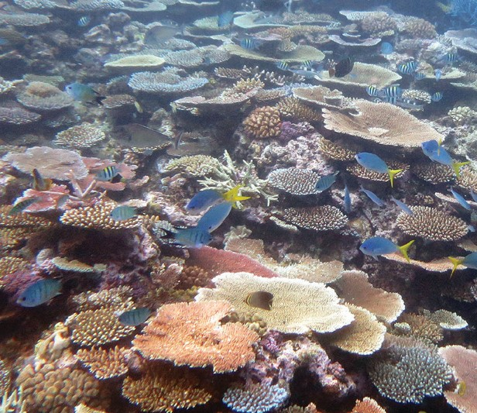
For example, plate corals are the drivers of rapid reef recovery.
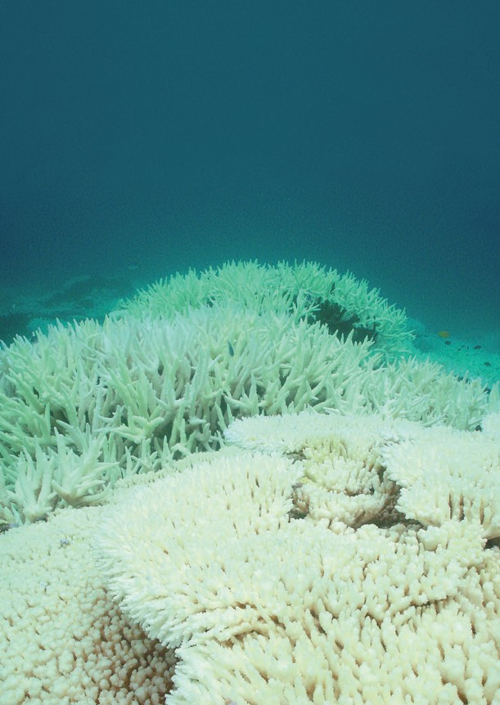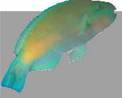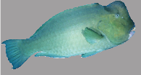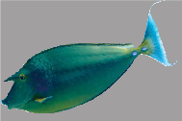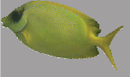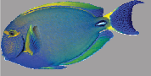Growing, maturing and reproducing relatively faster than other corals, these species are not only critical for coral re-establishment, but rapidly replenish shelter for a diversity of species following disturbances.

C O R A L R E E F R E C O V E R Y

Please don’t take these fish — the Reef needs them
Mass coral bleaching has occurred on the Great Barrier Reef due to above average ocean temperatures.
If left to grow, seaweed can quickly dominate reefs and stop coral larvae settling and starting the next generation of coral colonies.
Plant-eating fish, or herbivores, remove seaweed from reefs. In normal conditions, these fish act as nature’s lawnmowers and keep seaweed levels under control by grazing close to the bottom of the reef.
Following coral bleaching, these fish are critical to reef recovery because their grazing removes seaweed and provides space for new corals

How can you help?
If you are fishing or spearfishing consider help build new coral colonies.
© Jordan M Casey
Parrotfish
© Ian V. Shaw Reef Life Survey
ver and build its resilience to recover from future events.

w w w.gbrmpa.go v.au
2016-0054
rotfish (Bolbometopon muricatum), steephead parrotfish and surgeonfish are all important to reef recovery.

Reef’s recovery are already in place. These include the
and crown-of-thorns starfish control. All Reef users have a
They also help to restore the Reef’s aesthetic values.
Herbivores, including fish, turtles and many other species that graze on algae, play a key role in preventing macroalgae from proliferating following disturbances. This is vitally important as macroalgae stops corals from settling and growing.
Unicornfish (Naso unicornis), bumphead par
Bumphead parrotfish (Chlorurus microrhinos) and any species of rabbitfish
to grow.

leaving these species on the Great Barrier Reef to

Bluespined unicornfish
Rabbitfish
Ensuring that ‘reef recovery species’
Steephead parrotfish
- species that make the biggest contributions to coral reef resilience
Surgeonfish

and stakeholders to help improve the recovery of
- are not subject to unsustainable pressures is a key element of effective resilience-based management.
We’re working with Traditional custodians, Reef-users affected coral. Management tools to assist the Zoning Plan, Water Quality Improvement Plan,
role to play to help the Great Barrier Reef reco
This initiative focuses on identifying reef recovery species and assessing the adequacy of current protection measures.
Subject to the outcomes of assessments, we will implement measures to reduce risks associated with current or foreseeable future pressures and to enhance populations of these species.
To achieve the 2020 vision we will work with partners to:
- identify key reef recovery species, and assess their protection status and risks
- improve awareness of reef recovery species and their role in protecting the Reef
- promote voluntary stewardship to protect reef recovery species, especially voluntary moratoria on take
- deliver improved compliance with measures to protect reef recovery species, and
- support implementation of the Queensland Sustainable Fisheries Strategy 2017–2027.
In the first instance, we will seek to implement additional measures in partnership with industry and relevant reef users, for example through education, stewardship or other voluntary approaches.

ACTIVE LOCALISED RESTORATION

Vision for 2020
Coordinated restoration trials are in place at demonstration sites, providing
opportunities to test, evaluate and, where appropriate, scale-up restoration methods to ecologically-relevant scales.
Managing coral reef ecosystems in light of recent bleaching events, cumulative pressures, and possible climate change trajectories, requires a different approach. In the past, our approach has focused on measures designed to protect values (e.g. Zoning Plan) or mitigate risk (e.g. permits
required to conduct activities in the Marine Park and best practices). A defining characteristic of our approach moving forward will be adopting additional measures to not only protect and mitigate but to support reef recovery.
Restoration methods have been developed and tested in other regions of the world. To date, however, they have not been widely applied to the
Great Barrier Reef. While existing techniques are generally only feasible at small spatial scales, coral restoration techniques have the potential to make a significant contribution to resilience-based management of the Great Barrier Reef. There may also be scope to develop new techniques that can assist recovery of reef habitats at larger scales. Beyond ecological benefits, restoration can also provide opportunities for communities and industries to participate in practical efforts to improve locally-valued reef sites. In doing so this can help to build community and industry resilience.
This priority initiative focuses on three activity areas:
- testing, improving and scaling up local-scale reef restoration methods – based on the best available science – for potential application across the resilience network
- facilitating opportunities for community and industry participation in local- scale restoration, and
- researching and developing large-scale restoration methods.

While it is expected that many restoration activities would be led and implemented by partner organisations, private enterprise or community organisations, the Authority is responsible for approving restoration actions, consistent with Marine Park legislation, to protect the Reef and ensure activities do no harm.
To achieve the 2020 vision we will work with partners to:
- develop a policy to provide guidance on restoration activities in the Great Barrier Reef Marine Park
- establish restoration demonstration site(s), with supporting communication material, to test, improve and where appropriate scale-up restoration methods
- develop guidance for community participation in restoration activities, including ‘reef restoration toolkits’ to support localised restoration activities, and
- support establishment of a research program on large-scale restoration methods.

EMPOWERING PEOPLE TO BE PART OF THE SOLUTION

ACCELERATING ACTIONS TO ADDRESS CLIMATE CHANGE FOSTERING PARTNERSHIPS FOR ACTION AND INNOVATION

20 GREAT BARRIER REEF MARINE PARK AUTHORITY

EMPOWERING PEOPLE TO BE PART OF THE SOLUTION

ACCELERATING ACTIONS TO ADDRESS CLIMATE CHANGE

Vision for 2020
The Great Barrier Reef and coral reefs
globally are a focus of policy discourse and programs to reduce
carbon emissions. Great Barrier Reef communities and
industries are demonstrating
leadership in emission reduction efforts
and climate change adaptation.
Climate change is clearly recognised as the most important driver of the long-term outlook for the Great Barrier Reef. There is an urgent need to accelerate actions to
reduce greenhouse gas emissions if we are to secure a better future for the Great Barrier Reef and coral reef ecosystems globally.

Review of climate change policies
Discussion Paper

March 2017
While the Authority and its partners have little direct control over global carbon emissions, we do have an opportunity to highlight impacts of climate change on coral reefs, influence global discourse on carbon emissions and to demonstrate leadership in emissions reduction.
We also need to equip Marine Park
managers, industries and communities with the means to adapt in an environment characterised by increasing uncertainty and system-wide disturbances.
To achieve the 2020 vision we will work with partners to:
- strengthen efforts to address climate change impacts on coral reefs globally through the International Coral Reef Initiative
- give greater prominence to the benefits of reducing emissions for the Reef and its associated ecological, social, economic, cultural and heritage values
- communicate the implications of climate change for the Great Barrier Reef, and the outcomes required to secure its future, clearly and consistently across sectors
- ensure climate change implications are considered in the revised Reef 2050 Plan
- promote the uptake of renewable energy and emission reduction activities among reef communities, industries and visitors, including through showcasing practical initiatives, and
- build the capacity of Marine Park managers, industries and communities to adapt their activities in the face of changing climate.
We will develop a position statement on climate change implications for the Great Barrier Reef to guide implementation of the above actions.

Photograph: Gus Burrows, Styledia

FOSTERING PARTNERSHIPS FOR ACTION AND INNOVATION

Vision for 2020
Individuals, industries and communities
are aware of the challenges facing the Reef, participate in efforts to protect it, and are inspiring intergenerational change.
Management of the Great Barrier Reef is fundamentally a collective effort involving Marine Park managers, government agencies, Traditional Owners, researchers, industry, reef users and the community.
While the Authority has legislative responsibility for managing the Marine Park, we recognise that it is the combined efforts of everyone’s actions that will place the Reef in the best position to recover from the legacy of past impacts and withstand future disturbances.
Mutually-supportive partnerships, which recognise and foster stewardship, collaboration and innovation, are vitally important in building the resilience of coral reefs.
This initiative aims to empower a broader set of partners to be part of actions to build reef resilience. It seeks to position the Great Barrier Reef as a
world-leading example in reef stewardship through the adoption of leading technology, best practice and collaborative efforts.
To achieve the 2020 vision we will work with our partners to:
  - identify, empower and support stewardship leaders within communities and across sectors to help drive changes critical to improving the Reef’s outlook
  - coordinate efforts across sectors to generate new ideas and trial new approaches to reduce impacts and restore values
  - develop information and resources for local communities and industry sectors to use in protecting the Reef and building resilience
  - involve partners in identifying the resilience network and delivering actions to protect the Reef and build resilience
  - reduce the risk of marine debris to coral reef ecosystems, and
  - achieve the vision for 2020 of other key initiatives in this blueprint, for example:
    - ramping up COTS control (with Traditional Owners and the tourism industry),
    - protecting key species for reef recovery (with commercial and recreational fishers and other reef users), and
    - active localised restoration (with science and research partners).

In adopting the above actions, the Authority will support others to help drive changes and deliver innovative solutions.

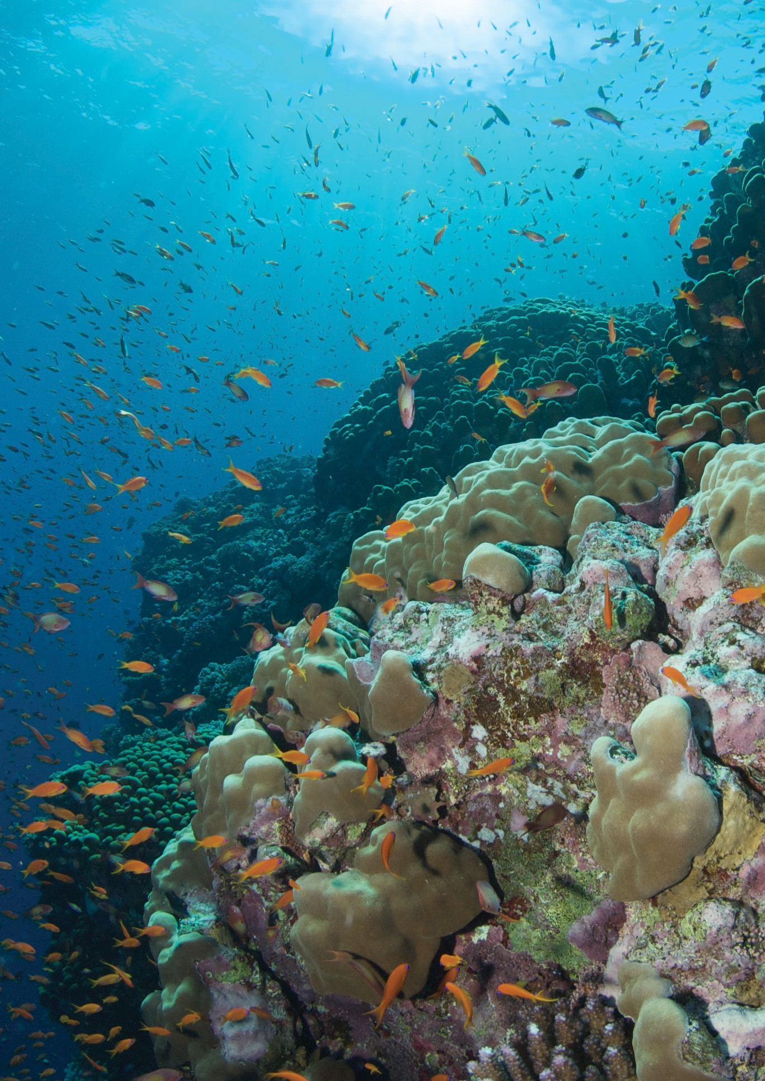FOSTERING CHANGE

ADAPTING POLICY AND LEGISLATION DEVELOPING DECISION-SUPPORT SYSTEMS BUILDING AWARENESS AND SUPPORT

GREAT BARRIER REEF BLUEPRINT FOR RESILIENCE 23

FOSTERING CHANGE

ADAPTING POLICY AND LEGISLATION

Vision for 2020
Government policy supports resilience- based management of the Great Barrier Reef by facilitating appropriate interventions, innovations and participation by communities and businesses.

Policy and legislation determine how the regulatory and decision-making roles of government and organisations are performed. As such, they play an important role in facilitating initiatives to protect the Reef and build resilience.
This initiative focuses on ensuring Marine Park policy and legislation function as ‘enablers’ for appropriate interventions, innovations and participation by communities and businesses in building Reef resilience.
To achieve this vision we will work with our partners to:
- develop a contemporary policy framework for restoration interventions in the Marine Park, and review existing policies to ensure they are consistent with the new policy, and
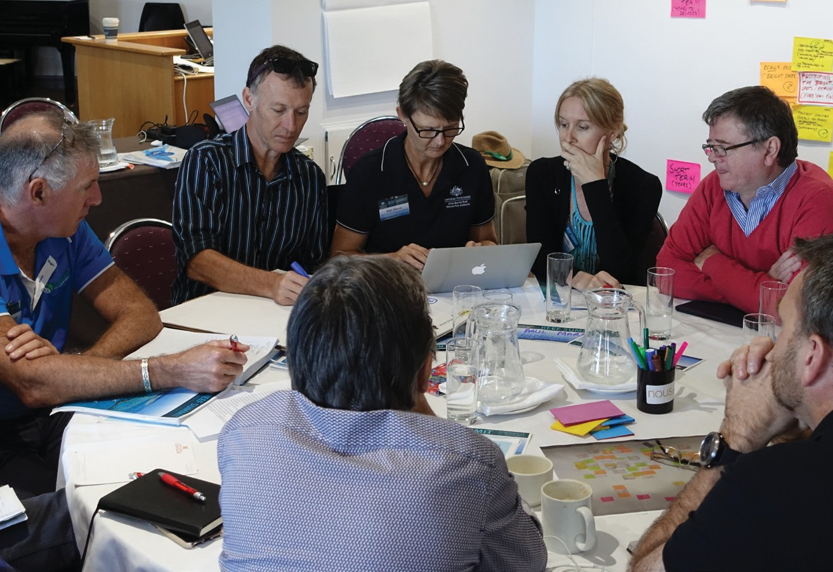
- build the operational capability to adopt a dynamic, resilience-based management approach and deliver the initiatives in this blueprint.

DEVELOPING DECISION- SUPPORT SYSTEMS

Vision for 2020
Timely and salient information is publicly available through decision-support systems to inform future- focused adaptive, resilience-based management.
Managing for resilience requires timely, salient information to ensure efforts are focused on areas that will have maximum impact and value. Additionally, it is critical that information is publicly available to promote awareness of changing circumstances and enable adjustments to actions.
This initiative focuses on improving the quality, timeliness, coverage and accessibility of data to inform adaptive, resilience-based management. It will complement and accelerate parts of the Reef 2050 Integrated
Monitoring and Reporting Program critical to responding to mass bleaching events. It relies on strong collaborations between the Authority, Traditional Owners, research institutions, the citizen scientist network and Reef users to share information and drive innovations in data capture, analytics and user-friendly data interfaces.
To achieve this vision we will work with our partners to:
- place a greater focus on the use of modelling and prognostic tools to ensure decisions are made in the context of influencing the Reef’s key drivers, including a changing climate and an understanding of cumulative impacts
- update the Eye on Reef application to improve data capture, quality and accessibility, and promote its use through citizen science and partner networks
- support initiatives that drive innovation in monitoring and modelling to reduce costs, increase coverage and improve accessibility and timeliness of data, and
- transition the Reef 2050 Integrated Monitoring and Reporting Program
— currently in design phase — into a fully operational Reef knowledge system to guide future resilience-based management actions.

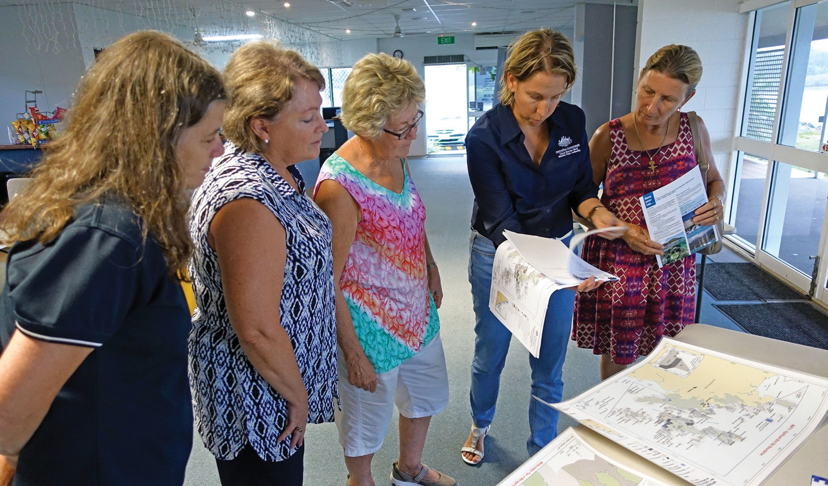

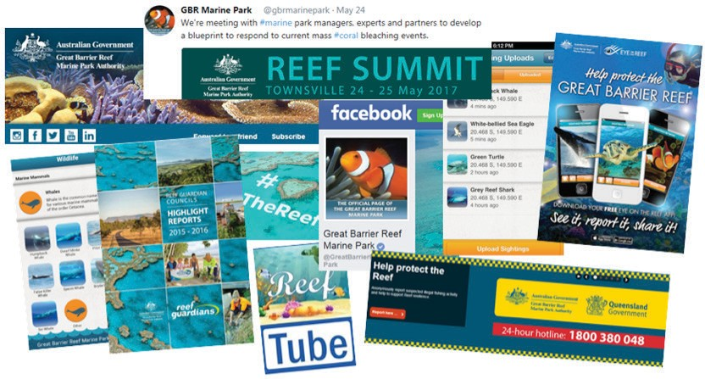

BUILDING AWARENESS AND SUPPORT

Vision for 2020
Efforts to protect and build resilience of the Great Barrier Reef, including in-park management and efforts to address external drivers such as climate change and degraded water quality, are actively supported by all sectors of society.
Improving the outlook for the Great Barrier Reef requires action at local, regional and global levels.
This initiative seeks to engage the broadest possible range of individuals, businesses and community groups — locally, nationally and internationally — in efforts to protect the Reef, reduce threats and build resilience. Building support within wider sections of society is key to building momentum for direct action and influencing others to take action.
The summit highlighted the need for clear, consistent communication across sectors on the risks to the Reef, actions to address challenges, timely information on emerging issues and outcomes from research and monitoring programs.
To achieve this vision we will work with partners to:
- amplify our outreach by having a clear position and strong voice on issues affecting the Reef
- give greater prominence to the range of goods and services that the Great Barrier Reef provides
- work with our science partners to establish consensus on critical issues affecting the Reef and communicate these consistently across sectors and the broader community
- ensure cutting-edge resilience science informs and improves existing guidance for reef managers globally
- implement targeted communication campaigns using a variety of media and mechanisms, with a common narrative, and
- improve the timeliness and effectiveness of communications across sectors on new science, forecasts and monitoring data, innovations, cause- and-effect relationships, and progress towards targets and outcomes.
We will use information in this blueprint and supporting information paper to communicate risks to the Reef and opportunities to build resilience with ‘one voice’.

SCALE AND DELIVERY OF INITIATIVES

The initiatives in this blueprint will be delivered at a range of spatial scales and their associated benefits will be realised over a range of timeframes.
The diagram below shows how the anticipated timeframes for implementation, and anticipated timeframes until benefits are realised, together with the spatial scale of initiatives outlined in the blueprint.

Time needed to implement action Timeframes until benefits are realised

2015
2020
2025 2030
2035
2040
2045
2050

Build a network of resilience bright-spots

Active, localised restoration

Ramp up crown-of-thorns
starfish control

Dramatically enhance
compliance

Protect key species for Reef recovery

Accelerate actions to address climate change

Foster partnerships for actions and innovation

Initiatives to foster change – namely adapting policy and legislation, developing decision-support systems and building awareness and support – are designed as enablers for the above initiatives and hence are not depicted in the diagram.

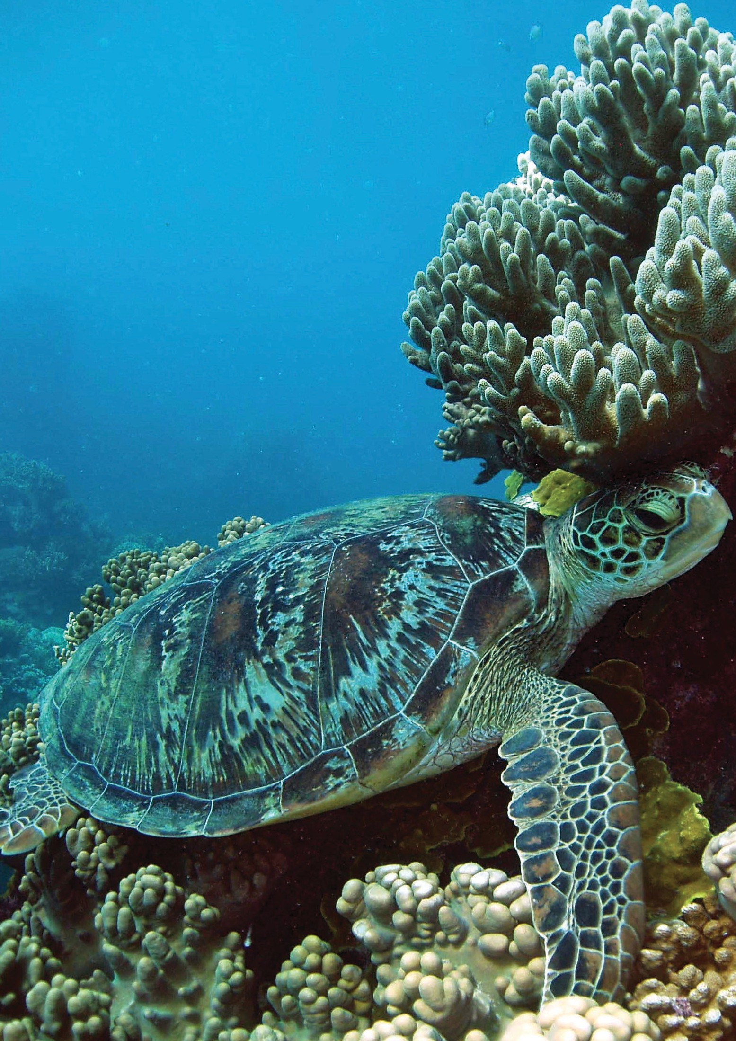

The future of coral reef ecosystems, including the Great Barrier Reef, will ultimately depend on the success of global efforts to reduce the extent of climate change.

Photograph: Chris Jones

28 GREAT BARRIER REEF MARINE PARK AUTHORITY

FROM BLUEPRINT TO ACTION

This blueprint presents a pathway for addressing current challenges facing coral reefs within the Great Barrier Reef Marine Park. It does this by outlining initiatives that complement current management arrangements to build the resilience of coral reef ecosystems.
The future of coral reef ecosystems, including the Great Barrier Reef, will ultimately depend on the success of global efforts to reduce the extent of climate change. Local actions to build resilience within the Great Barrier Reef Marine Park are critical complements to climate change mitigation efforts and catchment programs to improve water quality. A more resilient Reef will recover faster from recent shocks and cope better with the challenges ahead.
The Authority will lead the blueprint’s implementation. Approaches and initiatives within it are being embedded in the Authority’s corporate and operating plans and will be reported through its annual report. However, the successful implementation of initiatives will ultimately depend on the collective knowledge, expertise and resources of many.
It is our sincere hope that the shared commitment demonstrated by our partners at the Great Barrier Reef Summit to developing this blueprint will extend to its implementation and that actions outlined will become part of our partners’ core business.
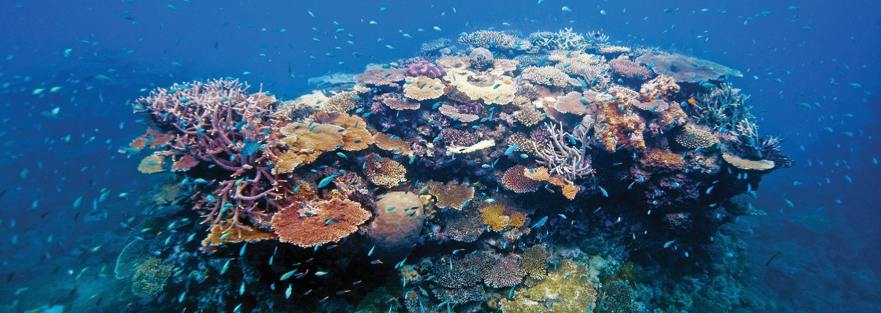
Work has commenced on a number of actions. Where additional funding or capacity is required we will work with our partners to address gaps, align efforts or look for alternative approaches to achieve outcomes.
There is no single solution to future-proofing or shielding the Great Barrier Reef from the effects of a changing climate.
However, we believe the combination of initiatives outlined in this blueprint, and their incorporation in a forward looking, dynamic and adaptive operational framework, will dramatically improve our ability to support the resilience of the Reef.
We hope you will join us on this journey.

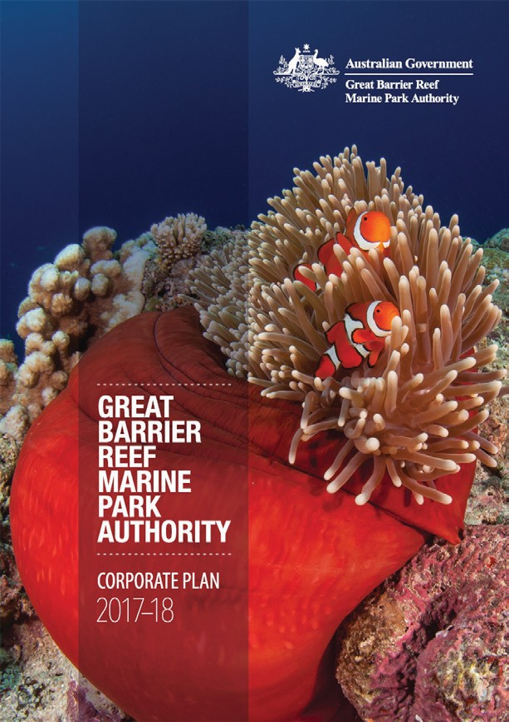

The Great Barrier Reef Marine Park Authority acknowledges the contribution from peers from the following organisations, who have made the development of this blueprint possible.
Association of Marine Park Tourism Operators Australian Coral Reef Society
The Australian Institute of Marine Science
Australian Research Council Centre of Excellence for Coral Reef Studies Biosecurity Australia
Bureau of Meteorology Cairns Marine
Citizens of the Great Barrier Reef CSIRO
Department of Agriculture and Fisheries (Queensland) Department of the Environment and Energy (Commonwealth) Department of Environment and Heritage Protection (Queensland) Department of Foreign Affairs and Trade
Department of National Parks, Sport and Racing (Queensland) Department of Prime Minister and Cabinet
Explore Whitsundays Great Barrier Reef Foundation
Great Barrier Reef Legacy
Great Barrier Reef Marine Park Authority Board International Coral Reef Initiative
James Cook University Lady Elliot Island Eco Resort
National Oceanic and Atmospheric Administration Queensland Parks Association
Queensland Tourism Industry Council Queensland University of Technology Reef 2050 Advisory Committee
Reef and Rainforest Research Centre Reef Ecologic
Reef Restoration Foundation Tangaroa Blue Foundation Torres Strait Regional Authority
Traditional Owner Representatives TropWATER
United Nations Environment Programme University of Hawaii
University of Queensland WWF Australia

WWW.GBRMPA.GOV.AU

