Appendix F – Additional Figures

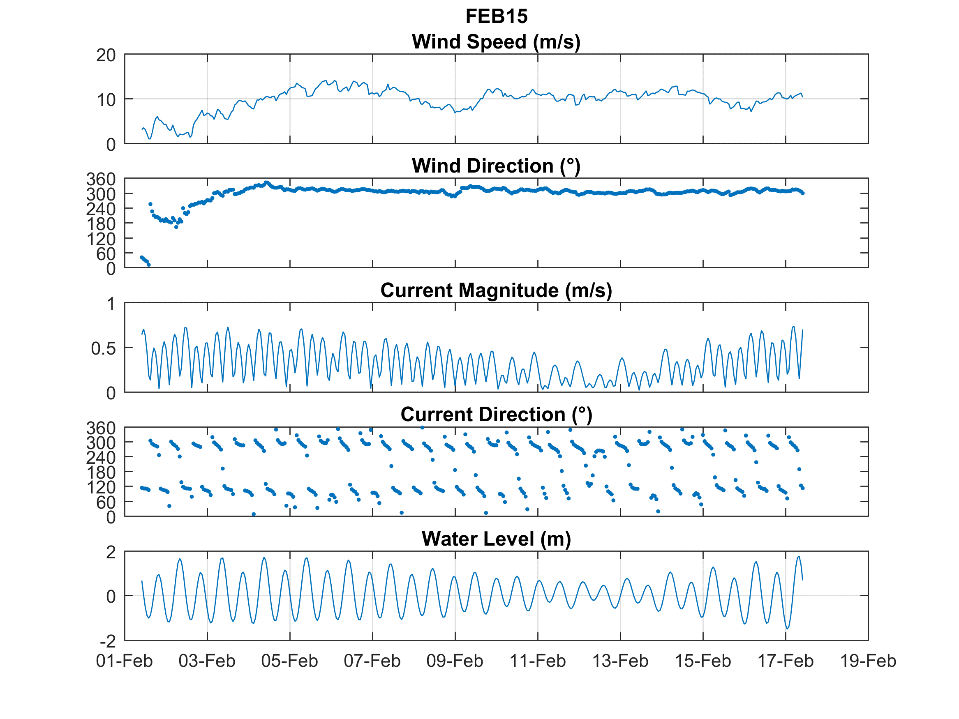
Figure F-1. Summary of February 2015 wind speed and direction, current strength and direction and tidal range data
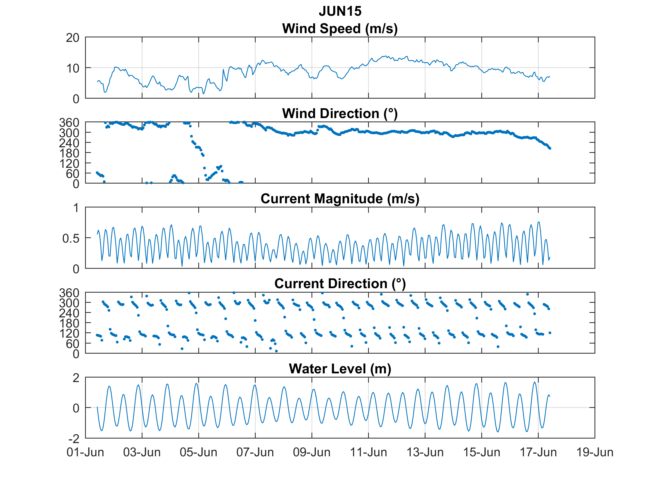
Figure F-2. Summary of June 2015 wind speed and direction, current strength and direction and tidal range data
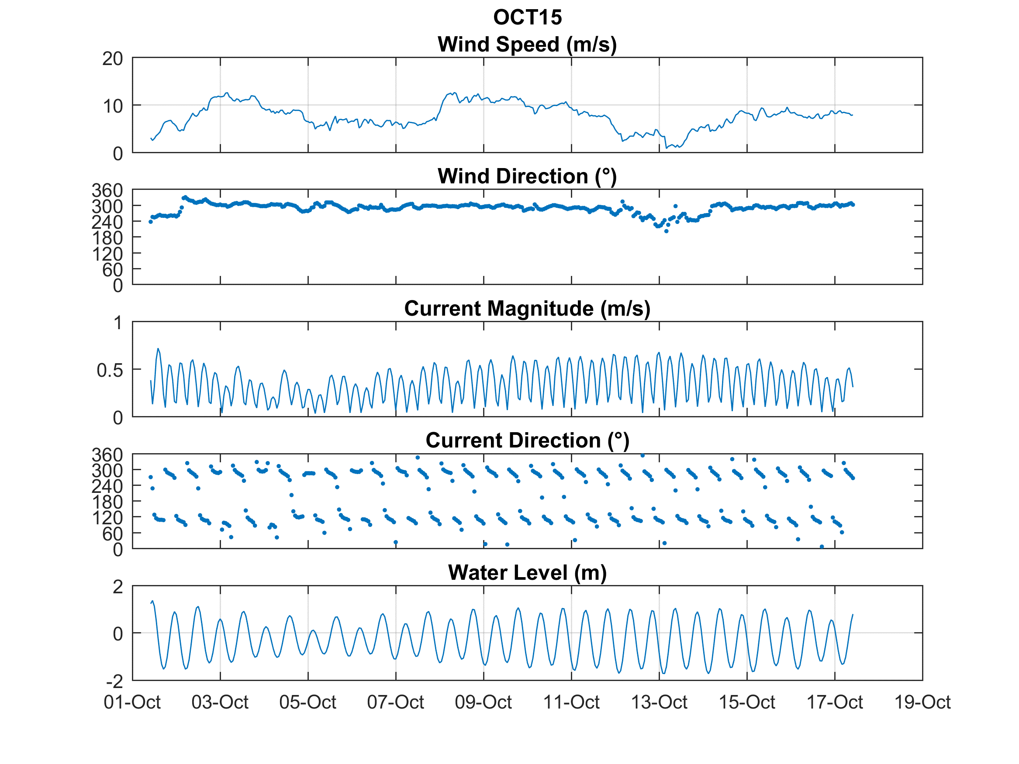
Figure F-3. Summary of October 2015 wind speed and direction, current strength and direction and tidal range data
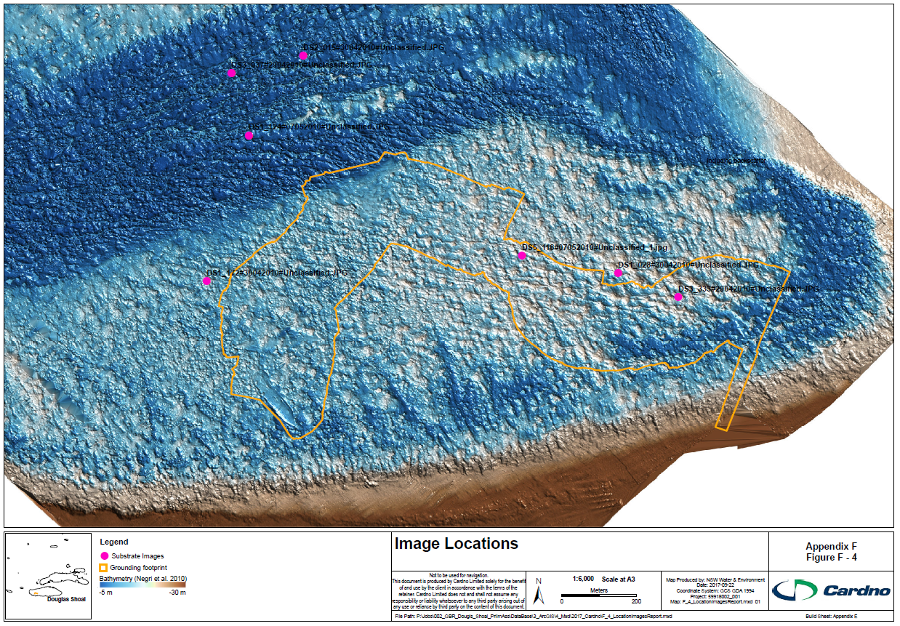
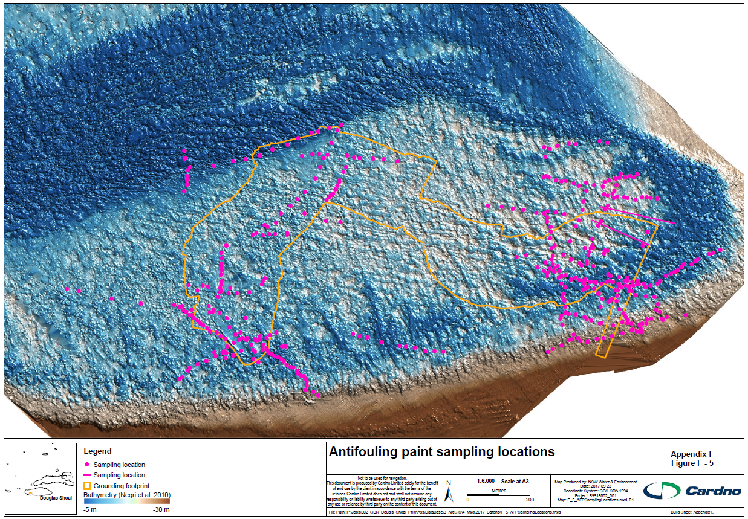
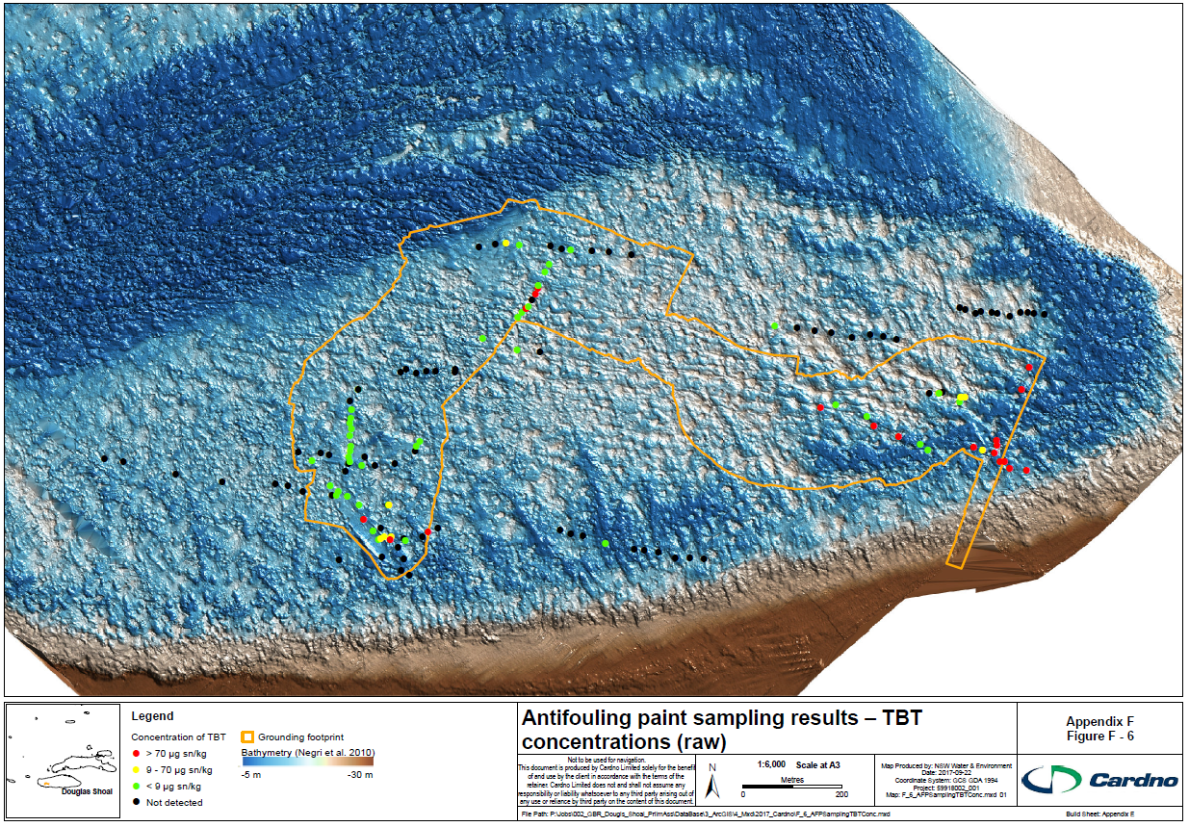
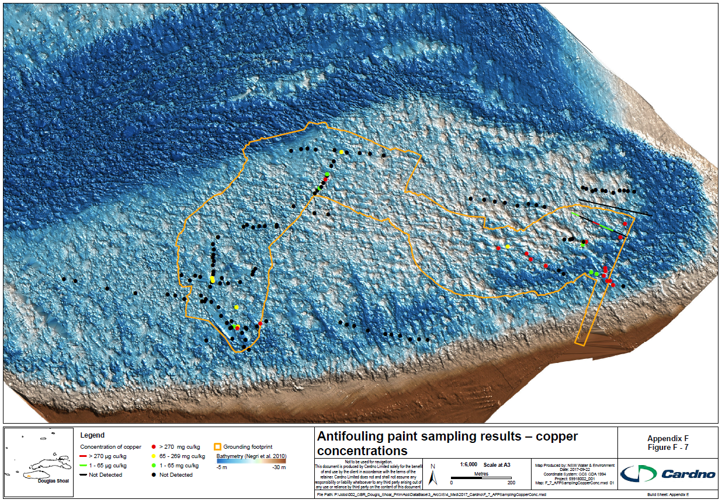
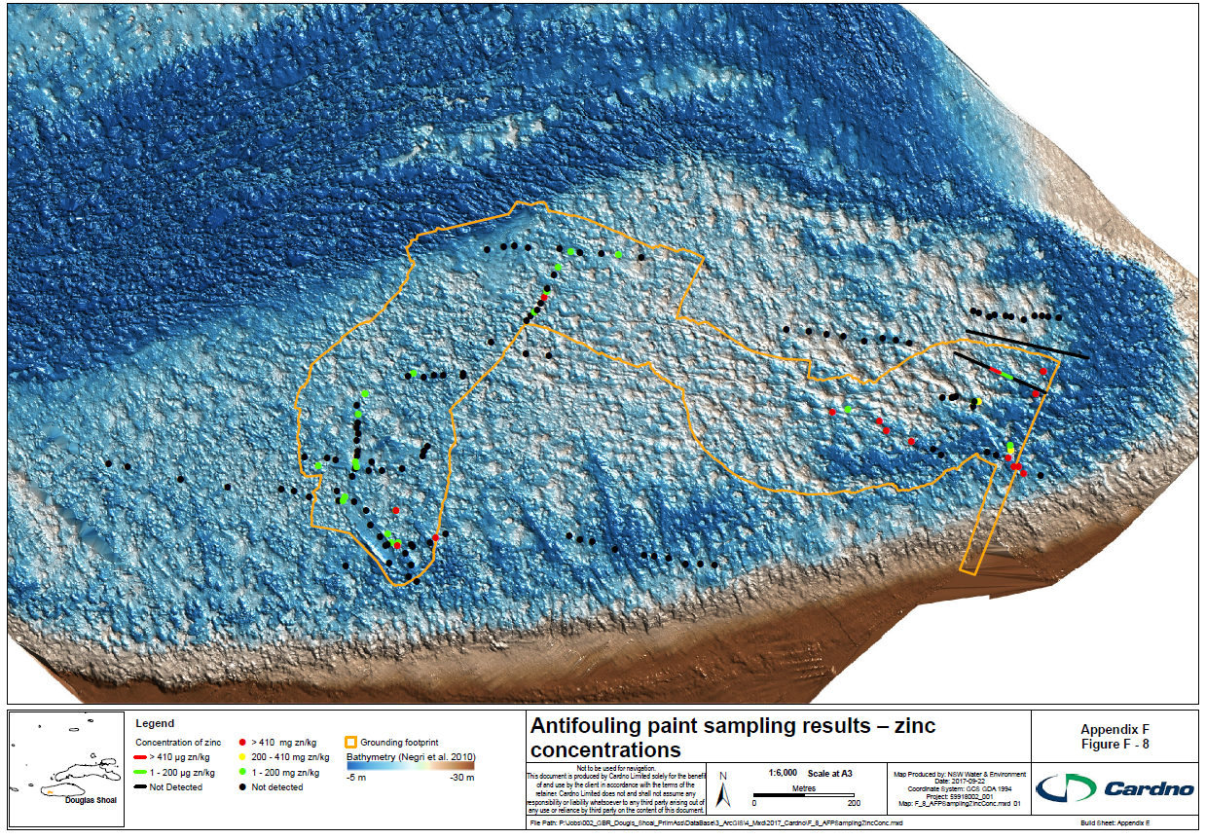
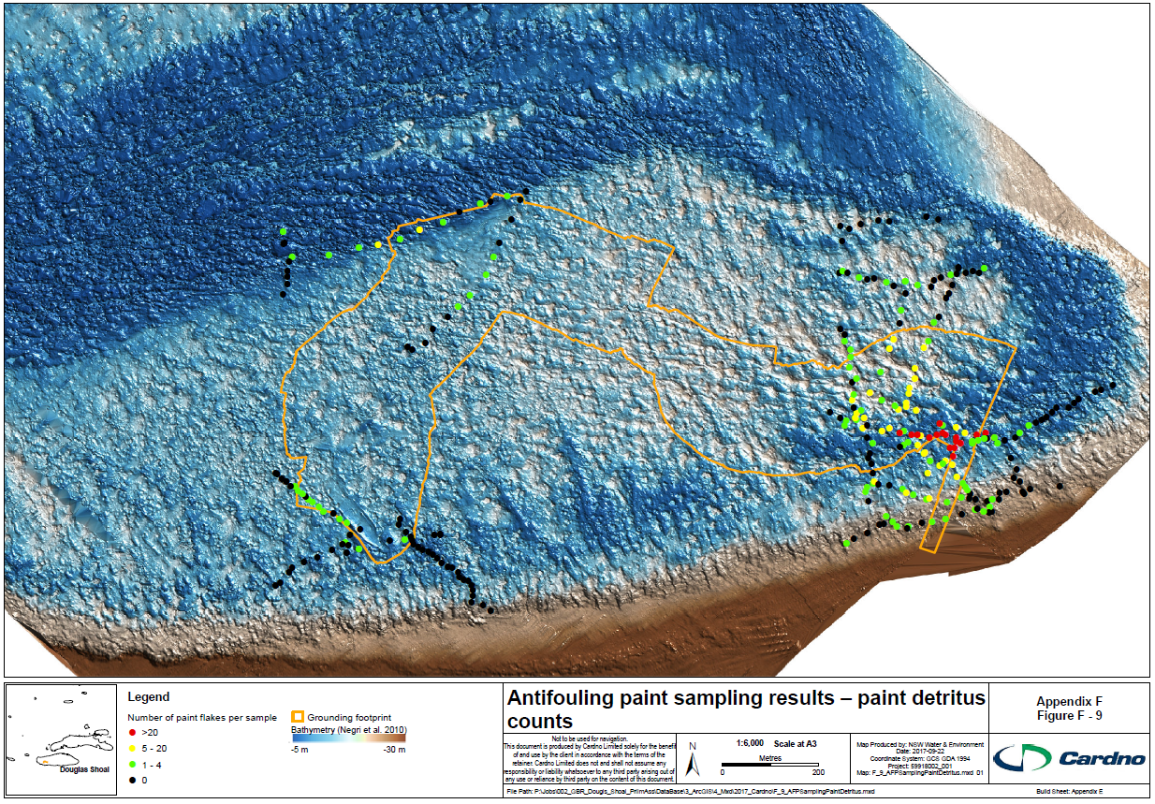
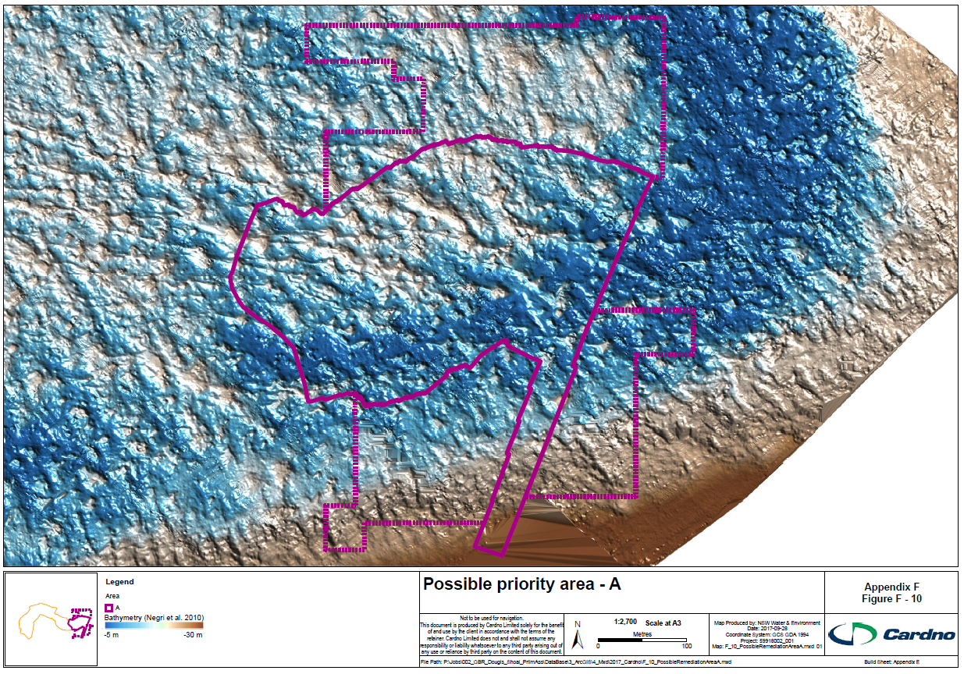
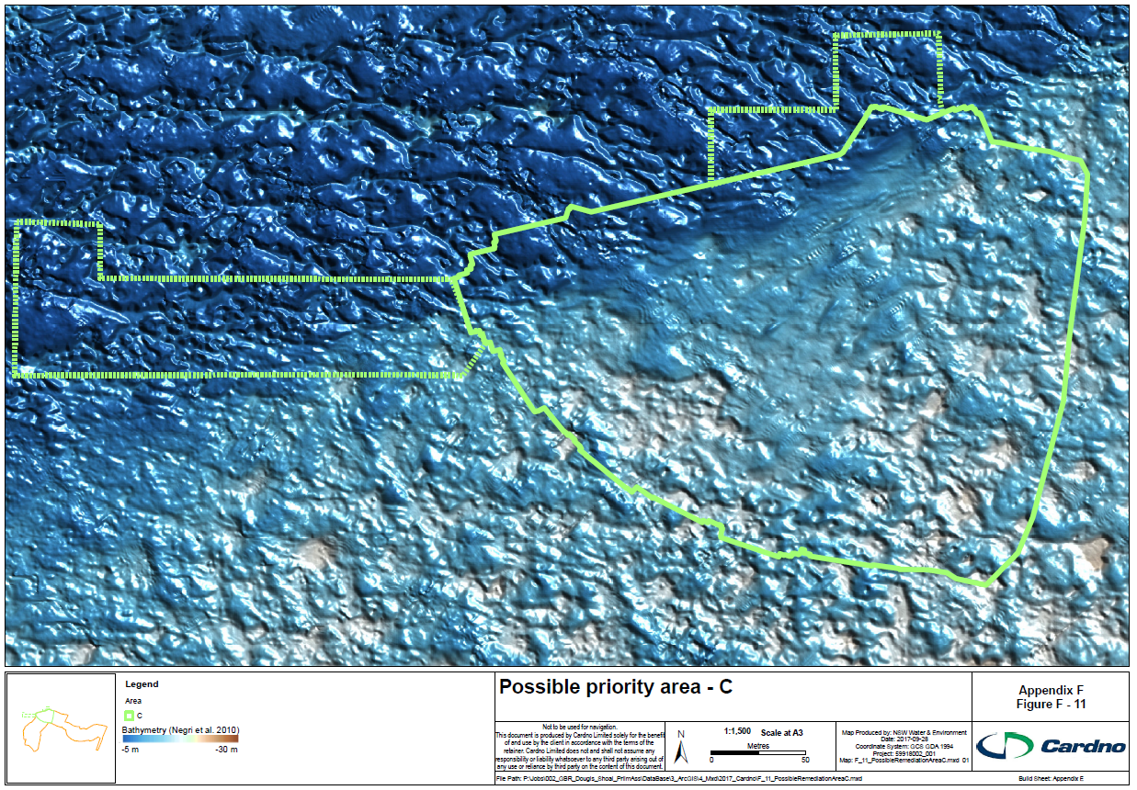
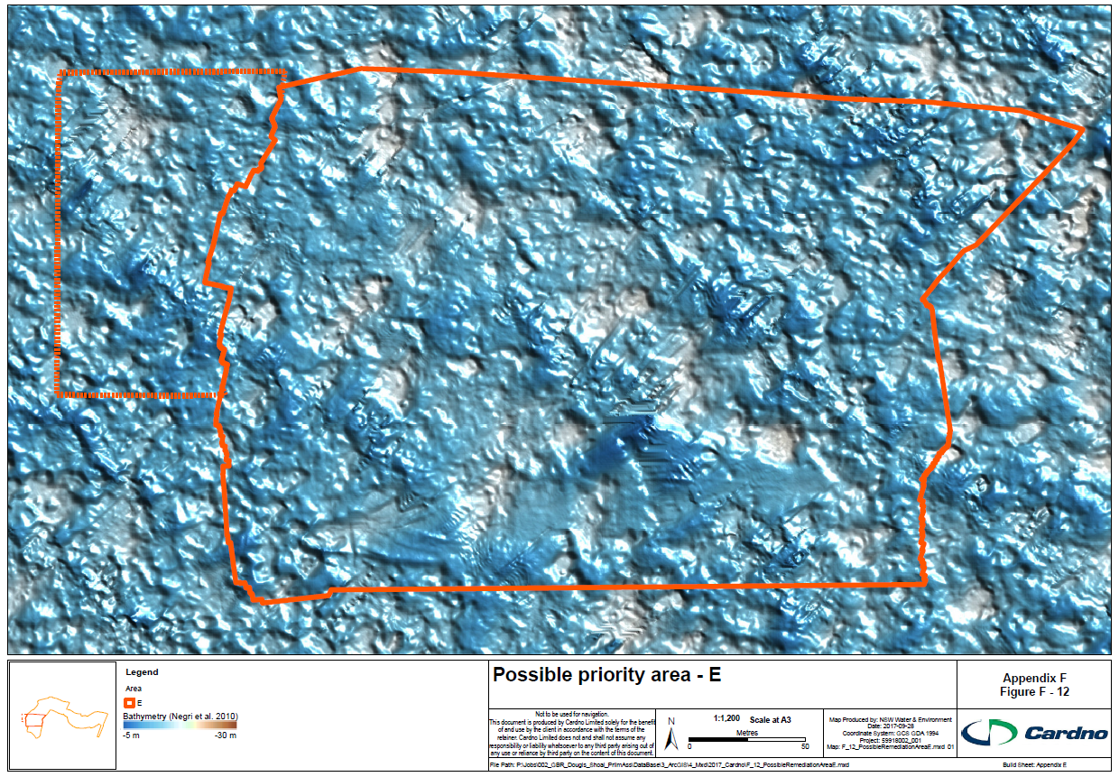
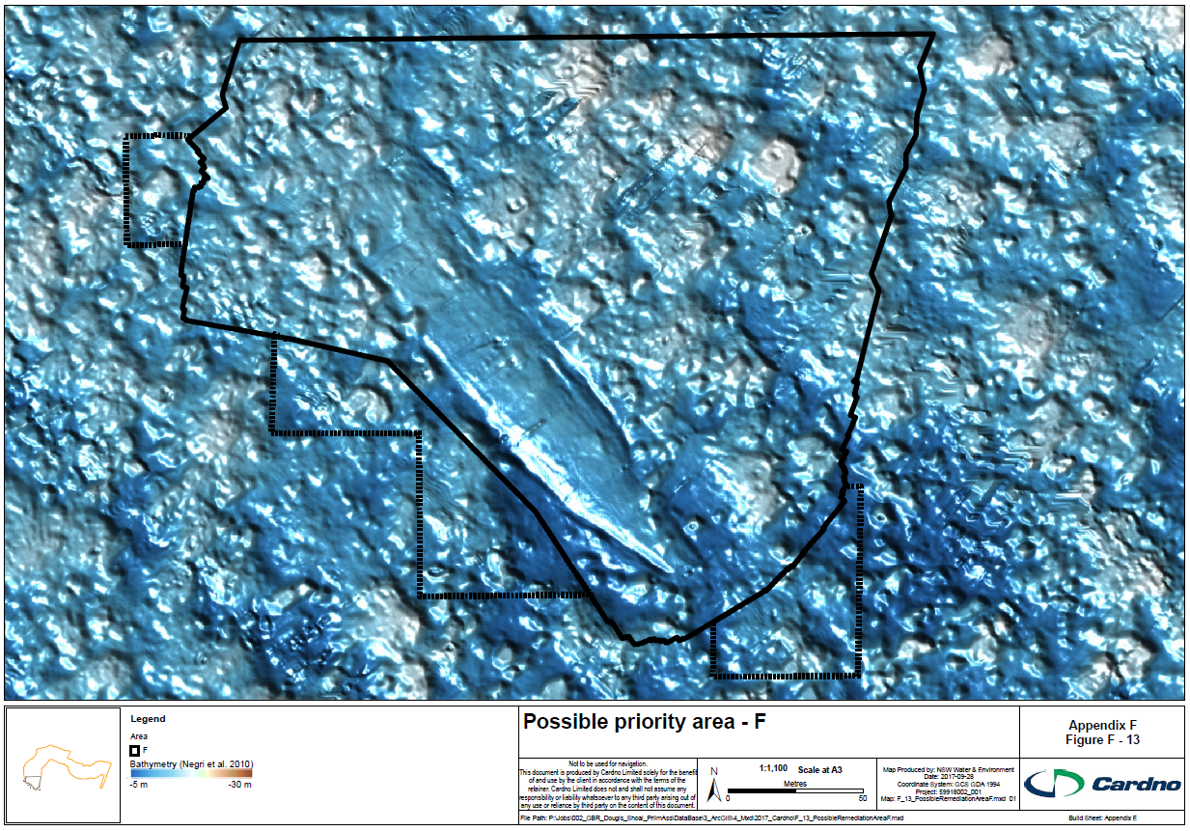

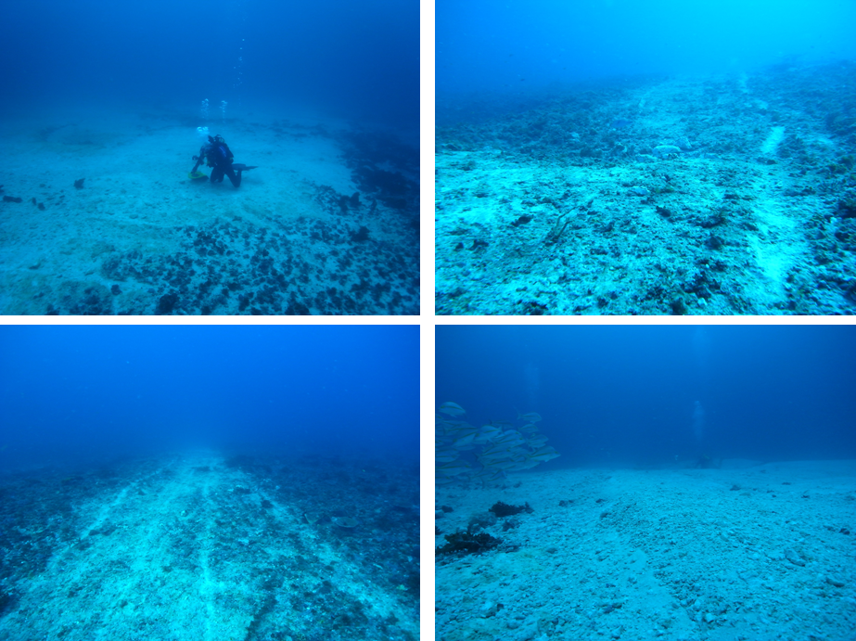
Figure F – 14 Photos taken from within the grounding footprint, April 2010 (Marshall 2010)
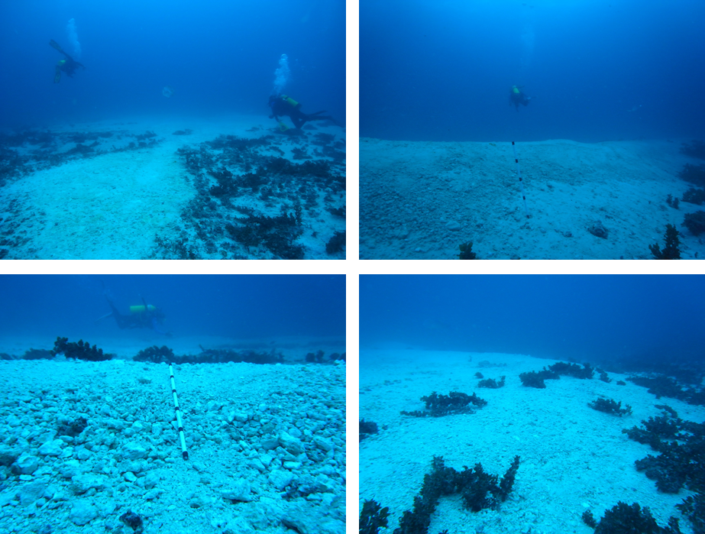
Figure F – 15 Photos taken from within the grounding footprint, April 2010 (Marshall 2010)
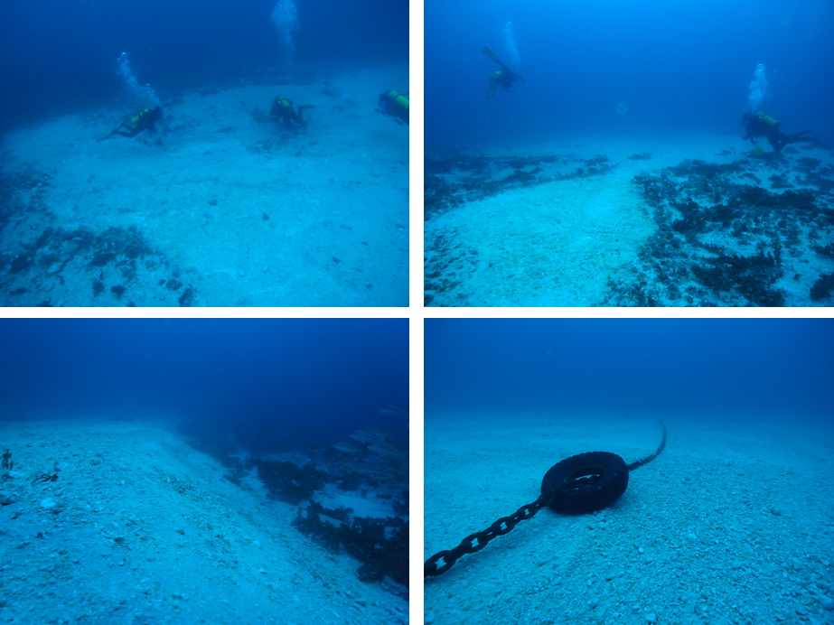
Figure F – 16 Photos taken from within the grounding footprint, April 2010 (Marshall 2010)
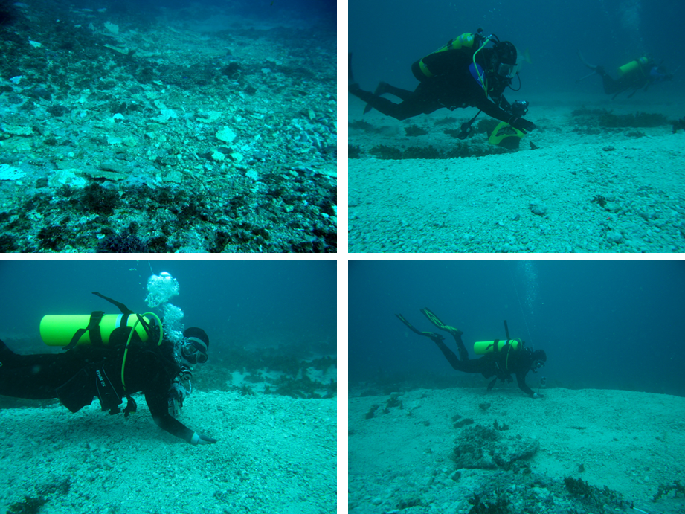
Figure F – 17 Photos taken from within the grounding footprint, April 2010 (Marshall 2010)

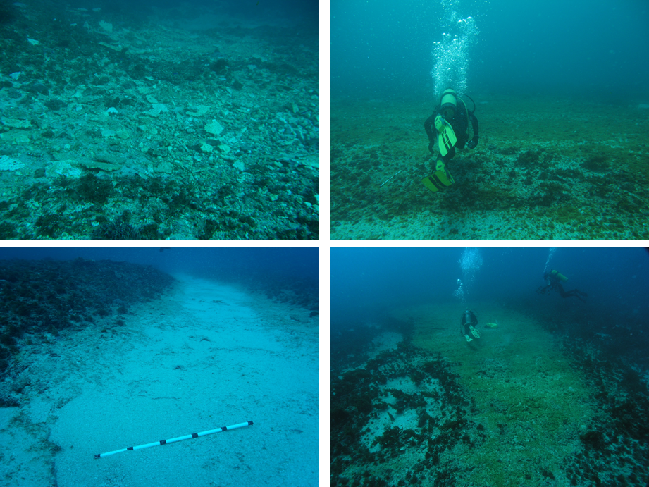
Figure F – 18 Photos taken from within the grounding footprint, April 2010 (Marshall 2010)

Appendix G – EPBC Act Protected Matters Report

See PDF Version

